Surface Corrosion Response of Al Alloys A383 and Aural 2 with Ce Additions in Aqueous NaCl and Salt-fog Environments

A Thesis Presented for the

Master of Science

Degree

The University of Tennessee, Knoxville

Michael James Thompson

May 2023

Acknowledgements
This work is supported by the Critical Materials Institute, an Energy Innovation Hub funded by the U.S. Department of Energy, Office of Energy Efficiency and Renewable Energy, Advanced Materials and Manufacturing Technologies Office, and was performed under the auspices of the U.S. DOE under Contract DE-AC05-00OR22725. The authors also thank the Institute for Advanced Materials & Manufacturing (IIAM) located at the University of Tennessee (UTK), Knoxville for the materials characterization facilities used for XRD, electron microscopy and corrosion testing.

ABSTRACT

Copper is commonly used in aluminum alloys to increase its strength by solid solution and precipitation strengthening, however, the corrosion resistance is inversely related to the amount of copper in the alloy. Over 70 percent of material used to produce aluminum alloys in the US come from recycled (secondary) alloys, many of which have a copper content of more than one percent by weight. Alloys with tightly controlled tolerances, where copper is seen as an impurity, are unable to utilize many of the recycling feedstock without adding newly processed (primary) aluminum to dilute impurities to within specifications. Primary aluminum is much more costly to produce due to the series of energy intensive processes required to make aluminum from raw materials such as bauxite. Adding cerium to aluminum alloys can increase the tolerance of impurities such as copper by binding them into more corrosion resistant intermetallic compounds that mitigate copper denuded zones at grain boundaries where most corrosion damage occurs. The corrosion response and microstructural changes of two Al-Si die-casting alloys in NaCl salt solution were investigated in the base alloys and after adding 0.6 weight percent copper and cerium additions up to 2.5 weight percent. Corrosion resistance was directly related to cerium additions, with the most significant improvement at 1.5 weight percent cerium. Further cerium additions yielded no further benefit to corrosion resistance. Compositional and structural characterization methods were used to determine the corrosion products that formed during exposure to NaCl salt solution. The majority of corrosion damage was observed at the interface of Al(FeMn)Si based intermetallics and the Al-matrix.

TABLE OF CONTENTS

Chapter I: Introduction 1
Aluminum production and recycling 2
Corrosion in Al alloys 2
Ce as an alloying addition 3
References 6
CHAPTER II: Corrosion behavior of two aluminum-silicon based die-casting alloys: influence of Ce rare-earth and Cu 9
Abstract 10
Introduction 10
Materials and Methodologies 12
Alloy composition and casting 12
Results and discussion 14
As-cast alloys and alloying effects 14
Corrosion response in NaCl salt solution 19
NaCl salt fog response of A383 and A2 and after Cu and Ce addition 22
Mechanisms behind the corrosion and corrosion products formation 28
Conclusion 28
References 31
Chapter III: Conclusion 33
Summary 34
Broader impact 34
Future work 35
VITA 37

LIST OF TABLES

Table 1: Nominal chemical composition of investigated alloys [38] and planned additions to A383 and Aural-2 (A2). All values in wt. %. 13
Table 2: Summary of Cu and Ce additions to A383 and A2 alloys 13
Table 3: Identified phases, their morphology, and contrast in the micrographs and their chemistry measured from EDS. 18
Table 4: Measured values for I_{corr}, E_{corr,} and Corrosion rates from the PDP tests. 23
Table 5: EDS data from various locations showing the composition of corrosion products. 23

LIST OF FIGURES

Figure 1: Schematic of a Tafel plot identifying anodic and cathodic branches, and values for corrosion potential (OCP) and corrosion current density. 4
Figure 2: XRD scans of A383, A383+0.6Cu+2.5Ce, A2, A2+0.6Cu+2.5Ce shown a log scale stacked plot. 15
Figure 3: BSE micrographs depicting the distribution of phases in (a) A383, (b) A383+0.6Cu, (c)A383+0.6Cu+1.5Ce and (d) A383+0.6Cu+2.5Ce. An increase in the amount of Cu2Al can be seen after the addition Cu is introduced, and the bright phase is due to Ce additions. 17
Figure 4: BSE micrographs showing the distribution of phases in (a) A2, (b) A2+0.6Cu, (c) A2+0.6Cu+1.5Ce and (d) A2+0.6Cu2.5Ce. The addition of Cu was mostly found in the Al(FeMn)Si intermetallics rather than Cu₂Al. The bright intermetallics were much less prevalent in A2 compared to A383. 17
Figure 5: XRD scans of A383 and A383+0.6Cu+2.5Ce after corrosion showing the peaks of oxides and hydroxides including Al₂O₅Si, Al₂O₃, SiO₂, Cu₂O, and Al(OH)₃. Selected areas are magnified to help with oxide identification. 20
Figure 6: XRD scans of A2 and A2+0.6Cu+2.5Ce, showing peaks of major uncorroded phases and oxides present. Selected areas are magnified to help with oxide identification. 20
Figure 7: Tafel curves for A383 and A2 depicting the cathodic and anodic branches along with the relative E_{corr} and I_{corr} values. The lower I_{corr} value and raised shape of the anodic branch of A2 shows the alloy's higher resistance to corrosion compared to A383. 21
Figure 8: Potentiodynamic curves for alloys (a) A383 with Cu and Ce additions and (b) A2 with Cu and Ce additions, and measured E_{corr}, I_{corr,} and corrosion rate for (c) A383 with Cu and Ce additions and (d) A2 with Cu and Ce additions. Corrosion rate decreased in both alloys with Ce additions up to 1.5 wt.% Ce after Cu was added. Further additions of Ce caused the corrosion rate to increase. 24
Figure 9: BSE micrographs of corroded samples (a) A383, (b) A383+0.6Cu, (c) A383+0.6Cu+1.5Ce, and (d) A383+0.6Cu+2.5Ce after salt fog exposure for 1800 hrs showing oxides and corrosion pits resulting from the experiment. 25
Figure 10: BSE micrographs of corroded samples (a) A2, (b) A2+0.6Cu, (c) A2+0.6Cu+1.5Ce, and (d) A2+0.6Cu+2.5Ce after salt fog exposure for 1800 hrs showing oxides and corrosion pits resulting from the experiment. 25
Figure 11: Maximum measured corrosion depths for all tested samples from SEM micrographs. The blue and pink bars correspond to A383 and A2 samples respectively. 27
Figure 12: Schematic diagram representing corrosion phenomena including formation of corrosion products and local cell formation at (a) Si-rich segregated regions, (b) interfaces of Ce-rich phases and Al-matrix, (c) corrosion response at the interface of Al matrix and Al(FeMn)Si (d) BSE micrographs of A383+0.6Cu+2.5Ce and (e)BSE micrographs of A2+0.6Cu+2.5Ce. 29

Chapter I: Introduction

Aluminum production and recycling
Aluminum (Al) alloys have become a primary choice material in the production of automotive components for their strength to weight ratio, corrosion resistance, and impact resistance. Al production can be viewed as three segments, upstream, downstream and secondary Al. The upstream segment is comprised of the primary Al produced from mining and refining bauxite into alumina. Primary Al is necessary when producing military grade alloys or to dilute impurities in alloys with tight compositional tolerances that would otherwise be exceeded when using recycled feedstock alone. Secondary Al makes up the scrap that is recycled to make subsequent alloys and can be further broken down into old scrap and new scrap. Old scrap refers to finished products that have reached their end-of-life, or otherwise deemed necessary to be recycled. New scrap is leftover material generated from processing consumer or industrial products. Both upstream and secondary Al are cast into unwrought shapes such as billets, slabs and ingots used by foundries to produce alloys of a desired composition and/or semi-finished products by the downstream segment such as automotive parts, construction materials, etc. Various Al-Si based casting alloys and 2000-6000 series wrought Al alloys are used in automotive components such as wheels, powertrain components, structural components, and body panels [1]–[4].

In 2022, the US produced 860,000 metric tons of primary Al from raw materials, while 2.4 million metric tons of combined new and old scrap were used in the production of Al alloys [5]. Primary Al, though necessary to produce military grade alloys or those with extremely tight tolerances on impurities, is extremely energy intensive to produce. Mined bauxite must be chemically extracted via the Bayer process into alumina, then the alumina is then smelted into raw aluminum using the Hall-Heroult process [6]. Approximately 20-40%, depending on the efficiency of the facility, of the energy needed to produce primary Al is attributed to electricity due to the high temperatures needed to smelt alumina. Secondary Al is ~90% more energy efficient than primary Al production due to the much lower temperatures needed to remelt scrap Al alloys [7]. Approximately 20% of the cost to produce secondary Al is attributed to the fuel consumed during scrap preparation, which includes disassembly and material separation of end-of-life automobiles [8]. Secondary Al is used primarily as feedstock for recycle alloys rather than high purity Al alloys that require tight control on impurity elements.

Corrosion in Al alloys
While generally considered to have good corrosion resistance, some Al alloys are more susceptible to corrosion than others due to the presence of phases at grain boundaries that are more prone to dissolution or galvanic corrosion than others. Cu-rich phases, such as Al₂Cu, form galvanic cells that react cathodically to the matrix and allows corrosion damage to penetrate deeper through grain boundaries due to denuded zones devoid of solute [9]. In Al alloys where Mg phases is precipitated at grain boundaries such as 5XXX series alloys, which can be nearly continuous, the interconnectivity of the β phase (Al₃Mg₂) is known to cause significant intergranular corrosion damage [10]. Al-Ce intermetallics don’t dissolve as easily as β phase and are thus more protective even if interconnected. Excess Fe in Al alloys tends to form needle shaped phases whose size are directly related to Fe content. These phases tend to decrease corrosion resistance when corrosion is provoked by adjacent Si phases [11].

Potentiodynamic polarization testing is a widely used technique to measure the corrosion behavior of materials. The experiment involves measuring the potential difference between the working electrode, the sample to be corroded, and a counter electrode, often a graphite rod, in an electrolyte such as NaCl salt water. This potential is compared to the potential difference between the working electrode and a reference, typically a saturated calomel electrode (SCE). The corrosion potential (OCP) is measured, and an applied potential is swept from below to above OCP. The OCP is the free potential measured between the sample being analyzed, working electrode, and the reference electrode when there is no current flowing in the circuit formed by the cell. A negative OCP implies a material is expected to spontaneously corrode, and the magnitude of the potential is the driving force for that process. The measured current representing corrosion kinetics is a function of applied potential, additional driving force above or below OCP, which are plotted to generate curves for the anodic and cathodic behavior of the material, Fig. 1. The current density, calculated by the exposed area of the sample, is related to the corrosion rate. This method effectively determines the active and passive corrosion rates. The anodic reaction occurs when the solution releases oxygen into the material, while the cathodic reaction is the passivation process, or corrosion.

A common practice to test the corrosion resistance in Al alloys is to use accelerated corrosion tests to determine the resistance to corrosion damage relative to other materials, or as composition is varied. Salt-fog testing, such as that standardized in ASTM B117, is an accelerated corrosion test method used to determine the relative corrosion resistance of the materials being tested. Samples are exposed to a 4-6% NaCl salt-fog while holding the exposure chamber at 35 °C. Although the test times aren’t directly correlated to exposure times in real world environments due to the constant temperature, salinity, and humidity, it is a standardized method for determining corrosion resistance of material on a more manageable timeframe that otherwise could take years to accomplish. The principle is to expose materials to a penetrative conductive solution that drives electrochemical reactions via chloride ions from the NaCl salt-fog, which yields dissolution of the base metal and formation of corrosion products. In Al alloys, this method significantly accelerates grain boundary corrosion, where most corrosion damage occurs in Al alloys [12].

Ce as an alloying addition
Al alloys using Ce as a primary alloying addition have been shown to be compatible with many processes used in the production of various Al alloys such as casting, extrusion, and die-casting [13]–[15]. The Al-Ce based intermetallics provide increased high temperature strength and strength retention after thermal exposure due to its thermodynamic stability and negligible solubility of Ce in the Al matrix [16], [17]. Ce has also been shown effective as a method of removing Fe, Ni, and Cu impurities that negatively affect corrosion behavior in Mg alloys [18]. This scavenging effect was found to capture impurities into stable intermetallics that make the alloys less prone to corrosion
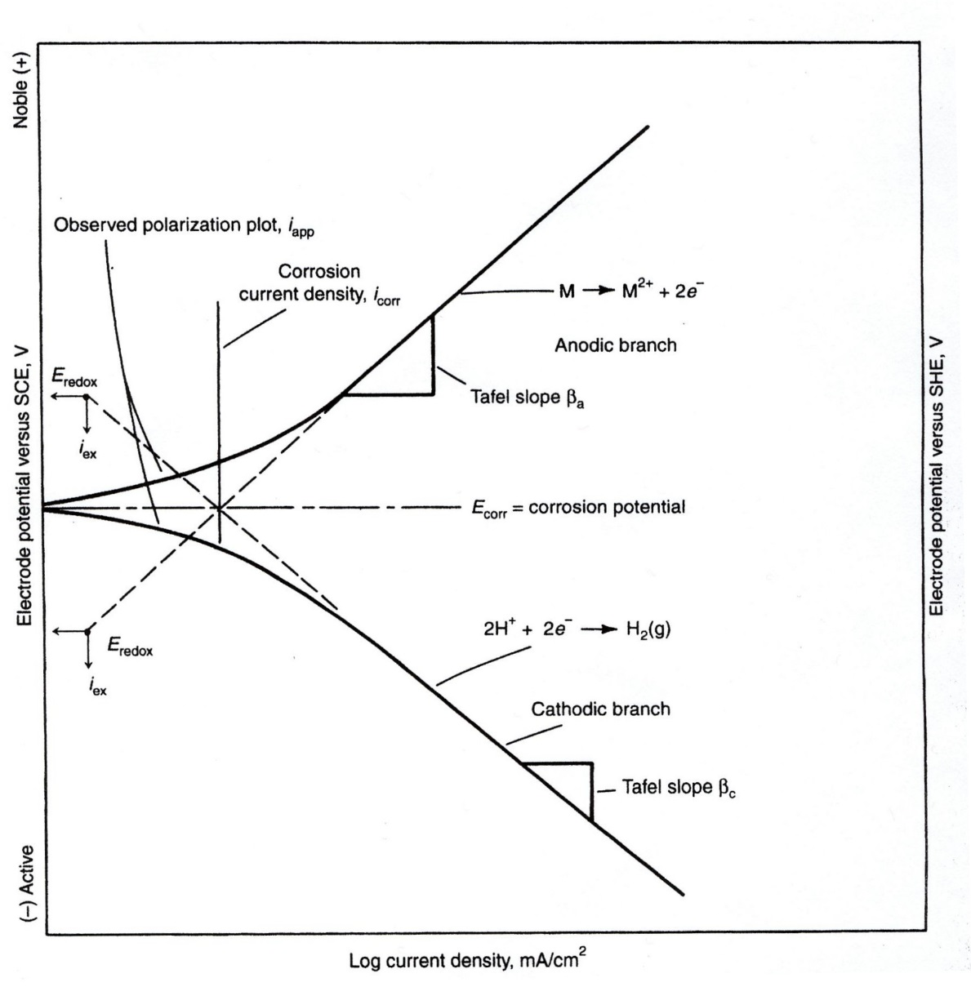Figure 1: Schematic of a Tafel plot identifying anodic and cathodic branches, and values for corrosion potential (OCP) and corrosion current density.

by reducing the activity of the cathode in Mg alloys. However, this effect has not been sufficiently studied in Al alloys. Ce has also been used as a scavenging agent for oxygen in Ti and Cr alloys[19, 20]. Due to its abundance, underutilization, and compatibility to current large scale processing methods of Al alloys, Ce shows promise as a potential pathway for “gettering” undesired impurities from lower cost feedstocks for higher value alloys. Additionally, rare-earth elements are mined together as a mixed ore and must be separated. Therefore, a large-scale use for Ce, such as an alloying addition to Al, would help make mining rare-earth elements more economical by bringing value to what is currently considered a waste product [21], [22]. Ce as a minor alloying addition has demonstrated its ability to scavenge impurity elements such as Fe and Cu [23], [24]. This could provide benefits for Al alloys in two ways; intentional Ce additions to bind impurities in a targeted alloy for improvement of corrosion resistance, and these alloys will inevitably enter the recycling stream, which could improve the sensitivity to impurities for subsequent alloys. Further, the intentional additions could be a basis for improving the next generation of conventional Al alloys as well as adding value to the recycling supply chain [25]. This work investigates the addition of Ce on commercial Al alloys to demonstrate its potential to increase corrosion resistance of commercial alloys while simultaneously increasing alloy tolerance to impurity element content, effectively broadening the recycled Al feedstock streams available to produce them.

References
[1] S. K. Das, J. A. S. Green, and J. G. Kaufman, “The development of recycle-friendly automotive aluminum alloys,” JOM, vol. 59, no. 11, pp. 47–51, Nov. 2007, doi: 10.1007/s11837-007-0140-2.
[2] R. S. Long, E. Boettcher, and D. Crawford, “Current and Future Uses of Aluminum in the Automotive Industry,” JOM, vol. 69, no. 12, pp. 2635–2639, Dec. 2017, doi: 10.1007/s11837-017-2554-9.
[3] D. Adamović, T. Vujinović, F. Živić, J. Živković, and M. Topalović, “Application of Aluminum and ITS Alloys in the Automotive Industry With Special Emphasis PN Wheel Rims,” JTTTP - J. TRAFFIC Transp. THEORY Pract., vol. 6, no. 2, Oct. 2020, doi: 10.7251/JTTTP2102087A.
[4] S. Montijo, “What is Aluminum Used for: Automotive Edition,” Kloeckner Metals Corporation, Apr. 28, 2021. https://www.kloecknermetals.com/blog/what-is-aluminum-used-for-automotive-edition/ (accessed Feb. 27, 2023).
[5] “Mineral commodity summaries 2022,” Reston, VA, Report 2022, 2022. doi: 10.3133/mcs2022.
[6] “Energy and Exergy Analysis of the Primary Aluminum Production Processes: A Review on Current and Future Sustainability.” https://www.tandfonline.com/doi/epdf/10.1080/08827508.2010.530721?needAccess=true&role=button (accessed Feb. 27, 2023).
[7] “Secondary Production 101 | The Aluminum Association.” https://www.aluminum.org/secondary-production-101 (accessed Feb. 01, 2023).
[8] J. Cui and H. J. Roven, “Recycling of automotive aluminum,” Trans. Nonferrous Met. Soc. China, vol. 20, no. 11, pp. 2057–2063, Nov. 2010, doi: 10.1016/S1003-6326(09)60417-9.
[9] “Corrosion pathways in aluminium alloys | Elsevier Enhanced Reader.” https://reader.elsevier.com/reader/sd/pii/S1003632617600062?token=4D0C329475B4787368ADF678F2BF36E51334239FBE6728318083162A7AFF2A33BA691C1127393038CD8FCDAAA45E0C46&originRegion=us-east-1&originCreation=20230228012014 (accessed Feb. 27, 2023).
[10] R. Zhang, N. Birbilis, S. Knight, R. Holtz, R. Goswami, and C. Davies, “A Survey of Sensitization in 5xxx Series Aluminum Alloys,” Corrosion, vol. 72, p. 150903122215004, Sep. 2015, doi: 10.5006/1787.
[11] L. Kuchariková, T. Liptáková, E. Tillová, D. Kajánek, and E. Schmidová, “Role of Chemical Composition in Corrosion of Aluminum Alloys,” Metals, vol. 8, no. 8, p. 581, Jul. 2018, doi: 10.3390/met8080581.
[12] J. T. Staley, “Corrosion of Aluminium Aerospace Alloys,” Mater. Sci. Forum, vol. 877, pp. 485–491, Nov. 2016, doi: 10.4028/www.scientific.net/MSF.877.485.
[13] E. T. Stromme et al., “Ageless Aluminum-Cerium-Based Alloys in High-Volume Die Casting for Improved Energy Efficiency,” JOM, vol. 70, no. 6, pp. 866–871, Jun. 2018, doi: 10.1007/s11837-018-2861-9.
[14] Z. C. Sims et al., “High performance aluminum–cerium alloys for high-temperature applications,” Mater Horiz, vol. 4, no. 6, pp. 1070–1078, 2017, doi: 10.1039/C7MH00391A.
[15] D. Weiss, “Composites and Alloys Based on the Al-Ce System,” in Aluminium Alloys and Composites, K. O. Cooke, Ed. Rijeka: IntechOpen, 2019. doi: 10.5772/intechopen.89994.
[16] F. Czerwinski, “Cerium in aluminum alloys,” J. Mater. Sci., vol. 55, no. 1, pp. 24–72, Jan. 2020, doi: 10.1007/s10853-019-03892-z.
[17] E. E. Moore et al., “Thermodynamic Modeling of the Al-Ce-Cu-Mg-Si System and Its Application to Aluminum-Cerium Alloy Design,” J. Phase Equilibria Diffus., vol. 41, no. 6, pp. 764–783, Dec. 2020, doi: 10.1007/s11669-020-00852-y.
[18] W. E. Mercer and J. E. Hillis, “The Critical Contaminant Limits and Salt Water Corrosion Performance of Magnesium AE42 Alloy,” in International Congress & Exposition, Feb. 1992. doi: https://doi.org/10.4271/920073.
[19] N. E. Ryan, “An appraisal of possible scavenger elements for chromium and chromium alloys,” J. Common Met., vol. 6, no. 1, pp. 21–35, Jan. 1964, doi: 10.1016/0022-5088(64)90005-0.
[20] Y. F. Yang, S. D. Luo, G. B. Schaffer, and M. Qian, “Impurity scavenging, microstructural refinement and mechanical properties of powder metallurgy titanium and titanium alloys by a small addition of cerium silicide,” Mater. Sci. Eng. A, vol. 573, pp. 166–174, Jun. 2013, doi: 10.1016/j.msea.2013.02.042.
[21] Z. C. Sims et al., “Cerium-Based, Intermetallic-Strengthened Aluminum Casting Alloy: High-Volume Co-product Development,” JOM, vol. 68, no. 7, pp. 1940–1947, Jul. 2016, doi: 10.1007/s11837-016-1943-9.
[22] Z. C. Sims et al., “How Cerium and Lanthanum as Coproducts Promote Stable Rare Earth Production and New Alloys,” J. Sustain. Metall., vol. 8, no. 3, pp. 1225–1234, Sep. 2022, doi: 10.1007/s40831-022-00562-4.
[23] H. B. Henderson et al., “Ternary Interactions and Implications for Third Element Alloying Potency in Al–Ce-Based Alloys,” in Light Metals 2020, A. Tomsett, Ed. Cham: Springer International Publishing, 2020, pp. 227–232. doi: 10.1007/978-3-030-36408-3_32.
[24] Z. C. Sims et al., “Application of Ce for scavenging Cu impurities in A356 Al alloys,” Eur. J. Mater., vol. 1, no. 1, pp. 3–18, Jan. 2021, doi: 10.1080/26889277.2021.1974801.
[25] A. V. Iyer, H. Lim, O. Rios, Z. Sims, and D. Weiss, “An Economic Model and Experiments to Understand Aluminum-Cerium Alloy Recycling,” JOM, vol. 70, no. 4, pp. 547–552, Apr. 2018, doi: 10.1007/s11837-018-2764-9.

CHAPTER II: Corrosion behavior of two aluminum-silicon based die-casting alloys: influence of Ce rare-earth and Cu
A version of this chapter will be submitted for publication during the semester of the defense by Michael J. Thompson, et. al.:
Michael J. Thompson, Nitish Bibhanshu, David Weiss, Kevin Anderson, Ryan Ott, Eric A. Lass , and Orlando Rios. “Corrosion Behavior of Two Aluminum-Silicon based Die-casting Alloys: Influence of Ce rare-earth element and Cu.”

The student shares first authorship and performed much of the work on the publication including material synthesis, analysis of SEM images and EDS data, analysis of potentiodynamic testing and drafting the original manuscript and revising subsequent versions. Nitish Bibhanshu shares first authorship for help drafting the original manuscript and revising subsequent versions, and assisted in analysis of SEM micrographs, EDS data, XRD data, and potentiodynamic data. David Weiss and Kevin Anderson contributed advice and expertise in aluminum metal casting and corrosion. Ryan Ott provided feedback on the manuscript versions and coordinated SEM imaging and EDS data acquisition. Orlando Rios provided the instruments for potentiodynamic and salt-fog testing and provided guidance in designing the experiment. Eric Lass acted as corresponding author and advisor for the student.

Abstract
The addition of Cerium (Ce) to selected commercial Aluminum (Al) alloys offers a pathway to improve impurity tolerance and corrosion resistance in NaCl solution. The improved corrosion resistance enables greater flexibility in the scrap recycling stream, where certain impurities (e.g., Cu) would normally lead to unacceptable performance. We have examined the effects of Cu and Ce additions in two Al-Si based die-casting alloys that are representative of commercial Aural-2 and A383. Potentiodynamic polarization curves showed an increase in corrosion rate in both base alloys after Cu additions. Corrosion resistance was improved with Ce additions up to 1.5 wt. %, above which no additional benefit was observed, and corrosion resistance was even found to decrease. The improved corrosion resistance was attributed to Ce-based intermetallic formation which mitigates the creation of Cu denuded zones that have negative effects on corrosion resistance. Microstructural analysis reveals most of the corrosion damage occurs at the Al(FeMn)Si and Al-matrix interface. The corrosion products were also identified from X-ray diffraction (XRD) scans, and included Al₂O₅Si, Al₂O₃, SiO₂, Cu₂O, and Al(OH)₃.

Introduction
Aluminum (Al) alloys show good specific strength, fracture toughness, weldability, damage tolerance, and corrosion resistance [26], [27]. This combination of mechanical, physical, and chemical properties make them ideal candidates for applications in automotive, marine, and aerospace sectors [28], [29]. Energy intensive processes required to produce primary Al from sources such as bauxite coupled with high material demand in multiple fields makes using secondary feedstocks (recycled Al scrap) the most economically beneficial route for synthesizing Al alloys. Common alloying elements such as Cu and Fe are seen as impurities in some Al alloys, but are inevitably present in Al scrap streams and impact the castability, mechanical behavior and corrosion response of secondary alloys [24], [30]–[33]. Aluminum has a high heat of mixing with several elements, and thus readily forms intermetallic compounds of various sizes and geometries with Cu, Fe, Ti, Ni, etc, during solidification [34]–[37]. Segregation, precipitation, and intermetallic phase formation at GBs has been shown to promote intergranular corrosion in both cast and wrought Al-alloys [38]–[43]. The maximum solubility of Cu in face-centered cubic (FCC) Al is 5.56 wt.% at 548 °C and approximately 0.24 wt. % at 250 °C [44], [45]. Al-Cu alloys are common high strength alloys, however, the Al₂Cu strengthening precipitates also have a deleterious effect on corrosion behavior due to preferential formation at the grain boundaries (GBs) forming denuded (Cu-depleted) zones surrounding the GBs [30], [44]. The decreased corrosion resistance attributed to segregated Al₂Cu is due to the formation of local cells with high electrochemical potential at the interface between the intermetallic and the Al-matrix that cause dissolution of material around the GBs [33], [46], [47]. Similarly, Si generally improves mechanical properties and castability, however, excess Si segregated at GBs is highly susceptible to intergranular corrosion due to anodic dissolution of Al in precipitate-free zones [48], [49]. The phenomena were also found to exist as micro-galvanic coupling of precipitates and the matrix of Cu precipitation strengthened 6000 series alloys [31], [41]–[43]. When denuded zones along GBs instead consisted of other phases such as Q-phase (Al₄Cu₂Mg₈Si₇) or their precursors, they improved the corrosion resistance of Al-Si-Mn-(Cu) alloys, suggesting that modification by additional alloying elements may help improve corrosion resistance [33], [42].

The addition of rare-earth elements have been shown as a potential pathway to improve corrosion resistance of Al-alloys [50]–[52]. Ce is abundant, underutilized, and relatively inexpensive, making it an attractive option as an alloying element. Moreover, it has already been shown to improve mechanical performance and scavenge impurities in Al-alloys [21], [24], [53]. Rare earth oxides are known to be very stable compared to most metallic oxides. For example, Ce₂O₃ is more thermodynamically stable compared to SiO₂, Fe₂O₃, Al₂O₃ and MnO [54], [55]. Due to its higher oxygen affinity and electrochemical stability, Ce₂O₃ retards the anodic and cathodic activities by blocking the surface sites’ reactivities, making it more difficult for the anions to combine with other elements [56]–[58]. Tian et al. [59] have reported Ce additions in Al-Cu-Mn-Mg-Fe alloy improves the corrosion resistance along with the strength and ductility simultaneously. Additionally, Zhang et al. reported an improvement in corrosion resistance with Ce addition; but only up to a critical concentration of Ce, above which the corrosion resistance was degraded [60]. This suggests that optimization of Ce additions to Al-Si based alloys could improve corrosion resistance [52], [59].

Here, two Al-Si based die-casting alloys with compositions similar to commercial Aural-2 and A383 are selected for investigation [61]. The Aural-2 alloy was chosen due to its good corrosion resistance that requires very tight control over Cu and Fe impurities. The second alloy, A383, has a much greater tolerance for Cu and Fe content, and thus recycled material content, but significantly reduced corrosion resistance compared to Aural-2 due to the formation of several Fe- and Cu-rich intermetallics [32], [62]–[65]. The higher Cu content of A383 also allows the formation of Al₂Cu, Al₄Mg₈Si₇Cu₂, and some Cu segregated at GBs [30], [46], [66], [67]. Experimental alloys based on A383 and Aural-2, investigated in this work, hereafter will be referred to as A383 and A2, respectively.

This work reports the effects of additional Cu on the microstructure and the resulting corrosion behavior along with potential pathways for improved corrosion resistance through Ce additions. Further, in the hope to improve corrosion resistance of the alloy while maximizing impurity tolerance and maintaining baseline mechanical properties, various amounts of Ce were added to the alloy after the Cu additions. The controlling mechanisms of the corrosion of Cu- and Ce-containing phases in the Al-alloys were investigated.

Materials and Methodologies

Alloy composition and casting

The influence of Cu and Ce on the corrosion behavior of two Al-alloys was explored by adding 0.6 wt. % Cu and different amounts of Ce ranging from 0.5-2.5 wt. % to the base materials, produced by Shiloh Industries, USA. The alloys were melted at a temperature of 675-695 °C to avoid the growth of primary intermetallic that can nucleate within the mushy zone, the region between the liquidus and solidus lines of the equilibrium phase diagram. Sections from the original 40 lb. cast ingot were used as a charge weight of 100 g per sample to which 99.999% Cu and commercially pure Ce metal were added. Detailed information about the original composition and alloying additions is provided in Table 1. Each charge was arc melted and homogenized using the electromagnetic mixing function via a coil of Cu wire embedded in the crucible. The thin layer of Ce oxide was mechanically polished from the surface of the Ce metal just prior to weighing and immediately loaded into the arc melter to ensure the accurate weight of Ce and minimize oxidation. The proportion of the Cu and Ce addition in A383 and A2 alloys are provided in Table 2. The melts were poured into cylindrical bars using a water-cooled copper mold yielding samples 12.7 mm in diameter and 85 mm in length. The mold was chosen to simulate the rapid solidification rate typical of die-casting.

Corrosion experiments

Potentiodynamic polarization (PDP) tests were conducted using a Gamry Instruments Reference 620+ Potentiostat and associated software in 30 mL of 0.1 M NaCl solution, prepared with reagent-grade chemicals, on a 4 mm section from the cast bars ground to a 1200 grit finish. A rubber O-ring was used to control the exposure area of 28.27 mm² across all samples. A saturated Calomel reference electrode (SCE) with a salt bridge tube and graphite counter electrode was used to measure the net corrosion activity. The surface was conditioned at the open-circuit potential (OCP) for 30 minutes before starting PDP measurements. The potential was swept at 1 mV/s in the anodic direction from -0.3 mV to 1.3 mV relative to the OCP.

Table 1: Nominal chemical composition of investigated alloys [61] and planned additions to A383 and Aural-2 (A2). All values in wt. %.
Alloy | Al | Ce | Cu | Si | Fe | Mg | Mn | Zn | Ni | Sn
A383 | Bal | - | 0.02 | 9.5 – 11.7 | 0.15 – 0.2 | 0.15 – 0.6 | 0.3 – 0.6 | 0.03 | - | -
A2 | Bal | - | 2.50 | 10.50 | 1.3 | 0.1 | 0.5 | 3.00 | 0.30 | 0.15

Table 2: Summary of Cu and Ce additions to A383 and A2 alloys
Base Material | Cu Addition (wt.%) | Ce Addition (wt.%) | Alloy name
A383/A2 | 0 | 0 | A383/A2
A383/A2 | 0.6 | 0 | A383/A2+0.6Cu
A383/A2 | 0.6 | 0.5 | A383/A2+0.6Cu+0.5Ce
A383/A2 | 0.6 | 1.0 | A383/A2+0.6Cu+1.0Ce
A383/A2 | 0.6 | 1.5 | A383/A2+0.6Cu+1.5Ce
A383/A2 | 0.6 | 2.0 | A383/A2+0.6Cu+2.0Ce
A383/A2 | 0.6 | 2.5 | A383/A2+0.6Cu+2.5Ce

The remaining section of the cast bars were exposed to a 5 % NaCl fog environment for 1800 hours using a Model 22 Auto Technology salt fog cabinet in accordance with ASTM B117. The temperature of the cabinet and feeding tower was held at 35 °C and 48 °C, respectively. The bars were mechanically cleaned with a soft bristle brush after the exposure to remove remaining salt build-up.

Materials Characterization

Samples were prepared for scanning electron microscopy (SEM) and energy dispersive X-ray spectroscopy (EDS) by mounting a 10 mm section in conductive epoxy and polishing to a mirror finish using standard metallographic procedures. Samples were analyzed using an FEI Teneo LoVac SEM in backscattered electron (BSE) mode using a working distance of 11 mm and accelerating voltage of 20 kV. EDS spectra were collected using an Oxford detector. X-ray Diffraction (XRD) was performed on a 3 mm section of each sample ground to an 800-grit finish using a Malvern Panalytical Empyrean diffractometer. All samples were scanned from 10°-90° in 2θ using a Cu tube (λ=0.154 nm) with a step size of 0.0263° (total scan time of 21 mins) and rotated at 4 sec/revolution to sample more grain orientations.

Results and discussion

As-cast alloys and alloying effects

Phase identification in arc melted alloys using XRD

A maximum of 1.65 wt.% Si can be dissolved in the Al lattice to form a solid solution; further, with an increase in Si concentration, it solidifies through a eutectic pathway. Solidification through pro-eutectic region may lead to a coring effect and show the segregation of excess Si [68]. Additional alloying elements present in the alloy could lead to precipitation of other phases. Using XRD, we attempted to identify the precipitated phases and intermetallic compounds in both alloys with and without Cu and Ce additions.

Major peaks found in the XRD scans of both the A383 and A2 samples corresponded to the FCC-Al matrix and segregated Si, while minor peaks for Al₁₇(Fe_{3.2}Mn_{0.8})Si₂ and Al₁₉(Fe₄Mn)Si₂ were seen with varying intensity between alloys due to the difference in Fe composition, Fig. 2 [69], [70]. Further, the higher Cu containing A383 alloy showed peaks of Al₂Cu not observed in the A2 alloy, which has a much lower Cu limit. In the Ce-containing alloys, peaks corresponding to AlCeSi phases were also identified as Al_{1.624}Ce₁Si_{0.367} and Al_{1.94}Ce₁Si_{0.06} which have AlB₂ (Hexagonal) and MgCu₂ (Cubic) structures, respectively [71]. Peaks associated with the Al₃CeCu phase were also observed in both alloys but were more prominent in A383+0.6Cu+2.5Ce than A2+0.6Cu+2.5Ce due to the higher amount of Cu available to form the phase.

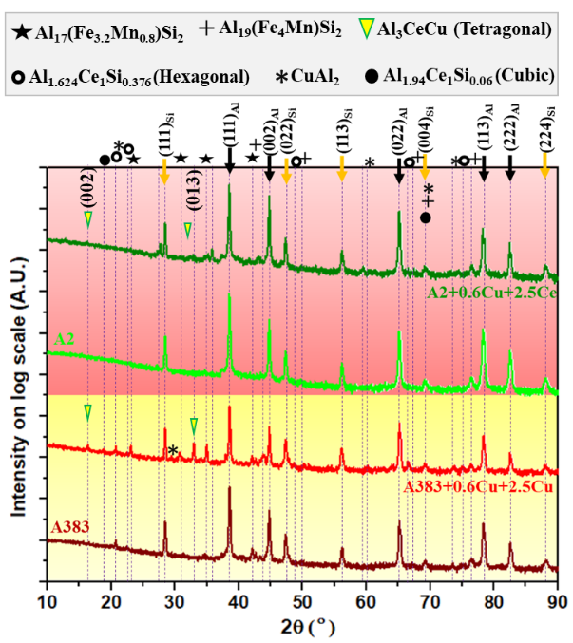
Figure 2: XRD scans of A383, A383+0.6Cu+2.5Ce, A2, A2+0.6Cu+2.5Ce shown a log scale stacked plot.

Phases and their distribution in microstructure

Along with chemistry, the shape, size, and distribution of various phases also influence the corrosion behavior of the alloy. BSE imaging was used to identify the microstructure of the different phases in the A383, A383+0.6Cu, A383+0.6Cu+1.5Ce, and A383+0.6Cu+2.5Ce alloys, Fig. 3. Shrinkage porosity in the interdendritic region was found in the A383 and A383+0.6Cu samples near the brighter Al(FeMn)Si and Al₂Cu phases. This was possibly due to the different contraction of the precipitate phases and Al-matrix during the solidification of the ingot. EDS scans were conducted to determine the composition of the phases and morphologies, Table 3.

In A383 and A383+0.6Cu, the ordered phases, which are potential sites to accommodate Fe and Cu, include Al₁₅(FeMn)₃Si₂ and Al₂Cu. The composition of Al₁₅(FeMn)₃Si₂ was found to be consistent with the solubility range reported in literature [72]–[75]. The brighter phase within the interdendritic regions was found to be Al₂Cu with Si and Cu segregated along the interface. The addition of more Cu caused the growth of the Al(FeMn)Si and Al₂Cu phases due to changes in chemical potentials creating local gradients that promote segregation. Si exceeding the solid solution solubility limit solidifies via a eutectic reaction, however, the high melting temperature difference between Al and Si causes a coring effect during solidification resulting in an inhomogeneous distribution of Si within the matrix. [76], [77]. The variation in the grey color gradient of the matrix corresponding to Si segregation confirms this effect [68], [77].

The micrographs of A383+0.6Cu+1.5Ce, and A383+0.6Cu+2.5Ce, Fig. 3c and 3d; respectively, show the Ce-rich phases were primarily needle shaped and contain Cu, Fe, and Mg. EDS measurements of these phases and their interfaces revealed Si and Fe. This is significant since free Fe and Si in the alloy can form the deleterious Al₁₅(FeMn)₃Si₂/Al(FeMn)Si phases. The observation of Si and Fe in the Ce-rich phases suggests the Ce is ‘gettering’ the excess Fe and Cu. Furthermore, the polygon shape of the Al(FeMn)Si are believed to promote porosity formation, and thus, suppression of these phases yields less porosity, as seen in Fig. 3 and 4 [78]. Gettering of these impurities is also believed to improve the corrosion resistance of these alloys [24], [25], [79], [80].

Phase morphologies in the A2 series of alloys are shown in Fig. 4. The A2 alloy (Fig. 4a) was found to have less shrinkage porosity compared to the A383 alloy; however, the porosity increased after the addition of Cu, Fig. 4b. Among the phases, fine globular shaped AlMgMnSi and needle shaped Al(FeMn)Si were observed in A2. Higher amounts of globular Si were found in the interdendritic regions, and smaller instances of blocky shaped Al(FeMn)Si appeared after the Cu addition, Fig. 4a and 4b. This increase in blocky shaped phases is probably due to the restriction in solubility of other elements like Fe, Mg, and Mn promoting precipitation and further growth of individual phases [81]. A reduction in the amount of segregated Si was observed after the addition of Ce because of the formation of AlCeSi(CuMg), which appeared along the interdendritic regions.
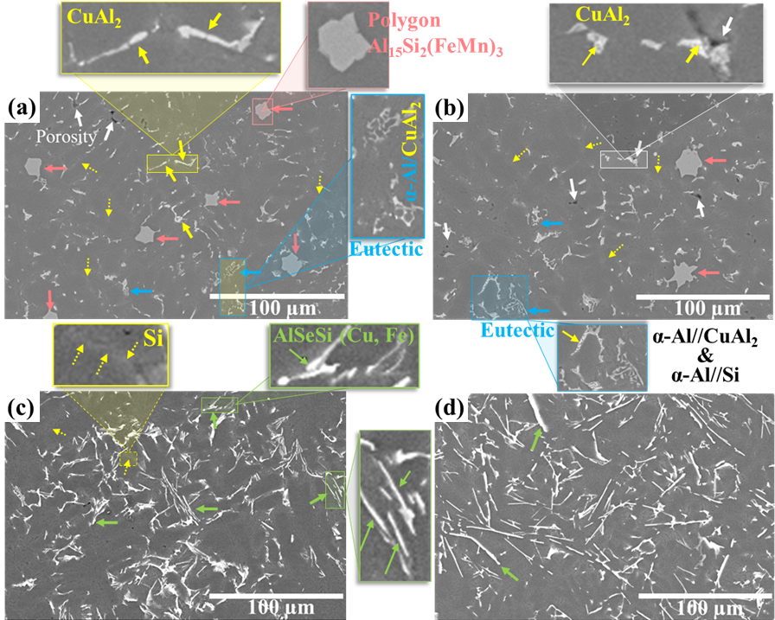
Figure 3: BSE micrographs depicting the distribution of phases in (a) A383, (b) A383+0.6Cu, (c)A383+0.6Cu+1.5Ce and (d) A383+0.6Cu+2.5Ce. An increase in the amount of Cu2Al can be seen after the addition Cu is introduced, and the bright phase is due to Ce additions.

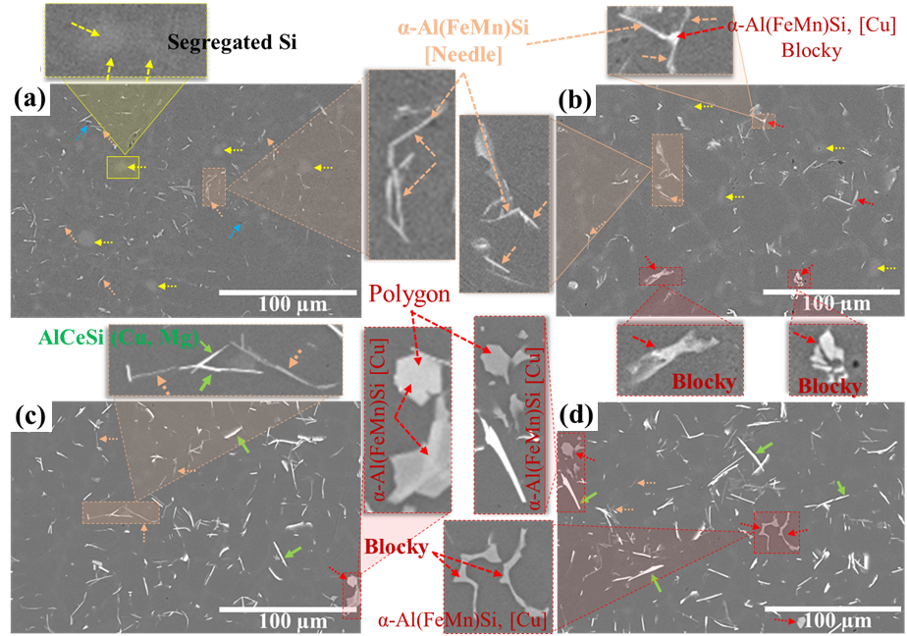
Figure 4: BSE micrographs showing the distribution of phases in (a) A2, (b) A2+0.6Cu, (c) A2+0.6Cu+1.5Ce and (d) A2+0.6Cu2.5Ce. The addition of Cu was mostly found in the Al(FeMn)Si intermetallics rather than Cu₂Al. The bright intermetallics were much less prevalent in A2 compared to A383.

Table 3: Identified phases, their morphology, and contrast in the micrographs and their chemistry measured from EDS.
Phase Shape | Phase Composition (based on EDS and in wt.%) | Possible stoichiometry
Samples of A383 including Cu and Ce additions
Polygon |  | Al₁₅(FeMn)₃Si₂
  Al:59.35 | Si:10.13 | Fe:20.15 | Mn:8.3 | Cu:1.5 | Balance: Other
Lamellae | Not available | Eutectic phase (Al+Si and/or α-Al+Cu₂Al)
Needle |  | Al₂Cu (θ)
  Al: 61.16 | Cu:33.81 | Si:1.71 | Balance: Other
Needle, Plate |  | AlCeSi(Cu, Fe)
  Al: 86.47 | Ce: 3.57 | Si:2.5 | Cu:4.05 | Fe:1.08 | Balance: Other
Samples of A2 including Cu and Ce additions
Needle |  | α-Al(FeMn)Si,
  Al:64.71 | Si:21.93 | Fe:3.75 | Mn:8.99 | Balance: Other
Globular |  | Segregated Si
  Si: 94.95 | Al:4.77 | Balance: Other
Globular spot |  | AlSiMgMn
  Al:75.45 | Si:16.56 | Mg:3.35 | Mn:3.04 | Balance: Other
Blocky (Polygon) |  | α-Al(FeMn)Si  [AlFeMnSi,Cu]
  Al:59.54 | Si:10.66 | Fe:6.38 | Mn:22.91 | Cu: 0.32 | Balance: Other
Needle, Plate |  | AlCeSi(Cu,Mg)
  Al:41.27 | Ce:31.78 |  | Si:24.42 | Cu:0.94 | Mg:1.45 | Balance: Other

In addition to the Ce containing phase, the Al(FeMn)Si were also identified with segregated Cu and Mg close to their interfaces [24], [80]. The amount of both phases, and their coverage of the GBs, increased as the Ce addition is increased from 1.5 to 2.5 wt. %.

Corrosion response in NaCl salt solution

In service, the surface of Al-alloys may be marred or scratched, removing the protective oxide film. Precipitates with different chemical compositions may form local cells that lead to the local flow of electrons and ions. Such behavior causes the initiation of corrosion and alloys degrade with time. To characterize the corrosion response of the alloys, corrosion products are first identified using XRD. A detailed understanding of the corrosion behavior of these alloys is then presented.

Corrosion product identification using XRD

Corrosion products formed after PDP testing of A383 and A383+0.6Cu+2.5Ce were identified as Al₂O₅Si, Al₂O₃, SiO₂, Cu₂O, and Al(OH)₃ using XRD, Fig. 5. The higher Cu content of A383 leads to more segregated Cu at grain boundaries which increases oxide formation and thus corrosion damage. Trapping excess Fe and Cu in corrosion resistant phases via Ce additions improves corrosion resistance by suppressing the formation of Cu₂O and Fe₂O₃, which are known to be products of corrosion damage. Only small peaks from these phases appear in the scans due to the low percentage present and superlattice diffraction [82], [83]. The XRD scans for A2 and A2+0.6Cu+2.5Ce show peaks for the same oxides seen in the A383 samples but with lower relative intensities compared to the main peaks correspond to the matrix, Fig. 6.

Potentiodynamic response of alloys A383 and A2

Analysis of the Tafel plots generated from PDP data for A383 and A2 displayed in Fig. 7 show the I_{corr} values of these alloys are 466 nA and 62.7 nA, respectively. A lower I_{corr} value corresponds to a lower corrosion rate, which can be calculated using the following equation [84].
Corrosion rate = $\frac{0.13 I_{corr} (EW)}{d}$ ……………… (2)
where EW and d are the equivalent weight and density of the alloys. The equivalent weight was calculated to be 8.994 from the molar mass of Al divided by its valence and was assumed to be constant for all samples. The PDP curves shown are the average response of corrosion that occurs in localized regions including precipitates and the matrix interface. The measured corrosion rates for both the reference alloy A383 and A2 are shown in Table 3. Corrosion rate and Tafel plots represent higher corrosion resistance for A2 compared to the alloy A383. Additionally, the higher average potential of the anodic branch of the A2 sample indicates higher a cationic dissolution potential, supporting the argument of higher resistivity to corrosion. The plots also show A2 enters the passive region earlier and has higher E_{corr} compared to the A383, indicating a higher resistance to corrosion.

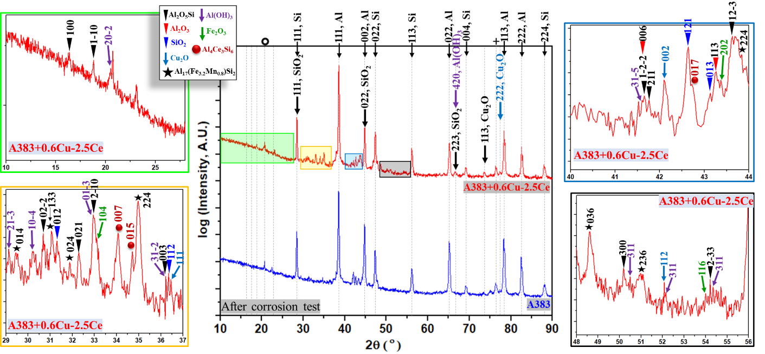
Figure 5: XRD scans of A383 and A383+0.6Cu+2.5Ce after corrosion showing the peaks of oxides and hydroxides including Al₂O₅Si, Al₂O₃, SiO₂, Cu₂O, and Al(OH)₃. Selected areas are magnified to help with oxide identification.

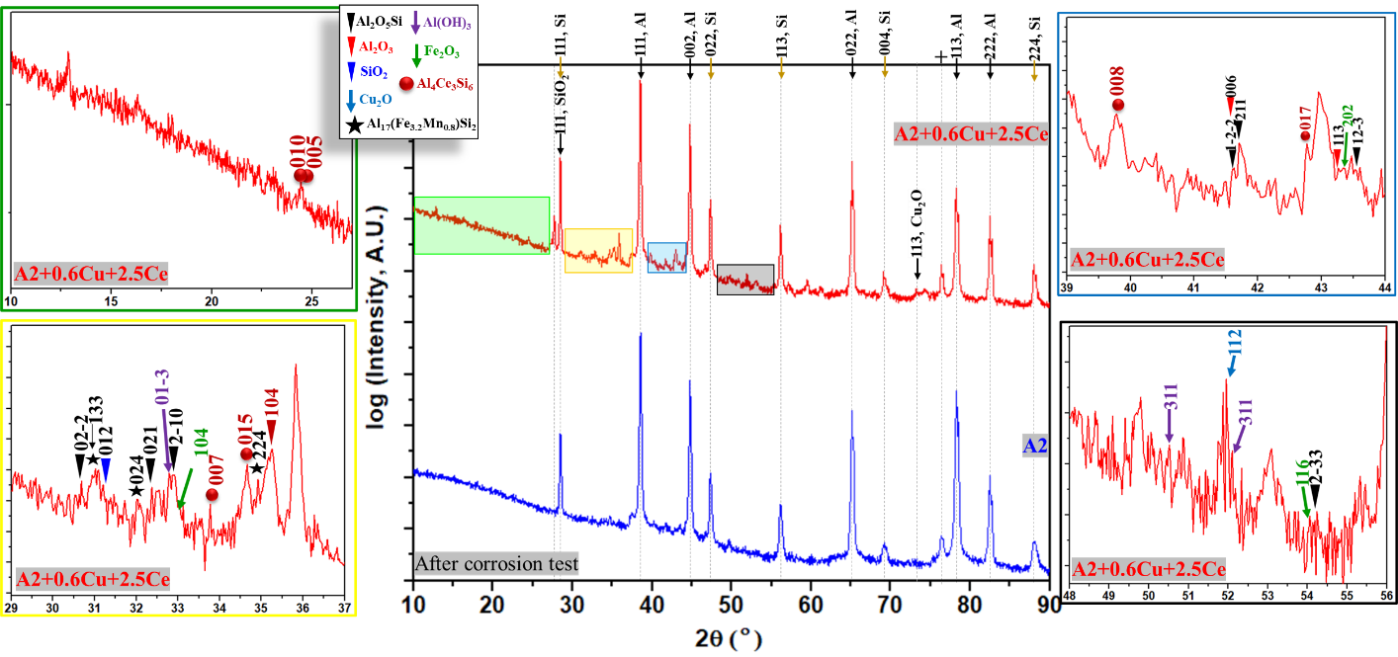
Figure 6: XRD scans of A2 and A2+0.6Cu+2.5Ce, showing peaks of major uncorroded phases and oxides present. Selected areas are magnified to help with oxide identification.

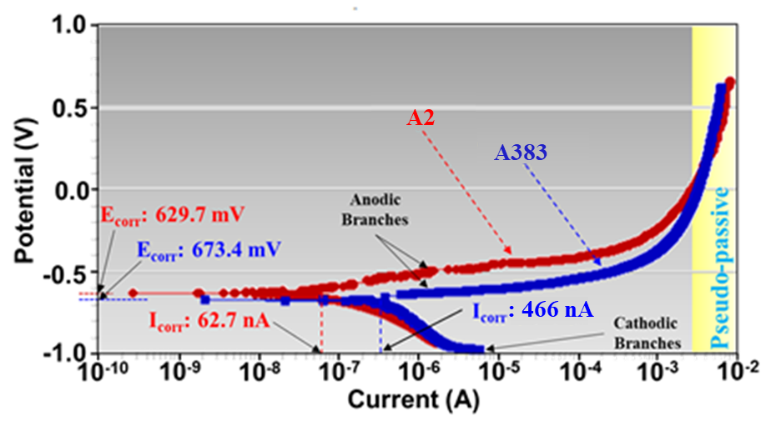
Figure 7: Tafel curves for A383 and A2 depicting the cathodic and anodic branches along with the relative E_{corr} and I_{corr} values. The lower I_{corr} value and raised shape of the anodic branch of A2 shows the alloy's higher resistance to corrosion compared to A383.

The anodic and cathodic branches of the Tafel plots appear due to oxidation and reduction, respectively. Ionization and electrochemical reactions associated with Al₂O₃, SiO_{2,} and Al₂O₅Si are included below.

NaCl → Na⁺ + Cl¯ …………………………………………….………… (3)
3H₂O → 3H⁺ + 3OH¯ …………………………………..………………… (4)
2Al → 2Al³⁺ + 6e¯ (oxidation reaction, at anode) ………..……………… (5)
6H⁺ + 6e¯ → 3H₂ (reduction reaction, at cathode) ………….…………… (6)
2Al³⁺ + 6OH¯ → 2Al(OH)₃ …………………………………….………… (7)
2Al(OH)₃ → Al₂O₃ + 3H₂O ……………………………………………… (8)
Si → Si⁴⁺ + 4e¯ ………………………………………....………………… (9)
Si⁴⁺ + 4OH¯ → SiO₂ + 2H₂O …………………………………………….. (10)
4Al³⁺ + 2Si⁴⁺ + 10OH¯ → 2Al₂O₅Si + 5H₂ ……………….……………… (11)

The electrochemical reactions associated with Al₂O₃, SiO_{2,} and Al₂O₅Si are represented based on the major oxides identified using XRD and reported work [85]–[88]. The oxides identified using XRD suggest the presence of Al³⁺, Si⁴⁺, Cu^{2+,} and Fe³⁺ as the major cations formed during the electrochemical reaction.

PDP measurements for the A383 and A2 samples with Cu and Ce additions were also performed. The measured values of I_{corr}, E_{corr,} and corrosion rate (Table 4) show an increase in corrosion rate and corrosion current over the base alloy after the addition of Cu followed by decrease in both values resulting from Ce additions of up to 1.5 wt. %. However, potentiodynamic curves for the A383 and A2 after the Cu and Ce additions, Fig. 8a and Fig. 8b, respectively, show the corrosion resistance decreases with increasing Ce additions beyond 1.5 wt. % Ce (see measured I_{corr}, E_{corr} and corrosion rate Fig. 8c and 8d). The rise in the corrosion rate for Ce additions beyond 1.5 wt. % is possibly caused by the formation of a higher fraction of the needle shaped Ce-containing phase. This needle shape phase increases the interfaces in the microstructure which can be additional sites for corrosion attack. Additional investigation is needed to confirm the controlling mechanism for increased corrosion in high Ce-content alloys. Regardless, the results show that Cu plays a significant role in degrading the alloy corrosion resistance in NaCl solution and the controlled addition of Ce provides an avenue to mitigate this degradation. The negative effects of Cu on the corrosion resistance of Al-alloys has been extensively reported in literature [31], [33], [38], [89].

NaCl salt fog response of A383 and A2 and after Cu and Ce addition

The microstructure of A383 and A2 with different amounts of Cu and Ce additions are shown in Fig. 9 and Fig. 10, respectively. EDS point scans (Table 5) were conducted in regions of Si segregation, near the interfaces of Ce-rich phases, and the interfaces of Al(FeMn)Si phases for comparison with the XRD determination of the oxides present. The areas most sensitive to corrosion were found to be the intergranular regions rich in the Si for the base A383 alloy.
Table 4: Measured values for I_{corr}, E_{corr,} and Corrosion rates from the PDP tests.
Calculated parameters | A383 with Cu and Ce additions
Sample | A383 | 0.6Cu | 0.6Cu+0.5Ce | 0.6Cu+1Ce | 0.6Cu+1.5Ce | 0.6Cu+2Ce | 0.6Cu+2.5Ce
I_{corr} (nA) | 466.0 | 483.6 | 308.0 | 267.0 | 251.0 | 440.0 | 916.0
E_{corr} (mV) | -673.4 | -657.3 | -585.0 | -646.0 | -631.0 | -614.0 | -643.0
Corrosion rate (mpy) | 0.71 | 0.30 | 0.47 | 0.40 | 0.38 | 0.67 | 1.39
 | A2 with Cu and Ce additions
Sample | A2 | 0.6Cu | 0.6Cu+0.5Ce | 0.6Cu+1Ce | 0.6Cu+1.5Ce | 0.6Cu+2Ce | 0.6Cu+2.5Ce
I_{corr} (nA) | 62.70 | 91.20 | 60.90 | 48.50 | 30.20 | 64.40 | 97.50
E_{corr} (mV) | -629.7 | -686.0 | -727.0 | -664.0 | -680.0 | -700.0 | -724.0
Corrosion rate (mpy) | 0.09 | 0.14 | 0.09 | 0.07 | 0.05 | 0.10 | 0.15

Specimens | Corrosion sites | Chemical composition (wt.%)
A383 | Segregated Si-rich regions | Sn:0.63 O:33.9 Balance: Other
  Al:38.21 | Cu:2.83 | Si:23.2 | Zn:0.87
A383+0.6Cu+2.5Ce | Close to the interface of Ce-containing phase | Sn:0.15 O:51.3 Balance: Other
  Al:47.48 | Ce:0.4 | Cu:1.08 | Si:0.38
A2 | Segregated Si-rich regions | Balance: Others
  Al:48.44 | Si:35.03 | Mn:0.22 | O:16.09
A2+0.6Cu+2.5Ce | At the interface of Al(FeMn)Si | O:7.51 Mn:0.18 Balance: Other
  Al:44.72 | Cu:0.3 | Si:46.89 | Mg:0.2
A2+0.6Cu+2.5Ce | At the interface of Ce-containing phase
  Al:38.09 | Ce:26.34 | Cu:0.9 | Si:18.22
  Fe:0.66 Mg:0.42 Mn:2.65 O:12.6 Balance: Other
Table 5: EDS data from various locations showing the composition of corrosion products.

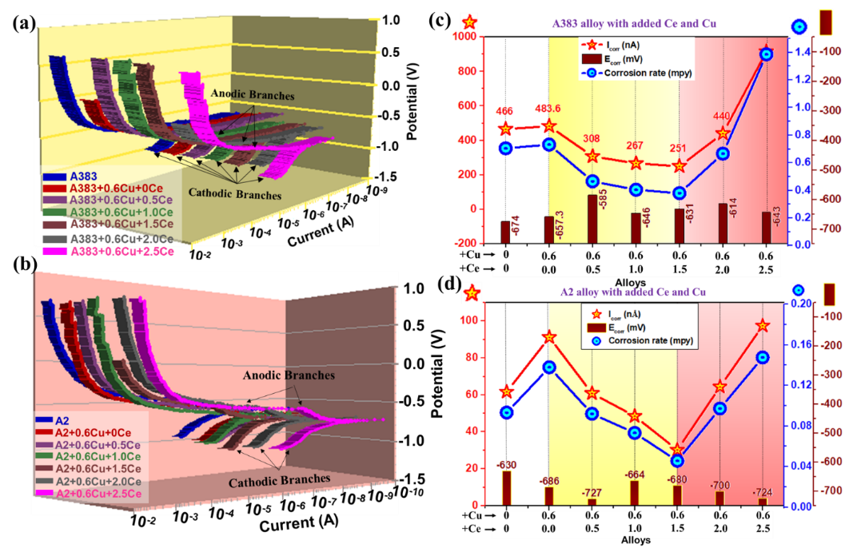
Figure 8: Potentiodynamic curves for alloys (a) A383 with Cu and Ce additions and (b) A2 with Cu and Ce additions, and measured E_{corr}, I_{corr,} and corrosion rate for (c) A383 with Cu and Ce additions and (d) A2 with Cu and Ce additions. Corrosion rate decreased in both alloys with Ce additions up to 1.5 wt.% Ce after Cu was added. Further additions of Ce caused the corrosion rate to increase.
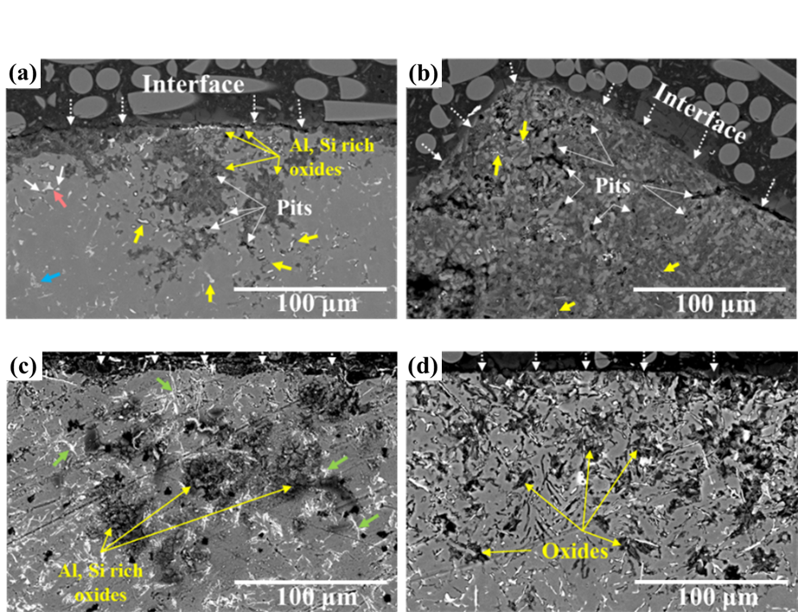
Figure 9: BSE micrographs of corroded samples (a) A383, (b) A383+0.6Cu, (c) A383+0.6Cu+1.5Ce, and (d) A383+0.6Cu+2.5Ce after salt fog exposure for 1800 hrs showing oxides and corrosion pits resulting from the experiment.

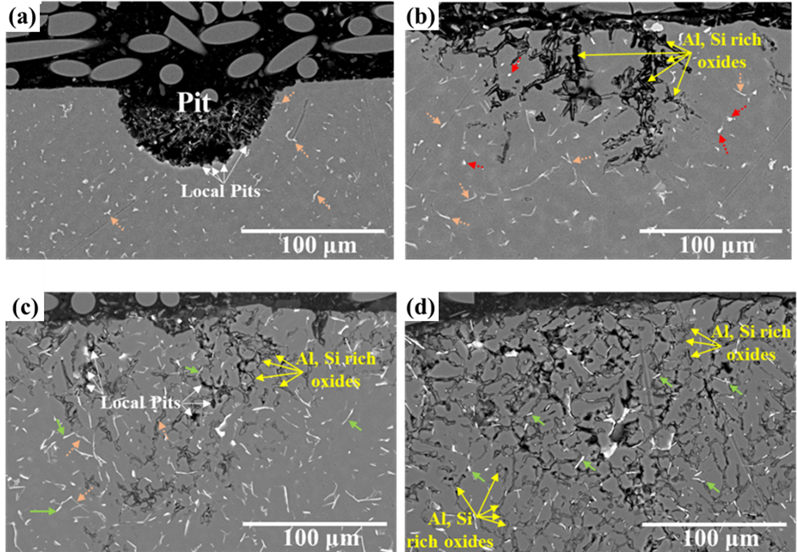
Figure 10: BSE micrographs of corroded samples (a) A2, (b) A2+0.6Cu, (c) A2+0.6Cu+1.5Ce, and (d) A2+0.6Cu+2.5Ce after salt fog exposure for 1800 hrs showing oxides and corrosion pits resulting from the experiment.

Some Al(FeMn)Si phases persisted through the salt fog exposure indicating some degree of stability; however, they have the potential to form local cells and develop corrosion product at their interfaces causing further damage [58], [90], [91]. Oxides percentage and pits size and amount greatly increased with the addition of 0.6 wt. % Cu, which is in good agreement with PDP results. The Ce-rich phases appear to be largely unaffected by the salt fog exposure, and slows the progression of corrosion damage while the intermetallics are discontinuous. However, with increased Ce-content, the interconnectivity of the intermetallic increases, and corrosion damage becomes more pronounced, suggesting the limiting factor for effective Ce-addition is the fraction of and interconnectivity of the Ce-containing intermetallic phases.

Alloy A2 showed a higher resistance to corrosion due to the lower amount of Cu; but, intergranular corrosion has been observed in the alloy. Additionally, minor surface pitting was observed in the Al matrix caused by casting inhomogeneities in an area with negligible Cu and low interconnectivity of intermetallics to provide a pathway for corrosion to progress. After the addition of 0.6Cu, corrosion sensitivity increased due to segregation of Cu in the interdendritic (Si-rich) regions and higher damage was observed along within them, although not as severe as A383 due to the lower Cu and Fe content. The two major intermetallics shown in the micrographs (Fig. 10c and 10d) of the alloys A2+0.6Cu+1.5Ce and A2+0.6Cu+2.5Ce, are Al(FeMn)Si and AlCeSi(Cu, Fe, Mn). These phases are believe to play a key role in inhibiting corrosion dependent on their shape and distribution [92]–[94]. Segregation of Cu, Fe and Si at the interface of these phases act as potential sites for local corrosion pits to form. As interconnectivity of these phases increase, so does the potential for further corrosion damage, similar to that seen in A383. Corrosion damage seen in A2 was also more extensive in areas of Si segregation as seen in A383. These results indicate a threshold addition of 1.5 wt. % Ce to be beneficial for corrosion performance in the alloys tested.

Corrosion depth measurements (Fig. 11) for all samples are in good agreement with the corrosion rates calculated from the PDP tests for both alloys, with the exception of the 0.6Cu+2.5Ce alloys, which showed a lower maximum corrosion depth than the 0.6Cu+2Ce alloys. It is believed the higher interconnectivity of the Ce-rich intermetallics yields a higher measured corrosion rate in the PDP tests, while in salt fog exposure, microstructural analysis suggests that the corrosion mode has changed from intergranular to planar corrosion due to the Ce-containing intermetallic distribution. The highest corrosion depth for both alloys was seen after 0.6 wt.% Cu addition (no Ce addition), which clearly illustrates the degradation that Cu impurities have on alloy corrosion resistance. The lowest corrosion depths were observed in A383+0.6Cu+2.5Ce and A2+0.6Cu+1Ce; however, the extent of corrosion damage observed in the microstructure of A383+0.6Cu+2.5Ce was much greater compared to the same A3830.6Cu+1.5Ce alloy. Similar behavior was seen for the A2+0.6Cu+1Ce, which had higher damage overall compared to the A2- 0.6Cu+1.5Ce alloy.

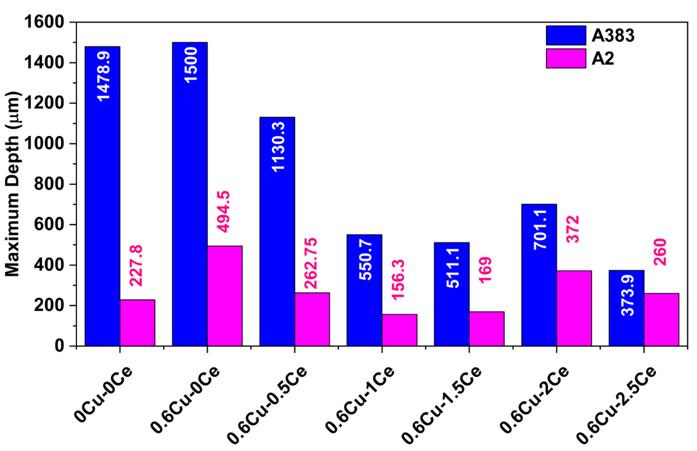
Figure 11: Maximum measured corrosion depths for all tested samples from SEM micrographs. The blue and pink bars correspond to A383 and A2 samples respectively.

Mechanisms behind the corrosion and corrosion products formation

Corrosion products formed due to NaCl salt solution exposure was characterized using EDS and XRD; while the spatial extent of the corrosion products was identified using BSE micrographs. Based on our findings and reported literature, a schematic diagram representing the phenomena of degradation is displayed in Fig. 12. The formation of corrosion products and their locations are shown in the diagrams to understand the mechanisms driving the formation of corrosion pits, cracks, and corrosion products (Fig. 12a, 12b and 12c). Because of the NaCl salt solution, ionization occurs at the alloy and solution interface. Most of the Al form Al2O3, which will protect the specimen from further corrosion because of its passive nature. However, in the presence of precipitates and other segregated elements, local electrochemical cells are formed, causing the initiation of the damage from their interface. Si-rich regions, Ce-rich intermetallics and Al(FeMn)Si with differing potentials lead to the initiation of damage. These phenomena are schematically shown in Fig. 12a, 12b, and 12c, respectively. Prior work indicates, cathodic behavior of Al(FeMn)Si with an Al-matrix leads to the dissolution of Fe⁺³ and Si⁺⁴ ions, though at a slow rate due to structural complexity [95]. Ce-rich intermetallics show a similar behavior but forms Ce₂O₃ near the interface which retards ion activity and improves overall corrosion resistance [93]. Segregated Cu and Fe at the interface can promote localized corrosion in the case of Ce-rich intermetallics as well. The onset of corrosion due to the NaCl solution begins in areas with segregated Si and Cu in the interdendritic regions and the interface of Ce-based intermetallic and Al(FeMn)Si phases interface. These regions with higher concentrations of Cu, Si and Fe are more prone to ionization due to their tendency to form localized cells which drive the formation of corrosion products such as Al₂O₅Si, Al₂O₃, SiO₂, Cu₂O, and Al(OH)₃. The phenomena presented by the schematic diagram is validated through BSE micrographs, shown in Fig. 12d and 12e for the A383+0.6Cu+2.5Ce and A2+0.6Cu+2.5Ce, respectively. The disagreement between the corrosion rates obtained by PDP testing and observed corrosion depths seen in the salt fog experiment has been found elsewhere in the literature for both Al and Mg alloys [76, 77]. This result is the determined of two phenomena. As corrosion pits form, the solution within the pits become more acidic and becomes stagnant. Then, the application of an external potential in the range spanned by the PDP testing causes Al to actively corrode instead of forming a passivating oxide layer as interpreted by the pourbaix diagram for Al [65].

Conclusion
Two Al-Si based die-casting alloys with and without Cu and Ce additions beyond the base alloy composition were cast to produce a microstructure comparable to die casting. The alloys were subjected to PDP testing and salt fog exposure to determine the corrosion response. From this work, we conclude:

- Both alloys show good castability, however, A2 showed higher corrosion resistance compared to A383 due to its lower Cu content.
- Both alloys consist of α-Al (Al-Si alloy), segregated Si, and varieties of aluminides including Al(FeMn)Si, Al₂Cu, and AlCeSi. The formation of these aluminides
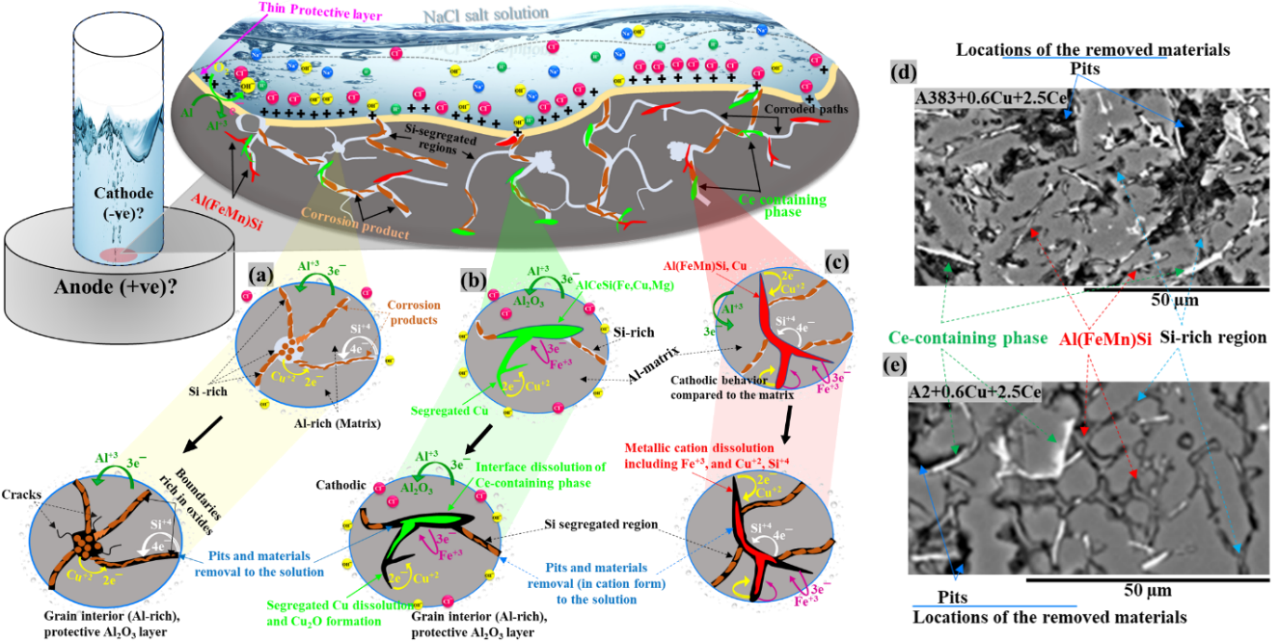
Figure 12: Schematic diagram representing corrosion phenomena including formation of corrosion products and local cell formation at (a) Si-rich segregated regions, (b) interfaces of Ce-rich phases and Al-matrix, (c) corrosion response at the interface of Al matrix and Al(FeMn)Si (d) BSE micrographs of A383+0.6Cu+2.5Ce and (e)BSE micrographs of A2+0.6Cu+2.5Ce.

causes segregation of other elements including Cu, Mg, and Si to the interdendritic regions which increase corrosion sensitivity.
- Ce is highly reactive with elements such as Cu and Fe which can lead to “gettering” these impurities and promoting corrosion resistant intermetallic structures. This mitigates their negative effects on corrosion performance of the alloy. The suppressed activity of Cu leads to a decrease in values for I_{corr} and corrosion rate.
- Ce addition up to 1.5 wt. % causes a decrease in the corrosion rate for both alloys; whilefurther additions up to 2.5 wt. % causes the corrosion mode to change from intergranular to planar.
- The interface of the Al(FeMn)Si and Ce-rich phases are sensitive to corrosion resulting in localized pits and corrosion product formation at their interfaces, however, Ce offers better protection against intergranular corrosion.
- Exposure to NaCl salt solution causes oxide formation including Al₂O₅Si, Al₂O₃, SiO₂, Cu₂O, and Al(OH)₃ as corrosion products.
- The addition of the Ce is an effective alloying strategy for the design of corrosion resistant Al-alloys that can be recycled.

References
[1] S. K. Das, J. A. S. Green, and J. G. Kaufman, “The development of recycle-friendly automotive aluminum alloys,” JOM, vol. 59, no. 11, pp. 47–51, Nov. 2007, doi: 10.1007/s11837-007-0140-2.
[2] R. S. Long, E. Boettcher, and D. Crawford, “Current and Future Uses of Aluminum in the Automotive Industry,” JOM, vol. 69, no. 12, pp. 2635–2639, Dec. 2017, doi: 10.1007/s11837-017-2554-9.
[3] D. Adamović, T. Vujinović, F. Živić, J. Živković, and M. Topalović, “Application of Aluminum and ITS Alloys in the Automotive Industry With Special Emphasis PN Wheel Rims,” JTTTP - J. TRAFFIC Transp. THEORY Pract., vol. 6, no. 2, Oct. 2020, doi: 10.7251/JTTTP2102087A.
[4] S. Montijo, “What is Aluminum Used for: Automotive Edition,” Kloeckner Metals Corporation, Apr. 28, 2021. https://www.kloecknermetals.com/blog/what-is-aluminum-used-for-automotive-edition/ (accessed Feb. 27, 2023).
[5] “Mineral commodity summaries 2022,” Reston, VA, Report 2022, 2022. doi: 10.3133/mcs2022.
[6] “Energy and Exergy Analysis of the Primary Aluminum Production Processes: A Review on Current and Future Sustainability.” https://www.tandfonline.com/doi/epdf/10.1080/08827508.2010.530721?needAccess=true&role=button (accessed Feb. 27, 2023).
[7] “Secondary Production 101 | The Aluminum Association.” https://www.aluminum.org/secondary-production-101 (accessed Feb. 01, 2023).
[8] J. Cui and H. J. Roven, “Recycling of automotive aluminum,” Trans. Nonferrous Met. Soc. China, vol. 20, no. 11, pp. 2057–2063, Nov. 2010, doi: 10.1016/S1003-6326(09)60417-9.
[9] “Corrosion pathways in aluminium alloys | Elsevier Enhanced Reader.” https://reader.elsevier.com/reader/sd/pii/S1003632617600062?token=4D0C329475B4787368ADF678F2BF36E51334239FBE6728318083162A7AFF2A33BA691C1127393038CD8FCDAAA45E0C46&originRegion=us-east-1&originCreation=20230228012014 (accessed Feb. 27, 2023).
[10] R. Zhang, N. Birbilis, S. Knight, R. Holtz, R. Goswami, and C. Davies, “A Survey of Sensitization in 5xxx Series Aluminum Alloys,” Corrosion, vol. 72, p. 150903122215004, Sep. 2015, doi: 10.5006/1787.
[11] L. Kuchariková, T. Liptáková, E. Tillová, D. Kajánek, and E. Schmidová, “Role of Chemical Composition in Corrosion of Aluminum Alloys,” Metals, vol. 8, no. 8, p. 581, Jul. 2018, doi: 10.3390/met8080581.
[12] J. T. Staley, “Corrosion of Aluminium Aerospace Alloys,” Mater. Sci. Forum, vol. 877, pp. 485–491, Nov. 2016, doi: 10.4028/www.scientific.net/MSF.877.485.
[13] E. T. Stromme et al., “Ageless Aluminum-Cerium-Based Alloys in High-Volume Die Casting for Improved Energy Efficiency,” JOM, vol. 70, no. 6, pp. 866–871, Jun. 2018, doi: 10.1007/s11837-018-2861-9.
[14] Z. C. Sims et al., “High performance aluminum–cerium alloys for high-temperature applications,” Mater Horiz, vol. 4, no. 6, pp. 1070–1078, 2017, doi: 10.1039/C7MH00391A.
[15] D. Weiss, “Composites and Alloys Based on the Al-Ce System,” in Aluminium Alloys and Composites, K. O. Cooke, Ed. Rijeka: IntechOpen, 2019. doi: 10.5772/intechopen.89994.
[16] F. Czerwinski, “Cerium in aluminum alloys,” J. Mater. Sci., vol. 55, no. 1, pp. 24–72, Jan. 2020, doi: 10.1007/s10853-019-03892-z.
[17] E. E. Moore et al., “Thermodynamic Modeling of the Al-Ce-Cu-Mg-Si System and Its Application to Aluminum-Cerium Alloy Design,” J. Phase Equilibria Diffus., vol. 41, no. 6, pp. 764–783, Dec. 2020, doi: 10.1007/s11669-020-00852-y.
[18] W. E. Mercer and J. E. Hillis, “The Critical Contaminant Limits and Salt Water Corrosion Performance of Magnesium AE42 Alloy,” in International Congress & Exposition, Feb. 1992. doi: https://doi.org/10.4271/920073.
[19] N. E. Ryan, “An appraisal of possible scavenger elements for chromium and chromium alloys,” J. Common Met., vol. 6, no. 1, pp. 21–35, Jan. 1964, doi: 10.1016/0022-5088(64)90005-0.
[20] Y. F. Yang, S. D. Luo, G. B. Schaffer, and M. Qian, “Impurity scavenging, microstructural refinement and mechanical properties of powder metallurgy titanium and titanium alloys by a small addition of cerium silicide,” Mater. Sci. Eng. A, vol. 573, pp. 166–174, Jun. 2013, doi: 10.1016/j.msea.2013.02.042.
[21] Z. C. Sims et al., “Cerium-Based, Intermetallic-Strengthened Aluminum Casting Alloy: High-Volume Co-product Development,” JOM, vol. 68, no. 7, pp. 1940–1947, Jul. 2016, doi: 10.1007/s11837-016-1943-9.
[22] Z. C. Sims et al., “How Cerium and Lanthanum as Coproducts Promote Stable Rare Earth Production and New Alloys,” J. Sustain. Metall., vol. 8, no. 3, pp. 1225–1234, Sep. 2022, doi: 10.1007/s40831-022-00562-4.
[23] H. B. Henderson et al., “Ternary Interactions and Implications for Third Element Alloying Potency in Al–Ce-Based Alloys,” in Light Metals 2020, A. Tomsett, Ed. Cham: Springer International Publishing, 2020, pp. 227–232. doi: 10.1007/978-3-030-36408-3_32.
[24] Z. C. Sims et al., “Application of Ce for scavenging Cu impurities in A356 Al alloys,” Eur. J. Mater., vol. 1, no. 1, pp. 3–18, Jan. 2021, doi: 10.1080/26889277.2021.1974801.
[25] A. V. Iyer, H. Lim, O. Rios, Z. Sims, and D. Weiss, “An Economic Model and Experiments to Understand Aluminum-Cerium Alloy Recycling,” JOM, vol. 70, no. 4, pp. 547–552, Apr. 2018, doi: 10.1007/s11837-018-2764-9.

Chapter III: Conclusion

Summary
In this work, two Al-Si based die-casting alloys, A383 and Aural 2, with Cu and Ce additions were investigated to determine the effectiveness of Ce at mitigating the negative effects of elevated Cu impurities on corrosion performance in a 5% salt-fog environment. The additional Cu added to the base alloys gave rise to a noticeable increase in corrosion products along grain boundaries, and overall corrosion depth. The increased corrosion rate was found to be a result of the formation of local galvanic cells formed between Cu containing compounds and the denuded zones of the Al matrix along the grain boundaries. When Ce was added, the Ce-containing phases that formed appeared to be acting anodically to the matrix, preferentially corroding the phase rather than the matrix, though empirically at a much slower rate than the Cu containing phases present without Ce additions. The incremental reduction of corrosion depth with increasing Ce additions confirms previous work reporting the scavenging ability of unfavorable impurities such as Cu and Fe by Ce additions that are deleterious to the corrosion performance of Al alloys. The interconnectivity of the Ce containing phases appeared to play a role in the extent of corrosion damage near the exposed surface, However, this work found that the maximum measured corrosion depth was further reduced with increasing Ce additions. This finding was more pronounced in the A2 alloy which has a tight tolerance of Cu to meet the composition specifications. The Ce-containing phases also acted as a local corrosion inhibitor, reducing further corrosion damage of the Al matrix around the intermetallics at grain boundaries. The findings in this work warrant further characterization of the Ce-containing phases to confirm the extent of protection against corrosion provided by these phases.

Broader impact
The intentional addition of Ce to commercial Al-alloys have been shown to be a viable method for scavenging impurity elements. Due to its lack of commercial use, Ce additions could be an economical alloying addition capable of removing impurities that reduce corrosion resistance while largely preserving mechanical performance, which would enable the use of less costly feedstocks when producing subsequent alloys. Since only small additions are required to scavenge impurities, this makes Ce an attractive option to mitigate the negative effects while maintaining or improving the recyclability of the alloy. However, in a sense, Ce itself is another impurity, and will likely have some impact on properties and performance of the materials to which it is added. Further, Ce-containing Al-alloys will inherently find their way into recycling streams, affecting the properties of recycled alloys. It is therefore imperative to understand the effect of Ce on the properties of Al-alloys such as tensile strength, ductility, and fatigue life in order to determine the long-term viability of Ce-additions as a scavenging alloying addition.

The economic impacts of using Ce to remove impurities from Al alloys could be significant, especially when considering the increased usage of Al in the automotive industry to reduce weight and increase fuel efficiency. Moreover, this application for Ce would generate more value for the material considering it is currently seen as a waste product of rare-earth mining. The ability to use lower cost feedstock to make components of automobiles would both make them cheaper to produce and improve longevity of the components made for these applications. Using more secondary Al for these components would have a significant impact on the amount of greenhouse gas emissions generated due to the reduced energy requirements compared to primary Al production coupled with more fuel-efficient vehicles. Additionally, since the vast majority of primary Al is produced in other countries, the reduced dependency on primary Al imports could have societal benefits stemming from a higher percentage of domestic supply usage. Further, Ce can be domestically sourced as well, which could lead to fewer imports on the material used to reduce primary Al imports as well as the material that could make this effort a possibility.

Future work
The present work demonstrated the beneficial effects of Ce additions on corrosion resistance of two commercial Al-alloys and their tolerance of impurities elements, but their effects on other properties are not yet known. Further, additional environmental corrosion experiments (ISO 12044-9) are suggested to better mimic the actual environment these alloys would be exposed to, such as varying temperature, pH, UV exposure and humidity. More aggressive corrosion techniques such as intergranular attack tests (ASTM G110) could be performed to better understand the degree of corrosion resistance Ce-rich phases provide along grain boundaries in contrast to those present in the absence of Ce. Additional PDP measurements should be performed on single crystals of the AlCeSi and AlCeCu type intermetallics found in the alloys after Ce additions to determine the corrosion resistance of each phase. These tests would allow a better understanding of the alloys’ corrosion performance by determining the corrosion rate and corrosion potential of the phases that form in grain boundaries where the majority of damage occurs. Longer PDP tests should be performed on the alloys from the paper to determine which oxides form first and the relative amount of each. These tests along with X-ray Photoelectron Spectroscopy (XPS) would give a more complete picture of the degree of protection the different Ce-containing phases contribute to the bulk alloy compared to the phases present before Ce additions.

Tensile and bend tests of the alloys investigated in this work before corrosion should be conducted to ensure tensile strength and ductility are preserved or determine to what degree they’ve been affected by the Ce additions. Considering that Cu is an impurity that would be undesired in alloys like Aural 2 or A356, it would be unexpected to lose strengthening due to the lack of solid solution or precipitation strengthening by Cu. Further, small amounts of Ce (<1 wt. %) may have beneficial effects on strength and should be further investigated. The fatigue performance of these alloys after Ce additions should also be investigated to determine how the Ce-rich intermetallics that form at grain boundaries affect fatigue life compared to those present in the alloy prior to Ce additions, since Al alloys are used extensively in the automotive industry where long-term performance is necessary.

This work could also be extended to other Al alloys used in applications, where exposure to salts are inevitable, that require higher cost or virgin material as feedstock to produce the alloy due to maximum tolerances of impurity elements that Ce could react with. One possibility would be small additions to 5000 series alloys such as 5083 used in marine applications where sensitization due to dissolution of Mg phases at grain boundaries is an issue. Ce phases could disrupt the continuity of these phases to prevent or reduce corrosion damage in these areas. Another system to investigate are the 2000 series alloys used for structural components across various commercial sectors that typically require a cladding to resist corrosion due to their high Cu content.

VITA

Michael Thompson, a Cleveland, Tennessee native, graduated high school in 2007. After working several trades, including being a butcher for nearly a decade, he decided he should return to college in order to provide more financial stability for his wife and two children. Having a natural love of math and science, he intended to pursue an undergraduate degree in Aerospace Engineering at the University of Tennessee-Knoxville after completing his Associates of Science at Cleveland Community College. After his first internship, he discovered Materials Science and Engineering and became more interested in material properties. Knowing he wanted to get a graduate degree as well, he decided the best path for him was to pursue a Master of Science in Materials Science and Engineering. His research interests include aluminum metallurgy and the development of new Al-Ce based alloys, which then evolved into the effects of Ce additions on the mechanical properties of existing alloys. After graduation, he will begin his new position as a Technical Professional at Oak Ridge National Laboratory. During his undergraduate and graduate career, he has had the pleasure of working with extremely supportive graduate students and post-docs that were instrumental to his success. He is incredibly grateful for all of the support from family and peers as he begins this next chapter of his life.

