A Radical Generation: High Temperature Ammonia Treatments of Carbon Felt Electrodes for Vanadium Redox Flow Batteries

A Dissertation Presented for the
Doctor of Philosophy
Degree
The University of Tennessee, Knoxville

Kaycee Madeline Gass
May 2025

Copyright © 2025 by Kaycee Madeline Gass
All rights reserved.

ACKNOWLEDGEMENTS
I extend deep gratitude to my advisor, Dr. Mench, for giving me the opportunity and resources to explore such an interesting problem. His guidance and confidence, both scientifically and professionally, are appreciated. I am grateful to Dr. Aaron for his mentorship and the time he spent enthusiastically explaining batteries to me. Thank you to my other committee members, Dr. Kihm and Dr. Rawn for their expertise and encouragement. I appreciate my lab mates for their companionship and advice. I will always remember the good conversations I had with them. My thanks to Clark for allowing me to bounce ideas off him and helping me maintain my sanity. I appreciate my Knoxville friends for making sure I was fed and healthy and keeping my spirits high. Thank you to my family for their love and support. Thank you to Dr. Meek for believing in me and introducing me to Dr. Mench. Financial support for this work was provided by the Condra Chair of Excellence (M. Mench) and the Tennessee’s Top 100 Fellowship.
ABSTRACT
The vanadium redox flow battery (VRFB) is a promising candidate for grid-scale energy storage. Modifying VRFB electrodes is one approach to improve overall battery performance and decrease costs. Research into improving these electrodes has included a focus of adding metallics or functional groups to the surface, even though they are easily swept away through physiochemical forces.
This dissertation explores a variety of physical characterization and experimental techniques and analyses to gain insight into the mechanisms around an effective and robust high temperature ammonia treatment on carbon felt electrodes for VRFBs. Initial work focused on the treatment time and temperature ranges of effectiveness and identifying the importance of the induced surface area of the electrode on performance. The work continued, focusing on pinpointing the mechanism behind the increase in surface area. It was found that at higher temperatures the ammonia gas decomposes into radicals which gasify the carbon. With this knowledge, methods of increasing rates of decomposition were developed with the goal of optimizing this approach to modification of electrodes for durable high-performance operation.
The main outcome of this dissertation is the determination of the mechanism of the ammonia treatment and a path to building upon it. The successful implementation of the radical theory through improving the kinetics of the radical generation and carbon removal with rough surfaces and nickel foam, resulting in improved battery performance beyond the baseline ammonia treatment, demonstrates the efficacy of the theory. This also opens avenues of research to improve electrodes by material removal rather than solely adding material, though combining the two methods is also a viable path. Experiments with high temperature nitrogen gas following high temperature ammonia also show promise. Revitalizing the optimization efforts for this component will increase the viability of VRFB technology. This scalable treatment could also be useful for carbon applications where higher porosity and surface area is beneficial, such as purification and poison control.

Table of Contents
Chapter One Introduction 1
1.1 Motivation 1
1.2 Flow battery overview 3
1.3 Electrodes 6
1.3.1 Graphite electrodes 6
1.3.2 Graphite electrode treatments 6
1.3.3 Graphite surface features 10
1.3.4 Ammonia 12
1.3.5 Outlook and motivation 14
1.4 Method of approach 14
1.5 Chapter preview 16
Chapter Two Method of approach 17
2.1 Treatment of materials 17
2.2 Physical characterization 17
2.2.1 SEM 17
2.2.2 EDS 17
2.2.3 Raman spectroscopy 17
2.2.4 XRD 18
2.2.5 FTIR 18
2.3 Electrochemical characterization 18
2.3.1 Battery cell testing conditions 18
2.3.2 EIS 20
2.3.3 Polarization curves 20
2.3.4 Charge-discharge cycling 20
Chapter Three High performance vanadium redox flow battery electrode via high-temperature ammonia treatment 21
Abstract 22
3.1 Introduction 22
3.2 Results and discussion 23
3.2.1 Characteristics of treated and untreated samples 23
3.2.2 Electrochemical properties 29
3.3 Conclusions 39
Chapter Four A radical generation: Investigating mechanism and outcome of ammonia treated carbon felt electrodes for vanadium redox flow batteries 41
Abstract 42
4.1 Introduction 42
4.2 Experimental methods 43
4.3 Results and discussion 43
4.3.1 Characteristics of treated and untreated samples 43
4.3.2 Electrochemical properties 54
4.3.3 Proof of radicals 62
4.4 Conclusions 70
Chapter Five Inducing radical generation of ammonia for carbon felt electrodes for vanadium redox flow batteries 73
Abstract 74
5.1 Introduction 74
5.2 Experimental methods 75
5.3 Results and discussion 75
5.3.1 Rough and smooth tube treatments 75
4.3.2 Nickel treatment 76
5.4 Conclusions 79
Chapter Six High temperature nitrogen post treatment of carbon felt electrodes 82
Abstract 83
6.1 Introduction 83
6.2 Results and discussion 83
5.2.1 Characteristics of treated materials 83
6.2.2 Electrochemical properties 90
6.4 Conclusions 90
Chapter Seven Conclusions and recommendations 94
7.1 Summary of state of the art 94
7.2 Summary of work 94
7.3 Recommendations 95
7.3.1 Optimizing treatment parameters 95
7.3.2 Improving ammonia decomposition kinetics 95
7.3.3 Investigating post-treatments 96
7.3.4 Investigating other radical treatments 96
7.3 Overall conclusions and outlook 97
References 98
Vita 114

LIST OF TABLES
Table 3.1. Disorder-to-order ratio of carbon felt samples; note that the 0.0 hr treatment time corresponds to untreated carbon felt. 28
Table 3.2. Charge transfer resistance of electrode samples. 31
Table 3.3. Current density at 80% voltage efficiency and 50% charge. 36
Table 3.4. Average efficiencies of electrodes. 38
Table 4.1. Select normalized FTIR spectra peak intensity values. 53
Table 4.2. Percent increase in current density of treated samples to untreated samples. 61
Table 4.3. Percent decrease of voltage efficiency at 150 mA/cm² after 100 charge-discharge cycles. 64
Table 5.1. ECSA, charge transfer resistance, and current density results of standard versus nickel foam conditions. 80
Table 6.1. Select normalized FTIR spectra peak intensity values. 88
Table 6.2. Charge transfer resistance, current density, graphitization, and electrochemical surface area results of standard versus nitrogen post-treatment conditions. 90

LIST OF FIGURES
Figure 1.1. Vanadium redox flow battery diagram 4
Figure 1.2. SEM images of a fiber from ammonia treated (left) and untreated (right) electrode. [41] 11
Figure 2.1. Diagram of experimental flow battery cell used in this work [3]. 19
Figure 3.1. SEM images at 200KX magnification of carbon felt electrodes: a) untreated, b) 30 min NH₃ treated at 900°C, c) 1-hour NH₃ treated at 900°C, d) 4 hours NH₃ treated at 900°C. Scale was identical for all micrographs. 24
Figure 3.2. SEM images of a carbon felt sample, treated with NH₃ for 1 hour at 900°C, at 30KX magnification before and after the beam was concentrated on the “blister.” 25
Figure 3.3. Raman spectroscopy and disorder ratio of carbon felt fiber samples. 27
Figure 3.4. Nyquist plot at open circuit of various electrode samples at 5 mV with electrolyte flowing. 30
Figure 3.5. Electrochemical surface area of electrodes over treatment time. 33
Figure 3.6. Polarization curve of samples showing current density at 80% voltage efficiency and 50% state of charge: a) original b) IR-corrected. Electrochemical surface area of electrodes over treatment time. 34
Figure 3.7. Voltage efficiency of samples cycled ten times at 40 mA/cm² and 65 mA/cm². 37
Figure 4.1. Experimental setup of treatment and HCN gas detection. NH₃ gas flows through the quartz tube in the furnace and exits via silver nitrate solution. The black object inside the quartz tube is representative of a carbon felt sample. 44
Figure 4.2. Mass loss percentage after each ammonia treatment; the yellow region indicates error range. Sample treated 4 hours at 1100°C in N₂ gas added for reference. 45
Figure 4.3. SEM images at 30KX magnification of carbon felt electrodes treated at different temperatures for 4 hours. 46
Figure 4.4. SEM images at 30KX magnification, 5 kV acceleration, of carbon felt treated at 1100°C immediately after treatment and one week after treatment. 48
Figure 4.5. SEM/EDS images taken at 15KX magnification, 15 kV acceleration, of carbon felt electrodes: a) untreated, b) 400°C, c) 700°C, d) 900°C, e) 1100°C. Atomic overlay of carbon (red), nitrogen (green), and oxygen (blue) from left to right. 49
Figure 4.6. Nitrogen and oxygen atomic percentages of treated samples. Note the 25°C treatment temperature signifies the untreated sample. 51
Figure 4.7. Normalized FTIR spectra of carbon felt samples. 52
Figure 4.8. Disorder-to-order ratio at different treatment temperatures. Note the 25°C treatment temperature signifies the untreated samples. 55
Figure 4.9. Diffraction peaks of carbon felt samples treated at different temperatures. Vertical line added to illustrate lack of diffraction peak shift. 56
Figure 4.10. Charge transfer resistance at different treatment temperatures. Note the 25°C treatment temperature represents the untreated samples. 57
Figure 4.11. Exchange current density and electrochemical active surface area of electrodes at different treatment temperatures. Note the 25°C treatment temperature signifies the untreated samples. 59
Figure 4.12. Current density at 80% voltage efficiency and 50% state of charge at different treatment temperatures. Note the 25°C treatment temperature signifies the untreated samples. 60
Figure 4.13. Voltage efficiency at different current densities and treatment temperatures. 63
Figure 4.14. Current density at 80% voltage efficiency (IR-corrected voltage) and 50% state of charge. ECSA versus order-to-disorder ratio of samples. 65
Figure 4.15. Samples generated during treatment by flowing outgas into silver nitrate solution. 67
Figure 4.16. Settled silver cyanide precipitates. 68
Figure 4.17. Diffraction peaks of white precipitate match reference pattern of AgCN. 69
Figure 4.18. Diagram of proposed primary reactions and effects of ammonia treatment. 71
Figure 5.1. Current density at 80% voltage efficiency of rough and smooth tubes samples. 76
Figure 5.2. Voltage efficiency of rough and smooth tubes samples. 77
Figure 5.3. SEM image at 30KX magnification, 3 kV acceleration, of carbon felt treated at 900°C in the presence of nickel foam. 78
Figure 5.4. Voltage efficiency of carbon felt sample treated in ammonia gas at 900°C versus that of a sample treated in equal conditions in the presence of nickel foam. 81
Figure 6.1. SEM images at 10KX-100KX magnification, 5 kV acceleration, of carbon felt treated at 900°C in ammonia gas for four hours, then at 900°C in nitrogen gas for one hour. 84
Figure 6.2. Comparison of diffraction peaks of carbon felt samples treated with ammonia versus with an additional treatment with nitrogen. 86
Figure 6.3. FTIR of post-treated sample compared to control samples. 87
Figure 6.4. Atomic percentage of sample compared to control sample. 89
Figure 6.5. Voltage efficiency of carbon felt sample treated in ammonia gas at 900°C versus that of a sample treated in equal conditions, but with an additional post-treatment with nitrogen gas. 91
Figure 6.6. Polarization curve comparison of best performing samples in each category of novel treatment. 92

Introduction

1.1 Motivation
While hydrocarbons are energy dense and widely applicable, the development of a variety of clean energy sources can advance energy independence. Solar, wind, hydropower, and nuclear are generally sustainable ways to generate electricity. Unfortunately, on their own, these options are intermittent (excepting nuclear) sources of energy.
Demand for energy storage is rapidly increasing due to the rise in renewable energy utilization and rapidly increasing grid level energy demand. Households and grids alike increasingly utilize solar and wind in electricity supply plans; but because solar and wind energy are intermittent, the introduction of these sources can destabilize the grid [e.g. [1, 2]]. Intermittent renewable generation can suffer from fluctuations that cannot currently be fully compensated for by existing load balancing mechanisms. Energy storage in massive capacity is needed to efficiently meet variable demand. Flow batteries are a versatile technology that have high potential to address the needs of grid energy suppliers. The vanadium redox flow battery (VRFB) is one of the most extensively studied in flow battery chemistry [e.g. [3, 4]]. Improvement of cost and durability for these systems is crucial to be competitive in the marketplace.
As the cost of silicon has dropped in recent years, solar photovoltaics (PV) have become more economically feasible. However, wind and solar are often not capable of meeting demand by consumers, especially as their peak production times may not match demand. Oftentimes their deficiencies are compensated by fossil fuel plants. In these cases, energy storage would allow for stabilization and consistency. The rapid replacement of fossil fuels with renewable energies necessitates high amounts of storage. For example, if fossil fuels were to be completely replaced by renewables in the state of Texas, almost 12 million MWh of storage would be required [5]. The United States does not yet have those capabilities. Any attempt to overhaul energy production systems in an efficient manner must include abundant storage capacity.
Hydropower and nuclear power are more stable than wind and solar but, if managed improperly, can be less efficient than desired. Hydropower production is only available in limited geographical regions. Nuclear is a reliable base load provider but is slow to adjust output, forcing plants to maintain a high output, resulting in wasted power and increased cycling costs [6]. These are examples of the wider problem of inefficiency in modern electrical grids. Due to fluctuations in energy needs throughout the day and the week, plants must adjust their output accordingly. Many providers have little to no energy storage incorporated in their grid system. Part of the mission of the Grid Modernization Initiative through the Department of Energy (DOE) includes a dedication to improved reliability for everyday operation, superior flexibility to respond to the variability and uncertainty of conditions, and increased sustainability through energy-efficient and renewable resources [7]. If these goals are to be met, inexpensive and large-scale energy storage must be developed. One of the goals of the DOE is to improve the performance and reduce the cost of energy storage technologies. The current grid is unable to sustain emergent burdens such as the mass adoption of electric vehicles [8] or massive adoption of AI platforming. Diversification of the system will be necessary to keep up with needs.
Energy storage will be important in the implementation of smart grids, the benefits of which the Electric Power Research Institute (EPRI) estimates will be between $1,294 billion and $2,028 billion [9]. Improving the capabilities of electrodes in VRFBs makes it more possible to transition to renewable electricity generation. The social and political trend toward this effort produces a demand for this type of technology to improve. Many governments are implementing carbon taxes and cap and trade laws that harm the poorer populations and industries that utilize fossil fuels to provide essential goods, such as agriculture [10-12].
As the consumption of electricity throughout the world increases, it becomes important to manage electricity efficiently and responsibly through grid scale energy storage. Mechanical methods of storage, though cost effective, often require significant space and special terrain. In cases where power is needed in remote locations, a smaller scale, and potentially more transportable, option is needed. There is a demand for more versatile means to overcome energy obstacles. Flow batteries are an emerging technology in the marketplace that has a high potential to address the need for reliable grid-scale energy storage capacity.

1.2 Flow battery overview
Vanadium redox flow batteries (VRFB) are a developing, safe form of energy storage. While VRFBs are one of the least costly types of electrochemical energy storage [13, 14], the current capital costs and levelized costs of electricity calculated are 300-600 $/kWh and 0.16-0.5 $/kWh_{d}, still above the DOE targets of 150 $/kWh and 0.05 $/kWh_{d} [15, 16]. Redox flow batteries are a useful energy storage option that can be used in a more diverse range of places than traditional mechanical methods, such as pumped hydroelectric energy storage. They are rechargeable and can be used for grid-scale, micro-grid, and even off-grid purposes. There are many different types of redox flow batteries, but vanadium redox flow batteries (VRFB) are most widely commercially available.
The VRFB is one of the most well-characterized of the redox flow batteries. A diagram of this system is shown in Figure 1.1 [17]. In VRFBs, chemical potential energy is stored in the oxidation states of vanadium ions, which are dissolved in a sulfuric acid solution [18]. The vanadium-sulfuric acid electrolyte is pumped through the electrodes in the cell to either be charged or discharged via the current collectors [19]. The positive electrode interacts with V⁴⁺/V⁵⁺ ions while the negative electrode interacts with V³⁺/V²⁺ ions. They are separated in the cell by an ion-selective membrane. This allows positive ions to balance the charge of the system during charging and discharging of the vanadium. Both the positive and negative electrolytes are vanadium, so the risk of solution contamination is not a concern although crossover does amount to reversible self-discharge and lost effective capacity. This has proven to be a flexible and useful system with a lot of potential.
Advantages of flow batteries include modularity, transportability, flexible operation, high efficiency, recyclability, scalability, long life cycles, and resistance to damage from complete discharge. Because the energy is stored completely in the
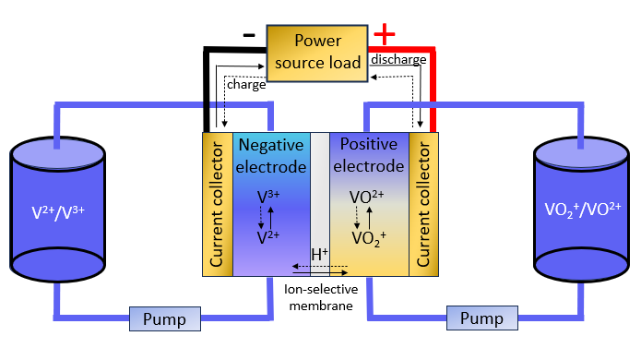
Figure 1.1. Vanadium redox flow battery diagram

electrolyte, the power and energy are decoupled. The energy storage capacity is determined by the concentration and volume of the electrolyte while the power of the system is determined by the number of cells in the stack and the size of the electrodes. Storage capacity and power rating can be designed independently to fit whatever need the user has. Scale-up can be achieved by increasing the size of the electrodes, adding more electrodes in each stack or by connecting the stack in either parallel or series configuration [4]. These units are also modular and can be expanded later by increasing tank size to hold more electrolyte or replacing the cell with a larger stack.
Another benefit of storing energy chemically with electrolyte is that it can be charged in one location and transported to another location to be discharged. This technique can be used to continuously provide power by removing the discharged electrolyte for recharging and refilling with fresh electrolyte. This would be convenient for remote or difficult to reach locations.
VRFBs can be used for grid-scale storage or for more decentralized purposes. Regarding how much energy can be stored in these batteries, the only limit is space to store the electrolyte. Currently, a flow battery is being constructed in Germany that will store its electrolyte in underground salt caverns [20]. Each of the two caverns has a volume of 3.5 million cubic feet, giving a capacity of up to 700MWh and an output of 120 MW. More large-scale flow batteries are being commissioned for upcoming years. VRFBs can last for over twenty years and when they are finished, the vanadium can be recycled. At this time, the flow battery is a newer technology that is not as well characterized as other battery systems, but this can provide room for further study and improvement.
The main areas in which loss is measured in this system are ohmic, mass transport, and kinetic. Ohmic losses are the result of all points of contact in the system producing resistance, particularly in the ion-exchange membrane separator [21]. Ohmic polarization can be mitigated by utilizing thinner, highly conductive materials in the battery construction and reducing surface oxidation while maintaining uniform compression and tight tolerances in assembly [22]. Concentration overpotential results from limitations in mass transport of the reactants to the electrodes. Mass transport losses can be mitigated by optimizing flow fields, electrode structure, and operational parameters. Focus will be primarily on activation (kinetic) overpotential, which is related to charge transfer kinetics [23]. Kinetic losses are dominated by activation overpotential at each electrode. Mitigating this limitation through electrode modification is a primary goal of this work.

1.3 Electrodes

1.3.1 Graphite electrodes
While optimization of every aspect of the battery is important, treatment of the carbon felt electrodes typically used is one path to improve the performance of these systems. One hurdle to the commercial viability of flow batteries is the cost of the cell stack [24]. A remedy to that would be to increase the power density of the cell stack. If this can be achieved, smaller stacks could be produced while meeting the same power requirements. We will discuss the properties of carbon electrodes and current efforts to increase interactions and voltage efficiency at high current density.
Carbon has high electrical conductivity and is a popular material for electrodes. It is affordable and has been used in RFB technology for many decades, which means it is well-characterized. There are several different forms this material has taken, such as carbon fibers, carbon cloth, graphite powder, carbon black, and graphite oxide amongst other things [25]. Carbon felt is a common material used as an electrode in VRFBs. Most carbon felt is synthesized by a method that uses polyacrylonitrile (PAN) as a precursor [26]. This produces a material with ~70% porosity. High surface area is desirable as it increases the points of contact with electrolyte and thus active surface area for reaction.

1.3.2 Graphite electrode treatments
The prevailing theory of electrode improvement is that materials should be added to the electrode to increase active sites to interact favorably with the electrolyte solution. Some amendments to graphite electrode materials involve thermal activation, nanoparticles, or functional group introductions. Approaches can be aimed at reducing electrochemical barriers to reaction at existing sites or increasing total surface area of potential reaction sites.
Heat treatments are a popular and longstanding method used to modify graphite material. Early modification experiments show that graphite felt heated at 400°C in air resulted in improved efficiencies and increased electrode activity and hydrophilicity [27]. The author [27] concluded oxides had formed on the surface and aided the wetting properties of the material by providing adsorption sites for water.
Other types of treatments, often in conjunction with heat, have been experimented with. Researchers have operated under the theory that oxygen functional groups are beneficial. Different methods have been implemented to increase the formation of such groups. Acid treatment is believed to have improved performance due to formation of oxygen functional groups on the graphite felt surface [28, 29]. Others have attempted to incorporate H₂O₂ into the system to increase oxygen [30-32]. One method uses HF etching prior while another uses an environmentally friendly Fenton’s reagent. Another experiment performs mild oxidation in conjunction with a plasma treatment with a similar one only using plasma [33, 34]. Atmospheric pressure plasma jets modestly increased energy efficiency at 80 mA cm⁻² [35]. Some additions specifically moved to increase content of -OH groups. Microwaves were used in one case [36]. The modified Hummers method also increased -OH groups [37]. A treatment of CO₂ at 1000°C creates large pores while increasing oxygen functional groups [38]. Recent findings suggest while some oxygen functional groups are beneficial (carboxyl), others are not (hydroxyl, carbonyl) [39, 40]. Pezeshki’s work has also brought doubt upon functionalization for long term improvement [41].
There are some cases where oxygen functionalization and the resulting decrease in activation energy barrier are not the goal. Other functional groups have been added before, such as sulfur and nitrogen [42]. Nitrogen functional groups were incorporated by adding dopamine through sonication then heating in a furnace [43]. Graphene coating has also been performed. [44] Carbon aerogels have been modified with the intent of increasing surface area [45]. There are also complicated multi-day, multi-step processes, which may be considered too labor intensive for the results to be profitable [46, 47]. Many of the aforementioned treatments produce underwhelming results, either in performance enhancement or longevity of any beneficial effects.
Modifications involving deposition of metals have been attempted. The general goal appears to be to improve kinetics. Nickel electroplating was attempted to increase porosity and surface area [48]. Attempts have been made to use iridium to increase activity and energy efficiency, but it is an expensive material [49]. Several different nanoparticles, nanodispersions, coatings, and doping have been used with elements such as bismuth, copper, B₄C, high entropy oxides, neodymium oxide, and cobalt oxide [50-57]. The copper nanoparticle deposition resulted in 80% EE at 300 mA cm⁻² [51]. Generally, these types of modifications have a good outcome, but are unfortunately temporary as the added materials are swept away.
One litmus for efficacy of electrodes VRFBs is the energy efficiency at a selected current density. Many treatments mentioned above only provide marginal improvements. A recent compilation of the best charge-discharge performances of published experiments show a variety of approaches [58]. The best performing data was generated from a battery that was a result of holistic optimization in both materials and mechanics [58]. The Pacific Northwest National Laboratory (PNNL) samples were improved through mechanical improvements [59, 60]. The rest focus on materials developments. The copper nanoparticle treatment by Zhao, previously mentioned, places roughly third on this chart [51]. Another paper, by Mench, follows the traditional route of adding oxygen to the electrode by heat treating in an oxygen rich environment [61]. The solvent treatment published by Zhang involves leveraging cohesive and swelling forces to generate large pores, which the investigators determined function as proton pathways [62]. Xi takes a similar approach in tunable pore sizes, but it appears they are fabricating the material instead of altering available felt [63]. One paper that stands out in terms of material modification is the second best performer on the graph [64]. The potassium hydroxide treatment was performed on carbon paper wherein the sample was heated, treated with KOH solution, then heated again. It was expected to increase oxygen functional groups. It did increase the ratio of C=O group representation, which the author suggests is C-OH groups being converted to C=O, but perhaps they are being removed entirely. They note a decrease in the number of functional groups and a decrease in electrochemical activity. They also note an increase in surface area, with SEM showing what the paper calls pores.
Phosphorus doping also has a significant effect, showing 81% EE at 200 mA cm⁻² [65]. This appears to drastically alter the structure of the carbon fibers, with deep grooves and a cavernous appearance increasing the surface area. In another case Ti₃C₂T_{x} MXene spheres were added, showing similar results [66].
While adding onto electrodes can be effective, at least in the short term, there is the risk of added atoms or functional groups being degraded or swept away in the harsh acidic environment of the flow battery. Recent literature in this area demonstrates drop off with cycling and there have been no new breakthroughs of late in this approach, which may indicate this type of pre-treatment is reaching its limits [67-70]. This highlights a need to innovate the approach to electrode modification.
Several papers reporting good performance coincide with high specific surface area, which is as expected [64, 65, 71-73]. Three of the best electrode enhancement examples involve pore modification. While it has been believed that functional groups are a driver of some performance gains demonstrated other factors, such as micropores, surface area, or edge defects, may be more significant contributors and resistant to cycle based degradation [66, 74-77]. Kim et al. found that defects kinetically enhance carbon felt electrodes [78]. Thus, a viable path forward for increased performance continues to be surface modification.
Three of the best electrode enhancement examples involve pore modification, which appear to increase surface area. Recent research suggests that oxygen functional groups may not be the key to sustained improved performance [41, 74], and enhanced surface area is a main driver for kinetic activity. Another study found that thermally deoxygenated electrodes had lower charge transfer resistance and higher half-cell activity [79]. An increase in edge sites and surface area was also observed; this increase may have had a greater benefit than the negative effect of loss of oxygen functional groups. It is possible that treatments meant to increase the presence of oxygen functional groups may improve electrodes by creating edge sites that facilitate reactions. Recent work has shown edge site defects may play an essential role in improving performance [74].
Work done by the Mench group at UTK has shown high temperature ammonia treatments to be a highly effective method to improve carbon felt electrodes. At a cell overpotential of 200 mV, the initial polarization curve for felt treated with ammonia for four hours at 900°C achieved a current density of 370 mA cm⁻² [41]. The ohmic resistance was reduced to a low 0.42 Ω cm². This sample was also found to have a surface area of 37000 cm² as compared to the ~50 cm² surface area of untreated felt. This is a rather significant transformation. Microscope images of treated and untreated fibers are shown in Figure 1.2 [41].
Pezeshki et al. determined that although this treatment decreases functional groups on the felt, it is made up for by the benefits of the greatly increased surface area. On the other hand, the ammonia seems to have little effect on 10AA carbon paper electrodes. Neither performance nor stability were notably improved by ammonia treatment. There is a difference between the two materials that could explain this. Carbon paper has very little oxygen groups while carbon felt generally has oxygen making up around 6-15% of the composition. This could indicate that ammonia interactions with oxygen functional groups are what lead to the increase in surface area of the material.

1.3.3 Graphite surface features
Graphite felt is a material made primarily of carbon. PAN-Carbon felt is a material made using such and such process. Resulting in a web of fibers interconnected like a nest of spaghetti.
This prompts an interest in what sorts of functional groups may be present on the surface of carbon felt and which ones may interact most agreeably with ammonia. There are a variety of acidic and basic functional groups one might encounter on a carbon basal plane [80]. The acidic groups consist of carboxyl, lactone, phenol, and lactol. The basic groups are composed of chromene, ketones, and pyrones.
Research by Vickers shows that an increase in acid-base character of PAN-based carbon fiber, even with low oxidation levels, results in higher wettability of carbon by
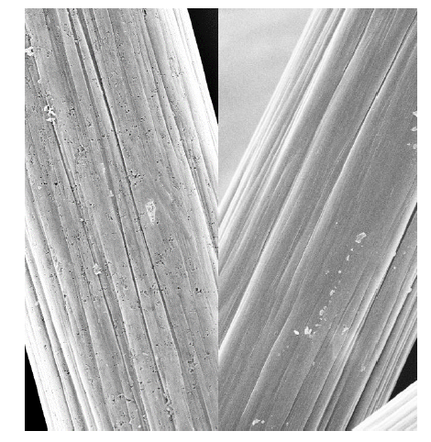
Figure 1.2. SEM images of a fiber from ammonia treated (left) and untreated (right) electrode. [41]

polar species [81]. Untreated fibers have little to no basicity and poor wetting after oxidation treatment, due to minimal polar interaction. Acid-base interactions of carbon fiber are important for increasing wettability of the material. Based off this paper, it appears that PAN-based carbon fibers have fewer basic groups.
An increase in acid-base character of PAN-based carbon fiber, even with low oxidation levels, results in higher wettability of carbon by polar species [52]. Acid-base interactions of carbon fiber are important for increasing wettability of the material. Because PAN-based carbon fibers have fewer basic groups, it may be advantageous to introduce them to this material to increase polar interactions and wettability. Ammonia treatment has been used to increase the basicity of activated carbon in other industrial applications [51, 53]. Activated carbon exposed to ammonia at high temperature can give chemically basic features such as C≡N [51].
In other experiments the objective of ammonia treatment had been to increase the basicity of activated carbon [80, 82]. The reaction of ammonia with carboxylic acid sites present in carbon can form ammonium salts that can lead to amide and nitrile formation. This treatment leads to the disappearance of carboxylic acid groups at low temperatures [83]. Another paper also suggests the result of annealing in ammonia at high temperatures is a reduction in the amount of oxygen complexes on the surface, particularly carboxylic acid [82]. Notably, the carbon developed a more porous structure. It was also observed that nitrogen was incorporated into the aromatic lattice of the carbon in the form of pyridine-type structures, increasing basicity. There are several types of nitrogen functional groups that can form on carbon [80].

1.3.4 Ammonia
Ammonia partly decomposes at high temperatures (600°C) into NH₂, NH, atomic hydrogen and nitrogen [84]. These radicals attack carbon, leading to some gasification in the form of methane, hydrogen, cyanide, and cyanogen. Above 800°C an increase in surface area is observed and micropore volume increases at 900°C. Ammonia treatment at elevated temperatures (600°C -900°C) resulted in considerable increase in activated carbon activity. It is possible that radicals might have a part in Pezeshki’s ammonia treatment.
At lower temperatures, below 600°C, ammonia exposure results in removal of oxygen, particularly carbonyl groups and leads to the incorporation of nitrogen in the form of functional groups that are not found in higher temperature experiments [85]. These functional groups include amides, lactams, and imides that could function as precursors to C-N=C formations at higher temperatures. Because Pezeshki’s treatment involves flowing ammonia while the furnace is heating and cooling, there is a period where low temperature reactions may occur. That different mechanisms might be acting at different temperatures is something to consider. Nevertheless, a common feature of the high temperature exposure is the increase in surface area and porosity.
Pezeshki appears to be one of the first to suggest increasing surface area would be more productive to improving electrodes, which leads to an importance to discovering the mechanism. The holes observed from the ammonia treatment resemble those on metal that have suffered from pitting corrosion. Pitting corrosion is an electrochemical oxidation-reduction process that created localized pits or holes [86]. Electrons are mobilized, and new compounds are formed. The danger of pitting in metals is that much of the damage cannot be seen as it is below the surface as it continues to grow. The surface area of ammonia treated felts indicates more is going on that cannot be observed.
Characteristic of pitting is the continual growth once pitting potential is achieved even when the potential is lowered [87]. The graphite felt could also have a pitting potential that is being reached by ammonia at high temperatures, which would explain the localization effect observed. Pitting is also more likely to occur in pits and crevices, which is reflected in the observations of our samples [88]. Additionally, deeper pits are associated with the presence of gas bubbles evolving out of the pits [89]. Micropits form and deepen as the process repeats, remaining under a passive film that forms over it.
Investigating increasing the surface area of electrodes appears to be a sound strategy based on the literature search. Highly porous carbon performs well even as some materials increase efficacy. The success of the high temperature ammonia gas treatment could be explained by several factors. Literature on carbon surfaces indicates increased basicity improves wettability and that ammonia at high temperatures can provide that. Additionally, ammonia interactions with oxygen functional groups, possibly carboxylic acid, can cause them to either be removed or replaced by a less bulky nitrogen group, which could be the cause of the pitting observed in the SEM images. Nitrogen functional group formation could have some support in improving performance. It could be the accumulation of all these factors.

1.3.5 Outlook and motivation
A comprehensive survey of the literature suggests that the most beneficial aspect of the ammonia treatment is that it greatly increases the surface area. The experimental plan is unique in that the treatments will be performed with the intent to strip functional groups from the felt instead of adding them. If the chemical mechanism of the high temperature ammonia and carbon felt can be determined, a more efficient treatment may be developed. Once proven correct, this concept could be applied more broadly to novel treatments.
This research can benefit fields other than energy. Water is one of our most precious resources, which is why the ability to efficiently procure clean water is crucial. With an increasing population we must become creative in how we provide it. Most of the water on the planet is saltwater, therefore the ability to filter it efficiently for consumption will prove useful. Carbon felt electrodes have been found to be capable of filtering brackish water using capacitive deionization [90]. One of their touted benefits towards this function is high surface area, therefore increasing said surface area would improve its capabilities. Determining more effective ways to generate usable water will be of great benefit long-term.
The goal of this research is to determine the mechanism of ammonia performance enhancement so that it can be exploited to generate more effective treatments. Samples will be analyzed for their material properties and battery tested. Further experiments will be devised based on the results.

1.4 Method of approach
Graphite felt was treated in ammonia with different conditions. The physical properties of the samples were analyzed with scanning election microscopy (SEM), energy-dispersive x-ray spectroscopy (EDS), x-ray diffraction (XRD), Fourier transform infrared spectroscopy (FTIR), and Raman spectroscopy.
Thermal treatments in an ammonia atmosphere were performed on carbon felt electrodes to improve performance. SEM has high magnification capabilities that can resolve minor details. These images were used to analyze the surface of the material and the effect of the treatment. This gave insight into any surface morphology changes occurring from the treatment. EDS is a technique used for the elemental analysis of a sample. To better determine composition of the material post-treatment, EDS was run to estimate atomic representation on the surface of the samples and determine any change in percentage or concentration of atomic distribution post-treatment. Carbon, oxygen, and nitrogen would be the most expected elements given the known elements of graphite and ammonia. If the ammonia is interacting with the graphite to add nitrogen to the system, higher ratios of nitrogen were expected on the samples that are completely treated. XRD is a technique used to determine the structure or composition of a sample. It was used to indicate whether bulk structural changes resulted from the treatment. Additionally, XRD was used to identify material exiting the furnace [91]. Raman spectroscopy was used to ascertain the level of surface defects or graphitization from the treatment [74, 92-95]. FTIR was used to determine whether there was an introduction or reduction in functional groups by the treatment. This was done to determine the mechanism of improvement, whether from functional groups or increased surface area. Silver nitrate solution was prepared to detect gas exiting the furnace.
Electrochemical characterization was performed using EIS, polarization curves, cycling, and ECSA. Electrochemical surface area (ECSA) was calculated from electrochemical impedance spectroscopy (EIS) and used to find the functional surface area of the electrodes based on interactions with sulfuric acid, which vanadium ions are dissolved in. EIS was also performed to observe charge transfer and analyze changes in performance. Polarization curves were taken to determine current density at 50% SOC and 80% voltage efficiency, which is a good standard for measuring performance. Cycling was performed to determine stability, performance, and efficiency of the improved materials.

1.5 Chapter preview
Chapter 2 describes the methods generally used in subsequent chapters. Chapter 3 describes the experimental results of GFD3 graphite felt treated in ammonia gas at 900°C at half an hour, one hour, and four hours. Material and electrochemical analysis were performed to demonstrate the enhancement. Chapter 4 investigates this type of modification further, describing the outcomes of graphite felt treated in ammonia at various temperatures for four hours to pinpoint the inflection point of treatment effectiveness. The mechanism of the treatment was investigated using more in-depth materials characterization. The results of novel treatments are presented in Chapters 5 and 6. Chapter 5 describes the outcome of treatments developed and tested based on the conclusions in Chapters 3 and 4, aiming to lower the energetic barrier to radical creation. Chapter 6 highlights the outcome of a novel N₂ gas post-treatment of the original ammonia treatment. A summary of the research, conclusions and future steps are discussed in Chapter 7.

Method of approach

2.1 Treatment of materials
Sigracell GFD3 carbon felt (SGL, GmbH, Meitingen, Germany) was weighed on a mass balance prior to treatment. The samples were placed in the center of a ThermoScientific Lindberg Blue M tube furnace. The furnace was purged for thirty minutes with ultra-high purity nitrogen at about 150 mL/min and the chamber was filled with NH₃ gas flowing at 200 mL/min throughout the treatment; this corresponds to an average residence time of 15 minutes. The tube furnace exhaust was directed to a chemical fume hood. The furnace was ramped to the desired treatment temperature and held for the desired time. The furnace was then allowed to cool to room temperature and the samples were retrieved after purging the furnace with N₂ gas. Each sample was weighed after treatment.

2.2 Physical characterization

2.2.1 SEM
Surface morphology was characterized by high resolution scanning electron microscope (SEM) on an Auriga instrument at 5 kV acceleration (LEO 1525 at 15 kV in Chapter 3) at the UTK Institute for Advanced Materials and Manufacturing (IAMM) Microscopy Center. Samples were secured to the stand with graphite tape (copper tape in Chapter 3) to improve conductivity and placed in the instrument. The chamber was evacuated prior to imaging.

2.2.2 EDS
Energy-dispersive X-ray spectroscopy (EDS) was performed on the carbon felt samples with a Zeiss EVO SEM instrument. Measurements were done at 15 kV acceleration. Samples were secured to the stand with graphite tape to improve conductivity and placed in the instrument. The chambers were evacuated prior to imaging. Bruker ESPRIT software was used to analyze the spectra.

2.2.3 Raman spectroscopy
Raman spectroscopy was performed on samples using a PlanarRAM-S system in
the Micro-/Nano- Scale Fluidics and Energy Transport (MINSFET) Laboratory. The DPSSL driver for the 532 nm MGL-III-532 50 mW laser was turned on and allowed to stabilize for five minutes. The samples were placed under 100x objective lens, and the laser was focused on the sample. EZScan software was used to image and analyze the samples. The settings were single acquisition mode, full vertical binning (FVB) readout mode, a neutral density (ND) filter of 10%, a ten second exposure time, a 16.25 vertical shift speed, readout rate of 33, pre-amplifier gain of 1, and pinhole at 50-70 µm. The laser beam was focused on the surface of the individual fibers of the felt and measurements were taken.

2.2.4 XRD
X-ray diffraction (XRD) of carbon felt samples and the solid products of the silver nitrate experiments was performed on an Empyrean X’Pert³ instrument at the IAMM Diffraction Facility. The detector used was the PIXcel3D, paired with CuKα radiation. All samples were scanned for ten minutes over a range of 10°-60°. The carbon felt samples were secured to a sample holder with putty. Precipitates were air dried, ground to a powder in a mortar and pestle, and evenly distributed and tamped in a shallow well sample holder. The spectra were analyzed using HighScore Plus.

2.2.5 FTIR
Fourier transform infrared (FTIR) spectroscopy was performed in a VERTEX 70 instrument using an attenuated total reflection (ATR) technique to determine the presence of functional groups in the carbon felt. This technique was chosen because it is fast and useful for large, solid samples. The spectra were analyzed using OPUS 7.0 software.

2.3 Electrochemical characterization

2.3.1 Battery cell testing conditions
Electrodes were placed in a single cell VRFB for battery testing. An example of the stack configuration is shown in Figure 2.1 [3]. A Nafion™ 117 ion-exchange membrane (9 cm x 9 cm) was placed between two pieces of GFD3 felt (2.25 cm x 2.25 cm) centered within gaskets that were ~75% the uncompressed thickness of the felt. These were placed between graphite plates with a serpentine flow field, with a channel depth and width of 1.0 mm and channel-to-land ratio of 1:2, for even distribution of
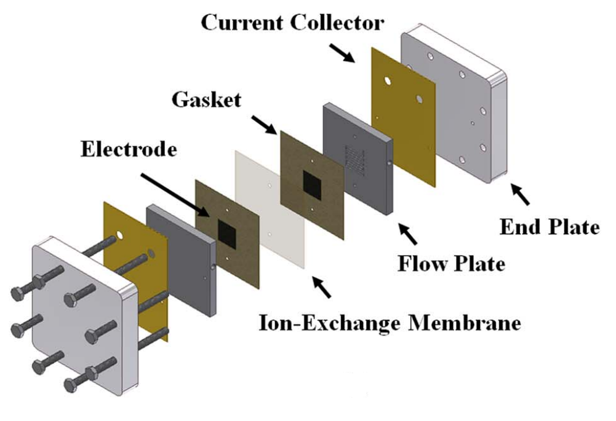
Figure 2.1. Diagram of experimental flow battery cell used in this work [3].

electrolyte. All parts were secured between two endplates with bolts tightened to 11 N-m torque. Two 50 mL (30 mL in Chapter 3) solutions of 1 M V^{3.5+}, (V³⁺:VO²⁺ = 1:1) with 3.3 M sulfuric acid were applied as negative and positive electrolytes, respectively. The cell and electrolyte were maintained at 30°C as electrolyte was pumped through the serpentine channels at a flow rate of 33 mL/min using an Easy-Load II Masterflex L/S pump. EC-Lab V10.40, later V11.27, software was used to control the BioLogic VMP3 potentiostat to evaluate the batteries.

2.3.2 EIS
Potentiostatic electrochemical impedance spectroscopy (PEIS) measurements were executed with 5 mV amplitude and 50 kHz-50 mHz frequency range on the whole cell at 50% state of charge (SOC) and with electrolyte flowing through the cell. Electrochemical surface area (ECSA) was studied via PEIS performed with 5mV amplitude and 200 kHz-1 Hz frequency range using 4M sulfuric acid. The data were fit with a simple capacitive electrode equivalent circuit.

2.3.3 Polarization curves
Polarization curves were executed chronopotentiometrically with the alternating charge/discharge current method to maintain the SOC at 50% [3]. Step times were adjusted to control the number of coulombs. The final fifteen seconds of each current hold were averaged for the polarization curve. The OCV was measured after each “cycle”
to monitor SOC throughout the polarization curve. The pump was turned on during polarization curve measurements.

2.3.4 Charge-discharge cycling
Charge-discharge cycling was conducted at current densities from 20 mA cm⁻² to 150 mA cm⁻² for twenty cycles (10 mA cm⁻² to 65 mA cm⁻² for ten cycles in Chapter 3) at each current density. This was done with the electrolyte pumps turned off to reduce testing time.
All error bars correspond to the average plus or minus the standard error of the mean, equation shown below:
$SE=\frac{S}{√N}$ (2.1)

High performance vanadium redox flow battery electrode via high-temperature ammonia treatment

Abstract
This chapter is revised based on the published paper with permission:[96]
Kaycee Gass, Bapi Bera, Doug S. Aaron, and Matthew M Mench, (2024). “High Performance Vanadium Redox Flow Battery Electrodes.” Journal of Electrochemical Energy Conversion and Storage, 21(1).
[https://doi.org/10.1115/1.4062441]

3.1 Introduction
Recent research suggests that oxygen functional groups may not be the key to sustained improved performance [41, 61], and enhanced surface area is a main driver for kinetic activity. Another study found that thermally deoxygenated electrodes had lower charge transfer resistance and higher half-cell activity [79]. An increase in edge sites and surface area was also observed; this increase may have had a greater benefit than the negative effect of loss of oxygen functional groups. It is possible that treatments meant to increase the presence of oxygen functional groups may improve electrodes by creating edge sites that facilitate reactions. Recent work has shown edge site defects play an essential role in improving performance [74].
An increase in acid-base character of PAN-based carbon fiber, even with low oxidation levels, results in higher wettability of carbon by polar species [81]. Acid-base interactions of carbon fiber are important for increasing wettability of the material. Because PAN-based carbon fibers have fewer basic groups, it may be advantageous to introduce them to this material to increase polar interactions and wettability. Ammonia treatment has been used to increase the basicity of activated carbon in other industrial applications [80, 82]. Activated carbon exposed to ammonia at high temperature can give chemically basic features such as C≡N [80].
The literature has developed limited understanding of how electrode treatments work and why some have better results than others. Experiments described here indicate that high temperature ammonia gas treatments enable good VRFB performance. To better understand this treatment, the material and electrochemical properties of carbon felt electrodes samples treated for increasing lengths of time are examined.

3.2 Results and discussion

3.2.1 Characteristics of treated and untreated samples
After the half hour, one-hour, and four-hour treatments, mass decreases were measured at 1.3%, 1.4%, and 1.6%, respectively. Figure 3.1 shows SEM images of untreated carbon felt and ammonia gas treated felts at 900°C for thirty minutes, one hour, and four hours. It is evident that increased time led to an increasingly pitted surface. The surface with no treatment was smooth with some large holes several hundred nanometers in diameter. The material after thirty minutes developed “blisters,” mostly in the 50-100 nm diameter range; these can be observed on the surface as well as in the crevices and clustering in larger holes. Shallower bumps covering the surface can also be observed. The sample that underwent one hour of treatment had both the blisters seen at 30 minutes and increased pitting. After four hours of treatment, the blisters disappeared and further pitting on the surface and in the crevices was observed, roughly 10-40 nm in diameter. This progression of surface features observed should lead to greater surface area available for supporting electrochemical reactions and may be responsible for increased overall activity of the electrode.
The SEM images of the sample surface over treatment time give some insight into a potential process of morphological change. The 1-2% loss of mass and appearance of pores suggest electrode material is removed during the ammonia treatment. The appearance of pitting suggests damage to the surface of the material and seems similar to images of carbon paper samples treated with KOH [64] wherein a decrease in oxygen functional groups, reactions with KOH and C, and an increase in surface area were observed. The progression in surface features from the 30-minute treatment to the 4-hour treatment implies that a physicochemical process changed the electrode surface. Figure 3.2 shows a 1-hour treated sample that, after exposure to the beam of the SEM, exhibited a change in pore structure.

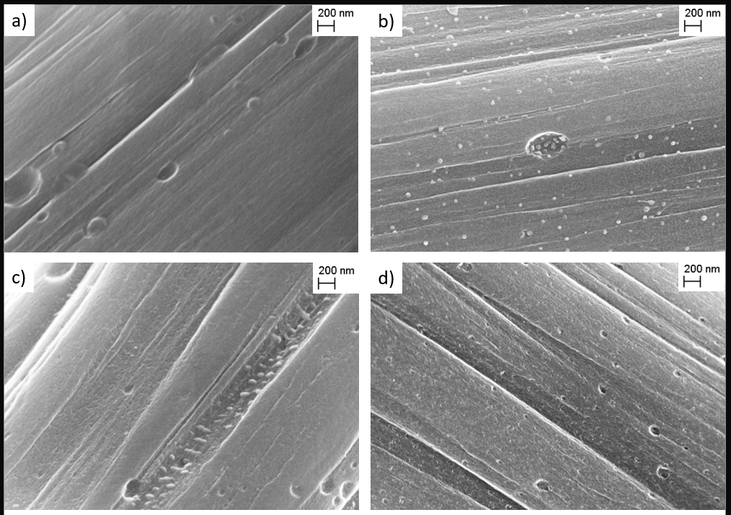
Figure 3.1. SEM images at 200KX magnification of carbon felt electrodes: a) untreated, b) 30 min NH₃ treated at 900°C, c) 1-hour NH₃ treated at 900°C, d) 4 hours NH₃ treated at 900°C. Scale was identical for all micrographs.

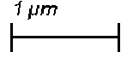
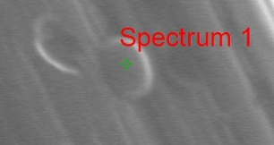
Figure 3.2. SEM images of a carbon felt sample, treated with NH₃ for 1 hour at 900°C, at 30KX magnification before and after the beam was concentrated on the “blister.”

A large blister, about 900 nm in length at the longest points, was observed on a sample treated for one hour. Upon closer examination, the intensity of the SEM beam caused the blister to “pop” and what appears to be a shallow pit in the surface of the fiber appeared beneath the blister, roughly 250 nm in length. Pits of similar diameter were observed after CO₂-etching treatments by Jing [97]. While they may have some visual similarities, the CO₂ treatment may have a slight oxidative effect at high temperatures, causing a mechanism different from the reductive NH₃ treatment to occur to achieve this result, to a lesser extent. This change from raised blister to recessed pit appears similar to the difference in features between the 30-minute and 4-hour treated felts, which suggests that the blisters may play a role in pore creation. Visually, this process is similar to pitting corrosion effects on the surface of metal [98, 99]. We hypothesize that these blisters form early in the treatment and, with further treatment (or energy transport from the SEM), the surface collapses to reveal a pit.
In addition to studying surface morphology via SEM, samples were evaluated via Raman spectroscopy to ascertain changes in graphitization. The Raman spectra of the samples were fitted by two bands: the G band (1590 cm⁻¹, ideal graphitic lattice) and the D band (1350 cm⁻¹, disordered graphitic lattice (edges)). The intensity ratio of the D and G bands (I_{D}/I_{G}) was used as an indicator of the proportion of defect sites present in the fibers. The I_{D}/I_{G} increased from 0.69 of the untreated sample to 0.95 and 0.94 of the half hour and hour long treatments. The four hour sample increased to 1.2. The Raman spectra and I_{D}/I_{G} ratios are shown in Figure 3.3 and Table 3.1.
The Raman spectra showed a notable increase in defect sites on the treated samples. The half hour and hour treated felts exhibited 38% and 36% increases in the ratio of disordered to ordered lattice edges (respectively), while the four-hour treated felt increased by 74%. The trend corresponds to the surface morphology changes observed in Figure 3.1 with the appearance of blisters and increased disorder, more so with increased pitting. This suggests that the treatment caused microstructural changes to the carbon felt resulting in more edge defect sites. This increase in edge sites appears to be similar to findings by Radinger [74, 79] and Zhang [92] with a higher defect density after treatment. This seems to correlate with improved battery performance from the electrodes. It should
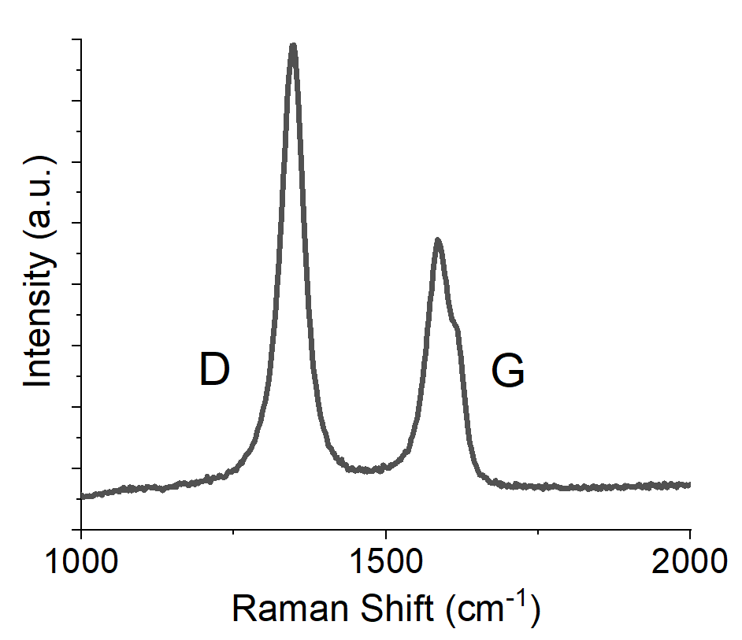
Figure 3.3. Raman spectroscopy and disorder ratio of carbon felt fiber samples.

Table 3.1. Disorder-to-order ratio of carbon felt samples; note that the 0.0 hr treatment time corresponds to untreated carbon felt.
Treatment time (hr) | I_{D}/I_{G}
0.0 | 0.69±0.02
0.5 | 0.95±0.02
1.0 | 0.94±0.03
4.0 | 1.20±0.03

be noted that other works have stated that functional groups could result in enhanced performance, which could be true here; but these are not associated with the physical phenomenon observed in this type of treatment.

3.2.2 Electrochemical properties
After placing untreated and treated electrodes in a VRFB, EIS was executed to study effects in kinetic and ohmic parameters. Area-specific resistances were normalized with respect to the geometric area of the VRFB (5.0 cm²). Spectra were compared on a Nyquist plot, shown in Figure 3.4. Since the test was stopped at a low frequency of 50 mHz, only the high frequency (ohmic) resistance and charge transfer resistance were estimated. The electrolyte pumps were flowing to reduce mass transport effects, enabling clearer charge transfer resistance measurement. The plot shows that the charge transfer resistance monotonically decreased as the treatment time increased. The half hour sample had roughly the same solution resistance as the untreated; however, the untreated sample showed much more overlap between charge transfer and mass transport regions of their respective Nyquist plots.
The spectra of the electrode samples showed decreased charge transfer resistance (CTR) with treatment, which can be seen in Table 3.2. Major influences on CTR include temperature, surface area, and rate constant; given that temperature was consistent between tests, it is likely that the material gained a large level of functionalization and/or increased specific surface area. The increased density of pitting observed via SEM suggests that surface area did increase. The gap between the CTR of the half hour and hour treatments is similar to the polarization curve results but not to Raman and ECSA, which have smaller gaps. The exact reason for these differences is unknown, as there are likely several factors contributing to performance, but the overall trend is still the same.
To confirm whether surface area increased, ECSA was measured and calculated using EIS and compared between treatment times. The acid-only spectra were fitted with a simple capacitive electrode equivalent circuit. Upon obtaining the electrode capacitance, a specific capacitance of 0.02 mF/cm² was used to obtain ECSA [41].
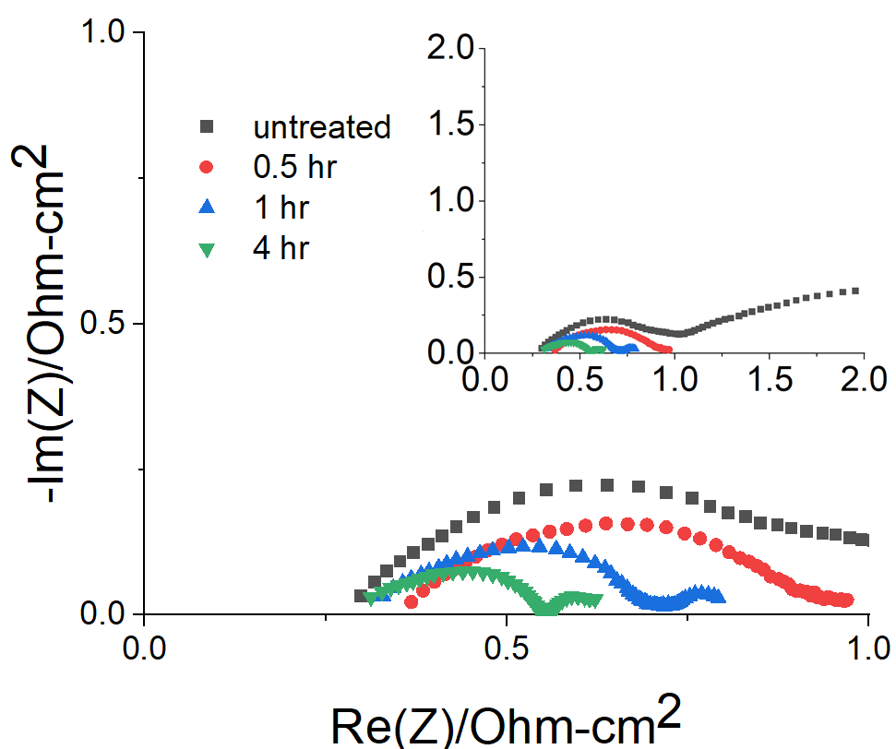
Figure 3.4. Nyquist plot at open circuit of various electrode samples at 5 mV with electrolyte flowing.

Table 3.2. Charge transfer resistance of electrode samples.
Treatment time (hr) | CTR (Ohm-cm²)
0.0 | 0.768±0.006
0.5 | 0.601±0.005
1.0 | 0.415±0.003
4.0 | 0.250±0.008

Results were averaged and the error was calculated. Figure 3.5 shows the electrochemical surface area over treatment time in which an increase in the surface area is observed. The 4-hour treated sample increased in surface area by 142% compared to the untreated sample, while the half hour and hour samples increased by 102% and 109%. This confirms what was visually observed in the SEM images. The presence of the pores seems to correlate with the surface area. This could also explain the decrease in charge transfer resistance.
Polarization curves were used to assess overall electrochemical performance of the treated samples and to estimate the current density corresponding to 80% voltage efficiency. Figure 3.6 shows a clear change in slope at current densities below 100 mA/cm² as a function of treatment time. The untreated sample showed a kinetic region qualitatively similar to that expected of Butler-Volmer kinetics, i.e. the untreated samples showed kinetic overpotential domination. For the ammonia treated samples, however, the polarization curves are straight lines that indicate favorable kinetics and ohmic overpotential control, even at low current density.
Current density at 80% voltage efficiency is a common benchmark which can be approximated by charge-discharge polarization curves executed at 50% SOC. [100] The current density was compared at 80% voltage efficiency, which occurred at ~1.58 V during charging and ~1.26 V during discharge. All the open circuit voltages were within 26 mV of each other near 1.42 V. Because the charging and discharging branches were slightly asymmetrical (due to small differences in starting OCV), the current densities at respective charging and discharging voltages were averaged between the curves. The current density at 80% voltage efficiency increased by 26% from the half hour to one hour sample and there was another 19% increase from the one hour to four-hour treatment. These results were IR-corrected using PEIS results as seen in Figure 3.6b.
Consistent with the impedance results shown in Figure 3.4, the polarization curves showed decreased kinetic overpotential as a function of increasing treatment time. As expected, and consistent with other results, there appears to be no significant change in the ohmic resistance based on the slopes of the polarization curves in Figure 3.6 or the high frequency resistances in Figure 3.4.
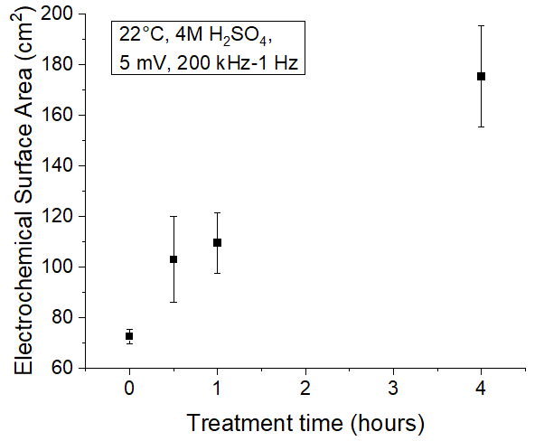
Figure 3.5. Electrochemical surface area of electrodes over treatment time.

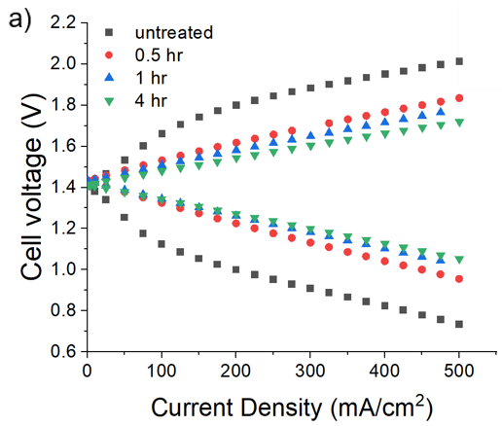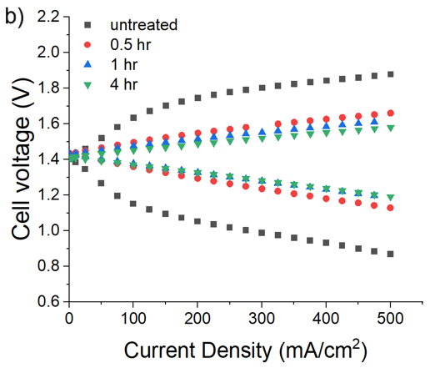
Figure 3.6. Polarization curve of samples showing current density at 80% voltage efficiency and 50% state of charge: a) original b) IR-corrected. Electrochemical surface area of electrodes over treatment time.

The polarization curves showed increases in the current densities at 80% voltage efficiency from the pristine sample to the treated samples of 188%, 259%, and 325%, respectively, compared to the untreated felt, shown in Table 3.3. Overpotential in both charge and discharge processes decreased with increased treatment time. For the treated samples, ohmic polarization dominated the voltage loss because the activation polarization was so effectively reduced. It can be concluded that the ammonia treatment had a significant effect on reducing the activation overpotential [22].
Figure 3.7 shows voltage efficiency results observed during charge-discharge cycling at 40 mA/cm² and 65 mA/cm². The voltage efficiencies of the treated samples were well above those of the untreated sample, increasing from 58-63% for untreated carbon felt to above 88% for all treated samples at both current densities. Additionally, voltage efficiencies had smaller gaps between current densities for the treated samples than those of the untreated sample. This observation is consistent with the polarization curves in Figure 3.6. The averages of the voltage, coulombic, and energy efficiencies are shown in Table 3.4. The voltage efficiency was calculated using the midpoint of each step of the charge/discharge curves. The coulombic efficiency was calculated using the total electronic charge transferred during charge and discharge. The energy efficiency was calculated by multiplying the voltage efficiency and coulombic efficiency. The equations are shown below:

Voltage efficiency:
$η_{ν}=\frac{V_{discharge}}{V_{charge}}$ (3.1)

Coulombic efficiency:
$η_{c}=\frac{Q_{discharge}}{Q_{charge}}=\frac{\int_{I_{discharge}dt}{ }}{\int_{I_{charge}dt}{ }}$ (3.2)

Energy efficiency:
$η_{e}=η_{ν}*η_{c}$ (3.3)
Table 3.3. Current density at 80% voltage efficiency and 50% charge.
Treatment time (hr) | Current density (mA/cm²) | IR-corrected current density (mA/cm²)
0.0 | 58±9 | 64±6
0.5 | 160±5 | 271±35
1.0 | 201±2 | 366±46
4.0 | 239±22 | 421±53

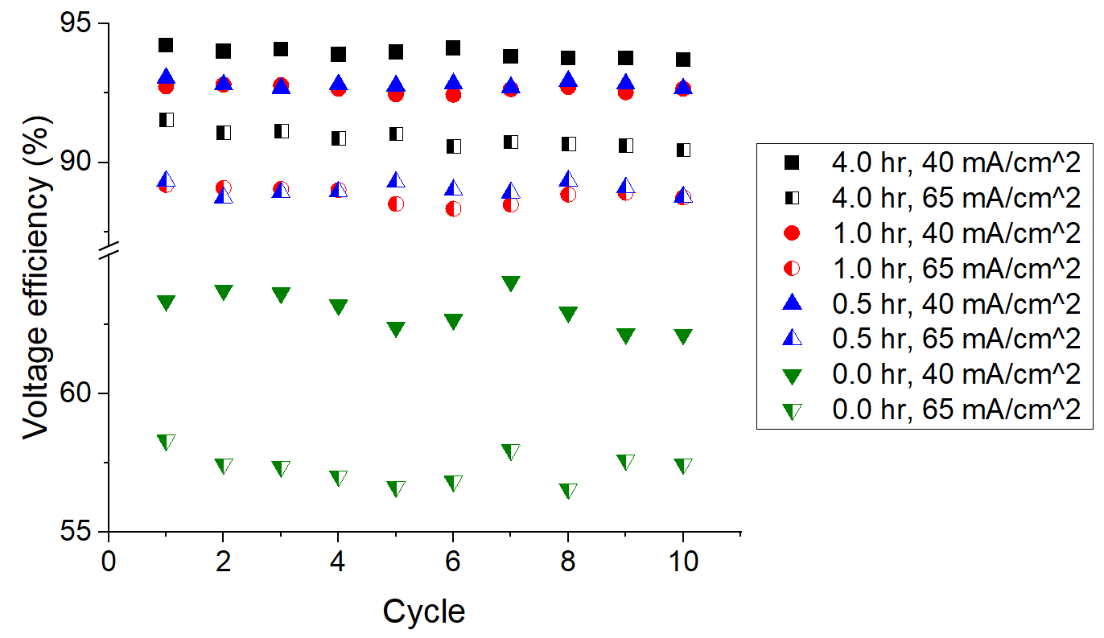
Figure 3.7. Voltage efficiency of samples cycled ten times at 40 mA/cm² and 65 mA/cm².

Table 3.4. Average efficiencies of electrodes.
Treatment time (hr)/ Current density (mA-cm⁻²) | Voltage efficiency (%) | Coulombic efficiency (%) | Energy efficiency (%)
4.0 / 65 | 90.9 | 97.4 | 88.4
4.0 / 40 | 93.9 | 94.7 | 88.9
1.0 / 65 | 88.9 | 97.7 | 86.8
1.0 / 40 | 92.6 | 96.9 | 89.8
0.5 / 65 | 89.0 | 98.0 | 87.3
0.5 / 40 | 92.8 | 95.6 | 88.7
0.0 / 65 | 57.3 | 96.0 | 55.0
0.0 / 40 | 63.0 | 94.7 | 59.7

The four-hour sample had a 3% change in voltage efficiency between 40 mA/cm² and 65 mA/cm²; the half hour and one-hour samples had a 4% difference, and the pristine sample had a much larger 8% gap in voltage efficiency. Coulombic efficiencies were roughly consistent at 95% or better for all tests.
The treated samples showed much higher voltage efficiency than the untreated and displayed a resistance to degradation during cycling, similar to Pezeshki’s results that found ammonia enhancements were substantially more durable and stable than oxidative treatments [41]. As the treatment time increased, these attributes improved. The gaps between voltage efficiencies at different current densities decreased and the efficiencies remained high. It is likely that functional groups or other materials attached to carbon felt electrodes that provide temporary improvements get electrochemically removed during charge/discharge cycling. Increased surface area is likely more persistent, which could explain the lack of degradation observed after cycling the electrodes treated in this manner with ammonia.
Overall, these electrodes show improved electrochemical performance with increasing treatment time. This is accompanied by higher ratios of edge sites and increased surface area. Some indications of increased durability were also seen, although results are not exhaustive. Impact from a physical morphological change rather than surface functionalization would be consistent with this observed enhanced durability. While thermal diffusion may play some part in changing morphology, carbon felt thermally treated in N₂ does not perform nearly as well as in ammonia gas [12, 14]. Even longer treatment times in high temperature ammonia would likely increase pitting due to extended interactions with the gas, with commensurately superior kinetics, until a plateau is reached. Time, resources, and energy costs would have to be optimized against the benefits of further electrochemical enhancement.

3.3 Conclusions
Carbon felt electrodes were treated with ammonia gas at 900°C and showed significantly improved performance in a VRFB. It is apparent that the surface of the carbon felt electrode was altered by the ammonia treatment; a process involving blistering and pore creation was observed. The treated samples exhibited a 36-74% increase in the ratio of disordered to ordered lattice edges observed via Raman spectroscopy and a 102-142% increase in electrochemical surface area. The performance enhancement is thus believed to be a result of morphological changes in the surface of the felt, and not only chemical functionalization. Treated electrodes showed greatly improved performance in battery testing with a 312% increase in current density at 80% voltage efficiency compared to untreated felt. Cycling tests also show the potential for reduction in degradation effects with voltage efficiencies as high as 94% after cycling. It is speculated that a chemical mechanism occurring during treatment causes a physical change in the felt morphology that improved battery performance through enhanced reactive surface area. While surface functionalization can contribute to enhanced kinetic performance, a large increase in surface area available for reactions was observed after ammonia treatment and would be consistent with enhanced robustness and enhanced activity during cycling as observed here.

A radical generation: Investigating mechanism and outcome of ammonia treated carbon felt electrodes for vanadium redox flow batteries

Abstract
This article hasn’t been published anywhere, nor will it be before I turn in the final version of my ETD, so I didn’t include a publication statement. A manuscript will be submitted for publication. This work was authored by Kaycee Gass, Bapi Bera, Gabriel Goenaga, Doug S. Aaron, and Matthew M. Mench.
Goenaga assisted with FTIR data collection.

4.1 Introduction
Chapter 3 determined that carbon felt treated in ammonia gas at 900°C improves electrode performance in VRFBs due to increased surface area and edge site defects [96]. It is also durable, having good cycling performance with minimal degradation-induced capacity fade [41]. Little is known yet about the precise mechanism which yields such good results. Boehm suggests that ammonia radicals (NH₂⁻, NH²⁻, and atomic hydrogen) are generated when ammonia gas experiences high temperatures; these radicals can interact with carbon materials (forming methane, cyanogen, and hydrogen cyanide) and create a rough surface with increased surface area and local porosity, enhancing effective catalytic activity for a given carbon material [84, 101, 102]. Radicals are highly reactive intermediates with short lifetimes [103]. The stronger the original bonds, the more energy is required to break those bonds and the more unstable the radicals are. Perman and Atkinson found ammonia completely decomposes at 1100°C in a porcelain globe into what they believed was molecular hydrogen and nitrogen [104]. Decomposition starts a little below 500°C in a porcelain globe, but is insignificant until around 650°C [105, 106]. To further differentiate whether benefits from ammonia treatment on carbon felt electrodes in VRBs are due to functional groups or increased surface area via a reaction with decomposition products, carbon felt was treated at varying temperature for four hours, and subsequently tested for material and electrochemical properties in this work. The results of this chapter help to clarify the foundational pathways for enhanced performance in VRB electrodes through active surface modification via reactive surface treatment of the carbon substrate.

4.2 Experimental methods
Treatments and measurements are performed as described in Chapter 2. Deviations and novel techniques are discussed below.
The outgas from the furnace was bubbled through a 0.1 M silver nitrate solution (ThermoScientific 99.9+% Y30I054) in a chemical fume hood to detect any HCN gas produced [107-110]. Variations of this technique are commonly used to capture cyanide compounds [111, 112]. A diagram of the experimental setup is shown in Figure 4.1, modified from Tereczki’s experimental method [113]. It is customary to add sodium hydroxide to this solution to provide basicity and prevent volatilization of HCN, keeping it in solution to interact with the silver nitrate, but the ammonium hydroxide formed from the ammonia gas flowing through the solution provides sufficient basicity that it is not necessary in this case. It should be noted that silver cyanide is toxic. The precipitate and solution should be handled carefully and disposed of properly.

4.3 Results and discussion

4.3.1 Characteristics of treated and untreated samples
After each treatment, the mass of the sample was measured and compared to its mass before treatment. A decrease in mass of up to 35.1% was calculated for the samples treated at 1100°C, which were noticeably lighter than other samples, with a softer, more compressible consistency. Figure 4.2 shows electrode mass loss as a function of treatment temperature and the clear onset of significant ammonia-felt interaction resulting in weight reduction. A sample treated in N₂ at 1100°C exhibited only 1.9% mass loss, likely related to the slightly charred appearance of the sample, demonstrating the mass loss is not due solely to elevated temperature, but interactions with ammonia.
The six samples treated in ammonia at 1100°C experienced the highest mass losses (averaging at 27.9%). At 900°C the average mass loss was 2.1%, while at and below 700°C it was 0.7% or less. Significant mass loss at 1100°C suggests electrode solid-phase material, likely carbon, converted to gas-phase product though reaction with high temperature ammonia. This seems consistent with what is observed in SEM images in Figure 4.3.

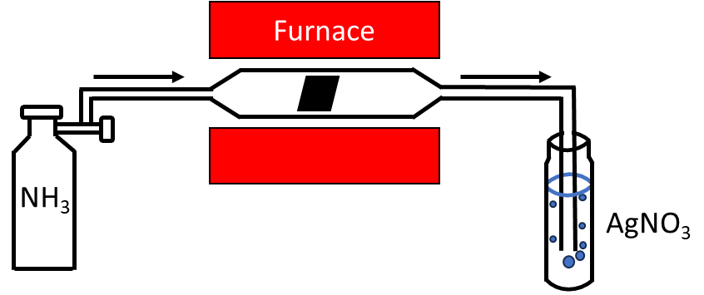
Figure 4.1. Experimental setup of treatment and HCN gas detection. NH₃ gas flows through the quartz tube in the furnace and exits via silver nitrate solution. The black object inside the quartz tube is representative of a carbon felt sample.

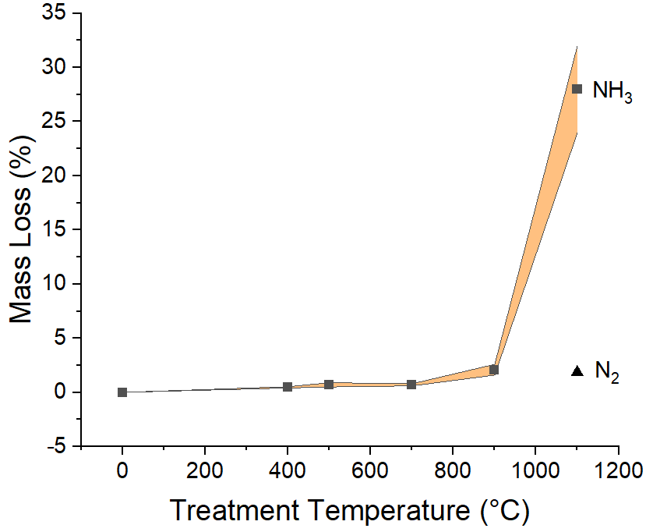
Figure 4.2. Mass loss percentage after each ammonia treatment; the yellow region indicates error range. Sample treated 4 hours at 1100°C in N₂ gas added for reference.

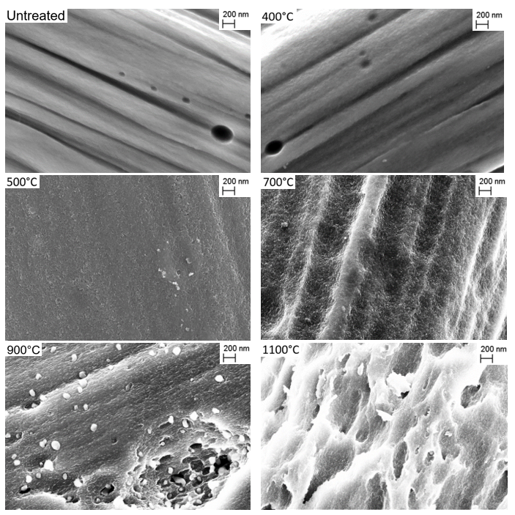
Figure 4.3. SEM images at 30KX magnification of carbon felt electrodes treated at different temperatures for 4 hours.

SEM images were taken of untreated carbon felt and ammonia gas treated carbon felts at 400°C, 500°C, 700°C, 900°C, and 1100°C. It is evident that material was removed in increasing quantities above 500°C and that increased temperature led to a progressively pitted and damaged surface.
The surface with no treatment was smooth with some large holes hundreds of nanometers in diameter. The material treated at 400°C and 500°C had slight surface roughness, but otherwise had a similar appearance to the untreated sample. The 700°C samples had variability in their surface outcomes, with SEM images ranging from smoother, like the lower temperature samples, to more pitting and surface degradation, as seen in Figure 4.3. The 700°C, 900°C, and 1100°C samples have the bubbles and pitting observed in Chapter 3 [96]. These bubbles, which appeared to emerge from the pits, were in the 10-20 nm and 40-120 nm diameter ranges. The 1100°C sample had some bubbles in the deep holes but clearly had the most damaged surface, which correlates to the largest measured mass loss. This progression of surface features observed should lead to greater surface area available for supporting electrochemical reactions and is likely responsible for observed increased overall activity of the electrode.
SEM images in Figure 4.4 show the presence of bubbles within the same day of treatment at 1100°C. These bubbles were no longer present when images were taken of the same sample a week later. This is a possible indication of what is happening during the treatment. Gases are coming from beneath the surface of the felt, generated from the radicals reacting with carbon. Pitting is produced on the surface in addition to the cavernous effects. The 1100°C treated surface experienced a more exaggerated effect of what happened at 900°C and with some of the 700°C samples. Smaller pitting is observed within the larger pitting. The radicals may be burrowing where it is most energetically favorable. The micropores generated greatly increase surface area.
EDS was performed on the treated carbon felt samples. SEM images with carbon (red), nitrogen (green), and oxygen (blue) atomic overlay are shown in Figure 4.5. The fiber of the 1100°C sample is distinctly thinner than the other fibers, further confirming the observed carbon material loss via radical interaction. Carbon, nitrogen, and oxygen have a uniform presence on the surface. The atomic percentages for each sample were
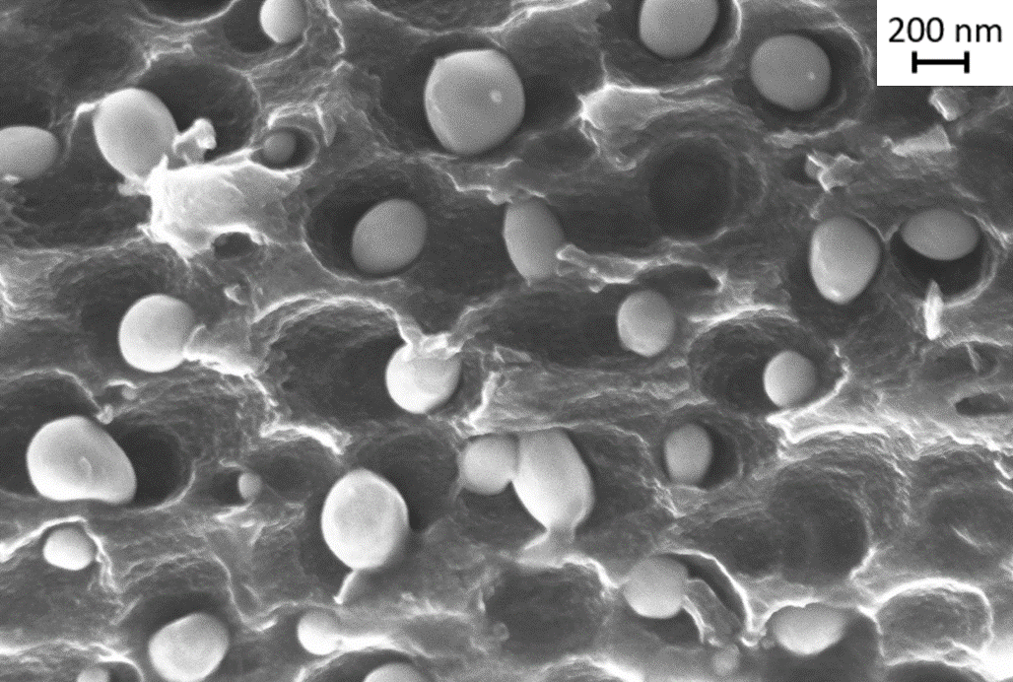
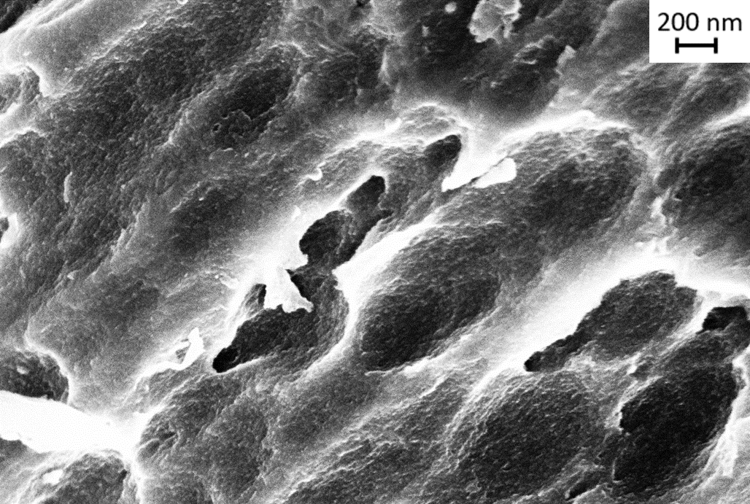
Figure 4.4. SEM images at 30KX magnification, 5 kV acceleration, of carbon felt treated at 1100°C immediately after treatment and one week after treatment.

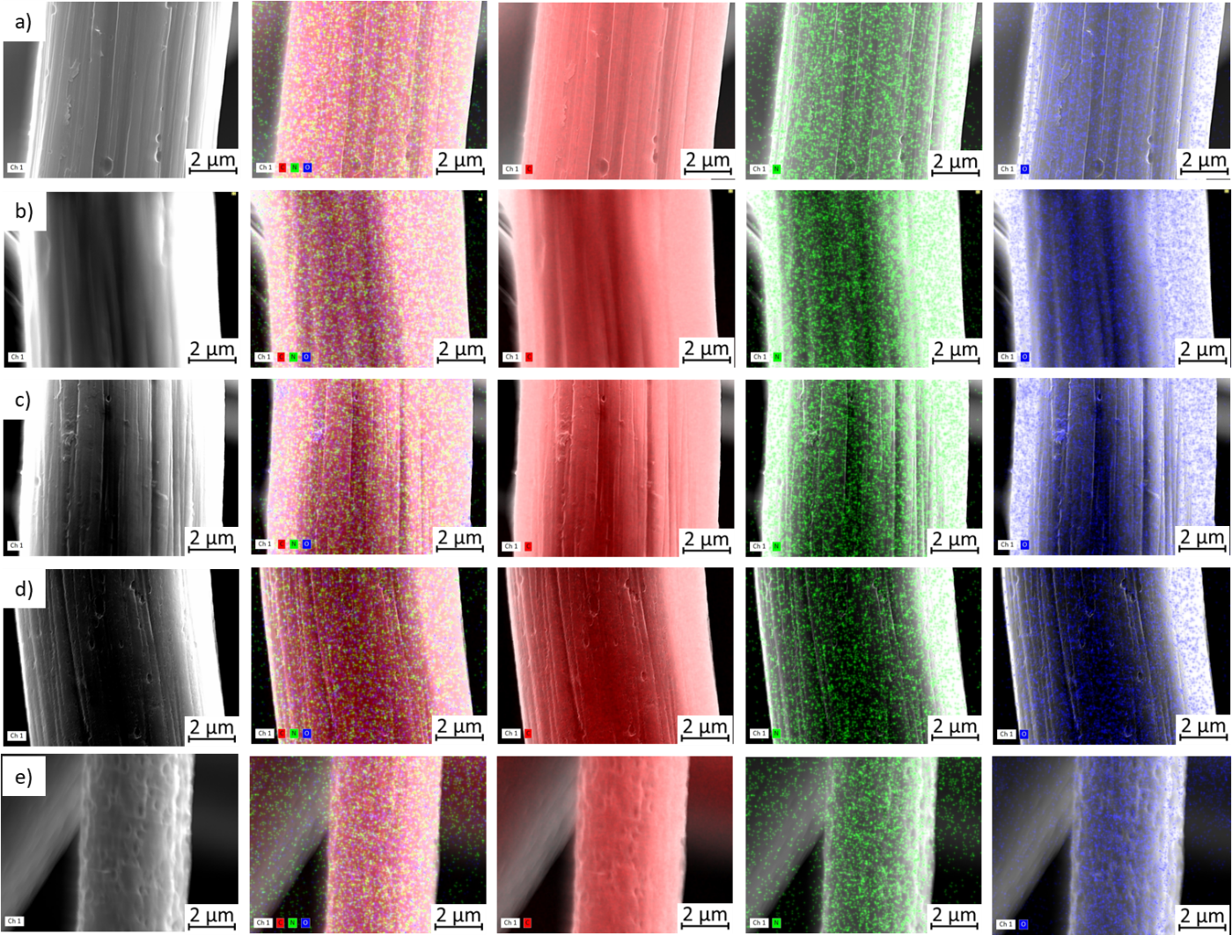

Figure 4.5. SEM/EDS images taken at 15KX magnification, 15 kV acceleration, of carbon felt electrodes: a) untreated, b) 400°C, c) 700°C, d) 900°C, e) 1100°C. Atomic overlay of carbon (red), nitrogen (green), and oxygen (blue) from left to right.

compared, shown in Figure 4.6, but no clear trend was observed. This makes it difficult to correlate electrode performance to a measured increase or decrease in functional groups. Similar observations were made by Pezeshki using x-ray photoelectron spectroscopy (XPS) [41].
Fourier transform infrared spectroscopy (FTIR) was performed on the samples to further determine the presence, or lack thereof, of functional groups before and after treatment. A sample treated only in N₂ at 1100°C was added for comparison. The results were normalized and compared in Figure 4.7. Regions with the most significant changes observed from the untreated samples are highlighted in black boxes. Peaks correlating with C-N and C-H bonds are seen in the 800-1400 cm⁻¹ region [114]. Primary amine peaks appear around the 3200-3500 cm⁻¹ region on the spectra of all treated samples. While less exaggerated due to the untreated sample having those existing peaks, there were increases in intensity of peaks in other regions, correlating with imine (1600-1700 cm⁻¹), amine (3200-3500 cm⁻¹), nitrile (2200-2300 cm⁻¹), carboxylic amide (1700-1750 cm⁻¹), and hydroxyl groups (3200-3600 cm⁻¹) [115]. The peaks at 2310 cm⁻¹ and 2370 cm⁻¹ were identified as CO₂ artifacts in the air during the FTIR measurement. Intensities of selected peaks were compared between the samples, shown in Table 4.1, but no pattern was observed in correlation to electrode performance. This shows that nitrogen functional groups are introduced to all the treated carbon felts. At lower temperatures, above 200°C, surface groups can react with NH₃ to form bonds or destroy surface groups in activated carbon [83, 116]. When comparing the normalized values of the nitrogen peaks, there is no apparent relationship between intensity and treatment temperature. This could indicate that, while contributing to improved performance, nitrogen functional groups are not as critical as surface area to the performance (in this treatment) considering the performance improved with increased treatment temperature. This could also explain why the lower temperature treatments yield improved performance even though they do not experience any ammonia radical bombardment and the resulting increased damage and surface area.

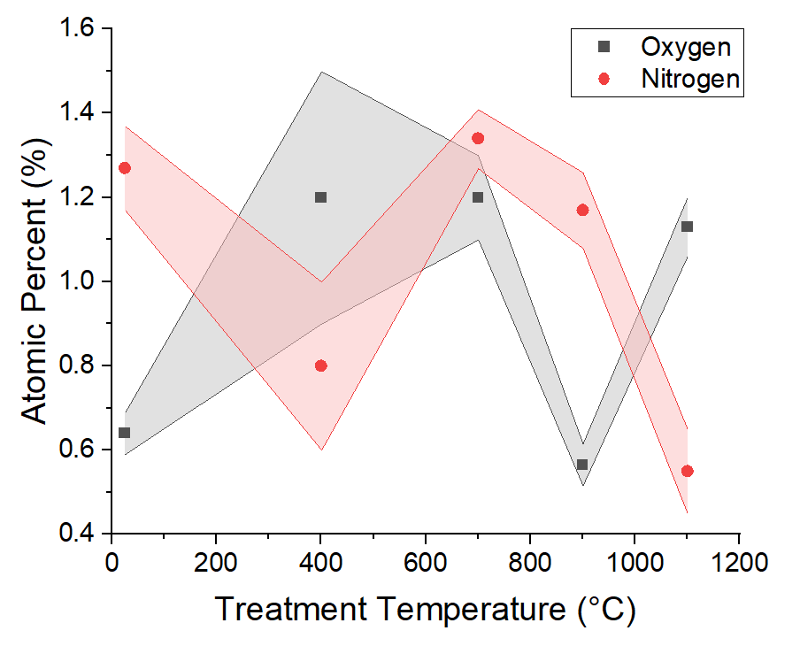
Figure 4.6. Nitrogen and oxygen atomic percentages of treated samples. Note the 25°C treatment temperature signifies the untreated sample.

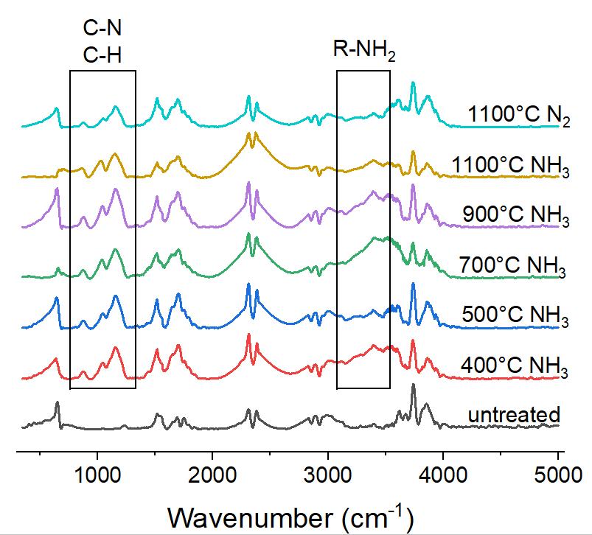
Figure 4.7. Normalized FTIR spectra of carbon felt samples.

Table 4.1. Select normalized FTIR spectra peak intensity values.
 | Aliphatic amine C-N stretch  1157 cm⁻¹ | Aromatic C=C stretch  1517 cm⁻¹ | Imine C=N stretch  1648 cm⁻¹ | Carboxylic amide C=O stretch  1751 cm⁻¹ | Secondary amine N-H stretch  3284 cm⁻¹ | Primary amine 3392 cm⁻¹
Untreated | 0.09 | 0.35 | 0.16 | 0.16 | 0.08 | 0.12
400°C | 0.70 | 0.66 | 0.55 | 0.55 | 0.55 | 0.76
500°C | 0.73 | 0.64 | 0.49 | 0.49 | 0.28 | 0.41
700°C | 0.65 | 0.56 | 0.53 | 0.53 | 0.6 | 0.90
900°C | 0.86 | 0.69 | 0.58 | 0.58 | 0.54 | 0.80
1100°C | 0.53 | 0.34 | 0.37 | 0.37 | 0.24 | 0.39
1100°C N₂ | 0.46 | 0.64 | 0.45 | 0.45 | 0.23 | 0.31

Raman spectroscopy was performed to evaluate the changes in graphitization. The spectra were fit by the D band (1350 cm⁻¹, disordered graphitic lattice (edges)) and the G band (1590 cm⁻¹, ideal graphitic lattice). The intensity ratio (I_{D}/I_{G}) was calculated to indicate the proportion of defect sites present in the fiber. The results for samples treated at each temperature were averaged, shown in Figure 4.8.
While the Raman spectra indicate an increase in defect sites of all treated samples, there is a notable jump between 700°C and 900°C, with an 18% increase in the ratio disordered lattice edges. 1100°C shows a 45% increase compared to the untreated sample. This suggests microstructural changes are occurring on the surface of the felt due to ammonia and carbon felt interacting at elevated temperatures. The increase in disorder correlates with performance of the electrodes.
X-ray diffraction (XRD) was performed on a pristine carbon felt sample and samples treated at 700°C, 900°C, and 1100°C for comparison, shown in Figure 4.9. All samples have identical diffraction peaks at (002) and (100), common to carbon materials [117, 118]. No significant shift in the diffraction peaks was observed. This demonstrates the bulk structure of the materials remains unchanged after treatment, meaning the changes happening are a surface phenomenon, rather than a structural one.

4.3.2 Electrochemical properties
Electrochemical impedance spectroscopy (EIS) was executed to study effects in kinetic and ohmic parameters of the treated and untreated samples. Area-specific resistances were normalized with respect to the geometric area of the VRFB (5.0 cm²). The test was stopped at a low frequency of 50 mHz and the high frequency (ohmic) and charge transfer resistances were calculated, average, and fit with an exponential curve, shown in Figure 4.10.
The samples tested experienced decreasing charge transfer resistance (CTR) with increasing treatment temperature. The 1100°C sample decreased by 97% in CTR from the untreated sample. This points to a large level of functionalization and/or increased specific surface area. The increased density of pitting observed via SEM suggests that surface area did increase. The introduction of surface defects along with the improved
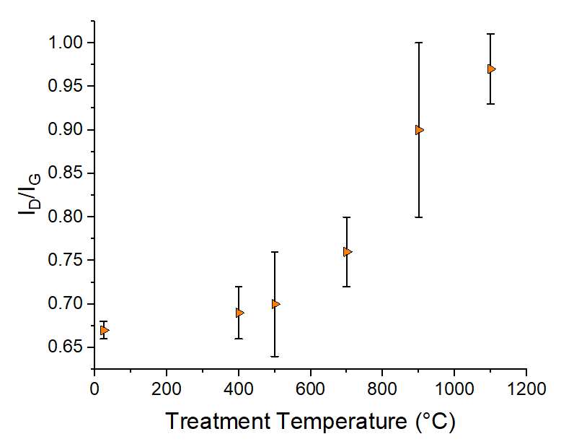
Figure 4.8. Disorder-to-order ratio at different treatment temperatures. Note the 25°C treatment temperature signifies the untreated samples.

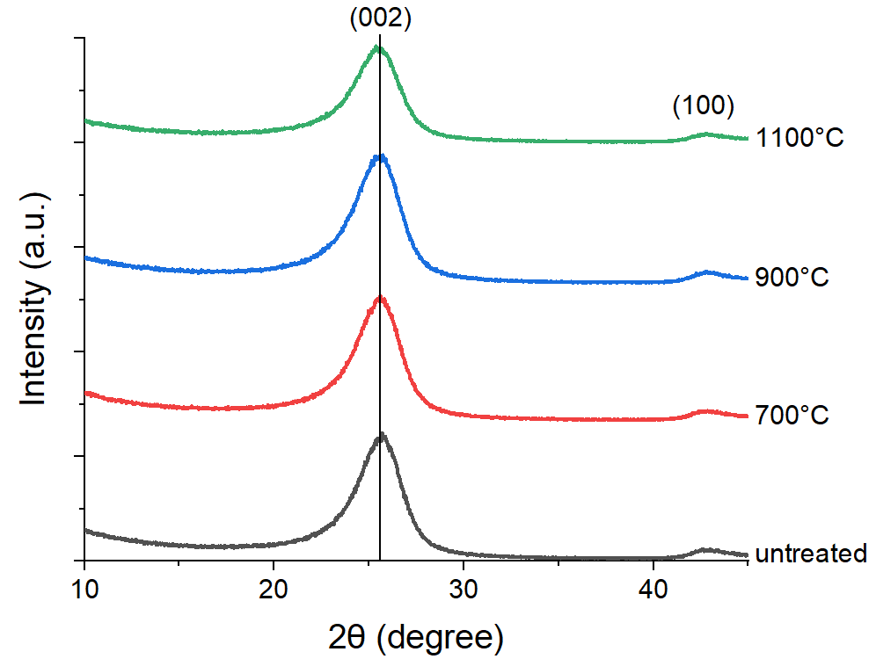
Figure 4.9. Diffraction peaks of carbon felt samples treated at different temperatures. Vertical line added to illustrate lack of diffraction peak shift.

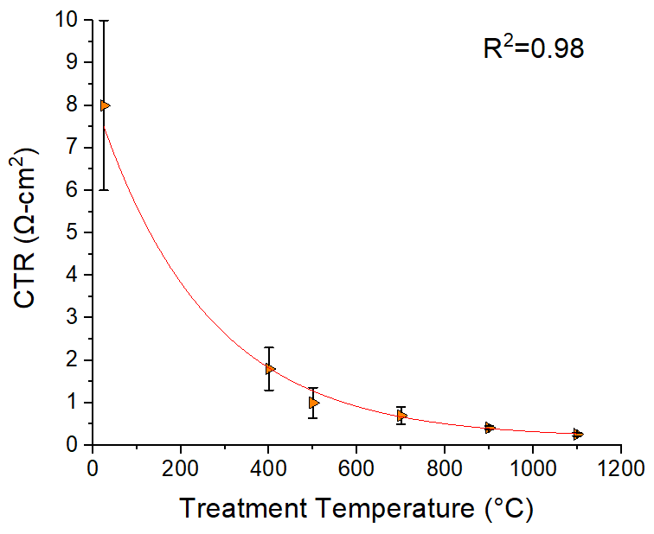
Figure 4.10. Charge transfer resistance at different treatment temperatures. Note the 25°C treatment temperature represents the untreated samples.

kinetics match well with the findings of Kim et al., as well as conventional expectation [78].
To confirm whether surface area increased, Electrochemical surface area (ECSA) (based on capacitance) was measured and calculated using EIS in acid and compared between treatment temperatures. The spectra were fitted with a simple capacitive electrode equivalent circuit. A specific capacitance of 0.02 mF/cm² was used with the electrode capacitance and mass of the electrodes to calculate ECSA [41]. The results of this calculation were averaged and the error was calculated. Tafel plots, with IR-corrected potential to limit overpotential to kinetic influence, were fitted in the linear regions, enabling identification of exchange current densities for each electrode treatment temperature. Figure 4.11 shows exchange current density and ECSA as functions of electrode treatment temperature. The ECSA and exchange current densities correlate strongly, indicating that kinetic enhancement is likely due to increased ECSA. The ECSA was determined via impedance spectroscopy for VRFB with no vanadium present while the Tafel plots were collected in an operating cell. This approach ensures that the ECSA and exchange current density are determined independently.
The sample treated at 1100°C for four hours had an increase in surface area of 399% compared to the untreated sample. The sample treated at 900°C had an increase of 281%. The samples treated at 400°C, 500°C and 700°C, showed only an average of 32%, 55%, and 73% increase. This correlates with the mass loss and what was observed in the SEM images. While ECSA does not exactly represent the physical surface area of the felt, it does give a more accurate depiction of the effective surface area in relation to electrolyte interactions.
Polarization curves taken at 50% state of charge were used to compare the performance of the electrodes treated at different temperatures. The current densities measured at 80% voltage efficiency were averaged and error was calculated, shown in Figure 4.12.
Table 4.2 shows percent increases in current density at 80% voltage efficiency over the range of treatment temperature, all relative to the 80% voltage efficiency current density for untreated samples. The 900°C results are consistent with prior research [96].
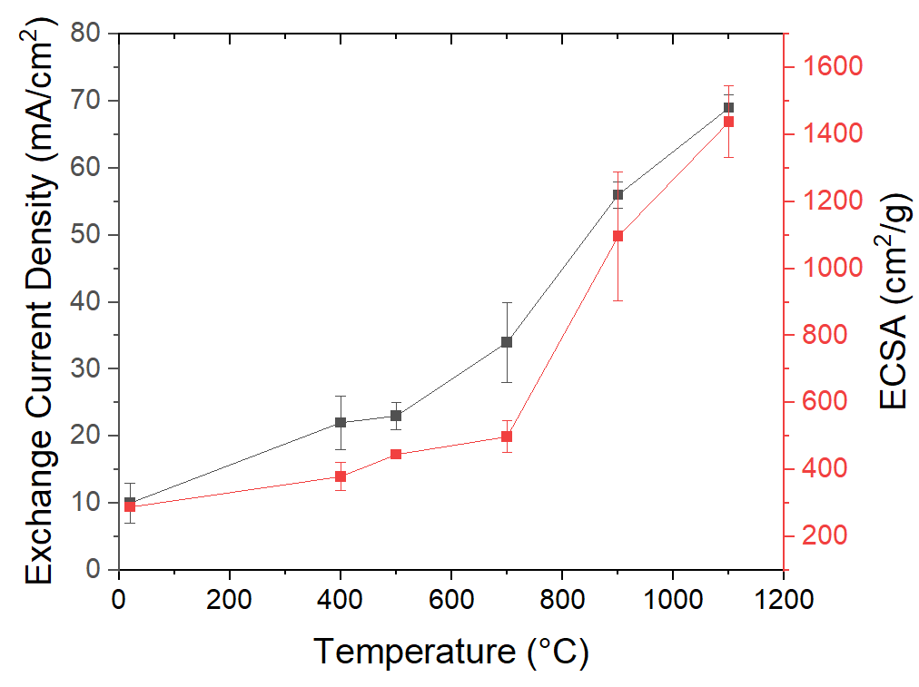
Figure 4.11. Exchange current density and electrochemical active surface area of electrodes at different treatment temperatures. Note the 25°C treatment temperature signifies the untreated samples.

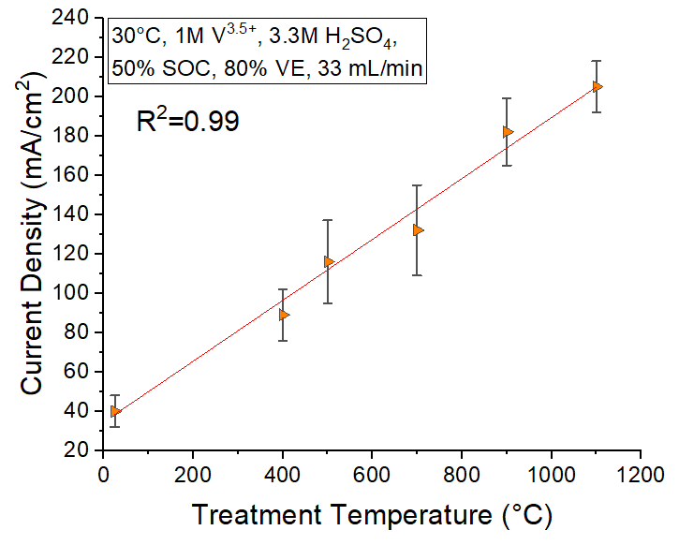
Figure 4.12. Current density at 80% voltage efficiency and 50% state of charge at different treatment temperatures. Note the 25°C treatment temperature signifies the untreated samples.

Table 4.2. Percent increase in current density of treated samples to untreated samples.
Treatment temperature (°C) | Percent increase (%)
400 | 123
500 | 190
700 | 230
900 | 355
1100 | 413

Voltage efficiency at a range of current densities was calculated using the midpoint of each step of the charge/discharge curves as seen in the equation below. Figure 4.13 shows voltage efficiency results from charge-discharge cycling from 20 mA/cm² to 150 mA/cm².
Voltage efficiency:

$ε_{ν}=\frac{V_{discharge}}{V_{charge}}$ (4.1)
The treated samples show elevated voltage efficiencies compared to the untreated samples. As treatment temperature increases, the drop in efficiency between current density is reduced. Additionally, the decrease in voltage efficiency between the first and last cycle shrinks, as seen in Table 4.3, demonstrating the lasting effect of the higher temperature treatments.
To better understand the correlation between electrochemical performance and material properties of these durable electrodes, we evaluated graphitization and ECSA as they relate to current density. The current density was measured at 80% voltage efficiency using IR-corrected voltages and compared to the ECSA results of each sample. The IR corrections were calculated using the high frequency resistance (HFR) values from PEIS data to rule out impedance/ohmic effects. ECSA was also compared to the disorder-to-order ratio obtained from Raman spectroscopy, shown in Figure 4.14.
ECSA and order-to-disorder ratio correlate positively with current density at 80% IR-corrected voltage efficiency. As carbon gets more disordered, ECSA tends to increase. This agrees with what Radinger et al. has theorized about increasing edge sites to improve performance and with the results of Kim et al. on surface defects [74, 78].

4.3.3 Proof of radicals
To confirm that radicals are attacking the carbon felt during the high temperature ammonia treatments, increasing surface area, the outgoing gas from the furnace was bubbled through a silver nitrate solution to detect -CN compounds. Argon and nitrogen were used with carbon felt samples present at 1100°C as controls. Additionally, ammonia
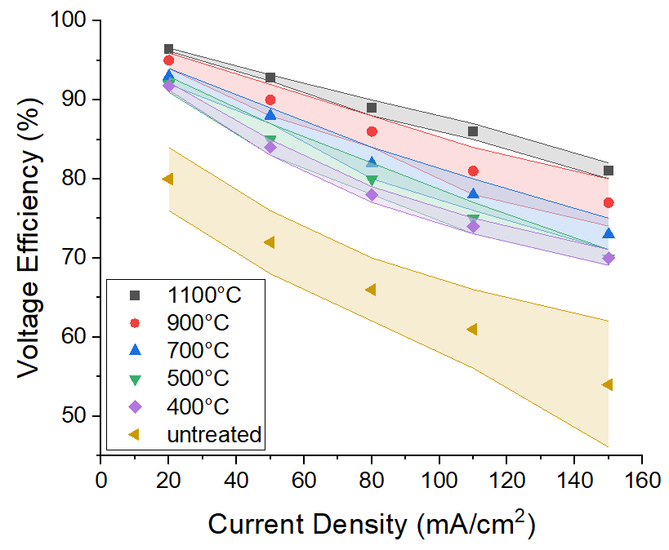
Figure 4.13. Voltage efficiency at different current densities and treatment temperatures.

Table 4.3. Percent decrease of voltage efficiency at 150 mA/cm² after 100 charge-discharge cycles.
Treatment temperature (°C) | Percent decrease (%)
25 | 15±4
400 | 9±1
500 | 7±2
700 | 6±1
900 | 2.9±0.2
1100 | 2.6±0.3

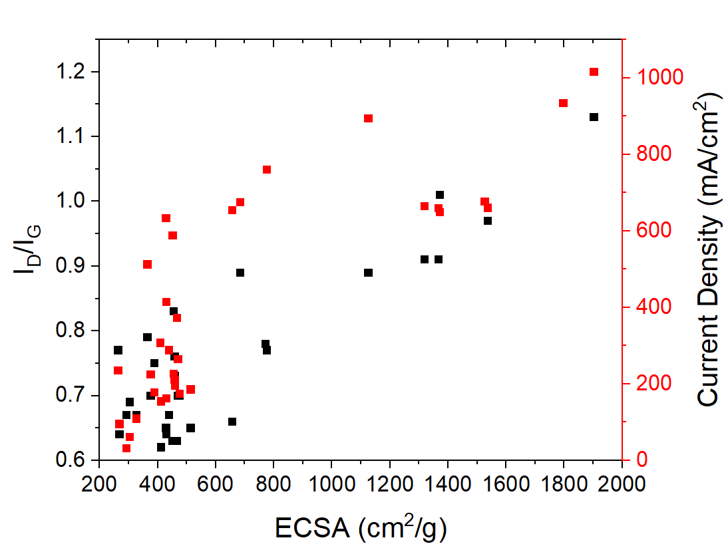

Figure 4.14. Current density at 80% voltage efficiency (IR-corrected voltage) and 50% state of charge. ECSA versus order-to-disorder ratio of samples.

at 1100°C and 400°C were tested with and without samples present. At 900°C with ammonia, it was only tested with a sample. Video stills of gas bubbling through solution from different treatment conditions are shown in Figure 4.15. The 900°C sample reaction takes roughly 10 minutes, while all other reactions take no more than one minute.
Thirty minutes after the furnace reached 1100°C with a carbon felt sample, the outgas flowed through the silver nitrate solution and turned milky brown, then whiter in the span of a minute. After 90 minutes a fresh solution was introduced, turning white immediately, indicating the presence of AgCN. The solution for the 900°C sample went from dirty white to brown. The solution did not precipitate during the argon and nitrogen experiments, remaining clear throughout. For both 400°C experiments and the 1100°C with no sample, the solution briefly precipitated brown into AgO₂ before dissolving back into a clear solution. This follows the reversible reaction of ammonia with the silver ions, creating AgO₂ before NH₄⁺, resulting from NH₃ gas and the water in solution, quickly pushes the equilibrium back to the left, clearing up the brown precipitate:
2 Ag⁺(aq) + 2NH₃(aq) + 2H₂O(l) ⇌ Ag₂O(s) + 2NH₄⁺(aq) + H₂O(l)
Alternatively, or additionally, the precipitate is dissolving in excess ammonia, forming a colorless complex ion, as seen below:
Ag₂O(s) + 4NH₃(aq) + H₂O(l) ⇌ 2[Ag(NH₃)₂]⁺(aq) + 2OH⁻(aq)
The solution does precipitate for the 1100°C sample (white) and the 900°C sample (white and black). The black precipitate is associated with Ag^{I/II}O₂ indicating an incomplete decomposition of ammonia. The white precipitate indicates that these carbon felt samples are exposed to enough ammonia radicals to generate HCN and other -CN gases to be detected, while the others are not. The precipitates, which can be seen crystallized above and below solution in Figure 4.16, were air dried and the resulting crystals analyzed using XRD for a more quantitative confirmation of the qualitative conclusions made [91]. The 1100°C sample spectra were compared to a AgCN reference in Figure 4.17 and appear to be pure [119]. This confirms HCN is being produced during the 1100°C ammonia treatment in quantities suggesting full decomposition of ammonia in the tube furnace, consistent with literature [104]. The peaks from the 900°C sample match with
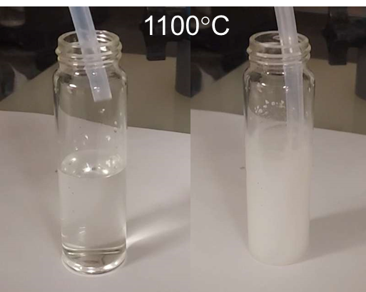
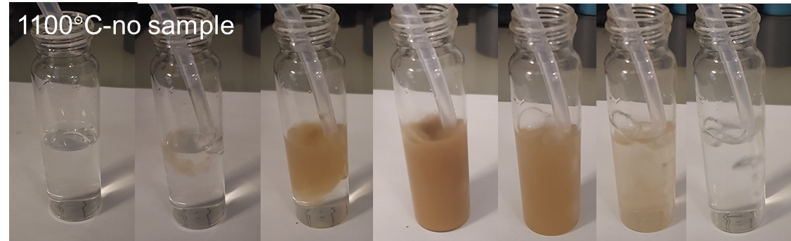
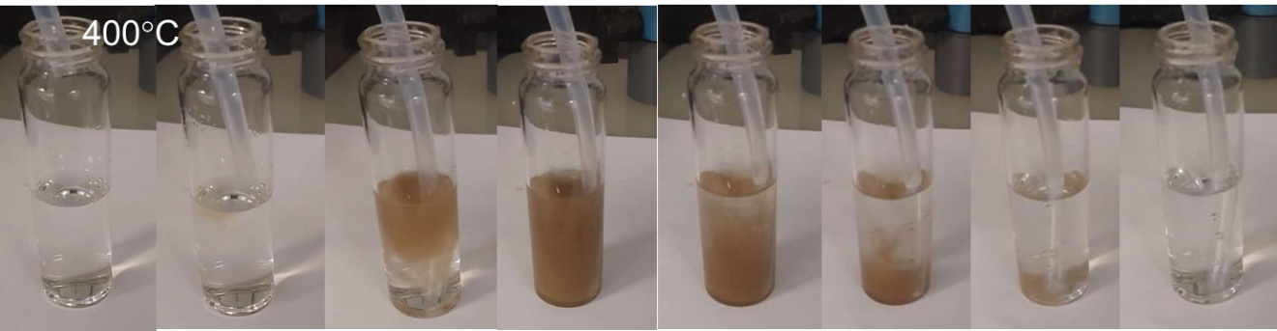
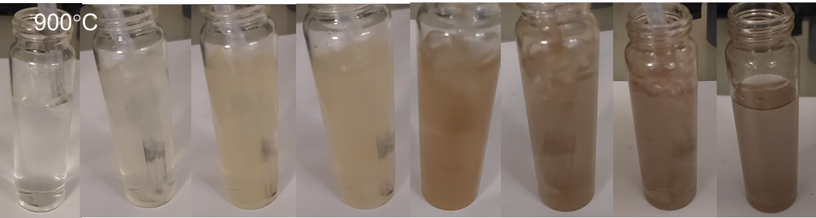
Figure 4.15. Samples generated during treatment by flowing outgas into silver nitrate solution.

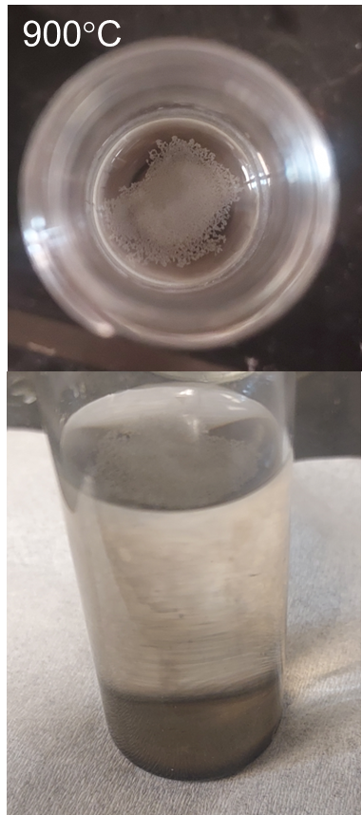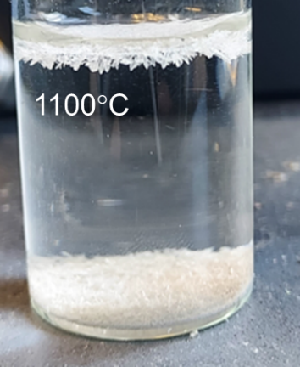
Figure 4.16. Settled silver cyanide precipitates.

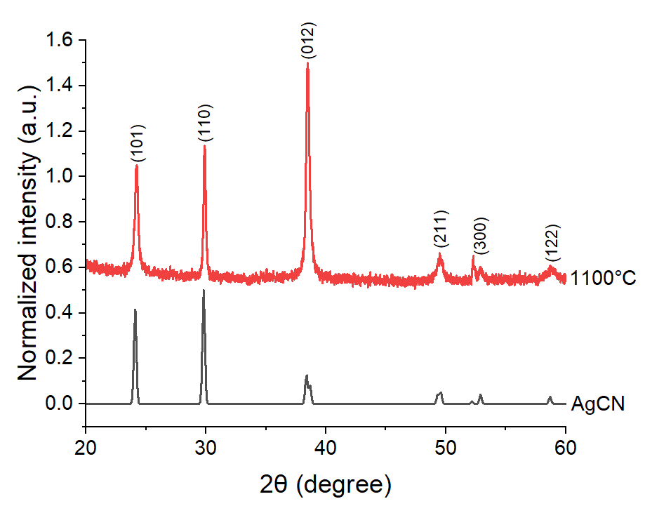
Figure 4.17. Diffraction peaks of white precipitate match reference pattern of AgCN.

AgCN and Ag^{I/II}O₂ sample spectra, indicating an incomplete decomposition, also consistent with the literature. The detection of HCN in the higher temperature ammonia treatments confirms that the mechanism described by Stohr et al. is occurring in our treatment [84]. Therefore, the radicals are real and are responsible for the mass loss and increase in surface area.
A schematic of the proposed dominant reactions is shown in Figure 4.18. As the temperature increases, reactions begin between the ammonia gas and the surface groups on the carbon felt, adding and possibly subtracting various functional groups (similarly occurring during cooldown). Ammonia decomposes to radicals (NH²⁻, NH₂⁻, atomic hydrogen) as it reaches high temperatures, their thermodynamic instability causing them to attack the carbon atoms in the carbon felt. This results in methane, hydrogen cyanide, and cyanogen gases forming before exiting the tube furnace. Over time a significant portion of the felt will be swept away in this manner. This produces a pitting effect on, and likely below, the surface of the material, not unlike what is observed in metallic structure corrosion [86]. Contrary to intuition, this damage is beneficial and leads to durable, enhanced performance through increased surface area.
The removal of carbon creates more surface area and defect sites, which improves electrochemical properties of the carbon felt. The lower temperatures would have little to no radicals present. Therefore, any benefits observed at 400°C and 500°C, which are roughly the same, are more likely due to the introduction of nitrogen functional groups. Radical-felt interactions may have an onset temperature around 700°C, as evidenced by the variable responses of samples treated at that temperature. Functionalization is inherently less stable, so the physical enhancement in this treatment is promising.

4.4 Conclusions
Carbon felt electrodes were treated with ammonia gas at 400°C-1100°C and showed progressively improved performance in a vanadium redox flow battery. At higher temperatures, significant morphological changes occurred on the carbon felt surface, with up to 35% mass loss at 1100°C. Analysis of the surface contents revealed an increase in functional groups in all samples compared to the untreated, but with no discernable correlation of percentage to performance. Hydrogen cyanide was detected during the
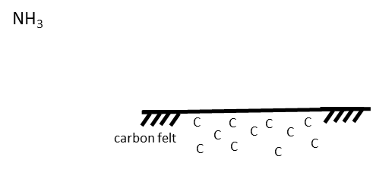
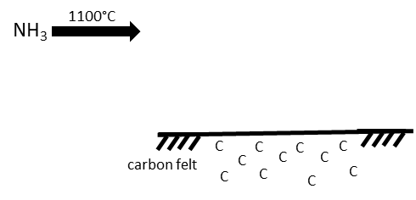
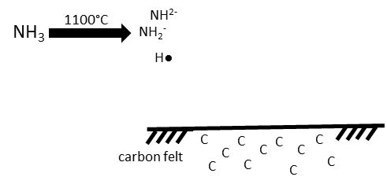
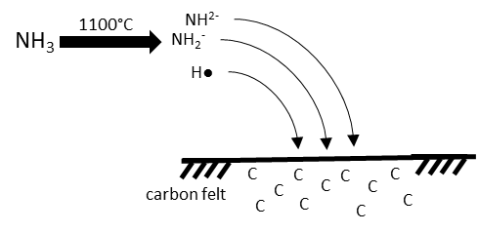
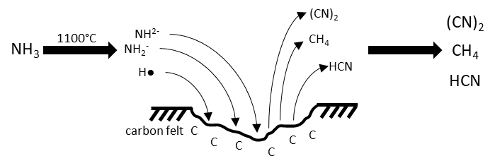
Figure 4.18. Diagram of proposed primary reactions and effects of ammonia treatment.
higher temperature treatments, revealing the carbon was gasified by decomposition products of ammonia. This resulted in an increase in defect sites and electrochemical surface area (ECSA) on the remaining material, correlating with an improvement in charge transfer resistance, current density, exchange current density, and voltage efficiency. Carbon felt treated at 1100°C had a 413% increase in current density at 80% voltage efficiency compared to untreated felt. ECSA and defect sites correlated with improved performance, with 399% and 45% increases. Surface morphological changes are a more robust pathway to enduring electrode performance compared to functional groups and this is exemplified in these results. Because these changes occurred due to ammonia decomposing to free radicals at high temperatures and reacting with carbon, lowering the energetic barrier to ammonia radical creation may decrease production costs of effective electrodes.

Inducing radical generation of ammonia for carbon felt electrodes for vanadium redox flow batteries

Abstract
This article hasn’t been published anywhere, nor will it be before I turn in the final version of my ETD, so I didn’t include a publication statement. A manuscript will be submitted for publication. This work was authored by Kaycee Gass, Bapi Bera, Gabriel Goenaga, Doug S. Aaron, and Matthew M. Mench.
Goenaga assisted data collection of FTIR.

5.1 Introduction
In Chapters 3 and 4, it was found that decomposition products of ammonia at high temperatures induce pitting in carbon felt electrodes, which is beneficial to VRFB performance. Because of this, it seems reasonable that using catalysts to induce the generation of radicals would be the next step forward in improving this treatment. Some proof-of-concept experiments were performed and tested electrochemically to see if their performance surpasses that of the original experiment.
Decomposition starts at a little below 500°C in porcelain conditions, but is miniscule until around 650°C [105, 106]. The rate of decomposition is influenced by the physical state of surface contact. For example, a porcelain environment exhibits a significantly higher percentage decomposition than a glass environment at any given temperature. Increasing the surface area inside the furnace with broken porcelain appears to increase decomposition rates. It is theorized that the ammonia molecule decomposition is greatly influenced by impact against solid surfaces.
Additional methods of radical generation were investigated. Metal catalysis reactions contributing to the decomposition of ammonia have been observed since the early 19th century [120, 121]. Certain metal catalysts are used to lower the energetic barrier of ammonia decomposition for hydrogen generation [122-125]. The ammonia interacts with the lattice to be adsorbed at the surface, dehydrogenated, and dissociated [126].
Possible reactionary steps are shown below [127]:
2NH₃(g) ⇌ 2NH₃(ad)
2NH₃(ad) ⇌ 2NH₂(ad) + 2H(ad)
2NH₂(ad) ⇌ 2NH(ad) + 2H(ad)
2NH(ad) ⇌ 2N(ad) + 2H(ad)
2N(ad) ⇌ N₂(ad)
N₂(ad) ⇌ N₂(g)
2H(ad) ⇌ H₂(ad)
H₂(ad) ⇌ H₂(g)
Nickel appears to be the most cost-effective catalyst, coming third in performance to ruthenium and rhenium, making it an affordable material to begin with [128-130], although iron also shows promise [105]. Improving the kinetics of the ammonia treatment will allow for more efficient outcomes with less time and/or energy consumption, making vanadium redox flow battery technology more commercially viable.

5.2 Experimental methods
Treatments and measurements are performed as described in Chapter 2. Deviations and novel techniques are discussed below.
Of the 400°C, 700°C, and 1100°C samples from Chapter 4, some were treated in quartz tubes that were smooth on the inside and others were treated in quartz tubes covered in a layer of zirconia that had formed on the interior (“rough” and “smooth” tubes). These datasets are differentiated and compared in this chapter.
New samples were generated at 900°C with the sample folded inside a 300 x 80 x 0.3 mm piece of nickel foam from MTI Corporation. The nickel foam has a surface density of 346 g/m² and a porosity of at least 95%.

5.3 Results and discussion

5.3.1 Rough and smooth tube treatments
Samples treated in rough and smooth tubes were compared to test the theory that roughening the surface inside the furnace will improve ammonia decomposition kinetics and, consequently, the performance of the electrode [106]. Current densities, at 80% voltage efficiency and 50% state of charge, as a function of treatment temperature were compared between samples treated in a smooth furnace tube and a roughened one, shown in Figure 5.1. The rough tube samples show an improvement over the smooth tube samples, with a widening gap as treatment temperature is raised, experiencing a 13.5% increase at 1100°C.
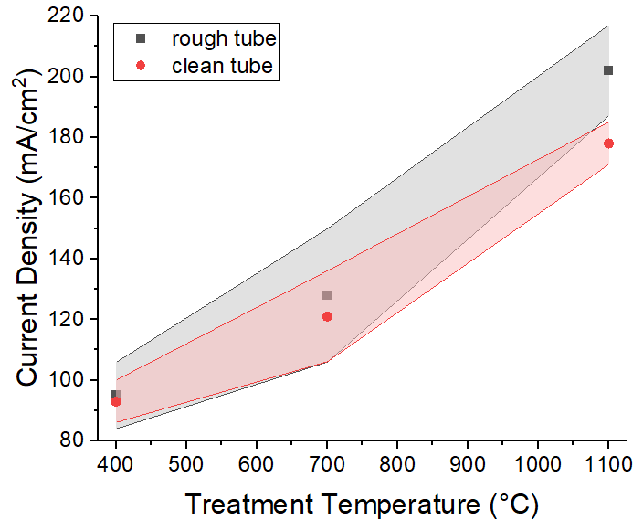
Figure 5.1. Current density at 80% voltage efficiency of rough and smooth tubes samples.

The voltage efficiency comparisons are shown in Figure 5.2. Again, the rough samples perform better than the smooth samples. With the rough tube, the CTR decreases, ECSA increases, current density increases, and voltage efficiency increases compared to the smooth tube. These modest but notable improvements in performance support the notion that rough surfaces improves the kinetics of the ammonia interactions with the carbon felt [104]. It also introduces a facile and passive addition to the process.

4.3.2 Nickel treatment
Samples treated in the presence of nickel foam and ammonia at 900°C were compared to samples treated only in ammonia at 900°C. SEM was taken of the nickel
sample, shown in Figure 5.3. Bubbles around 50 nm or less in diameter can be observed as well as a pitted surface. This is similar to prior images of 900°C and 1100°C, as well as some 700°C samples. Electrochemical surface area, charge transfer resistance, and
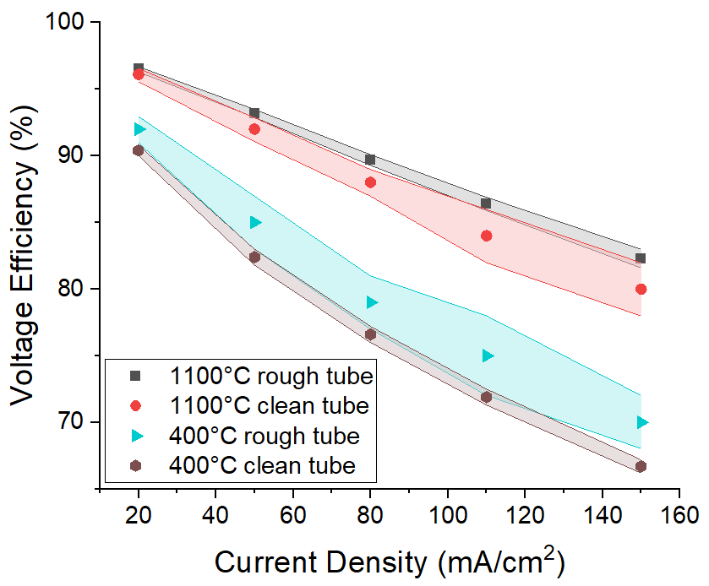
Figure 5.2. Voltage efficiency of rough and smooth tubes samples.

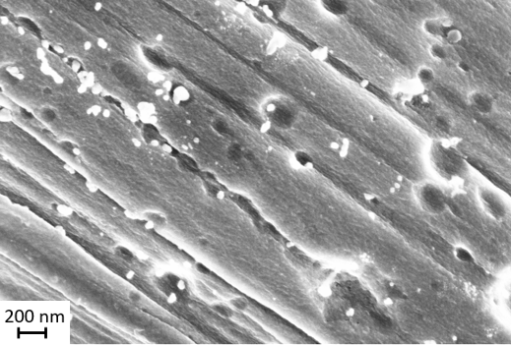
Figure 5.3. SEM image at 30KX magnification, 3 kV acceleration, of carbon felt treated at 900°C in the presence of nickel foam.

current density at 50% state of charge and 80% voltage efficiency of the two samples are compared in Table 5.1. The nickel sample shows a 40% increase in ECSA and a 7% increase in current density over the 900°C sample. Cycling data in Figure 5.4 shows the nickel sample with a higher performance and durability, at all but the smallest current densities measured, compared to the 900°C sample. These results support the theories presented in this chapter and provide another tool to increase ammonia radical production and interaction with the carbon felt.

5.4 Conclusions
The proof-of-concept experiments (rough versus smooth, nickel foam) improved performance, increasing current density at 80% voltage efficiency by 13.5% (rough over smooth) and 7%, respectively. These outcomes reinforce the theory that ammonia radicals are the main driver for surface area increase and performance improvement. Lowering the energetic barrier to ammonia radical creation has been shown to decrease energy requirements for effective electrodes.

Table 5.1. ECSA, charge transfer resistance, and current density results of standard versus nickel foam conditions.
 | 900°C | Nickel foam, 900°C
ECSA (cm²/g) | 1097±270 | 1538±60
Charge transfer resistance (Ω-cm²) | 0.33±0.05 | 0.37±0.04
Current density at 80% VE (mA/cm²) | 182±17 | 194±9

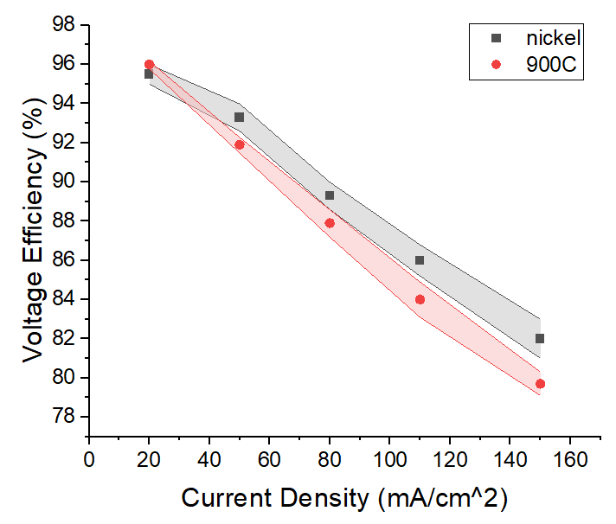
Figure 5.4. Voltage efficiency of carbon felt sample treated in ammonia gas at 900°C versus that of a sample treated in equal conditions in the presence of nickel foam.

High temperature nitrogen post treatment of carbon felt electrodes

Abstract
This article hasn’t been published anywhere, nor will it be before I turn in the final version of my ETD, so I didn’t include a publication statement. A manuscript will be submitted for publication. This work was authored by Kaycee Gass, Bapi Bera, Gabriel Goenaga, Doug S. Aaron, and Matthew M. Mench.
Goenaga assisted data collection of FTIR.

6.1 Introduction
While the ammonia treatment discussed in prior chapters is durable and effective, it is beneficial to explore alternative treatments to further energy storage goals. Adding on to the original treatment is a logical and efficient progression. Work done by Boehm et al. suggests performing a post-treatment, with either N₂ or H₂, may increase surface area and catalytic activity [84]. The mechanism is not well understood but, as it requires little extra time, effort, or equipment, it is a worthwhile path to pursue. Preliminary experiments were performed to explore the effects of the N₂ post-treatment on ammonia treated carbon felt samples.

6.2 Results and discussion

5.2.1 Characteristics of treated materials
Samples were treated at 900°C in NH₃ for four hours then allowed to cool before ramping up again to 900°C, but in N₂, for one hour. Treatments and measurements mentioned in this chapter were otherwise performed as described in Chapter 2. The samples had a significantly blackened/charred look compared to standard NH₃ treated samples.
The SEM images in Figure 6.1 show an interesting surface morphology, radically different from samples treated only in ammonia. Only a small portion of the original, ammonia treated surface area can be seen, as much of it is covered by amorphous structures. Once a section is found exposing the surface, micropores can be observed to have a similar surface morphology to samples treated for four hours at 900°C in ammonia. The amorphous structures can be seen partially embedded in these pores. When directing focus at less charred portions of the felt, less amorphous structures are
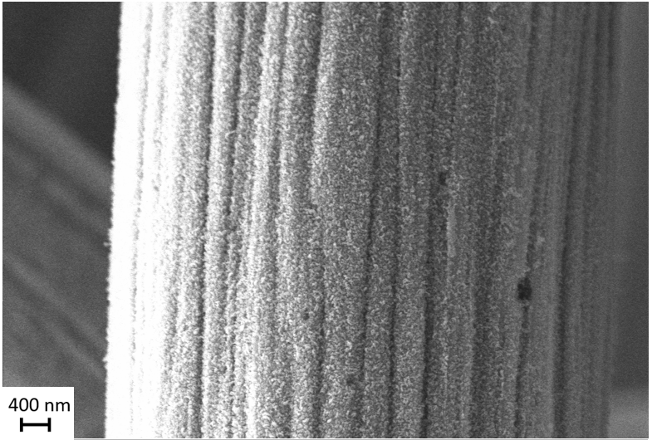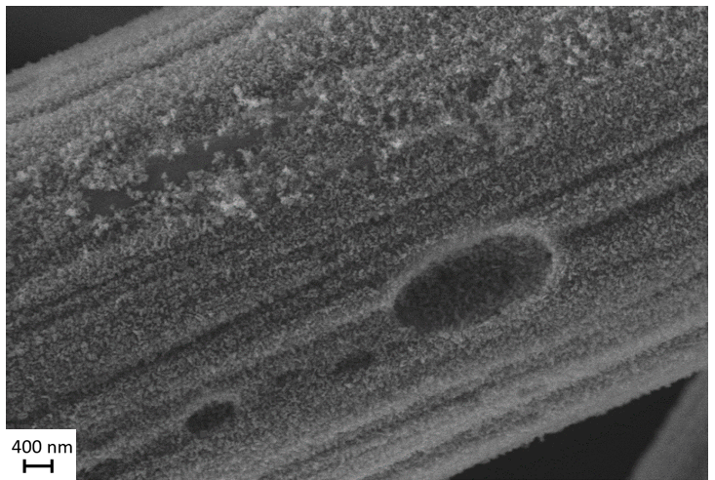
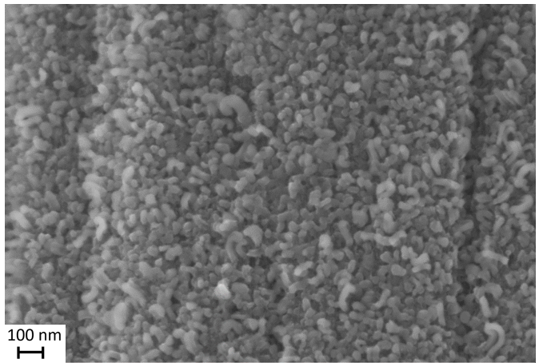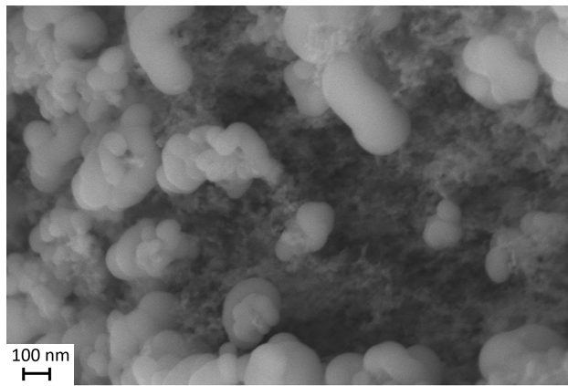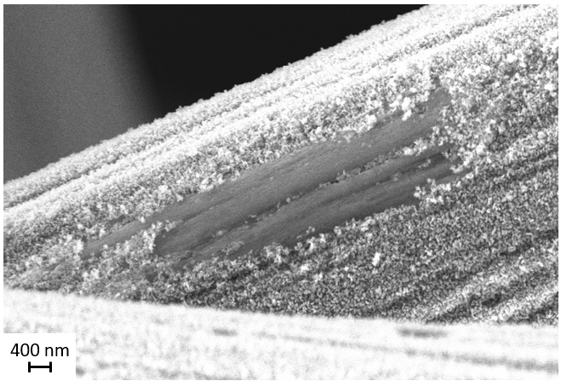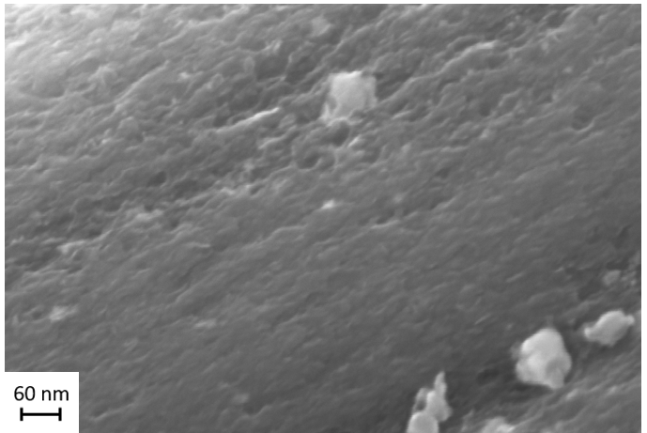
Figure 6.1. SEM images at 10KX-100KX magnification, 5 kV acceleration, of carbon felt treated at 900°C in ammonia gas for four hours, then at 900°C in nitrogen gas for one hour.

present and more of the original surface is visible. A mass loss of 1.3% was measured, less than the standard 900°C ammonia treatment, which loses approximately 2-3% mass. This is consistent with material, the amorphous structures, being added during the nitrogen gas portion of the treatment, after the ammonia portion of the treatment removing material.
X-ray diffraction, spectra shown in Figure 6.2, was performed to determine whether there were changes in the bulk material. As in Chapter 4, there appears to be no difference between any of the samples, nor any significant peak shifts, indicating no change.
FTIR was performed on the nitrogen post-treated sample and compared to untreated, standard treated, and nitrogen treated sample. The spectra are shown in Figure 6.3. The nitrogen post-treatment results in a spectrum more similar to the high temperature nitrogen treated sample rather than to the standard ammonia treated sample, with less prominent peaks in the primary amine (3200-3500 cm⁻¹) region, which was previously discussed in Chapter 5. This suggests a surface morphology more similar to the solely 1100°C nitrogen gas treated carbon felt, though it is more transient between the two samples in the peaks correlating with C-N and C-H bonds (800-1400 cm⁻¹) [115]. Intensities of selected peaks were compared among the samples, shown in Table 6.1. The peaks at 2310 cm⁻¹ and 2370 cm⁻¹ were identified as CO₂ artifacts in the air during the FTIR measurement. Perhaps the post-treatment reduces some of the functional groups attached during the prior ammonia treatment.
EDS was performed on the samples and the atomic percentages were measured and compared, shown in Figure 6.4. There is no apparent difference in atomic percentage between the two samples, which is curious considering the distinctions observed in SEM and FTIR results. The 900°C N₂ portion of the treatment may have an annealing effect on the carbon felt, restructuring the surface, rather than effecting a chemical change. This would allow for changes in functional groups, but not atomic percentage. Battery testing was performed on the samples to determine their electrochemical properties.

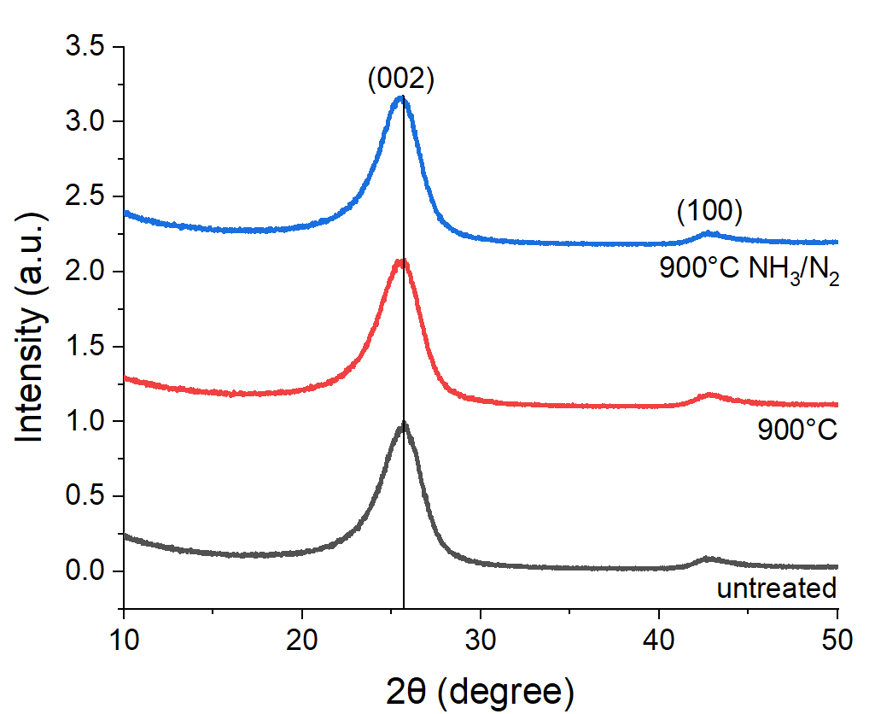
Figure 6.2. Comparison of diffraction peaks of carbon felt samples treated with ammonia versus with an additional treatment with nitrogen.

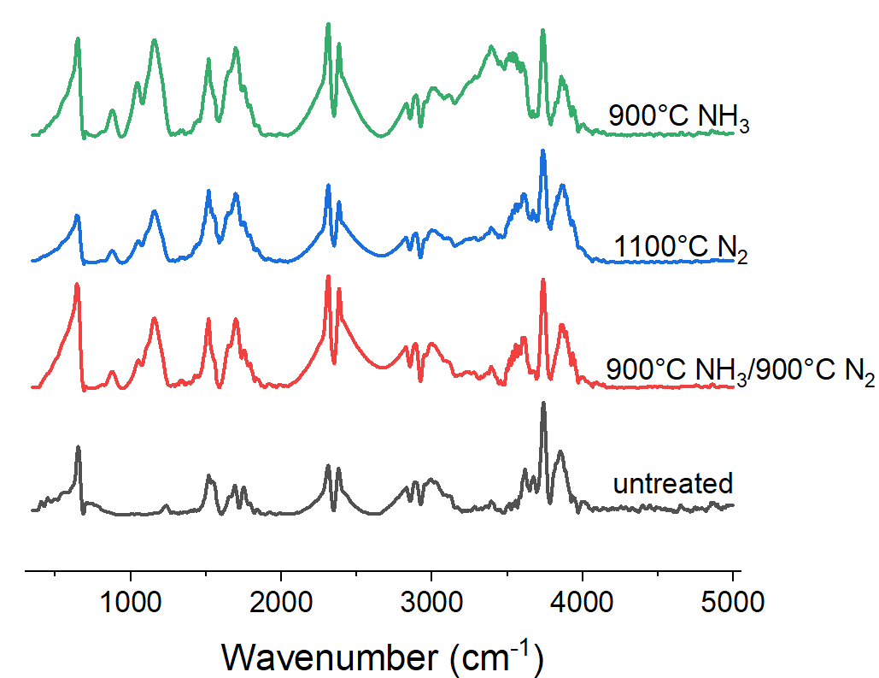
Figure 6.3. FTIR of post-treated sample compared to control samples.

Table 6.1. Select normalized FTIR spectra peak intensity values.
 | Aliphatic amine C-N stretch  1157 cm⁻¹ | Aromatic C=C stretch  1517 cm⁻¹ | Imine C=N stretch  1648 cm⁻¹ | Carboxylic amide C=O stretch  1751 cm⁻¹ | Secondary amine N-H stretch  3284 cm⁻¹ | Primary amine 3392 cm⁻¹
Untreated | 0.09 | 0.35 | 0.16 | 0.16 | 0.08 | 0.12
900°C | 0.86 | 0.69 | 0.58 | 0.58 | 0.54 | 0.80
900°C NH₃/N₂ | 0.62 | 0.62 | 0.38 | 0.34 | 0.14 | 0.19
1100°C N₂ | 0.46 | 0.64 | 0.45 | 0.45 | 0.23 | 0.31

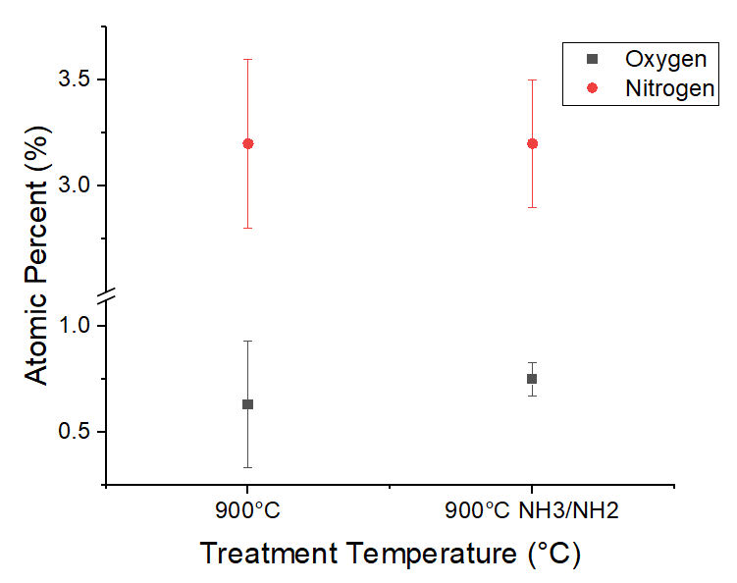
Figure 6.4. Atomic percentage of sample compared to control sample.

6.2.2 Electrochemical properties
In Table 6.2 charge transfer resistance (CTR), current density, graphitization and ECSA results are compared between the original and new treatment. CTR decreases by 49.8% between samples while the current density increases by 32.0%. The I_{D}/I_{G} increased by 9% and the ECSA increased by 80%. Overall, the post-treatment shows improvement over the original treatment. In Figure 6.5 voltage efficiencies from charge-discharge cycling at a range of current densities from 20 mA/cm² to 150 mA/cm² are compared. The additional nitrogen treatment produces a shallower slope than the original treatment, indicating improved durability. All post-treatment results demonstrate superior performance and durability to the original ammonia-only treatment.
It should be noted that these are preliminary results and were only compared to samples treated and tested under the same conditions around the same time, as was done in all the experiments in prior chapters. Figure 6.6 compares the best raw polarization curves from each category of treatment performed throughout the dissertation. The sample treated at 1100°C in rough surface conditions yields the best results, followed by the sample treated in the same conditions at 900°C. Samples treated with nickel follow behind and samples given a post-treatment, while having excellent results, come short of the performance of the rough samples.

6.4 Conclusions
A sample was treated in ammonia gas at 900°C for four hours and post-treated in nitrogen gas for one hour for comparison with a control sample treated in ammonia gas at 900°C for four hours. Although these are preliminary results, the novel sample performed well, improving current density by 32%. It is possible the NH₃ treatment increases surface area for nitrogen to populate upon and create more useful surface area, though the
Table 6.2. Charge transfer resistance, current density, graphitization, and electrochemical surface area results of standard versus nitrogen post-treatment conditions.
 | 900°C NH₃ (4 hr) | 900°C NH₃ (4 hr), N₂ (1 hr)
Charge transfer resistance (Ω-cm²) | 0.661±0.003 | 0.332±0.006
Current density at 80% VE (mA/cm²) | 147±8 | 194±9
I_{D}/I_{G} | 0.9±0.1 | 0.98±0.04
ECSA (cm²) | 175±20 | 315±8
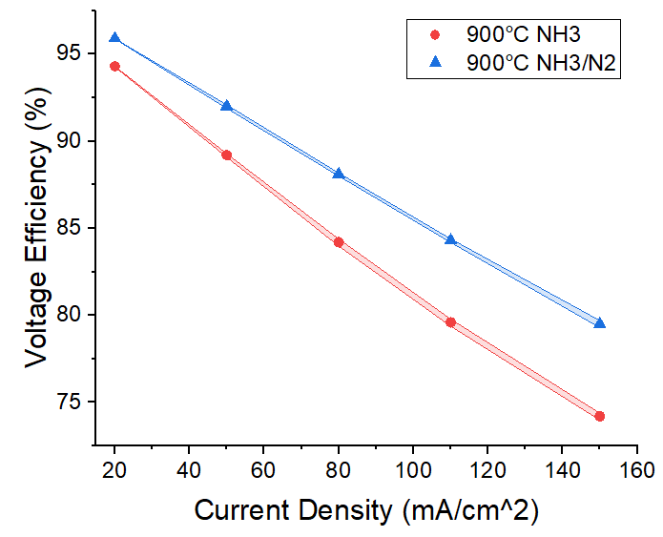
Figure 6.5. Voltage efficiency of carbon felt sample treated in ammonia gas at 900°C versus that of a sample treated in equal conditions, but with an additional post-treatment with nitrogen gas.

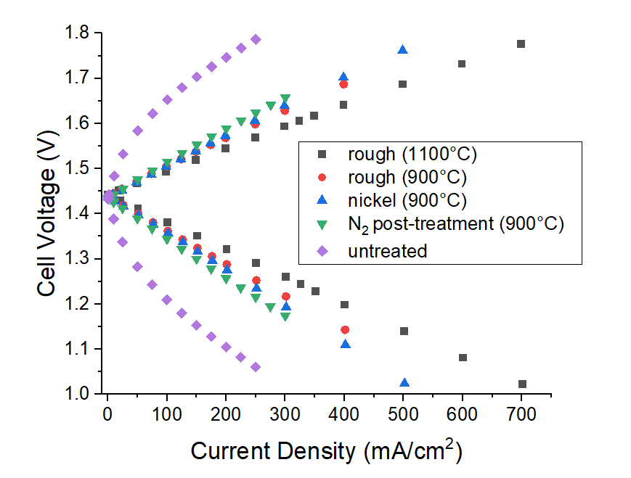
Figure 6.6. Polarization curve comparison of best performing samples in each category of novel treatment.

80% increase in ECSA over the original treatment suggests the post-treatment is also contributing its own surface area. Flowing N₂ with NH₃ simultaneously could be a more efficient way to do this treatment. Optimization needs to be implemented and the nature of the amorphous structures on the surface of the material needs to be investigated. Adding nitrogen gas as a post-treatment to the original ammonia gas treatment proved successful with greater performance and durability.

Conclusions and recommendations

7.1 Summary of state of the art
The state-of-the-art in carbon felt electrode modification is mostly adding metals, which don’t last long, or creating pores. Various methods of depositing metal onto carbon felt have been deployed with excellent short-term results, with copper nanoparticle deposition resulting in 80% EE at 300 mA cm⁻² [50-57]. The other successful genre of modification is highlighted by increased porosity and surface area, even with some cases resulting in a reduction in functional groups [51, 62-64]. Adding functional groups has not shown particularly remarkable results, though there is an interesting case involving the addition of Ti₃C₂T_{x} MXene spheres [66]. Unfortunately, anything added to carbon felt tends to be swept away.

7.2 Summary of work
Chapters 3 and 4 were primarily focused on enhancing carbon felt electrode performance in vanadium redox flow batteries and discovering the boundaries of the ammonia gas treatment. In Chapter 3, it was found that increased treatment time led to increased electrochemical surface area and improved battery performance, increasing current density by 325% and ECSA by 142%.
In Chapter 4, a range of treatment temperatures (400°C-1100°C) were compared, leading to an observed correlation of temperature to performance benefits. Samples treated at 1100°C showed a 413% increase in current density and 399% in ECSA. Literature suggests that this phenomenon was due to the generation of radicals and gasification of carbon [84]. To prove this, a more material focused approach was taken. FTIR and EDS were used to show functional groups were not the primary drivers for performance. A silver nitrate solution was used to detect hydrogen cyanide, proving radicals were removing carbon from the surface of the electrode, increasing surface area.
Upon this discovery, follow-up experiments were performed in Chapter 5 to build upon the original treatment. Increasing rough surface area in the tube furnace and introducing nickel foam catalysts improved the current density by 13.5% and 7%, respectively.
Chapter 6 briefly explored post-treatments to the original ammonia treatment. Additional high temperature nitrogen gas exposure was shown to improve the performance, boosting the current density at 80% voltage efficiency by 32%. The 80% increase in ECSA over the original treatment may suggest its contribution to the surface area, but the mechanism was not fully investigated.

7.3 Recommendations
The results of this work provide many avenues for future investigation. The original treatment has room for optimization. Additional elements can be added to the ammonia treatment to compound enhancements. The gained knowledge of surface area creation can be used to springboard entirely new treatments based around that concept. The following ideas can be advanced by mechanical engineering principles as well as chemistry, materials science, computational science, etc.

7.3.1 Optimizing treatment parameters
While the mechanism of the high temperature ammonia treatment was determined, it would be beneficial to model the system for better insight and future planning. There are many treatment parameters that could be optimized, including orientation of samples, number of samples per batch, gas flow rates, etc. Setting the flow rate as slow as possible seems to better allow decomposition and gasification of carbon to happen, but optimal flow rate is yet to be quantified. While 1100°C is the temperature at which ammonia completely decomposes, and should be the minimum in future experiments, treatment temperatures can certainly be raised for more expedient results. Additionally, as mentioned in Chapter 3, the treatment could go longer than 4 hours, but for the purposes of these studies 4 hours became the standard for comparison.

7.3.2 Improving ammonia decomposition kinetics
Experiments performed in Chapter 5 showed that rougher surfaces can produce a noticeable improvement in the ammonia treatment. Roughening the surface inside the tube furnace in a more systematic, measurable, and reproduceable way may be an avenue to passively improve the kinetics of the treatment.
Metal catalysts also appear promising. Ruthenium, iridium, rhenium, nickel, cobalt, platinum, palladium, and iron have been found to induce decomposition at lower temperatures than without [105, 122]. An analysis balancing both the cost of material and effectiveness of each material should be made to determine the optimal treatment option. Experiments with ruthenium need to be attempted since it is believed to be the most effective catalyst studied and it would be beneficial to test the limits of the treatment [124, 131-133]. There is plenty of opportunity to optimize the structure, quantity, and placement of catalysts during treatment [134-136]. It is probably better to use porous metals, such as a metal felt, because a brief attempt to use a large, solid piece of iron yielded poor results and iron deserves a fair attempt given its low price point and high potential [105].

7.3.3 Investigating post-treatments
As the N₂ post-treatment experiment results are preliminary, it is important to reproduce the results and investigate further to determine why it improves on the ammonia treatment. Mixing N₂ or H₂ with NH₃ should be explored to see if it has a similar effect and allows a reduction in treatment time. It may merely skew the kinetics in a preferred direction to aid an outcome more in line with the original treatment. Additionally, H₂ should also be investigated for post-treatment, as Boehm et al. reports even better catalytic results than N₂ [84]. Performing these experiments with the ammonia portion at 1100°C would likely have better performance outcomes over the original 900°C.
Ultimately, combining all the aforementioned treatments and post-treatments would cumulatively stack the benefits for a superb electrode, surpassing state-of-the-art. This mindset could be extended to experimenting with adding other known successful treatments involving adding metals or functional groups.

7.3.4 Investigating other radical treatments
With the knowledge that removing the carbon to create effective surface area is a valid approach, exploring other more facile methods of increasing the surface area is wise. Piranha solution is a common chemical mixture of sulfuric acid and hydrogen peroxide used to cleanse glassware of organic materials [137-139]. Concentrated sulfuric acid and 30% hydrogen peroxide form peroxysulfuric acid, also known as Caro’s acid, which reacts with carbon to generate CO₂ gas. This rapid exothermic reaction quickly dissolves organic materials, making it a desirable method of treatment, if viable. As it is an oxidizer, piranha solution may introduce carboxylic groups as a possible positive secondary effect [140]. Concentrations and ratios of components would need to be optimized to maximize effect. CO₂ gas could be measured to determine carbon loss in the felt.
In its traditional use, piranha reactions are a human hazard, but as the goal in this application is not to completely destroy the carbon felt material, the traditional concentrations would not be used but would be diluted. Additionally, this solution can be disposed of down the drain with copious amounts of water, though some may prefer to dispose of the waste properly with waste disposal.
Focusing on finding safer, less intensive methods of surface area creation would be a long-term goal, though that may not be easily attained due to the nature of destruction required to obtain the desired results.

7.3 Overall conclusions and outlook
This work interrogated the mechanism of the high temperature ammonia treatment of carbon felt electrodes and its effect on battery performance. Techniques from a range of disciplines were deployed. It was found that, contrary to current consensus, increasing the surface area of the carbon felt, rather than inserting functional groups, is the most effective way to improve electrode performance. Improvements to kinetic performance were associated primarily with an increase in surface area and edge site defect, rather than functional groups. High temperature ammonia treatments were found to accomplish this by gasifying carbon via ammonia radicals, which were detected by a silver nitrate solution. This treatment was improved upon by roughening the surfaces of the furnace tube and introducing a nickel foam catalyst. A nitrogen gas post-treatment was deployed to further enhance the electrode. Successful application of this knowledge will lead to safer, more cost-effective electrode enhancement methods.

References

1. Lee, C.K., S.C. Tan, F.F. Wu, S.Y.R. Hui, and B. Chaudhuri. Use of Hooke's law for stabilizing future smart grid — The electric spring concept. in 2013 IEEE Energy Conversion Congress and Exposition. 2013.
2. McDowall, J., Integrating energy storage with wind power in weak electricity grids. Journal of Power Sources, 2006. 162(2): p. 959-964.
3. Ashraf Gandomi, Y., D. Aaron, J. Houser, M. Daugherty, J. Clement, A. Pezeshki, T. Ertuğrul, D. Moseley, and M.M. Mench, Critical Review—Experimental Diagnostics and Material Characterization Techniques Used on Redox Flow Batteries. Journal of The Electrochemical Society, 2018. 165: p. A970-A1010.
4. Lourenssen, K., J. Williams, F. Ahmadpour, R. Clemmer, and S. Tasnim, Vanadium redox flow batteries: A comprehensive review. Journal of Energy Storage, 2019. 25.
5. Leonard, M.D., E.E. Michaelides, and D.N. Michaelides, Energy storage needs for the substitution of fossil fuel power plants with renewables. Renewable Energy, 2020. 145: p. 951-962.
6. Johnson, S.C., F. Todd Davidson, J.D. Rhodes, J.L. Coleman, S.M. Bragg-Sitton, E.J. Dufek, and M.E. Webber, Chapter Five - Selecting Favorable Energy Storage Technologies for Nuclear Power, in Storage and Hybridization of Nuclear Energy, H. Bindra and S. Revankar, Editors. 2019, Academic Press. p. 119-175.
7. About the Grid Modernization Initiative. 2020; Available from: https://www.energy.gov/grid-modernization-initiative-0/about-grid-modernization-initiative
8. Li, Y. and A. Jenn, Impact of electric vehicle charging demand on power distribution grid congestion. Proceedings of the National Academy of Sciences, 2024. 121(18): p. e2317599121.
9. EPRI, Estimating the Costs and Benefits of the Smart Grid. 2011.
10. Rivers, N. and B. Schaufele, The Effect of Carbon Taxes on Agricultural Trade. Canadian Journal of Agricultural Economics/Revue canadienne d'agroeconomie, 2015. 63(2): p. 235-257.
11. Zech, K.M. and U.A. Schneider, Carbon leakage and limited efficiency of greenhouse gas taxes on food products. Journal of Cleaner Production, 2019. 213: p. 99-103.
12. Stram, B.N., A new strategic plan for a carbon tax. Energy Policy, 2014. 73(C): p. 519-523.
13. Pawel, I., The Cost of Storage – How to Calculate the Levelized Cost of Stored Energy (LCOE) and Applications to Renewable Energy Generation. Energy Procedia, 2014. 46: p. 68-77.
14. Schmidt, O., S. Melchior, A. Hawkes, and I. Staffell, Projecting the Future Levelized Cost of Electricity Storage Technologies. Joule, 2019. 3(1): p. 81-100.
15. Buchanan, C. and N. Singh, Levelized cost of electricity and greenhouse gas emissions of Ce- and V-based redox flow batteries. Journal of Power Sources, 2023. 582: p. 233535.
16. DOE, U.S., Energy Storage Program Planning Document, U.D.o.E.O.o.E.D.a.E. Reliability, Editor. 2011.
17. Fu, J., M. Zheng, X. Wang, J. Sun, and T. Wang, Flow-Rate Optimization and Economic Analysis of Vanadium Redox Flow Batteries in a Load-Shifting Application. Journal of Energy Engineering, 2017. 143(6): p. 04017064.
18. Breeze, P., Chapter 4 - Large-Scale Batteries, in Power System Energy Storage Technologies, P. Breeze, Editor. 2018, Academic Press. p. 33-45.
19. Skyllas-Kazacos, M., 10 - Electro-chemical energy storage technologies for wind energy systems, in Stand-Alone and Hybrid Wind Energy Systems, J.K. Kaldellis, Editor. 2010, Woodhead Publishing. p. 323-365.
20. Irving, M., World's largest redox flow battery being built in underground salt caverns. New Atlas, 2017.
21. Tang, Z., R. Keith, D.S. Aaron, J.S. Lawton, A.P. Papandrew, and T.A. Zawodzinski, Proton Exchange Membrane Performance Characterization in VRFB. ECS Transactions, 2012. 41(23): p. 25.
22. Mench, M.M., Fuel Cell Engines. 2008, Hoboken, N.J.: John Wiley & Sons.
23. Perez, N., Kinetics of Activation Polarization, in Electrochemistry and Corrosion Science, N. Perez, Editor. 2016, Springer International Publishing: Cham. p. 101-150.
24. Zhang, M., M. Moore, J.S. Watson, T.A. Zawodzinski, and R.M. Counce, Capital Cost Sensitivity Analysis of an All-Vanadium Redox-Flow Battery. Journal of The Electrochemical Society, 2012. 159(8): p. A1183-A1188.
25. Chakrabarti, M.H., N.P. Brandon, S.A. Hajimolana, F. Tariq, V. Yufit, M.A. Hashim, M.A. Hussain, C.T.J. Low, and P.V. Aravind, Application of carbon materials in redox flow batteries. Journal of Power Sources, 2014. 253: p. 150-166.
26. Minke, C., U. Kunz, and T. Turek, Carbon felt and carbon fiber - A techno-economic assessment of felt electrodes for redox flow battery applications. Journal of Power Sources, 2017. 342: p. 116-124.
27. Sun, B. and M. Skyllas-Kazacos, Modification of graphite electrode materials for vanadium redox flow battery application—I. Thermal treatment. Electrochimica Acta, 1992. 37(7): p. 1253-1260.
28. Sun, B. and M. Skyllas-Kazacos, Chemical modification of graphite electrode materials for vanadium redox flow battery application—part II. Acid treatments. Electrochimica Acta, 1992. 37(13): p. 2459-2465.
29. Hassan, A. and T. Tzedakis, Enhancement of the electrochemical activity of a commercial graphite felt for vanadium redox flow battery (VRFB), by chemical treatment with acidic solution of K2Cr2O7. Journal of Energy Storage, 2019. 26: p. 100967.
30. He, Z., Y. Jiang, W. Meng, F. Jiang, H. Zhou, Y. Li, J. Zhu, L. Wang, and L. Dai, HF/H2O2 treated graphite felt as the positive electrode for vanadium redox flow battery. Applied Surface Science, 2017. 423: p. 111-118.
31. Kim, K.J., S.-W. Lee, T. Yim, J.-G. Kim, J.W. Choi, J.H. Kim, M.-S. Park, and Y.-J. Kim, A new strategy for integrating abundant oxygen functional groups into carbon felt electrode for vanadium redox flow batteries. Scientific Reports, 2014. 4(1): p. 6906.
32. Gao, C., N. Wang, S. Peng, S. Liu, Y. Lei, X. Liang, S. Zeng, and H. Zi, Influence of Fenton's reagent treatment on electrochemical properties of graphite felt for all vanadium redox flow battery. Electrochimica Acta, 2013. 88: p. 193-202.
33. Kim, K.J., Y.-J. Kim, J.-H. Kim, and M.-S. Park, The effects of surface modification on carbon felt electrodes for use in vanadium redox flow batteries. Materials Chemistry and Physics, 2011. 131(1): p. 547-553.
34. Zhang, W., J. Xi, Z. Li, H. Zhou, L. Liu, Z. Wu, and X. Qiu, Electrochemical activation of graphite felt electrode for VO2+/VO2+ redox couple application. Electrochimica Acta, 2013. 89: p. 429-435.
35. Chen, J.-Z., W.-Y. Liao, W.-Y. Hsieh, C.-C. Hsu, and Y.-S. Chen, All-vanadium redox flow batteries with graphite felt electrodes treated by atmospheric pressure plasma jets. Journal of Power Sources, 2015. 274: p. 894-898.
36. Wu, X., H. Xu, P. Xu, Y. Shen, L. Lu, J. Shi, J. Fu, and H. Zhao, Microwave-treated graphite felt as the positive electrode for all-vanadium redox flow battery. Journal of Power Sources, 2014. 263: p. 104-109.
37. Wu, X., H. Xu, Y. Shen, P. Xu, L. Lu, J. Fu, and H. Zhao, Treatment of graphite felt by modified Hummers method for the positive electrode of vanadium redox flow battery. Electrochimica Acta, 2014. 138: p. 264-269.
38. Chang, Y.-C., J.-Y. Chen, D.M. Kabtamu, G.-Y. Lin, N.-Y. Hsu, Y.-S. Chou, H.-J. Wei, and C.-H. Wang, High efficiency of CO2-activated graphite felt as electrode for vanadium redox flow battery application. Journal of Power Sources, 2017. 364: p. 1-8.
39. Estevez, L., D. Reed, Z. Nie, A.M. Schwarz, M.I. Nandasiri, J.P. Kizewski, W. Wang, E. Thomsen, J. Liu, and J.G. Zhang, Tunable oxygen functional groups as electrocatalysts on graphite felt surfaces for all‐vanadium flow batteries. ChemSusChem, 2016. 9(12): p. 1455-1461.
40. Li, X.-g., K.-l. Huang, S.-q. Liu, T. Ning, and L.-q. Chen, Characteristics of graphite felt electrode electrochemically oxidized for vanadium redox battery application. Transactions of Nonferrous Metals Society of China, 2007. 17(1): p. 195-199.
41. Pezeshki, A.M., "Impedance-Resolved Performance and Durability in Redox Flow Batteries. " PhD diss., University of Tennessee, 2016.
42. Shah, A.B., Y. Wu, and Y.L. Joo, Direct addition of sulfur and nitrogen functional groups to graphite felt electrodes for improving all-vanadium redox flow battery performance. Electrochimica Acta, 2019. 297: p. 905-915.
43. Youn, C., S.A. Song, K. Kim, J.Y. Woo, Y.-W. Chang, and S.N. Lim, Effect of nitrogen functionalization of graphite felt electrode by ultrasonication on the electrochemical performance of vanadium redox flow battery. Materials Chemistry and Physics, 2019. 237: p. 121873.
44. Xia, L., Q. Zhang, C. Wu, Y. Liu, M. Ding, J. Ye, Y. Cheng, and C. Jia, Graphene coated carbon felt as a high-performance electrode for all vanadium redox flow batteries. Surface and Coatings Technology, 2019. 358: p. 153-158.
45. Jiang, F., Z. He, D. Guo, and X. Zhou, Carbon aerogel modified graphite felt as advanced electrodes for vanadium redox flow batteries. Journal of Power Sources, 2019. 440: p. 227114.
46. Zhou, A., X. Shao, D. Li, Y. Du, Y. Zhang, L. Cao, and J. Yang, Heteroatom co-doped biomass carbon modified electrodes for all-vanadium redox flow batteries with ultra-low decay rate of energy efficiency. Journal of Power Sources, 2024. 591: p. 233890.
47. Zhou, A., D. Li, X. Shao, Y. Du, Y. Zhang, B. Li, L. Cao, and J. Yang, Synchronized dual-modified graphite felt electrodes for all-vanadium redox flow batteries with high power density and ultra-long lifespan. Journal of Energy Storage, 2024. 81: p. 110501.
48. Floner, D. and F. Geneste, Homogeneous coating of graphite felt by nickel electrodeposition to achieve light nickel felts with high surface area. Electrochemistry Communications, 2007. 9(9): p. 2271-2275.
49. Wang, W.H. and X.D. Wang, Investigation of Ir-modified carbon felt as the positive electrode of an all-vanadium redox flow battery. Electrochimica Acta, 2007. 52(24): p. 6755-6762.
50. González, Z., A. Sánchez, C. Blanco, M. Granda, R. Menéndez, and R. Santamaría, Enhanced performance of a Bi-modified graphite felt as the positive electrode of a vanadium redox flow battery. Electrochemistry Communications, 2011. 13(12): p. 1379-1382.
51. Wei, L., T.S. Zhao, L. Zeng, X.L. Zhou, and Y.K. Zeng, Copper nanoparticle-deposited graphite felt electrodes for all vanadium redox flow batteries. Applied Energy, 2016. 180: p. 386-391.
52. Jiang, H.R., W. Shyy, M.C. Wu, L. Wei, and T.S. Zhao, Highly active, bi-functional and metal-free B4C-nanoparticle-modified graphite felt electrodes for vanadium redox flow batteries. Journal of Power Sources, 2017. 365: p. 34-42.
53. Fetyan, A., G.A. El-Nagar, I. Derr, P. Kubella, H. Dau, and C. Roth, A neodymium oxide nanoparticle-doped carbon felt as promising electrode for vanadium redox flow batteries. Electrochimica Acta, 2018. 268: p. 59-65.
54. Xiang, Y. and W.A. Daoud, Investigation of an advanced catalytic effect of cobalt oxide modification on graphite felt as the positive electrode of the vanadium redox flow battery. Journal of Power Sources, 2019. 416: p. 175-183.
55. Li, B., M. Gu, Z. Nie, Y. Shao, Q. Luo, X. Wei, X. Li, J. Xiao, C. Wang, V. Sprenkle, and W. Wang, Bismuth Nanoparticle Decorating Graphite Felt as a High-Performance Electrode for an All-Vanadium Redox Flow Battery. Nano Letters, 2013. 13(3): p. 1330-1335.
56. Xiao, X.-H., D.M. Kabtamu, A.M. Demeku, G.-C. Chen, Y.-T. Ou, Z.-J. Huang, N.-Y. Hsu, H.-H. Ku, Y.-M. Wang, and C.-H. Wang, Defect-rich high-entropy spinel oxide catalyst for efficient vanadium redox flow battery. Journal of Power Sources, 2024. 597: p. 234178.
57. Li, Q., D. Pei, X. Zhang, and H. Sun, Boosting performance of Ti3C2TX/Bi modified graphite felt electrode for all-vanadium redox flow battery. Electrochimica Acta, 2024. 473: p. 143439.
58. Jiang, H.R., J. Sun, L. Wei, M.C. Wu, W. Shyy, and T.S. Zhao, A high power density and long cycle life vanadium redox flow battery. Energy Storage Materials, 2020. 24: p. 529-540.
59. Reed, D., E. Thomsen, B. Li, W. Wang, Z. Nie, B. Koeppel, and V. Sprenkle, Performance of a low cost interdigitated flow design on a 1 kW class all vanadium mixed acid redox flow battery. Journal of Power Sources, 2016. 306: p. 24-31.
60. Reed, D., E. Thomsen, W. Wang, Z. Nie, B. Li, X. Wei, B. Koeppel, and V. Sprenkle, Performance of Nafion® N115, Nafion® NR-212, and Nafion® NR-211 in a 1 kW class all vanadium mixed acid redox flow battery. Journal of Power Sources, 2015. 285: p. 425-430.
61. Pezeshki, A.M., J.T. Clement, G.M. Veith, T.A. Zawodzinski, and M.M. Mench, High performance electrodes in vanadium redox flow batteries through oxygen-enriched thermal activation. Journal of Power Sources, 2015. 294: p. 333-338.
62. Lu, W., Z. Yuan, Y. Zhao, X. Li, H. Zhang, and I.F.J. Vankelecom, High-performance porous uncharged membranes for vanadium flow battery applications created by tuning cohesive and swelling forces. Energy & Environmental Science, 2016. 9(7): p. 2319-2325.
63. Liu, Y., Y. Shen, L. Yu, L. Liu, F. Liang, X. Qiu, and J. Xi, Holey-engineered electrodes for advanced vanadium flow batteries. Nano Energy, 2018. 43: p. 55-62.
64. Zhou, X.L., Y.K. Zeng, X.B. Zhu, L. Wei, and T.S. Zhao, A high-performance dual-scale porous electrode for vanadium redox flow batteries. Journal of Power Sources, 2016. 325: p. 329-336.
65. Wang, R., Y. Li, Y. Wang, and Z. Fang, Phosphorus-doped graphite felt allowing stabilized electrochemical interface and hierarchical pore structure for redox flow battery. Applied Energy, 2020. 261: p. 114369.
66. Wei, L., C. Xiong, H.R. Jiang, X.Z. Fan, and T.S. Zhao, Highly catalytic hollow Ti3C2Tx MXene spheres decorated graphite felt electrode for vanadium redox flow batteries. Energy Storage Materials, 2020. 25: p. 885-892.
67. Kwon, S., Y. Suharto, and K.J. Kim, Facile preparation of an oxygen-functionalized carbon felt electrode to improve VO2+/VO2+ redox chemistry in vanadium redox flow batteries. Journal of Industrial and Engineering Chemistry, 2021. 98: p. 231-236.
68. Abbas, S., S. Mehboob, H.-J. Shin, S.B.H. Rizvi, J. Kim, D. Henkensmeier, and H.Y. Ha, Tunable surface chemistry of carbon electrodes and the role of surface functionalities towards vanadium redox reactions. Applied Surface Science, 2023. 628: p. 157331.
69. Yang, D.-S., J.H. Han, J.W. Jeon, J.Y. Lee, D.-G. Kim, D.H. Seo, B.G. Kim, T.-H. Kim, and Y.T. Hong, Multimodal porous and nitrogen-functionalized electrode based on graphite felt modified with carbonized porous polymer skin layer for all-vanadium redox flow battery. Materials Today Energy, 2019. 11: p. 159-165.
70. Etesami, M., E. Abouzari-Lotf, S.S. Sha'rani, M. Miyake, P. Moozarm Nia, A. Ripin, and A. Ahmad, Self-assembled heteropolyacid on nitrogen-enriched carbon nanofiber for vanadium flow batteries. Nanoscale, 2018. 10(27): p. 13212-13222.
71. Wu, L., Y. Shen, L. Yu, J. Xi, and X. Qiu, Boosting vanadium flow battery performance by Nitrogen-doped carbon nanospheres electrocatalyst. Nano Energy, 2016. 28: p. 19-28.
72. Jeong, K.I., S.A. Song, and S.S. Kim, Glucose-based carbon-coating layer on carbon felt electrodes of vanadium redox flow batteries. Composites Part B: Engineering, 2019. 175: p. 107072.
73. Hu, Z., Z. Miao, Z. Xu, X. Zhu, F. Zhong, M. Ding, J. Wang, X. Xie, C. Jia, and J. Liu, Carbon felt electrode modified by lotus seed shells for high-performance vanadium redox flow battery. Chemical Engineering Journal, 2022. 450: p. 138377.
74. Radinger, H., J. Pfisterer, F. Scheiba, and H. Ehrenberg, Influence and Electrochemical Stability of Oxygen Groups and Edge Sites in Vanadium Redox Reactions. ChemElectroChem, 2020. 7(23): p. 4745-4754.
75. Fu, H., X. Bao, M. He, J. Xu, Z. Miao, M. Ding, J. Liu, and C. Jia, Defect-rich graphene skin modified carbon felt as a highly enhanced electrode for vanadium redox flow batteries. Journal of Power Sources, 2023. 556: p. 232443.
76. Ji, J., C. Noh, M. Shin, S. Oh, Y. Chung, Y. Kwon, and D.-H. Kim, Vanadium redox flow batteries using new mesoporous nitrogen-doped carbon coated graphite felt electrode. Applied Surface Science, 2023. 611: p. 155665.
77. Abbas, S., H. Lee, J. Hwang, A. Mehmood, H.-J. Shin, S. Mehboob, J.-Y. Lee, and H.Y. Ha, A novel approach for forming carbon nanorods on the surface of carbon felt electrode by catalytic etching for high-performance vanadium redox flow battery. Carbon, 2018. 128: p. 31-37.
78. Kim, H., J. Paick, J.S. Yi, and D. Lee, Kinetic relevancy of surface defects and heteroatom functionalities of carbon electrodes for the vanadium redox reactions in flow batteries. Journal of Power Sources, 2023. 557: p. 232612.
79. Radinger, H., A. Ghamlouche, F. Scheiba, and H. Ehrenberg, Systematic Analysis of Oxygen Functional Groups and Graphitic Defects on Vanadium Flow Battery Electrodes. ECS Meeting Abstracts, 2020. MA2020-02(45): p. 3753-3753.
80. Shafeeyan, M.S., W.M.A.W. Daud, A. Houshmand, and A. Shamiri, A review on surface modification of activated carbon for carbon dioxide adsorption. Journal of Analytical and Applied Pyrolysis, 2010. 89(2): p. 143-151.
81. Vickers, P.E., J.F. Watts, C. Perruchot, and M.M. Chehimi, The surface chemistry and acid–base properties of a PAN-based carbon fibre. Carbon, 2000. 38(5): p. 675-689.
82. Biniak, S., G. Szymański, J. Siedlewski, and A. Świątkowski, The characterization of activated carbons with oxygen and nitrogen surface groups. Carbon, 1997. 35(12): p. 1799-1810.
83. Vinke, P., M. van der Eijk, M. Verbree, A.F. Voskamp, and H. van Bekkum, Modification of the surfaces of a gasactivated carbon and a chemically activated carbon with nitric acid, hypochlorite, and ammonia. Carbon, 1994. 32(4): p. 675-686.
84. Stöhr, B., H.P. Boehm, and R. Schlögl, Enhancement of the catalytic activity of activated carbons in oxidation reactions by thermal treatment with ammonia or hydrogen cyanide and observation of a superoxide species as a possible intermediate. Carbon, 1991. 29(6): p. 707-720.
85. Jansen, R.J.J. and H. van Bekkum, Amination and ammoxidation of activated carbons. Carbon, 1994. 32(8): p. 1507-1516.
86. Makhlouf, A.S.H., V. Herrera, and E. Muñoz, Chapter 6 - Corrosion and protection of the metallic structures in the petroleum industry due to corrosion and the techniques for protection, in Handbook of Materials Failure Analysis, A.S.H. Makhlouf and M. Aliofkhazraei, Editors. 2018, Butterworth-Heinemann. p. 107-122.
87. Pourbaix, M., Significance of Protection Potential in Pitting and Intergranular Corrosion. CORROSION, 1970. 26(10): p. 431-438.
88. Pickering, H.W., The significance of the local electrode potential within pits, crevices and cracks. Corrosion Science, 1989. 29(2): p. 325-341.
89. Pickering, H.W., The role of electrode potential distribution in corrosion processes. Materials Science and Engineering: A, 1995. 198(1): p. 213-223.
90. Wang, Y., I. Vázquez-Rodríguez, C. Santos, E. García-Quismondo, J. Palma, M.A. Anderson, and J.J. Lado, Graphite felt 3D framework composites as an easy to scale capacitive deionization electrode for brackish water desalination. Chemical Engineering Journal, 2019: p. 123698.
91. Das, B., M. Sharma, M.J. Baruah, K.K. Borah, and K.K. Bania, Synthesis of silver cyanide without poisonous KCN or NaCN. Inorganica Chimica Acta, 2019. 498: p. 119160.
92. Zhang, Z., J. Xi, H. Zhou, and X. Qiu, KOH etched graphite felt with improved wettability and activity for vanadium flow batteries. Electrochimica Acta, 2016. 218: p. 15-23.
93. Barranco, V., M.A. Lillo-Rodenas, A. Linares-Solano, A. Oya, F. Pico, J. Ibañez, F. Agullo-Rueda, J.M. Amarilla, and J.M. Rojo, Amorphous Carbon Nanofibers and Their Activated Carbon Nanofibers as Supercapacitor Electrodes. The Journal of Physical Chemistry C, 2010. 114(22): p. 10302-10307.
94. Langner, J., M. Bruns, D. Dixon, A. Nefedov, C. Wöll, F. Scheiba, H. Ehrenberg, C. Roth, and J. Melke, Surface properties and graphitization of polyacrylonitrile based fiber electrodes affecting the negative half-cell reaction in vanadium redox flow batteries. Journal of Power Sources, 2016. 321: p. 210-218.
95. Wang, H., T. Maiyalagan, and X. Wang, Review on Recent Progress in Nitrogen-Doped Graphene: Synthesis, Characterization, and Its Potential Applications. ACS Catalysis, 2012. 2(5): p. 781-794.
96. Gass, K., B. Bera, D.S. Aaron, and M.M. Mench, High Performance Vanadium Redox Flow Battery Electrodes. Journal of electrochemical energy conversion and storage, 2024. 21(1).
97. Jing, M., Z. Xu, D. Fang, X. Fan, J. Liu, and C. Yan, Improvement of the Battery Performance of Vanadium Flow Battery by Enhancing the Specific Surface Area of the Carbon Felt Electrodes: II. Digging Effect. Journal of The Electrochemical Society, 2021. 168(3): p. 030539.
98. Vargel, C., Chapter C.2 - Pitting corrosion, in Corrosion of Aluminium (Second Edition), C. Vargel, Editor. 2020, Elsevier: Amsterdam. p. 163-183.
99. Popov, B.N., Chapter 7 - Pitting and Crevice Corrosion, in Corrosion Engineering, B.N. Popov, Editor. 2015, Elsevier: Amsterdam. p. 289-325.
100. Aaron, D., S. Yeom, K.D. Kihm, Y. Ashraf Gandomi, T. Ertugrul, and M.M. Mench, Kinetic enhancement via passive deposition of carbon-based nanomaterials in vanadium redox flow batteries. Journal of Power Sources, 2017. 366: p. 241-248.
101. Boehm, H.P., G. Mair, T. Stoehr, A.R. De Rincón, and B. Tereczki, Carbon as a catalyst in oxidation reactions and hydrogen halide elimination reactions. Fuel, 1984. 63(8): p. 1061-1063.
102. Ullmann's encyclopedia of industrial chemistry. 6th, completely rev. ed. ed. Encyclopedia of industrial chemistry. 2003, Weinheim, Germany: Wiley-VCH.
103. Parsons, A.F., An introduction to free radical chemistry. 2000, Oxford ;: Blackwell Science.
104. Perman, E.P. and G.A.S. Atkinson, The Decomposition of Ammonia by Heat. Proceedings of the Royal Society of London. 74: p. 110 - 117.
105. Ramsay, W. and S. Young, XIV.—The decomposition of ammonia by heat. Journal of The Chemical Society, Transactions. 45: p. 88-93.
106. White, A.H. and W.R. Melville, THE DECOMPOSITION OF AMMONIA AT HIGH TEMPERATURES. Journal of the American Chemical Society, 1905. 27: p. 373-386.
107. Sharwood, W.J., NOTES ON THE ESTIMATION OF CYANOGEN BY SILVER NITRATE, USING POTASSIUM IODIDE AND AMMONIA AS INDICATORS.1. Journal of the American Chemical Society, 1897. 19(5): p. 400-434.
108. Alonso-González, O., C. Jiménez-Velasco, F. Nava-Alonso, F. Alvarado-Hernández, and J.A. González-Anaya, Free cyanide analysis by silver nitrate titration with sulfide ion as interference. Minerals Engineering, 2017. 105: p. 19-21.
109. Liebig, J., Verfahren zur Bestimmung des Blausäuregehaltes der medicinischen Blausäure, des Bittermandel-und Kirschlorbeerwassers. Justus Liebigs Annalen der Chemie, 1851. 77(1): p. 102-107.
110. Bark, L.S. and H.G. Higson, A review of the methods available for the detection and determination of small amounts of cyanide. Analyst, 1963. 88(1051): p. 751-760.
111. Britton, H.T.S. and W.G. Williams, 22. Electrometric studies of the precipitation of hydroxides. Part XIII. The reactions between silver nitrate and methylamine, mono-, di-, and tri-ethylamine, ethylenediamine, aniline, and pyridine in solution. Journal of the Chemical Society (Resumed), 1936(0): p. 96-100.
112. Michałowski, T., A.G. Asuero, M. Ponikvar-Svet, M. Toporek, A. Pietrzyk, and M. Rymanowski, Liebig–Denigès Method of Cyanide Determination: A Comparative Study of Two Approaches. Journal of Solution Chemistry, 2012. 41(7): p. 1224-1239.
113. Tereczki, B., Auf der oberfache parakristalliner kohlenstoffe, in Fakultat fur Chemie und Pharmazie. 1979, Ludwig-Maximilians-Universitat, Munchen.
114. Khan, S.A., S.B. Khan, L.U. Khan, A. Farooq, K. Akhtar, and A.M. Asiri, Fourier Transform Infrared Spectroscopy: Fundamentals and Application in Functional Groups and Nanomaterials Characterization, in Handbook of Materials Characterization, S.K. Sharma, Editor. 2018, Springer International Publishing: Cham. p. 317-344.
115. Wade, L.G., Organic Chemistry. 8 ed. 2013: Pearson.
116. Stoeckli, F., A. Guillot, and A.M. Slasli, Specific and non-specific interactions between ammonia and activated carbons. Carbon, 2004. 42(8): p. 1619-1624.
117. Wang, S., X. Qian, L. Jin, D. Rao, S. Yao, X. Shen, K. Xiao, and S. Qin, Separator modified by Y2O3 nanoparticles-Ketjen Black hybrid and its application in lithium-sulfur battery. Journal of Solid State Electrochemistry, 2017. 21: p. 1-8.
118. Bai and Ge, Boron and Nitrogen Co-Doped Porous Carbons Synthesized from Polybenzoxazines for High-Performance Supercapacitors. Coatings, 2019. 9: p. 657.
119. Bowmaker, G.A., B.J. Kennedy, and J.C. Reid, Crystal Structures of AuCN and AgCN and Vibrational Spectroscopic Studies of AuCN, AgCN, and CuCN. Inorganic Chemistry, 1998. 37(16): p. 3968-3974.
120. Robertson, A.J.B., The Early History of Catalysis. Platinum Metals Review, 1975. 19(2): p. 64-69.
121. Thenard, P.L.D.a.L.J., Ann. Chim. Phys., 1823. 23: p. 440.
122. Sun, S., Q. Jiang, D. Zhao, T. Cao, H. Sha, C. Zhang, H. Song, and Z. Da, Ammonia as hydrogen carrier: Advances in ammonia decomposition catalysts for promising hydrogen production. Renewable and Sustainable Energy Reviews, 2022. 169: p. 112918.
123. Pinzón, M., O. Avilés-García, A.R. de la Osa, A. de Lucas-Consuegra, P. Sánchez, and A. Romero, New catalysts based on reduced graphene oxide for hydrogen production from ammonia decomposition. Sustainable Chemistry and Pharmacy, 2022. 25: p. 100615.
124. Borisov, V.A., K.N. Iost, V.L. Temerev, M.M. Simunin, N.N. Leont'eva, Y.L. Mikhlin, M.N. Volochaev, and D.A. Shlyapin, Ammonia decomposition Ru catalysts supported on alumina nanofibers for hydrogen generation. Materials Letters, 2022. 306: p. 130842.
125. Czekajło, Ł. and Z. Lendzion-Bieluń, Effect of preparation conditions and promoters on the structure and activity of the ammonia decomposition reaction catalyst based on nanocrystalline cobalt. Chemical Engineering Journal, 2016. 289: p. 254-260.
126. Fang, H., D. Liu, Y. Luo, Y. Zhou, S. Liang, X. Wang, B. Lin, and L. Jiang, Challenges and Opportunities of Ru-Based Catalysts toward the Synthesis and Utilization of Ammonia. ACS Catalysis, 2022. 12(7): p. 3938-3954.
127. Mittemeijer, E.J. and M.A.J. Somers, Thermochemical Surface Engineering of Steels : Improving Materials Performance. Woodhead Publishing Series in Metals and Surface Engineering Ser. 2014, Cambridge: Elsevier Science & Technology.
128. Yin, S.-F., Q.-H. Zhang, B.-Q. Xu, W.-X. Zhu, C.-F. Ng, and C.-T. Au, Investigation on the catalysis of COx-free hydrogen generation from ammonia. Journal of Catalysis, 2004. 224(2): p. 384-396.
129. Schüth, F., R. Palkovits, R. Schlögl, and D.S. Su, Ammonia as a possible element in an energy infrastructure: catalysts for ammonia decomposition. Energy & Environmental Science, 2012. 5(4): p. 6278-6289.
130. McCabe, R.W., Kinetics of ammonia decomposition on nickel. Journal of Catalysis, 1983. 79(2): p. 445-450.
131. Bradford, M.C.J., P.E. Fanning, and M.A. Vannice, Kinetics of NH3Decomposition over Well Dispersed Ru. Journal of Catalysis, 1997. 172(2): p. 479-484.
132. Hill, A.K. and L. Torrente-Murciano, Low temperature H2 production from ammonia using ruthenium-based catalysts: Synergetic effect of promoter and support. Applied Catalysis B: Environmental, 2015. 172-173: p. 129-135.
133. Takahashi, A. and T. Fujitani, Kinetic Analysis of Decomposition of Ammonia over Nickel and Ruthenium Catalysts. Journal of Chemical Engineering of Japan, 2016. 49: p. 22-28.
134. Boisen, A., S. Dahl, J.K. Nørskov, and C.H. Christensen, Why the optimal ammonia synthesis catalyst is not the optimal ammonia decomposition catalyst. Journal of Catalysis, 2005. 230(2): p. 309-312.
135. Atsumi, R., R. Noda, H. Takagi, L. Vecchione, A. Di Carlo, Z. Del Prete, and K. Kuramoto, Ammonia decomposition activity over Ni/SiO2 catalysts with different pore diameters. International Journal of Hydrogen Energy, 2014. 39(26): p. 13954-13961.
136. Itoh, N., A. Oshima, E. Suga, and T. Sato, Kinetic enhancement of ammonia decomposition as a chemical hydrogen carrier in palladium membrane reactor. Catalysis Today, 2014. 236: p. 70-76.
137. Seu, K.J., A.P. Pandey, F. Haque, E.A. Proctor, A.E. Ribbe, and J.S. Hovis, Effect of surface treatment on diffusion and domain formation in supported lipid bilayers. Biophysical journal, 2007. 92(7): p. 2445-2450.
138. Sanzari, I., E. Buratti, R. Huang, C.G. Tusan, F. Dinelli, N.D. Evans, T. Prodromakis, and M. Bertoldo, Poly (N-isopropylacrylamide) based thin microgel films for use in cell culture applications. Scientific Reports, 2020. 10(1): p. 6126.
139. Koh, K.-S., J. Chin, J. Chia, and C.-L. Chiang, Quantitative studies on PDMS-PDMS interface bonding with piranha solution and its swelling effect. Micromachines, 2012. 3(2): p. 427-441.
140. Al Mgheer, T. and F.H. Abdulrazzak, Oxidation of multi-walled carbon nanotubes in acidic and basic Piranha mixture. Front. Nanosci. Nanotechnol, 2016. 2: p. 155-158.

Vita
Kaycee Madeline Gass was born in Southern Maryland. She received her Bachelor of Science degree in Chemistry, minoring in Physics, from Davidson College. She received her Master of Science in Materials Science and Engineering in 2019 and went on to pursue her Ph.D. in Engineering Science from the University of Tennessee at Knoxville under the guidance of Dr. Matthew Mench.

