Copper Mediated, Transmetallation Coupling Reactions using High Intensity Ultrasound

A Dissertation Presented for the
Doctor of Philosophy
Degree
The University of Tennessee, Knoxville

Bryan J. Musolino
August 2013
ACKNOWLEDGEMENTS

Thank you all for your help. However, this page is optional.

ABSTRACT

This is a sample Word document that can be used as a template in formatting your thesis/dissertation. Your abstract must be 350 words or fewer. If you are using special characters, you’ll want to spell them out between square brackets after each time you use them (this is in the abstract only. It’s not necessary elsewhere in the document, although use of special characters in the title is prohibited.)
For our purposes a special character is any character which cannot be found on your typical English language keyboard. Because of how your abstract is used in the cataloging process, you will want to tell people how to interpret your special character in case the character itself gets garbled. So, if I wanted to use the µ [micro] character in my abstract, I would have to tell people how to interpret it. Since you’re the expert, you decide how to best interpret that character. It could be µ [micro] or µ [mu], whichever would make the most sense if the symbol itself cannot be replicated
TABLE OF CONTENTS

CHAPTER I TRANSMETALLATION WITH BORON IN ORGANIC CHEMISTRY 1
1.1 Scope of this Dissertation 1
1.1.1 Historic Aspects of Transmetallation Organic Synthesis 1
1.1.2 Reactions of Transmetallation Organic Synthesis 2
1.1.2 Reactions of Copper using Ultrasound in Organic Synthesis 4
1.2 Homo-coupling of Aryl Compounds 5
1.3 O-Arylation and N-Arylation Coupling of a Phenol or Aniline 6
1.3 S-Arylation Coupling of a Thiol 8
1.4 Use of Ultrasound in Coupling Reactions 9
1.5 Statement of Problem 10
CHAPTER II HOMO-COUPLING OF POLYMER SUPPORTED ARYL-TRIFLUOROBORATES 12
2.1 Introduction 12
2.2 Results and Discussion 14
2.2.1 Method Development 14
2.2.2 Homo-Coupling of Various Dowex Supported Aryl-Trifluoroborates 17
2.2.3 Relationship to the Suzuki, Ullmann, and Chan-Evans-Lam Reactions 19
2.2.4 Mechanistic Study 20
2.3 Conclusion 28
2.4 Experimental Details 29
2.4.1 General Considerations 29
2.4.2 Preparation of Dowex-Aryl-Trifluoroborate Complexes 30
2.4.3 Representative Procedure for the Synthesis of Binaphthalene 30
2.4.4 Characterization of Compounds 201-214 31
CHAPTER III COUPLING OF Aryl-borates to phenols: application of ultrasound to the chan-evans-lam 34
3.1 Introduction 34
3.2 Results and Discussion 35
3.2.1 Reaction of Naphthaboronic Acid with Phenols 37
3.2.2 Reaction of (4-(Trifluoromethyl)phenyl)boronic Acid with Phenols 38
3.2.3 Reaction of (4-Acetylphenyl)boronic Acid with Phenols 39
3.2.4 Reaction of (3-Hydroxyphenyl)boronic Acid with Phenols 40
3.2.5 Reaction of (3-(dimethylamine)phenyl)boronic Acid with Phenols 41
3.2.6 Reaction of (2,6-Dimethylphenyl)boronic Acid with Phenols 43
3.2.7 Reaction of P-tolyboronic Acid with Phenols 43
3.2.8 Mechanistic Study 44
3.3 Conclusion 46
3.4 Experimental Details 46
3.4.1 General Considerations 46
3.4.2 Preparation of Dowex-Napthyl-Trifluoroborate Complex 47
3.4.3 Representative Procedure for the Synthesis of 2-phenoxynaphthalene 47
3.4.4 Characterization of Compounds 301-334 48
CHAPTER IV COUPLING OF Aryl-borates to Anilines: application of ultrasound to the chan-evans-lam reaction 52
4.1 Introduction 52
4.2 Results and Discussion 53
4.2.1 Reaction of Naphthaboronic Acid with Anilines and Indoles 53
4.2.2 Reaction of (4-(Trifluoromethyl)phenyl)boronic Acid with Anilines and Indoles 55
4.2.3 Reaction of (4-acetylphenyl)boronic Acid with Anilines and Indoles 56
4.2.4 Reaction of (3-hydroxyphenyl)boronic Acid with Anilines and Indoles 58
4.2.5 Reaction of (3-(dimethylamino)phenyl)boronic Acid with Anilines and Indoles 59
4.2.6 Reaction of (2,6-Dimethylphenyl)boronic Acid with Anilines and Indoles 61
4.2.7 Reaction of p-Tolylboronic Acid with Anilines and Indoles 61
4.2.8 Mechanistic Study 63
4.3 Conclusion 64
4.4 Experimental Details 64
4.4.1 General Considerations 64
4.4.2 Representative Procedure for the Synthesis of N-methyl-N-phenylnaphthalen-2-amine 65
4.4.3 Characterization of Compounds 401-441 65
CHAPTER V COUPLING OF Aryl-borates to Thiols: application of ultrasound to the chan-evans-lam reaction 66
5.1 Introduction 66
References 67

LIST OF TABLES
Table 2-1 Comparison of Metal Salts and Binaphthalene Yields 15
Table 2-2 Comparison of Copper Entities and Binaphthalene Yield 17
Table 2-3 Homo-Coupling of Dowex-Supported Aryl Trifluoroborate Derivatives 17
Table 2-4 Product Yield Results for Mechanism Study, Compound 214 24
Table 3-1 Reaction Results for Naphthylboronic Acid and Phenols 37
Table 3-2 Results of the Reaction of Phenols with (4-(trifluoromethyl)phenyl)boronic acid 38
Table 3-3 Reaction Results of Phenols with (4-acetylphenyl)boronic Acid 39
Table 3-4 Results of Reaction between Phenols and (3-hydroxyphenyl)boronic Acid 40
Table 3-5 Results of Reaction between Phenols and (3-(dimethylamino)phenyl)boronic Acid 42
Table 3-6 Results of Reaction of Phenols with p-tolylboronic Acid 43
Table 3-7 Summary of Mechanism Investigation Experiments 45
Table 4-1 Reactions of Naphthaboronic Acid with Anilines and Indoles 53
Table 4-2 Reactions of (4-(Trifluoromethyl)phenyl)boronic Acid with Anilines and Indoles 55
Table 4-3 Reactions of (4-acetylphenyl)boronic Acid with Anilines and Indoles 57
Table 4-4 Reactions of (3-hydroxyphenyl)boronic Acid with Anilines and Indoles 58
Table 4-5 Reactions of (3-(dimethylamino)phenyl)boronic Acid with Anilines and Indoles 60
Table 4-6 Reactions of p-Tolylboronic Acid with Anilines and Indoles 62
Table 4-7 Summary of Mechanism Investigation Experiments 63

LIST OF FIGURES
Figure 2-1 pXRD Spectrum of Copper (I) Acetate 25
Figure 2-2 pXRD Spectrum of Copper (II) Acetate, Starting Material 26
Figure 2-3 pXRD Spectrum of Extracted Copper from Entry 3, Table 2-4, Compared to Copper (I) and Copper (II) Standards 26
Figure 2-4 pXRD Spectrum of Extracted Copper from Entry 4, table 2-4, Compared to Copper (I) and Copper (II) Standards 27
Figure 2-5 pXRD Spectrum of Extracted Copper from Entry 5, Table 2-4, Compared to Copper (I) and Copper (II) Standards 27
Figure 2-6 pXRD Spectrum of Extracted Copper from Entry 6, Table 2-4, Compared to Copper (I) and Copper (II) Standards 28

LIST OF SCHEMES

Scheme 1-1 Coupling by either the Suzuki-Miyaura or Ullmann 3
Scheme 1-2 Chan-Evans-Lam Modified Ullmann Condensation Reaction 4
Scheme 1-3 Aryl Homo-Coupling 5
Scheme 1-4 Ullmann O-Arylation of Phenol 7
Scheme 1-5 Ullmann N-Arylation of Aniline 7
Scheme 1-6 Chan-Evans-Lam Modified Ullmann Reaction 8
Scheme 1-7 S-Arylation of Thiols, Chan-Evans-Lam Modified Ullmann Reaction 9
Scheme 2-1 Iodination of Naphthalene-Trifluoroborate 13
Scheme 2-2 Homo-Coupling of Ionically Bonded Dowex Trifluoroborate-Naphthalene 14
Scheme 2-3 Copper (II) Acetate Based Homo-coupling of Dowex-Trifluoroboronicnaphthalene 16
Scheme 2-4 Possible Ullmann Coupling Reaction Mechanism Pathways 21
Scheme 2-5 Suzuki Cross-Coupling Mechanism 22
Scheme 2-6 Reaction for Investigation of Mechanism 24
Scheme 2-7 Reaction for Investigation of Free Radical Mechanism 24
Scheme 3-1 Reaction of Phenols with (2,6-dimethylphenyl)boronic Acid 43
Scheme 4-1 Reaction of Phenols with (2,6-dimethylphenyl)boronic Acid 61

LIST OF SYMBOLS AND ABBREVIATIONS

CHAPTER I
TRANSMETALLATION WITH BORON IN ORGANIC CHEMISTRY

1.1 Scope of this Dissertation
This dissertation is centered on the coupling reactions of organo-borates, using ultrasound as the energy source, and a copper salt. To determine the scope of the developed method, a series of experiments were designed and completed. These experiments evaluate the coupling of an aryl-borate in: (1) homo-coupling reactions; (2) the coupling reaction of an aryl-borates with phenol based compounds; (3) the coupling reaction of an aryl-borate with aniline based compounds; and (4) the coupling reaction of an aryl-borate with thiol based compounds. Each chapter will illustrate the synthetic utility of the developed method, describe relationships with published literature, and discuss relevant mechanistic interpretations. This chapter will highlight the applicable background information that is necessary for the understanding of the chemistry discussed in this dissertation.

1.1.1 Historic Aspects of Transmetallation Organic Synthesis
The reaction of a transition metal with an organic compound, containing a metal or semi-metal (B, Si, Bi, Sn), historically will revolve around the transfer of the organic constituents from the semi-metal, to the transition metal, often referred to as transmetallation. The first use of transmetallation in organic synthesis occurred in the early 1900s with the development of the Grignard and Ullmann reactions.¹ The Ullmann reaction is of particular interest as potentially uses an oxidation addition / reduction elimination mechanistic pathway to couple organic molecules.¹ This oxidative addition / reductive elimination mechanism, combined with transmetallation, became popular in the 1970’s with the development of several named reactions; including the Negishi, Sonogashira, Stille, and Suzuki.¹ These reactions have become important to synthetic chemists as they provide the structural motifs to a wide range of fundamental building blocks.²
Even though the Ullmann, Negishi, Sonogashira, Stille, and Suzuki all are significant tools for the organic chemist, they all have associated negative aspects: the Negishi, Sonogashira, Stille, and Suzuki all are only applicable to carbon-carbon coupling, and although the Ullmann can be used to couple carbon to nitrogen, sulfur and oxygen (addition to carbon-carbon), the related harsh conditions preclude the use of many fragile molecules.¹⁻² In the early 2000’s several investigators were able to these negative aspects of the reactions, where they developed a method for the coupling of carbon to a variety of heteroatoms, using mild reaction conditions, and producing modest product yields.^{2a, 3}

1.1.2 Reactions of Transmetallation Organic Synthesis
Transmetallation has been used in organic synthesis for well over 100 years and has been instrumental in an exceptional number of reactions.^{1, 4} Within this broad category of methods is a set of reactions that use a metal catalyst to achieve a coupling reaction. Two of the more commonly used coupling reactions are the Suzuki and Ullmann reactions. Both require the use of an aryl-halide, but the Suzuki uses an orgaon-borate and mild reaction conditions as compared to the Ullmann reaction that requires harsh conditions but can be used to couple the aryl halide to a hetroatom (Scheme 1-1).
Scheme 1-1 Coupling by either the Suzuki-Miyaura or Ullmann ^{1-2, 5}
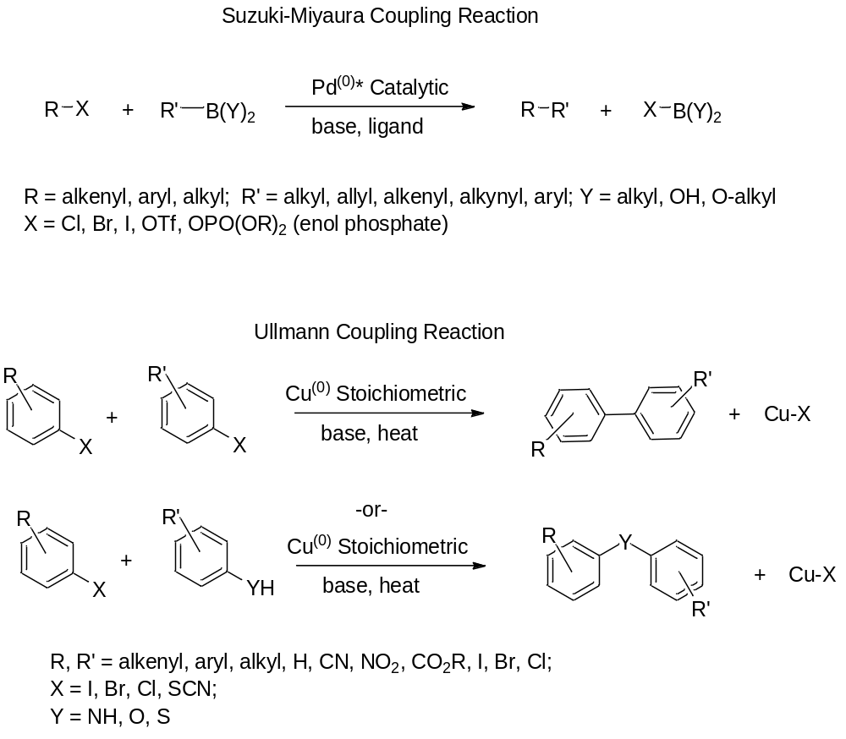

In 1998 the Chan-Evans-Lam Modified Ullmann Condensation Reaction was developed. This reaction takes elements of the Suzuki and Ullmann reactions, and applies them to the coupling of aryl-borates and heteroatoms, under mild conditions, using a copper salt, and producing modest product yields (Scheme 1-2).^{3d, 6}

Scheme 1-2 Chan-Evans-Lam Modified Ullmann Condensation Reaction ^{3d, 3e, 6b, 7}
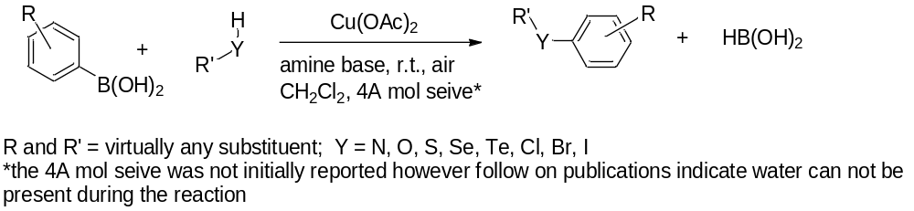

1.1.2 Reactions of Copper using Ultrasound in Organic Synthesis
The use of ultrasound in organic and organometallic synthesis has been used historically for improving reactions. This improvement typically allows the use of less hazardous chemicals and solvents, decreased energy consumption, improved product selectivity and improved product yields.⁸ When ultrasound is introduced to a liquid surface, the liquid will adsorb a portion of the generated vibrational energy. If the amplitude of the vibration is too great for the liquid, the liquid will be torn into large chunks and be ejected at high velocity – a phenomena known as cavitation.⁹ As the cavitation occurs, micro-sized bubbles are created in the wake of the liquid jet.¹⁰ Subsequent generated cavitations will cause the generated bubbles to collapse, with the result of significant amounts of energy being released - an estimated several thousand degrees Kelvin and hundreds of atmospheres of pressure in the immediate vicinity of the collapse.¹¹ This heat and pressure can easily translated to energy to be used in the chemical reaction.¹⁰
Ultrasound is known to improve reactions involving metals or metal salts. The microjects and cavitations can clean oxide layers from a metal surface, promote mass transport, or fragment larger particles and crystals to a nano-sized material (improving surface area reactivity).^{10, 12} In the scope of this dissertation, ultrasound has been applied to both the Suzuki and Ullmann reactions with improved results (decreased reaction times, decreased metal requirements, increased product yields); however, ultrasound has not been applied to the Chan-Evans-Lam reaction.^{10, 13}

1.2 Homo-coupling of Aryl Compounds
The homo-coupling of aryl compounds is an important reaction used in the formation of fundamental building blocks for numerous applications. There are several reactions that have been used to achieve such a coupling. Some of the more popular reactions include the Negishi, Stille, Suzuki, and Ullmann.¹ Each of these reactions requires the use of a transition metal to facilitate an aryl homo-coupling (Scheme 1-3):
Scheme 1-3 Aryl Homo-Coupling¹
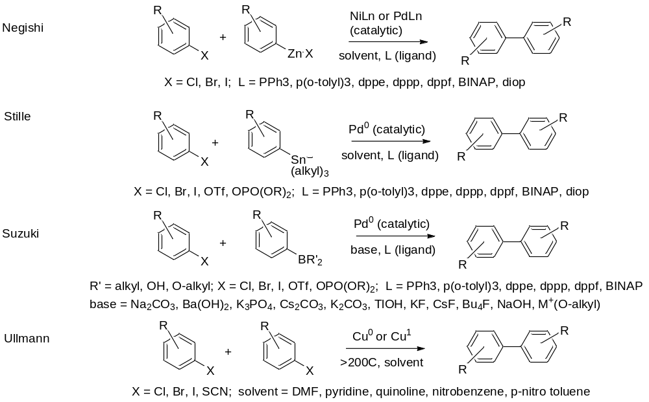
All of these reactions have significant negative aspects associated with them. The Negishi and Stille both produce a highly toxic metal halide by-product. The Stille and Suzuki require the use of expensive palladium catalyst. Although the Ullmann uses relatively safe and cheap copper, it requires stoichiometric amounts of the metal, with high heat and several days of reaction time.^{1, 14} Despite these issues, the reactions have remained over the years as a prime method for the synthesis of various bi-aryl compounds. Since the development of the development of the reactions, efforts have been undertaken to replace the expensive metals, reduce the toxicity of the generated waste, and improve reaction efficiency. The application of microwave and ultrasound technologies, specifically, has been shown to improve yields and improve product selectivity in these reactions, while decreasing the reaction times and amounts of metals required for synthesis.^{13, 15}

1.3 O-Arylation and N-Arylation Coupling of a Phenol or Aniline
Diaryl ethers and diaryl amines are structurally important as they form many fundamental building blocks for modern synthesis reactions. Historically, if the synthesis of diaryl ethers and diaryl amines was to be conducted by a coupling reaction, the Ullmann reaction was the principal route. The coupling of C-O and C-N by this method required very similar reaction conditions as the C-C Ullmann coupling reaction.
The Ullmann O-arylation coupling reaction uses a copper oxide or copper (I) salt to complex an aryl halide and phenol, under basic conditions, and high heat for 8-72 hours, depending on aryl groups (Scheme 1-4).^{2a, 16}

Scheme 1-4 Ullmann O-Arylation of Phenol ^{1, 16}
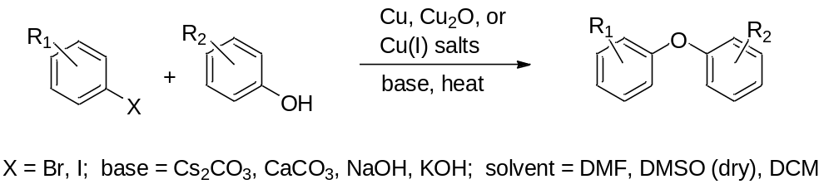
The synthesis of a diaryl amines by the Ullmann reaction commences in a similar manner, and under the same conditions as the diaryl or diaryl ether reaction (Scheme 1-5).¹⁷
Scheme 1-5 Ullmann N-Arylation of Aniline^{1, 17}
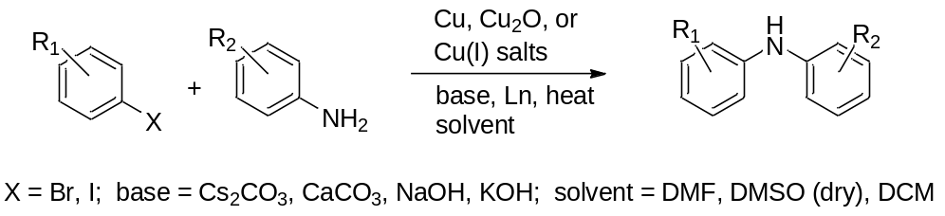
Unfortunately the harsh reaction conditions (high heat, long reaction times, strong basic conditions) can preclude many sensitive molecules from being used in the coupling reaction. With current environmental regulations and metal prices, the consumption of stoichiometric amounts of copper in the Ullmann reaction results in a disposal and cost issue.^{1, 16e}
Between 1950 and 1990 several carbon-heteroatom coupling reactions were developed, however most used highly toxic metals (lead, tin, arsenic), while not improving on the product yields of the Ullmann reaction. They did provide the pathway for the development of one of the most currently used cross-coupling reactions: the Chan-Evans-Lam modified Ullmann Reaction.^{2a, 6a, 16e} This reaction improves upon the Ullmann recation by using catalytic (or sub-stoichiometric) amounts of copper (II) salt, an aryl boronic acid instead of the aryl halide, and is carried out at room temperature (Scheme 1-6).^{3b, 3d, 6a} The reaction seems to have near universal applicability for the aryl coupling to various anilines and phenols; will produce similar yields (30-80%) and similar reaction times (1-3 days) to the Ullmann reaction, with the only negative aspect being that any water present will poison the reaction.^{2a, 3d, 6b, 7c}
Scheme 1-6 Chan-Evans-Lam Modified Ullmann Reaction ^{3b, 3d, 6a}
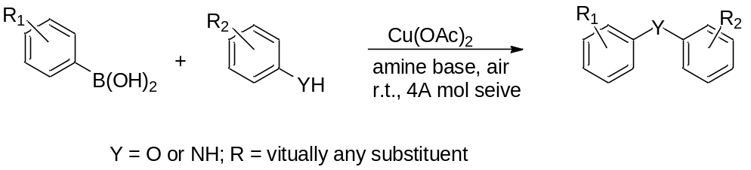

The Chan-Evans-Lam reaction has been applied to numerous coupling reactions, with marginal to good success.^{7c, 14} To date, microwave and ultrasound technology has only be applied to only the traditional Ullmann C-N and C-O coupling reaction in isolated cases; MW and ultrasound have not been reportedly applied to the Chan-Evans-Lam reaction.¹⁸

1.3 S-Arylation Coupling of a Thiol
There are a numerous methods for the synthesis of biaryl sulfides; however, for the synthesis of a biaryl sulfide via a coupling reaction, an Ullmann reaction was required, until recently.¹⁹ There has been limited reporting on using catalytic amounts of palladium to achieve the C-S coupling reaction, however all other conditions of the Ullmann remained, with no substantial product yield improvements.²⁰ Like the N- and O- arylation reactions, the conditions of the Ullmann reaction preclude many thiols from being used in the coupling reaction.^{7a} Shortly after the development of the Chan-Evans-Lam modified Ullman reaction it was successfully applied to the S-arylation of thiols (Scheme 1-7).^{2a, 6b, 7a, 7c}
Scheme 1-7 S-Arylation of Thiols, Chan-Evans-Lam Modified Ullmann Reaction

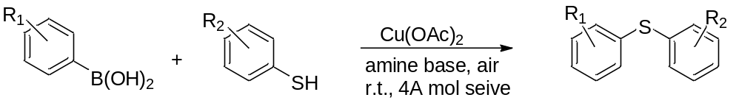

By coincidence, the use of copper may prevent the competing product formation of the related disulfide. During the Ullmann reaction the metal reaction product is copper (I).^{1, 21} Reporting has indicated that a copper (I) species will cleave an organo-disulfide.²² It is unknown if Copper (I) is produced during the Chan-Evans-Lam reaction. To date, microwave and ultrasound technology has not been applied to the Chan-Evans-Lam modified Ullmann reaction in the S-arylation of thiols.

1.4 Use of Ultrasound in Coupling Reactions
It is known that the use of ultrasound can dramatically improve a Suzuki or Ullmann coupling reaction: improved yields and decreased reaction times for both reactions, a 60% reduction in the amount of copper required for the Ullmann, and allowing the Ullmann to be run at “room temperature.”^{8, 10-12, 13b, 13c, 15} Unfortunately, a survey of literature revealed that there is not a consensus for ultrasound methods in coupling reactions. Most reporting indicated that a water bath ultrasound was used instead of a direct energy source; additionally, there was no set standard or consensus for reaction times, amounts of delivered energy, or reaction temperature.

1.5 Statement of Problem
There are several named reactions that can be used for C-C coupling, however they all have significant detrimental aspects. Similarly, there are only two named reactions that can be used in the carbon-heteroatom coupling reaction, for which both require a significant reaction time. A method was developed in the hopes of rectifying some of these negative characteristics.
Experiments were conducted to 1) determine what metals could be applied to homo-coupling reactions conducted in an aqueous solvent system using a polymer support, 2) develop an ultrasonic method that could improve this method by decreasing reaction times, decreasing the amount of metal required, and improving product yields, 3) determine the applicability of the homo-coupling reaction to aryl-boronic compounds that are sterically hindered, have electron withdrawing groups, or have electron donating groups, and 4) investigate the mechanism of the developed reaction (Chapter 2). The developed method was applied to the O-arylation of phenol to determine 1) the effect of ultrasound on the reaction time and product yield 2) the effect of sterics and electronics of the aryl-borate on the product yield, and 3) the effect of sterics and electronics of the phenols on the product yield (Chapter 3). The developed method was applied to the N-arylation of aniline and amine heterocycles to determine 1) the effect of ultrasound on the reaction time and product yield 2) the effect of sterics and electronics of the aryl-borate on the product yield, and 3) the effect of sterics and electronics of the anilines on the product yield (Chapter 4). The developed method was applied to the S-arylation of thiols to determine 1) the effect of ultrasound on the reaction time and product yield 2) the effect of sterics and electronics of the aryl-borate on the product yield, and 3) the effect of sterics and electronics of the thiols on the product yield (Chapter 5).

CHAPTER II
HOMO-COUPLING OF POLYMER SUPPORTED ARYL-TRIFLUOROBORATES

2.1 Introduction
The homo-coupling of aryl compounds is an important reaction used in the formation of fundamental building blocks for numerous industrial and pharmaceutical materials. Unfortunately many of the widely used homo-coupling reactions require expensive catalysts (Suzuki, Stille), or use harsh reaction conditions with large quantities of metal (Ullmann), while producing only modest product yields.^{13a, 13b} In an attempt to improve the negative aspects of these reactions, researchers have employed a variety of tactics, to include using different metals, ultrasound or microwave energy sources, different solvent systems, or different ligands; all with varying degrees of success or failure.^{5b, 5c, 13a, 13c, 23} Of these reaction modifications, one area that has shown great promise is the use of a polyethylene glycol supported Suzuki reaction. There is a significant quantity of reporting that indicates successful synthesis of biaryl compounds using this method; benefits of the modification include the reaction being run in water and under air, with good product yields (attributed to increased metal surface area as the chemical reaction produces palladium nano-particles).²⁴ Unfortunately many of these reactions require significant preparation of the polyethylene glycol before it can be used in the reaction.²⁴
The Kabalka group recently reported on an iodination reaction that used aryl trifluoroborates that were ionically bound to Dowex polymers (Scheme 2-1).²⁵
Scheme 2-1 Iodination of Naphthalene-Trifluoroborate ²⁵
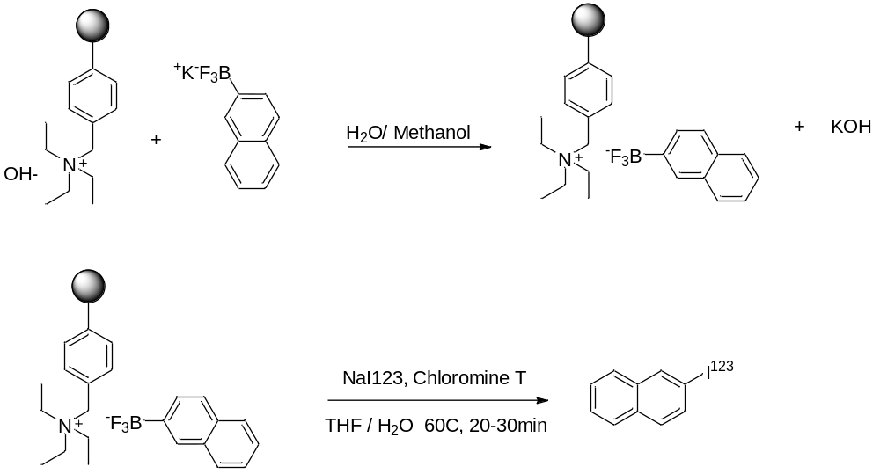

Since Dowex is commercially available, and does not require the extensive preparation, the Kabalka group attempted a homo-coupling reaction, parallel the reported polyethylene glycol methods using Dowex-trifluorborate-napthalene molecule.²⁶ Palladium (II) acetate was chosen as a survey metal, following the reporting methods.^{24, 27} Initial survey reactions using heat and stirring indicated only minimal product yield (7%) after 72 hours. It was decided to reattempt the reaction using an ultrasound energy source (in an attempt to improve the reactivity of the metal), this provided a significantly improved yield of 92%, and setting forth the initial reaction design (Scheme 2-2).²⁶

Scheme 2-2 Homo-Coupling of Ionically Bonded Dowex Trifluoroborate-Naphthalene²⁶

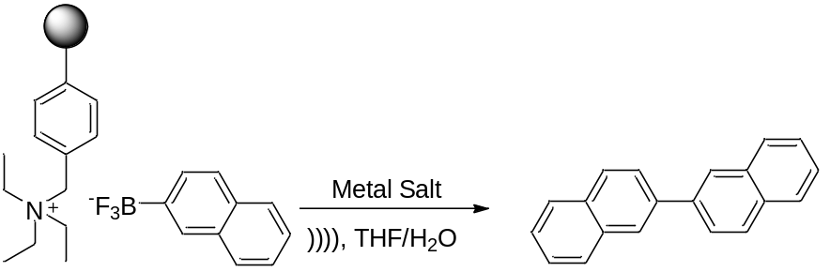

The successful synthesis of 2-2’-binaphthalene, in good yield, lends to the postulate that similar homo-coupling reactions could be accomplished using other trifluoroborate aryl compounds ionically bonded to Dowex. To our knowledge this reaction has not been reported.

2.2 Results and Discussion

2.2.1 Method Development
The successful homo-coupling of the Dowex supported naphtha-trifluoroborate prompted a detailed method development for the application to the homo-coupling of other aryl-trifluoroborates. Although a survey experiment showed the palladium (II) acetate could be used in the homo-coupling reaction, it was decided to investigate other metal salts for applicability to the reaction. Metals were chosen based on a combination of availability, water stability, oxidation state / electronic structure, and reported success in literature. ^{2b, 3a, 5a-c, 13c, 14, 23a, 28} Reactions were carried out using varying amounts of metals and using the reaction conditions in Scheme 2-2. The results of the survey reactions are presented in Table 2-1; the equivalents reported are the amounts of metals that provided the highest yields of binaphthalene; these reported values were confirmed with triplicate reactions and the yields reported being the average of those reactions.
Table 2-1 Comparison of Metal Salts and Binaphthalene Yields
Metal Salt | Yield of Bi-Naphthalene | Equivalents of Metal
Copper (II) acetate dihydrate | 56% | 4
Zinc acetate dihydrate | 10% | 3
Nickel (II) acetate tetrahydrate | No reaction | 1-4
Iron (II) acetate anhydrous | 17% | 2
Silver (II) acetate, anhydrous | 6% | 2
Cobalt (II) acetyl-Acetonate, anhydrous | No reaction | 1-4
Palladium acetate | 92% | 1
Platinum oxide (Adam’s catalyst) | 10% | 2

Copper (II) acetate was chosen for further study because of its cost, availability, and relation to the Chan-Evans-Lam modified Ullmann reaction. To improve the binaphthalene yield, the solvent system was investigated. Since it was desired to keep the system aqueous, only organic solvents that are miscible in water were evaluated. The first solvent chosen, ethanol, showed dramatic yield improvement to 97%. Because of the excellent yield, cost, and environmental nature, no other organic solvent components were investigated; the method was adjust for the changes (Scheme 2-3).

Scheme 2-3 Copper (II) Acetate Based Homo-coupling of Dowex-Trifluoroboronicnaphthalene

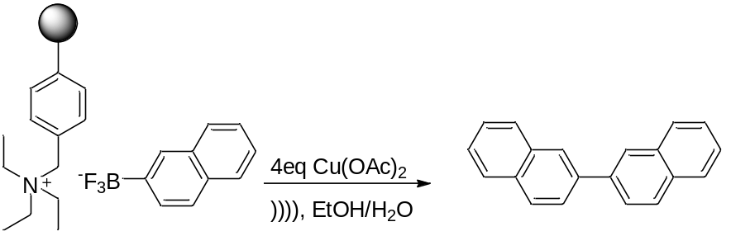

The next portion of the method development involved the optimization of the ultrasound. A horn dismemborator was chosen as it delivers the energy directly to the chemical system, with the energy level being known based on the instrument reading.⁹ The reaction depicted in Scheme 2-3 was run multiple times while varying the sonication time and watts delivered. The time and watts were independently varied to determine the optimal conditions for each (based on product yield); reaction times were varied from 1-8 hours, and the energy varied from 15 to 75 watts. It was found that the best conditions were one minute cycles of sonication followed by a three second pause, repeated over a 6 hour period, at a probe power level of 55 watts. Post reaction the temperature of the solvent system was found to range between 50-70°C.
Once the reaction method was established, the copper (II) acetate was re-evaluated to determine if any other copper salt provided improved results (quantity used verse yield of binaphthalene). Copper salts were chosen based on oxidation state, reported use in literature, and availability; in addition, cleaned copper metal and copper oxide were also evaluated.^{3a} The results of the experiments are shown in Table 2-2.

Table 2-2 Comparison of Copper Entities and Binaphthalene Yield

Copper Salt | % Yield Binaphthalene
Cu(OAc)₂ | 97
CuSO₄ | 3
CuI | 7
Cu (0) metal | 5
CuNO₂ | 53
Cu₂O | 4
CuCl₂ | 17
CuCN | 8

2.2.2 Homo-Coupling of Various Dowex Supported Aryl-Trifluoroborates
To evaluate the scope of the reaction noted in Scheme 2-3, a series of Dowex supported aryl-trifluoroborates were synthesized (using the method developed by the Kabalka group), and subjected to the conditions of the developed method.²⁵ The aryl substitutent was chosen with various electron donating or withdrawing groups, or with steric hindrance. The results of the reactions are listed in Table 2-3; the table denotes the starting material aryl and the determined product. All experiments were run in triplicate with the reported yields being the average of the reaction results.
Table 2-3 Homo-Coupling of Dowex-Supported Aryl Trifluoroborate Derivatives
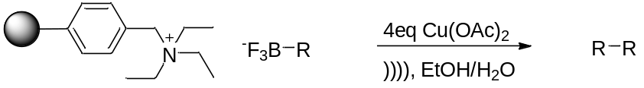

Entry | R | Product Structure | Yield | Product Number
1 | 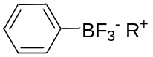 | 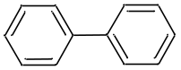 | 96% | 201
2 | 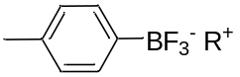 | 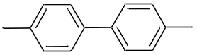 | 98% | 202
3 | 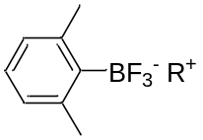 | 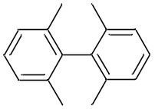 | No reaction | 203
4 | 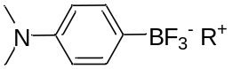 | 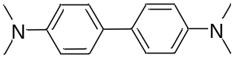 | 94% | 204
5 | 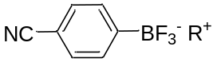 | 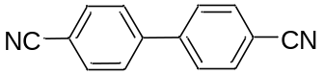 | 94% | 205
6 | 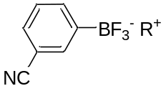 | 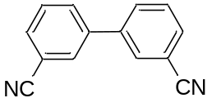 | 92% | 206
7 | 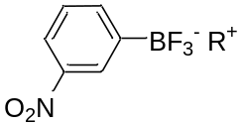 | 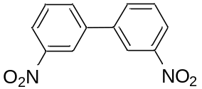 | 92% | 207
8 | 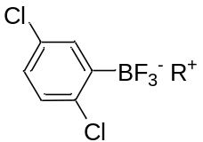 | 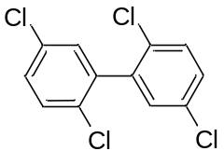 | 56% | 208
9 | 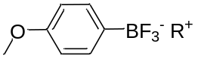 | 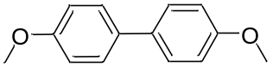 | 85% | 209
10 | 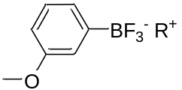 | 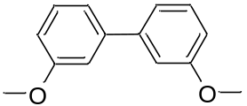 | 86% | 210
11 | 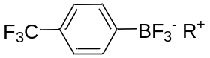 | 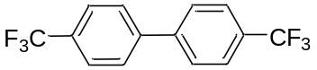 | 95% | 211
12 | 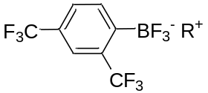 | 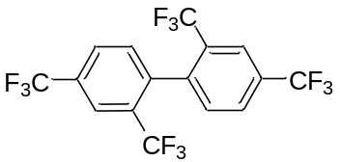 | No reaction | 212
13 | 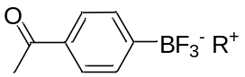 | 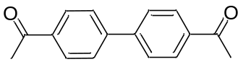 | 94% | 213
14 | 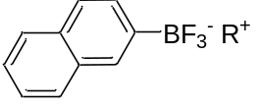 | 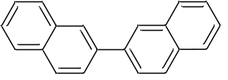 | 97% | 214

In all cases, the expected product was formed. It was determined that any unreacted aryl-trifluorborate had reverted to an aryl-boronic acid.²⁹
With the exception of the aryl groups that have a steric moiety, all product yields were good to excellent. The results show improvement over reported yields from other homo-coupling experiments that used an ultrasound source, and over reported yields from Ullmann or Suzuki experiments that were accomplished using traditional heating (with the exception of aryl’s with sterically hindering groups).^{2b, 13-14, 23b, 28b} It is hypothesized that the improved yields are as a result of direct sonication of the reaction mixture. Survey experiments had been initially conducted using a bath sonicator; the results from these experiments were in line with other reported literature yields, and averaged 10-20% less product than that reported in Table 2-3.

2.2.3 Relationship to the Suzuki, Ullmann, and Chan-Evans-Lam Reactions
Examination of the reaction in Scheme 2-3 shows that it has properties of both the Ullmann and Suzuki cross-coupling reactions. The developed method in Scheme 2-3 requires four equivalents of copper (II) acetate, although the Ullmann reaction requires ten equivalents copper metal, it has been well documented that if ultrasound is used as the energy source, only four equivalents of copper metal are required.^{3a, 10, 13b} The Ullmann reaction typically requires 1-3 days of reaction time; the use of ultrasound has been document that the reaction time is decreased to 2-8 hours.^{3a, 10, 13b} There are differences between the developed method and the Ullmann reaction: where the Ullmann reaction will use copper metal, copper oxide, and copper (I) salts, these materials showed no reactivity in the method (see Table2-1), and the method did not use an aryl-halide.
There are some comparisons of the developed method to the Suzuki coupling reaction: the reaction proceeds without the need for harsh conditions, an organo-boron entity participates in the reaction, and the results of using ultrasound instead of traditional heating are in line with cited documentation (shorter reaction times with improved yields).^{5a} However, the there is a significant difference, instead of using a palladium metal, copper (II) acetate was utilized as the reaction metal.
Perhaps the developed method has the most in common with the Chan-Evans-Lam modified Ullmann reaction. Copper (II) acetate and an aryl-borate are used in both reactions. There are three differences in the reactions: the Chan-Evans-Lam reaction has only been reportedly used in the coupling of an aryl carbon to a heteroatom (homo-coupling has not been reported), the reaction proceeds at room temperature (ultrasound has not been applied to the reaction), and no water can be present in the Chan-Evans-Lam. The final possible difference between the two reactions is the requirement for an amine base. The developed method uses a Dowex polymer that has a quaternary amine group, since the reaction is exposed to high heat via ultrasound it is possible that this quaternary amine undergoes a Hofman elimination resulting in a triethylamine base being produced.¹

2.2.4 Mechanistic Study
The Ullmann coupling reaction was discovered in 1901, yet the exact mechanism is still not known.¹ Depending on the aryl species involved, and the reaction conditions used while conducting the Ullmann, it is hypothesized that the reaction can follow one of two pathways: the first uses a single electron transfer from the copper metal to form an aryl radical, and the second involves an oxidation addition / reductive elimination of the copper metal (Scheme 2-4):^{1, 21, 30}
Scheme 2-4 Possible Ullmann Coupling Reaction Mechanism Pathways^{1, 21, 30}
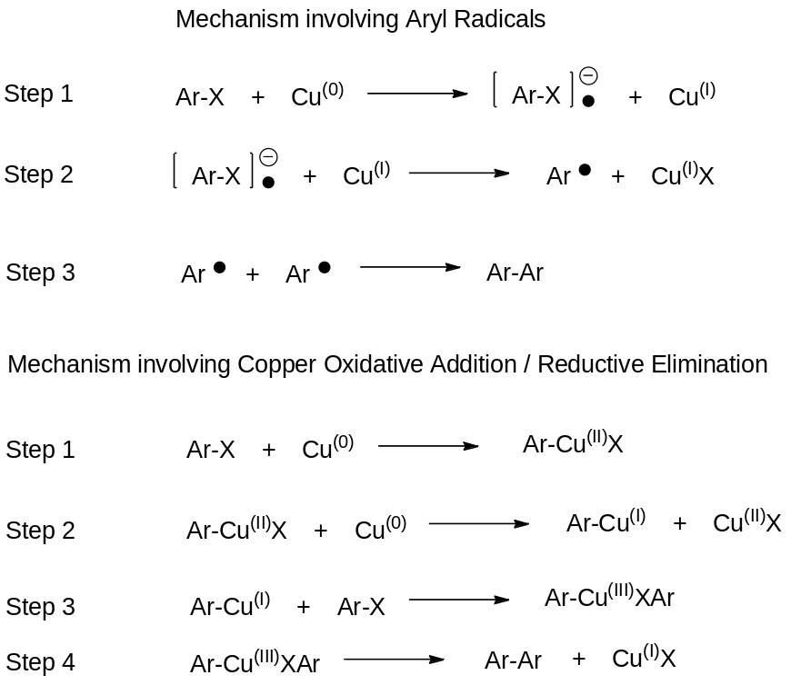

Studies conducted on the Chan-Evans-Lam reaction (although not carbon-carbon coupling related), indicates that the mechanism does not involve any single electron transfer or free radicals.^{6b} Using EPR copper (III) intermediates and a copper (I) product have been identified, providing significant evidence that it follows a similar pathway to the proposed oxidation addition / reduction elimination mechanism of the Ullmann (Scheme 2-4).^{6b}
The Suzuki cross-coupling reaction is similar to many other reactions that involve a catalytic metal cycle, with four distinct steps: 1) the oxidative addition of an organic halide to the palladium metal, 2) metathesis, 3) transmetallation between palladium and an organo-borate, and 4) reductive elimination to form a C-C bond and regeneration of the palladium metal (Scheme 2-5)
Scheme 2-5 Suzuki Cross-Coupling Mechanism

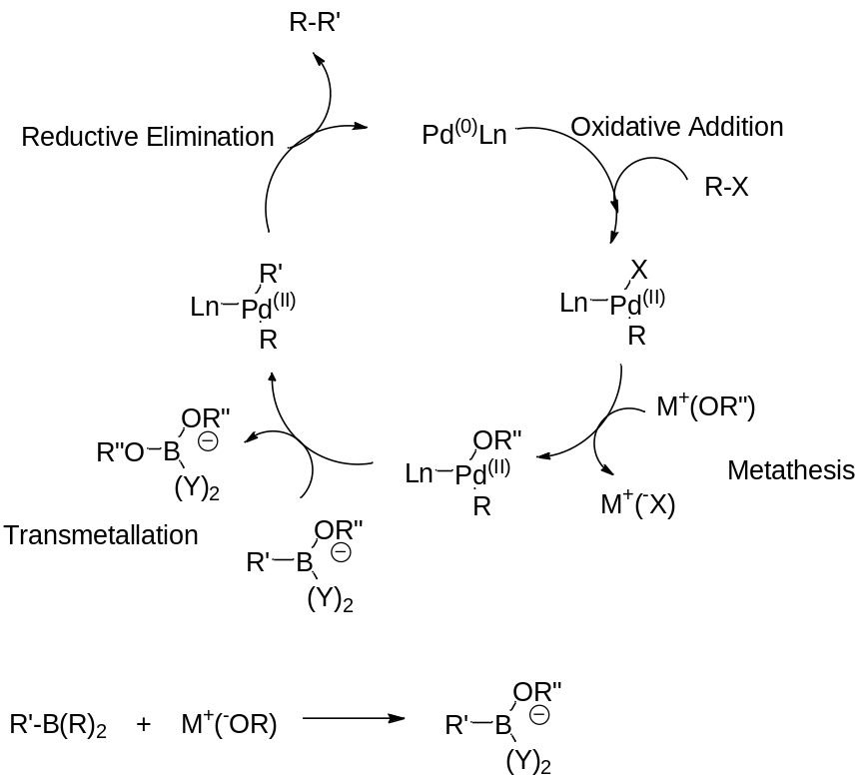
Using the published information on the three named reactions, a series of experiments were completed to garner information of the developed reaction’s mechanistic pathway. It can be hypothesized that the reaction commences by one of two routes: free-radical or oxidative addition / reductive elimination. By both mechanisms, it is projected that the copper (II) acetate would be converted to copper (I) acetate, which is water and air reactive.³¹ To preserve this species for analysis, the reaction cannot be run in the aqueous ethanol and under air, but rather a dry system. Since an aryl-trifluoroborate needs water to participate in a coupling reaction, this species would need to be changed to a system compatable aryl-boronic acid.²⁹ This is an obvious change in oxidation state for the boron. To verify that the aryl-trifluoroborate generates similar precursors as an aryl-boronic acid, an 11B NMR and ESI Mass Spectrometry analysis was performed on post-reaction samples from a water based reaction and a dry system. The primary boron species noted by NMR analysis were peaks at 19ppm, corresponding to boric acid, and 32ppm corresponding to naphthylboronic acid. There was an absence of a peak at 5ppm corresponding to napthyl-trifluoroborate. ESI Mass spec analysis indicated that the unreacted aryl species was naphthyl-boronic acid and not naphthyl-trifluoroborate. The mass spect and NMR evidence seems to support the theory that the naphthyl-trifluoroborate did generate intermediates similar to those generated by naphthyl-boronic acid precursors.²⁹ With this evidence it was decide to move ahead with additional reactions using aryl-boronic acids, in a dry system, to investigate the mechanism.
A series of experiments were set up using a dry system and under argon or dry nitrogen. Reactions were completed using both the ultrasound protocol and a correlated traditional heating method (150°C for 72 hours, and an increase to ten equivalents of copper (II) acetate).^{10, 13b} The first set of reactions used only naphtha-boronic acid and copper, there was no reaction, indicating that the Dowex functioned not only as a polymer support but also as a possible amine base (via a possible Hofmann elimination reaction).¹ To account for this aspect all other reactions were accomplished using an equivalence of triethylamine (Scheme 2-6).

Scheme 2-6 Reaction for Investigation of Mechanism

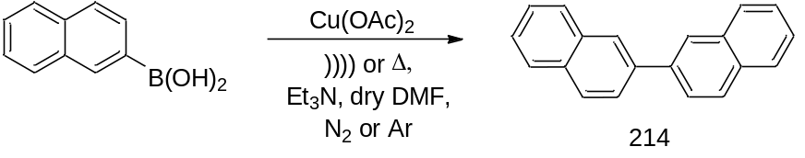
To determine if the reaction involves any free radical entity or single electron transfer, a similar set of reactions were run using the free-radical galvinoxyl (Scheme 2-7). Using this compound, it is expected that if a radical is present it would be immediately quenched, causing the reaction to terminate.
Scheme 2-7 14 Reaction for Investigation of Free Radical Mechanism
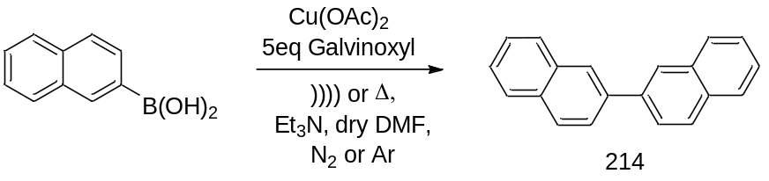
The reactions were run in triplicate, with the results shown in Table 2-4 for compound 214.
Table 2-4 Product Yield Results for Mechanism Study, Compound 214
Entry | Reaction Conditions | Product Yield
1 | Naphtha-boronic acid, heat | 0
2 | Naphtha-boronc acid, ultrasound | 0
3 | Naphtha-boronic acid, heat, Et₃N | 57
4 | Naphtha-boronic acid, ultrasound, Et₃N | 53
5 | Naphtha-boronic acid, heat, Et₃N, galvinoxyl | 56
6 | Naphtha-boronic acid, ultrasound, Et₃N, galvinoxyl | 55

Post reaction, the copper residue was extracted under dry nitrogen, sealed in paraffin powder, and analyzed by scanning powder x-ray diffractometer.³¹ The resulting spectrums were compared against starting material copper (II) acetate and a purchased copper (I) acetate. Although pXRD is not a standard method of analysis for different oxidation states, it can be applied for detection in this case. The structure of copper (I) acetate is a polymeric planar chain, each copper atom being in a distorted square-planar environment bonded to three oxygen atoms and another copper atom, while the copper (II) acetate exists as a “paddlewheel” formation - a binuclear molecule Cu₂-(CH3COO)₄·2H₂O in which copper(II) ions are bridged in pairs by four acetate groups with two water molecules.³¹⁻³² As they two different oxidation states have different arrangements, they will pack in different repeating units resulting in different crystal shapes and subsequently different two theta values of diffraction.³³ The results are shown in the following Figures:

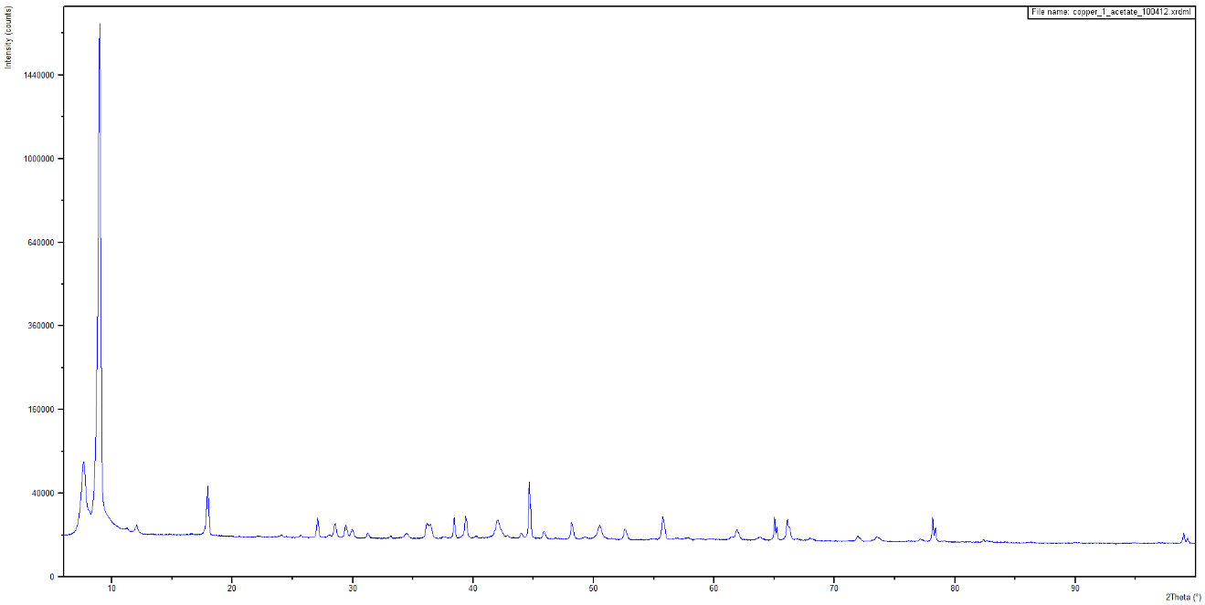
Figure 2-1 pXRD Spectrum of Copper (I) Acetate
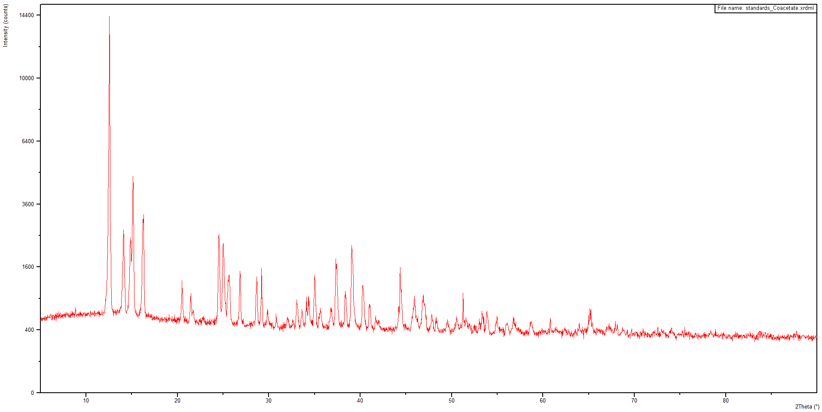
Figure 2-2 pXRD Spectrum of Copper (II) Acetate, Starting Material
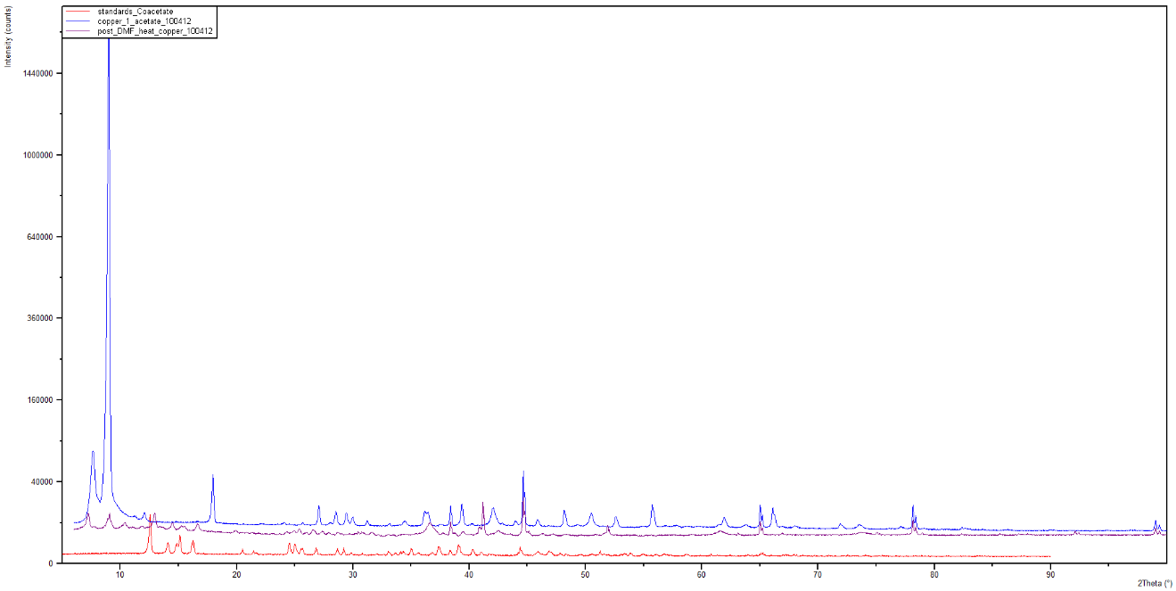
Figure 2-3 pXRD Spectrum of Extracted Copper from Entry 3, Table 2-4, Compared to Copper (I) and Copper (II) Standards
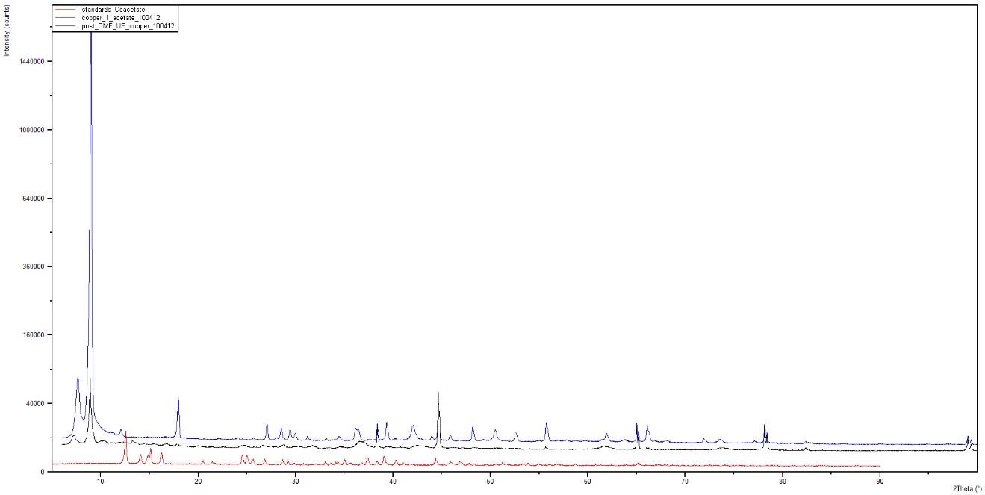
Figure 2-4 pXRD Spectrum of Extracted Copper from Entry 4, table 2-4, Compared to Copper (I) and Copper (II) Standards
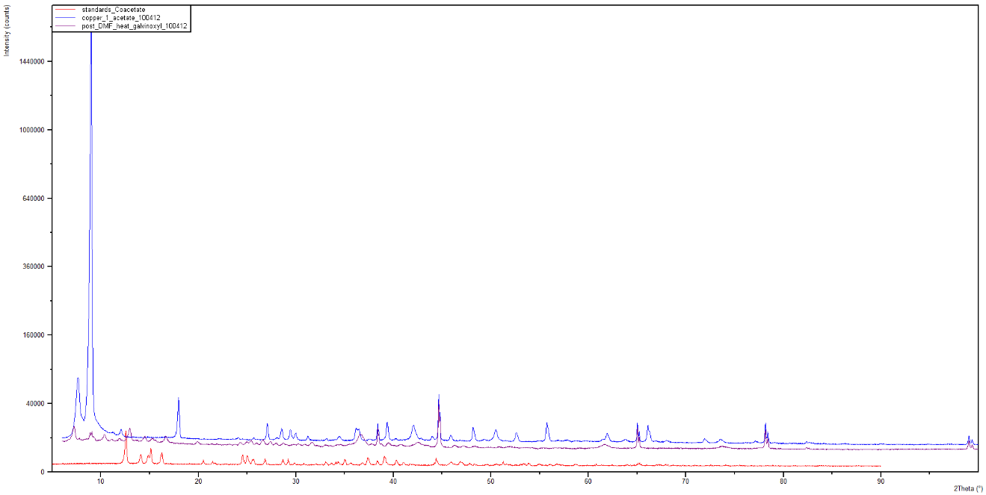
Figure 2-5 pXRD Spectrum of Extracted Copper from Entry 5, Table 2-4, Compared to Copper (I) and Copper (II) Standards
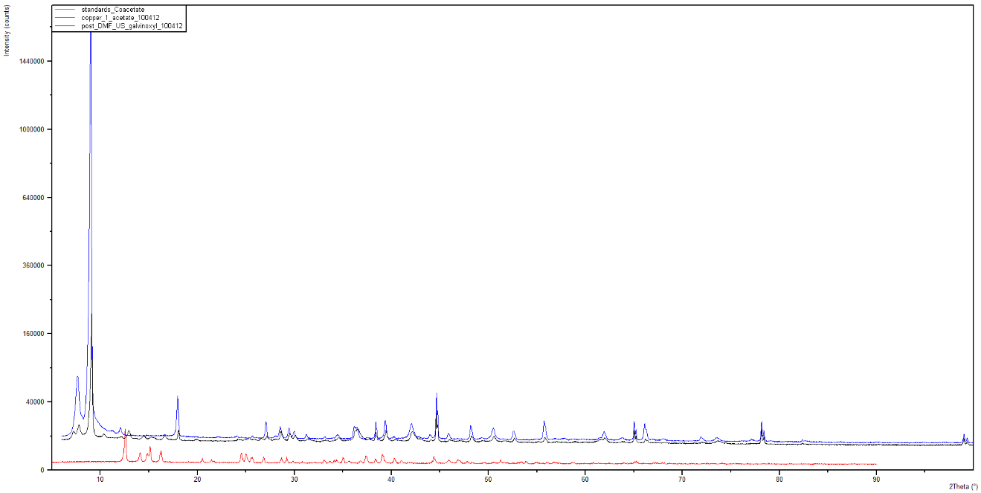
Figure 2-6 pXRD Spectrum of Extracted Copper from Entry 6, Table 2-4, Compared to Copper (I) and Copper (II) Standards
The product yields indicate that the galvinoxyl has no effect on the reaction, and pXRD analysis shows a strong indication that copper (I) acetate is produced in all reactions. The presence of the copper (I) acetate would explain the consumption of the copper during the reaction, since it is water reactive, it would immediately be converted to an unknown hydrate upon generation. The collected evidence provides a strong indication that the mechanism follows a pathway similar to that of the Ullmann reaction oxidation addition / reductive elimination mechanism hypothesis.

2.3 Conclusion
The homo-coupling results depicted in Table 2-3, indicates that the developed method has fairly broad applicability with good product yields. The use of the Dowex polymer supported aryl trifluoroborate allows the reaction to be carried out in aqueous ethanol instead of an organic solvent, providing a “green” synthesis method. Using ultrasound as the energy source results in a dramatically shortened reaction time decreases the quantity of metal catalyst required, while improving product yields. The reaction proceeds using copper (II) acetate instead of palladium metal, or other transition metals, allowing a cost effective, and safe, means for the synthesis of biaryl compounds. The work presented in this chapter will be published in the following article:
“Ultrasound induced, copper mediated homocoupling using polymer supported aryltrifluoroborates,” Musolino, B.; Quinn, M.; Hall, K.; Coltuclu, V.; Kabalka, G. W., Tetrahedron Letters.

2.4 Experimental Details

2.4.1 General Considerations
All glassware was dried at 120°C and flushed with dry nitrogen prior to use. All chemicals were purchased from commercial sources and used as received. Dowex 1-X 10 (Bio.Rad Laboratories, 100-200 mesh, chloride form. Control number, MM06170). DI water (Barnstead E-pure) was used in all solution preparation and reactions. Potassium organotrifluoroborates were obtained from commercial sources or prepared from organoboronic acids or esters according to the reported procedures.³⁴ Gas Chromatography-Mass Spectroscopy studies were run on a Hewlett Packard: HP 6890
series GC System with 5973 Mass Selective Detector; Column: HP-5 30m x 0.25mm x 0.25μm; Gas (He) flow 0.8ml / min; temperature program: flow 0.8 ml/min, initial temperature 90°C for 1 minute, ramp at 15°/minute to 200°C, then ramp at 5°/min to 250°C for 10 minutes. All samples were purified using vacuum column chromatography (anhydrous sodium sulfate and 60 Å 230-400 mesh silica gel), and then recrystallized. All sonication experiments were carried out using a Fisher Scientific Model 550 Sonic Dismemborator, employing a 0.5 in horn sonicator and a 1 in by 2 in cylindrical reaction vessel. All reactions were carried out in new borsite glass vessels.

2.4.2 Preparation of Dowex-Aryl-Trifluoroborate Complexes
All Dowex-aryl-trifluoroborates were prepared by established procedures set forth by Kabalka et al.²⁵ A representative procedure for the synthesis of Dowex-trifluoroborate-naphthalene: Dowex 1-X 10 (10 grams) was washed sequentially with 1N aqueous HCl (3 x 40 mL), 1 N aqueous NaOH (3 x 40 mL), water (100 mL) of water and then dried overnight prior to us. To a suspension of the base form of the Dowex resin (1g) in H2O (10 mL), a solution of 2-naphthylenyltrifluoroborate (1 mmol) in MeOH (10mL) was added in one portion. The pH of the reaction mixture was then monitored to determine reaction termination.

2.4.3 Representative Procedure for the Synthesis of Binaphthalene
1.25 g of naphthyltrifluoroborate-Dowex resin (equivalent to 0.5 mmol of naphthyltrifluoroborate) was added to 15 milliliters of 1:1 water / EtOH solvent; 2 mmol of copper (II) acetate was added, and the dismemberator horn placed in the reaction vessel. The sonicator was set to 55 watts and the reaction was allowed to proceed for 6 hours (1 minute pulse with a 3 second rest). Post reaction, the mixture was extracted with dichloromethane for subsequent purification and analytical analysis.
Yields of the 2,2’-binaphthalene were determined by a calibrated gas chromatograph / mass spectrometer, using a purchased 2-2’-binaphthalene standard (Aldrich S413402), the curve was seven points, with an R² of 0.9998, and with random samples verified by weight. All other synthesized bi-aryls yields were determined by weight.

2.4.4 Characterization of Compounds 201-214
¹H NMR and ¹³C NMR spectra were recorded at 250.13 and 62.89 MHz, respectively. Chemical shifts for 1H NMR and 13C NMR spectra were referenced to TMS and measured with respect to the residual protons in the deuterated solvents. High quality mass spectrometry was recorded using a Qstar electron spray ionization mass spectrometer, in positive mode, ionization energy of 5000e/v, injection rate of 20 μl/min.
1,1’-Biphenyl (201)^{28b}: ¹HNMR: δ 7.57 (d, J = 7.79 Hz, 2 H), 7.41 (t, J = 7.79 Hz, 2H), 7.32 (t, J = 7.45 Hz, 1 H). ¹³CNMR: δ 145.14, 127.87, 125.92, 125.80. Anal. Calcd for C₁₂H₁₀: 154.21. Found: 155.31. GC RT: 4.01
4,4’-dimethyl-1,1’-biphenyl (202)^{28b}: ¹HNMR: δ 7.47 (d, J = 7.22 Hz, 2 H), 7.22 (d, J = 7.47 Hz, 2 H), 2.37 (s, 3 H). ¹³CNMR: δ 136.60, 129.45, 127.84, 126.77, 126.45. Anal. Calcd for C₁₄H₁₄: 182.11. Found: 183.30 GC RT: 6.11
N4,N4,N4',N4'-tetramethyl-[1,1'-biphenyl]-4,4'-diamine (204)³⁵: ¹HNMR: δ 2.96 (6H, s), 6.79 (2H, d, J3(H)=8.2Hz), 7.45 (2H, d, J3(H)=9.2Hz) ¹³CNMR: δ 154.18, 133.46, 129.46, 110.47, 39.82, Anal. Calcd for C₁₆H₂₀N₂: 240.16. Found: 241.22 GC RT: 12.02
[1,1'-biphenyl]-4,4'-dicarbonitrile (205)³⁵: ¹HNMR: δ 7.62 (1H, dd, J3=7.8Hz, J3=7.8Hz), 7.72 (1H, ddd, J3=7.8Hz, J4=1.4Hz, J4=1.4Hz), 7.81 (1H, ddd, J3=7.8Hz, J4=1.4Hz, J4=1.4Hz), 7.85 (1H, d, J4=1.4Hz). ¹³CNMR: δ 142.56, 134.34, 127.83, 118.18, 112.87. Anal. Calcd for C₁₄H₈N₂: 204.07. Found: 205.12 GC RT: 5.03
[1,1'-biphenyl]-3,3'-dicarbonitrile (206):³⁶ ¹HNMR: δ 7.85 (s, 2 H), 7.81 (d, J = 8.0 Hz, 2 H), 7.73 (d, J = 7.6 Hz, 2 H), 7.63 (t, J = 7.6 Hz, 2 H). ¹³CNMR: δ 142.57, 132.07, 130.06, 129.46, 117.28, 112.88. Anal. Calcd for C₁₄H₈N₂: 204.07. Found: 205.15 GC RT: 6.83
3,3'-dinitro-1,1'-biphenyl (207)³⁵: ¹HNMR: δ 7.62 (1H, dd, J3=7.8Hz, J3=7.8Hz), 7.72 (1H, ddd, J3=7.8Hz, J4=1.4Hz, J4=1.4Hz), 7.81 (1H, ddd, J3=7.8Hz, J4=1.4Hz, J4=1.4Hz), 7.85 (1H, d, J4=1.4Hz) ¹³CNMR: δ 148.12, 139.69, 136.60, 129.45, 126.77, 126.45. Anal. Calcd for C₁₂H₈N₂O₄: 244.05. Found: 245.19 GC RT: 7.81
2,2',5,5'-tetrachloro-1,1'-biphenyl (208)³⁷: ¹HNMR: δ 7.22 (d, J = 8.2 Hz, 1H), 7.28 (d, J = 2.5 Hz, 1H), 7.34 (d, J = 2.2 Hz, 1H), 7.36 (d, J = 2.2 Hz, 1H), 7.44 (d, J = 8.5 Hz, 1H), 7.54 (d, J = 2.1 Hz, 1H) ¹³CNMR: δ 137.78, 134.03, 130.79, 129.61, 125.35. Anal. Calcd for C₁₂H₆Cl₄: 289.92. Found: 291.00 GC RT: 8.76
4,4'-dimethoxy-1,1'-biphenyl (209)^{28b}: ¹HNMR: δ 7.49 (d, J = 8.76 Hz, 2 H), 6.97 (d, J = 8.80 Hz, 2 H), 3.86 (s, 3 H) ¹³CNMR: δ 162.16, 133.61, 129.05, 114.30, 53.68. Anal. Calcd for C₁₄H₁₄O₂: 214.10. Found: 215.12 GC RT: 6.46
3,3'-dimethoxy-1,1'-biphenyl (210)³⁵: ¹HNMR: δ 3.82 (3H, s), 6.88 (1H, dd, J3=8.2Hz, J4=2.3Hz), 7.12 (1H, dd, J4=2.3Hz, J4=1.8Hz), 7.16 (1H, d, J3=7.8Hz), 7.32 (1H, dd, J3=8.2Hz, J3=7.8Hz). ¹³CNMR: δ 162.16, 147.17, 128.84, 121.09, 112.43, 55.55. Anal. Calcd for C₁₄H₁₄O₂: 214.10. Found: 215.19 GC RT: 6.33
4,4'-bis(trifluoromethyl)-1,1'-biphenyl (211)³⁸: ¹HNMR: δ 7.74 (s, 4H), 7.69-7.62 (m, 2H), 7.58-7.40 (m, 3H) ¹³CNMR: δ 147.70, 133.92, 131.64, 126.24, 124.80. Anal. Calcd for C₁₄H₈F₆: 290.05. Found: 291.10 GC RT: 8.25
1,1'-([1,1'-biphenyl]-4,4'-diyl)diethanone (213)³⁸: ¹HNMR: δ 7.65–7.58 (m, 4H), 7.52-7.33 (m, 3H), 7.07–7.03 (m, 2H), 3.91 (s, 3H). ¹³CNMR: δ 192.86, 146.51, 136.62, 127.87, 125.80, 26.42 Anal. Calcd for C₁₆H₁₄O₂: 238.10. Found: 239.25 GC RT: 6.77
2,2'-binaphthalene (214)^{28b}: ¹HNMR: δ 8.17 (s, 1 H), 7.96 (d, J = 7.12 Hz, 1 H), 7.94 (d, J = 7.39 Hz, 1 H), 7.89 (d, J = 7.51 Hz, 2 H), 7.53 (t, J = 7.38 Hz, 1 H), 7.50 (t, J = 7.12 Hz, 1 H). ¹³CNMR: δ 138.41, 133.74, 132.66, 128.50, 128.22, 127.67, 126.34, 126.10, 125.99, 125.73. Anal. Calcd for C₂₀H₁₄: 254.11 Found: 255.18 GC RT 9.53

CHAPTER III
COUPLING OF Aryl-borates to phenols: application of ultrasound to the chan-evans-lam

3.1 Introduction
The O-arylation coupling reaction is a key synthesis route of many diaryl ethers, used as starting materials in organic and bio-chemistry. In 1903 the Ullmann reaction was expanded to include the coupling of aryl halides and phenols, providing chemists a means for this synthesis that has remained until recently.^{2a} The harsh conditions, and less than desirable yields of the Ullmann reaction, motivated chemists to devise a new pathway for diaryl ether synthesis. Unfortunately, many of the developed reactions were limited in scope, or did not improve upon the conditions of the Ullmann reaction.^{2a} In 1998 through 2001, the Chan-Evans-Lam modified Ullmann reaction was developed.^{3b-d} Initially it was established for C-N coupling, but it was soon found that the reaction had applicability to couple aryl carbon to several heteroatoms, including phenol oxygen.^{6b} The reaction is conducted in mild conditions, at room temperature, and under air (Scheme 1-8); with only a few negative aspects: any water present will poison the reaction, the reaction time is typically 1-3 days, and the product yields are equivalent to those of the Ullmann reaction.^{2a, 6b, 7c}
With the success of the aryl homo-coupling reactions in Chapter 2, and the seeming relationship between that method and the Chan-Evans-Lam reaction, it was decided to apply ultrasound to the Chan-Evans-Lam reaction. To our knowledge, the direct application of ultrasound to the O-arylation of phenols, under the conditions of the Chan-Evans-Lam reaction, has not been reported.

3.2 Results and Discussion
To determine the feasibility of ultrasound to the Chan-Evans-Lam reaction, a series of survey experiments were conducted using phenol:
Reaction with Dowex-naphthyltrifluoroborate in aqueous ethanol: following the method developed in Scheme 2-3, Dowex support naphthyltrifluoroborate was mixed with an equal equivalence of phenol, 4 equivalents of copper (II) acetate, in aqueous ethanol, and exposed to ultrasound irradiation for the 6 hour program. A control was established using the same reaction mixture, and stirred at room temperature for 72 hours. There was no product for either reaction.
Reaction with Dowex-naphthyltrifluoroborate in DCM: following the method developed in Scheme 2-3, Dowex support naphthyltrifluoroborate was mixed with an equal equivalence of phenol, 4 equivalents of copper (II) acetate, dichloromethane was used as the solvent, and the reaction mixture was exposed to ultrasound irradiation for the 6 hour program. Since the heat generated by the ultrasound is high enough to evaporate the DCM, the reaction vessel was placed in an ice/water bath; the external reaction vessel was maintained at 0-5°C. A control was established, the same reaction mixture was stirred at room temperature for 72 hours. There was no product yield for either reaction, supported by Molander’s work that water must be present for a trifluoroborate to react.²⁹
Reaction with Naphthaboronic Acid and Triethylamine in DCM: 1 equivalence of phenol and 1.5 equivalence of naphthaboronic acid were mixed in DCM, with 5 equivalents of triethylamine base, and 4 equivalents of copper (II) acetate, and exposed to ultrasound irradiation for the 6 hour program. The increased equivalence of naphthaboronic acid was to account for any formed trimeric cyclic anhydrides. Since the heat generated by the ultrasound is high enough to evaporate the DCM, the reaction vessel was placed in an ice/water bath; the external reaction vessel was maintained at 0-5°C. A control was established using the same reaction mixture, and stirred at room temperature for 6 and 72 hours. The ultrasound experiment gave a product yield of 94%, the 6 hour control a yield of 23% and the 72 hour control a yield of 72%. As final survey, the ultrasound experiment was repeated, only the reaction time was cut to 4 hours, and the amount of copper (II) acetate was decreased from 4 equivalents to 1 equivalent. The product yield was found to be 92%. It is possible that the cooling of the ice bath had a beneficial effect on the reaction: with a cooler solvent system the ultrasound probe would be able to more easily shed built up internal heat, and thus improve the heat transfer from the probe to the surrounding media.⁹
The final survey experiment indicates that the application of ultrasound to the Chan-Evans-Lam can dramatically shorten the reaction time, while improving the product yield, thus we felt it valid to further explore this application. It was decided not to add mol sieve to the reaction mixture as the effect of the ultrasound could have a detrimental effect, please note that this absence seems to have no obvious effect on the reaction. The developed method was evaluated against a matrix of varying arylborates and phenols – arylborates and phenols were chosen to include electron donating groups, electron withdrawing groups, and sterically hindering groups.

3.2.1 Reaction of Naphthaboronic Acid with Phenols
Various phenols were mixed in DCM, with napthylboronic acid, copper (II) acetate, triethylamine, and the reacted according to the ultrasound protocol. The reaction results are shown in Table 3-1, with the various phenol starting material.
Table 3-1 Reaction Results for Naphthylboronic Acid and Phenols
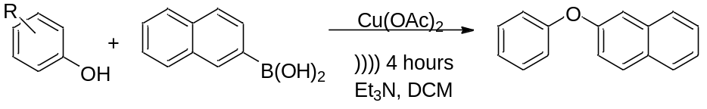
Entry | Starting Material | Product Structure | Yield | Product
1 | 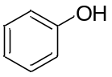 | 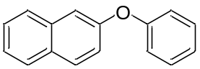 | 92 | 301
2 | 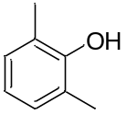 | 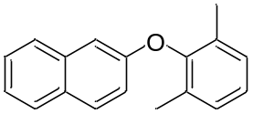 | 81 | 302
3 | 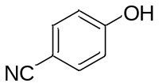 | 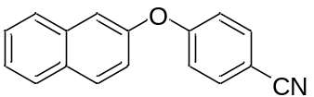 | 97 | 303
4 | 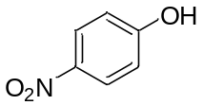 | 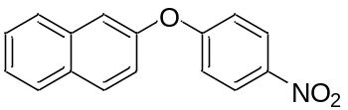 | 91 | 304
5 | 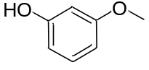 | 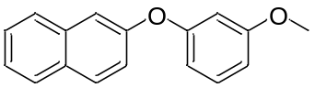 | 88 | 305
6 | 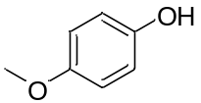 | 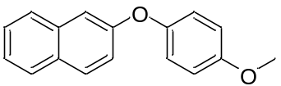 | 95 | 306
7 | 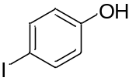 | 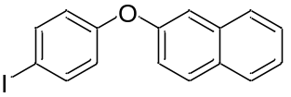 | 93 | 307
8 | 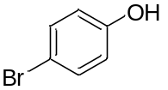 | 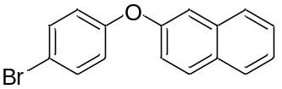 | 92 | 308
9 | 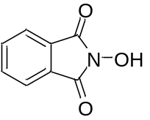 | 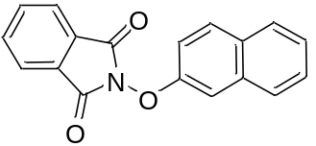 | 53 | 309

In all cases, the expected product was formed between the napthylboronic acid and respective phenol. There was no homo-coupling product detected, all unreacted naphthylboronic acid remained as the boronic acid.

3.2.2 Reaction of (4-(Trifluoromethyl)phenyl)boronic Acid with Phenols
Various phenols were mixed in DCM, with (4-(trifluoromethyl)phenyl)boronic acid, copper (II) acetate, triethylamine, and the reacted according to the ultrasound protocol. The reaction results are shown in Table 3-2, with the various phenol starting material.
Table 3-2 Results of the Reaction of Phenols with (4-(trifluoromethyl)phenyl)boronic acid
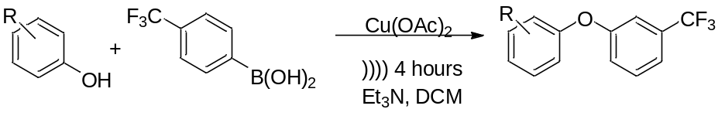
Entry | Starting Material | Product Structure | Yield | Product
1 |  | 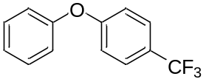 | 97 | 310
2 |  | 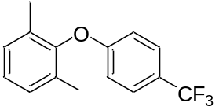 | 88 | 311
3 |  | 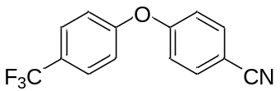 | 90 | 312
4 |  | 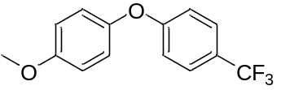 | 98 | 313
5 |  | 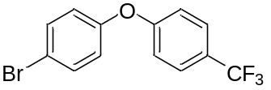 | 97 | 314

In all cases, the expected product was formed between (4-(trifluoromethyl)phenyl)boronic acid and respective phenol. There was no homo-coupling product detected, all unreacted naphthylboronic acid remained as the boronic acid.

3.2.3 Reaction of (4-Acetylphenyl)boronic Acid with Phenols
Various phenols were mixed in DCM, with (4-acetylphenyl)boronic acid, copper (II) acetate, triethylamine, and the reacted according to the ultrasound protocol. The reaction results are shown in Table 3-3, with the various phenol starting material.
Table 3-3 Reaction Results of Phenols with (4-acetylphenyl)boronic Acid
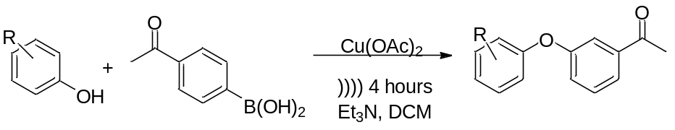
Entry | Starting Material | Product Structure | Yield | Product
1 |  | 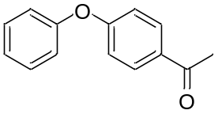 | 91 | 315
2 |  | 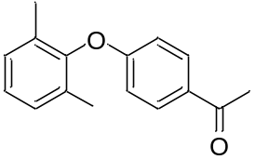 | 81 | 316
3 |  | 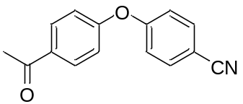 | 89 | 317
4 |  | 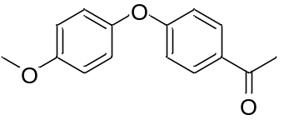 | 81 | 318
5 |  | 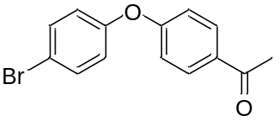 | 88 | 319

In all cases, the expected product was formed between the (4-acetylphenyl)boronic acid and respective phenol. There was no homo-coupling product detected, all unreacted naphthylboronic acid remained as the boronic acid.

3.2.4 Reaction of (3-Hydroxyphenyl)boronic Acid with Phenols
Various phenols were mixed in DCM, with (3-hydroxyphenyl)boronic acid, copper (II) acetate, triethylamine, and the reacted according to the ultrasound protocol. The reaction results are shown in Table 3-4, with the various phenol starting material.
Table 3-4 Results of Reaction between Phenols and (3-hydroxyphenyl)boronic Acid
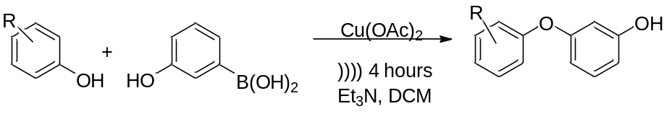
Entry | Starting Material | Product Structure | Yield | Product
1 |  | 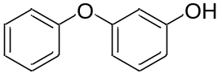 | 76 | 320
2 |  | 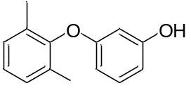 | 72 | 321
3 |  | 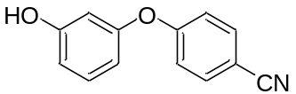 | NR | 322
4 |  | 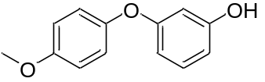 | NR | 323
5 |  | 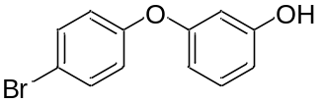 | 76 | 324

In all cases, the expected product was formed between the (3-hydroxyphenyl)boronic acid and respective phenol. There was no homo-coupling product detected, all unreacted naphthylboronic acid remained as the boronic acid. The two products that showed no product were verified that there was no yield by additional experiments.

3.2.5 Reaction of (3-(dimethylamine)phenyl)boronic Acid with Phenols
Various phenols were mixed in DCM, with (3-(dimethylamino)phenyl)boronic acid, copper (II) acetate, triethylamine, and the reacted according to the ultrasound protocol. The reaction results are shown in Table 3-5, with the various phenol starting material.

Table 3-5 Results of Reaction between Phenols and (3-(dimethylamino)phenyl)boronic Acid
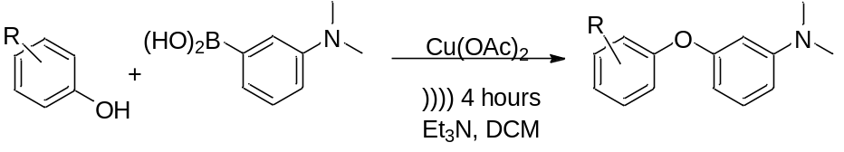

Entry | Starting Material | Product Structure | Yield | Product
1 |  | 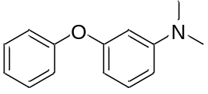 | 72 | 325
2 |  | 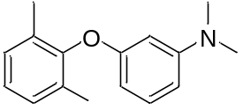 | 74 | 326
3 |  | 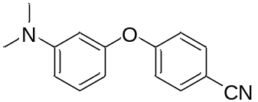 | 68 | 327
4 |  | 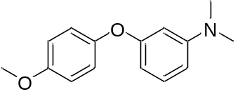 | 78 | 328
5 |  | 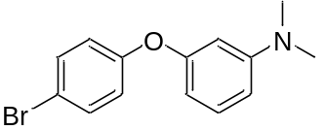 | 66 | 329

In all cases, the expected product was formed between the (3-(dimethylamino)phenyl)boronic acid and respective phenol. There was no homo-coupling product detected, all unreacted naphthylboronic acid remained as the boronic acid.

3.2.6 Reaction of (2,6-Dimethylphenyl)boronic Acid with Phenols
Various phenols were mixed in DCM, with (2,6-dimethylphenyl)boronic acid, copper (II) acetate and triethylamine (Scheme 3-1). There was no product formed for this set of experiments. This was verified with additional experiments. An additional set of experiments were accomplished using 6 hours of ultrasonic radiation, again no product was formed.
Scheme 3-1 Reaction of Phenols with (2,6-dimethylphenyl)boronic Acid
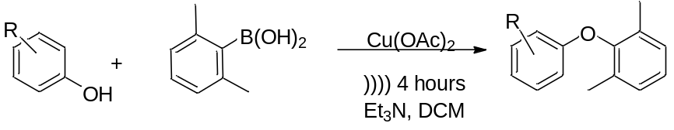

3.2.7 Reaction of P-tolyboronic Acid with Phenols
Various phenols were mixed in DCM, p-tolylboronic acid, copper (II) acetate, triethylamine, and the reacted according to the ultrasound protocol. The reaction results are shown in Table 3-6, with the various phenol starting material.
Table 3-6 Results of Reaction of Phenols with p-tolylboronic Acid
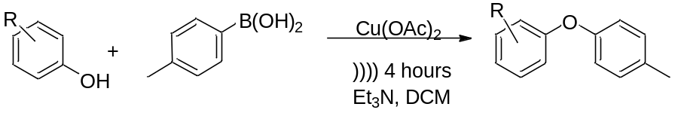
Entry | Starting Material | Product Structure | Yield | Product
1 |  | 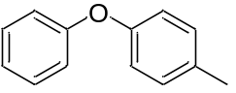 | 85 | 330
2 |  | 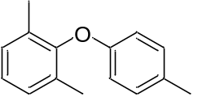 | 88 | 331
3 |  | 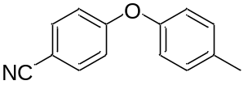 | 92 | 332
4 |  | 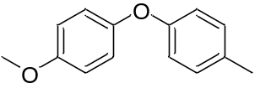 | 91 | 333
5 |  | 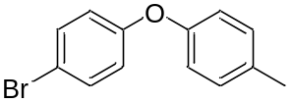 | 93 | 334

In all cases, the expected product was formed between the p-tolylboronic acid and respective phenol. There was no homo-coupling product detected, all unreacted naphthylboronic acid remained as the boronic acid.

3.2.8 Mechanistic Study
The mechanism of the Chan-Evans-Lam copper-catalyzed oxidative O-arylation reactions has been extensively studied but is still not fully understood.^{6b} A detailed mechanistic study was performed by King, Stahl, et al that provided significant evidence of the reaction pathway: EPR studies conducted during the reaction noted the presence of copper (III) intermediates and a copper (I) product, providing significant evidence that it follows a similar pathway to the proposed oxidation addition / reduction elimination mechanism of the Ullmann reaction (Scheme 2-4).³⁹ To determine if a free-radical participated in the reaction, Lam and coworkers complete several experiments using the free-radical trap 1-diphenylethylene, which had no effect on the reaction.^{6b} However, these studies were conducted by the standard method, which commences at room temperature, without the application of energy (e.g. ultrasound).^{3d}
It is possible that ultrasound can generate free-radicals by the nature of the energy generation.⁴⁰ To insure that this generation is not occurring, or that a mechanism different from what has been reported is occurring, a series of experiments were conducted; a summary of which is shown in Table 3-7. This series was designed to test for the presence of copper (I) acetate and if a free radical would impact the reaction yields. All experiments were conducted, and samples preserved, as described in Section 2.2.4.
Table 3-7 Summary of Mechanism Investigation Experiments
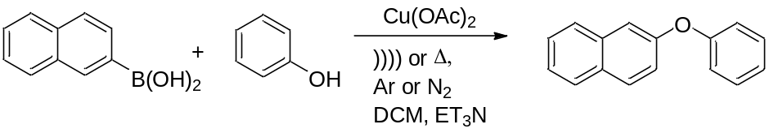
Entry | Reaction Conditions | Product Yield
1 | Naphthylboronic acid, phenol, R.T., 72 hours | 72
2 | Naphthylboronic acid, phenol, ultrasound 4 hours | 92
3 | Naphthylboronic acid, phenol, 5eq galvinoxyl R.T., 72 hours | 69
4 | Naphthylboronic acid, phenol, 5eq galvinoxyl ultrasound 4 hours | 90

It is not possible to conduct an ultrasound experiment in the presence of EPR, so to determine is copper (I) acetate is produced, scanning powder-x-ray diffraction was employed. The pXRD analysis showed that all samples showed two theta peaks associated with copper (I) acetate (2θ: 4.3, 7.2, 18, 26.7, 37, 42, 44.8; as compared to the copper (I) standard) post reaction. The added galvinoxyl had no impact on the reaction product yield. This evidence seems to support that the mechanism has not varied from what was reported in literature.

3.3 Conclusion
The application of ultrasound to the Chan-Lam-Evans modified Ullmann reaction has shown great benefit for the generation of biaryl ethers. Although the original reaction does not call for the addition of energy, ultrasound dramatically decreased the reaction time from 72 hours to 4 hours, while improving the product yields from the 30-80% range to a compound related range of 60-100%, while maintaining the mild reaction conditions. The resulting yields seem to indicate an electronic effect related to the aryl-boronic acid, which may warrant additional study from further method development. Unfortunately the use of an aqueous solvent system and polymer support are not applicable.

3.4 Experimental Details

3.4.1 General Considerations
All glassware was dried at 120°C and flushed with dry nitrogen prior to use. All chemicals were purchased from commercial sources and used as received. Dowex 1-X 10 (Bio.Rad Laboratories, 100-200 mesh, chloride form. Control number, MM06170). DI water (Barnstead E-pure) was used in all solution preparation and reactions. Potassium organotrifluoroborates were obtained from commercial sources or prepared from organoboronic acids or esters according to the reported procedures.³⁴
Gas Chromatography-Mass Spectroscopy studies were run on a Hewlett Packard: HP 6890 series GC System with 5973 Mass Selective Detector; Column: HP-5 30m x 0.25mm x 0.25μm; Gas (He) flow 0.8ml / min; temperature program: flow 0.8 ml/min, initial temperature 90°C for 1 minute, ramp at 15°/minute to 200°C, then ramp at 5°/min to 250°C for 10 minutes. All samples were purified using vacuum column chromatography (anhydrous sodium sulfate and 60 Å 230-400 mesh silica gel), and then recrystallized.
All sonication experiments were carried out using a Fisher Scientific Model 550 Sonic Dismemborator, employing a 0.5 in horn sonicator and a 1 in by 2 in cylindrical reaction vessel. All reactions were carried out in new borsite glass vessels. Reaction vessel external temperature was maintained at 0-5°C.

3.4.2 Preparation of Dowex-Napthyl-Trifluoroborate Complex
The Dowex-naphthyl-trifluoroborate was prepared by established procedure set forth by Kabalka et al:²⁵ Dowex 1-X 10 (10 grams) was washed sequentially with 1N aqueous HCl (3 x 40 mL), 1 N aqueous NaOH (3 x 40 mL), water (100 mL) of water and then dried overnight prior to us. To a suspension of the base form of the Dowex resin (1g) in H2O (10 mL), a solution of 2-naphthylenyltrifluoroborate (1 mmol) in MeOH (10mL) was added in one portion. The pH of the reaction mixture was then monitored to determine reaction termination.

3.4.3 Representative Procedure for the Synthesis of 2-phenoxynaphthalene
0.25g of naphthylboronic acid (1.5 mmol) was added with 0.094g of phenol (1 mmol) to 15ml of DCM. 0.36g of copper (II) acetate (2mmol) was added with 0.5g of triethylamine (5mmol), and the dismemberator horn placed in the reaction vessel. The sonicator was set to 55 watts and the reaction was allowed to proceed for 4 hours (1 minute pulse with a 3 second rest). Post reaction, the mixture was immediately cleaned by column chromatography for further analysis. Product yields were determined by weight after purity was confirmed by GC/MS and NMR.

3.4.4 Characterization of Compounds 301-334
¹H NMR and ¹³C NMR spectra were recorded at 250.13 and 62.89 MHz, respectively. Chemical shifts for 1H NMR and 13C NMR spectra were referenced to TMS and measured with respect to the residual protons in the deuterated solvents. High quality mass spectrometry was recorded using a Qstar electron spray ionization mass spectrometer, in positive mode, ionization energy of 5000e/v, injection rate of 20 μl/min.
2-phenoxynaphthalene (301)⁴¹: ¹HNMR: δ 7.78-7.82 (m, 2H), 7.67 (br d, 1H, J =7.7 Hz), 7.22-7.46 (m, 6H), 7.04-7.15 (m, 3H) ¹³CNMR: δ. 157.38, 151.35, 134.34, 130.59, 129.45, 127.84, 126.66, 126.44, 125.22, 122.97, 119.20, 116.85, 108.09 Anal. Calcd for C₁₆H₁₂O: 220.09 Found: GC RT
2-(2,6-dimethylphenoxy)naphthalene (302)⁴¹: ¹HNMR: δ 7.23-7.24(m, 2H), 7.04-7.10(m, 3H), 6.96(t, J=7.2Hz,1H), 6.75(d, J=7.8Hz, 2H), 2.12(s, 6H) ¹³CNMR: δ. 154.64, 151.23, 133.34, 129.01, 128.47, 126.70, 126.34, 125.74, 125.13, 123.76, 123.17, 114.36, 107.96, 16.75 Anal. Calcd for C₁₈H₁₆O: 248.12 Found: GC RT
4-(naphthalen-2-yloxy)benzonitrile (303)⁴¹: ¹HNMR: δ 7.57 (d, J = 8.6 Hz, 2H), 7.42 (m, J = 7.9 Hz, 2H), 7.25 (m, J = 7.6 Hz, 1H), 7.0 (d, J = 7.9 Hz, 2H), 6.89 (d, J = 8.8 Hz, 2H) ¹³CNMR: δ 161.92, 153.86, 133.83, 132.94, 130.10, 129.23, 127.42, 125.43, 122.86, 119.47, 117.60, 116.54, 109.17, 104.63. Anal. Calcd for C₁₇H₁₁NO: 245.08 Found: GC RT
2-(4-nitrophenoxy)naphthalene (304)⁴²: ¹HNMR: δ 8.26 (d, 3JHH = 9.12 Hz, 2 H, 3-H, 5-H), 8.06 (d, 3JHH = 8.82 Hz, 1 H, 4-H), 7.98 (d, 3JHH = 7.82 Hz, 1 H, 5-H), 7.91 (d, 3JHH = 7.06 Hz, 1 H, 8-H), 7.69 (s, 1 H, 1-H), 7.55 (m, 2 H, 6-H, 7-H), 7.37 (dd, 3JHH = 8.77 Hz and 4JHH = 2.18 Hz, 1 H, 3-H), 7.19 (d, 3JHH = 9.10 Hz, 2 H, 2-H, 6-H), ¹³CNMR: δ 162.49, 152.76, 141.86, 135.75, 130.16, 129.74, 127.82, 126.10, 125.77, 124.41, 123.71, 117.38, 116.17, 108.40. Anal. Calcd for C₁₆H₁₁NO₃: 265.07 Found: GC RT
2-(3-methoxyphenoxy)naphthalene (305)⁴¹: ¹HNMR: δ δ 7.86–7.83 (m, 2H), 7.74–7.71 (m, 1H), 7.49–7.40 (m, 2H), 7.36–7.35 (m, 1H), 7.29–7.24 (m, 2H), 6.72–6.65 (m, 3H), 3.79 (s, 3H) ppm ¹³CNMR: δ. 161.2, 158.6, 155.0, 134.5, 130.4, 130.2, 129.9, 127.8, 127.2, 126.6, 124.8, 120.1, 114.5, 111.3, 109.3, 105.2, 55.4 Anal. Calcd for C₁₇H₁₄O₂: 250.10 Found: GC RT
2-(4-methoxyphenoxy)naphthalene (306)⁴¹: ¹HNMR: δ 7.70 (2 H, d, J = 8.8 Hz), 7.56 (1H, d, J = 8.4Hz), 7.26-7.35 (2H,m), 7.14-7.17(1H,m), 7.09(1H,d,J = 2.4Hz), 6.94-6.97(2H,m), 6.82-6.84 (2H,m), 3.73 (3H,s). ¹³CNMR: δ 159.64, 158.34, 151.35, 136.60, 129.45, 128.26, 127.84, 126.77, 126.45, 123.31, 119.20, 117.16, 113.57, 109.55, 54.48. Anal. Calcd for C₁₇H₁₄O₂: 250.10 Found: GC RT
2-(4-iodophenoxy)naphthalene (307)⁴³: ¹HNMR: δ 6.81 (d, J = 8.0 Hz, 2H), 7.04–7.07 (m, 2H), 7.14–7.19 (m, 1H), 7.35–7.40 (m, 2H), 7.64 (d, J = 8.0 Hz, 2H). ¹³CNMR: δ 156.68, 154.45, 138.11, 133.22, 129.92, 127.69, 126.99, 126.51, 125.65, 118.18, 114.42, 108.82, 81.18. Anal. Calcd for C₁₆H₁₁IO: 345.99 Found: GC RT
2-(4-bromophenoxy)naphthalene (308)⁴³: ¹HNMR: δ 7.42 (d, 2 H, J = 8.0 Hz), 7.34 (t, 2H, J = 8.0 Hz), 7.14 (t, 1 H, J = 8.0 Hz), 6.90 (d, 2 H, J = 8.0 Hz), 6.88 (d, 2 H, J = 8.0Hz) ¹³CNMR: δ 156.42, 154.47, 133.40, 132.72, 130.29, 130.05, 127.99, 127.13, 126.64, 124.93, 119.79, 117.46, 144.40, 109.51. Anal. Calcd for C₁₆H₁₁BrO: 298.00 Found: GC RT
2-(naphthalen-2-yloxy)isoindoline-1,3-dione (309)⁴⁴: ¹HNMR: δ 7.90-7.94 (m, 2H) , 7.80-7.84 (m, 2H), 7.32-7.38 (m,2H), 7.12-7.20 (m, 3H). ¹³CNMR: δ 161.31, 150.67, 137.69, 133.36, 129.06, 128.46, 127.81, 127.07, 126.31, 125.56, 122.49, 121.57, 110.60, 104.92. Anal. Calcd for C₁₈H₁₁NO₃: 289.07 Found: GC RT
1-phenoxy-4-(trifluoromethyl)benzene (310): : ¹HNMR: δ ¹³CNMR: δ Anal. Calcd for C₁₃H₉F₃O: 238.06 Found: GC RT
1,3-dimethyl-2-(4-(trifluoromethyl)phenoxy)benzene (311): ¹HNMR: δ ¹³CNMR: δ Anal. Calcd for C₁₅H₁₃F₃O: 266.09 Found: GC RT
4-(4-(trifluoromethyl)phenoxy)benzonitrile (312): ¹HNMR: δ ¹³CNMR: δ Anal. Calcd for C₁₄H₈F₃NO: 263.06 Found: GC RT
1-methoxy-4-(4-(trifluoromethyl)phenoxy)benzene (313): ¹HNMR: δ ¹³CNMR: δ Anal. Calcd for C₁₄H₁₁F₃O₂: 268.07 Found: GC RT
1-bromo-4-(4-(trifluoromethyl)phenoxy)benzene (314): ¹HNMR: δ ¹³CNMR: δ Anal. Calcd for C₁₃H₈BrF₃O: 315.97 Found: GC RT

1-(4-(4-methoxyphenoxy)phenyl)ethanone (3**)⁴¹: ¹HNMR: δ 7.92–7.90 (m, 2H), 7.02–7.00 (m, 2H), 6.95–6.91 (m, 4H) ¹³CNMR δ:198.45, 163.08153.05, 149.78, 128.44, 121.50, 115.93, 114.67, 55.59, 26.36 Anal. Calcd for C₁₅H₁₄O₃: 242.09 Found: GC RT

1-methyl-4-phenoxybenzene (3**)⁴²: ¹HNMR: δ 7.31 (d, J = 9.06 Hz, 2H), 7.01 (d, J = 9.06 Hz, 2H), 6.89 (t, J = 8.86 Hz, 1H), 6.69 (d, J = 9.06 Hz, 2H), 6.54(d, J = 9.06 Hz, 2H), 2.9(s, 3H). ¹³CNMR: δ 157.09, 154.57, 131.58, 127.04, 128.78, 122.71, 118.06, 24.38. Anal. Calcd for C₁₃H₁₂O: 184.09 Found: GC RT

CHAPTER IV
COUPLING OF Aryl-borates to Anilines: application of ultrasound to the chan-evans-lam reaction

4.1 Introduction
Aryl-aryl, and aryl-phenol reactions, such as the Suzuki and Ullmann, are important and powerful methodologies in organic chemistry. However the corresponding aryl-nitrogen coupling reaction is not as common, especially ones that involve mild conditions and can use a wide spectrum of amines, anilines, and heteroarenes.⁴⁵ Traditional procedures, such as the Ullmann, typically only produce modest yields, while requiring high heat and strongly basic conditions that can be incompatible with many amines and anilines. In the mid-1990s, researchers were able to develop a method, using palladium metal, mirroring the Suzuki mechanism, to perform coupling between an aryl halide and amine.^{3e, 46} Although these reactions did not require the strong basic conditions or long reaction times of the Ullmann, these reactions did need moderate to high heat – making the reaction incompatible of coupling many of the thermally sensitive arenes and indoles. In the search for a C-N coupling reaction using mild conditions for pharmaceutical synthesis, the Chan-Lam reaction was developed (shortly thereafter expanded to the Chan-Evans-Lam reaction).^{6a} As previously discussed in Chapter 3, this reaction uses copper (II) acetate, in dry conditions, to perform the coupling reaction at room temperature. These relatively mild conditions have allowed the reaction to be applied to a variety of anilines and indoles that could not be arylated by previously published methods.^{2a, 7c} The primary downsides to the Chan-Lam reaction is the time, typically 24-72 hours, and the requirement that the reaction remain dry.^{6b}
Chapter 3 showed that the application of ultrasound to the Chan-Evans-Lam reaction, for the coupling various aryl-borates to phenols, resulted in a very good improvement on the reaction results (decreased reaction time, increased product yields). We decided to expand that developed method to the N-arylation of anilines and indoles. To our knowledge ultrasound has not been applied to the Chan-Evans-Lam modified Ullmann reaction for the coupling of aryl carbon to a nitrogen.

4.2 Results and Discussion

4.2.1 Reaction of Naphthaboronic Acid with Anilines and Indoles
Various anilines or indoles were mixed with naphthaboronic acid in DCM, in the presence of copper (II) acetate and triethylamine, and allowed to react by the ultrasound protocol. The reaction results are shown in Table 4-1, with the various anilines or indole starting material listed.
Table 4-1 Reactions of Naphthaboronic Acid with Anilines and Indoles
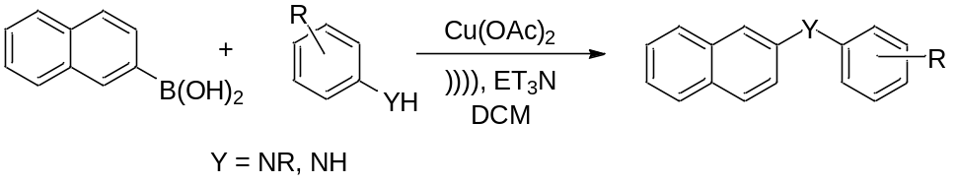
Entry | Starting Material | Product Structure | Yield | Product
1 | 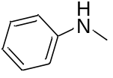 | 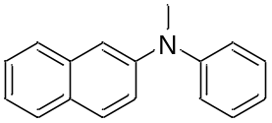 | 90 | 401
2 | 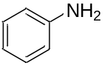 | 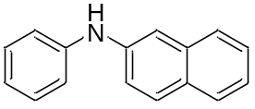 | 87 | 402
3 | 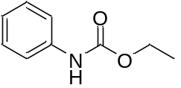 | 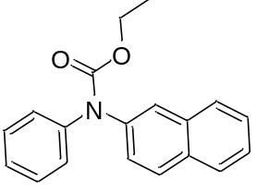 | NR | 403
4 | 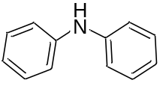 | 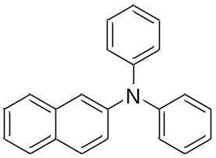 | NR | 404
5 | 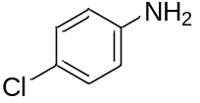 | 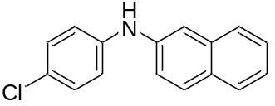 | 94 | 405
6 | 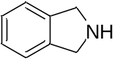 | 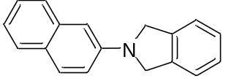 | 89 | 406
7 | 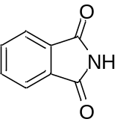 | 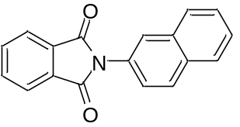 | NR | 407
8 | 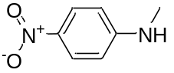 | 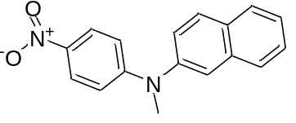 | 96 | 408
9 | 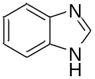 | 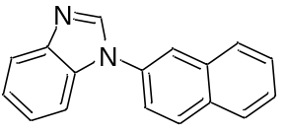 | 97 | 409
10 | 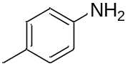 | 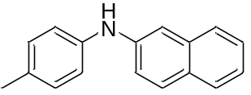 | 95 | 410
11 | 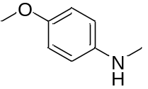 | 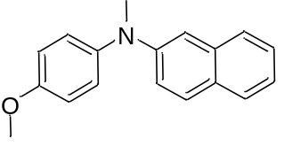 | 87 | 411
In all cases, the expected product was formed between the naphthaboronic acid and respective aniline or indole. There was no homo-coupling product detected, all unreacted naphthylboronic acid remained as the boronic acid, as determined by ESI/MS. The three reactions that showed no product formed were verified that there was no yield by additional experiments.

4.2.2 Reaction of (4-(Trifluoromethyl)phenyl)boronic Acid with Anilines and Indoles
Various anilines or indoles were mixed with (4-(trifluoromethyl)phenyl)boronic acid in DCM, in the presence of copper (II) acetate and triethylamine, and allowed to react by the ultrasound protocol. The reaction results are shown in Table 4-2, with the various anilines or indole starting material listed.
Table 4-2 Reactions of (4-(Trifluoromethyl)phenyl)boronic Acid with Anilines and Indoles
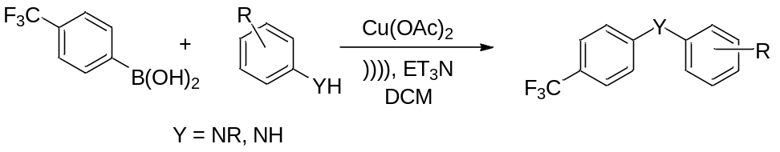
Entry | Starting Material | Product Structure | Yield | Product
1 |  | 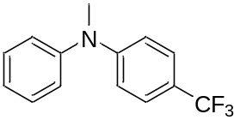 | 91 | 412
2 |  | 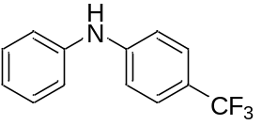 | 86 | 413
3 |  | 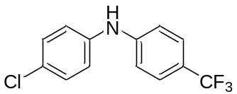 | 96 | 414
4 |  | 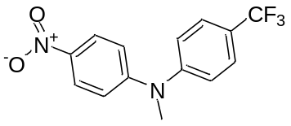 | 93 | 415
5 |  | 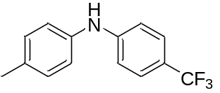 | 92 | 416
6 |  | 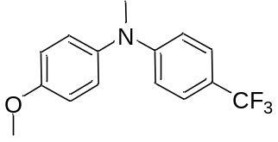 | 97 | 417

In all cases, the expected product was formed between the (4-(trifluoromethyl)phenyl)boronic acid and respective aniline or indole. There was no homo-coupling product detected, all unreacted naphthylboronic acid remained as the boronic acid, as determined by ESI/MS.

4.2.3 Reaction of (4-acetylphenyl)boronic Acid with Anilines and Indoles
Various anilines or indoles were mixed with (4-acetylphenyl)boronic acid in DCM, in the presence of copper (II) acetate and triethylamine, and allowed to react by the ultrasound protocol. The reaction results are shown in Table 4-3, with the various anilines or indole starting material listed.

Table 4-3 Reactions of (4-acetylphenyl)boronic Acid with Anilines and Indoles
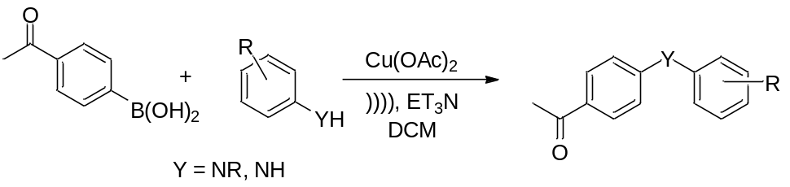
Entry | Starting Material | Product Structure | Yield | Product
1 |  | 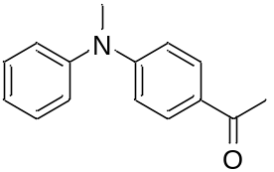 | 92 | 418
2 |  | 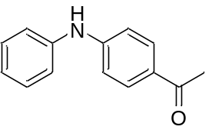 | NR | 419
3 |  | 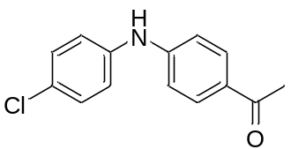 | 92 | 420
4 |  | 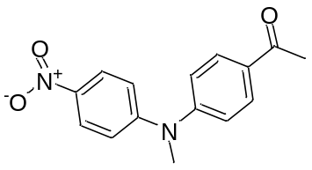 | NR | 421
5 |  | 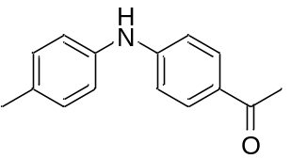 | 90 | 422
6 |  | 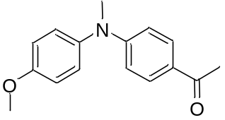 | 93 | 423

In all cases, the expected product was formed between the (4-acetylphenyl)boronic acid and respective aniline or indole. There was no homo-coupling product detected, all unreacted (4-acetylphenyl)boronic acid remained as the boronic acid, as determined by ESI/MS. The two reactions that showed no product formed were verified that there was no yield by additional experiments.

4.2.4 Reaction of (3-hydroxyphenyl)boronic Acid with Anilines and Indoles
Various anilines or indoles were mixed with (3-hydroxyphenyl)boronic acid in DCM, in the presence of copper (II) acetate and triethylamine, and allowed to react by the ultrasound protocol. The reaction results are shown in Table 4-4, with the various anilines or indole starting material listed.
Table 4-4 Reactions of (3-hydroxyphenyl)boronic Acid with Anilines and Indoles
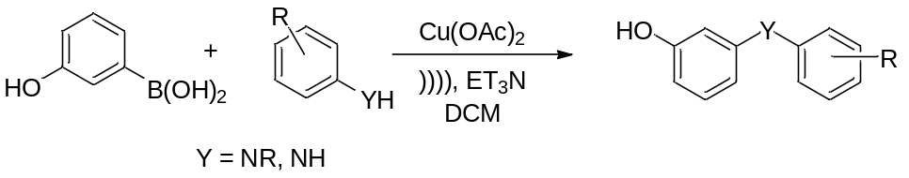
Entry | Starting Material | Product Structure | Yield | Product
1 |  | 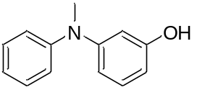 | 78 | 424
2 |  | 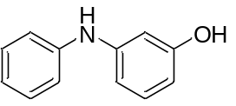 | 62 | 425
3 |  | 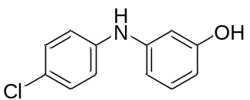 | 66 | 426
4 |  | 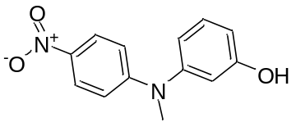 | NR | 427
5 |  | 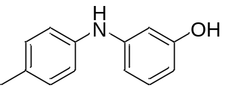 | 57 | 428
6 |  | 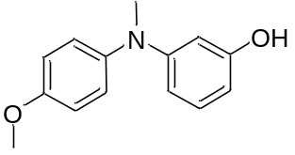 | 82 | 429

In all cases, the expected product was formed between the (3-hydroxyphenyl)boronic acid and respective aniline or indole. There was no homo-coupling product detected, all unreacted the (3-hydroxyphenyl)boronic acid remained as the boronic acid, as determined by ESI/MS. The reaction that showed no product formed was verified that there was no yield by an additional experiment.

4.2.5 Reaction of (3-(dimethylamino)phenyl)boronic Acid with Anilines and Indoles
Various anilines or indoles were mixed with (3-(dimethylamino)phenyl)boronic acid in DCM, in the presence of copper (II) acetate and triethylamine, and allowed to react by the ultrasound protocol. The reaction results are shown in Table 4-5, with the various anilines or indole starting material listed.
Table 4-5 Reactions of (3-(dimethylamino)phenyl)boronic Acid with Anilines and Indoles
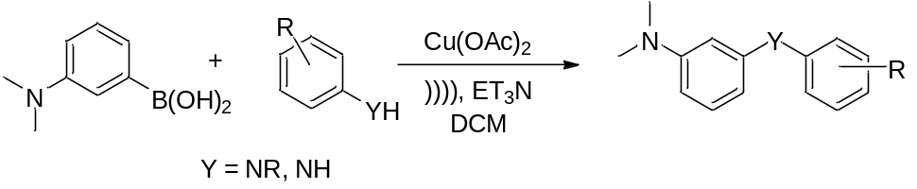
Entry | Starting Material | Product Structure | Yield | Product
1 |  | 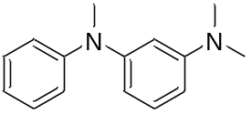 | 68 | 430
2 |  | 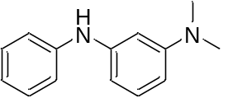 | 72 | 431
3 |  | 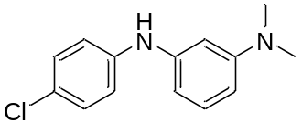 | 61 | 432
4 |  | 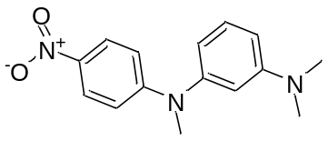 | 66 | 433
5 |  | 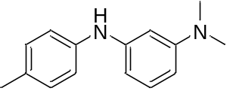 | 82 | 434
6 |  | 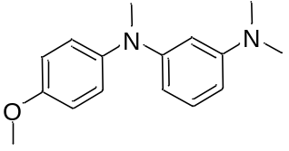 | 81 | 435

In all cases, the expected product was formed between the (3-(dimethylamino)phenyl)boronic acid and respective aniline or indole. There was no homo-coupling product detected, all unreacted (3-(dimethylamino)phenyl)boronic acid remained as the boronic acid, as determined by ESI/MS.

4.2.6 Reaction of (2,6-Dimethylphenyl)boronic Acid with Anilines and Indoles
Various anilines or indoles were mixed with (2,6-dimethylphenyl)boronic acid in DCM, in the presence of copper (II) acetate and triethylamine, and allowed to react by the ultrasound protocol. (Scheme 4-1). There was no product formed for this set of experiments. This was verified with additional experiments. An additional set of experiments were accomplished using 6 hours of ultrasonic radiation, again no product was formed.
Scheme 4-1 Reaction of Phenols with (2,6-dimethylphenyl)boronic Acid
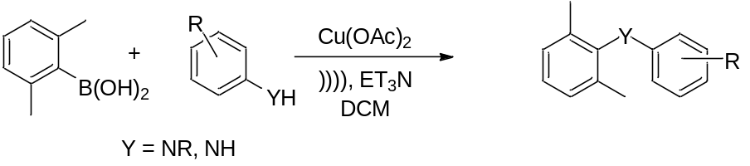

4.2.7 Reaction of p-Tolylboronic Acid with Anilines and Indoles
Various anilines or indoles were mixed with p-tolylboronic acid in DCM, in the presence of copper (II) acetate and triethylamine, and allowed to react by the ultrasound protocol. The reaction results are shown in Table 4-6, with the various anilines or indole starting material listed.

Table 4-6 Reactions of p-Tolylboronic Acid with Anilines and Indoles
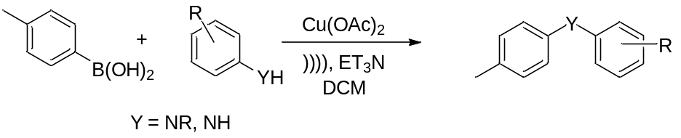
Entry | Starting Material | Product Structure | Yield | Product
1 |  |  |  | 436
2 |  |  |  | 437
3 |  |  |  | 438
4 |  |  |  | 439
5 |  |  |  | 440
6 |  |  |  | 441

In all cases, the expected product was formed between the p-tolylboronic acid and respective aniline or indole. There was no homo-coupling product detected, all unreacted p-tolylboronic acid remained as the boronic acid, as determined by ESI/MS.

4.2.8 Mechanistic Study
The method used in this Chapter, parallels that of Chapter 3 (please see Section 3.2.8 for all relevant background information). To insure that a different mechanism is not occurring (as discussed in Section 3.2.8), a series of experiments were conducted; a summary of which is shown in Table 4-7. This series was designed to test for the presence of copper (I) acetate and if a free radical would impact the reaction yields. All experiments were conducted, and samples preserved, as described in Section 2.2.4.
Table 4-7 Summary of Mechanism Investigation Experiments
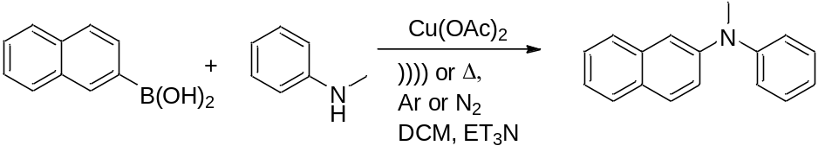
Entry | Reaction Conditions | Product Yield
1 | Naphthylboronic acid, N-methylaniline, R.T., 72 hours | 72
2 | Naphthylboronic acid, N-methylaniline, ultrasound 4 hours | 92
3 | Naphthylboronic acid, N-methylaniline, 5eq galvinoxyl R.T., 72 hours | 69
4 | Naphthylboronic acid, N-methylaniline, 5eq galvinoxyl ultrasound 4 hours | 90

It is not possible to conduct an ultrasound experiment in the presence of EPR, so to determine is copper (I) acetate is produced, scanning powder-x-ray diffraction was employed. The pXRD analysis showed that all samples showed two theta peaks associated with copper (I) acetate post reaction (2θ: 4.3, 7.2, 18, 26.7, 37, 42, 44.8; as compared to the copper (I) standard). The added galvinoxyl had no impact on the reaction product yield. This evidence seems to support that the mechanism has not varied from what was reported in literature.

4.3 Conclusion
The application of ultrasound to the Chan-Lam-Evans modified Ullmann reaction has shown great application to the N-arylation of various anilines and indoles. Although the original reaction does not call for the addition of energy, ultrasound dramatically decreased the reaction time from 72 hours to 4 hours, while improving the product yields from the 30-80% range to a compound related range of 60-100%, while maintaining the mild reaction conditions. Of particular interest is the successful coupling of naphthaboronic acid to isoindoline (entry 6, Table 4-1), as this molecule is very thermally sensitive. The resulting product yields seems to indicate that there is an electronic effect related to the aryl-boronic acid, which may warrant additional study from further method development.

4.4 Experimental Details

4.4.1 General Considerations
All glassware was dried at 120°C and flushed with dry nitrogen prior to use. All chemicals were purchased from commercial sources and used as received. Gas Chromatography-Mass Spectroscopy studies were run on a Hewlett Packard: HP 6890 series GC System with 5973 Mass Selective Detector; Column: HP-5 30m x 0.25mm x 0.25μm; Gas (He) flow 0.8ml / min; temperature program: flow 0.8 ml/min, initial temperature 90°C for 1 minute, ramp at 15°/minute to 200°C, then ramp at 5°/min to 250°C for 10 minutes. All samples were purified using vacuum column chromatography (anhydrous sodium sulfate and 60 Å 230-400 mesh silica gel), and then recrystallized.
All sonication experiments were carried out using a Fisher Scientific Model 550 Sonic Dismemborator, employing a 0.5 in horn sonicator and a 1 in by 2 in cylindrical reaction vessel. All reactions were carried out in new borsite glass vessels. Reaction vessel external temperature was maintained at 0-5°C.

4.4.2 Representative Procedure for the Synthesis of N-methyl-N-phenylnaphthalen-2-amine
0.25g of naphthylboronic acid (1.5 mmol) was added with 0.11g of N-methylaniline (1 mmol) to 15ml of DCM. 0.36g of copper (II) acetate (2mmol) was added with 0.5g of triethylamine (5mmol), and the dismemberator horn placed in the reaction vessel. The sonicator was set to 55 watts and the reaction was allowed to proceed for 4 hours (1 minute pulse with a 3 second rest). Post reaction, the mixture was immediately cleaned by column chromatography for further analysis. Product yields were determined by weight after purity was confirmed by GC/MS and NMR.

4.4.3 Characterization of Compounds 401-441
¹H NMR and ¹³C NMR spectra were recorded at 250.13 and 62.89 MHz, respectively. Chemical shifts for 1H NMR and 13C NMR spectra were referenced to TMS and measured with respect to the residual protons in the deuterated solvents. High quality mass spectrometry was recorded using a Qstar electron spray ionization mass spectrometer, in positive mode, ionization energy of 5000e/v, injection rate of 20 μl/min.

CHAPTER V
COUPLING OF Aryl-borates to Thiols: application of ultrasound to the chan-evans-lam reaction

5.1 Introduction
Start talking about sulfur

References

1. Kurti, L.; Czako, B.; Editors, Strategic Applications of Named Reactions in Organic Synthesis. Academic Press: 2005; p 864 pp.
2. (a) Ley, S. V.; Thomas, A. W., Modern Synthetic Methods for Copper-Mediated C(aryl)O, C(aryl)N, and C(aryl)S Bond Formation. Angewandte Chemie International Edition 2003, 42 (44), 5400-5449; (b) Suzuki, A., Organoborane coupling reactions (Suzuki coupling). Proc. Jpn. Acad., Ser. B 2004, 80 (8), 359-371.
3. (a) Beletskaya, I. P.; Cheprakov, A. V., Copper in cross-coupling reactions. Coord. Chem. Rev. 2004, 248 (21-24), 2337-2364; (b) Lam, P. Y. S.; Clark, C. G.; Saubern, S.; Adams, J.; Li, R.; Winters, M. P.; Chan, D. M. T.; Combs, A. In New aryl/heteroaryl C-N bond cross-coupling reactions via copper-promoted arylation using arylboronic acid, American Chemical Society: 1998; pp ORGN-512; (c) Lam, P. Y. S.; Deudon, S.; Hauptman, E.; Clark, C. G., α-Nitrogen-activating effect in the room temperature copper-promoted N-arylation of heteroaryl carboxamides with phenylsiloxane or 4-tolylboronic acid. Tetrahedron Lett. 2001, 42 (13), 2427-2429; (d) Lam, P. Y. S.; Vincent, G.; Clark, C. G.; Deudon, S.; Jadhav, P. K., Copper-catalyzed general C-N and C-O bond cross-coupling with arylboronic acid. Tetrahedron Lett. 2001, 42 (20), 3415-3418; (e) Antilla, J. C.; Buchwald, S. L., Copper-Catalyzed Coupling of Arylboronic Acids and Amines. Organic Letters 2001, 3 (13), 2077-2079; (f) Chiang, G. C. H.; Olsson, T., Polymer-Supported Copper Complex for C−N and C−O Cross-Coupling Reactions with Aryl Boronic Acids. Organic Letters 2004, 6 (18), 3079-3082.
4. March, J., Advanced Organic Chemistry
Reactions, Mechanisms, and Structures. Forth ed.; John Wiley and Sons: New York, 1992; p 1495.
5. (a) Alonso, F.; Beletskaya, I. P.; Yus, M., Non-conventional methodologies for transition-metal catalyzed carbon-carbon coupling: a critical overview. Part 2: The Suzuki reaction. Tetrahedron 2008, 64 (14), 3047-3101; (b) Hatakeyama, T.; Hashimoto, T.; Kondo, Y.; Fujiwara, Y.; Seike, H.; Takaya, H.; Tamada, Y.; Ono, T.; Nakamura, M., Iron-Catalyzed Suzuki-Miyaura Coupling of Alkyl Halides. J. Am. Chem. Soc. 2010, 132 (31), 10674-10676; (c) Percec, V.; Bae, J.-Y.; Hill, D. H., Aryl Mesylates in Metal Catalyzed Homocoupling and Cross-Coupling Reactions. 2. Suzuki-Type Nickel-Catalyzed Cross-Coupling of Aryl Arenesulfonates and Aryl Mesylates with Arylboronic Acids. J. Org. Chem. 1995, 60 (4), 1060-5; (d) Mao, J.; Guo, J.; Fang, F.; Ji, S.-J., Highly efficient copper(0)-catalyzed Suzuki-Miyaura cross-coupling reactions in reusable PEG-400. Tetrahedron 2008, 64 (18), 3905-3911.
6. (a) Lam, P. Y. S.; Clark, C. G.; Saubern, S.; Adams, J.; Winters, M. P.; Chan, D. M. T.; Combs, A., New aryl/heteroaryl CN bond cross-coupling reactions via arylboronic acid/cupric acetate arylation. Tetrahedron Letters 1998, 39 (19), 2941-2944; (b) Qiao, J. X.; Lam, P. Y. S., Copper-promoted carbon-heteroatom bond cross-coupling with boronic acids and derivatives. Synthesis 2011, (6), 829-856.
7. (a) Herradura, P. S.; Pendola, K. A.; Guy, R. K., Copper-Mediated Cross-Coupling of Aryl Boronic Acids and Alkyl Thiols. Organic Letters 2000, 2 (14), 2019-2022; (b) Collman, J. P.; Zhong, M., An Efficient Diamine·Copper Complex-Catalyzed Coupling of Arylboronic Acids with Imidazoles. Organic Letters 2000, 2 (9), 1233-1236; (c) Qiao, J. X.; Lam, P. Y. S. In Recent advances in Chan-Lam coupling reaction: copper-promoted C-heteroatom bond cross-coupling reactions with boronic acids and derivatives, Wiley-VCH Verlag GmbH & Co. KGaA: 2011; pp 315-361.
8. Cravotto, G.; Cintas, P., Power ultrasound in organic synthesis: moving cavitational chemistry from academia to innovative and large-scale applications. Chem. Soc. Rev. 2006, 35 (2), 180-196.
9. Berger, H. L., Ultrasonic liquid atomization: theory and application. second ed.; Partridge Hill Publishers: Hyde Park NY, 2006; p 177.
10. Mason, T. J., Use of ultrasound in chemical synthesis. Ultrasonics 1986, 24 (5), 245-253.
11. Margulis, M. A., Theory, kinetics, and mechanism of acoustochemical reactions. Zh. Fiz. Khim. 1976, 50 (1), 1-18.
12. (a) Boudjouk, P.; Thompson, D. P.; Ohrbom, W. H.; Han, B. H., Effects of ultrasonic waves on the generation and reactivities of some metal powders. Organometallics 1986, 5 (6), 1257-60; (b) Suslick, K. S.; Casadonte, D. J.; Doktycz, S. J., Ultrasonic irradiation of copper powder. Chem. Mater. 1989, 1 (1), 6-8.
13. (a) Polackova, V.; Hut'ka, M.; Toma, S., Ultrasound effect on Suzuki reactions. 1. Synthesis of unsymmetrical biaryls. Ultrason. Sonochem. 2005, 12 (1-2), 99-102; (b) Lindley, J.; Lorimer, J. P.; Mason, T. J., Enhancement of an Ullmann coupling reaction induced by ultrasound. Ultrasonics 1986, 24 (5), 292-3; (c) Cravotto, G.; Beggiato, M.; Penoni, A.; Palmisano, G.; Tollari, S.; Leveque, J.-M.; Bonrath, W., High-intensity ultrasound and microwave, alone or combined, promote Pd/C-catalyzed aryl-aryl couplings. Tetrahedron Lett. 2005, 46 (13), 2267-2271.
14. Hassan, J.; Sevignon, M.; Gozzi, C.; Schulz, E.; Lemaire, M., Aryl-aryl bond formation one century after the discovery of the Ullmann reaction. Chem Rev 2002, 102 (5), 1359-470.
15. Bremner, D. H., Recent advances in organic synthesis utilizing ultrasound. Ultrasonics Sonochemistry 1994, 1 (2), S119-S124.
16. (a) Cristau, H.-J.; Cellier, P. P.; Hamada, S.; Spindler, J.-F.; Taillefer, M., A general and mild Ullmann-type synthesis of diaryl ethers. Org. Lett. 2004, 6 (6), 913-916; (b) Rao, H.; Jin, Y.; Fu, H.; Jiang, Y.; Zhao, Y., A versatile and efficient ligand for copper-catalyzed formation of C-N, C-O, and P-C bonds: pyrrolidine-2-phosphonic acid phenyl monoester. Chem. - Eur. J. 2006, 12 (13), 3636-3646; (c) Cheng, A.-Y.; Hsieh, J.-C., Highly efficient copper catalytic system for the O-arylation of phenol with iodoarene. Tetrahedron Lett. 2012, 53 (1), 71-75; (d) Swapna, K.; Murthy, S. N.; Jyothi, M. T.; Nageswar, Y. V. D., Recyclable heterogeneous copper oxide on alumina catalyzed coupling of phenols and alcohols with aryl halides under ligand-free conditions. Org. Biomol. Chem. 2011, 9 (17), 5978-5988; (e) Kunz, K.; Scholz, U.; Ganzer, D., Renaissance of Ullmann and Goldberg reactions - progress in copper catalyzed C-N-, C-O- and C-S-coupling. Synlett 2003, (15), 2428-2439.
17. Agrawal, J. P., Organic Chemistry of Explosives. John Wiley and Sons: 2007.
18. Robin, M.; Pique, V.; Faure, R.; Galy, J.-P., Ultrasonic irradiation of the Ullmann condensation: Application to the preparation of dioxolo, dioxino, cyclopent, and imidazolo anthranilic acid derivatives. J. Heterocycl. Chem. 2002, 39 (5), 1083-1085.
19. (a) Sasaki, N. A.; Hashimoto, C.; Potier, P., A novel approach to the synthesis of optically pure non protein α-amino acids in both L and D configurations from L-serine. Tetrahedron Letters 1987, 28 (48), 6069-6072; (b) Hickman, R.; Christie, B.; Guy, R.; White, T., Synthesis of Aromatic S-Sustituted Derivatives of <i>N</i>-Acetyl-L-cysteine. Australian Journal of Chemistry 1985, 38 (6), 899-904.
20. (a) Ciattini, P. G.; Morera, E.; Ortar, G., A new, palladium-catalyzed synthesis of aromatic mercapturic acid derivatives. Tetrahedron letters 1995, 36 (23), 4133-4136; (b) Arnould, J. C.; Didelot, M.; Cadilhac, C.; Pasquet, M. J., Convenient synthesis of aromatic thiols from phenols. Tetrahedron letters 1996, 37 (26), 4523-4524; (c) Belokon, Y. N.; Sagyan, A. S.; Djamgaryan, S. M.; Bakhmutov, V. I.; Belikov, V. M., Asymmetric synthesis of β-substituted α-amino acids via a chiral nl< sup> ii</sup> complex of dehydroalanine. Tetrahedron 1988, 44 (17), 5507-5514.
21. Anslyn, E. V.; Dougherty, D. A., Modern Physical Organic Chemistry. University Science Books,: Sausalito, Ca, 2006; p 2018.
22. Savarin, C.; Srogl, J.; Liebeskind, L. S., A Mild, Nonbasic Synthesis of Thioethers. The Copper-Catalyzed Coupling of Boronic Acids with N-Thio(alkyl, aryl, heteroaryl)imides. Organic Letters 2002, 4 (24), 4309-4312.
23. (a) Yin, L.; Liebscher, J., Carbon-carbon coupling reactions catalyzed by heterogeneous palladium catalysts. Chem. Rev. (Washington, DC, U. S.) 2007, 107 (1), 133-173; (b) Silva, A. d. C.; de, S. A. L. F.; Antunes, O. A. C., Phosphine-free Suzuki cross-coupling reactions under ultrasound. J. Organomet. Chem. 2007, 692 (14), 3104-3107.
24. (a) Bej, A.; Srimani, D.; Sarkar, A., Palladium nanoparticle catalysis: borylation of aryl and benzyl halides and one-pot biaryl synthesis via sequential borylation-Suzuki-Miyaura coupling. Green Chem. 2012, 14 (3), 661-667; (b) Du, Z.; Zhou, W.; Wang, F.; Wang, J.-X., In situ generation of palladium nanoparticles: ligand-free palladium catalyzed ultra-fast Suzuki-Miyaura cross-coupling reaction in aqueous phase at room temperature. Tetrahedron 2011, 67 (26), 4914-4918; (c) Du, Z.; Zhou, W.; Zhang, W.; Wang, F. A process for preparing biaryl compounds in the presence of polyethylene glycol-400. CN102010280A, 2011; (d) Liu, C.; Liu, N.; Jin, Z. Process for preparation of biaryl compounds Suzuki cross-coupling reaction in pure water. CN102491862A, 2012; (e) Liu, N.; Liu, C.; Rao, X.; Jin, Z., Poly(ethylene glycol) in metal-mediated catalysis. Adv. Chem. Res. 2012, 16, 125-146; (f) Sessler, M.; Schatz, J., Organometallic C-C-bond-forming reactions in water. Chem. Unserer Zeit 2012, 46 (1), 48-59; (g) Silva, A. d. C.; Senra, J. D.; Aguiar, L. C. S.; Simas, A. B. C.; de, S. A. L. F.; Malta, L. F. B.; Antunes, O. A. C., Ligand-free Suzuki-Miyaura reactions in PEG 300. Tetrahedron Lett. 2010, 51 (30), 3883-3885; (h) Suzuka, T.; Adachi, M.; Yang, Z.-S.; Ogihara, K.; Higa, M., Use of polymer-supported terpyridine palladium complex for Suzuki-Miyaura cross-coupling reaction in water and the synthesis of 2,6-disubstituted pyrimidines. Trans. Mater. Res. Soc. Jpn. 2013, 38 (1), 119-122; (i) Suzuka, T.; Nagamine, T.; Ogihara, K.; Higa, M., Suzuki-Miyaura Cross-Coupling Reaction in Water with Polymer-Supported Terpyridine Palladium Complex Under Aerobic Conditions. Catal. Lett. 2010, 139 (3-4), 85-89; (j) Uozumi, Y. In Heterogeneous catalytic asymmetric synthesis in water with polymeric palladium complexes, American Chemical Society: 2010; pp ORGN-1092; (k) Yu, H.; Tong, Q.; Jia, L.; Jin, Z.; Shi, J., Novel bis(phosphine-immidazolium salts) bridged by polyethylene glycol (PEG): synthesis and aqueous Suzuki reaction. Youji Huaxue 2011, 31 (5), 742-746.
25. Yong, L.; Yao, M.-L.; Kelly, H.; Green, J. F.; Kabalka, G. W., Radioiodination of polymer-supported organotrifluoroborates. Journal of Labelled Compounds and Radiopharmaceuticals 2011, 54 (4), 173-174.
26. Musolino, B.; Quinn, M.; Hall, K.; Coltuclu, V.; Kabalka, G. W., Ultrasound induced, copper mediated homocoupling using polymer supported aryltrifluoroborates. Tetrahedron Letters (0).
27. (a) Chu, W.; Li, X.; Wang, M.; Ren, L.; Sun, Z. A green process for preparing biphenyls via nano-Pd-catalyzed Suzuki reaction. CN102643152A, 2012; (b) DesMarteau, D. D.; Lu, C., Synthesis of N,N-bis(trifluoromethyl)amino difluoromethylene trifluorovinyl ether. Journal of Fluorine Chemistry 2011, 132 (12), 1194-1197; (c) Liu, N.; Liu, C.; Jin, Z., Poly(ethylene glycol)-functionalized imidazolium salts-palladium-catalyzed Suzuki reaction in water. Green Chem. 2012, 14 (3), 592-597; (d) Suzuka, T.; Kimura, K.; Nagamine, T., Reusable polymer-supported terpyridine palladium complex for Suzuki-Miyaura, Mizoroki-Heck, Sonogashira, and Tsuji-Trost reaction in water. Polymers (Basel, Switz.) 2011, 3 (1), 621-639.
28. (a) Alonso, F.; Beletskaya, I. P.; Yus, M., Non-conventional methodologies for transition-metal catalyzed carbon-carbon coupling: a critical overview. Part 1: The Heck reaction. Tetrahedron 2005, 61 (50), 11771-11835; (b) Koza, D. J.; Carita, E., An efficient high yielding approach for the homocoupling of arylboronic acids. Synthesis 2002, (15), 2183-2186; (c) Zhou, L.; Miao, Q.; He, R.; Feng, X.; Bao, M., Ni-catalyzed cross-coupling reaction of aryl chlorides with arylboronic acids in IPA without using a reducing reagent. Tetrahedron Lett. 2007, 48 (44), 7899-7902.
29. Molander, G. A.; Ellis, N., Organotrifluoroborates: Protected Boronic Acids That Expand the Versatility of the Suzuki Coupling Reaction. Acc. Chem. Res. 2007, 40 (4), 275-286.
30. Carey, F. A.; Sundberg, R. J., Advanced Organic Chemistry Parts A & B. Fifth ed.; 2008.
31. Mounts, R. D.; Ogura, T.; Fernando, Q., Crystal structure of copper(I) acetate. Inorg. Chem. 1974, 13 (4), 802-5.
32. (a) Kato, M.; Jonassen, H. B.; Fanning, J. C., Copper(II) complexes with subnormal magnetic moments. Chem. Rev. 1964, 64 (2), 99-128; (b) Van, N. J. N.; Schoening, F. R. L., A new type of copper complex as found in the crystal structure of cupric acetate, Cu2(CH3COO)4.2H2O. Acta Crystallogr. 1953, 6, 227-32.
33. Glusker, J. P.; Lewis, M.; Rossi, M., Crystal structure analysis for chemists and biologists. Cryst. Res. Technol. 1996, 31 (2), 196.
34. Vedejs, E.; Chapman, R. W.; Fields, S. C.; Lin, S.; Schrimpf, M. R., Conversion of Arylboronic Acids into Potassium Aryltrifluoroborates: Convenient Precursors of Arylboron Difluoride Lewis Acids. J. Org. Chem. 1995, 60 (10), 3020-7.
35. Cahiez, G.; Chaboche, C.; Mahuteau-Betzer, F.; Ahr, M., Iron-Catalyzed Homo-Coupling of Simple and Functionalized Arylmagnesium Reagents. Org. Lett. 2005, 7 (10), 1943-1946.
36. Cheng, G.; Luo, M., Homocoupling of Arylboronic Acids Catalyzed by CuCl in Air at Room Temperature. Eur. J. Org. Chem. 2011, (13), 2519-2523, S2519/1-S2519/25.
37. Telu, S.; Parkin, S.; Robertson, L. W.; Lehmler, H.-J., Improved syntheses of non-dioxin-like polychlorinated biphenyls (PCBs) and some of their sulfur-containing metabolites. Environ. Int. 2010, 36 (8), 828-834.
38. Bezier, D.; Darcel, C., Iron-Catalyzed Suzuki-Miyaura Cross-Coupling Reaction. Adv. Synth. Catal. 2009, 351 (11+12), 1732-1736.
39. (a) King, A. E.; Brunold, T. C.; Stahl, S. S., Mechanistic study of copper-catalyzed aerobic oxidative coupling of arylboronic esters and methanol: Insights into an organometallic oxidase reaction. Journal of the American Chemical Society 2009, 131 (14), 5044; (b) King, A. E.; Huffman, L. M.; Casitas, A.; Costas, M.; Ribas, X.; Stahl, S. S., Copper-Catalyzed Aerobic Oxidative Functionalization of an Arene C− H Bond: Evidence for an Aryl-Copper (III) Intermediate. Journal of the American Chemical Society 2010, 132 (34), 12068-12073.
40. Riesz, P.; Berdahl, D.; Christman, C., Free radical generation by ultrasound in aqueous and nonaqueous solutions. Environmental Health Perspectives 1985, 64, 233.
41. Bistri, O.; Correa, A.; Bolm, C., Iron-catalyzed C-O cross-couplings of phenols with aryl iodides. Angew. Chem., Int. Ed. 2008, 47 (3), 586-588.
42. Arundhathi, R.; Sreedhar, B.; Parthasarathy, G., Highly efficient heterogeneous catalyst for O-arylation of phenols with aryl halides using natural ferrous chamosite. Appl. Clay Sci. 2011, 51 (1-2), 131-137.
43. Qu, X.; Li, T.; Zhu, Y.; Sun, P.; Yang, H.; Mao, J., Ligand-free highly effective iron/copper co-catalyzed formation of dimeric aryl ethers or sulfides. Org. Biomol. Chem. 2011, 9 (14), 5043-5046.
44. Johnson, S. M.; Petrassi, H. M.; Palaninathan, S. K.; Mohamedmohaideen, N. N.; Purkey, H. E.; Nichols, C.; Chiang, K. P.; Walkup, T.; Sacchettini, J. C.; Sharpless, K. B.; Kelly, J. W., Bisaryloxime Ethers as Potent Inhibitors of Transthyretin Amyloid Fibril Formation. J. Med. Chem. 2005, 48 (5), 1576-1587.
45. (a) López-Alvarado, F.; Avendaño, C.; Carlos Menéndez, J., Amide N-arylation with< i> p</i>-tolyllead triacetate. Tetrahedron letters 1992, 33 (45), 6875-6878; (b) Lopez-Alvarado, P.; Avendano, C.; Menendez, J. C., New synthetic applications of aryllead triacetates. N-arylation of azoles. The Journal of Organic Chemistry 1995, 60 (17), 5678-5682.
46. (a) Guram, A. S.; Rennels, R. A.; Buchwald, S. L., A simple catalytic method for the conversion of aryl bromides to arylamines. Angewandte Chemie International Edition in English 1995, 34 (12), 1348-1350; (b) Wagaw, S.; Buchwald, S. L., The Synthesis of Aminopyridines: A Method Employing Palladium-Catalyzed Carbon-Nitrogen Bond Formation. The Journal of organic chemistry 1996, 61 (21), 7240; (c) Wolfe, J. P.; Rennels, R. A.; Buchwald, S. L., Intramolecular palladium-catalyzed aryl amination and aryl amidation. Tetrahedron 1996, 52 (21), 7525-7546; (d) Louie, J.; Hartwig, J. F., Palladium-catalyzed synthesis of arylamines from aryl halides. Mechanistic studies lead to coupling in the absence of tin reagents. Tetrahedron Letters 1995, 36 (21), 3609-3612.

