Who Gives a Dollar?
A Qualitative Study of Young Alumni Donors

Paige Atchley
University of Tennessee, Knoxville

ABSTRACT
This paper focuses on the characteristics that University of Tennessee, Knoxville young alumni demonstrate when they decide to give or not give to the school. The traits that are focused on are: reasoning for donating (or not donating), university communication post-graduation, university engagement post-graduation, and campus involvement during the undergraduate career. After analyzing fifteen interviews, common patterns were identified to help the Office of Alumni Affairs and Development recognize which young alumni have the highest probability of giving back to better direct their fundraising efforts. The end of the paper offers a recommendation to efficiently reach as many young alumni as possible in hopes of increasing the rate of those that choose to give. [114 words]

Introduction
Who Gives a Dollar? A Qualitative Study of Young Alumni Donors will explore the motivation of why young alumni give money or do not give money to the University of Tennessee, Knoxville (UTK) after they graduate. It is important to note that UTK defines young alumni as those who have received any type of degree from the university within the last ten years, meaning there is no age restriction to be a young alumnus. (Additionally it is important to note that this particular study specifically targeted traditional students who had finished their undergraduate degree in the last ten years.)
UTK distinguishes three categories in which they place all patrons for fundraising purposes. (Patrons placed into these categories include all graduates and friends of the university. “Friends” refer to those that did not graduate from UTK but who have donated funds.) The first of these categories is “donor.” To be classified as a donor, one must give at least one gift of any size during any part of the year every consecutive year after his or her first gift is made. The next category is “lapse donor.” To be classified as a lapse donor, one gives at least one gift of any size during any part of the year for inconsecutive years after his or her first gift is made. (An example of this is to give in 2010, not give in 2011 or 2012, and then to give again in 2013.) The last category is “non-donor.” To be classified as a non-donor, one has never given any gift of any size to the university. Most graduates are placed into this category.
Who Gives a Dollar? will explain the method in which this study was conducted and why this study is important before it breaks down the data gathered about UTK and other institutions into the three categories listed above (donor, lapse donor, and non-donor). It will conclude with recommendations to UTK on how to better attract and steward donors in the future.
Method
An interview method was used to gather most the data presented in this paper. I contacted fifteen young alumni via phone and e-mail and asked them to participate in a five to ten minute phone interview. While I easily knew fifteen people that had graduated in the last ten years, I reached out to the Office of Alumni Affairs and asked for names and numbers of former students that I did not know in order to avoid only talking to those within my known social circle. I also asked those that I interviewed for recommendations of others that would not mind if I contacted them and found participants that way. Utilizing these methods was a quick, easy way to connect me to a diverse group of former students. (Exhibit 1) Additionally, I have concluded that taking both of these actions has helped me provide a better-rounded, informative study. (After all of the interviews were completed, I personally knew only five of the participants.)
All of the interviews followed the same format. There were six key questions asked in the same order the young alumni that took part in the process. (Exhibit 2) Often the interviews would reveal additional information, depending on who was taking part in the discussion, but the focus was placed on these questions. As you can see when looking at the exhibit, follow-up questions were also included after the key questions. This was to ensure that recognizable patterns (if there were any) could easily be identified. Finally, the closed-ended questions were included to gather quantitative data.
I analyzed the data by splitting it into the three fundraising categories previously mentioned. From there, I searched the interview responses in each subgroup for similar patterns, including involvement on campus and financial aid received. While I did not use any type of software to input the data, I believe that each subgroup was manageable enough to analyze on my own. The results I found will be discussed later in the paper.
Why Do We Need to Know?
As with any study, it is vital to recognize the importance the subject matter. This section will highlight the main three reasons that this study is relevant, why UTK should invest time into other studies like this, and why changes need to be made to the current outreach efforts.
Rising Costs
UTK is the flagship school of Tennessee and is meant to educate the people in the state. In order to fulfill this mission, it must be both accessible and affordable and has been successful in doing so. In fact, for years UTK has been touted as a great value, and was even named as one of the top 75 public Best Value Colleges for 2014 out of the 650 institutions surveyed. One of the reasons cited for this ranking was the more $23 million worth of scholarships awarded each year by UTK. In order to continue being recognized as attainable in terms of cost and quality, donations must be solicited to grow the amount of funds that can be awarded. This will be vital in the future because tuition increases, driven by rising costs and state budget cuts, continue to inflate the price that students are required to pay. (Exhibit 3) Student success at UT should be at the upmost interest to all graduates, as it increases the value of their degree that they earned.
Journey to the Top 25
In January 2010, UTK was challenged by Governor Phil Bredesen to become a Top 25 Public Research Institution within the decade. This is measured by many things, including alumni giving. (Exhibit 4) Although the weight of the alumni giving category is the lowest, one can see how funds invested in the university can go far beyond just this measure. The money provided by donors would also be vital in the act of raising salaries, investing in research expenditures, and updating infrastructure among other things. Reaching this goal is important, not only for the value of every student’s degree, but the stability of the future of the state as well.
Lagging Behind
UTK lags behind other schools of similar stature. In an evaluation of fellow South Eastern Conference (SEC) schools, UTK ranked last in the alumni participation rate at the end of 2011. (Exhibit 5) These numbers are offered as proof of two things. The first is that it is possible to increase the alumni giving percentage as UTK’s peers have done so. The second is that the large alumni base of approximately 225,000 is not the factor that is preventing them from having a higher giving percentage. (This is known because, for example, the University of Florida has an alumni base of nearly 300,000. )
Expectations
Although there is very little literature on this topic, I have researched and found that the key indicator of a community college donor and traditional 4-year university donor is a satisfying undergraduate experience. A “satisfying experience” is defined by memorable relationships with faculty and staff, high achievement in academia, and involvement in extracurricular activities. Additionally, this study showed that having a leadership position in an organization exponentially increases the chance of giving back. I believe that the same concepts will carry over to alumni at UTK and that these same notions will be brought up by interviewees in this study.

Donor Findings
Donating
Of the 15 interviewees, five of them were classified as donors. All five of these participants had financially given to UT, with two of them donating twice per year. When asked what motivated them to give to the university, the most cited answer was to give back, in some small way, to an institution that meant so much to them. One respondent reflected:
“The university played a huge part in my professional development. Going through school with nationally recognized programs and experienced teachers was a huge part of how I got to where I am. I guess I figure it is a small thing I can do to help people. I also want to invest in my school to strengthen my degree… and to get football tickets.”
Not surprisingly, the second most cited answer was that the respondents received university scholarships while they were in school. The only participant who did not receive these funds cited that as her main motivation.
“I want to be sure that all students have access to university funds to help pay for their education. I know that I was awarded the funds because I did not apply myself enough in high school, but I want every student who does to have a scholarship opportunity.”
University Communication
An aspect that I did find unusual was the responses I received about reading the material sent by the university when they asked the young alumni to donate. I thought this group would be very likely to always engage in the activity, but that was not the case. As showcased by Chart 1 in Exhibit 6, “Sometimes” was the most cited answer, followed by “Frequently.” Several of the participants explained that they did not always read the material because they are going to donate regardless of what it says. One of the participants also mentioned that he “gives on a planned pattern, so it will not really effect his decision to donate.”
Additionally in Exhibit 6, one can see in Chart 3 and 4 that electronic communication is preferred over any other type by young alumni donors. This is not a surprise, as younger people are known as being more technologically savvy.
University Engagement
When donors were asked about their engagement with the university after graduation, more interesting data surfaced. While three of them had “very much” interaction with UTK, two of them only had a “moderate amount.” Exhibit 7 shows that donors have more interaction on average, but less than I originally hypothesized.
As a reminder, engagement was defined by any events (including athletic events) that had been attended, being a guest speaker for a class, being a mentor, etc. (It did not include receiving publications from UTK.) Attending athletic events was the most highly cited answer for being engaged with the university upon graduation. The second most cited reason was visiting employees that worked at UTK or friends that were currently students. One participant stated:
“It worries me that so much of my involvement is dependent on me visiting current students. As I get older, I won’t have that option, and (even though I am actively involved with my local Alumni Chapter), I do not feel like I am ever really invited to get back on campus. I guess they reserve events on-campus for bigger donors, so maybe I’ll get invited back one day!”
When asked if they would like to get more involved, those that responded that they were “moderately involved” indicated they had interest but did not have any specific suggestions.
“I would say to have more events, but I also recognize that events are expensive. I don’t want my small gift to go towards getting me to give another gift. I want it to go to students. Offering more events where you pay a small fee might work?”
Those that said they were very involved had a slightly different reaction. One of the respondents stated, “I love helping UT[K], but when I continually get asked to do things, it becomes overwhelming.” The other said, “Sometimes you can get to the point where you think, “Can you ask someone else?” I don’t ever want it to be that way.”

Campus Involvement
The involvement experience of donors was higher than of lapse and non-donors. Four of the five donors expressed that their experiences on campus were the largest part of them feeling connected to university and were involved in more than two organizations where they held at least one major leadership position.
“The friends I made and the experiences I had in organizations [on campus] taught me more than the classroom ever did. I frequently look back to see what my groups are involved in today, and if there is any way I can help them get better. Some of my fondest memories come from my time in [my sorority].”
The respondent that was not involved on campus had this to say.
“I tried to get involved on campus, but I always got turned away. I wasn’t Greek. I got involved in an SGA Committee, but that wasn’t great. I tried to become a UT Ambassador but that didn’t work either. I sort of got disenchanted with campus. In fact, I am a little surprised I do decide to give back. I am definitely in the minority.”

Takeaways
After listening to the comments and stories of all of the respondents, I have concluded the following about young alumni donors. While young alumni donors have varying connections to UTK, most of them will have some sort of strong connection. (For some it may be appreciation for scholarships received while they were students, for others it may be fond memories of life on campus, and still for others it may be something else.) Additionally, young alumni donors prefer to be communicated with via technology and most were involved with at least two to three organizations on campus. Most importantly, young alumni donors often seek out ways to be engaged with the university, but may not be as interactive if they did not exert the effort to do so. Being sure that people have ways to stay connected is crucial when examining longevity of donors, so a recommendation must be made to improve this aspect.

Lapse Donor Findings
Donating
Of the 15 interviewees, five of them were classified as lapse donors. This subgroup had the most diverse answers to the questions that were asked, indicating that lapse donors may differ the most in their respective profiles. Two of the five gave a Senior Gift but have not given since. Two others gave to Senior Gift and then again after they graduated from graduate school. (Neither respondent went to UTK for their graduate degree.) The last participant of the five gave the first year after he graduated but never again.
When asked why they had only selected certain years and times to give, both of those that gave solely to Senior Gift their senior year expressed very different reasons. The first admitted:
“I didn’t really give the gift; my parents gave me the money to get the cords you received to wear at graduation. I guess technically I am a lapse donor, but I have never given my own money. I will though. I just don’t have the money right now.”
The other former student gave this reason:
“I was graduating, and I wanted to make some small token of gratitude. I figured others had done the same in the past when they graduated, and it was what I needed to do to give back.”
Both of these students indicated that they had plans to give in the future.
The students that gave after they finished graduate school both expressed that they did not have the financial resources to give to UTK while they were in school. One of them was taking out loans to pay for school and the other was receiving help from parents. Both of them expressed that they felt spending money in that way during school was “irresponsible.” Even now, after graduating, neither of these participants donates regularly.
“It’s not that I don’t want to, and it’s not that I don’t have the money. I just forget about it. I should probably just get on a schedule.”
The former student that gave to UTK after he graduated and never gave again brought a very unique perspective. He gave a $50 gift, which he stated was “pushing it.”
“I probably gave more than I should have. I was still searching for a job, but I felt compelled to give to back because of my heavy involvement during my undergrad[uate] career. About one or two weeks after I sent my gift in, I received a letter from UT[K] which I guessed was a thank you letter. I opened it up, and it did say thank you, but it also proceeded to tell me other ways I could give and how to “upgrade” my gift. I didn’t have the money to do that. It offended me, and I decided that if UT[K] was not going to appreciate what I gave them then I would not give at all.”
When asked if he would ever give again, he said:
“Probably – it will be a while though. I need to give UT[K] a little bit of time to change their practices. Like I said, I was really offended.”

University Communication
When asked about how often they read material sent by UTK, all answers ranged from “Sometimes” to “Never.” I believe this is an accurate reflection of most lapse donors because they have very different reasons to give and not give. (Even in this sample, we can see that this holds true.) Additionally, as with donors, lapse donors preferred to be communicated via technology. (Exhibit 8) Several of the respondents had strong negative feelings about other forms of communication, specifically phone calls. One respondent had this to say about the forms of communication listed:
“Social media is the best for me because it is not as intrusive as the other forms listed, and I can look at it when I want. E-mail would be my second choice, but because I get so many e-mails per day, I would quickly glance at it but delete it just as quickly. I see phone calls as a nuisance, and a letter to home… just definitely not.”

University Engagement
When asked about engagement with the university, their answers varied. Again, the most cited reason for being involved on campus was attending athletic events. (Four of the five had been involved in this way.) The two other ways participants cited as being involved were recruiting at job fairs and visiting friends and family. No one had been invited back personally to campus by the university for any type of event. As you can see in Exhibit 9, overall engagement was low.
When I asked those that indicated that they had had “Very Little” involvement if there had been any reason that had not been involved or of there was any way they would like to be involved, one participant stated:
“I want to be more involved with UT[K], but I feel like they reserve those rights to the people that write big checks. I don’t have a lot of money to give right now, but I can help with my time. And I don’t mean go to some young alumni event for a wine tasting (not that there is anything wrong with that); I mean being a mentor to a student or offering a job shadowing opportunity. I think that the university undervalues what that would mean to students and alumni.”
Campus Involvement
When asked about campus involvement, I was very surprised with the result. This group of lapse donors actually appeared to be very involved on campus. Three of the five were involved in more than two organizations and held some sort of leadership position in their respective organizations. One participant had this to say about being involved on campus:
“I was an orientation leader – it was probably one of my best experiences on campus, and I really got to know the adviser. I always asked her how it was going. Now that she is gone, even though I would like to know how everything is going and what is going on, I don’t want to contact someone I don’t know to ask. It’s awkward.”

Takeaways
In conclusion, lapse donors are the most unpredictable. Current personal circumstances seem to trump the desire and “need” to give back to the university that donors feel. Young alumni lapse donors often claim that they will give when they have more financial resources. However, it seems that UTK needs to keep their university experience in the front of their minds in order for them to deliver on that promise. Three of the lapse donors received scholarships from the university while they were undergraduates which undermines the notion that receiving scholarships while attending UTK makes one more likely to consistently give. Also, while there was only one lapse donor currently in higher education, the two respondents that were already out of school showed that being involved in a graduate program is probably a factor that stalls giving. Finally, the lack of engagement with campus after graduation is alarming. Although lapse donors express interest in being involved, they often do not exert the time and effort to do so. They want to feel like UTK needs and wants their talent to help current students be successful.

Non-Donor Findings
Donating
The last five interviewees are classified as non-donors. Of the fifteen interviews, these lasted the shortest amount of time. (While donor and lapse donor interviewees last closer to 15-20 minutes, non-donors lasted about 5-10 minutes.) None of these respondents have ever given to the university, and when they were asked why, their answers mainly revolved around one theme: they believed that they had already paid UTK enough. Out of all the questions asked, this one received the most passionate responses. One student stated:
“Honestly, I have no money, and I don’t care that much. As a nursing major, I was required to pay an extra $90 per credit hour when I was in school, and I never saw any benefits of the extra money I paid. If they weren’t using my money effectively then, why should I think they will now?”
Another student said:
“I am in law school and have very little financial resources. The American Bar Association does not allow first year students to work during school, and although I am a second year, I still choose not to work during school. Any income I receive usually goes to bare necessities and tithing. Honestly, it gets frustrating when UT asks recent graduates to give money so quickly upon graduation. I understand that some graduates may be financially stable, but it seems inconsiderate to assume everyone is financially capable of contributing, especially with the amount of debt students take on in the name of higher education.”
And still another expressed:
“I received an email soon after graduating that indicated I needed to update my information in UT’s system. When I called, the woman tried to sell me some yearbook that I had never heard of. When I declined to purchase this expensive UT “must have,” her attitude completely changed towards me and became very hateful and unpleasant. It made me feel as if I went from a leader on campus to just another name with a dollar sign next to it. It also made me feel like my worth to UT was based upon the money I donated, not how I served the university when I was a student. Nothing will make you not want to give more.”
University Communication
Chart 1 in Exhibit 10 shows the development office that it is going to be very hard to reach out to non-donors when it comes to asking for money. This makes sense because many non-donors are very opposed to the thought. Chart 2 shows that non-donors are most likely going to respond to electronic communication, if they have any kind of response at all. It is interesting that they are the only group to express any kind interest in non-electronic communication. This could be because they want UTK to take a more personal approach.

University Engagement
When asked about engagement on campus, there is a steep drop off when comparing non-donors to donors and lapse donors. (Exhibit 11) Despite the low engagement, the pattern of attending athletic events held strong. The two participants who had “Very Little” involvement cited football games as their primary connection to campus. Another citation by one participant was visiting family. When asked if there was any reason they had not been involved or if there was any way they would like to be, a participant with no engagement had this to say:
“School is very consuming. When you live across the state, it’s hard to get all the way back to Knoxville for a weekend. I imagine I will be more involved when I graduate.”
Another former student with no engagement stated:
“I haven’t been involved because I don’t know what there is to do. I am never told about anything, probably because I am not a big donor. I have no idea what programs are even out there that I could participate in.”

Campus Involvement
When asked out involvement on campus, this was the most differentiated group. One of respondents served in one of the largest leadership roles on campus, while three of the others participated in one or two organizations with no major leadership roles. The remaining participant was not involved in anything, except the Chancellor’s Honors Program. With the exception of the respondent that held a leadership role, the non-donors claimed that their involvement was a way to stay busy on campus while they were undergraduates, but did not mean very much to them after they graduated. One student claimed:
“I was a little involved, but I had to work a lot to put myself through school. Those activities were by no means my priority, but they were a nice distraction from academics and work when I had the opportunity to go to meetings.”

Takeaways
In summary, non-donors typically have low engagement when they graduate, and their on-campus involvement while they were undergraduates varied. UTK will have to educate non-donors about the role that tuition plays in paying for their education and that it does not go as far as they perceive that it does. Even though three of these five interviewees did receive scholarships from UTK, they did feel like they needed to “pay it forward” because they believed that the university should have awarded them the scholarships. One participant even commented that he or she deserved more. Communicating with non-donors will be the most difficult hurdle the development office will overcome.

Recommendation
It is important to realize that UTK does not have unlimited resources. This is why it is crucial to not only focus on the differences of the three fundraising categories but the similarities as well. Knowing similar traits among the groups will allow UTK the opportunity to create strategies that have the potential to reach more than one demographic. As one can see in Exhibit 12, there are three characteristics that each group identifies with: involvement on campus, electronic communication, and interest (or potential interest) in engaging with the university after graduation. While it is almost impossible for one action to reach all young alumni, the following is a suggestion that the Office of Alumni Affairs and Development, along with any other interested UTK fundraising entity, could utilize to raise the alumni giving rate.

Exhibit 12
Study Findings Summarized
Donors | Lapse Donors | Non-Donors
Strong connection to UTK – primary reason to give back | Current circumstances have more of an influence on decision to give than connection to campus | Feel like they have already given UTK enough money
Highly involved on campus (At least 2-3 organizations) | Highly to moderately involved on campus | Moderately to not involved on campus
Prefer to be communicated with electronically | Prefer to be communicated with electronically | Prefer to be communicated with electronically
Seek out ways to be engaged with UTK after graduation | Moderate to low engagement after graduation – interested in more that is not monetary giving | Low to no engagement with campus after graduation – unknowledgable about opportunites
Plan to continue giving into future | Many plan to give later when they have more financial resources | Future giving is unlikely, but not all have ruled it out

As my recommendation, I suggest creating a new website for young alumni in one of two ways. The first would be to completely revamp the VolsConnect website. The second would be to delete the VolsConnect website and start from scratch. As seen through these interviews, this website, which is meant to connect alumni back to campus, is not serving its purpose. Alumni do not know to go there for information after they graduate, and those that do often find it difficult to navigate.
The new website that I am proposing would offer services that graduated students use every day alongside information about UTK. This would include things like the weather, access to e-mail, and access to a news source. The goal would be for former students to set this page as their homepage. (I believe people would do this because it would have all of their needs being handled in one place.) To ensure that the website would be utilized, I suggest that it is not covered from start to finish talking about UTK. The homepage should be professional with an orange interface and subtle UTK references. (A subtle reference might be Ayes Hall along the banner or the “Big Orange Big Ideas” logo in the corner.) There should be nothing like “Give to UT Now” constantly in view. You want to make sure that alumni feel like you are not doing this just to solicit money! At the top of the page there should be a University of Tennessee tab that holds an “Events” tab, “Social Media” tab, “Athletics” tab, “What Can I Do?” tab and “News” tab.

Organization
This five tab system could give young alumni access to everything they need and want to know quickly and easily. The events tab should state all of the events that are coming up with details about how much they cost, what will be going on, who is encouraged to come, and so on. It should give anyone access to sign-up and pay for the event (if needed) on site.
The social media tab should focus on young alumni, not currently what is going on in Knoxville. The university should highlight events that just occurred with quotes, stories, pictures, and tweets from participants. I would also encourage you to start a “My Memories Campaign”. (Exhibit 13) This campaign would feature an alumni memory and picture every day. Do this by allowing alumni to upload their favorite college pictures with captions and quotes explaining why it means so much to them. Graduates would go back every day to see if their picture was chosen! I would do this on a rolling, basis and keep an Excel file of whose content has and has not been used to be sure that everyone gets their moment to shine and continues participating.
The “Athletics” tab would have upcoming athletic events, up to date scores on recent games, current records, and everything else athletics. I also suggest linking this page to the ticket buying website so alumni can easily purchase tickets to athletics events.
The “What Can I Do?” tab would have all of the opportunities that alumni can help campus. This would be where the “Give” portion of the website would be. However, this is where other opportunities to help campus would be as well. If the College of Business needed mentors, they could list it here. If the Sustainability Club needed those in the field to come talk about careers, they could list it here. There is so much good that our alumni are willing to do, and I believe that knowing about these opportunities would strengthen engagement.
Finally, the news tab would be a central place where UTK published all of its non-athletic accomplishments. The university is constantly releasing stories about impressive things that it has done that more people will be excited about if we made them easier to find!

Personalization
When talking to the Office of Alumni Affairs and Development, they expressed that one of their largest challenges was to keep up to date information about graduates. This new website could help manage that. I suggest giving everyone using the site the option to fill out a profile that makes the website more personalized for them. This profile could include contact information, like address and phone number, and it could also include a place for them to indicate what organizations they were involved in on campus and what college they graduated from. This could help produce articles in the “News” section that interest them more. (For example, if a previous student body president indicated that he was in the Student Government Association, then the article that the Beacon writes every year announcing the winner would be at the top of his news section.) This could also be helpful to on campus organizations, as it could help them keep updated lists of where their members are now. Additionally, it could help better connect former students to places that they want to give on campus. (For example, if a former Ignite Team Leader saw that the Center for Leadership and Service needed money for an additional Ignite camp, then he or she may be more likely to give.)

Conclusion
In conclusion, in order to be more effective, UTK must find ways to integrate the university into the lives of former students after they graduate. They cannot sit back and hope people will come to them. Reminding former students about their wonderful experiences and connecting them back to students after they leave will prove to be the two ways to increase the alumni giving rate.
Exhibit 1
Student Colleges, Organizations, and Activities Represented
(In Alphabetical Order)
Alternative Break Program | College of Communications | Mock Trial
Ballroom Dance Club | College of Engineering | Orientation Leaders
BCPC | College of Nursing | Recruitment Counselors
CPC | Dance Marathon | Sororities
College of Art and Architecture | Fraternities | Student Alumni Associates
College of Arts and Sciences | Ignite | Student Government Association
College of Business Admin | Intramurals | UT Ambassadors

*Specific fraternities and sororities are not named in order to ensure full confidentially of all participants.
**Overlapping organizations are not listed twice. Activities that are a part of a larger organization are not listed. (Ex. Student Senate is a part of the Student Government Association, and therefore is represented by it.)

Exhibit 2
Questions Asked in Interviews (in order)
- Have you ever financially given to the University of Tennessee?
  - If so, when? How often (one a year/month, every two years, etc.)?
    - What motivates you to give to the University of Tennessee?
  - If not, why?

- When UT asks me to donate, I read the information they send.
Never Rarely Sometimes Frequently Always
- If Never/Rarely/Sometimes, which method would you be most likely to respond to?
- If Sometimes/Frequently/Always, which method of communication do you like best?
Social Media E-mail Phone Call Letter to home Other (If other, what?)
- How much engagement have you had with UT since you graduated? (Gone to any events, been a guest speaker, gone to an athletic event, had a reunion with an organization you were involved in, etc.)
None Very Little Moderate Amount Very Much
- If None/Very Little, is there any reason you have not been involved? Is there any way you would like to be involved?
- If Moderate/Very much, how have you stayed involved? Is there any way you would like to be more involved?

- Can you describe your UT experience? (Organizations, Major, College, etc.)
- Did you receive any financial assistance when you were a student?
Yes No Prefer not to Answer
- Do you currently have any immediate family members or are you enrolled in higher education?
Yes No Prefer not to Answer

Exhibit 3
University of Tennessee, Knoxville
Full-Time Undergraduate Yearly Tuition Rates*
1983-2014**

*Does not include differential tuition for Business, Engineering, or Nursing
**From 1983-1988, UTK was on the quarter system. Rates were adjusted to account for paying per quarter instead of per semester.

Source: Office of Budget and Finance, The University of Tennessee, Knoxville: Tuition & Fees, Academic Term Rates

Exhibit 4
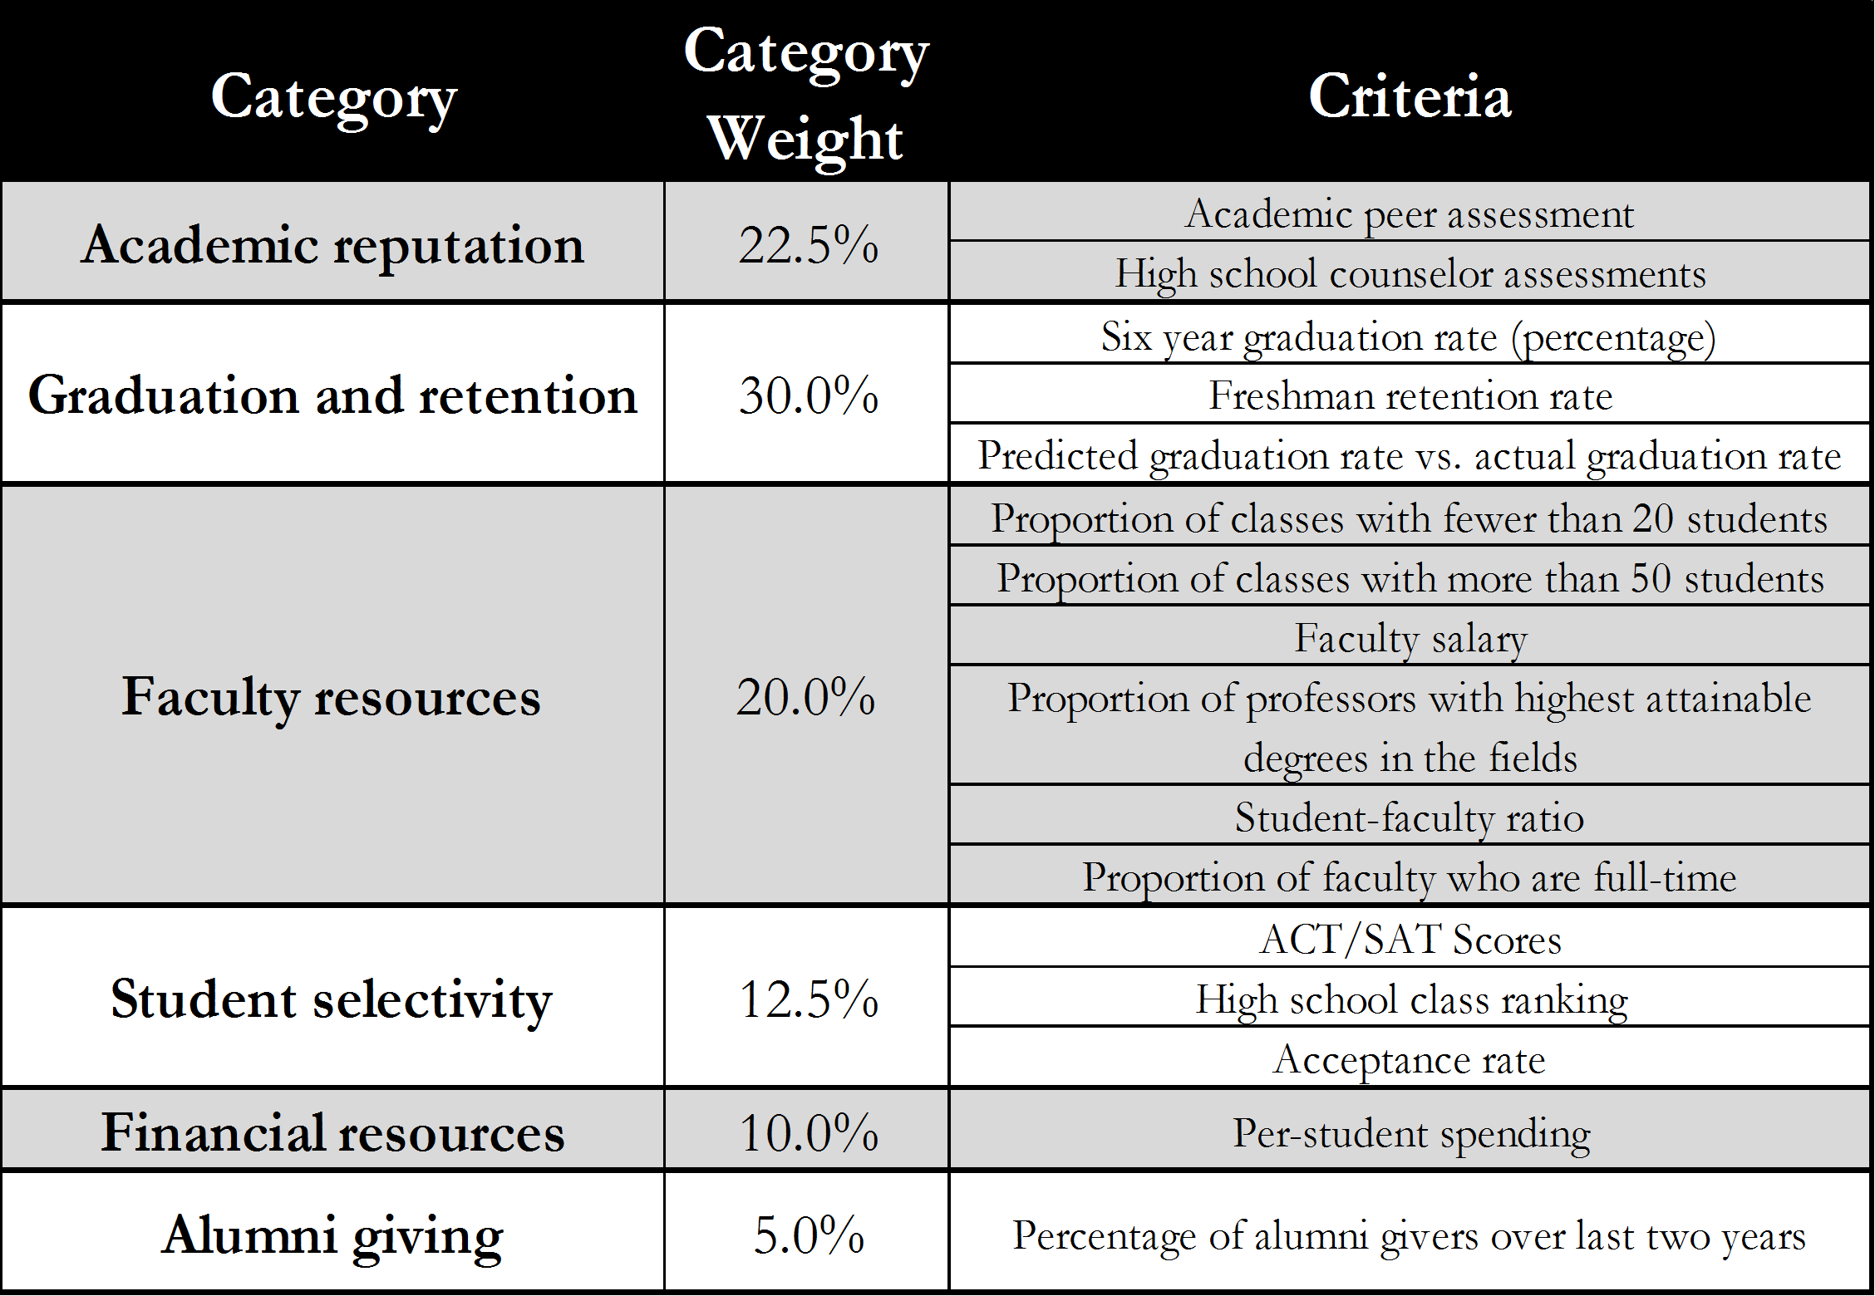.
Source: Melissa Shivers, Top 25 USNWR Ranking Presentation

Exhibit 5*

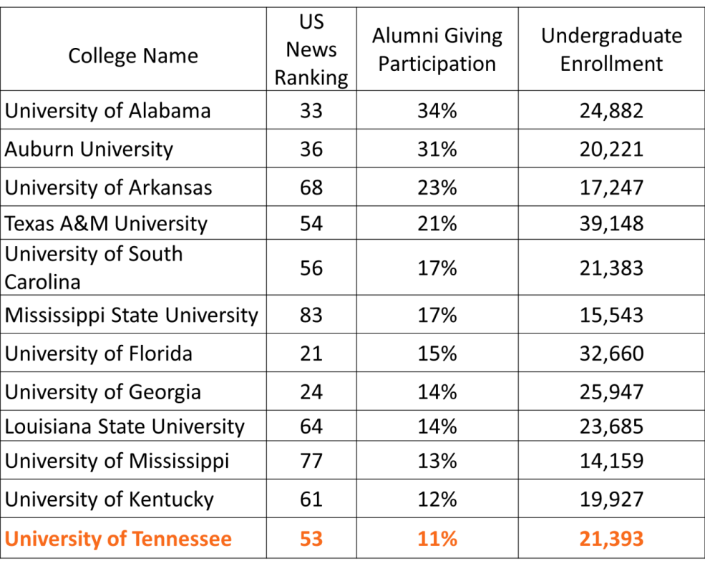
*This study was conduct before the University of Missouri joined the SEC.

Source: Lance Taylor, SEC Rankings

Exhibit 6
Chart 1 Chart 2

Chart 3 Chart 4

Exhibit 7

Exhibit 8

Exhibit 9

Exhibit 10
Chart 1 Chart 2

Exhibit 11

Exhibit 13
Recommendations for “My Memories Campaign”
Memory Monday
Tennessee Tuesday
Way Back Wednesday
Throwback Thursday
Flashback Friday

Citations
Office of Budget and Finance (2014). Download Fee History Document [PDF]. Retrieved from
http://budget.utk.edu/wp-content/blogs.dir/99/files/2013/10/FEEHIST.pdf

Primm, C. (2014). Princeton Review Names UT a ‘Best Value’ Public College. Tennessee Today.
Retrieved from http://tntoday.utk.edu/2014/01/31/princeton-review-names-ut-public-college/
Shivers, M. Top 25 USNWR Ranking Presentation [PowerPoint slides]. Retrieved via personal
communication.

Skari, L. (2014). Community College Alumni: Predicting Who Gives. Community College
Review. Retrieved from http://web.b.ebscohost.com/ehost/detail?vid=13&sid=e594f016-73ab-4170-9a7f-2fa2642e40f3%40sessionmgr111&hid=125&bdata=JnNjb3BlPXNpdGU%3d#db=aph&AN=92969500

Taylor, L. SEC Rankings. [PowerPoint slides]. Retrieved via personal communication

The Princeton Review (2014). 2014 Princeton Review 150 Best Value Colleges. USA Today.
Retrieved from http://www.usatoday.com/story/money/personalfinance/2014/01/28/2014-princeton-review-best-value-colleges-interactive/4478465/

University of Florida (2014). Stats and Facts for Prospective Students. Retrieved from
http://www.admissions.ufl.edu/ufprofile.html

University of Tennessee, Knoxville (2014.) Transforming Tennessee and the Wider World.
Retrieved from http://volsconnect.com/s/1341/utk/start.aspx?gid=2&pgid=61

Depending on the size and frequency of gifts, there are many different donor levels. However, for the purposes of this study, they are irrelevant and therefore will not be discussed.
The Princeton Review, 2014 Princeton Review 150 Best Value Colleges
Charles Primm, Princeton Review Names UT a ‘Best Value’ Public College
University of Tennessee Office of Alumni Affairs and Development Website
University of Florida Admissions Website
Lisa Ann Skari, Community College Alumni: Predicting Who Gives

