POLITICALLY MORAL:
MODERATE PARTISANS MORALLY DEROGATE OUT-PARTY MEMBERS, EVEN WHEN TREATED FAIRLY

A Thesis Presented for the
Master of Arts
Degree
University of Tennessee, Knoxville

Phillip P. McGarry
May 2022

ACKNOWLEDGEMENTS
I would like to thank my advisors, Dr. Garriy Shteynberg and Dr. Timothy Hulsey, as well as my previous collaborator, Dr. Robert Corwyn. Their guidance has helped me articulate and clarify ideas and methodology, as well as develop technical and analytical skills.

I would also like to thank my lab mate, Andrew Heim, for lengthy theoretical conversations and for never failing to encourage me. Additionally, thank you to Dr. Caleb James for being a good friend.

I would also like to thank my brothers, Alexander and Mark White, for inspiring in me a love of science and social psychology at a young age. Additionally, thank you to my stepfather, Daniel Bartlett, for the jokes.
ABSTRACT
Political polarization in the United States now entails partisan outgroup moral derogation. In order to examine the roles of political extremity, fairness, and political symmetry on out-party moral derogation, I employed the Ultimatum Game paradigm (n= 1070) where participants received fair or unfair offers by an in-party or out-party member. Results showed that self-identified moderate partisans morally derogated out-party members, even after being treated fairly. Additionally, these effects were politically symmetric. This suggests that political party identification can supersede other relevant information when making a moral judgment about a person, even for those who are not politically extreme and for those on the political left as well as the political right.
TABLE OF CONTENTS
I. Introduction | 7
Political Extremism | 9
Moral Judgment and Fairness | 10
Political Symmetry | 11
The Present Study | 12
II. Method | 13
Participants | 13
Procedure | 13
Measures | 14
III. Results | 15
IV. Discussion | 32
References | 35

LIST OF FIGURES
Figure 1. Outgroup Status. | 17
Figure 2. Political Extremity × Outgroup Status. | 18
Figure 3. Outgroup Status for Moderate Partisans. | 19
Figure 4. Fairness. | 21
Figure 5. Outgroup Status for Fair Treatment (5:5). | 22
Figure 6. Outgroup Status × Political Extremity for Fair Treatment (5:5). | 23
Figure 7. Outgroup Status × Political Extremity for Unair Treatment (6:4). | 24
Figure 8. Outgroup Status × Political Extremity for Very Unair Treatment (7:3). | 25
Figure 9. Political Affiliation | 27
Figure 10. Political Affiliation for Fair Treatment (5:5). | 28
Figure 11. Conceptual diagram of the mediation by moral derogation of outgroup status on rejection of offer in the UG, moderated by political extremity. | 29
Figure 12. Conceptual diagram of the mediation by moral derogation of outgroup status on rejection of offer in the UG, moderated by political extremity and fairness. | 31

I. Introduction
In recent years, political parties in the United States have become increasingly polarized, with stronger party affiliation coinciding with more animosity toward, and greater perceived social distance from, opposition party members (Abramowitz & Saunders, 2008; Iyengar, Sood, & Lelkes, 2012; Iyengar & Westwood, 2015; Pew Research Center, 2014; Pew Research Center, 2016). Since 2017, distaste for outgroup parties in the United States has surpassed that found in every comparable nation (Boxell et al., 2020). In fact, since 2012, outgroup party hate has become more prominent than ingroup party love (Abramowitz & Webster, 2016; Finkel et al., 2020).
Strikingly, partisans do not merely dislike opposition party members, but see them as immoral (Clifford, 2018; Finkel et al., 2020; Garrett & Bankert, 2018; Tappin & McKay, 2019). Consequently, partisans are unlikely to date or marry each other (Huber & Malhorta, 2017; Iyengar, Sood, & Lelkes, 2012), are more implicitly and explicitly biased towards each other (Iyengar & Westwood, 2015), and feel more threatened by and afraid of each other (Pew Research Center, 2016). It is not surprising then that Finkel and colleagues (2020) caution that moral derogation across party lines poses a threat to democracy, through an inability for democratic processes to resolve national challenges. More worrying, however, is the association of moral derogation with disgust (Giner-Sorolla & Chapman, 2017), punishment (Chapman et al., 2009), and dehumanization (Bandura, 1999; Bastian et al., 2011), which scholars contend coincide with antecedents of atrocities in the 20th century (i.e. Nazism in Germany; Matsumoto et al., 2015).
But many important questions remain. Do all partisans regard outgroup party members as immoral or just extreme partisans? Do moral or fair actions by outgroup party members mitigate moral derogation? Do liberals and conservatives differ in their propensity to morally derogate outgroup party members? Answers to these questions are of the utmost importance, as they may represent harbingers of an unsettling new American political milieu.

Political moderation remains high in the American public at large (Fiorini et al., 2006). It may be that as long as political moderation continues as the status quo, the more dangerous elements of moral derogation will be curtailed. This is a comforting thought, given that the most calamitous political outcomes (totalitarian oppression, genocide, and war) tend to be the result of political extremism (i.e. Nazism in Germany or Bolshevism in Russia). In addition, research finds that moral derogation typically occurs in response to immoral actions (Reeder & Brewer, 1979; Uhlmann et al., 2015). In studies using the Ultimatum Game paradigm (Güth et al., 1982), for example, moral condemnation of an individual increases only as the unfair actions of that individual increase (Chapman et al., 2009). Being treated fairly by a political opponent should then curtail the likelihood of moral censure of that opponent. If this is the case, promoting fair treatment of political opposition may preempt continued polarization. It may also be that the threat of moral derogation only exists for one part of the political spectrum. The political right and left employ different criteria when making moral evaluations (Graham, Haidt, & Nosek, 2009). Conservatives more than liberals adopt viewpoints such as authoritarianism and social dominance orientation (Jost et al., 2003). The potential problem of moral derogation and political extremity, therefore, may be more easily remedied if it exists only on the political right. Addressing these questions, of the influence of political extremism on moral derogation, the relationship between fair treatment and moral derogation, and the politico-spectral symmetry involved, is necessary for understanding the antecedents of moral derogation in a polarized political context, and potentially for avoiding the worst social and political outcomes.

Political Extremism
Extreme political views have become more common (Moss & O'Connor, 2020). Extreme partisans are more dogmatic (Harris & Van Bavel, 2021), more certain of the superiority of their beliefs (Harris & Van Bavel, 2021; Toner et al., 2013), and more intolerant of dissimilar groups (Brandt et al., 2014) than moderate partisans. Hatemi and colleagues (2019) found that political ideology is an antecedent of moral judgment, suggesting more extreme political ideologies form the basis of more extreme moral evaluations. Because extreme partisanship goes hand in hand with outgroup intolerance, and because extreme ideology entails extreme moral judgments, we would expect only extreme partisans to morally derogate outgroup party members.
Because ideology has also become increasingly indistinguishable from political party, even moderate partisans are more ideologically distant from out-party members than in previous years. While moderate Democrats traditionally held some politically conservative beliefs, and moderate Republicans some politically liberal beliefs, this is no longer the case (Pew Research Center, 2014). Democrats and Republicans have become more consistently liberal and conservative respectively, sharing fewer opinions across ideological boundaries (Abramowitz & Saunders, 2008; Pew Research Center, 2014). Even moderate partisans now lack ideological diversity, becoming “moderate” simply because their views are more mainstream than extreme partisans. Could it be that greater ideological consistency, combined with increasing ideological distance between parties, means that even self-identified moderates now see outgroup party members as immoral? The moralization of ideology might mean that, even for moderates, those who deviate from the party line are ipso facto immoral.

Moral Judgment and Fairness
Fairness considerations are instrumental in political and moral decision-making (de Waal, 1996; Haidt & Joseph, 2004; Tooby, Guzmán, & Cosmides, 2019; Magalhães & Aguiar-Conraria, 2019; Rodon & Sanjaume-Calvet, 2020); moral derogation increases as fair treatment decreases (Chapman et al., 2009; Güth et al., 1982). Participants will even act against their own self-interest to punish unfair behavior (Camerer, 2003). However, moral derogation is typically based on the individual actions of others. Contrary to moral judgment of individual actions, research on intergroup moral derogation typically occurs in contexts where party affiliation is the sole indicator of moral character. Moral or immoral actions should provide relevant information by which to judge moral character than party affiliation alone. If treated fairly, even extreme partisans may deem out-partisans moral.
If political identity is the sole basis of moral evaluation, however, partisans may morally derogate out-party members despite a fair offer. Brewer (1999), for example, suggested that moral superiority was a key feature of outgroup hostility and derogation. If moral superiority is the basis for intergroup judgment, then the individual actions of the outgroup members should play no role in their moral evaluation. Morally derogating out-party members, without regard for fair treatment, would then suggest that partisans do not consider out-party members as individuals, but render them solely in terms of their party affiliation (and morally culpable by association).

Political Symmetry
Ongoing debate on the tendency of conservatives or liberals to adopt extreme ideologies continues. Some argue that conservatives are more inclined to political extremity (Jost et al., 2003), while others argue this proclivity is equally distributed between the political left and right (Greenberg & Jonas, 2003). When considering moral derogation, however, liberals and conservatives maintain different criteria in determining whether an act is moral or not (Graham, Haidt, & Nosek, 2009). Liberals value fairness more when making such judgments while conservatives value ingroup loyalty and authority (Kivikangas, Lönnqvist, & Ravaja, 2017; Kugler, Jost, & Noorbaloochi, 2014). We would expect liberals then to reward fair treatment more than conservatives (even for outgroup partisans). By this thinking, because ingroup loyalty is a foundation of their moral values, conservatives should morally derogate outgroup partisans more than liberals regardless of the fairness of the offer.
If, however, liberals and conservatives morally derogate out-party members equally, then moral derogation is not the result of moral values, or of the actions of the other, but rather based merely on group identification. Greene (2013), for instance, suggests that the intuitions responsible for moral values are suited primarily for intergroup, rather than intragroup, relationships. Thus liberals and conservatives orient themselves in terms of tribal competition, disregarding any moral values (such as the importance of fairness) that would otherwise shape their evaluations. This creates the us versus them distinction common in national, ethnic, or religious cleavages (Berreby, 2005; Greene, 2013).

The Present Study
In this study, we seek to understand the effects of political extremity, fair treatment, and political affiliation on the moral derogation of out-partisans. In an attempt to answer the questions mentioned above, we manipulate the fairness of an offer a participant receives in the Ultimatum Game (UG; Güth et al., 1982) within a political intergroup versus intragroup context. By also measuring participant self-identified political affiliation and extremity, we examine the confluence of these factors on outgroup moral derogation with regard to variation in fair treatment in the UG.
In the UG, an experimenter allots one player (the proposer) an amount (usually $10) that must be divided between themselves and another player (the responder). The responder can either accept or reject the proposed division (the offer). If the responder accepts the offer (for example, a proposed 9:1 split) then the responder receives $1 and the proposer keeps $9. If the responder rejects the offer, then both players receive nothing. According to Chapman and colleagues (2009), reacting to unfairness in the UG involves moral judgment; players experience more moral emotions the more unfair the offer. Players in the UG are willing to act against their self-interest because it is more important that they morally derogate their partner for unfairness than benefit themselves. The UG is an ideal paradigm, because it allows participants to use both the fair or unfair behavior of their partner, as well as the party affiliation of their partner, in order to make a moral judgment about them. The UG also provides a behavioral corollary of moral derogation (in the rejection of the offer). If political extremity has an effect on out-party moral derogation, moral derogation should, therefore, mediate the relationship between political extremity and rejection for out-party members.

II. Method
Participants. Undergraduate students from a major public university in the southeastern United States participated (N = 1230). Institutional review board approval was acquired and informed consent was obtained from all participants before data collection commenced. Power analysis was conducted using the pwr package (Champely, 2017) in R, version 3.6.2, suggesting 1110 participants were required to obtain a small-to-medium effect size (Cohen’s d = .30; β = .80; α = .05). Participants were recruited through the participant pool in the Department of Psychology. Missing data was handled using list-wise deletion, which excluded 160 participants, leaving a final total of 1070 (Mage = 18.81; SDage = 1.26; Female = 670; White = 834). 578 self-identified as conservatives, while 492 self-identified as liberals. Random assignment resulted in 536 receiving offers from outgroup party members and 534 from ingroup party members. Additionally, random assignment to three fairness conditions occurred: 5:5 (fair; n = 359), 6:4 (unfair; n = 352), and 7:3 (very unfair; n = 359).

Procedure. After initial consent, random assignment to six conditions occurred: a 2 (Democrat or Republican opponent) × 3 (5:5, 6:4, or 7:3 UG offer) between-subjects design. Participants chose an avatar to reflect their political affiliation, and were subsequently presented with an avatar representing their UG partner’s political affiliation. The participant was led to believe they would be interacting with another person, though this was a deception.
Participants were then presented with the rules of the game and designated as the responder (rather than the proposer). A screen appeared for 15 seconds indicating that their partner (the proposer) was deciding on an offer, after which an offer was presented with options to accept or reject. The next screen showed received amounts of partner and participant, based on the decision to accept or reject. Participants then made a moral judgment of their partner after the game.

Measures.
Political Affiliation. One item had participants self-report their political affiliation by indicating on a 10-point scale whether they were slightly to extremely liberal or conservative. For this measure, both slight and extreme conservatives were coded as merely conservative (and likewise for liberals). This resulted in 578 conservatives and 492 liberals.
Political Extremity. The same item used for the political affiliation measure was used to measure political extremity. Participants indicated whether they were: “slightly,” “somewhat,” “moderately,” “very,” or “extremely,” liberal or conservative. For this measure, whether the participant indicated liberal or conservative was ignored, and only their degree of political affiliation was coded. For example, participants indicating they were “slightly conservative” and “slightly liberal” were both coded similarly as “slightly” (and likewise for the other degrees of political affiliation), with “slightly” coded as “1,” and “extremely” as “5,” M = 2.62, SD = 1.22.
Outgroup Status. Participants were randomly assigned to be presented with a partner avatar representing either the Democratic Party or the Republican Party. This resulted in 534 participants presented with an ingroup party image (liberals, n = 244; conservatives, n = 290), and 536 presented with an outgroup party image (liberals, n = 248; conservatives, n = 288).
Fairness. Participants were also randomly assigned to respond to different offers allegedly proposed by their partners. 359 participants responded to a 5:5 offer (fair; liberals, n = 165; conservatives, n = 194; ingroup, n = 180; outgroup, n = 179), 352 responded to a 6:4 offer (unfair; liberals, n = 162; conservatives, n = 190; ingroup, n = 175; outgroup, n = 177), and 359 responded to a 7:3 offer (very unfair; liberals, n = 165; conservatives, n = 194; ingroup, n = 179; outgroup, n = 180).
Moral Derogation. Participants responded to an item with instructions, “Please answer the following questions about your partner in this study using the scale below. Please guess to the best of your ability.” A Likert-scale from 1 (Strongly Disagree) to 7 (Strongly Agree) was provided alongside the statement, “My partner is a moral person.” M = 4.18, SD = 1.36.
Rejection. This measure reflects whether a participant chose to reject (rather than accept) the offer in the UG (n = 493).
III. Results
To reduce inflated error due to collinearity, all independent variables were mean-centered (Cohen, Cohen, West & Aiken, 2003; Jaccard, Turrisi, & Wan, 1990). Problems due to outliers or collinearity were not found (variance inflation factors < 2; Cook’s Distances < 1). Analyses were conducted in R, version 3.6.2, using ordinary least squares estimation.

Political Extremity on Moral Derogation. Regression analysis found that political extremity had no main effect on moral derogation (r = -0.054, SE = 0.034, t(1069) = -1.554, p = 0.120). An ANOVA found that outgroup status, however, had a significant main effect on moral derogation (F (1, 1068) = 13.854, p < 0.001, η_{p}² = 0.013) Outgroup partisans (M = 4.026, SD = 1.372) were morally derogated more than ingroup partisans (M = 4.333, SD = 1.327, see Figure 1). Notably, a significant two-way interaction emerged between political extremity and outgroup status on moral derogation (b = -0.400, SE = 0.067, t(1069) = -5.931, p < 0.001). Significant interactions were probed by conducting simple slope analyses and by plotting the interaction (Aiken & West, 1991; Cohen et al., 2003; Jaccard et al., 1990). Analyses of simple slopes revealed that for those playing with an outgroup partner, the effect of political extremity on moral derogation was significant (b = -0.256, SE = 0.048, t(1069) = -5.291, p < 0.001). Political extremity, therefore, had an effect on out-party moral derogation (see Figure 2). However, for those playing with an ingroup partner, there was a significant effect of political extremity on moral derogation in the opposite direction (b = 0.144, SE = 0.047, t(1069) = -2.232, p = 0.026; see Figure 2). In addition, contrast coding was used to probe effects for self-identified moderate partisans (coded as 3 on a 5-point scale). The contrast (0, 0, -1, 0, 0, 0, 0, 1, 0, 0) found a significant effect of outgroup status on moral derogation (F (1, 1060)= 5.264, p = 0.022, η_{p}² = 0.005). Moderate partisans, therefore, morally derogated outgroup party members (M = 3.962, SD = 1.323) compared to ingroup party members (M = 4.285, SD = 1.404, see Figure 3).
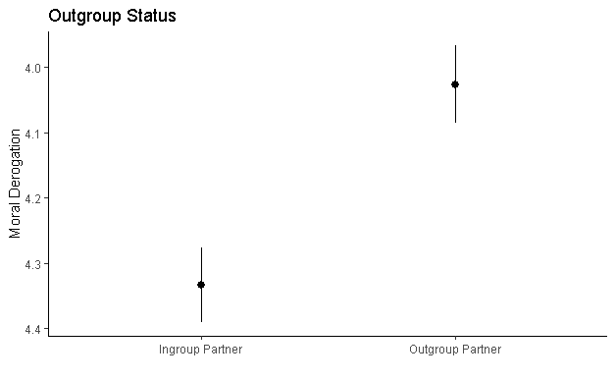
Figure 1. Error bars represent standard errors.

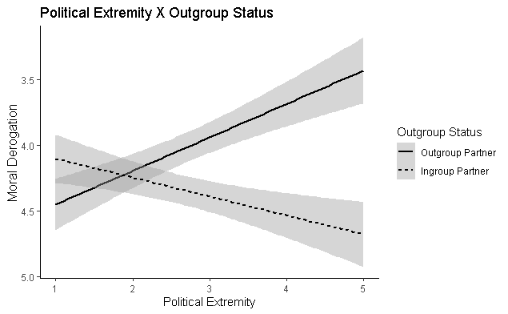
Figure 2.
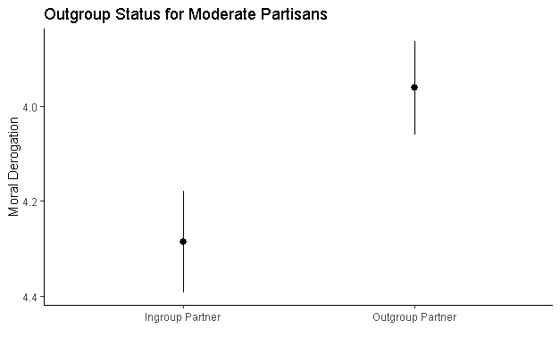
Figure 3. Error bars represent standard errors.
Fairness on Moral Derogation. Consistent with previous literature (Camerer, 2003), an ANOVA showed a significant main effect of fairness on moral derogation (F (2, 1067)= 46.130, p < 0.001, η_{p}² = 0.080; see Figure 4). Those who received fair treatment (M = 4.688, SD = 1.195) morally derogated less than the average of those who were treated unfairly (M = 4.080, SD = 1.318) and very unfairly (M = 3.769, SD = 1.392; F (1, 1067)= 81.838, p < 0.001, η_{p}² = 0.071); those who were treated unfairly morally derogated more than those who were treated fairly (F (1, 1067)= 10.091, p =0.002, η_{p}² = 0.009; see Figure 4). There was no two-way interaction between fairness and outgroup status though (F (2, 1064) = 2.183, p = 0.113). Hence, a contrast (-1, 1, 0, 0, 0, 0) found the effect of outgroup status on moral derogation remained, even for those who received fair treatment (F (1, 1064)= 10.293, p = 0.001, η_{p}² = 0.010). For those who received fair treatment, outgroup partisans (M = 4.480, SD = 1.210) were morally derogated more than ingroup partisans (M = 4.894, SD = 1.146; see Figure 5). The interaction of political extremity and outgroup status on moral derogation also did not change across levels of fairness; the three-way interaction of political extremity, outgroup status, and fairness on moral derogation was not significant (b = 0.025, SE = 0.081, t(1069) = .308, p = 0.758). The simple slopes of the political extremity and outgroup status interaction on moral derogation, therefore, remained significant for those who received fair treatment (b = -0.370, SE = 0.115, t(1069) = -3.232, p = 0.001; see Figure 6), for those who received unfair treatment (b = -0.402, SE = 0.115, t(1069) = -3.510, p < 0.001; see Figure 7), and for those who received very unfair treatment (b = -0.322, SE = 0.116, t(1069) = -2.775, p = 0.006; see Figure 8).
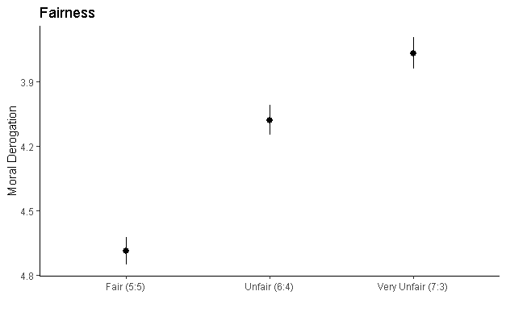
Figure 4. Error bars represent standard errors.
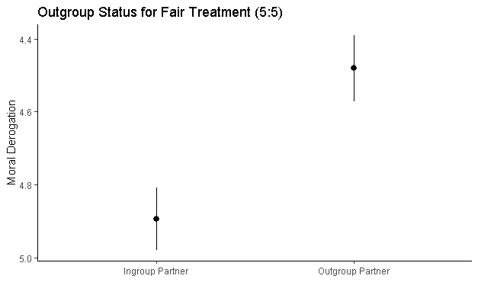
Figure 5. Error bars represent standard errors.
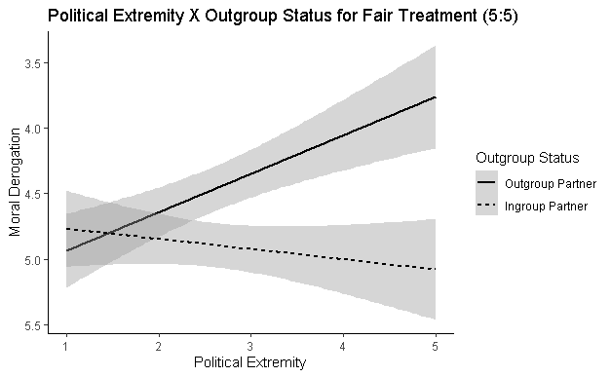
Figure 6.

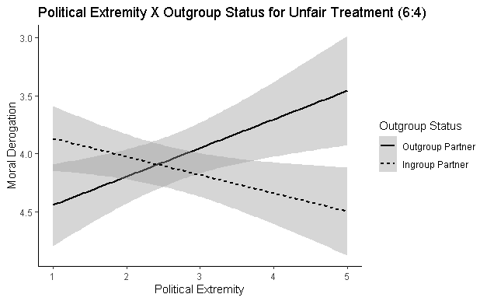
Figure 7.

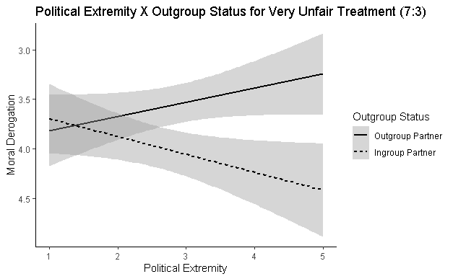
Figure 8.

Political Affiliation, Political Extremity, and Moral Derogation. An ANOVA found that political affiliation had a small main effect on moral derogation (F (1, 1068) = 4.384, p = 0.037, η_{p}² = 0.004), in that liberals (M = 4.085, SD = 1.318) morally derogated more than conservatives (M = 4.260, SD = 1.388; see Figure 9). Political affiliation did not have an effect on political extremity as predicted (F (1, 1072) = 0.284, p = 0.594). No two-way interaction emerged between political affiliation and outgroup status on moral derogation (F (1, 1068) = 0.915, p = 0.339). Additionally, a multiple regression analysis found no three-way interaction between political affiliation, political extremity, and outgroup status on moral derogation (b = -0.067, SE = 0.136, t(1069) = -0.497, p = 0.620). An ANOVA found a significant three-way interaction emerged between political affiliation, fairness, and outgroup status on moral derogation (F (2, 1058) = 10.366, p = 0.045, η_{p}² = 0.006). To probe the interaction, two simultaneous contrasts found that, for those who received fair treatment, there was an interaction of political affiliation and out-group status on moral derogation (contrast -1, 1, 0, 0, 0, 0, 0, 0, 0, 0, 0, 0; contrast 0, 0, 0, 0, 0, 0, 1, -1, 0, 0, 0, 0), F (2, 1058) = 6.921, p = 0.001, η_{p}² = 0.013; see Figure 10. That is, liberals morally derogated out-party members (M = 4.329, SD = 1.166) compared to in-party members (M = 5.024, SD = 1.104; contrast -1, 1, 0, 0, 0, 0, 0, 0, 0, 0, 0, 0; F (1, 1058) = 12.653, p < 0.001, η_{p}² = 0.012) more than conservatives morally derogated out-party members (M = 4.608, SD = 1.238) compared to in-party members (M = 4.784, SD = 1.175; contrast 0, 0, 0, 0, 0, 0, 1, -1, 0, 0, 0, 0; F (1, 1058) = 1.189, p = 0.276; see Figure 10). A multiple regression analysis found no significant three-way interaction between political affiliation, political extremity, and outgroup status on moral derogation (b = -0.067, SE = 0.136, t(1069) = -0.497, p = 0.620).
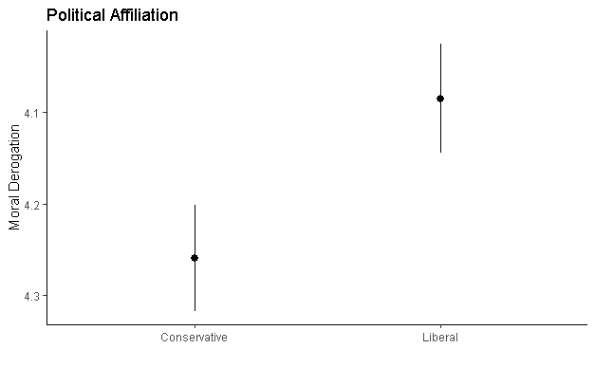
Figure 9. Error bars represent standard errors.
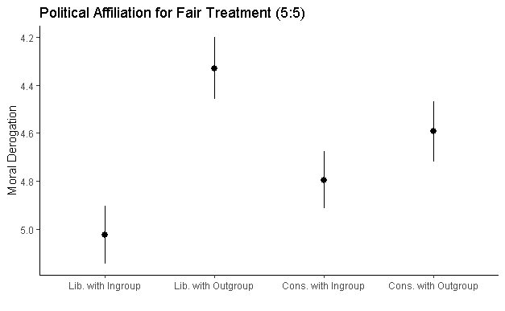
Figure 10. Error bars represent standard errors.

Mediation by Moral Derogation on Rejection. Moral derogation fully mediated the effect of outgroup status on rejection of the offer in the UG, with the outgroup status → moral derogation path moderated by political extremity (Figure 11). Conditional indirect effects, bootstrap standard error coefficients, and bootstrap confidence intervals were estimated using the PROCESS macro (Model 7) in SPSS with 5,000 bootstrap samples (Hayes, 2013). The conditional indirect effect of the outgroup status → moral derogation → rejection path for low political extremity (-1 SD) is non-significant (b = 0.067, SE = 0.043, 95% CI = [-0.155, 0.016]). The conditional indirect effects of the outgroup status → moral derogation → rejection path for mean political extremity (b = -0.114, SE = 0.035, 95% CI = [0.054, 0.190]) and high political extremity (+1 SD; b = -0.295, SE = 0.061, 95% CI = [0.187, 0.430]) were significant. There was no direct effect of outgroup status on rejection (b = -0.046, SE = 0.127, 95% CI = [-0.294, 0.203]). There were direct effects of outgroup status on moral derogation (b = 0.304, SE = 0.081, 95% CI = [0.115, 0.463]), political extremity on moral derogation (b = -0.255, SE = 0.048, 95% CI = [-0.350, -0.161]), and the outgroup status by political extremity on moral derogation (b = 0.400, SE = 0.067, 95% CI = [0.268, 0.533]). There was also a direct effect of moral derogation on rejection (b = -0.376, SE = 0.050, 95% CI = [0.268, 0.533]). There were no total effects of outgroup status on rejection (b = -0.147, SE = 0.123, 95% CI = [-0.388, 0.093]), political extremity on rejection (b = 0.097, SE = 0.073, 95% CI = [-0.046, 0.239]), and the interaction of outgroup status and political extremity (b = 0.083, SE = 0.102, 95% CI = [-0.282, 0.117]).
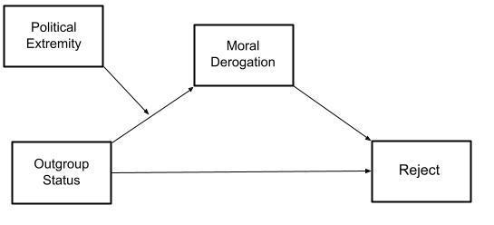
Figure 11. Conceptual diagram of the mediation by moral derogation of outgroup status on rejection of offer in the UG, moderated by political extremity.

Additionally, moral derogation fully mediated the effect of outgroup status on rejection of the offer in the UG, with the outgroup status → moral derogation path moderated by political extremity and the moral derogation → rejection path moderated by fairness (PROCESS Model 21; Figure 12). Fairness was indicator coded so that fair treatment (5:5) was the reference category. The conditional indirect effects of the outgroup status → moral derogation → rejection path for low political extremity (-1 SD) when treatment was fair (5:5; b = -0.203, SE = 0.039, 95% CI = [-0.122, 0.040]), unfair (6:4; b = 0.302, SE = 0.027, 95% CI = [-0.008, 0.092]), and very unfair (7:3; b = 0.049, SE = 0.036, 95% CI = [-0.013, 0.132]) were non-significant. The conditional indirect effect of the outgroup status → moral derogation → rejection path for mean political extremity when treatment was fair (5:5; b = 0.035, SE = 0.052, 95% CI = [-0.067, 0.144]) was non-significant. The conditional indirect effects of the outgroup status → moral derogation → rejection path for mean political extremity when treatment was unfair (6:4; b = -0.052, SE = 0.031, 95% CI = [-0.120, -0.002]) and very unfair (7:3; b = -0.084, SE = 0.038, 95% CI = [-0.169, -0.022]) were significant. The conditional indirect effect of the outgroup status → moral derogation → rejection path for high political extremity (+1 SD) when treatment was fair (5:5; b = -0.090, SE = 0.132, 95% CI = [-0.164, 0.364]) was non-significant. The conditional indirect effects of the outgroup status → moral derogation → rejection path for high political extremity (+1 SD) when treatment was unfair (6:4; b = -0.133, SE = 0.073, 95% CI = [-0.290, -0.005]) and very unfair (7:3; b = -0.216, SE = 0.080, 95% CI = [-0.388, -0.073]) were significant.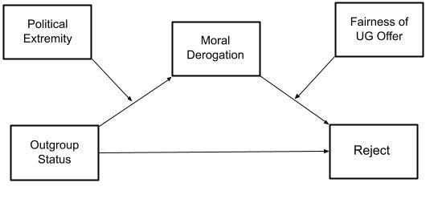
Figure 12. Conceptual diagram of the mediation by moral derogation of outgroup status on rejection of offer in the UG, moderated by political extremity and fairness.

There was no direct effect of outgroup status on rejection (b = -0.175, SE = 0.152, 95% CI [-0.472, 0.123]). There was also no direct effect of moral derogation (b = 0.114, SE = 0.165, 95% CI [-0.210, 0.437] or the interaction of moral derogation by fairness (dummy-coded as fair versus unfair; b = -0.284, SE = 0.185, 95% CI [-0.646, 0.079]) on rejection. However, there were significant direct effects of fairness (dummy-coded as fair versus unfair; b = 2.728, SE = 0.248, 95% CI [2.242, 3.213]), fairness (dummy-coded as unfair versus very unfair; b = 3.589, SE = 0.256, 95% CI [3.087, 4.091]), and the interaction of moral derogation by fairness (dummy-coded as unfair versus very unfair; b = -0.389, SE = 0.189, 95% CI [-0.759, -0.018]) on rejection.

IV. Discussion
Although we expected political extremity to impact out-party moral derogation, we were surprised to find that this effect did not change by being treated more or less fairly. The finding that as political extremity increases out-party moral derogation increases, even when treated fairly, has important implications for political discourse. This suggests that, as we become more politically extreme, the actions of out-party members no longer factor into our moral evaluation of them, reducing them to their political identity. When our political opponents are immoral by virtue of their political identity, obstacles set in the way of political cooperation and political compromise may be difficult to overcome.
Although we expected extreme partisans to morally derogate out-party members, we were also surprised to find that even those who self-identified as moderately partisan morally derogated out-party members. While those who ardently identify with their party may conflate their moral and political identity, it is puzzling that those who only moderately identify with their party still maintain that political disagreement in itself is immoral. Moral derogation of political opponents is more rampant than expected.
Given the previous research, it was also noteworthy that conservatives did not morally derogate out-partisans more than liberals. In fact, the only political asymmetry we were able to discover was that liberals morally derogate more than conservatives (though the effect size was small). This was not, however, true for out-party members only, but true rather for out-party members and in-party members alike. There was also a greater in-partisan/out-partisan distance between moral evaluations for those who were treated fairly for liberals versus conservatives (Figure 10). This too leaves us nonplussed, given that liberals value fairness more than conservatives (Kivikangas, Lönnqvist, & Ravaja, 2017; Kugler, Jost, & Noorbaloochi, 2014).
More importantly, political extremity caused moral derogation of out-party members, and that moral derogation led to a behavioral manifestation (rejection). As partisans become more politically extreme, they engage in a moral reductionism which ignores the individual actions of political opponents and reduces them to their political identity alone. This reductionism allows for categorical moral derogation which results in behavioral outcomes directed toward that category (political identity, in this case).
However, political extremity did not directly lead to rejection of out-party members’ offers. It is also important to note that moral derogation only led to rejection of the offer for moderate to extreme partisans who received unfair or very unfair offers, even though political extremity led to moral derogation regardless of fairness of offer. This may suggest that, for moderate to extreme partisans, the political affiliation of others trumps their actions when evaluating their moral character, but not when deciding how to respond to them behaviorally.
Some threats to ecological validity provide limitations. Because participants did not receive actual money from the distributions in the game, the stakes of their decisions were much lower. Additionally, because this study was conducted with a convenience sample of university undergraduates in an introductory psychology course, our ability to generalize findings to the American public remain limited. This latter limitation is due in large part to the restricted range in age of the participants, as younger voters tend to have unstable political opinions and limited political experience (Peterson et al., 2020; Strother et al., 2021). Future studies are planned to address these limitations by providing payoffs to participants based on offers in the game and by acquiring a more representative sample through online participant pools.

References
Abramowitz, A. I., & Saunders, K. L. (2008). Is polarization a myth? The Journal of Politics,70(02), 542–555.
Aiken, L.S., & West, S.G. (1991). Multiple regression: Testing and interpreting interactions. Newbury Park, CA: Sage.
Amira, K., Wright, J. C., & Goya-Tocchetto, D. (2019). In-group love versus out-group hate: Which is more important to partisans and when? Political Behavior, doi:10.1007/s11109-019-09557-6
Bandura, A. (1999). Moral disengagement in the perpetration of inhumanities. Personality and Social Psychology Review, 3, 193-209.
Bastian, B., Laham, S., Wilson, S., Haslam, N., & Koval, P. (2011). Blaming, praising and protecting our humanity: The implications of everyday dehumanization for judgments of moral status. British Journal of Social Psychology. 50, 469-483
Berreby, D. (2005). Us and them: Understanding your tribal mind. Little, Brown and Co.
Biella, M., & Sacchi, S. (2018). Not fair but acceptable… for us! Group membership influences the tradeoff between equality and utility in a Third Party Ultimatum Game. Journal of Experimental Social Psychology., 77, 117–131. doi:10.1016/j.jesp.2018.04.007
Boxell, L., Gentzkow, M., & Shapiro, J. M. (2020). Cross-country trends in affective polarization (No. w26669). National Bureau of Economic Research.
Brandt, M. J., Reyna, C., Chambers, J. R., Crawford, J. T., & Wetherell, G. (2014). The ideological-conflict hypothesis: Intolerance among both liberals and conservatives. Current Directions in Psychological Science, 23, 27–34. doi:10.1177/0963721413510932
Branscombe, N. R., Wann, D. L., Noel, J. G., & Coleman, J. (1993). In-group or out-group extremity: Importance of the threatened social identity. Personality and Social Psychology Bulletin, 19, 381–388.
Brewer, M. B. (1991). The social self: On being the same and different at the same time. Personality and Social Psychology Bulletin, 17: 475-482.
Brüne, M., Tas, C., Wischniewski, J., Welpinghus, A., Heinisch, C., & Newen, A. (2012). Hypnotic ingroup–outgroup suggestion influences economic decision-making in an ultimatum game. Consciousness and Cognition: An International Journal, 21(2), 939-946. doi:http://dx.doi.org.proxy.lib.utk.edu:90/10.1016/j.concog.2012.02.009
Camerer, C. (2003). Behavioural studies of strategic thinking in games. Trends in Cognitive Sciences., 7(5), 225–231. https://doi.org/10.1016/S1364-6613(03)00094-9
Champely, S. (2017). pwr: Basic functions for power analysis (Version 1.2-2) [Computer software]. Retrieved from http://cran.r-project.org/package=pwr
Chapman, H. A., Kim, D. A., Susskind, J. M., & Anderson, A. K. (2009). In bad taste: Evidence for the oral origins of moral disgust. Science, 323(5918), 1222-1226. doi:10.1126/science.1165565
Clifford, S. (2019). How emotional frames moralize and polarize political attitudes. Political Psychology, 40(1), 75-91. doi: 10.1111/pops.12507
Cohen, J., Cohen, P., West, S.G., & Aiken, L.S. (2003). Applied multiple regression/correlation analysis for the behavioral sciences (3rd ed.). Mahwah, NJ: Erlbaum.
Cosmides, L., Guzmán, R. A., & Tooby, J. (2018). The evolution of moral cognition. In A. Zimmerman, K. Jones, & M. Timmons (Eds.), The routledge handbook of moral epistemology (pp. 174– 228). New York: Routledge.
Cram, L., Moore, A., Olivieri, V., & Suessenbach, F. (2018). Fair is fair, or is it? territorial identity triggers influence ultimatum game behavior. Political Psychology, 39(6), 1233-1250. doi:10.1111/pops.12543
de Moura, G. R., Leader, T., Pelletier, J., & Abrams, D. (2008). Prospects for Group Processes and Intergroup Relations Research: A Review of 70 Years’ Progress. Group Processes & Intergroup Relations, 11(4), 575–596.
de Waal, F. B. M. (1996). Good natured: The origins of right and wrong in humans and other animals. Cambridge, MA: Harvard University Press.
Diekhof, E. K., Wittmer, S., & Reimers, L. (2014). Does competition really bring out the worst? testosterone, social distance and inter-male competition shape parochial altruism in human males. PLoS ONE, 9(7), 11. doi:10.1371/journal.pone.0098977
Finkel, E. J., Bail, C. A., Cikara, M., Ditto, P. H., Iyengar, S., Klar, S., Mason, L., McGrath, M. C., Nyhan, B., Rand, D. G., Skitka, L. J., Tucker, J. A., Van Bavel, J. J., Wang, C. S., Druckman, J. N. (2020). Political sectarianism in America. Science, 370 (6516), 533-536. doi: 10.1126/science.abe1715
Fiorina, M. P., Abrams, S. J., & Pope, J. C. (2006). Culture War? The Myth of a Polarized America. 2nd ed. New York: Pearson Longman.
Garrett, K. N., & Bankert, A. (2018). The moral roots of partisan division: How moral conviction heightens affective polarization. British Journal of Political Science. Advance online publication. doi:10.1017/S000712341700059X
Garrett, K. N. (2019), Fired up by morality: The unique physiological response tied to moral conviction in politics. Political Psychology, 40: 543-563. doi:10.1111/pops.12527
Gillespie, S. M., Mitchell, I. J., Johnson, I., Dawson, E., & Beech, A. R. (2013). Exaggerated intergroup bias in economical decision making games: Differential effects of primary and secondary psychopathic traits. PLoS ONE, 8(8), 9. doi:10.1371/journal.pone.0069565
Giner-Sorolla, R., & Chapman, H. A. (2017). Beyond purity: Moral disgust toward bad character. Psychological Science, 28, 80–91. doi:10.1177/0956797616673193
Graham, J., Nosek, B. A., Haidt, J., Iyer, R., Koleva, S., & Ditto, P. H. (2011). Mapping the moral domain. Journal of Personality and Social Psychology, 101(2), 366–385. doi:/10.1037/a0021847
Greenberg, J., & Jonas, E. (2003). Psychological motives and political orientation—the left, the right, and the rigid: Comment on Jost et al. (2003). Psychological Bulletin, 129, 376–382. doi:10.1037/0033-2909.129.3.376
Greene, J. (2013). Moral tribes: Emotion, reason, and the gap between us and them. Penguin Press, New York, NY.
Greene, S. (1999). Understanding party identification: A social identity approach. Political Psychology, 20(3), 393.
Guala, F. (2012). Reciprocity: Weak or strong? what punishment experiments do (and do not) demonstrate. Behavioral and Brain Sciences, 35(1), 1-15. doi:http://dx.doi.org.proxy.lib.utk.edu:90/10.1017/S0140525X11000069
Güth, W., Schmittberger, R., & Schwarze, B. (1982). An experimental analysis of ultimatum bargaining. Journal of Economic Behavior & Organization., 3(4), 367–388. doi:10.1016/0167-2681(82)90011-7
Hannikainen, I. R., Miller, R. M., & Cushman, F. A. (2017). Act versus impact: Conservatives and liberals exhibit different structural emphases in moral judgment. Ratio, 30(4), 462–493. doi:10.1111/raTi.12162.
Harris, E., & Van Bavel, J. J.(2021). Preregistered replication of “Feeling superior is a bipartisan issue: Extremity (not direction) of political views predicts perceived belief superiority”. Psychological Science, 32(3), 451–458.
Hayes, A. F. (2013). Introduction to mediation, moderation, and conditional process analysis: A regression-based approach. New York, NY: The Guilford Press.
Hofmann, W., Brandt, M. J., Wisneski, D. C., Rockenbach, B., & Skitka, L. J. (2018). Moral punishment in everyday life. Personality and Social Psychology Bulletin, 44, 1697–1711.
Holtfrerich, S., Knipper, S., Purwins, J., Castens, J., Beyer, B., Schlomm, T., & Diekhof, E. (2020). The impact of long-term androgen deprivation therapy on cognitive function and socioeconomic decision making in prostate cancer patients. Psycho-Oncology., 29(8), 1338–1346. doi:10.1002/pon.5442
Huber, G. A., & Malhotra, N. (2017). Political homophily in social relationships: Evidence from online dating behavior. The Journal of Politics, 79(1), 269–283.
Iyengar, S., Sood, G., & Lelkes, Y. (2012). Affect, not ideology: A social identity perspective on polarization. Public Opinion Quarterly, 76(3), 405-431.
Iyengar, S., & Westwood, S. J. (2015). Fear and loathing across party lines: New evidence on group polarization. American Journal of Political Science, 59(3), 690–707.
Jaccard, J., Turrisi, R., & Wan, C.K. (1990). Interaction effects in multiple regression. Newbury Park, CA. Sage.
Jost, J. T., Glaser, J., Kruglanski, A. W., & Sulloway, F. J. (2003). Political conservatism as motivated social cognition. Psychological Bulletin, 129, 339–375.
Keshvari, F., Lotfabadi, H., Imani, S., & Habibi, M. (2019). Neural correlates of fairness consideration in children in interaction with their in-/Out-group: An event-related potential study. Advances in Cognitive Science, 21(3), 1-17. doi:http://dx.doi.org.proxy.lib.utk.edu:90/10.30699/icss.21.3.1
Kivikangas, J. M., Lönnqvist, J.-E., Ravaja, N. (2017). Relationship of moral foundations to political liberalism-conservatism and left-right orientation in a Finnish representative sample. Social Psychology, 48(4), 246-251.
Kubota, J. T., Li, J., Bar-David, E., Banaji, M. R., & Phelps, E. A. (2013). The price of racial bias: Intergroup negotiations in the ultimatum game. Psychological Science, 24(12), 2498-2504. doi:http://dx.doi.org.proxy.lib.utk.edu:90/10.1177/0956797613496435
Kugler, M., Jost, J. T., Noorbaloochi, S. (2014). Another look at Moral Foundations Theory: Do authoritarianism and social dominance orientation explain liberal-conservative differences in “moral” intuitions? Social Justice Research, 27, 413-431.
Leach, C. W., Ellemers, N., & Barreto, M. (2007). Group virtue: The importance of morality (vs. competence and sociability) in the positive evaluation of in-groups. Journal of Personality and Social Psychology, 93(2), 234-249. doi:10.1037/0022-3514.93.2.234
Magalhães, P. C., & Aguiar-Conraria, L. (2019). Procedural fairness, the economy, and support for political authorities. Political Psychology, 40(1), 165-181.
Martherus, J. L., Martinez, A. G., Piff, P. K., & Theodoridis, A. G. (2019). Party animals? extreme partisan polarization and dehumanization. Political Behavior, doi:10.1007/s11109-019-09559-4
Marques, J. M. & Paez, D. (1994). The “black sheep effect”: social categorization, rejection of ingroup deviates, and perception of group variability. European Review of Social Psychology, 5,37–68.
Mason, L., & Wronski, J. (2018). One tribe to bind them all: How our social group attachments strengthen partisanship. Political Psychology, 39, 257-277.
Matsumoto, D., Frank, M. G., & Hwang, H. C. (2015). The role of intergroup emotions in political violence. Current Directions in Psychological Science, 24(5), 369-373. doi:10.1177/0963721415595023
McAuliffe, K. & Dunham, Y. (2016). Group bias in cooperative norm enforcement. Philosophical Transactions of the Royal Society of London., 371(1686). https://doi.org/10.1098/rstb.2015.0073
McCoy, J., Rahman, T., & Somer, M. (2018). Polarization and the global crisis of democracy: common patterns, dynamics, and pernicious consequences for democratic polities. American Behavioral Scientist, 62(1), 16–42.
McLeish, K. N., & Oxoby, R. J. (2011). Social interactions and the salience of social identity. Journal of Economic Psychology, 32(1), 172-178. doi:http://dx.doi.org.proxy.lib.utk.edu:90/10.1016/j.joep.2010.11.003
Mendoza, S. A., Lane, S. P., & Amodio, D. M. (2014). For members only: Ingroup punishment of fairness norm violations in the ultimatum game. Social Psychological and Personality Science, 5(6), 662-670. doi:http://dx.doi.org.proxy.lib.utk.edu:90/10.1177/1948550614527115
Molho, C., Tybur, J. M., Güler, E., Balliet, D., & Hofmann, W. (2017). Disgust and anger relate to different aggressive responses to moral violations. Psychological Science, 28(5), 609-619. doi: 10.1177/0956797617692000
Morgan, G. S., Skitka, L. J., & Wisneski, D. (2010). Moral and religious convictions and intentions to vote in the 2008 Presidential election. Analyses of Social Issues and Public Policy, 10, 307–320.
Moss, J. T., & O’Connor, P. J. (2020). Political correctness and the alt-right: The development of extreme political attitudes. PLoS One, 15(10)
Mussweiler, T., & Ockenfels, A. (2013). Similarity increases altruistic punishment in humans. PNAS Proceedings of the National Academy of Sciences of the United States of America, 110(48), 19318-19323. doi:http://dx.doi.org.proxy.lib.utk.edu:90/10.1073/pnas.1215443110
Newhagen, J. E. (1998). TV news images that induce anger, fear, and disgust: Effects on approach‐avoidance and memory, Journal of Broadcasting & Electronic Media, 42(2), 265-276, doi: 10.1080/08838159809364448
Peterson, J. C., Smith, K. B., & Hibbing, J. R. (2020). Do people really become more conservative as they age? The Journal of Politics, 82(2), 600-611. doi:http://dx.doi.org/10.1086/706889Petkanopoulou, K., Rodríguez‐Bailón, R., Willis, G. B., & van Kleef, G. A. (2019). Powerless people don't yell but tell: The effects of social power on direct and indirect expression of anger. European Journal of Social Psychology, 49(3), 533-547. doi:http://dx.doi.org.utk.idm.oclc.org/10.1002/ejsp.2521
Pew Research Center. (2014). Political polarization in the American public: How increasing ideological uniformity and partisan antipathy affect politics, compromise and everyday life. Retrieved from https://www.people-press.org/2014/06/12/political-polarization-in-the-american-public/
Pew Research Center. (2016). Partisanship and political animosity in 2016: Highly negative views of the opposing party and its members. Retrieved from https://www.people-press.org/2016/06/22/partisanship-and-political-animosity-in-2016/
Reeder, G. D., and Brewer, M. B. (1979). A schematic model of dispositional attribution in interpersonal perception. Psychological Review 86, 61–79. doi:10.1037/0033-295X.86.1.61
Reimers, L., Büchel, C., & Diekhof, E. K. (2017). Neural substrates of male parochial altruism are modulated by testosterone and behavioral strategy. NeuroImage, 156, 265-276. doi:http://dx.doi.org.proxy.lib.utk.edu:90/10.1016/j.neuroimage.2017.05.033
Robert, C., & Carnevale, P.J. (1997). Group choice in ultimatum bargaining. Organizational Behavior and Human Decision Processes, 72, 256-279.
Rodon, T., & Sanjaume-Calvet, M. (2020). How fair is it? an experimental study of perceived fairness of distributive policies. The Journal of Politics, 82(1), 384-391. doi:http://dx.doi.org.proxy.lib.utk.edu:90/10.1086/706053
Rosenberg, M. (1954). Some determinants of political apathy. Public Opinion Quarterly, 18, (4), 349–366, doi:10.1086/266528
Royzman, E., Atanasov, P., Landy, J. F., Parks, A., & Gepty, A. (2014). CAD or MAD? anger (not disgust) as the predominant response to pathogen-free violations of the divinity code. Emotion, 14(5), 892-907. doi:http://dx.doi.org.utk.idm.oclc.org/10.1037/a0036829
Schubert, M., & Lambsdorff, J. G. (2014). Negative reciprocity in an environment of violent conflict: Experimental evidence from the occupied palestinian territories. Journal of Conflict Resolution, 58(4), 539-563. doi:http://dx.doi.org.proxy.lib.utk.edu:90/10.1177/0022002713478792
Seip, E.C., van Dijk, W.W. & Rotteveel, M. (2014). Anger motivates costly punishment of unfair behavior. Motivation and Emotion, 38, 578–588. doi: 10.1007/s11031-014-9395-4
Skitka, L. J., & Bauman, C. W. (2008). Moral conviction and political engagement. Political Psychology, 29(1), 29–54. doi:10.1111/j.1467-9221.2007.00611.x
Skitka, L. J., Bauman, C.W., & Sargis, E. G. (2005). Moral conviction: Another contributor to attitude strength or something more? Journal of Personality and Social Psychology, 88, 895–917.
Strother, L., Piston, S., Golberstein, E., Gollust, S. E., & Eisenberg, D. (2021). College roommates have a modest but significant influence on each other's political ideology. PNAS Proceedings of the National Academy of Sciences of the United States of America, 118(2), 1-5. doi:http://dx.doi.org/10.1073/pnas.2015514117
Tajfel, H., & Turner, J. C. (1979). An integrative theory of intergroup conflict. In W. G. Austin & S. Worchel (Eds.), The social psychology of intergroup relations (pp. 33– 47). Monterey, CA: Brooks/Cole.
Tappin, B. M., & McKay, R. T. (2019). Moral polarization and out-party hostility in the US political context. Journal of Social and Political Psychology, 7(1), 213-245. doi:10.5964/jspp.v7i1.1090
Toner, K., Leary, M. R., Asher, M. W., & Jongman-Sereno, K. P. (2013). Feeling superior is a bipartisan issue: Extremity (not direction) of political views predicts perceived belief superiority. Psychological Science, 24, 2454–2462. doi:10.1177/0956797613494848
Uhlmann, E. L., Pizarro, D. A., & Diermeier, D. (2015). A person-centered approach to moral judgment. Perspectives on Psychological Science, 10(1), 72-81. doi:10.1177/1745691614556679
van Prooijen, J.-W. (2018). Perspectives on justice and morality.The moral punishment instinct. Oxford University Press. doi.: 10.1093/oso/9780190609979.001.0001
Wang, Y., Zhang, Z., Bai, L., Lin, C., Osinsky, R., & Hewig, J. (2017). Ingroup/outgroup membership modulates fairness consideration: neural signatures from ERPs and EEG oscillations. Scientific Reports., 7(1). https://doi.org/10.1038/srep39827
Wu, Z., & Gao, X. (2018). Preschoolers’ group bias in punishing selfishness in the ultimatum game. Journal of Experimental Child Psychology, 166, 280-292. doi:http://dx.doi.org.proxy.lib.utk.edu:90/10.1016/j.jecp.2017.08.015
Zhang, D., Liu, Y., Wang, L., Ai, H., & Luo Y. (2017). Mechanisms for attentional modulation by threatening emotions of fear, anger, and disgust. Cognitive, Affective, & Behavioral Neuroscience 17, 198–210 doi: 10.3758/s13415-016-0473-9

Measured by a “feeling thermometer” scale, ranging from 0⁰ (cold) to 50⁰ (neutral) to 100⁰ (warm; Abramowitz & Webster, 2016; Finkel et al., 2020).
This suggests a suppression effect, as described by (Rucker et al., 2011), wherein an unmeasured opposite sign indirect effect leads to non-significant total effect.

