Taxation and Economic Inequality

An Analysis of Income Taxes and their Impact on Various Levels of Income

Thomas Chandler Jones

Faculty Sponsor: Dr. Dan Murphy

- Abstract

The work will begin with an overview of the history of taxation in the United States, and its advancement into the complex system that it is today. As part of this foundation, the work will examine major driving forces that have been instrumental in shaping the tax system. As part of this discussion, an emphasis will be placed on the views of Adam Smith as expressed in his monumental work, The Wealth of Nations. The thesis will then shift direction slightly, as it takes a deeper look into the income disparity in modern day America, focusing on the impact that the tax system has had on this divide, if any. The levels of income will be broken into three distinguishable groups: the lower class, the middle class, and the upper class. The work will then examine various forms of tax policy, placing a particular focus on tax expenditures and the direct impact that they have on each economic class. This will be followed by a general discussion of the ways in which taxation influences financial and societal behavior. This work will conclude by briefly introducing some of the differing views related to income taxation as a means to lessen economic inequality, but will refrain from making a final statement on the matter.

II. Brief History

Arguably one of the most important powers of the American federal government is its ability to tax. Taxation has remained at the forefront of discussion and political debate since the inception of our union, largely due to its unique impact on the everyday lives of all Americans. The federal government’s power to tax the income of individuals, however, was only introduced in the previous century. On February 3, 1913 the 16th Amendment to the Constitution was ratified, giving Congress the “power to lay and collect taxes on incomes, from whatever source derived, without apportionment among the several States, and without regard to any census or enumeration.” Less than a year later President Woodrow Wilson signed the Revenue Act of 1913, and the metaphorical seed of the modern tax system was planted.
At its beginning in 1913, the Internal Revenue Code was comprised of both the 16th Amendment and the Revenue Act of 1913, and was able to be printed on a total of 27 pages. The first 1040 individual income tax form amounted to a total of four pages, including one full page of instructions. That might come to a surprise to many Americans today, who find the process of filling out the 1040 so burdensome that over 80% of taxpayers pay additional fees for assistance in preparing and filing their returns. Over the past century, the American economy and its industries have continued to grow, develop, and expand. With advancements in technology and the introduction of the Internet, it has become a much more global economy and increasingly complex. As Congress has attempted to keep up with this growth and change, we have seen a drastic increase in the size of the Internal Revenue Code. In 2013, the Internal Revenue Code reached 5,248 pages – quite the increase from 27 pages just 100 years earlier. This growth in legislation creates a great deal of complexity in the modern American tax system, which is why it is all the more important to attempt to gain an understanding.

- Background Information
Before moving into a more in-depth analysis of taxation and its impact on the American people, perhaps it would be beneficial to discuss some of the main drivers of tax policy today. Adam Smith’s renowned work, The Wealth of Nations, which was originally published in 1776, has served as one of the most influential works in shaping tax policy in America. In this monumental piece, Smith outlines four maxims of taxation that all nations should ascribe to. The first is, “The subjects of every state ought to contribute towards the support of the government, as nearly as possible, in proportion to their respective abilities; that is, in proportion to the revenue which they respectively enjoy under the protection of the state” (Smith 430). This has transformed into the commonly held view today, that people should pay what they are able, deriving a sense of equity within the tax system. This coincides with two well-established tenets within the modern tax system, and those are the notion of vertical and horizontal equity. “A tax system is horizontally equitable if identically situated people pay the same tax; a tax system is vertically equitably if it treats differently situated people in appropriately different ways” (Minarik 21). Although these seem to be simple and straightforward ideas, they are rarely so in practice, due to the fact that a fair proportion is largely subjective. While a more in-depth discussion of the issue will be saved for a later portion of this work, it is worth noting and briefly mentioning some of the underlying theories that are derived from this maxim: the progressive, regressive, and flat rate views. The progressive view holds the idea that individuals should be inclined to pay a larger portion of their income as their level of income increases. The regressive view suggests the opposite, indicating that the proportion one should pay should decrease with the increase in income. The flat tax falls in between the two, and would have all individuals pay the same proportion regardless of their income level.
The second maxim that Smith puts forth states, “The tax which each individual is bound to pay ought to be certain, and not arbitrary. The time of payment, the manner of payment, the quantity to be paid, ought to all be clear and plain to the contributor, and to every other person… The uncertainty of taxation encourages the insolence and favours the corruption of an order of men” (Smith 430). Smith finds this matter of such importance, that he goes on to urge that a miniscule amount of uncertainty in the tax system is a greater evil than considerable inequality (Smith 430). For reasons previously discussed, it seems that the American government has strayed from this guiding principle. The current tax system lacks the certainty and clarity that Smith calls for. We see complexity that arises not only from the lengthy Internal Revenue Code, but also from legislation offering deductions with set expiration dates and renewals delayed until late in the fourth fiscal quarter. The many factors that are attributable to the complexity of the tax system are so vast that it would be implausible to list them all. However, the point remains that the tax code today does not deliver the clarity Smith argued for. This could perhaps explain the why the public’s trust of the government is at historic lows, as well as the evident friction between various socioeconomic classes (Smith, S. 2015).
The third and fourth maxims deal with efficiency in the levying and collecting of taxes. The third states, “Every tax ought to be levied at the time, or in the manner, in which it is most likely to be convenient for the contributor to pay it” (Smith 430). Evidence of this maxim in practice in today’s tax system is demonstrated by the discrepancies between the book and tax methods of accounting. While certain expenses or revenues may be recognized for book purposes, they may not be for tax purposes generally depending on whether there is an actual cash transaction. The fourth and final maxim goes on to state that, “Every tax ought to be so contrived as both to take out and to keep out of the pockets of the people as little as possible, over and above what it brings into the public treasury of the state” (Smith 431). This is simply arguing that if it would be so inconvenient or burdensome to levy and collect a tax that the costs outweigh the benefits, then the government should recognize the inefficiency and refrain from levying that tax. While there are many factors that would go into making such a determination, one of the more prominent considerations today is analyzing the cost of bureaucratic salaries needed to implement the tax compared to the total revenue it would bring in.

- Income Levels
Now that basic principles of the tax system have been explained, it is appropriate to move into an analysis of the inner-workings of modern taxation in America, addressing its impact on each of the various levels of income. Before moving forward, it is essential to first discuss and appropriately define each of the varying income levels. Although it might seem simple to just break down classes into three groups – upper, middle, and lower – it is not that straight forward for a multitude of reasons. First off, there is not an authoritative source on the matter. While the U.S. Census Bureau arguably provides the most accurate data related to household income in the United States, the interpretation of that data is still subjective. Furthermore, a recent poll conducted by the Brookings Institute found that 85 percent of Americans labeled themselves as middle class, clearly indicating the difficulty in defining income classes. For this reason, the work will present various facts and figures related to income distribution as well as differing definitions for each class, before ultimately determining the definition that will be used throughout the remainder of the work. In addition to labeling the upper, middle, and lower classes, subgroups will be introduced and discussed when appropriate.
The U.S. Census Bureau provides a table and graph that depict and breakdown income distributions for 2014, which are both conveniently included in Appendix A. The table divides the population into quintiles, with one additional subgroup for the top 5 percent. It then shows the percentage of overall income that is being earned by each of these quintiles. It provides these percentages based on Money Income and Equivalence-adjusted Income. The Equivalence-adjusted Income metric attempts to provide a more accurate measure, by adjusting for differing household sizes, and will therefore be the measure focused on in this work. As is shown, the lowest quintile earns only 3.3% of aggregate income, with the second quintile earning 9.0%, the middle 14.8%, the fourth 22.9%, the fifth 50.0%, and lastly the top 5 percent earning 21.8%. Clearly, as one might expect, the aggregate income is more heavily distributed towards the upper percentiles. Also worth noting on the table is the Gini coefficient of 0.464, which will be further explained in a later discussion. Moving on, the graph provides actual monetary amounts associated with various percentiles. As is depicted, those in the 95th percentile have incomes of $206,600. The cutoffs for the 90th and 50th percentiles are $157,500 and $53,700 respectively, while the bottom 10 percent have household incomes of $12,300 or less, which is below the 2014 Poverty Level. In fact, the U.S. Census defined the 2014 Poverty Level for only one person as $12,071 and $24,230 for a household of four.
After the presentation of various figures pertaining to incomes and their distribution, the next step is determining an appropriate definition for income classes. In a recent study conducted by the Pew Research Center, each income class was defined in terms of a percentage of the median income. The middle class was defined as households with incomes between two-thirds of the national median and double the national median, resulting in a range of roughly $42,000 to $125,000. Therefore, the lower class would include those below the bottom limit, and the upper class would be all of the households with incomes above the upper limit. Another recent study conducted by the Brookings Institute defined its economic classes in slightly different terms. This study defined the upper class as those in top 20 percent, the lower class as those in the bottom 40 percent, and the middle class as those in the 40 percent between the two. Since this more closely follows the quintile breakdown used by the U.S. Census Bureau, which we concluded provides the most reliable figures, we will use the definition provided by the Brookings Institute.
The data presented above demonstrates that there are distinguishable economic classes within the United States, therefore implying that there is not perfect equality. The question then posed is, to what extent is there inequality? To answer that, we must examine a multitude of factors. Modern media and political discussion continually draw attention to a disappearing middle class, often asserting common phrases such as, “the rich get richer and the poor get poorer.” Recent studies of the matter seem to attach some validity to these assertions.
Below is a graph provided by the Brookings Institute, which draws these figures from the U.S. Census Bureau, displaying the growth in average household income for each of our defined economic classes for a given period of time. 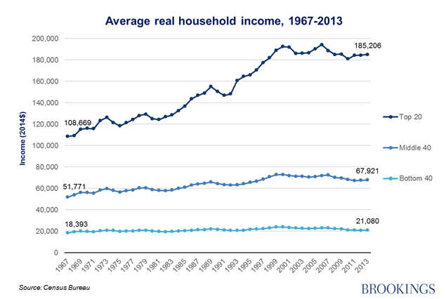
We are able to manipulate this data using the formula [(End. – Beg.) / Beg.], which allows us to deduce a total growth rate for the incomes of the upper, middle, and lower class. Following the given formula, we see overall growth for the upper class at an approximate rate of 70%, [(185,206 – 108,669) / 108,669]. For the middle class, the overall growth rate is roughly 31%, [(67,921 – 51,771) / 51,771]. Lastly, the approximate overall growth rate for the lower class is only 15%, [(21,080 – 18,393) / 18,393]. These data alone support the conclusion that there is an increasing gap between all of the classes, suggesting that there is not only inequality, but also it is increasing.
Another widely used metric for determining the extent of income inequality in a nation is the Gini coefficient. It applies various principles of economics and statistics to arrive at a measure that falls within the Gini Index. The Gini Index is on a scale of 0 to 1, with 0 indicating perfect equality, and 1 indicating perfect inequality (Gini Index 2016). As was previously noted, the United States had a Gini coefficient of 0.464 for 2014. For this number to add any value to our discussion, we must put it in context. In recent decades, there has been an upward trend in the Gini coefficient for the United States, implying that income inequality is increasing. This gives weight to the conclusion drawn from the calculations above that the income gaps are widening. Furthermore, the Organisation for Economic Co-operation and Development, commonly referred to as the OECD, publishes data concerning income inequality within its member countries. In its most recent publication, which used Gini coefficients for 2012, the U.S. was tied for second highest in terms of inequality among all of the other member nations.
It is now well established that there are distinguishable economic classes, an inequality among these groups exists, and that inequality is increasing. However, the overarching issues still remain unresolved. Will the rich inevitably get richer due to their ability to invest capital, while the poor continue to struggle to make ends meet? Is it the result of an unjust tax system that offers breaks to the wealthy at the expense of the poor? Or, does taxation provide a means to reign in the current state of inequality, correcting for years of disparity? These are the main issues and questions that will be addressed throughout the remainder of this work. A basic understanding of the expansion of American tax policy, and the theories driving that growth have been established. Details concerning the current state of income distribution in the United States and its equality, or lack there of, have also been presented. It is now appropriate to further examine the comingling of the two, beginning with a more in depth analysis of taxation as it relates to income classes.

- Taxation
The 16th Amendment gives the federal government the power to collect taxes from all sources of income, however Americans are also forced to pay taxes at the state and local level. For this reason, taxpayers face a variety of different types of taxes, but we will focus on two main forms that nearly everyone must deal with. First, and perhaps the most familiar, is the taxation of income. Individuals are required to report their earnings to the federal government each year to determine the amount of tax they may or may not be subject to pay. Some, but not all, states also levy an income tax. Residents of these states must comply with both the federal and state income tax laws. The second form of taxation that we will focus on is the sales tax. In general, sales taxes are primarily levied at the state and local level. It is important to understand that since states have autonomy in setting their own tax policy, individuals with identical activity for a given year might be subject to different amounts of taxes depending on their place of residence.
We will begin our analysis of taxation by taking a closer look at sales taxes, and the impact that they have on various levels of income. A sales tax is a tax on the purchase of goods. They are considered flat taxes, because the rate at which goods are taxed is the same for all individuals, regardless of their income. Sales taxes influence purchasing decisions for Americans, because they are essentially an added expense on top of the cost of the good. There is a large debate surrounding sales taxes, arguing that they are actually regressive by nature. Recall that a regressive tax is one in which lower income brackets pay a higher proportion. The basis for this argument is that there are certain necessities to life that all Americans must purchase regardless of their level of income - food, water, and shelter. For the lower income class, their entire income might be spent on these necessities. Given that a sales tax could be assessed on each of these, individuals in the lower income level would theoretically have an additional tax on all of their income. Members of the middle and upper classes, on the other hand, have incomes that exceed the cost of bare minimums of life. This means that a smaller portion of their income that is being impacted by the sales tax on these goods. The counter argument to this is that those with excess disposable incomes use it to purchase additional goods, which are subject to a sales tax. The sales tax on these additional purchases would make the proportions being taxed balance out, and therefore no regressive. Regardless of one’s opinion on the matter, the fact remains that sales taxes impact all levels of income, but the decision on what is being purchased varies. For the lower income levels, it could influence their ability to purchase the necessities of life whereas for the upper class, it could determine the size boat that they are able to afford.
Although sales taxes have stirred up recent debates, the most heated arguments converge on income taxes. For the scope of this work, we will examine income taxes in the context of federal income taxes. On a yearly basis, Congress sets the federal income tax brackets, and authorizes the Internal Revenue Service to oversee the implementation.

Included below are the anticipated 2016 tax brackets for the single taxpayer, as well as those married filing jointly.

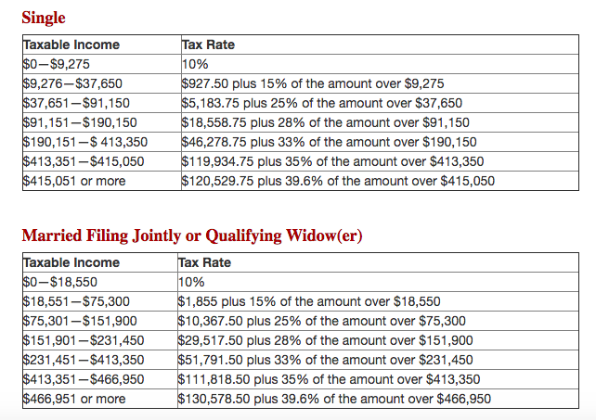

By nature, the income tax is a progressive form of taxation, as rates increase with higher levels of income. As is shown, the U.S. has seven different tax rates, each associated with ranges of income or brackets. These figures are considered marginal tax rates, because they provide the rates one must pay for each additional dollar earned. For example, if an individual filing single has an income of $200,000, they would fall in the 33% tax bracket. This however, does not mean that all of their income is taxed at a rate of 33%. Rather, portions of their income would be taxed at each of the preceding rates, arriving at a total tax of roughly $49,529 [((200,000 – 190,151) x .33) + 46,278.75]. The impact that this has on various levels of income is relatively straightforward. Following Adam Smith’s first maxim, as one’s income increases, so does the proportion they must contribute.
In addition to understanding the rates at which we are taxed, we must also understand what is being taxed, or equally important, what is not. Notice that the tax rates are associated with taxable income, rather than total income, indicating that there are portions of income that are not taxed – or at least not at the same rate. These amounts are often referred to as tax expenditures, not to be confused with actual expenses, but simply revenues that the federal government chooses not to collect. Tax expenditures include exclusions, exemptions, deductions, credits, preferential rates, and deferrals (Baneman, Rosenberg, Toder, Williams 2012). Individual taxable income is determined by reducing total income by all of the applicable expenditures listed above. This particular area of the American tax system stirs up a great deal of controversy among the public, primarily because it offers special treatment to different economic classes.
As we take a closer look at tax expenditures and how they impact the American people, we will begin by examining exclusions. Exclusions, as the term implies, are portions of income that are completely excluded from taxable income, and are therefore not taxed at all. The major exclusions are employer-paid health insurance benefits, portions of Social Security benefits, and interest from state and local municipal bonds, and foreign source income (Baneman, Rosenberg, Toder, Williams 2012). A basic understanding of each of these and the impact they have on an individuals tax liability would lead to the conclusion that these tend to favor those in higher income brackets. The majority of those receiving the benefit of excluding employer-paid health insurance benefits would be individuals with decent, salaried jobs, simply because there is generally not healthcare coverage for hourly, minimum wage employees. This would favor our definition of middle and upper class households. Also, for a taxpayer to receive any benefit from excluding interest received from municipal bonds, they would need excess capital that would allow them to invest in these securities. Lower and middle-income families do not typically have this luxury, as all of their earnings are being put towards bills and living expenses. It is the upper class that would receive the true benefit of this exclusion. As one study by the Tax Policy Center points out, “about two-thirds of the tax savings from exclusions benefit tax units in the top quintile, largely because they face higher tax rates” (Baneman, Rosenberg, Toder, Williams 2012). This makes sense, because individuals in the top income bracket save nearly $0.40 for every $1.00 of exclusions, whereas individuals in the bottom income bracket would only save $0.10 for every $1.00 they were able to exclude. Therefore, it seems that this aspect of taxation offers the greatest benefit to the upper economic class, with the middle class receiving slight benefits and the lower class receiving little to no benefits.
Exemptions are another aspect of the American tax system, in which not all levels of economic income receive the same treatment. The two types of exemptions that we will focus on are personal and dependency exemptions. These are available to nearly every taxpayer who is not claimed as a dependent, and reduce an individual’s taxable income by standard amounts. For 2015, the set amount for personal and dependency exemptions was $4,000. The amount of tax savings that this makes available to an individual is dependent upon their tax bracket, but similar to exclusions, those with higher incomes will be able to save more due to their higher rates. However, Congress has placed a phase-out on this, precluding the very wealthy households from taking advantage of this benefit. In 2015, the phase-out began when incomes exceeding $258,250 for single filers, or $309,000 for married filing jointly (Personal and Dependent Exemptions 2016). If you recall that households in the 95th percentile had incomes of $206,600, then this phase-out is really only impacting a small percentage of the extremely wealthy. In practicality, the lost potential maximum tax savings of $1,584 is relatively miniscule to these taxpayers. Overall, exemptions provide equal treatment, but slightly different benefits to all levels of income, with the exception of a very small percentage of the truly elite.
Tax deductions, another type of tax expenditure, are a common aspect of nearly every individual tax return, but the overall impact they can have in shaping the final tax liability can vary greatly depending on one’s level of income. Tax deductions are similar to exemptions in their ability to decrease taxable income. Taxpayers have the option to elect to use the standard deduction, available to all, or itemize their deductions. Common sense allows this decision to be made on the basis of which option will offer the larger amount of tax savings. The standard deduction amount for 2015 was $6,300 for a single tax payer or $12,600 for those married filing jointly.
Unlike standard deductions, itemized deductions are not set amounts, and are dependent upon the taxpayer’s activities during the fiscal year. Allowed itemized deductions include, but are not limited to, taxes paid, interest paid, gifts to charity, job related expenses, medical and dental expenses, and interest expenses (IRS Pub. 17). There are limits on some of these items for wealthy taxpayers whose incomes exceed the same limits used for exclusions. By examining each of the potential itemized deductions individually, it becomes apparent that these would tend to favor the upper class. Everyday Americans in the lower and middle-income levels are generally not participating in these financial activities, or if they are, it is often not enough to justify itemizing over taking the standard deduction. This makes sense, because it is usually upper class households that have an excess of income that allows them to donate large amounts to charity, or afford higher interest expenses and property taxes. It comes as no surprise then, that in 2011, “more than 80 percent of the tax savings from itemized deductions accrued to taxpayers in the top income quintile (our defined upper class), and 13 percent went to those in the top 0.1 percent” (Baneman, Rosenberg, Toder, Williams 2012). Furthermore, 80 percent of those in the upper income level elected to itemize their deductions, while only 16 percent of households in the middle and lower economic class decided to do so. Deductions attempt to provide some relief to all taxpayers, but itemized deductions clearly provide a larger benefit, in terms of tax savings, to the upper economic class.
Tax credits are unique in comparison to other tax expenditures, because instead of lower taxable income, they directly decrease the tax liability. This means that taxpayers using the same credits will receive the same amount of tax savings, regardless of which income bracket they are in. Another unique aspect of tax credits that differentiates them, is that they are the only tax expenditure that seems to provide more benefit or tax relief to the lower and middle levels of income than the upper income class. To understand this, we must examine the different types of tax credits that are available to the American people. There are two distinguishable groups of tax credits, and they can be classified as non-refundable or refundable. Non-refundable tax credits can only go so far as to eliminate an individual’s tax liability, meaning they do not owe any taxes. Refundable tax credits, as the name implies, have the potential to not only eliminate a tax liability, but any unused excess amount is actually refunded as a payment to the taxpayer from the government. There is a plethora of tax credits, each with their own criteria for determining which individuals qualify for them. The child credit, the earned income tax credit, and the American Opportunity tax credit are a few examples of refundable tax credits (Baneman, Rosenberg, Toder, Williams 2012). These are aimed to provide additional assistance in monetary form, to households that truly need it. There are phase-outs for each of these refundable credits, preventing only households in the very top percentiles from taking advantage of this, with the exception of the earned income tax credit, which phases out at a much lower income threshold. For this reason, more than “two-thirds of non-refundable credits and more than 90 percent of refundable ones went to households in the four bottom quintiles in 2011” (Baneman, Rosenberg, Toder, Williams 2012). It is therefore fair to conclude, that this aspect of the American tax system impacts the lower and middle classes more favorably, with the upper levels of income receiving little to no benefit.
The last tax expenditure we will discuss is the preferential treatment of capital gains and dividends. With regards to taxes, preferential treatment means that they are taxed at lower rates than they would be if they were considered ordinary income. So instead of following the rates associated with the income tax brackets, capital gains and dividends are taxed at zero percent for the bottom two brackets, 15 percent for the middle brackets, and 20 percent for the top bracket (The Tax Breakdown 2013). Taxpayers with incomes exceeding $200,000 for those filing single, or $250,000 for those married filing jointly, are susceptible to an additional 3.8 percent tax. So, the preferential rates follow the same progressive structure as the regular tax rates, taxing higher income levels at higher rates. Despite this progressive nature, households in the upper income class receive most of the benefits. Below is a graph that depicts this disparity.
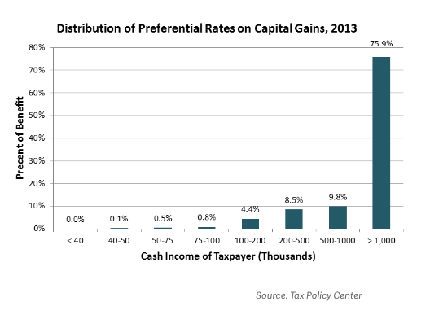
As another study done by the Tax Policy Center points out, “96 percent of the tax savings from preferential tax rates on long-term capital gains and qualified dividends went to people in the top income quintile in 2011, 75 percent to the top 1 percent, and 55 percent to the top tenth of 1 percent” (Baneman, Rosenberg, Toder, Williams 2012). This is an area where it is appropriate to distinguish separate subgroups of the upper income class. Clearly, there is a range of incomes in the top quintile that are only receiving a marginal percentage of the benefit from this. However, there is another group in that same economic class, the truly economic elite one percent, that is receiving the large majority of the benefits. Why would the tax system offer a tax benefit whose primary beneficiaries are households that already have a surplus of wealth? Congress allows for this preferential treatment to encourage individuals with excess capital to reinvest it in the economy, which in theory should help stimulate and grow the economy. The effectiveness of this is often disputed among politicians, and a definitive analysis on the matter is beyond the scope of this work. However, it is worth recognizing, to help understand the impact that this has on various levels of income. It obviously offers a significant amount of tax savings to the elites among the upper income class, with an attempt to indirectly impact the lower and middle-income classes.

- Summary
By now, hopefully it has become apparent that not all taxes or tax policies are created equally. Generally speaking, there are inevitably winners and losers, but perhaps there are some income groups that win or lose more than others. We know that in an attempt to be equitable, the government forces those with higher incomes to not only pay larger amounts, but also larger proportions of their income due to higher rates. There is also a general trend that the upper income class tends to receive more tax benefits from tax expenditures than the lower and middle-income classes combined. The graphs from the Tax Policy Center, which are shown below, support this conclusion (Baneman, Rosenberg, Toder, Williams 2012).
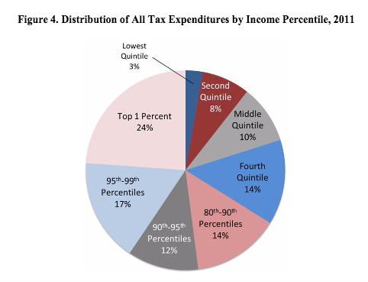
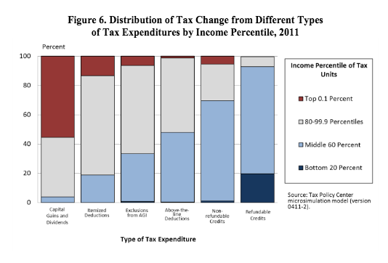
Without question, the upper class dominates in terms of benefits received from tax expenditures, followed by the middle and lower class respectively. However, statistics without perspective can often lead to misguided conclusions or interpretations. By the definitions set forth in this work, the upper class received 67 percent of the benefits from the tax expenditures in 2011. However, if you recall the distribution of income discussed earlier, the upper class also accounted for half of all the income earned during 2014. That, in combination with the higher tax rates these households face - which generally leads to more tax savings – could explain the disproportion of benefits received. Furthermore, in 2011 those in the upper income level contributed more than 70 percent of all the taxes collected. That being said, it seems that the proportions of taxes paid and tax savings are fairly similar. The fairness of this is largely subjective and open to the reader’s interpretation, but it does not appear that the tax system is outright lopsided to favor any income class.
Taxation in modern America certainly impacts various levels of income in different ways. For the lower class, Congress offers the standard deduction and a number of tax credits that help alleviate the tax burden for these individuals, and can actually act as a type of additional aid in some circumstances. While this lower level income class is not receiving a large portion of total earnings or tax savings, they are contributing an even smaller proportion of the total taxes collected. The impact that taxes have on the middle class is relatively similar to those in the lower class, however it would be less likely for households in the middle-income level to receive refunds from tax credits. Again, Congress offers a number of means for reducing their overall tax liability, but it is still likely that they are forced to contribute some of their income. For disclosure purposes, it is also worth noting that this work only focused on the levying and collecting of taxes, ignoring the ways in which the government spends those tax dollars. The lower and middle-income classes certainly receive additional benefits from government funded social and welfare programs. Lastly, it is the upper class that carries the majority of the tax burden, and as a result, they also receive the benefits in the form of tax savings.
Taxes are significant in that they reduce the purchasing power of all taxpayers, by decreasing their amount of disposable income. For the lower class, this could influence decisions concerning the amount of rent that a family could afford, or their monthly budget for groceries. For a middle class household, taxes might not impact decisions regarding the necessities of life, but could be the deciding factor in whether or not they can move out of an apartment and into a house, or afford a family vacation. The upper class households have the luxury of overlooking the impact taxes may have on their well-being, but they are definitely factored into large investment decisions, and have the potential to drastically shape the outcome of that decision.

- Final Thoughts: Taxes as a Means to an End
The majority of this work has been focused on the direct impact taxation has on the various economic classes throughout the United States, largely ignoring the indirect impact of macroeconomics. This is because there are so many variables to account for when calculating the economical impact a tax policy might have, that it is beyond the scope of this work and will be left to expert economists. However, we do find it appropriate to briefly present some of the common economic theories pertaining to income inequality and taxation that are circulating today. The notion that perhaps taxes were partly responsible for the income gap, or that they might be a means for resolving it have been hinted at throughout our discussion. There is a well-established precedent that the government has the power to influence and shape behavior through tax policy, but can that power go so far as to lessen or eliminate the income disparity?
The answer to that question depends on whom you ask, and whether they give more weight to supply side or demand side economics. Some ascribe to the idea that lower taxes on the rich is actually beneficial to the lower class, believing that their additional capital, as a result of lower taxes, will be reinvested to create jobs and stimulate growth. This theory is often referred to as trickle down economics, because it assumes that the wealth accumulated at the top will “trickle down” to the lower classes. On the other side of the aisle, there advocates arguing that the government should take a more active role in resolving the disproportionate distribution of income. Proponents of this notion generally believe that the upper class should be forced to contribute more of their income through taxes, so that this can be redistributed to the lower class in various forms. That being said, America is nowhere near becoming a communistic state, where all wealth is controlled and redistributed by the government. However, the fact that the self defined “democratic socialist” views of Bernie Sanders received such widespread support during his presidential campaign, suggests that the values and theories of American society might be taking an interesting shift. For now, this work and all other literature on the subject are limited to merely reporting, hypothesizing, and educating. The American populous will ultimately determine the course of action that the United States takes on the matter, as they cast their votes at the election polls.

Appendix A

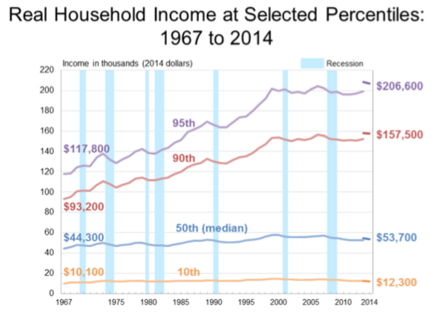

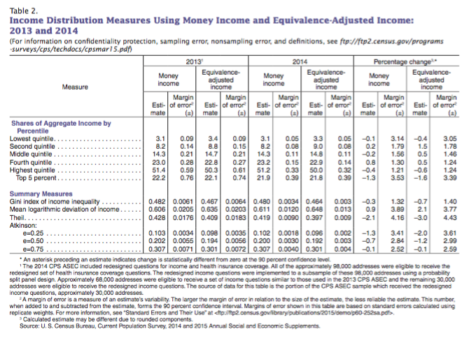

Works Cited

"America’s Shrinking Middle Class: A Close Look at Changes Within Metropolitan Areas." Pew Research Centers Social Demographic Trends Project RSS. N.p., 11 May 2016. Web. 18 June 2016.

Baneman, D., J. Rosenberg, E. Toder, and R. Williams. "Curbing Tax Expenditures." Tax Policy Center. Urban-Brookings Tax Policy Center, 30 Jan. 2012. Web. 12 June 2016.

DeNavas-Walt, C., and B. Proctor. "Income and Poverty in the United States: 2014." Income and Poverty in the United States: 2014. N.p., Sept. 2015. Web. 16 June 2016.

Fact Sheet. N.p.: Wolters Kluwer, CCH, 2013. PDF.

Gale, W., and A. Samwick. "Effects of Income Tax Changes on Economic Growth." The Brookings Institution. N.p., Feb. 2016. Web. 16 Apr. 2016.

"Gini Index." Gini Index. N.p., 25 Jan. 2016. Web. 16 June 2016.

Hassett, Kevin A., and R. Glenn. Hubbard. Inequality and Tax Policy. Washington, D.C.: AEI, 2001. Print.

Hederman, Rea. "Census Report Adds New Twist to Income Inequality Data." The Heritage Foundation. N.p., n.d. Web. 16 June 2016.

"Income." Income. United States Census Bureau, n.d. Web. 28 June 2016.

"Inequality - Income Inequality - OECD Data." The OECD. Organisation for Economic Co-operation and Development, n.d. Web. 16 June 2016.

Minarik, Joseph J. Making Tax Choices. Washington, D.C.: Urban Institute, 1985. Print.

"Personal and Dependent Exemptions." US Tax Center. N.p., n.d. Web. 20 June 2016.

Pomerleau, K. "Summary of Latest Federal Income Tax Data." Tax Foundation. N.p., 18 Dec. 2013. Web. 22 June 2016.

"Projected U.S. Tax Rates for 2016." US Tax Center. N.p., n.d. Web. 20 June 2016.

"Real Household Income at Selected Percentiles: 1967 to 2014." Real Household Income at Selected Percentiles: 1967 to 2014. United States Census Bureau, 16 Sept. 2015. Web. 15 June 2016.

Reeves, Richard. "The Dangerous Separation of the American Upper Middle Class." The Brookings Institution. N.p., 03 Sept. 2015. Web. 21 June 2016.

Slemrod, Joel. Does Atlas Shrug?: The Economic Consequences of Taxing the Rich. New York: Russell Sage Foundation, 2000. Print.

Smith, Adam, and C. J. Bullock. The Wealth of Nations. New York: Barnes & Noble, 2004. Print.

Smith, Samantha. "6 Key Takeaways about How Americans View Their Government." Pew Research Center RSS. N.p., 23 Nov. 2015. Web. 21 June 2016.

"The Tax Break-Down: Preferential Rates on Capital Gains." Committee for a Responsible Federal Budget. N.p., 27 Aug. 2013. Web. 22 June 2016.

US Constitution. Amend. XVI. Web.

U.S. Department of Treasury, Internal Revenue Service. Exemptions, Standard Deduction, and Filing Information. IRS Pub. 501. Washington: GPO, 2015.

US Department of Treasury, Internal Revenue Service. The Complexity of the Tax Code. Vol. 1. N.p.: Taxpayer Advocate Service, n.d. Print. 2008 Annual Report to Congress.

U.S. Department of Treasury, Internal Revenue Service. Your Federal Income Tax. IRS Pub. 17. Washington: GPO, 2015.

"U.S. Income Distribution: Just How Unequal? | Inequality.org." Inequality.org. N.p., 14 Feb. 2012. Web. 16 June 2016.

Source: "Real Household Income at Selected Percentiles: 1967 to 2014." Real Household Income at Selected Percentiles: 1967 to 2014. United States Census Bureau, 16 Sept. 2015. Web. 15 June 2016.
We recognize that this is a simplified formula, but nonetheless believe it provides a reasonable approximation for the purposes of this study.
Source: "Projected U.S. Tax Rates for 2016." US Tax Center. N.p., n.d. Web. 20 June 2016.
Source: "The Tax Break-Down: Preferential Rates on Capital Gains." Committee for a Responsible Federal Budget. N.p., 27 Aug. 2013. Web. 22 June 2016.
Source: Baneman, D., J. Rosenberg, E. Toder, and R. Williams. "Curbing Tax Expenditures." Tax Policy Center. Urban-Brookings Tax Policy Center, 30 Jan. 2012. Web. 12 June 2016.
Source: Baneman, D., J. Rosenberg, E. Toder, and R. Williams. "Curbing Tax Expenditures." Tax Policy Center. Urban-Brookings Tax Policy Center, 30 Jan. 2012. Web. 12 June 2016.
Source: "Real Household Income at Selected Percentiles: 1967 to 2014." Real Household Income at Selected Percentiles: 1967 to 2014. United States Census Bureau, 16 Sept. 2015. Web. 15 June 2016
Source: "Income." Income. United States Census Bureau, n.d. Web. 16 June 2016.

