Transit Equity: Analyzing Transit Supply to Access Opportunities and Services for Potential Transit Demand

A Dissertation Presented for the

Doctor of Philosophy

Degree

The University of Tennessee, Knoxville

Jing Guo

December 2023

DEDICATION

Even though this page is optional
I dedicate my work to you.

ACKNOWLEDGEMENTS

Thank you all for your help. However, this page is optional.

ABSTRACT

Evaluating transit equity and improving transit access is an important consideration in transit planning for transit providers. Providing transit services to access opportunities and essential services is critical for promoting health and enhancing the overall quality of life, particularly for populations residing in low income communities and those lacking personal vehicles, as they are most likely to rely on transit for their transportation needs. Therefore, this dissertation evaluates transit equity by analyzing transit supply to access different opportunities and services for various potential transit demand population groups.
The dissertation focuses on the following aspects of transit equity evaluation.
The dissertation has the following key findings.

Key words: Transit accessibility, transit equity, transit-dependent demand, affordable housing, transit deserts, demand response transit

TABLE OF CONTENTS

CHAPTER 1. Introduction 11
1.1 Problem Statement 12
1.2 Research objectives 15
1.3 Dissertation structure 15
CHAPTER 2. Evaluating transit accessibility and equity for affordable housing units 16
Abstract 17
2.1 Introduction 18
2.2 Literature review 19
2.2.1 Transit accessibility 19
2.2.2 Transit equity of affordable housing 22
2.3 Objectives 24
2.4 Background and case studies 24
2.4.1 Background on affordable housing 24
2.4.2 Background on the case studies 25
2.5 Data 26
2.5.1 Origins data (Affordable housing locations) 26
2.5.2 Destination data (Jobs locations) 26
2.5.3 Transit network 28
2.5.4 Geographic layer for measuring citywide transit accessibility 28
2.6 Methodology 28
2.6.1 Step 1: Measure transit accessibility 30
2.6.2 Step 2a: Evaluate transit equity of affordable housing programs at the city level 32
2.6.3 Step 2b: Evaluate transit equity of specific affordable housing locations within the city 34
2.6.4 Step 3: Propose transit service modifications for affordable housing locations with a high inequity index 34
2.7 Case studies and results 35
2.7.1 Results of Step 1: transit accessibility results 35
2.7.2 Results of Step 2a: Lorenz curves and Gini coefficients 38
2.7.3 Results of Step 2b: identify affordable housing locations with inequitable transit accessibility 42
2.7.4 Results of Step 3: Propose and evaluate transit service modifications for existing affordable housing locations with a high inequity index 46
2.8 Discussion and conclusions 48
2.9 Limitations and future research 51
CHAPTER 3. Evaluating spatiotemporal transit accessibility and transit equity of essential services 54
Abstract 55
3.1 Introduction 55
3.2 Literature review 57
3.2.1 Transit accessibility to essential services 57
3.2.2 Transit equity 60
3.3 Study area and data 62
3.3.1 Study area 62
3.3.2 Data 63
3.4 Methodology 65
3.4.1 Research questions and conceptual framework 65
3.4.2 Step 1: Measure spatiotemporal transit supply index 67
3.4.3 Step 2: Measure transit-dependent demand index 71
3.4.4 Step 3: Quantify spatial transit inequity using the Theil index 72
3.4.5 Step 4: Identify essential service deserts using the bivariate local indicator of spatial association (bi-LISA) 73
3.4.6 Step 5: Correlation analysis and Co-location maps of essential service deserts 75
3.5 Results 75
3.5.1 Transit supply index 77
3.5.2 Transit demand index 79
3.5.3 Spatial transit inequity using the Theil index 79
3.5.4 Spatial correlation between transit-dependent demand and transit supply and identification of essential service deserts 83
3.5.5 Correlation Analysis and Co-location Maps of essential service deserts 87
3.6 Discussion and conclusions 89
3.7 Limitations and future research 92
CHAPTER 4. Evaluating equity of Demand Response Transit in rural areas: analyzing accessibility for various trip purposes and across various age groups, disability statuses, and genders 93
Abstract 94
Chapter 5. CONCLUSION 95
Heading 2 95
REFERENCES 96
APPENDIX 105
VITA 107

LIST OF TABLES

Table 1 Results of transit accessibility and Gini coefficient 39
Table 2 Transit equity hypothesis test within 99% confidence interval 41
Table 3 Affordable housing locations with top five inequity index in three cities 42
Table 4 Data sources and data descriptions 64
Table 5 Example of two binary variables 76
Table 6 Theil index, $TBG$ and $TWG$ of relative transit supply to access essential services for population subgroups with different combined transit-dependent demand index 80

LIST OF FIGURES

Figure 1 Maps of the three study areas (Nashville, Memphis, Chattanooga) showing the transit networks, locations of affordable housing, and the total number of housing units in each census block 27
Figure 2 Conceptual framework of the methodology 29
Figure 3 Configuration for transit accessibility calculation 31
Figure 4 Example of Lorenz curves of transit accessibility distribution among a population 33
Figure 5 Transit accessibility and affordable housing locations in three cities 37
Figure 6 Transit accessibility Lorenz curves by type of affordable housing programs in three cities 40
Figure 7 Top five affordable housing locations with limited transit access in three cities 45
Figure 8 Satellite view of Wesley Highland Meadows and the surrounding road network and transit network 47
Figure 9 Overlapping isochrones before and after modifying the frequency of MATA transit route 40 for Wesley Highland Meadows 47
Figure 10 Conceptual Framework 66
Figure 11 Scatter plots and box plots of transit accessibility and time variation 69
Figure 12 Proposed weights for the estimation of spatiotemporal transit supply to access essential services 69
Figure 13 Distribution of the transit supply index to the five essential service categories in Nashville 78
Figure 14 Distribution of the transit-dependent demand index in Nashville 80
Figure 15 Bi-LISA cluster maps for different combinations of transit supply categories and transit-dependent demand groups 85
Figure 16 Bar plot of summary of bi-LISA clusters 86
Figure 17 Tetrachoric correlation matric for different types of essential service deserts 88
Figure 18 Co-location maps of (a) food deserts, healthcare deserts, school deserts, childcare deserts, and park deserts; (b) food deserts, healthcare deserts, school deserts, and childcare deserts (excluding parks) 88

CHAPTER 1.
Introduction

1.1 Problem Statement
There is a growing body of research investigating transit accessibility, which refers to the capacity of individuals to reach various destinations through public transportation (El-Geneidy et al., 2016b; Owen & Murphy, 2020a; Stewart, 2017; Welch, 2013; Yan et al., 2022). Providing transit services to access opportunities and essential services is critical for promoting health and enhancing overall quality of life, particularly for populations that rely on transit for their transportation needs (Brondeel et al., 2014; Jin et al., 2022; Mao & Nekorchuk, 2013; Martens et al., 2019; National Academies of Sciences Engineering and Medicine, 2022b; Taylor & Morris, 2014; USDA, 2023; Walker et al., 2010; Wood & Horner, 2016; Zhang & Mao, 2019; Zhang et al., 2022). The assessment of transit equity, which examines the geographical distribution of transit services and the provision of transit services to populations with the highest transit needs, has recently gained attention in the transit literature (Aman & Smith-Colin, 2020) and has emerged as an important aspect of the discourse on Environmental Justice for low-income and minority populations (FTA, 2012). Despite the growing body of research on transit accessibility and transit equity, there are still significant gaps that need additional attention and further investigation.
First, limited research has considered the transit accessibility of affordable housing units. In the U.S., some supply-side affordable housing programs are administered by the federal government, such as Low Income Housing Tax Credits (LIHTC), subsidized Multifamily Housing properties, and public housing. The overall purpose of such housing programs is to make rent more affordable for low income households. However, affordable housing units are sometimes planned without consideration of transit accessibility as an evaluation criterion, which is partly due to the absence of federal requirements for planning affordable housing as well as the lack of coordination of housing authorities with transit agencies (National Academies of Sciences Engineering and Medicine, 2022b). Furthermore, a recent study from the Transit Cooperative Research Program (TCRP) concluded that many transit agencies often do not specifically prioritize serving neighborhoods with high levels of affordable housing in their transit planning process (Chapple & Loukaitou-Sideris, 2019; National Academies of Sciences Engineering and Medicine, 2022b). Prior studies suggest that there is a need to develop systematic practical guidance and effective approaches that can be implemented by transit agencies and housing authorities to promote the coordination of transit services with affordable housing (Chapple & Loukaitou-Sideris, 2019; National Academies of Sciences Engineering and Medicine, 2022b). However, housing construction, especially large apartment complexes and fixed rail transit (such as subway and light rail) are durable and permanent infrastructure investments; bus routes are considerably more adaptable and can be (relatively) easily modified to improve transit accessibility. Therefore, modifications to local bus routes that can be implemented in the short-term (e.g., within a few weeks or within a few months) provide an important first step to potentially increase transit accessibility for existing affordable housing residents in underserved areas. Accordingly, systematically methods need to be developed to compare the transit equity of existing affordable housing units and to evaluate potential short-term bus service modifications that could increase transit access levels.
Second, spatial inequity in transit accessibility across diverse essential service types and potential spatial correlations in service deserts have received limited attention. The most extensively researched topic in transit accessibility studies is transit accessibility to jobs (Hess, 2005; Karner, 2018; Kawabata & Shen, 2006; Yan et al., 2022). However, the critical role of accessibility to essential services to improve the quality of life of individuals and evaluate the operational efficiency of transit systems has received less attention in the literature. Some travelers use transit to get to other essential services, such as food stores, healthcare facilities, schools, childcare services, green spaces, etc. Accessibility to these other essential services that meet the needs of people, especially minority populations and low-income people who rely on transit and people with limited access to personal vehicles, is a key consideration for transit planners and stakeholders and is an important evaluation of the level of transit equity. Hence, to identify essential service deserts characterized by low transit supply and high transit-dependent demand, the transit equity of spatiotemporal transit supply to access different essential services for different transit-dependent demand populations needs to be evaluated.
Last, Demand Response Transit (DRT) services play a crucial part in supporting rural transportation, especially for individuals without private vehicle access. However, numerous research has primarily concentrated on assessing the accessibility of fixed-bus routes within densely populated urban areas. The limited exploration of DRT in research literature can be partly attributed to the unavailability of standard data comparable to the General Transit Feed Specification (GTFS) in fixed-route transit (Transit, 2023). Consequently, the evaluation of accessibility and equity pertaining to DRT has been an inadequately explored domain. Therefore, it is critical to comprehensively explore the travel behavior of DRT users from the actual DRT trip data to understand the transit accessibility and transit equity in rural areas.

1.2 Research objectives
The overarching objective of the proposed doctoral study is to evaluate the transit equity for potential transit demand populations who are dependent on transit for their transportation needs. The specific objectives are as follows:
- Evaluate transit equity to jobs for affordable housing units
- Evaluate transit equity to essential services for transit-dependent demand populations
- Evaluate transit equity in rural areas by analyzing Demand Response Transit (DRT) trip data

1.3 Dissertation structure
This dissertation is structured in a multi-chapter format. This work is divided into five chapters, as follows:
- Chapter 1 defines the problem, research objectives, and outline of this study.
- Chapter 2 describes the method for analyzing transit access to jobs and evaluating the short-term transit modification for affordable housing units.
- Chapter 3 describes the spatiotemporal transit access to multiple essential services for transit-dependent demand and the identification of transit deserts.
- Chapter 4 describes the accessibility of DRT for various trip purposes and the equity among DRT users across various age groups, disability statuses, and genders.
- Chapter 5 concludes the findings and limitations of this work and provides recommendations for future research.

CHAPTER 2.
Evaluating transit accessibility and equity for affordable housing units

A version of this chapter was originally published by Jing Guo, Candace Brakewood, Ashley Hightower, and Christopher Cherry: "Evaluating Equity: A Method for Analyzing the Transit Accessibility of Affordable Housing Units." Transportation Research Record (2023). The paper was presented at the Transportation Research Board 102nd Annual Meeting 2023 in Washington, D.C. This research paper also received first place in the 2023 Annual Technical Paper Competition, Southern District Institute of Transportation Engineers, and second place in the 2023 Annual Student Paper Competition, Tennessee Section Institute of Transportation Engineers.

Abstract

Improving transit access for people in low income communities is an important consideration for transit providers. However, limited research has considered the transit accessibility of affordable housing units. This paper aims to develop a method to evaluate transit equity of existing affordable housing units and propose easy-to-implement modifications to local bus service to increase transit accessibility levels (assuming housing locations do not change in the short term). The proposed method has three steps, and it is applied to three Tennessee cities with primarily bus-based transit systems. The first step measures transit accessibility of specific affordable housing locations and citywide transit accessibility levels using a web-based platform built on open-source software. The second step evaluates the transit equity of affordable housing programs at the city level using Lorenz curves and Gini coefficients and evaluates the transit equity of specific affordable housing locations by proposing a simple inequity index. The results reveal that the level of transit equity for affordable housing units differs across housing programs and cities. In the third step, an example of a bus service modification is evaluated for one affordable housing location with a high inequity index to demonstrate the applicability of the method. The substantial increase in accessible jobs after modification, from 135 to 6,400, highlights the potential effectiveness of implementing short-term transit service changes to improve the accessibility of existing affordable housing locations. This three-step method primarily relies on open datasets that are also available for other regions of the United States.

2.1 Introduction

Prior research suggests that low income people who cannot afford a personal vehicle rely on public transit for their transportation needs (Martens et al., 2019; National Academies of Sciences Engineering and Medicine, 2022b; Taylor & Morris, 2014). Many American cities are automobile-oriented, which presents significant mobility challenges to those who cannot drive or do not want to drive. Transit authorities in the United States play a critical role providing essential mobility services to these often disadvantaged populations.
Along with transportation, housing expenses contribute to a significant financial burden on households, particularly those with low incomes. According to the consumer expenditures from the U.S. Bureau of Labor Statistics, housing and transportation are the two primary expense categories for U.S. households (U.S. Bureau of Labor Statistics, 2021). However, some studies suggest that transit services tend to be more frequent and widespread in dense, downtown areas (Kawabata & Shen, 2006) where housing prices are normally higher (Cervero, 2004; Immergluck, 2009). Some low income households who cannot afford high housing prices and private cars are often compelled to make trade-offs between housing and transportation costs. Therefore, the concept of affordable-accessible housing, which is inexpensive housing in walkable urban neighborhoods, has been proposed to try to improve transit equity among low income households (Litman, 2022).
In the U.S., some supply-side affordable housing programs are administered by the federal government, such as Low Income Housing Tax Credits (LIHTC), subsidized Multifamily Housing properties, and public housing. The overall purpose of such housing programs is to make rent more affordable for low income households. However, affordable housing units are sometimes planned without consideration of transit accessibility as an evaluation criterion, which is partly due to the absence of federal requirements for planning affordable housing as well as the lack of coordination of housing authorities with transit agencies (National Academies of Sciences Engineering and Medicine, 2022b). Furthermore, a recent study from the Transit Cooperative Research Program (TCRP) concluded that many transit agencies often do not specifically prioritize serving neighborhoods with high levels of affordable housing in their transit planning process (Chapple & Loukaitou-Sideris, 2019; National Academies of Sciences Engineering and Medicine, 2022b).
Prior studies suggest that there is a need to develop systematic practical guidance and effective approaches that can be implemented by transit agencies and housing authorities to promote the coordination of transit services with affordable housing (Chapple & Loukaitou-Sideris, 2019; National Academies of Sciences Engineering and Medicine, 2022b). However, housing construction, especially large apartment complexes and fixed rail transit (such as subway and light rail) are durable and permanent infrastructure investments; bus routes are considerably more adaptable and can be (relatively) easily modified to improve transit accessibility. Therefore, modifications to local bus routes that can be implemented in the short-term (e.g., within a few weeks or within a few months) provide an important first step to potentially increase transit accessibility for existing affordable housing residents in underserved areas.
By quantifying transit accessibility among existing affordable housing units, this research contributes to the literature in two important ways. First, this paper proposes a three-step method to systematically compare the transit equity of existing affordable housing units and to evaluate potential short-term bus service modifications that could increase transit access levels. Second, this three-step method primarily relies on open datasets, specifically General Transit Feed Specification (GTFS) data and affordable housing locations from the U.S. Department of Housing and Urban Development (HUD), which makes this method widely applicable to other regions of the U.S. with fixed route transit service.

2.2 Literature review
The following sections briefly review relevant literature pertaining to transit accessibility and transit equity.

2.2.1 Transit accessibility
Transit accessibility refers to one’s ability to reach opportunities via transit (Manout et al., 2018). A growing number of studies published in the last decade have focused specifically on transit accessibility (El-Geneidy et al., 2016b; Owen & Murphy, 2020b; Stewart, 2017; Welch, 2013). The following section reviews previous research on transit accessibility from the perspective of measurement methods and factors that contribute to calculation accuracy.

2.2.1.1 Transit accessibility measures
Transit accessibility measures can generally be grouped into two categories: opportunity-based measures (also known as primal measures) and time-or cost-based measures (also known as dual measures) (Cui & Levinson, 2020b). Opportunity-based measures are the most commonly used method in previous research (Levinson & King, 2020). Opportunity-based measures require a pre-assumed cutoff travel time that has no standard value under different scenarios (Levinson & King, 2020). Hence, previous research employing opportunity-based measures was often conducted in situations where individuals have multiple options, such as job opportunities (Cui & Levinson, 2020b; Zuo et al., 2020). Commonly used opportunity-based measures include the cumulative opportunity measure, the weighted cumulative opportunity measure, and the competitive access measure; each of these measures is briefly described in the following paragraphs.
The cumulative opportunity measure is the most popular of the opportunity-denominated measures in previous research (El-Geneidy & Levinson, 2006; Owen & Murphy, 2020b). A cumulative opportunities metric measures the number of opportunities - such as jobs - that one can reach within a given period of time (e.g., 60 minutes) via transit service. The cumulative opportunity measure has been used in many previous studies due to its minimal data requirements, ease of comprehension, and consistent interpretation across different times and locations, which enables greater comparison, tracking, and benchmarking (Levinson & King, 2020). For example, one recent study of the San Francisco Bay Area, California applied the cumulative opportunity measure in a transit accessibility analysis that calculated the total number of jobs accessible within 40 minutes of transit travel time during AM peak hours (7-10 am) (Blanchard & Waddell, 2017).
The weighted cumulative opportunity measure (also known as the gravity-type measure) is converted from the cumulative opportunity measure by adding weights to all the opportunities by a specific impedance function (e.g., distance decay functions, time decay functions, or cost decay functions), making opportunities with higher impedances from a certain location less attractive (El-Geneidy & Levinson, 2022; Levinson & King, 2020). For example, one relevant study conducted in Detroit calculated transit accessibility to jobs by using an impedance function of travel cost (Grengs, 2010). Although the weighted cumulative opportunity measure can better describe human behavior, it is more challenging to interpret than the cumulative opportunity measure since the impedance formula can vary from time to time and from location to location (Levinson & King, 2020; Palacios & El-geneidy, 2022).
The competitive access measure is another opportunity-based measure that considers the competition among travelers and opportunities (Levinson & King, 2020). As an example of a related study of the Boston area, Shen proposed the competitive access measure model that included competition at workplace locations to measure the employment accessibility of low-wage workers (Shen, 1998). The competitive access measure has been widely used in research on measuring transit accessibility (Allen & Farber, 2020; Kawabata & Shen, 2007; Merlin & Hu, 2017). However, compared to the cumulative opportunity measure, the competitive access measure requires more computation and may be more difficult to apply and understand in real-world practice (Levinson & King, 2020).
In contrast to the previous approach of calculating the number of opportunities that can be reached within a given time threshold, time- or cost-based measures calculate travel time or cost to achieve a fixed number of opportunities. Depending on the preset number of opportunities, this approach can be further divided into time- or cost-based measures for a single opportunity and time- or cost-based measures for multiple opportunities. For the single-opportunity measure, the number of opportunities is 1, while for the multiple-opportunities measure, that threshold is 2 or more. This measure is often used when the time or cost to access the opportunity is more important than the number of opportunities accessible (Cui & Levinson, 2020b). As an example, Farber et al. (Farber et al., 2014) measured accessibility to food stores in Cincinnati by calculating the travel time from each census block to the nearest one supermarket and the closest three supermarkets. Similar approaches have been successfully applied in measuring the accessibility of other essential services, such as one recent study of healthcare accessibility in Florida (Ghorbanzadeh et al., 2020). Time-or cost-based measures provide a straightforward way to compare transit accessibility levels between different locations and cities. They may also be more easily understandable to the public because measuring access in minutes provides an easy-to-interpret scale (Levinson & King, 2020). However, without a suitable reference point, determining a threshold number of opportunities beyond one may be challenging for time-or cost-based measures (Levinson & King, 2020). Furthermore, travel time alone may not fully capture people's needs or preferences (Levinson & King, 2020). For example, individuals may prefer to shop at a supermarket that is not necessarily the closest one to their home.
In this study, the cumulative opportunity accessibility measure will be selected to estimate transit accessibility to jobs, since it is easier to compute and interpret in practice and therefore more likely to be adopted by planning agencies.

2.2.1.2 Spatial resolution & time resolution of transit accessibility
The accuracy of accessibility calculations usually depends on two factors: spatial resolution and time resolution.
The spatial resolution of origins and destinations is an essential factor that could affect the results of accessibility studies. Many prior studies use the centroid points of arbitrary zones as the origin to calculate transit accessibility (Cui & Levinson, 2020b; El-Geneidy et al., 2016b). However, the transit accessibility of the centroid point might not represent the average transit accessibility level in that zone. In response to this problem, some methods now use a higher spatial resolution in which origins and destinations can be a rectangular grid cell for each region, which is the case with an open-source “Analysis” platform that is utilized in this study (Conway et al., 2017). To improve the accuracy and representativeness of citywide transit accessibility, this paper utilized every rectangular grid cell in the region as the origin of the calculation.
Another essential factor that could affect accessibility results is time resolution (Levinson & King, 2020). Transit accessibility is schedule-dependent (Levinson & King, 2020) and could be highly variable over time (Owen & Murphy, 2020b). Some prior studies only consider the service frequency (e.g., number of vehicle trips per week) (Aman & Smith-Colin, 2020; Delbosc & Currie, 2011; Ricciardi et al., 2015) or the transit accessibility at a single departure time (Cui & Levinson, 2020b; El-Geneidy et al., 2016b). However, the transit accessibility at a one-time point might not be representative. The common solution is to sample multiple time points and compute the average or the median travel time across the sample of time points (Levinson & King, 2020). To prevent the results from being influenced by a specific time point, this study utilized a schedule-based accessibility measurement that takes the median among results from multiple time points (Conway et al., 2017).

2.2.2 Transit equity of affordable housing
Equity is generally divided into two categories: horizontal equity, which emphasizes the equal distribution of resources between individuals and groups, and vertical equity, which suggests that the supply of resources should be based on needs and abilities (Litman, 2017). In the field of transit, vertical equity aims to provide transit access to those with the greatest need (Delbosc & Currie, 2011). Many prior studies related to transit vertical equity evaluate the distribution of transit accessibility among disadvantaged groups, which are categorized by demographic characteristics such as low income households, no-car households, or elderly groups (Delbosc & Currie, 2011; Manaugh et al., 2015; Sharma et al., 2020). Limited prior studies consider the transit equity of affordable housing units where low income populations often reside.
The purpose of affordable housing programs is to make the rent for low income households more affordable. However, it is often unknown if affordable housing programs provide equitable transit access. Hence, the transit equity of affordable housing programs (region-wide) and the transit equity of affordable housing locations (specific locations within a region) should be measured. One relevant previous study evaluated region-wide transit equity across affordable housing programs in Baltimore by applying Lorenz curves and Gini coefficients (Welch, 2013). Lorenz curves are commonly applied in a range of disciplines to graphically represent a quantity that can be accumulated across a population (Delbosc & Currie, 2011). The Gini coefficient can be used as a mathematical metric to quantify the system-wide degree of inequity by calculating the ratio of the area between the line of equity and the Lorenz curve (Gini, 1912) and has been used in some prior studies (Chen et al., 2019; Delbosc & Currie, 2011; Kaplan et al., 2014; Ricciardi et al., 2015). This paper adopts a similar method to evaluate transit equity of affordable housing programs at the city level. However, the above-mentioned Baltimore study (Welch, 2013) only used the Lorenz curve and Gini coefficient and lacks a measurement of transit equity for specific affordable housing locations. To fill this gap, this paper expands the analysis of transit inequality to consider specific locations of affordable housing units within a region.
The key point of measuring transit equity for specific locations within a region is to understand the relationship between the transit supply and transit demand of specific locations. A place with high demand and low supply will be defined as inequitable (Aman & Smith-Colin, 2020). Transit demand in this analysis is measured as the percentage of existing affordable housing units at a specific location, which has rarely been considered in previous studies. Therefore, this paper proposes a simple inequity index that calculates the ratio of the percentage of existing affordable housing units and the percentage of jobs accessible within a 60-minutes transit trip for each affordable housing location. This inequity index is a straightforward measure of the relative relationship between transit demand and transit supply and can be easily applied in practice.

2.3 Objectives
The following summarizes the three objectives of this study.
- Objective 1: Evaluate transit equity of existing affordable housing programs at the city level.
- Objective 2: Evaluate transit equity of specific affordable housing locations and identify specific affordable housing locations that have inequitable transit access within the city.
- Objective 3: Propose short-term transit service modifications to potentially increase transit accessibility for existing affordable housing locations.

2.4 Background and case studies

2.4.1 Background on affordable housing
Housing costs have the highest share (34.9% in 2020) of average annual expenditures for U.S. households (U.S. Bureau of Labor Statistics, 2021). To help alleviate the burden of housing costs for low income households, numerous affordable housing programs are administered by the U.S. federal government. One well-known program is known as Low-Income Housing Tax Credits (LIHTC) (2022a), also known as Section 42, which issues tax credits for the development of affordable housing for low income households. Two other programs considered in the following analysis are Multifamily Subsidized Housing (Multifamily) and Public Housing (PH), which are both rental assistance programs administered by the U.S. Department of Housing and Urban Development (HUD) that provide decent and safe rental housing for eligible low income households (2022b; 2022c). These are the three largest federally funded supply-side programs (Preston & Reina, 2021) with the overall purpose of making rent for low income households more affordable and geospatial datasets for these affordable housing programs are publicly available from the HUD-eGIS Storefront (U.S. Department of Housing and Urban Development, 2020). Therefore, they have been selected for analysis in this study.
The Qualified Allocation Plan (QAP) is the federally mandated standard for evaluating all housing projects that apply the federal Low Income Housing Tax Credit (LIHTC) program (Gramlich, 2014). Each state in the United States is required to design and implement its QAP that specifies the sociospatial selection criteria of affordable housing for low income people (Gramlich, 2014; Johnson, 2014). For example, three points will be awarded to a housing building if it is located within 1,500 feet of a regular public bus stop or rapid transit system stop in some states (Johnson, 2014). Because many low income people depend on transit for their transportation needs (Pendall et al., 2006), scoring criteria related to transit accessibility (e.g., proximity to transit stops and transit access to jobs) are used in some states (such as California, Connecticut, Virginia, Georgia, etc.) (Johnson, 2014; Palm & Niemeier, 2018).

2.4.2 Background on the case studies
Previous studies on transit accessibility and housing affordability primarily focused on dense cities with robust transit networks, such as recent studies of Baltimore (Welch, 2013), Chicago (Liu et al., 2021), San Diego (Duncan, 2011), Orange County, California (Houston et al., 2013), and Houston (Park & Choi, 2021). However, additional research is needed about low income populations living in lower-density, heavily automobile-oriented cities, such as those in Tennessee. According to the U.S. Census Bureau, about 60 percent of transit commuters in Tennessee are low-income workers earning less than $24,999 per year (U.S. Census Bureau, 2019), which suggests that transit plays a vital role in providing critical transportation services to low income communities.
Moreover, this paper is particularly relevant in Tennessee because the Tennessee Housing Development Agency's most recent Qualified Allocation Plan (QAP) for Low-Income Housing Credits does not consider transit access in the process of allocating credits for affordable housing (Perrey, 2022). This suggests the need to develop a method for policy-makers and practitioners to systematically evaluate the transit accessibility levels of existing affordable housing units. The proposed case studies demonstrate the significance of the work and the potential applicability to other urban areas in the United States facing similar issues.
This research focuses on three large cities in Tennessee (Nashville, Chattanooga, and Memphis) that all have predominantly automobile-oriented transportation systems with bus-based public transit systems. However, these three cities differ from one another in terms of population size, housing policies, demographics, and economic characteristics. Nashville is a very large population center experiencing significant economic growth and gentrification over the last decade, and it currently ranks as the 21st most populous city in the United States according to the most recent data from the U.S. Census Bureau (Bureau, 2021). It should also be noted that Public Housing is not included among the affordable housing programs in Nashville. Chattanooga is a relatively small-sized city that has experienced economic growth and gentrification – particularly in its downtown area – in recent years (Lambe & de Zeeuw, 2016). Compared to the other two cities, Memphis has a higher rate of poverty, a higher rate of crime, and a slower rate of economic growth (Bureau, 2021; Federal Bureau of Investigation, 2019).
In the remainder of this paper, the transit equity of existing affordable housing programs in these three cities is first evaluated and compared across cities. Then, for each city, specific affordable housing locations with inequitable transit accessibility are identified and ranked by inequity index values. Last, a specific affordable housing location with inequitable transit in the city of Memphis is selected to demonstrate the process of proposing and evaluating short-term transit service modifications.

2.5 Data
This section discusses the data used to measure transit accessibility and transit equity of affordable housing units. Figure 1 presents maps of the three case studies, including the transit network (shown as green lines), the locations of affordable housing (including LIHTC, Multifamily, and Public Housing (PH)), and the total number of housing units in each census block.

2.5.1 Origins data (Affordable housing locations)
The affordable housing programs selected in this study include LIHTC, Multifamily, and PH. Geocoded affordable housing locations with the number of housing units were extracted from HUD (2020).

2.5.2 Destination data (Jobs locations)
Various datasets provide job information nationally or regionally. The Longitudinal Employer-Household Dynamics (LEHD) Origin-Destination Employment Statistics (LODES) dataset provides the home and work locations of employed people living in the U.S. at the Census Block level. It is commonly used to obtain information about workers and jobs (Bertolaccini, 2018; Blanchard & Waddell, 2017; El-Geneidy & Levinson, 2006; Zuo et al., 2020). For this study, the geospatial locations of the jobs were obtained from the latest version of LODES, which was from
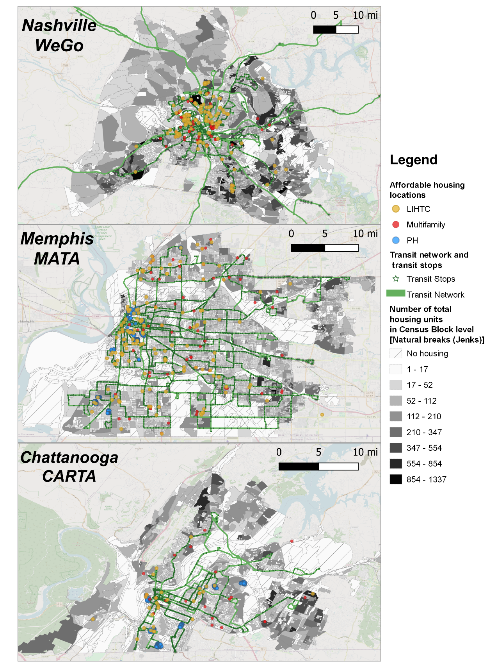
Figure 1 Maps of the three study areas (Nashville, Memphis, Chattanooga) showing the transit networks, locations of affordable housing, and the total number of housing units in each census block
2018. Because more recent data was not available, it was assumed that job locations were stable from 2018 to 2022.

2.5.3 Transit network
The General Transit Feed Specification (GTFS) is applied in previous literature on transit accessibility to estimate travel times from one point to another at different times of the day (Fransen et al., 2015). Furthermore, the standardization of GTFS data makes it possible to analyze transit accessibility across different cities (Bok & Kwon, 2016; Owen & Murphy, 2020b). The GTFS datasets, including static transit schedules and geospatial transit networks in 2022 for three Tennessee cities (Nashville, Memphis, and Chattanooga), were collected from the Nashville Metropolitan Transit Authority (WeGo), Memphis Area Transit Authority (MATA), and Chattanooga Area Regional Transportation Authority (CARTA).

2.5.4 Geographic layer for measuring citywide transit accessibility
To measure the transit accessibility for citywide total housing units, the 2020 TIGER/Line shapefile of census block boundaries (the finest level recording the number of housing units) was obtained (U.S. Census Bureau, 2020). The origins for measuring citywide transit accessibility are grid cells (with a resolution of 306 m (1002 ft.) cell width (measured at the equator) or 216 m (709 ft.) cell width (measured at the 45⁰ latitude)). The transit accessibility for total housing units within a census block was derived by calculating the average transit accessibility of each grid cell within the block.

2.6 Methodology
This section discusses the proposed method. Figure 2 shows the conceptual framework, which is divided into three steps. Step 1 measures transit accessibility for affordable housing locations and citywide transit accessibility for all housing units in a city. Step 2 evaluates transit equity of affordable housing programs at the city level by applying Lorenz curves and Gini coefficients, and it also identifies specific affordable housing locations within the city that have inequitable transit access by applying a simple inequity index. Step 3 demonstrates the process of proposing and evaluating possible transit service changes that can be implemented in the short term (e.g., for buses) for an existing affordable housing location with a high inequity index. The
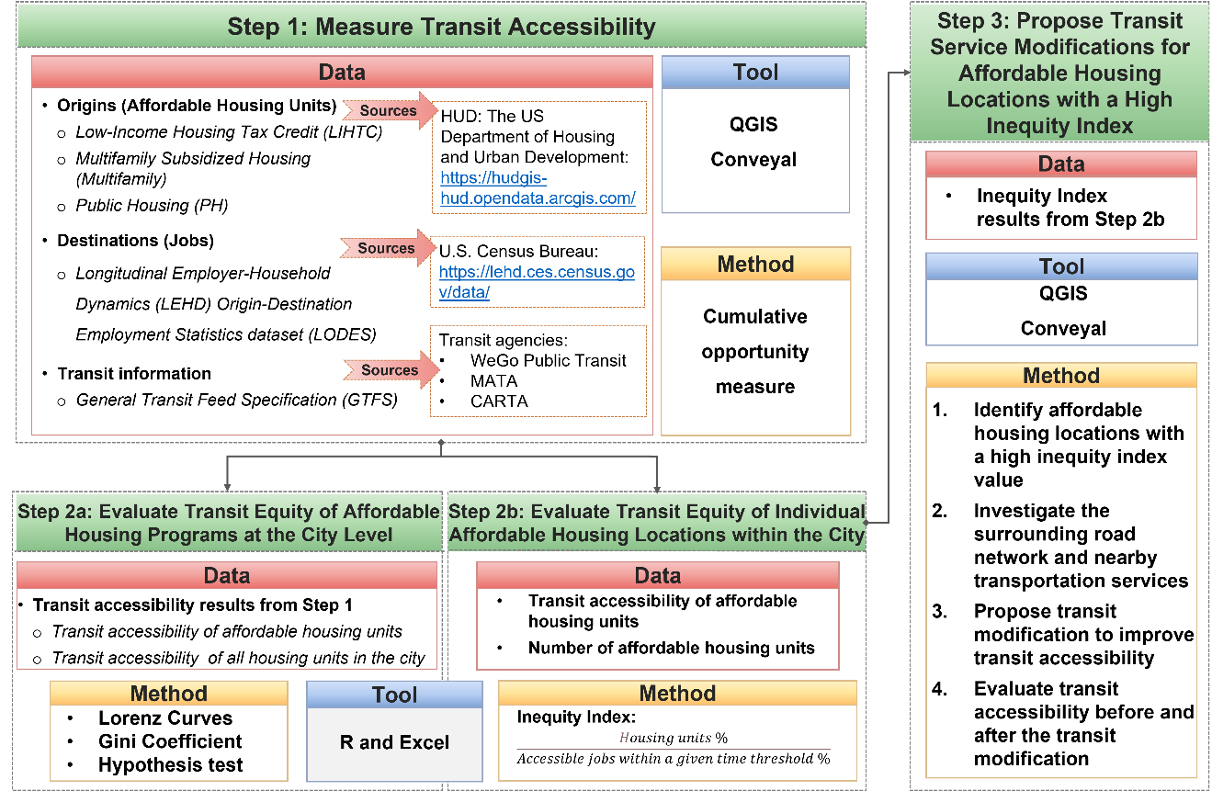
Figure 2 Conceptual framework of the methodology

method is applied to three cities with primarily bus-based transit systems in Tennessee (Nashville, Memphis, and Chattanooga).

2.6.1 Step 1: Measure transit accessibility
Figure 3 shows the configuration of measuring transit accessibility in the Conveyal Analysis platform. Two origin sets were used in the transit accessibility analysis. One was affordable housing locations; the other was grid cells of each of the three cities. The spatial resolution (cell width) of grid cells is 306 m (1002 ft.) (measured at the equator) or 216 m (709 ft.) (measured at the 45⁰ latitude). The following assumptions were made: transit vehicle departures were between 7 a.m. to 10 a.m. on a weekday; transit stops were accessed by walking; fixed route transit trips were taken with a maximum of three transfers (considered to encompass most practical trips (Conway & Stewart, 2019)); and walking was used to egress from transit stops to the destination. The maximum travel time was a total of 60 minutes, which was selected because 74% of Tennessee's transit commuters travel for less than 60 minutes to get to work (U.S. Census Bureau, 2019). The maximum walking time was set at 20 minutes, and the walking route followed the street network developed by OpenStreetMap. A schedule-based algorithm in the Analysis platform calculated the number of jobs accessible via walking and transit from each origin at every minute between 7 a.m. to 10 a.m. and then exported the median value of transit accessibility for all minutes as the result.
This paper applied the cumulative opportunity measure that calculated the number of jobs accessible via transit from given origins within a specific time threshold, as shown in equations (1) and (2) below.
$A_{i}=\sum_{j}{O_{j}f\left(C_{ij}\right),}$ | (1)
$f\left(C_{ij}\right)=1, when C_{ij}≤t$, else $f\left(C_{ij}\right)=0$ | (2)
$A_{i}$ is the transit accessibility from origin $i$, $O_{j}$ is the number of opportunities available at destination $j$, $C_{ij}$ is the travel cost from $i$ to $j$, and $f\left(C_{ij}\right)$ is an impedance function, which equals 1 when travel costs less than the given time threshold $t$ and equals 0 otherwise. In pedestrian access analysis, walking speed is generally assumed as 5 km/h (3 mph) based on prior experience (Levinson & King, 2020).
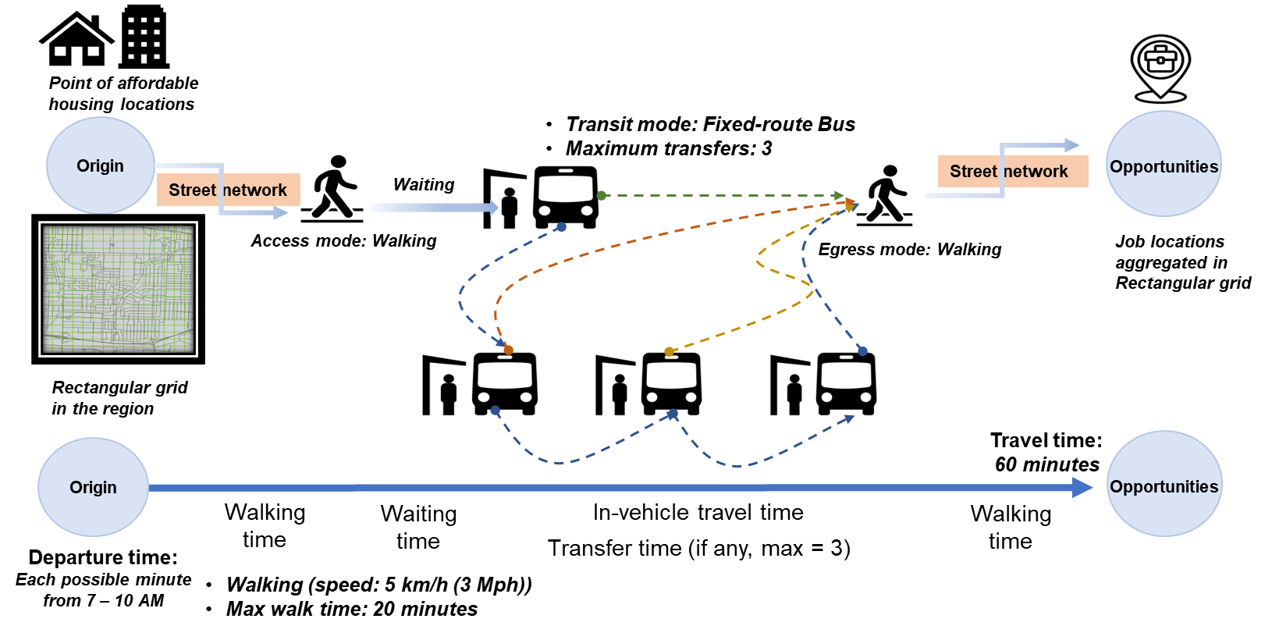
Figure 3 Configuration for transit accessibility calculation

2.6.2 Step 2a: Evaluate transit equity of affordable housing programs at the city level
The aim of this step is to 1) evaluate horizontal equity that investigates whether there is an equal distribution of transit accessibility among affordable housing units in different subsidized housing programs, and 2) evaluate vertical equity that determines if affordable housing programs provide more equitable transit accessibility compared to the citywide total housing or randomly selected housing units.
Transit equity of affordable housing programs at the city level was evaluated by applying Lorenz curves and Gini coefficients. Figure 4 shows an example of a Lorenz curve for the transit accessibility distribution among a population. The diagonal is the equity line that presents the equal distribution of cumulative transit access among the population. The curved line is an example of a Lorenz curve that represents an inequitable distribution of transit access among the population. In this example, 70% of the population shares only about 15% of the population’s transit supply. The ratio of the area between the equity line and the Lorenz curve (dot shaded area m in Figure 4) divided by the total area under the equity line (dot shaded area m plus slash shaded area n in Figure 4) is mathematically presented by the Gini coefficient (Gini, 1912).
Equation (3) approximately shows the mathematical calculation of the Gini coefficient (Brown, 1994):
$G_{j}=1-\sum_{i=1}^{n}{\left(Y_{i}+Y_{i-1}\right)*(X_{i}-X_{i-1}) }$ (3)
Where:
$Y_{i}$ is the cumulative proportion of the transit accessibility, $i= 0, …, n, Y_{0}=0, Y_{n}=1$,
$X_{i}$ is the cumulative proportion of the population, $i= 0, …, n, X_{0}=0, X_{n}=1$,
$G_{j}$ is the Gini coefficient for a sample $j$.
In the case of measuring transit equity among affordable housing programs, the Lorenz curve represents the cumulative distribution of transit-accessible jobs across the citywide total housing and affordable housing units, respectively.
To analyze the transit equity of affordable housing programs at the city level, a hypothesis test was used to determine if the Gini coefficient of affordable housing units was significantly different from the mean Gini coefficient of randomly selected housing units in a specific city. Citywide total housing includes houses, apartments, mobile homes, groups of rooms, and single rooms occupied or intended for occupancy as separate living quarters (U.S. Census Bureau). The number of housing units randomly selected from citywide total housing was set equal to the
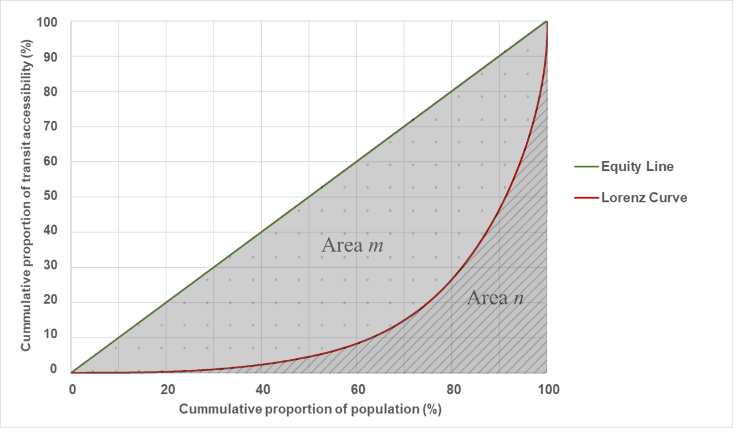
Figure 4 Example of Lorenz curves of transit accessibility distribution among a population

combined total number of housing units in the three affordable housing programs (LIHTC, Multifamily, PH) in that city. Fifty random samples were created for each city. The hypothesis test applied the 99% confidence interval and the two-tailed T-test. The null hypothesis $H_{0}$was that the mean Gini coefficient of randomly selected housing units is equal to the Gini coefficient of affordable housing units, and the alternative $H_{1}$was that the mean Gini coefficient of randomly selected housing units is not equal to the Gini coefficient of affordable housing units.
Based on the context of this study and objectives for this step of the method, a desirable outcome in terms of vertical equity would be that the Gini coefficients are lower for affordable housing units compared to the citywide total or randomly selected housing, and that the Lorenz curve of affordable housing units is closer to the equity line (above the Lorenz curves of citywide total housing or randomly selected housing).

2.6.3 Step 2b: Evaluate transit equity of specific affordable housing locations within the city
The numerator (the percent of housing units for a specific location i) was defined as the number of affordable housing units at location $i$ (e.g., within a large apartment complex) divided by the total number of affordable housing units in the city. The denominator (the percent of jobs accessible with a 60-minute transit trip) was defined as the number of transit-accessible jobs from the affordable housing location i divided by the cumulative number of transit-accessible jobs in all affordable housing locations within the city. This inequity index is a straightforward measure of the relative relationship between transit demand and transit supply and can be easily applied in practice. A higher inequity index indicates a higher demand (a higher number of affordable housing units) and a lower transit supply (a lower number of transit-accessible jobs).
${Inequity index}_{i} = \frac{Percent of affordable housing units at location i}{Percent of transit accessible jobs within a given time threshold at location i}$ (4)

2.6.4 Step 3: Propose transit service modifications for affordable housing locations with a high inequity index
This method aims to propose short-term transit service changes that can be easily applied in practice to existing affordable housing locations with limited transit access. Within the Conveyal Analysis platform tool, the following transit service modification types can be selected: converting frequency, adding a trip pattern, adjusting dwell time, adjusting speed, removing stops, removing trips, and rerouting (Conveyal User Manual, 2022). The “converting frequency” modification can modify the transit vehicle’s headway by editing the timetables. The “add trip pattern” modification enables the addition of new trip patterns to a scenario. The “adjust dwell time” modification allows for changes in the dwell time at a specific stop or along a route. The “adjust speed” modification can adjust the transit vehicle’s speed on an entire route or just a route segment. The “remove stops” modification can remove some of the stops from a route. The “remove trips” modification is used to remove entire routes or remove specific tip patterns on a particular route. The “reroute” modification can be used to represent detours, extensions, and curtailments (Conveyal User Manual, 2022).
The surrounding road network and nearby transit services were investigated before selecting one or more of these transit service changes in the software. For example, increasing the frequency would be selected if the walking distance to the nearest transit stop from the housing unit was relatively short but the headway of transit service was poor. For the specific affordable housing locations under consideration, various transit service modifications can be selected from this list and then analyzed in relation to a “comparison scenario” as the baseline. For the example used in this paper to demonstrate the method, the “converting frequency” modification was selected. Then, the transit accessibility level from the affordable housing location under the new scenario (e.g., increased transit frequency for the example shown in the results section) was calculated by applying the method described in Step 1. The platform then provides an isochrone map and numerical outputs for the change in the number of accessible job opportunities after each transit service modification. This simulation process in Conveyal’s analysis tool makes it easy to evaluate many different possible transit modifications before one is selected for implementation.

2.7 Case studies and results
This section presents the results of the three-step method applied to the case studies of Nashville, Memphis, and Chattanooga, Tennessee.

2.7.1 Results of Step 1: transit accessibility results
Figure 5 provides a visual representation of the distribution of transit accessibility levels at all affordable housing locations by displaying citywide transit accessibility levels and affordable housing locations in the three cities. The darker the purple area, the lower the transit accessibility in that area. Transit accessibility was grouped by quantile (equal count) classification. The housing
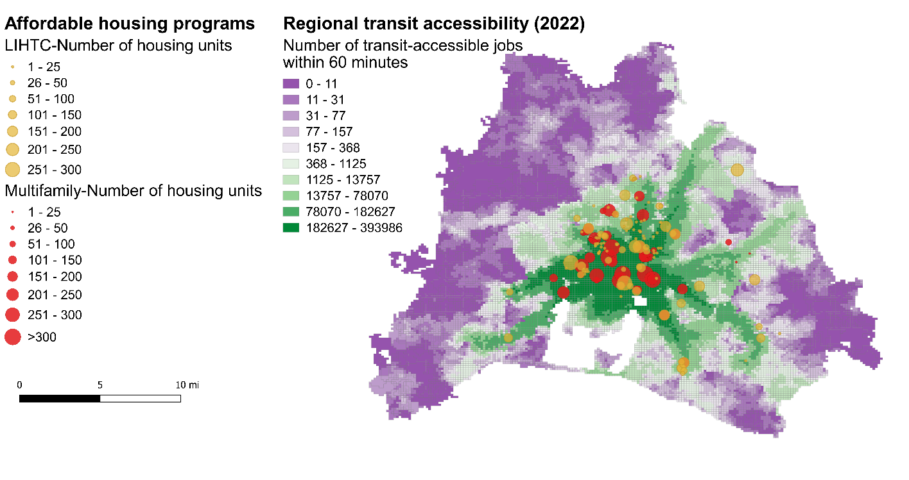
(1). Nashville
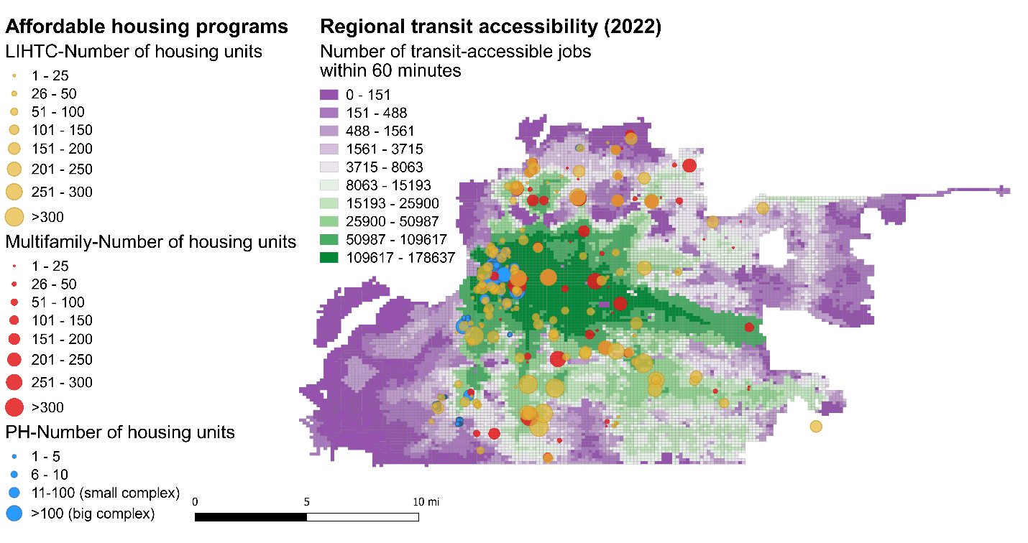
(2). Memphis
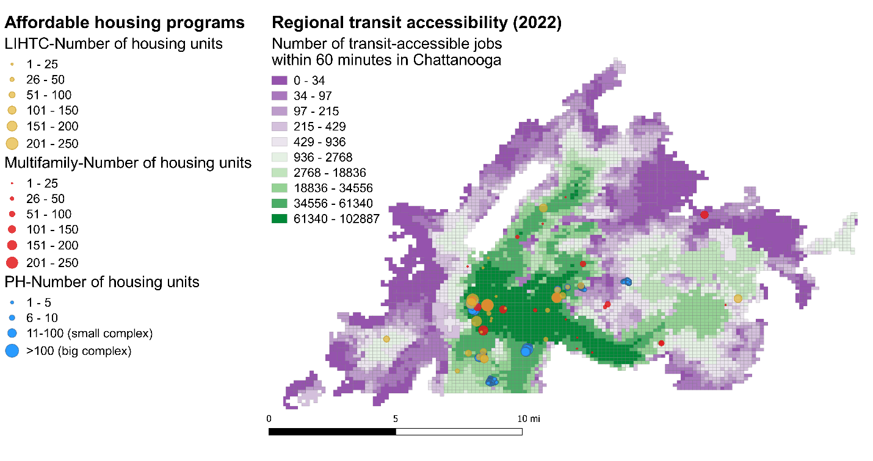
(3). Chattanooga
Figure 5 Transit accessibility and affordable housing locations in three cities

locations of LIHTC units, Multifamily units, and PH units are shown as yellow circles, red circles, and blue circles, respectively. As can be seen in the figure, compared to other cities, Nashville had the greatest range of variation in transit accessibility throughout the city, which may be related to the fact that Nashville is a consolidated city-county that also contains large areas of rural and undeveloped land. It should also be noted that compared to Chattanooga, Memphis had a higher number of affordable housing units.
These maps suggest that even though the majority of affordable housing was located in green areas with relatively good access to transit, there were still some affordable housing units located in purple areas with relatively low access to transit.

2.7.2 Results of Step 2a: Lorenz curves and Gini coefficients
Table 1 shows the results of transit accessibility calculations and the Gini coefficient for citywide total housing, random samples, and affordable housing units in Nashville, Memphis, and Chattanooga. The number of housing units randomly selected from citywide total housing is equal to the combined total number of affordable housing units in all three housing programs (LIHTC, Multifamily, PH) in that city. Generally, affordable housing units had higher transit accessibility on average than both citywide total housing and randomly selected housing units. Comparing the Gini coefficient of each affordable housing program separately, transit accessibility was more equitably distributed among Multifamily units than among units of other programs (LIHTC or PH). In Memphis and Chattanooga, the distribution of transit accessibility of the combined total of affordable housing units was less equitable than that of affordable housing units in any single program. This result indicates that transit resources were unevenly distributed among different affordable housing programs in Memphis and Chattanooga. This same result is shown in Figure 6, where the red solid line (which represents the Lorenz curve for combined affordable housing programs) lies below all dashed lines (which represent the Lorenz curves for LIHTC units, Multifamily units, or PH units) for Memphis and Chattanooga, while the red solid line lies between the two dashed lines for Nashville. The closer the Lorenz curve is to the equity line, the more equitable the transit accessibility distribution.
Table 2 provides the hypothesis test results within the 99% confidence interval and two-tailed T-test. The results of rejecting the null hypotheses and comparing the Gini coefficients indicate that transit access is distributed more equitably among each affordable housing program
Table 1 Results of transit accessibility and Gini coefficient
 | Housing types | Number of housing units | Average transit accessibility | Gini coefficient
Nashville | Citywide total housing | 316,363 | 116,979 | 0.8370
Nashville | Random samples | 15,509 | 117,123 | 0.8338
Nashville | Combined affordable housing programs^ | 15,509 | 160,665 | 0.7039
Nashville | LIHTC | 6,482 | 144,222 | 0.8350
Nashville | Multifamily | 9,027 | 204,414 | 0.4299
Memphis | Citywide total housing | 286,713 | 64,101 | 0.7230
Memphis | Random samples | 26,657 | 64,473 | 0.7241
Memphis | Combined affordable housing programs | 26,657 | 93,270 | 0.8950
Memphis | LIHTC | 15,602 | 76,890 | 0.6817
Memphis | Multifamily | 6,905 | 64,635 | 0.6379
Memphis | PH | 4,150 | 96,745 | 0.6703
Chattanooga | Citywide total housing | 85,266 | 46,719 | 0.7711
Chattanooga | Random samples | 6,099 | 46,650 | 0.7646
Chattanooga | Combined affordable housing programs | 6,099 | 53,140 | 0.7154
Chattanooga | LIHTC | 2,267 | 68,173 | 0.5138
Chattanooga | Multifamily | 1,685 | 57,643 | 0.4502
Chattanooga | PH | 2,147 | 51,959 | 0.4596
^Nashville does not have public housing.

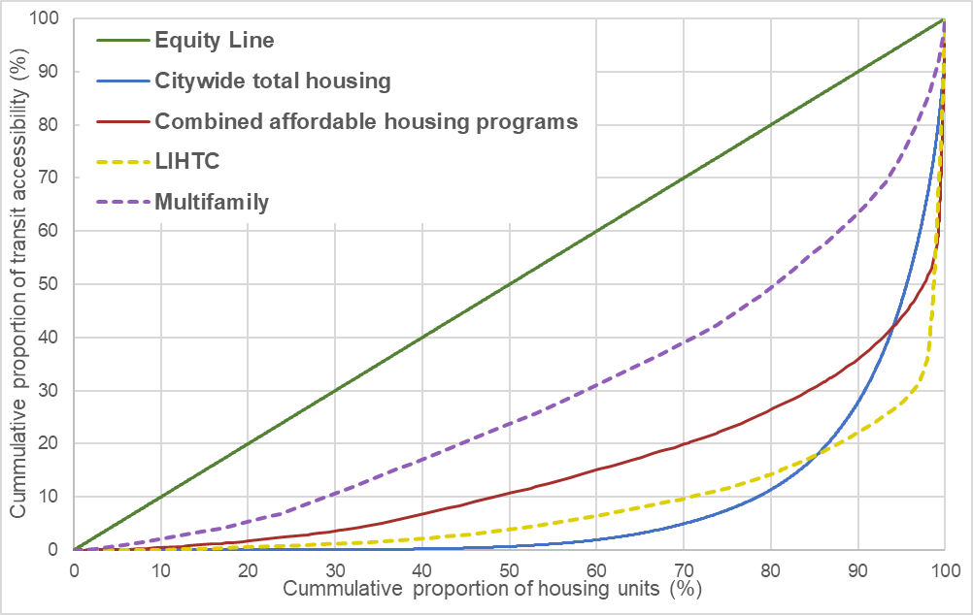
(1). Nashville
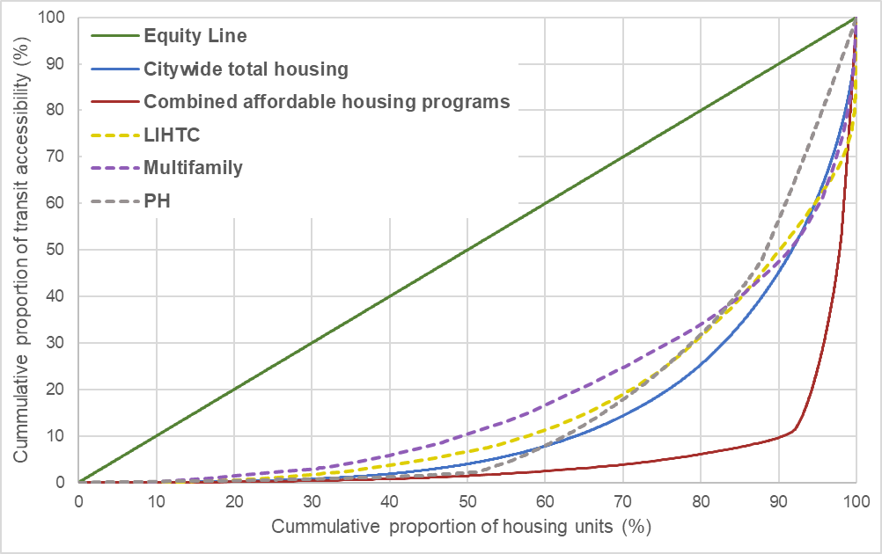
(2). Memphis
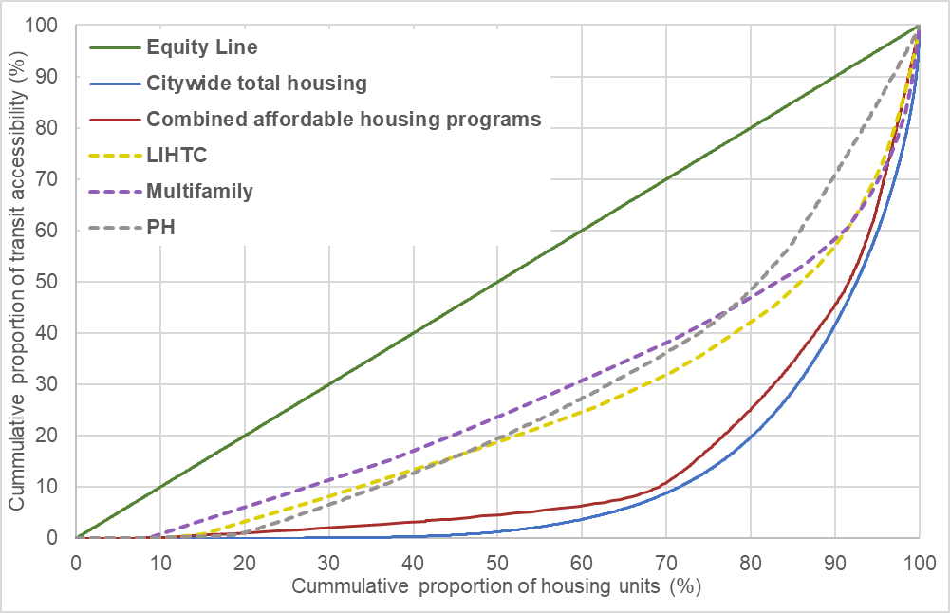
(3). Chattanooga
Figure 6 Transit accessibility Lorenz curves by type of affordable housing programs in three cities

Table 2 Transit equity hypothesis test within 99% confidence interval
 | Combined affordable housing programs (AHs) | LIHTC | Multifamily | PH
$$H_{0}$$ | $$μ_{G}= G_{AHs}$$ | $$μ_{G}= G_{LIHTC}$$ | $$μ_{G}= G_{Multifamily}$$ | $$μ_{G}= G_{PH}$$
$$H_{1}$$ | $$μ_{G}≠ G_{AHs}$$ | $$μ_{G}≠ G_{LIHTC}$$ | $$μ_{G}≠ G_{Multifamily}$$ | $$μ_{G}≠ G_{PH}$$
In Nashville: $n = 50, \overline{x}=0.833815, σ=0.019478$
T-value | 46.689483 | -0.425891 | 145.160974
P-value | <0.00001 | 0.672052 | <0.00001
Result | Reject $H_{0}$ | Do not reject $H_{0}$ | Reject $H_{0}$
In Memphis: $n = 50, \overline{x}=0.724131, σ=0.015135$
T-value | -79.028206 | 19.624625 | 39.88245 | 24.89721
P-value | <0.00001 | <0.00001 | <0.00001 | <0.00001
Result | Reject $H_{0}$ | Reject $H_{0}$ | Reject $H_{0}$ | Reject $H_{0}$
In Chattanooga: $n = 50, \overline{x}=0.764597, σ=0.032522$
T-value | 10.589294 | 53.981842 | 67.671158 | 65.647894
P-value | <0.00001 | <0.00001 | <0.00001 | <0.00001
Result | Reject $H_{0}$ | Reject $H_{0}$ | Reject $H_{0}$ | Reject $H_{0}$

than if the housing units were randomly distributed within the city (with the exception of LIHTC units in Nashville). Given the results in Table 1, the Gini coefficient of the combined total of the affordable housing programs is higher than the sample mean of random housing units in Memphis, suggesting that transit accessibility is distributed less equitably among affordable housing units than if the housing units are randomly selected; however, the opposite is true for Nashville and Chattanooga. This suggests that affordable housing units in Memphis may be more dispersed, with some housing in areas with good transit access and others in areas with poor transit access, and that some of the affordable housing locations may have high levels of transit inequity.

2.7.3 Results of Step 2b: identify affordable housing locations with inequitable transit accessibility
Next, the inequity index was calculated for each affordable housing location within the city to identify specific locations that have inequitable transit access. Table 3 lists the five affordable housing locations with the highest inequity indices in each of the three cities. Overall, Nashville had a higher level of inequitable transit accessibility among these affordable housing locations.
Figure 7 shows the five affordable housing locations listed in Table 3 on a map for each city; also included are the transit network (stops and routes) and transit accessibility levels (shaded in green to purple, as in previous figures). Figure 7 reveals that many of the affordable housing locations that scored poorly on the inequity index were in areas with low transit accessibility that also had substantial walking distances to the nearest transit stop. For affordable housing located away from transit stops, rerouting or extending transit routes may be a reasonable modification to improve accessibility. However, rerouting is funding-dependent, requires long-term planning, and can diminish overall transit operational efficiency. For affordable housing locations near transit stops (e.g., Wesley Highland Meadows in Memphis, shown in (2). Memphis of Figure 7), limited transit service frequency may be the cause of low transit accessibility levels, and a short-term schedule modification that increases frequency can be applied to improve transit accessibility in practice. In the following example, the results of Step 3 illustrate the process of proposing and evaluating a short-term schedule modification (specifically, increasing frequency/decreasing headway) to an existing affordable housing location with a high inequity index.

Table 3 Affordable housing locations with top five inequity index in three cities
Inequity Index Rank | Nashville |  |  | Memphis |  |  | Chattanooga
Inequity Index Rank | Affordable Housing Program | Measures |  | Affordable Housing Program | Measures |  | Affordable Housing Program | Measures
1 | Terrace Park Townhomes Phase II (LIHTC) | Inequity Index | 1,496 | Greenview Townhomes (LIHTC) | Inequity Index | 1,092 | Silvertree Seniors Apts (Multifamily) | Inequity Index | 2,264
1 | Terrace Park Townhomes Phase II (LIHTC) | Accessible jobs | 258 | Greenview Townhomes (LIHTC) | Accessible jobs | 94 | Silvertree Seniors Apts (Multifamily) | Accessible jobs | 30
1 | Terrace Park Townhomes Phase II (LIHTC) | Housing units | 172 | Greenview Townhomes (LIHTC) | Housing units | 158 | Silvertree Seniors Apts (Multifamily) | Housing units | 124
2 | Townhomes Of Nashboro Village (LIHTC) | Inequity Index | 819 | Southwind Lakes Apts Phase I (LIHTC) | Inequity Index | 1,057 | Cromwell Hills Apts (PH) | Inequity Index | 205
2 | Townhomes Of Nashboro Village (LIHTC) | Accessible jobs | 200 | Southwind Lakes Apts Phase I (LIHTC) | Accessible jobs | 123 | Cromwell Hills Apts (PH) | Accessible jobs | 533
2 | Townhomes Of Nashboro Village (LIHTC) | Housing units | 73 | Southwind Lakes Apts Phase I (LIHTC) | Housing units | 200 | Cromwell Hills Apts (PH) | Housing units | 200
3 | Cobblestone Corners (LIHTC) | Inequity Index | 680 | Wesley Highland Meadows (LIHTC) | Inequity Index | 963 | Eastwood Manor (Multifamily) | Inequity Index | 123
3 | Cobblestone Corners (LIHTC) | Accessible jobs | 317 | Wesley Highland Meadows (LIHTC) | Accessible jobs | 135 | Eastwood Manor (Multifamily) | Accessible jobs | 438
3 | Cobblestone Corners (LIHTC) | Housing units | 96 | Wesley Highland Meadows (LIHTC) | Housing units | 200 | Eastwood Manor (Multifamily) | Housing units | 98
4 | Old Hickory Towers (LIHTC) | Inequity Index | 577 | Surrey Apts I (Multifamily) | Inequity Index | 709 | Orange Grove II (Multifamily) | Inequity Index | 38
4 | Old Hickory Towers (LIHTC) | Accessible jobs | 840 | Surrey Apts I (Multifamily) | Accessible jobs | 99 | Orange Grove II (Multifamily) | Accessible jobs | 457
4 | Old Hickory Towers (LIHTC) | Housing units | 216 | Surrey Apts I (Multifamily) | Housing units | 108 | Orange Grove II (Multifamily) | Housing units | 32
5 | Heartland Christian Tower (Multifamily) | Inequity Index | 396 | Chapel Place Homes (LIHTC) | Inequity Index | 331 | Walden Group Home (Multifamily) | Inequity Index | 6
5 | Heartland Christian Tower (Multifamily) | Accessible jobs | 323 | Chapel Place Homes (LIHTC) | Accessible jobs | 171 | Walden Group Home (Multifamily) | Accessible jobs | 850
5 | Heartland Christian Tower (Multifamily) | Housing units | 57 | Chapel Place Homes (LIHTC) | Housing units | 87 | Walden Group Home (Multifamily) | Housing units | 10

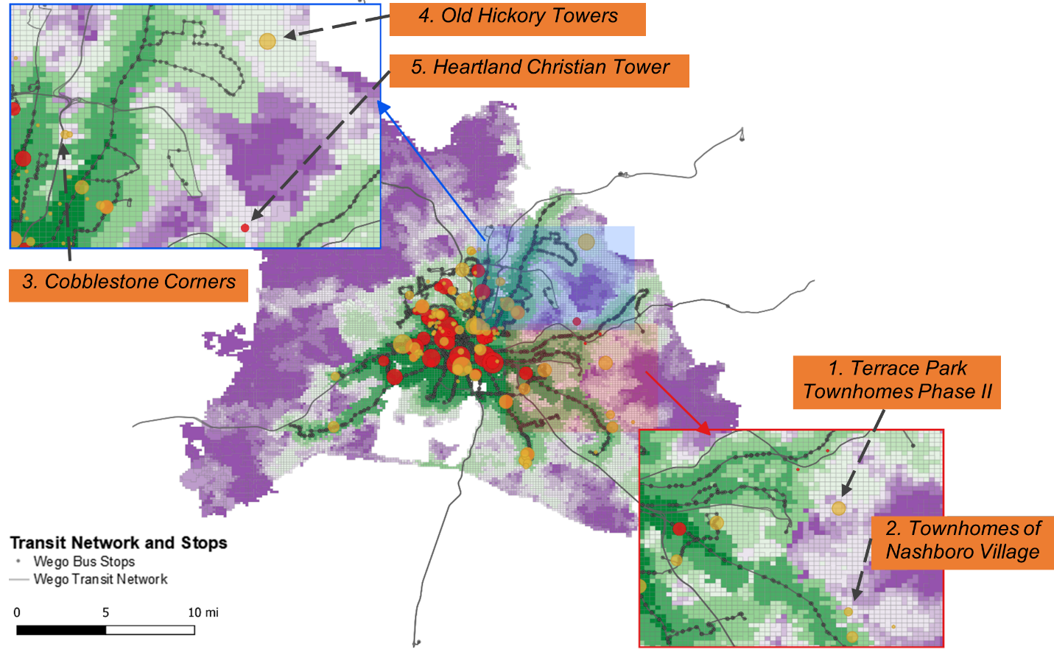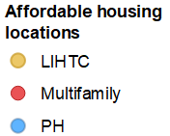
(1). Nashville
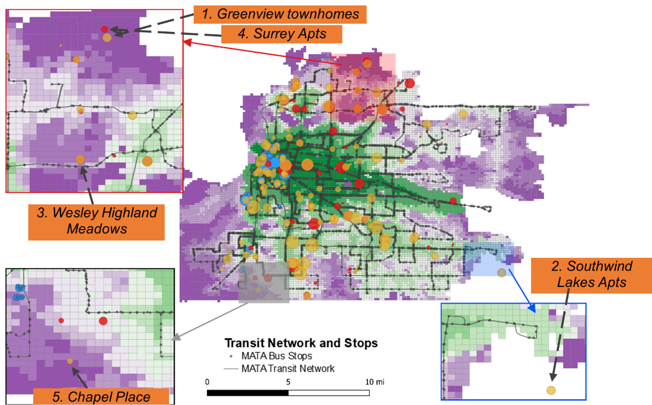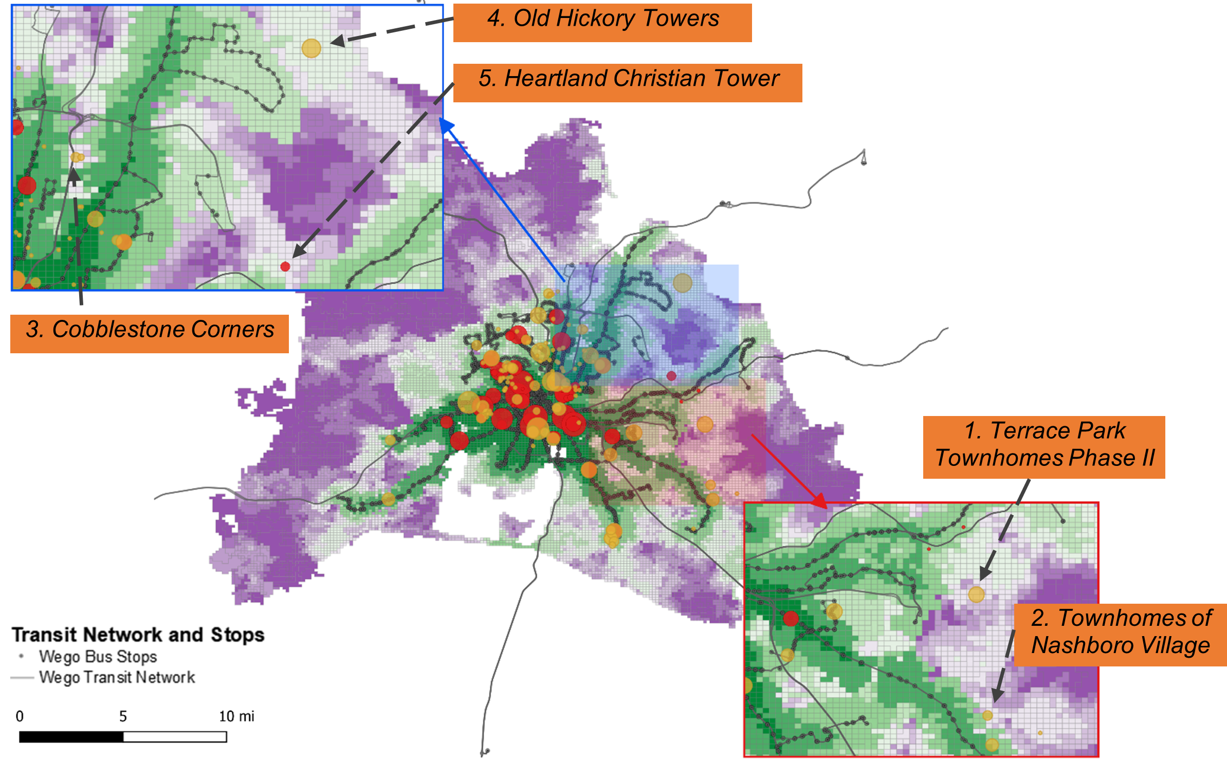
(2). Memphis
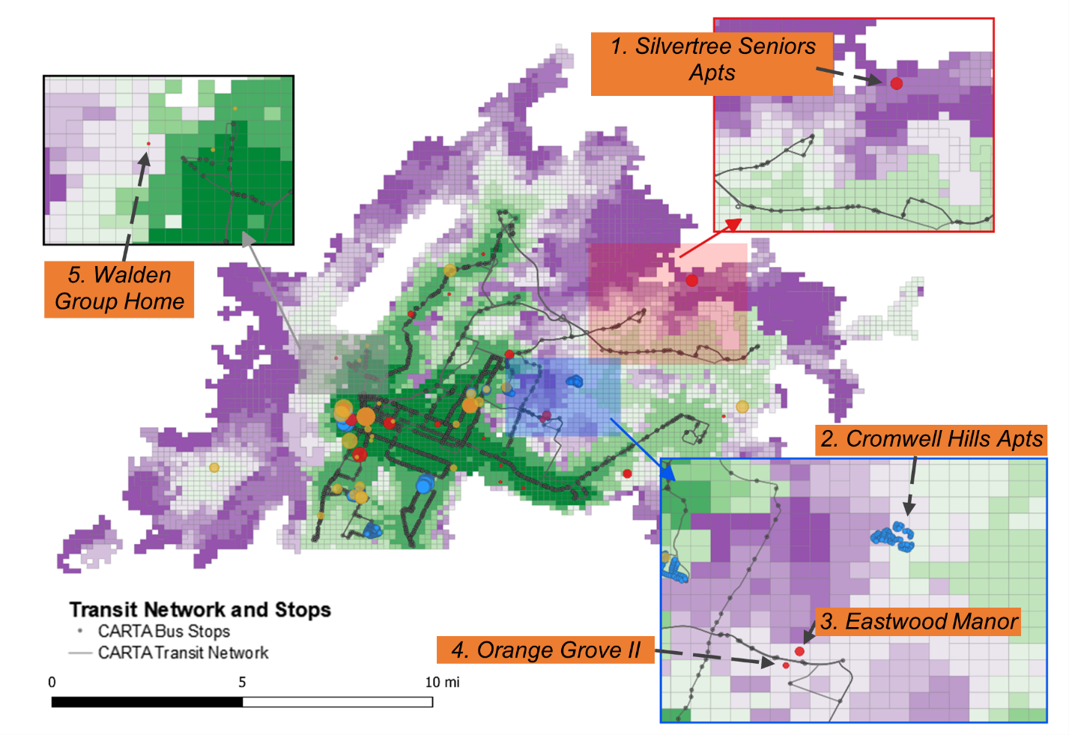
(3). Chattanooga
Figure 7 Top five affordable housing locations with limited transit access in three cities

2.7.4 Results of Step 3: Propose and evaluate transit service modifications for existing affordable housing locations with a high inequity index
This section demonstrates the process of proposing and evaluating transit service modifications for a single affordable housing location in Memphis known as Wesley Highland Meadows. One of the reasons this affordable housing location was chosen for in-depth study is that the nearest transit route (#40) has proposed modifications in a localplanning document known as the Memphis Transit Vision (City of Memphis, 2022). The Memphis Transit Vision includes a redesign of the existing transit system and was produced with significant involvement from the public, stakeholders, and elected officials who believe that, if funded, the proposed transit system redesign will significantly improve transit accessibility to jobs (City of Memphis, 2022). The Wesley Highland Meadows example was chosen not only to demonstrate the methodology for researchers, but also to show its real-world applicability to help transit agencies, local planners, and policy-makers assess proposed transit modifications.
Figure 8 shows a map of Wesley Highland Meadows relative to the nearby MATA Route 40 (red line), the nearby transit stops (black squares), and the walking path between the closest transit stop and the affordable housing location (black dashed line). Wesley Highland Meadows is 0.4 miles (8 minutes walking) from the nearest transit stop, indicating relatively good spatial access to transit. Route 40 has a headway of 90 minutes during the AM peak hour (7:00 a.m. to 10:00 a.m.), during which three buses depart from and two buses depart towards the downtown direction. Therefore, it could be concluded that a large headway of transit vehicles may be one cause of low accessibility levels.
The draft recommended transit network developed by the Memphis Transit Vision proposes decreasing the headway of Route 40 from 90 minutes to 60 minutes. Therefore, in this example, the proposed transit service modification is to decrease the headway of Route 40 in AM peak from 90 minutes to 60 minutes, which increases the number of trips departing Wesley Highland Meadows from five (three in one direction and two in the opposite direction) to seven during the AM peak hour (which is an additional trip in either direction). The results of this transit service modification are displayed in Figure 9, which shows overlapping isochrones in which blue indicates the isochrones under the baseline scenario (with existing transit service) and red indicates the isochrones under the comparison scenario (with increased frequency/decreased headway). The location of Wesley Highland Meadows is indicated as a blue icon in Figure 9. The red isochrone
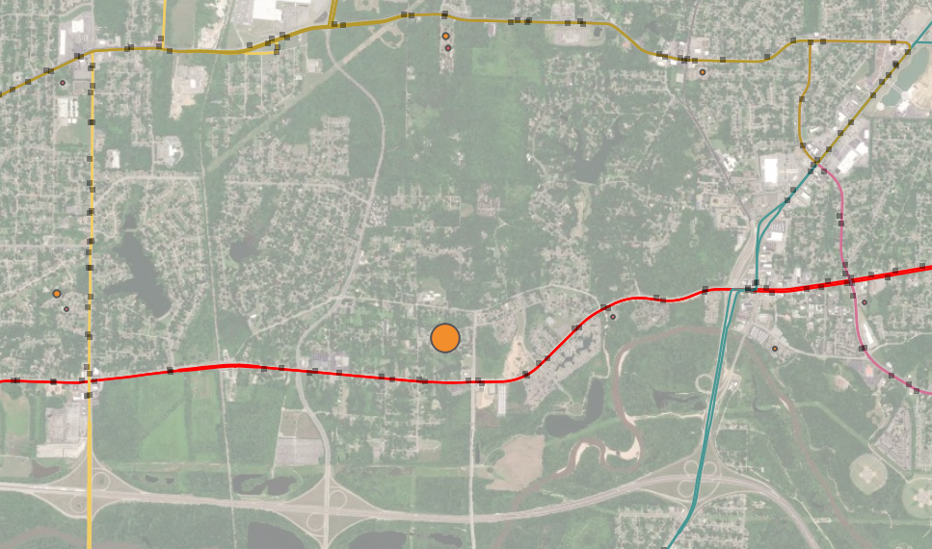
Wesley Highland Meadows
MATA Route 40
Figure 8 Satellite view of Wesley Highland Meadows and the surrounding road network and transit network
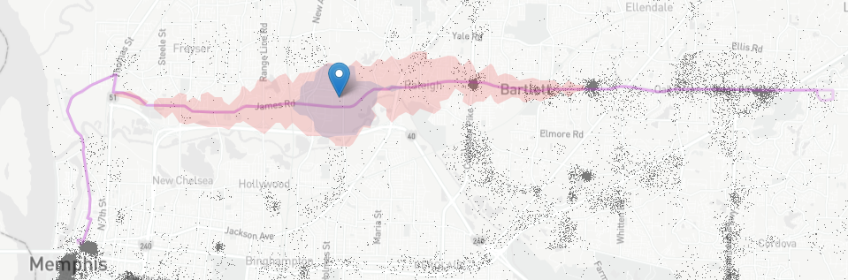
Figure 9 Overlapping isochrones before and after modifying the frequency of MATA transit route 40 for Wesley Highland Meadows

covers a larger area than the blue isochrone, which means that people from Wesley Highland Meadows can travel farther within an hour under the improved transit network. Specifically, people from Wesley Highland Meadows can reach 6,400 jobs (as opposed to just 135 jobs) within an hour after decreasing the headway of route 40 from 90 minutes to 60 minutes in the AM peak. The results suggest that a short-term transit service change can substantially improve the transit accessibility from this affordable housing location.

2.8 Discussion and conclusions
In this study, a three-step method to evaluate transit equity of existing affordable housing units was proposed, with case studies from Nashville, Memphis, and Chattanooga, Tennessee which have primarily bus-based transit systems. Transit accessibility is not considered in the process of allocating low income housing credits for affordable housing planning in Tennessee (Perrey, 2022). This suggests that there may be a need to develop a method for policy-makers and practitioners to systematically evaluate the transit accessibility levels of affordable housing units.
In Step 1, affordable housing and transit accessibility were visualized. In Step 2a, the results of the Gini coefficient showed that the overall transit accessibility of the combined total of affordable housing units (in the LIHTC, PH, and Multifamily programs) in Memphis and Chattanooga was less equitable than that of the affordable housing units in any single program. The citywide evaluations suggested that transit accessibility levels were distributed less equitably among affordable housing units (a Gini Coefficient of 0.895 for the combined total from three housing programs) than randomly selected housing units (with a Gini Coefficient of 0.724) in Memphis. The aforementioned findings showed that the transit equity of affordable housing units in different cities within a state can vary.
Step 2b identified Wesley Highland Meadows in Memphis as an affordable housing location with a high inequity index of 963 because residents at this location could only reach 135 jobs within an hour on transit but there is high potential demand for transit (specifically, 200 affordable housing units at this location). It is important to note that the goal of this step is to compare transit access (supply) and the number of affordable housing units (potential demand) across different existing affordable housing locations to identify those locations with the most inequitable transit access. By identifying these locations and bringing them to the attention of the relevant authorities, planners and policy-makers can better prioritize serving neighborhoods with high levels of affordable housing when making future transit service changes.
In Step 3, a frequency/headway modification (specifically, changing 90 minutes to 60 minutes for Route 40 in AM peak) was proposed for the Wesley Highland Meadows location. It is noted that the transit modification evaluated in this study aligns with local planning recommendations in a proposed Transit Vision for the city of Memphis. After modification, the number of jobs accessible via transit to the housing location was shown to increase from 135 to 6,400 jobs. The results of the three-step method suggest that short-term transit service changes can improve the transit accessibility of existing affordable housing locations with limited transit access. After conducting this analysis, it can be concluded transit agencies and housing authorities may avoid transit inequity by collaborating to ensure that transit resources are distributed evenly across different affordable housing programs and the transit accessibility of affordable housing units is higher than the regional average.
This paper contributes to the literature by proposing a three-step method that helps transit agencies and their partners to (1) assess transit equity of affordable housing programs at the city level; (2) evaluate transit equity of specific affordable housing locations within a city; and (3) consider possible transit modifications before actual implementation. It is noted that the method primarily relies on open datasets; specifically, GTFS data and geospatial affordable housing locations from HUD make this method widely applicable in other regions of the U.S. with fixed transit service.
The three-step method presented in this study provides useful insights for housing authorities and transit agencies to guide their efforts toward enhancing transit equity and serving their local communities.
This study offers transit agencies a framework for assessing the equity of transit services for low income groups, aligning with the Federal Transit Administration's (FTA) overarching objectives that seek to integrate environmental justice goals into programs, policies, and activities (FTA, 2012). By identifying affordable housing locations with higher demand and lower transit supply, transit providers can then prioritize service to these communities when making transit planning decisions. This approach could help improve transit access for residents in these areas, potentially leading to better mobility and connectivity. The proposed approach may be applicable for housing authorities in evaluating transit accessibility of affordable housing locations at both the citywide and location-specific level, particularly in instances where transit access is not already incorporated into the federally mandated Qualified Allocation Plan (QAP).
It is important to note that efforts to coordinate transit service planning and affordable housing development are ongoing in many US cities. For example, transit agencies in Raleigh, NC and Austin, TX each have plans to preemptively acquire land adjacent to transit corridors for affordable housing development. Both cities have dedicated funding to minimize the displacement of existing affordable housing units near new transit developments. The Equitable Development Around Transit plan in Raleigh uses zoning around transit stations to encourage the development and preservation of affordable housing units. This type of policy could be considered in other cities to facilitate the coordination of affordable housing and transit service in the future (City of Austin; City of Raleigh, 2020).
It is also important to highlight the ongoing efforts of many transit agencies to evaluate transit equity, including efforts in the case studies evaluated in this paper. For instance, in Nashville, TN, the WeGo transit agency regularly employs the Transit Boardings Estimation and Simulation Tool (TBEST) software to assess transit equity for minority and low-income populations, typically as part of Title VI service equity analyses (National Academies of Sciences Engineering and Medicine, 2022a). However, WeGo transit planners have noted in a recent survey that the percentage change in access to jobs could serve as a suitable accessibility metric for analyzing the impacts of proposed service plans under their Better Bus initiative (National Academies of Sciences Engineering and Medicine, 2022a). They further expressed a desire to incorporate transit accessibility into their planning activities in collaboration with key community partners in the future (National Academies of Sciences Engineering and Medicine, 2022a). This study proposes an approach that could be utilized by transit agencies such as WeGo in Nashville, TN to assess the impact of transit modifications while promoting coordination between transit planning and local partners, particularly housing authorities.
Broadly speaking, it is generally recommended that local transit agencies and housing authorities in the United States coordinate transit planning and affordable housing development. For example, transit agencies could give priority to affordable housing communities when planning new transit services and/or offer free or discounted fare programs to encourage affordable housing residents to take transit. In addition, housing authorities could consider locating new affordable housing construction in areas with good transit access. Other planning and policy options could also be considered to facilitate housing and transit coordination in the future.

2.9 Limitations and future research
There are at least three notable limitations to this study: (1) the applicability to other areas beyond the United States, (2) the absence of low-wage jobs in the transit accessibility indicator, and (3) the lack of a decay function for job attractiveness and potential competition among affordable housing residents in the transit accessibility measure.
First, the applicability of the method proposed in this study may be limited to the United States because housing policies, transit planning practices, and the availability of data vary significantly between different countries. The next two limitations are associated with different factors that can lead to variations in the results of the transit accessibility analysis, potentially influencing the conclusions.
A second limitation relates to the selection of the destinations in the calculation of transit accessibility levels. Some studies suggest that people living in low income communities are more likely to work in or be qualified for low-wage jobs (Benner & Karner, 2016; Delmelle et al., 2021; Klumpenhouwer & Huang, 2021). The absence of an analysis of transit accessibility to low-wage job destinations could lead to an underestimation of the transit inequity issues faced by affordable housing units, since their residents are typically low-income individuals and may be more likely to be employed in low-wage jobs. The goal of this paper was to provide a general understanding of transit accessibility to all jobs for affordable housing locations; however, future research should consider the unique challenges faced by individuals in low-wage jobs.
An additional limitation pertains to the type of transit accessibility measure used in this study. The use of the cumulative opportunity measure did not consider the decay function of job attractiveness and potential competition among affordable housing residents and other populations within the same area to access job opportunities. These limitations are particularly noteworthy since previous research on travel behavior has shown that individuals are less likely to travel to jobs that are farther away. Previous research also suggested that competition for job opportunities may occur among low-income people, with numerous persons potentially competing for the same job position. Consequently, this limitation may result in an underestimation of the transit inequity faced by affordable housing residents. Notably, the conclusions drawn from a study are contingent on the measure of transit accessibility employed, and different measures can potentially yield varying results and implications (Giannotti et al., 2022; Tiznado-Aitken et al., 2021).
There are several areas where future research could contribute to a deeper understanding of transit equity in affordable housing.
First, although providing access to jobs is an important function of public transit, some travelers – especially low income populations who may be transit-dependent – rely on transit to get to grocery stores, healthcare facilities, schools, outdoor recreational areas, or other essential services (Klumpenhouwer & Huang, 2021). Therefore, transit access to other essential services is a future focus for research.
Second, this paper measured the transit accessibility of fixed-bus routes in dense urban areas. However, on-demand services (e.g., dial-a-ride routes) are available in many suburban and rural areas that do not have fixed-bus routes. Therefore, measuring access using on-demand transit services among affordable housing units could be considered in future research.
Third, the proposed method considered the impact of transit service changes on the transit accessibility of a single affordable housing location along the transit route being modified; however, future research could expand the method to consider the impacts of transit service changes on all affordable housing locations in the vicinity.
Fourth, this paper proposed short-term transit modifications for existing affordable housing locations. Future research could consider long-term coordination between transit service planning and affordable housing development (e.g., where to locate new housing developments).
In summary, this study highlights several significant areas for future research. Moreover, the findings offer important policy implications for practitioners seeking to enhance transit equity and potentially improve the accessibility of affordable housing locations. By implementing this methodology, housing authorities and transit agencies can work towards creating more equitable and connected communities.

CHAPTER 3.
Evaluating spatiotemporal transit accessibility and transit equity of essential services

This chapter is based on a research paper by Jing Guo and Candace Brakewood titled "Analysis of spatiotemporal transit accessibility and transit inequity of essential services in low-density cities, a case study of Nashville, TN". This paper is in review at the Transportation Research Part A: Policy and Practice.

Abstract
Evaluating the accessibility and equity of transit service to essential services that fulfill people’s fundamental needs is critical, especially in lower-density areas with limited transit services. Although numerous studies have analyzed the inequity of transit accessibility in dense, urban areas with robust transit networks, few of them evaluated transit inequity across multiple essential service categories (e.g., food stores, healthcare facilities, schools, etc.). This paper fills this research gap by focusing on a low-density, automobile-oriented city (Nashville, TN) to evaluate spatial transit inequities across essential service deserts and sociodemographic groups. The results of the case study show that many areas with higher transit-dependent demand (i.e., populations with limited personal vehicles, those living in poverty and minority populations) tend to experience more restricted transit access to food, healthcare, school, and childcare facilities; interestingly, this is not the case for transit access to green space (specifically, parks). This study further identified essential service deserts by Local Indicator of Spatial Association (LISA) clustering and analyzed the correlation among them. The correlation results suggest that food deserts, healthcare deserts, school deserts, and childcare deserts are highly correlated with each other, while they have a lower correlation with park deserts. The findings of spatial transit inequity and the identification of essential service deserts provide crucial policy implications that can be used by transit agencies and local planning departments to prioritize their resources and target interventions to improve transit equity. This study contributes to the existing literature by proposing a systematic process that utilizes publicly available datasets to measure spatiotemporal transit supply, identify essential service deserts, and explore the correlation among these areas in a low-density city.

3.1 Introduction
There is a growing body of research investigating transit accessibility, which refers to the capacity of individuals to reach various destinations via public transportation (El-Geneidy et al., 2016b; Owen & Murphy, 2020a; Stewart, 2017; Welch, 2013; Yan et al., 2022). Providing transit access to essential services is critical for promoting health and enhancing overall quality of life, particularly for populations that rely on transit for their transportation needs (Brondeel et al., 2014; Jin et al., 2022; Mao & Nekorchuk, 2013; Martens et al., 2019; National Academies of Sciences Engineering and Medicine, 2022b; Taylor & Morris, 2014; USDA, 2023; Walker et al., 2010; Wood & Horner, 2016; Zhang & Mao, 2019; Zhang et al., 2022). The assessment of transit equity, which examines the geographical distribution of transit services and the provision of transit services to populations with the highest transit needs, has recently gained attention in the transit literature (Aman & Smith-Colin, 2020) and has emerged as an important aspect of the discourse on Environmental Justice for low-income and minority populations, particularly in the United States (FTA, 2012). Despite the growing body of research on transit accessibility and transit equity, there are still significant gaps that need additional attention and further investigation.
Firstly, most previous studies focused on single destination types, such as job opportunities, overlooking other essential services like healthcare facilities, food stores, schools, and childcare services. Secondly, temporal variations in transit services due to departure times and service frequency have been underemphasized, necessitating the development of a comprehensive spatiotemporal transit supply index. Thirdly, while social equity has been explored in previous research, spatial disparities in transit accessibility across diverse essential service types and potential spatial correlations in service deserts have received limited attention. Lastly, many transit equity studies have evaluated densely populated urban areas (Hess, 2005; Kawabata & Shen, 2006), while transit equity is no less important in lower-density areas (like Nashville, Tennessee) that are characterized by limited transit resources and unique urban structures. Addressing these gaps contributes significantly to the transit equity literature.
Therefore, this paper aims to contribute to the literature by (1) analyzing transit accessibility and transit equity to food, healthcare, education (schools), childcare, and green space (parks); (2) proposing a spatiotemporal transit supply index; (3) evaluating the spatial correlation between transit-dependent demand and transit supply and identifying essential service desert clusters; and (4) estimating the correlation among various types of essential service deserts. The proposed method will be applied in Nashville (the capital city of Tennessee), a sprawling city with a bus-oriented transit system, as a case study. The proposed method primarily relies on open datasets, specifically General Transit Feed Specification (GTFS) data, Census data, and public geospatial location data of essential service facilities from federal or local departments, which makes this method widely applicable to other regions of the United States with fixed route transit service.
The subsequent sections of the paper are organized as follows. The first section provides a comprehensive review of relevant literature, highlighting previous studies that have examined transit accessibility and equity to essential services. This is followed by an introduction to the study area and the data required for this study. The proposed methodology is summarized in the subsequent section. The results of the study are then presented, followed by a policy discussion. The conclusion section provides a summary of the study findings, and the potential limitations and future research are discussed in the final section.

3.2 Literature review
This section provides a review of related literature pertaining to transit access to essential services and transit equity in the context of reaching essential services.

3.2.1 Transit accessibility to essential services
A growing number of studies published in the last decade have focused specifically on accessibility via transit, which refers to one’s ability to reach opportunities by taking transit (El-Geneidy et al., 2016b; Owen & Murphy, 2020a; Stewart, 2017; Welch, 2013; Yan et al., 2022). The most extensively researched topic in these studies is transit accessibility to jobs (Hess, 2005; Karner, 2018; Kawabata & Shen, 2006; Yan et al., 2022). However, the critical role of accessibility to essential services to improve the quality of life of individuals and evaluate the operational efficiency of transit systems has received less attention in the literature. Some travelers use transit to get to other essential services, such as food stores, healthcare facilities, schools, childcare services, green spaces, etc. Accessibility to these other essential services that meet the needs of people, especially minority populations and low-income people who rely on transit, is a key consideration for transit planners and stakeholders and is an important evaluation of the level of transit equity.
Numerous recent studies have suggested the importance of providing accessible food sources for residents, as a lack of access to affordable and nutritious food has been linked to a range of negative health outcomes and is often indicative of broader systemic issues related to poverty and inequality (USDA, 2023; Walker et al., 2010; Wood & Horner, 2016; Zhang & Mao, 2019). Similarly, prior research focusing on transit accessibility to healthcare has emphasized the significance of such access for vulnerable populations and has highlighted the need for policymakers to take action to enhance transit access to healthcare facilities (Brondeel et al., 2014; Jin et al., 2022; Mao & Nekorchuk, 2013; Zhang et al., 2022).
While food and healthcare are widely recognized as fundamental needs that play a critical role in people’s lives, education and childcare services have received comparatively less attention in the literature. One prior study evaluated transit access to schools and found that highly educated people typically have better access to schools than other destinations (Ermagun & Tilahun, 2020). Some studies found that low-income parents frequently rely on transit for childcare trips, suggesting that transit access to childcare should be a significant factor in transit evaluation (Wang & Xu, 2020).
Additionally, parks offer a range of benefits for physical and mental well-being, community building, and environmental sustainability (Park et al., 2021). As such, parks are an important component of a well-functioning city and should not be overlooked in efforts to address service deserts and promote equitable access to essential services. One prior study analyzed transit accessibility levels to parks for disadvantaged populations and suggested that accessibility to parks has an important effect on both human health and social justice (Park et al., 2021).
Last, previous studies have predominantly concentrated on transit accessibility to one specific type of essential services, and only a few prior studies have considered multiple destinations, thereby creating a gap in the literature in which multiple essential service destinations are considered and compared. To address this gap, this study will calculate the transit accessibility to five types of essential services and provide insights into the variations in transit accessibility among these essential service destinations, enabling policymakers and urban planners to make informed decisions for enhancing overall accessibility and equity.

3.2.1.1 Measurement of transit accessibility to essential services
Transit accessibility measurements can be broadly classified into two categories: opportunity-based (primal) and time/cost-based (dual) measurements (Cui & Levinson, 2020a). Opportunity-based measurements rely on predefined travel time thresholds that have no standard value under different scenarios (Levinson & King, 2020). Such measurements are typically used in scenarios where individuals have multiple options, like accessing job opportunities. However, compared to jobs, essential services tend to be fewer in number and more dispersed in distribution. Consequently, prior research commonly employed a time-dominant approach to measure transit access to these essential services, as it mirrors the actual travel behaviors of accessing essential services. In contrast to the opportunity-dominated approach, which calculates the number of accessible opportunities within a specified time threshold, time-dominated measurements assess the travel time required to access a fixed number of opportunities (Cui & Levinson, 2020a). This measurement is particularly valuable when the emphasis is on the significance of time in reaching these opportunities (Levinson & King, 2020). For instance, Farber et al. (Farber et al., 2014) utilized this method when measuring accessibility to food stores in Cincinnati, determining the travel time from each census block to the nearest supermarket. This approach has also found successful application in evaluating the accessibility of other essential services, such as a recent study examining healthcare accessibility in Florida (Ghorbanzadeh et al., 2020). Another key advantage of utilizing travel time as the accessibility metric is its capacity to facilitate direct comparisons of transit accessibility levels among different types of essential services and various groups of transit users. Moreover, measuring access in travel time offers a user-friendly and easily interpretable scale, making it more comprehensible to the public (Levinson & King, 2020). Therefore, in this study, the time-dominated approach will be applied in the transit accessibility calculation.

3.2.1.2 Temporal variation of transit accessibility to essential services
Another important consideration in the analysis of transit accessibility to essential services is the temporal variation caused by differences in departure times or the variation in transit service frequency across different times of the day (Yan et al., 2022; Zhang et al., 2022). A growing body of literature incorporates temporal variation into the calculation of transit accessibility, either by calculating the average accessibility over multiple time windows (Allen, 2019; Boisjoly & El-Geneidy, 2016; Fransen et al., 2015) or by weighting accessibility by the percentage of time windows that reach a predetermined threshold (Farber et al., 2014). While commuting trips may be more concentrated during the AM and PM peaks on weekdays, trips to access essential services may be more likely to occur at other times of the day (Allen, 2019). Neglecting temporal variations in evaluating transit access to essential services may lead to inaccurate results, potentially resulting in incomplete and inadequate planning for future transit development.
This paper will first follow the method in previous studies (Allen, 2019; Farber et al., 2014; Fransen et al., 2015; Lei & Church, 2010; Yan et al., 2022; Zhang et al., 2022) in measuring transit accessibility in four time period on weekdays (AM peak during 7-10 a.m., midday during 11 a.m.-3 p.m., PM peak during 4 p.m. – 7 p.m., early-evening during 8 p.m. – 11 p.m.). Then, time variation is calculated based on the variance of transit accessibility over these different time periods. Based on the time variance, one previous study that evaluated transit services categorized traffic analysis zones into different scenarios based on the temporal dynamics of transit accessibility (Yan et al., 2022). This previous study also argued that consistently high accessibility throughout the day (i.e., high accessibility with low variance) is a more favorable scenario than a situation with generally high accessibility but occasional sharp drops (i.e., high accessibility with high variance) (Yan et al., 2022). Building on this prior research, this study proposes a comprehensive spatiotemporal transit supply index that weights transit accessibility by the effects of temporal variations on transit accessibility observed within the study area.

3.2.2 Transit equity

3.2.2.1 Transit-dependent demand
An important step in evaluating transit equity is to identify disadvantaged groups that may be dependent on transit more than the general population. Socially disadvantaged groups typically have less access to resources and goods than the general population and thus are commonly considered in measuring a variety of equity issues (Townsend et al., 1988). Social indicators, which have been widely used to identify socially disadvantaged groups in prior research (Foth et al., 2013; Sánchez-Cantalejo et al., 2008; Townsend et al., 1988), have been extensively applied in transit equity studies (El-Geneidy et al., 2016a; El-Geneidy et al., 2016b; Foth et al., 2013).
In terms of specific indicators, many prior studies have found that individuals with limited access to vehicles are more likely to rely on public transit to meet their transportation needs (Steiss, 2006). In recognition of this relationship, the U.S. Department of Transportation developed a formula for measuring the car-limited population based on data regarding household drivers and vehicle ownership (Steiss, 2006). This formula has subsequently been employed by numerous studies focused on transit equity as a means of quantifying transit-dependent demand (Cai et al., 2020; Jiao, 2017; Jiao & Dillivan, 2013; Lee et al., 2021; Li & Fan, 2020).
Among demographic variables, low-income and minority populations are frequently identified as groups with a higher potential need for transit because they may not be able to afford vehicles and are therefore more likely to rely on transit for travel. Previous studies (El-Geneidy et al., 2016b; Ermagun & Tilahun, 2020; Foth et al., 2013) suggested that individuals with lower incomes may find the cost of owning and operating a vehicle prohibitive and are therefore more likely to use public transit when it is available (Martens et al., 2019; Taylor & Morris, 2014). Race or ethnicity is often considered as a potential factor because some minority groups may have relatively lower income levels and experience lower levels of car ownership, leading to increased reliance on transit (Di Ciommo & Shiftan, 2017; Lucas et al., 2016; McCray & Brais, 2007).
Last, one prior study specifically conducted in rural regions of Tennessee indicated that rural transit riders in Tennessee are more likely to belong to minority groups, have lower income levels, and possess fewer or no personal vehicles (Yang & Cherry, 2017). Therefore, this study will consider potential car-limited populations with limited personal vehicle access, low income levels, and minority populations for the transit equity analysis that follows.

3.2.2.2 Transit equity of essential services
Previous studies examining transit equity to essential services have yielded varied findings. For instance, one transit equity study conducted in the Detroit metropolitan region demonstrated that minority and low-income households had favorable levels of transit accessibility to hospitals, yet faced disadvantages accessing supermarkets (Grengs, 2015). In another study conducted in Chicago, it was found that low-income households encountered restricted transit accessibility to grocery stores, while the Hispanic population experienced increased transit accessibility to grocery stores but faced limitations in accessing hospitals (Ermagun & Tilahun, 2020). Notably, these studies focused on dense areas with well-established transit networks. Therefore, the following analysis conducted in Nashville provides a valuable addition to the existing literature by examining the transit equity of essential services specifically in a low-density urban area.
The term “transit desert” has been extensively discussed in prior literature and is generally defined as geographic areas or locations that have limited transit accessibility to a specific type of service, such as “food deserts” (Forsyth et al., 2010; Walker et al., 2010) and “healthcare deserts” (Brondeel et al., 2014; Jiao & Dillivan, 2013; Mao & Nekorchuk, 2013). However, few prior studies have quantified transit equity for accessing multiple essential services that are important to fulfill people’s many fundamental needs (Cui & Levinson, 2020a; Zheng et al., 2019). Therefore, the concept of “essential service deserts” is proposed in this paper to identify areas with limited access to numerous essential services.
The literature on transit equity typically employs comparative or statistical approaches to measure transit equity. Comparative approaches include simple gap identification methods to identify transit deserts by the difference or ratio of demand and supply (Aman & Smith-Colin, 2020; Jiao, 2017; Jiao & Dillivan, 2013). In terms of statistical approaches, various indicators have been used to quantify transit equity, such as the Gini coefficient (Liang et al., 2023) and the Theil index (Jin et al., 2022). Some studies involving spatial analysis of transit equity have utilized the bivariate local indicator of spatial association (bi-LISA) to evaluate the spatial disparity of the relationship between transit supply and demand (Jin et al., 2022; Liang et al., 2023).
Despite numerous studies conducted on transit equity analysis, a potential gap exists as few of them have considered the spatial inequity of transit with regard to different types of essential services and the potential spatial correlations between different essential service deserts. This highlights the need for further research to consider the interconnectivity between transit accessibility and essential service facilities in order to better understand the spatial patterns of transit inequity.

3.3 Study area and data

3.3.1 Study area
Nashville is the capital city of the state of Tennessee located in the southeastern United States. According to the U.S. Census Bureau, as of 2020, Nashville had an estimated population of approximately 690,000 people, making it the 21st most populous city in the United States (U.S. Census Bureau, 2021b). However, due to its extensive land area, Nashville is listed as the third least densely populated large city (with 350,000 or more population) and ranks 24th out of the 318 least densely populated US cities (with a population above 100,000) (Heacock, 2019). Demographic data for Nashville show that about 15% of residents are below the poverty line, 38% of residents are minorities (non-white), and 14% of residents are Hispanic or Latino (U.S. Census Bureau, 2020).
Regarding transportation, Nashville is an automobile-oriented city with only 6% of households without vehicles. Nashville Metropolitan Transit Authority (Nashville MTA, rebranded as "WeGo Public Transit" (WeGo) in 2018 (Pair, 2018)) was established in 1973 to provide public transit services for Nashville’s Davidson County (Nashville MTA, 2019). The American Public Transportation Association (APTA) Public Transportation Factbook noted that the transit agency in the Nashville area is listed among the smaller transit agencies nationwide, with the Metropolitan Transit Authority (MTA) being the 84th-ranked transit agency evaluated by Unlinked Passenger Trips (APTA, 2022). However, transit equity is no less important in lower density areas (such as Nashville, Tennessee) where transit service may be limited. In such contexts, it is especially important to allocate limited transit resources to those who need it most. The most recent onboard surveys conducted by Nashville’s MTA in 2017 revealed that over half of riders belonged to minority groups and had limited access to personal vehicles, with approximately 44% of Black/African American and 36% of Hispanic/Latino riders indicating a lack of personal vehicle ownership (Nashville MTA, 2019).

3.3.2 Data
This section discusses the data used to measure transit accessibility and transit equity. GTFS data including static transit schedules and geospatial transit networks for 2022 were collected from the Nashville Metropolitan Transit Authority (WeGo Transit). For the transit accessibility calculations, origin locations were the centroid of each Census block; the 2020 TIGER/Line shapefile of Census blocks and Census block groups was obtained from the U.S. Census Bureau (U.S. Census Bureau, 2020). The Census block level was aggregated to the Census block group level to evaluate transit equity. The demographic information used to estimate transit-dependent demand was downloaded at the Census block group level from the U.S. Census Bureau (U.S. Census Bureau, 2020). Location data for essential services, including food stores, healthcare facilities, schools, childcare facilities, and parks, were assembled from various online datasets. These sources are from nationally available programs such as the Supplemental Nutrition
Table 4 Data sources and data descriptions
Data | Categories | Data source | Data description
Transit information | GTFS | WeGo transit | WeGo transit schedule, routes
Geographic information | TIGER/Line Shapefile | U.S. Census Bureau | 2020 TIGER/Line shapefile of census block and census block group boundaries
Demographic information | Car-limited population | U.S. Census Bureau | 2021 ACS data: Household Type (Including Living Alone) by Relationship; Tenure by Vehicles Available; Sex by Age
Demographic information | Poverty population | U.S. Census Bureau | 2021 ACS data: Ratio of Income to Poverty Level in the Past 12 Months
Demographic information | Minority (Race and ethnicity) population | U.S. Census Bureau | 2021 ACS data: Race; Hispanic or Latino Origin by Race
Essential service facility locations | Food stores | Supplemental Nutrition Assistance Program (SNAP) from the U.S. Department of Agriculture (USDA) | The locations of food stores were exported from SNAP the USDA website. An interactive mapping program on the USDA website provides a GIS dataset of authorized SNAP retailers including supermarkets, grocery stores, and convenience stores.
Essential service facility locations | Healthcare facilities | Department of Homeland Security (DHS) | The locations of healthcare facilities including hospitals and pharmacies were exported from the Homeland Infrastructure Foundation-Level Data (HIFLD) Open Data website provided by DHS.
Essential service facility locations | Schools | National Center for Education Statistics (NCES) | GIS datasets for educational institutions including colleges, universities, and public and private elementary and secondary schools were downloaded from the NCES Edge Open Data website.
Essential service facility locations | Childcare facilities | Department of Homeland Security (DHS) | A list of childcare services in the State of Tennessee was downloaded through an interactive tool from the Homeland Infrastructure Foundation-Level Data (HIFLD) Open Data website provided by DHS.
Essential service facility locations | Parks | ParkServe® data (The Trust for Public Land, 2019) | A list of parks that has open access (no restricted access)

Assistance Program (SNAP), Department of Homeland Security (DHS), National Center for Education Statistics (NCES), and The Trust for Public Land. Table 4 includes a description of these datasets. Last, since the entrance locations of parks were not available from the Trust for Public Land, the locations of park entrances were estimated by the intersection of park boundaries and roads using OpenStreetMap with no restriction to pedestrians, and to ensure the road intercepts the park boundaries, a 100-ft (30.48-meter) buffer was created. The 100-foot (30.48-meter) buffer was implemented based on insights derived from a prior study. This considered the potential for the road centerline to not align precisely with a park boundary, even when they are spatial close enough, along with the possible existence of pedestrian pathways between them, which are not included in the TIGER/Line® shapefiles (Park et al., 2021).

3.4 Methodology

3.4.1 Research questions and conceptual framework
Based on the literature review, the following research questions and methods have been proposed for the case study of Nashville, TN.
- Question 1: Does the level of transit supply to access different essential services facilities vary?
- Question 2: Does the level of transit-dependent demand vary among different socio-demographic groups?
- Question 3: Are there spatial inequities in transit supply to access different types of essential services? If so, does transit inequity vary among transit-dependent demand groups?
- Question 4: Does the spatial relationship between transit supply and transit-dependent demand allow for the identification of essential service deserts?
- Question 5: Is there a spatial relationship among different types of essential service deserts?
To answer these research questions, this paper proposed a five-step method shown in Figure 10, which provides a framework for the remainder of the paper. In the first step, a spatiotemporal transit supply index was developed to incorporate travel time-based transit accessibility and the temporal variation of accessibility across different times of the day. The second step involved the creation of a demand index for three potential groups that historically rely on transit utilizing sociodemographic data obtained from the U.S. Census Bureau. The third step applied the Gini Coefficient and Theil’s index to evaluate spatial transit inequity. To identify
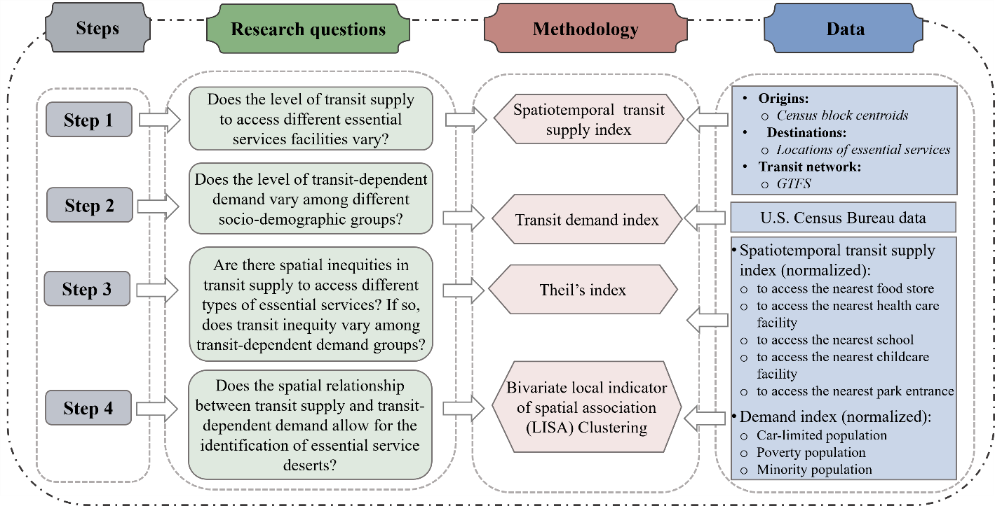
Figure 10 Conceptual Framework

the spatial clustering of transit inequity of essential services, the fourth step investigated the spatial disparity of the relationship between transit supply to access different essential services and transit-dependent demand using the bivariate local indicator of spatial association (LISA). After identifying essential service deserts in the fourth stage, the final step involved conducting further analysis of the relationships between different deserts by generating a correlation matrix and co-location maps.
Each of these steps is described in more detail in the following section.

3.4.2 Step 1: Measure spatiotemporal transit supply index

3.4.2.1 Step 1a: Measure transit accessibility
A time-dominated measurement was used to calculate the travel time required for accessing the nearest essential service facility via transit at a given departure time point. This method assumes that users opt for the nearest essential service location due to the unavailability of actual travel behavior data showing essential service selection. The equation for calculating the travel time is shown in Equation (1).
${Transit_access}_{ijT}=\min_{∀k∈K,∀t∈T}{({Travel_time}_{ijtk})}$ (1)
Where:
${Travel_time}_{ijtk}$ is the travel time via transit from the block centroid $i$ to the $k^{th}$ location of the essential service$j$ at departure time $t$;
$k$ is the location of essential service $j$;
$j$ is the type of essential service facility including food stores, healthcare facilities, schools, childcare facilities, and park entrances;
$t$ is the departure time within the time window T.
Time windows include the AM peak during 7:00 - 9:59, midday during 11:00 - 13:59, PM peak during 16:00– 18:59, and early evening during 19:00 - 21:59 on a weekday. Therefore, ${Transit_access}_{ijt}$ is the minimum transit travel time needed to travel from origin $i$ to the nearest essential service facility $j$ at time window $T$. Then the average transit accessibility for a day is calculated using Equation (2).
${Transit_access}_{ij}= \frac{\sum_{T}{{Transit_access}_{ijT}}}{Number of T}$ (2)
Where ${Transit_access}_{ij}$ is the average travel time from the block centroid $i$ to the essential service facility $j$ and T is equal to 4.

3.4.2.2 Step 1b: Measure time variation of transit accessibility
The time variation of transit accessibility is calculated using Equation (3).
${Time_Variation}_{ij}= \frac{\sum_{T}{{ (Transi{t_access}_{ijT} - {Transit_access}_{ij})}^{2}}}{(Number of T)-1}$ (3)
Where $T$ represents time windows and ${Time_Variation}_{ij}$is the time variation from the block centroid $i$ to the essential service facility $j$.

3.4.2.3 Step 1c: Measure transit supply index: spatiotemporal transit supply to access essential services
Equation (4) was developed to measure the spatiotemporal transit supply index, which assigns weights to travel time-based transit accessibility. First, the travel time-based transit accessibility was normalized to a range of 0 to 1. For ease of interpretation and consistency with common conventions, the transformation, represented as one minus the normalized travel time-based transit accessibility, was employed. This transformation ensures that a higher transit supply index value corresponds to a larger value level of accessibility and lower values show worsening access. The assignment of weights was determined by the effects of temporal variations on transit accessibility observed within the study area.
${Transit_supply}_{i,j} =\left(1-[{{Transit_access}_{ij}]}_{normalized}\right)* {Weight}_{i,j}$ (4)
Where:
$[{{Transit_access}_{i,j}]}_{normalized}=\frac{({Transit_access}_{i,j}- {min(Transit_access}_{j}))}{\left({max(Transit_access}_{j}\right)-{min(Transit_access}_{j}))}$;
${Transit_supply}_{i,j}$ is the transit supply to access the essential service facility $j$ for the block $i$;
${Weight}_{i,j}$ represents the weight that is determined based on the temporal variation of transit accessibility to the essential service facility $j$ for the block $i$.
To determine the weights in the context of Nashville, the distribution of the results in the study area from the previous two steps (step 1a and step 1b) were visualized through scatter plots and box plots (as illustrated in Figure 11). The x-axis denotes the average transit accessibility represented by the average travel time in minutes, and the y-axis denotes the temporal variation of
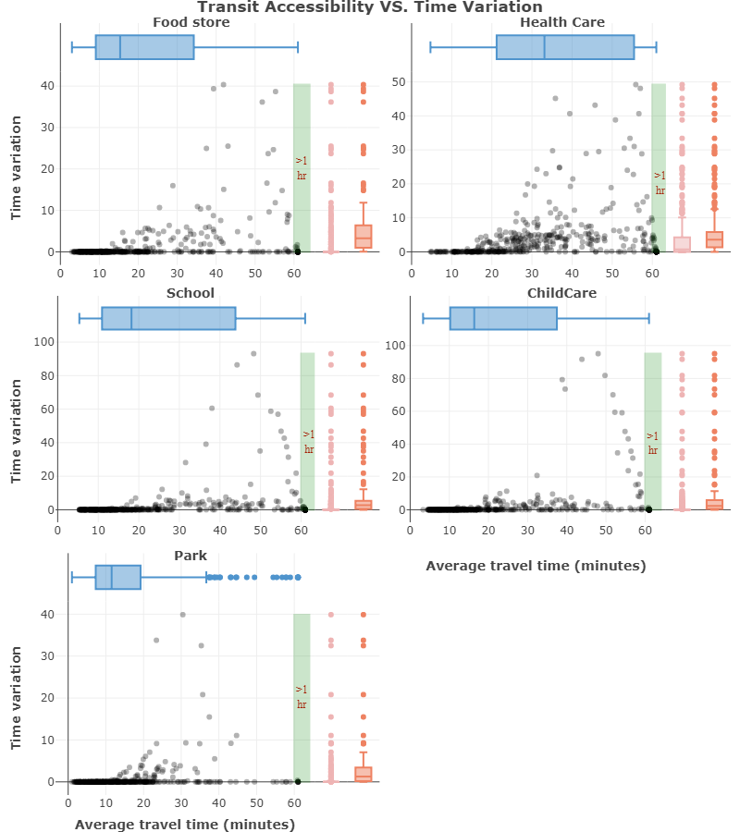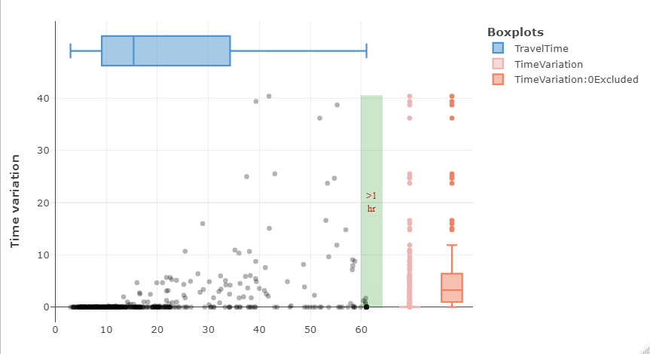
Figure 11 Scatter plots and box plots of transit accessibility and time variation
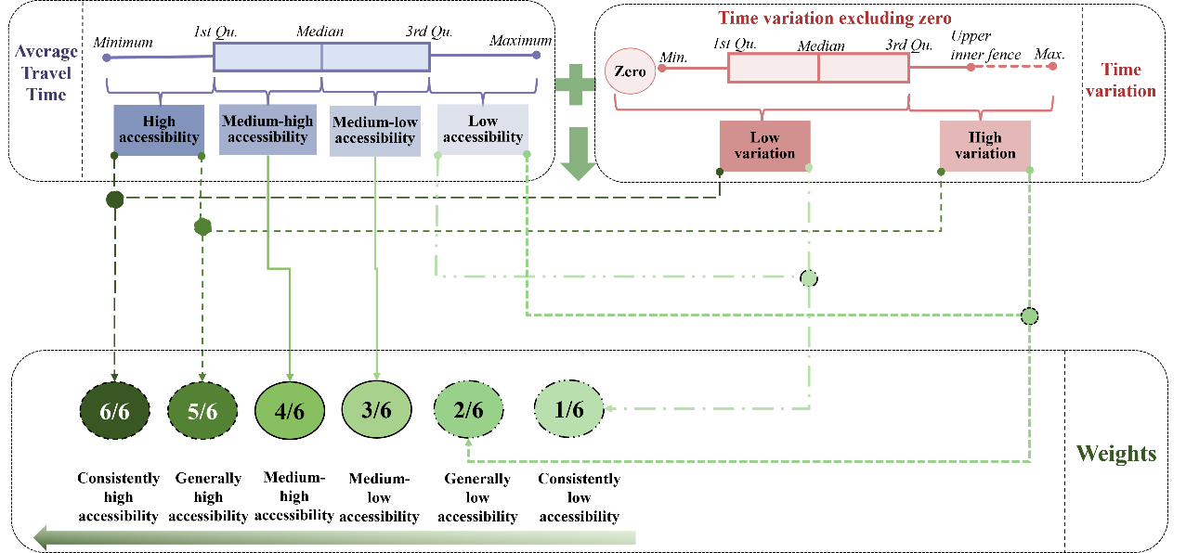
Figure 12 Proposed weights for the estimation of spatiotemporal transit supply to access essential services
transit accessibility. The blue box plots provide a summary of average transit accessibility, and the pink box plots depict a summary of the temporal variation of transit accessibility. Additionally, the orange box plots display the distribution of non-zero temporal variation of transit accessibility. As can be seen in Figure 11, the pink box plots generally have narrow boxes and short whiskers that extend toward the lower end of the plots, which suggests that the majority of the data points have values near zero. This indicates that the time variation of transit accessibility across the four time periods is minimal, suggesting that most transit services maintain a consistent schedule across different time periods. Therefore, the time variation value of zero was categorized as low variation. For those cases with time variation value greater than zero, time variation was categorized into low and high variation based on the third quantile value instead of the median value (the third quantile value was computed after separating zero-time variation cases) The transit accessibility results were categorized based on the quantile threshold values into four categories, namely high transit accessibility (travel time less than the first quantile), moderate-high transit accessibility (travel time ranging from the first quantile to the median), moderate-low transit accessibility (travel time ranging from the median to the third quantile), and low transit accessibility (travel time greater than the third quantile).
Weights were proposed for various combinations of transit accessibility and time variation, as illustrated in Figure 3. The highest weight was assigned to areas with high transit accessibility and low variation, indicating consistently high transit accessibility and the highest level of the transit supply index. The second-highest weight was assigned to areas with high transit accessibility and high variation, indicating overall high transit accessibility with occasional dips in accessibility. Conversely, the lowest weight was assigned to areas with low transit accessibility and low variation, indicating consistently low transit accessibility and the lowest level of the transit supply index. The second-lowest weight was assigned to areas with low transit accessibility and high variation, indicating overall low transit accessibility with occasional increases in accessibility. Consequently, six weights were assigned with a linear progression from 1/6 to 1 (Fransen et al., 2015). This progression guarantees that the transit supply index falls within the range of 0 to 1, offering a meaningful scale for interpretation while also facilitating a comprehensive spatiotemporal assessment of transit supply to access essential services.

3.4.3 Step 2: Measure transit-dependent demand index
Drawing on prior research, three sociodemographic groups were selected for evaluation in Nashville. The first group was car-limited populations, and the formula for this was adapted from research conducted by the U.S. Department of Transportation (USDOT) (Steiss, 2006). Car-limited populations were identified as those individuals who are unable to operate a vehicle or have limited vehicles available to use and, consequently, are more likely to rely on transit for their daily transportation needs. It is noted that individuals living in group quarters were deducted from the car-limited population calculation formula because the entity or organization that owns or manages the group quarters provides housing and/or other services for the residents (U.S. Census Bureau, 2021a), which may affect their reliance on transit.
Based on the USDOT formula, prior studies further considered potential car-limited populations who are not able to drive but sometimes might need to go out on their own (Jiao, 2017; Jiao & Dillivan, 2013; Li & Fan, 2020). This paper utilized the formula adapted by a previous study (Li & Fan, 2020) that included the population aged 10-15 as potentially car-limited. It is important to note that while there is no universal legal age at which children may be allowed to travel independently, the Tennessee State Courts (Tennessee State Courts) recommend against leaving children under the age of 10 unattended.
Accordingly, Equations (5) to Equations (7) were developed for this study to calculate the car-limited index at the $i_{th}$census block group:
- ${Driving-age_population}_{i}=$
${\left(populations over age 16\right)}_{i} – { (people living in group quarters)}_{i}$ (5)
- ${Car-limited_population}_{i} = {(Driving age population)}_{i} – {(Number of available vehicles)}_{i} + {(Total population between 10-15)}_{i}$ (6)
- ${Car-limited_index}_{i}= {[{Car-limited_population}_{i} ]}_{normalized }$ (7)
The normalization process in Equation (7) followed the same min-max method as applied in Equation (4).
Before continuing, it should be noted that a lack of data specifically showing the difference in the number of drivers and available vehicles at the household level may potentially result in an underestimation of the transit-dependent population.
The remaining two potential transit-dependent demand groups are comprised of poverty and minority populations, which are recognized as protected groups entitled to equitable transit access under Title VI of the Civil Rights Act of 1964. Poverty is defined as individuals with incomes below the poverty threshold (U.S. Census Bureau) at the Census block group level, and minority populations encompass nonwhite and Hispanic origin populations at the Census block group level. Accordingly, Equations (8) to (9) and Equations (10) to (11) were developed for this study to calculate indexes for the population in poverty and for minority populations at the $i_{th}$ Census block group, respectively.
- ${Poverty_population}_{i} = {population below poverty threshold}_{i}$ (8)
- ${Poverty_index}_{i}= {[{Poverty_population}_{i} ]}_{normalized }$ (9)
- ${Minority_population}_{i} = {\left(NonWhite population \left(Black, Asian, American Indian, Alaskan\right)\right)}_{i}+ \left( {Hispanic origin population}_{i} \right)$ (10)
- ${Minority_index}_{i}= {[{Minority_population}_{i} ]}_{normalized }$ (11)
Last, the populations from these three groups were then summed to measure the combined transit-dependent demand, as shown in Equation (12). All demand indexes had a range of 0 to 1.
- $Combined Transit-dependent{ demand index}_{i}={({Car-limited_population}_{i} + {Poverty_population}_{i} + {Minority_population}_{i})}_{normalized }$ (12)
The normalization process in Equation (9), Equation (11) and Equation (12) followed the same min-max method as applied in Equation (4).
In accordance the findings of prior research (Grengs, 2001; Li & Fan, 2020), it is pertinent to note that due to the inherent overlapping characteristics present in Census data across these demographic factors, there is a potential for unavoidably double-counting some people when aggregating to the combined transit-dependent demand index.

3.4.4 Step 3: Quantify spatial transit inequity using the Theil index
This step utilized the Theil index to estimate the spatial inequity associated with transit supply to access essential services. The overall Theil index, which measures the total spatial inequity in the study area, can be decomposed into within-group and between-group components. The advantage of this decomposition is that it helps identify inequality within and between different defined population subgroups with different levels of transit demand. The Theil index ranges between 0 and 1, where 0 indicates that transit supply to access essential services is equally distributed in the whole region and a higher Theil index indicates a wider disparity among Census block groups, suggesting a greater inequity. The equations are shown below in Equations (13), (14), and (15):
$T=(\frac{1}{N})\sum_{i=1}^{N}{\left(\frac{{TS}_{i}}{\overline{TS}}\right)ln⁡(\frac{{TS}_{i}}{\overline{TS}})}$ (13)
$T_{WG}=\sum_{k=1}^{K}{{TS}_{k}[\sum_{i∈g_{k}}{\frac{{TS}_{ki}}{\overline{TS}}}ln\frac{{TS}_{ki}/{TS}_{k}}{1/n_{k}}]}$ (14)
$T_{BG}=\sum_{k=1}^{K}{{TS}_{k} ln⁡(\frac{{TS}_{k}}{n_{k}/N})}$ (15)
Where:
T is the overall Theil index;
$T_{WG}$ is the within-group component of the Theil index, which evaluates the inequity within each transit demand subgroup;
$T_{BG}$ is the between-group component of the Theil index, which evaluates the inequity across different transit demand subgroups;
N is the total number of Census block groups;
${TS}_{i}$ is the transit supply index of Census block group $i$;
$\overline{TS}$ is the average level transit supply to access essential services of all the Census block groups in Nashville;
$K$ is the number of transit demand subgroups;
$g_{k}$ is the set of Census block groups within the $k_{th}$ level;
$n_{k}$ is the number of $g_{k}$;
${TS}_{ki}$ is the percent share of the total transit supply index of Census block group $i$;
${TS}_{k}$ is the percent share of the total transit supply index of the transit demand subgroup $k$.

3.4.5 Step 4: Identify essential service deserts using the bivariate local indicator of spatial association (bi-LISA)
To identify essential service deserts characterized by low transit supply and high transit-dependent demand, the bivariate local indicator of spatial association (bi-LISA) was utilized to evaluate the spatial disparity of the relationship between transit supply to access essential services and transit-dependent demand across Census block groups and to identify spatial clustering of transit inequity. The bi-LISA calculates the local Moran's I statistic for each Census block group $i$, as shown below in Equation (16):
$I_{i}= D_{i}\sum_{j}{W_{ij}S_{j}}$ (16)
Where:
$D_{i}$ is the standardized transit demand index (standardization of demand index obtained from Equation (9), Equation (11) and Equation (12)) for the Census block group $i$;
$S_{j}$ is the standardized transit supply index (standardization of supply index obtained from Equation (4)) for the Census block group $j$;
$W_{ij}$ are the elements of the neighborhood weight matrix that was generated by queen contiguity weight to assess the spatial relationship between Census block group $i$ and Census block group $j$ in which $W_{ij}$ = 1 if $i$ and $j$ are neighbors; $W_{ij}$ = 0 if $i$ and $j$ are not neighbors.
$D_{i}$ and $S_{j}$ represent the standardized index, which can encompass both positive and negative values. Consequently, the values for the local Moran's I range between – 1 and 1, where positive values represent positive spatial association patterns and negative values indicate the opposite direction. The absolute values of the local Moran's I correspond to the strength of the spatial correlation. A 5% significance level was used to determine the statistical significance of the calculation, with Census block groups having a p-value above this threshold considered not significant. The outputs of this step included the bi-LISA clustering maps showing the local spatial correlation patterns for different transit-dependent demand groups and different transit supply categories. The spatial correlation patterns can help to identify the spatial match and mismatch between transit-dependent demand and transit supply to access essential services by categorizing the census block groups into four clusters: High-High clusters (Census block groups with high transit-dependent demand and high transit supply to access essential services), High-Low clusters (Census block groups with high transit-dependent demand and low transit supply to access essential services), Low-High clusters (Census block groups with low transit-dependent demand and high transit supply to access essential services), and Low-Low clusters (Census block groups with low transit-dependent demand and low transit supply to access essential services). Specifically, High-Low clusters were identified as essential service deserts.

3.4.6 Step 5: Correlation analysis and Co-location maps of essential service deserts
This step further analyzed areas with inequitable transit supply that were identified as essential service deserts in the previous step. The analysis method for this step consists of two parts. First, the tetrachoric correlation measure was employed to estimate the correlation among various types of essential services, which were identified by the binary variables indicating whether a Census block group was classified as an essential service desert (1) or not (0). The tetrachoric correlation measures the Pearson product-moment correlation between two binary variables, with values ranging from -1 to 1. A value of -1 indicates a strong negative correlation, 0 indicates no correlation, and 1 indicates a strong positive correlation between the two variables. A 2x2 table containing two binary variables for “food store desert” and “school desert” is shown in Table 5 as an example, and the corresponding formula for calculating the tetrachoric correlation between the two variables is shown in Equation (17):
$Cor= \cos\left[\frac{π}{(1+\sqrt{ad/bc})}\right]$ (17)
Where:
a is the number of Census block groups that are neither food store deserts nor school deserts;
b is the number of Census block groups that are school deserts but not food store deserts;
c is the number of Census block groups that are food store deserts but not school deserts;
d is the number of Census block groups that are food store deserts and school deserts.
The outcome of this is a correlation matrix that displays the direction, strength, and statistical significance of the correlation among five identified essential service deserts.
In the second part of this step, areas with overlapping essential service deserts were identified by conducting a co-location analysis. The anticipated outcome comprises co-location maps that demonstrate the areas with multiple categories of essential service deserts with a high correlation value.

3.5 Results
This section presents the results of this study in five parts. The first two parts map the distribution of the transit supply index and transit demand index for the study area. The third part quantifies the spatial transit inequity for the five essential service categories and compares the

Table 5 Example of two binary variables
 |  | Variable: School desert (binary)
 |  | No (0) | Yes (1)
Variable: Food store desert (binary) | No (0) | a | b
Variable: Food store desert (binary) | Yes (1) | c | d

transit inequity across and within different transit-dependent demand groups. The fourth part assesses the spatial match and mismatch between transit supply to access essential services and transit-dependent demand and identifies underserved areas as essential service deserts. The last part presents the correlation analysis results across different types of essential service deserts and the co-location maps of areas with overlapping essential service deserts.

3.5.1 Transit supply index
This part applied the method discussed in section 4.2 to compute the spatiotemporal transit supply index for the five essential service categories. To enable comparison between maps for the city of Nashville, Figure 13 employed equal interval classifications to visualize the transit supply index at the Census block group level. The map in the bottom right corner displays Nashville’s WeGo transit network, and the remaining maps depict the transit supply index with overlaid essential service facility locations (e.g., one map showing food stores, one showing healthcare facilities, etc.). These transit supply index maps utilized a consistent reference scale and legend, with darker shades of blue representing higher levels of transit supply to access essential services.
The maps in Figure 13 reveal several noteworthy spatial patterns. First, the downtown area of Nashville has the highest transit supply levels regardless of the essential service category. Second, areas with denser transit stops and more essential service facility locations generally correspond to higher transit supply levels (as would be expected). Third, there is a consistent trend of decreasing transit access to food, healthcare, school, and childcare as one moves away from the city center and towards the outskirts of Nashville. Finally, the distribution of transit supply to access parks is somewhat different, with higher transit supply levels concentrated in the central and south/east areas of Nashville. This is likely because recreational amenities and green spaces, such particularly larger parks, are often located in suburban areas of the city. Based on these findings, it can be noted that certain areas in Nashville encounter limited access to one or several types of essential services via transit.
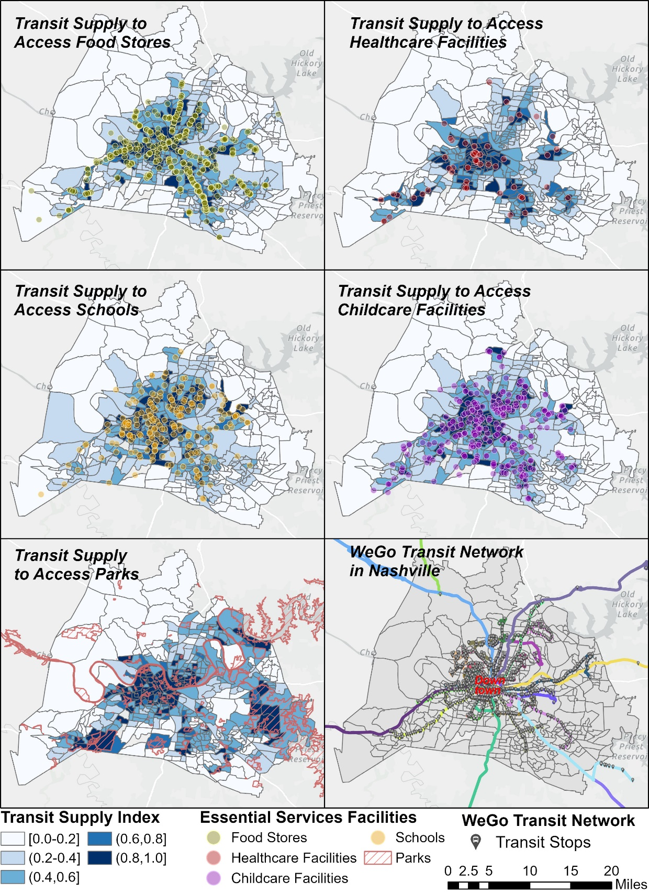
Figure 13 Distribution of the transit supply index to the five essential service categories in Nashville

3.5.2 Transit demand index
This part applied the method discussed in section 4.3 to compute the transit-dependent demand index for three transit-dependent groups (car-limited, poverty, minority) in the city of Nashville. Figure 14 displays the distribution of the transit-dependent demand index at the Census block group level, utilizing the equal interval classification method. The color scheme was created based on the value of the normalized transit-dependent demand population, with darker shades of orange-brown indicating higher levels of transit-dependent demand. As can be seen in Figure 14, most areas in Nashville exhibit relatively low levels of transit-dependent demand, as indicated by the lightest orange color. This finding aligns with the sociodemographic characteristics of Nashville, where approximately 15% of residents fall below the poverty line, 38% of residents are minorities (non-white), 14% of residents identify as Hispanic or Latino, and only 6% of households do not own vehicles. Despite variations in the distribution of different transit-dependent groups, there are some areas of overlap among them. For instance, one block group located in southeast Nashville has the highest transit-dependent demand index level for all three transit-dependent groups, indicated by the darkest orange shade.

3.5.3 Spatial transit inequity using the Theil index
The Theil index was applied to evaluate the spatial inequity of transit supply to access essential services in Nashville. The overall spatial inequity index of transit supply to access essential services is presented in the second column in Table 6. The average transit supply to access five essential services for the total population and for the five population subgroups with different levels of combined transit-dependent demand index are shown in the parentheses in Table 6. The Theil index for transit supply to access healthcare facilities (0.38) is the highest among all essential services, indicating that transit accessibility to healthcare has the greatest level of inequity. Furthermore, when compared to transit supply to access the other four essential services, the average transit supply to

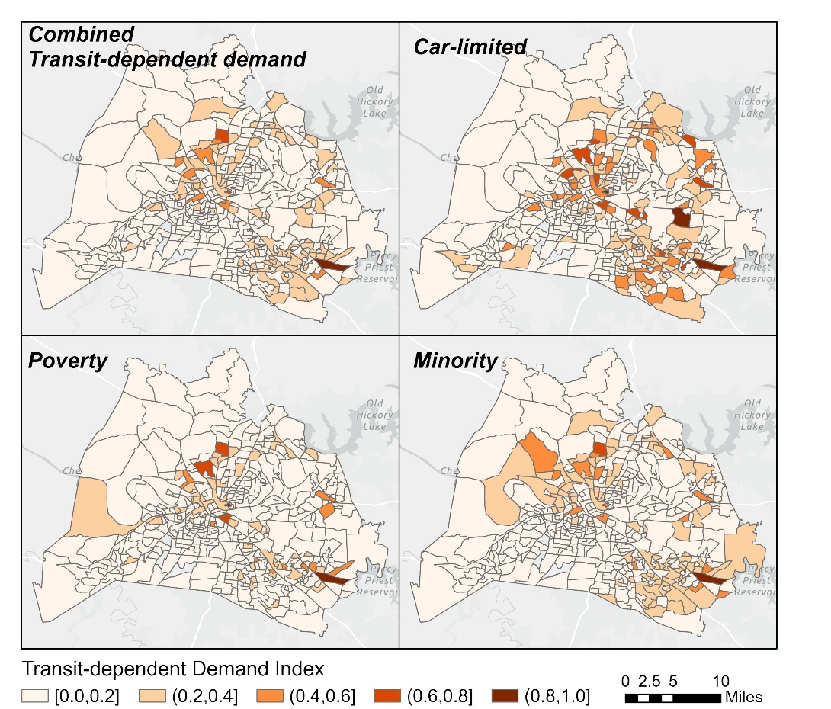
Figure 14 Distribution of the transit-dependent demand index in Nashville
Table 6 Theil index, $T_{BG}$ and $T_{WG}$ of relative transit supply to access essential services for population subgroups with different combined transit-dependent demand index
 | Theil index
 |  | Combined transit-dependent demand index
 | Total | (0.0, 0.2] | (0.2, 0.4] | (0.4, 0.6] | (0.6, 0.8] | (0.8, 1.0] | $$T_{BG}$$ | $$T_{WG}$$
Transit supply to access food store | 0.28  (0.48) | 0.28  (0.49) | 0.28  (0.46) | 0.24  (0.56) | 0.02  (0.49) | 0  (0.03) | 0.77% | 99.23%
Transit supply to access healthcare | 0.38  (0.38) | 0.37  (0.39) | 0.42  (0.35) | 0.50  (0.37) | 0.03  (0.35) | 0  (0.03) | 0.71% | 99.29%
Transit supply to access school | 0.32  (0.47) | 0.30  (0.49) | 0.40  (0.38) | 0.23  (0.66) | 0.12  (0.67) | 0  (0.03) | 2.36% | 97.64%
Transit supply to access childcare | 0.30  (0.47) | 0.28  (0.49) | 0.35  (0.41) | 0.27  (0.58) | 0.11  (0.66) | 0  (0.03) | 1.52% | 98.48%
Transit supply to access park | 0.20  (0.51) | 0.20  (0.51) | 0.21  (0.50) | 0.09  (0.69) | 0.35  (0.55) | 0  (0.38) | 0.55% | 99.45%
Average transit supply index for each population group is shown in parentheses
access healthcare facilities (which is also 0.38) is notably the lowest. This is mainly because, compared to other essential services, healthcare facilities are fewer in number and
more concentrated in certain areas, as shown in Figure 13. Conversely, transit accessibility to parks has the lowest total level of spatial inequity and transit supply to access parks has the highest average level across the city, as reflected by the smallest Theil index value (0.20) and the largest transit supply index value (0.51). This can be attributed in part to the fact that parks are more evenly distributed throughout the city than other essential service facilities. The level of spatial inequity in transit accessibility to other essential services in descending order of the Theil index is as follows: transit supply to access schools (0.32), transit supply to access childcare facilities (0.30), and transit supply to access food stores (0.28). Transit accessibility to these three essential services has similar levels of spatial inequity, which is consistent with Figure 13, where the transit supply index to these essential services has a similar spatial distribution pattern. This observation is further supported by the citywide average transit supply index values, which are very similar (0.47, 0.47 and 0.48, respectively) for these essential services.
In terms of transit inequity in different population subgroups with different levels of combined transit-dependent demand, the results from the third to the seventh column of Table 6 indicate that population subgroups with low to moderate levels of transit demand (with the combined transit-dependent demand index below 0.6) have more equitable transit access to parks (indicated by the Theil index of 0.20, 0.21, and 0.09). However, population subgroups with higher transit demand levels (with the combined transit-dependent demand index above 0.6) have more equitable transit access to food stores and healthcare facilities (indicated by the Theil index values of 0.02 and 0.03). Nevertheless, there are varying equity trends within subgroups, with some having an average transit supply index higher than the citywide average and others having an average transit supply index lower than the citywide average, even when the overall larger group shares a uniform level of equity. For example, the subgroup with the combined transit-dependent demand index between 0.0 to 0.2 and the subgroup with the combined transit-pendent demand index between 0.2 to 0.4 have the same Theil index value (0.28) for transit supply to access food stores. However, the former subgroup has an average transit supply index higher than the citywide average (as shown by 0.49 > 0.48) while the latter subgroup has an average transit supply index lower than the citywide average (as shown by 0.46 < 0.48). The subgroup with a combined transit-dependent demand index ranging from 0.6 to 0.8 exhibits a high level of spatial transit equity in accessing food stores and healthcare facilities, with Theil index values of 0.02 and 0.03, respectively. However, transit supply to access these two services differs within this subgroup, with higher-than-citywide transit supply level for food stores (0.49 > 0.48) and lower-than-citywide transit supply level for healthcare facilities (0.35 < 0.38). The Theil index for the transit-dependent demand index of (0.8, 1.0] is zero, which is because only one block group belongs to this level. The residents of this block group experience notably limited transit access to all these five essential services, with particularly poor accessibility to food, healthcare facilities, schools, and childcare services.
Furthermore, it is worth noting that even among subgroups with lower levels of equity, they may exhibit a higher average transit supply. For instance, when considering transit supply for accessing food stores and healthcare facilities, subgroups with a combined transit-dependent demand index ranging from 0.4 to 0.6 show lower spatial equity, indicated by Theil index values of 0.24 and 0.5, compared to subgroups with a combined transit-dependent demand index between 0.6 to 0.8, which have Theil index values of 0.02 and 0.03. However, despite the lower equity levels, the former subgroups have higher average transit supply for accessing food stores (0.56 compared to 0.49) and greater average transit supply for accessing healthcare (0.37 compared to 0.35). Therefore, further analysis of the spatial match and mismatch between the transit-dependent demand and transit supply to access essential services is developed in the next section.
The last two columns on the righthand side of Table 6 present the between-group and within-group components of the Theil index. The within-group inequity is much more pronounced than between-group inequity, primarily due to the disparities caused by a large number of block groups that were categorized within a single group (the group with the lowest range of (0.0, 0.2]). Regarding between-group inequity, transit supply to access schools has the highest level of inequity (2.36%), indicating that between-group inequity for transit accessibility to schools made a higher contribution to the overall inequity when compared with between-group inequity for transit accessibility to other categories. However, it still is a very small contribution compared to the within-group inequity.

3.5.4 Spatial correlation between transit-dependent demand and transit supply and identification of essential service deserts
The bi-LISA maps in Figure 15 visualize the spatial match and mismatch between the transit-dependent demand and transit supply to access essential services by categorizing block groups into four types of significant spatial correlation clusters. It is noted that a 5% significance level was used to determine the statistical significance of the calculation of local Moran's I, with block groups having a p-value above this threshold classified as not significant. The matched correlation consists of H-H clusters (shown in red), indicating high transit-dependent demand and high supply areas, and L-L clusters (indicated in blue), representing areas with low transit-dependent demand and low transit supply to access essential services. The mismatched pattern includes two types, namely the H-L clusters (indicated as pink), which highlights underserved areas with high levels of transit-dependent demand but limited access to essential services via transit, and the L-H clusters (indicated as indigo), indicating areas with low transit-dependent demand but high transit accessibility, which are considered overserved areas.
In general, the majority of H-H clusters (high demand and high supply) and L-H clusters (low demand and high supply) are concentrated in the central city area characterized by a high density of transit stops and numerous essential service facilities. In contrast, most H-L clusters (high demand and low supply) and L-L clusters (low demand and low supply) are distributed on the peripheries of the city. However, different distribution patterns can be observed between clusters of transit supply to access parks and clusters of transit supply to access the other four essential services. As an illustration, in terms of combined demand groups (shown in the first column), it is noted that the number of H-L clusters is higher for food stores, healthcare, schools, and childcare facilities compared to parks. This indicates that communities with high transit-dependent demand have less access to food stores, healthcare facilities, schools, and childcare facilities than to parks. Furthermore, within the southeastern region of the city, H-L clusters can be observed for food stores, healthcare, schools, and childcare facilities, whereas there are few H-L clusters.
The cross-sectional comparison reveals spatial disparities in transit supply to access essential services for different demand groups. Specifically, in terms of transit accessibility to food stores, healthcare facilities, schools, and childcare facilities (represented in the first four rows in Figure 15), H-L clusters (pink areas) were identified on the southeast edge and in the mid-northwest areas for minority groups, while these areas were classified as L-L clusters (blue areas) for car-limited groups and poverty groups. These findings imply that the southeast and mid-northwest areas of Nashville, with limited transit access, have a higher transit-dependent demand from minority populations. The H-L clusters for food store access, school access, and park access were observed for the poverty group in the southwest corner of the city, whereas the same communities were classified as L-L clusters for car-limited groups and minority groups. This implies that the underserved regions in the southwest corner of the city exhibit a greater demand from the poverty group.
The summary of the four bi-LISA clusters was visualized in a bar plot shown in Figure 16 for the different transit-dependent demand groups and different transit supply access to essential service categories. By examining the count of block groups in each cluster, it becomes apparent that there is a larger proportion of H-L clusters (indicated by the pink bar) in the food store, healthcare, school, and childcare categories than in the park category. Moreover, the healthcare, school, and childcare categories have a greater number of H-L clusters than the food store category. This implies that there are greater levels of transit inequity regarding access to healthcare facilities, schools, and childcare facilities, as opposed to food access and park access. In terms of transit-dependent demand, a greater proportion of H-L clusters was observed within minority groups, indicating that compared to those who are car-limited and in poverty, minority groups encounter more pronounced transit inequity. The average population for each category is also shown on the right side of Figure 16.The average population suggests that while the count of Census block groups
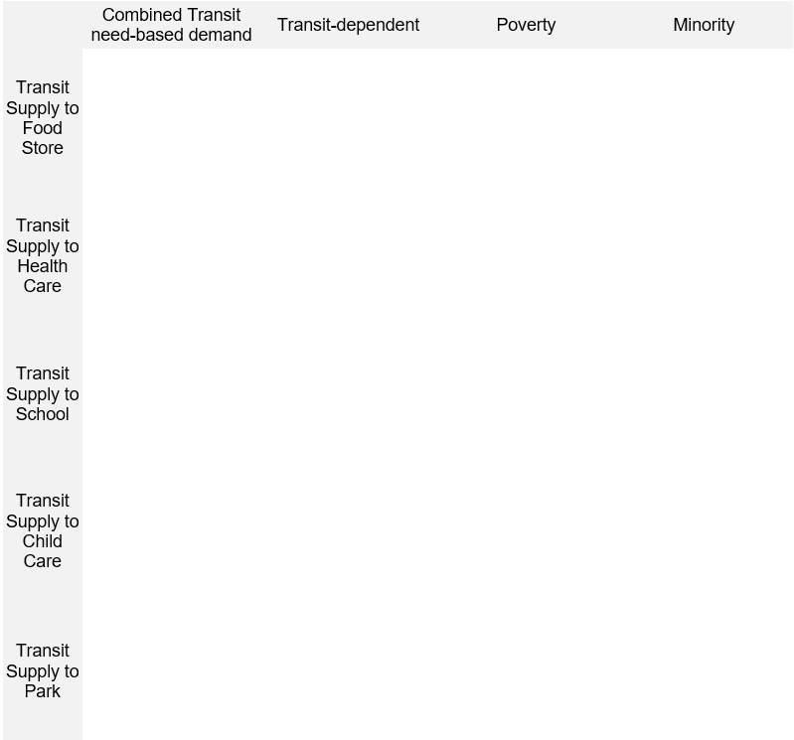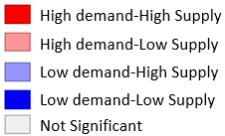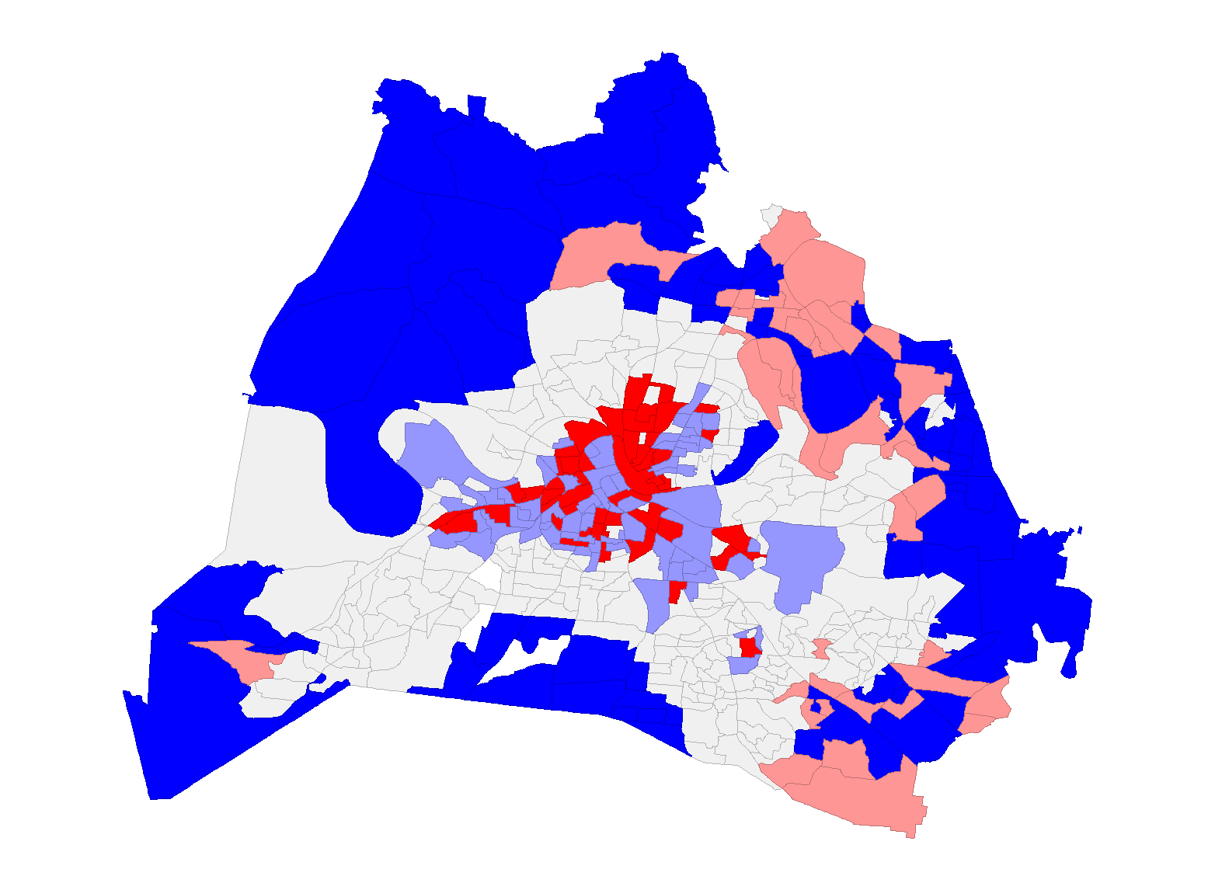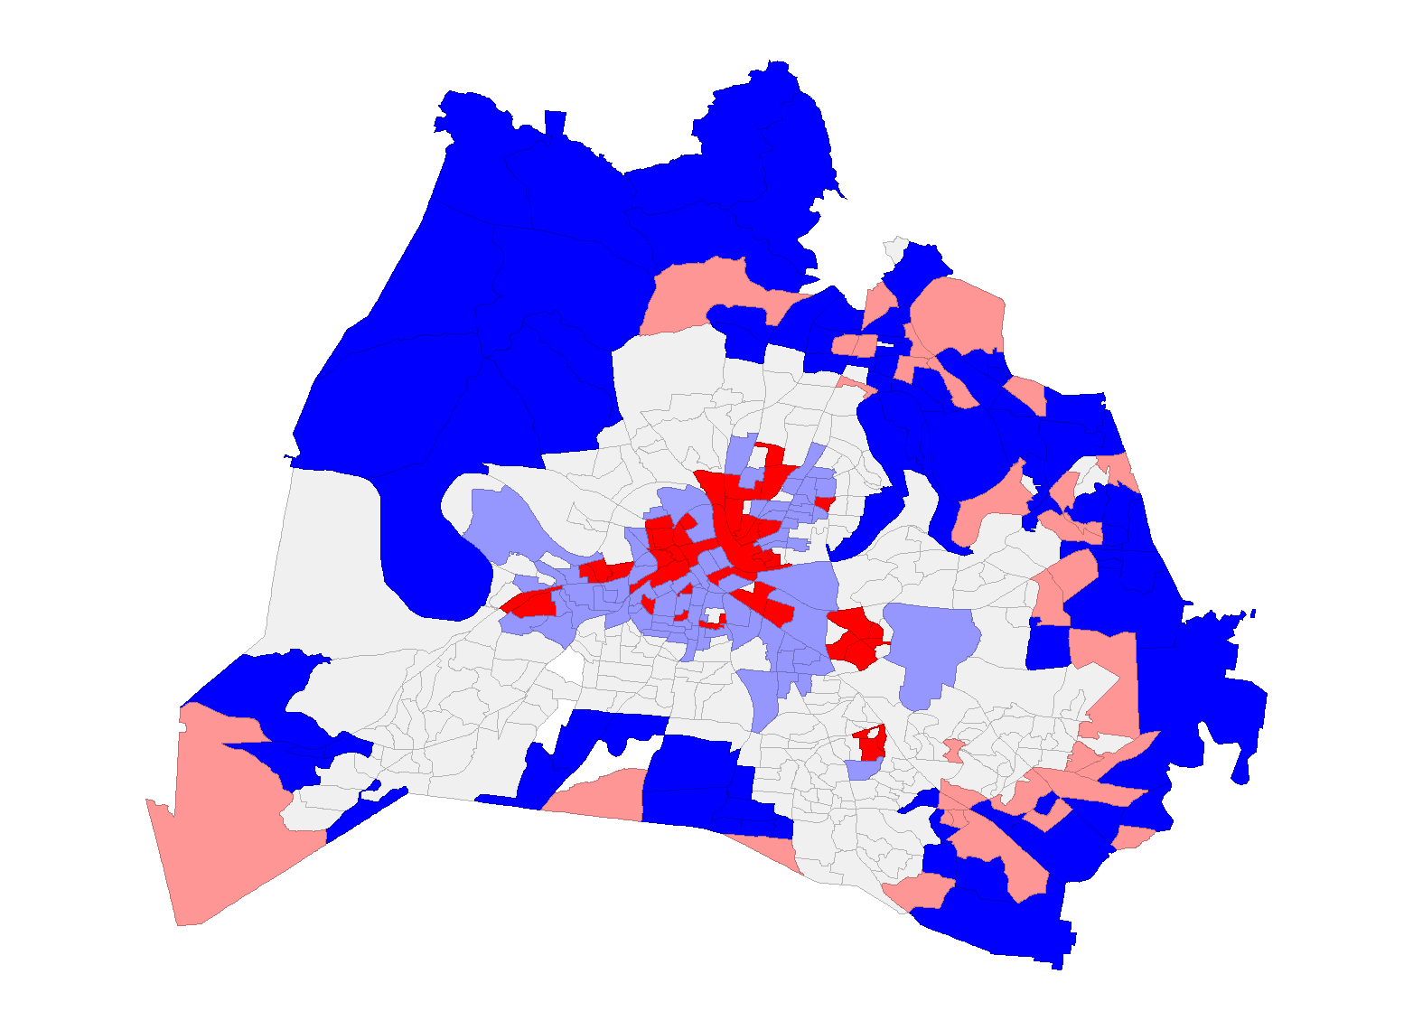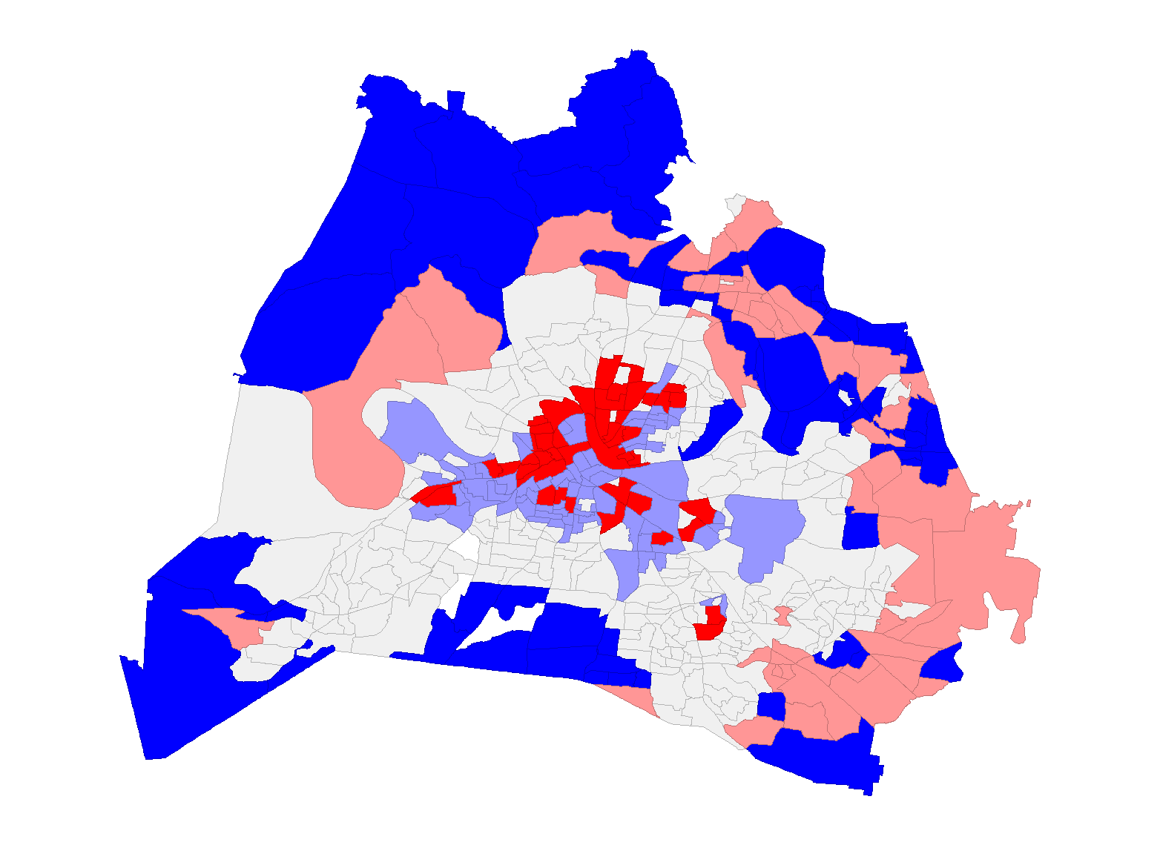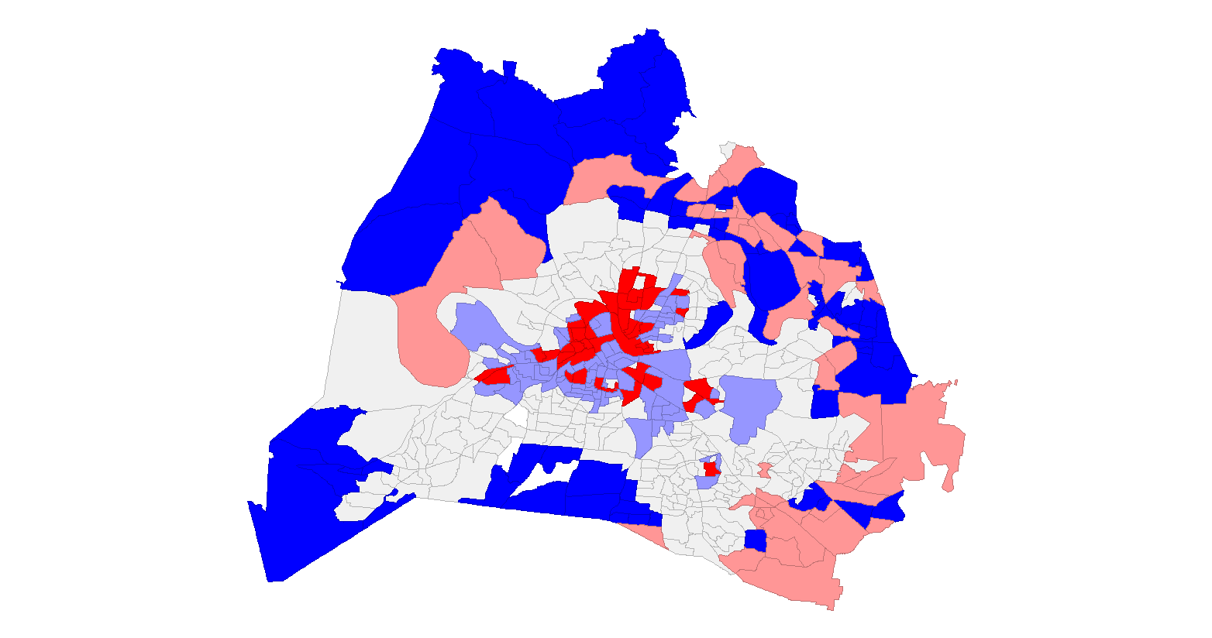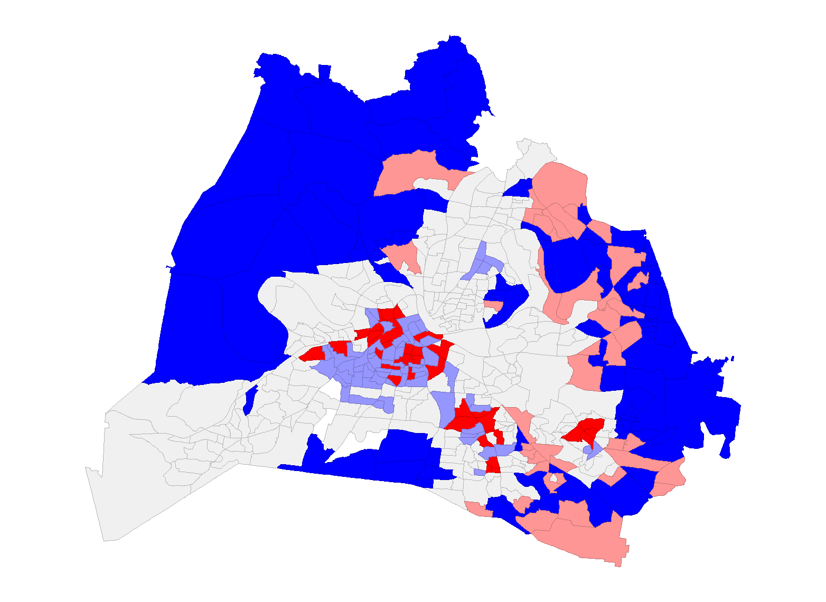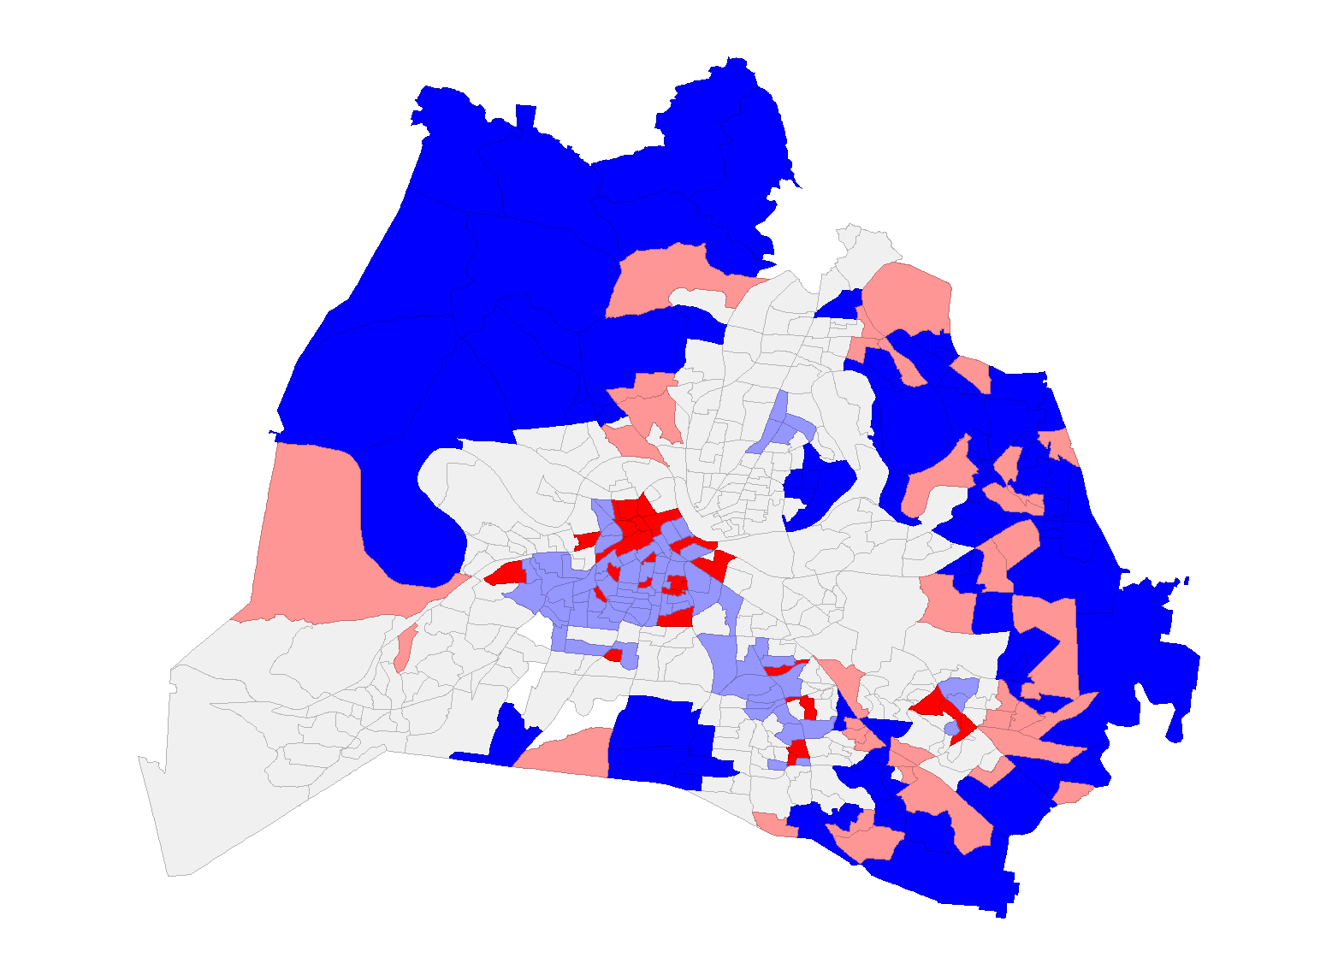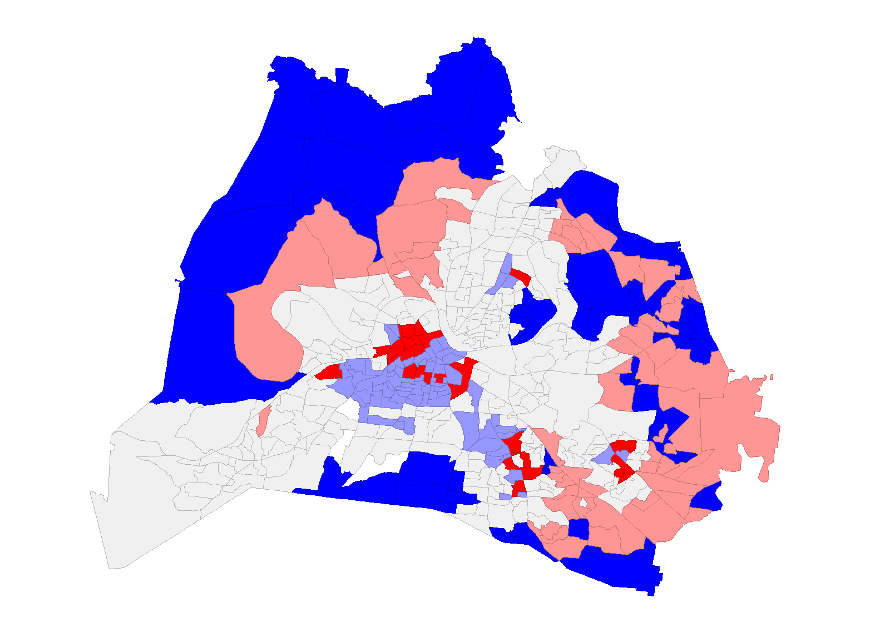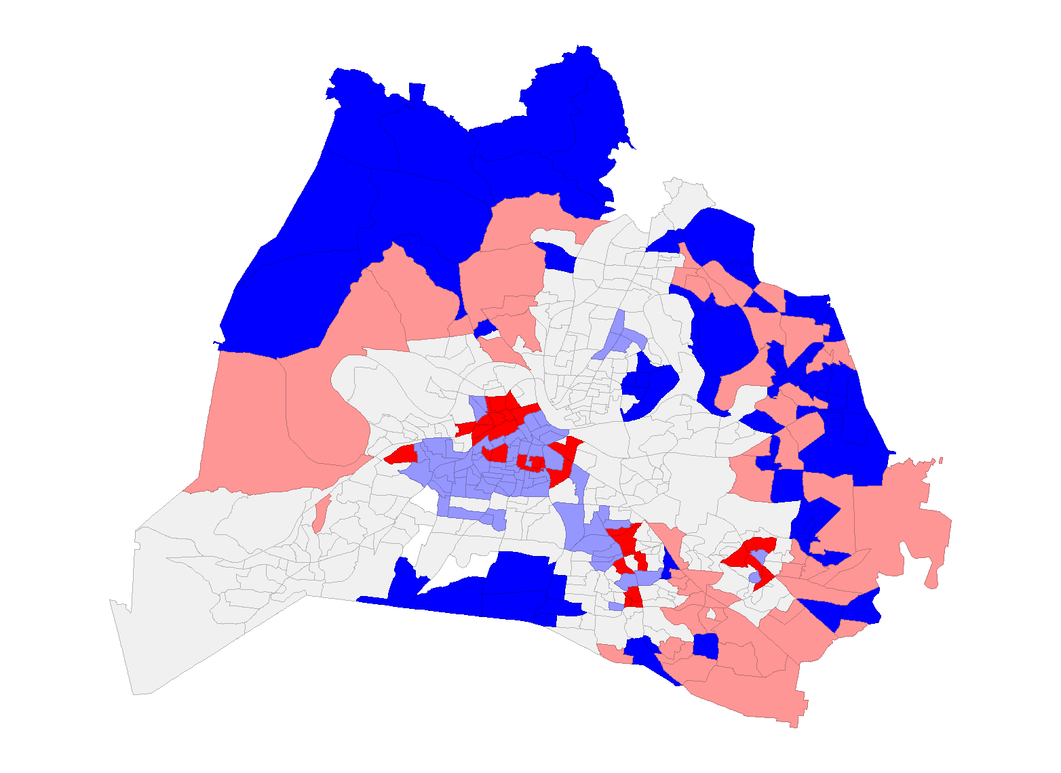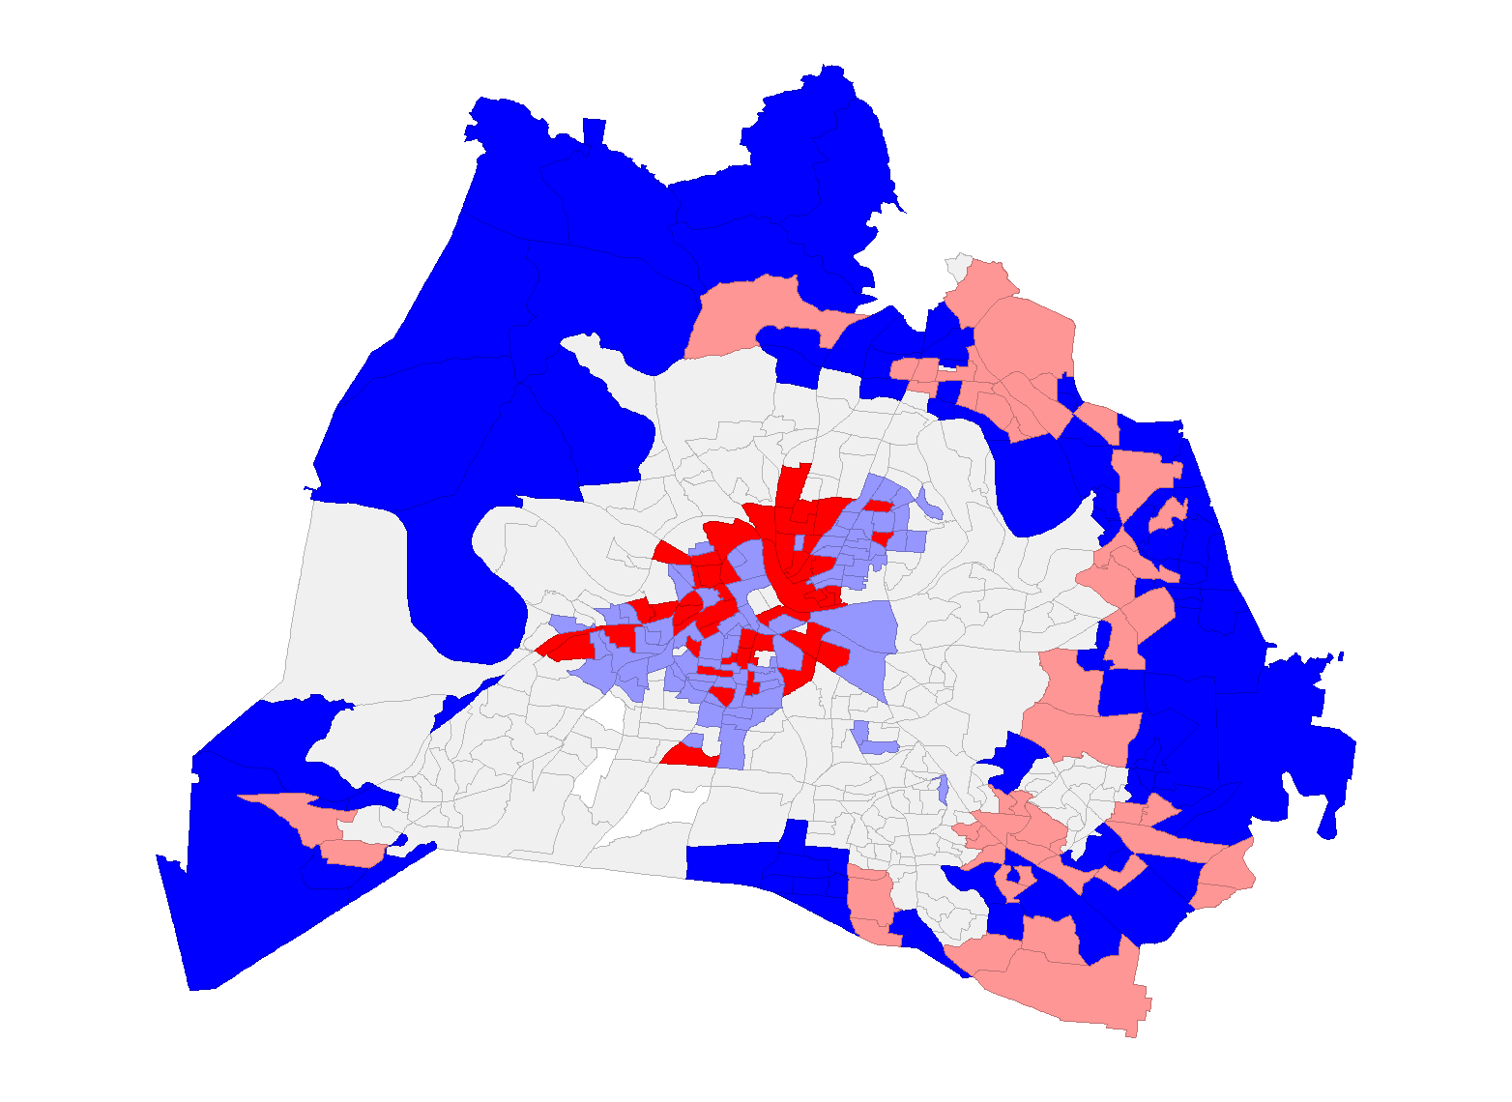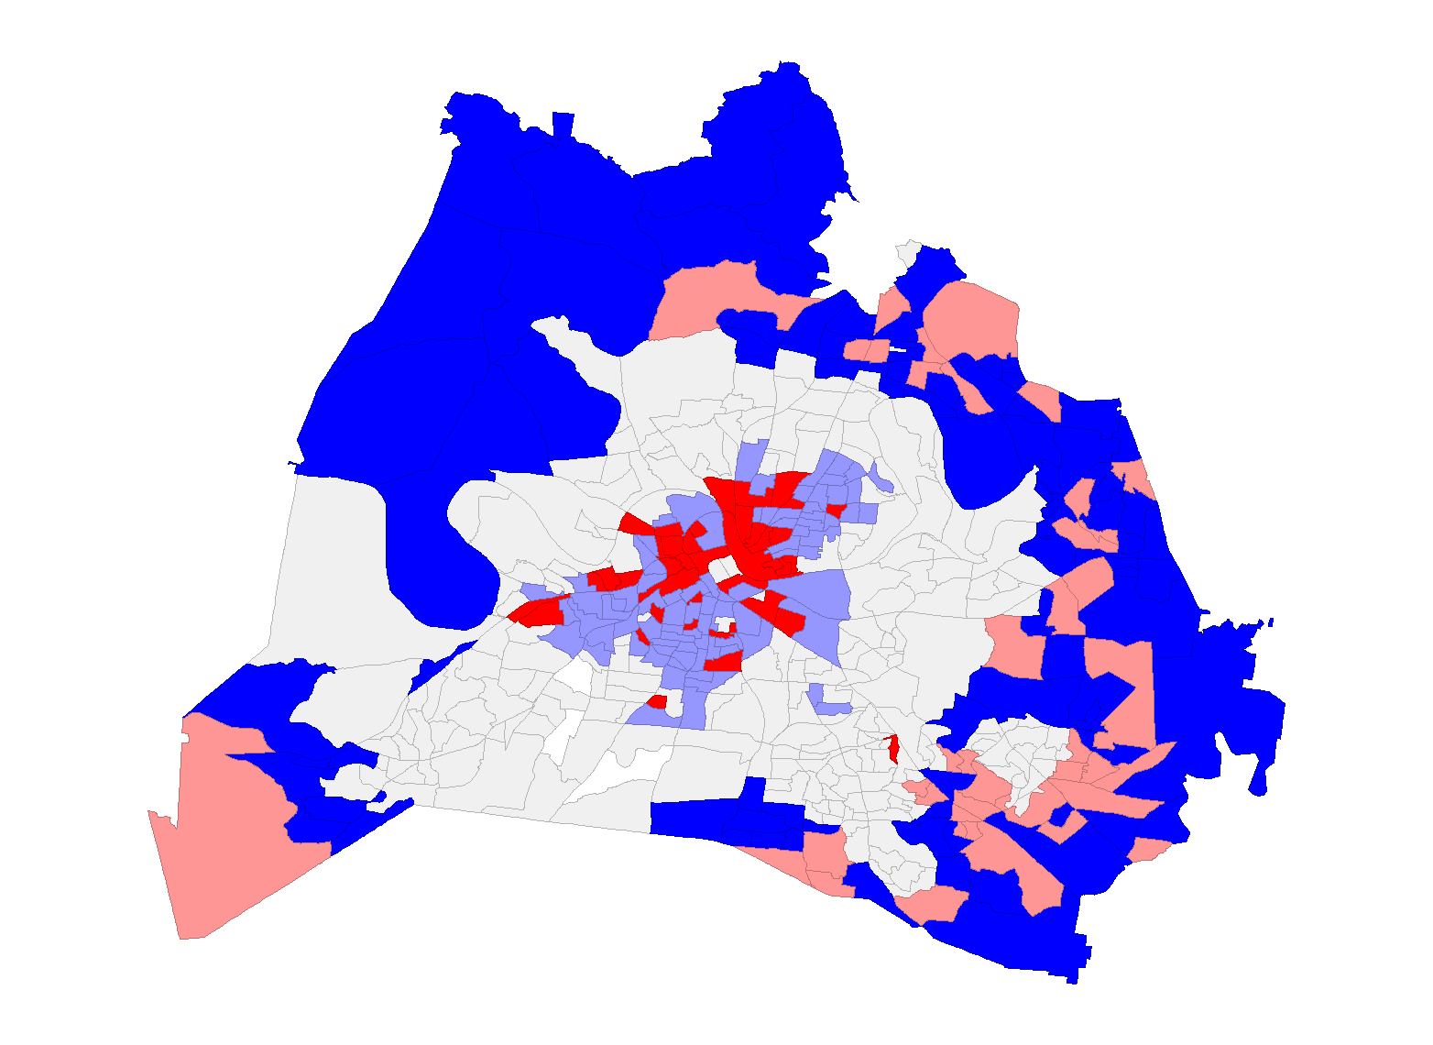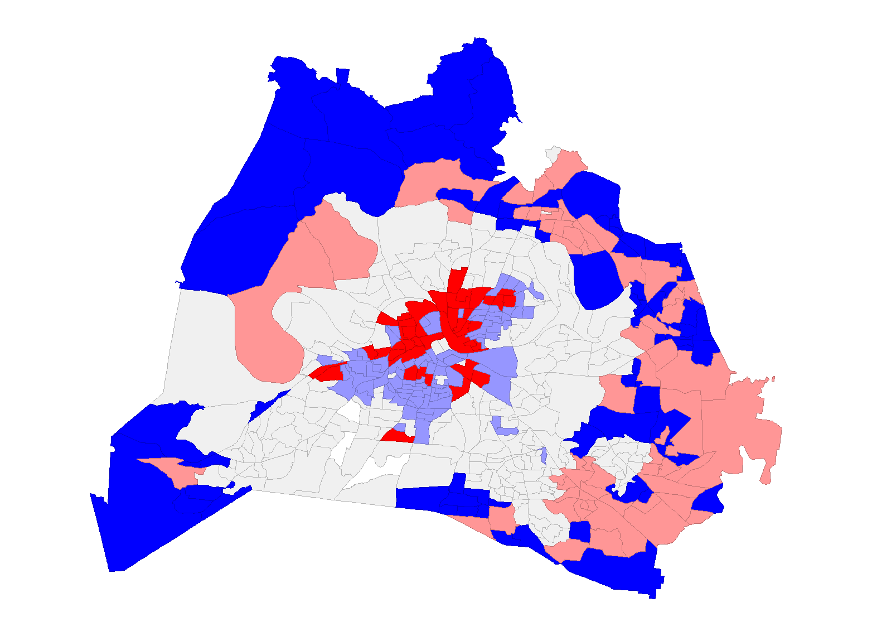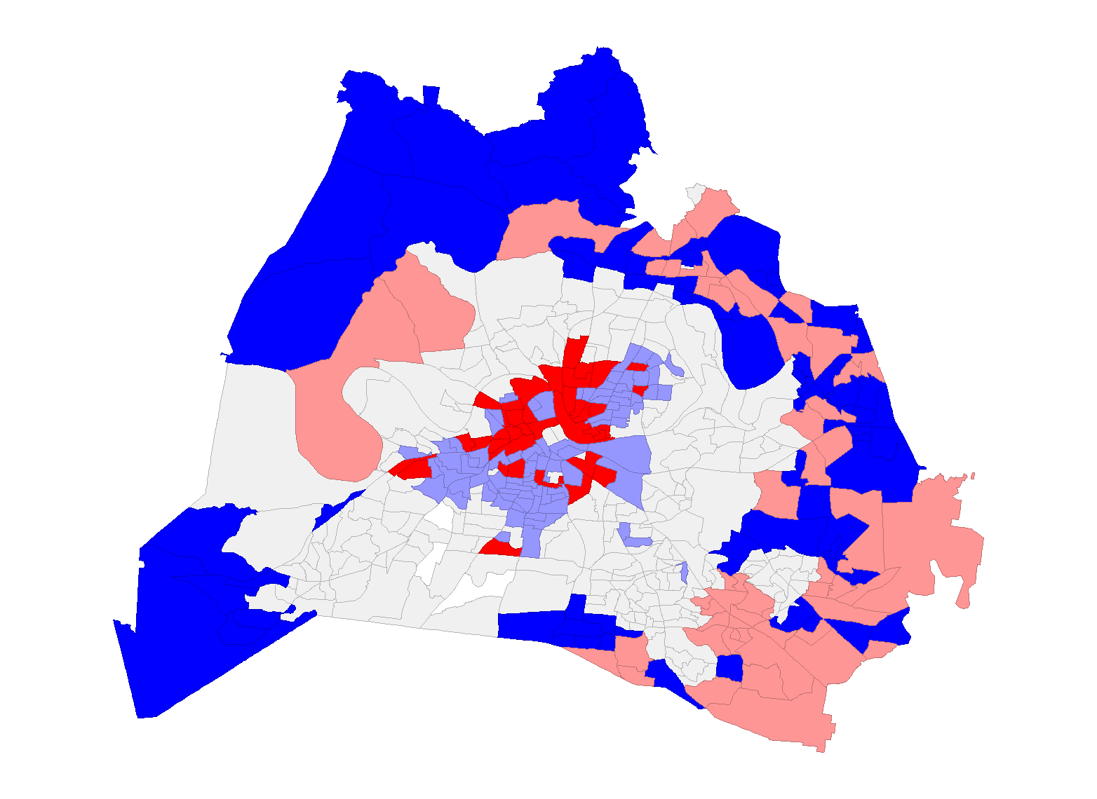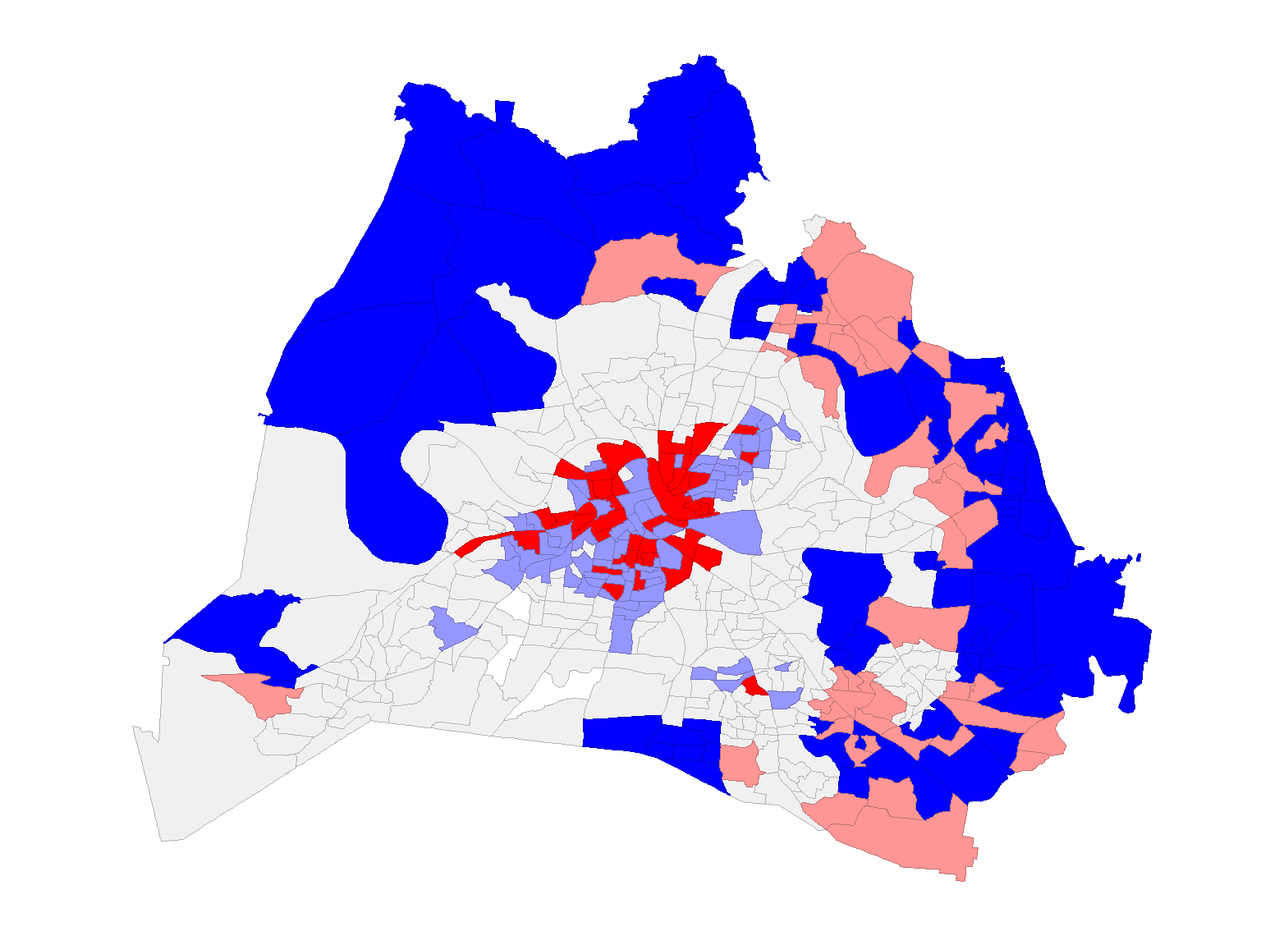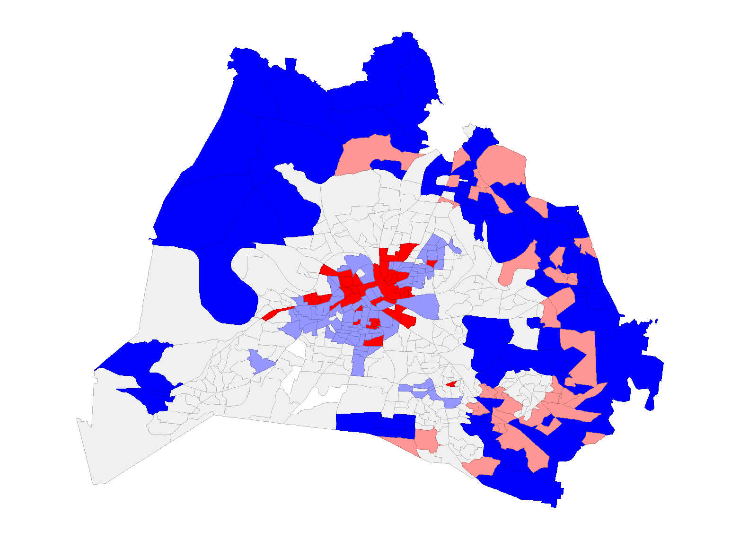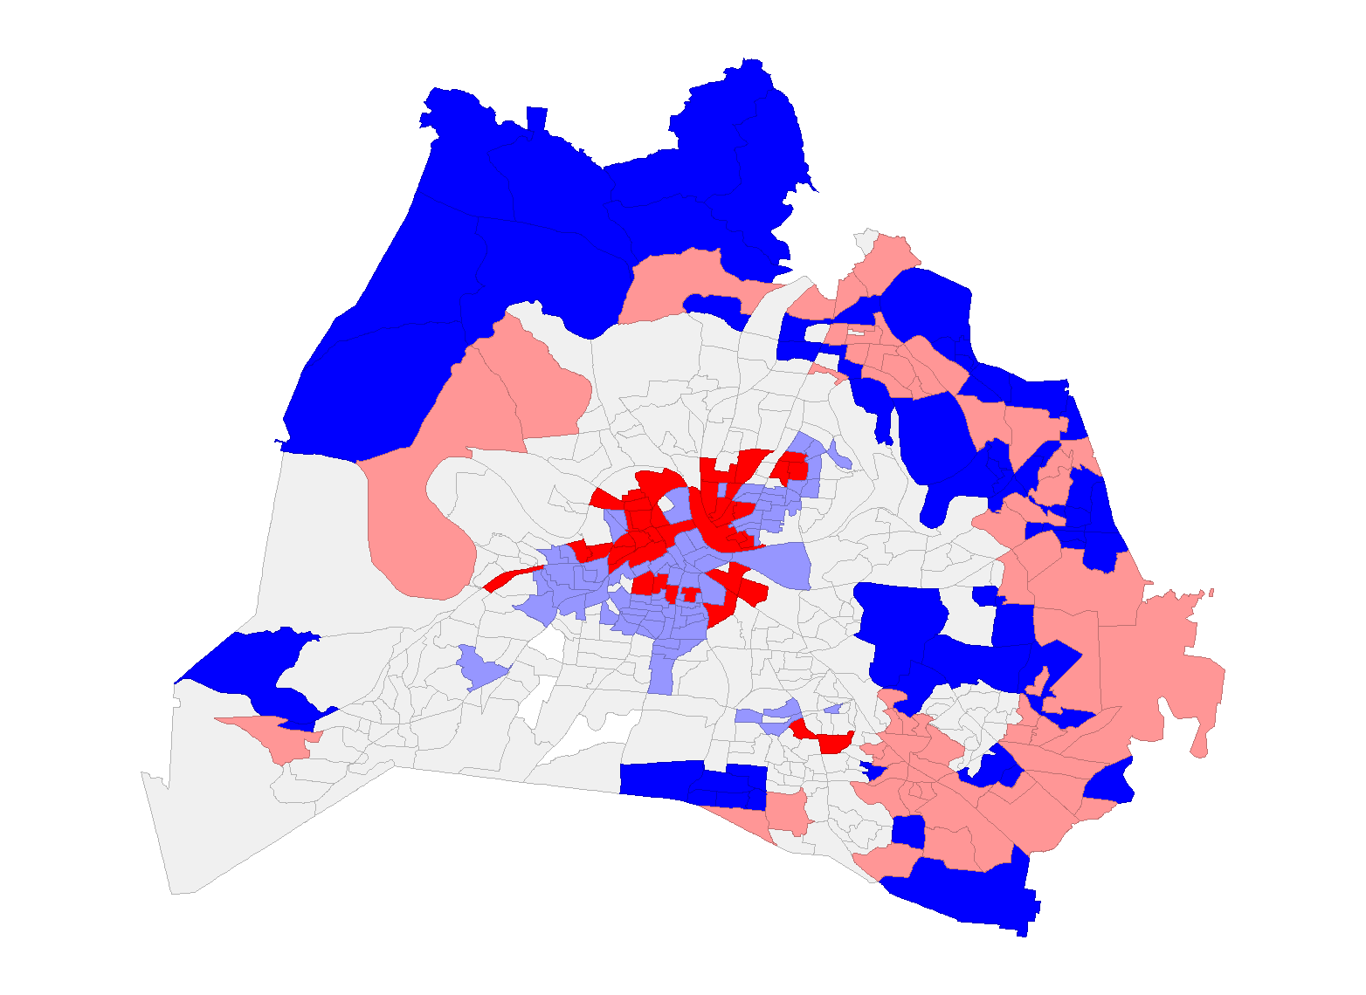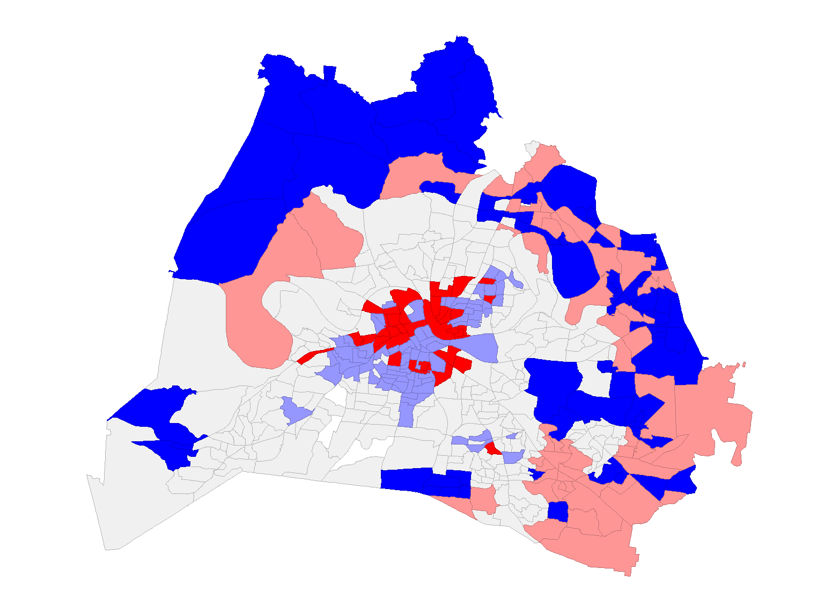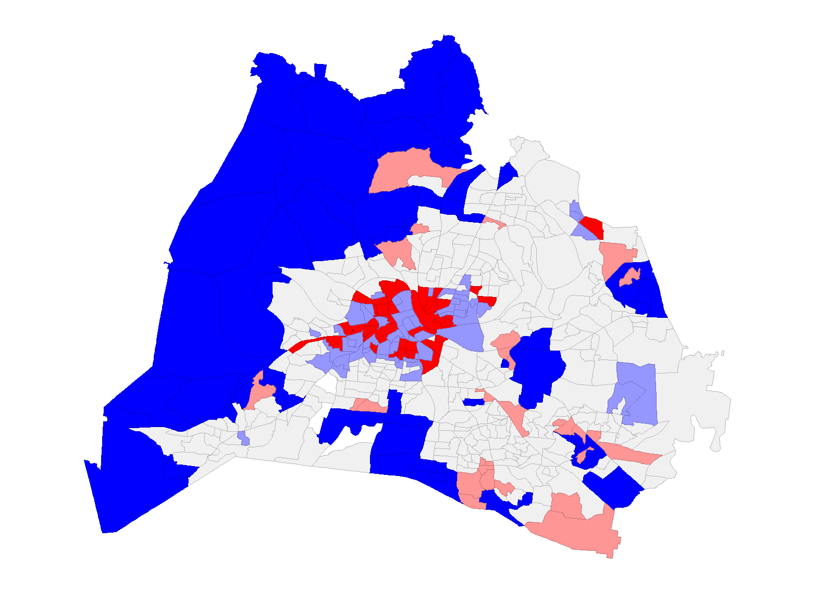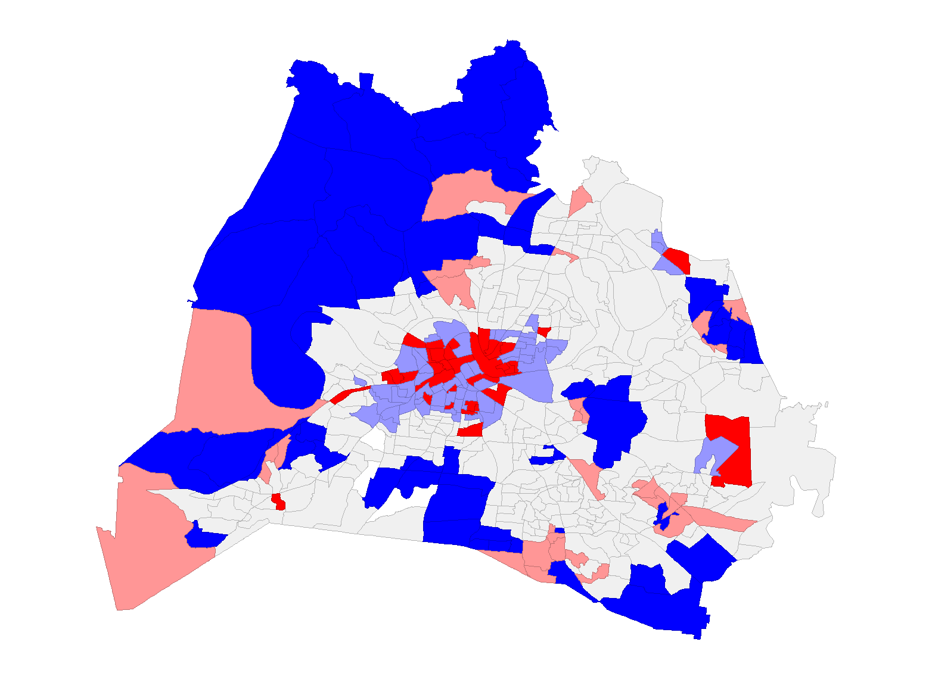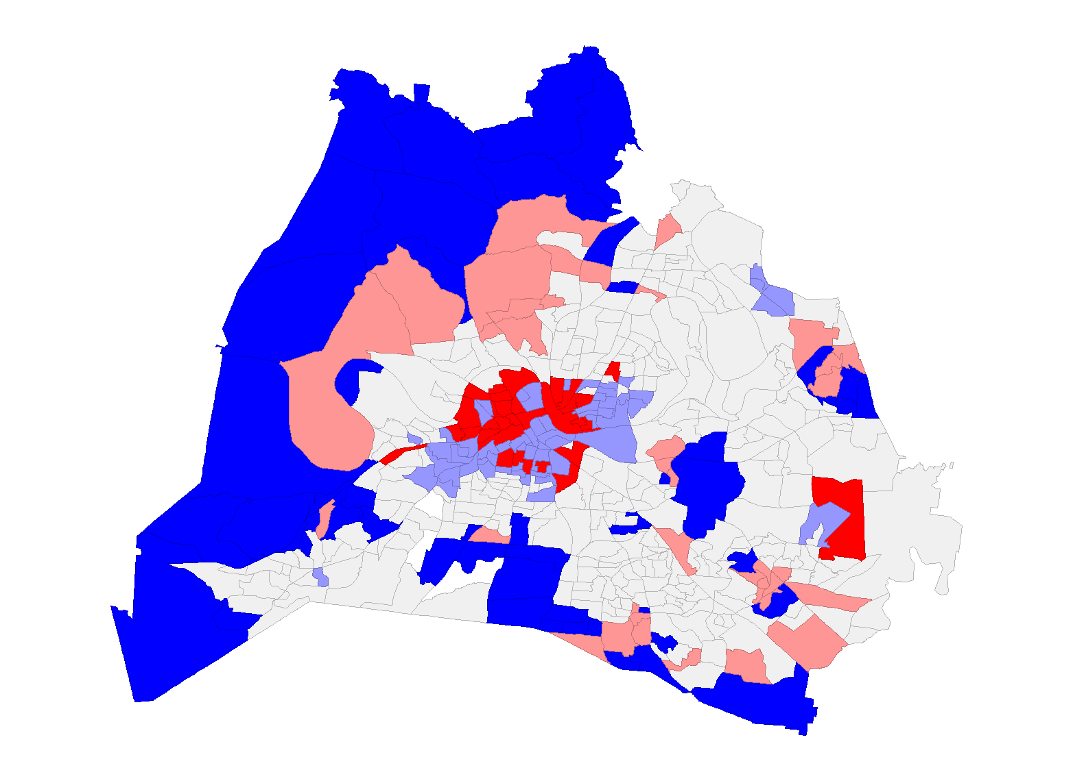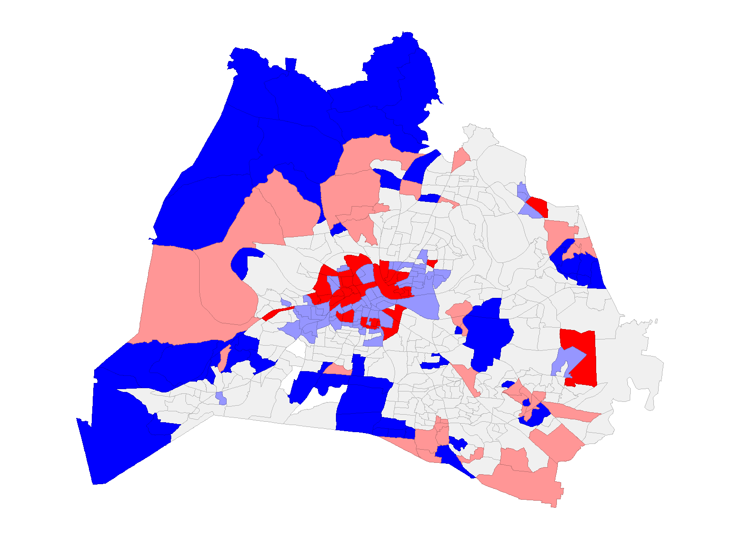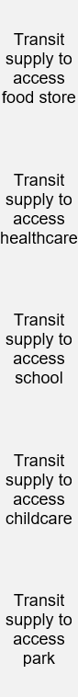
Figure 15 Bi-LISA cluster maps for different combinations of transit supply categories and transit-dependent demand groups
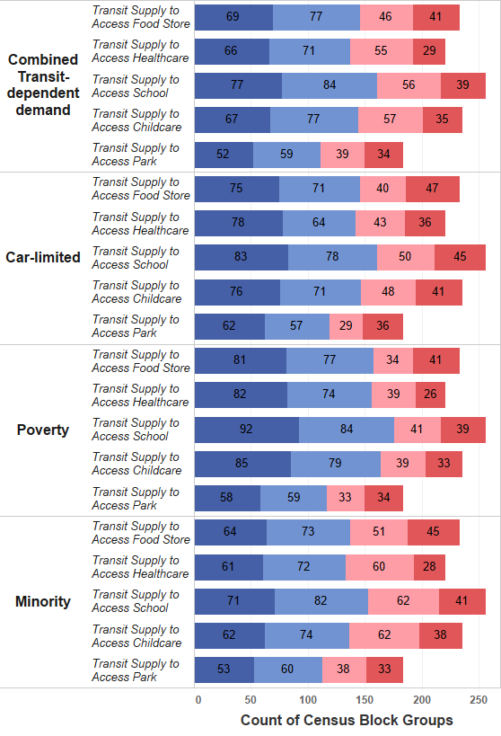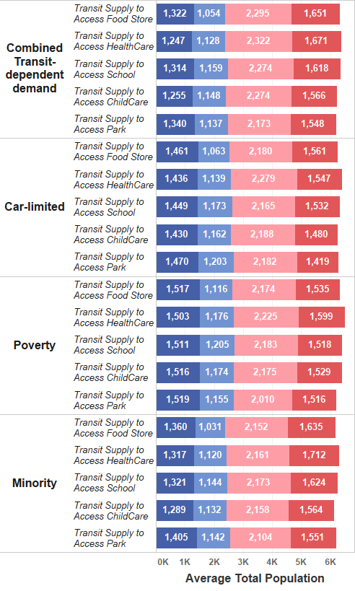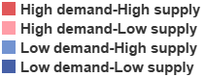
Figure 16 Bar plot of summary of bi-LISA clusters

in H-L clusters (highlighted by the pink bar) is lower than that in low-demand clusters (represented by indigo and blue bars), the total population within the H-L clusters surpasses all other clusters. This population visualization highlights an inequitable distribution of transit supply, with a concentration of population within these H-L clusters.
This section further identifies H-L clusters, which refer to areas with overall high transit-dependent demand but low transit supply, as essential service deserts. To determine if a block group was considered an essential services desert, five binary variables were coded to indicate whether the block group was included in each of the five essential service categories of H-L clusters. The outcomes of this step were used to examine the correlation of essential service deserts in the subsequent section.

3.5.5 Correlation Analysis and Co-location Maps of essential service deserts
The preceding section focused on the association between transit-dependent demand and transit supply, which identified essential service deserts that have high demand for transit but limited access to it. This section subsequently analyzed the statistical and spatial correlation between distinct categories of underserved essential service deserts using a tetrachoric correlation matrix and co-location maps.
Figure 17 displays the tetrachoric correlation matrix that examines the significance and strength of the relationship between each pair of essential service deserts. The green stars indicate significance, with at least one star denoting a statistically significant correlation at the 95% level, two stars representing 99% of confidence level, and three stars indicating 99.9% of confidence level. The red color denotes a positive association, with darker shades of red indicating a stronger association. The figure reveals that food deserts, healthcare deserts, school deserts, and childcare deserts are highly correlated with each other, but they have a lower correlation with park deserts (except healthcare deserts, which show no significant correlation with park deserts). To classify essential service deserts, hierarchical clustering was employed using the correlation distance. The clustering outcomes were also visualized in Figure 17 by the dendrograms, with two clusters represented by green branches and purple branches, respectively. The findings
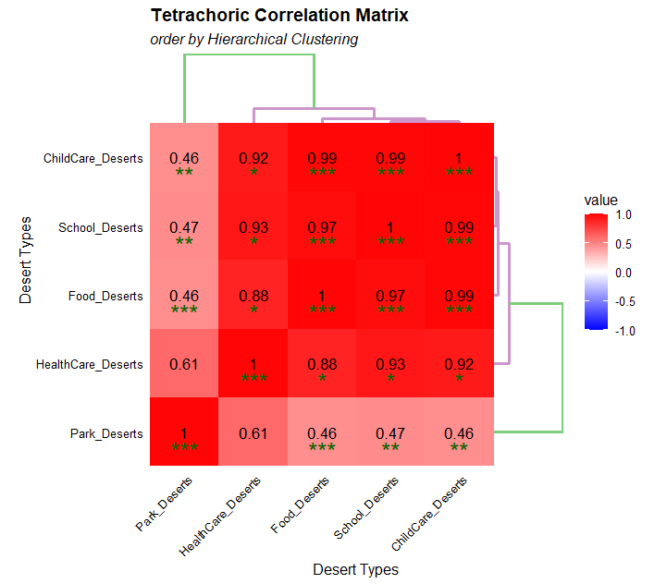
Figure 17 Tetrachoric correlation matric for different types of essential service deserts
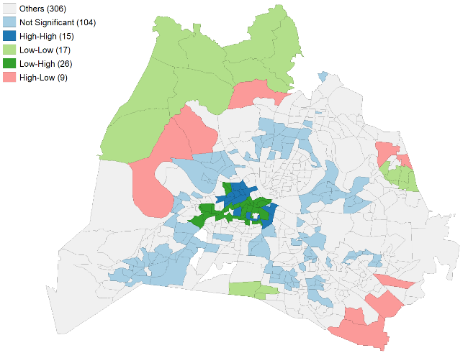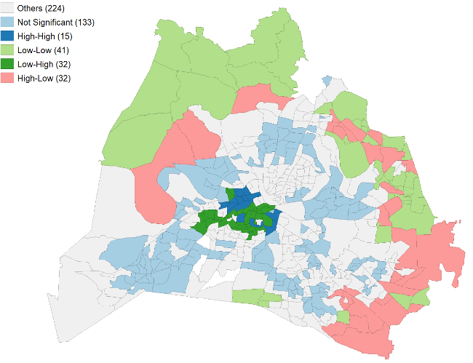
- (b)
Figure 18 Co-location maps of (a) food deserts, healthcare deserts, school deserts, childcare deserts, and park deserts; (b) food deserts, healthcare deserts, school deserts, and childcare deserts (excluding parks)
indicate that food deserts, healthcare deserts, school deserts, and childcare deserts have a high correlation, and therefore were grouped as a cluster, while park deserts have a lower correlation with other essential services and were classified as a separate cluster.
This section further investigated the spatial correlation of different types of essential service deserts by utilizing co-location maps to identify the most underserved areas with overlapping essential service deserts. Based on the correlation results, two co-location maps were generated: one to identify the co-location of bi-LISA clusters for all five essential service deserts, and the other to identify the co-location of bi-LISA clusters for food deserts, healthcare deserts, school deserts, and childcare deserts (excluding parks), since these have high correlation with each other.
The shaded pink communities in Figure 18 represent areas with essential service deserts. Figure 18 (a) shows nine block groups were found to be transit deserts with respect to all five essential services, distributed across the mid-northwest, northeast edge, and southeastern edge of Nashville. When excluding park deserts, the overlapping transit deserts increased to thirty-two block groups and extended to some eastern communities with good transit access to parks but limited transit access to food, healthcare, schools, and childcare.

3.6 Discussion and conclusions
This research contributes to literature in four important ways. First, this study proposed a spatiotemporal transit supply index that considers the temporal variation of transit accessibility, specifically in the context of Nashville, Tennessee. Second, this study identified essential service deserts as areas with a spatial mismatch between transit supply to access essential services and transit-dependent demand and compared the spatial disparities of transit inequity across essential service categories and potential transit-dependent demand groups. Third, this research further investigated the correlation between different categories of essential services and identified communities with overlapping essential service deserts. Finally, this study enriched the existing literature by focusing on a low-density, automobile-oriented city and investigating the transit equity of essential services using publicly available datasets.
The analysis of the temporal transit accessibility revealed that transit services in Nashville exhibit low variance across various time periods of the day. This finding is in line with expectations, as the transit agency in Nashville implements relatively consistent headways on most bus routes as part of their weekday schedules (WeGo Public Transit). Following that, a visualization was created to analyze the spatial distribution of the transit supply index and transit-dependent demand index. The spatial distribution of the transit supply index to parks was different from that of food, healthcare, school, and childcare. Based on the maps of the transit-dependent demand index, many areas in Nashville exhibit relatively low levels of transit-dependent demand for transit. However, there are certain areas where an overlap exists among different transit-dependent groups (e.g., car-limited, those in poverty, and/or minority groups).
The results of the Theil index suggested that transit accessibility to healthcare had the greatest level of inequity and that parks were more evenly distributed throughout the city than other essential service categories. This generally aligns with the pattern observed in the distribution of healthcare facilities and parks in Nashville. Most healthcare facilities are privately provided and concentrated in the central city, whereas parks, being predominantly public facilities, have a more balanced distribution throughout the city. This result may also be attributed to the greater availability of land for parks at the outskirts of the city compared to the densely developed downtown area. The components of the Theil index suggested that groups with a higher level of transit-dependent demand have more equitable transit access to food stores and healthcare facilities while groups with low to moderate levels of transit-dependent demand have more equitable transit access to parks. The findings could potentially be attributed to decisions made by individuals to prioritize transit access to essential resources such as food and healthcare over other factors like recreational or leisure facilities. The bi-LISA spatial clustering further found that areas with high transit-dependent demand are more likely to have limited transit access to food stores, healthcare, school, and childcare categories than to have limited transit access to parks. The clustering results also implied a different distribution of demand groups in underserved areas. A higher transit-dependent demand from minority populations was found in the southeast and mid-northwest areas, and a greater demand from the poverty group was located in the southwest corner of the city. The minority populations in mid-northwest areas have limited transit access to all five essential services and the poverty groups within the underserved regions in the southwest corner of the city have limited transit access to food stores, schools, and parks. Last, H-L clusters were identified as essential services deserts that have overall high transit-dependent demand but low transit supply. Among the five essential service deserts, food deserts, healthcare deserts, school deserts, and childcare deserts were highly correlated with each other, while they had a lower correlation with park deserts.
The findings of spatial transit inequity and the identification of transit deserts of essential services hold crucial policy implications that can be used by transit agencies and local planning departments to prioritize their resources and target interventions to improve transit access to essential services for specific populations. For instance, the results revealed a greater level of transit inequity towards healthcare facilities compared to other essential services in Nashville. This finding underscores the importance for transit authorities to prioritize connections with healthcare facilities when formulating transit planning decisions. Additionally, the identification of different categories of essential service deserts through the clustering map provides a valuable resource for developing and implementing customized urban planning and transit planning strategies. Specifically, the analysis identified that in the mid-northwest areas of Nashville, minority populations have limited transit access to all five essential services, necessitating efforts to improve transit access to all five categories of essential services or to locate more of these essential service facilities in the mid-northwest Nashville. On the other hand, populations in poverty located in the southwest corner of the city have limited transit access specifically to food stores, schools, and parks, highlighting the need for efforts to enhance transit accessibility to these specific destinations or the increase the number of food stores, schools, and parks in that area of the city. Accordingly, before initiating urban and transit planning processes, subsequent investigations are needed to differentiate whether transit deserts primarily result from a lack of nearby facilities or insufficient transit services.

3.7 Limitations and future research
There are some potential limitations and areas for future research that emerged from this study. First, the proposed study measured the transit accessibility of fixed-route transit service. However, on-demand services (e.g., dial-a-ride and microtransit routes) are available in some areas of Nashville. Therefore, measuring transit accessibility of on-demand transit services should be considered in future research. Second, this study only included five common essential service categories; other services such as libraries, various government services (e.g., courts), and restaurants could be added in future research. Third, this study only examined the time variation of transit accessibility on weekdays, primarily due to the high transit ridership observed during weekdays. However, investigating the time variation in transit accessibility between weekdays and weekends would provide a more comprehensive understanding of transit service distribution and potential disparities across different days of the week, further contributing to the body of knowledge in this field. Fourth, another limitation of this study is the modifiable areal unit problem (MAUP) due to the use of Census blocks; the MAUP is a common issue in spatial analysis that may influence the spatial patterns observed. Fifth, transit accessibility was estimated under the assumption that individuals choose to access the nearest essential service location; however, it is possible that people choose differently based on other criteria (e.g., a facility that is located farther away but is preferred for other reasons). Consequently, the identification of transit deserts represents a potential supply-demand mismatch and future research using actual behavioral data could enhance precision of the analysis. Furthermore, future research could expand upon this study's focus on transit equity for car-limited, poverty, and minority populations by including an examination of transit accessibility for seniors or individuals with disabilities. This would contribute to a more comprehensive understanding of transit equity across a broader range of vulnerable and underserved populations.

CHAPTER 4.
Evaluating equity of Demand Response Transit in rural areas: analyzing accessibility for various trip purposes and across various age groups, disability statuses, and genders

Abstract
This article hasn’t been published anywhere, nor will it be before I turn in the final version of my ETD, so I didn’t include a publication statement.

Chapter 5. CONCLUSION

This is the conclusion for the entire document.

Heading 2
Write here.

REFERENCES
Allen, J. (2019). Mapping differences in access to public libraries by travel mode and time of day. Library & Information Science Research, 41(1), 11-18. doi:https://doi.org/10.1016/j.lisr.2019.02.001
Allen, J. and Farber, S. (2020). A Measure of Competitive Access to Destinations for Comparing Across Multiple Study Regions. Geographical Analysis, 52(1), 69-86. doi:https://doi.org/10.1111/gean.12188
Aman, J. J. C. and Smith-Colin, J. (2020). Transit Deserts: Equity analysis of public transit accessibility. Journal of Transport Geography, 89, 102869.
APTA. (2022). Public Transportation Fact Book. Retrieved from https://www.apta.com/research-technical-resources/transit-statistics/public-transportation-fact-book/
Benner, C. and Karner, A. (2016). Low-wage jobs-housing fit: identifying locations of affordable housing shortages. Urban Geography, 37(6), 883-903.
Bertolaccini, K. (2018). An Analysis of Changes to Transit Accessibility and Equity after the Opening of A Bus Rapid Transit System in Hartford, Connecticut. Journal of Transport Land Use, 11(1), 1163-1171.
Blanchard, S. D. and Waddell, P. (2017). Urbanaccess: Generalized Methodology for Measuring Regional Accessibility with An Integrated Pedestrian and Transit Network. Transportation Research Record, 2653(1), 35-44.
Boisjoly, G. and El-Geneidy, A. (2016). Daily Fluctuations in Transit and Job Availability: A Comparative Assessment of Time-sensitive Accessibility Measures. Journal of Transport Geography, 52, 73-81.
Bok, J. and Kwon, Y. (2016). Comparable Measures of Accessibility to Public Transport Using the General Transit Feed Specification. Sustainability, 8(3), 224.
Brondeel, R., Weill, A., Thomas, F. and Chaix, B. (2014). Use of healthcare services in the residence and workplace neighbourhood: The effect of spatial accessibility to healthcare services. Health & Place, 30, 127-133. doi:https://doi.org/10.1016/j.healthplace.2014.09.004
Brown, M. C. (1994). Using gini-style indices to evaluate the spatial patterns of health practitioners: Theoretical considerations and an application based on Alberta data. Social Science & Medicine, 38(9), 1243-1256. doi:https://doi.org/10.1016/0277-9536(94)90189-9
Bureau, U. S. C. (2021). Population and Housing Unit Estimates Tables. Retrieved from https://www.census.gov/programs-surveys/popest/data/tables.html
Cai, M., Jiao, J., Luo, M. and Liu, Y. (2020). Identifying transit deserts for low-income commuters in Wuhan Metropolitan Area, China. Transportation Research Part D: Transport Environment, 82, 102292.
Cervero, R. (2004). Transit-oriented Development in the United States: Experiences, Challenges, and Prospects. Transportation Research Board of the National Academies, 102.
Chapple, K. and Loukaitou-Sideris, A. (2019). Transit-oriented displacement or community dividends?: Understanding the effects of smarter growth on communities: MIT Press.
Chen, Z., Guo, Y., Stuart, A. L., Zhang, Y. and Li, X. (2019). Exploring the equity performance of bike-sharing systems with disaggregated data: A story of southern Tampa. Transportation Research Part A: Policy and Practice, 130, 529-545. doi:https://doi.org/10.1016/j.tra.2019.09.048
City of Austin. (2020). Anti-Displacement Funding. Retrieved from https://www.austintexas.gov/page/anti-displacement-funding
City of Memphis. (2022). The Future of transit in the city of Memphis. Retrieved from https://transitvision.memphistn.gov/
City of Raleigh. (2020). Equitable Transit-Oriented Development Guidebook. Retrieved from https://cityofraleigh0drupal.blob.core.usgovcloudapi.net/drupal-prod/COR22/EDATGuidebook.pdf
Conveyal User Manual. (2022). Modification types. Retrieved from https://docs.conveyal.com/edit-scenario/modifications
Conway, M. W., Byrd, A. and van der Linden, M. (2017). Evidence-based transit and land use sketch planning using interactive accessibility methods on combined schedule and headway-based networks. Transportation Research Record, 2653(1), 45-53.
Conway, M. W. and Stewart, A. F. (2019). Getting Charlie off the MTA: a multiobjective optimization method to account for cost constraints in public transit accessibility metrics. International Journal of Geographical Information Science, 33(9), 1759-1787. doi:10.1080/13658816.2019.1605075
Cui, M. and Levinson, D. (2020a). Multi-activity access: How activity choice affects opportunity. Transportation Research Part D: Transport and Environment, 85, 102364.
Cui, M. and Levinson, D. (2020b). Primal and dual access. Geographical Analysis, 52(3), 452-474.
Delbosc, A. and Currie, G. (2011). Using Lorenz curves to assess public transport equity. Journal of Transport Geography, 19(6), 1252-1259.
Delmelle, E., Nilsson, I. and Adu, P. (2021). Poverty suburbanization, job accessibility, and employment outcomes. Social Inclusion, 9(2), 166.
Di Ciommo, F. and Shiftan, Y. (2017). Transport equity analysis. Transport Reviews, 37(2), 139-151. doi:10.1080/01441647.2017.1278647
Duncan, M. (2011). The impact of transit-oriented development on housing prices in San Diego, CA. Urban Studies, 48(1), 101-127.
El-Geneidy, A., Buliung, R., Diab, E., van Lierop, D., Langlois, M. and Legrain, A. (2016a). Non-stop equity: Assessing daily intersections between transit accessibility and social disparity across the Greater Toronto and Hamilton Area (GTHA). 43(3), 540-560. doi:10.1177/0265813515617659
El-Geneidy, A. and Levinson, D. (2022). Making accessibility work in practice. Transport Reviews, 42(2), 129-133. doi:10.1080/01441647.2021.1975954
El-Geneidy, A., Levinson, D., Diab, E., Boisjoly, G., Verbich, D. and Loong, C. (2016b). The Cost of Equity: Assessing Transit Accessibility and Social Disparity Using Total Travel Cost. Transportation Research Part A: Policy Practice, 91, 302-316.
El-Geneidy, A. M. and Levinson, D. M. (2006). Access to Destinations: Development of Accessibility Measures.
Ermagun, A. and Tilahun, N. (2020). Equity of transit accessibility across Chicago. Transportation Research Part D: Transport Environment, 86, 102461.
Farber, S., Morang, M. Z. and Widener, M. J. (2014). Temporal variability in transit-based accessibility to supermarkets. Applied Geography, 53, 149-159. doi:https://doi.org/10.1016/j.apgeog.2014.06.012
Federal Bureau of Investigation. (2019). 2019 Crime in the United States. Retrieved from https://ucr.fbi.gov/crime-in-the-u.s/2019/crime-in-the-u.s.-2019/topic-pages/tables/table-6
Forsyth, A., Lytle, L. and Riper, D. V. (2010). Finding food: Issues and challenges in using Geographic Information Systems to measure food access. Journal of Transport and Land Use, 3(1), 43-65. doi:10.5198/jtlu.v3i1.105
Foth, N., Manaugh, K. and El-Geneidy, A. M. (2013). Towards equitable transit: examining transit accessibility and social need in Toronto, Canada, 1996–2006. Journal of Transport Geography, 29, 1-10.
Fransen, K., Neutens, T., Farber, S., De Maeyer, P., Deruyter, G. and Witlox, F. (2015). Identifying Public Transport Gaps Using Time-dependent Accessibility Levels. Journal of Transport Geography, 48, 176-187. doi:https://doi.org/10.1016/j.jtrangeo.2015.09.008
FTA, F. T. A. (2012). Circular FTA C 4702.1 B: Title VI Requirements and Guidelines for Federal Transit Administration Recipients. In: US Department of Transportation Washington, DC.
Ghorbanzadeh, M., Kim, K., Ozguven, E. E. and Horner, M. W. (2020). A comparative analysis of transportation-based accessibility to mental health services. Transportation Research Part D: Transport and Environment, 81, 102278. doi:https://doi.org/10.1016/j.trd.2020.102278
Giannotti, M., Tomasiello, D. B. and Bittencourt, T. A. (2022). The bias in estimating accessibility inequalities using gravity-based metrics. Journal of Transport Geography, 101, 103337. doi:https://doi.org/10.1016/j.jtrangeo.2022.103337
Gini, C. (1912). Variabilità e mutabilità. Reprinted in Memorie di metodologica statistica.
Gramlich, E. (2014). Qualified Allocation Plan. Retrieved from https://nlihc.org/sites/default/files/2014AG-259.pdf
Grengs, J. (2001). Does Public Transit Counteract the Segregation of Carless Households? Measuring Spatial Patterns of Accessibility. Transportation Research Record, 1753(1), 3-10. doi:10.3141/1753-01
Grengs, J. (2010). Job accessibility and the modal mismatch in Detroit. Journal of Transport Geography, 18(1), 42-54. doi:https://doi.org/10.1016/j.jtrangeo.2009.01.012
Grengs, J. (2015). Nonwork Accessibility as a Social Equity Indicator. International Journal of Sustainable Transportation, 9(1), 1-14. doi:10.1080/15568318.2012.719582
Heacock, D. (2019). The Most (and Least) Densely Populated Cities in America. Retrieved from https://filterbuy.com/resources/most-and-least-densely-populated-cities/
Hess, D. B. (2005). Access to employment for adults in poverty in the Buffalo-Niagara region. Urban Studies, 42(7), 1177-1200.
Houston, D., Basolo, V. and Yang, D. (2013). Walkability, transit access, and traffic exposure for low-income residents with subsidized housing. American journal of public health, 103(4), 673-678.
Immergluck, D. (2009). Large Redevelopment Initiatives, Housing Values and Gentrification: The Case of the Atlanta Beltline. Urban Studies, 46(8), 1723-1745.
Jiao, J. (2017). Identifying transit deserts in major Texas cities where the supplies missed the demands. Journal of Transport Land Use, 10(1), 529-540.
Jiao, J. and Dillivan, M. (2013). Transit deserts: The gap between demand and supply. Journal of public transportation, 16(3), 23-39.
Jin, T., Cheng, L., Wang, K., Cao, J., Huang, H. and Witlox, F. (2022). Examining equity in accessibility to multi-tier healthcare services across different income households using estimated travel time. Transport Policy, 121, 1-13.
Johnson, M. S. (2014). Poverty deconcentration priorities in low-income housing policy: A content analysis of low-income housing tax credit (LIHTC) qualified allocation plans: Virginia Commonwealth University.
Kaplan, S., Popoks, D., Prato, C. G. and Ceder, A. (2014). Using connectivity for measuring equity in transit provision. Journal of Transport Geography, 37, 82-92. doi:https://doi.org/10.1016/j.jtrangeo.2014.04.016
Karner, A. (2018). Assessing public transit service equity using route-level accessibility measures and public data. Journal of Transport Geography, 67, 24-32.
Kawabata, M. and Shen, Q. (2006). Job Accessibility as An Indicator of Auto-oriented Urban Structure: A Comparison of Boston and Los Angeles with Tokyo. Environment Planning B: Planning Design, 33(1), 115-130.
Kawabata, M. and Shen, Q. (2007). Commuting Inequality between Cars and Public Transit: The Case of the San Francisco Bay Area, 1990-2000. Urban Studies, 44(9), 1759-1780. doi:10.1080/00420980701426616
Klumpenhouwer, W. and Huang, W. (2021). A flexible framework for measuring accessibility with destination bundling. Journal of Transport Geography, 91, 102949.
Lambe, W. and de Zeeuw, M. (2016). The small cities study tour: Chattanooga’s comeback. Federal Reserve Bank of Atlanta.
Lee, H. K., Jiao, J. and Choi, S. J. (2021). Identifying spatiotemporal transit deserts in Seoul, South Korea. Journal of Transport Geography, 95, 103145.
Lei, T. L. and Church, R. L. (2010). Mapping transit‐based access: integrating GIS, routes and schedules. International Journal of Geographical Information Science, 24(2), 283-304. doi:10.1080/13658810902835404
Levinson, D. and King, D. (2020). Transport Access Manual: A Guide for Measuring Connection between People and Places. In: Committee of the Transport Access Manual, University of Sydney.
Li, Y. and Fan, W. D. (2020). Modeling and evaluating public transit equity and accessibility by integrating general transit feed specification data: Case study of the city of Charlotte. Journal of Transportation Engineering, Part A: Systems, 146(10), 04020112.
Liang, H., Yan, Q., Yan, Y. and Zhang, Q. (2023). Using an improved 3SFCA method to assess inequities associated with multimodal accessibility to green spaces based on mismatches between supply and demand in the metropolitan of Shanghai, China. Sustainable Cities Society, 91, 104456.
Litman, T. (2017). Evaluating transportation equity: Victoria Transport Policy Institute.
Litman, T. (2022). Affordable-accessible housing in a dynamic city: why and how to increase affordable housing in accessible neighborhoods. Retrieved from https://www.vtpi.org/aff_acc_hou.pdf
Liu, D., Kwan, M. P., Kan, Z. and Song, Y. (2021). An integrated analysis of housing and transit affordability in the Chicago metropolitan area. The Geographical Journal, 187(2), 110-126.
Lucas, K., Bates, J., Moore, J. and Carrasco, J. A. (2016). Modelling the relationship between travel behaviours and social disadvantage. Transportation Research Part A: Policy Practice, 85, 157-173.
Manaugh, K., Badami, M. G. and El-Geneidy, A. M. (2015). Integrating social equity into urban transportation planning: A critical evaluation of equity objectives and measures in transportation plans in North America. Transport Policy, 37, 167-176. doi:https://doi.org/10.1016/j.tranpol.2014.09.013
Manout, O., Bonnel, P. and Bouzouina, L. (2018). Transit accessibility: A new definition of transit connectors. Transportation Research Part A: Policy and Practice, 113, 88-100. doi:10.1016/j.tra.2018.03.028
Mao, L. and Nekorchuk, D. (2013). Measuring spatial accessibility to healthcare for populations with multiple transportation modes. Health & Place, 24, 115-122. doi:https://doi.org/10.1016/j.healthplace.2013.08.008
Martens, K., Bastiaanssen, J. and Lucas, K. (2019). Measuring transport equity: Key components, framings and metrics. In Measuring transport equity (pp. 13-36): Elsevier.
McCray, T. and Brais, N. (2007). Exploring the role of transportation in fostering social exclusion: The use of GIS to support qualitative data. Networks Spatial Economics, 7, 397-412.
Merlin, L. A. and Hu, L. (2017). Does competition matter in measures of job accessibility? Explaining employment in Los Angeles. Journal of Transport Geography, 64, 77-88. doi:https://doi.org/10.1016/j.jtrangeo.2017.08.009
Nashville MTA, N. M. T. A. (2019). TITLE VI PROGRAM. Retrieved from https://www.wegotransit.com/assets/1/24/MTA-2021-TitleVI-Program.pdf
National Academies of Sciences Engineering and Medicine. (2022a). Assessing Equity and Identifying Impacts Associated with Bus Network Redesigns. Washington, DC: The National Academies Press. https://doi.org/10.17226/26487
National Academies of Sciences Engineering and Medicine. (2022b). Coordination of Public Transit Services and Investments with Affordable Housing Policies. Washington, DC: The National Academies Press. https://doi.org/10.17226/26542
Owen, A. and Murphy, B. (2020a). Access Across America: Transit 2019.
Owen, A. and Murphy, B. (2020b). Access Across America: Transit 2019. Retrieved from http://access.umn.edu/research/america/
Pair, J. (2018). Nashville's Metro Transit Authority revamps with new look and name. Retrieved from https://www.tennessean.com/story/news/2018/07/13/nashville-transit-metro-transit-authority-revamps-look-new-branding/782958002/
Palacios, M. S. and El-geneidy, A. (2022). Cumulative versus gravity-based accessibility measures: which one to use? Findings.
Palm, M. and Niemeier, D. (2018). Does placing affordable housing near rail raise development costs? Evidence from California’s four largest metropolitan planning organizations. Housing Policy Debate, 28(2), 180-198.
Park, H. J. and Choi, K. (2021). Affordable housing program tenants and their access to public transportation and employment. Journal of Housing the Built Environment, 36(3), 1119-1139.
Park, K., Rigolon, A., Choi, D.-a., Lyons, T. and Brewer, S. (2021). Transit to parks: An environmental justice study of transit access to large parks in the US West. Urban Forestry Urban Greening, 60, 127055.
Pendall, R., Nelson, A. C., Dawkins, C. J. and Knaap, G. J. (2006). Connecting smart growth, housing affordability, and racial equity. In The geography of opportunity: Race and housing choice in Metropolitan America (pp. 219-246): Brookings Institution Press.
Perrey, R. M. (2022). Low-Income Housing Credit 2022 Qualified Allocation Plan. Retrieved from https://www.novoco.com/sites/default/files/atoms/files/tennessee-lihtc-qap-final-2022-amended-02172022.pdf
Preston, G. and Reina, V. J. (2021). Sheltered From Eviction? A Framework for Understanding the Relationship Between Subsidized Housing Programs and Eviction. Housing Policy Debate, 31(3-5), 785-817. doi:10.1080/10511482.2021.1879202
Ricciardi, A. M., Xia, J. and Currie, G. (2015). Exploring public transport equity between separate disadvantaged cohorts: a case study in Perth, Australia. Journal of Transport Geography, 43, 111-122. doi:https://doi.org/10.1016/j.jtrangeo.2015.01.011
Sánchez-Cantalejo, C., Ocana-Riola, R. and Fernández-Ajuria, A. (2008). Deprivation index for small areas in Spain. Social Indicators Research, 89(2), 259-273. doi:10.1007/s11205-007-9114-6
Sharma, I., Mishra, S., Golias, M. M., Welch, T. F. and Cherry, C. R. (2020). Equity of transit connectivity in Tennessee cities. Journal of Transport Geography, 86, 102750.
Shen, Q. (1998). Location characteristics of inner-city neighborhoods and employment accessibility of low-wage workers. Environment Planning B: Planning Design, 25(3), 345-365.
Steiss, T. (2006). Calculating/analyzing transit dependent populations using 2000 census data and GIS.
Stewart, A. F. (2017). Mapping transit accessibility: Possibilities for public participation. Transportation Research Part A: Policy and Practice, 104, 150-166.
Taylor, B. D. and Morris, E. A. (2014). Public Transportation Objectives and Rider Demographics: Are Transit’s Priorities Poor Public Policy? Transportation, 42(2), 347-367. doi:10.1007/s11116-014-9547-0
Tennessee State Courts. What is the legal age for kids to stay home alone? Retrieved from https://www.tncourts.gov/courts/juvenile-family-courts/faqs#:~:text=What%20is%20the%20legal%20age,and%20care%20than%20older%20children.
The Trust for Public Land. (2019). ParkServe® Data. Retrieved from https://www.tpl.org/parkserve/downloads
Tiznado-Aitken, I., Muñoz, J. C. and Hurtubia, R. (2021). Public transport accessibility accounting for level of service and competition for urban opportunities: An equity analysis for education in Santiago de Chile. Journal of Transport Geography, 90, 102919. doi:https://doi.org/10.1016/j.jtrangeo.2020.102919
Townsend, P., Phillimore, P. and Beattie, A. (1988). Health and deprivation: inequality and the North (Vol. 8): Taylor & Francis.
Transit. (2023). Demand-Response and On-Demand Transit. Retrieved from https://resources.transitapp.com/article/401-on-demand-transit
U.S. Bureau of Labor Statistics. (2021). Consumer expenditures in 2020. Retrieved from https://www.bls.gov/opub/reports/consumer-expenditures/2020/home.htm
U.S. Census Bureau. Poverty Thresholds. Retrieved from https://www.census.gov/data/tables/time-series/demo/income-poverty/historical-poverty-thresholds.html
U.S. Census Bureau. (2019). 2019 Census. Retrieved from https://data.census.gov/table
U.S. Census Bureau. (2020). 2020 Census. Retrieved from https://www.census.gov/programs-surveys/decennial-census/decade/2020/2020-census-main.html
U.S. Census Bureau. (2021a). Group Quarters and Residence Rules for Poverty. Retrieved from https://www.census.gov/topics/income-poverty/poverty/guidance/group-quarters.html
U.S. Census Bureau. (2021b). QuickFacts: Nashville-Davidson metropolitan government (balance), Tennessee. Retrieved from https://www.census.gov/quickfacts/fact/table/nashvilledavidsonmetropolitangovernmentbalancetennessee/POP010220
U.S. Census Bureau. (2022). Housing Units. Retrieved from https://www.census.gov/quickfacts/fact/note/US/HSG010221
U.S. Department of Housing and Urban Development. (2020). Geospatial Data Storefront. Retrieved from https://hudgis-hud.opendata.arcgis.com/
U.S. Department of Housing and Urban Development. (2022a). Low-Income Housing Tax Credit (LIHTC). Retrieved from https://www.huduser.gov/portal/datasets/lihtc.html
U.S. Department of Housing and Urban Development. (2022b). Multifamily Housing. Retrieved from https://www.hud.gov/program_offices/housing/mfh
U.S. Department of Housing and Urban Development. (2022c). Public Housing. Retrieved from https://www.hud.gov/program_offices/public_indian_housing/programs/ph/
USDA. (2023). Food Access Research Atl. Retrieved from https://www.ers.usda.gov/data-products/food-access-research-atlas.aspx
Walker, R. E., Keane, C. R. and Burke, J. G. (2010). Disparities and access to healthy food in the United States: A review of food deserts literature. Health place, 16(5), 876-884.
Wang, S. and Xu, Y. (2020). Transit use for single-parent households: Evidence from Maryland. Transportation Research Interdisciplinary Perspectives, 8, 100223. doi:https://doi.org/10.1016/j.trip.2020.100223
WeGo Public Transit. Bus schedules. Retrieved from https://www.wegotransit.com/ride/bus-schedules/
Welch, T. F. (2013). Equity in Transport: The Distribution of Transit Access and Connectivity among Affordable Housing Units. Transport Policy, 30, 283-293.
Wood, B. S. and Horner, M. W. (2016). Understanding accessibility to snap-accepting food store locations: Disentangling the roles of transportation and socioeconomic status. Applied Spatial Analysis Policy, 9, 309-327.
Yan, X., Bejleri, I. and Zhai, L. (2022). A spatiotemporal analysis of transit accessibility to low-wage jobs in Miami-Dade County. Journal of Transport Geography, 98, 103218. doi:https://doi.org/10.1016/j.jtrangeo.2021.103218
Yang, H. and Cherry, C. R. (2017). Use characteristics and demographics of rural transit riders: a case study in Tennessee. Transportation Planning and Technology, 40(2), 213-227. doi:10.1080/03081060.2016.1266168
Zhang, J. and Mao, L. (2019). Integrating multiple transportation modes into measures of spatial food accessibility. Journal of Transport & Health, 13, 1-11.
Zhang, Y., Cao, M., Cheng, L., Gao, X. and De Vos, J. (2022). Exploring the temporal variations in accessibility to health services for older adults: A case study in Greater London. Journal of Transport Health & Place, 24, 101334.
Zheng, L., van Wee, B. and Oeser, M. (2019). Combining accessibilities for different activity types. Journal of Transport Land Use, 12(1), 853-872.
Zuo, T., Wei, H. and Chen, N. (2020). Promote Transit via Hardening First-and-last-mile Accessibility: Learned from Modeling Commuters’ Transit Use. Transportation Research Part D: Transport and Environment, 86, 102446.

APPENDIX

VITA

Jane X. Doe was born. She wrote a thesis. She graduated. She followed instructions and wrote her vita in third person and paragraph form (as opposed to a resume or CV), which made her thesis consultant very happy. This page is required.

