Employment and Business Establishment Growth in the Appalachian Region, 2000-2008: An Application of Smooth Transition Spatial Autoregressive Models

A Thesis Presented for the
Master of Science
Degree
University of Tennessee, Knoxville

Wan Xu
August 2011

ABSTRACT

Industry clusters can be important components of regional development. The effects of industry clusters on growth typically vary across geography, which has implications for targeted development strategies. Employment and business establishment growth in the Appalachian region (2000 – 2008) was regressed on industry cluster concentration indexes controlling for local determinants. The hypothesis that local response to growth determinants is geographically heterogeneous was tested using Smooth Transition spatial process models. This class of models exhibiting regime switching behavior is useful for identifying regional clusters, providing another tool for exploring relationships between geographical determinants and economic growth.

TABLE OF CONTENTS

CHAPTER 1. Introduction……………………………………………………………......1
  - Objectives…………………………………………………………………………4
  - Organization………………………………………………………………………5
CHAPTER 2. Literature Review………………………………………………………….6
2.1 Nonlinear Economic Growth and Heterogeneity…………………………………..6
2.2 Models with Spatial Dependence and Heterogeneity……………….. …………… 9
2.2.1 Partial Adjustment Models………………………………………………….....9

2.2.1.1 Regional Adjustment Models…………………………………………….11
2.2.2 Spatial Process Models………………………………………………………12
2.2.3 Smooth Transition Autoregressive (STAR) Models………………………….14
2.2.4 An Extension of the Smooth Transition Spatial Autoregressive Model………………………………………………………………………….17

CHAPTER 3. Local Determinants and Descriptive Statistics…………………………...20

3.1 Empirical Model…………………………………………………………………...20
3.2 Urban Influence and Labor Markets……………………………………………….22
3.3 Community Structure and Housing Markets………………………………………23
3.4 Demographic Structures……………………………………………………………23
3.5 Fiscal Policy………………………………………………………………………..24
3.6 Infrastructure……………………………………………………………………….25
3.7 Natural Resources …………………………………………………………………25
3.8 Industry Structure………………………………………………………………….26
3.8.1 Industry Clusters……………………………………………………………….26
3.8.1.1 Industry Concentration Measures………………………………….............27
3.8.1.2 Elasticities of the Industry Concentration Index…………………………...28

CHAPTER 4. Methods and Procedures………………………………………………….31

4.1. Two Stage Least Square (2SLS)…………………………………………………..31
4.2. General Method of Moments (GMM) Estimation of the STAR Models….………32
4.2.1 Specification of the Spatial Process model……………………………………32
4.2.2 Specification of the Spatial STAR model……………………………………..35
4.2.2.1 Nonlinear Least Squares…………………………………………………..35
4.2.2.2 Instrumental Variable (IV) Estimation……………………………………36

4.2.3 Hypothesis……………………………………………………………………….38
4.3 Choice of Transition Variables………………………………………………………39
CHAPTER 5. Results and Discussions…………………………………………………..41
5.1 Model Specification………………………………………………………………….41
5.2 Double Transition Functions…………………………………………………………43
5.3 Elasticities of Technology Industry Clusters………………………………………...46
5.4 Dynamic Stability Analysis………………………………………………………….48
CHAPTER 6. Summary and Conclusions……………………………………………….51
6.1 Summaries of Findings………………………………………………………………51
6.2 Future Research……………………………………………………………………...53

LIST OF REFERENCES………………………………………………………………...54

APPENDIX A. SUPPORTING TABLES……………………………………………….68

APPENDIX B. SUPPORTING FIGURES………………………………………………81
APPENDIX C. EXAMPLE CODE IN MATLAB FOR A STAR MODEL…………….96
VITA……………………………………………………………………………………110

LIST OF TABLES

Table 1: Summary of marginal effects of spatial process models……………………………….71
Table 2. Summary statistics of local determinants and concentration indexes…………………..72
Table 3: Basic Technology Industry Clusters…………………………………………...............73
Table 4: 2SLS Regression for Change in Business Establishment Growth from 2000-2008……………………………………………………………………………………..76

Table 5: 2SLS Regression for Change in Employment Growth from 2000-2008……………….77
Table 6: STAR-SEM Regression for Change in Business Establishment Growth from 2000-2008……………………………………………………………………………………. 78

Table 7: STAR Regression for Change in Employment Growth from 2000-2008……...............79
Table 8: STAR-SEM Model Specification for Change in Establishment Growth: 2000-2008…………………………………………………………………………………….80

Table 9: STAR Model Specification for Change in Employment Growth: 2000-2008…………81
Table 10: Adjustment coefficients and characteristic roots of the estimated models……………82

LIST OF FIGURES

Figure 1: Appalachian Region …………………………………………………………………..84
Figure 2: County Economic Status within the Appalachian Region, 2010……………...............85
Figure 3: Urban and Non-Urban in Appalachian Region………………………………………..86
Figure 4: Process of convergence of GDP per capita in multiple equilibriums in the long run……………………………………………………………………………………...87
Figure 5: Example of the transition function G(γ, c; v), and different levels of the smoothing parameter, γ. Note that two distinct regimes emerge when γ = 100, whereas there are no regimes identified when γ = 0.The parameter c functions as a location parameter; the inflection of the transition function is centered on c…………………………………...88
Figure 6: Examples of the interactions between two transition functions G₁(v₁; γ₁, c₁) and G₂=G₂(v₂; γ₂, c₂), and different levels of the smoothing parameter, γ. Note that how the curvure changes when γ changes………………………………………………………89
Figure 7: Local Determinants in the Adjustment Process……………………………………….90
Figure 8: Model Specification Process…………………………………………………………..91
Figure 9: Spatial Distribution of Distance from Metropolitan County…………………………..92
Figure 10: Transition function of G1(γ1, c1; v1) and its spatial distribution for change in business establishment growth: 2000-2008…………………………………………………….93
Figure 11: Transition function of G2 (γ2, c2; v2) and its spatial distribution for change in business establishment growth: 2000-2008………………………………………….94
Figure 12: Transition functions of G₁(γ₁, c₁; v₁) and its spatial distribution for change in employment growth: 2000-2008……………………………………………………..95
Figure 13: Transition function of G2 (γ2, c2; v2) and its spatial distribution for change in employment growth: 2000-2008……………………………………………………..96
Figure 14: Distribution of elasticities (left panel) and GI statistics (right panel) for the Engine Equipment cluster and employment growth, 2000 – 2008…………………..............97
Figure 15: Distribution of elasticities (left panel) and GI statistics (right panel) for the Pharmaceuticals cluster and employment growth, 2000 – 2008……………………..98
Figure 16: Distribution of elasticities (left panel) and GI statistics (right panel) for the Motor Vehicles cluster and employment growth, 2000 – 2008……………..........................99
Figure 17: Distribution of GI statistics for the Engine Equipment cluster based on concentration index (2008, left), and elasticity (2008, right)……………………………………...100
Figure 18: Distribution of GI statistics for the Pharmaceuticals cluster based on concentration index (2008, left), and elasticity (2008, right)……………………………………...101
Figure 19: Distribution of GI statistics for the Motor Vehicles cluster based on concentration index (2008, left), and elasticity (2008, right)……………………………………...102

CHAPTER I
INTRODUCTION
The Appalachian Region is a 205,000 square mile area that includes the Appalachian Mountains extending from southern New York to northern Mississippi. The Region is comprised of 420 counties, including all of West Virginia and parts of 12 other states: Alabama, Georgia, Kentucky, Maryland, Mississippi, New York, North Carolina, Ohio, Pennsylvania, South Carolina, Tennessee, and Virginia. About 42% of the population lives in rural areas compared with 20 percent of the national population (ARC, 2010) (Figure 1). Persistent poverty remains the most enduring social problem in the region, differentiating it economically and socially from the rest of the United States (Gebremariam, Gebremedhin, and Schaeffer, 2011). Despite significant economic growth and improvement in community well-being since 1965, roughly one fourth of the counties in Appalachia continue to struggle compared to other regions in terms of income, employment growth, and other economic indicators (Keefe, 2009). Improvement in relative economic well-being was apparent in many Appalachian communities from 1960 to 2011. For instance, some communities successfully diversified their economies to include a variety of manufacturing, service, and recreation industries. The Region's poverty rate also declined from 33 percent in 1965 to 18 percent in 2008 (ARC, 2010). However, in terms of income and employment growth spatial inequities persist. Many counties in Appalachia still suffer from high unemployment rates, low stocks of human and social capital, and substandard infrastructure and public services. The Appalachian Regional Commission (ARC) categorizes the economic well-being of counties using an index (Picard index) based on per capita market income, poverty rates, and three-year average unemployment rates. Based on this information, each county is classified into one of the five categories: distressed, at-risk, transitional, competitive, or attainment (Figure 2). As illustrated in Figure 2, most of the distressed counties which rank in the lowest 10 percent of the nation are distributed in the central Appalachian’s coal mining areas and the southwestern parts of Mississippi and Alabama. There are only a few “attainment” counties, with the majority in the transitional stage (ARC, 2010).
Many factors contribute to the persistent poverty observed in the Appalachian Region, including geographic isolation, external ownership of local resources, low-skilled populations, a lack of job opportunities, and other social and historical constraints. Like many rural counties, the challenges Appalachia counties continue to face are tradeoffs between scale economies, transportation costs, external market demand, and resource endowments; and how these factors relate to business location or job creation (Irwin et al., 2010). Lagging economic development in these areas eventually results in persistently high poverty rates, which suggests that these areas may possess additional physical, educational, or governmental constraints that could be ameliorated by coordinated regional economic development strategies.
Early regional scientists recognized that imperfect mobility of input factors, goods, and services increased industrial concentration in least-cost locations, eventually leading to unevenly distributed agglomeration economies (e.g., von Thünen, Lösch, Hotelling, Marshall, and Christaller; see McCann [2001] and Brakman et al., [2001]). To the extent that agglomeration economies characterize structural breaks across geography (e.g., Fujita, Krugman, and Venables, 1999), they simultaneously drive and are driven by localization economies reinforced by firm co-location, labor pooling, and eventually information spillovers (Shonkwiler and Harris, 1996; Barkley, Henry, and Kim, 1999). Low population density and the transportation costs associated with remoteness underscore the thin markets typifying some communities in Appalachia, which in turn increase the costs of public service provision (Kilkenny, 2010). This theoretical paradigm is the impetus behind the development of a regional adjustment model that explains the geographic heterogeneity of employment and business establishment growth as an endogenous process influenced by local capacity, access advantage, industry composition, and the influence of growth in neighboring locations.
Regional variation is evident in Appalachia in terms of the geographic distribution of socio-economic indicators (Figure 3). The topography of the Appalachian region is diverse, with the Appalachian mountain chain the most salient physical feature of the region. For years, the mountainous terrain has rendered trade with other regions and migration into and out of the area difficult. All of this started to rapidly change by the mid-1960’s and early 1970’s as road construction to the most remote reaches were subsidized by the Appalachian Regional Commission. Yet to this day pockets of the region, especially in the coal mining areas of eastern Kentucky, parts of Virginia, and West Virginia remain at a disadvantage in terms of access to the economies tied to the Atlanta, Cleveland Ohio, Nashville and Knoxville metropolitan statistical areas, and the east coast urban agglomerations. Variation with respect to access advantage to larger regional economies certainly plays a role in economic growth. The region is also socially and culturally diverse, including 420 counties distributed throughout the deep rural southern states of Mississippi, communities belonging to the Cherokee Nation, and to the Alleghany mountains and parts of southern New York State. While the rich socio-cultural diversity characterizing the region naturally provides opportunities for innovation and new invention, some groups or whole communities may be historically disadvantaged or disenfranchised, which poses challenges at the community level with respect to equipping young people the skills they need to competitively meet the labor demands of certain industries. Thirdly, the local economies of many places in the Appalachian region have been historically extraction-based and subject to “boom-bust” cycles, or worse depletion of resource bases that provide comparative advantage in terms of attracting (for example) mining, forestry, or other extraction enterprises. Thus, the geographical distribution of natural resources may also contribute to heterogeneous effects of local determinants on economic growth.

1.1 Objectives
The objective of this research is twofold. The first objective is to explore the spatial heterogeneity of the local factors and industry clusters determining employment and business establishment growth in the Appalachian Region with a relatively new class of spatial econometric models –the Smooth Transition Autoregressive (STAR) model – which allows for the endogenous sorting of spatial units into growth regimes. The approach is useful for modeling the effects of access advantage and transport costs on local growth as a data-driven process, bypassing the need for artificial dichotomies such as “rural” or “urban” classification schemes. The second objective is to identify which counties have comparative advantage in terms of employment and business establishment growth given initial levels of existing infrastructure, demographic attributes, and industry structure. The 2000 – 2008 period includes the low point of a brief recession (in 2001) and the economic recovery that lasted until 2008. The industry cluster identification method of Isserman and Feser (2009) is used in an econometric model to measure the extent to which clusters were associated with local economic growth, with particular attention given to what are ostensibly classified as “technology industry clusters” (Feser, Renski, and Goldstein, 2008; Feser and Isserman, 2009). Some industry clusters may have positively contributed to employment and business establishment growth during this period through their backward and forward linkages. But in other locations, different industry clusters may have no effect, or even a negative impact, on employment and income growth (Feser, Renski, and Goldstein, 2008; Spencer et al., 2010). Identifying which clusters contributed to local growth during this period may provide insight to potential economic development strategies for counties in terms of business retention and industry recruitment as policymakers, entrepreneurs, and credit lenders reinvent themselves today.

1.2 Organization
The rest of this thesis is organized as follows. In Chapter 2, the literature is reviewed and discussed on why regional scientists normally consider economic growth across space to be nonlinear and heterogeneous. Issues pertaining to spatial heterogeneity and the econometric methods attending to spatial dependence and heterogeneity are reviewed. Discussion (in Chapter 3) focuses on the variables used to proxy local determinants of economic growth, and the data sources. In Chapter 4, the methods and procedures used to analyze employment and business establishment growth in the Appalachian Region from 2000-2008 are described. The empirical results are presented and analyzed in Chapter 5. Lastly, Chapter 6 provides conclusions and suggestions for future research.

CHAPTER 2
LITERATURE REVIEW

2.1 Nonlinear Economic Growth and Geographic Heterogeneity
Understanding the sources and extent of geographic heterogeneity is important for accurately modeling and forecasting regional economic growth. By appropriately modeling heterogeneity, insight about connections to wider economies and specific solutions to region-wide resource allocation problems is possible. Spatial heterogeneity normally characterizes economic geographies. Heterogeneity may be caused by different production functions, systematically varying parameters, or heteroskedasticity associated with spatial regimes. For instance, commodity price transmission may be region-specific (Vitale and Bessler, 2006), skilled labor may be concentrated in certain locations (Davis and Schluter, 2005), or industry information spillovers may be realized more frequently in agglomeration economies (Cohen and Paul, 2005). Ad hoc spatial units chosen by researchers like “metropolitan”, “nonmetropolitan”, or “rural” may also be sources of heterogeneity (Lambert and McNamara, 2009). Measurement error due to differences in localized, unobserved factors such as cultural preferences, local policy, or social networks may be sources of geographic heterogeneity across space as well (Fotheringham, Brundson, and Charlton, 2002). In general, geographic heterogeneity typically implies structural breaks across space (Ertur, LeGallo, and Baumont, 2003). Heteroskedasticity (or non-constant variance between spatial units) may also be caused by spatial regimes (Anselin, 1988). Different geographical scales may account for heterogeneity, which in turn affects the magnitude of spatial spillover effects (Magrini, 2004). Measurement error or misspecification of spatial units may cause heteroskedasticity, and in turn may be a source of spatial autocorrelation (Kelejian and Robinson, 2004). Spatial heterogeneity may also be associated with spatially varying parameters generated by spatially dependent functional forms (Pace et al., 2004).
The degree to which geographic heterogeneity influences regional growth has been a longstanding topic in regional growth theory. According to neoclassical economic growth theory, there is a hypothetical long run equilibrium where all countries with similar initial conditions such as factor endowments and product demand will follow similar growth trajectories and converge to the same level of productivity (Broadberry, 1994). Studies have also focused on multiple long run equilibrium (Azariadis and Drazen, 1990; Chatterji, 1992). Such equilibrium can be characterized as “Convergence Clubs” or spatial regimes (Figure 4). As illustrated in figure 4, the process of convergence in terms of Gross Domestic Product (GDP) per capita may exhibit multiple equilibriums. Some regions will converge to one equilibrium (club 1) while other regions will converge to another (club 2). This simple example is useful for conceptualizing an econometric approach that explains regime membership as a function of spatial heterogeneity.
Research explaining geographic heterogeneity of economic growth is ubiquitous. For example, Partridge et al. (2008a) found that the effects of fiscal policies and other local characteristics on growth varied considerably across rural areas in the United States (U.S.) using Geographically Weighted Regression (GWR). Lambert and McNamara (2009) explained food manufacturer location decisions using discrete spatial regimes, finding that the importance of local determinants varied depending on how counties were classified as metropolitan, micropolitan, or noncore. Wojan, McGranahan, and Lambert (2010) allowed parameters to vary across metropolitan-micropolitan-noncore counties and three resource amenity categories, finding that the interaction effects between individuals in creative class occupations and entrepreneurs on economic indicators was heterogeneous across regimes. Arbia, Basile, and Piras (2005) applied a nonparametric regression estimator to examine the geographic nonlinearities of factors explaining the regional heterogeneity of growth in Italy. There are also numerous spatial econometric models which admit individual or group-specific responses; for instance, spatial adaptive filters (SAF) (Foster and Gorr, 1986); quantile regression; Quant’s (1958) regime switching regression; Casetti’s (1972) spatial expansion model; multilevel hierarchical modeling (Voss, White, and Hammer, 2004); random coefficient models (Anselin, Wendy, and Cho, 2002); and smooth transition autoregressive (STAR) models (Pede, 2010; Pede, Florax, and Holt, 2009). Regional studies using these approaches typically regress some economic indicator on local factors hypothesized to explain growth according to parameters or functional forms unique to spatial units or groups. The underlying assumptions of these methods are generally consistent with the conventional idea that the constraints, opportunities, and politics guiding growth are ultimately context dependent, and that development strategies are more likely to succeed when tailored to local conditions (Irwin et al., 2010). Local coefficients conditioned on neighbors by some metric may provide more accurate or detailed localized policy-relevant information about the relation between growth and local capacity. To the extent that geographically varying responses can be analyzed ex post using Exploratory Spatial Data Analysis (ESDA) techniques, counties exhibiting similar attributes in terms of relationships between growth outcomes and local resource capacity may suggest, to varying degrees, policy options that focus on regional coordination with respect to ramping up development of certain assets or attributes in one place, and perhaps de-emphasizing efforts to enhance the same assets in a different location. Hence, in absence of modeling the sources of heterogeneity, the usual consequences of the statistical validity of the models are overlooked: inferior forecasts, biased coefficients, and possibly compromised inference, all of which could adversely affect policies.

2.2 Models with Spatial Dependence and Heterogeneity

2.2.1 Partial Adjustment Models
A partial adjustment model is used to estimate the conditional influence local assets and industry clusters had on employment and business establishment growth in the Appalachian region from 2000 – 2008. Partial adjustment models have been frequently used to explain jobs and population migration dynamics and conditional economic growth (e.g., Carlino and Mills, 1987; Carruthers and Vias, 2005; Carruthers and Mulligan, 2007; Lambert et al., 2007; Pede, Florax, and de Groot, 2006), changes in county per capita income (Monchuk et al., 2007), and firm entry-exit dynamics (Lambert, Brown, and Florax, 2010). According to the partial adjustment model, economic growth is hypothesized to advance toward an unknown state of spatial equilibrium where income, jobs, and firms would be distributed across space in such a way that their utility or profits were maximized with respect to location.
Let y_{it} represent an economic growth indicator in period t, location i, with y_{i0} some level observed in the initial period. The model assumes that economic growth in a given location is constantly adjusting towards some unknown equilibrium level at time t, $y_{it}^{*}$=β′x_{i0}+ e_{it}, where e_{it} is an exogenous random shock, x are variables hypothesized to be correlated with the equilibrium state, and β a vector of parameters. Change in growth is measured as Δy_{it} = (y_{it}– y_{i0}) = α ($y_{it}^{*}$– y_{i0}), with α an adjustment parameter that is strictly positive and less than one. Observed economic growth exists between some obtainable but theoretical equilibrium level ($y_{it}^{*}$) and the level of economic activity in the previous period (y_{i0}). Rearranging the adjustment process suggests that economic activity at time t is the weighted average of the indicator in the previous period plus the target equilibrium level; y_{it} = α $y_{it}^{*}$+ (1 – α) y_{i0}. Substituting $y_{it}^{*}$, the level of the growth measure at time t is, y_{it} = α(β′x_{i0} + e_{it}$)+$ (1 – α) y_{i0}. Rearranging the expression produces a linear, reduced form equation that can be estimated with ordinary least squares under the usual assumptions:
$\left(1\right) ∆y_{it}=$ $β^{*'}$ x_{i0}${+α}^{*'}$ y_{i0} +$e_{st}^{*}$, with $β^{*}$= α∙β, $α^{*}$=- α, and $e_{it}^{*}$= α∙ e_{it ,}
where e* is an independent and identically distributed shock with E(e*)=0 and E[e*e*´] = Ω. When the variables are in logs, the coefficients are short-run elasticities (Greene, 2000). The change in employment and business establishment growth from 2000 – 2008 and the initial conditions are approximated in natural logs such that are (respectively) ln(y_{i2008}/ y_{i2000}) and ln y_{i2000}. As is typical with conditional growth models, the null hypothesis that α* < 0 suggests region-wide convergence of local economies towards some unknown equilibrium state. From here, let y be a growth indicator and X represent the exogenous right-hand side variables as the spatial process model with endogenous growth regimes is developed.

2.2.1.1 Regional Adjustment Models
Regional adjustment models usually portray two or more growth processes simultaneously, for example, population and employment (Clark and Murphy, 1996). Accordingly, population and employment growth are jointly determined by each other, moving towards an unknown future state of spatial equilibrium. The general framework of population (employment) change between time t and t-1 is modeled as a function of population (employment) at time t-1, employment (population) at time t, and a set of exogenous local attributes (Carlino and Mills 1987; Deller et al. 2001; Carruthers and Vias 2005; Carruthers and Mulligan 2007).
(2) $∆P_{i,t}=$ $α_{0}+{α_{1}P_{i,t-1}+α}_{2}E_{i,t}+α_{3}'X_{i,t-1}$+$e_{i,t}^{P}$
(3) $∆E_{i,t}=$ $β_{0}+{β_{1}E_{i,t-1}+β}_{2}P_{i,t}+β_{3}'X_{i,t-1}$+$e_{i,t}^{E}$
where $P$ and E denotes population and employment. These system equations hypothesize that the growth trajectories of population and employment are codetermined together. Therefore, population (employment) is hypothesized to be influenced by employment (population) at equilibrium.
There are various specifications of regional adjustment models that have been developed to depict the dynamic adjustment process between population and employment growth, all of which explain the bidirectional growth processes at different geographic scales. For instance, Carlino and Mills (1987), Mulligan, Vias, and Glavac (1999), and Clark and Murphy (1996) explored this regional perspective at the national level. Boarnet (1994) studied the effects of local infrastructure in the metropolitan areas. Duffy-Deno (1998) and Vias (1999) examined the influences of amenities in the sub-national regions.
Because the regional adjustment models include the endogenous variables of current employment at time t ($E_{i,t}$) or current population at time t ${(P}_{i,t})$, ordinary least squares (OLS) is inappropriate due to the failure of the zero conditional mean assumption E[u|x] =0. In other words, OLS is biased and inconsistent in this case. Two-stage least squares (2SLS) is typically used instead, which includes first regressing the endogenous variables on the set of exogenous instrumental variables (IV), and then using the predicted values of the endogenous variables in the estimation of equations (2) and (3) (Carruthers, and Vias 2005). Boarnet (1994) and Henry et al. (1997) use General Method of Moments (GMM) $χ^{2}$ test (J test) to test the orthogonality between the instruments and the regression errors. The J test is distributed as a $χ^{2}$ varite with the degrees of freedom equal to the number of over-identification restrictions. Under the assumption of independent, identically distributed (i.i.d.) errors, the J test is also known as Sargan test (Baum, Schaffer, and Stillman, 2002).

2.2.2 Spatial Process Models
The issue of heterogeneity across space and the potential for spatial regime “switching” behavior is further complicated when changes in economic indicators in one county are a function of growth in neighboring counties, or when unobserved factors are correlated across spatial units. In this research, the hypothesis is that growth in jobs and business establishments may be simultaneously determined by growth in neighboring counties. Change in employment or business establishment growth (y_{i}) in a county may be surrounded by j other counties with similar growth rates, for example, $\sum_{j=1,i≠j}^{n}{w_{ij}y_{j}}$, where W denotes spatial connectivity. Feedback between spatial units may be significant, meaning that growth in one county is dependent on or explained by growth in surrounding counties. Significant interaction suggests information spillovers, thick labor markets, or forward-backward linkages to other spatial units (Anselin, 2002; Moreno et al., 2004).
Spatial dependence in economic growth regressions is usually captured by a spatial autoregressive (SAR) lag model in which an endogenous variable is used to specify interactions between spatial units (Whittle ,1954; Anselin and Florax, 1995).The SAR model with autoregressive disturbances of order (1,1) (ARAR) includes a spatially lagged endogenous variable (Wy) and spatial autoregressive disturbances: y = ρWy + Xβ + ε, ε = λWε + u, u is independently and identically distributed with mean zero and covariance Ω, and W is a matrix defining relationships between spatial units (Anselin and Florax, 1995). The reduced form of the ARAR model is y = A⁻¹Xβ + A⁻¹B⁻¹u, where A = I – ρW and B = (I – λW) are lag autoregressive and error autocorrelation spatial filters respectively. The inverted matrices A⁻¹ and B⁻¹ are spatial multipliers which relay feedback/feed-forward effects of shocks between locations (Fingleton, 2008), distinguishing this class of models from other econometric models. When the weights are contiguity matrices or groups of observations bounded by some metric, local shocks are transmitted to all other locations, with the intensity of the shocks decaying over space. Because of the spatial multipliers, the marginal effects of the spatial process models in particular with SAR and ARAR models are more complicated than other econometric models. LeSage and Pace (2009) suggested a variety of approaches whereby the marginal effects can be calculated. In this research, the influence of the lag multiplier is approximated as a geometric series. For example, the “total effect” of a covariate k is the global impact of that variable on a given spatial unit; A⁻¹(I_{n} ◦ β_{k}) =[I_{n} + ρW + ρ²W² + ρ³W³ + ρ⁴W⁴+ ρ⁵W⁵ +… ρ^{q}W^{q}]β_{k}, where the order q refers to the impact of its neighbors. In the limit, $A^{-1}$ tends to ${(1-ρ)}^{-1}$, so the “total” marginal effect can be written as $β_{k}^{Total}={β_{k}(1-ρ)}^{-1}.$ The “indirect effect” is the difference between the total and direct effect (β_{k}), or the impact neighboring locations (on average) have on a given spatial unit given an incremental change in the covariate at that location; $β_{k}^{Indirect}=\frac{ρ}{1-ρ}β_{k}$. Provided a consistent covariance estimator, standard errors of the total and indirect effects can be estimated using the delta method (Greene, 2000). Table 1 summarizes the marginal effects of the three spatial process models.

2.2.3 Smooth Transition Autoregressive Models
Smooth Transition Autoregressive models are well-developed in the time series literature (Terasvirta and Anderson, 1992; Holt and Craig, 2006; Van Dijk and Franses, 2000) and biological sciences (Schabenberger and Pierce, 2002). This class of nonlinear regression models that exhibit endogenous switching across spatial units is less familiar to the spatial econometric literature, with some exceptions. A spatial analogue of the STAR model was presented by Gress (2004), Basile and Gress (2005) and Basile (2008). Recently, Dorfman et al. (2009) developed a model that is quite similar to the STAR approach but from a Bayesian perspective. Their approach also modeled hierarchical rather than contagious autoregressive processes. Pede, Florax, and Holt (2009) and Pede (2010) modified Lebreton’s (2005) spatial version of the time series STAR model by including a spatially lagged variable in the transition function. The approach applied here is parametric and extends their work.
Let G (v; γ, c) be an autocatalytic function (Schabenberger and Pierce, 2002), such as the logistic function; [1 + exp(–γ[v – c]/σ_{v})]⁻¹, with (respectively) slope and location parameters γ and c and a transition variable v. G (v; γ, c) is a potentially smooth, real-valued transition function bounded between zero and one. The parameters are approximately scale-neutral when they are normalized by the standard deviation of the transition variable (σ_{v}). The adjustment model with regime-switching potential is,
(4) Δy₂₀₀₀₋₂₀₀₈= G ◦ Zβ₁ + (1 – G) ◦ Zβ₂ + u,
where “◦” is the Hadamer product operator, Z is a matrix of covariates, and (β₁, β₂) are coefficients corresponding with regimes 1 and 2. Equation 4 can be rearranged accordingly (Madalla, 1983);
(5) Δy₂₀₀₀₋₂₀₀₈ = Zβ₂ + G ◦ Z(β₂ – β₁) + u, Δy₂₀₀₀₋₂₀₀₈ = Zβ + G ◦ Zδ + u,
with the interaction between the transition function and the exogenous variables (Z) permitting nonlinear parameter variation between spatial units. As γ increases, spatial units are sorted into more distinct groups. Intermediate values of γ identify spatial units along a continuum are “in transition”, and vary according to the transition variable, v (for example, Figure 5). The parameter c is a location parameter that determines the inflection point on the regime splitting curve according to the transition variable. For larger values of γ (typically >100), observations are separated into two distinct regimes with the coefficients of the interaction terms (δ) the difference from the reference group mean response to local determinants (the β₁) and the alternative regime. Thus, rejection of the null hypothesis δ = 0 suggests a nonlinear relationship between local covariates and economic growth. For large values of γ, the regression model of (5) behaves similarly to what one would expect if a set of counties were identified using a dummy variable (e.g., metropolitan or nonmetropolitan), and then interacted with all other explanatory variables. There are no regimes when δ = 0 and the effects of the covariates are geographically invariant. Thus, with regimes, the location-specific marginal effects (ME) of the STAR model are ${ME}_{i}$=$β+G_{i}δ$.
Nonlinear relationships across space are modeled using “autocatalytic” (or endogenous) switching functions under the STAR specification. From a theoretical perspective, the notion of endogenous regimes is also consistent with the “New Economic Geography” results that focus on the causes and consequences of regional economic asymmetries (e.g., Fujita, Krugman, and Venables, 1999; Brakman et al., 2001). To the extent that the STAR’s autocatalytic function sorts spatial units along a continuous hierarchy, the smooth transition model also lends itself to identifying endogenous break points across space resulting from (for example) differential trade costs; access advantage to urban economies; job and people migration; and “catastrophic agglomeration”, or the super-concentration of industries into a few regions (Fujita and Thisse, 2002; Baldwin et al., 2003). The endogenous sorting process so applied complements other modeling efforts that explain rural-urban growth interactions resulting from hierarchical access advantages (e.g., Partridge et al., 2008b). To the extent that persistent poverty still characterizes many of the distressed counties in the ARC region, this empirical perspective provides insight and an approach towards understanding the role various industry clusters have on employment and business establishment growth and how growth responses to local resources may be geographically dependent.

2.2.4 An Extension of the Spatial Smooth Transition Autoregressive Model
The family of Spatial Smooth Transition Autoregressive (STAR) models developed below extends Pede (2010) and Pede et al.’s (2010) previous work on STAR process models. In addition to endogenous stratification of counties into growth regimes, it allows for smooth transition processes by incorporating spillover effects through spatial multipliers. Combining the STAR model with the usual spatial error (SEM), spatial lag (SAR), and ARAR process models suggest (respectively) the following reduced form specifications that allow for spatial nonlinearity across regimes.
(6) STAR-SEM: Δy = Xβ + G ◦ Xδ + B⁻¹u.
(7) STAR-SAR: Δy = A⁻¹Xβ + A⁻¹G ◦ Xδ + A⁻¹u Δy = ρWΔy + Zβ + G ◦ Zδ + u.
(8) ARAR-STAR: Δy = A⁻¹Zβ + A⁻¹G ◦ Zδ + A⁻¹B⁻¹u Δy = ρWΔy + Zβ + G ◦ Zδ + B⁻¹u.
Therefore, with both regimes and spillovers, the marginal effects are no longer constant; they are geographically heterogeneous. For instance, the location-specific marginal effects (ME) of the STAR and STAR-SEM models are: ${ME}_{i}$=$β+G_{i}δ$, but the STAR and STAR-ARAR models are: ${ME}_{i}$=A⁻¹(β+$G_{i}$◦ δ).
To explore further the relationship between covariates and economic indicators, the STAR process model is extended to include multiple regimes. Of interest is to see whether multiple growth regimes can be identified in the partial adjustment process, and to what degree the trajectories differ between regimes. Therefore,
in analogy with the model used in time series (Holt and Craig, 2006), a second transition function (G₂ ) and its interaction with the first transition function are added to the basic STAR model:
(9) Δy₂₀₀₀₋₂₀₀₈ = [(1-G₁) ◦Zβ₁ + G₁◦Zβ₂ ] (1-G₂) +[(1-G₁) ◦Zβ₃ + G₁◦Zβ₄ ] G₂ +u,
G₁= G₁(v₁; γ₁, c₁), G₂=G₂(v₂; γ₂, c₂)

where G₁ and G₂ are logistic functions specified in section 3.3, each with different transition variables v₁ and v₂ respectively. Equation 7 can be re-arranged as:
(10) Δy₂₀₀₀₋₂₀₀₈ = Z β₁ +G₁ ◦Z (β₂ - β₁)+G₂ ◦Z (β₃ - β₁)+G₁G₂ ◦Z (β₁- β₂ - β₃+ β₄ )+ u,
Δy₂₀₀₀₋₂₀₀₈ = Z β +G₁ ◦Z δ₁+G₂ ◦Z δ₂+ G₁G₂ ◦Z δ₃+ u,

Clearly, if δ₃=0, the STAR model with two regimes reduces to an additive STAR model; if δ₃= δ₂=0 or δ₃= δ₁=0, it is the basic STAR model with the transition function of G₁ or G₂ respectively. This extension allows STAR model to accommodate more than two regimes, and have more flexibility in model parameters through regime switching behavior. Two different choices of transition variables that drive the regime switches can provide insight into interesting and nonlinear dynamics. Firstly, they characterize different structural breaks across space and drive the regime switching smoothly; secondly, two forces produced by two transition variables can reinforce together to agglomerate and leverage among different regimes (Figure 6). Combing with the spatial error (SEM), spatial lag (SAR), and spatial ARAR process models, three different reduced forms of spatial STAR models with double transition functions are obtained:
(11) STAR-SEM: Δy = Zβ +G₁ ◦Z δ₁+G₂ ◦Z δ₂+ G₁G₂ ◦Z δ₃ +B⁻¹u.
(12) STAR-SAR: Δy = A⁻¹Z β+ A⁻¹G₁ ◦Z δ₁+ A⁻¹G₂ ◦ Z δ₂+ A⁻¹G₁G₂ ◦Z δ₃ + A⁻¹u
Δy = ρWΔy + Zβ +G₁ ◦Z δ₁+G₂ ◦Z δ₂+ G₁G₂ ◦Z δ₃ + u.

(13) ARAR-STAR: Δy = A⁻¹Z β+ A⁻¹G₁ ◦Z δ₁+ A⁻¹G₂ ◦Z δ₂+ A⁻¹G₁G₂ ◦Z δ₃ + A⁻¹B⁻¹u
Δy = ρWΔy + Zβ +G₁ ◦Z δ₁+G₂ ◦Z δ₂+ G₁G₂ ◦Z δ₃ + B⁻¹u.

Therefore, the marginal effects are similar to those of the spatial STAR models with a single transition function; they are geographically heterogeneous as well. For example, the location-specific marginal effects (ME) of the STAR and STAR-SEM models with double transition functions are: ${ME}_{i}$= β +G_{1i} ◦δ₁+G_{2i} ◦δ₂+ G_{1i}G_{2i} ◦δ_{3;} while the STAR and STAR-ARAR models are: ${ME}_{i}$=A⁻¹(β +G_{1i} ◦δ₁+G_{2i} ◦δ₂+ G_{1i}G_{2i} ◦δ₃).

CHAPTER 3
LOCAL DETERMINANTS AND DESCRIPTIVE
STATISTICS

3.1 Empirical Model

Change in the number of business establishments (Δestabs₂₀₀₀₋₂₀₀₈) and employment (Δemp₂₀₀₀₋₂₀₀₈) are measured as natural log ratios with the initial (terminal) years of 2000 (2008). The initial levels for the indicators were their respective base years. The initial year for business establishments was normalized by county area (or business establishment density); more densely settled areas also correlate with employment density (Carruthers and Vias, 2005). These areas are attractive to businesses for their higher level of services, but employment density entails more than urban amenities. Rural jobs have tended to concentrate in densely populated areas, and employment density itself may suggest a relative shortage of land and higher housing prices (Wojan, McGranahan, and Lambert, 2010). Previous research also finds that job growth in rural locations is faster in more densely settled rural areas and in sprawling urban areas perhaps because of larger labor pools (McGranahan and Wojan, 2007).
Because the focus of this research is on the impact of industry clusters on employment and business establishment growth from 2000-2008 in the Appalachian Region, the “population-employment” regional adjustment model of is extended to depict employment and business establishment growth as a codetermined system:
(31) $∆{emp}_{i,t}=$ $α_{0}+α_{1}{lnemp}_{i,t-1}+α_{2}{lnestabs}_{i,t}+α_{3}X_{i,t-1}$+$e_{it}^{emp}$
(32) $∆{estabs}_{i,t}=$ $β_{0}+{β_{1}{lnestabs}_{i,t-1}+β}_{2}ln{emp}_{i,t}+β_{3}X_{i,t-1}$+$e_{it}^{estabs}$
The initial condition variables are log employment and log business establishment density in 2000 (lny_{i2000}), and the co-determined variables are log employment density in 2008 (lnemden08_{i} ) and log business establishment density in 2008 (lnestden08_{i} ). The specification allows for the potential interaction between employment growth and business establishment growth.
Local determinants hypothesized to influence employment and business establishments growth from 2000 – 2008 include demographic characteristics, settlement patterns, community structure, housing market, infrastructure, fiscal policy, physical and natural amenities, industry structure, and industry cluster concentration indexes (Figure 7). The baseline log-linear model is:
(33) Δy_{i2000-2008} = α₀·lny_{i2000} + α₁· lnemden08_{i} (or α₁· lnestden08_{i} )+β₀ + β₁·percomm_{i} + β₂·uemprt_{i} + β₃·lnmedhhi_{i}+ β₄·lnmedrent_{i} + β₅·perownocchouse_{i} + β₆·lnmedhomeval_{i} + β₇·skistd97_{i} + β₈·DI_{i} + β₉·crime_{i} + β₁₀·propertaxpc97_{i} + β₁₁·taxrate97_{i} + β₁₂·permanf_{i} +β₁₃·perestab20_{i} + β₁₄·perestab100_{i} + β₁₅·perpop2064_{i} + β₁₆·perpop65up_{i} + β₁₇·pctcc_{i}+ β₁₈·amenity_{i} + β₁₉·pubpct_{i} + β₂₀·interstate_{i} + β₂₁·adhs_{i} + $\sum_{k}{θ_{k }·{CI}_{i2000}^{k}}+$u_{i}, i = 1 to 1,070 counties, k = 1 to 15 industry clusters

The summary statistics of local determinants are summarized in Table 2: Δy₂₀₀₀₋₂₀₀₈= Zβ + u. The 2000 level of the outcome variable is included to mark the initial economic conditions.

3.2 Urban Influence and Labor Markets
Access advantage to economic centers was measured with two variables. The percent of workers commuting outside a county (percomm) is expected to be positively associated with employment growth, given the physical amenity advantages afforded by urban areas (Partridge et al., 2008a). Counties with relatively lower unemployment rates were expected to grow faster than counties with fewer available jobs (uemprt). Unemployment rates are calculated based on the Regional Economic Information System (REIS) files complied by the Bureau of Economic Analysis (BEA, 2008) and the percent of workers commuting to other counties is from the 2000 U.S. Census.
Human capital is often hypothesized to be associated with economic growth, and is represented by the percent of persons working in creative occupations (pctcc). Therefore, the percent of persons working in so-called creative occupations (Wojan and McGranahan, 2007) is included to proxy the stock of local talent and intellectual capacity.
Higher incomes might provide opportunities for new employment, but higher labor costs may be associated with slower rates of job creation (Wojan, McGranahan, and Lambert, 2010). The natural logarithm of median household income (in 2000) (lnmedhhi) was included to control for potential income effects on job or business establishment growth.

3.3 Community Structure and Housing Markets
The percentage of owner-occupied houses (perownocchouse), the natural logarithm of median rent of renter-occupied housing (lnmedrent), and the natural logarithm of the median value of owner-occupied homes (lnmedhomeval) refer to the level of affordable housing, which proxy the quality of life and a catalyst for economic growth. These variables can also influence the changes in population and employment density (Carruthers and Vias, 2005). The number of serious crimes per 100, 000 persons is a measure of community safety and neighborhood quality, which in turn could affect growth in business establishments and employment. The social capital index (skistd97) measures the density of organizations and associations in a county such as religious organizations, civic groups, labor unions, sports clubs, business and political organizations, tax-exempt nonprofit organizations, percentage of voters who vote for presidential elections, and county-level response rate to the Census Bureau’s decennial census (Rupasingha et al., 2006). Social capital can be leveraged to deliver social benefits through organizations, driving economic growth.

3.4 Demographic Structure
Demographic variables include the percent of the population age 20 – 64 (perpop2064), which is a measure of labor availability, and the proportion of the population over 65 (perpop65up), both enumerated in 2000. Some counties in the Appalachian region have become destinations for retirees (Lambert et al., 2007; Clark et al., 2009). Retirees may be inclined to start small businesses, but with no intention of becoming major employers (Rogoff, 2008). Therefore, the expected relationship is ambiguous. The proportions of the Black, Hispanic, Native American, and White populations may have different opportunities to participate in different job markets or start new businesses (Wojan, McGranahan, and Lambert, 2010). An ethnicity index (DI) was included to measure the effects of ethnic diversity had on employment and business establishment growth. It is calculated as one minus the sum of the squared shares of the races above. A high index value indicates a largely homogenous population; while a low value indicates a diverse population (Alessina and Ferrara, 2004).

3.5 Fiscal Policy

Local fiscal policy can either stimulate or hinder the economic growth. Personal income tax rates (taxrate97) cuts may stimulate economic growth and prosperity. The local property tax rates (propertaxpc97) are indicators of how much paid taxes are returned though the provision of local public services (White and Knapp, 1994). They are both included to control for tax burden and government spending patterns. For instance, local government spending on public welfare and services can positively contribute to local job and business establishment growth.

3.6 Infrastructure
Dummy variables indicating the presence of a national interstate (interstate) or an Appalachian Development Highway (adhs) in a county were included in the regression to control for the influence of transportation infrastructure on employment and business establishment growth. The expected sign is generally ambiguous. Good roads may be attractive to prospective firms, which may increase the likelihood of attracting new investment and jobs. However, good roads may encourage out commuting which could encourage growth elsewhere, thereby offsetting growth in local retail or service sectors (Kahn, Orazem, and Otto, 2001).

3.7 Natural Resources
Natural amenities and public land availability may influence business establishment growth by attracting new firms and people to locations with open space, wilderness, or scenic environments (Deller et al., 2001; McGranahan, 2008). In low-amenity places, growth may depend primarily on changes in demand for producer services driven by expansion of basic economic sectors (Wojan, McGranahan, and Lambert, 2010). But high-amenity areas may also be remote and difficult to access. A natural amenity index (amenity) was included to measure the relationship between economic growth and locations abundant in natural amenities (McGranahan, 1999). The variable is an aggregate index of sunlight, humidity, and temperature; topography; and water resources. The percent of the county in public land was included to control for the effects of public access to un-built areas on business establishment growth (pubpct).

3.8 Industry Structure
Industry structure is measured by the percentage of manufacturing establishments with less than 10 employees (perestab20), and the percentage of manufacturing establishments with more than 100 employees (perestab100). Both variables intend to capture effects due to agglomeration economies and economies of scale internal to firms (Lambert, Brown, and Florax, 2010). A broad industry structure category is also included, the percent employed in manufacturing (permanf). Following the trends in the larger economy, counties which specialized in business, finance, professional services, and tourism have usually experienced faster economic growth, while economic growth in counties that depend on resource-based industries and manufacturing may be slower (McGranahan, Wojan, and Lambert, 2010).

3.8.1 Industry Clusters
Industry clusters are built around export oriented firms that bring new wealth into a region and help drive regional economic growth (Barkley and Henry, 1997; Stimson, Stough, and Roberts, 2006). Gibbs and Bernat (1997) characterized industry clusters as businesses in similar industries seeking comparative advantage by locating near raw materials, demand centers, or labor markets. Industry clusters also influence competition by fostering innovation, research, and development, which in turn supports future productivity growth by stimulating business formation. These exchanges encourage additional rounds of interaction, which advance core industry sectors and reinforce the cluster (Porter, 1998). The resulting agglomeration of competing but collaborating industries in a well-defined region is arranged into horizontal and vertical relationships with similar resource and/or labor needs (Fujita and Thisse, 2002).
The basic technology industry clusters identified by Feser and Isserman (2009) are based on 1997 benchmark input-output account tables of the US economy. Feser and Isserman identified value chains which are groups of industries with highly similar sales and purchases patterns. There are 15 technology industry clusters: Basic Chemicals, Precision Instruments, Engine Equipment, Computer & Electronic Equipment, Information Services, Pharmaceuticals, Fertilizer & Chemical Products, Industrial Machinery & Distribution Equipment, Aerospace, Medical Instruments & Optics, Motor Vehicles, Wiring Devices & Switches, Technical & Research Services, Cable Manufacturing, and Architectural & Engineering Services (Table 3).

3.8.1.1 Industry Concentration Measures
A variety of measures could be used to proxy industry concentration (Goetz, Shields, and Wang, 2009). In this research, the role of the industry clusters on business establishment growth was measured using a concentration index,
$(34){ CI}_{i}^{k}$=$\frac{{(E}_{i}^{k}/E_{i}^{tot})}{{(E}_{tot}^{k}/E_{tot}^{tot})}$
where k is a technology cluster, $E_{i}^{k}$ is the number of business establishments of technology cluster k in county i, $E_{i}^{tot}$ is the total number of business establishments in county i, $E_{tot}^{k}$ is the number of business establishments of technology cluster k in all counties, and $E_{tot}^{tot}$ is the total number of business establishments in the region. The number of total establishments of each county for each sector based on 1997 North American Industry Classification System (NACIS) is available from County Business Pattern (CBP). Because each technology industry cluster is concordant to a set of NACIS codes, SAS is used to match up NACIS codes with each industry cluster and calculate the concentration index. The measure is constructed similarly to an employment location quotient (Isserman, 1977). Location quotients may be the most commonly used measure for identifying clusters (Shields, Barkley, and Emery, 2009), and are typically used in economic base analyses to compare local economies to other economies. They are also useful for determining which counties have comparative advantage with respect to a given industry (Shaffer, Deller, and Marcouiller, 2004). Ideally, location quotients could be calculated using sector employment data. However, disclosure issues precluded this convention, and establishment counts were used. Therefore, a ${CI}_{i}^{k}$ value greater than 1 indicates that county i has comparative advantage with respect to technology cluster k (Rosenfeld 1997). In total, there were 15 technology clusters included in the regressions. Of interest is the extent to which the initial level (or “stock”) of a particular technology cluster was associated with local business establishment growth. No priors are maintained on the expected relationships that the technology industry clusters might have with economic growth.

3.8.1.2 Elasticities of the Industry Concentration Index
Because the CI measure is an index, explaining the log-linear relationship between growth and the technology cluster concentration index as an elasticity (as opposed to simple marginal effects) has some advantages. The issue would be trivial if the concentration index could be expressed in natural logs. However, some establishments belonging to a cluster were not observed in a county. This has implications with respect to calculation of the elasticities corresponding with each technology cluster. Elasticities of the index with respect to growth can always be written as (Chiang, 1984),
$\left(35\right){ Elasticity}_{i}^{k}≈\frac{∂ln⁡( y_{i2008}/ y_{i2000})}{∂ln{CI}_{i2000}^{k}}=\frac{∂ln⁡( y_{i2008}/ y_{i2000})}{∂{CI}_{i2000}^{k}}$ $\frac{∂{CI}_{i2000}^{k}}{∂ln{CI}_{i2000}^{k}}$ , k=1 to 15
Because ∂lnz/∂z = 1/z, the percent change in the economic growth indicator given a 1% change in the concentration index can be approximated as
(36) ${ Elasticity}_{i}^{k}=$ ${θ_{k}∙CI}_{i2000}^{k}$ ,
where $θ_{k}$ is a constant scaling parameter (the regression coefficient). The expression lends itself to interesting applications in terms of analyzing the degree to which one might expect a particular technology cluster to contribute to the growth indicators used in the analysis and how these relationships may be geographically heterogeneous.
The elasticity of the STAR model is slightly more complicated, but also allows for the analysis of the marginal effects across space.
${\left(37\right) Elasticity}_{i}^{k}={CI}_{i2000}^{k}∙θ_{k }+G_{i}\left(v; γ, c\right) ° {CI}_{i2000}^{k}∙δ_{k }$ , k=1 to 15
The elasticities of the STAR-SEM model are estimated as in equation 37 as well. The total marginal effects of the CI’s for the STAR–SAR and STAR–ARAR models are estimated as,
${(38) Elasticity}_{i}^{k}=A^{-1}({CI}_{i2000}^{k}∙θ_{k }+G_{i}\left(v; γ, c\right) ° {CI}_{i2000}^{k}∙δ_{k })$ , k=1 to 15
Similarly, the elasticity of the STAR and SEM-STAR with two transition functions is:
(39) ${ Elasticity}_{i}^{k}={CI}_{i2000}^{k}∙θ_{k }+G_{1i} ° {CI}_{i2000}^{k}∙δ_{1k }+G_{2i} ° {CI}_{i2000}^{k}∙δ_{2k }+G_{1i}G_{2i} ° {CI}_{i2000}^{k}∙δ_{3k }$ , k=1 to 15.
while the total marginal effect the STAR–SAR and STAR–ARAR models are estimated as,
(40) ${ Elasticity}_{i}^{k}={A^{-1} (CI}_{i2000}^{k}∙θ_{k }+G_{1i} ° {CI}_{i2000}^{k}∙δ_{1k }+G_{2i} ° {CI}_{i2000}^{k}∙{ δ}_{2k }+G_{1i}G_{2i} ° {CI}_{i2000}^{k}∙δ_{3k })$ , k=1 to 15.
The geographic distribution of the elasticities corresponding with each concentration index of industry clusters was then analyzed using Getis-Ord Gi* statistic for hot spot analysis. In particular, GI statistics were estimated to identify counties where employment growth was correlated with a particular industry concentration index in terms of the estimated elasticities. For each GI statistic, a Z score is computed to determine its statistical significance. For instance, the larger absolute value of the Z score indicates a more intense clustering of high values. Smaller absolute values of the Z score suggest clustering of relative low values (Getis and Ord, 1992). An alpha level of 5% ( i.e. Z>1.96 or Z< -1.96) was used as a criterion for isolating regions exhibiting comparative advantage with respect to industry clusters. Of interest is the extent to which clusters of counties were associated with high employment and business establishment growth in terms of industry cluster concentration values.

CHAPTER 4
METHODS AND PROCEDURES

Variance inflation factors (VIF) and colinearity indices are calculated to check for multicollinearity. In general, if a VIF is greater than 10, it suggests that inference may be compromised because of the co-linear relationships between the covariates; if the co-linearity index is greater than 30, it indicates the signs of the regression coefficients may be affected by colinearity (Farrar and Glauber, 1967).

4.1 Two Stage Least Square (2SLS)
Because the potentially endogenous variables lnemden08_{i} and lnestden08_{i} are included in the business establishment and employment equation respectively, 2SLS is performed to estimate both models. In the first stage regression, the reduced-form of the models are estimated for the log of ending business establishment density (lnestden08_{i}), and the log of ending employment density (lnemden08_{i}). The reduced form equations for business establishment density (lnestden08_{i}) and employment density (lnemden08_{i}) are:

(41) lnestden08_{i} =$α_{0}+$ $α_{1}{lnestden00}_{i}$+$α_{2}{lnemden00}_{i}$+ $α_{3}{'X}_{i,2000}$+ $e_{i}$,

(42) lnemden08_{i} =$β_{0}+$ $β_{1}{lnestden00}_{i}$+$β_{2}{lnemden00}_{i}$+ $β_{3}'X_{i,2000}$+ $u_{i}$,

The log of business establishment density in 2000 (lnestden00_{i} ) and employment density in 2000 (lnemden00_{i}) are used as the additional IVs for employment and business establishment model respective, and then the predicted values of (lnestden08_{i}) and (lnemden08_{i}) are introduced into the second stage estimations. Since there is only one additional IV used, the models are just identified. The J statistic for lnestden08_{i} and lnemden08_{i} should be both close to 0 because there are no over identification restrictions (Baum, Schaffer, and Stillman, 2002).

4.2 General Method of Moments (GMM)

Estimation of the STAR Models
Pede (2010) and Pede et al. (2010) outline the estimation of the spatial STAR models using maximum likelihood (ML). To relax the distributional assumption of normality maintained under ML, a general method of moments (GMM) estimator suggested by Kelejian and Prucha (2010) and Arraiz et.al. (2010) is proposed to estimate the STAR versions of the SAR, SEM, and ARAR models. Specification of the spatial process model is discussed first, followed by the specification of the spatial STAR models. Specifically, the nonlinear estimation of the STAR model with two transitions and the procedure used to estimate the STAR two-transition model with lag and/or error dependence using instrumental variables (IV) are discussed in sequel.

4.2.1 Specification of the Spatial Process Models

If maximum likelihood were used to estimate the STAR-type models, then a step-wise “specific-to-general” (Florax, Folmer, and Rey, 2003) specification search could be applied using the Lagrange Multiplier tests proposed by Pede, Florax, and Holt. In this research, a “general to specific” model search is pursued (Hendry, 2006; Larch and Walde 2008) to specify each model. In other words, starting from the general ARAR (1,1) model, a more specific model such as OLS, SAR, or SEM is specified. Hypotheses about spatial lag, error, or ARAR (1,1) processes are tested by calculating Wald statistics based on the ARAR (1,1) model.
Anselin (2006) surveyed a variety of instruments that could be used to generate predicted values of the endogenous, spatially lagged dependent variable; $\hat{Wy}=\tilde{P}Wy$ where $\tilde{P}$ is symmetric, positive definite, and idempotent projection matrix including instrumental variables. Replacing Wy with its predicted value, the outcome variable is regressed on$\tilde{Z}=[Z, \hat{Wy}]$, yielding the SAR-IV estimator: $δ_{0}={({\tilde{Z}}^{'}\tilde{Z})}^{-1}{\tilde{Z}}^{'}y$. Standard errors are adjusted for the “first stage” regression such that $AsyCov\left(δ_{0}\right)= σ_{IV}^{2}{({\tilde{Z}}^{'}\tilde{Z})}^{-1}$(assuming homoskedastic errors) with variance $σ_{IV}^{2}=\frac{1}{n}\sum_{i=1}^{n}{{(y_{i}-δ_{0}^{'}Z_{i})}^{2}}$, where Z includes the original data (Greene, 2000). A heteroskedastic-robust version could be estimated as,
(43) ${AsyCov\left(δ\right)}_{HET}= \left(\frac{n}{n-k}\right){({\tilde{Z}}^{'}\tilde{Z})}^{-1}{\tilde{Z}}^{'}Ω\tilde{Z}{({\tilde{Z}}^{'}\tilde{Z})}^{-1}$,
with $Ω$ the diagonal matrix of the squared residuals, and the sample size divided by the degrees of freedom a small sample correction factor. Examples of IV’s for Wy typically used in the applied literature include Q₀ = [X, WX, W²X] (e.g., Kelejian and Prucha, 1999). An alternative set of instruments, which is adopted here, includes Lee’s (2003) “best” set of IV’s, such that $Q_{BEST}=[X,W(I-\hat{ρ}\text{0}\text{W)}\text{-1}\text{X}\hat{β}\text{0}\text{]}$, with $({\hat{β}}_{0},{\hat{ρ}}_{0})$ obtained from a first round IV regression with instruments Q₀. A robust J statistic is calculated to test the overidentification restrictions of this first stage IV regression (e.g. H₀: E[Q|u]=0, Pinske, Slade, and Brett 2002). Rejection of the null hypothesis suggests that the instruments and the disturbances of the Wy regression on Q₀ are not orthogonal, which indicates that estimates of $ρ_{0 }$are inconsistent and biased. Therefore, if the overidentification test is rejected (i.e. the instruments are correlated with the regression errors), the estimates of these first stage parameters are then determined using LeSage and Pace’s (2009) Bayesian heteroskedastic-robust SAR estimator to achieve consistent estimates of [$ρ_{0 }, β_{0 }].$ Based on the conditional distributions of the parameters,
Bayesian heteroskedastic-robust SAR estimator relaxes the constant variance assumption. Five-hundred iterations are used, followed by 2,000 Monte Carlo simulations.
In general, there is no consensus which spatial weights are most appropriate for any spatial econometric study (Anselin, 1988), and the selection of appropriate weight matrices remains a challenge to applied researchers (Etur and LeGallo, 2003). Florax and Rey (1995) discuss some problems that may arise if spatial weights matrices are poorly selected. One alternative is to test several types of weighting matrices and how they influence model estimates. Hence, four weight matrices were considered. The first is a queen contiguity matrix of the first order (W1) which uses a shared border to define its neighbors. The diagonal elements in the matrix are zero and the off-diagonal elements represent the specified neighborhood around each county. The second is an inverse distance matrix that only considers adjacent counties (W2). It is defined as W2 = 1/$d^{p}$, where d is the distance and p is the inverse power. The third matrix is a contiguity matrix with entries the length of the border county i shared with its jth neighbor divided by the perimeter of the county i (W3). The fourth weight matrix (W4) is a “Cliff–Ord” type neighborhood matrix (Schabenberger and Pierce, 2002; Anselin, 1988), where the elements of W3 are normalized by the entries in W2. All these spatial weight matrices were rendered scale-neutral by row standardization so as to make spatial parameters comparable across spatial units (Anselin, 1988).
Given an appropriate set of instruments, the ARAR (1,1) is estimated using each of the four spatial weights. Wald statistics are then calculated to determine whether the AR lag ($ρ$=0), AR error ($λ$=0), or joint test ($ρ=λ=0)$ are significant. The spatial process model (SEM, SAR, or ARAR (1,1)) is specified based on the Wald tests. The performance of each model based on the four different weight specifications is evaluated by squared correlation coefficient and the J statistic. Models yielding lower J statistics and higher squared correlation coefficient are considered to have a better fit.

4.2.2 Specification of the Spatial STAR model

After the spatial process model is specified, the STAR model with two transitions is included to test for parameter nonlinearities. The joint hypothesis that the parameters of the STAR version models are globally linear (i.e. the absence of regimes, δ₁ =δ₂=δ₃=0) was tested by Wald statistics based on the robust covariance of the estimation.

4.2.2.1 Nonlinear Least Squares

Nonlinear least squares is used to estimate the basic a spatial STAR model. Determining good starting values is critical for convergence. To calibrate the optimization procedure, a grid search over the shape and location parameters of each transition function with the objective of minimizing the concentrated sum of squared errors (SSE) was used,
(44) $SSE=\min_{γ_{1},c_{1},γ_{2},c_{2}}{\sum_{i=1}^{N}{(y_{i}}-β(γ_{1},c_{1, }γ_{2},c_{2};v_{1},v_{2}})'Z_{i})$²
Conditional on the shape and location parameters, the closed-form solution for the parameters is $β(γ_{1},c_{1, }γ_{2},c_{2};v_{1},v_{2})={(\tilde{Z}'\tilde{Z})}^{-1}\tilde{Z}'y$, where $\tilde{Z}$= [${Z, G}_{1}Z,G_{2}Z, {G_{1}G}_{2}Z]$. Note that concentrating the objective in (44) reduces the problem of finding reasonable starting values to a grid search over each of the parameters (Holt and Craig, 2006). The expected value of $γ_{i}$ is equal or greater than 0, so the outer grid domain ranged from 0 to 50 in increments of 0.2. The grid domain for each location parameter (c_{i}) was based on the 5%–tiles of the transition variable distribution. The shape and location parameters that minimized the SSE objective were used as starting values in a nonlinear optimization routine to estimate the STAR and its spatial process variants.

4.2.2.2 Instrumental Variable (IV) Estimation
Modification of the SAR–IV to the SAR–STAR IV estimator is straightforward.
- Replace Wy by its predicted value in the design matrix Z (as above).
- Find good starting values of the shape ($γ_{i}$) and location (c_{i}) parameters of each transition function, G₁(γ₀₁, c₀₁; v₁) and G₂(γ₀₂, c₀₂; v₂) using a grid search.
- Given reasonable starting values, use a constrained nonlinear optimization routine minimize the objective;
$\min_{\left(γ_{1},c_{1},γ_{2},c_{2}\right)}y'\left(I-Z_{G}{({\tilde{Z}}_{G}^{'}{\tilde{Z}}_{G})}^{-1}{\tilde{Z}}_{G}^{'}\right)y$,
where $Z_{G }$=[Z, $G_{1}Z, G_{2}Z$,${G_{1}G}_{2}Z,$ Wy], and ${\tilde{Z}}_{G}$=[ Z, $G_{1}Z, G_{2}Z, {G_{1}G}_{2}Z,$ $\hat{Wy}$].
- Estimate standard errors using a heteroskedastic-robust covariance matrix (e.g., equation 43).
Similar steps may be applied to estimate the ARAR–STAR with the instruments defined above following Kelejian and Prucha (2010) (K&P) general moments procedure, with some minor modifications. For instance, an iterative procedure is used to estimate a heteroskedastic–robust version of the error autoregressive parameter (λ). The algorithm used in this application to estimate that ARAR-STAR version follows;
- Estimate the STAR model with double transitions, yielding G₁ and G_{2.}
- Given G₁ and G₂, construct a residual vector with the IV estimator based on Z_{G} and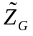.
- Find the error autoregressive parameter following K&P’s procedure for estimating the ARAR process model with autoregressive and heteroskedastic disturbances.
- Detrend the outcome and design matrix variables with the Cochran–Orcutt transformation as y* = y – λWy and 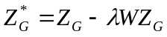.
- Update the STAR parameters (γ₁, c₁, γ₂, c₂) given (y*,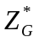).
- Return to step 1, and iterate until convergence (e.g., 0.000001, in this application).
Standard errors of the ARAR–STAR parameters are estimated using the asymptotic covariance matrix suggested by K&P (p. 60).
The step-wise iterative procedure used for the ARAR–STAR may be extended to cases where only error autocorrelation and spatial nonlinearities are considered, as in the case of the spatial error autoregressive model (SEM) with endogenous regimes (SEM–STAR). In this case, the IV matrix is an identity and Wy is omitted from the design matrix (Z). Standard errors may be estimated using an appropriate heteroskedastic–robust covariance matrix as above.

4.2.3 Hypotheses
The hypotheses about spatial nonlinearity, lag, error, ARAR processes and their combinations (H₁ – H₁₇) were tested by calculating Wald statistics based on the robust covariance matrix. This specification suggests the following hypotheses with respect to a baseline a-spatial that could be estimated using Ordinary Least Squares (OLS), and the usual spatial error (SEM) and spatial lag (SAR) process models:

(14) H₁: ρ = 0, λ = 0, δ₁ = δ₂ =0 (A-spatial model, suggesting estimation with OLS)

(15) H₂: ρ = 0, λ = 0, δ₂ = δ₃ =0, δ₁ ≠ 0 (STAR),
(16) H₃: ρ = 0, λ = 0, δ₁ = δ₃ =0, δ₂ ≠ 0 (STAR),
(17) H₄: ρ = 0, λ = 0, δ₃ =0, δ₁≠0, δ₂ ≠ 0 (Additive STAR),
(18) H₅: ρ = 0, λ = 0, δ₁≠0, δ₂ ≠ 0, δ₃ ≠ 0 (Additive STAR with Interactions),

(19) H₆: ρ = 0, λ ≠ 0, δ₂ = δ₃ =0, δ₁ ≠ 0 (SEM-STAR)
(20) H₇: ρ = 0, λ ≠ 0, δ₁ = δ₃ =0, δ₂ ≠ 0 (SEM-STAR),
(21) H₈: ρ = 0, λ ≠ 0, δ₃ =0, δ₁≠0, δ₂ ≠0 (SEM-Additive STAR),
(22) H₉: ρ = 0, λ ≠ 0, δ₁≠0, δ₂ ≠0, δ₃ ≠0 (SEM-Additive STAR with Interactions),

(23) H₁₀: ρ ≠0, λ = 0, δ₂ = δ₃ =0, δ₁ ≠ 0 (SAR-STAR),
(24) H₁₁: ρ ≠ 0, λ = 0, δ₁ = δ₃ =0, δ₂ ≠ 0 (SAR-STAR),
(25) H₁₂: ρ ≠ 0, λ = 0, δ₃ =0, δ₁≠0, δ₂ ≠ 0 (SAR-Additive STAR),
(26) H₁₃: ρ ≠ 0, λ = 0, δ₁≠0, δ₂ ≠ 0, δ₃ ≠ 0 (SAR-Additive STAR with Interactions),

(27) H₁₄: ρ ≠0, λ ≠ 0, δ₂ = δ₃ =0, δ₁ ≠ 0 (ARAR-STAR),
(28) H₁₅: ρ ≠ 0, λ ≠ 0, δ₁ = δ₃ =0, δ₂ ≠ 0 (ARAR -STAR),
(29) H₁₆: ρ ≠ 0, λ ≠ 0, δ₃ =0, δ₁≠0, δ₂ ≠ 0 (ARAR -Additive STAR),
(30) H₁₇: ρ ≠ 0, λ ≠ 0, δ₁≠0, δ₂ ≠ 0, δ₃ ≠ 0 (ARAR -Additive STAR with Interactions),
Figure 8 is a diagram illustrating the model specification process.

4.3 Choice of Transition Variables
Of particular importance is the choice of the transition variable, which is hypothesized to drive the sorting process. Ideally, v conveys information about connectivity between spatial units and identifies structural breaks across space. The transition variable should also be exogenous. In both models, the first transition variable v₁ is the road network distance of a county to the nearest metropolitan county defined by the Office of Management and Budget (OMB) (distmet), which is appealing to the extent that the geographic effects of trade costs on economic growth are hypothesized to be nonlinear (e.g., Fujita and Thisse, 2002) (Figure 9), and that urban–rural hierarchy is important with respect to firm location decisions (Partridge et al., 2008b; Partridge and Rickman, 2008, Lambert and McNamara 2009). The second transition variable v₂ , is the spatial lag of the initial level of the business establishment growth density (W·lnestden00_{i}) for business establishment model, and the spatial lag of the initial level of the employment growth density (W·lnemden00_{i}) for employment model, suggesting that counties surrounded by other counties with similar initial conditions may follow similar growth trajectories and respond similarly to changes in local determinants. The more firm co-locations and labor poolings, the more information and technology spillover effects. This localization economies eventually drive to agglomeration economies and enjoy economies of scale. Therefore, on one hand, as access to economic centers becomes more critical to local growth in nonmetropolitan or noncore counties, local assets or capacity (e.g., skilled labor, local resources, and fiscal policy) with growth may become irrelevant or, alternatively, essential for attracting and retaining business investment. On the other hand, employment and business establishment growth in these same locations may also be relatively more or less responsive to a set of local determinants, given the initial status of the employment and business establishment growth density. What’s more, the urban–rural hierarchy and the agglomeration effect will reinforce and leverage together to contribute to the regional economic growth by producing economies of scale and network effects in the local economy. These differential effects on the geography of local economic growth are endogenized in the STAR specification, allowing for identification of locations that respond similarly in terms of the contribution of a given industrial cluster to growth but perhaps very differently from another set of counties. The different growth regimes driven by these two forces will provide insights to the effectiveness of the local policies based on different locations.

CHAPTER 5
RESULTS AND DISCUSSIONS

The discussion of the econometric results focuses on (1) model specification, (2) the spatial patterns of the transition functions G₁ and G₂, and (3) the elasticities of the local determinants. Discussion centers on the covariates that were significant at the 5% level.

5.1 Model Specification
The co linearity diagnostics for employment and business establishment growth was performed first. Most of the VIF’s were less than 10, which suggests that the inference was not compromised by co linearity. There were only few covariates with VIFs above 10; however, their p-values were relatively small. The co linearity indices were all less than 30, indicating that the signs associated with the coefficients were robust. From the 2SLS estimators, about 61% and 51% of the variation in change of business establishment growth and change of employment growth from 2000-2008 was explained by each model respectively (Table 4 and Table 5). The initial level of business establishment density (lnestden00_{i}) was significantly related to the change in business establishment growth from 2000-2008 (p < 0.0001). The initial level of employment density (lnemden00) was not significantly related to the change in employment growth from 2000-2008 (p = 0.061).
Following the “general-to-specific” specification search, 4 spatial weight matrices were evaluated for the ARAR (1,1) specification. The first stage IV regression was used to generate the initial [ρ_{0,} β₀] to construct Lee’s best IV’s. The J test of the overidentification restrictions was rejected at 5% level, indicating that the instruments Q₀ used to predict Wy were correlated with the disturbances. LeSage and Pace’s (2009) Bayesian heteroskedastic-robust SAR estimator was then applied to obtain consistent estimates of [ρ_{0,} β₀]. The SAR model was just identified using Lee’s best IV for the predicted value of Wy. The squared correlation coefficients (r²) were used as an indicator of the overall model performance because instruments were used to estimate the model. Based on the Wald tests from the ARAR (1,1) estimator of the business establishment model, the p-values for the four weight matrices were less than 0.0001. The spatial lag AR and spatial error AR parameters were insignificant under all the weight matrices with p-values ranging from 0.278 to 0.644. The joint Wald test λ = ρ = 0 was rejected due to the significance of the spatial error AR coefficient. Therefore, all four spatial weight designs suggested that the Spatial Error Model (SEM) best explained the business establishment growth. According to the Wald tests from ARAR (1,1) estimation of the employment model, both spatial error and lag AR parameters were insignificant under inverse distance matrix (W2) where the squared correlation coefficients (r²) was the highest (r²=0.528). Thus, the employment growth model was estimated using 2SLS.
Lastly, in order to allow the relationship between local determinants and change in employment and business establishment growth vary between different regimes, the STAR type model with double transitions was included in the specified spatial process model to test for parameter nonlinearity. For the business establishment model, under each of the four weight matrices from STAR-SEM model, the squared correlation coefficients were nearly identical and were not useful for determining an appropriate set of weights. Hence, the weight design was chosen based on the lowest Sum of Squared Errors (SSE). The border weights (W3) were selected based on the lowest Sum of Squared Errors (SSE). The null hypothesis that the error terms were uncorrelated between counties was rejected at the 5% level (Wald = 15.546, p=0.0001), suggesting that the adjustment model could be specified as a SEM process model.

5.2 Double Transition Functions
Due to high degrees of co linearity problems generated by the interaction of the two transition functions, only the additive component of the two transition functions was considered here:
(43) Δy =Zβ +G₁ ◦Z δ₁+G₂ ◦Z δ₂+ u.
The null hypothesis that the effects of the covariates on growth were geographically invariant (δ₁ = 0 and δ₂ = 0) were both rejected at the 5% level (Wald = 61.800, p=0.012; Wald =122.845, p<0.0001), indicating that the growth trajectories exhibited heterogeneity across the region. Based on these results, it was concluded that the SEM-STAR additive model appropriately described the data generating process determining business establishment growth during this period (Table 8). The squared correlation coefficient of the SEM-STAR additive model was r² = 0.701, suggesting that more than 70% of the variation in the data was explained by the model (Table 6). By the same criteria, the appropriate weight design for the employment growth model was an inverse distance matrix (W4) with a squared correlation coefficient of 0.603 (Table 7). The coefficients of both regimes from the STAR additive model were statistically significant, suggesting that the growth trajectories exhibited heterogeneity across space (Table 9).
For the business establishment model, the transition function parameters were γ₁ =10.177, γ₂ = 11.003 (the shape parameter), and c ₁= 36.267, c₂ = 1.737 (the location parameter); while for the employment model, the transition function parameters were γ₁ = 50.029, γ₂ = 49.964, and c ₁ = 20.642, c₂ = 4.328. The intermediate values of γ₁ and γ₂ identify counties along a continuum that are “in transition”, and vary according to the transition variables distmet and Wlnestden00 or Wlnemden00 respectively (Figure 10, Figure 11, Figure 12, and Figure 13).
For the business establishment model with transition variable (v₁) of distmet in the first transition function (G₁ ), the effects of the covariates on business establishment growth are gradually heterogeneous moving past the 36 mile marker of a metropolitan county. The counties in the top percentile (the counties where G₁ = 1) are generally associated with nonmetropolitan counties. Counties in the bottom of the hierarchy (e.g., those where G₁ = 0) are associated with metropolitan counties. Many counties appeared to be “in transition” with respect to business establishment growth. The spatial distribution of the transition probabilities generated by the G₁ function was mapped (Figure 10). The pattern closely follows the distribution of the Picard index used by the ARC to categorize the economic disposition of counties (Figure 2). Counties lowest in the sorting hierarchy were most typically economically “Distressed”, according to the ARC Pickard index. “Attainment” counties belonged mainly to the upper tier of the structural break, which also generally correlated with metropolitan and micropolitan counties. “At risk” and “Transitional” counties were located along the smooth continuum.
Similarly, for the business establishment model with the transition variable (v₂) of Wlnestden00 in the second transition function (G₂), the effects of the covariates on business establishment growth are gradually heterogeneous moving past the threshold of 6 neighboring business establishments per square mile (= e ^{1.737}) The counties in the lower hierarchy (the counties where G₂ = 0) are generally associated with nonmetropolitan counties. Counties in the upper hierarchy (e.g., those where G₂ = 1) are associated with metropolitan counties. There are also many counties that appeared to be “in transition” along the continuum with respect to business establishment growth (Figure 11).
A slightly different picture emerged for the employment model (Figure 12, Figure 13). For the first transition function (G₁ ) with the transition variable (v₁) of distmet, on average, the threshold effect of proximity to metropolitan counties appears to be around 25 miles from urban centers (Figure 12). For the second transition function (G₂) with the transition variable (v₂) of Wlnemden00, initial level of employment density clearly separated counties into two distinct regimes with the cut-off point about 76 neighboring jobs per square mile (= e ^{4.328} ). The counties in the lower hierarchy (the counties where G₂ = 0) were generally associated with nonmetropolitan counties. Counties in the upper hierarchy (e.g., those where G₂ = 1) were associated with metropolitan counties. There are a few counties that appeared to be “in transition” with respect to employment growth (Figure 13).

5.3 Elasticities of Technology Industry Clusters
Using the employment growth model as an example (Table 7), there are 3 regimes. Regime 1 is the reference regime, while regime 2 (G₁ = 1) is associated with more remote counties, and Regime 3 (G₂ = 1) corresponds with counties located in or near metropolitan counties. The coefficients associated with Regime 1 and Regime 2 are the differences from the coefficients associated with Regime 1. Discussion of the important industry technology clusters and associated heterogeneity follows two criterions. First, the main effect coefficients (the β’s) had to be significant at the 5% level. Second, the coefficient associated with two transition functions (either δ₁’s or δ₂’s ) had to be significantly different from the reference coefficient at the 5% level. Significance of the δ’s suggests that the relationship between a covariate and a growth measure are regime dependent.
The only industry clusters exhibiting regime dependency were the Engine Equipment, Pharmaceuticals, and Motor Vehicles clusters (Figure 14, Figure 15, and Figure 16). The Engine Equipment cluster exhibited geographic heterogeneity with respect to the employment growth. In counties with less than 76 neighboring jobs per square mile, a 1% increase in the Engine Equipment concentration index was associated with a small but positive increase in employment growth from 2000 – 2008 (0.041%). In counties with more than 76 neighboring jobs per square mile, the net marginal effect was negative on employment growth: 0.041-0.083= -0.042%. From the spatial distribution of the GI statistics (Figure 14), most of the impact regions associated with Engine Equipment cluster were situated around Ohio, East Tennessee, and Mississippi, which is also evident in the spatial distribution of the GI statistics (Figure 17) based on the concentration index in 2008. However, the actual GI statistics based on the elasticity in 2008 showed a completely reverse picture (Figure 17). The positively impact region became the negatively impact region, reflecting the great recession resulted in a sharp downward turn in the US economy in 2008.
The Pharmaceuticals cluster also exhibited heterogeneity with respect to the employment growth. At the 25 mile threshold, in more densely populated areas a 1% increase in the Pharmaceuticals concentration index was associated with a small but positive 0.056% increase in employment growth from 2000 – 2008. In more remote counties, the relationship was opposite, with the net marginal effect of 0.056 – 0.060 = -0.004% (Table 7). From the spatial distribution of the GI statistics (Figure 15), the core impact regions associated with the Pharmaceuticals cluster appeared to be in Ohio and Kentucky, where the Ohio Valley Affiliates for Life Sciences (OVALS)—an alliance of University of Cincinnati, Wright State University, University of Kentucky, and University of Louisville is a diverse bioscience community and research leader that stimulates and advances research in life sciences. However, from the spatial distribution of the GI statistics based on concentration index and elasticity in 2008 (Figure 18), this impact region was actually growing slowly and it didn’t contribute to the local economy significantly. Most of this was due to the crashing economy since 2008 which affected almost every industry in the U.S.
The Motor Vehicles cluster was associated with slower employment growth, and the relationship was nonlinear. It was associated with decrease in employment in counties located within 25 miles of metropolitan counties, but farther away from urban areas the relationship was moderated. For example, a 1% increase in the Motor Vehicles concentration index corresponded with a relatively small decrease (-0.005%) in employment in metropolitan counties. For counties located farthest from metropolitan counties, the impact was effectively zero (–0.005 + [G₁ = 1] ·0.005=0). The Motor Vehicles cluster also exhibited a small decrease of (-0.005%) in counties with less than 76 neighboring jobs per square mile. However, for counties with more than 76 neighboring jobs per square mile, the net effect on employment growth was increasing and positive (0.003%). In addition, for counties beyond the 25 mile threshold and with more than 76 neighboring jobs per square mile, a 1% increase in Motor Vehicles concentration index associated with (on average) a small increase of 0.008%. According to the GI statistics (Figure 16), the negatively impact regions of the Motor Vehicles technology cluster include Pennsylvania, South Carolina, West Virginia, West Point, Georgia, suggesting that the markets in those regions are saturated. Kia Motors' facility which took place in late 2006 in Georgia has already experienced tremendous growth in the southeastern of U.S. West Virginia, was one of the fastest growing industries in West Virginia economy before, which ranked 4th nationally in the percentage growth in motor vehicle parts manufacturing employment. In addition, the year 2008 is a bad year for the entire auto industry because many companies shut down their plants and went bankruptcy. Therefore, creating more job opportunities on the saturated markets will not stimulate economic growth. However, on the other hand, from the spatial distribution of the GI statistics based on concentration index and elasticity in 2008 (Figure 19), some potential regions including Ohio, Kentucky, Tennessee, and Mississippi were experiencing growth and may provide a make-up for the loss on to the saturated markets.

5.4 Dynamic Stability Analysis
According to Carruthers and Mulligan (2007), it is important to check the stability of regional adjustment equation systems. In other words, the dynamic adjustment process moves the spatial distribution of employment and business establishment growth toward a stable future state only when these ratios are constant over time. In addition, it is useful to know how different the expected steady state is from the initial conditions for employment and business establishment growth. By applying this concept to the regime switching models, it is interesting to investigate whether and how the equilibrium of each regime differs.
Carlino and Mills (1987) suggested using the reduced-form coefficients of the regional adjustment models to analyze the stability of the system solutions. Recall the system equations from the empirical model (Equation 31, Equation 32), the reduced-form estimates were:
(50) ${lnemp}_{i,t}=$ $φ_{0}+φ_{1}{lnemp}_{i,t-1}+φ_{2}lne{stabs}_{i,t-1}+φ_{3}'X_{i,t-1}$+$ε_{it}^{emp}$
(51) ${lnestabs}_{i,t}=$ $ω_{0}+{ω_{1}{lnestabs}_{i,t-1}+ω}_{2}lne{mp}_{i,t-1}+ω_{3}'X_{i,t-1}$+$ε_{it}^{estabs}$
where $φ_{0}=\frac{α_{0}+α_{2}β_{0}}{1-α_{2}β_{2}}$, $φ_{1}=\frac{{1+α}_{1}}{1-α_{2}β_{2}}$ , $φ_{2}=\frac{α_{2}({1+β}_{1})}{1-α_{2}β_{2}}, φ_{3}=\frac{α_{2}β_{3}+α_{3}}{1-α_{2}β_{2}}$; $ω_{0}=\frac{β_{0}+β_{2}α_{0}}{1-α_{2}β_{2}}$, $ω_{1}=\frac{{1+β}_{1}}{1-α_{2}β_{2}}$ , $ω_{2}=\frac{β_{2}{(1+α}_{1})}{1-α_{2}β_{2}}$, and $ω_{3}=\frac{β_{2}α_{3}+β_{3}}{1-α_{2}β_{2}}$. Table 10 summarizes the adjustment coefficients, comparing the 2SLS and regime switching models (STAR or STAR-SEM). The reduced-form coefficients were placed in a two-by-two matrix and the characteristic roots were solved by the “characteristic” or “determinational” equation (Carruthers and Mulligan, 2007, p.92). Real characteristic roots within the unit interval occurred in the 2SLS and regime switching models except for regime 2. The results suggest that employment and business establishment converge globally to stable states within the time frame. Although the characteristic roots of regime 2 for the STAR type models are complex conjugates, the implied trajectory still converges to a steady state as Leonard and Van Long (1992, p.98) pointed out. In each model, the largest root is adopted to ensure the ratio between business establishments and jobs persisted at equilibrium. The ratio should then be transformed through exponentiation due to the natural logarithmic form of the regression estimates (Table 10). Take the 2SLS model as an example. The characteristic roots are 0.976 and 0.849, so the largest root of 0.976 is adopted:

$\left[\begin{matrix}0.963 & 0.014 \\ 0.108 & 0.862\end{matrix}\right]$·$\left[\begin{matrix}lnemden00 \\ lnestden00\end{matrix}\right]$ = 0.976·$\left[\begin{matrix}lnemden00 \\ lnestden00\end{matrix}\right]$ ,
Solving by linear algebra, the ratio $lnemden00 :lnestden00$= 1.06:1. Exponentiation of the ratio yields 1.06:1, which is the steady state ratio of jobs and business establishments at equilibrium. The ratio is useful in forecasting the future establishment size which is measured by the number of employees per business establishment. For instance, for the 2SLS model, a stable ratio is finally attained when there are approximate 2 jobs per each business establishment. Although the suggested establishment size is very small at equilibrium, it sheds light on the project future pattern of employment and business establishment growth which will be more likely focused on job creations from star-ups of newly small and young firms. New business creation is powerful in contributing economic development and growth because it creates new jobs, promotes the spillover of new innovations, ideas and market information (Robinson, Dassie, and Christy, 2004). The ratios of the regime switching models can also be interpreted similarly (Table 10).

CHAPTER 6
SUMMARY AND CONCLUSIONS

6.1 Summaries of Findings
This thesis combined six related chapters organized towards the goal of
investigating the relationship between local determinants and the spatial dimensions of business establishment and employment growth, in particular the impacts associated with industry technology clusters. The objective of this thesis was to (1) modify a regional adjustment model to examine the extent to which business establishment-employment growth was codetermined, (2) extend a relatively new econometric method– the Smooth Transition Autoregression model of Pede, Florax and Holt (2010) to a regional adjustment model, and (3) analyze the relationship between demographic characteristics, settlement patterns, community structure, housing market, infrastructure, fiscal policy, physical and natural amenities, industry structure, industry clusters and business establishment and employment growth in the Appalachian region using this method. The change in business establishment and employment growth were regressed on industry concentration indexes, controlling for local determinants. The time period investigated this relationship is from 2000-2008, which included the lowest point in recession (2001) and much of the economic recovery lasted through 2008. The hypothesis that the relationship between industry clusters on growth was geographically heterogeneous was tested using 4 spatial weight specifications by a relatively new spatial econometric approach, a Smooth Transition Autoregressive (STAR) model.
The STAR family of models is relatively new to the spatial econometric toolbox. The method contributes to the current approaches available in terms of its ability to identify regimes using a data driven approach as opposed to one where regimes are identified using conventions potentially fraught with definitional problems (i.e., metropolitan versus rural). The STAR model also relaxes the assumption of parameter similarity across spatial units, allowing for parameter heterogeneity across space, while at the same time bypassing the incidental parameter problem associated with other local regression methods like GWR. The STAR model also provides an empirical approach for testing some of the more fundamental theories predicting the effects of transport costs, and agglomeration economies on regional growth. To the extent that the STAR family of spatial models is able to identify structural breaks across space, the approach provides an interesting avenue for future research testing theories about labor migration, wage earnings, and firm location patterns as related to localization and urbanization agglomeration economies.
Evidence suggests the relationship between the industry technology clusters and growth was nonlinear across space, and the association between industry clusters and business establishment or employment growth could be characterized into different growth regimes. Industry technology clusters exhibiting regime dependency were the Engine Equipment, Pharmaceuticals, and Motor Vehicles clusters. The spatial distributions of the GI statistics illustrate the impact of clusters in regimes at different level of significances, which is useful for targeting the regional development strategies as it provides insights into the design of policies. The results obtained from this research have several policy implications. For instance, in the Pharmaceuticals cluster, a 1% increase in its concentration index in counties within 25 mile metropolitan threshold was associated with a 0.056% increase in employment growth from 2000-2008. Therefore, promoting the economies of counties located close to metropolitan counties (like Ohio area, Figure 15) will help them grow economically in terms of employment growth. However, in the Engine Equipment cluster, since a 1% increase in its concentration index in counties with less than 76 neighboring jobs per square mile was associated with a 0.041% increase in employment growth from 2000 – 2008, policies should be prioritized to counties which have low employment (like some areas in Tennessee, Ohio, and Mississippi; Figure 14) in 2000 so as to help them grow faster in 2008. In addition, the coefficients of Motor Vehicles concentration indexes are statistically significant in all 3 regimes, indicating that each regime is significantly different from the reference regime. The positive effect of the employment growth observed in Motor Vehicles cluster may imply that policy-makers should take into account both the geographical distance and the initial level of employment before designing regional growth policies. Specifically, policies should be designed in favor of counties which are 25 miles away from the metropolitan areas with more than 76 neighboring jobs per square mile. In addition, it should avoid the saturated areas like Georgia, and West Virginia (Figure 16).

6.2 Future Research
There are many limitations on this research. Firstly, the concentration index (CI) is calculated based on establishment, not employment. Industry composition would be more accurate if the employment number was available for calculating the location quotients. Secondly, the study period from 2000 to 2008 is too narrow to evaluate the medium or long-run impact of industry clusters on regional economic growth, and steady state convergence paths. Hence, obtaining the panel data may provide a deeper, richer analysis. Thirdly, there are many factors beyond industry clusters that may affect firm survivability such as firm growth, size, age, market concentration, and innovation rates (Audretsch, 1991). Some industry growth may depend heavily on the contributions of the clusters; while growth of other industries like tourism may even not need the clusters, and depend less as the scale economies typically provided by the clusters. Fourthly, the transition variables may themselves be sensitive to spatial heterogeneity. Both scale economies and capital intensity are significantly related to the economic growth and development. Hence, choosing an appropriate transition variable which proxies scale economies and capital intensity of the industry clusters is important. Much work remains to be done in terms of exploring further the STAR process models. Firstly, the failure of the interactions between two transition functions may suggest incorporating two choices of transition variables into a single transition function to decrease the degree of co linearity. Secondly, comparing estimation approaches applicable to the STAR process models. While the advantages and disadvantages of ML and GMM estimation are well-know, the performance of the STAR model and its spatial process variants under different experimental parameters remains to be documented. Lastly, the performance of diagnostics used to specify STAR-class models should be thoroughly investigated. In this application, a “general-to-specific” approach was taken to specify the regression model. How this specification search compares to a “specific-to-general” approach could provide information regarding which types of tests should be used under different assumptions; e.g., Lagrange Multiplier tests, assuming a normal distribution versus Wald tests where distributional assumptions are relaxed.

LIST OF REFERENCES

Alesina, A. H., and E. La Ferrara. 2004. “Ethnic Diversity and Economic Performance.” National Bureau of Economic Research Working Paper 10313.
Appalachian Regional Commission, 2011. “Appalachian Development Highway System”, http://www.arc.gov/adhs (Accessed 5/13/2011).
Anselin, L. 1988. Spatial Econometrics: Methods and Models. Dordrecht: Kluwer Academic Publishers.
---, L. 2002. “Under the hood: Issues in the specification and interpretation of spatial regression models.” Agricultural Economics 27: 247-267.
---, L. 2006. “Spatial Regression.” Working Paper, Spatial Analysis Laboratory, Department of Geography and National Center for Supercomputing Applications, Urbana-Champaign.
Anselin, L., and R. Florax. 1995. “Small sample properties of tests for spatial dependence in regression models.” In New Directions in Spatial Econometrics, 21-74. Berlin.
Anselin, L., K. Wendy, and T. Cho. 2002. “Spatial Effects and Ecological Inference.” Political Analysis 10: 276-297.
Arbia, G., R. Basile, and G. Piras. 2005. “Using Spatial Panel Data in Modeling Regional Growth and Convergence.” Working Papers, Institute for Studies and Economic Analyses, Rome, Italy.
Arraiz, I., D. M. Drukker, H. H. Kelejian, and I. R. Prucha. 2010. “A Spatial Cliff-Ord Type Model with Heteroskedastic Innovations: Small and Large Sample Results.” Journal of Regional Science 50: 592-614.
Audretsch, D. B. 1991. “New-Firm Survival and the Technological Regime.” The Review of Economics and Statistics 73(3): 441-450.
Azariadis, C. and A. Drazen. 1990. “Threshold Externalities in Economic
Development.” Quarterly Journal of Economics 105: 501-526.
Baldwin, R., R. Forslid, P. Martin, G. Ottaviano, and F. Robert-Nicoud. 2003. Economic Geography and Public Policy. Princeton and Oxford: Princeton University Press.
Barkley, D., and M. Henry. 1997. “Rural Industrial Development: To Cluster or Not To
Cluster?” Rev. Agr. Econ. 19(2): 308-325.
Barkley, D. L., M. S. Henry, and Y. Kim. 1999. “Industry Agglomerations and Employment Change in Non-Metropolitan Areas.” Review of Urban and Regional Development Studies 3: 168 -186.
Basile, R. 2008. “Regional Economic Growth in Europe: A Semi-parametric Spatial Dependence Approach.” Regional Science 87:527-544.
Basile, R., and B. Gress. 2005. “Semi-Parametric Spatial Auto-Covariance Models of Regional Growth in Europe.” Région et Dévéloppement 21: 93-118.
Baum, C. F., M. E. Schaffer, and S. Stillman. 2002. “Instrumental variables and GMM: Estimation and testing.” Working Papers in Economics 545, Department of Economics, Boston College.
Boarnet, M. G. 1994. “An Empirical Model of Intrametropolitan Population and Employment growth.” Regional Science 73:135-152.
Brakman, S., H. Garretsen, and C. V. Marrewijk. 2001. An Introduction to Geographical Economics: Trade, Location and Growth. Cambridge: Cambridge University Press.
Brakman, S., H. Garretsen, and C. V. Marrewijk. 2001. An Introduction to Geographical Economics: Trade, Location and Growth. Cambridge, U.K.: Cambridge University Press.
Broadberry, S. N. 1994. “Technological Leadership and Productivity Leadership in
Manufacturing since the Industrial Revolution: Implication for the Convergence
Debate.” The Economic Journal 104: 291-302.
Bureau of Economic Analysis. 2007. http://www.bea.gov/ .
Carlino, G. A., and E. S. Mills. 1987. “The Determinants of County Growth.” Journal of
Regional Science 27: 39-54.
Carruthers J. I., and G. F. Mulligan. 2007. “Land absorption in United States metropolitan areas: estimates and projections from regional adjustment models.” Geographical Analysis 39: 78-104.
Carruthers, J. I., and A. C. Vias. 2005. “Urban, Suburban, and Exurban Spatial in the Rocky Mountain West: Evidence From Regional Adjustment Models.” Journal of Regional Science 45: 21-48.
Casetti, E. 1972. “Generating Models by the Expansion Method: Applications to Geographical Research.” Geographical Analysis 4: 81-91.
Chatterji, M. 1992. “Convergence Clubs and Endogenous Growth.” Oxford Review of
Economic Policy 8: 57-69.
Chiang, A.C. (1984). Fundamental methods of mathematical economics. New York: McGraw-Hill.
Clark, C. D., D. M. Lambert, W. M. Park, and M. D. Wilcox. 2009. “Willingness to Fund Public Education in a Rural Retirement Destination County.” Journal of Research in Rural Education 24: 1-16.
Clark, D. E., and C. A. Murphy. 1996. “Countywide employment and population growth.” Journal of Regional Science 36: 235-256.
Cohen, J. P., and C. M. Paul. 2005. “Agglomeration Economies and Industry Location Decisions: The Impacts of Spatial and Industrial Spillovers.” Regional Science and Urban Economics 35: 215-237.
Davis, D.E., and G. E. Schluter. 2005. “Labor-Force Heterogeneity as a Source of Agglomeration Economies in an Empirical Analysis of County-Level Determinants of Food Plant Entry.” Journal of Agricultural and Resource Economics 30(3).
Deller, S. C., T-H. Tsai, D. W. Marcouiller, and D. B. K. English. 2001. “The role of amenities and quality of life in rural economic growth.” American Journal of Agricultural Economics 83: 352–365.
Dorfman, J. H., M. D. Partridge, and H. Galloway. 2009. “Do Natural Amenities Attract High-Tech Jobs?: Evidence From a Smoothed Bayesian Spatial Model.” Working Papers in Department of Agricultural and Applied Economics, The University of Georgia, Athens.
Duffy-Deno, K. T. 1998. “ The Effect of Federal Wilderness Land on County Growth in the Intermountain Western United States.” Journal of Regional Science 38: 109-136.
Ertur, C., and J. Le Gallo. 2003. “Exploratory Spatial Data Analysis of the Distribution of Regional per Capita GDP in Europe, 1980 – 1995.” Regional Science 82:175-201.
ESRI ArcView GIS software, 2010.
Farrar, D. E., and R. R. Glauber. 1967. “Multicollinearity in Regression Analysis: The Problem Revisited.” The Review of Economics and Statistics 49(1): 92-107.
Feser, E., and A. Isserman. 2009. “The Rural Role in National Value Chains and Regional Clusters.” Regional Studies 43(1): 89-109.
Feser, E., H. Renski, and H. Goldstein. 2008. “Clusters and Economic Development Outcomes: An Analysis of the Link Between Clustering and Industry Growth.” Econ. Develop. Quart. 22: 324-344.
Fingleton, B. 2008. “A generalized method of moments estimator for a spatial model with moving average errors, with application to real estate prices.” Empirical Economics 34: 35-57.
Florax, R. J. G. M., H. Folmer, and S. J. Rey. 2003. “Specification searches in spatial econometrics: the relevance of Hendry‟s methodology.” Regional Science and Urban Economics 33: 557-579.
Florax, R. J. G. M., and S. J. Rey. 1995. “The impacts of misspecified spatial weight structures in linear regression models.” In L. Anselin and R.J.G.M. Florax, ed. New Directions in Spatial Econometrics. Berlin: Springer.
Foster, S. A., and W. L. Gorr. 1986. “An Adaptive Filter for Estimating Spatially-Varying Parameters: Application to Modeling Police Hours Spent in Response to Calls for Service.” Management Science 32: 878-889.
Fotheringham, A.S., C. Brunsdon, and M. Charlton. 2002. Geographically Weighted Regression. UK: Wiley and Sons.
Fujita, M., P. Krugman, and A. J. Venables. 1999. The Spatial Economy. Cambridge, MA: MIT Press.
Fujita, M., and J-F. Thisse. 2002. Economics of Agglomeration: Cities, Industrial Location, and Regional Growth. UK: Cambridge University Press.
Gebremariam, G. H., T. G. Gebremedhin, and P. V. Schaeffer. 2011. “Employment, Income, and Migration in Appalachia: A Spatial Simultaneous Equations Approach.” Journal of Regional Science 51: 102-120.
Getis, A., and J. K. Ord. 1992. ‘The Analysis of Spatial Association by Use of Distance Statistics.” Geographical Analysis 24: 189-206.
Gibbs, R. M., and G. A. Bernat Jr. 1997. “Rural industry clusters raise local earnings.” Rural Development Perspectives 12(3):18-25.
Goetz, S., M. Shields, and Q. Wang. 2009. “Identifying Food Industry Clusters: A Comparison of Analytical Tools.” In S. J. Goetz, S. C. Deller, and T. R. Harris, eds. Targeting Regional Economic Development. New York: Routledge.
Greene, W. H. 2000. Econometric Analysis. Upper Saddle River, NJ: Prentice Hall.
Gress, B. 2004. “Semiparametric Spatial Autocovariance Models.” PhD Dissertation, University of California, Riverside.
Hendry, D. F. 2006. “A comment on Specification searches in spatial econometrics: The relevance of Hendry‟s methodology.” Regional Science and Urban Economics 36: 309-312.
Holt, T. M. and L. A. Craig. 2006. “Nonlinear Dynamic and Structural Change in the U.S. Hog-Corn Cycle: A Time-Varying STAR Approach.” American Journal of Agricultural Economics 88: 215-233.
Irwin, E., A. M. Isserman, M. Kilkenny, and M. D. Partridge. 2010. “A Century of Research on Rural Development and Regional Issues.” American Journal of Agricultural Economics 92: 522 -553.
Isserman, A. M. 1977. “The Location Quotient Approach for Estimating Regional Economic Impacts.” Journal of the American Institute of Planners 43: 33-41.
Kahn, R., P. F. Orazem, and D. M. Otto. 2001. “Deriving Empirical Definitions of Spatial Labor Markets: The Roles of Competing versus Complementary Growth.” Journal of Regional Science 41: 735 – 756.
Keefe, S. E. 2009. Participatory Development in Appalachia: Cultural Identity, Community, and Sustainability. Knoxville, Tennessee: University of Tennessee Press.
Kelejian, H. H., and I. R. Prucha. 1999. “A Generalized Moments Estimator for the Autoregressive Parameter in a Spatial Model.” International Economic Review 40: 509-533.
Kelejian, H. H., and I. R. Prucha. 2010. “Specification and Estimation of Spatial Autoregressive models with Autoregressive and Heteroskedastic Disturbances.” Journal of Econometrics 157: 53-67.
Kelejian, H. and D. P. Robinson. 2004. “The Influence of Spatially Correlated Heteroskedasticity on Tests for Spatial Correlation.” In Anselin, L., and R. Florax, ed. Advances in Spatial Econometrics.
Kilkenny, M. 2010. “Urban/Regional Economics and Rural Development.” Journal of Regional Science 50 (1): 449-470.
Lambert, D. M., J. Brown, and R. J. G. M. Florax. 2010. “A Two-step Estimator for a Spatial Lag Model of Counts: Theory, Small Sample Performance and an Application.” Regional Science and Urban Economics 40: 241-252.
Lambert, D. M., and K. T. McNamara. 2009. “Location Determinants of Food Manufacturers in the U.S., 2000 - 2004: Are Nonmetropolitan Counties Competitive?” Agricultural Economics 40: 617-630.
Lambert, D. M., C. D. Clark, W. D. Wilcox, and W. M. Park. 2007. “Do migrating retirees affect business establishment and job growth? An empirical look at southeastern non-metropolitan counties, 2000–2004.” Review of Regional Studies 37: 251-278.
Larch, M., and J. Walde. 2008. Lag or Error? Detecting the nature of spatial correlation. In Data Analysis, machine learning and applications, edited by C. Preisach, H. Burkhardt, L. Schmidit-Thieme , and R. Decker, 301-308. Berlin: Springer.
Lebreton, J-D. 2005. “Dynamical and statistical models for exploited populations.” Australian and New Zealand Journal of Statistics 47:49-63.
Lee, L. F. 2003. “Best Spatial Two-Stage Least Squares Estimators for a Spatial Autoregressive Model with Autoregressive Disturbances.” Econometric Reviews 22: 307-335.
Leonard, D., and N. Van Long. 1992. Optimal Control Theory and Static Optimization in Economics. Cambridge, UK: Cambridge University Press.
LeSage, J. P., and K. Pace. 2009. Introduction to Spatial Econometrics. Boca Raton: Taylor & Francis Group, LLC. 46
Maddala, G. S. 1983. Limited-dependent and Qualitative Variables in Econometrics. Cambridge: Cambridge University Press.
McCann, P. 2001. Urban and Regional Economics. Oxford: Oxford University Press.
McGranahan, D. A. 2008. “Landscape influence on recent rural migration in the U.S.” Landscape and Urban Planning 85: 228-240.
---, D. A. 1999. Natural Amenities Drive Rural Population Change. Agricultural Economic Report No. 781, U.S. Department of Agriculture. Washington, D.C.: U.S. Government Printing Office.
McGranahan, D. A., and T. R. Wojan. 2007. “Recasting the creative class to examine growth processes in rural and urban counties.” Regional Studies 41: 197-216.
Monchuk, D. C., J. A. Miranowski, D. J. Hayes, and B. A. Babcock. 2007. “An analysis of regional economic growth in the U.S. Midwest.” Review of Agricultural Economics 29: 17-39.
Moreno, R., E. Lopez-Bazo, E. Vaya, and M. Artis. 2004. “External effects and cost of production.” Advances in Spatial Econometrics: Methodology, Tools and Applications. Berlin: Springer.
Mulligan, G. F., A. C. Vias, and S. M. Glavac. 1999. “Initial Diagnostics of a Regional Adjustment Model.” Environment and Planning A 31: 855-876.
Pace, R.K., R. Barry, V. C. Slawson, and C. F. Sirmans. 2004. “Simultaneous Spatial and Functional Form Transformations.” In L. Anselin, R. J. G.M. Florax, and S. Rey, ed. Advances in Spatial Econometrics. Berlin: Springer, pp.197-215.
Partridge, M. D., and D. S. Rickman. 2008. “Distance from Urban Agglomeration
Economies and Rural Poverty.” Journal of Regional Science 48: 285-310.
Partridge, M. D., D. S. Rickman, K. Ali, and M. R. Olfert. 2008. “The Geographic Diversity of U.S. Nonmetropolitan Growth Dynamics: A Geographically Weighted Regression Approach.” Land Economics 84: 241-266.
Pede, V. O. 2010. “Spatial Dimensions of Economic Growth: Technological Leadership and Club Convergence.” Ph.D. Dissertation, Purdue University.
Pede, O. V., R. J. G. M. Florax, and M. T. Holt. 2009. “A Spatial Econometric STAR Model with an Application to U.S. County Economic Growth, 1969–2003.” Working Paper, Department of Agricultural Economics, Purdue University.
Pede, O.V., R. J. G. M. Florax, D. M. Lambert, and M. T. Holt. 2010. “Spatial Econometric STAR Models: Lagrange Multiplier Tests and Monte Carlo Simulations.” Paper presented at the 53rd Annual Meeting of North American Regional Science Association, Nov.
Pede, V. O., Florax, R. J. G. M., and H. L. F. de Groot. 2006. “The Role of Knowledge Externalities in the Spatial Distribution of Economic Growth: A Spatial Econometric Analysis for US Counties, 1969-2003.” Paper prepared for presentation at the American Agricultural Economics Association Annual Meeting, Long Beach, California, July.
Pinkse, J., M. E. Slade, and C. Brett. 2002. “Spatial Price Competition: A Semiparametric Approach.” Econometrica 70: 1111-1153.
Porter, M. E. 1998. “Clusters and the New Economics of Competition.” Haruard Bus. Rev. 11: 77-90.
Quandt, R. 1958. “The Estimation of the Parameters of a Linear Regression System Obeying Two Separate Regimes.” Journal of the American Statistical Association 53: 873-80.
Robinson, K. L., W. Dassie, and R. D. Christy. 2004. “Entrepreneurship and
Small Business Development as a Rural Development Strategy.” Southern Rural Sociology 20 (2): 1-23.
Rogoff, E. G. 2008. The Issues and Opportunities of Entrepreneurship after Age 50. Office of Academic Affairs Occasional Paper Number 5. Washington, DC: AARP.
Rosenfeld, S.A. 1997. “Exports, Competitiveness, and Synergy in Appalachia Industry Cluster-A Report to the Appalachian Regional Commission.” Paper presented at Regional Technology Strategies, Inc., February.
Rupasingha, A., J. G. Stephan, and D. Freshwater. 2006. “ The production of social capital in US counties.” The Journal of Socio-Economics 35: 83-101.
Schabenberger, O., and F. J. Pierce. 2002. Contemporary Statistical Models for the Plant and Soil Sciences. New York: CRC Press.
Shaffer, R., S. D., and D. Marcouiller. 2004. Community economics: Linking theory to practice. Oxford, UK: Basil Blackwell.
Shields, M., D. Barkley, and M. Emery. 2009. “Industry Clusters and Industry Targeting.” In S. J. Goetz, S. C. Deller, and T. R. Harris, eds. Targeting Regional Economic Development. New York: Routledge.
Shonkwiler, J. S., and T. Harris. 1996. “Rural Retail Business Thresholds and Interdependencies.” Journal of Regional Science 36: 617-630.
Spencer, G. M., T. M. Vinodrai, S. Gertler, and D. A. Wolfe. 2010. “Do Clusters Make a Difference? Defining and Assessing their Economic Performance.” Regional Studies 44: 697-715.
Stimson, R. J., R. R. Stough, and B. H. Roberts. 2006. Regional Economic Development, 2nd ed. New York: Springer Berlin Heidelberg.
Terasvirta, T., and H. M. Anderson. 1992. “Characterizing Nonlinearities in Business Cycles Using Smooth Transition Autoregressive Models.” Journal of Applied Econometrics 7: 119-136.
Van Dijk, D., and P. H. Franses. 2000. “Nonlinear Error-Correction Models for Interest Rates in the Netherlands.” In Nonlinear Econometric Modelling, edited by W. A. Barnett, D. F. Hendry, S. Hylleberg, T. Teräsvirta, D. Tjøstheim, and A. Würtz, 203-227. Cambridge: Cambridge University Press.
Voss, P. R., K. J. C. White, and R. B. Hammer. 2004. “The (re-) Emergence of Spatial Demography.” Working Paper, Center for Demography and Ecology, University of Wisconsin-Madison. Madison, WI.
Vias, A. C. 1999. “Jobs Follow People in the Rural Rocky Mountain West.” Rural Development Perspectives 14: 14-23.
Vitale, J., and D. A. Bessler. 2006. “On the discovery of millet prices in Mali.” Regional Science 85(1): 139-162.
White, N. E., and T. A. Knapp. 1994. “A Dynamic Model of Migration with Public Sector Attributes.” Regional Science 73(3): 331-340.
Whittle, P. 1954. “On Stationary Processes in the Plane.” Biometrika 41:434-449.
Wojan, T. R., and D. A. McGranahan. 2007. “Ambient Returns: Creative Capital‟s Contribution to Local Manufacturing Competitiveness.” Agricultural and Resource Economics Review 36: 133-148.
Wojan, T. R., D. A. McGranahan, and D. M. Lambert. 2010. “The Rural Growth Trifecta: Outdoor Amenities, Creative Class and Entrepreneurial Context.” Journal of Economic Geography, forthcoming.
Wooldridge, J. M. 2004. Introductory Econometrics-A Modern Approach. 2nd Edition. United States: South-Western College Pub.

APPENDIX

APPENDIX A: SUPPORTING TABLES

Table 1: Summary of marginal effects of spatial process models

 | SAR | SEM | ARAR
Direct | β_{k} | β_{k} | β_{k}
Total | (1– ρ) ⁻¹ β_{k} | β_{k} | (1– ρ) ⁻¹ β_{k}
Indirect | ρ∙ (1– ρ) ⁻¹β_{k} | NA | ρ∙ (1– ρ) ⁻¹β_{k}

Table 2. Summary statistics of local determinants and concentration indexes
Variable | Description | Data Source | Mean | Std. Dev.
lnestden00 | Log establishment/area, 2000 | CBP / 1 | 0.533 | 1.340
lnemden00 | Log employment/area, 2000 | CBP / 1 | 3.705 | 1.340
lnemden08 | Log employments/area, 2008 | CBP / 1 | 3.775 | 1.362
lnestden08 | Log establishment/area, 2008 | CBP / 1 | 0.568 | 1.373
percomm | % Commute outside county, 2000 | 2000 Census / 3 | 39.963 | 17.226
uemprt | % Unemployment rate, 2000 | REIS / 4 | 4.606 | 1.580
lnmedhhi | Log median HH Income, 2000 | 2000 Census | 10.444 | 0.246
lnmedrent | Log median contract rent, 2000 | CCDB | 6.277 | 0.250
perownocchouse | % Owner-occupied housing units,2000 | CCDB | 74.850 | 7.589
lnmedhomeval | Log median value of owner-occupied housing, 2000 | CCDB | 11.520 | 0.329
skistd97 | Social capital index, 1997 | CCDB | -0.300 | 0.479
DI | Diversity Indexes,2000 | Calculated | 0.751 | 0.186
crime | Serious crime per 100,000 pop, 2000 | CCDB | 4130.465 | 21777.406
propertaxpc97 | Property tax per capita, 1997 | CCDB | 0.649 | 0.878
taxrate97 | Tax rate in 1997 | CCDB | 0.281 | 0.139
permanf | % Emp. Manufacture., 2000 | CBP | 20.455 | 8.672
perestab20 | % of firms with < 20 employees, 2000 | CBP | 88.030 | 3.120
perestab100 | % of firms with > 100 employees, 2000 | CBP | 2.193 | 1.034
pctpop2064 | % Pop. 20-64 years old, 2000 | 2000 Census | 58.717 | 2.428
c00p65ov | % Pop. 64+ years old, 2000 | 2000 Census | 13.434 | 2.875
pctcc | % Pop. Creative occupations, 2000 | ERS | 16.941 | 6.101
amenity | Natural amenity index | 2000 Census | -0.200 | 1.178
pubpct | % Public land | 2000 Census | 7.410 | 11.367
interstate | Interstate ( = 1) | ESRI / 5 | 0.469 | 0.499
adhs | Appalachian Development Highway (= 1) | ARC / 6 | 0.136 | 0.343

Notes: 1. CBP (County Business Pattern); 2. ERS (Economic Research Service); 3. 2000 Census (U.S. Census, 2000); 4. REIS (Regional Economic Information System); 5. ESRI (ESRI ArcView GIS ); 6. ARC (Appalachian Region Commission); 7. CCDB (County & City Data Book)

Table 2. Summary statistics of local determinants and concentration indexes (continued)
Variable | Description |  | Mean | Std. Dev.
Industry Clusters (Establishment Concentration Index):
CI1 | Basic Chemicals |  | 0.360 | 0.684
CI2 | Precision Instruments |  | 0.156 | 0.379
CI3 | Engine Equipment |  | 0.357 | 0.476
CI4 | Computer & Electronic Equipment |  | 0.143 | 0.273
CI5 | Information Services |  | 0.180 | 0.139
CI6 | Pharmaceuticals |  | 0.192 | 0.839
CI7 | Fertilizer & Chemical Products |  | 0.524 | 1.279
CI8 | Industrial Machinery & Distribution Equipment |  | 0.324 | 0.655
CI9 | Aerospace |  | 0.155 | 0.605
CI10 | Medical Instruments & Optics |  | 0.201 | 0.407
CI11 | Motor Vehicles |  | 0.364 | 2.041
CI12 | Wiring Devices & Switches |  | 0.288 | 0.979
CI13 | Technical & Research Services |  | 0.185 | 0.128
CI14 | Cable Manufacturing |  | 0.275 | 1.024
CI15 | Architectural & Engineering Services |  | 0.206 | 0.144

Notes: 1. CBP (County Business Pattern); 2. ERS (Economic Research Service); 3. 2000 Census (U.S. Census, 2000); 4. REIS (Regional Economic Information System); 5. ESRI (ESRI ArcView GIS ); 6. ARC (Appalachian Region Commission); 7. CCDB (County & City Data Book)

Table 3: Basic Technology Industry Clusters
Basic Chemicals | Precision Instruments
Petrochemical manufacturing | Industrial process variable instruments
Plastics material and resin manufacturing | Watch, clock, and other measuring and controlling device manufacturing
Other basic organic chemical manufacturing | Analytical laboratory instrument manufacturing
Synthetic rubber manufacturing | Automatic environmental control manufacturing
Noncellulosic organic fiber manufacturing | Optical instrument and lens manufacturing
Adhesive manufacturing | Totalizing fluid meters and counting devices
Surface active agent manufacturing | Electricity and signal testing instruments
Cellulosic organic fiber manufacturing | Relay and industrial control manufacturing
Other miscellaneous chemical product manufacturing
Custom compounding of purchased resins | Computer & Electronic Equipment
Pesticide and other agricultural chemical manufacturing | Computer storage device manufacturing
Nitrogenous fertilizer manufacturing | All other electronic component manufacturing
Printing ink manufacturing | Other computer peripheral equipment manufacturing
Industrial process variable instruments | Broadcast and wireless communications equipment
 | Electricity and signal testing instruments
Engine Equipment | Search, detection, and navigation instruments
Fluid power pump and motor manufacturing | Electronic computer manufacturing
Speed changers and mechanical power transmission equipment | Telephone apparatus manufacturing
Pump and pumping equipment manufacturing | Semiconductors and related device manufacturing
Air and gas compressor manufacturing | Computer terminal manufacturing
Other engine equipment manufacturing | Irradiation apparatus manufacturing
Metal valve manufacturing | Electron tube manufacturing
Fluid power cylinder and actuator manufacturing | Electromedical apparatus manufacturing
Measuring and dispensing pump manufacturing
Turbine and turbine generator set units manufacturing | Pharmaceuticals
Small arms manufacturing | Polish and other sanitation good manufacturing
Scales, balances, and miscellaneous general purpose machinery | Toilet preparation manufacturing
Power-driven handtool manufacturing | Soap and other detergent manufacturing
Motor and generator manufacturing | Pharmaceutical and medicine manufacturing
Motor vehicle parts manufacturing | Pesticide and other agricultural chemical manufacturing
Welding and soldering equipment manufacturing
Military armored vehicles and tank parts manufacturing

Notes: Industry clusters are based on Feser and Isserman (2009) value chain analysis of the 1997 United States Benchmark Input/Output accounts. A complete set of cross references between I/O sector identification with NAICS listings are available at www.ace.illinois.edu/Reap/Feser_051015_BenchmarkValueChain.xls

Table 3: Basic Technology Industry Clusters (continued)
Information Services | Fertilizer & Chemical Products
Data processing services | Fertilizer & Chemical Products
Other computer related services, including facilities management | Fertilizer, mixing only, manufacturing
Computer systems design services | Other basic inorganic chemical manufacturing
Software publishers | Explosives manufacturing
Custom computer programming services | Synthetic dye and pigment manufacturing
Information services | Carbon and graphite product manufacturing
Telecommunications | Industrial gas manufacturing
Cable networks and program distribution | Nitrogenous fertilizer manufacturing
 | Petrochemical manufacturing
Industrial Machinery & Distribution Equipment
Conveyor and conveying equipment manufacturing | Aerospace
Industrial truck, trailer, and stacker manufacturing | Aircraft manufacturing
Mining machinery and equipment manufacturing | Other aircraft parts and equipment
Construction machinery manufacturing | Propulsion units and parts for space vehicles and guided missiles
Elevator and moving stairway manufacturing | Aircraft engine and engine parts manufacturing
Overhead cranes, hoists, and monorail systems | Guided missile and space vehicle manufacturing
Oil and gas field machinery and equipment
Packaging machinery manufacturing | Motor Vehicles
Industrial process furnace and oven manufacturing | Miscellaneous electrical equipment manufacturing
Railroad rolling stock manufacturing | Automobile and light truck manufacturing
Semiconductor machinery manufacturing | Heavy duty truck manufacturing
Electric power and specialty transformer manufacturing | Motor vehicle parts manufacturing
 | Audio and video equipment manufacturing
Cable Manufacturing
Other communication and energy wire manufacturing | Wiring Devices & Switches
Fiber optic cable manufacturing | Switchgear and switchboard apparatus manufacturing
Paint and coating manufacturing | Wiring device manufacturing
Wiring device manufacturing | Other communications equipment manufacturing
Switchgear and switchboard apparatus manufacturing | Motor and generator manufacturing
 | Architectural and engineering services

Notes: Industry clusters are based on Feser and Isserman (2009) value chain analysis of the 1997 United States Benchmark Input/Output accounts. A complete set of cross references between I/O sector identification with NAICS listings are available at www.ace.illinois.edu/Reap/Feser_051015_BenchmarkValueChain.xls.

Table 3: Basic Technology Industry Clusters (continued)
Medical Instruments and Optics | Architectural & Engineering Services
Surgical and medical instrument manufacturing | Architectural and engineering services
Ophthalmic goods manufacturing | Other communications equipment manufacturing
Photographic film and chemical manufacturing | Environmental and other technical consulting services
Surgical appliance and supplies manufacturing | Management consulting services
Primary battery manufacturing | Specialized design services
Dental equipment and supplies manufacturing
Storage battery manufacturing | Technical & Research Services
Other ordnance and accessories manufacturing | Environmental and other technical consulting services
Photographic and photocopying equipment manufacturing | Management consulting services
Audio and video equipment manufacturing | Scientific research and development services
Ammunition manufacturing | Specialized design services
Miscellaneous electrical equipment manufacturing | Other ambulatory health care services
 | Architectural and engineering services
 | Custom computer programming services

Notes: Industry clusters are based on Feser and Isserman (2009) value chain analysis of the 1997 United States Benchmark Input/Output accounts. A complete
set of cross references between I/O sector identification with NAICS listings are available at www.ace.illinois.edu/Reap/Feser_051015_BenchmarkValueChain.xls.

Table 4: 2SLS Regression for Change in Business Establishment Growth: 2000-2008
Variable | Coef. | P-value
int | -2.537 | 0.000
lnestden00 | -0.139 | 0.000
lnemden08 | 0.112 | 0.000
percomm00 | 0.028 | 0.221
uemprt2000 | -1.407 | 0.000
lnmedhhi2000 | 0.084 | 0.031
lnmedrent00 | 0.122 | 0.000
perownocchouse00 | 0.269 | 0.000
lnmedhomeval00 | 0.086 | 0.000
SKI97STD | -0.052 | 0.000
propertaxpc97 | -0.008 | 0.074
permanf2000 | -0.155 | 0.001
pctest_lt_20_00 | -0.059 | 0.705
pctest_gt_100_00 | -0.383 | 0.330
pctpop2064_00 | -0.860 | 0.000
c00p65ov | -0.462 | 0.002
pctcc00 | 0.730 | 0.000
DI | 0.027 | 0.142
taxrate97 | -0.031 | 0.153
crime | 0.000 | 0.016
amenity | 0.012 | 0.000
pubpct | 0.027 | 0.324
INTSTADHS | -0.602 | 0.314
ADHS | 1.665 | 0.047
Chemicals | -0.006 | 0.134
Precision Instruments | -0.004 | 0.587
Engine Equipment | -0.005 | 0.384
Computer & Electronic Equipment | -0.030 | 0.002
Information Services | -0.115 | 0.000
Pharmaceuticals | 0.004 | 0.188
Fertilizer & Chemical Products | -0.001 | 0.509
Industrial Machinery & Distribution Equipment | 0.001 | 0.724
Aerospace | 0.001 | 0.758
Medical Instruments & Optics | 0.002 | 0.763
Motor Vehicles | 0.003 | 0.016
Wiring Devices & Switches | -0.004 | 0.173
Technical & Research Services | -0.049 | 0.065
Cable Manufacturing | 0.004 | 0.117
Architectural & Engineering Services | -0.014 | 0.534
Adj.R² | 0.609

Table 5: 2SLS Regression for Change in Employment Growth: 2000-2008
Variable | Coef. | P-value
int | -1.531 | 0.000
lnemden00 | -0.039 | 0.061
lnestden08 | 0.016 | 0.449
percomm00 | 0.125 | 0.000
uemprt2000 | -0.321 | 0.270
lnmedhhi2000 | 0.062 | 0.165
lnmedrent00 | 0.053 | 0.213
perownocchouse00 | 0.066 | 0.369
lnmedhomeval00 | 0.089 | 0.001
SKI97STD | -0.051 | 0.000
propertaxpc97 | -0.012 | 0.049
permanf2000 | -0.395 | 0.000
pctest_lt_20_00 | -0.081 | 0.678
pctest_gt_100_00 | -1.795 | 0.000
pctpop2064_00 | -0.373 | 0.020
c00p65ov | -0.497 | 0.007
pctcc00 | 0.425 | 0.005
DI | 0.019 | 0.376
taxrate97 | 0.063 | 0.024
crime | 0.000 | 0.342
amenity | 0.008 | 0.019
pubpct | 0.002 | 0.950
INTSTADHS | 1.816 | 0.007
ADHS | 2.510 | 0.004
Chemicals | 0.000 | 0.940
Precision Instruments | 0.000 | 0.982
Engine Equipment | 0.008 | 0.309
Computer & Electronic Equipment | -0.023 | 0.035
Information Services | -0.108 | 0.009
Pharmaceuticals | -0.001 | 0.852
Fertilizer & Chemical Products | 0.000 | 0.925
Industrial Machinery & Distribution Equipment | -0.001 | 0.822
Aerospace | 0.005 | 0.334
Medical Instruments & Optics | -0.002 | 0.750
Motor Vehicles | -0.001 | 0.614
Wiring Devices & Switches | 0.004 | 0.200
Technical & Research Services | -0.005 | 0.907
Cable Manufacturing | 0.002 | 0.577
Architectural & Engineering Services | 0.065 | 0.043
Adj.R² | 0.508

Table 6: STAR-SEM Regression for Change in Establishment Growth from 2000-2008
 | Regime 1 |  |  | Regime 2 |  |  | Regime 3
Variable | Coef. | P-Value |  | Coef. | P-Value |  | Coef. | P-Value
int | -3.483 | 0.000 |  | 1.337 | 0.127 |  | 2.042 | 0.384
lnestden00 | -0.141 | 0.000 |  | 0.001 | 0.981 |  | -0.125 | 0.237
lnemden08 | 0.106 | 0.000 |  | 0.045 | 0.365 |  | 0.128 | 0.265
percomm00 | 0.039 | 0.372 |  | -0.034 | 0.621 |  | 0.192 | 0.145
uemprt2000 | -1.087 | 0.020 |  | -0.176 | 0.798 |  | 0.249 | 0.867
lnmedhhi2000 | 0.136 | 0.044 |  | -0.066 | 0.471 |  | 0.140 | 0.627
lnmedrent00 | 0.103 | 0.067 |  | -0.014 | 0.888 |  | -0.464 | 0.028
perownocchouse00 | 0.302 | 0.007 |  | -0.058 | 0.735 |  | 0.109 | 0.755
lnmedhomeval00 | 0.125 | 0.001 |  | -0.033 | 0.584 |  | -0.146 | 0.154
SKI97STD | -0.057 | 0.000 |  | 0.016 | 0.524 |  | -0.038 | 0.483
propertaxpc97 | -0.004 | 0.775 |  | -0.017 | 0.473 |  | 0.020 | 0.366
permanf2000 | -0.227 | 0.003 |  | 0.048 | 0.705 |  | 0.480 | 0.223
pctest_lt_20_00 | -0.244 | 0.427 |  | 0.172 | 0.691 |  | -0.388 | 0.746
pctest_gt_100_00 | 0.126 | 0.867 |  | -0.787 | 0.480 |  | -7.271 | 0.092
pctpop2064_00 | -0.571 | 0.053 |  | -0.488 | 0.238 |  | 1.645 | 0.049
c00p65ov | -0.069 | 0.798 |  | -0.413 | 0.298 |  | 1.107 | 0.192
pctcc00 | 0.787 | 0.000 |  | -0.527 | 0.102 |  | 1.001 | 0.105
DI | -0.044 | 0.154 |  | 0.083 | 0.071 |  | -0.248 | 0.139
taxrate97 | 0.068 | 0.089 |  | -0.109 | 0.121 |  | -0.273 | 0.015
crime | 0.000 | 0.012 |  | 0.000 | 0.946 |  | 0.000 | 0.198
amenity | 0.011 | 0.009 |  | -0.002 | 0.732 |  | 0.020 | 0.241
pubpct | 0.050 | 0.240 |  | 0.043 | 0.499 |  | -0.439 | 0.020
INTSTADHS | -1.483 | 0.102 |  | 1.815 | 0.195 |  | -0.377 | 0.936
ADHS | 2.084 | 0.099 |  | -2.107 | 0.274 |  | 8.722 | 0.268
Chemicals | -0.013 | 0.016 |  | 0.015 | 0.054 |  | 0.007 | 0.866
Precision Instruments | 0.001 | 0.944 |  | -0.008 | 0.612 |  | -0.064 | 0.299
Engine Equipment | 0.011 | 0.274 |  | -0.026 | 0.062 |  | -0.071 | 0.149
Computer & Electronic Equipment | -0.033 | 0.015 |  | 0.010 | 0.662 |  | 0.130 | 0.078
Information Services | -0.101 | 0.014 |  | 0.015 | 0.829 |  | 0.192 | 0.223
Pharmaceuticals | 0.019 | 0.110 |  | -0.023 | 0.177 |  | 0.139 | 0.022
Fertilizer & Chemical Products | 0.001 | 0.665 |  | -0.006 | 0.094 |  | 0.034 | 0.175
Industrial Machinery & Dis. Equip. | -0.001 | 0.892 |  | 0.000 | 0.975 |  | 0.036 | 0.382
Aerospace | -0.001 | 0.864 |  | 0.003 | 0.721 |  | 0.066 | 0.120
Medical Instruments & Optics | 0.007 | 0.478 |  | -0.011 | 0.486 |  | 0.118 | 0.110
Motor Vehicles | 0.002 | 0.199 |  | 0.000 | 0.913 |  | 0.025 | 0.003
Wiring Devices & Switches | -0.004 | 0.288 |  | -0.001 | 0.861 |  | 0.035 | 0.295
Technical & Research Services | -0.061 | 0.380 |  | 0.092 | 0.295 |  | -0.107 | 0.646
Cable Manufacturing | 0.000 | 0.969 |  | 0.005 | 0.304 |  | -0.009 | 0.707
Architectural & Engineering Services | 0.022 | 0.607 |  | -0.126 | 0.060 |  | -0.433 | 0.079
λ | 0.207 | 0.000
γ₁ | 10.177 | 0.565
c₁ | 36.267 | 0.000
γ₂ | 11.003 | 0.253
c₂ | 1.737 | 0.000
Sq. Corr. | 0.701

Table 7: STAR Regression for Change in Employment Growth: 2000-2008
 | Regime 1 |  |  | Regime 2 |  |  | Regime 3
Variable | Coef. | P-Value |  | Coef. | P-Value |  | Coef. | P-Value
int | -4.325 | 0.000 |  | 3.411 | 0.001 |  | 3.353 | 0.012
lnemden00 | -0.044 | 0.096 |  | 0.026 | 0.511 |  | -0.016 | 0.762
lnestden08 | 0.030 | 0.304 |  | -0.019 | 0.650 |  | -0.004 | 0.935
percomm00 | 0.081 | 0.173 |  | 0.090 | 0.134 |  | 0.001 | 0.985
uemprt2000 | 0.014 | 0.984 |  | -0.376 | 0.624 |  | -0.871 | 0.362
lnmedhhi2000 | 0.308 | 0.007 |  | -0.369 | 0.002 |  | -0.102 | 0.512
lnmedrent00 | -0.029 | 0.759 |  | 0.086 | 0.408 |  | -0.097 | 0.504
perownocchouse00 | -0.134 | 0.411 |  | 0.172 | 0.327 |  | 0.488 | 0.021
lnmedhomeval00 | 0.151 | 0.014 |  | -0.030 | 0.643 |  | -0.087 | 0.163
SKI97STD | -0.089 | 0.000 |  | 0.058 | 0.013 |  | 0.024 | 0.422
propertaxpc97 | -0.066 | 0.000 |  | 0.044 | 0.016 |  | 0.018 | 0.135
permanf2000 | -0.706 | 0.000 |  | 0.379 | 0.012 |  | 0.193 | 0.296
pctest_lt_20_00 | 0.253 | 0.591 |  | -0.209 | 0.684 |  | -0.596 | 0.340
pctest_gt_100_00 | -1.412 | 0.177 |  | -0.667 | 0.561 |  | 1.973 | 0.220
pctpop2064_00 | -0.458 | 0.263 |  | 0.185 | 0.673 |  | -0.567 | 0.215
c00p65ov | 0.271 | 0.558 |  | -0.581 | 0.232 |  | -0.949 | 0.052
pctcc00 | 0.146 | 0.619 |  | 0.255 | 0.432 |  | 0.566 | 0.202
DI | -0.043 | 0.390 |  | 0.044 | 0.418 |  | -0.101 | 0.198
taxrate97 | 0.099 | 0.084 |  | 0.054 | 0.405 |  | -0.040 | 0.540
crime | 0.000 | 0.009 |  | 0.000 | 0.023 |  | 0.000 | 0.448
amenity | 0.008 | 0.230 |  | -0.008 | 0.253 |  | 0.008 | 0.385
pubpct | 0.024 | 0.727 |  | -0.013 | 0.870 |  | -0.036 | 0.727
INTSTADHS | 1.861 | 0.211 |  | 0.260 | 0.874 |  | -1.122 | 0.581
ADHS | 3.986 | 0.018 |  | -1.397 | 0.481 |  | -6.522 | 0.042
Chemicals | 0.015 | 0.115 |  | -0.022 | 0.030 |  | 0.001 | 0.962
Precision Instruments | 0.023 | 0.357 |  | -0.029 | 0.272 |  | -0.016 | 0.597
Engine Equipment | 0.041 | 0.037 |  | -0.033 | 0.109 |  | -0.083 | 0.001
Computer & Electronic Equipment | -0.008 | 0.755 |  | -0.019 | 0.511 |  | 0.054 | 0.217
Information Services | -0.093 | 0.150 |  | -0.015 | 0.844 |  | 0.011 | 0.915
Pharmaceuticals | 0.056 | 0.000 |  | -0.060 | 0.000 |  | -0.023 | 0.330
Fertilizer & Chemical Products | 0.005 | 0.295 |  | -0.007 | 0.276 |  | 0.006 | 0.566
Industrial Machinery & Dis. Equip. | 0.013 | 0.272 |  | -0.017 | 0.177 |  | -0.009 | 0.665
Aerospace | 0.006 | 0.578 |  | 0.000 | 0.982 |  | 0.001 | 0.945
Medical Instruments & Optics | -0.007 | 0.560 |  | 0.003 | 0.857 |  | 0.008 | 0.740
Motor Vehicles | -0.005 | 0.014 |  | 0.005 | 0.032 |  | 0.008 | 0.040
Wiring Devices & Switches | -0.013 | 0.184 |  | 0.019 | 0.074 |  | 0.005 | 0.678
Technical & Research Services | 0.086 | 0.436 |  | -0.066 | 0.575 |  | -0.104 | 0.469
Cable Manufacturing | -0.014 | 0.074 |  | 0.017 | 0.039 |  | 0.023 | 0.078
Architectural & Engineering Services | -0.121 | 0.054 |  | 0.225 | 0.001 |  | 0.132 | 0.127
γ₁ | 50.029 | 0.000
c₁ | 24.642 | 0.000
γ₂ | 49.964 | 0.000
c₂ | 4.328 | 0.000
Sq. Corr. | 0.603

Table 8: STAR-SEM Model Specification for Change in Establishment Growth: 2000-2008

 | Wald Statistic | P-value
Spatial error AR, H₀: λ = 0 | 15.546 | <0.0001
Spatial nonlinearity, H₀: δ₁ = 0 | 61.800 | 0.012
Spatial nonlinearity, H₀: δ₂ = 0 | 122.845 | <0.0001
Spatial nonlinearity, H₀: δ₁ =δ₂= 0 | 251.056 | <0.0001
Joint nonlinearity/error, H₀: δ₁ = λ = 0 | 77.422 | <0.0001
Joint nonlinearity/error, H₀: δ₂ = λ = 0 | 144.208 | <0.0001
Joint nonlinearity/error, H₀: δ₁ = δ₂ = λ = 0 | 271.550 | <0.0001

Table 9: STAR Model Specification for Change in Employment Growth: 2000-2008

 | Wald Statistic | P-value
Spatial nonlinearity, H₀: δ₁ = 0 | 107.834 | <0.0001
Spatial nonlinearity, H₀: δ₂ = 0 | 107.223 | <0.0001
Spatial nonlinearity, H₀: δ₁ =δ₂= 0 | 246.235 | <0.0001

Table 10: Adjustment coefficients and characteristic roots of the estimated models

 |  | Emp |  | Estabs
2SLS: | Emp | 0.963 |  | 0.014
 | Estabs | 0.108 |  | 0.862
 | Root | 0.976 |  | 0.849
 | Ratio | 1.060 | : | 1
STAR/STAR-SEM: | Regime 1
 | Emp | 0.959 |  | 0.026
 | Estabs | 0.102 |  | 0.860
 | Root | 0.981 |  | 0.838
 | Ratio | 1.204 | : | 1
 | Regime 2
 | Emp | 1.024 |  | -0.016
 | Estabs | 0.043 |  | 1.002
 | Root | 1.013 |  | ±0.024i
 | Regime 3
 | Emp | 0.984 |  | -0.004
 | Estabs | 0.123 |  | 0.877
 | Root | 0.979 |  | 0.882
 | Ratio | 0.844 | : | 1

APPENDIX B. SUPPORTING FIGURES

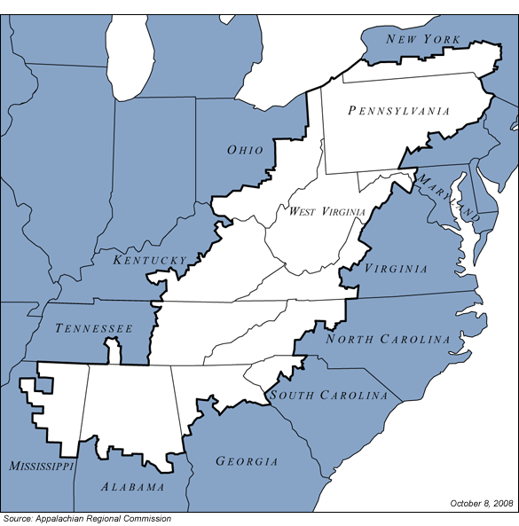

Figure 1: Appalachian Region
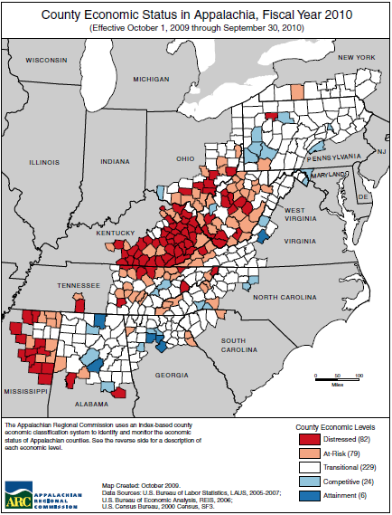

Figure 2: County Economic Status within the Appalachian Region, 2010

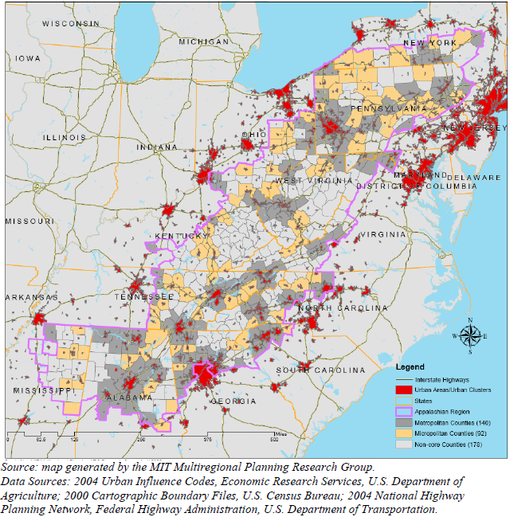

Figure 3: Urban and Non-Urban in Appalachian Region

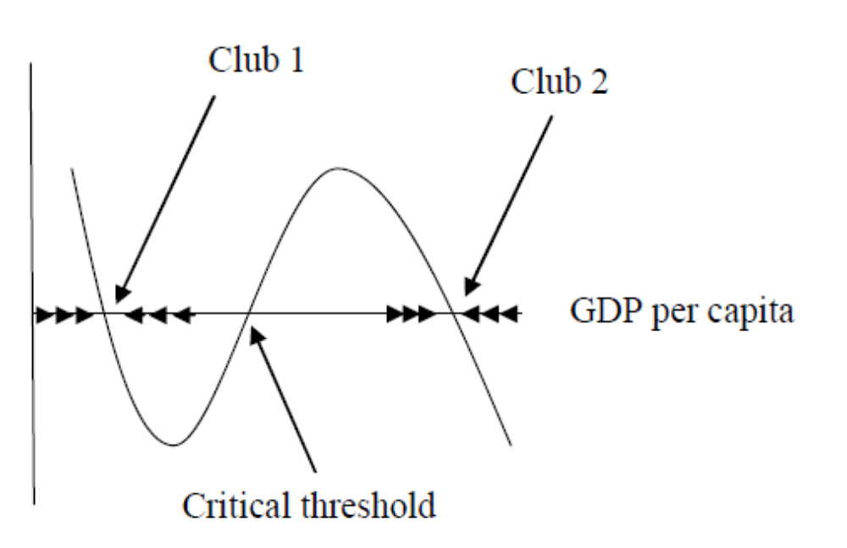
Figure 4: Process of convergence of GDP per capita in multiple equilibriums in the long run

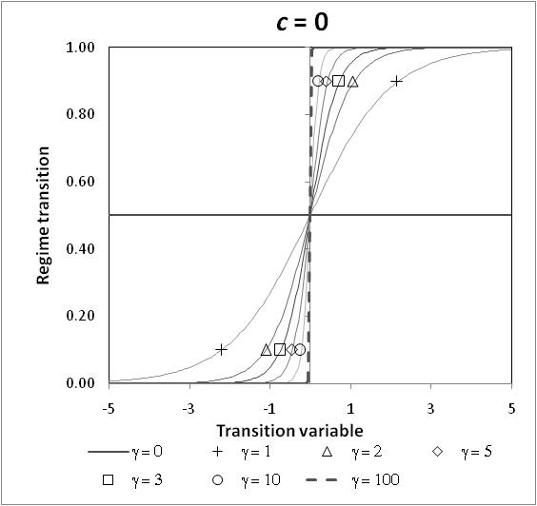
Regime 2
Regime 1

Figure 5: Example of the transition function G(γ, c; v), and different levels of the smoothing parameter, γ. Note that two distinct regimes emerge when γ = 100, whereas there are no regimes identified when γ = 0. The parameter c functions as a location parameter; the inflection of the transition function is centered on c.

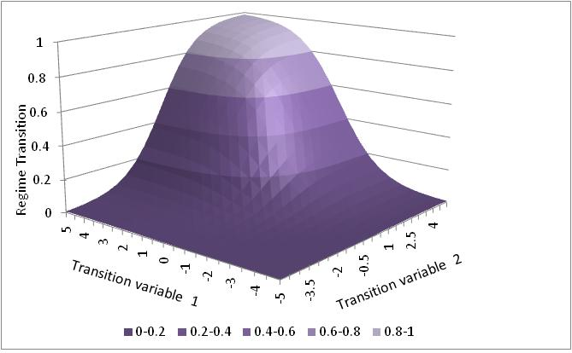 | 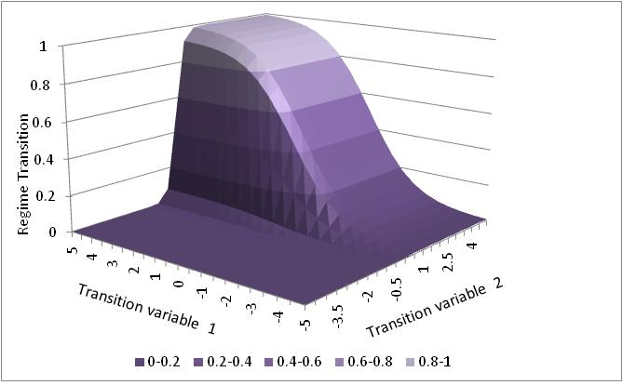
- γ₁=1, γ₂=1 (2) γ₁=1, γ₂=5
Figure 6: Examples of the interactions between two transition functions G₁(v₁; γ₁, c₁) and G₂=G₂(v₂; γ₂, c₂), and different levels of the smoothing parameter, γ. Note that how the curvure changes when γ changes.

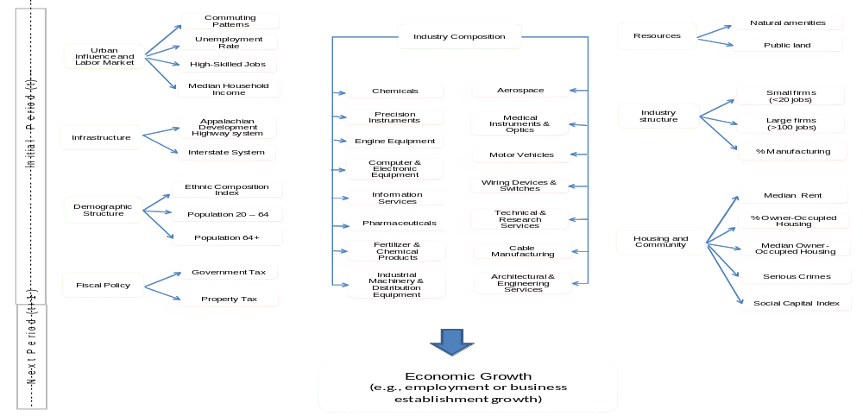
Source: Partridge et al., 2008a; BEA, 2008; Wojan and McGranahan, 2007; Wojan, McGranahan, and Lambert, 2010; Carruthers and Vias, 2005; Rupasingha et al., 2006; Lambert et al., 2007; Clark et al., 2009; Rogoff, 2008; Alessina and Ferrara, 2004; White and Knapp, 1994; Kahn, Orazem, and Otto, 2001; Deller et al., 2001; McGranahan, 2008; McGranahan, 1999; Lambert, Brown, and Florax, 2010; Barkley and Henry, 1997; Stimson, Stough, and Roberts, 2006; Gibbs and Bernat, 1997; Porter, 1998; Fujita and Thisse, 2002; Feser and Isserman, 2009.

Figure 7: Local Determinants in the Adjustment Process
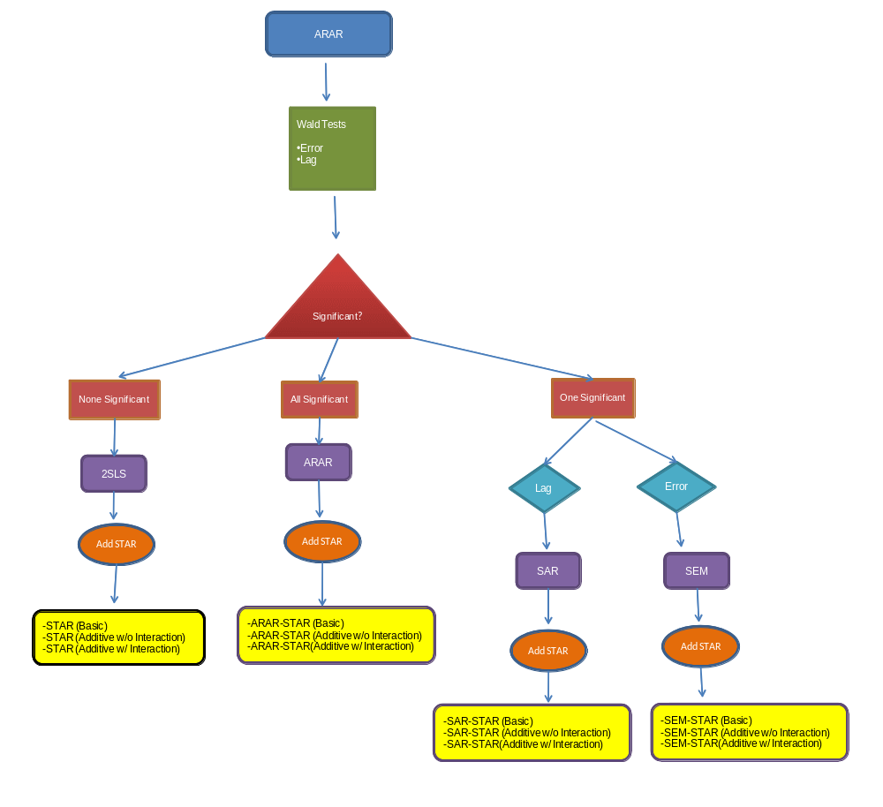

Figure 8: Model Specification Process

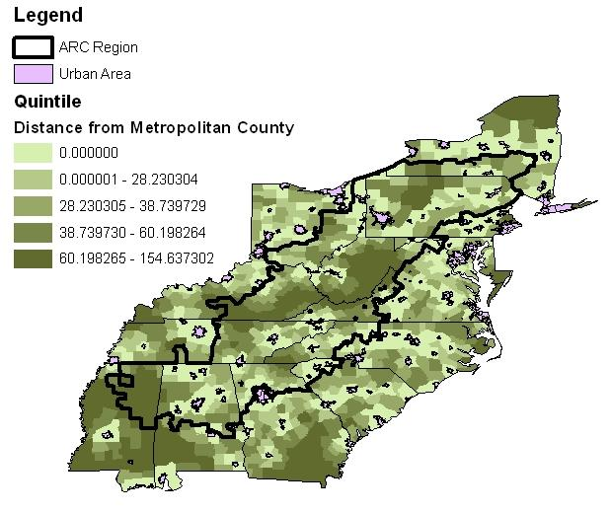

Figure 9: Spatial Distribution of Distance from Metropolitan County

Regime 1
Regime 2
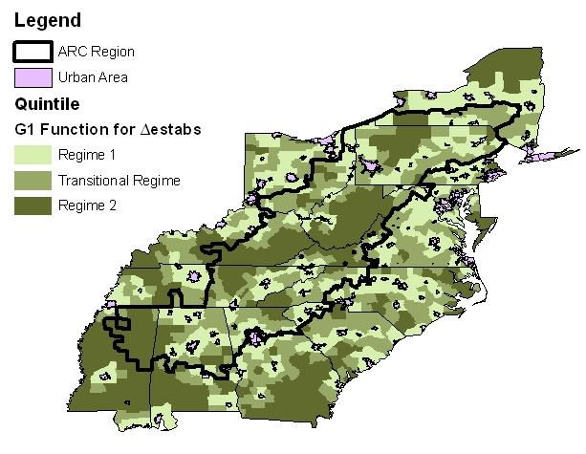

Figure 10: Transition function of G₁(γ₁, c₁; v₁) and its spatial distribution for change in business establishment growth: 2000-2008.

Regime 1
Regime 2
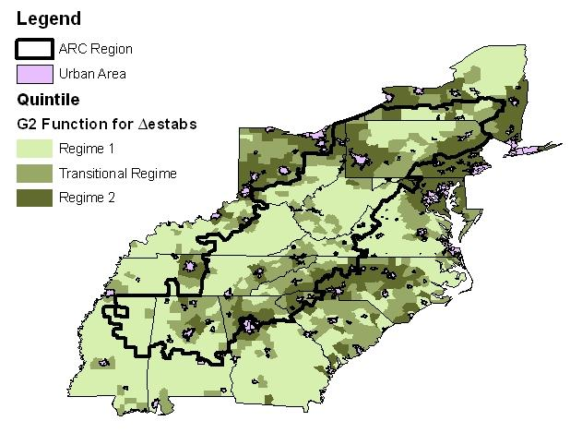

Figure 11: Transition function of G₂ (γ₂, c₂; v₂) and its spatial distribution for change in business establishment growth: 2000-2008.

Regime 1
Regime 2
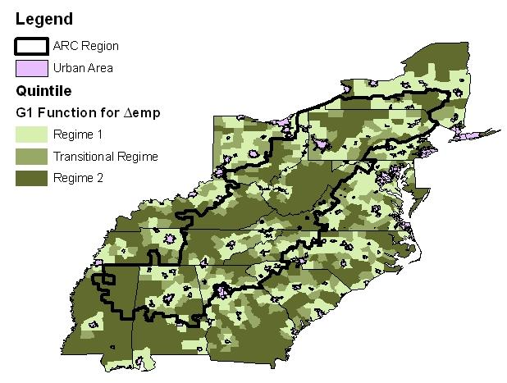

Figure 12: Transition function of G₁(γ₁, c₁; v₁) and its spatial distribution for change in employment growth: 2000-2008.

Regime 1
Regime 2
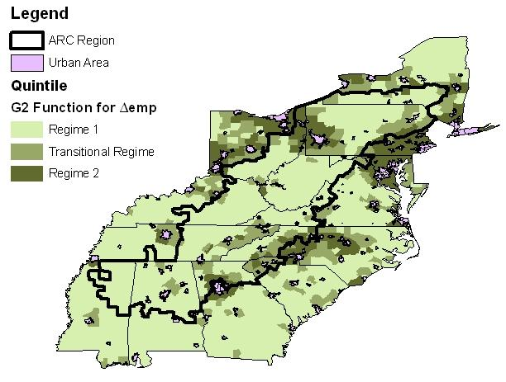

Figure 13: Transition function of G₂ (γ₂, c₂; v₂) and its spatial distribution for change in employment growth: 2000-2008.

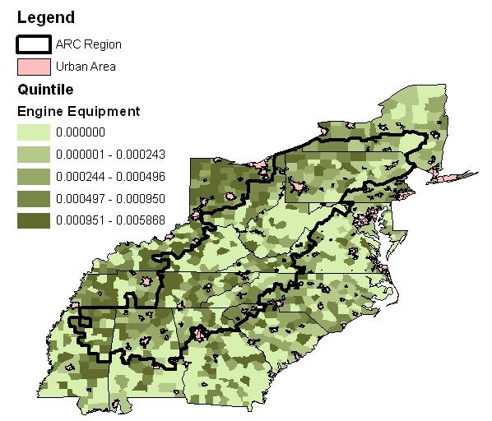 | 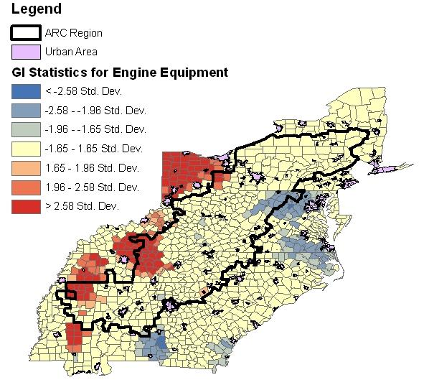

Figure 14: Distribution of elasticities (left panel) and GI statistics (right panel) for the Engine Equipment cluster and employment growth, 2000 – 2008.

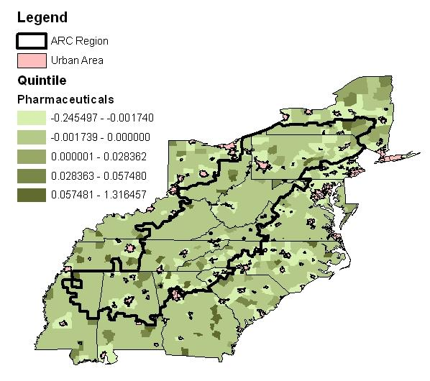 | 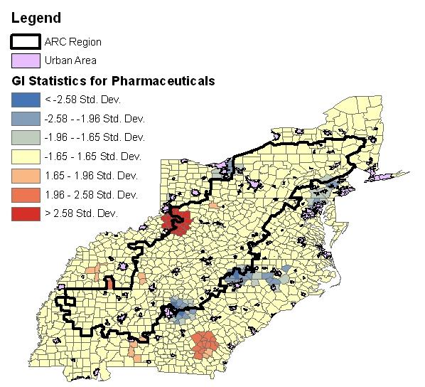

Figure 15: Distribution of elasticities (left panel) and GI statistics (right panel) for the Pharmaceuticals cluster and employment growth, 2000 – 2008.

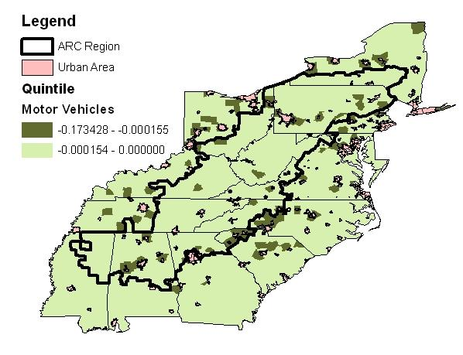 | 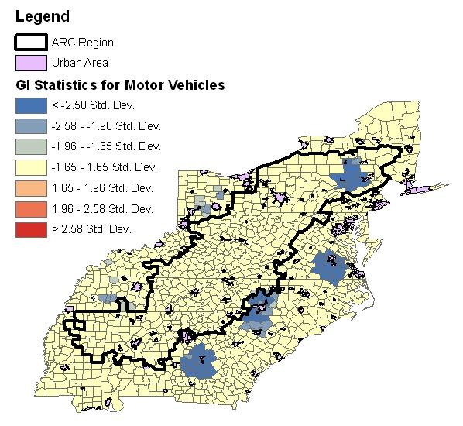

Figure 16: Distribution of elasticities (left panel) and GI statistics (right panel) for the Motor Vehicles cluster and employment growth, 2000 – 2008.

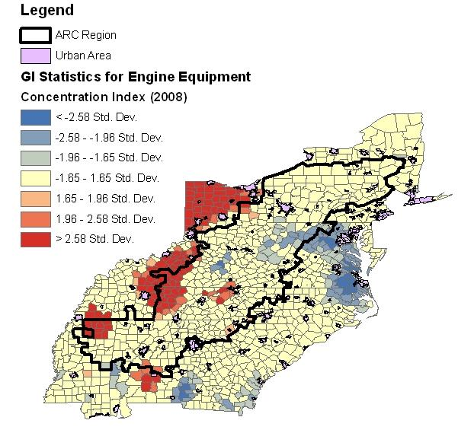 | 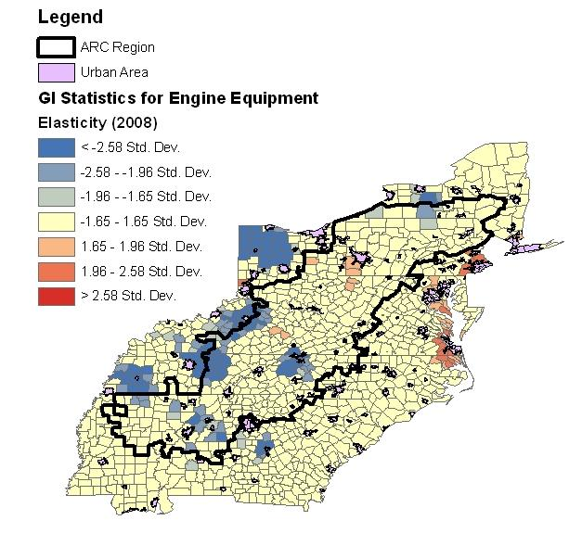

Figure 17: Distribution of GI statistics for the Engine Equipment cluster based on concentration index (2008, left), and elasticity (2008, right).

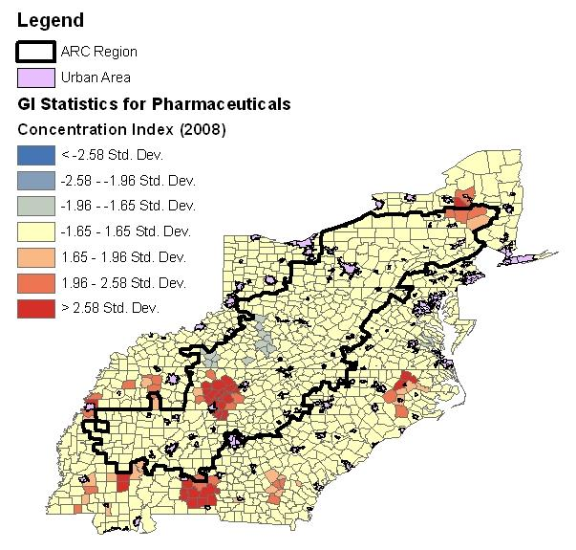 | 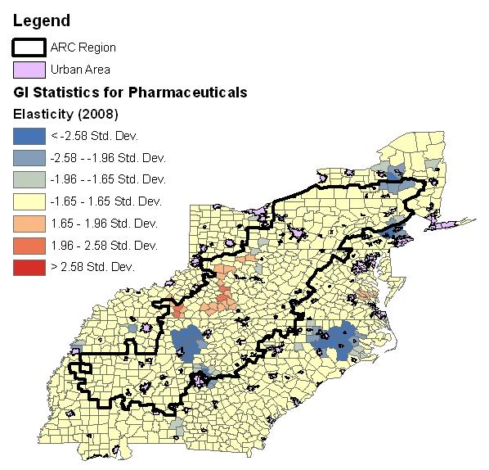

Figure 18: Distribution of GI statistics for the Pharmaceuticals cluster based on concentration index (2008, left), and elasticity (2008, right).

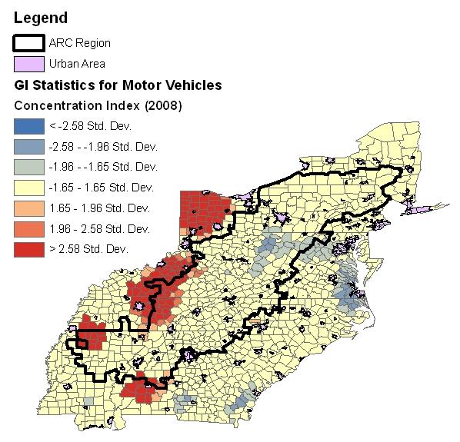 | 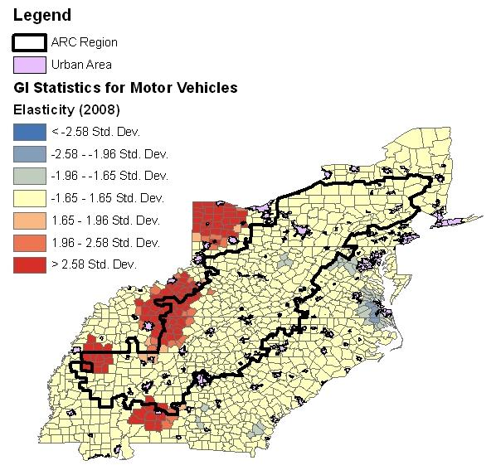

Figure 19: Distribution of GI statistics for the Motor Vehicles cluster based on concentration index (2008, left), and elasticity (2008, right).

APPENDIX C. EXAMPLE CODE IN MATLAB FOR A STAR MODEL

function results = starivgg(y, X0,endog,iv,Wz1,Wz2,infoz, vnames)

stdwx1=sqrt(var(Wz1));
stdwx2=sqrt(var(Wz2));
n = length(y);
h=.2:.2:.8;
c1 =quantile(Wz1,h)';
c2 =quantile(Wz2,h)';

if sum(X0(:,1)) ~= n,
cflag = 0;
else cflag = 1;
end

sse=[];

xc =X0;

z = [xc endog];

h = [xc iv];
hph = h'*h;
kh=cols(h);
invhph = hph\eye(kh);

p = h*invhph*h';
pz = [xc p*endog ];
elength = cols(pz);
zpz = pz'*z;
izpz = zpz\eye(cols(zpz));
delta2sls = izpz*pz'*y;
u = y - z*delta2sls;

for i1=1:rows(c1)
for j1=0:10:50
g1 = 1./(1+exp( - j1*(Wz1-c1(i1))/stdwx1));

xs1 = matmul(pz, g1);

for i2=1:rows(c2)
for j2=0:10:50
g2 = 1./(1+exp( - j2*(Wz2-c2(i2))/stdwx2));

xs2 = matmul(pz, g2);

xs=[pz xs1 xs2];
xspxs=xs'*xs;
ypxs=y'*xs;
ixspxs=pinv(xspxs);%\eye(cols(xspxs));
dd = ixspxs*ypxs';
e = y - [z matmul(g1,z ) matmul(g2,z )]*dd;
sse_ = e'*e;
sse=[[sse_ j1 c1(i1) j2 c2(i2)];sse];
end
end
end
end

select= sse(:,1)>0;

[~, sind] = min(sse(select,1));
start = sse(sind,:);

b0=start(2:5)';
infoz.func = 'lsfunc';
infoz.call='ls';
infoz.jake = 'numz';
infoz.hess = 'bfgs';
infoz.maxit = 1000;

infoz.momt ='mdouble2' ;

b0=start(2:5)';

[theta,~,stat]=minz(b0,infoz.func,infoz,y, [pz z Wz1 Wz2] , elength);

g2 = 1./(1+exp( -theta(end-1)*(Wz2-theta(end))/stdwx2));
g1 = 1./(1+exp( -theta(end-3)*(Wz1-theta(end-2))/stdwx1));

v1=[Wz1 g1];
v2=[Wz2 g2];
gsort1=sortrows(v1,1);
gsort2=sortrows(v2,1);
subplot(2,1,1), plot(gsort1(:,1),gsort1(:,2),'o');
subplot(2,1,2), plot(gsort2(:,1),gsort2(:,2),'o');

%xs2 = matmul(X0,g);%%%%%%%%WILL HAVE TO CHANGE THIS BECAUSE STATE DUMMIES ARE IN FRONT: 1 - 13

xs1 = matmul(pz, g1);
xs2 = matmul(pz, g2);
xstar=[pz xs1 xs2];
xstar0=[z matmul(z, g1) matmul(z, g2)];
xspxs=xstar'*xstar;
xspy=xstar'*y;
ixspxs=xspxs\eye(cols(xspxs));
beta = ixspxs*xspy;

e = y - xstar0*beta;

xuux = zeros(cols(xstar), cols(xstar));

for i=1:n
xp=xstar(i,:);
xpx=xp'*xp;
upu = e(i,1 )*e(i,1);
xuux = xuux + upu*xpx;
end

beta = [beta;theta];
kx=cols(xstar);
H = hessian0('starfunciv2',beta,y, [z Wz1 Wz2]);
iH=H\eye(cols(H));

covb = (n /(n-cols(xstar) ))*ixspxs*xuux*ixspxs;
cov0 = (n /(n-cols(xstar) ))*iH(:,1:kx)*xuux*iH(1:kx,:) ;

stderr = sqrt(diag(covb));

se0 = sqrt(diag(cov0( end-3:end, end-3:end)));
t0=theta./se0;
p0 = norm_prb(t0);

tstat = beta(1:end-4)./stderr;
pval = norm_prb(tstat);
pval = [pval;p0];
tstat = [tstat;t0];
result = [beta tstat pval];

ym = mean(y);

TSS = y'*y - n*ym.^2 ;
RSS = beta(1:end-4)'*xstar'*y - n*ym.^2 ;

results.rsqr = RSS/TSS ; % r-squared
results.rbar = 1 - (n -1)/(n-cols(xstar))*(1 - results.rsqr) ;
results.theta=theta;

yhat = xstar0*beta(1:end-4);

results.beta1 = beta(1:cols(pz) );
results.betas =beta(1:end-4);
beta1=results.beta1;
betas=results.betas;
results.delta = beta(cols(pz)+1:end-4 );
delta=results.delta;
%results.delta1 = beta(cols(xs1));
results.delta1 = beta(cols(pz)+1:end-43);
delta1=results.delta1;
%results.delta2 = beta(cols(xs2));
results.delta2 = beta(end-42:end-4);
delta2=results.delta2;

SqCorr= corr(y, yhat)^2 ;

results.nvar=cols(xstar)+4;

results.sige = (e'*e/n) ;

results.nvar=cols(xstar)+4;
results.g1 = g1;
results.g2 = g2;
results.beta = beta;
results.resid=e;
results.nobs=n;
results.sse=e'*e;

fprintf('STAR-IV\n')
fprintf('Sqrd Corr = %9.4f \n',SqCorr)
fprintf('SSE = %9.4f \n',results.sse)
fprintf('Nobs, Nvars = %6d,%6d \n',results.nobs,results.nvar)
fprintf('***************************************************************\n')

bstring = 'Coefficient'; tstring = 't-stat'; pstring = 'probability';
cnames = strvcat(bstring,tstring,pstring);
in.cnames = cnames;
in.rnames = vnames ;
in.fmt = '%16.6f';

mprint(result,in)

c0 = zeros(1,cols(pz));
ck1 = zeros(cols(xs1),rows(betas));
ck2 = zeros(cols(xs2),rows(betas));

for k1=1:cols(xs1)
if k1==1, ck1(k1,:) = [c0 1 zeros(1,cols(xs1)-1) zeros(1,cols(xs2))];
end
if 1<k1<cols(xs1), ck1(k1,:) = [c0 zeros(1, k1-1 ) 1 zeros(1,cols(xs1)-k1) zeros(1,cols(xs2))];
end
if k1==cols(xs1), ck1(k1,:) = [c0 zeros(1,cols(xs1)-1) 1 zeros(1,cols(xs2))];
end
end

for k2=1:cols(xs2)
if k2==1, ck2(k2,:) = [c0 zeros(1,cols(xs1)) 1 zeros(1,cols(xs2)-1)];
end
if 1<k2<cols(xs2), ck2(k2,:) = [c0 zeros(1,cols(xs1)) zeros(1, k2-1 ) 1 zeros(1,cols(xs2)-k2)];
end
if k2==cols(xs2), ck2(k2,:) = [c0 zeros(1,cols(xs1)) zeros(1,cols(xs2)-1) 1];
end
end

Wald2 = (ck1*betas)'*inv(ck1*covb*ck1')*(ck1*betas);
PrWald2 = 1-chis_prb(Wald2, rows(ck1));

Wald3 = (ck2*betas)'*inv(ck2*covb*ck2')*(ck2*betas);
PrWald3 = 1-chis_prb(Wald3, rows(ck2));

cc = [ck1;ck2];

Wald5 = (cc*betas)'*inv(cc*covb*cc')*(cc*betas);
PrWald5 = 1-chis_prb(Wald5, rows(cc));

walds = [Wald2 PrWald2
Wald3 PrWald3
Wald5 PrWald5];

results.theta=theta';

subplot(2,1,1), plot(gsort1(:,1),gsort1(:,2),'o');
subplot(2,1,2), plot(gsort2(:,1),gsort2(:,2),'o');

in2.cnames = strvcat('Wald','Probability') ;
in2.rnames = strvcat('Test','H0: delta1 = 0','H0: delta2 = 0','H0: delta1=delta2 = 0');
mprint(walds,in2);

VITA

Wan Xu is from China. She was born in China on August 29, 1982. She received a B.A. in Economics with a minor in Statistics from University of California, Davis in 2006. She worked two years as a Market Research Analyst at VLSI Research Inc. in Santa Clara, California. She was admitted to the Masters program in Agricultural Economics at the University of Tennessee in January, 2010. She was granted her Master of Science Degree in August 2011.

