Localization of sources producing substrate-borne vibrations by the fiddler crab
Undergraduate BCMB program, University of Tennessee, Knoxville, Tennessee 37916, USA
Rachel Keiper
12/9/2011

Localization of sources producing substrate-borne vibrations by the fiddler crab

Rachel Keiper
Undergraduate BCMB program, University of Tennessee, Knoxville, Tennessee 37916, USA

Introduction

The fiddler crab is well-known for its unique courtship behavior, deriving its name from the conspicuous waving display it performs to attract a mate. When night falls, the male fiddler crab (Genus Uca) must rely on less visible mechanisms in this pursuit, namely vibrational signaling. Using his large chela, the male raps the ground, sending vibrations through the substrate to potential mates and competitors. Vibrational signals are detected by Barth’s myochordotonal organ (MCO), which functions as a tympanic membrane by converting mechanical disturbances of the environment into electrophysiological pulses transmitted and processed by the crab’s neural network. The MCO is located on the merus of each of the crab’s legs (Salmon, Horch, and Hyatt 1977).
The signals differ in spectral and temporal content depending on the species of crab. Other vibrations, produced unwittingly by the movement of predators and other organisms are also received by the MCO, such that the detection and processing of vibrations functions not only within the confines of mating behavior, but rather as a sensory system akin to sight vital for predator avoidance and the overall fitness of the animal.

Analogous systems

The detection of vibrations in the substrata is not unique to the fiddler crab but rather found in diverse organisms throughout the animal kingdom and particularly prevalent in the arthropods. An estimated 150,000 species of insect use only substrate-borne vibrations to communicate with other members of the species (Cocroft and Rodriguez 2005). At least 32 species of mammal are known to use percussive signaling by drumming a body part against the substrate though it has not been shown definitively that the vibrations themselves encode the information (Randall 2001).
While much has been elucidated about the neural mechanism underlying the recognition and processing of the signal by the crab’s vibration-sensitive cells, the manner in which the crab derives spatial information localizing the source of the vibrations is not fully understood. It may be helpful to examine this type of processing in related organisms. In the nocturnal scorpion Paruroctonus mesaensis, each of the animal’s eight legs has a basitarsal compound slit sensillum (BCSS), which detects the direction of vibrations in the substrate. The arrangement of the eight BCSS functions as a spatial array, detecting slight differences in arrival time of the substrate-borne signal across the eight receptor sites (Brownell and Farley 1979a). The BCSS is analogous to the metatarsal lyriform slit organs in spiders, which also serve as a spatial array for detecting the direction of a substrate-borne signal (1979a). Even large mammals like the elephant have been shown to perceive substrate-borne vibrations via an array composed of their four feet (O’Connell-Rodwell et al. 2001). The ubiquity of substrate-borne vibrational signaling within the animal kingdom and the prevalence of the spatial array suggests that fiddler crabs may also utilize such an array for the localization of signals.
Before asserting that such an analogous system exists in the fiddler crab, a fact finding study of interactions among vibration-sensitive (VS) neurons within the brain may be beneficial. In this set of experiments, I focused on the fiddler crab’s responses at the neural level to left and right behaviorally relevant vibrational signals. Previous studies have shown that vibration sensitive neurons project to the dorso-medial tritocerebral neuropil within the brain (Hall 1985); therefore, this was the region targeted in these experiments. I sought to discover differences in the responses of VS neurons based on the side of the animal being stimulated: left legs only, right legs only, or all legs together. Specifically, I addressed the following questions. (1) Do neurons respond differently depending on the side of the animal stimulated? (2) Does a trend arise when the responses of many VS neurons are compared? (3) Based on these responses, to what extent can interactions among VS neurons in the brain be inferred?

Materials and Methods

Subjects. Male and female Uca pugilator were collected either from Folly Beach, South Carolina or bought from Gulf Specimen Marine Laboratory and housed in tanks filled with sand and circulating sea water located at the University of Tennessee.

Surgical procedure and positioning of animal. Both chelae were removed. A small puncture was made in the dorsal carapace using a straight pin and a ground wire inserted shallowly into the hole. A plexiglass rod was glued to the dorsal surface of the crab using superglue such that the tip of the rod was positioned directly between the eyes of the crab. This rod was then attached to a ringstand with the crab’s legs resting on either of two stimulating plates, such that the left legs rested on one plate, and the right legs on the other plate (Figures 1 & 2). Prior to any surgical cutting, a constant saline drip was positioned between the crab’s eyes, stabilized by the plexiglass rod, so that the brain was kept moist with fiddler crab saline throughout the operation and experiment. The ringer solution was made in accordance with the specifications outlined by Herreid and Mooney (1984).

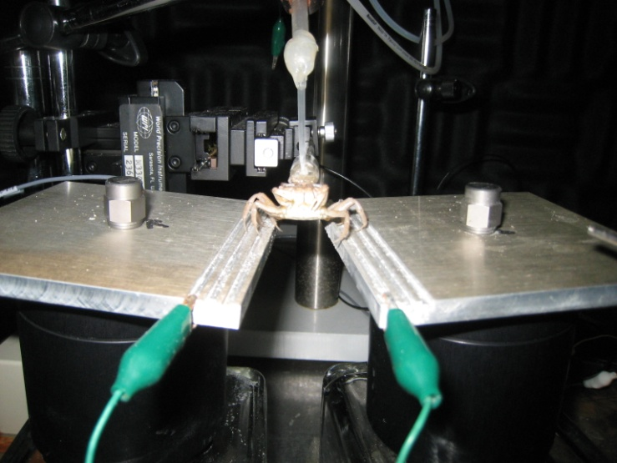

Fig. 1. The crab was positioned such that its left and right legs were resting on separate stimulating plates, which were connected to a programmable signal switcher.

The mouthparts of the animal were removed. A part of the exoskeleton lying immediately superior to the mouthparts was removed to expose the brain and the circumesophageal connectives (CEC) projecting inferiorly from the brain. A 30 gauge needle attached to a micromanipulator was positioned directly posterior to the CEC and inferior to the brain, restricting movement of the brain due to movement of the legs, respiration, etc.

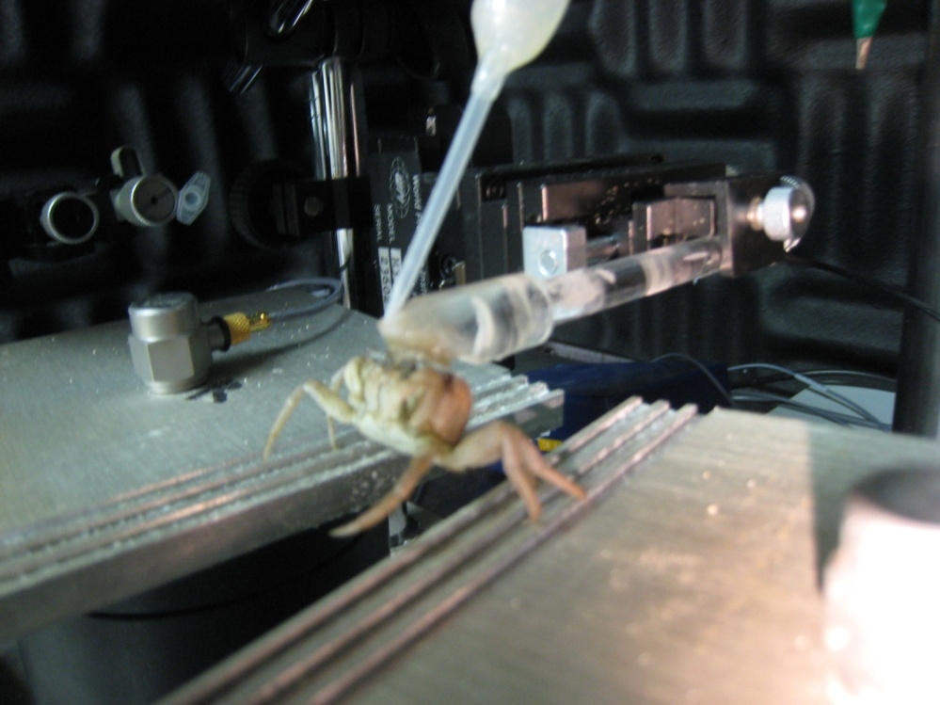

Fig. 2. The crab was attached to a plexiglass rod with Scotch superglue for stabilization. A constant saline drip flowed over the brain and mouthparts throughout the experiment to maintain the animal’s viability.

Recording techniques. Intracellular and extracellular recordings were taken using 1 mol CH₃CO₂K filled (resistance between 7 and 30 M Ω) microelectrodes of 1.5 mm diameter. A Kopf Model 650 micropositioner advanced the electrodes after the initial brain penetration (Fig. 3). When searching for a VS neuron, an artificial call of three tones (50, 300, and 1500 Hz) was presented to both stimulating plates simultaneously to mimic the possible frequencies the crab might encounter in nature at a duration of 100 ms and intensity of 50 dB. When a VS neuron was encountered, one tone was presented to both stimulating plates at varying frequencies to determine the best frequency (BF) or lowest response threshold. The threshold intensity at the BF was next determined. Experiments were carried out 20 dB above the threshold intensity.
When a VS neuron was isolated and its BF and threshold intensity obtained,

recordings were taken as the stimulus was applied to both stimulating plates, and to the left and right plates individually. Neurons from both sides of the brain were used in these experiments.



Fig. 3. A Kopf Model 650 micropositioner advanced the electrode through the brain. An A-M Systems Neuroprobe Amplifier was used to penetrate neurons and produce a visual display of the neuron’s membrane potential.

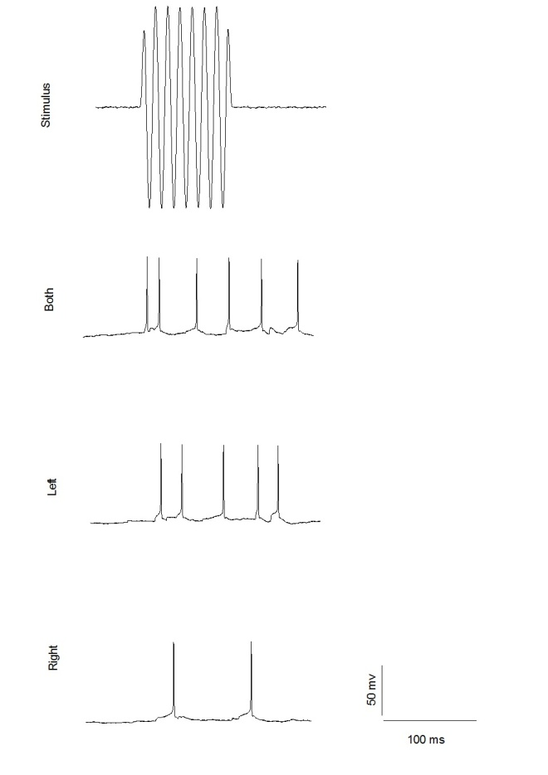

Fig. 4. Intracellular recording of the response of a VS neuron in the left side of the brain to an applied stimulus, shown at the top. The neuron responds most robustly when the stimulus is applied to both left and right legs simultaneously. The cell shows a slightly weaker response when only the left legs are stimulated. The weakest response results when only the right legs (contralateral to the recorded cell) are stimulated. Only two apparent action potentials result from right-only stimulation

Results

Intracellular recordings were taken from 22 VS neurons. Approaching hypothesis testing from a case by case basis, a trend of responsiveness emerges. In nearly every case (>90%), stimulating both left and right legs simultaneously resulted in an additive effect on the neuron’s response that stimulating either leg individually failed to match. Strength of a response here is measured quantitatively as the number of action potentials produced per stimulus

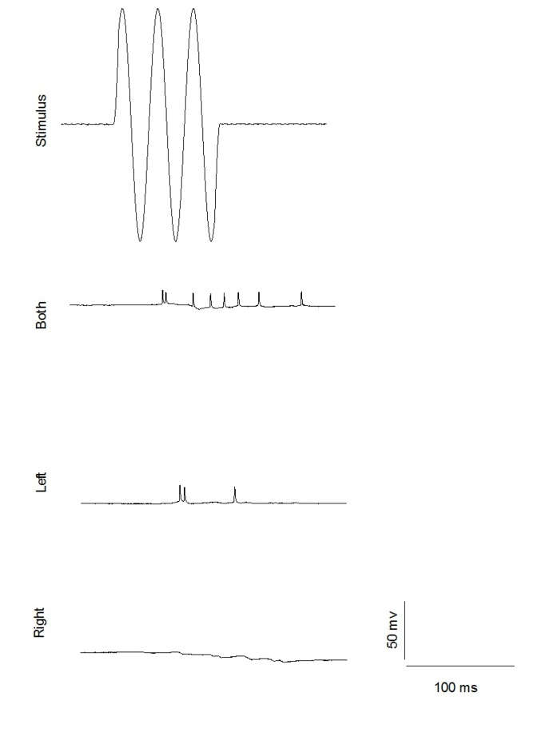

Fig. 5. Intracellular recording from a neuron located in the left side of the brain. Unlike in Fig. 4, there is no obvious response to right-only stimulation. Left-only stimulation causes a weak to moderate response. Stimulation of both legs simultaneously produces the most action potentials.

period. This trend followed for both tonic and phasic cell types. In most cases, the cell responded moderately to one or both sides, but in nearly every case, stimulation of both legs produced more action potentials (Figures 4 & 5). When the cell responded to stimulation of one side but not the other, invariably the side that produced a response was ipsilateral to the side of the brain being recorded.

Exceptions

In rare cases, neither side alone would produce a positive stimulus-specific response from the neuron but the stimulation of both sides still resulted in a moderate to strong response (Fig. 6). In the neuron 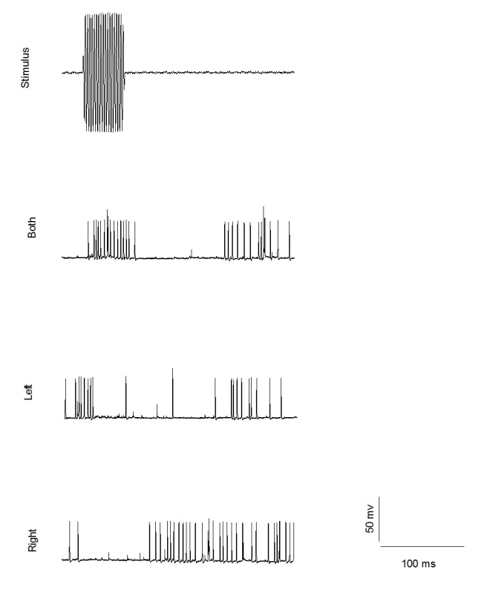 Fig. 6. Intracellular recording from a neuron located on the left side of the brain. When the stimulus was applied to all the legs, a strong, specific pattern of action potentials was produced. When only the left legs were stimulated, there was a period of inhibition with only a few action potentials during and for 100 ms after the presentation of a stimulus. When only the right legs were stimulated, an inhibitory response resulted for the duration of the stimulus.

displayed in Fig. 6, stimulation of the contralateral side produced an inhibitory response. This was also true for the neuron illustrated in Fig. 7. In both of these neurons, stimulation of the contralateral side produced a period of inhibition during the stimulus, followed by spontaneous neural firing. When all legs were stimulated together, the neuron produced a strong, specific pattern of action potentials. When the stimulus was removed, an inhibitory period of 100 ms followed, equal in duration to the stimulus itself.
Only one cell produced a response contrary to the overall trend. In this case (Fig. 8) stimulation of the left legs (while recording from a neuron on the left side of the brain) produced a response stronger

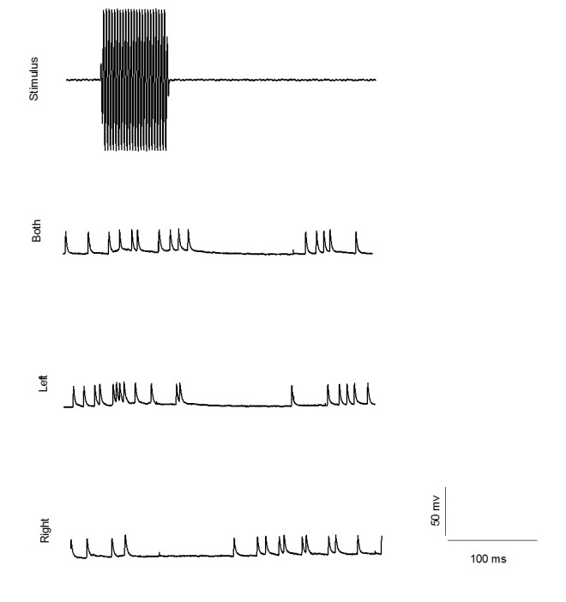

Fig. 7. Neural response of cell located in the left side of the brain. When both sets of legs were stimulated, a tonic pattern of action potentials was produced for the duration of the stimulus. This was followed by a period of inhibition. This tonic response followed by an inhibitory period also occurred when only the left legs (ipsilateral to the recorded neuron) were stimulated. When the right legs were stimulated, the period of inhibition occurred during the application of a stimulus. Spontaneous firing ensued after the stimulus was removed.

than or equal to the response to stimulation of all the legs.
Stimulation of the legs contralateral to the targeted neuron produced no specific response of action potentials but occasional spontaneous firing did occur. The responses demonstrated by Fig. 8 account for 4.5% of the total cellular responses observed in this set of experiments.

Conclusion

At the beginning of the experiment, I set out to answer several questions. (1) Do neurons respond differently depending on the side of the animal stimulated? Unequivocally, the answer to this first question is yes.
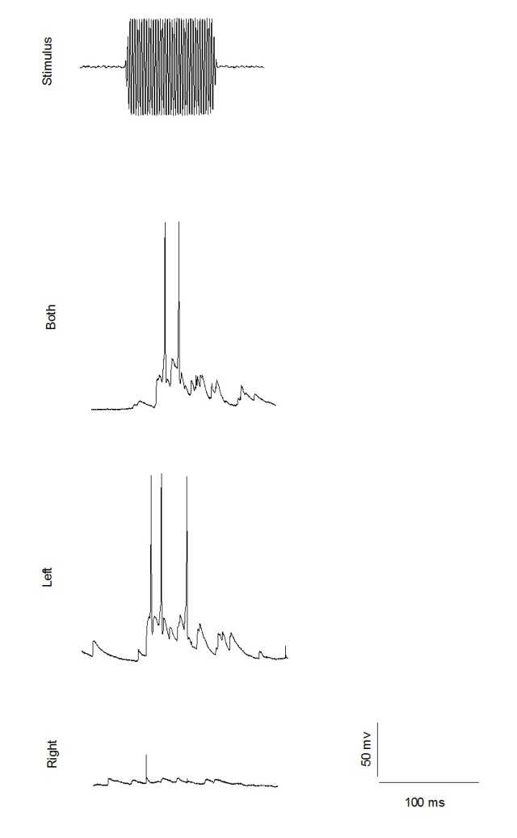

Fig. 8. Intracellular recording taken from a VS neuron located on the left side of the brain. Stimulation of both left and right legs resulted in a moderate response of 2-3 action potentials per stimulus. Stimulation of only the left legs resulted in a moderate to strong response of 3-5 action potentials per stimulus. Stimulation of only the right legs produced no recordable specific response but some spontaneous firing still occurred.

Based on the responses of the neurons studied in this experiment, stimulation of the legs ipsilateral to a neuron within the brain results in a stronger, more specific response than stimulation of the contralateral side. This could indicate that excitatory input from vibrational stimulation detected by the MCO is sent mainly to the ipsilateral regions of the brain for processing.

(2) Does a trend arise when the responses of many VS neurons are compared? Yes, a trend arises with responses that lie along a continuum. In almost all cases, stimulation of both legs simultaneously results in a measurably stronger neuronal response than stimulation of only the left or right legs. The strength of the neuron’s response to either side alone varied greatly. In a few cases, neither side alone produced action potentials specific to the stimulus. At the other extreme, stimulation of either side produced robust stimulus-specific action potentials. In 95% of the cases studied in this set of experiments, the joint stimulation of both sets of legs produced a more robust response than stimulation of either side alone.

(3) Based on these responses, to what extent can interactions among VS neurons in the brain be inferred?
The data certainly support the hypothesis that interaction occurs between neurons of each side of the brain. The exact nature of this interaction is difficult to decipher from the data presented here. The additive effect of the responses to stimulation of all the legs indicates that stimulation of one side alone is not sufficient to provide the animal with a comprehensive substrate-borne signal.
The atypical cases illustrated in Figures 6 & 7 also demonstrate interesting left/right interactions. According to these results, stimulation of only the legs contralateral to the targeted cell results in no excitatory response and possibly even inhibition of action potentials. When both sides are stimulated, neural input from the side of the body contralateral to the recorded cell may provide inhibitory input that does not inhibit the neuron’s response during stimulus, but instead produces a refractory period following stimulus during which the neuron is desensitized to further stimulation.
These preliminary findings do not reject the hypothesis that the fiddler crab employs a spatial array for localization of vibration signals. Further research must be undertaken to elucidate the details of this potential array. Particularly, the methods used by Brownell and Farley to study the nocturnal scorpion would provide illuminating information about the existence of such an array in the fiddler crab (1979b). Future studies to elucidate the localization mechanism might consider delaying the stimulus’ time of arrival to left versus right legs, or altering the intensity of the signal to one side of the animal while holding the other constant. Such experiments would provide a more complete picture of the neural interactions governing localization of substrate-borne vibrations.

Acknowledgements. These experiments were performed in part for the completion of the requirements for the Chancellor’s Honors Program and for the degree of Bachelor of Science at the University of Tennessee, Knoxville. I thank my undergraduate research colleagues Ben Verzi and Kelsey Moyers for their procedural assistance throughout the study. I particularly thank Dr. Jim Hall for the use of his experimental design and laboratory equipment and thank him additionally for providing guidance throughout this set of experiments and for reviewing this manuscript.

References

Brownell P, Farley RD (1979a) Detection of vibrations in sand by tarsal sense organs of the nocturnal scorpion, Paruroctonus mesaensis. J Comp Physiol A 131:23-30
Brownell P, Farley RD (1979b) Orientation to vibrations in sand by the nocturnal scorpion Paruroctonus mesaensis: mechanism of target localization. J Comp Physiol 131:31-38
Cocroft RB, Rodriquez RL (2005) The behavioral ecology of insect vibrational communication. Bioscience 55:323-334
Hall J (1985) Neuroanatomical and neurophysiological aspects of vibrational processing in the central nervous system of semi-terrestrial crabs. II. Comparative anatomical and physiological aspects of stimulus processing. J Comp Physiol A 157:105-113
Herreid CF II and Mooney SM (1984) Color change in exercising crabs: evidence for a hormone. J Comp Physiol B 154:207-212
O’Connell-Rodwell CE, Hart LA, Arnason BT (2001) Exploring the potential use of seismic waves as a communication channel by elephants and other large mammals. Am Zool 41:1157-1170
Randall JA (2001) Evolution and function of drumming as communication in mammals. Am Zool 41:1143-1156
Salmon M, Horch K, and Hyatt GW (1977) Barth’s myochordotonal organ as a receptor for auditory and vibrational stimuli in fiddler crabs (Uca pugilator and Uca minax) Mar Behav Physiol 4:187-194

