Phosphatase Enzyme-Responsive Synthetic Lipids for Liposome Immolation towards Enhanced Cargo Release

A Thesis Presented for the
Master of Science
Degree
The University of Tennessee, Knoxville

Justin Thomas Kirby
August 2023

ABSTRACT
Liposomal nanoscale delivery vehicles have been shown to aid in the delivery of therapeutic cargo due to their ability to encapsulate and improve the pharmacokinetic properties of a range of drug molecules. However, liposome therapeutic potential could be enhanced by exerting greater control over liposome cargo delivery and release. This is being pursued by designing lipids that are able to respond to specific stimuli, particularly those overexpressed in diseased cells. In this thesis, we describe stimuli-responsive liposomes in which the enzyme alkaline phosphatase is used as the stimulus. This trigger was selected since this enzyme is overexpressed in certain cancer cell lines as well as liver and kidney disease. To develop liposomes that respond to alkaline phosphatase, lipids switches were designed to self-immolate upon enzyme hydrolysis for programmed decomposition into small molecules that are incapable of forming a membrane bilayer. This method of self-immolation upon hydrolysis classifies these lipids as passive release, by utilizing the aberrant conditions within diseased cells to trigger release of cargo, in opposition to active release, which leverages external stimuli such as light or heat. A collection of lipids has been synthesized, each of which was envisioned to respond to excess amounts of alkaline phosphatase enzyme, thereby causing self-immolation to form small molecules that will decompose the liposomal bilayer and cause release of encapsulated cargo. The design, synthesis, and preliminary investigation of these immolating liposome designs are described in this thesis.
TABLE OF CONTENTS
CHAPTER ONE LIPIDS AND LIPOSOMES: STRUCTURE AND FUNCTION 1
1.1. General Structure of Lipids 1
1.1.1. Lipid Self-Assembly 5
1.2. Biological Applications of Lipids 5
1.3. Liposomes as Drug Delivery Vehicles 6
1.3.1. Active vs. Passive Mechanisms of Release 7
1.4. Summary 12
CHAPTER TWO DESIGN AND SYNTHESIS OF ALKALINE PHOSPHATASE RESPONSIVE SELF-IMMOLATING LIPIDS FOR TRIGGERED RELEASE 13
2.1. Project Summary 13
2.2. Enzyme Overexpression in Diseased Cells 13
2.3. Alkaline Phosphatase Enzyme Hydrolysis as a Stimulus for Cargo Release 15
2.4. Inspiration and Design of Alkaline Phosphatase Responsive Lipids 17
2.5. Design and Synthesis of Phosphatase Responsive Lipids PRL1 and PRL2 17
2.5.1. Synthesis of PRL1 and PRL2 19
2.5.2. Liposomal Release Studies of PRL1 and PRL2 22
2.6. Design and Synthesis of Phosphatase Responsive Lipids PRL3 and PRL4 26
2.6.1. Synthesis of PRL3 and PRL4 26
2.6.2. Liposomal Release Studies of PRL3 and PRL4 30
2.7. Design and Synthesis of Phosphatase Responsive Lipids PRL5, PRL6 and PRL7 31
2.7.1. Synthesis of PRL5, PRL6 and PRL7 34
2.7.2. Liposomal Release Studies of PRL5, PRL6 and PRL7 37
2.8. Summary and Future Work 42
2.9. Synthetic Details and Material Characterization 44
2.9.1. General Experimental Information 44
2.9.2. Synthetic Details: PRL1 and PRL2 Compounds 45
2.9.3. Synthetic Details: PRL3 and PRL4 Compounds 50
2.9.4. Synthetic Details: PRL5, PRL6 and PRL7 Compounds 57
LIST OF REFERENCES 63
APPENDIX 67
VITA 121
LISTS OF TABLES
Table 1. Summary of formulations explored for forming stable PRL1 liposomes containing different percentages of PC, DOPE, or PA. 25
Table 2. Summary of formulations explored for forming stable PRL2 liposomes containing different percentages of PC, DOPE, and PA. 27
Table 3. Summary of formulations explored for triggered release using PRL3 containing different percentages of PC, DOPE, or PA. 32
Table 4. Summary of formulations explored for forming stable PRL4 liposomes containing different percentages of PC, DOPE, DOTAP, or PA. 33
Table 5. Summary of formulations explored for forming stable PRL5 liposomes containing different percentages of PC, DOPE, and PA. 40
Table 6. Summary of formulations explored for forming stable PRL6 liposomes containing different percentages of PC, DOPE, and PA. 41

LIST OF FIGURES
Figure 1. Generalized structure of biologically relevant lipids. 2
Figure 2. Lipid packing parameter and self-assembly properties. 4
Figure 3. A cartoon representation of stimuli-responsive triggered release of encapsulated cargo from liposomes. 9
Figure 4. Examples of lipid switches designed for passive release driven by conformational changes. 11
Figure 5. Previously reported enzyme hydrolysis mediated release. 14
Figure 6. Self-immolation mechanism and examples of self-immolative linkers. 16
Figure 7. Mechanism of release of general alkaline phosphatase responsive liposomes. 16
Figure 8. Prior results indicating release of hydrophilic cargo. 18
Figure 9. Expected self-immolation mechanism of PRL1 and PRL2. 20
Figure 10. Self-immolation mechanism of PRL3 and PRL4. 28
Figure 11. Self-immolation mechanism of PRL5 and PRL6. 35
Figure 12. Preliminary liposomal release results utilizing PRL5. 38
Figure 13. Critical micelle concentration experimental results. 43

LIST OF SCHEMES
Scheme 1. Synthetic steps toward Frequent Intermediate PRL1.2. 21
Scheme 2. Synthetic steps towards PRL1 and PRL2. 21
Scheme 3. Synthetic steps towards synthetic intermediate PRL3.5. 29
Scheme 4. Synthetic steps towards lipids PRL3 and PRL4. 29
Scheme 5. Synthetic steps toward lipids PRL5, PRL6, and PRL7 36

LIST OF ABBREVIATIONS
CCl₄ carbon tetrachloride
CDCl₃ deuterated chloroform
CHCl₃ chloroform
CMC critical micelle concentration
CPP cell penetrating peptides
DAG diacylglycerol
DCM dichloromethane
DIPEA N,N-diisopropylethylamine
DLS dynamic light scattering
DMAP N,N’-dimethylaminopyridine
DMF N,N-dimethylformaide
DOPE 1,2-dioleoyl-sn-glycero-3-phosphoethanolamine
DOTAP dioleoyl-3-trimethylammonium propane
Dox doxorubicin
EDCI 1-ethyl-3-(3-dimethylaminopropyl)carbodiimide hydrochloride
EPR enhanced permeability and retention
EtOAc ethyl acetate
Et₂O diethyl ether
HCl hydrochloric acid
HCTU O-(1H-6-hlorobenzotriazole-1-yl)-1,1,3,3-tetramethyluronium hexafluorophosphate
H₂ hydrogen gas
H₂O water
KCl potassium chloride
KH₂PO₄ potassium dihydrogen phosphate
LiAlH₄ lithium aluminum hydride
LysoPC lysophosphatidylcholine
LysoPE lysophosphatidylethanolamine
MeCN acetonitrile
MeOH methanol
mg milligram
MgCl₂ magnesium chloride
MgSO₄ magnesium sulfate
MMP matrix metalloproteinase
NaCl sodium chloride
NaHCO₃ sodium bicarbonate
NaN₃ sodium azide
nm nanometers
NMR nuclear magnetic resonance
PA phosphatidic acid
PC phosphatidylcholines
Pd/c palladium on carbon
PE phosphatidylethanolamine
PEG polyethylene glycol
PG phosphatidylglycerol
PIP_{n} phosphoinositides
PRL phosphatase-responsive lipid
QM quinone methide
SRB sulfurhodamine B
TBAF tetrabutylammonium fluoride
TBDMS tert-butyldimethylsilyl ether
TBDMSCl tert-butyldimethylsilyl chloride
TEA triethylamine
THF tetrahydrofuran
TML trimethyl lock
TMSI iodotrimethylsilane
Tris tris(hydroxymetyl)aminomethane
TsCl 4-toluenesulfonyl chloride
TsOH p-toluenesulfonic acid
µL microliters
UV ultraviolet
ZnCl₂ zinc chloride

CHAPTER ONE LIPIDS AND LIPOSOMES: STRUCTURE AND FUNCTION
Lipids comprise a particular class of biological molecule with the unique ability to self-assemble into membrane bilayer structures, exemplified by liposomes, which are three-dimensional spherical vesicles. Leveraging the ability of these lipids to self-assemble allows us to mimic the benefits of vesicles found in biological environments, specifically their ability to encapsulate and deliver cargo. Liposomes are capable of being specifically tuned towards delivery of cargo in biological environments, through control of the composition of the liposome as well as their size and encapsulated cargo, known as liposomal delivery vehicles. These liposomal drug delivery vehicles are currently being used in numerous clinical applications to deliver life-saving therapeutics around the world.^{1,2} Here, we will discuss the nature of lipids and their ability to self-assemble and to encapsulate cargo, followed by recent advances in the mechanisms of release of that encapsulated cargo.

1.1. General Structure of Lipids
Lipids are incredible biological molecules known for their ubiquity in myriad key biological processes, with a vast degree of variety in their structure and membrane composition.³ Each lipid is amphiphilic in nature containing both a polar or hydrophilic headgroup and a nonpolar or hydrophobic tail, and variations in the structures of each of these separate regions allows for a great degree of tuning. By adjusting these various components, factors such as the size, shape, polarity, packing parameters and model assembly can be altered in minute ways to achieve the desired conditions, with this type of tuning occurring over millions of years of evolution (Figure 1).⁴

The most common lipid structure contains three distinct regions: the fatty acyl tail(s), a glycerol backbone, and a polar headgroup. The glycerol backbone or linker tying the two more important ends of the lipid together contains a three-carbon chain with each carbon labeled as the sn-1, sn-2, or sn-3 positions, with the polar headgroup generally attached to the sn-3 position. The acyl tail(s) comprise the hydrophobic portion of the lipid and are bound to the sn-1 and sn-2 positions through ester or ether linkages aiding in situating the lipid into a bilayer formation through the coalescing

Figure 1. Generalized structure of biologically relevant lipids.
The general structure of a lipid, comprised of hydrophobic alkyl tails, a glycerol backbone, and a headgroup. Different lipids are classified by their unique headgroups as well as the number and location of unsaturation points in their alkyl tails, occurring more frequently at the sn-2 position. Various polar headgroups: diacylglycerol (DAG), phosphatidic (PA), phosphatidylethanolamine (PE), phosphatidylglycerol (PG), phosphatidylcholines (PC), and phosphoinositides (PIP_{n}). Hydrophobic tail lengths and degrees of unsaturation may vary.
of numerous other acyl chains.⁵ These fatty acid tails come in many shapes and lengths, sometimes containing branches and points of unsaturation with such structural changes serving to decrease the rigidity of the bilayer when compared to a single long chain fully saturated acyl tail.⁶ With archaeal lipids containing crosslinking points in their lipid bilayers creating incredible rigidity, the ability to tailor the fatty acid tail to suit a particular need is an evolutionary advantage developed over millions of years.⁷ Finally, the polar headgroup is attached to the sn-3 position of the glycerol backbone and acts as the other end to the lipid’s amphiphilic nature facing the aqueous environment. These headgroups can also be comprised of several different functional groups, which take up varying amounts of space, as will discussed in the context of lipid self-assembly properties in a future section.

Given the ability to finely tune either the headgroup or the fatty acyl tails in the standard lipid we gain the ability to modulate lipid structure to best suit our needs. Lipid packing properties are used to categorize lipids in terms of their headgroup cross sections or critical packing parameter (CPP). The CPP value allows us to quickly determine if the lipid will assemble into a liposome, inverted micelle, or micelle three-dimensional structure (Figure 2).⁸ With lipids having a P > 1 it is understood that their headgroups occupy a larger space than their tails and thus they resemble an inverted cone shape structure. These lipids tend to favor an inverted micelle formation with the hydrophilic headgroups clustering together and the hydrophobic tails doing the same. Additionally, collections of inverted micelles will pack tightly together to help shield the hydrophobic outer layer from aqueous media. Lipids such as dioleoylphosphatidylethanolamine (DOPE), with its two points of unsaturation, will favor this structure. In contrast, P < 1/3 indicates a lipid shaped like a cone that favors micelle formation, with hydrophobic tails bunched together surrounded by significantly larger hydrophilic headgroups. Micelles tend to be smaller than liposomes since they lack an aqueous core, and therefore can only encapsulate hydrophobic cargo. Lysophosphatidylcholine (lysoPC) falls under this category owing to its lack of a fatty acyl tail in the sn-2 position. Finally, P = 1 indicates the formation of a liposome where the hydrophobic tails and hydrophilic headgroups exist with similar cross sections. With neither negative nor positive curvature, lipids with P = 1 favor the liposomal formulation where the bilayer consists of relatively little curvature along a lipid-to-lipid basis but accounts for this by ordering itself into significantly

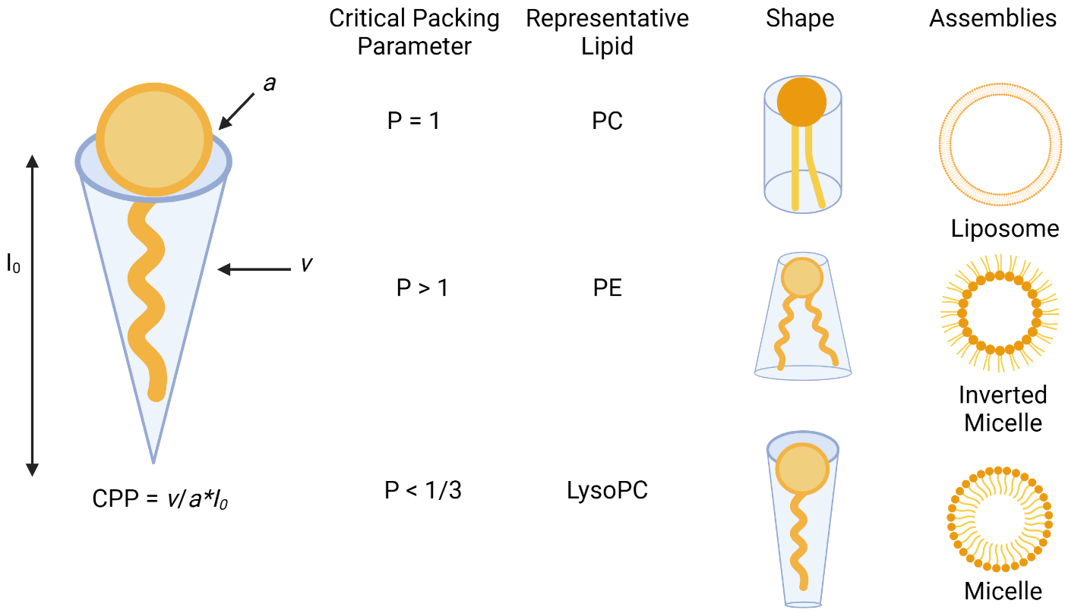
Figure 2. Lipid packing parameter and self-assembly properties.
Lipid shapes, their respective packing parameters and how those packing parameter values translate to self-assemblies are shown. Representative lipids that fall under each classification and the type of macrostructure they will self-assemble into in aqueous media.
larger sizes, ranging anywhere from 20-1000 nm in diameter.⁹ These bilayers are unique in that they can encapsulate both hydrophobic and hydrophilic cargo in either the lipid bilayer or aqueous core, respectively. This property makes liposomes attractive targets for the encapsulation and delivery of therapeutic cargo.

1.1.1. Lipid Self-Assembly
Using the correct formulation of lipids with appropriate packing parameters, lipids will automatically begin to assemble into liposomes but will do so in an uncontrolled manner resulting in self-assemblies of all sizes, with some even containing liposomes within liposomes. These self-assemblies can be manipulated to achieve desired uniformity through several techniques such as thin film hydration, and extrusion.¹⁰ Thin film hydration begins with the incorporation of lipids in the desired ratio into a clean glass vial followed by addition of the desired buffer. Vortexing with heat encourages the lipids residing along the walls to begin to self-assemble into liposomes, and continuing the process forces them to re-assemble repeatedly. Finally, extrusion forces the solution through a polycarbonate membrane, which agitates multilamellar vesicles and generates liposomes of the desired diameter.¹¹ With several available stock lipids, and any number of formulation percentages, liposomes of any composition can be obtained, even those incorporating synthetic lipid analogs whose structure can be designed to resemble any number of the standard stock lipids. Unfortunately, not all formulations generate vesicles stable enough to pass through the extrusion process. If a formulation is too unstable to form vesicles of any size, which would next be extruded to force uniformity to the solution, the process of extrusion ends up requiring too much pressure to force the formulation through the membrane, resulting in the membrane rupturing.

1.2. Biological Applications of Lipids
With a seemingly endless ability to vary the structural properties, lipids hold a key position in the function of biological life. Lipids comprise the majority of cell membranes and with their ability to be tailored to the specific task make for an important component of functioning organisms.¹² With their unique structure, suitable for membrane formation, a majority of the lipids present in eukaryotic life are either glycerophospholipids or sphingolipids, derived from either a glycerol or sphingosine backbone. The final class of lipid structure found prominently is comprised of sterols, including cholesterol, which is important due to its ability to either increase fluidity in the bilayer up to a point or increase the rigidity once that percent incorporation of cholesterol becomes too high.¹³ One of the most prevalent and important lipids in the figure below is phosphatidylcholine (PC), being the most abundant lipid in eukaryotic cell membranes. Additionally, it serves as the classic example of a bilayer forming lipid given its packing parameter = 1. PC will be used later as the bulk lipid of choice to facilitate a stable liposomal delivery vehicle. Aside from PC, there exist many other functional lipids capable of performing tasks such as regulating cell proliferation, metabolism and membrane trafficking.¹⁴ Most interesting is the ability to facilitate membrane trafficking. By storing cargo either within the bilayer amongst the hydrophobic fatty acyl tails or inside the aqueous core, liposomes can transport all nature of cargo, a function that will be useful when emulating their functions.

1.3. Liposomes as Drug Delivery Vehicles
Seeing that lipids self-assembled into liposomes are capable of transporting cargo from across the solubility spectrum provides an opportunity for us to do much the same. We have the capacity to encourage lipids to self-assemble and to tune the size and composition, all we must do now is use them to encapsulate and deliver cargo. This is where a particular method known as freeze/thaw cycling comes in, where the liposomes prior to extrusion are rapidly frozen and then thawed numerous times to encourage cargo that has been co-incubated with them to encapsulate either in the aqueous core or the liposomal bilayer. The cargo of choice for encapsulation is therapeutic cargo that would exhibit solubility problems if subjected to the aqueous environment of the body. For instance, Doxil, a brand name for doxorubicin, an anti-cancer drug has solubility issues, must be encapsulated in a liposomal delivery vehicle and was in fact the first FDA- approved liposome delivered drug.¹⁵ In the research environment, substitute materials are often used instead of the incredibly expensive and regulated therapeutics. In our case, Nile red (NR) and sulfurhodamine B (SRB) act as model replacements for hydrophobic and hydrophilic cargo, respectively. Additionally, these two compounds were chosen as model cargo due to their fluorescent properties. NR, being hydrophobic, resides in the liposomal bilayer and is fluorescent. When released to aqueous media it can precipitate out and a decrease in fluorescence is observed.¹⁶ SRB functions in the opposite manner, when tightly packed within the aqueous core the fluorescence self-quenches, and an increase in fluorescence is observed when SRB is allowed to dilute into the aqueous media.¹⁷

With liposomes encapsulating the appropriate cargo a target must be selected and the normal target of therapeutic delivery is diseased cells. These diseased cells uptake nutrients significantly faster than normal cells and so we can utilize the enhanced permeability and retention (EPR) effect. The EPR effect states that since diseased cells uptake nutrients faster they expand the opening to the bloodstream to allow for faster uptake, and these abnormally large pores can be selectively infiltrated. By utilizing the polycarbonate extruder membranes, liposomal delivery vehicles between 100 and 200 nm can be selected, which are of the appropriate size to benefit from the EPR effect.¹⁸ Additional considerations can be taken to generate stealth liposomes that exhibit significantly longer circulation times. This is done through PEGylation, where approximately 5 percent of the lipids in the bilayer are capped with polyethylene glycol (PEG) repeat units, which prevent lysosomes from fusing to the liposomes as well as enhance solubility of liposomes.¹⁹ Liposomal delivery would benefit from the development of triggered release protocols, which can take the form of either an active or passive targeting system. Guidance systems that target these liposomal delivery vehicles to desired locations to release encapsulated cargo would further enhance the efficiency of treating diseased cells specifically.

1.3.1. Active vs. Passive Mechanisms of Release
Despite the significant advancements that have been made for liposome circulation and delivery, a drawback of these nanocarriers is that they often do not efficiently release drug payload following cell entry. Therefore, enhancement of cargo release is desirable, which could be classified as both the quantity of delivered cargo at one time and the speed at which that cargo can be delivered. Strategies that have been pursued for enhancing cargo delivery fall in one of two categories, either active or passive release. Active release relies on an external stimulus to cause encapsulated cargo release whereas passive release leverages the aberrant conditions of diseased cells to cause triggered release. Both approaches are considered spatially and temporally specific methods of release, given that cargo is delivered only at a desired location and time, instead of relying on the slow degradation of the liposomal bilayer. With a seemingly unlimited number of stimuli to trigger the release of cargo, a healthy field of research has developed around designing specific stimuli responsive lipids to a specific aberrant condition of a diseased cell.²⁰ Whether it be active or passive release each method relies on similar strategies of membrane perturbation, including conformational switches, lipid or membrane restructuring, or removal of the liposomal stealth
coating (Figure 3). Active release relies on the addition of an external stimulus to cause a change in the liposomal bilayer. This allows for the selective design of a system responsive to unique non-naturally occurring events, such as excess localized heat,²¹ unique wavelengths of light,²² or sonic vibrations,²³ which are generally designed to induce heat, in one form or another, to trigger the decomposition of delivery vehicles. These systems have a drawback in that penetration depth of most triggers must be accounted for such as the depth penetration that different wavelengths of light have on the skin or the absorption of radiant heat to significant depths. Attempting to account for these depth issues by increasing the power output of the system has its own drawbacks in the form of several types of burns. For example, excess ultraviolet (UV) irradiation can potentially causing another form of cancer on top of the one it is being used to treat.²⁴ In addition to the ability to damage the peripheral cells, active methods of release require consideration of the circulation time needed for a delivery vehicle to reach the target in addition to requiring a number of different treatments, both of which amount to little more than a minor inconvenience, but are not necessarily considered when applying passive release mechanisms. Altogether, active release mechanisms prove to be significantly more invasive to the patient, in comparison.
Where active release requires an input to cause perturbation of the delivery vehicle, passive release leverages the aberrant conditions already being generated by diseased cells. These aberrant conditions are normally physiological differences or abnormalities observed between the healthy and diseased cells of the same line, such as the pH difference surrounding cancerous cells,²⁵ overexpression of certain enzymes,²⁶ or higher than average metabolite concentrations.²⁷ Liposomal delivery vehicles are designed to only release cargo in and around the overexpressed stimuli, alleviating a number of the harmful side effects from the cargo these vehicles are designed to deliver through a higher delivery efficiency. These passive release methods have an advantage in that circulation times need not be heavily considered, as the nano delivery vehicles are activated when they encounter the targeted stimulus, thus circumventing protracted release or numerous rounds of treatment to trigger release. Essentially, they operate on their own schedule. Additionally, since they do not rely on external stimuli, passive release delivery strategies do not need to take into consideration the depth of the targeted tissue, in contrast to systems involving triggers such as light or heat with the triggering conditions already being present around the diseased cells.

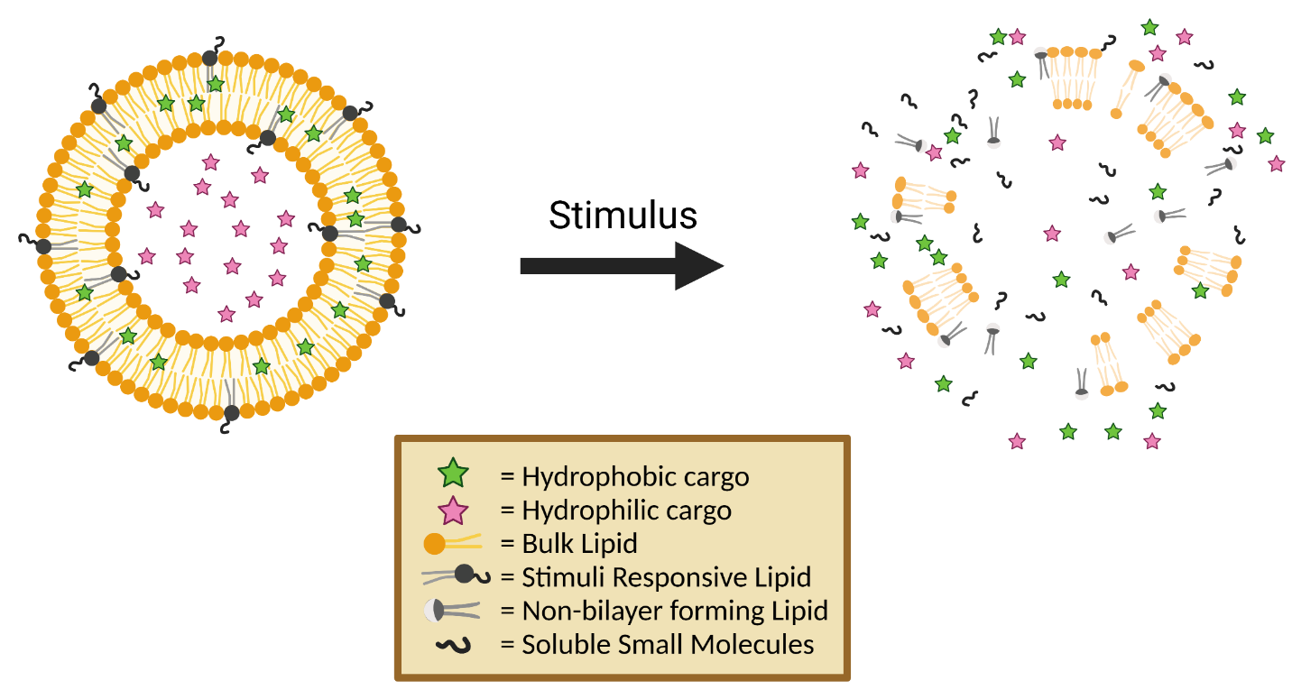
Figure 3. A cartoon representation of stimuli-responsive triggered release of encapsulated cargo from liposomes.
Liposomes load either hydrophobic (green) or hydrophilic (pink) cargo in either the liposomal bilayer or aqueous core, respectively. Liposomes are comprised of various compositions of bulk lipids that self-assemble to the bilayer system seen above, depending on their packing parameters. Stimuli-responsive lipids (black) are incorporated in varying percentages and designed to regulate the spatiotemporal release of encapsulated cargo. These stimuli-responsive lipids can either be triggered actively (light, heat, or ultrasound) or passively (pH, enzyme, ions, or molecular recognition) and upon being triggered cause disruption of the bilayer and release of encapsulated cargo, through methods such as conformational change, change in lipid packing parameter, or in this case lipid degradation.
Images made with Biorender.com
Numerous examples exist for the passive delivery of encapsulated cargo, though most involve encouraging structural changes to occur in the lipids comprising the liposomes, known as lipid switches or synthetic lipid analogs. The two examples discussed below involve synthetic lipid analogs undergoing conformational changes upon interaction with higher-than-average concentrations of either protons (H⁺) or calcium (Ca²⁺) ions (Figure 4). Figure 4A depicts a system developed by the Leblond group involving a di(methoxyphenyl)pyridine synthetic lipid analog capable of undergoing a conformational change at pH = 5.¹⁷ The di(methoxyphenyl)pyridine lipid was designed so that the pyridine and methoxy moieties would chelate excess protons and undergo a conformational change, significantly altering the cone angle of the lipid and therefore its membrane packing properties. This perturbation resulted in the release of up to 88% of encapsulated hydrophobic cargo. Along similar lines, Figure 4B demonstrates that the Best group was able to design a lipid switch capable of a similar conformational change instead utilizing chelation of Ca²⁺ as the trigger.²⁷ The tetraacetic acid moieties, which function as the hydrophilic headgroup of this synthetic lipid analog, are included to chelate to Ca²⁺ ions, causing a conformational change resulting in a drastic inversion of the cone angle and reorientation of the way this lipid situates itself in the bilayer, perturbating the bilayer and resulting in the approximately 60% hydrophobic release or 10% hydrophilic release.

Both examples of conformational change discussed above do not eliminate the lipid itself, but rather force the alteration of lipid shape. This change in shape, though drastic, still provides a lipid scaffold capable of self-assembly, which could theoretically retain encapsulated cargo or re-encapsulate any released cargo lingering in the area. On the other hand, lipid restructuring through the cleavage of a bond is an alternative method of causing perturbation of the bilayer that has the added benefit of preventing reassembly and re-encapsulation of cargo. Enzymes can function as a trigger for the passive release of cargo given their ability to break bonds within the lipid resting in the bilayer, causing the necessary membrane perturbation. It has been shown that enzymes such as phospholipase A₂ (sPLA2) can restructure lipids such as phosphatidylethanolamine (PE), which generates lysoPE, a non-bilayer forming lipid that causes membrane destabilization.²⁸ Other enzymes such as matrix metalloproteinase (MMP)²⁹ and cholinesterase³⁰ can cause lipid restructuring and will be discussed in greater detail later. Given the wide variety of target stimuli

B)
A)
Figure 4. Examples of lipid switches designed for passive release driven by conformational changes.
A. A di(methoxyphenyl)pyridine synthetic lipid analog undergoes extreme conformational change depending on the pH.¹⁷ B. A tetraacetic acid synthetic lipid analog capable of extreme conformational change upon chelation to calcium ions.²⁷

and minimal downsides, strategies involving passive release of encapsulated cargo have become prominent in the field of therapeutic cargo delivery.

1.4. Summary
Liposomal nanoparticle delivery vehicles designed to cause triggered release in a spatiotemporal specific manner provide an encouraging approach to the delivery of therapeutic cargo. The synthetic lipid analogs composing these liposomal delivery vehicles demonstrate remarkable potential to be tailored to modulate the mechanism of release or improve the circulation time. In this thesis, we will discuss the ongoing work of triggering passive release of therapeutic cargo by leveraging the aberrant condition of diseased cells, specifically the overproduction of the alkaline phosphatase enzyme. This overproduction is designed to, in turn, trigger the synthetic lipid analogs developed below to undergo a process of self-immolation that results in disruption of the liposomal delivery vehicle’s bilayer membrane, thereby causing release of the encapsulated cargo in a spatiotemporal manner. Despite the numerous breakthroughs in the field of therapeutic delivery, challenges exist, and there has yet to be a platform for triggered release approved for clinical use. Therefore, expansion of the toolbox of viable means of liposomal release vectors is needed to aid in the future application of this technology.

CHAPTER TWO DESIGN AND SYNTHESIS OF ALKALINE PHOSPHATASE RESPONSIVE SELF-IMMOLATING LIPIDS FOR TRIGGERED RELEASE

2.1. Project Summary
The purpose of this project is to synthesize a collection of four lipids susceptible to alkaline phosphatase enzyme. Upon enzyme hydrolysis, these compounds are designed to undergo decomposition through either self-immolating linkers or acyl chain migration reactions, resulting in either small molecules or a conformational change, respectively, both of which are designed to render the synthetic lipids incapable of reforming stable liposomes. These lipids will then be incorporated with additional stock lipids used to modulate the stability of the newly formed liposomes, so that enzymatic hydrolysis of lipid switches will cause the liposomal membrane to be unstable to a point where encapsulated cargo is released into the surrounding environment. Due to the overproduction of alkaline phosphatase enzyme in diseased cells such as those in certain cancers,^{31,32} liver,³³ and kidney disease,³⁴ this mechanism of release is of particular interest and has the potential to provide a pathway for the spatial and temporal specific release of encapsulated cargo.

2.2. Enzyme Overexpression in Diseased Cells
The overexpression of enzymes is a common phenomenon in diseased cells and specific diseases are found to overexpress specific enzymes. These enzymes have previously been demonstrated to be a promising source of stimuli for the triggered release of cargo. This is advantageous as the design of lipid switches capable of responding to specific enzymatic targets allows for the site-selective disruption of the liposomal bilayer and release of encapsulated cargo. Unfortunately, efforts to probe this avenue of release have been limited to a select group of enzymatic targets, including matrix metalloproteinase (MMP),²⁹ cholinesterase,³⁰ and phospholipase.³⁵ Due to the ability to directly modify the lipids that compose liposomes, phospholipase enzymes have been used previously to trigger release of cargo, as demonstrated by the Andresen group (Figure 5).³⁶ They used the enzyme secretory phospholipase A₂ (sPLA₂) to cleave the fatty acid tail from the phospholipid sn-2 position, facilitating an intramolecular cyclization reaction that caused release of the chemically attached drug molecule capsaicin, and in the process disruption of the liposomal bilayer. Prior work by the Best group into probing the use of enzymatic triggered release led to the

Figure 5. Previously reported enzyme hydrolysis mediated release.
A PG analog developed by the Andresen group demonstrates enzyme hydrolysis of the fatty acid in the sn-2 position. Immediately following enzyme hydrolysis, an intramolecular cyclization occurs, causing the release of an encapsulated prodrug, capsaicin.

development of three lipid switches, each of which is susceptible to a different enzymatic trigger, and capable of disrupting the liposomal bilayer and releasing cargo.³⁷ This prior work involved the targeting of three enzymes, esterase, β-galactosidase and alkaline phosphatase.

2.3. Alkaline Phosphatase Enzyme Hydrolysis as a Stimulus for Cargo Release
In this work, we proposed a series of lipids designed to respond to alkaline phosphatase since this enzyme is overexpressed in various forms of cancer,³⁸ as well as liver,³⁹ cardiovascular,⁴⁰ and kidney disease.⁴¹ The goal of this work is to leverage the ability of this enzyme to dephosphorylate substrates to drive the release of encapsulated cargo. The enzymatic hydrolysis of the terminal phosphate group positioned within the synthetic lipid analogs is designed to cause a cascading decomposition reaction through the cleavage of a self-immolating linker. Demonstrated below are the cascading decomposition reactions of two such linkers, the 1,4-quinone methide (QM) elimination pathway as well as the trimethyl lock (TML) intramolecular cyclization, both known for their fast kinetics of decomposition upon stimulated release (Figure 6).^{42,43} These decomposition reactions are driven through an increase in entropy as well as the formation of more thermodynamically stable side products,⁴⁴ and have been used in a number of application such as the release of small molecular drugs or fluorophores.^{45,46}

Incorporation of these self-immolating functionalities into the headgroups of synthetic lipid analogs means that once the trigger event and self-immolation occur, a significant imbalance in the headgroup cross-section will result. With such an imbalance, perturbation of the lipid bilayer occurs, and encapsulated cargo will begin to leak out (Figure 7). Contrary to other passive release systems studied by the Best group where only conformational changes are induced in the bilayer,⁴⁷ leveraging enzymatic hydrolysis to break chemical bonds and make structural changes to the lipid bilayer is advantageous. Such advantages present themselves through the lack of any continued assembly or theoretical reassembly of the bilayer following stimulus treatment. Through structural changes, what remains after enzymatic hydrolysis and self-immolation of linker compounds fails to resemble a lipid scaffold and will be incapable of encapsulating cargo.
A
B
Figure 6. Self-immolation mechanism and examples of self-immolative linkers.
A. General mechanism for the 1,4-QM-elimination reaction and its pathway of release. B. Sample TML cyclization reaction and its pathway of release.

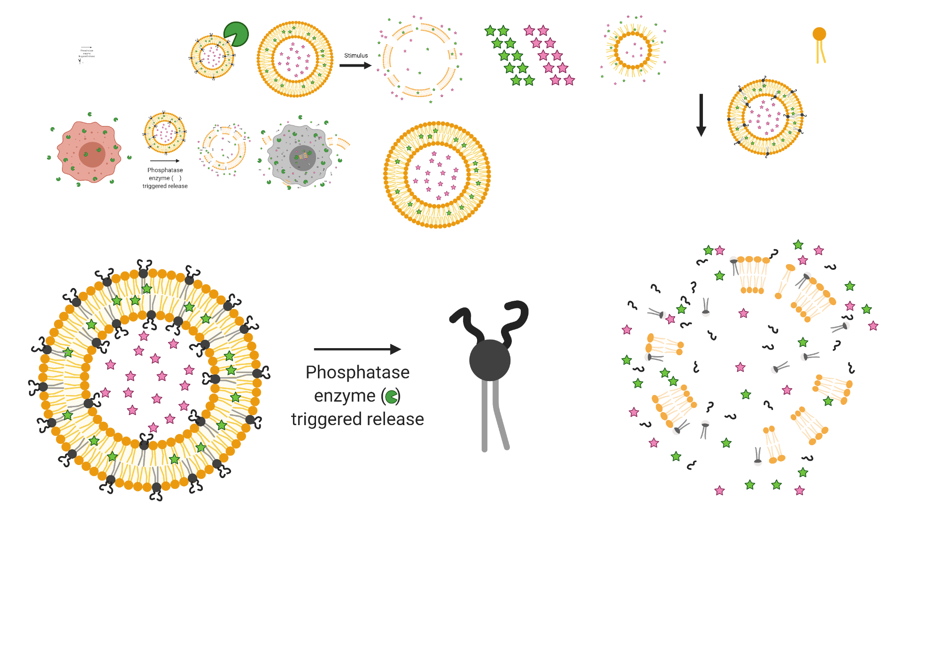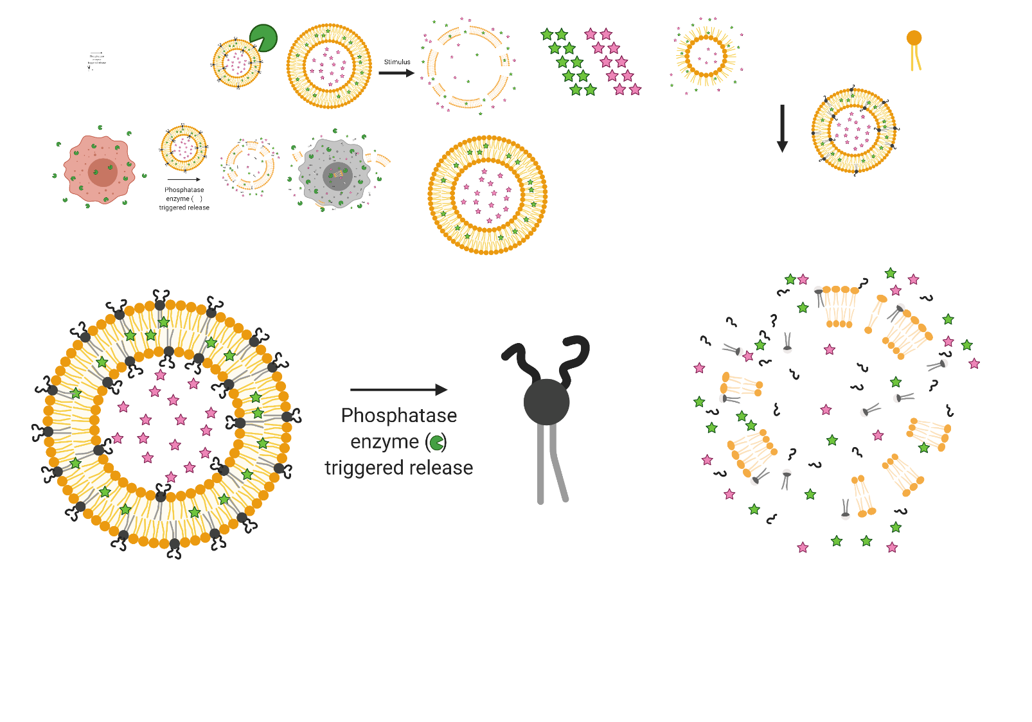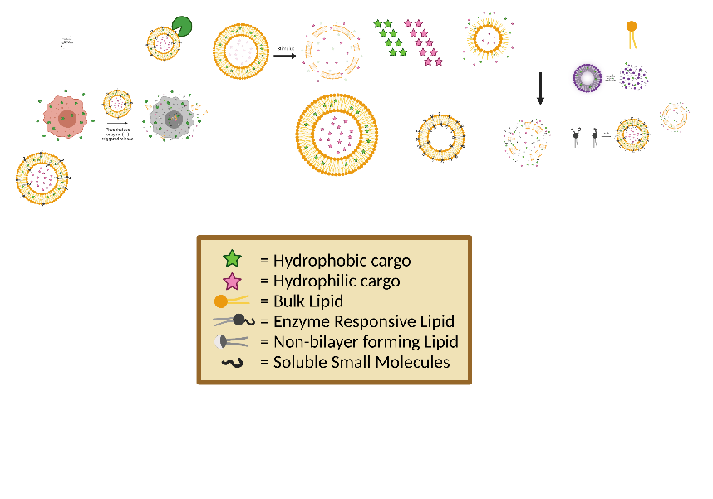
Figure 7. Mechanism of release of general alkaline phosphatase responsive liposomes.
A cartoon depicting the hypothetical model for liposomal release. Once subjected to alkaline phosphatase enzyme the synthetic lipid analogs are designed to self-immolate into small molecules, causing decomposition of the liposomal bilayer and preventing reassembly and encapsulation of cargo.
Images made with Biorender.com

2.4. Inspiration and Design of Alkaline Phosphatase Responsive Lipids
Inspiration for this class of lipid stems from prior work done by Dr. Jinchao Lou and co-workers where a DOPE scaffold was capped with a self-immolating linker and a phosphoester.³⁷ Subsequent enzymatic hydrolysis caused release of a self-immolating linker and the bulk lipid DOPE, with this system capable of releasing upwards of 50% of encapsulated Nile red when subjected to alkaline phosphatase enzyme. However, this system exhibited little to no release of sulfurhodamine B and nominal change to the average size of synthetic liposomes. The lower than desirable release of encapsulated cargo has been attributed to a slower and less than sufficient perturbation of the liposomal bilayer. While this system produces DOPE, a non-bilayer forming lipid that destabilizes membranes, it is believed that resulting lipid self-assemblies are still capable of encapsulating cargo, blunting the release of the maximum amount of cargo (Figure 8). To address this drawback, we propose the development of a class of lipids with a phosphate headgroup susceptible to alkaline phosphatase capable of near total self-immolation, designed without a DOPE scaffold. The previously discussed self-immolating linker will remain present between the phosphate headgroup and the hydrophobic hydrocarbon tails, required to anchor the lipid into the membrane bilayer. These self-immolating moieties will serve as the decomposable unit designed to trigger rapid liposome headgroup perturbation upon phosphate hydrolysis into non-bilayer forming small molecules and prevent the synthetic lipids from being able to reassemble, enabling the maximum release of cargo.

2.5. Design and Synthesis of Phosphatase Responsive Lipids PRL1 and PRL2
The design and results from the previously reported triggered release platform utilizing alkaline phosphatase enzyme by Dr. Lou and coworkers influence the development of our approach to total liposome immolation. Examining the original phosphatase-responsive lipid (PRL, Figure 8) from top to bottom, we will maintain the phosphate headgroup that provides a substrate for enzyme hydrolysis and acts as the hydrophilic headgroup in a stereotypical lipid design. Instead of the TML previously used we will instead exchange it for the QM linker seen on a prior galactosidase-responsive lipid, equally capable of self-immolation yet synthetically easier to access. Differing greatly from the previously discussed designs we will instead substitute the DOPE scaffolding used by Dr. Lou with a synthetically generated glycerolipid scaffold containing a pair of fatty acid tails attached via ester groups acting as the anchor to position these synthetic lipids, PRL1 and
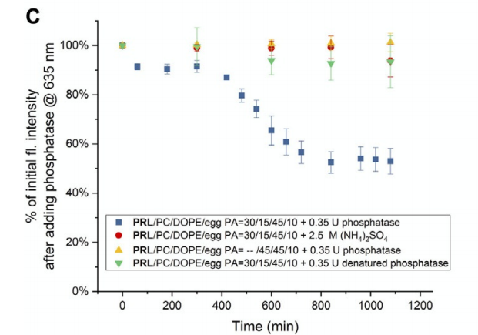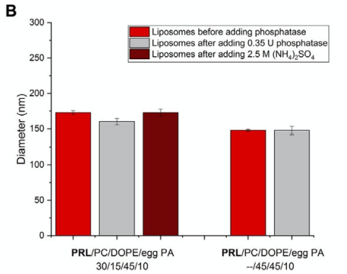
Figure 8. Prior results indicating release of hydrophilic cargo.
Previously synthesized by Dr. Jinchao Lou, synthetic lipid PRL is depicted prior to alkaline phosphatase enzyme hydrolysis. Upon treatment with alkaline phosphatase enzyme, over a 20-hour period, release of encapsulated hydrophobic fluorescent dye was demonstrated in slight excess of 50% (blue trace). Red, yellow, and green traces demonstrate lack of release of cargo upon treatment with various controls, indicating a shelf stable liposomal formulation. This work has been previously reported by Lou et. al and reproduced with permission.³⁷
PRL2, into the liposomal bilayer. Instead of relying solely on the changes to the headgroup cross-section changes observed through enzyme hydrolysis and single self-immolation of the QM linker, PRL1 and PRL2 will also incorporate the acyl chain migration mechanism reported by the Vermillion group⁴⁸ or the intramolecular cyclization reported by the Andresen group, respectively. With both a headgroup cross section change due to self-immolation and an acyl chain migration it is believed that significantly more disruption of the liposomal bilayer can be achieved than the previously reported systems utilizing the alkaline phosphatase enzyme (Figure 9). The acyl chain migrations theorized below differ in terms of the final product generated, with lipid PRL1 breaking an ester bond and instead forming an amide functional group, owing to the decreased steric strain caused by moving the interior acyl chain.⁴⁹ PRL2 is instead designed to cyclize to form an amide bond and eject an alcohol moiety, a favorable reaction due to stability of the resulting amide bond. These non-membrane forming compounds are designed to cause destabilization of the lipid bilayer trigger release of contents. In comparison to previous work in which DOPE was created as a result of triggered self-immolation, PRL2 is designed to generate only small molecules which have no little resemblance to a lipid and cause maximum release of cargo, through the inability encapsulate cargo.

2.5.1. Synthesis of PRL1 and PRL2
Synthesis of lipids PRL1 and PRL2 began with the formation of protected phosphotriester headgroup PRL1.5 containing the QM linker and a p-nitrophenyl group for subsequent attachment to lipid scaffolds (Scheme 1), following similar procedures outlined in previous work done by the Best lab.³⁷ This compound will be required for all lipids synthesized as both the trigger responsive moiety as well as the self-immolative linker. We began with 4-hydroxybenzyl alcohol, which was phosphorylated with dibenzyl phosphite in the presence of 4-dimethylaminopyridine (DMAP) and N,N-diisopropylethylamine (DIPEA), carbon tetrachloride (CCl₄), and acetonitrile (MeCN) to produce PRL1.1.⁵⁰ Next, PRL1.1 underwent a coupling to 4-nitrophenyl chloroformate to form the carbonate ester of PRL1.2 through nucleophilic attack using triethylamine (TEA) as a proton scavenger in tetrahydrofuran (THF). With a supply of the phosphotriester-containing PRL1.2, we began the synthesis of the lipid scaffolds PRL1 and PRL2 (Scheme 2). With a nitrophenyl leaving group priming PRL1.2 for amide bond formation, PRL1.2 was reacted with commercially available 2,2-dimethyl-1,3-dioxolane-4-methanamine, which serves to join the reactive headgroup

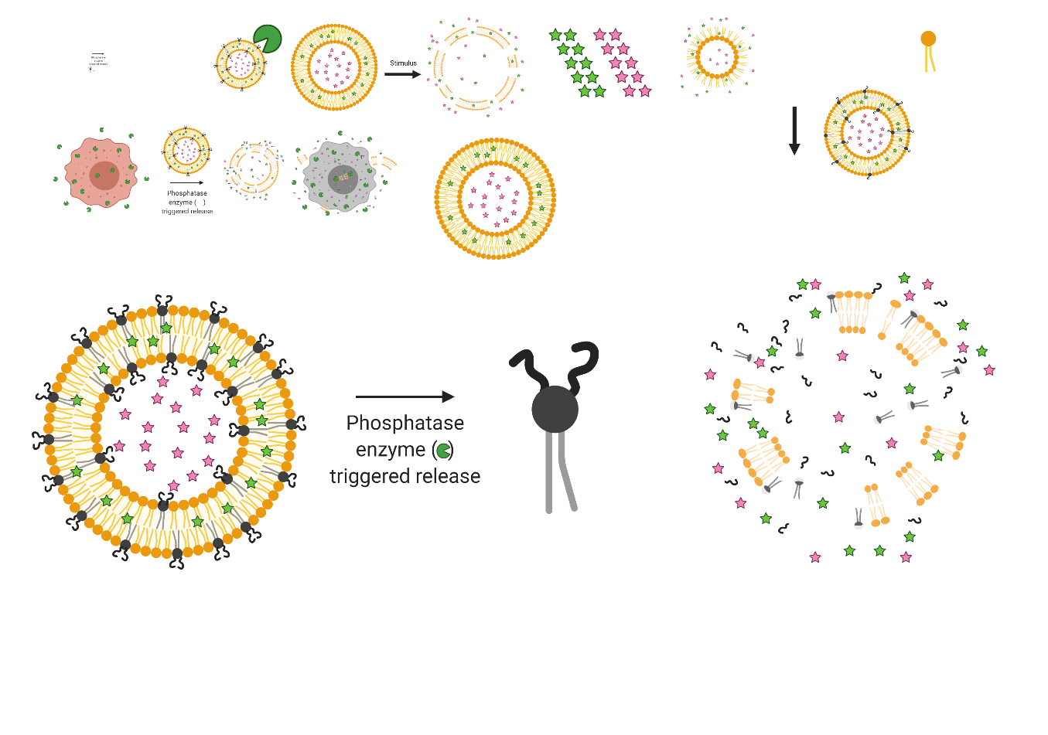
Figure 9. Expected self-immolation mechanism of PRL1 and PRL2.
Each lipid is subjected to alkaline phosphatase enzyme to hydrolyze the phosphorous-oxygen bond, causing QM self-immolation to occur, releasing one moiety of 4-hydroxybenzyl alcohol. From there PRL1, after QM self-immolation, is designed to undergo an acyl chain migration breaking an ester bond and forming an amide bond instead. The expected pathway for PRL2 is instead designed to involve one intramolecular cyclization forming a heterocycle and one moiety of dodecanol.

Scheme 1. Synthetic steps toward Frequent Intermediate PRL1.2.
Conditions: i) Dibenzyl phosphite, DMAP, DIPEA, CCl₄, dry MeCN ii) 4-nitrophenyl chloroformate, TEA, dry THF

Scheme 2. Synthetic steps towards PRL1 and PRL2.
Conditions: i) 2,2-dimethyl-1,3-dioxolane-4-methanamine, TEA, dry MeCN ii) 4-toluenesulfonyl alcohol (TsOH), methanol (MeOH) iii) stearic acid, DMAP, 1-ethyl-3-(3-dimethylaminopropyl)carbodiimide hydrochloride (EDCI), dry dimethyl foramide (DMF)/chloroform (CHCl₃) 50/50 iv) dodecyl chloroformate, pyridine, dry ethyl acetate (EtOAc) v) trimethylsilyl iodide (TMS-I), dry dichloromethane (DCM), MeOH/H₂O 95/5 vi) TMS-I, dry DCM, MeOH/H₂O 95/5
to the glycerol scaffold. Carbamate bond formation occurred, resulting in the production of 4-nitrophenol as a colorimetric leaving group to visually indicate that the reaction is proceeding, producing PRL1.3. Deprotection of PRL1.3 using TsOH in methanol produced PRL1.4 as a diol, ready to be used for subsequent nucleophilic attacks to attach the fatty acid tails. This acetonide deprotection was a precarious step due to the acidic conditions, which also had a habit of deprotecting the phosphate group through removal of one or more benzyl alcohols. This is undesirable because having a charged phosphate at this stage could produce side products in the upcoming Steglich esterification or acyl chloride carbonate ester formation by acting as a nucleophile to attack the carbonyls in both fatty acid tail coupling reactions.

From here two different synthetic pathways were taken with X= O or CH₂, creating both lipids PRL1 and PRL2, respectively. Towards the goal of synthetic lipid PRL1, a Steglich esterification was used to couple together the carboxylic acid of stearic acid and the vicinal diol of PRL1.4, using catalytic amounts of DMAP with EDCI in a 50/50 mixture of DMF/CHCl₃ to produce PRL1.5. On a parallel path towards lipid PRL2, molecule PRL1.4 underwent an additional chloroformate coupling through nucleophilic attack with dodecyl chloroformate using catalytic amounts of pyridine in ethyl acetate to produce PRL2.1. Both the Steglich esterification and acyl chloride carbonate ester coupling are sterically strained reactions that initially resulted in a large percentage of product containing only one hydrophobic tail addition at a time, requiring sequential reactions to the additional tail with purification in between. Such a requirement resulted in a loss of material and needed to be accounted for in overall yield calculations. Finally, both PRL1.5 and PRL2.1 were treated with trimethylsilyl iodide in DCM followed by MeOH/H₂O to produce lipids PRL1 and PRL2, respectively, using TMS-I as a Lewis acid to deprotect the phosphate group releasing two benzyl alcohol moieties.

2.5.2. Liposomal Release Studies of PRL1 and PRL2
With newly acquired lipids PRL1 and PRL2 we sought to begin release studies to determine if these lipids would cause membrane perturbation and subsequent release of encapsulated cargo. For all experiments, liposomes were formed using the thin film hydration method.¹⁰ Stock solutions of lipids PRL1 and PRL2 (5 mM) were solubilized in a solvent solution of 10/10/3/1 chloroform/methanol/water/trifluoroacetic acid, which was found to be the best solvent for these PRL synthetic lipid analogs. Additionally, PC (32.5 mM), hydrophobic dye Nile red (5 mM), DOPE (33.6 mM) and PA (5 mM) were solubilized in chloroform or a chloroform/methanol mixture. Lipids were measured out into clean one-dram vials to obtain various compositions to a total concentration of 2 mM. For all the formulations used in the Nile red release experiments seen below, the same procedure was performed. For an experimental formulation containing 10% PRL1 in egg PC, 14 µL of PRL1 followed by 19.4 µL of egg PC and 7 µL of Nile red were charged to a one-dram vile and concentrated under an N₂ stream. After thoroughly drying the residue under the N₂ stream, the vial was placed under high vacuum for one hour before being hydrated with 350 µL of an appropriate buffer to achieve a total lipid concentration of 2 mM.

The buffer used for the formulation and release of the PRL liposomes was a solution containing 1x TBS with cation activators (pH 8, containing 25 mM Tris/Tris hydrochloric acid (HCl), 0.13 M sodium chloride (NaCl), 0.0027 M potassium chloride (KCl), 0.25 mM magnesium chloride (MgCl₂) and 0.25 mM zinc chloride (ZnCl₂)) since magnesium and zinc ions are necessary for proper enzyme function. After addition of buffer solution, a process of hydration was used to encourage the lipids to self-assemble into liposomes, through incubation of the liposomal formulation in a 60°C hot water bath followed by vortexing, a process that was repeated once every ten minutes for 140 minutes. After ten cycles of vortexting, the newly formed liposomes were subjected to ten freeze-thaw cycles utilizing the same 60°C hot water bath followed by a freeze in a dry ice/acetone bath. These liposomes were then extruded through a 200 nm polycarbonate membrane to generate liposome samples that are smaller than 200 nm. These newly formed uniform liposomes, with PDIs around 0.2, were then subjected to enzyme hydrolysis to ascertain the best formulation for synthetic lipid analogs within stock lipids for the release of the maximum amount of encapsulated cargo.

Initial fluorescence studies were completed with varying percentages of PRL1 or PRL2 in only egg PC. The percent incorporation was raised until extrusion failed to yield stable liposomes, or it was experimentally determined through fluorescence that unstable liposomes were produced. Extruded liposomes were subjected to enzymatic hydrolysis no later than 48 hours after preparation and were never refrozen. Experimental analysis of release of encapsulated cargo will follow the same procedure through this document, for each set of synthetic lipid analogs. The newly extruded liposomes were added to a 90 µL microcuvette and the initial fluorescence measurements were recorded at time zero with readings being recorded from 560 – 700 nm using an excitation wavelength of 552 nm. A series of three liposome solutions was used for each experiment: 1. The study sample consisted of a formulation containing the synthetic lipid switch under consideration subjected to enzyme addition, 2. A control liposome comprised of no synthetic lipid analogs that received enzyme addition, with the synthetic lipid portion being replaced by egg PC, and finally 3. A formulation including the synthetic lipid that did not receive enzyme addition, but instead received an aliquot of the buffer solution that the enzyme is solubilized in. Control formulations without the synthetic lipid analog routinely resulted in no change in fluorescence intensity, normally residing around plus or minus 10% of the initial fluorescence for each sample. For synthetic formulations receiving enzyme treatment, it was generally accepted that any perturbation between 0 and 20% decrease or increase in fluorescence could be attributed to the time requirements of the incubation with enzyme, and only formulations that produced fluorescence changes greater than 20% were considered for repeat experiments. Given the time requirements for the enzyme to hydrolyze enough lipid and that the enzyme needed to be incubated in a 25°C warm water bath, fluorescence experiments generally began by acquiring before and after snapshots where the initial and final fluorescence were detected. Any experiments showing significant perturbation of only the study sample including synthetic liposomal formulation receiving enzyme was repeated for accuracy as well as to determine the percent decrease in fluorescence plateau driven by the synthetic formulation, an indication of the extent of release of encapsulated cargo that had been achieved.

Synthetic lipid analog PRL1 displayed minimal release of encapsulated cargo at lower percentages of synthetic incorporation when mixed with egg PC in liposome (Table 1). Moving on, it was decided to try a formulation similar to that which was successful for Dr. Lou for release using PRL lipid analog, a mixture of 30/15/45/10 PRL/PC/DOPE/PA, entry 13 in Table 1. This also resulted in minimal change to the percent fluorescence observed and subsequent adjustments to that formulation again yielded little to no results. PRL2 with its carbonate ester linkages displayed the
Table 1. Summary of formulations explored for forming stable PRL1 liposomes containing different percentages of PC, DOPE, or PA.
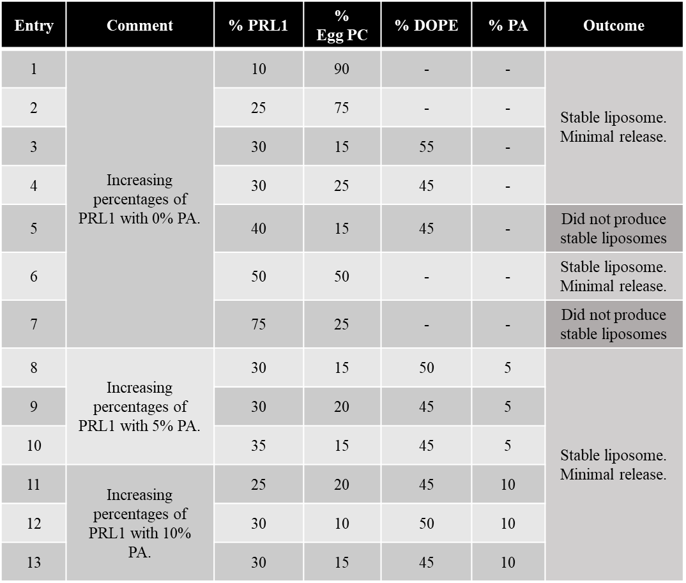

same lack of liposomal perturbation as PRL1 at lower percentages of incorporation into an egg PC liposome. With initial egg PC incorporation yielding little results, experimentation with variations of the previously successful 30/15/45/10 PRL/PC/DOPE/PA, entry 13 in Table 2, formulation began, again with little to show in terms of positive results (Table 2). PRL1 and PRL2 were shelved as the synthesis for PRL3 and PRL4 was completed, anticipating that the newer lipid analogs would have a larger cross section and upon enzyme hydrolysis cause an even greater perturbation to the liposomal bilayer and induce a larger change towards the release of encapsulated cargo.

2.6. Design and Synthesis of Phosphatase Responsive Lipids PRL3 and PRL4
We additionally proposed lipids PRL3 and PRL4 as targets since they were expected to exihibit enhanced ability to disrupt the lipid bilayer through increased self-immolation owing to the existence of two phosphate trigger moieties. It was envisioned that the hydrolysis of two phosphate trigger moieties followed by a double QM self-immolation could cause significant change to the packing parameter of the theorized synthetic lipids. Lipid analog PRL3 is designed with an ester tail and will rely on the acyl chain migration mechanism to encourage membrane perturbation and release of encapsulated cargo. In contrast, compound PRL4 was designed with carbonate ester tails to release both chains in an effort to enhance liposome decomposition through an intramolecular cyclization (Figure 10). Once hydrolyzed, the QM linker was expected to rapidly decompose, driving conversion into a stable non-lipid small molecule to cause membrane destruction. The symmetrical primary amines remaining were designed to act as nucleophiles, attacking the carbonyls attached to the fatty acid tails and relieving steric strain of 2 ester tails in such proximity and forming a new heterocyclic amide and two primary alcohols, all of which are unsuited to conform to a liposomal bilayer system. The diamine linker was specifically designed with C₂ symmetry in mind to avoid the production of stereoisomers during the synthesis.

2.6.1. Synthesis of PRL3 and PRL4
Synthesis of lipids PRL3 and PRL4 began with the development of a symmetrical diamine linker for attaching the two phosphate headgroups to the two hydrophobic tails, required to anchor the synthesized target lipid into the lipid bilayer. We began with commercially available diethyl-L-tartrate, which was protected with cyclopentanone using TsOH in toluene producing PRL3.1 (Scheme 3).51 Subsequent reduction of the ethyl esters of PRL3.1 using lithium aluminum hydride in THF produced intermediate PRL3.2. The alcohols of PRL3.2 were converted to
Table 2. Summary of formulations explored for forming stable PRL2 liposomes containing different percentages of PC, DOPE, and PA.
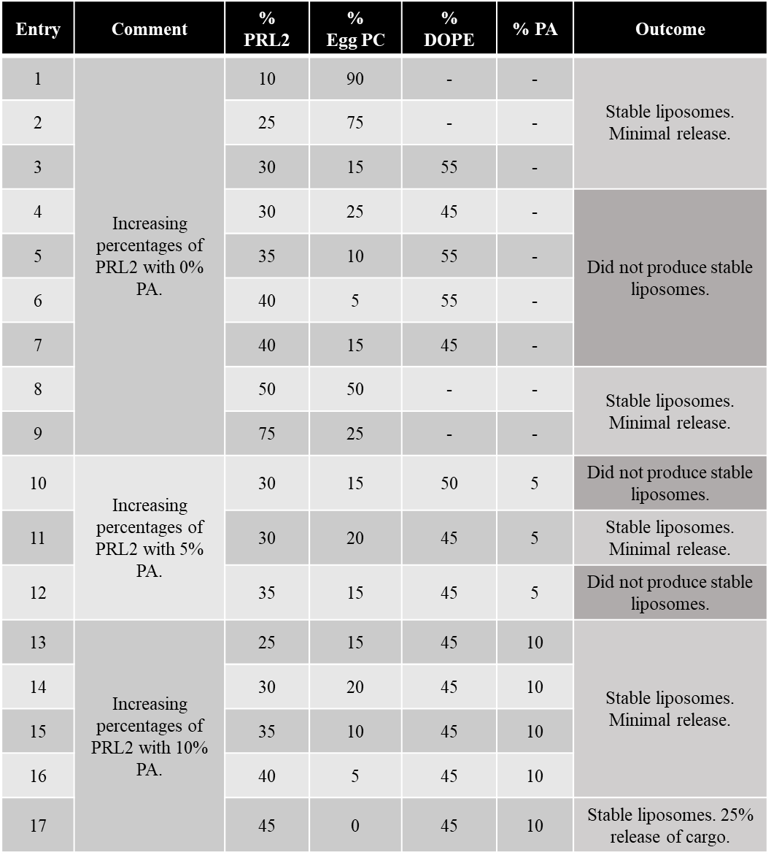

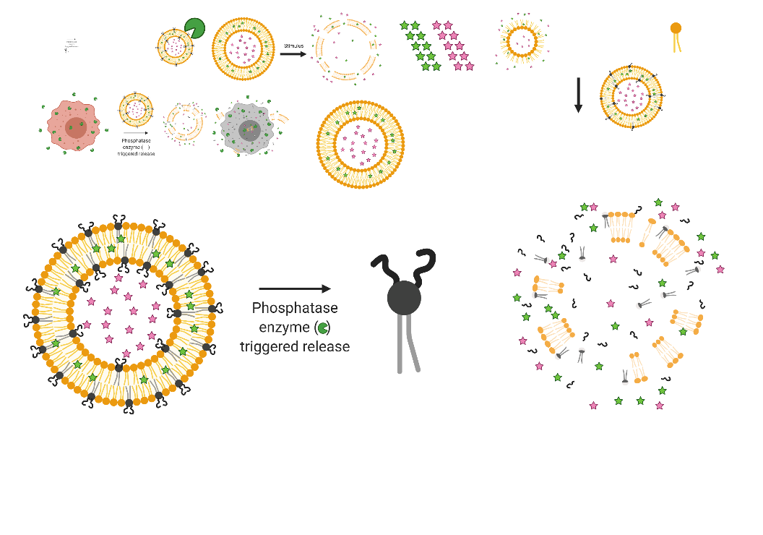
Figure 10. Self-immolation mechanism of PRL3 and PRL4.
Self-immolation mechanism for synthetic lipids PRL3 and PRL4. Each lipid is subjected to alkaline phosphatase enzyme, hydrolyzing the phosphorous-oxygen bond, and causing two QM self-immolations to occur, releasing two moieties of 4-hydroxybenzyl alcohol. From there PRL3, after QM self-immolation, is designed to undergo an acyl chain migration breaking an ester bond and forming an amide bond instead. PRL4 instead is envisioned to undergo two intramolecular cyclizations forming a bis-heterocycle and two moieties of dodecanol.
Scheme 3. Synthetic steps towards synthetic intermediate PRL3.5.
Conditions: i) cyclopentanone, TsOH, Toluene ii) LiAlH₄, dry THF iii) Tosyl chloride, dry DCM iv) Sodium azide, dry DMF v) 10% Pd/C, H₂(g), EtOAc

Scheme 4. Synthetic steps towards lipids PRL3 and PRL4.
Conditions: i) PRL3.5, TEA, dry DCM ii) TsOH, MeOH iii) Stearic acid, DMAP, EDCI, dry DMF/CHCl₃ 50/50 iv) dodecyl chloroformate, pyridine, dry EtOAc v) TMS-I, dry DCM, MeOH/H₂O 95/5 vi) TMS-I, dry DCM, MeOH/H₂O 95/5
leaving groups through reaction with 4-toluenesulfonyl chloride (TsCl) in DCM to yield PRL3.3, priming it for the substitution of protected alcohols with azide groups.⁵² Once the addition of the tosyl groups were confirmed, azidation using sodium azide (NaN₃) in DMF produced intermediate PRL3.4. Finally, full hydrogenation using palladium on carbon (Pd/C) with hydrogen gas (H₂) gas was used to generate linker PRL3.5.

Once the diamine linker was generated, lipids PRL3 and PRL4 were produced using steps similar to those that were previously successful for lipids PRL1 and PRL2 (Scheme 4). Amide bond formation between two equivalents of headgroup PRL1.4 and one equivalent of linker PRL3.5 using catalytic amounts of TEA in a DCM solution produced protected intermediate PRL3.6. This product was then deprotected using the same procedure as above with TsOH in methanol, being careful to consume any excess TsOH with sodium bicarbonate before workup and purification to produce diol PRL3.7 with cyclopentanone as a side product. Compound PRL3.7 was then divided among two different synthetic paths to form both lipids PRL3 and PRL4. A Steglich esterification was used to produce PRL3.8, the final intermediate before lipid PRL3, and a nucleophilic attack of the chloroformate, 4-nitrophenyl chloroformate, was utilized to form PRL4.1, the final intermediate before lipid PRL4. Both reactions were optimized in the previous synthesis of lipids PRL1 and PRL2, using stearic acid with catalytic amounts of DMAP and EDCI, in a 50/50 mixture of DMF/CHCl₃ to yield compound PRL3.8, and dodecyl chloroformate and catalytic amounts of pyridine in ethyl acetate to yield compound PRL4.1. Finally, intermediates PRL3.8 and PRL4.1 underwent the same TMS-I deprotection of their benzyl alcohol protecting groups and MeOH/H₂O workup to form their free phosphate trigger, lipids PRL3 and PRL4.

2.6.2. Liposomal Release Studies of PRL3 and PRL4
With lipid target PRL3 and PRL4 successfully synthesized and characterized, liposomal release studies began. Following the liposomal formulation procedure discussed above PRL3 or PRL4 was incorporated in varying percentages with other purchased stock lipids. Formulations vary from incorporation of only synthetic lipid analogs mixed with only egg PC to complex formulations containing the synthetic lipid analog, egg PC, DOPE, DOTAP, and PA, all to find the ideal formulation for a shelf stable liposome when undisturbed yet unstable enough to cause maximum cargo release once subjected to enzyme hydrolysis and subsequent lipid self-immolation. Following experimental procedures previously discussed, initial release experiments using either PRL3 or PRL4 in only egg PC were evaluated. All formulations of PRL3 in egg PC were found to be shelf stable, in fact, too stable to trigger release of encapsulated cargo. This was inferred when the experimental formulation under investigation not subjected to enzyme hydrolysis maintained the same level of fluorescence after 12 hours as at the beginning of measurement collection. Initial results from PRL4 on the other hand, proved that there existed a line between 50 and 75% PRL incorporation where the liposome was teetering between being stable and unstable. Since significantly less PRL3 was synthesized, this compound was shelved until a suitable formulation for PRL4 could be elucidated (Table 3).

Theorizing that PRL4 could cause greater release of encapsulated cargo, owing to the intramolecular cyclization reaction that would occur causing release of dodecanol, this compound was chosen for further experiments. Harkening back to the formulation that achieved the best result for the prior iteration of PRL lipid by Dr. Lou, the formulation percentages of 30/15/45/10% PRL/PC/DOPE/PA, entry 17 in Table 4, was tested in the next series of formulations. Starting there and manipulating all the variables up or down 5% at a time yielded no positive results after significant time investment (Table 4). After numerous attempts and no positive results to show, we attempted to understand what could be going wrong and how the next series of lipids analogs could remedy this issue. We concluded that despite previous results from Dr. Lou and the Best lab demonstrating the ability of the enzyme to trigger hydrolysis and previously designed lipid switches proving the QM self-immolation occurs the problem might reside in the theorized intramolecular cyclization or acyl chain migration. We came to believe that relying on the newly released primary amine to dip below the surface of the bilayer and trigger an intermolecular attack nay be too much to ask of these lipid analogs. Thus, a new class of lipid analogs needed to be designed, one which removed this mechanism yet still achieve the desired goal of near total lipid self-immolation.

2.7. Design and Synthesis of Phosphatase Responsive Lipids PRL5, PRL6 and PRL7
Lipids PRL5, PRL6, and PRL7 were designed to eliminate the need for an acyl chain migration, believed to be one of the possible reasons lipids PRL1-4 failed to achieve the desired release of encapsulated cargo, by instead causing liposome decomposition through only a series of sequential
Table 3. Summary of formulations explored for triggered release using PRL3 containing different percentages of PC, DOPE, or PA.
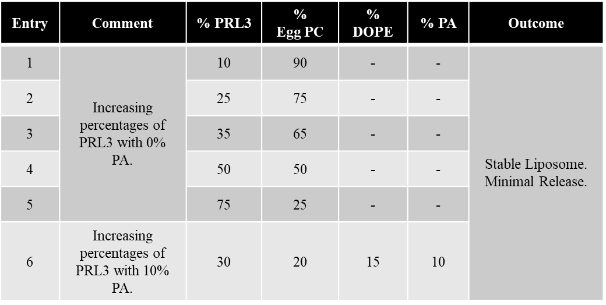

Table 4. Summary of formulations explored for forming stable PRL4 liposomes containing different percentages of PC, DOPE, DOTAP, or PA.
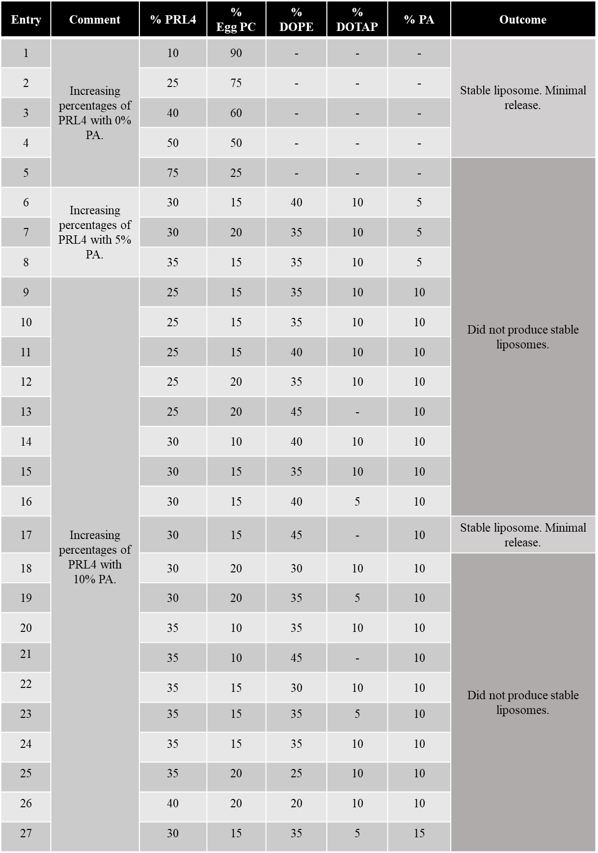
QM self-immolations (Figure 11). Lipids PRL5-7 are also designed with a phosphoester headgroup, being capable of enzyme hydrolysis upon subjection to alkaline phosphatase enzyme, followed by two quinone methide self-immolating groups, and finally an acyl chain composed of either an ester or carbonate ester fatty acid tail. Once hydrolyzed by the enzyme these lipids were again expected to self-immolate into small molecules incapable of reassembly and re-encapsulation of cargo. These lipids are designed to be incorporated in higher percentages amongst stock lipids into liposomes and once enzyme hydrolysis has proceeded to completion, theoretically lipids will no longer exist to encapsulate cargo. Given its theoretical packing parameter the synthetic lipid analog PRL7 could also possess the ability to self-assemble into micelles, providing another avenue of approach towards the goal of enhanced delivery of cargo, albeit only hydrophobic cargo.

2.7.1. Synthesis of PRL5, PRL6 and PRL7
Synthesis of PRL5-7 began with the protection of the benzyl alcohol of commercially available 4-hydroxybenzyl alcohol using tert-butyldimethylsilyl chloride (TBDMSCl) (Scheme 5). 4-Hydroxybenzyl alcohol was stirred under an argon atmosphere dissolved in DMF, followed by deprotonation of the benzyl alcohol using imidazole as a weak base. Finally, introduction of commercially available tert-butyldimethylsilyl chloride provided intermediate PRL5.1.⁵³ Next, the phenol of PRL5.1 was attached through a carbonate ester linkage to the benzylic alcohol of PRL1.1 utilizing triphosgene as a means to provide the carbonyl. This reaction proved quite challenging in terms of finding the right equivalencies of each reagent as well as timing the additions of each. The final reaction proceeded by dissolving 4 equivalents of DMAP as well as 0.3 equivalents of triphosgene in DCM. After allowing the two reagents to react and form the activated intermediate, 1.0 equivalent of the newly protected PRL5.1 was introduced and allowed to stir for 30 minutes at room temperature. After such time, 3.0 equivalents of PRL1.1 were introduced to act as a second nucleophile being tied together with PRL5.1 to form PRL5.2. Next, the TBDMS group protecting the benzylic alcohol of PRL5.2 needed to be removed. It was discovered that the industry standard TBAF deprotection of a TBDMS group resulted in the material immediately beginning to breakdown, never producing the desired product. This required us to consider alternate pathways for releasing the benzyl alcohol, from tetrabutylammonium fluoride (TBAF) deprotection at neutral pH through the use of a

Figure 11. Self-immolation mechanism of PRL5 and PRL6.
Self-immolation mechanism for synthetic lipids containing only QM moieties. Lipids PRL5 and PRL6 are each subjected to alkaline phosphatase, which is expected to hydrolyze the phosphorous-oxygen bond, causing a chain reaction of self-immolations to drive release of two QM moieties followed by one CO₂ molecule and a fatty acid tail in the case of PRL5 or two CO₂ molecules and an alcohol in the case of PRL6.

Scheme 5. Synthetic steps toward lipids PRL5, PRL6, and PRL7
Conditions: i) TBDMS-Cl, imidazole, dry DMF ii) triphosgene, DMAP, PRL1.1, dry DCM iii) 1% v/v 12M HCl, MeOH iv) octanoic acid, DMAP, HCTU, dry DMF/CHCl₃ 50/50 v) octyl chloroformate, pyridine, dry EtOAc vi) palmitic acid, DMAP, HCTU, dry DMF/CHCl₃ 50/50 vii) TMS-I, dry DCM, MeOH/H₂O 95/5 viii) TMS-I, dry DCM, MeOH/H₂O 95/5 ix) TMS-I, dry DCM, MeOH/H₂O 95/5
dipotassium hydrogen phosphate (K₂HPO₄) buffer,⁵⁴ or a TsOH in MeOH deprotection protocol,⁵⁵ finally settling upon a 1% by volume 12 M HCl deprotection.⁵⁶ PRL5.2 was dissolved in MeOH and set to stir for 40 minutes while reacting with 1% by volume 12 M HCl. After the reaction time had come to completion saturated sodium bicarbonate (NaHCO₃) was added and the reaction was extracted with DCM, dried using magnesium sulfate (MgSO₄), and concentrated to dryness, leaving behind PRL5.3 in quantitative yield.

From here, PRL5.3 was evenly divided along three pathways to develop the three separate lipids, PRL5, PRL6, and PRL7. Beginning with the pathway towards PRL5, PRL5.3 was subjected to an esterification with octanoic acid as the fatty acid tail, using O-(1H-6-chlorobenzotriazole-1-yl)-1,1,3,3-tetramethyluronium hexafluorophosphate (HCTU) and DMAP as the coupling reagents in a 50:50 mixture of DMF and CHCl₃ to form intermediate PRL5.4. An additional aliquot of PRL5.3 was reacted with octyl chloroformate using pyridine as a base in EtOAc to form intermediate PRL6.1. The final collection of intermediate PRL5.3 was reacted with lauric acid, HCTU, and DMAP in a 50:50 mixture DMF and DCM to form intermediate PRL7.1. All three penultimate intermediates, PRL5.4, PRL6.1, and PRL7.1 were subjected to the same deprotection conditions mentioned above, TMSI deprotection followed MeOH/H₂O workup to free the amphiphilic lipids PRL5, PRL6, and PRL7 all ready to begin incorporation and release experiments.

2.7.2. Liposomal Release Studies of PRL5, PRL6 and PRL7
With the completion and characterization of lipids PRL5-7, liposomal release studies began. Lipids PRL5 and PRL6 were prepared to a concentration of 5 mM stock solution utilizing a solvent mixture of 10/10/3/1 chloroform/methanol/water/trifluoroacetic acid, the only mixture found to solubilize these lipids, a similar solvent mixture required by prior lipid scaffold PRL1-4. PRL5 and PRL6 were then incorporated into liposomes following the same technique seen in section 2.5.1. Liposomes comprising 0, 10, 25, 50, and 75% PRL5 or PRL6 in egg PC were hydrated with MilliQ water to a concentration of 2 mM liposomal solution for initial incorporation and release experimentation. Upon initial fluorescence measurements and subjection to stock alkaline phosphatase enzyme for an incubation period of 20 hours at 35°C, PRL5 at 75% incorporation showed significant release, 70% of encapsulated cargo (Figure 12). PRL5 at all other percent incorporations showed minimal release of cargo in relation to the control synthetic formulation not

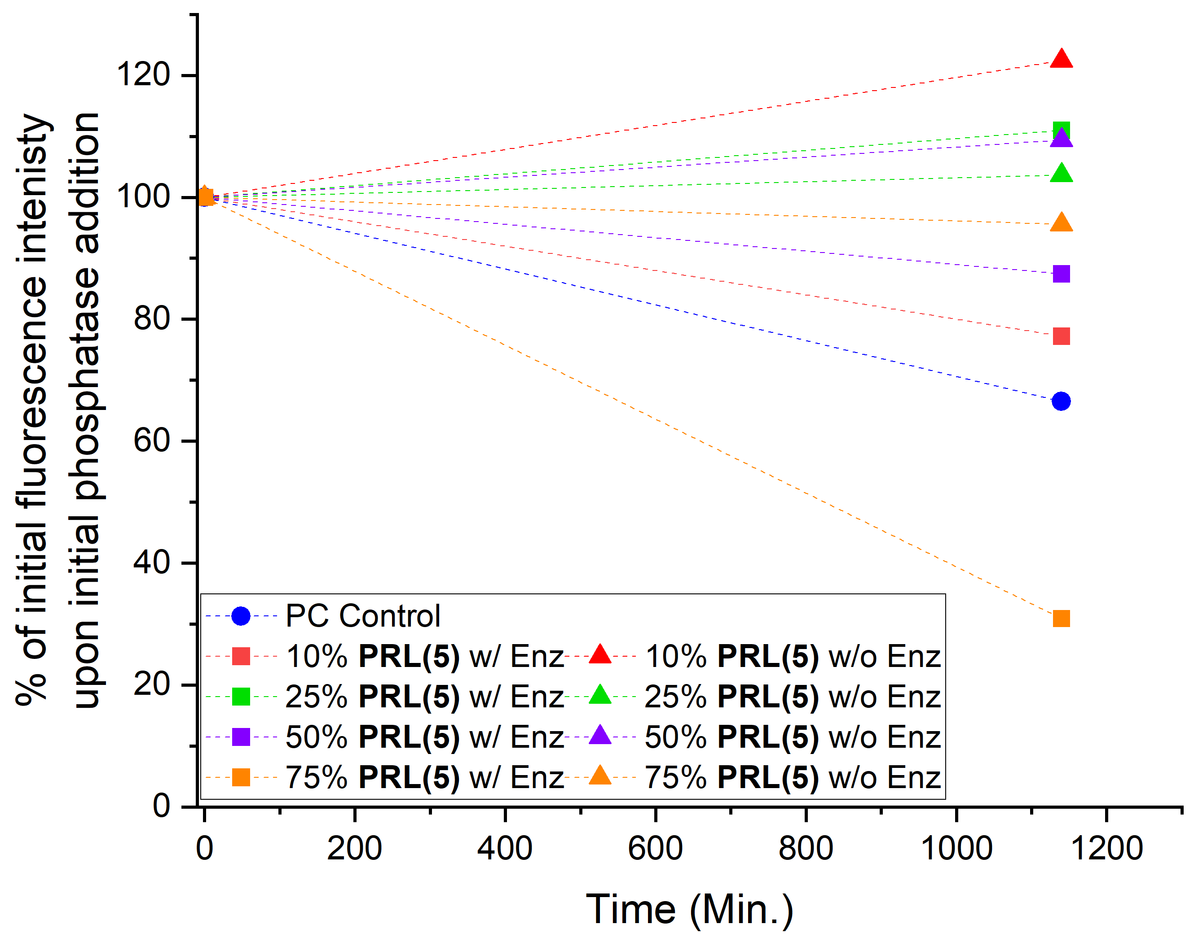
Figure 12. Preliminary liposomal release results utilizing PRL5.
Liposomes composed of PC and synthetic lipid analog PRL5. Significant release observed at higher concentrations of synthetic lipid PRL5, 75% synthetic lipid intermixed with 25% PC, demonstrating 70% release of encapsulated hydrophobic fluorescent cargo. Liposomes of lower synthetic incorporation percentages show significantly less release with the next most effect only demonstrating approximately 20% release of encapsulated hydrophobic fluorescent cargo. Synthetic formulations not subjected to enzymatic hydrolysis maintain fluorescent intensities after 20 hours.

subjected to stock enzyme. PRL6 at 75% synthetic lipid incorporation also showed promise with a decrease of 45% fluorescence intensity upon being subjected to enzymatic hydrolysis for 20 hours, with both being determined to show promise enough to repeat for accuracy and to observe the plateau in release of encapsulated cargo, a phenomenon indicative of having achieved the maximum release of cargo for that system. An additional point of note is that the 25% decrease in fluorescence of stock 100% egg PC liposome control that did receive enzymatic treatment provided a red flag that brought this study under scrutiny. Repeat experiments were conducted utilizing fresh egg PC in both control and synthetic formulations, with measurements taken every hour instead of an initial and final scan found that neither formulation was stable. This conclusion was drawn from the observation that during measurements both the synthetic formulation with and without enzyme treatment decreased in fluorescence intensity in lockstep with each other. The false positive result may result from the liposome solution being studied a significant period of time after initial formulation, since liposomes are known to decompose over time. Further formulations were attempted along two different fronts, one where the percent of egg PC was increased to hopefully repeat the test results seen originally and another series of formulations stemming those that achieved positive results in the original enzymatic release paper led by Dr. Lou. All attempts proved unsuccessful in generating a liposomal formulation that was both stable without enzyme treatment as well as unstable enough to cause significant perturbation of the bilayer and release of cargo upon enzymatic treatment (Table 5) (Table 6).

While PRL5 and PRL6 were both being formulated for incorporation into liposomes, PRL7 was also studied for micelle formation. PRL7, containing a longer of an acyl tail, would theoretically function better in the formation of micelles instead of incorporating within a bilayer of stock lipids. Initial studies on this process began with the determination of the critical micelle concentration (CMC), the concentration at which surfactants begin to favor the formation of micelles over partitioning along the air water surface interface.⁵⁷ The industry standard method for determining CMC is to monitor the encapsulation of pyrene as micelles begin to form around the hydrophobic cargo as the concentration of the surfactant increases. With the two aromatic rings built into PRL7, encapsulation of pyrene is unnecessary and changes in absorbance measured by UV-Vis spectrophotometry were utilized to determine the CMC. Solutions of PRL7, being solubilized in
Table 5. Summary of formulations explored for forming stable PRL5 liposomes containing different percentages of PC, DOPE, and PA.
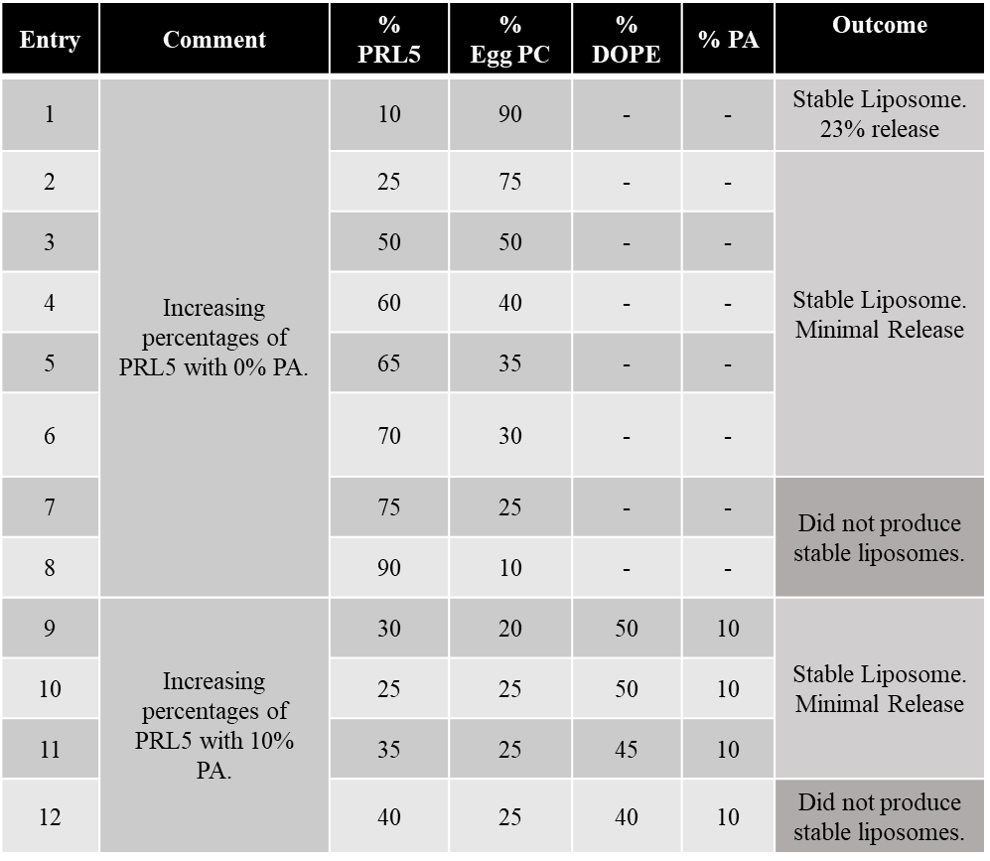

Table 6. Summary of formulations explored for forming stable PRL6 liposomes containing different percentages of PC, DOPE, and PA.
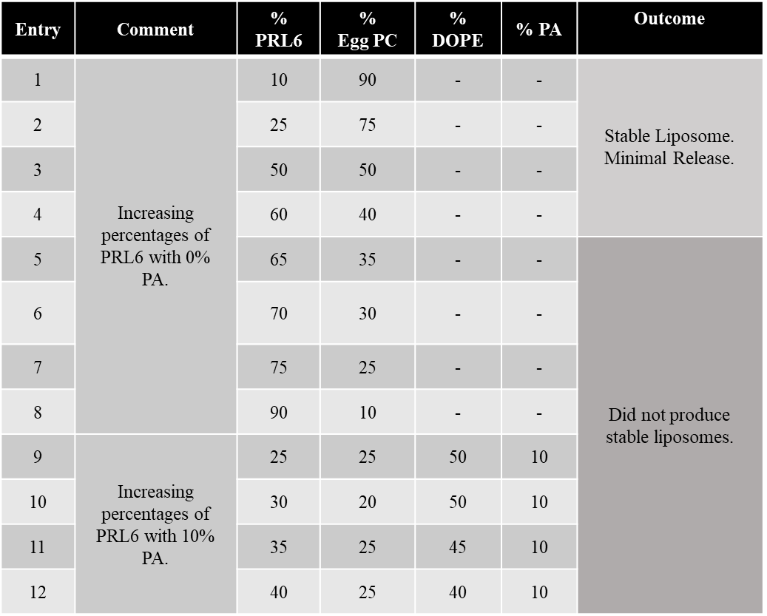
the 10/10/3/1 chloroform/methanol/water/trifluoroacetic acid mixture, were dried down into two-dram vials before being solubilized in the stock Tris buffer solution previously required for release experiments involving PRL lipids, beginning at a concentration 0.0125 mM and increasing by a concentration of 0.0125 mM to an upper concentration of 1.29 mM, skipping around at the higher concentrations and filling in gaps in an effort to expend as little lipid stock solution as possible. Solutions of lipid PRL7 in buffer had their absorbances measured using a Cary 5000 Spectrophotometer which measured the absorbance from 800 to 200 nm. From that raw data, the critical micelle concentration was determined by the inflection point
along the graph of the inverse log of concentration plotted against absorbance and was found to be 0.11 mM (Figure 13). From here further studies utilizing PRL7 need to be conducted to determine the size of the micelles generated followed by the upper limit of encapsulation of cargo that can be achieved in the core of these micelles before any release experimentation can begin.

2.8. Summary and Future Work
Enzyme overproduction as a trigger for the release of encapsulated cargo from therapeutic liposomes represents a new tool in the toolbelt of those designing new ways to combat diseases that affect so many. The ability to passively target a diseased system utilizing one aspect of its aberrant nature has tremendous potential for the elimination of diseased cells without causing undue collateral damage. This work proposes several synthetic lipid analogs responsive to alkaline phosphatase, which utilize the overproduction of this enzyme, a phenomenon noted in several cancers, as well as kidney and liver diseases to trigger structural changes in the lipid scaffold. These lipids were designed to undergo enzyme hydrolysis and self-immolation both structural decomposition mechanisms that were envisioned to eliminate the lipid scaffold altogether in contrast to conformation changes observed in many previously reported lipid switch systems. This radical change to the lipid scaffolding would theoretically destabilize the membrane to the point where significant cargo release could be observed.

Currently, lipids switches PRL1-4 utilizing the self-immolation and acyl chain migration or cyclization have not resulted in significant release of encapsulated cargo and require further alterations to the liposomal composition to find the perfect ratio to achieve optimal cargo release or further re-designs of their structures. It is noted that a number of lipid compositions achieved
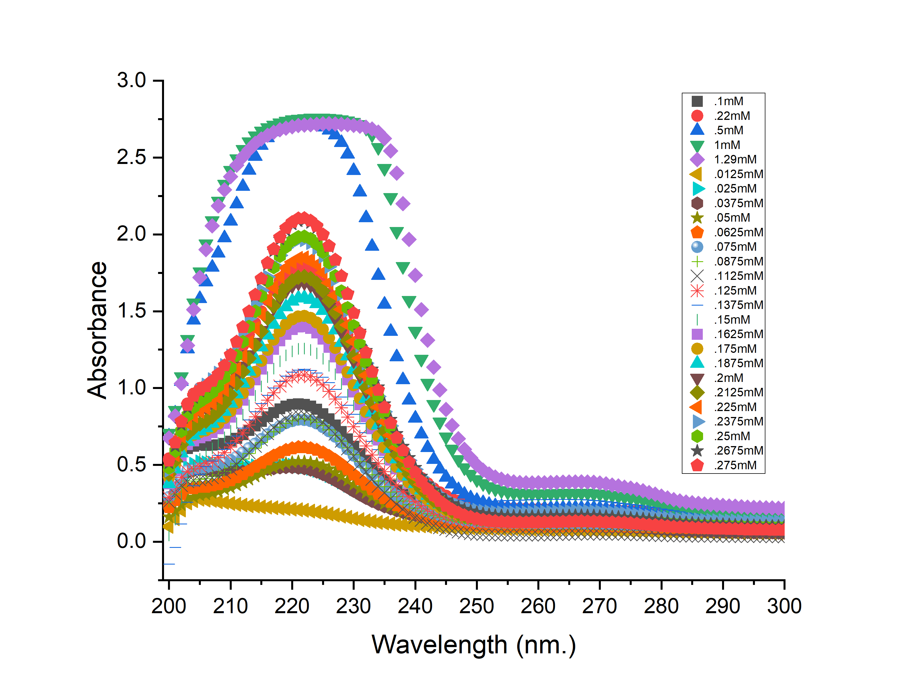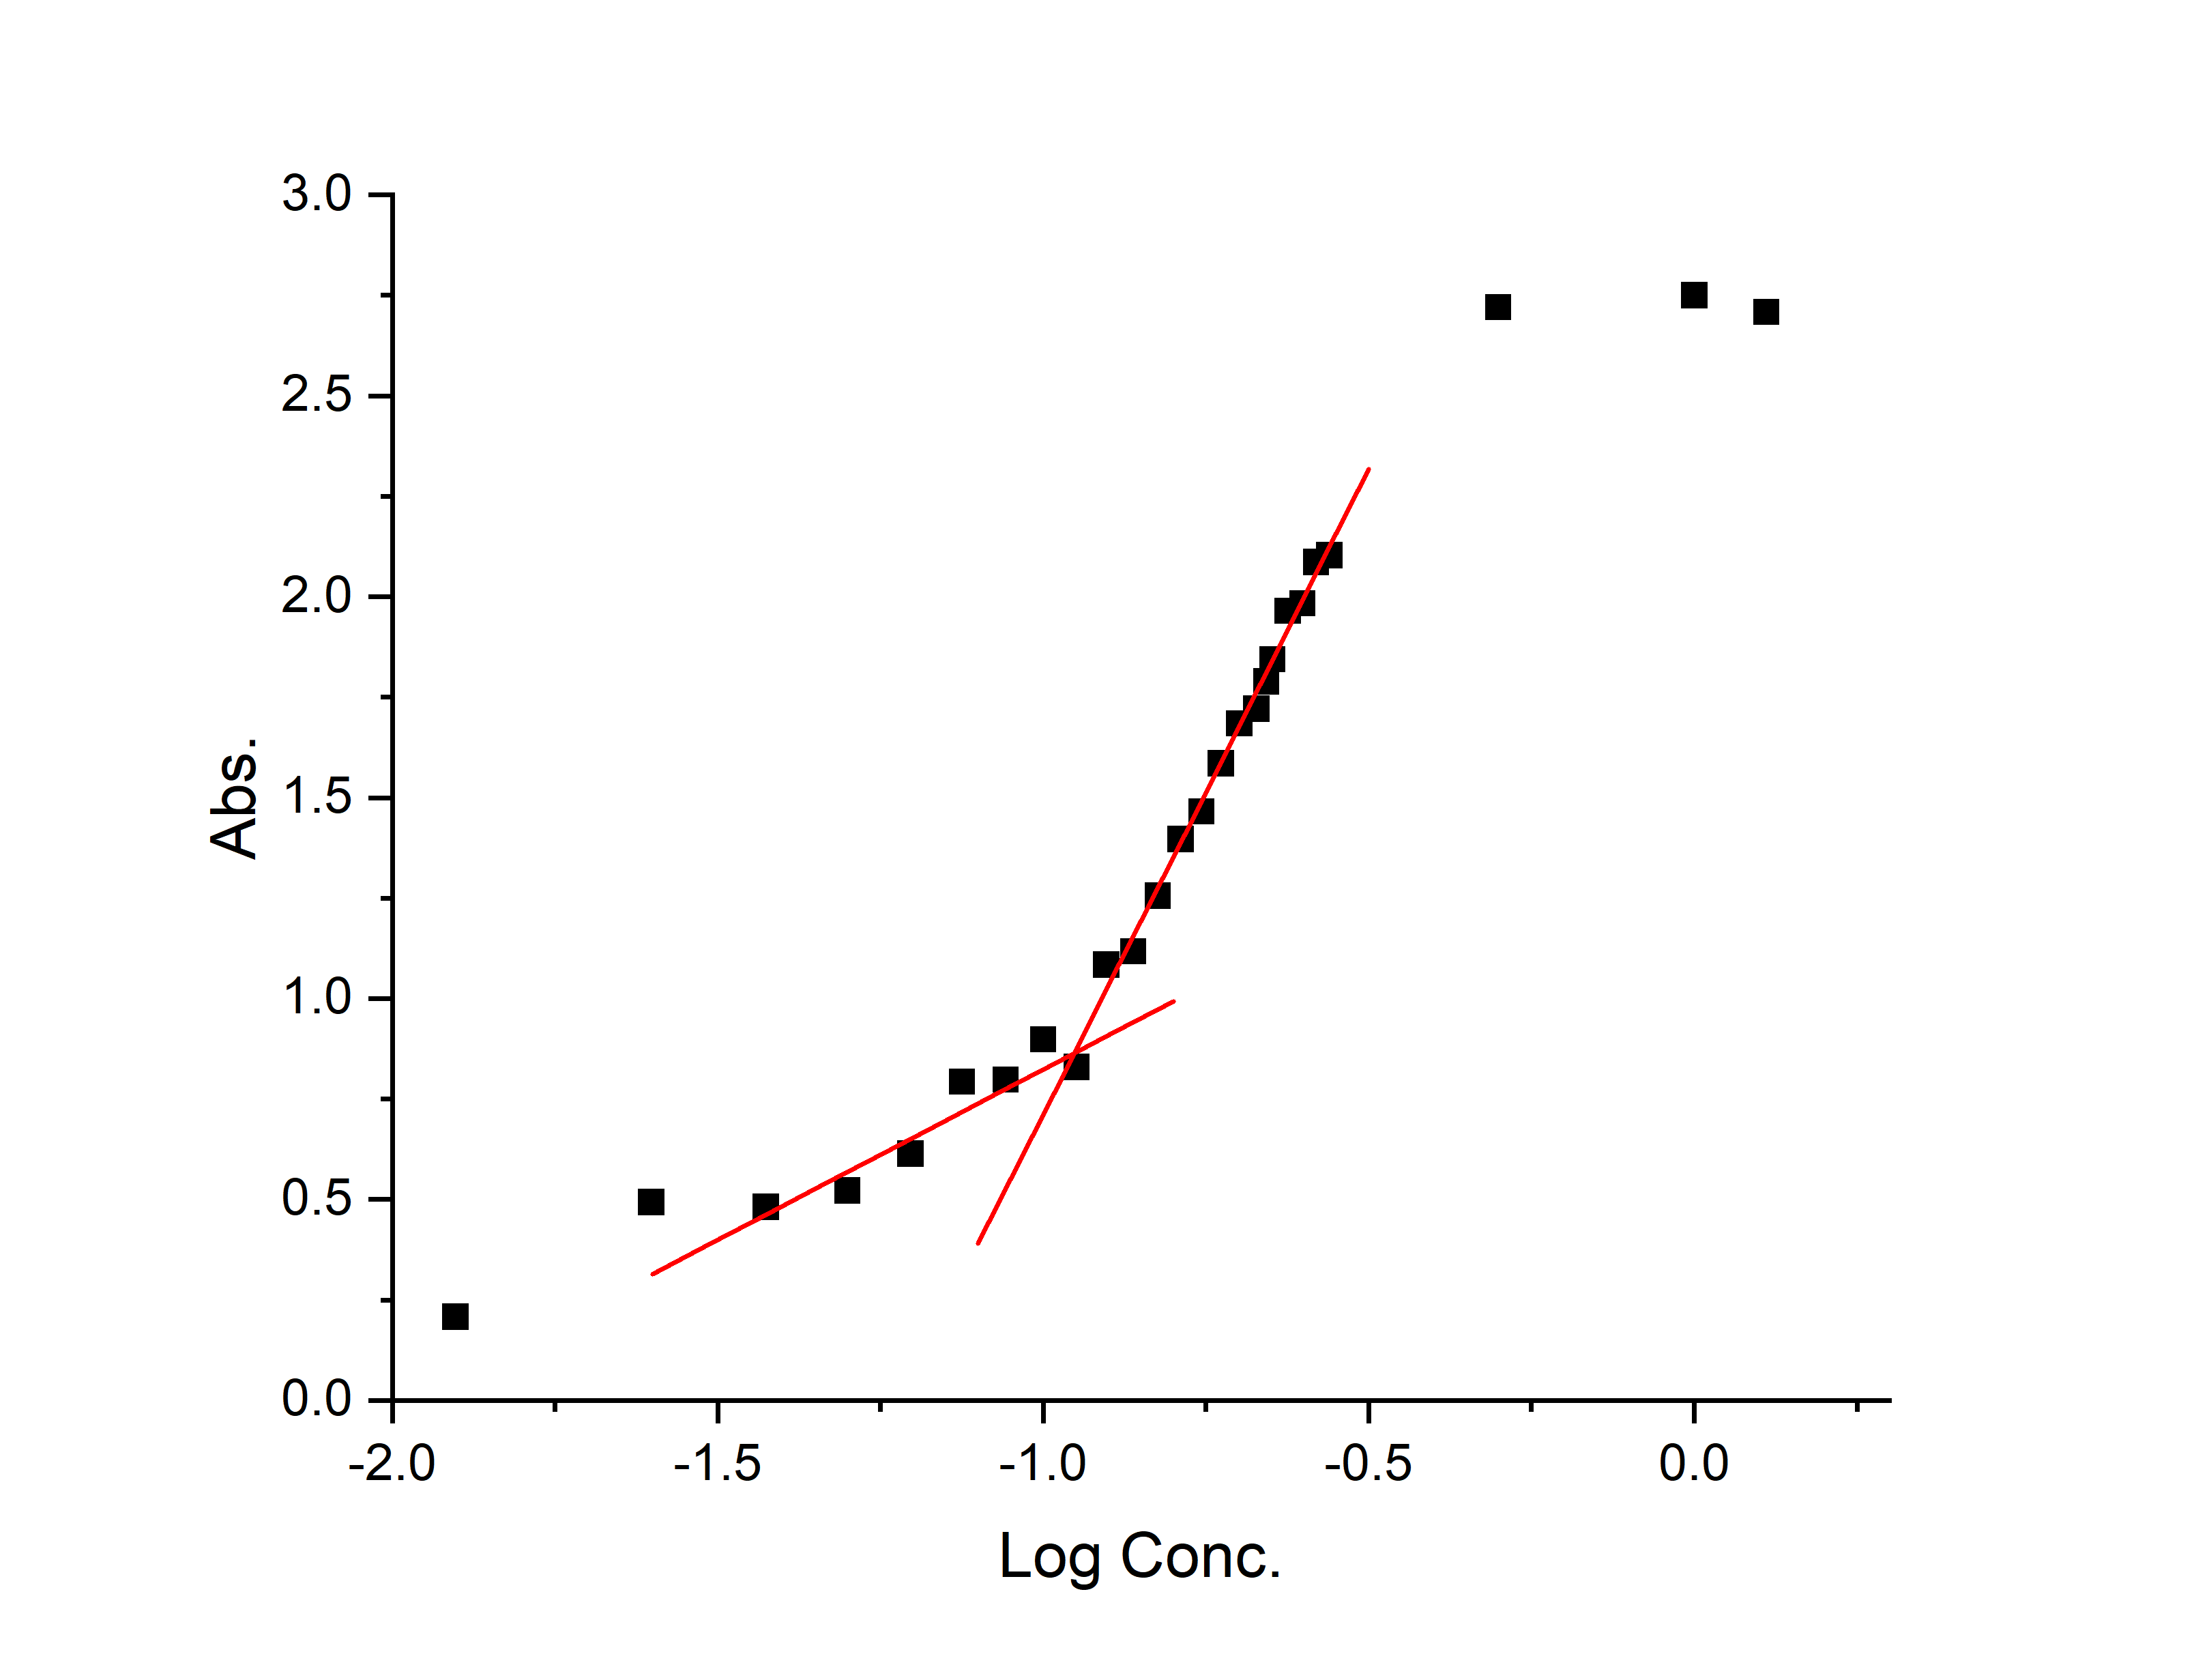
CMC = .11mM
Figure 13. Critical micelle concentration experimental results.
Determination of the critical micelle concentration of PRL7 involves generating solutions of increasing concentration of PRL7 and using a Cary 5000 Spectrophotometer to monitor the changes in the absorbance of the aromatic rings that makeup the QM moieties of PRL7. Plotting of the absorbance vs the log of concentration provided the inflection point indicating the concentration of PRL7 that was needed to self-assemble into micelles. For the synthetic lipid PRL7 that concentration is 0.11mM.
stable liposomes over a prolonged period of time but were unable to cause significant perturbation of the bilayer to trigger adequate release of cargo. Tailoring the composition for each specific synthetic lipid analog will require significant time, due to the number of formulations required, in addition to considering additional bulk lipid options to tune the liposomal bilayer to be either more or less initially stable. Synthetic lipids PRL5-7 have not yet been subjected to nearly as many formulations attempts as lipids PRL1-4 and therefore have even further to go in order to elucidate the perfect liposomal composition to achieve a shelf stable liposome yet unstable enough that once subjected to enzyme hydrolysis will undergo the maximum amount of release of encapsulated cargo. In addition, preliminary studies have been conducted regarding the optimum concentration of PRL7 for the formation of micelles, but further experiments such as accurate DLS results and TEM images need to be conducted to determine if and how these new surfactants can encapsulate hydrophobic cargo. Together, these synthetic lipid analogs will provide researchers with a component in the development of enzyme-responsive self-immolative liposomal delivery vehicles.

2.9. Synthetic Details and Material Characterization

2.9.1. General Experimental Information
Reagents and solvents were generally purchased from Acros, Sigma-Aldrich, Fisher Scientific, Oakwood Scientific or Tokyo Chemical Industry and were used without further purification. Bulk lipids: such as PC (_{L}-α-Phosphatidylcholine, mixed isomers from chicken eggs), DOPE (1,2-dioleoyl-sn-glycero-3-phosphoethanolamine), PA (_{L}-α-phosphatidic acid sodium salt from chicken eggs), DOTAP (1,2-dioleoly-3-trimethylammonium-propane, chloride salt) were purchased from Avanti Polar Lipids, Inc (Alabaster, AL). The alkaline phosphatase enzyme from Escherichia coli was purchased from Sigma-Aldrich (in 2.5 M ammonium sulfate, SKU: P4252). Dry solvents were obtained from a Pure Solv MD-7 delivery system from Innovative Technology, Inc (Newburyport, MA). Column chromatography was performed using 230-300 mesh silica gel purchased from Sorbent Technologies. NMR spectra were obtained through a Varian 500 MHz spectrometer. Mass spectra were obtained through a Waters Synapt G2-Si mass spectrometer (Milford, MA). Liposome extruder and size exclusion membranes were obtained from Avanti Polar lipids Inc (Alabaster, AL). Ultrapure water was obtained via a Millipore Water system. Fluorescence studies were run on a Cary Eclipse Fluorescence Spectrophotometer. UV-Vis spectra were obtained using a Cary 5000 Spectrophotometer. And all plots were generated using either Origin Pro 2021 or Microsoft Excel.

2.9.2. Synthetic Details: PRL1 and PRL2 Compounds
Dibenzyl (4-hydroxymethyl)phenyl) phosphate (PRL1.1)
Commercially available 4-(hydroxymethyl)phenol (2.000 g, 16.100 mmol, 1.0 equiv.) was dissolved in 100 mL dry MeCN under stirring and argon atmosphere and cooled to -10℃ using an ice/ acetone bath. DMAP (0.197 g, 1.670 mmol, 0.1 equiv.), DIPEA (4.160 g, 33.370 mmol, 2.0 equiv.) were added in as solids through removal of the septum. Carbon tetrachloride (7.810 mL, 83.430 mmol, 5.0 equiv.) was added using a syringe through the septum. After five minutes of stirring, dibenzylphosphite (5.200 mL, 23.360 mmol, 1.5 equiv.) was added slowly, dropwise. The reaction was spun at -10℃ for 5 hours, then allowed to warm to room temperature, at which point 100mL of 0.5 M aq. potassium dihydrogen phosphate (KH₂PO₄) was added. The mixture was then extracted 3 times with 100 mL of EtOAc and the combined organic layer was washed once with 100 mL saturated NaCl, dried with MgSO₄, filtered, and concentrated under reduced pressure. Purification via column chromatography with 25-75% EtOAc in hexane yielded PRL1.1 as a white solid (4.954 g, 59% yield). Rf = 0.3 (50% EtOAc:hexane). ¹H NMR (500 MHz, CDCl₃): δ 7.36 – 7.26 (m, 13H), 7.13 (d, J = 7.4 Hz, 2H), 5.12 (d, J = 8.3 Hz, 4H), 4.65 (s, 2H) ³¹P NMR (202 MHz): δ -6.19.

4-((Bis(benzyloxy)phosphoryl)oxy)benzyl (4-nitrophenyl) carbonate-dibenzyl (4-(hydroxymethyl)phenyl) phosphate (PRL1.2)
Compound PRL1.1 (1.000 g, 2.601 mmol, 1.0 equiv.) was dissolved in 50 mL of dry THF under stirring and an argon atmosphere and then cooled to 0℃ using an ice bath. TEA (1.800 mL, 13.608 mmol, 5.0 equiv.) was added as a liquid through the septum. Commercially available 4-nitrophenol chloroformate (0.760 g, 3.772 mmol, 1.45 equiv.) was added as a solid and the reaction was allowed to stir at room temperature overnight. Upon completion, the reaction was concentrated by rotary evaporation, and the residue was solubilized in EtOAc and washed with saturated NaHCO₃ until the aqueous layer was no longer yellow in coloration and then once with 100 mL of saturated NaCl. The organic layer was then dried with MgSO₄, filtered, and solvent removed under reduced pressure. Column chromatography with 0-50% EtOAc in hexane gave 1.201 g of the product as a white solid (84% yield). R_{f} = 0.3 (50% EtOAc:hexane). ¹H NMR (500 MHz, CDCl₃): δ 8.28 (d, J = 9.3 Hz, 2H), 7.39 – 7.31 (m, 14H), 7.17 (d, J = 7.5 Hz, 2H), 5.25 (s, 2H), 5.13 (d, J = 8.5 Hz, 4H) ³¹P NMR (202 MHz): δ -6.28.

4-((Bis(benzyloxy)phosphoryl)oxy)benzyl ((2,2-dimethyl-1,3-dioxolan-4-yl)methyl)carbamate (PRL1.3)
Commercially available (2,2-dimethyl-1,3-dioxolan-4-yl)methanamine (0.100 g, 0.762 mmol, 1.0 equiv.) was dissolved in 50 mL of dry MeCN under an argon atmosphere with stirring. TEA (0.500 mL, 3.049 mmol, 4.0 equiv.) was added through the septum and the reaction was cooled to 0℃. Compound PRL1.2 (0.629 g, 1.144 mmol, 1.5 equiv) was added as a solid and the reaction was allowed to warm to room temperature and set to stir overnight. The reaction was then concentrated under reduced pressure, and the residue taken up in 100 mL EtOAc. The solution was extracted with saturated NaHCO₃ continuing to separate and re-extract until the aqueous layer was no longer yellow in coloration and then once with 100 mL of saturated NaCl. The organic layer was then dried with MgSO₄, filtered, and solvent removed under reduced pressure, followed by column chromatography with gradient elution of 25-50% EtOAc in hexane resulting in 0.355 g of the product as a clear oil (87% yield). R_{f} = 0.35 (50% EtOAc:hexane).¹H NMR (500 MHz, CDCl₃): δ 7.35 – 7.26 (m, 11H), 7.12 (d, J = 7.5 Hz, 2H), 5.12 (d, J = 8.4 Hz, 4H), 5.06 (s, 2H), 4.27 – 4.18 (m, 1H), 4.07 – 3.62 (m, 2H), 3.50 – 3.21 (m, 2H), 1.42 (s, 3H), 1.34 (s, 3H) ³¹P NMR (202 MHz): δ -6.28.

4-((Bis(benzyloxy)phosphoryl)oxy)benzyl (2,3-dihydroxypropyl)carbamate (PRL1.4)
Compound PRL1.3 (0.250 g, 0.460 mmol, 1.0 equiv.) was added to a 50 mL round bottom flask and dissolved in 25 mL of MeOH. The reaction was set to stir before TsOH (0.194 g, 1.385 mmol, 3.0 equiv.) was added as a solid. The reaction was set to stir overnight before being quenched with solid NaHCO₃. The reaction mixture was filtered before being concentrated to dryness then taken up in 100 mL of EtOAc and washed three times with 50 mL of H₂O followed once with 50 mL of saturated NaCl. The organic layer was dried using MgSO₄, filtered, and had the solvent removed under reduced pressure. The crude was purified by column chromatography with a gradient elution of 50-100% EtOAc in hexane resulting in 0.217 g of the product as a white solid (93% yield). R_{f} = 0.2 (100% EtOAc). ¹H NMR (500 MHz, CDCl₃): δ 7.37 – 7.25 (m, 12H), 7.11 (d, J = 7.5 Hz, 2H), 5.11 (d, J = 8.4 Hz, 4H), 5.05 (s, 2H), 3.75 (p, J = 5.2 Hz, 1H), 3.62 – 3.48 (m, 2H), 3.39 – 3.23 (m, 2H) ³¹P NMR (202 MHz): δ -6.27.

3-((((4-((Bis(benzyloxy)phosphoryl)oxy)benzyl)oxy)carbonyl)amino)propane-1,2-diyl distearate (PRL1.5)
Compound PRL1.4 (0.600 g, 1.196 mmol, 1.0 equiv.) was added to a 100 mL round bottom flask charged with argon. The compound was then dissolved in 50 mL of a 50:50 mixture of dry DMF:CHCl₃ with stirring. Next, DMAP (0.073 g, 0.598 mmol, 0.5 equiv.) was added as a solid, followed next by commercially available stearic acid (0.748 g, 2.632 mmol, 2.2 equiv.) as a solid. Finally, EDCI (0.492 g, 3.171 mmol, 2.65 equiv.) was added and the reaction was allowed to stir at room temperature overnight. The reaction was then diluted with 50 mL H₂O and extracted three times, each with 50 mL of DCM. The organic layer was collected, washed once with 50 mL of saturated NaCl, dried over MgSO₄, filtered, and concentrated to dryness. The crude product was subjected to column chromatography using a gradient elution of 25-75% EtOAc in hexane, producing 0.392 g as a white viscous oil (31% yield). R_{f} = 0.2 (75% EtOAc/hexane). ¹H NMR (500 MHz, CDCl₃): δ 7.37 – 7.26 (m, 11H), 7.12 (d, J = 7.3 Hz, 2H), 5.11 (d, J = 8.4 Hz, 4H), 5.05 (s, 2H), 5.00 (t, J = 6.4 Hz, 1H), 4.30 – 4.09 (m, 3H), 3.50 – 3.35 (m, 2H), 2.33 – 2.27 (m, 4H), 1.60 (p, J = 6.9 Hz, 5H), 1.25 (s, 54H), 0.88 (t, J = 7.0 Hz, 6H) ³¹P NMR (202 MHz): δ -6.27.

4-((Bis(benzyloxy)phosphoryl)oxy)benzyl (2,3-bis(((dodecyloxy)carbonyl)oxy)propyl)carbamate (PRL2.1)
To a dry, degassed, argon filled 50 mL round bottom flask containing a stir bar compound PRL1.4 (0.100 g, 0.199 mmol, 1.0 equiv.) was added. EtOAc (25 mL), having sat under sieves for 48 hours, was added through the septum and the reaction was set to stir at 0℃. Commercially available dodecyl chloroformate (0.200 mL, 0.798 mmol, 4.0 equiv.) was added through the septum followed by dry pyridine (0.100 mL, 1.196 mmol, 6.0 equiv.) and the reaction was allowed to stir for 6 hours at 0℃ followed over night at room temperature. The reaction mixture was then charged to a separatory funnel and washed three times each with 50 mL of H₂O followed by one wash with 50 mL of saturated NaCl. The organic layer was dried with MgSO₄, filtered, and concentrated to dryness. The crude reaction mixture was subjected to column chromatography with gradient elution of 25-50% EtOAc in hexane, providing 0.116 g of a white viscous oil (56% yield). R_{f} = 0.2 (25% EtOAc/hexanes). ¹H NMR (500 MHz, CDCl₃): δ 7.37 – 7.25 (m, 12H), 7.13 (d, J = 7.4 Hz, 2H), 5.12 (d, J = 8.4 Hz, 4H), 5.05 (s, 2H), 4.96 (p, J = 5.0 Hz, 1H), 4.31 (ddd, J = 86.7, 12.1, 4.6 Hz, 2H), 4.17 – 4.09 (m, 4H), 3.51 (d, J = 32.1 Hz, 2H), 1.66 (p, J = 6.7 Hz, 4H), 1.34 (d, J = 9.9 Hz, 4H), 1.25 (s, 38H), 0.88 (t, J = 7.0 Hz, 7H) ³¹P NMR (202 MHz): δ -6.27.

4-((((2,3-Bis(stearoyloxy)propyl)carbamoyl)oxy)methyl)phenyl phosphate (PRL1)
Compound PRL1.5 (0.075 g, 0.0752 mmol, 1.0 equiv.) was added to a 25 mL round bottom flask charged with argon. The compound was then dissolved in 10 mL of dry DCM and set to stir at 0℃. TMS-I (0.030 mL, 0.181 mmol, 2.5 equiv.) was introduced through the septum and the reaction was allowed to stir for 1 hour at 0℃. After the one-hour mark, the reaction was concentrated under a stream of N₂, followed by 30 minutes under high vacuum. After 30 minutes had elapsed 10 mL of a 5:95 mixture of H₂O:MeOH was added and the reaction was allowed to stir overnight. The reaction mixture was then concentrated under an N₂ stream, followed by high vacuum. Afterwards it was taken up in a minimal amount of a mixture composed of 65/25/4 parts CHCl₃/MeOH/H₂O and subjected to column chromatography using an elution of 100% CHCl₃ followed by the 65/25/4 mixture yielding 0.059 g of a white solid (96% yield). R_{f} = 0.35 (65/25/4 CHCl₃/MeOH/H₂O). ¹H NMR (500 MHz, CDCl₃): δ 7.41 (ddd, J = 66.8, 5.7, 3.3 Hz, 4H), 4.89 (s, 1H), 4.78 (s, 4H), 3.99 (s, 2H), 2.12 – 2.10 (m, 4H), 1.50 – 1.30 (m, 19H), 1.03 (s, 55H), 0.70 (t, J = 7.5 Hz, 6H) ³¹P NMR (202 MHz): δ -3.52.

4-(6-(((Dodecyloxy)carbonyl)oxy)-3,9-dioxo-2,8,10-trioxa-4-azadocosyl)phenyl phosphate (PRL2)
Compound PRL2.1 (0.050 g, 0.054 mmol, 1.0 equiv.) was added to a 25 mL round bottom flask charged with argon. The compound was then dissolved in 10 mL of dry DCM and set to stir at 0℃. TMS-I (0.020 mL, 0.135 mmol, 2.5 equiv.) was introduced through the septum and the reaction was allowed to stir for 1 hour at 0℃. After the one-hour mark, the reaction was concentrated under a stream of N₂, followed by 30 minutes under high vacuum. After 30 minutes had elapsed 10 mL of a 5:95 mixture of H₂O:MeOH was added and the reaction was allowed to stir overnight. The reaction mixture was then concentrated under an N₂ stream, followed by high vacuum. Afterwards it was taken up in a minimal amount of a mixture composed of 65/25/4 parts CHCl₃/MeOH/H₂O and subjected to column chromatography using an elution of 100% CHCl₃ followed by the 65/25/4 mixture yielding 0.029 g of a white solid (73% yield). R_{f} = 0.4 (65/25/4 CHCl₃/MeOH/H₂O). ¹H NMR (500 MHz, CDCl₃): δ 7.50 – 7.33 (m, 4H), 4.89 (s, 2H), 3.99 (d, J = 5.9 Hz, 6H), 3.44 (s, 1H), 1.42 (s, 4H), 1.03 (s, 35H), 0.70 (t, J = 7.5 Hz, 6H) ³¹P NMR (202 MHz): δ -3.34.

2.9.3. Synthetic Details: PRL3 and PRL4 Compounds
Diethyl (2R,3R)-1,4-dioxaspiro[4.4]nonane-2,3-dicarboxylate (PRL3.1)
In a 250 mL round bottom flask, filled with argon and equipped with a stir bar, commercially available Diethyl-_{L}-Tartrate (3.400 mL, 19.560 mmol, 1.0 equiv.) was added followed by 130 mL of toluene and the reaction was allowed to stir. Cyclopentanone (8.700 mL, 98.250 mmol, 5.0 equiv.) was added dropwise in addition to solid TsOH (0.380 g, 1.99 mmol, 0.1 equiv.). The reaction was set up with a Dean stark trap filled with toluene, and a condenser, and set to heat at 130℃ overnight. The following day, the reaction was removed from heat and excess solid NaHCO₃ was introduced and allowed to stir until room temperature was achieved. The reaction was filtered and concentrated under reduced pressure and the crude was subjected to column chromatography following a gradient elution of 0-20% EtOAc in hexane yielding 4.138 g of a yellow oil (77% yield). R_{f} = 0.3 (25% EtOAc/hexane). ¹H NMR (500 MHz, CDCl₃): δ 4.72 (s, 2H), 4.27 (q, J = 7.2 Hz, 5H), 2.02 – 1.81 (m, 5H), 1.75 – 1.66 (m, 5H), 1.31 (t, J = 7.2 Hz, 7H).

((2S,3S)-1,4-Dioxaspiro[4.4]nonane-2,3-diyl)dimethanol (PRL3.2)
To a round bottom flask, charged with argon, excess LiAlH₄ (0.246 g, 1.180 mmol, 2.2 equiv.) was added as a solid and the reaction was allowed to stir at 0℃. To the stirring reaction, 25 mL of dry THF was introduced dropwise. Intermediate PRL3.1 was then diluted in an additional 25 mL of dry THF and introduced dropwise, followed by stirring at room temperature overnight. The following morning, the reaction vessel was cooled to 0℃, the septum was removed, and 2 mL of H₂O was added dropwise, followed by 2 mL of 2.0 M NaOH, and once again with 5 mL of H₂O. The reaction was allowed to stir at 0℃ for one hour, followed by one hour at room temperature. The contents of the round bottom flask were then filtered through a celite plug and rinsed with excess THF, (50 mL). The contents of the filtrate were dried with MgSO₄ and refiltered, concentrated to dryness under reduced pressure, and subjected to column chromatography with a solvent gradient from 50-100% EtOAc in hexane yielding 0.425 g of a clear oil (77% yield). R_{f} = 0.4 (40% EtOAc/hexane). ¹H NMR (500 MHz, CDCl₃): δ 3.96 (tq, J = 2.7, 1.5 Hz, 2H), 3.75 (dddd, J = 43.8, 11.7, 2.8, 1.5 Hz, 5H), 1.83 – 1.62 (m, 8H).

((2S,3S)-1,4-Dioxaspiro[4.4]nonane-2,3-diyl)bis(methylene) bis(4-methylbenzenesulfonate) (PRL3.3)
To a dry, degassed, argon filled 100 mL round bottom flask 50 mL of dry DCM was charged. PRL3.2 (1.000 g, 5.310 mmol, 1.0 equiv.) was then added as a solid and allowed to stir as the reaction vessel was set to 0℃. TEA (3.000 mL, 21.250 mmol, 4.0 equiv.) was added as a lipid through the septum followed by solid 4-toluene sulfonyl chloride TsCl (4.050 g, 21.250 mmol, 4.0 equiv.) and the reaction was allowed to stir overnight at room temperature. The reaction was then added to a 250 mL separatory funnel and washed 3x each with 50 mL H₂O followed once with 50 mL of saturated NaCl. The organic layer was then dried with MgSO₄, filtered, concentrated to dryness, and subjected to column chromatography using gradient elution ranging from 0-50% EtOAc in hexane yielding 1.840 g of a white solid (70% yield). Rf = 0.4 (50% EtOAc/hexane). ¹H NMR (500MHz, CDCl₃): δ 7.78 (d, J = 8.3 Hz, 4H), 7.36 (d, J = 7.9 Hz, 5H), 4.06 (d, J = 3.4 Hz, 5H), 3.96 (t, J = 3.3 Hz, 2H), 2.46 (s, 7H), 1.66 – 1.54 (m, 8H).

(2S,3S)-2,3-Bis(azidomethyl)-1,4-dioxaspiro[4.4]nonane (PRL3.4)
To a dry, degassed, 100 mL round bottom flask argon was added followed by 50 mL of dry DMF. PRL3.3 (1.000 g, 2.010 mmol, 1.0 equiv.) was added as a solid followed by NaN₃ (0.524 g, 8.050 mmol, 4.0 equiv.) and the reaction vessel was affixed with a reflux condenser and set to stir overnight at 100℃. The reaction was then allowed to cool to room temperature before being diluted with H₂O and extracted 3x each with 100 mL Et₂O. The organic layer was collected and washed once with saturated NaCl, dried using MgSO₄, filtered, and concentrated to dryness under reduced pressure. The crude reaction mixture was subjected to column chromatography using a gradient elution from 0-25% Et₂O in hexane resulting in 0.431 g of a white solid (90% yield). R_{f} = 0.3 (25% Et₂O/hexane). ¹H NMR (500 MHz, CDCl₃): δ 3.99 (t, J = 3.1 Hz, 2H), 3.54 – 3.33 (m, 5H), 1.93 – 1.79 (m, 4H), 1.78 – 1.62 (m, 4H)

((2S,3S)-1,4-Dioxaspiro[4.4]nonane-2,3-diyl)dimethanamine (PRL3.5)
To a dry, degassed, 100 mL round bottom flask PRL3.4 (0.100 g, 0.420 mmol, 1.0 equiv.) was added and diluted with 25 mL of EtOAc. Pd/C (0.010 g, 0.094 mmol, 10% w/w) was added and the reaction was set to stir aggressively. A double layered balloon filled with H₂ with a long needle was driven through the septum and to the bottom of the round bottom flask. An additional needle was pierced through the septum exposing the reaction vessel to the fume hood. The H₂ balloon was squeezed to fully expel the H₂ gas before being replaced and the venting needle removed. The H₂ balloon was monitored for an additional 6 hours, replacing, if necessary, followed by filtration through a pad of celite with 75 mL of EtOAc. The reaction was concentrated to dryness to yield 0.078 g of the product as a white solid (95% yield). ¹H NMR (500 MHz, CDCl₃): δ 3.76 – 3.68 (m, 2H), 2.91 – 2.80 (m, 4H), 1.87 – 1.72 (m, 4H), 1.72 – 1.61 (m, 4H).

Bis(4-((bis(benzyloxy)phosphoryl)oxy)benzyl) (((2S,3S)-1,4-dioxaspiro[4.4]nonane-2,3-diyl)bis(methylene))dicarbamate (PRL3.6)
To a dry, degassed, 250 mL round bottom flask filled with argon, 100 mL of dry MeCN was added. PRL3.5 (0.227 g, 1.219 mmol, 1.0 equiv.) was added as a solid. TEA (0.700 mL, 4.880 mmol, 4.0 equiv.) was added and the reaction was set to stir at 0℃. PRL1.2 (1.676 g, 3.049 mmol, 2.5 equiv.) was added and the set to stir overnight. The following morning the reaction was concentrated under reduced pressure and then resuspended in 100 mL of EtOAc, washed once with 50 mL of saturated NaHCO₃ until the aqueous layer was no longer yellow in coloration followed by once with 100 mL saturated NaCl. The organic layer was then dried with MgSO₄, filtered, concentrated to dryness under reduced pressure, and subjected to column chromatography using a gradient elution of 25-75% EtOAc in hexane providing 0.847 g of a white solid (70% yield). R_{f} = 0.4 (50% EtOAc/hexane). ¹H NMR (500 MHz, CDCl₃): δ 7.36 – 7.27 (m, 22H), 7.12 (d, J = 7.5 Hz, 4H), 5.11 (d, J = 8.4 Hz, 8H), 5.05 (d, J = 3.3 Hz, 4H), 3.79 (s, 2H), 3.51 – 3.33 (m, 4H), 1.79 – 1.61 (m, 8H) ³¹P NMR (202 MHz): δ -6.25.

Bis(4-((bis(benzyloxy)phosphoryl)oxy)benzyl) ((2S,3S)-2,3-dihydroxybutane-1,4-diyl)dicarbamate (PRL3.7)
To a 50 mL round bottom flask, PRL3.6 (0.500 g, 0.497 mmol, 1.0 equiv.) was added as a solid followed by 25 mL of MeOH. The starting material was spun to dissolve followed by addition of solid TsOH (0.209 g, 1.490 mmol, 3.0 equiv.) and the reaction mixture was set to stir overnight. Excess solid NaHCO₃ (0.500 g, 5.952 mmol, 10.0 equiv.) was added as a solid and the reaction was then filtered, concentrated to dryness, and subjected to column chromatography using a gradient elution from 50-100% EtOAc in hexane providing 0.359 g of a white solid (77% yield). R_{f} = 0.2 (100% EtOAc). ¹H NMR (500 MHz, CDCl₃): δ 7.36 – 7.26 (m, 23H), 7.11 (d, J = 7.4 Hz, 4H), 5.30 (s, 4H), 5.11 (d, J = 8.4 Hz, 8H), 3.51 (s, 2H), 3.32 (dd, J = 71.5, 10.8 Hz, 6H) ³¹P NMR (202 MHz): δ -6.29.

(6S,7S)-1,12-Bis(4-((bis(benzyloxy)phosphoryl)oxy)phenyl)-3,10-dioxo-2,11-dioxa-4,9-diazadodecane-6,7-diyl distearate (PRL3.8)
To a dry, degassed, argon-filled 100 mL round bottom flask 50 mL of a 50:50 mixture of DMF:CHCl₃ was added and the reaction vessel was set to stir. PRL3.7 (0.150 g, 0.159 mmol, 1.0 equiv.) was added as a solid followed by DMAP (0.010 g, 0.080 mmol, 0.5 equiv.). Stearic acid (0.100 g, 0.351 mmol, 2.2 equiv.) was next added as a solid and finally, EDCI (0.066 g, 0.422 mmol, 2.65 equiv.) was added and the reaction was allowed to stir overnight. The reaction was concentrated to dryness, taken up in 100 mL EtOAc, washed 3x with 50 mL H₂O, and once with 50 mL saturated NaCl. The organic layer was then dried with MgSO₄, filtered, concentrated to dryness, and subjected to column chromatography using a gradient elution from 0-50% EtOAc in hexane to yield 0.071 g of a colorless oil (30% yield). R_{f} = 0.7 (50% EtOAc/hexane). ¹H NMR (500 MHz, CDCl₃): δ 7.55 – 7.22 (m, 24H), 7.12 (d, J = 8.2 Hz, 4H), 5.12 (s, 6H), 5.10 (s, 8H), 5.03 (q, J = 12.3 Hz, 4H), 3.50 – 3.23 (m, 4H), 2.33 (t, J = 7.6 Hz, 4H), 1.61 (q, J = 7.2 Hz, 5H), 1.25 (s, 56H), 0.88 (t, J = 6.9 Hz, 6H) ³¹P NMR (202 MHz): δ -6.25.

4-((6S,7S)-3,10-Dioxo-12-(4-(phosphonatooxy)phenyl)-6,7-bis(stearoyloxy)-2,11-dioxa-4,9-diazadodecyl)phenyl phosphate (PRL3)
Compound PRL3.8 (0.075 g, 0.075 mmol, 1.0 equiv.) was added to a 25 mL round bottom flask charged with argon. The compound was then dissolved in 10 mL of dry DCM and set to stir at 0℃. TMS-I (0.050 mL, 0.181 mmol, 2.5 equiv.) was introduced through the septum and the reaction was allowed to stir for 1 hour at 0℃. After the one-hour mark, the reaction was concentrated under a stream of N₂, followed by 30 minutes under high vacuum. After 30 minutes had elapsed 10 mL of a 5:95 mixture of H₂O:MeOH and the reaction was allowed to stir overnight. The reaction mixture was then concentrated under an N₂ stream, followed by high vacuum. Afterwards it was taken up in a minimal amount of a mixture composed of 65/25/4 parts CHCl₃/MeOH/H₂O and subjected to column chromatography using an elution of 100% CHCl₃ followed by the 65/25/4 mixture yielding 0.059 g of a white solid (96% yield). R_{f} = 0.35 (65/25/4 CHCl₃/MeOH/H₂O). ¹H NMR (500 MHz, CDCl₃): δ 7.06 (d, J = 10.1 Hz, 4H), 6.97 (d, J = 8.2 Hz, 4H), 4.80 (s, 2H), 4.19 (s, 4H), 3.10 – 2.81 (m, 4H), 2.13 (d, J = 16.6 Hz, 4H), 1.38 (s, 4H), 1.04 (s, 56H), 0.65 (s, 6H) ³¹P NMR (202 MHz): δ -5.19.

(((6S,7S)-1,12-Bis(4-((bis(benzyloxy)phosphoryl)oxy)phenyl)-3,10-dioxo-2,11-dioxa-4,9-diazadodecane-6,7-diyl)bis(oxy))bis((dodecyloxy)carbonate) (PRL4.1)
To a dry, degassed, argon-filled 50 mL round bottom flask containing a stir bar compound PRL3.7 (0.050 g, 0.053 mmol, 1.0 equiv.) was added. EtOAc (25 mL), having sat under sieves for 48 hours, was added through the septum and the reaction was set to stir at 0℃. Commercially available dodecyl chloroformate (0.060 mL, 0.213 mmol, 4.0 equiv.) was added through the septum followed by dry pyridine (0.030 mL, 0.319 mmol, 6.0 equiv.) and the reaction was allowed to stir for 6 hours at 0℃ followed over night at room temperature. The reaction mixture was then transferred to a separatory funnel and washed three times with 50 mL of H₂O followed by a wash with 50 mL of brine. The organic layer was dried with MgSO₄, filtered, and concentrated to dryness. The crude reaction mixture was subjected to column chromatography following a gradient elution of 25-50% EtOAc in hexane, providing 0.116 g of a white viscous oil (38% yield). R_{f} = 0.4 (50% EtOAc/hexanes). ¹H NMR (500 MHz, CDCl₃): δ 7.37 – 7.25 (m, 24H), 7.12 (d, J = 7.4 Hz, 4H), 5.11 (d, J = 8.4 Hz, 8H), 4.96 (q, J = 4.4 Hz, 2H), 4.13 (td, J = 6.9, 2.2 Hz, 4H), 3.48 (ddd, J = 56.9, 14.7, 8.8 Hz, 4H), 1.65 (dd, J = 14.1, 7.0 Hz, 4H), 1.33 (d, J = 4.3 Hz, 7H), 1.25 (s, 38H), 0.88 (t, J = 7.0 Hz, 6H) ³¹P NMR (202 MHz): δ -6.26.

4-((6S,7S)-6-(((Dodecyloxy)carbonyl)oxy)-3,9-dioxo-7-(((((4-(phosphonatooxy)benzyl)oxy)carbonyl)amino)methyl)-2,8,10-trioxa-4-azadocosyl)phenyl phosphate (PRL4)
Compound PRL4.1 (0.050 g, 0.037 mmol, 1.0 equiv.) was added to a 25 mL round bottom flask charged with argon. The compound was then dissolved in 10 mL of dry DCM and set to stir at 0℃. TMS-I (0.030 mL, 0.183 mmol, 5.0 equiv.) was introduced through the septum and the reaction was allowed to stir for 1 hour at 0℃. After the one-hour mark, the reaction was concentrated under a stream of N₂, followed by 30 minutes under high vacuum. After 30 minutes had elapsed 10 mL of a 5:95 mixture of H₂O:MeOH was added and the reaction was allowed to stir overnight. The reaction mixture was then concentrated under an N₂ stream, followed by high vacuum. Afterwards it was taken up in a minimal amount of a mixture composed of 65/25/4 parts CHCl₃/MeOH/H₂O and subjected to column chromatography first using an elution of 100% CHCl₃ followed by the 65/25/4 mixture yielding 0.028 g of a white solid (72% yield). R_{f} = 0.35 (65/25/4 CHCl₃/MeOH/H₂O). ¹H NMR (500 MHz, CDCl₃): δ 7.51 – 7.45 (m, 4H), 7.38 – 7.33 (m, 4H), 5.94 (s, 2H), 4.91 (s, 4H), 4.00 (s, 4H), 3.44 (s, 4H), 1.39 (s, 4H), 1.04 (s, 32H), 0.66 (s, 6H) ³¹P NMR (202 MHz): δ -3.22.

2.9.4. Synthetic Details: PRL5, PRL6 and PRL7 Compounds
4-(((Tert-butyldimethylsilyl)oxy)methyl)phenol (PRL5.1)
To a dry, degassed, argon filled 100 mL round bottom flask commercially available 4-hydroxybenzyl alcohol (0.400 g, 3.22 mmol, 1.0 equiv.) was charged as well as 50 mL of dry DMF. Imidazole (0.263 g, 3.87 mmol, 1.2 equiv.) was added as a solid and the reaction was set to stir at 0℃. TMS-Cl (0.583 g, 3.870 mmol, 1.2 equiv.) was then added as a solid and the reaction was warmed to room temperature and set to stir for 1.5 hours. The reaction was then diluted with 100 mL of Et₂O and charged to a separatory funnel. The organic mixture was washed 2x each with 50 mL saturated NH₄Cl followed by once with 50 mL saturated NaCl. The organic layer was dried using MgSO₄, filtered, concentrated to dryness, and subjected to column chromatography using a gradient elution of 0-50% EtOAc in hexane. The product was collected yielding 0.737 g of a yellow tinted oil (96% yield). R_{f} = 0.5 (25% EtOAc/hexanes). ¹H NMR (500 MHz, CDCl₃): δ 7.19 (d, J = 8.7 Hz, 2H), 6.79 (d, J = 8.5 Hz, 2H), 4.66 (s, 2H), 0.93 (s, 9H), 0.09 (s, 6H).

4-((Bis(benzyloxy)phosphoryl)oxy)benzyl (4-(((tert-butyldimethylsilyl)oxy)methyl)phenyl) carbonate (PRL5.2)
To a dry, degassed, argon-filled 250 mL round bottom flask 100 mL of DCM was added followed by solid DMAP (0.108 g, 0, 0.888 mmol, 4.0 equiv.) and the reaction mixture was stirred to dissolve at 0℃. Triphosgene (0.020 g, 0.067 mmol, 0.3 equiv.) was added as a solid and the reaction mixture was allowed to stir at 0℃ for 30 minutes. Afterwards, PRL5.1 (0.053 g, 0.222 mmol, 1.0 equiv.) was added as an oil dissolved in a dry DCM solution, dropwise. The reaction was allowed to stir for an additional 30 minutes, followed by the addition of a solution of PRL1.1 (0.171 g, 0.443 mmol, 2.0 equiv.) in dry DCM solution. The reaction mixture was allowed to warm to room temperature and stir overnight. The reaction mixture was then charged to a separatory funnel and washed 3x each with 50 mL of H₂O followed by once with 50 mL of saturated NaCl. The organic layer was collected, dried with MgSO₄, filtered, concentrated to dryness, and subjected to column chromatography using a gradient elution 0-50% EtOAc in hexane. The product was collected yielding 0.047 g of a clear oil (33% yield). R_{f} = 0.25 (25% EtOAc/hexanes). ¹H NMR (500 MHz, CDCl₃): δ 7.38 – 7.31 (m, 14H), 7.18 – 7.10 (m, 4H), 5.21 (s, 2H), 5.13 (d, J = 8.5 Hz, 4H), 4.73 (s, 2H), 0.94 (s, 9H), 0.10 (s, 6H) ³¹P NMR (202 MHz): δ -6.30.

4-((Bis(benzyloxy)phosphoryl)oxy)benzyl (4-(hydroxymethyl)phenyl) carbonate (PRL5.3)
To a 50 mL round bottom flask PRL5.2 (0.131 g, 0.202 mmol, 1.0 equiv.) was added, as was 25 mL of MeOH. HCl (0.25 mL, 12 M, 1% v/v) was added, and the reaction was spun for 45 minutes. After 45 minutes had elapsed 20 mL of saturated NaHCO₃ was added and the reaction was transferred to a separatory funnel containing 50 mL of DCM. The reaction was extracted twice more with 50 mL of DCM each, and the organic layers were combined. The organic layer was then washed once with 50 mL of saturated NaCl, dried with MgSO₄, filtered, and concentrated to dryness resulting in 0.103 g of a white solid (95% yield). ¹H NMR (500 MHz, CDCl₃): δ 7.40 – 7.31 (m, 12H), 7.19 – 7.14 (m, 4H), 5.21 (s, 2H), 5.13 (d, J = 8.5 Hz, 4H), 4.69 (s, 2H) ³¹P NMR (202 MHz): δ -6.31.

4-((((4-((Bis(benzyloxy)phosphoryl)oxy)benzyl)oxy)carbonyl)oxy)benzyl octanoate (PRL5.4)
To a dry, degassed, argon-filled 100 mL round bottom flask HCTU (0.093 g, 0.225 mmol, 1.23 equiv.) was added as a solid followed by 25 mL of dry DMF. Next, DMAP (0.046 g, 0.374 mmol, 2.90 equiv.) was added as a solid followed by octanoic acid (0.100 mL, 0.374 mmol, 2.0 equiv.) and the reaction was set to stir at room temperature for 45 minutes. PRL5.3 (0.100 g, 0.187 mmol, 1.0 equiv.) was added as a solid followed by 25 mL of dry DCM and the reaction was allowed to stir at room temperature overnight. The reaction was then dried under reduced pressure, taken up in 100 mL of EtOAc, washed 3x each with 50 mL of H₂O, followed once by 50 mL of saturated NaCl. The organic layer was dried using MgSO₄, filtered, concentrated to dryness, and subjected to column chromatography using a gradient elution 0-50% EtOAc in hexane. The product was collected as 0.045 g of a clear oil (37% yield). R_{f} = 0.2 (25% EtOAc/hexanes). ¹H NMR (500 MHz, CDCl₃): δ 7.40 – 7.30 (m, 12H), 7.19 – 7.14 (m, 4H), 5.22 (s, 2H), 5.13 (d, J = 8.5 Hz, 4H), 5.10 (s, 2H), 2.34 (t, J = 7.5 Hz, 3H), 1.64 (d, J = 14.6 Hz, 2H), 1.28 (dddd, J = 8.9, 7.5, 3.6, 1.7 Hz, 8H), 0.88 (q, J = 3.0 Hz, 4H) ³¹P NMR (202 MHz): δ -6.33.

4-((((4-((Bis(benzyloxy)phosphoryl)oxy)benzyl)oxy)carbonyl)oxy)benzyl heptyl carbonate (PRL6.1)
To a dry, degassed, argon filled 50 mL round bottom flask PRL5.3 (0.100 g, 0187 mmol, 1.0 equiv.) was added followed by 25 mL of EtOAc which had been sitting for 48 hours under sieves. Pyridine (0.100 mL, 1.120 mmol, 6.0 equiv.) was added as a liquid through the septum and the reaction was set to stir at 0℃. Octyl chloroformate (0.100 mL, 0.374 mmol, 2.0 equiv.) was added as a liquid and the reaction was allowed to warm to room temperature to stir overnight. The reaction mixture was then transferred to a separatory funnel and washed three times each with 50 mL of H₂O followed by once with 50 mL of saturated NaCl. The organic layer was dried with MgSO₄, filtered, and concentrated to dryness. The crude reaction mixture was subjected to column chromatography following a gradient elution of 0-50% EtOAc in hexane, providing 0.097 g of a clear oil (77% yield). R_{f} = 0.3 (25% EtOAc/hexanes). ¹H NMR (500 MHz, CDCl₃): δ 7.43 – 7.30 (m, 12H), 7.20 – 7.14 (m, 4H), 5.21 (s, 2H), 5.14 (s, 4H), 5.12 (s, 2H), 4.14 (t, J = 6.7 Hz, 2H), 1.65 (dd, J = 15.0, 6.9 Hz, 3H), 1.31 – 1.25 (m, 8H), 0.88 (t, J = 6.9 Hz, 3H) ³¹P NMR (202 MHz): δ -6.33.

4-((((4-((Bis(benzyloxy)phosphoryl)oxy)benzyl)oxy)carbonyl)oxy)benzyl palmitate (PRL7.1)
To a dry, degassed, argon filled 100 mL round bottom flask HCTU (0.093 g, 0.225 mmol, 1.23 equiv.) was added as a solid followed by 25 mL of dry DMF. Next, DMAP (0.046 g, 0.374 mmol, 2.90 equiv.) was added as a solid followed by palmitic acid (0.096 g, 0.374 mmol, 2.0 equiv.) and the reaction was set to stir at room temperature for 45 minutes. PRL5.3 (0.100 g, 0.187 mmol, 1.0 equiv.) was added as a solid followed by 25 mL of dry DCM and the reaction was allowed to stir at room temperature overnight. The reaction was then dried under reduced pressure, taken up in 100 mL EtOAc, washed 3x each with 50 mL of H₂O, followed once by 50 mL of saturated NaCl. The organic layer was dried using MgSO₄, filtered, concentrated to dryness, and subjected to column chromatography using a gradient elution 0-50% EtOAc in hexane. The product was collected as 0.122 g of a clear oil (85% yield). R_{f} = 0.3 (25% EtOAc/hexanes). ¹H NMR (500 MHz, CDCl₃): δ 7.39 – 7.30 (m, 12H), 7.19 – 7.14 (m, 4H), 5.22 (s, 2H), 5.13 (d, J = 8.5 Hz, 4H), 5.10 (s, 2H), 2.34 (t, J = 7.6 Hz, 2H), 1.64 (p, J = 7.3 Hz, 3H), 1.27 (d, J = 16.3 Hz, 26H), 0.88 (t, J = 6.9 Hz, 3H) ³¹P NMR (202 MHz): δ -6.30.

4-((((4-(Phosphonooxy)benzyl)oxy)carbonyl)oxy)benzyl octanoate (PRL5)
Compound PRL5.4 (0.055 g, 0.083 mmol, 1.0 equiv.) was added to a 25 mL round bottom flask charged with argon. The compound was then dissolved in 10 mL of dry DCM and set to stir at 0℃. TMS-I (0.050 mL, 0.249 mmol, 3.0 equiv.) was introduced through the septum and the reaction was allowed to stir for 1 hour at 0℃. After the one-hour mark, the reaction was concentrated under a stream of N₂, followed by 30 minutes under high vacuum. After 30 minutes had elapsed, 10 mL of a 5:95 mixture of H₂O:MeOH was added and the reaction was allowed to stir overnight. The reaction mixture was then concentrated under an N₂ stream, followed by high vacuum. Afterwards it was taken up in a minimal amount of a mixture composed of 65/25/4 parts CHCl₃/MeOH/H₂O and subjected to column chromatography first using an elution of 100% CHCl₃ followed by the 65/25/4 mixture yielding 0.019 g of a white solid (48% yield). R_{f} = 0.35 (65/25/4 CHCl₃/MeOH/H₂O). ¹H NMR (500 MHz, CDCl₃): δ 7.20 (dd, J = 8.2, 5.8 Hz, 4H), 7.07 (d, J = 8.0 Hz, 2H), 6.98 (d, J = 8.4 Hz, 3H), 5.03 (s, 2H), 4.92 (s, 2H), 2.18 (t, J = 7.6 Hz, 2H), 1.44 (dt, J = 13.9, 7.0 Hz, 4H), 1.09 (s, 8H), 0.69 (d, J = 6.9 Hz, 5H) ³¹P NMR (202 MHz): δ -5.16.

Heptyl (4-((((4-(phosphonooxy)benzyl)oxy)carbonyl)oxy)benzyl) carbonate (PRL6)
Compound PRL6.1 (0.119 g, 0.176 mmol, 1.0 equiv.) was added to a 25 mL round bottom flask charged with argon. The compound was then dissolved in 10 mL of dry DCM and set to stir at 0℃. TMS-I (0.075 mL, 0.527 mmol, 3.0 equiv.) was introduced through the septum and the reaction was allowed to stir for 1 hour at 0℃. After the one-hour mark, the reaction was concentrated under a stream of N₂, followed by 30 minutes under high vacuum. After 30 minutes had elapsed 10 mL of a 5:95 mixture of H₂O:MeOH was added and the reaction was allowed to stir overnight. The reaction mixture was then concentrated under an N₂ stream, followed by high vacuum. Afterwards it was taken up in a minimal amount of a mixture composed of 65/25/4 parts CHCl₃/MeOH/H₂O and subjected to column chromatography first using an elution of 100% CHCl₃ followed by the 65/25/4 mixture yielding 0.107 g of a white solid (94% yield). R_{f} = 0.35 (65/25/4 CHCl₃/MeOH/H₂O). ¹H NMR (500 MHz, CDCl₃): δ 7.24 (d, J = 8.3 Hz, 2H), 7.19 (d, J = 7.8 Hz, 2H), 7.06 (d, J = 13.3 Hz, 2H), 6.99 (d, J = 8.2 Hz, 2H), 5.02 (s, 2H), 4.97 (s, 2H), 3.97 (t, J = 6.7 Hz, 3H), 1.51 – 1.47 (m, 2H), 1.09 (s, 8H), 0.70 (s, 3H) ³¹P NMR (202 MHz): δ -5.13.

4-((((4-(Phosphonooxy)benzyl)oxy)carbonyl)oxy)benzyl palmitate (PRL7)
Compound PRL7.1 (0.166 g, 0.215 mmol, 1.0 equiv.) was added to a 25 mL round bottom flask charged with argon. The compound was then dissolved in 10 mL of dry DCM and set to stir at 0℃. TMS-I (0.075 mL, 0.537 mmol, 2.50 equiv.) was introduced through the septum and the reaction was allowed to stir for 1 hour at 0℃. After the one-hour mark, the reaction was concentrated under a stream of N₂, followed by 30 minutes under high vacuum. After 30 minutes had elapsed 10 mL of a 5:95 mixture of H₂O:MeOH was added and the reaction was allowed to stir overnight. The reaction mixture was then concentrated under an N₂ stream, followed by high vacuum. Afterwards it was taken up in a minimal amount of a mixture composed of 65/25/4 parts CHCl₃/MeOH/H₂O and subjected to column chromatography first using an elution of 100% CHCl₃ followed by the 65/25/4 mixture yielding 0.021 g of a white solid (17% yield). R_{f} = 0.35 (65/25/4 CHCl₃/MeOH/H₂O). ¹H NMR (500 MHz, CDCl₃): δ 7.22 – 7.14 (m, 4H), 7.07 (d, J = 8.3 Hz, 2H), 6.97 (d, J = 8.7 Hz, 2H), 5.01 (s, 2H), 4.91 (s, 2H), 2.17 (t, J = 7.6 Hz, 2H), 1.44 (d, J = 7.4 Hz, 2H), 1.07 (s, 31H), 0.69 (d, J = 1.4 Hz, 3H)

LIST OF REFERENCES
(1) Deshpande, P. P.; Biswas, S.; Torchilin, V. P. Current trends in the use of liposomes for tumor targeting. Nanomedicine 2013, 8 (9), 1509-1528.
(2) Allen, T. M.; Cullis, P. R. Liposomal drug delivery systems: from concept to clinical applications. Advanced drug delivery reviews 2013, 65 (1), 36-48.
(3) Harayama, T.; Riezman, H. Understanding the diversity of membrane lipid composition. Nature reviews Molecular cell biology 2018, 19 (5), 281-296.
(4) Fong, W.-K.; Hanley, T. L.; Thierry, B.; Tilley, A.; Kirby, N.; Waddington, L. J.; Boyd, B. J. Understanding the photothermal heating effect in non-lamellar liquid crystalline systems, and the design of new mixed lipid systems for photothermal on-demand drug delivery. Physical Chemistry Chemical Physics 2014, 16 (45), 24936-24953.
(5) Gunstone, F. D. Fatty acid and lipid chemistry; Springer, 2012.
(6) Yamashita, A.; Hayashi, Y.; Nemoto-Sasaki, Y.; Ito, M.; Oka, S.; Tanikawa, T.; Waku, K.; Sugiura, T. Acyltransferases and transacylases that determine the fatty acid composition of glycerolipids and the metabolism of bioactive lipid mediators in mammalian cells and model organisms. Progress in lipid research 2014, 53, 18-81.
(7) Siliakus, M. F.; van der Oost, J.; Kengen, S. W. Adaptations of archaeal and bacterial membranes to variations in temperature, pH and pressure. Extremophiles 2017, 21, 651-670.
(8) Tanford, C. Theory of micelle formation in aqueous solutions. The Journal of Physical Chemistry 1974, 78 (24), 2469-2479.
(9) Pattni, B. S.; Chupin, V. V.; Torchilin, V. P. New developments in liposomal drug delivery. Chemical reviews 2015, 115 (19), 10938-10966.
(10) Bangham, A.; De Gier, J.; Greville, G. Osmotic properties and water permeability of phospholipid liquid crystals. Chemistry and physics of lipids 1967, 1 (3), 225-246.
(11) Zhang, H. Thin-film hydration followed by extrusion method for liposome preparation. Liposomes: Methods and protocols 2017, 17-22.
(12) Casares, D.; Escribá, P. V.; Rosselló, C. A. Membrane lipid composition: effect on membrane and organelle structure, function and compartmentalization and therapeutic avenues. International journal of molecular sciences 2019, 20 (9), 2167.
(13) Presti, F. T. The role of cholesterol in regulating membrane fluidity. Membrane fluidity in biology 1985, 4, 97-145.
(14) Wymann, M. P.; Schneiter, R. Lipid signalling in disease. Nature reviews Molecular cell biology 2008, 9 (2), 162-176.
(15) Barenholz, Y. C. Doxil®—The first FDA-approved nano-drug: Lessons learned. Journal of controlled release 2012, 160 (2), 117-134.
(16) Liang, X.; Yue, X.; Dai, Z.; Kikuchi, J.-i. Photoresponsive liposomal nanohybrid cerasomes. Chemical Communications 2011, 47 (16), 4751-4753.
(17) Viricel, W.; Mbarek, A.; Leblond, J. Switchable lipids: conformational change for fast pH‐triggered cytoplasmic delivery. Angewandte Chemie International Edition 2015, 54 (43), 12743-12747.
(18) Nakamura, Y.; Mochida, A.; Choyke, P. L.; Kobayashi, H. Nanodrug delivery: is the enhanced permeability and retention effect sufficient for curing cancer? Bioconjugate chemistry 2016, 27 (10), 2225-2238.
(19) Allen, T. The use of glycolipids and hydrophilic polymers in avoiding rapid uptake of liposomes by the mononuclear phagocyte system. Advanced drug delivery reviews 1994, 13 (3), 285-309.
(20) Alam, S.; Mattern-Schain, S.; Best, M. Targeting and triggered release using lipid-based supramolecular assemblies as medicinal nanocarriers. In Comprehensive Supramolecular Chemistry II. 2017, 329-364. DOI: 10.1016/B978-0-12-409547-2.12540-5pp.
(21) Kneidl, B.; Peller, M.; Winter, G.; Lindner, L. H.; Hossann, M. Thermosensitive liposomal drug delivery systems: state of the art review. International journal of nanomedicine 2014, 9, 4387.
(22) Shum, P.; Kim, J.-M.; Thompson, D. H. Phototriggering of liposomal drug delivery systems. Advanced drug delivery reviews 2001, 53 (3), 273-284.
(23) Sirsi, S. R.; Borden, M. A. State-of-the-art materials for ultrasound-triggered drug delivery. Advanced drug delivery reviews 2014, 72, 3-14.
(24) Sine, J.; Urban, C.; Thayer, D.; Charron, H.; Valim, N.; Tata, D. B.; Schiff, R.; Blumenthal, R.; Joshi, A.; Puri, A. Photo activation of HPPH encapsulated in “Pocket” liposomes triggers multiple drug release and tumor cell killing in mouse breast cancer xenografts. International journal of nanomedicine 2015, 10, 125.
(25) Paliwal, S. R.; Paliwal, R.; Vyas, S. P. A review of mechanistic insight and application of pH-sensitive liposomes in drug delivery. Drug delivery 2015, 22 (3), 231-242.
(26) Fouladi, F.; Steffen, K. J.; Mallik, S. Enzyme-responsive liposomes for the delivery of anticancer drugs. Bioconjugate chemistry 2017, 28 (4), 857-868.
(27) Lou, J.; Carr, A. J.; Watson, A. J.; Mattern‐Schain, S. I.; Best, M. D. Calcium‐Responsive Liposomes via a Synthetic Lipid Switch. Chemistry–A European Journal 2018, 24 (14), 3599-3607.
(28) Mock, J.; Costyn, L.; Wilding, S.; Arnold, R.; Cummings, B. Evidence for distinct mechanisms of uptake and antitumor activity of secretory phospholipase A2 responsive liposome in prostate cancer. Integrative Biology 2013, 5 (1), 172-182.
(29) Zhu, L.; Kate, P.; Torchilin, V. P. Matrix metalloprotease 2-responsive multifunctional liposomal nanocarrier for enhanced tumor targeting. ACS nano 2012, 6 (4), 3491-3498.
(30) Menger, F.; Johnston Jr, D. Specific enzyme-induced decapsulation. Journal of the American Chemical Society 1991, 113 (14), 5467-5468.
(31) Östman, A.; Hellberg, C.; Böhmer, F. D. Protein-tyrosine phosphatases and cancer. Nature Reviews Cancer 2006, 6 (4), 307-320.
(32) Zhao, S.; Sedwick, D.; Wang, Z. Genetic alterations of protein tyrosine phosphatases in human cancers. Oncogene 2015, 34 (30), 3885-3894.
(33) Kendall, M.; Cockel, R.; Becker, J.; Hawkins, C. Raised serum alkaline phosphatase in rheumatoid disease. An index of liver dysfunction? Annals of the Rheumatic Diseases 1970, 29 (5), 537.
(34) Drechsler, C.; Verduijn, M.; Pilz, S.; Krediet, R. T.; Dekker, F. W.; Wanner, C.; Ketteler, M.; Boeschoten, E. W.; Brandenburg, V.; Group, N. S. Bone alkaline phosphatase and mortality in dialysis patients. Clinical Journal of the American Society of Nephrology 2011, 6 (7), 1752-1759.
(35) Thamphiwatana, S.; Gao, W.; Pornpattananangkul, D.; Zhang, Q.; Fu, V.; Li, J.; Li, J.; Obonyo, M.; Zhang, L. Phospholipase A2-responsive antibiotic delivery via nanoparticle-stabilized liposomes for the treatment of bacterial infection. Journal of materials chemistry B 2014, 2 (46), 8201-8207.
(36) Linderoth, L.; Peters, G. H.; Madsen, R.; Andresen, T. L. Drug delivery by an enzyme‐mediated cyclization of a lipid prodrug with unique bilayer‐formation properties. Angewandte Chemie International Edition 2009, 48 (10), 1823-1826.
(37) Lou, J.; Best, M. D. A General Approach to Enzyme‐Responsive Liposomes. Chemistry–A European Journal 2020, 26 (39), 8597-8607.
(38) Kim, M.; Baek, M.; Kim, D. J. Protein tyrosine signaling and its potential therapeutic implications in carcinogenesis. Current pharmaceutical design 2017, 23 (29), 4226-4246.
(39) Ooi, K.; Shiraki, K.; Morishita, Y.; Nobori, T. High‐molecular intestinal alkaline phosphatase in chronic liver diseases. Journal of Clinical Laboratory Analysis 2007, 21 (3), 133-139.
(40) Li, J.-W.; Xu, C.; Fan, Y.; Wang, Y.; Xiao, Y.-B. Can serum levels of alkaline phosphatase and phosphate predict cardiovascular diseases and total mortality in individuals with preserved renal function? A systemic review and meta-analysis. PLoS One 2014, 9 (7), e102276.
(41) Haarhaus, M.; Brandenburg, V.; Kalantar-Zadeh, K.; Stenvinkel, P.; Magnusson, P. Alkaline phosphatase: a novel treatment target for cardiovascular disease in CKD. Nature Reviews Nephrology 2017, 13 (7), 429-442.
(42) Wang, B.; Gangwar, S.; Pauletti, G. M.; Siahaan, T. J.; Borchardt, R. T. Synthesis of a novel esterase-sensitive cyclic prodrug system for peptides that utilizes a “trimethyl lock”-facilitated lactonization reaction. The Journal of Organic Chemistry 1997, 62 (5), 1363-1367.
(43) Gnaim, S.; Shabat, D. Quinone-methide species, a gateway to functional molecular systems: from self-immolative dendrimers to long-wavelength fluorescent dyes. Accounts of Chemical Research 2014, 47 (10), 2970-2984.
(44) Alouane, A.; Labruère, R.; Le Saux, T.; Schmidt, F.; Jullien, L. Self‐immolative spacers: kinetic aspects, structure–property relationships, and applications. Angewandte Chemie International Edition 2015, 54 (26), 7492-7509.
(45) Gonzaga, R. V.; do Nascimento, L. A.; Santos, S. S.; Sanches, B. A. M.; Giarolla, J.; Ferreira, E. I. Perspectives about self-immolative drug delivery systems. Journal of Pharmaceutical Sciences 2020, 109 (11), 3262-3281.
(46) Gisbert-Garzarán, M.; Manzano, M.; Vallet-Regí, M. Self-immolative chemistry in nanomedicine. Chemical Engineering Journal 2018, 340, 24-31.
(47) Lou, J.; Schuster, J. A.; Barrera, F. N.; Best, M. D. ATP-Responsive Liposomes via Screening of Lipid Switches Designed to Undergo Conformational Changes upon Binding Phosphorylated Metabolites. Journal of the American Chemical Society 2022, 144 (8), 3746-3756.
(48) Laszlo, J. A.; Compton, D. L.; Vermillion, K. E. Acyl migration kinetics of vegetable oil 1, 2-diacylglycerols. Journal of the American Oil Chemists' Society 2008, 85, 307-312.
(49) Kodali, D. R.; Tercyak, A.; Fahey, D. A.; Small, D. M. Acyl migration in 1, 2-dipalmitoyl-sn-glycerol. Chemistry and physics of lipids 1990, 52 (3-4), 163-170.
(50) Zhuang, J.; Seçinti, H.; Zhao, B.; Thayumanavan, S. Propagation of Enzyme‐Induced Surface Events inside Polymer Nanoassemblies for a Fast and Tunable Response. Angewandte Chemie International Edition 2018, 57 (24), 7111-7115.
(51) Mamidi, N.; Gorai, S.; Mukherjee, R.; Manna, D. Development of diacyltetrol lipids as activators for the C1 domain of protein kinase C. Molecular BioSystems 2012, 8 (4), 1275-1285.
(52) Kim, D.-K.; Kim, G.; Gam, J.; Cho, Y.-B.; Kim, H.-T.; Tai, J.-H.; Kim, K. H.; Hong, W.-S.; Park, J.-G. Synthesis and antitumor activity of a series of [2-substituted-4, 5-bis (aminomethyl)-1, 3-dioxolane] platinum (II) complexes. Journal of medicinal chemistry 1994, 37 (10), 1471-1485.
(53) Smith, J. M.; Vitali, F.; Archer, S. A.; Fasan, R. Modular assembly of macrocyclic organo–peptide hybrids using synthetic and genetically encoded precursors. Angewandte Chemie 2011, 22 (123), 5181-5186.
(54) DiLauro, A. M.; Seo, W.; Phillips, S. T. Use of catalytic fluoride under neutral conditions for cleaving silicon–oxygen bonds. The Journal of organic chemistry 2011, 76 (18), 7352-7358.
(55) Yeh, C. M.; Chen, M. C.; Wu, T. C.; Chen, J. W.; Lai, C. H. Lectin‐Triggered Aggregation of Glyco‐Gold Nanoprobes for Activity‐based Sensing of Hydrogen Peroxide by the Naked Eye. Chemistry–An Asian Journal 2021, 16 (21), 3462-3468.
(56) O'Sullivan, J. J.; Medici, V.; Heffern, M. C. A caged imidazopyrazinone for selective bioluminescence detection of labile extracellular copper (II). Chemical Science 2022, 13 (15), 4352-4363.
(57) Fu, J.; Cai, Z.; Gong, Y.; O’Reilly, S.; Hao, X.; Zhao, D. A new technique for determining critical micelle concentrations of surfactants and oil dispersants via UV absorbance of pyrene. Colloids and Surfaces A: Physicochemical and Engineering Aspects 2015, 484, 1-8.

APPENDIX
Spectrum 1: ¹H NMR (500 MHz, CDCl₃) Compound PRL1.1
Spectrum 2: ³¹P NMR (202 MHz) Compound PRL1.1
Spectrum 3: ¹H NMR (500 MHz, CDCl₃) Compound PRL1.2
Spectrum 4: ³¹P NMR (202 MHz) Compound PRL1.2
Spectrum 5: ¹H NMR (500 MHz, CDCl₃) Compound PRL1.3
Spectrum 6: ³¹P NMR (202 MHz) Compound PRL1.3
Spectrum 7: ¹H NMR (500 MHz, CDCl₃) Compound PRL1.4
Spectrum 8: ³¹P NMR (202 MHz) Compound PRL1.4
Spectrum 9: ¹H NMR (500 MHz, CDCl₃) Compound PRL1.5
Spectrum 10: ³¹P NMR (202 MHz) Compound PRL1.5
Spectrum 11: ¹H NMR (500 MHz, CDCl₃) Compound PRL2.1
Spectrum 12: ³¹P NMR (202 MHz) Compound PRL2.1
Spectrum 13: ¹H NMR (500 MHz, CDCl₃) Compound PRL1
Spectrum 14: ³¹P NMR (202 MHz) Compound PRL1
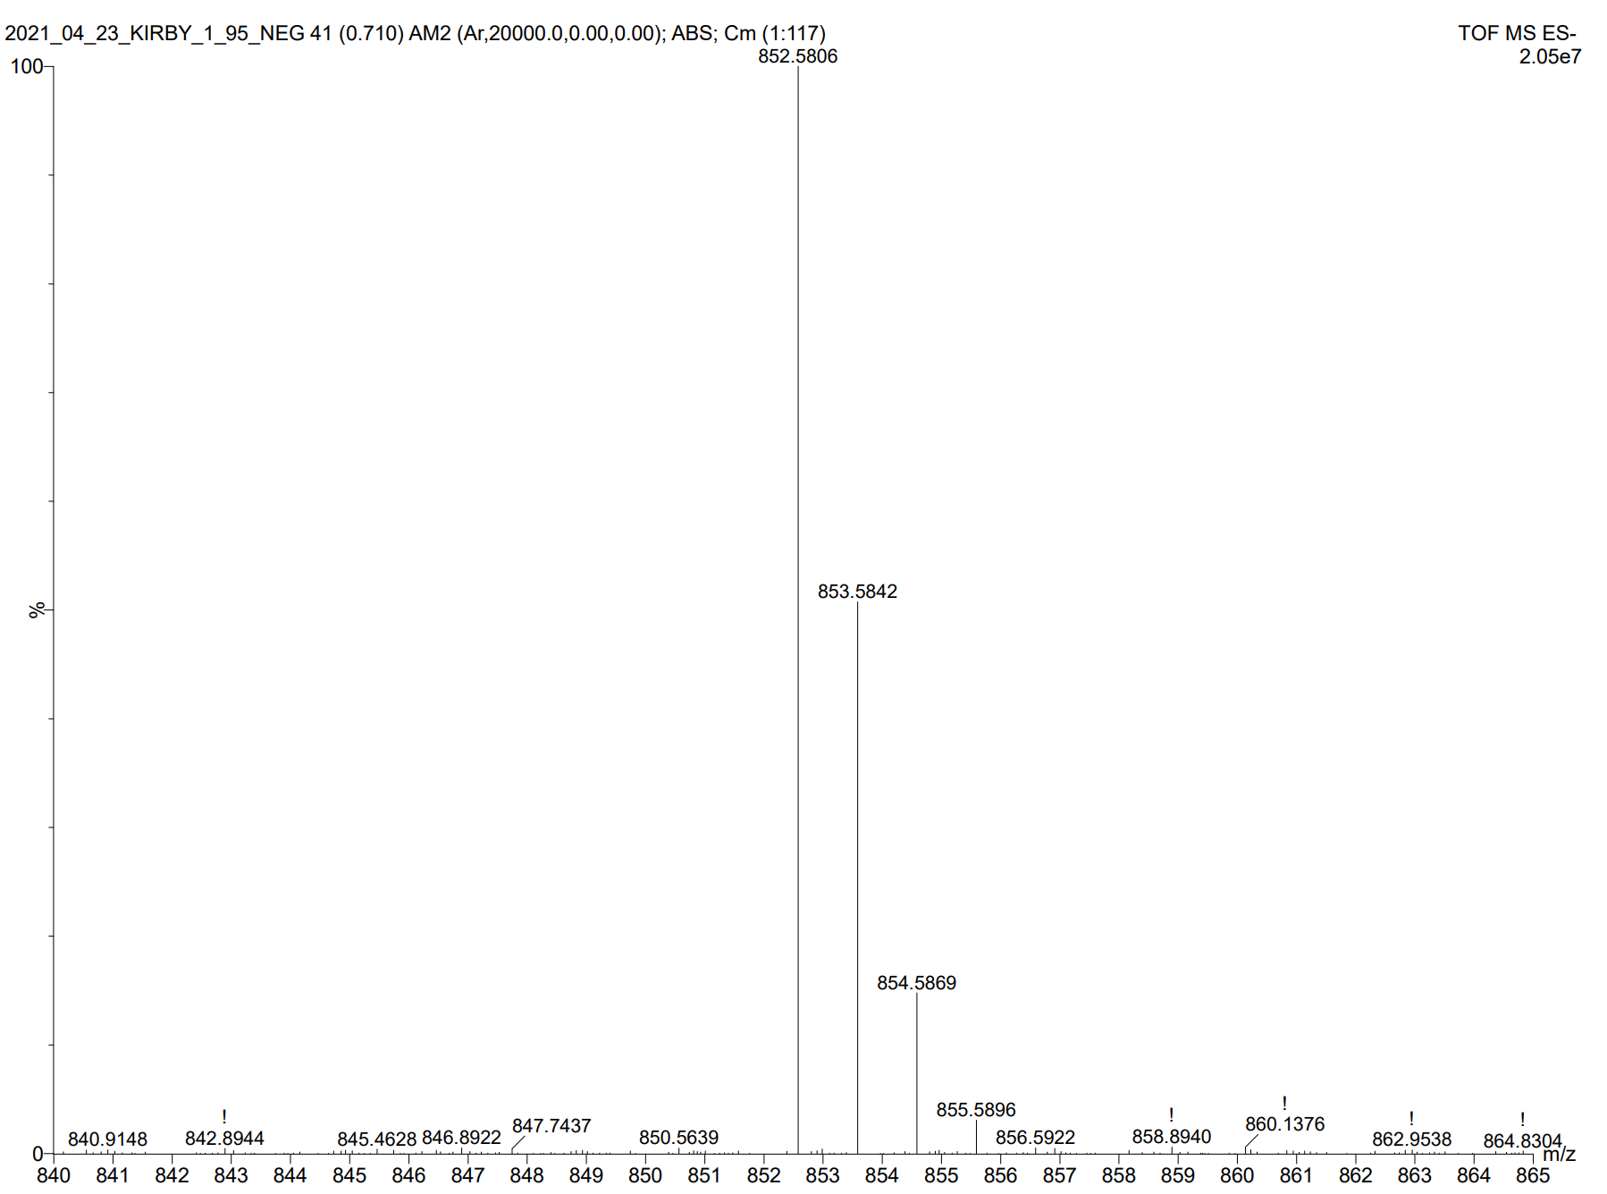
Spectrum 15: Mass Spectrum (Waters Synapt G2-Si mass spectrometer) Compound PRL1 [M-1] predicted: 852.5755 [M-1] found: 852.5806
Spectrum 16: ¹H NMR (500 MHz, CDCl₃) Compound PRL2
Spectrum 17: ³¹P NMR (202 MHz) Compound PRL2
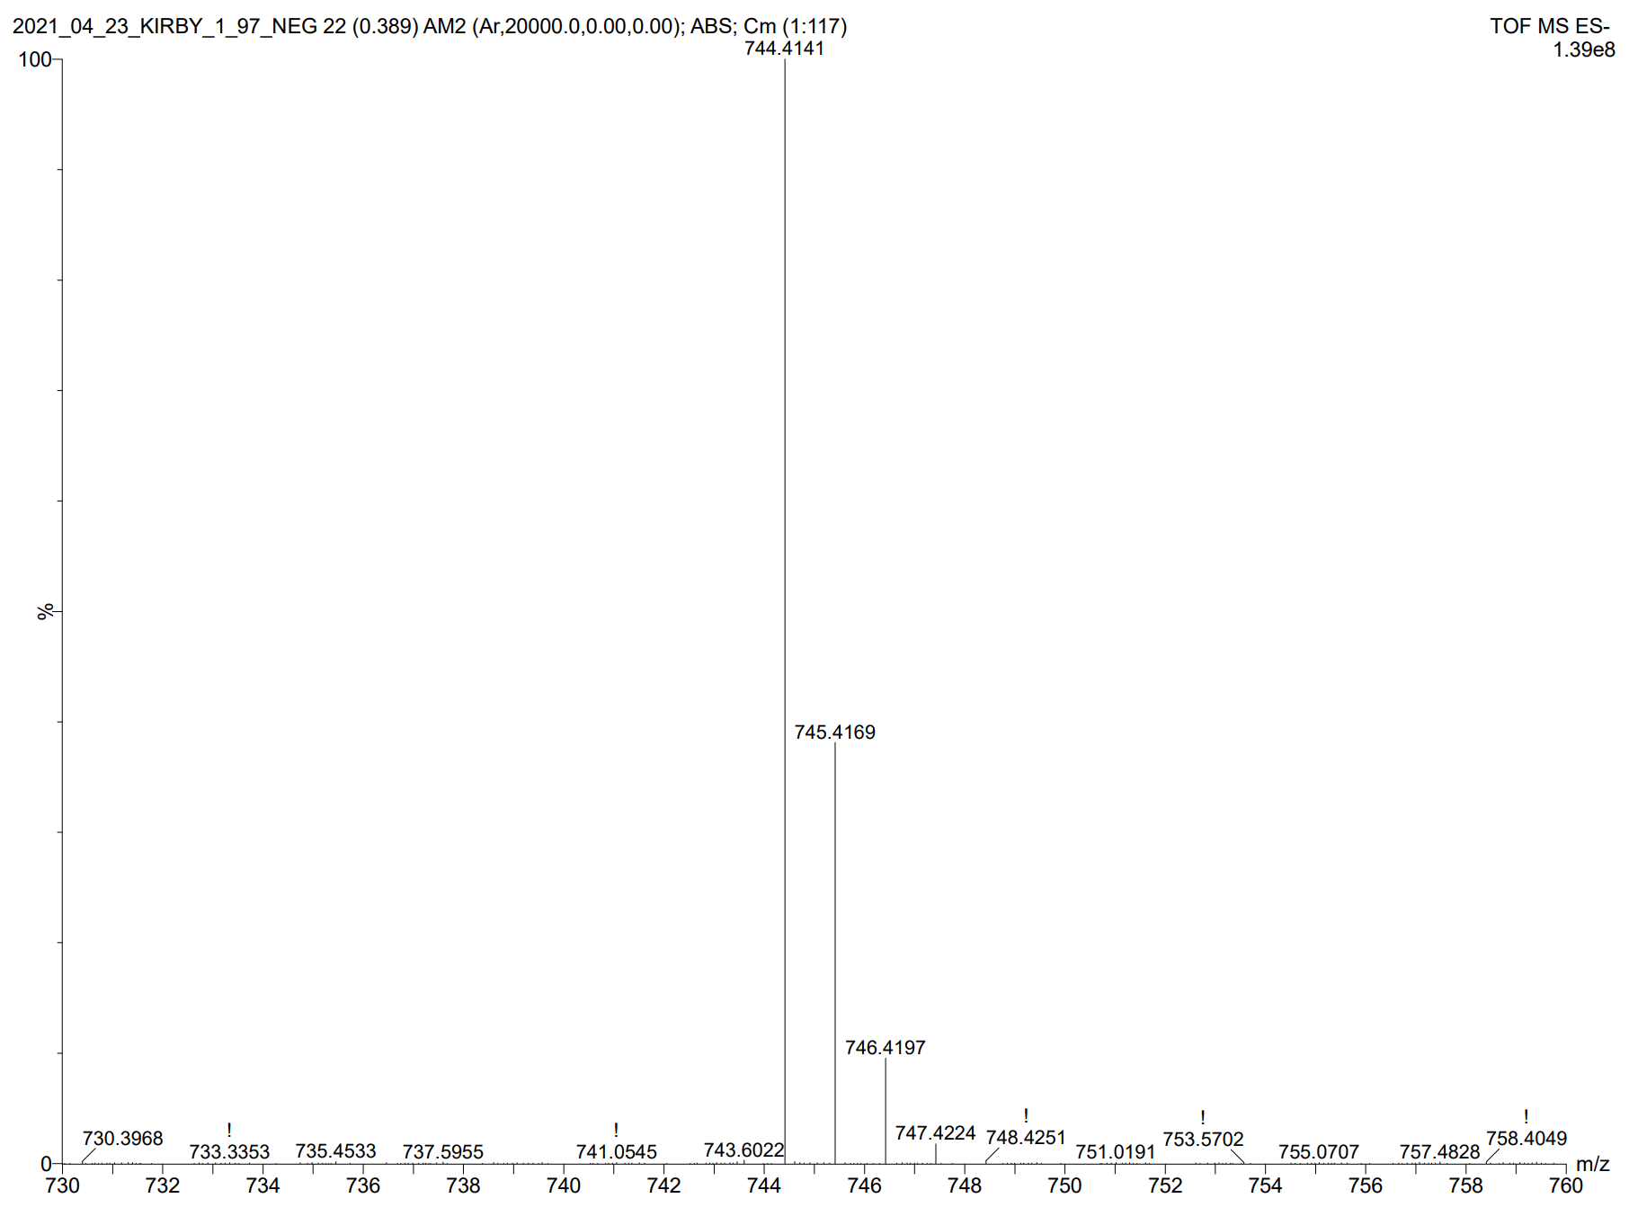
Spectrum 18: Mass Spectrum (Waters Synapt G2-Si mass spectrometer) Compound PRL2 [M-1] predicted: 744.409 [M-1] found: 744.414
Spectrum 19: ¹H NMR (500 MHz, CDCl₃) Compound PRL3.1
Spectrum 20: ¹H NMR (500 MHz, CDCl₃) Compound PRL3.2
Spectrum 21: ¹H NMR (500 MHz, CDCl₃) Compound PRL3.3
Spectrum 22: ¹H NMR (500 MHz, CDCl₃) Compound PRL3.4
Spectrum 23: ¹H NMR (500 MHz, CDCl₃) Compound PRL3.5
Spectrum 24: ¹H NMR (500 MHz, CDCl₃) Compound PRL3.6
Spectrum 25: ³¹P NMR (202 MHz) Compound PRL3.6
Spectrum 26: ¹H NMR (500 MHz, CDCl₃) Compound PRL3.7
Spectrum 27: ³¹P NMR (202 MHz) Compound PRL3.7
Spectrum 28: ¹H NMR (500 MHz, CDCl₃) Compound PRL3.8
Spectrum 29: ³¹P NMR (202 MHz) Compound PRL3.8
Spectrum 30: ¹H NMR (500 MHz, CDCl₃) Compound PRL3
Spectrum 31: ³¹P NMR (202 MHz) Compound PRL3
Spectrum 32: ¹H NMR (500 MHz, CDCl₃) Compound PRL4.1
Spectrum 33: ³¹P NMR (202 MHz) Compound PRL4.1
Spectrum 34: ¹H NMR (500 MHz, CDCl₃) Compound PRL4
Spectrum 35: ³¹P NMR (202 MHz) Compound PRL4
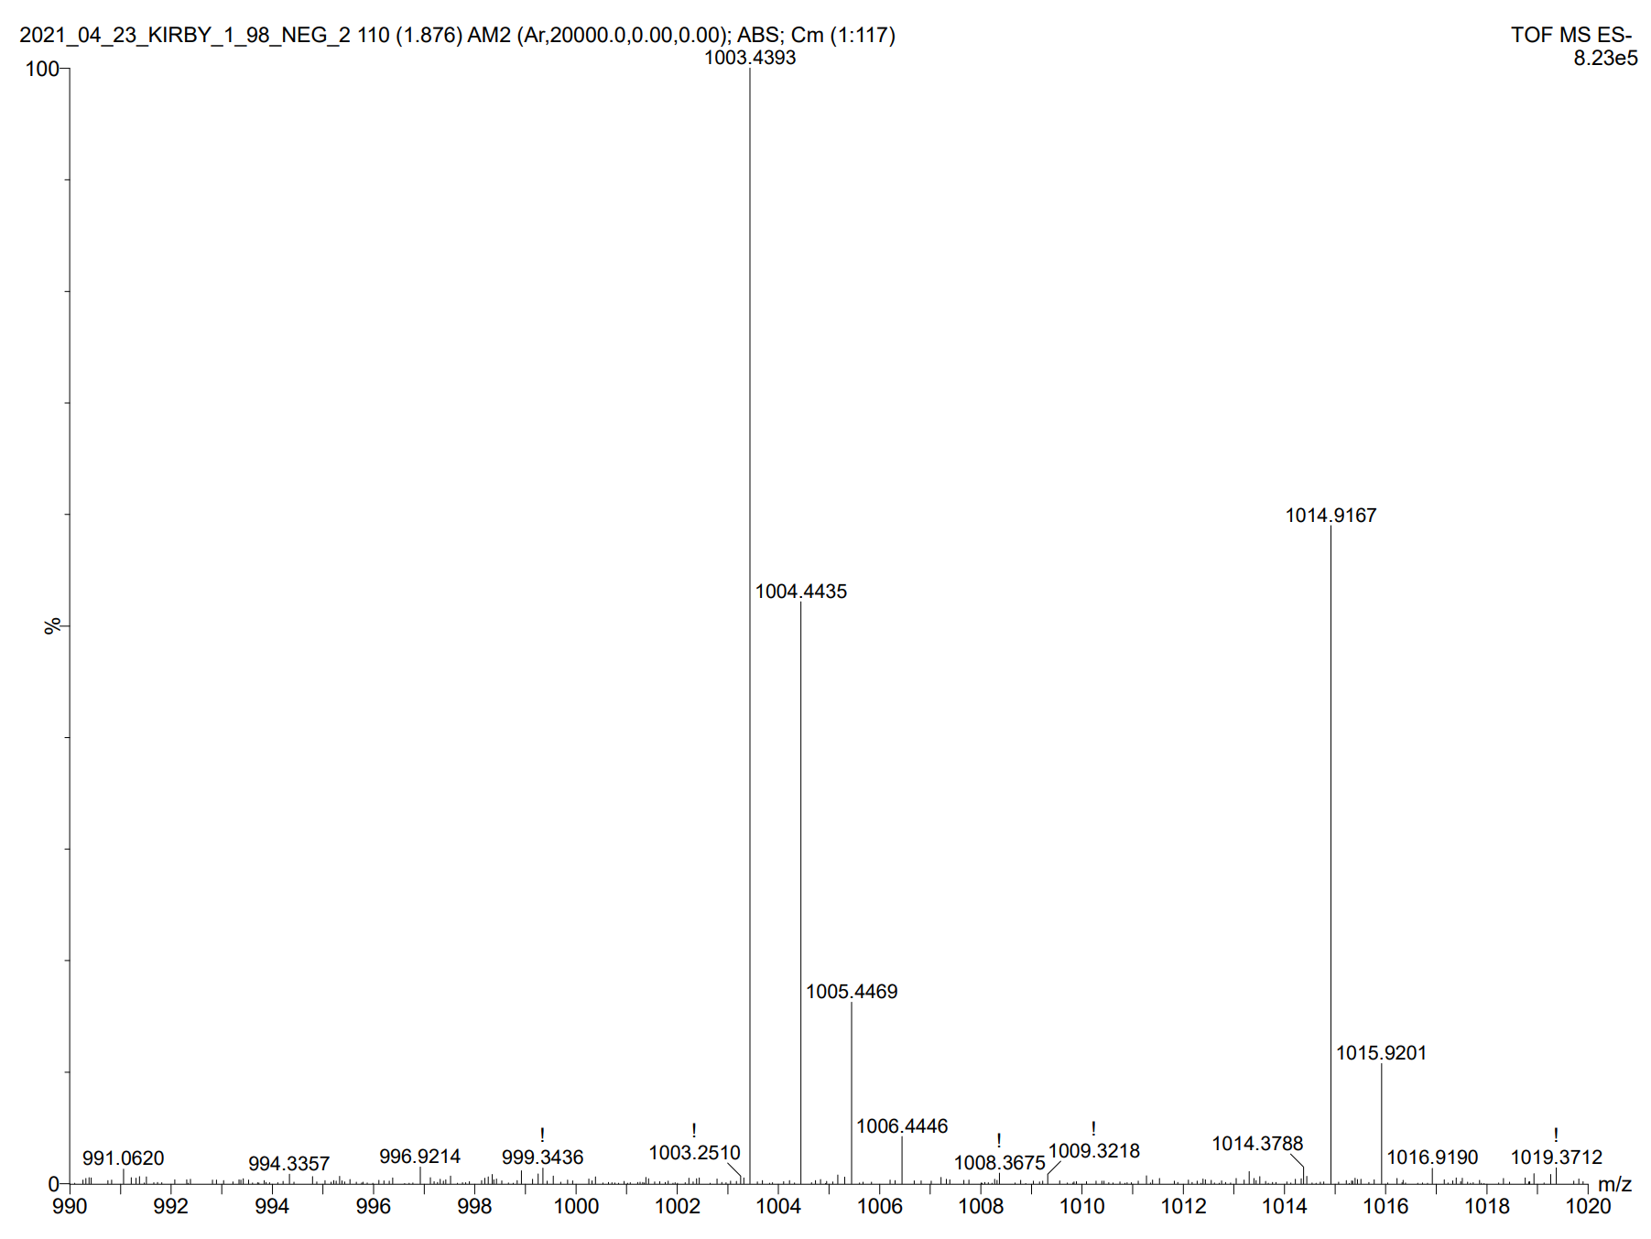
Spectrum 36: Mass Spectrum (Waters Synapt G2-Si mass spectrometer) Compound PRL4 [M-1] predicted: 1003.433 [M-1] found: 1003.439
Spectrum 37: ¹H NMR (500 MHz, CDCl₃) Compound PRL5.1
Spectrum 38: ¹H NMR (500 MHz, CDCl₃) Compound PRL5.2
Spectrum 39: ³¹P NMR (202 MHz) Compound PRL5.2
Spectrum 40: ¹H NMR (500 MHz, CDCl₃) Compound PRL5.3
Spectrum 41: ³¹P NMR (202 MHz) Compound PRL5.3
Spectrum 42: ¹H NMR (500 MHz, CDCl₃) Compound PRL5.4
Spectrum 43: ³¹P NMR (202 MHz) Compound PRL5.4
Spectrum 44: ¹H NMR (500 MHz, CDCl₃) Compound PRL6.1
Spectrum 45: ³¹P NMR (202 MHz) Compound PRL6.1
Spectrum 46: ¹H NMR (500 MHz, CDCl₃) Compound PRL7.1
Spectrum 47: ³¹P NMR (202 MHz) Compound PRL7.1
Spectrum 48: ¹H NMR (500 MHz, CDCl₃) Compound PRL5
Spectrum 49: ³¹P NMR (202 MHz) Compound PRL5
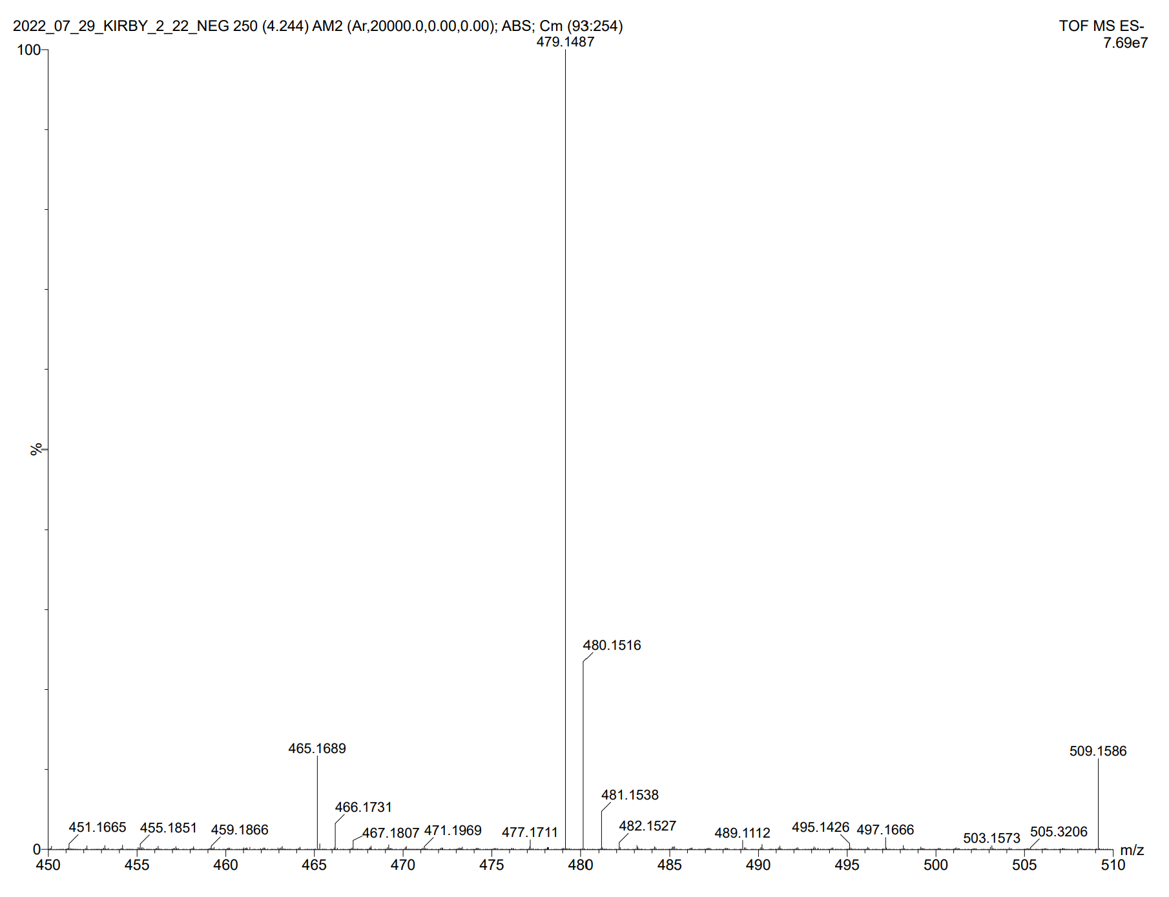
Spectrum 50: Mass Spectrum (Waters Synapt G2-Si mass spectrometer) Compound PRL5 [M-1] predicted: 479.147 [M-1] found: 479.149
Spectrum 51: ¹H NMR (500 MHz, CDCl₃) Compound PRL6
Spectrum 52: ³¹P NMR (202 MHz) Compound PRL6
Spectrum 53: ¹H NMR (500 MHz, CDCl₃) Compound PRL7
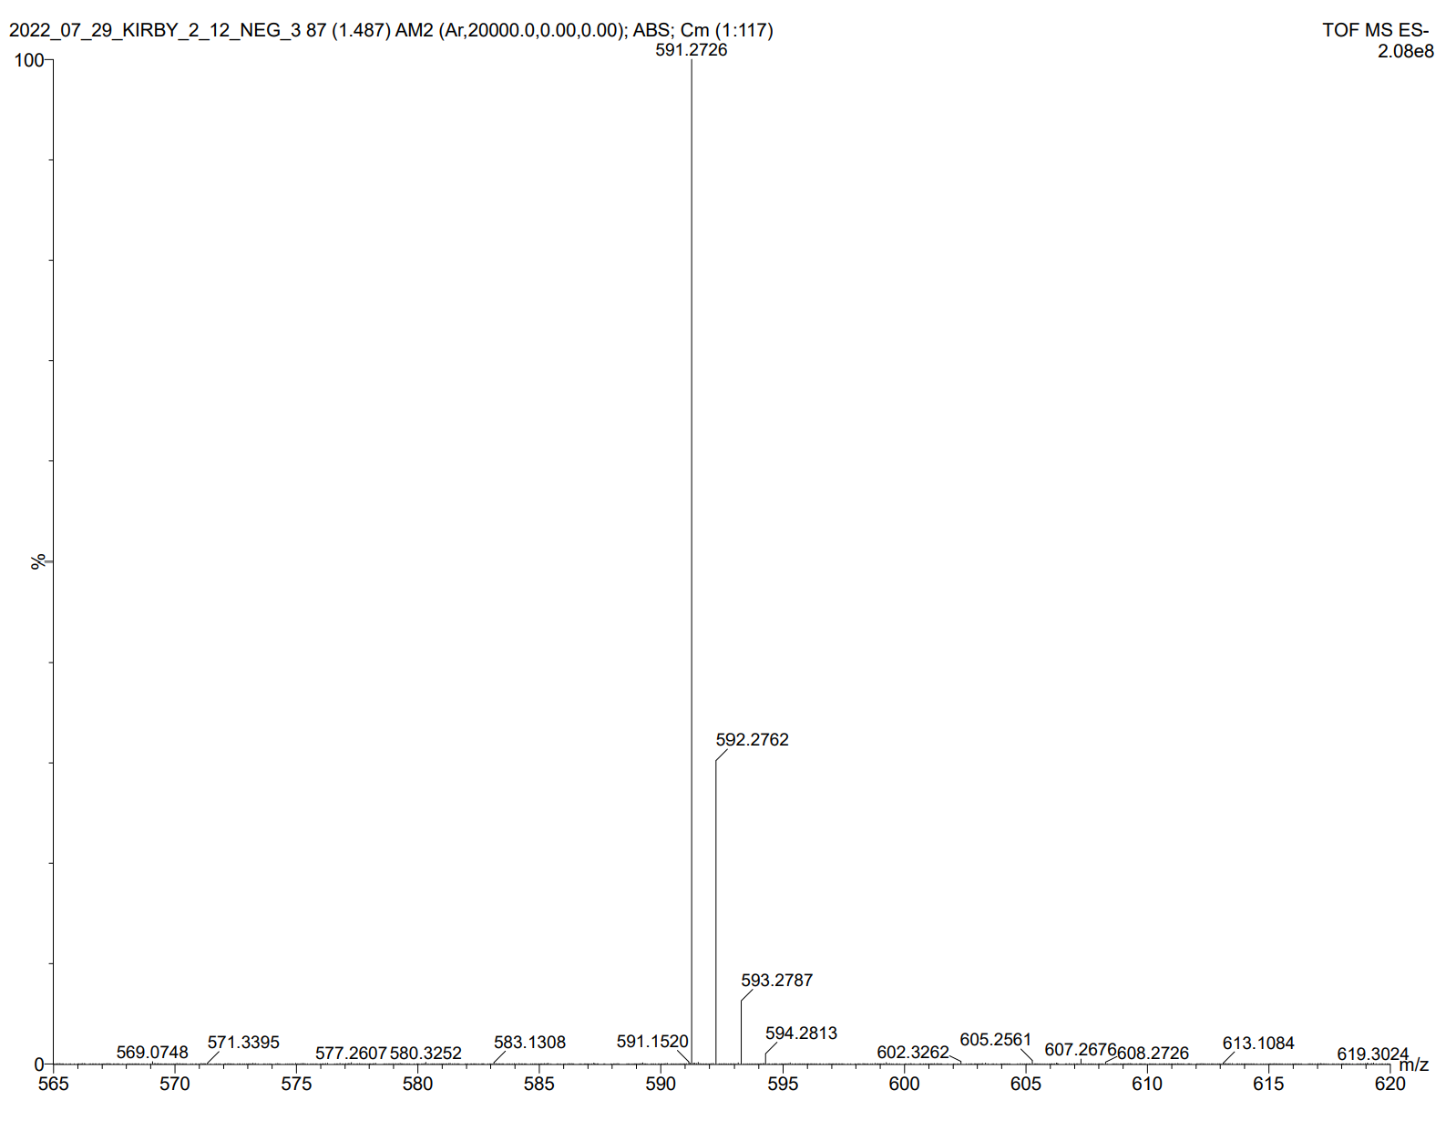
Spectrum 54: Mass Spectrum (Waters Synapt G2-Si mass spectrometer) Compound PRL7 [M-1] predicted: 591.272 [M-1] found: 591.272

VITA

Justin Kirby was born in Spartanburg, South Carolina. His high school AP Chemistry, Dr. Richardson, encouraged him to pursue chemistry and he has never looked back. He attended Wofford College and received a B.S. in Chemistry with a minor in Philosophy. He worked for Pacific Industrial Development Corporation for a year following graduation, operating as a Quality Control Technician ensuring material leaving the facility was in line with industry standards. He then attended the University of Tennessee, Knoxville as a graduate student in Dr. Best’s lab where he contributed to the synthesis of phosphorous-based self-immolative stimuli-responsive lipid analogs.

