To the Graduate Council:

I am submitting herewith a dissertation written by Taejun (David) Lee entitled “The Role of Financial Services Advertising in Investors’ Economic Decision-Making.” I have examined the final electronic copy of this dissertation for form and content and recommend that it be accepted in partial fulfillment of the requirement for the degree of Doctor of Philosophy, with a major in Communication and Information.

Eric Haley
Major Professor

We have read this dissertation
and recommend its acceptance:

Ronald E. Taylor

Roxanne Hovland

Michael Olson

Accepted for the Council:

Carolyn R. Hodges
Vice Provost and Dean of the Graduate School

(Original signatures are on file with official student records.)

The Role of Financial Services Advertising in Investors’ Economic Decision-Making

A Dissertation
Presented for the
Doctor of Philosophy
Degree
The University of Tennessee, Knoxville

Taejun (David) Lee
May 2011
Copyright © 2011 by Taejun (David) Lee
All rights reserved.
Dedication
I dedicate this dissertation to my family who has shared the moments of joy and sorrow and given me invaluable opportunities for knowledge and education. This work could not have been completed without their sacrifice, support, love and pray. They instilled in me a lifelong love of adventure and always encouraged my pursuits.

Acknowledgements
I thank the Lord, my heavenly father who always guides, leads, protects, empowers, and loves me from the beginning to the end.
Now, I have chosen to take this opportunity to express my gratitude to several eminent people who have impacted my dissertation tremendously. Without their wisdom, assistance, and contribution on my intellectual journey, I could not complete this work.
In the course of this research, I would particularly like to thank Dr Eric Haley for his rigorous guidance as the major advisor. His patience, insightful guidance, and constant support during the last two years have upgraded my scholarship as well as this research. Additionally, I would like to acknowledge Dr. Ronald E. Taylor, veritable pillar of the University of Tennessee School of Advertising and Public Relations community. His wisdom for the advertising discipline is in valuable: may you continue to make as profound a difference in the lives of future Advertising and Public Relations students as you have mine. Dr Roxanne Hovland and Dr Michael Olson should be acknowledged for their thoughtful comments and precious time in this research as the committee members.
Also, I would like to thank my research mentors and colleagues who have shared great ideas and sophisticated techniques with me for this research: Dr. Yongjun Sung, Dr. Taiwoong Yun, and Dr Wonjun Chung. Their priceless advice and proactive research motivation were essential to the completion of this research. Here, I also have to appreciate my old mentors, who guided me to the world of advertising since my undergraduate days and paved the way for education at University of Tennessee, Knoxville. They are Dr. DeRyong Lyi and Jang-Sun Hwang in the Department of Advertising and Public Relations of Chung-Ang University at Seoul, Korea, which is the best advertising and public relations program in the nation.
My special thank goes for my family, especially my wife and my son. Apart from Jesus Christ, they are my constant source of joy and sanity. They are always a treasure to behold and be with; my career as a doctoral student was made successful because of their devoted sacrifice and unswerving support these past three years. Especially, I could overcome all of my pains and sorrows thanks to the presence of my busy and happy boy, Joshua Jihwan while at studying. Finally, the dear friends, I had the joy to know and work alongside while a graduate students, I hold the utmost for you as colleagues; your professionalism and demeanor is insuperable.
Abstract
The present study assesses the effect of financial services advertising (FSA) in investors’ decision-making by adopting a two-sided approach: a stimulus-side analysis to document the nature and prevalence of FSA strategies and disclosures and a response-side investigation to examine the investors’ processing of and receptiveness to FSA. By performing a content analysis of recently published magazine advertisements, this study provides a contemporary look at whether and how financial institutions inform, persuade, and communicate with average investors. Results from this content analysis are used as a foundation to help design realistic test ads in the subsequent experimental design. Combined with stimulus-side data, a between-group experimental design examines how the interaction between different FSA practices and investor’s regulatory focus might affect the ways investors perceive and evaluate the advertised financial product. Thus, in order to adequately evaluate the range of investor’s response to FSA strategies and disclosures, this study employs a two advertising strategies (informational versus transformational) x two disclosure conditions (complete disclosure versus non-disclosure) x two individual regulatory orientations (promotion-focused versus prevention-focused) between-subject, randomized, experimental design. This study forms the basis of the response-side approach to complement the content analysis phase. Results from the content analysis show that financial institutions increased informational strategies and presented more financial disclosures during the three-year (2007-2009) period of interest. Findings demonstrate that FSA might play a role in enhancing the role of communication and information in the marketplace for financial literacy and consumer welfare. And, findings from the experimental design show that regulatory focus was found to be function as a moderating variable that may influence the direction and strength of relationship between different FSA practices and the outcome variables of financial decision-making such as risk perceptions, product attitudes, and purchase intentions. This in turn implies that investors’ economic decision-making might be affected by regulatory focus (i.e., internal characteristics) as well as FSA strategies and disclosures (i.e., external information). Finally, theoretical, managerial, and policy implications are discussed and opportunities for the future research are identified.

Table of Contents
CHAPTER 1: INTRODUCTION 1
Research Problem 1
Changes in Financial Services Industry 1
Financial Services Industry and the Economy 3
The Purpose of Study 5
The Organization of Dissertation 8
CHAPTER 2: LITERATURE REVIEW 10
The Transformation of Financial Services Marketplace 10
The Advent of Financial Services Marketing 13
The Key Players of Financial Services Industry 15
Banking 15
Lending and Credit 16
Saving and Investing 17
Insurance 19
The Environmental Determinants of Financial Services Advertising 21
Political and Legal Conditions 21
Economic Conditions 24
Socio-Demographic Conditions 26
Technological Conditions 28
Challenges Facing Financial Services Advertising 29
The Complexity of Financial Products and Services 29
The Diversity of Financial Offerings 30
Baby Boom Generation and the Rapid Increase in Life Expectancy 32
Chaniges in Income 33
Chaniges in Pension Arrangements and Retirement Plans 34
Chaniges in Capital Markets 36
Theoretical Framework 36
The Institutional Role of Financial Services Advertising in the Marketplace 36
Financial Services Advertising as Consumer Information 38
External Information for Financial Decision-Making: Advertising Strategies and
Advertising Disclosures 40
Financial Services Advertising Strategy 40
Advertising Strategies and Persuasion 44
Financial Services Advertising Disclosure 53
Advertising Disclosure and Information Processing 58
Internal Characteristics: Individual Regulatory Orientations 62
Regulaotry Focus Theory 62
Regulaotry Fit Theory 64
Cognitive Mechanism that Underlies Regulaotry Focus 66
Decision Fit Hypothesis and Regulatory Focus 71
The Influence of Regulaotry Focus in Financial Services Advertising 75
CHAPTER 3: THE STUDY 85
Research Objectives 85
Documenting and Selecting Ad Strategies and Ad Disclosures in Financial Services
Advertising (Study 1) 87
Content Analysis Method 87
The Context of Mutual Fund Advertising 88
Sample 88
Measure 89
Coding Procedure 90
Intercoder Reliability 90
Results and Discussion 92
The Role of Ad Strategies, Ad Disclosures, and Regulatory Focus in Consumers’ Financial
Decision-Making (Study 2) 94
Experimental Design 95
Stimuli 95
Pretest 97
Subjects 98
Data Collection 102
Sample Profile and Procedure 104
Measurements 105
Chronic Regulatory Focus 105
Manipulation Checks 106
Risk Perceptions of Financial Product 107
Attitudes toward Financial Product 107
Purchase Intentions of Financial Product 108
Analysis and Results 108
The Results of Hypotheses Tests 108
CHAPTER 4: DISCUSSION 123
The Overview of Key Findings 123
Theoretical Implications 125
Managerial Implications 129
Public Policy Implications 138
The Role of External Information in Financial Decision-Making 139
The Role of Internal Characteristics in Financial Decision-Making 145
The Role of Theory and Practice in Financial Literacy and Consumer Welfare 149
Limitations and Avenues for Future Research 153
LIST OF REFERENCES 163
APPENDICES 182
Appendix A. Ad Stimuli 183
Appendix B. Measurements 184
VITA 187

List of Tables

Table 1. The Information Processing and Decision Making Mechanism of Regulatory Focus 81
Table 2. The Operational Definitions of Ad Strategies in Mutual Fund Advertising 89
Table 3. The Operational Definitions of Ad Disclosures in Mutual Fund Advertising 89
Table 4. Intercoder Reliability 91
Table 5. The Incidence of Ad Strategies in Mutual Fund Advertising 92
Table 6. The Incidence of Ad Disclosures in Mutual Fund Advertising 93
Table 7. The Sample Profile of Study Participants 105
Table 8. Summary Statistics and Correlations among Study Variables 109
Table 9. Moderated Multiple Regressions Results 110

List of Figures

Figure 1. Regulatory Changes and U.S. Asset Growth in Retirement Plan 23
Figure 2. Regulatory Changes and U.S. Total Mutual Fund Asset 24
Figure 3. Economic Crisis and U.S. Total Mutual Fund Asset 25
Figure 4. U.S. Mutual Fund Asset of 2005–2010 31
Figure 5. U.S. Household Retirement Asset of 1980–2010 35
Figure 6. The Proposed Conceptual Framework: Financial Services Advertising, Regulatory Focus, and Financial Decision Making 187
Figure 8. Ad Strategy x Ad Disclosure Risk Perceptions 111
Figure 9. Ad Strategy x Ad Disclosure Attitude toward Financial Prodcut 112
Figure 10. Ad Strategy x Ad Disclosure Purchase Intention 113
Figure 11. Ad Strategy x Regulatory Focus Risk Perception 114
Figure 12. Ad Strategy x Regulatory Focus Attitude toward Financial Product 115
Figure 13. Ad Strategy x Regulatory Focus Purchase Intention 116
Figure 14. Ad Disclosure x Regulatory Focus Risk Perception 117
Figure 15. Ad Disclosure x Regulatory Focus Attitude toward Financial Product 117
Figure 16. Ad Disclosure x Regulatory Focus Purchase Intention 118
Figure 17. Ad Strategy x Ad Disclosure x Regulatory Focus Risk Perception 120
Figure 18. Ad Strategy x Ad Disclosure x Regulatory Focus Attitude toward Financial Product 121
Figure 19. Ad Strategy x Ad Disclosure x Regulatory Focus Purchase Intention 122
Figure 20. The Proposed Conceptual Framework: The Role of Financial Services Advertising in Consumer Financial Welfare 145
Figure 21. A Depiction of the Integrated Elements of Financial Services Advertising in Consumer Welfare 153

CHAPTER 1: INTRODUCTION
Research Problem
Changes in Financial Services Industry
Service organizations such as auto repair shops, fast food restaurants, hotels (motels), banks, and insurance companies constitute the primary business sector in the U.S. economy. Among such organizations, financial services organizations have been one of the fastest growing market sectors. As noted by Loonam and O’Loughlin (2008), the U.S. financial services industry has undergone significant change in the last three decades, and the forces of dynamic changes are even more aggressively challenging today’s financial services organizations.
First, deregulation has made competition border-less, allowing intrastate branching, which has encouraged consolidation (Popper & Murray, 1989). As a number of deregulatory changes began around the 1980s, the financial services industry in the U.S. has undergone a radical change over the last 30 years (Huhmann & Bhattacharyya, 2008). For instance, the Riefle Neal Interstate Banking and Branching Efficiency Act of 1994 (Pub. L. No. 103-328) created a greater competitive landscape by removing legal barriers to nation-wide interstate banking. The enactment of the Gramm-Leach-Bliley Act of 1999 (P. L. 106-102) that established the Federal Deposit Insurance Corporation (FDIC) was designed to introduce banking reforms and control speculation. Some provisions of the Act, such as Regulation Q, which allowed the Federal Reserve to regulate interest rates in savings accounts, were repealed by the Depository Institutions Deregulation and Monetary Control Act of 1980. Most recently, financial liberalization intensifies competition not only within baking institutions such as commercial banks, savings and loans, and credit unions but also with other non-banking financial firms such as securities and insurance companies. In addition, the entry of foreign financial services organizations into the U.S. market have resulted in the fierce competition in the financial marketplace. Rapidly changing electronic technology has also reshaped how consumers interact with their financial firms (Lami & Moyer, 1995).
With this backdrop, effective marketing strategies have become of great importance for various types of financial services organizations such as banks, finance companies, insurance companies, financial advisory firms, and brokerages (Albers-Miller & Straughan, 2000). It is not surprising, therefore, that these organizations have attracted considerable scholarly interest, generating a distinct body of knowledge related to their advertising and marketing strategies. Given the growth of the financial services industry in economies throughout the world, and the almost universal belief by scholars working in this area that financial services marketing is different in certain key aspects from goods marketing, the rapid growth of financial services literature in recent years is not surprising. However, despite the dramatic changes in the financial services environment that has occurred over the past decade, there is the need for researchers to think broadly about researchable issues with respect to marketing strategies and concepts that are contextualized in the areas of financial services (Rootman, Tait, & Bosch, 2008).
Especially, to date, the rationale for a special treatment of services marketing centers on the existence of a number of characteristics of financial services which are consistently cited in the literature: intangibility, inseparability of production and consumption, heterogeneity, and perishability (e.g., Zeithaml, Parasuraman, & Berry, 1985). These four distinctions pose challenging problems in financial services marketing (Kozup, Howlett & Pagano, 2008). Here, a critical question facing financial services organization and even regulators is how to fashion responsible and yet persuasive financial services advertising. Hence, the purpose of this study is to better understand how advertising strategies presented in financial services advertisements affect different types of consumers. Given that consumers have become more sensitive to the issue of financial well-being and the fact that financial services advertising has become a more common consumer information resource for financial management behavior (Bone, 2008; Warren, 2008), it is crucial to provide strategic guidance to what types of advertising practices are appropriate or even desirable for consumers’ financial decision making processes.
Financial Services Industry and the Economy
Today’s financial services organizations are increasingly engaging in advertising and marketing activities. In addition to financial reporting, financial services organizations now focus on relationship-building and -maintaining with various audiences such as current and potential investors, consumers, and shareholders (Laukkanen & Pasanen, 2008). To this end, advertising practice on what and how to communicate with average consumers is the most important aspect to policy makers, consumer educators, researchers, and financial companies (Albers-Miller & Straughan, 2000).
In Fall 2008 the U.S. economy currently faced one of the most tumultuous periods since the Great Depression. However, this downturn would last longer than the eight-month-long recession of 2001 (Warren, 2008). The headwinds facing the U.S. economy included the housing downturn, capital market turmoil, credit crunch, and rising energy/food prices. Especially, the self-inflicted wounds of extensions and abuse of credit in the housing and financial sectors were deeply related to the 2008 U.S. economy malaise, which was not evident in 2001 (Bone, 2008; Kozup & Hogarth, 2008).
In the U.S., the economic problems started with excesses and defaults in the subprime lending and housing markets. As the bubble burst, foreclosures mounted and housing activities ground to a halt. Throughout 2007, the carnage spread slowly, reaching from subprime borrowers and home builders to middle-class homeowners and the stores they frequent, like Home Depot. For instance, the percentage of mortgage borrowers behind on their payments − 6.35 percent − was the highest in 2008 since the MBA began tracking the number in 1979 (Mortgage Asset Research Institute, 2008). As a result, a variety of financial services organizations extricated themselves from the home-equity-line-of-credit business. In addition, the decline in home prices was followed by the subprime mortgage crisis, which also removed an important source of support for consumer spending. Americans who grew accustomed to borrowing against rising home equity to finance car purchases or vacations found themselves bereft (Vranica, 2009). American consumers were both tapped out financially and burned out psychologically. Economists seem to think that a change in housing prices has a 3.75 to 7 percent effect on consumer spending in either direction and the consumer-driven economy may not bounce back as rapidly as it did in the fraught months after 9/11.
In a very uncertain and complex environment where economic conditions remain difficult and principal problems unresolved, advertising activities of the U.S. financial services organizations would likely undergo a very challenging period of adjustment. For instance, a recent significant drop in financial services advertising spending reflects the macro movements in the overall economy. Certainly during a recession when financial services firms are failing, advertising for financial services organizations would likely undergo a period of revision. For example, a significant drop or increase in financial services advertising reflects the macro movements in the overall economy. One media research firm estimated that overall advertising spending on media such as TV, print and online display ads fell 14% to $30.18 billion in the first quarter of 2009 from a year earlier and spending by FSO’s fell 18% (Vranica, 2009). In addition, according to a Nielsen report (2008), advertising by credit card services companies — including Capital One, Discover, Synovus, Washington Mutual, and Visa — diminished significantly in the first three weeks of September 2008 as the ongoing economic turmoil in the U.S. reached a boiling point. Advertising spending by other sectors of the financial services industry also declined steadily. In July and August, spending by mortgage service companies was down by almost 54%, compared to the same period in 2007. Spending by loan companies dropped by almost 37% between July-August 2007 and July-August 2008.
How do advertising managers of financial services organizations react proactively − yet sensitively − to the noxious mix of fiscal aggravation, damaged normal operations, jeopardized image, and organizational culpability during an economic crisis? It seems that they are forced to agonize over the best way to communicate with and to handle their vulnerability and potential consequences of the crisis. Despite how solid their advertising practices may have been up until that point, they may need to reinvestigate their underlying strategies and tactics that are central to their advertising activity to better inform and persuade their consumers.
The Purpose of Study
Due to the recent economic crisis, assessing the effect of financial services advertising on consumers requires a two-sided approach: a stimulus-side analysis to document the nature of the ad strategies and ad disclosures being used and a response-side investigation to assess the consumer’s processing of and receptiveness to these advertising practices. First, in the present study, stimulus-side inquiries are associated with analyzing financial services magazine advertisements (Huhmann & Bhattacharyya, 2008). By performing a content analysis of recently published financial services magazine advertisements, this study attempts to examine the nature and use of ad strategies and ad disclosures presented in financial services advertising. Systematic analyses of the content of advertising practices employed by financial services organizations can be especially useful in both understanding consumer behavior and informing public policy research by uncovering the meanings associated with different types of financial products (Albers-Miller & Straughan, 2000; Jones & Smythe, 2003). Next, response-side research is performed to explore the effect of consumers’ characteristics (i.e., regulatory focus) on financial decision-making in different financial services advertising contexts identified from the content analysis. In this study, a quasi-experiment incorporates the usage of the ad strategies (informational versus transformational strategies), ad disclosures (full disclosure versus non-disclosure) based on individual regulatory orientations (i.e., promotion-focused vs. prevention-focused).
This research contributes to the extant literature on the influence of FSA by pairing a stimulus-side inquiry that documents how ad strategies and ad disclosures are presented within a financial services ad with a response-side assessment of whether regulatory focus and exposure to ad strategies and ad disclosures in that ad influence the processing of the FSA and consumers’ economic decision-making. The inquiry focuses on the nature and impact of advertising within a financial services marketing. This focus is important for two key reasons. First, not only is FSA ubiquitous in average consumers’ ordinary situations (Koehler & Mercer, 2009); it is also complex and leads to cognitive overload to consumers (Lee & Cho, 2005). Identifying the ways in which ad strategies and ad disclosures are presented can help illuminate the likely mechanisms through which they affect the consumer in the financial marketplace. Second, as evidenced by the long line of previous research on the topic (e.g., Huhmann & Bhattacharyya, 2005; Jones & Smythe, 2003; Jordan & Kaas, 2002; Philpot & Johnson, 2007), policy makers are concerned about the societal impact of FSA on consumer’s economic decision-making (Diacon & Hasseldine, 2007; Estelami, 2009). For example, according to Investment Company Institute (2010), average investors are susceptible to the influences of financial services advertising and promotion, as they use them as a tool to understand financial offerings that are relevant to their economic situations. As recently expressed by the Dodd-Frank Wall Street Reform and Consumer Protection Act, new efforts should be undertaken to better monitor and regulate the ad strategies and ad disclosures in financial services marketing contexts, especially those likely to be processed by consumers (Pub.L. 111-203, H.R. 4173).
In addition, certain obligations mandate that financial companies provide consumers with ad information. However, research indicates that consumers often fail to notice such information (Diacon & Hasseldine, 2003; Philpot & Johnson, 2007). In light of managerial standpoints, financial companies conveying ad information for many reasons, one of which is altruistic (i.e., to inform consumers and help generate a safe, credible consumer response toward a financial product). Therefore, for financial companies, it is worth investigating what constitutes effective advertising practices in FSA and what impact this has on consumer response towards the advertised brand and company (Huhmann & Bhattacharyya, 2005; Koehler & Mercer, 2009). However, little has examined the impact of ad strategies and ad disclosures effectiveness in FSA contexts. In this sense, financial companies are unaware of how ad strategies and ad disclosures in an ad affects consumer responses to the brand and company.
In view of these concerns, the purpose of the dissertation is to address the following research questions: (i) What was the nature and prevalence of ad strategies and ad disclosures in financial services advertising? (ii) How do advertisers communicate their promotional messages and provide advertising information in financial services advertising? (iii) What effect will different ad strategies and ad disclosures (identified from the content analysis) have on consumers’ evaluations and purchase intentions of financial services? (iv) What is the role of individual characteristics (i.e., regulatory focus) in consumers’ evaluations and purchase intentions? and (v) What effect does congruence (or fit) between financial services advertising practices (i.e., advertising strategies and advertising disclosures) and individual regulatory orientation have on actual consumer’s financial decision-making?
- The findings aim to achieve three things. First, they provide researchers, policy makers, and financial services advertisers with broader insights into financial services organizations’ strategic responses to the recent economic crisis. Second, they aid practitioners in deciding which advertising practices to employ in terms of audience segmentation for effective and persuasive financial services marketing. Finally, the implications of regulators and consumer educators are discussed and opportunities for the future research of consumer financial welfare are identified.
The Organization of Dissertation
The dissertation is organized as follows. The next chapter presents a brief introduction to the historical and theoretical background to the U.S. financial marketplace. In doing so, the chapter focuses on the emergence of financial services advertising in the marketplace. Then, existing literature on the critical environmental factors (i.e., political/legal, economic, societal, and technological factors) and the key players in the financial marketplace (i.e., bank, credit card, insurance, and investment) is reviewed; this entails the theoretical and practical characteristics and challenges (i.e., intangibility, inseparability, perishability, and heterogeneity) with respect to financial services advertising. It also offers an overview of the advertising practices used by financial services organizations to inform and persuade target consumers.
This chapter also provides theoretical frameworks for the stimulus-side and response-side of this dissertation. This research builds on and extend prior research to demonstrate the role of advertising in the financial marketplace from the perspectives of external market information and consumer protection. In this chapter, there is an extensive literature on ad strategies, ad disclosures in terms of external consumer information and regulatory focus in light of internal characteristics that would likely affect consumer’s economic decision in financial services advertising contexts. Based on the review of literature, this chapter develops the research questions and the rationale for exploring them, articulates a conceptual model, and formally presents several hypotheses.
The third chapter provides the findings of content analysis for the stimulus-side and experimental design for the response-side to test proposed research questions. Specifically, the purpose is to assess the nature and impact of different ad strategies (i.e., informational vs. transformational) and ad disclosures (i.e., an ad with disclosure vs. an ad without disclosure) employed by financial services organizations depending upon consumer investors’ regulatory focus (promotion-focused vs. prevention-focused). The research pairs a stimulus-side approach documenting the nature and dominant usage of financial services ad strategies and ad disclosures in the national print magazine advertisements with a response-side experiment of the role of ad strategies, ad disclosures, and regulatory focus on actual (potential) consumers’ financial decision-making. A stimulus-side approach simply provides a description of advertising practices used by financial services organizations. Combined with response-side data, however, the two-sided approach allows an empirical test of how individual regulatory orientations affect consumers’ financial decision-making in the context of financial services advertising. Therefore, regulatory focus theory and regulatory fit theory serve as a theoretical basis for the response-side approach to complement the content analysis phase. Regulatory focus theory offers theoretical perspectives of the role of distinct individual regulatory orientations on consumers’ responses to financial services advertising, and regulatory fit theory leads to further accounts of the importance regarding the congruence between ad strategies, ad disclosure, and regulatory focus for the effectiveness of financial services advertising. In this chapter, a moderated multiple regressions analysis is employed to test the research hypotheses developed in the previous chapter, thereby presenting the empirical findings and a brief discussion of them.
The final chapter expands upon the previous discussions of the findings and stresses compelling findings concerned the effect of ad strategy, ad disclosure, and regulatory focus in consumer economic decision-making in financial services advertising contexts. These findings have theoretical, managerial, and public policy implications. And, the limitations of the study are discussed, with a final section devoted to exploring future research directions.
Research Problem
Changes in Financial Services Industry
Service organizations such as auto repair shops, fast food restaurants, hotels (motels), banks, and insurance companies constitute the primary business sector in the U.S. economy. Among such organizations, financial services organizations have been one of the fastest growing market sectors. As noted by Loonam and O’Loughlin (2008), the U.S. financial services industry has undergone significant change in the last three decades, and the forces of dynamic changes are even more aggressively challenging today’s financial services organizations.
First, deregulation has made competition border-less, allowing intrastate branching, which has encouraged consolidation (Popper & Murray, 1989). As a number of deregulatory changes began around the 1980s, the financial services industry in the U.S. has undergone a radical change over the last 30 years (Huhmann & Bhattacharyya, 2008). For instance, the Riefle Neal Interstate Banking and Branching Efficiency Act of 1994 (Pub. L. No. 103-328) created a greater competitive landscape by removing legal barriers to nation-wide interstate banking. The enactment of the Gramm-Leach-Bliley Act of 1999 (P. L. 106-102) that established the Federal Deposit Insurance Corporation (FDIC) was designed to introduce banking reforms and control speculation. Some provisions of the Act, such as Regulation Q, which allowed the Federal Reserve to regulate interest rates in savings accounts, were repealed by the Depository Institutions Deregulation and Monetary Control Act of 1980. Most recently, financial liberalization intensifies competition not only within baking institutions such as commercial

CHAPTER 2: LITERATURE REVIEW
The Transformation of Financial Services Marketplace
Financial services have recently received more attention academically. This is not surprising given that international trade in financial services has reached unprecedented levels (Walia & Kiran, 2009). Financial services are the fastest growing part of international trade and services, in total, account for the increasing share of gross domestic product for all but the lowest income countries (Anderson, Zhan & Scott, 2004). However, as financial services in general have enjoyed growth markets, the financial services market has been characterized as more competitive (Stevenson & Plath, 2006) and financial service marketers have had to take a harsh look at their industry (Soureli, Lewis & Karantinou, 2008).
A great deal has been written about improving the strategic position of financial services through the use of bank marketing (Srivasta & Srinivasan, 2008). Over the past 20 years, the use of marketing by banks and financial institutions has received both praise and criticism. Since the 1980s financial institutions around the world have faced new challenges, including increased competition, recessions, image problems, etc. these problems have not faded away, and in fact, have often intensified. Specifically, financial services are often considered to be “second-rate” by customers (Mahesh & Rajeev, 2009). Ravi and Sagar (2006) reported that banks suffer from image and identity problems, have failed to keep consumers satisfied and face ever increasing competition in markets with little growth in demand.
As discussed earlier, in the mid-1990s, changes in laws governing financial services have resulted in greater competition among various types of financial firms (Fox, Bartholomae & Lee, 2005). Given this increased competition, financial services organizations need to focus on understanding the consumer’s decision processes for purchasing financial services in order to better meet the needs of their potential customers as well as to maintain a competitive position within the industry. Understanding the consumer decision process for financial services will help firms better identify the needs of their potential customers.
The financial services industry in the U.S. has undergone what can only be called a ‘transformation’ over the last 25 years or so. During the Depression, as a result of legislation commonly known as Glass-Steagall (technically the Banking Act of 1933), the financial services industry was segmented (e.g., the separation of investment banking from commercial baking) and banking especially was protected from competition. Competition was discouraged via geographic restrictions (e.g., banks could not expand over state borders; in some states – known as unit banking states – a bank could have only one branch), product restrictions (banks were limited to a restricted product set), entry restrictions (it was very difficult to start a new bank), and interest rate ceilings (Regulation Q of Glass-Steagall allowed no interest on checking accounts and limits (just over 5 percent) on interest on deposits). These regulations, designed to provide a stable banking system, led to the reputation of bankers as ‘in by 10, on the golf course by 3’. There was little effort expended on attracting customers because, with limited choice, customers came to the bank anyway.
A number of deregulatory changes beginning around 1980 have, however, resulted in a highly competitive and profoundly volatile industry. Legislation such as the Depository Institutions Deregulation and Monetary Control Act (1980) and the Depository Institutions Act (1982, also known as Garn-St. Germaine) eliminated interest rate ceilings (Regulation Q) and allowed banks to expand their product offerings (e.g., interest checking accounts and money market accounts). Opinions by federal regulators and the courts further expanded product offerings (e.g., some insurance and corporate underwriting) in the 1980s. In 1994, the Riefle Neal Interstate Banking and Branching Efficiency Act opened the way for geographic (even nationwide) expansion, and finally in 1999 the Gramm-Leach-Bliley Financial Modernization Act removed virtually all restrictions on banking organizations combining or offering any financial product and service.
All of these changes have created a highly competitive financial services landscape, where banks, finance companies, insurance companies, financial advisory firms, and brokerages all aggressively compete for business. In this more competitive world, banks of all sizes have been combining with other banks and nonblank financial institutions in an effort to provide the sable and product offerings necessary to succeed.
The Advent of Financial Services Advertising
In the 1980s, marketing, and in many cases advertising, was often viewed as a cure for all these woes. Banks that had previously eschewed advertising embraced it in the hope of overcoming the increasing difficulties. Financial institutions began concentrating more resources on marketing (Gounaris & Kortas, 2008). Unfortunately, most banks approached marketing with a traditional marketing mix approach and were less than pleased with the results (Loonam & O’Loughlin, 2008). Albers-Miller and Straughan (2000) found that ads for banks create a sterile image and reinforce similar attributes and concepts of financial products.
The value of marketing as a tool for financial services was attacked and supported in turn. Some banks have shunned advertising, thinking it is poorly received by consumers. However, scholars and financial services marketers have recommended aggressive promotion of financial services to impart information externally to average investors (Laukkanen & Pasanen, 2008). Corporate communication and advertising have been defended as important ways to help reduce consumers’ perceived risk and trade off of financial offering (Koehler & Mercer, 2009; Loke, 2008).
The perceived failure of marketing efforts is not necessarily an indication of the failure of advertising per se, but more than likely a failure to properly communicate (Papaioannou, 2009). Banks have used the wrong type of advertising or bad advertising (Albers-Miller & Straughan, 2000). In fact, research has indicated that how advertising is used by financial service providers is an issue. Koehler and Mercer (2009) reported that the right advertising decisions must be made to avoid costly mistakes.
Unfortunately, the advertising of financial services is an understudied area. Much of the bank marketing literature has concentrated on marketing theory more than advertising practice. On the other hand, research on advertising practice rarely looks at services at all, only very rarely at financial services advertising. Perhaps in response to outcries that financial services advertisements were poorly received by consumers, Zinkhan and Zinkhan (1985) did examine consumer responses to financial service. Since the publication of that study, little else has been written examining financial services advertising and no study has focused specifically on financial services advertising to financial customers. Since effective marketing communications should add values in the eye of the consumer, it is particularly important to understand financial services advertising in the context of financial decision-making.
Strategy scholars have examined financial services from a number of viewpoints. There is a wealth of literature examining the variables associated with customer loyalty, customer retention, satisfaction, corporate identity, corporate image, corporate personality and perceptions of quality. Other researchers have examined the relationships between these constructs. For example, Sirgy and Samli (1989) found a direct positive relationship between image and loyalty. Additionally, corporate identity is related to corporate personality and the values of the organization’s personnel (Hatch & Schultz, 1997). Although many of these studies have examined banking and financial services from different angles, many have agreed that marketers must understand the needs of the consumers, must create programs that stress benefits that are salient to the audience, and must meet consumer expectations (Lymperopolous & Chaniotakis, 2008).
The Key Players of Financial Services Industry
As already discussed, the recent U.S. financial services marketplace is far more complex than it has been historically, with large, diversified financial groups spanning many of core product domains such as banking, savings and loans, insurance, and investment. Nonetheless, many companies can be found that are specialists with a narrow product focus.
Banking
The current account represents the primary means by which salaried employees receive payroll credits from their employers and manage payments and cash withdrawals. The extent of current account penetration typically reflects the proportion of the population paid by salary. Thus, in the U.S. some 95 percent of the population have bank accounts (Estelami, 2009). Current account supply has broadened ever further in recent years as a consequence of factors such as technological development and the arrival of the new entrants (Coughlin & D’Ambrosio, 2009). In particular, technology and changing consumer tastes have facilitated greater diversity regarding money transmission and payments (Mattsson & Helmersson, 2005). For example, the usage of check has declined significantly in recent years owing to factors such as the growing use of debit and credit cards. As a result, this made it easier for new entrants and virtual banks to compete in the market for current accounts.
Lending and Credit
The provision of loans is one of the oldest financial services in the U.S. In a sense, it performs a key role as a facilitator of income smoothing by enabling consumers to enjoy current consumption from future earnings. Indeed, American consumers face an enormous array of loan and credit arrangements (Burgess, Shank & Borgia, 2001). In simple terms, a loan represents the granting of a specific sum of money to an individual or organization for them to spend personally in respect of some specific, previously agreed item. Credit, on the other hand, refers to a means of financing an item or items of expenditure whereby the funds are transferred to the product provider directly by the source of credit (Botti & Iyengar, 2006). In this way, the consumer receiving the goods or services financed by the credit undertakes to reimburse the credit provider for the principal sum plus any interest that may be due.
However, the difficulties arise when there is a mismatch between current consumption expectations and future income surpluses. In short, the affordability of credit has become a major concern through the U.S. For example, college students’ credit card debt has been problem in U.S. society. In 2005 Nellie Mae survey clearly shows a clear picture of undergraduate students’ debt. In May 2005, Nellie Mae found that 76% of undergraduates began the 2004 school year with credit cards, some decrease from 83% who started the 2001 school year with them. Their average outstanding balance on cards was $2,169 in 2004, down 7% from an average balance from $1,879 in 1998, but still large. The report also mentioned that undergraduates reported freshman year as the most popular time for getting credit cards, with 56% reporting having obtained their first card at age 18. The report’ statistical figures, even if there are some declines from the past three years, still show undergraduates’ risky financial management. Moreover, 44% of them say they make more than the minimum payment but generally carry forward a balance.
In addition to affordability, there is a somewhat philosophical concern regarding the relationship between the timescale of the consumption experience and the repayment of any accompanying form of loan or credit (Hill & Kozup, 2007). The traditional view was that short-term loans and credit should apply to short-term forms of consumption. The corollary to these are long-term loans, such as 25-year mortgage to fund a home purchase (Devaney, Anong & Whirl, 2007). In between lie intermediate loans for purchases of cars and consumer durables such as furniture. Traditional practice has been for consistency between the purpose of loan and the duration of the repayment period. In recent years there has been a weakening in this relationship, principally by individuals obtaining long-term loans for short-term consumption (Botti & Iyengar, 2006). In short, there were concerns that short-term consumption pleasure would be at the expense of long-term interest repayments.
Saving and Investing
Saving and investing represents the reciprocal of lending and credit. In general, savings is used to describe a process associated with the accumulating of a larger fund through regular contributions, while investment is used to describe the process of managing a lump sum for the purpose of income or further capital worth.
Specifically, savings can be understood as follows; deposit accounts, the simplest vehicle for savings are some form of cash-based deposit account. The typical deposit account might be considered to be somewhat passive approach to saving in that additional contributions tend to be made on a largely ad hoc basis. Collective savings variants allow individuals to save on a regular basis or periodic basis by making contributions to some form of a collective savings scheme. Examples of this include unit trusts (mutual funds), investment trusts, and open-ended investment schemes (OEICS). In the U.S. there may be preferential tax allowance that governments provide in order to incentivize the savings habit (Fox et al., 2005). These types of savings schemes are largely based on contributions being made into stock that is traded on the world’s stock markets. As such, savers make their contributions on the basis that share prices can fall as well as rise, and thus the schemes carry a degree of risk. For this reason, they are not generally suitable for savers who are either highly risk averse or are saving on a fairly short-term timescale. By contributing on a regular monthly basis, savers can mitigate fluctuations in share prices. When share prices fall, a given contribution level buys more units in a fund then when share prices rise. Furthermore, a defining characteristic of the savings endowment is that lump sum is payable to the beneficiary in the event of the death of the customer before the targeted maturity date of the contract. Finally, saving cash sums in a deposit account on an ad hoc basis represents the simplest form of saving, whereas pensions, annuities, or retirement plans (e.g. IRAs, 401 (k), 403 (b), 457, etc.) represent arguably the most complex form of savings. Indeed, a pension is nothing more than a form of saving for a future event. It is normal for there to be some form of incentive from the government to engage in this form of saving. The rationale is simple: the greater the extent to which individual provider for their own retirement needs, the less will be the burden placed on state finances and the taxpayer (Hira & Loibl, 2005; Morrin et al., 2008). It is customary to conceptualize pensions as being either personal or occupational. Whereas the former is a scheme which is entered into on behalf of the individual, the latter is a group scheme run on behalf of an employer. In the U.S. individual select a pension provider and then make contributions to a fund of their choice made available by that provider. At the date of retirement the fund so accumulated is used to purchase an annuity, and this becomes the source of income in retirement. Thus, individuals will not be certain of the value of their ultimate pension until they reach retirement. On the other hand, investing has been a key driver of contemporary saving behavior, as the evidence shows that individuals are choosing stocks and bonds for investment (Keller & Siegrist, 2006).
Insurance
The term ‘life insurance’ is somewhat ambiguous in that it is often used to denote the range of product groups that are supplied by the life insurance industry (Kim & Lyons, 2008). It is customary for the life insurance market to be segmented according to whether products are provided on an individual or a group basis.
First, when it comes to life insurance, a whole-of-life policy provides for the payment of an agreed sum-assured upon death on an open-ended basis. On the other hand, a term life policy provides for the payment of a given sum-assured upon the death of the life-assured within a specified number of years – for example, within a 10-year period in the case of a 10-year term policy. Compared with whole-of-life, term insurance is normally considerably cheaper, and thus provides relatively high levels of coverage for comparatively low premiums (Wiener & Doescher, 2008). A variant of term insurance is decreasing term insurance. This provides for a sum-assured to be paid upon death that gradually reduces as the term progresses. Most commonly, it is used as a form of mortgage protection where the customer is gradually paying off the debt through a capital repayment mortgage.
Second, within the range of health insurance, critical illness insurance pays out an agreed sum-assured upon the diagnosis of a life-endangering illness such as cancer. This can be bought as a stand-alone policy or as an added feature to a term insurance policy, as a means of guarding against a range of risks. Permanent health insurance is a form of policy that provides for the replacement of lost income should the policyholder be unable to work as a result of an acute illness or chronic disability. This is particularly important for individuals who are self-employed or do not enjoy sufficient sickness benefits from their employers. In recent years, it has been suggested the policy has been abused by people who use it as a means of facilitating early retirement. Next, private health insurance provides the policyholders with cover in respect of medical costs. The insurer either reimburses the policyholder for costs incurred, or makes direct payment to the medical services provider up to an agreed limit. Lastly, long-term care insurance is a form of insurance that pays toward the costs associated with long-term nursing care for the elderly. As with private medical insurance, the extent of demand for this type of insurance is heavily dependent upon the scope and extent of provision made by individual countries’ welfare systems.
Finally, an annuity is the means by which a lump sum, typically a maturing pension fund, is converted into regular income (Wiener & Doescher, 2008). Once entered into, it pays a regular monthly income until death. This is an open-ended arrangement which involves the pooling of thousands of customers’ funds to arrive at a given level of income. Consumers bear risk of losing the bulk of their pension fund if they die soon after retiring as their surplus fund then remains part of the general pool. Thus, this is becoming an increasingly contentious matter as people choose to avoid taking such a risk with their long-term savings (Kim & Lyons, 2008;).
In simple terms, whereas life insurance provides benefits in the event of human death or illness during a prolonged contract period, general insurance provides for the payment of benefits in respect of risks to tangible and intangible non-human assets. The typical range of general insurance risks includes motor vehicles, property, personal possessions, liability, financial loss, creditor, and accident and health. General insurance is normally based on annual contacts, whereby premium is paid in respect of a 12-month period of coverage. Thus the cover expires at the end of 12 months, and in order to maintain coverage the customer must then either renew the policy for the next 12-month period or seek coverage from another supplier. General insurance tends to be more price-led than life insurance, and is a fiercely competitive marketplace.
The Environmental Determinants of Financial Services Advertising
Political and Legal Conditions
Among services industry in the U.S. economy, the financial services organizations (hereafter, FSOs) was one of the fastest growing market sectors. However, historically, the U.S. financial services sector had always been thought of as very stable (Karrh, 2004). Heavily regulated, the marketplace did change, but slowly and predictably; competition was limited and the types of financial services required by, and offered to, customers were relatively simple. In such an environment, marketing was largely a tactical activity, concerned with determining how best to advertise and sell the existing set of services (Lee & Cho, 2005). However, a number of deregulatory changes in laws governing financial services began around 1980. For example, the Depository Institutions Deregulation and Monetary Control Act (1980), the Depository Institutions Act (1982), and the Riefle Neal Interstate Banking and Branching Efficiency Act (1994) created a greater competitive landscape.
In general, two aspects of the political environment, defined in its broadest sense, are of particular relevance to the U.S. financial services – namely, industry regulation and consumer protection (Howlett, Kees & Kemp, 2008). Regulation typically refers to a set of rules and legal requirements that guide the operation of the industry and the conduct of firms within the industry. As such, it is specific to financial services. Financial regulation is typically concerned with licensing providers, guiding the conduct of business, enforcing relevant laws, protecting customers, and preventing fraud and misconduct (Delgadillo, Erickson, & Piercy, 2008). Consumer protection refers to a regulatory system which focuses specifically on the rights and interests of consumers in their interactions with business and other entities. Typically, consumer protection legislation applies across all sectors of the economy and, consequently, there will be some overlap between industry-specific regulation and economy-wide consumer protection systems (Kozup & Hogarth, 2008; Warren, 2008).
In the U.S. the responsibility for regulation is effectively split between the Securities and Exchange Commission (SEC), which regulates all aspects of the securities industry, and both the Federal Reserve System (FRS) and the Federal Deposit Insurance Commission (FDIC), which regulate most of the banking sector. The SEC has as its mission ‘to protect investors, maintain fair, orderly, and efficient markets, and facilitate capital formation’ (SEC, 2006). It places particular emphasis on informed decision making, and requires all public companies to disclosure any meaningful information so that all investors have access to the same pool of knowledge on which to base purchase decisions (SEC, 2006). The Federal Reserve Board (FRB) is the central bank of the U.S. and has, as one of its responsibilities, the supervision and regulation of the banking and financial system. It has particular responsibility for domestic banks that choose to become members of the Federal Reserve, and for foreign banks. The FDIC is the primary regulator of banks that are chartered by individual states by which choose not to be members of the Federal Reserve. Its primary function is to promote public confidence in the financial system of the U.S., and one of its best-known policy instruments is deposit insurance (to a maximum of $250,000) (The Money Alert, 2009). (See, Figure 1).
Regulations relating to consumer protection cover a wide range of topics, including information provision (particularly advertising), product liability, privacy rights, unfair business practices, fraud, misrepresentation, and other forms of interaction between business and consumers. For example, in the U.S. the Federal Trade Commission (FTC) and the U.S. Department of Justice have responsibility in enforcing federal legislation, and there are parallel organizations at state levels (Kozup & Hogarth, 2008). (See, Figure 2).
Economic Conditions
The economic environment covers all aspects of economic behavior at an aggregate level, and includes consideration of factors such as growth in income, interest rates, inflation, unemployment, investment and exchange rates (Perry, 2008). Government economic policy is typically a central component because of its impact on economic performance. The nature of consumer demand for financial services will inevitably be affected by economic performance. Higher levels of economic growth will result in higher levels of demand for existing financial services as well as creating demand for new ones (Delvin & Ahzar, 2004). The growth in equity investments by private consumers and the increased demand for mutual funds is one aspect of this change in patterns of demand. In addition to the level of income a rage of growth, the proportion of income that is saved is likely to be another key consideration. For example, the U.S. is currently reporting a national savings rate of less than 14 percent, with household savings at less than 1 percent of income (Rhine & Greene, 2006). As well as affecting overall economic performance, the savings rate provides an indicator of the potential size of the market for savings and investment products (Rhine & Greene, 2006).
Equally important economic influence will be interest rates and inflation. High real interest rates based on the difference between inflation and nominal interest rates may encourage savings; low real interest rates will tend to encourage borrowing. Equally, the current low interest rate and low inflation environment in the U.S. constraint the extent to which cost increases can be passed on to consumers in the form of higher prices (Grable, Park, & Joo, 2009) (See, Figure 3).
Often it is not sufficient to consider individual economic variables by themselves, as the interaction between variables can be important (Hilgert, Hogarth, & Beverly, 2003). It would be easy to assume that a fall in interest rates will increase demand for mortgages, but if those low interest rates are accompanied by either rising unemployment or falling average incomes then the expected changes in demand may not materialize (Hilgert et al., 2003). Conversely, just because aggregate income rises we cannot assume that aggregate savings will also rise, because the savings decision will also be affected by other factors - including prevailing interest rates and taxation (Anderson et al., 2004).

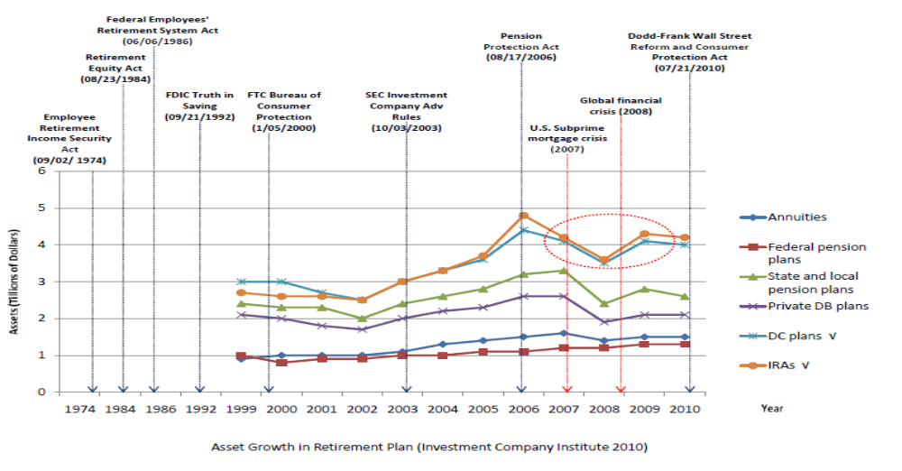
Figure 1. Regulatory Changes and U.S. Asset Growth in Retirement Plan

Source: Investment Company Institute (2010), Financial Industry Regulatory Authority (2010), Center for Retirement Research (2009), and Federal Reserve Board (2009)

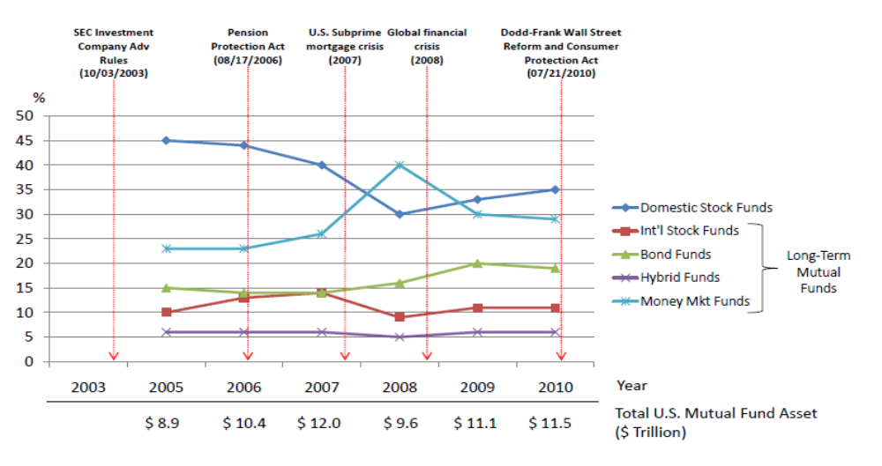
Figure 2. Regulatory Changes and U.S. Total Mutual Fund Asset

Source: Investment Company Institute (2010), Financial Industry Regulatory Authority (2010), Center for Retirement Research (2009), and Federal Reserve Board (2009)
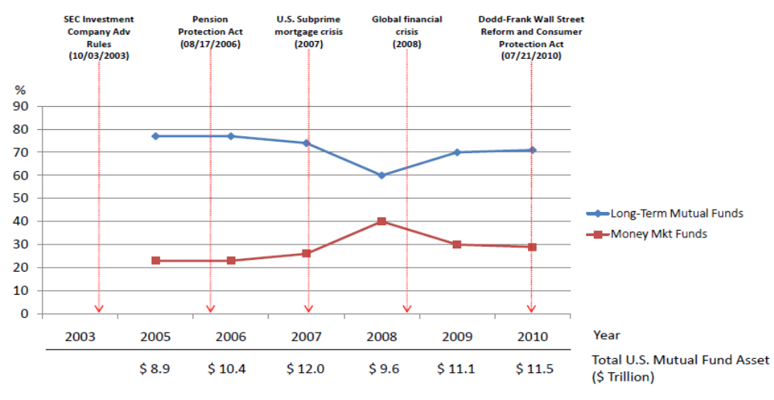

Figure 3. Economic Crisis and U.S. Total Mutual Fund Asset

Source: Investment Company Institute (2010), Financial Industry Regulatory Authority (2010), Center for Retirement Research (2009), and Federal Reserve Board (2009)

Socio-Demographic Conditions
The social environment is extremely broad and covers all relevant aspects of a society, including demographics, culture, values, attitudes, lifestyles, etc. First, the demographics environment encompasses all factors relating to the size, structure and distribution of the population. The potential market for any product is affected not only by the number of individuals within the population but also by the age structure and regional distribution of that population. Population changes depend on both birth and death rates, and death rates have been falling worldwide. For example, the birth rate (number of birth per 10000 people) in the U.S. was estimated at 14.14 (CIA World Fact Book, 2006). Countries with low birth rates such as U.S. typically have ageing populations – a feature that may have important implications for pension products, health insurance and long-term care insurance (Martenson, 2008).
There are several other aspects of population structure that might be relevant to financial services. The regional distribution of the population, and particularly the balance between urban and rural areas, may be important – particularly so in relation to retail banking and the distribution of branches. Household structure is also relevant; in the U.S. there has been a tendency towards a declining household size and an increase in the number of single-person household as individuals leave home but delay marriage (Fox et al., 2005). This trend will have implications for mortgage products and life insurance products – single mortgage-holders may feel less need for life insurance coverage if they have no dependents to worry about. Of course, the decline of the extended family in many parts of the world also creates greater demand for products that provide financial support in retirement, including pensions, care insurance and equity release products.
Second, culture can define how individuals do things in financial market – it relates to how people behave, what they believe, what they value, their customs and traditions, and what is considered acceptable and unacceptable (Rugimbana, 2007). In principle, the biggest challenge that culture presents is in relation to international markets, where an ability to understand the prevailing culture and adjust and adapt to it are essential. However, an understanding of culture and cultural changes is also relevant in domestic markets. The nature of marketing communications, the use of color and particular symbols can all touch on cultural sensitivities (Huhmann & McQuitty, 2009). Some countries may have a relatively homogenous culture, while others can be very diverse. In the U.S., for example, marketers must be sensitive to the different heritage and cultures of the Hispanic, African, Asian and white communities (Grable et al., 2009). In addition, one of the strongest elements of culture is religion, and this provides a very clear example of the way in which culture can affect financial services marketing.
Lastly, a range of other issues relating to social structures and social values may also be important for FSOs, including changing patterns of work, changing social structures and changing values (Mandell, 2007). These factors may affect the ways in which people may wish to access financial services – for example, American people who are working longer hours my place greater importance on being able to access their bank accounts through ATMs, telephone banking and Internet banking (Hernandez & Mazzon, 2007). Social influences may also affect the types of financial services demanded. Thus, with an increasing value being placed on education, prospective parents may seek financial services that allow them to save for their children’s education (Mandell, 2007). With more traveling internationally, demand for internationally recognized debit and credit cards will continue to increase. Where consumers are concerned about environmental or ethical issues, there may be a demand for financial services that are provided in a way that is consistent with these values (Brown & Taylor, 2008).

Technological Conditions

Technology affects not only the type of products available, but also the ways in which people organize their lives and the ways in which goods and services can be marketed. In the financial services sector, the single most important aspect of technology has been information and communication technology (ICT) (Katuri & Lam, 2007). ICT has had a dramatic impact on the delivery of financial services, the types of financial services that can be offered and the ways in which those services are marketed.
Financial services may now be delivered via ATMs, by telephone and via the Internet (Mayer, Huh, & Cude, 2005). For example, ATMs were first introduced in the U.S. in the 1970s, and at that stage their main function was to dispense cash. As technology developed and consumer acceptance of ATMs increased, machines were developed with a much wider range of functions which allow individuals to undertake an extensive range of banking activities; they have also served an additional marketing tool, as banks including Bank of America, Citi Bank, Wells Fargo use the ATM transaction to promote other services (Alhudaithy & Kitchen, 2009). The telephone has a long history of use in the purchase and management of financial services, supporting interpersonal interactions and paper-based transactions. Most U.S. financial services providers now offer or are developing phone banking systems using a mixture of automated voice recognition outside of reasonable working hours, and personal contact during reasonable working hours. A growing number of financial services are now available online. The development of the worldwide web provided a major impetus for the development of computer-based banking (Shi, Shambare, & Wang, 2007). The Internet has proved effective for dealing in a range of other financial services, including simple insurance, loans, mortgages, share trading and mutual fund trading. It also offers significant cost benefits to organizations, with cost of Internet-based on transactions being estimated at 10 percent of the cost of phone transaction and 1 percent of the cost of in-branch transactions (Mattsson & Helmersson, 2005). However, research on customer attitudes does tend to suggest that more retail customers feel comfortable when using the Internet for relatively simple products and many are much less comfortable with the idea of using for more complex products. Internet-based distribution may also pose a marketing problem if fewer customers visit the branch and there is, therefore, less of an opportunity actively to sell to those customers.
Challenges Facing Financial Services Advertising
The Complexity of Financial Products and Services
A generation ago most consumers had just two basic banking products: a checking account and a saving account. Such accounts were simple to open and maintain. Now, consumers are faced with a variety of different types of checking or bank accounts. Investors can also choose to invest in a variety of options from mutual funds, including international funds, growth funds, income funds, and tax-free funds to stocks, bonds, commodities, futures, etc.
However, now even relatively straightforward financial products can appear quite complex to the average consumer, as they often require an understanding of terms to maturity, durations, payout options, and various other features. In addition, it is often difficult to assess the quality of financial products at the time of purchase (Hira & Loibl, 2005). Furthermore, as these products are purchased infrequently, there is limited score for learning about quality form repeated purchases (Perry & Morris, 2005). For example, over 70% of new automobile purchases in the United States are financed in part by vendor loans and personal car loans have amounted to 34% of monthly nonmortgage debt in the U.S. (Dasgupta, Siddarth, & Silva-Risso, 2007). The changing array of financing alternatives and rebate offers complicates the process of purchasing a car and may have significant implications for the well-being of buyers. Consequently, financial products can be difficult to understand and many consumers purchase inappropriate ones or decided not to purchase any at all.
The Diversity of Financial Offerings
Deregulation of financial markets and the reduction in costs brought about by developments in information technology and telecommunications have resulted in a proliferation in the number of new products tailored to meet very specific market needs (Botti & Iyengar, 2006). These innovations in financial products and services have enabled more consumers to gain access to a greater variety of financial products (Hira & Loibl, 2005). The Internet has also increased both the amount of information about investment and credit products and the availability of these products (Perry & Morris, 2005). The diversity of new financial products provides consumers with more choices but also more challenges.
As shown in Figure 4, investors in equities, for example, now have access to many new trading mechanisms and venues, some of which offer speedier executions or greater anonymity, as well as access to many different types of investments. Users of credit and debt in the U.S. are being presented with many new options for loans, credit cards, and other forms of debt (Wiener & Doescher, 2008). Technology has enabled a reduction in creditor costs through credit-scoring techniques and as a result more consumers have no formal relationship with financial markets. With more financial decisions facing consumers and with an increased number of transactions assuming the existence or ownership of a bank account, those individuals without one or with limited use of one are increasingly at a disadvantage (Perry & Morris, 2005).
Baby Boom Generation and the Rapid Increase in Life Expectancy
Offspring of the baby boomer generation (i.e., echo boomers) are the largest generation of Americans to emerge since the 1960s, numbering over eighty million (Anderson et al., 2004). This large cohort is gradually coming of age at the same time as baby boomers are retiring or considering retirement. The situation is further compounded by the increase in life expectancy, which means that this large cohort of retirees might be spending more time in retirement than previous generations and might, therefore, need to be supported for a longer time.

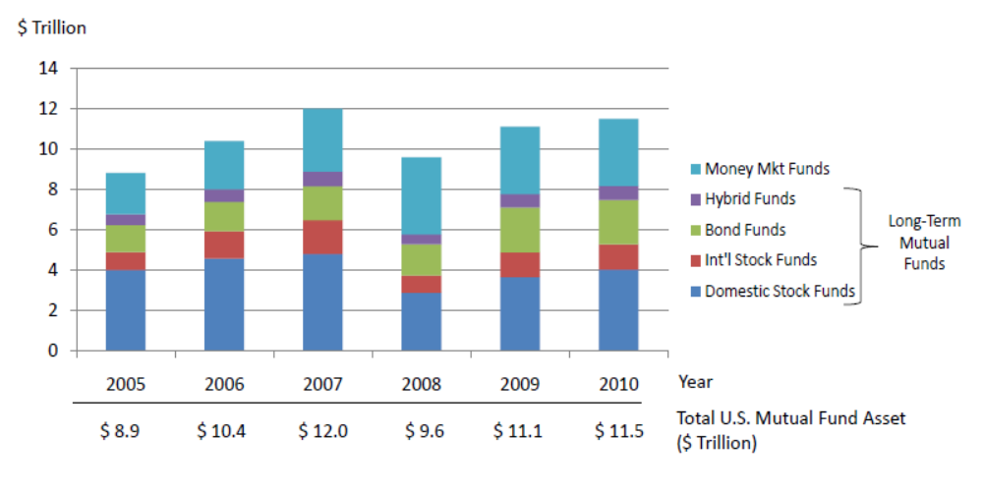

Figure 4. U.S. Mutual Fund Asset of 2005–2010

Source: Investment Company Institute (2010), Financial Industry Regulatory Authority (2010), Center for Retirement Research (2009), and Federal Reserve Board (2009)

The ageing of the populations in the U.S. will have severe consequences for public retirement programs such as Social Security Systems (Hira & Loibl, 2005). The working population will not be large enough to support the ever-growing number of retirees without changes to these programs. Governments, in order to sustain these programs, will face difficult choices such as cuts in benefits, tax increases, massive borrowing, lower cost-of-living adjustments, later retirement ages, or a combination of these elements (Botti & Iyengar, 2006). For individuals, the increase in life expectancy means the possibility of more time spent in retirement and, thus, a greater need for asset management, tax and estate planning, expanded insurance products, and other financial strategies as longevity increases (Wiener & Doescher, 2008). The ageing of the baby boom generation might also have an adverse affect on the return to private savings (Anderson et al., 2004). This effect could have serious repercussions about because the baby boom generation will have to rely more heavily on personal savings for retirement income than did earlier generations.
Researchers have noted a recent shift in how much money American consumers are willing and able to save for their retirement. For the first time since the Great Depression, overall consumer savings rates were negative (-20.4% in 2005 and -21.1% in 2006). These numbers are down sharply from the average savings rate during the mid-1990s (14.6%; Crutsinger, 2007). Although there are a number of macro level, uncontrollable economic factors that account for this troubling trend (e.g., rising energy costs), some experts have noted consumers’ general tendency to opt to spend, as opposed to save, discretionary income. For instance, David Wyss (2007), Chief Economist at Standard and Poor’s, has publicly stated in 2007 that ‘‘Americans seem to have the feeling that it is wimpish to save’’ and that ‘‘the idea is to put away money for old age and we are just not doing that.’’ Lack of financial resources during the later stages of one’s life cycle can have devastating effects on consumer health and welfare. The importance of retirement savings in early life stages is critical, and thus, it is imperative for young adults currently entering the workforce to consider the potential long-term consequences of their current spending and saving habits.
Changes in Income
The accumulation of financial assets by the baby boom generation resulted in a rise in the number of individual investors in the U.S. (Warren, 2008). Another factor explaining the increase in the number of individual investors is the rise in personal income that occurred in the U.S. over the past decade with the result that more people now have funds to invest (Rhine & Greene, 2006). The U.S. shows that the growth of per capita income accelerated in the latter of the 1990s. This acceleration represents a break with the slower growth of per capita income in the previous two decades.
As a result of this growth in income, there has been an increase in both the percentage of households investing as well as an increase in the amount of household wealth. The proportion of households investing directly or indirectly in stocks increased significantly in the 1990s for the U.S. (Perry, 2008; Wiener & Doescher, 2008). Of note is the importance of investment through financial intermediaries. When such indirect holdings are counted, the percentage of households investing in stocks more than doubled in the U.S. For example, percent of American households had direct holdings of stocks; however, almost 49 percent of households held stock either directly or indirectly (Rhine & Greene, 2006). Increases in income also mean that more individuals can afford to make larger purchases on credit, to take out loans, and to buy homes. Furthermore, net financial wealth as a percent of nominal disposable income has grown significantly in the 1990s (Warren, 2008). Equities as a percent of disposable income have more than doubled in the U.S. in the same period.
Changes in Pension Arrangements and Retirement Plans
One of the most-popular ways for American consumers to save for the future is to enroll in a 401(k) plan (Botti & Iyengar, 2006). As shown Figure 5, A 401(k) plan is a specific type of employer-sponsored retirement plan that enables employees to save for retirement while deferring income taxes on the saved money and earnings until they are withdrawn. Typically, a portion of the employee’s wage is withheld and paid directly into the 401(k) account. In the most-common type of plan, the employee can choose to invest in a variety of different funds. The long-term benefits of a savings plan are clear; however, the benefits are multiplied when the employer matches the individual’s contribution. Consider a typical 401(k) “matching” plan offered by many firms, say, for every $1.00 invested by the employee, the firm provides a $0.50 match (up to 6%) of the total annual salary. In this case, if an employee earns $40,000 annually and contributes 10% of his or her salary ($4,000) to a 401(k) plan, the employer will provide an additional $2,000 for a grand total savings of $6,000. Typical drawbacks associated with 401(k) retirement plans include steep penalties associated with the early withdrawal of funds and forgoing spending in the short term. Money that is invested each week (or month) in a 401(k) plan is not available for things such as day-to-day living expenses, family vacations, or unanticipated rainy days (Perry & Morris, 2005).

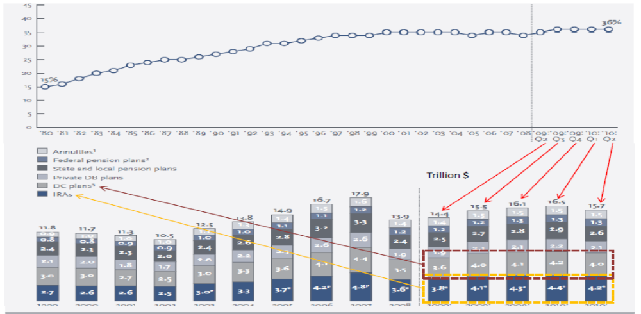

Figure 5. U.S. Household Retirement Asset of 1980–2010

Source: Investment Company Institute (2010), Financial Industry Regulatory Authority (2010), Center for Retirement Research (2009), and Federal Reserve Board (2009)

Despite the benefits of saving for the future, a significant percentage of people choose not to adequately save for long-term needs or have unrealistic retirement expectations such as overly optimistic expected returns on their investments or heavy reliance on state and/or workplace pensions (Warren, 2008). Outside of uncontrollable, external constraints on discretionary income (i.e., the amount of money leftover after basic needs such as food, clothing, and shelter have been satisfied), there are many potential explanations as to why consumers fail to adequately save for retirement. One popular framework to examine why consumers opt to spend today versus save for tomorrow is intertemporal choice (i.e., decision making over time; Loewenstein, Read, & Baumeister, 2003). Many difficult circumstances could be avoided, such as financial hardship, if people simply made more careful, deliberate choices that match in accordance with their long-term best interests and goals. Of course, this is not an easy thing to do. Most consumers have made decisions at some point in their lives that seem reasonable in the short term but result in negative outcomes in the future.
Changes in Capital Markets
More consumers in the U.S. are becoming involved in financial markets. These consumers have limited experience with capital markets. In the U.S. there is often low awareness of financial products and services, distrust of modern financial instruments, and a belief in a traditional way of saving money. The level of financial literacy among individual investors in the U.S. is often very low and these investors risk suffering losses due to their insufficient knowledge of financial issues and of the risks of financial investments (Perry and Morris, 2005; Warren, 2008). Also, it is often difficult for these investors to find information and guidance. Financial education programs will need to address the needs of these consumers, who will require basic information on the operation of financial markets as well as information on different types of investments and the risks they entail.
Theoretical Framework
The Institutional Role of Financial Services Advertising in the Marketplace
This research proceeds from the assertion that advertising is an institution: that is, it is a humanly designed method of handling certain problems (Rotzoll, 1976; Sandage, 1972). Advertising, as Carey (1960) wrote, is an institution intended to provide information about economic goods and services, but under the impact of modern conditions, it sometimes gives rise to broader, noneconomic applications. Carey (1960) saw that advertising brought buyers and sellers together, and acted as an agent of social control by providing norms of behavior appropriate to current socio-economic conditions. Carey (1960) argued that the character of advertising was dependent upon the character of market structures and the values and beliefs that support such structures. Thus, to regard advertising as an institution suggests that we should study its overall character even though such arises from the efforts of individual advertisers.
Indeed, in a very uncertain and complex environment, one would expect to see a change in overall advertising strategy and advertising disclosure. Financial institutions that are able to stay in business may strive to reduce uncertainty and confusion, avoid equivocal messages, and affect other possible forms of action among consumers with the dissemination of more factual market information and concrete norms of appropriate market behavior (Bone, 2008). In particular, as the subprime mortgage crisis was brutal to the overall financial services industry, many consumer activists and governmental agencies called for enhanced advertising disclosures in order to assist consumer decision-making and reduce potentially misleading impressions about a variety of financial products (Warren, 2008). However, recent research in finance, economics, and the psychology of economic decision making suggests that the advertising and promotional practices of financial services industries should continue to rely on emotional appeals and peripheral cues because these marketing communication strategies are likely be important determinants of consumer choice decisions (Harrison, 2003). In their experiment, for instance, Jordan and Kaas (2002) also found that adding emotional appeals to mutual fund advertisement stimuli also lowered perceptions of risk.
Financial Services Advertising as Consumer Information
Zeithaml, Parasuraman, and Berry (1985)’s review of the services literature suggests that services advertising can be characterized by four important distinctions: intangibility, inseparability of production and consumption, perishability, and heterogeneity, whereas FSA tends to be used to reduce these four challenging problems in financial services marketing (Vargo & Lusch, 2004). First, due to the intangible nature of financial services, FSA would attempt to incorporate into ads tangible artifacts and concrete evidence in order to address the problem of lack of physical form (Stafford, 1996). Second, because financial services can only be provided if there is a customer willing to purchase and experience it, FSA would typically emphasize involvement of the customer to a greater degree than would be the case with physical goods and present the interaction between the production and the customers’ consumption of financial services in ads (Lovelock, 2001). Third, financial services cannot be inventoried. Due to the nature of perishability, consumers have considerable difficulties with respect to pre-purchase evaluation and they tend to draw on the experience of others and the perception of third-parties when evaluating services (Gummesson, 1993). Hence, FSA would employ positive word-of-mouth of the organization and its people in order that there will be a ‘halo effect’ from the organization to their financial products (Mangold et al., 1999). Lastly, the production of financial services is heterogeneous, which gives rise to variability in quality. Indeed, financial services cannot be standardized – the financial service experienced may vary from consumer to consumer, or may vary from time to time for a particular consumer (Lovelock, 2001). Rather, FSA would offer and underscore the customization of performance records, effects, or characteristics of the financial service in order to meet the heterogeneous standards of consumers.
In their ordinary activity, as already prescribed by regulations in place in the U.S., FSA should have a responsibility to provide consumers with information that clearly and accurately represents the terms and conditions associated with the products they offer, openly describes the interests of financial products and its relationship to the information provided, and avoids deceptive language in marketing materials (Kozup & Hogarth, 2008). By providing understandable and unbiased information and by being clear about their role in the process, FSA can serve the role of financial education, mainly by increasing individuals’ awareness (Grable et al., 2009).
The provision of clear and accurate information by FSOs will also enhance the competitive process by enabling market participants to know the risk-return characteristics to investment and, therefore, to decide where capital should flow (Bone, 2008). It must also be recognized that FSA may as well benefit from improved financial literacy and education of customers since this facilitates the provision of accurate and appropriate financial information and advice (Wonder, Wilhelm, & Fewings, 2008).
In addition to providing financial information, FSA should make sure that consumers are aware of the financial products available and know how to access them. Some analysts have suggested that the responsibility of FSA have an obligation to ensure that consumers understand the information they provide (Warren, 2008). More generally, FSOs should be encouraged to check that the information provided to their consumers is read and understood, for instance through tests and especially for those financial services which entail long-term commitment or have potentially significant financial consequences (Hogarth and English, 2002).
External Information for Financial Decision-Making: Advertising Strategies and Advertising Disclosures

Although the primary purpose of this research is to address possible interaction effects of internal consumer characteristics (i.e., regulatory focus; prevention-focused vs. promotion-focused), these effects are examined in the context of financial ad strategies (i.e., an informational ad vs. a transformational ad) and ad disclosures (an ad with disclosure vs. an ad without disclosure). Thus, a brief summary of prior research on ad strategies and ad disclosure effects is discussed, followed by a review of internal characteristics and the conceptual rationale for interaction and moderation effects.
Financial Services Advertising Strategy
In today’s tough economic climate, many FSOs have been forced to slash budgets for marketing and advertising. However, when the markets are frozen, they should focus even harder on their marketing communication efforts. One of the essential ways for FSOs to inform, persuade, and build successful relationships with the customers is to reconsider and reconstruct overall advertising strategies. Researchers have identified two ways to study advertising strategies: informational versus transformational strategy.
The dyad framework of transformational and informational strategies has been studied extensively in the advertising literature. According to Puto and Wells (1984), transformational advertising involves the association of the experience of using/consuming the advertised brand with a unique set of psychological characteristics. A transformational advertisement would therefore make the experience of using the brand richer and more enjoyable by connecting the experience of the ad with that of using the brand in such an intimate fashion that “consumers cannot remember the brand without recalling the experience generated by the advertisement” (Puto & Well, 1984, p.638). Overall, transformational strategies are grounded in the emotional, hedonic, and experiential side of consumption. Transformational strategies seek to make consumers feel good about the product, by creating a likeable or friendly brand: they heavily rely on feelings for effectiveness. For example, Young (1981) contends that services have a different hierarchy of effects than goods (feel→do→learn, rather than learn→feel→do), which would make the transformational approach more effective for services advertising such as retailing, financial services, and travel agencies. Indeed it is believed that when service advertisers design promotional messages, they are expected to use symbols that are recognizable and meaningful to a given marketplace, because transformational approaches can help alleviate the difficulty in understanding intangible aspects of services and instill the abstract nature of service offerings into concreteness and vividness (Legg and Baker, 1987; Stern, 1988). In that regard, FSOs tend to promote a way of feeling about the meaning and value of financial services and recalibrate customer satisfaction, customer retention, customer loyalty, corporate identify, corporate image, corporate personality, and perceptions of service quality through transformational advertising strategy, including empathetic messages, non-verbal cues, and emotional approaches (Coombs & Holladay, 2006).
Several researchers have argued that the tendency toward employing the transformational approach in service advertising arises from the unique characteristics of services, such as intangibility. Unwin (1975) argues that emotional and experiential approach can help alleviate issues resulting from the abstract nature of service offerings. For example, to overcome the difficulty in understanding intangible service products, arousing the emotion of the consumers is believed to enhance the concreteness and vividness of the same. Upah and Uhr (1981) emphasize the importance of services advertising to communicate the emotional end-benefit the service firm is providing. Legg and Baker (1987) and Stern (1988) cite the need for dramatizing abstract offerings through services advertising. In sum, emotional appeals seemingly would be the most effective in conveying a service’s ‘personality’ to consumers.
Thus, FSOs are likely to involve transformational, image, or emotional advertising strategy during the financial crisis (Everett, 1988). Previous research has indicated that transformational approaches are used more for services than for physical goods (Cutler & Javalgi, 1993). Abernethy and Butler (1992) concluded that services actually use fewer informational cues in their advertisements. A meta-analysis of nearly 60 content analyses also confirmed that services tend to have lower amount of information than product advertisements (Abernethy & Franke, 1996).
In contrast, according to Puto and Wells (1984), informational advertising provides the audiences with factual information about the product and relevant brand data in a clear and logical manner such that they have greater confidence in their ability to assess the merits of buying the brand after having seen the advertisement. Accoridng to Kotler and Armstrong (1994), such approaches are designed to change the message receiver’s beliefs about the advertised brand and rely on their persuasive power of arguments or reasons about brand attributes. Such message strategies tend to relate to the target audience’s self-interest by showing product benefits. Prior literature suggests that a variety of professional services advertisers such as financial firms, medical services, and lawyers use informational advertising strategy to infuse an objective reality into the intangibility of the services (Pennington, 1993). Prior service research found that more factual claims and verifiable information can help alleviate some of the problems associated with intangibility and enhance the attitudes and purchase intentions toward the services (Stafford & Day, 1995).
Informational advertising stems from the traditional information processing models of decision making wherein the consumer is believed to make logical and rational decisions. Such approach is designed to change the message receiver’s beliefs about the advertised brand, and rely on the persuasive power of arguments or reasons about brand attributes. Such message strategies relate to the audience’s self-interest by showing product benefits (Puto & Wells, 1984).
More specifically, some prior research has argued that services advertising tends towards the informational approach; an approach designed to provide useful information and plays a role in the decision-making process by helping consumers make more rational and informed comparisons (Cutler & Javagi, 1993). For example, in explaining his findings that services advertisers are more likely to appeal to “objective reality,” Pennington (1993) notes the importance of the verifiability of service quality claims, emphasizing that verifiable product information cues are an important basis for consumer attitudes and purchase decisions. LaBand, Pickett, and Grove (1992) attribute the use of informational strategies to the intangibility of services, contending that more factual information can help alleviate some of the problems associated with intangibility. Similarly, Stafford and Day (1995)’s experiment involving two types of retail services revealed that the informational approach is more effective than the transformational one in enhancing consumers’ attitudes toward the ad of service provider. In their content analysis, Grove, Pickette, and LaBand (1995) also showed that service ads contained more informational and factual cues compared to advertisements for physical products. Zinkhan et al. (1992) maintain that service firms use cognitive and informational ads more than behavioral and affective ads.
FSOs are likely to rely on informational advertising strategy by providing more factual description and concrete information to improve consumers’ rational financial decision-making. FSA performs the vital function of informing and persuading the consumers in respect to financial products’ economic benefits and utilitarian features related to consumers’ needs or wants.
As discussed above, previous studies have explored and debated the effectiveness of the two approaches in services advertising strategies in general. Although the results of these studies appear to be contradictory, it may be the case that the effectiveness of the message depends upon the service type – that is, that different types of financial services may require different types of ad strategies.
Advertising Strategies and Persuasion
First, as shown above, informational advertising has been defined as providing meaningful facts to the consumer (Cutler et al., 2000). The goal of informational appeals is to focus directly on features or benefits of the product itself (Puto & Wells, 1984) and provide fact-laden and direct descriptions of product features and benefits (Milton, 1974). Informational ads, which are also referred to as, expository ads (Smith, 1995), factual ads (Peracchio & Meyers-Levy, 1997), lecture ads (Wells, 1989), or argumentative ads (Boller & Olson, 1991), communicate information about the features of a product or service in a direct, logical, and fact-based manner. Importantly, the ideas in the ad are not enacted by a character and are not connected in a causal or temporal sequence of events (Padgett & Allen, 1997). As such, these ads present product information with relatively little emphasis on a specific story that might be associated with the product. This approach does not feature a plot or characters and hence, factual ads do not attribute specific actions to individuals or objects. As a result, units of ideas can be moved around with minimal or no change to the overall meaning of the ad copy (Smith, 1995). This feature of factual ads makes them very different from transformational ads where idea units are set in specific orders.
A transformational advertising, in contrast, has been defined as emphasizing the experience that consuming a good or service will provide for consumers. It does not focus directly on features or benefits of the product itself (Puto & Wells, 1984). Deighton (1988) asserted transformational advertising goes beyond showing the experience; they define and project the experience consumers will have during consumption. Likewise, Cutler et al. (2000) suggested transformational ads move the consumer emotionally to a point of greater product/service acceptance. Transformational ads, which have also been labeled as narrative ads, drama ads, communicate information about the features of a product or service through a story-like format (Deighton, Romer,& McQueen, 1989;Wells, 1989). Transformational ads often are intriguing and contextually rich. They may convey the same product information as factual ads but do so through a conversation-like approach (Peracchio & Meyers-Levy, 1997). The story or narrative contains contextual material concerning the product’s creator, use and development and uses a script to convey the relationships between the consumer and the consumption context (Stern, Thompson, & Arnould, 1998). Although transformational ad is often a thematically and temporally related sequence of lead character consumption (Adaval & Wyer, 1998), it does not always follow a story-like sequence. For example, the conclusion of the story can be communicated first, followed by background information that fills in missing details. As a result, ads are considered to be transformational if they include “actors with motives, an event sequence, and a setting that has physical, social, and temporal components” (Padgett & Allen, 1997, p. 53). In other words, narrative ads typically rely on a chronologically and causally related sequence of events to portray how one or several characters consume, use, or create a product or service. Therefore, narrative ads are characterized by a content component (i.e., actors, actions, and motives) as well as by a structural component (i.e., a causal and temporal plot) (Padgett & Allen, 1997). Although many narrative ads rely on a linear, story-like sequence of events, Polyorat, Alden, and Kim (2007) assert that this is not a necessary prerequisite; that is, the conclusion of a narrative ad can be communicated first, followed by the events that lead up to this conclusion.
These concepts of emotional/ rational and informational/transformational have some overlap with soft sell/hard sell (Mueller, 1987). In exploring global consumer positioning strategies, Alden, Steenkamp, and Batra (1999) operationalized the overall sales appeal of an advertisement by labeling two contrasting approaches: the soft-sell/image approach (image-oriented content that does not emphasize reasons to buy but, rather, conveys general associations with the brand), and the hard-sell/direct approach (sales-oriented, verbal, strong message arguments, comparative content). It is of interest to note that their research suggested that the features of the soft-sell approach (subtlety, implicitness, and abstractness) make it more suitable than the hard-sell approach for a global consumer culture positioning strategy. Indeed, over half of the global consumer culture positioning ads surveyed employed such a soft-sell approach.
More recently, Okazaki, Mueller, and Taylor (2010) defined a soft-sell appeal as one in which human emotions are emphasized to induce an affective (feeling) reaction from the viewer. These appeals tend to be subtle and indirect, and an image or atmosphere may be conveyed through a beautiful scene or the development of an emotional story, or via some other indirect mechanism. Meanwhile, they defined a hard-sell appeal as one in which the objective is to induce rational thinking on the part of the receiver. These appeals tend to be direct, emphasizing a sales orientation, and often specifying the brand name and product recommendations. There is often explicit mention of factual information, such as comparisons with competing products or specific distinguishing features of the product that give it an advantage in performance or some other dimension relevant to consumers. Stemming from this conceptualization and via a review of prior literature, supplemented by content analysis, a free-association task, expert judgment, and focus group, they developed a method for measuring these advertising strategies.
Specifically, the first set of dimensions are feeling and thinking. Prior studies have examined the degree to which an ad aims to induce feelings or emotions rather than rational thoughts, and several theories support the notion that persuasive communication is influenced by both feelings and thoughts. Cognitive response theory, for example, suggests that thoughts and feelings, labeled “cognitive responses,” are thought to affect attitude formation and change (Petty, Ostrom, & Brock, 1981). Similarly, the theory of reasoned action proposes that there is both a cognitive and an affective component to persuasive communication (Ajzen & Fishbein, 1980). Additionally, the Foote, Cone, and Belding (FCB) Matrix, a well-known framework for product classification, classifies products according to whether the purchase decision is high or low involvement and involves cognitive (thinking) or affective (feeling) information processing (Vaughn, 1986). The FCB grid was extended by Rossiter and Percy (1997), who argued that product and brand attitude classifications should be based on underlying purchase motives—both informational and transformational. Based on these frameworks, there is a recognition that some ads attempt to convey information to consumers to help them develop a preference, while others appeal to emotions, or “transformational motives.” Clearly, prior discussions of soft sell and hard sell have touched on the notion of the appeal being related to inducing either cognitive processing (thinking) or affect (feeling). Intuitively, it makes sense that hard-sell appeals rely more on the “thinking” aspect than the “feeling” aspect. Conversely, soft-sell approaches rely more heavily on the emotive aspect, appealing to feelings.
The second set of dimensions are implicit and explicit. Prior discussions of hard-sell appeals clearly suggest that the degree of directness of such messages is a feature that distinguishes them from soft-sell appeals. A primary characteristic of hard-sell appeals is that they are direct and designed to induce action, whereas soft-sell appeals are less direct. Thus, the second set of dimensions proposed is implicitness and explicitness. Advertisements can create either overt meaning or latent meaning (Williamson, 1978). When attempting to create overt meaning, advertisers convey the message very directly via explicit communication. According to McQuarrie and Mick (1996), rhetorical approaches can be used to determine how to express a thought most effectively in a given situation. In advertising, messages can be designed, either through the use of rhetoric or by other means, to emphasize objective product features. This type of advertising message tends to offer explicit meaning. In contrast, latent meaning is created less directly. One of the most effective means of creating latent meaning is by using metaphors. McQuarrie and Phillips (1996) define a metaphor as “a type of indirect claim because claims are made in a figurative way rather than in a literal way – the advertising message is not stated outright but only implied” (2005, p. 8). In indirect persuasion, illustrations are often used to convey figurative claims. The use of advertising illustrations has increased even more rapidly than the use of verbal aspects in commercial messages (Phillips & McQuarrie, 2003). Pollay’s (1985) research revealed that in the course of the twentieth century, illustrations came to occupy an ever-increasing portion of magazine ads, while at the same time, the number of words decreased steadily. Pollay (1985) proposed that this was suggestive of a move toward a more soft-sell approach.
The third set of dimensions proposed is image and fact. According to Leiss, Klein, and Jhally (1997), there are two basic advertising formats: product-information format and product-image format. In the former, which is consistent with a hard-sell approach, the product is the center of attention, and the focus of the ad is on explaining the product and its function. Thus, factual and objective elements are the essence of this format. In contrast, in the product image format, “brand name and package play an important part, but the product is given special qualities by means of a symbolic relationship that it has to some more abstract and less pragmatic domain of significance than mere utility” (Leiss, Klein, & Jhally 1997, p. 244). The product image format is consistent with the soft-sell approach. Here, the product becomes embedded or “situated” in a symbolic context that imparts meaning to the product beyond its specific elements or benefits. In essence, this dimension suggests that hard-sell approaches will rely on more objective, factual information, whereas soft-sell approaches will attempt to build an image to help convey meaning.
In the area of advertising persuasion, distinguishing between informational and transformational ads is important since they typically trigger different forms of processing, “each providing distinctive ways of ordering experiences, of constructing reality” (Bruner, 1986, p. 11). Specifically, informational ads typically elicit a more analytical, logical, and paradigmatic form of processing. As such, each piece of information is likely to have its own meaning and can be moved around without affecting the overall meaning of the ad very strongly (Adaval & Wyer, 1998). Bruner (1986) asserts that this mode of processing “attempts to fulfill the ideal of a formal, mathematical system of description and explanation” that is based on “logical proof, sound argument, and empirical discovery” (pp. 12–13). Hence, the goal of analytical processing consists of deriving an abstract, “true” conclusion rather than creating personal meaning. As such, a consumer who processes an ad in an analytical fashion is prone to adopt dispassionate, verifiable rules of logic and will modify her attitudes according to the strength of the ad’s arguments (Adaval & Wyer, 1998; Petty & Cacioppo, 1986). Analytical processing is also likely to elicit more counterarguments than narrative processing because the consumer explicitly evaluates the objective “truthfulness” of the arguments (Deighton, Romer, & McQueen, 1989; Padgett & Allen, 1997).
On the other hand, transformational ads often prompt consumers to adopt a narrative form of processing (Bruner, 1986). Specifically, narrative thought may “initiate and guide a search for meanings among a spectrum of possible meanings,” which implies the possibility that different individuals may ascribe a different meaning to the same experience (Bruner, 1986, p. 25). Building on Bruner’s ideas, Padgett and Allen (1997) suggest that narrative ads may elicit multiple interpretations in the marketplace and may therefore increase the ambiguity of what consumers think about the brand. Expository ads, on the other hand, may be less ambiguous because “they have the advantage of presenting logically connected ideas, thus limiting the number of potential interpretations” (p. 58). Therefore, narrative processing may help consumers to create meaning for an ad and may improve evaluations of the advertised brand.
First, narrative processing may elicit a cognitive process called “transportation,” which is defined as the extent to which individuals immerse themselves into a text and eventually get “lost” in it (Green & Brock, 2000). By processing an ad in a narrative manner a consumer may transport herself into the world suggested by the ad and may “perform” the meaning of the ad for herself (Bruner, 1986; Gerrig, 1993). As a result, the consumer may gain a more realistic, vicarious “foretaste” of the emotional consequences that are associated with the consumption of the brand (Padgett & Allen, 1997;Woodside, Sood, & Miller, 2008). To the extent that the ad conveys a positively valenced experience, narrative processing and transportation are likely to elicit affect that is also positive in nature. However, narrative ads may also lead to levels of transportation and absorption that can harm the evaluation of the brand. For instance, Sujan, Bettman, and Baumgartner (1993) found that ads that encourage the retrieval of autobiographical memories may reduce attention to product information. In a similar vein, consumers may become transported so strongly into narrative ads that they will not pay sufficient attention to the brand that is depicted in the ad. These arguments suggest that further research is needed to fully understand the antecedents and consequences of narrative processing in response to advertising.
Second, narrative processing may also intensify the connections between the brand and the consumer’s self (Escalas, 2004). When new information is processed in the form of a narrative, consumers will try to match that information to their existing stories in memory, searching for stories with similar motives, outcomes, and courses of action (Schank, 1990; Schank & Abelson, 1995). For instance, Schank (1990) asserts that “understanding a story means being able to correlate the story we are hearing with one that we already know” (p. 21). Typically, the stories that individuals have stored in memory are related to the self, since individuals tend to rely on self-stories to construct their identity and to understand who they are (Kerby, 1991; Polkinghorne, 1991). Hence, by processing an ad in a narrative manner, consumers may find it easier to connect the advertised brand to their own experiences, which increases the likelihood that a meaningful connection is formed between the brand and the consumers’ selves (Escalas, 2004). An increase in self-brand connections, in turn, should lead to more positive attitudes toward the brand (Escalas & Bettman, 2003).
According to Wentzel, Tomczak, and Hermann (2010), transformational ads prime a narrative processing style, whereas informaitonal ads trigger an analytical processing style. They suggest that while transformational ads can be an effective advertising tactic, they lose their persuasive advantage if they are associated with cues that make manipulative intent salient. Hence, managers who decide to use transformational ads should not combine those ads with other executional cues that may cause consumers to become suspicious and to revert to a more analytical processing style (e.g., rhetorical statements, comparisons with other brands). This implies that transformational ads could be best used to familiarize consumers with a brand and to encourage them to think what it would be like to own and use the brand without making a persuasive intent overly explicit. That is, narrative ads should be employed to provide consumers with a “taste” of the psychological consequences of consuming the brand (Padgett & Allen, 1997; Polyorat, Alden, & Kim, 2007). On the other hand, informational ads may be more suitable for communicating “objective” information that can be verified through analytical processing (e.g., price, functional attributes, a comparison with competing brands). Hence, the two ad forms may be used in a complementary fashion within the same campaign.
Previous literature has shown that transformational appeals may be most appropriate for service providers due to the intangible nature of services (Mittal, 1999; Swaminathan et al., 1996) and the need for psychological appeals and emotional responses to help link services to customers (Bennett et al., 2007). Zinkhan et al. (1992) found that retailers were more likely to use transformational appeals in their commercials, but the influence of the appeals has not been studied. If transformational appeals operate by influencing experience, then this creative strategy could prove to be a powerful marketing tool.
According to Deighton (1988), all successful service advertising will influence experience and create tangibility. What makes transformation unique is that the experience can be enhanced without first changing the consumer’s expectations. This theory of delayed persuasion has been proposed to explain the effect of transformational appeals. A delay in persuasive effect is most likely to occur when there is ambiguity about a consumption experience (Hoch & Ha, 1986; Schindler, 1986). Transformational appeals, by design, communicate points that are hard to articulate about the product or are used when the brand’s appeal is not reducible to everyday language (Deighton, 1988). In the face of ambiguity, aspects of the experience will provide confirmation of the product benefits presented in the ad, leading to enhanced evaluations (Hoch & Ha, 1986; Schindler, 1986). Advertisements of service organizations with slogans like “Your home away from home” (Starbucks) or “Come and live the magic” (Disney), reflect such transformational tenets. Furthermore, narrative (versus factual) ad copy has been found to generate higher rates of ad recall (Smith, 1995; Tun, 1989), more intense affective reactions (Mattila, 2000), more favorable ad attitudes (Mattila, 2000), more favorable service evaluations (Adaval & Wyer, 1998) and stronger service purchase intentions (Mattila, 2000). Naylor, Kleiser, Baker, and Yorkston (2008) found that transformational advertising affects consumers’ initial retail experiences, but are not effective when a consumption experience is already well defined. Further, the results of their study indicated that transformational appeals enhance hedonic and symbolic benefits but do not appear to affect evaluations of functional benefits. Polyrat, Alden, and Kim (2007) explored the relative impact of narrative versus factual message strategies on product evaluation. In this study, narrative versus factual print ad copy resulted in more favorable product evaluations. Narrative print ad copy also elicited higher ad message involvement which, in turn, mediates the differential effect of narrative versus factual copy on product evaluations.
Financial Services Advertising Disclosure
Provision and usage of advertising information are critical issues for financial services marketing and public policy. Financial firms provide information in an attempt to enhance consumer brand perceptions and purchase probabilities, whereas policy makers want advertisers to provide information to improve the quality of consumer decisions. However, the potential benefits of advertising information to marketers, consumers, and society should be expected to accrue only to the extent that consumers notice, process, and comprehend such information. Thus, effective communication involves the interaction between information provision on the sellers’ side and information utilization on the buyers’ side (Friestad & Wright, 1994).
Theory and research on the economics of information (EOI) help to explain the information interplay between buyer and seller (Nelson 1970, 1974). First, EOI distinguishes between products in terms of when consumers can evaluate their critical characteristics: before purchase for so-called search products and after product purchase and use for so-called experience products. Second, EOI suggests that consumers will be most skeptical of information that is the most difficult and costly to evaluate prior to purchase. Finally, EOI suggests a relationship between buyers and sellers such that sellers, understanding buyers’ beliefs regarding the nature of information across products types, will provide information in a manner consistent with those beliefs.
The policy implications of EOI rely on a correspondence between beliefs and perceptions (e.g., skepticism) on one hand and behavior (e.g., information provision and usage) on the other. However, there is considerable debate about the role of advertising information among both academics and practitioners. One view suggests that more information is generally desirable and of interest to consumers to the extent that it does not create information overload (e.g., Abernethy & Franke, 1996). An alternative view advocates a considerably more selective and limited approach to information provision (e.g., Ziamou & Ratneshwar, 2002).
From a societal perspective, even advertising critics feel that advertising’s informational function lends some legitimacy to advertising’s role in the economy (Pollay, 1983). Documenting the amount and content of consumer information available in ads could weaken-or reinforce-critics’ claims that advertising provides little value. A widely used method of measuring advertising information, introduced by Resnik and Stern (1977), involves content analysis to determine which types of information are present in an ad. The information content of each ad was measured using methods introduced by Resnik and Stern (1977) and used in numerous studies since its introduction, determining if advertisements include specific informational cues in the following categories: price or value, quality, performance, components or contents, availability, special offers or promotions, taste, nutrition, packaging or shape, guarantees, safety, independent research, company research, and new ideas.
With this backdrop, advertising disclosures play a potentially important role in reducing misleading impressions from advertising claims, messages, or other cues. Disclosures may also provide helpful warning and risk information for consumers (Hoy & Lwin, 2007). In particular, the Federal Trade Commissions (FTC) views advertising disclosures as an information remedy for potential deception or unfairness by providing consumers useful information. In general, the FTC influences the level and content of information primarily through issuing regulations that mandate disclosure of material information and setting standards for certain products or services that a typical consumer could not easily evaluate (Azcuenaga, 1995). Additionally, disclosures may be triggered based on the advertising claim. However, advertising disclosure is a simple idea and, at first brush, appears to be easy to implement, it is neither simple nor easy. In an effort to provide guidance to marketers and thereby facilitate more effective advertising disclosure, the Federal Trade Commission (FTC) developed guidelines for affirmative disclosure in 1970: the “clear and conspicuous” standard (CCS). These guidelines are intended to provision of direction to marketers about acceptable standards for disclosure remedies in deception and unfair advertising cases, and these standards have been extended and amplified in various policy statements and orders since their inception (Hoy & Lwin, 2007).
Therefore, advertising disclosures are a ubiquitous facet of consumers’ information environment. Information disclosure, whether FTC-mandated or provided voluntarily by the advertiser, offers opportunities to clarify claims made in the advertisement and provide helpful warning and risk information for consumers (Hoy & Lwin, 2007). As described by Foxman, Muehling, and Moore (1988), advertising disclosures are supposed to give supplemental information to aid in consumer decision-making as well as attempt to protect the advertiser from accusations of misleading or deceptive advertising.
However, advertising disclosures, at least in some forms, may not always be necessary or even desirable, and they may produce outcomes that are contrary to the intended effects with respect to consumer response. In some cases, advertising disclosure alone may be insufficient to produce intended outcomes (Bone, 2008). Thus, it is useful to consider the potential roles and objectives of advertising disclosure, including alternative strategies for disclosure, the roles of message timing and media type, measurement issues, and alternatives other than advertising disclosure for achieving broader objectives related to consumer welfare.
In this vein, federal regulations dictate that sellers are responsible for the claims they make about their products and services. The Federal Trade Commissions (FTC) notes that third parties, such as advertising agencies, may be held responsible for claim substantiation depending on the extent of their involvement in the preparation of the challenged ad, whereas claim substantiation is a totally different issue than presenting required disclosures (Kozup et al., 2008). In this vein, in order for that information to have a positive impact on the consumer decision making process, the FTC (2006) has investigated the possibility of mandating a standardized advertising disclosure with respect to credit and financial issues such as open-ended credits (such as credit cards and lines of credit) and closed-ended credits (mortgages, investment funds, vehicle loans, installment loans) in a clear and understandable type that consumers need and want.
As discussed earlier, given that there is a problem with its financial equivalent: namely, financial insecurity represented as excess debt, insufficient savings, poor retirement planning, and suboptimal investment behavior, FSOs’ advertising disclosures in a choice situation typically are supposed to provide important consumer benefits such as improved decision making. However, in order for FSOs’ advertising disclosures to have a positive impact on the consumer decision making process, it must conduct consumer tests to discern the key disclosures that consumers need and want, beyond simply providing information to consumers. Especially, it is imperative that FSOs consider the types of information needed, and the formats that would provide optimal opportunity to process that information so that consumers can comprehend the information given.
Indeed, FSOs must comply with general advertising disclosures guideline prohibiting advertising that is untruthful, deceptive, or unfair. However, it is disconcerting that advertising disclosures are so often ignored in the financial marketplace (Kozup et al., 2008). Most notably, financial product and service categories that either did not exist or were in their infancy in 1990 are now prevalent and the economic boom of the 1990s produced increased demand for financial services and subsequent consumer advertising (Fox et al., 2005). In other words, as many financial marketplace factors have changed dramatically, the numbers of financial products and services that require disclosures and the complexity of what needs to be communicated have dramatically increased (Kozup & Hogarth, 2008). Both the FTC and the National Advertising Division (NAD) of the Council of Better Business Bureau have noted an increase in cases involving FSOs’ advertising disclosures that fall short of standards despite the long-standing legal standard of disclosure (FTC and NAD 2001). Furthermore, the NAD noted that the disclosures must be a frequent issue in competitor challenges (FTC and NAD 2001). Thus, this creates a significant burden on advertisers, consumers, and regulators and raises questions about how best to inform consumers and regulate marketing communications in the financial marketplace.
For instance, FSOs have many advertising disclosures requirements – mandated by the federal government (such as the Federal Trade Commission and the Securities and Exchange Commission), industry associations (the National Association of Securities Dealers, the New York Stock Exchange), and various departments within each individual state (state banking department, attorney general’s office, insurance office). For example, like pharmaceuticals or food manufacturers, FSOs are probably the most highly regulated of all industries when it comes to advertising: for example, the SEC has fined hedge funds that advertise in consumer publications.
Advertising Disclosure and Information Processing
Advertising regulations in the United States tend to center on deceptive and unfair advertising, comparative advertising, sex and decency in advertising, and advertising to children. In general, advertising regulations are categorized (ranging from least to most restrictive) as removing restraints on information flow, enhancing information now, and restricting information flow (Mazis et al, 1981). Regulations on the content of advertising often focus on the form of the message and the way information is presented in advertising appeals to specific target audiences.
Information is critical to the effective functioning of markets. A core principle of economics is that markets are more competitive, and therefore more efficient, when accurate information is available to both consumers and suppliers. When information on alternatives is readily available, product offerings will have to meet customers’ demands and offering prices will have to reflect those of market competitors. In addition, information helps individual consumers by improving their ability to compare products and to choose those that will help them meet their personal goals. For instance, a series of works on “The Economics of Information (EOI)” examined the advertising’s role in reducing consumers’ time and efforts associated with obtaining and processing information (Stigler, 1961). Therefore, EOI presumes that market mechanisms (primarily, withholding of purchases on the part of the consumer) align the information exchange of buyers and sellers and information provision in ads (seller side) corresponds to information utilization (buyer side). In that regard, the benefits of advertising have been expected to accrue only the extent that consumers notice, process, and comprehend such information (Nelson, 1974). With this backdrop, policy makers and consumer educators have the use of disclosures to prevent misleading impressions from important omissions in advertising, as long as such disclosures are clearly and conspicuously displayed (Hoy & Lewin, 2007).
In general, advertising disclosure (or disclaimers) have been defined as a “statement or disclosure made with the purpose of clarifying or qualifying potentially misleading or deceptive statements made within an advertisement” (Stern & Harmon, 1984, p. 13). Although disclosures are not central to overall advertising practices, they do provide more complete information about claims made in the message. The literature in a number of fields also holds that disclosures provide consumers with information crucial to an accurate understanding of the product in advertising (Andrew, Netemeyer, & Burton, 2009).
Indeed, these arguments are not just theoretical. There is systematic evidence that in practice, changes in advertising disclosure affect both consumer and supplier behavior in a number of consumer markets. According to Hoy and Lewin (2007), disclosure statements or qualifications in ads are designed to provide additional information to consumers to prevent them from being misled or deceived by the primary claims or messages in the ad. If disclosures are clearly and prominently displayed, they can be effective in mitigating the formation of potentially misleading beliefs, attitudes, and intentions. For instance, research has shown that evaluative disclosures (e.g., characterizing the preserving level of the nutrient to be “high,” as determined by the Food and Drug Administration [FDA]) can be effective in reducing misperceptions and inaccurate generalizations from nutrition claims (e.g., “no cholesterol” and “1/3 less salt”) when related nutrients are at high levels (see Andrews, Burton, & Netemeyer 2000). Kozup, Howlett, and Pagano (2008) indicated that a supplemental information disclosure impacts investors’ fund evaluations and investment intentions. More recently, Bates, Burton, Howlett, and Huggins (2009) found that nutrition disclosures can have an impact on consumer product evaluations and preferences, particularly for restaurant items that are less healthful than anticipated.
Today, because of criticisms that financial services advertising might create misunderstanding among the average consumers or actually mislead that target audience, disclosures have become an important element of the information mix for advertising content (Bone, 2008; Warren, 2008). To be effective, ad disclosures must give consumers information about financial offerings at a time when it is relevant, and consumers can easily understand. The information provision in ads must also be in a format that allows consumers to pick out and use the information that is most important to them. Effective ad disclosures give consumers information they notice, understand, and can use. Better ad disclosure permits better-informed financial decisions and, hence, more effective competition among financial service providers. Simply put, effective ad disclosure empowers consumers and enhances competition.
In fulfilling its responsibility to protect consumers, the federal agencies do all that it can to prevent fraudulent and abusive financial advertising practices. Specifically, in the U.S., mandatory FTC guidelines guard against unfair and deceptive financial services advertising practices. For example, the FTC also works with the SEC, FRB, FDIC, and many federal agencies to impose standards for advertising directed to consumers in the financial market. For instance, FTC, SEC, FRB, FDIC have asked that financial companies should abide by the rule in regard to advertising disclosures and consider the disclosure’s intended audiences’ characteristics to ensure that they fully understand it (Kozup & Hogarth, 2008). Also, the Dodd–Frank Wall Street Reform and Consumer Protection Act (Pub.L. 111-203, H.R. 4173) that is a federal statute in the U.S. that was signed into law by President Barack Obama on July 21, 2010 asks these federal agencies to take an innovative approach to revising its regulations and improving the effectiveness of ad disclosures by using consumer testing systematically across financial products. Thus, policy makers, consumer educators, financial institutions, and researchers are asked to determine what information should be highlighted for consumers. How much information is enough, and how much is too much? How can we encourage plainer language, recognizing that there may be a trade-off between simplicity and accuracy? What formats work best in presenting the information? When is the best time to present information so it will be most relevant and useful to consumers? How can we craft disclosure requirements that are flexible enough to accommodate innovation and change and to enhance competition?
In practical terms, consumer testing can help these agencies address the considerable challenge of making advertising disclosures more effective. Consumers increasingly face more-diverse and more-complex financial products, including nontraditional financial offerings with multiple features. Given this complexity, financial companies have to be mindful of the dangers of consumers’ cognitive and information overload. Thus, it is very important to carry out and design disclosures that are not only accurate, but also clear and simple enough that they are meaningful and useful to consumers.
Internal Characteristics: Individual Regulatory Orientations
Regulatory Focus Theory
Regulatory focus theory (RFT; Higgins, 2002) posits the co-existence of two regulatory systems—the promotion and prevention systems—that serve fundamentally important but different survival needs. The relative dominance of either state (both as a measured and manipulated variable) has been shown to affect diverse phenomena in social judgment and behavior (Friedman & Förster, 2001). According to Higgins (1998), there is a fundamental distinction between ideals and oughts. Ideals refer to people’s hopes, wishes, and aspirations (e.g., wanting a beautiful house, dreaming of an exotic vacation). Oughts refer to people’s obligations, duties, and responsibilities (e.g., having to provide for a child’s education, behaving professionally at work). Recent work on regulatory-focus theory (Higgins, 1998) suggests that ideals and oughts tap into distinct self-regulatory systems. Ideals tap into the promotion system, which is responsible for the regulation of nurturance needs; oughts tap into the prevention system, which is responsible for the regulation of security needs.
Within this theory, promotion focus refers to those circumstances where growth and advancement needs motivate people to try to bring themselves into alignment with their ideal selves and thus to attain desired self-states. On the other hand, prevention focus refers to those circumstances where security and safety needs prompt people to seek alignment with their ought selves. Thus, while promotion focus is geared to motivate to attain advancement and achievement by approaching matches to desired end states, a prevention focus is geared to motivate people to achieve protection and safety by avoiding mismatches to desired end states (Higgins, 2002). Specifically, whereas the promotion system is concerned with nurturance needs (i.e., needs related to ideals, advancement, and accomplishment) and is marked by a strategic preference for eagerness means, the prevention system involves needs related to duties, obligations, and security concerns and is marked by a strategic preference for vigilant means. The prevention system is characterized by sensitivity to the absence or presence of negative outcomes, and, consequently, an individual in a prevention state is motivated to avoid matches to undesired end-states. Within this framework, vigilant strategies allow an individual in a prevention state to guard effectively against loss (Werth & Förster, 2007). In summary, individuals who embrace alternative regulatory foci manifest different psychological states during the process of goal attainment (Crowe & Higgins, 1997).
As discussed above, because promotion focus individuals strive for matches to their goals, they have been shown to be in a state of eagerness to include as many options as possible that may help them achieve their goals (Crowe & Higgins, 1997). However, because prevention-focused individuals concentrate on avoiding mismatches to their goals, they are in a state of vigilance that entails considering more restrictively only clearly appropriate options (Crowe & Higgins, 1997). In signal detection terms (Tanner & Swets, 1954), a prevention focus should engender a conservative bias, the setting of a very strict criterion for acceptance. A conservative bias results in few false alarms and reflects the psychological state of “playing it safe,” characterized by thoroughness, attentiveness, and erring on the side of caution. This strategic tendency stands in stark contrast to the means that should be exhibited by individuals under a promotion focus. Because these latter individuals are motivated to realize gains and advancement, they should adopt a lenient criterion for acceptance, being open and inclusive even at the risk of increased false alarms. Given their preference for eager strategies, promotion individuals should therefore exhibit a “risky” or “liberal” bias, a willingness to ensure hits and avoid misses.
Regulatory focus occurs as both a chronic individual variable and a situational variable (Van-Dijk & Kluger, 2004). Importantly, chronic regulatory focus is significantly determined by a person’s accumulated experience in prior goal achievement (Higgins & Silberman, 1998). At the same time, regulatory focus occurs as a situational variable, typically manipulated by problem framing that triggers signal detection mechanisms. Problems framed in terms of gains or non-gains trigger a situational promotion focus, whereas problems framed in terms of losses and non-losses trigger a situational prevention focus (Förster, Higgins, & Idson, 1998).
Regulatory Fit Theory
Regulatory fit theory (Higgins, 2000, 2005) is a goal-pursuit theory that places special emphasis on the relation between the motivational orientation of the actor and the manner in which that actor pursues the goal (e.g., the strategic means used by the actor). A central idea of regulatory fit is that an actor’s orientation often leads to preferences for certain types of goal-pursuit means (in particular, for those means that will sustain her orientation), and that the actor’s experience of goal pursuit differs depending on whether or not these preferred means are used. When the fit between the regulatory goal and its strategic means is congruent, (i) individuals have more positive feelings about desirable choices and more negative feelings about undesirable choices, (ii) they evaluate goal pursuits more positively, and (iii) they place higher values on chosen objects (Higgins, 2002). In short, the value of decision-making processes can be enhanced when strategic means for achieving the goal are matched to the regulatory focus. For instance, Aaker and Lee (2001) demonstrated that promotion-focused information (e.g., getting energized) had better persuasion for individuals with a promotion focus than for those with a prevention focus, whereas the reverse was true for prevention-focused information (e.g., avoiding heart diseases). Crowe and Higgins (1997) found that when people are induced by a regulatory goal, they are more likely to remember information that is compatible with the regulatory focus. Hong and Lee (2008) indicated that regulatory fit enhances self-regulation through a state of intensified motivation, whereas regulatory non-fit impairs self-regulation by reducing motivation.
More recently, a sizeable literature has amassed on the role of regulatory fit in persuasion (e.g., Avnet & Higgins, 2006; Cesario, Grant, & Higgins 2004). Three explanations appear in the literature to account for the impact of the fit effect on persuasiveness. First, a relatively high degree of fit enables people to evaluate information more easily, resulting in more favorable evaluations (i.e., the processing fluency account) (Lee & Aaker, 2004). Second, a high level of fit creates a sense of “feeling right”, which subsequently transfers to favorable evaluations. In regulatory fit effects, attitudes become more polarized and intense when decision strategies are consistent with a person’s regulatory orientation. Third, regulatory fit creates a certain degree of engagement when executing a particular activity (i.e., evaluating an object) and this subsequently magnifies the value experience related to that activity (Higgins, 2006). Recent studies on regulatory fit reveal that people’s regulatory focus (promotion vs. prevention) moderates the effect of message framing (gain vs. loss) on persuasion (Avnet & Higgins, 2006).
Cognitive Mechanism that Underlies Regulatory Focus
Much research has explained regulatory focus effects via the alternative type of cognitive mechanism by showing that regulatory focus is an antecedent of type of elaboration. Specifically, Zhu and Meyers-Levy (2007) found that promotion-focus individuals engage in relational elaboration, which entails identifying commonalities or abstract relationships among disparate items. In contrast, prevention-focus individuals engage in item-specific elaboration, which involves focusing on specific attributes of each item independent of others. Theoretically, relational elaboration involves integrating and often abstracting shared aspects (e.g., themes) among dissimilar pieces of information (Hunt & Einstein, 1981). In contrast, item-specific elaboration involves generating precise and context-specific (i.e., concrete) associations to each individual item in isolation of others (Hunt & Einstein, 1981). Under this conceptualization, it was found that promotion-focus individuals, due to their emphasis on relational elaboration and its powers of integration, better comprehended and responded more favorably to ambiguously related ad visuals (Zhu & Meyers-Levy, 2007). Yet, prevention-focus individuals, owing to their prevailing use of item-specific elaboration and its focus on the particulars of data, responded more favorably to unambiguously related ad visuals (Zhu & Meyers-Levy, 2007).
Importantly, the use of relational versus item-specific elaboration may explain many of the outcomes that promotion-focus and prevention-focus individuals have manifested previously. Because relational elaboration involves generating overarching connections or abstractions that link multiple pieces of data, it can account for promotion-focus individuals’ earlier noted generation of more dimensions shared by diverse items (Crowe & Higgins, 1997); more hypotheses about an object’s identity, which are culled via feature integration (Liberman et al., 2001); and more far-ranging abstract ideas that can heighten creativity (Förster, Friedman, & Liberman, 2004). In contrast, because item-specific elaboration involves encoding precise, context-specific associations to each independent item, it can account for prevention-focus individuals’ identification of fewer dimensions shared by disparate items (Crowe & Higgins 1997), fewer hypotheses about an object’s identity (Liberman et al., 2001), and fewer creative ideas, owing to the emphasis on precise, non-distal associations (Friedman & Förster, 2001).
Furthermore, cognitive tuning theory (Friedman & Förster, 2001) suggests that focusing on positive states, as promotion-focus individuals do, informs them that their current environment is benign and requires no particular action. Thus, such individuals are likely to behave in an exploratory manner, which may entail attending freely to relationships among items and noting higher-level abstractions. In contrast, focusing on negative states, as prevention-focus individuals do, informs them that the environment is problematic and that specific action is needed to rectify this. Thus, they assess matters carefully in precise detail, presumably employing item-specific elaboration that entails attending to particulars. In contexts involving creative cognition, individuals with a promotion focus versus a prevention focus have been found to generate more dimensions shared by diverse items (Crowe & Higgins, 1997) and to engage in more exploratory processing, resulting in more creative ideas (Friedman & Förster, 2001). In contexts involving hypothesis generation where stimuli are ambiguous, individuals with a promotion focus generated many hypotheses about the stimuli’s identity, apparently eager to embrace an optimal hypothesis; individuals with a prevention focus generated only a few hypotheses, vigilantly limiting the prospect of an erroneous hypothesis (Liberman et al., 2001).
Additionally, research pertaining to level of construal offers an interesting insight for the different cognitive mechanism of regulatory focus. Construal level refers to the degree of abstraction at which goal-directed actions are represented in the cognitive hierarchy (Trope, Liberman, & Wakslak, 2007). High-level construals focus on the desirability of an activity, that is, why certain things are done. Descriptions at this level are abstract, superordinate, and decontextualized. In contrast, low-level construals are concerned with the feasibility of an activity and thus pertain to how certain things are done. Lee, Keller, and Sternthal (2010) identified persuasive impact of a message featuring a high or low-level construal depends on the recipients’ self-regulatory goal orientation. According to regulatory focus theory (Higgins 1997, 2000), individuals with a prevention focus regulate their attitudes and behaviors to attain safety and security, whereas those with a promotion focus regulate their attitudes and behaviors to attain growth and achievement. They suggest that individuals with a prevention focus are likely to construe information at a low level, whereas those with a promotion focus are inclined to construe information at a high level. Further, they found that when there is a correspondence between the individual’s regulatory orientation and the level at which the message is construed, the evaluation of the message advocacy is more favorable than when such correspondence is absent. These outcomes are thought to occur because a match between one’s regulatory orientation and the level at which the means of goal pursuit is construed stimulates a subjective experience of engagement. This experience creates a motivational force that absorbs and engrosses people (Higgins, 2006). In the context of a persuasive message, engagement is thought to intensify processing of the advocacy and thus positive reactions to it. These findings are not new. A similar speculation about the relationship between regulatory focus and construal level is offered by Liberman et al. (1999). They suggest that a prevention focus encourages the representation in a more concrete and detailed form because every component of the task can potentially thwart the goal of safety and security. In contrast, a promotion focus might encourage a more abstract and general representation of a task because the goals of advancement and growth depend on finding multiple means of making progress.
In particular, in light of evidence indicating that a proximal temporal perspective fosters low-level construals and a distal temporal perspective fosters high-level construals (Trope et al., 2007) and that the finding that a proximal temporal perspective is related to a prevention focus and a distal temporal perspective is related to a promotion focus (Pennington & Roese, 2003), these results provide support for the relationship between regulatory focus and level of construal. Lee et al. (2010) offer support for the fit from construal hypothesis, which predicts a correspondence between regulatory focus and level of construal. Whereas prevention-focused individuals tend to construe information at a low level, those with a promotion focus are more inclined to construe information at a high level.
Proceeding further in the same vein, in a range of studies and findings, the language used by individuals in a promotion or prevention focus may be expected to differ in terms of the types of predicates that are used in descriptions of how to strategically proceed toward desired end states due to global and local processing. People in a promotion focus are predicted to use more abstract terms and those in a prevention focus are expected to use more concrete predicates in their descriptions of the strategic means they would deploy to obtain specific end states. Förster and Higgins (in press) found that participants were presented with stimuli consisting of larger figures (e.g., large letters) that were constructed with arrangements of smaller figures (e.g., smaller letters), and they had to decide whether a large letter (global) or a small letter (local) appeared on the screen. They found that the strength of promotion focus was positively correlated with global processing speed, whereas the reverse was obtained for prevention orientation strength. Thus, whereas chronically promotion-inclined individuals were more likely to display a global perceptual processing advantage (more general or abstract), chronically prevention-inclined individuals were more likely to display a local (more concrete or detail-focused) perceptual processing advantage. Also consistent with the fit from construal hypothesis is the demonstration that people develop more favorable attitudes toward an advertised product when the information in the advertisement is construed at a level that fits with their regulatory focus. Prevention-focused participants had more positive brand attitudes when the product was described at a low rather than a high level of construal. In contrast, promotion-focused participants had more favorable brand attitudes when the product was described at a high versus low level of construal.
Finally, drawing form these studies, it has been suggested that promotion versus prevention focus is associated with distant versus proximal temporal perspective (Pennington & Roese, 2003), abstract versus concrete mental representations (Keller, Lee, & Sternthal, 2004), additive versus subtractive counterfactuals (Roese, Hur, & Pennington, 1999), change versus stability (Liberman et al., 1999), creativity versus self-control (Freitas, Liberman, & Higgins, 2002; Friedman & Förster, 2001), fun and enjoyment versus safety and security (Aaker & Lee, 2001), and dejection versus agitation emotions (Higgins, 1997; Lee, Aaker, & Gardner, 2000). These activities should either sustain or diminish a person’s regulatory focus, depending on the fit or non-fit of these activities with the person’s focus. For example, Roese et al. (1999) found that participants who were promotion (prevention) focused were more likely to generate additive (subtractive) counterfactuals. In turn, prompting people to engage in additive (subtractive) counterfactual thinking led to their becoming promotion versus prevention focused. Further evidence of a regulatory fit type of effect is reported by Pennington, Aaker, and Mogilner (2005), who find that when people with a prevention focus are prompted to take on a proximal versus a distant temporal perspective, they evaluate the target product more favorably.
Decision Fit Hypothesis and Regulatory Focus
Investigations of consumer decision making suggest that choice is based on individuals’ assessment of product attribute information that is guided by a decision strategy (Bettman, Luce, & Payne, 1998). Depending on the context, the decision strategy might entail maximizing the accuracy of a judgment (e.g., equal weight strategy; Bettman et al. 1998) or facilitating rapid progress toward a decision (e.g., elimination-by-aspects [EBA] strategy, lexicographic; Bettman et al. 1998). In either case, judgments are content based: they rely on the concatenation of brand features as the basis for judgments. At the same time, there is emerging evidence that decisions can be based on metacognitions, which involve reflecting on the subjective experience of processing decision-related information and using this subjective experience to render a judgment (Aaker & Lee ,2001; Higgins, 2000). In general terms, the investigations reviewed offer credence for the decision fit hypothesis prediction that there is a fit between a prevention focus and decision strategies that maximize accuracy of a decision outcome and between a promotion focus and decision strategies that facilitate making rapid progress toward a decision (Wan, Hong, & Sternthal, 2008).
More specifically, according to decision fit hypothesis (Wan et al., 2008), the decision strategies are ones that prompt either the achievement of decision accuracy or the perception of rapid progress toward a decision. The goal orientation is regulatory focus (Higgins, 1997), which pertains to two goals that are highly relevant in consumption contexts: prevention and promotion focus. They demonstrated that those with a prevention focus and the attendant desire for security experience fit when the decision strategy enhances the perception of decision accuracy, whereas for those with a promotion focus and the related desire for achievement, fit would occur when the decision strategy fosters the perception of rapid progress toward a decision. In turn, the presence of such correspondence induces a positive subjective experience that leads to a more favorable judgment of a chosen alternative than would occur in the absence of this correspondence. In reality, the prediction of fit between those with a prevention focus and decision strategies that maximize the accuracy of the decision outcome is based on the observation that prevention-focused individuals are sensitive to the presence and absence of negative outcomes and attempt to minimize errors of commission (Crowe & Higgins, 1997). This goal might be achieved by taking all available information into consideration in making a decision. Therefore, decision strategies that are perceived to maximize the accuracy of the decision outcome should fit with their regulatory orientation. However, the sensitivity of those with a promotion focus to positive outcomes and minimizing errors of omission suggests that fit would occur when decision strategies are perceived to facilitate rapid progress toward making a judgment. These decision strategies enhance the perception of those with a promotion focus that the opportunity for advancement has not been missed and that rapid progress is being made toward their goal.
Most notably, Wan et al. (2008) contributes to the literature on consumer decision making and regulatory focus theory. Whereas prior research has primarily examined eagerness and vigilance strategies (see Avnet & Higgins [2003] for an exception), their research advances the analysis of regulatory focus by linking it to two important types of decision strategies (accuracy strategy and progress strategy). Also, they extended this analysis by demonstrating that decision makers’ self-regulatory orientation affects the impact of strategies that maximize accuracy (e.g., equal weight strategy) and facilitate rapid progress toward making a decision (e.g., lexicographic and EBA) on evaluation of the decision outcome. In doing so, they documented individual evaluations depend not only on how stimulus information is concatenated under different decision strategies (Bettman et al. 1998) but also on the decision makers’ subjective experience of confidence that results from a reflection on the decision process. Finally, their research extends the work of Avnet and Higgins (2003), which demonstrated a fit between regulatory mode (i.e., locomotion vs. assessment) and decision strategies (full evaluation vs. progressive elimination) by showing that (i) fit can also occur between regulatory focus and these decision strategies, (ii) fit can occur between regulatory focus and alternative presentation formats that foster accuracy and progress, (iii) the subjective experience of confidence mediates the fit effects, and (iv) the effects of fit do not extend to the nonchosen brand. Subsequently, several studies are congenial with the decision fit hypothesis prediction that there is a correspondence between regulatory focus and the decision strategy related to accuracy versus progress. Interpreted in terms of the decision fit hypothesis, prevention-focused participants continued to perform the task they had been working on because this strategy enhanced the chances of being accurate, whereas for promotion-focused participants switching to a new task created a greater sense of progress than adhering to the initial task.
Especially, previous literature suggests that regulatory fit can enhance the value of the product, although evidence that fit can have the opposite effect on judgment has also been observed. Aaker and Lee (2001) found that those who experience fit between their regulatory orientation and means of goal pursuit exhibit more favorable evaluations of a message advocacy than those experiencing nonfit when the message arguments are strong and less favorable evaluations when the message arguments are weak. Similarly, Cesario, Grant, and Higgins (2004) observed that positive thoughts lead to more favorable evaluations, whereas negative thoughts lead to more unfavorable evaluations when participants are presented with a fit (vs. nonfit) message. Furthermore, increased engagement induced by fit not only affects responses to tasks that are integral to the experience of fit but also to tasks that are temporally proximate but incidental to the source of the fit experience. For example, Hong and Lee (2008) induced fit or nonfit by asking research participants to think of a promotion or prevention goal and then list vigilant or eager means by which that goal might be pursued. That is, investigations of responses that are both integral and incidental to the experience of fit offer support for the view that fit creates engagement that in turn intensifies reactions.
Additional support for this theorizing emerges in studies that examine factors that mediate the effect of fit on judgments. For example, Higgins et al., (2003) suggest that increased engagement arising from fit is characterized by a sense of feeling right, which has been shown to mediate the effect of fit on product judgments (Malaviya & Sternthal, 2009). Also, Idson, Liberman, and Higgins (2004) report evidence that the motivation created by fit mediates the intensity of the responses observed. Apparently, when people experience strong engagement with something, they are involved, occupied, interested and attentive to it (Higgins, 2006). In this respect, engagement is not the only factor that has been shown to mediate the effects of fit. There is also evidence that processing fluency serves as a mediator of fit effects (Lee & Aaker, 2004). Messages that fit with the recipients’ orientation are easier to process, and this experience of fluent processing has been found to induce more extreme outcomes. Indeed, it is possible that fluent processing of a fit message is the result of increased engagement from fit. Or fluent processing of a fit message may offer a “feel right” experience for the message recipient that enhances engagement.
All in all, the documentation of a correspondence between a prevention focus and decision strategies fostering accuracy and between a promotion focus and decision strategies facilitating rapid progress is of interest because it has implications for judgment. The decision fit hypothesis predicts that the correspondence between regulatory focus and a decision strategy is manifested by a more favorable evaluation of the chosen brand. Support for the prediction that fit between one’s regulatory orientation and the means of goal pursuit leads to more favorable judgments has been found for a variety of responses such as message persuasiveness (Cesario, Grant, and Higgins, 2004), liking of common objects (Higgins et al. 2003), and willingness to pay for a chosen object (Avnet and Higgins, 2003).
The Influence of Regulatory Focus in Financial Services Advertising
As noted above, the distinction between promotion- and prevention-focused self-regulation, which ideals and oughts tap into, appears to be a strong predictor of judgment, thought, and behavior (e.g., Aaker & Lee, 2001). For example, Aaker and Lee (2001) found that consumers with an independent self-view, who tend to be promotion-focused, are more persuaded by messages focusing on positive outcomes, whereas people with an interdependent self-view, who tend to be prevention-focused, are more persuaded by messages emphasizing negative outcomes. Because promotion centers on approaching matches to desired end states, it seems to trigger a drive to capture as many existing opportunities as possible. This drive fosters a more eager form of exploration, in which the person is more willing to accept risks and seeks to maximize hits and minimize misses (errors of omission). In contrast, because prevention centers on avoiding mismatches to desired end states, it seems to trigger a drive to protect against potential threats. This drive fosters a more vigilant form of exploration, in which the person is less willing to accept risks and seeks to maximize correct rejections and minimize false alarms (errors of commission). Similarly, Liberman et al. (1999) observed that in situations involving a choice between a status quo (a conservative option) and a new course of action (a more risky option), promotion-focused individuals tended to choose the new course of action, whereas prevention-focused individuals tended to choose the status quo.
In terms of RFT and its relevant information processing, it makes a difference whether people strive for achieving gains (promotion focus) or avoiding losses (prevention focus). Pham and Avnet (2004) suggest that the accessibility of ideals versus oughts alters how much consumers rely on affect versus substance in persuasion. The accessibility of ideals (compared to oughts) tends to increase the reliance on subjective affective responses to the ad, whereas the accessibility of oughts (compared to ideals) tends to increase the reliance on the substance of the message. It was also found that the differential reliance on affect versus substance was accompanied by a change in the perceived diagnosticity of the two types of information under accessible ideals versus oughts. Under accessible ideals, subjective affective responses to the ad were perceived to be more diagnostic than under accessible oughts. Under accessible oughts, assessments of the substance of the message were perceived to be more diagnostic than under accessible ideals. Finally, it was found that the greater reliance on affective information under accessible ideals was more pronounced when the ad was attractive, that is, when the affective signal was positive. In contrast, the greater reliance on substantive information under accessible oughts was more pronounced when the claims were weak, that is, when the substantive signal was negative. These last results are consistent with the proposition that, when the end state is desirable, promotion should increase the reliance on positive signals and prevention should increase the reliance on negative signals (Higgins, 1998).
Specifically, several lines of argument would suggest that a vigilant (and risk-averse) form of exploration should encourage the reliance on substantive information in persuasion. First, it has been proposed that heightened vigilance increases the reliance on external data as opposed to internal knowledge structures (Bless, Mackie, & Schwarz, 1992). This is consistent with the idea that problematic situations should encourage learning from the external environment (Gray, 1971). This argument helps explain why negative moods often increase message scrutiny in persuasion settings. Negative moods, just like prevention, can trigger states of vigilance because negative affect generally signals that the environment is unsafe. This vigilance in turn encourages the reliance on external information, which message claims provide (Bless et al., 1996). A related argument comes from studies suggesting that emotional states with a strong element of uncertainty (e.g., sadness or anxiety) trigger greater message scrutiny compared to emotional states with a strong element of certainty (e.g., anger or disgust; Tiedens and Linton 2001). Second, vigilant and risk-averse individuals should theoretically prefer information whose use can be readily justified (Shafir, Simonson, & Tversky, 1993). This tendency should favor the reliance on substantive information because this information, being more factual, can provide a more compelling basis for justification (Rieke & Sillars, 1975). Third, vigilant and risk-averse individuals should theoretically prefer information that is seen as safe. The substance of the message is likely to be regarded as safer because, on average, the substance of the message should be a better predictor of the true merit of the target than other nonsubstantive elements of the ad (see Hilton & Fein, 1989). Finally, research shows that prevention and risk-aversion tends to increase the reliance on analytical processes (Friedman & Förster, 2001). Theoretically, analytical and ruled-based processes should be more compatible with substantive information.
On the other hand, several lines of argument on persuasion would suggest that an eager (and risk-seeking) form of exploration should encourage the reliance on affective information in persuasion. First, eagerness and risk-seeking should encourage the use of heuristics in general (Friedman & Förster, 2001). To the extent that feelings are compelling evaluation heuristics (e.g., Pham, 1998; Schwarz & Clore, 1996), eagerness and risk-seeking should also increase the reliance on subjective affective responses in persuasion. Second, promotion-induced eagerness has been shown to increase creativity (Friedman & Förster, 2001). To the extent that subjective affective responses to the ad provide information that may go beyond stated attributes of the target, this increased creativity may promote the use of affect in persuasion. This reasoning is consistent with Forgas’s (1995) thesis that feelings are especially likely to infuse into judgments when people engage in inferential processing, and with Epstein’s (1990) argument that affect-based judgments are more likely under more associative (as opposed to rule-based) modes of reasoning. Finally, it has been proposed that states of eagerness encourage the reliance on internal inputs as opposed to external information (Bless et al., 1992, 1996). To the extent that subjective and affective responses capture internal reactions to the environment as opposed to external information, reliance on such affective responses should increase under states of eagerness.
Based on the above rationale, individuals in a prevention focus are more attentive to informational aspects that appeal to their needs to fulfill duties and responsibilities and that address safety and security needs. Promotion-focused individuals will be more receptive to informational aspects that fulfill their ideal goals and address advancement and achievement. Accordingly, it seems that prevention-focused individuals rely more than promotion-focused individuals do on ad content (e.g., advertising information, ad disclosure) (Florack, Ineichen, & Bieri, 2009). First, substantive arguments that can be derived from the ad content allow for a safer judgment than does reliance on an affective response to the appeal of an ad. Hence, the motivation of prevention-focused individuals to avoid a risky judgment should lead to an increased reliance on the ad content. Findings of Florack et al. (2005) and Pham and Avnet (2004) support this argument. Second, for prevention-focused individuals it should be of importance that ad disclosures contain information about product features. There are several findings showing that prevention-focused individuals attend more to such features than promotion-focused individuals (e.g., Florack & Hartmann, 2007; Wang & Lee, 2007). Third, there is evidence that a promotion focus leads to global processing whereas a prevention focus leads to local processing (Förster & Higgins, 2005). Mentioned shortcomings as well as other concrete product information can be regarded as details which might be more relevant when individuals are in a local processing mode.
In addition, Aaker and Lee (2001) showed that compatibility of ad content and consumer regulatory focus positively influenced brand attitudes and the perceived effectiveness of the ad. Depending on their regulatory focus, individuals were more persuaded by an advertisement that was related either to promotion-focused benefits (e.g., energy creation of juice) or to prevention-focused benefits (e.g., cancer and heart disease prevention of juice). In line with these findings, Chernev (2004) showed that regulatory focus compatibility of product attributes positively affects product evaluations. Attributes compatible with the regulatory focus tend to be overweighted in choice. Prevention-focused consumers are more receptive to utilitarian, reliability-related, and unattractive attributes, whereas promotion-focused consumers are more receptive to hedonic, performance-related, and attractive product attributes. In sum, regulatory focus determines what information is important for consumers. Pham and Avnet (2004) showed that reliance on substantive versus affective ad information depends on one’s regulatory focus. Promotion-focused individuals were more influenced by the attractiveness of an ad, while prevention-focused individuals were more persuaded by substantive information. Accordingly, regulatory focus influences which information an individual deliberately seeks or which information attracts attention. Noort, Kerkhof, and Fennis (2008) found that prevention-focused online consumers are more receptive to reliability-related information and with the suggestion that a prevention focus fosters a preference for security-related information (i.e., ad disclosure). In summary, Table 1 provides a list of previous literature’s theoretical and empirical discussion of the effect of regulatory focus and regulatory fit on consumers’ information processing and decision-making.

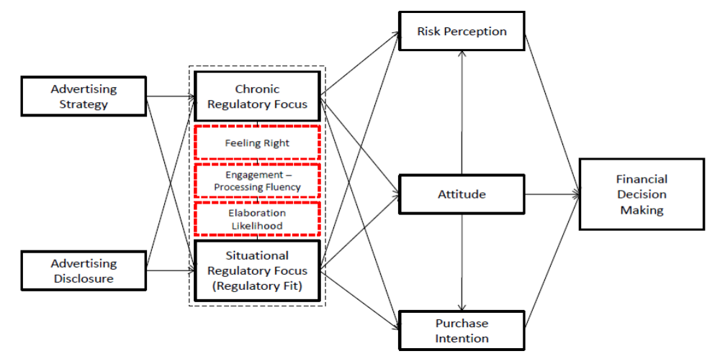

Figure 6. The Proposed Model of Framework: Financial Services Advertising, Regulatory Focus, and Financial Decision Making

Table 1. The Information Processing and Decision Making Mechanism of Regulatory Focus

Type | Prevention-Focused | Promotion-Focused
Goal  Pursuit | • Oughts  - People’s obligations and responsibilities (Higgins, 1998) | • Ideals  - People’s hopes, wishes, and aspirations (Higgins, 1998)
 | • Safety and security (Aaker and Lee, 2001) | • Fun and enjoyment (Aaker and Lee, 2001)
 | • Stability (Liberman et al., 1999) | • Change (Liberman et al., 1999)
 | • A strategic preference for vigilance means (Werth and Förster, 2007) | • A strategic preference for eagerness means (Werth and Förster, 2007)
 | • Avoidance strategy to goal attainment (negative outcome)  - Attain achievement and advancement by approaching matches end states. (Higgins, 2002) | • Approach strategy to goal attainment (positive outcome)  - Achieve protection or safety by avoiding mismatches to desired end states. (Higgins, 2002)
 | • Conservative bias  - The setting of a very strict criterion for acceptance (Signal Detection Theory; Tanner and Swets, 1954) | • Risk (or liberal) bias  - A wiliness to adopt a lenient criterion for acceptance (Signal Detection Theory; Tanner and Swets, 1954)
Cognitive Process | • Item-specific elaboration  - Involves focusing on specific attributes of each item independent of others (Zhu and Meyers-Levy, 2007)  - Involves generating precise and context-specific (concrete) associations to each individual item in isolation of others (Hunt and Einstein, 1981)  - Fewer hypotheses about an object’s identity (Liberman et al., 2001)  - Fewer creative ideas, owing to the emphasis on precise, non-distal associations (Friedman and Förster, 2001) | • Relational elaboration:  - Entail identifying commonalities or abstract relationships among disparate items (Zhu and Meyers-Levy, 2007)  - Involves integrating and abstracting shared aspects (themes) among dissimilar pieces of information (Hunt and Einstein, 1981)  - More hypotheses about an object’s identity, which are culled via feature integration (Liberman et al., 2001)  - More far-ranging abstract ideas that can heighten creativity (Förster, Friedman, and Liberman, 2004)
 | • Assessment (Avnet and Higgins, 2003) | • Locomotion (Avnet and Higgins, 2003)
 | • Analytical processes (Friedman and Förster, 2001) | • Use of heuristics in general (Friedman and Förster, 2001)
 | • Inferential processing (Forgas, 1995) | • Affect-based processing (Forgas, 1995)
 | • Concrete mental representations (Keller, Lee, and Sternthal, 2004) | • Abstract mental representations (Keller, Lee, and Sternthal, 2004)

Table 1 (continued)
 | • Rule-based mode of reasoning (Epstein, 1990) | • Associative modes of reasoning (Epstein, 1990)
 | • Local processing (Förster and Higgins, 2005) | • Global processing (Förster and Higgins, 2005)
 | • Subtractive counterfactuals (Roese, Hur, and Pennington, 1999) | • Additive counterfactuals (Roese, Hur, and Pennington, 1999)
 | • Proximal temporal perspective (Pennington and Roese, 2003) | • Distant temporal perspective (Pennington and Roese, 2003)
 | • Interdependent self-view (Aaker and Lee, 2001) | • Independent self-view (Aaker and Lee, 2001)
 | • Low construal (Lee, Keller, and Sternthal, 2010)  - Concerned with the feasibility of an activity and thus pertain to how certain things are done  - Descriptions at this level are concrete, ordinate, and contexualized | • High construal (Lee, Keller, and Sternthal, 2010)  - Focus on the desirability of an activity, that is, why certain things are done  - Descriptions at this level are abstract, superordinate, and decontextualized
 | • Reliance on substantive information (Pham and Avnet, 2004)  - More receptive to utilitarian, reliability-related, and unattractive product attributes | • Subjective affective responses in persuasion (Pham and Avnet, 2004)  - More receptive to hedonic, performance-related, and attractive product attributes
 | • Reliance on external information (Bless et al., 1992, 1996) | • Reliance on internal input (Bless et al., 1992, 1996)
 | • Minimizing errors of commission (Crowe and Higgins, 1997) | • Minimizing errors of omission (Crowe and Higgins, 1997)
Decision  Making | • Accuracy decision strategy (Förster, Higgins, and Bianco, 2003) | • Progress decision strategy (Förster, Higgins, and Bianco, 2003)
 | • Equal-weight-strategy  - Maximizing the accuracy of a judgment (Bettman, Luce, and Payne, 1998) | • Elimination-by-strategy (Lexicographic)  - Facilitating rapid progress toward a decision (Bettman, Luce, and Payne, 1998)  - Be subject to metacognition
 | • Rely on the concatenation of brand features as the basis for judgment (Decision Fit Hypothesis; Wan, Hong, and Sternthal, 2008) | • Reflect on the subjective experience of processing decision-related information and using this subjective experience to render a judgment (Decision Fit Hypothesis; Wan, Hong, and Sternthal, 2008)

Table 1 (continued)
 | • Self-control (Freitas, Liberman, and Higgins, 2002; Friedman and Förster, 2001) | • Creativity (Freitas, Liberman, and Higgins, 2002; Friedman and Förster, 2001)  • Impulsiveness (Sengupta and Zhou, 2007)
 | • Dejection emotions (Higgins, 1997; Lee, Aaker, and Gardner, 2000). | • Agitation emotions (Higgins, 1997; Lee, Aaker, and Gardner, 2000).

Based on the substantial evidence on the effect of ad strategies, ad disclosures, and regulatory focus on consumers’ information processing and decision-making, the following research hypotheses were advanced. Figure 6 shows the proposed conceptual model that is established to test hypotheses in experimental study.

Ad Strategy x Ad Disclosure Risk Perception, Attitude toward Financial Product, and Purchase Intention:

H1 _{a}: Consumers’ perceived risk of financial product is a function of ad strategy
(informational ad vs. transformational ad) and ad disclosure (presence or absence of ad
disclosure). Specifically, the impact of ad disclosure availability on the risk
perception of financial product is greater for informational ad than transformational ad.

H1_{b}: Consumers’ attitude toward financial product is a function of ad strategy
and the availability of ad disclosure. Specifically, consumers exposed to informational
ad prefer advertisement with disclosure while the opposite pattern is expected for
consumers exposed to transformational ad.

H1_{c}: Consumers’ purchase intention of financial product is a function of ad strategy and
the availability of ad disclosure. Specifically, consumers exposed informational ad prefer
advertisement with disclosure while the opposite pattern is expected for consumers
exposed to transformational ad.

Ad Strategy x Regulatory Focus Risk Perception, Attitude toward Financial Product, and Purchase Intention:

H2_{a}: Consumers’ perceived risk of financial product is a function of ad strategy and regulatory focus. Specifically, prevention-focused consumers have lower perceived risk when exposed to informational ad than transformational ad while promotion-focused consumers have lower perceived risk when exposed to transformational ad than informational ad.

H2_{b}: Consumers’ attitude toward financial product is a function of ad strategy and regulatory focus. Specifically, prevention-focused consumers have more favorable attitude toward financial product when exposed to informational ad than transformational ad while promotion-focused consumers have more favorable attitude toward financial product when exposed to transformational ad than informational ad.

H2_{c}: Consumers’ purchase intention of financial product is a function of ad strategy and regulatory focus. Specifically, prevention-focused consumers have greater purchase intention toward financial product when exposed to informational ad than transformational ad while promotion-focused consumers have greater purchase intention toward financial product when exposed to transformational ad than informational ad.

Ad Disclosure x Regulatory Focus Risk Perception, Attitude toward Financial Product, and Purchase Intention:

H3_{a}: Consumers’ perceived risk of financial product is a function of regulatory focus and ad disclosure (presence or absence of ad disclosure). Specifically, the impact of advertising disclosure availability on the risk perception of financial product is greater for prevention-focused consumers than promotion-focused consumers.

H3_{b}: Consumers’ attitude toward financial product is a function of ad disclosure and regulatory focus. Specifically, prevention-focused consumers have more favorable attitude toward financial product when exposed to an ad with advertising disclosure than an ad without disclosure while promotion-focused consumers have more favorable attitude toward financial product when exposed to an ad without disclosure than an ad with disclosure.

H3_{c}: Consumers’ purchase intention of financial product is a function of ad disclosure and regulatory focus. Specifically, prevention-focused consumers have greater purchase intention of financial product when exposed to an ad with disclosure than an ad without disclosure while promotion-focused consumers have greater purchase intention of financial product when exposed to an ad without disclosure than an ad with disclosure.

In addition to the above two-way interactions, the current study established further hypotheses to test the underlying the three-way interactions of study variables by covering the situation in which there are two moderator variables which jointly influence the regression of the dependent variable on an independent variable (Dawson & Ritcher, 2006). Research suggests that ad strategy, ad disclosure, and regulatory focus are important determinants of the level of elaboration in consumers’ financial decision-making. Thus, in order to precisely examine how ad strategy (ad disclosure) and regulatory focus jointly influence the role of ad disclosure (ad strategy) on financial decision-making, the following hypotheses were put forth:

Ad Strategy x Ad Disclosure x Regulatory Focus Risk Perception, Attitude toward Financial Product, and Purchase Intention

H4_{a}: The moderating role of ad strategy and regulatory focus on risk perception of financial product is further qualified by the availability of ad disclosure. That is, there is a three-way interaction among ad strategy, ad disclosure and regulatory focus on the perceived risk.

H4_{b}: The moderating role of ad strategy and regulatory focus on attitude towards financial product is further qualified by the availability of ad disclosure. That is, there is a three-way interaction among ad strategy, ad disclosure and regulatory focus on attitude towards financial product.

H4_{c}: The moderating role of ad strategy and regulatory focus on purchase intention of financial product is further qualified by the availability of ad disclosure. That is, there is a three-way interaction among ad strategy, ad disclosure and regulatory focus on the purchase intention.

CHAPTER 3: THE STUDY

Research Objectives

This research contributes to the extant literature on financial services advertising (FSA) influence by paring a stimulus-side inquiry that documents how ad strategies and ad disclosures are presented within a print magazine advertisement (Albers-Miller & Straughan, 2000; Huhmann & Bhattacharyya, 2005; Jones & Smythe, 2003) with a response-side assessment of difference in the impact of exposure to and consumer’s regulatory focus (Daryanto, de Ruyter, & Wetzels, 2010; Holler et al., 2008; Zhou & Pham, 2004) on the processing of that FSA depending upon its ad strategies and ad disclosures. Specifically, the inquiry focuses on the nature of FSA and its impact on consumers in financial decision-making. Here, of the many media sources, print magazine is regarded as an influential source through average investors acquire knowledge and learn about financial offerings (Jones & Smythe, 2003; Koehler & Mercer, 2009).
Assessing the impact of ad strategies and ad disclosures presented in print magazine financial services ads on consumers requires a two-sided approach: a stimulus-side analysis to documents the nature of the ad strategies and ad disclosures being communicated and a response-side investigation to assess the consumer’s processing of and economic decision-making on these practices. Systematic analyses of the content of presented ad strategies and ad disclosures in FSA can help uncover the meaning associated with different types of financial behavior (Jones & Smythe, 2003; Koehler & Mercer, 2009), and in turn, offer insights into their impact on financial customers (Albers-Miller & Straughan, 2000; Huhmann & Bhattacharyya, 2005).
Response-side research incorporates the nature of the ad strategies and ad disclosures, but also consumer’s regulatory focus. Extant research suggests that several important characteristics of the investors could impact the compounded effect of economic decision-making in financial services marketing contexts (Kozup, Howlett, & Pagano, 2008; Perry, 2008; Zhou & Pham, 2004). Regulatory focus theory posits that individual self-regulatory orientation (i.e., promotion-focused versus prevention-focused) is an important criterion factor that affects consumers’ receptiveness to ad strategies and ad disclosures and relates to consumers’ perceptions, beliefs, attitudes, and behaviors of economic decision-making (Daryanto et al. 2010; Holler et al., 2007; Zhou & Pham, 2004). Regulatory focus involves a single stock of resources that operate like energy or strength in individual perceptions and decision-making (Lee & Higgins, 2009).
As noted earlier, consumer regulatory orientations have been the focus of a great deal of recent research across a variety of disciplines (Hong & Lee, 2008; Lee & Aaker, 2004). For example, according to the most-common conceptualizations, regulatory focus refers to when a person pursues a goal in a way that maintains the person’s own personal values and beliefs (Lee, Keller, & Sternthal, 2010). Regulatory focus operates on the basic principle that people embrace pleasure but avoid pain, and they then maintain their regulatory fit based on this standard (Lee et al., 2010). Therefore, a response-side inquiry of ad strategies and ad disclosures contained in FSA should account for different types of exposures and individual regulatory orientation (Zhou & Pham, 2004).
In summary, the purpose of this study is to assess the nature and impact of ad strategies and ad disclosures presented in FSA on consumer’s financial decision-making. A stimulus-side approach (i.e., content analysis) simply provides a description of whether and how ad strategies and ad disclosures are communicated (Carlson, 2008). Combined with response-side data, however, the two-sided approach allows an empirical test of how exposure and regulatory focus to a financial services ad affect the ways consumers perceive and evaluate these FSA practices, and how these practices relate to their own perceptions, attitudes, beliefs, and behaviors in financial decision-making. Specifically, the exposition of this study proceeds as follows. First, this research examines current ad strategies and ad disclosures with a content analysis of print magazine financial services ads. The purpose of the content analysis is twofold. First, it is intended to provide a contemporary look at FSA practices in light of ad strategies and ad disclosures. Second, it is used as a foundation to help design realistic test ads in the experimental design. Next, a between-group experimental design examines consumer attitudinal and purchase intention changes for different ad strategies and ad disclosures in the context of FSA. Finally, this study offers theoretical, managerial, and policy implications, study limitations, and future research directions.
Documenting and Selecting Ad Strategies and Ad Disclosures
in Financial Services Advertising (Study 1)

Content Analysis Method
To better assess current FSA strategies and disclosures and to help in the desing of the test ads used in the present study, a content analysis was conducted on a random sample of business- and finance- consumer magazines. Content analysis provides a “scientific, objective, systematic, quantitative and generalizable description of communications content” (Kassarjian, 1977, p. 10) and is the method of choice for stimulus-side inquiries. In addition, content analysis has been for assessing overt communication and subsequent behavioral responses (Riffe, Lacy, & Fisco 2005). In addition, content analysis has been applied to advertising research in a number of contexts, including financial services advertising practices. For instance, in financial services advertising studies, this analysis is commonly regarded as a useful measurement technique to investigate to what extent and how financial companies use advertising (e.g., Huhmann & Bhattacharyya, 2005; Jones & Smythe, 2003). The present study uses a content analysis as an exploratory tool to identify the ad strategies and ad disclosures presented in recent business- and finance- consumer magazines advertisements. These data, along with existing advertising and financial services marketing literature, will be used to help design the print ad used in this study.
The Context of Mutual Fund Advertising
Data for this study was collected through a content analysis of mutual fund advertisements in national print magazines. From the perspectives of public policy and consumer welfare, it has been documented that the type and nature of mutual fund advertising presented to investors during their pre-purchase information search is in need for more research (Investment Company Institute, 2010; Koehler & Mercer, 2009). Recently, regulators and consumer educators have aggressively asked mutual fund companies to develop a more proactive marketing approach to improve both individuals’ perceptions and knowledge of financial plans and management (Kozup & Horgarth, 2008). Therefore, the current study focuses on how mutual fund advertising informs and persuades prospective investors.
Sample
To conduct the content analysis, three coders were hired to analyze mutual fund advertisements included in all 2008 and 2009 issues of BusinessWeek, Economist, Forbes, Fortune, Money, SmartMoney, Barron’s, and Kiplinger’s. These eight publications were chosen in prior studies because they were used as the samples for previous studies on mutual fund advertising (Huhmann & Bhattacharyya, 2005; Jones & Smythe, 2003). In addition, theses magazines were found to be the most widely circulated personal financial management periodicals (Mediamark Research Inc., 2009). Mutual fund advertisements for the three-year period (2007-2009) were selected. All advertisements were coded regardless of the size. Overall, a total of 297 advertisements were coded for this study.
Measure
As shown in Table 2 and 3, the categorization schemes selected were ad strategies from Puto and Wells (1984) and Taylor (1999), whereas disclosures used in mutual fund advertising were drawn from the SEC’ Investment Company advertising Rules (Federal Register, 2003), Investment Company Institute Factbook (2009, 2010), Jones and Smythe (2003), and Huhmann and Bhattacharyya (2005). Specifically, according to the SEC’ advertising rules, mutual fund companies are asked to provide disclosures with respect to the following three aspects: 1) past performance, 2) legend statement, 3) information regarding investment objectives, risks, charges and expenses in that these advertising information has been expected to create better-informed investors and better-protected financial companies (Bone, 2008; Warren, 2008). Thus, this study adopted the categorizations of the SEC’ advertising rules. As a result, the coding framework used in the current study had the merits of enabling the researcher to systematically examine how mutual fund advertisers employed ad strategies and provided ad disclosures in a given period.

Table 2. The Operational Definitions of Ad Strategies in Mutual Fund Advertising

Categories | Detailed Description of Variables Studied
Informational | • Providing factual product information about a brand or company  • Providing relevant brand data in a clear and logical manner  • Showing competing brands, focusing on claims of uniqueness, or providing nature of brands  • Rational appeals: comfort, convenience, ease of use, healthy, profitability, reliability, environmental friendliness, time-saving, efficiency, comparative, variety/diversity, economy, or quality
Transformational | • Associating the experience of using a band with a set of psychological characteristics  • Focusing on the users of a brand and their life style or focusing on developing a brand image  • Emotional appeals: adventure, fear, humor, romance, sensuousness/sex, status, care for loved ones, guilt, pay/contest, or affiliation

Source: Puto & Wells (1984), Taylor (1999)

Table 3. The Operational Definitions of Ad Disclosures in Mutual Fund Advertising
Categories | Detailed Description of Variables Studied
Past performance | • Does the ad include a toll-free or collect telephone number or a Web site where an investor may obtain performance data current to the most recent month-end?  • Does the ad include total return quotations current to the most recent month ended seven business days prior to the date of use?  • Does the ad provide more timely performance data?  • Does the ad provide any discussion/information to reducing the ability of funds to selectively use performance data?  • Does the ad provide any information/data to compare performance among competing funds?
Legend | • Does the ad include a legend stating that past performance does not guarantee future results, and that current performance may be lower or higher than the data quoted?  • Does the ad provide any statement to make investors more aware of the limitations of relying on performance data for investment decisions?
Investment Objectives, Risks, Charges and Expenses | • Does the ad provide any discussion/information concerning the fund’s investment objectives, risks, and charges and expenses?  • Does the ad provide any discussion/information to direct investors to important information that could affect their returns?  • Does the ad include ant discussion/information to allow investors to more easily compare the objectives, risks, and costs of competing funds?

Source: The operational definitions are drawn from SEC’s Investment Company Advertising Rules (Federal Register, 2003), Investment Company Institute Factbook (20009, 2010), Jones and Smythe (2003), and Huhmann and Bhattacharyya (2005).

Coding Procedure
After the coding sheet and written coding instructions were developed, the analysis was performed by two coders trained in the technique. First, the two coders reviewed and discussed the coding categories, previewed a sample of ads, and practiced using the coding instructions in the same way. The coders independently conducted a pilot test of twenty ads. Ads were coded as a dichotomous decision (yes/no) for each category. Unclear and disputed items were discussed and clarified, and changes were made. When disagreements arose, the coders discussed their interpretations and a final decision was made by consensus.
After the pilot coding, the coders independently analyzed mutual fund ads placed in every issue of eight business and finance consumer magazines from January 2007 to December 2009 using the same coding book. The issues, years, and magazines were randomly assigned and systematically rotated. The coders first categorized each ad as either informational or transformational strategies. With respect to ad disclosure, each mutual fund advertisement was coded for the presence or absence of disclosures according to the coding scheme.
Intercoder Reliability
Intercoder reliabilities were computed using percentage of agreement, which is the ratio of agreements to the total number of coding decisions. The two coders had a high percentage of agreement (over 92% agreement) on all categories. To achieve acceptable reliability, another discussion session was held, after which 92% agreement was achieved. As a reliability check, approximately 15% (N=44) of the total sample were randomly selected and coded by the coders. The coders achieved satisfactory percentage of agreement across the ads (higher than 92%). In addition, Perreault and Leigh (1989)’s reliability index (Ir) was employed as a more rigorous reliability test. Table 4 presents reliability indices by variable. Estimates based on Ir ranged from .92 to .96 for the two ad strategies, and from .84 to .92 for the three ad disclosures.

Table 4. Intercoder Reliability

Variables | Percentage of Agreement | Perreault and Leigh (Ir)
Ad Strategy
Informational | 96% | 0.92
Transformational | 98% | 0.96
Ad Disclosure
Performance Information | 96% | 0.92
Legend | 92% | 0.84
Information Regarding Investment Objectives, Risks, and Charges and Expenses | 92% | 0.84

Source: Ir = [(F/N − (1/k))][k/(k −1)]^{.5} for F/N ≥ 1/k, Ir = 0 for F/N ≤ 1/k; where F is the frequency of observed agreement, N is the total number of pairwise judgment, and k is the number of categories into which the responses can be coded.

Results and Discussion
It was found that the overall volume of mutual fund ads and the change in the ratio of informational to transformational ad strategies. The overall volume of Informational strategies used in mutual fund ads was 51.2% (N=152) compared to 48.8% (N=145) transformational ad strategies during the three years studied. However, it is interesting to note that prior to 2007, mutual fund advertising were more likely to employ transformational strategies (61.6%, N=69 in 2007), whereas since 2008, informational strategies had been widely used in mutual fund advertising (57.8%, N=56 in 2008 and 60.2%, N=53 in 2009). The complete findings are reported in Table 5.
Table 5. The Incidence of Ad Strategies in Mutual Fund Advertising

Ad Strategy | 2007 | 2008 | 2009 | Total
Ad Strategy | N/% | N/% | N/% | N/%
Informational | 43/38.4 | 56/57.8 | 53/60.2 | 152/51.2
Transformational | 69/61.6 | 41/42.3 | 35/39.8 | 145/48.8
Total | 112 | 97 | 88 | 297

When it comes to ad disclosures, mutual fund advertising was found to increasingly provide past performance information (61.6%, N=69 in 2007; 74.2%, N=72 in 2008; 79.5%, N=70 in 2009), legend statement (51.8%, N=58 in 2007; 72.2%, N=70 in 2008; 78.4%, N=69 in 2009), and information regarding investment objectives, risks, charges, and expenses (61.6%, N=69 in 2007; 74.2%, N=72 in 2008; 81.8%, N=72 in 2009) in ads during the given period. As a result, there was an increase in the availability of the three required ad disclosures in mutual fund ads during the three-year period (see, Table 6).
In summary, there are two main implications from this stimulus-side inquiry. One the one hand, the content analysis revealed that informational strategies were more used than transformational strategies in mutual fund ads, especially in 2008 and 2009. It is also obvious that mutual fund advertising increasingly presented the required disclosures that might positively affect consumers’ financial knowledge and behavior in savings, investing, and debt. Thus, given that beyond structural approach (e.g., financial education and governmental education), communication approach (e.g., persuasion and information remedy) has played an important role in a wide range of consumer’s economic decision-making (Wiener & Doescher, 2008), the increase in informational strategies and the enhanced availability of disclosures in mutual fund advertising would likely enhance financial literacy and, in turn, increase responsible financial management (Kozup & Hogarth, 2008).

Table 6. The Incidence of Ad Disclosures in Mutual Fund Advertising

Ad Disclosure | 2007 | 2008 | 2009 | Total
Ad Disclosure | N/% | N/% | N/% | N/%
Performance Information
Not included | 43/38.4 | 25/25.8 | 18/20.5 | 86/29.0
Included | 69/61.6 | 72/74.2 | 70/79.5 | 211/71.0
Total | 112 | 97 | 88 | 297
Legend
Not included | 54/48.2 | 27/27.8 | 19/21.6 | 100/33.4
Included | 58/51.8 | 70/72.2 | 69/78.4 | 197/66.3
Total | 112 | 97 | 88 | 297
Information Regarding Investment Objectives, Risks, Charges and Expenses
Not included | 43/38.4 | 25/25.8 | 16/18.2 | 84/28.3
Included | 69/61.6 | 72/74.2 | 72/81.8 | 213/71.7
Total | 112 | 97 | 88 | 297

However, in light of the other side of these finding, it can be assumed that a certain number of consumers might not be exposed to informational ads (61.6%, N=69 in 2007; 42.3%, N=41 in 2008; 39.8%, N=35 in 2009). It is also important to note that mutual fund companies did not fully present the three required disclosures in ads. For instance, federal and state governments and consumer educators ask that mutual fund companies should provide full ad disclosures given average consumers’ financial knowledge and skill (Bone, 2008; Kozup & Hogarth, 2008). Previous research has also shown that full (or complete) ad disclosures can positively impact consumers’ perceptions, attitudes, and intentions (Andrew et al., 2000, 2009; Bates et al., 2009). Hence, to adequately evaluate the range of consumer response effects to ad strategies and ad disclosures in FSA, this study designed four different experimental ads: two different ad strategies (i.e., informational versus transformational) and two ad disclosure conditions (full disclosure versus non-disclosure). Research has used similar test ad features in food and health communication contexts (Andrew et al., 2000, 2009; Bates et al., 2009). Furthermore, this study incorporates regulatory focus in that consumer’s regulatory focus will have more impacts on individual attitudes and behaviors in financial marketing contexts (Zhou & Pham, 2004). The likely processing and persuasive differences between ad strategies and ad disclosures and the potential moderating role of consumer regulatory focus form the basis for the response-side study to complement the content analysis phase.
The Role of Ad Strategies, Ad Disclosures, and Regulatory Focus
in Consumers’ Financial Decision-Making (Study 2)

To answer research questions 1–4, an experiment was conducted to explore the roles of consumers’ inherent regulatory focus, financial services advertising strategies and disclosures identified from the content analysis on consumers’ financial decision-making – risk perception, attitude toward financial product, and purchase intention. An experimental design is chosen because a high level of internal control is needed to isolate effects and control for possible confounds. The current study measured constructs in the natural setting.
Specifically, the current study was to examine the differences in how consumers perceive the ad strategies and ad disclosures presented in financial services advertisement, and in turn, how those perceptions and beliefs relate to their real-life financial decisions. In addition, given the importance of financial decision planning and behavior in consumer welfare, the objective of this research was to examine important factors that influence consumers’ evaluation and judgments for savings and investment. In particular, within the context of financial services advertising, this study investigated how regulatory focus can moderate the influence of different types of ad strategies and ad disclosures on consumers’ financial decision-making.
Experimental Design
A between-group experimental design was used for the study so that there is no chance of one treatment contaminating the other. The study employed a 2 (ad strategy: informational vs. transformational) x 2 (ad disclosure: with disclosure vs. without disclosure) x 2 (regulatory focus: promotion vs. prevention) between-subjects, randomized, experimental design. Both ad strategy and ad disclosure were manipulated in the study while chronic regulatory focus was measured via a scale by Lockwood, Jordan and Kunda (2002). The dominant types of ad strategies and ad disclosures identified in the content analysis were used for this experiment. The dependent measures were risk perceptions of the financial product, attitudes towards the ad, attitudes towards the financial product, and purchase intentions of the financial product in that these three constructs were considered crucial for financial services marketers and policy makers (Jordan & Kaas, 2002; Kozup et al., 2008).
Stimuli
This study used the magazine advertisement format because print media advertisements (e.g. magazine, direct mail, or newspaper) are common in the financial services marketing communications. The current study developed financial services ads sponsored by a fictitious company/product name. Four full-page, color mutual fund for retirement magazine advertisements were created to correspond to the two ad strategies (informational versus transformational) and two ad disclosures (full disclosures versus non-disclosures) by a professional advertising consultant.
In order to avoid any bias toward stimulus among different groups, all other content in the advertisement were held constant. Specifically, the ad stimuli were manipulated only in the verbal description of advertisement. Based on thorough literature review of ad strategy and financial services advertising, such as Puto and Wells (1983), Pollay (1983), Taylor (1999), and Albers-Miller and Straughan (2000), survey items were selected as the basis for operationalizing theses manipulations (see, Table 2). For example, an informational ad mainly contained arguments, information, and expositions with respect to the nature and features of a financial product in a direct, logical, and fact-based manner with emotionally neutral visual elements. In contrast, a transformational ad was based on a specific story that might be associated with the product in a causal or temporal sequence of events by featuring a plot that might attribute specific financial products and projecting the experience consumers will have during financial decision-making (see, Appendix 1).
Ad disclosures for mutual fund product included information with respect to (i) past performance, (ii) legend statement, and (iii) information of investment objectives, risks, charges, and expenses based on the results from Study 1 (see, Table 3). Additionally, in order to develop special ad disclosures for investment products that were used for the current study, the professional advertising consultant abided by the Securities and Exchange Commission (SEC)’s Investment Company Advertising Rules.
Pretest
Prior to data collection, in order to ensure that ad strategies and ad disclosures were operationalized in a proper way, the test ads were reviewed by three advertising professors. Based on recommendations, the executions of ads were revised several times to confirm the intended operationalization of ad stimuli. Then, participants for a focus group were solicited to evaluate the manipulations used in the test ads (i.e., an informational ad with disclosures, an informational ad without disclosures, a transformational ad with disclosure, and a transformational ad without disclosure) (Griffin, Babin, & Darden, 1992). Results from the focus group exercise (i.e., 27 of 27 participants, including 16 actual customers who were involved in mutual fund product and 11 potential investors who were willing to invest mutual fund in the near future), in which each participant viewed the four test ads, corroborated these assumptions.
To further validate the informational versus transformational strategy manipulation in the test ads, participants rated the test ads on a scale designed to classify ads as primarily informational or primarily transformation (Puto & Wells). Participants rated the transformational ad significantly more transformational (M = 6.61) than informational (M = 2.74, t(26) = 19.99, p < .001) and rated the informational ad significantly more informational (M = 5.70) than transformational (M = 2.74, t(26) = 9.18, p < .001). At the same time, participants were asked if they noticed the disclosure presented in ads. A seven-point Likert scale item, “I noticed the ad disclosure,” anchored by (1) strongly disagree to (7) strongly agree was used (Barlow & Wogalter, 1993; Frantz & Rhoades, 1993). Using an independent sample t test, a significant difference between the mean scores was found: an ad with disclosure, M = 5.07; an ad without disclosure M = 2.19, t(26) = 2.53, p < .05. Hence, the pretests were effective.
Subjects
Competitive pressures from deregulation of the financial services market increase the requirement for market orientation and a more intimate knowledge of the market and its segments. Previous research has shown that there are various benefits from taking a segmented approach to financial services marketing: a better serving of customer requirements; a tailoring of offerings; and higher customer satisfaction (Harrison & Ansell, 2002). It can increase customer retention and create loyalty and long-term relationships that positively affect performance (Martenson, 2008). Hence, understanding subject’s background characteristics is vital for the sampling plan for this study.
Ownership of mutual funds that were presented in ad stimuli in this study has grown significantly in the last 30 years. Forty-five percent of all U.S. households owned mutual funds in 2008, compared with less than 6 percent in 1980. The estimated 92 million individuals who owned mutual funds included many different types of people with a variety of financial goals. Fund investors purchase and sell mutual funds through four principal sources: professional financial advisers (e.g., full-service brokers and independent financial planners), employer-sponsored retirement plans, fund companies directly, and fund supermarkets. The rapid growth in assets under management over the period of 1980-2009 and the increased exposure of U.S. household wealth to the stock and bond markets have provided individual investors with a wider choices in terms of types of funds, investing styles, risk, and expense information (Meredith & Salter, 2008).
As indicated in Figure 7, the U.S. Census Bureau (2008) and the U.S. Bureau of Labor Statistics (2008) indicate that in 2008, an estimated 92 million individual investors owned mutual funds and held 82 percent of total mutual fund assets at year-end. Altogether, 52.5 million households, or 45 percent of all U.S. households, owned funds. Indeed, mutual funds represented a significant component of many U.S. households’ financial holdings in 2008. Specifically, 2010 Investment Company Fact Book reports that among households owning mutual funds, the median amount invested in mutual funds was $100,000. Seventy-six percent of individuals heading households that owned mutual funds were married or living with a partner, and 46 percent were college graduates. Seventy-eight percent of these individuals worked full– or part–time. With respect to mutual fund ownership by age and income, in 2009, the incidence of mutual fund ownership was greatest among households headed by individuals between the ages of 35 and 64 – the group considered to be in their peak earning and saving years (Investment Company Institute, 2010). More than half of all households in this age group owned mutual funds. The median age of individuals heading households owning mutual funds was 49 (Investment Company Institute, 2010). Eighteen percent of all individuals heading households owning mutual funds were members of the Silent or GI Generations (born in 1945 or earlier), 46 percent were members of the Baby Boom Generation (born between 1946 and 1964), 24 percent were members of Generation X (born between 1965 and 1976), and 12 percent were members of Generation Y (born in 1977 or later).
Finally, mutual fund advertising has emerged as one of the most important sources of information for individual investors when making mutual fund investment decisions (Albers-Miller & Straughan, 2000; Huhmann & Bhattacharyya, 2005) and fund companies have increasingly used advertising as a communication vehicle to reach mutual fund investors (Jones and Smythe, 2003; Jordan and Kaas, 2002). Huhmann and Bhattacharyya (2005) stressed that print advertising (newspapers and magazines), versus other media types, might require more effort from readers for advertising to have an effect, but investors are more likely to use print advertisements for information gathering purposes than other media types. Jones and Smythe (2003) indicated that financial services advertisements can be often found in media targeting adults with higher education, such as BusinessWeek, The Economist, Baron’s, Newsweek, Money, etc.
As a result, this study was intended to collect data from actual investor consumers characterized by 35-49 years of age, married or living with a partner, college graduates, and employed (full- or part-time) that might be highly involved in savings and investment for future (e.g., retirement, education, family, health, etc.).
Data Collection
Several factors recommended the use of the Internet to conduct the study. First, the Internet is another way that some shareholders access fund and other investment information. In 2008, 91 percent of U.S. households owning mutual funds had Internet access, up from 68 percent in 2000, the first year in which ICI measured shareholders’ access to the Internet (Investment Company Institute, 2009). Paralleling the national pattern, the incidence of Internet access traditionally has been greatest among younger mutual fund shareholders. Increases in Internet access among older shareholder segments, however, have narrowed the generational gap considerably. In 2008, 82 percent of shareholders with Internet access went online for financial purposes, most often to obtain investment information or check their bank or investment accounts (Investment Company Institute, 2009). In addition, mutual fund–owning households were much more likely than non-fund-owning households to engage in common online activities, such as accessing email, obtaining information about products and services other than investments, or purchasing products and services other than investments online.
Next, computer-generated choice tasks can be more easily randomized, and this form of data collection is much faster and easier for the respondents. Respondents required an average of fifteen minutes to complete the online questionnaire. Several introductory screens were devoted to describing the purpose of the study, to assuring anonymity, and to explaining the choice tasks. An open-ended question was placed immediately after the choice screens to solicit respondent comments. This was followed by several questions asking respondents to self-report their standard demographic information.
The research was selected for partial funding in the amount of $2,000 from the 2010 American Academy of Advertising Dissertation Competition. With this financial support, the current study employed a market research company named “E-Rewards market research” for ensuring the external validity of experimental study. The company is located in Houston, TX. All of the consumer panels for the company acknowledges that they will be approached for multiple studies by the company and agree to be the company’s consumer panels. The company will recruit the consumer panels for this study. The company uses a “by-invitation only” approach for recruiting consumers. All panel establishment methodologies employed by the company are fully compliant with CASRO (Code of Standards and Ethics for Survey Research) guidelines. Those guidelines include “respondents should be: (i) willing participants in research, (ii) appropriately informed about the research’s intentions and how their personal information and research responses will be used and protected, (iii) willing to participate again in research” and (iv) informed “confidentiality” of the research.
The E-Rewards provide the means of conducting primary online market research and gauging consumer interest in marketing campaigns and financial issues with extensive profile information for more than 3.3 million members. The E-Rewards online-survey company was chosen due to the following advantages over other online survey company. The E-Rewards online-survey company use by-invitation-only acquisition. Since the company started in 2002, every The E-Rewards member has been exclusively invited into the panel and has experienced the same standardized enrollment process. By avoiding “open” recruitment, Planet Panel, Inc. does not attract the undesirable “professional survey takers” that many other panels do. The company invites panel members through a controlled mix of both online and offline methods, including e-mail and direct mail invitations.
In addition, for fraud prevention, the company identifies undesirable respondents within our panels. Once identified, undesirable respondents no longer receive survey opportunities. The company checks for the following bad behaviors: Inconsistent profiling answers, Straight-lining answers, Answering surveys too quickly, Member duplication. In addition, the company requires a valid and unique e-mail address in order for panelists to receive surveys. Also, physical addresses provided by panelists are verified against government postal information. Thus, participants are members of the E-Rewards online-survey, a nationwide Internet research panel. Members of the research panel are entered into a drawing for cash prizes in exchange for their participation and randomly assigned to the experimental conditions. The ad stimuli are presented to subjects in a static file that mirrored a traditional magazine print ad.
Sample Profile and Procedure
E-Rewards company pre-screening service determined that subjects are characterized by 35-49 years of age, married or living with a partner, college graduates, and employed (full- or part-time) before they participated in the survey. Before participation, subjects were required to go through a screening procedure. If they say no to either question, they were moved to the termination message by the E-Rewards company. Therefore, the current study collected participants who have purchasing experience and plan to purchase mutual fund or retirement savings program in the future that may be sought by mutual fund advertisers, thereby ensuring external validity. As a result, the number of participants amounted to 219. The sample of this study is described in Table 7.
Table 7. The Sample Profile of Study Participants (N = 219)

 | N | % |  | N | %
Age |  |  | Have a child/children
35-39 years | 97 | 44.3 | Yes | 139 | 63.5
40-44 years | 69 | 31.5 | No | 80 | 36.5
45-49 years | 53 | 24.2
 |  |  | Educational level
Gender |  |  | Less than university degree | 49 | 22.4
Male | 133 | 60.7 | University degree | 131 | 59.8
Female | 86 | 39.3 | Postgradate | 39 | 17.8
Ethnicity |  |  | Employment status
Caucasian/White | 78 | 35.6 | Full-time | 181 | 82.6
Hispanic/Latino | 64 | 29.2 | Part-time | 38 | 17.4
Asian | 49 | 22.4
African American | 18 | 8.2 | Total income (before tax)
Other | 10 | 4.6 | Under $35,000 | 33 | 15.1
 |  |  | $35,000 to $54,999 | 54 | 24.7
Marital status |  |  | $55,000 to $74,999 | 93 | 42.5
Married | 123 | 51.2 | $75,000 to $99,999 | 32 | 14.6
Not married | 96 | 48.2 | More than $100,000 | 7 | 3.2

For those who passed several screening questions, treatments were randomly assigned by time order when respondents signed in. First, participants were asked to answer questionnaires for chronic regulatory focus. Then, they were systematically assigned to one of four conditions; (i) an informational mutual fund ad with disclosure, (ii) an informational mutual fund ad without disclosure, (iii) a transformational mutual fund ad with disclosure, or (iv) a transformational mutual fund ad without disclosure. Then, participants were asked to answer questions for measurements with the following order; (i) risk-perceptions of the financial product, (ii) attitudes towards the financial product, (iii) purchase intentions of the financial products, and (iv) demographics (e.g., nationality, age, gender, marital status/family size, ethnicity, education, household income, and occupation).

Measurements
Chronic Regulatory Focus
Since this study was not intended to prime subjects’ regulatory focus, it employed the scale items to measure the chronic regulatory focus of subjects. A sizeable literature has amassed recently on the accuracy and usefulness of Lockwood et al. (2002)’s regulatory focus scale. Specifically, this scale has been utilized and validated in previous research and substantial evidence has demonstrated the power to explain and predict the individual regulatory focus in the context of risk-taking behavior and decision-making, especially health, food, or finance (Cesario & Higgins, 2008; Summerville & Roese, 2008). This scale has eighteen items, half of which measure promotion focus and the other half of which measure prevention focus. Using a scale with endpoints of 1 (“not at all true of me”) and 9 (“very true of me”), participants indicate the extent to which they endorse items relevant to a promotion focus and items relevant to a prevention focus (see, Appendix 2). Cronbach’s alpha for the promotion-focused scale showed an acceptable level of reliability at .91. Also, items measuring prevention-focused showed high level of reliability, α = .95.
Manipulation Checks
Several manipulation checks were used. Similar to pretests, participants were asked to answer Puto and Wells (1984)’s scale items to chech whether the informational versus transformational strategy was perceived as intented. Ad strategies were measured on a scale of 1 = “strongly disagree” to 6 “strongly agree” (Puto & Wells, 1984). An informaionl strategy score was obtained by combining eight informaitonal strategy items (Cronbach’s α = .96) and a transformational score was obtained by combining fifteen transformational strategy items (Cronbach’s α = .97). Using an independent sample t test, a significant difference between informational strategy and transformational strategy was found. The results indicated that informational ads were more informational (M = 5.12) than transformational (M = 2.29, t(217) = 58.11, p < .001), and transformational ads are more transformational (M = 4.90) than informational (M = 2.25, t(217) = -51.35, p < .001). Thus, participants perceived the two ad strategies as intended.
To further validate an ad with disclosures versus an ad without disclosure manipulation in the test ads, a seven-point Likert scale item, “I noticed the ad disclosure,” anchored by (1) strongly disagree to (7) strongly agree was used (Barlow & Wogalter, 1993; Frantz & Rhoades, 1993). Using an independent same t test, a significant difference between the mean scores was found: an ad with disclosure, M = 5.55; an ad without disclosure, M = 3.31, t(217), p < .001. Hence, the manipulations were successful.
Risk Perceptions of Financial Product
Based on literature on financial behavior (e.g., Jordan & Kass, 2002; Lee & Cho, 2005, Perry, 2008), the four items with five-point scales labeled from 1 = “I fully disagree” to 5 = “I fully agree” were adopted to measure individual risk perception of financial product. As shown in Appendix 2, this construct was measured with items questioning whether “This mutual fund bears a high risk of losing money or of missing personal investment objective”, “I feel uncertain about investing in this mutual fund, as I feel uninformed and incompetent about it”, “Investing in this fund also entails good chances to realize higher, above-average returns”, and “Regarding this mutual fund, I reckon there will be significant performance variations over time.” The mean of four items was used as an index for the risk perception of financial product. Cronbach’s alpha for the scale showed an acceptable level of reliability at .90.
Attitudes towards Financial Product
Attitude toward the financial product was measured with three Likert-scale items with five-point scales. Attitude has been identified as an important objective in the context of financial services marketing (Albers-Miller & Straughan, 2000; Kozup et al., 2008). Here, attitude toward financial product was used as a measure of individual perception and belief of the financial product, with three items measuring this factor whether the financial product is good–bad, positive–negative, and favorable–unfavorable (Kozup et al., 2008; MacKenzie & Lutz, 1989) (see, Appendix 2). Reliability for the scale was acceptable, α = .91.
Purchase Intentions of Financial Product
In the current study, purchase intention was operationalized as ‘willingness’ to purchase a product, which is produced by an ad’s sponsoring company. Based on prior studies (Kozup et al. 2008), purchase intentions were measured using four seven-point Likert statements such as the following three items: “Assuming you were going to have a credit card, would you be more or less likely to have this credit card, given the information shown?”; ‘‘Given the information shown about the credit card, how probable is it that you would consider having this credit card, if you were going to have?”; and “How likely would you be to have this credit card, given the information shown?” (see, Appendix 2). Cronbach’s alpha for the scale showed an acceptable level of reliability at .92.
Analysis and Results
Data were analyzed using descriptive statistics such as percentage and frequencies to present the main characteristics of the sample (see, Table 8). Additionally, Table 9 presents means, standard deviations, and intercorrelations of the main variables of the study.

Table8. Summary Statistics and Correlations among Study Variables

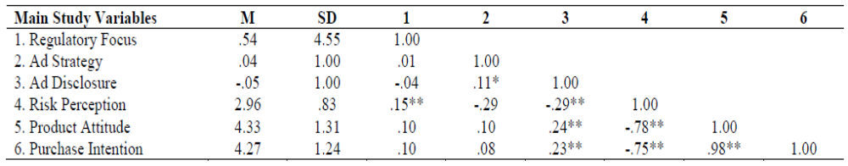
* Significant at .05
** Significant at .01

Especially, the analytical approach used in this study is moderated multiple regression analyses (MRA) instead of conventional AN(C)OVA. This study employed moderated multiple regression rather than AN(C)OVA to avoid a median split that is commonly used for interaction effects dealing with continuous independent variables (i.e., regulatory focus) by turning them -into categorical ones. However, median split inevitably reduces information contained in the variable of interests and may lead to misleading conclusion. Use of moderated multiple regression treat the continuous independent variable in its natural form, thus create greater statistical power (Agunis & Gottredson, 2010; Aiken & West, 1991). Specifically, MRA was applied to test the hypothesized effects of ad strategy, ad disclosure, and regulatory focus on investor consumers’ financial decision-making, including risk perception, attitude toward financial product, and purchase intention. Table 9 reports the results of moderated multiple regression analysis.

Table 9. Moderated Multiple Regressions Results

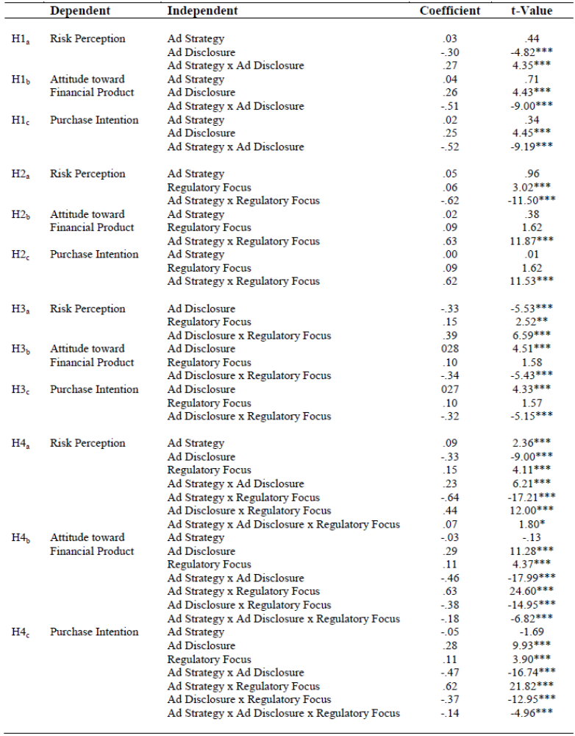
* Significant at .1; ** Significant at .05; ** Significant at .01

The Results of Hypotheses Test

H1 examined potential interaction between ad strategy and ad disclosure on their influence on such outcome measures as risk perception (H1a), attitude toward financial product (H1b) and purchase intention (H1c). As expected in H1a, variance in risk perception was interactive function of adv strategy and ad disclosure (t = 4.35, p < .01). Specifically, as stated in H1a, the impact of ad disclosure on the risk perception of financial product was greater for information ad than transformational ad (see Figure, 7).

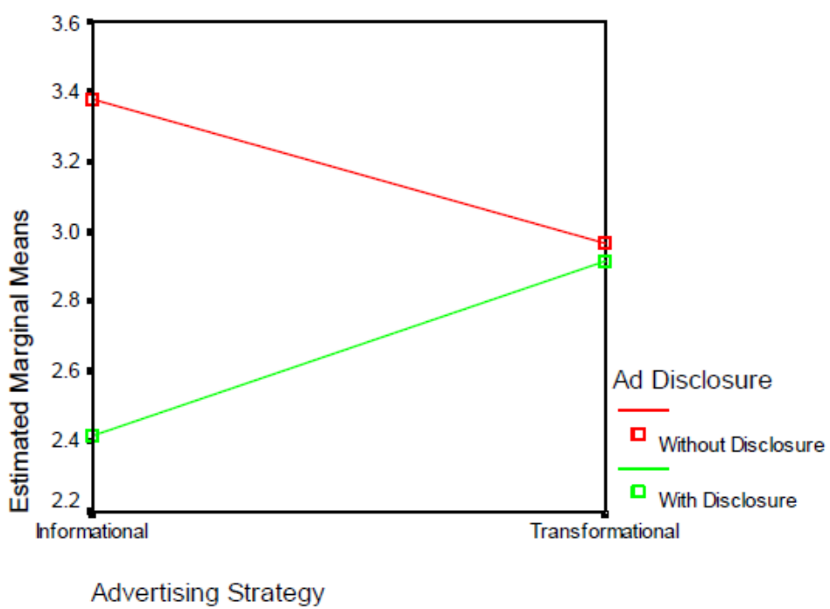

Figure 7. Ad Strategy x Ad Disclosure Risk Perception

In a similar vein, variance of attitude toward financial product was a function of moderation between ad strategy and ad disclosure (t = -9.00, p < .01). Consistent with H1b, there is a disordinal interaction between ad disclosure and ad strategy (see Figure, 8). Specifically, subjects exposed to informational ad prefer advertisement with disclosure while the opposite pattern was found for subjects exposed to transformational ad.

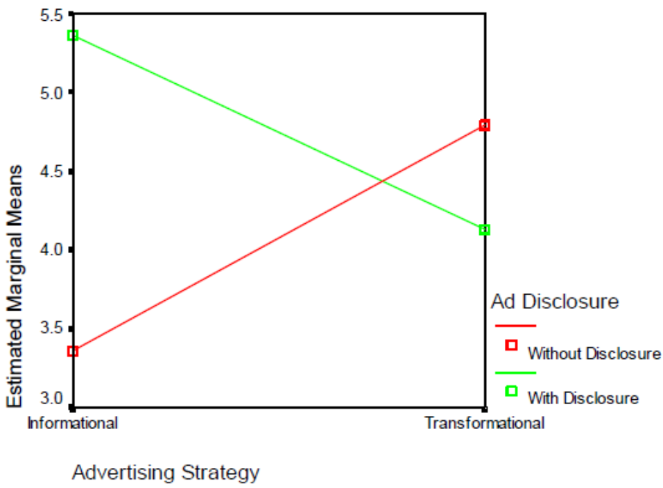

Figure 8. Ad Strategy x Ad Disclosure Attitude toward Financial Product

Concerning H1c, variance in purchase intention was interactive function of ad strategy and ad disclosure (t = -9.19, p < .01). As stated in H1c, result of H1c clearly show that subjects exposed to informational ad had higher purchase intention for the advertisement with disclosure while the opposite pattern was observed for subjects exposed to transformational ad (see Figure, 9). Therefore, H1 was supported.
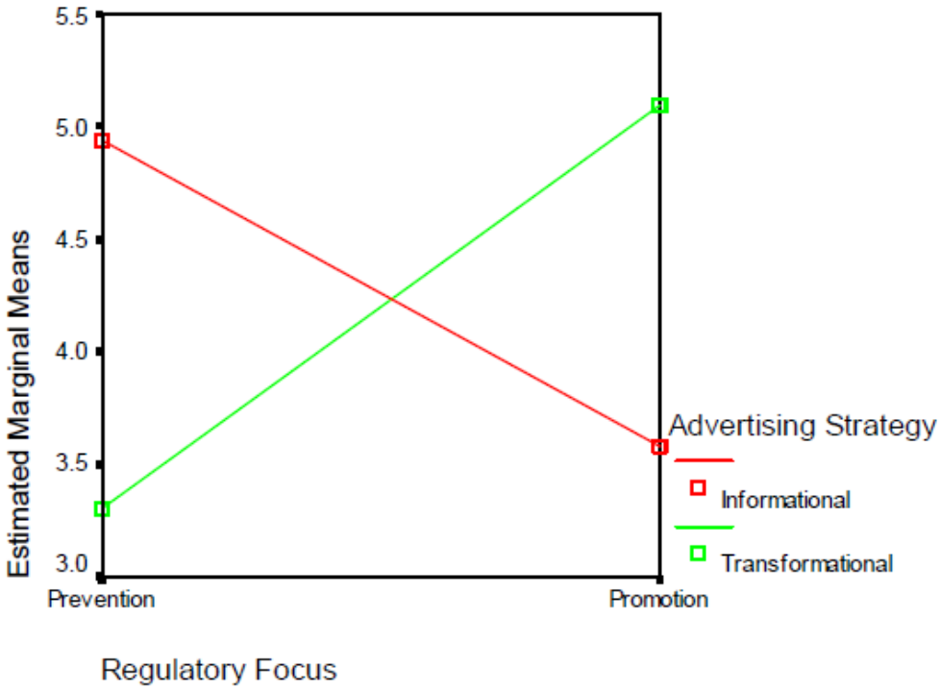

Figure 9. Ad Strategy x Ad Disclosure Purchase Intention

H2 examined potential interaction between ad strategy and chronic regulatory focus on their influence on risk perception (H2a), attitude toward financial product (H2b) and purchase intention (H2c). With regard to the potential interaction effect of ad strategy and chronic regulatory focus on risk perception (H2a), the result of moderated multiple regression analyses indicate that there is statistically significant interaction between ad strategy and chronic regulatory focus (t=-11.50, p<.01). Furthermore, the direction of interaction effect is as expected from H2a. Specifically, prevention-focused subjects had lower perceived risk when exposed to informational ad than transformational ad. In contrast, promotion-focused subjects had lower perceived risk when exposed to transformational ad than informational ad (see Figure, 10).
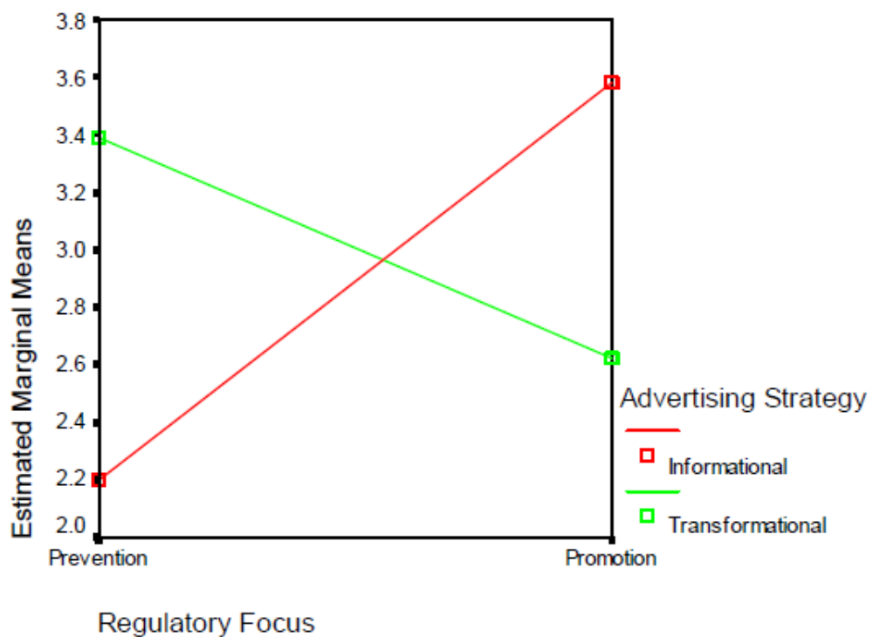

Figure 10. Ad Strategy x Regulatory Focus Risk Perception

H2b stated that there is an interactive effect of advertising strategy and regulatory focus on subjects’ attitude toward financial product. As shown in Table 10, the interaction effect was statistically significant (t=11.87, p<.01). Furthermore, as expected, prevention-focused subjects had more favorable attitude toward financial product when exposed to informational ad than transformational ad while promotion-focused subjects had more favorable attitude toward financial product when exposed to transformational ad than informational ad (see Figure, 11).

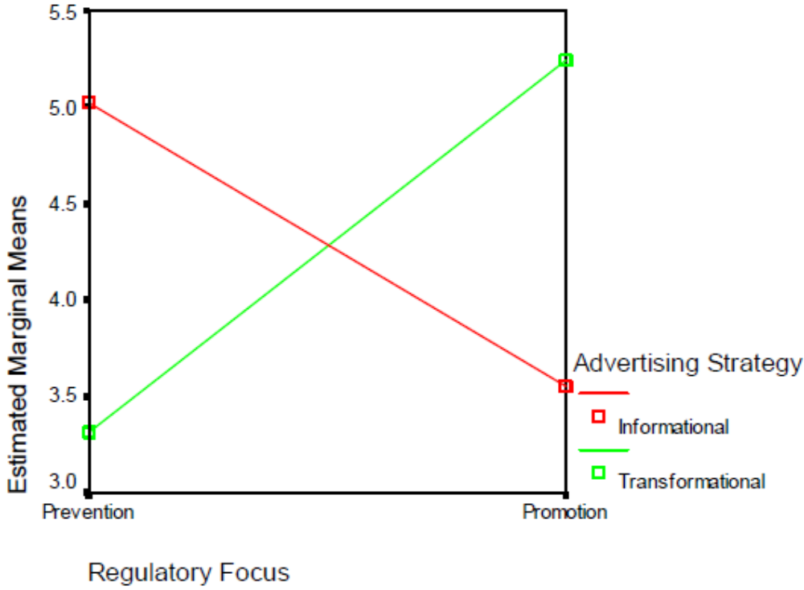

Figure 11. Ad Strategy x Regulatory Focus Attitude toward Financial Product

Similarly, H2c stated that there is an interactive effect of ad strategy and regulatory focus on subjects’ purchase intention toward financial product. As shown in Table 10, the interaction effect was statistically significant (t=11.53, p<.01). Furthermore, as noted in H2c, prevention-focused subjects had greater purchase intention toward financial product when exposed to informational ad than transformational ad while the opposite pattern was revealed for promotion-focused subjects (see Figure, 12). Thus, H2 was supported.

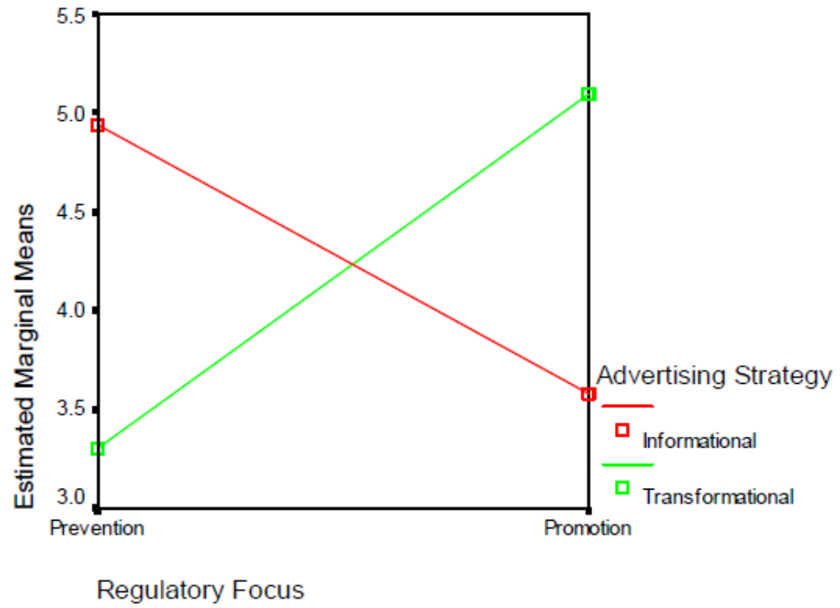

Figure 12. Ad Strategy x Regulatory Focus Purchase Intention

To test the prediction in, H3a, H3b, and H3c, moderated regression analyses were also used. As indicated in Table 10, results indicate that ad disclosure and regulatory focus interact in their effects on consumers’ financial decision-making, thus supporting H3a (β = .39, t = 6.59, p < .01), H3_{b} (β = -.34, t = -5.43, p < .01), and H3_{c} (β = -.32, t = -5.15, p < .01). Specifically, the impact of ad disclosure on the risk perception was greater for prevention-focused subjects than promotion-focused subjects (see Figure, 13). In addition, the influence of ad disclosure on attitude toward financial product is greater for prevention-focused subjects than promotion-focused subjects (see Figure, 14). Finally, with regard to purchase intention, the role of ad disclosure on purchase intention is greater for prevention-focused subjects than promotion-focused subjects (see Figure, 15). Therefore, H3 were supported.
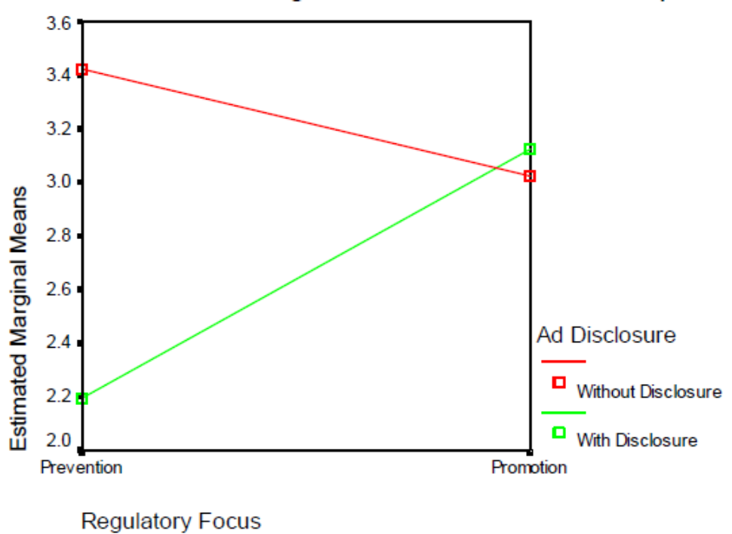

Figure 13. Ad Disclosure x Regulatory Focus Risk Perception

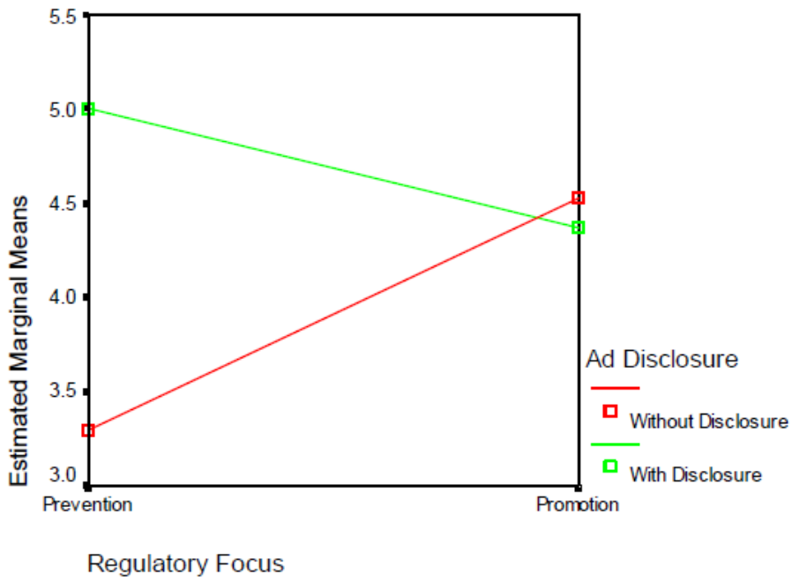

Figure 14. Ad Disclosure x Regulatory Focus Attitude toward Financial Product
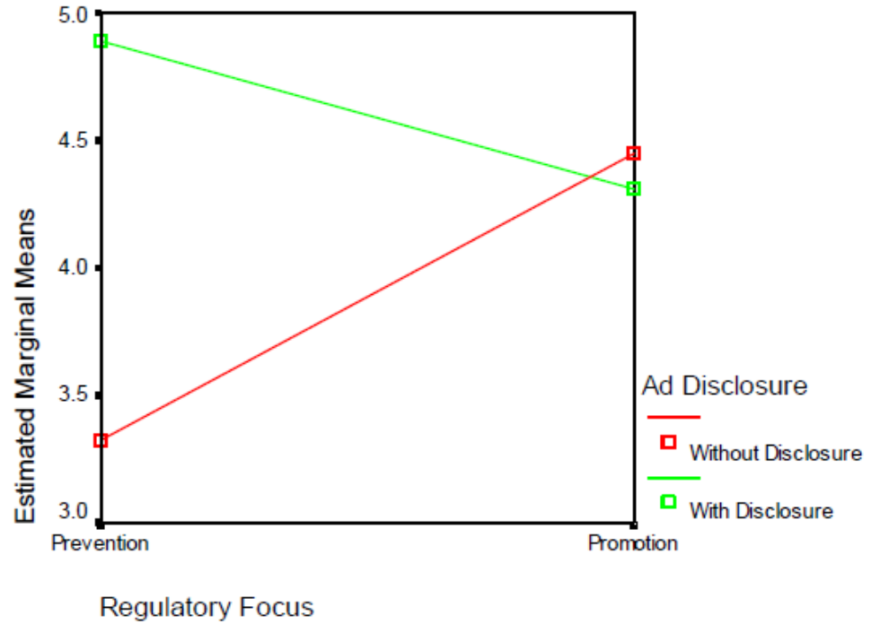
Figure 15. Ad Disclosure x Regulatory Focus Purchase Intention

The results pertaining to H4a, H4b, and H4c are of greater interest because they assess the joint effect of three independent variables (i.e., ad strategy, ad disclosure, and regulatory focus) on dependent variables (i.e., risk perception, attitude toward financial product, and purchase intention) in financial services advertising contexts. As Table 10 shows, all three hypothesized three-way interaction effects were statistically significant in the predicted direction: H4a (β = .07, t = 1.80, p < .10), H4b (β = -.18, t = -6.82, p < .01), and H4c (β = -.14, t = -4.96, p < .01). More specifically, results demonstrate that ad strategy, ad disclosure, and regulatory focus interact on their effects on individual financial decision-making as stated in H4. That is, the interaction effect between ad strategy and regulatory focus is further qualified by the availability of ad disclosure. Specifically, for H4a, under the condition of ad disclosure non-availability, perceived risk difference between prevention-focused subjects and promotion-focused subject was greater under transformational ad condition than informational ad condition; however, the opposite pattern was observed under ad disclosure condition as shown in Figure 16.
With regard to H4b, which concerns three-way interaction among ad strategy, ad disclosure and regulatory focus on attitude towards financial product, the expected pattern of relationship is obtained. Specifically for H4b, under the condition of ad disclosure non-availability, attitude difference between prevention-focused subjects and promotion-focused subject was greater under transformational ad condition than informational ad condition; however, the opposite pattern was observed under ad disclosure condition as shown in Figure 17.
Finally, H4c examined potential three-way interaction among the independent variables on their impact on purchase intention towards financial product. As with H4b, under the condition of ad disclosure non-availability, attitude difference between prevention-focused subjects and promotion-focused subject was greater under transformational ad condition than informational ad condition; however, the opposite pattern was observed under ad disclosure condition as shown in Figure 18. Therefore, H4 was supported.

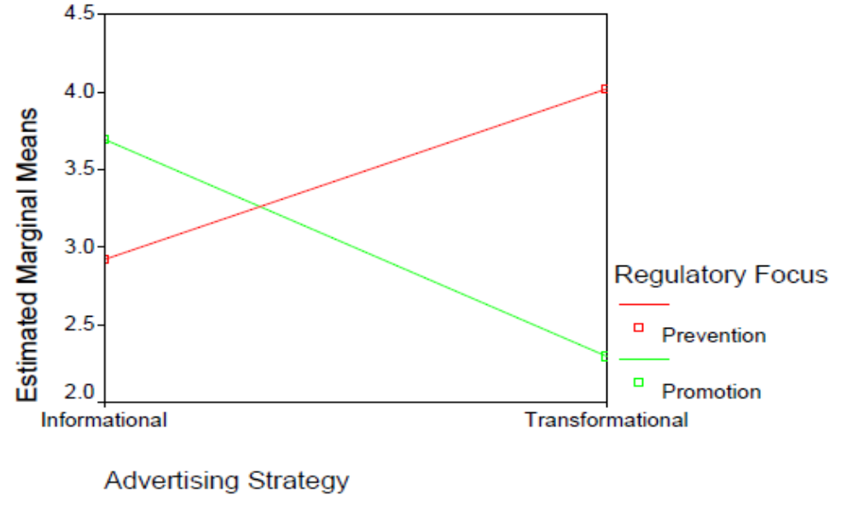

Figure 16. Ad Strategy x Ad Disclosure x Regulatory Focus Risk Perception (An Advertisement without Disclosure)

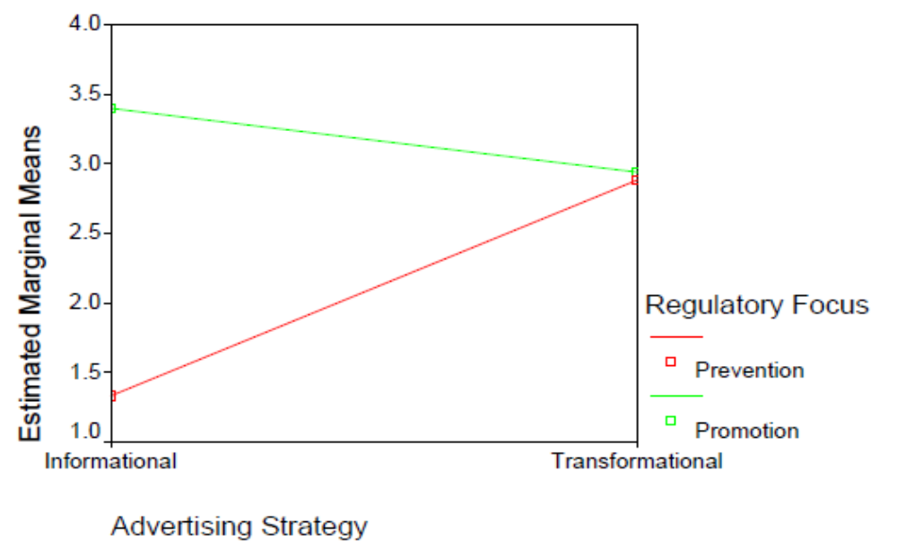
Figure 16. Ad Strategy x Ad Disclosure x Regulatory Focus Risk Perception (An Advertisement with Disclosure)

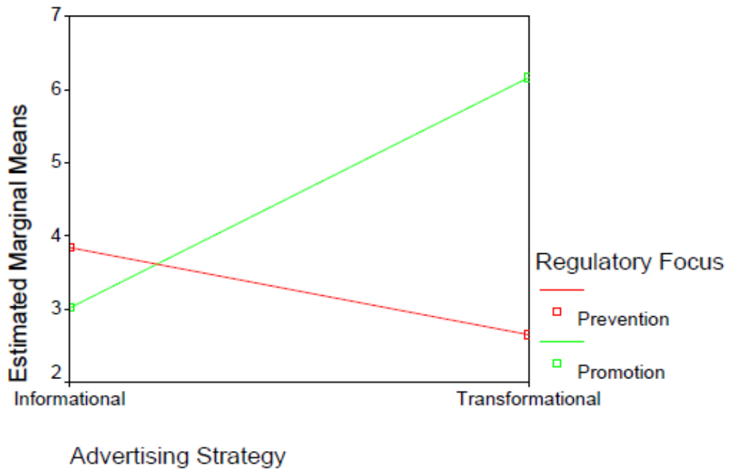

Figure 17. Ad Strategy x Ad Disclosure x Regulatory Focus Attitude toward Financial Product (An Advertisement without Disclosure)

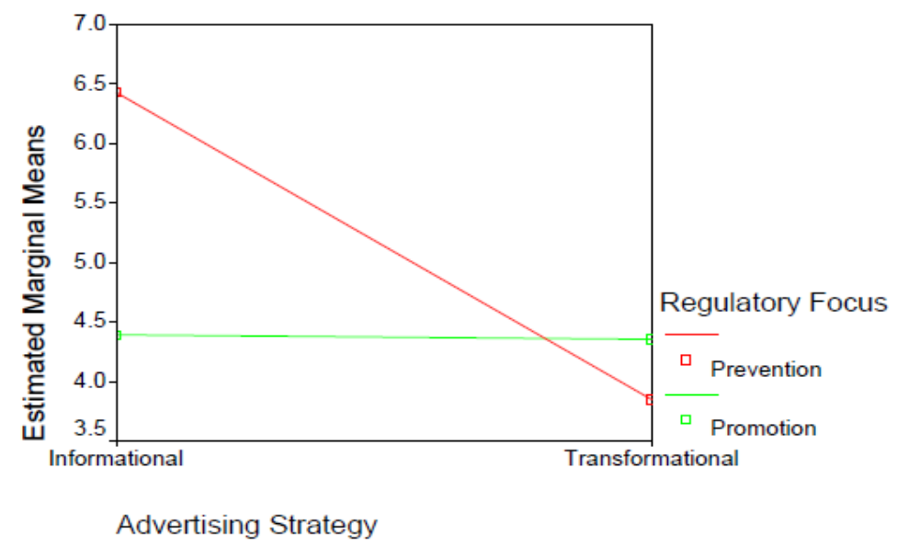

Figure 17. Ad Strategy x Ad Disclosure x Regulatory Focus Attitude toward Financial Product (An Advertisement with Disclosure)

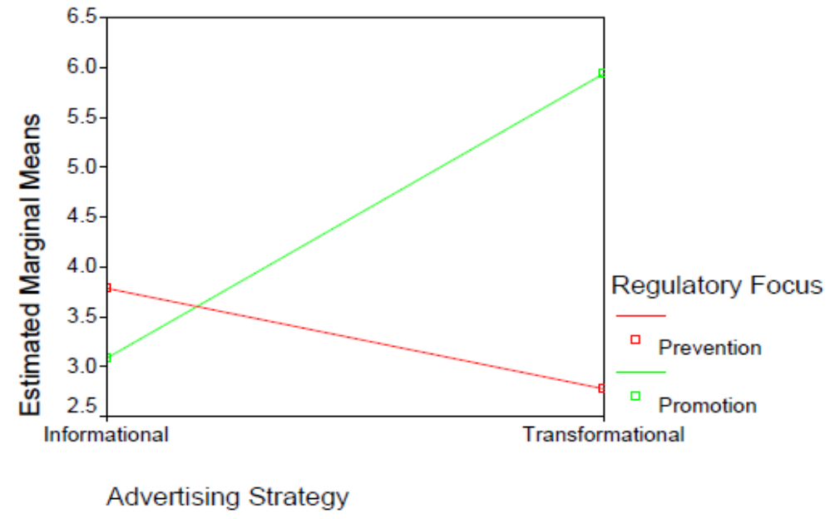

Figure 18. Ad Strategy x Ad Disclosure x Regulatory Focus Purchase Intention (An Advertisement without Disclosure)

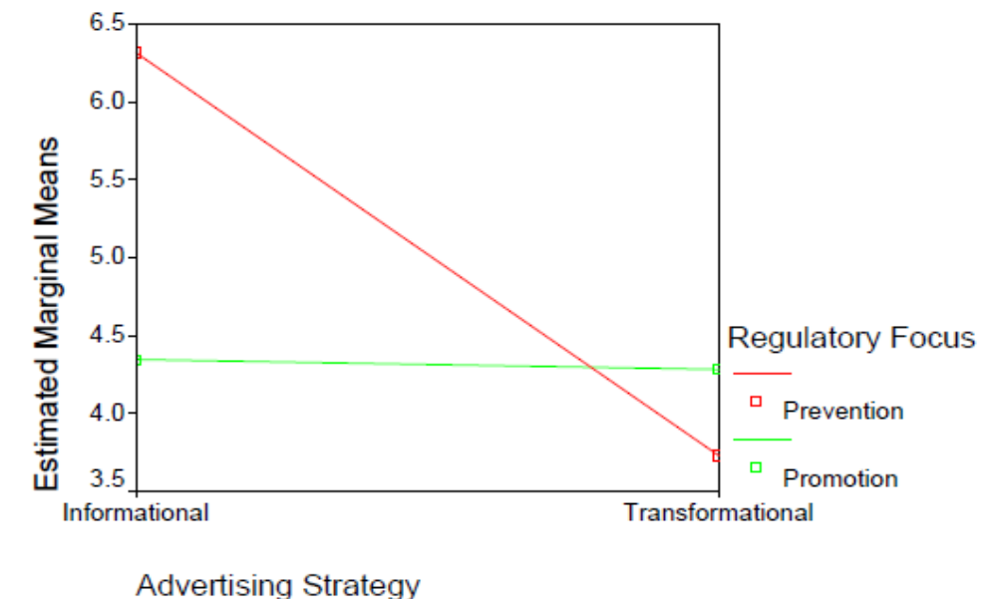

Figure 18. Ad Strategy x Ad Disclosure x Regulatory Focus Purchase Intention (An Advertisement with Disclosure)
CHAPTER 4: DISCUSSION

The Overview of Key Findings

The present study demonstrates the role of ad strategies, ad disclosures, and regulatory focus on individual economic decision-making in the context of FSA. The traditional model of consumers decision-making assumes that complete information is potentially available, that rationality is ideally unbounded and objective, and that human decision-making is primarily aimed at utility maximization (Kahneman & Tversky, 1979; Schwartz, 2002). However, traditional model of consumer decision-making cannot explain easily why economic decisions, which typically entail large financial stakes, are often made with a seeming lack of diligence and expertise (Hong & Lee, 2008; Kirmani & Zhu, 2007). Specifically, those assumptions lead to a distorted view of financial behavior and skewed the analysis of financial decision making process by neglecting contextual, situational and cultural factors (Florack, Ineichen,& Bieri, 2009). They also failed to recognize that consumers have different perceptual, attitudinal, and behavioral responses and outcomes reflecting psychological factors (Bryant & Dunford, 2009). In response to these limitations of classical theories of consumers’ financial decision-making, numerous scholars have developed models that seek to incorporate the external and internal factors that influence financial decision. For example, we now have a far deeper understanding of the role played by cognitive biases, affective states, achievement outcome history, dispositional preferences, and situational factors in consumers’ financial behavior (Kahneman & Tversky, 1979). Several lines of arguments reveal that there is more to consumer decision-making than information search, multi-attribute brand comparison, and heuristics and biases in the financial marketplace (Schwartz, 2002). Nonetheless, there is still much work to do and significant gaps remain.
With this backdrop, the current study indicates that consumes’ economic decision may be affected by individual characteristics (i.e., regulatory focus) and marketing communications (e.g., ad strategies and ad disclosures). In other words, in the minds of consumer investors, FSA seem to be associated with and governed by processes of distinct regulatory orientations that are managed across separate mental accounts rather than being reconsidered on every occasion (Zhou & Pham, 2004). In seeking to advance understanding of these processes, this paper investigated the role of ad strategy, ad disclosures, and regulatory focus in financial decision-making in FSA based on content analysis (Study 1) and experimental study (Study 2). Specifically, the current study (Study 2) investigated actual (potential) investor consumers’ reactions to FSA, using regulatory focus as a theoretical basis. Subsequently, this study attempted to examine the interaction effect between the manner in which a financial service ad is communicated and informed (i.e., ad strategies and ad disclosures) and consumers’ regulatory focus (i.e., prevention-focused vs. promotion-focused). In addition, it was assumed that chronic regulatory focus construct might function as a criterion variable that moderates the impact of fit between different FSA practices (i.e., ad strategies and ad disclosures) and the outcome variables of economic decision-making such as risk perception, product attitude, and purchase intention.
The data supported the basic premise that consumers’ perceptions, attitudes and behaviors of financial product depend on how ad strategy and ad disclosure are processed under different regulatory orientations by indicating that regulatory focus leads to greater sensitivity to different ad strategies and the availability of ad disclosures. Specifically, prevention-focused respondents had lower perceived risk perception, more favorable attitude toward financial product, and greater purchase intention when exposed to informational ad than transformational ad. In contrast, promotion-focused counterparts had lower perceived risk perception, more favorable attitude toward financial product, and greater purchase intention when exposed to transformational ad than informational ad. Prevention-focused respondents had lower perceived risk perception, more favorable attitude toward financial product, and greater purchase intention when exposed to an ad with disclosure than an ad without disclosure. However, promotion-focused respondents had lower perceived risk perception, more favorable attitude toward financial product, and greater purchase intention when exposed to an ad without disclosure.
In summary, the results support the notion that regulatory focus affects the direction and the depth of processing in consumers’ financial behavior in the context of FSA (Daryanto, Ruyter, & Wetsels, 2009; Zhou & Pham, 2004). These findings have both theoretical, managerial, and public policy implications.
Theoretical Implications
The current research contributes to the regulatory focus literature on several fronts. First, results from this research contribute to extant theory by identifying a cognitive mechanism that clarifies how regulatory focus exerts effects on consumers’ response to FSA (Zhu & Meyers-Levey, 2007). As predicted, participants with a promotion focus, due to their emphasis on relational elaboration and its powers of integration, recorded higher risk-perception and responded more favorably to a transformational ad and an ad without disclosure. Yet, participants with a prevention focus, owing to their prevailing use of item-specific elaboration and its focus on the particulars of data, responded more favorably to an informational ad and an ad with disclosure. This in turn suggests that people who adopt a promotion (prevention) focus engage predominately in relational (item-specific) elaboration, which prompts integrative (item-specific) ideation in response to ad strategies and ad disclosures (Kirmani & Zhu, 2007).
Second, the present research examined the accessibility and consequence for regulatory focus on attitudinal strength in financial decision-mkaing. As noted earlier, evaluations formed under accessible ideals (i.e., promotion-focused) and accessible oughts (i.e., prevention-focused) have comparable attitudinal strength in terms of confidence, persistence, and resistance to counterattitudinal information (Avnet & Pham, 2004). More importantly, accessibility of ideals (compared to oughts) tends to increase the reliance on subjective affective responses of a message, whereas the accessibility of oughts (compared to ideals) tends to increase the reliance on the substance of the message (Pham & Avnet, 2004; Zhu & Meyers-Levy, 2007). Consistent with these findings, this study reveals that the greater reliance on affective information (i.e., an transformational ad and an ad without disclosure) under accessible ideals was more pronounced, whereas the greater reliance on substantive information (i.e., an informational ad and an ad with disclosure) under accessible oughts was more pronounced. Building on prior research, this paper extends the notion of the differential reliance on affect versus substance by demonstrating that a change in the perceived diagnosticity of ad strategies and ad disclosure is accompanied by regulatory focus (Wang & Lee, 2006).
However, the current study cautiously suggests that the ideals and oughts change the relative weight attached to subjective affective responses to the ad versus the substance of the message. As discussed by Cesario et al. (2008), it is not clear whether the phenomenon is driven by (i) an increased reliance on subjective affective responses under accessible ideals, (ii) an increased reliance on the substance of the message under accessible oughts, or (iii) both at the same time. Under an averaging rule, it can be said that ideals (i.e., a promotion focus) and oughts (i.e., a prevention focus) generate two separate tendencies: one to weight affective information (i.e., a transformational ad and an ad without disclosure) more heavily under ideals and one to weight substance (i.e., an informational ad and an ad with disclosure) more heavily under oughts in the context of FSA.
Third, results contribute to extant elaboration literature by identifying that regulatory focus is an antecedent of varying the type of elaboration people use in financial decision-making. Pham and Avnet (2004) highlight that compatibility with the person’s goals increases the weights of inputs in judgments and decisions. For example, many ideals seem inherently more commensurable with affective considerations than with substantive reasons. In contrast, oughts may be more commensurable with norms or rule-like inputs. In the same token, this study found that that promotion-focused consumers, as ideals, are more compatible with affective inputs (i.e., a transformational ad and an ad without disclosure) than with substantive inputs (i.e., an informational ad and an ad with disclosure).
However, the distinction between the type of elaboration in regulatory focus and other well-known processing dichotomies (e.g., central vs. peripheral, heuristic vs. systematic, category-based vs. piecemeal, holistic vs. analytic processing) remains unclear (Pham & Avnet, 2004; Zhou & Meyers-Levy, 2007). For instance, according to Elaboration Likelihood Model, any persuasion variable may influence attitude change through a variety of processes, such as serving as persuasive arguments, serving as peripheral cues, or affecting the extent and direction of elaboration (Petty & Cacioppo, 1984). However, using feelings as information may be using feeling right as a heuristic cue (‘If I feel right about it, it must be right’), and feeling right about one’s reaction to the message may be an instance of self-validation (Cesario et al., 2000). In this light, one issue is how regulatory fit combines with other persuasion techniques in consumer behavior and marketing. It would be useful in the future to clarify the extent of such similarities and determine where unique effects occur. For example, it would be interesting to test the role of regulatory fit within existing models of persuasion, such as the elaboration likelihood model (Petty & Cacioppo, 1984), heuristic-systematic model (Chaiken, 1980), and the unimodel (Kruglanski & Thompson, 1999).
Fourth, one of the most compelling findings provides convergent information about the distinctive linguistic signatures of individuals differing in their strategic inclination, especially chronically. As defined by Semin et al. (2005), the linguistic signature of promotion is characteristically abstract and is the language (i.e., a transformational ad and an ad without disclosure) by which eager strategic approach is best captured. Characteristically, prevention-orientation entails a predominantly concrete linguistic signature (i.e., an informational ad and an ad with disclosure), and this is typically a language that is best used to express vigilant strategic avoidance. Semin et al. (2005) indicate that individuals with a promotion orientation are more likely to use abstract terms in describing their goals or conveying impressions while prevention-oriented individuals are more likely to prefer to sue a concrete linguistic strategy for the same ends. In the current study, the pattern of this interaction dovetails with outcomes of the previous Semin et al. (2005)’s experiments, thereby suggesting that the effective linguistic (e.g., ad claims and ad information) strategies for promotion- and prevention-oriented individuals differ systematically in economic decision-making. Taken together, these findings provide an important path to investigating vale from regulatory focus as a persuasion variable.
Finally, this study suggest the importance and usefulness of three outcome variables, including risk perception, attitude toward financial product, and purchase intention in FSA by demonstrating that regulatory focus moderates the effect of ad strategies and ad disclosures on the three variables in the consistent direction. In particular, with respect to the influence of risk perception on behavioral intentions, extant research reveals the tripartite relationship among risk perceptions, attitude toward a product, and behavioral intentions (Towsend & Campbell, 2004). In that regard, if financial services advertisers simply match the ad strategies and ad disclosure to an individual regulatory orientation, then the persuasive effectiveness will be greater.
Managerial Implications
The present research contributes to the literature on financial service marketing and advertising by opening up a myriad of potential application of regulatory focus theory to consumers’ financial decision-making. To begin with, the present study found that a match between audiences’ regulatory focus and the message’s regulatory focus enhanced advertising persuasion by demonstrating that there are two distinct groups of investors: promotion-focused versus prevention-focused investors (Zhou & Pham, 2004). This study also extends findings by demonstrating that the effects of FSA may be observed when ad strategies and ad disclosures are relevant to both promotion and prevention concerns. The data provide evidence that the effect of ad strategies and ad disclosures in FSA on consumers’ financial decision-making was moderated by individual regulatory orientations, suggesting that people rely on their regulatory focus as a filter to process information selectively to construct their psychological responses in the context of FSA (Avnet & Higgins, 2003). In particular, it is interesting to note that the match between a transformational strategy and a promotion focus (risk perception: M = 2.62, s.d.= .60; product attitude: M = 5.24, s.d. = .99; purchase intention: M = 5.10, s.d. = .97) is more likely to induce greater consumers’ evaluations and judgments than the match between an informational strategy and a prevention focus (risk perception: M = 2.20, s.d.=.84; product attitude: M = 5.02, s.d. = 1.37; purchase intention: M = 4.94, s.d. = 1.34). These findings are congenial with previous findings that for promotion-focused individuals, fit might lead to more positive judgments due to the increased processing effort and takes performance compared to prevention-focused individuals (Wang & Lee, 2006). Wang and Lee (2006) indicate that the regulatory fit effect is the result of heuristic processing and not systematic processing by illuminating that consumers rely on their regulatory focus as a guide when allocating scarce cognitive resource. Also, the present results show that ad strategies are more likely to enhance product evaluations for promotion-focused than for prevention-focused individuals (Florack et al., 2009).
On the other hand, prior studies show that a prevention focus may backfire if messages or information (e.g., advertisement) contains ambiguous, implicit claims because a prevention focus could lead to greater use of sentry coping strategies (Kirmani & Campbell, 2004). According to Kirmani and Campbell (2004), targets behaving as goal seekers (e.g., individuals with a promotion focus) attempted to use the persuasion agent to achieve their own purchase-related goals, whereas targets behaving as persuasion sentries (e.g., individuals with a prevention focus) attempted to achieve their purchase-related goals by guarding against unwanted persuasion. Kirmani and Zhu (2007) suggest that sentry strategies (i.e., the desire to avoid being unduly persuaded, included forestalling, deception, assertive resistance, confrontation, punishment, withdrawal, preparation, and enlisting a companion) may be more likely to be used in a prevention focus, whereas seeker strategies may be more likely to be used in a promotion focus by identifying suspicious processing of marketing stimuli as a potential outcome of a prevention focus. As a result, prevention-focused people are more vigilant against manipulation than promotion-focused people. And, prevention-focused people are more likely to perceive ambiguous ad claims (e.g., an transformational ad and an ad without disclosure) as diagnostic of manipulative intent and, consequently, to activate persuasion knowledge and from less favorable brand evaluations because manipulative intent is more accessible to prevention-focused people than to promotion-focused people, and this greater accessibility could lead to greater perceived diagnoticity (Kirmani & Zhu, 2007). Building on these insights, financial services advertisers should be cautious in inducing a prevention focus in the presence of ad practices that might be interpreted ambiguously or implicitly. Moreover, it is important to design advertisements to reduce the suspicion by including reassuring information such as ad disclosures. All in all, despite the significance of regulatory orientations in decision-making, researchers and practitioners should not apply these findings thoughtlessly.
By extension, related implications flow for ad strategies (e.g., message, claim, or visual element) in relation to target audience’s regulatory focus. In general, promotion and prevention regulatory focus are directly and indirectly related to hedonic values and utilitarian values (Arnold & Reynolds, 2009). Given that promotion-focused consumers are more likely to engage in exploratory, creative behaviors and better understand symbolically related information (Zhu & Meyers-Levy, 2007), then it seems logical that financial services advertisers may see some benefits from providing a message that invites and emphasizes more abstract, symbolic communication approaches. Prevention-focused people are more analytical and think about financial matters carefully in precise, concrete detail (e.g., Semin et al., 2005). Financial services advertiser who wish to create utilitarian value may see more benefit from a message that is fairly understandable, transparent, and concrete communications. This distinction is a potentially promising areas for financial services marketers.
Second, the results from this study shows that the fit effects between regulatory focus and FSA (i.e., ad strategies and ad disclosures) significantly influence consumer investors’ purchase intentions. As noted earlier, the fit from construal hypothesis can offer an alternative explanation of the potential impact of regulatory fit on purchase intention (Zhao & Pechmann, 2007; Zhu & Pham, 2004). Specifically, construal hypothesis predicts a correspondence between regulatory focus and level of construal (Lee, Keller, & Sternthal, 2009). Whereas prevention-focused individuals tend to construe information at a low level, those with a promotion focus are more inclined to construe information at a high level. Consistent with the fit from construal hypothesis is the demonstration that people develop more favorable attitude toward an advertised product when the information in the advertisement is construed at a level that fits with their regulatory focus. Prevention-focused participations had more positive product attitudes when the product was described at a low rather than a high level of construal (i.e., an informational ad and an ad with disclosure). In contrast, promotion-focused participants had more favorable product attitudes when the product was described at a high very versus low level of construal (i.e., a transformational ad and an ad without disclosure). As found by Lee and Aaker (2004), the process in which fit between regulatory focus and construal level influences product attitudes increases engagement, which in turn leads to intensified reactions (i.e., purchase intention) in an integral evaluation task. Given that financial service providers are generally interested in enhancing purchase intentions, these findings have major implications for marketing practice.
Third, this study suggests advertising’s potential impact on varying segments of individual consumers in the financial marketplace. Given severe market competition and legal changes in financial service industry ignite a demand for better marketing communications (Huhmann & Bhattacharyya 2005), the practical value of indentifying the regulatory focus of the target consumers and then considering a function of the target consumer’s regulatory focus and a communication approach will product the greatest persuasive impact (Kirmani & Zhu, 2007; Pham & Avnet, 2004). For example, as suggested by Lee et al. (2008), for those consumers whose goal is growth and advancement (i.e., promotion-focused individuals), a laddering-up advertising strategy (i.e., involving initially presenting a brand feature, then prompting the functional benefits of the feature, and finally elaborating on the emotional implication of the benefit) by focusing on high construals (i.e., transformational strategies) is likely to heighten engagement and enhance brand evaluations. In contrast, for the consumers whose goal is safety and security (i.e., prevention-focused individuals), a laddering-up advertising strategy creates a nonfit experience that may render the message less persuasive (Lee et al., 2008). Messages that use a laddering-down strategy and focus on low low-level construals (i.e., informational strategies) related to feasibility are likely to be more persuasive than those that ladder up to emotional benefits (Wang & Lee, 2006). Thus, the current study marshals in support for the construction of advertising approaches that engage consumers at the appropriate regulatory orientations.
From a managerial perspective, the knowledge, in turn, might have strong implications for the conduct of corporate advertising, investor-relations programs, and integrated marketing communications efforts. As today’s investing public includes many new entrants and a range of investment options, communication with investors is an important part of a larger marketing strategy and should be well-coordinated with firm’s other marketing efforts between investors, customers, and other important stakeholders. According to Karrh (2004), a financial company’s commitment to advertising can be considered as more of a long-term investment than as a current-term expense, especially for investor relations activities. As a result, FSA should prove useful in addressing a set of target audiences and issues. Thus, financial services advertisers should focus on the deliberate application and compatibility of advertising approaches depending upon target audiences’ regulatory focus (Keller, 2006).
In addition, from a practical standpoint, the analytical framework utilized in this study has the ability to enhance the long-term profitability of financial institutions by understanding target consumers’ psychographics (i.e., regulatory orientation) that may influence information processing and decision-making. Importantly, Pettier, Schiborwsky, Schurz, and David (2002) suggest that financial companies must use psychographics approach in the relationship marketing in an effort to create difference products, identify different cross-selling opportunities, and develop difference communications when prompting the different product categories to each of the segments. For many companies, the interactive psychographical modeling (e.g., Pettier et al., 2002) can be used to gain a better understanding of a firm’s current customers and allow the firm to target customers from those segments that are most likely to meet the organization’s long-term marketing objectives. In this respect, regulatory focus construct used in this study provides financial companies with a roadmap to modify their marketing communications efforts to best identify and satisfy current customers and prospect for new customers.
Fourth, this study did not observe any boomerang effect: that is, no advertisement inadvertently encouraged participants to respond to ad strategies and ad disclosures. As moderation analysis showed, the persuasiveness of ad strategies and ad disclosures was largely due to individual regulatory orientation. In other words, ad messages not matching investors’ regulatory focus were perceived as irrelevant and subsequently ignored without further processing. Consistent with previous findings (Pham & Avnet, 2004), results show that financial decision makers’ self-regulatory orientation affects the impact of strategies that maximize accuracy (e.g., vigilance strategy; equal weight strategy) and facilitate rapid progress toward making a decision (e.g. eagerness strategy; lexicographic and EBA) in the context of FSA. Similarly, Keller (2006) suggests that a promotion focus is oriented toward how easy it is to take action rather than the effectiveness of the action whereas a prevention focus is more oriented toward the effectiveness of the action rather than ease of taking action. Bass et al. (2008) suggest that a promotion focus triggers cognitive flexibility (broad conceptual attention, accessing multiple cognitive categories), and a prevention focus triggers cognitive perseverance (focused attention, persevering within few cognitive categories) more.
Nonetheless, in other marketing contexts, exposure to brand information that is incompatible with audiences’ regulatory focus might inadvertently affect consumers’ brand evaluations (e.g., Labroo & Lee, 2006). For instance, Evans and Petty (2003) found that participant’s evaluation of the product was more strongly affected by argument quality (e.g., informational strategies or ad-disclosures) when the message fit their regulatory focus, but only for those with a low need for cognition. Uninvolved consumers are less likely to be aware of the potential bias of feeling right or processing fluency or to expend cognitive resources to correct their initial response (Schwartz, 2004). Wang and Lee (2006) suggest that when people are not motivated to process information, they rely on their regulatory focus to screen out information that is irrelevant to their regulatory concerns and to construct their presences on the basis of the perceptual salience of the selected information rather than the diagnosticity of the information. In this regard, practitioners should be aware of the boundary conditions under which exposure to ad strategies and ad disclosures incompatible with audiences’ regulatory focus might boomerang and adversely affect consumer evaluations and judgments.
Finally, given that the use of regulatory focus and regulatory fit helps people pass through the stages of behavioral change, this research provides an important future application for social marketing programs (Semin et al., 2005). First, financial services advertisers could adopt social cognitive strategies that may alter risk-taking behaviors through reinforcing and/or encouraging regulatory focus in financial behavior. This study found the reciprocal relationship between risk perception and regulatory focus in financial behavior by showing mixed results for the main effect of regulatory focus. That is, ad strategies and ad disclosures can be predictors of detection and protection intentions and behaviors in risky-decision making process. Interestingly, the literature on the link between regulatory focus and risky decision making (e.g., Bryant & Dunford, 2008) would expect greater regulatory fit when a promotion focus is matched with detection behaviors (i.e., providing information about the presence or absence of a potential undesirable outcome) and a prevention focus is paired with preventative behaviors (i.e., providing people with the opportunity to maintain or improve their status). Detection behaviors are frequently perceived in terms of short-term costs, whereas long-term benefits are dependent on preventative perspectives (Keller, 2006). Van Noort, Kerkhof, and Fennis (2007) demonstrated that a prevention focus initiates higher levels of risk perceptions. In view of the findings, financial services advertisers are advised to consider promotion and prevention concerns when advertising expected returns and potential risks of financial product. Specifically, given the prominent role of financial risk perceptions in product evaluations and judgments (Daryanto et al., 2009), financial service advertising should stimulate active consumer consideration of cost-benefit ratios that are aligned with consumers’ regulatory orientations. Also, to facilitate perceived risks and expected returns in decision-making process, it would be worthwhile offering easy-to-use tools to compare cost and benefits in FSA. By making appropriate advertising approaches that influence regulatory focus and distributing them to segments dominated by a promotion or prevention regulatory focus, consumers may be led to be more concerned with either avoiding losses from a prevention focus, such as insurance and credit risk, or attaining gains from a promotion focus, such as mutual fund and securities in financial decision-making (Zhou & Pham, 2004).
Next, the current research offers something of practical interest for those who unregulated (i.e., impulsive) financial behavior. In recent days, by identifying a connection between the two mechanisms underlying the influence of impulsivity, prior studies show that people in a promotion mindset are more likely to be influenced by affect, whereas a prevention mind-set typically leads to a greater emphasis on cognitive features. As found by Sengupta and Zhou (2007), the greater reliance on affect by impulsive people could be due, at least in part, to the heightened promotion focus. Building on these insights, Hong and Lee (2008) demonstrated that regulatory focus can enhance self-regulation when people adopt strategies that match their regulatory orientation, but it can also weaken self-regulation when people adopt strategies that mismatch their regulatory orientation. Sengupta and Zhou (2004) found that high impulsive (versus low impulsive) develop an increased promotion focus on exposure to a less utilitarian, functional, and rational product choice and a promotion focus involves a disproportionate emphasis on the potential upside and ideal-related benefits (versus potential downside and ought-related consequences) associated with a choice behavior. Also, mere exposure to a product or message that can evoke thoughts and feelings related to promotion focus is more likely to influence the choice behavior of promotion-oriented consumers by impulse rather than under self-regulation. In contrast, a prevention focus was found to be associated with better self-control than a promotion focus (Freitas et al., 2002). Thus, it can be surmised that a transformational ad and an ad without disclosure may enable people with high impulsiveness and a promotion focus to choose financial option on impulse or without self-control.
From this point of view, financial services advertisers must understand that the activation of regulatory focus can be moderated by individual characteristics, including impulsive at the time of choice. For instance, financial services marketers are encouraged to develop various self-control strategies that may have the potential to be activated in the context of financial decision-making and reduce the tendency of impulsive. Furthermore, given that regulatory fit can overcome can self-regulatory depletion (Hong & Lee, 2008), financial services marketers should reflect on the effect of fit between advertising practices and target consumers’ regulatory focus when designing communication strategies and information provisions. These propositions can make major contributions to efforts at behavioral and attitudinal changes in consumers’ irrational and suboptimal financial behavior. This will be a relatively promising area and bring ramifications for a wider range of applied issues such as social marketing, public service announcements, inter alia.
Policy Implications
It is important to better understand the policy implications of current financial planning by American investors today, particularly given the uncertainties of the federal Social Secur0ity system, the recent trend of negative savings rates, and the devastating effects of failing to9b adequately prepare for retirement. Enrolling in financial management plan (e.g., IRAs, 401(k), 403(b), 457, etc.) is one of the most-popular ways to financially prepare for the future. However, many Americans are neglecting to do this, and unfortunately, many individuals lack the basic financial literacy necessary to make wise financial decisions. With this backdrop, this study examined that regulatory focus, ad strategy, and ad disclosure have an impact on consumer evaluations of and intentions to enroll in financial service. From a policy standpoint, these results might hold particular promise for the important role of advertising in consumer financial well-being.
The Role of External Information in Financial Decision-Making
Taking on the scope of libertarian paternalism (Thaler & Sunstenin, 2003), external information provision could be effective in reducing various errors and biases in consumers’ decision-making processes. External information provision (e.g., ad claims, ad information, and ad disclosures) can be seen as a form of libertarian paternalism that guides consumers to be better off without necessarily restricting their choices (Thaler & Sunstein, 2003). This research supports prior work investigating the effects of external information (i.e., ad claims, ad information, and ad disclosure) on consumers’ product evaluations and judgments. In particular, previous literature reveals that presenting external information in the form of a prominent ad disclosure counterbalances the potential misperceptions about the perceived risk of weight gain associated with the product (Kozup, Creyer, & Burton, 2003). Andrews et al. (2008) support the role of concisely written and prominently displayed disclosure statements for less healthy products in overcoming misleading perceptions for all consumers, not just those who are more motivated and knowledgeable. Kozup et al. (2008) suggest that financial disclosure is to increase the perceived benefits of using information, which is consistent with educational and social marketing endeavors by reducing the costs associated with increased information processing efforts. This research also builds on and extend prior research to demonstrate how presenting ad disclosure to investors affect product-related perceptions, attitudes, and behaviors in the context of financial decision-making.
Policy makers, researchers, and concerned consumers have considered the potential role played by the financial services marketing (Perry, 2008). From many studies on consumers’ financial behavior, consumers need to assess their own levels of financial literacy and explore means to improve it in order to make effectively enhance their financial outcomes such as savings, investing, and debt behaviors (Perry & Morris, 2005; Wonder, Wilhelm, & Fewings, 2008). In recent years, a growing body of literature has shown that financial literacy enhanced by external information provision (e.g., ad disclosure) has played an important role in a wide range of financial behaviors, including wealth accumulation, stock market participation, portfolio diversification, participation and asset allocation in financial plans and responsible fiduciary behaviors (Monticone, 2010; Wiener & Doescher, 2008). For example, the dominant paradigm in the theory of finance indicates that ad disclosures include a working knowledge of crucial information, ideas, concepts and terminology, thus assisting consumers developing their cognitive ability to process financial information during decision-making (Huhmann & Bhattacharyya, 2005; Kozup & Hogarth, 2008). Several arguments suggest that, in terms of information remedy and consumer protection, external information (i.e., ad claims and ad disclosures) has been expected to improve consumers’ knowledge, perceptions and intentions regarding financial management, persuade an individual to join an optimal financial program, and increase his or her level of contribution to such a program (Bone, 2008; Monticone, 2010). Thus, the results of the current study imply that public policy involvement and legislative intervention regarding FSA could be necessary so that it can enhancing serve the positive role of external information for consumers’ financial welfare.
However, while increased ad disclosures might result in various consumer benefits, this situation can generate the problem of information overload for average consumers (Jacoby, 1984; Warren, 2008). According to the limited-capacity model of attention (Kahneman, 1973), one’s total attentional capacity at any one point in time is limited and, in turn, the total capacity allocated to process all activities can be divided into two parts: capacity devoted to the primary task and spare capacity. In this process, it is often necessary for consumers to allocate their cognitive capacity to processing irrelevant, unclear, and inaccurate data in order to find needed information (Jacoby, 1984; Lee & Cho, 2005). For instance, research shows that despite the high involvement environment associated with financial behavior, consumers are susceptible to various heuristics biases that can lead to suboptimal economic decision-making because they have limited ability to perform their own due diligence (Estelami, 2009). Lee and Cho (2005) found that an oversupply of information adds more burdens and consumers’ information processing, causes psychological anxiety and tension, reduces attention span, increases difficulties in memorizing and remembering, and leads to suboptimal decision-making. Jordan and Kaas (2002) indicated that regardless of information readability and comprehension, mere exposure to advertising disclosures can lead to the “hallo effect” or function as a judgmental heuristic cue, thereby leading consumers to have a biased belief that a particular company or advertised product may be successful and of good quality. Hedesström, Svedsäter, and Gärling (2004) showed that due to cognitive overload or simplification in the context of contribution-based retirement savings plans, novice consumers are more likely to resort to various heuristic choice rules and make suboptimal financial decisions.
Given these findings, it is critical for policy makers and consumer advocates to encourage financial services marketers to eliminate consumers’ confusion and distraction and increase readability and comprehensibility of marketing communications. For instance, financial institutions need to make their advertising disclosures clearer and more conspicuous by discarding the selection of words and phrases that may result in a confused or garbled message and by using shorter sentences and replacing difficult words with easier-to-read synonyms (Philpot & Johnson, 2007). Also, segmenting investors on the basis of individual characteristics (e.g., regulatory orientations, prior knowledge, involvement, motivation, etc.) that might be relevant to financial decision-making will enable these parties to present the types of information that specific investors will find most useful (Zhao & Pechmann, 2007). At the same time, it will be necessary to continue with large-scale efforts to increase the consumer motivation component to process financial information and communication programs (Lee et al., 2000).
Furthermore, this research suggests that using presentation formats that facilitate the fit between regulatory orientations and ad claims/disclosures would increase the impact of financial services advertising on consumers’ economic decision (Wan et al., 2008). Prior studies demonstrate that a message prompting a perception of progress toward a decision would increase the persuasiveness of appeals (Lee et al., 2009). From a consumer protection perspective, such approaches can enhance the likelihood that a consumer comprehends financial information, is conscientious in analyzing the information, and detects a financial institution’s mistake or predatory practice (Kozup et al., 2008).
As was mentioned above, simply providing information to consumers is inadequate; consumers must also be able to comprehend the information given. Comprehension depends on interaction between the consumer’s individual characteristics and the format friendliness (Kozup et al., 2008). In this respect, most educational groups involved in financial literacy focus on providing consumers with the knowledge and abilities needed to process financial information and make appropriate financial decisions for themselves. Operationally, however, financial literacy will differ substantially from industry to industry and decision to decision because the set of skills needed in one situation, such as negotiating a car loan, is likely to differ from skills needed in another situation, such as working with a health insurance firm after an accident. For instance, in the case of mortgage servicing, consumer literacy could be operationalized by the consumer understanding monthly or annual statements (if they are available) well enough to detect a mistake or predatory practice. Given that many consumers have difficulty in grasping financial concepts or lack of sufficient prior knowledge about financial products, research has demonstrated the conditions under which format of financial claim/disclosure aids consumers in their evaluation and judgment of financial product (Bone, 2008). To this end, one needs to ask ‘‘Is the right information on the disclosure?’’ Is there too much information? Does it meet a clear and conspicuous standard? Research into consumer behavior provides some insights into the types of information needed and the formats that would provide optimal opportunity to process that information (e.g., Brucks, Mitchell, & Staelin, 1984). Indeed, several federal agencies and many financial institutions are conducting consumer tests to discern the key disclosures that consumers need and want and find an optimal method of comparison across financial products that can be communicated in a manner similar to the nutrition facts panel. Recently, Karniouchina, Moore, and Cooney (2009) found that when investors are looking for recommendations, the situation could be similar to when a person has an interest in a product or service class but does not have a specific brand in mind. They suggest that financial services marketers need to make sure not only that the message is going to the right people but also that it is appropriately positioned among the competitive entries and designed in a way that grabs consumer attention and cuts through the clutter (Karniouchina et al., 2009). With this backdrop, the present findings suggest the need to develop the format of ad disclosures that can significantly alter consumer preferences and choices and have a systematic and predictable impact on consumer economic decision making.
In summary, as shown in Figure 19, a multifaceted, integrated, and comprehensive approach is needed, involving market-based solutions, possible financial education, disclosures, financial incentives, and community-based programs. Therefore, policy makers and consumer organizations involved in financial literacy education could use public service campaign strategies and other social marketing approaches to promote rational economic decision-making beyond external information provision. Market-based solutions may present a more viable option for vulnerable investors. Thaler and Sunstein (2003) suggest that consumers often make choices that are not necessarily good for them, and their mistakes provide clues that could facilitate the design of simple interventions that could help consumers avoid making problematic choices. In a similar vein, Ratner and colleagues (2008) emphasize the need to explore how findings and methods from behavioral decision research can be used to help consumers improve their decision making and to enhance their own welfare or that of society as a whole. Specifically, they suggest that errors in choices that are resulted from systemic cognitive biases, emotion, incomplete information, and the limits of cognitive capacity can be easily corrected through suitable simple interventions, including information provision, decision tool provision, cognitive representation change, choice options organization and restriction, or expectation management (Ratner et al., 2008). On the basis of the above discussion, the findings of this study point to ways that one can proactively enhance the effectiveness of FSA and create possible interventions that can enable FSA to serve consumers in a socially desirable manner.

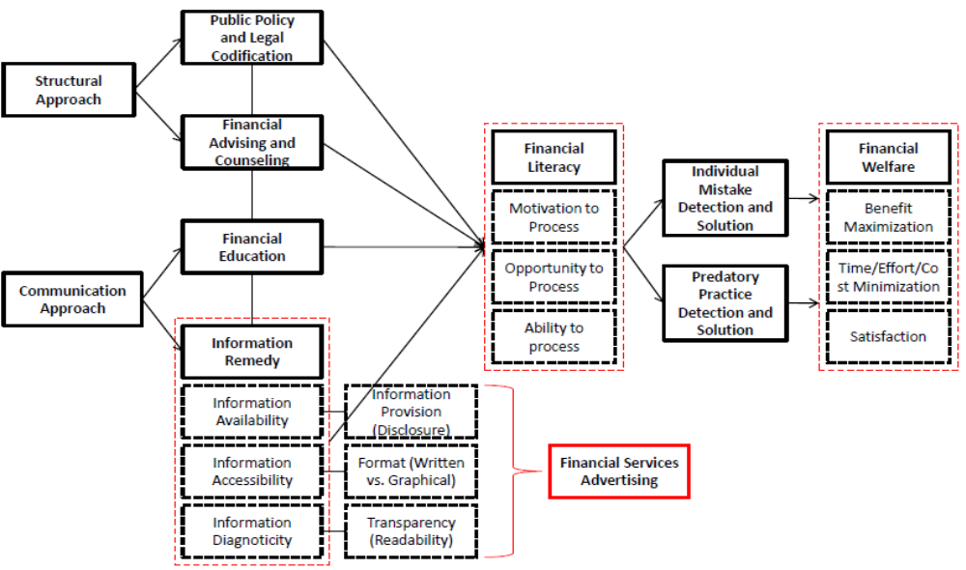

Figure 21. The Proposed Conceptual Framework: The Role of Financial Services Advertising in Consumer Financial Welfare
The Role of Internal Characteristics in Financial Decision-Making
Results from this study supports contentions that different types of self-regulation may be needed to produce the greatest potential effect in achieving financial well-being. In today’s market, many financial difficulties and economic problems that are exacerbated by the lack of self-regulation are on the rise (Howlett et al., 2008). These situations severely undermine consumer fiscal health and pose a tremendous burden on financial service industry. While self-help remedies are saturating the market, self-regulation remains a strenuous process and a constant struggle for many consumers.
The current study indicates that for financial management, regulatory focus is an important factor to consider when designing FSA in that regulatory focus interacts with ad practices (i.e., ad strategies and ad disclosures) during financial decision-making. That is, it can be argued that the effectiveness of ad claims and ad disclosures depends on the recipients’ regulatory focus. Findings from this study seem to suggest that FSA should be given when people are well rested and attentive in relation to consumers’ regulatory focus.
This research offers an important step toward understanding individual characteristics (i.e., regulatory focus) and highlights the benefits of adopting the right advertising approaches that can serve consumer financial well-being. For instance, results from this study could contribute to more voluntary savings and investment for future by way of FSA. Many Americans are not saving enough for their retirement. According to the 2007 Retirement Confidence Survey, only 66 percent of workers report that they and/or their spouse have saved money for retirement and only 60 percent report that they are currently saving. Even among those who do save, savings can be insufficient. About half of all workers saving for retirement report that the total value of their investments, excluding their home and their defined benefit plan, was less than $25,000. Because this problem has been well known for many years, both private agents and public policy makers have made numerous efforts to increase the extent to which American workers save for retirement.
For example, in a tax setting or retirement planning communication context, regulatory focus can be a relevant factor determining willingness to cooperate and choose the use of contributions and the provision of public goods. As discussed above, given that regulatory focus can be attenuated and manipulated (Kirmani & Zhu, 2007), it would be helpful to examine if FSA can reduce temporal discounting and facilitate decisions that ensure long-term financial stability. This would be especially useful since consumers typically do not have to self-regulate themselves and choose to participate in retirement savings on a week-to-week or month-to-month basis. Unlike dieting or smoking, once the initial decision has made to allocate funds to a retirement account, financial self-regulation as it relates to retirement planning does not necessarily need to be in force on an ongoing basis. According to the “slippery slope” framework proposed by Kirchler (2007) suggests that authorities should aim at influencing consumers’ individual characteristics, which in turn would result in voluntary compliance and effective choice. A message about the use of taxes or retirement plans that is both credible and framed in the right way to be processed more easily due to its congruence with target audiences’ regulatory focus is likely to enhance financial welfare (Pham & Avnet, 2004). In that regard, this presents a unique opportunity for FSA to put consumers on solid financial footing in the long term by allowing them to self-regulate at distinct points in time.
Many studies suggest that psychographic constructs including regulatory focus are under-researched in relation to consumer financial management (Karrh, 2004). According to Huhmann and McQuitty (2009), financial research does recognize that personality may influence financial confidence and attitudes. This may be because much consumer financial management research has used secondary data sets, such as socio-demographic, behavioristic, and economic variable. These externally valid, readily available datasets describe financial behavior and use of these datasets has expanded understanding of various financial issues, whereas the lack of values, lifestyle, or personality measures does not provide much detail (Benartzi & Thaler, 2002). Nowadays, in many cases, psychographic variables better explain consumer behavior than demographic or usage variables by evincing the relationship between individual differences and financial behavior (Benartzi & Thaler, 2007). For example, Perry (2008) revealed the empirical evidence of negative consequences of overconfidence, that is, overestimation in consumer judgments about credit quality. People who do not know their credit rating are more likely to overestimate than to underestimate their credit quality. This tendency toward overestimation may lead consumers to be less cautious in their financial decision-making. Also, it is interesting to relate the findings to the notion of uncertainty orientation (Brouwers & Sorrentino, 1993). Like promotion-focused people, uncertainty-oriented individuals are those who – because they have been rewarded for past exploratory behavior – are motivated by situations that allow them to resolve uncertainty about the self and the environment. They tend to be curious, open to new information, and have a high tolerance for ambiguity (e.g., a transformational ad and an ad without disclosure) (Pham & Avnet, 2004). Like prevention-focused people, certainty-oriented individuals are those who are motivated by situations that do not allow the resolution of uncertainty (e.g., an informational ad and an ad with disclosure), because they have not been rewarded for past exploratory behavior and may even have been punished. They tend to refer the familiar and the predictable, and have a low tolerance for ambiguity (Pham & Avnet, 2004). In general, although uncertainty orientation refers to a personality trait and regulatory focus refers to a motivational state, there seems to be some surface resemblance between the two constructs.
Taken together, as indicated by Wiener and Doescher (2008), while structural approaches attempt to change the conditions under which people save, communication approaches focus on changing both workers’ knowledge and their perceptions. The former occurs through education (e.g., teaching the fundamentals of investing); the latter occurs through persuasion (e.g., creating normative pressures or enhancing the perceived importance of one’s retirement years). Although past policy efforts have focused on structural changes and on education, recent regulatory approaches (e.g., the Pension Protection Act of 2006, the Dodd–Frank Wall Street Reform and Consumer Protection Act of 2010) have also focused on the role that can be played by persuasive communications. In terms of the role of persuasive communications, the current research suggest that FSA can get an individual to join a necessary financial program (e.g., a 401(k) plan), increase his or her level of contribution to such a program, or make a discrete economic decision (e.g., buy an individual retirement account [IRA]) by influencing an individual factors that are strongly related to financial decision-making (Howlett et al., 2008; Pham & Avnet, 2004).
The Role of Theory and Practice in Financial Literacy and Consumer Wellbeing
The flow of external information into markets can be the result of competitive strategies or consumer activism and has been shown to increase the competitive efficiency in financial market (Ratner et al., 2008). However, providing information via disclosures is part of the financial security equation. For instance, with more Americans depending on mutual fund investments to cover their retirement needs, improved conveyance of information regarding fund attributes is paramount. Evidence suggests that a “do-it-yourself” approach to 401(k) plans currently is not the most-effective option for investors saving for retirement (Kozup et al., 2008). For example, Alicia Munnell, an economist at Boston College that has studied this issue, stated that the do-it-yourself attributes of such plans are not working and that these 401(k) plans are simply too complicated for people to handle. Thaler and Sunstein (2003), in their discussion of “libertarian paternalism,” cite the inconsistencies among investors regarding retirement behavior. Consequently, consumers should (i) know what pieces of information they need; (ii) process those pieces with factors relating to their situation, tastes, and preferences; and (iii) use the output to make decisions about what financial products to purchase. However, this only begins the process – consumers also need to know how to use and manage these products. Although standard finance theory can rationalize the behavior of most households and thereby resolve the discrepancy between actual and optimal behavior, some consumers still make investment mistakes because of which their actual behavior diverges significantly from what is optimal. At this stage, financial literacy can help such consumers resolve their mistakes. Financial literacy provides the tools that enable the processing and managing to take place. Financial literacy and the optimal provision of information are also key factors in consumer financial well-being (Bone, 2008).
Due to economic crisis, increasing consumer financial literacy is a public policy objective to improve welfare through better decision-making. The recent mortgage crisis, consumer overindebtedness and household bankruptcy rates provide evidence to support this goal. Financial literacy is typically an input to model the need for financial education and explain variation in financial outcomes (Monticone, 2010). Defining and appropriately measuring financial literacy is essential to understand educational impact as well as barriers to effective financial choice. In general, financial literacy has two distinct components that are frequently conflated in the literature: financial capacity and financial knowledge (Remund, 2010). Specifically, financial capacity is the ability to process and comprehend information and statistics related to financial products, whereas financial knowledge involves adequate knowledge about financial concepts and how financial products work (Huhmann & McQuitty, 2009). In other words, financial capacity is learning-based, whereas financial knowledge is memory-based (Remund, 2010). A consumer’s financial capacity (i.e. processing capacity or cognitive ability in regard to financial information) and financial knowledge (i.e. prior knowledge of financial products and services) should interact in determining that consumer’s financial numeracy (i.e. proficiency or expertise in comprehending financial information during decision making) (Huhmann & McQuitty, 2009).
In recent days, researchers and consumer educators are increasingly using theory to rigor to the practice of financial literacy as personal finance seeks to define and establish itself (Lyons & Neelakantan, 2008). Theory may help a practitioner identify the wrong goals. Theory may also provide practitioners with a baseline for the right goals. Based on the role of theory, financial education can help consumers (i) clearly identify and define individual financial success, (ii) realize and change their behavior to achieve financial success, and (iii) evaluate whether financial success has been achieved (Lyons & Neelakantan, 2008).
The work to date provides a promising foundation for rigorous, theory-based approaches to financial literacy. That is, the results of this study can be one key to designing effective education programs for financial literacy by showing that all goal-related behaviors, such as optimizing financial management outcomes, are regulated by either a prevention focus or a promotion focus. Consumer educator could take the form of screening criteria at the real core of financial literacy and operationalize these findings within a financial education initiative. With this backdrop, researchers and practitioners both should to be cognizant of the proper use of theory. Specifically, consumer behavior change involves progressing through a series of stages, with individuals commonly relapsing before successfully giving up negative behaviors or engaging in positive behaviors. Researchers and practitioners use the theory to identify the stage at which individuals are ready and able to change their behavior. However, theories from psychology and finance need to be modified before they can be applied to changing financial behavior. They then apply appropriate educational, literacy interventions tailored to meet individuals’ specific needs at that stage. Furthermore, financial education programs cannot be implemented and evaluated using a “one-size-fits-all” approach in that the interdisciplinary nature of personal finance poses a challenge. Before researchers can communicate the usefulness of theory to practitioners, they need to develop a better understanding of the theories themselves, especially those outside their own field. Theory provides context, and a baseline, for what consumers should be doing in practice. As a result, ignoring theory would not be a problem if practitioners’ anecdote-based recommendations always led to consumers making optimal financial decisions. In recent years, a number of federal regulators and state government agencies as well as private financial institutions have devoted resources toward consumer financial literacy programs. The current study suggests that applying theoretical approach to consumer financial literacy and education may be worthwhile.
Taken together, as shown in Figure 20, the present findings serve to show that the effects of both internal (regulatory focus) and external (ad strategies and ad disclosures) are evident and relatively independent of each other, suggesting that the need to address these types of variables in enhancing financial welfare. For instance, comprehensive financial education media campaigns can be important elements in increasing financial literacy and motivation (Howlett et al., 2008). Perry and Morris (2005) reiterate the positive role of financial education in financial planning behavior. Especially, financial services marketing communcantions, including strategic message platforms, message heuristics, media planning, budget issues, and measurement and evaluation decisions are all additional factors essential in the success of such efforts (Karniouchina et al., 2009; Pham & Avnet, 2004). As discussed earlier, careful segmentation is expected to enhance financial welfare in conjunction with target audiences’ demographic, psychographic, geographic, and cultural characteristics (Karrh, 2004; Zhao & Pechmann, 2007).

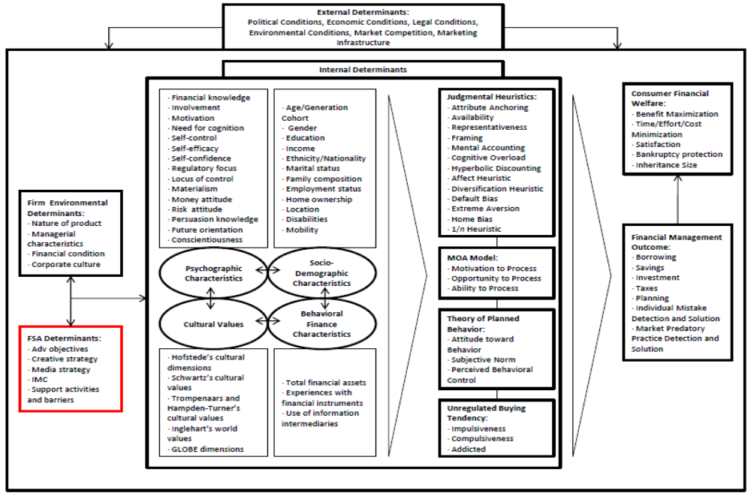

Figure 20. A Depiction of the Integrated Elements of Financial Services Advertising in Consumer Welfare

Limitations and Avenues for Future Research
As with any research, caution must be exercised before generalizing these results to situation beyond those studied. Several key limitations require greater attention in future research. First, as indicated in Figure 22, future research should examine other psychological factors (e.g., financial knowledge, involvement, motivation, self-efficacy, etc.) that may affect financial decision-making. To take an example, different consumers’ characteristics, such as financial knowledge, product involvement, motivation, can affect consumers’ response to different messages in relation to their regulatory orientations (Lee & Aaker, 2004). Howlett et al. (2008) found that employees may be more likely to participate in retirement plans if they are primed to think about the future benefits of participating and/or the potential future consequences of not participating by inducing higher levels of consumers’ future consequence.
Especially, given the importance of financial literacy, a further aspect that should be considered is to examine the influence of financial knowledge on financial decision-making in the context of FSA. As found by Perry and Morris (2005), in the absence of basic financial knowledge, consumers’ orientation toward the future had little influence on the likelihood of contributing to a 401(k) plan. The effect of consumers’ future orientation did not seem to be present when consumers were not presented basic information on how a 401(k) plan worked. However, with some basic level of financial knowledge, consumers with higher levels of future orientation both expressed higher likelihood of contributing to a 401(k) plan and had less-favorable attitudes toward a risky investment than consumers with lower levels of future orientation. This finding reinforces the importance of sound financial knowledge. However, given that financial knowledge is multifaceted (Monticone, 2010; Remund, 2010). As discussed above, financial literacy involves one’s understanding and knowledge of financial concepts and is imperative for effective consumer financial decision making (Fox et al., 2005). Further research should investigate what kinds of financial literacy have the most impact on financial behavior and outcomes. In addition, future research needs to examine to what extent consumers understand financial information and how financial knowledge affects financial decisions in the context of FSA.
Second, this study, as most studies on regulatory focus to date, was designed on the assumption that consumers’ response to FSA and corresponding financial decision-making are moderated by regulatory focus. But, Lee and Higgins (2009) state that although regulatory focus can influence persuasion through fit effects (i.e., either feeling right or engagement strength mechanisms), the underlying psychological processes behind these mechanisms may differ due to boundary conditions or exterior factors. For instance, recent theorizing (Lee & Higgins, 2009) has identified a number of boundary conditions (e.g., motivation) that may not yield a positive outcome. Furthermore, another relevant extension of this study would be to incorporate the influence of socio-demographic, behavioral, contextual, historical, and situational factors in future research in that these factors are among the antecedents of consumers’ financial decision-making as well as FSA effectiveness (Huhmann & McQuitty, 2009) (see, Figure 22). Hence, more research is needed to delineate theses processes and examine the impact of boundary conditions and other factors on regulatory focus, especially in relation to individual financial behavior. Especially, results would not explain that regulatory focus theory introduced a critical distinction between the independence of the system level of self-regulation (i.e., whether individuals were approaching desired end-states or avoiding undesired end-states) and the strategic level of self-regulation (i.e., whether individuals were approaching those desired end- states or avoiding those undesired end-states using either eager or vigilant strategies) (Hong & Lee, 2008). Future research should more clearly differentiate between the strategic and tactical levels of self-regulation with respect to financial behavior. The distinction between a general and a task-related regulatory fit (and nonfat) experience is important would be important from a theory development and policy implication perspective.
Third, as this study was conducted in the U.S., the results may not be generalizable to other countries or cultures where the dominant regulatory focus may differ (see, Figure 22). For instance, financial customers in a bear financial market are likely to be prevention focused, whereas those in a bull market are likely to be promotion focused (Zhou & Pham, 2004). In addition, there is evidence of cross-cultural differences in regulatory focus predominance and in regulatory mode predominance (Lee et al., 2008), but cross-cultural studies on regulatory focus and persuasion have yet to be conducted. Specifically, in cross-cultural research, Morris and Peng (1994) observed that those from a collectivist culture assigned greater weights to low-level contextual factors than did those from an individualist culture. And, Trafimow, Triandis, and Goto (1991) found that when participants were asked to describe the self, those from a collectivist culture used more concrete self-descriptions, whereas those from an individualist culture were more likely to provide self-descriptions that were relatively abstract. Consistent with the fit from construal hypothesis, previous studies indicate that membership in a collectivist or individualistic culture can serve as one indicator of regulatory orientation (Lee et al., 2000). Simply put, individuals from a collectivist culture are more prevention-focused and those from an individualistic culture are more promotion-focused. From a managerial perspective, identifying groups that have a naturally occurring predominance of one orientation or the other, and testing whether fit effects can be produced with these different groups, should be given attention to financial services marketers. Also, describing promotion benefits using high-level construals and prevention benefits using low-level construals warrants attention in future research into creating self-contained fit messages in situations where the regulatory orientation of the target consumer is unknown or mixed (Wang & Lee, 2006). Thus, future research should further substantiate the role of culture on consumers’ financial behavior in the context of financial services marketing.
Fourth, although this study followed recommended procedures for ad copy tests, employed professionally designed ad stimuli, and used an actual investor sample from several major markets reflecting U.S. demographics, the generalizability of the findings may be limited in ways specific to copy test research. In particular, given the hypothetical context in which the experiment that was conducted, there are many factors that restrict the generalizability of these findings to the actual market place because this study’s participants examined financial services ad outside of the natural setting where a mix of situational and contextual influences may lead to different responses. Researchers concerned by these limitations would be advised to employ qualitative research methods (e.g., observation, focus group, projective technique, etc.), thereby providing a deeper insight into consumer financial behavior.
Fifth, additional research opportunities exist regarding judgmental heuristic cues and biased financial decision making (see, Figure 22). In behavioral finance, judgmental heuristics (also called ‘mental shortcuts’ or ‘rules of thumb’) are considered as the underlying forces leading to irrational economic decisions in the human cognitive system (Kahneman, 2003). Research has indicated that judgmental heuristics systematically, but often unconsciously, lead to oversimplified and suboptimal financial decision making (Benartzi & Thaler, 2007; Morrin et al., 2008). For example, Jordan and Kass (2002) found that private investors make use of judgmental heuristics during the processing of mutual fund ads which lead to biases in their perception of risks and returns of mutual funds regardless of their expertise in the financial offering and investment. Such judgmental heuristics were the anchoring heuristic (e.g., consumers cognitively rely on a numerical anchor value which is explicitly or implicitly presented to them when arriving at an economic decision), the representativeness heuristic (e.g., consumers stereotypically believe that causes and effects will resemble one another), and the affect heuristic (e.g., consumers make forecast, predictions, or assessment of a stimulus through affective impressions or emotional states without deliberation). Johnson and Tellis (2005) indicated that due to the significance of consumers’ tendency to overweight past trends of mutual fund and reverse them after a certain length by revealing that in a market situation, investors can hold subrational views. Benartzi and Thaler (2007) found that consumers cope with simple heuristics and make less sophisticated decisions due to their systematic biases in the context of retirement savings. Morrin et al. (2008) found that less knowledgeable consumers whose task is to invest in a 401 (k) retirement plan are more likely to be subject to menu effects or structural characteristics of 401 (k) plans when changing the asset allocation strategies of their portfolios in response to choosing from a larger fund assortment. Perry (2008) provided empirical evidence of negative consequences of overconfidence, that is, overestimation in consumer judgments about credit quality. People who do not know their credit rating are more likely to overestimate than to underestimate their credit quality. This tendency toward overestimation may lead consumers to be less cautious in their financial decision-making. Taken from these findings, it would be interesting to replicate this study with judgmental heuristic cues in FSA.
Sixth, future research should consider sampling a much wider base of consumers in light of wide-ranging geo-demographic variables including income, gender, education, family, ethnicity, residence, and so forth. although this study used all actual (or potential) investors that were interested in or engaged in mutual fund and retirement plan to test the hypotheses, they are a homogeneous group, which may limit the generalizability of the entire population of all consumers. As suggested by Zhou and Pham (2004), respondents may have a different mental accounting and make its relevant economic decision depending upon different life situations. Also, people with higher income can afford to take greater risks. For instance, in health insurance and retirement plan market, collective financial plans (e.g., a specific insurance scheme arranged by an insurer for group of employees by an employer) still exist, but individuals have the discretion to join and switch individual plans each year. Considering these aspects, it would be wise to extend this research to a workplace environment and capture the actual investment decisions of different target segments across financial products (e.g., heath insurance and retirement plan). It would be also interesting to compare decision-making styles of financial asset management professionals (who could be regarded as experts) and individual consumers who could be considered novices with respect to this domain.
Seventh, the results of this study limit the manipulations to a single form of investment product (e.g., mutual fund). Other financial offerings (e.g., credit card, insurance, securities, bond, loan, savings and deposits, etc.) might produce different results (Daryanto et al., 2009). As found by prior studies (e.g., Micu & Chowdhury, 2010; Zhou & Pham, 2004), consumers’ regulatory focus varies between different product categories. For instance, hedonic product categories are more related to promotion focus goals, whereas utilitarian product categories are more related to prevention goals (Chernev, 2004). Likewise, in the minds of consumer investors, financial products seem to be associated with distinct regulatory orientations (Zhou & Pham, 2004). Zhou and Pham (2004)’s findings show that some products, such as individual stocks and trading accounts, seem to be identified with promotion and the achievement of gains. Other products, such as mutual funds and retirement accounts, seem to be identified with prevention and the avoidance of losses (Zhou & Pham, 2004). These mental associations were found to be evident in experiments, where the mere evaluation of investment opportunities, labeled either as individual stocks in trading accounts or as mutual funds in retirement accounts, which triggered distinct promotion or prevention orientations that carried over to unrelated judgments and decisions. These associations were also evident in another experiment, where the mere priming of promotion versus prevention was found to influence how consumers allocated money across different types of assets and different types of accounts (Zhou & Pham, 2004). Stemming from the above reasoning, future research should provide practical insights into the compatibility between ad practices (e.g., ad claims and ad information provisions) and financial products that are promotion-focused versus prevention-focused.
Eighth, this study employed the two contrasting ad strategies, but questions remain about the role of various creative and appeal strategies on financial decision-making. For example, activating mood states and creating emotional response were particularly the case when mood states were associated with a promotion rather than a prevention focus (Baas, De Dreu, & Nijstad, 2008). Given that the impact of mood dimensions, such as level of activation and regulatory focus on consumer evaluations and judgments, researchers and practitioners would benefit from a careful and calibrated choice of what specific mood state to induce or measure and with what method or instrument for the sake of advertising persuasion. Then, are consumers more persuaded by appeals that address just their regulatory concerns or by mixed appeals that address both promotion and prevention concerns? Does it matter if consumers are processing the appeals systematically or heuristically? The effectiveness of pure versus mixed appeals when consumers engage in systematic versus heuristic processing awaits further research. These inquires deserve future attention.
Finally, print ads were used; therefore, the findings might not hold in other sorts of media. Keller (2006) suggests that regulatory focus may be induced or activated either by the context in which the advertisements are transmitted or even by a ad itself. Therefore, advertising media planner can consider the fit between target audiences’ regulatory orientation and media vehicle and content. For instance, regulatory focus could be induced through a TV-ad by using images or scenes which activate either promotion or prevention focus. The regulatory focus activated by the spot should then be coherent with the goal-framing of the advertising slogan. Furthermore, different radio or TV-programs could induce either promotion or prevention focus. A game show may activate a promotion focus, whereas a documentary about the protection of nature may induce a prevention focus. Commercials transmitted during or after specific programs could be more effective if their message fits the focus induced by the programs. More recently, Noort et al. (2008) reveal that the persuasiveness of online cues depends on consumers’ regulatory goals – specifically, that a regulatory fit between Web content and consumers’ prevention focus positively influences consumers’ responses. From this point of view, future research needs to take into account the relationship between consumers’ regulatory focus and advertising vehicle and contents in different media setting.

References

Aaker, Jennifer and Angela Y. Lee (2001), “I Seek Pleasures and We Avoid Pains: The Role
of Self-Regulatory Goals in Information Processing and Persuasion,” Journal of
Consumer Research, 28 (1), 33–49.

Aaker, Jennifer and Angela Y. Lee (2006), “Understanding Regulatory Fit,” Journal of
Marketing Research, 43 (1), 15–19.

Adaval, Rashmi and Robert S. Wyer, Jr. (1988), “The Role of Narratives in Consumer
Information Processing,” Journal of Consumer Psychology, 7 (3), 207–245.

Albers-Miller, Nancy D. and Robert D. Straughan (2000), “Financial Services Advertising in
Eight Non-English Speaking Countries,” International Journal of Bank Marketing, 18
(7), 347–357.

Alden, Dana L., Jan-Benedict E. M. Steenkamp, and Rajeev Batra (1999), “Brand Positioning
Through Advertising in Asia, North America, and Europe: The Role of Global Consumer
Culture,” Journal of Marketing, 63 (1), 75–87.

Alhudaithy, Abdullatif I. and Philip J. Kitchen (2009), “Rethinking Models of Technology
Adoption for Internet Banking: The Role of Website Features,” Journal of Financial
Services Marketing, 14 (1), 56–69.

Alferoff, C., D. Knights and K. Starkey (2005), Corporate Social Responsibility and Financial
Service Organisations. Financial Services Research Forum, October.

Anderson, Steven G., Min Zhan, and Jeff Scott (2004), “Targeting Financial Management
Training at Low-Income Audiences,” Journal of Consumer Affairs, 38 (1), 167–177.

Andrews, J. Craig, Scot Burton, and Richard G. Netemeyer (2000), “Are Some Comparative
Nutrition Claims Misleading? The Role of Nutrition Knowledge, Ad Claim Type and
Disclosure Condition,” Journal of Advertising, 29 (3), 29–42.

Andrews, J. Craig, Richard G. Netemeyer, and Scot Burton (2009), “The Nutrition Elite: Do
Only the Highest Levels of Caloric Knowledge, Obesity Knowledge, and Motivation
Matter in Processing Nutrition Ad Claims and Disclosures?” Journal of Public Policy &
Marketing, 28 (1), 41–55.

Arnold, Mark J. and Kristy E. Reynolds (2009), “Affect and Retail Shopping Behavior:
Understanding the Role of Mood Regulation and Regulatory Focus,” Journal of
Retailing, 85 (3), 308–320.

Athanassopoulos, P. and A. Johne (2004), “Effective Communication with Lead Customers in
Developing New Banking Products,” International Journal of Bank Marketing, 22(2),
100–125.

Avnet, Tamar and E. Tory Higgins (2003), “How Regulatory Fit Affects Value in Consumer

Choices and Opinions,” Journal of Marketing Research, 43 (1), 1–10.

Avnet, Tamar and E. Tory Higgins (2006), “How Regulatory Fit Affects Value in Consumer
Choices and Opinions,” Journal of Marketing Research, 43 (1), 1–10.

Balls, Andrew (2006), “Spending in US Households Exceeds Incomes,” The Americas, 62(3), 6.

Bass, Matthjis, Carsten K. W. De Dreu, and Bernard A. Jijstad (2008), “A Meta-Analysis of 25
Years of Mood-Creativity Research: Hedonic Tone, Activation, or Regulatory Focus?”
Psychological Bulletin, 134 (6), 779–806.

Bates, Kenneth, Scot Burton, Elizabeth Howlett, and Kyle Huggins (2009), “The Roles of
Gender and Motivation as Moderators of the Effects of Calorie and Nutrient Information
Provision on Away-from-Home Foods,” Journal of Consumer Affairs, 43 (2), 249–273.

Benartzi, Shlomo and Richard H. Thaler (2002), “How Much Is Investor Autonomy Worth?”
Journal of Finance, 57(4), 1593–1616.

Benartzi, Shlomo and Richard H. Thaler (2007), “Heuristics and Biases in Retirement Savings
Behavior,” Journal of Economic Perspectives, 21(3), 81–104.

Bennett, Chi Kin Yim, Kimmy Wa Chan and Kineta Hung (2007). “Multiple Reference Effects
in Service Evaluations: Roles of Alternative Attractiveness and Self-Image Congruity,”
Journal of Retailing, 1 (83) 147–157.

Bettman, James R., Mary Frances Luce and John W. Payne (1998), “Constructive Consumer
Choice Processes,” Journal of Consumer Research, 25 (3), 187–217.

Bless, Herbert, Diane M. Mackie, and Norbert Schwarz (1992), “Mood Effects on Attitude
Judgments: Independent Effects of Mood Before and After Message Elaboration,”
Journal of Personality and Social Psychology, 63 (4), 585–595.

Boller, G.W., & Olson, J. C. (1991). Experiencing ad meaning: Crucial aspect of narrative/drama
processing. In R. Holman & M. Solomon (Eds.), Advances in consumer research (Vol.18,
pp. 164–171). Provo,UT: Association of Consumer Research.

Bone, Paula Fitzerald (2008), “Toward a General Model of Consumer Empowerment and
Welfare in Financial Markets with an Application to Mortgage Servicers,” Journal of
Consumer Affairs, 42 (2), 165–188.

Botti, Simona and Sheena S. Iyengar (2006), “The Dark Side of Choice: When Choice
Impairs Social Welfare,” Journal of Public Policy & Marketing, 25 (1), 24–38.

Brouwers, Melissa C. and Richard M. Sorrentino (1993), “Uncertainty Orientation and
Protection Motivation Theory: The Role of Individual Differences in Health
Compliance,” Journal of Personality and Social Psychology, 65 (1), 102–112.

Brown, Sarah B. and Karl B. Taylor (2008), “Household debt and financial assets: evidence from
Germany, Great Britain and the USA”, Journal of the Royal Statistical Society, 171 (3),
615– 643.

Brucks, Merrie, Andrew A. Mitchell and Richard Staelin (1984), “The Effect of Nutritional
Information Disclosure in Advertising: An Information Processing Approach,” Journal of
Public Policy & Marketing, 3, 1–25.

Bruner, J. (1986). Actual minds, possible worlds. Cambridge, MA: Harvard University Press.

Bryant, Peter and Richard Dunford (2008), “The Influence of Regulatory Focus on Risky
Decision-Making,” Applied Psychology: An International Review, 57 (2), 335–359.

Burgess, Deanna O., Todd M. Shank, and Daniel Borgia (2001), “Consumer Lending and
Deposit Abuses,” Journal of Public Policy & Marketing, 20 (1), 138–143.

Buch, J., K. Rhoda and J. Talaga (2002), “The Usefulness of the APR for Mortgage Marketing in
the USA and the UK,” International Journal of Bank Marketing, 20(2), 76–85.

Carey, James W. (1960), “Advertising: An Institutional Approach,” in The Role of Advertising in
Society, C. H. Sandage and Vernon Fryburger, eds., Homewood, IL: Richard D. Irwin, 3–
17.

Cesario, Joseph, Heidi Grant, and E. Tory Higgins (2004), “Regulatory Fit and Persuasion:
Transfer From “Feeling Right””, Journal of Personality and Social Psychology, 86 (3),
388–404.

Chaiken, Shelly (1980), “Heuristic versus Systematic Information Processing and the Use of
Source versus Message Cues in Persuasion,” Journal of Personality and Social
Psychology, 39 (5), 752–756.

Chernev, Alexander (2004), “Goal Orientation and Consumer Preference for the Status Quo,”
Journal of Consumer Research, 31 (3), 557–565.

CIA (2006). CIA World Fact Book (available at http:// www.cia.gov/cia/publications/factbook/).

Coughlin, Joseph F. and Lisa A. D’Ambrosio (2009), “Seven Myths of Financial Planning
and Baby Boomer Retirement,” Journal of Financial Services Marketing, 14 (1), 83–
91.

Crowe, Ellen and E. Tory Higgins (1997), “Regulatory Focus and Strategic Inclinations:
Promotion and Prevention in Decision-Making,” Organizational Behavior and Human
Decision Processes, 69 (2), 117–132.

Culter Bob D. and Rajshekhar G. Javalgi (1993), “Analysis of Print Ad Features: Services
versus Products,” Journal of Advertising Research, 33 (2), 62–69.

Daryanto, Ahmad, Ko de Ruyter, and Martin Wetzels (2009), “Getting a Discount or Sharing the
Cost: The Influence of Regulatory Fit on Consumer Response to Service Pricing
Schemes,” Journal of Service Research, 13 (2), 153–167.

Delgadillo, Lucy M., Luke V. Erickson, and Kathleen W. Piercy (2008), “Disentangling the
Differences between Abusive and Predatory Lending: Professionals’ Perspectives,”
Journal of Consumer Affairs, 42 (3), 313–334.

Dighton, John and Robert M. Schindler (1988), “Can Advertising Influence Expericne?”
Psychology & Marketing, 5 (2), 103–115.

Deighton, John, Daniel Romer, and Josh McQueen (1989), “Using Drama to Persuade,” Journal
of Consumer Research, 16 (3), 335–343.

Delvin, James and Sarwar Azhar (2004), “’Life Would be A Lot Easier If We Were a Kit Kat’:
Practitioners’ Views on the Challenges of Branding Financial Services Successfully,”
Journal of Brand Management, 12 (1), 12–30.

Devlin, James, C. T. Ennew and M. Mirza (1995), “Organizational positioning in financial
services Retailing,” Journal of Marketing Management, 11(1-3), 119–132.

Devaney, Sharon A., Sophia T. Anong, and Stacy E. Whirl (2007), “Household Savings
Motives,” Journal of Consumer Affairs, 41 (1), 174–186.

Ennew, C. T. and H. Sekhon (2003). The financial Services Trust Index: A Pilot Study. Financial
Services Research Forum.

Escalas, Jennifer Edson and James R. Bettman (2003), “Your Are What They Eat: The Influence
of Reference Groups on Consumers’ Connections to Brands,” Journal of Consumer
Psychology, 13 (3), 339–348.

Escalas, Jennifer Edson (2004), “Imagine Yourself in the Product: Mental Simulation, Narrative
Transportation, and Persuasion,” Journal of Advertising, 33 (2), 37–48.

Estelami, Hooman (2009), “Cognitive Drivers of Suboptimal Financial Decisions:
Implications for Financial Literacy Campaigns,” Journal of Financial Services
Marketing, 13 (4), 273–283.

Evans, Lisa M. and Richard E. Petty (2003), “Self-Guide Framing and Persuasion:
Responsibly Increasing Message Processing to Ideal Levels,” Personality and Social
Psychology Bulletin, 29(3), 313–324.

Everett, Stephen E. (1988), “Financial Services Advertising Before and After the Crash of
1987,” Journalism Quarterly, 65(4), 920–924.

Federal Deposit Insurance Corporation (2001). Money Smart: An Adult Education Program.
Washington, DC: FDIC.

Florack, Arnd and Martin Scarabis (2006), “How Advertising Claims Affect Brand
Preferences and Category-Brand Associations: The Role of Regulatory Fit,”
Psychology & Marketing, 23(9), 741–755.

Florack, Arnd and Juliane Hartmann (2007), “Regulatory Focus and Investment Decisions in
Small Groups,” Journal of Experimental Social Psychology, 43 (4), 626–632.

Florack, Arnd, Simon Ineichen, and Rahel Bieri (2009), “The Impact of Regulatory Focus on
the Effects of Two-Sided Advertising,” Social Cognition, 27 (1), 37–56.

Förster, Jens and Tory E. Higgins (2005), “How Global Versus Local Perception Fits Regulatory
Focus,” Psychological Science, 16 (8), 631–636.

Förster, Jens, Nira Liberman, and Ronald S. Friedman (2007), “Seven Principles of Goal
Activation: A Systematic Approach to Distinguishing Goal Priming From Priming of
Non-Goal Constructs,” Personality and Social Psychology Review, 11 (3), 211–233.

Fox, Jonathan, Suzanne Bartholomae, and Jinkook Lee (2005), “Building the Case for
Financial Education,” Journal of Consumer Affairs, 39 (1), 195–214.

Freitas, Antonio L., Nira Liberman, and E. Tory Higgins (2002), “Regulatory Fit and Resisting
Temptation during Goal Pursuit,” Journal of Experimental Social Psychology, 38 (3). 291
– 298.

Friedman, Ronald S. and Jens Förster (2001), “The Effects of Promotion and Prevention Cues on
Creativity,” Journal of Personality and Social Psychology, 81 (6), 1001–1013.

Getter, Darryl E. (2003), “Contributing to the Delinquency of Borrowers,” Journal of
Consumer Affairs, 37 (1), 86–100.

Gibson, Bryan (2008), “Can Evaluative Conditioning Change Attitudes toward Mature
Brands? New Evidence from the Implicit Association Test,” Journal of Consumer
Research, 35 (1), 178–188.

Gounaris, Spiros P. and Christos D. Kortos (2008), “Using the Extended Innovation
Attributes Framework and Consumer Personal Characteristics as Predictors of
Internet Banking Adoption,” Journal of Financial Services Marketing, 13 (1), 39–51.

Grable, John E., Joo-Yung Park, and So-Hyun Joo (2009), “Explaining Financial
Management Behavior for Koreans Living in the United States,” Journal of
Consumer Affairs, 43 (1), 80–107.

Green, Melanie C. and Timothy C. Brock (2000), “The Role of Transportation in the
Persuasiveness of Public Narratives,” Journal of Personality and Social Psychology, 79
(5), 701–721.

Griffin, Mitch, Barry J. Babin, and William R. Darden (1992), “Consumer Assessments of
Responsibility for Product-Related Injuries: The Impact of Regulations, Warnings, and
Promotional Policies,” in Advances in Consumer Research, vol. 19, Brian Sternthal and
John Sherry, eds., Ann Arbor, MI: Association for Consumer Research, 870–878.

Hedesström, Ted Martin, Henrik Svedsäter, and Tommy Gärling. 2004. Identifying Heuristic
Choice Rules in the Swedish Premium Pension Scheme. Journal of Behavioral Finance,
5 (1), 32–42.

Henson, S. W. and J. C. Wilson (2002), “Case study: Strategic challenges in the financial
services Industry,” Journal of Business and Industrial Marketing, 17(5), 407–418.

Heitfield, Erik and Tarun Sabarwal (2004), “What Drives Default and Prepayment on Subprime
Auto Loans?” The Journal of real estate finance and economics, 29(4), 457–477.

Hernandez, Jose Mauro C. and Jose Afonso Mazzon (2007), “Adoption of Internet Banking:
Proposition and Implementation of An Integrated Methodology Approach,” International
Journal of Bank Marketing, 25(2), 72–88.

Higgins, E. Tory (2000), “Social Cognition: Learning about What Matters in the Social World,”
European Journal of Social Psychology, 30 (1), 3–39.

Higgins, E. Tory (2002), “How Self-Regulation Creates Distinct Values: The Case of Promotion
and Prevention Decision Making,” Journal of Consumer Psychology, 12 (3), 177–191.

Higgins, E. Tory, Lorraine Chen Idson, Antonio L. Freitas, Scott Spiegel, and Daniel C. Molden
(2003), “Transfer of Value from Fit,” Journal of Personality and Social Psychology, 84
(June), 1140–1153.

Hilgert, Marianne A., Jeanne M. Hogarth, and Sandra G. Beverly (2003), “Household Financial
Management: The Connection between Knowledge and Behavior,” Federal Reserve
Bulletin, 89 (7), 309–322.

Hill, Ronald Paul and John C. Kozup (2007), “Consumer Experiences with Predatory
Lending Practices,” Journal of Consumer Affairs, 41 (1), 29–46.

Hilton, James L. and Steven Fein (1989), “The Role of Typical Diagnosticity in Stereotype-
Based Judgments,” Journal of Personality and Social Psychology, 57 (2), 201–211.

Hira, Tahira, K. and Cazillia Loibl (2005), “Understanding the Impact of Employer-Provided
Financial Education on Workplace Satisfaction,” Journal of Consumer Affairs, 39 (1),
173–193.

Hoch, Stephen J. and Young-Won Ha (1986), “Consumer Learning: Advertising and the
Ambiguity of Product Experience,” Journal of Consumer Research, 13 (2), 221–233.

Hong, Jiewen and Angela Y. Lee (2008), “Be Fit and Be Strong: Mastering Self-Regulation
through Regulatory Fit,” Journal Consumer Research, 34 (5), 682–695.

Howlett, Elizabeth, Jeremy Kees, and Elyria Kemp (2008), “The Role of Self-Regulation,
Future Orientation, and Financial Knowledge in Long-Term Financial Decisions,”
Journal of Consumer Affairs, 42(2), 223–242.

Hoy, Mariea Grubbs and J. Craig Andrews (2004), “Adherence of Prime-Time Televised
Advertising Disclosures to the ‘Clear and Conspicuous’ Standard: 1990 Versus 2002,”
Journal of Public Policy & Marketing, 23(2), 170–182.

Hoy, Mariea G. and May O. Lwin (2007), “Disclosures Exposed: Banner Ad Disclosure
Adherence to FTC Guidance in the Top 100 U.S. Web Sites,” Journal of Consumer Affairs, 41(2), 285–325.

Huhmann, Bruce A. and Nalinaksha Bhattacharyya (2005), “Does Mutual Fund Advertising
Provide Necessary Investment Information,” International Journal of Bank Marketing,
23 (4), 296–316.

Huhmann, Bruce A. and Shaun McQuitty (2009), “A Model of Consumer Financial Numeracy,”
International Journal of Bank Marketing, 27 (4), 270–293.

Hunt, R. Reed and Gilles O. Einstein (1981), “Relational and Item-Specific Information in
Memory,” Journal of Verbal Learning and Verbal Behavior, 20 (5), 497–514.

Idson, Lorraine Chen, Nira Liberman and E. Tory Higgins (2004), “Imagining How You'd Feel:
The Role of Motivational Experiences from Regulatory Fit,” Personality and Social
Psychology Bulletin, 30 (7), 926–937.

Jacoby, Jacob (1984), “Perspectives on Information Overload,” Journal of Consumer Research,
10(4), 432–435.

Jain, Shailendra Pratap, Charles Lindsey, Nidhi Agrawal, Durairaj Maheswaran (2007), “For
Better or For Worse? Valenced Comparative Frames and Regulatory Focus,” Journal
of Consumer Research, 34 (1), 57–65.

Johnson, Joseph and Gerard J. Tellis (2005), “Blowing Bubbles: Heuristics and Biases in the

Run-Up of Stock Prices,” Journal of the Academy of Marketing Science, 33 (4), 486–503.

Jones, Michael A. and Tom Smythe (2003), “The Information Content of Mutual Fund Print
Advertising,” Journal of Consumer Affairs, 37 (1), 22–41.

Jordan, Jenny and Klaus P. Kaas (2002), “Advertising in the Mutual Fund Business: The Role of
Judgmental Heuristics in Private Investors’ Evaluation of Risk and Return,” Journal of Financial Services Marketing, 7(2), 129–140.

Kahneman, Daniel (1973), Attention and Effort, Englewood Cliffs, NJ: Prentice Hall.

Kahneman, Daniel and Amos Tversky (1979), “Prospect Theory: An Analysis of Decision under
Risk,” Econometrica, 47 (2), 263–292.

Karniouchina, Ekaterina V., William L. Moore, and Kevin J. Cooney (2009), “Impact of Mad
Money Stock Recommendations: Merging Financial and Marketing Perspectives,”
Journal of Marketing, 73 (November), 244–266.

Karrh, James A. (2004), “Does Advertising Influence Investors? Evidence and Research
Propositions,” Journal of Current Issues and Research in Advertising, 26 (2), 1–10.

Katuri, Srinivasa and Monica Lam (2007), “Switching Customers from Branches to Internet:
A Credit Union’s Journey,” Journal of Financial Services Marketing, 11 (3), 229–248.

Keller, Punam, Angela Y. Lee, and Brian Sternthal (2004), “Construing Fit to Judgment: The
Effects of Regulatory Focus and Level of Construal,” working paper, Kellogg School of
Management, Northwestern University.

Keller, Carmen and Michael Siegrist (2006), “Money Attitude Typology and Stock
Investment,” Journal of Behavioral Finance, 7 (2), 88–96.

Kim, Hyungsoo and Angela C. Lyons (2008), “No Pain, No Strain: Impact of Health on the
Financial Security of Older Americans,” Journal of Consumer Affairs, 42 (1), 9–36.

Kim, Yeung-Jo (2006), “The Role of Regulatory Focus in Message Framing in Antismoking
Advertisements for Adolescents,” Journal of Advertising, 35(1), 143–151.

Kirchler, Erich (2007). The Economic Psychology of Tax Behavior. Cambridge: Cambridge
University Press.

Kirmani, Amna and Rui Juliet Zhu (2007), “Vigilant Against Manipulation: The Effect of
Regulatory Focus on the Use of Persuasion Knowledge,” Journal of Marketing
Research, 44 (4), 688–701.

Koehler, Jonathan J. and Molly Mercer (2009), “Selection Neglect in Mutual Fund
Advertisements,” Management Science, 55 (7), 1107–1121.

Kozup, John C., Elizabeth H. Creyer, and Scot Burton (2003), “Making Healthful Food Choices:

The Influence of Health Claims and Nutrition Information on Consumers’ Evaluations of

Packaged Food Products and Restaurant Menu Items,” Journal of Marketing, 67 (2), 19–

34.

Kozup, John, Elizabeth Howlett, and Michael Pagano (2008), “The Effects of Summary
Information on Consumer Perceptions of Mutual Fund Characteristics,” Journal of
Consumer Affairs, 42 (1), 37–59.

Kozup, John and Jeanne M. Hogarth (2008), “Financial Literacy, Public Policy, and
Consumers’ Self-Protection – More Questions, Fewer Answers,” Journal of
Consumer Affairs, 42 (2), 127–136.

Kruglanski, Arie W. and Erik P. Thompson (1999), “Persuasion by a Single Route: A View from
the Unimodel,” Psychological Inquiry, 10 (2), 83–109.

Kruglanski, Arie W. (2006), “The Nature of Fit and the Origins of ‘Feeling Right’: A Goal-
Systematic Perspective,” Journal of Marketing Research, 43 (1), 11–14.

Kuperman, Jerome C. (2003), “Using Cognitive Schema Theory in the Development of Public
Relations Strategy: Exploring the Case of Firms and Financial Analysts Following
Acquisition Announcements,” Journal of Public Relations Research, 15(2), 117–150.

Labro, Aparna A. and Angela Y. Lee (2006), “Between Two Brands: A Goal Fluency
Account of Brand Evaluation,” Journal of Marketing Research, 43 (3), 374–385.

Lalwani, Ashok K., L. J. Shrum, and Chi-yue Chiu (2009), “Motivated Response Styles: The
Role of Cultural Values, Regulatory Focus, and Self-Consciousnesses in Socially
Desirable Responding,” Journal of Personality and Social Psychology, 96 (4), 870–
882.

Lami, Robert E. and R. Charles Moyer (1995), “Financial Services Marketing and Banking
Regulation: The Case of the Community Reinvestment Act,” Psychology &
Marketing, 12 (8), 721–733.

Laukkanen, Tommi and Mika Pasanen (2008), “Mobile Banking Innovators and Early
Adopters: How They Differ from Other Online Users?” Journal of Financial Services
Marketing, 13 (2), 86–94.

LeBlanc, G. and N. Nguyen (1988), “Customers’ Perceptions of Service Quality in Financial
Institutions,” International Journal of Bank Marketing, 6(4), 7–18.

Lee, Angela Y., Wendi L. Gardner, and Jennifer L. Aaker (2000), “The Pleasures and Pains
of Distinct Self-Construals: The Role of Interdependence in Regulatory Focus,” Journal
of Personality and Social Psychology, 78 (6), 1122–1134.

Lee, Angela and Jennifer Aaker (2004), “Bringing the Frame into Focus: The Influence of
Regulatory Fit on Processing Fluency and Persuasion,” Journal of Personality and Social
Psychology, 86 (February), 205–218.

Lee, Angela Y. and E. Tory Higgins (2009), “The Persuasive Power of Regulatory Fit,” in
Frontiers of Social Psychology: Social Psychology of Consumer Behavior, ed. Michaela
Wanke, New York: Psychology Press, 319–33.

Lee, Angela Y., Punam Anand Keller, and Brian Sternthal (2010), “Value from Regulatory
Construal Fit: The Persuasive Impact of Fit between Consumer Goals and Message
Concreteness,” Journal of Consumer Research, 36 (5), 735–747.

Lee, Jinkook and Jinsook Cho (2005), “Consumers’ Use of Information Intermediaries and
the Impact of Their Information Search Behavior in the Financial Market,” Journal of
Consumer Affairs, 39 (1), 95–120.

Lee, Jinkoo (2002), “A Key to Marketing Financial Services: The Right Mix of Products,
Services, Channels, and Customers,” Journal of Services Marketing, 16 (3), 238–258.

Leiss, William, Stephen Klein, and Sut Jhally (1997), Social Communication in Advertising:
Persons, Products and Images of Well-Being, 2nd ed., London: Routledge.

Liberman, Nira, Lorraine Chen Idson, Christopher J. Camacho, E. Tory Higgins (1999),
“Promotion and Prevention Choices Between Stability and Change,” Journal of
Personality and Social Psychology, 77 (6), 1135–1145.

Loke, Yiing Jia (2008), Merchants and Credit Cards: Determinants, Perceptions and Current
Practices – A Case of Malaysia,” Journal of Financial Services Marketing, 13 (2),
121–134.

Loonam, Mary and Deirdre O’Loughlin (2008), “An Observation Analysis of E-Service
Quality in Online Banking,” Journal of Financial Services Marketing, 13 (2), 164–
178.

Lymperopolous, Constantine and Ioannis E. Chaniotakis (2008), “Price Satisfaction and
Personnel Efficiency as Antecedents of Overall Satisfaction from Consumer Credit
Products and Positive Word of Mouth,” Journal of Financial Services Marketing, 13
(1), 63–71.

Lyons, Angela C. and Urvi Neelakantan (2008), “Potential and Pitfalls of Applying Theory to
the Practice of Financial Education,” Journal of Consumer Affairs, 42(1), 106–112.

Mahesh, H.P. and Meenakshi Rajeev (2009), “Producing Financial Services: An Efficiency
Analysis of Indian Commercial Banks,” Journal of Services Research, 8 (20), 7–29.

Malaviya, Prashant and Brian Sternthal (2009), “Parity Product Features Can Enhance or Dilute
Brand Evaluation: The Influence of Goal Orientation and Presentation Format,” Journal
of Consumer Research, 36 (1), 112–121.

Mandell, L. (2007), Financial Literacy: Improving Education, Jumpstart Coalition, Washington,
DC.

Martenson, Rita (2008), “Are Men Better Investors than Women? Gender Differences in
Mutual Fund and Pension Investments,” Journal of Financial Services Marketing, 13
(1), 72 – 81.
Mattila, Anna and Jochen Wirtz (2000), “The Role of Preconsumption Affect in Postpurchase
Evaluation of Services,” Psychology & Marketing, 17 (7), 587–605.

Mattsson, Jan and Helge Helmersson (2005), “Internet Banking: Modelling the E-Competence of Customers with a Text-Analytic CIT Approach,” International Journal of Bank
Marketing, 23(6), 470–483.

Mayer, Robert N., Jisu Huh, and Brenda J. Cude (2005), “Cues of Credibility and Price
Performance of Life Insurance Comparison Web Sites,” Journal of Consumer Affairs,
39 (1), 71–94.

McCormack, Lauren, Carla Bann, Jennifer Uhrig, Nancy Berkman, and Rima Rudd (2009),
“Health Insurance Literacy of Older Adults,” Journal of Consumer Affairs, 43 (2),
223–248.

McQuarrie, Edward F., and David Mick (1996), “Figures of Rhetoric in Advertising Language,”
Journal of Consumer Research, 22 (4), 424–438.

McQuarrie, Edward F. and Barbara J. Phillips (2005), “Indirect Persuasion in Advertising,”
Journal of Advertising, 34 (2), 7–20.

Micu, Camelia C. and Tilottama G. Chowdhury (2010), “The Effect of Message’s Regulatory
Focus and Product Type on Persuasion,” Journal of Marketing Theory and Practice, 18
(2), 181–190.

Mittal, Vikas, Pankaj Kumar and Michael Tsiros (1999), “Attribute-Level Performance,
Satisfaction, and Behavioral Intentions over Time: A Consumption-System Approach,”
Journal of Marketing, 63 (2), 88–101.

Mazis, Michael B., Richard Staelin, Howard Beales, and Steven Salop (1981), “A Framework
for Evaluating Consumer Information Regulation,” Journal of Marketing, 45 (1), 11–21.

Money Alert (2009). FDIC Insurance: Are You Covered?, available at
http://www.themoneyalert.com/FDICinsurance.html (accessed March 30, 2010).

Monticone, Chiara (2010), “How Much Does Wealth Matter in the Acquisition of Financial
Literacy,” Journal of Consumer Affairs, 44 (2), 403–422.

Morrin, Maureen, Susan Broniarczyk, J. Jeffery Inman, and John Broussard (2008), “Saving
for Retirement: The Effects of Fund Assortment Size and Investor Knowledge on
Asset Allocation Strategies,” Journal of Consumer Affairs, 42 (2), 206–222.

Morris, Michael W. and Kaiping Peng (1994), “Culture and Cause: American and Chinese
Attributions for Social and Physical Events,” Journal of Personality and Social
Psychology, 67 (6), 949–971.

Mueller, Barbara (1987), “Reflections of Culture: An Analysis of Japanese and American
Advertising Appeals,” Journal of Advertising Research, 27 (3), 51–59.

Mortgage Asset Research Institute (2008). Quarterly fraud report, available at
www.marisolutions.com/pdfs/mba/mortgage-fraud-report-2008Q1.pdf (accessed
28 October 2008).

Naylor, Gillian, Susan Bardi Kleiser, Julie Baker, and Eric Yorkston (2008), “Using
Transformational Appeals to Enhance the Retail Experience,” Journal of Retailing, 84
(1), 49–57.

Nelson, Phillip (1974), “Advertising as Information,” Journal of Political Economy, 82 (4), 729–
754.

Nielson Wire (2008). Credit card services advertising down in September, available
at http://blog.nielsen.com/nielsenwire/media_entertainment/credit-card-services-advertising-down-in-september/ (accessed October 22, 2008).

Noort, Guda van, Peter Kerkhof, and Bob M. Fennis (2007), “Online versus Conventional
Shopping: Consumers' Risk Perception and Regulatory Focus,” CyberPsychology &
Behavior, 10 (5), 731–733.

Okazaki, Shintaro, Barbara Mueller, and Charles R. Taylor (2010), “Measuring Soft-Sell Versus
Hard-Sell Advertising Appeals,” Journal of Advertising, 39 (2), 5–20.

Ozdemir, Sena and Paul Trott (2009), “Exploring the Adoption of a Service Innovation: A
Study of Internet Banking Adopters and Non-Adopters, ,” Journal of Financial
Services Marketing, 13 (4), 284–299.

Padgett,Dan and Douglas Allen (1997), “Communication Experiences: A Narrative Approach to
Creating Service Brand Image,” Journal of Advertising, 26 (4), 49–62.

Papaioannou, George J. (2009), “The Market Structure Effects of Commercial Bank Entry
into Underwriting: Evidence from the League Tables,” Journal of Financial Services
Marketing, 13 (4), 300 – 316.

Pettier, James W., John A. Schibrowsky, Don E. Schultz, and John Davis (2002), “Interactive
Psychographics: Cross-Selling in the Banking Industry,” Journal of Advertising
Research, 42 (2), 7–22.

Pennington, Ginger L. and Neal J. Roese (2003), “Regulatory Focus and Temporal Distance,”
Journal of Experimental Social Psychology, 39 (6), 563–576.

Pennington, Ginger L., Jennifer Aaker, and Cassie Mogilner (2005), “When Does ‘Not So Bad’
Seem Awfully Good? Event Proximity, Temporal Construal, and the Persuasiveness of
Prevention Focus,” working paper, Graduate School of Business, Stanford University.

Perry, Vanessa G. and Marlene D. Morris (2005), “Who Is in Control? The Role of Self-
Perception, Knowledge, and Income in Explaining Consumer Financial Behavior,”
Journal of Consumer Affairs, 39(2), 299–313.

Perry, Vanessa Gail (2008), “Is Ignorance Bliss? Consumer Accuracy in Judgments about
Credit Ratings,” Journal of Consumer Affairs, 42 (2), 189–205.

Petty, Richard and John T. Cacioppo (1984), “The Effects of Involvement on Responses to
Argument Quantity and Quality: Central and Peripheral Routes to Persuasion,” Journal of
Personality and Social Psychology, 46 (1), 69–81.

Pham, Michael Tuan and Tamar Avnet (2004), “Ideals and Oughts and the Reliance on
Affect versus Substance in Persuasion,” Journal of Consumer Research, 30 (4),
503–518.

Pham, Michael Tuan and Tamar Avnet (2009), “Rethinking Regulatory Engagement
Theory,” Journal Consumer Psychology, 19 (2), 115–123.

Peracchio, Laura A. and Joan Meyers-Levy (1997), “Evaluating Persuasion‐Enhancing
Techniques from a Resource‐Matching Perspective,” Journal of Consumer Research, 24
(2), 178–191.

Pham, Micheal T. (1998), “Representativeness, Relevance, and the Use of Feelings in Decision-
Making,” Journal of Consumer Research, 25 (2), 144–159.

Philpot, James, and Don T. Johnson. “Mutual Fund Performance and Fund Prospectus Clarity.”
Journal of Financial Services Marketing 11 (2007): 211-216.

Pistelak, Petr (2006), “Selling Banks is the Same as Selling Soap: Applying Fast-Moving
Consumer Goods Best Marketing Practices to the Banking Industry in Central and
Eastern Europe,” Journal of Financial Services Marketing, 11(1), 72–84.

Pollay, Richard W. (1985), “The Subsiding Sizzle: A Descriptive History of Print Advertising,
1900–1980,” Journal of Marketing, 49 (3), 24–37.

Polkinghorne, D. E. (1991). Narrative and self-concept. Journal of Narrative and Life History, 1,
135–153.

Polyorat, Kawpong, Dana L. Alden, and Eugene S. Kim (20 “Impact of Narrative versus Factual
Print Ad Copy on Product Evaluation: The Mediating Role of Ad Message Involvement,” Psychology & Marketing, 24 (6), 539–554.

Rajatanavin, Ranchana and Mark Speece (2004), “The Sales Force as an Information Transfer
Mechanism for New Service Development in the Thai Insurance Industry,” Journal of
Financial Services Marketing, 8(3), 244–258.

Ratner, Rebecca K., Dilip Soman, Gal Zauberman, Dan Ariely, Ziv Carmon, Punam A. Keller,B.
Kyu Kim, Fern Lin, Selin Malkoc, Deborah A. Small, and Klaus Wertenbroch (2008),
“How Behavioral Decision Research Can Enhance Consumer Welfare: From Freedom of
Choice to Paternalistic Intervention,” Marketing Letters, 19 (3-4), 383–397.

Ravi, V., Mahil Carr, and N. Vidya Sagar (2006), “Profiling of Internet Banking Users in
India Using Intellignet Techniques,” Journal of Services Research, 6 (2), 61–73.

Remund, David L. (2010), “Financial Literacy Explicated: The Case for a Clearer Definition in
an Increasingly Complex Economy,” Journal of Consumer Affairs, 44 (2), 276–295.

Rhine, Sherrie L. and William H. Greene (2006), “The Determinants of Being Unbanked for
Immigrants,” Journal of Consumer Affairs, 40 (1), 21–40.

Roese, Neal J. and Taekyun Hur, and Ginger L. Pennington (1999), “Counterfactual Thinking
and Regulatory Focus: Implications for Action Versus Inaction and Sufficiency Versus
Necessity,” Journal of Personality and Social Psychology, 77 (6), 1109–1120.

Rootman, Chantal, Madele Tait, and Johan Bosch (2008), “Variables Influencing the
Customer Relationship Management of Banks,” Journal of Financial Services
Marketing, 13 (1), 52–62.

Rossiter, John R. and Larry Percy (1997), Advertising and Promotion Management, 2nd ed.,
New York: McGraw-Hill.

Rugimbana, Robert (2007), “Generation Y: How Cultural Values Can Be Used to Predict
Their Choice of Electronic Financial Services,” Journal of Financial Services
Marketing, 11 (4), 301–313.

Schwarz, Norbert (2004), “Meta-Cognitive Experiences in Consumer Judgment and Decision
Making,” Journal of Consumer Psychology, 14 (4), 332–348.

Securities and Exchange Commission (SEC) (2006). SEC announces next steps for sarbanes-
oxley implementation, available at http://www.sec.gov/news/press/2006/2006-75.htm
(accessed March 29, 2009).

Securities and Exchange Commission (SEC) (2006). Invest Wisely: An Introduction to Mutual
Funds, available at http://www.sec.gov/investor/pubs/inwsmf.htm (accessed October 12,
2008).

Semin, Gün R., Tory Higgins, Lorena Gil de Montes, Yvette Estourget, and Jose F. Valencia
(2005), “Linguistic Signatures of Regulatory Focus: How Abstraction Fits Promotion
More Than Prevention,” Journal of Personality and Social Psychology, 89 (1), 36–45.

Sengupta, Jaideep and Rongrong Zhou (2007), “Understanding Impulsive Eaters’ Choice
Behaviors: The Motivational Influences of Regulatory Focus,” Journal of Marketing
Research, 44 (2), 297–308.

Schank, R. C. (1990). Tell me a story: Narrative and intelligence. Evanston, IL: Northwestern
University Press.

Schank, R. C., and Abelson, R. P. (1995). Knowledge and memory: The real story. In R. S.Wyer,
Jr. (Ed.), Knowledge and memory: The real story (pp. 1–85). Hillsdale: Lawrence
Erlbaum Associates, Inc.

Schwartz, Hugh (2002), “Herbert Simon and Behavioral Economics,” Journal of Socio-
Economics, 31 (3), 181–189.

Shafir, Eldar, Itamar Simonson, and Amos Tversky (1993), “Reason-Based Choice,” Cognition,
49 (1-2), 11–36.

Sheppard, Blair H., John Hartwick, and Paul R. Warshaw (1988), “The Theory of Reasoned
Action: A Meta-Analysis of Past Research with Recommendations for Modifications and
Future Research,” Journal of Consumer Research, 15 (3), 325–343.

Shi, Weihua, Narcissus Shambare, and Jian Wang (2007), “The Adoption of Internet
Banking: An Institutional Theory Perspective,” Journal of Financial Services
Marketing, 12 (4), 272–286.

Smith, Malcom C. and Mark R. Phillips Jr (2001), “Age Differences in Memory for Radio
Advertisements: The Role of Mnemonics,” Journal of Business Research, 53 (2), 103–
109.

Soureli, Magdalini, Babara R. Lewis, and Kalipso M. Karantinou (2008), “Factors that Affect
Consumers’ Cross-Buying Intention: A Model for Financial Services,” Journal of
Financial Services Marketing, 13 (1), 5–16.

Srivasta, H.S. and R. Srinivasan (2008), “New Age Youth Banking Behavior: An Explorative
Study in the Indian Banking Sector,” Journal of Services Research, 8 (2), 53–71.

Stern, Barbara B. and Robert R. Harmon (1984), “The Incidence and Characteristics of
Dislaimers in Children’s Television Advertising,” Journal of Advertising, 13 (2), 12–16.

Stern, Barbara B., Craig J. Thompson, and Eric J. Arnould (1988), “Narrative Analysis of a
Marketing Relationship: The Consumer’s Perspective,” Psychology & Marketing, 15 (3),
195–214.

Stevenson, Thomas H. and D. Anthony Plath (2006), “Marketing Financial Services to
Hispanic American Consumers: A Portfolio-Centric Analysis,” Journal of Services Marketing, 20 (1), 37–50.

Stewart, David W. and Ingrid M. Martin (2004), “Advertising Disclosures: Clear and
Conspicuous or Understood and Used?,” Journal of Public Policy & Marketing, 23(2),
183–192.

Stigler, George J. (1961), “The Economics of Information,” Journal of Political Economy, 69
(3), 213–225.

Sujan, Mita, James R. Bettman and Hans Baumgartner (1993), “Influencing Consumer
Judgments Using Autobiographical Memories: A Self-Referencing Perspective,” Journal
of Consumer Research, 30 (4), 422–436.

Thaler, Richard H. and Cass R. Sunstein (2003), “Behavioral Economics, Public Policy, and
Paternalism: Libertarian Paternalism,” American Economic Review, 93 (2), 175–179.

Tam, Jackie L. M. (2007), “Managing Customer Expectations in Financial Services:
Opportunities and Challenges,” Journal of Financial Services Marketing, 11(4), 281–
289.

Taylor, Ronald E. (1999), “A Six-Segment Message Strategy Wheel,” Journal of Advertising
Research, 39 (6), 7–17.

Townsend, Ellen and Scott Campbell (2004), “Psychological Determinants of Willingness to
Taste and Purchase Genetically Modified Food,” Risk Analysis, 24 (5), 1385–1393.

Trafimow, David, Harry C. Triandis, and Sharon G. Goto (1991), “Some Tests of the Distinction
between the Private Self and the Collective Self,” Journal of Personality and Social
Psychology, 60 (5), 649–655.

Trope, Yaacov, Nira Liberman, and Cheryl Wakslak (2007), “Construal Levels and
Psychological Distance: Effects on Representation, Prediction, Evaluation, and
Behavior,” Journal of Consumer Psychology, 17 (2), 83–95.

Tun, Patricia S. (1989), “Age Difference in Processing Expository and Narrative Text,” Journal
of Gerontology, 44 (1), 9–15.

Vaughn, Richard (1980), “How Advertising Works: A Planning Model,” Journal of Advertising
Research, 20 (5), 27–33.

Vranica, S. (2009, June 11). U.S. Ad spending fell 14% in first quarter, The Wall Street Journal.
Retrieved from http://online.wsj.com/article/SB124467774162404243.html.

Walia, Nidhi and Ravi Kiran (2009), “An Analysis of Investor’s Risk Perceptions toward
Mutual Funds Services,” International Journal of Business and Management, 4 (5),
106–120.

Wan, Echo Wen, Jiewen Hong, and Brian Sternthal (2008), “The Effect of Regulatory
Orientation and Decision Strategy on Brand Judgments,” Journal of Consumer Research,
35 (6), 1026–1038.

Wang, Jing and Angela Y. Lee (2006), “The Role of Regulatory Focus in Preference
Construction,” Journal of Marketing Research, 43 (1), 28–38.

Warren, Elizabeth (2008), “Product Safety Regulation as a Model for Financial Services
Regulation,” Journal of Consumer Affairs, 42 (3), 452–460.

Wentzel, Daniel, Torsten Tomczak, and Andreas Herrma (2010), “The Moderating Effect of
Manipulative Intent and Cognitive Resources on the Evaluation of Narrative Ads,”
Psychology & Marketing, 27 (5), 510–530.

Wiener, Josh and Tabitha Doescher (2008), “A Framework for Promoting Retirement
Savings,” Journal of Consumer Affairs, 42 (2), 137–164.

Wilcox, Ronald T. (2001), “Advertising Mutual Fund Returns: A Critical Analysis of a U.S.
Securities and Exchange Commission Proposal to Change Advertising Law,” Journal of
Public Policy & Marketing, 20 (1), 133–137.

Williamson, Judith (1978), Decoding Advertisements, London: Marion Boyars.

Wonder, Nicholas, Wendy Wilhelm, and David Fewings (2008), “The Financial Rationality of
Consumer Loan Choices: Revealed Preferences Concerning Interest Rates, Down
Payments, Contract Length, and Rebates,” Journal of Consumer Affairs, 42 (2), 243–
270 .

Woodwide, Arch G., Suresh Sood, and Kenneth E. Miller (2008), “When Consumers
and Brands Talk: Storytelling Theory and Research in Psychology and Marketing,”
Psychology & Marketing, 25 (2), 97–145.

Zeithaml, V. A., A. Parasuraman and L. L. Berry (1985), “Problems and Strategies in Services
Marketing,” Journal of Marketing, 49 (4), 33–46.

Zhao, Guangzhi and Cornelia Pechmann (2007), “The Impact of Regulatory Focus on
Adolescents’ Response to Antismoking Advertising Campaigns,” Journal of
Marketing Research, 44 (4), 671–687.

Zinkhan, George M. and F. Christian Zinkhan (1985), “Responses Profiles and Choice
Behavior: An Application to Financial Services Advertising,” Journal of Advertising, 14
(3), 39–44.

Zinkhan, George M., Madeline Johnson, and F. Christian Zinkhan (1992), "Differences Between
Product and Services Television Commercials," Journal of Services Marketing, 6 (3), 59–
66.

Zhou, Rongrong and Michel Tuan Pham (2004), “Promotion and Prevention across Mental
Accounts: When Financial Products Dictate Consumers’ Investment Goals,” Journal of
Consumer Research, 31 (1), 125–135.

Zhu, Rui Juliet and Loan Meyers-Levy (2007), “Exploring the Cognitive Mechanism that
Underlies Regulatory Focus Effects,” Journal of Consumer Research, 34 (1), 89–96
Appendices

Appendix A: Ad Stimuli
Stimuli (1):  Informational Ad Without Ad Disclosure | Stimuli (2):  Informational Ad With Ad Disclosure
 | 
Stimuli (3):  Transformational Ad Without Ad Disclosure | Stimuli (4):  Transformational Ad Without Ad Disclosure
 | 

Appendix B. Measurements

Regulatory Focus (Lockwood et al., 2002)

Not at all true of me ……….…………………………………………………….... Very true of me
1 | 2 | 3 | 4 | 5 | 6 | 7 | 8 | 9

1. In general, I am focused on preventing negative events in my life.
2. I am anxious that I will fall short of my responsibilities and obligations.
3. I frequently imagine how I will achieve my hopes and aspirations.
4. I often think about the person I am afraid I might become in the future.
5. I often think about the person I would ideally like to be in the future.
6. I typically focus on the success I hope to achieve in the future.
7. I often worry that I will fail to accomplish my professional goals.
8. I often think about how I will achieve professional success.
9. I often imagine myself experiencing bad things that I fear might happen to me.
10. I frequently think about how I can prevent failures in my life.
11. I am more oriented toward preventing losses than I am toward achieving gains.
12. My major goal at work right now is to achieve my professional ambitions.
13. My major goal at work right now is to avoid becoming a professional failure.
14. I see myself as someone who is primarily striving to reach my “ideal self”—to fulfill my hopes, wishes, and aspirations.
15. I see myself as someone who is primarily striving to become the self I “ought” to be—to fulfill my duties, responsibilities, and obligations.
16. In general, I am focused on achieving positive outcomes in my life.
17. I often imagine myself experiencing good things that I hope will happen to me.
18. Overall, I am more oriented toward achieving success than preventing failure.

Financial Knowledge (Lee & Cho, 2005)

Strongly disagree …………………………..…………………………...………... Strongly agree
1 | 2 | 3 | 4 | 5 | 6 | 7

1. My household knows how to choose the financial products and services that are best
for us.
2. I do a very good job of keeping my financial affairs in order.
3. Often I’m not sure whether the financial decisions I’ve made are the right ones.*
4. I feel qualified to make my own investment decisions.

Risk Perception of the Financial Product (Jordan & Kass, 2002)

Strongly disagree …………………………………….…….………………….. Strongly agree
1 | 2 | 3 | 4 | 5

1. This mutual fund bears a high risk of losing money.
2. I feel uncertain about investing in this mutual fund, as I feel uninformed about it.
3 This mutual fund bears a high risk of missing personal investment objective.
4. I feel uncertain about investing in this mutual fund, as I feel incompetent about it.
5. Investing in this fund also entails good chances to realize higher, above-average
returns.
6. Regarding this mutual fund, I reckon there will be significant performance variations
over time.

Attitudes towards the Financial Product (MacKenzie & Lutz, 1989)

Strongly disagree …………………………………………………………..…...... Strongly agree
1 | 2 | 3 | 4 | 5 | 6 | 7

1. My overall impression of the financial product is positive.
2. My overall impression of the financial product is favorable.
3. My overall impression of the financial product is good.

Purchase Intention (Kozup et al., 2008)

Less likely …………………………...………….…………………………………...... More likely
1 | 2 | 3 | 4 | 5 | 6 | 7

1. Assuming you were going to invest in a mutual fund, would you be more or less likely
to
invest in this fund?
2. How probable is it that you would consider investing in this fund, if you were going to
invest?
3. How likely would you be to invest in this fund, given the information shown?

Demographics

1. Please indicate your age: ____________________

2. Please indicate your primary residence (write in city/state – and country if outside of USA):
__________________________________________________________________________

3. Please indicate your gender:
Male
Female

4. Indicate your marital status:
Married
Not married (never married, divorced, widowed, etc.)

5. Indicate the answer that best represents your race:
African American/Black
American Indian/Eskimo/Aleut
Asian
Caucasian/White
Multi-racial
Native Hawaiian/Pacific Islander
Spanish/Hispanic/Latino
Other

6. Indicate the answer that best represents the highest level of education you have completed:
Grade school/elementary
High school/GED
Some college/no degree
Associate’s degree
Bachelor’s degree
Master’s degree
Terminal degree (JD, MD, PhD, EdD, etc.)

7. Indicate the category that best represents your current employment status:
Full time
Part time
Retired/Unemployed
Student
Other

8. What is your (and your spouse’s combined) total before-tax income? Please consider income from all sources, including work, alimony, child support, rental income, investment income and any other money you may receive. (MARK ONE ANSWER ONLY)
Under $15,000
$15,000 to $24,999
$25,000 to $34,999
$35,000 to $44,999
$45,000 to $54,999
$55,000 to $64,999
$65,000 to $74,999
$75,000 to $100,000
More than $100,000

Vita

Vita
Taejun (David) Lee is an assistant professor of communication at Bradley University in Peoria, IL. Prior to joining the Bradley faculty in 2010, he was a graduate teaching associate at the University of Tennessee from 2007-2010. Taejun began his education at Chung-Ang University in Seoul, South Korea, where he earned a B.A. in Advertising and Public Relations. After earning his B.A. degree, he became a tactical control and public affairs officer in the Republic of Korea Air-Force in June 2000. In August, 2003, he worked in the advertising agency business, particularly in account management service for various multinational advertisers and local advertisers, where he worked until entering the Department of Advertising at the University of Texas at Austin in 2005. In 2007, he entered the Advertising doctoral program in the College of Communication and Information at the University of Tennessee.

The term ‘security’ is usually used to refer to any readily transferable investment and include company stocks and shares, corporate bonds, government (sovereign) bonds, mutual funds and a range of other financial instruments. Typically, such products are represented by some form of certificate.
Equity release products are good for senior citizens. This can be a strategy that maybe the answer for you if you wish to remain in your home during your golden years. Many seniors are finding themselves in a situation where they are living on a fixed income and are having difficulty paying their bills. Struggling to pay the bills during your golden years is no way for anyone to live. These equity release products help seniors convert their home equity into cash allowing them to remain in their homes until they either move out permanently, sell their home or pass away. The basic requirements are homeowners must be 62 years of age or older, there is no income or credit check and no monthly payments giving seniors financial freedom.

