Craft Beer: Manufacturing Muscle Meets Local Tastes
Jessica Pendleton
Chancellor’s Honors Program
Senior Thesis Project
Faculty Advisor: Mike Burnette

Intro
In the past decade there has been a major shift in the beer industry. What started out as a hobby for many turned the industry on its head. The rise of craft beers has challenged the throne of immensely popular and powerful multi-national brewers like InBev and CoorsMiller. One figure from CNBC states that Budweiser has had a 28 percent decrease in domestic sales volume, and sales of Bud Light have fallen 10 percent. In fact InBev brands alone aren’t suffering, last year four out of five of the top US brands posted declines (WSJ – crafty).
What began in the 1980’s as a few “microbreweries” has swiftly grown into over 3,000 craft breweries today. While the definition of a craft brewery is 6 million barrels annually, many of these local brands have found national recognition. According to the Brewer’s Association, in 2014 craft beer made up an 11% share in barrels for the industry (Brewer’s Association). Mintel research shows US craft beer sales nearly doubled between 2007 and 2012, increasing from $5.7 billion to $12 billion. In 2014 the Brewer’s Association defines craft beer as an amazing $19.6 billion industry.
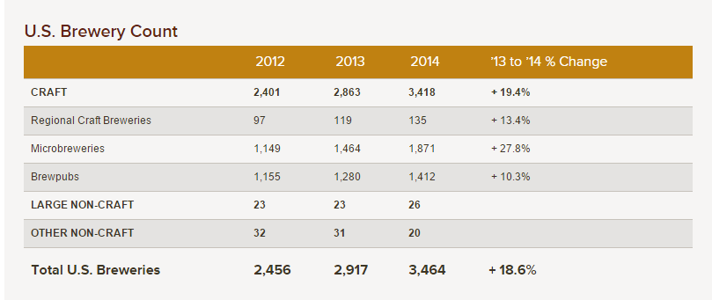
(http://www.brewersassociation.org/statistics/number-of-breweries/)
Research shows this trend is not just occurring in the United States, but in countries around the world. Even in Great Britain, there was a significant increase between 2012 and 2013 of Britons drinking 33 million pints more of local beer (Telegraph.co.uk).
Problem
The rise of these craft brewers or “micro-breweries” began as small competition to the larger corporations, but gradually, the popularity of locally produced and distributed beer has created a challenge. Despite InBev’s dominance in the US market, with 48% market share, these companies are beginning to pay closer attention to their home-grown competition (Bloomberg Business). Boston Beer Company is a great example of homegrown brewery that has seen major popularity with its “Samuel Adams” brands in recent years. In 1985 when the Boston Beer Company was founded, they were producing only 36,000 barrels of beer/year in 50 local bars and restaurants. As of 2013, they sell 3.4 million barrels/year in every state in the US and in 20 foreign countries (SamuelAdams.com).
One of the key targeting segment for alcoholic beverages, and more specifically beer, is young people. In recent years there has been a lot of research as the “millennial” generation begins to form and break the molds of their parent’s generation. This US segment is over 80 million strong. Millennials have increasing buying power in the US market. They tend to be less brand loyal, leading to much speculation about the effectiveness of big brand advertising in today’s media clutter. Therefore it is no surprise to learn people of this age group are straying away from their dad’s and grandpa’s favorite beer brands. An astonishing 43 percent of both Millennials and Gen X (born early 60’s to early 80’s) beer drinkers say craft beer tastes better, compared to just 32 percent of baby boomers (Mintel 2013). The craft beer industry is booming with the support of these young consumers. An article in the Wall Street Journal states an amazing 44% of people 21 to 27 in the US have never tried Budweiser. This only highlights the stark differences between millennials and their Baby Boomer parents who never would have predicted such an upset in the dominance of the “King of Beers.”
Many attribute the growth and success of this market to the shift in generations in the US. In June 2014 Chicago-based research firm Mintel produced a report on the craft beer industry. More than one in five (23%) respondents drink craft beer (2014). Amongst the 25-34 age group, representing the segment’s heaviest users, 70% say that the brand of beer says a lot about you and 66% say the style does the same (Mintel 2014). This information is not surprising given the numerous studies about millennials and their passion for self-expression and “personal branding” (U.S. Chamber Foundation). According to Mintel food and drink analyst Beth Bloom, “Craft beer allows for people to express their individual sense of style while also allowing for experimentation…and that’s a very exciting thing for a lot of people.” However, research also shows young people in this age group are more price sensitive due to financial challenges. The millennial generation is the largest group to go to college or post-secondary education. In combination with rising tuition rates, many beer consumers in this age group deal with student loans or work to pay off school related expenses, with less disposable income than this age group in previous generations. Nevertheless, 55% of respondents in the Mintel research are willing to pay more money for craft beer.
In fact, to emulate the factors of success in craft beers, some large companies are looking to gain back that missing piece of pie. There has been an uprising in “crafty beers” – beers that are specifically formulated to taste and look like it’s been produced by a local brewery. The best example of this is in the MillerCoors Corporation with brand Blue Moon, and InBev producing ShockTop.
Hypothesis
My hypothesis of how companies like InBev are taking back their market share is by acquisitions. Historically, huge brand names in the beer industry have maintained their dominance in the hearts of American consumers through advertising. For example, in 2012 the Business Insider ranked Anheuser-Busch InBev number 21 on a list of highest advertising budgets ($1.42 billion), outranking big name brands such as Unilever, McDonalds, and Apple. In the past Anhueser-Busch InBev has been able to afford this level of marketing expertise due to sheer volume in sales. According to Statstica, AB InBev has spent collectively from 2010-2014 over $150 million in SuperBowl advertising alone (Statista).
Statistics show beer consumption in the U.S. is declining, with a five percent decrease from 2007 to 2012 (USdrinksconference.com). With no growth, large beer companies can no longer drive sales through advertising. Instead they are attempting to buy back their declining market share. With the rise of small breweries such as a Samuel Adams gain popularity and threaten market share, InBev has readjusted its strategy. They are purchasing their competitors by horizontal acquisition.
In the past 5 years, AB InBev has been very busy in acquisitions. Several domestic purchases are listed below. Additionally there is speculation in the market of a deal to purchase SABMiller, holding company of the Miller Brewing Company and many popular international brews.
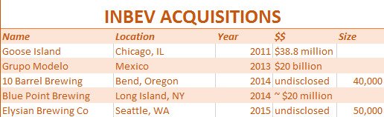
Platform Management is a Supply Chain concept of “an integrated system (materials, product/formula, equipment, operations, and process) designed to optimize existing supply systems and create high quality/cost effective new supply systems (GSCI)”. This process of aligning resources is exactly how InBev is making money by spending millions on acquisitions. InBev is setting itself up for the future by decreasing advertising spend to bring in new business units. By preparing for the craft beer loving population, InBev is also able to utilize platform management principles to gain economies of scale.
Supply
InBev currently owns and manages many assets that produce materials for the beer brewing process (Anheuser-Busch). The ownership of suppliers like hop farms make scalability a very achievable cost savings for giants like InBev. For example Anhueser-Busch owns Elk Mountain Hop Farm, once the largest contiguous hop farm in the world with over 1,700 acres in Bonner’s Ferry, Idaho (GoodBeerHunting.com). After the purchase of the Chicago craft beer Goose Island, Anheuser-Busch was able to use their Idaho farm to specifically cater to the unique types of hops used in Goose Island, thus creating a competitive advantage. Before the purchase, Goose Island hops were purchased for market price. Therefore AB is able to grab up these smaller, profitable, threatening breweries like Goose Island and give them a stable supply of products, like hops for example. Now that the Goose Island group isn’t having to deal with the uncertainty of supply and pay risk-associated costs, it is much more stable in its place in the marketplace and is able to grow and expand without the threat of overwhelming, often unpredictable supply costs. In recent years, lower yields in hop farms have led to rising prices and the number of craft breweries continues to grow (47hops.com). Research indicates the market for hops is unpredictable, which could force many smaller companies out of business. It is a supplier’s market, so the brewery with the most access to hops will win. AB is boosting the Goose Island business unit not only with access to sheer quantity, but also variety. Many craft beers like Goose Island pride themselves on distinctive, fresh, original flavors. Often the varieties of hops can change the flavors in the beers. Goose Island is now a better product and it’s cheaper to produce, a win-win for the InBev corporatation.
“According to Barth report (2011) the U.S. is the second largest producer of hops with 29.7% share of the world market in 2010. Germany was the leader in hop production with 34.27% share of world production of hops in 2010. “(Gnel Gabrielyan)
Being a company large enough to own its own assets can also help negate the effects of inaccurate forecasting and sudden changes in demand.
Additionally since the Anheuser-Busch InBev merger, the company has begun to aggressively cut costs on raw materials. A high-quality German hop called Hallertauer Mittelfrüh previously used to produce Budweiser has suddenly been taken off the AB InBev ingredient list in exchange for a cheaper, presumably blander hop (Bloomberg).
From a purchasing perspective, it is a good strategy for InBev to reduce its number of suppliers to achieve greater economies of scale. Additionally it is considered a good platform management practice to utilize materials that are more universal and are used in many products. One former InBev employee quoted a savings of around $55 million per year by substituting cheaper hops in Budweiser and other U.S. beers (Bloomberg). The choice to cut costs in raw materials like hops is a good move for the COGS column of the accounting books, but InBev pays for it in quality. Representatives from InBev consistently claim there is no change in taste or recipe or newly acquired brands.

Production
One thing InBev is doing to really upset its consumers is changing where the acquired craft beers are produced. Much of the hype and popularity of craft beers is a sense of community loyalty and pride. As stated earlier, the up-and-coming generation of beer drinkers is less big-brand loyal and more community-focused and likely to support something local.
When beers like Germany’s Becks, Latrobe, Pennsylvania’s Rolling Rock, and Chicago’s Goose Island are moved from their origins to an AB InBev facility, the consumers notice. Some loyal craft beer consumers feel the beer has been completely changed and degraded by being torn from the original brewery’s heritage. In one Bloomberg article, a consumer brings national attention to the change in production of Beck’s. Formerly brewed in the northern German city of Bremen, InBev has moved production for U.S. Beck’s to their backyard: St. Louis, Missouri.
Therefore companies like InBev try to keep it pretty quiet when the move operations to one of their production facilities. InBev attempts to keep these changes quiet, but changing lonely minute details printed on the bottles and documented on the websites. For example, Rolling Rock’s old label previously read “Latrobe, PA” and has been changed to “St. Louis, MO.” Nearly unnoticeable changes on the bottles can be seen with a manufacturing code.

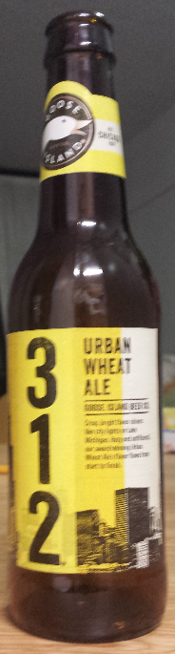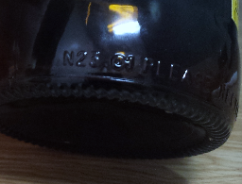
S- Saint Louis
B- Baldwinsville NY
C- Columbus Oh
D- Fort Collins Co
F- Fairfield Ca
H- Houston TX
J- Jacksonville FL
L- Los Angeles CA
M- Merrimack NH
N- Newark NJ
W- Williamsburg VA
V- Cartersville GA

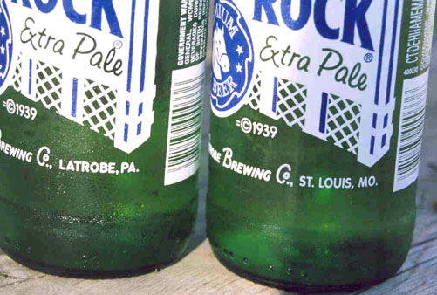
Stated during their public tour of the St. Louis, Missouri manufacturing plant, Anheuser-Busch can run 1000 bottles/min and 2000 cans/min. This obviously is a significant jump from the ~ 200 bottles/min rate at many craft breweries. Since all beer is made with the same basic ingredients, the amount of scale achieved by moving operations to AB InBev plants is extremely profitable. Moreover, many of these acquired brands are regional, many producing as little as 40,000 barrels/year, which pales in comparison the hundreds of millions of barrels made by AB. Therefore each added brand is a minuscule percentage of manufacturing facilities and resources dedicated. The ability to streamline this process into the lean AB plants creates savings previously out of reach for these craft brewers. AB InBev can use these production savings to fund their notorious marketing prowess.
Future
While even the strongest proponents for local beer agree there has been little to no actual decrease in quality of these newly acquired beers, craft advocates fear for the future. The industry as watched as international conglomerates have added more and more to their portfolios. Many worry the AB InBev giant will begin to look for new ways to cut costs if their dropping market share and margins continue.
There are two areas in which the craft beers acquired by big beer companies will suffer. The first is creativity. Most craft breweries begin as a hobby for beer-lovers, bottling 50 bottles at a time in a garage, with the support of friends and family as taste-testers. They grew their business from nothing based on the strong, unique flavors created in their breweries. Although AB InBev keeps many of the brewmasters from the companies it purchases, it is predictable that it may be difficult to keep that flow of creativity in recipes in a large corporate environment. Another argument in opposition of these acquisitions is the focus on the community. Craft breweries can be found all over the United States, many being local or regional. Many people, especially Millennials as discussed earlier, enjoy the exclusivity of directly supporting where they are from. They enjoy the sense of community that comes with a brewpub or brewery owned by their neighbors. When corporates like InBev purchase these locally bred brands, consumers feel like their money is no longer going into their city or state, but to a faceless international corporation. Additionally, craft breweries employ people locally. In many instances InBev will sell the original brewery as it did with Goose Island in Chicago.
As stated previously the lower production cost is a huge benefit of the merging of large beer companies and craft brewery counterparts. Hopefully this corporate scalability will lead to cost savings that producers can pass onto the consumers while maintaining a flourishing market of high quality products.

Sources
Duva, Nicholas. "Why Do Those Elitist Millennials Hate Big Beer?" CNBC. 08 Nov. 2014. Web. 05 May 2015.
Esterl, Mike, and Tripp Mickle. "Beer Giants Cultivate Their Crafty Side." WSJ. N.p., 28 Dec. 2014. Web. 05 May 2015.
Gabrielyan, Gnel. “Domestic and Export Price Formation of U.S. Hops.” 12 Aug 2012. Web. 05 May 2015.
Ginley, Mike. “U.S. Beverage Alcohol Trends.” US Drinks Conference. Web. 05 May 2015.
Kiser, Michael. "Reaping What You Sow - Anheuser-Busch and Goose Island Bring a Hop Farm Back to Life." Good Beer Hunting. 3 Sept. 2014. Web. 05 May 2015.
Leonard, Devin. "The Plot to Destroy America's Beer." Bloomberg.com. Bloomberg, 25 Oct. 2012. Web. 05 May 2015.
Thomas, Natalie. "Craft Beer Revolution Continues as Sales Rise 8pc." The Telegraph. Telegraph Media Group, 26 Feb. 2014. Web. 05 May 2015.
"National Beer Sales & Production Data - Brewers Association." Brewers Association. N.p., n.d. Web. 05 May 2015.
"The Rise of Craft Beer in the US – Craft Beer Sales Have Doubled in the past Six Years and Are Set to Triple by 2017." Mintel. 23 Jan. 2013. Web. 05 May 2015.
"Craft Beer Sales Surge 110% as Americans Embrace Sense of Individual Style." Mintel. 25 July 2014. Web. 05 May 2015.
"The Millennial Generation Research Review." U.S. Chamber of Commerce Foundation. N.p., 14 Nov. 2012. Web. 05 May 2015.
"Largest Super Bowl Advertisers 2010-2014.” Statista. Web. 05 May 2015.
“2013 State of the U.S. Hop Industry.” 47hops.com. Web. 05 May 2015.

