Hydrogen peroxide impacts on marine phytoplankton community structure:
A modeling story

A Dissertation Presented for the
Doctor of Philosophy
Degree
The University of Tennessee, Knoxville

Donna Kathleen “Katie” McCullough
August 2024
Copyright © Donna Kathleen McCullough
All Rights Reserved

Dedication
To the past iterations of myself for whom this dissertation seemed unattainable;
thank you for persevering.

Acknowledgements
Microbial survival in the surface ocean depends on continual community intervention to combat the innumerable pressures of the open sea; individual success in graduate school is no different. First, to Dr. David Talmy, taking on a microbiology student with no prior computer science or math modeling training into your global ecology modeling group was a choice. Thank you for making it. The frequent frolics into the weeds and base understanding of mental health (Thank goodness you are British!) have been highlights of this experience. To my committee members (Drs. Andrew Steen, Mike Gilchrist, and Erik Zinser), thank you for guiding and raising issue(s) with my project for the betterment of the science and of me as a scientist. To Talmy Lab members of the past and present, Eric Carr, Harshana Rajakaruna, Dr. K.C. Pramir, Dr. Audra Hinson, Kyla Linn, M.S., and Dr. Spiro Papoulis, thank you for being my sounding boards and non-judgmental tutors. To Eric Carr specifically, thank you for being all lab members in one for my final years. To Dr. Audra Hinson, thank you for being my first guide into Data science and thus instrumental in my progress. To the upper classesmen of graduate students who helped mold my graduate schooling with preliminary exam practices, insightful paper discussions, and productive comments from colloquia, thank you for making graduate classes a helpful experience. To Zinser lab members Dr. Liz Glasgo, Dr. Ben Calfee, and Emily Bowden specifically, thank you for-dealing with annoyingly endless lab questions. To my graduate school Cohort (Dr.s Pramir, Selene, Aeric, TJ, Elise, Alexandra, Brit, Liz, Haley, and Sean) thank you for the scientific and mental support that only can come from comrades in the trenches. Thank you for lending me your sanity and hope when I had none myself. I wish every grad student a grad family as incredible as these.
To Elizabeth McPherson, thank you for your pedagogical mentorship and unwavering leadership for all laboratory microbiology teaching graduate students. Your advice was instrumental to me surviving the first year of grad school. Further, Thank you for perpetual excellences from the UTK Microbiology Office staff of the present and past (Rachelle Allen, Misty Jones, Erikka Lyn Jennings, Sharon Sexton, Zhane Fanning, Christina Gregory, Lane Hall). Y’all never balked at the perpetual pleas of help coming from my lab. Thank you for handling the concerns we could not. To James Hodges, thank you for your science material and daily joke delivery. You never failed to have a friendly word and smile.
To the 3 different Director of Graduate Studies (Steve Wilhelm, Liz Fozo, and Erik Zinser) who all provided invaluable advice in separate times of acute graduate school distress; I appreciate your service and care. Thank you to all the UTK microbiology professors and staff for sharing their expertise and advice. The daily interactions and weekly seminars were useful sources of friendly scientific feedback and banter. Thank you to the United Campus Workers Union for fighting for us all. For the UTK Grad Gay Straight Alliance (GSA) and Grad Student Senate (GSS), thank for your organizational and people skills.
Thank you to the HOTs cruise 347 Crew of the research vessel R/V Kilo Moana, especially to Carolina and Annie, for keeping me alive. To my college crew, Polish friends near and far, Knoxville Women’s Rugby Club members and Caitlin Corbitt with the Shakespeare-Out-Loud troupe, thank you for allowing me to dip in and out of your lives when school allowed. Your joy is infectious and lifesaving. To Dr. Neal, my therapist throughout graduate school, who kept laughing at my dark jokes during the depths of covid; I wish you a quiet and family-filled retirement. To my Parents, thank you for making me what I am. Mum – I never needed to look anywhere else to have a strong female (and scientist) role model. Thank you for never backing down from a fight. Tenacity is definitely a family trait. To Aunt Donna, thank you for being a bad ass role model in breaking glass (often patriarchal) ceilings. I see your unwavering devotion to those in your life and I hope to emulate that. To my siblings, Charles and Sarah, thank you for providing a variable and tough environment so as to aid in my development. And to Haley for marrying my brother, that was silly, but welcome. Having two sisters is double the trouble/ fun. To Emily and Co., thank you for the constant support and reminder that we are more than our work. I enjoy life with all y’all. Lastly, to the family, church supporters, and friends who did not live see the completion of this work, as well as every student whose life or education ended as a casualty of war, I wish for you peace.

Abstract
Microbial community structure in the oligotrophic ocean has evolved so that organisms unable to survive in monoculture can flourish in this harsh, nutrient deplete environment. The oligotrophic ocean contains high concentrations of hydrogen peroxide (H₂O₂), a type of harmful reactive oxygen species, which is produced when light hits pigmented detrital material. Prochlorococcus is the most abundant photosynthetic organism in the oligotrophic ocean and is estimated to perform half of the carbon fixation there, yet it cannot live in monoculture at the level of H₂O₂ produced in one day of its natural environment. The less streamlined sister of Prochlorococcus, Synechococcus, as well as co-isolated heterotrophic bacteria, are able to survive the H₂O₂ of this environment but cannot outcompete Prochlorococcus for low nutrients concentrations here. Prochlorococcus has evolved dependence on other microorganisms, requiring them to constantly detoxify ambient H₂O₂. Thus, allowing Prochlorococcus to survive in mixed-culture communities but not to competitively exclude the community members without facing H₂O₂ damage. Mechanisms that control the oceanic carbon cycle are an essential area of current and future climate change research, yet they are complex and poorly understood. Mathematical models accounting for various biological and physical processes allow for the assessment of factors that exert control on carbon and nutrient cycling.
Current phytoplankton global models attribute 25% of marine primary production to Prochlorococcus but exclude H₂O₂ as a source of microbial death in those calculations. Beginning with a simple Monod-based representation of H₂O₂ dynamics, this thesis provides a basal quantitative groundwork to assess H₂O₂ detoxification and damage in globally important plankton genera. The tradeoffs between growth advantage (Prochlorococcus) and H₂O₂ detoxification (Synechococcus) were found to control the toggle between competitive and coexistent behavior. The leakiness of H₂O₂ detoxification was found to be a key driver of coexistence both in dimensionless and spatially/ temporally resolved frameworks. The stepwise build of this model keeps resource competition and coexistence theories rooted in the (micro)biology while allowing for quantitative ecological evaluation of H₂O₂ impacts on globally relevant microbial dynamics.

Table of Contents
Chapter 1 Hydrogen peroxide and phytoplankton interactions of the open ocean: A base understanding 1
Introduction 3
Review 5
H₂O₂ stress in phytoplankton 9
Strategies to mitigate H₂O₂ 11
Modeling surface ocean microbial communities 12
Goals of this dissertation 13
Chapter 2 Quantification of the coupled dynamics of cell growth and hydrogen peroxide (H₂O₂) in laboratory batch culture experiments 20
Abstract 22
Introduction 22
Methods 25
Model equations 25
Laboratory data 26
Fitting procedure 27
Experimental approach: 30
Results 30
Abiotic media analyses 30
Phytoplankton batch culture dynamics without hydrogen peroxide 31
Phytoplankton batch culture dynamics with amended hydrogen peroxide 31
Modeling Synechococcus and H₂O₂ dynamics 35
Discussion 36
Acknowledgements: 44
Chapter 3 Evaluation of H₂O₂ as a community composition moderator within oligotrophic plankton dynamics 45
Abstract 47
Introduction 48
Methods 53
Model 53
Experimental Approach 55
Results 59
Non-leaky dynamics 60
Leaky dynamics including Synechococcus detoxification 61
Leaky dynamics including Synechococcus and Bacterial detoxification 71
Discussion 78
Conclusions 80
Chapter 4 Modeling the impact of H₂O₂ traits on marine biology at a global scale 82
Abstract: 84
Introduction: 84
Methods: 86
Model and experimental approach 90
Case 1 – Nonleaky world, H₂O₂ no-impact 90
Case 2 – Non-leaky world, H₂O₂ damage on Prochlorococcus implemented 91
Case 3 - Leaky world, Synechococcus detoxification implemented 91
Case 4 - Leaky world, Synechococcus and Bacterial detoxification 92
Results: 93
Case 1 – Nonleaky world, H₂O₂ no-impact 93
Case 2 – Nonleaky world, H₂O₂ damage on Prochlorococcus implemented 93
Case 3 - Leaky world, Synechococcus detoxification implemented 96
Case 4 - Leaky world, Synechococcus and Bacterial detoxification 96
Discussion: 97
Conclusions: 105
Chapter 5 Conclusions and Future Work 106
References 110
Appendices 140
Appendix A supplementary information Chapter 2 140
A1 Parameter fitting procedure 140
A2 Quantifying uncertainty in experimental data 143
A3 Additional experimental datasets 149
A4 Media and Buffer H₂O₂Production Assays 157
Appendix B supplementary information: Chapter 3 160
B1 Monoculture parameter fittings 160
B2 Equilibria 170
B3. Equilibria and dynamic contour plots 172
Appendix C Supplementary Information: Chapter 4 177
Vita 184

List of Tables
Table 1 Monoculture Parameter and variable definitions and units 29
Table 2 Competition model parameter and variable definitions and units 57
Table 3 Monoculture laboratory parameters conversion to global Darwin parameters 94
Table 4 Global parameter inclusion into four global model cases 95

List of Figures
Figure ‎1.1 Concurrent monoculture or coculture dynamics for Prochlorococcus and H₂O₂ 6
Figure ‎1.2 Roadmap of the stepwise model formation using divergent H₂O₂ phenotypes in dominant plankton 16
Figure ‎2.1 Stepwise model construction allows for data constraint on individual parameters within a coupled ODE model. 28
Figure ‎2.2 Stepwise model construction allows for data constraint on individual parameters within a coupled ODE model. 28
Figure ‎2.3 Stepwise model construction allows for data constraint on individual parameters within a coupled ODE model. 28
Figure ‎2.4 Abiotic growth media modeled in zero H₂O₂ spike 32
Figure ‎2.5 Abiotic spiked media modeled in 400nM H₂O₂ spike 33
Figure ‎2.6 Monoculture Prochlorococcus dynamics modeled in growth media without additional H₂O_{2.} Laboratory batch culture dynamics of Prochlorococcus (green line) and model searches (grey lines) with best-fit solution (red line) with zero H₂O₂ addition (a). Also shown are parameter posterior distributions for the initial population size, P₀ (b) and the exponential growth rate, $μi$ (c). i.e. The range of possible model solutions (grey) and best fit (red line) shown in section a are represented in the width and medians of parameter, P₀ in b and $μi$ in c, value histograms. 34
Figure ‎2.7 Monoculture Prochlorococcus modeled in H₂O₂ spiked media. 37
Figure ‎2.8 Monoculture Synechococcus CC9605 modeled in growth media 38
Figure ‎2.9 Monoculture Synechococcus CC9605 modeled in H₂O₂ spiked media. 39
Figure ‎2.10 Recovered H₂O₂ trait parameters from different picoplankton during H₂O₂ spike assays. H₂O₂ detoxification rate ($ϕmax,i ,$mL cell⁻¹ day⁻¹) and H₂O₂ induced rate of cell death ($κdam, i$, mL nmol⁻¹ day¹) for different cyanobacterial (Prochlorococcus and Synechococcus), heterotrophic bacterial (Alteromonas), and picoeukaryotic (Micromonas spp and Ostreococcus spp.) monoculture batch cultures. ‘avg’ delineation indicates multiple monoculture data sets for this species were individually modeled and then averaged. Dynamic models showing the retrieval of these parameters can be found in Appendices A and B. 40
Figure ‎3.1 Parameters impacting Prochlorococcus and Synechococcus growing on ammonium in H₂O_{2.} Schematic showing overall model formulation of the ODEs shows two microbes, Prochlorococcus (Pro) and Synechococcus (Syn) grow from a singular ammonium pool (N) with external H₂O₂ (H) production. The heterotrophic bacterial helper (B) does not compete for ammonium here. Parameters (symbols) control the flux (arrows) between measurable pools of P, S, N, and H. Differential inclusion of H₂O₂ parameters within this framework allows this model to evaluate how 4 scenarios (cases) impact the competitive advantage of these microbes over one another (a microbial Thunderdome). 52
Figure ‎3.2 Quantitatively recovered tradeoffs found in the coupling of H₂O₂ detoxification rate ($ϕmax,i ,$mL cell⁻¹ day⁻¹) and H₂O₂ induced rate of cell death ($κdam, i$, mL nmol⁻¹ day¹) for different plankton (i) grown in monoculture batch conditions. Each symbol represents a single plankton species, i. 56
Figure ‎3.3 Dynamics of Prochlorococcus and Synechococcus in zero H₂O₂ 58
Figure ‎3.4 Dynamics of Prochlorococcus and Synechococcus in non-leaky H₂O₂ world 62
Figure ‎3.5 Evaluation of non-leaky model dynamics across a range of S_{H} and S_{N} 63
Figure ‎3.6 Dynamic outcomes for H, N, P and S leaky case model iterations under different H supplies. 3.6a, 3.6b, and 3.6c depict different dynamic model outputs for P, S, N, and H from increasing H inputs under case 3, S leaky H₂O₂ detoxification regime. The top graph of a,b or c each depicts dynamics model solutions for Prochlorococcus (P) and Synechococcus (S) analogue abundances in green or yellow as predicted solid lines. The associated steady state solutions predicted from these parameter values are visualized in dotted lines on the same axes. The middle plot shows the modeled nutrient concentration over time for the dynamics (solid) and steady state (dotted) purple lines. The bottom plot shows H₂O₂ dynamics over time. S_{N} is kept constant for all scenarios (a,b,c) as is Synechococcus detoxification ($ϕmax,S$ = 2.0 x10⁻⁶). Despite this single parameterization, differentially dominated coexistence scenarios occur in P and S communities based on value S_{H.} Using only Synechococcus detoxification ($ϕmax,S$) allows coexistence along a small (200-900 nmol mL⁻¹ day⁻¹) range of S_{H,} 64
Figure ‎3.7 ϕ_{max,S} effects on Prochlorococcus and Synechococcus coexistence in dynamics and equilibria contours. 68
Figure ‎3.8 Different coexistence landscapes available dependent upon who is detoxifying H. 73
Figure ‎3.9 Contour outputs across a range of S_{N} and S_{H} under different heterotrophic detoxification (ϕ_{max,B} ) regimes 74
Figure ‎3.10 Prochlorococcus and Synechococcus competitive outcomes as a result of EZ55 cell density 77
Figure ‎4.1 Extrapolating from four dimensionless plankton competition models to an in situ global plankton model influenced by realistic physical inputs 87
Figure ‎4.2 Mean temporally aggregated H₂O₂ concentration from last year of a 10 year global circulation model 98
Figure ‎4.3 Nutrient Competition in a non-leaky world 99
Figure ‎4.4 Unilateral H₂O₂ damage in a non-leaky world 100
Figure ‎4.5 Leaky H₂O₂ dynamics using monoculture Prochlorococcus and Synechococcus parameters. 101
Figure ‎4.6 Leaky H₂O₂ dynamics using Bacterial and Synechococcus detoxification parameters 102
Figure A 1 Standard deviation and mean analysis among biological triplicates for raw (left) vs log-transformed (right) Prochlorococcus abundance, Synechococcus abundance and H₂O₂ (HOOH) data. 144
Figure A 2 Error analysis replicates of hydrogen peroxide 147
Figure A 3 Error analysis replicates of Synechococcus 148
Figure A 4 Monoculture dynamics of Prochlorococcus dataset #2 modeled in growth media with 0 additional H₂O₂. Laboratory batch culture dynamics of Prochlorococcus (Vol #1) data (blue line) and model searches (grey lines) with optimal solution (red line) in zero H₂O₂ batch culture (a). Also shown are parameter value histograms for the initial cell concentration (P₀) and exponential growth rate ($μi$) (b,c, respectively). 149
Figure A 8 Synechococcus WH7803 (Vol #52) modeled in growth media with 0 additional H₂O₂ 153
Figure A 9 Modeled Synechococcus WH7803 monoculture in 400nM H₂O₂ spike assay 154
Figure A 10 Heterotroph EZ55 300nM H₂O₂ spiked media dynamics over 2 hours 155
Figure A 11 Heterotroph EZ55 800nM H₂O₂ spiked media dynamics over 2 hours 156
Figure A 12 Modeled H₂O₂ production in TAPs buffer 158
Figure A 13 Modeled H₂O₂ production in HEPES buffer 159
Figure B 1 Monoculture Micromonas commoda in growth media with 0 additional H₂O₂ 161
Figure C 1 H₂O₂, Prochlorococcus and Synechococcus biogeography in year 9 of Case 1: Non-leaky world, no k_{dam,p}. 178
Figure C 2 H₂O₂, Prochlorococcus and Synechococcus biogeography in year 9 of Case 2: Non-leaky, no biotic detoxification ($max,i).$ 179
Figure C 3 Projected H₂O₂, Prochlorococcus and Synechococcus biogeographies in year 9 of Case 3: Leaky world, Synechococcus H₂O₂ detoxification ($max,s$ ) alone is incooperated. 180
C 4 Projected H₂O₂, Prochlorococcus and Synechococcus biogeographies in year 9 of Case 3: Leaky world, heterotrophic detoxification ($max,B )$alone. 181
Figure C 5 H₂O₂ biogeographical plot and ratio plot of (Syn) / (Syn + Pro)) biogeography in Case 3: Leaky world, heterotrophic detoxification ($max,B$) alone. 182
Figure C 6 Projected H₂O₂, Prochlorococcus and Synechococcus biogeographies in year 9 of Case 4 with both heterotrophic bacterial and Synechococcus H₂O₂ detoxification ( $max,S$ and $max,B$) incoorperated. 183

Hydrogen peroxide and phytoplankton interactions of the open ocean: A base understanding

Author(s): D.K.M. and D.T.
Author contribution statements: Written and edited by DKM with feedback from DT

Introduction

Oceans cover approximately 70% of the earth (Raven and Falkowski 1999) and are largely composed of ‘nutrient deserts.’ The oligotrophic ocean by definition is nutrient poor, with nitrogen, along with iron and phosphorus shown, to be colimiting to microbial growth (Moore et al. 2013). Nitrogen (N) is considered to be limiting in 75% of ocean productivity (Bristow et al. 2017). Microorganisms that dominate these oligotrophic waters tend to be small, physically streamlined cells (Azam et al. 1983; Beaulieu et al. 2008; Dortch and Packard 1989; Moya et al. 2009; Thompson et al. 2019) that can uptake sufficient amounts of rare nitrogen due to their increased surface area to volume ratio (Lee and Fuhrman 1987; Pianka 1970; Ben A. Ward et al. 2017). Small microbes, mainly picophytoplankton (Buitenhuis et al. 2012; Falkowski, Woodhead, and Vivirito 1992), serve as the base of the microbial loop (Field 1998; Bristow et al. 2017; Follows and Dutkiewicz 2011), and thus the marine ecosystem (Falkowski, Woodhead, and Vivirito 1992), by fixing gaseous carbon to bioavailable components (Gruber et al. 2009; Raven and Falkowski 1999). Primary production and carbon fixation in marine oligotrophic environments is intimately tied to the growth of phytoplankton communities (Hartmann et al. 2014; Williams et al. 2013).
Two picocyanobacterial genera (Prochlorococcus and Synechococcus) are responsible for roughly 25% of global carbon fixation (Field 1998; Follows et al. 2007; Partensky, Hess, and Vaulot 1999). Once carbon is initially fixed via phytoplankton, such as cyanobacteria and algae, heterotrophic microbes, like Alteromonas, viruses (Jover et al. 2014; Weitz and Wilhelm 2012), and eukaryotic grazers (Banse 1995) determine the secondary fate of carbon by recycling it, funneling it to higher trophic levels, or storing it (Arístegui 2005; Boyd 2015; Buchan et al. 2014; Dortch and Packard 1989; Duarte et al. 2013). The carbon cycle is thus tied to the other nutrient cycles, such as phosphorus, nitrogen, and iron (Follows and Dutkiewicz 2011; Gruber and Galloway 2008; Redfield 1958; Voss et al. 2013) through the metabolisms, geographical ranges, and life histories of marine microorganisms (Falkowski 1997; Fuhrman 2009, 199; Passarge et al. 2006; Fuhrman 2002).
The carbon cycle plays an integral role in climate change science (Le Quéré et al. 2009; Friedlingstein et al. 2006). It is predicted that as global carbon emissions continue to rise (Sokolov et al. 2009; Plattner et al. 2008) marine systems that canonically act as carbon sinks (Tagliabue, n.d.; Boyd 2015; Gruber et al. 2009; Raven and Falkowski 1999; Siegel et al. 2014) will be significantly affected (Friedlingstein et al. 2006; Gruber et al. 2009; Hennon et al. 2018). Nitrogen deposition is expected to increase in the future (Voss et al. 2013) yet increased stratification is set to favor streamlined, smaller-celled competitors (Henson et al. 2021; Knight and Morris 2020; Sallée et al. 2021; Wang et al. 2023). CO₂ concentration itself is expected to exhibit contrasting controls on community members (Dutkiewicz et al. 2015; Knight and Morris 2020). Despite various studies addressing this topic (Beman et al. 2011; Hennon et al. 2018; Hutchins and Fu 2017; Liao et al. 2019; Plattner et al. 2008; Sokolov et al. 2009; Wang et al. 2019), it is still unclear how climate change will affect oligotrophic waters and their microbial inhabitants. Therefore, understanding of the drivers that control the microbial biomass of the primary producers and their community members are applicable to current theories about marine carbon and nutrient cycle (Martin et al. 1987) and also inform predictions about future oceanic conditions.
Genera like Prochlorococcus , Synechococcus, and Alteromonas spp. all grow together in the oligotrophic ocean, yet differ in their diel (daily) and seasonal spatial patterns (Biller, Berube, et al. 2015; Berube et al. 2015; Marie et al. 1997; Partensky, Hess, and Vaulot 1999; Sohm et al. 2016; Liu and Campbell 1995) as well as geographic range (Barton et al. 2010; Buitenhuis et al. 2012; Flombaum et al. 2013; Follows et al. 2007; Rippka et al. 2001; Sohm et al. 2016; Thompson et al. 2013; Thomson et al. 2010). Prochlorococcus generally outgrows Synechococcus by ten-fold (Morris et al. 2011; Thompson et al. 2013) in oligotrophic waters. Presumably this is due to its streamlined size, and associated benefits, as compared to Synechococcus (Flombaum et al. 2013; Partensky, Hess, and Vaulot 1999). In laboratory culture however, it was not possible to mirror these microbial dynamics until hydrogen peroxide (H₂O₂) and heterotrophic bacteria were introduced (Calfee 2021; Morris et al. 2008). It was shown that Prochlorococcus’s streamlined form lacks the ability to survive alone in the concentrations of (H₂O₂) abiotically produced in this environment (Morris 2011; Zinser 2018a) likely due to its lack of H₂O₂ detoxifying catalase (Harada et al. 2021; Bernroitner et al. 2009). Thus, Prochlorococcus has evolved a dependence on catalase-positive microbes that share its environment, like Synechococcus spp. and Alteromonas spp, as shown in Figure 1.1, to allow it to survive in mixed-culture communities and dominate production there (Biller, Berube, et al. 2015; Berube et al. 2015; Morris et al. 2011; Morris, Lenski, and Zinser 2012).
This dissertation investigates how these differing controls and the underlying mechanisms impact plankton community structures in the open ocean through contemporary computation modeling approaches. Thus, we first review current knowledge on H₂O₂ in the ocean and how phytoplankton are currently known to differ in reaction with exogenous H₂O₂. Then we cover known models that simulate phytoplankton dynamics implicitly, via correlative representations, or explicitly, via trait parameterization, and known environmental toggles.
After reviewing the current knowledge of oceanic production of reactive oxygen species (ROS) like H₂O₂ and global marine phytoplankton modeling efforts in relation to nutrient supplies, this dissertation will concentrate on the intersection of H₂O₂ and nutrient stresses on plankton dynamics. It will explore H₂O₂ influences on singular plankton (Chapter 2) before investigating how coculture interactions are augmented by differing nitrogen (N) and H₂O₂ assumptions (Chapter 3). Trait space explaining the steady state concentration predictions of phytoplankton and H₂O₂ is further explored as a function of H₂O₂ parameters. Trait differences are visualized in separate different biogeographical predictions for prominent phytoplankton via utilization of microbial trait model projections on top of a global circulation model (Chapter 4).

Review
Reactive oxygen species, and specifically H₂O₂, are constant threats to microbial cells in the aerobic environment (Morris, Rose, and Lu 2022; Zinser 2018a; 2018a). Despite both being the primary H₂O₂ sink in marine systems (Morris, Rose, and Lu 2022; Zinser 2018a) and having known differential affects plankton that grow in the surface ocean (Morris et al. 2011; Zinser 2018a; Morris, Rose, and Lu 2022) currently no ocean microbial model accounts for the differential influence of H₂O₂ dynamics on oceanic microbial abundances. Gyres where Prochlorococcus is found to dominate numerically are defined by harsh abiotic conditions like high incident light (up to 2000 μmol quanta m⁻² s⁻¹ at the surface (Morris et al. 2011; Zinser et al. 2007; Cooper et al. 1988)), yearly maximum temperatures above 30º C (Martiny et al. 2009),
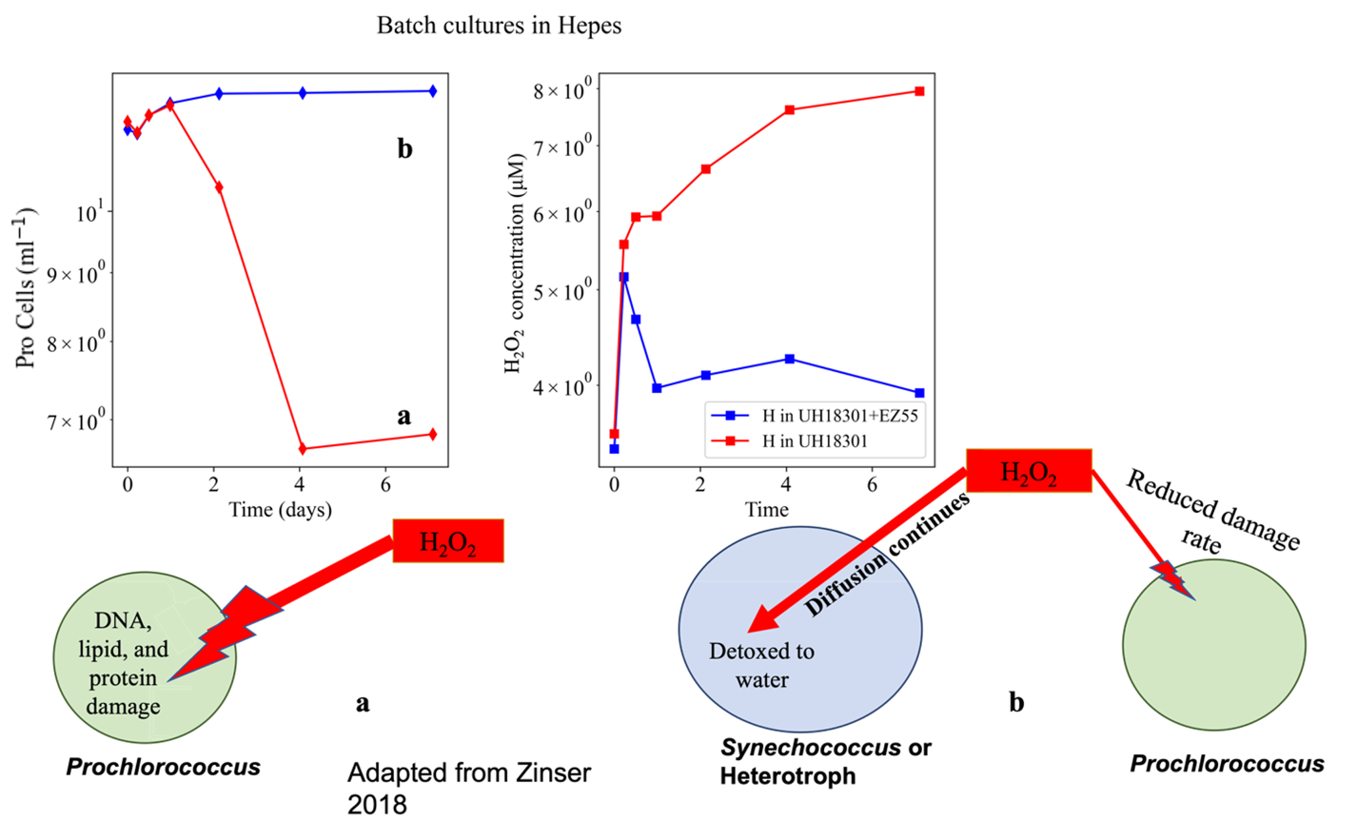
Figure ‎1.1 Concurrent monoculture or coculture dynamics for Prochlorococcus and H₂O₂
Prochlorococcus abundance (left) and H₂O₂ concentrations (right) in batch cultures spiked with photochemical- H₂O₂ production via HEPES buffer either in axenic (monoculture) assays (a, red) or coculture with Alteromonas, a heterotrophic bacterial helper, assays (b, blue). (HEPES buffer H₂O₂ production is shown in Appendix A, section A3.) The monoculture (a) and coculture (b) dynamics shown in representative bubble diagrams of a and b are below data plots. The bubble diagrams are assumed to represent the mechanisms on which the corresponding dynamics (a, red or b, blue) depend. Computational modeling concerning Prochlorococcus without (a, red) or with (b, blue) a helper microbe (like Alteromonas) to act as a H₂O₂ sink, is based upon the H₂O₂ diffusional interactions shown within this figure. These assumptions are continued through this dissertation. (Adapted from Zinser (2018b) with data from Morris 2011).

and daily reactive oxygen species production from biotic and abiotic sources (Blot et al. 2011; Cooper et al. 1988; Imlay 2003; Nishiyama, Allakhverdiev, and Murata 2006). Temperature has been studied in relation to Synechococcus and Prochlorococcus community structure, with Synechococcus shown to dominate Prochlorococcus in the colder (Sohm et al. 2016), more eutrophic waters (Flombaum et al. 2013). Light has been shown to coincide with temperature as the main determinant between Prochlorococcus ecotype niche differentiation (Martiny et al. 2009; Rippka et al. 2001) and as a regulator of Synechococcus growth, as Synechococcus is resigned to the shallower depths than Prochlorococcus (Biller, Berube, et al. 2015; Berube et al. 2015; Zinser et al. 2007).
Concepts from resource competition theory (Grover 1997; Tilman 1982; 1977; Hardin 1960) are often used to explain Prochlorococcus’ dominance in nutrient-deplete water. Its streamlined size allows Prochlorococcus to have a higher surface area to volume ratio than Synechococcus indicating that Prochlorococcus has both a lower requirement for membrane-constructing molecules (like phospholipids) and an increased ability to uptake essential nutrients from the environment (Beaulieu et al. 2008; Ward et al. 2017; 2012; Moore and Chisholm 1999; Edwards et al. 2012). Competition theory categorizes organisms into either ‘r’ or ‘k’ strategists, based on the carrying capacity, k, or net growth rate , r (Pianka 1970). Leading to the organization of groups defined to compete with others by either maximizing the ability to grow quickly (by maximizing their maximum growth rate value, and k) like diatoms (Kirchman 2016), or maximizing the ability to take up nutrients (by minimizing their nutrient affinity value, and r); Prochlorococcus is a classic example of the latter (Armstrong and McGehee 1980; Pianka 1970; Treusch et al. 2009). While it is clear that Prochlorococcus is streamlined for ammonium use (Garcia-Fernandez, de Marsac, and Diez 2004), nitrogen is a constant constraint on growth (Biller, Berube, et al. 2015; Berube et al. 2015; Bristow et al. 2017) as nitrogen composes 7% of microbial cell mass in proteins and nucleic material, while phosphorus generally composes 1% (Krumhardt et al. 2013). This means that for a microbe that is streamlined for growth, further streamlining or the evolutionary cutting a protein from one’s genetic repertoire, is arguably more advantageous than cutting a single gene, as nitrogenous molecular construction and maintenance costs for proteins are considered alongside the molecular and spatial costs of gene storage and replication as well (Lynch and Marinov 2015; Read et al. 2017). Prochlorococcus has been noted to be especially streamlined genetically and physically (Garcia-Fernandez, de Marsac, and Diez 2004; Avrani and Lindell 2015; Chisholm 2017; Zinser and Martiny 2023; Partensky and Garczarek 2010), meaning that it likely strategically cut genes, and associated proteins and functions, from various areas of cellular life (Kettler et al. 2007; Morris, Lenski, and Zinser 2012). For example, high light Prochlorococcus spp. form fewer photosystem subunits presumably to decrease nitrogen constraint in the higher light conditions (MacGregor-Chatwin et al. 2019) while they also have cut all genes for phycobilosomes from their genome over the span of their evolution (Ulloa et al. 2021; Urbach et al. 1998). It is key to note that these proteins are known to be especially nitrogen and metal heavy (Barynin et al. 2001; Brill and Williams 1961), similar to catalase proteins (Chelikani, Fita, and Loewen 2004; Barynin et al. 2001). Thus Prochlorococcus may have ‘lost’ or ‘cut’ the genes for phycobilosomes and catalase to minimize ‘wasted’ genetic space (Morris, Lenski, and Zinser 2012; Morris, Papoulis, and Lenski 2014) and reduce the amount of cellular material required for growth. Thus allowing survival of Prochlorococcus over the course of the cyanobacteria’s 3.5 million year evolutionary span in such low nutrient environments (Zhang et al. 2021; Zamocky et al. 2012).
Competition theory did not explain fully why Synechococcus can continue to grow in the oligotrophic regions despite Prochlorococcus being better adapted for the nutrient conditions (Hutchinson 1967) until recently when Masuda et al. (2023) quantitatively showed that Prochlorococcus and Synechococcus are able to coexist by taking advantage of the differences in ammonia and nitrate concentrations in the oligotrophic gyres and genetic nitrogen usage repertoire (Garcia-Fernandez, de Marsac, and Diez 2004). Genetic and physical streamlining offers the distinct trade-off that in cutting 'extraneous' genes in order to decrease cell size, the cell is reducing its ability to perform functions that could become necessary in a changing environment (Kettler et al. 2007; Swan et al. 2013; Giovannoni, Cameron Thrash, and Temperton 2014; Giovannoni et al. 2005). For example, Prochlorococcus is smaller than Synechococcus and thus can acquire nutrients more efficiently (Berube et al. 2018) but also lacks the gene for most efficient H₂O₂ detoxifying enzyme in cyanobacteria, a bifunctional catalase-peroxidase , katG (Bernroitner et al. 2009; Williams 1928; Keilin and Hartree 1943). As Prochlorococcus did not retain catalase, a key enzyme in the protection against H₂O₂ (Biller, Berube, et al. 2015; Berube et al. 2015, 20; Morris, Papoulis, and Lenski 2014), Prochlorococcus must rely on other cyanobacterial species (like Synechococcus) or heterotrophic bacteria (like Alteromonas spp.) in this environment for H₂O₂ detoxification function.

H₂O₂ stress in phytoplankton

Reactive oxygen species (ROS) are an inevitable side effect of marine aerobic life (Imlay 2013; Morris, Lenski, and Zinser 2012; Hansel and Diaz 2021; Diaz and Plummer 2018). ROS can arise from biotic processes like photosynthesis (Banerjee et al. 2013; Mackey et al. 2013; Bailey and Grossman 2008) and respiration (Bond, Hansel, and Voelker 2020; Hayyan, Hashim, and AlNashef 2016; Seaver and Imlay 2001) as well as from abiotic processes such as photocatalytic H₂O₂ production via sunlight and dissolved organic carbon (Cooper et al. 1988; Zinser 2018a; Morris, Rose, and Lu 2022). Short lived ROS like OH^{.-} or O₂^{.-}. are charged and thus more unstable (Cooper et al. 1988; Zinser 2018b; Morris, Rose, and Lu 2022) and reactive to than O₂ or H₂O₂; meaning that unless OH^{.-} or O₂^{.-} are created in the cell, they do not pose a significant threat to microbial cell health as they cannot easily cross the membrane and generally react too quickly (Imlay 2003; 2013; Seaver and Imlay 2001; Möller et al. 2019; Morris et al. 2011). H₂O₂ is created down-stream of O₂^{.-} reactions through the enzyme superoxide dismutase (SOD). It detoxifies O₂^{.-} to H₂O₂ and is found ubiquitously in aerobic microbes (Ighodaro and Akinloye 2018; Miller 2012). While Prochlorococcus only contains one type of SOD (Latifi, Ruiz, and Zhang 2009), other ocean microbes contain various SOD enzymes with different metallic centers thus giving a range of catalytic events across broader electron (e-) charge ranges (Boden et al. 2021; Miller 2012). H₂O₂ also forms when electron transport, either through the photosystem, or the aerobic metabolic chain, gets overloaded from errant or excess electrons Aharonovich, Sher, D., 2016. Thus creating ^{-.}OH or O₂^{.-} that then damage cellular material or are detoxified to H₂O₂. Transcriptional responses of Prochlorococcus to co-culture with a marine Alteromonas indicate Prochlorococcus interacts differentially with separate strains and these differences may involve putative info or ROS chemicals (Imlay 2013; 2003; Zamocky et al. 2012).
Extracellular H₂O₂, however, can persist in the environment for hours (Zinser 2018a; 2013; Petasne and Zika 1997; Avery et al. 2005) as abiotic decomposition is relatively slow and largely dominated by thermal decomposition (Hong et al. 2009). Extracellular H₂O₂ can cross the cellular membrane as it is uncharged and dipolar, similar to water molecules (Tjell and Almdal 2018). While H₂O₂ is important in iron and other key trace metal charge cycling, if it is not detoxified, H₂O₂ interacts and damages lipids, DNA, proteins, and cellular material (Imlay 2003; Latifi, Ruiz, and Zhang 2009; Morris 2011). These damages may compile leading to cellular death (Laloi and Havaux 2015; Imlay 2003; Curtin, Donovan, and Cotter 2002).
H₂O₂ is created abiotically from extracellular chromatic dissolved organic material capturing electrons displayed by ultraviolet (UV) and visible light in the surface ocean (Cooper et al. 1988; Morris et al. 2016; Zhu et al. 2022) and from rain events (Vaughan and Blough 1998; Willey, Paerl, and Go 1999). Dark production of H₂O₂ also occurs in abiotic and sea waters below the mixed surface layer indicating more complex mechanisms at work (Sutherland, Wankel, and Hansel 2020; Yuan 2004; Hopwood et al. 2017; Zinser 2018b). With open oceans having high incident light (reaching up to 2000 μmol quanta of electrons m-² s⁻¹ at the surface (Morris et al. 2011)), there is a detectible diel or production cycle (Zinser 2018b; Imlay 2003; Blot et al. 2011; Cooper et al. 1988; Nishiyama, Allakhverdiev, and Murata 2006). Different wavelengths of light create different amounts of H₂O₂ giving complex patterns in water due to the wavelength’s differential refraction rates and H₂O₂ production (Zhu et al. 2022). H₂O₂, if not detoxified, will damage DNA, proteins, and cellular material that it contacts until the cell can no longer function (Imlay 2003; Latifi, Ruiz, and Zhang 2009; Morris 2011). For photosynthetic organisms, H₂O₂ poses a particular threat to photosystem two (PSII) as electrons are both key to PSII function and easily move from reactive species like H₂O₂ (He and Häder 2002; Latifi, Ruiz, and Zhang 2009; Nishiyama, Allakhverdiev, and Murata 2006; Takahashi and Murata 2008). D1 is one of the two protein components in the reaction center of PSII responsible for binding P680 and various electron receptors (Campbell et al. 1998; Maxwell and Johnson 2000; Szilárd, Sass, and Vass 2002). It is key to photosynthetic energy storage. D1 is routinely damaged and replaced during photosynthesis due to the high reactivity of this process (Maxwell et al. 1994; Soitamo, Havurinne, and Tyystjärvi 2017; Takahashi and Badger 2011). H₂O₂ inhibits photosynthesis and the regeneration of D1 in PSII by blocking the synthesis of new D1 subunits (Nishiyama, Allakhverdiev, and Murata 2006; Takahashi and Badger 2011). In this direct way, H₂O₂ can lead to decreased photosynthetic efficiency and photoinhibition in photosynthetic organisms like Prochlorococcus and Synechococcus.

Strategies to mitigate H₂O₂

H₂O₂ is diffusible through the cell membrane and aquaporin channels (Bienert et al. 2007), so cells must get rid of H₂O₂ they create through cellular respiration and photosynthesis (Curtin, Donovan, and Cotter 2002; Nishiyama, Allakhverdiev, and Murata 2006; Ziegelhoffer and Donohue 2009; Zinser 2018b), as well as environmentally sourced H₂O₂. Many phytoplankton possess enzymes to detoxify H₂O₂ as enzymatic decomposition of H₂O₂ is much faster (Alfonso-Prieto et al. 2009; Zinser 2018a) than abiotic processes, but others have lost one or more of the enzymes needed to detoxify ROS fully (Bengtsson-Palme et al. 2014; Regelsberger et al. 2002; Bernroitner et al. 2009). Cellular detoxification of H₂O₂ canonically is attributed to catalase, and to a lesser extent, peroxidase enzymes (Ighodaro and Akinloye 2018; Williams 1928; Schellhorn 1995; Sato et al. 1992; Petigara, Blough, and Mignerey 2002). Thus, organisms which lack catalase but contain peroxidase, such as Prochlorococcus, are more vulnerable to their environmental H₂O₂ conditions. With the inherent leakiness of H₂O₂ across membranes (Bienert et al. 2007; Tjell and Almdal 2018), detoxification of H₂O₂ cannot be inherently for just one cell but inadvertently benefits the entire biological community within that environment. Consequently, if an organism detoxifies all of the H₂O₂ in its cell, the laws of diffusion and chemical reaction balance will dictate that the internal absence of H₂O₂ will draw externally sourced H₂O₂ into the cell (Omar et al. 2022). This is typically described as a 'leaky function' (Blot et al. 2011, 201; Cooper et al. 1988; Imlay 2013; Latifi, Ruiz, and Zhang 2009). This implies that organisms capable of 'cheating' by not making a catalase enzyme while still getting the benefit of catalase’s function, will do so (de Mazancourt and Schwartz 2010; Estrela, Morris, and Kerr 2016; Allison 2005; Ehrlich, Kath, and Gaedke 2020). This evolutionary drive for genetic streamlining, in Prochlorococcus for example, has been termed the "Black Queen Hypothesis" (Morris, Lenski, and Zinser 2012). It states that if a function is leaky while also being energetically costly to perform and maintain, the function will only be executed by the organisms in a community that 'get stuck with the job', much like the Queen of Spades in a game of Hearts (Morris, Lenski, and Zinser 2012). The oligotrophic gyres of the ocean have both very low nutrient influx and high light incidence, giving a harsh combination of nutrient deprivation and high rates of H₂O₂ formation that microbes must endure (Diaz and Plummer 2018; Zinser 2018b). Prochlorococcus is the most numerically abundant photosynthetic organism in oligotrophic waters and is estimated to perform half of the carbon fixation there, yet it cannot live in monoculture with the level of H₂O₂ found in its natural environment. Clearly Prochlorococcus has evolved a dependence on other microorganisms, allowing it to survive its environment in mixed-culture communities, but not in monocultures (Biller, Berube, et al. 2015; Berube et al. 2015; Morris et al. 2011; Morris, Lenski, and Zinser 2012).

Modeling surface ocean microbial communities

As oligotrophic environments contain a plethora of abiotic and biotic variables, understanding the drivers of marine microbial growth, biogeochemical cycling, and the structure of oligotrophic microbial communities is difficult (Dutkiewicz, Follows, and Bragg 2009; Follows and Dutkiewicz 2011; Hutchinson 1967). Mathematical models are often used to quantify parameters and interactions within these communities that are problematic to isolate or test with traditional experimental methods (Saba et al. 2010). This also creates the opportunity to use such models as predictive frameworks for organisms that are difficult to study in their natural environment conditions. Previous mathematical models that describe oceanic cyanobacterial distributions have been either correlative models (Flombaum et al. 2013) that assume only abiotic factors like temperature and light are drivers of microbial abundance, or deterministic models (Dutkiewicz, Follows, and Bragg 2009; Follows et al. 2007; Ward et al. 2017) that explore competitive outcomes between microbes using population traits and nutrient supply (Dutkiewicz, Follows, and Bragg 2009; Flombaum et al. 2013; Follows et al. 2007; Ward et al. 2017; 2012). However, there has yet to be a model that considers the influence of H₂O₂ dynamics and nutrient balances on large-scale oceanic microbial distributions using these deterministic methods. Correlative models that assume abiotic factors like temperature and light are drivers of microbial abundance innately contain the light and temperature dependencies of H₂O₂ concentration, and further, cell death via H₂O₂, yet do not track or represent it plainly. This thesis aims to add deterministic value to marine global model regarding H₂O₂.
Current biochemically resolved circulation models of Earth’s oceans (Carroll et al. 2020; Ward et al. 2012) agree with niche models and limited data (Flombaum et al., 2013; Partensky, Blanchot, et al., 1999) indicating that Prochlorococcus dominates in the most oligotrophic marine surface regions (Dutkiewicz, Follows, and Bragg 2009; Follows and Dutkiewicz 2011; Ward et al. 2017). While Prochlorococcus’s streamlining-induced specialization regarding nutrients has been incorporated (Dutkiewicz, Follows, and Bragg 2009; Masuda et al. 2023; Ward and Follows 2016) into empirical, predictive models, the known phytoplankton death processes of Prochlorococcus have been less noted (Anderson, Diou‐Cass, and Harvey 2018; Hinson et al. 2023). The inclusion of phototrophic levels (Dutkiewicz, Follows, and Bragg 2009; Dutkiewicz, Scott, and Follows 2013) and predation like grazers (Follett et al. 2022) and viruses (Carlson et al. 2022; Talmy et al. 2019) has begun for global predictions, yet explicit representations of chemical impediments to cyanobacteria, like H₂O₂, have been ignored. The main goal of this thesis to provide a basal framework to allow for the inclusion of H₂O₂ into said global models.

Goals of this dissertation

In aquatic systems, the organic particulate matter (X, here including cellular matter at the pico and nano level) follow a similar mass balance to that of dissolved material, in that they are governed by a mass balance for advection $\left(κX\right)$, diffusion ($uX)$, and biological sources and sinks or losses ($S_{BX }) ,$ along with an addition loss (sinking) rate of $ωx$, as the particles themselves are large enough to effect movement calculations (Dutkiewicz, Follows, and Bragg 2009; Follows and Dutkiewicz 2011; Ward et al. 2012). With respect to X as carbon, nitrogen, phosphorus, and iron

$$\frac{∂X}{∂t} = S_{BX } - ∇∙\left(uX\right) + ∇∙\left(κX\right) - \frac{∂ωxX }{∂z}$$

𝐵𝑖𝑜𝑙𝑜𝑔𝑖𝑐𝑎l 𝑟𝑒𝑎𝑐𝑡𝑖𝑜𝑛𝑠 on X 𝑎𝑑𝑣𝑒𝑐𝑡𝑖𝑜𝑛 𝑑𝑖𝑓𝑓𝑢𝑠𝑖𝑜𝑛 sinking along axis Z
The ultimate goal of the dissertation is to add H₂O₂ dynamics into the complex biological S_{Bx} term. S_{Bx} is the total balance of biological inputs and outputs of carbon in the global ocean with regards to all X molecules of interest cycled through biomatter. Linking H₂O₂-based detoxification and damage to the microbes considered in S_{Bx} allows for the connection of H₂O₂ concentrations to global predictions of X, be it carbon, nitrogen, or iron. This thesis follows the stepwise methods seen in Figure 1.2 for showing what it takes to go from laboratory to global model scales. While phytoplankton dynamics are incorporated (S_{Bx}) into global models for quantification of their impacted on global chemical cycles, the known H₂O₂ dependencies within phytoplankton communities are not explicitly represented. The aim of this dissertation is to provide a first attempt at quantifying (Chapter 2), evaluating (Appendices A, B, and C) and projecting (Chapters 3, 4) the differential impacts of H₂O₂ on phytoplankton monoculture abundances and resultant community dynamics when in concert with in situ nutrient limitation.
Boyd et al. (2018) suggests that the challenge of climate change on ocean modeling requires integrating information and methods from multiple approaches. This thesis embraces the combination of techniques from various microbial laboratory, computer science, math modeling, and ocean ecology to get a broad scale understanding of global changes wrought by H₂O₂. We confront several laboratory experiments with ordinary differential equations representing monoculture batch culture cell dynamics with or without H₂O₂ to analyze the innate dependencies of Prochlorococcus, and fellow ocean microbes, on H₂O₂ interactions within our framework. Model parameters are difficult to explicitly measure within a laboratory/environmental experiment alone due to difference in lab vs. global scales (Saba et al. 2010). And the relatively small amount (~2%) of the ocean’s total global area that has been sampled for microbial dynamics is well recognized (Carroll et al. 2020) and is thus an impediment to accurately modeling the microbes within marine ecosystems. This project introduces simple mathematical representations of the time dependent cell abundance and nutrient or H₂O₂ dynamics for multiple members of Prochlorococcus’ oligotrophic community and take a stepwise modeling approach, iterating over specific data sets to recover abiotic, biotic, and H₂O₂ - based parameters in Chapter 2. We parameterized these models with laboratory culture data to ensure that our projections are rooted in the biology driving this complex ecology (Figure 1.2, a, ‘Chapter 2’ section). We build from prior deterministic models that explore competitive outcomes between microbes using population traits and nutrient supply (Follows et al. 2007; Ward et al. 2017; Buitenhuis et al. 2012; Edwards et al. 2012; Passarge et al. 2006) and explore H₂O₂ as an explicit parameter that may influence feedbacks of H₂O₂ dynamics and nutrient balances on large-scale oceanic microbial distributions starting in Chapter 3 (Figure 1.2, b, Chapter 3 competition and coexistence scenarios). Then trade-offs between efficient nutrient acquisition and maintaining H₂O₂ detoxifiers are considered using resource competition theory to assess how nutrient supply and H₂O₂ concentration gradients exert control on the selection of microbial communities. Thus, a framework starts to explicitly resolve how the community interactions of Prochlorococcus may be shaped by their H₂O₂ dependencies, with the overall goal of illuminating drivers of large-scale (global) distributions of Prochlorococcus biogeography in Chapter 4. Prochlorococcus is governed by two opposing forces: the evolutionary push to streamline in order to outcompete all for nutrients and the need for detoxification of unavoidable reactive species created within their environment. This dissertation model set starts with monoculture growth and H₂O₂ culture models with later extrapolation to more complex competition and global model formulations. It continues with mirroring the natural way in which Prochlorococcus community structure appears from singular interactions. And concludes by attempting to quantify the ecological tradeoff that Prochlorococcus faces in situ through the projection of Prochlorococcus biogeographies resultant from differing assumptions about how natural Prochlorococcus populations balance the interaction of nutrient competition and H₂O₂ detoxification requirements in the oligotrophic ocean.

a)
Chapter 2

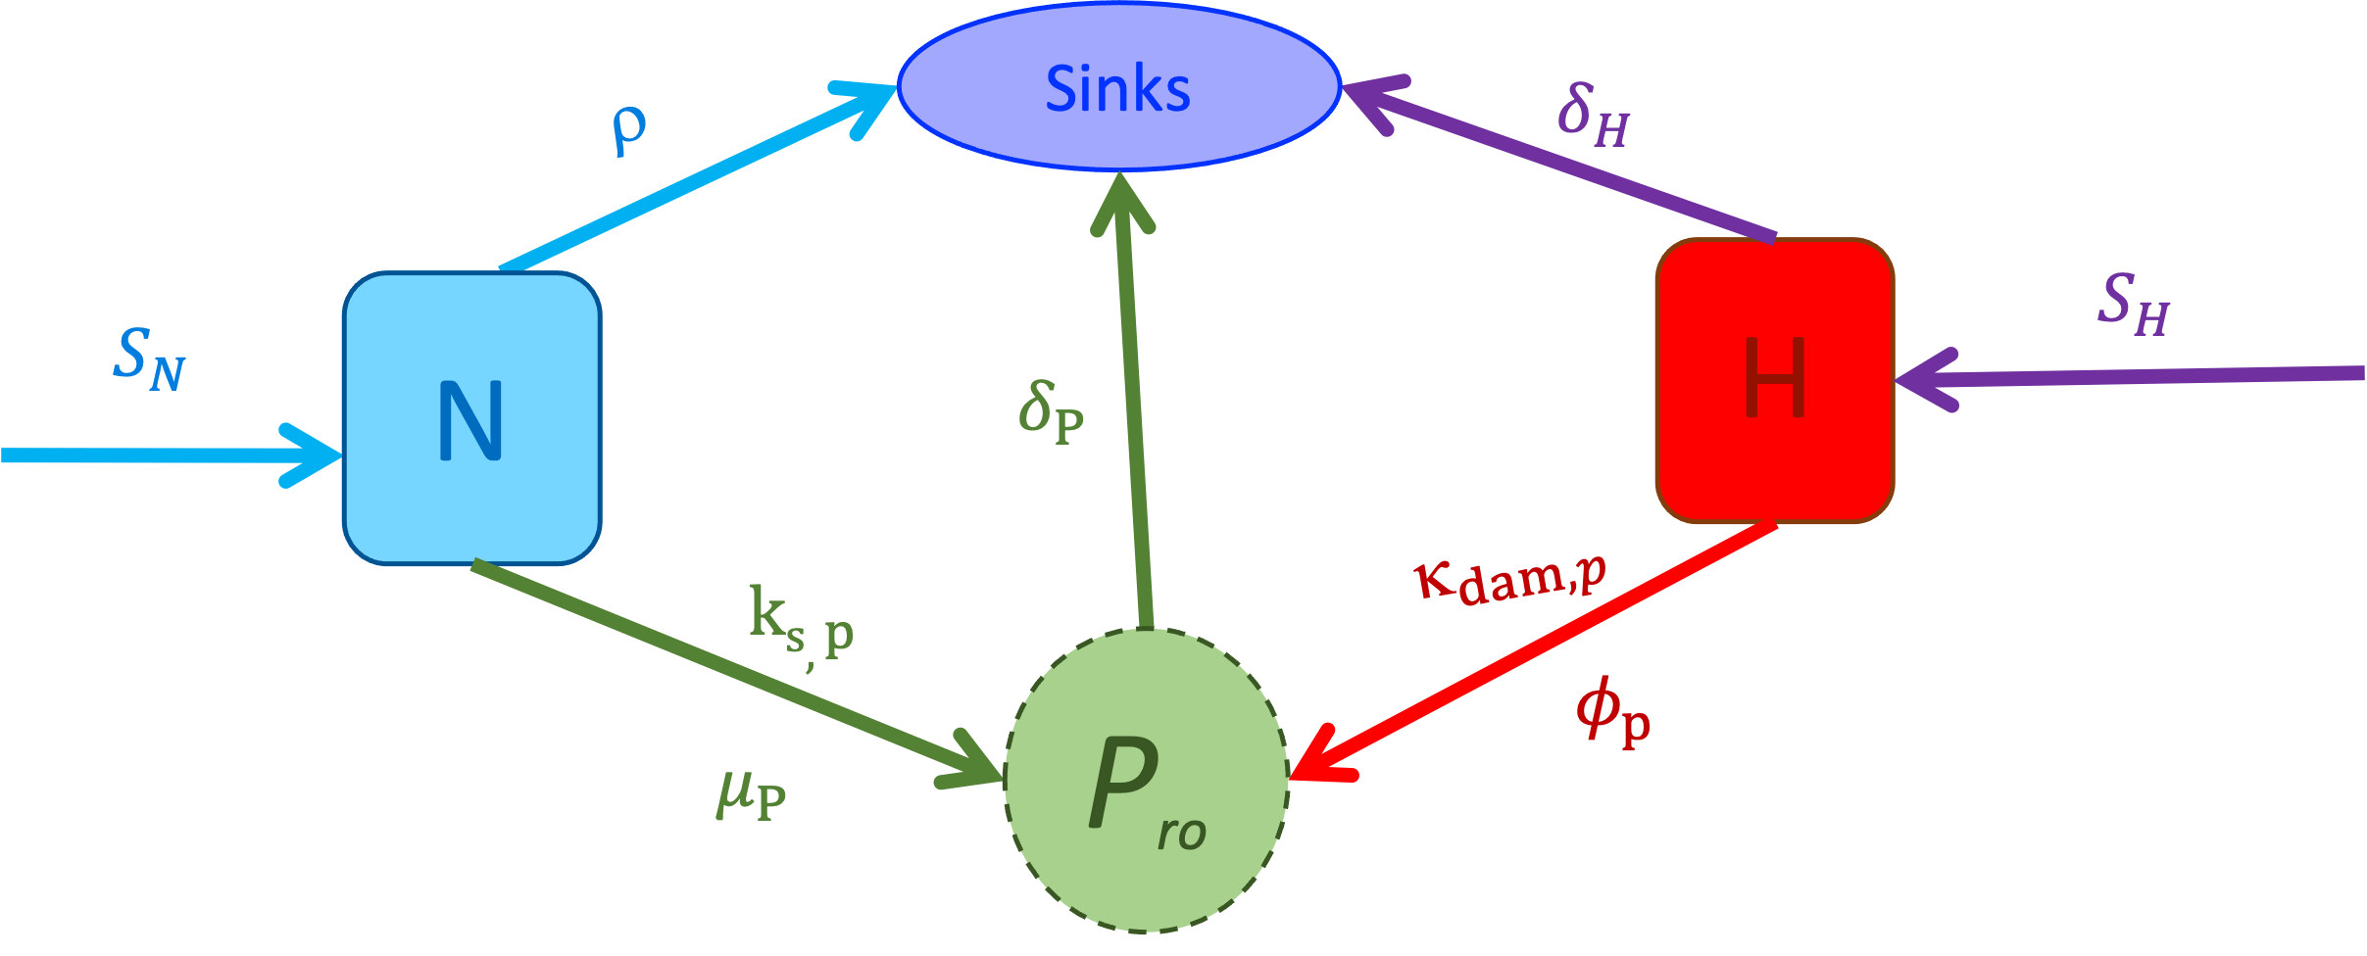
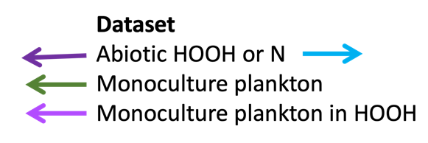
Figure ‎1.2 Roadmap of the stepwise model formation using divergent H₂O₂ phenotypes in dominant plankton. (a) Chapter 2 uses multiple laboratory datasets to isolate different monoculture parameters for growth and H₂O₂ interactions. Using parameters found for different microbial species in Chapter 2, (b) Chapter 3 explores competition and coexistence outcomes between these species in various nutrient and H₂O₂ supplies. Following this intuition, (c) Chapter 4 utilizes a global model framework to visualize predicted biogeographies of globally important microbial analogues to those chosen for Chapter 2.

b) Chapter 3
Competitive Exclusion

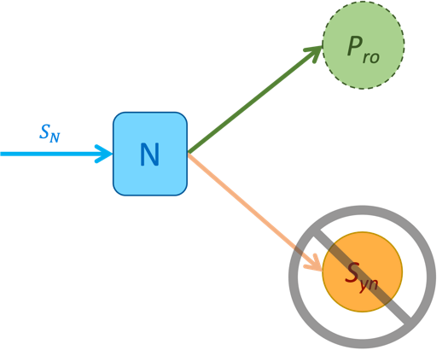

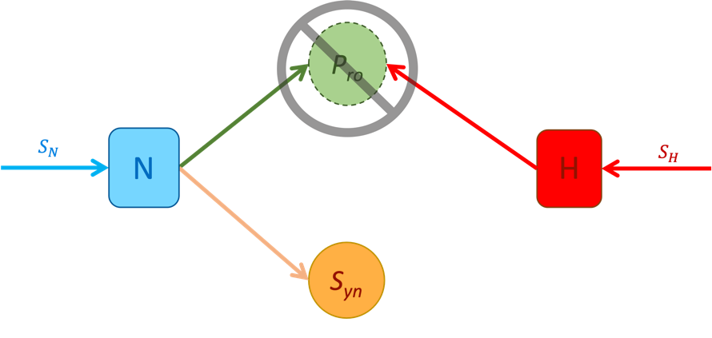
Figure 1.2 continued

Coexistence

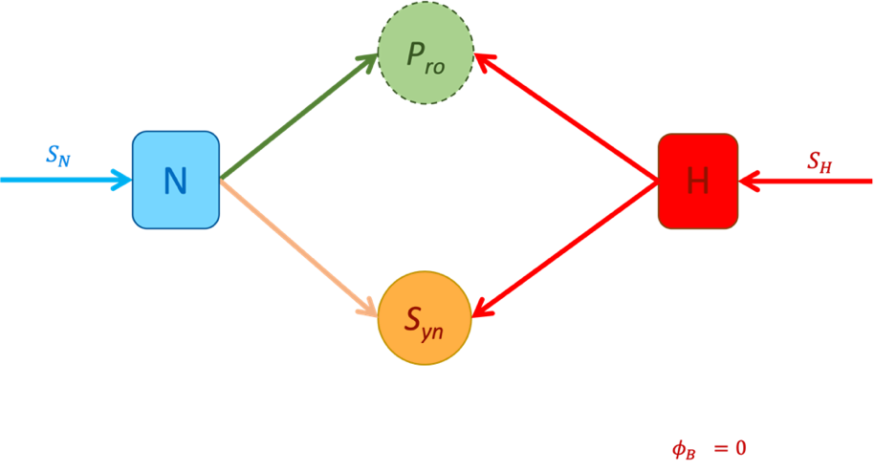
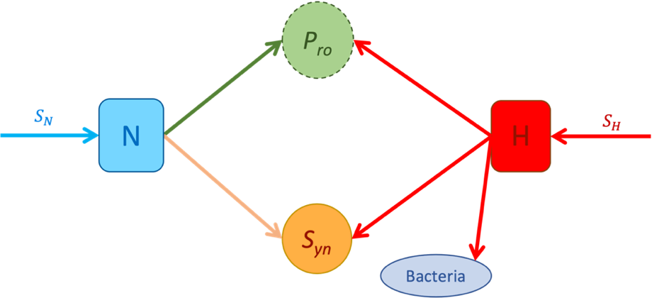
Figure 1.2 continued

c)
Chapter 4
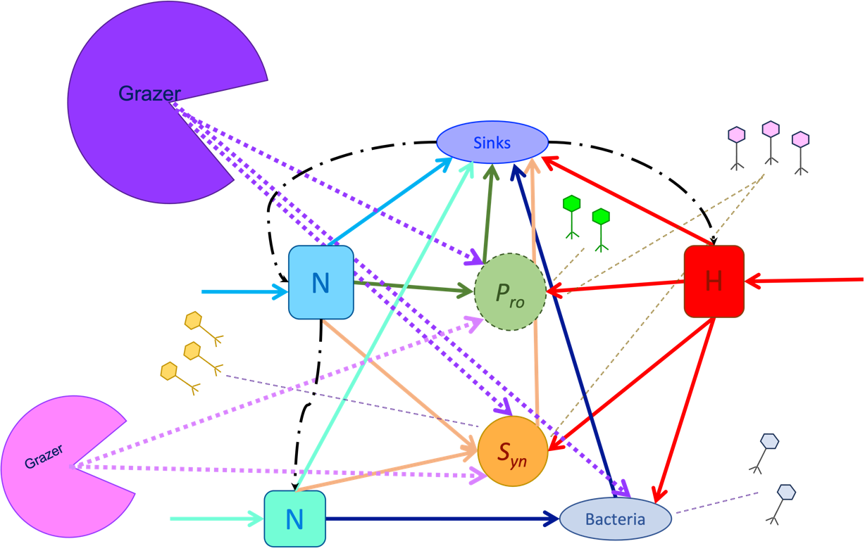

Figure 1.2 continued

Quantification of the coupled dynamics of cell growth and hydrogen peroxide (H₂O₂) in laboratory batch culture experiments

Author(s): D.K.M., E.B., M.A.G., B.C.C., E.R.Z., and D.T.
Manuscript reviewed at Applied and Environmental Microbiology and submitted Microbiology Spectrum under the title: Quantification of the coupled dynamics of cyanobacteria and reactive oxygen species in laboratory batch culture experiments.
Author contribution statements: Written and edited by D.K.M., M.A.G., and D.T. with feedback from E.R.Z, and B.C.C. Experiments were designed by B.C.C., E.B., and E.R.Z.; experiments were performed by B.C.C. and E.B.

Abstract
Prochlorococcus, the smallest and most numerous phytoplankter of the oligotrophic surface ocean, requires coexisting ‘helper’ microbes to detoxify hydrogen peroxide (H₂O₂) produced in the surface ocean. In this chapter, we present coupled ordinary differential equation models of the dynamics of multiple oligotrophic plankton grown in different levels of H₂O₂. We evaluate and fit our model to monoculture time series data of peroxide-sensitive Prochlorococcus and peroxide-resistant Synechococcus and bacteria. Our fits provide estimates of H₂O₂ cell damage and detoxification rates in these ecologically dominant microbes. Our results indicate that catalase containing microbes, like Synechococcus and known heterotroph helpers (Alteromonas), have high rates of detoxification and low rates of H₂O₂ mediated cell death. In contrast, the catalase-negative Prochlorococcus has high rates of H₂O₂ mediated cell death and low rates of cell-specific detoxification. Our results quantify the possible trade-off between H₂O₂ detoxification and cell death due to the presence of detoxifying enzymes. The use of differential equation models to quantify parameters underlying microbe-H₂O₂ dynamics provides a basis for ecosystem models to explore the impact of reactive oxygen species on cell mortality and microbial community composition.

Introduction
Oceans cover 70% of the earth and (Raven and Falkowski 1999), outside the inputs of coastal and cold water upwelling inputs (Field 1998; Bristow et al. 2017), are largely composed of nitrogen limited ‘nutrient deserts’ (Ustick 2022). Two globally dominant genera of cyanobacteria, Prochlorococcus and Synechococcus (Flombaum et al. 2013) perform ~50% of marine carbon fixation, serving as the basal step of the food chain (Field 1998; Bristow et al. 2017; Follows and Dutkiewicz 2011). Prochlorococcus is the most numerous phytoplankter genus of the ocean (Kent et al. 2016; Zinser et al. 2006; Biller, Berube, et al. 2018; Berube et al. 2018; Johnson 2006; Zinser and Martiny 2023) and numerically dwarfs its sister genus Synechococcus in nutrient deplete gyres (Partensky et al. 1996). Predictions of future Prochlorococcus distributions show numerical dominance of Prochlorococcus; again at mid to low latitudes throughout much of the surface open ocean (Flombaum et al. 2013), despite future shifting environmental pressures (Dutkiewicz et al. 2015; Hutchins and Fu 2017). The numerical dominance of Prochlorococcus in these areas is thought to be due to its minimal nutrient requirements and high surface area to volume ratio associated with its smaller cell (0.6 – 0.8 μm vs 0.6 – 2.0 μm) and total genome lengths (1.5 - 2.5 Million basepairs (Mbp) vs > 2.4 Mbp) as compared to Synechococcus (Giovannoni, Cameron Thrash, and Temperton 2014; Rocap et al. 2003; Dao 2013; Partensky and Garczarek 2010). One striking aspect of Prochlorococcus' streamlined genome is its evolutionary loss of catalase, a key enzyme in the protection against the reactive oxygen species (ROS) hydrogen peroxide (H₂O₂) that is present in surface ocean environments (Bernroitner et al. 2009; Biller, Berube, et al. 2015; Berube et al. 2015; Morris et al. 2011; Morris, Papoulis, and Lenski 2014).
The monofunctional catalase (and bifunctional catalase-peroxidase) enzyme has been shown to be extremely efficient in the face of H₂O₂ spikes whether isolated from mammalian cells, Escherichia coli, or Synechococcus spp.(Curtin, Donovan, and Cotter 2002; Ravishankar, Rao, and Ramasarma 1995; Alfonso-Prieto et al. 2009; Zamocky et al. 2012). The function of catalase specifically is expeditated by the closeness of the binding sites and protein side chains helping stabilize H₂O₂ during the reaction (Alfonso-Prieto et al. 2009; Bernroitner et al. 2009). It is found in all domains of life (Zamocky et al. 2012) including most cultured, aerobic microbial species (Bernroitner et al. 2009; Harada et al. 2021; Kawasaki et al. 1997). Despite being found in all kingdoms of life, catalases are isolated infrequently in natural ocean samples (Bernroitner et al. 2009). In contrast, monofunctional peroxidases, are found across the tree of life and are also widespread, including within Prochlorococcus. The pervasiveness of peroxidases and relative rarity of catalases suggest a functional copy of the latter enzyme is costly to express. Catalases and peroxidases both detoxify H₂O₂ to H₂O and another non-toxic molecule (Bernroitner et al. 2009; Ighodaro and Akinloye 2018; Regelsberger et al. 2002). And proteins within these groups have separately been shown to both be constitutive and stress-induced regulation (Brown 1995; Venkatesan et al. 2007; Schellhorn 1995; Sato et al. 1992). Further peroxidase and catalase require metals to operate properly (Pinnix et al. 1994; Regelsberger et al. 2002; Bernroitner et al. 2009; Tovmasyan et al. 2015), thus a warming ocean may influence all detox mechanisms of H₂O₂ in microbes. Thus Prochlorococcus’s lack of a catalase (Morris, Rose, and Lu 2022; Zhu et al. 2022; Goldstone and Voelker 2000) is all the more striking given that abiotic production from a single diel cycle results in ambient H₂O₂ concentrations ten times higher than those shown to kill Prochlorococcus (Morris 2011).
Without the ability to robustly detoxify H₂O₂ proficiently, Prochlorococcus is left itself to be dependent on other species for this vital detoxification function (Morris 2011; Morris et al. 2008; 2011; Morris, Lenski, and Zinser 2012; Morris 2015). H₂O₂, unlike most other reactive oxygen species, is uncharged and thus can readily diffuse across cell membranes (Ohno and Gallin 1985; Omar et al. 2022; Möller et al. 2019; Morris, Lenski, and Zinser 2012; Seaver and Imlay 2001). Facilitated by aquaporins (Bienert et al. 2007), the internal and external cellular environments can equilibrate in less than 1 second after external peroxide addition (Antunes and Cadenas 2000). Exogenous H₂O₂ that enters bacterial cells is detoxified quickly (Alfonso-Prieto et al. 2009; Seaver and Imlay 2001) in organisms that contain catalase enzymes, serving as an important sink of endogenous and exogenous H₂O₂ (Morris 2011). Bacteria with catalases can therefore provide a benefit to their community through exogeneous H₂O₂ detoxification (Morris 2011; Morris, Lenski, and Zinser 2012; Ma and Eaton 1992). As a result, Prochlorococcus and other globally dominant, genetically streamlined, and catalase-deficient organisms like SAR11 (Giovannoni 2017; Grote et al. 2012), are essentially obligate symbionts, dependent on other catalase containing microbes (Morris, Lenski, and Zinser 2012). While data suggests the transmission and expression of singular genes do not have exorbitant energetic costs, (Lynch and Marinov 2015), catalase is a large, metal (iron or manganese) containing enzyme (Barynin et al. 2001; Chelikani, Fita, and Loewen 2004). Catalase also has a high turnover rate, requiring renewal of protein structures after activity (Nicholls 2012; Cao et al. 2003). High enzyme production and maintenance costs of catalase for Prochlorococcus, when combined with the low nutrient supplies in oligotrophic waters and the presence of other catalase expressing community members (e.g. Synechococcus and Alteromonas spp), may explain the evolutionary loss of catalase in Prochlorococcus (Morris, Lenski, and Zinser 2012; Morris 2015; Morris et al. 2016; Morris 2011; Ma et al. 2018).
In situ measurements cover only a small percentage of the ocean so our current understanding of Prochlorococcus, and other picoplankton (Visintini, Martiny, and Flombaum 2021), abundances and distributions are explored through global models. Ecosystem (Carroll et al. 2020; Ward et al. 2012) and statistical niche models (Flombaum et al. 2013; Luo et al. 2015; Carroll et al. 2020) calculate abundance differently but both indicate that Prochlorococcus dominates in the most oligotrophic regions of the ocean (Dutkiewicz, Follows, and Bragg 2009; Ward et al. 2017; Follows and Dutkiewicz 2011). Realistic patterns of Prochlorococcus biogeography are recreated in ecosystem trait models that assume Prochlorococcus has superior competitive ability for ammonium (Dutkiewicz, Follows, and Bragg 2009; Masuda et al. 2023; Ward and Follows 2016). More recent modeling studies indicate that Prochlorococcus loss processes, such as viral predation and grazing, are also important influences on Prochlorococcus biogeography (Follett et al. 2022; Carlson et al. 2022). In contrast, the role of H₂O₂ dynamics on dominant oceanic microbial abundances has not been modeled, despite observed susceptibilities of the same plankton when in cultivated settings (Morris et al. 2011).
Here, we present a coupled ordinary differential equation (ODE) model for microbial and H₂O₂ dynamics. As our model illustrates, coupled ODEs are well suited to quantification of cell-H₂O₂ dynamics. As microbial populations grow and die, their ability to detoxify exogenous reactive oxygen species changes. Our ODE model explicitly quantifies changes in population sizes and H₂O₂ concentration. By fitting our model to laboratory time-series data using a Bayesian Monte Carlo Markov Chain (MCMC) approach, we obtain estimates of cell specific death and detoxification rates for globally important genera. Finally, we illustrate how our ODE model can be used to explore the impact of H₂O₂ on cell mortality and community composition.

Methods
Below we describe the system of ordinary differential equations (ODEs) we used to model the population dynamics of bacteria across a range of H₂O₂ values. Special cases of our model were fitted in different permutations of laboratory community assays using a Bayesian Metropolis-Hastings MCMC to estimate the posterior distributions of the relevant model parameters (See Figure 2.1 for a model schematic and Table 1 for a definition of all parameters) (Metropolis et al. 1953). All computer code is provided in a GitHub repository: https://github.com/DKMcCullough/HOOH_dynamics. Below is a detailed description of both the model equations and data used to estimate model parameters.

Model equations
The dynamics of phytoplankton, i, abundance ($P_{i}$, cells mL-1) and H₂O₂ concentration (H, nmol mL⁻¹) were modeled with a set of coupled ordinary differential equations (ODEs):
Monoculture Model Equation Set
$\frac{dP_{i}}{dt} = μ_{i}P_{i} - κ_{dam,i}P_{i}H$  net growth rate of plankton_{i} (P_{i}) net loss of P_{i} due to H | (2.1)
$$\frac{dH}{dt } = S_{H} - { δ}_{H}H - { ϕ}_{{max,i}_{i}}P_{i}H$$  H₂O₂ supply rate abiotic decay biotic detoxification by plankton i | (2.2)

All parameter and state variable definitions and units are provided in Table 1. Phytoplankton grow at constant rate $μ_{i}$ (day⁻¹). The main rate of cell death is assumed to be dependent on H₂O₂ concentration and a mass action coefficient $κ_{dam,i}$ (mL nmol⁻¹ day⁻¹). H₂O₂ is supplied at rate S_{H} (nmol mL⁻¹ day⁻¹), and subject to first order abiotic decay at rate $δ_{H}$ (day⁻¹), and cell contact dependent detoxification set by mass action coefficient $ϕ_{max,i}$ (mL cell⁻¹ day⁻¹).

Laboratory data
H₂O₂ Spike Assays: We measured the temporal dynamics of H₂O₂ in cell free, abiotic media illuminated AMP-J, filter sterilized artificial seawater for cyanobacteria according to Ma et al. (2018) in the oligotrophic ocean spiked to 400nm H₂O₂. We measured the exogenous H₂O₂ concentration using an acridinium ester chemiluminescence injection protocol (King et al. 2007; Morris et al. 2011) in abiotic and growth media. Each fluorescence reading was transformed to H₂O₂ nM mL⁻¹ data via a linear reference curve made in Microsoft Excel following Morris and Zinser (2013) and Morris et al. (2011) protocols. This was done for readings from both the Control (0nM H₂O₂ added) or Spiked (400nM H₂O₂ added) assays at the appropriate time points.
Phytoplankton culture assays: We grew Prochlorococcus MIT9215 and Synechococcus CC9605 in batch cultures at 24º C (Moore et al. 2007) in Percival incubators (Percival, Boone, IA) that allowed for gradual increase and decrease of cool white light to simulate sunrise and sunset with peak midday light intensity of 150 mmol quanta m⁻²s⁻¹ on a 14 hr:10 hr light:dark cycle in AMP-J media for all biomass assays (Calfee 2021; Hennon et al. 2018; Knight and Morris 2018). We measured cell densities of Prochlorococcus and Synechococcus using different autofluorescent properties in flow cytometric assays (Campbell, Nolla, and Vaulot 1994; Calfee, Glasgo, and Zinser 2022). Following published methods, heterotrophs were counted through plating assays as concurrent H₂O₂ measurements were taken (Calfee, Glasgo, and Zinser 2022). All biotic data can be found at the Biological and Chemical Oceanography Data Management Office (Zinser, Talmy, and Calfee 2023).

Fitting procedure
Our ODE model as defined Equations 1 has five unknown parameters: maximum plankton growth rate ($μ_{i}$), H₂O₂-induced cellular death rate ($κ_{dam,i}$), cell-mediated H₂O₂ detoxification rate ($ϕ_{max,i}$), abiotic H₂O₂ supply rate (S_{H}), and abiotic H₂O₂ decay rate ($δ_{H}$). Our goal was to find the combination of parameters that best explained observed H₂O₂ and cell abundance dynamics in each laboratory population dataset. We chose to use the Metropolis-Hastings algorithm (Metropolis et al. 1953; Hastings 1970), a widely used Monte Carlo Markov-Chain (MCMC) method. We took a Bayesian approach to parameter quantification, thereby assuming that each parameter is itself a distribution with inherent uncertainty. A brief summary of our key assumptions of the fitting procedure is included below. A full explanation of the fitting procedure in Appendix A, Supplementary Information Chapter 2, section A1.
The goal of our model fitting was to sample and summarize the posterior probability distribution of the model parameters given the model and data. Let D be a given experimental dataset and let $θ$ be the set of parameters of interest (e.g., for the full model θ = (μ, κ, …)). The following describes a procedure to estimate the posterior probability distributions of the parameters θ given the data D or P(θ |D).
Using Bayes theorem, the probability of a given parameter set θ given dataset D is:
(2.2) $P\left(θ\text{|}D\right)=\frac{P\left(D\text{|}θ\right)P\left(θ\right)}{P\left(D\right)}$
where P(θ) represents the prior distribution for our parameters. For simplicity, we used an improper, uninformative prior of P(θ) = 1. Further we let the data and associated noise guide further narrowing of the prior P(θ) through the fitting procedure. Observational uncertainty and
 Abiotic H₂O₂ dynamics
 Cell growth dynamics
 Biotic H₂O₂ dynamics
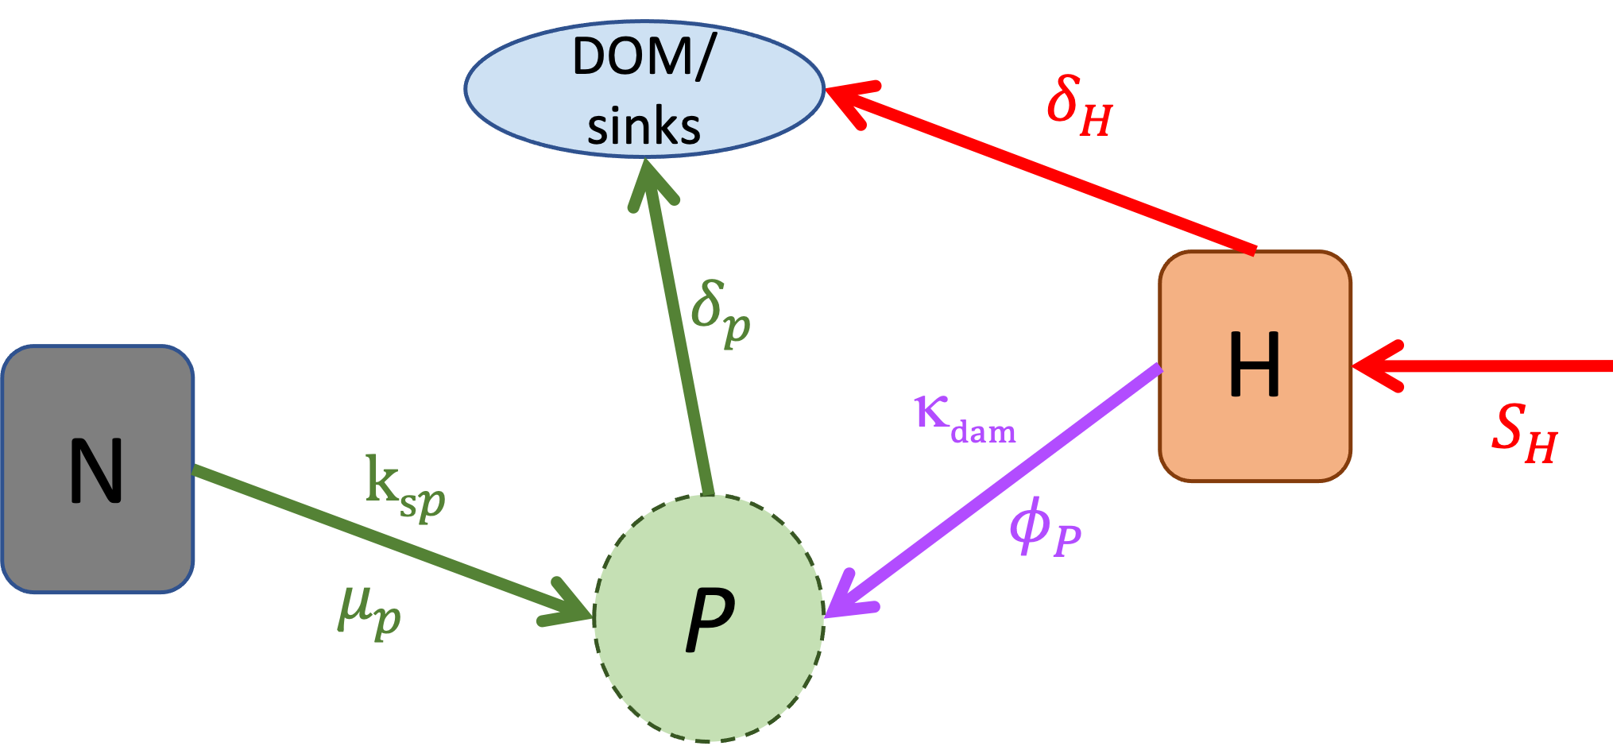
Figure ‎2.1 Stepwise model construction allows for data constraint on individual parameters within a coupled ODE model.
Figure ‎2.2 Stepwise model construction allows for data constraint on individual parameters within a coupled ODE model.
Figure ‎2.3 Stepwise model construction allows for data constraint on individual parameters within a coupled ODE model. Colored shapes represent measurable pools of Nutrients (N), Phytoplankton (P_{i}), H₂O₂ (H), and sinks in a well-mixed batch culture. Arrow colors indicate pathways of H₂O₂ and nutrient flow.

Table 1 Monoculture Parameter and variable definitions and units
Symbol | Description | Units
$$μ_{i}$$ | Net growth rate | day⁻¹
$$κ_{dam,i}$$ | H₂O₂ specific rate of cell death | mL nmol⁻¹ day¹
S_{H} | H₂O₂ supply rate | nmol mL⁻¹ day⁻¹
$$δ_{H}$$ | H₂O₂ decay rate | day⁻¹
$$ϕ_{max,i}$$ | Cell specific rate of H₂O₂ detoxification | mL cell⁻¹ day⁻¹
$$P_{i}$$ | Plankton (i) Cell abundance | cells mL ⁻¹
H | H₂O₂ concentration | nmol mL⁻¹

other noise in our data is generally distributed log normally around the ‘true’ state of the system. Under this assumption of Log(N) error, the likelihood function, $L\left(θ\right)$, is defined as follows:
$\left(2.3\right) P\left(D | θ\right)=L\left(θ\right)=\exp\left({-χ}^{2}\right)$
Using $y_{i,D}$ to represent data point i, such as H₂O₂ concentration or cell abundance, and $y_{i,θ}$ to represent our model’s predicted value given a set of parameter values $θ$:
(2.4) $Pr\left(D\text{|}θ\right)∝exp\left(\sum_{i}{\frac{{\left(ln\left(y_{i,D}\right)-ln⁡\left(y_{i,θ}\right)\right)}^{2}}{σ_{y,i}^{2}}}\right)$
where $σ_{y,i}$ quantifies the noise in our measurements. For simplicity of our model fittings, we set $σ_{y,i}$ equal to the standard deviation of our log transformed measurements across technical and biological replicates (see Appendix A, Supplementary Information Chapter 2).

Experimental approach:
Abiotic H₂O₂ production and decay parameters, S_{H}, and $δ_{H}$ , were constrained first via cell-free dynamics of hydrogen peroxide. Then the modeled cyanobacteria population dynamics without added H₂O₂ to constrain growth rates, $μ_{i}$. Finally, the predictions of a model were compared with dynamic H₂O₂ with a range of laboratory culture data spanning catalase positive and catalase negative organisms to constrain biotic H₂O₂-related parameters of damage ($κ_{dam,i}$ ) and detoxification ($ϕ_{max,i}$).

Results

Abiotic media analyses
We first set out to model abiotic dynamics in a control system without H₂O₂ additions. In Figure 2.2a, we present both the laboratory data (pink symbols) and model fit (red line) for H₂O₂ in cell free medium with zero addition of H₂O₂ are presented. Here, we set Prochlorococcus cell concentrations (P_{i}) to zero in Equation 2.1. In Figure 2.2 b, c we present histograms of our posterior samples, highlighting the mean and surrounding uncertainty of our model-based estimates of H₂O₂ supply rate, S_{H}, and decay rate, $δ_{H}$. Our data and model both showed rising H₂O₂ concentration despite no H₂O₂ addition. This is consistent with prior studies indicating illuminated growth media produces H₂O₂ (Jeffrey Morris and Zinser 2013).
Using the same cell free model, we captured and represented H₂O₂ dynamics and parameter distributions for the 400nM H₂O₂ spiked medium (Figure 2.3). Our posterior samples for the abiotic production rate were slightly lower, but within a similar range to the zero-addition treatment in Figure 2.3. Across treatments, the decay rate was generally less than 0.05 day⁻¹. This hints to the model’s capture of H₂O₂ dynamics that are agnostic of light like those mentioned in (Sutherland, Wankel, and Hansel 2020). Thus, our model captures H₂O₂ spike assay dynamics in cell-free culture conditions at multiple starting spike levels, providing an important constraint on the rate of H₂O₂ supply and decay in growth media. We use these basal parameter ranges to define background abiotic H₂O₂ dynamics when Equation 2.1 was considered in the presence of microbial cells.

Phytoplankton batch culture dynamics without hydrogen peroxide
Being now able to account for relevant abiotic processes, we next considered how microbial dynamics may be impacted by H₂O₂. Figure 2.4 shows our model trained and compared with Prochlorococcus strain MIT9215 in exponential growth.
The model provides a satisfactory fit to the population density change over time (Figure 2.4a) allowing retrieval of posterior samples of two cell growth-related parameters: the initial Prochlorococcus concentration (P₀, Figure 2.4b) and the exponential growth rate ($μ_{i}$ Figure 2.4c).

Phytoplankton batch culture dynamics with amended hydrogen peroxide

Having quantified Prochlorococcus growth without H₂O₂ addition, we then compared our mode in Equations 2.1 with our microbial abundance and H₂O₂ concentration data. In Figure 2.5 below we present the dynamics of Prochlorococcus in 400nM spiked H₂O₂. Our results clearly indicate that Prochlorococcus died once H₂O₂ was added to growth medium (Figure 2.5a). We kept the previously quantified exponential growth rate $μ_{i}$ (Figure 2.5c) steady from the model’s initial fitting of Prochlorococcus in zero H₂O₂. Having trained our model on cellular

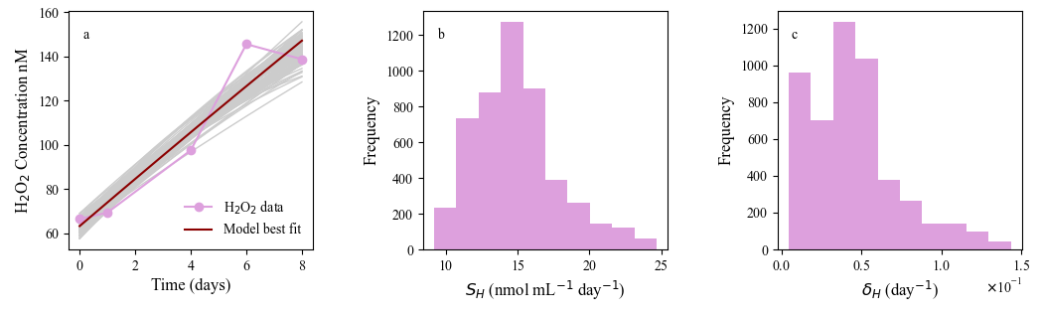
Figure ‎2.4 Abiotic growth media modeled in zero H₂O₂ spike
Model-data comparison for cell free media with zero H₂O₂ spike assay a) laboratory H₂O₂ measurements (connected pink symbols), model fit (red line), and model uncertainty (grey lines) b,c) histograms representing uncertainty in estimates of H₂O₂ supply rate (S_{H}, $nmol{ ml}^{-1}{day}^{-1}$) and decay ($δ_{H},{day}^{-1}$).

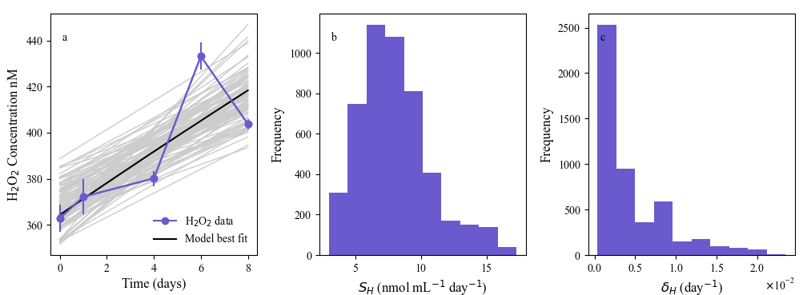
Figure ‎2.5 Abiotic spiked media modeled in 400nM H₂O₂ spike
Model-data comparison for cell free media with 400 nM H₂O₂ spike assay a) laboratory H₂O₂ measurements (connected blue symbols), model fit (black line), and model uncertainty (grey lines) b,c) histograms representing uncertainty in estimates of H₂O₂ supply rate (S_{H}, $nmol{ ml}^{-1}{day}^{-1}$) and decay ($δ_{H},{day}^{-1}$) respectively.

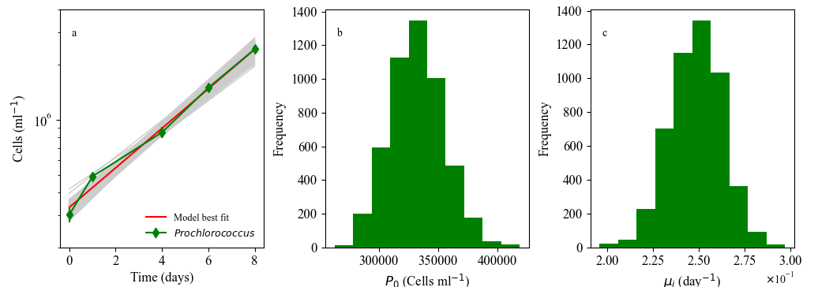
Figure ‎2.6 Monoculture Prochlorococcus dynamics modeled in growth media without additional H₂O_{2.} Laboratory batch culture dynamics of Prochlorococcus (green line) and model searches (grey lines) with best-fit solution (red line) with zero H₂O₂ addition (a). Also shown are parameter posterior distributions for the initial population size, P₀ (b) and the exponential growth rate, $μ_{i}$ (c). i.e. The range of possible model solutions (grey) and best fit (red line) shown in section a are represented in the width and medians of parameter, P₀ in b and $μ_{i}$ in c, value histograms.

media with the addition of a H₂O₂ spike, we can quantify two H₂O₂-based parameters: the H₂O₂ specific rate of cell death, $κ_{dam,i}$ (Figure 2.5c), and the cell-specific rate of detoxification, $ϕ_{max,i}$ (Figure 2.5f). Importantly, our model predicts vanishingly small values for Prochlorococcus $ϕ_{max,P}$ in Figure 2.5f indicating negligible detoxification of exogenous H₂O₂ ($ϕ_{max,p} \sim 0)$. This tracks with previous laboratory studies that signified Prochlorococcus cannot grow alone in exogenous H₂O₂ above 400nM (Ma 2015; Morris 2011).

Modeling Synechococcus and H₂O₂ dynamics
We follow the same methodology from Prochlorococcus analyses to parameterize our Synechococcus monoculture models. Figure 2.6 shows the exponential growth dynamics of Synechococcus without H₂O₂ addition. Our model was able to adequately capture these dynamics (Figure 2.6a), allowing us to quantify the initial cell concentration (S₀) and the exponential growth rate ($μ_{i}$) (Figure 2.6 b, c). Unlike catalase-deficient Prochlorococcus, the catalase positive Synechococcus strain CC9605 grew well in the presence of H₂O₂ (Figure 2.7a). Using our model, we were also able to capture these different dynamics (Figure 2.7a for Synechococcus vs. Figure 2.5a for Prochlorococcus) allowing us to quantify the initial cell concentration (S0) and a smaller H₂O₂ specific rate of cell death, $κ_{dam,i}$(Figure 2.7 b,c). Similarly, we were also able to capture the concurrent dynamics of Synechococcus CC9605 cell growth and drawdown of H₂O₂ concentration (Figure 2.7d) as well as the parameters that represent the initial H₂O₂ concentration (H₀) and Synechococcus cell-specific rate of detoxification, $ϕ_{max,S}$ (Figure 2.7e,f, respectively).
After noting the ability of our model to capture the divergent H₂O₂ phenotypes of catalase negative Prochlorococcus and a catalase positive Synechococcus cyanobacteria, we analyzed further monoculture strains. Alteromonas, a noted ‘contaminant’ microbe from Prochlorococcus strains (Biller, Coe, et al. 2015) was of particular interest due to prior reports of its ‘helper’ status in stressful environments (Biller, Coe, et al. 2018; Hennon et al. 2018; Morris et al. 2008). In Figure 2.8 we present the relationship between the H₂O₂ damage rates ($κ_{dam,S}$) and H₂O₂ detoxification rates ($ϕ_{max,i}$) for microbes (i) in our data. The associated curves and parameter histograms for each model run are shown in Appendices A and B. Our coupled model framework finds that organisms with a high rate of cell-specific detoxification have low rates of cell death. Simultaneous quantification of detoxification ability ($ϕ_{max,i}$) and damage rate ($κ_{dam,i}$) trait parameters from different microbes allows us to capture the potential patterns between parameter value and ecological function leading to an idea of the H₂O₂ trait space available to ocean microbes using our model.

Discussion
In this chapter we present an ODE based model of concurrent dynamics of H₂O₂ and microbial abundance which we parameterized using laboratory data. Our model adequately captured H₂O₂ dynamics over a range of ecologically relevant H₂O₂ inputs (spikes) and their differential impacts on closely related cyanobacteria. Our modeling allowed us to quantify two key parameters that describe the impact of H₂O₂ on cells ($κ_{dam,i}$ ) and the impact of detoxification on H₂O₂ concentration ($ϕ_{max,i}$). Quantification of these parameters captured well-documented differential H₂O₂ impacts on phytoplankton cells. Catalase positive Synechococcus (Prochlorococcus’ most closely related, but genomically and physically larger, family member) does not show the noted H₂O₂ toxicity sensitivity that most Prochlorococcus cultures do in laboratory assays (Chan 2008; Morris 2011; Calfee 2021).
Using the closely related but oppositely genotyped cyanobacteria Prochlorococcus and Synechococcus, along with known ‘helper’ and catalase containing heterotroph Alteromonas, we demonstrated our model’s ability to capture the duality of divergent H₂O₂ detoxification phenotypes from environmentally important microbes using our model. Our ODE based approach allowed us to quantify parameters in a manner that also accounts for changes in H₂O₂ concentration over the course of the experiment. Because many marine ecosystem models (e.g. that of (Fasham, Ducklow, and McKelvie 1990)) are also based on differential equations, the parameters we have identified ($κ_{dam,i}$ ,$ϕ_{max,i}$) can be used to evaluate the impacts of H₂O₂ on microbial community composition and carbon cycling within these more complex models.

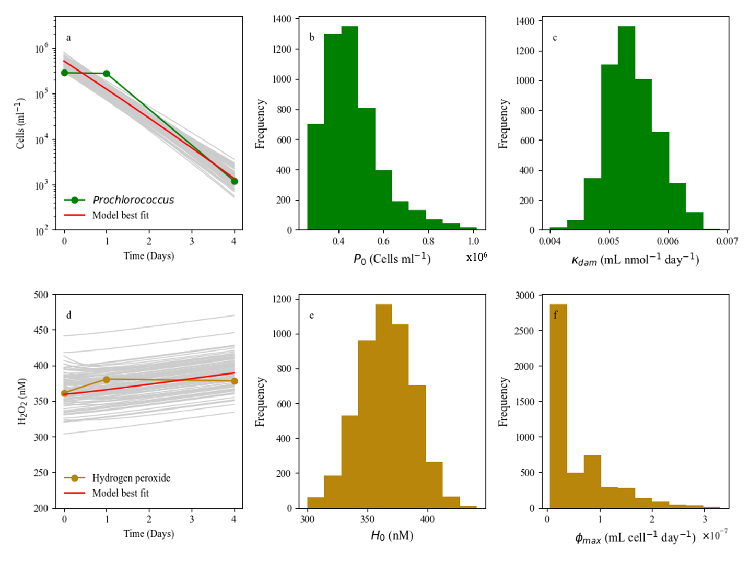
Figure ‎2.7 Monoculture Prochlorococcus modeled in H₂O₂ spiked media.
Coupled laboratory batch culture dynamics of Prochlorococcus (2.7a) and H₂O₂ (2.7d) data alongside model best-fit (red line) and searched (grey) combinations in laboratory assays containing 400nM H₂O₂. To the right of each (P or H) line’s dynamics plot, histograms of retrieved possible values for: the initial value of Prochlorococcus, P₀ (b) or H₂O₂, H₀ (e) and the controlling parameter for each line’s dynamics: κ_{dam,p} for the damage rate of H on P (c) and ϕ_{max,p} for detoxification rate of H by P cells (e) are each shown.

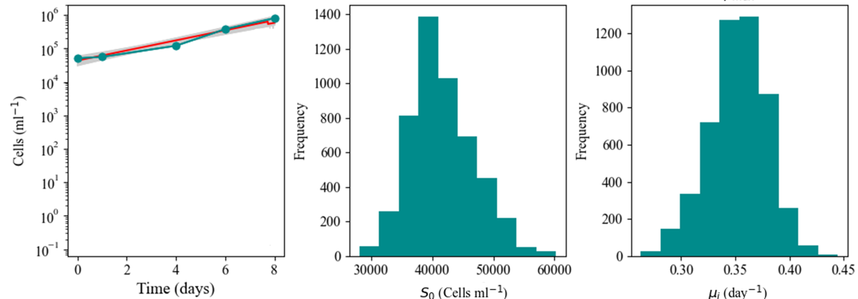
Figure ‎2.8 Monoculture Synechococcus CC9605 modeled in growth media

Laboratory batch monoculture dynamics of Synechococcus CC9605 data (blue line) and model searches (grey lines) with best-fit solution (red line) in growth media with zero additional H₂O₂ (a). Also shown are histograms displaying the values retrieved for initial cell concentration of Synechococcus (S₀) and exponential growth rate ($μ_{i}$) (b,c, respectively).

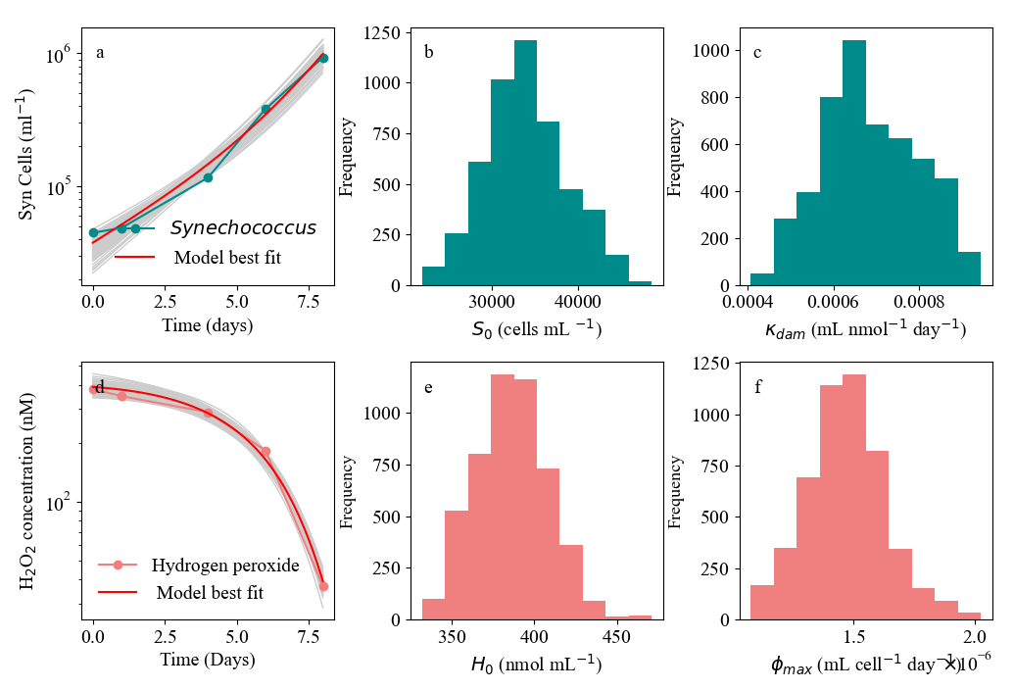
Figure ‎2.9 Monoculture Synechococcus CC9605 modeled in H₂O₂ spiked media.
Coupled laboratory batch culture dynamics of Synechococcus CC9605 (a) and H2O2 (d) data alongside searched parameter combinations (grey) in batch culture containing 400nM H₂O₂. To the right of each (S or H) line’s dynamics plot, histograms of retrieved possible values for: the initial value of Synechococcus, S₀ (b) or H₂O₂, H₀ (e) and the controlling parameter for each line’s dynamics: κ_{dam,s} for the damage rate of H on S (c) and ϕ_{max,s} for detoxification rate of H by S cells (e) are each shown.

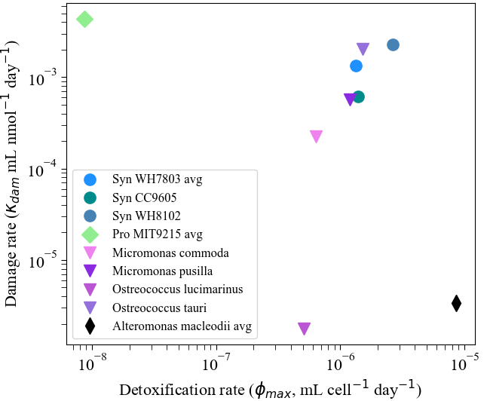
Figure ‎2.10 Recovered H₂O₂ trait parameters from different picoplankton during H₂O₂ spike assays. H₂O₂ detoxification rate ($ϕ_{max,i} ,$mL cell⁻¹ day⁻¹) and H₂O₂ induced rate of cell death ($κ_{dam, i }$, mL nmol⁻¹ day¹) for different cyanobacterial (Prochlorococcus and Synechococcus), heterotrophic bacterial (Alteromonas), and picoeukaryotic (Micromonas spp and Ostreococcus spp.) monoculture batch cultures. ‘avg’ delineation indicates multiple monoculture data sets for this species were individually modeled and then averaged. Dynamic models showing the retrieval of these parameters can be found in Appendices A and B.

A limitation of our study is that the laboratory conditions do not fully replicate conditions cells experience in the open ocean. For example, the modeled experiments introduced single spikes of H₂O₂ which while consistent with rain inputs for surface waters (Willey, Paerl, and Go 1999; O’Sullivan et al. 1999), is different from the continual H₂O₂ photoproduction in natural systems that follow a diel cycle associated with changes in light and dissolved organic carbon (DOC) concentration (Zinser 2013; 2018b; Zhu et al. 2022). Use of chemical buffers to control H₂O₂ production (Zinser 2013) is one way to more closely mimic natural H₂O₂ production, and could be accounted for via alterations of our H₂O₂ production parameter S_{H}. To constrain our model with experimental data, we require synchronized time-dependent measurements of both H₂O₂ and cell abundance, which were only available in the spike assay data used here. Fitting our model to experiments with chemical buffer would provide a more realistic and general test of this framework. But we do not anticipate this would fundamentally change any of our main findings regarding detoxification and cell death parameters. Future models may wish to consider using diel photoproduced H₂O₂ with cell growth within chemostats to allow for analyses under nutrient restricted and nutrient-tracked assays. This would allow for more realistic estimates of in situ H₂O₂ and associated cell dynamics in oligotrophic surface waters where ammonium is often below detectible levels.
Relative to the cyanobacteria modeled here, many heterotrophic bacteria (see, Appendices A and B) such as Alteromonas, are known to detoxify H₂O₂ very effectively (Morris et al. 2011). Our modeling approach is readily extended to quantify cell-specific rates of detoxification among heterotrophic microbes known to grow with (Babić et al. 2017; Aharonovich and Sher 2016) and help (Morris et al. 2008; Morris 2011; Biller, Coe, et al. 2018; Hennon et al. 2018; Zinser 2018a). Prochlorococcus in the open ocean. It is unclear why the detoxification rate of Alteromonas is ten times higher than Synechococcus. Prochlorococcus and Synechococcus are on similar size ranges, however Synechococcus and Alteromonas both contain genes for catalase so a combination of allometry and genetic capability may be involved. Further, the ODEs used in our model account for changing cell density, but assume a fixed cell state, i.e. we do not account for changing transcription levels of detoxification genes that occur in microbial populations in response to increased reactive oxygen or other environmental pressures (Chan 2008; Cao et al. 2003; Kawasaki et al. 1997; Schellhorn 1995; Klanian and Preciat 2017; Aharonovich and Sher 2016; Alonso-Sáez et al. 2023; Poretsky et al. 2009; Ottesen et al. 2014; Mulo, Sakurai, and Aro 2012).
This chapter focuses mainly on the inclusion of catalase in the genome as a binary defining trait. However, a wide array of H₂O₂ detoxification enzymes exist in nature (Tripathi, Bhatt, and Dietz 2009; Bengtsson-Palme et al. 2014; Ighodaro and Akinloye 2018). While peroxidases, specifically glutathione peroxidase, have been reported to show faster whole cell- H₂O₂ detoxification rates than isolated catalase rates, it is generally accepted that catalase is the most efficient H₂O₂ detoxification enzyme available to aerobic organisms (Nicholls 2012; Ohno and Gallin 1985). This, along with the genetic closeness of Prochlorococcus and Synechococcus and stark differential peroxide susceptibility (Morris 2011) led to catalase being the focus of this first presentation of our model. However with catalase and peroxidase showing different tolerances to temperature stress (Omran 1980), differentiation between primary, secondary, and tertiary detoxification mechanisms (Ighodaro and Akinloye 2018) may be important for modeling future ocean microbes (Ma 2015). Further training of our model with data from a wider set of taxonomic groups and relevant detoxification genes would expand the ecological relevance of our modeling framework.
The batch culture conditions used for our laboratory cultures are not reflective of the nutrient limiting conditions prevalent in the oligotrophic systems where Prochlorococcus thrives. However, it is difficult to lower nitrogen enough to assess relevant in situ Prochlorococcus low nitrogen conditions (Masuda et al. 2023; Calfee 2021) and global microbial modeling framework (Dutkiewicz, Follows, and Bragg 2009), for which these ODEs were developed, incorporates nutrient fluxes on worldwide inputs. Applying our model to Prochlorococcus growing in chemostat conditions – where nutrients are more likely to be limiting - under a range of nitrogen inputs would be a powerful additional test of its applicability. Regardless, the authors do not anticipate that this would qualitatively modify the main finding that catalase positive cyanobacteria tend to have far higher rates of cell specific detoxification than Prochlorococcus and have significantly diminished rates of cell death associated with H₂O₂ damage.
Continued excretion of dissolved organic carbon (DOC) by Prochlorococcus (Calfee, Glasgo, and Zinser 2022; Grossowicz et al. 2017; Roth‐Rosenberg et al. 2021; Ofaim et al. 2021) may augment H₂O₂ production from light (Zhu et al. 2022) and other sources. Our model did not explicitly resolve the sensitivity of H₂O₂ production to DOC concentration, but this did not prevent it from providing a satisfactory description of the dynamics of H₂O₂ through batch culture experiments. However, DOC mediated production of H₂O₂ is likely to be an important process in any environmentally relevant model of H₂O₂ dynamics. Further analysis of H₂O₂ production in spike assays (Calfee 2021) and chemical buffers or natural DOC (Zinser 2013; Morris 2011) may elucidate and constrain differences between laboratory and ocean observations. Light and DOC are both currently incorporated within the a global plankton modeling framework (Dutkiewicz, Follows, and Bragg 2009), thus both factors can be incorporated into our model, providing an avenue for further investigation of their importance and impact on microbial dynamics.
Despite its limitations, our model is trained with laboratory data and can quantitatively constrain physiological rate constants. We find that very closely related cyanobacteria displayed a wide range of detoxification rates, indicating this is an evolutionarily variable trait, even among close genera. Synechococcus strains are usually less contaminated (Chan 2008; Morris et al. 2008) with H₂O₂-detoxifying heterotrophs when isolated than Prochlorococcus (Morris et al. 2008; Chisholm et al. 1988; Moore et al. 2007), which tracks with Black Queen Logic, and suggests Synechococcus does not require helpers to grow in situ (Morel et al. 1993).
Our model provides a basis on which to explore the mechanisms driving these interdependencies now and in future oceans. Climate change is changing carbon and nitrogen flux of the ocean (Friedlingstein et al. 2006; Sokolov et al. 2009; Beman et al. 2011; Le Quéré et al. 2009) while altering marine temperature (Fu et al. 2007) and precipitation (Hutchins and Fu 2017) inputs which directly affect H₂O₂ concentrations (Morris, Rose, and Lu 2022; Zhu et al. 2022; Zinser 2018b; Ahmad et al. 2015; Blough and Zepp 1995; Vaughan and Blough 1998). Already, noted plankton groups are projected to differ in the future marine environment (Carey et al. 2012; Henson et al. 2021; Dutkiewicz et al. 2015; Knight and Morris 2020; Beman et al. 2011). We anticipate that quantification of H₂O₂-detoxification and susceptibility in multiple catalase positive and negative plankton groups will help future analyses exploring the impacts of multiple stressors oligotrophic microbial communities experience in a changing world.

Acknowledgements:
J.J. Morris, University of Alabama at Birmingham – access to original data (2011, 2013, 2018) and culturing advice. B.C. Calfee, University of Chicago– original data and DKM lab training (BCC: Prochlorococcus and Synechococcus in 0 and 400 H₂O₂ data). E.A. Carr, University of Tennessee at Knoxville – modeling and science advice for D.K.M. High Performance & Scientific Computing group, University of Tennessee at Knoxville - maintaining the ISAAC computing cluster. National Science Foundation’s Graduate Research Fellowship Program and Simons Foundation and OCE-2023680 funding of D.K.M., D.T., and E.R.Z.

Evaluation of H₂O₂ as a community composition moderator within oligotrophic plankton dynamics

Author(s): D.K.M., D.T.
Author contribution statements: Written and edited by D.K.M. with feedback from D.T.

Abstract
Prochlorococcus the smallest known free-living autotroph, and Synechococcus, the closest extant relative known to Prochlorococcus perform approximately 50% of marine carbon fixation. Yet laboratory experiments indicate that streamlining-induced loss of vital hydrogen peroxide (H₂O₂), a type of harmful reactive oxygen species, detoxication genes has led to Prochlorococcus requiring ‘helper’ microbes to survive the daily environmental H₂O₂ produced in surface waters. The oligotrophic ocean contains high concentrations of H₂O₂ due to photoproduction via pigmented detrital material as well as rain events. Prochlorococcus is the most numerically abundant photosynthetic organism in the oligotrophic ocean and is estimated to perform half of the carbon fixation there, yet it cannot live in monoculture at the level of H₂O₂ that accumulates abiotically in a single diel cycle of its natural environment. Synechococcus shows marked differences in recovered H₂O₂ monoculture batch assays parameter (See Chapter 2 work). These paradoxical controls over Prochlorococcus community dominance are the focus of Chapter 3. We investigate the effect of divergent H₂O₂ phenotypes on modeled phytoplankton community structure under a single nutrient competition framework. We build upon accepted nutrient competition theories and known H₂O₂ impacts on two autotroph species, one catalase negative, P (Prochlorococcus analogue), and one catalase positive, S (Synechococcus analogue) are used to investigate microbial population composition available to a community level under different ammonium (N) or H₂O₂ (H) conditions. We show that selective resistance to a community threat in microbial populations confers competitive advantages depending on the environmental conditions. We recover distinct phytoplankton assembly predictions for oligotrophic growth when considering two key H₂O₂ model parameters. The tradeoff between growth advantage in low N and higher H₂O₂ detoxification rate controls the toggle between competitive and coexistent behavior in this P, S system. Interestingly, leaky detoxification from Synechococcus alone only allows for coexistence at high N or low H supply rates. Bacterial detoxification along with Synechococcus detoxification H₂O of was needed in this model framework to recover Prochlorococcus and Synechococcus coexistence on a single N within ecologically relevant oligotrophic low N or H supply rates. This competition model provides clarity on scenarios in which H₂O₂ exerts ecological pressure on globally important microbes.

Introduction
Phytoplankton, through their growth and death dynamics, control the nutrient flows and subsequent composition of the community determines the way in which nutrients cycle through a marine system (Behrenfeld et al. 2005; Mullin, Sloan, and Eppley 1966; Saba et al. 2010). The oligotrophic oceans, while low in nutrient influx both from continents or deep sea (Altabet, Robinson, and Walstad 1986; Dong et al. 2022; Karl 1999), supports a diverse range of plankton (Visintini, Martiny, and Flombaum 2021; Buitenhuis et al. 2012; Partensky et al. 1996; Partensky, Blanchot, and Vaulot 1999; Venrick 1982). Prochlorococcus, first isolated in the 1980’s (Chisholm et al. 1988) has since been shown to dominate oligotrophic surface waters (Partensky et al. 1996; Partensky, Hess, and Vaulot 1999) and grow alongside its closest extant relative Synechococcus (Partensky, Blanchot, and Vaulot 1999; Rabouille, Edwards, and Zehr 2007). Efficiency of nutrient usage due to genomic and physical streamlining is touted as allowing Prochlorococcus to dominate (Read et al. 2017; Giovannoni et al. 2005; Giovannoni, Cameron Thrash, and Temperton 2014; Beaulieu et al. 2008) over sister genera while usage of ammonium over nitrate (R Rippka et al. 2000) as a nitrogen source has been shown to allow coexistence between Prochlorococcus and Synechococcus in situ (Morris et al. 2008; R Rippka et al. 2000). Despite their prevalence, Prochlorococcus was historically difficult to culture (Rippka et al. 2000) until diluted helper bacteria, formally considered ‘contaminants,’ were found to help Prochlorococcus grow when added back to Prochlorococcus in dilute coculture (Morris et al. 2008; Rippka et al. 2000). This ‘help’ was shown to come in the form of environmental H₂O₂ drawdown via detoxification by whole cells, pyruvate, or exogenous purified catalase (Morris et al. 2008; Ma 2015; Zinser 2018a).
Prochlorococcus’s loss of catalase-peroxidase (Chelikani, Fita, and Loewen 2004; Alfonso-Prieto et al. 2009) due to genomic streamlining and reduction renders it vulnerable to H₂O₂; as little as 400 nM H₂O₂ spike is lethal in monoculture, which is the equivalent of half a day’s abiotically accumulated H₂O₂ concentration in Prochlorococcus’s native, surface oligotrophic, environment (Morris 2011; Ma et al. 2018). In contrast Synechococcus, a catalase containing sister genus, does not share this H₂O₂ sensitive phenotype (Morris et al. 2016). Ambient marine H₂O₂ rests under 200 nM H₂O₂ , below the demonstrated lethal limit for Prochlorococcus (Zinser 2013; Powers and Miller 2014). This is despite daily photochemical H₂O₂ production from DOC (Zhang, Del Vecchio, and Blough 2012; Willey, Paerl, and Go 1999; Avery et al. 2005; Goldstone and Voelker 2000) and periodic rain events increasing ROS production rates (Willey, Paerl, and Go 1999; Morris, Rose, and Lu 2022; Harvey 1925). Thus something in the ocean is constantly removing this H₂O₂. A growing host of literature (Morris, Rose, and Lu 2022; Zinser 2018a; Ma et al. 2018; Knight and Morris 2018) has shown that H₂O₂ is both important and differentially constraining to community members in open ocean systems.
Our previous work (Chapter 2) in monoculture analyses quantified observed H₂O₂ susceptibilities in Prochlorococcus and Synechococcus parameters representing detoxification and damage (Figure 3.2). Membrane permeability of H₂O₂ defines the damage and detoxification of it as leaky functions. Meaning the benefits of the functions are available to organisms other than the creator of the function within the system (Morris 2015). Leaky functions have been shown to alter the competitive advantage of microbes in the system, allowing for coexistent rather than exclusive behaviors (Adkins-Jablonsky et al. 2021; Morris, Lenski, and Zinser 2012). Functions done within the cell that do not create or catabolize diffusible products generally are non-leaky. Non-leaky functions seem evolutionary more advantageous for strict microbial competition scenarios, especially in diffuse environments; with the noted selection against cheaters, or those taking advantage of other’s leaky functions, like iron siderophore production (Manck et al. 2022; Butaitė et al. 2017). Cheater microbes are selected against due to lack of a necessary function, but survive due to the lower cost living while successfully cheating off of others that have this function (Allison 2005; Morris, Papoulis, and Lenski 2014; Butaitė et al. 2017; Adkins-Jablonsky et al. 2021). Nutrient restricted environments select for the leakiness of in some functions (Sexton and Schuster 2017) and the presence of leaky functions may significantly impact community competition and community physical structure (Estrela, Morris, and Kerr 2016; Wang et al. 2021). H₂O₂ detoxification is notably among the leaky function group and has been experimentally shown to augment microbial interactions (Omar et al. 2022; Morris 2015; Zinser 2018a; Kim et al. 2016; 2021; Purkan et al. 2010). In this Chapter, we add to this study through a computational analysis of how the leakiness of H₂O₂ detoxification and impacts microbial community structure using previously (Chapter 2) recovered Prochlorococcus, Synechococcus, and heterotrophic bacteria H₂O₂ parameter values.
While both Prochlorococcus and Synechococcus grow in the oligotrophic gyres, they differ markedly in predicted biogeography (Flombaum et al. 2013). They differ both in temperature optima as well as depth profiles due to nutrient availability (Partensky, Blanchot, and Vaulot 1999). Both genera are composed of large pangenomes (Delmont and Eren 2018; Ahlgren and Rocap 2012; Sohm et al. 2016; Babić et al. 2017) that are divided into coexistent ecotypes (Garczarek et al. 2007; Sohm et al. 2016), with these microbial sisters grouped into traits regarding ammonium (N) and H₂O₂ (H). Synechococcus generally can access more different nitrogen species than Prochlorococcus (Moore et al. 2002) yet Prochlorococcus ’s streamlined size is accredited with its superior nutrient affinity for ammonium (Bentkowski, Van Oosterhout, and Mock 2015; Garcia-Fernandez, de Marsac, and Diez 2004). The genetic differentiation of utilization capabilities in Prochlorococcus and Synechococcus have been well documented, however it was recently, 2023 with Masuda et al , that it was quantitively confirmed that Prochlorococcus and Synechococcus strains may coexist by using ammonium or nitrite/nitrate as their main nitrogenous nutrient in the oligotrophic surface ocean (Masuda et al. 2023). However, this, and prior, global, models of Prochlorococcus fail to incorporate the documented differences in Prochlorococcus and Synechococcus regarding H₂O₂ in laboratory cultures (Morris et al. 2011). A regime based solely on differential nutrient utilization is neglectful of other known differences between Prochlorococcus and Synechococcus, particularly their differential H₂O₂ responses, which have been extensively documented experimentally in laboratory culture.
Our previous (Chapter 2) model used a simple Monod-based representation of H₂O₂ dynamics to quantify H₂O₂ effects on Prochlorococcus, Synechococcus, and heterotrophic bacterial ‘helper.’ Though found almost ubiquitously with Prochlorococcus (Partensky, Hess, and Vaulot 1999; Flombaum et al. 2013), Synechococcus is not the most effective helper of Prochlorococcus ; a picobacterial heterotroph, Alteromonas, provides more effective H₂O₂ detoxification. Thus, Synechococcus detoxification efficacy and its contribution as a marine community impactor is uncertain. The interesting tradeoff between the differential ammonium affinity and H₂O₂ detoxification of Prochlorococcus and Synechococcus has been implicated in allowing for coexistence between these two organisms (Morris, Lenski, and Zinser 2012; Morris 2015). Using monoculture parameters isolated in Chapter 2, we assess the quantitative intuition for how protection against H₂O₂, along with resource competition, may influence Prochlorococcus and Synechococcus within an in silico competition framework. Competition and cooperation are notoriously difficult to detangle, and the fact that interrelatedness of organism can either hinder or help cooperation activities further muddles microbial studies (West et al. 2006; Wiens 1977; Beckett and Weitz 2017). Armstrong and McGhee (1980) as well as Tilman (1982) showed that multiple species can survive on one resource with additional external forcings from the environment (Armstrong and McGehee 1980; Tilman 1982). With the relative closeness of Prochlorococcus and Synechococcus, we expect them to operate similarly in a nutrient model as they share a fair amount of base cell machinery for processing the nutrients that they can both acquire (Garcia-Fernandez, de Marsac, and Diez 2004; Baer et al. 2017). Bacterial helper interactions are initially ignored to evaluate Synechococcus only effects on Prochlorococcus biogeography. The model is first used to investigate how P and S, Prochlorococcus and Synechococcus analogous in our in silico analyses, would compete for a single nutrient with the previously determined (Chapter 2) H₂O₂ susceptibilities. Second, we consider how H₂O₂ damage impacts P and S as inhibition of one species via ‘external lethal inhibiter’ that does not affect the other species has been found to promote stable coexistence on a single nutrient when another other species is not susceptible (Bar et al. 2020; Tilman 1982; Lenski and Hattingh 1986).
We then include bacterial helper interactions, with Alteromonas as a model heterotrophic bacterial helper, ‘B’, (Biller, Coe, et al. 2015; Hennon et al. 2018), to evaluate how a two vs. three microbe community impacts the outcomes of a single nutrient system. Using appropriate model forcings to explore environmental and biological stimuli, differential stable community structures in oligotrophic systems are recovered. Alteromonas is a prevalent (García‐Martínez et al. 2002; Ivars‐Martínez et al. 2008) and an active member of the marine community (Henríquez-Castillo et al. 2022). It is equipped to survive H₂O₂ with an active copy of catalase (Morris et al. 2016; Wietz et al. 2022) as well as different metabolism and iron acquisition (iron is a common base metals of H₂O₂ cycling enzymes (Chelikani, Fita, and Loewen 2004; Ighodaro and Akinloye 2018)) than Prochlorococcus or Synechococcus. Thus, how bacterial detoxification affects competition between the two cyanobacteria for a single nutrient is also evaluated. Figure 3.1 described the overall competitive framework used to evaluate the possible ramifications of

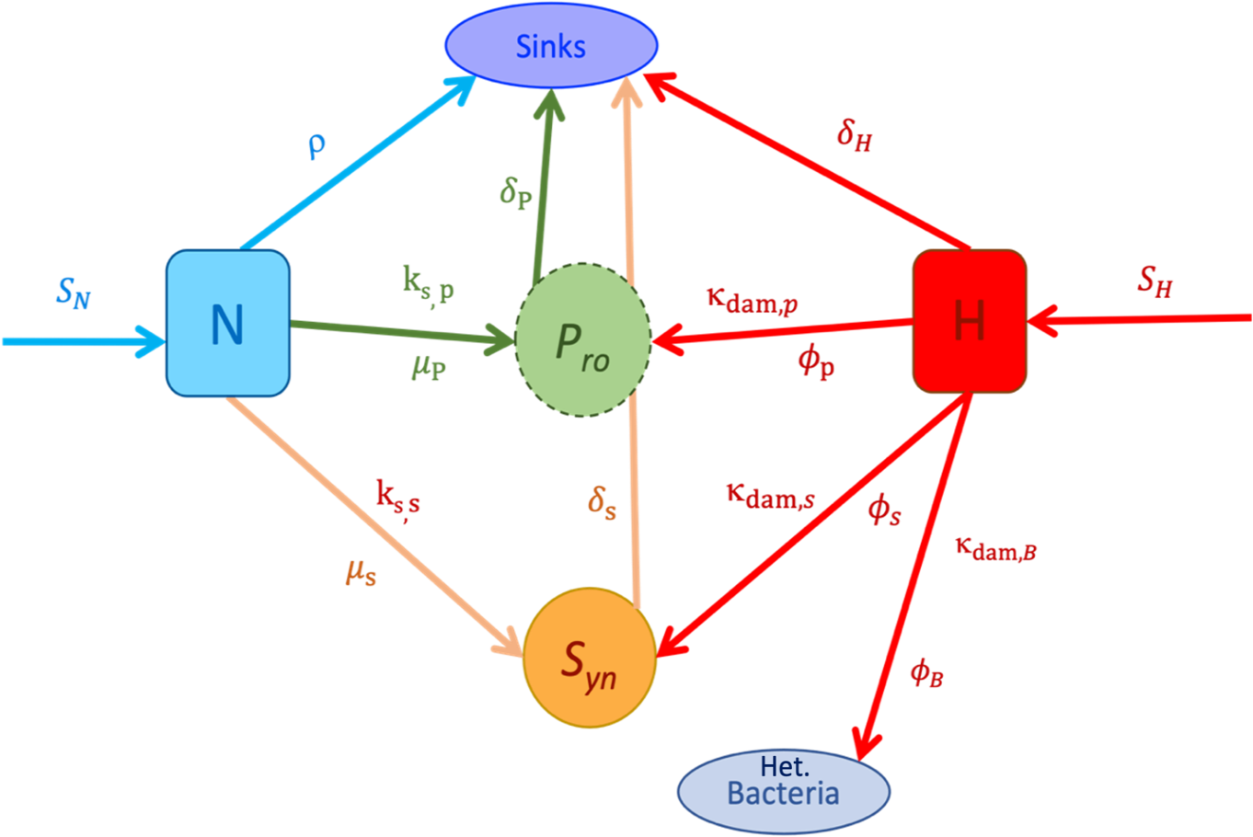
Figure ‎3.1 Parameters impacting Prochlorococcus and Synechococcus growing on ammonium in H₂O_{2.} Schematic showing overall model formulation of the ODEs shows two microbes, Prochlorococcus (Pro) and Synechococcus (Syn) grow from a singular ammonium pool (N) with external H₂O₂ (H) production. The heterotrophic bacterial helper (B) does not compete for ammonium here. Parameters (symbols) control the flux (arrows) between measurable pools of P, S, N, and H. Differential inclusion of H₂O₂ parameters within this framework allows this model to evaluate how 4 scenarios (cases) impact the competitive advantage of these microbes over one another (a microbial Thunderdome).

differential H₂O₂ trait occurrence within a nutrient competition framework based on parameters from monoculture assessment of Prochlorococcus and Synechococcus.

Methods
We developed a coculture model that builds from Chapter 2 parameters but adds source and basal sink terms to N, representing ammonium. This ammonium, which both Prochlorococcus and their close relative Synechococcus can access at differing degrees (Garcia-Fernandez, de Marsac, and Diez 2004; Masuda et al. 2023), serves as the only N term in this system. This single nutrient system, along with only two plankton with different ammonium (and eventually H₂O₂ traits) allows for the examination of growth and detoxification tradeoffs in a simple yet quantitate way. Thus, allowing for the analysis of Prochlorococcus and Synechococcus dynamics from a community lens while isolating the influences of H₂O₂ and nitrogen on this community. Because this model was built in a stepwise manor, this took only slight augmentation of monoculture parameters to bring new control to its ability for hypothesis testing. Using three cases of a competition model, we assess how the parameters modeled in monoculture may influence long term community structure within a two - microbe system. Specifically, cases evaluate if Prochlorococcus H₂O₂ damage is deadly in situ, if said damage is ameliorated by Synechococcus and what bacterial detoxification adds to that of Synechococcus in a community situation.

Model
A competition system (Dynamic Model Equation Set: Equations 3.1-3.5) of ordinary differential equations (ODEs) is used to model the population dynamics of cyanobacteria in a range of H₂O₂ conditions. Special cases of this full system of ODEs were used to show differential community permutations possible from environmentally relevant (Chapter 2) parameters, visualized in Figure 3.2, inclusion according to our methods schematic (Figure 3.1). All computer code is provided in a GitHub repository: https://github.com/DKMcCullough/Pro_vs_Syn.

Dynamic Competition Model Equation Set
$$\frac{dN}{dt} = λ_{N} - { δ}_{N}N - \frac{{ μ}_{P_{i}}N}{N+ {ks}_{P_{i}}}P_{i} - \frac{{ μ}_{S_{i}}N}{ N+ {ks}_{S_{i}}}S_{i}$$  Abiotic N supply abiotic N decay P uptake/use of N S uptake/use of N | (3.1)
$$\frac{dH}{dt } = { λ}_{H} - { δ}_{H}H - { ϕ}_{S_{i}}S_{i}H - { ϕ}_{B_{i}}B_{i}H$$  H₂O₂ supply abiotic decay detox via Syn detox via Bacteria | (3.2)
$$\frac{dP_{i}}{dt} = \frac{{ μ}_{P_{i}}N}{N+ {ks}_{P_{i}}}P_{i} - { δ}_{P_{i}}P_{i}{ - k}_{{dam}_{P_{i}}}P_{i}H$$  Growth of P on N innate cell death H₂O₂ -based cell loss | (3.3)
$$\frac{dS_{i} }{dt} = \frac{{ μ}_{S_{i}}N}{N+ {ks}_{S_{i}}}S_{i} -{ δ}_{S_{i}}S_{i}$$  Growth of S on N innate cell death  $$\frac{dB_{i}}{dt} = { μ}_{B_{i}}B_{i} - { δ}_{B_{i}}B_{i}$$  Growth and death of heterotrophic bacteria | (3.4)  (3.5)

The dynamics of a dissolved ammonium (N, nmol mL⁻¹), catalase negative or positive phytoplankton analogues (Prochlorococcus (P_{i}, cells mL⁻¹) and Synechococcus (S_{i}, cells mL⁻¹)) as well H₂O₂ (H, nmol mL⁻¹) were modeled with a composite set of coupled ordinary differential equations (3.1-5) shown above. N is supplied at a rate represented by $λ_{N}$ (or S_{N}) and has an abiotic depletion rate represented by ${ δ}_{N}$ .The biotic depletion of N through uptake and growth is based on Michaelis-Menten (Michaelis and Menten 1913) kinetics with mu, μ_{Pi} , representing the maximum growth rate, and the ratio of N uptake/affinity rate alpha ( α_{Pi} ), and μ_{Pi} , as the saturation constant ks_{i} (Monod 1949; Michaelis and Menten 1913) for both Prochlorococcus and Synechococcus ODEs. The innate death rate of either cell type in in batch culture, represented as δ_{P,i} and δ_{S,i}, was set to basal rate of 0.2 per day to encapsulate natural cell death, grazer, and viral predation in culture. (See monoculture dynamics in growth media for Synechococcus and Prochlorococcus in Chapter 2 for further δ information.) For our in silico analysis this δ represents not only death found in monoculture laboratory assays but death imposed from sources not quantified here i.e. viral loss, grazer predation, toxin effects. However, a fully combined death term is yet unquantified in situ, but literature shows that viruses and grazers split death evenly (J A Fuhrman and Noble 1999). Thus, prior modeling in Chapter 2 and literature review guides this choice. The abiotic H flux is controlled by $λ_{H}$ (or S_{H},) the supply rate of H, and δ_{H}, loss rate of H while ϕ_{max,s} , represents the biotic degradation in our system of H via S (or B) according to the detoxification ability of each plankton (i) captured in the $ϕ_{max,i}$parameter on Figure 3.2. k_{dam},_{P} serves here as a H₂O₂ - specific cellular damage/loss rate to our cell population and is implemented on P according to the values on Figure 3.2 patterns. $ϕ_{max,P}$ is negligible here and set to 0 for better constraint on S (Synechococcus) impacts on H pools through detoxification. These parameters are explored in ‘non-leaky’ and ‘leaky’ cases of the model described below.

Experimental Approach
A fictional set of ‘Non-leaky’ H₂O₂ detoxification cases are set up. This is done with either supply of H₂O₂ ($λ_{H}$or S_{H}) as zero or non-zero. S_{H} = 0 or S_{H} > 0 competition outcomes of both cases were evaluated using the Prochlorococcus (P) and Synechococcus (S) analogues’ survival patterns after 1 year under either environmental (S_{H}) regime. In both scenarios, P and S microbes are specialized for their own survival. P is given a greater nutrient uptake ($α_{i}$) value but

Figure ‎3.2 Quantitatively recovered tradeoffs found in the coupling of H₂O₂ detoxification rate ($ϕ_{max,i} ,$mL cell⁻¹ day⁻¹) and H₂O₂ induced rate of cell death ($κ_{dam, i }$, mL nmol⁻¹ day¹) for different plankton (i) grown in monoculture batch conditions. Each symbol represents a single plankton species, i.

Table 2 Competition model parameter and variable definitions and units
Symbol | Description | Units
$$μ_{i}$$ | Max cell growth rate of plankton, i (S,P or B) | day⁻¹
$$δ_{i}$$ | Innate death rate of plankton, i (S, P, or B) | day⁻¹
$$κ_{dam,i}$$ | Hydrogen peroxide specific rate of cell death | mL nmol⁻¹ day⁻¹
$λ_{N}$ or S_{N} | Nutrient supply rate | $μ$mol mL⁻¹ day⁻¹
$$ρ$$ | Abiotic nutrient loss rate | $μ$mol mL⁻¹ day⁻¹
$λ_{H}$ or S_{H} | Hydrogen peroxide supply rate | nmol mL⁻¹ day⁻¹
$$δ_{H}$$ | Abiotic hydrogen peroxide decay rate | day⁻¹
$$ϕ_{max,i}$$ | Cell specific rate of H₂O₂ detoxification | mL cell⁻¹ day⁻¹
$$P_{i}$$ | Cell abundance of Prochlorococcus analogue | cells mL⁻¹
$$S_{i}$$ | Cell abundance of Synechococcus analogue | cells mL⁻¹
$$B_{i}$$ | Cell abundance of heterotrophic bacteria analogue | cells mL⁻¹
H | Hydrogen peroxide concentration | nmol mL⁻¹

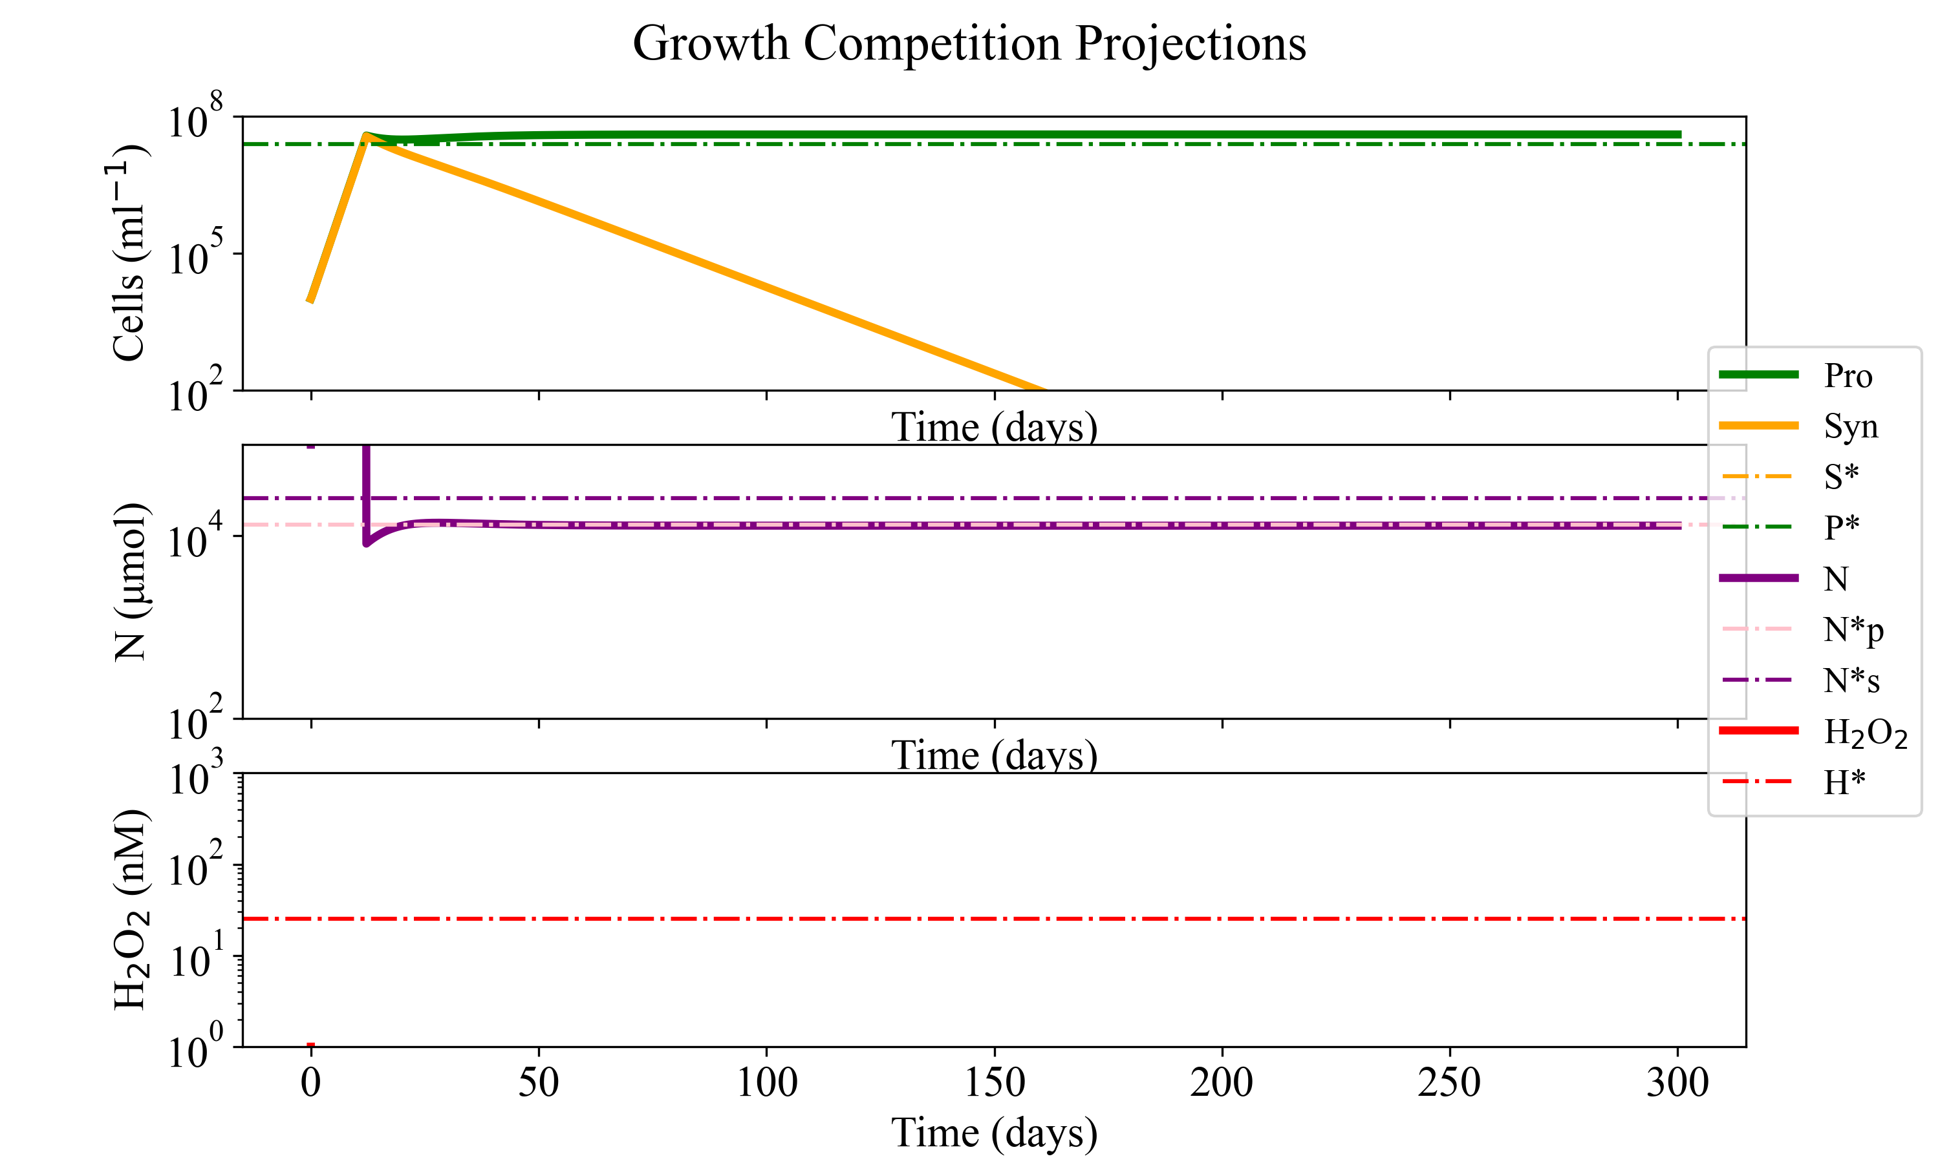
Figure ‎3.3 Dynamics of Prochlorococcus and Synechococcus in zero H₂O₂
Dynamics of Prochlorococcus (green) and Synechococcus (yellow) analogues growing on a single nutrient (purple) in batch culture with zero H₂O₂ in solution. We calculate the equilibrium constants for Prochlorococcus and nutrients predicted from our set of initial parameters. In this case (no H₂O₂ damage to cells ($κ_{dam,p}$) and no biotic H₂O₂ detoxification ($ϕ_{max,S} or ϕ_{max,B}$ )) we see the green P cells drawing N down to N* and reaching P* steady state while S is outcompeted to extinction. The * equilibria values for these and other scenarios are calculated in Appendix B, section B2.

suffers accordingly with H₂O₂ susceptibility ($κ_{dam,p})$ . S is able to survive H₂O₂ ($κ_{dam,s} \sim 0)$ but acquires nutrients at a slower rate than P. ($α_{P}$ < $α_{S}$giving a lower k_{s} constant. (Aksnes and Egge 1991; Michaelis and Menten 1913)). Figure 3.5 shows this case extrapolated across an array of nutrient and H₂O₂ supplies, S_{N} and S_{H} respectively.
A second case, delineated ‘Leaky case’, was evaluated for long term for coexistence with Prochlorococcus and Synechococcus abundances. Here S is given Synechococcus’ $ϕ_{max,S}$ value from Figure 3.2. Essentially the full model set is used with $ϕ_{max,B}$ or B equal to zero. With the use of realistic $ϕ_{max,S}$ values, coexistence is viable but unlikely as it occurs at high nutrient and high S_{H} values only of $ϕ_{max,S}$ and bacterial abundances effects on to in situ Prochlorococcus vs. Synechococcus (Prochlorococcus/Synechococcus (Pro/Syn)) competition outcomes are explored using various contour maps.
Lastly, we explore the full model set with the addition of B detoxification. We analyze the effect of bacterial abundance and detoxification on Prochlorococcus and Synechococcus competition. Heterotrophic Bacteria, $B_{i}$, (cells mL⁻¹) here are not modeled as growing from supplied N but rather as a stable population that functions solely to reduce the H₂O₂ standing concentration via its own $ϕ_{max,B}$ detoxification. We calculate $ϕ_{max,B}$ from a 2-hour detoxification curve from EZ55 growth in H₂O₂ spiked culture following Chapter 2 protocol. (Monoculture time dependent dynamics shown in Appendix B) We then follow up with a secondary bacterial analysis with EZ55 as the lone B detoxifier. This is for the ‘leaky’, more realistic, H₂O₂ case.
For each of these cases, base analytical approaches (equilibrium calculations, time-dependent numerical analysis, sensitivity studies to H and N supplies) were used in congress with ranges of believable (retrieved in Chapter 2 and represented in Figure 3.2) parameters to investigate the effect each H₂O₂ and underlying assumptions phytoplankton community structure.

Results
From Chapter 2 monoculture analyses, Figure 3.2 shows the concurrent values of $ϕ$ and $κ_{dam,p}$ recovered. These will be used for non-leaky (Prochlorococcus $κ_{dam,p}$ and Prochlorococcus $ϕ_{max}$ (~0) values) and leaky (inclusion of Prochlorococcus damage ( $κ_{dam,p}$) and Synechococcus detoxification ($ϕ_{max,S}$) cases.

Non-leaky dynamics
We first assure that our models align with known convention (Button 1998) that Prochlorococcus’ superior affinity (higher $α$ bundled into lower ks constant) allows it to outcompete Synechococcus without H₂O₂. We extrapolate our ODE models out for 150 or 300 days to simulate competition over approximately a half or a full year. We find that our competition converges on the eventuality of Prochlorococcus analogue, P, reaching an equilibrium state and the Synechococcus analogue, S, slowly being outcompeted to extinction (Figure 3.3). The equilibrium solutions for the system shown in dotted lines and calculated (* ) equations’ outputs are shown below said dynamics. Calculations of equilibria shown are located in Appendix B. In this model P’s greater nutrient affinity ($α)$, P outcompetes S to exclusion. However, this matches neither in situ or laboratory data (Calfee, Glasgo, and Zinser 2022; Knight and Morris 2018; Visintini, Martiny, and Flombaum 2021; Partensky, Blanchot, and Vaulot 1999) so H₂O₂ parameter impacts are added starting with k_{dam,i} in P for case 2 in Figure 3.4.
The dynamics resulting from analysis of the ‘non-leaky’ case, (i.e., the inclusion of H₂O₂ damage without the inclusion of community H₂O₂ detoxification) when S_{H} is non-zero dynamics are shown in Figure 3.4. P’s greater nutrient affinity ($α)$ allows P to outcompete S, but the concurrent higher $κ_{dam,p}$ rate leads to significant P population loss when not ameliorated by biotic detoxification mechanisms within the environment (i.e., B or S cell based detoxification, $ϕ_{max,i}$). The dynamics and equilibria both assert that high nutrient affinity of P alone is not enough to outcompete with S when H₂O₂ is unbounded by biological detoxification. We see a flipping in the dynamics between Figure 3.3 and Figure 3.4 controlled solely by the addition of $κ_{dam,p}$ to the P equation, showing P indeed requires external H₂O₂ detoxification to survive and outcompete S via nutrient affinity. This matches culture data where helpers are required to grow Prochlorococcus at ecologically relevant H₂O₂ production rates (Morris et al. 2011).
When competition of Prochlorococcus and Synechococcus analogues is assessed across an array of S_{H} and S_{N} values, only two outcomes are observed. This allows us to investigate how cells may react to traveling from the gyres towards the coast (higher H₂O₂ production (S_{H}) and higher N inflow (S_{N}) to be found near the coast) or traveling down the water column (higher N inflow (S_{N}) and unknown (S_{H}) impacts (decreased photoproduction of H₂O₂ with depth although other H₂O₂ sources seem to change with depth (Sutherland, Wankel, and Hansel 2020; Hopwood et al. 2017)). In Figure 3.5, along a matrix of inputs, the end state concentration of S to total plankton (Synechococcus and Prochlorococcus analogues) in the system is calculated. Thus, when P outcompetes S due to nutrient affinity, the fraction is 0 and the graph is green. When S wins due to H₂O₂ killing P, the fraction equals 1 and the graph is yellow. Despite a wide range of starting parameter values (S_{H} and S_{N}), Prochlorococcus and Synechococcus competition has only two options for outcome within this non-leaky model framework. Either Prochlorococcus kills off Synechococcus when N is too limited for S to survive or H₂O₂ is too high for Prochlorococcus to survive. Thus, Prochlorococcus (P) or Synechococcus (S) alone can grow on the ammonium (N) of a non-leaky ocean system. There is no coexistence found under this single nutrient regime.

Leaky dynamics including Synechococcus detoxification
The ‘leaky case’ of our model involving only Synechococcus (S) cell-based detoxification of H₂O₂ is evaluated in Figure 3.6 dynamically. This mirrors known dynamics of H₂O₂ easily flowing across cellular membranes, meaning that if a cell increases or decreases their internal concentration, the extracellular concentrations of H₂O₂ will be impacted as well. This exploration of community H₂O₂ detoxification shows the combination of nutrient competition and innate leakiness of H₂O₂ detoxification that results in a coexistent dynamic with a steady state coexistence of Prochlorococcus and Synechococcus around their respective N*s in the equilibria. N*s is the nutrient concertation that gives replacement numbers for Synechococcus; N*p likewise is the nutrient concentration for Prochlorococcus to have replacement numbers possible in situ. The nutrient acquisition ability of Prochlorococcus and Synechococcus determine these equilibria N* values and thus we can use our framework to compare dynamics prediction to mathematically tabulated equilibria. (See Appendix B for full equilibria calculations.)

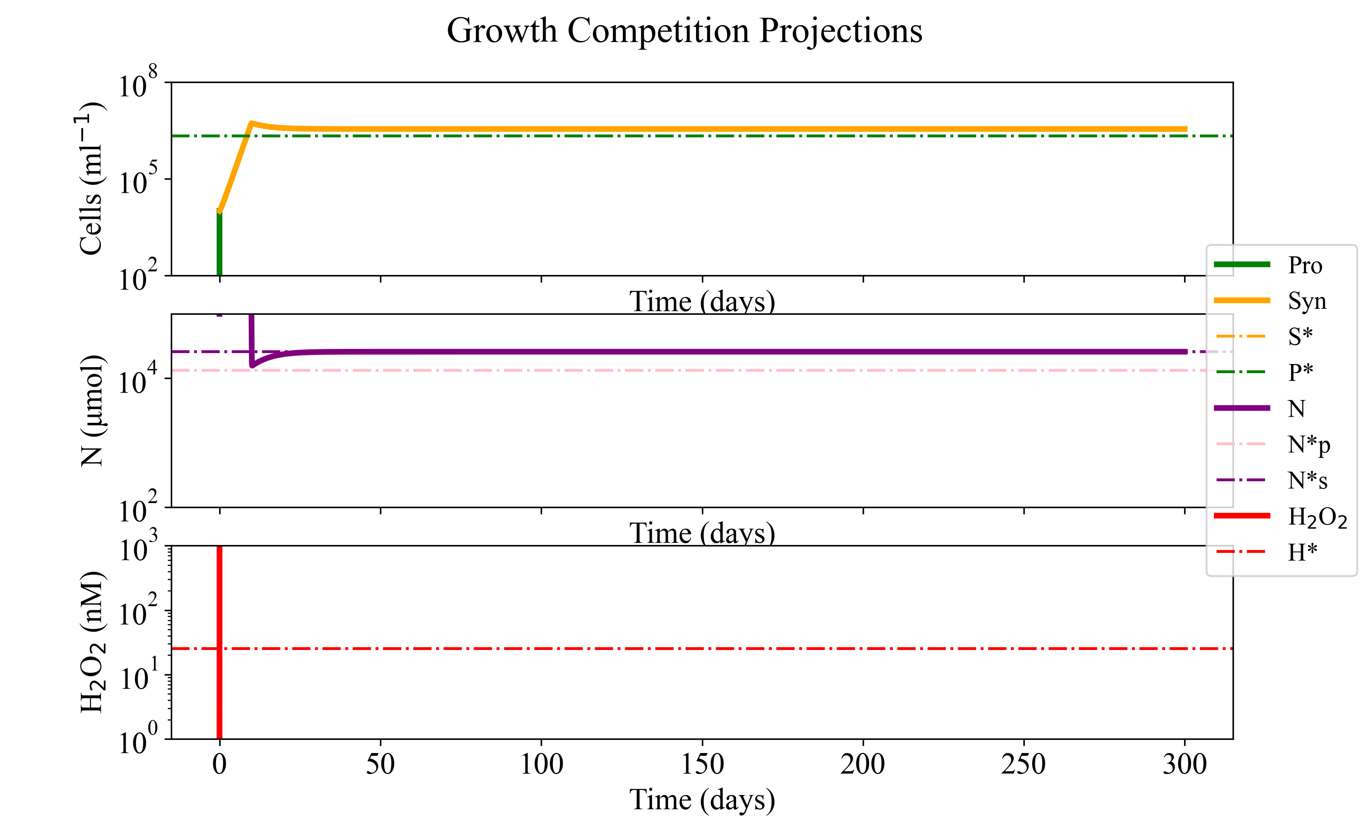
Figure ‎3.4 Dynamics of Prochlorococcus and Synechococcus in non-leaky H₂O₂ world
The top graph depicts the dynamic model solutions for Prochlorococcus and Synechococcus analogue abundances in solid green or yellow lines as predicted with steady H₂O₂ input into solution. Steady state solutions for said models are visualized in dotted lines on the same axes. The middle plot shows the modeled nutrient concentration over time for the dynamics (solid) and steady state (dotted) purple lines. The bottom plot shows H₂O₂ dynamics over time.

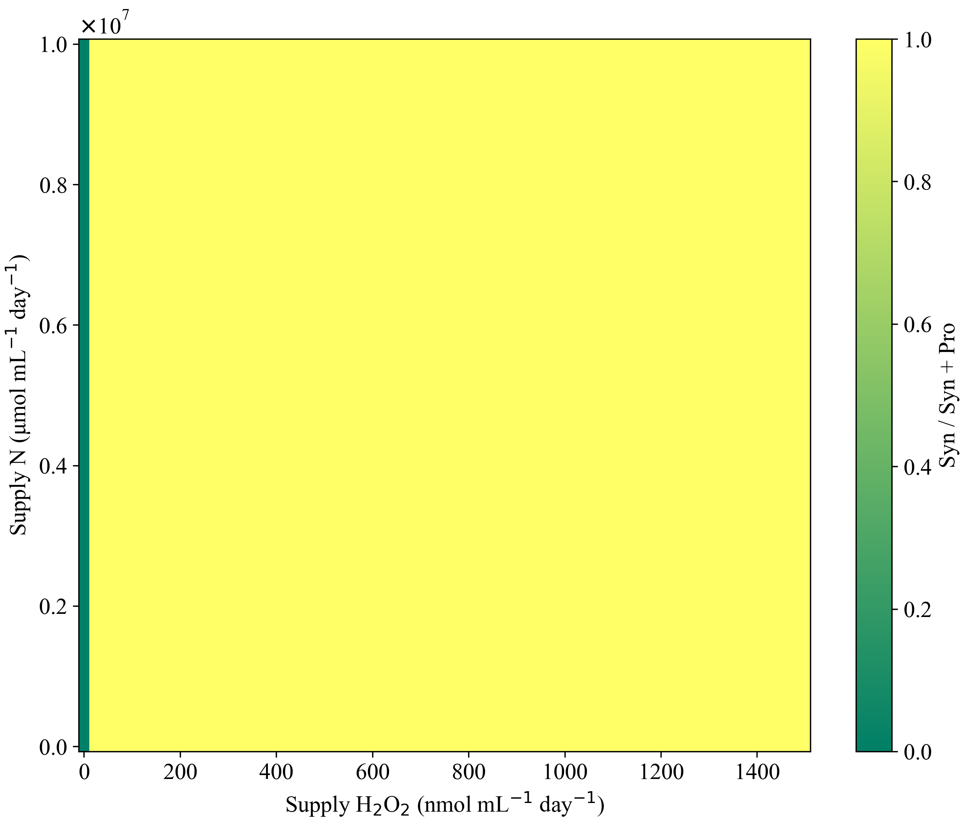
Figure ‎3.5 Evaluation of non-leaky model dynamics across a range of S_{H} and S_{N}
Non-leaky contour map of Prochlorococcus and Synechococcus competition outcomes across nutrient and H₂O₂ inputs. Dark green represents Prochlorococcus dominated (end state) competition via exclusion while bright yellow represents Synechococcus – dominated competitive exclusion. There is no yellow-green here, meaning only Prochlorococcus or Synechococcus exists at the end of these projections. The difference between the green and yellow portions of the contour are determined by the replacement numbers of Prochlorococcus on the nutrient available vs the damage incurred from the H₂O₂ input.

a. Leaky Model Projections: S_{N} 8.5x10⁶ $μ$mol mL⁻¹ day⁻¹ and S_{H} 2.5x10² nmol mL⁻¹ day⁻¹
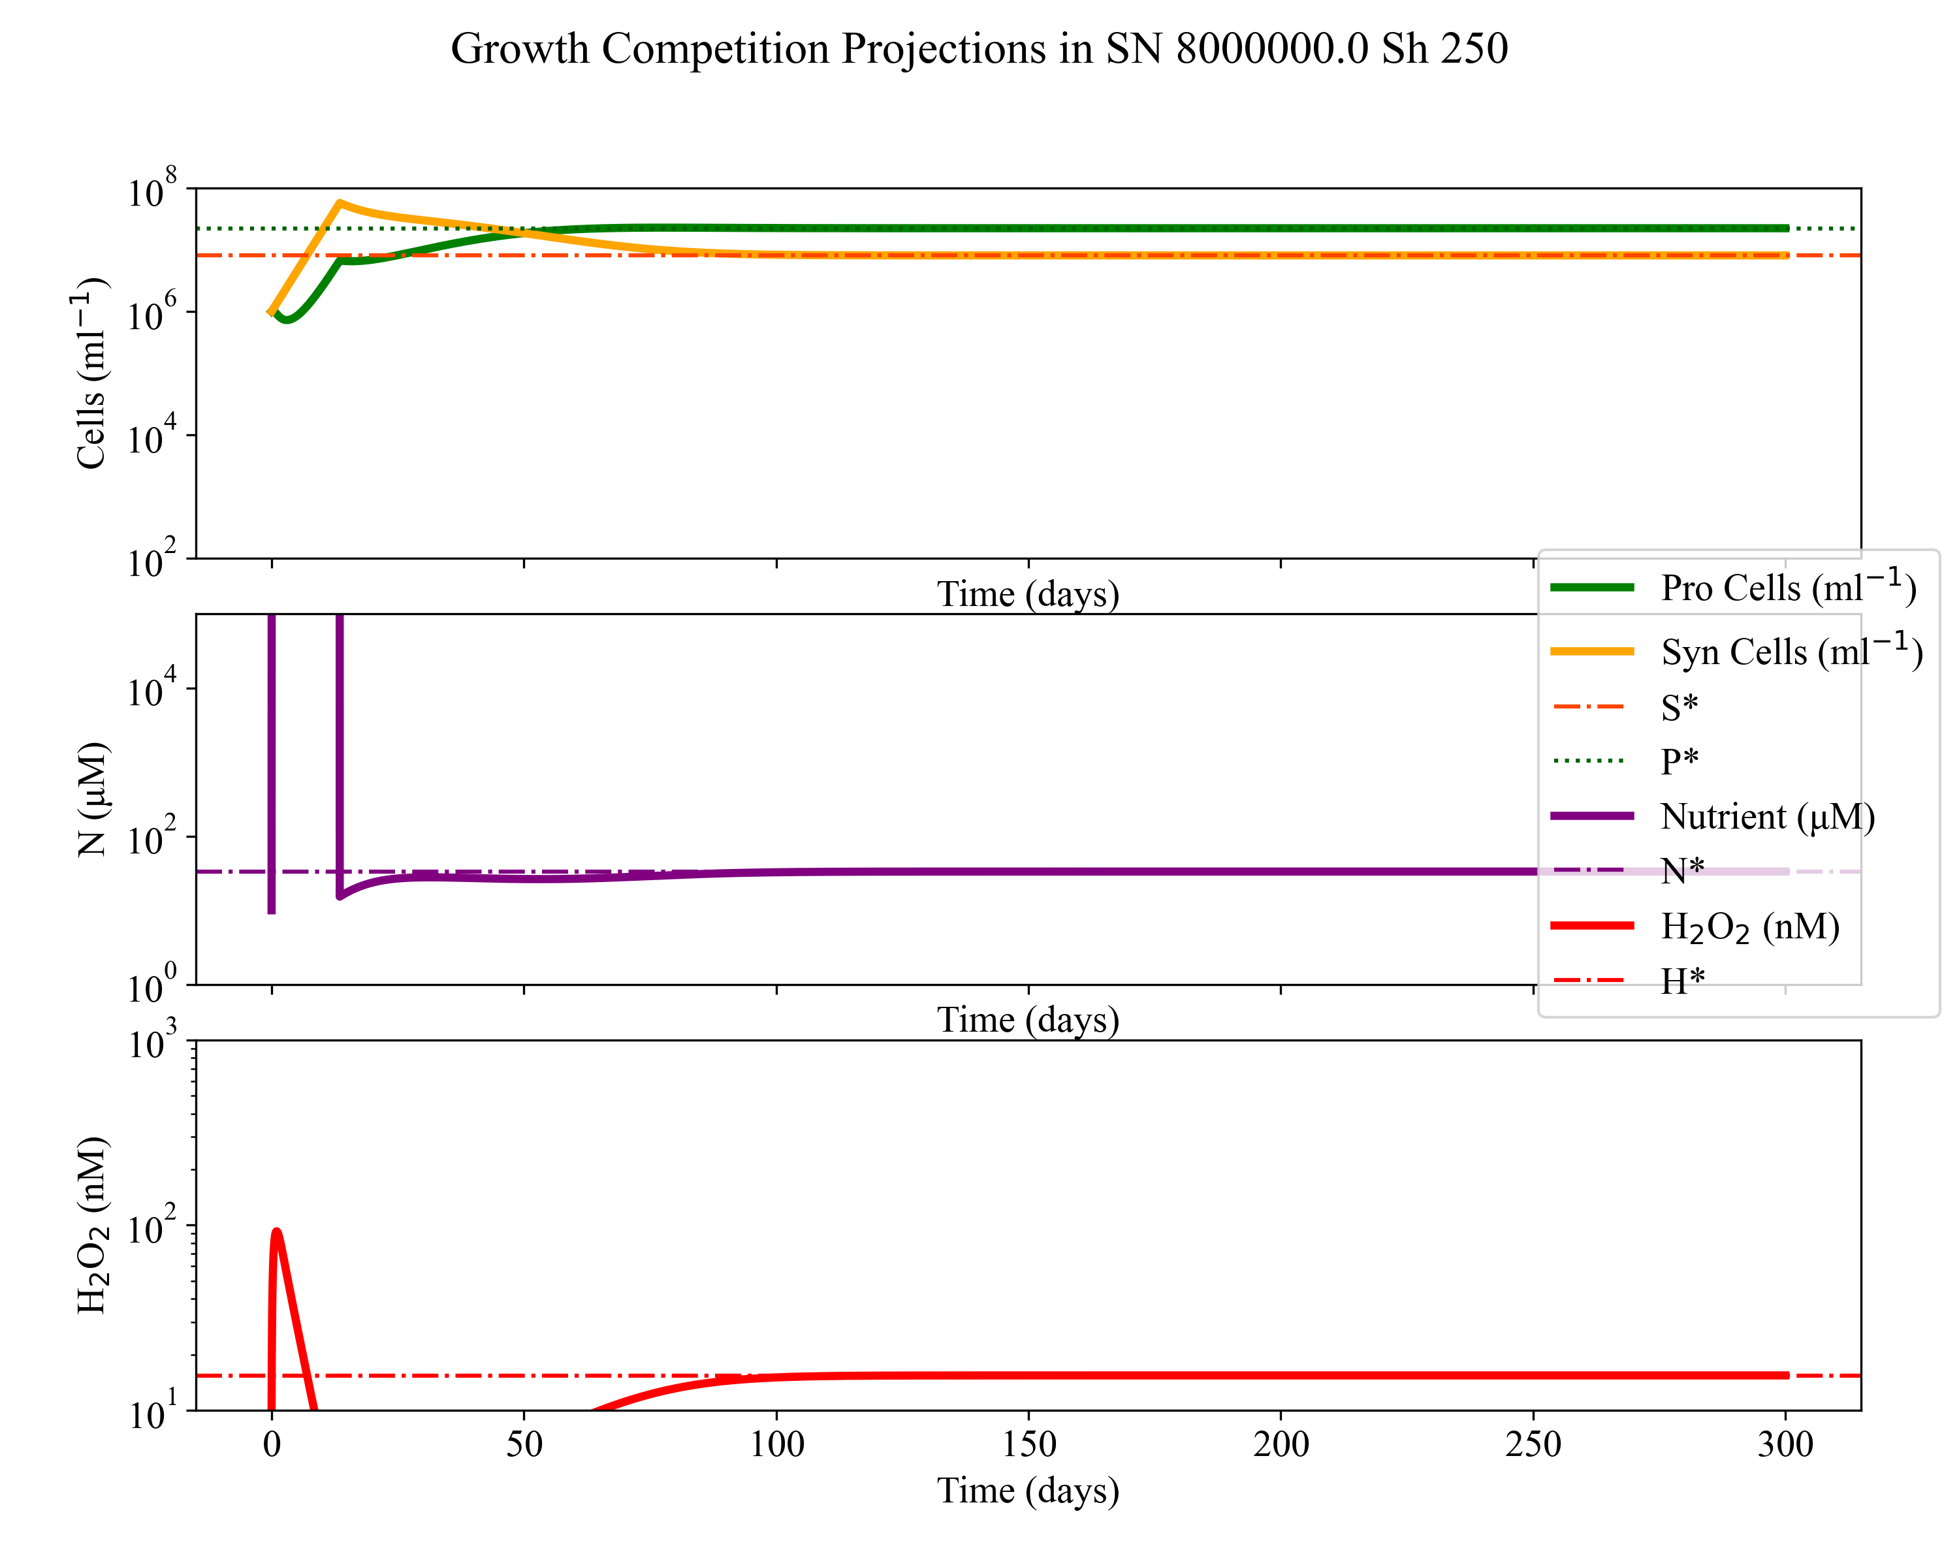Figure ‎3.6 Dynamic outcomes for H, N, P and S leaky case model iterations under different H supplies. 3.6a, 3.6b, and 3.6c depict different dynamic model outputs for P, S, N, and H from increasing H inputs under case 3, S leaky H₂O₂ detoxification regime. The top graph of a,b or c each depicts dynamics model solutions for Prochlorococcus (P) and Synechococcus (S) analogue abundances in green or yellow as predicted solid lines. The associated steady state solutions predicted from these parameter values are visualized in dotted lines on the same axes. The middle plot shows the modeled nutrient concentration over time for the dynamics (solid) and steady state (dotted) purple lines. The bottom plot shows H₂O₂ dynamics over time. S_{N} is kept constant for all scenarios (a,b,c) as is Synechococcus detoxification ($ϕ_{max,S}$ = 2.0 x10⁻⁶). Despite this single parameterization, differentially dominated coexistence scenarios occur in P and S communities based on value S_{H.} Using only Synechococcus detoxification ($ϕ_{max,S}$) allows coexistence along a small (200-900 nmol mL⁻¹ day⁻¹) range of S_{H,}

b. Leaky Model Projections: S_{N} 8.5x10⁶ $μ$mol mL⁻¹ day⁻¹ and S_{H} 4.5x10² nmol mL⁻¹ day⁻¹
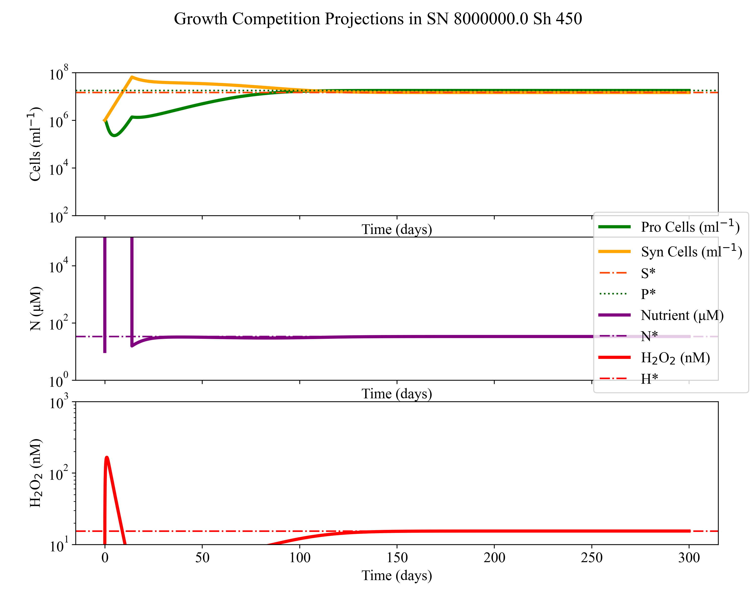
Figure 3.6 continued

c. Leaky Model Projections: S_{N} 8.5x10⁶ $μ$mol mL⁻¹ day⁻¹ and S_{H} 8.5x10² nmol mL⁻¹ day⁻¹
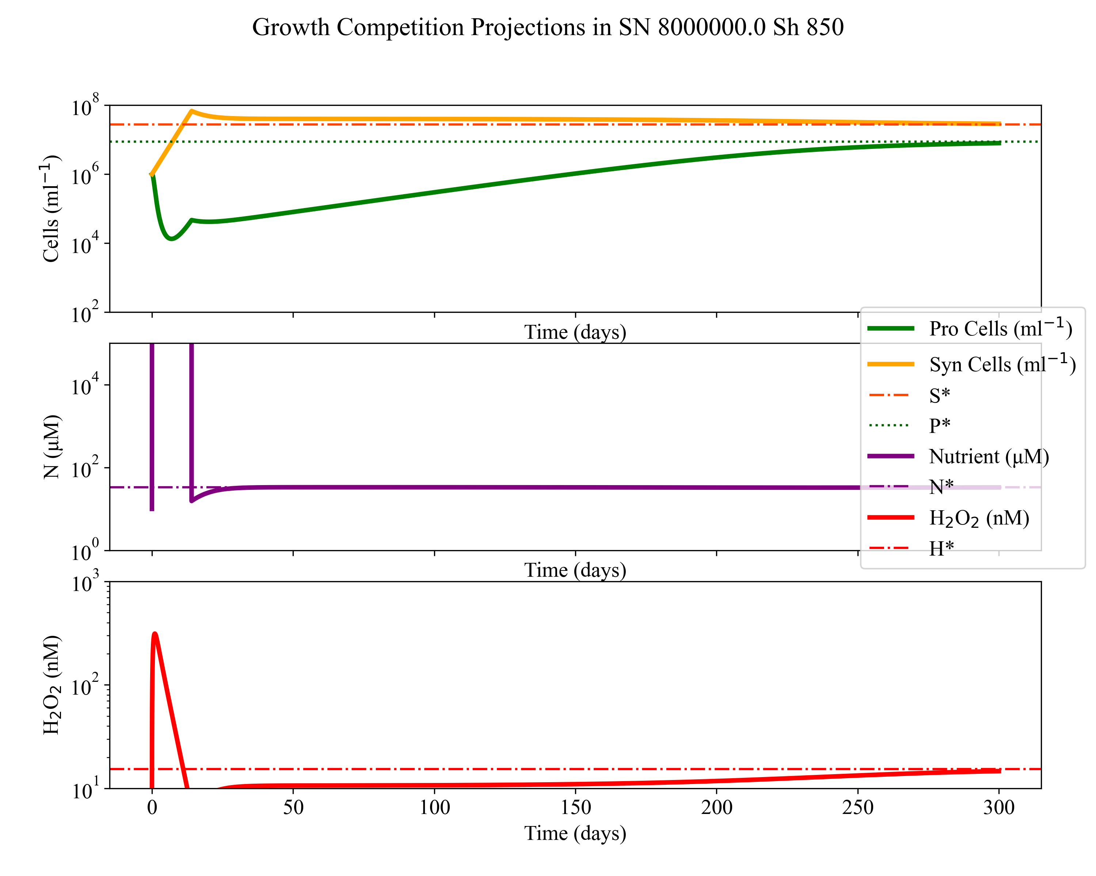

Figure 3.6 continued

Further evaluation of the effect of detoxification ($ϕ_{max,i}$) value on the contour outcome gives the range of maps seen in Figure 3.7. (The range of $ϕ_{max,S}$varies from values isolated from Synechococcus spp modeled in Chapter 2 or heterotrophic levels of detoxification modeled in Appendix A, Shown in Figure 3.2).
Outcomes of the leaky detoxification via Synechococcus on a system of Prochlorococcus and Synechococcus are projected across nutrient and H₂O₂ supplies in Figure 3.7. Green indicates Prochlorococcus dominated competitive exclusion while yellow indicates Synechococcus dominated exclusion. Yellow-green (notably absent from the leaky cases) represents various coexistence ratios of Prochlorococcus and Synechococcus. Dynamics like those pictured in the dynamics of Figure 3.6a-c, give these yellow-green colors. These ranges of coexistence between P and S in silico do not occur when S does not provide enough detoxification to give a rate ($ϕ_{max,S} )$ above 0.
These heat maps show that coexistence is possible but only at high nutrients that give unrealistic (Partensky, Hess, and Vaulot 1999) abundance values for Prochlorococcus and Synechococcus analogues. The nutrient supply (S_{N}) of the oligotrophic ocean is unconstrained however given that dynamics in Figure 3.6 have abundances too high along with these overly large N values, we do not think this dynamic alone is controlling dynamics in the ocean. Further, preliminary in situ HEPES buffer (Morris et al. 2016) and HOTS cruise spike assay data produced S_{H} values in our current model of <50. These models currently do not include DOC or light explicitly despite both being tied to the creation of more H₂O₂ (Cooper et al. 1988; Zinser 2013). Thus, it is unknown how closely these artificial supply rates correlate to values given by Zhu et al. (2022) or Powers and Miller (2014).
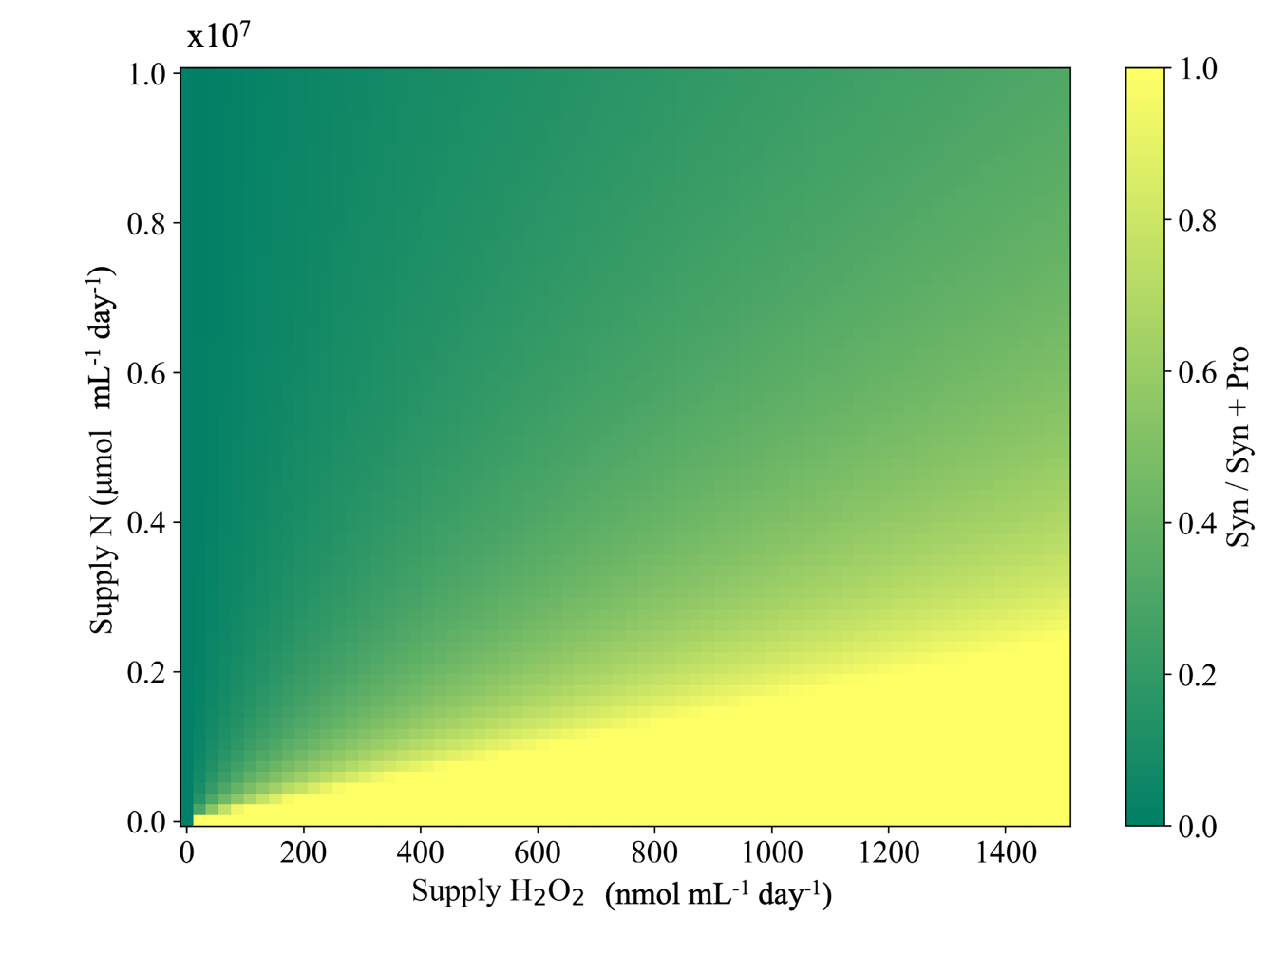
Figure ‎3.7 ϕ_{max,S} effects on Prochlorococcus and Synechococcus coexistence in dynamics and equilibria contours. Dynamics ODEs equilibrium ( *) equations are projected for various H₂O₂ detoxification parameterizations of Synechococcus. The non-zero value of ϕ_{max,S} allows coexistence and controls the extent to which it can occur along a continuum of S_{N} and S_{H} values. 0 to 1500nM range for in situ H₂O₂ is relevant for surface microbes, especially with rain inputs. S_{N} range was tabulated to be give cellular values close to in situ values. The average recovered Synechococcus ϕ_{max,S} from Chapter 2 is represented by the middle $ϕ_{max,S}$ (2.0 x10⁻⁶) value in this figure. Under case 3 of our model’s regime (leaky detoxification from only Synechococcus cells), coexistence is available only at high S_{N} or low S_{H} values. * equilibria are calculated in Appendix B2. Comparison with Dynamic contours are shown in Appendix B, Section B3.
$ϕ_{max,S}$ = 8.0 x10⁻⁶ mL cell⁻¹ day⁻¹
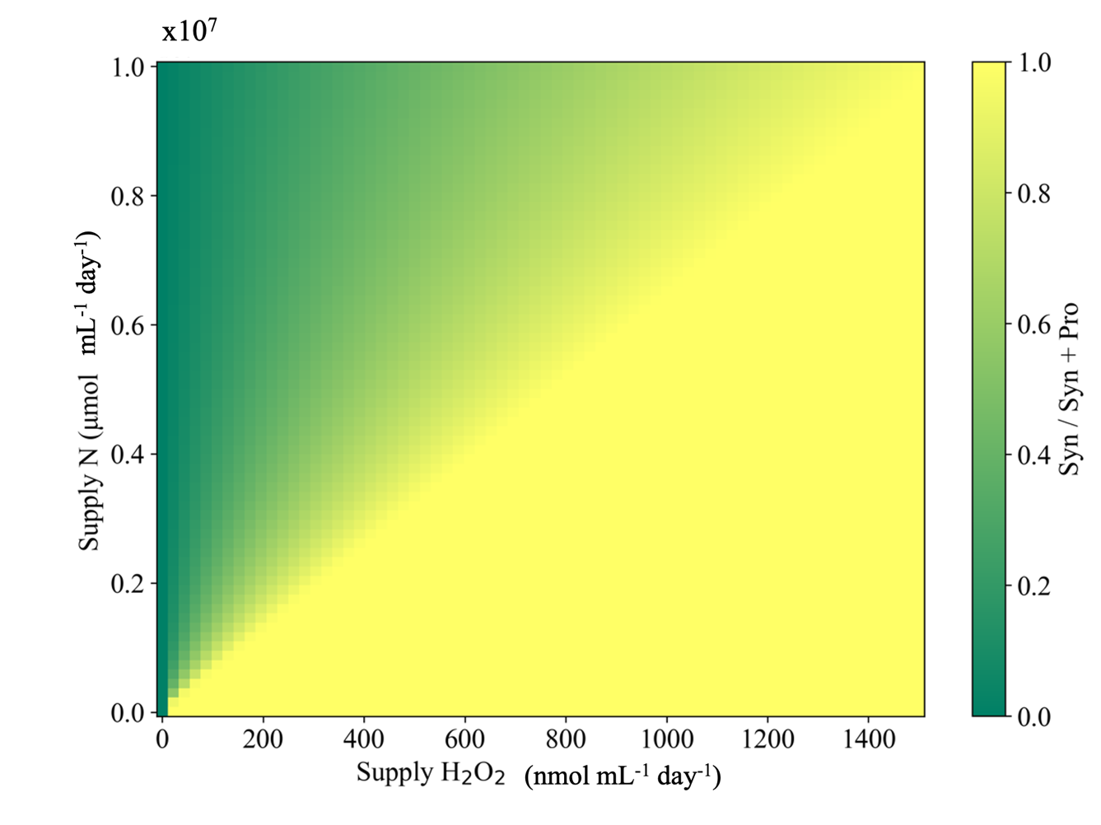
Figure 3.7 continued
$ϕ_{max,S}$ = 2.0 x10⁻⁶ mL cell⁻¹ day⁻¹

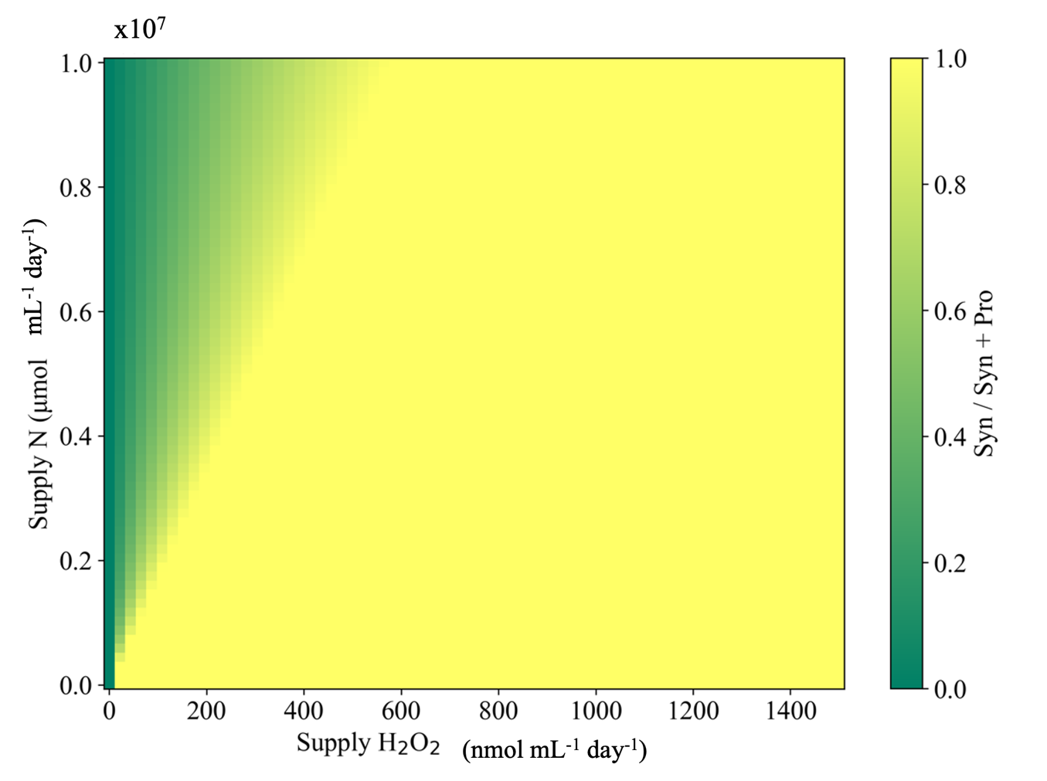
Figure 3.7 continued
$ϕ_{max,S}$ = 0.5 x10⁻⁶ mL cell⁻¹ day⁻¹

Leaky dynamics including Synechococcus and Bacterial detoxification
Bioinformatic comparative analysis of all known bacterial genomes has been found ‘surprisingly small’ amount of detoxification genes in marine microbes (as compared to cultured bacteria). In bacteria, catalase is ‘almost completely absent’ (Bengtsson-Palme et al. 2014; Morris et al. 2016) while peroxides are found to be abundant in marine isolates. Thus it seems not all H₂O₂ detoxification enzymes are equally as prone to being cut from populations (Bernroitner et al. 2009). Prochlorococcus has retained multiple peroxidases, but Synechococcus and other plankton have retained catalase (Bernroitner et al. 2009). Bacterioplankton groups Alpha$\left(α-\right)$proteobacteria and Gamma($γ-)$proteobacteria compose ~50% of average total marine bacterial genomic reads (Barberán and Casamayor 2010). Heterotrophic classes eclipse phototrophic groups in all eubacterial abundance size fractions and locations sampled in ocean samples (Henríquez-Castillo et al. 2022) while in coastal studies, $γ-$proteobacteria were shown to compose ~70% of microbial genetic reads, with distinct Vibrio and Alteromonas isolates found (Hagström, Pinhassi, and Zweifel 2000). Alteromonas macleodii ($γ-$proteobacteria: Alteromonadales: Alteromonadaceae: Alteromonas : spp (Wietz et al. 2022), is ubiquitous in temperate marine waters and increases in proportion to the total amount of free living bacteria along the water column down to ~ 3500m the surface (García‐Martínez et al. 2002). EZ55 (Morris et al. 2008), an isolated strain of A. macleodii similar to ones found in situ in Henríquez-Castillo et al. (2022), has been characterized (Baumann et al. 1984) and isolated from ‘contaminated’ Prochlorococcus marine samples (Biller, Berube, et al. 2015). Other $γ-$protebactiera that have also been investigated for reactive oxygen detoxification (Schellhorn 1995; Morris, Papoulis, and Lenski 2014) include model organisms Vibrio spp. and E. coli (García‐Martínez et al. 2002).Thus we choose the heterotrophic $γ-$proteobacteria as the basis of our heterotrophic bacteria (B) population and explore it further its effect on our model further with the noted EZ55 bacterial helper.
Adkins-Jablonsky et al. (2021) suggest that the higher cost of a leaky function (how much that cost affects the helper) determines if said ‘helper’ is the sole helper or if the leaky functions more spread out between multiple helpers. B is initially modeled as representative heterotrophic eubacterial concentration of surface waters (Wigington et al. 2016; Zinser, Talmy, and Calfee 2023) and used with calculated detoxification $ϕ_{max,i}$ (Chapter 2, Alteromonas avg. parameters) as a steady draw on H₂O₂ input (i.e., it is not growing on the N source for which P and S compete). For all ‘leaky’ model runs: B is 1 x10⁺⁵ and $ϕ_{max,B}$is 4 x10⁻⁴. This $ϕ$ value comes from the modeling of EZ55, a laboratory strain of Alteromonas. The coculture assays from which these parameters came are shown in Figure 3.2 and Appendix A. EZ55, an isolate of catalase positive Alteromonas had a roughly calculated $ϕ_{max}$ of 4 x10⁻⁴ mL cell⁻¹ day⁻¹. This is ten times that of Synechococcus. We evaluated EZ55 $ϕ_{max}$ as a main control of coexistence for Prochlorococcus and Synechococcus through the detoxification of H₂O₂. (Modeling of this bacterial $ϕ_{max}$ is found in Appendix B.) Dynamic and contour plots show different EZ55 abundance scenarios to evaluate possible effect and possible ‘super helper – EZ55’ effect on Prochlorococcus and Synechococcus competition.
Bacterial cell specific H₂O₂ detoxification, $ϕ_{max,B}$, is ten times higher than that of Synechococcus and thus allows coexistence between S and P at lower S_{N} and higher S_{H} values as compared to $ϕ_{max,S}$ alone. Greater ranges of coexistence are permitted across large areas of an environment when bacteria and Synechococcus are both detoxifying H₂O₂. With $ϕ_{max,B}$ bringing standing H₂O₂ concentrations down to a lower level, Synechococcus detoxification ($ϕ_{max,S}$ in Figure 3.8) is then enough to help save Prochlorococcus while also itself surviving on low nutrients that Prochlorococcus otherwise outcompetes it for. $ϕ_{max,B}$is a rough estimate from one species (EZ55, Alteromonas sp.) so we encourage future studies to explore and characterize the detoxification range of marine bacterial populations. Further, heterotrophic bacteria (B) biomass was not tied to N here in Figure 3.8. Thus $ϕ_{max,B}$ acts as a very steep abiotic H₂O₂ sink in this model formulation. This is continued in the models of Chapter 4. However, we note that further biotic analysis of H₂O₂ and nutrient impacts on picoheterotrophs along with broad bacterial population responses, are needed to model these heterotrophic microbes and resultant H₂O₂ detoxification more robustly in future studies.

- b.
Synechococcus ( $ϕ_{max,S}$ ) Synechococcus ($ϕ_{max,S}$) and bacteria ($ϕ_{max,B}$)
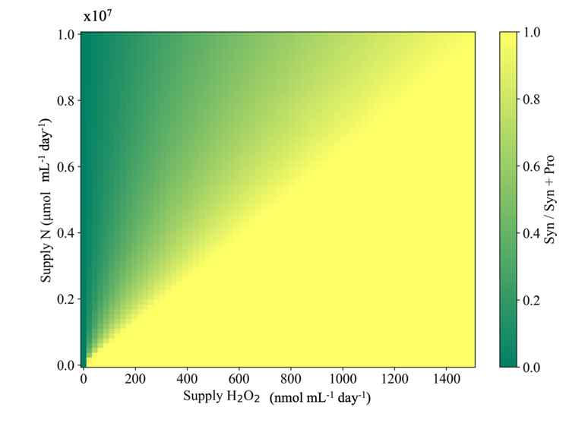 | 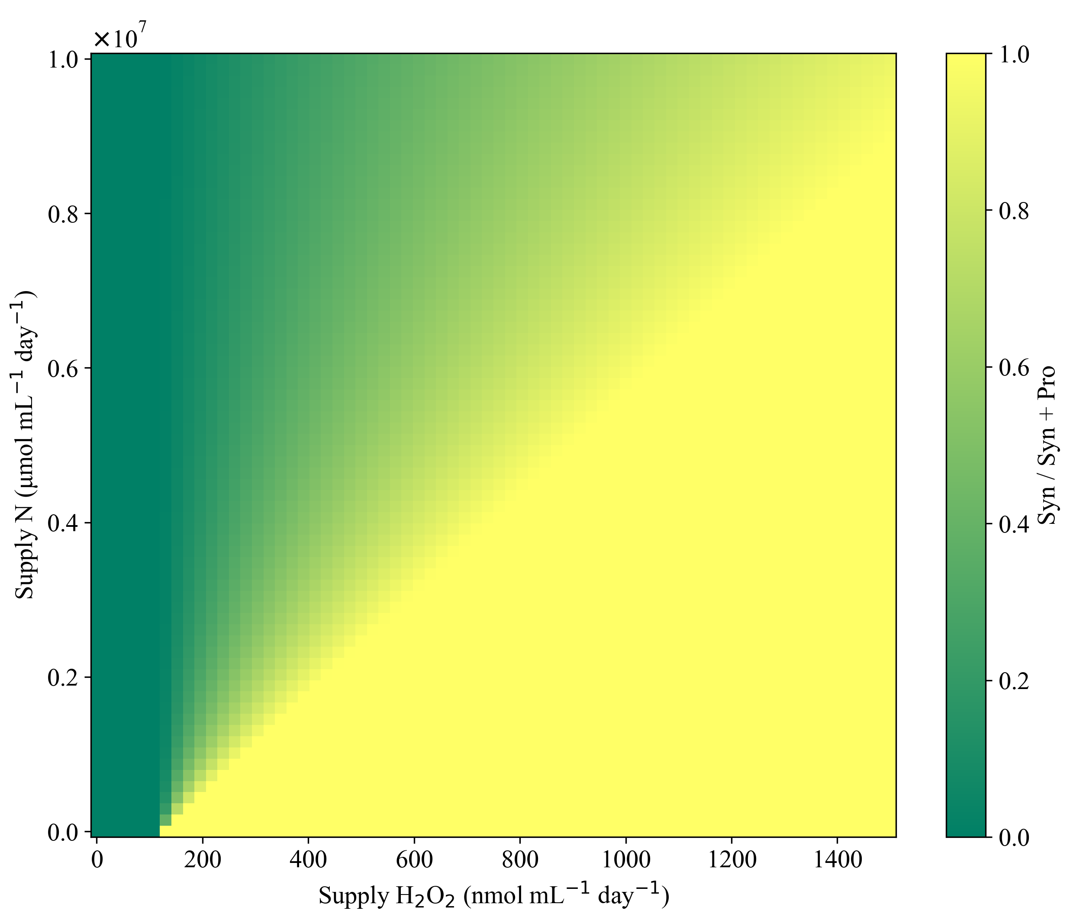
Figure ‎3.8 Different coexistence landscapes available dependent upon who is detoxifying H.
Heat map contours for dynamic competition outcomes between Prochlorococcus and Synechococcus over a range of S_{N} ( $μ$mol mL⁻¹ day⁻¹) and S_{H} (nmol mL⁻¹ day⁻¹) inflows. We compare here two different detoxification regimes; Synechococcus detoxification ($ϕ_{max,S}$) one or Synechococcus and heterotrophic bacterial detoxification ($ϕ_{max,B}$). Synechococcus detoxification ($ϕ_{max,S})$ is 2.0 x10⁻⁶ in both contour plots but bacterial detoxification ($ϕ_{max,B}$) is either 0 (a, left) or 4.0 x10⁻⁴ (b, right).
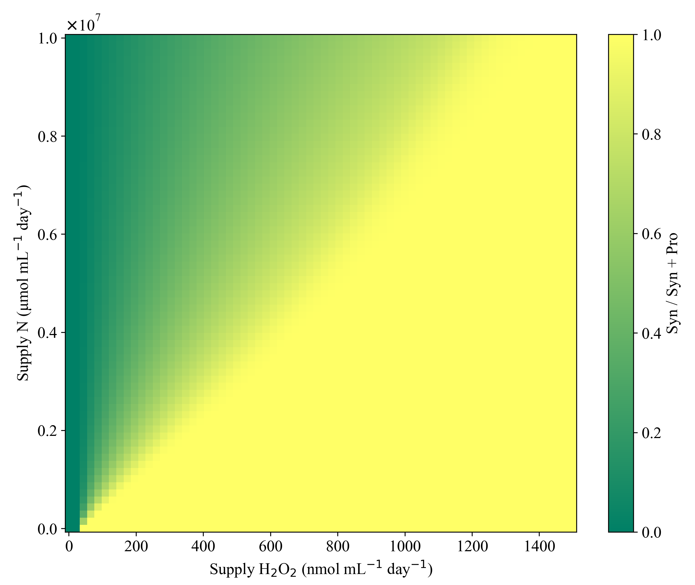
$ϕ$_{max,B} = 2.0 x10⁻⁵ mL cell⁻¹ day⁻¹
Figure ‎3.9 Contour outputs across a range of S_{N} and S_{H} under different heterotrophic detoxification (ϕ_{max,B} ) regimes
Dynamics ODEs (left) or equilibrium solution equations (right) are projected along a biomass ratio contour plot indication Syn/(Pro+Syn). These competitions are evaluated over a range of S_{N} ( $μ$mol mL⁻¹ day⁻¹) and S_{H} (nmol mL⁻¹ day⁻¹) inputs. Each row represents a different parameterization (value) of stationary phase heterotrophic Bacterial (B) culture H₂O₂ detoxification ${(ϕ}_{max,B})$.

$ϕ$_{max,B} = 8 x10⁻⁵ mL cell⁻¹ day⁻¹
Figure 3.9 continued

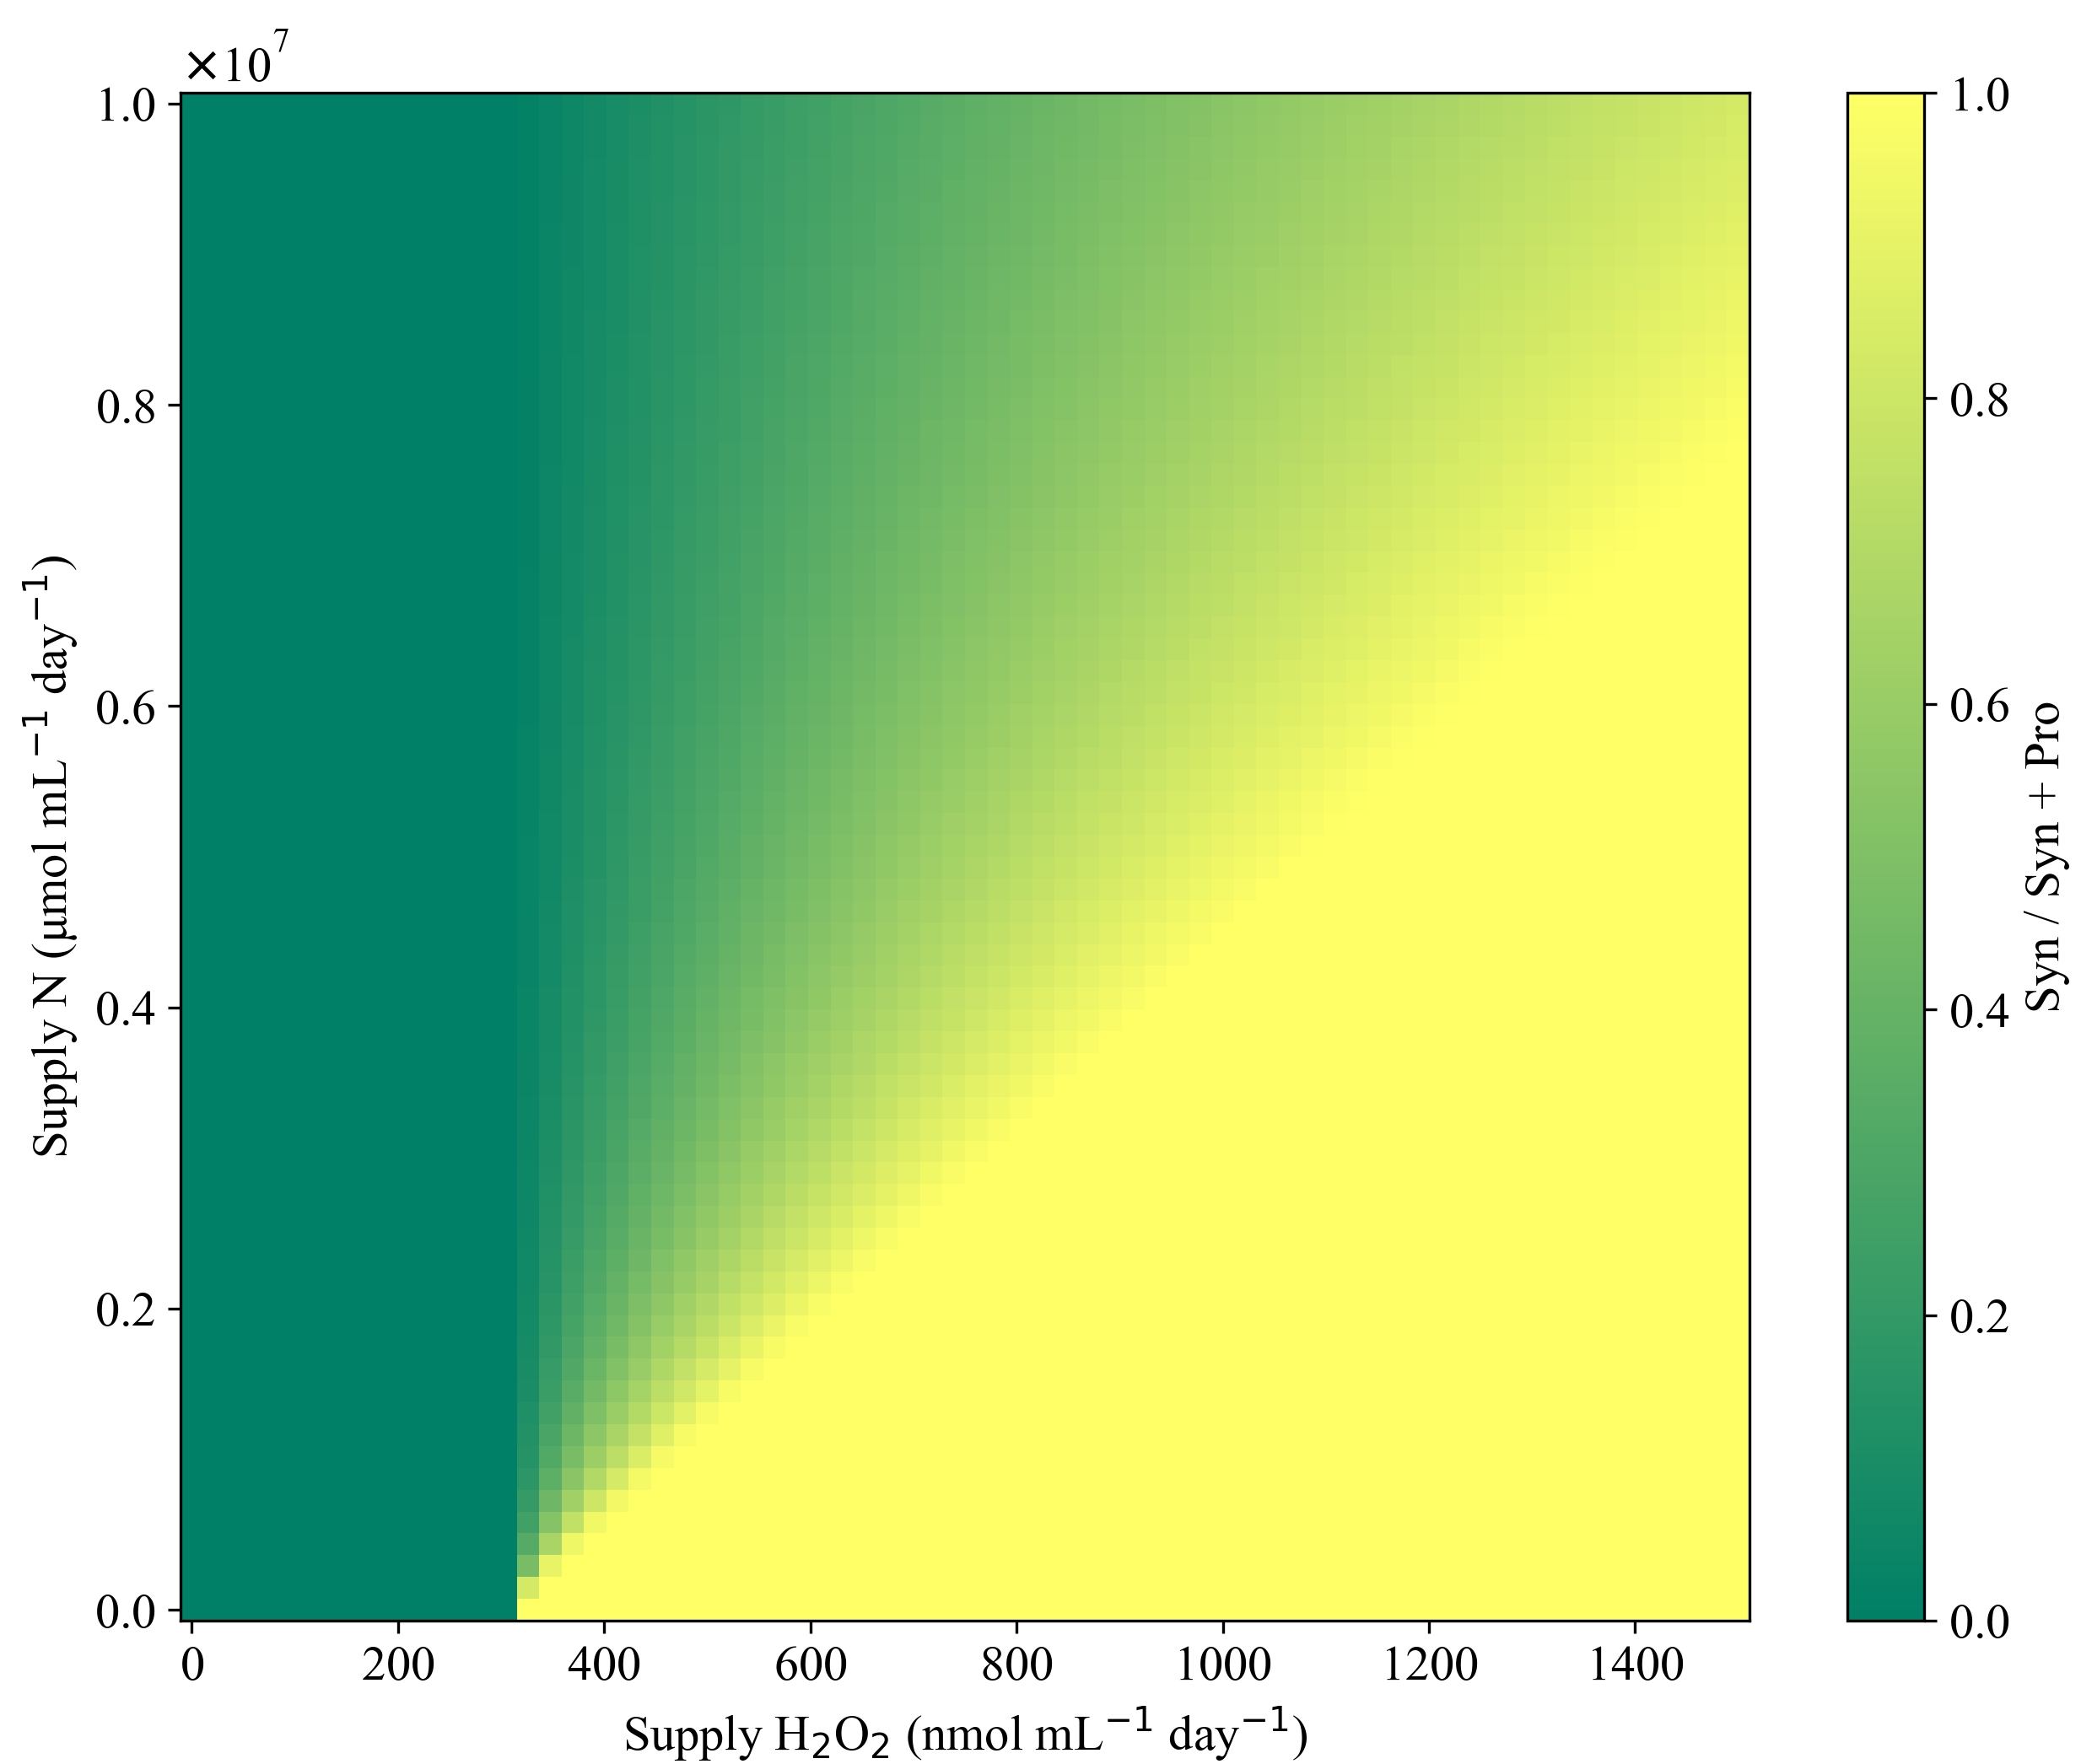
$ϕ$_{max,B} = 2.0 x10⁻⁴ mL cell⁻¹ day⁻¹

Figure 3.9 continued

- b.
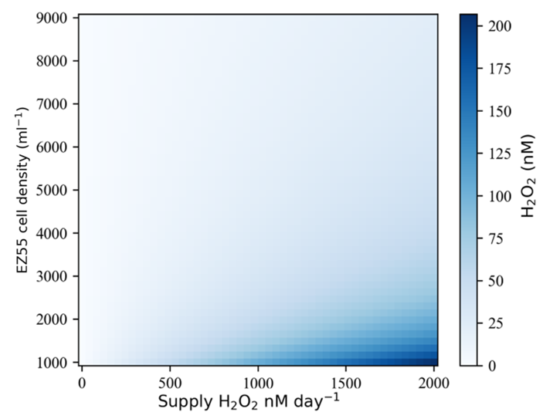
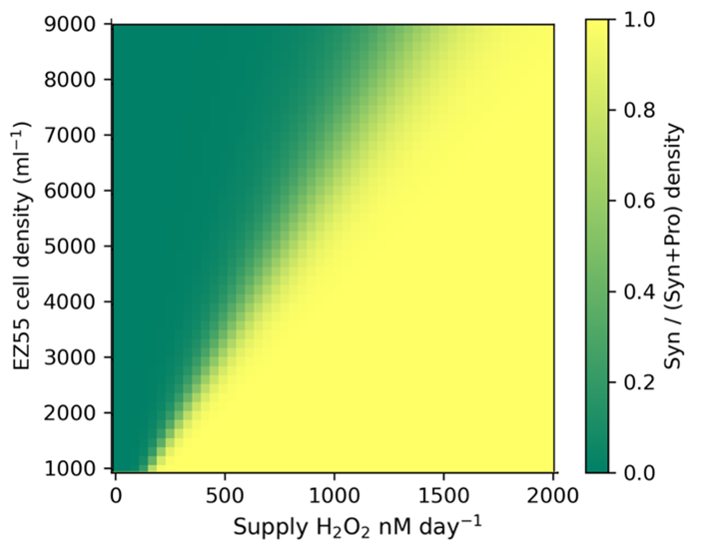
Figure ‎3.10 Prochlorococcus and Synechococcus competitive outcomes as a result of EZ55 cell density. a. Competition outcomes of P and S across a range of EZ55 (cell mL⁻¹) and S_{H} (nmol mL⁻¹ day⁻¹) values. Dark Green represents Prochlorococcus dominated (end state) competitive exclusion while yellow represents Synechococcus – dominated competitive exclusion. Yellow-green represents various coexistence ratios of Prochlorococcus and Synechococcus. b. Right contour shows how EZ55 concentration, $ϕ$_{max,D}, and S_{H} input parameters work together to create standing stock H₂O₂ concentrations that affect the Prochlorococcus and Synechococcus equilibria. Note here that H₂O₂ concentrations hover between 10 and 200nM, much like daily ambient H₂O₂ seen in situ (Morris et al. 2016; Zhu et al. 2022; Hopwood et al. 2017).

Discussion
Resource competition theory (Tilman 1982; Grover 1997) indicates that when two or more organisms attempts to coexist in an environment on one nutrient, the better competitor organism should eventually outcompete the other, unless the competitor develops the ability to utilize other nutrient pools (Armstrong and McGehee 1980; Hardin 1960; Hutchinson 1967). The full extent of resource partitioning in the ocean and associated microbial community composition is far from understood (Hutchinson 1967; Bier et al. 2015; Litchman et al. 2006; Saba et al. 2010). While differential nutrient acquisition has long been considered and modeled as an important driver of ecological niches, Berube et al. (2023) and Calfee et al. (2022) showed that cross feeding of nitrogen (N) or carbon (C) molecular species in oligotrophic genera may sustain coexistence (Berube et al. 2023; Calfee, Glasgo, and Zinser 2022)). Here we show that H₂O₂ pressure should also be considered a niche-expanding mechanism and thus be modeled accordingly. We first evaluated the hypotheses that superior nutrient acquisition mechanisms, devoid of other forcings, were enough to allow Prochlorococcus to competitively exclude community members for nutrients. Our initial modeling shows that nutrient affinity indeed controls our system in the absence of H₂O₂ (zero for supply (S_{H} = 0) and initial conditions of H₂O₂ (H(0) = 0)) and Prochlorococcus dominates. However, when we put Prochlorococcus in an environment where there is a cost to nutrient affinity in the form of H₂O₂ susceptibility (i.e., catalase loss from evolutionary streamlining) it is clear, that nutrient success alone is not sufficient to allow survival when H₂O₂ is non-zero, as is true in the oligotrophic ocean. While Prochlorococcus has optimized its ability to obtain ammonia, Synechococcus can utilize sources of nitrogen, such as nitrate, that Prochlorococcus cannot access (Garcia-Fernandez, de Marsac, and Diez 2004) thus this in silico scenario allowed for the isolation of interactions that cannot isolated directly from in situ sampling. Different Prochlorococcus (Berube et al. 2023) or Synechococcus ecotypes (Masuda et al. 2023) can coexist on different N sources (with NO₂ or NO₃ adding niche room for coexistence), with the phenomenon modeled by Masuda alongside ecologically relevant data. Our results provide context to the competition dynamics that allow coexistence on a shared ammonium (N) source.
Non-leaky H₂O₂ detoxification causes the predicted dynamic outcomes to switch from competitive exclusion of Synechococcus to the competitive exclusion of Prochlorococcus. In this case, ‘non-leaky’ detox of H₂O₂ keeps Synechococcus safe but does not allow Prochlorococcus to reap the benefit of community detox. (This is done practically with Synechococcus ODE dynamics containing no H₂O₂ ₋based damage rate ($κ_{dam,s})$ and the ODE controlling H (See equations 3.1-3.5) having no biotic detoxification term.) Thus, Synechococcus is ‘agnostic’ to H₂O₂ and leaves Prochlorococcus to be damaged by the external H₂O₂. Despite Prochlorococcus’ superior nutrient affinity, this burden of toxic H₂O₂ is too much for Prochlorococcus to overcome. Omar et al. (2022) showed that diffusional and spatial properties of the oligotrophic environment make it unlikely that microbes receive H₂O₂ detoxification help directly via cell contact but rather through diffusive interactions Thus, we suspect our current form of inadvertent H₂O₂ detoxification is a good fit biologically and mathematically for this system. We assessed our non-leaky framework’s ability to capture Prochlorococcus and Synechococcus competitive interactions across ranges of nutrient and H₂O₂ inputs, reminiscent of a sampling transect across the surface marine environment. Despite the varied inputs, only two community outcomes were found to be possible withing a non-leaky H₂O₂ framework.
Detoxification of H₂O₂ however is known to be a leaky process, where environmental H₂O₂ is detoxified by Prochlorococcus ’s microbial community members. We were required to allow for leaky community H₂O₂ detoxification, first from Synechococcus alone, in case 3, and then from heterotrophic bacteria, in case 4, that were quantified with Chapter 2 methods ($ϕ$_{max,S} and $ϕ$_{max,B}). Inclusion of these allowed for cell-based drawdown ambient H₂O₂ concentrations in the model, allowing for Prochlorococcus to survive and compete with its community members via greater nutrient acquisition ability. We first attempted to do this in the leaky model case 3 with Synechococcus ‘help’ alone ($ϕ$_{max,S}), but the detoxification efficiency of Synechococcus was not high enough to allow coexistence of Prochlorococcus and Synechococcus analogues in a biologically reasonable range of ammonium and H₂O₂ concentrations. An additional heterotrophic bacterial helper (B), an A. macleodii analogue with associated detoxification rate ($ϕ$_{max,B}), was able to drawdown H₂O₂ and allow Prochlorococcus to survive and coexist with Synechococcus at lower ranges of N and higher ranges of H.
A. macleodii is an ecologically important marine community member. A. macleodii produces a photoreactive siderophore on a scale that have been modeled to significantly influence global iron patterns (Manck et al. 2022). Metatranscriptomic analysis of marine waters also suggested Alteromonas iron specialization and carbon metabolism are closely tied (Henríquez-Castillo et al. 2022), meaning this microbe may also affect its overall draw down of in situ H₂O₂ concentrations via prevention of iron based, Fenton-like, reactions (Zinser 2018b; Zhang, Del Vecchio, and Blough 2012). A. macleodii is a diverse genera with a pangenome composed of 7819 total genes (Nayfach et al. 2016) that is divided into 35 species as of November 2022 (Wietz et al. 2022). Surface and deep species of A. macleodii differ in organic C or N usage (Biller, Berube, et al. 2015; V. Klochko et al. 2012) and pH optima (Ivanova et al. 2015). This mirrors the differentiation regimes of Prochlorococcus and Synechococcus genera through nitrogen, light, and temperature (Delmont and Eren 2018; Johnson 2006; Kujawinski et al. 2023; Sohm et al. 2016). Thus, we expect H₂O₂ influences the community composition between these organisms over a wide range of environments within the ocean. Chapter 4 will delve into a global circulation model’s extrapolation of our H₂O₂ framework to explore natural variation of H₂O₂ and nutrient sources in the global ocean.

Conclusions
This exploration into parameter theoretical space is used to show that microbial detoxification of exogenous H₂O₂ is a key toggle for Prochlorococcus niche space and is key in allowing coexistence in singular nutrient scenarios and thus allows microbial dynamics to switch between competitive exclusion and coexistence. The streamlined nature of Prochlorococcus is touted as the way in which it dominates current marine biogeography (Visintini, Martiny, and Flombaum 2021; Flombaum et al. 2013; Partensky, Hess, and Vaulot 1999). However, the downside, mainly H₂O₂ – based lethality, of its streamlined nature is not currently quantitively established. We use the base ODE models from Chapter 2 and evaluate the effect of H₂O₂ on Prochlorococcus and Synechococcus analogs in a competition framework. We first use values isolated from quantitative modeling methods in Chapter 2 and expand with bacterial detoxification and abundance stock values to analyze the different possible community structures available under relevant H₂O₂ and nutrient inputs. Predicted decreases in overall average cell size of the surface ocean microbes (a predicted outcome for future ocean nutrient inputs due to climate change (Dutkiewicz et al. 2015; Litchman et al. 2006)) is modeled to change the downward concentration and flux of carbon to the sequestration deep ocean (Levin and Le Bris 2015; Falkowski 1997; Hutchins and Fu 2017) through changing community composition augmenting internal mixed layer fluxes (Ducklow, Quinby, and Carlson 1995; Dutkiewicz, Scott, and Follows 2013; Barreto Filho et al. 2022; Henson et al. 2021; Wagner and Adrian 2009; Beman et al. 2011; Dutkiewicz et al. 2015; Traving, Clokie, and Middelboe 2014; Lomas and Lipschultz 2006) and decreased mixing between surface mixed layer and deep ocean layers (Sallée et al. 2021; Wang et al. 2023). Thus future oceans changes are set to augment the carbon storage function of the ocean (Boyd 2015). Models predict that heterotroph : autotroph ratios increase with temperature and even more so if heterotrophs are modeled to have ‘relevant’ higher enzyme sensitivity (Archibald et al. 2022). Since heterotrophs are key to the detoxification of H₂O₂ for the current dominant cyanobacteria of the ocean, and chemistry and temperature of future oceans favors longer reactive oxygen species lingering times (Morris, Rose, and Lu 2022), we find this study’s timing apt.

Modeling the impact of H₂O₂ traits on marine biology at a global scale

Author(s): D.K.M., E.A.C., and D.T.
Author contribution statements: Darwin model implementation lead by E.A.C., written by D.K.M. with guidance from D.T. and E.A.C.

Abstract:
Global models attribute approximately 50% of marine phytoplankton primary production, and accordingly 25% of Earth’s total primary carbon primary fixation function, to the cyanobacterial sisters Prochlorococcus and Synechococcus. However, Prochlorococcus and Synechococcus have differential H₂O₂ interactions that have been verified in situ and via laboratory assays but are yet to be incorporated into global plankton models. In this chapter, Prochlorococcus, Synechococcus, and Alteromonas again are used as model organisms with differential cellular susceptibilities to and impacts on environmental H₂O₂. Basal supply and decay rates of H₂O₂ are inserted into a globally resolved biological trait framework. Following the community composition lens of Chapter 3, this global model is used to evaluate H₂O₂ impacts on phytoplankton biogeography is several cases. Without helper detoxification, diel concentrations of H₂O₂ input can kill off Prochlorococcus across all latitudes allowing Synechococcus to numerically dominate the globe at all locations. Synechococcus detoxification of environmental H₂O₂ is then added and found to significantly alter Prochlorococcus and Synechococcus interactions, allowing for coexistence rather than exclusion. Alteromonas (heterotrophic bacterial)-based detoxification further shapes community composition allowing for Prochlorococcus to fully dominate low latitudes while Synechococcus overtakes Prochlorococcus at higher latitudes. This presents a biogeographic output for Prochlorococcus and Synechococcus that are consistent with current understanding of plankton in situ biogeographies. Using different of H₂O₂ parameter combinations layered sequentially into a global plankton competition framework, we quantitatively show that H₂O₂ impacts large scale microbial biogeographical patterns and their stability.

Introduction:
With marine production controlling 50% of global carbon flux (Field 1998; Raven and Falkowski 1999), microbial phytoplankton are the key link between ocean chemistry and biology (Azam et al. 1983; Falkowski, Fenchel, and Delong 2008). Prochlorococcus and Synechococcus combine to facilitate 50% of this marine flux (Partensky, Blanchot, and Vaulot 1999; Flombaum et al. 2013). Only a small percentage of the ocean has currently been sampled and models are used to visualize hypothesized population densities of microbes based on noted microbial traits (Buitenhuis et al. 2012). Modeling plankton, using growth and death traits quantified from environmentally relevant environmental scenarios in laboratory experiments, is a key bridge in understanding how the physical environment of the ocean and the microbial life within it interact on large scales. This is sometimes done at the species level (Larkin et al. 2023) however the number of microbes known vs. culturable microbes is low (Barton et al. 2010; Fuhrman and Campbell 1998; Kaeberlein, Lewis, and Epstein 2002; Barberán and Casamayor 2010). Thus, direct laboratory to in situ extrapolation is difficult. Furthermore, modeling ocean dynamics with the full microbial diversity of the ocean would be computationally intractable. Other model frameworks consider genera of plankton constrained with laboratory optima of temperature and light growth extrapolated across global temperature and light patterns (Flombaum et al. 2013; Visintini, Martiny, and Flombaum 2021). While mirroring vertical and latitudinal distributions in the water column, these representations do not allow direct analysis of the underlying chemical and biological processes. For direct mechanistic connections between cellular growth and environmental conditions, we utilize a Massachusetts Institute of Technology (MIT) global plankton modeling framework (Follows et al. 2007). In Chapter 3 we explored cell based H₂O₂ parameters and their impact the community dynamics of picoplankton. In Chapter 4 we use these parameters and extrapolate to global scale investigation of community plankton dynamics via the implementation of a phytoplankton H₂O₂ trait model within the MIT General Circulation Model (gcm) (https://darwinproject.mit.edu/research/).
The ocean’s physical dynamics imposed by the MIT General Circulation Model are then funneled into the MIT ‘Darwin’ plankton model (Follows et al. 2007). This trait model that uses Monod nutrient (Monod 1950) uptake that scales allometrically, meaning cell size determines with nutrient uptake, maximum growth, and nutrient quotas of each microbe (Edwards et al. 2012). This mirrors the choice in Chapter 3 to link nutrient affinity to size, with Prochlorococcus having a smaller size and associated higher nutrient affinity. Nutrient and temperature traits of globally important groups like Diatoms, Flagellates, and Prochlorococcus and Synechococcus are represented (Follows et al. 2007; Dutkiewicz, Follows, and Bragg 2009).
Global H₂O₂ has previously been represented in photochemical production models as linear (Powers and Miller 2014) or non-linear (Zhu et al. 2022) functions of light and water’s physical properties. However, these models were implemented and compared to abiotic H₂O₂ dynamics. Omar et al. (2022) further investigated H₂O₂ as it, and its diffusive properties, pertain to differently sized cells (Omar et al. 2022, 20).While they determined direct cell-to-cell detoxification is unlikely in the diffuse marine ecosystem, community impact of batch species could be significant.
The future ocean is predicted to change in ways (increased temperature, increased stratification, pH decrease, CO₂ influx, nitrification decrease (Wilson et al. 2022; Dutkiewicz et al. 2015)) that are expected to widen the nutrient deplete areas of the ocean as well as increase production of reactive oxygen species (Friedlingstein et al. 2006; Raven and Falkowski 1999; Fu et al. 2007; Beman et al. 2011; Diaz and Plummer 2018; Dutkiewicz et al. 2015). Thus, we find it timely to investigate how cellular interactions with H₂O₂ recovered from Chapter 2 impact community dynamics. To start, this chapter details how Chapter 2 parameter ranges are converted to global parameters with further analyses interaction seen in Chapter 3 to investigate cellular impacts of H₂O₂ in a global model. Figure 4.1a below shows the four cases of our model we investigate within the Darwin framework which we show in a simplified rendition in Figure 4.1b.

Methods:
Figure 4.1 depicts the path this chapter takes to continue analyzing H₂O₂ impacts on plankton dynamics. Panel A represents the different community composition outcomes analyzed using the H₂O₂ model for two microbes under nutrient competition using monoculture derived parameters from Chapter 2. Panel B represents a simplified view of the ocean that is still computationally and mathematically dense. We utilize prior global frameworks created to handle plankton dynamics calculations across ocean basins to further investigate impacts of H₂O₂ on ocean plankton. The ‘Darwin’ framework tracks microbial cell concentrations (abundances) and nutrient concentrations using mass balance equations on a global framework. Thus, it allows for the quantification of chemical flow between the pools of microbes and nutrients of interest across global scales.

a.
Case 1  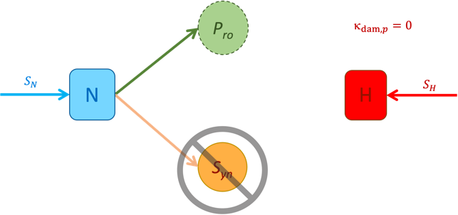  Case 2  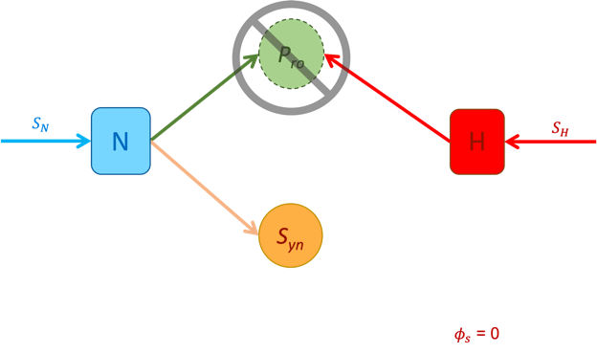 | Case 3  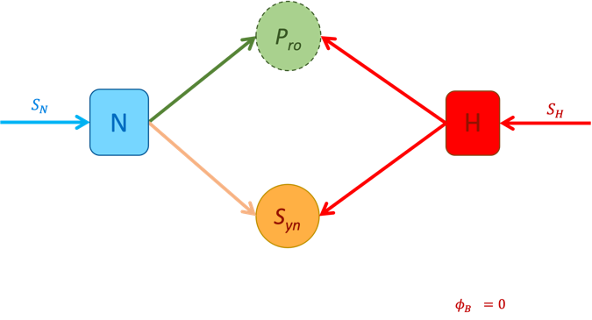  Case 4  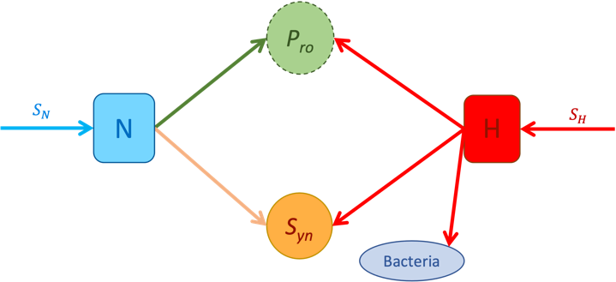
Figure ‎4.1 Extrapolating from four dimensionless plankton competition models to an in situ global plankton model influenced by realistic physical inputs. Stepwise (a -->b) model construction accounting for interactions of phytoplankton directly impacted or mediated by H₂O₂. This model formulation accounts for measurable pools of nutrients (N) , H₂O₂, (H) or cells of Prochlorococcus (Pro), Synechococcus (Syn), and heterotrophic bacterial helper (Bacteria) represented by bubbles. The arrows represent the fluxes of carbon, nitrogen, etc. between these pools. The fluxes of this model are controlled by parameters retrieved from monoculture data analyses in Chapter 2.

b.
A ‘simple’ ocean
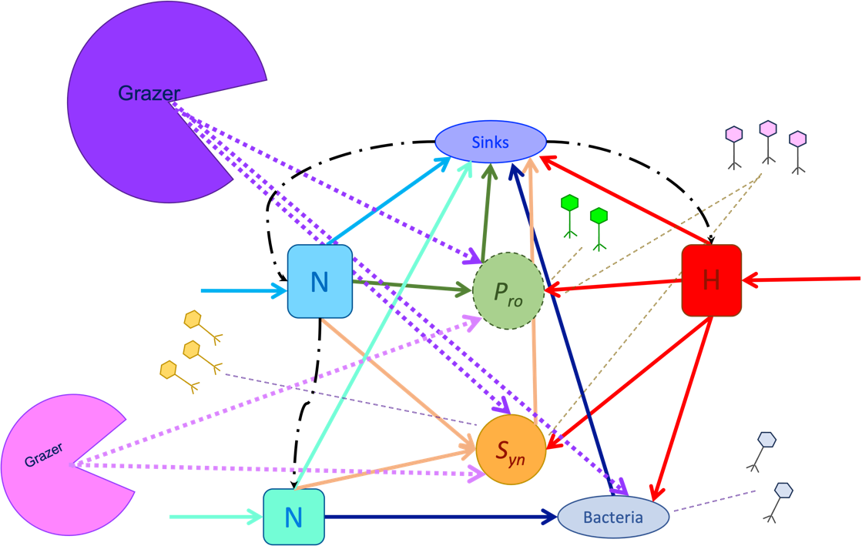
Figure 4.1 Continued

Generic tracers in the Darwin, labeled X (representing elements such as carbon, nitrogen, phosphorus, or iron), are influenced by advection $\left(κX\right)$, diffusion ($uX)$, and biological sources and sinks ($S_{BX })$ along with an additional loss (sinking) rate of $ωx$, that only applies to particles that are large enough to effect movement calculations (such as particulate organic matter or large phytoplankton). Z axis refers to axis of measured r5water column depth here.

$$\frac{∂X}{∂t} = S_{BX } - ∇∙\left(uX\right) + ∇∙\left(κX\right) - \frac{∂ωxX }{∂z}$$
𝐵𝑖𝑜𝑙𝑜𝑔𝑖𝑐𝑎l 𝑟𝑒𝑎𝑐𝑡𝑖𝑜𝑛𝑠 on X 𝑎𝑑𝑣𝑒𝑐𝑡𝑖𝑜𝑛 𝑑𝑖𝑓𝑓𝑢𝑠𝑖𝑜𝑛 sinking along Z axis

Different tracers, representing single nutrients or complex microbial cells, are integrated for 10 years along on a 1 degree x 1 degree resolution of the globe allowing for the evaluation of each tracers’ biogeographies (Follows et al. 2007). The first 9 years here are treated as a training (or burn in) period and we visualize patterns and dynamics that appear in the 10th, and final, year of the model. Darwin includes global temporal dynamics of temperature and light which are key to ROS production and were incorporated in the new H₂O₂ tracer dynamics (described below) for this global model. A Darwin model framework involving 6 plankton and 4 zooplankton each with unique growth traits implemented over the global ocean on chemical tracers such as carbon, ammonium, and iron (https://gitlab.com/darwinproject/gud/-/tree/gud/verification/monod_eccov3_6+4?ref_type=heads) was utilized. This implementation included offline ocean currents and initialization files for published Darwin tracers. This version of Darwin’s trait framework forms the basis our novel model implementation that incorporates H₂O₂ abiotic and biotic interactions into multiple plankton tracers on a global scale. In this way, observed H₂O₂ impacts on plankton growth were explicitly tied to global predictions of plankton abundance. This allowed for the investigation of H₂O₂ based parameters and assumptions on globally dominant plankton genera Prochlorococcus, Synechococcus, and Alteromonas on a global scale.

Model and experimental approach
We now document the changes that were made to the Darwin code, beginning with the insertion of our simple H₂O₂ model into a global framework. In the following equation reports the chemical and biological modification to the H₂O₂ tendency term (encapsulated within S_{Bx} in the above general mass-balance). Advective and diffusive effects on [H] are treated in the MITgcm (https://darwinproject.mit.edu/research/) and are not described further in this document.
$$\left[H\right]=\left[H\right]+\left(\left(QuantumYield\right)\left(DOC\right)\left({PAR}_{total}\right)-abioticHdecay \left[H\right]- {biotic}_{detox}\left[H\right]\right)*timestep$$
H concentration abiotic H production rate abiotic H decay rate biotic H detoxification rate
Here, H₂O₂ production is now a linear function (Powers and Miller 2014) of dissolved organic carbon (DOC) and Total Photosynthetically Available Radiation (PAR). The abiotic decay of H₂O₂ was merely converted from recovered Chapter 2 findings, and the biotic detoxification term is described below. The timestep parameter controls the time step for integration and was set to three hours for all simulations. H₂O₂ production was initiated at year 1 in the Darwin burn in period with a starting concentration of 0 and augmented abiotic H₂O₂ supply and decay parameters. The H₂O₂ dynamics were allowed to stabilize over 9 years. The 10th year within the Darwin model is then used for analysis of mean yearly H₂O₂ dynamics and projected resultant impacts on biotic tracers.

Case 1 – Nonleaky world, H₂O₂ no-impact
The tracers for Prochlorococcus and Synechococcus in Darwin were hijacked to allow for H₂O₂ trait parameter tradeoff analysis. For case 1, and all following cases, Prochlorococcus and Synechococcus were set to different size classes, with Prochlorococcus being the smaller, to allow Darwin’s allometry-based framework inflict a growth cost on Synechococcus for retaining detoxification enzymes. Detoxification of exogenous H₂O₂ was neglected by setting biotic_detox in the [H] tracer equation to zero. Nutrient distributions were initialized from previous Darwin simulations. The tracers of Prochlorococcus and Synechococcus were then simulated over 10 years. This non-leaky H₂O₂ assumption, case 1, allows for the analysis of Chapter 3 competition frameworks with a set of global H₂O₂ projections. With no H₂O₂ damage term implemented on Prochlorococcus, the cost of higher cell size (Synechococcus) and innate differences in nitrogen uptake and utilization traits (de Marsac et al. 2001; Moore et al. 2002) are expected to control the competitive outcome (Masuda et al. 2023).

Case 2 – Non-leaky world, H₂O₂ damage on Prochlorococcus implemented
The monoculture Prochlorococcus damage rate ($κ_{dam,p})$, isolated in Chapter 2 work, was converted to Darwin’s units and shown as the cell-based H₂O₂ damage ($κ_{dam,p}$) in the equation for Prochlorococcus ’s global tracer, denoted [P]. Table 4.1 shows the monoculture to Darwin conversions. The Synechococcus analogue was left agnostic to H₂O₂ as it was given neither H₂O₂ damage ($κ_{dam,S})$ nor H₂O₂ detoxification ($ϕ_{max,S})$ parameters. H₂O₂ dynamics were dominated by abiotic supply and decay rates described above. The Prochlorococcus was simulated to change with time as follows:
[P] = [P] + (DarwinGrowthFunctions - Kdam(j)*photoTempFunc(j)* [H] * [P] )*timestep
P concentration P growth rate P death rate due to H

Case 3 - Leaky world, Synechococcus detoxification implemented
The monoculture Synechococcus cell-specific detoxification rate ($ϕ_{max,S})$ isolated from Chapter 2 was converted to Darwin’s units, seen in Table 4.1, and inserted into the [H] tracer equation within the biotic detoxification parameter, $ϕ_{max,i}$. The ‘photoTempFunc’, a function included withing the Darwin framework, ensures that reactions with the rate $ϕ_{max,i}$ only occur in ranges of ecologically relevant temperatures (i.e., temperatures at which biotic growth can occur). The Prochlorococcus tracer was enacted as before in case 2. All community members were then projected forward through time for 10 years to analyze resultant community composition.
[${biotic}_{detox}$] = [${biotic}_{detox}$] + ( Phi(j)*photoTempFunc( j)* [H] ) *X )
S detoxification rate of H
In the Darwin code, this line appears within a for loop that sums over plankton types, j. Synechococcus, but not Prochlorococcus, is part of this plankton type (j).

Case 4 - Leaky world, Synechococcus and Bacterial detoxification
Lastly, heterotrophic bacterial (bacteria in equation) effects on detoxification, and thus Prochlorococcus biogeography were assessed. Biotic decay, from case 3, was given a second $ϕ_{max,i}$ term, this one reliant on a steady state heterotrophic bacterial concentration ((2500 cells per mL)) and recovered (within Chapter 2) Alteromonas H₂O₂ detoxification ($ϕ_{max,B})$ parameter values. With the lack of constraint on dynamics in situ heterotrophic bacterial concentrations (and corresponding lack of bacterial tracers within the Darwin framework), we enact only a steady concentration of heterotrophic bacteria, meaning no growth or innate death parameters are associated with the bacterial tracer. This also means the detoxification through bacteria does not draw down ammonium here, mirroring work done in Chapter 3), but acts outside of the Prochlorococcus and Synechococcus competition dynamics, acting on the H₂O₂ of the system alone. Prochlorococcus damage and Synechococcus detoxification is implemented as in case 3.

$${bacterial}_{detox}\left[H\right]= {[bacterial}_{detox}]+( Phi(j)*photoTempFunc( j)* [H] ) *X )$$
bacterial detoxification rate of H
H₂O₂ biotic rates
H₂O₂ abiotic rates
$$\left[H\right]=\left[H\right]+ \left(\left(QuantumYield\right)\left(DOC\right)\left({PAR}_{total}\right)-abioticHdecay \left[H\right] - {biotic}_{detox}\left[H\right] - {bacterial}_{detox}\left[H\right] \right)*timestep$$

As mentioned previously, Chapter 2 and 3 considered cells as their own entities while Darwin operates in moles of carbon, thus conversions were necessary to get recovered parameters into usable forms in this Darwin framework. The Prochlorococcus and Synechococcus plankton types within a published Darwin framework tracking 6 phytoplankton types globally were utilized to parallel the work performed non-spatially in Chapter 3. Cellular rates and parameter ranges from Chapter 2 were transformed into carbon-based rates to detoxification or damage scalars to be implemented via binary detoxification/damage parameters respectively. The values and conversions of Chapter 2 laboratory parameters to global model parameters for the Darwin framework are shown in Table 3. The binary state (on or off) of each global model parameter for investigative Cases 1- 4 is indicated by the color blocking in Table 4.

Results:
Following the cases laid out in Figure 4.1, we analyze the effect of stepwise inclusion of H₂O₂ parameters delineated in Table 4. In Figure 4.2 we show our predicted H₂O₂ abiotic concentrations buildup via dissolved organic material (DOM), light, and recovered H₂O₂ production parameter values (from Chapter 2) using the Darwin framework that works on top of MIT global circulation models. This means that H₂O₂ concentration is now subject to spatial/temporal patterns from physical models. Thus, our model allows for the analysis of H₂O₂ as it impacts of global nutrient and chemical fluxes. Note that DOM within Darwin is a combined term composed of DOC (Dissolved organic carbon) and other dissolved organic nutrients that were not tracked within original laboratory cultures from Chapter 2.

Case 1 – Nonleaky world, H₂O₂ no-impact
We first evaluated H₂O₂ implementation on a non-leaky world, or a world where H₂O₂ does not cross the cell membrane. Thus, we produce H₂O₂ (Figure 4.3) but the microbes are not affected by it (no biotic damage term, k_{dam},_{i} = 0) and are not affecting H₂O₂ either (no biotic detoxification term, $ϕ_{max,i}$= 0). This means that competition between microbes should be governed solely by their nutrient and temperature functions in Darwin. Specifically with regards to the differing size classes of Prochlorococcus and Synechococcus analogue implemented to account for Synechococcus growth disadvantage due to catalase production.
Prochlorococcus should numerically dominate Synechococcus in areas where ammonium superiority would give a growth advantage. This is seen in Figure 4.3 alongside a H₂O₂ plot that remains unchanged between Figure 4.2 as there is no H₂O₂ -based drawdowns on any plankton groups’ cell concentration. Prochlorococcus global concentration predictions, and all other tracer predictions except for DOC, thus remain largely unchanged between Darwin iterations without H₂O₂ and this first case of our H₂O₂ model. (Only minute differences in predictions occur here due to use of DOC in H₂O₂ production.

Case 2 – Nonleaky world, H₂O₂ damage on Prochlorococcus implemented
We next implement our retrieved monoculture damage rate for Prochlorococcus in a Prochlorococcus analogue in the global model. The flux of H₂O₂ across membranes here is only
Table 3 Monoculture laboratory parameters conversion to global Darwin parameters
Monoculture Name | Monoculture units | Darwin Name | Value | Units in Darwin
--------NA--------- | ---------- | H₂O₂_quantum_yield | 3.0 x10⁻¹⁰
K_{dam} Prochlorococcus | ml(cell)⁻¹(day)⁻¹ | H₂O₂_grp_Kdam | 6.4x10⁻⁵ | m³(mmol)⁻¹ (s)⁻¹
$ϕ_{max}$ abiotic | (day)⁻¹ | H₂O₂_abiotic_detox | 5.8 x10⁻⁸ | (s)⁻¹
$ϕ_{max}$ bacteria | ml(cell)⁻¹(day)⁻¹ | H₂O₂_bacterial_detox | 5.8 x10⁻⁶ | m³(mmol)⁻¹ (s)⁻¹
$ϕ_{max}$ Synechococcus | ml(cell)⁻¹(day)⁻¹ | H₂O₂_grp_Phi | 1.39 x10⁻⁴ | m³(mmol)⁻¹ (s)⁻¹

Table 4 Global parameter inclusion into four global model cases
Case | H₂O₂ | Abiotic detoxification | K_{dam} Prochlorococcus | $ϕ_{max}$ Synechococcus | $$ϕ_{max}$$  Heterotrophic bacteria
1 | yes | yes | no | no | no
2 | yes | yes | yes | no | no
3 | yes | yes | yes | yes | no
4 | yes | yes | yes | yes | yes

allowed for cells damaged by H₂O₂, Again, Synechococcus and other (heterotrophic) bacterial tracers are agnostic to H₂O₂. When projecting these results below, we see that the damage from H₂O₂ decimates Prochlorococcus across the globe allowing for Synechococcus to achieve what many humans strive for; world domination. However non-leaky detoxification is not possible practically for microbes in the ocean as H₂O₂ crosses cell membranes and is produced in the sunlit surface ocean.

Case 3 - Leaky world, Synechococcus detoxification implemented
We next transition to a leaky world, as we know H₂O₂ can cross biological and artificial phospholipid membranes (Antunes and Cadenas 2000; Möller et al. 2019; Tjell and Almdal 2018). Implementing detoxification found in Chapter 2 for the Synechococcus analogue, we view a global model of a two-microbe system in H₂O₂ below in Figure 4.5. With Synechococcus alone conducting detoxification, Prochlorococcus biogeography is expanded back to a range reminiscent of in situ studies. Not only does Prochlorococcus survive in marine environments unavailable to it in Figure 4.4., it does so with the implementation of monoculture H₂O₂ damage and detoxification ($ϕ_{max,i})$parameters retrieved in Chapter 2. Thus, monoculture H₂O₂ interactions, parameterized in laboratory cultures, have the potential to impact global microbial populations. Note that while Prochlorococcus does grow in the lower latitudes, the encroachment of Synechococcus into the northern Atlantic regions does not match in situ data (Buitenhuis et al. 2012; Partensky, Blanchot, and Vaulot 1999).

Case 4 - Leaky world, Synechococcus and Bacterial detoxification
Lastly, bacterial detoxification along with Synechococcus biotic detoxification was analyzed with respect to model outcomes. Figure 6 shows these results. With bacterial detoxification implemented as a $ϕ_{max,B}$ and B*, with B* here representing the assumed equilibria (stationary phase concentration) of heterotrophic bacterial population. This additional detoxification essentially reduced the standing stock of H₂O₂ that Synechococcus then has to detoxify in order to compete to coexist with Prochlorococcus. Bacterial detoxification (without Synechococcus) is visualized in the Chapter 4 Supplementary Information of Appendix C. While Synechococcus detoxification alone seems to save Prochlorococcus in this model framework, the amount of Prochlorococcus recovered with bacteria and Synechococcus is greater than that of Synechococcus detoxification alone. With bacteria like Alteromonas absent from biogeochemical models, this basal detoxification using monoculture parameters and assumed stationary bacteria are the limit of this study.

Discussion:
Chapter 4 adds realism to this modeling story with the addition of physical water movements, seasonal variation, and global spatial resolution. We use the Darwin framework that transports biological tracers, affected by light, nutrient, and temperature fields, by currents, u, and mixing coefficients, κ, using the MIT ocean circulation model. Cases 1 – 4 shown in Table 4 are investigated using Prochlorococcus and Synechococcus analogues made to differ in nutrient affinity using Darwin ‘s built in allometric scaling. Initial model runs, case 1, were used to ensure that under a zero H₂O₂ production regime (Figure 4.3), a superior nutrient affinity (Prochlorococcus analogue) ensures competitive advantage in marine systems. This H₂O₂ map is projected from case 1 of the methods mentioned above. Brighter red colors represent higher H₂O₂ within ocean waters. These projected values are from between the 25 and 30m depth slice (27.5 meters is the midpoint) of the MITgcm giving the approximate mixed layer concentration of H₂O₂ of the globe.
H₂O₂ global production was implemented as a function of our recovered (Chapter 2) H₂O₂ production rate, Dissolved organic material (DOM) concentrations, and light influx for the surface ocean. More accurate quantum yields of H₂O₂ take into account the wavelengths of light, but this is not yet feasible for this model within the Darwin framework as PAR is a composite variable. However the global map of 1 year the results of our projected H₂O₂ geography in Figures 4.2a and 4.2b respectively give similar patterns and ranges to more complex photochemical models (Zhu et al. 2022). With H₂O₂ production solved, the biological connections between H₂O₂ and Prochlorococcus or Synechococcus were inserted first with damage and then detoxification rates. By inserting damage rates (recovered from Chapter 2) without implementing detoxification as well, we simulate a ‘selfish detoxification’ world. This allows for Figure 4.5 to give the resultant ‘flipped’ biogeography to that of known oceanic measurements (Partensky, Blanchot, and Vaulot 1999) , while the implementation of both damage and detoxification gave a more realistic world view in Figure 4.6. The abiotic decay,

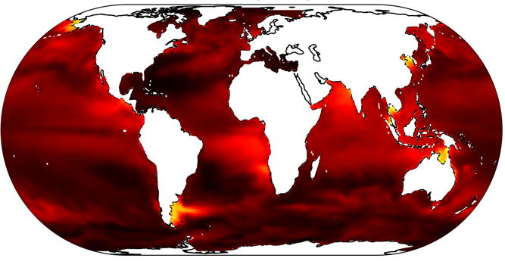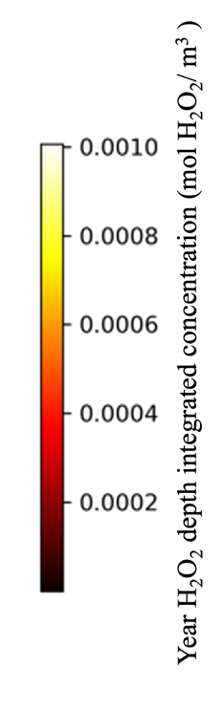
Figure ‎4.2 Mean temporally aggregated H₂O₂ concentration from last year of a 10 year global circulation model

a H₂O₂ M b Syn/ (Pro+ Syn)
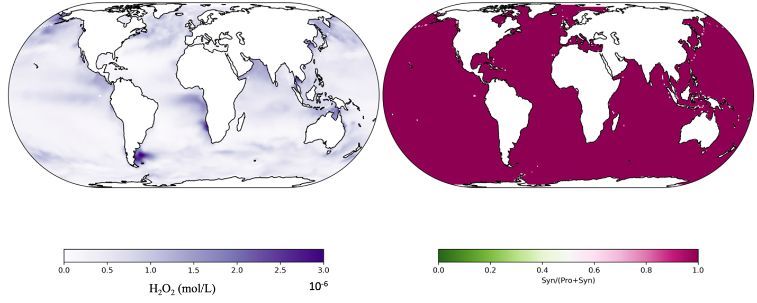
Figure ‎4.3 Nutrient Competition in a non-leaky world
Annual mean H₂O₂ (a, left) and the ratio of Synechococcus (Syn) over Prochlorococcus (Pro) and Synechococcus (Syn) (b,right) from the last year (9 or 10) in case 1 of our model. With the nutrient tradeoff of H₂O₂ detoxification incorporated but not H₂O₂ impact, Synechococcus (in red) is outcompeted nearly everywhere by Prochlorococcus (in green). Thus, if H₂O₂ is not directly tied to the biology, Prochlorococcus is this model format is projected to numerically dominate over Synechococcus at lower latitudes via its superior ammonium affinity.

a H₂O₂ M b Syn/ (Pro+ Syn)
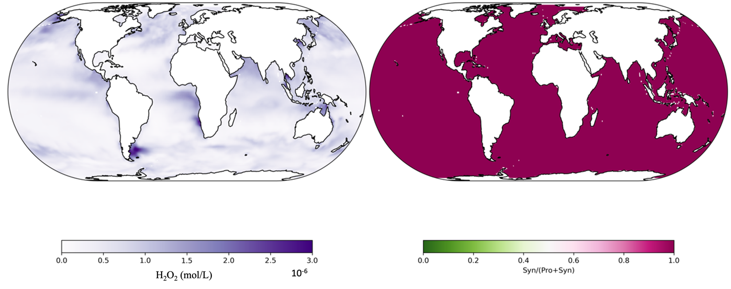
Figure ‎4.4 Unilateral H₂O₂ damage in a non-leaky world
Annual H₂O₂ (left, a) and (right,b) Synechococcus (Syn) over Prochlorococcus (Pro) and Synechococcus (Syn) ratio predicted from 1 year if H₂O₂ influx (S_{H} > 0) and damage (${}_{dam,i}$) but no biotic detoxification $\left(ϕ_{max,i} \right)$ is allowed. Synechococcus survives H₂O₂ test while Prochlorococcus is killed everywhere despite its superior nutrient affinity. Leading to a world devoid of Prochlorococcus cell biomass.

a H₂O₂ M b Syn/ (Pro+ Syn)
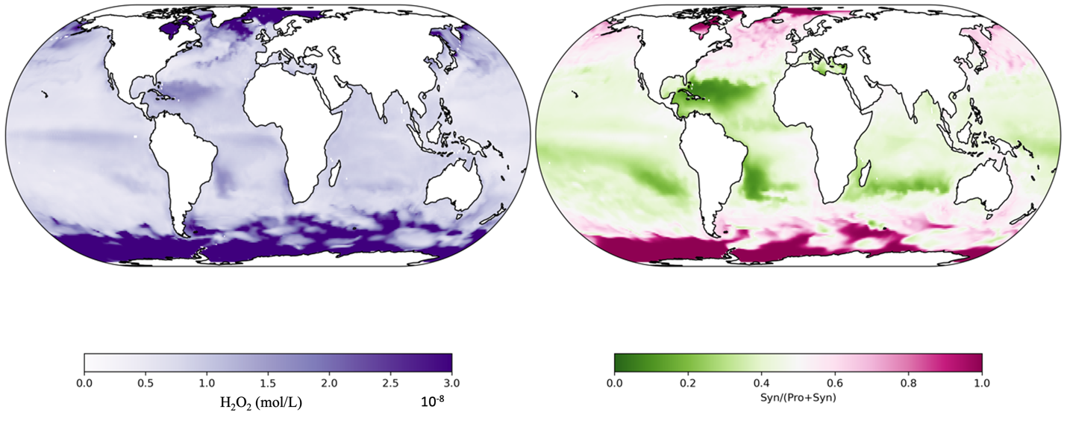
Figure ‎4.5 Leaky H₂O₂ dynamics using monoculture Prochlorococcus and Synechococcus parameters. Annual mean H₂O₂ (left,a) and (right,b) Prochlorococcus and Synechococcus from year 9 of our model case for H₂O₂ impact with biotic detoxification implemented as well. Prochlorococcus is saved from obliteration through the implementation of a biotic H₂O₂ detoxification parameter $\left(ϕ_{max,i} \right)$provided by Synechococcus cells ($ϕ_{max,S})$in this case 3 model run. Heterotrophic bacteria are neglected in this case (#3).

a H₂O₂ M b Syn/ (Pro+ Syn) 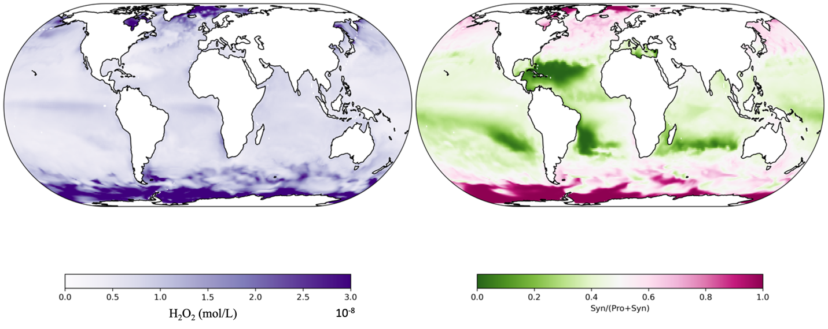
Figure ‎4.6 Leaky H₂O₂ dynamics using Bacterial and Synechococcus detoxification parameters.
H₂O₂ (left, a) and (right,b ), Prochlorococcus and Synechococcus ratio predictions incurred from Synechococcus and bacterial detoxification both occurring within a global framework. Prochlorococcus is further saved by H₂O₂ detoxification parameter from Synechococcus ($ϕ_{max,S}$) and bacterial detoxification ($ϕ_{max,B}$) inclusion, while Synechococcus biomass is also bolstered (in the southern ocean) by the additional (heterotrophic bacteria) detoxification.

other than bacterial inclusion in case 4, is not linked to cell waste. Dead cells and particulate matter pools of material may act as significant reactive oxygen sinks. But as these are unquantified currently on monoculture levels, we identify this for future studies. Prochlorococcus biogeography is commonly modeled to be primarily based on the intersection of environmental nitrogen, temperature, and light forcings (Flombaum et al. 2013; Rabouille, Edwards, and Zehr 2007). Higher ammonium affinity allows Prochlorococcus to numerically dominate low latitude and oceanic gyres (Partensky, Blanchot, and Vaulot 1999, 201; Partensky and Garczarek 2010) over other phytoplankton genera (Dutkiewicz, Follows, and Bragg 2009). Previous models indicate Prochlorococcus and Synechococcus community composition is influenced by differential light and nutrient or temperature optima (Moore, Goericke, and Chisholm 1995; Mella-Flores et al. 2012; Lipschultz 1995). Light and temperature stress are both implicated in reactive oxygen species mediated cell damage (Fu et al. 2007; Ma et al. 2018). With multiple intersecting environmental stresses weighing on cyanobacteria, H₂O₂ detoxification amelioration has important environmental stress relieving effects on Prochlorococcus growth. Ma (2018) investigated the effect of H₂O₂ on biogeochemistry with regard to temperature, showing that microbial helper populations were essential to recover Prochlorococcus biogeography reflected in oceanic data (Partensky, Blanchot, and Vaulot 1999; Ma et al. 2018). This study expands upon possible bacterial cell effects on Prochlorococcus though with evaluation of plankton cell-specific (Chapter 2 isolated) detoxification ($ϕ_{max,i}$) of environmental H₂O₂.
Decreasing pH of the ocean is projected to increase ocean reactivity (Ahmad et al. 2015; Hopwood et al. 2018) while increased CO₂ also has been shown to increase H₂O₂ production (Klanian and Preciat 2017; Hennon et al. 2018). Further, warmer temperatures are predicted decrease oceanic nitrogen flux (Beman et al. 2011; Sallée et al. 2021) and augment community composition through cascading changes in nutrient structure (Dutkiewicz et al. 2014, 201; 2015). This implies that as pCO₂ rises and oceans warm (Dutkiewicz, Scott, and Follows 2013; Fu et al. 2007) H₂O₂ detoxification requirements of Prochlorococcus may be simultaneously more profound and less addressed via the community.
Prior H₂O₂ models have shown depth and spectra resolved H₂O₂ quantum yields from seawater (He and Häder 2002; Zhu et al. 2022; Cooper et al. 1988). This study omits the noted effects of UV spectra on H₂O₂ as our current laboratory data made it impossible to isolate specific wavelength based H₂O₂ parameters. Instead, the study utilizes the Darwin total PAR as the main light controlling H₂O₂ production in the global model. Further (dissolved organic carbon) DOC and light effects on H₂O₂ are not constrained in monoculture (Chapter 2) here before insertion (S_{H} term here originated from spike assay analyses in Chapter 2). Use of these models on H₂O₂ producing or inert media buffers, like HEPES and TAPS buffers, in Appendix A, (Zinser 2013; Zigler et al. 1985; Lepe-Zuniga, Zigler, and Gery 1987) or natural waters (Morris et al. 2016; Goldstone and Voelker 2000; Powers and Miller 2014) that produce H₂O₂ could further constrain the production terms in this model format to start accounting for this drawback. Dark production has been noted for various reactive oxygen species (Sutherland, Wankel, and Hansel 2020; Zinser 2013) but this is ignored here as the diel light cycle produces significantly higher H₂O₂ fluxes (Cooper et al. 1988) and more readily matches laboratory methods and prior H₂O₂ ocean studies (Morris, Rose, and Lu 2022; Zinser 2018b). This study also ignores direct H₂O₂ deposition from atmospheric production and diffusion (O’Sullivan et al. 1999), rain events (Willey, Paerl, and Go 1999; Hopwood et al. 2018; Morris, Rose, and Lu 2022), and terrestrial runoff effects (Zhang, Del Vecchio, and Blough 2012) which have all been noted as significant sources of surface water H₂O₂. This model uses binary inclusion of model parameters in cases 1- 4 but there are an array of H₂O₂ detoxification mechanisms and an even larger array of ways in which cells have been shown to augment the number, regulation, or combination of these detoxification mechanisms throughout their lifecycles (Gómez-Baena et al. 2001; Kawasaki et al. 1997; Morris et al. 2016, 20; Rai et al. 2021; Sato et al. 1992; Venkatesan et al. 2007; Schellhorn 1995). This range of control on possible H₂O₂ parameter values at the microbial cell level are ignored here for simplicity. Further, another iteration of Darwin, using intercellular fluxes has been published, but as exact H₂O₂ detoxification mechanisms have not been mechanistically traced within Prochlorococcus cells as extensively they have been in E.coli (Seaver and Imlay 2001) or neutrophils (Ohno and Gallin 1985), this remains out of our framework’s scope. To our knowledge, none of these reported H₂O₂ influences are incorporated into large scale ecosystem or biogeochemical model. Using Darwin, we have assessed biologically measured impacts of H₂O₂ on dominant microbes in the oligotrophic ocean.
This model does not account for ecotype or strain variability within any of the microbes chosen here. The Darwin framework does allow for multiple microbes within a group to scale a shared trait allometrically so later inclusion of this intricacy may be feasible. However, more monoculture constraint on the connection between detoxification gene presence within a cell and the cell’s detoxification ability is needed for clarity here. Furthermore, we chose microbes of importance for Chapter 2 basal modeling. However, the Darwin model framework we utilized only includes 10 plankton (6 phytoplankton, 4 zooplankton) total, meaning it fails to capture a variety of ocean complexity. The picoeukaryotic (Appendix B) and picoheterotrophic (Alteromonas in Appendix A) bacteria that seem to detoxify most for Prochlorococcus, are among the dynamics lost with this model implementation despite their various documented impacts on Prochlorococcus’ growth (Biller, Coe, et al. 2018; Guillou et al. 2001, 20; Follett et al. 2022; Weissberg, Aharonovich, and Sher 2023, 20). Different heterotrophs have documented differential susceptibilities to H₂O₂ (Bond, Hansel, and Voelker 2020, 202), thus these need to be investigated along with picoeukaryotes that grow alongside Prochlorococcus (Visintini, Martiny, and Flombaum 2021).

Conclusions:
The aim of Chapter 4 was to insert the cell based H₂O₂ parameters that were isolated and estimated in Chapter 2 and investigate the community dynamics those parameters predict in Chapter 3 on a global scale via the phytoplankton trait-based model Darwin. With the exploration of H₂O₂ trait parameters, differences in H₂O₂ susceptibilities on model organisms from laboratory to global scales are analyzed. Through differential implementations of the full model framework, global repercussions of two recovered H₂O₂ parameters ($ϕ_{max,i }and k_{dam,i })$on the microbiology of the ocean were further investigated. Outcomes in this chapter echoed non-spatial model conclusions; that the combination of H₂O₂ leaky damage and H₂O₂ leaky detoxification can allow for coexistence rather than competitive exclusion in our model.

Conclusions and Future Work

Author(s): D.K.M., D.T.
Author contribution statements: Written and edited by D.K.M. with feedback from D.T.

Prochlorococcus is the smallest yet most numerous phytoplankton of the oligotrophic surface ocean (Flombaum et al. 2013; Partensky, Blanchot, and Vaulot 1999, 199). Its dominance of marine microbial communities is primarily attributed to its superior nutrient affinities (Masuda et al. 2023; Partensky and Garczarek 2010) induced from genetic and physical streamlining. Prochlorococcus’s closest genetic relative, Synechococcus, dominates growth at higher latitudes and lower depths as compared to its streamlined sister (Flombaum et al. 2013, 201). Lab experiments indicate that streamlining-induced loss of fundamental hydrogen peroxide (H₂O₂) detoxication genes, like katG encoded catalase-peroxidase, has led to Prochlorococcus requiring coexisting ‘helper’ microbes, such as Synechococcus (Bernroitner et al. 2009; Biller, Berube, et al. 2015; Morris et al. 2011), survive the daily environmental H₂O₂ produced (Morris, Rose, and Lu 2022; Zhu et al. 2022) surface waters. Current phytoplankton global models attribute 25% of global production to Prochlorococcus (Flombaum et al. 2013) but exclude H₂O₂ as a source of microbial death.
H₂O₂ production may be directly impacted by the higher pCO₂, higher temperatures, and lower pHs predicted to occur with changing climate and increasingly stratified upper ocean. Microbial nutrient structures will be further impacted by the decreased atmospheric nitrogen deposition along with decreased upwelling rates (Gruber and Galloway 2008; Altabet, Robinson, and Walstad 1986, 19). Nutrient pressures alone would indicate the future ocean selecting for Prochlorococcus -like microbes (Martiny et al. 2022; Voss et al. 2013). However, as H₂O₂ inputs may increase, while nutrient depletion could simultaneously decrease community ‘helper‘ populations, additional investigation is required to further the understanding of this system. Current biochemically resolved circulation models of Earth’s oceans (Carroll et al., 2020; Ward et al., 2012) agree with thermal niche and nutrient models that Prochlorococcus dominates in the most oligotrophic marine surface regions (Dutkiewicz, Follows, and Bragg 2009; Follows and Dutkiewicz 2011; Ward et al. 2017). However explicit representations of H₂O₂, impacts on these cyanobacteria have been ignored. This thesis aims to serve as a basal step in filling this need.
This thesis presents a stepwise methodology for the construction of a microbial model framework. Laboratory data was used to constrain monoculture parameters that we then manipulate across modeled nutrient and H₂O₂ landscapes in order to investigate these as drivers of microbial community composition. Divergent phenotypes of different picoplankton are quantifiable H₂O₂ using this model. This is the first iteration of quantifying the biogeographical impact of H₂O₂ on various plankton found in the surface ocean. The tradeoffs between growth advantage (Prochlorococcus and other streamlined competitors) and H₂O₂ detoxification (Synechococcus or heterotrophic bacteria) were found to control the toggle between competitive and coexistent behavior in this model framework. The leakiness of H₂O₂ detoxification was found to be a key driver of coexistence both in both the dimensionless Chapter 3 and the spatially and temporally resolved Chapter 4. Thus, quantitative ecological evaluation of microbes impacted by H₂O₂ can be performed at the community level using this model framework.

References
Adkins-Jablonsky, Colleen M. Clark, Spiridon E. Papoulis, Matthew D. Kuhl, and J. Jeffrey Morris. 2021. “Market Forces Determine the Distribution of a Leaky Function in a Simple Microbial Community.” Proceedings of the National Academy of Sciences 118 (39): e2109813118. https://doi.org/10.1073/pnas.2109813118.
Aharonovich, and Daniel Sher. 2016. “Transcriptional Response of Prochlorococcus to Co-Culture with a Marine Alteromonas: Differences between Strains and the Involvement of Putative Infochemicals.” The ISME Journal 10 (12): 2892–2906. https://doi.org/10.1038/ismej.2016.70.
Ahlgren, and Gabrielle Rocap. 2012. “Diversity and Distribution of Marine Synechococcus: Multiple Gene Phylogenies for Consensus Classification and Development of qPCR Assays for Sensitive Measurement of Clades in the Ocean.” Frontiers in Microbiology 3. https://doi.org/10.3389/fmicb.2012.00213.
Ahmad, Xiaogang Gu, Li Li, Shuguang Lu, Yisheng Xu, and Xuhong Guo. 2015. “Effects of pH and Anions on the Generation of Reactive Oxygen Species (ROS) in nZVI-rGo-Activated Persulfate System.” Water, Air, & Soil Pollution 226 (11): 369. https://doi.org/10.1007/s11270-015-2635-8.
Aksnes, and Jk Egge. 1991. “A Theoretical Model for Nutrient Uptake in Phytoplankton.” Marine Ecology Progress Series 70:65–72. https://doi.org/10.3354/meps070065.
Alfonso-Prieto, Xevi Biarnés, Pietro Vidossich, and Carme Rovira. 2009. “The Molecular Mechanism of the Catalase Reaction.” Journal of the American Chemical Society 131 (33): 11751–61. https://doi.org/10.1021/ja9018572.
Allison. 2005. “Cheaters, Diffusion and Nutrients Constrain Decomposition by Microbial Enzymes in Spatially Structured Environments: Constraints on Enzymatic Decomposition.” Ecology Letters 8 (6): 626–35. https://doi.org/10.1111/j.1461-0248.2005.00756.x.
Alonso-Sáez, Antonio S. Palacio, Ana M. Cabello, Semidán Robaina-Estévez, José M. González, Laurence Garczarek, and Ángel López-Urrutia. 2023. “Transcriptional Mechanisms of Thermal Acclimation in Prochlorococcus.” Edited by Jennifer B. H. Martiny. mBio 14 (3): e03425-22. https://doi.org/10.1128/mbio.03425-22.
Altabet, Allan R. Robinson, and Leonard J. Walstad. 1986. “A Model for the Vertical Flux of Nitrogen in the Upper Ocean: Simulating the Alteration of Isotopic Ratios.” Journal of Marine Research 44 (1): 203–25. https://doi.org/10.1357/002224086788460111.
Anderson, Quintin P. Diou‐Cass, and Elizabeth L. Harvey. 2018. “Short‐term Estimates of Phytoplankton Growth and Mortality in a Tidal Estuary.” Limnology and Oceanography 63 (6): 2411–22. https://doi.org/10.1002/lno.10948.
Antunes, and Enrique Cadenas. 2000. “Estimation of H ₂ O ₂ Gradients across Biomembranes.” FEBS Letters 475 (2): 121–26. https://doi.org/10.1016/S0014-5793(00)01638-0.
Archibald, Stephanie Dutkiewicz, Charlotte Laufkötter, and Holly V. Moeller. 2022. “Thermal Responses in Global Marine Planktonic Food Webs Are Mediated by Temperature Effects on Metabolism.” Journal of Geophysical Research: Oceans 127 (12): e2022JC018932. https://doi.org/10.1029/2022JC018932.
Arístegui. 2005. “Active Mesopelagic Prokaryotes Support High Respiration in the Subtropical Northeast Atlantic Ocean.” Geophysical Research Letters 32 (3): L03608. https://doi.org/10.1029/2004GL021863.
Armstrong, and Richard McGehee. 1980. “Competitive Exclusion.” Am. Nat. 1980. Vol. 115,:151–70.
Avery, William J. Cooper, Robert J. Kieber, and Joan D. Willey. 2005. “Hydrogen Peroxide at the Bermuda Atlantic Time Series Station: Temporal Variability of Seawater Hydrogen Peroxide.” Marine Chemistry 97 (3–4): 236–44. https://doi.org/10.1016/j.marchem.2005.03.006.
Avrani, and Debbie Lindell. 2015. “Convergent Evolution toward an Improved Growth Rate and a Reduced Resistance Range in Prochlorococcus Strains Resistant to Phage.” Proceedings of the National Academy of Sciences 112 (17). https://doi.org/10.1073/pnas.1420347112.
Azam, T Fenchel, Jg Field, Js Gray, La Meyer-Reil, and F Thingstad. 1983. “The Ecological Role of Water-Column Microbes in the Sea.” Marine Ecology Progress Series 10:257–63. https://doi.org/10.3354/meps010257.
Babić, Ines Petrić, Sunčica Bosak, Hrvoje Mihanović, Iris Dupčić Radić, and Zrinka Ljubešić. 2017. “Distribution and Diversity of Marine Picocyanobacteria Community: Targeting of Prochlorococcus Ecotypes in Winter Conditions (Southern Adriatic Sea).” Marine Genomics 36 (December):3–11. https://doi.org/10.1016/j.margen.2017.05.014.
Baer, Michael W. Lomas, Kristina X. Terpis, Céline Mouginot, and Adam C. Martiny. 2017. “Stoichiometry of Prochlorococcus, Synechococcus , and Small Eukaryotic Populations in the Western North Atlantic Ocean: Taxon-Specific Stoichiometry of Phytoplankton.” Environmental Microbiology 19 (4): 1568–83. https://doi.org/10.1111/1462-2920.13672.
Bailey, and Arthur Grossman. 2008. “Photoprotection in Cyanobacteria: Regulation of Light Harvesting †.” Photochemistry and Photobiology 84 (6): 1410–20. https://doi.org/10.1111/j.1751-1097.2008.00453.x.
Banerjee, Prashanth S. Raghavan, Anand Ballal, Hema Rajaram, and S. K. Apte. 2013. “Oxidative Stress Management in the Filamentous, Heterocystous, Diazotrophic Cyanobacterium, Anabaena PCC7120.” Photosynthesis Research 118 (1–2): 59–70. https://doi.org/10.1007/s11120-013-9929-8.
Banse. 1995. “Zooplankton: Pivotal Role in the Control of Ocean Production.” ICES Journal of Marine Science 52 (3–4): 265–77. https://doi.org/10.1016/1054-3139(95)80043-3.
Bar, Tewfik Sari, ,Université AbouBakr Belkaid, LSDA, Tlemcen, Algérie, and ,ITAP, Univ Montpellier, Irstea, Montpellier SupAgro, Montpellier, France. 2020. “The Operating Diagram for a Model of Competition in a Chemostat with an External Lethal Inhibitor.” Discrete & Continuous Dynamical Systems - B 25 (6): 2093–2120. https://doi.org/10.3934/dcdsb.2019203.
Barberán, and Eo Casamayor. 2010. “Global Phylogenetic Community Structure and β-Diversity Patterns in Surface Bacterioplankton Metacommunities.” Aquatic Microbial Ecology 59 (March):1–10. https://doi.org/10.3354/ame01389.
Barreto Filho, Zhiying Lu, Melissa Walker, and J Jeffrey Morris. 2022. “Community Context and pCO2 Impact the Transcriptome of the ‘Helper’ Bacterium Alteromonas in Co-Culture with Picocyanobacteria.” ISME Communications 2 (1): 113. https://doi.org/10.1038/s43705-022-00197-2.
Barton, S. Dutkiewicz, G. Flierl, J. Bragg, and M. J. Follows. 2010. “Patterns of Diversity in Marine Phytoplankton.” Science 327 (5972): 1509–11. https://doi.org/10.1126/science.1184961.
Barynin, Mei M Whittaker, Svetlana V Antonyuk, Victor S Lamzin, Pauline M Harrison, Peter J Artymiuk, and James W Whittaker. 2001. “Crystal Structure of Manganese Catalase from Lactobacillus Plantarum.” Elsevier Science : Structure Vol. 9:725-738,.
Baumann, Linda Baumann, Ron D. Bowditch, and Blaine Beaman. 1984. “Taxonomy of Alteromonas: A. Nigrifaciens Sp. Nov., Nom. Rev.; A. Macleodii; and A. Haloplanktis.” International Journal of Systematic and Evolutionary Microbiology, 34 (2): 145–49. https://doi.org/10.1099/00207713-34-2-145.
Beaulieu, Ilia J. Leitch, Sunil Patel, Arjun Pendharkar, and Charles A. Knight. 2008. “Genome Size Is a Strong Predictor of Cell Size and Stomatal Density in Angiosperms.” New Phytologist 179 (4): 975–86. https://doi.org/10.1111/j.1469-8137.2008.02528.x.
Beckett, and Joshua S. Weitz. 2017. “Disentangling Niche Competition from Grazing Mortality in Phytoplankton Dilution Experiments.” Edited by Hans G. Dam. PLOS ONE 12 (5): e0177517. https://doi.org/10.1371/journal.pone.0177517.
Behrenfeld, Emmanuel Boss, David A. Siegel, and Donald M. Shea. 2005. “Carbon‐based Ocean Productivity and Phytoplankton Physiology from Space.” Global Biogeochemical Cycles 19 (1): 2004GB002299. https://doi.org/10.1029/2004GB002299.
Beman, Cheryl-Emiliane Chow, Andrew L. King, Yuanyuan Feng, Jed A. Fuhrman, Andreas Andersson, Nicholas R. Bates, Brian N. Popp, and David A. Hutchins. 2011. “Global Declines in Oceanic Nitrification Rates as a Consequence of Ocean Acidification.” Proceedings of the National Academy of Sciences 108 (1): 208–13. https://doi.org/10.1073/pnas.1011053108.
Bengtsson-Palme, Magnus Alm Rosenblad, Mikael Molin, and Anders Blomberg. 2014. “Metagenomics Reveals That Detoxification Systems Are Underrepresented in Marine Bacterial Communities.” BMC Genomics 15 (1): 749. https://doi.org/10.1186/1471-2164-15-749.
Bentkowski, Cock Van Oosterhout, and Thomas Mock. 2015. “A Model of Genome Size Evolution for Prokaryotes in Stable and Fluctuating Environments.” Genome Biology and Evolution 7 (8): 2344–51. https://doi.org/10.1093/gbe/evv148.
Bernroitner, Marcel Zamocky, Paul G. Furtmüller, Günter A. Peschek, and Christian Obinger. 2009. “Occurrence, Phylogeny, Structure, and Function of Catalases and Peroxidases in Cyanobacteria.” Journal of Experimental Botany 60 (2): 423–40. https://doi.org/10.1093/jxb/ern309.
Berube, Steven J. Biller, Thomas Hackl, Shane L. Hogle, Brandon M. Satinsky, Jamie W. Becker, Rogier Braakman, et al. 2018. “Single Cell Genomes of Prochlorococcus, Synechococcus, and Sympatric Microbes from Diverse Marine Environments.” Scientific Data 5 (1): 180154. https://doi.org/10.1038/sdata.2018.154.
Berube, Steven J Biller, Alyssa G Kent, Jessie W Berta-Thompson, Sara E Roggensack, Kathryn H Roache-Johnson, Marcia Ackerman, et al. 2015. “Physiology and Evolution of Nitrate Acquisition in Prochlorococcus.” The ISME Journal 9 (5): 1195–1207. https://doi.org/10.1038/ismej.2014.211.
Berube, Tyler J. O’Keefe, Anna Rasmussen, Trent LeMaster, and Sallie W. Chisholm. 2023. “Production and Cross-Feeding of Nitrite within Prochlorococcus Populations.” Edited by Nicole Dubilier. mBio, July, e01236-23. https://doi.org/10.1128/mbio.01236-23.
Bienert, Anders L.B. Møller, Kim A. Kristiansen, Alexander Schulz, Ian M. Møller, Jan K. Schjoerring, and Thomas P. Jahn. 2007. “Specific Aquaporins Facilitate the Diffusion of Hydrogen Peroxide across Membranes.” Journal of Biological Chemistry 282 (2): 1183–92. https://doi.org/10.1074/jbc.M603761200.
Bier, Emily S. Bernhardt, Claudia M. Boot, Emily B. Graham, Edward K. Hall, Jay T. Lennon, Diana R. Nemergut, et al. 2015. “Linking Microbial Community Structure and Microbial Processes: An Empirical and Conceptual Overview.” Edited by Gerard Muyzer. FEMS Microbiology Ecology 91 (10): fiv113. https://doi.org/10.1093/femsec/fiv113.
Biller, Paul M. Berube, Keven Dooley, Madeline Williams, Brandon M. Satinsky, Thomas Hackl, Shane L. Hogle, et al. 2018. “Marine Microbial Metagenomes Sampled across Space and Time.” Scientific Data 5 (1): 180176. https://doi.org/10.1038/sdata.2018.176.
Biller, Paul M. Berube, Debbie Lindell, and Sallie W. Chisholm. 2015. “Prochlorococcus: The Structure and Function of Collective Diversity.” Nature Reviews Microbiology 13 (1): 13–27. https://doi.org/10.1038/nrmicro3378.
Biller, Allison Coe, Ana-Belen Martin-Cuadrado, and Sallie W. Chisholm. 2015. “Draft Genome Sequence of Alteromonas Macleodii Strain MIT1002, Isolated from an Enrichment Culture of the Marine Cyanobacterium Prochlorococcus.” Genome Announcements 3 (4): e00967-15, /ga/3/4/e00967-15.atom. https://doi.org/10.1128/genomeA.00967-15.
Biller, Allison Coe, Sara E. Roggensack, and Sallie W. Chisholm. 2018. “Heterotroph Interactions Alter Prochlorococcus Transcriptome Dynamics during Extended Periods of Darkness.” Edited by Olivia Mason. mSystems 3 (3): e00040-18. https://doi.org/10.1128/mSystems.00040-18.
Blot, Daniella Mella-Flores, Christophe Six, Gildas Le Corguillé, Christophe Boutte, Anne Peyrat, Annabelle Monnier, et al. 2011. “Light History Influences the Response of the Marine Cyanobacterium Synechococcus Sp. WH7803 to Oxidative Stress.” Plant Physiology 156 (4): 1934–54. https://doi.org/10.1104/pp.111.174714.
Blough, and R.G. Zepp. 1995. “Reactive Oxygen Species in Natural Waters.” In Active Oxygen in Chemistry. Structure Energetics and Reactivity in Chemistry Series, 1995th ed. Vol. 2. Springer, Dordrecht. https://doi.org/10.1007/978-94-007-0874-7_8.
Boden, Kurt O. Konhauser, Leslie J. Robbins, and Patricia Sánchez-Baracaldo. 2021. “Timing the Evolution of Antioxidant Enzymes in Cyanobacteria.” Nature Communications 12 (1): 4742. https://doi.org/10.1038/s41467-021-24396-y.
Bond, Colleen M. Hansel, and Bettina M. Voelker. 2020. “Heterotrophic Bacteria Exhibit a Wide Range of Rates of Extracellular Production and Decay of Hydrogen Peroxide.” Frontiers in Marine Science 7 (February):72. https://doi.org/10.3389/fmars.2020.00072.
Boyd. 2015. “Toward Quantifying the Response of the Oceans’ Biological Pump to Climate Change.” Frontiers in Marine Science 2 (October). https://doi.org/10.3389/fmars.2015.00077.
Brill, and R. J. P. Williams. 1961. “Primary Compounds of Catalase and Peroxidase.” Biochemical Journal 78 (2): 253–62. https://doi.org/10.1042/bj0780253.
Bristow, Wiebke Mohr, Soeren Ahmerkamp, and Marcel M.M. Kuypers. 2017. “Nutrients That Limit Growth in the Ocean.” Current Biology 27 (11): R474–78. https://doi.org/10.1016/j.cub.2017.03.030.
Brown. 1995. “Reversible Binding and Inhibition of Catalase by Nitric Oxide.” European Journal of Biochemistry 232 (1): 188–91. https://doi.org/10.1111/j.1432-1033.1995.tb20798.x.
Buchan, Alison, Gary R. LeCleir, Christopher A. Gulvik, and José M. González. 2014. “Master Recyclers: Features and Functions of Bacteria Associated with Phytoplankton Blooms.” Nature Reviews Microbiology 12 (10): 686–98. https://doi.org/10.1038/nrmicro3326.
Buitenhuis, W. K. W. Li, D. Vaulot, M. W. Lomas, M. Landry, F. Partensky, D. M. Karl, et al. 2012. “Picophytoplankton Biomass Distribution in the Global Ocean.” Earth System Science Data Discussions 5 (1): 221–42. https://doi.org/10.5194/essdd-5-221-2012.
Butaitė, Elena, Michael Baumgartner, Stefan Wyder, and Rolf Kümmerli. 2017. “Siderophore Cheating and Cheating Resistance Shape Competition for Iron in Soil and Freshwater Pseudomonas Communities.” Nature Communications 8 (1): 414. https://doi.org/10.1038/s41467-017-00509-4.
Button. 1991. “Biochemical Basis for Whole-Cell Uptake Kinetics: Specific Affinity, Oligotrophic Capacity, and the Meaning of the Michaelis Constant.” APPL. ENVIRON. MICROBIOL. 57:6.
———. 1998. “Nutrient Uptake by Microorganisms According to Kinetic Parameters from Theory as Related to Cytoarchitecture.” MICROBIOL. MOL. BIOL. REV. 62:10.
Calfee. 2021. “Determining the Ecological and Physiological Factors Contributing to the Competitive Success of Prochlorococcus in the Oligotrophic Ocean.” University of Tennessee.
Calfee, Liz Glasgo, and E. R. Zinser. 2022. “Prochlorococcus Exudate Stimulates Heterotrophic Bacterial Competition with Rival Phytoplankton for Available Nitrogen” 13 (1): 14.
Campbell, Vaughan Hurry, Adrian K. Clarke, Petter Gustafsson, and Gunnar Öquist. 1998. “Chlorophyll Fluorescence Analysis of Cyanobacterial Photosynthesis and Acclimation.” Microbiology and Molecular Biology Reviews 62 (3): 667–83. https://doi.org/10.1128/MMBR.62.3.667-683.1998.
Campbell, H. A. Nolla, and Daniel Vaulot. 1994. “The Importance of Prochlorococcus to Community Structure in the Central North Pacific Ocean.” Limnology and Oceanography 39 (4): 954–61. https://doi.org/10.4319/lo.1994.39.4.0954.
Cao, Yumei Leng, Xuan Liu, Yanping Yi, Ping Li, and Donald Kufe. 2003. “Catalase Is Regulated by Ubiquitination and Proteosomal Degradation. Role of the c-Abl and Arg Tyrosine Kinases.” Biochemistry 42 (35): 10348–53. https://doi.org/10.1021/bi035023f.
Carey, Bas W. Ibelings, Emily P. Hoffmann, David P. Hamilton, and Justin D. Brookes. 2012. “Eco-Physiological Adaptations That Favour Freshwater Cyanobacteria in a Changing Climate.” Water Research 46 (5): 1394–1407. https://doi.org/10.1016/j.watres.2011.12.016.
Carlson, François Ribalet, Ilia Maidanik, Bryndan P. Durham, Yotam Hulata, Sara Ferrón, Julia Weissenbach, et al. 2022. “Viruses Affect Picocyanobacterial Abundance and Biogeography in the North Pacific Ocean.” Nature Microbiology 7 (4): 570–80. https://doi.org/10.1038/s41564-022-01088-x.
Carroll, D Menemenlis, J.F. Adkins, K.W. Bowman, H Brix, and S Dutkiewicz. 2020. “The ECCO‐Darwin Data‐assimilative Global Ocean Biogeochemistry Model: Estimates of Seasonal to Multidecadal Surface Ocean pCO2 and Air‐sea CO2 Flux.” Journal of Advances in Modeling Earth Systems 23 (e2019MS001888). https://doi.org/10.1029/2019MS001888.
Chan. 2008. “Physiological and Transcriptional Responses to Induced Oxidative Stress in Synechococcus Sp. Strains CC9311, WH8102, and CC9605.” UMI Microform 1456304 Copyright 2008 by ProQuest LLC.
Chelikani, I. Fita, and P. C. Loewen. 2004. “Diversity of Structures and Properties among Catalases.” Cellular and Molecular Life Sciences (CMLS) 61 (2): 192–208. https://doi.org/10.1007/s00018-003-3206-5.
Chisholm. 2017. “Prochlorococcus.” Current Biology 27 (11): R447–48. https://doi.org/10.1016/j.cub.2017.02.043.
Chisholm, Robert J. Olson, Erik R. Zettler, Ralf Goericke, John B. Waterbury, and Nicholas A. Welschmeyer. 1988. “A Novel Free-Living Prochlorophyte Abundant in the Oceanic Euphotic Zone.” Nature 334 (6180): 340–43. https://doi.org/10.1038/334340a0.
Cooper, Rod G. Zika, Robert G. Petasne, and John M. C. Plane. 1988. “Photochemical Formation of Hydrogen Peroxide in Natural Waters Exposed to Sunlight.” Environmental Science & Technology 22 (10): 1156–60. https://doi.org/10.1021/es00175a004.
Curtin, Maryanne Donovan, and Thomas G Cotter. 2002. “Regulation and Measurement of Oxidative Stress in Apoptosis.” Journal of Immunological Methods 265 (1–2): 49–72. https://doi.org/10.1016/S0022-1759(02)00070-4.
Dao. 2013. “Reassessment of the Cell Surface Area Limitation to Nutrient Uptake in Phytoplankton.” Marine Ecology Progress Series 489 (August):87–92. https://doi.org/10.3354/meps10434.
de Marsac, H M Lee, M Hisbergues, A M Castets, and S Bedu. 2001. “Control of Nitrogen and Carbon Metabolism in Cyanobacteria.” Journal of Applied Phycology 13:287–92.
de Mazancourt, and Mark W. Schwartz. 2010. “A Resource Ratio Theory of Cooperation.” Ecology Letters 13 (3): 349–59. https://doi.org/10.1111/j.1461-0248.2009.01431.x.
Delmont, and A. Murat Eren. 2018. “Linking Pangenomes and Metagenomes: The Prochlorococcus Metapangenome.” PeerJ 6 (January):e4320. https://doi.org/10.7717/peerj.4320.
Diaz, and Sydney Plummer. 2018. “Production of Extracellular Reactive Oxygen Species by Phytoplankton: Past and Future Directions.” Journal of Plankton Research, September. https://doi.org/10.1093/plankt/fby039.
Dong, Xingchen Tony Wang, Adam V. Subhas, Frank J. Pavia, Jess F. Adkins, and William M. Berelson. 2022. “Depth Profiles of Suspended Carbon and Nitrogen along a North Pacific Transect: Concentrations, Isotopes, and Ratios.” Limnology and Oceanography 67 (1): 247–60. https://doi.org/10.1002/lno.11989.
Dortch, and Theodore T. Packard. 1989. “Differences in Biomass Structure between Oligotrophic and Eutrophic Marine Ecosystems.” Deep Sea Research Part A. Oceanographic Research Papers 36 (2): 223–40. https://doi.org/10.1016/0198-0149(89)90135-0.
Duarte, Aurore Regaudie-de-Gioux, Jesús M. Arrieta, Antonio Delgado-Huertas, and Susana Agustí. 2013. “The Oligotrophic Ocean Is Heterotrophic.” Annual Review of Marine Science 5 (1): 551–69. https://doi.org/10.1146/annurev-marine-121211-172337.
Ducklow, Helen L. Quinby, and Craig A. Carlson. 1995. “Bacterioplankton Dynamics in the Equatorial Pacific during the 1992 El Niño.” Deep Sea Research Part II: Topical Studies in Oceanography 42 (2): 621–38. https://doi.org/10.1016/0967-0645(95)00022-I.
Dutkiewicz, M. J. Follows, and J. G. Bragg. 2009. “Modeling the Coupling of Ocean Ecology and Biogeochemistry: COUPLING OF ECOLOGY AND BIOGEOCHEMISTRY.” Global Biogeochemical Cycles 23 (4): n/a-n/a. https://doi.org/10.1029/2008GB003405.
Dutkiewicz, J. Jeffrey Morris, Michael J. Follows, Jeffery Scott, Orly Levitan, Sonya T. Dyhrman, and Ilana Berman-Frank. 2015. “Impact of Ocean Acidification on the Structure of Future Phytoplankton Communities.” Nature Climate Change 5 (11): 1002–6. https://doi.org/10.1038/nclimate2722.
Dutkiewicz, J. R. Scott, and M. J. Follows. 2013. “Winners and Losers: Ecological and Biogeochemical Changes in a Warming Ocean.” Global Biogeochemical Cycles 27 (2): 463–77. https://doi.org/10.1002/gbc.20042.
Dutkiewicz, B. A. Ward, J. R. Scott, and M. J. Follows. 2014. “Understanding Predicted Shifts in Diazotroph Biogeography Using Resource Competition Theory.” Biogeosciences 11 (19): 5445–61. https://doi.org/10.5194/bg-11-5445-2014.
Edwards, Mridul K. Thomas, Christopher A. Klausmeier, and Elena Litchman. 2012. “Allometric Scaling and Taxonomic Variation in Nutrient Utilization Traits and Maximum Growth Rate of Phytoplankton.” Limnology and Oceanography 57 (2): 554–66. https://doi.org/10.4319/lo.2012.57.2.0554.
Ehrlich, Nadja J. Kath, and Ursula Gaedke. 2020. “The Shape of a Defense-Growth Trade-off Governs Seasonal Trait Dynamics in Natural Phytoplankton.” The ISME Journal 14 (6): 1451–62. https://doi.org/10.1038/s41396-020-0619-1.
Estrela, J. Jeffrey Morris, and Benjamin Kerr. 2016. “Private Benefits and Metabolic Conflicts Shape the Emergence of Microbial Interdependencies: The Origins of Microbial Interdependencies.” Environmental Microbiology 18 (5): 1415–27. https://doi.org/10.1111/1462-2920.13028.
Falkowski. 1997. “Evolution of the Nitrogen Cycle and Its Influence on the Biological Sequestration of CO2 in the Ocean.” Nature 387.
Falkowski, T. Fenchel, and E. F. Delong. 2008. “The Microbial Engines That Drive Earth’s Biogeochemical Cycles.” Science 320 (5879): 1034–39. https://doi.org/10.1126/science.1153213.
Falkowski, Avril D. Woodhead, and Katherine Vivirito, eds. 1992. Primary Productivity and Biogeochemical Cycles in the Sea. Boston, MA: Springer US. https://doi.org/10.1007/978-1-4899-0762-2.
Fasham, H. W. Ducklow, and S. M. McKelvie. 1990. “A Nitrogen-Based Model of Plankton Dynamics in the Oceanic Mixed Layer.” Journal of Marine Research 48 (3): 591–639. https://doi.org/10.1357/002224090784984678.
Field. 1998. “Primary Production of the Biosphere: Integrating Terrestrial and Oceanic Components.” Science 281 (5374): 237–40. https://doi.org/10.1126/science.281.5374.237.
Flombaum, J. L. Gallegos, R. A. Gordillo, J. Rincon, L. L. Zabala, N. Jiao, D. M. Karl, et al. 2013. “Present and Future Global Distributions of the Marine Cyanobacteria Prochlorococcus and Synechococcus.” Proceedings of the National Academy of Sciences 110 (24): 9824–29. https://doi.org/10.1073/pnas.1307701110.
Follett, Stephanie Dutkiewicz, François Ribalet, Emily Zakem, David Caron, E. Virginia Armbrust, and Michael J. Follows. 2022. “Trophic Interactions with Heterotrophic Bacteria Limit the Range of Prochlorococcus.” Proceedings of the National Academy of Sciences 119 (2): e2110993118. https://doi.org/10.1073/pnas.2110993118.
Follows, Dutkiewicz, Grant, and Chisholm. 2007. “Emergent Biogeography of Microbial Communities in a Model Ocean.” Science 315 (5820): 1843–46. https://doi.org/10.1126/science.1138544.
Follows, and Stephanie Dutkiewicz. 2011. “Modeling Diverse Communities of Marine Microbes.” Annual Review of Marine Science 3 (1): 427–51. https://doi.org/10.1146/annurev-marine-120709-142848.
Friedlingstein, P. Cox, R. Betts, L. Bopp, W. von Bloh, V. Brovkin, P. Cadule, et al. 2006. “Climate–Carbon Cycle Feedback Analysis: Results from the C ⁴ MIP Model Intercomparison.” Journal of Climate 19 (14): 3337–53. https://doi.org/10.1175/JCLI3800.1.
Fu, Mark E. Warner, Yaohong Zhang, Yuanyuan Feng, and David A. Hutchins. 2007. “EFFECTS OF INCREASED TEMPERATURE AND CO ₂ ON PHOTOSYNTHESIS, GROWTH, AND ELEMENTAL RATIOS IN MARINE SYNECHOCOCCUS AND PROCHLOROCOCCUS (CYANOBACTERIA).” Journal of Phycology 43 (3): 485–96. https://doi.org/10.1111/j.1529-8817.2007.00355.x.
Fuhrman. 2002. “Community Structure and Function in Prokaryotic Marine Plankton.”
———. 2009. “Microbial Community Structure and Its Functional Implications.” Nature 459 (7244): 193–99. https://doi.org/10.1038/nature08058.
Fuhrman, and Lisa Campbell. 1998. “Microbial Microdiversity.” Nature 393 (6684): 410–11. https://doi.org/10.1038/30839.
Garcia-Fernandez, N. T. de Marsac, and J. Diez. 2004. “Streamlined Regulation and Gene Loss as Adaptive Mechanisms in Prochlorococcus for Optimized Nitrogen Utilization in Oligotrophic Environments.” Microbiology and Molecular Biology Reviews 68 (4): 630–38. https://doi.org/10.1128/MMBR.68.4.630-638.2004.
García‐Martínez, Silvia G. Acinas, Ramon Massana, and Francisco Rodríguez‐Valera. 2002. “Prevalence and Microdiversity of Alteromonas Macleodii ‐like Microorganisms in Different Oceanic Regions.” Environmental Microbiology 4 (1): 42–50. https://doi.org/10.1046/j.1462-2920.2002.00255.x.
Garczarek, Alexis Dufresne, Sylvie Rousvoal, Nyree J. West, Sophie Mazard, Dominique Marie, HervÃ© Claustre, et al. 2007. “High Vertical and Low Horizontal Diversity of Prochlorococcus Ecotypes in the Mediterranean Sea in Summer: Diversity of Prochlorococcus in the Mediterranean Sea.” FEMS Microbiology Ecology 60 (2): 189–206. https://doi.org/10.1111/j.1574-6941.2007.00297.x.
Giovannoni. 2017. “SAR11 Bacteria: The Most Abundant Plankton in the Oceans.” Annual Review of Marine Science 9 (1): 231–55. https://doi.org/10.1146/annurev-marine-010814-015934.
Giovannoni, J Cameron Thrash, and Ben Temperton. 2014. “Implications of Streamlining Theory for Microbial Ecology.” The ISME Journal 8 (8): 1553–65. https://doi.org/10.1038/ismej.2014.60.
Giovannoni, H. James Tripp, Scott Givan, Mircea Podar, Kevin L. Vergin, Damon Baptista, Lisa Bibbs, et al. 2005. “Genome Streamlining in a Cosmopolitan Oceanic Bacterium.” Science 309 (5738): 1242–45. https://doi.org/10.1126/science.1114057.
Goldstone, and Voelker. 2000. “Chemistry of Superoxide Radical in Seawater: CDOM Associated Sink of Superoxide in Coastal Waters.” Environmental Science & Technology 34 (6): 1043–48. https://doi.org/10.1021/es9905445.
Grossowicz, Dalit Roth‐Rosenberg, Dikla Aharonovich, Jacob Silverman, Michael J. Follows, and Daniel Sher. 2017. “Prochlorococcus in the Lab and in Silico: The Importance of Representing Exudation.” Limnology and Oceanography 62 (2): 818–35. https://doi.org/10.1002/lno.10463.
Grote, J. Cameron Thrash, Megan J. Huggett, Zachary C. Landry, Paul Carini, Stephen J. Giovannoni, and Michael S. Rappé. 2012. “Streamlining and Core Genome Conservation among Highly Divergent Members of the SAR11 Clade.” Edited by John W. Taylor. mBio 3 (5): e00252-12. https://doi.org/10.1128/mBio.00252-12.
Grover. 1997. Resource Competition. Boston, MA: Springer US.
Gruber, and Galloway. 2008. “An Earth-System Perspective of the Global Nitrogen Cycle.” Nature 451 (7176): 293–96. https://doi.org/10.1038/nature06592.
Gruber, Manuel Gloor, Sara E. Mikaloff Fletcher, Scott C. Doney, Stephanie Dutkiewicz, Michael J. Follows, Markus Gerber, et al. 2009. “Oceanic Sources, Sinks, and Transport of Atmospheric CO ₂: OCEANIC SOURCES, SINKS AND TRANSPORT OF CO ₂.” Global Biogeochemical Cycles 23 (1): n/a-n/a. https://doi.org/10.1029/2008GB003349.
Guillou, S Jacquet, Mj Chrétiennot-Dinet, and D Vaulot. 2001. “Grazing Impact of Two Small Heterotrophic Flagellates on Prochlorococcus and Synechococcus.” Aquatic Microbial Ecology 26:201–7. https://doi.org/10.3354/ame026201.
Hagström, J Pinhassi, and Ul Zweifel. 2000. “Biogeographical Diversity among Marine Bacterioplankton.” Aquatic Microbial Ecology 21:231–44. https://doi.org/10.3354/ame021231.
Hansel, and Julia M. Diaz. 2021. “Production of Extracellular Reactive Oxygen Species by Marine Biota.” Annual Review of Marine Science 13 (1): 177–200. https://doi.org/10.1146/annurev-marine-041320-102550.
Harada, Ayumi Akiyama, Ryutaro Furukawa, Shin-ichi Yokobori, Eiichi Tajika, and Akihiko Yamagishi. 2021. “Evolution of Superoxide Dismutases and Catalases in Cyanobacteria: Occurrence of the Antioxidant Enzyme Genes before the Rise of Atmospheric Oxygen.” Journal of Molecular Evolution 89 (8): 527–43. https://doi.org/10.1007/s00239-021-10021-5.
Hardin. 1960. “The Competitive Exclusion Principle.” Science 131 (3409): 1292–97. https://doi.org/10.1126/science.131.3409.1292.
Hartmann, Gomez-Pereira, Carolina Grob, Martin Ostrowski, David J Scanlan, and Mikhail V Zubkov. 2014. “Efficient CO2 Fixation by Surface Prochlorococcus in the Atlantic Ocean.” The ISME Journal 8 (11): 2280–89. https://doi.org/10.1038/ismej.2014.56.
Harvey. 1925. “Oxidation in Sea Water.” Journal of the Marine Biological Association of the United Kingdom 13 (4): 953–69. https://doi.org/10.1017/S002531540000936X.
Hastings. 1970. “Monte Carlo Sampling Methods Using Markov Chains and Their Applications.” Biometrika 57 (1): 97–109. https://doi.org/doi.org/10.2307/2334940.
Hayyan, Mohd Ali Hashim, and Inas M. AlNashef. 2016. “Superoxide Ion: Generation and Chemical Implications.” Chemical Reviews 116 (5): 3029–85. https://doi.org/10.1021/acs.chemrev.5b00407.
He, and Häder. 2002. “Reactive Oxygen Species and UV-B: Effect on Cyanobacteria.” Photochem. Photobiol. Sci. 1 (10): 729–36. https://doi.org/10.1039/B110365M.
Hennon, J Jeffrey Morris, Sheean T Haley, Erik R Zinser, Alexander R Durrant, Elizabeth Entwistle, Terje Dokland, and Sonya T Dyhrman. 2018. “The Impact of Elevated CO2 on Prochlorococcus and Microbial Interactions with ‘Helper’ Bacterium Alteromonas.” The ISME Journal 12 (2): 520–31. https://doi.org/10.1038/ismej.2017.189.
Henríquez-Castillo, Alvaro M. Plominsky, Salvador Ramírez-Flandes, Anthony D. Bertagnolli, Frank J. Stewart, and Osvaldo Ulloa. 2022. “Metaomics Unveils the Contribution of Alteromonas Bacteria to Carbon Cycling in Marine Oxygen Minimum Zones.” Frontiers in Marine Science 9 (September):993667. https://doi.org/10.3389/fmars.2022.993667.
Henson, B. B. Cael, Stephanie R. Allen, and Stephanie Dutkiewicz. 2021. “Future Phytoplankton Diversity in a Changing Climate.” Nature Communications 12 (1): 5372. https://doi.org/10.1038/s41467-021-25699-w.
Hinson, Spiro Papoulis, Lucas Fiet, Margaret Knight, Priscilla Cho, Brielle Szeltner, Ioannis Sgouralis, and David Talmy. 2023. “A Model of Algal‐virus Population Dynamics Reveals Underlying Controls on Material Transfer.” Limnology and Oceanography 68 (1): 165–80. https://doi.org/10.1002/lno.12256.
Hong, Aamir Farooq, Ethan A. Barbour, David F. Davidson, and Ronald K. Hanson. 2009. “Hydrogen Peroxide Decomposition Rate: A Shock Tube Study Using Tunable Laser Absorption of H ₂ O near 2.5 Μm.” The Journal of Physical Chemistry A 113 (46): 12919–25. https://doi.org/10.1021/jp907219f.
Hopwood, Insa Rapp, Christian Schlosser, and Eric P. Achterberg. 2017. “Hydrogen Peroxide in Deep Waters from the Mediterranean Sea, South Atlantic and South Pacific Oceans.” Scientific Reports 7 (1): 43436. https://doi.org/10.1038/srep43436.
Hopwood, Ulf Riebesell, Javier Arístegui, Andrea Ludwig, Eric P. Achterberg, and Nauzet Hernández. 2018. “Photochemical vs. Bacterial Control of H2O2 Concentration Across a pCO2 Gradient Mesocosm Experiment in the Subtropical North Atlantic.” Frontiers in Marine Science 5 (March):105. https://doi.org/10.3389/fmars.2018.00105.
Hutchins, and Fu. 2017. “Microorganisms and Ocean Global Change.” Nature Microbiology 2 (6): 17058. https://doi.org/10.1038/nmicrobiol.2017.58.
Hutchinson. 1967. “The Paradox of the Plankton,” 10.
Ighodaro, and Akinloye. 2018. “First Line Defence Antioxidants-Superoxide Dismutase (SOD), Catalase (CAT) and Glutathione Peroxidase (GPX): Their Fundamental Role in the Entire Antioxidant Defence Grid.” Alexandria Journal of Medicine 54 (4): 287–93. https://doi.org/10.1016/j.ajme.2017.09.001.
Imlay. 2003. “Pathways of Oxidative Damage.” Annual Review of Microbiology 57 (1): 395–418. https://doi.org/10.1146/annurev.micro.57.030502.090938.
———. 2013. “The Molecular Mechanisms and Physiological Consequences of Oxidative Stress: Lessons from a Model Bacterium.” Nature Reviews Microbiology 11 (7): 443–54. https://doi.org/10.1038/nrmicro3032.
Ivanova, Mario López-Pérez, Mila Zabalos, Song Ha Nguyen, Hayden K. Webb, Jason Ryan, Kiril Lagutin, Mikhail Vyssotski, Russell J. Crawford, and Francisco Rodriguez-Valera. 2015. “Ecophysiological Diversity of a Novel Member of the Genus Alteromonas, and Description of Alteromonas Mediterranea Sp. Nov.” Antonie van Leeuwenhoek 107 (1): 119–32. https://doi.org/10.1007/s10482-014-0309-y.
Ivars‐Martínez, Giuseppe D’Auria, Francisco Rodríguez‐Valera, Cristina Sánchez‐Porro, Antonio Ventosa, Ian Joint, and Martin Mühling. 2008. “Biogeography of the Ubiquitous Marine Bacterium Alteromonas Macleodii Determined by Multilocus Sequence Analysis.” Molecular Ecology 17 (18): 4092–4106. https://doi.org/10.1111/j.1365-294X.2008.03883.x.
Johnson. 2006. “Niche Partitioning Among Prochlorococcus Ecotypes Along Ocean-Scale Environmental Gradients.” Science 311 (5768): 1737–40. https://doi.org/10.1126/science.1118052.
Jover, T. Chad Effler, Alison Buchan, Steven W. Wilhelm, and Joshua S. Weitz. 2014. “The Elemental Composition of Virus Particles: Implications for Marine Biogeochemical Cycles.” Nature Reviews Microbiology 12 (7): 519–28. https://doi.org/10.1038/nrmicro3289.
Kaeberlein, K. Lewis, and S. S. Epstein. 2002. “Isolating ‘Uncultivable’ Microorganisms in Pure Culture in a Simulated Natural Environment.” Science 296 (5570): 1127–29. https://doi.org/10.1126/science.1070633.
Karl. 1999. “A Sea of Change: Biogeochemical Variability in the North Pacific Subtropical Gyre,” 34.
Kawasaki, D Wysong, R Diamond, and J Aguirre. 1997. “Two Divergent Catalase Genes Are Differentially Regulated during Aspergillus Nidulans Development and Oxidative Stress.” Journal of Bacteriology 179 (10): 3284–92. https://doi.org/10.1128/JB.179.10.3284-3292.1997.
Keilin, and Hartree. 1943. “Decomposition of Hydrogen Peroxide by Catalase.” Nature 152 (3865): 626–626. https://doi.org/10.1038/152626a0.
Kent, Chris L Dupont, Shibu Yooseph, and Adam C Martiny. 2016. “Global Biogeography of Prochlorococcus Genome Diversity in the Surface Ocean.” The ISME Journal 10 (8): 1856–65. https://doi.org/10.1038/ismej.2015.265.
Kettler, Adam C Martiny, Katherine Huang, Jeremy Zucker, Maureen L Coleman, Sebastien Rodrigue, Feng Chen, et al. 2007. “Patterns and Implications of Gene Gain and Loss in the Evolution of Prochlorococcus.” PLoS Genetics 3 (12): 14.
Kim, Wonjae Kim, Yunho Lee, and Woojun Park. 2021. “Linkage between Bacterial Community-Mediated Hydrogen Peroxide Detoxification and the Growth of Microcystis Aeruginosa.” Water Research 207 (December):117784. https://doi.org/10.1016/j.watres.2021.117784.
Kim, Soo-Je Park, Jaap S. Sinninghe Damsté, Stefan Schouten, W. Irene C. Rijpstra, Man-Young Jung, So-Jeong Kim, et al. 2016. “Hydrogen Peroxide Detoxification Is a Key Mechanism for Growth of Ammonia-Oxidizing Archaea.” Proceedings of the National Academy of Sciences 113 (28): 7888–93. https://doi.org/10.1073/pnas.1605501113.
King, William J. Cooper, Steven A. Rusak, Barrie M. Peake, James J. Kiddle, Daniel W. O’Sullivan, Megan L. Melamed, Chris R. Morgan, and Stephen M. Theberge. 2007. “Flow Injection Analysis of H ₂ O ₂ in Natural Waters Using Acridinium Ester Chemiluminescence: Method Development and Optimization Using a Kinetic Model.” Analytical Chemistry 79 (11): 4169–76. https://doi.org/10.1021/ac062228w.
Kirchman. 2016. “Growth Rates of Microbes in the Oceans.” Annual Review of Marine Science 8 (1): 285–309. https://doi.org/10.1146/annurev-marine-122414-033938.
Klanian, and Montserrat Preciat. 2017. “Effect of pH on Temperature Controlled Degradation of Reactive Oxygen Species, Heat Shock Protein Expression, and Mucosal Immunity in the Sea Cucumber Isostichopus Badionotus.” Edited by Giovanni Li Volti. PLOS ONE 12 (4): e0175812. https://doi.org/10.1371/journal.pone.0175812.
Knight, and J. Jeffrey Morris. 2018. “Competition and Synergy Between Prochlorococcus and Synechococcus Under Ocean Acidification Conditions.” Preprint. Microbiology. https://doi.org/10.1101/337378.
———. 2020. “Co‐culture with Synechococcus Facilitates Growth of Prochlorococcus under Ocean Acidification Conditions.” Environmental Microbiology 22 (11): 4876–89. https://doi.org/10.1111/1462-2920.15277.
Krumhardt, Kate Callnan, Kathryn Roache-Johnson, Tammy Swett, Daniela Robinson, Emily Nahas Reistetter, Jaclyn K. Saunders, Gabrielle Rocap, and Lisa R. Moore. 2013. “Effects of Phosphorus Starvation versus Limitation on the Marine Cyanobacterium Prochlorococcus MED4 I: Uptake Physiology: Phosphorus Uptake of Prochlorococcus.” Environmental Microbiology 15 (7): 2114–28. https://doi.org/10.1111/1462-2920.12079.
Kujawinski, Rogier Braakman, Krista Longnecker, Jamie W. Becker, Sallie W. Chisholm, Keven Dooley, Melissa C. Kido Soule, Gretchen J. Swarr, and Kathryn Halloran. 2023. “Metabolite Diversity among Representatives of Divergent Prochlorococcus Ecotypes.” Edited by Jack A. Gilbert. mSystems 8 (5): e01261-22. https://doi.org/10.1128/msystems.01261-22.
Laloi, and Michel Havaux. 2015. “Key Players of Singlet Oxygen-Induced Cell Death in Plants.” Frontiers in Plant Science 6 (February). https://doi.org/10.3389/fpls.2015.00039.
Larkin, George I Hagstrom, Melissa L Brock, Nathan S Garcia, and Adam C Martiny. 2023. “Basin-Scale Biogeography of Prochlorococcus and SAR11 Ecotype Replication.” The ISME Journal 17 (2): 185–94. https://doi.org/10.1038/s41396-022-01332-6.
Latifi, Marion Ruiz, and Cheng-Cai Zhang. 2009. “Oxidative Stress in Cyanobacteria.” FEMS Microbiology Reviews 33 (2): 258–78. https://doi.org/10.1111/j.1574-6976.2008.00134.x.
Le Quéré, Michael R. Raupach, Josep G. Canadell, Gregg Marland, Laurent Bopp, Philippe Ciais, Thomas J. Conway, et al. 2009. “Trends in the Sources and Sinks of Carbon Dioxide.” Nature Geoscience 2 (12): 831–36. https://doi.org/10.1038/ngeo689.
Lenski, and Susan E. Hattingh. 1986. “Coexistence of Two Competitors on One Resource and One Inhibitor: A Chemostat Model Based on Bacteria and Antibiotics.” Journal of Theoretical Biology 122 (1): 83–93. https://doi.org/10.1016/S0022-5193(86)80226-0.
Lepe-Zuniga, J.S. Zigler, and Igal Gery. 1987. “Toxicity of Light-Exposed Hepes Media.” Journal of Immunological Methods 103 (1): 145. https://doi.org/10.1016/0022-1759(87)90253-5.
Levin, and Nadine Le Bris. 2015. “The Deep Ocean under Climate Change.” Science 350 (6262): 766–68. https://doi.org/10.1126/science.aad0126.
Liao, Zujing Yang, Zheng Dou, Fanhua Sun, Sihua Kou, Zhengrui Zhang, Xiaoting Huang, and Zhenmin Bao. 2019. “Impact of Ocean Acidification on the Energy Metabolism and Antioxidant Responses of the Yesso Scallop (Patinopecten Yessoensis).” Frontiers in Physiology 9 (January):1967. https://doi.org/10.3389/fphys.2018.01967.
Lipschultz. 1995. “Nitrogen-Specific Uptake Rates of Marine Phytoplankton Isolated from Natural Populations of Particles by Flow Cytometry.” Marine Ecology Progress Series 123:245–58. https://doi.org/10.3354/meps123245.
Litchman, C A Klausmeier, J R Miller, O M Schoﬁeld, and P G Falkowski. 2006. “Multi-Nutrient, Multi-Group Model of Present and Future Oceanic Phytoplankton Communities,” 22.
Liu, and Lisa Campbell. 1995. “Growth and Mortality Rates of Prochlorococcus and Synechococcus Measured with a Selective Inhibitor Techniaue.” Marine Ecology Progress Series 116:11.
Lomas, and Fredric Lipschultz. 2006. “Forming the Primary Nitrite Maximum: Nitrifiers or Phytoplankton?” Limnology and Oceanography 51 (5): 2453–67. https://doi.org/10.4319/lo.2006.51.5.2453.
Luo, Mark W. Shephard, Karen E. Cady-Pereira, Daven K. Henze, Liye Zhu, Jesse O. Bash, Robert W. Pinder, Shannon L. Capps, John T. Walker, and Matthew R. Jones. 2015. “Satellite Observations of Tropospheric Ammonia and Carbon Monoxide: Global Distributions, Regional Correlations and Comparisons to Model Simulations.” Atmospheric Environment 106 (April):262–77. https://doi.org/10.1016/j.atmosenv.2015.02.007.
Lynch, and Georgi K. Marinov. 2015. “The Bioenergetic Costs of a Gene.” Proceedings of the National Academy of Sciences, November, 201514974. https://doi.org/10.1073/pnas.1514974112.
Ma. 2015. “Physiological Characterization of Prochlorococcus under Abiotic Stressors Temperature and Hydrogen Peroxide.” University of Tennessee.
Ma, Benjamin C Calfee, J Jeffrey Morris, Zackary I Johnson, and Erik R Zinser. 2018. “Degradation of Hydrogen Peroxide at the Ocean’s Surface: The Influence of the Microbial Community on the Realized Thermal Niche of Prochlorococcus.” The ISME Journal 12 (2): 473–84. https://doi.org/10.1038/ismej.2017.182.
Ma, and J W Eaton. 1992. “Multicellular Oxidant Defense in Unicellular Organisms.” Proceedings of the National Academy of Sciences 89 (17): 7924–28. https://doi.org/10.1073/pnas.89.17.7924.
MacGregor-Chatwin, P. J. Jackson, M. Sener, J. W. Chidgey, A. Hitchcock, P. Qian, G. E. Mayneord, et al. 2019. “Membrane Organization of Photosystem I Complexes in the Most Abundant Phototroph on Earth.” Nature Plants 5 (8): 879–89. https://doi.org/10.1038/s41477-019-0475-z.
Mackey, A. Paytan, K. Caldeira, A. R. Grossman, D. Moran, M. McIlvin, and M. A. Saito. 2013. “Effect of Temperature on Photosynthesis and Growth in Marine Synechococcus Spp.” PLANT PHYSIOLOGY 163 (2): 815–29. https://doi.org/10.1104/pp.113.221937.
Manck, Jiwoon Park, Benjamin J Tully, Alfonso M Poire, Randelle M Bundy, Christopher L Dupont, and Katherine A Barbeau. 2022. “Petrobactin, a Siderophore Produced by Alteromonas , Mediates Community Iron Acquisition in the Global Ocean.” The ISME Journal 16 (2): 358–69. https://doi.org/10.1038/s41396-021-01065-y.
Marie, Frederic Partensky, Stephan Jacquet, and Daniel Vaulot. 1997. “Enumeration and Cell Cycle Analysis of Natural Populations of Marine Picoplankton by Flow Cytometry Using the Nucleic Acid Stain SYBR Green I.” APPL. ENVIRON. MICROBIOL. 63:8.
Martin, George A. Knauer, David M. Karl, and William W. Broenkow. 1987. “VERTEX: Carbon Cycling in the Northeast Pacific.” Deep Sea Research Part A. Oceanographic Research Papers 34 (2): 267–85. https://doi.org/10.1016/0198-0149(87)90086-0.
Martiny, George I. Hagstrom, Tim DeVries, Robert T. Letscher, Gregory L. Britten, Catherine A. Garcia, Eric Galbraith, et al. 2022. “Marine Phytoplankton Resilience May Moderate Oligotrophic Ecosystem Responses and Biogeochemical Feedbacks to Climate Change.” Limnology and Oceanography 67 (S1). https://doi.org/10.1002/lno.12029.
Martiny, Amos P. K. Tai, Daniele Veneziano, François Primeau, and Sallie W. Chisholm. 2009. “Taxonomic Resolution, Ecotypes and the Biogeography of Prochlorococcus.” Environmental Microbiology 11 (4): 823–32. https://doi.org/10.1111/j.1462-2920.2008.01803.x.
Masuda, Keisuke Inomura, Jan Mareš, Taketoshi Kodama, Takuhei Shiozaki, Takato Matsui, Koji Suzuki, et al. 2023. “Coexistence of Dominant Marine Phytoplankton Sustained by Nutrient Specialization.” Edited by Adriana Lopes Dos Santos. Microbiology Spectrum 11 (4): e04000-22. https://doi.org/10.1128/spectrum.04000-22.
Maxwell, Falk, Norman P A Huner, and Norman P A Huner. 1994. “Growth at Low Temperature Mimics High-Light Acclimation in Chlorella Vulgaris’” 105:9.
Maxwell, and Giles N Johnson. 2000. “Chlorophyll Fluorescence—a Practical Guide.” Journal of Experimental Botany 51 (345): 10.
Mella-Flores, Christophe Six, Morgane Ratin, Frédéric Partensky, Christophe Boutte, Gildas Le Corguillé, Dominique Marie, et al. 2012. “Prochlorococcus and Synechococcus Have Evolved Different Adaptive Mechanisms to Cope with Light and UV Stress.” Frontiers in Microbiology 3. https://doi.org/10.3389/fmicb.2012.00285.
Metropolis, Arianna W. Rosenbluth, Marshall N. Rosenbluth, Augusta H. Teller, and Edward Teller. 1953. “Equation of State Calculations by Fast Computing Machines.” The Journal of Chemical Physics 21 (6): 1087–92. https://doi.org/10.1063/1.1699114.
Michaelis, and Maud Menten. 1913. “The Kinetics of Invertase Action.”
Miller. 2012. “Superoxide Dismutases: Ancient Enzymes and New Insights.” FEBS Letters 586 (5): 585–95. https://doi.org/10.1016/j.febslet.2011.10.048.
Möller, Matias N., Ernesto Cuevasanta, Florencia Orrico, Ana C. Lopez, Leonor Thomson, and Ana Denicola. 2019. “Diffusion and Transport of Reactive Species Across Cell Membranes.” In Bioactive Lipids in Health and Disease, edited by Trostchansky and Homero Rubbo, 1127:3–19. Advances in Experimental Medicine and Biology. Cham: Springer International Publishing. https://doi.org/10.1007/978-3-030-11488-6_1.
Moore, and Sallie W. Chisholm. 1999. “Photophysiology of the Marine Cyanobacterium Prochlorococcus: Ecotypic Differences among Cultured Isolates.” Limnology and Oceanography 44 (3): 628–38. https://doi.org/10.4319/lo.1999.44.3.0628.
Moore, Allison Coe, Erik R. Zinser, Mak A. Saito, Matthew B. Sullivan, Debbie Lindell, Katya Frois‐Moniz, John Waterbury, and Sallie W. Chisholm. 2007. “Culturing the Marine Cyanobacterium Prochlorococcus.” Limnology and Oceanography: Methods 5 (10): 353–62. https://doi.org/10.4319/lom.2007.5.353.
Moore, Goericke, and Chisholm. 1995. “Comparative Physiology of Synechococcus and Prochlorococcus: Influence of Light and Temperature on Growth, Pigments, Fluorescence and Absorptive Properties.” Marine Ecology Progress Series 116 (1/3): 259-275.
Moore, Mills, Arrigo, Berman-Frank, Bopp, P. W. Boyd, E. D. Galbraith, et al. 2013. “Processes and Patterns of Oceanic Nutrient Limitation.” Nature Geoscience 6 (9): 701–10. https://doi.org/10.1038/ngeo1765.
Moore, Anton F. Post, Gabrielle Rocap, and Sallie W. Chisholm. 2002. “Utilization of Different Nitrogen Sources by the Marine Cyanobacteria Prochlorococcus and Synechococcus.” Limnology and Oceanography 47 (4): 989–96. https://doi.org/10.4319/lo.2002.47.4.0989.
Morel, Yu-Hwan Ahn, Frédéric Partensky, Daniel Vaulot, and Hervé Claustre. 1993. “<I>Prochlorococcus</I> and <I>Synechococcus</I>: A Comparative Study of Their Optical Properties in Relation to Their Size and Pigmentation.” Journal of Marine Research 51 (3): 617–49. https://doi.org/10.1357/0022240933223963.
Morris. 2011. “The ‘Helper’ Phenotype: A Symbiotic Interaction Between Prochlorococcus and Hydrogen Peroxide Scavenging Microorganisms.” University of Tennessee.
———. 2015. “Black Queen Evolution: The Role of Leakiness in Structuring Microbial Communities.” Trends in Genetics 31 (8): 475–82. https://doi.org/10.1016/j.tig.2015.05.004.
Morris, Zackary I. Johnson, Martin J. Szul, Martin Keller, and Erik R. Zinser. 2011. “Dependence of the Cyanobacterium Prochlorococcus on Hydrogen Peroxide Scavenging Microbes for Growth at the Ocean’s Surface.” Edited by Francisco Rodriguez-Valera. PLoS ONE 6 (2): e16805. https://doi.org/10.1371/journal.pone.0016805.
Morris, Zackary I. Johnson, Steven W. Wilhelm, and Erik R. Zinser. 2016. “Diel Regulation of Hydrogen Peroxide Defenses by Open Ocean Microbial Communities.” Journal of Plankton Research 38 (4): 1103–14. https://doi.org/10.1093/plankt/fbw016.
Morris, R. Kirkegaard, M. J. Szul, Z. I. Johnson, and E. R. Zinser. 2008. “Facilitation of Robust Growth of Prochlorococcus Colonies and Dilute Liquid Cultures by ‘Helper’ Heterotrophic Bacteria.” Applied and Environmental Microbiology 74 (14): 4530–34. https://doi.org/10.1128/AEM.02479-07.
Morris, Richard E. Lenski, and Erik R. Zinser. 2012. “The Black Queen Hypothesis: Evolution of Dependencies through Adaptive Gene Loss.” mBio 3 (2): e00036-12. https://doi.org/10.1128/mBio.00036-12.
Morris, Spiridon E. Papoulis, and Richard E. Lenski. 2014. “COEXISTENCE OF EVOLVING BACTERIA STABILIZED BY A SHARED BLACK QUEEN FUNCTION: EXPERIMENTAL EVOLUTION OF A BLACK QUEEN COMMUNITY.” Evolution 68 (10): 2960–71. https://doi.org/10.1111/evo.12485.
Morris, Andrew L. Rose, and Zhiying Lu. 2022. “Reactive Oxygen Species in the World Ocean and Their Impacts on Marine Ecosystems.” Redox Biology 52 (June):102285. https://doi.org/10.1016/j.redox.2022.102285.
Moya, Rosario Gil, Amparo Latorre, Juli Peretó, Maria Pilar Garcillán-Barcia, and Fernando De La Cruz. 2009. “Toward Minimal Bacterial Cells: Evolution vs. Design.” FEMS Microbiology Reviews 33 (1): 225–35. https://doi.org/10.1111/j.1574-6976.2008.00151.x.
Mullin, P. R. Sloan, and R. W. Eppley. 1966. “RELATIONSHIP BETWEEN CARBON CONTENT, CELL VOLUME, AND AREA IN PHYTOPLANKTON.” Limnology and Oceanography 11 (2): 307–11. https://doi.org/10.4319/lo.1966.11.2.0307.
Mulo, Isamu Sakurai, and Eva-Mari Aro. 2012. “Strategies for psbA Gene Expression in Cyanobacteria, Green Algae and Higher Plants: From Transcription to PSII Repair.” Biochimica et Biophysica Acta (BBA) - Bioenergetics 1817 (1): 247–57. https://doi.org/10.1016/j.bbabio.2011.04.011.
Nayfach, Beltran Rodriguez-Mueller, Nandita Garud, and Katherine S. Pollard. 2016. “An Integrated Metagenomics Pipeline for Strain Profiling Reveals Novel Patterns of Bacterial Transmission and Biogeography.” Genome Research 26 (11): 1612–25. https://doi.org/10.1101/gr.201863.115.
Nicholls. 2012. “Classical Catalase: Ancient and Modern.” Archives of Biochemistry and Biophysics 525 (2): 95–101. https://doi.org/10.1016/j.abb.2012.01.015.
Nishiyama, Suleyman I. Allakhverdiev, and Norio Murata. 2006. “A New Paradigm for the Action of Reactive Oxygen Species in the Photoinhibition of Photosystem II.” Biochimica et Biophysica Acta (BBA) - Bioenergetics 1757 (7): 742–49. https://doi.org/10.1016/j.bbabio.2006.05.013.
Ofaim, Snorre Sulheim, Eivind Almaas, Daniel Sher, and Daniel Segrè. 2021. “Dynamic Allocation of Carbon Storage and Nutrient-Dependent Exudation in a Revised Genome-Scale Model of Prochlorococcus.” Frontiers in Genetics 12 (February):586293. https://doi.org/10.3389/fgene.2021.586293.
Ohno, and J I Gallin. 1985. “Diffusion of Extracellular Hydrogen Peroxide into Intracellular Compartments of Human Neutrophils. Studies Utilizing the Inactivation of Myeloperoxidase by Hydrogen Peroxide and Azide.” Journal of Biological Chemistry 260 (14): 8438–46. https://doi.org/10.1016/S0021-9258(17)39493-0.
Omar, Ondrej Prášil, Scott McCain, and Douglas Campbell. 2022. “Diffusional Interactions among Marine Phytoplankton and Bacterioplankton: Modelling H2O2 as a Case Study.” Microorganisms 2022 10 (821). https://doi.org/10.3390/ microorganisms10040821.
Omran. 1980. “Peroxide Levels and the Activities of Catalase, Peroxidase, and Indoleacetic Acid Oxidase during and after Chilling Cucumber Seedlings.” Plant Physiology 65 (2): 407–8. https://doi.org/10.1104/pp.65.2.407.
O’Sullivan, B. G. Heikes, M. Lee, W. Chang, G. L. Gregory, D. R. Blake, and G. W. Sachse. 1999. “Distribution of Hydrogen Peroxide and Methylhydroperoxide over the Pacific and South Atlantic Oceans.” Journal of Geophysical Research: Atmospheres 104 (D5): 5635–46. https://doi.org/10.1029/98JD01250.
Ottesen, Curtis R. Young, Scott M. Gifford, John M. Eppley, Roman Marin, Stephan C. Schuster, Christopher A. Scholin, and Edward F. DeLong. 2014. “Multispecies Diel Transcriptional Oscillations in Open Ocean Heterotrophic Bacterial Assemblages.” Science 345 (6193): 207–12. https://doi.org/10.1126/science.1252476.
Partensky, Jean Blanchot, François Lantoine, Jacques Neveux, and Dominique Marie. 1996. “Vertical Structure of Picophytoplankton at Different Trophic Sites of the Tropical Northeastern Atlantic Ocean.” Deep Sea Research Part I: Oceanographic Research Papers 43 (8): 1191–1213. https://doi.org/10.1016/0967-0637(96)00056-8.
Partensky, Jean Blanchot, and D Vaulot. 1999. “Differential Distribution and Ecology of Prochlorococcus and Synechococcus in Oceanic Waters: A Review.".” Bulletin-Institut Oceanographique Monaco-Numero Special-, 457–76.
Partensky, and Laurence Garczarek. 2010. “Prochlorococcus : Advantages and Limits of Minimalism.” Annual Review of Marine Science 2 (1): 305–31. https://doi.org/10.1146/annurev-marine-120308-081034.
Partensky, W. R. Hess, and D. Vaulot. 1999. “Prochlorococcus , a Marine Photosynthetic Prokaryote of Global Significance.” Microbiology and Molecular Biology Reviews 63 (1): 106–27. https://doi.org/10.1128/MMBR.63.1.106-127.1999.
Passarge, Suzanne Hol, Marieke Escher, and Jef Huisman. 2006. “COMPETITION FOR NUTRIENTS AND LIGHT: STABLE COEXISTENCE, ALTERNATIVE STABLE STATES, OR COMPETITIVE EXCLUSION?” Ecological Monographs 76 (1): 57–72. https://doi.org/10.1890/04-1824.
Petasne, and Rod G. Zika. 1997. “Hydrogen Peroxide Lifetimes in South Florida Coastal and Offshore Waters.” Marine Chemistry 56 (3–4): 215–25. https://doi.org/10.1016/S0304-4203(96)00072-2.
Pianka. 1970. “On R- and K-Selection.” The American Naturalist 104 (940): 592–97. https://doi.org/10.1086/282697.
Pinnix, G.S. Guzman, H.L. Bonkovsky, S.R. Zaki, and J.M. Kinkade. 1994. “The Post-Translational Processing of Myeloperoxidase Is Regulated by the Availability of Heme.” Archives of Biochemistry and Biophysics 312 (2): 447–58. https://doi.org/10.1006/abbi.1994.1331.
Plattner, R. Knutti, F. Joos, T. F. Stocker, W. von Bloh, V. Brovkin, D. Cameron, et al. 2008. “Long-Term Climate Commitments Projected with Climate–Carbon Cycle Models.” Journal of Climate 21 (12): 2721–51. https://doi.org/10.1175/2007JCLI1905.1.
Poretsky, Ian Hewson, Shulei Sun, Andrew E. Allen, Jonathan P. Zehr, and Mary Ann Moran. 2009. “Comparative Day/Night Metatranscriptomic Analysis of Microbial Communities in the North Pacific Subtropical Gyre.” Environmental Microbiology 11 (6): 1358–75. https://doi.org/10.1111/j.1462-2920.2008.01863.x.
Powers, and William L. Miller. 2014. “Blending Remote Sensing Data Products to Estimate Photochemical Production of Hydrogen Peroxide and Superoxide in the Surface Ocean.” Environ. Sci.: Processes Impacts 16 (4): 792–806. https://doi.org/10.1039/C3EM00617D.
Purkan, Ihsanawati, Retnoningrum, Natalia, and Noer. 2010. “Mutation of katG Gene In Mycobacterium Tuberculosis That Promoting Inactive of Catalase/Peroxidase Leads to Isoniazid Resistance.” Proceedings of the Third International Conference on Mathematics and Natural Sciences, 9.
Rabouille, Christopher A. Edwards, and Jonathan P. Zehr. 2007. “Modelling the Vertical Distribution of Prochlorococcus and Synechococcus in the North Pacific Subtropical Ocean.” Environmental Microbiology 9 (10): 2588–2602. https://doi.org/10.1111/j.1462-2920.2007.01376.x.
Raven, and P. G. Falkowski. 1999. “Oceanic Sinks for Atmospheric CO ₂.” Plant, Cell and Environment 22 (6): 741–55. https://doi.org/10.1046/j.1365-3040.1999.00419.x.
Ravishankar, A.V.S. Rao, and T. Ramasarma. 1995. “Catalase Degrades Diperoxovanadate and Releases Oxygen.” Archives of Biochemistry and Biophysics 321 (2): 477–84. https://doi.org/10.1006/abbi.1995.1420.
Read, Paul M Berube, Steven J Biller, Iva Neveux, Andres Cubillos-Ruiz, Sallie W Chisholm, and Joseph J Grzymski. 2017. “Nitrogen Cost Minimization Is Promoted by Structural Changes in the Transcriptome of N-Deprived Prochlorococcus Cells.” The ISME Journal 11 (10): 2267–78. https://doi.org/10.1038/ismej.2017.88.
Redfield. 1958. “THE BIOLOGICAL CONTROL OF CHEMICAL FACTORS IN THE ENVIRONMENT,” 19.
Regelsberger, Christa Jakopitsch, Lisa Plasser, Hansjörg Schwaiger, Paul Georg Furtmüller, Günter A. Peschek, Marcel Zámocký, and Christian Obinger. 2002. “Occurrence and Biochemistry of Hydroperoxidases in Oxygenic Phototrophic Prokaryotes (Cyanobacteria).” Plant Physiology and Biochemistry 40 (6–8): 479–90. https://doi.org/10.1016/S0981-9428(02)01405-5.
Rippka, Rudolf I. Amann, Nicholas J. Fuller, David J. Scanlan, Wilhelm A. Schönhuber, Nyree J. West, and Anton F. Post. 2001. “Closely Related Prochlorococcus Genotypes Show Remarkably Different Depth Distributions in Two Oceanic Regions as Revealed by in situ Hybridization Using 16S rRNA-Targeted Oligonucleotides.” Microbiology 147 (7): 1731–44. https://doi.org/10.1099/00221287-147-7-1731.
Rippka, T Coursin, W Hess, C Lichtlé, D J Scanlan, K A Palinska, I Iteman, F Partensky, J Houmard, and M Herdman. 2000. “Prochlorococcus Marinus Chisholm et al. 1992 Subsp. Pastoris Subsp. Nov. Strain PCC 9511, the First Axenic Chlorophyll A2/B2-Containing Cyanobacterium (Oxyphotobacteria).” International Journal of Systematic and Evolutionary Microbiology 50 (5): 1833–47. https://doi.org/10.1099/00207713-50-5-1833.
Rocap, Frank W. Larimer, Jane Lamerdin, Stephanie Malfatti, Patrick Chain, Nathan A. Ahlgren, Andrae Arellano, et al. 2003. “Genome Divergence in Two Prochlorococcus Ecotypes Reflects Oceanic Niche Differentiation.” Nature 424 (6952): 1042–47. https://doi.org/10.1038/nature01947.
Roth‐Rosenberg, Dikla Aharonovich, Anne Willem Omta, Michael J. Follows, and Daniel Sher. 2021. “Dynamic Macromolecular Composition and High Exudation Rates in Prochlorococcus.” Limnology and Oceanography 66 (5): 1759–73. https://doi.org/10.1002/lno.11720.
Saba, Marjorie A. M. Friedrichs, Mary-Elena Carr, David Antoine, Robert A. Armstrong, Ichio Asanuma, Olivier Aumont, et al. 2010. “Challenges of Modeling Depth-Integrated Marine Primary Productivity over Multiple Decades: A Case Study at BATS and HOT: MODELING MARINE PRIMARY PRODUCTIVITY.” Global Biogeochemical Cycles 24 (3): n/a-n/a. https://doi.org/10.1029/2009GB003655.
Sallée, Violaine Pellichero, Camille Akhoudas, Etienne Pauthenet, Lucie Vignes, Sunke Schmidtko, Alberto Naveira Garabato, Peter Sutherland, and Mikael Kuusela. 2021. “Summertime Increases in Upper-Ocean Stratification and Mixed-Layer Depth.” Nature 591 (7851): 592–98. https://doi.org/10.1038/s41586-021-03303-x.
Sato, K Ito, H Kohara, Y Yamaguchi, K Adachi, and H Endo. 1992. “Negative Regulation of Catalase Gene Expression in Hepatoma Cells.” Molecular and Cellular Biology 12 (6): 2525–33. https://doi.org/10.1128/MCB.12.6.2525.
Schellhorn. 1995. “Regulation of Hydroperoxidase (Catalase) Expression in Escherichia Coli.” FEMS Microbiology Letters 131 (2): 113–19. https://doi.org/10.1111/j.1574-6968.1995.tb07764.x.
Seaver, and James A. Imlay. 2001. “Hydrogen Peroxide Fluxes and Compartmentalization inside Growing Escherichia Coli.” Journal of Bacteriology 183 (24): 7182–89. https://doi.org/10.1128/JB.183.24.7182-7189.2001.
Sexton, D. Joseph, and Martin Schuster. 2017. “Nutrient Limitation Determines the Fitness of Cheaters in Bacterial Siderophore Cooperation.” Nature Communications 8 (1): 230. https://doi.org/10.1038/s41467-017-00222-2.
Siegel, K. O. Buesseler, S. C. Doney, S. F. Sailley, M. J. Behrenfeld, and P. W. Boyd. 2014. “Global Assessment of Ocean Carbon Export by Combining Satellite Observations and Food-Web Models.” Global Biogeochemical Cycles 28 (3): 181–96. https://doi.org/10.1002/2013GB004743.
Sohm, Nathan A Ahlgren, Zachary J Thomson, Cheryl Williams, James W Moffett, Mak A Saito, Eric A Webb, and Gabrielle Rocap. 2016. “Co-Occurring Synechococcus Ecotypes Occupy Four Major Oceanic Regimes Defined by Temperature, Macronutrients and Iron.” The ISME Journal 10 (2): 333–45. https://doi.org/10.1038/ismej.2015.115.
Soitamo, Vesa Havurinne, and Esa Tyystjärvi. 2017. “Photoinhibition in Marine Picocyanobacteria.” Physiologia Plantarum 161 (1): 97–108. https://doi.org/10.1111/ppl.12571.
Sokolov, P Stone, C Forest, R Prinn, M Sarofim, M Webster, S Paltsev, et al. 2009. “Probabilistic Forecast for 21st Century Climate Based on Uncertainties in Emissions (without Policy) and Climate Parameters,” 50.
Sutherland, Scott D. Wankel, and Colleen M. Hansel. 2020. “Dark Biological Superoxide Production as a Significant Flux and Sink of Marine Dissolved Oxygen.” Proceedings of the National Academy of Sciences 117 (7): 3433–39. https://doi.org/10.1073/pnas.1912313117.
Swan, B. Tupper, A. Sczyrba, F. M. Lauro, M. Martinez-Garcia, J. M. Gonzalez, H. Luo, et al. 2013. “Prevalent Genome Streamlining and Latitudinal Divergence of Planktonic Bacteria in the Surface Ocean.” Proceedings of the National Academy of Sciences 110 (28): 11463–68. https://doi.org/10.1073/pnas.1304246110.
Szilárd, László Sass, and Imre Vass. 2002. “Photoinactivation of Photosystem II at Low Light Intensity. Mathematical Models.” Acta Biologica Szegediensis Volume 46 (3–4): 167–69.
Tagliabue. n.d. “Climate Forecasts: Bring Marine Microbes into the Equation.”
Takahashi, and Murray R. Badger. 2011. “Photoprotection in Plants: A New Light on Photosystem II Damage.” Trends in Plant Science 16 (1): 53–60. https://doi.org/10.1016/j.tplants.2010.10.001.
Takahashi, and Norio Murata. 2008. “How Do Environmental Stresses Accelerate Photoinhibition?” Trends in Plant Science 13 (4): 178–82. https://doi.org/10.1016/j.tplants.2008.01.005.
Talmy, Stephen J. Beckett, Adam B. Zhang, Darcy A. A. Taniguchi, Joshua S. Weitz, and Michael J. Follows. 2019. “Contrasting Controls on Microzooplankton Grazing and Viral Infection of Microbial Prey.” Frontiers in Marine Science 6 (April):182. https://doi.org/10.3389/fmars.2019.00182.
Thompson, Mohamed F Haroon, Ahmed A Shibl, Matt J Cahill, David K Ngugi, Gareth J Williams, James T Morton, Rob Knight, Kelly D Goodwin, and Ulrich Stingl. 2019. “Red Sea SAR11 and Prochlorococcus Single-Cell Genomes Reflect Globally Distributed Pangenomes.” Applied and Environmental Microbiology 85 (13): 18.
Thompson, Genivaldo G. Z. Silva, Nayra M. Vieira, Robert Edwards, Ana Carolina P. Vicente, and Fabiano L. Thompson. 2013. “Genomic Taxonomy of the Genus Prochlorococcus.” Microbial Ecology 66 (4): 752–62. https://doi.org/10.1007/s00248-013-0270-8.
Thomson, Andrew T. Davidson, Rick van den Enden, Imojen Pearce, Laurent Seuront, James S. Paterson, and Guy D. Williams. 2010. “Distribution and Abundance of Marine Microbes in the Southern Ocean between 30 and 80°E.” Deep Sea Research Part II: Topical Studies in Oceanography 57 (9–10): 815–27. https://doi.org/10.1016/j.dsr2.2008.10.040.
Tilman. 1977. “Resource Competition between Plankton Algae: An Experimental and Theoretical Approach.” Ecology 58 (2): 338–48. https://doi.org/10.2307/1935608.
———. 1982. Resource Competition and Community Structure. Vol. Volume 17.
Tjell, and Kristoffer Almdal. 2018. “Diffusion Rate of Hydrogen Peroxide through Water-Swelled Polyurethane Membranes.” Sensing and Bio-Sensing Research 21 (November):35–39. https://doi.org/10.1016/j.sbsr.2018.10.001.
Tovmasyan, Clarissa G.C. Maia, Tin Weitner, Sebastián Carballal, Romulo S. Sampaio, Dominik Lieb, Robert Ghazaryan, et al. 2015. “A Comprehensive Evaluation of Catalase-like Activity of Different Classes of Redox-Active Therapeutics.” Free Radical Biology and Medicine 86 (September):308–21. https://doi.org/10.1016/j.freeradbiomed.2015.05.018.
Traving, Martha R.J. Clokie, and Mathias Middelboe. 2014. “Increased Acidification Has a Profound Effect on the Interactions between the Cyanobacterium Synechococcus Sp. WH7803 and Its Viruses.” FEMS Microbiology Ecology 87 (1): 133–41. https://doi.org/10.1111/1574-6941.12199.
Treusch, Kevin L Vergin, Liam A Finlay, Michael G Donatz, Robert M Burton, Craig A Carlson, and Stephen J Giovannoni. 2009. “Seasonality and Vertical Structure of Microbial Communities in an Ocean Gyre.” The ISME Journal 3 (10): 1148–63. https://doi.org/10.1038/ismej.2009.60.
Tripathi, Indu Bhatt, and Karl-Josef Dietz. 2009. “Peroxiredoxins: A Less Studied Component of Hydrogen Peroxide Detoxification in Photosynthetic Organisms.” Protoplasma 235 (1–4): 3–15. https://doi.org/10.1007/s00709-009-0032-0.
Ulloa, Carlos Henríquez-Castillo, Salvador Ramírez-Flandes, Alvaro M. Plominsky, Alejandro A. Murillo, Connor Morgan-Lang, Steven J. Hallam, and Ramunas Stepanauskas. 2021. “The Cyanobacterium Prochlorococcus Has Divergent Light-Harvesting Antennae and May Have Evolved in a Low-Oxygen Ocean.” Proceedings of the National Academy of Sciences 118 (11): e2025638118. https://doi.org/10.1073/pnas.2025638118.
Urbach, David J. Scanlan, Daniel L. Distel, John B. Waterbury, and Sallie W. Chisholm. 1998. “Rapid Diversification of Marine Picophytoplankton with Dissimilar Light-Harvesting Structures Inferred from Sequences of Prochlorococcus and Synechococcus (Cyanobacteria).” Journal of Molecular Evolution 46 (2): 188–201. https://doi.org/10.1007/PL00006294.
Ustick. 2022. “Global Analysis of Nutrient Limitation and Microdiversity of Prochlorococcus.” Irvine: UNIVERSITY OF CALIFORNIA.
V. Klochko, Liubov B. Zelena, Sergei I. Voychuk, and Andriy N. Ostapchuk. 2012. “Peculiarities of <I>Alteromonas Macleodii</I> Strains Reflects Their Deep/Surface Habitation Rather than Geographical Distribution.” The Journal of General and Applied Microbiology 58 (2): 129–35. https://doi.org/10.2323/jgam.58.129.
Vaughan, and Neil V. Blough. 1998. “Photochemical Formation of Hydroxyl Radical by Constituents of Natural Waters.” Environmental Science & Technology 32 (19): 2947–53. https://doi.org/10.1021/es9710417.
Venkatesan, Lenin Mahimainathan, Falguni Das, Nandini Ghosh-Choudhury, and Goutam Ghosh Choudhury. 2007. “Downregulation of Catalase by Reactive Oxygen Species via PI 3 Kinase/Akt Signaling in Mesangial Cells.” Journal of Cellular Physiology 211 (2): 457–67. https://doi.org/10.1002/jcp.20953.
Venrick. 1982. “Phytoplankton in an Oligotrophic Ocean: Observations and Questions: Ecological Archives M052-002.” Ecological Monographs 52 (2): 129–54. https://doi.org/10.2307/1942608.
Visintini, Adam C. Martiny, and Pedro Flombaum. 2021. “Prochlorococcus , Synechococcus , and Picoeukaryotic Phytoplankton Abundances in the Global Ocean.” Limnology and Oceanography Letters 6 (4): 207–15. https://doi.org/10.1002/lol2.10188.
Voss, Hermann W. Bange, Joachim W. Dippner, Jack J. Middelburg, Joseph P. Montoya, and Bess Ward. 2013. “The Marine Nitrogen Cycle: Recent Discoveries, Uncertainties and the Potential Relevance of Climate Change.” Philosophical Transactions of the Royal Society B: Biological Sciences 368 (1621): 20130121. https://doi.org/10.1098/rstb.2013.0121.
Wagner, and Rita Adrian. 2009. “Cyanobacteria Dominance: Quantifying the Effects of Climate Change.” Limnology and Oceanography 54 (6part2): 2460–68. https://doi.org/10.4319/lo.2009.54.6_part_2.2460.
Wang, Shujin Guo, Junhua Liang, and Xiaoxia Sun. 2023. “Water Column Stratification Governs Picophytoplankton Community Structure in the Oligotrophic Eastern Indian Ocean.” Marine Environmental Research 189 (July):106074. https://doi.org/10.1016/j.marenvres.2023.106074.
Wang, Xiaonan Liu, Yong Nie, and Xiao-Lei Wu. 2021. “Selfishness Driving Reductive Evolution Shapes Interdependent Patterns in Spatially Structured Microbial Communities.” The ISME Journal 15 (5): 1387–1401. https://doi.org/10.1038/s41396-020-00858-x.
Wang, J. Keith Moore, Adam C. Martiny, and François W. Primeau. 2019. “Convergent Estimates of Marine Nitrogen Fixation.” Nature 566 (7743): 205–11. https://doi.org/10.1038/s41586-019-0911-2.
Ward, B. A., S. Dutkiewicz, O. Jahn, and M. J. Follows. 2012. “A Size-Structured Food-Web Model for the Global Ocean.” Limnology and Oceanography 57 (6): 1877–91. https://doi.org/10.4319/lo.2012.57.6.1877.
Ward, and Michael J. Follows. 2016. “Marine Mixotrophy Increases Trophic Transfer Efficiency, Mean Organism Size, and Vertical Carbon Flux.” Proceedings of the National Academy of Sciences 113 (11): 2958–63. https://doi.org/10.1073/pnas.1517118113.
Ward, Emilio Marañón, Boris Sauterey, Jonathan Rault, and David Claessen. 2017. “The Size Dependence of Phytoplankton Growth Rates: A Trade-Off between Nutrient Uptake and Metabolism.” The American Naturalist 189 (2): 170–77. https://doi.org/10.1086/689992.
Weissberg, Dikla Aharonovich, and Daniel Sher. 2023. “Phototroph-Heterotroph Interactions during Growth and Long-Term Starvation across Prochlorococcus and Alteromonas Diversity.” The ISME Journal 17 (2): 227–37. https://doi.org/10.1038/s41396-022-01330-8.
Weitz, and Steven Wilhelm. 2012. “Ocean Viruses and Their Effects on Microbial Communities and Biogeochemical Cycles.” F1000 Biology Reports, September. https://doi.org/10.3410/B4-17.
West, Ashleigh S. Griffin, Andy Gardner, and Stephen P. Diggle. 2006. “Social Evolution Theory for Microorganisms.” Nature Reviews Microbiology 4 (8): 597–607. https://doi.org/10.1038/nrmicro1461.
Wiens. 1977. “On Competition and Variable Environments: Populations May Experience ‘Ecological Crunches’ in Variable Climates, Nullifying the Assumptions of Competition Theory and Limiting the Usefulness of Short-Term Studies of Population Patterns.” American Scientist 65 (5): 590–97.
Wietz, Mario López-Pérez, Daniel Sher, Steven J. Biller, and Francisco Rodriguez-Valera. 2022. “Microbe Profile: Alteromonas Macleodii − a Widespread, Fast-Responding, ‘Interactive’ Marine Bacterium.” Microbiology 168 (11). https://doi.org/10.1099/mic.0.001236.
Wigington, Derek Sonderegger, Corina P. D. Brussaard, Alison Buchan, Jan F. Finke, Jed A. Fuhrman, Jay T. Lennon, et al. 2016. “Re-Examination of the Relationship between Marine Virus and Microbial Cell Abundances.” Nature Microbiology 1 (3): 15024. https://doi.org/10.1038/nmicrobiol.2015.24.
Willey, Hw Paerl, and M Go. 1999. “Impact of Rainwater Hydrogen Peroxide on Chlorophyll a Content of Surface Gulf Stream Seawater off North Carolina, USA.” Marine Ecology Progress Series 178:145–50. https://doi.org/10.3354/meps178145.
Williams. 1928. “THE DECOMPOSITION OF HYDROGEN PEROXIDE BY LIVER CATALASE.” Journal of General Physiology 11 (4): 309–37. https://doi.org/10.1085/jgp.11.4.309.
Williams, Paul D. Quay, Toby K. Westberry, and Michael J. Behrenfeld. 2013. “The Oligotrophic Ocean Is Autotrophic.” Annual Review of Marine Science 5 (1): 535–49. https://doi.org/10.1146/annurev-marine-121211-172335.
Wilson, Oliver Andrews, Anna Katavouta, Francisco De Melo Viríssimo, Ros M. Death, Markus Adloff, Chelsey A. Baker, et al. 2022. “The Biological Carbon Pump in CMIP6 Models: 21st Century Trends and Uncertainties.” Proceedings of the National Academy of Sciences 119 (29): e2204369119. https://doi.org/10.1073/pnas.2204369119.
Yuan. 2004. “Hydrogen Peroxide in Deep Waters of the North Pacific Ocean.” Geophysical Research Letters 31 (1): L01310. https://doi.org/10.1029/2003GL018439.
Zamocky, Margit Bernroitner, Günter A. Peschek, Christian Obinger, and Gernot Renger. 2012. “Chapter 7 Hydrogen Peroxide Degradation in Cyanobacteria and Chapter 23 Cyanobacterial Respiratory Electron Transport: Heme-Copper Oxidases and Their Electron Donors.” In Bioenergetic Processes of Cyanobacteria: From Evolutionary Singularity to Ecological Diversity. Vol. 49. http://choicereviews.org/review/10.5860/CHOICE.49-5658.
Zhang, Rossana Del Vecchio, and Neil V. Blough. 2012. “Investigating the Mechanism of Hydrogen Peroxide Photoproduction by Humic Substances.” Environmental Science & Technology 46 (21): 11836–43. https://doi.org/10.1021/es3029582.
Zhang, Ying Sun, Qinglu Zeng, Sean A. Crowe, and Haiwei Luo. 2021. “Snowball Earth, Population Bottleneck and Prochlorococcus Evolution.” Proceedings of the Royal Society B: Biological Sciences 288 (1963): 20211956. https://doi.org/10.1098/rspb.2021.1956.
Zhu, Leanne C. Powers, David J. Kieber, and William L. Miller. 2022. “Depth-Resolved Photochemical Production of Hydrogen Peroxide in the Global Ocean Using Remotely Sensed Ocean Color.” Frontiers in Remote Sensing 3 (October):1009398. https://doi.org/10.3389/frsen.2022.1009398.
Ziegelhoffer, and Timothy J. Donohue. 2009. “Bacterial Responses to Photo-Oxidative Stress.” Nature Reviews Microbiology 7 (12): 856–63. https://doi.org/10.1038/nrmicro2237.
Zigler, J. L. Lepe-Zuniga, B. Vistica, and I. Gery. 1985. “Analysis of the Cytotoxic Effects of Light-Exposed Hepes-Containing Culture Medium.” In Vitro Cellular & Developmental Biology 21 (5): 282–87. https://doi.org/10.1007/BF02620943.
Zinser. 2013. “Continuous Hydrogen Peroxide Production by Organic Buffers in Phytoplankton Culture Media.” Journal of Phycology 49 (6): 1223–28. https://doi.org/10.1111/jpy.12123.
———. 2018a. “Cross-Protection from Hydrogen Peroxide by Helper Microbes: The Impacts on the Cyanobacterium Prochlorococcus and Other Beneficiaries in Marine Communities: HOOH and Cross-Protection.” Environmental Microbiology Reports 10 (4): 399–411. https://doi.org/10.1111/1758-2229.12625.
———. 2018b. “The Microbial Contribution to Reactive Oxygen Species Dynamics in Marine Ecosystems: Abiotic and Biotic Sources and Sinks of ROS.” Environmental Microbiology Reports 10 (4): 412–27. https://doi.org/10.1111/1758-2229.12626.
Zinser, A. Coe, Z. I. Johnson, A. C. Martiny, N. J. Fuller, D. J. Scanlan, and S. W. Chisholm. 2006. “Prochlorococcus Ecotype Abundances in the North Atlantic Ocean As Revealed by an Improved Quantitative PCR Method.” Applied and Environmental Microbiology 72 (1): 723–32. https://doi.org/10.1128/AEM.72.1.723-732.2006.
Zinser, Zackary I. Johnson, Allison Coe, Erdem Karaca, Daniele Veneziano, and Sallie W. Chisholm. 2007. “Influence of Light and Temperature on Prochlorococcus Ecotype Distributions in the Atlantic Ocean.” Limnology and Oceanography 52 (5): 2205–20. https://doi.org/10.4319/lo.2007.52.5.2205.
Zinser, and Adam C. Martiny. 2023. “Prochlorococcus.” In Bergey’s Manual of Systematics of Archaea and Bacteria, edited by William B. Whitman, 1st ed., 1–18. Wiley. https://doi.org/10.1002/9781118960608.gbm00420.pub2.
Zinser, D Talmy, and B Calfee. 2023. “Picocyanobacteria (Prochlorococcus or Synechococcus) and Picoeukaryote (Micromonas and Ostreococcus) Cell Concentrations and Hydrogen Peroxide (HOOH) Concentrations during Batch Culture at the University of Tennessee, Knoxville.” Biological and Chemical Oceanography Data Management Office (BCO-DMO). https://doi.org/doi:10.26008/1912/bco-dmo.913181.1.

Appendices

Appendix A supplementary information Chapter 2

A1 Parameter fitting procedure

The goal of our fitting procedure was to search for probability distributions that maximize the probability of each parameter being true, given the model and the experimental data. Let a given experimental dataset be labelled D, and a set of parameters be $θ$. In the following, we describe a procedure to estimate the probability of the parameters given the observations, which may be written $P(θ$ |D). The following is true for any specific choice of data (e.g. Prochlorococcus cell densities through time, main text Figure 2.4a) and corresponding parameter set (e.g. $θ=\{P_{0},μ_{max}$}, main text Figure 2.4b,c). Using Bayes theorem, the probability of a given parameter set given the observations is:

(A1 eq1)$P\left(θ | D\right) =\frac{P\left( D | θ\right)P\left(θ\right)}{P\left(D\right)}$
In practice, it is difficult to directly find the set $θ$ which agrees with the probability in Equation S1. The Metropolis-Hastings algorithm approximates the set $θ$ with a random walk procedure. Consider first assuming a given parameter set, which we call $θ_{old}$. The essence of the random walk algorithm is to consider the feasibility of this parameter set by comparing it to a competing set of parameters, which we call $θ_{proposed}$. By Equation A1 eq1, the ratio of $P\left(θ_{proposed} | D\right)$ to $P\left(θ_{old} | D\right)$ may be written as

(A1 eq2) $\frac{ P\left(θ_{proposed} | D\right) }{P\left(θ_{old} | D\right)}=\frac{P\left( D | θ_{proposed}\right)}{P\left( D | θ_{old}\right)}\frac{P\left(θ_{proposed}\right)}{P\left(θ_{old}\right)}$

Note that $P\left(D\right)$ does not appear in Equation A1 eq2, which is helpful as this quantity is difficult to ascertain empirically. Equation A1 eq2 requires knowledge of $P\left( D | θ\right)$, the probability of the data for a given parameter set, and $P\left(θ\right)$, the probability of a given parameter set independent of anything else. Before defining these mathematically, we focus attention on procedural aspects of the Metropolis-Hastings algorithm.
The Metropolis-Hastings algorithm generates each new parameter set following a random walk procedure:
(A1 eq3) $μ_{prop}=μ_{old}e^{a}$ $τ_{prop}=τ_{old}e^{b}$ $φ_{prop}=φ_{old}e^{c}$ $φ_{prop}=φ_{old}e^{d}$
where a, b, c and d are independent random numbers drawn from a normal probability distribution with mean zero and standard deviation 0.05. The precise choice of standard deviation modifies the computational efficiency of the algorithm but should not change the results (Robert and Casella 2010). If the new parameter set is more probable than the old parameter set, then the ratio of $P\left(θ_{proposed} | D\right)$ to $P\left(θ_{old} | D\right)$ (Equation A1 eq2) will be greater than one. If this is the case, then we can adopt this parameter set by relabeling it $θ_{new}$. We then generate another $θ_{proposed}$ with Equation 7 (this time $θ_{new}$ becomes $θ_{old})$, and repeat this procedure iteratively until the random walk navigates to the set that best describes the probability in Equation A1 eq1. A subtle but key additional feature of the Metropolis-Hastings algorithm is to search parameter space by occasionally letting worse parameter sets be adopted. It does this by accepting the new parameter set if:
(A1 eq4) $\frac{ P\left(θ_{proposed} | D\right) }{P\left(θ_{old} | D\right)}e^{a+b+c+d}≥r$
where r is drawn randomly from a uniform distribution within the range [0,1]. This prevents parameter set convergence on local minima and helps the algorithm search for global minima, and thus global optima for parameter values. Note that the exponential term in Equation A1 eq4 helps the algorithm compensate for the asymmetry of the lognormal distribution, and its tendency to favor large values over small values. If the ratio in Equation A1 eq4 is greater than r, then it must also be greater than one, and hence improvements to the parameter set are always accepted. However, every so often, the ratio in Equation A1 eq4 will be less than one but greater than r. Here, poorer parameter sets are still opted for allowing for the search of some ‘bad’ parameter sets as well. The algorithm still converges upon optimal parameter sets since there is a stronger tendency to select improved parameter sets over poorer ones.
We now return to the unknowns in Equation A1 eq2: the probability of the data being true with respect to a given parameter set (i.e., $P\left( D | θ\right)$), and the probability of each parameter set being true, independent of anything else (i.e., $P\left(θ\right)$). In practice, these are typically quantified by a likelihood, and a set of priors, respectively. The likelihood of the data being true for any proposed parameter set is calculated with a likelihood function, $L\left(θ\right)$, which is defined as follows:
(A1 eq5) $P\left( D | θ \right) =L\left(θ\right)=\exp\left({-χ}^{2}\right)$
Where $χ^{2}$ is the squared sum of differences between log-transformed hydrogen peroxide and cell abundances and the corresponding model estimate, evaluated at $θ$ (labelled here $y_{i,m}$):
(A1 eq6) $χ^{2}=\sum_{i}{\frac{{\left(\overline{\ln\left(y_{i,j}\right)}-\ln\left(y_{i,m}\right)\right)}^{2}}{σ_{y,i}}}$
In Equation A1 eq6, $y_{i,j}$ represents the population size at time-point i=1,n, and replicate j=1,m, and $\overline{\ln\left(y_{i,j}\right)}$ is the average of replicates after log-transformation. The parameter $σ_{y,i}$ is an uncertainty value, which sets the confidence with which we believe each datapoint is true. The specific choice of $σ_{y,i}$ was estimated for each dataset separately by analyzing the standard deviation among replicates or triplicates of log-transformed hydrogen peroxide and cell abundance data (see Section A2 and Figures A1-A3).
The probability of a given parameter set being true, ($P\left(θ\right)$ in Equation A1 eq1), is set by priors, which we have the freedom to choose. We assumed uninformative priors by neglecting $P\left(θ\right)$, allowing all parameter values to be equally feasible before the fitting procedure. For each model-data fit, the random walk was run for 100,000 steps in parallel from two chains. The initial 50,000 iterations of the random walk were discarded as ‘burn in’ period or training runs.

A2 Quantifying uncertainty in experimental data
The Metropolis-Hastings algorithm takes information about the uncertainty of each experimental datapoint to quantify parameter posterior distributions. Our likelihood function (Equations A1 eq5 and A1 eq6) assumes log-transformed data are normally distributed. This assumption was based on our observation that strong correlation between standard deviation and mean of biological replicates (Figure A2.1, left column) largely disappeared after log-transformation (Figure A1, right column). Strong positive correlation between standard deviation and mean is an indication that a multiplicative process generates variance in biological replicates. The lack of clear structure in the relationship between standard deviation and mean after log-transformation suggests a log-normal distribution may be an appropriate description of variance. The log-normal distribution is widely used to model variance in biological systems for theoretical and empirical reasons (Crow and Shimizu 1987; Koch 1966; Limpert, Stahel, and M. 2001).
Figure A1 gives the analysis of the relationship between standard deviation and mean among biological triplicates for raw (left column) vs log-transformed (right column) a,b) Prochlorococcus abundance data c,d) Synechococcus abundance data and e,f) Hydrogen peroxide concentrations. There is greater positive correlation between mean and standard deviations in untransformed data, which is largely removed after log-transformation. We interpret this as evidence of multiplicative noise-generating processes and assume log-transformed data are normally distributed.

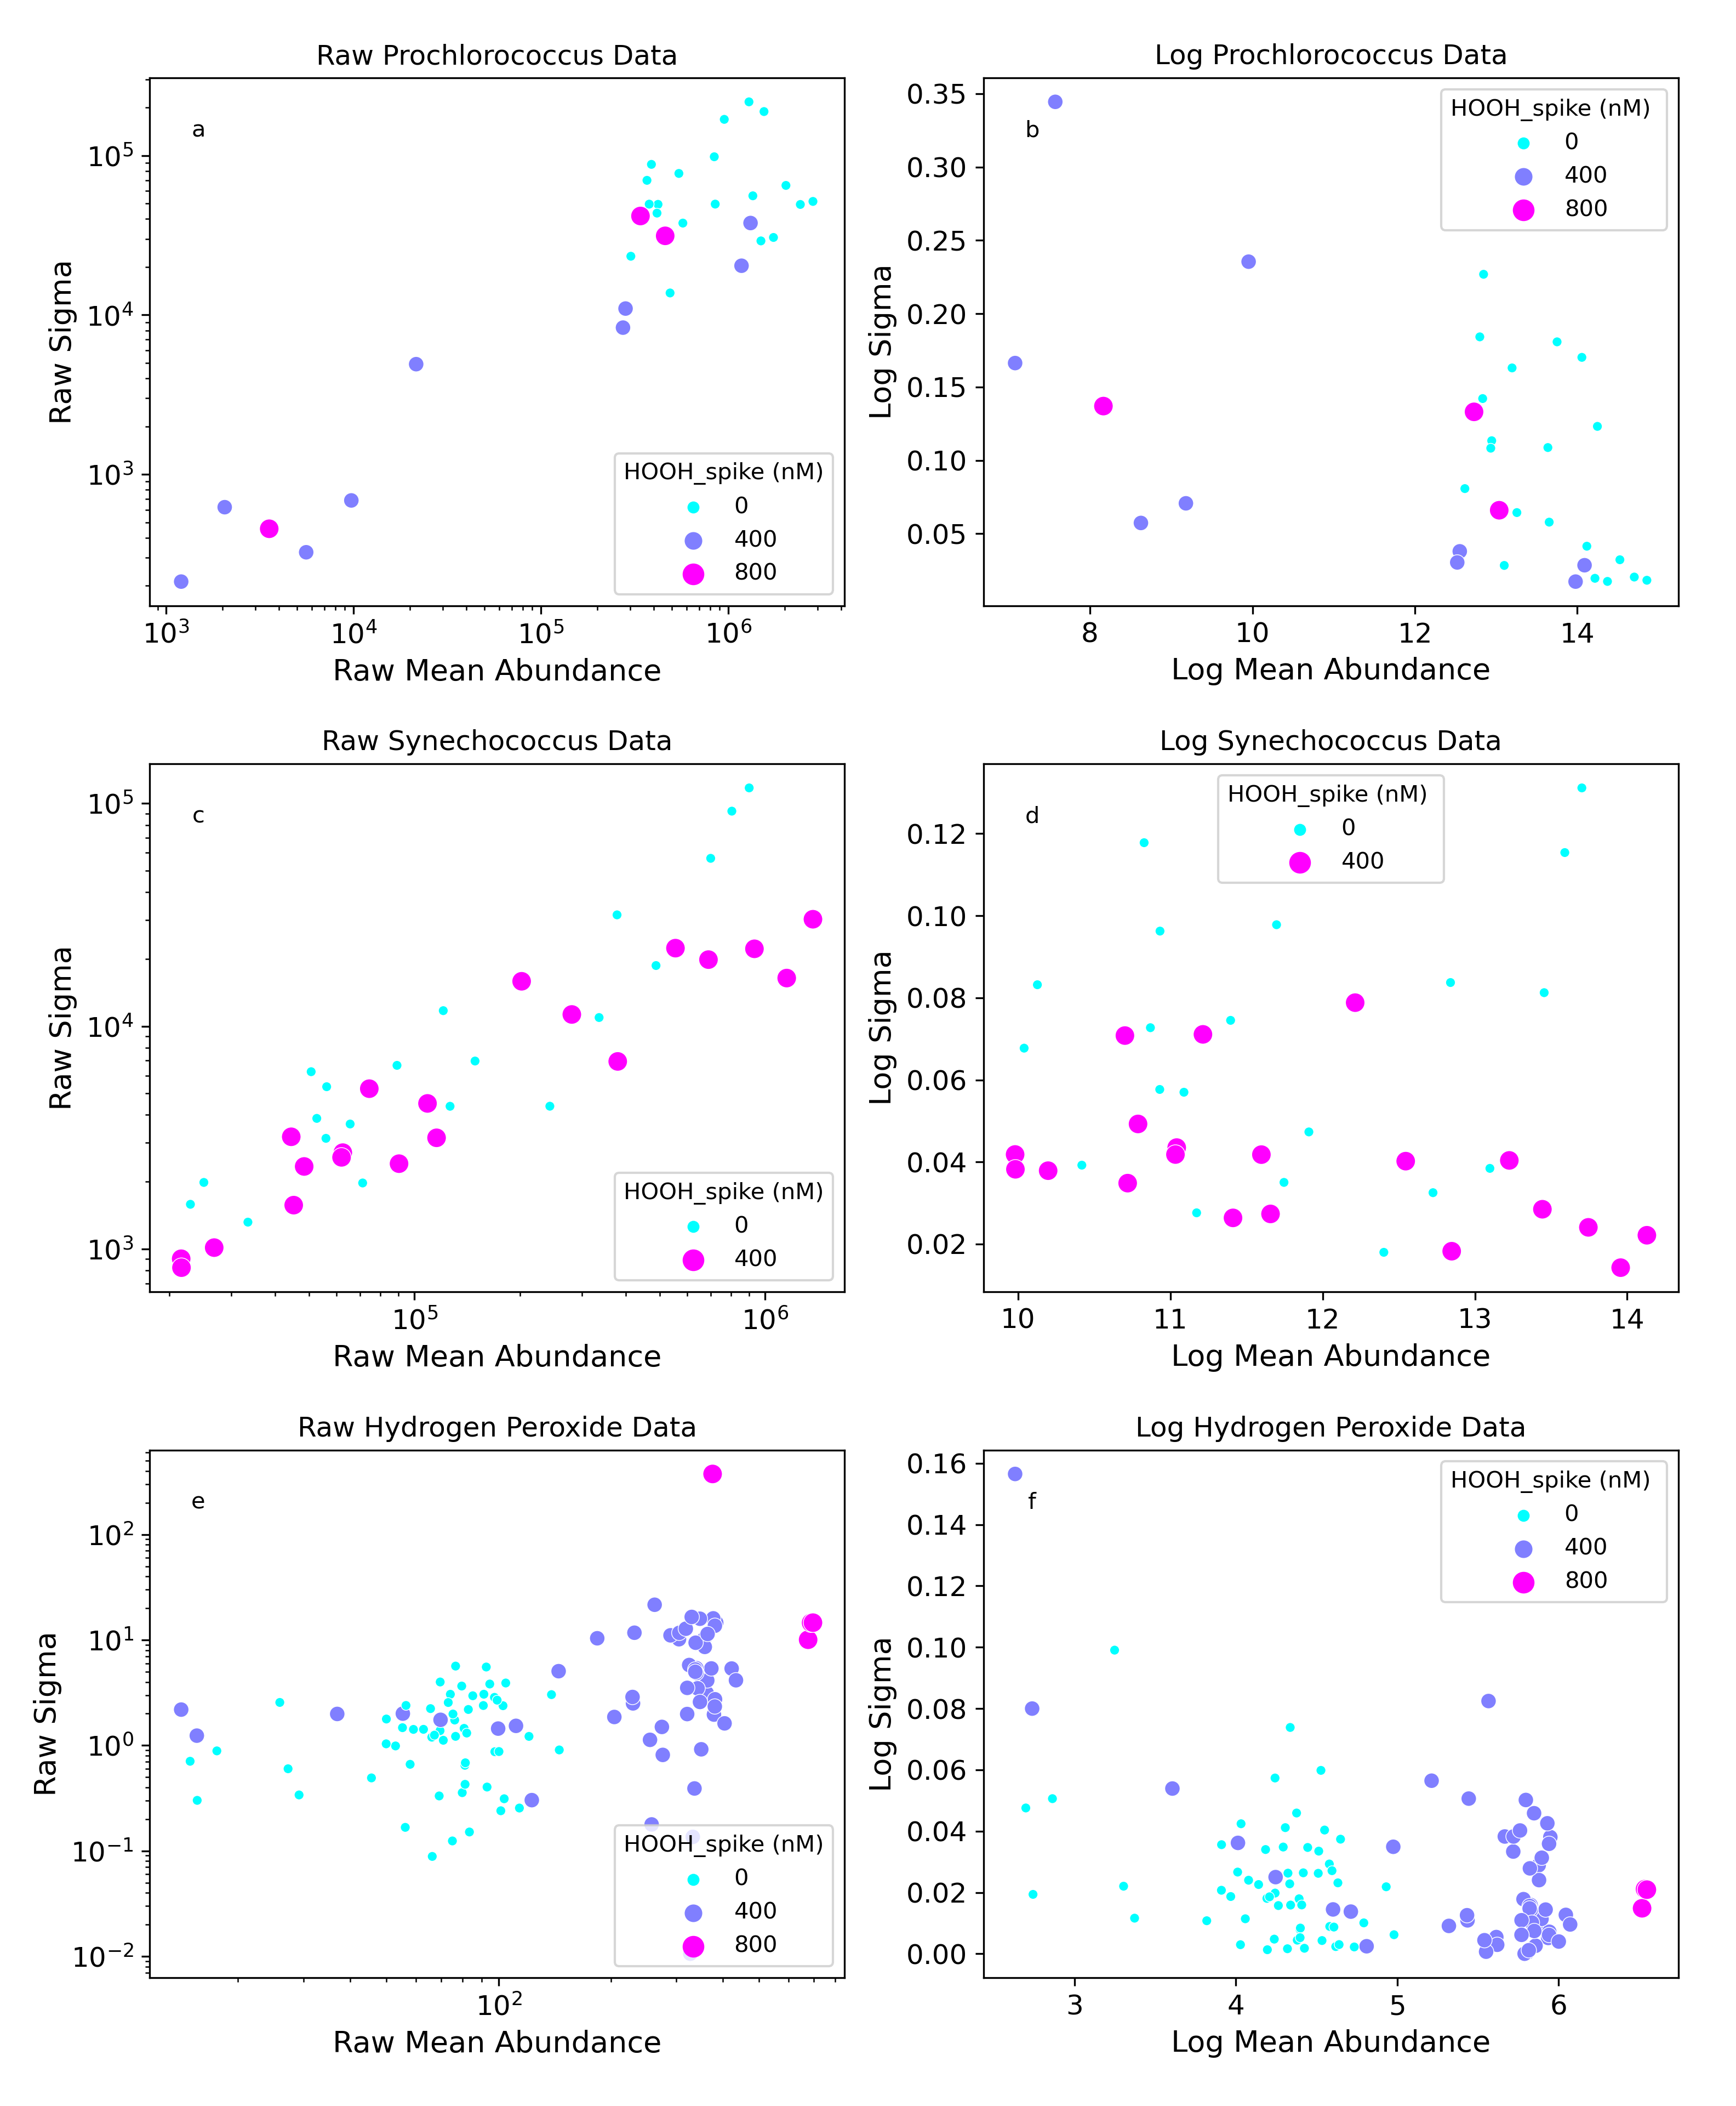
Figure A 1 Standard deviation and mean analysis among biological triplicates for raw (left) vs log-transformed (right) Prochlorococcus abundance, Synechococcus abundance and H₂O₂ (HOOH) data.

We first assumed that the uncertainty parameter, $σ_{y,i}$ could be constrained by the standard deviation among biological replicates or triplicates:
(A2 eq1) $σ_{y,i}^{2}=\sum_{j}{{\left(\ln\left(y_{i,j}\right)-\overline{\ln\left(y_{i,j}\right)}\right)}^{2}}$
where $y_{i,j}$ represents the population size at time-point i=1,n, and replicate j=1,m, and $\overline{\ln\left(y_{i,j}\right)}$ is the average of replicates. Within each dataset, we initially constructed a 99% confidence interval on the uncertainty parameter, by assuming that the standard deviation follows a chi-squared distribution (Sheskin 2003):
(A2 eq2) ${\sqrt{\frac{m-1}{χ_{\frac{α}{2},m-1}^{2}}}<σ}_{y,i}<\sqrt{\frac{m-1}{χ_{1-\frac{α}{2},m-1}^{2}}}$
where $α$ is the desired confidence level which in our case is 1-0.99=0.01. Due to the high-level of uncertainty associated with sample size m=2 or m=3 (as is the case for biological replicates or triplicates, respectively), Equation S9 led to unrealistically wide confidence intervals for the standard deviations. We therefore estimated the standard deviation across time-points. To do this, we first subtracted the mean of log-transformed replicates from each log-transformed replicate (i.e. ${\tilde{y}}_{i,j}=\ln\left(y_{i,j}\right)-\overline{\ln\left(y_{i,j}\right)}$ ). We assumed that each ${\tilde{y}}_{i,j}$ was normally distributed with mean 0 and unknown variance $σ_{y}$ which we assumed was equal across time-points (i.e. $σ_{y}=σ_{y,i}$ for all i=1,n). We then calculated the variance of ${\tilde{y}}_{i,j}$ and used Equation S9 to again construct 99% confidence intervals, this time however, with n-1 degrees of freedom:
(A2 eq3) ${\sqrt{\frac{n-1}{χ_{\frac{α}{2},n-1}^{2}}}<σ}_{y}<\sqrt{\frac{n-1}{χ_{1-\frac{α}{2},n-1}^{2}}}$
In Figure A2 2a, we show hydrogen peroxide replicates in media with zero H₂O₂ addition. The blue dots in Figure A2 2b show log-transformed standard deviations among replicates (i.e., $σ_{y,i}$). The red-dashed line is the average standard deviation across time-points, and the solid red line is the upper limit of the 99% confidence interval in Equation A2 eq2. The solid red line was used to constrain $σ_{y,i}$ in Equation A2 eq3. A different $σ_{y,i}$ was calculated for each dataset D following the same procedure. An example of this for Synechococcus cell dynamics is shown in Figure A3.

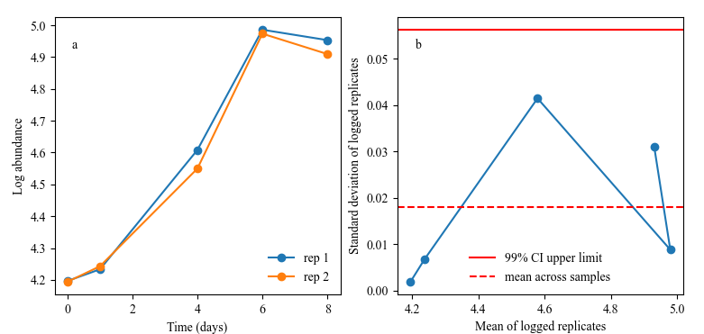
Figure A 2 Error analysis replicates of hydrogen peroxide
Replicates of hydrogen peroxide concentration (a) along with a depiction of different quantities to constrain uncertainty across time-points (b). The red dashed line marked by the upper limit of a 99% confidence interval was determined with Equation A2 eq3 and set the uncertainty parameter $σ_{y,i}$ across timepoints in this dataset.

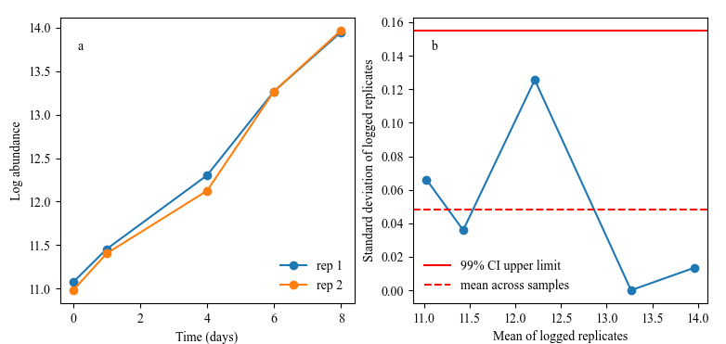
Figure A 3 Error analysis replicates of Synechococcus
Replicates of Synechococcus abundance (a) along with a depiction of different quantities to constrain uncertainty across time-points (b). All lines and symbols have the same meaning as in Figure A2.

A3 Additional experimental datasets

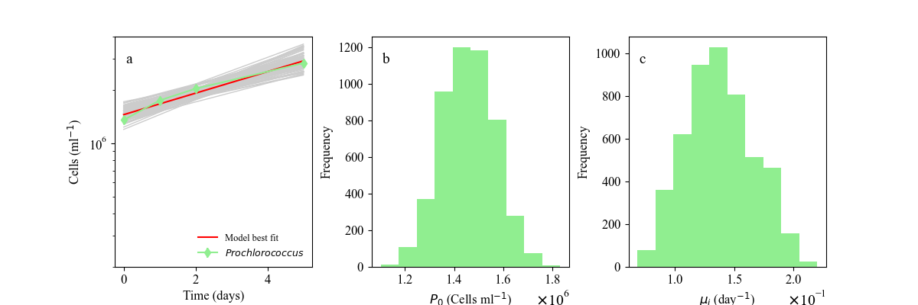
Figure A 4 Monoculture dynamics of Prochlorococcus dataset #2 modeled in growth media with 0 additional H₂O₂. Laboratory batch culture dynamics of Prochlorococcus (Vol #1) data (blue line) and model searches (grey lines) with optimal solution (red line) in zero H₂O₂ batch culture (a). Also shown are parameter value histograms for the initial cell concentration (P₀) and exponential growth rate ($μ_{i}$) (b,c, respectively).

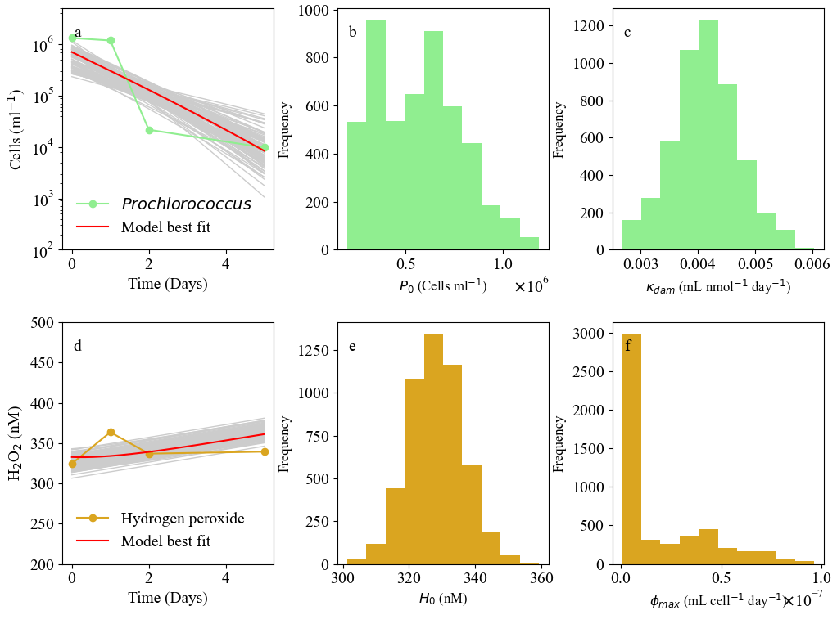
Figure A 5 Prochlorococcus and H₂O₂ model from 400nM spike assay repetition
Coupled laboratory batch culture dynamics of Prochlorococcus (a) and H₂O₂ (d) data alongside model optimal (red line) and searched (grey) combinations in laboratory assays containing 400nM H₂O₂. To the right of each dynamics plot we show the initial value of P (b) or H (e) and the controlling parameter for each line: $k_{dam,I}$ for P (c) and $ϕ_{max,i}$ for H (e).

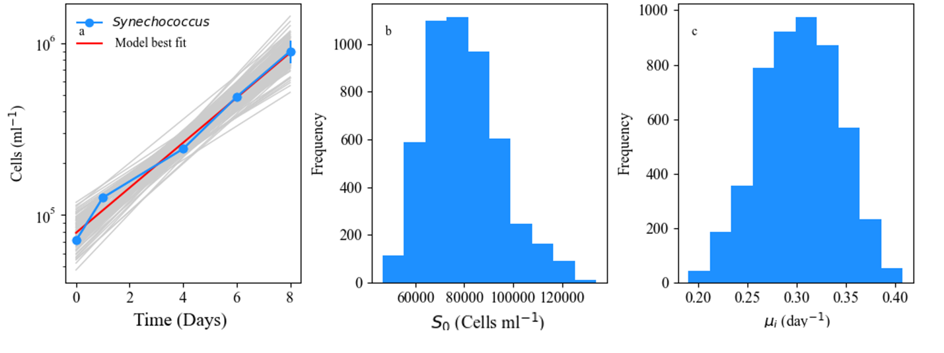
Figure A 6 Synechococcus WH7803 (Vol #28) modeled in growth media.
Laboratory batch culture dynamics of Synechococcus WH7803 (Vol #28) data (blue line) and model searches (grey lines) with optimal solution (red line) in zero H₂O₂ batch culture (a). Also shown are parameter value histograms for the initial cell concentration (S₀) and exponential growth rate ($μ_{i}$) (b,c, respectively).

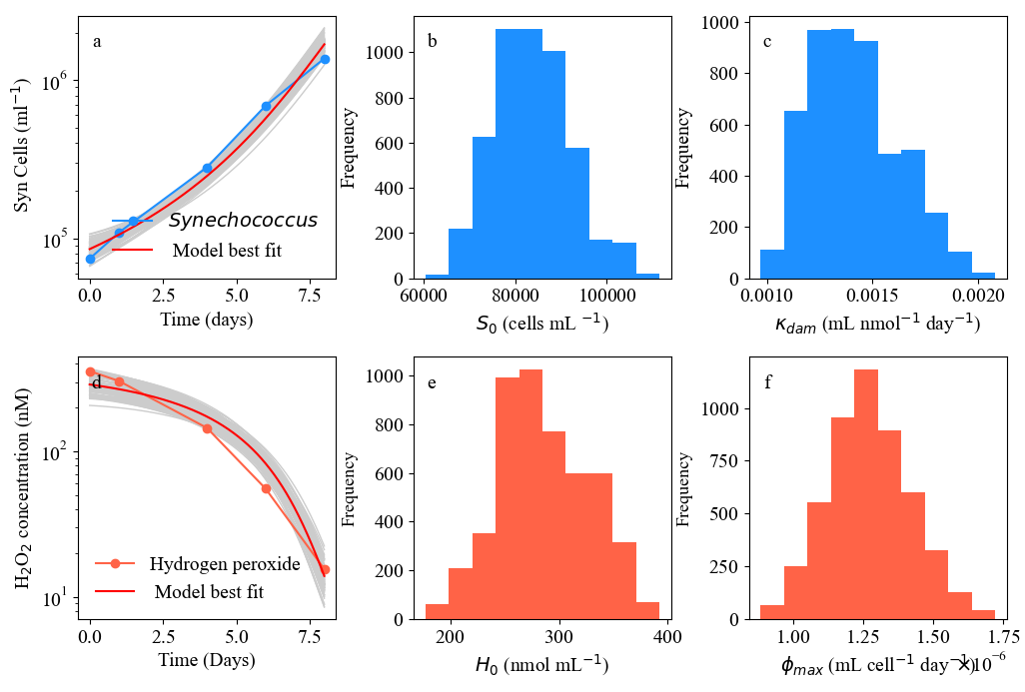
Figure A 7 Synechococcus WH7803 (Vol #28) in 400nM H2O2 spike assay Coupled laboratory batch culture dynamics of Synechococcus WH7803 (Vol# 28) (a) and H2O2 (d) data alongside searched parameter combinations (grey) in batch culture containing 400nM H2O2. To the right of each dynamics plot we show the initial cell concentration (S0) and H2O2 specific death rate (kdam,i) (b,c) and initial hydrogen peroxide concentration (H0) and cell-specific detoxification rate (𝜙𝑚𝑎𝑥,𝑖) (e,f).

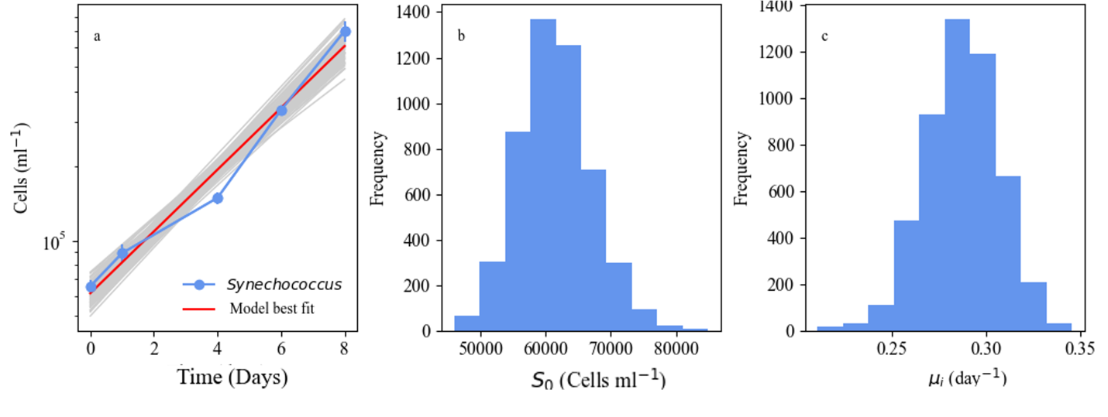
Figure A 8 Synechococcus WH7803 (Vol #52) modeled in growth media with 0 additional H₂O₂
Laboratory batch culture dynamics of Synechococcus WH7803 (Vol #52) data (blue line) and model searches (grey lines) with optimal solution (red line) in zero H₂O₂ batch culture (a). Also shown are parameter value histograms for the initial cell concentration (S₀) and exponential growth rate ($μ_{i}$) (b,c, respectively).

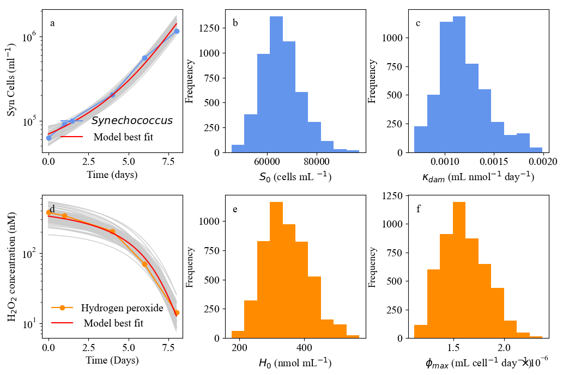
Figure A 9 Modeled Synechococcus WH7803 monoculture in 400nM H₂O₂ spike assay
Coupled laboratory batch culture dynamics of Synechococcus WH7803 (a) and H₂O₂ (d) data alongside searched parameter combinations (grey) in batch culture containing 400nM H₂O₂. To the right of each dynamics plot we show the initial cell concentration (S₀) and H₂O₂ specific death rate ($k_{dam,i}$) (b,c) and initial hydrogen peroxide concentration (H₀) and cell-specific detoxification rate ($ϕ_{max,i}$) (e,f).

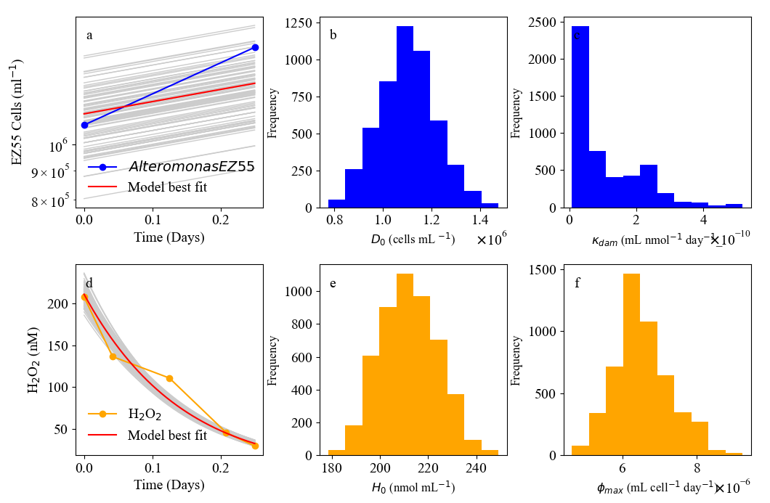
Figure A 10 Heterotroph EZ55 300nM H₂O₂ spiked media dynamics over 2 hours
Coupled laboratory batch culture dynamics of Alteromonas EZ55 (a) and H₂O₂ (d) data alongside searched parameter combinations (grey) in batch culture containing 300nM H₂O₂. To the right of each dynamics plot we show the initial cell concentration (D₀) and H₂O₂ specific death rate ($k_{dam,i}$) (b,c) and initial H₂O₂ concentration (H₀) and EZ55 cell-specific H₂O₂ detoxification rate ($ϕ_{max,i}$) (e,f).

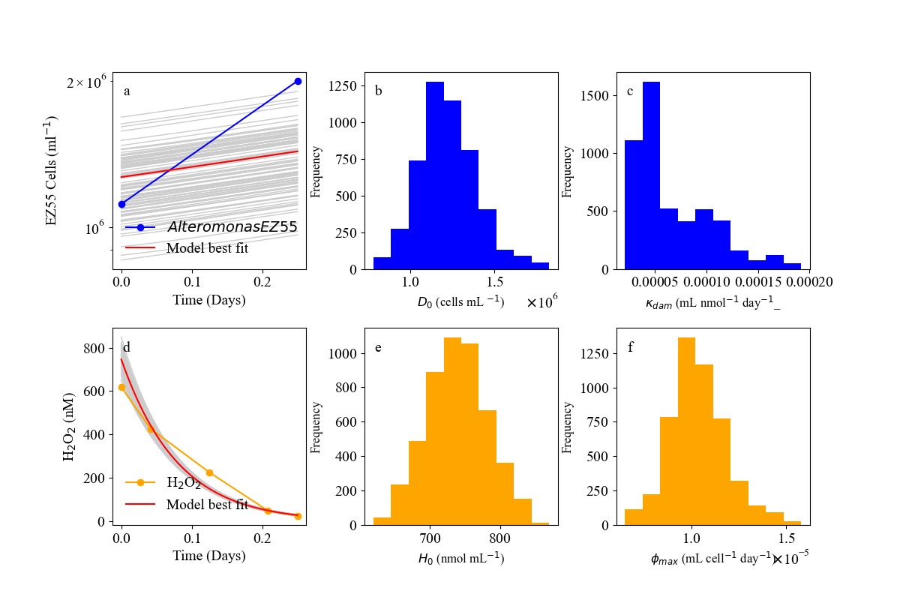
Figure A 11 Heterotroph EZ55 800nM H₂O₂ spiked media dynamics over 2 hours
Coupled laboratory batch culture dynamics of Alteromonas EZ55 (a) and H₂O₂ (d) data alongside searched parameter combinations (grey) in batch culture containing 800nM H₂O₂. To the right of each dynamics plot we show the initial cell concentration (D₀) and H₂O₂ specific death rate ($k_{dam,i}$) (b,c) and initial H₂O₂ concentration (H₀) and EZ55 cell-specific H₂O₂ detoxification rate ($ϕ_{max,i}$) (e,f).

A4 Media and Buffer H₂O₂Production Assays

HEPES buffer produces H₂O₂ when illuminated at relevant irradiances (Morris 2013) so we use it here to ensure our model may be used for the more environmentally relevant, photochemically produced H₂O₂ dynamics before analyzing the more common spike assay. While the rest of this thesis concerns H₂O₂ spikes as the main source of H₂O₂ in media, the diel nature of in situ external H₂O₂ threats drove us to ensure the applicability of our model. We leverage the assays of prior studies (Jeffrey Morris & Zinser, 2013; Morris, 2011) that tested H₂O₂ photoproduction in growth buffers to test our H₂O₂ production term (S_{H}) and its ability to capture a more realistic photochemical reaction to that of the open ocean (Jeffrey Morris and Zinser 2013). H₂O₂ concentrations from dataset 1 singular TAPS (Figure A12) or HEPES (Figure A13) production were evaluated against the performance of our model from Eq. set 1 in natural seawater. Production here takes on a non-linear production, yet our model manages to capture this. The dashed analytical solution of our model is visualized as well to ensure that our model solution protocol is effective. Similar to our models for H₂O₂ spike assays, the abiotic model captured the HEPES-initiated dynamics in our batch data. Agreement of both model solutions with laboratory data led to our adoption of this formulation for future H₂O₂ modeling regarding media assays. Through this analysis we ensured that 1) chosen ODE set 1 solved to an intelligible solution, shown below, and 2) this solution converged on our supplied data in a similar degree and manner as our fitting method. This step is key in evaluating our integration methods thus allowing a comparison of this data set dynamics to that of an analytical solution set calculated from an abiotic scenario.

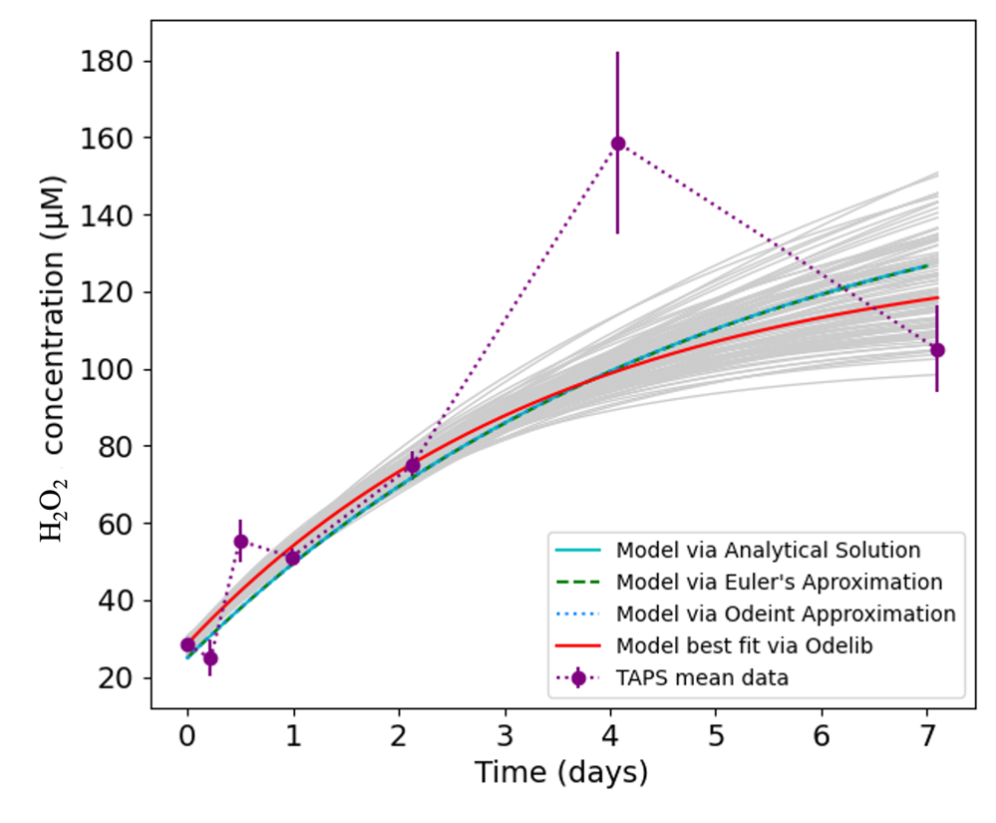
Figure A 12 Modeled H₂O₂ production in TAPs buffer
H₂O₂ measurements (connected purple symbols), sample explored model solutions (grey lines) and optimal model formulation (red line) from 3.75 mM TAPS buffer in batch growth media. Data from Morris et al. 2011. This solution is visualized against several fitting methods to ensure reproducibility of analyses.

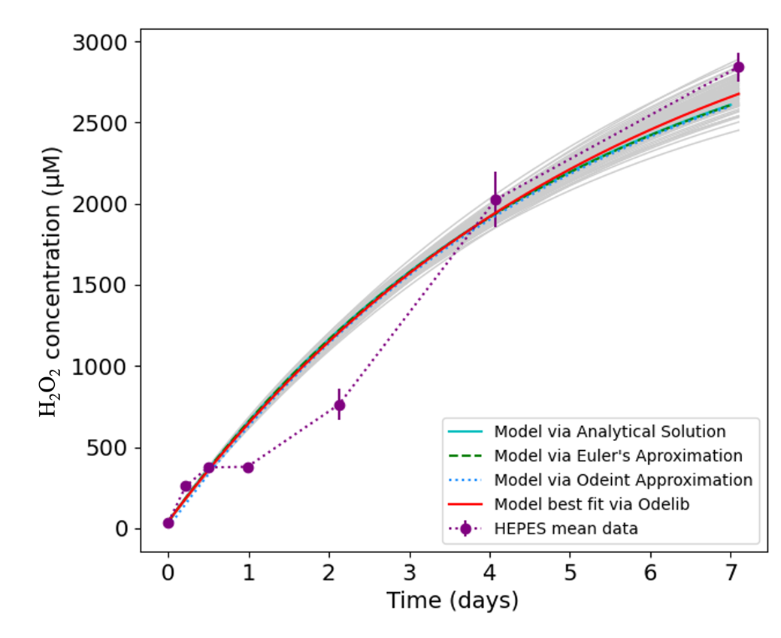
Figure A 13 Modeled H₂O₂ production in HEPES buffer
Visualization of direct HEPES to H₂O₂ conversion following Eq. 1. Both the analytical solution (green solid line) and model solutions via ODEint (cyan dotted line) or ODElib (Red solid) capture the measured H₂O₂ (purple symbols) dynamics of a 3.75mM HEPES buffer assay over 7 days. A singular rate of abiotic decay ( $δ_{H}$) is assumed here. (Data from Morris et al. 2011)

Appendix B supplementary information: Chapter 3

B1 Monoculture parameter fittings
Monoculture curves fittings for picoeukaryotes mentioned in Figure 3.2 of the main text. Prochlorococcus and Synechococcus spp. and Alteromonas macleodii monoculture parameter analyses were shown in the main text or supplementary information (Appendix A) for Chapter 2.

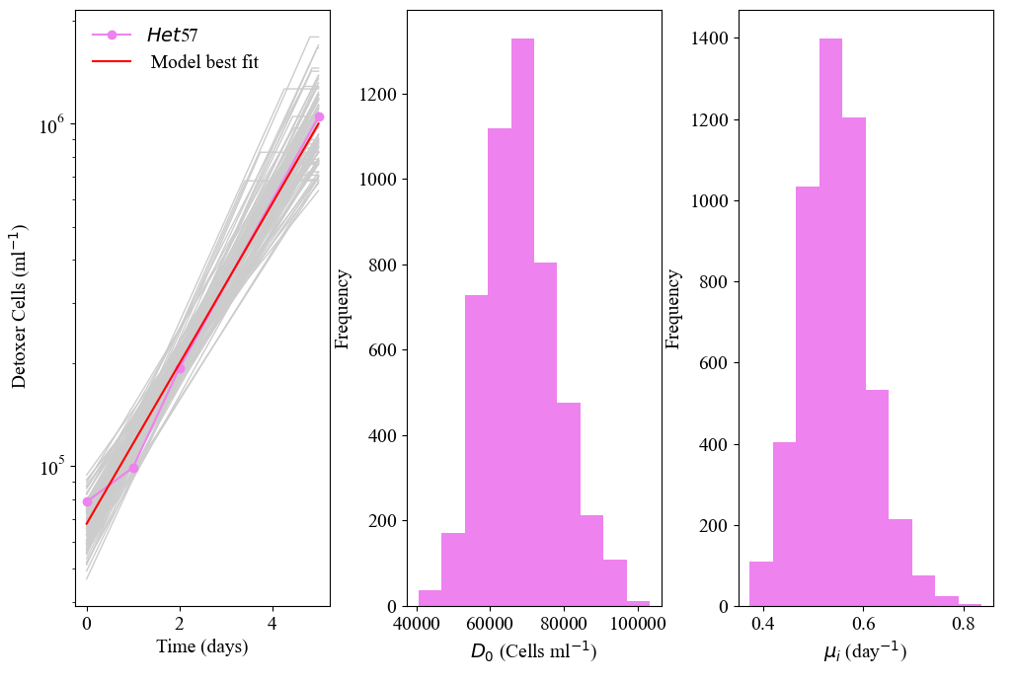
Figure B 1 Monoculture Micromonas commoda in growth media with 0 additional H₂O₂
Monoculture laboratory dynamics of the detoxifier (D) Micromonas commoda (pink line) and model searches (grey lines) with optimal solution (red line) in zero H₂O₂ batch culture (a). Also shown are parameter value histograms for the initial cell concentration (D₀) and exponential growth rate ($μ_{i}$) (b,c, respectively).

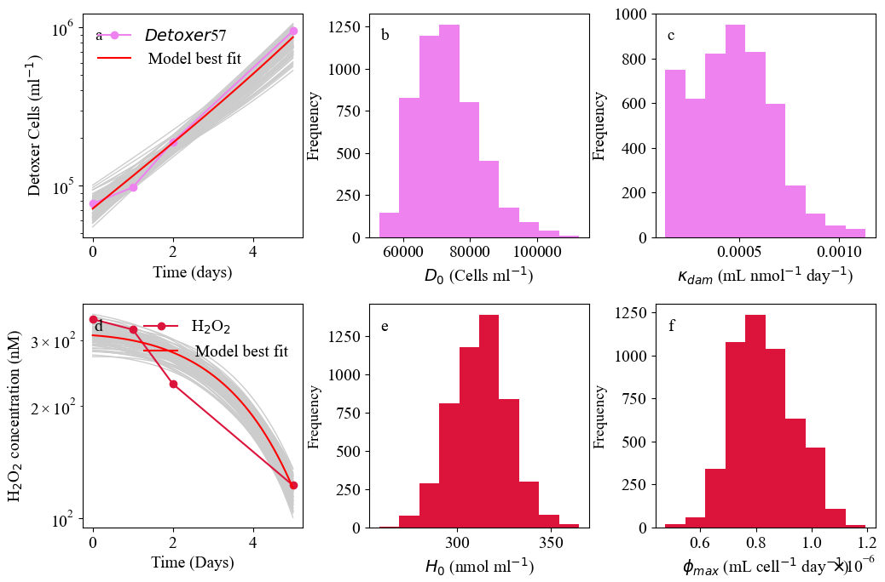
Figure B 2 Monoculture (Detoxer57) Micromonas commoda in 400nm H2O2 spike Coupled laboratory batch culture dynamics of the detoxifier (D) Micromonas commoda (pink line) (a) and H2O2 (maroon line) (d) data alongside searched parameter combinations (grey) in batch culture containing 400nM H2O2. To the right of each dynamics plot we show the initial cell concentration (D0) and H2O2 specific death rate (kdam,i) (b,c) and initial hydrogen peroxide concentration (H0) and cell-specific detoxification rate (𝜙𝑚𝑎𝑥,𝑖) (e,f).

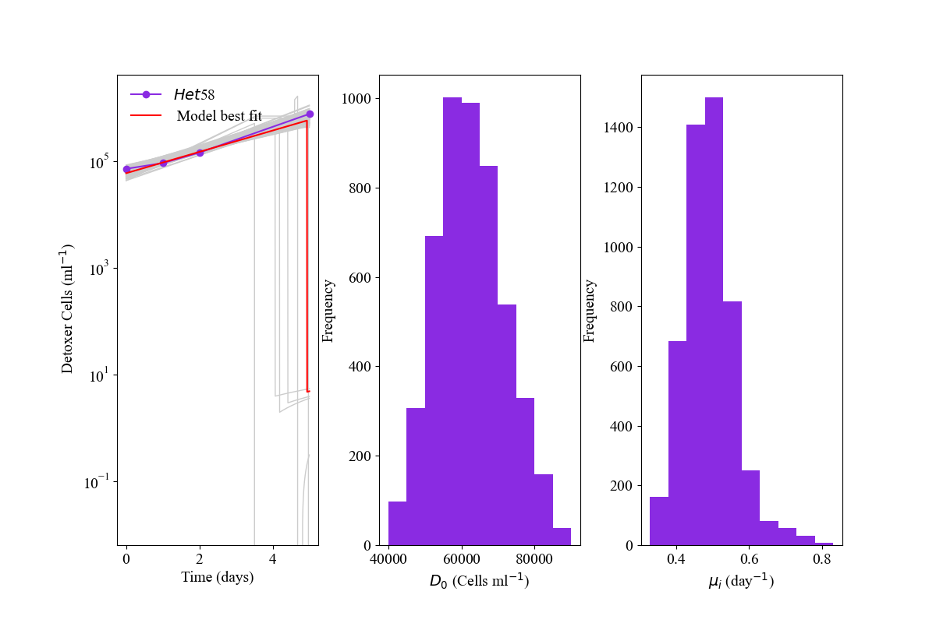
Figure B 3 Monoculture Micromonas pusilla in growth media with 0 additional H₂O₂
Laboratory batch culture dynamics of the detoxifier (D) Micromonas pusilla with data (purple line) and model searches (grey lines) with optimal solution (red line) in zero H₂O₂ batch culture (a). Also shown are parameter value histograms for the initial cell concentration (D₀) and exponential growth rate ($μ_{i}$) (b,c, respectively).

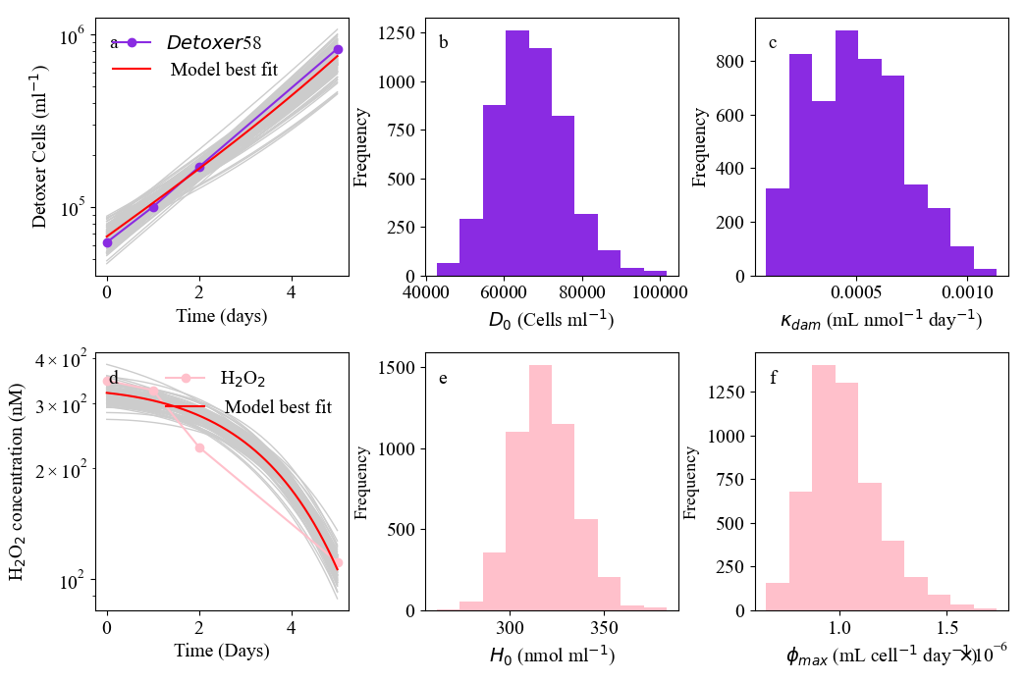

Figure B 4 Monoculture (Detoxer58) Micromonas pusilla in 400nM H₂O₂ spike
Coupled laboratory batch culture dynamics of the detoxifier (D) Micromonas pusilla (purple line) (a) and H₂O₂ (pink line) (d) data alongside searched parameter combinations (grey) in batch culture containing 400nM H₂O₂. To the right of each dynamics plot we show the initial cell concentration (D₀) and H₂O₂ specific death rate ($k_{dam,i}$) (b,c) and initial hydrogen peroxide concentration (H₀) and cell-specific detoxification rate ($ϕ_{max,i}$) (e,f).

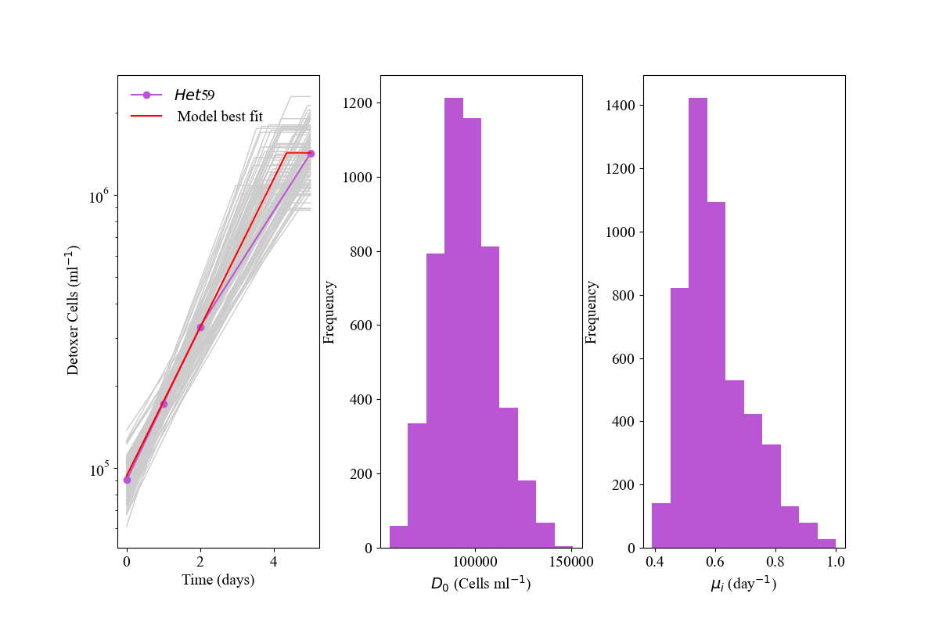
Figure B5 Monoculture Ostreococcus lucimarinus in growth media with 0 additional H₂O₂
Laboratory batch culture dynamics of the detoxifier (D) Ostreococcus lucimarinus with data (pink line) and model searches (grey lines) with optimal solution (red line) in zero H₂O₂ batch culture (a). Also shown are parameter value histograms for the initial cell concentration (D₀) and exponential growth rate ($μ_{i}$) (b,c, respectively).

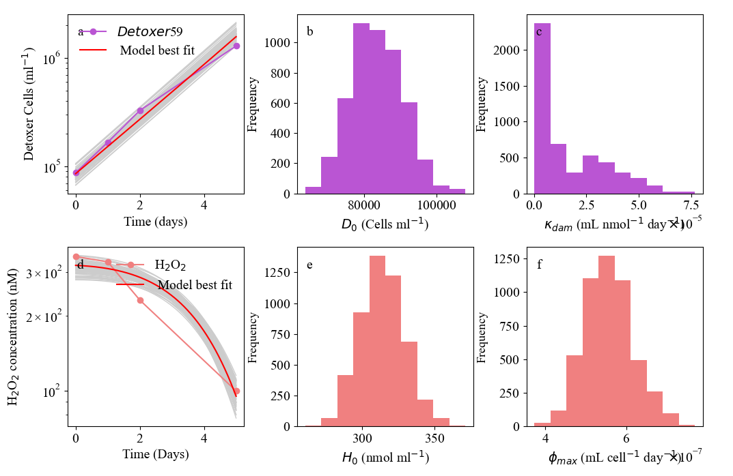
Figure B6 Monoculture (Detoxer59) Ostreococcus lucimarinus in 400nM H₂O₂ spike
Coupled laboratory batch culture dynamics of the detoxifier (D) Ostreococcus lucimarinus (pink line) (a) and H₂O₂ (orange line) (d) data alongside searched parameter combinations (grey) in batch culture containing 400nM H₂O₂. To the right of each dynamics plot we show the initial cell concentration (D₀) and H₂O₂ specific death rate ($k_{dam,i}$) (b,c) and initial H₂O₂ concentration (H₀) and cell-specific detoxification rate ($ϕ_{max,i}$) (e,f).

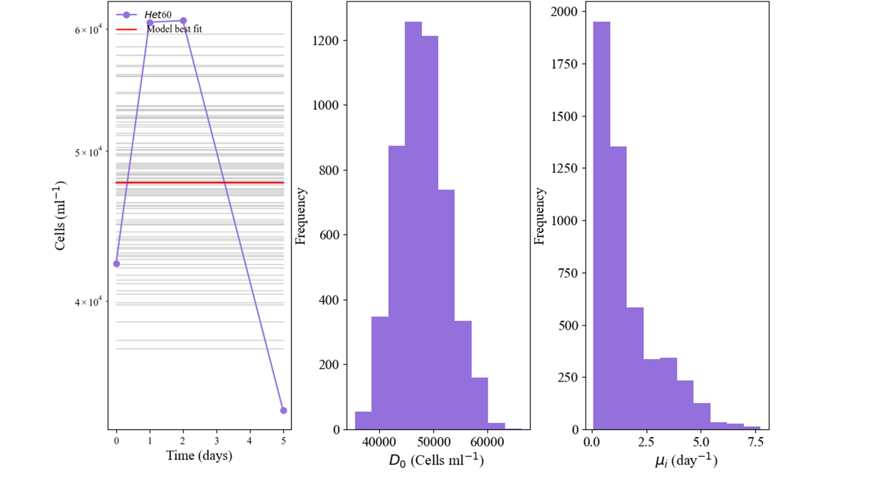
Figure B7 Monoculture Ostreococcus tauri in growth media with 0 additional H₂O₂
Laboratory batch culture dynamics of the detoxifier (D) Ostreococcus tauri with data (purple line) and model searches (grey lines) with optimal solution (red line) in zero H₂O₂ batch culture (a). Also shown are parameter value histograms for the initial cell concentration (D₀) and exponential growth rate ($μ_{i}$) (b,c, respectively).

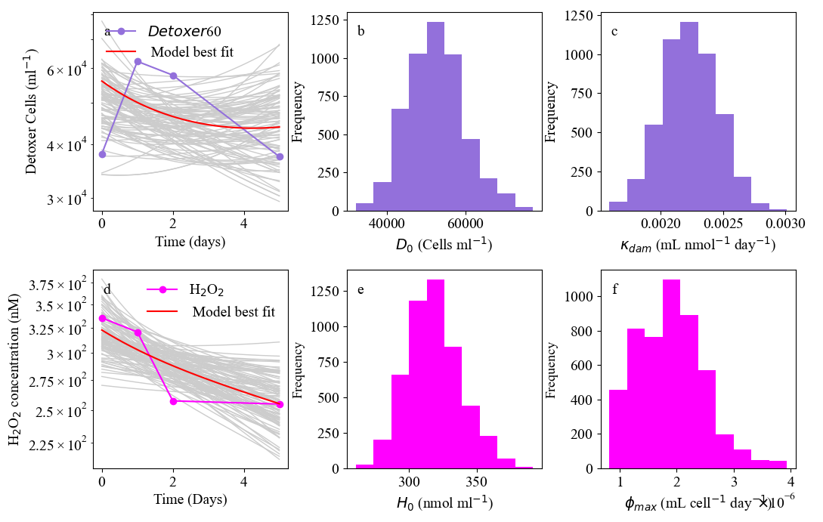
Figure B8 Monoculture Parameter Summary Table Growth Parameters of $μ_{i}$ (mus) and nutrient affinity (k1s) from assays with 0nM additional H₂O₂ spike and H₂O₂ parameters of cell-specific
H₂O₂ detoxification, (phis) $ϕ_{max,i}$ and H₂O₂ cell damage, (kdams) $k_{dam,i}$, from assays with 400nM additional H₂O₂ spike.

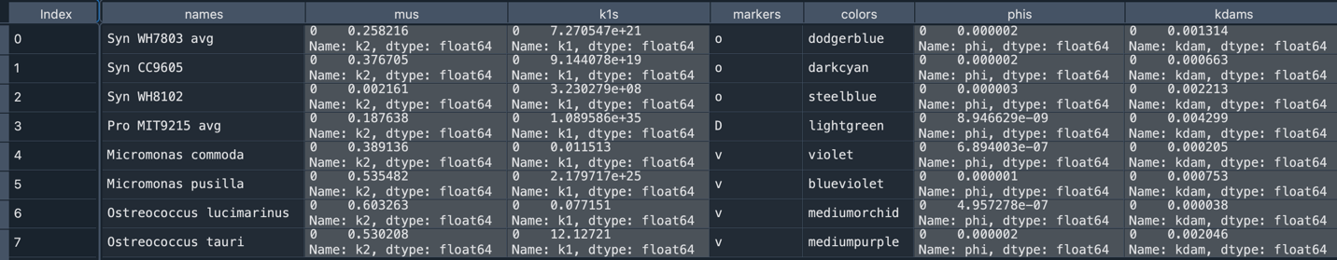
Figure B9 Monoculture Parameter Summary Table Growth Parameters of 𝜇𝑖 (mus) and nutrient affinity (k1s) from assays with 0nM additional H2O2 spike and H2O2 parameters of cell-specific H2O2 detoxification, (phis) 𝜙𝑚𝑎𝑥,𝑖 and H2O2 cell damage, (kdams) kdam,i, from assays with 400nM additional H2O2 spike.

B2 Equilibria

Equilibrium for cases 1-4 calculated with differentiation and S*, P*, H*, N* algebaric substitutions for chapter 3 analyses of long term S,P,N,H dynamics.
Steady State of P and N in 0 supply of H₂O₂ : Equilibria Set 1
$$N* = - \frac{\left({ δ}_{H}δ_{P}+H*κ_{dam,p}\right)μ_{P}}{α_{1}\left(δ_{H}δ_{p}+H*κ_{dam,p}-{ δ}_{H}μ_{p}\right)}$$

$$P* = \frac{N*δ_{H}}{{ δ}_{H}δ_{p}+H*κ_{dam,p}}+\frac{{ δ}_{H}ρμ_{p}}{α_{p}\left(δ_{H}δ_{P}+S_{H}κ_{dam,p}-{ δ}_{H}μ_{p}\right)}$$
$$S* =0 ; H* = 0$$
Steady States calculated for Synechococcus winning completion for N: Equilibria case 2
$$N* = -\frac{δ_{S}μ_{S}}{α_{2}\left(δ_{2}-μ_{2}\right)}$$
$$S* = \frac{N*}{δ_{S}}+\frac{ρμ_{s}}{α_{s}\left(δ_{s}-μ_{s}\right)}$$
$$H* = \frac{S_{H}α_{s}δ_{s}\left(δ_{s}-μ_{s}\right)}{ρδ_{s}μ_{s}ϕ_{s}+α_{s}\left(δ_{s}-μ_{s}\right)\left(δ_{H}δ_{s}+S_{N}ϕ_{s}\right)}$$
$$P* =0$$

Steady States equilibria values calculated for P, S, H, and N in ‘leaky case: Equilibria set 3
$$N* = -\frac{δ_{S}μ_{S}}{α_{s}\left(δ_{S}-μ_{S}\right)}$$
$$H* =\frac{α_{p}δ_{S}\left(δ_{p}-μ_{p}\right)μ_{s}+α_{s}δ_{p}μ_{p}\left(-δ_{s}+μ_{s}\right)}{κ_{dam,p}\left(α_{s}μ_{p}\left(δ_{s}-μ_{s}\right)-α_{p}δ_{s}μ_{s}\right)}$$
$$S*=\frac{(S_{H}-(δ_{H}\left(H*\right))}{\left(H*\right)ϕ_{S}}$$
P* =$\frac{\left(S_{N}-\left(\frac{μ_{P}\left(N*\right)}{{ks}_{s}+ \left(N*\right)}\right)\left(S*\right)-ρ\left(N*\right)\right)}{\left(\frac{μ_{P}\left(N*\right)}{{ks}_{p}+ \left(N*\right)}\right)}$

Steady States equilibria values calculated for P, S, H, and N in ‘leaky case: Equilibria set 4
$$N* = -\frac{δ_{S}μ_{S}}{α_{s}\left(δ_{S}-μ_{S}\right)}$$
$$H* =\frac{α_{p}δ_{S}\left(δ_{p}-μ_{p}\right)μ_{s}+α_{s}δ_{p}μ_{p}\left(-δ_{s}+μ_{s}\right)}{κ_{dam,p}\left(α_{s}μ_{p}\left(δ_{s}-μ_{s}\right)-α_{p}δ_{s}μ_{s}\right)}$$
$$S* = \frac{(-{k1}_{2}μ_{1}\left(δ_{2}-μ_{2}\right)\left(Hsupplyκ_{1}+δ_{1}\left(ζ+1000ϕ_{3}\right)\right)+{k1}_{1}δ_{2}μ_{2}\left(Hsupplyκ_{1}+δ_{1}\left(ζ+1000ϕ_{3}\right)-μ_{1}\left(ζ+1000ϕ_{3}\right)\right)}{\left({k1}_{2}δ_{1}μ_{1}\left(δ_{2}-μ_{2}\right)+{k1}_{1}δ_{2}\left(-δ_{1}+μ_{1}\right)μ_{2}\right)ϕ_{2}}$$

$$P*=\left(\begin{aligned}\left({k1}_{2}μ_{1}\left(δ_{2}-μ_{2}\right)-{k1}_{1}δ_{2}μ_{2}\right) \\ \left(\begin{aligned}ρ{k1}_{1}δ_{2}^{2}\left(-δ_{1}+μ_{1}\right)μ_{2}^{2}ϕ_{2}+{k1}_{2}^{2}μ_{1}{\left(δ_{2}-μ_{2}\right)}^{2}\left(Hsupplyδ_{2}κ_{1}+δ_{1}\left(Nsupplyϕ_{2}+δ_{2}\left(ζ+1000ϕ_{3}\right)\right)\right)-{k1}_{2}δ_{2}\left(δ_{2}-μ_{2}\right)μ_{2} \\ \left(-ρδ_{1}μ_{1}ϕ_{2}+{k1}_{1}\left(-Nsupplyμ_{1}ϕ_{2}+δ_{1}\left(Nsupplyϕ_{2}+δ_{2}\left(ζ+1000ϕ_{3}\right)\right)+δ_{2}\left(Hsupplyκ_{1}-μ_{1}\left(ζ+1000ϕ_{3}\right)\right)\right)\right)\end{aligned}\right)\end{aligned}\right)$$
$$\left({/ (k1}_{1}{k1}_{2}δ_{2}μ_{1}μ_{\begin{aligned}2 \\ \end{aligned}}\left(-δ_{2}+μ_{2}\right)\left({k1}_{2}δ_{1}μ_{1}\left(δ_{2}-μ_{2}\right)+{k1}_{1}δ_{2}\left(-δ_{1}+μ_{1}\right)μ_{2}\right)ϕ_{2)}\right)$$

B3. Equilibria and dynamic contour plots
Figure B10 below represents dynamics ODEs (left) or equilibrium * equations (right) are projected for various H₂O₂ detoxification parameterizations of Synechococcus. The non-zero value of $ϕ_{max,S}$ allows coexistence and controls the extent to which it can occur along a continuum of S_{N} and S_{H} values. The average recovered Synechococcus $ϕ_{max,S}$ from Chapter 2 is represented by the middle $ϕ_{max,S}$ (2.0 x10⁻⁶) value in this figure. Under this regime, (leaky detoxification from only Synechococcus cells) coexistence is available only at high N or low H. * equilibria are calculated in Appendix B2.

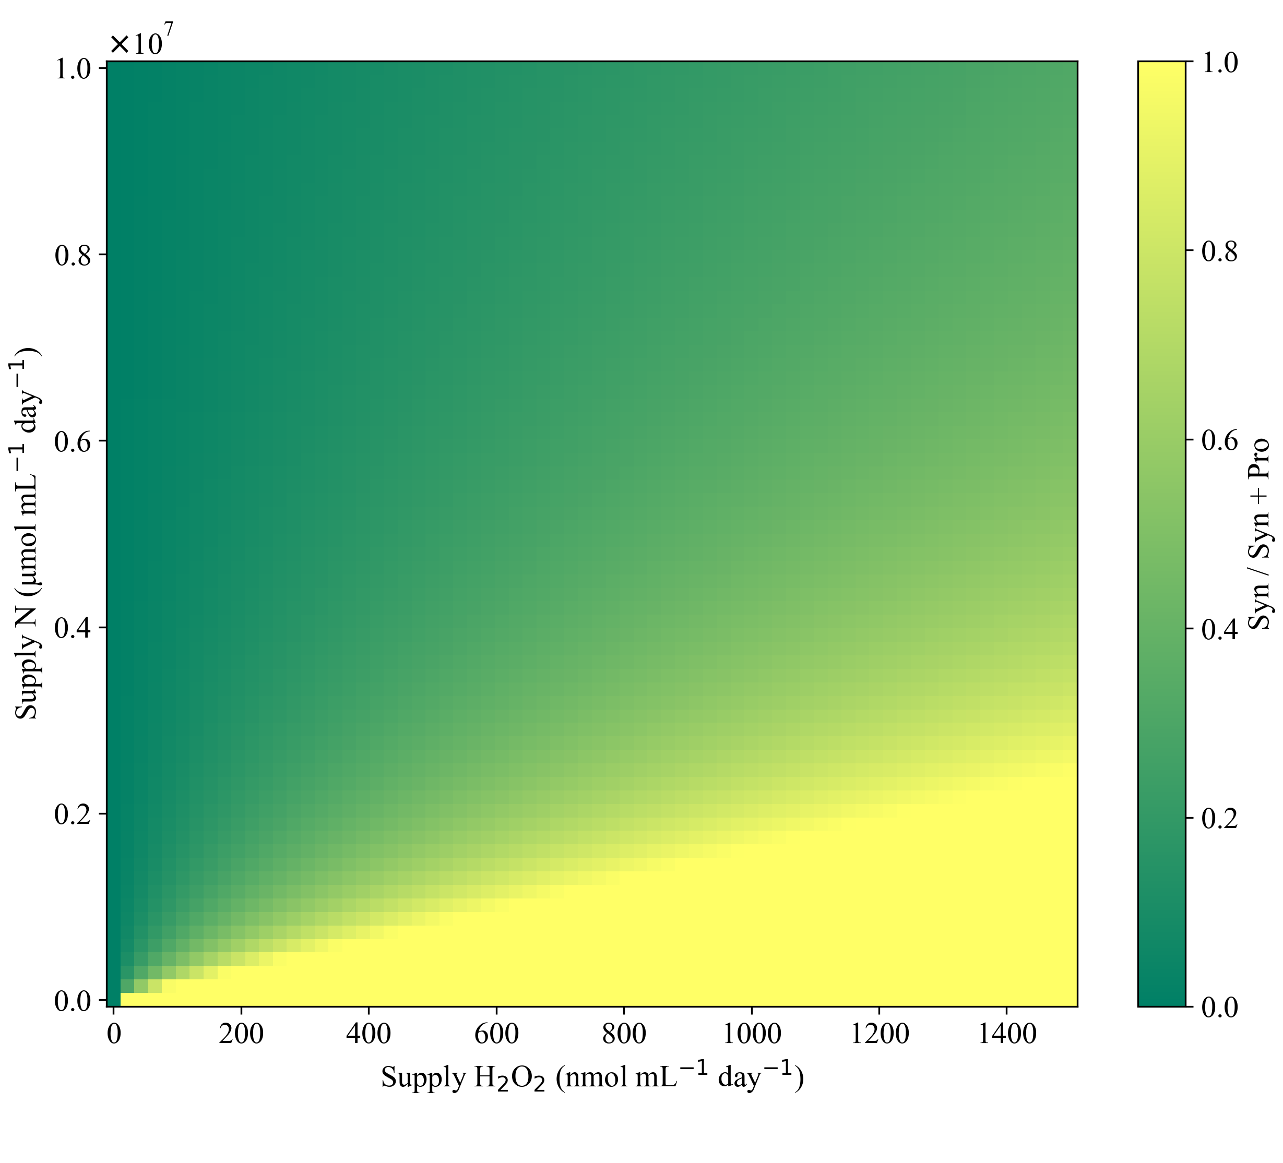 | 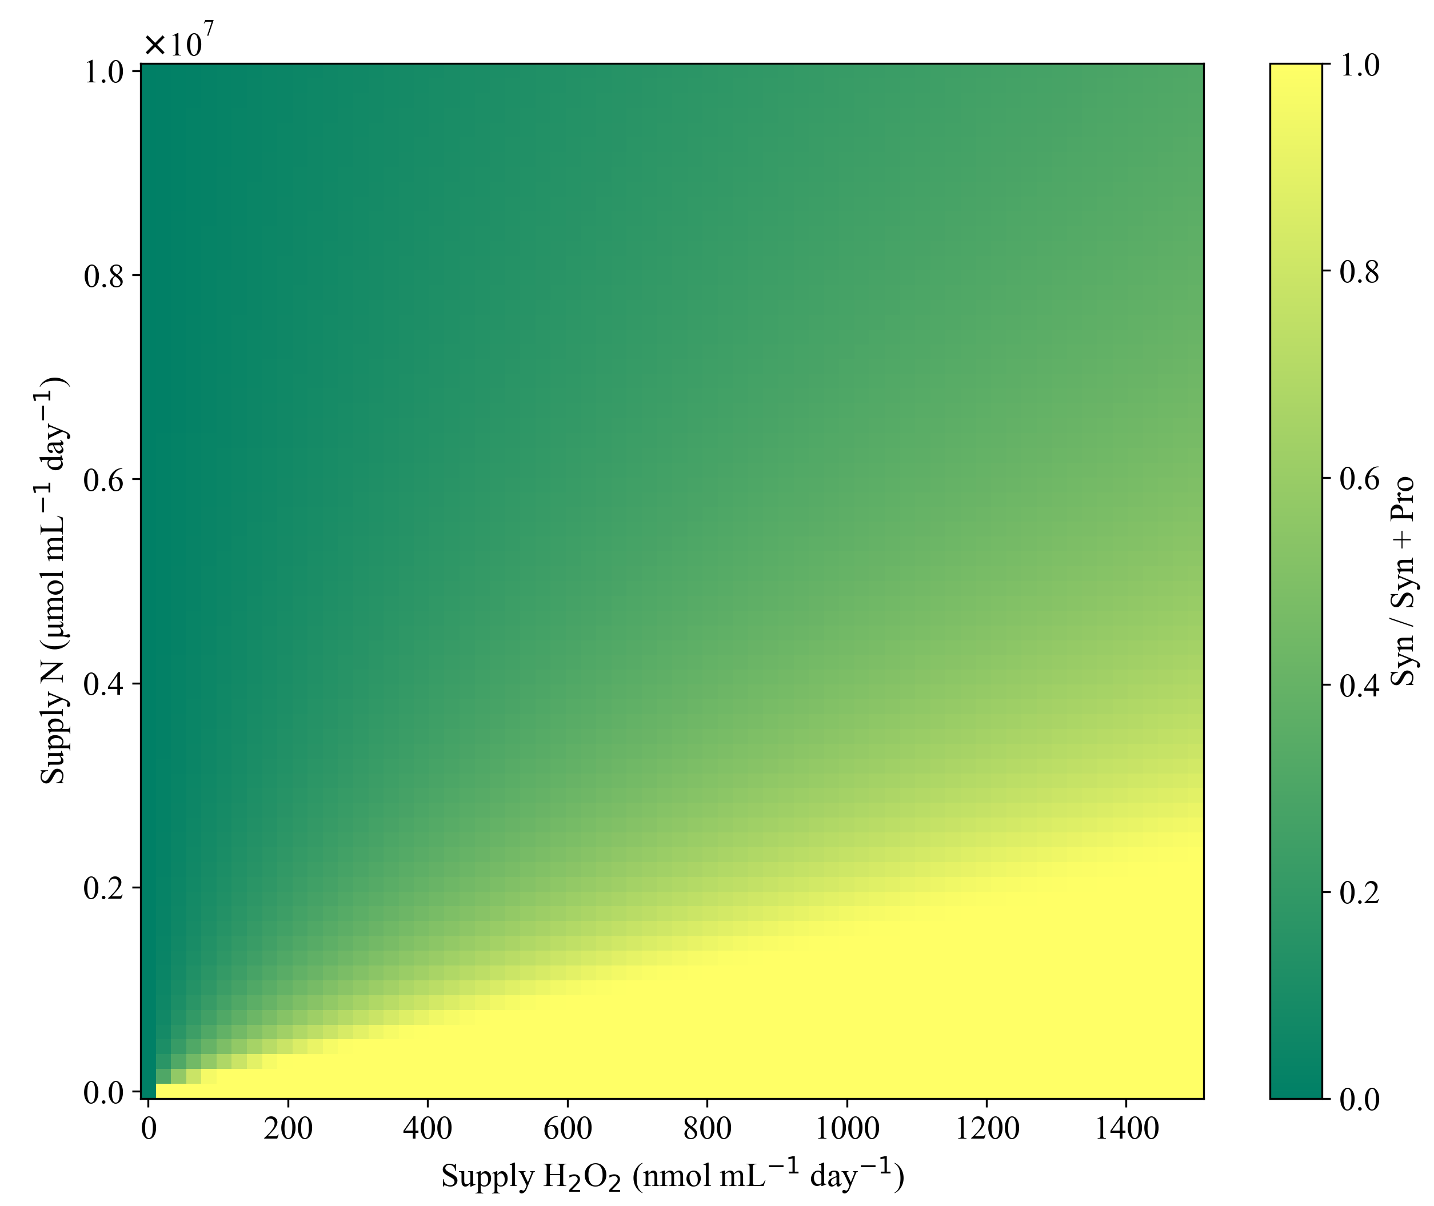
$ϕ_{max,S}$ = 8.0 x10⁻⁶
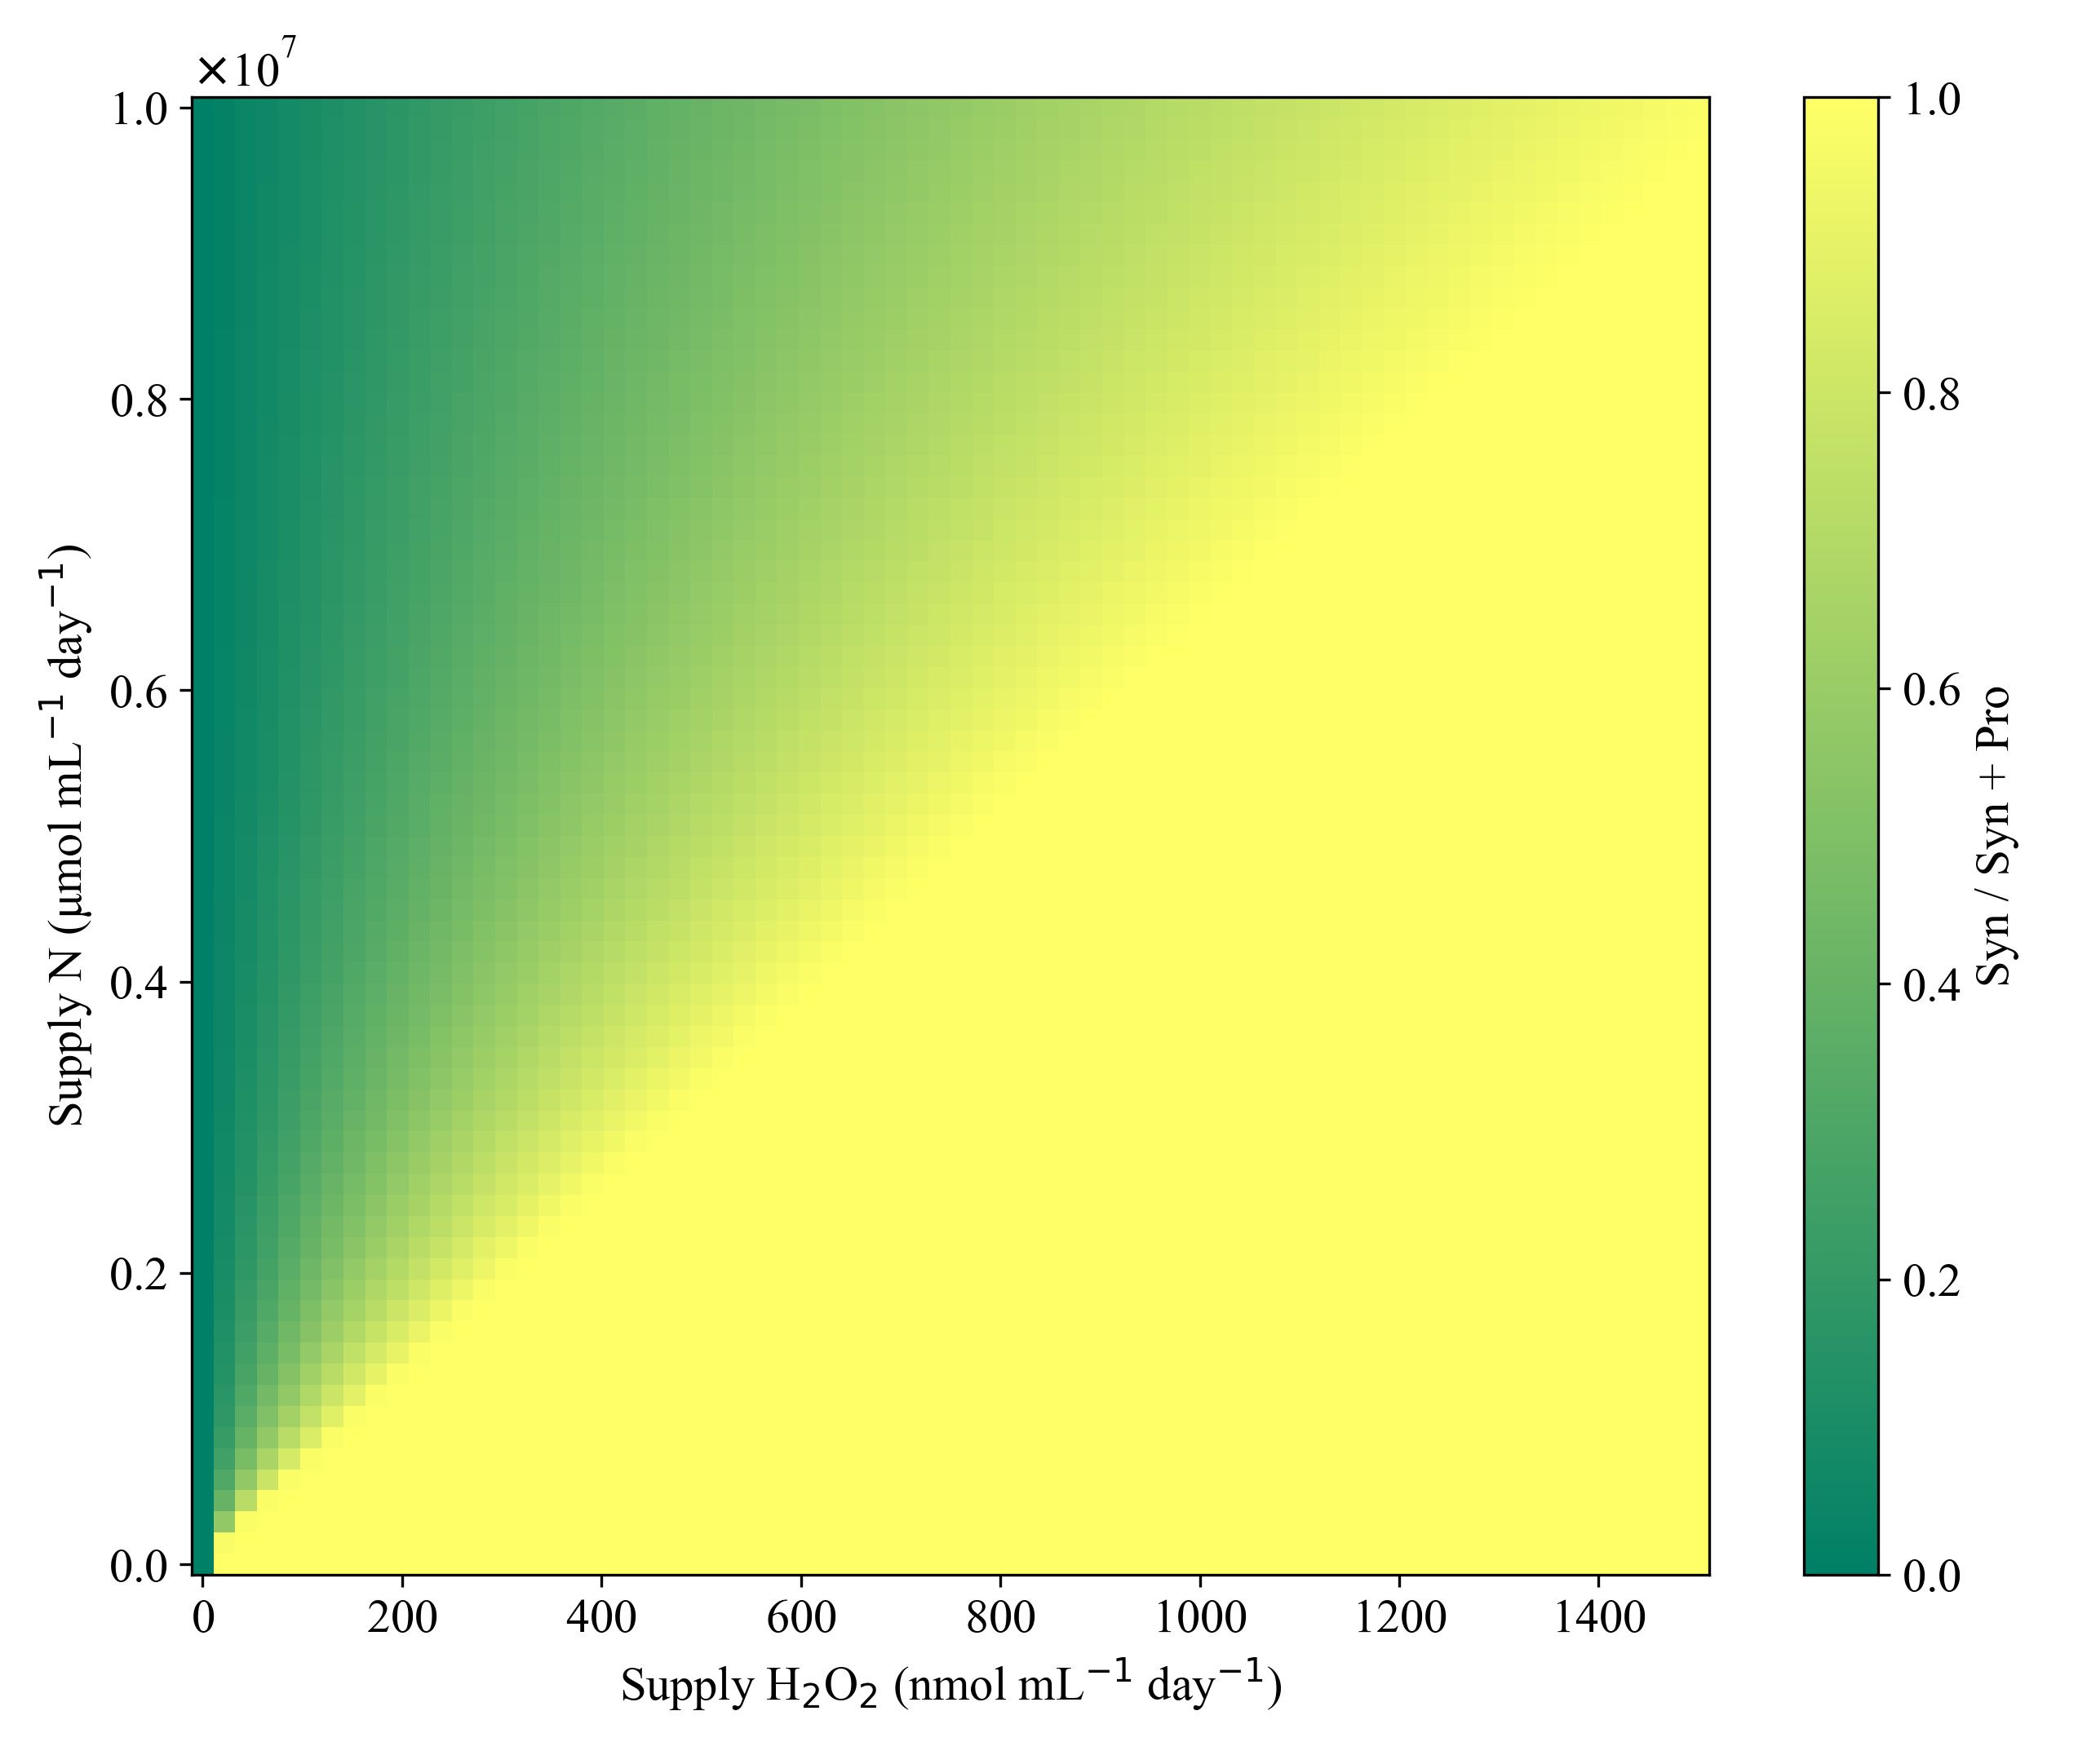 | 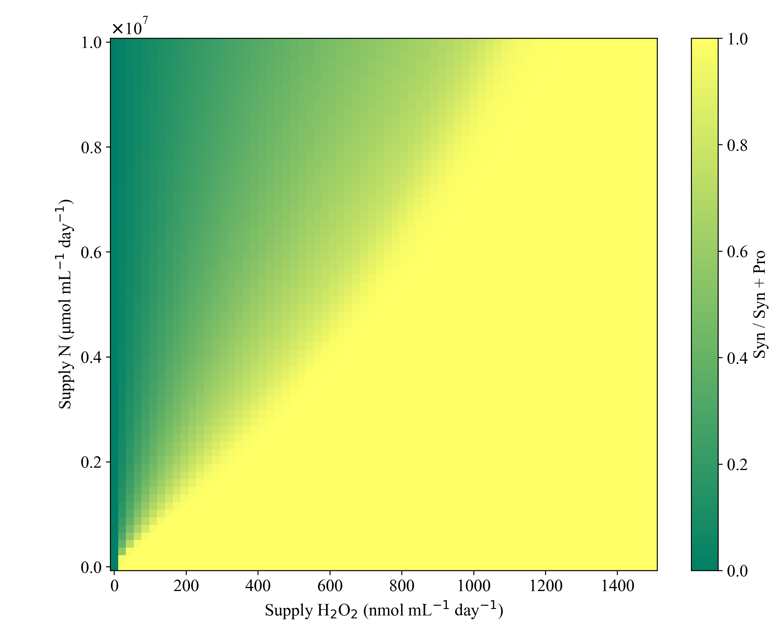
Figure B 10 ϕmax,s effects on Prochlorococcus and Synechococcus coexistence in dynamics and equilibria contours. Dynamics ODEs (left) or equilibrium solution equations (right) are projected along a biomass ratio contour plot indication Syn/(Pro+Syn). Each row represents a different parameterization (value) of Synechococcus cell based H2O2 detoxification (𝜙𝑚𝑎𝑥,𝑆).

$ϕ_{max,S}$ = 2.0 x10⁻⁶
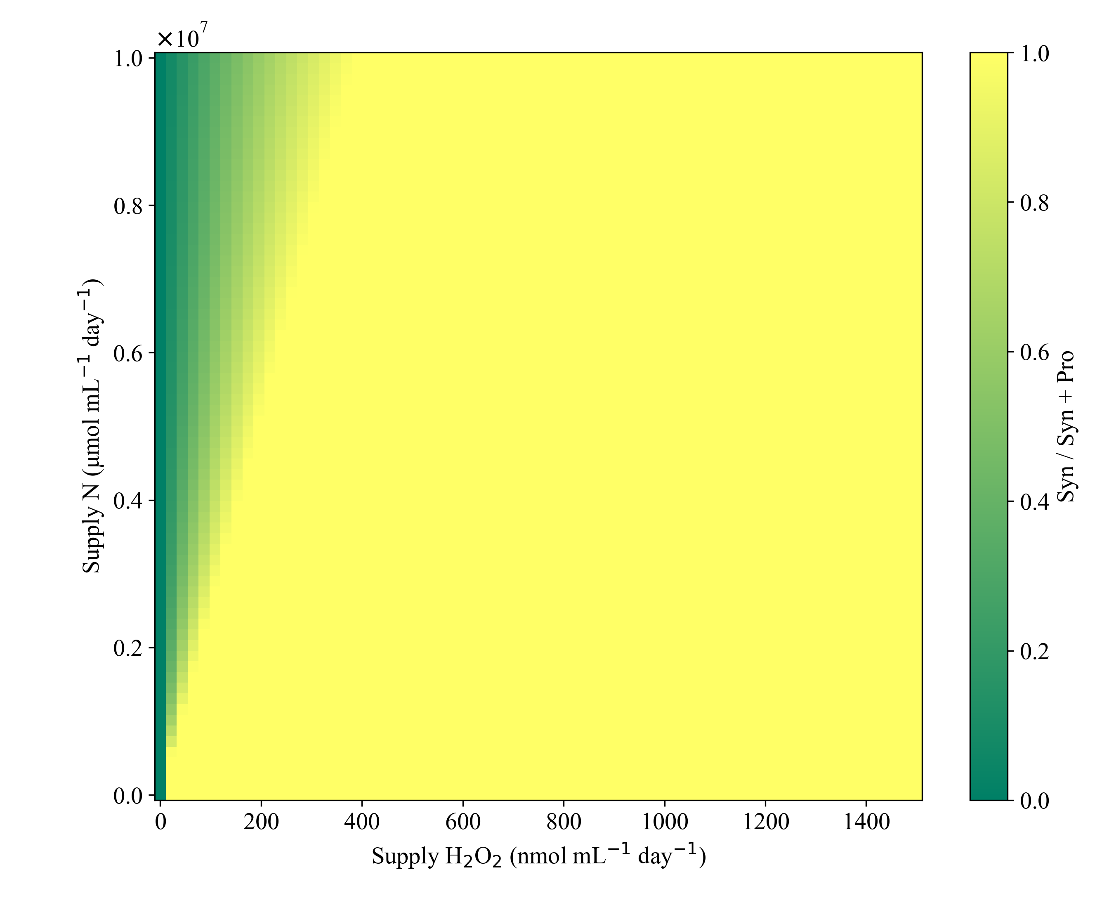 | 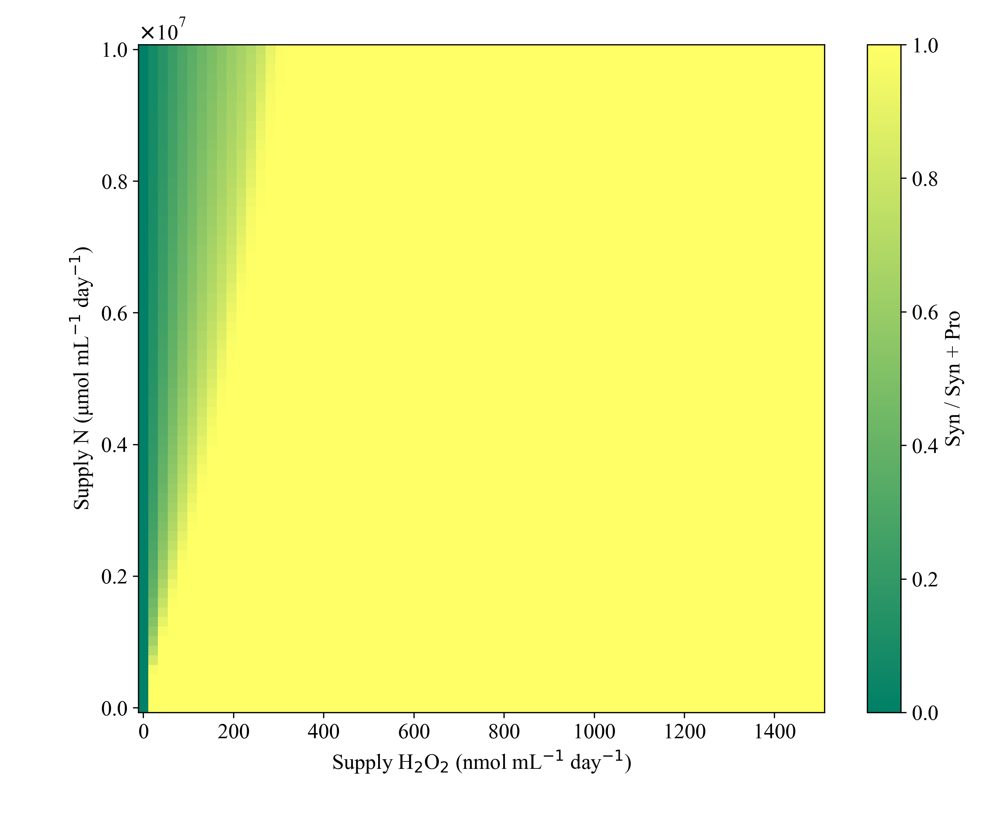
Figure B10 Continued
$ϕ_{max,S}$ = 0.5 x10⁻⁶

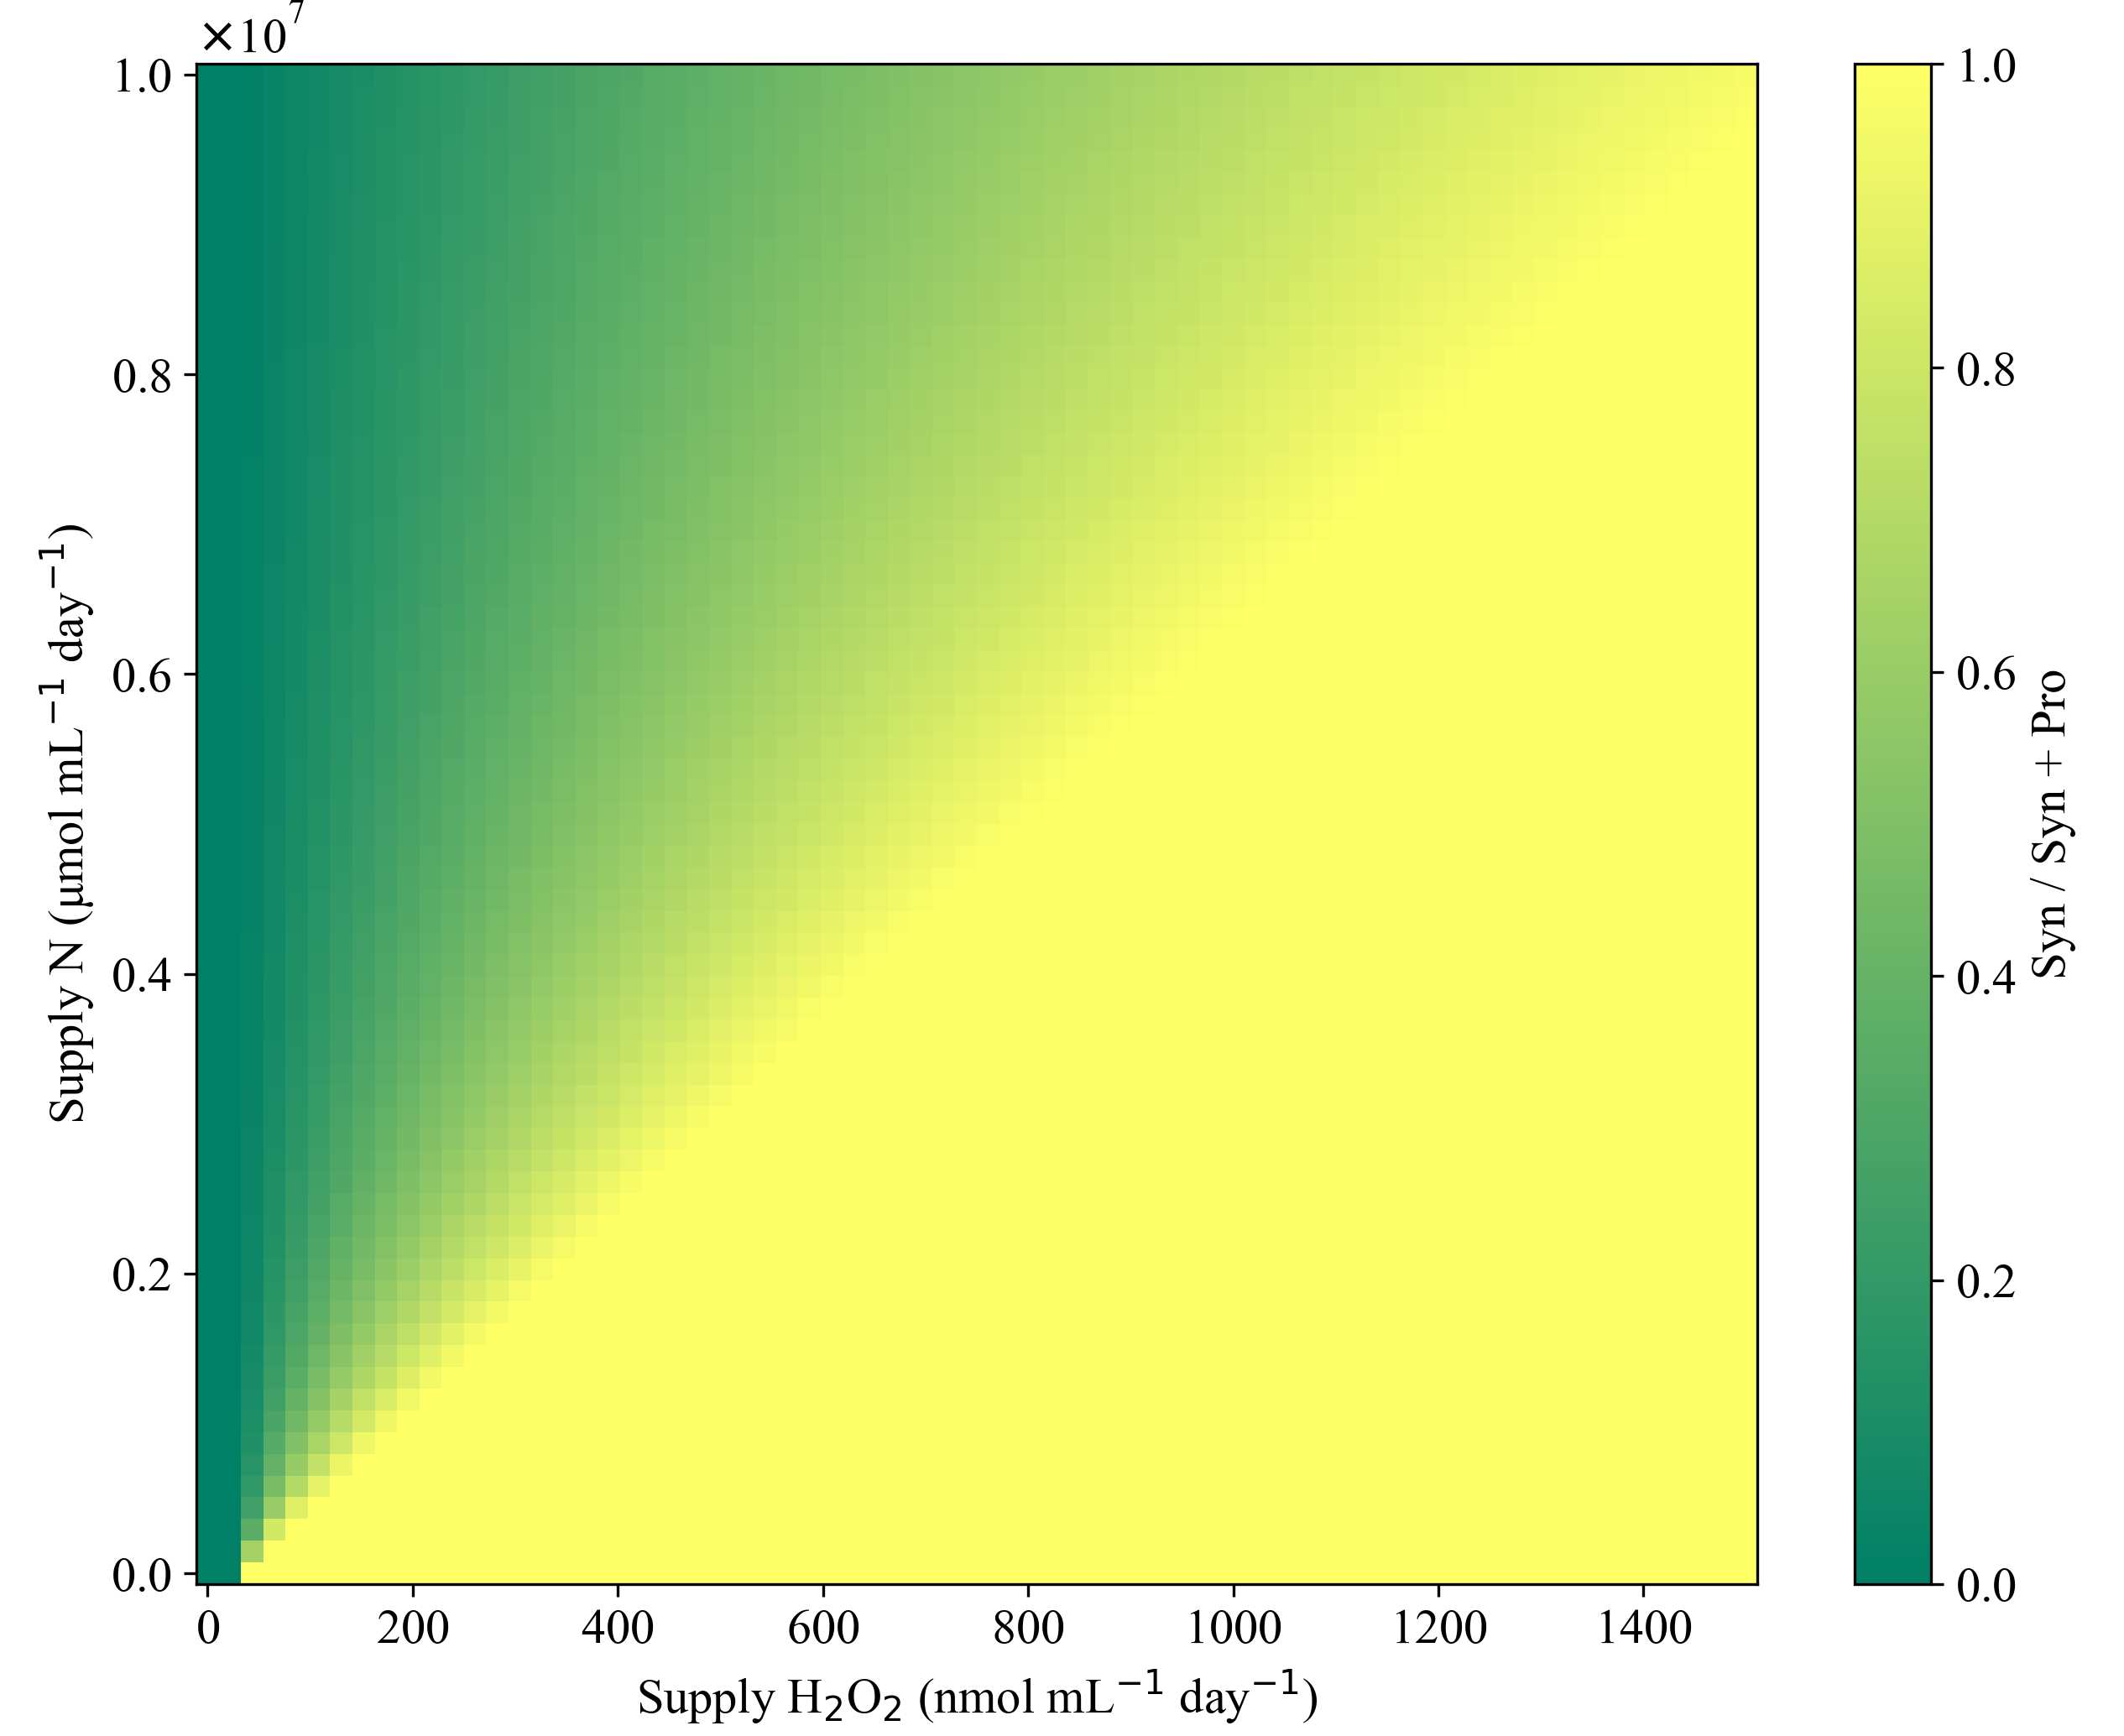
$ϕ$_{max,B} = 2.0 x10⁻⁵
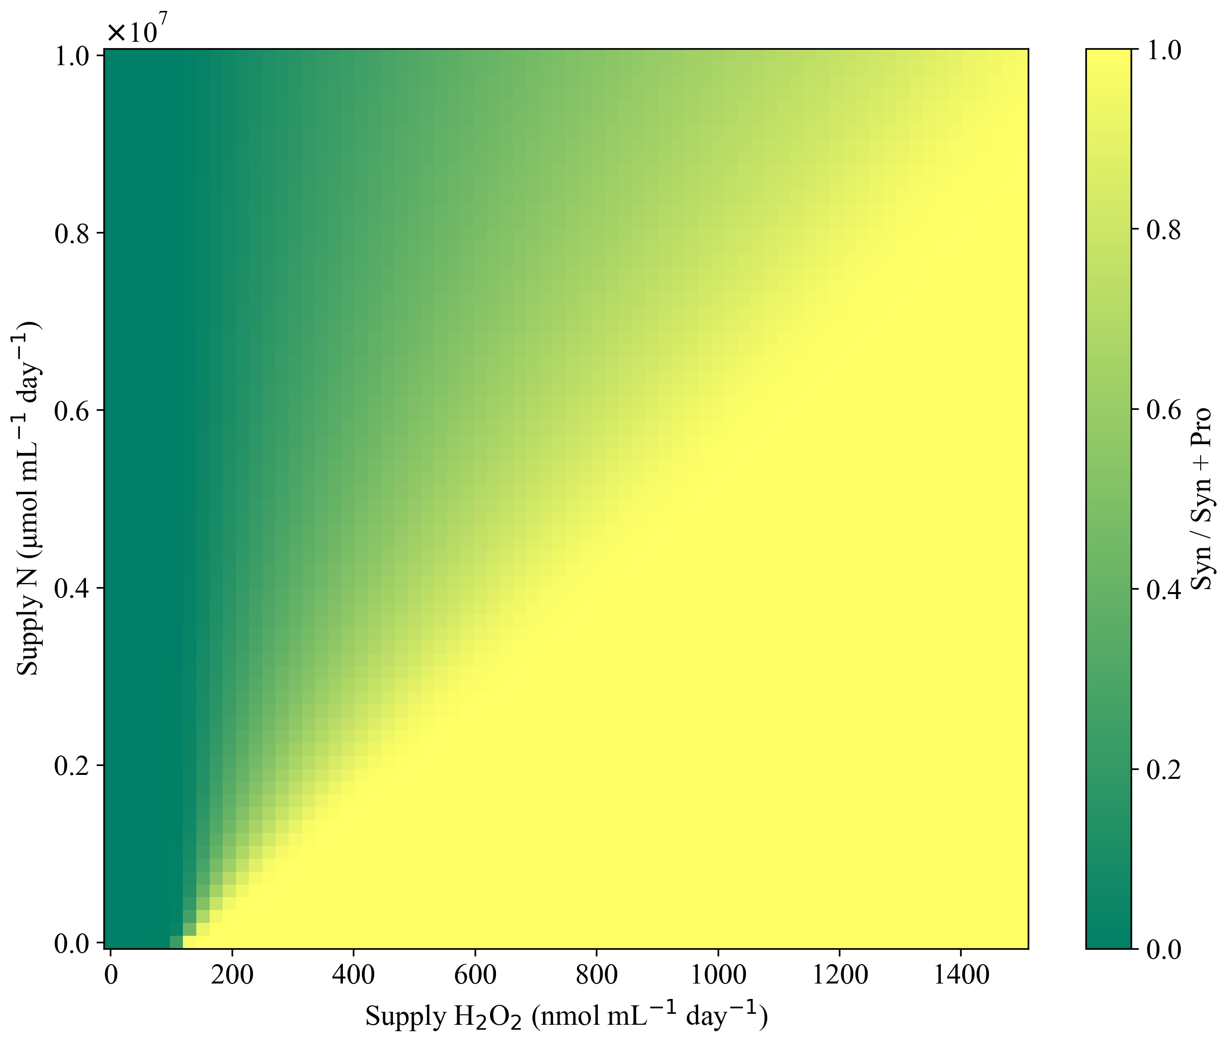
Figure B 11 $ϕ$_{max,B} effects on Prochlorococcus and Synechococcus coexistence in dynamics and equilibria contours. Dynamic ODEs (left) or equilibrium solution equations (right) solutions are projected along a heat map of S_{H} and S_{N} inputs. Color represents the biomass ratio of Syn/(Pro+Syn). Each row represents a different parameterization (value) of a stationary phase heterotrophic bacterial (B) culture’s H₂O₂ detoxification rate ($ϕ$_{max,B}). Synechococcus detoxification rate ($ϕ$_{max,B}) is held constant at 2.0 x10⁻⁶. $ϕ$_{max,B} = 8 x10⁻⁵

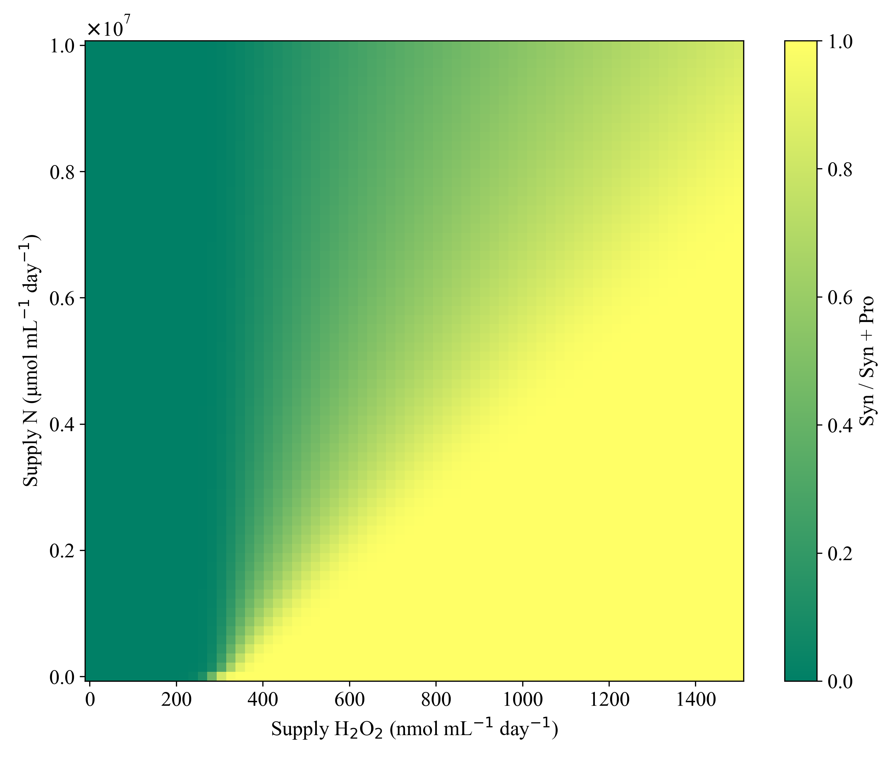
Figure B11 Continued
$ϕ$_{max,B} = 2.0 x10⁻⁴

Appendix C Supplementary Information: Chapter 4

Global maps of individual H, P, and S, tracers in Cases 1-4 are shown below.

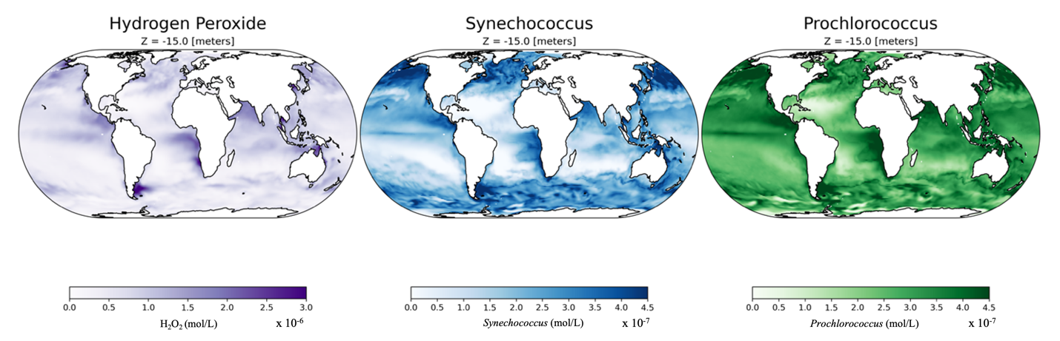
Figure C 1 H₂O₂, Prochlorococcus and Synechococcus biogeography in year 9 of Case 1: Non-leaky world, no k_{dam,p}.

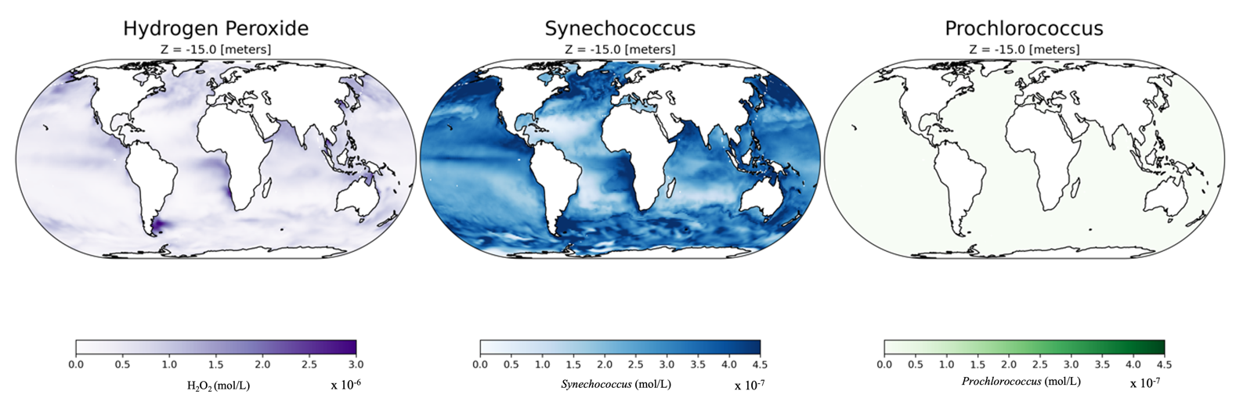
Figure C 2 H₂O₂, Prochlorococcus and Synechococcus biogeography in year 9 of Case 2: Non-leaky, no biotic detoxification (${}_{max,i}).$

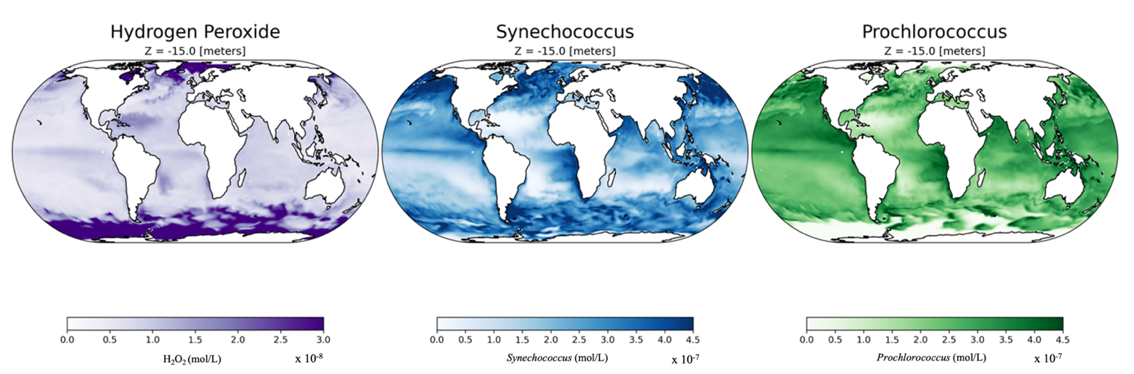
Figure C 3 Projected H₂O₂, Prochlorococcus and Synechococcus biogeographies in year 9 of Case 3: Leaky world, Synechococcus H₂O₂ detoxification (${}_{max,s}$ ) alone is implemented in the model.

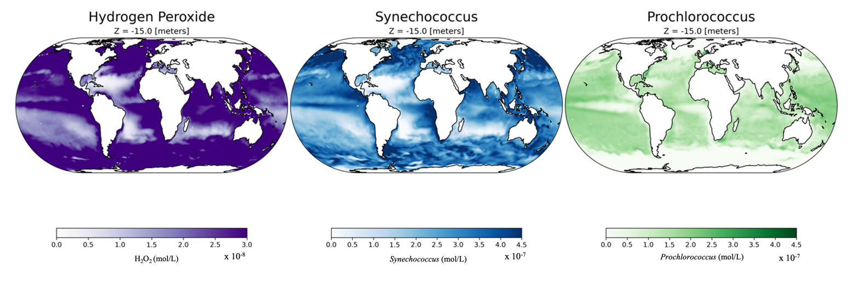
C 4 Projected H₂O₂, Prochlorococcus and Synechococcus biogeographies in year 9 of Case 3: Leaky world, heterotrophic detoxification (${}_{max,B })$alone.

a H₂O₂ M b Syn/ (Pro+ Syn)
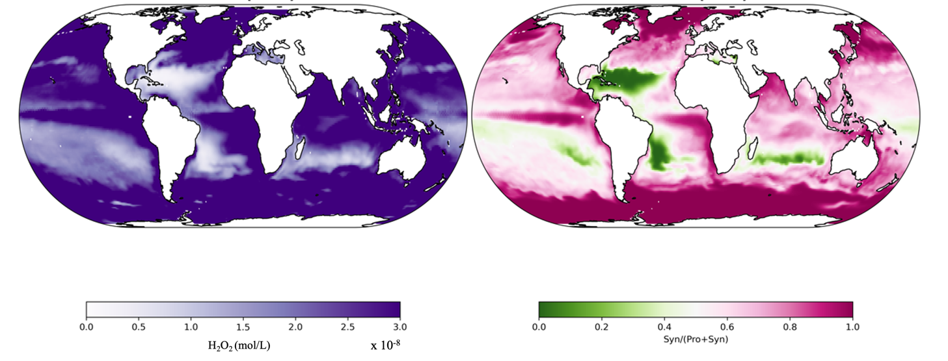
Figure C 5 H₂O₂ biogeographical plot and ratio plot of (Syn) / (Syn + Pro)) biogeography in Case 3: Leaky world, heterotrophic detoxification (${}_{max,B}$) alone.

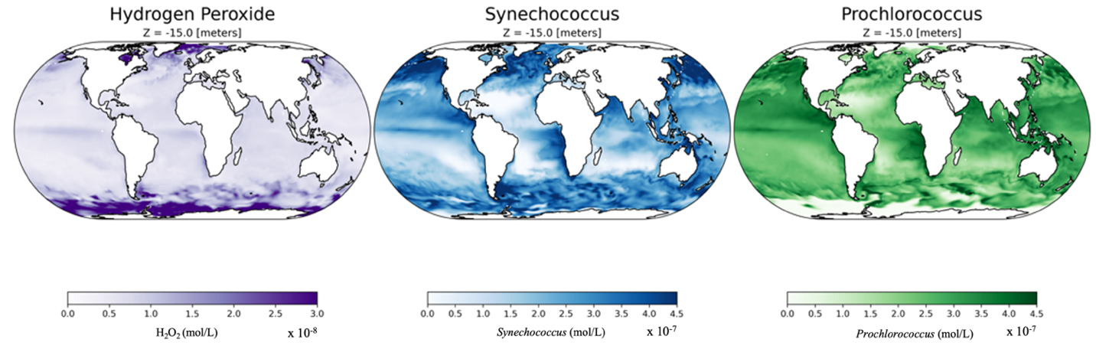
Figure C 6 Projected H₂O₂, Prochlorococcus and Synechococcus biogeographies in year 9 of Case 4 with both heterotrophic bacterial and Synechococcus H₂O₂ detoxification ( ${}_{max,S }$ and ${}_{max,B }$) incorporated in the model.

Vita
Donna Kathleen “Katie” McCullough was born in Huntsville, Alabama in 1994, two days before a tornado rattled the whole town. She is named after Donna Barnes, the first female head of the Mississippi Appellate State Court and biggest fan of Disney ever born. As the 3rd child to Claire and Calvin McCullough, an electrical and nuclear engineer respectively, she enjoyed a curiosity and educational upbringing. Her eventful childhood with older twin siblings, Charles and Sarah McCullough, was first located in Huntsville, AL and then Ringgold, Georgia. Katie first attended school at Graysville Elementary and then finished her K-12 education at Ringgold Middle and High school. Katie attended the University of North Georgia (Formally North Georgia College and State University) with both academic and music scholarship support. After volunteering at Lumpkin Country Animal Shelter in Dahlonega, Ga and memories of an unfortunate fetal pig dissection, D. Katie changed her major from veterinary sciences to biology. After a year of field reef ecology research parried with a microbiology laboratory prep assistant job, D. Katie found herself fully entrenched in biological research. UNG faculty were instrumental in this growth. After a year sabbatical studying the genetics of yeast subpopulation differentiation Poland under a Fulbright scholarship, Katie enrolled in the University of Tennessee in Knoxville for a PhD in Microbiology. Joining the Talmy lab, she delved into ocean microbiology with computer science and mathematical modeling tools informed by laboratory and in situ data.

