Dual Threat: The Spanish Influenza and
World War I

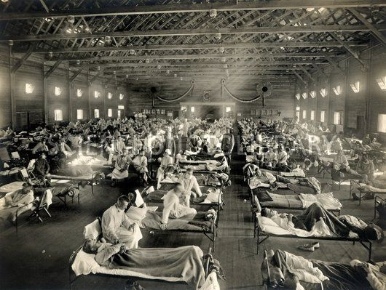

By: Matheson Williams
Chancellor’s Honors Thesis
May 8, 2014

During World War I, the world saw how destructive modern warfare could be. By the end of the war, around 10 million people in arms and 6 million civilians lay dead. These numbers were shocking compared to the number of casualties from wars in the past. This war had been all encompassing, considered a “total” war by many countries, and would be named “the war to end all wars”. But behind all of the weapons and massive armies was an even greater killer that claimed more lives over the course of the war than the fighting did. Though it received little press, it played a major part in the outcome of the war. The killer was the Spanish Influenza. It was a unique flu virus with a special ability to kill the young and healthy. Within a year, it had killed more people than the Bubonic Plague killed in a century. It infected around 500 million people and killed nearly 50 million around the world. The question is what made this flu so strong and what allowed it to infect and kill so many people. It is important for us today to understand what happened in 1918 and 1919 so that we can prevent an epidemic like this from ever happening again.

The World becomes smaller: Pre-1918
Nationalism and European colonization actually helped the Spanish influenza become the killer that it was. Throughout the 19th century, European countries claimed as much of the world as they could in an attempt to become more powerful than their competitors. Places that had never been touched by people outside of their native populations were now being opened up for world-trade. People began traveling from one side of the world to the other exchanging raw materials, finished goods, and even disease. Countries built powerful empires, which allowed for constant contact from people located all over the globe.
Nationalism played a role in how countries operated at this time. Citizens began to identify themselves more from what nation they came from, such as a German or Englishman, over their family or religious origins. Leaders and their people believed in their nation and wanted to make it the greatest and most powerful. This led to countries wanting larger populations so that they could have more soldiers in their military and more workers to help build their nation’s economy. In order to increase production and fuel the economy, factories were built where people worked close together, sharing and breathing the same air. Larger populations meant more people were living in cities where diseases could easily be spread from person to person. Even within countries, new railways were built that only further increased the exchange of products and disease.

Spring 1918
Before the flu first appeared, the war had been going on for almost three and a half years. The Allies, which included the United Kingdom, France, and the Russian Empire, were against the Central Powers of Germany, Austria-Hungary, and the Ottoman Empire. Several other countries joined the war on various sides as the war continued, including the United States on the side of the Allies. The Allies realized that they could not gain an advantage against the Central Powers, so they called on the United States to join the war. America agreed, declared war in April 1917, and began to mobilize an army.
Meanwhile, the spring of 1918 had many headlining stories. In January, President Wilson made his famous Fourteen Points address where he outlined what he believed would bring peace to the world and prevent another world war. It included his idea for a League of Nations that he hoped would help to encourage international diplomacy. In March, Russia left the war when the Bolsheviks agreed to a peace settlement with the Central Powers. Russia was in the midst of a political revolution and could no longer continue the conflict. Now, Germany only needed to focus on the front against France and Britain.
One story that did not make the headlines was the outbreak of something strange in Fort Riley army camp in Haskell County, Kansas. Soldiers were reporting to the medical building with complaints of headache, fever, and aching joints. They became nauseated and congested with mucous which impaired their respiratory system. Doctors could not explain what was happening. The illness quickly spread all over the camp and into other camps around the area. Soon, it was seen in military bases all along the east coast of the United States, then spread west as shown by the map below. It was the beginning of the first wave of the Spanish Influenza.
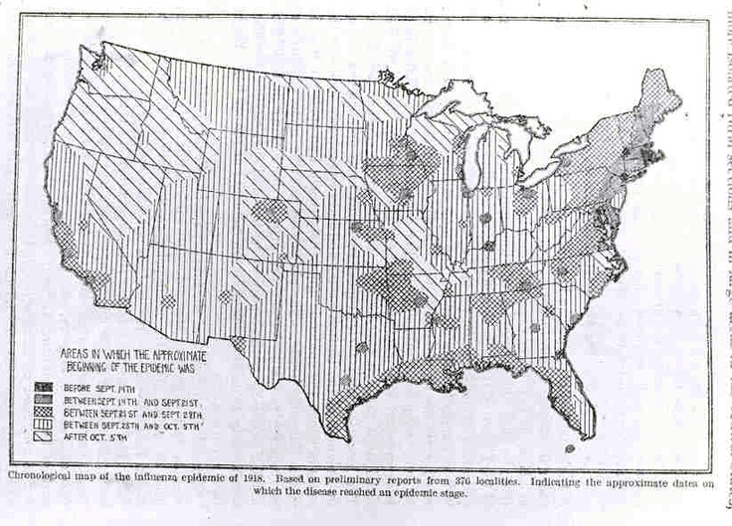
The Spanish flu came in three waves with the first beginning in March 1918.
The first wave had a high infection rate but a low mortality rate. Many of the deaths that did occur were caused by a secondary infection of pneumonia, as antibiotics were not yet discovered. People were bedridden and extremely weak, but they were usually able to recover within a few days.
The flu easily made its way onto U.S. troop ships bound for Europe. Europeans asked for American troops, but they never expected the soldiers to bring one of the worst outbreaks of disease in the history of the world. The flu spread quickly between armies. It was seen in the British Expeditionary Force by April and made its way into the French troops by May, 1918. Germany saw its first outbreaks in April, and Italy and Spain followed soon after. It was in Spain that this deadly virus first received its name. Since Spain was not part of the war, its government did not try to conceal how widespread the flu was becoming. It was the first country to report the flu outbreaks, so people began calling the sickness, Spanish Influenza. In the belligerent countries, the flu lost much of its deserved press because of war censorship.
At the Western Front, Spanish Influenza had already begun to affect the war by May 1918. Multitudes of troops on both sides were becoming ill and were unable to continue fighting. Many American ships and submarines had cases where one-third to one-half of the men aboard became sick and almost 10 percent of the entire British Grand Fleet contracted the flu. Some of their planned attacks had to be moved to later dates so that their soldiers could recover from the flu.
The flu also played a role in turning the tides of the war. In March, the Germans decided that their only remaining chance to win the war would be to defeat the Allies before the American troops made it to the front lines. Thus, they launched a massive offensive where they left the trenches and tried to overwhelm the Allies. They had a slight advantage in numbers after moving their troops from the Eastern front after the Russians surrendered. The offensive in the west allowed Germany to make huge territory gains relative to those made in the previous three years of the war. They were close enough to send bombs into Paris when the flu began spreading along Germany’s army. Influenza inflicted nearly half a million men in June and July of 1918 greatly affecting the strength of the German Army. The offensive lasted through the summer into July until the Allies were able to counter-attack in August. This was as close as Germany would come to winning the war. Germany’s leading general Erich von Ludendorff stated later that “it was a grievous business” listening to the number of flu reports and the reported weakness of their men. He went on to blame the failure of his offensive on the flu. He said it caused his men to have low morale and they were unable to fight at their best.
As the flu began to die down in July of 1918 along the Western Front, the fatality statistics were being tallied. Countries looked at the deaths across their civilian populations and military. Whenever they analyzed the deaths by the flu, the plot showed uncharacteristic results. Normally, flu tends to kill the very young, elderly, and infirm. The mortality usually follows the trend of a U-shaped curve as shown by the dotted line on the graph.
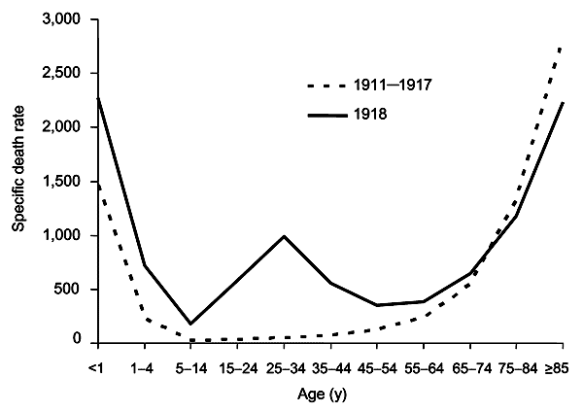
The 1918 influenza, however, created the W-shaped curve shown by the dark line. Even in cities where many of the young adults were away fighting in the war, the graph showed the same result. Amazing disproportions of young adults were being killed by this flu. Something was going on with this influenza epidemic that had not been seen before, and right in time for the deciding point of a war where young people were the fighting weapons.

The Science Behind the Flu
The Spanish Influenza puzzled scientists and doctors in 1918; however, much has been discovered about it since. In 1931, scientists found that influenza is caused by a virus and not a type of bacteria like they thought in 1918. Viruses have their own genome that can mutate and form new genes, which are copied and passed on to future viruses. Genes can change how the virus infects the body, for example, making the respiratory system more susceptible than the nervous system. The virus can also become more infectious or more deadly because of certain mutations. But mutations can also be harmful to the virus by making it less infectious. It is a matter of chance whether the mutation actually causes the virus to become more infectious.
Viruses can be made of single stranded RNA or double stranded DNA. Influenza contains 9 separate RNA strands. This allows it to mutate more freely because it only needs to change one strand rather than two, which is how DNA operates. Influenza can also swap strands with other viruses coming up with new combinations. Viruses are considered non-living because they are unable to build organs that allow for them to produce energy for themselves or reproduce. They can survive on inanimate objects but they need hosts in order to reproduce themselves. This is why they have to infect other species’ cells. Viruses insert their genome into the host cell and cause it to create replicas of the virus. Whenever the host cell becomes filled with viruses, it bursts and the new viruses invade another cell so that the cycle can continue. The host cell dies in the process. Through natural selection, viruses want to decrease their infectivity to the point that the host can survive. This way, the virus can survive and perpetuate for generations to come. A sign of an old virus is that it is not infectious, so the fact that the Spanish flu was so deadly indicated that it was a very new strain of virus.
Because they do not have to worry about building machinery to supply their own reproductive organs, viruses can be lazy with replicating their genome. Higher organisms have to be more exact when copying their DNA, because if the wrong mutation gets into the gene for a heart, for example, then the organism may die. We have a proofreading mechanism that scans our newly copied DNA for mistakes so that there is little room for error. Viruses, however, can freely mutate, coming up with combinations that allow them to infect an even greater number of hosts.
The body fights an infection with white blood cells. Chemicals called “cytokines” are used to activate the white blood cells and prime them to start fighting the infection. Cytokines are used whenever influenza viruses are detected on our cells. Sometimes, cells do not receive the signal for cytokines to stop being made, and excessive amounts of toxic cytokines are released that cause the body to start hurting itself. This is called a cytokine storm, and this is what is believed to have happened during the 1918-19 flu epidemic. The cytokine storms explain why young adults were the ones most affected by this flu. Their young immune systems were very proficient at creating massive amounts of cytokines that caused them to be even more susceptible to the virus and death.
The timing was perfect. A flu that happened to be particularly good at infecting and killing young people came about right when young people were traveling all over the world to fight a war.
Second Wave: August-December 1918
The first wave of the flu had been a nuisance. It caused large amounts of soldiers and civilians to fall ill and disrupted war productions, but nothing really alarming. Its only disturbing facts were its high infection rate and the high percentage of young people infected compared to the normal bout of flu.
With only mild outbreaks popping up every so often during the summer months, influenza seemed to disappear from the United States. Influenza, however, was infecting new hosts across the world. It was able to mutate and change its appearance, so that anyone who had gained immunity in the spring was no longer entirely safe.
Flu season is usually between late fall and early spring in the United States, however, the Spanish Flu came in the spring of 1918 and stayed around for almost an entire year. Flu viruses are usually strongest in cold weather, but the fact that this virus was able to cause so much damage throughout the year shows how lethal it was. The second wave brought worse symptoms than the first, which had only shown the usual flu symptoms. Victims in the fall would begin with a headache, fever, and pains in their joints, followed by nausea and vomiting. Their skin would turn dark blue and their lungs would begin to fill with infection as blood would pour from their nose, mouth, eyes, and ears. They would die within hours or days of showing symptoms. When doctors conducted autopsies, the lungs of flu victims were lined with a substance that looked like jelly and were filled with a frothy fluid. They could not understand what had happened.
The second wave began in August 1918 in three areas of the world at almost exactly the same time. The new, stronger strain showed up in Brest, France; Boston, Massachusetts; and Free town, Sierra Leone.
Brest was the main disembarkation point for the AEF. Around 17,000 Americans were usually stationed there and a dozen other countries from around the world also used this port. This particular port was an easy target for the flu because of the changing populations of people without immunity. The infected soldiers would then take the flu all over the continent as they moved to the front lines. Between August 22 and September 15, around 1,350 soldiers in Brest were admitted to the hospital with the flu and around 370 died. Soldiers of the AEF carried the flu deeper into Europe as they marched to the front lines.
The flu arrived in Sierra Leone most likely on a British ship. Free town was a major coaling station for British ships, so there was a lot of traffic coming into and out of the port that could have easily brought the flu. The workers on the docks became infected by the flu, and then spread it to their families and communities. By the end of September, two-thirds of the native population had been infected with the flu and approximately three percent of the population had died. The virus then spread to other British sailors who came to the port, and they continued to carry it with them around the world.
In Boston, the new strain appeared at Commonwealth Pier, an area for military personnel to stay while on their way to other assignments. On August 28, the new strain appeared when men began reporting to the medical facility with early symptoms that included aches in their joints, muscles, back, and head. Two weeks later, nearly 2,000 men had been infected and between five and ten percent had contracted pneumonia. As officers and recruits from this area were moved to new locations, the flu went with them. In the fall of 1918, influenza would infect all 40 of the large training camps in the United States and Puerto Rico. The reason the flu spread so easily is because influenza is a highly infectious respiratory disease. Anytime an infected person coughs, sneezes, or talks, microdroplets that contain the virus are released into the air and can be breathed in by anyone in the area. Also, if someone touches an object that has the virus on it and then touches his or her eyes, nose, or mouth, they can catch the flu.
The war took part in spreading the flu even outside of the military population. The first civilian to contract the flu was admitted to Boston City Hospital on September 3. Washington officials were told about the flu on September 11, and on September 12, around 13 million men at the prime age for contracting the Spanish Flu crowded into city halls, post offices, and schools to register for the draft. These men coughed, sneezed, and breathed the same air effectively allowing the flu to spread to millions of new victims.
If the draft did not do the trick, the rallies and parades for the war bond drive certainly did. The government was running low on funds for the war so it launched a war bond drive on October 4. This led to numerous door-to-door solicitations, meetings, and parades that brought large numbers of people together. In Philadelphia, the Liberty Loan Drive on September 28 gathered 200,000. In the following week the flu exploded in Philadelphia with 635 cases of the flu reported on October 1. During the week of October 5, hundreds died of influenza, the next week 2,600 died, and 4,500 the week after. They began closing theatres, schools, and churches to help avoid spreading the flu. Policemen, firemen, and garbage men, all necessary professions for community health, were now unable to show up for work. Many businesses were forced to close because so many of their workers were sick. Entire families were stricken and many children were helpless, as their parents lay sick and dying. The war had taken twenty-six percent of Philadelphia’s doctors and nurses leaving a shortage of medical staff for the thousands that became sick. Bodies would sometimes be left in their homes for days before being moved to the street where they would sit until someone could bury them. As the dead began to pile up, authorities worried about a possible second infection and knew that seeing bodies along the streets would certainly affect people’s morale. Undertakers were completely overwhelmed, coffins were in short supply, and the prices for gravediggers rose to over 600 percent of the normal price forcing many families to bury their own dead.
The government and health officials seemed unsure of what to do. Public health organizations were unorganized and ineffective, government pamphlets detailing what to do about the epidemic were unhelpful, and people no longer trusted the medical community to heal them. The government issued posters like the one shown below that were of little help. The poster exemplifies that leaders realized the flu was affecting the strength of the country to fight the war effectively.
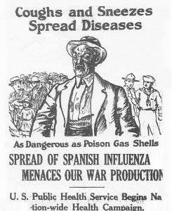
Authorities assured the public that they should not panic and that this was just a normal round of flu, but after the first week of October when hundreds of thousands of people were infected and hundreds lay dying, no one could continue to claim that this was only a normal strain of influenza. On September 13, the Surgeon General of the United States Public Health Service released a statement about how to recognize and treat the flu with bed rest, good food, salts of quinine, and aspirin for the sick.
Doctors were also somewhat clueless about how to help people suffering. They tried remedies and preventatives that had helped in the past, but nothing seemed to help. Vaccines were attempted and did not work, drugs that worked for other diseases had almost no effect, and home remedies were concocted that did little more than ease symptoms as a patient lay dying.
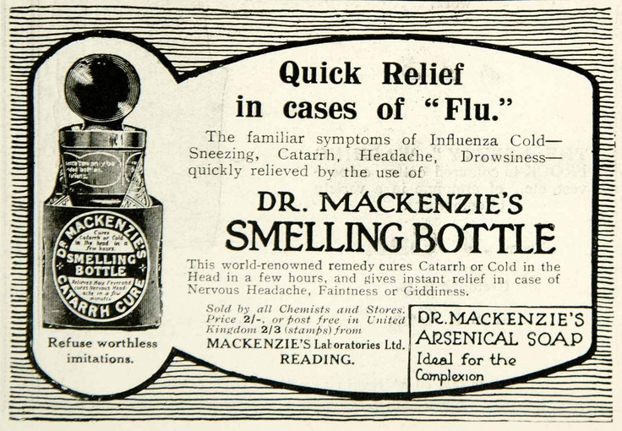
Good nursing seemed to be the only effective treatment but nurses were at a shortage during this time because of the war. The medical community lost much of their credibility because their treatments and assuring words were worth little.
Another attempt at prevention was quarantine. Towns closed schools, churches, and theatres in an attempt to prevent the spread of the flu. In San Francisco, people were ordered to wear gauze masks whenever they left their homes and would be fined if they were found without one. Although it left devastating death tolls, the disease came and went relatively quickly through communities, sometimes reaching a peak and dying down within three to four weeks. By the time communities had taken precautionary measures, the flu would have peaked and moved on. In Philadelphia, for example, in one month from September 29 to November 2, 1918, the flu killed 12, 162 people. The death tolls dropped from 4,597 in the week of October 19 to only 375 in the week of November 9 showing that the flu had already reached its peak.
In parts of the world away from the war, the flu took an even greater toll. Poverty in areas such as Southeast Asia, Africa, and Latin America made the flu even stronger. People were unable to find quality medical care and poor living conditions decreased the body’s defenses because there was a greater chance for secondary infection. In these areas, issues such as heart and kidney problems, diabetes, and asthma usually went untreated and contributed to people being weakened by the flu. Women were at an especially high risk of death because they were the main caregivers and usually had to take care of their families while being sick.
Influenza’s spread was influenced by the railways in areas like Africa and India where Europeans had built railway systems throughout the country. In India for example, the trains helped transport the flu from the coast and into rural areas leading to nearly 18 million deaths from influenza. In China, where extensive railways had not been built, only around one to nine million deaths may have occurred in a population that was bigger than India’s.

Second Wave affects the War
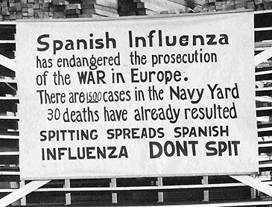
On September 20, the United States army had 9,313 reported cases of flu since the beginning of the second wave; by September 23, it had over 20,000. This happened right in the middle of the AEF’s offensive in the Argonne-Meuse sector where they fought into German lines. Despite their successes on the battlefield, Army leaders were losing the fight against the flu. It continued to spread into Army and Navy bases throughout the country even when there were orders demanding that sick men not be moved. However, these men who were infected but had yet to show symptoms would unknowingly be moved and spread the flu in the next camp. When soldiers were on leave they would spread the flu to their families and then the flu would infect the town. Stopping the spread of flu thus seemed impossible.
Draft calls were postponed or canceled due to the Spanish Flu. Training was halted as well, as soldiers lay sick in their bunks and officers were not well enough to lead. From September 21 to 27, an estimated 1,018 men in the Army died from the flu. In the Navy, by September 28 over 31,000 men had been stricken with flu and over 1,100 had died. At the end of the war, forty percent of the U.S. Navy came down with the flu while 36 percent of the Army was infected.
Some of the worst influenza mortality rates were seen on ships taking the doughboys to Europe. During certain weeks in September and October, the chance of survival for a doughboy in the Argonne forest was just as good as one crossing the Atlantic Ocean. President Wilson was advised to stop the shipment of men to France until the epidemic was under control. Putting men on these ships was like a death sentence with the close quarters and lack of open air. The President knew he had to weigh the lives lost to influenza against those lost at the front, because the troops could end the war sooner and thereby save more lives.
Experiences on the ships headed for France could be terrifying. One soldier said that the “assigned quarters on lower deck” were the “blackest, foulest, most congested hole that I ever set foot into.” On the ship Leviathan, so many began to get sick that the ship’s medical ward could not hold all of the men. Soldiers with the flu were forced to stay out on the main deck. Private Robert Wallace was one of these. He complained to the doctor that it was cold and windy on the deck but the doctor said he could either stay out there or risk infecting all of the men below. Wallace recalled that a storm hit one night and waves washed over, soaking the men on deck. Each morning, orderlies would come and check on the men and remove any that had died over night. This did little for morale for the men who were sick or healthy. Eventually, Wallace was allowed a bed in the medical ward. One night, a fellow patient asked Wallace to get him a cup of water. Wallace shouted for a nurse to bring him one but no one came to help. Soon the man said, “Don’t bother any more, I won’t need it.” The next day they found him dead in his bunk.
Other ships had stories just like the ones from the Leviathan. Men went below deck knowing that they were being enclosed with men who had the flu. The close spaces with no ventilation made a perfect place to spread the flu to everyone in the area. The living quarters below could quickly become an area covered with blood and vomit allowing the disease to spread even more if the men aboard the ship did not clean up after the sick. Eventually a policy of only sending troops to France that had been exposed to the Spanish Flu and thus were immune came to pass.
Once the soldiers made it to Europe, the sick desperately needed rest and a warm place to sleep, but instead, many of them had to make mile long hikes or take cramped railway cars to camps further inland. They had to wait in lines to receive their provisions and bed assignments, and even longer to see a doctor. Some became sicker simply because they did not have the chance to rest and fight the disease. Hospital tents were overflowing so many soldiers decided to just stay in their own tents. This caused many of them to infect the men around them.
This also happened along the front because many men did not want to leave their command and their fellow soldiers. These men became a hindrance to the fighting effort because their friends would help take care of them and sometimes catch the flu as well. A soldier with the flu was more of a liability than one who had been injured because at least the wound could not be passed on to other soldiers. However, the front usually saw better infection and mortality rates from the flu than the training camps and ports because soldiers at the front were not as cramped and received better ventilation. Additionally, the soldiers at the front had usually been exposed to the first wave of flu in Europe and to more respiratory illnesses. The new recruits were especially susceptible because their bodies were fighting new germs of which they had never been exposed as well as fighting the deadly new flu virus.

The End of the War and the Paris Peace Conference
The flu was causing havoc right in the middle of a war that required the countries involved to be completely dedicated to the war effort. Influenza was negatively affecting the war by bringing down the production rates when workers became sick, distracting government leaders who now had to worry about their civilian populations dying as well as their military, and costing countries even more money than they were already spending on the war. This leads one to question if the Spanish Flu influenced the end of the war, maybe evening shortening what could have been a much longer conflict. Influenza reached its height in Germany in October 1918 right when Germany’s military and political situations were on the edge of collapsing causing Germans to demand that the war must end even if that meant that Germany would be defeated. By the time the last shots were fired, the pandemic had killed twice the amount of people who died in the war. This fact alone shows how much of an impact the flu was having and the extra stress placed on these governments to end the war quickly to gain some sort of control over the situation within their countries.
The beginning of the end came on October 6 and 7, when Germany and Austria asked President Wilson for a peace based on his Fourteen Points. An armistice was negotiated between the Allies and Central Powers that became effective on November 11. The Allies began discussions about a treaty with Germany and what each wanted after the war. The main players were France, Great Britain, and the United States. The world did not want to see another war like this one with so much death and destruction. Many hoped that the future would be peaceful, however, some wanted Germany to be punished for the war. France was led by the French Premier George Clemenceau, who was determined to leave Germany “permanently mutilated” after France lost nearly 1.5 million people in the war. He did not want Germany to escape without paying retributions for the destruction it had caused France. The British Prime Minister was Lloyd George, who understood that creating a just peace would help to ensure that Germany would be reasonable and that there would be less of a chance for conflict in the future. His country, however, wanted revenge and they were the ones who voted to give him a job. He struggled during the peace conference with what he felt was right and what was best for his political career. Wilson was the outsider with his grand ideas about world peace and the League of Nations. He believed in giving Germany a fair treaty so that they would be agreeable in the future and not vengeful after losing such a costly war. He was the only hope for Germany not to become completely mutilated like the others wanted.
In the election of 1918, Wilson’s Democratic Party lost control of the House and Senate leaving him with little power when negotiating. Anytime he threatened that the United States would not go along with what the other powers wanted, the leaders of Britain and France knew that his threats held little weight. In addition, many of the Republicans in Congress (as well as some Democrats) disliked Wilson and voted against any treaty that he was able to bring home from the Conference. They also voted against the United States ever joining the League of Nations, making it nearly impossible for Wilson to achieve the peace that he envisioned.
When the Conference began in November, the third wave of the Spanish Flu began as well. It was not as strong as the second, but it did have an impact on the Conference. The third wave peaked in the United States in late January and in Paris in February. Wilson’s trusted adviser on foreign affairs, Colonel House, and three of House’s party members became ill during the last weeks of December and beginning of January. This hurt the Americans, making them more disorganized and unprepared compared to the British and French who would usually come prepared with typed manuscripts, ready for discussion. The Americans seemed one step behind, unable to obtain what they wanted. Wilson worked night and day in an attempt to coerce the other powers into agreeing with his ideas about a simpler peace with Germany. He may have achieved this feat if not for the Spanish Flu.
On April 3, Wilson began to feel ill as his temperature rose to 103 degrees. He felt very weak and started having a serious cough. He was diagnosed with the Spanish Flu and was bedridden for weeks. He chose House to represent him during this time because the peace talks would continue without him. Meanwhile, the Flu took its toll on Wilson. He became “thoroughly discouraged” as described by House, and lost his will to fight for his beliefs. Those close to him noticed that he had trouble with concentration and making conclusions after his illness. When he went back to the meetings, he made concessions to the other leaders, giving in to some of their wants instead of arguing tirelessly like he had before.
The Versailles Treaty was completed in early May and was signed unwillingly by Germany on June 28, 1919. Even though the peace was softened slightly by Wilson with the inclusion of his League of Nations in the Treaty, Germany was still forced to pay heavily. Germany would have to pay reparations and accept full responsibility for the war, demilitarization of their country, have of parts of their homeland confiscated, and lose their territories abroad. This Treaty and its treatment of Germany are sometimes blamed as a cause for the Second World War. It made Germany feel mistreated and ashamed which may have been the perfect precursor for their turn towards extreme nationalism, which influenced Hitler’s rise to power. If not for the flu, Wilson may have persuaded the other leaders to agree to a peace that did not motivate Germany to seek revenge and cause another war. He may have also been able to finally persuade the United States to join the League of Nations, but his sickness led to a stroke in the fall from which he was unable to recover.
While the “war to end all wars” was well known for it’s gruesome trench fighting and costly toll to all countries involved, the secret killer behind the scenes, the Spanish influenza, came at a much heavier price. With three deadly waves exacerbated by the increased movement of people and soldiers travelling all over the world, unhealthy and crowded war conditions, and industrialism causing crowding in cities and factories, the Spanish influenza could appropriately be called one of the worst diseases in human history. This deadly illness came at the perfect time and mutated simultaneously to target the very people who were leading the war effort. What resulted was a disastrous epidemic that very well could have altered the course of the war in the Allies’ favor. This virus may have even affected the end of the war by bringing it to a quicker close, as well as, the peace negotiations, by striking President Wilson at the worst possible time. As is often said, timing is everything, and the Spanish influenza is the prime example.

Notes
Baker, Robert. Epidemic: The Past, Present, and Future of the Diseases that Made Us. London: Vision Paperbacks, 2007.

Bessel, Richard. Germany After the First World War. Oxford: Clarendon Press, 1993.

Crosby, Alfred W. America’s Forgotten Pandemic: The Influenza of 1918. Cambridge: Cambridge University Press, 2003.

Hays, J. N. The Burdens of Disease: Epidemics and Human Response in Western History. New Brunswick: Rutgers University Press, 2009.

Kennedy, David M. Over Here: The First World War and American Society. New York: Oxford University Press, 1980.

Stone, Ralph A. (ed.). Wilson and the League of Nations. New York: Holt, Rinehart, and Winston, 1967.

Sherman, Irwin W. Twelve Diseases that Changed Our World. Washington, D.C.: ASM Press, 2007.

J. N. Hays, The Burdens of Disease: Epidemics and Human Response in Western History (New Brunswick: Rutgers University Press, 2009), 259.
Alfred W. Crosby, America’s Forgotten Pandemic: The Influenza of 1918 (Cambridge: Cambridge University Press, 2003), 17.
Irwin W. Sherman, Twelve Disease that Changed Our World (Washington D.C.: ASM Press, 2007), 158.
Crosby, Forgotten Pandemic, 19.
Crosby, Forgotten Pandemic, 25.
Hays, Burdens, 277.
Hays, Burdens, 277.
Crosby, Forgotten Pandemic, 26.
Crosby, Forgotten Pandemic, 26.
Richard Bessel, Germany After the First World War (Oxford: Clarendon Press, 1993), 46.
Crosby, Forgotten Pandemic, 27.
Crosby, Forgotten Pandemic, 27.
Robert Baker, Epidemic: The Past, Present and Future of the Diseases that Made Us (London: Vision Paperbacks, 2007), 61.
Crosby, Forgotten Pandemic, 21.
Sherman, Twelve Diseases, 163.
Baker, Epidemic, 39.
Baker, Epidemic, 43.
Baker, Epidemic, 43.
Baker, Epidemic, 67.
Sherman, Twelve Diseases, 167.
Sherman, Twelve Diseases, 158.
Sherman, Twelve Diseases, 158.
Hays, Burdens, 275.
Crosby, Forgotten Pandemic, 38.
Sherman, Twelve Diseases, 167.
Crosby, Forgotten Pandemic, 38.
Crosby, Forgotten Pandemic, 39.
Hays, Burdens, 276.
Crosby, Forgotten Pandemic, 40.
Crosby, Forgotten Pandemic, 46.
Crosby, Forgotten Pandemic, 73.
Crosby, Forgotten Pandemic, 74.
Hays, Burdens, 276.
Crosby, Forgotten Pandemic, 71.
Crosby, Forgotten Pandemic, 77.
Sherman, Twelve Diseases, 165.
Sherman, Twelve Diseases, 166.
Crosby, Forgotten Pandemic, 46.
Hays, Burdens, 276.
Sherman, Twelve Diseases, 167.
Hays, Burdens, 276.
Hays, Burdens, 276.
Crosby, Forgotten Pandemic, 86.
Hays, Burdens, 278.
Hays, Burdens, 275.
Crosby, Forgotten Pandemic, 47.
Crosby, Forgotten Pandemic, 49.
Crosby, Forgotten Pandemic, 48.
Crosby, Forgotten Pandemic, 123.
David M. Kennedy, Over Here: The First World War and American Society (New York: Oxford University Press, 1980), 205.
Kennedy, Over Here, 189.
Crosby, Forgotten Pandemic, 125.
Crosby, Forgotten Pandemic, 131.
Crosby, Forgotten Pandemic, 138.
Kennedy, Over Here, 189.
Crosby, Forgotten Pandemic, 151.
Bessel, Germany, 39-47.
Sherman, Twelve Diseases, 166.
Crosby, Forgotten Pandemic, 186.
Crosby, Forgotten Pandemic, 186.
Crosby, Forgotten Pandemic, 175.
Crosby, Forgotten Pandemic, 177.
Ralph A. Stone, Ed., Wilson and the League of Nations (New York: Holt, Rinehart and Winston, 1967), 65.
Crosby, Forgotten Pandemic, 192.
Sherman, Twelve Diseases, 166.
Kennedy, Over Here, 359.
Sherman, Twelve Diseases, 166.
Stone, Wilson, 73.

