CHAPTER ONE
Background and Introduction

CLINICAL IMPLICATIONS OF CANDIDA ALBICANS INFECTIONS
Candida albicans infections are recognized as being of clinical importance since they are increasingly being isolated from patients with HIV infection, cancer, transplantation and other immunocompromised patients. Candida albicans is the most common fungal pathogen causing nosocomial infections and the main clinical forms are bloodstream and peritonitis infections (Leroy et al., 2009). C.albicans infections can manifest in the form of oral, gastrointestinal, vaginal candidiasis or life-threatening disseminated candidiasis. C.albicans causes severe morbidity in infected individuals with mortality rates of over 40% (Gudlaugsson et al., 2003). Vaginal candidiasis alone affects about 75% of women at least once during their life, equating to ~30 million infection episodes a year (Sobel JD, 1992). ~ 90% of AIDS patients suffer from oral candidiasis (Naglik and Moyes, 2011) and 10% develop one episode of esophageal candidiasis (de Repentigny et al., 2004). Additionally, the costs associated with hospital stay and treatment of invasive candidiasis is high (Morgan et al., 2005).
The risk factors associated with C.albicans infections include underlying debilitating diseases and/ or hospitalization that predispose patients to infection from their endogenous flora from superficial mucosal or cutaneous surfaces. Antibiotic therapy that suppresses bacterial growth also allows yeast to proliferate especially in neutropenic patients (Richet et al., 1991). Use of intravascular catheters, parenteral nutrition or steroid therapy may damage the integrity of skin or gastrointestinal mucosa thereby facilitating penetration and spread of yeast. The development of candidiasis is dependent on a delicate interplay between the fungus and the host immune status.
Interaction between C.albicans and the host is highly complex that initiates with the adhesion and colonization of epithelial cell surfaces, followed by penetration into the epithelial layer. This results in superficial infections of mucosal surfaces such as oral thrush or vulvo-vaginal candidiasis. Immunocompetent hosts can usually contain the infection and prevent further dissemination. Depending on the hosts immune status, the fungi can reach the bloodstream and invade tissues by penetrating endothelial surfaces.
The most common drugs used to treat invasive candidiasis are amphotericin B, azoles and echinocandins (Odds et al., 2003). Intensive prophylactic and therapeutic use of antifungals have selected for drug-resistant strains (Anderson J.B. 2005). Thus there is a need to explore new drug targets and develop new antifungals to treat C.albicans infections. Targets that differ from the conventional drug targets have to be identified such as those targeting virulence factors or unique metabolic pathways.
CANDIDA ALBICANS HAS A REPERTOIRE OF VIRULENCE FACTORS
Candida albicans is equipped with a complex set of putative virulence factors that aid in pathogenesis. The main virulence attributes are highlighted below.
Yeast to Hyphal transitions and Phenotypic Switching
Dimorphic transitions or the ability of this organism to grow in different morphological forms such as yeast, pseudohyphae and hyphal forms, with each form associated with different pathogenic traits is a key virulence determinant. These properties of C.albicans enables it to adapt to various environmental cues reflecting the host such as nutrient limitation, presence of serum, neutral or alkaline pH and 37ºC temperature. Yeast-hyphal transitions are also important for evading the host’s immune system by escaping phagocytosis (Lorenz et al., 2004), escaping blood vessels (Phan et al., 2000) and colonizing indwelling medical devices via formation of biofilms (Nobile et al., 2006). Strains that are defective in morphological transitions are attenuated in systemic models of candidiasis (Lo et al., 1997; Saville et al., 2003); hyphal forms are associated with tissue invasion and yeast forms can more easily disseminate in the bloodstream.
Adhesion to host surfaces
Adhesion of C.albicans to host tissues is a critical step in its pathogenesis since it is a prerequisite for tissue colonization and establishment of disease (Fukazawa & Kagaya, 1997; Pendrak & Klotz, 1995). Adherence is mediated by cell wall components called adhesins (Chaffin et al., 1998). Several cell wall components such as chitin, glucans and mannoproteins facilitate adhesion to host surfaces (Calderone RA, 1993). Lectin-like molecules interact with epithelial cell receptors and contribute to colonization (Hostetter M 1994). C.albicans exhibits affinity for extracellular matrix proteins (Hostetter M, 1999; Chaffin W, 2008), laminin (Bouchara et al., 1990), fibronectin (Klotz et al., 1994; Santoni et al., 1994), collagen (Negre et al., 1994) and even complement (Meri et al., 2004). In addition to host cells, adhesion to plastic medical devices enables C.albicans to establish biofilms and disseminate infection.
Agglutinin-like sequences
The ALS (agglutinin-like sequence) gene family of Candida albicans codes for cell-surface glycoproteins that play a role in adhesion to host tissues (Hoyer et al., 2008). Mutants that are defective for Als production haven been shown to be attenuated for virulence (Fu et al., 2002; Alberti-Segui et al., 2004). ALS genes have also been linked to biofilm formation, invasion of epithelial cells and iron-acquisition (Liu & Filler, 2011).
Secreted proteins
C.albicans secretes proteinases for nutrient acquisition, digesting host cell membranes to mediate adhesion and tissue invasion or to destroy cells of the host immune system to evade attack by the host. Secreted aspartyl proteinases are the main proteinases produced by C.albicans and they are encoded by a family of 10 genes (Naglik et al., 2003). Secreted proteinases contribute to the overall virulence of C.albicans and this has been demonstrated by a number of observations. Some mutants that are defective for proteinase production are attenuated in virulence (Naglik et al., 2003; De Bernadis et al., 1999). Less pathogenic Candida species do not produce significant amounts of proteinases (Naglik et al., 2003) and this could account for their low level of virulence. Proteinase production also correlates with hyphal formation (Hube et al., 1994), adhesion (Ghannoum & Abu-Elteen, 1986; Abu-Elteen et al., 2001) and phenotypic switching (Kvaal et al., 1999). Moreover, SAP genes are also expressed in tissues during infection further highlighting their role in virulence (Naglik et al., 1999).
Lipases and Phospholipases
These hydrolytic enzymes are linked with host cell membrane damage, adhesion and invasion. C.albicans mutants that are defective in phospholipase (Ghannoum A, 2000; Theiss et al., 2006; Leidich et al., 1998) and lipase (Gacser et al., 2007) production exhibit reduced virulence in a mouse model of systemic candidiasis. Lipases and phospholipases are also expressed during infection (Stehr et al., 2004; Schofield et al., 2005; Naglik et al., 2003; Ripeau et al., 2002) suggesting an important role for these enzymes in host-niche adaptation.
TARGETING NUTRIENT ACQUISITION DURING INFECTION
C.albicans requires special strategies to survive and propagate in the hostile host environment as it is subjected to nutrient limitation during infection. As described above, hyphal formation and secretion of hydrolytic enzymes are crucial for nutrient acquisition and survival in the host. Different metabolic adaptations are required for colonization of different host niches due to differences in nutritional composition and targeting metabolic pathways is being considered as a viable antifungal drug target. A lot of research has been dedicated to understanding the metabolic needs of C.albicans during infection, but additional studies are required to gain a full understanding of metabolism in vivo. Identifying essential metabolic pathways that are suitable for the development of novel antifungals is needed and this can be facilitated by studying the virulence of mutants that are defective for different metabolic processes.
Nutrient auxotrophies significantly modify the virulence of C.albicans as evidenced by the observation that mutants which are defective for the biosynthesis of adenine, uracil and heme are all attenuated in virulence (Kirsch & Whitney, 1991). Similarly, deletion of key enzymes in carbon utilization pathways such as the glyoxalate cycle, gluconeogenesis and β-oxidation of fatty acids compromises the virulence of this organism (Ramirez & Lorenz, 2007). Defects in phospholipid biosynthetic pathways also alter the virulence of C.albicans (Chen et al., 2010). Therefore, novel antifungals for the treatment of candidiasis can be developed through a judicious selection of biosynthetic pathways or target enzymes that are unique to fungal metabolism.
LIPID METABOLISM IN CANDIDA ALBICANS
Lipids govern many important physiological processes in C.albicans including, but not limited to, cellular permeability, enzymatic activity, morphogenesis, adhesion and virulence. Most insight into lipid metabolism comes from studies on Saccharomyces cerevisiae but studies have suggested that the mechanism of lipid synthesis and degradation is similar in C.albicans and S.cerevisiae (Mishra et al., 1992)
Biosynthesis of sterols has been the most extensively studied area in lipid metabolism and since sterol synthesis is essential for C.albicans virulence, sterol biosynthetic enzymes or sterols themselves are targets for some antifungal drugs such as azoles and polyenes. Sterols play an important role in regulating the fluidity of cell membranes influencing cellular processes such as membrane transport, morphogenesis and chitin synthase activity (Pesti et al., 1981; Mishra et al., 1992). Altered lipid composition in the membrane changes the conformation of membrane proteins and has pleiotropic effects on the biology of C.albicans (Mishra et al., 1992).
Phospholipids such as phophatidylcholine, phosphatidylserine, phosphatidylethanolamine and phosphatidyl inositol are important constituents of the C.albicans cell membrane (Mishra et al., 1992). Variations in phospholipid composition affect diverse processes such as morphogenesis (Sundaram et al., 1981), signaling and cell cycle transitions (Dudani & Prasad, 1985).
Fatty acids also fulfill diverse functions in the cell as they are important constituents of lipids, they can form side chains in co-enzymes and metabolites, they also form covalent attachments to proteins and play a central role in energy storage and regulating the integrity and dynamics of cell membranes (Schweizer & Hofmann, 2004). Fatty acids also play a role in adherence and virulence (Hoberg et al., 1986) since alterations in fatty acid synthesis decrease the adhesion of C.albicans to host epithelial cells. It has also been suggested that fatty acyl composition modulates chitin synthase enzyme activity (Hoberg et al., 1983), and thus may play a role in cell wall biogenesis. The composition of fatty acids varies with the morphological form of the organism, with the hyphal forms containing more polyunsaturated fatty acids (Ghannoum et al., 1986). Fatty acid profiles also differ significantly between white and opaque cells with the ratio of unsaturated to saturated fatty acid being higher in opaque cells (Ghannoum et al., 1990). Thus in addition to being important components of the cell membrane and governing the entry and exit of various molecules and metabolites, lipids also influence the activity of enzymes involved in cell wall morphogenesis and antifungal action.
The importance of lipids in pathogenesis is highlighted from studies that have demonstrated that lipases, which are involved in acquisition of lipids from the environment, are important for the virulence of C.albicans (Gacser et al., 2007). A better understanding of lipid biosynthesis and how lipid composition influences interactions with antifungals is needed to discern the role of lipids in C.albicans pathogenesis. Sterol and fatty acid synthetic pathways have already been exploited as antimicrobial targets in a number of organisms. Differences in the organization of fungal and mammalian biosynthetic systems offers the prospect of developing specific inhibitors that do not affect host processes. The potential for these pathways to yield clinically useful agents for the treatment of candidiasis is still to be fully explored.
FATTY ACID SYNTHASE- MECHANISM AND POTENTIAL ANTIFUNGAL TARGET
Given the diversity of biological functions of lipids and fatty acids, the de novo biosynthesis of fatty acids is a fundamental process in all cells. The enzyme that catalyzes the synthesis of fatty acids is called fatty acid synthase (Fas) and is considered a housekeeping enzyme of the cell.
Structural Organization & Reaction Mechanism
Fatty acid synthase is a multienzyme that performs several iterative cycles of a distinct reaction sequence. The pathway for yeast fatty acid synthesis and the structure of Fas has been a topic of research for more than 30 years (Schweizer & Hofmann, 2004). The components of the Fas system are: Acyltransferases (AC); Malonyl/acetyl transacylase (AT); malonyl/palmitoyl-transferase (MPT); Ketoacyl synthase (KS); ketoacyl reductase (KR) dehydratase (DH); enoyl reductase (ER); acyl carrier protein (ACP) and thioesterase (TE).
The domain sequence of yeast fatty acid synthase is: AC-ER-DH-MPT/ ACP-KR-KS (Fig:1-1; Fig:1-2). Fatty acid biosynthesis (Fig:1-3) initiates with the loading of an acyl primer (usually acetyl CoA) by the enzyme acetyl transferase to a binding site on the fatty acid synthase complex to generate malonyl CoA. Malonyl transacylation from CoA to the enzyme results in enzyme-bound malonate, followed by its condensation to 3-keto-acyl-enzyme by ketoacyl synthase. This is followed by the reduction of 3-ketoacyl to an intermediate, 3-hydroxyacyl, by the enzyme ketoacyl reductase. Dehydratase catalyzes the dehydration of this intermediate to 2,3-trans-enoate and finally reduction of enoate to the saturated acyl-enzyme. The prosthetic group 4’-phosphopantetheine plays a central role in processing of intermediates (Schweizer & Hofmann, 2004). At the end of the process, palmitoyl transferase and thioesterase terminate chain elongation. Yeast elongation systems usually elongate C₁₂ to C₁₈ acyl-CoA primers to C₁₈ to C₂₆ long chain fatty acids and these constitute the vast majority of fatty acids being incorporated into the phospholipids of cell membranes (Welch & Burlingame, 1973). About 70% of the fatty acids found in C.albicans membranes are unsaturated fatty acids (Xu et al., 2009). Polyunsaturated fatty acids such as linoleic or linolenic acids are found in higher concentrations in C.albicans (Krishnamurthy et al., 2004).
Yeast mitochondria contain their own Fas which is structurally different from the cytoplasmic Fas. The products of yeast mitochondrial activity are C₈ to C₁₈ fatty acids (Rossler et al., 2003) and therefore, mitochondrial Fas is partially redundant with cytoplasmic Fas. However, mitochondrial FAS cannot fulfill the roles of cytoplasmic FAS since yeast fas∆ mutants are auxotrophic for fatty acids in vitro (Schweizer & Hofmann, 2004).
Another enzyme that is important in the biosynthesis of fatty acids is the Ole1 desaturase which catalyzes the desaturation of saturated fatty acids by sequentially inserting double bonds into palmitic and stearic acid precursors (Stukey et al., 1989). Deletion of OLE1 results in mutants auxotrophic for unsaturated fatty acids (Stukey et al., 1989).
The balance between saturated fatty acids and unsaturated fatty acids is important in governing the fluidity of the membrane and morphogenesis in C.albicans (Krishnamurthy et al., 2004). Unsaturated fatty acids have also been shown to play a role in mitochondrial movement and inheritance (Stewart & Yaffe, 1991). Very long chain fatty acids are essential for cell viability possibly because they are the main fatty acids incorporated into the sphingolipid backbone (Dickson, R.C. 1998; Schneiter, R. 1999).
FAS Gene Organization
Fatty acid synthases can belong to three general classes: (a) dissociated type II FAS systems, which occur in bacteria and eukaryotic organelles (b) integrated type I FAS multienzymes with discrete functional domains on a single polypeptide chain or (c) on two different multifunctional proteins. In fungi, fatty acid synthase is a type I multienzyme and is a hexamer, consisting of two sub-units, α and β that form the heteromultimeric α₆β₆ complex (Fig:1-2). The α subunit codes for the Fas2 component and β sub-unit codes for the Fas1 component of the complex (Schweizer et al., 1978). The α subunit contains ketoacyl synthase, ketoacyl reductase and acyl carrier protein domains, while the β subunit includes acetyl transferase, enoyl reductase, dehydratase and malonyl/palmitoyl transferase domains (Schweizer et al., 1986).
Synthesis of fatty acids in yeast is constitutive but may be regulated according to the need for membrane fluidity and phospholipid synthesis (Schweizer & Hofmann, 2004). The synthesis of the complex requires the coordinated expression of the two genes, FAS1 and FAS2. These genes are not linked and mapped to two different chromosomes (Burkl et al., 1972).
Fatty acid synthases and fungal virulence
Considering the essential role of fatty acids in a plethora of cellular processes it is not surprising the disrupting the genes that code for fatty acid biosynthesis would adversely affect the virulence of fungal pathogens.
Disruption of FAS2 in C.albicans severely compromises the ability of the pathogen to cause infection in a rat model of oropharyngeal infection and in a mouse model of systemic infection (Zhao et al.,1996 & 1997). Disruption of FAS2 in C.parapsilosis attenuates its virulence in a mouse model of systemic infection. The C.p.fas2∆/∆ mutant is also defective for replication within macrophages and is hypersensitive to acid and oxidative stress (Nguyen et al., 2009). Deletion of OLE1 in C.albicans affected hyphal formation (Krishnamurthy et al., 2004) and virulence in a mouse model of systemic infection (Xu et al., 2009). Similarly, the Candida parapsilosis ole1∆/∆ mutant was avirulent in a mouse model of systemic infection (Nguyen et al., 2011). Avirulence of the mutant was attributed to it being killed more effectively by macrophages and its hypersusceptibility to a range of membrane stress-inducing agents. Deletion of both FAS1 and FAS2 in Cryptococcus neoformans abrogated its ability to colonize brain tissue in a murine model of pneumonia (Chayakulkeeree et al., 2007).
Fatty acid synthase – a potential drug target
Amongst the currently exploited drug targets only fungal cell wall and membrane biosynthetic enzymes have been successfully exploited. In contrast, "housekeeping enzymes" that are involved in the general biosynthetic and metabolic functions of the cell, have not been seriously considered as potential antifungal drug targets since significant homologies exist between these enzymes and their counterparts in the host. However, certain biosynthetic enzymatic pathways, that are essential for the survival of certain pathogenic fungi, are absent in the mammalian host and can be exploited for the development of better antifungals.
Fatty acid synthases fall in this category, since they are important for fungal growth and virulence and thus represent a promising antifungal drug target. Mammalian fatty acids are structurally distinct in that they exist as dimers, consisting of one sub-unit α, that dimerizes to form the α₂ fatty acid synthase complex (Schweizer & Hofmann, 2004). The domain sequence of mammalian Fas is distinct from fungal Fas and is represented by – KS-AT-DH-ER-KR-ACP-TE (Fig:1-1). Thus this difference can be exploited to design compounds that selectively inhibit fungal fatty acid synthases.
It has been reported that the potency of fluconazole against C. neoformans is enhanced and is rendered fungicidal when the genes coding for fatty acid synthases are disrupted (Chayakulkeeree et al., 2007). Therefore, fatty acid synthases can potentially be fungicidal targets either alone or when combined with azoles.
CURRENT ANTIFUNGALS AND THE SEARCH FOR NOVEL ANTIFUNGAL DRUG TARGETS
One of the antifungals currently in use for the treatment of Candida albicans infections is amphotericin B which belongs to the polyenes class of drugs. But its use is limited because adverse effects such as chills, nausea and electrolyte abnormalities are associated with its usage (Bernardo et al., 2004). In the 1990s, azoles were available and this significantly improved the outcome of therapy since they are less toxic (Sheehan et al., 1999). However with the emergence of azole-resistant strains, new antifungal agents with more potency and less toxicity such as echinocandins and triazoles have been developed (Fera et al., 2009), and these provide the potential to improve the outcomes of invasive candidiasis. Figure 1-4 demonstrates the modes and sites of actions of different antifungal agents.
The incidence of invasive fungal infections due to drug-resistant C. albicans still continues to increase (Petrikkos & Skiada., 2007; Rodloff et al., 2011), therefore there is a dire need to improve treatment strategies or develop safer and more effective antifungals to which resistance cannot be developed.
Polyenes:
Polyenes such as amphotericin B bind to ergosterol in the fungal cell membrane and create pores in the membrane leading to leakage of solutes (Ghannoum & Rice, 1999). Resistance to polyenes is rare, but there have been some reported studies on amphotericin B-resistant fungi (Ellis D, 2002). Amphotericin B has been associated with nephrotoxicity but this has been avoided by the use of lipid formulations of the drug (Ostrosky-Zeichner et al., 2003).
Azoles:
Azoles interfere with ergosterol biosynthesis by inhibiting the α-demethylase step in the pathway. This results in the accumulation of toxic sterols which can disrupt packing of phospholipids and impair the activity of membrane-bound enzymes. The azoles available for therapeutic use include ketoconazole (1981), itraconazole (1992), fluconazole (1990) and a new generation of triazoles such as voriconazole (2002) and posaconazole. However, intensive prophylactic and therapeutic use of azoles has selected for fluconazole-resistant strains (Rex et al.,1995; Anderson JB, 2005; Cowen et al., 2002). Figure 1-5 depicts the various mechanisms by which C.albicans develops resistance to azoles. The extended spectrum triazoles are more effective in clearing Candida infections (Ianas et al., 2010), are associated with very mild side-effects (if any), and are also available as lipid formulations, making them ideal for use in long-term therapy and prophylaxis (Lai, Chih-Cheng et al., 2008).
Allylamines:
Allylamines such as terbinafine is another antifungal which inhibits ergosterol biosynthesis by inhibiting squalene epoxidase. This drug is mainly used for the treatment of superficial infections such as hair and nail infections (Johnson & Perfect, 2010).
Echinocandins:
Echinocandins target 1,3-β-glucan synthase and thus interfere with cell wall biosynthesis in fungi (Onishi et al., 2000). Glucans are important components of the fungal cell wall and play an integral role in maintaining its stability and integrity. Echinocandins include caspofungin, micafungin and anidulafungin and are fungicidal in nature. Although resistance to echinocandins is rare, there have been some documented cases (Garcia-Effron et al., 2010; Perlin DS, 2007).
Other drug targets
To widen the repertoire of antifungal drugs, targets that differ from those of the current drugs need to be identified. Targeting virulence factor production has recently been considered and looks promising. For example, the inhibition of hyphal formation of C.albicans in a murine model of systemic infection by peptides has been effective (Lupetti et al., 2007; Rauch et al., 2007). Cathelicidin peptides exert their anti-candidal effect by increasing membrane permeability (Benincasa et al., 2006). Some cationic nanoparticles and lipids have also been shown to inhibit fungal adhesion to epithelial cells (McCarron et al., 2007).
Compounds that target enzymes such as chitin synthase (Chen et al., 2009), GMP synthase (Rodriguez-Suarez et al.,2007) and phospholipases (Ng et al., 2006) have shown good activity against C.albicans in vitro and require further exploration using animal models and clinical trials.
Antifungal-drug combinations
The relentless increase in invasive fungal infections and therapeutic failures with conventional drugs has prompted investigators to explore antifungal combination therapy. Combination therapy offers unique advantages as the drugs can simultaneously target different processes to enhance the potency of drug activity, and overcome the problem of drug resistance. However, clinical trials utilizing combination therapy is limited due to the inherent risk of causing harmful drug interactions and toxicities in vivo and the burden of higher cost for treatment without proven clinical benefits.
Several drug combinations have been tested in vitro and in vivo against C. albicans:
- Amphotericin B combinations: Amphotericin B has been tested in combination with fluorocytosine and fluconazole. In vitro, synergy has been demonstrated with amphotericin B and fluorocytosine (Montgomerie et al., 1975; Chen et al., 1982; Lewis et al.,2002). Amphotericin B in combination with fluconazole has usually been antagonistic in vitro, but in animal models this combination has been associated with improved survival rates and decreased tissue burden of C. albicans (Sugar AM, 1991; Sanati et al., 1997; Louie et al., 1999; Sugar et al.,1995). Similarly, in animal models of invasive candidiasis, fluorocytosine-amphotericin B combinations have resulted in tissue sterilization and prolonged survival ( Rabinovich et al., 1974; Thaler et al., 1988).
- Fluconazole combinations: Fluconazole in combination with fluorocytosine have generally been antagonistic or indifferent using both in vitro and in vivo models (Beggs et al., 1982; Lewis et al., 2002). Terbinafine-azole combinations seem promising (Barchiesi et al., 1998) in vitro and in animal models, fluconazole synergizes with cyclosporine to decrease yeast burden in kidneys compared to the results seen with either agent alone in a rat model of endocarditis (Marchetti et al., 2000). Combinations of echinocandins with fluconazoles have not been successful in vitro.
- Antifungal-antibacterial combination therapy: There has been some success in combining fluconazole with antibacterial agents such as ciprofloxacin and trovafloxacin in improving the survival rates of mice in a model of systemic candidiasis (Sugar et al., 1997). In vitro, fluconazole synergizes with minocycline (Shi et al., 2010), doxycycline (Miceli et al., 2009), tetracycline (Oliver et al., 2008) and fluoroquinolones (Stergiopoulou et al., 2009) against C.albicans.

Clinical success of antifungal combination therapy
Data from clinical studies have generated exciting prospects using fluconazole-amphotericin B combination therapy (Rex et al., 2003). The success rate in treating candidaemia was 69% for the combination therapy compared to 56% for those receiving monotherapy. Similarly, positive outcomes with fluconazole-amphotericinB combinations were seen among neonates (Huttova et al., 1998) and adults (Minari et al., 2001) with candidemia. Combination therapy with fluconazole and fluorocytosine resulted in sterilizing tissues and in successfully treating peritonitis in patients in intensive care units (Abele-Horn et al., 1996). The efficacy of amphotericin B in combination with fluorocytosine for the treatment of Candida prosthetic hip infections (Ramamohan et al., 2001) and meningitis (Casado et al., 1997; Smego et al., 1984) was evaluated and was found to be successful.
Results from studies on antifungal combination therapies look promising and has the potential to improve clinical outcomes of invasive fungal infections. Data from in vitro and in vivo studies should be carefully analyzed to design clinical trials of combination therapy in patients.
CONCLUSIONS:
The development of new antifungals is limited by the number of drug targets in fungi that do not have functional or structural human homologs and are hence susceptible to inhibition in humans. Most antifungals target the cell membrane by inhibiting ergosterol (or its biosynthesis), the main sterol of fungal membranes. The other class of antifungals inhibit the biosynthesis of 1,3-β-glucan which is a key component of the fungal cell wall. Although, 5-fluorocytosine is another class of pyrimidine analogs that displays fungicidal activity by inhibiting DNA synthesis (Fig:1-4), it is usually not administered as a single agent because of the rapid development of resistance (Stiller et al., 1983). Therefore, currently only antifungals that target cell wall and membrane components or biosynthetic enzymes are in clinical use and there is a need to develop newer antifungals that target processes that are important for fungal growth. These could include fungal-specific metabolic enzymes or virulence factors.
Housekeeping genes such as those involved in gluconeogenesis, β-oxidation, carbon utilization and biosynthesis of lipids have all been shown to affect fungal virulence. Exploiting structural differences in the key biosynthetic enzymes or blocking fungal-specific steps in the biosynthetic pathway could provide attractive drug targets. The breadth of fatty acid synthases as drug targets looks promising as these enzymes regulate the growth and virulence of many fungal pathogens including Candida albicans, Candida parapsilosis and Cryptococcus neoformans.
Recently, the success of antifungal combination therapy in the treatment and management of invasive fungal infections has opened a new avenue for research. The main rationale behind combination therapy is to improve the spectrum of efficacy, increase potency, improve safety, tolerability and reduce the appearance of resistant isolates. Combination therapy has achieved some success because drugs in combination target complementary components or cellular processes in fungal cells. Investigations on antifungal drug combinations are still in the early stages, since drug companies largely shy away from proceeding towards clinical trials. This is because there have been numerous examples of lack of correlation between in vivo and in vitro drug interactions. Also, there is a potential risk of generating toxic drug interactions in vivo and this has impeded clinical studies. Nonetheless, there have been documented examples of success in combination therapy in improving survival and reducing tissue burden for a number of fungal pathogens. Some antifungal-antibacterial drug combinations have been successful against C.albicans biofilms and represent a new strategy for antimicrobial lock therapy in managing catheter-related candidiasis. Fluconazole synergizes with several antibacterial agents and there has been some success in improving survival rates of mice using these combinations in animal models of systemic candidiasis.

APPENDIX A: FIGURES
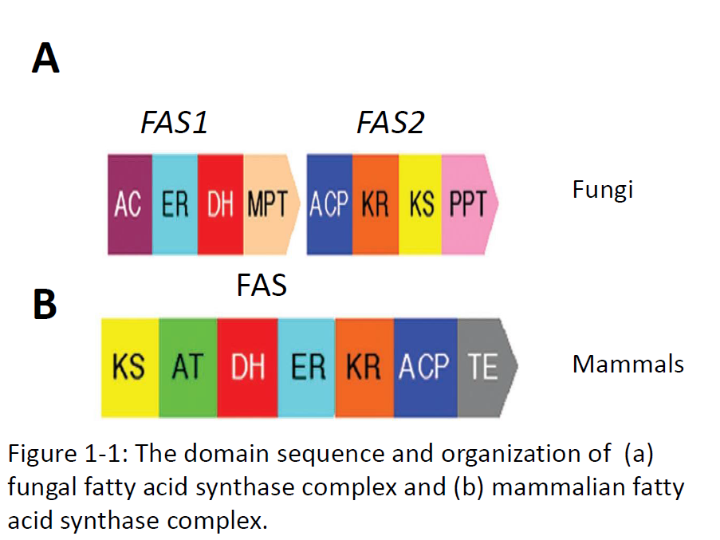
Figure adopted from Schweizer & Hoffman (2004)

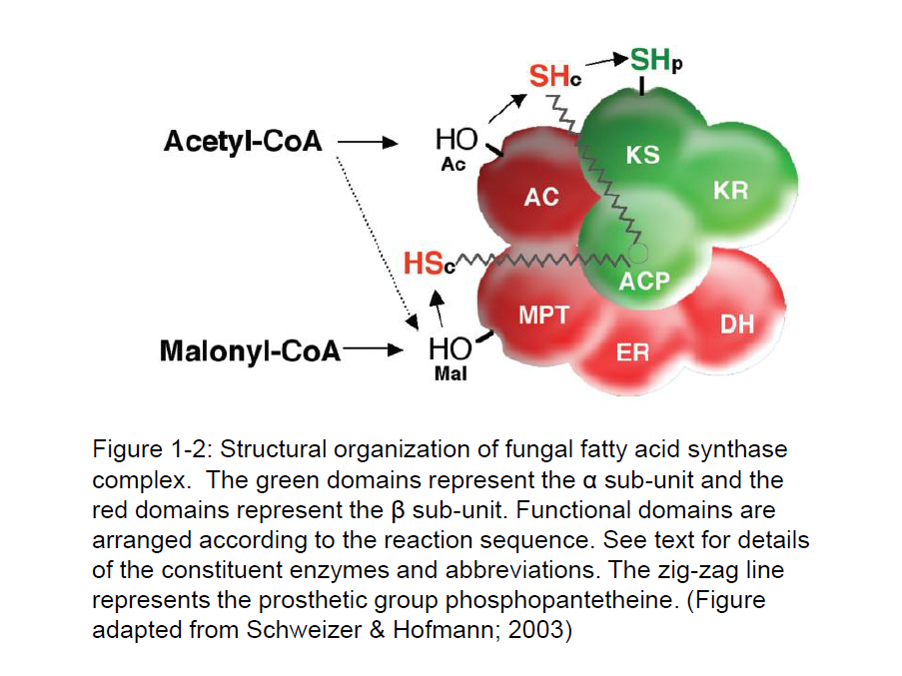
Figure 1-3: Fatty acid biosynthesis pathway in yeast.
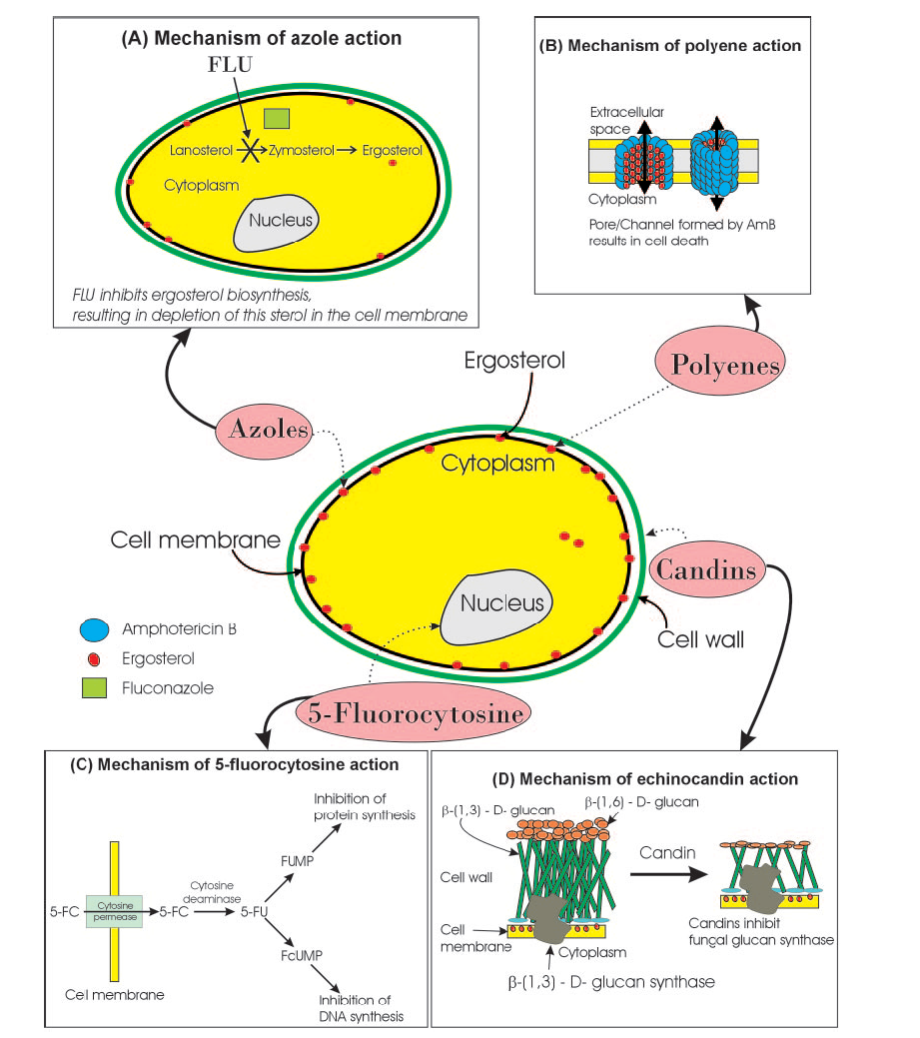
Figure 1-4: Schematic representation of the different sites of action of commonly used antifungals. (Figure adopted from Mukherjee et al., 2005)

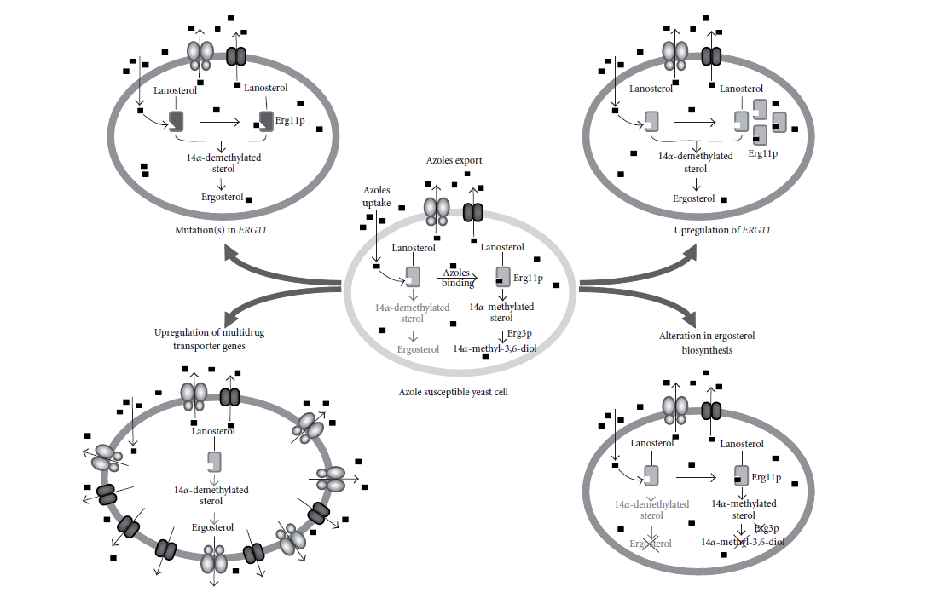
Figure 1-5: Mechanisms of azole resistance in Candida albicans. The ergosterol biosynthetic pathway in yeast is depicted. (Figure adopted from Vandepute et al., 2012)

CHAPTER TWO
Fatty acid Synthesis is Essential for the Survival of Candida albicans and for systemic infection

ABSTRACT
Candida albicans is the most common human fungal pathogen. It causes life-threatening systemic infections in susceptible individuals such as immunocompromised, cancer and transplant patients. Despite improvement of antifungal therapies over the last 30 years, antifungal resistance is still of major concern in the clinical setting. Most antifungals target either cell wall biogenesis or the cell membrane. New drug targets are thus required that target fundamental physiological or metabolic processes in C.albicans. Genes that code for biosynthetic enzymes represent attractive drug targets since they regulate fungal survival and hence virulence in vivo. Since fatty acids are major building block in cells and govern a diverse range of cellular processes, its synthesis can be a potential target for antifungal drugs. Fas1 which codes for the synthesis of the β sub-unit of the fatty acid synthase complex was disrupted in C.albicans to determine its role in fungal growth and virulence. The fas1∆/∆ mutant was auxotrophic for saturated fatty acids in vitro and was required for systemic infection in a mouse model of candidiasis. FAS1 was not required for growth in serum, suggesting the mutant could acquire essential fatty acids from serum. Consequently, the mutant could initiate hyphal formation and colonization in mice kidneys at least for the first six hours post-infection, but failed to sustain infection in the host by 3 days post-infection. This suggests that the mutant is either cleared up more effectively by the host compared to wild-type C.albicans or it is hypersusceptible to various stresses inside the host and is thus attenuated for virulence.

INTRODUCTION
Candida albicans is an important fungal pathogen in humans, especially affecting individuals with implanted medical devices, those undergoing chemotherapy, or immunocompromised individuals. C.albicans infections can manifest from superficial mucosal infections to hematogenously disseminated candidaemia (Odds, 1988). C. albicans is the fourth most common cause of hospital-acquired infections (Wisplinghoff et al., 2004) with a mortality rate approaching 40% (Wenzel & Gennings, 2005). A number of virulence factors have been identified in C.albicans including secretion of hydrolytic enzymes, yeast to hyphal transitions, production of adhesions and biofilm formation (Calderone & Fonzi, 2001). These factors and the genes/ proteins that encode them can be potential targets for antifungal drug development. Additionally, metabolic pathways or functions that are required to utilize nutrients or maintain cellular physiology during infections can be targeted for antifungal drug development.
For example, the de novo biosynthesis of fatty acids is important for diverse cellular functions. These include governing the integrity and dynamics of biological membranes, energy storage, cellular metabolism and signaling, as cofactors in enzymatic reactions etc. The enzyme that codes for fatty acid biosynthesis in fungi is called fatty acid synthase. In fungi, fatty acid synthase (Fas) comprises of two sub-units, α and β, specified by the FAS2 and FAS1 genes, respectively. These two sub-units together form a 2.6 MD heterohexamer α₆β₆ (Schweizer, E 1996). Another gene important in fatty acid synthesis is the OLE1 gene which encodes for a desaturase and is essential for the desaturation of saturated fatty acids or production of monounsaturated fatty acids (Krishnamurty et al., 2004).
Fatty acid synthase catalyzes a multi-step reaction process that is iterative in nature consisting of repeated cycles of a distinct reaction sequence (Stoops et al., 1978, Schweizer et al., 1971, 1978). Fatty acid biosynthesis essentially initiates by loading a primer from acetyl CoA to a binding site on Fas, followed by elongation of enzyme bound intermediates by several iterative cycles. At the end of the cycle, the product of FAS is removed after termination of chain elongation (Schweizer & Hofmann, 2004). C₁₆ to C₁₈ fatty acids are usually the main products of de novo fatty acid synthesis (Schweizer & Hofmann, 2004). These products are the precursors for subsequent desaturation reactions to produce unsaturated fatty acids.
The constituent chemical reactions catalyzed by Fas are essentially the same in all biological systems. However significant variation is seen in the molecular structure of Fas in different organisms. Mammalian fatty acid synthase is a 270-kD homodimer α₂ (Witkowski et al., 1991) with a different domain sequence from fungal fatty acid synthases. Thus the organization and overall structure of mammalian fatty acid synthases is distinct from fungal fatty acid synthases and this makes fungal Fas an attractive target in designing antifungal drugs. Fatty acid synthases are good drug targets in bacteria and extensive research has been dedicated on targeting fatty acid biosynthesis in the pathogen Mycobacterium tuberculosis (Morbidoni et al., 2006; Ngo et al., 2007 and Mdluli et al., 1998). This potential is further underlined by the potency of the drugs isoniazid and triclosan, that inhibit the enoyl reductase step of bacterial fatty acid biosynthesis.
Disruption of fatty acid synthases results in fatty acid auxotrophy in Saccharomyces cerevisiae (Schuller et al., 1992), Candida albicans (Zhao et al., 1997) and Candida parapsilosis (Nguyen et al., 2009). In C.neoformans, disruption of both FAS1 and FAS2 is lethal since the mutants cannot grow even in the presence of exogenous fatty acids in the culture medium.
In fungi, disruption of FAS2 significantly attenuates the virulence of C.albicans (Zhao et al., 1996; Zhao et al., 1997), Cryptococcus neoformans (Chayakulkeeree et al., 2007) and Candida parapsilosis (Nguyen et al., 2009). The role of FAS1 in C.albicans pathogenesis has not yet been determined. In C.neoformans, deletion of FAS1 resulted in reduced fungal burden in mice brains in a model of pulmonary cryptococcosis (Chayakulkeeree et al., 2007).
In this study we hypothesize that Fas1 is important for the pathogenesis of C.albicans and disruption of FAS1 would lead to a severe attenuation of virulence in a systemic murine infection model.
MATERIALS AND METHODS
Strains and culture conditions
C.albicans strains generated and used in this study are listed in table 1. If not otherwise mentioned, the strains were grown in yeast-extract (1%) peptone (2%) dextrose (2%) (YPD) medium supplemented with 1% tween-80 and 0.01% myristic acid. For overnight liquid cultures, the strains were grown in YPD supplemented with 10% mouse serum (Equitech-Bio Inc).
Strain construction
The FAS1 gene was disrupted using the fusion PCR method described by Noble and Johnson (2005). The fusion PCR method is outlined in Fig.2-1 and the primer sequences are listed in table 3. In the first round of PCR, flanking sequences of the FAS1 gene is amplified (with a template of genomic DNA and primers MRO58 and MRO 93; and MRO94 and MRO95 in separate reactions) and linked to tails complementary to the selectable marker constructs (red and green tails in the Fig.2-1). The selectable markers (HIS1 and LEU2) are amplified with universal primers MRO96 and MRO97. The 5’ tails of primers MRO 93 and MRO96 are complementary and the 5’tails of MRO94 and MRO 97 are complementary. In the second round of PCR, all three products of the first round are combined into one “fusion” reaction and the fusion products are amplified with primers MRO 58 and MRO95.
The 1st PCR reaction is as follows: 50µL reactions were made containing 0.5µL Ex-Taq Polymerase (Takara Bio, Inc) in 1x ExTaq buffer, 0.25mM deoxynucleotide triphosphates, 0.2µM each primer, and C.albicans genomic DNA or plasmid DNA with the HIS1 (pSN52) and LEU2 (pSN52) constructs. The reactions were subjected to the following cycle in the thermocycler: 93ºC for 5 min; 35 cycles of 93ºC for 30s, 45ºC for 45s, and 72ºC for 3 min; and a final step of 72ºC for 10 min. All products were purified using the Qiaex II gel extraction kit (Qiagen).
For the second fusion PCR reaction, the reaction mixture was the same except the template consisted of 1µL of each of three preceding reaction products. The PCR cycle was as follows: 93ºC for 5 min; 35 cycles of 93ºC for 30s, 50ºC for 45s, and 72ºC for 4.5 min; and a final step of 72ºC for 10 min. The product was purified with the QIAquick PCR purification kit and transformed into C.albicans strain SN87. Transformants were selected on minimal media lacking leucine for the first round of gene disruption and homozygous mutants were selected on minimal media lacking histidine and leucine and supplemented with 1% tween-40 and 0.01% of each myristic and stearic acids.
Diagnosis and confirmation of gene knockout was confirmed using primers MRO 98 and MRO 54 or MRO 99 and MRO 55 for checking HIS integration in the FAS1 locus and MRO 100 and MRO54 or MRO 101 and MRO 55 for checking LEU2 integration in the FAS1 locus.
For creation of the reintegration construct, primers MRO58 and MRO 95 were used to amplify 7.2 kb of the FAS1 gene together with the 5’ and 3’ flanking sequences. After purification of the PCR product, the construct was transformed into the homozygous mutant and selected on minimal media lacking histidine.
For generation of the MET3 conditional mutant, primers MRO107 and MRO108 used to amplify the CaMET3 with a HIS1 flank, and this construct was transformed into the heterozygous mutant to generate the FAS1 conditional strain.
Transformation
C.albicans cells were transformed by electroporation. A single colony was inoculated in 5ml YPD medium and incubated overnight with shaking at 30ºC. The cells were collected and centrifuged for 5 min at 3000 rpm. Cells were then resuspended in 50 ml YPD and incubated at 30ºC with shaking until an O.D. of 1.3 was reached. The entire solution was centrifuged at 3000 rpm/4ºC/5 min. The cells were resuspended in 8ml sterile distilled water containing 1 ml 10X Tris-EDTA buffer, 1 ml of 1 M lithium actetae and 250 µL dithiothreitol. The cells are then incubated at room-temperature on a rocker for 60 min, after which 40 ml water is added, cells are centrifuged and the pellet is washed sequentially in 25 ml ice-cold water and 5ml ice-cold 1M sorbitol. Finally, the pellet is resuspended in 100 µL 1 M sorbitol. 100 µL of the suspension is mixed with 5 µL of DNA (~0.1µg) and incubated on ice for 5 minutes. The cells are then transferred to cuvettes and subjected to electroporation. The electroporation conditions were as follows: 1.5kV, 25 µF (capacitance) and 200 Ω (resistance). After electroporation, cells were resuspended in 1 ml cold 1M sorbitol and centrifuged; and resuspended in 1 ml minimal media and incubated on a rocker at room-temperature for 2 hours. The suspension is then centrifuged and 100 µL is spread on solid media.
Growth assays
The growth curve of the wild-type, fas1∆/∆ mutant and reintegrant strain was performed in YPD containing 1% tween-80 + 0.01% myristic acid and in YPD supplemented with 10% serum. A single colony of the above three strains were incubated in the medium and next day the cells were washed three times in phosphate buffered saline prior to beginning the growth curve. The growth was measured by O.D.600 at different time points. The assays were repeated three times.
To test the growth of the strains in the presence of the different fatty acids, cells from an overnight culture were washed in distilled water and then streaked onto the YPD medium supplemented with the individual fatty acids (0.01%) and the plates were incubated at 30ºC/ 48 hrs.
Esterase activity was determined by spot-inoculating the strains on Tween-40 agar (10.0 g of Bacto Peptone, 5.0 g of NaCl, 0.1 g of CaCl₂, 15.0 g of agar, 5ml tween-40 and 1,000 ml of distilled water) and incubating the plates at 37ºC for 7 days. The presence of an opalescent halo around the growth was considered positive for esterase activity.
Mouse infection studies
Five- to six-week old male ICR mice from Harlan Laboratories were used for the infection studies. Five mice were housed per cage. Colonies of C.albicans strains growing overnight in YPD+1% tween-80+0.01%myristic acid were washed thrice in phosphate buffered saline. The cells were counted by a haemocytometer and adjusted to a final concentration of 10⁷ cells/ml in phosphate buffered saline. Mice were injected via the tail vein with 100µL of the cell suspension and the course of infection was monitored for three weeks. Mice were monitored daily for any overt signs of infection (head-tilt or tremors or immobility). Moribund mice were euthanized. Each experiment was done in triplicates with five mice in each group. All experimental procedures were carried out in accordance with the NIH guidelines for the ethical treatment of animals. CFU numbers were determined from the kidneys 3 and 5 days after infection by plating tissue homogenates on YPD media supplemented with 1% tween-80 and 0.01% myristic acid.
Histology on mice kidneys
Kidneys were dissected 3 days post-infection, halved longitudinally, fixed in 10% phosphate buffered formalin and sent to the College of Veterinary Medicine (Dr. Robert Donnell, University of Tennessee, Knoxville) for histological analysis.
Alexa Fluor labeling
For Alexa fluor 647 labeling of C. albicans, cells pre-grown at 37°C overnight in YPD + 10% serum were washed three times in phosphate buffered saline (PBS) and resuspended in PBS at a concentration of 1x10⁹ cells/ml. Alexa fluor 647-succinimidyl ester (Molecular Probes) was dissolved and stored in DMSO at a concentration of 10 mg/ml. Just prior to labeling, 11 µL of 1 M NaCO₃ pH 10 was added to the Candida cells and then 2 µL of Alexa fluor 647 was added and mixed briefly by vortexing. Cells were labeled for 1 hour at room temp, then washed five times with PBS, counted by hemacytometer, and used for infection. Viability of the cells used for injection was determined by plating the suspension on solid media. 6 h post-infection, mice kidneys were collected and homogenized in PBS, and suspensions were observed by fluorescence microscopy. Images were taken with a MagnaFire Olympus digital camera and Olympus BX50 microscope (Olympus America, Melville, NY,USA). Images were superimposed with PictureFrame software (Optronics, Goleta,CA).
Time-lapse Microscopy
Candida albicans cells were suspended in mouse serum (0.1 O.D./ml). 100µL suspensions of the different strains were put into wells embedded in an agarose slide chamber. The wells were sealed with agarose and sent for analyses to the Advanced Microscopy and Imaging Center at UTK (Dr.Steve Minkin) for time-lapse microscopy. Hyphal formation and growth of the strains was compared over a 6h time-period.
Statistical Analysis
GraphPad Prism Software (version 4.0) was used for conducting statistical analysis. For the mouse survival curves, the Kaplan-Meier test was used to compare the curves and significance was calculated using the Mantel-Haenszel log rank test. Statistical significances were determined by student’s t test and were considered significant when P was <0.05.

RESULTS
Generation of Candida albicans fas1∆/∆ strain
To characterize the role of Candida albicans FAS1, the gene was disrupted from the wild-type strain to determine if it was essential for fatty acid biosynthesis. The method used to knock out the gene was the one developed by Noble and Johnson (2005). This method relies on the use of auxotrophic markers such as HIS1 (Histidine biosynthesis), LEU2 (Leucine biosynthesis) and ARG4 (Arginine biosynthesis) to replace the target gene. Disruption of these genes results in strains with normal karyotypes and has no effect on Candida albicans virulence, making them ideal to mark deletions for virulence assays (Noble & Johnson, 2005). The reference strain used to create these deletions is CAF2-1 (ura3∆::imm⁴³⁴/URA3) which is a strain derived from the clinical isolate SC5314 and is routinely used to make gene disruptions. The genotypes of the strains used in the study are presented in Table 1.
Primers were designed to disrupt FAS1 in strain SN87 as outlined in Figure 2-1. The first round of gene disruption was conducted with one of the three selectable markers (LEU2), and the second round was carried out with the remaining marker HIS1. After selection of transformants on YPD medium containing 1% Tween 80 and the fatty acids myristic acid (0.01%) and stearic acid (0.01%), gene disruption was confirmed by screening transformants by PCR for expected 5’ and 3’ junctions as well as the size of the deleted gene (Figure: 2-2B and C). The FAS1 disruption construct is diagrammed in Fig: 2-2A. The FAS1 gene was also reintegrated into the HIS1 locus to verify that resulting phenotypes are associated with deletion of the gene.
The FAS1 gene in C. albicans is required for growth in the absence of an exogenous supply of fatty acids
The wild-type, fas1∆/ FAS1, fas1∆/∆, and fas1∆/∆::FAS1 strains were compared for growth on medium lacking and supplemented with fatty acids. The growth dependence of the fas1∆/∆ mutant was tested in YPD medium supplemented with different fatty acids. As expected, disruption of FAS1 compromised the ability of the strain to grow in the absence of an exogenous supply of fatty acids. The mutant was unable to grow in media supplemented with unsaturated fatty acids such as palmitoleic (16:1) or oleic (18:1) or vaccenic acid (18:1 cis) (Fig: 2-3A; Pg 47) but was able to grow in media supplemented with saturated fatty acids myristic acid (14:0), palmitic acid (16:0) or stearic acid (18:0)(Fig:2-3B; Pg 47). Addition of olive oil or serum to the growth medium also rescued the growth defect of the fas1∆/∆ mutant on YPD (Fig:2-4; Pg 48). The mutant also grew well on Tween 40 Agar which contains palmitic acid (16:0) and Egg yolk medium (data not shown). In fact the mutant displayed esterase activity on tween-40 medium comparable to the wild-type (Fig:2-5; Pg 49 ) as indicated by an opalescent halo around the growth.
Growth curves were performed of the different strains in YPD supplemented with 1% Tween80 and 0.01% myristic acid. The fas1∆/∆ mutant displayed a lag in growth compared to the wild-type and reintegrant strains at later time-points (Fig:2-6; Pg 50). The growth of the different strains in YPD supplemented with 10% mouse serum was however comparable to the wild-type strain (data not shown) and saturated conditions were achieved at 24h. This medium was thus used to grow the strains for all subsequent experiments.
Fas1 is required for virulence in Candida albicans
To examine whether the fas1∆/∆ mutant is attenuated for virulence, outbred ICR mice (Harlen) were challenged intravenously with the mutant, wild-type and reintegrant strains. Mice were monitored for signs of infection over a period of 3 weeks and survival curves were plotted. The fas1∆/∆ mutant was avirulent compared to the wild-type and reintegrant strains (Fig:2-7, Pg 51) as none of the mice succumbed to infection 3 weeks post-infection. Three independent fas1∆/∆ knock-outs were tested in this experiment and each experiment was done in triplicates. Additionally, a conditional fas1∆/∆ mutant was also tested to confirm these findings and similar results were obtained (Supplementary Figure:1).
fas1∆/∆ mutant exhibits reduced fungal burden in mice kidneys
Since mouse serum was sufficient to satisfy the mutants nutritional auxotrophy, we wanted to test if the avirulence of the mutant was due to a colonization defect. To test this, mice kidneys were examined 3 and 5 days after infection. The fas1∆/∆ mutant displayed reduced kidney CFUs (2.5 + 0.9 x 10³ CFU/g of kidney) compared to the CFUs of kidneys from mice infected with wild-type (28 + 17 x 10³ CFU/g of kidney) and reintegrant (35 + 20 x 10³ CFU/g of kidney) strains 5 days after infection (Fig: 2-8; Pg 52), thus indicating that the mutant is defective for establishing an infection in mice kidneys.
The higher susceptibility of mice to infection for the wild-type and reintegrant strains was also evident in GMS and H&E stained histological sections of the kidney. At day 3, kidney sections of mice infected with these strains exhibited tissue necrosis and GMS staining showed an increase in fungal cells in the hyphal form (Fig: 2-9; Pg 53). In contrast, kidney sections of mice infected with the fas1∆/∆ mutant revealed very few if any yeast cells and no detectable tissue damage suggesting that yeast proliferation was controlled. These results are in accordance with the fungal burden CFUs.
Avirulence of the fas1∆/∆ mutant is not due to nutritional auxotrophy
The finding that the fas1∆/∆ mutant is avirulent is somewhat unexpected, since in vitro growth assays of the mutant in mouse serum revealed that the mutant could acquire essential fatty acids from serum as demonstrated by its ability to grow and form hyphae (Fig:2-10). We would thus expect that the mutant would be able to proliferate and establish infection in vivo using serum as a source of fatty acids. It is hypothesized that the mutant was unable to establish an infection in mice kidneys due to its inability to initiate growth and/or colonize the organ (presumably due to a fatty acid auxotrophy). Alternatively, the mutant could be cleared up more effectively by the host due to some other secondary defect as a result of the mutation or its increased susceptibility to host-immune surveillance.
To test this, the growth of the different strains in mice kidneys were examined 6 hrs post-infection. This time-point was chosen since wild-type cells with yeast and hyphal morphologies can be clearly detected in mice kidneys at this time post-infection. At later time-points, massive invasion of tissue takes places making it difficult to demarcate yeast from hyphal growth. GFP-expressing strains were engineered wherein the wild-type and mutant strains constitutively express GFP to enable easy identification of cells in mice tissues. To distinguish new growth from the original inoculum, the GFP-expressing yeast cells were treated with Alexa fluor 647-succinimidyl ester which is an amine reactive dye that non-specifically binds to cell surface proteins. Treatment of live cells with this dye homogenously labels all cells in the inoculum and this label is tightly retained on the cells with no loss of intensity on the parent cell and no transfer of label to growing hyphae in those cells, thus making this system a long-lasting, non-dispersing mark for tracking the growth of Candida albicans cells. Following injection of yeast cells into mice tail-veins, any newly formed cells in vivo display only GFP fluorescence.
Using this method, growth of wild-type and the fas1∆/∆ mutant in mice kidneys was examined 6h post-infection. As shown in Fig: 2-11, both the wild-type and fas1∆/∆ mutant were able to initiate hyphal formation (green fluorescent growth) 6h post-infection, suggesting that the mutant could initiate if not sustain growth in vivo. This would suggest that the avirulence of the mutant in mice is not a consequence of nutritional (fatty acid) auxotrophy since the mutant can clearly acquire enough fatty acids to promote growth in vivo early post-infection. Thus, it is apparent from this experiment that disruption of fatty acid biosynthesis impacts the ability of C.albicans to survive in vivo possibly because the mutant may be more susceptible to immune clearance or other stresses inside the host. Determining the mechanism for the avirulence of the mutant would help identify the role of FAS1 in the survival and growth of Candida albicans. In the next chapter, the susceptibility of the fas1∆/∆ mutant to various stresses and the survival of the mutant in the presence of phagocytic cells will be examined.
DISCUSSION
Fatty acids serve many critical functions in the cell, including regulating the integrity and dynamics of biological membranes, cellular metabolism, energy storage and cell signaling. As mentioned earlier, in Candida albicans fatty acid biosynthesis requires a complex of fatty acid synthases that exist as two sub-units, α and β, and the active enzyme forms a heterohexamer α₆β₆. The trifunctional α sub-unit is encoded by the FAS2 (fatty acid synthase 2) gene and the pentafunctional β sub-unit is encoded by the FAS1 (fatty acid synthase 1) gene. While fungal and mammalian fatty acid synthases exhibit certain homologies, especially with regards to the catalytic domain (Siggaard-Andersen, 1993), the overall structure and spacing of the enzymes are substantially distinct (Schweizer et al., 1987).
Considering the essential role for fatty acids in many cellular processes, one would expect that mutations that would lead to an auxotrophy for fatty acids would result in a necessity of fatty acid synthase for pathogenicity. Thus the enzyme and/ or pathway can be utilized to identify potential therapeutic drugs for candidiasis.
Previous studies have reported that disruption of FAS2 in C.albicans abolished the ability of the organism to cause disease in a murine model of systemic candidiasis and in a rat model of oropharyngeal candidiasis (Zhao et al. 1997; Zhao et al. 1996). In order to investigate if FAS1 is required for Candida albicans infection in the mammalian host, experiments were performed to examine the virulence of the fas1∆/∆ mutant in a murine model of systemic candidiasis.
The fas1∆/∆ mutant is avirulent in a mouse model of disseminated candidiasis. Mice infected with the wild-type and reintegrant C. albicans strains succumb to infection within 10 days post-infection, while the fas1∆/∆ mutant-infected mice show no overt signs of disease and do not succumb to infection throughout the 3-week period. Therefore FAS1 is necessary for the pathogenesis of C.albicans and since virulence is restored by reintroduction of a wild-type copy of FAS1 in the mutant, it is evident that the avirulence of the fas1∆/∆ mutant is directly associated with the loss of fatty acid synthase activity. Examination of mice kidneys 3 and 5 days post-infection revealed that the fungal burden in mice kidneys infected with the fas1∆/∆ mutant was severely reduced when compared to the wild-type and reintegrant strains. This suggests that the mutant may have a colonization defect in mice tissues or it may be cleared up more rapidly when compared to the wild-type strain.
Furthermore, histological examination of the kidneys from the mice infected with the individual strains supports these contentions. The wild-type strain showed hyphal formation in the infected kidneys suggesting invasion and colonization of kidney tissue, and few yeast cells were found in the tissue specimens. On the other hand, for the fas1∆/∆ mutant, no hyphal growth was detected in the kidney tissue and very few yeast cells (if any) were seen. The growth of the reintegrant strain was similar to the wild-type strain, where hyphal growth was seen at several sites in the tissue. The absence of hyphal-growth in mice tissue indicates that the fas1∆/∆ strain is not capable of colonizing kidney epithelial cells and may also lack the ability to produce certain key virulence factors that are hyphal-specific and this may collectively contribute to the mutant’s avirulence in mice.
The avirulence of the fas1∆/∆ mutant in mice is consistent with the virulent phentoypes in related pathogens. For example, a fatty acid synthase mutant in the fungal pathogen, Cryptococcus neoformans is avirulent in a murine model of pulmonary cryptococcosis (Chayakulkeeree et al. 2007). Fas2 and Ole1 which play important roles in the fatty acid biosynthesis pathway of Candida parapsilosis regulate fungal virulence and survival in a murine model of systemic infection (Nguyen et al., 2009; Nguyen et al., 2011). In addition, there have been several studies demonstrating the critical role for enzymes involved in fatty acid biosynthesis in bacterial virulence. For example, polyketide synthase which produce mycerosic fatty acids in Mycobacteria species is important for persistence and virulence in mice (Rousseau et al., 2003). A fatty acid desaturase is important for virulence factor production in Pseudomonas aeruginosa (Schweizer & Choi., 2011). Similarly, fatty acid synthesis is essential for infection for Vibrio species (Brown et al., 2008), Listeria monocytogenes (Sun & O’Riordan, 2010) and the parasites Plasmodium (Jayabalasingham et al., 2010) and Toxoplasma gondii (Mazumdar et al., 2006).
Fas1 is essential for the growth of C.albicans in the absence of an exogenous supply of saturated fatty acids, suggesting that it is the key enzyme involved in the de novo biosynthesis of saturated fatty acids. The mutant fails to grow in media supplemented with unsaturated fatty acids, but Tween 20 and Tween 40, which contain lauric, palmitic acids respectively, can complement its requirement for fatty acids in media.
Since the mutant exhibits a fatty acid auxotrophy in vitro, we hypothesized that its inability to grow in mice maybe due to its inability to acquire essential fatty acids from the host. Serum is the main source of free fatty acids in the host, so the growth of the mutant in mouse serum (collected from the same breed of mice used for the virulence assays) was examined. The mutant grew as well as the wild-type in mouse serum and was able to form extensive hyphae comparable to the wild-type strain. There were no observable differences between the growth rate of the mutant, wild-type and reintegrant strains in mouse serum as determined by hyphal growth using time-lapse microscopy.
So, the inability of the mutant to colonize kidneys may be because the concentration of free fatty acids in mice kidney tissue may be too low to satisfy the nutritional requirements of the mutant. We thus hypothesized that the mutant would not be able to initiate growth and/ or hyphal formation in the kidneys due to this nutritional auxotrophy.
Using GFP-expressing cells labeled with alexa-fluor, we were able to determine if the mutant could initiate hyphal formation in vivo. Since new growth would only fluoresce green and not retain the alexa-fluor dye, distinguishing newly-formed cells from parent cells in the kidney tissue homogenate was feasible. It was thus determined that the mutant could initiate hyphal formation in vivo comparable to the wild-type strain. This growth is not expected to be due to residual fatty acids carried over from the rich medium used to grow the cells, since cells were washed thoroughly and incubated for an hour in buffer containing alexa-fluor prior to injection in mice. Moreover, considering the length of hyphae 6h p.i., it is unlikely that the mutant does not acquire fatty acids from the host.
Since nutritional auxotrophy is not the determining factor that accounts for the avirulence of the fas1∆/∆ mutant, our next aim was to identify the mechanism behind the avirulent phenotype. Since fatty acids are integral to a number of cellular properties and functions, other processes could be affected by disruption of the FAS1 gene and identifying these would help identify the role of Fas1 in C.albicans physiology and pathogenesis. For example, membrane fatty acid composition could be altered as a result of the disruption of FAS1 in C.albicans. This in turn could affect the permeability and integrity of the membrane and the susceptibility of C.albicans to stresses such as osmotic, oxidative, pH and heat stress. Moreover, the mutant could also be more susceptible to immune recognition and clearance by phagocytes. In the next chapter, the susceptibility of the mutant to these stresses will be examined in order to gain a better understanding of the mechanism of avirulence of the mutant.
Conclusions:
From these observations it is clear however that FAS1 is important for infection in Candida albicans and this coupled with the fact that human and fungal fatty acids are structurally distinct, fungal fatty acid synthases would be an ideal target for the development of new therapeutic agents. Fungal fatty acid synthases as a target shows some breadth since they are also important for the virulence of Candida parapsilosis and Cryptococcus neoformans. In fact for C.neoformans, it has already been demonstrated that when fatty acid synthase is inhibited, fluconazole has more potent antifungal activity and is fungicidal (Chayakulkeeree et al., 2007). Further study into the cellular processes that are affected by disruption of fatty acid synthases and identifying compounds that inhibit its activity, especially in combination with other antifungal agents that weaken fungal membranes, is a promising area for research on the development of novel antifungal drugs.

APPENDIX B: TABLES AND FIGURES
Table 1: Candida albicans strains used in this study
Strain | Parent | Genotype | Reference
SC5314 |  | Blood-stream clinical isolate  Prototroph wild-type | Gillum et al. 1984
CAF2-1 |  | ura3∆::imm⁴³⁴/URA3 | Fonzi & Irwin 1993
SN87 | SC5314 | leu2∆/leu2∆his1∆/his1∆URA3/ ura3∆::imm⁴³⁴ IRO1/iro1∆::imm⁴³⁴ | Noble and Johnson 2005
MMR 54 | SN87 | FAS1/fas1∆::LEU2 | This study
MMR60 | MMR54 | fas1∆::HIS1/ fas1∆::LEU2 | This study
MMR71 | MMR60 | fas1∆::HIS1/ fas1∆::FAS1 | This study
MMR66 | MMR54 | fas1∆/P_{MET3}-FAS1 | This study
MMR96 | SC5314 | P_{eno1-}EGFP_NAT^{R} | This study
MMR74 | MMR60 | fas1∆/fas1∆ P_{eno1-}EGFP_NAT^{R} | This study

Table 2: Plasmids used in this study
Plasmids | Characteristics | Reference
pSN40 | Plasmid containing C. maltosa LEU2 selectable marker including the promoter and terminator sequences. | Noble and Johnson 2005
pSN52 | Plasmid containing C. dubliniensis HIS2 selectable marker including the promoter and terminator sequences | Noble and Johnson 2005
pYLC314 | Plasmid containing the MET3 conditional promoter construct | Y. Chen 2008
pENO1-yEGFP3-NAT | Plasmid containing GFP expressed from the ENO1 promoter, marked with nourseothricin resistance gene. | Wheeler et al., 2008

Table 3: Primers used in this study
Primer | Sequence (5’3’) | Use
MRO58 | CCCAACATTAAATATCGTGCC | Disrupt FAS1
MRO93 | cacggcgcgcctagcagcggAGGCTAAAATAGGGGGGAAA | Disrupt FAS1
MRO94 | gtcagcggccgcatccctgcCTGGGAACAATACGAATAAAC | Disrupt FAS1
MRO95 | TGGGTCTTGAGTGGCGCT | Disrupt FAS1
MRO96 | ccgctgctaggcgcgccgtgACCAGTGTGATGGATATCTGC | Amplify C.d. HIS1 or C.m. LEU2 for integration into target gene
MRO97 | gcagggatgcggccgctgacAGCTCGGATCCACTAGTAACG | Amplify C.d. HIS1 or C.m. LEU2 for integration into target gene
MRO98 | ATTAGATACGTTGGTGGTTC | Confirm disruption of FAS1
MRO99 | AACACAACTGCACAATCTGG | Confirm disruption of FAS1
MRO100 | AGAATTCCCAACTTTGTCTG | Confirm disruption of FAS1
MRO101 | AAACTTTGAACCCGGCTGCG | Confirm disruption of FAS1
MRO106 | AAATACCCTCCCCAGAAAACCTGGGAACAATACGAATAAAC | MET3 conditional FAS1 construct
MRO107 | gtcagcggccgcatccctgcAAAACTACGAACAATTGTC | MET3 conditional construct (HIS1 flank)
MRO108 | GTTTTCTGGGGAGGGTATTT | MET3 conditional construct
MRO109 | CCATACAAGTAGTTGTTTTGAACCC | Confirm FAS1 conditional construct

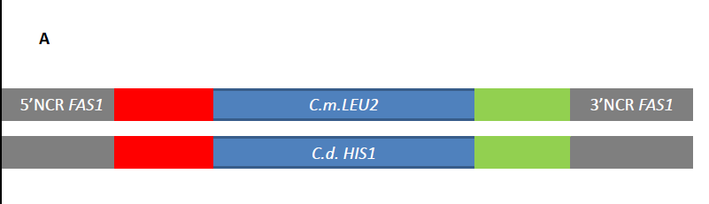
1 2 3
1 2 3 4
At least three independent isolates were tested by PCR for deletion of the FAS1 gene (Lanes 1-3 in panel B and 1-4 in panel C).
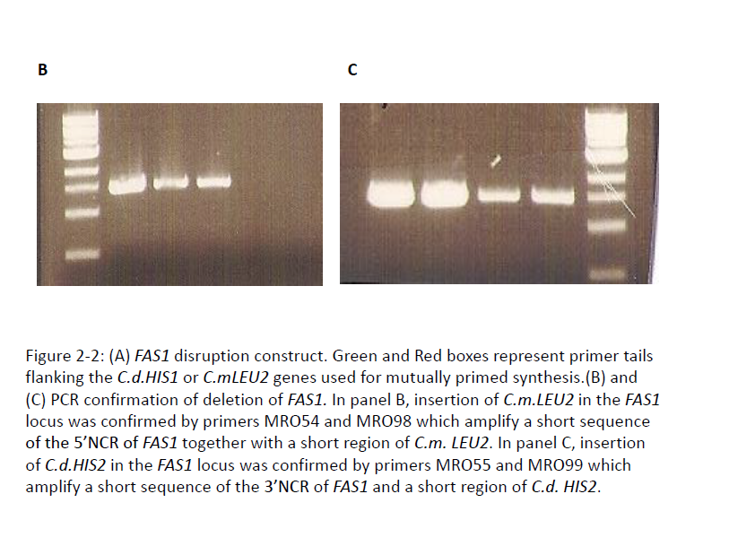

A

Figure 2-4: C.albicans strains growing in YPD supplemented with (A) Olive Oil (B) 10% Mouse Serum. Cells were collected at 0.1 O.D/ml and grown for 24 h in olive oil and 3h in 10% mouse serum respectively and observed under a light microscope.
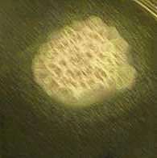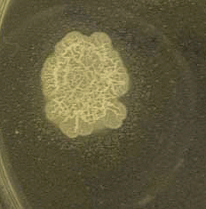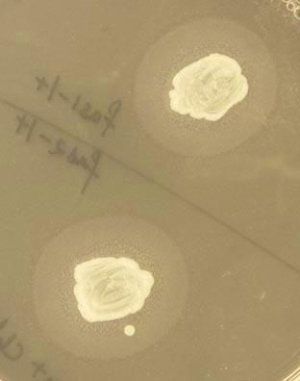
Wild-type
fas1∆/∆
fas1∆/FAS1FigFigure 2-3: Growth of the different Candida albicans strains on YPD medium supplemented with (A) unsaturated fatty acids: Palmitoleic acid, Vaccenic acid and Oleic acid; and (B) myristic acid. Similar growth was seen for all the strains in YPD media supplemented with palmitic or stearic acid. All plates were incubated at 37⁰C/ 48 hrs.
15mm
15mm
15mm

Figure 2-5: C.albicans strains displaying esterase activity on Tween 40 Agar. The cells were spot inoculated on the medium and incubated for 5 days at 37°C.

Figure 2-6: Growth curve of the different C.albicans strains in YPD supplemented with 1% Tween 80 and 0.01% myristic acid. The cells were grown at 30°C with shaking for 24h and O.D. was measured at 600nm.

Figure 2-7: Survival proportions of mice injected intravenously with 10⁶ C.albicans cells. The virulence of the fas1∆/∆ mutant was compared to that of the wild-type, homozygous mutant and reintegrant strains. p value (WT v/s fas1∆/∆ mutant)= 0.007.

Figure 2-8: Fungal burden in mice kidneys 5 days after intravenous infection. The error bar represents the mean + standard deviation of three randomly selected mice infected with the individual strains. p value: WT v/s fas1∆/∆ mutant = 0.0004; fas1∆/∆ mutant v/s reintegrant = 0.018.

Figure 2-9: Histological sections of kidneys dissected from mice infected with wild-type, fas1∆/∆ mutant and reintegrant strains. Mice were sacrificed 3 days after intravenous infection. Gomori Methenamine Silver staining was used to observe colonization. Arrows indicate hyphal growth. Magnification = 40X Bar = 50µm

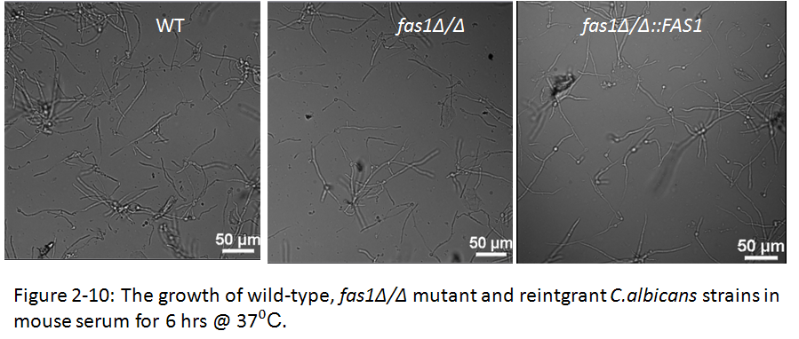
Figure 2-10: The growth of wild-type, fas1∆/∆ and reintegrant C.albicans strains in mouse serum. 0.1 O.D./ml cells were collected in mouse serum and 100 µL suspensions of each strain were put into agarose slide chambers and observed for hyphal growth for 6h @ 37⁰C by time-lapse microscopy.

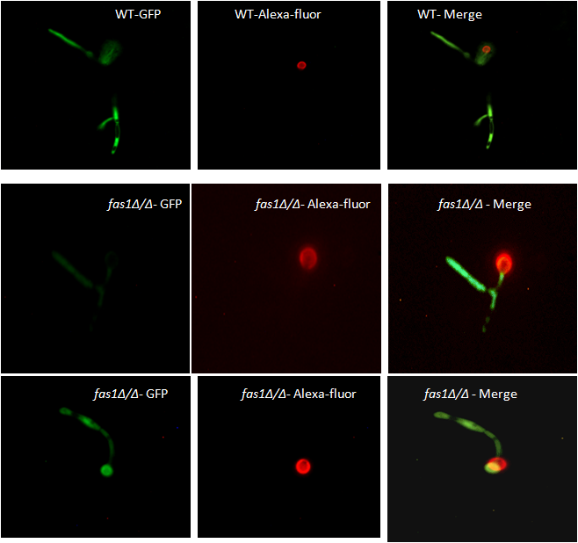
Figure 2-11: Growth of the fas1∆/∆ mutant and wild-type C.albicans in mice kidneys 6h post-infection. GFP-expressing cells were pre-labeled with Alexa-fluor and injected intravenously in mice (10⁷ cells/ml). At 6 h p.i. kidneys were collected and homogenized and examined under a fluorescent microscope for the presence of hyphal cells.

CHAPTER THREE

Fatty acid synthase 1 in the integrity and permeability of Candida albicans cell membrane

ABSTRACT
Fatty acids govern the integrity and dynamics of fungal cell membranes. Disruption of the β sub-unit of the fatty acid synthase complex in Candida albicans results in an imbalance in the ratio of saturated: unsaturated fatty acids in the membrane. Alterations in the fatty acid composition resulted in hyper-sensitivity to osmotic stress in vitro. Fas1 does not play a role in the intracellular survival of C.albicans in macrophages or neutrophils or in adaptation to oxidative stress. However, the membrane permeability of the fas1∆/∆ mutant was compromised during growth in serum and this could account for its inability to cope with osmolyte-induced membrane stress and reduced virulence in mice. In this section we demonstrate that FAS1 is essential for C. albicans growth in the absence of exogenous fatty acids and is involved in the production of saturated fatty acids. Fas1 influences virulence and survival in the host presumably by controlling adaptation to osmotic stress and thus represents a promising antifungal drug target.

INTRODUCTION
Fatty acids are the building blocks of membrane lipids and can strongly influence the permeability and fluidity of the membrane and also receptor or channel function (Escriba et al., 2008). Disruption of fatty acid synthesis can have adverse effects on the cell membrane. Since the membrane is the second barrier to the external environment, disruption of its integrity or fluidity can influence the diffusion of compounds through the cell. The fatty acid synthase (Fas) complex is responsible for the biosynthesis of fatty acids in fungi. This complex consists of two sub-units, α and β, which are encoded by the FAS2 and FAS1 genes respectively. Disruption of fatty acid biosynthesis leads to fatty acid auxotrophy in vitro and attenuation of virulence in murine systemic infections for the fungal pathogens Candida albicans (Zhao et al., 1997), Candida parapsilosis (Nguyen et al., 2009) and Cryptococcus neoformans (Chayakulkeeree et al.,2007).
In Candida parapsilosis Fas2 is an important determinant in the regulating the ratio of saturated: unsaturated fatty acids in the cell membrane. This alters the ability of the fas2∆/∆ mutant to combat various stress conditions in vitro. For example, it was found that the mutant was hypersensitive to low pH, high temperature and oxidative stress (Nguyen et al., 2009). The mutant was also defective for biofilm formation which a key virulence determinant. Effective biofilm formation on polystyrence or silicone surfaces (materials that are used to make indwelling medical devices) is strongly correlated with fungal resistance and virulence in vivo and it was found that disruption of C.pFAS2 results in a marked reduction in the metabolic activity of the mutant when grown on these surfaces. The mutant was also unable to grow in serum suggesting that it could not acquire essential fatty acids from this important fatty acid source. This finding coupled with the observation that the mutant was more efficiently killed by macrophages could be responsible for the avirulence of the mutant in mice.
Another gene that is important in the synthesis of fatty acids is OLE1 which codes for a desaturase enzyme (Bloomfield & Bloch, 1960) that catalyzes the sequential insertion of double bonds into palmitic acid or stearic acid precursors. Since most fatty acids in fungi are unsaturated species (Weete, 1974) and production of unsaturated fatty acids depends on the availability of saturated fatty acids, deletion of FAS1 could impact the balance of unsaturated fatty acids in Candida albicans. OLE1 in C.albicans was found to be essential for viability and virulence in a murine model of disseminated candidiasis (Xu et al., 2009). In C.parapsilosis, the ole1∆/∆ mutant is avirulent (Nguyen et al., 2011). Similar to the C.pfas2∆/∆ mutant, the C.p ole1∆/∆ mutant displays imbalances in the membrane fatty acid composition, is hypersensitive to oxidative stress and high temperatures. The mutant is also more efficiently phagocytized by macrophages and is defective in filamentous growth.
In this study the mechanism for avirulence of the C.albicans fas1∆/∆ mutant was investigated. It was hypothesized that disruption of FAS1 could significantly alter the membrane fatty acid composition in C.albicans resulting in impaired membrane permeability and an inability to deal with membrane stress-inducing conditions in vitro and in vivo.
MATERIALS AND METHODS
Strains and culture conditions
C.albicans strains generated and used in this study are listed in table 1 (Chapter 2; Pg 42). If not otherwise mentioned, the strains were grown in yeast-extract (1%) peptone (2%) dextrose (2%) (YPD) medium supplemented with 1% tween-80 and 0.01% myristic acid. For overnight liquid cultures, the strains were grown in YPD supplemented with 10% mouse serum (Equitech Bio Inc).

Fatty acid profiling by mass spectrometry
C.albicans cells were grown in the different media overnight/ 30ºC in a shaker. 0.1 O.D. of cells were collected and centrifuged for 1 min at 13000 rpm. The pellet was resuspended in 100µL phosphate-buffered saline and processed immediately. Phospholipid fatty acids were extracted using a modified Bligh and Dyer extraction method (1959).Brifely, the supernatant was discarded and the pellet (left as dry as possible) was mixed with 500µL of a saponification reagent (Reagent 1: sodium hydroxide (15% w/v), 50 ml distilled water and 50 ml methanol). Cells were vortexed and then transferred to Teflon-lined glass tubes with a glass pipette and 500µL of reagent 1 was added again to obtain a total volume of 1 ml. The suspension was then heated in a 100ºC water bath for 5 minutes and then vortexed for 10 seconds and returned to the water bath to complete 30 minutes of heating. Methylation of fatty acids is carried out by adding 2 ml of reagent 2 (325 ml 6N HCl and 275 ml methyl alcohol) to the cooled tubes, vortexing briefly and then heating the tubes at 80ºC for 10 minutes. Fatty acid methyl esters were then extracted by adding 1.25 ml of reagent 3 (200 ml hexane + 200 ml methyl tert-butyl ether) to the cooled tubes and tumbling the tubes on a rotator for 10 minutes. The upper organic phase is transferred to a fresh glass tube and 3 ml of reagent 4 (10.8g sodium hydroxide in 900 ml distilled water) is added to the tubes which are tumbled for 5 more minutes. 2/3 of the organic phase is transferred to a GC vial and dried under liquid nitrogen. After the vial is dry, 500µL of 19:0 internal standard is added to each vial and subjected to gas-chromatography mass spectrometry at the Center for Environmental Biotechnology, UTK (Dr. Susan Pfiffner). The identity of the fatty acids was verified by comparing the GC-MS peaks with standards. Each experiment was repeated in quadruplets.
Phagocyte killing assays
The murine macrophage cell-line RAW264.7 was used to determine phagocytic killing of the C.albicans strains. RAW264.7 cells were seeded at 5x10⁵ cells per well in RPMI medium (Sigma Aldrich) supplemented with 10% mouse serum (Equitech Bio, Inc) one day prior to the assay. Yeast cells in fresh medium were added at a ratio of 1:40 (yeasts: macrophages). The co-cultures were incubated at 37ºC/ 5% CO₂ for 3 h. At the end of the incubation period, water was added to lyse the macrophages and serial dilutions of all strains was performed. 100µL of the appropriate dilution was spread on YPD+1% tween 80 +.01% myristic acid. Colony-forming units were determined after incubation at 37ºC/24 hrs.
For the neutrophil killing assay, human neutrophils were isolated from the peripheral blood of healthy human volunteers by dextran sedimentation and centrifugation through lymphocyte separation medium (Percoll; Amersham Biosciences) as previously described (Markert et al., 1984). Erythrocytes were removed by hypotonic lysis (0.2% NaCl; 30s). Neutrophils were resuspended in RPMI media at the required cell concentration. Viable neutrophils were quantified by trypan blue exclusion. The use of human subjects has been approved by the University of Tennessee Institutional Review Board. Yeast strains were washed twice with PBS after overnight growth in YPD supplemented with 10% mouse serum. They were then opsonized in mouse serum for 30 min @ 37ºC. Human neutrophils and opsonized yeast cells were mixed at a cell ratio of 1:40 (yeasts:neutrophils) and co-cultured for 2h at 37ºC/ 5%CO₂. Samples were prepared similarly as described for the macrophage assay and CFUs were determined after 24h. All experiments were performed at least 3 times.
Hydrogen peroxide susceptibility assay
C.albicans cells in the exponential phase were collected at 0.1 O.D./ml in YPD+10% mouse serum. 100µL of the suspension (for each strain) was pipetted into 5 wells of a 96-well microtitre plate. The five wells were labeled as 10mM, 5mM, 2.5mM, 1.25mM and 0mM, respectively. 200µL of a 100mM hydrogen peroxide solution/ml was added to the well marked 10mM (final concentration 20mM). The suspension was mixed by pipetting. Serial-fold dilutions were performed and 100µL was discarded from the final well. The plates were incubated at 30ºC/1hr with shaking. After incubation, the samples were diluted and plated on YPD medium +1% Tween80 +.01% myristic acid. Colony-forming units were determined after overnight incubation at 37ºC.
Growth assays
For the spot dilution tests, overnight cultures of the C.albicans strains were washed twice in PBS, and resuspended at 1O.D./ml. The cells were serially five-fold diluted and spotted onto YPD agar + 1% tween 80 + 0.01% myristic acid containing the cell wall inhibitors: Amphotericin B (10µg/ml); Calcoflour white (10µg/ml); Caspofungin (10µg/ml); Congo Red (10µg/ml); Hygromycin B (100µg/ml) and Nikkomycin Z (10µg/ml). To test susceptibility to osmotic stress, the following membrane-stress inducing agents were added to the medium: 1.5M NaCl; 1.5M KCl, 1M sorbitol and 0.1% SDS. All plates were incubated at 37ºC/ 48h and then examined for growth. For susceptibility to human beta-defensin-3 (Peptides International- Louisville, Kentucky), C.albicans cells (100 µL) were added to wells of a microtitre plate at a concentration of 1x 10⁶ cells/ml in YPD+10% mouse serum. Human beta-defensin-3 (100µL) was added to the first well at a final concentration of 10µM. Serial two-fold dilutions were performed to obtain the concentrations 5 and 2.5µM. The plates were incubated on a shaker/1 h @ 30ºC. The samples were diluted and plated on YPD+1% tween 80 +.01% myristic acid to obtain CFUs.
Propidium iodide staining
C.albicans strains were grown in YPD+10% serum overnight at 30ºC. Cells were washed the next day and incubated in 20µg/ml propidium iodide in mouse serum at room temperature for 30 min. The yeast cells were then observed with an Olympys BX50 microscope with the RED emission (NG) filter cube (excitation at 530-550 nm).
Statistical Analysis
Prism 4.0 software (GraphPad) was used to determine the significance of differences in the fatty acid composition, phagocytic killing, and, susceptibility to hydrogen peroxide and cationic peptide assays. Statistically significant differences were determined using the two-tailed unpaired t test. Statistical significance was set at a P value of <0.05.
RESULTS
fas1∆/∆ mutant alters its membrane fatty acid composition upon growth in serum
To determine the effect of deletion of FAS1 on membrane fatty acid composition, fatty acid profiling of the mutant was performed. It was observed that fatty acid compositions were strongly dependent on the growth medium, thus fatty acid profiles of the different strains were compared after growth in YPD supplemented with 10% serum (which is the growth medium used for the mouse virulence studies), YPD supplemented with tween 80 and myristic acid and mouse serum (since serum is the source of fatty acids in the host and would thus be the most viable representation of the fatty acid composition of the mutant growing in vivo).
Overall, the percentage of saturated fatty acids in the mutant was reduced compared to the wild-type strain, with the mutant producing 24.7 % and the wild-type strain producing about 34% of saturated fatty acids after growth in mouse serum (Table 4, p value =0.15). Moreover, the mutant has lower amounts of palmitic acid (16:0); accounting for 15% total fatty acids in the mutant compared to 31% in the wild-type strain. There was also increased levels of long chain fatty acids such as C:22 and C:23 fatty acids in the mutant during growth in serum (Fig:3-1).
Similarly during growth in YPD containing tween-80 and myristic acid, the mutant displayed significant differences in the fatty acid composition compared to the wild-type. Saturated fatty acids comprised 22% of total fatty acids in the wild-type strain but only 9.6% of total fatty acids in the mutant strain. In this medium too, there were lower amounts of palmitic acid in the mutant (6.12%) compared to the wild-type (17%). However, there was increased amount of linoleic acid (18:3) compared to the wild-type.
When grown in YPD supplemented with 10% mouse serum, the concentration of linoleic (18:3) and stearic (18:0) acids was increased in the mutant compared to the wild-type strain (Table 4).
The balance between unsaturated and saturated fatty acids is a critical factor in determining the membrane fluidity of cells. The nature of fatty acids that are to be incorporated into phospholipids affects the functions of proteins present in the cell membrane such as those involved in signaling and morphogenesis. Thus, the altered fatty acid composition in the fas1∆/∆ mutant may affect its susceptibility to various stresses in the host and virulence. In Candida parapsilopsis, a fas2∆/∆ mutant was more efficiently killed by macrophages and was more susceptible to stress conditions presumably due to alterations in the balance of fatty acids (Nguyen et al.,2009).
To determine if these alterations in the fatty acid composition of the C.albians fas1∆/∆ mutant affected its susceptibility to various stresses within the host thus resulting in reduced virulence in mice, the susceptibility of the mutant was tested against various stresses in vitro.
Fas1 does not play a role in survival within phagocytes
To better understand the mechanism of avirulence of the fas1∆/∆ mutant and explore the role of FAS1 in Candida albicans pathogenesis, we examined the effect of host immune cells on the mutant’s growth and proliferation. Macrophages serve as the prime effector cells in clearing Candida from the host. We hypothesized that the fas1∆/∆ mutant may be more susceptible to macrophage killing compared to the wild-type strain and this could account for its avirulence in mice. To test this, we analyzed the ability of yeast cells to persist within murine macrophages RAW 264.7. Killing of intracellular cells was measured by determining CFU’s on YPD medium after co-culture with macrophages. No differences were found in the survival percentage of the wild-type, mutant and reintegrant strains within macrophages (Fig: 3-2). Therefore, Fas1 is unlikely to be involved in the survival of C. albicans within murine phagocytic cells or in the resistance to the oxidative burst that accompanies internalization by macrophages.
These findings are consistent with the survival of the mutant in the presence of sub-lethal concentrations of hydrogen peroxide. Adaptation to oxidative stress is key to survival within macrophages. The susceptibility of the strains to varying concentrations of hydrogen peroxide was tested and the growth of the fas1∆/∆ mutant was comparable to the wild-type strain (Fig: 3-3). When grown in YPD 20% serum containing 1mM H₂O₂, the survival percentage of the wild-type was about 47% and that of the mutant was about 49%. Similar results were obtained when the assay was done in YPD containing olive oil as the source of fatty acids (data not shown). This data indicates that Fas1 does not play a role in oxidative stress response and the avirulence of the mutant is not due to its inability to survive intracellularly within phagocytes.
Like macrophages, neutrophils are important components of the innate immune response to C.albicans. This has been demonstrated by the fact that some patients with neutropenia are overtly susceptible to systemic candidiasis. To test if the fas1∆/∆ mutant displays increased susceptibility to neutrophils and is therefore more efficiently cleared from the host, the survival of the mutant in the presence of human neutrophils was examined. There were no significant differences observed in the intracellular survival of the mutant strain compared to the wild-type or reintegrant strains after 2 hours of co-culture with neutrophils (Fig:3-4). Opsonizing the cells prior to co-culture or increasing the co-culture time period did not have any effect on the survival percentage of either strain.
Taken together these data suggest that the mutant is not avirulent because it is more susceptible to host immune effector cells thus resulting in it being cleared from the host more effectively compared to wild-type C.albicans.
The fas1∆/∆ mutant is hypersensitive to osmotic stress in vitro
The fatty acid composition of the phospholipid bilayer is critical to cell membrane function since fluidity and permeability are vital parameters that regulate the response of microorganisms to various environmental cues. For example, in several microorganisms it has been demonstrated that fatty acid content regulates heat, pH and ethanol stress resistance. By modifying membrane fluidity in response to environmental stresses via altering the levels of saturated and fatty acids in the cell membrane, bacteria stabilize their membranes. It is not surprising therefore those mutants that are defective for biosynthesis of fatty acids can have cell membrane and/or cell wall defects.
To test if the fas1 ∆/∆ mutant displayed any cell wall defects, the susceptibility of the mutant was tested against a range of cell wall perturbing agents such as: the chitin synthase inhibitor- nikkomycin Z; the β-glucan synthase inhibitor- caspofungin; and other wall compromising agents such as calcofluor white, congo red and hygromycin B. The fas1∆/∆ mutant did not display increased sensitivity (Fig: 3-5) to any of the above tested cell wall perturbing agents compared to the wild-type strain suggesting that defects in fatty acid biosynthesis does not adversely affect the cell wall.
Next, the susceptibility of the mutant was tested in the presence of various membrane stress-inducing agents. The fas1∆/∆ mutant was found to be hyper-sensitive to high concentrations of salt and solutes compared to the wild-type and reintegrant strains. As shown in Fig: 3-6, addition of 1.5 M NaCl, 1.5M KCl, 1M Sorbitol to YPD medium resulted in the mutant being hypersensitive to these osmotic stress inducing agents. This is not surprising since membrane remodeling via fatty acid biosynthesis is likely to be an important component regulating osmotic stress responses in C.albicans.
Susceptibility of the fas1∆/∆ mutant to cationic peptides
C.albicans mutants that are sensitive to osmotic stress have been shown to be hypersensitive to cationic peptides. Cationic peptides are key components of the innate defense system and primarily target the cell membrane by punching holes in the membrane and facilitating ionic imbalance. Thus adaptation to cationic peptides requires the activation of osmotic stress response pathways to minimize loss of ions and solutes. Thus mutants that are defective in their ability to cope with osmotic stress have an increased susceptibility to cationic peptides (Vylkova et al., 2007).
It was hypothesized that due to membrane alterations in the fas1∆/∆ mutant, the general stress response pathway in the mutant may be compromised. Hypersensitivity of the mutant to osmotic stress supports this hypothesis. To test if the fas1∆/∆ mutant is susceptible to cationic peptides due to its inability to cope with osmotic stress, its growth response in the presence of the potent fungicidal cationic peptide, human β-defensin-3, was tested.
Surprisingly, there was no significant difference in the susceptibility of the mutant to human β-defensin-3 when compared to the wild type stain. The survival percentage of both the wild-type and mutant was about 75% at 2 µM hβD-3 and decreased to about 52% and 65% at 5 µM hβD-3 for the wild-type strain and mutant respectively (Fig:3-7). This however does not rule out the possibility that the mutant may be hypersensitive to the activity of other cationic peptides (see discussion).
Fas1 is essential for maintaining membrane integrity
Since fatty acids play an integral role in membrane permeability and plasticity, it was hypothesized that defects in fatty acid biosynthesis could disrupt the membrane integrity of the cell. To test this, the permeability of the fas1∆/∆ yeast cells to a membrane impermeable dye was examined by microscopy.
Propidium iodide is a membrane impermeable dye that is excluded from the cytoplasm of cells with intact cell membranes. It is thus used as a membrane-integrity indicator as cells with damaged membranes fluoresce red after staining with this dye. Monitoring the influx of propidium iodide has been widely used to examine the integrity of C.albicans membranes, and when grown in the presence of agents that compromise the integrity of membranes, C.albicans is permeable to propidium iodide (Philips et al., 2003; Vylkova et al., 2006).
The permeability of the fas1∆/∆ mutant to propidium iodide was examined and as shown in Fig:3-8, the mutant was more permeable to the dye compared to the wild-type strain, as indicated by red fluorescence of the cytoplasm. Heat-killed wild-type cells were used as a positive control for compromised membrane integrity and like the mutant strain, displayed increased permeability to propidium iodide. The increased permeability of the fas1∆/∆ mutant may be responsible for its hyper susceptibility to osmotic stress inducing agents and its failure to sustain infection in vivo.

DISCUSSION:
The biological functions of fatty acids are impressively diverse. They not only govern membrane integrity and dynamics but also regulate cellular metabolism and cell physiology. Lipids are important nutritional sources during fungal infections, and this is highlighted by the fact that disruption of fatty acid biosynthetic genes in C.albicans (Zhao et al., 1997), C.parapsilosis (Nguyen et al., 2009), C.neoformans (Chayakulkeeree et al., 2007) and Aspergillus fumigatus (Langfelder et al., 1998) adversely affects the growth and/ or virulence of these fungal pathogens. Moreover, the importance of lipases in fungal growth and virulence highlights the importance of acquisition of fatty acids during infection.
As mentioned above, disruption of FAS1 in Candida albicans leads to an auxotrophy for saturated fatty acids. Unsaturated fatty acids do not fulfill the nutritional auxotrophy of the mutant, suggesting that Fas1 is the key enzyme responsible for the de novo biosynthesis of saturated fatty acids in C.albicans. Thus one would expect that disruption of FAS1 would lead to changes in the fatty acid composition of yeast cell membranes and the fatty acid profile would be dependent on the growth medium. The fatty acid profile of the wild-type and mutant strains were thus examined under different growth conditions. Significant changes were found in the membrane fatty acid composition between these two strains (Table 4) suggesting that disruption of FAS1 results in remodeling of the cell membrane fatty acids and these modifications may alter its ability to respond to various stresses inside the host . As expected, the percentage of saturated fatty acids was reduced in the mutant as compared to the wild-type. Previous studies have reported that the in vitro products of yeast fatty acid synthases are usually 18- to 20-carbon fatty acids (Schweizer and Hofmann, 2004), with 18:1 and 18:2 being the major constituents in C.albicans membranes (Xu et al., 2009). These imbalances in saturated and unsaturated fatty acids could have a deleterious effect on the survival of C. albicans. In general, the ratio of unsaturated fatty acids: saturated fatty acids was 3.0 and 1.9 in the mutant and wild-type respectively. The main differences were that the percentage of palmitic acid was significantly reduced and the levels of 22- and 23-carbon fatty acids were slightly increased in the fas1∆/∆ mutant when mouse serum was used as the source of fatty acids. When the growth medium was supplemented with Tween-80 and myristic acid as sources for fatty acids, a similar decrease in palmitic acid concentration was seen.
Host defense against systemic candidiasis is mediated by engulfment of the yeast cells by cells of the innate immune system such as macrophages and neutrophils. Intracellular pathogenesis is important in Candida infections and the outcome of phagocyte-Candida interactions is a strong determinant in host susceptibility to the infection. Candida albicans can typically exploit the intracellular environment of the phagocyte for its replication and disseminate to different sites in the host. Alterations in the fatty acid composition on C.albicans membranes have been shown to affect the fluidity of the cell membrane (Krishnamurthy et al., 2004). Changes in cell membrane fluidity could affect the susceptibility of C. albicans to the burst of reactive oxygen species released by phagocytes and consequently impair its ability to survive intracellularly. In Candida parapsilosis, disruption of FAS2 impaired its ability to survive intracellularly within the macrophage cell line J774.16. Deletion of OLE1, which codes for a desaturase and is involved in the synthesis of unsaturated fatty acids, enhanced the phagocytosis of C.parapsilosis by J774.16 cells. Moreover, the OLE1 mutants in both C.albicans (Krishnamurthy et al., 2004) and C.parapsilosis (Nguyen et al., 2011) were defective in hyphal formation and this could account for its avirulence and / or inability to evade phagocytic killing.
The C.albicans fas1∆/∆ mutant is not defective for filamentous growth, however the imbalance in fatty acid ratios in the membrane could alter its susceptibility to reactive oxygen species and intracellular survival within phagocytes. No difference was found in the ability of the wild-type strain or the mutant to survive in the murine macrophage cell line RAW264.7. Similarly, no significant differences were found in the survival of the wild-type, mutant or reintegrant strains in human neutrophils. One caveat to these assays is that the phagocytes were not activated prior to the co-culture with Candida cells, and this could significantly diminish their anti-candidal activity. But since the mutant was tolerant to sub-lethal concentrations of hydrogen peroxide, and no differences were found in its ability to cope with this form of oxidative stress compared to the wild-type strain, it is unlikely that enhanced phagocytic killing could account for the avirulence of the mutant. This tolerance to sub-lethal doses of hydrogen peroxide is similar to observations in the Saccharomyces cerevisiae fas1∆ mutant, and this tolerance may be mediated by the increased proportions of unsaturated fatty acids in the membrane, especially the long chain 22- and 23-carbon fatty acids.
Fatty acids also govern the physiology of yeast, in terms of its response to harsh environmental conditions such as osmotic stress, cold and heat stress, pH stress and oxidative stress (Chatterjee et al., 2000; Yazawa et al.,2009; Howlett and Avery., 1997; Gasch et al., 2002; Rodriguez-Vargas et al.,2007). Biological membranes are the second barrier that separates cells from the environment and are thus subject to extensive damage during harsh environmental conditions. Environmental fluctuations cause modifications in the structural organization of membrane lipids. For example, fatty acid biosynthetic genes such as desaturases are upregulated during cold and salt stress to increase the flexibility of membranes (Rodriguez-Vargas et al., 2007). In C.parapsilosis, disruption of FAS2 enhanced its susceptibility to various stress conditions including acid-stress, high temperatures and the membrane-stress inducing hydrogen peroxide (Nguyen et al., 2009). Similarly, the OLE1 mutant in C.parapsilosis displayed enhanced sensitivity to membrane-stress inducing agents (Nguyen et al., 2011).
The susceptibility of the fas1∆/∆ mutant to cell-wall perturbing agents was tested. The mutant did not display any cell wall defects as determined by no growth defects when grown in the presence of cell wall inhibitors. The mutant was however hypersensitive to osmotic stress (membrane stress-inducing agents) as revealed by its reduced growth in the presence of high concentrations of salts and solutes.
Some C.albicans mutants that are sensitive to osmotic stress have been shown to hypersusceptible to antimicrobial cationic peptides (Vylkova et al., 2007). Antimicrobial cationic peptides or defensins exert their antifungal action by forming pores in the cell membrane and mediating the efflux of cellular ATP and ions and thus inducing ionic imbalance (Xu et al., 1999; Koshlukova et al., 1999). The main adaptation to defensin-mediated osmolyte loss is regulating the transport of water, compensating for ion loss and activating the osmotic stress response pathway (Yeaman and Yount., 2003). Thus, mutants that have defects in osmotic stress responses would be hypersensitive to the action of defensins. C.albicans hog1∆/∆ and pbs2∆/∆ mutants are hypersusceptible to the cationic peptides human β-defensins and histatin5 (Vylkova et al., 2007; Argimon et al., 2011). Hog1 and Pbs2 are components of the high-osmolarity glycerol pathway which is a MAP-kinase pathway that plays a key role in sensing and transmitting responses to various environmental cues (Kruppa & Calderone, 2006).
Since the fas1∆/∆ mutant is sensitive to osmotic stress, we hypothesized that it may be hypersusceptible to the antifungal action of defensins. Moreover, since cationic peptides exert their action by interacting with membrane lipids, it is possible that cell membrane fatty acid alterations could affect their interaction in a deleterious manner. Alternatively, membrane transporters could be affected due to alterations in the membrane fatty acid composition of the fas1∆/∆ mutant, thus interfering with compensatory uptake systems that are activated in response to defensin-mediated ion loss. However, there were no significant differences observed in the susceptibility of the mutant to human β-defensin 3 when compared to the wild-type strain. This does not however rule out the possibility that the mutant may be hypersusceptible to other cationic peptides such as histatin 5, lactoferrins or the other β-defensins. In fact, the transcriptional response of C.albicans to histatin 5 involved the up-regulation of several genes that are involved in adaptation to osmotic stress. Thus, enhanced antimicrobial peptide sensitivity cannot be ruled out as mechanism for the avirulence of the fas1∆/∆ mutant.
Lastly, the membrane permeability of the mutant was examined during growth in serum. As expected, the mutant was more permeable to the membrane-impermeable dye propidium iodide. This phenotype was similar to heat-killed wild-type C.albicans which is compromised in the integrity of its cell membrane. This finding is consistent with findings from the Candida parapsilosis fas2∆/∆ and ole1∆/∆ mutants. The increased membrane permeability is presumed to be due to alterations in the fluidity of the membrane mediated by modifications in fatty acid composition.
Conclusions:
Disruption of the FAS1 gene in Candida albicans results in significant modifications in the membrane fatty acid composition, thus resulting in altered membrane permeability to various stressors inside the host. The mutant is hypersensitive to osmotic stress and this may account for its reduced ability to colonize host kidneys. It is known that kidney cells (renal medulla) undergo fluctuations in solute concentrations and the intracellular levels of osmolytes (such as sorbitol) and salts can reach very high concentrations (Somero, G.N., 2011). Thus, defects in the osmotic stress response may compromise the ability of C.albicans to cope with high concentrations of salts and solutes encountered inside the host and influence its virulence.
The susceptibility of the fas1∆/∆ mutant to different cationic peptides needs to be further explored as resistance to these potent antifungal compounds may be impaired in the mutant. Another aspect that has not been investigated in this study is the effect of disruption of FAS1 on membrane protein localization and function. The imbalance in fatty acids could affect the localization of key proteins and thus have pleiotropic effects on the physiology and virulence of the C.albicans fas1∆/∆ mutant.

APPENDIX C: TABLES AND FIGURES

Table 4: Fatty acid profiles (mol%) of the wild-type and fas1∆/∆ strains
 | 16:1w7c | 16:0 | 17:0 | 18:3 | 18:1 | 18:0 | 20:0 | 22:1 | 22:0 | 23:0 | 24:0
WT (Mouse serum) | 3.86 +.43 | 21.67+.71 | 0.33+.29 | 33.72+.32 | 28.59+.30 | 10.64+.822 | .16+.045 | .08+0.04 | .63+.20 | 0 | .09+.04
fas1∆/∆ (Mouse serum) | 4.59+.53 | 14.55+5.38 | 0.56+.33 | 39.01+3.24 | 32.71+4.34 | 11.41+1.8 | .195+.035 | .02+.02 | 1.05+.2 | 1.44 | .122+.05
WT (YPD +10% Serum) | 3.2 | 10.34 | 2.89 | 31.82 | 47.26 | 2.81 | 0 | 1.69 | 0 | 0 | 0
fas1∆/∆ (YPD+ 10% Serum) | 0 | 9.52 | 0 | 54.73 | 28.3 | 6.41 | 0 | 0 | .99 | 0 | 0
WT (YPD +T-80+ Myristic acid) | 2.18 | 16.70 | 1.57 | 27.5 | 48.57 | 2.53 | 0 | 0 | .95 | 0 | 0
fas1∆/∆ (YPD+ T-80 + Myristic acid) | 4.9 | 6.12 | 1.8 | 50.26 | 33.76 | 1.29 | .16 | .22 | .49 | 0 | 0

Table 5: Summary of fatty acid profiles (mol%) of the wild-type and fas1∆/∆ strains growing in mouse serum
Strain | Saturated fatty acids | Mono-unsaturated fatty acids | Polyunsaturated fatty acids
WT | 33.515+.975 | 32.76+1.095 | 33.715+1.415
fas1∆/∆ | 24.744+5.4 | 37.32+4.5 | 39.01+4.54

*

**

Figure 3-1: Disruption of FAS1 in Candida albicans results in significant changes in the membrane fatty acid composition.* P value< 0.02 **<0.1

Figure 3-2: Survival percentage of C. albicans cells within the murine macrophage cell-line RAW26.47. C.albicans cells were incubated with RAW264.7 cells for 3h and the number of viable intracellular C.albicans cells were quantified by plating them on YPD supplemented with tween 80 and myristic acid.

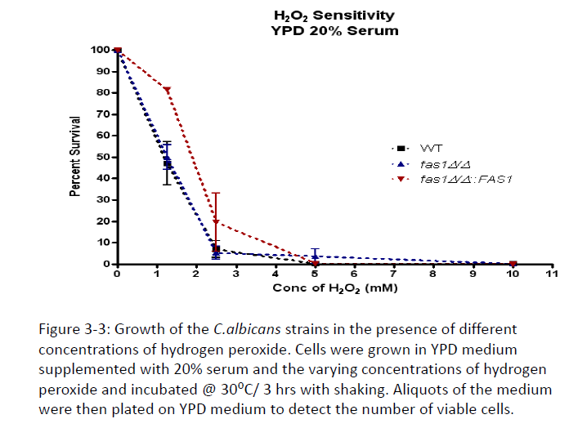

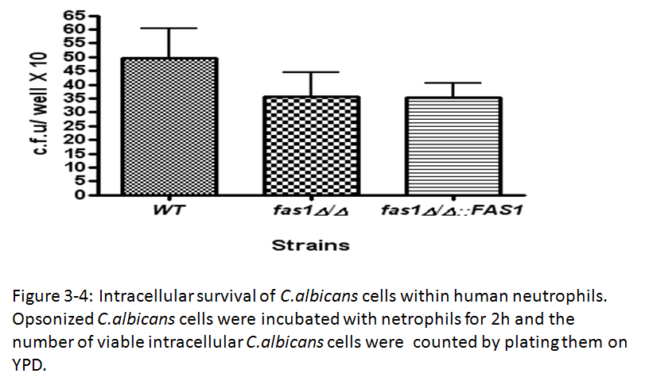
Figure 3-4: Intracellular survival of C.albicans cells within human neutrophils. Opsonized C.albicans cells were incubated with neutrophils for 2h and the number of viable intracellular cells was counted by plating them on YPD containing 1% Tween 80 + 0.01% myristic acid. No statistically significant differences were found between the different strains with respect to survival within neutrophils.

Calcofluor White

Figure 3-5: Growth of the wild-type, fas1∆/∆ mutant and reintegrant C.albicans strains in the presence of cell wall perturbing agents. Cells from an overnight cutlture were resuspended in saline at 1 O.D. / ml, serially diluted 5-fold and then spot-inocuated on YPD containing 1% T-80 + 0.01% myristic acid in the presence of the indicated cell wall perturbing agents. The plates were incubated at 30⁰C/ 48 hrs.

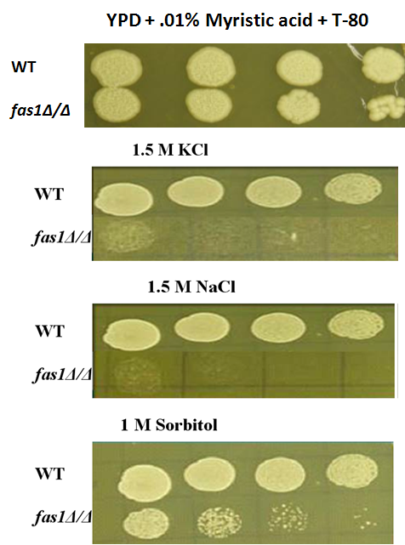

Figure 3-6: Growth of the wild-type, fas1∆/∆ mutant and reintegrant C.albicans strains in the presence of cell membrane stress-inducing (osmotic stress) agents. Cells from an overnight cutlture were resuspended in saline at 1 O.D. / ml, serially diluted 5-fold and then spot-inocuated on YPD containing 1% T-80 + 0.01% myristic acid in the presence of the osmotic stress-inducing agents . The plates were incubated at 30⁰C/ 48 hrs.

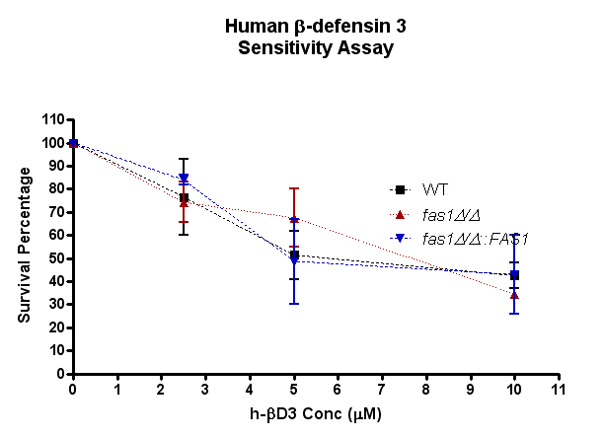
Figure 3-7: Survival percentage of the wild-type, fas1∆/∆ mutant and reintegrant C.albicans strains in the antimicrobial cationic peptide human β-defensin 3. Cells were grown in the presence of varying concentrations of h-βD3 at 30⁰C/ shaking for 1 h. Aliquots of the medium were then plated on YPD (supplemented with myristic acid and T-80) to obtain the number of viable cells.

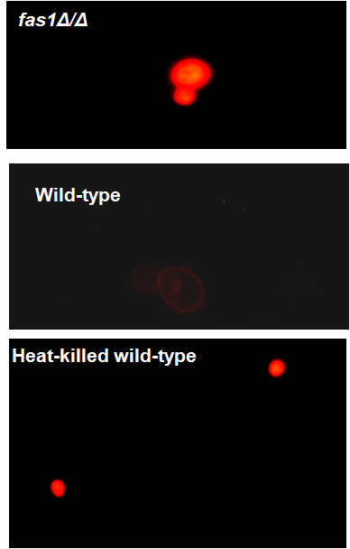

Figure 3-8: Permeability of wild-type C.albicans and the fas1∆/∆ mutant to the membrane-impermeable dye propidium iodide. 0.1 O.D. cells were collected and resuspended in YPD +10% serum (1ml). Cells were then stained with propidium iodide (20µg/ml) for 30’’ and then washed and examined under a fluorescent microscope (530 nm)

CHAPTER FOUR
Tetracycline enhances the susceptibility of Candida albicans to fluconazole in vitro

ABSTRACT
The incidence of invasive candidiasis has drastically increased over the past 30 years and this is simultaneously accompanied by the increased isolation of drug-resistant Candida strains. This has been the driving force in evaluating the efficacy of combination therapy in the treatment and management of fungal infections. Combination therapy was first implemented in the 1970s and the most successful combinations have been with azole-polyene combinations. There has been some evidence to suggest that fluconazole-antibacterial combinations can inhibit C.albicans growth in vitro and in animal models. Tetracycline and its derivative doxycycline enhance the susceptibility of C.albicans to fluconazole and a combination therapy of fluconazole and high-dose doxycycline has been suggested for the management of catheter-related Candida infections. In this study, fluconazole in combination with tetracycline was hypothesized to potentiate its antifungal effect by affecting mitochondrial function in C.albicans. This has been supported by observations that mitochondrial membrane potential is impaired in the presence of this combination. Moreover, the activity of mitochondrial dehydrogenases was reduced in the presence of this combination. The in vitro efficacy of fluconazole in combination with tetracycline in inhibiting C.albicans growth warrants exploration of this combination in treating candidiasis using animal models of systemic infection.

INTRODUCTION
Candida albicans continues to pose a significant clinical challenge as it has been implicated in a wide range of infections from superficial mucosal infections to invasive disseminated candidiasis. Patients predisposed to C. albicans infections include the immunocompromised such as AIDS, cancer, diabetes, transplant and surgical patients.
Several classes of drugs are used to treat C.albicans infections. Current therapy includes polyenes (such as amphotericin B) – which bind to the major sterol, ergosterol, in the cell membrane; azoles – which interfere with ergosterol biosynthesis and results in its depletion; echinocandins- which inhibit β-1, 3,-glucan synthesis and thus interfere with cell wall generation. A major problem associated with treating Candida infections is the increasing emergence of multi-drug resistant strains that are resistant to amphotericin B and the azole class of drugs.
Fluconazole, which belongs to the azole class of drugs, is still the most widely used antifungal for the treatment of invasive mycosis. Inhibition by fluconazole is associated with reduced membrane ergosterol levels which compromise the integrity of the C. albicans cell membrane (Kohli et al., 2002). Fluconazole is selectively toxic against fungal cells since higher eukaryotes are enriched for cholesterol rather than ergosterol in their plasma membrane (Zachowski A, 1993). However, the prolonged prophylactic use of this fungistatic drug in recent years has been associated with an increase in fluconazole resistant C. albicans strains in clinical settings (Goffeau & Monk, 2008). Resistance to fluconazole is attributed to alterations in the expression of membrane proteins (Franz et al., 1998; Morschhäuser, 2002) resulting in consequent enhanced efflux of this drug. However, due to its favorable bioavailability and pharmacokinetics (DeMuria et al., 1993), fluconazole is still commonly used for the prevention and treatment of candidiasis.
The need to develop safer and more effective antifungal agents to which resistance has not or cannot be developed has led to exploring the use of two-drug combination therapies. There have been several reports demonstrating that combination therapy enhance the effect of antifungals against various pathogenic yeasts in vitro (Medoff et al., 1972; Huppert et al., 1974; Beggs et al., 1976; Edwards et al., 1980; Nakajima et al., 1995; Johnson et al., 2004). For example, fluconazole in combination with amphotericin B (Ernst et al., 1998) or calcineurin inhibitors (Onyewu et al., 2003; Uppuluri et al., 2008) has a synergistic effect against C. albicans. There has been some success in implementing combination therapy in vivo. For example, combination therapy for canidiasis including flucytosine and amphotericin B (Lewis et al.2002; Keele et al.2001; Hope et al.2007) or fluconazole (Louie et al.1999; 2001) have generally resulted in improved survival or reduced tissue burden. Clinical applications of these combination therapies for invasive candidiasis in patients have resulted in a positive outcome especially when fluconazole was coadministered with amphotericin B (Rex et al.2003) and terbinafine (Ghannoum et al. 1999).
Recently, there have been reports of synergism between tetracycline and its derivative doxycycline and antifungal agents such as fluconazole and amphotericin B in vitro (Miceli et al., 2009; Oliver et al., 2008; Lew et al., 1977; El-Azizi, 2007). Although the exact molecular mechanism underlying tetracycline and antifungal synergy is not known, it is proposed that tetracyclines inhibit mitochondrial protein synthesis and thus enhance the antifungal activity of fluconazole and amphotericin B against pathogenic yeasts (Oliver et al., 2008).High-dose doxycycline in combination with fluconazole has been proposed as antimicrobial lock therapy for the treatment of catheter-related bloodstream Candida albicans infections because of the high efficacy of this combination against Candida biofilms Given these observations, identifying drug combinations that synergize with fluconazole for the prevention and treatment of C. albicans infections provides a promising avenue for antifungal chemotherapeutic research.
In this study, we investigate the effect of fluconazole in combination with tetracycline against Candida albicans and elucidate the mechanism of synergism between these two commonly used drugs.
MATERIALS AND METHODS
Strains and culture conditions
C.albicans strain SC5314 which is bloodstream clinical isolate was used in this study. Yeast-extract peptone dextrose (YPD) medium was used to grow this strain. Unless otherwise mentioned, RPMI 1640 medium (Cellgro, Mediatech Inc) at pH 5.5 was used for all the in vitro drug synergy studies.
Fluconazole E-tests
C.albicans cells at 1 O.D/ml in phosphate buffered saline were spread with a sterile cotton swab on RPMI agar (pH 7) + tetracycline (100 µg/ml) supplemented with 2% glucose and buffered with MOPS. Fluconazole E-test strips (BioMerieux; 0.016-256 µg) were placed in the center of the plate and incubated at 37ºC/24 hrs. The MIC was recorded as the lowest concentration at which the border of the elliptical inhibition zone intercepted the scale on the strip. Cells from the zone of inhibition were scraped with a cotton swab and sub-cultured on YPD to determine if colonies grew after the drug was removed.
Disc-diffusion assays
C.albicans cells at 1 O.D/ml in phosphate buffered saline were spread with a sterile cotton swab on RPMI agar (pH 7) + tetracycline (100µg/ml) supplemented with 2% glucose and buffered with MOPS. Sterile filter paper discs impregnated with fluconazole at the indicated concentrations were placed on the plate and incubated at 37ºC/24 hrs. The zone around the disc was examined for the presence of micro-colonies (fuzzy growth) to determine fungistatic v/s fungicidal effect of the drug combination.
Antifungal susceptibility testing- CLSI microdilution method
Broth microdilution tests were performed according to CLSI document M27-A. An inoculum was prepared by picking about 10 colonies from Saboraud’s dextrose agar into 5ml sterile water, the final concentration was adjusted to O.D. 0.1 at 600nm. The culture was 1:100 diluted and 100µL of the culture was added to each well of the labeled microtitre plate. Tetracycline (200µg/ml) in RPMI medium (100µL final volume) was added into each well of the plate. An additional 100µL of media was added to the no drug control well. Fluconazole at 4 times the highest concentration (8*4=32µg/ml) in RPMI was prepared and 100µL of the prepared drug was added to the first well and then diluted half across the plate to the last well (final well concentration was 0.125µg). The plates were incubated at 35°C and read after 48 h of incubation. The MIC was determined visually according to CLSI recommendations of an 80% reduction in turbidity. This experiment was performed at least three times.
Microdilution Assay with mitochondrial inhibitors
C.albicans cells were collected at 0.1 O.D./ml in RPMI medium (pH 5.5). 100µL of the suspension was pipetted into 5 wells of a 96-well microtitre plate. The five wells were labeled as 20, 10, 5, 2.5 µg/ml of fluconazole, respectively. 100µL of fluconazole in RPMI was added to the well labeled 20 to obtain a final concentration of 20µg/ml fluconazole. Two-fold dilutions were performed across the plate up to the final well. For the synergy assays, C.albicans cells at 0.1 O.D./ml were suspended in RPMI containing the individual inhibitors: tetracycline (200µg/ml); FCCP (25µM); Antimycin A (5µg/ml); Ethidium bromide (50mg/ml); NaCN (10mM); Na₃N (.025%) and SHAM (2mM). The plates were incubated at 30ºC/ 24hr with shaking and the O.D. was read at 600nm using a microplate reader. Each experiment was done at least 5 times; each time 3 wells containing the fluconazole-inhibitor combinations were used for comparison to the fluconazole-treated wells.
For the ketoconazole-tetracycline synergy assays, the same procedure was used except the highest concentration of ketoconazole tested was 3.25µg/ml.
Rhodamine 123 staining
C.albicans cells growing in RPMI medium alone or supplemented with fluconazole (1µg/ml), tetracycline (200µg/ml) or fluconazole + tetracycline for 12h were harvested by centrifugation, washed twice and resuspended to 1x10⁵ cells/ml with cold distilled water. Rhodamine 123 (Sigma-Aldrich) was added to a final concentration of 90ng/ml, incubated for 30 min in dark at room-temperature and observed with the Olympus BX50 microscope using the rhodamine filter (excitation 530-550 nm) under the 100X oil-immersion lens. Images were captured with the MagnaFire Olympus camera. This experiment was done in triplicates.
MitoTracker staining
C.albicans cells growing in RPMI medium alone or supplemented with fluconazole (1µg/ml), tetracycline (200µg/ml) or fluconazole + tetracycline for 12h were harvested by centrifugation, washed twice and resuspended to 1x10⁵ cells/ml with cold distilled water containing the dye MitoTracker Red CMXRos (MTR, Invitrogen) at a final concentration of 20 nM. Cells were incubated for 15 min at 30ºC on a shaker in the dark then washed once in fresh media. Stained cells were collected by centrifugation and resuspended in phosphate-buffered saline and viewed under the 100X oil-immersion lens with the Olympus BX50 microscope using the RED NG filter (excitation at 550 nm) and images were captured with the Olympus MagnaFire camera. The experiment was done in triplicates.
DAPI staining
C.albicans cells growing in RPMI medium alone or supplemented with fluconazole (1µg/ml), tetracycline (200µg/ml) or fluconazole + tetracycline for 12h were harvested by centrifugation, washed twice and resuspended to 1x10⁵ cells/ml with cold distilled water containing DAPi dye at a final concentration of 2.5µg/ml. Cells were incubated for 30 min at 30ºC on a shaker in the dark then washed once in distilled water. Stained cells were collected by centrifugation and resuspended in distilled water and viewed under the 100X oil-immersion lens with the Olympus BX50 microscope using the NU filter (excitation at 360-370 nm) and images were captured with the Olympus MagnaFire digital camera. The experiment was done in triplicates.
Mitochondrial membrane potential
C.albicans cells growing in RPMI medium alone or supplemented with fluconazole (1µg/ml), tetracycline (200µg/ml) or fluconazole + tetracycline for 12h were harvested by centrifugation, washed twice with cold distilled water followed by a wash in buffer A (1M sorbitol, 10mM MgCl₂, 50mM Tris-HCl [pH 7.4]). Cells were resuspended in buffer A at a final concentration of 3ml/g of cells containing 30mM dithiothreitol. After 30 min of incubation at 30ºC with shaking, the cells were harvested by centrifugation, suspended in buffer A containing glusulase (1mg/g of cells) and 1mM dithiothreitol and incubated at 30ºC until there is a significant drop in the O.D. (90% conversion to spheroplasts – approx. 90 min). The cell wall digestion was stopped by the addition of ice-cold buffer A and spheroplasts were washed twice in the same buffer. Spheroplasts were added to a reaction medium containing 125mM sucrose, 65mM KCl, 10mM HEPES (pH7.2), 2.5 mM KH₂PO₄, 1mM MgCl₂, 5µM Safranine O and 5mM succinate in a total volume of 2ml. The mitochondrial membrane potential was monitored by measuring the fluorescence spectrum of safranine O using a Photon Technology International Spectrophotometer (Quanta Master,New Jersey) operating at excitation and emission wavelengths of 495 and 586 nm, respectively, and with slit widths of 5nm. The protonophore, FCCP is added to the reaction mixture to determine if there is depolarization of the mitochondrial membrane potential as indicated by an increase in fluorescence. Relative change in membrane potential was expressed as arbitrary fluorescence units. This experiment was repeated at least three times.
Paraquat sensitivity assay
For the spot dilution tests, overnight cultures of the C.albicans cells were washed twice in PBS, and resuspended at 1 O.D./ml. The cells were serially five-fold diluted and spotted onto YPD agar containing 10mM paraquat and the different drug combinations: fluconazole (10µg/ml), tetracycline (100µg/ml) and fluconazole+tetracycline. All plates were incubated at 37ºC/ 48h and then examined for growth.
Measurement of mitochondrial dehydrogenase activity
XTT was prepared at a final concentration of 0.5mg/ml in Ringer’s lactate (Sigma). Prior to the assay a fresh solution of XTT was prepared by adding menadione (1mM in acetone) to obtain a final concentration of 10µM. C.albicans cells incubated in the presence of the different drug combinations were grown for 12hrs, collected by centrifugation, washed in water and resuspended in water at a final concentration of 1 O.D./ml. 100µL of the suspensions (for each treatment) was added to a 96-well microtitre plate and 25µL of the XTT solution containing menadione was added to each well. The plates were incubated at 30ºC/ 3hrs on a rocker and the color intensity was measured with a microplate reader at 490 nm.

Statistical analysis
GraphPad Prism (4.0) was used to compare the significances of differences. Statistical significances were determined by student’s t test and were considered significant when P was <0.05.

RESULTS:
Tetracycline in combination with fluconazole is fungicidal against C.albicans
Fluconazole E-tests were performed using media + tetracycline (TET). In the absence of TET, fluconazole (FLU) displays fungistatic action against the C. albicans clinical isolate SC5314. This is depicted by fuzzy growth (no clearing of growth) in the elliptical zone of inhibition surrounding the fluconazole E-test strip (Fig:4-1). However, in the presence of TET (Panel B), fluconazole is rendered fungicidal against C. albicans. As shown in Fig: 4-1, in the presence of tetracycline (100µg/ml), fluconazole is inhibitory against C. albicans resulting in the complete clearing of growth around the strip. Fungicidal activity of TET+FLU against C.albicans was confirmed by scraping the zone of inhibition with a cotton swab and sub-culturing on YEPD media. No viable cells were recovered after 48hrs of incubation confirming the TET+FLU fungicidal effect.
The fungicidal effect of TET+FLU was further confirmed by the disc-diffusion assay, wherein discs were impregnated with fluconazole (0.5 and 1.0 µgs) and placed on a lawn of C.albicans cells growing in media + tetracycline (100µg). No growth of C.albicans was observed around the disc in media containing tetracycline (Supplementary Fig: 2) compared to the medium lacking TET.
These observations are consistent with findings reported by Oliver et al (2008), regarding the effect of tetracycline on fluconazole susceptibility. Tetracycline by itself does not inhibit C. albicans growth as seen in the growth on plate B (Fig. 4-1B, arrow).
Antifungal susceptibility testing was also performed using the clinical and laboratory standards institute (CLSI) broth microdilution method. Results from this assay were consistent with the E-test as depicted by a prominent decrease in turbidity when C.albicans is grown with fluconazole in combination with tetracycline compared to the amount of growth in the growth-control (no antifungal agent) and fluconazole only tests (Fig:4-2 and Table 6). Aliquots of the medium where no growth was observed were plated on YEPD medium. No colonies grew up after 48 h incubation indicating that the combination of TET and FLU was fungicidal. Thus, the combined effect of fluconazole and tetracycline is greater than the effect of fluconazole alone.
Tetracycline enhances the susceptibility to fluconazole by affecting mitochondrial function
The mechanism by which tetracycline influences fluconazole sensitivity in C. albicans is not known, although there has been some suggestion that tetracycline’s known mode of inhibition of bacterial protein synthesis (Chopra & Roberts, 2001) leads to inhibition of fungal mitochondrial function (Oliver et al. 2008; Panepinto et al.2010). This could in turn result in an increase in the cell’s susceptibility to fluconazole. Based on the known fact that mitochondrial membranes contain ergosterol (Zinser et al., 1993; Zinser & Daum, 1995), we hypothesized that fluconazole weakens the mitochondrial membrane making it more permeable to tetracycline resulting in a fungicidal consequence of the drug combination of tetracycline and fluconazole. In order to test our hypothesis, the growth of C. albicans was assayed in the presence of various inhibitors of mitochondrial function in combination with fluconazole, to determine if this combination is similar to the effect of fluconazole plus tetracycline. The mitochondrial inhibitors used in this assay have been shown to inhibit various components of the C. albicans respiratory chain (Alonso-Monge et al., 2009); Fig: 4-3. Thus, this analysis would also help shed some clues on the specific component of the mitochondrial respiratory chain that is affected by fluconazole.
Microdilution assays were performed and the growth of C.albicans was monitored after 24 and 48 hrs of incubation in the presence of the different drug combinations (Fig: 4-4). C. albicans cells at 0.1 O.D./ ml were incubated in RPMI 1640 containing varying concentrations of fluconazole (0-20µg/ml) and a fixed concentration of inhibitors in a microtitre plate. The mitochondrial inhibitors that displayed synergy with fluconazole include Antimycin A (5µg/ml), FCCP (25µM) and NaCN (10mM). As shown in Fig:4-3, Antimycin A inhibits complex III of the respiratory chain, while NaCN exerts its effect on complex IV and the parallel respiratory pathway (Cavalheiro R., et al 2004). FCCP on the other hand acts as an uncoupling agent of oxidative phosphorylation. Ethidium Bromide (50mg/L) was used as a control for inhibition of mitochondrial function since it induces quantitative loss of mitochondrial DNA in yeast cells (Slonimski et al. 1968; Abu-Hatab & Whittaker., 1992). Complex III and IV oxidoreductases are critical for the production of H+ ions which are pumped into the inner membrane space of the mitochondria to generate a membrane potential for the synthesis of ATP. Thus inhibition of these complexes would have a profound effect on C.albicans growth by resulting in dysfunctional mitochondria. No effect was found when the mitochondrial inhibitors rotenone, SHAM and Na₃N were used in combination with fluconazole (Supplementary Fig: 3), suggesting that complex I and/or the alternative oxidase pathway may not be targets of fluconazole and tetracycline.
To confirm the fungicidal effect of FLU+TET treatment on C.albicans, aliquots from the wells were taken and spread onto YPD medium and incubated for 48 hrs. Very few viable cells were recovered from the FLU+TET treated wells in comparison to the fluconazole only treated cells, further confirming that the combined effect of fluconazole and tetracycline on C.albicans is greater than the effect of either drug alone (data not shown).
Mitochondrial Membrane Potential is Altered in the Presence of Fluconazole + Tetracycline
To further test the hypothesis that fluconazole in combination with tetracycline is fungicidal against C.albicans due to inhibition of mitochondrial function, mitochondrial membrane potential (∆ΨM) was determined using rhodamine 123 as an indicator of the energetic state of the mitochondria. Rhodamine 123 is mitochondrial membrane-potential dependent distributional probe, i.e. cells with functional mitochondria are impermeable to the dye and is thus excluded from the cytoplasm, whereas cells with a diminished mitochondrial membrane potential are more permeable to the dye and the cytoplasm of these cells exhibit green fluorescence after exposure to rhodamine 123.
As demonstrated in Fig: 4-5, C. albicans cells treated with fluconazole and tetracycline are more permeable to the dye and hence exhibit an increase in fluorescence when compared to cells treated with tetracycline alone or untreated cells. Cells treated with fluconazole alone also exhibit a slight increase in fluorescence compared to the controls since fluconazole affects ergosterol content in the mitochondrial membrane (Daum & Tuller, 1995) and hence the fluidity and permeability of mitochondria, and this could interfere with the generation of an electric potential across the membrane/ rhodamine uptake ( Maesaki et al., 1999).
Mitochondrial membrane potential (∆ΨM) of permeabilized cells (spheroplasts) was also monitored by measuring the fluorescence spectrum of Safranine O. The fluorescence spectrum of Safranine O shifts as it binds to polarized inner mitochondrial membranes (Akerman and Wikstrom., 1976). This shift is directly proportional to a developed mitochondrial membrane potential and is measured using a fluorophotometer at an emission wavelength of 495 nm. When C. albicans spheroplasts are suspended in a buffer containing succinate as a substrate, addition of safranine O to the buffer results in a sharp decrease in fluorescence (Fig: 4-6). Addition of the uncoupling agent FCCP promoted depolarization of the inner mitochondrial membrane, with a subsequent reduction in membrane potential, thus releasing the dye and increasing fluorescence (Gray and purple lines in Fig: 4-6 A and B respectively). C. albicans cells treated with fluconazole + tetracycline, on the other hand developed a very small ∆ΨM that is not significantly modified by the addition of FCCP as indicated by a slight rise in the fluorescence peak. Fluconazole only and tetracycline only treated cells behaved similar to untreated cells as depicted by the blue and green lines for fluconazole-treated cells and the white and pink lines for tetracycline-treated cells in Fig: 4-6 panels A and B. This data further suggests that fluconazole in combination with tetracycline exerts its fungicidal effect by interfering with the development of mitochondrial membrane potential in C. albicans.
Findings from the rhodamine 123 assay are consistent with the mitotracker analysis which is another fluorescence microscopy-based membrane potential-dependant vital dye (Guthrie & Fink, 2002). C. albicans cells with intact mitochondria (no antifungal agent control) display standard patterns of mitochondrial morphology when treated with Mito-Tracker Red™. As demonstrated in Fig:4-7, mitochondria in no-drug control and tetracycline treated cells display an intense staining of mitochondria with standard ribbon-like mitochondria in all cells. Cells grown in the presence of tetracycline in combination with fluconazole display diffuse staining of mitochondria and ribbon-like mitochondria are virtually undetectable under these growth conditions. This suggests that mitochondrial membrane potential is affected in the presence of FLU+TET thus interfering with the accumulation of the dye and subsequent staining of mitochondria.
Similar patterns of mitochondrial staining were observed when cells (under the different growth conditions) were stained with DAPI (Supplementary Fig:4), another vital dye that is commonly used to visualize mitochondrial DNA in yeast.
Paraquat resistance confirms mitochondrial dysfunction in FLU+TET treated cells
Paraquat (methyl viologen) interferes with the mitochondrial respiratory chain by uncoupling the oxidative phosphorylation process resulting in defective mitochondria (Fukushima et al., 2002; Cocheme & Murphy, 2008). Therefore, yeast respiratory deficient mutants or when grown in the presence of inhibitors of the mitochondrial electron transport chain, yeast are resistant to paraquat (Blaszczynski et al., 1985).
We found that C. albicans treated with fluconazole in combination with tetracycline was slightly resistant to paraquat (10 mM) compared to cells treated with either drug alone (Fig: 4-8). These findings are consistent with our hypothesis, cells grown in the presence of tetracycline and fluconazole exhibit mitochondrial dysfunction and hence show a slight difference in susceptibility to paraquat.
Effect of tetracycline and fluconazole on the metabolic activity of C.albicans
Candida albicans cells were grown in the presence of fluconazole (10 µg/ml) alone or in combination with tetracycline (200 µg/ml) for 12 hrs and the metabolic activity of the treated cells were determined by the tetrazolium salt (XTT) reduction assay. Mitochondrial dehydrogenases of viable yeast cells reduce the XTT dye to a colored end-product, the intensity of which can be measured spectrophotometrically. The metabolic activity of fluconazole + tetracycline treated C.albicans cells was significantly reduced when compared to the untreated or fluconazole, tetracycline treated controls (Fig: 4-9).
Tetracycline in combination with another azole drug - ketoconazole exerts a similar fungicidal effect
Microbroth dilution assays were also performed for tetracycline in combination with ketoconazole. A similar fungicidal effect on the growth of C.albicans was seen like the FLU+TET combination (Figure: 4-10). This suggests that azoles in general can synergize with tetracycline and exert fungicidal activity against C.albicans.
DISCUSSION
A common problem associated with treating Candida albicans infections is its emerging resistance to conventional drugs such as the azoles (fluconazole) and allylamines (terbinafine). Current therapy for systemic candidiasis primarily consists of amphotericin B and azole antifungals, however these antifungal agents are associated with safety and tolerability issues (Vazquez & Sobel, 2006). Prolonged high-doses of amphotericin B and azoles are associated with renal toxicity (Bates et al., 2001; Vazquez & Sobel, 2006). Another potential roadblock associated with developing newer antifungals is the similarity of the fungal cell to host cells, since fungi share many biochemical targets with these cells.
There have been few reports that have implicated synergism between antibacterial agents and antifungals against yeast (Schaumann &Shah., 1992; Edwards et al., 1980.,Miceli et al., 2009; Oliver et al., 2008;). For example, the antifungal activity of fluconazole and amphotericin B is enhanced in the presence of fluoroquinolones presumably by inhibiting DNA replication and transcription in conjunction with the antifungal mode of inhibition (Nakajima et al., 1995; Sasaki et al., 2000). Ciprofloxacin was also found to have synergistic activity against C.albicans in the presence of azoles and caspofungin (Stergiopoulou et al., 2008 & 2009; Sugar et al., 1997). Since amphotericin B and fluconazole affect ergosterol levels in fungal cell membranes and impair membrane permeability, combinations of these antifungals with antimicrobials such as rifampin and 5 fluorocytosine allows these agents to better penetrate the fungal membrane and exert their lethal effect at the sites of their action.
Tetracycline (and its derivative doxycycline) has been demonstrated to modulate the susceptibility of C.albicans to amphotericin B and fluconazole in vitro (Lew et al., 1977; El-Azizi, 2007; Oliver et al., 2008; Miceli et al., 2009). It is proposed that yeast cells grown in the presence of antibacterial agents such as tetracycline and doxycycline undergo a substantial reduction in mitochondrial function due to inhibition of mitochondrial protein synthesis and translation. Given the structural and functional similarities between the yeast mitochondrial and bacterial ribosomes, it is not surprising that tetracycline could affect yeast mitochondrial protein synthesis and subsequent mitochondrial function. In fact tetracycline has been shown to have an effect on other eukaryotic parasites such as Giardia lamblia (Edlind 1989), Trichomonas vagninalis (Edlind and Katiyar., 1991), Toxoplasma gondii (Beckers et al., 1995) and Plasmodium falciparum (Dahl et al., 2006).
Therefore, combination therapies utilizing a fungistatic agent and an antibacterial agent such as tetracycline offers a unique opportunity to develop agents that can be implemented in clinical settings to effectively treat mycotic infections.
In this study, we have sought to determine the mechanism of synergy between the fungistatic drug- fluconazole and tetracycline against the bloodstream clinical isolate Candida albicans SC314. Fluconazole inhibits the synthesis of ergosterol which is a key component of C. albicans membranes (Gordee and Debono., 1994). It is proposed that this altered sterol metabolism increases the permeability of C. albicans membranes to tetracycline entry.
To determine if fluconazole + tetracycline is fungicidal against Candida albicans by interfering with mitochondrial function, the effect of fluconazole + various mitochondrial electron transfer chain inhibitors on the growth of C. albicans was investigated. Fluconazole when combined with the inhibitors of complex III (Antimycin A) and IV (NaCN) and a decoupling agent (FCCP) are fungicidal against C.albicans . These results, coupled with the observation that fluconazole does not synergize with inhibitors of complex I and the alternative oxidase components of the mitochondrial respiratory chain, suggest that tetracycline could interfere with the mitochondrial proton gradient downstream of complex I and thus enhances the susceptibility of C.albicans to fluconazole.
Consistent with the hypothesis that fluconazole synergizes with tetracycline and inhibits mitochondrial function, loss of mitochondrial function is clearly detectable using the Mito-tracker and rhodamine 123 dyes. These dyes are mitochondrial membrane potential-dependent dyes (Rahn et al., 1991; Ludovico et al., 2001; Helmerhorst et., 1999) that are commonly used for evaluating mitochondrial membrane potential in actively viable cells. Ergosterol is present in discernable amounts in yeast mitochondria and is believed to play a role in maintaining mitochondrial morphology. Saccharomyces cerevisiae cells lacking ergosterol biosynthetic genes harbor aberrant mitochondria (Altmann & Westermann, 2005). Therefore, it is plausible that C. albicans mitochondrial morphogenesis is compromised in the presence of FLU+TET and this could interfere with the generation of an electric potential across the inner mitochondrial membrane and viability of this pathogenic fungus.
Notably, tetracycline in combination with fluconazole adversely affected the metabolic activity of C.albicans. This finding is consistent with the observation that tetracycline inhibits mitochondrial function of fluconazole treated C.albicans, since the XTT assay to measure metabolic activity is dependent on functional mitochondrial dehydrogenases of active cells to form a formazan colored product (Hawser et al., 1998).
Conclusions:
The effect of tetracycline in combination with fluconazole in inhibiting C.albicans was tested in vitro. The combination of these two drugs affects the viability of C.albicans in vitro and the combined effect of this treatment is much greater than the effect of fluconazole treatment alone. The drug combination is hypothesized to exert its fungicidal activity against C.albicans by affecting its mitochondrial function. The mitochondrial membrane potential in the presence of this drug combination is compromised as indicated by membrane potential dependent probes, MitoTracker and Rh123. Metabolic activity of C.albicans in the presence of fluconazole + tetracycline is also reduced presumably because the activity of mitochondrial dehydrogenases is impaired. It would be interesting to examine the response of fluconazole-resistant strains of C.albicans to this drug combination and the effect this combination has on clinical isolates.
In conclusion, the effect of tetracycline in combination with fluconazole on the viability of C. albicans looks promising in vitro, but the efficacy of this combination in vivo remains to be determined. The potential clinical implications of the findings presented in this study warrant further exploration using in vivo models of C.albicans infections. This aspect will be investigated in the next chapter.

APPENDIX D: TABLES AND FIGURES

Table 6: Growth* of fluconazole-treated C. albicans in the presence or absence of tetracycline using the CLSI broth microdilution method.
Concentration of fluconazole (µg/ml)
 | No Fluconazole | .0156 | .0312 | .0625 | .125 | .25 | .5 | 1 | 2 | 4 | 8
Without tetracycline | 4 | 4 | 4 | 3 | 2 | 2 | 2 | 2 | 1 | 1 | 1
With tetracycline (200µg/ml) | 4 | 4 | 3 | 2 | 1 | 1 | 1 | 0 | 0 | 0 | 0
* The amount of growth in each well is compared visually to the growth-control well (no fluconazole). The following numerical scale is used to record the growth: 0, optically clear; 1, slightly hazy; 2, prominent decrease in turbidity (~50%); 3, slight reduction in turbidity; and 4, no reduction in turbidity. (Adapted from the “Reference Method for Broth Dilution Antifungal Susceptibility Testing of Yeasts; Third Edition” M27-A3 Vol.0.)

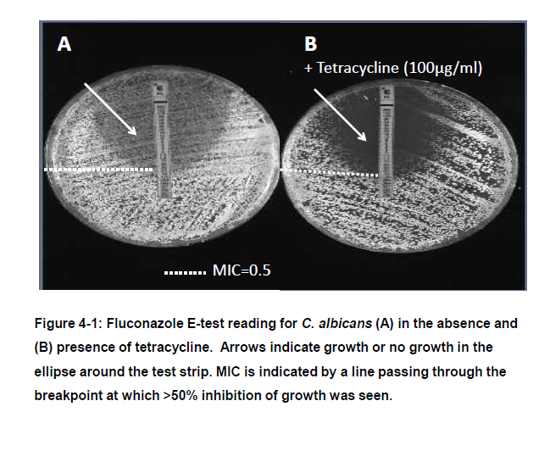

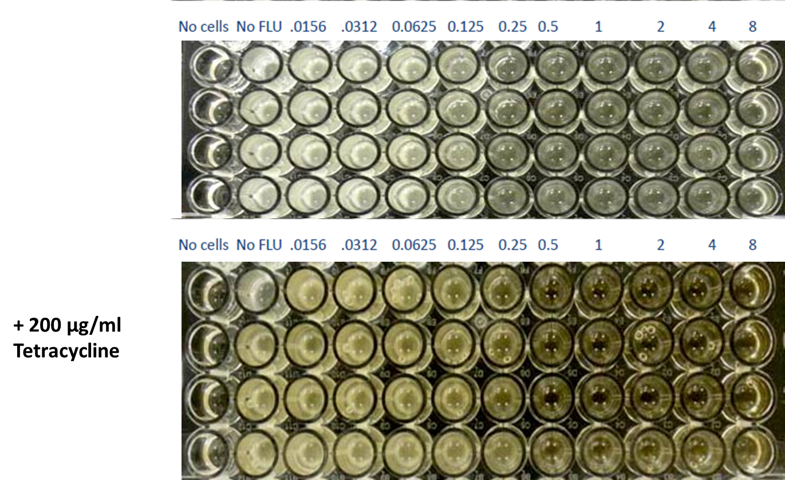

Figure 4-2: CLSI Broth Microdilution Test: Fluconazole is diluted in wells of the microtiter plate. C.albicans cells in media lacking and containing tetracycline are added to the wells and allowed to grow for 48 hrs. Wells are visually inspected and scored according to CLSI guidelines. The image is a top view of the micro-titre plate depicting the gradation of growth following the indicated treatments.
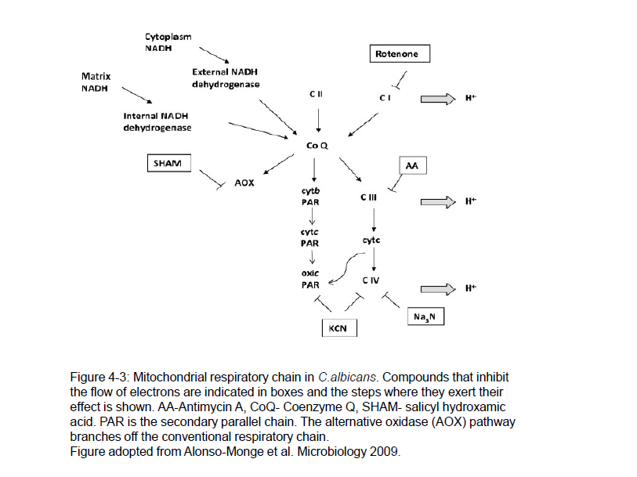

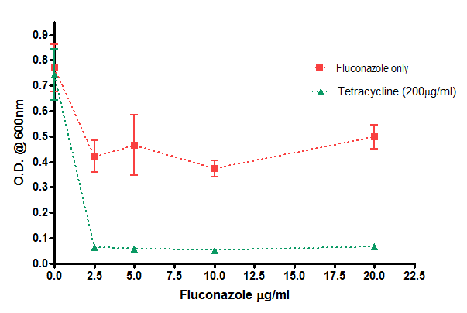
A

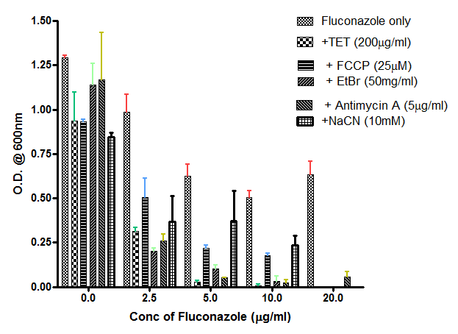
B

Figure 4-4: Effect of 24 hr (A) tetracycline and (B) mitochondrial inhibitor treatment on the viability of fluconazole-treated Candida albicans cells. P value (Fluconazole treated v/s FLU+ TET treated) = .028
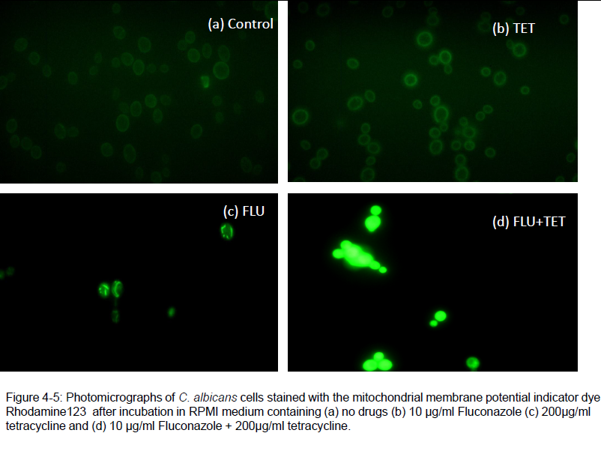

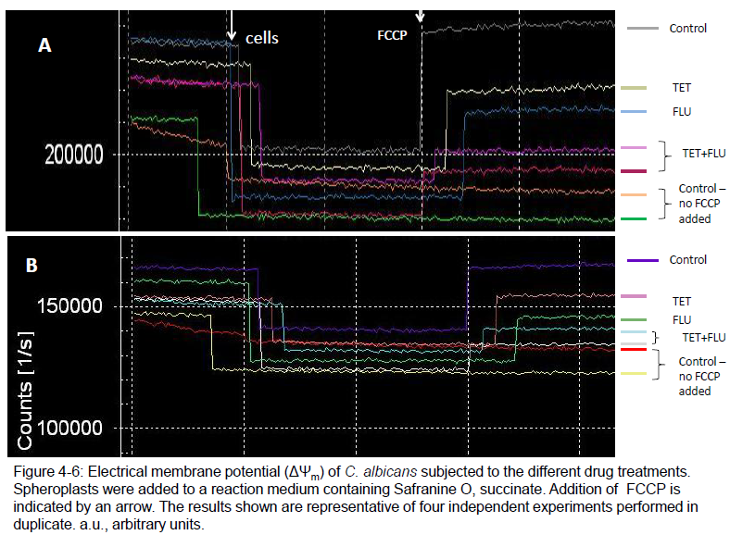

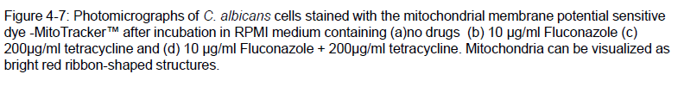

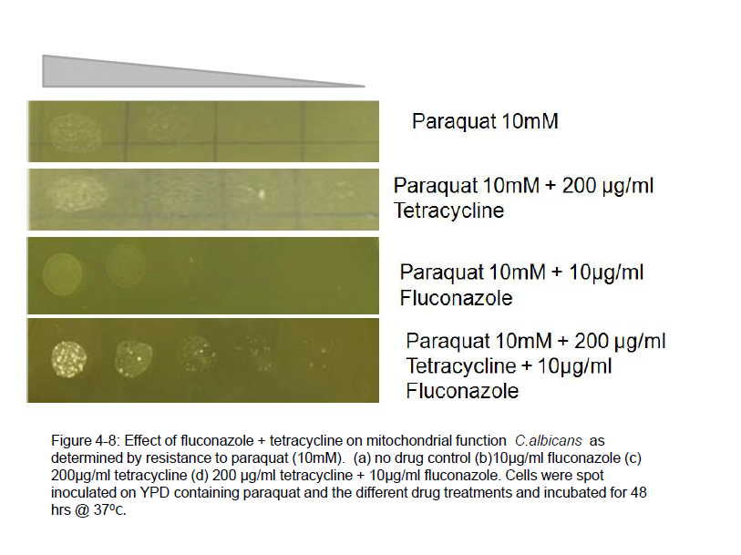

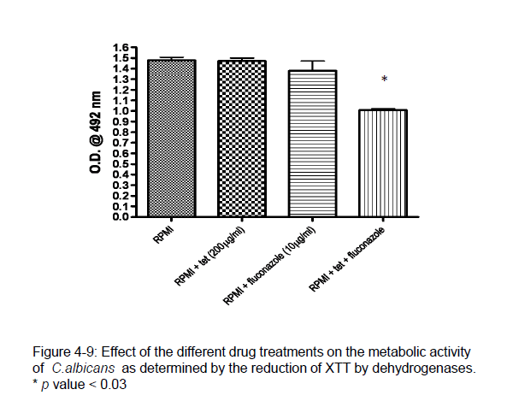

Figure 4-10: The effect of ketoconazole in combination with tetracycline on the survival of C.albicans.

CHAPTER FIVE
Testing the in vivo efficacy of fluconazole in combination with tetracycline in a systemic model of candidiasis

ABSTRACT
Fluconazole in combination with tetracycline resulted in inhibition of Candida albicans growth in vitro. This drug combination was shown to affect mitochondrial membrane potential and function. To test the in vivo efficacy of this combination in increasing survival of mice infected with C.albicans, a murine model of systemic infection was used. This drug combination resulted in no differences in the survival of mice or fungal burden in kidney tissues compared to the fluconazole-treated mice.

INTRODUCTION:
The use of combination antifungal therapy for the treatment of invasive mycoses has been of clinical interest for several decades now (Codish et al.,1979). Combination antimicrobial therapy has been used in clinical settings for the treatment of various infectious diseases. Because of the high morbidity and mortality associated with invasive fungal infections clinicians are always searching for better therapeutic options. Antifungal combination therapy is being considered as a strategy to broaden the spectrum of activity, increase the extent of killing via drug synergy and minimize the development of resistance (Johnson & Perfect, 2010). There has been some promise in this area especially in treatment of cryptococcosis (Mukherjee et al., 2005). Clinical trials in antifungal combination therapy is limited because of the associated costs, difficulties in conducting trials because of enrollment challenges, time constraints and drug companies not wanting to risk combining drugs due to the inherent danger of adverse effects of the combination (Mukherjee et al., 2005). Moreover, most experimental methods lack standardization and sometimes there is no correlation between the results from in vitro studies, animal models and clinical trials. Several factors have to be considered when evaluating in vivo efficacies of drug combinations including absorption and metabolism of drugs in animals (Mukherjee et al., 2005).
There have been some examples of success in using combination therapy for the treatment of fungal infections using animal models and clinical case studies. Animal models for candidiasis have demonstrated that amphotericin B and 5 fluorocytosine combinations are successful in reducing fungal load in the kidneys and improving survival rates (Polak, A. 1978; Thaler et al., 1988). The use of azoles in combination with amphotericin B has also been effective in increasing survival and reducing fungal densities in kidneys and brains of neutropenic mice (Sanati et al., 1997). Combining fluconazole with a cell wall synthesis inhibitor- caspofungin for treatment of systemic candidiasis in a murine model resulted in reduced renal tissue burden in mice compared with those receiving fluconazole alone (Graybill et al., 2003). The efficacies of the antibiotics ciprofloxacin and trovafloxacin, alone and in combination with fluconazole have been evaluated in vivo against C. albicans in a murine model of systemic candidiasis, and in vitro. In vitro, these drug combinations were not synergistic, but in vivo, the combination of both ciprofloxacin and trovafloxacin with fluconazole was more effective than fuconazole alone in increasing survival times of mice. Fluconazole has also been shown to synergize with the antibacterials such as minocycline (Shi et al., 2010), doxycycline (Miceli et al., 2009) and polymyxin B (Zhai et al., 2010) in vitro. Recently, it was reported that tetracycline synergized with amphotericin B and fluconazole against C. albicans and C. neoformans in vitro (Oliver et al., 2008).
These encouraging findings have led to the evaluation of combination therapy in clinical trials. In neutropenic patients with candidaemia, fluconazole + amphotericin B combination therapy resulted in faster sterilization of the blood and resolution of fever and hypotension compared with fluconazole monotherapy (Rex et al., 2003). Scheven et al (1992) reported that fluconazole with fluorocytosine was successful in the treatment of C.albicans sepsis. Success with this combination was also reported for C.glabrata and C.krusei infections with complete resolution of symptoms within two weeks (Girmenia et al.,2003). Fluconazole in combination with terbinafine (another inhibitor of ergosterol biosynthesis) was successful in the treatment of an oral C.albicans infection (Ghannoum & Elewski, 1999).
A summary of in vitro, animal model and clinical trials of fluconazole combination therapy studies for Candida species is tabulated in Table 7.

Table 7: Efficacy of fluconazole drug combinations against Candida species
Study | Combination | Effect | Reference
In vitro | FLU + AmB | No effect | Louie et al., 2001
 | FLU+AmB | Antagonistic | Sugar et al., 1995
 | FLU+AmB | Synergy | Ghannoum et al., 1995
 | 5FC+FLU | Synergistic or additive | Nguyen et al., 1995
 | 5FC+FLU | Additive | Girmenia et al., 2003
 | VORI+FLU | Additive or indifferent | Ghannoum et al., Abtsr, Trends Invasive Fungal Infections, 2001
In vivo | AmB + FLU | No antagonism | Sugar et al., 1995
 | AmB+FLU | Indifferent against FLU-resistant strains | Louie et al., 1999
 | AmB + FLU | Survival and tissue clearance increased | Sanati et al., 1997
 | FLU then AmB, + FLU (sequential) | Antagonisitic | Louie et al., 2001
 | FLU+5FC | No effect | Graybill et al., 1995
 | FLU+5FC | Better tissue clearance | Atkinson et al., 1995, Louie et al., 1999
Clinical | FLU+AmB | No antagonism | Rex et al., 2003
 | FLU+5FC | Resolution of candidiasis | Scheven et al., 1992
 | FLU+5FC | Resolution of sepsis and meningitis | Marr et al.,1994
 | FLU+5FC | Cleared C.krusei and C.glabrata infections | Girmenia et al., 2003
 | FLU+TERB | Resolution of infection | Ghannoum & Elewski, 1999
AmB – Amphotericin B; FLU- Fluconazole; 5FC-5fluorocytosine; TERB-terbinafine

MATERIALS AND METHODS
Strains and culture conditions
C.albicans strain SC5314 which is bloodstream clinical isolate was used in this study. Yeast-extract peptone dextrose (YPD) medium was used to grow this strain.
Mouse infection studies
Five- to six-week old male ICR mice from Harlan Laboratories were used for the infection studies. Five mice were housed per cage. Colonies of C.albicans strains growing overnight in YPD were washed thrice in phosphate buffered saline. The cells were counted by a haemocytometer and adjusted to a final concentration of 10⁷ cells/ml in phosphate buffered saline. Mice were injected via the tail vein with 100µL of the cell suspension. One day after infection, drug treatments were started and the course of infection was monitored for three weeks.
Four treatment groups were established:
- Fluconazole treatment: Fluconazole at 1mg/kg was injected intraperitonealy daily for five days
- Tetracycline treatment: Tetracycline was dissolved in a 5% sucrose solution at a final concentration of 2mg/ml and filled in the drinking water bottles. The water bottles were changed every 2 days.
- Fluconazole + Tetracycline treatment: this treatment involved a combination of (a) and (b) for five days.
- No treatment control
Mice were monitored daily for any overt signs of infection (head-tilt or tremors or immobility). Moribund mice were euthanized. This experiment was done in duplicate with five mice in each group. All experimental procedures were carried out in accordance with the NIH guidelines for the ethical treatment of animals.
Fungal burden in mice kidneys
This was determined by dissecting kidneys from three randomly selected mice 6 days after infection (i.e. one day after stopping treatment). The kidneys were weighed, crushed and homogenized in phosphate-buffered saline. 1:10 dilutions of the tissue homogenates were plated on YPD media and incubated at 37ºC/24 h. The colony forming units were determined.
Statistical Analysis
GraphPad Prism Software (version 4.0) was used for conducting statistical analysis. For the mouse survival curves, the Kaplan-Meier test was used to compare the curves and significance was calculated using the Mantel-Haenszel log rank test. Statistical significances were determined by student’s t test and were considered significant when P was <0.05.
RESULTS:
In this study, the efficacy of fluconazole in combination with the antibacterial agent tetracycline in treating C.albicans infections was evaluated using a murine model of disseminated candidiasis.
For the survival studies, a group of 10 mice was used for each strain and each treatment. Mice were challenged with 1 X 10⁶ C.albicans cells into the lateral tail vein. The different groups were treated as follows: (1) Fluconazole at 1 mg/kg of body weight/dose given intraperitoneally daily, (2) Tetracycline 2mg/ml in sucrose solution given orally in the drinking water and (3) The combination of an intraperitoneal dose of fluconazole and oral dose of tetracycline. Water bottles were changed every 2 days. All treatments began 24 h after challenge, and the therapy lasted for 5 days. Mice were checked daily for 15 days. Mean survival times were estimated by the Kaplan-Meier method.
No significant differences were found in the survival time of mice between the fluconazole only or fluconazole + tetracycline treatments, P>0.1 (Fig:5-1). As expected, the untreated control mice and tetracycline treated mice died faster than the other treatment groups. The concentration of fluconazole used in this study was probably too high to be able to discern any effect of FLU+TET or tetracycline may be metabolized in vivo or absorbed slowly to see any effect at the concentration used.
Since kidneys are the main organs that C.albicans colonizes, disseminated infection was evaluated by determining the cfu/g kidneys. For tissue burden studies, four groups of 5 mice, one for each treatment and one for controls, were used. For all treatments, therapy began 24 h after challenge and lasted 5 days. One day after the treatment finished, three of the surviving mice were sacrificed. Kidneys were collected and homogenized in 1 ml of sterile phosphate buffered saline. Serial 10-fold dilutions of the homogenates were plated on YPD agar, incubated at 37°C, and the numbers of CFU per gram of kidney tissue was calculated. No significant differences were found between the fungal burden in mice kidneys following fluconazole treatment or fluconazole + tetracycline treatment, P>0.5 (Figure:5-2).

DISCUSSION:
Given the degree of morbidity and the rate of mortality associated with invasive fungal infections, especially in immunocompromised patients, the use of combination therapy to treat these infections has been considered over the past decades (Bennet et al., 1979). Despite the lack of data from controlled clinical trials, combination therapy has been considered as a viable option with the hope of achieving reduced antifungal resistance and synergy between drugs that target different cellular components or processes. This in part is supported by the success of using combination therapy for the treatment of cryptococal meningitis as determined by animal models and anecdotal case studies (Mukherjee et al., 2005). The use of amphotericin B in combination with 5 fluorocytosine resulted in rapid clearance of C.neoformans from the cerebrospinal fluid and higher rates of cure (Baddley & Pappas, 2005). There has been some clinical evidence for improved outcomes of candidiasis patients receiving a combination therapy of amphotericin B and fluconazole (Abele-Horn et al., 1996).
In this study the in vivo efficacy of using tetracycline in combination with fluconazole was evaluated using a mouse model of systemic candidiasis. The rationale for testing this combination is based on the demonstration of synergy between the two drugs in vitro. In vivo efficacy was determined by measuring fungal burden in mice kidneys after the different treatments and by measuring mean survival times of mice.
For groups of mice receiving the combination or fluconazole alone, the results were similar and survival rates were comparable (P>0.1). No differences were found in the fungal load in mice kidneys too. These observations suggest that no synergy occurs between fluconazole and tetracycline in vivo at least at the concentrations used. However, there are several loopholes in this study that could explain the different observations in vitro and in vivo. The concentration of tetracycline was not optimized, in terms of how it is metabolized in vivo, the serum levels and/ or tissue distribution of the drug was not determined, so there was no way of knowing if the most effective dose of tetracycline was used. Moreover, the dose of tetracycline was not controlled. Since the dose was given orally in the form of drinking water, it was just assumed that the mice would drink the same amount of water daily and the daily dose of tetracycline would be more or less constant throughout the treatment period. Perhaps a better way of administering the dose would be to inject tetracycline intraperitoneally to ensure a constant dose throughout the treatment regimen.
No significant conclusions with regards to the efficacy of fluconazole + tetracycline combination therapy could be made from this study. This drug combination warrants further investigation where the dose of both fluconazole and tetracycline is controlled.

APPENDIX E: FIGURES
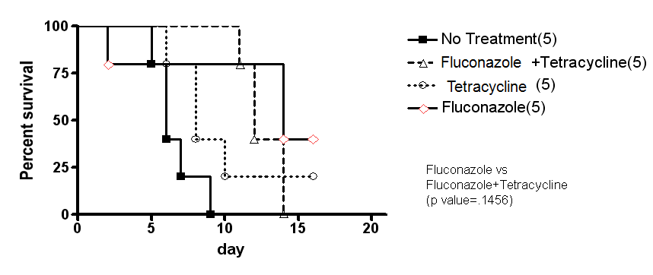
Figure 5-1: Effect of treatment with fluconazole, tetracycline and fluconazole in combination with tetracycline on the mortality of mice infected with wild-type C.albicans. This figure is representative of two experiments with 5 mice in each treatment group.

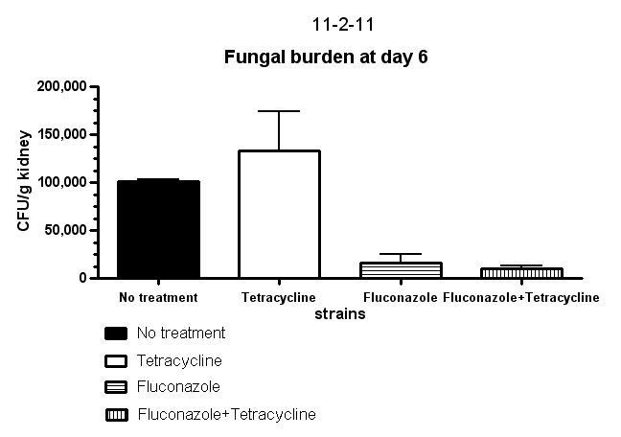
Figure 5-2: The effect of fluconazole, tetracycline or fluconazole in combination with tetracycline on the fungal burden in mice kidneys 6 days after intravenous infection with C.albicans. The error bar represents the mean + standard deviation of three randomly selected mice.

CHAPTER SIX
Conclusions

Candida albicans remains the leading cause of fungal systemic infections amongst immunocompromised individuals and patients with indwelling medical devices. Changes in medical care and the lack of more effective antifungal treatments have led to increasing cases of candidiasis. Thus a better understanding of the biology of C.albicans and the mechanisms that facilitate survival in the host is necessary to develop better therapeutic agents. In this thesis, the role of fatty acid synthase 1 (Fas1) in Candida albicans virulence is explored. In the second part of the thesis, the efficacy of using fluconazole (a commonly available antifungal agent that inhibits ergosterol biosynthesis and thus weakens the fungal membrane) in combination with tetracycline (an antibacterial agent that inhibits protein synthesis) against C.albicans is explored.
Fatty acids play a multifaceted role in C.albicans physiology by governing several vital processes in the cell, such as energy storage, metabolism, signaling and cell-cell interactions and, the integrity of cell membranes. It is not surprising therefore, that disruption of fatty acid biosynthesis would have detrimental effects on the survival of C. albicans in the host and attenuates its virulence in a systemic animal model of candidiasis. Targeting processes or enzymes that are important for fungal growth is increasingly being recogonized as a viable strategy to treat systemic candidiasis. Genes involved in biosynthetic pathways have been shown to affect fungal virulence and thus provide attractive drug targets. To this end, fatty acid synthases as a drug target looks promising as they affect pleitropic procces in pathogens and have been demonstrated to regulate the virulence of the fungal pathogens Candida albicans, Candida parapsilosis and Cryptococcus neoformans.
In C.albicans, Fas1 encodes for the β sub-unit of the fatty acid synthase complex which is involved in the biosynthesis of saturated fatty acids. Consequently, a fas1∆/∆ mutant fails to grow in the absence of an exogenous supply of fatty acids. We have demonstrated that the fas1∆/∆ mutant can initially colonize mice kidneys but fails to sustain the infection 1 day post-infection, suggesting that while the mutants nutritional auxotrophy may be fulfilled, it may be more readily cleared up by the host immune system. In order to investigate the mechanism for its avirulence, several assays were performed to examine the survival of the mutant in the presence of immune effector cells, oxidative stress, cell wall inhibiting agents and cationic peptides to name a few. The fas1∆/∆ mutant was found to, be hypersensitive to osmotic stress in vitro and, display increased permeability to the membrane impermeable dye, propidium iodide. This increased permeability was hypothesized to be due to alterations in its membrane fatty acid composition as reflected by a down-regulation in C:16 fatty acids and up-regulation in long chain C:22 and C:23 fatty acids in the mutants membrane compared to the wild-type strain. Thus, by influencing the virulence and survival of C.albicans in the host, fatty acid synthase 1 provides some scope as a target for the development of antifungals and a further evaluation of the role of fatty acids in the physiology of the organism is warranted. For example, what signaling processes are affected by disruption of fatty acid biosynthesis and how do these membrane fatty acid imbalances affect the ability of C. albicans to interact with the host and other virulence attributes such as adhesion to host mucosal surfaces, or evading immune attack or sensing and responding to stimuli that permit hyphal formation or nutrient acquisition in the host.
Combination therapy has been an area of extensive research for the successful treatment of invasive candidiasis due to the unique adavantages it offers. Two different processes can be targeted simultaneously thus limiting the possibility of developing resistance to the drugs in combination. Tetracycline was found to enhance the susceptibility of C.albicans to fluconazole in vitro and this drug combination was found to be more effective in inhibiting and killing the organism compared to treatments with either drug alone. Fluconazole is known to inhibit ergosterol biosynthesis and since this sterol forms an important component of the fungal cell membrane, fluconazole exerts in antifungal effect by weakening the cell membrane and rendering it more permeable. Fluconazole is however only fungistatic against C.albicans, and the organism has evolved several mechanisms to resist its antifungal activity. Tetracycline, on the other hand, is an antibacterial that exerts its effect by inhibiting ribosomal protein synthesis.Considering the similarities between fungal mitochondrial ribosomes and bacterial ribosomes it is not surprising that tetracycline has been shown to affect the mitochondria of some eukaryotic organisms. To explore the hypothesis that fluconazole in combination with tetracycline is fungicidal against C.albicans by inhibiting mitochondrial function, due to the increased permeability of the mitochondrial membrane caused by fluconazole, several tests were performed to assess mitochondrial function following treatment with this drug combination.
In the presence of fluconazole + tetracycline, C.albicans displays loss of mitochondrial membrane potential (as determined by Rhodamine 123 and Mito Tracker staining), more aberrant or diffuse staining of mitochondria (observed by DAPI staining), decrease in the activity of mitochondrial dehydrogenases and a slight increase in resistance to paraquat, which is a drug that is lethal to cells with an intact mitochondrial respiratory chain. The effect of the drugs is combination was thus concluded to be fungicidal by inhibiting mitochondrial function. In vivo assays to test the efficacy of this drug combonation was not found to be fruitful as the drugs in combination did not result in prolonged mice survival or decrease in fungal burden in mice kidneys. Thus suggesting that either fluconazole + tetracycline is not synergistic in vivo or under the experimental conditions tested, an effective serum concentration was not reached for these drugs to be synergistic and exert their antifungal activity. However, these drugs in combination are highly effective in vitro and can still be explored as a viable therapeutic strategy in antimicrobial lock therapy for the treatment of C.albicans biofilms.
APPENDIX F: SUPPLEMENTARY FIGURES
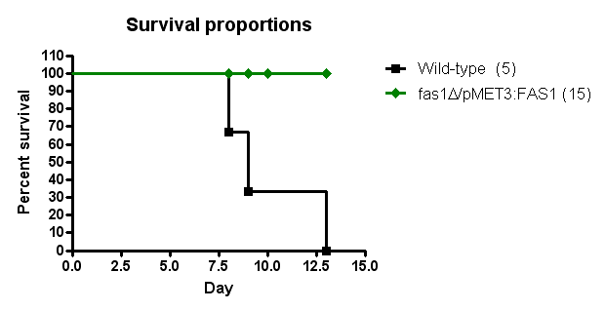

Supplementary Figure 1: Survival proportions of mice injected intravenously with 10⁶ C.albicans cells. The wild-type C.albicans strains was compared to a MET3 conditional fas1∆/P-_{MET3}FAS1 mutant. In the presence of methionine, the other allele of FAS1 is not expressed. P value <0.05.

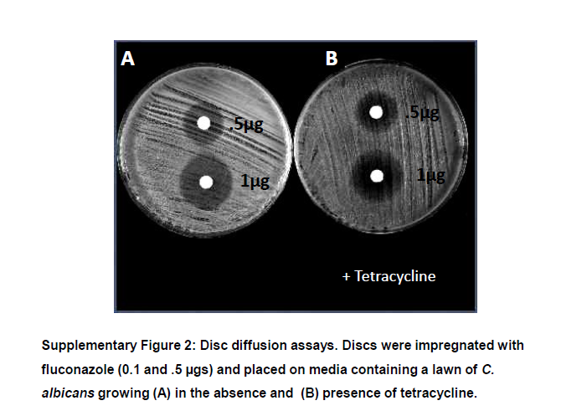

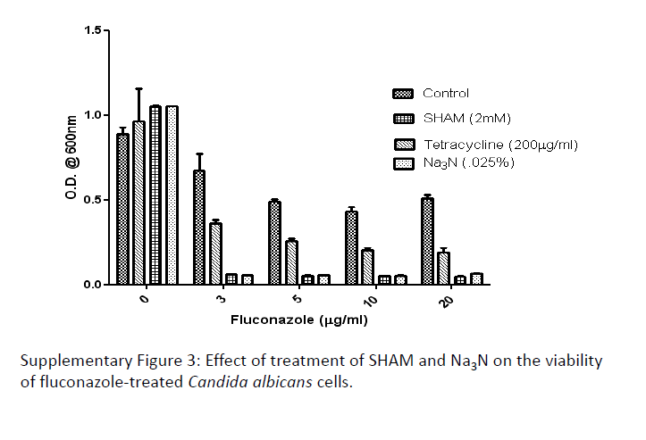

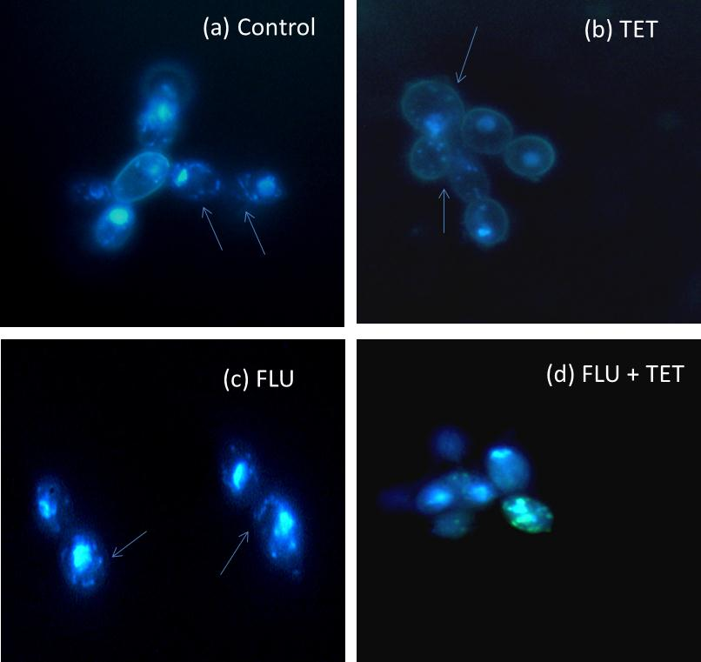

Supplementary Figure 4: Photomicrographs of C. albicans cells stained with DAPI after incubation in RPMI medium containing (a) no drugs (b) 10µg/ml Fluconazole (c) 200µg/ml tetracycline and (d) 10µ/ml Fluconazole + 200µg/ml tetracycline. DAPI stains the nucleus and mitochondria of yeast cells. Mitochondria appear as bright blue spots or ribbon-shaped structres (indicated by blue arrows) after staining with DAPI.
CITATIONS
1. Alonso-Monge R, Carvaihlo S, Nombela C, Rial E, & Pla J (2009) The Hog1 MAP kinase controls respiratory metabolism in the fungal pathogen Candida albicans. Microbiology 155(Pt 2):413-423.
2. Altmann K & Westermann B (2005) Role of essential genes in mitochondrial morphogenesis in Saccharomyces cerevisiae. Molecular biology of the cell 16(11):5410-5417.
3. Anderson JB (2005) Evolution of antifungal-drug resistance: mechanisms and pathogen fitness. Nature reviews. Microbiology 3(7):547-556.
4. Arendrup MC, et al. (2010) Echinocandin susceptibility testing of Candida species: comparison of EUCAST EDef 7.1, CLSI M27-A3, Etest, disk diffusion, and agar dilution methods with RPMI and isosensitest media. Antimicrobial agents and chemotherapy 54(1):426-439.
5. Argimon S, Fanning S, Blankenship JR, & Mitchell AP (2011) Interaction between the Candida albicans high-osmolarity glycerol (HOG) pathway and the response to human beta-defensins 2 and 3. Eukaryotic cell 10(2):272-275.
6. Atkinson BA, et al. (1995) Comparison of fluconazole, amphotericin B and flucytosine in treatment of a murine model of disseminated infection with Candida glabrata in immunocompromised mice. The Journal of antimicrobial chemotherapy 35(5):631-640.
7. Baddley JW & Pappas PG (2005) Antifungal combination therapy: clinical potential. Drugs 65(11):1461-1480.
8. Barchiesi F, et al. (1998) In-vitro interaction of terbinafine with amphotericin B, fluconazole and itraconazole against clinical isolates of Candida albicans. The Journal of antimicrobial chemotherapy 41(1):59-65.
9. Bates DW, et al. (2001) Mortality and costs of acute renal failure associated with amphotericin B therapy. Clinical infectious diseases : an official publication of the Infectious Diseases Society of America 32(5):686-693.
10. Beckers CJ, et al. (1995) Inhibition of cytoplasmic and organellar protein synthesis in Toxoplasma gondii. Implications for the target of macrolide antibiotics. The Journal of clinical investigation 95(1):367-376.
11. Beggs WH & Sarosi GA (1982) Combined activity of ketoconazole and 5-fluorocytosine on potentially pathogenic yeasts. Antimicrobial agents and chemotherapy 21(2):355-357.
12. Beggs WH & Sarosi GA (1982) Further evidence for sequential action of amphotericin B and 5-fluorocytosine against Candida albicans. Chemotherapy 28(5):341-344.
13. Beggs WH, Sarosi GA, & Walker MI (1976) Synergistic action of amphotericin B and rifampin against Candida species. The Journal of infectious diseases 133(2):206-209.
14. Benincasa M, et al. (2006) Fungicidal activity of five cathelicidin peptides against clinically isolated yeasts. The Journal of antimicrobial chemotherapy 58(5):950-959.
15. Bennett JE, et al. (1979) A comparison of amphotericin B alone and combined with flucytosine in the treatment of cryptoccal meningitis. The New England journal of medicine 301(3):126-131.
16. Bernardo J, Sabra R, Vyas S, & Branch R (2004) Amphotericin B
Clinical Nephrotoxins. eds Broe M, Porter G, Bennett W, & Verpooten G (Springer Netherlands), pp 199-222.
17. Blaszczynski M, Litwinska J, Zaborowska D, & Bilinski T (1985) The role of respiratory chain in paraquat toxicity in yeast. Acta microbiologica Polonica 34(3-4):243-254.
18. Bligh EG & Dyer WJ (1959) A rapid method of total lipid extraction and purification. Canadian journal of biochemistry and physiology 37(8):911-917.
19. Bloomfield DK & Bloch K (1960) The formation of delta 9-unsaturated fatty acids. The Journal of biological chemistry 235:337-345.
20. Bouchara JP, Tronchin G, Annaix V, Robert R, & Senet JM (1990) Laminin receptors on Candida albicans germ tubes. Infection and immunity 58(1):48-54.
21. Brown RN & Gulig PA (2008) Regulation of fatty acid metabolism by FadR is essential for Vibrio vulnificus to cause infection of mice. Journal of bacteriology 190(23):7633-7644.
22. Burkl G, Castorph H, & Schweizer E (1972) Mapping of a complex gene locus coding for part of the Saccharomyces cerevisiae fatty acid synthetase multienzyme complex. Molecular & general genetics : MGG 119(4):315-322.
23. Calderone RA (1993) Recognition between Candida albicans and host cells. Trends in microbiology 1(2):55-58.
24. Calderone RA (1993) Molecular interactions at the interface of Candida albicans and host cells. Archives of medical research 24(3):275-279.
25. Calderone RA & Fonzi WA (2001) Virulence factors of Candida albicans. Trends in microbiology 9(7):327-335.
26. Casado JL, et al. (1997) Candidal meningitis in HIV-infected patients: analysis of 14 cases. Clinical infectious diseases : an official publication of the Infectious Diseases Society of America 25(3):673-676.
27. Cavalheiro RA, et al. (2004) Respiration, oxidative phosphorylation, and uncoupling protein in Candida albicans. Brazilian journal of medical and biological research = Revista brasileira de pesquisas medicas e biologicas / Sociedade Brasileira de Biofisica ... [et al.] 37(10):1455-1461.
28. Chaffin WL (2008) Candida albicans cell wall proteins. Microbiology and molecular biology reviews : MMBR 72(3):495-544.
29. Chaffin WL, Lopez-Ribot JL, Casanova M, Gozalbo D, & Martinez JP (1998) Cell wall and secreted proteins of Candida albicans: identification, function, and expression. Microbiology and molecular biology reviews : MMBR 62(1):130-180.
30. Chatterjee MT, Khalawan SA, & Curran BP (2000) Cellular lipid composition influences stress activation of the yeast general stress response element (STRE). Microbiology 146 ( Pt 4):877-884.
31. Chayakulkeeree M, Rude TH, Toffaletti DL, & Perfect JR (2007) Fatty acid synthesis is essential for survival of Cryptococcus neoformans and a potential fungicidal target. Antimicrobial agents and chemotherapy 51(10):3537-3545.
32. Chen HH, Liushih RN, & Hsieh WC (1982) Combined in vitro activity of amphotericin B and 5-fluorocytosine against Cryptococcus neoformans and Candida albicans. Zhonghua Minguo wei sheng wu ji mian yi xue za zhi = Chinese journal of microbiology and immunology 15(2):106-112.
33. Chen L, Shen Z, & Wu J (2009) Expression, purification and in vitro antifungal activity of acidic mammalian chitinase against Candida albicans, Aspergillus fumigatus and Trichophyton rubrum strains. Clinical and experimental dermatology 34(1):55-60.
34. Chen YL, Kauffman S, & Reynolds TB (2008) Candida albicans uses multiple mechanisms to acquire the essential metabolite inositol during infection. Infection and immunity 76(6):2793-2801.
35. Chen YL, et al. (2010) Phosphatidylserine synthase and phosphatidylserine decarboxylase are essential for cell wall integrity and virulence in Candida albicans. Molecular microbiology 75(5):1112-1132.
36. Chopra I & Roberts M (2001) Tetracycline antibiotics: mode of action, applications, molecular biology, and epidemiology of bacterial resistance. Microbiology and molecular biology reviews : MMBR 65(2):232-260 ; second page, table of contents.
37. Cocheme HM & Murphy MP (2008) Complex I is the major site of mitochondrial superoxide production by paraquat. The Journal of biological chemistry 283(4):1786-1798.
38. Codish SD, Tobias JS, & Hannigan M (1979) Combined amphotericin B-flucytosine therapy in Aspergillus pneumonia. JAMA : the journal of the American Medical Association 241(22):2418-2419.
39. Codish SD, Tobias JS, & Monaco AP (1979) Recent advances in the treatment of systemic mycotic infections. Surgery, gynecology & obstetrics 148(3):435-447.
40. Cowen LE, Anderson JB, & Kohn LM (2002) Evolution of drug resistance in Candida albicans. Annual review of microbiology 56:139-165.
41. Dahl EL, et al. (2006) Tetracyclines specifically target the apicoplast of the malaria parasite Plasmodium falciparum. Antimicrobial agents and chemotherapy 50(9):3124-3131.
42. de Bernardis F, et al. (1999) High aspartyl proteinase production and vaginitis in human immunodeficiency virus-infected women. Journal of clinical microbiology 37(5):1376-1380.
43. de Repentigny L, Lewandowski D, & Jolicoeur P (2004) Immunopathogenesis of oropharyngeal candidiasis in human immunodeficiency virus infection. Clinical microbiology reviews 17(4):729-759, table of contents.
44. Debono M & Gordee RS (1994) Antibiotics that inhibit fungal cell wall development. Annual review of microbiology 48:471-497.
45. DeMuria D, et al. (1993) Pharmacokinetics and bioavailability of fluconazole in patients with AIDS. Antimicrobial agents and chemotherapy 37(10):2187-2192.
46. Dickson RC (1998) Sphingolipid functions in Saccharomyces cerevisiae: comparison to mammals. Annual review of biochemistry 67:27-48.
47. Dudani AK & Prasad R (1985) Differences in amino acid transport and phospholipid contents during the cell cycle of Candida albicans. Folia microbiologica 30(6):493-500.
48. Edlind TD (1989) Tetracyclines as antiparasitic agents: lipophilic derivatives are highly active against Giardia lamblia in vitro. Antimicrobial agents and chemotherapy 33(12):2144-2145.
49. Edlind TD (1989) Susceptibility of Giardia lamblia to aminoglycoside protein synthesis inhibitors: correlation with rRNA structure. Antimicrobial agents and chemotherapy 33(4):484-488.
50. Edwards JE, Jr., Morrison J, Henderson DK, & Montgomerie JZ (1980) Combined effect of amphotericin B and rifampin on Candida species. Antimicrobial agents and chemotherapy 17(3):484-487.
51. Ellis, D (2002) Amphotericin B: Spectrum and Resistance. Journal of Antimicrobial Chemotherapy Feb;49 Suppl 1:7-10.
52. El-Azizi M (2007) Enhancement of the in vitro activity of amphotericin B against the biofilms of non-albicans Candida spp. by rifampicin and doxycycline. Journal of medical microbiology 56(Pt 5):645-649.
53. Ernst EJ, Klepser ME, & Pfaller MA (1998) In vitro interaction of fluconazole and amphotericin B administered sequentially against Candida albicans: effect of concentration and exposure time. Diagnostic microbiology and infectious disease 32(3):205-210.
54. Escriba PV, et al. (2008) Membranes: a meeting point for lipids, proteins and therapies. Journal of cellular and molecular medicine 12(3):829-875.
55. Fera MT, La Camera E, & De Sarro A (2009) New triazoles and echinocandins: mode of action, in vitro activity and mechanisms of resistance. Expert review of anti-infective therapy 7(8):981-998.
56. Franz R, et al. (1998) Multiple molecular mechanisms contribute to a stepwise development of fluconazole resistance in clinical Candida albicans strains. Antimicrobial agents and chemotherapy 42(12):3065-3072.
57. Fu Y, et al. (2002) Candida albicans Als1p: an adhesin that is a downstream effector of the EFG1 filamentation pathway. Molecular microbiology 44(1):61-72.
58. Fukazawa Y & Kagaya K (1997) Molecular bases of adhesion of Candida albicans. Journal of medical and veterinary mycology : bi-monthly publication of the International Society for Human and Animal Mycology 35(2):87-99.
59. Fukushima T, Tanaka K, Lim H, & Moriyama M (2002) Mechanism of cytotoxicity of paraquat. Environmental health and preventive medicine 7(3):89-94.
60. Gacser A, et al. (2007) Lipase 8 affects the pathogenesis of Candida albicans. Infection and immunity 75(10):4710-4718.
61. Gacser A, Trofa D, Schafer W, & Nosanchuk JD (2007) Targeted gene deletion in Candida parapsilosis demonstrates the role of secreted lipase in virulence. The Journal of clinical investigation 117(10):3049-3058.
62. Garcia-Effron G, et al. (2010) Novel FKS mutations associated with echinocandin resistance in Candida species. Antimicrobial agents and chemotherapy 54(5):2225-2227.
63. Gasch AP (2007) Comparative genomics of the environmental stress response in ascomycete fungi. Yeast 24(11):961-976.
64. Gasch AP & Werner-Washburne M (2002) The genomics of yeast responses to environmental stress and starvation. Functional & integrative genomics 2(4-5):181-192.
65. Ghannoum M & Abu Elteen K (1986) Correlative relationship between proteinase production, adherence and pathogenicity of various strains of Candida albicans. Journal of medical and veterinary mycology : bi-monthly publication of the International Society for Human and Animal Mycology 24(5):407-413.
66. Ghannoum MA (2000) Potential role of phospholipases in virulence and fungal pathogenesis. Clinical microbiology reviews 13(1):122-143, table of contents.
67. Ghannoum MA, Burns GR, Elteen KA, & Radwan SS (1986) Experimental evidence for the role of lipids in adherence of Candida spp. to human buccal epithelial cells. Infection and immunity 54(1):189-193.
68. Ghannoum MA & Elewski B (1999) Successful treatment of fluconazole-resistant oropharyngeal candidiasis by a combination of fluconazole and terbinafine. Clinical and diagnostic laboratory immunology 6(6):921-923.
69. Ghannoum MA, et al. (1995) In vitro determination of optimal antifungal combinations against Cryptococcus neoformans and Candida albicans. Antimicrobial agents and chemotherapy 39(11):2459-2465.
70. Ghannoum MA, Janini G, Khamis L, & Radwan SS (1986) Dimorphism-associated variations in the lipid composition of Candida albicans. Journal of general microbiology 132(8):2367-2375.
71. Ghannoum MA & Rice LB (1999) Antifungal agents: mode of action, mechanisms of resistance, and correlation of these mechanisms with bacterial resistance. Clinical microbiology reviews 12(4):501-517.
72. Ghannoum MA, Swairjo I, & Soll DR (1990) Variation in lipid and sterol contents in Candida albicans white and opaque phenotypes. Journal of medical and veterinary mycology : bi-monthly publication of the International Society for Human and Animal Mycology 28(2):103-115.
73. Gillum AM, Tsay EY, & Kirsch DR (1984) Isolation of the Candida albicans gene for orotidine-5'-phosphate decarboxylase by complementation of S. cerevisiae ura3 and E. coli pyrF mutations. Molecular & general genetics : MGG 198(1):179-182.
74. Girmenia C, Venditti M, & Martino P (2003) Fluconazole in combination with flucytosine in the treatment of fluconazole-resistant Candida infections. Diagnostic microbiology and infectious disease 46(3):227-231.
75. Goffeau A (2008) Drug resistance: the fight against fungi. Nature 452(7187):541-542.
76. Graybill JR, Bocanegra R, Najvar LK, Hernandez S, & Larsen RA (2003) Addition of caspofungin to fluconazole does not improve outcome in murine candidiasis. Antimicrobial agents and chemotherapy 47(7):2373-2375.
77. Graybill JR, Najvar LK, Holmberg JD, & Luther MF (1995) Fluconazole, D0870, and flucytosine treatment of disseminated Candida tropicalis infections in mice. Antimicrobial agents and chemotherapy 39(4):924-929.
78. Gudlaugsson O, et al. (2003) Attributable mortality of nosocomial candidemia, revisited. Clinical infectious diseases : an official publication of the Infectious Diseases Society of America 37(9):1172-1177.
79. Hawser SP, Norris H, Jessup CJ, & Ghannoum MA (1998) Comparison of a 2,3-bis(2-methoxy-4-nitro-5-sulfophenyl)-5-[(phenylamino)carbonyl]-2H-t etrazolium hydroxide (XTT) colorimetric method with the standardized National Committee for Clinical Laboratory Standards method of testing clinical yeast isolates for susceptibility to antifungal agents. Journal of clinical microbiology 36(5):1450-1452.
80. Helmerhorst EJ, et al. (1999) The cellular target of histatin 5 on Candida albicans is the energized mitochondrion. The Journal of biological chemistry 274(11):7286-7291.
81. Hoberg KA, Cihlar RL, & Calderone RA (1983) Inhibitory effect of cerulenin and sodium butyrate on germination of Candida albicans. Antimicrobial agents and chemotherapy 24(3):401-408.
82. Hoberg KA, Cihlar RL, & Calderone RA (1986) Characterization of cerulenin-resistant mutants of Candida albicans. Infection and immunity 51(1):102-109.
83. Hope WW, et al. (2007) Optimization of the dosage of flucytosine in combination with amphotericin B for disseminated candidiasis: a pharmacodynamic rationale for reduced dosing. Antimicrobial agents and chemotherapy 51(10):3760-3762.
84. Hostetter MK (1994) Adhesins and ligands involved in the interaction of Candida spp. with epithelial and endothelial surfaces. Clinical microbiology reviews 7(1):29-42.
85. Hostetter MK (1999) Integrin-like proteins in Candida spp. and other microorganisms. Fungal genetics and biology : FG & B 28(3):135-145.
86. Howlett NG & Avery SV (1997) Induction of lipid peroxidation during heavy metal stress in Saccharomyces cerevisiae and influence of plasma membrane fatty acid unsaturation. Applied and environmental microbiology 63(8):2971-2976.
87. Hoyer LL, Green CB, Oh SH, & Zhao X (2008) Discovering the secrets of the Candida albicans agglutinin-like sequence (ALS) gene family--a sticky pursuit. Medical mycology : official publication of the International Society for Human and Animal Mycology 46(1):1-15.
88. Hube B, Monod M, Schofield DA, Brown AJ, & Gow NA (1994) Expression of seven members of the gene family encoding secretory aspartyl proteinases in Candida albicans. Molecular microbiology 14(1):87-99.
89. Huppert M, Sun SH, & Vukovich KR (1974) Combined amphotericin B-tetracycline therapy for experimental coccidioidomycosis. Antimicrobial agents and chemotherapy 5(5):473-478.
90. Huttova M, et al. (1998) Candida fungemia in neonates treated with fluconazole: report of forty cases, including eight with meningitis. The Pediatric infectious disease journal 17(11):1012-1015.
91. Ianas V, Matthias KR, & Klotz SA (2010) Role of posaconazole in the treatment of oropharyngeal candidiasis. Infection and drug resistance 3:45-51.
92. Irwin M.Y. and Fonzi. W.A. (1993) Isogenic strain construction and gene mapping in Candida albicans. Genetics. 134(3):717-28
93. Jayabalasingham B, Menard R, & Fidock DA (2010) Recent insights into fatty acid acquisition and metabolism in malarial parasites. F1000 biology reports 2.
94. Johnson MD, MacDougall C, Ostrosky-Zeichner L, Perfect JR, & Rex JH (2004) Combination antifungal therapy. Antimicrobial agents and chemotherapy 48(3):693-715.
95. Johnson MD & Perfect JR (2010) Use of Antifungal Combination Therapy: Agents, Order, and Timing. Current fungal infection reports 4(2):87-95.
96. Katiyar SK & Edlind TD (1991) Enhanced antiparasitic activity of lipophilic tetracyclines: role of uptake. Antimicrobial agents and chemotherapy 35(11):2198-2202.
97. Keele DJ, DeLallo VC, Lewis RE, Ernst EJ, & Klepser ME (2001) Evaluation of amphotericin B and flucytosine in combination against Candida albicans and Cryptococcus neoformans using time-kill methodology. Diagnostic microbiology and infectious disease 41(3):121-126.
98. Kirsch DR & Whitney RR (1991) Pathogenicity of Candida albicans auxotrophic mutants in experimental infections. Infection and immunity 59(9):3297-3300.
99a. Klotz SA (1994) Plasma and extracellular matrix proteins mediate in the fate of Candida albicans in the human host. Medical hypotheses 42(5):328-334.
99b. Klotz SA, Hein RC, Smith RL, & Rouse JB (1994) The fibronectin adhesin of Candida albicans. Infection and immunity 62(10):4679-4681.
100. Kohli A, Smriti, Mukhopadhyay K, Rattan A, & Prasad R (2002) In vitro low-level resistance to azoles in Candida albicans is associated with changes in membrane lipid fluidity and asymmetry. Antimicrobial agents and chemotherapy 46(4):1046-1052.
101. Koshlukova SE, Lloyd TL, Araujo MW, & Edgerton M (1999) Salivary histatin 5 induces non-lytic release of ATP from Candida albicans leading to cell death. The Journal of biological chemistry 274(27):18872-18879.
102. Krishnamurthy S, et al. (2004) Dosage-dependent functions of fatty acid desaturase Ole1p in growth and morphogenesis of Candida albicans. Microbiology 150(Pt 6):1991-2003.
103. Kruppa M & Calderone R (2006) Two-component signal transduction in human fungal pathogens. FEMS yeast research 6(2):149-159.
104. Kvaal C, et al. (1999) Misexpression of the opaque-phase-specific gene PEP1 (SAP1) in the white phase of Candida albicans confers increased virulence in a mouse model of cutaneous infection. Infection and immunity 67(12):6652-6662.
105. Lai C-C, Tan C-K, Huang Y-T, Shao P-L, & Hsueh P-R (2008) Current challenges in the management of invasive fungal infections. Journal of Infection and Chemotherapy 14(2):77-85.
106. Langfelder K, et al. (1998) Identification of a polyketide synthase gene (pksP) of Aspergillus fumigatus involved in conidial pigment biosynthesis and virulence. Medical microbiology and immunology 187(2):79-89.
107. Leidich SD, et al. (1998) Cloning and disruption of caPLB1, a phospholipase B gene involved in the pathogenicity of Candida albicans. The Journal of biological chemistry 273(40):26078-26086.
108. Leroy O, et al. (2009) Epidemiology, management, and risk factors for death of invasive Candida infections in critical care: a multicenter, prospective, observational study in France (2005-2006). Critical care medicine 37(5):1612-1618.
109. Lew MA, Beckett KM, & Levin MJ (1977) Antifungal activity of four tetracycline analogues against Candida albicans in vitro: potentiation by amphotericin B. The Journal of infectious diseases 136(2):263-270.
110. Lewis RE (2002) Pharmacotherapy of Candida bloodstream infections: new treatment options, new era. Expert opinion on pharmacotherapy 3(8):1039-1057.
111. Lewis RE, Diekema DJ, Messer SA, Pfaller MA, & Klepser ME (2002) Comparison of Etest, chequerboard dilution and time-kill studies for the detection of synergy or antagonism between antifungal agents tested against Candida species. The Journal of antimicrobial chemotherapy 49(2):345-351.
112. Lewis RE, Kontoyiannis DP, Darouiche RO, Raad, II, & Prince RA (2002) Antifungal activity of amphotericin B, fluconazole, and voriconazole in an in vitro model of Candida catheter-related bloodstream infection. Antimicrobial agents and chemotherapy 46(11):3499-3505.
113. Liu Y & Filler SG (2011) Candida albicans Als3, a multifunctional adhesin and invasin. Eukaryotic cell 10(2):168-173.
114. Lo HJ, et al. (1997) Nonfilamentous C. albicans mutants are avirulent. Cell 90(5):939-949.
115. Lorenz MC, Bender JA, & Fink GR (2004) Transcriptional response of Candida albicans upon internalization by macrophages. Eukaryotic cell 3(5):1076-1087.
116. Louie A, Banerjee P, Drusano GL, Shayegani M, & Miller MH (1999) Interaction between fluconazole and amphotericin B in mice with systemic infection due to fluconazole-susceptible or -resistant strains of Candida albicans. Antimicrobial agents and chemotherapy 43(12):2841-2847.
117. Louie A, et al. (2001) Impact of the order of initiation of fluconazole and amphotericin B in sequential or combination therapy on killing of Candida albicans in vitro and in a rabbit model of endocarditis and pyelonephritis. Antimicrobial agents and chemotherapy 45(2):485-494.
118. Louie A, et al. (1999) Efficacies of high-dose fluconazole plus amphotericin B and high-dose fluconazole plus 5-fluorocytosine versus amphotericin B, fluconazole, and 5-fluorocytosine monotherapies in treatment of experimental endocarditis, endophthalmitis, and pyelonephritis due to Candida albicans. Antimicrobial agents and chemotherapy 43(12):2831-2840.
119. Ludovico P, Sansonetty F, & Corte-Real M (2001) Assessment of mitochondrial membrane potential in yeast cell populations by flow cytometry. Microbiology 147(Pt 12):3335-3343.
120. Lupetti A, et al. (2007) Human lactoferrin-derived peptide's antifungal activities against disseminated Candida albicans infection. The Journal of infectious diseases 196(9):1416-1424.
121. Maesaki S, Marichal P, Vanden Bossche H, Sanglard D, & Kohno S (1999) Rhodamine 6G efflux for the detection of CDR1-overexpressing azole-resistant Candida albicans strains. The Journal of antimicrobial chemotherapy 44(1):27-31.
122. Marchetti O, et al. (2000) Fluconazole plus cyclosporine: a fungicidal combination effective against experimental endocarditis due to Candida albicans. Antimicrobial agents and chemotherapy 44(11):2932-2938.
123. Marchetti O, Moreillon P, Glauser MP, Bille J, & Sanglard D (2000) Potent synergism of the combination of fluconazole and cyclosporine in Candida albicans. Antimicrobial agents and chemotherapy 44(9):2373-2381.
124. Markert M, Andrews PC, & Babior BM (1984) Measurement of O2- production by human neutrophils. The preparation and assay of NADPH oxidase-containing particles from human neutrophils. Methods in enzymology 105:358-365.
125. Marr B, Gross S, Cunningham C, & Weiner L (1994) Candidal sepsis and meningitis in a very-low-birth-weight infant successfully treated with fluconazole and flucytosine. Clinical infectious diseases : an official publication of the Infectious Diseases Society of America 19(4):795-796.
126. Mazumdar J, E HW, Masek K, C AH, & Striepen B (2006) Apicoplast fatty acid synthesis is essential for organelle biogenesis and parasite survival in Toxoplasma gondii. Proceedings of the National Academy of Sciences of the United States of America 103(35):13192-13197.
127. McCarron PA, Donnelly RF, Marouf W, & Calvert DE (2007) Anti-adherent and antifungal activities of surfactant-coated poly(ethylcyanoacrylate) nanoparticles. International journal of pharmaceutics 340(1-2):182-190.
128. Mdluli K, et al. (1998) Inhibition of a Mycobacterium tuberculosis beta-ketoacyl ACP synthase by isoniazid. Science 280(5369):1607-1610.
129. Medoff G, Dismukes WE, Meade RH, 3rd, & Moses JM (1972) A new therapeutic approach to Candida infections. A preliminary report. Archives of internal medicine 130(2):241-245.
130. Medoff G, Kobayashi GS, Kwan CN, Schlessinger D, & Venkov P (1972) Potentiation of rifampicin and 5-fluorocytosine as antifungal antibiotics by amphotericin B (yeast-membrane permeability-ribosomal RNA-eukaryotic cell-synergism). Proceedings of the National Academy of Sciences of the United States of America 69(1):196-199.
131. Meri T, et al. (2004) The hyphal and yeast forms of Candida albicans bind the complement regulator C4b-binding protein. Infection and immunity 72(11):6633-6641.
132. Miceli MH, Bernardo SM, & Lee SA (2009) In vitro analyses of the combination of high-dose doxycycline and antifungal agents against Candida albicans biofilms. International journal of antimicrobial agents 34(4):326-332.
133. Minari A, Hachem R, & Raad I (2001) Candida lusitaniae: a cause of breakthrough fungemia in cancer patients. Clinical infectious diseases : an official publication of the Infectious Diseases Society of America 32(2):186-190.
134. Mishra P, Bolard J, & Prasad R (1992) Emerging role of lipids of Candida albicans, a pathogenic dimorphic yeast. Biochimica et biophysica acta 1127(1):1-14.
135. Monk BC & Goffeau A (2008) Outwitting multidrug resistance to antifungals. Science 321(5887):367-369.
136. Montgomerie JZ, Edwards JE, Jr., & Guze LB (1975) Synergism of amphotericin B and 5-fluorocytosine for candida species. The Journal of infectious diseases 132(1):82-86.
137. Morbidoni HR, et al. (2006) Dual inhibition of mycobacterial fatty acid biosynthesis and degradation by 2-alkynoic acids. Chemistry & biology 13(3):297-307.
138. Morgan J (2005) Global trends in candidemia: review of reports from 1995-2005. Current infectious disease reports 7(6):429-439.
139. Morgan J, et al. (2005) Excess mortality, hospital stay, and cost due to candidemia: a case-control study using data from population-based candidemia surveillance. Infection control and hospital epidemiology : the official journal of the Society of Hospital Epidemiologists of America 26(6):540-547.
140. Morschhauser J (2002) The genetic basis of fluconazole resistance development in Candida albicans. Biochimica et biophysica acta 1587(2-3):240-248.
141. Moyes DL & Naglik JR (2011) Mucosal immunity and Candida albicans infection. Clinical & developmental immunology 2011:346307.
142. Mukherjee PK, Sheehan DJ, Hitchcock CA, & Ghannoum MA (2005) Combination treatment of invasive fungal infections. Clinical microbiology reviews 18(1):163-194.
143. Naglik JR, Challacombe SJ, & Hube B (2003) Candida albicans secreted aspartyl proteinases in virulence and pathogenesis. Microbiology and molecular biology reviews : MMBR 67(3):400-428, table of contents.
144. Naglik JR, et al. (1999) In vivo analysis of secreted aspartyl proteinase expression in human oral candidiasis. Infection and immunity 67(5):2482-2490.
145. Naglik JR, et al. (2003) Differential expression of Candida albicans secreted aspartyl proteinase and phospholipase B genes in humans correlates with active oral and vaginal infections. The Journal of infectious diseases 188(3):469-479.
146. Nakajima R, Kitamura A, Someya K, Tanaka M, & Sato K (1995) In vitro and in vivo antifungal activities of DU-6859a, a fluoroquinolone, in combination with amphotericin B and fluconazole against pathogenic fungi. Antimicrobial agents and chemotherapy 39(7):1517-1521.
147. Negre E, et al. (1994) The collagen binding domain of fibronectin contains a high affinity binding site for Candida albicans. The Journal of biological chemistry 269(35):22039-22045.
148. Ng CK, et al. (2006) Correlation of antifungal activity with fungal phospholipase inhibition using a series of bisquaternary ammonium salts. Journal of medicinal chemistry 49(2):811-816.
149. Ngo SC, et al. (2007) Inhibition of isolated Mycobacterium tuberculosis fatty acid synthase I by pyrazinamide analogs. Antimicrobial agents and chemotherapy 51(7):2430-2435.
150. Nguyen LN, Gacser A, & Nosanchuk JD (2011) The stearoyl-coenzyme A desaturase 1 is essential for virulence and membrane stress in Candida parapsilosis through unsaturated fatty acid production. Infection and immunity 79(1):136-145.
151. Nguyen LN, Trofa D, & Nosanchuk JD (2009) Fatty acid synthase impacts the pathobiology of Candida parapsilosis in vitro and during mammalian infection. PloS one 4(12):e8421.
152. Nguyen MH, Barchiesi F, McGough DA, Yu VL, & Rinaldi MG (1995) In vitro evaluation of combination of fluconazole and flucytosine against Cryptococcus neoformans var. neoformans. Antimicrobial agents and chemotherapy 39(8):1691-1695.
153. Nobile CJ & Mitchell AP (2006) Genetics and genomics of Candida albicans biofilm formation. Cellular microbiology 8(9):1382-1391.
154. Nobile CJ, Nett JE, Andes DR, & Mitchell AP (2006) Function of Candida albicans adhesin Hwp1 in biofilm formation. Eukaryotic cell 5(10):1604-1610.
155. Noble SM & Johnson AD (2005) Strains and strategies for large-scale gene deletion studies of the diploid human fungal pathogen Candida albicans. Eukaryotic cell 4(2):298-309.
156. Odds FC, Brown AJ, & Gow NA (2003) Antifungal agents: mechanisms of action. Trends in microbiology 11(6):272-279.
157. Odds FC, Webster CE, Mayuranathan P, & Simmons PD (1988) Candida concentrations in the vagina and their association with signs and symptoms of vaginal candidosis. Journal of medical and veterinary mycology : bi-monthly publication of the International Society for Human and Animal Mycology 26(5):277-283.
158. Oliver BG, et al. (2008) Tetracycline alters drug susceptibility in Candida albicans and other pathogenic fungi. Microbiology 154(Pt 3):960-970.
159. Onishi J, et al. (2000) Discovery of novel antifungal (1,3)-beta-D-glucan synthase inhibitors. Antimicrobial agents and chemotherapy 44(2):368-377.
160. Onyewu C, Blankenship JR, Del Poeta M, & Heitman J (2003) Ergosterol biosynthesis inhibitors become fungicidal when combined with calcineurin inhibitors against Candida albicans, Candida glabrata, and Candida krusei. Antimicrobial agents and chemotherapy 47(3):956-964.
161. Ostrosky-Zeichner L (2003) New approaches to the risk of Candida in the intensive care unit. Current opinion in infectious diseases 16(6):533-537.
162. Ostrosky-Zeichner L, Marr KA, Rex JH, & Cohen SH (2003) Amphotericin B: time for a new "gold standard". Clinical infectious diseases : an official publication of the Infectious Diseases Society of America 37(3):415-425.
163. Panepinto JC, et al. (2010) Overexpression of TUF1 restores respiratory growth and fluconazole sensitivity to a Cryptococcus neoformans vad1Delta mutant. Microbiology 156(Pt 8):2558-2565.
164. Pendrak ML & Klotz SA (1995) Adherence of Candida albicans to host cells. FEMS microbiology letters 129(2-3):103-113.
165. Perlin DS (2007) Resistance to echinocandin-class antifungal drugs. Drug resistance updates : reviews and commentaries in antimicrobial and anticancer chemotherapy 10(3):121-130.
166. Pesti M, Horvath L, Vigh L, & Farkas T (1985) Lipid content and ESR determination of plasma membrane order parameter in Candida albicans sterol mutants. Acta microbiologica Hungarica 32(4):305-313.
167. Pesti M, Novak EK, Ferenczy L, & Svoboda A (1981) Freeze fracture electron microscopical investigation of Candida albicans cells sensitive and resistant to nystatin. Sabouraudia 19(1):17-26.
168. Petrikkos G & Skiada A (2007) Recent advances in antifungal chemotherapy. International journal of antimicrobial agents 30(2):108-117.
169. Phan QT, Belanger PH, & Filler SG (2000) Role of hyphal formation in interactions of Candida albicans with endothelial cells. Infection and immunity 68(6):3485-3490.
170. Phillips AJ, Sudbery I, & Ramsdale M (2003) Apoptosis induced by environmental stresses and amphotericin B in Candida albicans. Proceedings of the National Academy of Sciences of the United States of America 100(24):14327-14332.
171. Polak A (1978) Synergism of polyene antibiotics with 5-fluorocytosine. Chemotherapy 24(1):2-16.
172. Rabinovich S, Shaw BD, Bryant T, & Donta ST (1974) Effect of 5-fluorocytosine and amphotericin B on Candida albicans infection in mice. The Journal of infectious diseases 130(1):28-31.
173. Rahn CA, Bombick DW, & Doolittle DJ (1991) Assessment of mitochondrial membrane potential as an indicator of cytotoxicity. Fundamental and applied toxicology : official journal of the Society of Toxicology 16(3):435-448.
174. Ramamohan N, Zeineh N, Grigoris P, & Butcher I (2001) Candida glabrata infection after total hip arthroplasty. The Journal of infection 42(1):74-76.
175. Ramirez MA & Lorenz MC (2007) Mutations in alternative carbon utilization pathways in Candida albicans attenuate virulence and confer pleiotropic phenotypes. Eukaryotic cell 6(2):280-290.
176. Rauch I, Lundstrom L, Hell M, Sperl W, & Kofler B (2007) Galanin message-associated peptide suppresses growth and the budded-to-hyphal-form transition of Candida albicans. Antimicrobial agents and chemotherapy 51(11):4167-4170.
177. Rex JH, et al. (2003) A randomized and blinded multicenter trial of high-dose fluconazole plus placebo versus fluconazole plus amphotericin B as therapy for candidemia and its consequences in nonneutropenic subjects. Clinical infectious diseases : an official publication of the Infectious Diseases Society of America 36(10):1221-1228.
178. Rex JH, Rinaldi MG, & Pfaller MA (1995) Resistance of Candida species to fluconazole. Antimicrobial agents and chemotherapy 39(1):1-8.
179. Richet HM, Andremont A, Tancrede C, Pico JL, & Jarvis WR (1991) Risk factors for candidemia in patients with acute lymphocytic leukemia. Reviews of infectious diseases 13(2):211-215.
180. Ripeau JS, Fiorillo M, Aumont F, Belhumeur P, & de Repentigny L (2002) Evidence for differential expression of candida albicans virulence genes during oral infection in intact and human immunodeficiency virus type 1-transgenic mice. The Journal of infectious diseases 185(8):1094-1102.
181. Rodloff C, Koch D, & Schaumann R (2011) Epidemiology and antifungal resistance in invasive candidiasis. European journal of medical research 16(4):187-195.
182. Rodriguez-Suarez R, et al. (2007) Mechanism-of-action determination of GMP synthase inhibitors and target validation in Candida albicans and Aspergillus fumigatus. Chemistry & biology 14(10):1163-1175.
183. Rodriguez-Vargas S, Sanchez-Garcia A, Martinez-Rivas JM, Prieto JA, & Randez-Gil F (2007) Fluidization of membrane lipids enhances the tolerance of Saccharomyces cerevisiae to freezing and salt stress. Applied and environmental microbiology 73(1):110-116.
184. Rossler H, Rieck C, Delong T, Hoja U, & Schweizer E (2003) Functional differentiation and selective inactivation of multiple Saccharomyces cerevisiae genes involved in very-long-chain fatty acid synthesis. Molecular genetics and genomics : MGG 269(2):290-298.
185. Rousseau C, et al. (2003) Virulence attenuation of two Mas-like polyketide synthase mutants of Mycobacterium tuberculosis. Microbiology 149(Pt 7):1837-1847.
186. Sanati H, Ramos CF, Bayer AS, & Ghannoum MA (1997) Combination therapy with amphotericin B and fluconazole against invasive candidiasis in neutropenic-mouse and infective-endocarditis rabbit models. Antimicrobial agents and chemotherapy 41(6):1345-1348.
187. Santoni G, et al. (1994) Candida albicans expresses a fibronectin receptor antigenically related to alpha 5 beta 1 integrin. Microbiology 140 ( Pt 11):2971-2979.
188. Sasaki E, et al. (2000) Synergistic effect of ofloxacin and fluconazole against azole-resistant Candida albicans. Journal of infection and chemotherapy : official journal of the Japan Society of Chemotherapy 6(3):151-154.
189. Saville SP, Lazzell AL, Monteagudo C, & Lopez-Ribot JL (2003) Engineered control of cell morphology in vivo reveals distinct roles for yeast and filamentous forms of Candida albicans during infection. Eukaryotic cell 2(5):1053-1060.
190. Schaumann RF & Shah PM (1992) Effect of amphotericin B alone or in combination with rifampicin on phagocytosis of Candida species by human polymorphonuclear leukocytes. Methods and findings in experimental and clinical pharmacology 14(10):753-758.
191. Scheven M, Junemann K, Schramm H, & Huhn W (1992) Successful treatment of a Candida albicans sepsis with a combination of flucytosine and fluconazole. Mycoses 35(11-12):315-316.
192. Schneiter R (1999) Brave little yeast, please guide us to thebes: sphingolipid function in S. cerevisiae. BioEssays : news and reviews in molecular, cellular and developmental biology 21(12):1004-1010.
193. Schofield DA, Westwater C, Warner T, & Balish E (2005) Differential Candida albicans lipase gene expression during alimentary tract colonization and infection. FEMS microbiology letters 244(2):359-365.
194. Schuller HJ, Fortsch B, Rautenstrauss B, Wolf DH, & Schweizer E (1992) Differential proteolytic sensitivity of yeast fatty acid synthetase subunits alpha and beta contributing to a balanced ratio of both fatty acid synthetase components. European journal of biochemistry / FEBS 203(3):607-614.
195. Schuller HJ, Hahn A, Troster F, Schutz A, & Schweizer E (1992) Coordinate genetic control of yeast fatty acid synthase genes FAS1 and FAS2 by an upstream activation site common to genes involved in membrane lipid biosynthesis. The EMBO journal 11(1):107-114.
196. Schweizer E (1973) Molecular structure and biosynthesis of the fatty acid synthetase-multienzyme complex of yeast. Angew Chem Int Ed Engl 12(4):341-342.
197. Schweizer E (1977) [Biosynthesis and structure of the yeast fatty acid synthetase complex]. Die Naturwissenschaften 64(7):366-370.
198. Schweizer E (1996) [Fatty acid synthases--strategic functions of multienzymes]. Die Naturwissenschaften 83(8):347-358.
199. Schweizer E & Hofmann J (2004) Microbial type I fatty acid synthases (FAS): major players in a network of cellular FAS systems. Microbiology and molecular biology reviews : MMBR 68(3):501-517.
200. Schweizer E, Kuhn L, & Castorph H (1971) A new gene cluster in yeast: the fatty acid synthetase system. Hoppe-Seyler's Zeitschrift fur physiologische Chemie 352(3):377-384.
201. Schweizer E, et al. (1987) GENETIC-CONTROL OF FATTY-ACID SYNTHETASE BIOSYNTHESIS AND STRUCTURE IN LOWER FUNGI. Fett Wiss. Technol.-Fat Sci. Technol. 89(14):570-577.
202. Schweizer E, Werkmeister K, & Jain MK (1978) Fatty acid biosynthesis in yeast. Molecular and cellular biochemistry 21(2):95-107.
203. Schweizer HP & Choi KH (2011) Pseudomonas aeruginosa aerobic fatty acid desaturase DesB is important for virulence factor production. Archives of microbiology 193(3):227-234.
204. Schweizer M, Lebert C, Holtke J, Roberts LM, & Schweizer E (1984) Molecular cloning of the yeast fatty acid synthetase genes, FAS1 and FAS2: illustrating the structure of the FAS1 cluster gene by transcript mapping and transformation studies. Molecular & general genetics : MGG 194(3):457-465.
205. Schweizer M, et al. (1986) Molecular structure and expression of fatty acid synthetase genes in yeast. Biochemical Society transactions 14(3):572-574.
206. Sheehan DJ, Hitchcock CA, & Sibley CM (1999) Current and emerging azole antifungal agents. Clinical microbiology reviews 12(1):40-79.
207. Shi W, et al. (2010) The combination of minocycline and fluconazole causes synergistic growth inhibition against Candida albicans: an in vitro interaction of antifungal and antibacterial agents. FEMS yeast research 10(7):885-893.
208. Siggaard-Andersen M (1988) Role of Escherichia coli beta-ketoacyl-ACP synthase I in unsaturated fatty acid synthesis. Carlsberg research communications 53(6):371-379.
209. Slonimski PP, Perrodin G, & Croft JH (1968) Ethidium bromide induced mutation of yeast mitochondria: complete transformation of cells into respiratory deficient non-chromosomal "petites". Biochemical and biophysical research communications 30(3):232-239.
210. Smego RA, Jr., Perfect JR, & Durack DT (1984) Combined therapy with amphotericin B and 5-fluorocytosine for Candida meningitis. Reviews of infectious diseases 6(6):791-801.
211. Sobel JD (1992) Pathogenesis and treatment of recurrent vulvovaginal candidiasis. Clinical infectious diseases : an official publication of the Infectious Diseases Society of America 14 Suppl 1:S148-153.
212. Somero GN (2011) Comparative physiology: a "crystal ball" for predicting consequences of global change. American journal of physiology. Regulatory, integrative and comparative physiology 301(1):R1-14.
213. Stehr F, et al. (2004) Expression analysis of the Candida albicans lipase gene family during experimental infections and in patient samples. FEMS yeast research 4(4-5):401-408.
214. Stergiopoulou T, et al. (2008) Isobolographic analysis of pharmacodynamic interactions between antifungal agents and ciprofloxacin against Candida albicans and Aspergillus fumigatus. Antimicrobial agents and chemotherapy 52(6):2196-2204.
215. Stergiopoulou T, et al. (2009) Comparative pharmacodynamic interaction analysis between ciprofloxacin, moxifloxacin and levofloxacin and antifungal agents against Candida albicans and Aspergillus fumigatus. The Journal of antimicrobial chemotherapy 63(2):343-348.
216. Stewart LC & Yaffe MP (1991) A role for unsaturated fatty acids in mitochondrial movement and inheritance. The Journal of cell biology 115(5):1249-1257.
217. Stiller, R.L., J.E.Bennet, H.J. Scholer, M. Wall, A. Polak, and D.A. Stevens (1983) Correlation of in vitro susceptibility test results with in vivo response: flucytosine therapy in a systemic candidiasis model. Journal of Infectious Diseases 147:1070-1077.
218. Stoops JK, et al. (1978) Studies on the yeast fatty acid synthetase. Subunit composition and structural organization of a large multifunctional enzyme complex. The Journal of biological chemistry 253(12):4464-4475.
219. Stoops JK & Wakil SJ (1978) The isolation of the two subunits of yeast fatty acid synthetase. Biochemical and biophysical research communications 84(1):225-231.
220. Stukey JE, McDonough VM, & Martin CE (1989) Isolation and characterization of OLE1, a gene affecting fatty acid desaturation from Saccharomyces cerevisiae. The Journal of biological chemistry 264(28):16537-16544.
221. Sugar AM (1991) Interactions of amphotericin B and SCH 39304 in the treatment of experimental murine candidiasis: lack of antagonism of a polyene-azole combination. Antimicrobial agents and chemotherapy 35(8):1669-1671.
222. Sugar AM, Hitchcock CA, Troke PF, & Picard M (1995) Combination therapy of murine invasive candidiasis with fluconazole and amphotericin B. Antimicrobial agents and chemotherapy 39(3):598-601.
223. Sugar AM, Liu XP, & Chen RJ (1997) Effectiveness of quinolone antibiotics in modulating the effects of antifungal drugs. Antimicrobial agents and chemotherapy 41(11):2518-2521.
224. Sun Y & O'Riordan MX (2010) Branched-chain fatty acids promote Listeria monocytogenes intracellular infection and virulence. Infection and immunity 78(11):4667-4673.
225. Sundaram S, Sullivan PA, & Shepherd MG (1981) Changes in lipid composition during starvation and germ-tube formation inCandida albicans. Experimental mycology 5(2):140-147.
226. Thaler M, Bacher J, O'Leary T, & Pizzo PA (1988) Evaluation of single-drug and combination antifungal therapy in an experimental model of candidiasis in rabbits with prolonged neutropenia. The Journal of infectious diseases 158(1):80-88.
227. Theiss S, et al. (2006) Inactivation of the phospholipase B gene PLB5 in wild-type Candida albicans reduces cell-associated phospholipase A2 activity and attenuates virulence. International journal of medical microbiology : IJMM 296(6):405-420.
228. Tuller G & Daum G (1995) Import of sterols into mitochondria of the yeast Saccharomyces cerevisiae. FEBS letters 372(1):29-32.
229. Uppuluri P, Nett J, Heitman J, & Andes D (2008) Synergistic effect of calcineurin inhibitors and fluconazole against Candida albicans biofilms. Antimicrobial agents and chemotherapy 52(3):1127-1132.
230. Vazquez JA & Sobel JD (2006) Anidulafungin: a novel echinocandin. Clinical infectious diseases : an official publication of the Infectious Diseases Society of America 43(2):215-222.
231. Vylkova S, Jang WS, Li W, Nayyar N, & Edgerton M (2007) Histatin 5 initiates osmotic stress response in Candida albicans via activation of the Hog1 mitogen-activated protein kinase pathway. Eukaryotic cell 6(10):1876-1888.
232. Vylkova S, Li XS, Berner JC, & Edgerton M (2006) Distinct antifungal mechanisms: beta-defensins require Candida albicans Ssa1 protein, while Trk1p mediates activity of cysteine-free cationic peptides. Antimicrobial agents and chemotherapy 50(1):324-331.
233. Vylkova S, Nayyar N, Li W, & Edgerton M (2007) Human beta-defensins kill Candida albicans in an energy-dependent and salt-sensitive manner without causing membrane disruption. Antimicrobial agents and chemotherapy 51(1):154-161.
234. Weete JD & Laseter JL (1974) Distribution of sterols in the fungi. I. Fungal spores. Lipids 9(8):575-581.
235. Welch JW & Burlingame AL (1973) Very long-chain fatty acids in yeast. Journal of bacteriology 115(1):464-466.
236. Wenzel RP & Gennings C (2005) Bloodstream infections due to Candida species in the intensive care unit: identifying especially high-risk patients to determine prevention strategies. Clinical infectious diseases : an official publication of the Infectious Diseases Society of America 41 Suppl 6:S389-393.
237. Wheeler RT, Kombe D, Agarwala SD, & Fink GR (2008) Dynamic, morphotype-specific Candida albicans beta-glucan exposure during infection and drug treatment. PLoS pathogens 4(12):e1000227.
238. Wisplinghoff H, et al. (2004) Nosocomial bloodstream infections in US hospitals: analysis of 24,179 cases from a prospective nationwide surveillance study. Clinical infectious diseases : an official publication of the Infectious Diseases Society of America 39(3):309-317.
239. Witkowski A, Rangan VS, Randhawa ZI, Amy CM, & Smith S (1991) Structural organization of the multifunctional animal fatty-acid synthase. European journal of biochemistry / FEBS 198(3):571-579.
240. Xu D, et al. (2009) Chemical genetic profiling and characterization of small-molecule compounds that affect the biosynthesis of unsaturated fatty acids in Candida albicans. The Journal of biological chemistry 284(29):19754-19764.
241. Xu Y, et al. (1999) Histatin 3-mediated killing of Candida albicans: effect of extracellular salt concentration on binding and internalization. Antimicrobial agents and chemotherapy 43(9):2256-2262.
242. Yazawa H, Iwahashi H, Kamisaka Y, Kimura K, & Uemura H (2009) Production of polyunsaturated fatty acids in yeast Saccharomyces cerevisiae and its relation to alkaline pH tolerance. Yeast 26(3):167-184.
243. Yeaman MR & Yount NY (2003) Mechanisms of antimicrobial peptide action and resistance. Pharmacological reviews 55(1):27-55.
244. Zachowski A (1993) Phospholipids in animal eukaryotic membranes: transverse asymmetry and movement. The Biochemical journal 294 ( Pt 1):1-14.
245. Zhai B, et al. (2010) Polymyxin B, in combination with fluconazole, exerts a potent fungicidal effect. The Journal of antimicrobial chemotherapy 65(5):931-938.
246. Zhao XJ, et al. (1996) Requirement for the Candida albicans FAS2 gene for infection in a rat model of oropharyngeal candidiasis. Microbiology 142 ( Pt 9):2509-2514.
247. Zhao XJ, McElhaney-Feser GE, Sheridan MJ, Broedel SE, Jr., & Cihlar RL (1997) Avirulence of Candida albicans FAS2 mutants in a mouse model of systemic candidiasis. Infection and immunity 65(2):829-832.
248. Zinser E & Daum G (1995) Isolation and biochemical characterization of organelles from the yeast, Saccharomyces cerevisiae. Yeast 11(6):493-536.
249. Zinser E, Paltauf F, & Daum G (1993) Sterol composition of yeast organelle membranes and subcellular distribution of enzymes involved in sterol metabolism. Journal of bacteriology 175(10):2853-2858.

VITA
Marissa Rodrigues received her Bachelor of Science degree in Microbiology from Sophia College, affiliated to the University of Mumbai in 2002. In 2005, she received her Master of Science degree in Microbiology from Sophia College, University of Mumbai. After obtaining her Master’s degree she worked as an embryologist at INKUS IVF Center, Mumbai with Dr.Indira Hinduja . She then conducted research on nosocomial infections with Dr.M.T.Pandya (Chairman of Mumbai University and Head of Department, Microbiology at Jai Hind College, Mumbai) at Jaslok Hospital, Mumbai. In 2006, she took up a Research Assistant position at Sir. H.N. Hospital and Medical Research Society in Mumbai. Marissa has received a graduate teaching assistant award for outstanding teaching in 2009. She was awarded first prize for her poster presentation at the South East Regional Yeast Meeting in 2011.

