URANIUM HOLDUP MASS
QUANTIFICATION BY HYBRID
GAMMA IMAGING

A Thesis Presented for the
Master of Science
Degree
The University of Tennessee, Knoxville

Blake R. Montz
December 2022

DEDICATION

Dedicated to my wife, Victoria, and our dog, Rudy, for their constant love and support.
ACKNOWLEDGEMENTS

This work is supported by UTK and ORNL through the graduate assistantship program. I would also like to thank the individuals on this project for their support and collaboration:

Dr. Hayward, Dr. Liesenfelt, and Jonathan Mitchell at UTK on the research team.

Dr. Venkataraman, Dr. Klaus-Ziock, and Dr. Schmitt at ORNL on the research team.

Dr. Ramsey and Dr. Howard at UTK in the Medical Physics program.
ABSTRACT

Accurate quantification of uranium holdup is crucial in the efficient operation of many processing facilities involved with special nuclear material (SNM). The varying shapes and sizes of holdup deposits can make accurate quantification a challenge. The most common approach is the Generalized Geometry Holdup (GGH) method which simplifies the shape of the deposit to a point, line, or area source. Although the GGH method is quick and easy to implement, the oversimplifying assumptions can lead to systematic uncertainties as high as 50%. The research presented here is exploring gamma-ray imaging as a more accurate method of quantifying deposits. A PHDs Germanium Gamma Imager (GeGI) is used with a coded aperture mask to simultaneously collect coded-aperture and Compton images that make use of the entire gamma-ray emission spectrum from the deposits. Rather than rely on the native PHDs Compton imaging software framework, which is not accessible to users, we are creating the Compton images separately, allowing further development of a methodology for combining the two imaging modalities, determining deposit shape, and then quantitively determining deposit mass. To achieve this, the Compton back-projected cones are discretized to individual rays which can be traced through 3D space and geometries to provide supplemental source localization information. Each ray is assigned a weighting factor for its probability of originating from the source based on attenuation through the coded-aperture mask, Compton angular uncertainty, and agreement with the coded aperture image. The weighting system provides a more accurate representation of the deposit distribution by accounting for more physical factors of the detection system and shaping based off the higher angular resolution coded aperture image obtained from the same dataset. The images and data produced contain pixel-by-pixel spectra to be used in the evaluation of holdup deposit mass from a method developed at ORNL using an inverse transport solver.
Table of Contents

CHAPTER ONE GENERAL INFORMATION 1
Project Summary 1
Holdup 1
Generalized Geometry Holdup (GGH) Method 1
Imaging Method 3
Project Purpose and Goals 3
Workflow 4
CHAPTER TWO INTRODUCTION 7
Current State of Gamma Imaging 7
Imager Specifications 10
Semiconductor Detectors 10
PHDS GeGI 11
Data Formats 14
Compton Imaging 16
Coded Aperture Imaging 23
CHAPTER THREE METHODS 29
Simple-Backprojection 29
Dynamic Ray-Casting 33
Cone Weighting Process 34
Mask Attenuation Weighting 34
Angular Uncertainty Weighting 39
Image Comparison Weighting 42
Combination of All Weighting Values 44
Detector Characterization 46
Image Combination 55
Mass Estimation 55
Thickness Determination 57
Enrichment Determination 57
Formulation 58
DREAM Method 58
CHAPTER FOUR RESULTS 60
Measurement Setup 60
Data Analysis 60
CHAPTER FIVE CONCLUSION AND FUTURE WORK 74
Summary 74
Work Limitations 74
Future Work 75
LIST OF REFERENCES 77
VITA 79

LIST OF TABLES

Table 1. GeGI Specifications……………………………………………………………. 12
Table 2. Mass Estimation with known thickness………………………………………... 72

LIST OF FIGURES

Figure 1. High level project flowchart 5
Figure 2. Separated imager configuration with overlaid mask. 9
Figure 3. Separated imager configuration with active mask first layer. 9
Figure 4. Single layer imager with overlaid mask, this project’s configuration. 9
Figure 5. NIST XCOM data for elemental germanium representing the two dominant interaction types for relevant energies pertaining to uranium holdup. 13
Figure 6. A photo of the PHDS GeGI used in this work. 15
Figure 7. A photo of the Coded aperture mask on module capable of rotation. 15
Figure 8. Concept of formatting for datacube output. An image is created for each energy in the spectrum. This way energy dependent images can be created as well as spectrum data for each pixel in the image. 17
Figure 9. Compton scatter imaging process from top to bottom: multi-interaction event from a photon detected, tracing direction vector from two interactions, calculate scattering angle, trace scattering angle around vector to create a backprojected cone. 19
Figure 10. Single backprojected cone (top), vs multiple backprojected cones (bottom). 20
Figure 11. Process showing spacing needed for proper evaluation of each interaction from a single event. Dark strips represent primary fired strip, lighter strips represent neighboring fired strips used for interpolation. 3D representation of strips firing for an interaction being detected (top). 2D interpretation of top image (middle). Representation of spacing needed for two interactions from the same event to have independent strip firings for optimal localization. 21
Figure 12. Normalized Klein-Nishina formula to show scatter direction probability with increasing energy. 22
Figure 13. “Shadow” projection of mask pattern on detector for cross-correlation analysis. 24
Figure 14. Coded aperture imaging process in a 1D example. 26
Figure 15. Process of image creation: mask pattern (right), detector count histogram (left), cross-correlation histogram for image (middle). This is a simple ideal simulation for method testing. 27
Figure 16. Same process as Figure 15, but with a line source instead to show the pattern difference that the detector sees. 27
Figure 17. Simulation of GeGI response to mask overlaid. This is a more complex simulation to portray the capabilities of the imager and method more accurately. 27
Figure 18. (left) Simple back-projected Compton scatter cones intersecting with 2D plane 1 m away from imager. (right) Coded aperture image generated from the same dataset. 30
Figure 19. Simple bask-projected Compton scatter cones intersecting with sphere 10 m away from imager. 30
Figure 20. Proof of concept for tallying lines with pixelated grid. Made to tally cone intersection with coded aperture pixelated image. 31
Figure 21. (top) Pixelated Compton scatter back-projected cones within the same fashion as the coded aperture image. (bottom) Coded aperture image created from same dataset. 32
Figure 22. Attenuation coefficients in tantalum, the coded aperture mask material. 35
Figure 23. Process for tracking a ray through the mask from top to bottom (the process here is shown for a complex case of the ray travelling from one mask element, through a gap, and into another mask element): Tracing method tracks locations of entry in the mask plane and exit of the mask plane, and a vector is defined between the points. The mask is condensed to 2D to find intersection points of mask edges. The newly defined points are interpolated within the 3rd dimension to find 3D tracing through each intersected mask element. 37
Figure 24. A simulation of a full cone travelling through the mask, with attenuation factors calculated. The back plane is away from the detector and the front plane is toward the detector. The image shows that rays travelling through mask elements have a higher attenuation probability and therefore, a lower weighting. 38
Figure 25. Location uncertainty example. The black dots are the measured interaction positions. The red and blue dots are other potential interaction locations based on the uncertainty of the positioning. This demonstrated the reorienting of the cone projection based on location uncertainty. 40
Figure 26. Infinite thickness comparison (density of 5.2 g/cc) between 1001 keV photons (blue), and 186 keV photons (orange) for U₃O₈. 43
Figure 27. Concept for weighting back-projected cone based on agreement with coded aperture image. The Compton image will have a wider source area, with the coded aperture image lying within. Looking at sections which contain both will be weighted higher for most likely being the deposit for emission at low and high energies. 45
Figure 28. Simple diagram showing how photons coming in at different angles lead to a greater thickness of material to travel through. 48
Figure 29. Diagram showing the GeGI cylindrical crystal from the perspective of the photon at two different angles to demonstrate the lower solid angle taken by the imager. 48
Figure 30. MCNP visualization of the cone beam from the point source off center projecting to the imager. 50
Figure 31. Image of measurement setup to determine location and energy dependent efficiency. 52
Figure 32. Efficiency distribution at 356 keV from an 11 by 11 grid of positions within a 1.8 m coded aperture field of view at 1.1 m distance from the imager. Geant4 was used with 10,000,000 primaries at each position. 53
Figure 33. Efficiency distribution at 356 keV from an 11 by 11 grid of positions within a 1.8 m coded aperture field of view at 1.1 m distance from the imager. MCNP was used with 10,000,000 primaries at each position. 53
Figure 34. Image of efficiency from Geant4 and MCNP simulations, as well as measurements at different pixel locations. 54
Figure 35. Self-attenuation corrected intensities using three different energy peaks. 56
Figure 36. Ratios of self-attenuation corrected intensities using three different energy peaks. 56
Figure 37. Uranium card source measurement. Distance 1 m, time of measurement 21 hours, enrichment ~5%. 61
Figure 38. Energy spectrum produced from measurement. 61
Figure 39. Coded aperture generated image in photon energy range 50 keV to 300 keV. 62
Figure 40. Compton simple backprojection generated image in photon energy range 300 keV to 1200 keV. 63
Figure 41. Compton weighted and efficiency corrected image in photon energy range 300 keV to 1200 keV. 63
Figure 42. Compton weighted image from 1001 keV photons. 65
Figure 43. Compton weighted image from 766 keV photons. 65
Figure 44. Compton weighted image from both 766 keV and 1001 keV photons. 66
Figure 45. Compton weighted image from 662 keV photons. 66
Figure 46. Compton image from mask weighting only in photon energy range 300 keV to 1200 keV. 67
Figure 47. Compton image from uncertainty weighting only in photon energy range 300 keV to 1200 keV. 67
Figure 48. Compton image from coded aperture agreement weighting only in photon energy range 300 keV to 1200 keV. 68
Figure 49. Compton image from mask weighting only from 766 keV and 1001 keV photons. 69
Figure 50. Compton image from mask weighting only from 662 keV photons. 69
Figure 51. Combined image using energy range of 50 keV to 1200 keV. 70
Figure 52. Pixel specific spectra from both coded aperture and Compton scattering at different pixel locations. 70
Figure 53. Total mass image combined from U-235 and U-238 estimates. 73

General Information

Project Summary

Holdup

Holdup is residual nuclear material accumulations within various structures at a processing facility. These deposits are created from buildup in equipment relevant to reprocessing, fuel fabrication, and enrichment methods (Reilly 1991). Contrary to contamination, holdup addresses deposits that are in areas where nuclear material is expected but not in an accumulated form. Although a slow process, holdup can accumulate to quantities on the order of kilograms. Holdup needs to be properly accounted for to prevent issues such as increased dose, material accountability, and potentially criticality safety (Reilly 1991).

What makes measuring holdup difficult is the variations of the deposit. Holdup can vary greatly in size, shape, and composition depending on the equipment and facility type. When considering uranium alone, the variation of enrichment could be from depleted up to 93% depending on the facility. The methods to quantify these deposits needs to be robust and malleable to these varied measurement scenarios.

Generalized Geometry Holdup (GGH) Method

Current methods rely on passive gamma ray measurements with spectrometers. The primary method to quantify the mass of holdup using gamma ray measurements is the GGH model. The reason for this method’s popularity is the simplicity in its hardware and implementation. The basic idea for the GGH method is to simplify the shape of a deposit, no matter how complex, into a geometric approximation to provide quick analytical calculations to determine the mass of a deposit.

The hardware for this system is less expensive requiring a collimated gamma detector capable of spectroscopy. This can include shielded NaI(Tl) detectors or portable multichannel analyzers (Doyle, 2008). These detectors are calibrated for 2D response within the field-of-view (FOV). Simplifying the shape of the deposit is categorized relative to the FOV of the detector and can take on three forms: a point source, a line source, or an area source. A point source is simply a point at the center of the FOV, a line source is a thin straight line extending from edge to edge of the FOV, and an area source encompasses the entirety of the FOV.

A short measurement is acquired, typically 10-15 seconds (Doyle, 2008). The measurement is performed from personnel being present in the room and holding the detector at a pre-determined position to have a known distance from the deposit. The measurement data along with the geometry assumption are used to plug into an analytical formula. The quantification calculation is improved upon with correction factors (if known) from self-attenuation as well as blocking materials between the detector and deposit.

Even with the correction factors, the basis of the generalized geometry model incurs high uncertainty. These uncertainties are common to reach 50% or more, creating issues for the facility from overly conservative evaluations (Venkataraman, 2020). To stay within safe practices, the high end of the uncertainty is used for assessment. Overly conservative quantification leads to more frequent shutdowns for assessment and maintenance, decreasing the efficiency of the facility.

Imaging Method

One method to reduce such uncertainty is to implement the use of a gamma imager in place of spectroscopic detectors. With a gamma imager, the shape of the holdup can be evaluated and will no longer be an assumption. The ability to image the deposit will lead to lower uncertainties in measurements and will reduce the frequency of down time due to overly conservative estimates from the GGH model. Another major benefit will be the implementation of unattended monitoring. This is where the imaging system is set in the room and the imager remains without personnel, continuously collecting data. In predetermined time intervals, images are produced, and quantification is performed. Unattended monitoring would greatly reduce dose to workers originally performing GGH analysis.

Project Purpose and Goals

This project involves the use of a modified commercial gamma imager to test the imaging method of holdup quantification. The goal of this work is to utilize the GeGI to obtain more accurate estimated masses of uranium holdup deposits when compared to the GGH model. A PHDS Germanium Gamma Imager (GeGI) is used to produce the data for imaging.

A vital component to the imager implementation is the imaging method performed. Uranium emits photons across a wide spectrum of energies. The nuclides which are important for uranium measurements are U-235 and U-238. U-235 emits photons of lower energies, the most important being 186 keV. On the other hand, U-238 emits photons of higher energies, the most important being 766 keV and 1001 keV.

The way photons interact within the imager has dependency on the photon’s energy. Different types of imaging methods are required for processing depending on how a photon will interact within the imager. Lower energy photons will likely only interact in the imager once, depositing all its energy via the photoelectric effect. Therefore, an imaging method that relies on one interaction is needed. This is where coded aperture imaging used. Higher energy photons will likely interact multiple times within the detector. Compton scattering is common at higher energies, so Compton scatter-based imaging is used.

Because of the wide range of gammas produced from uranium, two separate imaging techniques are implemented, each most effective at a specific energy range. This hybrid imaging method will maximize the amount of data which can be collected from a single measurement, therefore, providing more accurate information for mass quantification.

The objectives for this work are to create the Compton scatter image, combine the Compton scatter image with the coded aperture image, and provide preliminary mass estimations based on this method to improve upon the GGH model.

Workflow

This project contains multiple objectives to go from taking a measurement with the imager to a final estimated mass. These tasks were distributed across personnel at Oak Ridge National Laboratory (ORNL), the Y-12 Security Complex (Y-12), and the University of Tennessee Knoxville (UTK). Below is a quick breakdown of the primary, high-level, objectives and the facility heading the section. A flowchart of the individual tasks is shown in Figure 1.

The initial data is collected one of two ways, either through direct measurement with the GeGI, or through Geant4 simulations. Direct GeGI measurements are performed at both ORNL and Y-12. The data is then processed by two imaging modalities: Compton scatter imaging and coded aperture imaging. The Compton scatter imaging framework is developed at UTK and is one of the objectives for this work. The coded aperture imaging
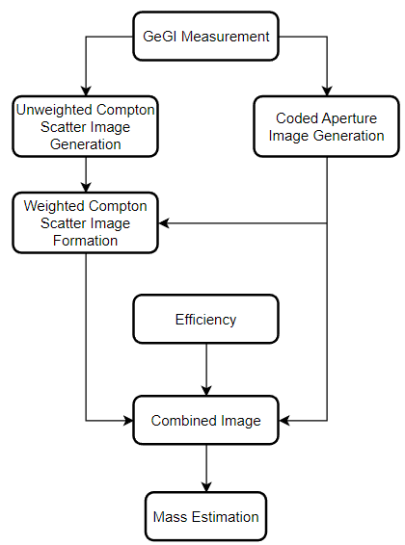
Figure 1. High level project flowchart
framework development was performed at ORNL and provided to UTK. The method for combining the two images is an objective for this work. Characterizing the detector to find the efficiency is a joint effort between ORNL and UTK. ORNL evaluated efficiencies for coded aperture imaging. UTK is addressing the Compton scatter imaging efficiencies, which is shown in this thesis. Simulation work for efficiency calculations is performed in both MCNP and Geant4 for comparisons. A measurement campaign was also conducted to compare with the simulation work.

The combined image data is used to estimate the mass of a deposit. This process is headed by ORNL through an artificial intelligence algorithm called the Differential Evolution Adaptive Metropolis (DREAM) solver. This implementation is not addressed in this thesis, as it is a future goal. However, a preliminary analytical method of mass determination is provided for verification of the hybrid imaging method.

Introduction

Current State of Gamma Imaging

Photon imaging is a rapidly progressing field of research spanning multiple disciplines and applications. This creates many different frameworks for similar imaging types, and spans similar topics addressed in this work. There are papers addressing hybrid imaging (Smith 1998), quantification (Hellfeld 2021), and even 3D photon imaging (Hecla 2021). All of which provide new branches to take the imaging field. Some of these papers will be addressed here for comparisons with the work in this thesis.

One major note of comparison is the imaging system design. This is important to address for the design and can directly impact the quality of the data collected for processing. There was a major component differentiating each design for how Compton events were considered. Each project focused on using either a single detector layer, or two detector layers.

Lee’s detector design used a passive mask and uses a two-layer Compton imaging system (Lee 2014). The first detector after the mask acts as the single interaction absorber for coded aperture imaging as well as the scattering detector for Compton imaging. After this first detector layer, a second set of detectors is placed at varying angles in respect to the first layer to detect scattered photons, providing the information for Compton scatter imaging. The research performed by Smith used a similar design (Smith 1998). This system design can be seen in Figure 2.

Lee has another project with a much different design which used an active coded aperture mask (Lee 2014). This means that instead of using a high attenuating metal mask, this work used a series of detectors creating the mask pattern. This way the mask can also act as the first interaction layer for Compton scatter imaging. The second layer acts as both the absorption layer for coded aperture imaging and the absorption layer for Compton scatter imaging. This imaging system design can be seen in Figure 3.

The system design in this work, shown in Figure 4, uses one detector layer. The passive overlaid mask acts to absorb photons for coded aperture imaging. The detector layer behind the mask acts for all detector interactions. This includes both the absorption layer for coded aperture imaging and all multi-site interactions for Compton imaging. This system allows for much smaller detector design compared to the other designs discussed above, allowing for greater potential of portability and simplicity. However, this is at the expense of lower efficiency for Compton scatter imaging.

There are a few common simplifications involving Compton imaging processing that are set to be improved upon in this work. The primary simplifications are the far-field assumption and the effects of the coded aperture mask. For the papers that do address the mask in the Compton scatter imaging modality, the primary approach seen involves the use of a 2D binary mask (Smith 1998). A 2D binary mask means that every part of the backprojected cone which crosses a 2D cross section mask element is assigned an attenuation factor. This work incorporates a 3D mask ray tracing method to improve on mask attenuation considerations.

The far field approach is another common assumption seen in literature. The far field approach assumes a point detector geometry when projecting data for imaging. For Compton scatter imaging, this implies that every cone is projected from the same location. This does provide a more simplistic approach for cone reconstruction, because the imaging space can be analyzed solely off of angular coordinates. For this work however, the far field approach is not used. With the Compton image distance relying on the coded aperture framework, and the future implementation of 3D imaging, the far field assumption may not always hold. The distance for the far field assumption to work is a

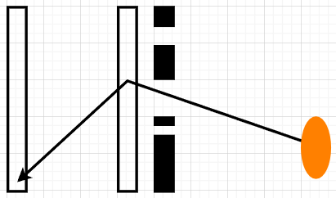
Figure 2. Separated imager configuration with overlaid mask.

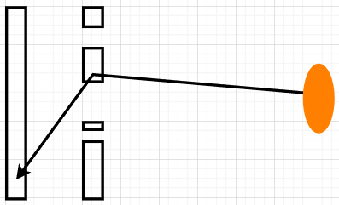
Figure 3. Separated imager configuration with active mask first layer.

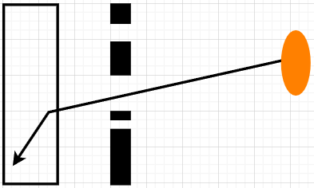
Figure 4. Single layer imager with overlaid mask, this project’s configuration.

source distance over 10 times the detector width (Hellfeld 2021). For the work in this thesis, the cones will be backprojected from the location of the first interaction site, varying between events.

Imager Specifications

Semiconductor Detectors

A semiconductor detector is selected in this work for its high energy resolution capabilities. Semiconductor detectors function by collecting charge from electron-hole pairs when a radiation interaction occurs. The electron-hole pairs are created from excitations to the conduction band within a semi-conductor. Considering the structure of metals, the highest energy band is not filled, allowing electrons at this level to travel easily across the material (Byun 2017). The ease of electrons to excite from a lower energy level (valence band) to this high traversal energy level (conduction band), is the conductivity. Insulators have a large energy gap to traverse, making it very difficult for electrons to be excited to the conduction band, while conductors require minimal energy. Semiconductors lie in the middle between insulators and conductors, allowing electrons to excite to the conduction band through energy transfer from radiation. Most semiconductors, including the GeGI, are cooled to optimize the size of the band gap. Too small of a band gap will result in thermal excitations and noise to contribute to detector pulses, too large of a band gap would result in too little charge collected per radiation interaction. A voltage bias is applied to the material such that electrons excited to the conduction band are collected, creating a current. The pulse height created from the charge collected is proportional to the energy deposited, allowing for energy spectra measurements.

PHDS GeGI

The high-purity Germanium semiconductor in the GeGI is a 1.1 cm thick cylinder with a radius of 9 cm. The charge collection sites are strips extending across the surface of the cylinder spaced 5mm apart. 16 cathode strips are placed one side while 16 anode strips are placed orthogonally on the other side. This setup is known as a double-sided strip detector (DSSD). The orthogonal placement of cathode and anode strips allow localization of interactions. This is because charge is collected at both ends of the cylinder to opposing strips. The intersection of the signaled strips shows the interaction location. Though the charge is not usually collected by only one strip on a side. With the small pitch between strips, charge collection is often shared between adjacent strips. The charge collected can be interpolated between these adjacent strips for more accurate localization. The drift time of the electron-hole pairs can also be utilized to find where within the thickness of the semiconductor the interaction occurred. With known drift velocities of the electrons and holes within germanium, the difference in the collection time between the electrons and the holes can show thickness localization, within the constraints of 20 ns timing resolution.

The GeGI planar and thickness resolution is around 1 mm, and the drift velocity z axis also has a resolution of 1 mm (Venkataraman, 2020). The GeGI is mechanically cooled and designed to be handheld (weight of 7 kg) with hot swappable batteries, allowing the system to be easily transported. The primary characteristics of the GeGI imaging system relevant to this work is shown in Table 1. Along with the interaction characteristics in the relevant energy range shown in Figure 5.

The GeGI has included software included for imaging, providing both pinhole imaging and Compton scatter imaging (Longford 2018). However, each of the methods are limited in the scope of this work. The included imaging provides localization of sources, but only as qualitative information of directionality and isotope identification. For quantification
Table 1. GeGI Specifications
Weight | 15 lbs
Energy Resolution | FWHM < 2.1 keV at 662 keV
Exposure Rate Capacity | 200 kcps
Energy Range | 30 keV – 3 MeV
HPGe Dimensions | 9 cm diameter, 1.1 cm thick
Active Detector Volume, Area | $67 {cm}^{3}$, 61${cm}^{2}$
Other features | Remotely operable

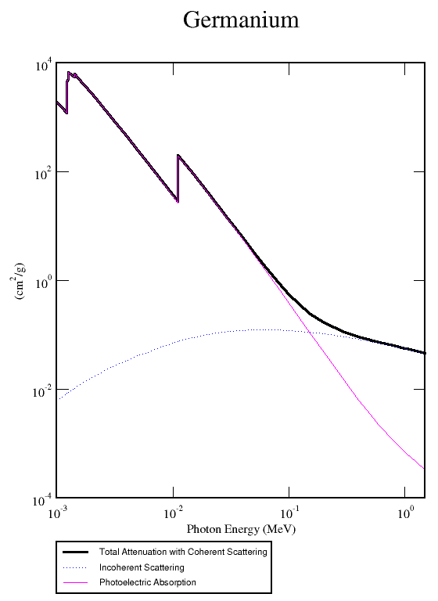
Figure 5. NIST XCOM data for elemental germanium representing the two dominant interaction types for relevant energies pertaining to uranium holdup.

purposes, only the raw data from the GeGI will be used for processing, and the imaging system itself is modified. The raw data extracted is the location, energy deposited, and interaction order of events. To acquire data appropriate for coded aperture imaging. A tantalum mask is overlaid in front of the detector as shown in Figure 7.

Data Formats

The goal of the project is to produce an image capable of quantifying the mass of a deposit. To do this, a specific data structure will need to be created to save the relevant information. The activity of specific photon energies is important as well as the locations of these activities. This information will give location and shape to where the activity is occurring, allowing mass to be calculated.

The data structure to accomplish this will be created as a datacube. The datacube is a 3D matrix, where the first two indices are locations x and y on the image, and the third index is energy. This will provide location specific energy spectra as well as energy specific images. Both outputs can be ideal for identifying multiple sources as well as quantifying sources.

For how the actual data is processed from detector to image. The raw output from the GeGI is in a binary format. The information is related to each activated strip’s accumulation time and energy per interaction. These parameters are then processed to obtain location, deposited energy, and interaction order from an event. The original output can also be from simulations in Geant4, which is in ROOT format of the already processed location and energy deposition.

The data processed from ORNL for the coded aperture is given as the datacube in binary as well. This data is given as a 37 by 37 matrix of intensity values at each energy in 0.5 keV increments.

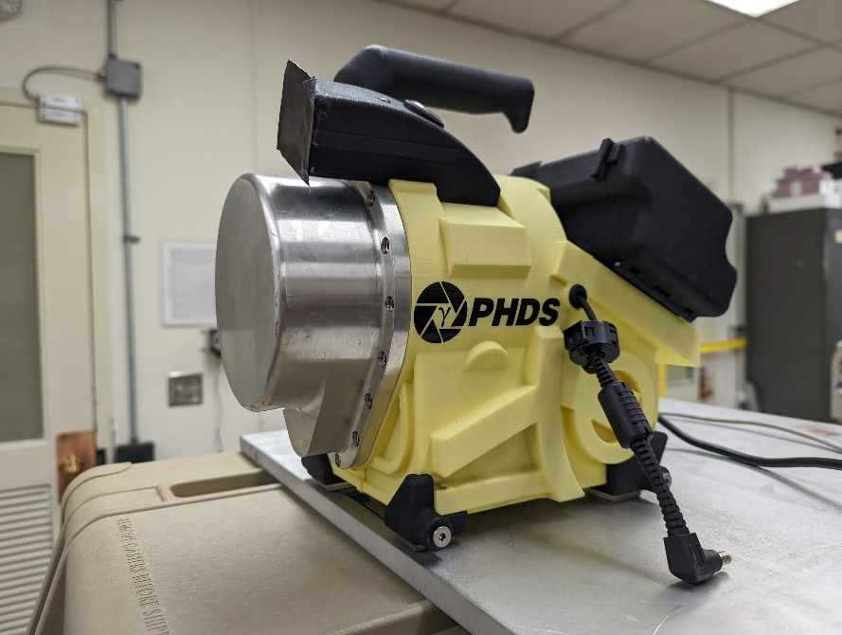
Figure 6. A photo of the PHDS GeGI used in this work.

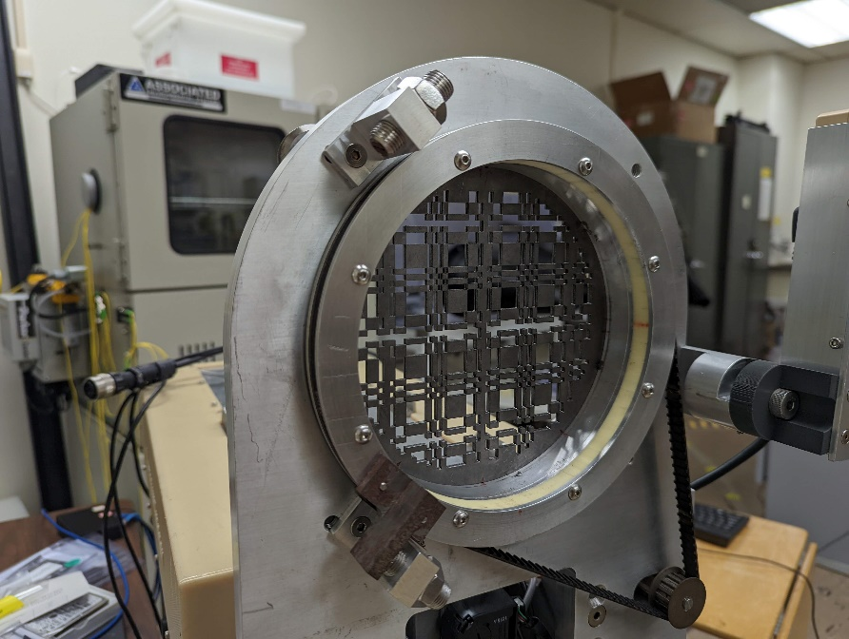
Figure 7. A photo of the Coded aperture mask on module capable of rotation.

The data processed at UTK is first transferred to SQLite. The processed data yield’s location of interaction, energy deposited, and order of energy interaction. The cone angle uncertainty is also processed in this step and will be discussed further in the methods.

This SQLite data is imported to python for image generation. The output is a combined intensity image from both the Compton and coded aperture methods. The combined image is now in a format viable for quantification. Shown as an example of the datacube format shown in Figure 8.

Compton Imaging

Compton scatter imaging is based on multi-interaction events, which are more prominent from higher energy photons (above 300keV). Compton scattering is the process where a photon inelastically scatters with an assumed “free” electron (an electron which has no binding energy). Knowing the photon’s initial energy and the rest mass of the electron (assuming no kinetic energy), the angle of scatter of the photon’s new path from the photon’s initial path can be evaluated. The scattering angle equation (equation 3) is derived from the conservation of energy (equation 1) and momentum (equation 2).

$$\begin{aligned}E_{γ}+m_{e}c^{2}={E^{'}}_{γ}+\sqrt{p_{e}^{2}+{\left(m_{e}c^{2}\right)}^{2}} \#\left(1\right)\end{aligned}$$

$$\begin{aligned}p_{i}=p_{f}+p_{e} \#\left(2\right)\end{aligned}$$

$$\begin{aligned}θ=\cos^{-1}\left(1-m_{e}c^{2}\frac{E_{γ}-{E^{'}}_{γ}}{E_{γ}{E^{'}}_{γ}}\right) \#\left(3\right)\end{aligned}$$

The incoming photon energy is measured as the sum of all energies deposited from all interactions from a single event. The scattered photon energy is evaluated as the incoming photon energy minus the energy deposited from the first interaction.
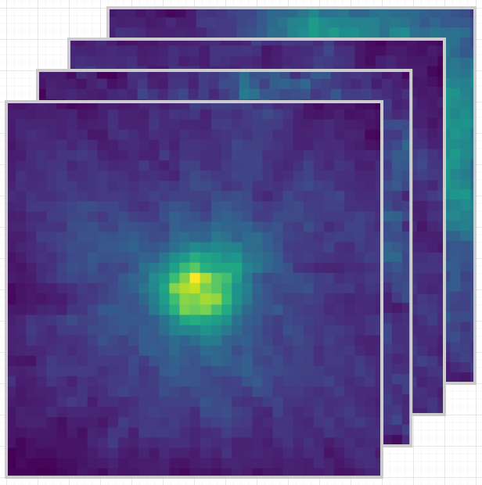
Figure 8. Concept of formatting for datacube output. An image is created for each energy in the spectrum. This way energy dependent images can be created as well as spectrum data for each pixel in the image.

Using the Compton scatter equation, the scattering angle can be used to back-project the photon from the detector to find the source. However, knowing only one angle within a 3D space does not suffice to find the exact direction to the source (the other angle is not known because the scattered electron direction is not known). What is known is the vector direction from the first two photon interactions and the angle of scattering. A cone of probability is created by rotating the line created from the scattering angle around the direction vector, shown in Figure 9. This cone is back-projected from the first interaction site within the detector out into 3D space and represents a surface of probabilities of where the photon originated from. One cone on its own does not provide much information on the exact location of the source, but as many cones are back-projected, overlaps between cones will start to accumulate. The source position becomes known as many cones overlap within the same region seen in Figure 10.

Branching off the initial Compton scatter cone formation, the type of imaging specific to the GeGI contains some important information, mainly for how the DSSD setup functions for multiple interactions. As said earlier, for a single interaction, up to three strips can be collecting charge for localization on each side of the DSSD. If a subsequent interaction from the scattered photon occurs within the same range of these three strips, the charge collected will only add deposited energy to the first interaction and not be counted as a separate interaction. This means that the scattered photon’s second interaction will need to be at least 3 strips away from the first interaction to have completely independent charge collection, shown in Figure 11.

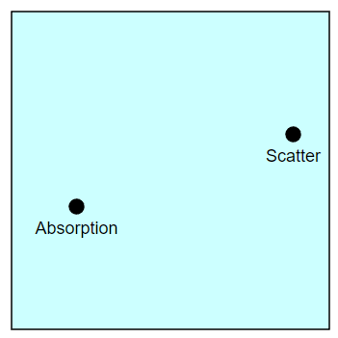
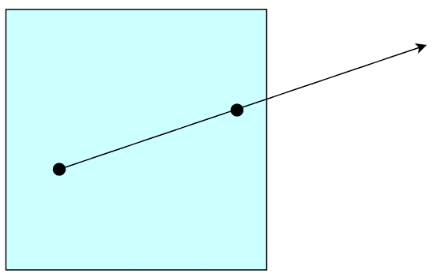
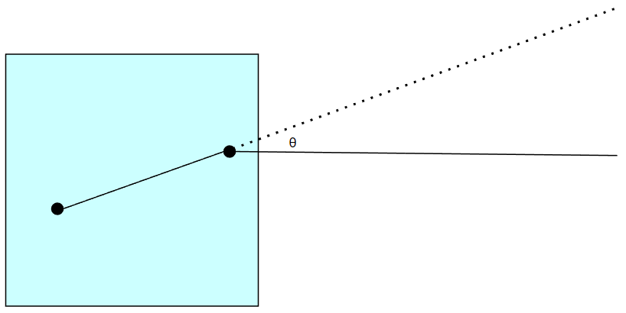
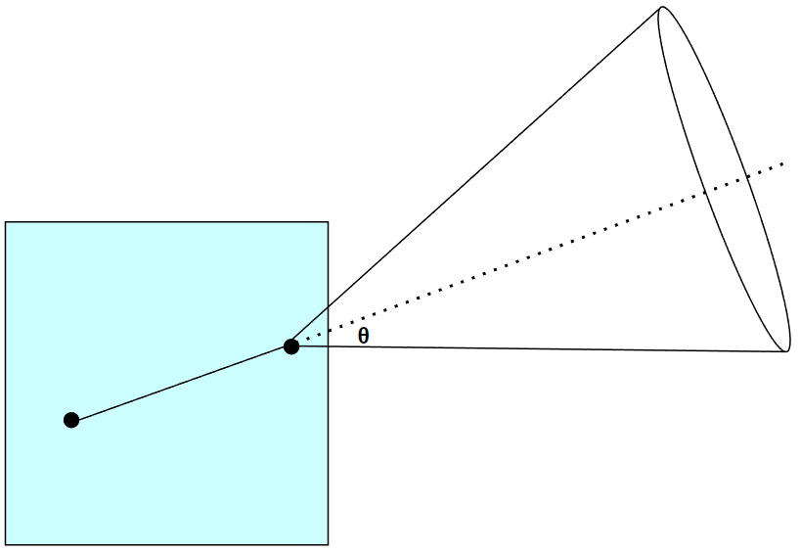
Figure 9. Compton scatter imaging process from top to bottom: multi-interaction event from a photon detected, tracing direction vector from two interactions, calculate scattering angle, trace scattering angle around vector to create a backprojected cone.
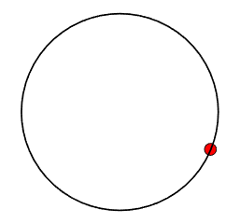
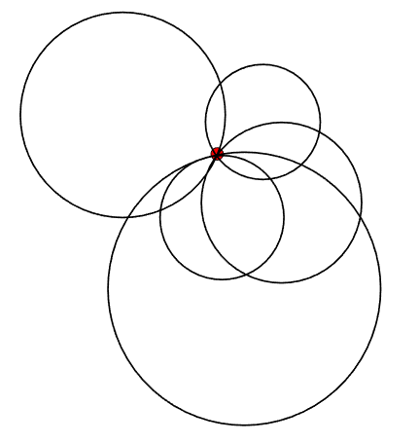
Figure 10. Single backprojected cone (top), vs multiple backprojected cones (bottom).
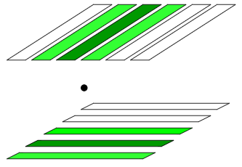
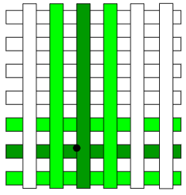
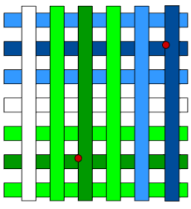
Figure 11. Process showing spacing needed for proper evaluation of each interaction from a single event. Dark strips represent primary fired strip, lighter strips represent neighboring fired strips used for interpolation. 3D representation of strips firing for an interaction being detected (top). 2D interpretation of top image (middle). Representation of spacing needed for two interactions from the same event to have independent strip firings for optimal localization.

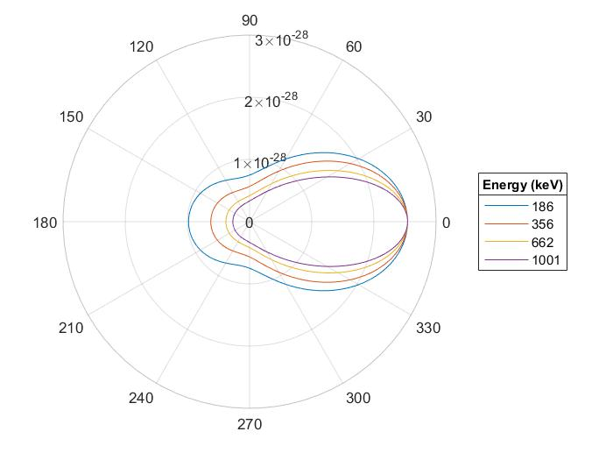
Figure 12. Normalized Klein-Nishina formula to show scatter direction probability with increasing energy.

For secondary interactions to occur multiple strips away, the scattering angle should be close to perpendicular to the initial direction of the photon. The probability for this angle of scatter can be shown below in equation 4 and visualized in Figure 12.

$$\begin{aligned}\frac{dσ}{dΩ}=\frac{r_{0}^{2}}{2}\left(1+\cos^{2}θ\right){\left[\frac{1}{1+α\left(1-cosθ\right)}\right]}^{2}\left\{1+\frac{α^{2}{\left(1-cosθ\right)}^{2}}{\left[1+α\left(1-cosθ\right)\right]\left(1-\cos^{2}θ\right)}\right\} \#\left(4.a\right)\end{aligned}$$
$$\begin{aligned}α=\frac{E}{m_{e}c^{2}} \#\left(4.b\right)\end{aligned}$$

Equation 4 reveals some important information for the imaging work done here, mainly showing that increasing energy will greatly increase the probability of forward scatter. This shows that higher energy scatters will result in less probability for that the subsequent interaction will take place 3 strips away. This will in turn lower the imaging efficiency at higher energies. To compound on this, higher energy photons have a lower interaction cross section even though its scattering cross section is proportionally larger, shown in Figure 5.

Coded Aperture Imaging

Coded aperture imaging is best implemented for lower photon energies at or below 300 keV. This is due to coded aperture method relying on single interaction events, where all energy is deposited from the first interaction by photoelectric effect. The key component for coded aperture imaging is a high attenuating mask which is placed between the imager and the source. The material for the mask in this project is tantalum with a thickness of 0.2778 cm. The high attenuating material covers 50% of the total mask area, and is curated with a very specific pattern, shown in Figure 13. With the mask, photons emitted from a source will cast a pattern onto the imager with shadows correlating with mask elements. What makes the mask pattern special is that they are designed such that the shadow pattern projected to the imager is unique for every angle within the coded aperture’s FOV.

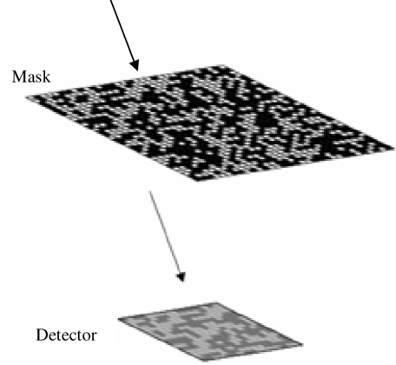
Figure 13. “Shadow” projection of mask pattern on detector for cross-correlation analysis.
When a measurement is taken, the pattern seen on the detector can be compared to the pattern of the mask to identify where the source originated from. This is done through
convolution. Convolution is the process where a function is applied at every element in a matrix, where the surrounding elements are considered in the function. The function of coded aperture imaging is the matrix of counts across the detector and is applied to the mask pattern matrix, shown in equation 5.

$$\begin{aligned}I_{i}=\sum_{j}{M_{i+j}×D_{j}} \#\left(5\right)\end{aligned}$$

Positive feedback (positive values) is given to high counts corresponding with holes in the mask and low counts corresponding . While negative feedback (negative values) is given for the opposite.

Knowing the distance from the source to the mask and the distance from the mask to the imager, the size of the image can be evaluated with the relation shown below.

$$\begin{aligned}Length=\frac{a∙d∙n}{f} \#\left(6\right)\end{aligned}$$

A 2D histogram is created displaying the matrix outcome of the convolution, producing the image. A 1D example is shown from Figure 14. A 2D example is shown in Figure 15 and Figure 16. The 2D examples show both a small disc source as well as a line source to show how different source types affect the pattens cast to the detector. Figure 17 shows a simulation with the mask pattern and detector used for the GeGI. The patterns in these three figures are modified uniform redundant arrays (MURA). The MURA pattern is unique for its rotational orthogonality. This means that rotating the mask 90 degrees produces an opposite pattern to its initial state.

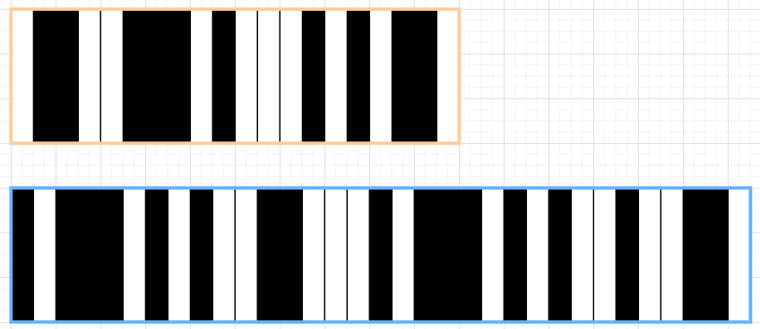
Mask (top, orange), detector pattern (bottom, blue).

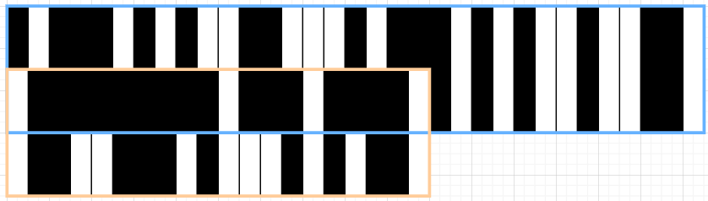
Overlaying mask on detector pattern to find matches in first position.

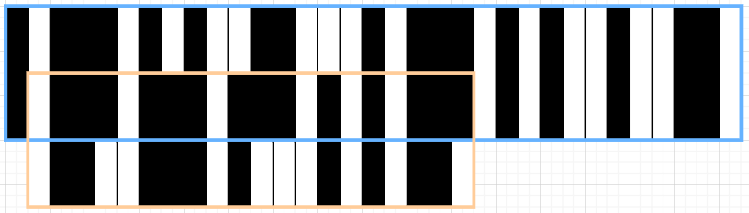
Overlaying mask on detector pattern to find matches in second position.

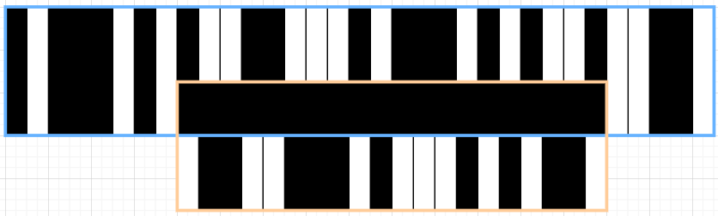
Overlaying mask on detector pattern to find matches in optimal position.

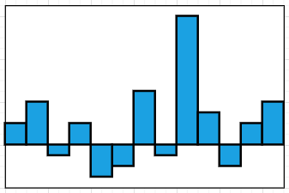
Histogram of summing matches at each position to show angle of source position.

Figure 14. Coded aperture imaging process in a 1D example.
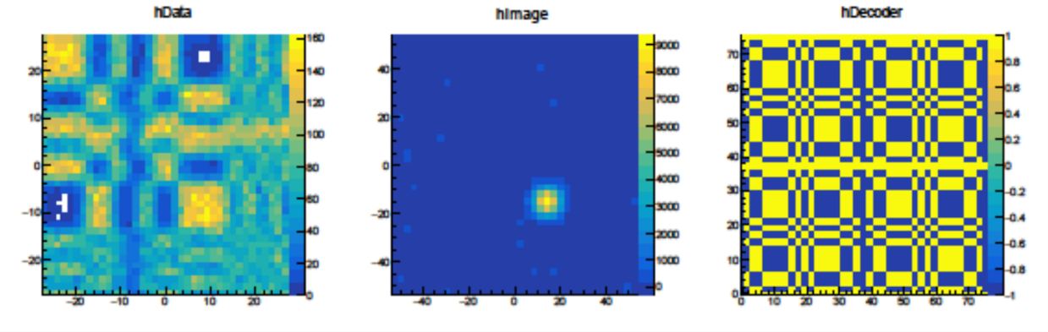
Figure 15. Process of image creation: mask pattern (right), detector count histogram (left), cross-correlation histogram for image (middle). This is a simple ideal simulation for method testing.

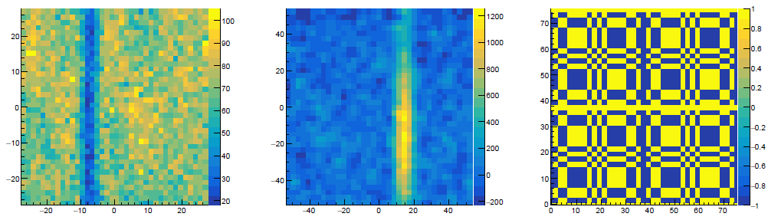
Figure 16. Same process as Figure 15, but with a line source instead to show the pattern difference that the detector sees.
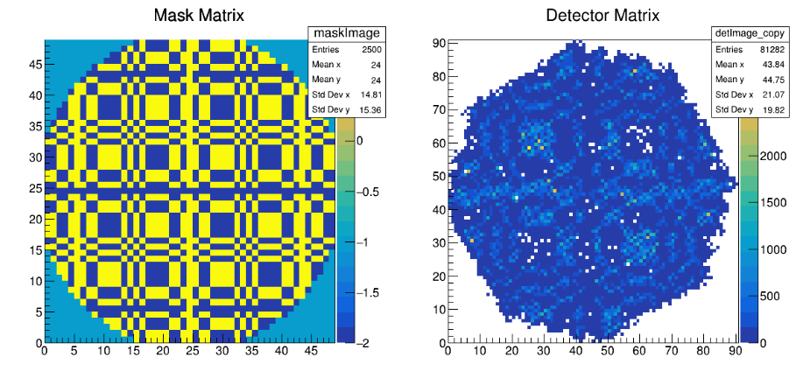
Figure 17. Simulation of GeGI response to mask overlaid. This is a more complex simulation to portray the capabilities of the imager and method more accurately.
Rotational orthogonality is a useful tool for background subtraction. A measurement can be made in each orientation to produce its own dataset, then can be subtracted from one another to single out the source. This is because the photons from the source will create equal and opposite detected patterns between the unrotated and rotated mask measurements, but the background will remain equivalent in both measurements. Subtracting the two measurements remove the background counts but leave the counts from the source.

methods

Simple-Backprojection

Using the simple back projection techniques introduced earlier, the cones will need to be traced to relevant geometries for imaging. To accomplish this, the cone will be discretized into individual rays. Projecting individual rays simplifies the intersection calculations with 3D objects, allowing for complex tracing. For the initial purposes of creating an image, the rays are projected to a plane and a sphere around the detector, shown in Figure 18 (left) and Figure 19 respectively. The intersection points from each ray and the created geometry are recorded. Then A line is traced among all the intersection points to create the lines seen on each image.

Even though this method produces an image, when compared to the coded aperture image, each method produces data in a completely different format. The coded aperture image is in a matrix format, providing quantitative information. The Compton scatter image is only showing traced lines on a geometry surface, providing only qualitative information. With the final objective being to combine both imaging modalities, the Compton scatter image will need to be reformatted in the same fashion as the coded aperture image to combine properly.

To reformat the image, the back-projected rays will be not projected to a single plane, but instead projected to the same pixelated grid as the coded aperture image. This grid can be recreated with the known pixel size and distance from the detector. From here, a numerical tally is taken in each pixel based on how many lines intersect the pixel. The process for isolating intersected pixels is shown in Figure 20. This second processing step recreates the Compton scatter image shown in Figure 21.

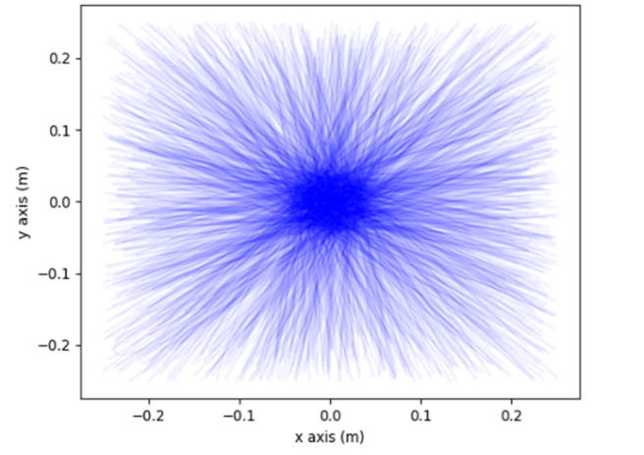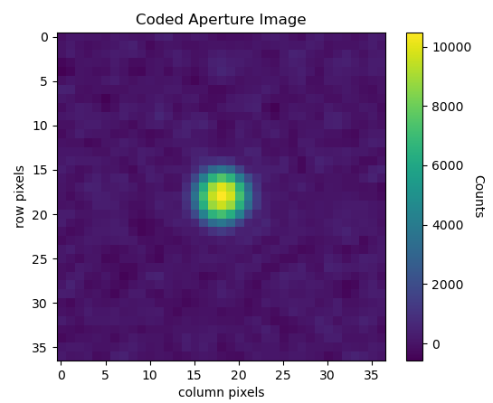
Figure 18. (left) Simple back-projected Compton scatter cones intersecting with 2D plane 1 m away from imager. (right) Coded aperture image generated from the same dataset.

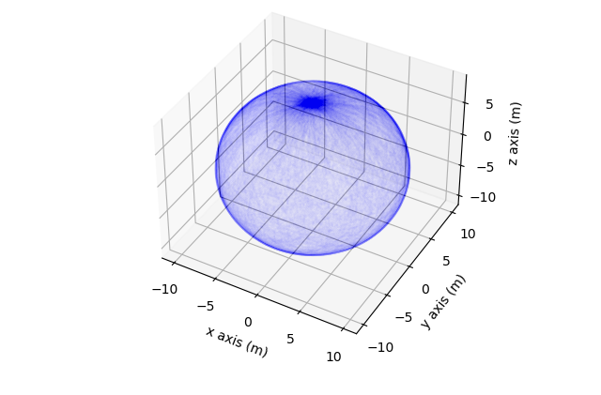
Figure 19. Simple bask-projected Compton scatter cones intersecting with sphere 10 m away from imager.
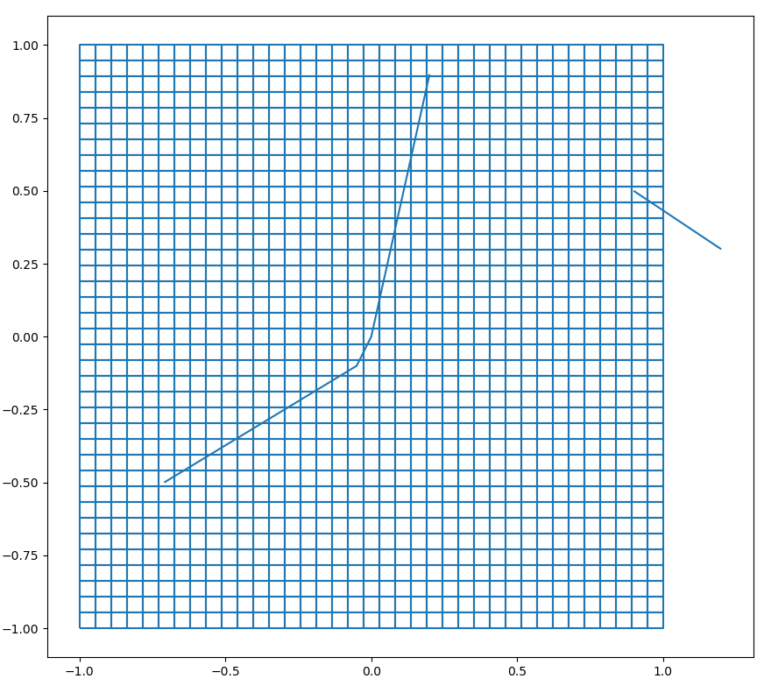
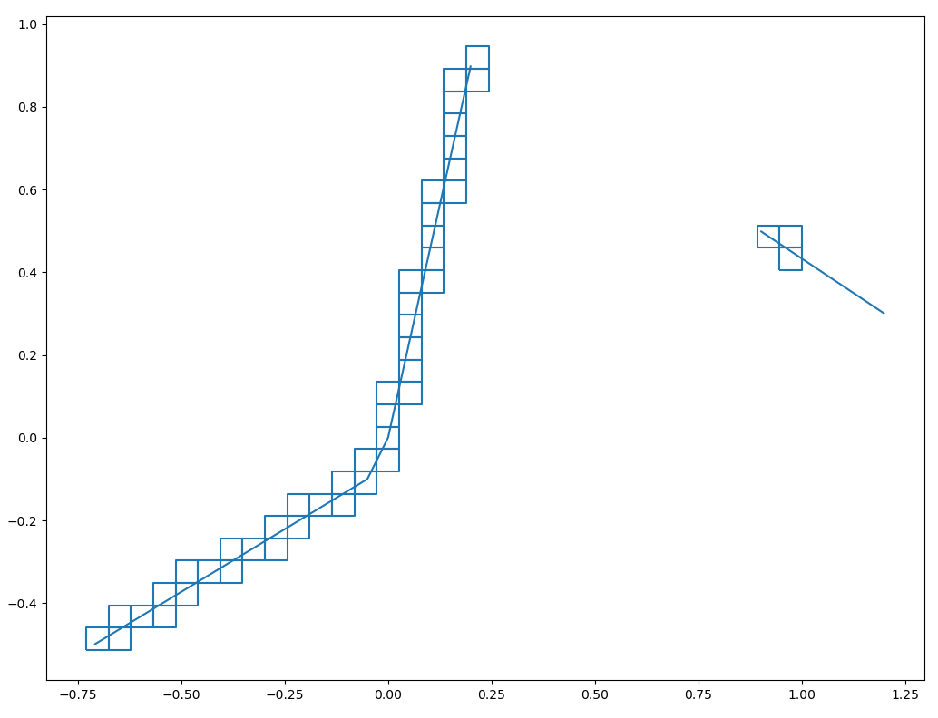
Figure 20. Proof of concept for tallying lines with pixelated grid. Made to tally cone intersection with coded aperture pixelated image.

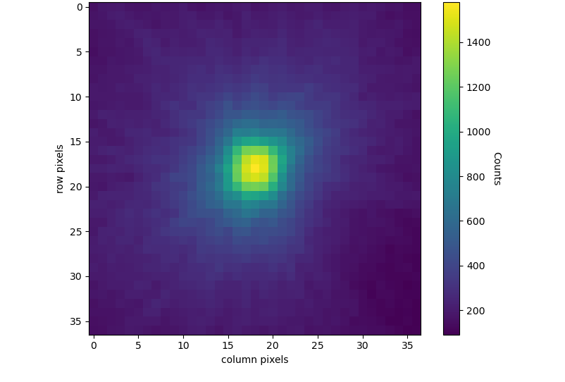
Figure 21. (top) Pixelated Compton scatter back-projected cones within the same fashion as the coded aperture image. (bottom) Coded aperture image created from same dataset.

Dynamic Ray-Casting

An important aspect of the grid imaging was the further implementation of dynamic ray-casting. Dynamic ray casting reallocates the rays from an event toward the imaging space, providing more data where it is important. The initial casting of rays is uniformly spaced across the surface of the cone. There are 360 initial rays cast, giving a ray for every degree around the cone. This is a good initial projection to evaluate the cone as whole, however, only a small portion may intersect the imaging grid. Most of the rays projected will not contribute to the image, leading to an inefficient use of the data. A solution to this is to cast a second set of rays only in the imaging space.

To create the second casting of rays, the first set will be tracked to the imaging grid as described earlier. All intersection points (plus one on each side) with the grid are documented, as well as the length of the arc created by connecting the intersection points. A new set of rays are then projected only between the previously recorded intersection points, allocating all the new rays to the imaging space. The dynamic portion of this method is that the number of rays projected is proportional to the length of the arc on the grid. This ensures the same concentration of rays for every cone intersecting the imaging grid, keeping consistency during image generation. A perk of this method is the fact that two projections are created, one for the whole cone and one specific to the imaging space. The first cast of rays may not directly contribute to the image but can instead create a 4π image around the detector to potentially find sources outside of the coded aperture FOV and can give directionality information to the user.

Cone Weighting Process

The simple-backprojection image to the pixelated grid does create an image in the format to combine with the coded aperture image. However, the image can be further improved. The initial back projected image has an overall high angular uncertainty, especially compared to the coded aperture image. The goal from here is to reformat the backprojected cones to better accommodate for the aspects of coded aperture imaging and the angular uncertainty of the Compton cones.

The method to reformat the cones will be through a weighting system. Since each projected ray from a backprojected cone can carry independent information, a weight will be curated for each one. The weight assigned to each ray will be based on its probability of originating from the source. The scale of the weighting will be from 0 to 1, to ensure that no individual ray is attributing to more than a single count. A higher weighting will mean that it is more probable that the source originated from this ray. The weight applied to each ray will be dependent on three factors: attenuation probability through the coded aperture mask, comparison with the coded aperture image, and the cone angular uncertainty.

Mask Attenuation Weighting

With a high attenuating material covering 50% of the FOV, it is important to account for potential attenuation passing through the mask to track each ray more accurately. Previous literature addresses this with a binary mask (Smith 1998), in which any section of the cone which crosses a 2D section of the mask is cut from the final cone. This is fast in implementation but can cut data from the final image. At higher energies, there is a non-negligible probability that the photon will traverse the mask unattenuated. This can be shown in Figure 22. In this work, each discretized ray is traced through the 3D mask. The ray is traced to find the total distance the ray travels through the mask to calculate
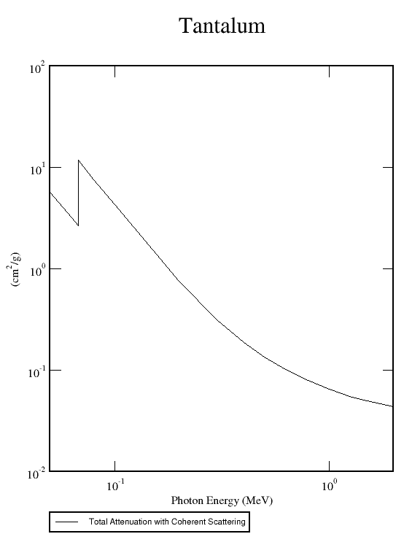
Figure 22. Attenuation coefficients in tantalum, the coded aperture mask material.

the probability the ray traverses through unattenuated. This probability is the mask weighting factor.

A 2D plane of the mask pattern is created in Python and set to the proper distance from the detector. A second plane with the mask pattern is also made slightly further at the distance to the mask plus the thickness of the mask. This creates two planes to track ray intersections. The intersection points between each ray and both planes individually are recorded.

With every mask element being representative of a cube, all 2D mask positions are the same throughout the thickness of the mask. Although this may seem like a simple observation, the cubic mask element will allow tracking through the complex mask pattern to be much more time efficient. Interpolations can be used across 2D cross sections instead of using more complex methods of 3D geometry ray tracing. The two intersection points can be plotted and connected on one the mask cross section. Linear interpolating can now be used to assess where along each mask element the ray enters and exits, while also leaving out gaps between mask elements. Using a second interpolation, the thickness of where the rays travel can be evaluated. Therefore, the 2D measurements can be used to track 3D attenuation probabilities of each ray. A visual interpretation of this process is shown in Figure 23. Now with a known distance the ray travels within the tantalum, an attenuation probability calculation is done to directly apply the weighting factor, shown in equation 7.

$$\begin{aligned}WF\left(t,E\right)=1-\exp\left(-μ(E)ρt\right) \#\left(7\right)\end{aligned}$$

The results from this method can be seen in Figure 24. What is an important factor from this method is its versatility. The ray can be tracked through any potential crossing through the mask, as well as passing through any combination of mask elements.

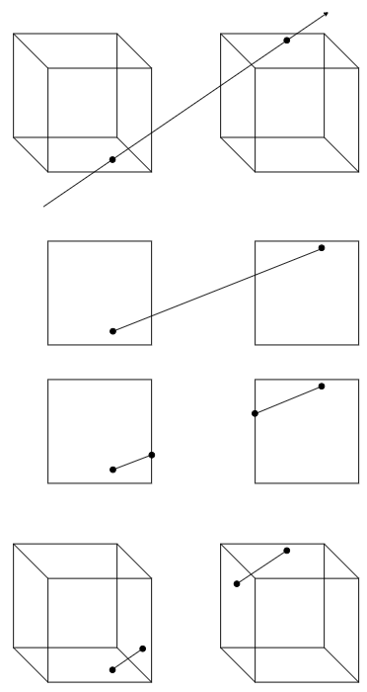
Figure 23. Process for tracking a ray through the mask from top to bottom (the process here is shown for a complex case of the ray travelling from one mask element, through a gap, and into another mask element): Tracing method tracks locations of entry in the mask plane and exit of the mask plane, and a vector is defined between the points. The mask is condensed to 2D to find intersection points of mask edges. The newly defined points are interpolated within the 3rd dimension to find 3D tracing through each intersected mask element.
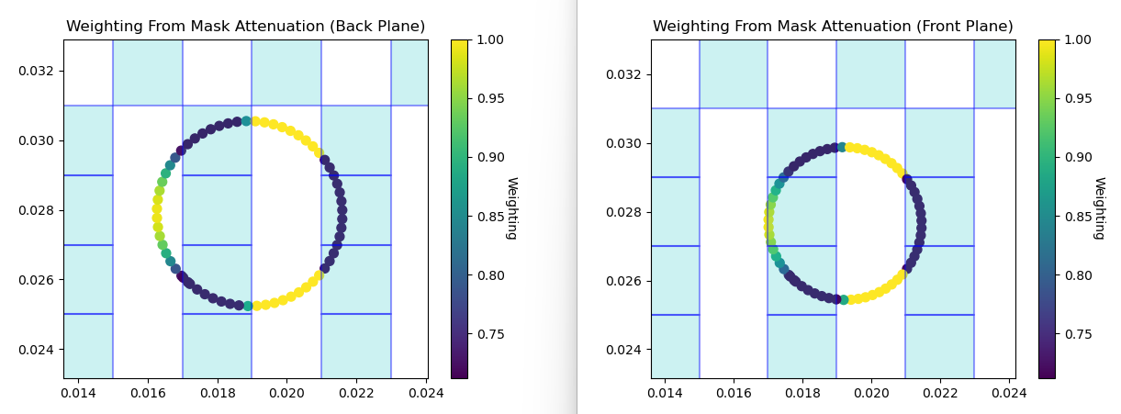

Figure 24. A simulation of a full cone travelling through the mask, with attenuation factors calculated. The back plane is away from the detector and the front plane is toward the detector. The image shows that rays travelling through mask elements have a higher attenuation probability and therefore, a lower weighting.

First iterations of this method only considered how a ray travelled through the first mask element it encountered. This method wrongly assumed that the ray would only interact with a single mask element before passing though completely. However, after working with simulations and measurement data, it was proven that a single ray could cross through multiple mask elements, even crossing through gaps between. The rays could travel much further laterally than initially expected. As a result, the linear interpolation method proved to be more viable.

Angular Uncertainty Weighting

The angular uncertainty will be an important evaluation in the weighting of the Compton cone for it tells how large of an area is representative of where the ray could have originated from. In short, a larger uncertainty would lead to a larger area of probability, which means any individual location inherently has less of a chance of being the source. The uncertainty of the cone angle can be broken down into three parts: uncertainty in the interaction position, uncertainty in the interaction energy deposition, and uncertainty in the interaction order determination.

The location uncertainty plays into the cone angle uncertainty by reorienting the direction vector based on the first two interactions. As shown in Figure 25, even with the scatter angle remaining the same, the projected cone can be vastly different depending on the interaction point locations within the range of the location uncertainty.

Energy deposition uncertainty is a specification of the detector and can be imported to the code through tabular data. The energy deposition uncertainty is the most direct contribution to the cone angle uncertainty, as the scatter angle is determined by the deposited energies of the first two interactions, shown in equation 3.

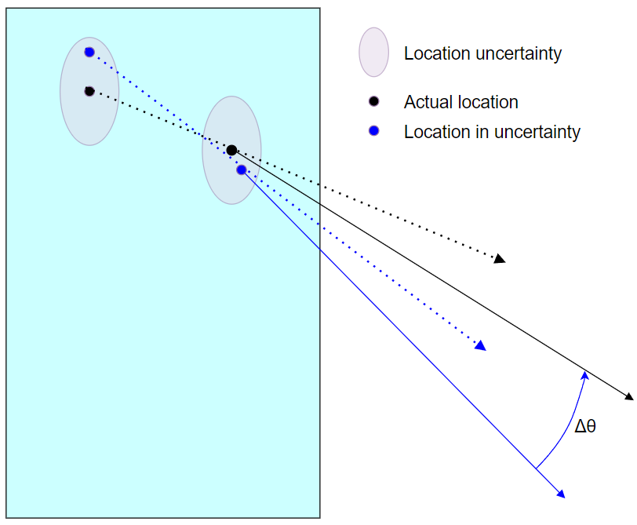
Figure 25. Location uncertainty example. The black dots are the measured interaction positions. The red and blue dots are other potential interaction locations based on the uncertainty of the positioning. This demonstrated the reorienting of the cone projection based on location uncertainty.

The interaction order of multi-interaction events is not a given from the imager specifications. All interactions happen essentially simultaneously, as well as the charge collection. Because of this, the interaction order needs to be determined, and is not a given. The interaction order is determined based on the probability of the scattering angle, shown in equation 4. Forward scattering retains the highest probability at the energies measured for Compton scatter imaging. This leads to events on the anterior face of the imager to be placed as the first interaction. However, with small probabilities of backward scatter, the method is not perfect, resulting in uncertainty in this determination. In the instances where the wrong interaction is chosen as the first interaction, the wrong interaction will be deemed as the scattering interaction. This will change the scattered energy deposition, leading to the wrong cone angle, attributing to the cone angle uncertainty.

The cone angle uncertainty is evaluated from these metrics based on Monte-Carlo analysis. Points are randomly selected within the location uncertainty, projecting the direction vector. The cone angle is provided based on the cone projection difference from many direction vectors randomly projected (Mitchell 2022).

The angular uncertainty will be an important factor in weighting the Compton cone for it tells how reliable each generated cone is. In short, a larger uncertainty would lead to a larger area of probable origin, resulting in less reliable information about a specific region. A higher angle of uncertainty will directly result in a lower weighting by a power of 3.

Image Comparison Weighting

Lastly, a feature of simultaneous imaging using two different modalities is being able to compare the two. The pros and cons of each imaging method can be addressed with this comparison, improving the resulting image.

Coded aperture imaging has a higher detection efficiency for the GeGI. This is because the detector is a thin cylinder. Lower photon energies have an overall higher interaction probability (Figure 5). Compton scatter imaging also relies on two or more interactions, meaning the second interaction also must take place within the thinness of the detector. With forward scatter being most probable (Figure 12), it decreases the overall efficiency for Compton scatter imaging. On the other side, there are downsides to imaging lower energy photons. Lower energy photons have a much lower penetrating power, making it more difficult to image through material. With holdup usually taking place behind walls and duct work, this will impact the number of photons reaching the detector. The source itself can act as an attenuator, known self-attenuation. This can cause an issue when the thickness of the material is high enough where a photon emitted from the back end of the deposit will almost always attenuate before the photon reaches the front end of the deposit. This phenomenon is known as infinite thickness. The ratio of photons emitted within a source to photons unattenuated through can help estimate the thickness of a deposit. However, infinite thickness scenarios make it problematic to estimate the thickness of the material. This is because increasing thickness further will not change the ratio of photons passing through, shown in Figure 26. The last downside to Coded aperture imaging is the restricted FOV which is dependent on the overlaid mask.

Compton scatter imaging, on the other hand, can image higher energy photons, which are more penetrating, reducing effects from self-attenuation and housing materials. The infinite thickness criteria are also much larger, allowing for mass evaluations with thicker deposits. There is also no restricted FOV for Compton scatter imaging. The cones can be projected to full 4π imaging. However, as discussed earlier, the GeGI Compton scatter
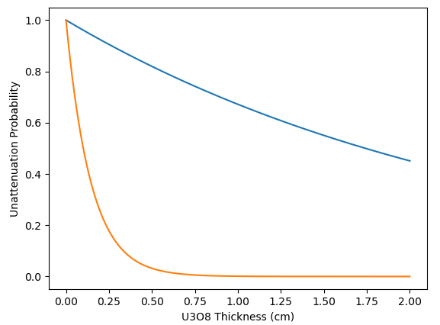
Figure 26. Infinite thickness comparison (density of 5.2 g/cc) between 1001 keV photons (blue), and 186 keV photons (orange) for U₃O₈.

imaging efficiency is much lower compared to coded aperture imaging. The angular uncertainty of Compton imaging is also much higher, leaving more blurred images. This is partly due to each cone distributing counts across a large distance. A single cone can also arc across multiple sources, potentially blurring the final image.

Since both modalities create an image using the same dataset, the coded aperture data can help isolate the source shape in the Compton image. This can be done by weighting each ray for its intersection position within the coded aperture image, shown in Figure 27. A ray produced from Compton imaging can be weighted higher if it crosses a region where both the coded aperture image and the Compton image are identifying a source. A simple back-projected image is produced initially from the first 1000 before weighting begins to create a preliminary Compton scatter image to compare with. The weighting is applied pixel by pixel, instead of ray by ray. First, every pixel intersected by the cone is isolated, shown in Figure 20. A scaled weighting factor is applied to each pixel based on the normalized counts each image has developed. Every ray which crosses a pixel is assigned the scaled weighting factor of that pixel.

Combination of All Weighting Values

With all weighting factors evaluated, the next step is to apply the weightings to a count in the image. The weighted rays will be distributed to their intersecting pixels to assign a new value. From the numerical tally simple-backprojection method, a value of 1 was assigned to every intersected pixel. With the weighting system, the value assigned to each pixel will be based on the weighted values of nearest rays. The coded aperture imaging agreement weighting is given pixel by pixel, so no extra steps are needed. The rays have assigned weightings from the cone angle uncertainty and mask attenuation probability. For each isolated pixel intersecting with the backprojected cone, as discussed earlier, the center location is evaluated. From the center point of the pixel, the nearest three rays are selected to average their weighted values to be combined with the coded aperture
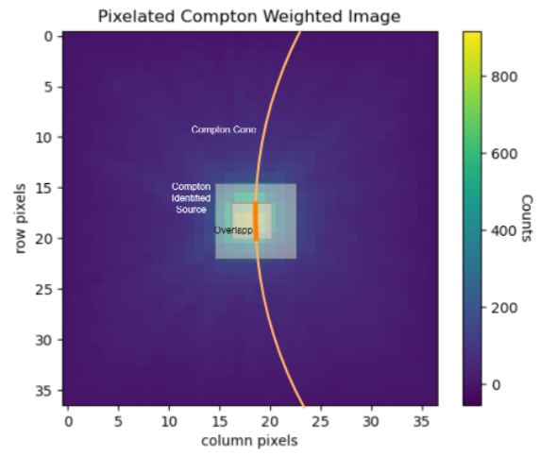
Figure 27. Concept for weighting back-projected cone based on agreement with coded aperture image. The Compton image will have a wider source area, with the coded aperture image lying within. Looking at sections which contain both will be weighted higher for most likely being the deposit for emission at low and high energies.
imaging comparison weighting shown in equation 8. This method is implemented to account for scenarios where only a small portion of the arc crosses a pixel, and a ray intersection may not be directly within it.

$$\begin{aligned}Pixel Count=\sum_{r}^{R}{W_{CA}F_{CA}+}W_{Mask}F_{Mask}+W_{Unc}F_{Unc} \#\left(8\right)\end{aligned}$$

Where $W_{CA}+W_{Mask}+W_{Unc}=1$, normalizing all the weightings, and allowing a weighted average for each factor. The metrics of these can be shifted depending on importance for the imaging scenario.

Detector Characterization

With an image of the counts generated, the next step is to find the efficiency of the imaging system. The efficiency of the imaging system is the fraction of photons emitted from the deposit which contribute to the creation of the image. Finding the efficiency is important for two reasons. The first is that the calculations for mass quantification is dependent on the intensity of the source, which is found through knowing the efficiency. The second reason is that the coded aperture image from ORNL is provided in the format of intensity in each pixel, so the Compton scatter image will need to be converted to this format as well to directly combine.

The efficiency of a detector is broken down into two parts: the external efficiency and internal efficiency. The external efficiency is a measure of how many photons that are emitted from a source reach the detector. This is directly influenced on the geometry of the detector relative to the source, known as the solid angle. More directly, the solid angle is the measure, in steradians, of how much the detector covers the 4π view from the source. This assumes the source is isotropic. Energy and location of the source are tested factors to quantify the efficiency more accurately the custom GeGI configuration. For a cylindrical detector, the solid angle can be calculated with the relation below (Knoll, 2010).

$$\begin{aligned}Ω=2π\left(1-\frac{d}{\sqrt{d^{2}+a^{2}}}\right) \#\left(9\right)\end{aligned}$$

The internal efficiency, on the other hand, is considered once a photon has reached the detector. The internal efficiency is the measure of how many photons contribute to a count compared to how many photons reach the detector. This metric is usually evaluated through measurement or simulation rather than analytical methods. This is because the internal efficiency is based on the energy of the photon, the direction of travel, and the mechanics of the detection system. All these variables vary event by event, which can be evaluated better through measurement rather than analytics which would have to make assumptions for these variables.

For the GeGI imaging system, simulations and measurements are performed to evaluate the efficiency. Multiple energies and locations are considered in the evaluation. Changing locations is a vital consideration for the efficiency of the imaging system. A different location will change the direction incident photons on the detector. Changing the incident angle will also change the distance in which the photon travels through the detector, altering its interaction probability, shown in Figure 28. Changing the incident angle also alters the shape of the detector relative to the source, decreasing or increasing the solid angle, shown in Figure 29.

On the simulation side, two simulations are performed for comparison: MCNP and Geant4. MCNP cards are created for a simple HPGe disk with a source in air. The simplicity of the simulation allows for quick outputs even with a high number of primaries: 10,000,000. This also allows simulations in a multitude of locations within a large field of view (an 11 by 11 grid for a 1.8 m plane length) for a spectrum of energies (100, 300, 356, 662, 766, 1001, 1332, 2000 keV). The 11 by 11 grid of positions, shown
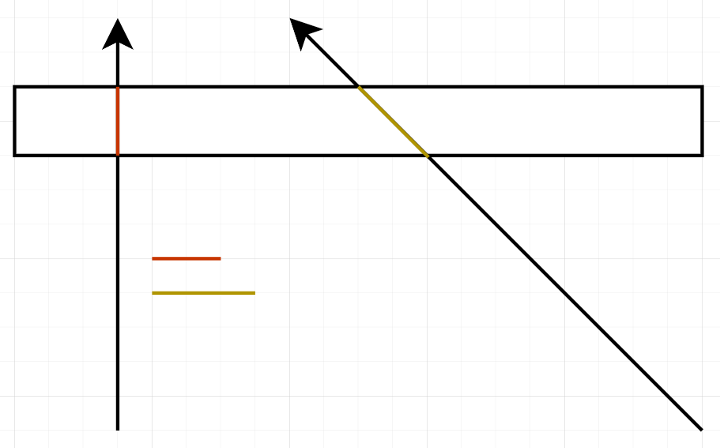
Figure 28. Simple diagram showing how photons coming in at different angles lead to a greater thickness of material to travel through.

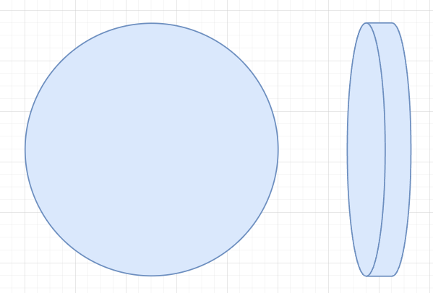
Figure 29. Diagram showing the GeGI cylindrical crystal from the perspective of the photon at two different angles to demonstrate the lower solid angle taken by the imager.

in is chosen for it matches the same positions as the measurements performed in the lab. Comparing the simulations to the lab acquired data will verify the simulations were performed correctly.

Geant4 simulations were performed as well and is a great metric of comparison. The Geant4 simulation framework has been developed at ORNL for years and includes the detector components as well as implementation of the DSSD system. However, compared to the MCNP simulation, the Geant4 framework has a much larger processing time. Each file produced from a single simulation is about 300 MB. This creates almost 300 GB of data for the full efficiency simulation. To account for this, symmetry is assumed within the relevant FOV, and simulations are performed for one quarter of the final result. The quarter is then mirrored in the other directions to create a full FOV simulation at one energy.

To increase the efficiency of each individual run, the simulations from both MCNP and Geant4 produce a cone of photons toward the detector rather than simulate an isotropic source. This is visualized in Figure 30. The cone angle is set to encompass the imager at a distance of 1.1 m. This method increases the efficiency of the photons used in the simulation because a much higher percentage of primaries interact with the detector. The cone angle is then normalized based on the solid angle to provide the absolute efficiency, accounting for both the internal and external efficiency.

The simulation process begins with the creation of input files. The input files for both methods are created via python script because of the numerous amounts of files needed for all energies and FOV positions. For the MCNP simulations, Cygwin is used to process a shell script which is written in order to run every MCNP input file created from the python script. For Geant4, shell scripts are created to run in the Linux terminal to run each file. Lastly, a second python script is created to analyze every input file to pick out the efficiency data.

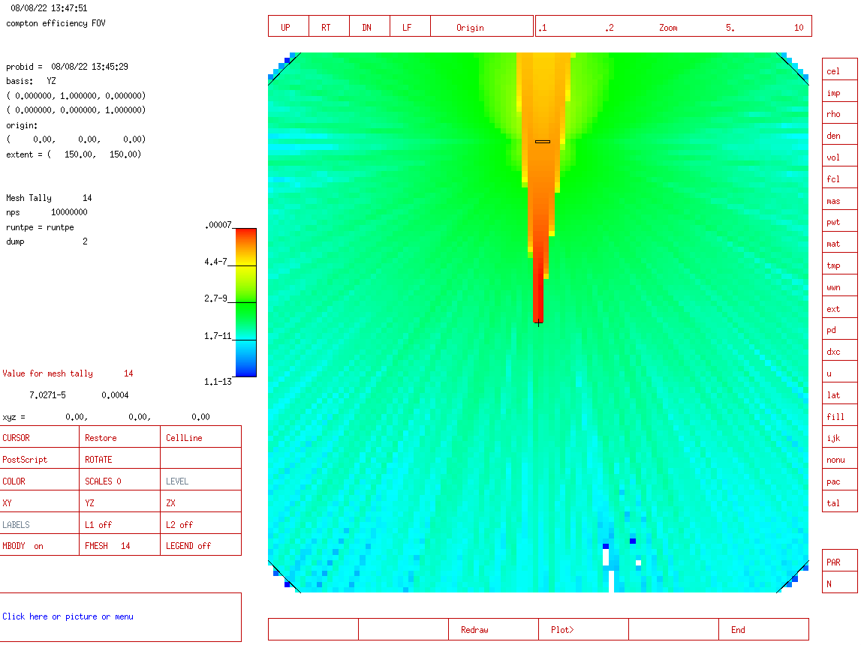

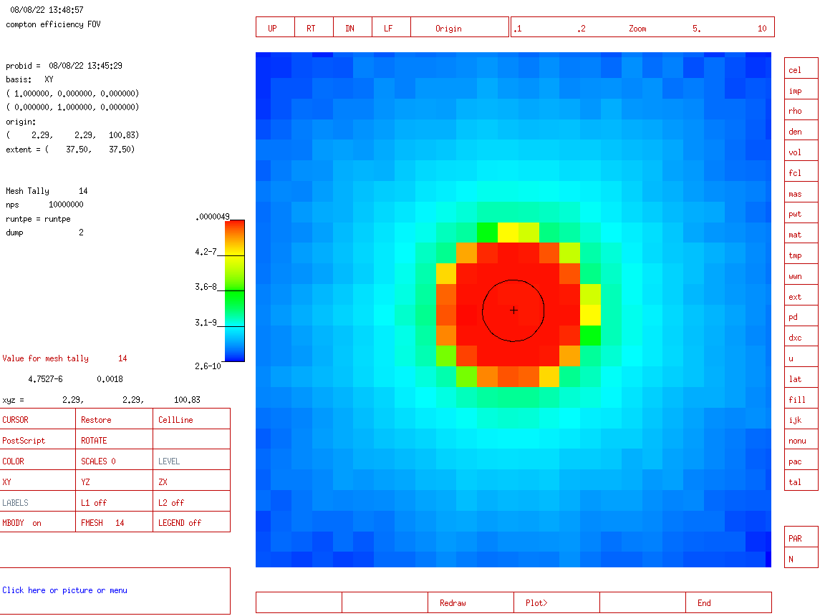
Figure 30. MCNP visualization of the cone beam from the point source off center projecting to the imager.

Both efficiency simulations use the same criteria to determine a count for image production. Two tallies were created in order to determine the Compton detector efficiency. The first tally is a pulse height spectrum. For MCNP, there are 200 bins created from 0 to 2000 keV. For Geant4, the energy collected from each event is imported on an event-by-event basis. The pulse height spectrum is used to find how many events fully deposit the energy within the detector, rather than partial depositions. The second tally is number of interactions. This tally is to track how many photons interacted more than once within the imager. These two factors combined will give an estimation of the efficiency of the imager for Compton scatter imaging specifically.

The simulation methods are then compared with the measurement campaign which took place at ORNL. Figure 31 shows the GeGI with the source for measurement. The structure the source is placed on is able to move the source in timed intervals to specific locations which match the locations of the simulations performed. At each location, a 10-minute measurement took place to determine the efficiency. The sources used were Ba-133 (356 keV), Cs-137 (662 keV), and Co-60 (1173 keV and 1332 keV) in order to encompass as much as the simulation spectrum as possible. A cubic spline interpolation was performed for some center location measurements from the Co-60 measurements due to lapses at certain locations.

The output of the GeGI characterization is a datacube of similar structure to that of the image, shown in Figure 32, Figure 33, and Figure 34. The x and y indexes represent locations within the FOV, and the z index represents the variation in energy. With this structure, 3D interpolation can evaluate the efficiency for each ray casted. The weighted pixel count from equation 8 is divided by the efficiency to give the intensity in the same format as the coded aperture image.

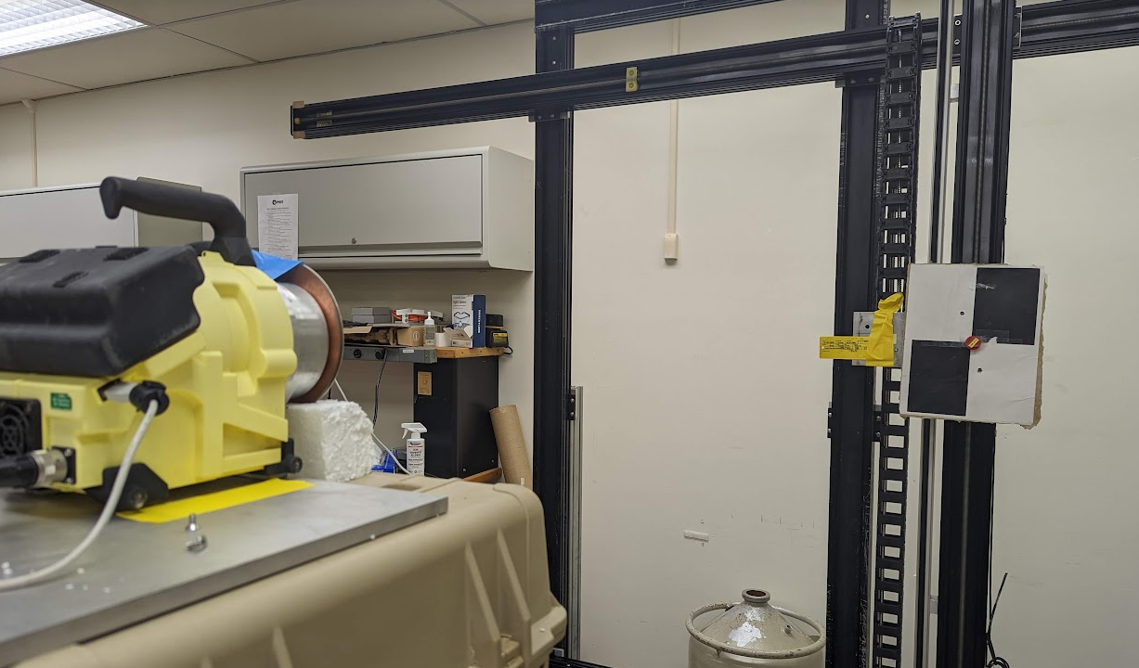
Figure 31. Image of measurement setup to determine location and energy dependent efficiency.

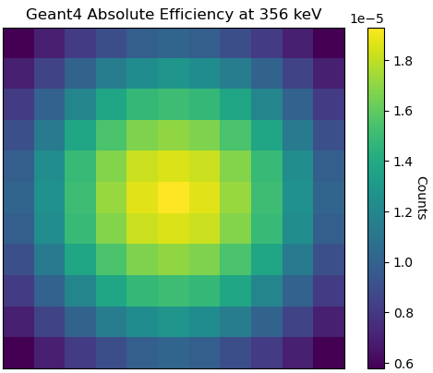
Figure 32. Efficiency distribution at 356 keV from an 11 by 11 grid of positions within a 1.8 m coded aperture field of view at 1.1 m distance from the imager. Geant4 was used with 10,000,000 primaries at each position.

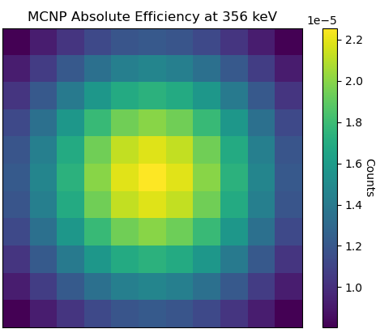
Figure 33. Efficiency distribution at 356 keV from an 11 by 11 grid of positions within a 1.8 m coded aperture field of view at 1.1 m distance from the imager. MCNP was used with 10,000,000 primaries at each position.

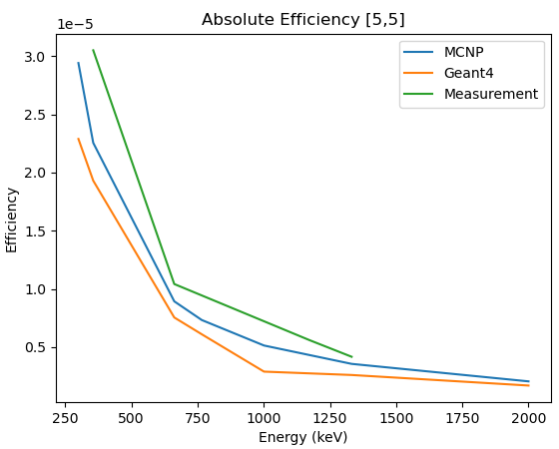
Figure 34. Image of efficiency from Geant4 and MCNP simulations, as well as measurements at different pixel locations.

Image Combination

The images can now be combined. The Compton scatter image is reformatted by the efficiency and then divided by the measurement time to obtain the corrected intensity for each pixel. The coded aperture image will consist of photons within the energy range of 50 keV to 300 keV, and the Compton scatter image will consist of photons within the energy range of 300.5 keV to 1200 keV. This energy range will account for all primary uranium emission peaks being used for mass quantification (186 keV, 766 keV, and 1001 keV). In this format, the mass calculations are able to be performed.

Mass Estimation

With the data combined in the format of intensity, the last phase is to evaluate the mass of the deposit. The mass estimation is a multistep process that involves first determining the ρt and then the enrichment for each pixel. The ρt is the thickness times the density of the source material. This is a combined parameter in order to cut down on the number of unknowns, as they can be combined as a product from their incorporation into attenuation shown below.

$$\begin{aligned}f\left(ρt,E\right)=-\exp\left(-μ(E)ρt\right) \#\left(10\right)\end{aligned}$$

The self-attenuation factor is the ratio of photons that will pass through a source if emitted from the far end (away from the detector). The mass evaluation remains accurate within thicknesses before infinite-thickness parameters are met, as seen in Figure 26. For 186 keV photons, infinite thickness is observed around 4 g/cm², while at 1001 keV this phenomenon is not found until about 50 g/cm².

Figure 35 shows the mass evaluation at different thicknesses for multiple energies to see their relation. The 186 keV mass evaluation is for U-235 and the 766 keV and 1001 keV
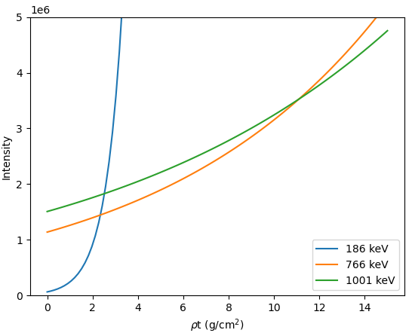
Figure 35. Self-attenuation corrected intensities using three different energy peaks.
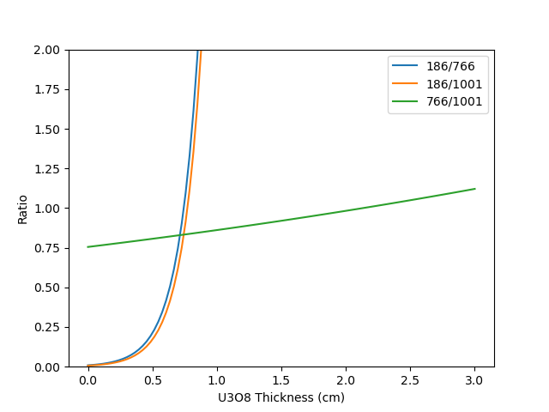
Figure 36. Ratios of self-attenuation corrected intensities using three different energy peaks.

mass evaluations is for U-238. As expected, the 186 keV mass estimation highly overestimates the mass starting around 0.8 cm, just after the infinite-thickness parameter is met. This is because the $f_{E}$ factor approaches 0.

Thickness Determination

The ρt value of the source can be determined from observing the ratios of the intensity estimations at each energy peak normalized based on the self-attenuation and the branching ratio show in Figure 36. The ratios of a sample source can be used as a calibrator for future measurements of similar enrichment. The ratio of a new measurement can be compared with the sample at many different ρt values, where the intersection is most likely the new measurements ρt. This method works as long as the measurements are performed within the limitations of infinite-thickness. The most accurate estimates will occur in the thinner regions where all three ratios can be compared, though estimations can still be done using only the 766 keV and 1001 keV ratio. This method will require a calibration database with varying enrichments and densities of the source. This is because the ratios for different energy peaks will vary depending on the enrichment.

Enrichment Determination

In higher ρt scenarios, where only the U-238 energies can be used to determine ρt, the mass estimation for U-235 will be calculated indirectly. What can be done is instead of direct calculation of the mass can be determining the enrichment. This is performed through the comparison of the ratios of each energy peak, shown in equation 11 (Reilly 1991). Where $m$ is the atomic weight and t is the time of the measurement.

$$\begin{aligned}enrichment=\frac{I_{235}m_{235}t}{I_{235}m_{235}t+I_{238}m_{238}t} \#\left(11\right)\end{aligned}$$

Formulation

For preliminary results, when no comparison measurements are provided, the value of ρt is assumed to be known. With an assumed ρt of the deposit, the mass can be evaluated from the intensity of the source. The efficiency corrected intensity at each energy is background subtracted first, then evaluated to the mass based on its branching ratio, specific activity, and self-attenuation, in their respective order in the denominator of equation 12. The self-attenuation is averaged through the entirety of the ρt to account for a photon emitted anywhere within the source, not just at a specific location as done for the intensity ratio comparisons.

$$\begin{aligned}M_{i,j,E}=\frac{I_{i,j,E}}{BR∙SA∙\frac{\sum{f\left(ρt,E\right)}}{n}} \#\left(12\right)\end{aligned}$$

DREAM Method

The work provided in this thesis does not implement DREAM into the mass calculation. However, to provide full scope for the project, including future goals, a high-level overview of DREAM will be covered for the future implementation of the hybrid imaging method. DREAM is an iterative approach to determining mass of the deposit.

Iterative schemes are meant to solve a problem through repeated calculations of a scenario with changing variables to approach a solution. The models for iterative schemes can be more accurate compared to analytical methods because models can be created with less assumptions. However, iterative schemes can become a very time and resource intensive process.

The DREAM method operates as an inverse transport solver solved by stochastic iterative methods (Venkataraman 2020). Stochastic methods in this case mean the parameters for setting up the problem are generated randomly, then the solution provides information for preparing the next iteration of variables.

A Bayesian framework is used to create the inverse solution space probability distribution from the stochastically generated variables. Then the next iteration is performed, and compared to the first, rather than being instantly accepted. The criterion for accepting the next iteration is based on the Metropolis probability. Markov Chain Monte Carlo techniques are used to iterate upon this framework. MCMC typically uses a single chain of one iteration to the next based on one set of starting parameters. While good in theory, MCMC method computation time can vary greatly depending on the starting parameters chosen. This project aims to improve upon this idea from two fronts. The first being to run multiple chains simultaneously to improve chances of one chain having an ideal starting point. The other is having an informed starting guess based on the measurement data rather than a true randomly generated guess.

Results

Measurement Setup

The set of measurements shown here are performed with an NBL standard. The source is low enriched uranium at 4.46%. The source is a compressed U3O8 powder in the shape of a disc. The disc is 1.58 cm thick with a diameter of 7 cm. The measurement was taken at 1.12 m from the source using a focal length of 12 cm. Figure 37 shows the setup from the imager’s point of view. The measurement was taken over a period of 21 hours. The measurement time is split in half between mask and anti-mask configurations. The anti-mask configuration is the 90˚rotated version of the original mask position. Figure 38 shows the full imager collected spectrum, not considering imaging. This provides a baseline for the ratios of the peaks expected for the imaging spectra. This sample helps provide a starting point for the imaging process for it is a homogeneous disc source in the center of the field of view.

Data Analysis

Figure 39 shows the coded aperture generated image from this measurement. The energy range is specific to 50 keV to 300 keV to maximize the energy range favoring single site events. This will be seed image for the coded aperture image comparison weighting factor when creating the weighted Compton scatter image.

Figure 40 and Figure 41 overview the Compton imaging process. The first image is of the unweighted image which is only the simple back-projection with a numerical tally of the grid. The next image is using the same data as the previous, but now including all the weighting factors and the efficiency. As shown, the weighted image performs much better in shaping the source geometry and localizing the source.

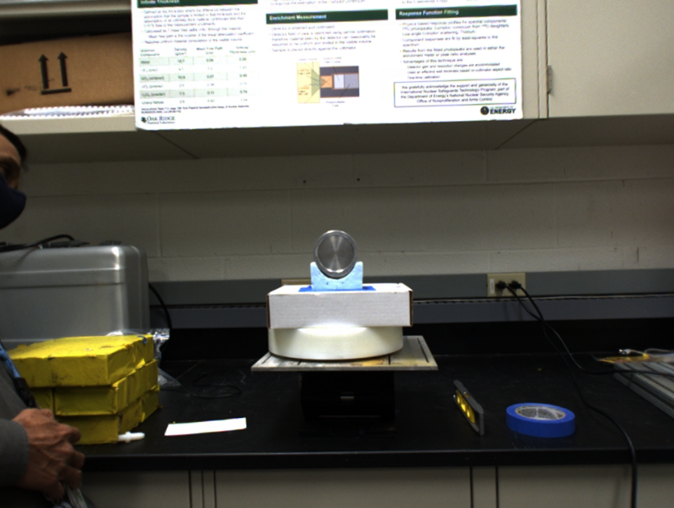
Figure 37. Uranium card source measurement. Distance 1 m, time of measurement 21 hours, enrichment ~5%.

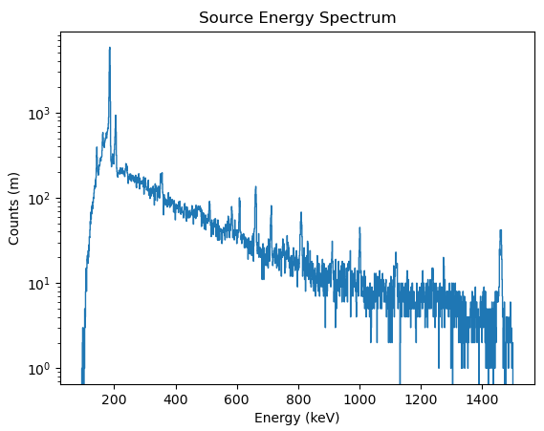
Figure 38. Energy spectrum produced from measurement.

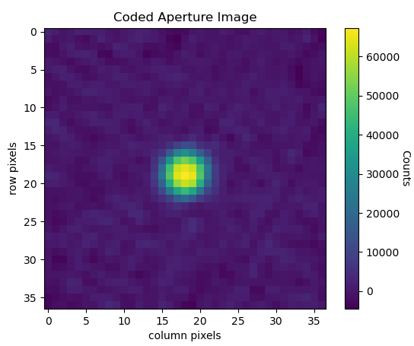
Figure 39. Coded aperture generated image in photon energy range 50 keV to 300 keV.

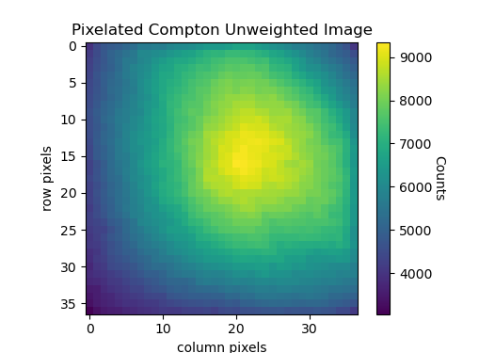
Figure 40. Compton simple backprojection generated image in photon energy range 300 keV to 1200 keV.

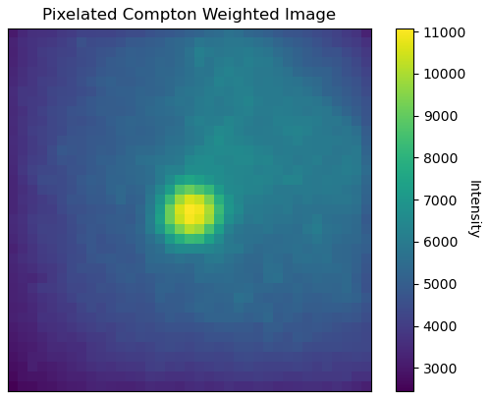
Figure 41. Compton weighted and efficiency corrected image in photon energy range 300 keV to 1200 keV.

One interesting note for the data, primarily shown in the unweighted image, is the location of the highest counts. The highest region of counts in the unweighted image is off center, located more up and to the right compared to what is expected. From the coded aperture image, the source is clearly in the center of the FOV, which also matches the measurement setup. The first assumption was that there was a problem with the code, either being the creation of the imaging grid, or backprojection of the cones. More analysis was needed to identify the source of the off-axis image.

The next set of images (Figure 42, Figure 43, Figure 44, and Figure 45) show the weighted image isolated at specific energies. 766 keV and 1001 keV are selected for U-238 emissions, and as expected, the source localizations are in the center of the FOV. However, looking at the expected spectrum from Figure 38, there is a large energy peak at 662 keV. 662 keV is not from uranium or its decay chain, but rather from Cs-137. The image for 662 keV shows a large section of counts off center in the region showing high counts.

To further analyze the off-center source from Cs-137, the weighted images are split into their respective individual weightings. Figure 46 is from the mask weighting only. Figure 47 is from the cone angle uncertainty weighting only. Lastly, Figure 48 is from the coded aperture image agreement weighting only. Looking at the 662 keV peak from the mask weighting and cone angle uncertainty weighting, the source for Cs -137 is localized as separate from the uranium source and is attributing to noise. This shows the benefits of the datacube structure for imaging. Other sources can be isolated from the desired image, providing further information for other sources which may need to be considered.

The combined image and pixel specific spectra can be shown in Figure 52. This is after the data has been normalized to the measurement time, resulting in the intensity for each pixel. The data is now in the format required for mass evaluation.

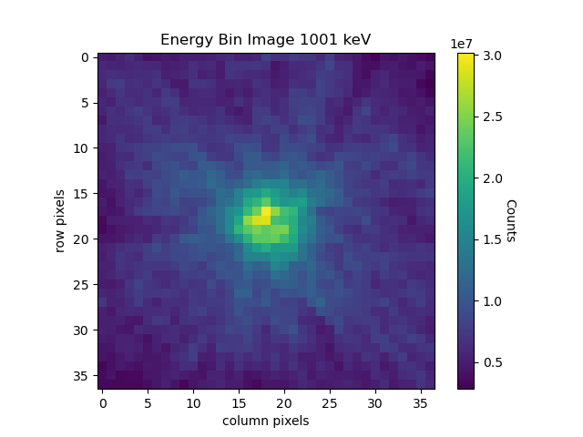
Figure 42. Compton weighted image from 1001 keV photons.

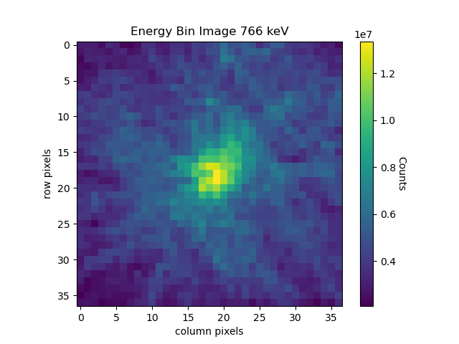
Figure 43. Compton weighted image from 766 keV photons.

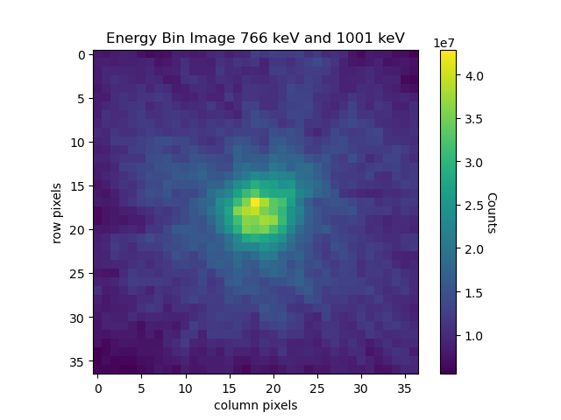
Figure 44. Compton weighted image from both 766 keV and 1001 keV photons.

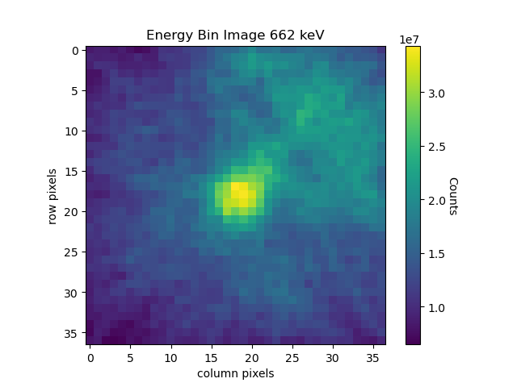
Figure 45. Compton weighted image from 662 keV photons.

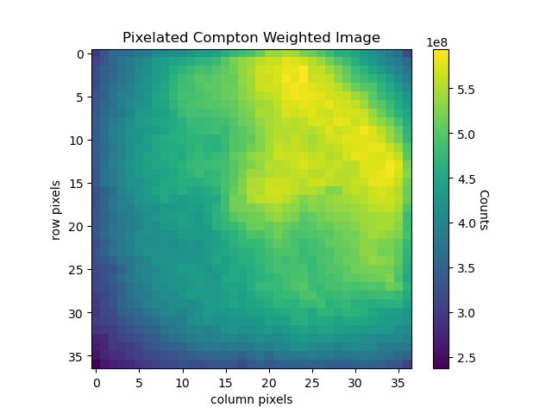
Figure 46. Compton image from mask weighting only in photon energy range 300 keV to 1200 keV.

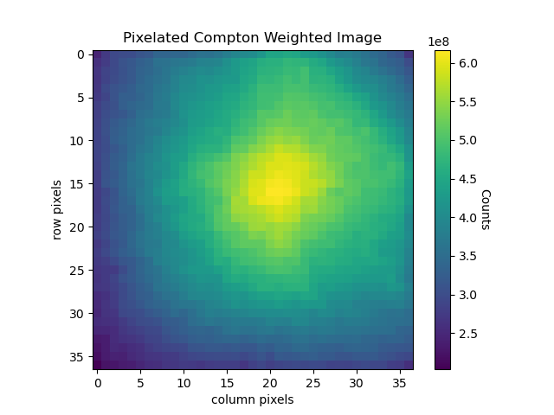
Figure 47. Compton image from uncertainty weighting only in photon energy range 300 keV to 1200 keV.

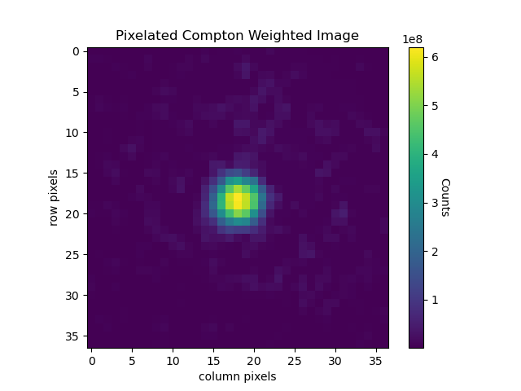
Figure 48. Compton image from coded aperture agreement weighting only in photon energy range 300 keV to 1200 keV.

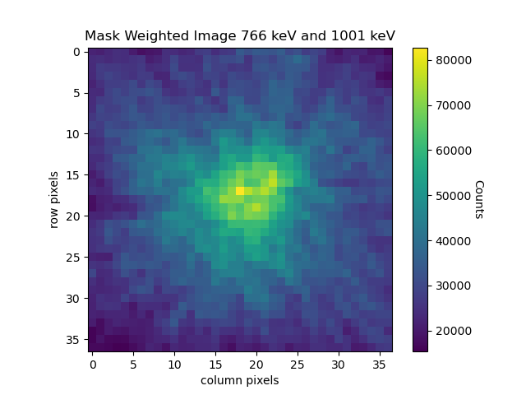
Figure 49. Compton image from mask weighting only from 766 keV and 1001 keV photons.
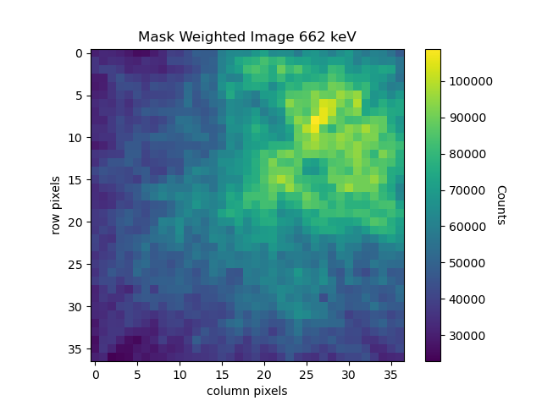
Figure 50. Compton image from mask weighting only from 662 keV photons.

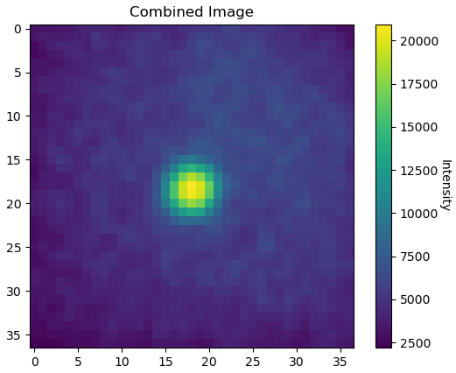
Figure 51. Combined image using energy range of 50 keV to 1200 keV.

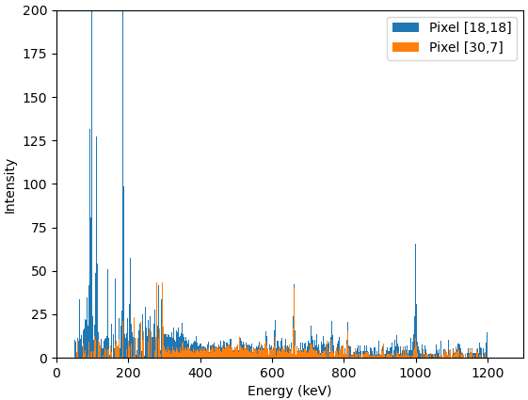
Figure 52. Pixel specific spectra from both coded aperture and Compton scattering at different pixel locations.
The first mass estimation results are shown in Table 2, with an image of the mass in Figure 53. This is with a known thickness of 1.58 cm and assumed homogeneous composition. The mass of U-238 was estimated with the data shown in the combined image with the peak intensities at both 766 keV and 1001 keV. For the known thickness case, an average was taken of the two estimated masses. Equation 12 was used to evaluate the mass with the self-attenuation factor coming from the assumed known ρt. Then the intensities were used to find the enrichment for the U-235 mass. The uncertainties were calculated from first order error propagation originating with the uncertainty in the counts from each pixel following Poisson counting statistics ($σ_{c}=\sqrt{c}$). This method provides a preliminary estimation of the uncertainty, though is not all encompassing. More precise uncertainty estimations would consider the uncertainty from each projected cone attributing to a count. This would consider more in depth the mechanisms of the backprojected reconstruction and image to source geometries.
Table 2. Mass Estimation with known thickness
 | Measured | Actual | Percent Error Range
Mass U-235 | 7.16 ± 0.395 g | 7.54 g | 0.199 - 10.3 %
Mass U-238 | 149 ± 7.94 g | 161 g | 2.52 - 12.4 %
Enrichment | 4.58 ± 0.0480 % | 4.46 % | 1.61 – 3.77 %
Total Mass | 156 ± 7.95 g | 169 | 2.99 - 12.4 %

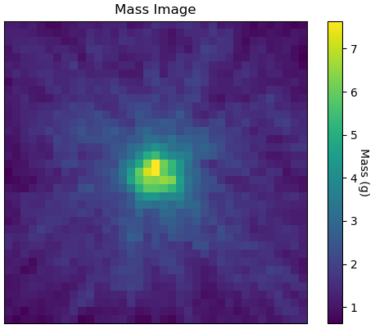
Figure 53. Total mass image combined from U-235 and U-238 estimates.

Conclusion and future work

Summary

A commercial gamma imager (GeGI) was utilized for uranium holdup quantification. This work produced a novel method to combining two different imaging modalities from a single measurement to form an image. Coded aperture imaging was used for lower photon energies (0 - 300 keV) and Compton scatter imaging is used for higher energies (300.5 - 1200 keV). The Compton scatter back-projected cones were reweighted based on mask attenuation, cone angle uncertainty, and agreement with the coded aperture image. The reweighting process improved upon the simple-backprojection method, better localizing the deposit geometry. The combined image based on source intensity retains a datacube format, creating a full energy spectrum for each pixel in the resulting image. The datacube was then used to quantify the mass of the deposit based on the peak ratios for U-235 and U-238.

Work Limitations

The results section was produced using one measurement with a NBL standard at the center of the FOV. This is an overall ideal setup for imaging and mass quantification. The setup works great for the mass calibration using the peak ratios and provides the first tests of the weighted Compton scatter imaging methods. However, this NBL standard measurement does not push the methods to complex scenarios. Future work can push the methods established here in more complex scenarios.

Another limitation of the hybrid method is identifying what types of sources are ideal for measurement. This imaging method is created for uranium holdup, specifically using the wide gamma energy spectra emitted. This hybrid approach relies on images being generated with both methods. Because of this reliance, the hybrid approach described in this thesis works best with low enriched uranium. This is due to the low activity of U-238 compared to that of U-235, and the lower imaging efficiency of higher energy photons. Other sources with extreme enrichments on either end of the spectrum (i.e. HEU or DU) will dominate in in one imaging modality over the other, limiting the implementation of this hybrid imaging method. That being said, images can still be produced, but the weighting factor from the coded aperture image agreement would no longer be valid. This is because this weighting factor relies on the images created from both methods applied to the same source. Without this weighting factor, the images created from each method are independent of each other and can identify sources specific to their energy regions.

Future Work

What the work in this thesis provides is the basis for using a hybrid gamma imaging technique. The next steps to take would be to take this foundation to the next level of development.

To directly build on this foundation, one could test the current code base with more complex imaging measurements. Taking measurements behind thin shielding, with off center sources, and even multiple sources in the FOV would be great ways to test the imaging methods in non-ideal conditions. Using more complex scenarios will identify potential issues with the current iteration of the code that may not be identifiable with the NBL standard measurement and provide feedback on ways to improve.

To fully implement the mass determination method from the mass ratios, a measurement campaign will be required in future work. The measurement described in the results section acts as a basis for future measurements; it cannot on its own evaluate the thickness. The ratios seen in Figure 36 are specific to the enrichment of this measurement. Changing the enrichment will result in a different scale of peak intensities, and, therefore, change the comparisons. Because of this, measurements will be needed with multiple sources of uranium at varying enrichments to build a database that can be applied to new measurements. This will provide a foundation for determining the mass from new measurements and their analysis.

The current state of R&D is moving towards real-time imaging (Hellfeld 2021) and 3D imaging (Hecla 2021). This would be a natural progression of this work as well. The groundwork has been laid at UTK for the hybrid imaging of holdup deposits with quantification. Along with this, preliminary work is being performed at UTK for 3D Compton imaging. This is being done with LIDAR scans of the room in question. The LIDAR scan results in a point cloud of the geometries detected. The points in the point cloud would work in a similar aspect to that of the pixels in the hybrid imaging. However, the point cloud would take full advantage of the 4π imaging capabilities of Compton scatter imaging. The coded aperture imaging, however, would not be discarded. The points within the coded aperture FOV could still benefit from the hybrid imaging techniques, providing the most accurate information in the scan. Quantification would move to a point-by-point basis instead of pixel-by-pixel.

List of References

Hellfeld, D., Bandstra, M. S., Vavrek, J. R., Gunter, D. L., Curtis, J. C., Salathe, M., Pavlovsky, R., Negut, V., Barton, P. J., Cates, J. W., Quiter, B. J., Cooper, R. J., Vetter, K., & Joshi, T. H. Y. (2021). Free-moving Quantitative Gamma-ray Imaging. Scientific Reports, 11(1), 20515. https://doi.org/10.1038/s41598-021-99588-z

Reilly, D, Ensslin, N, Smith, H Jr, & Kreiner, S. Passive nondestructive assay of nuclear materials. United States.

Doyle, J. (2011). Nuclear Safeguards, Security and Nonproliferation: Achieving Security with Technology and Policy. Elsevier Science. https://books.google.com/books?id=8WOza_y3IkQC

Barnowski, R. B. (2016). Development and Evaluation of Real-Time Volumetric Compton Gamma-Ray Imaging. UC Berkeley. ProQuest ID: Barnowski_berkeley_0028E_16305. Merritt ID: ark:/13030/m5g7831v. Retrieved from https://escholarship.org/uc/item/6099194w

E. A. Wulf, B. F. Phlips, W. N. Johnson, R. A. Kroeger, J. D. Kurfess and E. I. Novikova, "Germanium strip detector Compton telescope using three-dimensional readout," in IEEE Transactions on Nuclear Science, vol. 50, no. 4, pp. 1182-1189, Aug. 2003, doi: 10.1109/TNS.2003.815133.

J. Hecla et al., "Polaris-LAMP: Multi-Modal 3-D Image Reconstruction With a Commercial Gamma-Ray Imager," in IEEE Transactions on Nuclear Science, vol. 68, no. 10, pp. 2539-2549, Oct. 2021, doi: 10.1109/TNS.2021.3110162.

Knoll, G.F. (2010) Radiation Detection and Measurement. 4th Edition, Wiley, Hoboken, 217.
Longford, D & Kiser, M & Hull, E & Aspetti, Pio & Santoni, Enrico. (2018). GeGI gamma-ray imaging spectrometer: redefining stand-off radiation detection of special nuclear material.

Venkataraman, Ramkumar, Ziock, Klaus-Peter, Blackston, Matthew, Lousteau, Angela, Croft, Stephen, Bledsoe, Keith, Lefebvre, Jordan, Preston, Jeff, & Knowles, Justin. Gamma ray Imaging Based Methods to Improve the Accuracy of Uranium Holdup Quantification. United States.

Smith, L.E. & He, Zhong & Wehe, D.K. & Knoll, G.F. & Wilderman, Scott. (1998). Design and modeling of the Hybrid Portable Gamma Camera system. Nuclear Science, IEEE Transactions on. 45. 963 - 969. 10.1109/23.682687.

Cannon, T.M., & Fenimore, E.E. (1980). Coded Aperture Imaging: Many Holes Make Light Work. Optical Engineering, 19, 193283.

Lee, T., & Lee, W. (2014). Compact hybrid gamma camera with a coded aperture for investigation of nuclear materials. Nuclear Instruments & Methods in Physics Research Section A-accelerators Spectrometers Detectors and Associated Equipment, 767, 5-13.

T. Lee and W. Lee, "Portable Active Collimation Imager Using URA Patterned Scintillator," in IEEE Transactions on Nuclear Science, vol. 61, no. 1, pp. 654-662, Feb. 2014, doi: 10.1109/TNS.2013.2295621.

Lee, W., & Wehe, D. (2007). Hybrid gamma ray imaging-Model and results. Nuclear Instruments and Methods in Physics Research, Section A: Accelerators, Spectrometers, Detectors and Associated Equipment, 579(1), 200-204. https://doi.org/10.1016/j.nima.2007.04.039

Vita

Blake Montz attended North Carolina State university and received a Bachelor of Science in Nuclear Engineering. Wanting to specialize in the field, he started graduate school at the University of Tennessee, Knoxville originally for health physics. His research interest was in radiation imaging and pursued a project in joint with ORNL for gamma imaging and quantification. While in graduate school, Blake became interested in the Medical Physics field from the department’s new program. He joined the Medical Physics program while continuing his imaging research. After graduation he plans to enroll in a residency program for medical physics.

