IDENTIFYING THE UNDERLYING MOLECULAR BASIS OF THREE DELETERIOUS PHENOTYPES IN HEREFORD CATTLE

A Thesis Presented for the
Master of Science
Degree
The University of Tennessee, Knoxville

Ana Beatrice Raffo Caiado
December 2024

Copyright © 2024 by Ana Beatrice Raffo Caiado
All rights reserved.

ACKNOWLEDGEMENTS
I would like to start by thanking my family and all my friends who have been by my side and supported me throughout this journey of pursuing my degree. I would not be where I am nor have accomplished what I have without you. To my mom and dad who I would never be here without your undying love and support. The constant support and push made me who I am, and I can never thank you enough for everything.

To all my friends. both graduate students at UT and outside of UT, you have heard my ups and downs throughout the entire process. I will be forever grateful to have you all in my life. I’d like to specifically thank Trevor, Maddie, Cassidy, Leif, and all the others that I have become so close to within these last two and a half years. Thank you all for your support on this wild ride through my MS and I can’t wait to see what you all accomplish in the future.

Thank you to my amazing committee, Dr. Troy Rowan and Dr. Cheryl Kojima. They have been there for every question I had and supported me the whole way.

Last, but certainly not least, I would like to thank my mentor, Dr. Jonathan Beever, for everything he has done to help me grow and succeed. Through the ups and the downs, he has always been on my side and truly couldn’t have done it or be where I am without him.
ABSTRACT
Hereford cattle are among the most popular breeds of beef cattle in the United States. As with any breeding population, traits or phenotypes may arise that are less desirable and/or have negative economic consequences. In Herefords, three such phenotypes have been observed throughout the history of the breed and remain concerns in the current population. These phenotypes include. In Herefords, ocular squamous cell carcinoma, commonly called cancer eye, scurs, and ocular dermoid are three phenotypes observed throughout the history of the breed and remains a concern in the current population. This project was conducted in an effort to define the potential underlying molecular genetic basis of these traits using 95 animals affected with at least one of the phenotypes. Samples of these 95 animals were submitted by Hereford breeders and received either as whole blood, tissue, or semen. The case group of 95 animals representing cases of each phenotype, consisted of 57 with cancer eye, 18 scurred female individuals, and 19 with ocular dermoid. Genomic DNA was isolated, and all samples were whole-genome sequenced (WGS) to an average depth of coverage of 9.93 following quality control and pruning of the sequences using Plink. The American Hereford Association provided WGS information from 105 individuals to be used as unaffected control samples. Analysis from the WGS, showed significant associations with numerous variants on multiple chromosomes. Variants were considered significant if exceeding the genome-wide significance (p<5.0e08). threshold Cancer eye had three variants located on chromosomes 2, 4, and 20. Scurs had six variants located on chromosomes 12 and 26. Ocular dermoid had two variants located on chromosome 6. Positional candidate genes were identified for future investigation and further studies will be required to discover the true causative mutations in these three traits.

Table of Contents
CHAPTER ONE LITERATURE REVIEW 1
Introduction 1
Bovine Ocular Squamous Cell Carcinoma 2
Breed and Susceptibility 4
Age and Onset 6
Scurs 7
Scurs in the Hereford Breed 8
Ocular Dermoid 11
Genome-Wide Association Study 12
Linear Mixed Models 12
Conclusions 13
CHAPTER TWO IDENTIFYING THE MOLECULAR BASIS OF THREE PHENOTYPES IN HEREFORD CATTLE 14
Introduction 14
Materials and Methods 16
Sample Size 16
DNA Isolation 16
Quality Assurance 17
Genome Wide Association 18
Results 19
Cancer Eye 19
Scurs 21
Dermoid 22
Discussion 23
Conclusions 26
LIST OF REFERENCES 27
APPENDIX 31
VITA 65

LIST OF TABLES

Table 1 Polled, Horned, and Scurred Genotype Classification [15] 3
Table 2 Proposed Theory of Inheritance with 4 Loci by White and Ibsen 10
Table 3 Genomic and Suggestive SNPs Across Traits 20
Table 4 Statistics of Whole-Genome Sequencing – Raw Case and Control Samples 64
Table 5 Statistics of Whole-Genome Sequencing – Trimmed Case and Control Samples 64

LIST OF FIGURES

Figure 1. Pipeline Summary 31
Figure 2. Cancer Eye Genome-Wide Manhattan Plot 32
Figure 3 Cancer Eye Chromosome 4 33
Figure 4 Cancer Eye Chromosome 4 Genome-Wide Threshold SNP 34
Figure 5 Cancer Eye Chromosome 4 Suggestive Peaks 35
Figure 6 Cancer Eye Chromosome 27 36
Figure 7 Cancer Eye Chromosome 27 Suggestive Peak 37
Figure 8 Scurs Genome-Wide Manhattan Plot 38
Figure 9 Scurs Chromosome 6 39
Figure 10 Scurs Chromosome 6 Suggestive Peak 40
Figure 11 Scurs Chromosome 6 Suggestive Peak 41
Figure 12 Scurs Chromosome 6 Suggestive Peak 42
Figure 13 Scurs Chromosome 10 43
Figure 14 Scurs Chromosome 10 Three Suggestive Peaks 44
Figure 15 Scurs Chromosome 12 45
Figure 16 Scurs Chromosome 12 Genome-Wide Threshold Peak 46
Figure 17 Scurs Chromosome 13 47
Figure 18 Scurs Chromosome 13 Suggestive Peak 48
Figure 19 Dermoid Genome-Wide Manhattan Plot 49
Figure 20 Dermoid Chromosome 3 50
Figure 21 Dermoid Chromosome 3 Suggestive Peak 51
Figure 22 Dermoid Chromosome 3 Suggestive Peak 52
Figure 23 Dermoid Chromosome 3 Suggestive Peak 53
Figure 24 Dermoid Chromosome 3 Suggestive Peak 54
Figure 25 Dermoid Chromosome 6 55
Figure 26 Dermoid Chromosome 6 Genome-Wide Threshold Peak 56
Figure 27 Dermoid Chromosome 6 Suggestive Peak 57
Figure 28 Dermoid Chromosome 6 Suggestive Peak 58
Figure 29 Dermoid Chromosome 6 Suggestive Peak 59
Figure 30 Dermoid Chromosome 8 60
Figure 31 Dermoid Chromosome 8 Suggestive Peak 61
Figure 32 Dermoid Chromosome 9 62
Figure 33 Dermoid Chromosome 9 Suggestive Peak 63

Chapter One
Literature Review

Introduction

Hereford cattle are among the most popular breeds of beef cattle in the United States. They are known for their docile nature, meat quality, and production efficiency. Throughout the history of the breed, three different phenotypes have arisen and continue to be a reason for concern for producers. Ocular neoplasia or cancer eye (CE) is an invasive chronically progressing neoplasia that can metastasize through draining lymphatics of the head and neck causing extreme discomfort for the animal that could lead to removal of the eye, early culling from the herd, and carcass condemnation [1]. CE is an important source of economic loss to the livestock industry [2] because affected animals have a poorer performance, reduced productive life, and are heavily discounted at slaughter due to increased risk of carcass condemnation [3]. Studies have shown that CE could be influenced by both environmental and genetic factors such as increased exposure to sunlight [4] and when compared to various other breeds, Herefords had a 74% affected rate when other breeds had 0% - 1.1% [5]. In 1956, CE comprised 80% of all bovine tumors reported at slaughter [6]. In 1985, CE was the most prevalent malignant tumor affecting cattle causing substantial economic losses for producers [1]. With the decline of Hereford animal numbers throughout the years relative to other breeds, not as many records are shown of affected animals, however animals continue to develop CE and it remains a concern for producers who still suffer from an economic loss when discounts are applied to salvage value from an affected animal.

Scurs are horn like processes that share similar shape and location with horns but they are generally smaller and characterized by an absence of fusion between the bony core and the skull [7]. Animals are typically classified into three phenotypic groups: horned animals, polled or hornless animals, and scurred [8]. The scurred locus is characterized in Bos Taurus by two alleles: Sc which codes for the development of scurs and sc which codes for the absence of scurs [9, 10]. Scurs are observed in males more frequently than females due to the influence of sex on phenotypic expression [11]. A sex-influenced expression pattern indicates that the relationship between genotype and phenotype is not the same for both sexes [12]. For scurs, the Sc allele behaves as a dominant allele in males meaning a male only has to have one Sc allele to express scurs as shown in. However, in females, the Sc allele behaves a s a recessive allele requiring females to be homozygous in order to have scurs. Proposed genotypes are shown in Table 1. Furthermore, the scurs locus is known to have an epistatic interaction with the horn/polled locus.

Ocular dermoid is a peculiar defect observed in animals and characterized by solid, skin-like masses of tissue on or in various ocular structures [13]. They occur sporadically in numerous cattle breeds, have no clear sex incidence, and can occur unilaterally or bilaterally [13]. Dermoids involving the central cornea, nictitating membrane (third eyelid), or the eyelid occasionally occur in cattle and are corrected easily by surgery [14]. In previous studies. it was determined that ocular dermoid in Hereford cattle is a genetically transmitted defect and characteristics of autosomal recessive and polygenic inheritance were observed [13].

Bovine Ocular Squamous Cell Carcinoma

Bovine ocular squamous cell carcinoma, commonly referred to as cancer eye, is an important source of economic loss to the livestock industry [2]. In the years of 1969-1972, US federally inspected packing houses estimated that 12.6% of all bovine carcasses condemned were due to bovine ocular squamous cell carcinoma eye [2]. Cancer eye has a large impact on animals that are used for meat production. The salvage value for an animal with cancer eye greatly decreases meaning the producer receives little to no compensation when that animal is processed. It is in the producer’s best interest to cull or treat affected animals as soon as lesions develop.

Cancer eye is an invasive chronically progressing tumor which metastasizes through draining lymphatics of the head and neck [1]. Typically, cancer eye arises from plaque and papilloma precursor lesions on and around the epithelium of the eye [1].
Table 1 Polled, Horned, and Scurred Genotype Classification [15]
Genotype | Males | Females
PP ScSc | Scurred | Scurred
PP Scsc | Polled, nonscurred | Polled, nonscurred
PP scsc | Polled, nonscurred | Polled, nonscurred
Pp ScSc | Scurred | Scurred
Pp Scsc | Scurred | Polled, nonscurred
Pp scsc | Polled, nonscurred | Polled, nonscurred
pp ScSc | Horned | Horned
pp Scsc | Horned | Horned
pp scsc | Horned | Horned

Cancer eye begins as a lesion that grows either on the eyeball, on the eyelid, or on the nictitating membrane, also known as the third eyelid. If the lesion is not assessed and treated, it will grow into a cancerous tumor. Typically, any lesion on the third eyelid will grow into a tumor whereas a lesion on the eyeball could be an ocular dermoid or on the eyelid could be a skin tag and mistaken as cancer eye. When an animal is identified to have a lesion or a tumor that is found to be cancer eye, the location that is most common is the third eyelid [6]. The cancerous tissue can also grow inwards that will invade the deeper tissues behind the eye, but it can also progress to the lymph nodes of the head.

Breed and Susceptibility

Hereford cattle are known to be highly susceptible in developing lesions causing cancer eye, more so than other breeds of cattle. A study done by French [16], examined over 300 mature cattle of which 150 were Herford and 150 were Shorthorn. It was found that 35% of Herefords had eye lesions, but no Shorthorns did. In another study done by Anderson [5], many different breeds of cattle were examined across age ranges. The four pure breeds with the highest number of collected data were Hereford, Angus, Holstein, and Shorthorn. Out of these four breeds, Hereford had 74% affected and Holstein had 1.1% affected among all age ranges while the other breeds had 0% affected.

In another study done by Sloss [17], three different herds of Hereford cattle containing affected animals were examined over a 3.5 year period. The first herd contained 155 head and they were examined 13 times in intervals of 20-140 days. The second herd was examined 6 times in intervals of 77-242 days. The third herd was examined 4 times in intervals of 87-221 days. Affected animals with lesions on the eyeball and upper eyelid were treated by cryosurgery using a copper probe of 1 or 2 cm diameter which was cooled in liquid nitrogen. Lesions on the third eyelid that did not extend beyond the free part of the eye were treated by extirpation of the whole third eyelid. Overall, the majority of the animals recovered after 1 or 2 treatments, but there were some cases that there was regrowth or new growth of lesions and this was seen mostly in Herd A. Some animals in Herd B did not respond to several treatments and thus resulting in removal of the eye being necessary.

While there are options for removal of cancerous tissues, large-scale production systems likely will not identify the lesion or tumor in the ocular region early enough in the disease progression to prevent further growth. Further, surgery to remove the lesions and tumors is costly and many producers will not opt for it. Therefore, the lesions and tumors cannot be removed before slaughter, resulting in potential condemnation of the carcass and reduction of producer profit. If successfully removed, producers may be able to retrieve some salvage value from the carcasses. However, the reduced value of the carcasses maintains a loss in the production system.
Genetic studies regarding cancer eye have been carried out to evaluate two aspects of inheritance: inheritance of susceptibility independent of environmental factors and the relationship between pigmentation of the eye and cancer eye [1]. There have been different studies analyzing the relationship between ultraviolet light and the lack of pigmentation on the white portion of the Hereford face. The color pattern in the Hereford breed is due to mutations in the KIT gene which encodes a receptor tyrosine kinase. The mutations in this gene are responsible for the improper or lack of migration of pigment producing cells or melanocytes [18]. Nishimura and Frisch [19], discuss how the relationship between ultraviolet (UV) radiation and ambilateral circumocular pigmentation (ACOP) affect cancer eye. They saw that an animal's susceptibility to cancer eye greatly decreased if they had ACOP which is a highly heritable trait. It was also found that there was a genetic-environmental interaction where an increased level of pigmentation reduced the susceptibility and probability of lesion development. However, regardless if the animal has ACOP or not, lesions can still develop in the ocular region. In another study by Jara et al. [3], visual pigmentation records were taken from a group of 886 Hereford bulls and steers and genotypic data for 774,660 SNP markers were available for these animals. The data was analyzed using single-step genome-wide association study (ssGWAS). It was found that eyelid pigmentation is a moderately heritable trait with a value of 0.41. The ssGWAS showed that there were at least eight regions on the genome that were associated with eyelid pigmentation: BTA1, BTA3, BTA5, BTA14, BTA16, BTA18, BTA19, and BTA24. Due to eyelid pigmentation being a moderately heritable trait, it would be beneficial to look at this trait when breeding animals to try and reduce the occurrence of an ocular disease. In another study done by Anderson [20], it was found that pigmentation around the eye had an inverse effect on the lesions developing at the corneoscleral junction meaning when there is increased pigmentation, there is decreased lesion development. This study also found that eye pigmentation and lesion development were not genetically related meaning that just because an animal had pigmentation around the ocular region does not mean that they do not have a chance of developing lesions. It is known that animals beyond the age of 5 years old are the most susceptible in developing cancer eye [21, 22].

Heritability values have been estimated in a study done by Russell et al. [2], where they looked at Hereford cattle of different ages and estimated heritability for presence of tumors and number of tumors. Heritability estimates were in a range of the lowest value being -0.11 and the highest value being 0.59. The lower heritability values corresponded with the younger animal age groups, 2-3, and the higher heritability values corresponded to the older animal age groups, 9+. If looking at the heritability between the ages of 5 and 10, it would most likely be higher than the heritability of ages 2 through 17. The heritability of cancer eye has been estimated by using different methods that are based on parent offspring, paternal, maternal half-sib studies, and by breed comparison [1]; however, the overall heritability of cancer eye in Hereford cattle remains undetermined.

Age and Onset

Cancer eye has been an ongoing issue for Hereford cattle for over 40 years. A study performed by Blackwell et al. [21], looked at purebred Hereford animals across age classes in years from 1-4, 5-7, 8-9, and 10+. They found that a younger animal aged 4 and below has lower observed frequency signs of cancer eye compared to an older animal past the age of 4. A younger animal sent to processing has a lower chance of being found to have lesions or tumors compared to an older animal that stays in the herd longer. A study done by Woodward and Knapp [22], found that animals of 5 and 7 years of age that are being removed from the herd for any reason have higher incidences of cancer eye. An animal that stays in the herd longer, such as a breeding animal, has a higher chance of developing lesions and tumors simply because their age makes them more susceptible. Heeney and Valli [1] identified that female animals have a higher likelihood of presenting with cancer eye than males do, because females tend to stay in the herd longer for breeding, while steers are sent to process before the age of 30 months. In the breeding or cow-calf segment, breeding bulls that are kept in the herd for more than five years are just as susceptible to developing cancer eye as the breeding cows in the same age group. Bulls have a higher turnover rate than cows to reduce inbreeding and rapidly improve genetic progress in a herd. These are all important factors to keep in mind when selecting cattle to keep in the herd or cull. Cattle should be selected based on various factors, one of which should include susceptibility to cancer eye if there have already been cases in the current herd. Selection is utterly important for the progression and growth of a herd and one animal that develops cancer eye could cause a problem for both the producer and future generations. The producer has the option to cull or treat affected animals knowing even if treated, the salvage value will still be discounted. Due to the genetic nature of cancer eye still being unknown, it is likely that some animals could be carriers and not present with the disease. It is important to identify the molecular variations that are underlying to be able to place negative selection pressure on them to reduce future development of cancer eye in herds.

Scurs

Early ancestors to modern day cattle were all horned breeds. Horns continue to be a common trait in modern day cattle and some breeds are characterized by their horns such as Longhorn cattle. The polled trait is relatively new occurrence and for some breeds, is a breed characteristic. The modern day cattle industry is selecting for animals that are hornless for both practical and economic reasons such as lower risk of injury for humans, easier handling of the animals, and market value [23]. Handling of animals with horns can be dangerous for humans as horns can be used in self-defense and can cause issues for the animals themselves such as when going through a chute their horns can get caught. Horned animals will have a lower market value than a polled animal for reasons such as human safety, easier handling, and having future potential horned calves that will sell for less than polled calves. It is also known that when being processed, horned animals tend to have more bruises on their meat compared to polled animals, thus decreasing their carcass value as well [24].

Scurs are defined as hornlike formations that grow in the same area of the skull that horns would, but they are not attached to the skull, nor do they reach the same size as horns do. They can occur in both beef and dairy breeds of cattle. The size of scurs varies from small scabs to 15 cm long protrusions. A previous study found that in adult Charolais females and males, scurs were much larger reaching more than 10 cm in length [7]. Based on different breeds, scurs will have completely developed in a full grown and mature animal just as horns would [10].

Scurs in the Hereford Breed

Polled Herefords have been created by one of two methods: (1) by crossbreeding horned Herefords with other polled breeds; and (2) by using mutant polled and scurred Herefords [25]. However, because of when the original crossbreeding took place, most polled Herefords now trace back to the original sires causing problems with inbreeding. In a study done by Guthrie [26], a mutant polled bull that was a crossbred of Hereford and Shorthorn was bred to horned Hereford females and no horns appeared in calves from any generation except in the F2 generation where scurs began to appear. Many of the foundational group of Polled Herefords were sired by bulls that were scurred. According to White and Ibsen [9], it is impossible for a polled bull to produce only polled calves regardless of the cow they are bred to. However, one of the authors from Williams and Williams had a polled bull that produced same phenotype calves where the first ten calves were polled. Some of these calves came from horned females or females that passed the scurred allele. The same bull was later bred to every female in the herd that had ever produced a horned or scurred calf, and all the calves produced from these mating’s were polled. White and Ibsen [9] stated a theory of inheritance that included 4 independent loci; P – Polled, H – Horned, Ha – Africa, and Sc – Scurs. They believed that the horn loci has an epistatic relationship with the scurs loci meaning an animal with the genotype pp HH haha ScSc will produce a horned animal regardless of what allele is present at the Africa locus. Males that are heterozygous at the polled locus, homozygous dominant at the horn locus, homozygous recessive at the Africa locus, and heterozygous at the scurs locus will be scurred while females with the same genotype will be polled. Proposed genotypes are shown in Table 2. This would mean that scurs are inherited as sex-influenced and epistatic to the polled locus in males. It is also said that there is fairly enough evidence that an animal with the above stated genotype and homozygous dominant at the scurs locus will be scurred regardless if male or female. This again showing the epistatic relationship between the scurs and polled locus.

In order for the scurs phenotype to occur, there must be at least one dominant allele at the polled locus. Scurs is known to be a sex-influenced gene in that it has complete penetrance in males with both homozygous and heterozygous, P_ScSc and PpScsc, males being scurred and incomplete penetrance in heterozygous females being polled and homozygous females being scurred regardless of what is at the polled locus [15]. However, both males and females will be horned if they are homozygous recessive at the polled locus regardless of what is at the scurs locus. It is difficult to select against the scurs phenotype because it is a complex relationship between phenotype and genotype. When selecting animals, males are simple to point out if they have scurs or not where females could be a carrier even if they don’t present with scurs. A way to determine if that female is a carrier is to breed her to a known homozygous scurred bull. It has also occurred where calves have scurs that are asymmetrical with one side being scurred and the other being polled or one side having larger scurs than the other [27]. Previous studies have discovered by linkage mapping that the scurs mutation occurs on BTA 19, but no responsible gene has been identified [28]. In another study by Capitan et. al [7], a form of scurs called type 2 scurs was identified in the Charolais breed and the causative mutation was identified in the TWIST1 gene located on BTA 4. The mutation appeared to cause a frameshift change in the TWIST1 gene causing the amino acid change to inactivate TWIST1. In a study done by Tetens et al. [29], a GWAS (Genome Wide Association Study) was conducted on 150 heterozygous polled Simmental cattle in which there were 27 scurred and 22 smooth polled males, and 61 scurred and 40 smooth polled females. They found only one clear association peak at BTA 19, but there were also single SNPs found at BTA 4 and 7 that showed suggestive association. In a recent study done by Gehrke et al. [23] genotypes of 232 Holstein cattle were analyzed using two mapping
Table 2 Proposed Theory of Inheritance with 4 Loci by White and Ibsen
Genotype | Males | Females
Pp HH haha ScSc | Scurred | Scurred
Pp HH haha Scsc | Scurred | Polled, nonscurred
Pp HH haha scsc | Polled, nonscurred | Polled, nonscurred
pp HH haha ScSc | Horned | Horned

approaches: mixed linear model-based association analyses and combined linkage disequilibrium and linkage analysis. They found four genome-wide significant loci that had an effect on scur development. One locus was on BTA 5 and three loci were on BTA 12. They also found suggestive associations on BTA 16, BTA 18, and BTA 23. Associated genes located on BTA 16 and BTA 18 were SUCO and ARHGAP33 respectively. SUCO is associated with bone development while ARHGAP33 is associated with the nervous system. They concluded and hypothesized that the mode of inheritance for horns and scurs is not the current accepted model, but rather an oligogenic model.

Ocular Dermoid

Ocular dermoids are peculiar defects recognized in animals and characterized by solid, skin-like masses of tissue on or in various ocular structures [13]. The cause of ocular dermoids is unclear, but they occur in many different breeds of cattle [30], sex is not an influencing factor [31], and they can occur unilaterally and bilaterally [32]. Ocular dermoids may cause the animal to have visual impairment if a large area of the cornea is involved. If the cornea, third eyelid, or eyelid are involved, it can be easily corrected by surgery [14]. Veterinarians from southcentral Iowa indicated a high incidence of ocular dermoid within individual Hereford herds and the calves from these herds had multiple dermoid growths per eye causing disfigurement of ocular structures [13]. In a study done by Barkyoumb and Leipold [13], 23 purebred Hereford calves that were affected with ocular dermoids all had different dams and 15 of the calves were sired by the same bull. There was considerable variation among individual eyes and between calves in expression of the defect depending on location, size, amount and type of hair, and number of skin-like masses present. From this study it was determined that ocular dermoids in Hereford cattle are a genetically transmitted defect and there were characteristics of autosomal recessive and polygenic inheritance were observed.

Genome-Wide Association Study

Genome-wide association studies (GWAS) are studies in which a dense array of genetic markers, which captures a substantial proportion of common variation in genome sequence, is genotyped in a set of DNA samples that are informative for a trait of interest [33]. They exploit linkage disequilibrium, which are population level associations between markers and causative mutations. The goal is to map susceptibility effects through the detection of associations between genotype frequency and trait status. By using a GWAS, the genetic basis underlying complex traits can be revealed. The aim of a GWAS is to identify single nucleotide polymorphisms (SNPs) of which the allele frequencies vary systematically as a function of phenotypic trait values [34]. However, several factors can influence and affect the accuracy of a GWAS such as heritability, genetic architecture, sample size, and number of SNPs [35]. The findings which are discovered when using a GWAS provide valuable clues to the allelic architecture of complex traits in general. At the same time, many methodological and technical issues that are relevant to the successful prosecution of large-scale association studies have been addressed. A GWAS requires a large sample size in order to achieve a significant level of statistical power, especially to be able to detect the small polymorphisms that make up complex traits [36].
Due to low levels of linkage disequilibrium in cattle breeds, genome-wide association studies result in large genomic intervals of significant association which make it difficult to identify causal mutations [37].

Linear Mixed Models

The use of linear mixed models (LMM) in a GWAS are currently being widely used among research [38]. They are an extension of linear models in that they allow both fixed and random effects. Linear mixed models rely on a genomic relationship matrix (GRM) which is calculated by total SNPs across a group of individuals [39].

Despite there being a large cost reduction in WGS in recent years, it is cheaper to genotype animals using SNP chips than sequencing individuals using whole-genome [40]. Due to the fact that these are novel traits and their location in the genome is not known, it is useful to access the whole genome versus a select number of already known markers on a SNP chip.

Conclusions

With the growing populations need for beef increasing around the world, researchers and producers are working together to produce animals that will be most productively efficient. Production efficiency can be altered by many factors, but health and disease control are an area that are affecting the efficiency of Hereford cattle. Research needs to target the specific diseases that are causing a loss for producers when an animal is found to have the disease. Current studies show there is a genetic influence causing these diseases within the Hereford breed. This leaves a gap in research to discover the mutations in the genome causing these three diseases in the Hereford breed.

Chapter Two
Identifying the Molecular Basis of Three Phenotypes in Hereford Cattle

Introduction

It is estimated that by the year 2050 there will be another two-billion people on Earth and in order to meet the protein needs of the population, there needs to be about 120 million kg of protein produced daily, which beef is a major contributor [41]. For producers to meet the need of the growing population, their cattle need to be productively efficient. Diseases in the Hereford breed of cattle can cause a significant impact on production efficiency and economics. The Hereford cattle breed is currently affected by three different phenotypes of interest: bovine ocular squamous cell carcinoma or cancer eye, scurs, and ocular dermoid.

Cancer eye is the most common type of cancer in cattle. Russell et. al [2] found that in the years of 1969-1972, US federally inspected packing houses estimated that 12.6% of all bovine carcasses condemned were due to bovine ocular squamous cell carcinoma. Cancer eye causes a significant economic loss for producers due to the decreased salvage value, condemned carcasses, and the shortened productive life of the animal. Hereford cattle are particularly susceptible to cancer eye due to the reduced pigmentation on their face particularly around their eyes. While animals with light pigmentation around their eyes have a higher chance of developing cancer eye, animals with dark pigmentation around their eyes are still susceptible to developing cancer eye over time as well. Nishimura and Frisch [19], discussed how cancer eye is affected by ultraviolet (UV) radiation and ambilateral circumocular pigmentation (ACOP). They saw that the animal’s susceptibility to cancer eye greatly decreased if they had ACOP which is a highly heritable trait. Herefords are of interest because they have the highest number of reported cancer eye cases compared to any other cattle breed. Anderson [5] looked at many different breeds of cattle across age ranges where the four breeds with the highest number of collected data were Hereford, Angus, Holstein, and Shorthorn. Of these breeds, Hereford had 74% affected and Holstein had 1.1% affected among all age ranges while all other breeds had 0% affected.

Scurs play a large part in the modern-day cattle industry specifically for practical and economical reasons. Scurs are a type of hornlike formations that occur in the same area of the skull as horns do but are not attached to the skull. The current cattle industry is breeding for animals that are polled because of the lower risk of injury for humans, easier handling of the animals, and market value [23]. Economically speaking, a scurred bull will have a higher sale discount than a polled bull because a scurred bull can sire a horned calf. Scurs loci is known to have an epistatic effect with horn/polled loci. Scurs is also known to be a sex-influenced trait in that it has complete penetrance in males with ScSc females being scurred regardless of what allele is present at the polled locus, and P-ScSc and PpScsc males being scurred [15]. In study done by Capitan et. al [7], a frameshift mutation in the TWIST1 gene located on BTA 4 was associated with a trait called scurs 2 in the Charolais breed. In another study done by Tetens [29], a GWAS was conducted on 150 heterozygous polled Simmental cattle in which there were 27 scurred and 22 smooth polled males, and 61 scurred and 40 smooth polled females. They found only one clear association peak at BTA 19, but there were also single significant SNPs found at BTA 4 and 7. From these studies, different breeds show different chromosomes associated with the scurs phenotype. It is possible that the mutation causing scurs in the Hereford breed is located on one of the above-mentioned chromosomes.

Ocular dermoids occur in many different breeds of cattle [30] and are characterized as solid, skin-like masses of tissue on or in various ocular structures [13]. Ocular dermoids can cause visual impairment but can be corrected by surgery depending on location. In a study done by Barkyoumb and Leipold [13], 23 affected purebred Hereford calves were analyzed, and it was found that the expression of the defect changed per calf. From this study it was determined that ocular dermoids in Hereford cattle are a genetically transmitted defect and there were characteristics of autosomal recessive and polygenic inheritance observed.

The Hereford breed is among the most susceptible breeds to having these three mutations occur in the genome. These mutations causing the phenotypes affect the production efficiency of the animal and causing an economic loss for the producer. There is a need to analyze and determine the underlying genetic cause of these diseases. The objective of this study was to determine the causative variants of cancer eye, scurs, and ocular dermoid in the genome of Hereford cattle.

Materials and Methods

Sample Size

Our sample group consisted of 200 animals of the Hereford breed of cattle in which 90 were case samples and 105 were control samples. The 95 case sample group consisted of 57 cancer eye, 19 scurs, and 19 ocular dermoid samples. Whole blood samples, tissue, and semen of affected animals were received at the University of Tennessee and the University of Illinois from producers across the United States.

DNA Isolation

Samples from the University of Illinois had already been isolated and were kept in storage of a -20ºC freezer. Only whole blood samples were received and isolated at the University of Tennessee. Each whole blood sample measured 10 mL and was added into their own 50 mL conical tube that consisted of 20 mL of NH4Cl (Red Blood Cell (RBC) lysis buffer). Each blood tube was then rinsed with a small amount of RBC lysis buffer to remove any residual blood in the tube and poured into their respective 50 mL conical tube. The conical tubes were first vortexed and then centrifuged at a speed of 2,000xg for 3 minutes at room temperature to create a cell pellet at the bottom of the conical tube. The supernatant was then aspirated out of the conical tube being careful to not aspirate the pellet. The first three steps were then repeated for each sample of adding 20 mL of RBC Lysis Buffer, vortexing and centrifuging, and aspiration of the supernatant. Once complete, 3 mL of DNA extraction buffer along with 25 μL of Proteinase K was added to the remaining pellet and vortexed until the pellet was completely resuspended. Once resuspended, 200 μL of 10% SDS was added and vortexed again. The samples were then incubated at 60°C for 5 hours. After 5, then placed in the -20°C freezer overnight. The next morning the frozen samples were thawed at room temperature and 1.2 mL of 5M NaCl was added to each conical tube. The samples were vortexed for 15 minutes vigorously and then centrifuged at a speed of 20,000xg for 10 minutes. Ten mL of 100% pure Ethanol was added to new 15 mL conical tubes for each sample. The supernatant produced after centrifugation in each of the 50 mL conical tubes was then transferred to an individual 15 mL conical tube being very careful to not disturb the pellet at the bottom of the 50 mL tube. The 50 mL conical tubes were then discarded. The 15 mL conical tubes were then closed and mixed by inversion several times and at this point the DNA was visible inside the tube. The DNA visible and floating in the top area of the tube was collected with a 1000 μL pipette tip and squeezed against the conical tube wall to remove any excess ethanol. The “dry” DNA was transferred to a new 1.5 mL tube containing 500 μL of extraction buffer. All samples were then placed in the refrigerator overnight.

Quality Assurance

After being refrigerated overnight, the samples were removed and vortexed before measuring concentration on a NanoDrop One C. A total 56 cancer eye, 20 dermoid, and 20 scur samples were selected to make a 96 well plate. These 96 samples then underwent purification using the Zymo Research Genomic DNA Clean & Concentrator 10, Kit D4011, to clean out any impurities from the samples and to make sure that all the samples had the same concentration before starting the library. The IGT xGen DNA Library Prep EZ Kit was utilized to prepare the samples for sequencing. This kit consisted of enzymatic prep, ligation, post-ligation cleanup, PCR, post-PCR cleanup, and second purification. The Deceleration module was utilized for enzymatic preparation. The Normalase module was utilized in place of the standard protocol stated in the Library Prep Kit. This module eliminates individual sample quantification and performs equal volume pooling where 5μL of each sample was used. The pooling was run on a TapeStation to then look at average fragment size for each of the samples. Post-fragmenting, the samples went on to sequencing where they had a final concentration of 4nM and were sequenced on an S4 flow cell Illumina Novaseq 6000 and run paired-end 150 nucleotides on a 300-cycle flow cell at the University of Tennessee Genomics Core. Once we received sequenced data, implementation into the pipeline began. Along with the 90 samples sequenced at the University of Tennessee, 107 sequenced genotypes were sent from the American Hereford Association (AHA) to serve as control samples. The 90 samples analyzed at the University of Tennessee, Knoxville were combined with the 107 sequenced genotypes sent from the American Hereford Association and underwent analysis. To visualize the quality of each sample, fastqc version 0.11.9 was run for general sample statistics. Samples were trimmed and filtered using Trimmomatic version 0.4, where Illumina adapters were removed, and sequences were trimmed for a quality score of greater than or equal to 28. After sequences were trimmed, samples were mapped to the GCF_002263795.2_ARS-UCD1.3_genomic.fna bovine reference genome using BWA version 0.7.17. The bovine reference genome was indexed using BWA for mapping where .bam files were produced for each file. Read groups were then added using Picard tools and produced .bai files to then proceed with variant calling using GATK version 4.2.2.0. Variant calling produced a .g.vcf file for each sample which were then combined into one .g.vcf file to run a genome-wide association. These variants underwent further pruning using Plink where filters used were a score of 0.05 for mapping quality, 0.05 Hardy Weinberg equilibrium, and 0.1 for genotype calls. Figure 1, shown in the Appendix, shows the analysis pipeline used for all samples.

Genome Wide Association

To produce a genome wide association (GWA) analysis, the software Genome-wide Complex Trait Analysis (GCTA) was used with mixed linear model-based analysis (MLMA) and genetic relationship matrix (GRM). Genome-wide and individual chromosome Manhattan plots were created in R Studio 4.3.0. for each of the three traits using .mlma files created from GCTA. A table with a list of significant SNPs can be found in Table 2.

Results

We conducted a GWAS of three traits in 200 registered Hereford cattle, 95 of which were case samples and 105 control samples. Post-sequencing, there was an average genomic coverage of 11.59x from the raw case samples. Summary statistics for raw case samples are provided in the appendix in Table 4. Post trimming using Trimmomatic, the case samples had an average genomic coverage of 9.93x. Summary statistics for trimmed case samples are provided in the appendix in Table 5. The control samples from the American Hereford Association had been sequenced prior to being received. For raw samples, the average genomic coverage was 15.84x and trimmed samples had an average genomic coverage of 11.55x. Summary statistics for both raw and trimmed control AHA samples can be found in the appendix in Tables 4 and 5 respectively. Pre-quality filtering by GATK, there were 29.1 million SNPs and 5.3 million indels and after filtering, there were 18.6 million SNPs and 3.2 million indels. After pruning, the total genotyping rate was 0.981823 and final variant count was 5.1 million SNPs and 44 thousand indels on valid chromosomes. Once GWA analyses were run individually for all three traits, genome-wide Manhattan plots of the results from cancer eye, scurs, and dermoid were created and can be seen in figures 2, 8, and 19 respectively. The plots show peaks, or areas, of significant variants that have a significant p-value and high change in allele frequency making them of high interest to be further investigated. The genome-wide threshold for the plots was set at 5.0e-08 while the suggestive threshold was set at 1.0e-05. Table 3 contains the significant SNPs along with pertinent information for each. For both cancer eye and scurs, the Y chromosome, or chromosome 31, passed the genome-wide threshold, however this is most likely due to the fact the majority of the case samples were cows and the majority of the control samples were bulls rather than a true association between markers on Y chromosome with these traits.

Cancer Eye

Three chromosomes have variants with significant values to pass the genome-wide threshold on the genome-wide Manhattan plot of cancer eye along with many variants that passed the
Table 3 Genomic and Suggestive SNPs Across Traits
SNP ID | Chromosome | Trait | Location (bp) | p-value | Candidate Gene
._1087983 | 4 | Cancer Eye | 116898528 | 5.6116e-09 | PAXIP1
._1077890 | 4 | Cancer Eye | 113263173 | 2.95533e-06 | -
._4867297 | 27 | Cancer Eye | 8584801 | 3.87084e-06 | NEIL3
._1355313 | 6 | Scurs | 11322756 | 1.22796e-06 | -
._1448132 | 6 | Scurs | 63081863 | 1.17716e-06 | KCTD8
._1473982 | 6 | Scurs | 78068596 | 8.7209e-07 | -
._2321730 | 10 | Scurs | 48388496 | 2.08848e-07 | -
._2322913 | 10 | Scurs | 48981549 | 5.29351e-05 | RORA
._2325326 | 10 | Scurs | 50274093 | 5.10721e-07 | -
._2766850 | 12 | Scurs | 47616916 | 6.36013e-09 | PIBF1
._2958610 | 13 | Scurs | 53187074 | 8.75189e-07 | -
._734390 | 3 | Dermoid | 69040918 | 4.512e-06 | MSH4
._752865 | 3 | Dermoid | 78044260 | 2.1627e-06 | -
._756167 | 3 | Dermoid | 80015088 | 3.21859e-05 | DNAJC6
._773468 | 3 | Dermoid | 88755555 | 3.92498e-06 | DAB1
._1365263 | 6 | Dermoid | 17160778 | 2.61064e-09 | LEF1
._1362957 | 6 | Dermoid | 15489319 | 1.83834e-07 | EGF
._1961229 | 8 | Dermoid | 87457103 | 3.03743e-06 | -
._2166458 | 9 | Dermoid | 85152743 | 4.20992e-06 | -

suggestive threshold. The genome-wide Manhattan plot for cancer eye can be seen in Figure 2 in the Appendix. Chromosomes of interest for this trait are 4 and 27. Figures for both chromosomes of interest can be seen below in Figures 3 – 7 in the Appendix. Even though chromosome 2 has a lead SNP above the genome-wide threshold, upon further investigation, the individual chromosome plot showed that there was not a grouped peak of significant variants indicating that variants on that chromosome were likely not associated with the trait. Figure 4 shows the lead SNP on chromosome 4 which passed the genome-wide threshold, ._1087983 located at 116,898,528 Mb with a p-value of 5.6116e-09, which is found to be in a coding region on the bovine genome associated with the gene PAXIP1. The PAXIP1 gene is located in the region of 116,913,456 Mb – 116,954,800 Mb of the genome. A significant SNP that passed the suggestive threshold on chromosome 27 shown in Figure 6, ._4867297 located at 8,584,801 Mb with a p-value of 3.87084e-06, is located in a coding region of the genome that is associated with the gene NEIL3. The gene NEIL3 is located in the region 8,574,896 Mb – 8,621,182 Mb of the genome.

Scurs

Two chromosomes showed a group of variants that pass the genome-wide threshold and one chromosome whose peak of variants crosses the suggestive threshold, but not the genome-wide threshold. This along with many other chromosomes that have SNPs that pass the suggestive threshold. The chromosomes of interest for this trait are 6, 10, 12, and 13. The Figure for the genome-wide Manhattan plot for scurs can be seen in Figure 8 in the Appendix. Figures for the chromosomes of interest can be seen below in Figures 9 – 18 in the Appendix. Chromosome 12 was the only chromosome of interest that had SNPs to pass the genome-wide threshold. Figure 18 shows the lead SNP on this chromosome, ._2766850 located at 47,616,916 Mb with a p-value of 6.36013e-09, is located in a coding region of the genome that was associated with the gene PIBF1. The gene PIBF1 is located in the region 47,532,907 Mb – 47,763,675 Mb of the genome. Chromosome 10 has three different peaks of significant SNPs, shown in Figure 14, with two peaks that passed the suggestive threshold. One of the peaks has a lead SNP, ._2322913 located at 48,981,549 Mb with p-value 5.29351e-05, found in a coding region of the genome associated with the gene RORA. The gene RORA is located in the region 48,892,424 Mb – 49,702,373 Mb of the genome. The lead SNP and other suggestive SNPs on the other two peaks were found to be in non-coding regions of the genome. Chromosome 6 also had three peaks of SNPs of interest that all passed the suggestive threshold. The lead SNP on one peak, shown in Figure 10, ._1448132 located at 63,081,863 Mb with p-value of 1.17716e-06, is located in a coding region of the genome associated with the gene KCTD8. The gene KCTD8 is located in the region 62,834,653 Mb – 63,097,599 Mb of the genome. The other two suggestive peaks had no SNPs present in coding regions of the genome. Chromosome 13 had one peak to pass the suggestive threshold, however, none of the suggestive SNPs were found to be located in a coding region of the genome.

Dermoid

Only chromosome 6 had a peak of variants that passed the genome-wide threshold with many other chromosomes having peaks that passed the suggestive threshold. The chromosomes of interest for this trait were 3, 6, 8, and 9. The figure for the genome-wide Manhattan plot for ocular dermoid can be seen in Figure 19 in the Appendix. Figures for the chromosomes of interest can be seen below in Figures 20 – 33 in the Appendix. Chromosome 3 had four peaks, three of which passed the suggestive threshold and the fourth having variants with significant values to come close to the suggestive threshold, but not enough to cross it. The lead SNPs from three of the peaks were all found to be in coding regions of the genome, while the one peak had no associated SNPs. The first peak has the lead SNP ._734390 located at 69,040,918 Mb with p-value 4.512e-06 which is associated with the gene MSH4. The gene MSH4 can be found in the region 68,960,191 Mb – 69,055,498 Mb of the genome. The second peak has no SNP that was found to be in a coding region of the genome. The third peak has the lead SNP ._756167 located at 80,015,088 Mb with p-value 3.21859e-05 with an association with the gene DNAJC6. The gene DNAJC6 is located in the region 79,928,527 Mb – 80,107,439 Mb of the genome. The fourth and final peak has the lead SNP ._773468 located at 88,755,555 Mb with p-value 3.92498e-06 and is associated with the gene DAB1. Chromosome 6 had four variant peaks of interest, one of which passed the genome-wide threshold and three that passed the suggestive threshold. The peak that passed the genome-wide threshold, seen in Figure 26, has a lead SNP ._1365263 located at 17,160,778 Mb with p-value 2.61064e-09 and is associated with the gene LEF1. The gene LEF1 is located in the region 17,083,384 Mb – 17,200,677 Mb of the genome. The second peak which was one to pass the suggestive threshold, seen in Figure 27, has a lead SNP ._1362957 located at 15,489,319 Mb with p-value 1.83834e-07 which is associated with the gene EGF. The gene EGF is located in the region 15,415,036 Mb – 15,518,720 Mb of the genome. The remaining two peaks seen in Figures 28 and 29 passed the suggestive threshold, but no SNPs were found to be located in coding regions of the genome that were associated with any genes. The same can be said for the SNPs that passed the suggestive threshold on chromosomes 8 and 9 seen in Figures 30 and 32. The SNPs seen in these plots passing the suggestive threshold are located in non-coding regions of the genome and are not associated with any genes.

Discussion

The purpose of this study was to identify the molecular basis of three phenotypes in Hereford cattle: cancer eye, scurs, and ocular dermoid. This is the first study to have a more significant case sample number and conduct a GWAS. Previous studies discuss Herefords compared to other breeds or discuss only the Hereford breed, but do not have recent data. Different approaches could have been taken to get results for this study. Using the GWAS, we are able to compare genetic variation across the entire genome rather than just a region. It is believed that the three traits in question have different modes of inheritance, such as epistasis or polygenic, so by using a GWAS small variations in case and control animals were able to be detected and noted for analysis.

Through the use of a GWAS analysis, we were able to determine different variations that could possibly be linked to the polymorphisms. Among the three traits in question, significant SNPs were discovered, and some SNPs were found to be located in coding regions of the genome. Though there were quite a few significant SNPs that passed both the genomic and suggestive thresholds, they were not enough to say that they are the sole causal variant of these traits. Due to the smaller number of case animals compared to the control animals, it is possible that a portion of the SNPs found could be more population specific with a gene-by-environment interaction than trait specific. The genome-wide Manhattan plots for all three traits visualized the significant peaks of SNPs even though the ability to detect true QTL for the traits was impacted by the lack of power due to a larger number of animals in the control population rather that in the case population. In genome wide plots for cancer eye and scurs, chromosome 31 and 32 represent Y and MI respectively. Both chromosomes have strong high peaks of SNPs for both traits and while in this study it isn’t proven, it is believed that the reasoning for chromosome 31 is because of the sex distribution among case and control animals. The majority, 90%, of the case group are all affected cows and the majority, 90%, of the control group are unaffected bulls. Chromosome 32 is more likely due to the fact that most of the samples from the control bulls were from semen samples reducing the number of mitochondria in the samples.

Among the two chromosomes of interest for cancer eye, both had variants located in coding regions of the genome. The genes associated with the SNPs on the chromosomes were PAXIP and NEIL3. The gene PAXIP1 has been shown to be associated with breast, ovarian, and gastric cancer [42-44]. NEIL3 has been shown to be overly expressed in certain types of human cancer and increase tumor expression and growth [45]. Another study found that NEIL3 is associated with an increased number of somatic cell mutations because it is positively associated with the gene APOBEC3B, a mutation inducer, in certain cancer types [46]. NEIL3 includes a zinc finger motif within it and evidence has shown the role that zinc finger proteins have on cancer progression [47].

When looking at cancer eye in cattle, there is no previous research looking at possible roles of genes in trait expression, only how ocular pigmentation could affect lesion development. However, given previous research and known interactions between genes and other proteins, it is a possibility that the genes PAXIP1 and NEIL3 could have an impact on the tumor development in cattle. It would be advantageous for future studies regarding cancer eye in cattle to consider looking at these genes and their potential role in this specific cancer type among a larger group of affected animals.

Among the chromosomes of interest for scurs, chromosomes 6, 10, and 12, had variants that were located in coding regions of the genome. Chromosome 6 was associated with the gene KCTD8. Upon further investigation, this gene does not seem to be related to the scurs trait but rather to retinal degradation in humans [48]. SNPs on chromosome 10 were found to be associated with the gene RORA. Previous studies have shown that this gene is related to stress disorders [49, 50]. The final gene for scurs, located on chromosome 12, was PIBF1. Further investigation showed that this gene plays a role in the piebald deletion complex in mice in that itde plays a role in cytoskeletal organization [51]. Other studies found this gene to play a role in cardiovascular development and neurocongenital defects [52, 53].

Previous studies in cattle have identified genes that are linked to the scurs trait such as TWIST1 [7]. However, in this study, TWIST1 was not a candidate gene presented nor do any of the presented candidate genes show much promise for a connection to the scurs trait. It would be advantageous for future studies to have a larger case group of animals compared to the control group.

Of the four chromosomes of interest for ocular dermoid, chromosome 3 and 6 had candidate genes presented to be further investigate. Chromosome 3 had three different lead SNPs in three different coding regions that were associated with different genes, MSH4, DNAJC6, and DAB1. MSH4 in previous studies has been shown to have a role in meiosis [54], DNAJC6 has been shown to have a role in Parkinson’s disease [55], and DAB1 has been associated with brain development, none of which have to do with ocular dermoids. Chromosome 6 has two candidate genes presented based off of lead SNPs and they are EGF and LEF1. EGF is known as epithelial growth factor and previous studies have linked this gene to hair epidermal and limbal epithelial stem cells, skin repair, and skin cancer [56-58]. LEF1 gene has been shown in a previous study in its ability to help skin regenerate to repair wounds in humans [59].

Though the candidate genes on chromosome 3 do not seem to have an association with ocular dermoids, it would be advantageous for future studies to investigate both genes EGF and LEF1 further and their potential role in ocular dermoid formation.

Conclusions

The present study was able to determine areas of significance along the genome where there are changes in allele frequencies causing a rise of significant SNPs. Areas found to be associated with cancer eye had interactions with genes that had positive correlations with cancer types. Previous studies have been done identifying physiological aspects of cancer eye, but this is the first study to identify locations and possible candidate genes that could interact with causal variants that lead to tumor development in Hereford cattle. Polymorphisms were found to be associated with ocular dermoid and scurs trait, however only the genes associated with the polymorphisms found for ocular dermoid had previous studies showing the association between the specific candidate gene and epithelial tissue. There was very little to no data previously about ocular dermoids in cattle and their genetic makeup. Previous studies identified genes associated with scurs, but not in Herefords and unfortunately those genes were not found in this study. Though the true causal variants have yet to be determined for these three traits, the findings presented provide a path for what regions and genes could possibly have an influence in cause of these three traits.

List of References
1. Heeney, J.; Valli, V. Bovine ocular squamous cell carcinoma: an epidemiological perspective. Canadian Journal of Comparative Medicine 1985, 49, 21.
2. Russell, W.; Brinks, J.; Kainer, R. Incidence and heritability of ocular squamous cell tumors in Hereford cattle. Journal of Animal Science 1976, 43, 1156-1162.
3. Jara, E.; Peñagaricano, F.; Armstrong, E.; Ciappesoni, G.; Iriarte, A.; Navajas, E. A. Revealing the genetic basis of eyelid pigmentation in Hereford cattle. Journal of Animal Science 2022, 100, skac110.
4. Anderson, D. E.; Skinner, P. E. Studies on Bovine Ocular Squamous Carcinoma (“Cancer Eye”) XI. Effects of Sunlight. Journal of Animal Science 1961, 20, 474-477, doi:10.2527/jas1961.203474x.
5. Anderson, D. E. Genetic aspects of cancer with special reference to cancer of the eye in the bovine. Annals of the New York Academy of Sciences 1963, 108, 948-962.
6. Russell, W. O.; Wynne, E. S.; Loquvam, G. S.; Mehl, D. A. Studies on bovine ocular squamous carcinoma (“cancer eye”). I. Pathological anatomy and historical review. Cancer 1956, 9, 1-52, doi:https://doi.org/10.1002/1097-0142(195601/02)9:1<1::AID-CNCR2820090102>3.0.CO;2-Z.
7. Capitan, A.; Grohs, C.; Weiss, B.; Rossignol, M.-N.; Reversé, P.; Eggen, A. A newly described bovine type 2 scurs syndrome segregates with a frame-shift mutation in TWIST1. PloS one 2011, 6, e22242.
8. Dove, W. F. The physiology of horn growth: a study of the morphogenesis, the interaction of tissues, and the evolutionary processes of a Mendelian recessive character by means of transplantation of tissues. Journal of Experimental Zoology 1935, 69, 347-405.
9. White, W.; Ibsen, H. L. Horn inheritance in Galloway-Holstein cattle crosses. Journal of Genetics 1936, 32, 33-49.
10. Capitan, A.; Grohs, C.; Gautier, M.; Eggen, A. The scurs inheritance: new insights from the French Charolais breed. BMC genetics 2009, 10, 1-11.
11. Georges, M.; Drinkwater, R.; King, T.; Mishra, A.; Moore, S. S.; Nielsen, D.; Sargeant, L. S.; Sorensen, A.; Steele, M. R.; Zhao, X. Microsatellite mapping of a gene affecting horn development in Bos taurus. Nature genetics 1993, 4, 206-210.
12. Raidan, F. S.; Porto-Neto, L. R.; Reverter, A. Across-sex genomic-assisted genetic correlations for sex-influenced traits in Brahman cattle. Genetics Selection Evolution 2019, 51, 1-11.
13. Barkyoumb, S. D.; Leipold, H. Nature and cause of bilateral ocular dermoids in Hereford cattle. Veterinary Pathology 1984, 21, 316-324.
14. Croshaw Jr, J. Bilateral corneal dermoid in a calf; a case report. Journal of the American Veterinary Medical Association 1959, 135, 216-218.
15. LONG, C. R.; GREGORY, K. E. Inheritance of the horned, scurred, and polled condition in cattle. Journal of Heredity 1978, 69, 395-400.
16. French, G. A clinical and genetic study of eye cancer in Hereford cattle. 1959.
17. Sloss, V.; Smith, T.; De Yi, G. Controlling ocular squamous cell carcinoma in Hereford cattle. Australian Veterinary Journal 1986, 63, 248-251.
18. Tazzoli, M.; Beever, J.; Fontanesi, L.; Russo, V. Identification of mutations in the bovine KIT gene, a candidate for the Spotted locus in cattle. Italian Journal of Animal Science 2007, 6, 218-218.
19. Nishimura, H.; Frisch, J. Eye cancer and circumocular pigmentation in Bos taurus, Bos indicus and crossbred cattle. Australian Journal of Experimental Agriculture 1977, 17, 709-711.
20. Anderson, D. Genetic study of eye cancer in cattle. Journal of Heredity 1991, 82, 21-26.
21. Blackwell, R.; Anderson, D. E.; Knox, J. Age incidence and heritability of cancer eye in Hereford cattle. Journal of Animal Science 1956, 15, 943-951.
22. Woodward, R.; Knapp Jr, B. The hereditary aspect of eye cancer in Hereford cattle. Journal of Animal Science 1950, 9, 578-581.
23. Gehrke, L. J.; Capitan, A.; Scheper, C.; König, S.; Upadhyay, M.; Heidrich, K.; Russ, I.; Seichter, D.; Tetens, J.; Medugorac, I. Are scurs in heterozygous polled (Pp) cattle a complex quantitative trait? Genetics Selection Evolution 2020, 52, 1-13.
24. Youngers, M.; Thomson, D.; Schwandt, E.; Simroth, J.; Bartle, S.; Siemens, M.; Reinhardt, C. Case study: Prevalence of horns and bruising in feedlot cattle at slaughter. The Professional Animal Scientist 2017, 33, 135-139.
25. WILLIAMS, H. D.; WILLIAMS, T. THE INHERITANCE OF HORNS: and Their Modifications in Polled Hereford Cattle. Journal of Heredity 1952, 43, 267-272.
26. Guthrie, W. History of Polled Herefords. Journal of Heredity 1906, 93-95.
27. Prayaga, K. Genetic options to replace dehorning in beef cattle—a review. Australian Journal of Agricultural Research 2007, 58, 1-8.
28. Asai, M.; Berryere, T.; Schmutz, S. The scurs locus in cattle maps to bovine chromosome 19. Animal Genetics 2004, 35, 34-39.
29. Tetens, J.; Wiedemar, N.; Menoud, A.; Thaller, G.; Drögemüller, C. Association mapping of the scurs locus in polled Simmental cattle-evidence for genetic heterogeneity. Animal genetics 2015, 46, 224-225.
30. Priester, W. Congenital ocular defects in cattle, horses, cats, and dogs. Journal of the American Veterinary Medical Association 1972, 160, 1504-1511.
31. Lawson, D. Corneal dermoids in animals. Veterinary Record 1975.
32. Cordy, D. Nervous system and eye. Tumors in Domestic Animals. Moulton, JC Ed. 1978.
33. McCarthy, M. I.; Abecasis, G. R.; Cardon, L. R.; Goldstein, D. B.; Little, J.; Ioannidis, J. P.; Hirschhorn, J. N. Genome-wide association studies for complex traits: consensus, uncertainty and challenges. Nature reviews genetics 2008, 9, 356-369.
34. Marees, A. T.; de Kluiver, H.; Stringer, S.; Vorspan, F.; Curis, E.; Marie‐Claire, C.; Derks, E. M. A tutorial on conducting genome‐wide association studies: Quality control and statistical analysis. International journal of methods in psychiatric research 2018, 27, e1608.
35. Sánchez-Roncancio, C.; García, B.; Gallardo-Hidalgo, J.; Yáñez, J. M. GWAS on Imputed Whole-Genome Sequence Variants Reveal Genes Associated with Resistance to Piscirickettsia salmonis in Rainbow Trout (Oncorhynchus mykiss). Genes 2023, 14, 114.
36. Zhang, Z.; Ersoz, E.; Lai, C.-Q.; Todhunter, R. J.; Tiwari, H. K.; Gore, M. A.; Bradbury, P. J.; Yu, J.; Arnett, D. K.; Ordovas, J. M. Mixed linear model approach adapted for genome-wide association studies. Nature genetics 2010, 42, 355-360.
37. Raven, L.-A.; Cocks, B. G.; Hayes, B. J. Multibreed genome wide association can improve precision of mapping causative variants underlying milk production in dairy cattle. BMC genomics 2014, 15, 1-14.
38. Listgarten, J.; Lippert, C.; Kadie, C. M.; Davidson, R. I.; Eskin, E.; Heckerman, D. Improved linear mixed models for genome-wide association studies. Nature methods 2012, 9, 525-526.
39. Widmer, C.; Lippert, C.; Weissbrod, O.; Fusi, N.; Kadie, C.; Davidson, R.; Listgarten, J.; Heckerman, D. Further improvements to linear mixed models for genome-wide association studies. Scientific reports 2014, 4, 6874.
40. Fernandes Junior, G. A.; Carvalheiro, R.; de Oliveira, H. N.; Sargolzaei, M.; Costilla, R.; Ventura, R. V.; Fonseca, L. F.; Neves, H. H.; Hayes, B. J.; de Albuquerque, L. G. Imputation accuracy to whole-genome sequence in Nellore cattle. Genetics Selection Evolution 2021, 53, 1-10.
41. Hubbart, J. A.; Blake, N.; Holásková, I.; Mata Padrino, D.; Walker, M.; Wilson, M. Challenges in Sustainable Beef Cattle Production: A Subset of Needed Advancements. Challenges 2023, 14, 14.
42. De Gregoriis, G.; Ramos, J. A.; Fernandes, P. V.; Vignal, G. M.; Brianese, R. C.; Carraro, D. M.; Monteiro, A. N.; Struchiner, C. J.; Suarez-Kurtz, G.; Vianna-Jorge, R. DNA repair genes PAXIP1 and TP53BP1 expression is associated with breast cancer prognosis. Cancer biology & therapy 2017, 18, 439-449.
43. Chen, B.; Lu, X.; Zhou, Q.; Chen, Q.; Zhu, S.; Li, G.; Liu, H. PAXIP1-AS1 is associated with immune infiltration and predicts poor prognosis in ovarian cancer. PloS One 2023, 18, e0290031.
44. Li, J.; Pei, M.; Xiao, W.; Liu, X.; Hong, L.; Yu, Z.; Peng, Y.; Zhang, J.; Yang, P.; Lin, J. The HOXD9-mediated PAXIP1-AS1 regulates gastric cancer progression through PABPC1/PAK1 modulation. Cell Death & Disease 2023, 14, 341.
45. Tran, O. T.; Tadesse, S.; Chu, C.; Kidane, D. Overexpression of NEIL3 associated with altered genome and poor survival in selected types of human cancer. Tumor Biology 2020, 42, 1010428320918404.
46. Shinmura, K.; Kato, H.; Kawanishi, Y.; Igarashi, H.; Goto, M.; Tao, H.; Inoue, Y.; Nakamura, S.; Misawa, K.; Mineta, H. Abnormal expressions of DNA glycosylase genes NEIL1, NEIL2, and NEIL3 are associated with somatic mutation loads in human cancer. Oxidative medicine and cellular longevity 2016, 2016, 1546392.
47. Jen, J.; Wang, Y.-C. Zinc finger proteins in cancer progression. Journal of biomedical science 2016, 23, 1-9.
48. Kelln, R. M. Analysis of retinal degeneration using a model of human retinal disease: focus on the in vivo and in vitro molecular characterization of the novel gene KCTD8. 2007.
49. Logue, M. W.; Baldwin, C.; Guffanti, G.; Melista, E.; Wolf, E. J.; Reardon, A. F.; Uddin, M.; Wildman, D.; Galea, S.; Koenen, K. C. A genome-wide association study of post-traumatic stress disorder identifies the retinoid-related orphan receptor alpha (RORA) gene as a significant risk locus. Molecular psychiatry 2013, 18, 937-942.
50. Zhu, Y.; McAvoy, S.; Kuhn, R.; Smith, D. RORA, a large common fragile site gene, is involved in cellular stress response. Oncogene 2006, 25, 2901-2908.
51. Hagarman, J. Functional Annotation of the Piebald Deletion Region of Mouse Chromosome 14. 2010.
52. Lee, J. G.; Yon, J.-M.; Kim, G.; Lee, S.-G.; Kim, C.-Y.; Cheong, S.-A.; Kim, H.-Y.; Yu, J.; Kim, K.; Sung, Y. H. PIBF1 regulates trophoblast syncytialization and promotes cardiovascular development. Nature communications 2024, 15, 1487.
53. Ginevrino, M. Genetic characterization and genotype-phenotype correlation of cerebellar and brainstem congenital defects. 2020.
54. Carlosama, C.; Elzaiat, M.; Patiño, L. C.; Mateus, H. E.; Veitia, R. A.; Laissue, P. A homozygous donor splice-site mutation in the meiotic gene MSH4 causes primary ovarian insufficiency. Human molecular genetics 2017, 26, 3161-3166.
55. Jesús, S.; Gómez-Garre, P.; Carrillo, F.; Cáceres-Redondo, M. T.; Huertas-Fernández, I.; Bernal-Bernal, I.; Bonilla-Toribio, M.; Vargas-González, L.; Carballo, M.; Mir, P. Analysis of c. 801-2A> G mutation in the DNAJC6 gene in Parkinson's disease in southern Spain. Parkinsonism & Related Disorders 2014, 20, 248-249.
56. Pastore, S.; Mascia, F.; Mariani, V.; Girolomoni, G. The epidermal growth factor receptor system in skin repair and inflammation. Journal of Investigative Dermatology 2008, 128, 1365-1374.
57. Shimizu, T.; Izumi, H.; Oga, A.; Furumoto, H.; Murakami, T.; Ofuji, R.; Muto, M.; Sasaki, K. Epidermal growth factor receptor overexpression and genetic aberrations in metastatic squamous-cell carcinoma of the skin. Dermatology 2001, 202, 203-206.
58. Watson, S.; Sarris, M.; Kuishek, M.; McKelvie, P.; Figueria, E.; McCluskey, P.; Coroneo, M.; Wakefield, D. Limbal dermoid epithelium shares phenotypic characteristics common to both hair epidermal and limbal epithelial stem cells. Current eye research 2013, 38, 835-842.
59. Phan, Q. M.; Fine, G. M.; Salz, L.; Herrera, G. G.; Wildman, B.; Driskell, I. M.; Driskell, R. R. Lef1 expression in fibroblasts maintains developmental potential in adult skin to regenerate wounds. Elife 2020, 9, e60066.
60. ARS, U. Genome assembly ARS-UCD1.3. Available online: https://www.ncbi.nlm.nih.gov/datasets/genome/GCF_002263795.2/ (accessed on 4/20/2023)

                - Appendix

Figure 1. Pipeline Summary

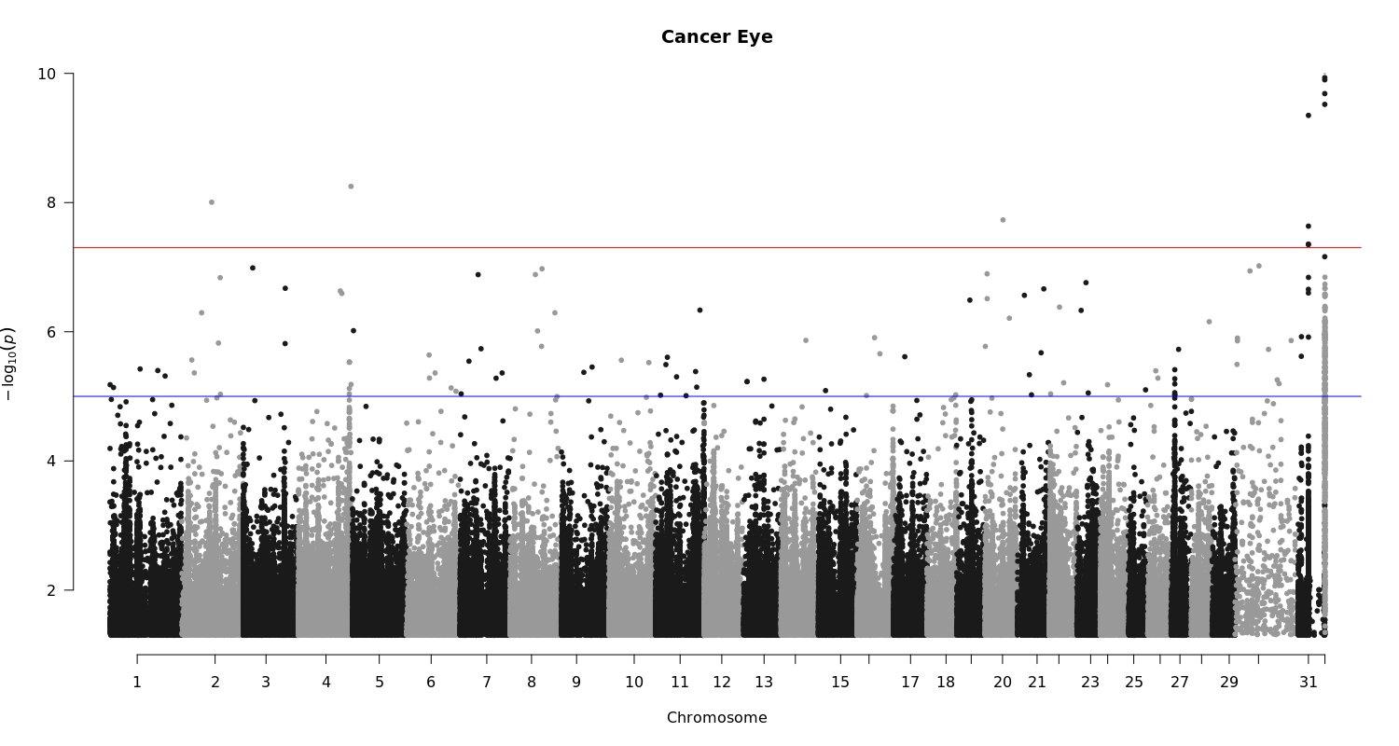
Figure 2 Cancer Eye Genome-Wide Manhattan Plot

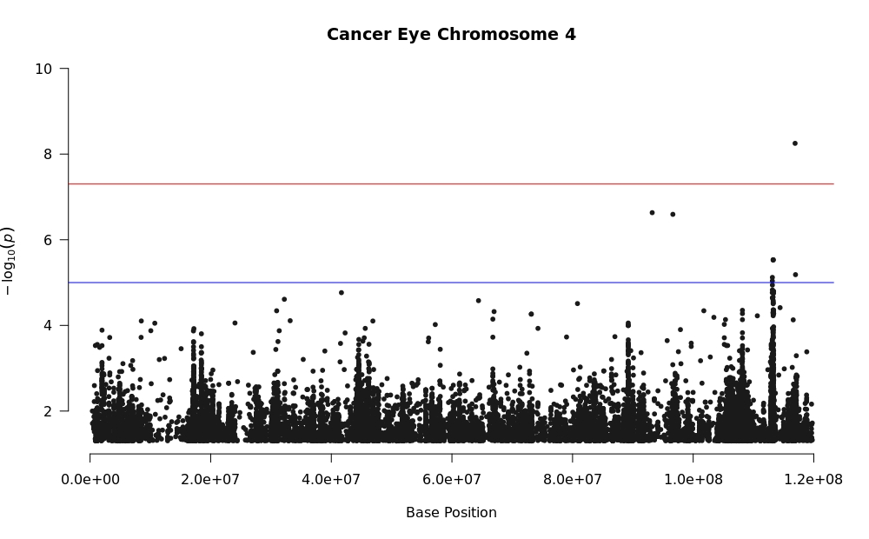
Figure 3 Cancer Eye Chromosome 4

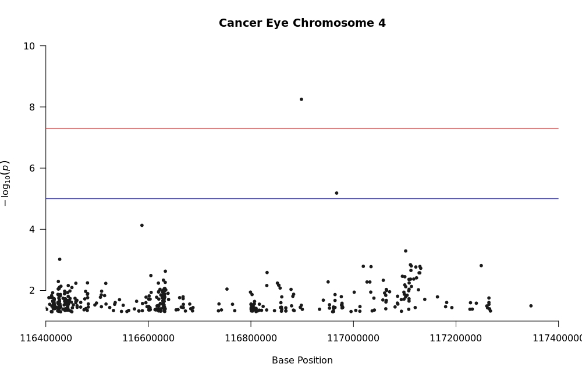
Figure 4 Cancer Eye Chromosome 4 Genome-Wide Threshold SNP

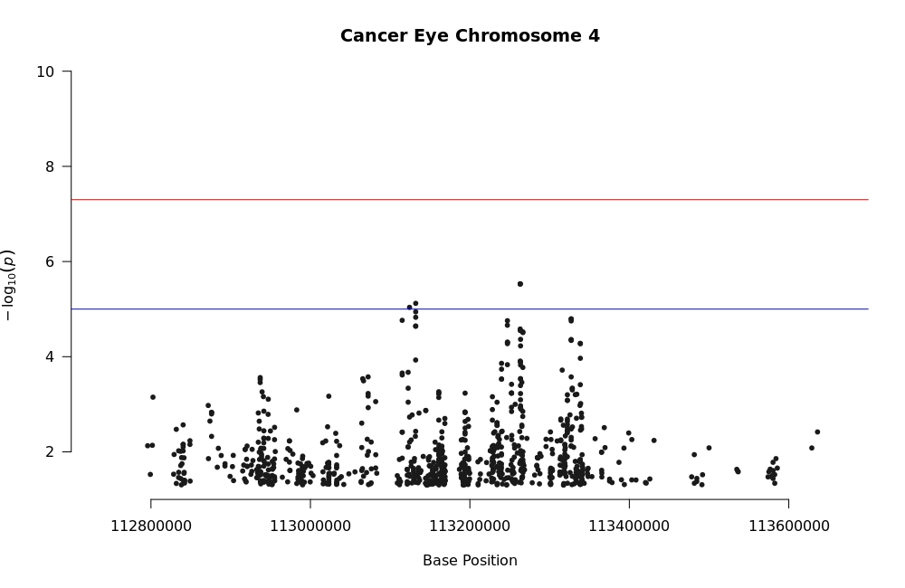
Figure 5 Cancer Eye Chromosome 4 Suggestive Peaks

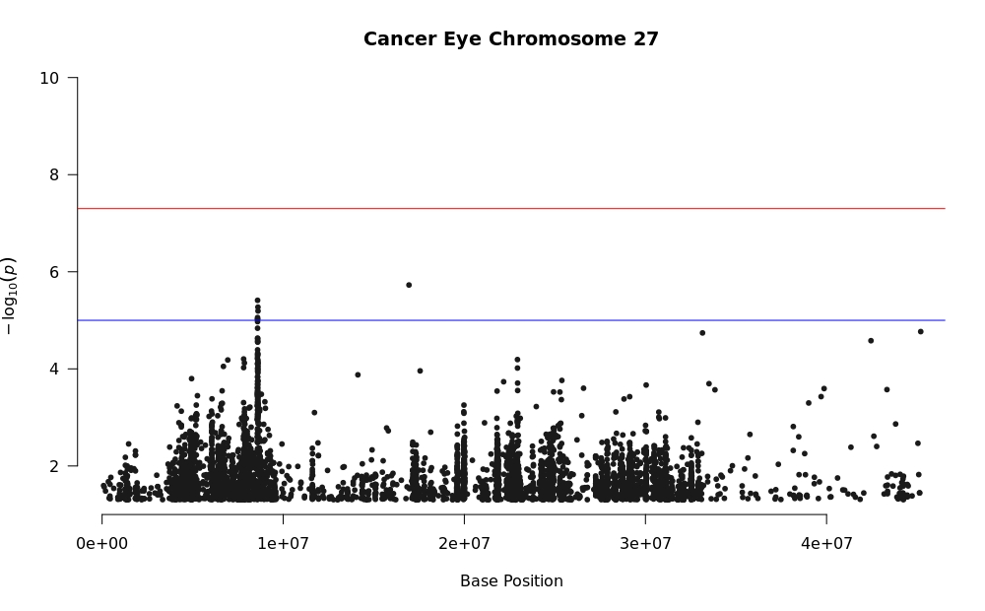
Figure 6 Cancer Eye Chromosome 27

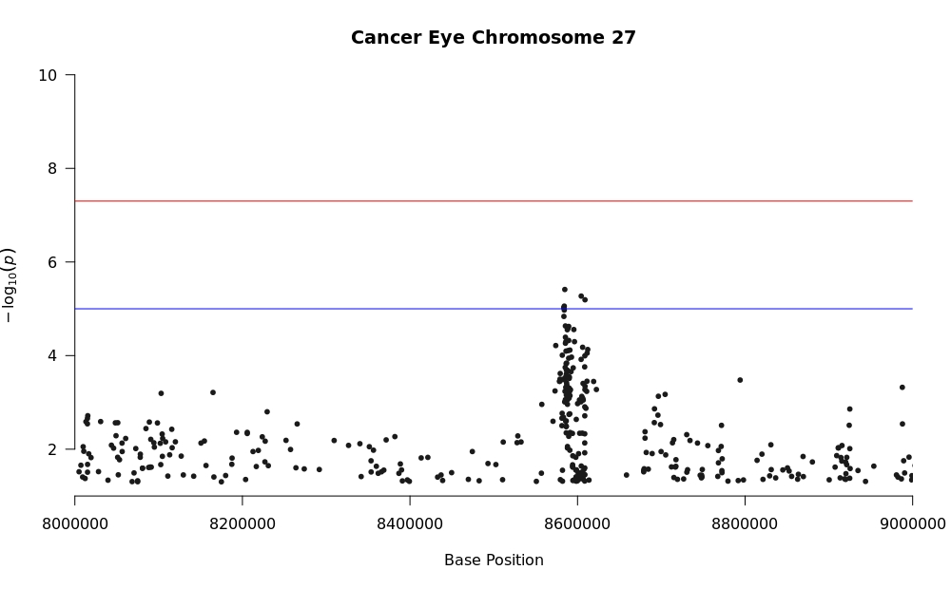
Figure 7 Cancer Eye Chromosome 27 Suggestive Peak

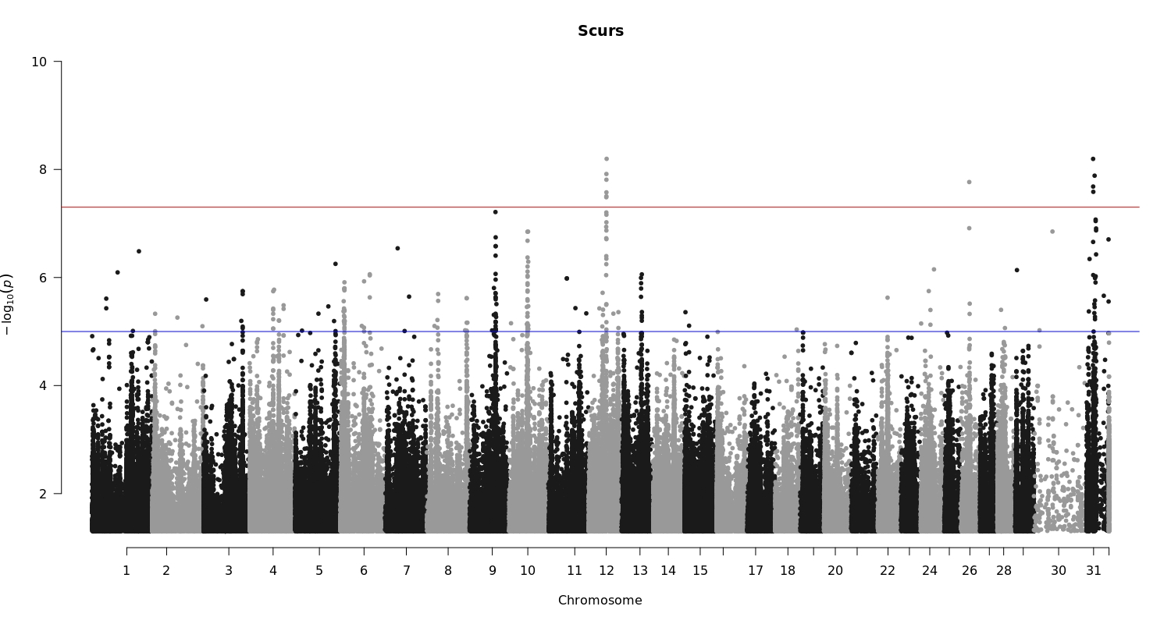
Figure 8 Scurs Genome-Wide Manhattan Plot

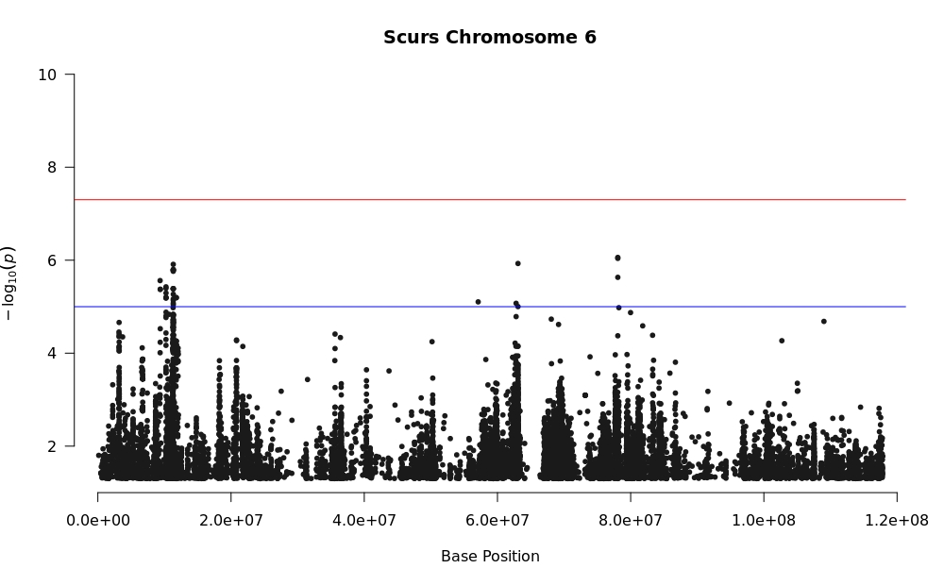
Figure 9 Scurs Chromosome 6

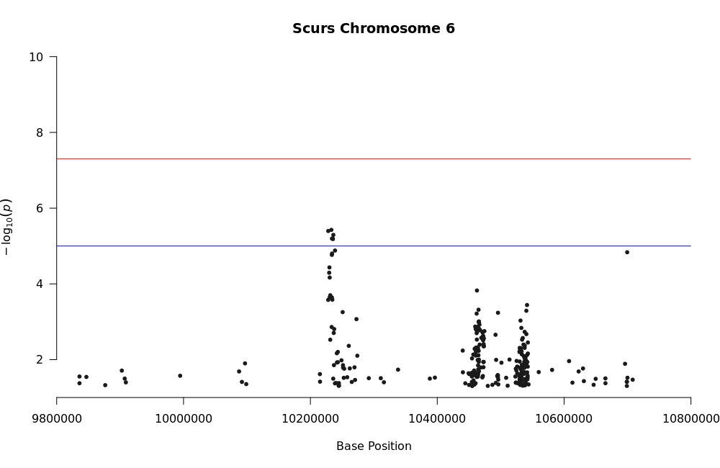
Figure 10 Scurs Chromosome 6 Suggestive Peak

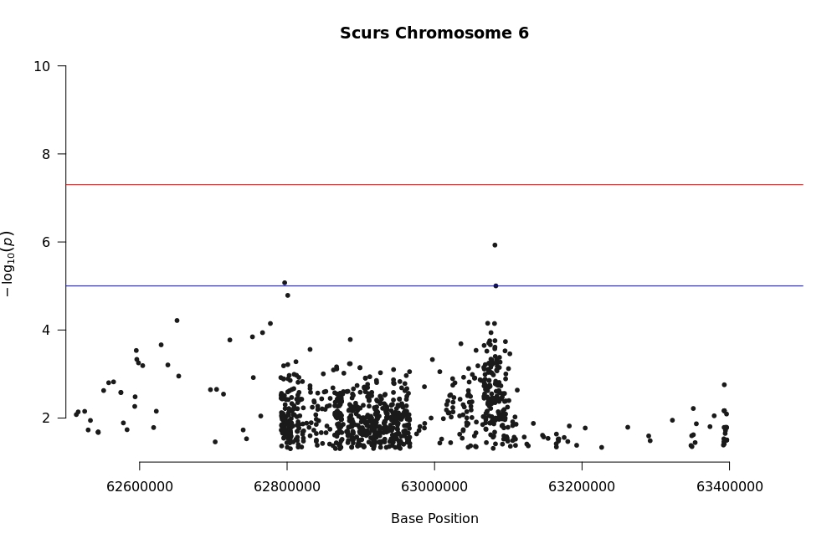
Figure 11 Scurs Chromosome 6 Suggestive Peak

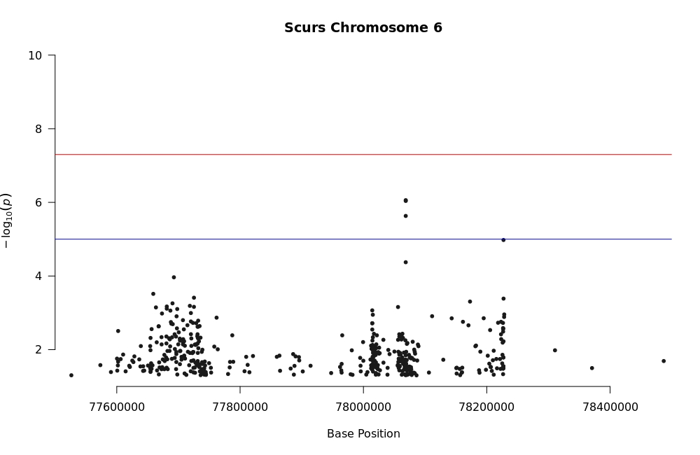
Figure 12 Scurs Chromosome 6 Suggestive Peak

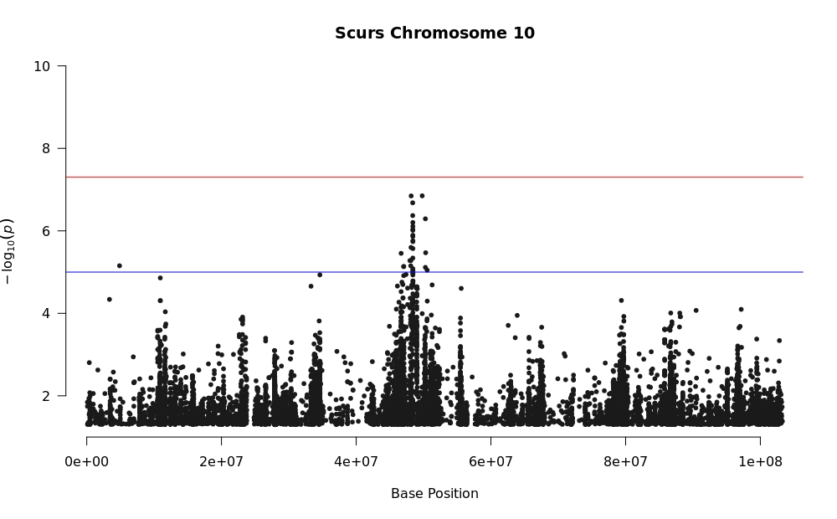
Figure 13 Scurs Chromosome 10

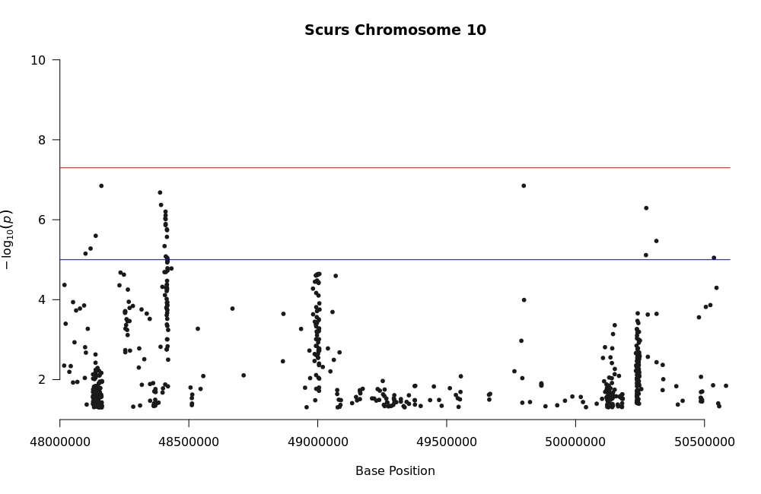
Figure 14 Scurs Chromosome 10 Three Suggestive Peaks

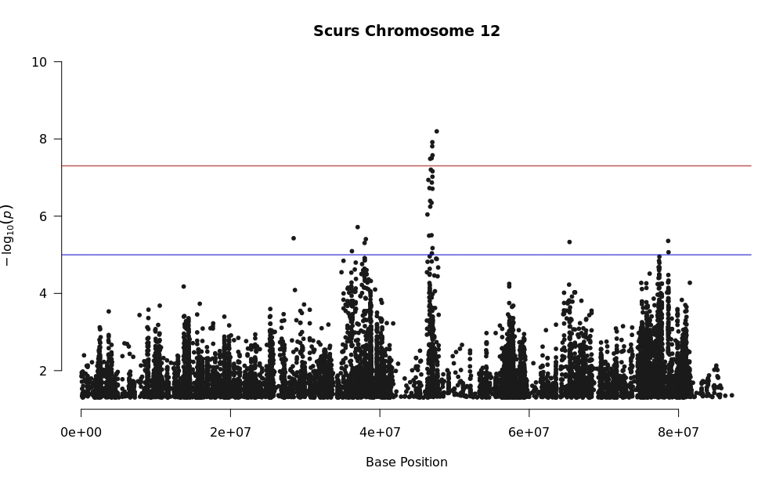
Figure 15 Scurs Chromosome 12

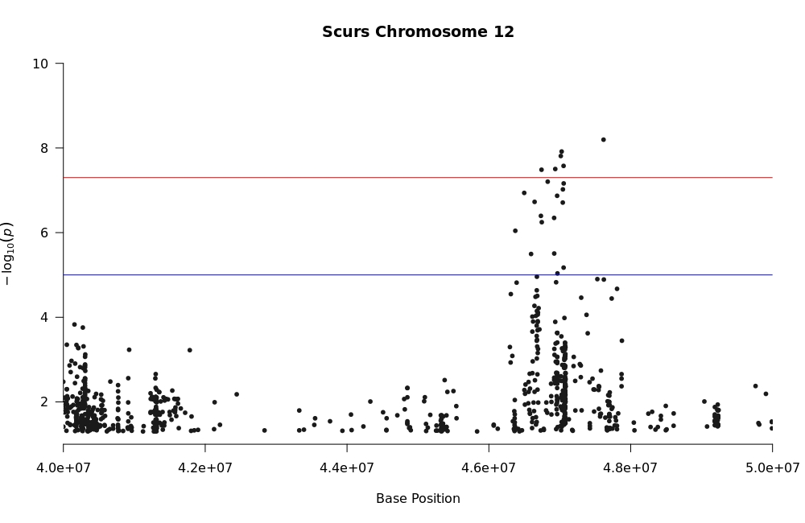
Figure 16 Scurs Chromosome 12 Genome-Wide Threshold Peak

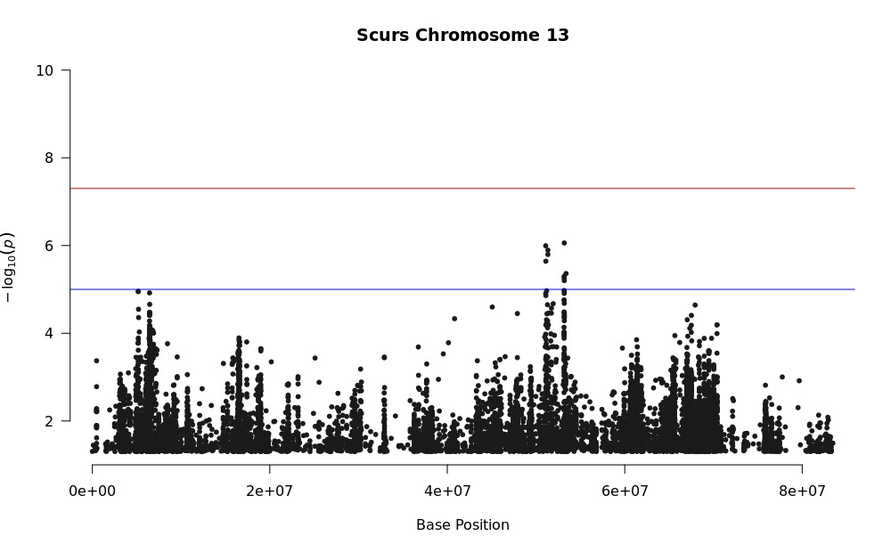
Figure 17 Scurs Chromosome 13

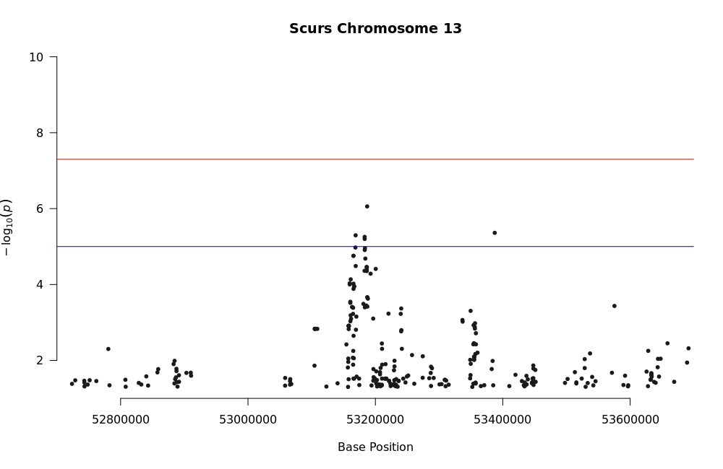
Figure 18 Scurs Chromosome 13 Suggestive Peak

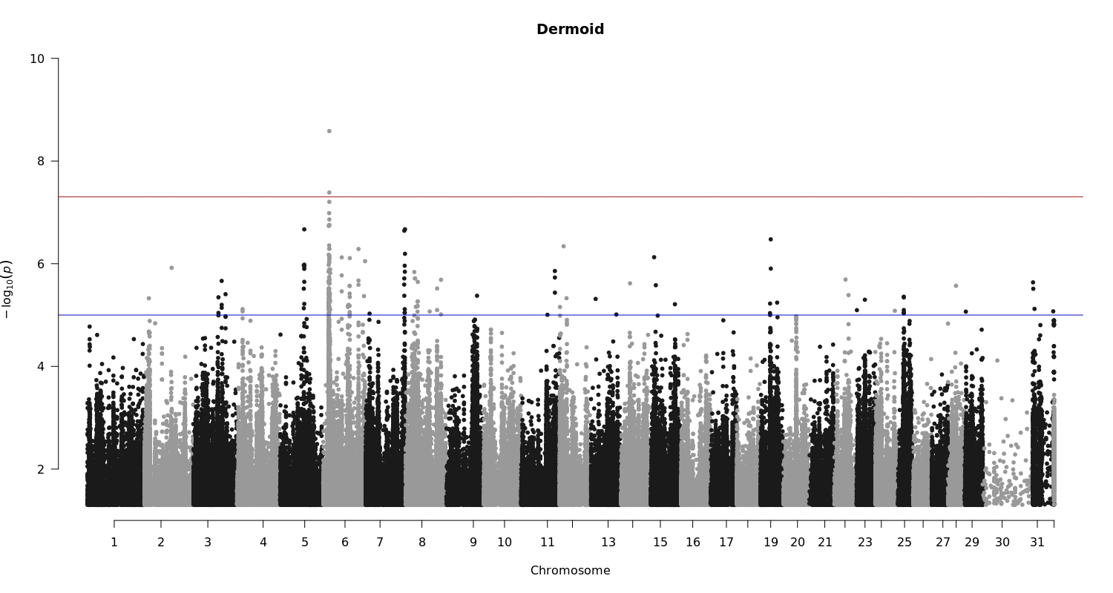
Figure 19 Dermoid Genome-Wide Manhattan Plot

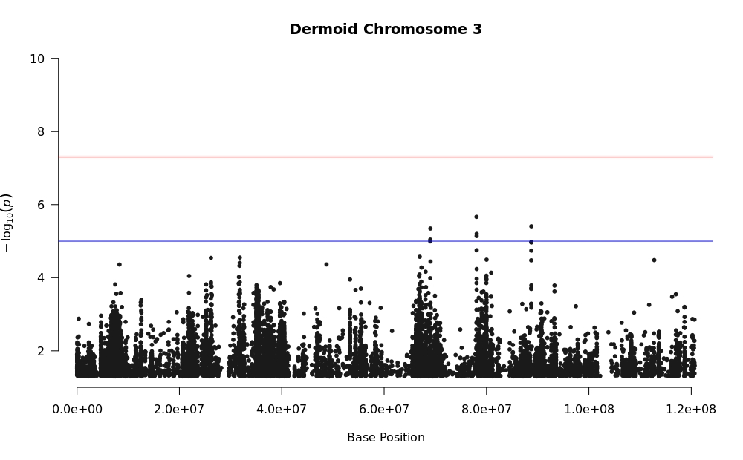
Figure 20 Dermoid Chromosome 3

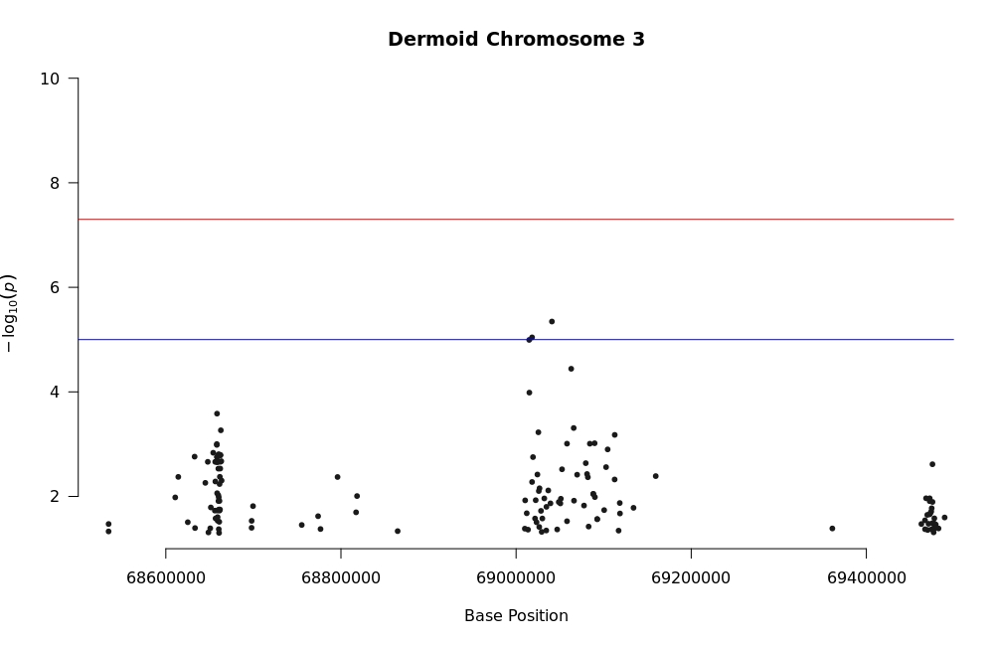
Figure 21 Dermoid Chromosome 3 Suggestive Peak

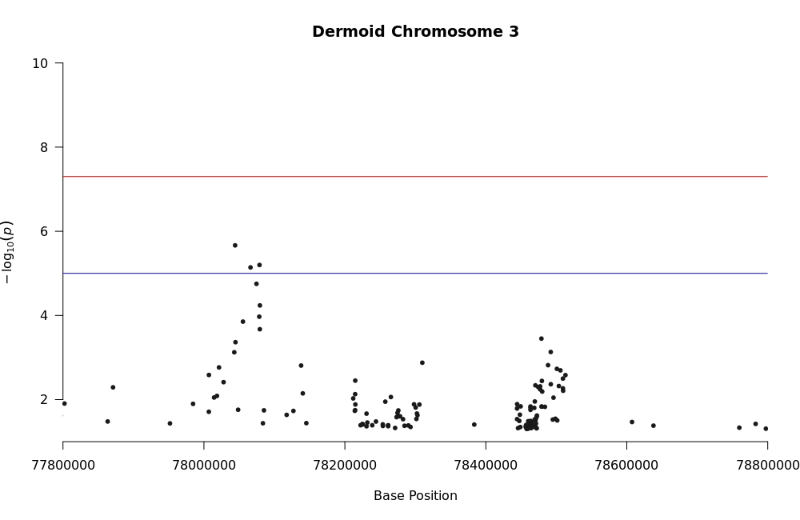
Figure 22 Dermoid Chromosome 3 Suggestive Peak

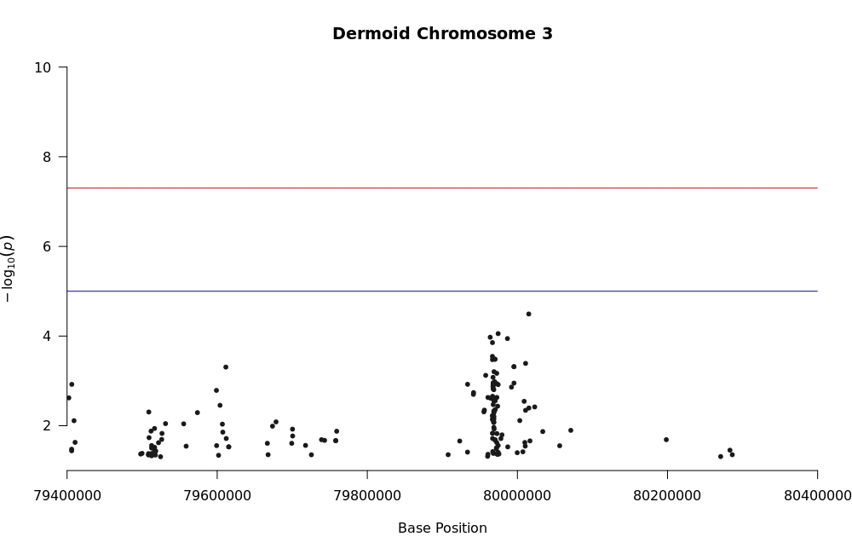
Figure 23 Dermoid Chromosome 3 Suggestive Peak

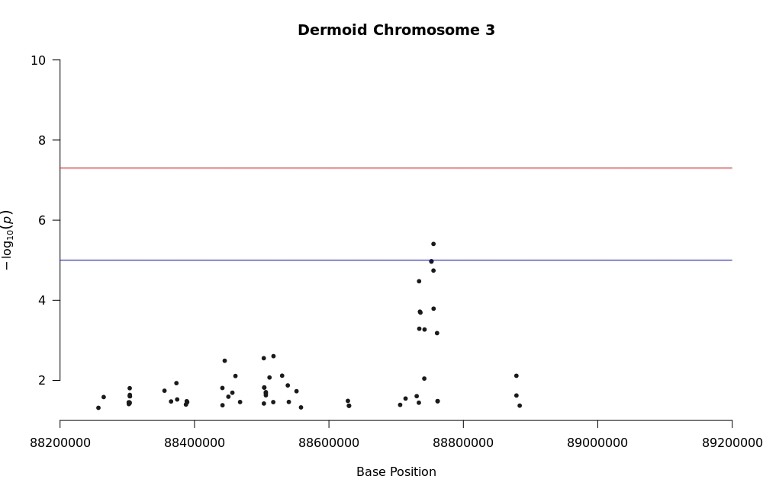
Figure 24 Dermoid Chromosome 3 Suggestive Peak

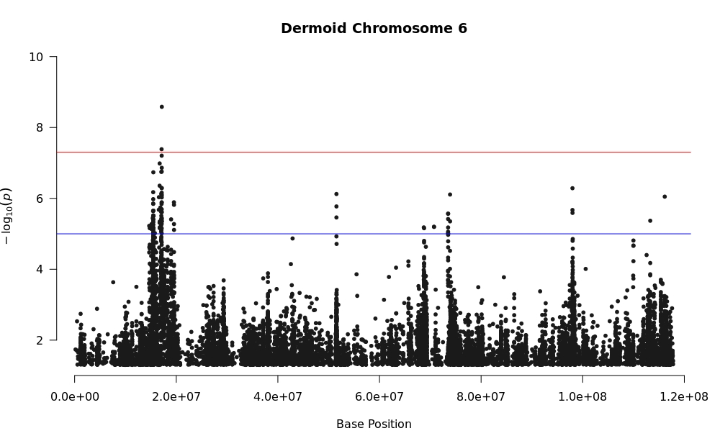
Figure 25 Dermoid Chromosome 6

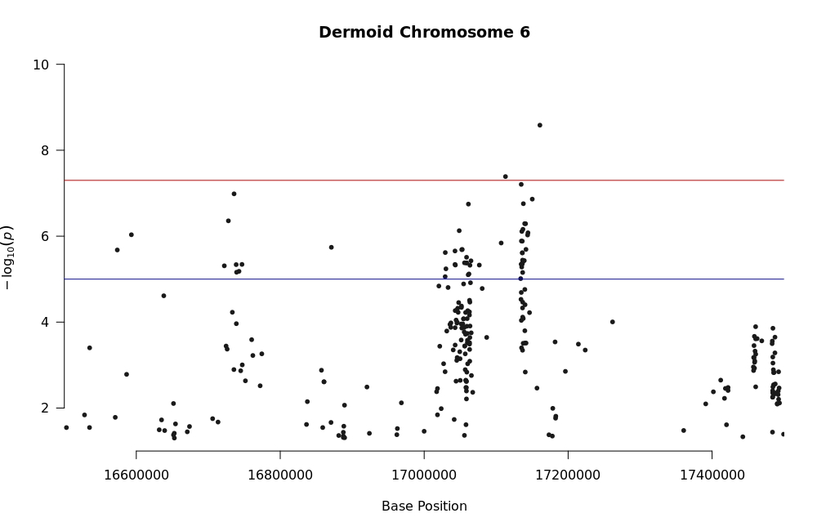
Figure 26 Dermoid Chromosome 6 Genome-Wide Threshold Peak

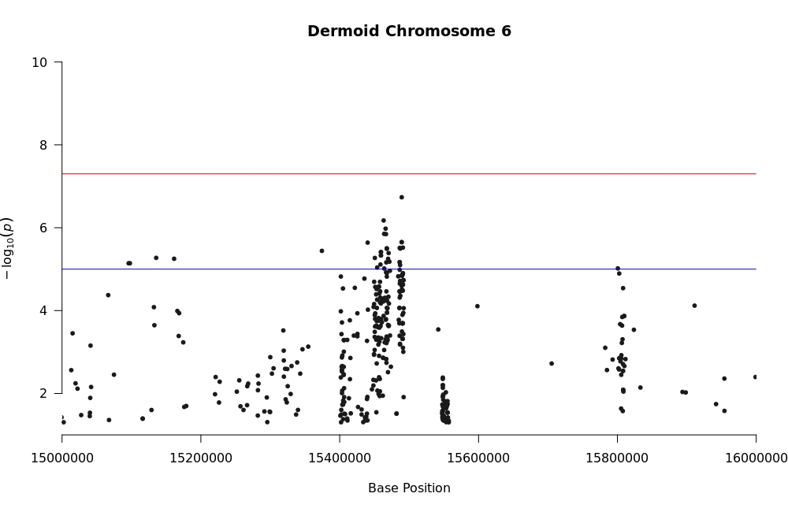
Figure 27 Dermoid Chromosome 6 Suggestive Peak

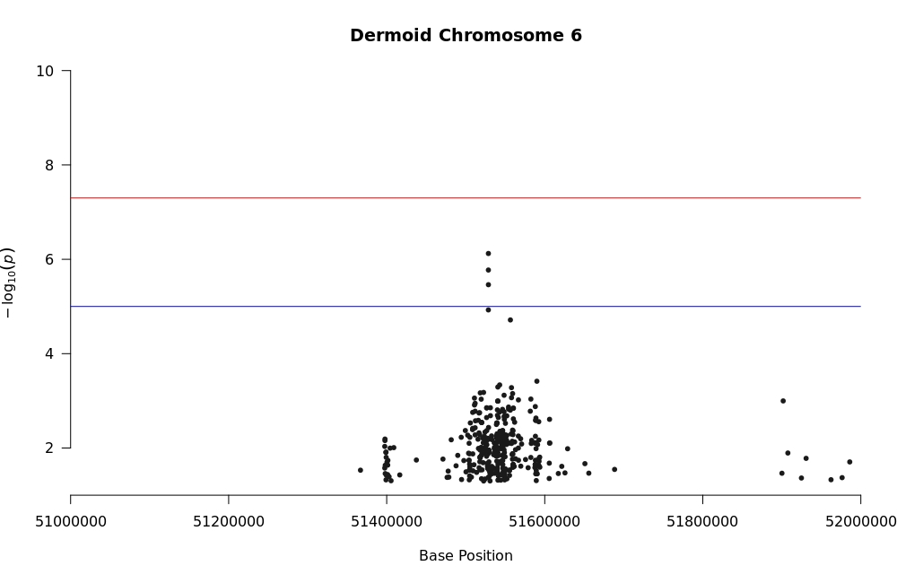
Figure 28 Dermoid Chromosome 6 Suggestive Peak

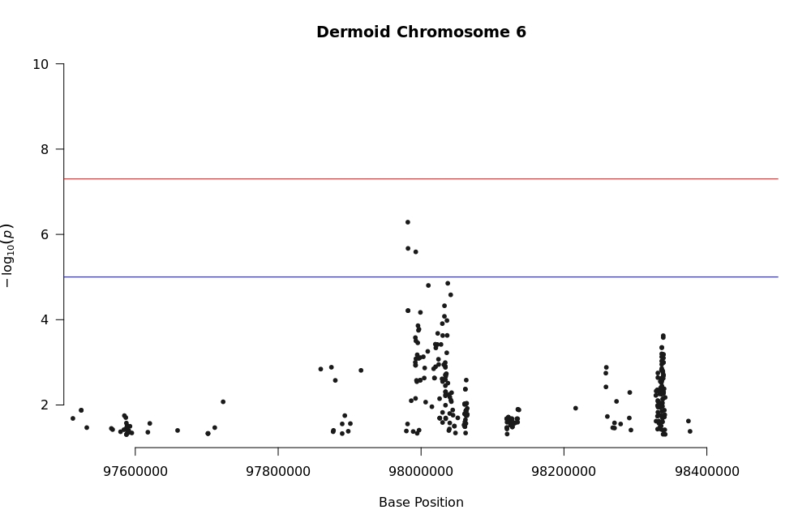
Figure 29 Dermoid Chromosome 6 Suggestive Peak

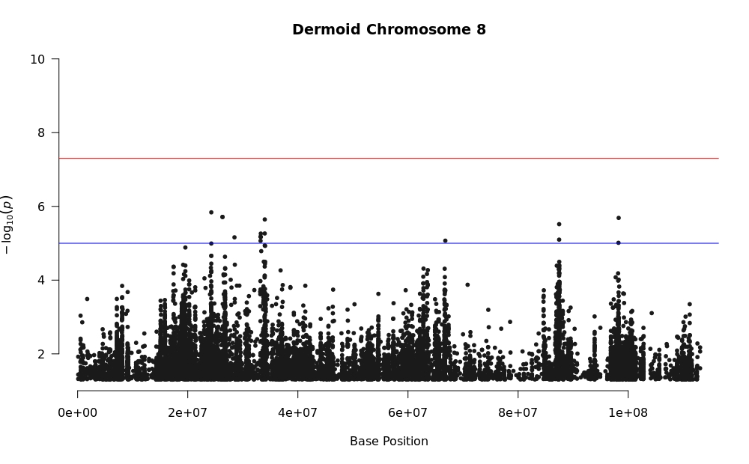
Figure 30 Dermoid Chromosome 8

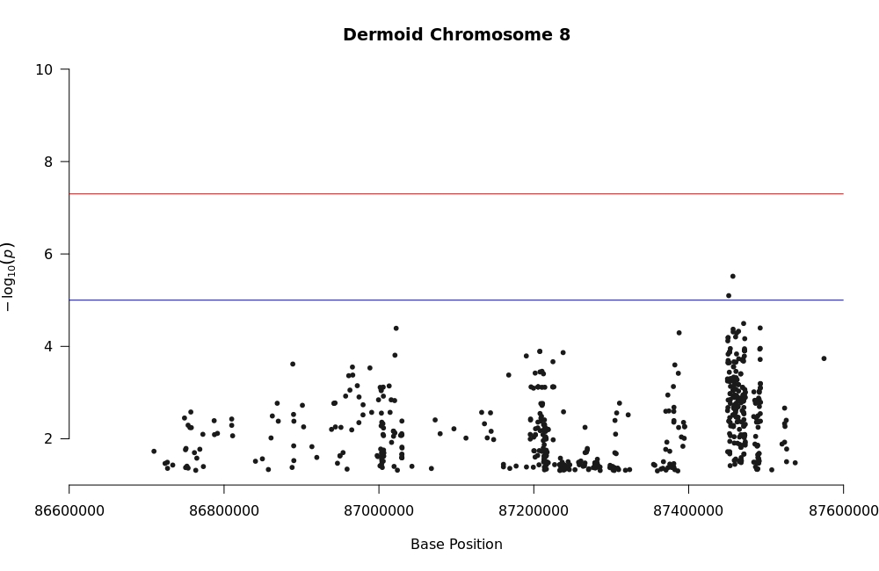
Figure 31 Dermoid Chromosome 8 Suggestive Peak

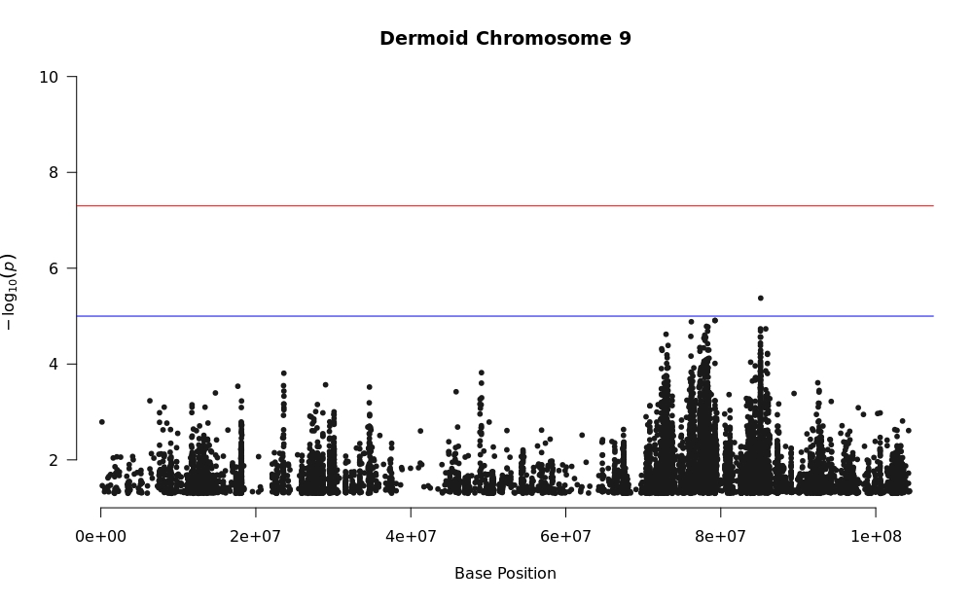
Figure 32 Dermoid Chromosome 9

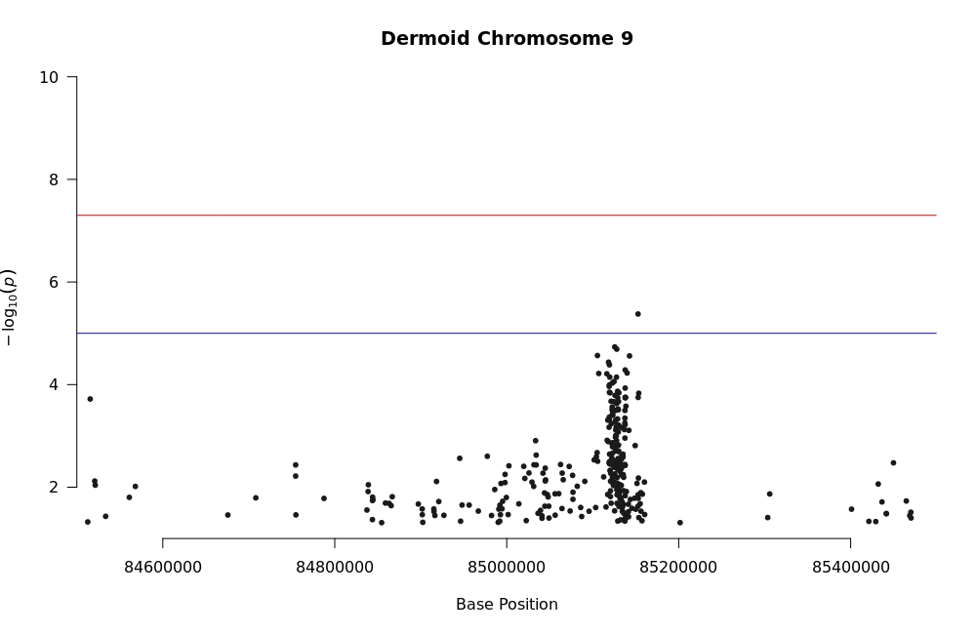
Figure 33 Dermoid Chromosome 9 Suggestive Peak

Table 4 Statistics of Whole-Genome Sequencing – Raw Case and Control Samples
Sample Classification | Average Million Sequences | Estimated Genome Coverage | Total Average Genome Coverage
Cancer Eye | 104.90 | 11.41 | 11.59
Scurred | 112.81 | 12.37
Dermoid | 103.64 | 11.36
Control | 166.22 | 15.84 | 15.84

Table 5 Statistics of Whole-Genome Sequencing – Trimmed Case and Control Samples
Sample Classification | Average Million Sequences | Estimated Genome Coverage | Total Average Genome Coverage
Cancer Eye | 93.02 | 8.08 | 9.93
Scurred | 99.87 | 8.69
Dermoid | 91.35 | 7.99
Control | 160.7 | 11.55 | 11.55

                - Vita

Beatrice Caiado was born on September 24th, 1999, in Rio de Janeiro, Brazil. Beatrice graduated high school from The American International School of Vienna in Vienna, Austria in 2017. She completed her Bachelor of Science in Animal Science at the University of Tennessee in May 2021. Beatrice began working with Dr. Jonathan Beever in the Summer of 2021 and began working for her Master of Science in Animal Science under Dr. Beever’s mentorship in August 2021.

1 Bovine genome size considered 2.7Gb 60. ARS, U. Genome assembly ARS-UCD1.3. Available online: https://www.ncbi.nlm.nih.gov/datasets/genome/GCF_002263795.2/ (accessed on 4/20/2023)

