User Perspective and Analysis of the Continuous-Energy Sensitivity Methods in SCALE 6.2 using TSUNAMI-3D

A Thesis Presented for the
Master of Science
Degree
The University of Tennessee, Knoxville

Elizabeth Lauryn Jones
May 2015

ACKNOWLEDGEMENTS

I would like to express my sincere gratitude to my advisor from the University of Tennessee, Department of Nuclear Engineering, Dr. Ivan Maldonado, for the continuous support of my M.S. study and research, and his guidance during the past year. I would also like to thank my mentor, B.J. Marshall, from Oak Ridge National Laboratory (ORNL), who shared his knowledge and experience while training me in sensitivity and uncertainty data analysis techniques, and assisted in reviewing multiple technical reports. In addition, I appreciate the other members of my committee, Dr. Ondrej Chvala, and Dr. Lawrence Heilbronn for their assistance and comments regarding the thesis review and process. I wish to acknowledge the Reactor and Nuclear Systems Division at ORNL for their computer and technical assistance throughout my M.S. graduate research.

This research would not have been possible without the financial support from the Department of Energy Nuclear Criticality Safety Program and the Nuclear Energy University Programs Fellowship, and I express my gratitude to those agencies.

ABSTRACT

The Tools for Sensitivity and UNcertainty Analysis Methodology Implementation (TSUNAMI) suite within the SCALE code system makes use of eigenvalue sensitivity coefficients to enable several capabilities, such as quantifying the data-induced uncertainty in calculated eigenvalues and assessing the similarity between different critical systems. The TSUNAMI-3D code is one tool within the TSUNAMI suite used to calculate eigenvalue sensitivity coefficients in three-dimensional models. The SCALE 6.1 code system includes only the multigroup (MG) mode for three-dimensional sensitivity analyses; however, the upcoming release of SCALE 6.2 will feature the first implementation of continuous-energy (CE) sensitivity methods in SCALE. For MG calculations, TSUNAMI-3D provides resonance self-shielding of cross-section data, calculation of the implicit effects of resonance self-shielding calculations, calculation of forward and adjoint Monte Carlo neutron transport solutions, and calculation of sensitivity coefficients. In CE-TSUNAMI, the sensitivity coefficients are computed in a single forward Monte Carlo neutron transport calculation. The two different approaches for calculating eigenvalue sensitivity coefficients in CE-TSUNAMI are the Iterated Fission Probability (IFP) and the Contributon-Linked eigenvalue sensitivity/Uncertainty estimation via Tracklength importance CHaracterization (CLUTCH) methods. Unlike IFP, CLUTCH has a significantly lower memory footprint, is faster, and has been implemented with parallel capability; however, CLUTCH requires additional input parameters, which require additional user expertise.

This work summarizes the results of TSUNAMI-3D calculations using both MG and CE CLUTCH methods for various systems in the International Handbook of Evaluated Criticality Safety Benchmark Experiments (IHECSBE) using the SCALE code package developed at Oak Ridge National Laboratory. The critical benchmark experiments will cover both the KENO V.a and KENO-VI codes using the ENDF/B-VII.0 data for the different evaluations. The broad range of types of systems will expand the experience base with the CE-TSUNAMI CLUTCH method by identifying best practices for using the code, and provide generic user guidance for utilizing this new capability. Additionally, the study aims to demonstrate the accuracy and usefulness of the CE-TSUNAMI CLUTCH method, especially for systems for which MG methods perform poorly.

PREFACE

Initially, my graduate research started on a Department of Energy (DOE) Nuclear Criticality Safety Program (NCSP) project that focused on performing sensitivity calculations for documented International Criticality Safety Benchmark Evaluation Project (ICSBEP) evaluations using the Verified, Archived Library of Inputs and Data (VALID) procedure at Oak Ridge National Laboratory.

The goal of the NCSP project was to identify an appropriate set of documented ICSBEP evaluations and to provide TSUNAMI-generated sensitivity data files and verified SCALE input files for distribution with the ICSBEP handbook, aiming to provide sensitivity profiles for benchmark evaluations that are already published in the ICSBEP handbook. Traditionally, the TSUNAMI-generated sensitivity data files were obtained by using the multigroup (MG) library, since SCALE 6.1 does not have continuous-energy (CE) TSUNAMI capabilities.

After a few months of performing the above research, I had difficulty obtaining accurate MG TSUNAMI sensitivities in SCALE 6.1 for a specific case. An ORNL staff member suggested that I attempt running the sensitivity calculations with the new SCALE 6.2 CE TSUNAMI since the MG TSUNAMI sensitivity calculations were unsuccessful for the specific evaluation. This led to the decision to expand my CE TSUNAMI experience and perform the following study in order to share the information gained regarding CE TSUNAMI.

TABLE OF CONTENTS
SECTION 1 INTRODUCTION 1
SECTION 2 CODE DESCRIPTION 3
Multigroup TSUNAMI-3D Techniques 3
Continuous-Energy TSUNAMI-3D Techniques 4
IFP. 5
CLUTCH. 5
Overview of Important CE TSUNAM-3D Parameters. 6
SECTION 3 SENSITIVITY DATA COMPARISON PROCESS 8
SECTION 4 DESCRIPTION OF EVALUATIONS FOR SENSITIVITY ANALYSIS 12
MIX-SOL-THERM-002 Model Description 13
MIX-SOL-THERM-004 Model Description 13
MIX-SOL-THERM-005 Model Description 15
MIX-MISC-THERM-001 Model Description 16
PU-SOL-THERM-011 Model Description 18
HEU-SOL-THERM-001 Model Description 19
HEU-MET-MIXED-017 Model Description 20
HEU-MET-FAST-018 Model Description 21
HEU-MET-FAST-093 Model Description 22
IEU-MET-FAST-007 Model Description 23
LEU-COMP-THERM-042 Model Description 25
SECTION 5 RESULTS FOR MG TSUNAMI-3D AND CE TSUNAMI-3D 27
MIX-SOL-THERM-002-001 Results 28
MIX-SOL-THERM-004-001 Results 31
MIX-SOL-THERM-005-001 Results 34
MIX-MISC-THERM-001-001 Results 38
PU-SOL-THERM-011-012 Results 41
HEU-SOL-THERM-001-001 Results 47
HEU-MET-MIXED-017-001 Results 51
HEU-MET-FAST-018-001 Results 56
HEU-MET-FAST-093-001 Results 59
IEU-MET-FAST-007-001 Results 62
LEU-COMP-THERM-042-007 Results 68
SECTION 6 CONCLUSIONS 74
SECTION 7 FUTURE WORK 76
REFERENCES 77
APPENDIX 79
Appendix A 80
Appendix B 82
Appendix C 84
VITA 85

LIST OF TABLES
Table 1. Required Parameters for CE TSUNAMI-3D CLUTCH 6
Table 2. Recommended Parameters for CE TSUNAMI-3D CLUTCH 7
Table 3. Types of Systems Analyzed in CE TSUNAMI-3D CLUTCH 12
Table 4. MST-002-001 CSAS5 k_{eff} Results Using the V7-238 and the CE_V7 Libraries 28
Table 5. MG TSUNAMI-3D Results for MST-002-001 28
Table 6. CE TSUNAMI-3D CLUTCH Results for MST-002-001 30
Table 7. MST-004-001 CSAS6 k_{eff} Results Using the V7-238 and the CE_V7 Libraries 32
Table 8. MG TSUNAMI-3D Results for MST-004-001 32
Table 9. CE TSUNAMI-3D CLUTCH Results for MST-004-001 33
Table 10. MST-005-001 CSAS5 k_{eff} Results Using the V7-238 and the CE_V7 Libraries 35
Table 11. MG TSUNAMI-3D CLUTCH Results for MST-005-001 35
Table 12. CE TSUNAMI-3D Results for MST-005-001 36
Table 13. MMT-001-001 CSAS5 k_{eff} Results Using the V7-238 and the CE_V7 Libraries 38
Table 14. MG TSUNAMI-3D Results for MMT-001-001 38
Table 15. CE TSUNAMI-3D CLUTCH Results for MMT-001-001 40
Table 16. PST-011-012 CSAS5 k_{eff} Results Using the V7-238 and the CE_V7 Libraries 41
Table 17. MG TSUNAMI-3D Results for PST-011-012 42
Table 18. CE TSUNAMI-3D CLUTCH Results for PST-011-012 43
Table 19. HST-001-001 CSAS5 k_{eff} Results Using the V7-238 and the CE_V7 Libraries 47
Table 20. MG TSUNAMI-3D Results for HST-001-001 48
Table 21. CE TSUNAMI-3D CLUTCH Results for HST-001-001 50
Table 22. HMM-017-001 CSAS5 k_{eff} Results Using the V7-238 and the CE_V7 Libraries 51
Table 23. MG TSUNAMI-3D Results for HMM-017-001 52
Table 24. CE TSUNAMI-3D CLUTCH Results for HMM-017-001 53
Table 25. HMF-018-001 CSAS5 k_{eff} Results Using the V7-238 and the CE_V7 Libraries 56
Table 26. MG TSUNAMI-3D Results for HMF-018-001 56
Table 27. CE TSUNAMI-3D CLUTCH Results for HMF-018-001 58
Table 28. HMF-093-001 CSAS6 k_{eff} Results Using the V7-238 and the CE_V7 Libraries 59
Table 29. MG TSUNAMI-3D Results for HMF-093-001 60
Table 30. CE TSUNAMI-3D CLUTCH Results for HMF-093-001 61
Table 31. IMF-007-001 CSAS5 k_{eff} Results Using the V7-238 and the CE_V7 Libraries 62
Table 32. MG TSUNAMI-3D Results for IMF-007-001 63
Table 33. CE TSUNAMI-3D CLUTCH Results for IMF-007-001 with GEN=5000, NPG=200000, and NSK=1000 64
Table 34. CE TSUNAMI-3D CLUTCH Results for IMF-007-001 with GEN=6000, NPG=200000, and NSK=2000 65
Table 35. LCT-042-007 CSAS5 k_{eff} Results Using the V7-238 and the CE_V7 Libraries 68
Table 36. MG TSUNAMI-3D Results for LCT-042-007 69
Table 37. CE TSUNAMI-3D CLUTCH Optimal Results for LCT-042-007 with NPG=50,000 70
Table 38. CE TSUNAMI-3D CLUTCH Summary of Case-Specific Parameters 74
Table 39. CE TSUNAMI-3D Extended Results for PST-011-012 with NPG=10000 and NSK=1000 80
Table 40. CE TSUNAMI-3D Extended Results for LCT-042-007 with GEN=5000 and NSK=500 82
Table 41. TSUNAMI-3D Summary of Results for MG and CE CLUTCH for LCT-042-007 84

LIST OF FIGURES
Figure 1. Vertical Plan View for the Model Geometry of MST-002 13
Figure 2. Elevation View for Part of the Model Geometry of MST-004 14
Figure 3. Benchmark Model Elevation View of MST-004-001 14
Figure 4. Benchmark Model Plan View of MST-004-001 15
Figure 5. Elevation View for Part of the Model Geometry of MST-005 15
Figure 6. Schematic of the Boiler Tube-Type Tank used for MMT-001 16
Figure 7. Benchmark Model Elevation View of MMT-001 17
Figure 8. Model of Fuel Rod in Guide Tube for MMT-001 17
Figure 9. Benchmark Model for PST-011 19
Figure 10. Experimental Configuration of HST-001 20
Figure 16. Axial-View Schematic of Detailed Benchmark Model of IMF-007 25
Figure 19. Benchmark Model Elevation View of LCT-042 26
Figure 20. TSUNAMI-3D and Direct Perturbation Sensitivity Comparisons for Representative MST-002-001 Nuclides in the Solution 31
Figure 21. Figures of Merit for MG and CE TSUNAMI-3D for MST-002-001 31
Figure 22. TSUNAMI and Direct Perturbation Sensitivity Comparisons for Representative MST-004-001 Nuclides in the Solution 34
Figure 23. TSUNAMI and Direct Perturbation Sensitivity Comparisons for Representative MST-005-001 Nuclides in the Solution 37
Figure 24. TSUNAMI and Direct Perturbation Sensitivity Comparisons for Representative MMT-001-001 Nuclides 41
Figure 25. CE TSUNAMI-3D Hydrogen Sensitivity as a Function of Total Active Particles PST-011-012 44
Figure 26. CE TSUNAMI-3D Hydrogen Sensitivity Uncertainty as a Function of Runtime in Serial for PST-011-012 44
Figure 27. Meshview Plot of F*(r) with NPG=200,000 for PST-011-012 46
Figure 28. Plot of F*(r) Values in the x-direction for PST-011-012 46
Figure 29. TSUNAMI and Direct Perturbation Sensitivity Comparisons for Representative PST-011-012 Nuclides in the Solution 46
Figure 30. Figures of Merit for MG and CE TSUNAMI-3D for PST-011-012 47
Figure 31. TSUNAMI and Direct Perturbation Sensitivity Comparisons for Representative HST-001-001 Nuclides in the Solution 50
Figure 32. Figures of Merit for MG and CE TSUNAMI-3D for HST-001-001 51
Figure 33. TSUNAMI and Direct Perturbation Sensitivity Comparisons for Representative HMM-017-001 Nuclides 55
Figure 34. Figures of Merit for MG and CE TSUNAMI-3D for HMM-017-001 55
Figure 35. TSUNAMI and Direct Perturbation Sensitivity Comparisons for Representative HMF-018-001 Nuclides 58
Figure 36. Figures of Merit for MG and CE TSUNAMI-3D for HMF-018-001 59
Figure 37. TSUNAMI and Direct Perturbation Sensitivity Comparisons for Representative HMF-093-001 Nuclides 61
Figure 38. Figures of Merit for MG and CE TSUNAMI-3D for HMF-093-001 62
Figure 39. Front View Meshview Image of F*(r) Relative Uncertainty for IMF-007-001 66
Figure 40. Meshview Plot of F*(r) Values for the Optimal Case 66
Figure 41. TSUNAMI and Direct Perturbation Sensitivity Comparisons for Representative IMF-007-001 Nuclides 67
Figure 42. Figures of Merit for MG and CE TSUNAMI-3D for IMF-007-001 68
Figure 43. Meshview Plot of F*(r) Values for Optimal Parameters for LCT-042-007 70
Figure 44. Meshview Plot of F*(r) Relative Uncertainties for NPG=50,000 71
Figure 45. Plot of F*(r) Values in the x-direction for NPG=50,000 for LCT-042-007 71
Figure 46. TSUNAMI and Direct Perturbation Sensitivity Comparisons for Representative LCT-042-007 Nuclides 72
Figure 47. CE TSUNAMI-3D Sensitivity for Hydrogen for LCT-042-007 as a Function of Total Active Particles 73
Figure 48. Figure of Merit for MG and CE TSUNAMI-3D for LCT-042-007 73

SECTION 1
INTRODUCTION

Sensitivity and uncertainty analysis allows industry to associate an importance with each material, nuclide, reaction and energy by simulating real-world criticality scenarios. Cross-section sensitivity and uncertainty data can be used to guide criticality safety validation efforts and, while cross-section uncertainty data is tabulated for each data library, sensitivity data must be generated for each system. The sensitivity calculations can be computationally expensive and cumbersome, therefore development efforts are underway to identify and implement easier or more efficient methods for these calculations.
The Tools for Sensitivity and UNcertainty Analysis Methodology Implementation (TSUNAMI) suite within the SCALE code system [1] makes use of eigenvalue sensitivity coefficients to enable several capabilities, such as quantifying the data-induced uncertainty in calculated eigenvalues and assessing the similarity between different critical systems [2]. The TSUNAMI-3D code is one tool within the TSUNAMI suite used to calculate eigenvalue sensitivity coefficients in three-dimensional models. The coefficients represent the sensitivity of k_{eff} to each constituent cross-section data component used in the calculation. The sensitivity data are coupled with cross-section uncertainty data to produce an uncertainty in k_{eff} due to uncertainties in the underlying nuclear data. SCALE 6.2 will include two modes for three-dimensional cross-section sensitivity analyses: multigroup (MG) and continuous-energy (CE).
The SCALE 6.1 code system includes only the MG mode for three-dimensional sensitivity analyses; however, the upcoming release of SCALE 6.2 will feature the first implementation of CE sensitivity methods in SCALE [3]. For MG calculations, TSUNAMI-3D provides resonance self-shielding of cross-section data, calculation of the implicit effects of resonance self-shielding calculations, calculation of forward and adjoint Monte Carlo neutron transport solutions, and calculation of sensitivity coefficients. In CE-TSUNAMI, the sensitivity coefficients are computed in a single forward Monte Carlo neutron transport calculation. The two different approaches for calculating eigenvalue sensitivity coefficients in CE TSUNAMI are the Iterated Fission Probability (IFP) and the Contributon-Linked eigenvalue sensitivity/Uncertainty estimation via Tracklength importance CHaracterization (CLUTCH) methods.
Unlike IFP, CLUTCH has a significantly lower memory footprint, is faster, and has been implemented with parallel capability; however, CLUTCH requires additional input parameters, which require additional user expertise. These methods allow analysis of some types of systems that cannot be analyzed accurately in previous versions of SCALE due to limitations within the traditional, MG methods in the TSUNAMI suite. Some work demonstrating the efficacy of the CE TSUNAMI methods has been published [4,5], but only a limited number of systems have been examined with these techniques to date. This work summarizes the results of TSUNAMI-3D calculations using both the traditional MG approach in SCALE 6.1 and the CE CLUTCH method in SCALE 6.2. The TSUNAMI-3D models used to analyze the accuracy of the CE CLUTCH method are based on critical experiments documented in the International Handbook of Evaluated Criticality Safety Benchmark Experiments (IHECSBE) [6].
The systems examined in this study include combinations of fast, thermal, and mixed spectrums with metal, compound, and solution material forms. The primary fissile species include low-enriched uranium, intermediate-enriched uranium, high-enriched uranium, plutonium, and mixed uranium and plutonium. None of the populations of experiments considered here is sufficiently large for safety-related validation, but the cases selected provide an indication of general code performance for these systems. This broad range of systems expands the experience base with the CE CLUTCH method, identifies best practices for using the code, and provides generic user guidance for utilizing this new capability. Additionally, the study aims to demonstrate the accuracy and usefulness of the CE CLUTCH method, especially for systems for which MG methods perform poorly.

SECTION 2
CODE DESCRIPTION

The SCALE code system contains two Monte Carlo transport codes used primarily for nuclear criticality safety analyses: KENO V.a and KENO-VI, both of which solve the k-effective (k_{eff}) eigenvalue problem in three-dimensions using the Monte Carlo method. KENO V.a and KENO-VI can perform calculations using either multigroup (MG) or continuous-energy (CE) physics. KENO V.a allows a fairly simple description of complicated systems and is capable of using repeating Cartesian array structures and holes to facilitate system descriptions; however, each geometry object must be oriented along a coordinate axis, and objects are not allowed to intersect. KENO-VI has similar capabilities to KENO V.a but incorporates the SCALE Generalized Geometry Package (SGGP) and is therefore able to represent systems of significantly increased geometric complexity. A predefined set of geometry objects can be specified to define regions of space, or generalized quadratic surfaces can be supplied for regions that are not well described by any of the predefined shapes. KENO-VI also supports rotation and therefore allows bodies to be oriented in directions that are not parallel to the major coordinate axes. KENO-VI continues to support holes and arrays, including rectangular, triangular (hexagonal), and dodecahedral arrays. Intersecting geometry definitions can be supplied for exact modeling of features such as pipe junctions.
Currently, two computational sequences are available with TSUNAMI-3D to calculate sensitivities: TSUNAMI-3D-K5 and TSUNAMI-3D-K6. TSUNAMI-3D uses the same material and cell data input as all other SCALE sequences. In SCALE 6.2, TSUNAMI-3D calculates eigenvalue sensitivity coefficients using either MG or CE Monte Carlo simulations, but the theoretical approaches for each calculation mode differ significantly.

Multigroup TSUNAMI-3D Techniques

For MG calculations, TSUNAMI-3D provides automated, problem-dependent cross sections using the same methods and input as the Criticality Safety Analysis Sequences (CSAS). In place of the BONAMI code used by CSAS, TSUNAMI-3D utilizes the sensitivity version called BONAMIST. This enhanced code computes the resonance self-shielded cross sections and their sensitivities to the input data, the so-called “implicit sensitivities.” Additionally, several routines from the Material Information Processor Library (MIPLIB) of SCALE are replaced with corresponding sensitivity versions from the Sensitivity Library (SENLIB).
After the cross sections are processed, the TSUNAMI-3D-K5 sequence performs two KENO V.a criticality calculations in MG mode, one forward and one adjoint; the MG-TSUNAMI-3D-K6 sequence performs two KENO-VI calculations. If a mesh is added to the MG TSUNAMI-3D input file, the forward and adjoint fluxes are accumulated over the same mesh, and then the fluxes are multiplied together prior to summing over a region (e.g. all fuel pins). Without a specified mesh, the forward and adjoint fluxes are accumulated over the same region. Finally, the sequences call the Sensitivity Analysis Module for SCALE (SAMS) to calculate the sensitivity coefficients and, if requested, the uncertainty in the calculated value of k_{eff} due to uncertainties in the basic nuclear data. SAMS prints energy-integrated sensitivity coefficients and their statistical uncertainties to the SCALE output file and generates a sensitivity data file (SDF) containing the energy-dependent sensitivity coefficients. Additional details of the MG sensitivity methods used in TSUNAMI-3D are provided in Reference 1.

Continuous-Energy TSUNAMI-3D Techniques

Currently, the two different approaches for calculating eigenvalue sensitivity coefficients in CE TSUNAMI are the Iterated Fission Probability (IFP) and the Contributon-Linked eigenvalue sensitivity/Uncertainty estimation via Tracklength importance CHaracterization (CLUTCH) methods. Both methods calculate sensitivity coefficients within a single forward Monte Carlo calculation and without the use of a flux mesh. Instead of directly calculating the adjoint flux, the two CE TSUNAMI-3D methods estimate the importance of events in a particle’s lifetime by tracking and storing additional information regarding that particle history, which are used to weight reaction rate tallies and calculate eigenvalue sensitivity coefficients [7]. Even though both methods calculate sensitivities based on importance estimates, the IFP and CLUTCH methods differ in the efficiency, memory requirements, and implementation of the importance calculations.

IFP. The IFP method is activated in TSUNAMI-3D by setting the CET parameter to 2. The IFP method determines the importance of events by examining the population of neutrons in the system that are descendants of the neutron that initiated these events. The generations between an event and the assessment of importance are referred to as “latent generations.” The number of latent generations to use is controlled with the CFP parameter. If neutrons disperse quickly through the system, then CFP can be small, such as 2 - 5; however, if they disperse through the system slowly, then CFP should be large, such as 10. For the IFP method, the memory footprint requirements and runtime scale directly with the number of latent generations and the number of particles per generation; therefore, CFP should be minimized when possible. For systems requiring a large number of latent generations, the memory requirement can be reduced somewhat by reducing the number of particles per generation, but this may reduce accuracy. A large number of latent generations will also increase the uncertainty of the sensitivity calculation, as fewer particle histories will persist through the required number of generations. IFP calculations, while potentially cumbersome, are generally viewed as highly accurate reference solutions.

CLUTCH. The CLUTCH method is activated in TSUNAMI-3D by setting the CET parameter to 1. Compared to IFP, the CLUTCH method has a significantly lower memory footprint, is faster, and works in parallel; however, CLUTCH requires more input and more experience by the user. CLUTCH requires an F*(r) function, which is defined as the average importance of a fission neutron generated at location r. The F*(r) mesh is set in the “read gridgeometry” block, and the grid ID to use is specified with the CGD parameter. The F*(r) function is calculated with the IFP method in the inactive generations; the CFP parameter controls the number of latent generations. Generally, a fine mesh of 1-3 cm resolution is sufficient to obtain accurate sensitivities [4]. Unlike MG sensitivity calculations, the F*(r) mesh only needs to cover the fissionable regions of the model. Since the F*(r) function is calculated during the inactive generations, the user may need to simulate additional inactive histories to allow for sufficient F*(r) convergence. An accurate determination of the F*(r) function is essential to the generation of accurate sensitivity coefficients; within the CLUTCH method the term “inactive” is somewhat of a misnomer.
Since the F*(r) function is defined as the average importance of a fission neutron generated for each mesh cell, calculating the F*(r) function is computationally easier than calculating full eigenvalue sensitivity coefficients, because the importance is only calculated in fissile regions, rather than the entire detailed geometry. Therefore, the difference in runtime or memory requirements between 2 and 20 latent generations for CLUTCH F*(r) calculations is minimal. On the other hand, similar to the IFP method, using a larger CFP will increase the variance of the F*(r) tallies, as fewer particle histories will persist through the required number of generations.
The CLUTCH method can also perform calculations with the F*(r) function set uniformly to unity by setting CFP = -1; however, calculations with a uniform F*(r) function usually produce inaccurate sensitivity coefficients unless the importance of fission neutrons is fairly constant across the entire system. This option is mainly useful for determining the sufficiency of the F*(r) function calculated using a specific set of parameters, which also be determine by setting FST=yes.

Overview of Important CE TSUNAM-3D Parameters. The CE TSUNAMI-3D sequence not only contains parameters that are new to the traditional MG TSUNAMI-3D user, but also provides a different meaning to the conventional definitions of other parameters, such as the number of skipped generations. In order to initiate the CE TSUNAMI-3D eigenvalue sensitivity calculations, at a minimum, the three parameters described in Table 1 are required. The CET parameter simply defines which method the CE TSUNAMI-3D sequence should use. For the purposes of this CE TSUNAMI-3D CLUTCH study, CET is set to “1” for all input files. The CGD parameter identifies the grid or the F*(r) mesh for continuous energy CLUTCH sensitivity calculations. The CGD parameter is not required for the CE TSUNAMI-3D IFP method. The last required parameter is the CFP, which states the number of latent generations used by the IFP method for either calculating sensitivity coefficients (CET=2) or for calculating F*(r) during the inactive generations (CET=1).

Table 1. Required Parameters for CE TSUNAMI-3D CLUTCH
Parameter | Description | Default value for TSUNAMI-3D
CET | CE TSUNAMI-3D mode (0 = No sensitivity calculations, 1 = CLUTCH sensitivity calculation, 2 = IFP sensitivity calculation) | 1
CGD | Grid ID for the F*(r) mesh for continuous energy CLUTCH sensitivity calculations | NONE
CFP | Number of latent generations used by the IFP method for either calculating sensitivity coefficients (CET=2) or for calculating F*(r) during the inactive generations (CET=1) | -1 if CET=1, 5 if CET=2

Table 2 details a compiled list of recommended parameters for CE TSUNAMI-3D CLUTCH eigenvalue sensitivity calculations. The entries in the F*(r) grid can be printed to a 3dmap file by setting the parameter FST equal to “yes”, which can be viewed using the SCALE Meshview tool. As always, the parameter GEN denotes the number of generations to be run, NPG represents the number of neutrons per generation, and NSK is the number of skipped generations. Note that the number of latent generations (CFP) and the number of generations skipped for fission source convergence (NSK) control different things; however, both are important in the continuous-energy sensitivity calculations. Since the F*(r) values are calculated during the skipped generations, users must now be aware of the importance of NSK. Another useful parameter for CE TSUNAMI-3D analysis is TBA, which sets the time allotted per generation. The default value for TSUNAMI-3D is ten minutes per generation; however, if the calculations are processed in serial, rather than parallel, the CE TSUNAMI-3D job can exceed the default value, which causes the job to abort. It is therefore recommended to set TBA to a large number, especially for serial users. Since it is not recommended to use the default values for the parameters, approaches for determining proper values for each parameter are analyzed in the results section.

Table 2. Recommended Parameters for CE TSUNAMI-3D CLUTCH
Parameter | Description [1] | Default value for TSUNAMI-3D [1]
FST | Create a .3dmap file that contains the F*(r) mesh used by a CE TSUNAMI-3D CLUTCH sensitivity calculation | NO
GEN | Number of generations to be run | 550
NPG | Number of neutrons per generation | 1000
NSK | Number of generations (1 through nskip) to be omitted when collecting results | 50
TBA | Time allotted for each generation (in minutes) | 10

SECTION 3
SENSITIVITY DATA COMPARISON PROCESS

ANSI/ANS-8.1-2014 [8], Nuclear Criticality Safety in Operations with Fissionable Material Outside Reactors, and ANSI/ANS-8.24-2007:R2012 [9], Validation of Neutron Transport Methods for Nuclear Criticality Safety Calculations, require validation of a computer code and the associated data through the calculation of benchmark evaluations that are based on physical experiments. A SCALE [1] procedure has been established to generate a verified, archived library of inputs and data (VALID) [10,11]. The models in the VALID library are based on critical experiments documented in the IHECSBE [6]. Currently, the VALID library contains over 400 individual benchmark experiment configurations covering nine different IHECSBE categories of experiments. A number of the analyzed MG TSUNAMI-3D models will be obtained from VALID. However, since SCALE 6.2 has not been released, VALID does not contain any CE TSUNAMI-3D models.
Before an experiment from the IHECSBE can be added to VALID, the TSUNAMI-3D sensitivity coefficients are verified using reference sensitivities, which are referred to as direct perturbation (DP) sensitivities. In order to maintain confidence that the sensitivities from the MG/CE TSUNAMI-3D output files are accurate, DP sensitivities must be calculated and compared to the TSUNAMI-3D sensitivities. The comparison against DPs is essential to provide a check that the TSUNAMI methods, MG or CE, are providing reliable estimates of the sensitivities for key nuclides in a system. The DP sensitivity calculations involve recalculating k_{eff} while varying the density of a nuclide, element, mixture or region. The density variation should target a 0.5% change in k_{eff} (0.005 Δk_{eff}); therefore, the change in the density is equal to 0.005 divided by the sensitivity from TSUNAMI-3D (Δρ=0.005/S). The k_{eff} results and density perturbations are used to manually calculate energy-integrated total sensitivity via the following equation: S_{DP} = (Δk/k)/(Δρ/ρ). Ideally, the user should perturb nuclides with high sensitivity coefficients (i.e. main fissile or moderating species) since those will be the most important values of interest. In practice, direct perturbation calculations focus on sensitivities greater than ~0.02 (Δk/k)/(Δσ/σ).

The process for obtaining the direct perturbation reference sensitivities is as follows:
- Run the model using the CSAS sequence to obtain the k_{eff} estimate before calculating sensitivities.
- Create the TSUNAMI-3D input file and run the sequence.
- From the TSUNAMI-3D output file, obtain sensitivities greater than ~0.02 along with the corresponding sensitivity standard deviation. Traditionally, it is best to find the table titled “Total Sensitivity Coefficients by Nuclide,” which contains the nuclide type, mixture identification, atom density, sensitivity, sensitivity standard deviation and percent standard deviation. However, if needed, other tables are provided in the output file, such as:
  - “Energy, Region and Mixture Integrated Sensitivity Coefficients for this Problem”,
  - “Energy and Region Integrated Sensitivity Coefficients for this Problem”, and
  - “Total Sensitivity Coefficients by Mixture”.
- Calculate the perturbed densities: ${\text{ρ}}_{\text{1}} \text{=} {\text{ρ}}_{\text{nominal}}\text{*}\left(\text{1-}\frac{\text{0.005}}{{\text{S}}_{\text{TSUNAMI-3D}}}\right)$ and ${\text{ρ}}_{\text{2}} \text{=} {\text{ρ}}_{\text{nominal}}\text{*}\left(\text{1+}\frac{\text{0.005}}{{\text{S}}_{\text{TSUNAMI-3D}}}\right)$for each nuclide with a sensitivity greater than ~0.02.
- Edit the initial input file with a perturbed density and re-run the CSAS sequence for each perturbed density.
- Calculate the DP sensitivity coefficient for each nuclide.
- Compare the DP sensitivity to the TSUNAMI-3D sensitivity for each perturbed nuclide.
- If the TSUNAMI-3D sensitivity does not agree with the DP sensitivity, within set criteria, then repeat steps 3 and 5-6 with an edited TSUNAMI-3D input file until the TSUNAMI-3D sensitivities agree with the DP.
For example, CE TSUNAMI-3D calculated a hydrogen sensitivity of $\text{0.36347 ± 0.00334}$ in a plutonium-uranium nitrate solution, where the hydrogen atom density is 0.066092 atoms/cm³. Therefore, for the DP calculations, the percent change in density is as follows:
$$\text{∆}\text{ρ} \text{=} \frac{\text{0.005}}{{\text{S}}_{\text{TSUNAMI-3D}}}\text{=}\frac{\text{0.005}}{\text{0.36347}}\text{=} \text{0.014}$$
Thus, ${\text{ρ}}_{\text{1}} \text{=} {\text{ρ}}_{\text{nominal}}\text{*}\left(\text{1-0.014}\right) \text{=} \text{0.0}\text{66092} \text{*} \text{0.986} \text{=} \text{0.065167}$
${\text{ρ}}_{\text{2}} \text{=}{ \text{ρ}}_{\text{nominal}}\text{*}\left(\text{1+0.014}\right) \text{=} \text{0.0}\text{66092} \text{*} \text{1.014} \text{=} \text{0.067017}$
The direct perturbation sensitivity is as follows:
$${\text{S}}_{\text{DP}}\text{=}\frac{\text{(}{\text{k}}_{\text{2}}\text{-}{\text{k}}_{\text{1}}\text{)/}{\text{k}}_{\text{nominal}}}{\text{(}{\text{ρ}}_{\text{2}}\text{-}{\text{ρ}}_{\text{1}}\text{)/}{\text{ρ}}_{\text{nominal}}}\text{=}\frac{\text{(}\text{0.999251}\text{-0.989070)/}\text{0.994243}}{\text{(0.0}\text{67017}\text{-0.0}\text{65167}\text{)/0.0}\text{66092}}\text{=0.36571}$$
Therefore, in this scenario, the CE TSUNAMI-3D is $\text{0.36347 ± 0.00334}$ and the direct perturbation sensitivity is $\text{0.36571} \text{±} \text{0.0035}$, which results in the three following comparison types:
- Sensitivity percent difference $\text{=}\frac{\text{(}{\text{S}}_{\text{TSUNAMI-3D}}\text{-}{\text{S}}_{\text{DP}}\text{)}}{{\text{S}}_{\text{DP}}}\text{=}\frac{\text{(0.36347-0.36571)}}{\text{0.36571}}\text{= -0.61\%}$
- Sensitivity difference in standard deviation $\text{=}\left|\frac{\text{(}{\text{S}}_{\text{TSUNAMI-3D}}\text{-}{\text{S}}_{\text{DP}}\text{)}}{\sqrt{{{\text{σ}}_{\text{TSUNAMI-3D}}}^{\text{2}}\text{+}{{\text{σ}}_{\text{DP}}}^{\text{2}}}}\right|\text{=}\left|\frac{\text{(0.36347-0.36571)}}{\sqrt{{\text{0.00334}}^{\text{2}}\text{+}{\text{0.0035}}^{\text{2}}}}\right|\text{= 0.46}$
- Sensitivity difference $\text{=}{ \text{S}}_{\text{TSUNAMI-3D}} \text{-} {\text{S}}_{\text{DP}} \text{=} \text{0.36347-0.36571} \text{=} \text{-0.0022}$

For this study, a sensitivity percent difference, sensitivity difference in standard deviation, and sensitivity difference greater than 5%, 2 standard deviations, and 0.01, respectively, will be the cut-off criteria for step 8 in the direct perturbation comparison process.
When comparing the TSUNAMI-3D sensitivities to the reference direct perturbation sensitivities, the TSUNAMI-3D sensitivity may not be accurate on the first attempt. In this case, for MG TSUNAMI-3D, the user can change certain parameters, such as:
- adjusting the MG TSUNAMI-3D mesh,
- adding multiple regions in the solution with the same thickness (with both the same material numbers and with varying material numbers),
- adding multiple regions in the solution with the same volume (again, with both the same material numbers and with varying material numbers),
- changing the order of the flux moments collected (via parameters PNM and PN) ,
- adding more direct perturbation points to obtain more accurate reference sensitivities.
The parameters to adjust when optimizing the CE TSUNAMI-3D results will be discussed in the results section.
Another important parameter when comparing MG TSUNAMI-3D and CE TSUNAMI-3D is the performance of each sequence. The Figure of Merit (FoM) is designed to measure the performance of a calculation by combining the uncertainty in the quantity of interest and the runtime used to reach that uncertainty, incorporating the theoretical inverse-square relationship between uncertainty and run time so that the value is nearly constant over a range of run-times. Since the FoM is used for comparing codes, the FoM will not be discussed if accurate sensitivities were not obtained for either MG or CE TSUNAMI-3D. The generally accepted definition of the FoM for Monte Carlo tallies is shown in Equation 1. Even though the FoM is analyzed for more than one nuclide, the lowest FoM for a system typically controls the overall calculation runtime.
 | $$\text{FoM=}\frac{\text{1}}{{\text{(Apparent Uncertainty)}}^{\text{2}} \text{*} \text{CPU Runtime}}$$ | …………………Equation 1
After calculating the MG TSUNAMI-3D, MG DP, CE TSUNAMI-3D, and CE DP sensitivities and comparing the corresponding TSUNAMI-3D results to the DP calculations, the study will then compare the accuracy of CE TSUNAMI-3D to the accuracy of the traditional MG TSUNAMI-3D, along with figures of merit for each case.

SECTION 4
DESCRIPTION OF EVALUATIONS FOR SENSITIVITY ANALYSIS

This section provides details on the ICSBEP evaluations that were chosen for continuous-energy sensitivity analysis. The PU, HEU, IEU, LEU and MIX fuel benchmark models are found in Volumes I, II, III, IV and VI of the IHECSBE, respectively [6]. All models were developed based on information contained in Section 3 of the respective IHECSBE evaluation. Most evaluations in the IHECSBE contain multiple cases with relatively minor differences, such as variations in the fissile solution composition, tank reflector type or critical solution height; however, only one case per evaluation is chosen for the CE TSUNAMI-3D study.
Table 3 shows the range of system types analyzed for the CE TSUNAMI-3D study. Even though the study attempts to provide the reader with diverse system types, the population of experiments is not sufficiently large for safety-related validation, but the cases selected provide an indication of general code performance for these systems. Ideally, the single case analyzed will provide CE TSUNAMI-3D user-guidance towards implementation for other similar system categories. The models for the high-enriched uranium fast spectrum, high-enriched uranium thermal spectrum, intermediate-enriched uranium, low-enriched uranium, and plutonium cases used in the CE TSUNAMI-3D study were obtained from VALID. The IHECSBE The high-enriched uranium mixed spectrum, and mixed uranium and plutonium cases used were built as a portion of the research discussed in the preface.

Table 3. Types of Systems Analyzed in CE TSUNAMI-3D CLUTCH
Fissile Material | Form | Spectrum | IHECSBE Evaluation
Mixed uranium and plutonium | Solution | Thermal | MIX-SOL-THERM-002-001, -004-001, -005-001
Mixed uranium and plutonium | Miscellaneous | Thermal | MIX-MISC-THERM-001-001
Plutonium | Solution | Thermal | PU-SOL-THERM-011-012
High-enriched uranium | Solution | Thermal | HEU-SOL-THERM-001-001
High-enriched uranium | Metal | Mixed | HEU-MET-MIXED-017-001
High-enriched uranium | Metal | Fast | HEU-MET-FAST-018-001, -093-001
Intermediate-enriched uranium | Metal | Fast | IEU-MET-FAST-007-001
Low-enriched uranium | Compound | Thermal | LEU-COMP-THERM-042-007

MIX-SOL-THERM-002 Model Description

The MIX-SOL-THERM-002 (referred to hereafter as “MST-002”) evaluation includes three critical experiments with mixed plutonium and uranium nitrate solutions at a plutonium fraction (mass ratio of Pu to total Pu+U) of 0.2 and 0.5 in a large cylindrical tank with water reflection around and below the tank. The KENO V.a MST-002 model consists of a cylindrical reaction vessel with a 68.68 cm inner diameter surrounded by a cuboid of water. The height of the reaction vessel, including the top and bottom plates, is 108.506 cm. Since the evaluation concluded that room return was negligible, the model used for MST-002 did not include the concrete room floor, ceiling, or walls.

The three cases within the MST-002 evaluation are modeled using KENO V.a due to the geometric simplicity of these critical experiments. The MST-002 benchmark evaluation is reported in Volume VI of the IHECSBE [6] and is based on measurements in the critical assembly room at Pacific Northwest National Laboratory (PNNL), which has an area of 10.67 square meters and a ceiling height of 6.4 meters. The vertical plan view of the MST-002 model geometry is shown in Figure 1. The TSUNAMI-3D calculations with the MG and CE methods will only include MST-002-001, which has a critical height of 76.8 cm.
Figure 1. Vertical Plan View for the Model Geometry of MST-002 [6]

MIX-SOL-THERM-004 Model Description

Performed in the critical assembly room at Pacific Northwest National Laboratory (PNNL) in the 1970’s, the MIX-SOL-THERM-004 (MST-004) evaluation contains nine critical experiments with mixed plutonium and uranium nitrate solutions at a plutonium fraction of 0.4 in a small cylindrical geometry with three different reflectors. The KENO-VI MST-004 model consists of a cylindrical reaction vessel with a constant inner diameter of 35.39 cm. The height of the reaction vessel, including the top and bottom plates, is 108.506 cm.
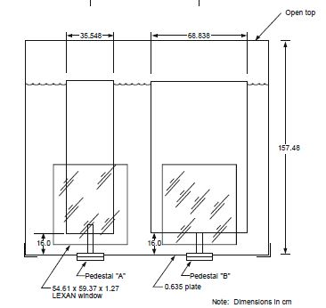
The benchmark model for the bare and concrete-reflected experiments includes the auxiliary empty large cylinder (with an inner diameter of 68.68 cm), water reflector tank floor and walls, and the concrete room floor, ceiling, and walls. The benchmark model used for the water-reflected experiments did not include the auxiliary empty large cylinder, water reflector tank floor and walls, or the concrete room floor, ceiling, and walls.
Figure 2. Elevation View for Part of the Model Geometry of MST-004 [6]
The experiments differ due to varying solution compositions and critical solution heights. The MST-004 cases consist of three bare experiments, three water-reflected experiments, and three concrete-reflected experiments. The elevation view for part of the MST-004 model is shown in Figure 2. Figure 3 and Figure 4 show an elevation view and a plan view, respectively, for the bare cases. The TSUNAMI-3D calculations with the MG and CE methods will only include MST-004-001, which is an unreflected system with a critical height of 44.46 cm.
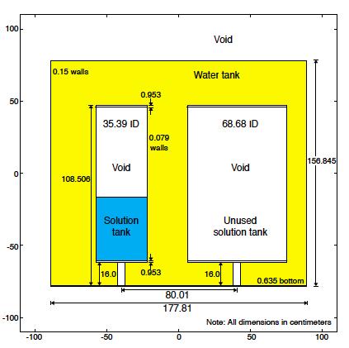
Figure 3. Benchmark Model Elevation View of MST-004-001 [6]

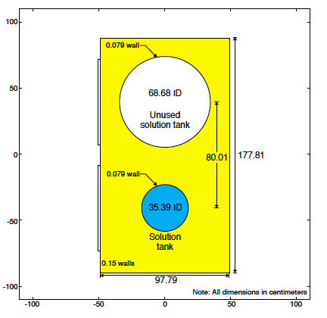
Figure 4. Benchmark Model Plan View of MST-004-001 [6]

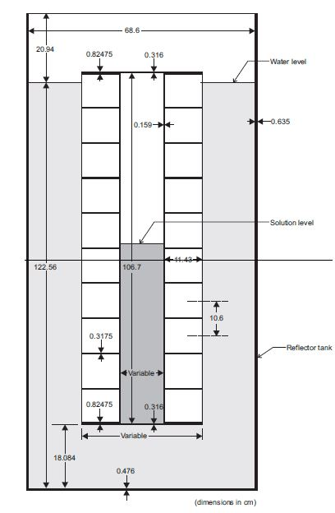

MIX-SOL-THERM-005 Model Description

Performed in the critical assembly room at Pacific Northwest National Laboratory (PNNL) in the 1970’s, the MIX-SOL-THERM-005 (MST-005) evaluation includes seven critical experiments with mixed plutonium and uranium nitrate solutions at a plutonium fraction of 0.4 in slab geometry. The KENO V.a MST-005 model for the slab tank reaction vessel consists of a stainless steel cuboid with square sides 107.332 cm in height and width. An egg-crate style support grid reinforces the square faces of the slab tank.
The experiments differ due to varying solution compositions for some of the experiments, critical solution heights, and active fuel widths. Changes to the slab tank width inherently alter the width of the reflector since the reflector tank width is constant. Three of the seven experiments are bare, while the other four cases are water reflected. The water-reflected cases are modeled with only the cuboidal representation of the slab tank, the reinforcing egg-crate support, and the reflector tank faces. In addition, the bare cases include a containment hood, floor, ceiling, and walls. The elevation view for part of the model of MST-005 is shown in Figure 5. The TSUNAMI-3D calculations with the MG and CE methods will only include MST-005-001, which has a slab fuel width of 19.81 cm and a height of 54.70 cm.
Figure 5. Elevation View for Part of the Model Geometry of MST-005 [6]

MIX-MISC-THERM-001 Model Description

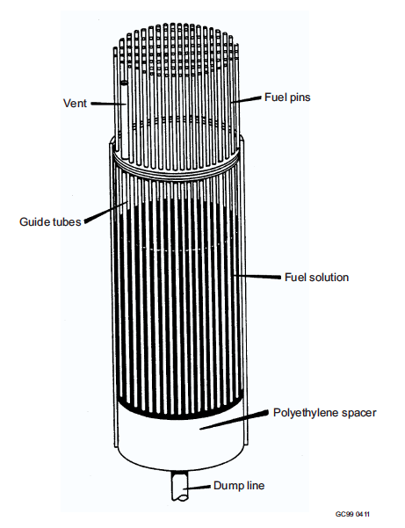
Pacific Northwest National Laboratory (PNNL) in 1987 and 1988, the MIX-MISC-THERM-001 (MMT-001) evaluation includes eleven critical experiments with a mixed oxide fuel-pin lattice in plutonium-uranium nitrate solution with a plutonium fraction of 0.22 in a boiler tube-type assembly. The KENO V.a MMT-001 model for the boiler tube-type tank consists of an array of mixed oxide fuel pins with a 1.4 cm square pitch w ith a water reflector. The MMT-001 experiments were designed to determine the critical height of the plutonium-uranium nitrate solution for the lattice assembly to be just critical and to determine the effectiveness of gadolinium, which was added to the solution for cases -006 through -010, as a neutron poison [6].
Each of the 996 fuel pins contain various different axial layers of materials, such as Inconel 600 reflectors, uranium dioxide reflectors, the fuel pellet stack, a homogenized Type 302 stainless steel spring, and a Type 316 stainless steel plenum. The experiments differ due to varying plutonium-uranium nitrate solution compositions and critical solution heights. The fuel pins were removed for the final case. The schematic of the boiler tube-type tank used for MMT-001 is shown in Figure 6. The lattice arrangement and a single fuel pin are shown in Figure 7 and Figure 8, respectively. The TSUNAMI-3D calculations with MG and CE methods will only include MMT-001-001, which has a critical fissile-solution height of 18.41 cm.
Figure 6. Schematic of the Boiler Tube-Type Tank used for MMT-001 [6]

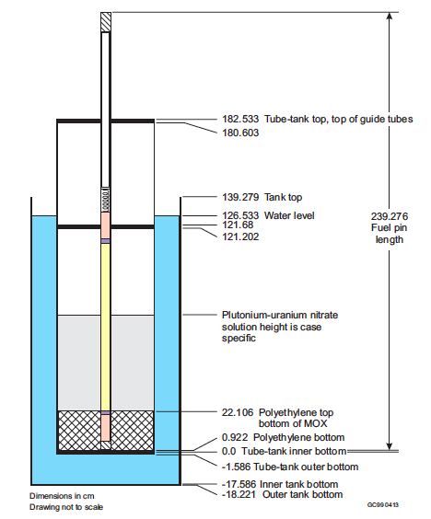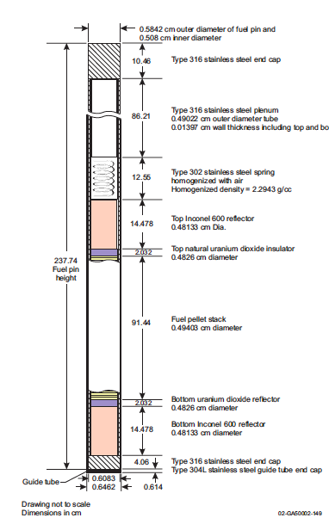

Figure 7. Benchmark Model Elevation View of MMT-001 [6]
Figure 8. Model of Fuel Rod in Guide Tube for MMT-001 [6]

PU-SOL-THERM-011 Model Description

Performed in the P-11 area of the Hanford Reservation in the early 1950's, the PU-SOL-THERM-011 (PST-011) evaluation contains twelve critical experiments with bare 16 and 18 inch (40.64 and 45.72 cm) diameter spheres of plutonium nitrate solutions. The KENO V.a PST-011 model consists of a 0.13 cm thick Type 347 stainless steel sphere filled to the critical height with plutonium solution. In addition, for the cases with an 18-inch sphere, the stainless steel shell is covered with 0.051 cm thick cadmium. Since the evaluation concluded that room return was negligible, the model used for PST-011 did not include the room floor, ceiling, or walls. The P -11 series of experiments were designed to determine the effect of geometry, concentration, foreign atoms, plutonium isotopic content, neutron reflection, and temperature on the critical mass of light-water moderated and reflected homogeneous plutonium solutions [6]. The series of PST experiments intended to use a number of spherical, cylindrical, and hemispherical containers; however, experiments for the hemispherical containers were never performed – “probably because of an accidental excursion, followed by a fire during cleanup that permanently shut down the facility. [6]”
The experiments differ due to varying solution compositions and sphere dimensions. The PST-011 evaluation consists of five bare 16-inch diameter sphere experiments and seven 18-inch diameter sphere experiments that are covered by a thin layer of cadmium. The benchmark model geometry for PST-011 is shown in Figure 9. The following TSUNAMI-3D calculations with MG and CE methods will only include PST-011-012, which contains the thin layer of cadmium.

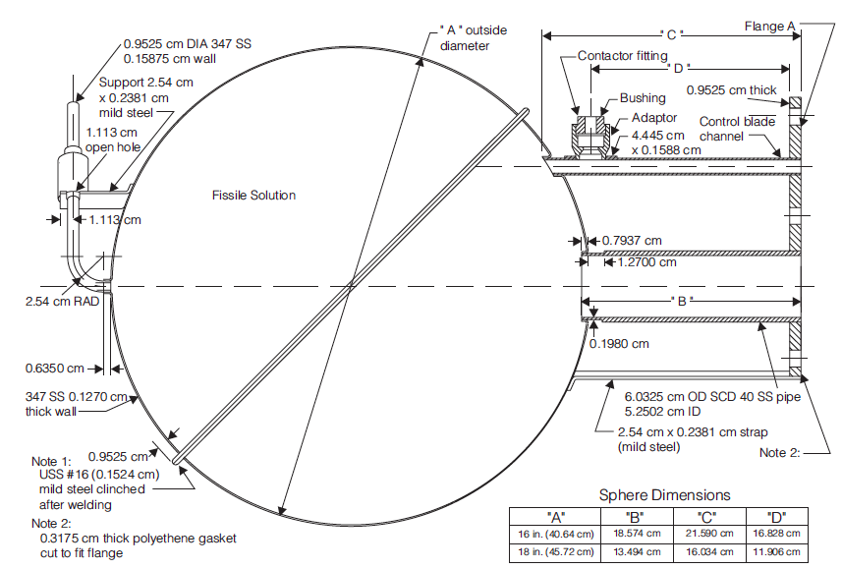
Figure 9. Benchmark Model for PST-011 [6]

HEU-SOL-THERM-001 Model Description

In the mid-1970's at the Rocky Flats Plant, the HEU-SOL-THERM-001 (HST-001) evaluation was performed, which contains ten critical experiments with minimally reflected cylinders of highly enriched solutions of uranyl nitrate. The KENO V.a HST-001 model consists of a 0.32 cm thick Type 347 stainless steel cylinder filled to the critical height with uranyl nitrate solution. Each critical experiment configuration had a height to diameter ratio less than 1.2.
The ten experiments differ due to varying solution compositions, critical solution heights, tank inside diameters, and tank inside heights. The elevation view for part of the model geometry of HST-001 is shown in Figure 10. The TSUNAMI-3D calculations with MG and CE methods will only include HST-001-001, which has a critical solution height of 31.20 cm with an inside diameter of 27.92 cm.
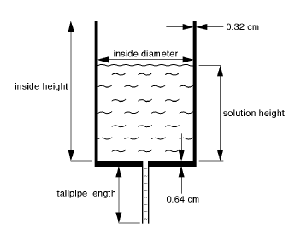
Figure 10. Experimental Configuration of HST-001 [6]

HEU-MET-MIXED-017 Model Description

The HEU-MET-MIXED-017 (HMM-017) benchmark evaluation is based on measurements taken at the All-Russian Scientific Research Institute of Technical Physics (VNIITF) using the criticality test facility FKBN-2 (Vertical Lift Machine) in 2009. The HMM-017 evaluation includes one critical experiment (HMM-017-001) with a heterogeneous cylinder of HEU, polyethylene, and tungsten reflected by polyethylene.
The configuration for the model geometry of HMM-017 is shown in Figure 11. The core is divided by a horizontal gap into two nearly equal parts: a movable bottom part and a stationary top part. The KENO V.a HMM-017 model for the assembly core contains alternating disks of highly enriched uranium, polyethylene, and tungsten. The measured diameter for the HEU, CH₂, and W disks is 19.990 cm.
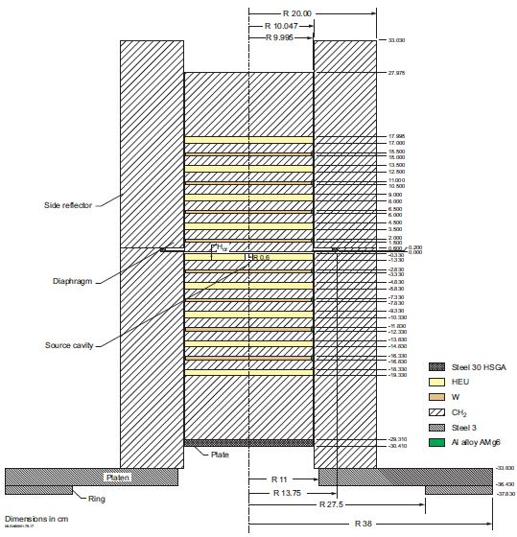
Figure 11. Configuration of the Model Geometry of HMM-017-001 [6]

HEU-MET-FAST-018 Model Description

The HEU-MET-FAST-018 (HMF-018) benchmark evaluation is based on measurements taken by All-Russian Scientific Research Institute of Experimental Physics (VNIIEF) at its criticality test facility (CTF) in 1962 (later re-evaluated between 1992 and 1994). The KENO V.a HMF-018 model contains a bare spherical assembly of ²³⁵U(90%), which incorporates 10 hemispherical layers. The evaluation contains two critical experiments: a detailed model with the core composed of 10 adjacent spherical layers and a simplified model with the core homogenized. The TSUNAMI-3D calculations with the MG and CE methods will only include HMF-018-001, which is the detailed model of HMF-018.
The sectional view for the assembly for the benchmark model of HMF-018 is shown in Figure 12, where the numbered sections are identified as follows:
- lower core unit
- upper core unit
- steel diaphragm
- upper support
- attachment
- lower support
- neutron source

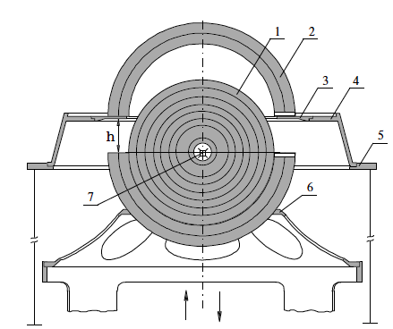
Figure 12. Sectional View of the Assembly for HMF-018 [6]

HEU-MET-FAST-093 Model Description

The HEU-MET-FAST-093 (HMF-093) benchmark evaluation is based on measurements taken by VNIITF at the criticality test facility FKBN-2 in 2013. HMF-093 consists of a single case (HMF-093-001) that was performed to obtain neutron data validation in the fast energy range. The KENO V.a HMF-093-001 model consists of an unreflected cylindrical core consisting of alternating disks of high-enriched uranium (95.98 wt.% ²³⁵U) and molybdenum (Mo). Similar to HMM-017, the core is divided by a horizontal gap into two nearly equal parts: a movable bottom part and a stationary top part. The benchmark model configuration of HMF-093-001 is shown in Figure 13.
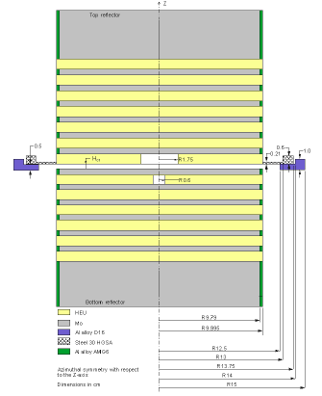
Figure 13. Benchmark Model Configuration for HMF-093 [6]

IEU-MET-FAST-007 Model Description

The IEU-MET-FAST-007 (IMF-007) criticality experiment, also known as the Big Ten experiment, was performed at the Los Alamos Critical Experiment Facility (LACEF). The KENO V.a IMF-007 model consists of a large, mixed-uranium-metal cylindrical core with 10% average ²³⁵U enrichment, surrounded by a thick ²³⁸U reflector. The evaluation contains two critical experiments: the detailed model and the improved simplified model. The primary objective for Big Ten was to measure effective cross sections in a neutron spectrum that was appreciably softer than those in the earlier, smaller Los Alamos metal assemblies [6]. Detailed information regarding the dimensions of the Big Ten criticality experiment is provided in the IHECSBE.
The reflector segments of the IMF-007 Big Ten assembly and IMF-007 KENO3D image is shown in Figure 14 and Figure 15, respectively. The axial schematic view of the detailed benchmark model is show in Figure 16, where zones prefaced with a C, P, and R correspond to the core, plate, and reflector components, respectively. The TSUNAMI-3D calculations with the MG and CE methods will only include IMF-007-001, which is the detailed model of IMF-007.

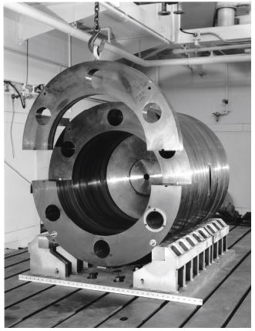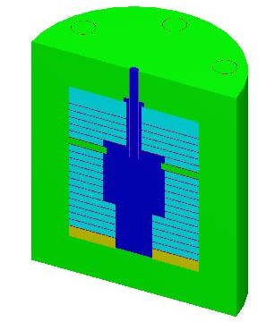
Figure 14. Assembly of the Big Ten Reflector Segments for IMF-007 [6]
Figure 15. KENO3D Image of IMF-007

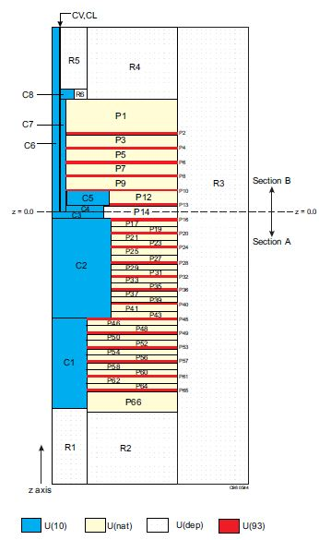
Figure 16. Axial-View Schematic of Detailed Benchmark Model of IMF-007 [6]

LEU-COMP-THERM-042 Model Description

Performed at the Critical Mass Laboratory at the Pacific Northwest National Laboratories (PNNL) in late 1979 or early 1980, the LEU-COMP-THERM-042 (LCT-042) evaluation includes seven critical experiments with three water-moderated rectangular clusters of U(2.35)O₂ fuel rods (1.684 cm square-pitch) separated by different absorber plate types [6]. The seven absorber-plate types were stainless steel, borated stainless steel, Boral, Boraflex, cadmium, copper, and copper with 1% cadmium. All LCT-042 models are built using the KENO V.a Monte Carlo transport code. LCT-042 has already been added to VALID with the MG TSUNAMI-3D sequence. For the purposes of CE TSUNAMI-3D analysis, this study will use the LCT-042-007 case, which was obtained from VALID. A KENO3D rendering of the TSUNAMI-3D LCT-042-007 model is shown in Figure 17. The benchmark model plan and elevation views for LCT-042 are shown in Figure 18 and Figure 19, respectively.
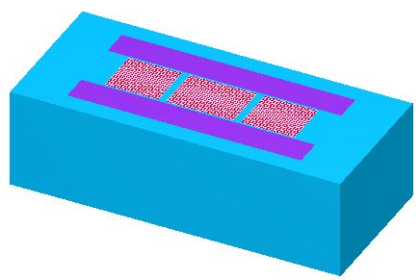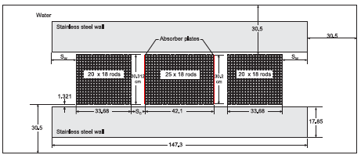
Figure 17. KENO3D Image of the Plan View of LCT-042

Figure 18. Benchmark Model Plan View of LCT-042 [6]

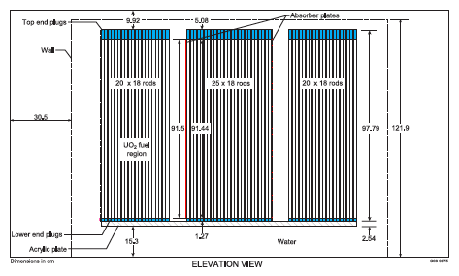
Figure 19. Benchmark Model Elevation View of LCT-042 [6]

SECTION 5
RESULTS FOR MG TSUNAMI-3D AND CE TSUNAMI-3D

All calculations were performed using SCALE and were executed on a Linux workstation at Oak Ridge National Laboratory. In general, all CE TSUNAMI-3D CLUTCH simulations were distributed across 31 slave cores, plus the single master core, for a total of 32 cores per CE TSUNAMI-3D CLUTCH job in the beta version of SCALE 6.2. Alternatively, the MG TSUNAMI-3D input files were run using serial processing in SCALE 6.1. The MG TSUNAMI-3D and CE TSUNAMI-3D calculations were performed using the ENDF/B-VII.0 SCALE 6.1 multigroup library (V7-238) and the ENDF/B-VII.0 SCALE 6.2b4 continuous energy library (CE_V7), respectively.
The expected k_{eff} value for each benchmark model configuration is provided in the IHECSBE evaluation for each corresponding experiment [6]. The C/E ratios can be calculated from the expected values and the calculated KENO values. Estimated uncertainties are supplied for the expected values and calculated k_{eff} from the IHECSBE and KENO output, respectively. The relative uncertainty in the C/E ratio is calculated as the square root of the sum of the squares of the relative calculation and evaluation uncertainties. The absolute uncertainty in the C/E ratio is thus simply the relative uncertainty multiplied by the C/E ratio. The uncertainty in the expected k_{eff} value is on the order of 20 to 80 times as large as the Monte Carlo simulation statistical uncertainty and is therefore the primary driver in the C/E uncertainty. The results for each case and category of experiments are generated and reported for each nuclear data library (V7-238 in SCALE 6.1 and CE_V7 in SCALE 6.2b4), allowing for a comparison of the multigroup and continuous-energy TSUNAMI-3D performance of the SCALE codes based on the same benchmark models.
Sensitivities within the criteria summarized in Section 3 may result from the initial candidate model, from some number of revisions, or such good agreement may never be achieved. Since this study is simply using MG TSUNAMI-3D as a comparison tool, rather than teaching the user about MG TSUNAMI-3D techniques, the following multigroup results will only show sensitivities for the most efficient MG TSUNAMI-3D job. However, the CE TSUNAMI-3D results may have multiple variations of results shown in order to depict the usefulness and impact of different parameters. It should also be noted that multiple continuous-energy variations were run in addition to those shown below.

MIX-SOL-THERM-002-001 Results

Table 4 provides k_{eff} results for the CSAS5 calculations using the V7-238 and CE_V7 libraries, which are used as k_{nominal} in the direct perturbation calculations.

Table 4. MST-002-001 CSAS5 k_{eff} Results Using the V7-238 and the CE_V7 Libraries
Case | Benchmark |  | CSAS5 Result |  | Calculated/Experimental |  | Δk_{eff}
(MIX-SOL-THERM-002-001) | Model Values |  |  |  |  |  | (CSAS - Benchmark)
 | k_{eff} | σ | k_{eff} | σ | C/E | σ | Δk_{eff} | σ
MG | 1.000 | 0.0024 | 1.00232 | 0.0001 | 1.00232 | 0.0024 | 0.00232 | 0.0024
CE | 1.000 | 0.0024 | 1.00170 | 0.0001 | 1.00170 | 0.0024 | 0.00170 | 0.0024

The MG TSUNAMI-3D results were obtained by simulating 100 skipped generations and 4,974 active generations with 10,000 neutrons per generation for the forward calculation and 300 skipped generations and 9,900 active generations with 10,000 neutrons per generation for the adjoint calculation. The MG TSUNAMI-3D used 1.5 GB of memory with a runtime of 70 minutes. Table 5 provides the results for the MG TSUNAMI-3D sensitivities and DP calculations using the V7-238 library. The MG results are within 0.96% for all examined sensitivities. The largest magnitude of difference is 0.0023, which occurred for the Pu-239 in the solution.

Table 5. MG TSUNAMI-3D Results for MST-002-001
Nuclide | In Material | TSUNAMI Results |  |  | Direct Perturbation Results |  |  | Results Comparison
 |  | S | σ_{S} | %σ_{S} | S | σ_{S} | %σ_{S} | S Diff in % | S Diff in Std Dev | ΔS
H | Solution | -0.1845 | 1.20E-2 | 6.52% | -0.1836 | 0.0026 | 1.39% | 0.52% | 0.08 | -0.0010
O | Solution | 0.0334 | 6.34E-4 | 1.90% | 0.0337 | 0.0005 | 1.38% | -0.96% | 0.41 | -0.0003
Pu-239 | Solution | 0.4310 | 1.92E-4 | 0.04% | 0.4287 | 0.0058 | 1.35% | 0.54% | 0.40 | 0.0023
Pu-240 | Solution | -0.0254 | 1.01E-5 | 0.04% | -0.0256 | 0.0004 | 1.39% | -0.78% | 0.56 | 0.0002

Ultimately, it was determined that accurate CE TSUNAMI-3D results could be obtained by simulating 1,000 skipped generations and 4,000 active generations with 200,000 neutrons per generation. After the proper GEN, NPG, and NSK parameters were determined, multiple input files were created with varying number of latent generations (CFP) and varying mesh interval sizes in the fissile material. A mesh size of 1 cm in the x-, y-, and z-direction was determined to provide the most efficient sensitivities for MST-002-001. Table 6 provides the results for the CE TSUNAMI-3D results and DP calculations using the CE_V7 for CFP=2, 5, and 10. From Table 6, the percent difference between the CE TSUNAMI-3D results and the DP sensitivities is above the desired limit when CFP=2. As expected, the accuracy improves from a percent difference of 8.82% to a percent difference of 4.30% when CFP is increased to 5 and then improves again from CFP=5 to CFP=10. A similar trend is seen for the difference of sensitivities in standard deviations and the direct difference in sensitivities. I n the MST-002-001 study, for CFP=10, the CE results are within 1.72% for all examined sensitivities. The largest magnitude of difference is 0.0032, which occurred for the hydrogen in the solution. The CE TSUNAMI-3D calculation requires 1.7-1.9 GB of memory with a runtime of 5 days while running in parallel on a total of 32 cores, for a total of 160 CPU-days. Since increasing CFP does not increase the runtime or the memory footprint, the MST-002-001 CE TSUNAMI-3D model with the following parameters is considered accurate:
- GEN=5,000 | - CET=1 (CLUTCH)
- NPG=200,000 | - CFP=10
- NSK=1,000 | - TBA=30
- Mesh size in x-, y-, and z-dir. ≈ 1 cm
Figure 20 presents comparisons of TSUNAMI-3D-K5 and direct perturbation results for nuclide sensitivities having an absolute magnitude of ~0.02 or greater for both MG and CE TSUNAMI-3D. The U-235 in the MST-002-001 solution does not appear as an important sensitivity (S_{TSUNAMI-3D U-235}$≈$0.0019), because the concentration is low, unlike the Pu-239, which has a higher concentration, and thus, a higher sensitivity. Typically, in the mixed fuel systems, hydrogen has a positive sensitivity; however, as shown in Figure 20, the sensitivity for hydrogen in MST-002-001 has an overall negative sensitivity since the negative sensitivity on the absorption reaction outweighs the positive sensitivity on the scattering reaction. The MG and CE TSUNAMI-3D and direct perturbation results presented in Figure 20 are considered acceptably consistent; however, the CE TSUNAMI-3D results show a slight improvement in the sensitivity uncertainty for the hydrogen in the solution. Even though the MG TSUNAMI-3D results in Table 5 appear to be more accurate for hydrogen than CE TSUNAMI-3D results in Table 6, the numbers are somewhat deceiving due to the uncertainty in the multigroup sensitivity for hydrogen. The MG results for oxygen seem slightly more accurate than the CE sensitivities; however, CE TSUNAMI-3D appears to achieve better accuracy for Pu-239 and Pu-240. Since both MG and CE TSUNAMI-3D have low sensitivity uncertainty and good agreement with the direct perturbation sensitivities, both methods are considered adequate for calculating MST-002-001 sensitivities.
Figure 21 shows the figure of merit for each important nuclide for the MG and CE TSUNAMI-3D methods for MST-002-001. Since the FoM incorporates the CPU runtime of each code as well as the edit uncertainties, the MG TSUNAMI-3D method exceeds the CE FoM for all nuclides by approximately two orders of magnitude. However, even though the FoM is analyzed for multiple nuclides, the lowest FoM (or the largest nuclide sensitivity uncertainty) for a single system will control the overall calculation runtime. Therefore, the most important FoM for MST-002-001 is the hydrogen in the solution. The MG TSUNAMI-3D FoM is approximately 280 times larger than the FoM for CE TSUNAMI-3D for this limiting nuclide.

Table 6. CE TSUNAMI-3D CLUTCH Results for MST-002-001
Nuclide | In Material | TSUNAMI Results |  |  | Direct Perturbation Results |  |  | Results Comparison
 |  | S | σ_{S} | %σ_{S} | S | σ_{S} | %σ_{S} | S Diff in % | S Diff in Std Dev | ΔS
CFP=2
H | Solution | -0.1920 | 3.38E-3 | 1.76% | -0.1865 | 0.0037 | 1.98% | 2.91% | 1.08 | -0.0054
O | Solution | 0.0309 | 2.40E-4 | 0.78% | 0.0340 | 0.0005 | 1.49% | 9.10% | 5.51 | -0.0031
Pu-239 | Solution | -0.0152 | 1.71E-5 | 0.11% | 0.4320 | 0.0068 | 1.57% | 0.41% | 0.26 | 0.0001
Pu-240 | Solution | 0.4317 | 2.94E-5 | 0.01% | -0.0255 | 0.0004 | 1.70% | 0.09% | 0.06 | -0.0004
CFP=5
H | Solution | -0.1883 | 3.48E-3 | 1.85% | -0.1865 | 0.0037 | 1.98% | 0.92% | 0.34 | -0.0017
O | Solution | 0.0324 | 2.47E-4 | 0.76% | 0.0340 | 0.0005 | 1.49% | 4.55% | 2.74 | -0.0015
Pu-239 | Solution | -0.0152 | 1.76E-5 | 0.12% | 0.4320 | 0.0068 | 1.57% | 0.45% | 0.29 | 0.0001
Pu-240 | Solution | 0.4311 | 3.11E-5 | 0.01% | -0.0255 | 0.0004 | 1.70% | 0.23% | 0.15 | -0.0010
CFP=10
H | Solution | -0.1833 | 3.43E-3 | 1.87% | -0.1865 | 0.0037 | 1.98% | 1.72% | 0.64 | 0.0032
O | Solution | 0.0334 | 2.45E-4 | 0.73% | 0.0340 | 0.0005 | 1.49% | 1.59% | 0.96 | -0.0005
Pu-239 | Solution | 0.4309 | 3.09E-5 | 0.01% | 0.4320 | 0.0068 | 1.57% | 0.27% | 0.17 | -0.0012
Pu-240 | Solution | -0.0256 | 3.28E-6 | 0.01% | -0.0255 | 0.0004 | 1.70% | 0.32% | 0.19 | -0.0001

Figure 20. TSUNAMI-3D and Direct Perturbation Sensitivity Comparisons for Representative MST-002-001 Nuclides in the Solution

Figure 21. Figures of Merit for MG and CE TSUNAMI-3D for MST-002-001

MIX-SOL-THERM-004-001 Results

The MST-004-001 case was selected for this study because the MG TSUNAMI-3D results encountered difficulty in obtaining desirable uncertainties in the hydrogen sensitivity for the solution. Additionally, MST-004-001 is one of the two cases studied that is built in KENO-VI, rather than KENO V.a, which provides additional diversity and confidence in the CE TSUNAMI-3D results. Table 7 shows k_{eff} results for the CSAS6 calculations using the V7-238 and CE_V7 libraries, which are used as k_{nominal} in the direct perturbation calculations.

Table 7. MST-004-001 CSAS6 k_{eff} Results Using the V7-238 and the CE_V7 Libraries
Case | Benchmark |  | CSAS6 Result |  | Calculated/Experimental |  | Δk_{eff}
(MIX-SOL-THERM-004-001) | Model Values |  |  |  |  |  | (CSAS - Benchmark)
 | k_{eff} | σ | k_{eff} | σ | C/E | σ | Δk_{eff} | σ
MG | 1.000 | 0.0033 | 0.99681 | 0.0001 | 0.99681 | 0.0033 | 0.00319 | 0.0033
CE | 1.000 | 0.0033 | 0.99606 | 0.0001 | 0.99606 | 0.0033 | 0.00394 | 0.0033

The MG TSUNAMI-3D results were obtained by simulating 100 skipped generations and 773 active generations with 250,000 neutrons per generation for the forward calculation and 100 skipped generations and 2,479 active generations with 200,000 neutrons per generation for the adjoint calculation. The MG TSUNAMI-3D used 10 GB of memory with a runtime of 11.6 days while running in serial. The long runtime is a result of the decreased sigma cut-off, which was implemented as an attempt to decrease the uncertainty in the hydrogen sensitivity. Table 8 provides the results for the MG TSUNAMI-3D sensitivities and DP calculations using the V7-238 library. After running multiple variations of the MST-004-001 model, the lowest uncertainty achieved in hydrogen and oxygen sensitivities was 24.71% and 7.76%, respectively.

Table 8. MG TSUNAMI-3D Results for MST-004-001
Nuclide | In Material | TSUNAMI Results |  |  | Direct Perturbation Results |  |  | Results Comparison
 |  | S | σ_{S} | %σ_{S} | S | σ_{S} | %σ_{S} | S Diff in % | S Diff in Std Dev | ΔS
H | Solution | 0.4446 | 1.10E-1 | 24.71% | 0.4506 | 0.0041 | 0.91% | -1.33% | 0.05 | -0.0060
O | Solution | 0.1016 | 7.88E-3 | 7.76% | 0.0987 | 0.0008 | 0.83% | 2.93% | 0.37 | 0.0029
Pu-239 | Solution | 0.1927 | 5.88E-3 | 3.05% | 0.1926 | 0.0019 | 0.98% | 0.06% | 0.02 | 0.0001
Pu-240 | Solution | -0.0469 | 2.66E-4 | 0.57% | -0.0473 | 0.0005 | 0.98% | -0.97% | 0.86 | 0.0005

Due to the similarities in fuel types, MST-004-001 CE TSUNAMI-3D behavior is expected to be comparable to MST-002-001. Therefore, the initial analysis of MST-004-001 CE TSUNAMI-3D is simulated with the same parameters used for MST-002-001 CE TSUNAMI-3D. After scaling back on the parameters in attempts to improve efficiency for MST-004-001, it was determined that accurate CE TSUNAMI-3D sensitivities could be obtained by simulating only 100,000 neutrons per generation with five latent generations (CFP=5), rather than ten. Additionally, the mesh in the x-, y-, and z-direction was set to an interval size of 2 cm, 2 cm, and 3 cm without loss of sensitivity accuracy. Table 9 provides the results for the final CE TSUNAMI-3D case and DP calculations using the CE_V7. From Table 9, the CE TSUNAMI-3D agreement with the DPs is acceptable for each nuclide. In addition, the largest sensitivity uncertainty for a nuclide is 2.10%, which is a significant improvement compared to MG TSUNAMI-3D, which has a maximum uncertainty of 24.71%. In the MST-004-001 study, the CE results are within 1.12% for all examined sensitivities. The largest magnitude of difference is 0.005, which occurred for the hydrogen in the solution. The CE TSUNAMI-3D calculation requires approximately 2.7 GB of memory with a runtime of 7 days while running in serial. The total wall time could be significantly reduced if the simulation was processed in parallel. Typically, for serial processes, MG TSUNAMI-3D requires less runtime than the CE TSUNAMI-3D method. However, due to the struggles encountered for MG TSUNAMI-3D in hydrogen sensitivity uncertainty, CE TSUNAMI-3D actually completed with a shorter runtime in serial for MST-004-001. The parameters used for MST-004-001 are the following:
- GEN=5,000 | - CET=1 (CLUTCH)
- NPG=100,000 | - CFP=5
- NSK=1,000 | - TBA=30
- Mesh size in x- and y-dir. ≈ 2 cm | - Mesh size in z-dir. ≈ 3 cm

Table 9. CE TSUNAMI-3D CLUTCH Results for MST-004-001
Nuclide | In Material | TSUNAMI Results |  |  | Direct Perturbation Results |  |  | Results Comparison
 |  | S | σ_{S} | %σ_{S} | S | σ_{S} | %σ_{S} | S Diff in % | S Diff in Std Dev | ΔS
H | Solution | 0.4485 | 9.41E-3 | 2.10% | 0.4435 | 0.0043 | 0.97% | 1.12% | 0.48 | 0.0050
O | Solution | 0.1023 | 1.06E-3 | 1.03% | 0.1012 | 0.0009 | 0.92% | 1.07% | 0.77 | 0.0011
Pu-239 | Solution | 0.1936 | 7.35E-4 | 0.38% | 0.1944 | 0.0019 | 0.96% | -0.45% | 0.43 | -0.0009
Pu-240 | Solution | -0.0472 | 1.80E-4 | 0.38% | -0.0477 | 0.0005 | 0.96% | -0.95% | 0.92 | 0.0005

Figure 22 presents comparisons of TSUNAMI-3D-K6 and direct perturbation results for nuclide sensitivities having an absolute magnitude of ~0.02 or greater for both MG and CE TSUNAMI-3D. Similar to MST-002-001, the U-235 in the MST-004-001 solution is not an important sensitivity (S_{TSUNAMI-3D U-235}$≈$0.0011), because the concentration is low, unlike the Pu-239, which has a higher concentration. Unlike MST-002-001, the hydrogen in MST-004-001 has an overall positive sensitivity, which is a result of the positive sensitivity on the scattering reaction outweighing the negative sensitivity on the absorption reaction. Only the CE TSUNAMI-3D and direct perturbation results presented in Figure 22 are considered acceptably consistent for calculating MST-004-001 sensitivities.

Figure 22. TSUNAMI and Direct Perturbation Sensitivity Comparisons for Representative MST-004-001 Nuclides in the Solution

MIX-SOL-THERM-005-001 Results

Similar to MST-004-001, the MST-005-001 case was also selected for this study, because the MG TSUNAMI-3D results encountered difficulty in obtaining desirable uncertainties for the hydrogen sensitivity in the solution. Table 10 provides k_{eff} results for the CSAS5 calculations using the V7-238 and CE_V7 libraries for MST-005-001, which are used as k_{nominal} in the direct perturbation calculations.

Table 10. MST-005-001 CSAS5 k_{eff} Results Using the V7-238 and the CE_V7 Libraries
Case | Benchmark |  | CSAS5 Result |  | Calculated/Experimental |  | Δk_{eff}
(MIX-SOL-THERM-005-001) | Model Values |  |  |  |  |  | (CSAS - Benchmark)
 | k_{eff} | σ | k_{eff} | σ | C/E | σ | Δk_{eff} | σ
MG | 1.000 | 0.0037 | 0.99414 | 0.0001 | 0.99414 | 0.0037 | 0.00586 | 0.0037
CE | 1.000 | 0.0037 | 0.99338 | 0.0001 | 0.99338 | 0.0037 | 0.00662 | 0.0037

The MG TSUNAMI-3D results were obtained by simulating 100 skipped generations and 525 active generations with 200,000 neutrons per generation for the forward calculation and 100 skipped generations and 601 active generations with 600,000 neutrons per generation for the adjoint calculation. The MG TSUNAMI-3D used 8.1 GB of memory with a runtime of 2.6 days. Table 11 provides the results for the MG TSUNAMI-3D sensitivities and DP calculations using the V7-238 library. After running multiple variations of the MST-005-001 model, the lowest uncertainty achieved in hydrogen and oxygen sensitivities was 21.76% and 7.52%, respectively.

Table 11. MG TSUNAMI-3D CLUTCH Results for MST-005-001
Nuclide | In Material | TSUNAMI Results |  |  | Direct Perturbation Results |  |  | Results Comparison
 |  | S | σ_{S} | %σ_{S} | S | σ_{S} | %σ_{S} | S Diff in % | S Diff in Std Dev | ΔS
H | Solution | 0.4054 | 8.82E-2 | 21.76% | 0.4097 | 0.0041 | 1.01% | -1.04% | 0.05 | -0.0043
O | Solution | 0.0841 | 6.32E-3 | 7.52% | 0.0871 | 0.0011 | 1.31% | -3.48% | 0.47 | -0.0030
Pu-239 | Solution | 0.2038 | 4.67E-3 | 2.29% | 0.1978 | 0.0021 | 1.04% | 3.00% | 1.16 | 0.0059
Pu-240 | Solution | -0.0464 | 2.03E-4 | 0.44% | -0.0465 | 0.0006 | 1.34% | -0.20% | 0.14 | 0.0001

Again, due to the similarities in the mixed uranium and plutonium nitrate solutions, the MST-005-001 CE TSUNAMI-3D is expected to exhibit behavior comparable to MST-002-001 and MST-004-001. Therefore, the initial analysis of MST-005-001 CE TSUNAMI-3D is simulated with the final parameters used for MST-004-001 CE TSUNAMI-3D. Then, the number of neutrons per generation was adjusted to determine if the runtime could be reduced without losing accuracy in the sensitivity coefficients. Table 12 provides the results for two different CE TSUNAMI-3D cases with the only difference being the number of neutrons per generation. Ideally, the user may expect improved accuracy and precision in the F*(r) function if the number of neutrons per generation is increased from 10,000 to 100,000. However, as shown in Table 12, the large increase in particles actually produces an insignificant difference between the sensitivity results with NPG=10,000 and NPG=100,000. Both CE TSUNAMI-3D models have the same memory footprint, at approximately 2.1 GB; however, the runtime increases significantly from 4.3 days in serial to 4.2 days in parallel on 32 cores when the number of neutrons per generation increases by a factor of ten. Since the difference between the two cases is statistically insignificant, the case with 10,000 neutrons per generation is considered the most efficient due to the short runtime. The mesh in the x-, y-, and z-direction was refined to an interval size of 1 cm, 1 cm, and 2.75 cm. From Table 12, the CE TSUNAMI-3D agreement with the DPs is acceptable for each nuclide except hydrogen in the solution. In addition, the largest sensitivity uncertainty for a nuclide is 2.09%, which is a significant improvement compared to MG TSUNAMI-3D, which has a maximum uncertainty of 21.76%. In the MST-005-001 study, the CE results are within 5.02% for all examined sensitivities. The largest magnitude of difference is 0.0196 (almost twice the limit), which occurred for the hydrogen in the solution. The options for achieving an improved CE TSUNAMI-3D hydrogen sensitivity have not yet been exhausted; however, the best results thus far show good agreement with direct perturbations for all other examined nuclides. The following parameters are used for MST-005-001:
- GEN=5,000 | - CET=1 (CLUTCH)
- NPG=10,000 | - CFP=5
- NSK=1,000 | - TBA=30
- Mesh size in x- and y-dir. ≈ 1 cm | - Mesh size in z-dir. ≈ 2.75 cm

Table 12. CE TSUNAMI-3D Results for MST-005-001
Nuclide | In Material | TSUNAMI Results |  |  | Direct Perturbation Results |  |  | Results Comparison
 |  | S | σ_{S} | %σ_{S} | S | σ_{S} | %σ_{S} | S Diff in % | S Diff in Std Dev |  | ΔS
NPG=10,000
H | Solution | 0.4095 | 8.55E-3 | 2.09% | 0.3900 | 0.0059 | 1.51% | 5.02% |  | 1.89 | 0.0196
O | Solution | 0.0834 | 9.14E-4 | 1.10% | 0.0842 | 0.0012 | 1.40% | -0.95% |  | 0.54 | -0.0008
Pu-239 | Solution | 0.2015 | 1.19E-4 | 0.06% | 0.1975 | 0.0028 | 1.43% | 2.03% |  | 1.42 | 0.0040
Pu-240 | Solution | -0.0468 | 3.39E-5 | 0.07% | -0.0474 | 0.0007 | 1.40% | -1.14% |  | 0.82 | 0.0005
NPG=100,000
H | Solution | 0.4059 | 2.70E-3 | 0.67% | 0.3900 | 0.0059 | 1.51% | 4.09% |  | 2.47 | 0.0159
O | Solution | 0.0831 | 2.92E-4 | 0.35% | 0.0842 | 0.0012 | 1.40% | -1.27% |  | 0.89 | -0.0011
Pu-239 | Solution | 0.2012 | 3.68E-5 | 0.02% | 0.1975 | 0.0028 | 1.43% | 1.89% |  | 1.32 | 0.0037
Pu-240 | Solution | -0.0468 | 1.08E-5 | 0.02% | -0.0474 | 0.0007 | 1.40% | -1.14% |  | 0.81 | 0.0005

Figure 23 presents comparisons of TSUNAMI-3D-K5 and direct perturbation results for nuclide sensitivities having an absolute magnitude of ~0.02 or greater for both MG and CE TSUNAMI-3D and the corresponding direct perturbation sensitivities. Similar to MST-002-001 and MST-004-001, the U-235 in the MST-004-001 solution is not an important sensitivity (S_{TSUNAMI-3D U-235}$≈$0.0012), because the concentration is low. Currently, none of the TSUNAMI-3D and direct perturbation results presented in Figure 23 are considered acceptably consistent for calculating MST-005-001 sensitivities. However, the CE TSUNAMI-3D CLUTCH results provide significant improvement in the uncertainty of the hydrogen sensitivity.

Figure 23. TSUNAMI and Direct Perturbation Sensitivity Comparisons for Representative MST-005-001 Nuclides in the Solution

MIX-MISC-THERM-001-001 Results

Table 13 provides k_{eff} results for the CSAS5 calculations using the V7-238 and CE_V7 libraries, which are used as k_{nominal} in the direct perturbation calculations for MMT-001-001.

Table 13. MMT-001-001 CSAS5 k_{eff} Results Using the V7-238 and the CE_V7 Libraries
Case | Benchmark |  | CSAS5 Result |  | Calculated/Experimental |  | Δk_{eff}
(MIX-MISC-THERM-001-001) | Model Values |  |  |  |  |  | (CSAS - Benchmark)
 | k_{eff} | σ | k_{eff} | σ | C/E | σ | Δk_{eff} | σ
MG | 1.000 | 0.0044 | 0.99424 | 0.0001 | 0.99424 | 0.0044 | 0.00576 | 0.0044
CE | 1.000 | 0.0044 | 0.99372 | 0.0001 | 0.99372 | 0.0044 | 0.00628 | 0.0044

The MG TSUNAMI-3D results were obtained by simulating 100 skipped generations and 788 active generations with 100,000 neutrons per generation for the forward calculation and 50 skipped generations and 6,641 active generations with 300,000 neutrons per generation for the adjoint calculation. The MG TSUNAMI-3D used 33 GB of memory with a serial runtime of 5.2 days. Table 14 provides the results for the MG TSUNAMI-3D sensitivities and DP calculations using the V7-238 library. The options for achieving an improved MG TSUNAMI-3D Pu-239 sensitivity have not yet been exhausted; however, the best results thus far show good agreement with direct perturbations for all examined nuclides, except Pu-239.

Table 14. MG TSUNAMI-3D Results for MMT-001-001
Nuclide | In Material | TSUNAMI Results |  |  | Direct Perturbation Results |  |  | Results Comparison
 |  | S | σ_{S} | %σ_{S} | S | σ_{S} | %σ_{S} | S Diff in % | S Diff in Std Dev | ΔS
H | Solution | 0.3635 | 3.34E-3 | 0.92% | 0.3657 | 0.0035 | 0.95% | -0.62% | 0.47 | -0.0023
O | Solution | 0.0514 | 2.87E-4 | 0.56% | 0.0520 | 0.0005 | 0.97% | -1.20% | 1.07 | -0.0006
Pu-239 | Fuel | 0.1270 | 8.70E-4 | 0.68% | 0.1151 | 0.0013 | 1.09% | 10.39% | 7.82 | 0.0120
Pu-240 | Fuel | -0.0459 | 4.26E-5 | 0.09% | -0.0449 | 0.0005 | 1.00% | 2.18% | 2.16 | -0.0010

Table 15 provides the results for three revisions of the CE TSUNAMI-3D model for MMT-001-001. For each MMT-001-001 set of sensitivities shown in Table 15, five latent generations are simulated with 4,000 active generations and 100,000 particles per generation. By maintaining constant parameters for CFP, GEN, and NPG, the user can vary other parameters, such as NSK and the mesh size, which will help provide a general idea for their importance in the MMT-001-001 CE TSUNAMI-3D model.
The first two cases represent results with a constant mesh and a differing number of skipped generations (NSK=1,000 and NSK=2,000). Logically, if the F*(r) function is calculated during the skipped generations, the user may expect an improvement in the F*(r) function, which would ideally lead to more accurate and precise sensitivities. Counterintuitively, the improvement does not occur for MMT-001-001 when increasing the number of skipped generations from 1000 to 2000. Previously, in the MST-005-001 results section, a similar affect was shown with the increase in particles per generations, which, for F*(r) function, is equivalent to increasing the number of skipped histories. In MST-005-001, the increase resulted in statistically equivalent sensitivities; therefore, the simulation with a fewer number of particles was chosen as more efficient.
The first and third cases represent results with a constant number of skipped particles and a differing mesh interval size in the z-direction. Ideally, if the mesh is refined to a smaller interval size, the user may expect improved sensitivity results; however, this assumption is not always accurate. Creating a smaller mesh will require a significant increase in the number of particles simulated in order to obtain low F*(r) value uncertainties. Sometimes the trade-off is not worth the increase in runtime. To maintain consistency in this scenario, the number of particles will not be increased with the smaller mesh in the z-direction. As reflected in Table 15, the smaller mesh size only slightly improved sensitivity results. Alternatively, if the mesh interval size is changed to ~10-12 cm, then the sensitivity results would be greatly affected. After considering the runtime and memory differences, the first case shown in Table 15 was selected as the most efficient case for MMT-001-001.
The “best case” MMT-001-001 CE TSUNAMI-3D model has a memory footprint of approximately 333 MB with a runtime of 1.87 days in parallel on 32 cores (60 CPU-days). The mesh interval size that provides accurate sensitivities was determined to be 1.4 cm, 1.4 cm, and 5 cm in the x-, y-, and z-direction. From Table 15, the CE TSUNAMI-3D agreement with the DPs is acceptable for each nuclide. In addition, the percent difference between the CE TSUNAMI-3D sensitivity and the DP sensitivity for Pu-239 in the fuel is reduced to 2.19%, which is a significant improvement compared to MG TSUNAMI-3D, which has a percent difference of 10.39%. The largest magnitude of difference is 0.0077, which occurred for the hydrogen in the solution. The optimal parameters for MMT-001-001 are determined to be the following:
- GEN=5,000 | - CET=1 (CLUTCH)
- NPG=100,000 | - CFP=5
- NSK=1,000 | - TBA=30
- Mesh size in x- and y-dir. ≈ 1.4 cm | - Mesh size in z-dir. ≈ 5 cm
Figure 24 presents comparisons of TSUNAMI-3D-K5 and direct perturbation results for nuclide sensitivities having an absolute magnitude of ~0.02 or greater for both MG and CE TSUNAMI-3D. Currently, until further investigation is performed on the MG TSUNAMI-3D model, only the CE TSUNAMI-3D and direct perturbation results presented in Figure 24 are considered acceptably consistent for calculating MMT-001-001 sensitivities.

Table 15. CE TSUNAMI-3D CLUTCH Results for MMT-001-001
Nuclide | In Material | TSUNAMI Results |  |  | Direct Perturbation Results |  |  | Results Comparison
 |  | S | σ_{S} | %σ_{S} | S | σ_{S} | %σ_{S} | S Diff in % | S Diff in Std Dev | ΔS
z-direction mesh size=5 cm, NSK=1000
H | Solution | 0.3582 | 1.87E-3 | 0.52% | 0.3659 | 0.0034 | 0.93% | -2.10% | 1.98 | -0.0077
O | Solution | 0.0505 | 2.30E-4 | 0.46% | 0.0524 | 0.0005 | 0.90% | -3.68% | 3.67 | -0.0019
Pu-239 | Fuel | 0.1178 | 4.29E-5 | 0.04% | 0.1153 | 0.0011 | 0.99% | 2.19% | 2.21 | 0.0025
Pu-240 | Fuel | -0.0442 | 1.50E-5 | 0.03% | -0.0444 | 0.0004 | 0.94% | -0.32% | 0.34 | 0.0001
z-direction mesh size=5 cm, NSK=2000
H | Solution | 0.3543 | 1.87E-3 | 0.53% | 0.3659 | 0.0034 | 0.93% | -3.18% | 3.00 | -0.0117
O | Solution | 0.0502 | 2.28E-4 | 0.45% | 0.0524 | 0.0005 | 0.90% | -4.25% | 4.25 | -0.0022
Pu-239 | Fuel | 0.1179 | 4.21E-5 | 0.04% | 0.1153 | 0.0011 | 0.99% | 2.22% | 2.24 | 0.0026
Pu-240 | Fuel | -0.0442 | 1.52E-5 | 0.03% | -0.0444 | 0.0004 | 0.94% | -0.30% | 0.32 | 0.0001
z-direction mesh size=2 cm, NSK=1000
H | Solution | 0.3621 | 1.87E-3 | 0.52% | 0.3659 | 0.0034 | 0.93% | -1.06% | 0.99 | -0.0039
O | Solution | 0.0513 | 2.32E-4 | 0.45% | 0.0524 | 0.0005 | 0.90% | -2.18% | 2.17 | -0.0011
Pu-239 | Fuel | 0.1173 | 4.29E-5 | 0.04% | 0.1153 | 0.0011 | 0.99% | 1.74% | 1.76 | 0.0020
Pu-240 | Fuel | -0.0443 | 1.51E-5 | 0.03% | -0.0444 | 0.0004 | 0.94% | -0.21% | 0.22 | 0.0001

Figure 24. TSUNAMI and Direct Perturbation Sensitivity Comparisons for Representative MMT-001-001 Nuclides

PU-SOL-THERM-011-012 Results

Table 16 provides k_{eff} results for the CSAS5 calculations using the V7-238 and CE_V7 libraries, which are used as k_{nominal} in the direct perturbation calculations for PST-011-012.

Table 16. PST-011-012 CSAS5 k_{eff} Results Using the V7-238 and the CE_V7 Libraries
Case | Benchmark |  | CSAS5 Result |  | Calculated/Experimental |  | Δk_{eff}
(PU-SOL-THERM-011-012) | Model Values |  |  |  |  |  | (CSAS - Benchmark)
 | k_{eff} | σ | k_{eff} | σ | C/E | σ | Δk_{eff} | σ
MG | 1.000 | 0.0052 | 1.00032 | 0.0001 | 1.00032 | 0.0052 | 0.00032 | 0.0052
CE | 1.000 | 0.0052 | 0.99874 | 0.0001 | 0.99874 | 0.0052 | 0.00126 | 0.0052

The MG TSUNAMI-3D results were obtained by simulating 100 skipped generations and 8844 active generations with 10,000 neutrons per generation for the forward calculation and 300 skipped generations and 2,650 active generations with 100,000 neutrons per generation for the adjoint calculation. The MG TSUNAMI-3D used 1 GB of memory with a serial runtime of 16.5 hours. Table 17 provides the results for the MG TSUNAMI-3D sensitivities and DP calculations using the V7-238 library. The MG results are within 2.16% for all examined sensitivities. The largest magnitude of difference is 0.0059, which occurred for the Pu-239 in the solution.
Table 17. MG TSUNAMI-3D Results for PST-011-012
Nuclide | In Material | TSUNAMI Results |  |  | Direct Perturbation Results |  |  | Results Comparison
 |  | S | σ_{S} | %σ_{S} | S | σ_{S} | %σ_{S} | S Diff in % | S Diff in Std Dev | ΔS
H | Solution | 0.2862 | 2.63E-3 | 0.92% | 0.2828 | 0.0038 | 1.36% | 1.18% | 0.71 | 0.0033
N | Solution | -0.0194 | 1.62E-5 | 0.08% | -0.0192 | 0.0002 | 1.28% | 1.30% | 1.01 | -0.0003
O | Solution | 0.0955 | 1.68E-4 | 0.18% | 0.0967 | 0.0013 | 1.31% | 1.21% | 0.92 | -0.0012
Pu-239 | Solution | 0.2799 | 9.13E-5 | 0.03% | 0.2740 | 0.0037 | 1.33% | 2.16% | 1.62 | 0.0059
Pu-240 | Solution | -0.0206 | 6.53E-6 | 0.03% | -0.0210 | 0.0003 | 1.28% | 1.58% | 1.23 | 0.0003

Table 39 in Appendix A provides the results for ten different CE TSUNAMI-3D cases with a single changing parameter between each case. For each PST-011-012 case shown in Table 39, five latent generations are simulated with 1,000 skipped generations and 10,000 particles per generation. The ten different active generations (GEN-NSK) are as follows: 100, 250, 500, 1000, 1500, 4000, 6500, 9000, 14000, and 19000. The difficulty in obtaining accurate PST-011-012 sensitivities with CE TSUNAMI-3D was initially a result of the large uncertainty of the hydrogen sensitivity in the solution. Until this point, the majority of large uncertainties in sensitivities have appeared in the MG TSUNAMI-3D results. Ideally, whether using MG or CE TSUNAMI-3D, the user expects a decrease in the uncertainty of the sensitivity as the total number of particles simulated increases. Unfortunately, since MG TSUNAMI-3D can only be executed in serial, achieving the desired uncertainty can require a significant (and potentially unrealistic) increase in runtime. However, for CE TSUNAMI-3D CLUTCH, the parallel capabilities allow the simulation of a large number of generations without an unrealistic wall time. From Table 39, the uncertainty in the Pu-239 sensitivity begins at 21.50% for 100 active generations, and then improves to 1.81% after 19,000 active generations. However, sufficient uncertainty of 2.62% is achieved at 9,000 active generations, which will be considered the optimal case for PST-011-012.
The most efficient PST-011-012 CE TSUNAMI-3D model, which is also shown in Table 18, has a memory footprint of approximately 1.2 GB with a runtime of 2 days in serial CE TSUNAMI-3D. The mesh interval size that provides accurate sensitivities was determined to be 1 cm in the x-, y-, and z-direction. From Table 18, the CE TSUNAMI-3D agreement with the DPs is acceptable for each nuclide. The largest magnitude of difference is 0.0029, which occurred for Pu-239 in the solution. The PST-011-012 CE TSUNAMI-3D model with the following parameters is considered accurate:
- GEN=10,000 | - CET=1 (CLUTCH)
- NPG=10,000 | - CFP=5
- NSK=1,000 | - TBA=30
- Mesh size in x-, y-, and z-dir. ≈ 1 cm

Table 18. CE TSUNAMI-3D CLUTCH Results for PST-011-012
Nuclide | In Material | TSUNAMI Results |  |  |  | Direct Perturbation Results |  |  | Results Comparison
 |  | S | σ_{S} |  | %σ_{S} | S | σ_{S} | %σ_{S} | S Diff in % | S Diff in Std Dev | ΔS
H | Solution | 0.2841 |  | 7.45E-3 | 2.62% | 0.2870 | 0.0034 | 1.19% | 0.99% | 0.35 | -0.0028
N | Solution | -0.0194 |  | 9.37E-5 | 0.48% | -0.0197 | 0.0003 | 1.32% | 1.64% | 1.17 | 0.0003
O | Solution | 0.0945 |  | 6.69E-4 | 0.71% | 0.0949 | 0.0012 | 1.25% | 0.42% | 0.29 | -0.0004
Pu-239 | Solution | 0.2800 |  | 5.20E-5 | 0.02% | 0.2771 | 0.0034 | 1.24% | 1.06% | 0.85 | 0.0029
Pu-240 | Solution | -0.0208 |  | 1.01E-5 | 0.05% | -0.0209 | 0.0003 | 1.26% | 0.53% | 0.42 | 0.0001

Figure 25 depicts the convergence of the eigenvalue sensitivity coefficient for hydrogen in the solution with CE TSUNAMI-3D-K5 as a function of total active particles. The hydrogen sensitivities in Figure 25 fluctuate between 0.2559 and 0.3097. However, since all data points are within one-sigma of each other, the convergence of the hydrogen sensitivity as a function of active particles is acceptable. Figure 26 represents the corresponding uncertainties as a function of runtime (in serial processing) on a log-log scale. When analyzing uncertainty convergence as a function of runtime, the users expect a theoretical straight line for a well-behaved problem. The PST-011-012 results demonstrate an almost perfectly linear behavior with an R² values greater than 0.98. Both figures provide an indication of the proper number of total active particles for convergence along with the suitable runtime required in order to obtain a low uncertainty for the hydrogen in PST-011-012.

Figure 25. CE TSUNAMI-3D Hydrogen Sensitivity as a Function of Total Active Particles PST-011-012

Figure 26. CE TSUNAMI-3D Hydrogen Sensitivity Uncertainty as a Function of Runtime in Serial for PST-011-012

Figure 27 depicts an XY-planar slice of the F*(r) function using the SCALE Meshview visualization tool. As expected, the F*(r) values are highest (greater importance) near the center of the spherical model (Figure 27 (a)). Additionally, the F*(r) values decrease towards the edge of the sphere. Figure 27 (b) depicts low uncertainties in the center of the sphere, with large uncertainties near the periphery of the sphere. This is expected due to the large number of interactions in the center of the sphere, which reduces the uncertainty of the F*(r) function. Figure 28 represents the plot of F*(r) values and uncertainties along the x-direction for PST-011-012. The plot of F*(r) values in Figure 28, which correlate to the values in Figure 27, displays the highest F*(r) values at the center of the sphere and decreasing values near the edge of the sphere. When analyzing the plot of F*(r) values in Figure 28, the user should not focus too heavily on obtaining lower uncertainty values as long as the resulting TSUNAMI-3D sensitivities agree with the direct perturbation sensitivities. It is important to note that the “_FStar_3dmap” file is created immediately after the number of skipped generations is complete. Therefore, for time conservation purposes, the user should view the F*(r) values and the uncertainties associated with the F*(r) values as soon as the number of skipped generations has ended. If the uncertainties in the F*(r) values appear too large in areas of the model with high expected importance, then the user should terminate the calculation and increase the number of particles or adjust the mesh size in order to obtain lower uncertainty in the F*(r) values.
Figure 29 presents comparisons of TSUNAMI-3D-K5 and direct perturbation results for nuclide sensitivities having an absolute magnitude of ~0.02 or greater for both MG and CE TSUNAMI-3D and the corresponding direct perturbation sensitivities. The MG and CE TSUNAMI-3D results presented in Figure 29 are considered acceptably consistent; however, the CE TSUNAMI-3D results show a slight improvement in the sensitivity comparisons for the hydrogen, Pu-239 and Pu-240 in the solution. Since both MG and CE TSUNAMI-3D have low sensitivity uncertainty and good agreement with the direct perturbation sensitivities, both methods are considered adequate for calculating PST-011-012 sensitivities.

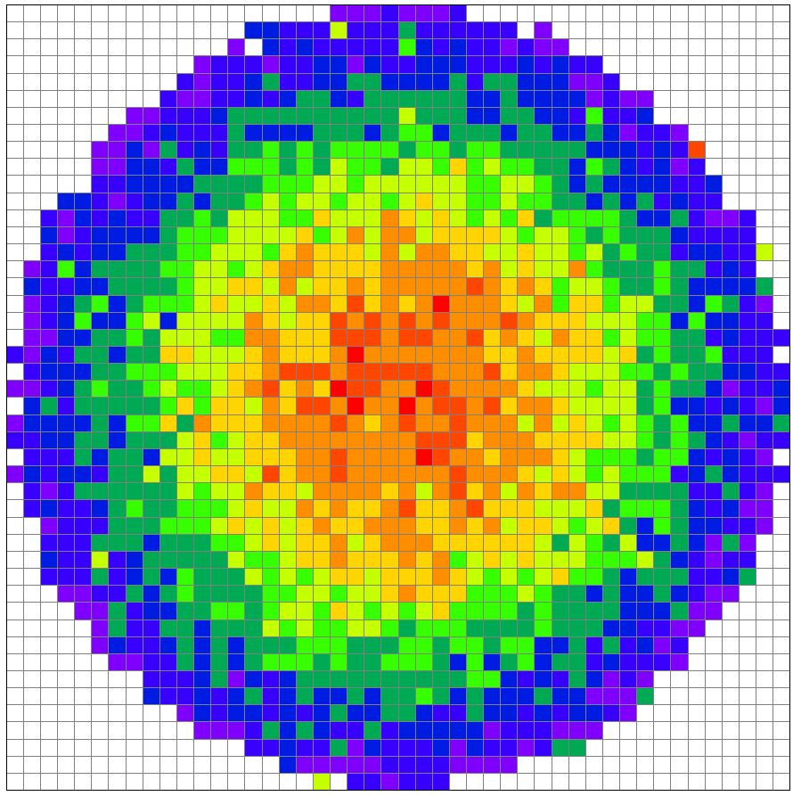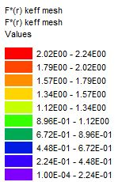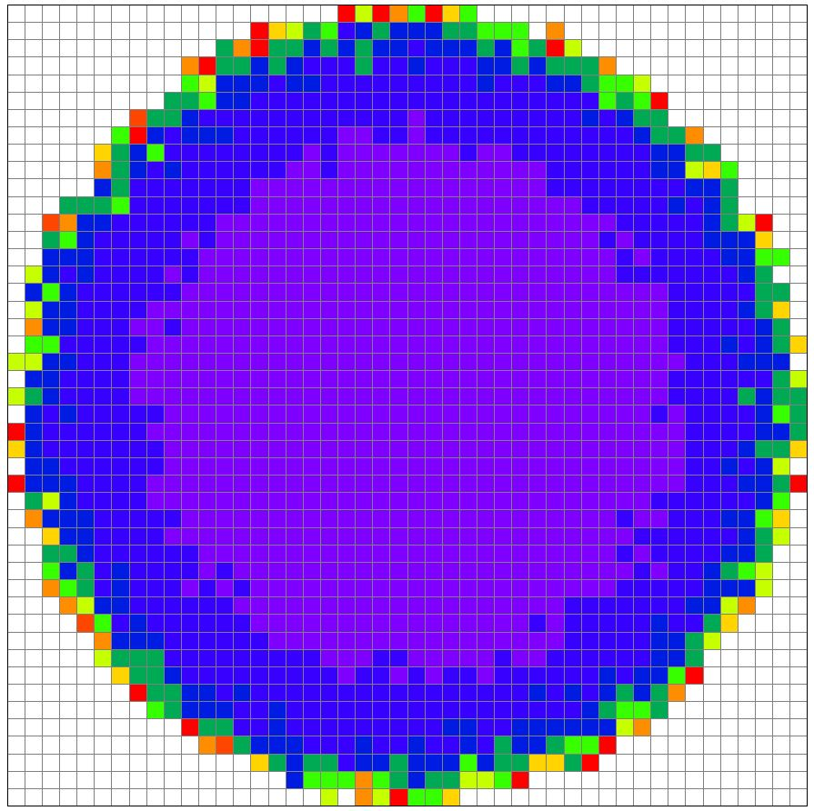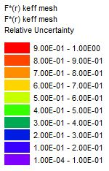
(a) F*(r) Values (b) F*(r) Uncertainties
Figure 27. Meshview Plot of F*(r) with NPG=200,000 for PST-011-012

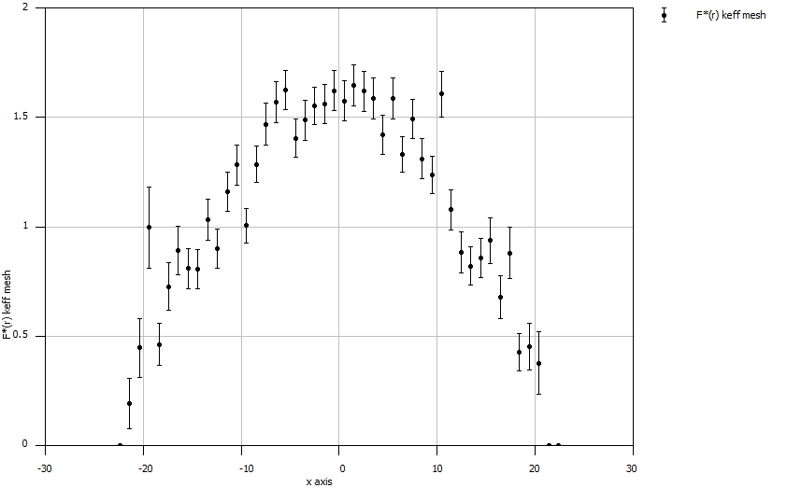
Figure 28. Plot of F*(r) Values in the x-direction for PST-011-012

Figure 29. TSUNAMI and Direct Perturbation Sensitivity Comparisons for Representative PST-011-012 Nuclides in the Solution
Figure 30 represents the figure of merit for the important nuclides for the MG and CE TSUNAMI-3D methods for PST-011-012. For serial processing, the MG TSUNAMI-3D method exceeds the CE FoM for all nuclides. For the PST-011-012 case, the most important nuclide when calculating the FoM is the hydrogen in the solution.

Figure 30. Figures of Merit for MG and CE TSUNAMI-3D for PST-011-012

HEU-SOL-THERM-001-001 Results

Table 19 provides k_{eff} results for the CSAS5 calculations using the V7-238 and CE_V7 libraries, which are used as k_{nominal} in the direct perturbation calculations for HST-001-001.

Table 19. HST-001-001 CSAS5 k_{eff} Results Using the V7-238 and the CE_V7 Libraries
Case | Benchmark |  | CSAS5 Result |  | Calculated/Experimental |  | Δk_{eff}
(HEU-SOL-THERM-001-001) | Model Values |  |  |  |  |  | (CSAS - Benchmark)
 | k_{eff} | σ | k_{eff} | σ | C/E | σ | Δk_{eff} | σ
MG | 1.0004 | 0.0060 | 0.99870 | 0.0001 | 0.99830 | 0.0060 | 0.00210 | 0.0060
CE | 1.0004 | 0.0060 | 0.99799 | 0.0001 | 0.99759 | 0.0060 | 0.00281 | 0.0060

The MG TSUNAMI-3D results were obtained by simulating 20 skipped generations and 9,980 active generations with 10,000 neutrons per generation for the forward calculation and 150 skipped generations and 4,625 active generations with 20,000 neutrons per generation for the adjoint calculation. The MG TSUNAMI-3D requires 186 MB of memory with a runtime of 3.4 hours. Table 20 provides the results for the MG TSUNAMI-3D sensitivities and DP calculations using the V7-238 library. The MG results are within 3.68% for all examined sensitivities. The largest magnitude of difference is 0.0042, which occurred for the U-235 in the solution. Even though the largest difference in standard deviations is 3.53, which is greater than two standard deviations, MG TSUNAMI-3D are still considered consistent with the direct perturbations.

Table 20. MG TSUNAMI-3D Results for HST-001-001
Nuclide | In Material | TSUNAMI Results |  |  | Direct Perturbation Results |  |  | Results Comparison
 |  | S | σ_{S} | %σ_{S} | S | σ_{S} | %σ_{S} | S Diff in % | S Diff in Std Dev | ΔS
U-235 | Solution | 0.1173 | 2.38E-4 | 0.20% | 0.1131 | 0.0012 | 1.02% | 3.68% | 3.53 | 0.0042
O | Solution | 0.1292 | 2.16E-4 | 0.17% | 0.1310 | 0.0013 | 0.96% | 1.34% | 1.37 | -0.0018
H | Solution | 0.6433 | 2.36E-3 | 0.37% | 0.6457 | 0.0062 | 0.95% | 0.36% | 0.35 | -0.0023
Fe | Tank | 0.0142 | 1.28E-5 | 0.09% | 0.0139 | 0.0001 | 0.92% | 1.83% | 2.01 | -0.0003

Table 21 provides the results for three different HST-001-001 CE TSUNAMI-3D cases with a single changing parameter between each case. For each HST-001-001 set of sensitivities shown in Table 21, five latent generations are simulated with 3,001 total generations and 10,000 particles per generation. Initially, the HST-001-001 study showed difficulties in obtaining a low uncertainty for the hydrogen sensitivity and issues with obtaining proper DP agreement in the iron. Ultimately, it was determined that simulating more particles decreased the uncertainty in the hydrogen sensitivity and creating a smaller mesh interval size improved the iron DP agreement. Alternatively, exclusively creating a smaller mesh did not reduce the hydrogen sensitivity uncertainty and solely simulating more particles did not improve the iron DP agreement.
The three HST-001-001 cases analyzed in Table 21 represent results with a differing number of skipped generations (NSK=20, NSK=100, and NSK=1000). The increase in NSK, which required a longer runtime, did not improve the accuracy of the sensitivities. Therefore, the case with NSK=20 is considered the optimal case for HST-001-001. The preferred HST-001-001 CE TSUNAMI-3D model has a memory footprint of approximately 1.1 GB with a runtime of 13.4 minutes in parallel on 64 cores. The most efficient mesh interval size was determined to be 2.8 cm, 2.8 cm, and 4 cm in the x-, y-, and z-direction. From Table 21, the CE TSUNAMI-3D agreement with the DPs is acceptable for each nuclide. In addition, the largest disagreement between TSUNAMI and the DPs occurred in the oxygen in the solution, with a percent difference of 2.95%, a standard deviation difference of 1.87 and a difference of -0.0039. Since none of these values exceed the desired limit, the HST-001-001 CE TSUNAMI-3D model with the following parameters is considered accurate:
- GEN=3,001 | - CET=1 (CLUTCH)
- NPG=10,000 | - CFP=5
- NSK=20 | - TBA=30
- Mesh size in x- and y-dir. ≈ 2.8 cm | - Mesh size in z-dir. ≈ 4 cm
Figure 31 presents comparisons of TSUNAMI-3D-K5 and direct perturbation results for nuclide sensitivities having an absolute magnitude of ~0.02 or greater for both MG and CE TSUNAMI-3D. The MG and CE TSUNAMI-3D results presented in Figure 31 are considered acceptably consistent; however, the CE TSUNAMI-3D results show a slight improvement in the sensitivity comparisons for the hydrogen, and U-235 in the solution. Since both MG and CE TSUNAMI-3D have low sensitivity uncertainty and good agreement with the direct perturbation sensitivities, both methods are considered adequate for calculating HST-001-001 sensitivities.
Figure 32 shows the figure of merit for each important nuclide for the MG and CE TSUNAMI-3D methods for HST-001-001. When calculating the FoM with the CPU runtime, the MG TSUNAMI-3D method exceeds the CE FoM for all nuclides. Unlike previous cases, neither method had difficulty obtaining a low sensitivity uncertainty in the hydrogen; however, the calculated hydrogen sensitivity uncertainty is still the largest compared to the other important nuclides. Therefore, hydrogen in the solution is the limiting nuclide when analyzing the figure of merit for HST-001-001.

Table 21. CE TSUNAMI-3D CLUTCH Results for HST-001-001
Nuclide | In Material | TSUNAMI Results |  |  | Direct Perturbation Results |  |  | Results Comparison
 |  | S | σ_{S} | %σ_{S} | S | σ_{S} | %σ_{S} | S Diff in % | S Diff in Std Dev | ΔS
NSK=20
U-235 | Solution | 0.1146 | 1.27E-4 | 0.11% | 0.1127 | 0.0016 | 1.43% | 1.64% | 1.15 | 0.0019
O | Solution | 0.1277 | 9.90E-4 | 0.78% | 0.1315 | 0.0018 | 1.38% | 2.95% | 1.87 | -0.0039
H | Solution | 0.6414 | 7.93E-3 | 1.24% | 0.6432 | 0.0089 | 1.38% | 0.28% | 0.15 | -0.0018
Fe | Tank | 0.0146 | 5.30E-5 | 0.36% | 0.0142 | 0.0002 | 1.50% | 2.34% | 1.51 | 0.0003
NSK=100
U-235 | Solution | 0.1141 | 1.22E-4 | 0.11% | 0.1127 | 0.0016 | 1.43% | 1.22% | 0.85 | 0.0014
O | Solution | 0.1280 | 1.00E-3 | 0.78% | 0.1315 | 0.0018 | 1.38% | 2.68% | 1.70 | -0.0035
H | Solution | 0.6438 | 7.79E-3 | 1.21% | 0.6432 | 0.0089 | 1.38% | 0.10% | 0.05 | 0.0006
Fe | Tank | 0.0149 | 5.20E-5 | 0.35% | 0.0142 | 0.0002 | 1.50% | 4.95% | 3.20 | 0.0007
NSK=1000
U-235 | Solution | 0.1142 | 1.66E-4 | 0.15% | 0.1127 | 0.0016 | 1.43% | 1.30% | 0.90 | 0.0015
O | Solution | 0.1284 | 1.21E-3 | 0.94% | 0.1315 | 0.0018 | 1.38% | 2.40% | 1.45 | -0.0032
H | Solution | 0.6500 | 9.41E-3 | 1.45% | 0.6432 | 0.0089 | 1.38% | 1.06% | 0.53 | 0.0068
Fe | Tank | 0.0148 | 6.16E-5 | 0.42% | 0.0142 | 0.0002 | 1.50% | 4.23% | 2.71 | 0.0006

Figure 31. TSUNAMI and Direct Perturbation Sensitivity Comparisons for Representative HST-001-001 Nuclides in the Solution

Figure 32. Figures of Merit for MG and CE TSUNAMI-3D for HST-001-001

HEU-MET-MIXED-017-001 Results

Table 22 provides k_{eff} results for the CSAS5 calculations using the V7-238 and CE_V7 libraries, which are used as k_{nominal} in the direct perturbation calculations for HMM-017-001. Ideally, the difference in k_{eff} between the benchmark and CSAS results is larger than the user would prefer; however, for the purposes of this study, the values in Table 22 are acceptable.

Table 22. HMM-017-001 CSAS5 k_{eff} Results Using the V7-238 and the CE_V7 Libraries
Case | Benchmark |  | CSAS5 Result |  | Calculated/Experimental |  | Δk_{eff}
(HEU-MET-MIXED-017-001) | Model Values |  |  |  |  |  | (CSAS - Benchmark)
 | k_{eff} | σ | k_{eff} | σ | C/E | σ | Δk_{eff} | σ
MG | 1.000 | 0.0008 | 0.99115 | 0.00007 | 0.99115 | 0.0008 | 0.00885 | 0.0008
CE | 1.000 | 0.0008 | 0.98913 | 0.00008 | 0.98913 | 0.0008 | 0.01087 | 0.0008

The MG TSUNAMI-3D results were obtained by simulating 50 skipped generations and 738 active generations with 100,000 neutrons per generation for the forward calculation and 150 skipped generations and 10,050 active generations with 200,000 neutrons per generation for the adjoint calculation. The MG TSUNAMI-3D used 20 GB of memory with a runtime of 6.4 days. Table 23 provides the results for the MG TSUNAMI-3D sensitivities and DP calculations using the V7-238 library. The MG results are within 5.00% for all examined sensitivities. The largest magnitude of difference is 0.0023, which occurred for U-235 in one of the fuel disks. The absolute differences are artificially low as a result of subtracting two low sensitivity coefficients. Even though the largest difference in standard deviations is 4.61, which is greater than two standard deviations, MG TSUNAMI-3D are still considered consistent with the direct perturbations due to the consistency of the other difference comparisons. Additionally, when calculating the U-235 sensitivity for the entire model, rather than the individual fuel disks, the sensitivity is also in good agreement with the direct perturbation sensitivity.

Table 23. MG TSUNAMI-3D Results for HMM-017-001
Nuclide | In Material | TSUNAMI Results |  |  | Direct Perturbation Results |  |  | Results Comparison
 |  | S | σ_{S} | %σ_{S} | S | σ_{S} | %σ_{S} | S Diff in % | S Diff in Std Dev | ΔS
C | Side Reflector | 0.0354 | 2.38E-4 | 0.67% | 0.0366 | 0.0003 | 0.95% | 3.41% | 2.97 | -0.0012
U-235 | Fuel Disk #1 | 0.0131 | 7.17E-5 | 0.55% | 0.0132 | 0.0001 | 0.98% | 0.21% | 0.19 | 0.0000
U-235 | Fuel Disk #2 | 0.0262 | 1.11E-4 | 0.42% | 0.0254 | 0.0003 | 1.01% | 3.18% | 2.88 | 0.0008
U-235 | Fuel Disk #3 | 0.0380 | 1.50E-4 | 0.39% | 0.0378 | 0.0004 | 0.99% | 0.50% | 0.47 | 0.0002
U-235 | Fuel Disk #4 | 0.0480 | 1.68E-4 | 0.35% | 0.0457 | 0.0005 | 1.02% | 5.00% | 4.61 | 0.0023
U-235 | Fuel Disk #5 | 0.0477 | 1.66E-4 | 0.35% | 0.0471 | 0.0005 | 1.00% | 1.45% | 1.37 | 0.0007
U-235 | Fuel Disk #6 | 0.0447 | 1.67E-4 | 0.37% | 0.0436 | 0.0004 | 1.01% | 2.70% | 2.50 | 0.0012
U-235 | Fuel Disk #7 | 0.0373 | 1.52E-4 | 0.41% | 0.0362 | 0.0004 | 1.02% | 3.14% | 2.85 | 0.0011
U-235 | Fuel Disk #8 | 0.0256 | 1.08E-4 | 0.42% | 0.0246 | 0.0003 | 1.02% | 3.83% | 3.45 | 0.0009
U-235 | Fuel Disk #9 | 0.0126 | 7.04E-5 | 0.56% | 0.0124 | 0.0001 | 1.00% | 1.76% | 1.53 | 0.0002

Table 24 provides the results for three different CE TSUNAMI-3D cases with two differing parameters. For each set of sensitivities shown in Table 24, five latent generations are simulated with 3,000 active generations. The first set of sensitivities shown in Table 24 represent the results with NSK=100 and NPG=10,000; however, in attempts to improve the DP agreements, the number of skipped generations (NSK) was increased to 500. For the same number of particles per generation, the increase in NSK improved the accuracy from a maximum difference in standard deviations of 3.09 to a maximum difference in standard deviations of 1.90. The four remaining sets of sensitivities in Table 24 are simulated with a constant number of skipped generations (NSK=100) and a varying number of particles per generation (NPG=10,000, 25,000, 50,000, and 100,000). Based on the insignificant changes in the DP agreement for the simulation of increasing particles per generation, the model with the shortest runtime (NPG=10,000) is chosen for the most efficient HMM-017-001 case.
The preferred HMM-017-001 CE TSUNAMI-3D model has a memory footprint of approximately 1.7 GB with a runtime of 1.6 hours in parallel on 32 cores. The mesh interval size that provides accurate sensitivities was determined to be 1 cm, 1 cm, and 1.33 cm in the x-, y-, and z-direction. From Table 24, the CE TSUNAMI-3D agreement with the DPs is acceptable for each nuclide. In addition, the maximum percent difference between the TSUNAMI-3D sensitivity and the DP sensitivity for U-235 in the fuel is reduced from 5.00% in MG TSUNAMI-3D to 2.56% in CE TSUNAMI-3D. The largest magnitude of difference is 0.0006, which occurred for U-235 in the fuel. Similar to the MG results, the absolute differences are artificially low as a result of subtracting two low sensitivity coefficients. However, the CE agreement is still slightly improved compared to the MG agreement. The more efficient parameters for HMM-017-001 are determined to be the following:
- GEN=3,500 | - CET=1 (CLUTCH)
- NPG=10,000 | - CFP=5
- NSK=500 | - TBA=30
- Mesh size in x- and y-dir. ≈ 1 cm | - Mesh size in z-dir. ≈ 1.33 cm
Figure 33 presents comparisons of TSUNAMI-3D-K5 and direct perturbation results for nuclide sensitivities having an absolute magnitude of ~0.02 or greater. The x-axis in Figure 33 represents the U-235 fuel disks, starting from #1 at the bottom of the configuration to #10 at the top of it. As expected, the shape of the sensitivities matches well with the probable distribution of fission neutrons as a function of energy. The MG and CE TSUNAMI-3D and direct perturbation results presented in Figure 33 are considered acceptably consistent.

Table 24. CE TSUNAMI-3D CLUTCH Results for HMM-017-001
Nuclide | In Material | TSUNAMI Results |  |  | Direct Perturbation Results |  |  | Results Comparison
 |  | S | σ_{S} | %σ_{S} | S | σ_{S} | %σ_{S} | S Diff in % | S Diff in Std Dev | ΔS
NSK=100, NPG=10,000
C | Side Reflector | 0.0364 | 3.11E-4 | 0.85% | 0.0363 | 0.0004 | 1.21% | 0.33% | 0.22 | 0.0001
U-235 | Fuel Disk #1 | 0.0127 | 7.29E-5 | 0.57% | 0.0129 | 0.0001 | 1.11% | 1.45% | 1.16 | -0.0002
U-235 | Fuel Disk #2 | 0.0246 | 1.15E-4 | 0.47% | 0.0251 | 0.0003 | 1.26% | 2.01% | 1.50 | -0.0005
U-235 | Fuel Disk #3 | 0.0384 | 1.55E-4 | 0.40% | 0.0376 | 0.0005 | 1.29% | 2.25% | 1.66 | 0.0008
U-235 | Fuel Disk #4 | 0.0453 | 1.75E-4 | 0.39% | 0.0448 | 0.0006 | 1.30% | 1.10% | 0.81 | 0.0005
U-235 | Fuel Disk #5 | 0.0459 | 1.76E-4 | 0.38% | 0.0461 | 0.0006 | 1.39% | 0.55% | 0.38 | -0.0003
U-235 | Fuel Disk #6 | 0.0444 | 1.77E-4 | 0.40% | 0.0449 | 0.0005 | 1.20% | 1.00% | 0.80 | -0.0005
U-235 | Fuel Disk #7 | 0.0371 | 1.56E-4 | 0.42% | 0.0365 | 0.0005 | 1.36% | 1.61% | 1.13 | 0.0006
U-235 | Fuel Disk #8 | 0.0249 | 1.17E-4 | 0.47% | 0.0246 | 0.0003 | 1.26% | 1.57% | 1.17 | 0.0004
U-235 | Fuel Disk #9 | 0.0120 | 7.59E-5 | 0.63% | 0.0125 | 0.0001 | 1.15% | 4.02% | 3.09 | -0.0005
NSK=500, NPG=10,000
C | Side Reflector | 0.0361 | 3.01E-4 | 0.83% | 0.0363 | 0.0004 | 1.21% | 0.40% | 0.27 | -0.0001
U-235 | Fuel Disk #1 | 0.0126 | 7.48E-5 | 0.59% | 0.0129 | 0.0001 | 1.11% | 1.96% | 1.56 | -0.0003
U-235 | Fuel Disk #2 | 0.0250 | 1.18E-4 | 0.47% | 0.0251 | 0.0003 | 1.26% | 0.29% | 0.22 | -0.0001
Table 24. Continued.
Nuclide | In Material | TSUNAMI Results |  |  |  | Direct Perturbation Results |  |  | Results Comparison
 |  | S |  | σ_{S} | %σ_{S} | S | σ_{S} | %σ_{S} | S Diff in % | S Diff in Std Dev | ΔS
U-235 | Fuel Disk #3 | 0.0382 |  | 1.54E-4 | 0.40% | 0.0376 | 0.0005 | 1.29% | 1.54% | 1.14 | 0.0006
U-235 | Fuel Disk #4 | 0.0453 |  | 1.73E-4 | 0.38% | 0.0448 | 0.0006 | 1.30% | 1.16% | 0.86 | 0.0005
U-235 | Fuel Disk #5 | 0.0458 |  | 1.73E-4 | 0.38% | 0.0461 | 0.0006 | 1.39% | 0.76% | 0.53 | -0.0004
U-235 | Fuel Disk #6 | 0.0445 |  | 1.69E-4 | 0.38% | 0.0449 | 0.0005 | 1.20% | 0.77% | 0.61 | -0.0003
U-235 | Fuel Disk #7 | 0.0369 |  | 1.51E-4 | 0.41% | 0.0365 | 0.0005 | 1.36% | 1.04% | 0.73 | 0.0004
U-235 | Fuel Disk #8 | 0.0252 |  | 1.17E-4 | 0.46% | 0.0246 | 0.0003 | 1.26% | 2.56% | 1.90 | 0.0006
U-235 | Fuel Disk #9 | 0.0124 |  | 7.24E-5 | 0.59% | 0.0125 | 0.0001 | 1.15% | 1.36% | 1.05 | -0.0002
NSK=500, NPG=25,000
C | Side Reflector |  | 0.0370 | 1.96E-4 | 0.53% | 0.0363 | 0.0004 | 1.21% | 1.95% | 1.47 | 0.0007
U-235 | Fuel Disk #1 |  | 0.0125 | 4.67E-5 | 0.37% | 0.0129 | 0.0001 | 1.11% | 2.99% | 2.55 | -0.0004
U-235 | Fuel Disk #2 |  | 0.0255 | 7.55E-5 | 0.30% | 0.0251 | 0.0003 | 1.26% | 1.58% | 1.22 | 0.0004
U-235 | Fuel Disk #3 |  | 0.0380 | 9.61E-5 | 0.25% | 0.0376 | 0.0005 | 1.29% | 1.05% | 0.80 | 0.0004
U-235 | Fuel Disk #4 |  | 0.0458 | 1.11E-4 | 0.24% | 0.0448 | 0.0006 | 1.30% | 2.28% | 1.72 | 0.0010
U-235 | Fuel Disk #5 |  | 0.0457 | 1.12E-4 | 0.24% | 0.0461 | 0.0006 | 1.39% | 1.02% | 0.72 | -0.0005
U-235 | Fuel Disk #6 |  | 0.0445 | 1.09E-4 | 0.24% | 0.0449 | 0.0005 | 1.20% | 0.92% | 0.75 | -0.0004
U-235 | Fuel Disk #7 |  | 0.0368 | 9.55E-5 | 0.26% | 0.0365 | 0.0005 | 1.36% | 0.78% | 0.56 | 0.0003
U-235 | Fuel Disk #8 |  | 0.0248 | 7.48E-5 | 0.30% | 0.0246 | 0.0003 | 1.26% | 1.15% | 0.89 | 0.0003
U-235 | Fuel Disk #9 |  | 0.0123 | 4.59E-5 | 0.37% | 0.0125 | 0.0001 | 1.15% | 2.00% | 1.66 | -0.0003
NSK=500, NPG=50,000
C | Side Reflector |  | 0.0364 | 1.36E-4 | 0.37% | 0.0363 | 0.0004 | 1.21% | 0.45% | 0.35 | 0.0002
U-235 | Fuel Disk #1 |  | 0.0125 | 3.33E-5 | 0.27% | 0.0129 | 0.0001 | 1.11% | 2.83% | 2.48 | -0.0004
U-235 | Fuel Disk #2 |  | 0.0253 | 5.37E-5 | 0.21% | 0.0251 | 0.0003 | 1.26% | 1.04% | 0.81 | 0.0003
U-235 | Fuel Disk #3 |  | 0.0379 | 6.83E-5 | 0.18% | 0.0376 | 0.0005 | 1.29% | 0.91% | 0.70 | 0.0003
U-235 | Fuel Disk #4 |  | 0.0458 | 7.67E-5 | 0.17% | 0.0448 | 0.0006 | 1.30% | 2.43% | 1.85 | 0.0011
U-235 | Fuel Disk #5 |  | 0.0456 | 7.76E-5 | 0.17% | 0.0461 | 0.0006 | 1.39% | 1.21% | 0.86 | -0.0006
U-235 | Fuel Disk #6 |  | 0.0443 | 7.67E-5 | 0.17% | 0.0449 | 0.0005 | 1.20% | 1.29% | 1.06 | -0.0006
U-235 | Fuel Disk #7 |  | 0.0368 | 6.69E-5 | 0.18% | 0.0365 | 0.0005 | 1.36% | 0.93% | 0.68 | 0.0003
U-235 | Fuel Disk #8 |  | 0.0249 | 5.20E-5 | 0.21% | 0.0246 | 0.0003 | 1.26% | 1.30% | 1.01 | 0.0003
U-235 | Fuel Disk #9 |  | 0.0122 | 3.25E-5 | 0.27% | 0.0125 | 0.0001 | 1.15% | 2.32% | 1.97 | -0.0003
NSK=500, NPG=100,000
C | Side Reflector |  | 0.0364 | 9.73E-5 | 0.27% | 0.0363 | 0.0004 | 1.21% | 0.37% | 0.30 | 0.0001
U-235 | Fuel Disk #2 | 0.0254 |  | 3.72E-5 | 0.15% | 0.0251 | 0.0003 | 1.26% | 1.30% | 1.03 | 0.0003
U-235 | Fuel Disk #3 | 0.0379 |  | 4.85E-5 | 0.13% | 0.0376 | 0.0005 | 1.29% | 0.90% | 0.70 | 0.0003
U-235 | Fuel Disk #4 | 0.0457 |  | 5.59E-5 | 0.12% | 0.0448 | 0.0006 | 1.30% | 2.02% | 1.55 | 0.0009
U-235 | Fuel Disk #5 | 0.0458 |  | 5.48E-5 | 0.12% | 0.0461 | 0.0006 | 1.39% | 0.66% | 0.47 | -0.0003
U-235 | Fuel Disk #6 | 0.0443 |  | 5.41E-5 | 0.12% | 0.0449 | 0.0005 | 1.20% | 1.27% | 1.06 | -0.0006
U-235 | Fuel Disk #7 | 0.0369 |  | 4.81E-5 | 0.13% | 0.0365 | 0.0005 | 1.36% | 1.09% | 0.80 | 0.0004
U-235 | Fuel Disk #8 | 0.0249 |  | 3.72E-5 | 0.15% | 0.0246 | 0.0003 | 1.26% | 1.43% | 1.12 | 0.0004
U-235 | Fuel Disk #9 | 0.0123 |  | 2.24E-5 | 0.18% | 0.0125 | 0.0001 | 1.15% | 1.71% | 1.46 | -0.0002

Figure 34 shows the figure of merit for each individual important nuclide for the MG and CE TSUNAMI-3D methods for HMM-017-001. The CE TSUNAMI-3D FoM method exceeds the MG FoM for all important nuclides. As mentioned previously, multigroup methods typically have a larger FoM than continuous-energy methods; however, in this scenario, the multigroup processing required a longer runtime due to the large number of simulated generations/particles (10,050 active generations with 200,000 neutrons per generation) for the adjoint calculation in the multigroup method. Overall, both methods obtained less than one percent uncertainty in the sensitivity for each important nuclide. For HMM-017-001, the most important nuclide when considering efficiency is the carbon in the side reflector.

Figure 33. TSUNAMI and Direct Perturbation Sensitivity Comparisons for Representative HMM-017-001 Nuclides

Figure 34. Figures of Merit for MG and CE TSUNAMI-3D for HMM-017-001

HEU-MET-FAST-018-001 Results

Table 25 provides k_{eff} results for the CSAS5 calculations using the V7-238 and CE_V7 libraries, which are used as k_{nominal} in the direct perturbation calculations for HMF-018-001.

Table 25. HMF-018-001 CSAS5 k_{eff} Results Using the V7-238 and the CE_V7 Libraries
Case | Benchmark |  | CSAS5 Result |  | Calculated/Experimental |  | Δk_{eff}
(HEU-MET-FAST-018-001) | Model Values |  |  |  |  |  | (CSAS - Benchmark)
 | k_{eff} | σ | k_{eff} | σ | C/E | σ | Δk_{eff} | σ
MG | 1.000 | 0.0014 | 1.00125 | 0.0001 | 1.00125 | 0.0014 | 0.00125 | 0.0014
CE | 1.000 | 0.0014 | 1.00033 | 0.0001 | 1.00033 | 0.0014 | 0.00032 | 0.0014

The MG TSUNAMI-3D results were obtained by simulating 20 skipped generations and 6,810 active generations with 10,000 neutrons per generation for the forward calculation and 150 skipped generations and 23,582 active generations with 150,000 neutrons per generation for the adjoint calculation. The MG TSUNAMI-3D used 139 MB of memory with a runtime of 24.97 hours. Table 26 provides the results for the MG TSUNAMI-3D sensitivities and DP calculations using the V7-238 library. The largest disagreement between MG TSUNAMI-3D and the DPs occurred in the U-235 in the outermost fuel later, with a percent difference of 9.82%, a standard deviation difference of 6.41 and a difference of 0.0085.

Table 26. MG TSUNAMI-3D Results for HMF-018-001
Nuclide | In Material | TSUNAMI Results |  |  | Direct Perturbation Results |  |  | Results Comparison
 |  | S | σ_{S} | %σ_{S} | S | σ_{S} | %σ_{S} | S Diff in % | S Diff in Std Dev |  | ΔS
U-235 | Fuel Layer #2 | 0.0657 | 9.19E-5 | 0.14% | 0.0651 | 0.0009 | 1.41% | 0.83% | 0.59 | 0.0005
U-235 | Fuel Layer #3 | 0.0681 | 9.78E-5 | 0.14% | 0.0671 | 0.0010 | 1.43% | 1.38% | 0.96 | 0.0009
U-235 | Fuel Layer #4 | 0.0662 | 9.53E-5 | 0.14% | 0.0675 | 0.0009 | 1.37% | 1.87% | 1.36 | -0.0013
U-235 | Fuel Layer #5 | 0.0839 | 9.44E-5 | 0.11% | 0.0818 | 0.0012 | 1.42% | 2.57% | 1.80 | 0.0021
U-235 | Fuel Layer #6 | 0.0893 | 9.19E-5 | 0.10% | 0.0889 | 0.0012 | 1.41% | 0.45% | 0.32 | 0.0004
U-235 | Fuel Layer #7 | 0.1087 | 9.82E-5 | 0.09% | 0.1070 | 0.0015 | 1.42% | 1.55% | 1.09 | 0.0017
U-235 | Fuel Layer #8 | 0.1158 | 8.86E-5 | 0.08% | 0.1123 | 0.0016 | 1.45% | 3.11% | 2.14 | 0.0035
U-235 | Fuel Layer #9 | 0.1087 | 7.29E-5 | 0.07% | 0.1040 | 0.0015 | 1.46% | 4.45% | 3.04 | 0.0046
U-235 | Fuel Layer #10 | 0.0952 | 5.31E-5 | 0.06% | 0.0867 | 0.0013 | 1.53% | 9.82% | 6.41 | 0.0085

Table 27 provides the results for two different CE TSUNAMI-3D cases. The first set of sensitivities shown in Table 27 represent the HMF-018-001 with conservative parameters, which were used simply to obtain correct sensitivity without the consideration of efficiency (CFP=5, GEN=2,000, NPG=200,000, and NSK=500), which resulted in a runtime of 7 days with serial processing. The second set of sensitivities in Table 27 was obtained by scaling back significantly on GEN and NPG to reduce the total runtime. Based on the insignificant changes in the DP agreement, the model with the shortest runtime (CFP=5, GEN=1,000, NPG=50,000, and NSK=500) is chosen for the more efficient HMF-018-001 set of parameters.
The preferred HMF-018-001 CE TSUNAMI-3D model has a memory footprint of approximately 2.1 GB with a runtime of 14 hours in serial, which is a rare instance of a larger memory requirement than MG TSUNAMI-3D. The mesh interval size that provides accurate sensitivities was determined to be 1 cm, 1 cm, and 2 cm in the x-, y-, and z-direction. From Table 27, the CE TSUNAMI-3D agreement with the DPs is acceptable for each nuclide. In addition, the percent difference between the CE TSUNAMI-3D sensitivity and the DP sensitivity for U-235 in the fuel is reduced to 2.80%. The largest magnitude of difference is 0.0019, which occurred for U-235 in the outermost layer of fuel. The optimal parameters for HMF-018-001 are determined to be the following:
- GEN=1,000 | - CET=1 (CLUTCH)
- NPG=50,000 | - CFP=5
- NSK=500 | - TBA=30
- Mesh size in x- and y-dir. ≈ 1 cm | - Mesh size in z-dir. ≈ 2 cm
Figure 35 presents comparisons of TSUNAMI-3D-K5 and direct perturbation results for nuclide sensitivities having an absolute magnitude of ~0.02 or greater for both MG and CE TSUNAMI-3D and the corresponding direct perturbation sensitivities. The MG and CE TSUNAMI-3D results presented in Figure 35 are considered acceptably consistent; however, the CE TSUNAMI-3D results show a slight improvement in the sensitivity comparisons for U-235 in the fuel disks. Since both MG and CE TSUNAMI-3D have low sensitivity uncertainty and good agreement with the direct perturbation sensitivities, both methods are considered adequate for calculating HMF-018-001 sensitivities.

Table 27. CE TSUNAMI-3D CLUTCH Results for HMF-018-001
Nuclide | In Material | TSUNAMI Results |  |  | Direct Perturbation Results |  |  | Results Comparison
 |  | S | σ_{S} | %σ_{S} | S | σ_{S} | %σ_{S} | S Diff in % | S Diff in Std Dev | ΔS
CFP=5, GEN=2000, NPG=200000, NSK=500
U-235 | Fuel Layer #2 | 0.0650 | 3.93E-5 | 0.06% | 0.0650 | 0.0009 | 1.40% | 0.09% | 0.06 | -0.0001
U-235 | Fuel Layer #3 | 0.0677 | 3.79E-5 | 0.06% | 0.0681 | 0.0010 | 1.39% | 0.69% | 0.50 | -0.0005
U-235 | Fuel Layer #4 | 0.0658 | 3.56E-5 | 0.05% | 0.0674 | 0.0009 | 1.38% | 2.45% | 1.78 | -0.0017
U-235 | Fuel Layer #5 | 0.0833 | 3.81E-5 | 0.05% | 0.0837 | 0.0012 | 1.39% | 0.42% | 0.30 | -0.0003
U-235 | Fuel Layer #6 | 0.0883 | 3.87E-5 | 0.04% | 0.0878 | 0.0012 | 1.40% | 0.54% | 0.38 | 0.0005
U-235 | Fuel Layer #7 | 0.1071 | 3.72E-5 | 0.03% | 0.1056 | 0.0015 | 1.41% | 1.38% | 0.98 | 0.0015
U-235 | Fuel Layer #8 | 0.1134 | 3.61E-5 | 0.03% | 0.1131 | 0.0016 | 1.41% | 0.25% | 0.18 | 0.0003
U-235 | Fuel Layer #9 | 0.1045 | 2.92E-5 | 0.03% | 0.1047 | 0.0015 | 1.39% | 0.21% | 0.15 | -0.0002
U-235 | Fuel Layer #10 | 0.0874 | 2.12E-5 | 0.02% | 0.0855 | 0.0012 | 1.44% | 2.18% | 1.51 | 0.0019
CFP=5, GEN=1000, NPG=50000, NSK=500
U-235 | Fuel Layer #2 | 0.0649 | 1.28E-4 | 0.20% | 0.0650 | 0.0009 | 1.40% | 0.21% | 0.15 | -0.0001
U-235 | Fuel Layer #3 | 0.0679 | 1.40E-4 | 0.21% | 0.0681 | 0.0010 | 1.39% | 0.31% | 0.22 | -0.0002
U-235 | Fuel Layer #4 | 0.0655 | 1.28E-4 | 0.20% | 0.0674 | 0.0009 | 1.38% | 2.80% | 2.01 | -0.0019
U-235 | Fuel Layer #5 | 0.0833 | 1.39E-4 | 0.17% | 0.0837 | 0.0012 | 1.39% | 0.42% | 0.30 | -0.0004
U-235 | Fuel Layer #6 | 0.0882 | 1.27E-4 | 0.14% | 0.0878 | 0.0012 | 1.40% | 0.50% | 0.35 | 0.0004
U-235 | Fuel Layer #7 | 0.1072 | 1.28E-4 | 0.12% | 0.1056 | 0.0015 | 1.41% | 1.47% | 1.04 | 0.0016
U-235 | Fuel Layer #8 | 0.1138 | 1.24E-4 | 0.11% | 0.1131 | 0.0016 | 1.41% | 0.60% | 0.42 | 0.0007
U-235 | Fuel Layer #9 | 0.1044 | 1.05E-4 | 0.10% | 0.1047 | 0.0015 | 1.39% | 0.26% | 0.19 | -0.0003
U-235 | Fuel Layer #10 | 0.0874 | 7.50E-5 | 0.09% | 0.0855 | 0.0012 | 1.44% | 2.27% | 1.57 | 0.0019

Figure 35. TSUNAMI and Direct Perturbation Sensitivity Comparisons for Representative HMF-018-001 Nuclides
Figure 36 shows the figure of merit for the important nuclides for the MG and CE TSUNAMI-3D methods for HMF-018-001. The FoM values for U-235 in the nine examined fuel layers are essentially equivalent for the MG and CE TSUNAMI-3D methods. Overall, both methods obtained less than 0.50% uncertainty in the sensitivity for each important nuclide. For HMF-018-001, the most important nuclide when considering efficiency is U-235 in fuel layers 2 through 4 of the model.

Figure 36. Figures of Merit for MG and CE TSUNAMI-3D for HMF-018-001

HEU-MET-FAST-093-001 Results

Table 28 provides k_{eff} results for the CSAS6 calculations using the V7-238 and CE_V7 libraries, which are used as k_{nominal} in the direct perturbation calculations for HMF-093-001. The difference in k_{eff} between the benchmark and CSAS results is slightly larger than the user would prefer; however, for the purposes of this study, the values in Table 28 are considered acceptable.

Table 28. HMF-093-001 CSAS6 k_{eff} Results Using the V7-238 and the CE_V7 Libraries
Case | Benchmark |  | CSAS6 Result |  | Calculated/Experimental |  | Δk_{eff}
(HEU-MET-FAST-093-001) | Model Values |  |  |  |  |  | (CSAS - Benchmark)
 | k_{eff} | σ | k_{eff} | σ | C/E | σ | Δk_{eff} | σ
MG | 0.9978 | 0.0012 | 1.00373 | 0.0001 | 1.00595 | 0.0012 | 0.00815 | 0.0012
CE | 0.9978 | 0.0012 | 1.00337 | 0.0001 | 1.00558 | 0.0012 | 0.00778 | 0.0012

The MG TSUNAMI-3D results were obtained by simulating 100 skipped generations and 3,158 active generations with 20,000 neutrons per generation for the forward calculation and 300 skipped generations and 34,332 active generations with 120,000 neutrons per generation for the adjoint calculation. The MG TSUNAMI-3D used 3.1 GB of memory with a runtime of 2.3 days. Table 29 provides the results for the MG TSUNAMI-3D sensitivities and DP calculations using the V7-238 library. The MG results are within 3.24% for all examined sensitivities. The largest magnitude of difference is 0.0122, which occurred for the U-235 in the HEU fuel.

Table 29. MG TSUNAMI-3D Results for HMF-093-001
Nuclide | In Material | TSUNAMI Results |  |  | Direct Perturbation Results |  |  | Results Comparison
 |  | S | σ_{S} | %σ_{S} | S | σ_{S} | %σ_{S} | S Diff in % | S Diff in Std Dev | ΔS
Mo | Reflector | 0.1268 | 1.30E-4 | 0.10% | 0.1257 | 0.0017 | 1.31% | 0.80% | 0.61 | 0.0010
U-234 | HEU Fuel | 0.0067 | 5.20E-6 | 0.08% | 0.0068 | 0.0001 | 1.31% | 1.56% | 1.19 | -0.0001
U-235 | HEU Fuel | 0.7195 | 4.86E-4 | 0.07% | 0.7317 | 0.0090 | 1.22% | 1.66% | 1.36 | -0.0122
U-238 | HEU Fuel | 0.0069 | 1.25E-5 | 0.18% | 0.0071 | 0.0001 | 1.32% | 3.24% | 2.44 | -0.0002

Table 30 provides the results for two different CE TSUNAMI-3D cases. The first set of sensitivities shown in Table 30 represent the HMF-093-001 with conservative parameters, which were used simply to obtain correct sensitivity without the consideration of efficiency (CFP=5, GEN=5,000, NPG=100,000, and NSK=1000). The second set of sensitivities in Table 30 was obtained by scaling back significantly on GEN, NPG, and NSK to reduce the total runtime. Based on the insignificant changes in the DP agreement, the model with the shortest runtime (CFP=5, GEN=4,100, NPG=20,000, and NSK=100) is chosen for the more efficient HMF-093-001 set of parameters.
The preferred HMF-093-001 CE TSUNAMI-3D model has a memory footprint of approximately 1.7 GB with a runtime of 18.9 hours in serial. The mesh interval size was determined to be approximately 0.5 cm in the x-, y-, and z-direction. From Table 30, the CE TSUNAMI-3D agreement with the DPs is acceptable for each nuclide. The optimal parameters for HMF-093-001 are determined to be the following:
- GEN=4,100 | - CET=1 (CLUTCH)
- NPG=20,000 | - CFP=5
- NSK=100 | - TBA=30
- Mesh size in x-, y-, and z-dir. ≈ 0.5 cm

Table 30. CE TSUNAMI-3D CLUTCH Results for HMF-093-001
Nuclide | In Material | TSUNAMI Results |  |  | Direct Perturbation Results |  |  | Results Comparison
 |  | S | σ_{S} | %σ_{S} | S | σ_{S} | %σ_{S} | S Diff in % | S Diff in Std Dev | ΔS
CFP=5, GEN=5000, NPG=100000, NSK=1000
Mo | Reflector | 0.1265 | 7.77E-5 | 0.06% | 0.1301 | 0.0016 | 1.27% | 2.73% | 2.15 | -0.0035
U-234 | HEU Fuel | 0.0067 | 1.04E-5 | 0.16% | 0.0066 | 0.0001 | 1.34% | 1.38% | 1.02 | 0.0001
U-235 | HEU Fuel | 0.7188 | 7.83E-5 | 0.01% | 0.7265 | 0.0096 | 1.32% | 1.07% | 0.82 | -0.0078
U-238 | HEU Fuel | 0.0068 | 1.56E-5 | 0.23% | 0.0069 | 0.0001 | 1.38% | 0.21% | 0.15 | 0.0000
CFP=5, GEN=4100, NPG=20000, NSK=100
Mo | Reflector | 0.1264 | 1.85E-4 | 0.15% | 0.1301 | 0.0016 | 1.27% | 2.82% | 2.22 | -0.0037
U-234 | HEU Fuel | 0.0067 | 2.47E-5 | 0.37% | 0.0066 | 0.0001 | 1.34% | 1.00% | 0.72 | 0.0001
U-235 | HEU Fuel | 0.7186 | 3.37E-4 | 0.05% | 0.7265 | 0.0096 | 1.32% | 1.10% | 0.83 | -0.0080
U-238 | HEU Fuel | 0.0069 | 3.71E-5 | 0.53% | 0.0069 | 0.0001 | 1.38% | 1.09% | 0.74 | 0.0001

Figure 37 presents comparisons of TSUNAMI-3D-K6 and direct perturbation results for nuclide sensitivities having an absolute magnitude of ~0.02 or greater for both MG and CE TSUNAMI-3D. The MG and CE TSUNAMI-3D results presented in Figure 37 are considered acceptably consistent; however, the CE TSUNAMI-3D results show a slight improvement in the sensitivity comparisons for all uranium nuclides. Since both MG and CE TSUNAMI-3D have low sensitivity uncertainties and good agreement with the direct perturbation sensitivities, both methods are considered adequate for calculating HMF-093-001 sensitivities.

Figure 37. TSUNAMI and Direct Perturbation Sensitivity Comparisons for Representative HMF-093-001 Nuclides
Figure 38 shows the figure of merit for each important nuclide for the MG and CE TSUNAMI-3D methods for HMF-093-001. The CE TSUNAMI-3D method exceeds the MG figures of merit for the U-235 in the fuel. The MG TSUNAMI-3D method provides a larger FoM for U-234 and U-238 in the fuel. The molybdenum figure of merit is approximately equal for both sensitivity methods. Overall, both methods obtained less than one percent sensitivity uncertainty for each important nuclide. For the HMF-093-001 model, the most important nuclide when considering the FoM is U-238 in fuel.

Figure 38. Figures of Merit for MG and CE TSUNAMI-3D for HMF-093-001

IEU-MET-FAST-007-001 Results

Table 31 provides k_{eff} results for the CSAS5 calculations using the V7-238 and CE_V7 libraries, which are used as k_{nominal} in the direct perturbation calculations for IMF-007-001.

Table 31. IMF-007-001 CSAS5 k_{eff} Results Using the V7-238 and the CE_V7 Libraries
Case | Benchmark |  | CSAS5 Result |  | Calculated/Experimental |  | Δk_{eff}
(IEU-MET-FAST-007-001) | Model Values |  |  |  |  |  | (CSAS - Benchmark)
 | k_{eff} | σ | k_{eff} | σ | C/E | σ | Δk_{eff} | σ
MG | 1.0046 | 0.0002 | 1.01041 | 0.0001 | 1.00578 | 0.0002 | 0.00118 | 0.0002
CE | 1.0046 | 0.0002 | 1.00401 | 0.0000 | 0.99942 | 0.0002 | 0.00518 | 0.0002

The MG TSUNAMI-3D results were obtained by simulating 100 skipped generations and 4,623 active generations with 10,000 neutrons per generation for the forward calculation and 300 skipped generations and 13,904 active generations with 300,000 neutrons per generation for the adjoint calculation. The MG TSUNAMI-3D used 26 GB of memory with a runtime of 15.2 days. Table 32 provides the results for the MG TSUNAMI-3D sensitivities and DP calculations using the V7-238 library. The MG results are within 3.95% for all examined sensitivities. The largest magnitude of difference is 0.0034, which occurred for the U-235 in the middle plate.

Table 32. MG TSUNAMI-3D Results for IMF-007-001
Nuclide |  | In Material | TSUNAMI Results |  |  | Direct Perturbation Results |  |  | Results Comparison
 |  |  | S | σ_{S} | %σ_{S} | S | σ_{S} | %σ_{S} | S Diff in % | S Diff in Std Dev | ΔS
U-235 | u(93) metal/middle |  | 0.2960 | 1.78E-4 | 0.06% | 0.2926 | 0.0029 | 0.98% | 1.17% | 1.20 | 0.0034
U-235 | u(10) metal/central |  | 0.1310 | 5.68E-5 | 0.04% | 0.1300 | 0.0013 | 0.98% | 0.75% | 0.76 | 0.0010
U-238 | u(10) metal/central |  | -0.0518 | 3.75E-4 | 0.72% | -0.0509 | 0.0005 | 0.99% | 1.73% | 1.40 | -0.0009
U-238 | u(nat) metal/middle |  | -0.0401 | 5.46E-4 | 1.36% | -0.0386 | 0.0004 | 1.01% | 3.95% | 2.28 | -0.0015

Table 33 provides the results for the CE TSUNAMI-3D results and DP calculations using the CE_V7 for CFP=2, 5, and 10 with 1,000 skipped generations. From Table 33, the percent difference between the CE TSUNAMI-3D results and the DP sensitivities is above the desired limit for all variations of CFP. However, as expected, the accuracy increases from a percent difference of 22.47% to a percent difference of 7.99% when CFP is increased to 5 and then increases marginally from CFP=5 to CFP=10. A similar trend is seen for the difference of sensitivities in standard deviations and the direct difference in sensitivities.

Table 33. CE TSUNAMI-3D CLUTCH Results for IMF-007-001 with GEN=5000, NPG=200000, and NSK=1000
Nuclide |  | In Material | TSUNAMI Results |  |  | Direct Perturbation Results |  |  | Results Comparison
 |  |  | S | σ_{S} | %σ_{S} | S | σ_{S} | %σ_{S} | S Diff in % | S Diff in Std Dev | ΔS
CFP=2
U-235 | u(93) metal/middle |  | 0.3022 | 3.60E-5 | 0.01% | 0.2942 | 0.0020 | 0.67% | 2.75% | 4.11 | 0.0081
U-235 | u(10) metal/central |  | 0.1244 | 2.84E-5 | 0.02% | 0.1306 | 0.0008 | 0.65% | 4.81% | 7.40 | -0.0063
U-238 | u(10) metal/central |  | -0.0502 | 1.57E-4 | 0.31% | -0.0523 | 0.0003 | 0.63% | 3.98% | 5.69 | 0.0021
U-238 | u(nat) metal/middle |  | -0.0470 | 2.31E-4 | 0.49% | -0.0384 | 0.0003 | 0.75% | 22.47% | 23.43 | -0.0086
CFP=5
U-235 |  | u(93) metal/middle | 0.2978 | 3.63E-5 | 0.01% | 0.2942 | 0.0020 | 0.67% | 1.22% | 1.83 | 0.0036
U-235 |  | u(10) metal/central | 0.1295 | 2.97E-5 | 0.02% | 0.1306 | 0.0008 | 0.65% | 0.83% | 1.28 | -0.0011
U-238 |  | u(10) metal/central | -0.0514 | 1.66E-4 | 0.32% | -0.0523 | 0.0003 | 0.63% | 1.57% | 2.22 | 0.0008
U-238 |  | u(nat) metal/middle | -0.0414 | 2.29E-4 | 0.55% | -0.0384 | 0.0003 | 0.75% | 7.99% | 8.35 | -0.0031
CFP=10
U-235 |  | u(93) metal/middle | 0.2966 | 3.63E-5 | 0.01% | 0.2942 | 0.0020 | 0.67% | 0.81% | 1.22 | 0.0024
U-235 |  | u(10) metal/central | 0.1307 | 3.00E-5 | 0.02% | 0.1306 | 0.0008 | 0.65% | 0.08% | 0.13 | 0.0001
U-238 |  | u(10) metal/central | -0.0517 | 1.68E-4 | 0.32% | -0.0523 | 0.0003 | 0.63% | 1.04% | 1.47 | 0.0005
U-238 |  | u(nat) metal/middle | -0.0411 | 2.29E-4 | 0.56% | -0.0384 | 0.0003 | 0.75% | 7.24% | 7.58 | -0.0028

Since the direct perturbation agreement is not within the desired limits, the study was performed again with an increase to 2,000 for the number of skipped generations. Table 34 provides the results for the CE TSUNAMI-3D results and DP calculations for CFP=2, 5, and 10 with 2,000 skipped generations. From Table 34, the percent difference between the CE TSUNAMI-3D results and the DP sensitivities is now within acceptable limits when 10 latent generations are simulated. Again, the accuracy increases from a percent difference of 21.62% to 3.94% when CFP is increased to 10. A similar trend is seen for the difference of sensitivities in standard deviations and the direct difference in sensitivities. For IMF-007-001, the case with 2,000 skipped generations and 10 latent generations was determined to provide acceptable sensitivities. The increase in CFP was required in order to obtain proper agreement with the DP for U-238 in natural uranium for a middle plate in the model, which is likely the result of the atypical material in the central region of the model. The largest magnitude of difference is 0.0024, which occurred for ²³⁵U(93%) in the middle plate. The CE TSUNAMI-3D calculation requires 2.4 GB of memory with a runtime of 4.7 days while running in parallel on a total of 32 cores (150.4 CPU-days). The parameters for IMF-007-001 which result in acceptable sensitivities are determined to be the following:
- GEN=6,000 | - CET=1 (CLUTCH)
- NPG=200,000 | - CFP=10
- NSK=2,000 | - TBA=30
- Mesh size in x-, y-, and z-dir. ≈ 1 cm
Figure 39 shows an XZ-plane of the F*(r) relative uncertainty for CFP=2, 5, and 10 with NSK=2,000. As expected, the F*(r) relative uncertainties increase towards the edge of the cylindrical assembly. As mentioned in PST-011-012, this expected due to the large number of interactions in the center of the assembly, which reduces the F*(r) uncertainty. Additionally, since a large number of particles are simulated, the overall uncertainty decreases as CFP increases. The number of neutrons born in the reflector that do not survive to fission is less after larger numbers of latent generations are simulated. Figure 39 (a) (CFP=2) represents multiple high uncertainty estimates around the reflector, which represents the neutrons that survived the two latent generations and contribute to the F*(r) function. In the CFP=10 case shown in Figure 39 (c), the neutrons did not survive the ten latent generations; thus, fewer neutrons contribute to the F*(r) function and have no uncertainty.

Table 34. CE TSUNAMI-3D CLUTCH Results for IMF-007-001 with GEN=6000, NPG=200000, and NSK=2000
Nuclide | In Material | TSUNAMI Results |  |  | Direct Perturbation Results |  |  | Results Comparison
 |  | S | σ_{S} | %σ_{S} | S | σ_{S} | %σ_{S} | S Diff in % | S Diff in Std Dev |  | ΔS
CFP=2
U-235 | u(93) metal/middle | 0.3023 | 3.58E-5 | 0.01% | 0.2942 | 0.0020 | 0.67% | 2.77% |  | 4.15 |  | 0.0082
U-235 | u(10) metal/central | 0.1244 | 2.78E-5 | 0.02% | 0.1306 | 0.0008 | 0.65% | 4.75% |  | 7.30 |  | -0.0062
U-238 | u(10) metal/central | -0.0500 | 1.55E-4 | 0.05% | -0.0523 | 0.0003 | 0.63% | 4.27% |  | 6.11 |  | 0.0022
U-238 | u(nat) metal/middle | -0.0467 | 2.34E-4 | 0.31% | -0.0384 | 0.0003 | 0.75% | 21.62% |  | 22.42 |  | -0.0083
CFP=5
U-235 | u(93) metal/middle | 0.2978 | 3.60E-5 | 0.01% | 0.2942 | 0.0020 | 0.67% | 1.24% |  | 1.85 |  | 0.0036
U-235 | u(10) metal/central | 0.1298 | 2.91E-5 | 0.02% | 0.1306 | 0.0008 | 0.65% | 0.67% |  | 1.02 |  | -0.0009
U-238 | u(10) metal/central | -0.0513 | 1.64E-4 | 0.32% | -0.0523 | 0.0003 | 0.63% | 1.83% |  | 2.60 |  | 0.0010
U-238 | u(nat) metal/middle | -0.0407 | 2.33E-4 | 0.57% | -0.0384 | 0.0003 | 0.75% | 6.00% |  | 6.23 |  | -0.0023
CFP=10
U-235 | u(93) metal/middle | 0.2965 | 3.61E-5 | 0.01% | 0.2942 | 0.0020 | 0.67% | 0.80% |  | 1.20 |  | 0.0024
U-235 | u(10) metal/central | 0.1311 | 2.94E-5 | 0.02% | 0.1306 | 0.0008 | 0.65% | 0.36% |  | 0.55 |  | 0.0005
U-238 | u(10) metal/central | -0.0516 | 1.66E-4 | 0.32% | -0.0523 | 0.0003 | 0.63% | 1.25% |  | 1.76 |  | 0.0007
U-238 | u(nat) metal/middle | -0.0399 | 2.32E-4 | 0.58% | -0.0384 | 0.0003 | 0.75% | 3.94% |  | 4.10 |  | -0.0015

As shown in Figure 40, an XY-planar slice of the F*(r) function depicts high F*(r) values near the center of the assembly for the case with acceptable results (CFP=10). Additionally, the F*(r) values decrease as the F*(r) function moves outward to the natural and depleted uranium reflector. This is expected since U-235 in the 10 wt% uranium is more important than the natural and depleted uranium reflector.

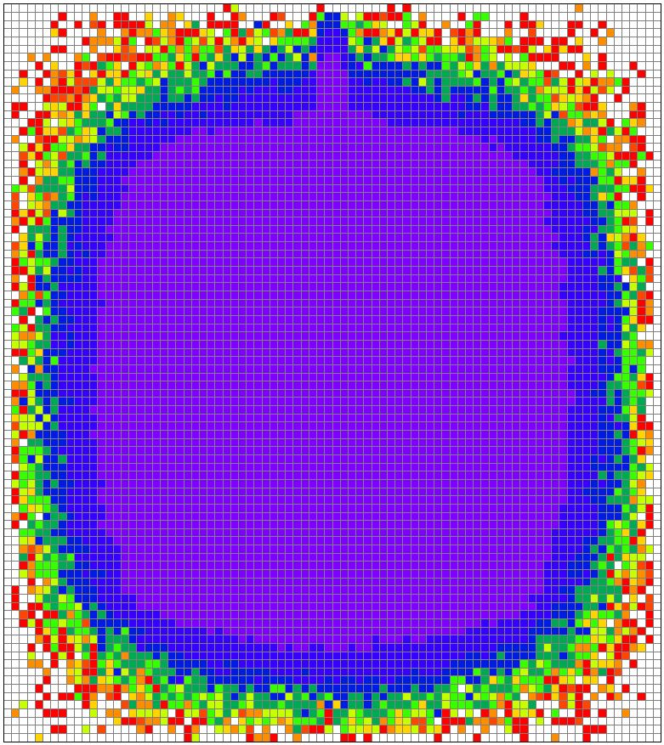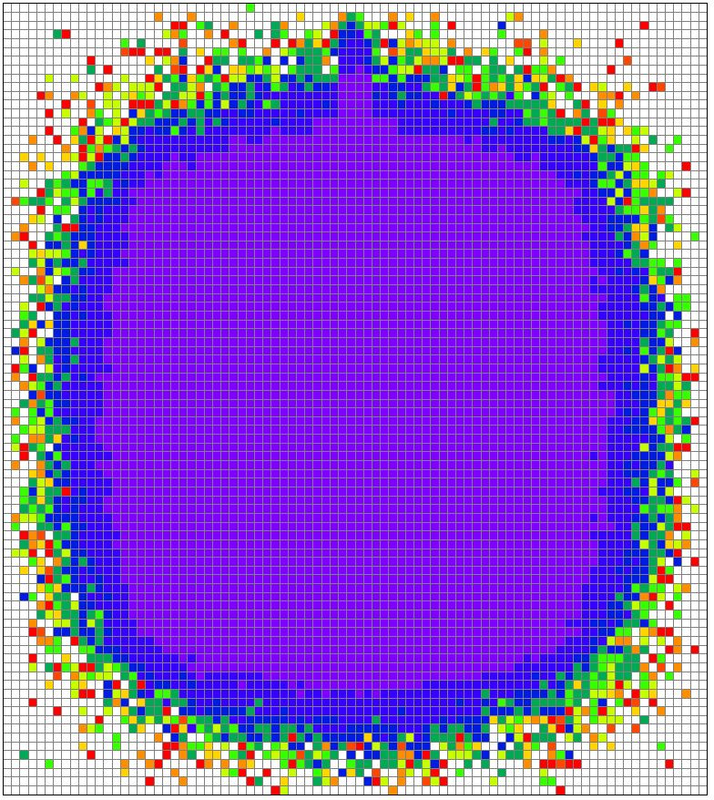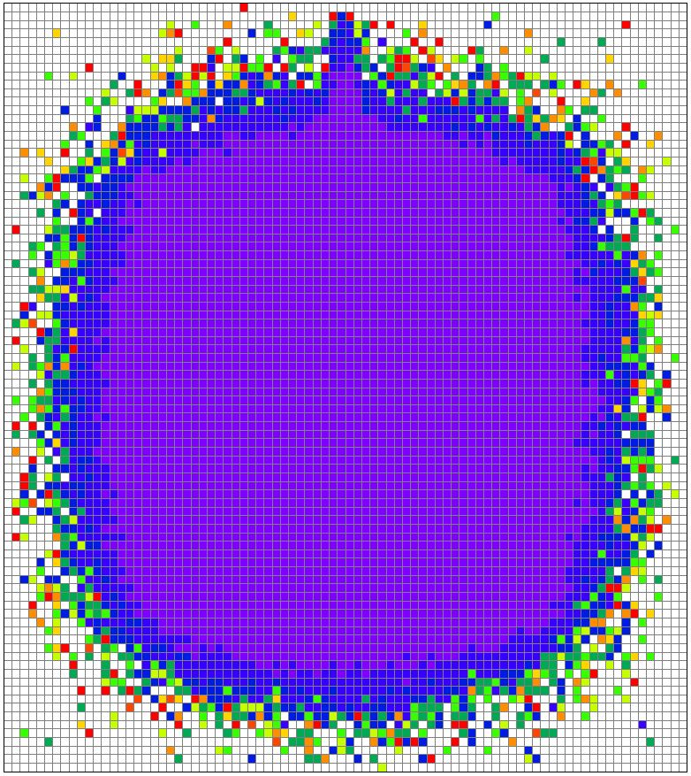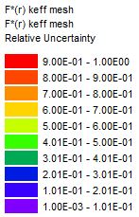
(a) CFP=2 (b) CFP=5 (c) CFP=10
Figure 39. Front View Meshview Image of F*(r) Relative Uncertainty for IMF-007-001

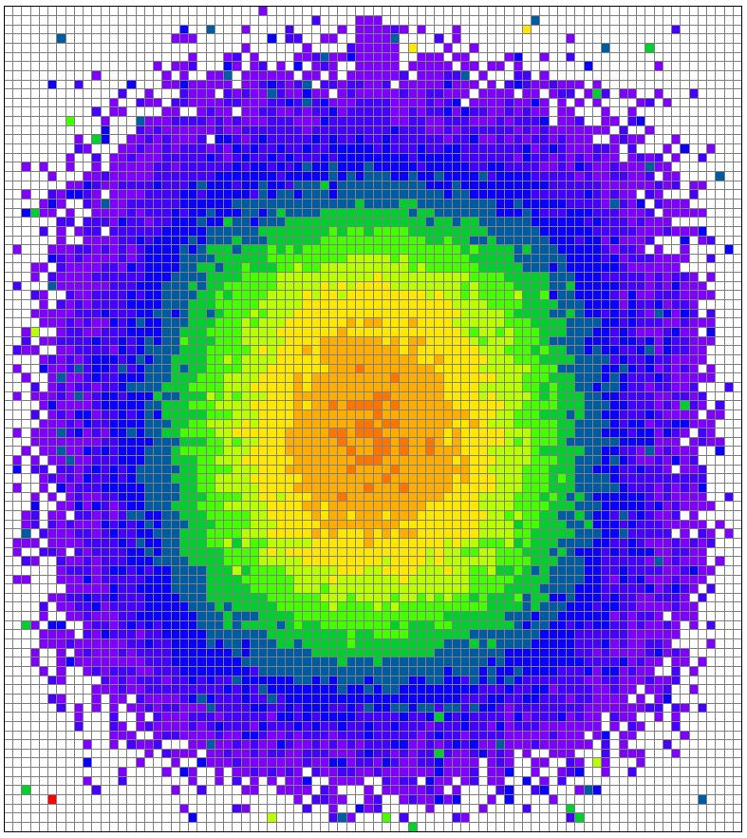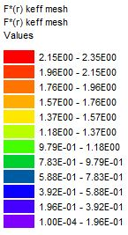
Figure 40. Meshview Plot of F*(r) Values for the Optimal Case

Figure 41 presents comparisons of TSUNAMI-3D-K5 and direct perturbation results for nuclide sensitivities having an absolute magnitude of ~0.02 or greater for both MG and CE TSUNAMI-3D. The MG and CE TSUNAMI-3D results presented in Figure 41 are considered acceptably consistent; however, the CE TSUNAMI-3D results show a slight improvement in the sensitivity comparisons for all important uranium nuclides. Since both MG and CE TSUNAMI-3D have low uncertainties associated with the sensitivities and good agreement with the direct perturbation sensitivities, both methods are considered adequate for calculating IMF-007-001 sensitivities.

Figure 41. TSUNAMI and Direct Perturbation Sensitivity Comparisons for Representative IMF-007-001 Nuclides

Figure 42 represents the figure of merit for each important nuclide for the MG and CE TSUNAMI-3D methods for IMF-007-001. The CE TSUNAMI-3D method exceeds the MG figure of merit for U-235 in the 93-wt% middle plate section. The MG TSUNAMI-3D method provides a larger FoM for U-235 in the natural uranium region, and U-235 and U-238 in the 10-wt% central plate region. Overall, IMF-007-001 the U-235 in the natural uranium is the limiting nuclide for the efficiency of the either sensitivity code.

Figure 42. Figures of Merit for MG and CE TSUNAMI-3D for IMF-007-001

LEU-COMP-THERM-042-007 Results

Table 35 provides k_{eff} results for the CSAS5 calculations using the V7-238 and CE_V7 libraries, which are used as k_{nominal} in the direct perturbation calculations for LCT-042-007.

Table 35. LCT-042-007 CSAS5 k_{eff} Results Using the V7-238 and the CE_V7 Libraries
Case | Benchmark |  | CSAS5 Result |  | Calculated/Experimental |  | Δk_{eff}
(LEU-COMP-THERM-042-007) | Model Values |  |  |  |  |  | (CSAS - Benchmark)
 | k_{eff} | σ | k_{eff} | σ | C/E | σ | Δk_{eff} | σ
MG | 1.000 | 0.0018 | 0.99634 | 0.0001 | 0.99634 | 0.0018 | 0.00366 | 0.0018
CE | 1.000 | 0.0018 | 0.99792 | 0.0001 | 0.99792 | 0.0018 | 0.00208 | 0.0018

The MG TSUNAMI-3D results were obtained by simulating 10 skipped generations and 832 active generations with 100,013 neutrons per generation for the forward calculation and 30 skipped generations and 2,398 active generations with 100,000 neutrons per generation for the adjoint calculation. The MG TSUNAMI-3D used 26 GB of memory with a runtime of 2.12 days. Table 36 provides the results for the MG TSUNAMI-3D sensitivities and DP calculations using the V7-238 library. The MG results are within 4.98% for all examined sensitivities. The largest magnitude of difference is 0.0030, which occurred for the U-238 in the fuel. The largest different in sensitivities in standard deviations is 2.81, which occurred for iron in the steel reflector. The DP comparisons for MG TSUNAMI-3D are considered adequate for calculating sensitivities for LCT-042-007.

Table 36. MG TSUNAMI-3D Results for LCT-042-007
Nuclide | In Material | TSUNAMI Results |  |  | Direct Perturbation Results |  |  |  | Results Comparison
 |  | S | σ_{S} | %σ_{S} | S | σ_{S} |  | %σ_{S} | S Diff in % | S Diff in Std Dev |  | ΔS
U-235 | fuel | 0.2424 | 1.37E-4 | 0.06% | 0.2431 |  | 0.0023 | 0.93% | -0.31% |  | 0.33 | -0.0007
U-238 | fuel | -0.1375 | 1.25E-4 | 0.09% | -0.1345 |  | 0.0014 | 1.00% | 2.24% |  | 2.22 | -0.0030
O | water moderator | 0.0212 | 1.11E-4 | 0.52% | 0.0213 |  | 0.0002 | 0.95% | -0.55% |  | 0.51 | -0.0001
Fe | steel reflector | 0.0228 | 9.19E-5 | 0.40% | 0.0233 |  | 0.0002 | 0.81% | -2.53% |  | 2.81 | -0.0006
H | water reflector (around fuel) | 0.2321 | 1.44E-3 | 0.62% | 0.2328 |  | 0.0023 | 0.99% | -0.31% |  | 0.27 | -0.0007
H | water reflector | -0.0324 | 1.49E-3 | 4.59% | -0.0341 |  | 0.0003 | 0.93% | -4.98% |  | 1.12 | 0.0017

Table 40 in Appendix B provides the results for seven different CE TSUNAMI-3D cases with a single changing parameter between each case. For each LCT-042-007 case shown in Table 40, five latent generations are simulated with 500 skipped generations with 4,500 active generations. The seven different variations of neutrons per generation are as follows: 1,000, 10,000, 25,000, 50,000, 100,000, 150,000, and 200,000. The difficulty in obtaining LCT-042-007 sensitivities began with a large uncertainty in the hydrogen in the water reflector for CE TSUNAMI-3D. From Table 40, the uncertainty in the hydrogen sensitivity begins at 25.78% for 1,000 particles per generation, and then improves to 1.57% after 200,000 particles per generation are simulated. However, sufficient uncertainty of 3.19% is achieved at 50,000, which will be considered the most efficient case for LCT-042-007.
The most efficient LCT-042-007 CE TSUNAMI-3D model, which is also shown in Table 37, has a memory footprint of approximately 3.1 GB with a runtime of 14.1 hours while running in parallel on a total of 32 cores (18.8 CPU-days). The mesh interval size that provides accurate sensitivities was determined to be 1 cm, 1 cm, and 2 cm in the x-, y-, and z-direction. From Table 37, the CE TSUNAMI-3D agreement with the DPs is well within the acceptable limits for each nuclide. The largest magnitude of difference is 0.0063, which occurred for the hydrogen in the section of water reflector around the fuel region. The optimal parameters for LCT-042-007 are determined to be the following:

- GEN=5,000 | - CET=1 (CLUTCH)
- NPG=50,000 | - CFP=5
- NSK=500 | - TBA=30
- Mesh size in x- and y-dir. ≈ 1 cm | - Mesh size in z-dir. ≈ 2 cm

Table 37. CE TSUNAMI-3D CLUTCH Optimal Results for LCT-042-007 with NPG=50,000
Nuclide | In Material | TSUNAMI Results |  |  | Direct Perturbation Results |  |  | Results Comparison
 |  | S | σ_{S} | %σ_{S} | S | σ_{S} | %σ_{S} | S Diff in % | S Diff in Std Dev | ΔS
U-235 | fuel | 0.2422 | 5.35E-5 | 0.02% | 0.2448 | 0.0022 | 0.92% | -1.07% | 1.16 | -0.0026
U-238 | fuel | -0.1363 | 2.57E-4 | 0.19% | -0.1354 | 0.0013 | 0.95% | 0.68% | 0.70 | -0.0009
O | water moderator | 0.0208 | 2.66E-4 | 1.27% | 0.0211 | 0.0002 | 0.96% | -1.26% | 0.80 | -0.0003
Fe | steel reflector | 0.0213 | 3.59E-4 | 1.68% | 0.0220 | 0.0002 | 0.82% | -3.02% | 1.65 | -0.0007
H | water reflector (around fuel) | 0.2300 | 2.49E-3 | 1.08% | 0.2363 | 0.0022 | 0.93% | -2.67% | 1.90 | -0.0063
H | water reflector | -0.0348 | 1.11E-3 | 3.19% | -0.0340 | 0.0003 | 0.96% | 2.33% | 0.68 | -0.0008

Figure 43 depicts the top view of the F*(r) values for LCT-042-007 using the SCALE Meshview visualization tool. As expected, the F*(r) values are highest near the center of the each array. Additionally, the F*(r) values decrease towards the edge of the each array. Figure 44 shows a low uncertainty in the center of the each array, with a large uncertainty as the function moves in the outward direction. Figure 45 represents the plot of F*(r) values along the x-direction for LCT-042-007. The plot of F*(r) values in Figure 45 displays the highest F*(r) values at the center of the each array and decreasing values along the edge of the arrays. Similar to PST-011-012, the user should not spend a considerable amount of time obtaining lower uncertainty values as long as the resulting TSUNAMI-3D sensitivities agree with the direct perturbation sensitivities.

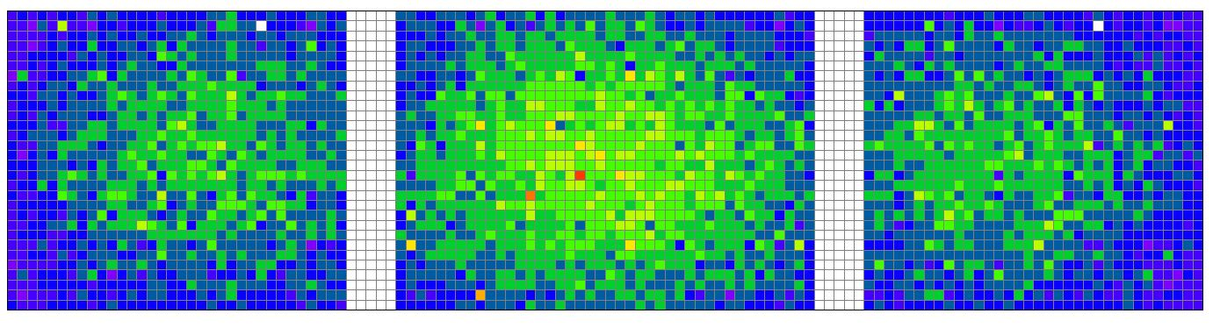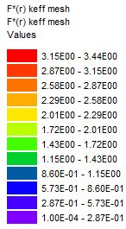
Figure 43. Meshview Plot of F*(r) Values for Optimal Parameters for LCT-042-007

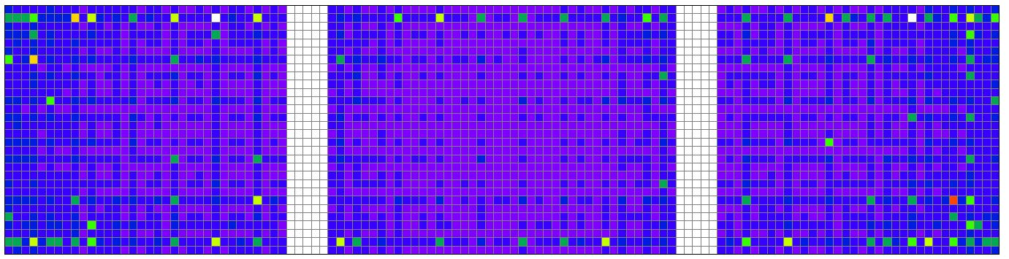
Figure 44. Meshview Plot of F*(r) Relative Uncertainties for NPG=50,000

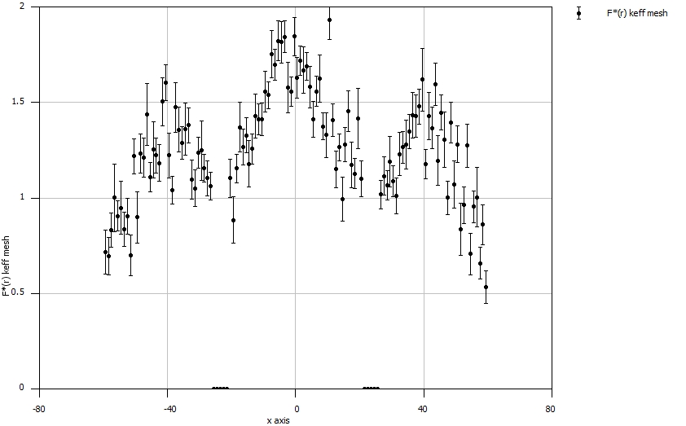
Figure 45. Plot of F*(r) Values in the x-direction for NPG=50,000 for LCT-042-007

Figure 46 presents comparisons of TSUNAMI-3D-K5 and direct perturbation results for nuclide sensitivities having an absolute magnitude of ~0.02 or greater for both MG and CE TSUNAMI-3D for LCT-042-007. The MG and CE TSUNAMI-3D results presented in Figure 46 are considered acceptably consistent with indistinguishable DP agreements. Since both MG and CE TSUNAMI-3D have low sensitivity uncertainty and good agreement with the direct perturbation sensitivities, both methods are considered adequate for calculating sensitivities for LCT-042-007.
Figure 47 represents the convergence of the eigenvalue sensitivity coefficient for hydrogen in the solution with CE TSUNAMI-3D-K5 as a function of total active particles. The figure provides an indication of the proper number of total active particles for convergence required in order to obtain a low uncertainty for the hydrogen in LCT-042-007.
Figure 48 shows the figure of merit for each individual important nuclide for the MG and CE TSUNAMI-3D methods for LCT-042-007. The MG TSUNAMI-3D method exceeds the CE FoM for all important nuclides except U-235. The U-235 figure of merit is approximately equal for both sensitivity methods. Similar to previous systems, the most important FoM for LCT-042-007 is for hydrogen in water reflector region (excluding water reflector region around the fuel). A detailed table of the figures of merit is shown in Table 41 in Appendix C.

Figure 46. TSUNAMI and Direct Perturbation Sensitivity Comparisons for Representative LCT-042-007 Nuclides

Figure 47. CE TSUNAMI-3D Sensitivity for Hydrogen for LCT-042-007 as a Function of Total Active Particles

Figure 48. Figure of Merit for MG and CE TSUNAMI-3D for LCT-042-007

SECTION 6
CONCLUSIONS

The multigroup TSUNAMI-3D and continuous-energy TSUNAMI-3D CLUTCH calculations were used to analyze a wide variety of system types. The models were built based on evaluations from the International Handbook of Evaluated Criticality Safety Benchmark Experiments. Each evaluation examined resulted in good agreement with the direct perturbation for MG TSUNAMI-3D except MST-004-001 and MST-005-001. Ultimately, all experiments modeled in CE TUNAMI-3D CLUTCH resulted in accurate sensitivities when compared to the reference sensitivities. Table 38 provides a general overview of parameters used for each type of analyzed system from the IHECSBE. In addition to the parameters shown below, all models also contain CET=1, FST=yes, TBA=30 (or any sufficiently large positive integer), and CGD=1 (or any positive integer). To avoid repetitiveness, these parameters are not added to the parameters shown in Table 38.

Table 38. CE TSUNAMI-3D CLUTCH Summary of Case-Specific Parameters
System Type | CE TSUNAMI-3D CLUTCH Parameters | System Type | CE TSUNAMI-3D CLUTCH Parameters
MST | GEN=5,000 | HMM | GEN=3,500
MST | NPG=10,000-200,000 | HMM | NPG=10,000
MST | NSK=1,000 | HMM | NSK=500
MST | CFP=5 or 10 | HMM | CFP=5
MST | Mesh size in X,Y=1-2 cm | HMM | Mesh size in X,Y=1 cm
MST | Mesh size in Z=1-3 cm | HMM | Mesh size in Z=1.33 cm
MMT | GEN=5,000 | HMF | GEN=1,000-4,100
MMT | NPG=100,000 | HMF | NPG=20,000-50,000
MMT | NSK=1,000 | HMF | NSK=100-500
MMT | CFP=5 | HMF | CFP=5
MMT | Mesh size in X,Y=1.4 cm | HMF | Mesh size in X,Y=0.5-1 cm
MMT | Mesh size in Z=5 cm | HMF | Mesh size in Z=0.5-2 cm
PST | GEN=10,000 | IMF | GEN=6,000
PST | NPG=10,000 | IMF | NPG=200,000
PST | NSK=1,000 | IMF | NSK=2,000
PST | CFP=5 | IMF | CFP=10
PST | Mesh size in X,Y=1 cm | IMF | Mesh size in X,Y=1 cm
PST | Mesh size in Z=1 cm | IMF | Mesh size in Z=1 cm
HST | GEN=3,001 | LCT | GEN=5,000
HST | NPG=10,000 | LCT | NPG=50,000
HST | NSK=20 | LCT | NSK=500
HST | CFP=5 | LCT | CFP=5
HST | Mesh size in X,Y=2.8 cm | LCT | Mesh size in X,Y=1 cm
HST | Mesh size in Z=4 cm | LCT | Mesh size in Z=2 cm
The main factors for determining which sensitivity method should be used include computing availability, type of system modeled, and runtime considerations. Overall, for serial processing, MG TSUNAMI-3D typically requires a shorter runtime than CE TSUNAMI-3D; however, MG TSUNAMI-3D is also known to require large memory usage. If the user has access to significant computational resources, then processing CE TSUNAMI-3D in parallel reduces the wall time substantially. Across the systems analyzed, the continuous-energy sensitivity calculations appear to provide better accuracy for U-235 and Pu-239 when compared to the multigroup results. For cases with high hydrogen sensitivity in thermal systems, the multigroup method performed better than the continuous-energy method. However, difficulties are occasionally encountered in the uncertainty of the hydrogen sensitivity for the MG method, as shown in MST-004-001 and MST-005-001. When facing difficulties with hydrogen sensitivity uncertainty in MG, the CE TSUNAMI-3D CLUTCH method is capable of obtaining accurate sensitivities with a low uncertainty. Therefore, CE TSUNAMI-3D provides an additional option for obtaining sensitivities where MG appears to perform poorly.

SECTION 7
FUTURE WORK

Future work includes a continuation of reviewing CE TSUNAMI-3D models, with an expansion on fast spectrum systems and other system types from the IHECSBE. Once SCALE 6.2 is released, a thorough review of unsuccessful MG TSUNAMI-3D evaluations should be reevaluated with the new SCALE 6.2 continuous-energy (CE) TSUNAMI CLUTCH for the potential addition to VALID. Since a significant amount of nuclear criticality safety experiments are performed with thermal systems, it would be beneficial to research potential improvements in the hydrogen sensitivity results for CE TSUNAMI-3D CLUTCH.

REFERENCES
- Scale: A Comprehensive Modeling and Simulation Suite for Nuclear Safety Analysis and Design, ORNL/TM-2005/39, Version 6.1, Oak Ridge National Laboratory, Oak Ridge, Tennessee, June 2011. Available from Radiation Safety Information Computational Center at Oak Ridge National Laboratory as CCC-785.

- B.T. Rearden, M.L. Williams, M.A. Jessee, D.E. Mueller, and D.A. Wiarda, Sensitivity and Uncertainty Analysis Capabilities and Data in SCALE, Nuclear Technology, 174(2), 236-288, May 2011.

- B.T. Rearden et al., Overview of SCALE 6.2, ANS Nuclear Criticality Safety Division Topical meeting (NCSD2013), Wilmington, NC, September 29 – October 3, 2013.

- C.M. Perfetti and B.T. Rearden, Development of a SCALE Tool for Continuous-Energy Eigenvalue Sensitivity Coefficient Calculations, Joint International Conference on Supercomputing in Nuclear Applications and Monte Carlo 2013 (SNA + MC 2013), La Cité des Sciences et de l’Industrie, Paris, France, October 27-31, 2013.

- C.M. Perfetti and B.T. Rearden, Use of SCALE Continuous-Energy Monte Carlo Tools for Eigenvalue Sensitivity Coefficients Calculations, ANS NCSD 2013 – Criticality Safety in the Modern Era: Raising the Bar, Wilmington, NC, September 29 – October 3, 2013.

- International Handbook of Evaluated Criticality Safety Benchmark Experiments, NEA/NSC/DOC(95)03, Nuclear Energy Agency/Organisation for Economic Co-operation and Development, September 2013.

- C. M. Perfetti, Advanced Monte Carlo Methods for Eigenvalue Sensitivity Coefficient Calculations, doctoral dissertation, University of Michigan (2012).

- Nuclear Criticality Safety in Operations with Fissionable Material Outside Reactors, ANSI/ANS-8.1-2014, American Nuclear Society, La Grange Park, IL (2014).

- Validation of Neutron Transport Methods for Nuclear Criticality Safety Calculations, ANSI/ANS-8.24-2007:R2012, American Nuclear Society, La Grange Park, IL (2012).

- W.J. Marshall and D. A. Reed, Scale Procedure for Verified, Archived Library of Input and Data (VALID), Scale-CMP-012, Revision 2, Oak Ridge National Laboratory, Oak Ridge, Tenn., May 22, 2013.

- W.J. Marshall and B.T. Rearden, The SCALE Verified, Archived Library of Inputs and Data - VALID, ANS Nuclear Criticality Safety Division Topical meeting (NCSD2013), Wilmington, NC, September 29 – October 3, 2013.

APPENDIX

Appendix A
Table 39. CE TSUNAMI-3D Extended Results for PST-011-012 with NPG=10000 and NSK=1000
Nuclide | In Material | TSUNAMI Results |  |  | Direct Perturbation Results |  |  | Results Comparison
 |  | S | σ_{S} | %σ_{S} | S | σ_{S} | %σ_{S} | S Diff in % | S Diff in Std Dev | ΔS
GEN=1,100
H | Solution | 0.3097 | 6.66E-2 | 21.50% | 0.2870 | 0.0034 | 1.19% | 7.93% | 0.34 | 0.0228
N | Solution | -0.0194 | 8.63E-4 | 4.45% | -0.0197 | 0.0003 | 1.32% | 1.59% | 0.35 | 0.0003
O | Solution | 0.1013 | 5.80E-3 | 5.73% | 0.0949 | 0.0012 | 1.25% | 6.73% | 1.08 | 0.0064
Pu-239 | Solution | 0.2797 | 5.13E-4 | 0.18% | 0.2771 | 0.0034 | 1.24% | 0.97% | 0.77 | 0.0027
Pu-240 | Solution | -0.0205 | 1.05E-4 | 0.51% | -0.0209 | 0.0003 | 1.26% | 1.64% | 1.21 | 0.0003
GEN=1,250
H | Solution | 0.2745 | 4.21E-2 | 15.33% | 0.2870 | 0.0034 | 1.19% | 4.35% | 0.30 | -0.0125
N | Solution | -0.0199 | 5.17E-4 | 2.60% | -0.0197 | 0.0003 | 1.32% | 0.93% | 0.32 | -0.0002
O | Solution | 0.0934 | 3.88E-3 | 4.15% | 0.0949 | 0.0012 | 1.25% | 1.57% | 0.37 | -0.0015
Pu-239 | Solution | 0.2798 | 2.99E-4 | 0.11% | 0.2771 | 0.0034 | 1.24% | 0.99% | 0.79 | 0.0027
Pu-240 | Solution | -0.0207 | 6.20E-5 | 0.30% | -0.0209 | 0.0003 | 1.26% | 0.85% | 0.65 | 0.0002
GEN=1,500
H | Solution | 0.2559 | 3.09E-2 | 12.06% | 0.2870 | 0.0034 | 1.19% | 10.82% | 1.00 | -0.0311
N | Solution | -0.0193 | 3.87E-4 | 2.00% | -0.0197 | 0.0003 | 1.32% | 1.86% | 0.78 | 0.0004
O | Solution | 0.0926 | 2.79E-3 | 3.02% | 0.0949 | 0.0012 | 1.25% | 2.48% | 0.78 | -0.0024
Pu-239 | Solution | 0.2798 | 2.17E-4 | 0.08% | 0.2771 | 0.0034 | 1.24% | 1.00% | 0.81 | 0.0028
Pu-240 | Solution | -0.0208 | 4.34E-5 | 0.21% | -0.0209 | 0.0003 | 1.26% | 0.63% | 0.50 | 0.0001
GEN=2,000
H | Solution | 0.2841 | 2.21E-2 | 7.77% | 0.2870 | 0.0034 | 1.19% | 0.98% | 0.13 | -0.0028
N | Solution | -0.0192 | 2.76E-4 | 1.44% | -0.0197 | 0.0003 | 1.32% | 2.38% | 1.24 | 0.0005
O | Solution | 0.0959 | 2.00E-3 | 2.09% | 0.0949 | 0.0012 | 1.25% | 1.01% | 0.41 | 0.0010
Pu-239 | Solution | 0.2800 | 1.53E-4 | 0.05% | 0.2771 | 0.0034 | 1.24% | 1.04% | 0.84 | 0.0029
Pu-240 | Solution | -0.0208 | 2.99E-5 | 0.14% | -0.0209 | 0.0003 | 1.26% | 0.55% | 0.43 | 0.0001
GEN=2,500
H | Solution | 0.2778 | 1.80E-2 | 6.48% | 0.2870 | 0.0034 | 1.19% | 3.19% | 0.50 | -0.0092
N | Solution | -0.0194 | 2.29E-4 | 1.18% | -0.0197 | 0.0003 | 1.32% | 1.33% | 0.76 | 0.0003
O | Solution | 0.0942 | 1.63E-3 | 1.73% | 0.0949 | 0.0012 | 1.25% | 0.74% | 0.35 | -0.0007
Pu-239 | Solution | 0.2799 | 1.26E-4 | 0.05% | 0.2771 | 0.0034 | 1.24% | 1.03% | 0.83 | 0.0029
Pu-240 | Solution | -0.0208 | 2.45E-5 | 0.12% | -0.0209 | 0.0003 | 1.26% | 0.56% | 0.44 | 0.0001

Table 39. Continued.
Nuclide | In Material | TSUNAMI Results |  |  | Direct Perturbation Results |  |  | Results Comparison
 |  | S | σ_{S} | %σ_{S} | S | σ_{S} | %σ_{S} | S Diff in % | S Diff in Std Dev | ΔS
GEN=5,000
H | Solution | 0.2740 | 1.11E-2 | 4.05% | 0.2870 | 0.0034 | 1.19% | 4.51% | 1.11 | -0.0129
N | Solution | -0.0195 | 1.40E-4 | 0.72% | -0.0197 | 0.0003 | 1.32% | 1.13% | 0.76 | 0.0002
O | Solution | 0.0937 | 1.00E-3 | 1.07% | 0.0949 | 0.0012 | 1.25% | 1.36% | 0.83 | -0.0013
Pu-239 | Solution | 0.2800 | 7.74E-5 | 0.03% | 0.2771 | 0.0034 | 1.24% | 1.04% | 0.84 | 0.0029
Pu-240 | Solution | -0.0208 | 1.50E-5 | 0.07% | -0.0209 | 0.0003 | 1.26% | 0.50% | 0.40 | 0.0001
GEN=7,500
H | Solution | 0.2765 | 8.73E-3 | 3.16% | 0.2870 | 0.0034 | 1.19% | 3.66% | 1.12 | -0.0105
N | Solution | -0.0194 | 1.10E-4 | 0.57% | -0.0197 | 0.0003 | 1.32% | 1.64% | 1.14 | 0.0003
O | Solution | 0.0942 | 7.86E-4 | 0.83% | 0.0949 | 0.0012 | 1.25% | 0.81% | 0.54 | -0.0008
Pu-239 | Solution | 0.2800 | 6.11E-5 | 0.02% | 0.2771 | 0.0034 | 1.24% | 1.05% | 0.85 | 0.0029
Pu-240 | Solution | -0.0208 | 1.18E-5 | 0.06% | -0.0209 | 0.0003 | 1.26% | 0.50% | 0.40 | 0.0001
GEN=10,000
H | Solution | 0.2841 | 7.45E-3 | 2.62% | 0.2870 | 0.0034 | 1.19% | 0.99% | 0.35 | -0.0028
N | Solution | -0.0194 | 9.37E-5 | 0.48% | -0.0197 | 0.0003 | 1.32% | 1.64% | 1.17 | 0.0003
O | Solution | 0.0945 | 6.69E-4 | 0.71% | 0.0949 | 0.0012 | 1.25% | 0.42% | 0.29 | -0.0004
Pu-239 | Solution | 0.2800 | 5.20E-5 | 0.02% | 0.2771 | 0.0034 | 1.24% | 1.06% | 0.85 | 0.0029
Pu-240 | Solution | -0.0208 | 1.01E-5 | 0.05% | -0.0209 | 0.0003 | 1.26% | 0.53% | 0.42 | 0.0001
GEN=15,000
H | Solution | 0.2874 | 5.95E-3 | 2.07% | 0.2870 | 0.0034 | 1.19% | 0.14% | 0.06 | 0.0004
N | Solution | -0.0194 | 7.48E-5 | 0.39% | -0.0197 | 0.0003 | 1.32% | 1.58% | 1.15 | 0.0003
O | Solution | 0.0951 | 5.35E-4 | 0.56% | 0.0949 | 0.0012 | 1.25% | 0.20% | 0.15 | 0.0002
Pu-239 | Solution | 0.2800 | 4.14E-5 | 0.01% | 0.2771 | 0.0034 | 1.24% | 1.06% | 0.85 | 0.0029
Pu-240 | Solution | -0.0208 | 8.11E-6 | 0.04% | -0.0209 | 0.0003 | 1.26% | 0.49% | 0.39 | 0.0001
GEN=20,000
H | Solution | 0.2823 | 5.10E-3 | 1.81% | 0.2870 | 0.0034 | 1.19% | 1.62% | 0.76 | -0.0046
N | Solution | -0.0194 | 6.39E-5 | 0.33% | -0.0197 | 0.0003 | 1.32% | 1.48% | 1.09 | 0.0003
O | Solution | 0.0946 | 4.59E-4 | 0.48% | 0.0949 | 0.0012 | 1.25% | 0.37% | 0.28 | -0.0004
Pu-239 | Solution | 0.2800 | 3.56E-5 | 0.01% | 0.2771 | 0.0034 | 1.24% | 1.05% | 0.84 | 0.0029
Pu-240 | Solution | -0.0208 | 6.94E-6 | 0.03% | -0.0209 | 0.0003 | 1.26% | 0.47% | 0.37 | 0.0001

Appendix B
Table 40. CE TSUNAMI-3D Extended Results for LCT-042-007 with GEN=5000 and NSK=500
Nuclide | In Material | TSUNAMI Results |  |  | Direct Perturbation Results |  |  | Results Comparison
 |  | S | σ_{S} | %σ_{S} | S | σ_{S} | %σ_{S} | S Diff in % | S Diff in Std Dev | ΔS
NPG=1,000
U-235 | fuel | 0.2464 | 5.73E-4 | 0.23% | 0.2448 | 0.0022 | 0.92% | 0.67% | 0.71 | 0.0016
U-238 | fuel | -0.1355 | 2.17E-3 | 1.60% | -0.1354 | 0.0013 | 0.95% | 0.09% | 0.05 | -0.0001
O | water moderator | 0.0193 | 2.17E-3 | 11.23% | 0.0211 | 0.0002 | 0.96% | -8.40% | 0.81 | -0.0018
Fe | steel reflector | 0.0252 | 3.55E-3 | 14.07% | 0.0220 | 0.0002 | 0.82% | 14.60% | 0.90 | 0.0032
H | water reflector (around fuel) | 0.2340 | 2.16E-2 | 9.21% | 0.2363 | 0.0022 | 0.93% | -1.00% | 0.11 | -0.0024
H | water reflector | -0.0462 | 1.19E-2 | 25.78% | -0.0340 | 0.0003 | 0.96% | 35.99% | 1.03 | -0.0122
NPG=10,000
U-235 | fuel | 0.2430 | 1.32E-4 | 0.05% | 0.2448 | 0.0022 | 0.92% | -0.73% | 0.80 | -0.0018
U-238 | fuel | -0.1376 | 6.10E-4 | 0.44% | -0.1354 | 0.0013 | 0.95% | 1.63% | 1.55 | -0.0022
O | water moderator | 0.0201 | 6.25E-4 | 3.12% | 0.0211 | 0.0002 | 0.96% | -5.00% | 1.61 | -0.0011
Fe | steel reflector | 0.0225 | 8.61E-4 | 3.83% | 0.0220 | 0.0002 | 0.82% | 2.11% | 0.53 | 0.0005
H | water reflector (around fuel) | 0.2247 | 5.94E-3 | 2.64% | 0.2363 | 0.0022 | 0.93% | -4.91% | 1.83 | -0.0116
H | water reflector | -0.0313 | 2.75E-3 | 8.78% | -0.0340 | 0.0003 | 0.96% | -7.80% | 0.96 | 0.0027
NPG=25,000
U-235 | fuel | 0.2424 | 7.76E-5 | 0.03% | 0.2448 | 0.0022 | 0.92% | -0.99% | 1.08 | -0.0024
U-238 | fuel | -0.1367 | 3.67E-4 | 0.27% | -0.1354 | 0.0013 | 0.95% | 0.96% | 0.97 | -0.0013
O | water moderator | 0.0203 | 3.01E-4 | 1.48% | 0.0211 | 0.0002 | 0.96% | -3.67% | 2.13 | -0.0008
Fe | steel reflector | 0.0212 | 5.18E-4 | 2.44% | 0.0220 | 0.0002 | 0.82% | -3.62% | 1.45 | -0.0008
H | water reflector (around fuel) | 0.2289 | 3.54E-3 | 1.55% | 0.2363 | 0.0022 | 0.93% | -3.13% | 1.78 | -0.0074
H | water reflector | -0.0330 | 1.57E-3 | 4.76% | -0.0340 | 0.0003 | 0.96% | -2.84% | 0.60 | 0.0010
NPG=50,000
U-235 | fuel | 0.2422 | 5.35E-5 | 0.02% | 0.2448 | 0.0022 | 0.92% | -1.07% | 1.16 | -0.0026
U-238 | fuel | -0.1363 | 2.57E-4 | 0.19% | -0.1354 | 0.0013 | 0.95% | 0.68% | 0.70 | -0.0009
O | water moderator | 0.0208 | 2.66E-4 | 1.27% | 0.0211 | 0.0002 | 0.96% | -1.26% | 0.80 | -0.0003
Fe | steel reflector | 0.0213 | 3.59E-4 | 1.68% | 0.0220 | 0.0002 | 0.82% | -3.02% | 1.65 | -0.0007
H | water reflector (around fuel) | 0.2300 | 2.49E-3 | 1.08% | 0.2363 | 0.0022 | 0.93% | -2.67% | 1.90 | -0.0063
H | water reflector | -0.0348 | 1.11E-3 | 3.19% | -0.0340 | 0.0003 | 0.96% | 2.33% | 0.68 | -0.0008
Table 40. Continued.
Nuclide | In Material | TSUNAMI Results |  |  | Direct Perturbation Results |  |  | Results Comparison
 |  | S | σ_{S} | %σ_{S} | S | σ_{S} | %σ_{S} | S Diff in % | S Diff in Std Dev | ΔS
NPG=100,000
U-235 | fuel | 0.2422 | 3.76E-5 | 0.02% | 0.2448 | 0.0022 | 0.92% | -1.08% | 1.18 | -0.0026
U-238 | fuel | -0.1363 | 1.83E-4 | 0.13% | -0.1354 | 0.0013 | 0.95% | 0.68% | 0.71 | -0.0009
O | water moderator | 0.0205 | 1.85E-4 | 0.90% | 0.0211 | 0.0002 | 0.96% | -2.85% | 2.20 | -0.0006
Fe | steel reflector | 0.0206 | 2.54E-4 | 1.24% | 0.0220 | 0.0002 | 0.82% | -6.53% | 4.61 | -0.0014
H | water reflector (around fuel) | 0.2276 | 1.75E-3 | 0.77% | 0.2363 | 0.0022 | 0.93% | -3.70% | 3.11 | -0.0087
H | water reflector | -0.0323 | 7.60E-4 | 2.35% | -0.0340 | 0.0003 | 0.96% | -5.01% | 2.06 | 0.0017
NPG=150,000
U-235 | fuel | 0.2421 | 3.08E-5 | 0.01% | 0.2448 | 0.0022 | 0.92% | -1.12% | 1.22 | -0.0027
U-238 | fuel | -0.1364 | 1.51E-4 | 0.11% | -0.1354 | 0.0013 | 0.95% | 0.72% | 0.76 | -0.0010
O | water moderator | 0.0207 | 1.53E-4 | 0.74% | 0.0211 | 0.0002 | 0.96% | -2.10% | 1.75 | -0.0004
Fe | steel reflector | 0.0213 | 2.09E-4 | 0.98% | 0.0220 | 0.0002 | 0.82% | -3.35% | 2.67 | -0.0007
H | water reflector (around fuel) | 0.2297 | 1.43E-3 | 0.62% | 0.2363 | 0.0022 | 0.93% | -2.82% | 2.54 | -0.0067
H | water reflector | -0.0339 | 6.14E-4 | 1.81% | -0.0340 | 0.0003 | 0.96% | -0.27% | 0.13 | 0.0001
NPG=200,000
U-235 | fuel | 0.2421 | 2.63E-5 | 0.01% | 0.2448 | 0.0022 | 0.92% | -1.12% | 1.22 | -0.0027
U-238 | fuel | -0.1364 | 1.31E-4 | 0.10% | -0.1354 | 0.0013 | 0.95% | 0.74% | 0.77 | -0.0010
O | water moderator | 0.0207 | 1.32E-4 | 0.64% | 0.0211 | 0.0002 | 0.96% | -2.15% | 1.88 | -0.0005
Fe | steel reflector | 0.0211 | 1.80E-4 | 0.85% | 0.0220 | 0.0002 | 0.82% | -4.22% | 3.64 | -0.0009
H | water reflector (around fuel) | 0.2289 | 1.26E-3 | 0.55% | 0.2363 | 0.0022 | 0.93% | -3.14% | 2.93 | -0.0074
H | water reflector | -0.0346 | 5.45E-4 | 1.57% | -0.0340 | 0.0003 | 0.96% | 1.82% | 0.98 | -0.0006

Appendix C
Table 41. TSUNAMI-3D Summary of Results for MG and CE CLUTCH for LCT-042-007
 | MG | CE CLUTCH on 32 Cores
Runtime (hrs) | 50.78 | 104.32 | 164.16 | 354.88 | 450.24 | 760.00 | 1082.88 | 1479.68
DP Agreement? | Yes | No | No | No | Yes | Yes | Yes | Yes
NPG | 100,013 | 1,000 | 10,000 | 25,000 | 50,000 | 100,000 | 150,000 | 200,000
NSK | 10 | 500
Memory (GB) | 25.7 | 3.1
U-235 Sensitivity | 0.2424 | 0.246 | 0.243 | 0.242 | 0.242 | 0.242 | 0.242 | 0.242
Uncertainty in U-235 Sensitivity | 0.06% | 0.23% | 0.05% | 0.03% | 0.02% | 0.02% | 0.01% | 0.01%
U-235 FoM (/min) | 911.703 | 30.201 | 406.108 | 521.825 | 925.432 | 548.246 | 1539.106 | 1126.370
U-238 Sensitivity | -0.1375 | -0.1355 | -0.1376 | -0.1367 | -0.1363 | -0.1363 | -0.1364 | -0.1364
Uncertainty in U-238 Sensitivity | 0.09% | 1.60% | 0.44% | 0.27% | 0.19% | 0.13% | 0.11% | 0.10%
U-238 FoM (/min) | 405.201 | 0.624 | 5.244 | 6.442 | 10.254 | 12.976 | 12.720 | 11.264
O Sensitivity | 0.0212 | 0.0193 | 0.0201 | 0.0203 | 0.0208 | 0.0205 | 0.0207 | 0.0207
Uncertainty in O Sensitivity | 0.52% | 11.23% | 3.12% | 1.48% | 1.27% | 0.90% | 0.74% | 0.64%
O FoM (/min) | 12.138 | 0.013 | 0.104 | 0.214 | 0.230 | 0.271 | 0.281 | 0.275
Fe Sensitivity | 0.0228 | 0.0252 | 0.0225 | 0.0212 | 0.0213 | 0.0206 | 0.0213 | 0.0211
Uncertainty in Fe Sensitivity | 0.40% | 14.07% | 3.83% | 2.44% | 1.68% | 1.24% | 0.98% | 0.85%
Fe FoM (/min) | 20.513 | 0.008 | 0.069 | 0.079 | 0.131 | 0.143 | 0.160 | 0.156
H (mod-around fuel) Sensitivity | 0.2321 | 0.234 | 0.2247 | 0.2289 | 0.23 | 0.2276 | 0.2297 | 0.2289
Uncertainty in H (mod-around fuel) Sensitivity | 0.62% | 9.21% | 2.64% | 1.55% | 1.08% | 0.77% | 0.62% | 0.55%
H (mod-around fuel) FoM (/min) | 8.538 | 0.019 | 0.146 | 0.195 | 0.317 | 0.370 | 0.400 | 0.372
H (mod-elsewhere) Sensitivity | -0.0324 | -0.0462 | -0.0313 | -0.033 | -0.0348 | -0.0323 | -0.0339 | -0.0346
Uncertainty in (mod-elsewhere) Sensitivity | 4.59% | 25.78% | 8.78% | 4.76% | 3.19% | 2.35% | 1.81% | 1.57%
H (mod-elsewhere) FoM (/min) | 0.156 | 0.002 | 0.013 | 0.021 | 0.036 | 0.040 | 0.047 | 0.046

VITA

Elizabeth Jones was born in Knoxville, TN, to David and Cheryl Jones. She is the middle child of three, with an older brother, Jared, and a younger sister, Ashlyn. She attended Rush Strong Elementary School and continued to Jefferson County High School in Dandridge, TN. After graduation, she began studying at Walters State Community College (WSCC) while coinciding with student tutoring at WSCC. In the summer of 2011, she graduated from WSCC with an Associate’s Degree in Pre-Engineering with a Minor in Mathematics. Then she started attending the University of Tennessee, Knoxville (UTK) in the Department of Nuclear Engineering in the Fall 2011. In August of 2011, she began an internship with the Control Evaluations Staff in Human Resources at the Tennessee Valley Authority which lasted for two and a half years. In May 2013, she completed a study abroad course through UTK in Prague, CZ, and Vienna, AT. In May 2014, she obtained a Bachelor of Science in Nuclear Engineering from The University of Tennessee, Knoxville with Minors in Mathematics and Reliability & Maintainability. Continuing into graduate school at UTK, she currently is employed as a Graduate Research Assistant for Dr. Ivan Maldonado and is a full–time student at UTK in the Department of Nuclear Engineering. She plans to graduate with a Master of Science Degree in May 2015, which will be followed by PhD coursework and research.

