Role of Leucine in Modulation of Mitochondrial Biogenesis and SIRT1-AMPK Signaling in C2C12 Myotubes

A Dissertation
Presented for the

Doctor of Philosophy

Degree

The University of Tennessee, Knoxville

Chunzi Liang
August 2014

Copyright © 2014 by Chunzi Liang
All rights reserved

Acknowledgment

I would like to thank my major advisor, Dr. Michael B. Zemel. Without his patient guidance and help, I would never have been able to finish this project and present it here. He helps me set attainable goals for my PhD project and provides an excellent atmosphere and strong financial support to achieve them. Countless hours have been spent on this work and now it has come to the fruition.

I would also like to express my gratitude to the committee members Dr. Seung J. Baek Dr. Guoxun Chen, and Dr. Ling Zhao for their active participation and guidance to develop my fundamental knowledge in physiology, biochemistry and animal studies during the past several years.

I am particularly grateful to my friends, Tia, Ben, Trish, Jiyoung and Megan. They are always willing to help and give me their best suggestions for my research and life experiences. It would have been a lonely lab and difficult time for me without them.

Finally, I appreciate the supports from my parents who have consistently cheered me up over the past four years. Without their understanding and caring my research would not have been possible.

Abstract
Mitochondrial dysfunction in skeletal muscle has been considered as a crucial step in the development of metabolic diseases, including insulin resistance syndrome, type 2 diabetes and cardiovascular diseases. Previous studies have demonstrated that dietary branched-chain amino acids, particularly leucine, protects against high-fat diet induced impairment of mitochondria and insulin resistance in skeletal muscle and adipose tissue through mTOR-dependent and independent pathways. In addition, previous ex vivo and in vitro approaches from this laboratory indicate that leucine and its metabolites (HMB and KIC) stimulate mitochondrial biogenesis and promote energy partitioning from adipocytes to muscle cells, partially through SIRT1 signaling. Moreover, recent work indicates that HMB promotes AMPK phosphorylation synergistically with metformin, resulting in increased insulin sensitivity and glucose tolerance in HFD mice. Therefore, it is hypothesized that leucine-induced activation of SIRT1 and AMPK are the central events that link to the up-regulated mitochondrial biogenesis and fatty acid oxidation in skeletal muscle. Thus, SIRT1 activity, AMPK phosphorylation level, fatty acid oxidation, mitochondrial content and mitochondrial biogenesis related genes expressions were measured in C2C12 myotubes after incubated with leucine and controls. Furthermore, considering SIRT1 and AMPK share multiple downstream substrates and display mutual interactions in response to energy restriction, C2C12 myotubes were treated with SIRT1 inhibitor, EX527, and AMPK inhibitor, Compound C, to determine the respective roles of SIRT1 and AMPK in leucine effects on mitochondrial biogenesis. Additionally, a time-course experiment was conduced to elucidate the relationship between SIRT1 and AMPK. The results of this research confirm that leucine increased mitochondrial biogenesis and fatty acid oxidation in C2C12 myotubes via SIRT1 and AMPK dependent pathways, with SIRT1 activation being the primary event.

Table of Contents

Part One: Introduction……………………………………………………………...… 1
- Literature cited…………………………….……………………………...…….. 5

Part Two: Literature review……………………………………..………………….... 7
- 2.1 The role of Mitochondria in energy metabolism…………………….….…... 8

2.1.1 Mitochondrial function and Mitochondrial biogenesis……..….…... 8

2.1.2 Roles of PGC-1α in mitochondrial biogenesis and function…...….. 12
- 2.1.3 Mitochondrial dysfunction and insulin resistance……...…...…….. 16
- 2.2 Roles of SIRT1 in energy metabolism……………….……...……………... 20

2.2.1 Sirutins overview………………………...………………………… 20

2.2.2 Roles of SIRT1 in metabolic homeostasis…………………...…….. 21

2.2.3 Roles of SIRT1 in mitochondrial biogenesis and function……...…. 25

2.2.4 Regulation of SIRT1 expression and activity…………………...…. 27
- 2.3 Roles of AMPK in energy metabolism…………………………………...... 32
- 2.4 SIRT1 and AMPK interaction……………………..………………………. 35
- 2.5 Leucine…………………………………………………….…...…..……… 38
- 2.5.1 BCAAs overview……………………………….……...…..……… 38
- 2.4.2 BCAAs metabolism………………………….………...…..……… 38
- 2.4.3 Roles of leucine in protein synthesis………….……...…...….……. 39
- 2.4.4 Roles of leucine in glucose regulation and insulin resistance…...… 42
- 2.4.5 Tissue- , dose- and time- dependent manners of leucine………...… 48
- Literature cited…………………………………………………………………. 50

Part Three: Leucine Modulates Mitochondrial Biogenesis and SIRT1-AMPK Signaling in C2C12 Myotubes……………………………………………………… 63
- 3.1 Abstract………………………………………………………………… 64
- 3.2 Introduction…………………………………………………………….. 66
- 3.3 Material and Methods………………………………………………….. 68
- 3.4 Results………………………………….……………………………… 73
- 3.5 Discussion…………………………….……………………………….. 82
- Literature cited………….…………………………………………………… 90

Vita…………………………………………………………………………………... 93

List of Figures

Figure 1-1: The hypothetical leucine-activated SIRT1/AMPK cycle and its significance..4

Figure 2-1: Mitochondrial biogenesis and the OXPHOS machinery……………….….. 11

Figure 2-2: Mechanism of mitochondrial dysfunction……………………………….… 17

Figure 2-3: SIRT1 Regulates metabolism in multiple tissues……………………….…. 23

Figure 2-4: Mammalian NAD+ biosynthetic pathways………………………..……….. 30

Figure 2-5: The hypothetical SIRT1/AMPK cycle and its significance………..………. 37

Figure 2-6: Regulation of protein synthesis by branched-chain amino acids in vivo… 41

Figure 2-7: Model of allosteric activation of SIRT1 by sirtuin activating compounds (STACs)……………………………………………………………………………….. 47

Figure 3-1: Leucine treatment induces mitochondrial biogenesis and SIRT1 enzymatic activity in C2C12 myotubes………………………………………………..…………… 74

Figure 3-2: Leucine improves Mitochondrial biogenesis in C2C12s in a SIRT1- dependent Manner…………………………………………….………………………... 76

Figure 3-3: Leucine induces phosphorylation of AMPK and ACC in SIRT1-dependent manner in C2C12 myotubes …..………………………………………………………. 78

Figure 3-4: Leucine activates SIRT1 activity, AMPK phosphorylation and cellular NAD+ level in a Time-dependent manner……………………………………………………... 80

Figure 3-5: AMPK inhibitor attenuates leucine’s effects on promotion of mitochondrial biogenesis………………………………………………………………………………. 82

Figure 3-6: Leucine activates AMPK and mitochondrial function in a SIRT1-dependent pathway…………………………………….…………………………………………… 87

Part One

Introduction

According to the WHO (World Health Organization), over 1 billion adults are overweight or obese (BMI (Body Mass Index, Kg/m²) >25 kg/m² defined as overweight; >30 kg/m² as obese) worldwide [1], and this global obesity prevalence has been increased rapidly for the last three decades. In the United States, by the year 2013, 154.7 million (63.1% of total) were overweight or obese among Americans age 20 and older [2]. This rapidly increasing prevalence of obesity has tremendous impacts on individual health and society. For example, obesity is highly associated with increased risk of chronic diseases, including type 2 diabetes, cancers, and cardiovascular diseases [3]. The American Heart Association estimates that by 2030, total healthcare costs caused by obesity could reach $861 to $957 billion in US, which would be 20% of the total health expenditures [5]. Therefore, obesity has become a critical area in medical sciences, with the goals to understand mechanisms of obesity-related pathological development, and to discover pharmacological molecules to inhibit these effects.
Mitochondrial dysfunction includes decreased mitochondrial content, lower expression levels of oxidative enzymes, and decreased ATP synthesis rate [7]. Mitochondrial dysfunction and the related accumulation of lipid intermediates have been demonstrated to contribute to the pathogenesis of obese-related diseases and aging [4], and there have been extensive studies focusing on promoting mitochondrial biogenesis and lipid oxidation in skeletal muscle and understanding the fundamental cellular molecular mechanisms [8-10].
During the past decade, the view of skeletal muscle has changed from a contractile apparatus to that of an active secretory organ that produces and releases multiple hormones and myokines, such as myostatin, osteogenic factors IGF-1 and irisin [4, 5]. In addition, skeletal muscle is a major site for insulin action to maintain whole body energy homeostasis [6].
Branched-chain amino acids (leucine, isoleucine and valine) have been shown to display beneficial effects against metabolic diseases [11]. In addition to promote protein synthesis, leucine has been demonstrated to increase mitochondrial oxidative function and restore insulin sensitivity in skeletal muscle through both mammalian target of rapamycin (mTOR)-dependent and independent pathways [12]. Recent studies have shown that SIRT1, a NAD⁺ (nicotinamide adenine dinucleotide)-dependent deacetylase, and AMP-activated protein kinase (AMPK) might also contribute to the leucine effects on energy metabolism [13, 14].
Therefore, considering the evidence of leucine modulation on energy metabolism and the activation SIRT1 and AMPK signaling pathways in skeletal muscle, the objectives of this project are: 1) to confirm the roles of leucine in mitochondrial biogenesis and fatty acid oxidation; and 2) to elucidate the roles of SIRT1 and AMPK in leucine regulation of mitochondrial biogenesis in C2C12 myotubes.
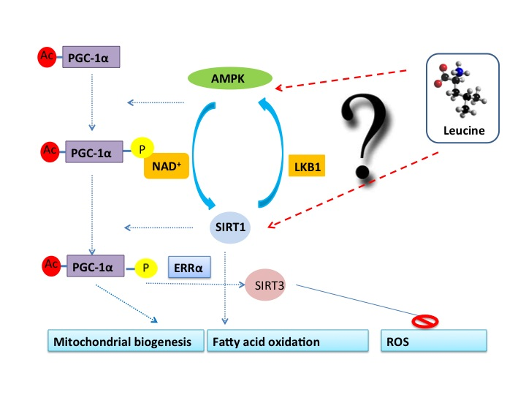
Figure 1-1 The hypothetical leucine activating SIRT1/AMPK cycle and its significance.

Literature cited
1. Hjartaker, A., H. Langseth, and E. Weiderpass, Obesity and diabetes epidemics: cancer repercussions. Adv Exp Med Biol, 2008. 630: p. 72-93.
2. Guyenet, S.J. and M.W. Schwartz, Clinical review: Regulation of food intake, energy balance, and body fat mass: implications for the pathogenesis and treatment of obesity. J Clin Endocrinol Metab, 2012. 97(3): p. 745-55.
3. Calle, E.E., et al., Overweight, obesity, and mortality from cancer in a prospectively studied cohort of U.S. adults. N Engl J Med, 2003. 348(17): p. 1625-38.
4. Johannsen, D.L. and E. Ravussin, The role of mitochondria in health and disease. Curr Opin Pharmacol, 2009. 9(6): p. 780-6.
5. Andreux, P.A., R.H. Houtkooper, and J. Auwerx, Pharmacological approaches to restore mitochondrial function. Nat Rev Drug Discov, 2013. 12(6): p. 465-83.
6. Schrauwen, P., et al., Mitochondrial dysfunction and lipotoxicity. Biochim Biophys Acta, 2010. 1801(3): p. 266-71.
7. Kairisalo, M., et al., Resveratrol reduces oxidative stress and cell death and increases mitochondrial antioxidants and XIAP in PC6.3-cells. Neurosci Lett, 2011. 488(3): p. 263-6.
8. Bostrom, P., et al., A PGC1-alpha-dependent myokine that drives brown-fat-like development of white fat and thermogenesis. Nature, 2012. 481(7382): p. 463-8.
9. Pedersen, B.K. and M.A. Febbraio, Muscles, exercise and obesity: skeletal muscle as a secretory organ. Nat Rev Endocrinol, 2012. 8(8): p. 457-65.
10. Watt, M.J. and A.L. Hevener, Fluxing the mitochondria to insulin resistance. Cell Metab, 2008. 7(1): p. 5-6.
11. Newgard, C.B., et al., A branched-chain amino acid-related metabolic signature that differentiates obese and lean humans and contributes to insulin resistance. Cell Metab, 2009. 9(4): p. 311-26.
12. Stipanuk, M.H., Leucine and protein synthesis: mTOR and beyond. Nutr Rev, 2007. 65(3): p. 122-9.
13. Zemel, M.B., et al., Effects of dairy compared with soy on oxidative and inflammatory stress in overweight and obese subjects. Am J Clin Nutr, 2010. 91(1): p. 16-22.
14. Zemel, M.B. and A. Bruckbauer, Effects of a leucine and pyridoxine-containing nutraceutical on fat oxidation, and oxidative and inflammatory stress in overweight and obese subjects. Nutrients, 2012. 4(6): p. 529-41.

Part Two
Literature Review

2.1 The role of mitochondria in energy metabolism

2.1.1 Mitochondrial functions and mitochondrial biogenesis
Mitochondria, as one of the most important double membrane-bound organelles in cells, play essential roles in energy metabolism, cell signaling and apoptosis [15]. The double-membrane structure in mitochondria creates distinct compartments in the organelle with specific functions. For example, space between the inner and outer membranes is relative isolated from mitochondrial matrix, and plays crucial roles in oxidative phosphorylation and ATP production. The mitochondrial matrix is the region surrounded by inner membranes, and it contains enzymes involved in tricarboxylic acid (TCA) cycle, fatty acid oxidation and mitochondrial DNA (mtDNA) replication [16].
The primary function of mitochondria is to generate ATP to fulfill cellular energetic demands through oxidative phosphorylation in the respiratory chain. The TCA cycle in mitochondrial matrix serves as a central site that links to a wide variety of metabolic substrates generating acetyl-CoA, including carbohydrates, proteins and lipids. The TCA cycle oxidizes acetyl-CoA into carbon dioxide and water. Meanwhile, energy released from oxidation is saved in NADH, FADH2 and guanosine triphosphate (GTP). Subsequently, NADH is oxidized by NADH dehydrogenase (complex I) and recycled back as NAD⁺. The electrons donated from NADH are passed along a series of proteins and lipids, including coenzyme Q, cytochrome b/c1 (complex III), cytochrome c and cytochrome a/a3 (complex IV) and eventually donated to oxygen (1/2 O2) to produce H₂O. This process has been referred as electron transport chain (ECT). Meanwhile, the energy released from NADH oxidation pumps protons into inner-membrane space and creates a proton electrochemical gradient, which drives the synthesis of ATP from ADP by ATP synthase complex (Complex V). And this process has been identified as oxidative phosphorylation [6]. Generally, only a portion (30-40 %) of the energy from the NADH oxidation is used to generate proton gradient, the rest part is mainly released as heat. But, some proteins and proton channels allow the protons leaking back into the matrix and diminish the proton gradient. Higher expression of these proteins means that more NADH is required to maintain the proton gradient, and more energy is lost as heat. In humans, mitochondrial uncoupling accounts for approximately 25% of whole–body basal metabolism [16, 17]. There are 3 different types of uncoupling proteins (UCP) with tissue-specific distribution in mammals; UCP1 is mainly expressed in brown adipose tissue, UCP2 is expressed at high level in pancreatic islets and immune system, UCP3 is primarily expressed in skeletal muscle [6, 18].
Meanwhile, mitochondria also are involved in multiple cellular basic processes, such as urea production, heme biosynthesis, fatty acids β-oxidation, nucleotide synthesis, cell proliferation, differentiation and apoptosis [19, 20]. For example, mitochondria regulate cellular oxidative stress via reactive oxygen species (ROS) production and degradation [21]. Under physiological conditions, 0.2-2% of total oxygen uptake in mitochondria are converted to ROS, by direct passing electrons to O₂ to generate superoxide anions (O₂⁻) [22]. Most of the superoxide can be catalyzed to non-radical hydrogen peroxide (H₂O₂) by superoxide dismutase. But, ETC defects or excessive substrate in mitochondria results in higher ROS production through increased binding between overabundance electron and free oxygen, leading to impairment of mitochondrial function [23]. Therefore, precise regulations of mitochondrial content, distribution and function are required for the maintenance of cellular homeostasis.
Mitochondrial biogenesis is a process of generating new mitochondria in cells in response to cellular stress, inflammatory signals and environmental changes [25] [26]. Multiple steps are involved in this process, such as mtDNA replication, mtDNA transcription and translation, structural proteins and lipids biosynthesis, nucleus-derived transcriptional factors translation, mitochondrial proteins import and assembling [27].
Compared to nuclear genome, mammalian mtDNA is a small circular double-stranded DNA genome (~16.5 kb pairs) with limited coding capacity [28], which encodes only 13 respiratory complexes proteins, 2 rRNAs and 22 tRNAs [29]. Remaining 1000-15000 essential proteins in mitochondria rely on nuclear genome encoding and mitochondrial import [30]. Therefore, coordinated expression of mtDNA and nuclear genomes are required to maintain the mitochondrial function and mitochondrial biogenesis [19]. The nucleus regulates mitochondrial biogenesis through several pathways, including encoding catalytic proteins components of mitochondrial enzymes, encoding transcription factors and co-activators that regulate mitochondrial biogenesis; and encoding proteins that are responsible for assembly, import and translocation of mitochondrial enzymes [31].
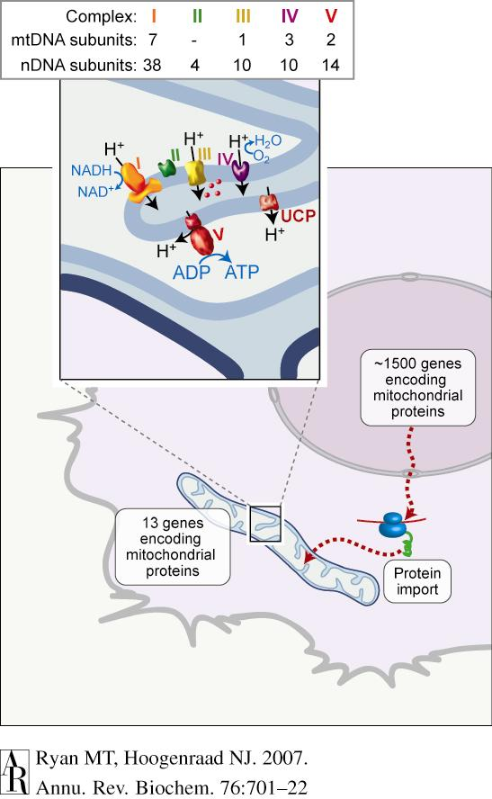
Figure 2-1 Mitochondrial biogenesis and the OXPHOS machinery.
The protein complement of mitochondria consists of 13 subunits, encoded by mtDNA, which are synthesized in the organelle. The remaining proteins are encoded by nuclear genes and are made in the cytosol and imported into mitochondria. Inset: the OXPHOS machinery of the inner membrane consists of complexes I–IV, involved in electron transfer and proton export to the intermembrane space, whereas complex V uses the proton gradient to generate ATP. Uncoupling protein (UCP) uses proton flow to generate heat. Cytochrome c (red) is found in the intermembrane space. The total number of subunits encoded by nuclear and mtDNA are shown for each of the OXPHOS complexes. Adopted from Michael T. Ryan et al., 2001 [28].
Nuclear respiratory factor 1 and 2 (NRF1/NRF2) are the first isolated transcription factors that control mitochondrial genes expression in mammalian cells [19, 33]. NRF1 regulates mitochondrial biogenesis by promoting expression of genes involved in mitochondrial transcription, protein import and assembly. NRF2 has been found to promote oxidative phosphorylation system (OXPHOS) enzyme expression [34]. Additionally, estrogen-related receptors α (ERRα) have been considered as key regulator in proliferation of mitochondria [26]. Nuclear factor kappa-light-chain-enhancer of activated B cells (NF-κB), a major inflammatory transcriptional factor, has been shown to promote anti-apoptosis by interacting with mitochondrial ATP/ADP translocator-1 (ANT1), and decrease ETC activity via inhibition of cytochrome c oxidase III (Cox III) and cytochrome b (Cyt b) expression [35]. Signal transducer and activator of transcription 3 (STAT3) also has been reported to stimulate Complex I encoding, which further decreases mitochondrial ROS generation and protects against mitochondrial apoptosis [36].
Since NRF-1, ERRα and peroxisome proliferator-activated receptor (PPARα) have been demonstrated as direct targets of peroxisome proliferator-activated receptor gamma co-activator 1 (PGC-1) family [37], mitochondrial function and biogenesis appear to be highly associated with PGC-1α gene expression and activity [26].
2.1.2 Roles of PGC-1α on mitochondrial biogenesis and function
PGC-1α belongs to PGC-1 coactivator family, which also contains PGC-1β and PRC with similar structure.
Originally, PGC-1α was identified in brown adipose tissue during adaptive thermogenesis as a binding protein of PPARγ under cold exposure [38]. Mechanistically, PGC-1α co-activates PPARγ and induces UCP1 gene expression, resulting in increased heat production in brown adipocytes in response to cold stimuli [39]. Later, protein analysis indicated that PGC-1α served as a major regulator of mitochondrial biogenesis and oxidative metabolism via modulation of transcriptional factors and nuclear hormone receptors, such as NRF-1, ERRα, YY1, PPARα and MEF2C, in high energy demand tissues and organs, including brown adipose tissue, heart, skeletal muscle, kidney and brain [19]. By co-activating with PGC-1α, NRFs and ERRα not only bind to regulatory regions of genes involved in mitochondrial biogenesis, but also bind to other mitochondrial transcription factors promoter. Thus, PGC-1α modulates mitochondrial biogenesis and oxidative function via utilization of the transcriptional factors-related network [26].
Activated PGC-1α triggers downstream effects in a tissue-specific manner. In the liver, PGC-1α markedly promotes gluconeogenesis to maintain whole body glucose homeostasis during fasting via increasing TCA cycle flux by inducting expression of phosphoenolpyruvate carboxykinase (PEPCK) and glucose-6-phosphatase [40]. In brown adipose tissue, as discussed above, PGC-1α induces UCP1 expression and coordinately modulates adaptive thermogenesis [39]. In skeletal muscle, PGC-1α is a potent regulator of glucose uptake, fatty acid oxidation and muscular fiber type switching [41]. For example, overexpression of PGC-1α in mouse skeletal muscle significantly increases mitochondrial biogenesis and mitochondrial oxidative function via promoting expression of cytochrome c oxidase subunit 4 and cytochrome c (Cyt C) [42], which subsequently induces muscular fiber characteristic change from type IIB fibers (fast glycolytic) into type I (slow oxidative fibers) with abundant mitochondria and higher endurance for exercise [43]. Interestingly, PGC-1α also regulates energy metabolism in skeletal muscle [44, 45]. Physical exercise activates PGC-1α via phosphorylation and activation of AMPK, leading to increased adaptive oxidative metabolism in skeletal muscle [46]. In addition, PGC-1α plays an essential role in regulation insulin signaling in skeletal muscle. Decreased PGC-1α expression has been found in insulin resistant patients, associated with mitochondrial content loss and function impairments [47], whereas increased PGC-1α via exercise training rescues insulin resistance and glucose intolerance back to normal [48]. Moreover, evidences suggest that PGC-1α regulates oxidative and inflammatory stress in skeletal muscle. By promoting expression of superoxide dismutase-2, catalase, glutathione peroxidase 1 and uncoupling proteins, PGC-1α decreases the ROS production and facilitates its degradation, and protects mitochondrial proteins against oxidative stress [49].
Since PGC-1α plays such important roles in energy metabolism, its expression and activity are strictly regulated by transcription factors and co-activators, protein kinases/phosphatases at both transcriptional and post-transcriptional levels [49]. At the transcriptional level, PGC-1α expression can be elevated by a wide range of factors in a tissue-dependent manner, such as cold exposure and beta-adrenergic signaling in brown adipose tissue, prolonged exercise and nutrient deficiency in skeletal muscle, fasting and calorie restriction in liver [50].
Structurally, PGC-1α has an activation domain at the N-terminus, which normally modulated by steroid receptor coactivator 1 (SRC1) and cAMP response element binding protein (CREB) binding protein / p300 [51]. cAMP signaling serves as a key activator of PGC-1α transcription by prompting the binding between CREB and PGC-1α promoter [52]. Also, PPARs has been considered as the major activators of PGC-1α in response to various external stimulations in skeletal muscle and brown adipose tissue [19]. Additionally, PGC-1α regulates its own expression in a positive auto-regulatory loop through activation of YingYang 1 (YY1), a common target of mTOR signaling [53]. At certain level, activated mTOR signaling leads to increases of YY1- PGC-1α transcription, which subsequently promotes mitochondrial biogenesis [52]. Interestingly, mTOR signaling modulates mitochondrial function in two different pathways: suppressed mTOR signaling activates fatty acid oxidation and promotes OXPHOS enzymes expression, which is accompanied by inhibition of cellular protein synthesis. In contrast, activated mTOR also stimulates mitochondrial biogenesis through mTOR-YY1- PGC-1α signaling pathway with few effects on protein biosynthesis [54].
In addition to the regulation of PGC-1α expression, its activity and stability are also highly controlled by posttranscriptional modifications, including phosphorylation, ubiquitination and acetylation [37]. In skeletal muscle, AMPK, p38 MAPK and protein kinase B (AKT) have been reported to active PGC-1α by changing phosphorylation status of residues at distinct sites of the protein [49]. AMPK directly phosphorylates threonine-177 and serine-538 residues of PGC-1 α, and hereby induces PGC-1α activation, whereas, p38 MAPK phosphorylates PGC-1 α and stabilizes the protein [55]. Since PGC-1α has a relative short half-life, extending the protein stability is an important mechanism to maintain PGC-1α activity [49]. Furthermore, PGC-1α is heavily acetylated in the whole sequence of protein, and decreased acetylation status of PGC-1α is highly associated with PGC-1α activation. Thus, acetyltransferase GCN5 and deacetylase SIRT1 have been reported as key regulatory enzymes for PGC-1α [56]. For instance, by sensing decreased cellular NAD⁺ level, activated SIRT1 promotes mitochondrial biogenesis and fatty acid oxidation to generate more ATP to rebalance the energy metabolism, partially through deacetylation and activation of PGC-1α [57]. In fact, recent data from resveratrol studies strongly support that AMPK and SIRT1 act synergistically on PGC-1α activation [58].
2.1.3 Mitochondrial dysfunction and insulin resistance
Since mitochondria play such crucial roles in energy metabolism, inherent or acquired mitochondrial disorders can cause major disruption of cell survival and whole body metabolic homeostasis [6]. For example, defects in respiratory complex I lead to atrophy of optic nerve in adults; mutation of mitochondrial aminoacyl-transfer RNA synthestases (ARS2s), which is required for mitochondrial tRNA function, results in ovarian dysfunction and hearing loss [59]. Impaired mitochondrial oxidative function has been found in neuromuscular degenerative diseases, such as Alzheimer’s disease, Parkinson’s disease and some types of cancer [21]. Mitochondrial content loss strongly links to development of age-related diseases [24].
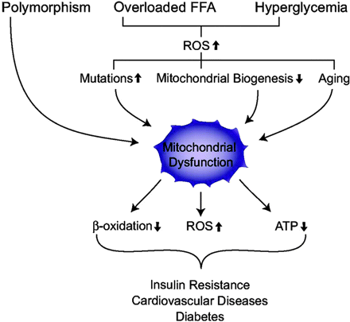
Figure 2-2: Mechanism of mitochondrial dysfunction.
Excess intake of nutrients, including overloaded FFAs or hyperglycemia conditions, increases ROS production and reduces mitochondrial biogenesis, causing mitochondrial dysfunction. Mitochondrial dysfunction leads to decreased β-oxidation and ATP production and increased ROS production, resulting in insulin resistance, diabetes, and cardiovascular disease. Adopted from Kim J.A et al., 2008[60]
In previous studies, mitochondrial dysfunction in skeletal muscle has been found in a number of chronic metabolic diseases, such as insulin resistance syndrome, obesity, cancer, and type 2 diabetes [61]. For example, reduced mtDNA and respiratory enzymes expression have been reported in insulin resistant individuals among obesity patients [62]. Decreased mitochondrial density is strongly correlated to insulin resistance and glucose intolerance in type 2 diabetes patients [63].
As a major anabolic hormone, insulin stimulates glucose uptake and mobilization, promotes synthesis of lipids and proteins, and inhibits gluconeogenesis primarily through IRS- PI3K-AKT-mTOR-FOXO1 signaling pathway [64]. While, insulin resistance is a pathological condition that cells fail to respond to hormone insulin normally [65].
Regards to the relationship between mitochondrial dysfunction and insulin resistance, previous studies provide multiple theories to explain the underlying mechanism. According to Befroy et al., genetic and environmental factors-induced mitochondrial defects are the main causes of insulin resistance. Decreased mitochondrial oxidation capacity and increased lipid intermediates accumulation, such as fatty acyl CoA and diacylglycerol, promote phosphorylation of Ser/Thr of IRS-1 through intracellular serine/threonine kinase cascades, resulting in impairment of insulin signaling [66]. Indeed, Zhang et al. demonstrated that long-chain acyl-CoA dehydrogenase mutation causes mitochondrial dysfunction, leading to diacylglycerol accumulation and insulin resistance in liver [67].
However, some other studies suggest that excessive lipid accumulation is the reason rather than the consequence of mitochondrial dysfunction [9, 68]. For example, data from oligonucleotide microarray analysis reveal that feeding of HFD decreases expression of genes that are required for OXPHOS and mitochondrial biogenesis, such as NADH dehydrogenase 1 beta subcomplex 3 (NDUFB3), NDUFB5 and PGC-1α, leading to the impaired mitochondrial function in pre-diabetic and insulin resistance state patients [69].
Interestingly, mitochondrial dysfunction might exhibit beneficial effects on insulin signaling under certain circumstances [70]. Evidence from Pospisilik et al. demonstrate that decreased mitochodnrial oxidative phosphorylation, which induced by targeted deletion of the mitochondiral flavoprotein apoptosis inducing factor (AIF), protects against HFD-induced obesity and insulin resistance in mice [71].
On the other hand, mitochondrial biogenesis and oxidative capacity have been found elevated in skeletal muscle in type 2 diabetes patients and HFD-fed animals.[7]. However, the increased mitochondrial oxidative function might not be able to compensate the excessive fatty acid flux, resulting in accumulation of lipid metabolites that could be further oxidized into lipid peroxides in the mitochondrial matrix [68]. Unlike genomic DNA, mtDNA is sensitive and vulnerable to oxidative stress due to the lack of protective histones [72]; therefore, increased mitochondrial ROS promotes toxic impacts on mtDNA, RNA and mitochondrial proteins [73], leading to the impairments of mitochondrial function. Nabben et al. further support the role of ROS in mitochondrial dysfunction by showing that overexpression of UCP3 significantly decreases ROS level and blocks age-induced mitochondrial loss and insulin resistance in mouse skeletal muscle [73].
In addition, substrates competition in mitochondria might be another explanation for the lipid-induced insulin resistance [68]. The abundance of fatty acids in mitochondria tends to switch glucose oxidation into lipid oxidation, which aggravates glucose accumulation in both cytoplasm and circulation. Therefore, fatty acid oxidation blockers have been used as treatment for type 2 diabetes to lower the plasma glucose level. For example, etomoxir, an inhibitor of carnitine palmitoyltransferase 1 (CPT1), has been found to decrease plasma glucose, increase GLUT4 translocation, and stimulate glucose uptake and mobilization by reducing fat oxidation in skeletal muscle [74].
Although the cause-and-effect relationship between mitochondrial dysfunction and lipid-toxicity remains uncertain [6], increased mitochondrial function and mitochondrial biogenesis may have beneficial effects on metabolic diseases.
2.2 Roles of SIRT1 in energy metabolism
2.2.1 Sirtuins overview
Calorie restriction (CR), normally identified as a diet contains all essential nutrients but with 20-40% less calorie intake compared to free fed diet, has been associated with multiple beneficial effects on aging and the onset of age-related diseases in a number of species, including worms, yeast, fish, mice and primates [75]. Genetic and molecular studies from different organisms indicate that CR is an actively regulated process, rather than a passive consequence of low-level calorie intake [76]. Although few studies have confirmed the CR effects on age-related diseases in humans, possibly due to the difficulty of complying with dietary changes, CR is highly associated with reduction of disease and mortality risk in a wide range species [94].
SIR2 (Silent Information Regulator 2) in budding yeast Saccharomyces cerevisiae has been indicated as the main regulator mediating CR-induced metabolic changes and extending lifespan [77]. Overexpression of Sir2 and Sir2 activator treatment have been shown to prolong the replicative life span in S. cerevisiae via directly interaction with nucleosome histones, such as histone H4 lysine16 (H4K16), whereas, Sir2 functional mutants significantly cut down the lifespan [78]. Meanwhile, the histone-deacetylase activity of Sir2 is highly dependent on intracellular NAD⁺ level, suggesting that Sir2 might also play a part in the modulation of cell energy metabolism [79].
In mammals, SIRT1, the orthologue of Sir2, belongs to a conserved sirtuins family of protein deacetylases and mono-ADP-ribosyltransferases [77]. In protein deacetylation reaction, SIRT1 couples lysine residues deacetylation to NAD⁺ hydrolysis, which converts NAD⁺ into nicotinamide (NAM) and O-acetyl-ADP ribose [80]. Unlike yeast, mammalian sirtuins not only target histone, but also deacetylate other transcription factors, such as p53, FOX (Forkhead box) and PGC-1α [81]. The identification of cellular sirtuins substrates further supports the potential effects of sirtuins on a wide range of biological processes, including DNA repairing, oxidative stress responses, energy metabolism and cell apoptosis [82].
There are seven conserved members (SIRT1- SIRT7) in mammalian sirtuins family with distinct intracellular localizations, such as nucleus sirtuins (SIRT1, 2, 3, 6, and 7), cytoplasm sirtuins (SIRT1 and 2) and mitochondrial sirtuins (SIRT3, 4 and 5) [83]. The major function of these sirtuin are different from one-another: most sirtuins have NAD⁺-dependent deacetylase activity, while Sirt4 and Sirt6 exhibit NAD⁺-dependent mono-ADP-ribosyltransferase activity, whereas, Sirt7 has no observed deacetylase activity at all [84] [85].
2.2.2 Roles of SIRT1 in metabolic homeostasis
SIRT1 was first identified and most extensively studied Sir2 orthodox in mammals. In addition to mediating CR-induced extending lifespan, SIRT1 has been found to play an important role in modulation of energy metabolism [86]. For example, SIRT1 is required for the increases in physical activity observed during CR in mice [80]. Nisol et al. demonstrated that CR promoted mitochondrial biogenesis and SIRT1 expression in multiple tissues of male mice via endothelial nitric oxide synthase (eNOS)-dependent pathway [87]. Furthermore, overexpression of SIRT1 has been demonstrated to mimic CR-induced metabolic changes, including improved glucose tolerance and insulin sensitivity, decreased circulating triglycerides and cholesterol [83, 88].
Mechanistically, there are mainly three pathways mediating SIRT1 regulatory effects on energy metabolism [83]. First, SIRT1 modulates chromatic function via direct deacetylation of histone, and leads to DNA translation changes. Additionally, SIRT1 can regulate acetylation status of transcription factors and coactivators, such as p53, NF-κB, PPAR-γ and PGC-1α, thereby, regulate target genes transcription. Finally, SIRT1 can directly deacetylate and activate target enzymes, leading to the controlling of cellular signaling [89].
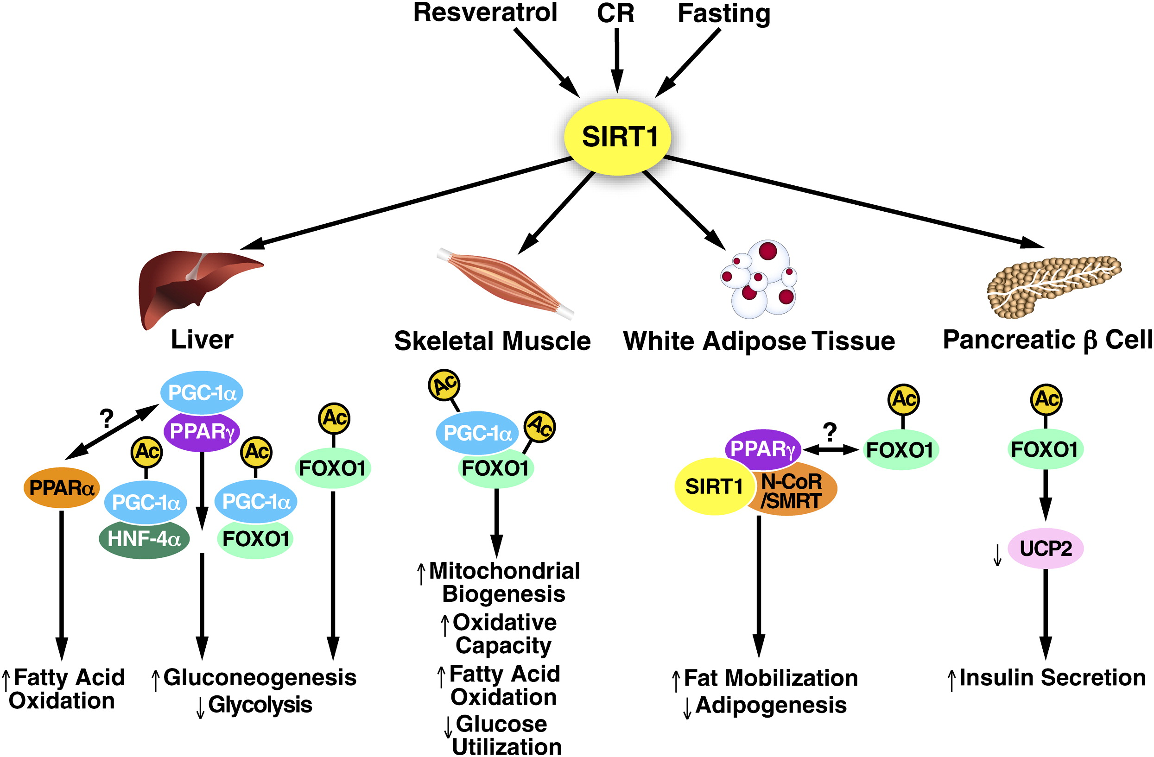
Figure 2-3 SIRT1 regulates metabolism in multiple tissues
SIRT1 regulates the activity of critical transcriptional regulators of metabolism, including FOXO1, PPARα, PPARγ, and PGC-1α, in several organs. In the liver, SIRT1 deacetylates and activates PGC-1α and interacts with FOXO1, which leads to activation of gluconeogenesis and decreased glycolysis. In muscle, SIRT1 activates PGC-1α, inducing mitochondrial biogenesis and increasing fatty acid oxidation. In white adipose tissue (WAT), SIRT1 represses the transcriptional activity of PPARγ, causing increased fat mobilization and decreased adipogenesis. In the pancreas, SIRT1 enhances insulin secretion by downregulating UCP2 expression. The expression and biological activity of SIRT1 are activated during fasting and calorie restriction (CR) and in response to resveratrol. It should be noted that resveratrol has other cellular targets, such as AMPK, which could mediate some of its biological activities. Adopted from Schwer et al., 2008 [83]
In lipid metabolism, activated SIRT1 primarily reduces fat accumulation. At transcriptional level, overexpression of SIRT1 decreases fat storage in WAT by reducing expression of genes involved in lipid synthesis, such as adipose tissue-specific fatty acid-biding protein 2 (AP2), PPARγ, CCAAT/enhancer-binding protein α (C/EBP α) and C/EBPδ [90, 91]. SIRT1 activates and deacetylates FOXO1, a transcription inhibitor of PPARγ, resulting in increased hepatic gluconeogenesis and suppression of adipocyte differentiation [54, 91]. Moreover, studies have demonstrated SIRT1 promotes lipolysis to protect against HFD-induced obesity in mice through a complicated signaling cascade that involving in AMPK activation [58]. Paradoxically, SIRT1 also has been found to activate and deacetylate acetyl-CoA synthetase (AceCS), a key enzyme for lipid synthesis in response to SREBPs and insulin, leading to increases of fatty acid synthesis from acetate. There are two AceCSs in mammals: cytoplasmic AceCS1 and mitochondrial AceCS2. SIRT1 could deacetylate mouse AceCS1 on Lys-661 site and subsequently lead to activation of AceCS1, resulting in a pronounced increase in fatty acid production via AceCS1-dependent pathway [92].
SIRT1 also contributes to the modulation of glucose metabolism in a tissue-specific manner. Under fasting and CR condition, the liver provides glucose as a fuel to other organs and maintains circulating glucose homeostasis via gluconeogenesis [93]. SIRT1 activity and expression level are highly elevated during CR and promote hepatic glucose metabolic shift from glycolysis into gluconeogenesis via activation of PGC-1α and FOXO, resulting in significant increased release of glucose [91]. Specific hepatic-SIRT1 knockout attenuates glucose output, and subsequently induces mild circulating hypoglycemia and free fatty acid accumulation in liver [93]. In skeletal muscle, SIRT1 also activates PGC-1 α to switch the cell fuel utilization from glucose oxidation to fatty acid oxidation in response to fasting, associated with up-regulated mitochondrial biogenesis and oxidative function [57].
Meanwhile, SIRT1 has been found to regulate glucose homeostasis through modulation of insulin secretion. Pancreatic β-cell is the only source of insulin production and secretion, and its dysfunction causes hyperglycemia and insulin resistance [93]. Insulin secretion in pancreatic β-cells strongly depends on intracellular ATP/ADP ratio and UCP2 expression: increased glucose uptake in the β-cells stimulates ATP production, which triggers insulin releases from the cell by exocytosis. Increased UCP2 diminishes the mitochondrial inner-membrane gradients and subsequently decreases ATP synthesis, resulting in suppression of insulin secretion [94]. SIRT1 has been found to directly bind to and inhibit UCP2 promoter, leading to decreased UCP2 protein expression and subsequent increased insulin releases [95]. Genetic forced expression of SIRT1 in pancreatic β-cells results in significant improvement of glucose tolerance, associated with reduced UCP2 expression and increased insulin secretion in HFD mice [96], while, SIRT1 siRNA markedly attenuates these effects.
In addition to UCP2, some transcriptional factors, such as NF-κB, PPARγ, FOXO1 and PGC-1α also have been implicated in SIRT1 effects in β-cells [83]. For example, SIRT1 protects pancreatic β-cells against acute oxidative stress by deacetylation and activation of FOXO1 [97]. Similarly, SIRT1 activation induced by resveratrol has been found to promote insulin secretion in an UCP2-independent pathway in INS-1E beta cells and human islets [98].
SIRT1 also stimulates insulin sensitivity in peripheral tissues to maintain the metabolic homeostasis. For example, activated SIRT1 increases GLUT4 translocation, thereby, stimulates glucose uptake in skeletal muscle cells. SIRT1 suppresses protein tyrosine phosphatase 1 B (PTP1B), an inhibitor of insulin signaling, through a PGC-1α dependent pathway, resulting in increased insulin sensitivity in HFD mice [99].
2.2.3 Roles of SIRT1 in mitochondrial biogenesis and function
The content and function of mitochondria are highly associated with the balance between cellular energy requirements and the ATP production. By sensing decreased intracellular NAD⁺ level, activated SIRT1 promotes mitochondrial biogenesis and function, at least in part, through activation of PGC-1α to maintain intracellular energy homeostasis in response to environmental changes [100].
In yeast, worms and flies, Sir2 has been reported to mediate CR-induced increases in mitochondrial biogenesis, oxygen consumption and ATP production [87, 101]. Overexpression SIRT1 increases whole-body metabolic efficiency and protects against HFD-induced metabolic abnormalities in mice [102]. In human, CR has been proved to promote muscle mtDNA replication in association with elevated SIRT1, PGC-1α and TFAM expression [103]. Similar results also have been found in SIRT1 activators studies. Resveratrol, an activator of SIRT1, could mimic CR effects on energy metabolism by promoting mitochondrial biogenesis and mitochondrial regulatory proteins in mice [89].
Prolonged exercise has been demonstrated to promote mitochondrial oxidative capacity and mitochondrial content in skeletal muscle, but whether SIRT1 expression is also elevated during exercise and proportional to the mitochondrial function and content is an unanswered question. For example, soleus muscle contains less mitochondrion but higher SIRT1 protein at baseline than heart cells [104]. In fact, evidence from Gurd et al.’s study shows that SIRT1 is not associated with mitochondrial oxidative function [105]. Overexpression of SIRT1 decreases mitochondrial biogenesis in heart and skeletal muscle in rat in response to exercise [105]. Genetic SIRT1 knockout mice exhibit normal mitochondrial content and function in skeletal muscle compared to the wild-type controls, suggesting that other signaling pathways may contribute to the maintenance of mitochondrial biogenesis [106].
However, some studies demonstrate that SIRT1 is positively correlated to mitochondrial biogenesis in rat skeletal muscle [107]. Increased SIRT1 activity has been found in rat skeletal muscle with chronic electrical stimulation and cold exposure [104]. In addition, elevated SIRT1 expression has been found to rescue the age-induced mitochondrial content loss in Wistar rats [108].
SIRT1 regulates mitochondrial biogenesis primarily through two pathways: modification of transcriptional level of genes involved in mitochondrial biogenesis, and directly deacetylation of enzymes in the mitochondria. Deacetylated and activated PGC-1α, a direct target of SIRT1, controls mitochondrial biogenesis and function via regulating transcription of the nuclear and mitochondrial genome as we discussed above [109]. For example, resveratrol increases SIRT1 activity and mitochondrial biogenesis, associated with increased acetylation and activation of PGC-α in HFD mice [110]. In addition, SIRT1 directly deacetylates and suppresses hypoxia-induced factor 1α (HIF1 α), a key transcription factors that inhibits the TCA cycle, resulting in significant increases of mitochondrial oxidative capability and attenuation of glycolysis [111].
At post-translational level, most of the enzymes involved in TCA cycle, fatty acid oxidation and oxidative phosphorylation in mitochondrial are highly acetylated. Data from proteomic survey demonstrate that 511 lysine residues in proteins of ETC are modified by acetylation [112]. Therefore, SIRT1 may modulate these enzymes activity through direct deacetylation and thereby regulate mitochondrial oxidative function [98, 110]. For example, AceCS2, a mitochondrial matrix protein, can be reversibly acetylated at Lys-642 and subsequently activated by mitochondrial sirtuins [113]. On the other hand, SIRT1 and SIRT3 knockouts markedly attenuate mitochondrial function, and lead to suppression of ATP production in many tissues of mice [110].

2.2.4 Regulation of SIRT1 expression and activity
SIRT1 modulates multiple cellular fundamental processes by serving as the key regulator of energy metabolism. However, the regulation of the SIRT1 enzyme itself, including the gene expression and activity, is still not fully elucidated.
At gene expression level, CR is a strong environmental stimulus to promote SIRT1 expression in many species. In both primates and rodents, CR increases SIRT1 protein levels in many tissues, including brain, heart, kidney and skeletal muscle [114]. Similarly, elevated SIRT1 expression also has been found under many other nutrient deprivation statuses, such as fasting and prolonged physical exercise [115]. CR-induced SIRT1 expression occurs in a tissue-dependent manner, particularly in liver. Chen et al. indicate that both CR fed and high-calorie diet could increase SIRT1 protein level in liver in mice [116], suggesting more complex mechanism underlies the SIRT1 regulation.
Mechanistically, the molecular signaling pathways of SIRT1 gene transcription are not fully understood. Nemoto et al. demonstrate that increased intracellular NAD⁺ losses the binding between redox sensor transcriptional corepressor CtBP (Carboxylterminal binding protein) and transcriptional repressor HIC1 (Hypermethylated in Cancer), and leads to the opening of the SIRT1 promoter site for other transcriptional factors, such as FoxO3 and p53, resulting in increased SIRT1 expression[115]. Cellular oxidative and inflammatory stress also appears to play a part in the regulation of SIRT1 expression and activity. For example, Wu et al. report that HFD-induced oxidative stress in cerebellar cells significantly decreases SIRT1 expression, and vitamin E supplementation markedly reverses this down-regulation effect [117]. In mouse cardiac muscle, overexpression SIRT1 protects against oxidative stress-induced cardiomyopathy via decreasing ROS production by promoting expression catalase. But high-level ROS could decrease SIRT1 expression and trigger cardiac pathology [118].
Cellular NAD⁺ level or NAD⁺/NADH ratio is the major regulator of SIRT1 activation. There are two NAD⁺ biosynthesis pathways in mammalian cells, de novo and salvage pathways. NAD⁺ synthesized via de novo pathway uses L-tryptophan as the precursor through multiple steps. The salvage pathway uses nicotinamide (NAM) or nicotinic acid (both of them called niacin or vitamin B3) to produce NAD⁺, catalyzed by two rate-limiting enzymes: nicotinamide phosphoribosyltransferase (NAMPT) and nicotinamide mononucleotide adenylyltransferase 1 (NMNAT-1) [89, 119]. Therefore, SIRT1 activity is highly associated with the expression and activity of NAMPT and NMNAT-1 [89]. For example, in myoblasts, elevated NAMPT expression increases cellular NAD⁺/NADH ratio and stimulates SIRT1 activity, leading to a SIRT1-dependent attenuation of cell differentiation [120]. Similar results have been found in human vascular smooth muscle cells (SMCs), that increased NAMPT expression and SIRT1 activity have been found during cell maturation [121]. Moreover, NAMPT is implicated in SIRT1-dependent regulation of the circadian rhythm in mice [122]. In addition to NAMPT, NMNAT-1 also has been reported to regulate SIRT1 and subsequently protect neuronal cells against oxidative stress in Wallerian degeneration slow (WId^{S}) mouse model [123, 124].
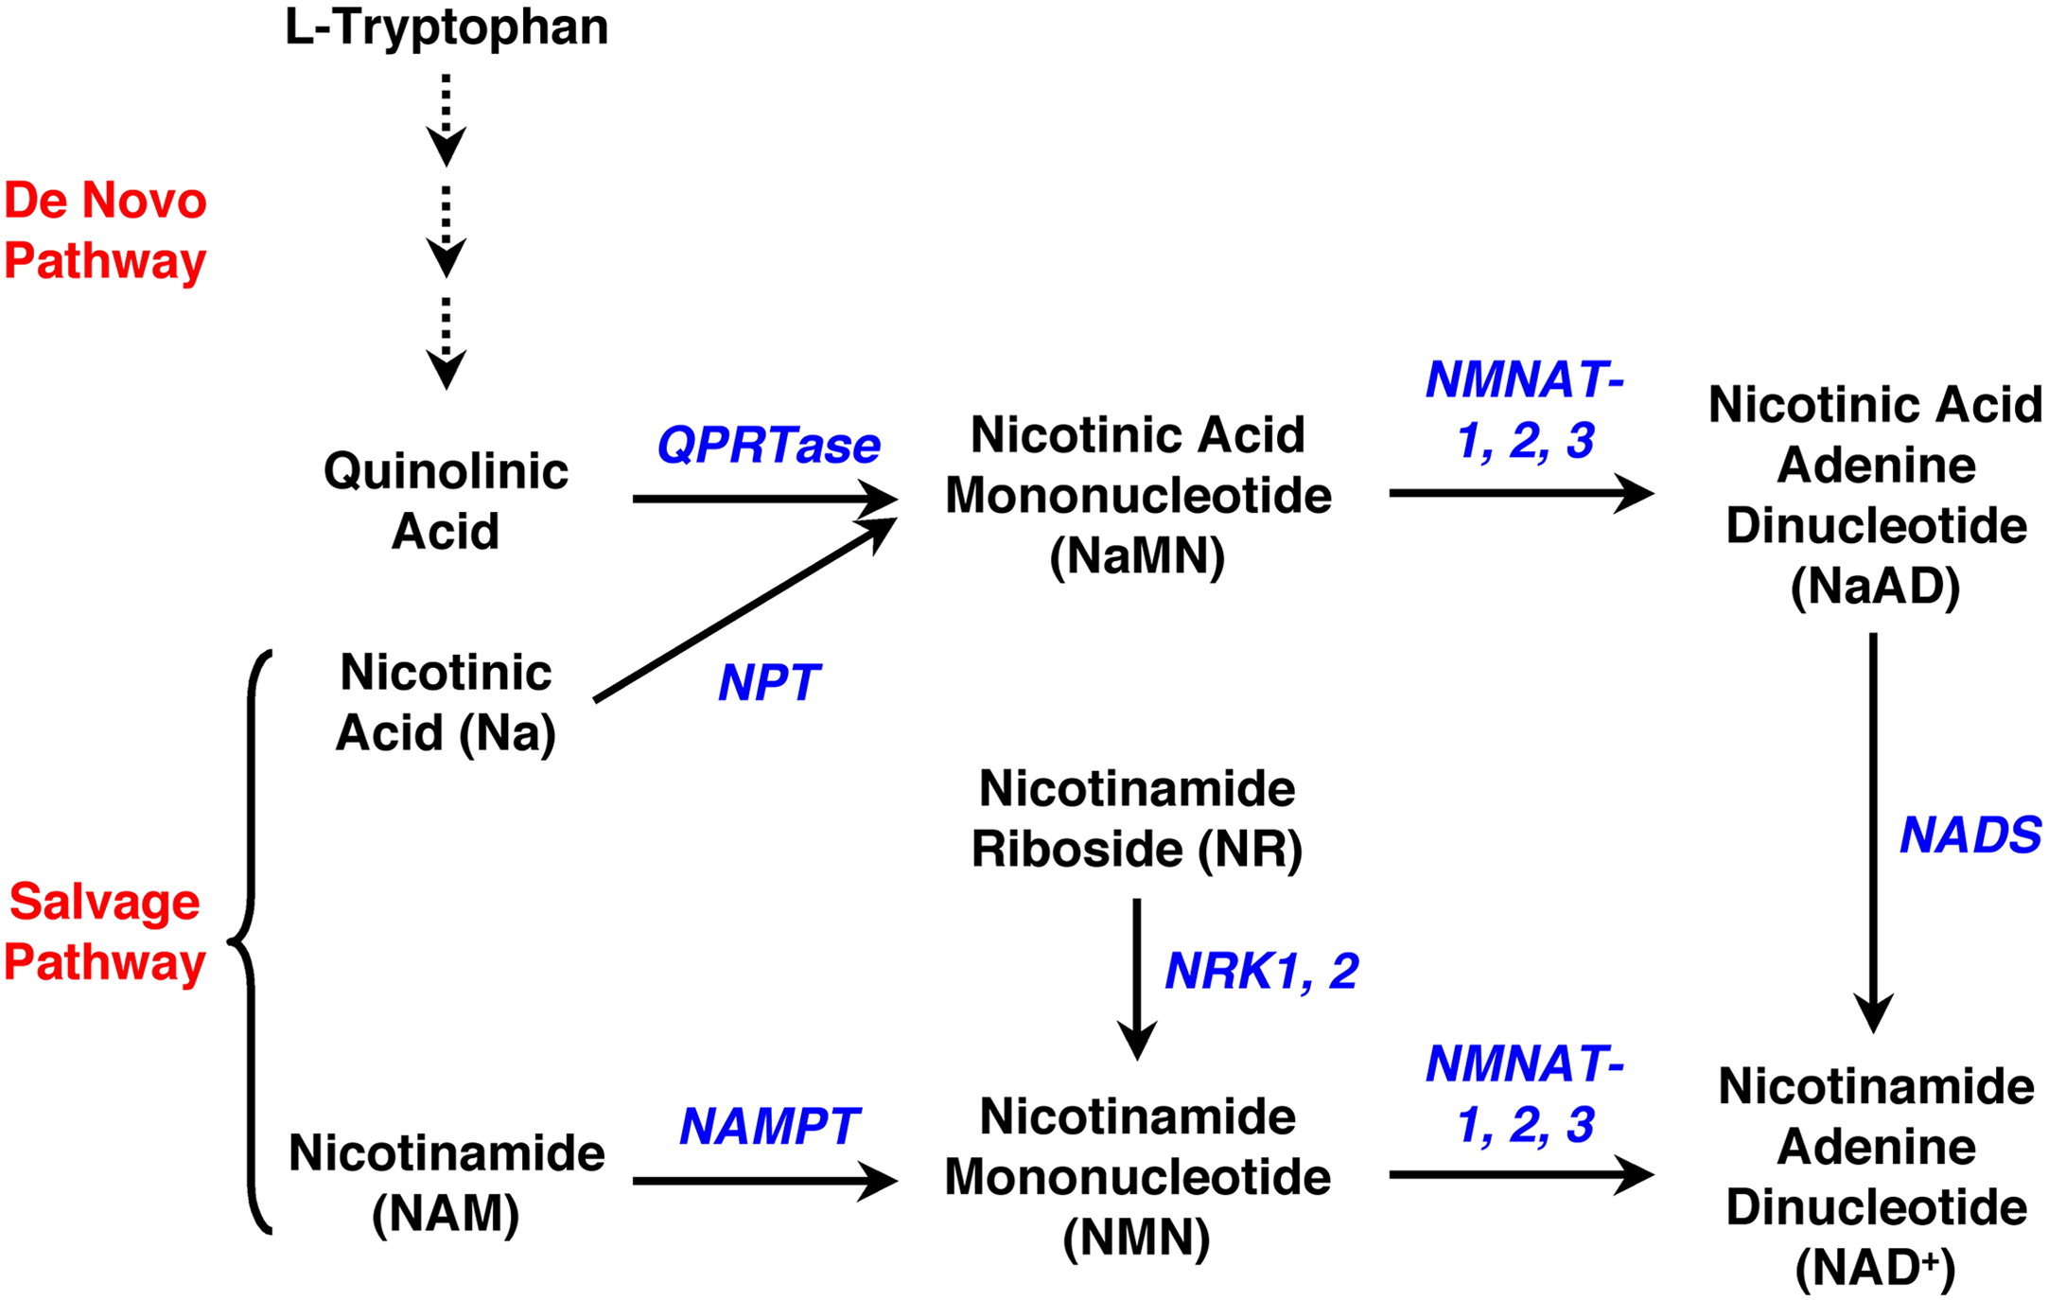
Figure 2-4 Mammalian NAD+ biosynthetic pathways.
The de novo pathway uses l-tryptophan as the precursor for NAD⁺ production in a multi-step pathway. The salvage pathway uses nicotinamide or nicotinic acid (together called niacin or vitamin B₃) to make NAD⁺. In addition, nicotinamide riboside has been identified as a dietary precursor for NAD⁺ biosynthesis. QPRTase, quinolinic acid phosphoribosyltransferase; NPT, nicotinic acid phosphoribosyltransferase; NMNAT, nicotinamide/nicotinic acid mononucleotide adenylyltransferase; NAMPT, nicotinamide phosphoribosyltransferase; NADS, NAD synthase, NRK, nicotinamide riboside kinase. Adopted from Zhang, T et al., 2010 [89]
Furthermore, poly (ADP-ribose) polymerase 1 (PARP-1), a NAD⁺-dependent chromatin and transcription-regulating enzyme, has been demonstrated to inhibit SIRT1 activity by competition for intracellular NAD⁺ [125, 126]. For instance, increased genotoxic stress activates PARP-1, which subsequently exhausts intracellular NAD⁺, leading to the suppression of SIRT1 activity [77].
SIRT1 and its homology Sir2 share a common deacetylase domain with approximately 250 amino acids, which are highly phosphorylated at both N- and C- termini [127]. The crystal structure of Archaeoglobus fulgidi Sir2 reveals that the catalytic core of SIRT1 consists of a Rossmann fold and a small zinc-binding segment. Polypeptide substrates are captured in the cleft of these two segments and further deacetylased at acetyl-Lys residues. Meanwhile, NAD⁺ binds to the cleft and goes through hydroxylation at each Lys residue during deacetylation [128]. EX527, a SIRT1 specific inhibitor, has been found to displace NAD⁺ from the binding site, promote SIRT1 enzyme structural conformation and prevent substrate binding, leading to inhibition of SIRT1 activity [128]. Accordantly, most pharmacological activators of SIRT1 appear to facilitate the process of NAD⁺ or peptide substrate binding to the enzyme [129].
Studies have identified a group of small molecules that could activate SIRT1 and mimic the CR effects as a promising therapeutic tool in the treatment of metabolic diseases, referred as sirtuin-activating compounds (STACs). Among these STACs, resveratrol has been studied most intensely. In 2003, Konrad et al. first reported three classes of sirtuin activators, including resveratrol, sharing a similar trans-stibene ring structures [101], which has been identified as an essential structure for SIRT1 allosteric conformation and activation [130].
Although some studies have challenged the direct activation theory of resveratrol on SIRT1 enzyme, abundant data indicate that resveratrol and some other STACs, including SRT1460, SRT1720 and SRT2183, bind to SIRT1 N-terminal domain and promote an allosteric conformation change of the enzyme-peptide substrate complex, leading to the decreases of Michaelis constant of SIRT1 for acetylated substrates and NAD⁺ [101, 131].
2.3 Roles of AMPK in energy metabolism
AMPK is an evolutionary conserved enzyme comprising of three subunits in most species, including a catalytic subunit (α) and two regulatory subunits (β and γ). AMPK serves as a crucial regulator of cellular energy metabolism by sensing intracellular ATP level or AMP/ADP ratio [132]. Increased AMP directly binds to γ subunit of AMPK and further promotes the enzyme self-conformation to expose Thr-172 (a threonine residue) in the α subunit, allowing AMPK upstream kinases, such as LKB1 and CaMKK β (calmodulin-dependent protein kinase kinase β), further phosphorylate and activate the enzyme. The binding of AMP to γ subunit also prevents AMPK dephosphorylating and keeps its activation status [133, 134].
LKB1 was initially identified as tumor suppressor in Peutz-Jeghers syndrome by inhibiting cell growth and proliferation via activation of AMPK signaling pathway [135], and its mutation results in significant susceptibility to human cancers [136]. LKB1 is strictly regulated at both transcriptional and post-translational levels. For instance, activated SIRT1 has been reported to deacetylate and activate LKB1, resulting in LKB1 translocation from nucleus into cytoplasm [137]. Unlike LKB1, CaMKK β-mediated AMPK activation depends on increase of cytosolic Ca²⁺, which caused by multiple cellular ATP-consuming processes, such as nutrient transportation, muscle contraction and exocytosis, without elevation of AMP [138].
Once activated, AMPK promotes a cellular metabolic switch from ATP-consuming anabolic pathways into more ATP-producing catabolic pathways, including promoting glucose and fatty acids uptake and oxidation while decreasing lipid, glycogen and protein synthesis and inhibiting cell growth and division [132]. Therefore, metabolic stresses that decrease cellular ATP content generally could activate AMPK, such as hypoxia, ischemia, low nutrients, oxidative stresses and prolonged exercise [139, 140]. Also, AMPK is sensitive to hormones and pharmacological molecules, such as leptin, adiponectin, AICAR (5-aminoimidazole-4-carboxamide-1-β-D-ribofuranoside) and metformin [135].
In the regulation of carbohydrate metabolism, AMPK stimulates glucose uptake in both skeletal muscle and white adipose tissue by increasing the glucose transporter GLUT4 translocation from cytoplasm to plasma membrane through Rab GTPase-activating protein (RabGAP)-dependent pathway [141]. Recent studies indicate that activated AMPK phosphorylates AS160 at some sites as AKT/PKB in insulin signaling, suggesting that insulin and AMPK might act synergistically at GLUT4 translocation and glucose uptake [142]. Activated AMPK also reduces glycogen synthesis via direct phosphorylation and suppression of glycogen synthases, and increases glycolysis by activation of 6-phosphofructo-2-kinase (PFK-2), leading to higher ATP production in a short-time period [143].
Regards to lipid metabolism, AMPK inhibits lipids synthesis via direct phosphorylation and suppression of acetyl-CoA carboxylase (ACC1/ACC2) and HMG-CoA reductase (3-hydroxy-3-methyl-glutaryl-CoA reductase), which are the rate-limiting enzymes for fatty acid and cholesterol biosynthesis, respectively [144]. Additionally, AMPK promotes fatty acids oxidation by phosphorylation and activation of carnitine palmitoyltransferase (CPT1). CPT1 regulates long-chain fatty acid oxidation in skeletal muscle by accelerating long-chain acyl-CoA flux into mitochondria. In this process, malonyl-CoA, synthesized by ACC at the first step of lipid production, serves as an allosteric inhibitor of CPT1 and blocks the long chain fatty acids flux [145]. AMPK decreases malonyl-CoA level by direct activation of malonyl-CoA decarboxylase (MCD), which is a malonyl-CoA catabolism-promoting enzyme [146]. Therefore, AMPK not only phosphorylates and inhibits ACC to decrease fat synthesis, but also reduces the production of malonyl-CoA to promote lipids oxidation. Furthermore, AMPK could directly activate lipases in fat tissue, including hormone-sensitive lipase (HSL) and adipocyte-triglyceride lipase (ATGL), and thereby promote lipolysis [147].
In addition to the direct acute modulation of key metabolic enzymes, AMPK is also involved in long-term adaptive lipids metabolic reprogramming through modulation of transcriptional factors, such as SREBP1 and PGC1-α [148]. Activated SREBP1 induces expression of multiple target genes involved in lipogenesis, such as ACC1 and FASN (fatty acid synthase), resulting in increased lipid synthesis not only in liver and other metabolic tissues, but also in all dividing cells [149]. AMPK has been demonstrated to directly phosphorylate a conserved site of SREBP1 and inhibit the SREBP1 expression, leading to decreased lipid biosynthesis [148].
Protein synthesis is an energy consuming process; therefore, it is not surprising that AMPK exhibits attenuation effects on protein metabolism. AMPK blocks the mTOR signaling, a major regulator promoting protein synthesis, via phosphorylation of TSC1-TSC2 (tuberous sclerosis 2) complex [150]. AMPK phosphorylates and activates the TSC1-TSC2 complex, which inhibits mTORC1 activity via suppression of Rheb, to promote their negative effects on mTOR signaling and blocks the protein synthesis [151].
AMPK activation also attenuates cell growth and proliferation in mammals. AICAR-activated AMPK has been demonstrated to suppress cell growth by blocking cell cycle through p53-dependent pathway in cancer cell lines [152]. Besides promoting cell-cycle arrest, AMPK suppresses cell divides, partially through the classical effects on inhibition of lipids and protein synthesis [153].
Furthermore, AMPK appears to stimulate ATP production not only by promoting fatty acid flux into mitochondria, but also by inducing mitochondrial biogenesis and oxidative function. Previous studies show that activated AMPK induces transcription of mitochondrial genes, including CPT1, FABP3 and acyl-CoA oxidase (ACO), resulting in higher mitochondrial biogenesis and increased exercise endurance in skeletal muscle cells, while specific AMPK knockout blocks these effects [169]. Although, mechanisms underlying AMPK promoting mitochondrial biogenesis are still unclear, PGC-1α has been considered as the major target and mediator of AMPK [170]. Jager et al. demonstrate that PGC-1α phosphorylation is the initial step of many AMPK-induced regulatory effects on energy metabolism, such as increased mitochondrial biogenesis, glucose uptake and fatty acid oxidation [55]. Interestingly, AMPK-induced phosphorylation of PGC-1α does not change its co- factor activity; instead, it releases PGC-1α from the repressor proteins and allows subsequent modification, such as SIRT1-induced deacetylation and activation [58].
2.4 SIRT1 and AMPK interaction
Both SIRT1 and AMPK detect energy deficits and regulate cellular responses to maintain energy balance. Therefore, it is not surprising that some downstream substrates and signaling pathways of SIRT1 and AMPK overlap. In fact, mutual interactions between SIRT1 and AMPK have been found in a wide number of tissues and cell types, including liver, skeletal muscle and neuronal cells [132].
Initially, AMPK was considered as an upstream regulator of SIRT1 by increasing intracellular NAD⁺ level via promoting Nampt expression. In skeletal myoblasts, low glucose treatment activates AMPK and causes SIRT1-dependent impairment of cell differentiation. AMPK activation markedly increased expression of NAD⁺ biosynthetic enzyme, Nampt, which consequently increases NAD⁺/NADH ratio and NAD⁺ level. This increase in NAD⁺ activated SIRT1, which subsequently inhibited skeletal myogenesis via related gene transcriptional regulation [154]. Evidence from SIRT1 knockout mice shows that the expression of AMPK-target genes, such as UCP2, UCP3 and PDK4, are reduced with the absence of SIRT1 during fasting, indicating that SIRT1 regulates metabolic gene expression coherently with AMPK in skeletal muscle [120]. Consistently, recent evidence indicates that resveratrol activate SIRT1 through cAMP-AMPK-NAD⁺ signaling pathway in skeletal muscle in HFD-mice [155].
However, activated SIRT1 also has been reported to regulate lipid metabolism by activating AMPK in liver via LKB1, suggesting that SIRT1 might serve as the upstream signal in this axis [143]. In addition, resveratrol-induced activation of SIRT1 decreases lipid accumulation and protects against HFD-induced obesity in mice, primary via LKB1-dependnet activation of AMPK [156]. Moreover, forced overexpression of SIRT1 significantly stimulates AMPK signaling in HepG2 cell line and mouse liver [157].
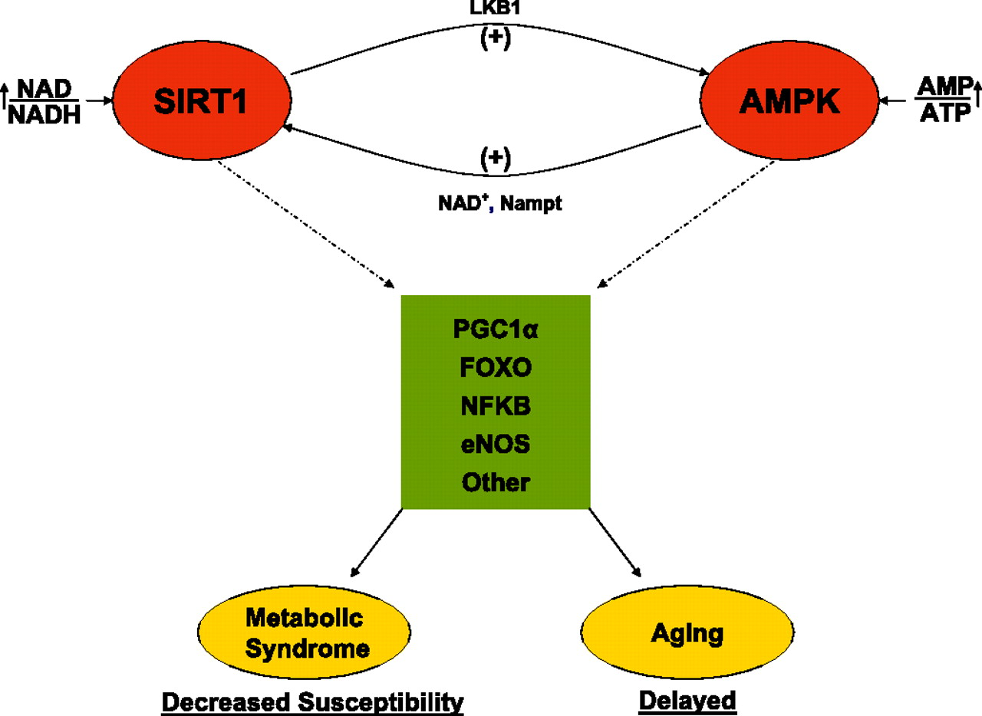
Figure 2-5: The hypothetical SIRT1/AMPK cycle and its significance.
A decrease in energy state or activation of AMPK by other means leads to activation of SIRT1, perhaps by increasing NAD+ or the NAD/NADH ratio and/or the activity of Nampt. SIRT1 then deacetylates and activates LKB1, which in turn activates AMPK. Alternatively, these events could be set in motion by factors that primarily increase SIRT1. The joint activation of SIRT1 and AMPK allows for the concurrent deacetylation and phosphorylation of the listed target molecules and presumably others. The predicted result would be a decreased susceptibility to metabolic syndrome-associated disorders and possibly delayed aging. Not shown is that a primary downregulation of SIRT1 or AMPK would presumably have opposite effects and predispose to the metabolic syndrome and accelerated aging. Adopted from Ruderman N. B et al., 2010 [158]

2.5 Leucine
2.5.1 BCAAs overview
According to the recommended daily allowance (RDA), 0.8 g protein/kg body weight/day (~70g/d) of dietary protein intake is recommended for healthy adults to maintain minimum level of nitrogen balance [159]. There are three amino acid members in branched chain amino acid (BCAA) group: leucine, valine and isoleucine [160]. The BCAAs have been implicated in many cellular metabolic processes beyond serving as essential substrates for new peptide synthesis. The roles BCAA play include regulating protein translation initiation, modulating insulin-PI3K signaling cascade, serving as a major nitrogen donor for alanine and glutamine, and a fuel for oxidation to generate ATP [161, 162]. Recently, evidence suggests that BCAAs might contribute to modulation of food intake and energy balance in central nervous system [163].
Interestingly, unlike the other 17 amino acids that are predominantly catabolized in liver, circulating BCAA levels stay unchanged after passing through the liver, possibly due to low expression levels of hepatic BCAA catabolic enzymes [161]. Therefore, BCAA concentrations in plasma and peripheral tissues, such as skeletal muscle and adipose tissue, are strongly dependent on dietary intake [160]. Accordingly, the potential effects of BCAAs on protein metabolism, insulin signaling and alanine and glutamine production are increased by higher BCAAs concentrations in skeletal muscle [164].
2.5.2 BCAAs metabolism
In skeletal muscle, BCAA catabolism initially undergoes two steps, which are catalyzed by branched-chain amino transferase (BCAT) and branched-chain α-keto acid dehydrogenase (BCKDH) complex [165]. BCAT isozymes, including mitochondrial and cytosolic BCAT, catalyze reversible transamination reaction of BCAAs and transfer the BCAAs from the α-amino group into α-ketoglutarates: α-ketoisocaproic acid (KIC) for leucine, α-keto-β-methylvaleric acid (KMV) for isoleucine, and α-ketoisovaleric acid (KIV) for valine [161]. These keto acids of BCAA can subsequently be oxidized through the oxidative decarboxylation reaction by the BCKDH complex or released into circulation and taken up again by other organs, such as liver and adipose tissue, where they can be resynthesized into BCAAs or completely oxidized as fuels to generate ATP [161]. The BCKDH complex is comprised of three different enzymes, including a branched-chain α-keto acid decarboxylase (E1), dihydrolipol transacylase (E2) and dihydrolipoyl dehydrogenase (E3). The complex activity is regulated by BCKDH phosphatase and kinase by changing phosphorylation status of the E1 α subunit, leading to the modulation of BCAAs metabolism [166].
2.5.3 Roles of leucine in protein synthesis
Leucine is well known for its potential effect on promoting skeletal muscle protein synthesis under catabolic conditions, such as fasting, calorie restriction and prolonged exercise [167]. Leucine supplementation alone or combined with valine and isoleucine has been found to stimulate muscle protein anabolism in both rodent and human models [168-170]. In addition, short-term high doses (3 to 7 g) of leucine infusion have been demonstrated to reduce protein breakdown without changing protein synthesis rate [169].
The molecular mechanism for leucine-induced protein synthesis has been well established in many previous studies. mTOR, a conserved Ser/Thr kinase, has been considered as the major mediator for leucine-induced protein synthesis [171]. mTOR was initially found as the target of rapamycin, a macrolide with broad antiproliferative capabilities, and interacts with several other regulatory proteins to form two distinct complexes named mTOR complex 1 and 2 (mTORC1 and mTORC2) [172]. Compared to mTORC2, studies have focused more on mTORC1 signaling and functions. Besides amino acids, at least four major environmental factors modulate mTORC1 pathways, including growth factors, stress, energy condition and cellular oxygen status [173]. In fact, amino acids are so importation for mTOR signaling, that the absence of amino acids, especially leucine and glutamate, markedly attenuates growth factors-induced mTORC1 activation [174]. The mTORC1 promotes protein translation initiation by phosphorylation and activation of translation factors, such as eukaryotic translation initiation factor 4E (eIF4E)-binding protein 1 (4E-BP1) and S6 kinase 1 (S6K1). In contrast, inhibition of mTORC1, such as ATP-competitive mTOR inhibitor treatment, dramatically decreases protein synthesis, and subsequently impairs cell growth and proliferation [175].
Leucine activates mTOR kinase and promotes phosphorylation of eukaryotic initiation factor 4 complex and dissociates from its binding protein, leading to the activation of eIF4E. Activated mTOR also activates p70S6 kinase and then phosphorylates S6 ribosomal proteins. Additionally, leucine activates a second initiation factor, eukaryotic initiation factor-4G (eIF4G), via mTOR-independent pathways [176]. Therefore, leucine induces the activation of these tranlational factors and promotes translation initiation and protein synthesis [171, 176].
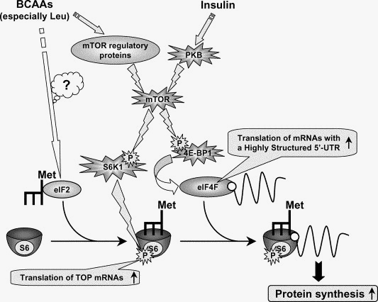
Figure 2-6: Regulation of protein synthesis by branched-chain amino acids in vivo. The diagram outlines the mechanisms through which in vivo administration of BCAAs enhances the initiation phase of mRNA translation. The details are discussed in the text. PKB, protein kinase B; mTOR, mammalian target of rapamycin protein kinase; eIF, eukaryotic initiation factor; 4E-BP1, eIF4E binding protein-1; S6K1, 70-kDa ribosomal protein S6 protein kinase; S6, ribosomal protein S6; TOP, terminal oligopyrimidine tract; and UTR, untranslated region. Adopted from Yoshizawa F. et al., 2004 [176].
However, the mechanisms of leucine activating mTOR signaling are poorly understood. Du et al. suggest that leucine activates mTOR signaling partially through AMPK inhibition by reducing intracellular AMP/ATP ratio [177], while others report a direct interaction between leucine and mTORC1.
2.5.4 Roles of leucine in glucose regulation and insulin resistance
Unlike the regulatory effects on protein synthesis, the impacts of leucine on glucose homeostasis are still controversial, with studies suggesting both improving and worsening of insulin sensitivity.
In some studies, leucine has been found to stimulate hepatic glucose output, increase fasting glucose level, and aggravate glucose intolerance. Under physiological conditions, increased BCAAs intake promotes its own degradation in skeletal muscle, and results in increased production of alanine/glutamine, which subsequently participate hepatic gluconeogenesis in liver [161]. According to Ahlborg and colleagues, over 40% of endogenous glucose input depends on this glucose-alanine cycle during prolonged exercise [178], and BCAA-related hepatic gluconeogenesis accounts for 70% of glucose releases in liver during overnight fasting [179].
Meanwhile, BCAAs also have been demonstrated to impair the whole body glucose tolerance through blocking insulin signaling in peripheral tissues and pancreatic β-cells. Rachdi et al. found leucine supplementation during pregnancy not only increased fetal body weight, plasma glucose and insulin, but also decreased pancreatic endocrine progenitor cells differentiation and β-cell formation via activation of mTOR-HIF1α signaling [180].
Increased circulating BCAA levels have been found in both insulin resistant animals and humans. Newgard et al. demonstrate that BCAAs and their related metabolites are markedly associated with insulin resistance compared to many lipids, which have been considered as the major stimuli to promote insulin resistance [11]. They found that HFD with BCAA supplementation in Wistar rats reduced food intake and body weight, but also led to greater insulin resistance than HFD alone. In addition, cross-sectional observations and interventional studies further support the connection between BCAAs and insulin resistance. Tai et al. found increased alanine, valine, leucine and isoleucine to be significantly associated with insulin resistant risk factors, such as fatty acids and inflammatory cytokines, in 263 non-obese Asian-Indian and Chinese men [181]. The baseline of BCAAs is positively correlated to insulin resistance in healthy children, leading to over 5-fold higher risk to develop type 2 diabetes [182].
According to the BCAA metabolic pathways, the increased plasma BCAAs in insulin resistant models are highly dependent on decreased BCAAs catabolic rate in peripheral tissues, particularly adipose tissue [166]. Although the reason is still unknown, decreased expression levels of BCAT and BCKDH complex have been found in adipose tissue compared to the lean controls, accompanied by significant increase of plasma BCAAs in obese rodent models [163]. Similar results were also found in human subjects [183].
Under over-nutrient conditions, such as obesity and type 2 diabetes, mTORC1 activity and expression are highly promoted in response to elevated circulating insulin, cytokines, BCAAs and glucose. On the other hand, activated mTORC1 impairs insulin signaling through phosphorylation S6K1- IRS-1 pathways. For example, BCAAs, particularly leucine, have been reported to activate p70 ribosomal S6 kinase (p70S6K) and S6K through mTORC1. Activated S6K subsequently phosphorylates serine/threonine residues of IRS-1, leading to the inhibition and degradation of IRS-1, and consequently blocks insulin signaling [166, 184]. This leucine-induced IRS-1 phosphorylation pathway has been found in wide range of cell types, such as 3T3L1 adipocytes, L6 myotubes, and skeletal muscle of rat [185]. Notably, Tremblay et al. found that amino acid infusion-induced insulin resistance in human was also mediated through the mTOR-p70S6-S6K1-IRS1-phosphorylation cascade [186]. Not surprisingly, leucine-deficient diet has been found to significantly rescue the insulin sensitivity in mice [187], and S6K1 deficient mice are protected against this BCAA-induced obesity and insulin resistance [188].
Furthermore, recent evidence suggests that AMPK and general control nonderepressible (GCN2) might also contribute to leucine-induced insulin resistance. GCN2 is the intracellular amino acid sensor and serves as upstream inhibitor of mTOR to suppress global protein synthesis [189]. According to Xiao et al., absence of leucine in liver not only activates GCN2 to inhibit mTOR signaling, leading to maintenance of insulin action, but also decrease lipogenesis through suppression SREBP-1c to reduce lipid synthesis, resulting in subsequent increases in insulin sensitivity indirectly [166, 187].
In contrast to these reports, some other studies demonstrate that BCAAs, particularly leucine, mediate beneficial effects on energy metabolism, especially, on insulin signaling. For example, Yzamin et al. found that doubling dietary leucine intake significantly reversed many HFD-induced metabolic abnormalities and increased glucose tolerance and insulin sensitivity in mice despite an increase in phosphorylation of IRS1 [190]. Similarly, Zhang et al. demonstrated that increasing dietary leucine intake markedly decreased diet-induced obesity, hyperglycemia and hypercholesterolemia in mice [191]. Furthermore, Nairizi et al. demonstrate leucine supplementation improves glycemia in mice [195].
Mechanistically, part of these leucine-induced positive metabolic effects, such as reduced body fat, increased glucose tolerance and insulin sensitivity, are the consequence of decreased food intake. Leucine has been found to activate mTOR signaling and inhibit AMPK in the hypothalamus, leading to inhibition of food intake, known as anorectic effect [192]. In addition, leucine has been found to decrease adiposity and improve insulin sensitivity in HFD-fed mice via promoting thermogeneiss by increaseing UCP3 expression in brown adipose tissue [193].
Leucine may also protect agaisnt HFD-induced abnormalities directly in peripheral tissues, such as adipose tissue and skeletal muscle, without changing food intake or bodyweight. For example, Macotela et al. found leucine to resuce HFD-induced metabolic abnormalities withouth chaning weight gains compared to controls [190]. Interestingly, althought they found leucine triggered activation of mTOR signaling and IRS phosphorylation, which is normally considered as an insulin resistance phenomenon, leucine intake attenuated HFD-induced metabolic abnormalities, suggesting that other mechanisms might be invovled in leucine’s positive effect, such as AMPK and SIRT1 signaling.
According to Saha et al. excess leucine intake downregulates the fule sensing and singling enzyme AMPK, which subseuqnelty activates mTOR-p70S6K, resulting in insulin resistance [194]. In contrast, recent data demonstrate that leucine and its metabolites (HMB) activate AMPK synergistically with resveratrol and metformin, resulting in increased insulin sensitivity in 3T3L1 adipocytes and diet-induced obese mice [195, 196]. Consistent with this, Roger et al. found that leucine markedly enhanced oxidative capacity and increased mitochondrial density in skeletal muscle, in part, through AMPK-mediated increases of PGC-1α [197].
SIRT1 activation also appears to contribute to the leucine’s beneficial metabolic effects. Macotela et al. found that leucine rescued SIRT1 expression and intracellular NAD⁺ level back to normal levels in liver and muscle, associated with improved insulin sensitivity in HFD mice [190]. Li et al. reported that leucine supplementation not only increased SIRT1 expression and activity, but also prevented mitochondrial dysfunction, accompanied by decreased acetylation of PGC-1α and FOXO1[198]. Similar data have been found in our previous studies. Leucine stimulates mitochondrial biogenesis and oxygen consumption in both C2C12 myotubes and 3T3L1 adipocytes through a SIRT1-dependent pathway [199]. Consistently, high dairy (rich in leucine) intake significantly decreases oxidative and inflammatory stress level in overweight and obese subjects in human, associated with activation of SIRT1 [13].
However, the mechanisms underlying leucine activation of AMPK and SIRT1 are still unknown. According to our recent data, leucine and its metabolites (HMB and KIC) have been found to increase recombinant human SIRT1 enzyme activity by 30 to 100% via direct allosteric conformation in cell free system, which reduces over 50% of SIRT1 Km values to NAD⁺ and substrate [196]. Recent evidences from Basil’s study [200] indicate that specific hydrophobic motif in SIRT1 substrates and a single amino acid (Glu²³⁰) in SIRT1 N-terminal domain facilitate the activation of SIRT1 enzyme by STACs [200]. For example, fluorophores are bulky and hydrophobic, and have been found to activate SIRT1 in vitro with resveratrol [201]. Leucine is a highly hydrophobic amino acid, which might also explain the direct activation effect [202]. Indeed, with the presence of leucine and HMB, lower concentrations of resveratrol are required for the activation of SIRT1 and AMPK, as well as increases in insulin sensitivity and glucose uptake in both in vivo and in vitro studies [130].
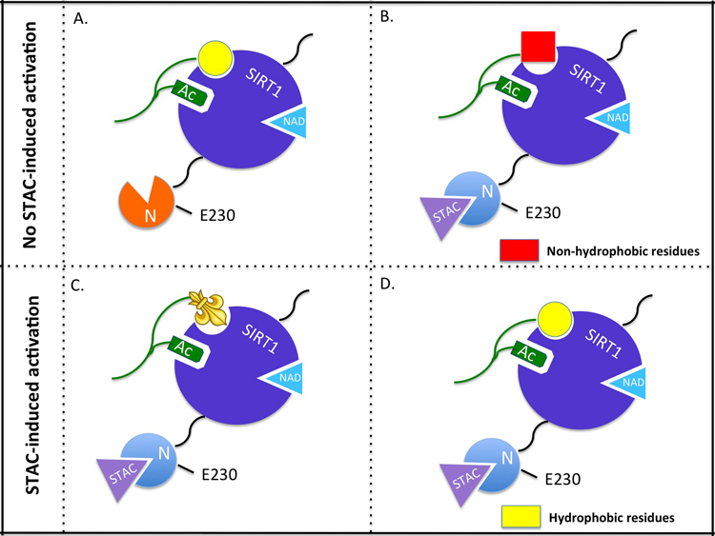
Figure 2-7: Model of allosteric activation of SIRT1 by sirtuin activating compounds (STACs).
(A) SIRT1 acting on a substrate with a hydrophobic signature (yellow) in the absence of a STAC. (B) Binding of a STAC alters the N-terminal structure of SIRT1 but the absence of hydrophobic residues C-terminal to the acetyl-lysine on the substrate prevents activation by STACs. (C) The aminomethycoumarin group on the Fluor-de-Lys peptide substrate mimics hydrophobic residues of natural substrates, facilitating activation by STACs. (D) Substrate contains hydrophobic residues C-terminal to the acetyl-lysine thus allowing STAC-induced activation. Mutation of E230 allows STACs to bind to SIRT1 but abolishes STAC-mediated allosteric activation. Adopted from Kugel S et al., 2013 [202]
2.5.5 Tissue-, dose- and time- dependent manners of leucine
The impacts of leucine on energy metabolism are so different among the studies that may reflect a time-dependent manner. For instance, short-term leucine administration promotes insulin resistance, accompanied by increased phosphorylation of mTOR, JNK and IRS1 in HFD-fed rat [11]. While, a chronic high BCAAs diet leads to improved insulin sensitivity in patients with liver diseases [203].
Leucine has been found to promote energy partitioning from adipocytes to muscle cells under co-culture condition, resulting in decreased lipid accumulation in adipocytes and increasing fatty acid oxidation in muscle [204]. In obese subjects, specialized whey fraction (rich in leucine) significantly reduced 6.1% of the body fat mass and promoted higher protein synthesis in muscle compared to the lean controls [205]. Moreover, leucine protects against HFD-induced insulin resistance and decreases inflammatory stress in perigonadal (PG) fat by blocking macrophage infiltration and inflammatory marker genes expression, despite leucine having no effect on weight loss of intra-abdominal/PG or adipocytes sizes [190]. Indeed, dietary leucine has been found to inhibit expression of NFκB, a transcription factor triggering wide range of genes involved in inflammation, resulting in significant decreases of oxidative and inflammatory stress, partially via activation of mTOR signaling [13]. Furthermore, leucine supplementation is able to improve insulin secretion synergistically with glucose in β-cells, leading to the improvement of whole body glucose tolerance, without changing the body weight [206]. Previous studies demonstrate that activated SIRT1 promotes insulin secretion in pancreatic β-cells [207], and leucine is a potential SIRT1 activator, therefore, leucine might be able to promote insulin sensitivity by stimulation of insulin release in a SIRT1-dependent pathway in pancreatic endocrine cells.
In addition to tissue-specific impacts, leucine might modulate energy metabolism associated with the dose of the leucine intake and the metabolic status of the subjects. For example, Leucine primarily serves as a substrate for new protein synthesis at 1-4 g/d intake, and then as precursors for alanine and glutamine production after meeting the minimum needs. When the intake reaches up to 7~12 g/d, leucine exhibits regulatory impacts on energy metabolism, such as improving skeletal muscle glucose uptake and utilization, reducing food intake and body weight through activation of mTOR signaling in hypothalamus [160]. Zhang et al. [191] and Opara et al [208] consistently found that leucine improved glucose tolerance and insulin sensitivity in HFD-fed mice, but not in chow diet-fed mice. Nairizi et al. confirmed these data by showing that leucine improved glycaemia in HFD-fed mice, although either higher level of leucine (150 mm/l) or BCAAs (109 mm/l) could not rescue the diet-induced obesity [209]. Meanwhile, modest increases in leucine intake, sufficient to raise plasma leucine to ~ 0.5mm/l, significantly reduced obesity-related oxidative and inflammatory stress, resulting in improvement of insulin sensitivity in humans [204]. Similarly, Roger et al. found that leucine in the 0.1mm/l – 0.5mm/l range induces a dose-dependent expression of PGC-1α, leading to significant increases of mitochondrial density and oxidative capacity in skeletal muscle cells [197].

Literature Cited

1. Hjartaker, A., H. Langseth, and E. Weiderpass, Obesity and diabetes epidemics: cancer repercussions. Adv Exp Med Biol, 2008. 630: p. 72-93.
2. Guyenet, S.J. and M.W. Schwartz, Clinical review: Regulation of food intake, energy balance, and body fat mass: implications for the pathogenesis and treatment of obesity. J Clin Endocrinol Metab, 2012. 97(3): p. 745-55.
3. Calle, E.E., et al., Overweight, obesity, and mortality from cancer in a prospectively studied cohort of U.S. adults. N Engl J Med, 2003. 348(17): p. 1625-38.
4. Bostrom, P., et al., A PGC1-alpha-dependent myokine that drives brown-fat-like development of white fat and thermogenesis. Nature, 2012. 481(7382): p. 463-8.
5. Pedersen, B.K. and M.A. Febbraio, Muscles, exercise and obesity: skeletal muscle as a secretory organ. Nat Rev Endocrinol, 2012. 8(8): p. 457-65.
6. Johannsen, D.L. and E. Ravussin, The role of mitochondria in health and disease. Curr Opin Pharmacol, 2009. 9(6): p. 780-6.
7. Watt, M.J. and A.L. Hevener, Fluxing the mitochondria to insulin resistance. Cell Metab, 2008. 7(1): p. 5-6.
8. Andreux, P.A., R.H. Houtkooper, and J. Auwerx, Pharmacological approaches to restore mitochondrial function. Nat Rev Drug Discov, 2013. 12(6): p. 465-83.
9. Schrauwen, P., et al., Mitochondrial dysfunction and lipotoxicity. Biochim Biophys Acta, 2010. 1801(3): p. 266-71.
10. Kairisalo, M., et al., Resveratrol reduces oxidative stress and cell death and increases mitochondrial antioxidants and XIAP in PC6.3-cells. Neurosci Lett, 2011. 488(3): p. 263-6.
11. Newgard, C.B., et al., A branched-chain amino acid-related metabolic signature that differentiates obese and lean humans and contributes to insulin resistance. Cell Metab, 2009. 9(4): p. 311-26.
12. Stipanuk, M.H., Leucine and protein synthesis: mTOR and beyond. Nutr Rev, 2007. 65(3): p. 122-9.
13. Zemel, M.B., et al., Effects of dairy compared with soy on oxidative and inflammatory stress in overweight and obese subjects. Am J Clin Nutr, 2010. 91(1): p. 16-22.
14. Zemel, M.B. and A. Bruckbauer, Effects of a leucine and pyridoxine-containing nutraceutical on fat oxidation, and oxidative and inflammatory stress in overweight and obese subjects. Nutrients, 2012. 4(6): p. 529-41.
15. Wallace, D.C., A mitochondrial paradigm of metabolic and degenerative diseases, aging, and cancer: a dawn for evolutionary medicine. Annu Rev Genet, 2005. 39: p. 359-407.
16. Attardi, G. and G. Schatz, Biogenesis of mitochondria. Annu Rev Cell Biol, 1988. 4: p. 289-333.
17. Rolfe, D.F. and M.D. Brand, The physiological significance of mitochondrial proton leak in animal cells and tissues. Biosci Rep, 1997. 17(1): p. 9-16.
18. Spiegelman, B.M. and J.S. Flier, Obesity and the regulation of energy balance. Cell, 2001. 104(4): p. 531-43.
19. Scarpulla, R.C., Transcriptional paradigms in mammalian mitochondrial biogenesis and function. Physiol Rev, 2008. 88(2): p. 611-38.
20. Caruso, F., et al., Mitochondria are primary targets in apoptosis induced by the mixed phosphine gold species chlorotriphenylphosphine-1,3-bis(diphenylphosphino)propanegold(I) in melanoma cell lines. Biochem Pharmacol, 2007. 73(6): p. 773-81.
21. Psarra, A.M. and C.E. Sekeris, Nuclear receptors and other nuclear transcription factors in mitochondria: regulatory molecules in a new environment. Biochim Biophys Acta, 2008. 1783(1): p. 1-11.
22. Harper, M.E., et al., Ageing, oxidative stress, and mitochondrial uncoupling. Acta Physiol Scand, 2004. 182(4): p. 321-31.
23. Wallace, D.C., Mitochondrial diseases in man and mouse. Science, 1999. 283(5407): p. 1482-8.
24. Cannino, G., C.M. Di Liegro, and A.M. Rinaldi, Nuclear-mitochondrial interaction. Mitochondrion, 2007. 7(6): p. 359-66.
25. Williams, R.S., et al., Adaptation of skeletal muscle to increased contractile activity. Expression nuclear genes encoding mitochondrial proteins. J Biol Chem, 1987. 262(6): p. 2764-7.
26. Scarpulla, R.C., Metabolic control of mitochondrial biogenesis through the PGC-1 family regulatory network. Biochim Biophys Acta, 2011. 1813(7): p. 1269-78.
27. Zhu, J., K.Z. Wang, and C.T. Chu, After the banquet: mitochondrial biogenesis, mitophagy, and cell survival. Autophagy, 2013. 9(11): p. 1663-76.
28. Ryan, M.T. and N.J. Hoogenraad, Mitochondrial-nuclear communications. Annu Rev Biochem, 2007. 76: p. 701-22.
29. Peralta, S., X. Wang, and C.T. Moraes, Mitochondrial transcription: lessons from mouse models. Biochim Biophys Acta, 2012. 1819(9-10): p. 961-9.
30. Pagliarini, D.J., et al., A mitochondrial protein compendium elucidates complex I disease biology. Cell, 2008. 134(1): p. 112-23.
31. Scarpulla, R.C., Nuclear control of respiratory gene expression in mammalian cells. J Cell Biochem, 2006. 97(4): p. 673-83.
32. Gerbeth, C., D. Mikropoulou, and C. Meisinger, From inventory to functional mechanisms: regulation of the mitochondrial protein import machinery by phosphorylation. FEBS J, 2013. 280(20): p. 4933-42.
33. Scarpulla, R.C., Transcriptional activators and coactivators in the nuclear control of mitochondrial function in mammalian cells. Gene, 2002. 286(1): p. 81-9.
34. Ongwijitwat, S. and M.T. Wong-Riley, Is nuclear respiratory factor 2 a master transcriptional coordinator for all ten nuclear-encoded cytochrome c oxidase subunits in neurons? Gene, 2005. 360(1): p. 65-77.
35. Johnson, R.F., Witzel, II, and N.D. Perkins, p53-dependent regulation of mitochondrial energy production by the RelA subunit of NF-kappaB. Cancer Res, 2011. 71(16): p. 5588-97.
36. Szczepanek, K., E.J. Lesnefsky, and A.C. Larner, Multi-tasking: nuclear transcription factors with novel roles in the mitochondria. Trends Cell Biol, 2012. 22(8): p. 429-37.
37. Lin, J., C. Handschin, and B.M. Spiegelman, Metabolic control through the PGC-1 family of transcription coactivators. Cell Metab, 2005. 1(6): p. 361-70.
38. Puigserver, P., et al., A cold-inducible coactivator of nuclear receptors linked to adaptive thermogenesis. Cell, 1998. 92(6): p. 829-39.
39. Wu, Z., et al., Mechanisms controlling mitochondrial biogenesis and respiration through the thermogenic coactivator PGC-1. Cell, 1999. 98(1): p. 115-24.
40. Handschin, C. and B.M. Spiegelman, Peroxisome proliferator-activated receptor gamma coactivator 1 coactivators, energy homeostasis, and metabolism. Endocr Rev, 2006. 27(7): p. 728-35.
41. Kang, C. and L. Li Ji, Role of PGC-1alpha signaling in skeletal muscle health and disease. Ann N Y Acad Sci, 2012. 1271: p. 110-7.
42. Lehman, J.J., et al., Peroxisome proliferator-activated receptor gamma coactivator-1 promotes cardiac mitochondrial biogenesis. J Clin Invest, 2000. 106(7): p. 847-56.
43. Lelliott, C.J., et al., Ablation of PGC-1beta results in defective mitochondrial activity, thermogenesis, hepatic function, and cardiac performance. PLoS Biol, 2006. 4(11): p. e369.
44. Terada, S. and I. Tabata, Effects of acute bouts of running and swimming exercise on PGC-1alpha protein expression in rat epitrochlearis and soleus muscle. Am J Physiol Endocrinol Metab, 2004. 286(2): p. E208-16.
45. Coffey, V.G., et al., Early signaling responses to divergent exercise stimuli in skeletal muscle from well-trained humans. FASEB J, 2006. 20(1): p. 190-2.
46. Akimoto, T., et al., Exercise stimulates Pgc-1alpha transcription in skeletal muscle through activation of the p38 MAPK pathway. J Biol Chem, 2005. 280(20): p. 19587-93.
47. Lira, V.A., et al., PGC-1alpha regulation by exercise training and its influences on muscle function and insulin sensitivity. Am J Physiol Endocrinol Metab, 2010. 299(2): p. E145-61.
48. Summermatter, S., et al., PGC-1alpha improves glucose homeostasis in skeletal muscle in an activity-dependent manner. Diabetes, 2013. 62(1): p. 85-95.
49. Fernandez-Marcos, P.J. and J. Auwerx, Regulation of PGC-1alpha, a nodal regulator of mitochondrial biogenesis. Am J Clin Nutr, 2011. 93(4): p. 884S-90.
50. Lin, J., et al., Transcriptional co-activator PGC-1 alpha drives the formation of slow-twitch muscle fibres. Nature, 2002. 418(6899): p. 797-801.
51. Puigserver, P., et al., Activation of PPARgamma coactivator-1 through transcription factor docking. Science, 1999. 286(5443): p. 1368-71.
52. Scarpulla, R.C., R.B. Vega, and D.P. Kelly, Transcriptional integration of mitochondrial biogenesis. Trends Endocrinol Metab, 2012. 23(9): p. 459-66.
53. Handschin, C., et al., An autoregulatory loop controls peroxisome proliferator-activated receptor gamma coactivator 1alpha expression in muscle. Proc Natl Acad Sci U S A, 2003. 100(12): p. 7111-6.
54. Duvel, K., et al., Activation of a metabolic gene regulatory network downstream of mTOR complex 1. Mol Cell, 2010. 39(2): p. 171-83.
55. Jager, S., et al., AMP-activated protein kinase (AMPK) action in skeletal muscle via direct phosphorylation of PGC-1alpha. Proc Natl Acad Sci U S A, 2007. 104(29): p. 12017-22.
56. Amat, R., et al., SIRT1 controls the transcription of the peroxisome proliferator-activated receptor-gamma Co-activator-1alpha (PGC-1alpha) gene in skeletal muscle through the PGC-1alpha autoregulatory loop and interaction with MyoD. J Biol Chem, 2009. 284(33): p. 21872-80.
57. Gerhart-Hines, Z., et al., Metabolic control of muscle mitochondrial function and fatty acid oxidation through SIRT1/PGC-1alpha. EMBO J, 2007. 26(7): p. 1913-23.
58. Lagouge, M., et al., Resveratrol improves mitochondrial function and protects against metabolic disease by activating SIRT1 and PGC-1alpha. Cell, 2006. 127(6): p. 1109-22.
59. Nunnari, J. and A. Suomalainen, Mitochondria: in sickness and in health. Cell, 2012. 148(6): p. 1145-59.
60. Kim, J.A., Y. Wei, and J.R. Sowers, Role of mitochondrial dysfunction in insulin resistance. Circ Res, 2008. 102(4): p. 401-14.
61. Hojlund, K., et al., Mitochondrial dysfunction in type 2 diabetes and obesity. Endocrinol Metab Clin North Am, 2008. 37(3): p. 713-31, x.
62. Ritov, V.B., et al., Deficiency of subsarcolemmal mitochondria in obesity and type 2 diabetes. Diabetes, 2005. 54(1): p. 8-14.
63. Kelley, D.E., et al., Dysfunction of mitochondria in human skeletal muscle in type 2 diabetes. Diabetes, 2002. 51(10): p. 2944-50.
64. Cheng, Z., Y. Tseng, and M.F. White, Insulin signaling meets mitochondria in metabolism. Trends Endocrinol Metab, 2010. 21(10): p. 589-98.
65. White, M.F., Insulin signaling in health and disease. Science, 2003. 302(5651): p. 1710-1.
66. Befroy, D.E., et al., Impaired mitochondrial substrate oxidation in muscle of insulin-resistant offspring of type 2 diabetic patients. Diabetes, 2007. 56(5): p. 1376-81.
67. Zhang, D., et al., Mitochondrial dysfunction due to long-chain Acyl-CoA dehydrogenase deficiency causes hepatic steatosis and hepatic insulin resistance. Proc Natl Acad Sci U S A, 2007. 104(43): p. 17075-80.
68. Koves, T.R., et al., Mitochondrial overload and incomplete fatty acid oxidation contribute to skeletal muscle insulin resistance. Cell Metab, 2008. 7(1): p. 45-56.
69. Sparks, L.M., et al., A high-fat diet coordinately downregulates genes required for mitochondrial oxidative phosphorylation in skeletal muscle. Diabetes, 2005. 54(7): p. 1926-33.
70. Wredenberg, A., et al., Respiratory chain dysfunction in skeletal muscle does not cause insulin resistance. Biochem Biophys Res Commun, 2006. 350(1): p. 202-7.
71. Pospisilik, J.A., et al., Targeted deletion of AIF decreases mitochondrial oxidative phosphorylation and protects from obesity and diabetes. Cell, 2007. 131(3): p. 476-91.
72. Menzies, K.J. and D.A. Hood, The role of SirT1 in muscle mitochondrial turnover. Mitochondrion, 2012. 12(1): p. 5-13.
73. Nabben, M., et al., The effect of UCP3 overexpression on mitochondrial ROS production in skeletal muscle of young versus aged mice. FEBS Lett, 2008. 582(30): p. 4147-52.
74. Schrauwen, P., et al., Etomoxir-induced increase in UCP3 supports a role of uncoupling protein 3 as a mitochondrial fatty acid anion exporter. FASEB J, 2002. 16(12): p. 1688-90.
75. Bordone, L. and L. Guarente, Calorie restriction, SIRT1 and metabolism: understanding longevity. Nat Rev Mol Cell Biol, 2005. 6(4): p. 298-305.
76. Heilbronn, L.K. and E. Ravussin, Calorie restriction and aging: review of the literature and implications for studies in humans. Am J Clin Nutr, 2003. 78(3): p. 361-9.
77. Imai, S., et al., Transcriptional silencing and longevity protein Sir2 is an NAD-dependent histone deacetylase. Nature, 2000. 403(6771): p. 795-800.
78. Vaquero, A., et al., Human SirT1 interacts with histone H1 and promotes formation of facultative heterochromatin. Mol Cell, 2004. 16(1): p. 93-105.
79. Kaeberlein, M. and L. Guarente, Saccharomyces cerevisiae MPT5 and SSD1 function in parallel pathways to promote cell wall integrity. Genetics, 2002. 160(1): p. 83-95.
80. Chen, D., et al., Increase in activity during calorie restriction requires Sirt1. Science, 2005. 310(5754): p. 1641.
81. Brunet, A., et al., Stress-dependent regulation of FOXO transcription factors by the SIRT1 deacetylase. Science, 2004. 303(5666): p. 2011-5.
82. Zhong, L. and R. Mostoslavsky, Fine tuning our cellular factories: sirtuins in mitochondrial biology. Cell Metab, 2011. 13(6): p. 621-6.
83. Schwer, B. and E. Verdin, Conserved metabolic regulatory functions of sirtuins. Cell Metab, 2008. 7(2): p. 104-12.
84. Michishita, E., et al., SIRT6 is a histone H3 lysine 9 deacetylase that modulates telomeric chromatin. Nature, 2008. 452(7186): p. 492-6.
85. Haigis, M.C., et al., SIRT4 inhibits glutamate dehydrogenase and opposes the effects of calorie restriction in pancreatic beta cells. Cell, 2006. 126(5): p. 941-54.
86. Cohen, H.Y., et al., Calorie restriction promotes mammalian cell survival by inducing the SIRT1 deacetylase. Science, 2004. 305(5682): p. 390-2.
87. Nisoli, E., et al., Calorie restriction promotes mitochondrial biogenesis by inducing the expression of eNOS. Science, 2005. 310(5746): p. 314-7.
88. Bordone, L., et al., SIRT1 transgenic mice show phenotypes resembling calorie restriction. Aging Cell, 2007. 6(6): p. 759-67.
89. Zhang, T. and W.L. Kraus, SIRT1-dependent regulation of chromatin and transcription: linking NAD(+) metabolism and signaling to the control of cellular functions. Biochim Biophys Acta, 2010. 1804(8): p. 1666-75.
90. Picard, F., et al., Sirt1 promotes fat mobilization in white adipocytes by repressing PPAR-gamma. Nature, 2004. 429(6993): p. 771-6.
91. Frescas, D., L. Valenti, and D. Accili, Nuclear trapping of the forkhead transcription factor FoxO1 via Sirt-dependent deacetylation promotes expression of glucogenetic genes. J Biol Chem, 2005. 280(21): p. 20589-95.
92. Hallows, W.C., S. Lee, and J.M. Denu, Sirtuins deacetylate and activate mammalian acetyl-CoA synthetases. Proc Natl Acad Sci U S A, 2006. 103(27): p. 10230-5.
93. Rodgers, J.T. and P. Puigserver, Fasting-dependent glucose and lipid metabolic response through hepatic sirtuin 1. Proc Natl Acad Sci U S A, 2007. 104(31): p. 12861-6.
94. Patane, G., et al., Role of ATP production and uncoupling protein-2 in the insulin secretory defect induced by chronic exposure to high glucose or free fatty acids and effects of peroxisome proliferator-activated receptor-gamma inhibition. Diabetes, 2002. 51(9): p. 2749-56.
95. Bordone, L., et al., Sirt1 regulates insulin secretion by repressing UCP2 in pancreatic beta cells. PLoS Biol, 2006. 4(2): p. e31.
96. Moynihan, K.A., et al., Increased dosage of mammalian Sir2 in pancreatic beta cells enhances glucose-stimulated insulin secretion in mice. Cell Metab, 2005. 2(2): p. 105-17.
97. Kitamura, Y.I., et al., FoxO1 protects against pancreatic beta cell failure through NeuroD and MafA induction. Cell Metab, 2005. 2(3): p. 153-63.
98. Vetterli, L., et al., Resveratrol potentiates glucose-stimulated insulin secretion in INS-1E beta-cells and human islets through a SIRT1-dependent mechanism. J Biol Chem, 2011. 286(8): p. 6049-60.
99. Sun, C., et al., SIRT1 improves insulin sensitivity under insulin-resistant conditions by repressing PTP1B. Cell Metab, 2007. 6(4): p. 307-19.
100. Lomb, D.J., G. Laurent, and M.C. Haigis, Sirtuins regulate key aspects of lipid metabolism. Biochim Biophys Acta, 2010. 1804(8): p. 1652-7.
101. Howitz, K.T., et al., Small molecule activators of sirtuins extend Saccharomyces cerevisiae lifespan. Nature, 2003. 425(6954): p. 191-6.
102. Banks, A.S., et al., SirT1 gain of function increases energy efficiency and prevents diabetes in mice. Cell Metab, 2008. 8(4): p. 333-41.
103. Civitarese, A.E., et al., Calorie restriction increases muscle mitochondrial biogenesis in healthy humans. PLoS Med, 2007. 4(3): p. e76.
104. Chabi, B., et al., Relationship between Sirt1 expression and mitochondrial proteins during conditions of chronic muscle use and disuse. J Appl Physiol (1985), 2009. 107(6): p. 1730-5.
105. Gurd, B.J., et al., The deacetylase enzyme SIRT1 is not associated with oxidative capacity in rat heart and skeletal muscle and its overexpression reduces mitochondrial biogenesis. J Physiol, 2009. 587(Pt 8): p. 1817-28.
106. Boily, G., et al., SirT1 regulates energy metabolism and response to caloric restriction in mice. PLoS One, 2008. 3(3): p. e1759.
107. Pauli, J.R., et al., Acute exercise reverses aged-induced impairments in insulin signaling in rodent skeletal muscle. Mech Ageing Dev, 2010. 131(5): p. 323-9.
108. Koltai, E., et al., Exercise alters SIRT1, SIRT6, NAD and NAMPT levels in skeletal muscle of aged rats. Mech Ageing Dev, 2010. 131(1): p. 21-8.
109. Gurd, B.J., Deacetylation of PGC-1alpha by SIRT1: importance for skeletal muscle function and exercise-induced mitochondrial biogenesis. Appl Physiol Nutr Metab, 2011. 36(5): p. 589-97.
110. Verdin, E., et al., Sirtuin regulation of mitochondria: energy production, apoptosis, and signaling. Trends Biochem Sci, 2010. 35(12): p. 669-75.
111. Lim, J.H., et al., Sirtuin 1 modulates cellular responses to hypoxia by deacetylating hypoxia-inducible factor 1alpha. Mol Cell, 2010. 38(6): p. 864-78.
112. Kim, S.C., et al., Substrate and functional diversity of lysine acetylation revealed by a proteomics survey. Mol Cell, 2006. 23(4): p. 607-18.
113. Schwer, B., et al., Reversible lysine acetylation controls the activity of the mitochondrial enzyme acetyl-CoA synthetase 2. Proc Natl Acad Sci U S A, 2006. 103(27): p. 10224-9.
114. Kwon, H.S. and M. Ott, The ups and downs of SIRT1. Trends Biochem Sci, 2008. 33(11): p. 517-25.
115. Nemoto, S., M.M. Fergusson, and T. Finkel, Nutrient availability regulates SIRT1 through a forkhead-dependent pathway. Science, 2004. 306(5704): p. 2105-8.
116. Chen, D., et al., Tissue-specific regulation of SIRT1 by calorie restriction. Genes Dev, 2008. 22(13): p. 1753-7.
117. Wu, A., Z. Ying, and F. Gomez-Pinilla, Oxidative stress modulates Sir2alpha in rat hippocampus and cerebral cortex. Eur J Neurosci, 2006. 23(10): p. 2573-80.
118. Alcendor, R.R., et al., Sirt1 regulates aging and resistance to oxidative stress in the heart. Circ Res, 2007. 100(10): p. 1512-21.
119. Anderson, R.M., et al., Manipulation of a nuclear NAD+ salvage pathway delays aging without altering steady-state NAD+ levels. J Biol Chem, 2002. 277(21): p. 18881-90.
120. Fulco, M., et al., Glucose restriction inhibits skeletal myoblast differentiation by activating SIRT1 through AMPK-mediated regulation of Nampt. Dev Cell, 2008. 14(5): p. 661-73.
121. van der Veer, E., et al., Pre-B-cell colony-enhancing factor regulates NAD+-dependent protein deacetylase activity and promotes vascular smooth muscle cell maturation. Circ Res, 2005. 97(1): p. 25-34.
122. Nakahata, Y., et al., Circadian control of the NAD+ salvage pathway by CLOCK-SIRT1. Science, 2009. 324(5927): p. 654-7.
123. Mack, T.G.A., et al., Wallerian degeneration of injured axons and synapses is delayed by a Ube4b/Nmnat chimeric gene. Nature Neuroscience, 2001. 4(12): p. 1199-1206.
124. Zhang, T., et al., Enzymes in the NAD+ salvage pathway regulate SIRT1 activity at target gene promoters. J Biol Chem, 2009. 284(30): p. 20408-17.
125. Pillai, J.B., et al., Poly(ADP-ribose) polymerase-1-dependent cardiac myocyte cell death during heart failure is mediated by NAD+ depletion and reduced Sir2alpha deacetylase activity. J Biol Chem, 2005. 280(52): p. 43121-30.
126. Ame, J.C., C. Spenlehauer, and G. de Murcia, The PARP superfamily. Bioessays, 2004. 26(8): p. 882-93.
127. Sasaki, T., et al., Phosphorylation regulates SIRT1 function. PLoS One, 2008. 3(12): p. e4020.
128. Zhao, X., et al., The 2.5 A crystal structure of the SIRT1 catalytic domain bound to nicotinamide adenine dinucleotide (NAD+) and an indole (EX527 analogue) reveals a novel mechanism of histone deacetylase inhibition. J Med Chem, 2013. 56(3): p. 963-9.
129. Sauve, A.A., et al., The biochemistry of sirtuins. Annu Rev Biochem, 2006. 75: p. 435-65.
130. Bruckbauer, A. and M.B. Zemel, Synergistic Effects of Polyphenols and Methylxanthines with Leucine on AMPK/Sirtuin-Mediated Metabolism in Muscle Cells and Adipocytes. PLoS One, 2014. 9(2): p. e89166.
131. Smith, J.J., et al., Small molecule activators of SIRT1 replicate signaling pathways triggered by calorie restriction in vivo. BMC Syst Biol, 2009. 3: p. 31.
132. Wang, Y., Y. Liang, and P.M. Vanhoutte, SIRT1 and AMPK in regulating mammalian senescence: a critical review and a working model. FEBS Lett, 2011. 585(7): p. 986-94.
133. Mihaylova, M.M. and R.J. Shaw, The AMPK signalling pathway coordinates cell growth, autophagy and metabolism. Nat Cell Biol, 2011. 13(9): p. 1016-23.
134. Shackelford, D.B. and R.J. Shaw, The LKB1-AMPK pathway: metabolism and growth control in tumour suppression. Nat Rev Cancer, 2009. 9(8): p. 563-75.
135. Shaw, R.J., et al., The kinase LKB1 mediates glucose homeostasis in liver and therapeutic effects of metformin. Science, 2005. 310(5754): p. 1642-6.
136. Alessi, D.R., K. Sakamoto, and J.R. Bayascas, LKB1-dependent signaling pathways. Annu Rev Biochem, 2006. 75: p. 137-63.
137. Price, N.L., et al., SIRT1 is required for AMPK activation and the beneficial effects of resveratrol on mitochondrial function. Cell Metab, 2012. 15(5): p. 675-90.
138. Suter, M., et al., Dissecting the role of 5'-AMP for allosteric stimulation, activation, and deactivation of AMP-activated protein kinase. J Biol Chem, 2006. 281(43): p. 32207-16.
139. Fogarty, S., et al., Calmodulin-dependent protein kinase kinase-beta activates AMPK without forming a stable complex: synergistic effects of Ca2+ and AMP. Biochem J, 2010. 426(1): p. 109-18.
140. Xie, M., et al., A pivotal role for endogenous TGF-beta-activated kinase-1 in the LKB1/AMP-activated protein kinase energy-sensor pathway. Proc Natl Acad Sci U S A, 2006. 103(46): p. 17378-83.
141. Sakamoto, K. and G.D. Holman, Emerging role for AS160/TBC1D4 and TBC1D1 in the regulation of GLUT4 traffic. Am J Physiol Endocrinol Metab, 2008. 295(1): p. E29-37.
142. Kramer, H.F., et al., Distinct signals regulate AS160 phosphorylation in response to insulin, AICAR, and contraction in mouse skeletal muscle. Diabetes, 2006. 55(7): p. 2067-76.
143. Fulco, M. and V. Sartorelli, Comparing and contrasting the roles of AMPK and SIRT1 in metabolic tissues. Cell Cycle, 2008. 7(23): p. 3669-79.
144. Sato, R., J.L. Goldstein, and M.S. Brown, Replacement of serine-871 of hamster 3-hydroxy-3-methylglutaryl-CoA reductase prevents phosphorylation by AMP-activated kinase and blocks inhibition of sterol synthesis induced by ATP depletion. Proc Natl Acad Sci U S A, 1993. 90(20): p. 9261-5.
145. Ruderman, N.B. and D. Dean, Malonyl CoA, long chain fatty acyl CoA and insulin resistance in skeletal muscle. J Basic Clin Physiol Pharmacol, 1998. 9(2-4): p. 295-308.
146. Roepstorff, C., et al., Malonyl-CoA and carnitine in regulation of fat oxidation in human skeletal muscle during exercise. Am J Physiol Endocrinol Metab, 2005. 288(1): p. E133-42.
147. Watt, M.J., et al., Regulation of HSL serine phosphorylation in skeletal muscle and adipose tissue. Am J Physiol Endocrinol Metab, 2006. 290(3): p. E500-8.
148. Li, Y., et al., AMPK phosphorylates and inhibits SREBP activity to attenuate hepatic steatosis and atherosclerosis in diet-induced insulin-resistant mice. Cell Metab, 2011. 13(4): p. 376-88.
149. Porstmann, T., et al., SREBP activity is regulated by mTORC1 and contributes to Akt-dependent cell growth. Cell Metab, 2008. 8(3): p. 224-36.
150. Canto, C. and J. Auwerx, AMP-activated protein kinase and its downstream transcriptional pathways. Cell Mol Life Sci, 2010. 67(20): p. 3407-23.
151. Pacholec, M., et al., SRT1720, SRT2183, SRT1460, and resveratrol are not direct activators of SIRT1. J Biol Chem, 2010. 285(11): p. 8340-51.
152. Imamura, K., et al., Cell cycle regulation via p53 phosphorylation by a 5'-AMP activated protein kinase activator, 5-aminoimidazole- 4-carboxamide-1-beta-D-ribofuranoside, in a human hepatocellular carcinoma cell line. Biochem Biophys Res Commun, 2001. 287(2): p. 562-7.
153. Hardie, D.G., AMP-activated/SNF1 protein kinases: conserved guardians of cellular energy. Nat Rev Mol Cell Biol, 2007. 8(10): p. 774-85.
154. Fulco, M., et al., Sir2 regulates skeletal muscle differentiation as a potential sensor of the redox state. Mol Cell, 2003. 12(1): p. 51-62.
155. Park, S.J., et al., Resveratrol ameliorates aging-related metabolic phenotypes by inhibiting cAMP phosphodiesterases. Cell, 2012. 148(3): p. 421-33.
156. Hou, X., et al., SIRT1 regulates hepatocyte lipid metabolism through activating AMP-activated protein kinase. J Biol Chem, 2008. 283(29): p. 20015-26.
157. Shin, S.M., I.J. Cho, and S.G. Kim, Resveratrol protects mitochondria against oxidative stress through AMP-activated protein kinase-mediated glycogen synthase kinase-3beta inhibition downstream of poly(ADP-ribose)polymerase-LKB1 pathway. Mol Pharmacol, 2009. 76(4): p. 884-95.
158. Ruderman, N.B., et al., AMPK and SIRT1: a long-standing partnership? Am J Physiol Endocrinol Metab, 2010. 298(4): p. E751-60.
159. Trumbo, P., et al., Dietary reference intakes for energy, carbohydrate, fiber, fat, fatty acids, cholesterol, protein and amino acids. J Am Diet Assoc, 2002. 102(11): p. 1621-30.
160. Layman, D.K., The role of leucine in weight loss diets and glucose homeostasis. J Nutr, 2003. 133(1): p. 261S-267S.
161. Harper, A.E., R.H. Miller, and K.P. Block, Branched-chain amino acid metabolism. Annu Rev Nutr, 1984. 4: p. 409-54.
162. Patti, M.E., et al., Bidirectional modulation of insulin action by amino acids. J Clin Invest, 1998. 101(7): p. 1519-29.
163. She, P., et al., Disruption of BCATm in mice leads to increased energy expenditure associated with the activation of a futile protein turnover cycle. Cell Metab, 2007. 6(3): p. 181-94.
164. Iwanaka, N., et al., Leucine modulates contraction- and insulin-stimulated glucose transport and upstream signaling events in rat skeletal muscle. J Appl Physiol (1985), 2010. 108(2): p. 274-82.
165. Shimomura, Y., et al., Branched-chain amino acid catabolism in exercise and liver disease. J Nutr, 2006. 136(1 Suppl): p. 250S-3S.
166. Lu, J., et al., Insulin resistance and the metabolism of branched-chain amino acids. Front Med, 2013. 7(1): p. 53-9.
167. Buse, M.G. and S.S. Reid, Leucine. A possible regulator of protein turnover in muscle. J Clin Invest, 1975. 56(5): p. 1250-61.
168. Rennie, M.J. and K.D. Tipton, Protein and amino acid metabolism during and after exercise and the effects of nutrition. Annu Rev Nutr, 2000. 20: p. 457-83.
169. Matthews, D.E., Observations of branched-chain amino acid administration in humans. J Nutr, 2005. 135(6 Suppl): p. 1580S-4S.
170. Volpi, E., et al., Essential amino acids are primarily responsible for the amino acid stimulation of muscle protein anabolism in healthy elderly adults. Am J Clin Nutr, 2003. 78(2): p. 250-8.
171. Layman, D.K. and D.A. Walker, Potential importance of leucine in treatment of obesity and the metabolic syndrome. J Nutr, 2006. 136(1 Suppl): p. 319S-23S.
172. Laplante, M. and D.M. Sabatini, mTOR signaling in growth control and disease. Cell, 2012. 149(2): p. 274-93.
173. Inoki, K., et al., Rheb GTPase is a direct target of TSC2 GAP activity and regulates mTOR signaling. Genes Dev, 2003. 17(15): p. 1829-34.
174. Sancak, Y., et al., The Rag GTPases bind raptor and mediate amino acid signaling to mTORC1. Science, 2008. 320(5882): p. 1496-501.
175. Thoreen, C.C., et al., An ATP-competitive mammalian target of rapamycin inhibitor reveals rapamycin-resistant functions of mTORC1. J Biol Chem, 2009. 284(12): p. 8023-32.
176. Yoshizawa, F., Regulation of protein synthesis by branched-chain amino acids in vivo. Biochem Biophys Res Commun, 2004. 313(2): p. 417-22.
177. Du, M., et al., Leucine stimulates mammalian target of rapamycin signaling in C2C12 myoblasts in part through inhibition of adenosine monophosphate-activated protein kinase. J Anim Sci, 2007. 85(4): p. 919-27.
178. Ahlborg, G., et al., Substrate turnover during prolonged exercise in man. Splanchnic and leg metabolism of glucose, free fatty acids, and amino acids. J Clin Invest, 1974. 53(4): p. 1080-90.
179. Balasubramanyam, A., et al., Ethnicity affects the postprandial regulation of glycogenolysis. Am J Physiol, 1999. 277(5 Pt 1): p. E905-14.
180. Rachdi, L., et al., L-leucine alters pancreatic beta-cell differentiation and function via the mTor signaling pathway. Diabetes, 2012. 61(2): p. 409-17.
181. Tai, E.S., et al., Insulin resistance is associated with a metabolic profile of altered protein metabolism in Chinese and Asian-Indian men. Diabetologia, 2010. 53(4): p. 757-67.
182. McCormack, S.E., et al., Circulating branched-chain amino acid concentrations are associated with obesity and future insulin resistance in children and adolescents. Pediatr Obes, 2013. 8(1): p. 52-61.
183. She, P., et al., Obesity-related elevations in plasma leucine are associated with alterations in enzymes involved in branched-chain amino acid metabolism. Am J Physiol Endocrinol Metab, 2007. 293(6): p. E1552-63.
184. Haruta, T., et al., A rapamycin-sensitive pathway down-regulates insulin signaling via phosphorylation and proteasomal degradation of insulin receptor substrate-1. Mol Endocrinol, 2000. 14(6): p. 783-94.
185. Tzatsos, A. and K.V. Kandror, Nutrients suppress phosphatidylinositol 3-kinase/Akt signaling via raptor-dependent mTOR-mediated insulin receptor substrate 1 phosphorylation. Mol Cell Biol, 2006. 26(1): p. 63-76.
186. Tremblay, F., et al., Overactivation of S6 kinase 1 as a cause of human insulin resistance during increased amino acid availability. Diabetes, 2005. 54(9): p. 2674-84.
187. Xiao, F., et al., Leucine deprivation increases hepatic insulin sensitivity via GCN2/mTOR/S6K1 and AMPK pathways. Diabetes, 2011. 60(3): p. 746-56.
188. Um, S.H., et al., Absence of S6K1 protects against age- and diet-induced obesity while enhancing insulin sensitivity. Nature, 2004. 431(7005): p. 200-5.
189. Murguia, J.R. and R. Serrano, New functions of protein kinase Gcn2 in yeast and mammals. IUBMB Life, 2012. 64(12): p. 971-4.
190. Macotela, Y., et al., Dietary leucine--an environmental modifier of insulin resistance acting on multiple levels of metabolism. PLoS One, 2011. 6(6): p. e21187.
191. Zhang, Y., et al., Increasing dietary leucine intake reduces diet-induced obesity and improves glucose and cholesterol metabolism in mice via multimechanisms. Diabetes, 2007. 56(6): p. 1647-54.
192. Ropelle, E.R., et al., A central role for neuronal AMP-activated protein kinase (AMPK) and mammalian target of rapamycin (mTOR) in high-protein diet-induced weight loss. Diabetes, 2008. 57(3): p. 594-605.
193. Binder, E., et al., Leucine supplementation protects from insulin resistance by regulating adiposity levels. PLoS One, 2013. 8(9): p. e74705.
194. Saha, A.K., et al., Insulin resistance due to nutrient excess: is it a consequence of AMPK downregulation? Cell Cycle, 2011. 10(20): p. 3447-51.
195. Bruckbauer, A., et al., Synergistic effects of leucine and resveratrol on insulin sensitivity and fat metabolism in adipocytes and mice. Nutr Metab (Lond), 2012. 9(1): p. 77.
196. Bruckbauer, A. and M.B. Zemel, Synergistic effects of metformin, resveratrol, and hydroxymethylbutyrate on insulin sensitivity. Diabetes Metab Syndr Obes, 2013. 6: p. 93-102.
197. Vaughan, R.A., et al., Leucine treatment enhances oxidative capacity through complete carbohydrate oxidation and increased mitochondrial density in skeletal muscle cells. Amino Acids, 2013. 45(4): p. 901-11.
198. Li, H., et al., Leucine supplementation increases SIRT1 expression and prevents mitochondrial dysfunction and metabolic disorders in high-fat diet-induced obese mice. Am J Physiol Endocrinol Metab, 2012. 303(10): p. E1234-44.
199. Sun, X. and M.B. Zemel, Leucine modulation of mitochondrial mass and oxygen consumption in skeletal muscle cells and adipocytes. Nutr Metab (Lond), 2009. 6: p. 26.
200. Hubbard, B.P., et al., Evidence for a common mechanism of SIRT1 regulation by allosteric activators. Science, 2013. 339(6124): p. 1216-9.
201. Dai, H., et al., SIRT1 activation by small molecules: kinetic and biophysical evidence for direct interaction of enzyme and activator. J Biol Chem, 2010. 285(43): p. 32695-703.
202. Kugel, S. and R. Mostoslavsky, SIRT1 activators: the evidence STACks up. Aging (Albany NY), 2013. 5(3): p. 142-3.
203. Kawaguchi, T., et al., Branched-chain amino acid-enriched supplementation improves insulin resistance in patients with chronic liver disease. Int J Mol Med, 2008. 22(1): p. 105-12.
204. Sun, X. and M.B. Zemel, Leucine and calcium regulate fat metabolism and energy partitioning in murine adipocytes and muscle cells. Lipids, 2007. 42(4): p. 297-305.
205. Frestedt, J.L., et al., A whey-protein supplement increases fat loss and spares lean muscle in obese subjects: a randomized human clinical study. Nutr Metab (Lond), 2008. 5: p. 8.
206. Kalogeropoulou, D., et al., Leucine, when ingested with glucose, synergistically stimulates insulin secretion and lowers blood glucose. Metabolism, 2008. 57(12): p. 1747-52.
207. Luu, L., et al., The loss of Sirt1 in mouse pancreatic beta cells impairs insulin secretion by disrupting glucose sensing. Diabetologia, 2013. 56(9): p. 2010-20.
208. Opara, E.C., et al., L-glutamine supplementation of a high fat diet reduces body weight and attenuates hyperglycemia and hyperinsulinemia in C57BL/6J mice. J Nutr, 1996. 126(1): p. 273-9.
209. Nairizi, A., et al., Leucine supplementation of drinking water does not alter susceptibility to diet-induced obesity in mice. J Nutr, 2009. 139(4): p. 715-9.

Part Three
Leucine Modulates Mitochondrial Biogenesis and SIRT1-AMPK Signaling in C2C12 Myotubes

3.1 Abstract

Background:

SIRT1 (Silent Information Regulator Transcript 1) and AMPK (AMP-activated protein kinase) are important regulators of energy metabolism, and the activation of both enzymes have been reported to prevent the development of insulin resistance and type 2 diabetes. We have shown that leucine stimulates Sirt1 gene expression as well as mitochondrial biogenesis in vivo and in vitro. In addition, β-hydroxy-β-methyl butyrate (HMB), a metabolite of leucine, has been reported to activate AMPK synergistically with resveratrol in C2C12 myotubes. Accordingly, we sought to determine the roles of SIRT1 and AMPK in leucine-stimulated mitochondrial biogenesis in C2C12 well differentiated myotubes.

Methods: C2C12 myotubes were treated with leucine (0.5 mM), alanine (0.5 mM), valine (0.5 mM), EX527 (SIRT1 inhibitor, 25 μM) and Compound C (AMPK inhibitor, 25 μM) alone or in combinations for various lengths of time as indicated in figure legends.

Results: Mitochondrial content, the expression levels of genes involved in mitochondrial biogenesis, fatty acid oxidation, SIRT1 activity and gene expression, and AMPK phosphorylation in C2C12 myotubes were significantly increased by the leucine treatment compared to the controls, and these effects were markedly attenuated by EX527 and Compound C. Further, leucine treatment for 24-hours resulted in time-dependent increases in NAD⁺ level, SIRT1 activity and p-AMPK level. Although both SIRT1 and AMPK activation were essential for leucine-stimulated mitochondrial biogenesis, leucine activates SIRT1 ahead of AMPK.

Conclusion: These results indicate that leucine promotes mitochondrial biogenesis in a SIRT1 and AMPK dependent manner in C2C12 myotubes, with SIRT1 activation being the primary event.

3.2 Introduction
Caloric restriction (CR) has been shown to extend life span and delay the onset of aging-associated pathology in many species, such as yeast, worms, flies and some mammals [1]. These beneficial effects of CR are mediated partially through activation of Sir2 (Silent Information Regulator Two) in lower species and its orthologue SIRT1 in mammals. By sensing cellular energy status via intracellular NAD⁺/NADH (Nicotinamide adenine dinucleotide) ratio, SIRT1 regulates target genes expression by changing acetylation status of histone and transcriptional factors, such as peroxisome proliferator-activated receptor gamma coactivator 1-alpha (PGC-1α), tumor suppressor p53 (p53), nuclear factor kappa-light-chain-enhancer of activated B cells (NF-κB) and Forkhead box O3 (FOXO3) [2], resulting in modulation of wide range of cellular fundamental processes, including DNA repair, metabolic regulation, and cell apoptosis [3, 4]. Overexpression of SIRT1 protects against high-fat diet (HFD)-induced metabolic abnormalities, such as insulin resistance, glucose intolerance and liver steatosis; without extending their lifespan in mouse models [5]. In addition, activated SIRT1 deacetylates and activates PGC-1α, a major regulator of mitochondrial biogenesis and metabolism, leading to improvement of insulin sensitivity and decreases of oxidative and inflammatory stress [6]. Therefore, small molecules that could activate SIRT1 and mimic the CR-induced positive effects have drawn considerable attention.
Leucine, a branched-chain amino acid, stimulates tissue protein synthesis through both mTOR-dependent and independent pathways[7] [8]. However, leucine appears to play a distinct role in energy metabolism in addition to its pivotal function in protein synthesis. For example, studies have shown that leucine administration promotes energy partitioning from adipocytes to muscle cells, leading to decreased lipid storage in adipocytes and increased fat utilization in muscle [9]. Also, leucine supplementation increases insulin sensitivity and glucose tolerance by promoting glucose uptake and fatty acid oxidation in skeletal muscle in HFD mice [10-13]. In fact, evidences suggest that these leucine-induced beneficial metabolic effects are mediated partially through SIRT1 activation, as Sirt1 knockout significantly diminishes these changes [14, 15]. Consistent with this, our recent data indicate that leucine directly activates SIRT1, and promotes the enzyme affinity for NAD⁺[14], leading to increased fatty acid oxidation in adipocytes and myotubes [16, 17];
Further, leucine promotes AMPK (AMP-activated protein kinase) phosphorylation synergistically with metformin; resulting in significant increases in insulin sensitivity and glucose tolerance in mice [18]. AMPK is an evolutionary conserved enzyme and serves as an energy status sensor in eukaryotes [19]. Similar to SIRT1, AMPK is activated and phosphorylated in response to energy restriction. Increased cellular AMP or AMP/ATP ratio activates AMPK through LKB1 (kinases tumor suppressor liver kinase B1) and Camkkβ (Ca²⁺/calmodulin-dependent kinase kinase beta) signaling pathways, and subsequently promotes a cell catabolic shift with increased fatty acid oxidation and ATP production to rescue the energy crisis [20]. In fact, data from resveratrol (a SIRT1 activator) studies have shown that SIRT1 activation in vivo is highly associated with phosphorylation of AMPK [1, 21]. All these evidences provide a framework of leucine’s modulation mechanism on SIRT1 and AMPK in skeletal muscle [17, 22].
Since SIRT1 and AMPK share multiple metabolic substrates [23], and part of the two enzymes signaling pathways are overlapped, we hypothesize that leucine-induced activations of SIRT1 and AMPK are the major events that regulate fatty acid oxidation and mitochondrial biogenesis in skeletal muscle cells.
Accordingly, we examined the effects of leucine, valine (branched-chain amino acid control), and alanine (non-branched chain amino acid control) on mitochondrial biogenesis, SIRT1 activation, and phosphorylation of AMPK in C2C12 myotubes. In addition, we also used EX-527 (SIRT1 selective inhibitor) and Compound C (specific AMPK inhibitor) to probe the role of each enzyme in leucine modulation of energy metabolism in differentiated C2C12 myotubes.
3.3 Materials and Methods
3.3.1 Cell Culture
C2C12 myoblast cells were seeded at a density of 1.2$×$10⁶ cells per well in 6-well plates and incubated in Dulbecco’s Modified Eagle Medium (DMEM) containing 4.5g/L D-glucose, 10% fetal bovine serum (FBS) and 1% penicillin-streptomycin at 37°C and 5% CO₂. After the cells reach 90% confluence, the medium was switched to a standard differentiation medium (DMEM supplemented with 2% Horse Serum and 1% antibiotics) for 2 to 4 days. The differentiation media was changed every other day to allow 90% cells to form myotubes (3-5 days later) before additional treatments began.
The dosages of reagents were 0.5mM for leucine, 0.5mM for alanine, 0.5mM for valine, 100nM for Resveratrol, 20μM for EX527, 20μM for Compound C, and 50μM for AICAR. The incubation lengths were from 1 to 48 hours as indicated in the figure legend.

3.3.2. Measurement of mitochondrial biogenesis related genes expression
Total RNA was extracted from C2C12 cells using Ambion ToTally RNA Isolation Kit (Ambion, Inc., Austin, TX, USA) according to the manufacture’s instructions. Total RNA content was determined using NanoDrop ND-1000 Spectrophotoeter (NanoDrop Technologies Inc., Wilmington, DE, USA). RNA quality was assessed by the 260nm/280nm ratio (1.8-2.0) and 260nm/230nm ratio (2.0). The expression levels of myotube ribosomal 18S (18S), Sirt1, Sirt3, PGC-1α, cytochrome c oxidase subunit 5b (Cox5b), heat shock cognate protein 1 (Hspd 1) and Cox2 genes were measured via quantitative real-time PCR using TaqMan Universal PCR Master Mix kit (Applied Biosystems, Branchburg, NJ, USA) according to the manufacturer’s instructions. The real-time PCR reactions were carried out in 96-well format using ABI 7300HT instrument, with cycle condition of 48°C 30min, then 40 cycles of 95°C for 15s/60°C for 1 minute. The mRNA levels were normalized against endogenous housekeeping gene 18S with standard curve. Data for each gene was presented as a ratio to 18S.
3.3.3 Measurement of SIRT1 enzyme activity
SIRT1 Fluorometric Drug Discovery Kit (BML-AK555, ENZO Life Science International, Inc. PA, USA) was used to measure SIRT1 activity in C2C12 cells, following the manufacturer instruction. In this assay, SIRT1 activity was determined by deacetylation reaction of a standardized substrate that contains an acetylated lysine residue. This Fluor de Lys® substrate is a peptide containing amino acids 379-382 of human p53 (Arg-His-Lys-Lys(Ac)), serving as a direct target for SIRT1. SIRT1 activity is proportionally related to the degree of deacetylation of Lys-382 and the corresponding fluorescence signal changes.
All the cell lysates were harvested by homogenizing cells in RIPA buffer, which contains protease inhibitor cocktail (MP Biomedicals LLC, Solon, OH, USA) (100: 1 v/v). After 5 seconds ultrasonication on ice, the cell lysates were centrifuged at 12,000 $×$ g for 5 minutes. The supernatants were used for SIRT1 activity assessment and other experiments. According to the protocol, 5 μl of cell lysate were used for the endogenous SIRT1 activity detection. Samples were incubated in a PBS (phosphate-buffered saline) solution with peptide substrate (25 μM) and NAD⁺ (500 μM) at 37°C on a horizontal shaker for 45 minutes. The deacetylation reaction was stopped with the addition of the stop solution (2mM nicotinamide) and developer that binds to the deacetylated lysine to form a fluorophore. Following 10 minutes of incubation at 37°C, fluorescence intensity was determined using a Glomax Multi Detection system (Promega, WI, USA), with excitation and emission wavelengths of 360 nm and 450 nm, respectively. Resveratrol (100 mM) and suramin sodium (25 mM) were used as positive and negative controls, respectively. To normalize the data of SIRT1 activity, concentrations of the sample cellular protein were measured using BCA-assay.
3.3.4 Measurement of fatty acid oxidation
Cellular fatty acid oxidation was measured using [³H]-palmitate, as described in our previous studies [9]. C2C12 cells in 12-well plates were washed with 2 ml of cold PBS solution twice and incubated in 1 ml of Hank’s basic salt solution containing 0.5mg/ml BSA, 22 μM-unlabeled palmitate plus 5 μM [³H]-palmitate (32.4 mCi/μm) for 2 hour. All of the reaction solutions were collected from each well, and then 200 μl of 10% trichloracetic acid and 6 N NaOH were added in the solution. Mixtures were then removed from each well and placed in corresponding poly-prep chromatography columns with 1.5 ml Dowex-1 overnight. The ³H₂O passed through the column was collected into a scintillation vial, and radioactivity was measured with a liquid scintillation counter. The protein level of each well was measured using BCA reagent and used to normalize the palmitate oxidation data.

3.3.5 Western Blotting
Primary antibodies for total AMPK$α$ (AMP-activated protein kinase$α$), p-AMPK$α$ (Phosphor-AMPK$α$), ACC (Acetyl-CoA Carboxylase), and p-ACC (Phospho-ACC) were obtained from Cell Signaling Technology Inc (Danvers, MA, USA). And Horseradish peroxidase (HRP)-conjugated goat anti-rabbit secondary antibody was obtained from Thermo Scientific Inc (Waltham, MA, USA).
Following the indicated treatments, C2C12 myotubes were washed twice with ice cold PBS, and the total cell lysates were prepared using RIPA buffer plus protease/phosphatase inhibitor cocktails with 100:1:1 (v/v/v, ratio) (Sigma-Aldrich). Following a 10-minute centrifugation at 14,000 x g, the supernatants were collected for the determination of protein content using BCA assay kit (Thermo Scientific Inc, Waltham, MA, USA) and western blotting. Equal amount of total cell lysates (20 μg) were loaded to 10% SDS-PAGE (10 cm x 10 cm, Criterion precast gel, Bio-Rad Laboratories, Hercules, CA, USA) and transferred to PVDF membrane (polyvinylidene difluoride membrane) (Bio-Rad, Hercules, CA). The membrane was incubated in 25 ml blocking buffer (1$×$ TBS, 0.1% Tween-20 with 5% w/v nonfat dry milk) for 1 hour at room temperature. Then the membrane was incubated in TBST containing 5% dry milk with primary antibody (1:1000) with gentle agitation at 4°C overnight, washed three times with TBST and incubated with TBST containing rabbit HRP-conjugated secondary antibody (1:5000) for 1 hour at RT. Bound antibodies were visualized by chemiluminescence (ECL Western Blotting Substrate, Thermo Scientific) and membranes were exposed to X-ray films (Phenix Research Product, Candler, NC) for protein band detection. The films were scanned using an HP Scanjet 39070 (Palo Alto, CA 94304) and stored as Tagged Image File Format (TIFF) at 300dpi. The protein bands were quantified by densitometry using BioRad ChemiDoc instrumentation and software of Image Lab 4.0 (Bio-Rad Labratories).
3.3.6 Measurement of mitochondrial contents
Mitochondrial abundance in C2C12 myotubes was assessed by 10-N-nonyl acridine orange (NAO) dye (Life Sciences, PA, USA) according to manufacturer’s instruction. After desired treatment, cells in 96-well plates were treated with 10 $μ$l NAO dye in each well, following 2-hour incubation at 37°C in the dark. NAO itself is not fluorescent, but it can be oxidized into the fluorescent-NAO by oxidative species, and accumulated in mitochondrial membranes. The absorbance in each well was measured at 570 nm wavelengths (Promega, WI, USA), and normalized with cellular protein level. The image of mitochondria was taken using a Nikon Eclipse Ti-E Ti-E Fluorescence microscope (Nikon Metrology, Inc. US) equipped with an automated stage and a 20 X objective. A 3 × 3 large image scan was taken in each of 5 random fields by multi-channel capture (channel 1: excitation/emission= 488/517, channel 2: excitation/emission = 550/567 nm).
3.3.7 Statistical analysis
Data presented as means ± standard deviation (SD). Levene's test was used to determined homogeneity of variance among groups using SPSS 21.0 statistical software (IBM, Armonk, NY) and where necessary natural log transformation was performed before analysis. Multiple comparisons were analyzed by one-way analysis of variance (ANOVA) using least significant different when equal variance was assumed, and Games-Howell test was used when equal variance was not assumed. The independent sample t-test was used to compare two conditions. Differences were considered statistically significant at P < 0.05.
3.4 Results

3.4.1 Leucine treatment induced the mitochondrial biogenesis in C2C12 myotubes
Figure 3-1 shows the changes of mitochondrial content (A), expression level of mitochondrial biogenesis genes (B), SIRT1 enzyme activity (C) and fatty acid oxidation (D) in C2C12 myotubes treated with vehicle control, leucine, valine and alanine for 48 hours. Leucine significantly increased mitochondria content in C2C12s compared to alanine and valine (p=0.007) (Fig. 3-1A). These effects were accompanied by increases in mRNA expression levels of PGC-1α (198%, p=0.01) and SIRT3 (167%, p=0.03) with leucine treatment (Fig. 3-1B). Moreover, SIRT1 activity (p=0.017) and fatty acid oxidation (p=0.03) in the C2C12s were highly elevated by leucine compared to the control groups (Fig. 3-1C and D, respectively).
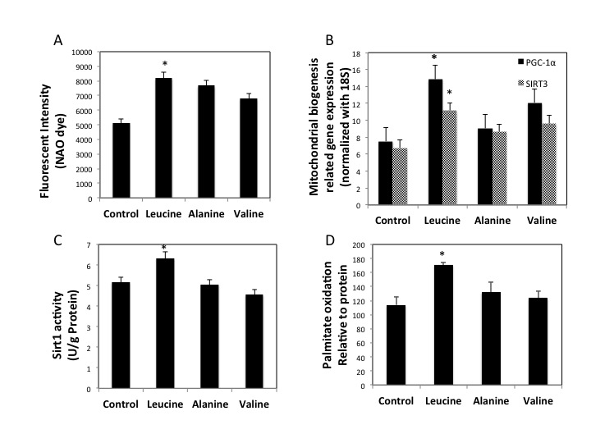
Figure 3-1: Leucine treatment induces mitochondrial biogenesis and SIRT1 enzymatic activity in C2C12 myotubes
Mitochondrial contents were quantitated with NAO dye (10 μM) (A) 48 hours after treated the cells treated with leucine (0.5 mM), alanine (0.5 mM) and valine (0.5 mM); mRNA expression levels of PGC-1α and SIRT3 (B) with the same treatments were evaluated by quantitative RT-PCR. The relative mRNA expression was normalized to 18S and expressed as dark and grey bars. Cellular SIRT1 activity (C) and palmitate oxidation ability (D) were measured after leucine and its amino acids controls, and the results were normalized to cellular protein level for each sample. Data are mean ± SE (n=4). Different letters indicate significant differences between solid or gray bars. * Significantly different from controls with p<0.05.

3.4.2 SIRT1 is required for leucine–induced mitochondria biogenesis in C2C12 myotubes
We used a selective SIRT1 inhibitor, EX527, to determine the role of SIRT1 in leucine-induced mitochondrial biogenesis. Leucine increased mitochondrial biogenesis as demonstrated by significant increases in mitochondrial content (p=0.001), palmitate oxidation (p=0.038) and mitochondrial biogenesis-related gene markers PGC-1α (p=0.003), SIRT3 (p=0.031) and COX5b (p=0.015) (Fig. 2 A, C-D, dark panel), and these effects were markedly attenuated by EX527 administration (Fig. 3-2 A, C-D, grey panel). Comparing the relative SIRT1 expression, leucine and resveratrol (positive control) markedly increased Sirt1 mRNA level (p=0.020); paradoxically, the SIRT1 inhibitor (EX527) (p=0.015) revealed the same pattern (Fig.3-2 B).
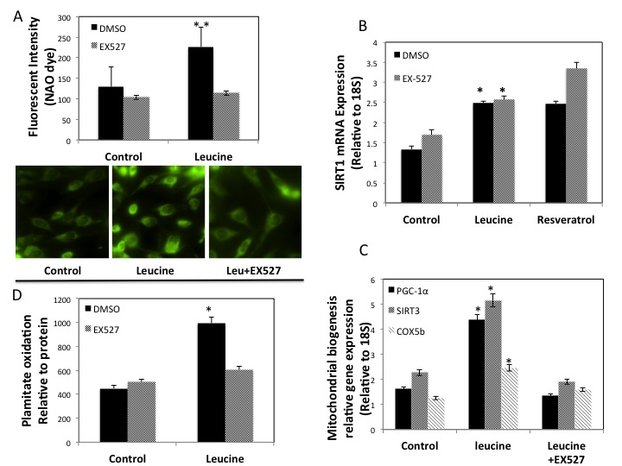
Figure 3-2: Leucine improves Mitochondrial biogenesis in C2C12s in a SIRT1- dependent Manner
(A) Mitochondrial contents and imagines were detected using NAO (10 μM) dye after 48-hour leucine, leucine plus SIRT1 inhibitor (EX527 25 μM) treatments in C2C12 cells. (B, C) SIRT1 activity and mitochondrial biogenesis related gene (PGC-1α, SIRT3, COX5b) mRNA levels were measured after the same treatments. The relative SIRT1 activity was normalized to cellular protein level, and mRNA was normalized to housekeeper gene 18S. (D) palmitate oxidation level was detected after the same treatment, and the results were normalized to cellular protein for each sample. Data are mean ± SE (n=4). Different letters indicate significant differences between solid or gray bars. * Significantly different from controls, and ** significantly different from control and EX527 groups with p<0.05.
3.4.3 Leucine induces phosphorylation of AMPK in a SIRT1-dependent manner
We found that 6-hour treatment of leucine resulted in 3-fold increase in AMPK phosphorylation in the C2C12 myotubes, which was significantly different from baseline, valine and alanine. Consistent with this observation, phosphorylation of Acetyl-CoA carboxylase (ACC), a downstream target of AMPK, was also elevated by leucine treatment compared to the controls (p=0.014) (Fig. 3-3 A), while EX527 supplementation resulted in corresponding suppression of AMPK phosphorylation (p=0.012)(Fig. 3-3 B), indicating the requirement of SIRT1 for leucine-induced AMPK activation.
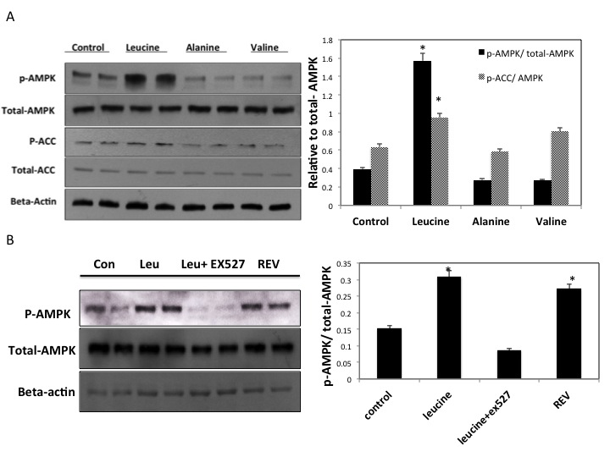
Figure 3-3: Leucine induces phosphorylation of AMPK and ACC in SIRT1-dependent manner in C2C12 Myotubes
(A) C2C12 myotubes were serum starved overnight and treated with leucine (0.5 mM), alanine (0.5 mM), valine (0.5 mM), DMSO for 6 hour. The whole cell lysate was prepared with RIPA buffer plus protease/phosphatase inhibitor cocktails with 100:1:1 (v/v/v, ratio) The cell lysates were detected by western blotting analysis with specific antibodies against phosphor-AMPKα, phosphor-ACC, total AMPKα (Thr 172) and beta-actin. Integrated density values for the p-AMPK and p-ACC was normalized to total-AMPK band density and represented as dark or gray bars. (B) C2C12 cells were treated with 0.2% FBS medium overnight and then treated with leucine (0.5 mM), Resveratrol (100 nM) and leucine plus EX527 (25 uM) for 6 hour. Whole cell lysates were prepared and detected by western blotting with specific antibodies against phosphor-AMPKα, AMPK α (Thr 172) and beta-actin. Integrated density value for phosphor-AMPK was normalized to total-AMPK. * Significantly different from controls with p<0.05.
3.4.4 Leucine stimulates SIRT1 activity, phosphorylation of AMPK and cellular NAD⁺ in a time-dependent manner.
To determine the interplay between SIRT1 and AMPK, we measured the cellular NAD⁺ level, SIRT1 activity, and phosphorylation level of AMPK at 0, 1, 4, 6, 12 and 24-hours by leucine administration in C2C12 myotubes. Leucine increased SIRT1 activity at 1 (p=0.028), 12 (p=0.042) and 24 hours (p=0.010) compared to the baseline (Fig.3-4 A). However, no change was observed for cellular NAD⁺ content and p-AMPK level during the first 4 hours. NAD⁺ level was elevated almost two-fold higher at time point 4- (p=0.025) and 24-hour (p=0.010) compared to baseline level, and otherwise remained low (Fig. 3-4 B); The levels of p-AMPK was markedly increased and stayed high from 4- to 24-hours (p=0.000) (Fig. 3-4 C).
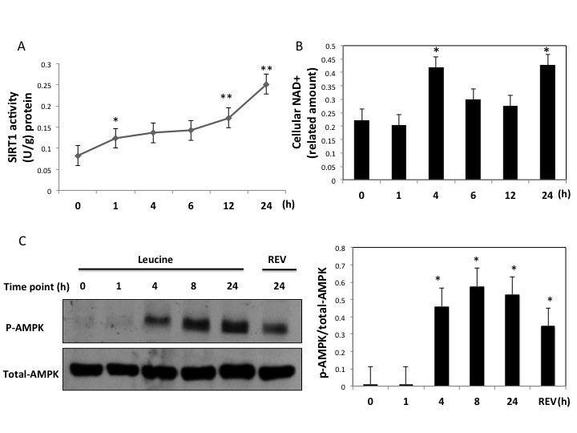
Figure 3-4: Leucine activates SIRT1 activity, AMPK phosphorylation and cellular NAD⁺ level in a Time-dependent manner
C2C12 myotubes were serum starved overnight and treated with Leucine (0.5 mM). Cell lysate was collected and analyzed for cellular SIRT1 activity; western blotting of p-AMPK and cellular NAD⁺ levels at indicated certain time points. (A) SIRT1 activity was activated at 1, 12 and 24 hours after leucine treatment. (B) Cellular NAD+ level showed similar pattern as SIRT1 activity at time points 4 and 24. Both SIRT1 activity and NAD+ level were normalized to cellular protein for each sample. (C) Phosphorylation level of AMPK was detected using western blotting following the same time course in C2C12 cells, resveratrol serving as positive control. Data are mean ± SE (n=3). Different letters indicate significant differences between solid or gray bars. * Significantly different from point 0, and ** significantly different from time point 1.

3.4.5 Leucine-induced mitochondrial biogenesis in C2C12 myotubes requires AMPK
We next examined whether AMPK also mediates leucine’s modulation on mitochondrial biogenesis in C2C12 myotubes. As shown in Figure 3-5, leucine treatment markedly increased the mRNA expression levels of mitochondrial component genes (Fig. 3-5A, dark columns), Hspd1 (p=0.003) and COX2 (p=0.003). Similar effects were found for mitochondrial biogenesis-related genes, PGC-1α (p=0.001), Sirt1 (p=0.022) and Cox5b (p=0.04), (Fig. 3-5B, Dark columns). Compound C treatment markedly impaired all these inductions (Fig. 3-5 Grey panels).
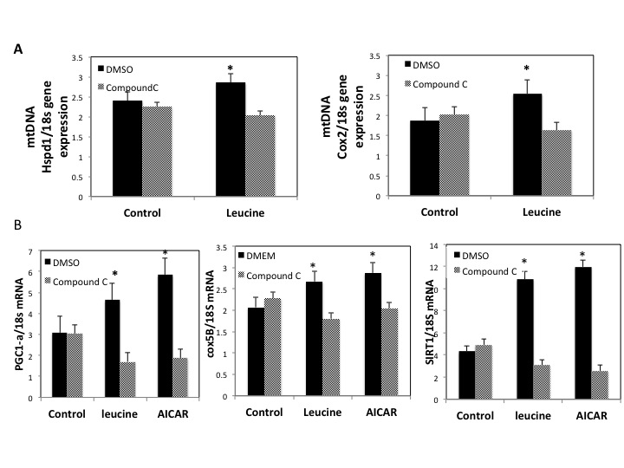
Figure 3-5: AMPK inhibitor attenuates leucine-induced mitochondrial biogenesis
(A, B) C2C12 myotubes were treated with leucine (0.5 mM), AICAR (20 μM) and Compound C (25 μM) for 24 hour. mtDNA levels of the cells were analyzed by the gene expression levels of mitochondrial markers, Hspd1 and COX2 using real-time PCR. (C, D) Mitochondrial biogenesis related gene mRNA expression of PGC-1α and COX5b were evaluated also by RT-PCR. (E) SIRT1 gene expression after leucine and Compound C administration were measured; all the mRNA levels were normalized to 18s housekeeping gene. Data are mean ± SE (n=4). Different letters indicate significant differences between solid or gray bars. * Significantly different from controls.

3.5 Discussion
These data indicate that leucine stimulates significant muscular metabolic changes, including SIRT1 activation, AMPK phosphorylation and mitochondrial biogenesis in C2C12 myotubes. These changes may contribute to leucine’s beneficial effects on energy metabolism and insulin sensitivity in both animal and human models [13, 15, 24, 25].
Previous clinical trial data have shown that high dairy intake (rich in BCAAs) induced significant suppression of ROS and inflammatory stress, indicated by decreased plasma tumor necrosis factor alpha (TNF-α), interleukin 6 (IL-6) and monocyte chemoattractant protein-1 (MCP-1) levels [15]. Doubling leucine intake in mice has been found to reverse multiple HFD-induced metabolic abnormalities, including glucose intolerance, hepatic steatosis and inflammation [7]. These effects are accompanied by corresponding increases in mitochondrial function and biogenesis. Impairment of mitochondrial oxidative function or decreases in mitochondrial mass are directly linked to the development of metabolic disorders [26], such as insulin resistance, type 2 diabetes, age-related hearing loss and some types of cancers [27], while, increased mitochondrial function and mitochondrial biogenesis appears to rescue obese-related metabolic abnormal [28]. Our previous studies indicate that leucine promotes mitochondrial biogenesis in both adipocytes and myotubes, and leads to energy partitioning from adipocytes to muscle cells, resulting in decreased energy storage in adipocytes and increasing fat utilization in muscle [9].
Here, we show that 0.5 mM leucine treatment, which is comparable to the plasma leucine concentration achieved by a leucine-rich diet, such as a high dairy diet [29], can have significant impacts on mitochondrial biogenesis and oxidative function in C2C12 myotubes. Compared to other BCAA control (valine) and non-branched-chain amino acid control (alanine), leucine markedly increases mitochondrial content and fatty acid oxidation.
The data herein demonstrate that the improvement of fatty acid oxidation and mitochondrial content by leucine is accompanied by increased SIRT1 activity in C2C12 cells. SIRT1, a NAD⁺-dependent deacetylase, has been demonstrated to play significant roles in leucine-induced beneficial effects on energy metabolism. In Yazmin et al. ’s study [7], leucine restores HFD-reduced hepatic NAD⁺ and SIRT1 expression back to normal levels. Similarly, Li et al. demonstrate that leucine increases SIRT1 expression and deacetylation level of PGC-1α, resulting in attenuation of HFD-induced mitochondrial dysfunction, insulin resistance and obesity in mice [30]. Similarly, Sun and Zemel found that leucine induces mitochondrial biogenesis in muscle cells by stimulating expression of PGC-1α and NRF-1 via a SIRT1-dependent pathway [22]. These findings, along with the observations reported here, are in agreement with our recent work that leucine could activate SIRT1 enzyme through allosteric interaction in adipocytes and myotubes [23].
SIRT1 has been reported to directly activate and deacetylate PGC-1α during caloric restriction, leading to increased mitochondrial metabolism to maintain cellular energy balance[31]. SIRT3, a mitochondrial sirtuin, serves as downstream target of PGC-1 α via estrogen-related receptor alpha (ERRα), and may also contribute to mitochondrial biogenesis by suppression of ROS production [32]. Consistent with leucine’s effect on SIRT1 and PGC-1 α, SIRT3 expression was also elevated in C2C12 myotubes by leucine.
To establish whether or not SIRT1 is required for leucine-induced mitochondrial biogenesis, EX527 (specific SIRT1 inhibitor) was used to treat the cells in combination with leucine. EX527 significantly attenuated leucine-induced mitochondrial content, mitochondrial biogenesis-related genes expression and fatty acid oxidation in C2C12 myotubes. The observations reported here are consistent with Price et al., who found that SIRT1 knockout can completely block resveratrol-promoted mitochondrial biogenesis and function in skeletal muscle [33], further supporting the essential roles of SIRT1. Paradoxically, SIRT1 gene expression level was also increased by EX527, although the mechanism of that effect is not clear.
We also found that AMPK phosphorylation, which is elevated in response to metabolic energy stress [34], was also increased by leucine treatment. This change might help explain leucine-induced improvement in fatty acid oxidation in the cells. Similarly, in mice, leucine supplementation has shown to activate AMPK synergistically with resveratrol and metformin, leading to increases of insulin sensitivity and glucose tolerance [18]. On the other hand, Compound C, an inhibitor of AMPK, markedly blocked leucine’s effects on mitochondrial biogenesis, indicating that like SIRT1, AMPK is also required for leucine to promote mitochondrial biogenesis and fatty acid oxidation in C2C12 myotubes.
Notably, we found that leucine-induced AMPK phosphorylation was highly decreased by SIRT1 inhibitor (EX527), suggesting that AMPK might serve as a downstream target of SIRT1. Park et al. found that resveratrol activates SIRT1 via an indirect pathway involved in activation of Camkkβ -AMPK. Price et al. reported that SIRT1 activation is required for AMPK phosphorylation and improvement of mitochondrial function via deacetylation and activation of LKB1 both in vivo and in vitro [33, 35]. Currently available evidence suggests that AMPK and SIRT1 display a mutual interaction with each other; AMPK activates SIRT1 by increasing cellular NAD⁺ level through promoting expression of Nicotinamide phosphoribosyltransferase (Nampt), a rate-limiting enzyme in NAD⁺ biosynthesis. Meanwhile, SIRT1 directly deacetylates and activates LKB1, an key upstream kinase of AMPK, leading to the modulation AMPK activity [36].
Our time-course data suggest that SIRT1 may be the initial target of leucine. SIRT1 activity was increased within the first hour of leucine treatment, while cellular NAD⁺ and p-AMPK levels remained unchanged. Considering the increased Sirt1 gene expression and SIRT1 activity level occurred at some time after the leucine treatment for 24 hours, it is possible that both SIRT1 activity and expression are elevated by leucine first, and then activation of AMPK is a subsequent event.
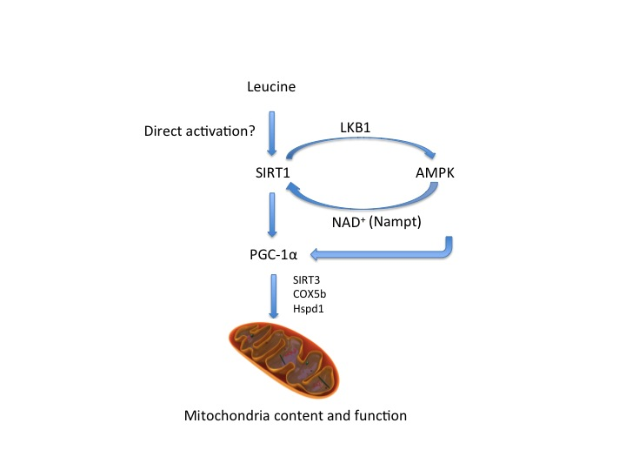
Figure 3-6: Leucine activates AMPK and improves mitochondrial function in a SIRT1-dependent pathway
Our data may reflect dose-dependent effects of leucine treatment. For example, in contrast to our findings, high-dose leucine infusion (total plasma leucine approximately 2 mm/l) has been shown to produce insulin resistance and glucose intolerance in humans [37]. Similarly, short-term BCAAs supplementation with HFD in rats also increases insulin resistance compared to HFD alone [38], possibly due to activation of mTOR signaling. Leucine activates mTOR signaling and leads to activation of p70 ribosomal S6 kinase (p70S6K), which subsequently phosphorylates serine/threonine residues of insulin receptor substrate 1 (IRS1), resulting in suppression and degradation of IRS-1 and the impairment of insulin signaling [39]; In contrast, modest increases in leucine intake, sufficient to induce plasma leucine elevations to ~ 0.5mm/l, significantly reduced obesity-related oxidative and inflammatory stress, resulting in improvement of insulin sensitivity in humans [15]. Similarly, Roger et al. found that leucine in the 0.1mm/l – 0.5mm/l range induces a dose-dependent increases of PGC-1α expression, leading to significant elevated mitochondrial density and oxidative capacity in skeletal muscle cells [13]. Consistent with this, we found comparable levels of leucine promoted mitochondrial biogenesis and fatty acid oxidation in C2C12 myotubes.
There are several limitations to this study. One of them is the use of the Fleur de Lys assay to measure SIRT1 activity. Studies have challenged the validity of the assay, as some studies have found that sirtuin-activating compounds (STACs) only increased SIRT1 activity by using fluorophore-tagged substrates but not the matching non-tagged peptides, which also might explain why this SIRT1 activation can be found exclusively in vitro but not in vivo [40, 41]. Moreover, according to Borra et al, the fluorophore acts synergistically with STACs to promote binding between substrate and SIRT1 enzyme protein [42]. Furthermore, evidence suggests resveratrol-induced SIRT1 activation is actually mediated through an indirect signaling pathway involved in cAMP phosphodiesterases (PDE) and AMPK in vivo [35]. However, Hubbard et al. recently provided data to support the allosteric binding and activation theory between STACs and SIRT1. They found that specific hydrophobic motifs in SIRT1 substrates and a single amino acid (Glu ²³⁰) in SIRT1 protein mediate the structure change during the deaceytlation [43]. As a highly hydrophobic amino acid, leucine might also directly activate SIRT1 through structural conformation. Indeed, recent evidence demonstrates that leucine exerts a direct effect on SIRT1 kinetics, by decreasing 50% of SIRT1 Km for NAD⁺. With the presence of leucine and HMB, lower concentration of resveratrol is required for the activation of SIRT1 [44]. Therefore, further experiments using fluorophore-free substrates to measure the SIRT1 activity are needed to elucidate the exact pathways of leucine binding and activating SIRT1. A second limitation is lack of data assessing the cellular acetylation status of LKB1 and PGC-1α, as well as Nampt phosphorylation.

Conclusion
Data from this study demonstrate that leucine regulates aerobic metabolism in a SIRT1-dependent manner, with secondary activation of AMPK mediated by SIRT1.

Literature cited
1. Howitz, K.T., et al., Small molecule activators of sirtuins extend Saccharomyces cerevisiae lifespan. Nature, 2003. 425(6954): p. 191-6.
2. Schwer, B. and E. Verdin, Conserved metabolic regulatory functions of sirtuins. Cell Metab, 2008. 7(2): p. 104-12.
3. Guarente, L., Sirtuins, aging, and metabolism. Cold Spring Harb Symp Quant Biol, 2011. 76: p. 81-90.
4. Imai, S. and L. Guarente, Ten years of NAD-dependent SIR2 family deacetylases: implications for metabolic diseases. Trends Pharmacol Sci, 2010. 31(5): p. 212-20.
5. Herranz, D. and M. Serrano, SIRT1: recent lessons from mouse models. Nat Rev Cancer, 2010. 10(12): p. 819-23.
6. Puigserver, P. and B.M. Spiegelman, Peroxisome proliferator-activated receptor-gamma coactivator 1 alpha (PGC-1 alpha): transcriptional coactivator and metabolic regulator. Endocr Rev, 2003. 24(1): p. 78-90.
7. Macotela, Y., et al., Dietary leucine--an environmental modifier of insulin resistance acting on multiple levels of metabolism. PLoS One, 2011. 6(6): p. e21187.
8. Stipanuk, M.H., Leucine and protein synthesis: mTOR and beyond. Nutr Rev, 2007. 65(3): p. 122-9.
9. Sun, X. and M.B. Zemel, Leucine and calcium regulate fat metabolism and energy partitioning in murine adipocytes and muscle cells. Lipids, 2007. 42(4): p. 297-305.
10. Donato, J., Jr., et al., Effects of leucine supplementation on the body composition and protein status of rats submitted to food restriction. Nutrition, 2006. 22(5): p. 520-7.
11. Rachdi, L., et al., L-leucine alters pancreatic beta-cell differentiation and function via the mTor signaling pathway. Diabetes, 2012. 61(2): p. 409-17.
12. Zanchi, N.E., H. Nicastro, and A.H. Lancha, Jr., Potential antiproteolytic effects of L-leucine: observations of in vitro and in vivo studies. Nutr Metab (Lond), 2008. 5: p. 20.
13. Vaughan, R.A., et al., Leucine treatment enhances oxidative capacity through complete carbohydrate oxidation and increased mitochondrial density in skeletal muscle cells. Amino Acids, 2013. 45(4): p. 901-11.
14. Zemel, M.B. and A. Bruckbauer, Effects of a leucine and pyridoxine-containing nutraceutical on fat oxidation, and oxidative and inflammatory stress in overweight and obese subjects. Nutrients, 2012. 4(6): p. 529-41.
15. Zemel, M.B., et al., Effects of dairy compared with soy on oxidative and inflammatory stress in overweight and obese subjects. Am J Clin Nutr, 2010. 91(1): p. 16-22.
16. Lagouge, M., et al., Resveratrol improves mitochondrial function and protects against metabolic disease by activating SIRT1 and PGC-1alpha. Cell, 2006. 127(6): p. 1109-22.
17. Bruckbauer, A., et al., Synergistic effects of leucine and resveratrol on insulin sensitivity and fat metabolism in adipocytes and mice. Nutr Metab (Lond), 2012. 9(1): p. 77.
18. Bruckbauer, A. and M.B. Zemel, Synergistic effects of metformin, resveratrol, and hydroxymethylbutyrate on insulin sensitivity. Diabetes Metab Syndr Obes, 2013. 6: p. 93-102.
19. Canto, C., et al., Interdependence of AMPK and SIRT1 for metabolic adaptation to fasting and exercise in skeletal muscle. Cell Metab, 2010. 11(3): p. 213-9.
20. Hawley, S.A., et al., Calmodulin-dependent protein kinase kinase-beta is an alternative upstream kinase for AMP-activated protein kinase. Cell Metab, 2005. 2(1): p. 9-19.
21. <D-Glucose and Lleucine transport by humanl.pdf>.
22. Sun, X. and M.B. Zemel, Leucine modulation of mitochondrial mass and oxygen consumption in skeletal muscle cells and adipocytes. Nutr Metab (Lond), 2009. 6: p. 26.
23. Bruckbauer, A. and M.B. Zemel, Effects of dairy consumption on SIRT1 and mitochondrial biogenesis in adipocytes and muscle cells. Nutr Metab (Lond), 2011. 8: p. 91.
24. Nicastro, H., et al., An overview of the therapeutic effects of leucine supplementation on skeletal muscle under atrophic conditions. Amino Acids, 2011. 40(2): p. 287-300.
25. Campos-Ferraz, P.L., et al., Distinct effects of leucine or a mixture of the branched-chain amino acids (leucine, isoleucine, and valine) supplementation on resistance to fatigue, and muscle and liver-glycogen degradation, in trained rats. Nutrition, 2013. 29(11-12): p. 1388-94.
26. Brand, M.D., Uncoupling to survive? The role of mitochondrial inefficiency in ageing. Exp Gerontol, 2000. 35(6-7): p. 811-20.
27. Schrauwen, P., et al., Mitochondrial dysfunction and lipotoxicity. Biochim Biophys Acta, 2010. 1801(3): p. 266-71.
28. Baur, J.A., et al., Resveratrol improves health and survival of mice on a high-calorie diet. Nature, 2006. 444(7117): p. 337-42.
29. Tang, J.E., et al., Ingestion of whey hydrolysate, casein, or soy protein isolate: effects on mixed muscle protein synthesis at rest and following resistance exercise in young men. J Appl Physiol (1985), 2009. 107(3): p. 987-92.
30. Li, H., et al., Leucine supplementation increases SIRT1 expression and prevents mitochondrial dysfunction and metabolic disorders in high-fat diet-induced obese mice. Am J Physiol Endocrinol Metab, 2012. 303(10): p. E1234-44.
31. Scarpulla, R.C., Transcriptional paradigms in mammalian mitochondrial biogenesis and function. Physiol Rev, 2008. 88(2): p. 611-38.
32. Kong, X., et al., Sirtuin 3, a new target of PGC-1alpha, plays an important role in the suppression of ROS and mitochondrial biogenesis. PLoS One, 2010. 5(7): p. e11707.
33. Price, N.L., et al., SIRT1 is required for AMPK activation and the beneficial effects of resveratrol on mitochondrial function. Cell Metab, 2012. 15(5): p. 675-90.
34. Wang, Y., Y. Liang, and P.M. Vanhoutte, SIRT1 and AMPK in regulating mammalian senescence: a critical review and a working model. FEBS Lett, 2011. 585(7): p. 986-94.
35. Park, S.J., et al., Resveratrol ameliorates aging-related metabolic phenotypes by inhibiting cAMP phosphodiesterases. Cell, 2012. 148(3): p. 421-33.
36. Ruderman, N.B., et al., AMPK, insulin resistance, and the metabolic syndrome. J Clin Invest, 2013. 123(7): p. 2764-72.
37. Tremblay, F., et al., Overactivation of S6 kinase 1 as a cause of human insulin resistance during increased amino acid availability. Diabetes, 2005. 54(9): p. 2674-84.
38. Newgard, C.B., et al., A branched-chain amino acid-related metabolic signature that differentiates obese and lean humans and contributes to insulin resistance. Cell Metab, 2009. 9(4): p. 311-26.
39. Haruta, T., et al., A rapamycin-sensitive pathway down-regulates insulin signaling via phosphorylation and proteasomal degradation of insulin receptor substrate-1. Mol Endocrinol, 2000. 14(6): p. 783-94.
40. Dai, H., et al., SIRT1 activation by small molecules: kinetic and biophysical evidence for direct interaction of enzyme and activator. J Biol Chem, 2010. 285(43): p. 32695-703.
41. Beher, D., et al., Resveratrol is not a direct activator of SIRT1 enzyme activity. Chem Biol Drug Des, 2009. 74(6): p. 619-24.
42. Gertz, M., et al., A molecular mechanism for direct sirtuin activation by resveratrol. PLoS One, 2012. 7(11): p. e49761.
43. Hubbard, B.P., et al., Evidence for a common mechanism of SIRT1 regulation by allosteric activators. Science, 2013. 339(6124): p. 1216-9.
44. Bruckbauer, A. and M.B. Zemel, Synergistic Effects of Polyphenols and Methylxanthines with Leucine on AMPK/Sirtuin-Mediated Metabolism in Muscle Cells and Adipocytes. PLoS One, 2014. 9(2): p. e89166.

Vita

Chunzi Liang, the daughter of Feiyue Liang and Yafang Xiong, was born on September 22, 1985 in Hubei, China. After graduating from high school, she attended the Medical School at the Wuhan University, China, from 2003 to 2008. She worked as master student and resident doctor in Zhongnan-hospital, China, from 2008 to 2010, and received her doctoral degree for medicine from the Wuhan University, China in 2010. In August 2010, she entered the Graduate Program in the University of Tennessee, Knoxville to pursue a Ph.D degree in Nutritional Science. She started her research work as a Ph.D candidate in the laboratory of Dr. Michael B. Zemel and defended her dissertation in April 2014.

