Design and Construction
Of a Full-Scale
Lateral Impact Testing Facility

A Thesis Presented for the
Master of Science Degree
The University of Tennessee, Knoxville

Cody A. Mitchell
December 2014
Acknowledgements

I would like to thank my family for their love and support throughout my academic career. Without their support and advice I would not be the man that I am today. I would like to thank Dr. Ma for the opportunity to pursue my Master’s degree and for the chance to work on this one of a lifetime project. This project would not have been possible without John Hillman and Duane Otter. Their dedication to this research is what made this project possible. I would also like to thank those who helped me along the way with different aspects of this project, whether it be the design or construction process; Dr. John Cabbage, Larry Roberts, Elijah Roberts, Ken Thomas, Tyler Henderson, Scott Rice, Ice Pruttianan, Drew Mitchell, Andy Mitchell, and Yuan Jing. I am most grateful for the help of our corporate partners, Britton Bridge, and especially Southern Shores Construction. Without Chris Burkhart being so gracious by providing us with a testing site and J.D. Wallace giving me more help than I ever thought possible this project would not have been a success. I would also like to that Dr. Edwin Burdette and Dr. Timothy Truster for serving on my committee. Thanks to all of you who assisted me in this endeavor, I could not have done it without you.

Abstract

The goal of this work is to design and construct a full scale lateral impact testing facility that is capable of recreating the damage that would be created by an overheight vehicle collision. This was accomplished by impacting a test specimen with an 8000 lbs. impact cart. The impact cart is raised on an elevated track and allowed to roll down the track with a change in height of 10 ft. This change in height is what provides the impact force necessary to recreate an overheight vehicle collision. The track is constructed out of wood and is designed to withstand both the gravity and lateral loads that the impact cart will cause. The impact cart consists of a concrete block surrounded in plate steel on a cart frame. The cart itself was designed to withstand multiple impacts so that it can be used for more than a single test. The supported system for the test specimen consists of gravity supports and lateral supports. The lateral support, or backstop, prevents the test specimen from sliding during testing and insures the most accurate representation of actual conditions that would occur during an overheight vehicle collision. The facility must be capable of testing a variety of specimens in order to fully utilize the potential of such a facility.

Chapter 1 Introduction 1
Chapter 2 Literature Review 2
Chapter 3 Options Considered for Testing Facility 4
Overview of Testing 4
Drop Weight Test 4
Pendulum Test 5
Self-Propelled Impact Cart 5
Impact Cart with Elevated Track 6
Chapter 4 Design and Construction of Facility 8
Impact Cart 8
Frame/Connections 8
Pull Hitch 9
Casters 10
Concrete Block 11
Impactor 13
Track System 14
Overall Dimensions 14
Posts 14
Work Platforms 16
Top Joists and Decking 17
Lateral Bracing 18
X-Bracing 20
Rail System 21
Joist Compression Boards 23
Backstop Design 24
Footing 24
Steel Beams 26
HSS Tubes 27
Backstop Construction 28
Footing layout and excavation 28
Steel Beam Layout and Erection 28
Support System 34
Operating the Testing Facility 35
Chapter 5 Testing Results and Modifications 36

Figure 1. Excavator that has impacted the side of a bridge 3
Figure 2. Damage caused by overheight collision. 4
Figure 3. Cart frame with caster connection plates and concrete block attachment angles. 9
Figure 4. Pull hitch attached to cart frame. 10
Figure 5. Example of main bearing caster. 11
Figure 6. Concrete Block formwork. Showing steel plates, rebar mats and lifting hooks. 12
Figure 7. Finished concrete block with impactor. 13
Figure 8. Imbed plate and attachment bolts. 14
Figure 9. Impactor attached to the imbed plate. 14
Figure 10. Posts screwed into guide boards. 16
Figure 11. Lower work platform without decking and before casting of concrete. 17
Figure 12. Lower portion of track with top joists prior to 2x4 decking. 18
Figure 13. Lateral bracing applied at multiple levels per post. 19
Figure 14. Nail through nail pin. Lateral bracing to ground connection. 20
Figure 15. 2x4 X-Bracing 21
Figure 16. Rails connected to joist by U-Bolts. 22
Figure 17. Welds connecting the top of the rails and splice plates. 23
Figure 18. HSS tubes between rails. 23
Figure 19. Added 2x4’s for extra compression reinforcement. 24
Figure 20. Caterpillar 307C excavating one of the footing. 30
Figure 21. Guide system for steel beams. 30
Figure 22. Nail pins securing the guide system to the ground. 31
Figure 23. Steel beam sitting within the guide system. 32
Figure 24. Concrete being poured from a ready mix truck. 32
Figure 25. Finished concrete footing. 33
Figure 26. Vertical beams with predrilled holes at 2” spacing. 34
Figure 27. Connection of HSS tubes to vertical beams. 34
Figure 28. One of the supports with test specimen sitting on top. 35
Figure 29. Impact cart hooked up to excavator by shackles and chain. 36
Figure 30. Prestressed beam after impact. 38
Figure 31. Prestressed beam after impact. 38
Figure 32. Damage to joists after testing. 39
Figure 33. Damage to rails after testing. 39

Chapter 1 Introduction

The bridges of the United States are in a state of disrepair. This damage has been caused by a variety of problems, with one of the more detrimental issues being lateral impact due to overheight vehicles. While the majority of overheight vehicle collisions only cause superficial damage there are instances when an overheight collision can completely destroy a bridge beyond repair. While these occurrences are known to happen it is very difficult to recreate these collision with small scale testing, and bridges that are damaged by impact must be repaired quickly in order to maintain road or rail serviceability. Therefore, it is prudent to try and perform testing to replicate these types of collisions so that more can be learned about the behavior of bridge girders under impact loading. This understanding will allow for more to be done in preventing more damage to current and future bridges.

Currently most research regarding overheight impact is based on observational damage of existing bridges. These observations are limited because the damage is the only data that can be obtained. It is impossible to know the precise force with which the bridge was impacted and without that information no result will be as useful as a controlled full scale test. In order to obtain all of the data necessary to truly understand the behavior of impacted bridge a full scale destructive test must be performed. Such a test would allow for researchers and engineers to determine what happens to a bridge girder during an overheight collision. Such a test would also allow for visual damage to be observed on a single specimen that is not connected to an existing bridge. This means that no bridges need be kept out of service to simply observe the damage caused by the impact.

This paper outlines the procedure of selecting a full scale testing facility, and then the design and construction of such a facility. The discussion will include the results of a trail test on a prestressed concrete beam. Once constructed this facility will be able to provide; lateral impact data for a variety of test specimens, as well as visual damage that is representative of the maximum damage that could be experienced during an overheight vehicle impact.

Chapter 2 Literature Review

While there has been extensive research done in the area of repair of bridges that have endured an overheight collision there is very little that has been done in the recreation of such collisions. While there have not been tests conducted specifically for overheight collisions there is research involving full scale impact testing. An example of such a test is found in (welded steel Panels). The test performed was a lateral impact test on a tank car covering. While the test specimen is not relevant to overheight impact the testing setup is. The setup consists of an impact ram with and indenter that slides along a track until it impacts the test specimen. This testing setup can be adapted to model the worst case of an overheight impact.

The worst case of an overheight vehicle collision is when a piece of construction equipment that is improperly loaded onto a flatbed truck strikes the side of a bridge. This worst case was determined in a study performed by (Fu). A nationwide survey was taken concerning the frequency and severity of overheight collisions. It was found that while the most frequent collisions nationwide were from box trailers, the collisions that caused the most damage were due to heavy equipment loaded on flatbeds. Some states even reported that flatbed trailers made up more than half of the total overheight collisions and not just those that required repair.

The report also stated whether or not each state considered overheight impacts to be a problem. The responses mostly report that it is a problem with 62% of states reporting that it is a problem. The states that did not deem overheight collision to be a problem were also the states that reported the least amount of overheight collisions per year.
Based upon this information it was determined that the best way to simulate a worst case overheight impact would be to mimic a piece of heavy equipment improperly loaded on a flatbed. Example photos of the type of damage that can be caused by this type of collision are shown in Figures 1, 2.

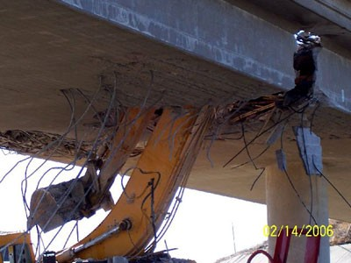
Figure 1. Excavator that has impacted the side of a bridge

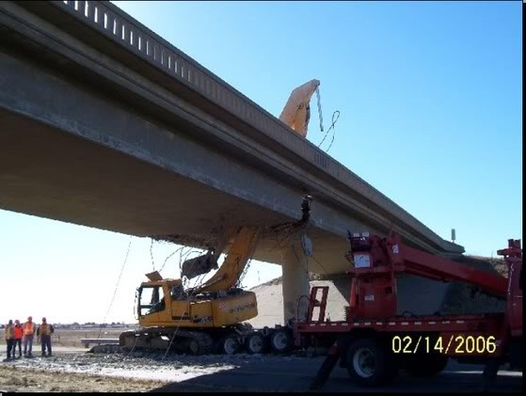
Figure 2. Damage caused by overheight collision.

Chapter 3 Options Considered for Testing Facility

Overview of Testing

Multiple factors were considered during the process of designing the testing apparatus. The test would need to impact the HCB specimen with a certain amount of force, while maintaining a low construction cost, and maintaining safety standards during construction and testing. With these factors in mind multiple options for the testing apparatus were considered. A drop weight test, pendulum test, self-propelled impact cart, and elevated impact cart were all considered as potential testing apparatus’s.

Drop Weight Test

The drop weight test requires a load frame to be that can be firmly anchored to a strong floor with adequate bracing to prevent tipping. The drop system itself requires several safety features, including a break system, slide rails to maintain linear motion, and a quick release system that could be operated from a distance. In order to impact the HCB on the desired face with the drop weight test required rotation of the specimen out of its standard orientation. This means that the direction of impact would coincide with the direction of gravity, unlike the impact that would happen to an actual bridge with the impact occurring horizontally. This difference in orientation was a cause for concern that the impact would show as being greater than would actually occur in the field.

Adding to the concerns caused by the non-standard specimen orientation, the amount of time needed to build the drop frame along with all of the necessary safety systems exceeded the overall project time frame. This lead to the drop weight test not being implemented as the final testing apparatus.

Pendulum Test

The pendulum test consists of a steel frame with a rigid pendulum arm that will be elevated and allowed to impact the HCB. The main components of the pendulum are a steel frame and rigid pendulum arm. Due to the large scale of this setup the pendulum could not be constructed at and University of Tennessee facility and an outdoor site is needed. This will require the pendulum frame to be anchored to the ground by either a shallow foundation or hammered piles. Both of these methods would create permanent fixtures at the testing site. This makes it difficult to find a testing site since few people are willing to have such permanent changes made to their property.

A second concern with the pendulum test is not allowing the pendulum arm to impact the HCB more than once. This requires a mechanism that will catch the pendulum arm on the backswing after initial impact. This cost of this mechanism was determined to be beyond the limits of the project budget. Due to exceeding the budget as well as the difficulty in finding a suitable testing site the pendulum test was not implemented as the final testing apparatus.

Self-Propelled Impact Cart

This testing setup relies on an impact cart colliding with the HCB. This setup is different from the previous two in that it does not require a frame or any permanent change to the testing site. What is required for this testing setup is a large amount of space. In order for the cart to impact the HCB with the desired force a large area is needed to allow the cart to accelerate to the speed that would achieve the desired amount of force. This speed can be reduced if more mass is added to the cart to create the same impact force at a lower speed. This will still require a large testing area since the cart will accelerate slower as more weight is added. Implementation of a self-propelled cart proved to be too costly and exceeded the project budget.

This testing setup requires the cart to be self-propelled as well as able to travel in a perfectly straight line so that the accuracy of the location of the impact is maintained. In order to achieve these conditions perfectly flat ground would be needed with the potential for needing a finished surface for the cart to travel on. Finding such a site was not practical for the project time frame. The self-propelled cart testing setup was not implemented as the final testing apparatus since it exceeded the project schedule as well as being over budget.

Impact Cart with Elevated Track

This testing setup also requires an impact cart to collide with the HCB. Unlike the Self-Propelled cart the source of energy for this setup relies upon gravity. The cart will be elevated above the HCB specimen and will roll down a track and impact the HCB. The difference in initial and final height will provide the necessary energy to impact the HCB with the desired force. This testing setup requires a smaller amount of space than the self-propelled impact cart due to the quick gain in speed that occurs during the decent. This testing setup will also not make any permanent changes to the testing site. All parts of the testing apparatus can be removed upon completion of testing.

The challenges presented in this testing setup are creating a quick release system as well as preventing secondary impact of the HCB. Unlike the drop weight and pendulum setups the quick release for the track setup is not under as much pressure. The impact cart sits directly onto a track which will support a majority of the weight of the cart. This reduced demand on the quick release allows for a more simplistic design as well as resulting in a safer system. In order to prevent secondary impact the end of the track has a slight upward angle. This means that when the cart attempt to impact the HCB the second time it will have to roll uphill and overcome gravity. The initial impact energy decreases the speed of the cart by a large enough amount to where the impact cart will not be able to reach the HCB, and create a secondary impact.

The simple solutions to the challenges of this testing setup allowed for a lower cost setup than the other options. In addition to the lower cost, this setup is much less complicated overall and the time needed to construct it is much less than the other options. These reasons along with the difficulties found with the other options lead to the Impact cart on elevated track being chosen as the final testing setup.

Chapter 4 Design and Construction of Facility

Impact Cart

In order to reach the required impact force the weight of the impact cart was determined to be 8000 lbs. In order to achieve this weight the impact cart is a 50 cubic foot concrete block supported by a steel frame. Attached to the steel frame are eight casters. Four of which are main bearing casters that support the weight of the impact cart. The other four act as side wheels to provide lateral stability and straight tracking. The concrete block is connected to the frame by steel angles that are bolted to the frame.

Frame/Connections

The support frame of the impact cart consists of 3x3x1/4” Hollow Steel Sections (HSS) as shown in Figure 3. The worst case loading scenario was taken to be when all of the weight of the block is resting solely on one tube. The tube section was chosen based on this loading scenario and the AISC selection tables. The tubes are welded together at their ends to create the base frame of the cart. The outside edges of the frame parallel to the impact direction have 3-1/2x5x1/4” steel angles welded to them. These angles are matched up with angles on the concrete block. These four angles sit flat on one another when the block is placed on the frame. The angles are then connected by bolts. There are 12 bolts total 6 on each side of the block. The number of bolts was determined based on a shear loading of 8000 lbs, the weight of the block. Four bearing plates are welded onto the underside of the frame. These bearing plates have holes drilled into them in order to connect the casters to the frame. This option was chosen to allow the casters to be removed and reused upon completion of testing. Welding the casters into place would have worked equally as well but would have limited future use of the casters and the cart frame. In addition to the angle sections another set of plates were welded to the sides of the frame. These plates provide the connection of the cart to the side casters.

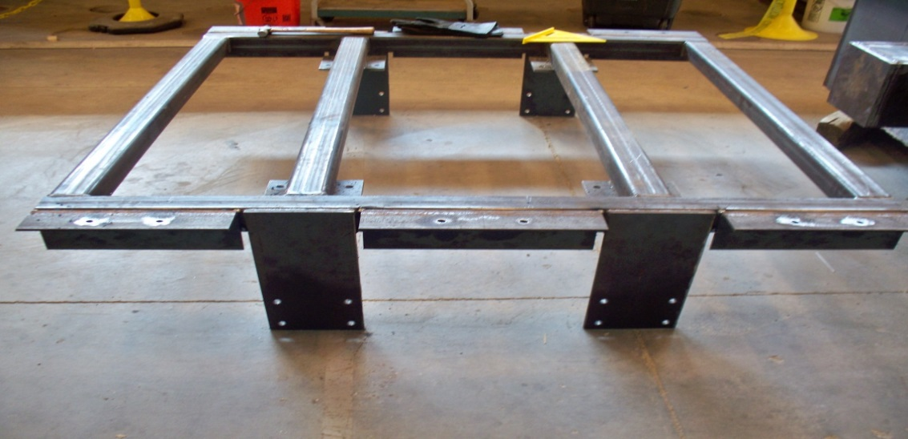
Figure 3. Cart frame with caster connection plates and concrete block attachment angles.

Pull Hitch

In order to be able to pull the impact cart up the slope of the track a hitch was fabricated. The hitch can be seen in Figure 4. The hitch is made of ¼ in. thick and 3 in tall steel plates. These plates were welded together. The amount of weld provided more than enough strength to pull the 8000 lbs. impact cart. The strength of the weld was determined in accordance with AISC. The equation used is shown below. The opening between the pieces of steel was made to allow a 1 ½ in. shackle to pass through. The hitch was fabricated and then was welded to the frame as one unit. The multiple openings on the hitch were meant to provide the option to attach more than one means of pulling the cart if needed. It also allows for a release system to be attached to the hitch while it is still hooked up to the pulling shackle.

$$ϕR_{n}=1.392Dl$$

The length of the weld group is 6 in. and the weld size was conservatively taken as 1/8 in. The capacity of the hitch was determined to be 16.7 k. This is well about the 8000 lbs weight of the impact cart.
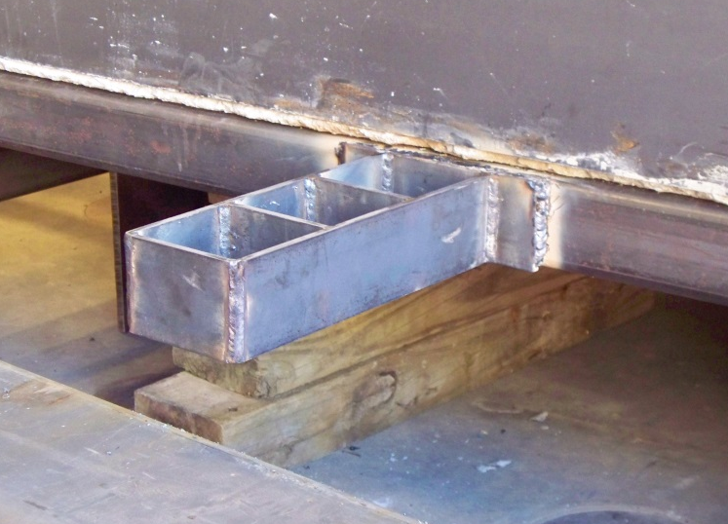
Figure 4. Pull hitch attached to cart frame.

Casters

Eight casters of two different types were utilized in the design of the impact cart. Four casters were used as main bearing casters. These casters were standard rigid plate casters rated at a 2500 lbs. capacity per caster. The casters were 6” in diameter, have a tread width of 3”, and a total height of 7-1/2”. These casters were bolted onto bearing plates that were welded to the underside of the cart frame. The main bearing casters, shown in Figure 5, support the weight of the impact cart and allow for the motion and proper acceleration of the cart. Since the main bearing casters were not limited by any straight tracking mechanism four additional casters were added, two for each side of the cart. These casters ensured that the cart would maintain a straight line during travel. These casters were also 6” in diameter, and have a 2” tread. The side casters are mounted perpendicular to the main bearing casters. They are connected to the cart frame by being bolted to the side plates.
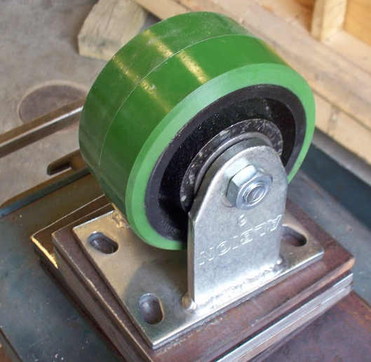
Figure 5. Example of main bearing caster.

Concrete Block

The concrete block makes up the largest portion of the weight of the impact cart. The block is 5x5x2’ and in total weighs 7500 lbs. The concrete block has two layers of #5 rebar placed in 4’6”x4’6” mats with one foot spacing. The rebar was put in place to increase the reliability of the lifting hooks. Four lifting hooks were placed in the concrete block. The hooks are pieces of #5 rebar that are bent with a U on top and two 90° bends, one for each leg. The legs were placed underneath the bottom mat of rebar. This will insure that when the block is lifted the hooks will then pull on the rebar mats instead of simply pulling on the hooks. The four sides of the concrete block are wrapped in ¼” thick plate steel as seen in Figure 6. The plates were connected with seem welds on the inside and outside. These plates were added to help prevent punching shear from the impactor during testing. The connection between the concrete block and the impactor was provided by an imbed plate. The imbed plate was bolted to the formwork for the block and those bolts were then used to connect the impactor to the imbed plate. While casting the concrete for the block the bottom form dipped in between the studs and created humps on the bottom of the block. This meant that the bock did not sit perfectly flat on the frame. In order to counteract this metal shims were welded onto the cart frame at each corner. These shims allowed the block to remain level during testing and prevented the block from rocking during testing. The finished concrete block is show in Figure 7.
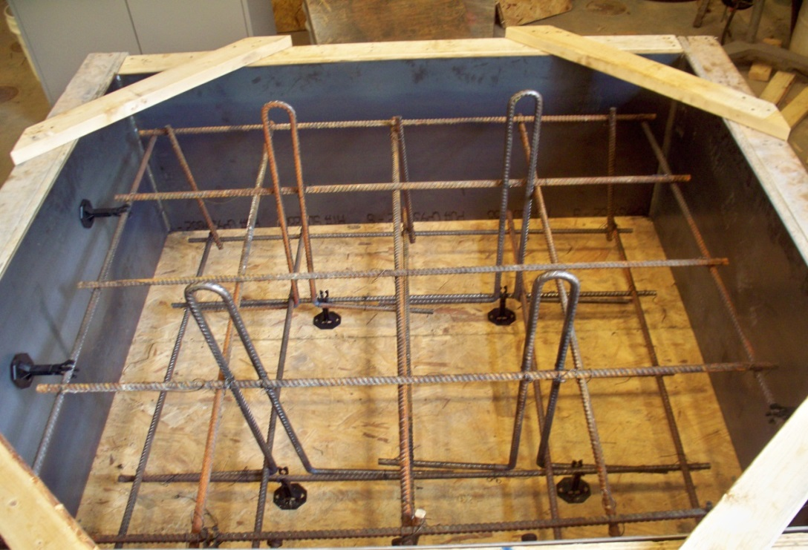
Figure 6. Concrete Block formwork. Showing steel plates, rebar mats and lifting hooks.

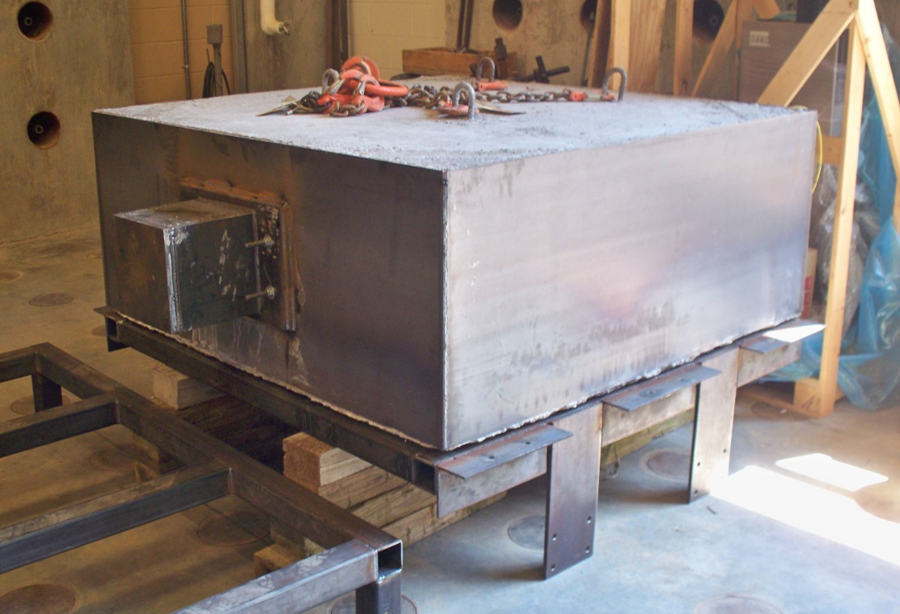
Figure 7. Finished concrete block with impactor.

Impactor

The dimensions of the impactor are 10x10x10”. The impactor was built with ¾” thick steel plates that were welded together. These welds were different than all other welds for the project in that the edges of the steel plates were first ground off to an angle to allow for a deeper penetration of the weld. This was done to insure that the impactor remained intact during testing. The impactor was also filled with concrete to prevent any bending of the plates and to insure that good contact was maintained throughout the actual impact. The impactor was welded to a base plate that was then bolted to the imbed plate on the concrete block. The bolts were threaded into the imbed plate and were used as the bolts for the impactor, Figure 8, 9. Once bolted the impactor was welded to the ¼” plate to insure that full transference if the weight of the concrete block to the impactor was achieved.

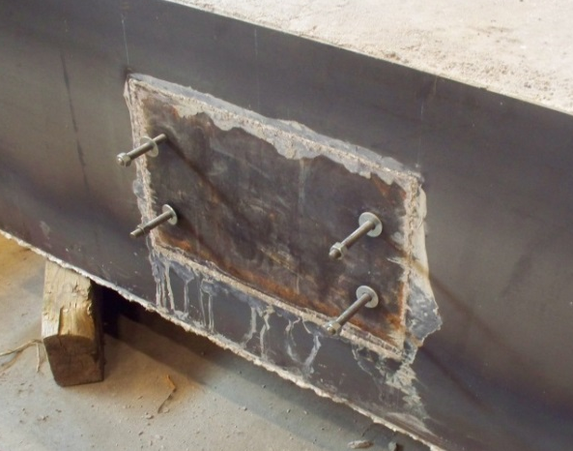
Figure 8. Imbed plate and attachment bolts.
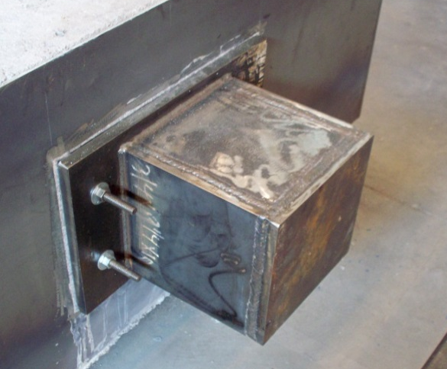
Figure 9. Impactor attached to the imbed plate.

Track System

The track system for this testing setup requires a framework capable of withstanding both gravity and lateral loads. This must be made possible while still occupying a small area, be easy to construct and deconstruct, as well as being cost effective. The frame system will consist of posts set into the ground, bracing, work platforms and a rail system.

Overall Dimensions

The post lines for the track system were placed directly beneath the track itself in order to create proper load path and load distribution. Since the cart size was determined prior to the support system the spacing between the post lines was determine based off of the impact cart. The cart is 5’ wide and the side casters must be in contact with the track at all times. The spacing between post lines was determined to be 3’ 8-1/2”. The spacing of the posts along the length of the track was determined to be 5’. The target impact energy of 100 kJ was used to determine the necessary height change from the top to bottom of the track. The 8000 lbs cart was assumed to be in free-fall and the height was then determined based off of the following equation for potential energy.

$$U=mgh$$

The change in height that would be able to impart the desired energy was determined to be 10 ft. Since the bottom of the track was already set at a height of one ft. The height at the top of the track was 11 ft.

Posts

The posts were determined to be 4x4 wood posts. The posts were designed from static loading when the impact cart is sitting between post lines. This means that at any given time a minimum of four posts will be taking the load of the impact cart. The limiting design criterion was compression loading with an applied load of 2000 lbs. per post and a capacity of 3000 lbs. The posts were set in the ground by auguring 12 in. diameter holes at an average of 2 ft. This depth was desired to be greater; however equipment restrictions and site conditions limited the depth that could be achieved. The holes were augured by a single person auger and the ground was harder than expected. Aside from the soil being more compacted than expected the ground contained large boulders and concrete slabs that were used as fill when the property was created. This is what limited the depth that could be reached. Since the depth was limited concrete was cast around and under the posts to insure that the posts did not shift during testing. This was achieved by slightly raising the posts and them screwing them into the guide boards so that the concrete could flow under the posts during the pour. The post positioning was laid out by having a 2x4 guide board that ran the length of the two post lines and a cross board that attached to the two post lines. These cross boards were placed every 5’ to maintain post spacing. This created a 90 degree corner that the posts could be laid against, as seen in Figure 10. Once the concrete was cast the top of the post were cut on the proper angle to insure that full contact between the top of the post and the track itself would be achieved.

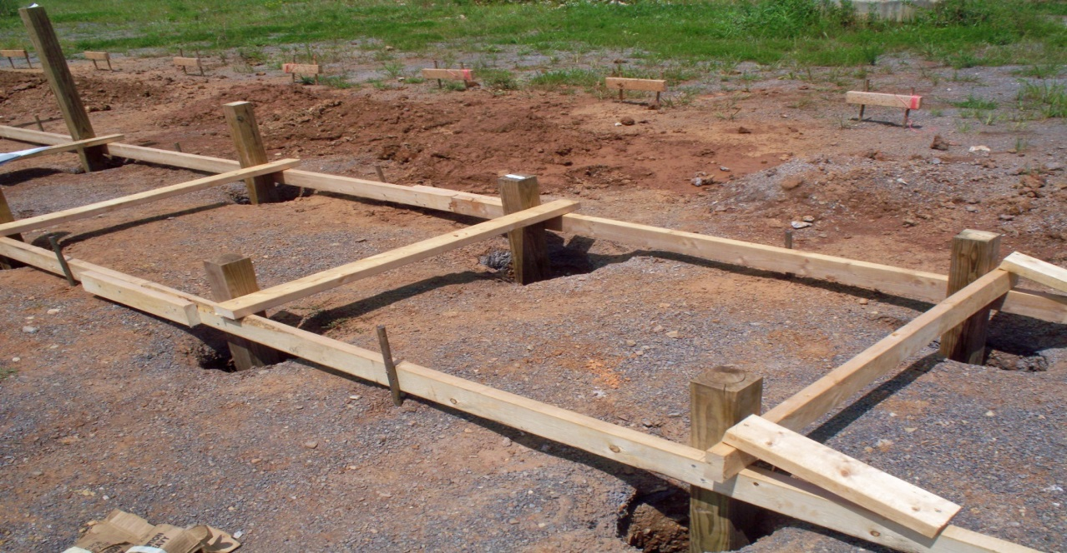
Figure 10. Posts screwed into guide boards.

Work Platforms

The work platforms consisted of 2x6 boards that wrapped around the outside of three lines of posts with joists spaced at one foot on centers as seen in Figure 11. The framework was then decked with 7/16 in. OSB plywood to provide a working surface. The work platforms served multiple purposes in the construction of the track. The main function was to provide a stable platform to stand upon for any work that could not be performed from the ground. Two platforms were built along the length of the track each spanning between three post lines. Since the elevation of the track changes along the length two platforms were placed at different heights with a built in ladder to connect them. Another purpose of the platforms was to tie the posts together while maintaining the desired spacing between the posts. The platforms were constructed prior to casting the concrete which allowed for the posts to be plumed and spaced evenly with ease. With the posts connected together bracing for casting of concrete was minimized to only four temporary braces instead of needing two braces per post if the platforms were not present at the time of concrete casting.

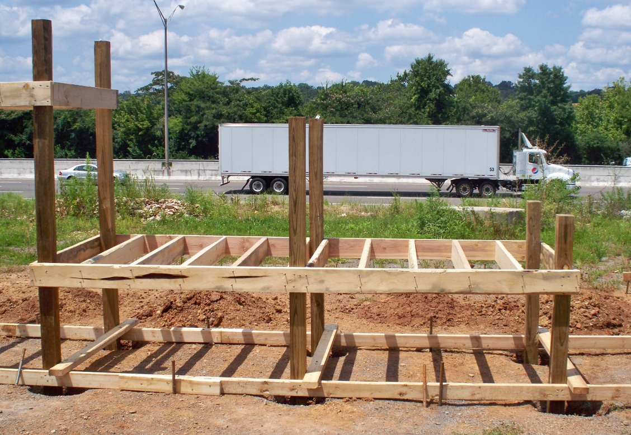
Figure 11. Lower work platform without decking and before casting of concrete.
Top Joists and Decking

In order to maintain proper spacing at the top of the posts 2x6 joists were added. The joists that ran perpendicular to the length of the track were precut. This maintained the spacing at the top of the posts so that they would all be in line with each other. The joists that were placed along the length of the track were cut to match the existing spacing between the posts. This was done to insure that full contact between the joists and the posts was achieved. Each joist was cut on an angle to match the slope of the track. This can be seen in Figure 12. The joists were connected to the posts at the very top of each post with joist hangers. Since the joists were angled instead of horizontal, notches had to be cut out of the bottom of the joists to create a horizontal surface for the joist to rest on the hangers. The hangers allowed the joists to be placed in the center of the posts with ease. This was necessary to maintain a straight line for which the rails could be attached. Once all joists were in place 2x4s were nailed on top of and perpendicular to the joists. The 2x4’s were nailed flatways spaced at one ft. on center in order to provide a stable platform of the rails to sit upon.

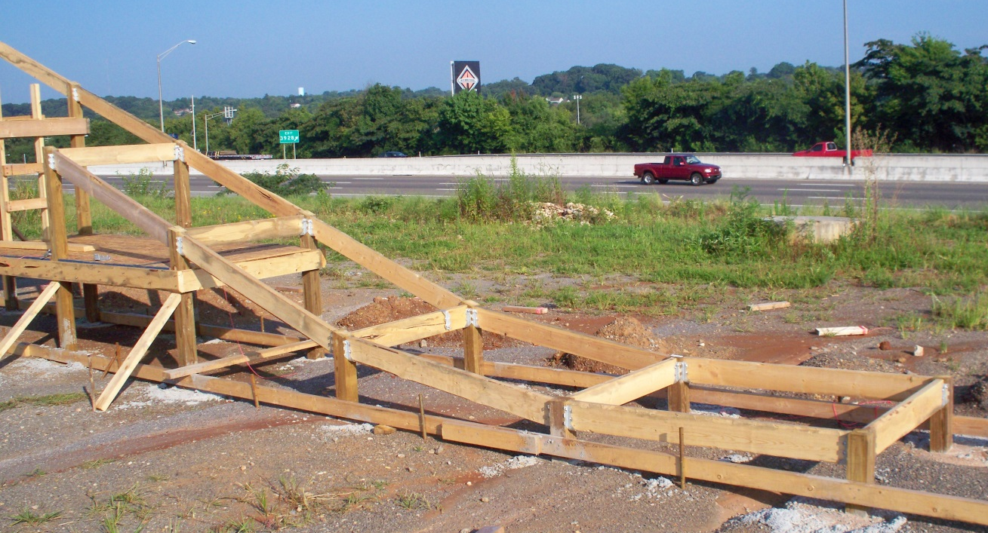
Figure 12. Lower portion of track with top joists prior to 2x4 decking.
.

Lateral Bracing

In order to prevent the track from swaying side to side during testing lateral bracing was added. Each brace consisted of 2 2x4’s that were nailed together on edge. The braces were connected to the posts in two different locations. The lowest braces were placed directly underneath the work platforms to provide a solid contact surface. While the upper braces were placed directly underneath of a small 2x4 wrap that went around each post. These wraps were placed directly underneath the joist hangers to insure that gravity loads from the impact cart would be fully transferred into the braces without having to rely wholly on the connections. The braces were placed at a 45° angle from the posts, Figure 13. This meant that all of the braces needed to be cut on 45° to insure complete contact with the wraps and work platforms. In order to secure the braces to the ground ¾ in diameter holes were drilled through the braces at the bottom and a nail pin was run through the hole, Figure 14. Once driven sufficiently into the ground a 16 d nail was placed through the nail pin and the pin was then driven further into the ground until the nail compressed against the board. This was necessary to insure that the braces had solid contact with the ground in the event that the track would try to shift.

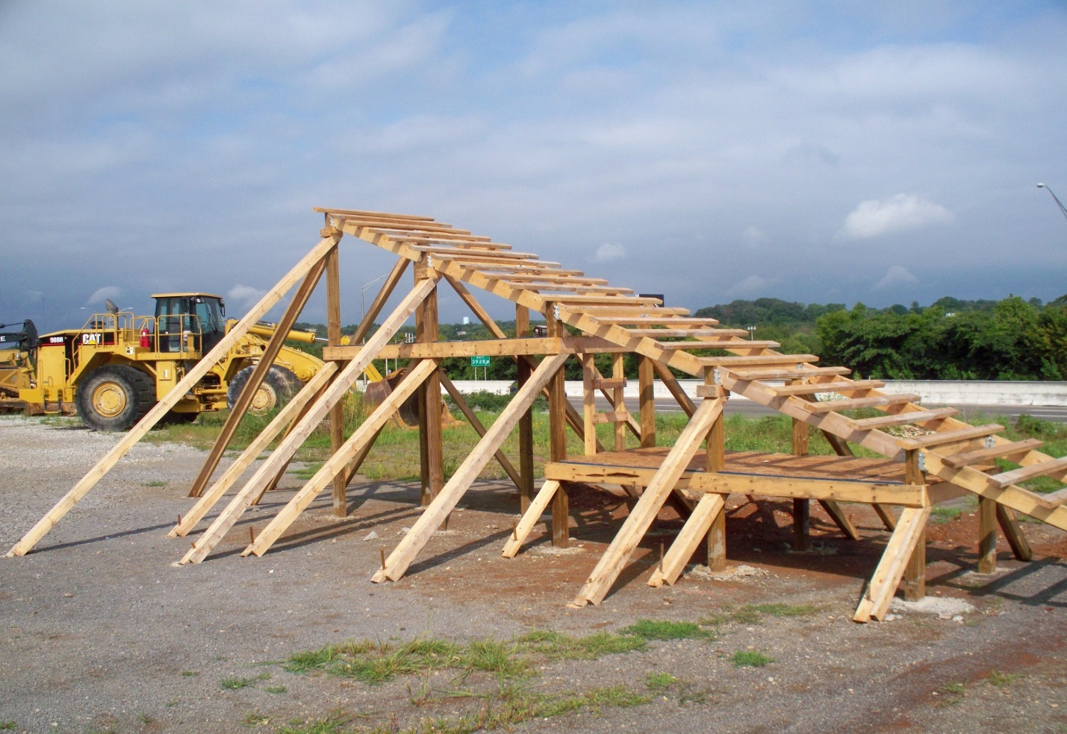
Figure 13. Lateral bracing applied at multiple levels per post.

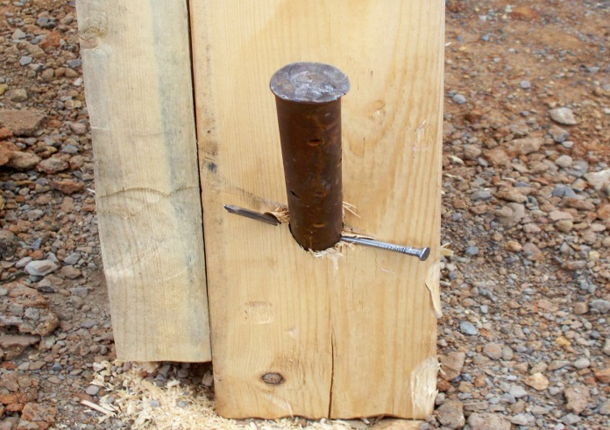
Figure 14. Nail through nail pin. Lateral bracing to ground connection.

X-Bracing

In order to counteract the lateral force that the track will experience while the impact cart travels down the track X-bracing was added along the length of the track. The bracing consisted of 2x4s that were nailed to the posts. These braces were placed on both the top and bottom of the work platforms in an alternating pattern to properly distribute the lateral forces. The braces were only placed underneath the sloped portion of the track. The reason for this is because when the track is flat the impact cart is not able to impart a large amount of lateral force to the track. When possible the bracing was placed flat against the concrete that surrounds the posts as shown in Figure 15. This was done to transmit as much of the lateral force as possible into the ground rather than carry it through the entire frame of the track.

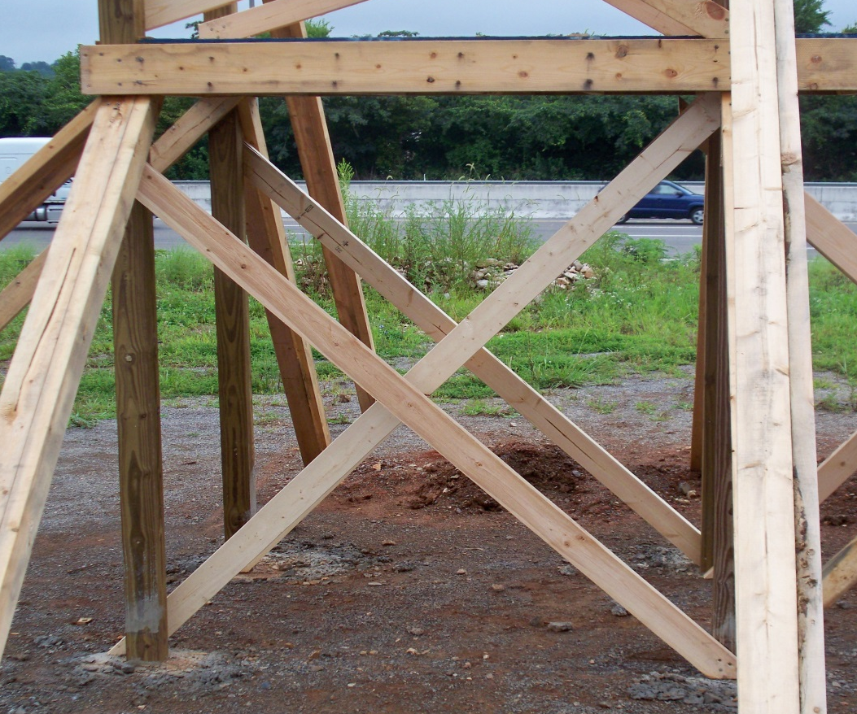
Figure 15. 2x4 X-Bracing

Rail System

In order to create an effective impact with the HCB the impact cart needed to roll down a smooth surface. This surface was provided by rails that were attached to the top of the track. The rails were made of W8x13 steel sections. The rails were placed directly on top of the post lines to effectively transmit the load through the track to the ground. The rails were attached to the track by U-bolts. The U-bolts wrapped around the 2x6 joists and were bolted to the rails on either side of the web. The U-bolts were placed on either side of each post in order to insure that the rails did not shift along the length of the track during testing as shown in Figure 16.

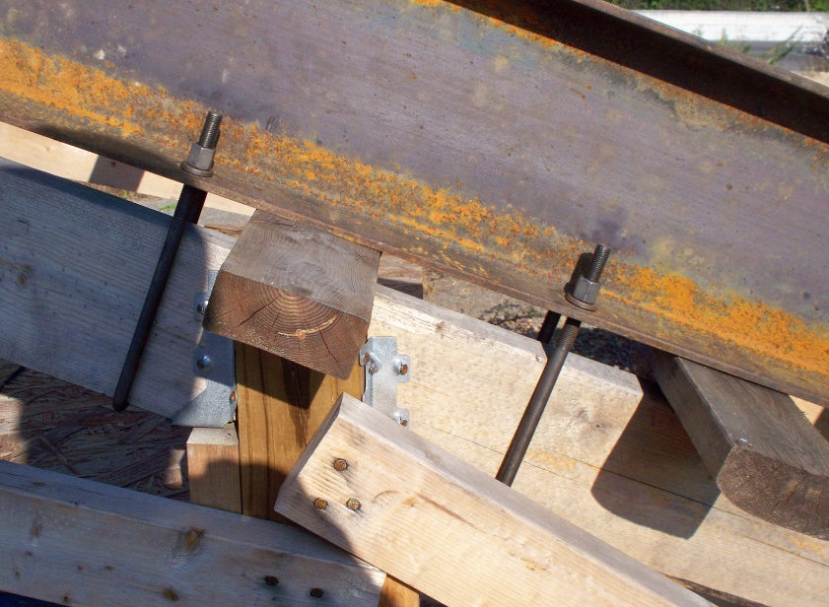
Figure 16. Rails connected to joist by U-Bolts.

At the points along the track where the slope changes the rails were cut and the top flanges of the rails were butted up against one another. The tops of the rails were welded together to create a smoother transition between pieces as shown in Figure 17. The welds were also necessary to ensure that the pieces held together and acted as one cohesive unit. In addition to welding the top flanges splice plates were also welded on the inside of the web wherever to pieces came together. These plates helped to tie the pieces together. Once the two rails were completed they were tied together with 2x2 in. HSS tubes as seen in Figure 18. The tubes were welded onto the inside of the web of each rail. In order to maintain a constant distance between the rails the tubes were all cut to an exact length and the rails were either pushed or pulled until the tube fit snuggly on either side.

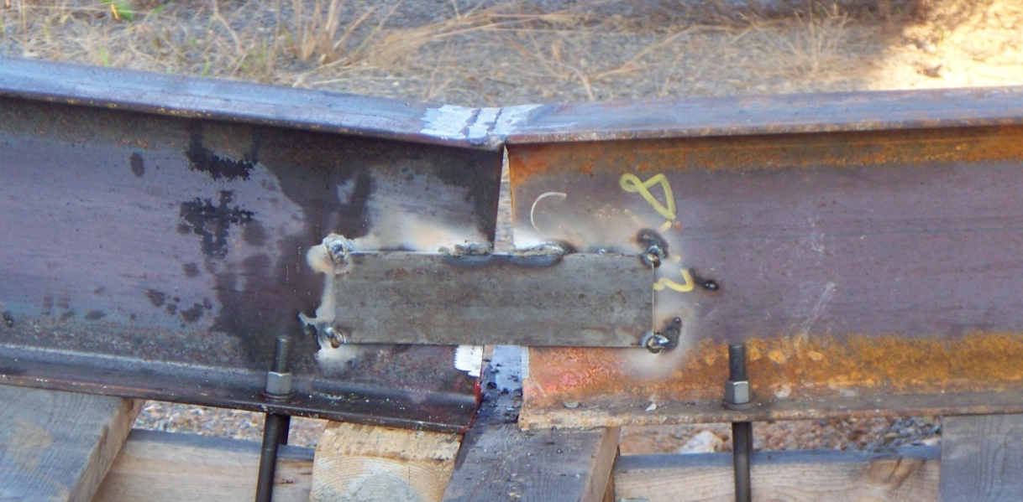
Figure 17. Welds connecting the top of the rails and splice plates.

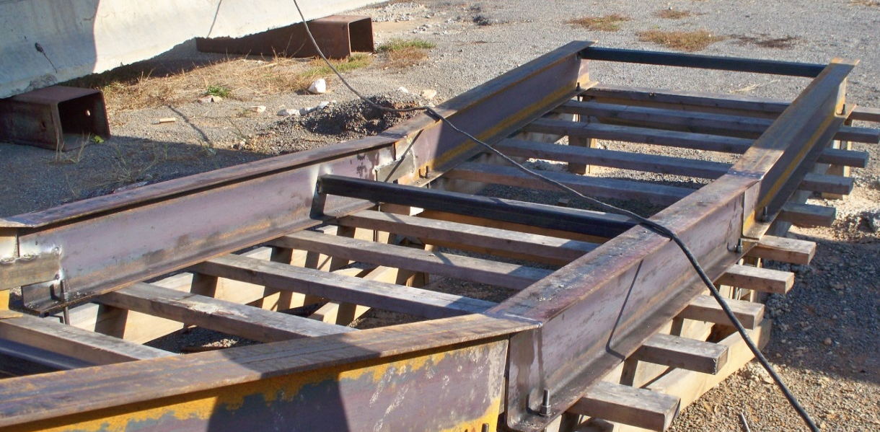
Figure 18. HSS tubes between rails.

Joist Compression Boards

Extra compression reinforcement was added on either side of each post. This was achieved by nailed 2x4’s against the posts. The 2x4’s were wedged between the joist hangers and the concrete that was poured around the posts. This was done to ensure that when the impact cart travelled over the top of the posts that the load would be carried from the rails through the joists to the 2x4’s and into the posts. The added compression wood is shown in Figure 19.

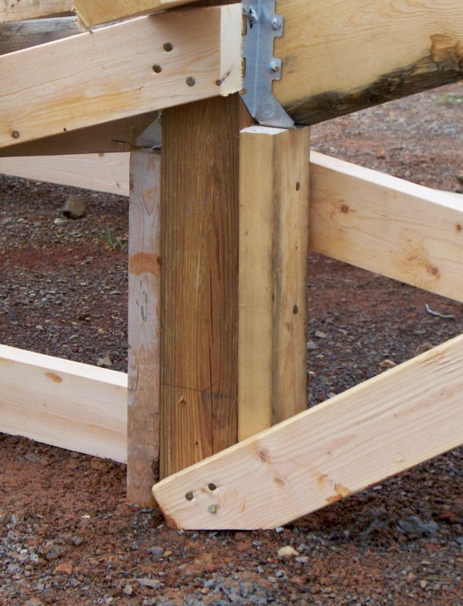
Figure 19. Added 2x4’s for extra compression reinforcement.

Backstop Design

In order to insure that the test beams receives the maximum impact force from the impact cart a backstop is necessary. The backstop provides lateral support that prevents the test beam from moving horizontally. This must be accomplished while being able to measure the amount of force that is resisted by the backstop to determine reactions. The backstop consists of two concrete footings with a steel W-shape set in each footing, as well as interchangeable steel tubes that provide lateral resistance.

Footing

The footing was designed to resist the lateral loads that would be created during testing. In order to do this the footing area would need to be large enough to absorb the impact force and transfer it into the soil. The soil found on the site consists of fill with all kinds of materials including boulders, slabs of concrete and other types of large fill. Well compacted soil filled in the gaps between the large fill with a layer of compacted gravel on top of the fill. The lateral bearing pressure of the fill was assumed to be 800 lbs/ft^2. This number is not based off of testing, since soil samples would be nearly impossible to acquire, but rather upon IBC allowable maximum value for sedimentary and foliated rock. This classification was chosen since it most closely matched the existing soil conditions. The listed IBC value is 400 lbs/ft^2 however there is a prevision that states that the allowable values may be doubled for short term loading conditions. Since the impact duration was expected to be extremely short the value of 800 lbs/ft^2 was deemed to be satisfactory.

The design of the footing was based upon a rigid analysis from Coduto (need to site). This analysis was chosen in lieu of a more in depth analysis because it provided a simpler calculation while still being conservative. This type of analysis was also necessary because it allows the use of IBC allowable lateral bearing pressures where other more precise analysis would require detailed soil properties which were not readily available. From this analysis the minimum footing depth was determined that could provide the necessary lateral bearing pressure to resist an estimated impact load of 40k per footing. This loading was determined based off of the expected velocity of the impact cart is if were in freefall and an impact duration of 0.2 s. Free fall was assumed because it represents the largest impact force that can theoretically be achieved since the impact cart is not actually in free fall and friction resistance will slow it down to some extent. A free-head condition was used since the steel beams would essentially act as vertical cantilevers being loading on the free end. The equations used are as follows.

$$P=\frac{2mv}{t}$$
$$D_{min}=\frac{A}{2}\left(1+\sqrt{\frac{4.36l}{A}}\right)$$
Where
$$A=\frac{2.34P}{S_{1}B}$$

In the above equations D_{min} is the minimum depth of the footing while B is the width and S₁ is the allowable lateral bearing pressure. Based upon these equations it was determined that the footing depth would need to be 7’ 6” and the length would need to be 7’. This cross sectional area provides enough lateral resistance to withstand the impact force. In order to properly distribute the load across the entire face a mat of #5 rebar with bars spaced at 12” O.C. in both directions was placed vertically in the direction of impact. The width of the footing was determined based upon the size of the steel beam that would be placed at the center of the footing, and the amount of concrete that would be needed to provide shear resistance in the direction of impact. The shear action of the steel beam was taken to be one way shear since the beam extends the entire depth of the footing. Therefore the shear capacity of the concrete was calculated based upon ACI 318-11 section 11.2 with the equation that follows. It was desired that the concrete provide the entire amount of required shear resistance.

$$V_{c}=2λ\sqrt{f_{c}^{'}}b_{w}d$$
The shear capacity of the concrete was set equal to the loading divided by a strength reduction factor, φ, of 0.75. The concrete was normal weight with strength of 3000 psi; the depth the footing was used as b_{w}. Based upon this the amount of concrete needed to resist shear was determined to be 6 in. Since this value did not provide enough tolerance for constructability the value was bumped up to 12”. This means that the footing would need to have 12” of concrete on either side of the steel beam. Therefore the overall width of the footing was determined to be the depth of the steel beam plus 12” on either side.

Steel Beams

The steel beams that would be embedded in the concrete footing served as the method of load transference from the test specimen to the footing. The beams were placed vertically and had a length of 4’ 4” sticking out of the footing. This height was used in calculations to determine the size of the steel beam. In order to maintain the assumption of a rigid system a maximum limiting deflection of 1/32” was used. To obtain the size of the beam the limiting deflection was inputted into the deflection equation for a cantilever beam with length 4’ 4”. The deflection equation used is shown below.

$$∆=\frac{Pl^{3}}{3EI}$$

The limiting deflection was plugged into the equation and the required moment of inertia was obtained. This value was then used to pick the most economical W-shape. A W-21x111 was selected. This section meets the deflection criteria as well as strength checks. In order to connect the HSS tubes to the beams bolt holes were drilled through the flange of the beam. Several rows of holes were drilled to provide multiple elevations at which the tubes could be placed. This provided construction tolerance in case if the actual elevation of the beams did not match the design elevation.

HSS Tubes

In order to make the backstop more versatile HSS Tubes were used to extend the beams to the test specimen. The tubes were designed to be a removable feature of the backstop so that multiple test specimens could be tested with the facility. The tubes serve the purpose of transferring the load from the test specimen to the steel beams. These tubes were oriented horizontally between the test specimen and the steel beams. Therefore the limiting design criterion was compression. Based upon an effective length of 7’ the minimum size for the HSS tubes was 3x3x1/4”. This was not the ultimate section chosen since two 8x8x1/2” tubes were available at no cost. Therefore the size used was 8x8x1/2”. In order to attach the tubes to the beams plates were welded onto the tubes with the same bolt hole pattern as that on the beams. A plate was also welded onto the front side of the tubes to insure full contact between the tubes and the test specimen.

Backstop Construction

Footing layout and excavation

In order for the footings to be placed in the correct location string lines were run off of the length of the existing track. Cross lines were then run perpendicular to these lines to set the distance away from the end of the track. These lines were attached to batter boards that held the string lines constant. Once the string lines were set the footprint of the footings were painted onto the ground so that the footings could be excavated. The overall dimensions of the two footings are 4’x7’x7’6”. The total volume of soil that needed to be excavated was 7.67yds^3 per footing. This large amount of soil required excavation to be completed with construction equipment rather than by hand. A small excavator, Caterpillar 307C, was used to dig out the footings as seen in Figure 20.

Steel Beam Layout and Erection

Once excavation was complete the layout for the steel beams began. String lines that laid out the footprint of the beams were run and attached to the already existing batter boards. In order to insure that the beams would remain in proper position during the concrete pour a guide system made up of 2x4’s was built as shown in Figure 21. The main portion of the guide system consisted of two 14’ long 2x4’s that spanned across the open footing. These boards were spaced at the width of the flange of the steel beam plus 1/8”, for ease of steel erection, for a total spacing of 12 ½”. Cross members were placed along the length of the boards to maintain spacing and stability. Two of these cross members were used to mark the front and the back of where the steel beam was to be placed. The same 1/8” was added in this direction to ease in erecting the steel making the gap between the two boards 21 5/8”. At the midpoint of the 14’ boards two stacked 2x4’s were placed. These stacked boards served as added stability and were also used to maintain lateral positioning of the guide system. The stacked boards were attached to the 14’ boards with a scab board to aid in ease of construction, and to insure that they did not come loose during steel erection. With all of the boards joined together the guide system was staked in place with nail pins as seen in Figure 22. This created a guide box for the steel beams to be placed in.

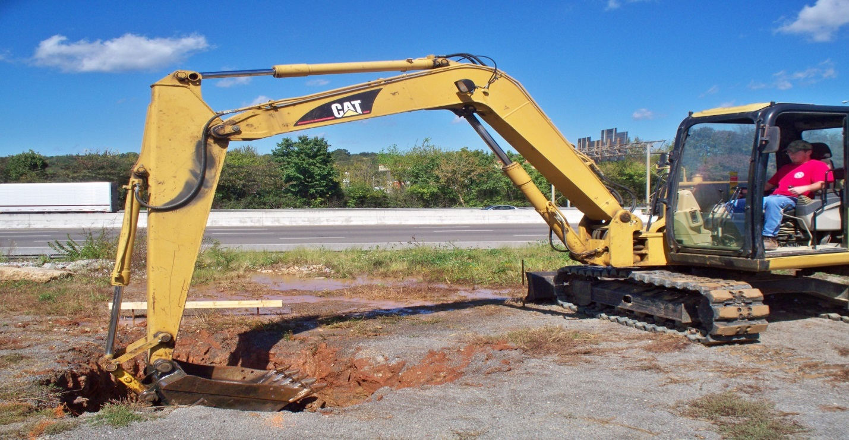
Figure 20. Caterpillar 307C excavating one of the footing.

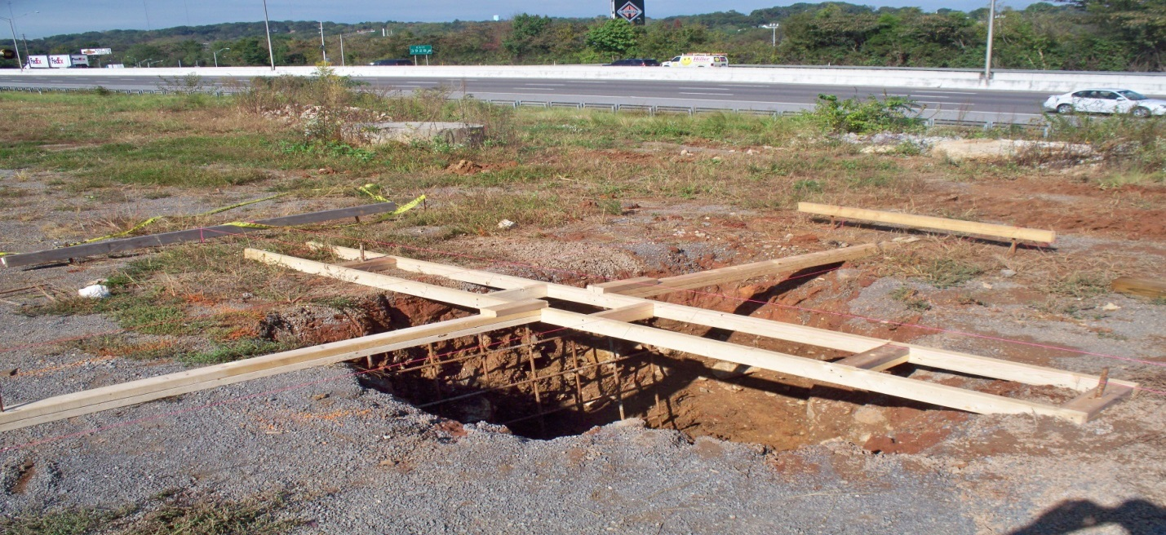
Figure 21. Guide system for steel beams.
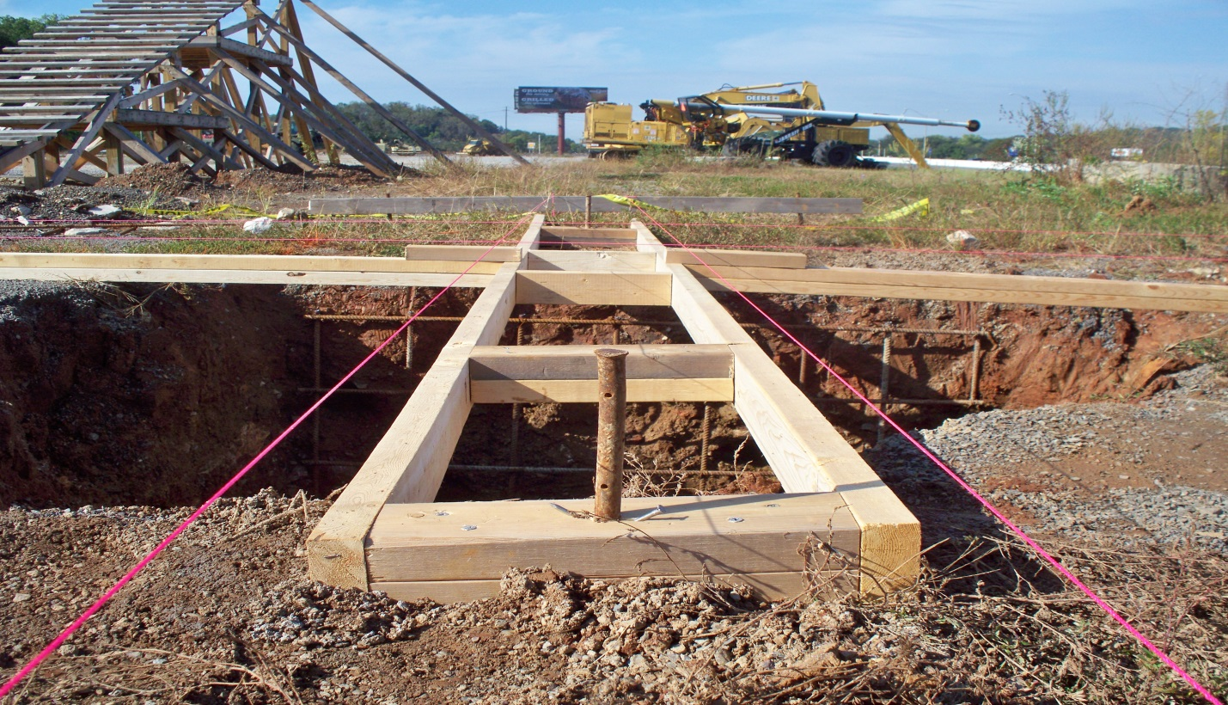
Figure 22. Nail pins securing the guide system to the ground.

The steel beams were erected with a small crane, Caterpillar Galion 150FA. In order to slide the beams through the guide system they needed to be lowered straight down. This was accomplished by torch cutting a hole through the web of the steel at its balance point and running a shackle through the hole. The beams were slowly lowered through the guide system until they settled on the bottom of the footing. Once set the beams were plumed by placing small wood shims between the beam itself and the guide system. A beam set in the guide system is shown in Figure 23.

With the rebar mat and steel beams set in place concrete was poured in the open footings. The large volume of concrete needed for the footings required for the concrete to be poured out of ready mix trucks as seen in Figure 24. The concrete was poured in two foot lifts and was vibrated for consolidation after each lift was poured. The concrete was poured up to the existing ground elevation. Since nothing needed to be placed on top of the concrete no finishing was required. Therefore the only method of finishing was normal consolidation due to vibrating the concrete. One of the finished footings is shown in Figure 25.
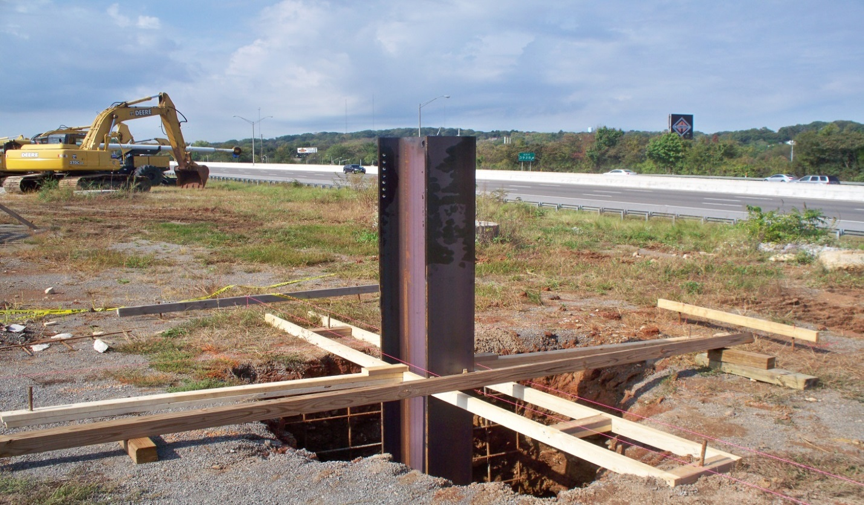
Figure 23. Steel beam sitting within the guide system.

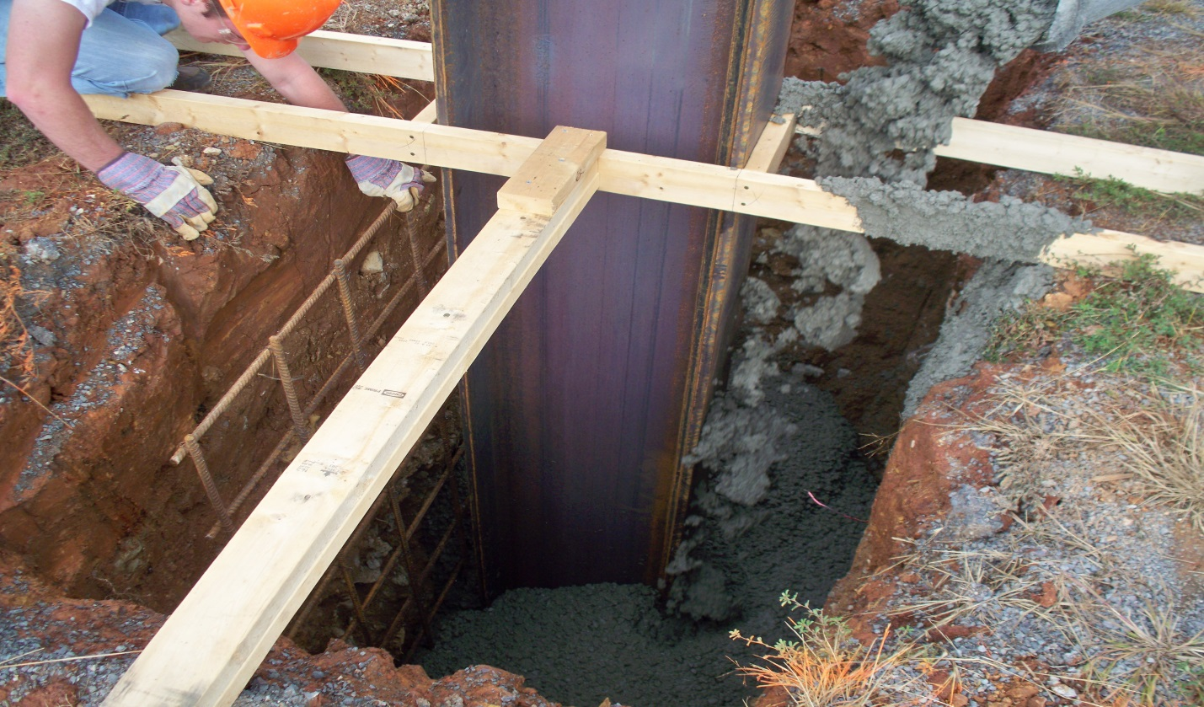
Figure 24. Concrete being poured from a ready mix truck.

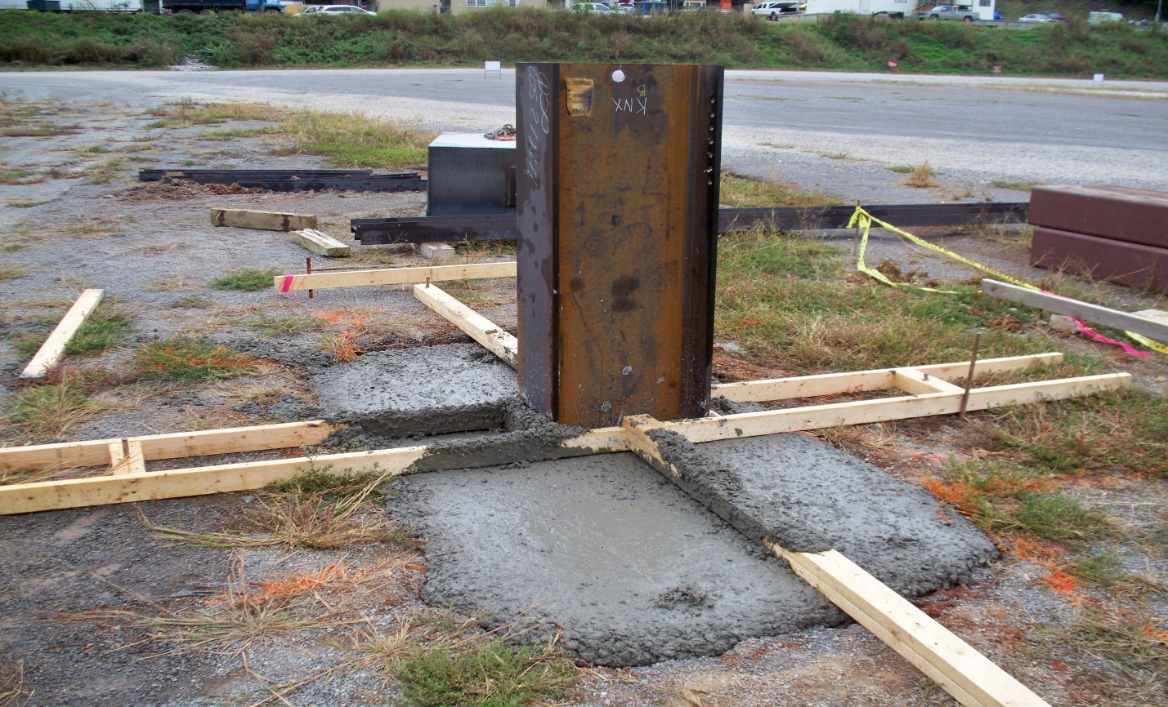
Figure 25. Finished concrete footing.

In order to make the tubes removable they needed to be bolted onto the vertical beams. Therefore the backplate that was welded to the HSS had four holes drilled through it with a spacing of 6”. Matching holes were also drilled through the vertical beams prior to placement with spacing of 2”, as seen in Figure 26. The smaller spacing was so that the tubes could be placed at multiple elevations. The tubes were installed by lowering them into place with a crane and then bolting them to the flange of the vertical beams. During installation it was discovered that the holes in the vertical beam did not match up with the holes in the tubes. The holes were not off by much, however it was enough that only two bolts could be used for one of the tubes. As a substitute to bolts the backplate was connected to the beam by two small welds on either edge of the flange as seen in Figure 27. This held the tube in place during testing and the welds were ground off when the tubes needed to be taken down.

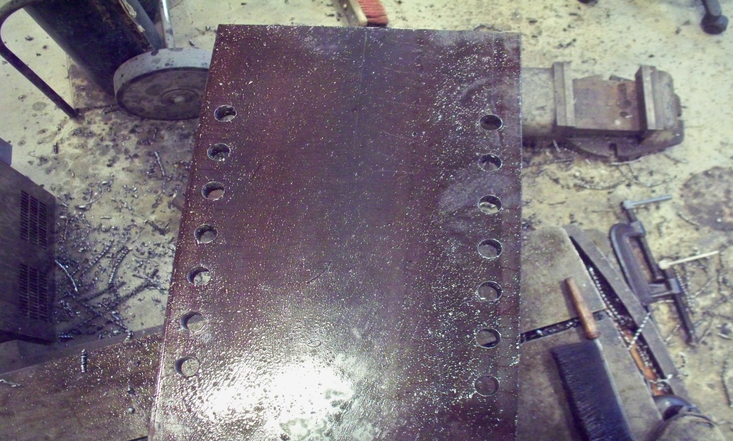
Figure 26. Vertical beams with predrilled holes at 2” spacing.

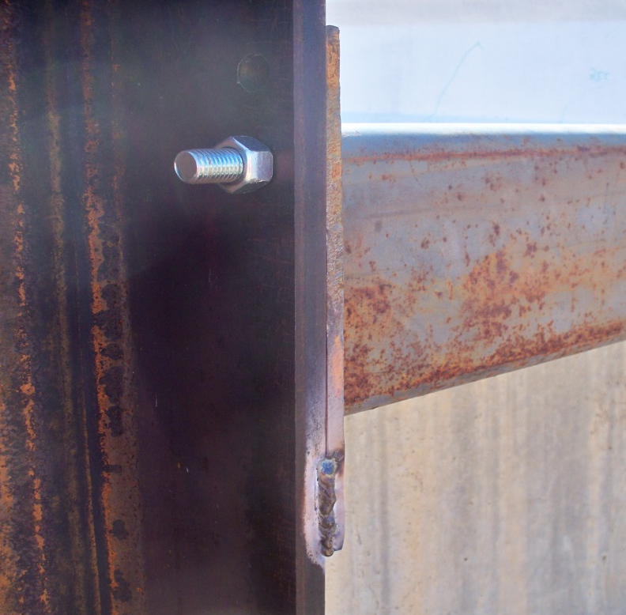
Figure 27. Connection of HSS tubes to vertical beams.

Support System

In order to have the maximum impact force possible the impact point must be at the center of gravity of the impactor. Since the target impact location off the test specimen was the bottom flange the specimen needed to be elevated to where the center of the bottom flange lined up with the center of the impactor. This was accomplished through the support system. The system consists of New Jersey Barriers and HSS tubes placed beneath the barrier. The choice of these materials was based on availability. The barriers were already on the testing site and were made available to use two of them for testing. The barriers were not tall enough on their own to properly elevate the test specimen. This meant that a secondary component was necessary. The height needed was determined to be roughly 12 in. Fortunately four 12x12x3/8 in. steel HSS tubes were available for use. Two tubes were placed underneath each of the barriers. The barriers were placed perpendicular to the direction of the test specimen and just to the inside of the backstop. This was done to create a support condition that was close to what the specimen would experience if it were being used in an actual bridge. The support system is shown in Figure 28.

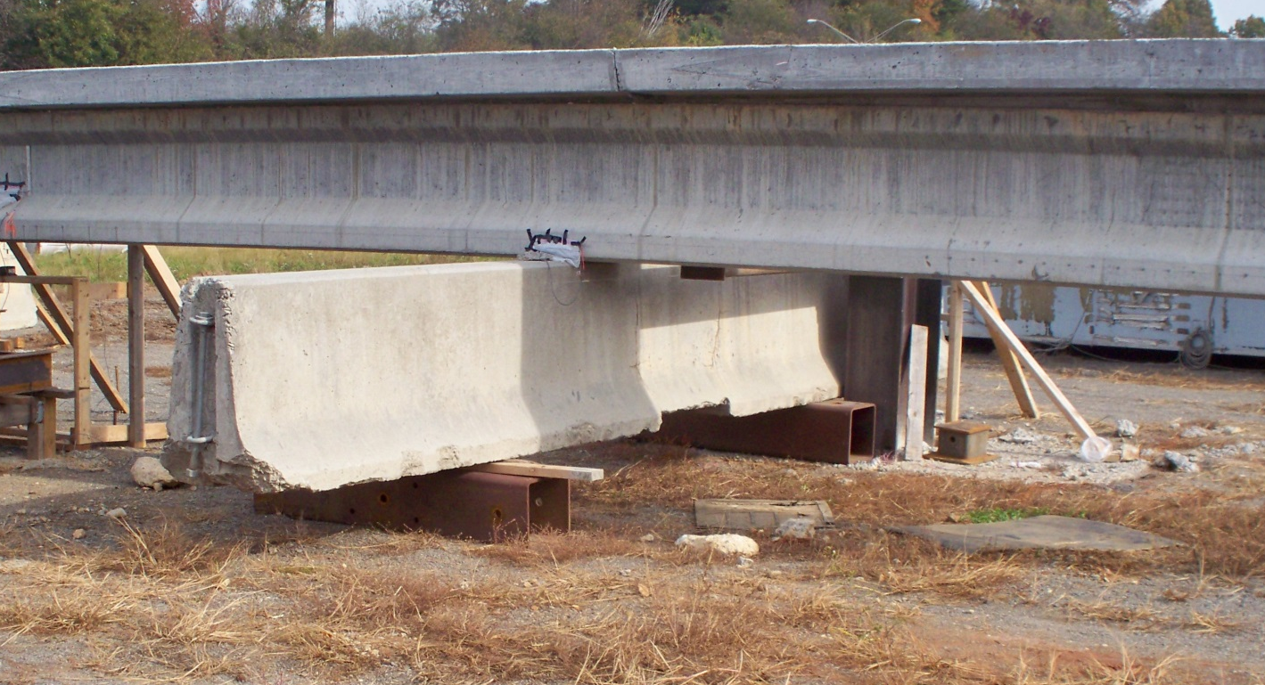
Figure 28. One of the supports with test specimen sitting on top.

Operating the Testing Facility

In order to operate the testing facility the impact cart must be pulled up the track, locked in place, and then released. This was accomplished by means of two large excavators. The first excavator pulls the impact cart up the slope. The impact cart is connected to the excavator by a chain and shackles that connect to the hitch on the cart itself as seen in Figure 29. Once the cart is pulled up the track a second excavator locks the impact cart in place. Meaning that the bucket of the second excavator is placed on the front side of the impact cart preventing it from rolling down the slope. Once the second excavator has secured the impact cart the chain is slacked and the shackle is unfastened from the hitch of the impact cart. Once the shackle is removed the bucket of the second excavator is raised and the impact cart is allowed to roll down the track. This method of release served as a type of quick release system, but was much safer than the alternatives. This method allowed for multiple redundancies and could be tested prior to the actual test without having the impact cart roll down the track.

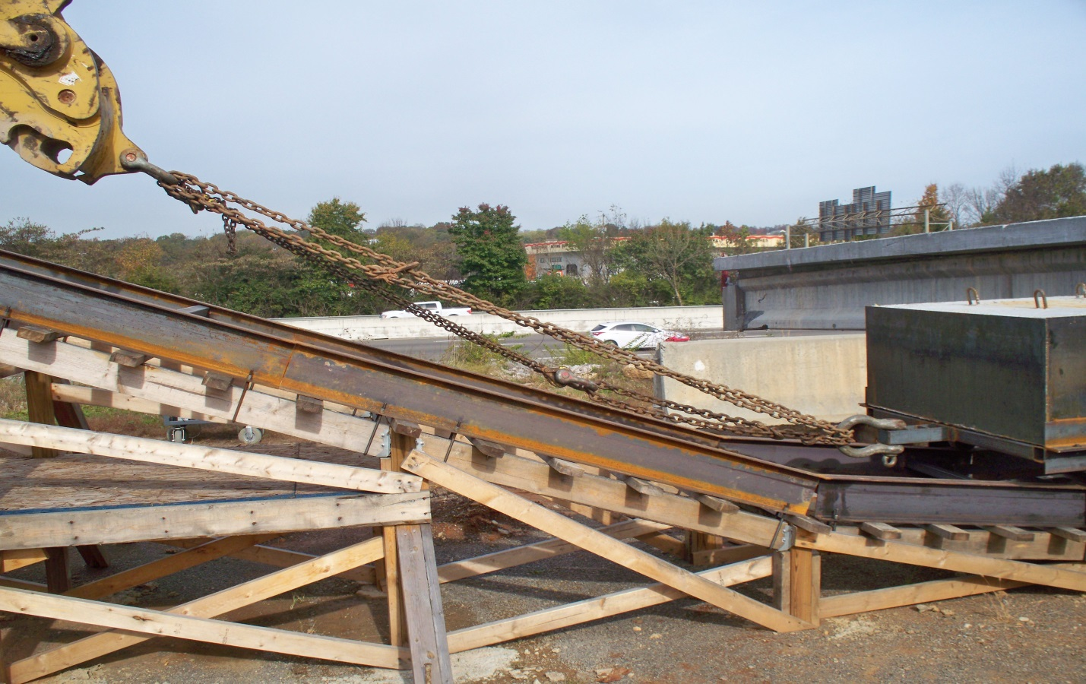
Figure 29. Impact cart hooked up to excavator by shackles and chain.

Chapter 5 Testing Results and Modifications

A single impact test was performed on a prestressed beam. The operation went smoothly and the impact cart collided with the beam as planned. The backstop acted as planed and prevented the beam from sliding. The damage that occurred to the specimen can be classified as a catastrophic failure of the structural integrity of the beam. Upon impact the bottom flange of the beam crumbled and the beam twisted about the midpoint. Cracking was observed all the way through the beam and into the top deck. The prestressing strands were all uncovered and the pre-tensioning was released from all of the strands. The damage to the beam is shown in Figures 30, 31. The structure itself performed well, however when the impact cart hit the first angle change near the bottom of the ramp the structure failed. The joists nearly sheared completely in two and the welds on the rails broke. The failure was instantaneous, suggesting that the failure was due to vertical impact. The damage to the track is shown in Figures 32, 33. Despite this damage to the track the impact cart still collided with the beam with the expected force. This indicates that the facility as a whole worked for the intended purpose. However, modifications must be made so that this type of failure does not occur in future tests. In order to fix the broken section the initial design concept was scrapped in favor of an alternative that was more suited to withstand vertical impact.

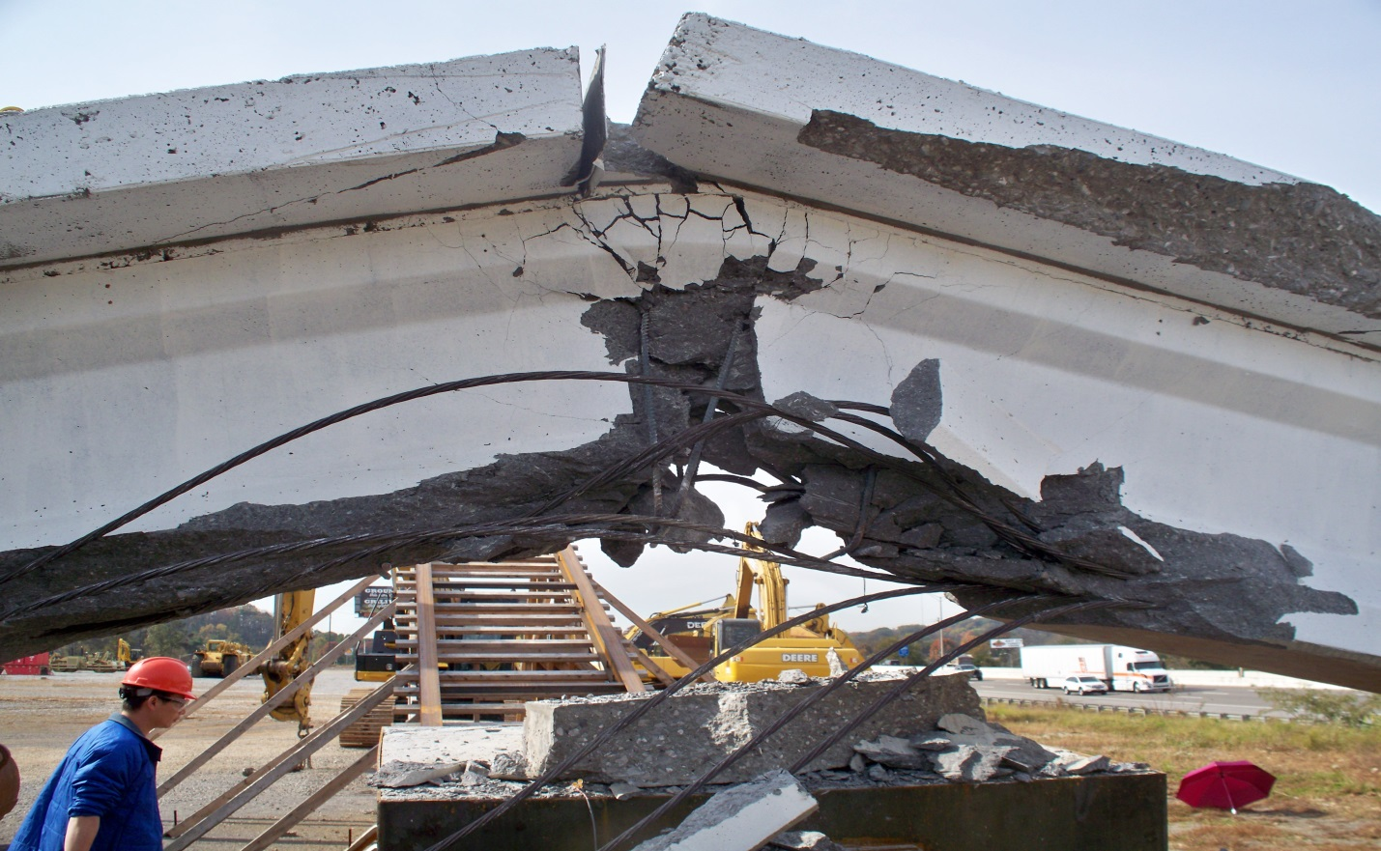
Figure 30. Prestressed beam after impact.

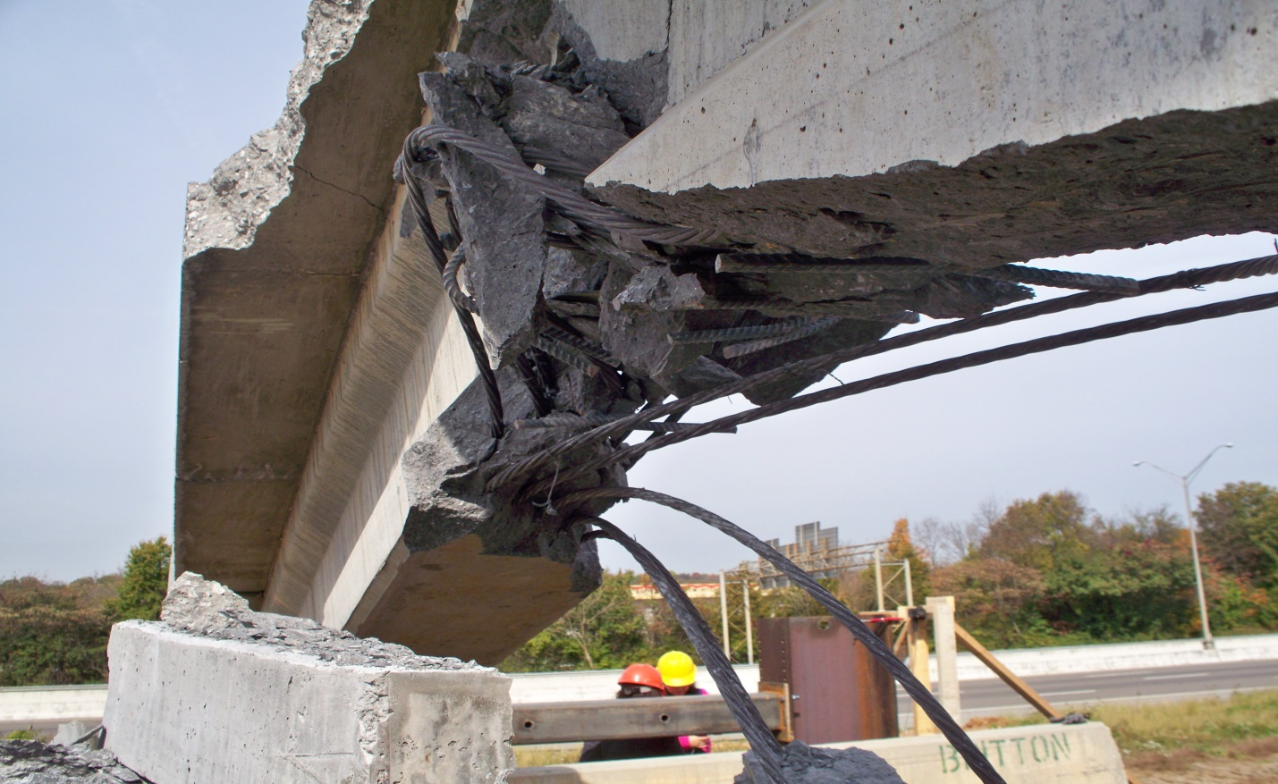
Figure 31. Prestressed beam after impact.
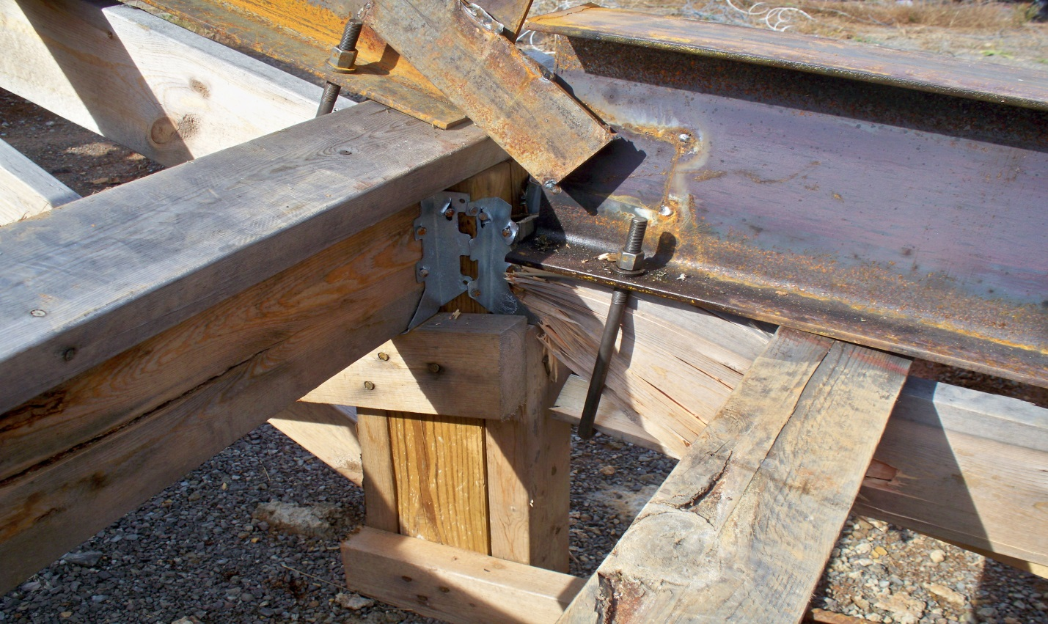
Figure 32. Damage to joists after testing.

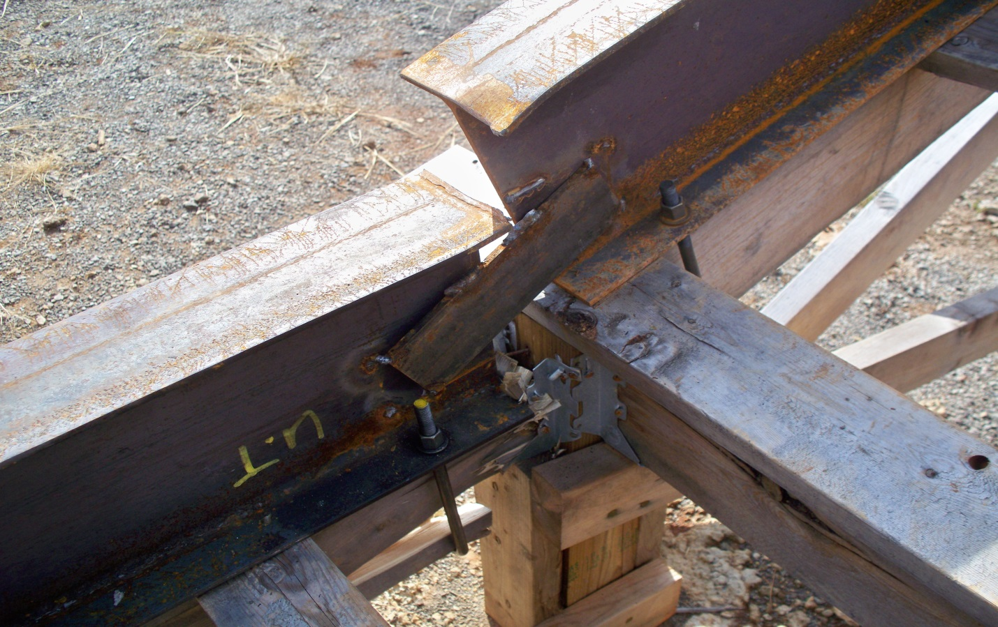
Figure 33. Damage to rails after testing.
In order to determine what loading was needed for the redesign an impact factor was calculated. This impact factor was then multiplied to the original static load. As a starting point for picking an impact factor the worst case scenario was chosen to be if the impact cart were to be in free-fall and impact the structure from a fall height of 10 ft. This scenario would provide the largest impact factor possible because this scenario provides the largest loading. This case is not necessarily practical; however it served as a starting point to see what types of numbers were possible. The static deflection was determined based upon the following equation.

$$∆=\frac{Pl}{AE}$$

The input values were based off of the extra compression boards that were nailed to the posts. This was done because these boards received little damage and the goal of the redesign was to determine how much more surface area would be required to sustain the impact force. The load used was 8000 lbs, length of 12 in, area of 4.5 in², and elastic modulus of 400,000psi. The computed static deflection was 0.053 in.

The dynamic deflection was calculated based off of energy methods. The system was modeled as a spring system with a falling mass. The potential energy of the impact cart was set equivalent to the spring stiffness equation, as shown below.

$$mg\left(h+∆\right)=\frac{1}{2}k∆^{2}$$

This equation was rearranged to solve for the dynamic deflection. The drop height was varied and multiple values of the dynamic deflection were plotted in Figure 34. These values were then compared to the static deflection to determine an impact factor.

Figure 34. Dynamic deflection vs. Drop Height.

Based off of the maximum dynamic deflection of 3.63 in. from a drop height of 10 ft the impact factor was determined to be 68.5. This is obviously unreasonably large and not a true representation of how much force is being transferred into the structure. Since this number was so large the worst case cannot be considered as the actual loading case.

As a substitute to the worst case of a 10 ft drop height the load was taken to be a rectangular pulse force. This loading scenario is much more realistic since the impact cart rolls over this portion of the structure for only a finite amount of time and with a relatively constant loading. The impact factor R_{d} was determined based on the following equation.

$$R_{d}=\left\{\begin{aligned}2sin\left(π\frac{t_{d}}{T_{n}}\right)⁡, \frac{t_{d}}{T_{n}}≤\frac{1}{2} \\ 2, &\frac{t_{d}}{T_{n}}≥\frac{1}{2}\end{aligned}\right.$$

The natural period was determined to be 0.0738 s and the time duration for the application of the load, t_{d}, was taken to be 0.1 s. These values result in an R_{d} of 2. This modification factor is much more reasonable than the 68.5 from the previous scenario. With the impact factor of 2 applied to the static load the new design load equals 16,000 lbs. The broken portion of the structure was then modified based on this new loading.

Only one section of the track needed to be redesigned. The rails were temporarily removed over the section while the joists and 2x4 decking were permanently removed. In place of the joist and decking system two walls were built and the rails were placed directly on top of them. The walls consist of a top and bottom 2x4 plates and end framing that is nailed directly onto the posts. The wall is then filled with layered 2x12’s and 1/2” plywood. The total thickness of this fill equals the total thickness of the plates. The entire system is then covered in 3/4” plywood on either side creating a solid composite wood wall. This amount of wood is overkill, however it was desired to build a quick and easy solution that would ensure that the structure would not fail again.

With the walls built the rails were then set directly on top of them. This section of rail was then welded to the other rails as previously described. Since the impact cart did not shift laterally during the first test it was determined that the rails did not need to be secured to the walls and rather only to the existing rails.

List of References

Vita

Cody Mitchell was born in Knoxville, Tennessee on March 16, 1991. He was raised by his parents Andy Mitchell and Lisa Pfeister along with younger brother Drew. Cody attended the University of Tennessee in Knoxville and graduated with his Bachelor of Science in Civil Engineering in 2013. Cody is currently pursuing his Master of Science in Civil Engineering with a concentration in Structural Engineering at the University of Tennessee, Knoxville.

