CHAPTER-3
Multi-Channel Analysis of Surface Waves (MASW)
3.1 INTRODUCTION
In general, there are two types of surface waves; Rayleigh and Love waves (Dobrin and Savit, 1988). Both represent the plane-wave solutions to the following coupled elastic wave equation (Haskell, 1953):
∂²φ/∂t² = V_{p}² ∇²φ and ∂²Ψ/∂t² = V_{s}² ∇²Ψ
In most of surface seismic surveys when a compressional source is used, more than two-thirds of total seismic energy generated is imparted into Rayleigh waves (Richart et al., 1970), which is the principal component of ground roll (which is Rayleigh-type surface waves generated most effectively in all kinds of surface seismic surveys). Surface waves show the property of dispersion i.e. for a vertical velocity variation, each frequency component of a surface wave has a different propagation velocity (called phase velocity), which in turn results in a different wavelength for each frequency propagated. Therefore, due to its dispersive property, ground roll can be utilized to infer near-surface elastic properties (Nazarian et al., 1983; Stokoe et al., 1994; Park et al., 1998a). Constructing shear wave velocity profile through the analysis of plane-wave fundamental mode Rayeligh waves is one of the most common ways to use the dispersive properties of surface waves (Bullen, 1963). The phase velocities for different wavelengths can be found from the solutions to the above wave equation by treating the near surface materials as layered earth medium (Haskell, 1953). Therefore, by analyzing the dispersion feature of ground roll represented in recorded seismic data, the near-surface S-wave velocity (Vs) profiles can be constructed and the corresponding shear moduli (μ) are calculated from the relation between the two parameters.
V_{s} =√μ/ρ
where ρ represents the density of material (assumed as constant since it varies little with depth).

The Multi-channel Analysis of Surface Wave method (MASW), first introduced into geotechnical and geophysical community in early 1999, is a seismic method which generates a shear wave velocity profile (Vs) (i.e., Vs versus depth) by analyzing Rayleigh-type surface waves on a multi-channel record. MASW is a seismic exploration method evaluating ground stiffness in 1-D, 2-D and 3-D formats for various types of geotechnical engineering projects. Since its first introduction in the late 1990’s, it has been utilized by many practitioners and researched by many investigators worldwide.
3.2 ADVANTAGES OF MASW
Directly measuring shear-wave velocities from a shear-wave survey is very difficult in terms of maintaining favorable signal-to-noise ratio (S/N) during both data acquisition and data processing. But MASW method provides fairly favorable and competent results. In this method the data acquisition is more tolerant in terms of selecting the parameters than any other seismic methods and also provides high signal-to-noise (S/N) ratio. This is due to the fact that seismic surface waves are the most strongest seismic waves generated that can travel longer distance than body waves without suffering from noise contamination. Because of strong S/N ratio, MASW method assures reliable pattern recognitions on a seismic record. i.e. it can extract signal in midst of noise of any kind from natural to cultural activities and also to other types of inherent seismic waves generated simultaneously.
3.3 OVERALL MASW PROCEDURE
The method utilizes multi-channel recording and processing concepts widely used in reflection surveying for oil exploration. The fundamental mode of ground roll (the Rayleigh-type surface wave event) is without a doubt one of the most troublesome types of source-generated noise on reflection surveys. Rayleigh wave energy is defined as signal in MASW analysis, and needs to be enhanced during both data acquisition and processing steps. In all kinds of surface seismic surveys using vertical sources, ground roll takes more than two thirds of total generated seismic energy and usually appears with the most prominence on the Multi-channel records. Therefore, generation of ground roll is easiest among all other types of seismic waves. The field setup is shown in Figure (1). The method first measures seismic surface waves generated from various types of seismic sources-such as sledge hammer-analyzes the propagation velocities of those surface waves, and then finally deduces shear-wave velocity (Vs) variations below the surveyed area that is most responsible for the analyzed propagation velocity pattern of surface waves.
The most common procedure that is followed for typical MASW surveys include three major steps:
- Data acquisition-acquiring multichannel field records
- Dispersion analysis-extracting dispersion curves
- Inversion-Back calculating shear-wave velocity variation with depth
A 2-D (surface and depth) Vs map can also be constructed through an appropriate interpolation scheme by placing each 1-D Vs profile at surface location corresponding to the middle of the receiver line. Detailed step by step procedure for each of the step is explained below and the optimum field parameters are also tabulated.
3.3.1 Field procedure-Data acquisition
The whole field procedure for MASW data acquisition is explained here. Among the active and passive MASW, the active method is the most common type for acquiring 2-D Vs profiles. The maximum depth of investigation (Zmax) that can be achieved from the survey is usually 10-30 m range and varies with the type of source used. Some of the parameters related to data acquisition procedure are described below. The following table also describes the optimum field parameters for a typical data acquisition procedure, keeping in mind the fact that these can be changed or updated by investigators and practitioners depending upon the requirements.
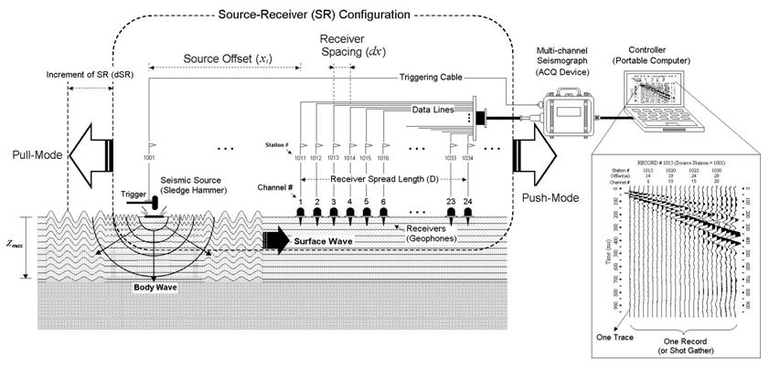
Figure: 1 Schematic representation of the active MASW field survey (modified from Park, 2003)
Source
Maximum investigation depth (Zmax) is determined by the longest wavelength (Lmax) of the surface waves used for the analysis as Zmax=0.5Lmax. And Lmax is governed by the impact of the seismic source, which can be controlled type like the sledge hammer in case of an active survey (or a car moving or any other kind of cultural noise in case of a passive survey). According to the above relation, the longer Lmax, (deeper the Zmax) can be achieved with a greater impact power. Some of the commonly used sources include a heavy sledge hammer (10-20 lb), weight-drop etc. Using an impact plate (also called base plate) will help the source impact point intrude less into soil. The table below explains different optimum sources for different investigation depth. For unusually shallow investigation, a relatively light source has to be used so that the dominant frequency can be shifted towards higher frequencies.
Ambient noise can be significantly reduced through multiple impacts and vertical stacking of these impacts therefore is always recommended, especially if the survey takes place in an urban area.

Receivers
Usually vertical (instead of horizontal) low-frequency geophones (e.g., 4.5 Hz) are always recommended. Although spike coupled geophones always give the highest sensitivity, the coupling provided by a land streamer can be equally efficient and is a significant convenience in field operation. The high end of geophone frequency is not critical as in the reflection survey where any minor drop in sensitivity may become critical. For instance, recording and analysis of surface waves up to 450 Hz have been reported by using 4.5-Hz geophones (Miller et al., 2000).
Field Geometry
Length of the receiver spread (D) is directly related to the longest wavelength (Lmax) that can be analyzed, which in turn determines the maximum depth of investigation (Zmax). D usually has to be equal to or greater than Zmax.
D= mZmax (1<m<3)
On the other hand, receiver spacing (dx) is related to the shortest wavelength (Lmin) and therefore determines the shallowest resolvable depth of investigation (Zmin).
Zmin = kdx (0.3 < k < 1.0)
The source offset distance (x1) is also a major governing factor to predict the degree of contamination by the near-field effects that indicate a congregate of all adverse influences on data acquisition because of the source being too close to the receivers. Although its optimum value is still under debate, a value of 20% of D is suggested as a minimum and 100% as a maximum. A larger value of x1 and D will increase the risk of higher-mode domination and reduce S/N for the fundamental mode.
Also while performing an active linear survey sometimes a roll along spread is used and the interval (dSRC) of source-receivers configuration move between 1dx-12dx is recommended for 24-channel acquisition. This particular variable is also directly related to the horizontal resolution.
Table1a: Data acquisition parameters for active survey. Recommended values in ( )
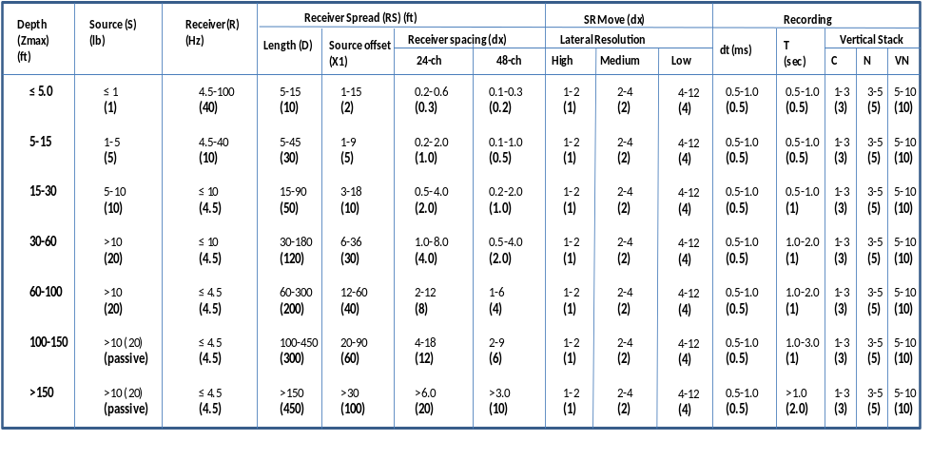
*** SR Move represents distance in receiver spacing (dx) that the source (S) and Receiver (R) setup moves after acquiring data at one location; dt represents sampling interval in milliseconds (ms); T represents total recording time in seconds (sec); Vertical stack is the number of stacking data in seismograph’s memory before being saved under different conditions of calm (C), noisy (N), and very noisy (VN) environment, respectively. These parameters given here are just a list of optimum parameters and are by no means definitive or required. There is a tolerance level of +/- 20% to most of these recommended values.

Recording Parameters
A one-millisecond of sampling interval (dt=1 ms) is most commonly used with a 1-sec total recording time (T=1 sec). A smaller dt is recommended if any body-wave processing is planned as by product and a longer T is recommended in case of extremely low velocities or if a longer receiver spread (D) is used. An excessively longer T, when used, may increase the chance of recording ambient noise. Generally, shorter dx and longer D combination is recommended. When more channels are used the Signal-to-noise ratio (S/N) will be increased during data analysis because of the redundancy as well as the possibility of increasing resolution at shallow depths. Also the effect of increasing D will be an increased Zmax.
3.3.2 Field procedure-Data Analysis
The first step in data analysis involves extracting dispersion curves from the data that are in turn used in the next step of data inversion, which tries to find a proper layer (shear-wave velocity-Vs) model whose theoretical dispersion curves match the measured ones as close as possible. Usually we estimate what is known to be the fundamental mode (M0) curve. But recent studies suggest that higher-modes can also be utilized to get shear-wave velocity information.
Concept of Dispersion
In the early stage of surface wave method using monotonic vibrator exciting at a single frequency (f) at a time, the distance (Lf) between two consecutive amplitude maxima was measured by scanning the ground surface with a sensor. Then, corresponding phase velocity (Cf) was calculated as Cf=Lf*f. This measurement was then repeated for different frequencies to construct a dispersion curve with the assumption that the fundamental mode (M0) of the surface wave dominate in the field. In early 1900’s this method was used efficiently by the spectral analysis of surface waves (SASW) method. Instead of trying to measure the distance of Lf, it tries to measure the phase difference (dp) for a frequency (f) between the two receivers a known distance apart from the relationship: Cf=2*pi*f/dp. This process is repeated for different frequencies to construct a dispersion curve. Possibility of multi-modal influence during the inversion process is accounted for with the concept of apparent dispersion curve.
While using a multi-channel approach, however, we do not calculate individual phase velocity first, but instead construct an image space where dispersion trends are identified from the pattern of energy accumulation in this space. Then, necessary dispersion curves are extracted by following the image trends. During this imaging process, a multichannel record in time-space domain is transformed into either frequency-wave number or frequency-phase velocity domain. In order to acquire this, the phase-shift method is generally used instead of any other traditional method like pi-omega or the f-k method because it achieves higher resolution than the other methods.
The Dispersion imaging scheme
A multi channel field record (a) is first decomposed via Fast Fourier Transformation (FFT) into individual frequency components, and then amplitude normalization is applied to the each component (b). Then, for a given testing phase velocity in a certain range, necessary amount of phase shifts are calculated to compensate for the time delay corresponding to a specific offset, applied to individual component, and all of them are summed together to make a summed energy of (c). This in turn is repeated for different frequency components. When all the energy is summed in frequency-phase velocity space, it will show a pattern of energy accumulation that represents the dispersion curve as shown in (d). In case of multi-modal dispersion, that behavior of energy will appear as multiple energy accumulations for a given frequency as shown in (e).
3.3.3 Field Procedure-Data Inversion
Inversion in general
Inversion in general means seeking the cause to a result with the latter on hand. On the other hand, predicting the result from the given cause is referred to as forward modeling. An inversion is known to be unique if there is only one solution to the problem and non-unique if multiple solutions exist. It is also called “linear” if the cause-related relationship is linear as a small change gives also a small change in result, whereas “non-unique” if a small change can give rise to a big change in result.
Typical MASW method inversion
The goal of a field survey and data processing is to establish the fundamental mode (M0) dispersion curve as accurately as possible. Theoretical M0 curves are then different earth models by using a proper forward modeling scheme, the most common of which is the one by Schwab and Knopoff (1972), to be compared against the measured curve. The process of inversion is based on the assumption that the measured dispersion curve represents the M0 curve only not influenced by any other modes of surface waves. The most important issue with the inversion process is to figure out the best-fit earth model among many different models as efficiently as possible. One way to check for the closeness between the measured and theoretical curves is the Root-Mean Square (RMS) error factor.
Multi-modal Inversion
This inversion technique uses both the fundamental and higher-mode curves for the inversion. This is done in order to increase the accuracy (resolution) of the final 1D Vs profile by narrowing the range of solutions with 1D Vs profiles otherwise equally well suited if only the M0 curve is used. This method can also alleviate the inherent problem with the inversion method of non-uniqueness in general. As in every theory, there exists a problem with this method that it can introduce more degrees of freedom with one or more variables added into the system of inversion.
Dispersion Image Inversion
This method of inversion includes the use of dispersion Image data (also called phase velocity spectra) instead of dispersion curves that does not even involve the extraction of modal curves at all (Ryden and Park, 2006; Forbriger, 2003a;2003b).
This approach eliminates such drawbacks with the modal-curve based inversion as the mode-misidentification and mode-mix problems (misidentifying higher mode curve as a M0 curve) if data acquisition and subsequent processing are not properly performed. Dispersion curves when misidentified may lead to erroneous Vs profile because of the lack of compatibility in the inversion process trying to match measured and theoretical curves.
Raw Data Inversion
As the name suggests, in this type of inversion we use the raw multichannel record instead of the one processed for dispersion imaging (Forbriger, 2003b). In this process, it tries to compare the whole seismic waveforms observed at different distances from the source with synthetic waveforms generated from a proper forward modeling scheme. This type of approach may be advantageous over others for the fact that it is not biased by any other kind of data processing such as dispersion imaging or curve extraction. But at the same time it has to take into account the attenuation and excitability issues, as well as layer parameters, as all of these can contribute to the shaping of a seismic waveform.
2-D Vs Inversion
This approach uses the final output of 2D Vs profile from current typical inversion approach as input to the second phase of the inversion based on a different forward modeling scheme than previously used. The main objective of this method is to consider the smearing effect caused by the lateral variations during dispersion analysis as much as possible by adopting another scheme accounting for the local variation of Vs. For this purpose we consider the Vs structure provided by the previous output of the 2D Vs profile as an initial starting model to account for the local variations observed within an individual field record to update a certain part of the 2D Vs model, mostly likely corresponding to the surface location of the receiver spread used during data acquisition. Iterations can be performed for a better result. But the main drawback for this method is that it is computationally intensive.

3.4 TYPES OF MASW METHODS
Depending upon the source used to generate surface waves there are two basic types of MASW technique: active, where we use an impact source such as a sledge hammer or a weight drop, and passive method wherein surface waves are generated using sources like cultural and natural noise such as traffic and tidal motion.
While the active survey method is the conventional mode of survey for collecting MASW data in which data is collected in a roll-along mode using an active seismic source such as a sledge hammer and a linear receiver array. There are two sub categories in the passive methods both of which utilizes surface waves generated passively from ambient cultural noise such as traffic, thunder etc. The passive remote method (Park et al., 2004; 2005) employs a 2D receiver array such as a cross or circular layout to record surface waves. On the other hand, the passive roadside MASW method (Park and Miller, 2006) adopts the conventional linear receiver array and tries mainly to utilize those surface waves generated from local traffic. Here, the array can be deployed along a sidewalk or on the shoulder of a road and the survey can continue in a roll-along mode for the purpose of 2-D Vs profiling.
3.4.1 Why do we need passive method?
From most of the active method, although one can achieve reliable Vs estimations, the depth of investigations is only down to a few tens of meters (for example, 30 m). While this kind of depth is sometimes sufficient for near surface investigations, there are other instances where the investigation depth is insufficient due to either elastic properties of the near surface materials or the usually deep investigation depth sought. Some of the commonly used active source like a sledge hammer or heavier source like the weight drop can overcome the limitation; the depth range gained may often be trivial as the power delivered by most of the active sources is not sufficient to achieve a distinguished gain in investigation depth. Even if such a source is invented, it would be uneconomical and impractical. But on the other hand, the surface waves generated from natural or cultural noise are usually of low-frequency nature with wavelengths ranging from a few kilometers (natural sources) to a few tens (or hundreds) of meters (cultural sources) (Okada, 2003), providing a wide range of penetration depths and therefore proving to be more advantageous than the active methods (Park and Miller, 2006). Also as the necessity of performing MASW surveys in urban areas grows, utilizing those surface waves generated by local traffic is found to be a perfect choice recently (Asten, 1978; Louie, 2001; Okada, 2003; Suzuki and Hayashi, 2003; Yoon and Rix, 2004; Park et al., 2004).
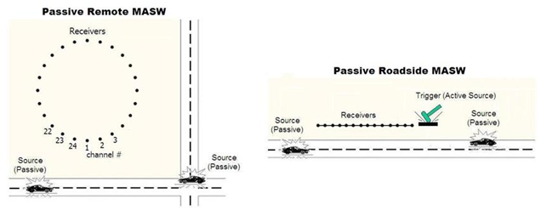
Figure:1 Typical field layout for passive remote (left) and passive roadside (right) MASW surveys
3.4.2 Types of passive MASW methods
Passive MASW methods are further divided into two main types depending on the field logistics and the type of shear-wave velocity (Vs) profiles (1-D or 2-D) generated: passive remote (Park et al., 2004) and passive road side (Park and Miller, 2008) surveys.
Passive remote survey
The former method utilizes a two-dimensional (2-D) receiver array such as circular, cross or any other symmetrical shape to record passive surface waves. Although this method involves laborious field operation and needs more space for deploying the array, results in most accurate 1-D shear-wave velocity profiles (Vs) (Park et al., 2005). For this type of survey any kind of symmetrical shape like circle, cross, square, triangular or random etc. is used. This study is mainly focused on a study comparing some of the 2-D arrays with that of a random array in terms of its effect on dispersion analysis and shear-wave velocity extraction. Some of the commonly used 2-D arrays are shown pictorially in figure.2
Passive roadside survey
As mentioned above this type of MASW method utilizes conventional linear receiver array and uses local traffic as noise. This method overcomes limitation with the remote in terms of area of survey and data acquisition procedures, but one has to sacrifice the accuracy of the Vs evaluation (usually <10%). Because the receivers can be laid linearly and traffic noise can be used as a source, this set up can be set along a sidewalk, median or on the shoulder of a road and just as in the active linear array, a roll-along mode can be used for the purpose of 2-D Vs profiling. Also, while performing this survey, an active impact can be applied at one end of the array to trigger a long recording. Therefore from passive road side array a combined analysis of surface waves for Vs evaluation can be achieved for both shallow and deep information simultaneously. An example of a 2-D Vs profile obtained from a roadside survey that used a linear receiver array and roll along mode is shown in figure ( ).
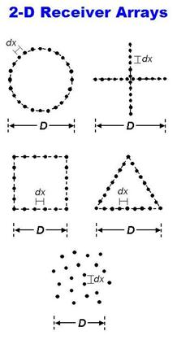
Figure: 2 Examples of 2-D receiver arrays for the passive remote MASW surveys

Combined active and passive survey
In some cases it is often necessary and useful to combine dispersion images from both active and passive data sets for two main reasons: (1) to enlarge the analyzable frequency range of dispersion. (2) to better identify the modal identity of dispersion trends (active methods results in high frequency range and passive results in the low frequency range). Although some studies (Aki, 1965) suggests that the M0 obtained from passive survey are predominantly Rayleigh waves, recent studies (Park et al., 2005; 2006) reveal that there is also a strong possibility of higher modes domination. Therefore it is suggested (Park et al., 2005) that a combined analysis would be more reliable for modal identification.
3.5 SUMMARY
The Multi-channel Analysis of Surface Wave (MASW) method is a recently developed seismic method dealing with relatively lower frequencies and shallow investigation depth ranges than any other conventional seismic methods. The data acquisition and processing scheme results (Vs information) proved to be highly reliable in geotechnical field even under the presence of higher modes of surface waves and also under various types of cultural noise. The intrinsic properties of surface waves make the resolution of the result limiting to the size of the anomaly. A minimum size that can be handled is about one tenth of depth as a rule of thumb. The data processing steps are all automated which makes this method extremely easy and fast to implement and also very cost-effective. Due to these advantages, this method has gained significant importance in geotechnical engineering and also in other engineering communities.

