Synthesis and Characterization of Stimuli Responsive Polymer Brushes

A Dissertation Presented for the
Doctor of Philosophy
Degree
The University of Tennessee, Knoxville

Chaitra Vasant Deodhar
May 2013

Dedication

This dissertation is dedicated to my beloved parents, Vasant and Ashwini Deodhar.

Acknowledgements
There are several individuals who deserve my sincere gratitude for helping me complete this work. First, I would like to thank my family: my parents, Vasant and Ashwini Deodhar, and my sister, Gauri. Their support, encouragement and love inspires me to achieve my goals. I am also thankful for my beloved husband Mihir, whose help, understanding and support have been a vital part of my time in graduate school.
I would like to express my deep gratitude to Prof. Michael Kilbey for his insightful guidance during these past five years. He has been and remains my role model for a scientist, mentor and a teacher. I am grateful to all of my committee members, Prof. Mark Dadmun, Prof. Craig Barnes and Prof. Wei He for their time, efforts and suggestions that have helped me move my research forward.
I have had the pleasure of working with many people during these years, and I am very thankful for the great times we have shared and for their help. I appreciate all the past and present members of Kilbey group: Erick, JP, Camille, Mike, Kamlesh, Jesse, Wang, Zach, Anna and Bethany. I have been fortunate to work with and befriend several researchers at the Center for Nanophase Material Sciences and Spallation Neutron Source at Oak Ridge National Laboratory, including Brad Lokitz, Deanna Pickel, Jamie Messman, David Uhrig, Peter Bonnesen, John Ankner, Jim Browning and Candice Halbert.
Finally, I express my sincere thanks to the many friends I have made during these years in Knoxville, for all the fun and good times and great experiences we have shared.

Abstract
Polyelectrolytes (PE) are the least understood polymeric systems due to their complex behavior that arises because of the intimate connection between charge and conformation. To address this challenge, my research focuses on understanding the responsive behavior of weak polyelectrolyte brushes to different stimuli such as pH, type of ion and ionic strength. In this work, weak polyelectrolyte brushes made of poly(methacrylic acid) (PMAA) and random copolymer brushes incorporating hydroxyethyl methacrylate (HEMA) as co-monomer were studied. The polymer brushes were synthesized by both “grafting to” and “grafting from” approaches and were characterized mainly by ellipsometry and neutron reflectometry.
Several methods for preparing alkyne-decorated substrates suitable for “click” chemistry are described. For each method, factors that control film thickness and content of alkyne groups were investigated. Azide terminated PMAA and poly(vinyl-dimethylazlactone) polymers were tethered to alkyne-bearing poly(glycidylmethacrylate) surface layers via click reactions. It was observed that the alkyne content obtained by these approaches was sufficiently high and was not the limiting factor for the click reaction of azide-capped polymers. A method to self-consistently determine water content of PE films using neutron reflectometry under different hydration conditions is reported. Multiple data sets were modeled with constrained fittings to obtain dry polymer mass density, layer thickness and PE brush profiles into different pH solutions. The influence of monovalent ions from the cationic Hofmeister series on the structure and swelling behavior of weak polyelectrolyte brushes was also investigated. It was found that the scaling behaviors of PMAA brushes with respect to salt concentration are similar in presence of different salts; however, the cross-over salt concentration at which the transition occurs is different for each type of salt and can be explained by its position in Hofmeister series. Finally, some preliminary results concerning calcium carbonate mineralization of PMAA brushes as a function of concentration of organic additive are reported. Calcium carbonate films were obtained by polymer-induced liquid precursor (PILP) strategy, using an ammonia diffusion method. Various characterizations show that as the concentration of additive is increased, the extent of mineralization decreases.

Table of Contents
Chapter 1 - Introduction 1
1.1 Motivation: Complex Behavior of Polyelectrolyte Brushes 3
1.2 Strategies for synthesizing polymer brushes 7
1.3 Prior Work on Weak Polyelectrolyte Brushes 12
1.4 Neutron Reflectivity - An Important Tool to Study Polyelectrolyte Brushes 15
1.5 Research Objectives 20

Chapter 2 - Versatility of Alkyne-modified Poly (glycidyl methacrylate) Layers for Click Reactions 23
2.1 Introduction 24
2.2 Experimental section 27
2.2.1 Materials 27
2.2.2 Instrumentation 28
2.2.3 Synthetic Procedures 30
2.3 Results and Discussion 35
2.3.1 Alkyne Functionalization of Silicon Substrates 35
2.3.2 Click Reactions 55
2.4 Conclusions 59

Chapter 3 - Hydration in Weak Polyelectrolyte Brushes 61
3.1 Introduction 61
3.2 Experimental section 64
3.2.1 Polymer Synthesis 64
3.2.2 Synthesis of 2-bromo-2-methyl-N-(undec-10-enyl)propanamide 65
3.2.3 Synthesis of 2-bromo-N-(11-(dichloro(methyl)silyl)undecyl)-2-methylpropanamide 66
3.2.4 Polymer Brush Characterizations 67
3.2.5 Hydration Calculations 70
3.3 Results and Discussion 72
3.4 Conclusions 80

Chapter 4 - Ion-Specific Effects on Swelling Behavior of Weak Polyelectrolyte Brushes by Neutron Reflectometry 81
4.1 Introduction 82
4.2 Experimental 85
4.2.1 Materials and Preparations 85
4.2.2 Instrumentation 86
4.2.3 Synthetic Procedures 87
4.3 Results and Discussion 89
4.3.1 Synthesis of PMAA Brushes 89
4.3.2 In situ Swelling Measurements of PMAA Brushes by Ellipsometry 91
4.3.3 Ion Specific Behavior of PMAA Brushes Studied by Neutron Reflectometry 95
4.4 Conclusions 101

Chapter 5 - Mineralization of Calcium Carbonate using PMAA Brushes as Templates 103
5.1 Introduction 103
5.2 Experimental Section 105
5.2.1 Materials 105
5.2.2 Instrumentation 106
5.2.3 Synthesis of PMAA brushes by SI-ATRP 107
5.2.4 Mineralization of Calcium Carbonate 108
5.3 Results and Discussion 109
5.4 Conclusions 120

Chapter 6 – Summary, Conclusions and Future Work 122

List of References 127

Appendices 148
Appendix A: Attenuated total reflectance – Fourier transform infrared spectroscopy of alkyne-containing films 149
Appendix B: Atomic force microscopy of PGMA and alkyne-modified films 151
Appendix C: Scattering length density of PGMA 154
Appendix D: Effect of propargylamine concentration on modification of PGMA films 156
Appendix E: Buffer Recipes 158

Vita 159

List of Tables
Table 2-1. Properties of PGMA Homopolymer and pGP Copolymers 32

Table 2-2 Properties of pGP and PGMA-Hex surfaces, Azide-Capped Polymers and Resulting Click Products 56

Table 2-3 Properties of PGMA-Prop surfaces, Azide-Capped PMAA Polymers and Resulting Click Products 58

Table 3-1 Properties of PMAA and P(MAA_{1-r}-co-HEMA_{r}) brushes. Here r is the mole fraction of HEMA in the copolymer, d_{ellipsometry} is the ellipsometric thickness of the polymer layer in humid air, M_{n} is the number average molecular weight and PDI is the polydispersity index of the polymer chains grown in solution measured by size exclusion chromatography. Grafting density Γ_{ellipsometry} is calculated using the ellipsometric thickness measured in air. 69

Table 3-2 Results of iterative fitting of the neutron data. Here, r is the mole fraction of HEMA in the random copolymer, f_{pH} the water volume fraction in the copolymer against D₂O pH buffer, f_{hum} the volume fraction of water in the polymer film in humid air, ρ the mass density of the polymer, μ/ρ the polymer “dry” thickness in the absence of hydrating water. The stretch ratio is wet vs. dry thickness, d'_{pH} /(μ/ρ), and Γ_{neutron} is the neutron-derived grafting density. 79

Table 4-1. Properties of PMAA brushes 91

Table 5-1. Surface composition of calcium carbonate mineralized PMAA and PtBMA brushes derived from XPS results. The concentration of PAA added to the crystallizing solution is given in brackets for each sample. 118

Table E-1. Amounts of acid/base and given salts required to make 100 ml of buffer solutions. 158

List of Figures
Figure 1-1. Schematic drawing of a polyelectrolyte brush: Circled charges represent polymer ions and “condensed” counter-ions. Uncricled charges represent added dissociated salt ions. 2

Figure 1-2. Schematic drawing showing changes in structure of polyacid brush with changes in pH of the surrounding solution. 5

Figure 1-3. Scaling behavior of strong and weak PE brushes as a function concentration of added salt, C_{s}. OS is osmotic brush regime and SB is salted brush regime. 6

Figure 1-4. Schematic illustration of the “grafting to” approach. (A) Early in the layer formation process chains can easily reach the surface and attach. (B) At higher grafting densities the chains that are already attached hinder the approach and attachment of incoming polymer chains. (Adapted from reference 2.) 9

Figure 1-5. Schematic illustration of the common strategy used in the “grafting from” approach. An initiator molecule (Ini) is deposited on the surface via reaction of the anchor group with suitable surface sites and, subsequently, chains are grown on the surface from initiating sites. (Adapted from reference 2.) 9

Figure 1-6. Mechanism of main RAFT equilibrium. RAFT polymerization allows controlled growth of polymers through the equilibrium between active and dormant species where dithioester compound acts a chain transfer agent. (Adapted from reference 2.) 10

Figure 1-7. Mechanism of transition metal catalyzed atom transfer radical polymerization (ATRP). In ATRP the equilibrium is shifted towards dormant species, leading to propagation in a well-defined (uniform) manner. (Adapted from Reference 2.) 12

Figure 2-1. Residual epoxy groups of PGMA-modified films react with alkyne-containing molecules of basic or acidic nature (propargylamine and 5-hexynoic acid, respectively), yielding surfaces displaying alkyne functionality. 27

Figure 2-2. Dependence of PGMA film thickness on solvent and concentration of PGMA in the spin coating solution. The film thickness changed negligibly before and after annealing. The thicknesses reported were measured after annealing and sonication/rinsing with the corresponding solvent. Error bars derive from multiple measurements across a given sample; for some points the error bars are smaller than the symbols. 36

Figure 2-3. Neutron reflectivity profile of a PGMA film made by spin coating a 0.3 % (w/v) PGMA solution in chloroform onto a silicon substrate and annealing at 110 °C for 45 minutes. The black squares are the measured reflectivity and the solid line is the calculated reflectivity based on the model shown in the inset graph (PGMA layer thickness = 135 Å, SLD_{PGMA} = 8.3 × 10⁻⁷ Å⁻² and an interfacial roughness of 10 Å.) 39

Figure 2-4. Increase in ellipsometric thickness of PGMA-coated silicon surfaces upon reaction with propargylamine (H_{Prop}). The initial PGMA layer thickness was nominally 14.5 nm and the propargylamine solution was 2% v/v in 2-propanol at 55 °C. Here the error bars represent thickness variations across a sample. 42

Figure 2-5. Neutron reflectivity profile of a propargylamine-modified PGMA film (PGMA-Prop) obtained by reaction of a PGMA film with 20% v/v propargylamine in 2-propanol at 55 °C for 30 hours. The data are well fit using a model consisting of a single slab of 190 Å thickness, SLD_{PGMA-Prop} = 8.2 × 10⁻⁷ Å⁻² and an interfacial roughness of 25 Å. The black squares are the measured reflectivity values; the continuous line is the reflectivity calculated using the SLD profile shown in the inset graph. The dashed line is the calculated reflectivity curve of the parent PGMA film (thickness 141 Å, SLD_{PGMA} = 8.4 × 10⁻⁷ Å⁻² and an interfacial roughness of 20 Å). 44
Figure 2-6. Increase in ellipsometric thickness after exposure of PGMA films (initial thickness ~ 13.5 nm) to 5-hexynoic acid at 60 °C. The black hollow points are the measured ellipsometric thicknesses, the dashed blue line is a guide to the eye. The error bars represent the variation (standard deviation) across a film surface. 48

Figure 2-7. Neutron reflectivity profile of a PGMA-Hex film obtained by reaction of a PGMA film with neat 5-hexynoic acid at 60 °C for 90 hours. As observed from the figure, the measured reflectivity data are well fit by the model SLD profile shown in the inset graph. The model consisted of a single slab 193 Å thick PGMA-Hex layer (SLD_{PGMA-Hex} = 8.3 × 10⁻⁷ Å⁻²) with a broad and smoothly decreasing transition (described by an interfacial roughness of 15 Å). The dashed blue line is the calculated reflectivity curve of the parent PGMA film (PGMA layer thickness = 135 Å, SLD_{PGMA} = 8.3 × 10⁻⁷ Å⁻² and an interfacial roughness of 10 Å). 50

Figure 2-8. Structure of pGP copolymers, which are synthesized by free radical polymerization. Copolymer composition is adjusted by varying the feed ratio of the two monomers. 52

Figure 2-9. Dependence of pGP copolymer film thickness (after spin-coating, annealing and solvent washing) on pGP concentration using 2-butanone as solvent. The error bars represent the standard deviation between different samples (in some instances the error bars are smaller than the symbol). 52

Figure 2-10. Neutron reflectivity profile of pGP-3/1 film made by spin coating from a 0.3 % (w/v) pGP-3/1 solution in 2-butanone. The data are well fit by a model consisting of a single slab of 70 Å thickness having SLD_{pGP-3/1} = 1.28 × 10⁻⁶ Å⁻² and an interfacial roughness of 35 Å. 54

Figure 3-1. Schematic picture of the neutron reflectometry liquid cell. Reflectivity measurements in buffer solutions were performed using this liquid cell with inverted geometry. 69

Figure 3-2. Reflectivity curves RQ⁴ vs. wavevector Q (a) and fitted scattering density profiles (b) for an r =0.2 random copolymer film before deprotection [P(tBMA_{0.8}-co-HEMA_{0.2})] and after deprotection [P(MAA_{0.8}-co-HEMA_{0.2})] in humid air and against a pH 8 buffer solution (10 mM) made with D₂O. 74

Figure 3-3. Fitted random copolymer P(MAA_{1-r}-co-HEMA_{r}) volume fraction profiles for (a) r = 0, (b) r = 0.2, and (c) r =0.3 for films measured in air and the same films in contact with pH 3, 6, and 8 D₂O buffer solutions at 10 mM ionic strength. The inset in (c) schematically represents MAA and HEMA monomers and their random association in the polymer. 76

Figure 4-1. Swollen thickness of a 26 nm PMAA brush as a function of ionic strength of NaCl, KCl and LiCl solutions by multiangle ellipsometry. 94

Figure 4-2. Neutron reflectivity data (symbols) and preliminary model fits (continuous lines) for PtBMA and PMAA brushes measured in air. PMAA brushes are obtained after cleaving the tert-butyl groups by acid hydrolysis of the neutral precursor PtBMA brush. 96

Figure 4-3. Neutron reflectivity curves for PMAA brushes in air (“Dry”) and in buffer solutions at pH = 7 using Hofmeister cations of A) KCl, B) NaCl and C) LiCl at various ionic strengths that are indicated in the figure legends. 100

Figure 5-1. Experimental setup for calcium carbonate mineralization of PMAA brushes via ammonia diffusion method. 110

Figure 5-2. X-ray diffraction pattern of calcium carbonate mineralized PMAA brushes obtained as a function of concentration of PAA. The peak at 28.5° is characteristic of Si (100) and the peak at 29.5° is characteristic of CaCO₃. 111

Figure 5-3. SEM images of PMAA brushes mineralized with calcium carbonate using different concentrations of PAA as the organic additive: A) 60 μg/L, B) 80 μg/L, C) 100 μg/L and D) 120 μg/L. E) High magnification image of CaCO₃ crystals grown using concentration of PAA = 60 μg/L. F) Image of the film created in a control experiment that tested whether mineralization occurred when the surface was covered with a PtBMA brush. Magnification: 69x (A – D and F), 1220x (E) Scale bar: 100 μm (A – D and F), 10 μm (E). 113

Figure 5-4. XPS survey spectra of PMAA and PtBMA brushes mineralized with calcium carbonate at different PAA concentrations. The concentration of PAA (M_{w} = 2,100 g/mol) used in each experiment is indicated in brackets labeling each spectrum. 115

Figure 5-5. High resolution scans in the C_{1s} region of PMAA and PtBMA brushes mineralized with calcium carbonate at different PAA concentrations. Concentration of PAA (M_{w} = 2,100 g/mol) used in each experiment is indicated in brackets. Solid lines at 288.5 eV and 285 eV are provided as guides to the eye. 116

Figure 5-6. Ca_{2p} core level spectra of calcium carbonate mineralized PMAA and PtBMA brushes. The concentration of PAA (M_{w} = 2,100 g/mol) used in each experiment is indicated in brackets, and the solid line at 347.1 eV, which is the binding energy attributed to the CaCO₃ polymorph calcite, is to guide the eye. 119

Figure A-1. ATR-FTIR spectrum of pGP-3/1 film. The band at 2125 cm⁻¹ is characteristic of triple bond of an alkyne and the more intense band at 3270 cm⁻¹ is due to a stretching mode between the triple bond carbon and the terminal hydrogen atom. The inset shows these alkyne bands more distinctly. 150

Figure B-1. AFM height images of PGMA films spin coated from different solvents a) chloroform (H_{PGMA} = 10 nm), b) toluene (H_{PGMA} = 2 nm) and c) 2-butanone (H_{PGMA} = 10 nm). Films made using chloroform were consistently smooth and uniform in appearance. 152

Figure B-2. AFM height images of alkyne-modified PGMA films. a) PGMA-Prop (the initial PGMA layer thickness was 13 nm and the increase after reaction with propargyl amine 20% v/v for 19 hours at 55 °C was 6.0 nm), the measured RMS roughness over a 1 μm² area is 1.13 nm; b) PGMA-Hex (the initial PGMA layer thickness was 12 nm and the increase after reaction with neat 5-hexynoic acid for 80 hours at 60 °C was 5.1 nm), the measured RMS roughness over a 1 μm² area is 0.65 nm. 153
Figure C-1. Variation of χ² as a function of the SLD of PGMA used in the model. A lower χ² value indicates a better statistical fit. All other variables in the SLD model (thicknesses of PGMA and SiO_{x} layers and roughnesses between interfaces) were fixed. 155

Figure D-1. Increase in ellipsometric thickness of a PGMA-coated silicon surface upon reaction with propargylamine (H_{Prop}). The hollow black points are the measured ellipsometric thicknesses, the dashed lines are simply a guide to the eye. The initial PGMA layer thickness was nominally 13.5 nm and the reaction time was 20 hours at 55 °C. The error bars represent the variation in thickness across a sample. 157

- Introduction
The term “polymer brush” refers to systems in which polymer chains are end-tethered at grafting densities high enough such that the chains stretch away from the surface as a result of repulsion between chains due to crowding.¹ Chain stretching starts when the chains at the substrate begin to overlap and increases strongly with increasing grafting density of the chains. The stretching is the result of repulsive segment-segment interactions within and between the attached chains and is balanced by the entropic penalty that opposes elastic stretching.² Pinning the polymer chain ends to the surface imparts certain behaviors to the tethered chains that are different from free coils. This structural difference affects the interfacial behavior of tethered chains, which in turn, leads to many novel properties of polymer brushes.
Therefore, fabricating polymer brushes provides a way to modify the interfacial properties of the material. For example, the properties such as biocompatibility, wettability, corrosion resistance, friction, affinity to specific target molecule, and adsorption capacity can be controlled by modifying a surface with polymer brushes. Owing to these capabilities, polymer brushes are of wide interest as central models for investigating colloid stabilization³ and lubrication.⁴ Brushes also can be used for designing biomaterials, for improving the effectiveness of drug delivery and for fine tuning cell/surface interactions.⁵ Polymer brushes have also found application in various areas concerning new adhesive materials,⁶ protein-resistant or protein-adhesive biosurfaces,⁷ chromatographic devices,⁸ polymer compatibilizers,^{1a} chemical gates,⁹ and microfluidic¹⁰ devices, to name a few.

Brushes that carry charges along the polymer chain are referred to as the polyelectrolyte brushes (see Figure 1-1). Polyelectrolyte brushes are sometimes called “smart” materials because they are capable of conformational (i.e. swelling or collapsing) and chemical changes in response to chemical or physical stimuli, such as changes in pH, temperature, solvent, specific counter-ions or ionic strength.¹¹ The strong segment-segment repulsions and electrostatic interactions present in such systems bring about completely new and complex physical behaviors as compared to non-charged polymer brushes. Complexity in the structure of polyelectrolytes arises due to the fact that they consist of ionizable repeat units that dissociate in water to produce pendant charged groups that provide hydrophilicity along a hydrophobic hydrocarbon backbone. The charged groups interact with each other and other charged species through coulombic interactions, while dispersive interactions dominate the behavior of the hydrocarbon backbones.

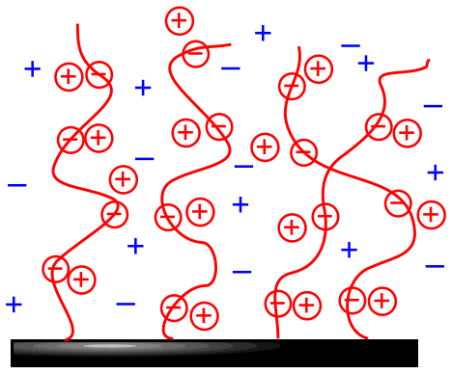
Figure 1-1. Schematic drawing of a polyelectrolyte brush: Circled charges represent polymer ions and “condensed” counter-ions. Uncircled charges represent added dissociated salt ions.

Also, the distance between the charged groups remains fixed due to the composition of the polymer. As a result, the structure of polyelectrolytes is governed by a balance between electrostatic interactions, osmotic pressure of counter-ions and chain stretching, which is entropically disfavored. This is different from the situation of neutral polymer brushes, where the structure is governed by short-ranged dispersive interactions (segment-segment and segment-solvent interactions).
Because the properties of polymer chains depend on their molecular conformation, it is crucial to understand structure-property relationship of polyelectrolyte brushes so that they can be tailored to the exact needs of a particular application. In this chapter, I highlight the progress and direction of research done in the area of synthesis of “weak” polyelectrolyte brushes using different polymerization techniques and their characterization by techniques such as multi-angle ellipsometry and neutron reflectometry. “Weak” is a special term that describes a type of polyelectrolyte brushes, and it will be discussed in section 1.1. This focus is intended to provide insight into complex connections between charge and nanostructure. Various concepts and techniques that form the basis of this work are presented in this chapter, and an overview of related research work also is presented to illustrate the novelty of my thesis research.

Motivation: Complex Behavior of Polyelectrolyte Brushes
Polyelectrolytes, which are charged polymers, are an important class of polymers that can be used to modify material surfaces. They usually consist of long chain-like molecules with ionizable groups that dissociate in water and produce charged groups along the backbone. Complex architectures like block, branched, and graft copolymers are possible. Polymers with a single type of charged group are polyelectrolytes, whereas polymers with ability to carry negative and positive charges are called polyampholytes. Many important biological macromolecules are polyelectrolytes. For example, DNA and RNA are polyelectrolytes; whereas proteins are polyampholytes.
As described in an earlier section, the complex behavior of polyelectrolyte brushes is a result of competing factors and restrictions due to its ionizable nature, hydrophobicity of backbone and medley of interaction forces.¹² This is different from neutral brushes where the structure is governed by short-ranged dispersive interactions (segment-segment and segment-solvent).^{1a, 13} As a result of these competing factors and restrictions, these charged macromolecules display a rich variety of structures and properties not found in neutral polymers and are, therefore, of considerable interest from a basic scientific standpoint. Polyelectrolytes (PEs) now have a wide-range of technological uses: They are used as processing aids such as flocculants,¹⁴ as additives in detergents and cosmetics,¹⁵ ion-exchange resins, gels,¹⁶ and modified plastics. Therefore, the study of PEs spans the diverse areas of biomedicine, wastewater treatment, colloid science, and petroleum recovery.
For “strong” PEs the charge groups are completely dissociated, fixing the number and position of charges along the chain, and their properties do not depend on the pH of the solution. The scaling behavior of strong PE brushes has been studied extensively.^{3, 17} In “weak” PE brushes, the equilibrium between dissociated and associated forms depends on the pH and/or the ionic strength of the surrounding solution. To understand the response of charged brush to changes in pH, prior knowledge of the dissociation constant (pK_{a}) of the functional groups of a polyacid brush is needed (pK_{b} for polybase brushes). Weak polyelectrolytes can exist in either their charged state or their neutral state depending on the pH of the surrounding solution, as seen in Figure 1-2. When the pH of the surrounding solution is greater than the pK_{a}, acid groups are dissociated, and when the pH is less than the pK_{a}, the acid groups are protonated. Thus it is expected that a weak polyacid brush will increase in thickness as the pH is increased due to an increase in number of dissociated carboxylic acid groups. A higher degree of dissociation implies a higher charge density. Because charges cannot be uncompensated, counter-ions enter the brush, causing the layer to swell because of the osmotic pressure of counter-ions. The effect of ionic strength (salt concentration) on the behavior of weak polyacid brushes is more complex: depending on whether the counter-ion concentration outside of the layer is greater or less than the counter-ion concentration within the brush, the thickness of the polyacid layer may increase or decrease as a function of salt concentration. For weak polyacid polymers, the degree of dissociation of the brush, α, is defined as shown in Equation 1.1.¹⁸
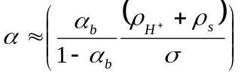 (1.1)

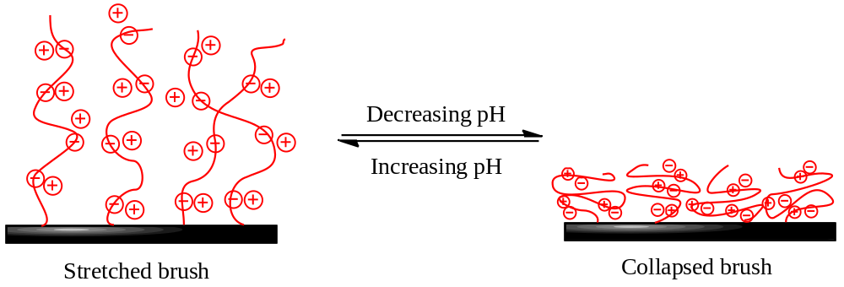
Figure 1-2. Schematic drawing showing changes in structure of polyacid brush with changes in pH of the surrounding solution.

In Equation 1.1, α_{b} is the average degree of dissociation experienced by a chain in the solution at certain pH, ρ_{H}⁺ is the concentration of free protons in the solution, ρ_{s} is the concentration of added salt and σ is the grafting density of the brush. This acid-base equilibrium makes the swelling behavior of weak PE brushes complicated.¹⁹ Acid-base equilibrium is affected by salt, as shown in Equation 1.1, and salt also screens charges. These two effects of added salt - influencing the chemical equilibrium (acid-base) and participating in physical interactions (screening) - is what makes the behavior of weak polyelectrolytes very complex.^{12a} The expected behaviors for strong and weak polyelectrolyte brushes in the presence of added salt are well-known from mean field theory^{3, 19a, 20} and are depicted in Figure 1-3. For strong PE brushes, added salt does not affect the swollen thickness of the brush until the external salt concentration is greater than that of the concentration of counter-ions inside the brush. At higher salt concentrations, the height of the brush H decreases according to the H ~ C_{s}^{-1/3} scaling law because of the screening of electrostatic interactions.³

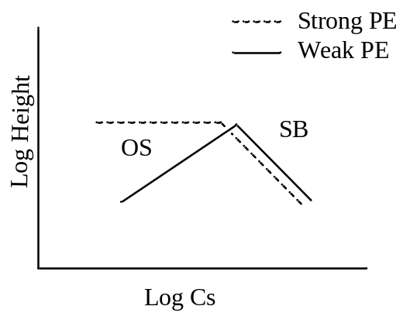
Figure 1-3. Scaling behavior of strong and weak PE brushes as a function of concentration of added salt, C_{s}. OS is osmotic brush regime and SB is salted brush regime.
For weak PE brushes, in the osmotic brush regime, i.e. at low salt concentrations, the concentration of counter-ions inside the brush is greater than the external salt concentration in solution. The height of the brush is determined by the balance between the osmotic pressure due to counter-ions and the retracting force that tries to keep the chains coiled. At low C_{s}, as salt is added, the degree of dissociation, α (Equation 1.1), goes up, resulting in dissociation of more groups. Counter-ions come inside the brush to compensate the charge, resulting in the stretching of the brush according to H ~ C_{s}^{1/3} scaling law. When the concentration of added salt becomes equal to the concentration of free counter-ions inside the brush, the brush enters the salted brush regime. In the salted brush regime, the concentration of counter-ions inside the brush is lower than the external salt concentration. Now the osmotic pressure outside the brush is greater than that inside the brush environment. In this scenario, increasing the salt concentration increases the screening of electrostatic charge, resulting in a decrease in thickness of the brush.²¹

Strategies for synthesizing polymer brushes
There are two main approaches that are used to synthesize polymer brushes at solid surfaces: they are often called “grafting to” and “grafting from”. In the “grafting to” technique, premade polymer molecules containing a functional moiety at the chain end are reacted with the complementary reactive groups present on the surface to obtain the desired brush.²² This process is illustrated in Figure 1-4A. Even though the layer composition and organization can be well controlled by “grafting to” technique, this method intrinsically yields layers of low grafting density and film thicknesses. This is due to attached polymer chains hindering incoming polymer chains from approaching the surface and interacting with reactive groups buried on the substrate surface, as illustrated in Figure 1-4B. On the other hand, in the “grafting from” technique, a polymer brush is generated in situ by growth from suitable surface immobilized initiators,²³ as illustrated in Figure 1-5. As monomer molecules can easily diffuse through the already grafted polymer chains, higher grafting densities are easily obtained as compared to those obtained by the grafting to approach. But a key disadvantage is that the grafted polymer chains are not well characterized: Specifically, the molecular weight and polydispersity are not known. Therefore, they are often assumed to be the same as that of untethered chains grown simultaneously from free initiators added to the polymerization solution.²⁴
In the “grafting to” technique, synthesis of polymer chains possessing a suitable end-functionality can be performed using several techniques including anionic, cationic, living free radical and ring opening metathesis polymerizations. These techniques allow for controlled growth of the polymer chains and also permit facile conversion of the chains ends to desired functionalities like hydroxyl, carboxyl, amino, thiol, etc. that can be reacted to the substrate.²⁵ The surface also plays an important role in the synthesis of brush layers made by this technique. To create surfaces amenable to the “grafting to” technique, it is necessary to install one of the participating functional groups on the surface to enable coupling reactions with the polymer chains. This can be accomplished by using self-assemble monolayers (SAMs) and other coupling agents to introduce various surface functionalities.

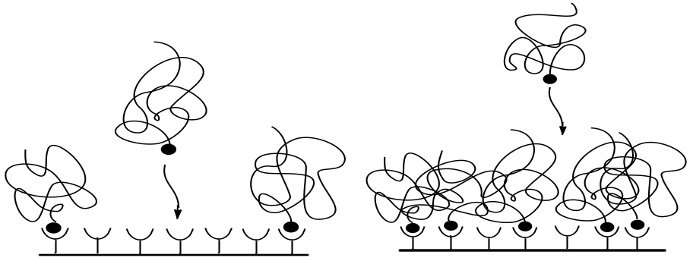
A B
Figure 1-4. Schematic illustration of the “grafting to” approach. (A) Early in the layer formation process chains can easily reach the surface and attach. (B) At higher grafting densities the chains that are already attached hinder the approach and attachment of incoming polymer chains. (Adapted from reference 2.)

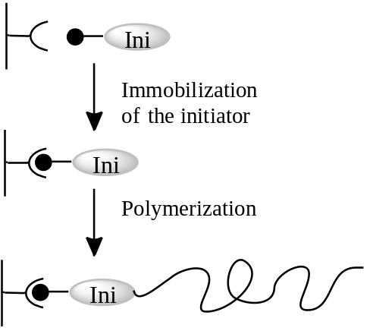
Figure 1-5. Schematic illustration of the common strategy used in the “grafting from” approach. An initiator molecule (Ini) is deposited on the surface via reaction of the anchor group with suitable surface sites and, subsequently, chains are grown on the surface from initiating sites. (Adapted from reference 2.)

In one part of my thesis work, reversible addition-fragmentation chain-transfer (RAFT) polymerization was used to produce polymer brush layers by a “grafting to” technique. RAFT polymerization involves a reversible addition fragmentation cycle in which there is a transfer of a dithioester moiety between active and dormant species, as shown in Figure 1-6. RAFT polymerization allows control of molecular weight, yielding polymers with narrow polydispersity. The chain transfer agent used in RAFT polymerization can be designed to have a functional group that is useful for attaching chains by their ends. In the “grafting from” technique, initiators are immobilized onto the surface and end-tethered polymer chains are synthesized by surface-initiated polymerization. A variety of polymerization methods, including thermal or photo-initiated free radical polymerizations, living anionic and cationic polymerizations, and “living” free radical polymerizations (LRP) have been used to produce surface-tethered polymer layers via the “grafting from” approach. Of these techniques, LRP techniques like atom transfer radical polymerization (ATRP) are most widely used because of their ability to produce polymers of low polydispersity and controlled molecular weight due to the equilibrium established between active and dormant chains, which is depicted in Figure 1-7.

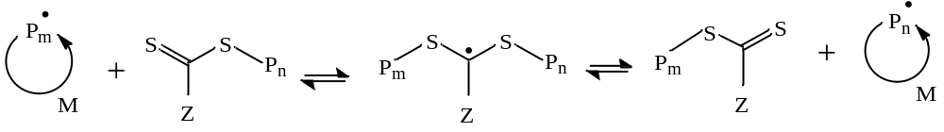
Figure 1-7. Mechanism of main RAFT equilibrium. RAFT polymerization allows controlled growth of polymers through the equilibrium between active and dormant species where dithioester compound acts as chain transfer agent. (Adapted from reference 2.)
ATRP can be used to synthesize complex polymer architectures and it is versatile in terms of the type of monomers that can be used. ATRP makes use of transition metal catalysts, such as copper, that can exist in different oxidation states. During this process, the dormant polymer chain is end-capped with halogen atom (X = Cl or Br). The transition metal-ligand complex, Cu^{I}-Y/Ligand, abstracts the halogen atom from the polymer end, creating a higher oxidation state species, X-Cu^{II}-Y/ Ligand, while at the same time generating an active propagating radical, P●. The oxidized form of the catalyst (X-Cu^{II}-Y/ Ligand) can recombine with the propagating radicals to recreate the corresponding halogen-capped dormant species (P-X) and Cu^{I} species. This cycle occurs repeatedly and randomly, thus allowing all of the chains to grow slowly and simultaneously. When ATRP is adapted as a surface-initiated process, a drawback is that additional steps must be taken to determine the molecular weight and the polydispersity index of chains because the polymer chains are end-tethered to the surface. The obvious way in which this can be done is to cleave the chains from the surface, collect them and analyze them. But because flat surfaces have very low surface areas and brushes typically have low grafting densities (10¹⁶ chains/m²), the amount of polymer recovered after cleaving will be in the range of nanograms, and collecting and analyzing such a small sample is challenging. An alternate strategy to address this question is to carry out surface initiated ATRP (SI-ATRP) in presence of free initiator in the solution, which is often referred to as “sacrificial” initiator.²⁶ The sacrificial initiator results in growth of untethered polymer chains in solution and also helps to establish the equilibrium between growing and dormant chains (depicted in Figure 1-7) by providing a source of deactivating species. These free chains can be collected, analyzed and used to describe the molecular weight and polydispersity index of the tethered chains.

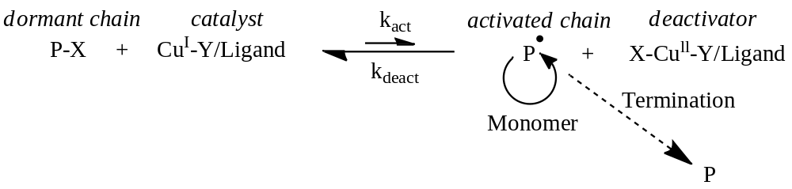
Figure 1-8. Mechanism of transition metal catalyzed atom transfer radical polymerization (ATRP). In ATRP the equilibrium is shifted towards dormant species, leading to propagation in a well-defined (uniform) manner. (Adapted from Reference 2.)

Prior Work on Weak Polyelectrolyte Brushes
Transitions from the osmotic brush regime to the salted brush regime have been studied for both strong as well as weak PE brushes using a variety of techniques including ellipsometry,^{11a, 18, 21} dynamic light scattering,²⁷ neutron reflectivity^{17a, b, 28} and atomic force microscopy.²⁹ The theoretical predictions for the dependence of the height of the strong PE brush on the added salt concentration have been verified experimentally.^{17c, 27, 30} However, the experimental studies performed on weak PE brushes show some discrepancies with the theoretical predictions for the osmotic brush regime.^{18, 21, 29} Parnell et al. investigated the swelling behavior of PMAA brushes as function of pH and salt concentration in aqueous solutions using atomic force microscopy. They found that the swelling transition of PMAA brushes occurred at pH 9, which is different from the pK_{a} of the monomer, which is 5.5. Their results show that the exponent scaling the relationship between the height and the salt concentration in the osmotic brush regime is significantly smaller than what is predicted by the theory. These studies provide no details of the local structure of the brush. Genzer et al. also studied the interfacial properties of poly(acrylic acid) brushes as a function of ionic strength, solution pH, polymer grafting density, and molecular weight using spectroscopic ellipsometry.³¹ For these studies they used PAA brushes with a gradual variation in grafting density on a single solid substrate. According to their results, in the osmotic brush regime and at high grafting density σ, the height of the brush scales like H ~ σ^{n}, where 0.28 < n < 0.34. These results are in contrast to theory, which predicts H ~ σ^{-1/3}.
Although, these two examples from the literature highlight efforts to examine the link between charge and the structure of weak PE brushes, there are some shortcomings. For example, PMAA brushes studied in Rühe’s group are highly polydisperse, and in Parnell’s work no efforts were made to study the nanoscale structure of the brush, as they used AFM to image the surface. In Parnell’s work they did not explain why the pK_{a} changes by ~4 orders of magnitude. These curiosities along with the variation in the scaling exponents reported for weak PE brushes in osmotic brush regime suggests the current need for careful structural studies of these systems.
The previous discussion of the complex behaviors of weak PE brushes does not consider the details of the shape (structure) of polyelectrolyte brush. Of course, the segment density of the surface-attached brush is one of the key factors that determines their physical properties. Experimental verification of theoretical predictions of brush density profiles has been difficult, largely because idealized grafting conditions are usually assumed. Zhang and Rühe prepared polymethacrylic acid (PMAA) brushes by thermally initiated, free radical polymerization from surface tethered azo-initiators²¹ and studied their swelling behavior using ellipsometry. Free radical polymerization leads to brushes with high polydispersity (~2), and ellipsometry uses a ‘box model’ to describe the density profile of the brush. A box model assumes that all of the polymer chains stretch in the same way up to certain height, as if the polymer chains are monodisperse. But due to high polydispersity, Rühe’s brush shows a segment density profile shaped like an exponential decay. Thus the results obtained from ellipsometry give an idea about the average structure (height) of polymer brushes without any details of the actual profile of the brush. According to theoretical studies, the segment density profile of the real brush is parabolic with a ‘tail’ at the end. This tail occurs because of fluctuations of the brush at the outer interface due to finite chain length and polydispersity.^{22b} Thus the details of the nanoscale structure of the brush become important because the segment density profile of the brush is not constant with distance from the tethering surface. The particular shape of the profile governs the range and strength of the interactions across the brush-modified surface. The work of Szleifer et al. is an excellent example of this. They demonstrated that the local pH and degree of dissociation within a weak polyelectrolyte brush changes significantly with the distance from the grafting surface because the monomer concentration changes as one walks out along the brush.^{12a} As a result, not only does the overall structure of a weak PE brush change as solution conditions are changed, but the details of the “internal” structure also changes. For example, lowering the salt concentration results in an increase of protons within the polymer layer and they start playing a role as counter-ions.
This highlights the fact that the local structure, properties and interactions of polyelectrolyte brushes hinge on the layer composition and distribution of charged groups. Therefore, a key goal of my work was to develop PE brushes with uniform, well-defined segment density profiles in order to examine the effects of pH and salt on brush structure. Through this work, in which neutron reflectometry is used to study weak PE brushes, it will be interesting to gain experimental insight to parallel the findings of Szleifer et al., which derive from theory, concerning segment density profiles.
Neutron reflectivity has the ability to reveal the segment density profile of the layers and also to provide an opportunity to examine the brush structure under different environmental conditions with nanoscale resolution.^{17b} There have been only a few studies of the average structure of weak PE brushes. Thus, there are many unanswered questions regarding the molecular level response of the PE brushes to the changes in their environment. For example, how does the nanoscale structure change when the pH is changed? Is the shrinkage of the brush uniform as salt concentration is changed, or does the periphery of the brush contract differently than the region near the surface that has a higher segment density? Do all salts induce the same response or there are ion specific effects? I have tried to address these questions through my work.
In a majority of my work, poly(methacrylic acid) brushes are made using surface initiated ATRP (SI-ATRP), which produces uniform layers and also circumvents the problem of low grafting density. The nanoscale structure of these brushes is studied mainly by neutron reflectometry, which will provide access to the shape of the segment density profiles. Tools such as ellipsometry and atomic force microscopy have also been used.

Neutron Reflectivity - An Important Tool to Study Polyelectrolyte Brushes
Neutron reflectivity is an ideal tool for studying polymer thin films organized on flat surfaces at fluid-substrate interfaces due to its convincing and unique capabilities. In the neutron reflectivity measurement, a monochromatic neutron beam is reflected off of a flat surface and the intensity of the specular reflection is measured as a function of angle. The specular reflectivity of a neutron wave of wavelength λ incident at angle θ onto the surface, is described in terms of the wave vector transfer Q,
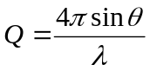 (1.2)
Specular reflectivity contains information related to the laterally-averaged segment density profile of a polymer film normal to the substrate, which is related to both the composition of the polymer film and its density. The wavelength of neutrons used for reflectivity measurements is on the order of 1 Å, i.e. three magnitude shorter than light. As a result, details of the molecular-level structures can be probed. Because neutrons are deeply penetrating, it is possible to investigate buried interfaces, which are not accessible by other techniques that use light. Neutrons can probe materials encased in a variety of sample environments such as liquid and humidity cells.³² To calculate the reflection of light, the refractive index and angle of incidence is used, but for neutron reflectivity, scattering length density and wave vector transfer Q are used. The relation between refractive index n and the scattering length density N_{b} is shown in Equation 1.3.
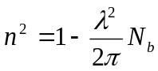 (1.3)
The scattering length density N_{b} is given by
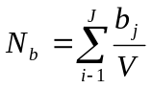 (1.4)
where V is the molar volume of J atoms in the compound composed of nuclei of scattering length b_{j}. The neutron scattering length is an experimentally determined quantity which measures the strength of interaction between a neutron and the nucleus. The value of neutron scattering length varies unpredictably through the periodic table and from isotope to isotope. Therefore, the scattering length density of a compound can be manipulated through the use of isotopic substitution. Since the neutron interacts with the nucleus, isotopic substitution will significantly change the scattering length densities of the materials without an appreciable change in their chemistry.³³ Due to the vast difference in scattering lengths of hydrogen and deuterium, compounds can be synthesized using deuterium as the isotopic label, which provides contrast that can be used to ‘highlight’ distinct regions of a polymer film, for example. As the reflectivity depends on the differences in scattering length density between the layers, deuteration can also be used to highlight selected regions or phases in a polymer film. Along with scattering length densities, the thicknesses of polymer films measured with neutron reflectivity are also dependent on local segment concentrations. Therefore neutron reflectivity measurements yield information about the roughness, uniformity and most importantly, the segment density profile normal to the surface.^{17b, 34} It is a challenging task to decipher the measured reflectivity data to produce a physical representation of a system because there is no unique solution for a given reflectivity curve. Commonly, the reflectivity data is fitted to a slab-like model consisting of multiple layers described by their thicknesses, scattering length densities and also the interfacial widths between the slabs of the film. To constrain the models to fit the neutron reflectivity curve, one must use data from the multiple measurements of the same sample under different conditions. The ambiguities in data fitting can also be reduced by using additional information about the sample obtained from other complimentary instrumental techniques like ellipsometry, atomic force microscopy, scanning electron microscopy (SEM), X-ray techniques, etc. and also from theoretical simulations.
Neutron reflectivity has been widely used to examine the structure and behavior of polyelectrolyte brushes.^{17a, b, 28, 30} In spite of their significance and relevance to fields of biology and medicine, polyelectrolytes are the least understood class of polymeric systems. In addition, the behavior of polymers at wet interfaces is important in a number of technological areas. One of the key features that dictate performance of a solvated polymer film is the distribution of polymer segments normal to the interface. Therefore, neutron reflectometry is well suited for the study of such systems.
In the recent work of Prabhu et al.,³⁵ the counter-ion distribution inside a cross-linked weak polyelectrolyte film is determined. In that work, H₂O/D₂O mixtures were used in neutron reflectivity measurements to contrast match the scattering length density of the dry poly (5-(2-trifluromethyl-1,1,1-trifluro-2-hydroxypropyl)-2-norborene) film grown on a silicon substrate. This film was equilibrated within a liquid cell with controlled concentration of deuterium labelled d₁₂-tetramethylammonium (d-TMA) hydroxide. The condensation of d-TMA cations onto the grafted polyanion film resulted in an enhancement of reflectivity. The distribution of the d-TMA cations within the film and the swelling of the polymer layer could be determined by fitting the measured reflectivity profiles. This work demonstrated the ability of neutron reflectivity to determine the structure of solvated films and also its sensitivity to isotopic substitution.
The analytic self-consistent field (SCF) theory by Zhulina et al.³⁶ predicts a parabolic segment density profile, ϕ(z), for neutral polymer brushes of the form
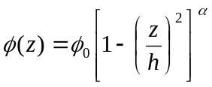 (1.5)
Here h is the cut-off thickness of the profile and α takes the value of 1 in a good solvent and a value of ½ in a θ solvent. Karim et al.^{22b} used neutron reflectometry to systematically investigate the effects of solvent quality on a relatively dense polystyrene brush that was chemically grafted onto silicon via a SiCl₃ group. Neutron reflectivity measurements were performed over a range of temperatures above and below the theta point. Deuterated solvents were used to obtain satisfactory contrast between the protonated polymer layer, the silicon substrate and the solvent. This is a good illustration of the versatility of neutron reflectivity to measure brushes in solvents other than water. From the neutron reflectivity curves and segment density profiles derived from them, contraction and stretching of polystyrene brush was observed as a function of the quality of solvent. The density profile shape exponent α that was used to fit the brush profile in good and theta solvents was in accord with self-consistent field theory calculations, which predict α = 1 and α = ½ respectively (Equation 1.5), except that it was necessary to add a “tail” described by an exponential decay to the profile beyond the end of the parabolic distribution so that the brush smoothly decayed to meet the solvent. These neutron reflectivity experiments also show that there is no relative depletion of polymer segments in the region immediately adjacent to the surface.^{22b}
Neutron reflectometry has also been used to study the adsorption and interaction of proteins with the material surfaces, but there have been fewer studies involving polyelectrolyte brushes. Hollmann et al. studied the adsorption of α-lactalbumin onto planar poly(acrylic acid) (PAA) brush using neutron reflectometry.³⁷ First a deuterated polystyrene (dPS) film was spin coated on a silicon surface and then a deuterated diblock copolymer consisting of poly(styrene-d₈)-poly(acrylic acid) (PS_{d8} -PAA) was transferred onto the substrate to create PAA brushes. D₂O was used as a solvent to determine how α-lactalbumin interacted with weak PAA brush at a bulk pH of 6.1. These measurements showed that despite the net negative charge on the protein, it penetrates into the PAA brush and does not accumulate at the substrate/brush or brush/solvent interfaces. This study is an example of the ability of neutrons to study how proteins interact with a planar charged brush in fluid environments. As shown through all of these works, neutron reflectivity is a powerful tool for studying polymer-modified interfaces, and it has been applied to study PE brushes in this thesis work.

Research Objectives
In view of previous discussions, the major objectives of the present work are to
- Synthesize uniform and well-defined weak polyelectrolyte brushes of methacrylic acid using either grafting to or grafting from synthetic strategies;
- Study the responsive behavior of weak polyelectrolyte brushes, mainly by using techniques such as ellipsometry and neutron reflectometry, as a function of pH, type of ions and ionic strength;
- Gain experimental insight to compare findings of Szleifer et al. concerning the segment density profiles of weak PE brushes; and
- Investigate the role of PMAA brushes as a template in calcium carbonate mineralization.
In this dissertation, Chapter 2 describes three methods for preparing substrates with alkyne groups which show versatility for “click” chemistry reactions. Two of the methods consist of using layers of poly(glycidyl methacrylate) (PGMA) and their reactive modification with either propargylamine or 5-hexynoic acid. The third method consists of using copolymers comprising glycidyl methacrylate and propargyl methacrylate. For each method, factors that control film thickness and content of alkyne groups were investigated using ellipsometry, and the nanophase structure of the films was studied using neutron reflectometry. Alkyne-modified substrates were used to attach azide-terminated polymers of methacrylic acid and 2-vinyl-4,4-dimethylazlactone using “click” chemistry. It was observed that the alkyne content obtained by the three decorating approaches was sufficiently high that it was not the limiting factor for the click reaction of azide-capped polymers. Because layers of low grafting density result from grafting to strategy, I switched to using a “grafting from” approach.
In Chapter 3, weak polyelectrolyte brushes made of poly(methacrylic acid) and also random copolymer brushes consisting of methacrylic acid (MAA) and hydroxyethyl methacrylate (HEMA) were made using SI-ATRP. HEMA was used because it is neutral and water soluble. In particular, structural responses as a function of pH were studied using neutron reflectometry. Multiple data sets were modeled to obtain dry polymer mass density, layer thickness and PE brush profiles into different pH solutions. This results in a self-consistent determination of the water content of PE films.
In Chapter 4, the influence of monovalent ions from the Hofmeister series on the structure and swelling behavior of polyelectrolyte brushes consisting of poly(methacrylic acid) (PMAA) chains made by a surface-initiated atom transfer radical polymerization (SI-ATRP) was investigated. Ellipsometry and neutron reflectometry (NR) were used to investigate how ionic strength of monovalent salts of the Hofmeister series affect the structure of PMAA brushes. In the NR measurements, constrained fittings (i.e. mass balance) were used at all conditions in order to help quantify how the structure of the brush changes as experimental conditions are varied. It was observed that the scaling behaviors of PMAA brushes with respect to salt concentration are similar in presence of different salts; however, the cross-over salt concentration at which the transition occurs is different for each type salt. The cross-over salt concentration for each ion can be explained by its position in Hofmeister series.
Finally, in Chapter 5, some preliminary results concerning calcium carbonate mineralization of PMAA brushes as a function of concentration of organic additive are described. PMAA brushes made by SI-ATRP were used. Calcium carbonate films were obtained by polymer-induced liquid precursor (PILP) strategy using an ammonia diffusion method. Mineralized PMAA brushes were characterized using techniques such as X-ray diffraction, scanning electron microscopy and X-ray photoelectron spectroscopy (XPS). The preliminary results suggest that as the concentration of polyacid additive present in the solution is increased, the extent of mineralization decreases.

- Versatility of Alkyne-modified Poly (glycidyl methacrylate) Layers for Click Reactions
[As published in Langmuir 2011, 27, 5986-5996 with slight revision]

Functional soft interfaces are of interest for a variety of technologies. In this chapter, I describe three methods for preparing substrates with alkyne groups, which show versatility for “click” chemistry reactions. Two of the methods have the same root: formation of thin, covalently attached, reactive interfacial layers of poly(glycidyl methacrylate) (PGMA) via spin coating onto silicon wafers followed by reactive modification with either propargylamine or 5-hexynoic acid. The amine or the carboxylic acid moieties react with the epoxy groups of PGMA, creating interfacial polymer layers decorated with alkyne groups. The third method consists of using copolymers comprising glycidyl methacrylate and propargyl methacrylate (referred to by the acronym pGP). The pGP copolymers are spin coated and covalently attached on silicon wafers. For each method, factors that control film thickness and content of alkyne groups were investigated using ellipsometry, and the nanophase structure of the films was studied using neutron reflectometry. Azide-terminated polymers of methacrylic acid and 2-vinyl-4,4-dimethylazlactone synthesized via reversible addition fragmentation chain transfer polymerization, were attached to the alkyne-modified substrates using “click” chemistry, and grafting densities in the range of 0.007-0.95 chains nm⁻² were attained. The maximum density of alkyne groups attained by functionalization of PGMA with propargylamine or 5-hexynoic acid was approximately 2 alkynes nm⁻². The alkyne content obtained by the three decorating approaches was sufficiently high that it was not the limiting factor for the click reaction of azide-capped polymers.

Introduction
The properties of interfaces dictate a variety of processes ranging from cellular signaling³⁸ to rusting of metals. As a result, the ability to tailor interfacial properties in useful and convenient ways is essential for improving materials performance, adapting existing technologies, and developing novel devices.³⁹ The use of soft materials for this purpose offers a number of possibilities because of the rich variety of available functional groups and relatively mild conditions needed to process them. One recently introduced method for installing functionality onto materials are so-called “click” reactions, which are specific, high yielding orthogonal chemical couplings that generate innocuous or no byproducts. The application of orthogonal click reactions in the synthesis of polymeric materials was comprehensively reviewed by Hawker et al.⁴⁰ Of the various types of click reactions, copper catalyzed alkyne-azide cycloaddition is a particularly convenient 1,3-dipolar cycloaddition reaction because of its specificity, tolerance to many chemical environments and stability of the resulting 1,4-disubstituted 1,2,3-triazole ring.⁴¹ To create surfaces amenable to click chemistry, it is necessary to install one of the participating functional groups on the surface. This can be accomplished through the use of azide-capped self-assembled monolayers (SAMs) grafted either to oxide⁴² or to gold surfaces, and these azide-functionalized SAMs have been used to couple alkyne-containing polymers,⁴³ polypeptides,⁴⁴ DNA,⁴⁵ and ferrocenes⁴⁶ to the surface. Hydrosilylation of 1,8-nonadiyne on hydride-terminated silicon substrates has also been used to produce well-defined monolayers of terminal alkyne molecules on silicon; however, this approach requires the use of hydrofluoric acid, elevated temperatures, and an inert environment.⁴⁷ Initiated chemical vapor deposition (iCVD) of propargyl methacrylate (PMA) onto silicon followed by surface plasma polymerization has been used to create alkyne-functionalized surfaces that could be “clicked” with azide-biotin.⁴⁸ Alkyne- bearing surfaces have also been made by covalent attachment of small molecules onto vapor-deposited SAMs chemically oxidized by ozone (generated by UV radiation)⁴⁹ and also onto polyethylene films oxidized using Cr(IV) in sulfuric acid.⁵⁰ In each case, functionalization of reactive carboxylic acid groups yields the alkyne-decorated surfaces. The resulting polymer-modified substrates have been used to control biofouling⁴⁹ and to create multilayer structures via layer-by-layer (LbL) clicking of alternating alkyne- and azide-functionalized poly(N-isopropyl acrylamide) (PNIPAM) chains.⁵⁰ The LbL approach has also been used for the functionalization and clicking of poly(acrylic acid) on quartz, silicon, and gold⁵¹ as well as for the clicking of dendrimers onto silicon substrates.⁵²
The use of reactive polymers as “primers” that covalently bind to surfaces and allow further functionalization has drawn interest because of the ability to cast these polymers onto various surfaces and to widely vary the type of chemical modifications that can subsequently be used to alter surface properties, thereby producing robust and tunable layers.⁵³ Controlled radical polymerization techniques have been used to make copolymers containing both protected alkyne groups and functionalities that have affinity for the substrates. For example, Fleischmann et al. synthesized a random terpolymer of styrene, a protected alkyne and glycidyl methacrylate (GMA) via nitroxide mediate polymerization (NMP).⁵⁴ Rengifo et al. synthesized alkyne-terminated diblock copolymers of tert-butyl acrylate (tBA) and methyl methacrylate (MMA) via atom transfer radical polymerization (ATRP) using an initiator that contained a protected alkyne.⁵⁵ In both cases, the resulting polymers were applied to silicon, quartz, or glass surfaces by spin coating. Surface anchoring was achieved through reaction of the epoxy groups of GMA with hydroxyl groups on the surface or through physisorption (due to favorable thermodynamic interactions) of the poly(methyl methacrylate) (PMMA) block onto the surface. Deprotection strategies were used to make alkyne functionalized surfaces, which could then be used in click reactions. Recently, Ostaci et al. used a method that avoids the need for deprotection in order to functionalize silicon surfaces with alkyne groups; their strategy consisted of forming random copolymers of GMA, PMA, and MMA via RAFT polymerization.⁵⁶ The copolymer was chemically anchored to the surface through the reaction of the epoxy groups on GMA and the silanol groups on the surface. The MMA served as a spacer and PMA provided the alkyne groups, and azido-terminated poly(ethylene glycols) of different molecular weight were attached to the substrates via click chemistry.
In this chapter, I describe the facile and convenient preparation of alkyne-functionalized silicon surfaces and its applicability for click reactions to attach polymer chains, focusing specifically on methods that covalently tether the layers to the surface and avoid protection/deprotection strategies. Silicon surfaces were modified with either PGMA homopolymers or random copolymers of GMA and PMA (pGP) using spin coating followed by annealing for short times under mild conditions to promote covalent attachment to the surface through the epoxy groups. However, even under these mild conditions, cross-linking of the chains can occur. Residual epoxy groups of the PGMA homopolymer films were modified with small alkyne-containing molecules of basic or acidic nature (propargylamine and 5-hexynoic acid, respectively), yielding surfaces displaying alkyne functionality as seen in Figure 2-1. The topography, nanoscale structure, and mass density of the alkyne-decorated films were studied using neutron reflectometry. The various alkyne-functionalized surfaces were modified by copper-catalyzed alkyne-azide cycloaddition of azide-capped polymers made by RAFT polymerization. The range of alkyne-decorating conditions explored point to numerous ways to tune the surface density of alkyne groups.

Experimental section

Materials
All reagents were purchased from Aldrich at the highest purity available and used as received unless specified otherwise. Methacrylic acid (MAA), 2-vinyl-4,4-dimethylazlactone, (VDMA; Isochem North America, LLC) glycidyl methacrylate (GMA), propargyl methacrylate (PMA), and propargylamine were fractionally distilled under reduced pressure and the middle fraction (∼70%) was collected and retained for use. 2,2’-Azobis(2-methylpropionitrile) (AIBN) was recrystallized from anhydrous methanol (MeOH) three times and dried under vacuum. Silicon chips of size 1 × 1.2 cm were purchased from Silicon Quest. Two-inch diameter, 5000-μm thickness single-side polished silicon wafers for neutron reflectometry studies were purchased from the Institute of Electronic Materials Technology (ITME).

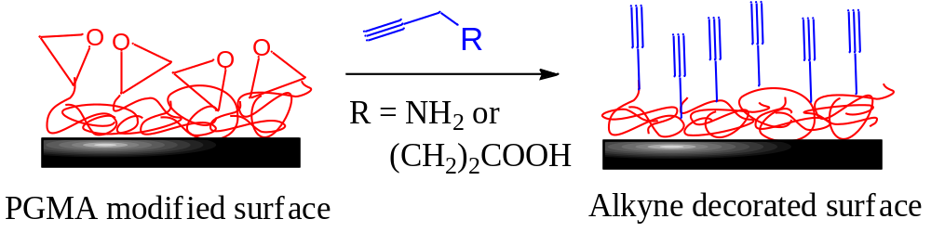
Figure 2-1. Residual epoxy groups of PGMA-modified films react with alkyne-containing molecules of basic or acidic nature (propargylamine and 5-hexynoic acid, respectively), yielding surfaces displaying alkyne functionality.

Instrumentation
Solution ¹H and ¹³C NMR spectroscopy was performed on a Bruker/TecMag-AC250 spectrometer. The molecular weight of PMAA was measured using aqueous gel permeation chromatography (GPC). The separation module consisted of an Agilent Technologies 1200 series autosampler, Agilent Technologies 1100 series pump and degasser equipped with two Polymer Laboratories PL Aquagel-OH mixed columns 8 μm (300 × 7.5 mm) and one PL Aquagel-OH column guard 8 μm (50 × 7.5 mm), a Wyatt technology Heleos multiangle light scattering detector, and a Wyatt Optilab rEX differential refractive index detector. The mobile phase consisted of 20% acetonitrile and 80% aqueous solution consisting of 0.01 M Na2HPO4 and 0.05MNaNO3.⁵⁷ The specific refractive index increment, dn/dc, of PMAA in this mobile phase was measured to be 0.142 mL/g. The flow rate was 1 mL/min. Data acquisition and molecular weight calculations were performed using the Wyatt Technology Astra V software. The molecular weights reported for PGMA and P(GMA-co-PMA) (also called pGP) are relative to PMMA standards and were measured by GPC using tetrahydofuran (THF) as the mobile phase. The absolute molecular weights of PVDMA were measured using a dn/dc of PVDMA in THF of 0.084 mL/g.⁵⁰ This system consisted of a Waters Alliance 2695 Separations Module equipped with three Polymer Laboratories PLgel 5 μm mixed-C columns (300 × 7.5 mm) in series, a Waters Model 2414 Refractive Index detector, a Waters Model 2996 Photodiode Array detector, a Wyatt Technology miniDAWN multiangle light scattering (MALS) detector. Spin coating was done using either a Laurell WS- 400B-6NPP/LITE spin coater or a Headway Research Inc. spin coater (model PWM32) at 2,500 rpm. Attenuated total reflectance Fourier transformed infrared spectroscopy (ATR-FTIR) absorption spectra were obtained using a Harrick VariGATR accessory in a Bruker Optics Vertex 70 instrument using a KBr beamsplitter and an MCT detector. Sixteen background scans were collected (Ge crystal) and 702 scans were collected for each sample. Thicknesses of polymer thin films were measured using either a J.A. Woollam M-2000 U spectroscopic ellipsometer at a reflection angle of 70° or a Beaglehole Instruments Picometer ellipsometer at multiple angles of incidence ranging from 80° to 60° using 1° increments. Atomic force microscopy (AFM) images were collected using a Veeco Instruments Nanoscope IIIa multimode atomic force microscope. The topographical height and phase contrast images were acquired in tapping mode using a constant amplitude set point.
Neutron reflectivity measurements were made at the Spallation Neutron Source (SNS) at Oak Ridge National Laboratory using the Liquids Reflectometer (LR). The LR collects specular reflectivity data in a continuous wavelength band (set to 2.5 Å < λ < 6.0 Å) at several different incident angles; here θ = 0.19°, 0.27°, 0.34°, 0.62°, 1.12°, and 2.01° were used. As a result of these instrument settings, data are acquired over a wavevector transfer (Q = 4π sin θ/λ) range of 0.006 Å⁻¹ < Q < 0.176 Å⁻¹. Data were collected at each angle with incident-beam slits set to maintain a constant relative wavevector resolution of δQ/Q = 0.078, which allows the data obtained at different θ to be stitched together into a single reflectivity curve. The neutron refractive index depends on the scattering length density (SLD), Σ, which is determined using the equation Σ = b/V, where b is the monomer scattering length (sum of scattering lengths of constituent atomic nuclei) and V is the monomer volume. To fit the data, the initial thicknesses measured using ellipsometry were used to calculate the reflectivity and then layer compositions, thicknesses, and interfacial widths were adjusted to optimize the goodness-of-fit⁵⁸ of the model with the neutron reflectivity data.

Synthetic Procedures

2.2.3A Synthesis of Azide-Capped PMAA and PVDMA via RAFT Polymerization
Reversible addition-fragmentation chain transfer (RAFT) polymerization is a versatile controlled radical polymerization technique that allows chain-end functionalized polymers to be readily synthesized.^{25, 59} Azide-capped PMAA and PVDMA were synthesized via RAFT polymerization, as shown in Scheme 2-1, using azide-capped chain transfer agents (CTAs) based on 4-cyano-4-(dodecylsulfanyl-thiocarbonyl) sulfanyl pentanoic acid (CMP)²⁵ and 2-dodecylsulfanylthiocarbonylsulfanyl-2-methylpropionic acid (DMP).⁶⁰ The azide-capped CTAs are referred to here as CMP-N₃ and DMP-N₃, and are synthesized according to literature procedures.⁶⁰

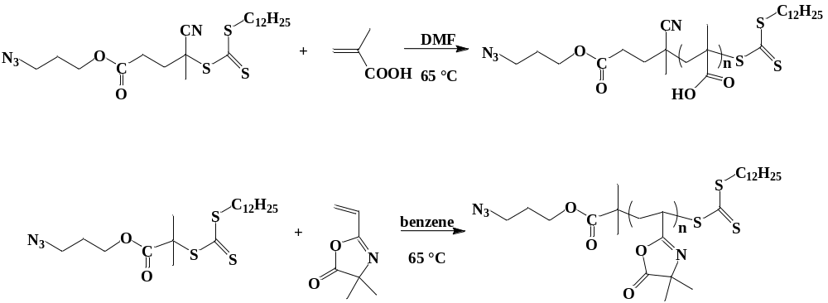
Scheme 2-1 Synthesis of Azide-Capped PMAA (PMAA-N₃) and PVDMA (PVDMA-N₃)

As an example, RAFT polymerization of MAA was performed as follows: (Scheme 2-1) MAA (2.58 g, 30 mmol) was added into a 50 mL round-bottom flask equipped with a Teflon-coated magnetic stir bar along with CMP-N₃ (31.4 mg, 6.45 × 10⁻² mmol), AIBN (2.1 mg, 5.2 × 10⁻³ mmol) (from a dimethylformamide [DMF] stock solution of concentration 5 mg/mL), and 27.5 mL of DMF. These amounts equate to [MAA] = 1 M, [MAA]/[CMP] = 465 and [CMP]/[AIBN] = 5. The reaction vessel was sealed and the solution was sparged with dry argon for at least 30 min to remove any oxygen present. The reaction vessel was then placed in a preheated oil bath at 65 °C and allowed to react for 12 h, after which the reaction vessel was removed, cooled to room temperature, and opened to the atmosphere. PMAA-N₃ was recovered by precipitating into diethyl ether and purified by redissolving in methanol and precipitating into diethyl ether three times followed by drying for ∼15 h under vacuum. The RAFT polymerization of VDMA was performed following a similar protocol, using DMP-N₃ as CTA and benzene as solvent. PVDMA was isolated by precipitation into hexanes and then purified by redissolving in THF and precipitating into hexanes (cycle repeated three times), followed by drying overnight under vacuum.

2.2.3B Synthesis of PGMA and P(GMA-co-PMA)
A homopolymer of GMA and random copolymers of GMA and PMA were synthesized by free radical polymerization.⁶¹ Typically, 8 mL of the monomer (e.g., GMA), 25 mL of benzene and 250 mg of AIBN were added to a 50 mL round-bottom flask. The reaction vessel was sealed with a rubber septum and sparged with dry nitrogen for at least 30 min. The reaction vessel was then placed in a preheated oil bath at 65 °C and allowed to react for 90 min. The polymers were recovered by precipitation into cold hexanes. In the case of copolymers, compositions were altered by changing the feed ratio of GMA:PMA. The composition of the each of copolymers (as determined by ¹H NMR) is in close agreement with the GMA:PMA feed ratio. Table 2-1 shows the properties of PGMA homopolymer and poly(glycidyl methacrylate-co-propargyl methacrylate) (pGP) copolymers. The naming scheme for the pGP copolymers identifies the GMA/PMA feed ratio.

Table 2-1. Properties of PGMA Homopolymer and pGP Copolymers
Entryª | GMA:PMA^{b} | M_{n} / g mol^{-1 c} | PDI
pGP-2/1 | 2:1 | 60,600 | 3.23
pGP-3/1 | 3:1 | 56,200 | 3.11
pGP-5/1 | 5:1 | 52,800 | 2.66
pGP-10/1 | 10:1 | 51,500 | 2.11
PGMA | 1:0 | 66,300 | 1.90
ª The numbers associated with each name of the pGP copolymers identifies the GMA/PMA feed ratio. ^{b} The copolymer composition (as determined by ¹H-NMR) was in close agreement with the feed ratio. ^{c} Measured by GPC in THF against PMMA standards.

2.2.3C Alkyne Modification of Silicon Surfaces
Silicon substrates were freshly cleaned by immersion in piranha acid (3:1 v/v solution of concentrated sulfuric acid and 30% aqueous hydrogen peroxide) at 110 °C for 90 min, followed by rinsing with copious amounts of distilled, deionized water and drying with a stream of dry nitrogen. Caution: piranha acid is a strong oxidizer and a strong acid. It should be handled with extreme care, as it reacts violently with most organic materials. While the following procedure describes surface modification with PGMA, because the attachment occurs by reaction of the epoxy groups on the polymer with silanol groups on the surface, analogous procedures were followed for modifying silicon surfaces with pGP copolymers. Freshly cleaned silicon surfaces were spin coated at 2500 rpm using a solution of PGMA in 2-butanone, chloroform, or toluene (100 μL, 0.05-0.27 wt %). The PGMA-coated substrates were then annealed under vacuum at 110 °C for 30-45 min in order to promote covalent attachment of the epoxy groups to hydroxyl groups on the surface. After removing the polymer-modified surfaces from the oven and allowing them to cool, they were rinsed with copious amounts of solvent and sonicated for at least 20 min to remove any nonbonded chains. The change in ellipsometric thickness before and after rinsing was negligible. The same solvent used for spin-coating (2-butanone, chloroform, or toluene) was used in the rinsing and sonication steps. ATR-FTIR spectroscopy was used to qualitatively confirm the presence of alkyne groups on the substrates. The ATR-FTIR spectrum of a pGP-3/1 film (shown in Appendix A Figure A-1) shows a band at 2125 cm⁻¹ that is characteristic of the carbon-carbon triple bond in alkynes. Additionally, a more intense band at 3270 cm⁻¹ corresponding to the stretch between the triple bond carbon and the terminal hydrogen atom is observed. The same bands were observed in PGMA-Prop and PGMA-Hex films (not shown).
To install alkyne groups on the PGMA-modified surfaces, the substrates were submerged in a solution of propargylamine in 2-propanol (2-50% v/v) and allowed to react for 1-75 h at 55 °C. The substrates were sonicated in 2-propanol for 15 min, rinsed, and dried. The propargylamine functionalized substrates will be referred to as PGMA-Prop. Alternatively, PGMA-coated substrates were covered with 5-hexynoic acid (bulk liquid) and then allowed to react at 60 °C for 0.75-110 h. The substrates were sonicated in 2-propanol for 15 min, rinsed with 2-propanol, and dried with a stream of dry nitrogen. The hexynoic acid functionalized substrates will be referred to as PGMA-Hex.

2.2.3D Click Reaction of Azide-Capped Polymers with Alkyne-Functionalized Silicon Surfaces.
The three different types of alkyne-functionalized surfaces (PGMA-Prop, PGMA-Hex, and pGP) were used. PGMA-Prop was used as the substrate for the click reaction with PMAA-N₃, PGMA-Hex and pGP were used as substrates for the click reaction with PVDMA-N₃. The click reaction between alkyne-modified PGMA-Prop and PMAA-N₃ typically were carried out as follows: 1.0 g of PMAA-N₃ was measured into a 20-mL scintillation vial and dissolved in 10 mL of methanol or DMF (0.027 or 0.01 mmol of -N₃, depending on the molecular weight) then the alkyne-modified silicon surface, PGMA-Prop, was immersed in the PMAA-N₃ solution. A catalyst system consisting of 100 μL of a 1 M sodium ascorbate aqueous solution (0.1 mmol), 100 μL of a 0.1 M CuSO₄ aqueous solution (0.01 mmol), and 5 μL of N,N-diisopropylethylamine (DIPEA) were added. An alternate catalyst system consisting of 3 mg of CuBr (0.02 mmol) and 5 μL of DIPEA was used for some reactions. The vial containing the polymer, the modified substrate, and catalyst was sealed by capping and then placed in a preheated oil bath at 50 °C. After allowing 24 h for reaction, the silicon chip was removed, rinsed with copious amounts of water and methanol or DMF, sonicated for at least 30 min in methanol and dried with a stream of dry nitrogen.
Click reactions between alkyne-modified PGMA-Hex and PVDMA-N₃ typically were carried out as follows: 200 mg of PVDMA-N₃ (0.0052 mmol) was added to a 25-mL round-bottom flask inside a glovebox. Ten mL of THF was added in order to dissolve the polymer and then 0.4 mg of Cu(PPh₃)₃Br (0.0005 mmol) and 1 mg of DIPEA (0.0015 mmol) were added. Finally, the alkyne-modified silicon surface, PGMA-Hex, was submerged in the PVDMA-N₃ solution. The solution was sparged with argon, sealed, and then placed in an oil bath preheated to 60 °C for 24 h. After this time, the surface was removed, rinsed with copious amounts of THF, sonicated in THF for at least 30 min, and dried with a stream of dry nitrogen. Click reactions between alkyne-modified pGP substrates and PVDMA-N₃ were typically carried out following the same procedure used for the click reaction between PGMA-Hex and PVDMA-N₃.

Results and Discussion

Alkyne Functionalization of Silicon Substrates

2.3.1A Formation of PGMA Layers
A base layer of PGMA of tunable thickness was deposited on silicon surfaces via spin coating and annealing. Covalent attachment to surface hydroxyl groups (silanol groups) by ring-opening of the epoxy groups of PGMA is promoted by annealing.⁶¹ This process may also result in crosslinking, though it has been demonstrated that the attachment of PGMA thin films on silicon substrates does not consume all of the epoxy groups,⁶¹ leaving residual functionality. The effect of the concentration of PGMA on the thickness of the resulting films prepared via spin coating was explored using three solvents of different polarity and boiling point: chloroform, 2-butanone, and toluene were used. Figure 2-2 shows how the ellipsometric thickness, H, of the PGMA films depends on the concentration of PGMA in the solutions used for spin coating. The PGMA film thicknesses were easily tuned over the range of 2-15 nm by the selection of solvent and concentration; however, PGMA layer thicknesses were consistently 1.9 ± 0.1 nm when toluene was used. Chloroform tended to produce the thickest and most uniform films and a linear increase of thickness with increasing concentration was observed. When using PGMA solutions made with 2-butanone, Luzinov et al. found that the resulting PGMA films had thicknesses in the range of 1-5 nm, and the thickness was proportional to the PGMA concentration.⁶¹

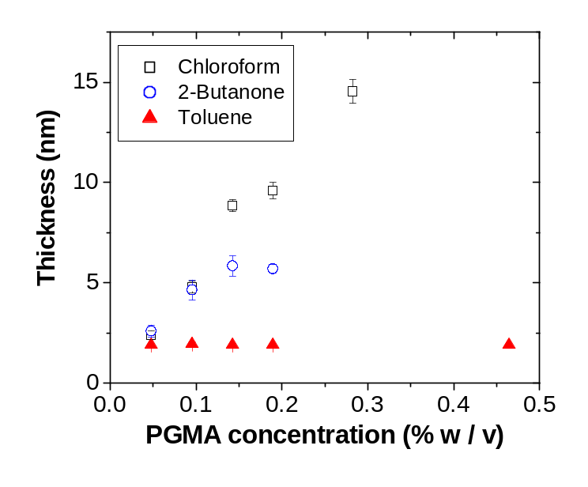
Figure 2-2. Dependence of PGMA film thickness on solvent and concentration of PGMA in the spin coating solution. The film thickness changed negligibly before and after annealing. The thicknesses reported were measured after annealing and sonication/rinsing with the corresponding solvent. Error bars derive from multiple (3) measurements across a given sample; for some points the error bars are smaller than the symbols.

A similar trend was found in spin coating experiments, but the thickness reached a plateau at ∼6 nm. The film thickness can also be adjusted by varying the molecular weight of the PGMA (results not shown). In general, at constant mass concentration of PGMA, higher molecular weights yield thicker films compared to lower molecular weights.
Atomic force microscopy was used to examine the topography of the PGMA films produced by spin coating from chloroform, 2-butanone, and toluene. (Images are shown in Appendix B). The rms roughnesses measured over a 1 μm² area were 0.3, 0.3, and 0.4 nm, respectively. The presence of ∼20 nm particles is apparent on the film cast from toluene; this is probably because the poor solubility of PGMA in toluene leads to the formation of latex-like particles that can deposit on the surface. Films made by spin coating from chloroform appear smoother than those made from 2-butanone. The content of water in the solvent and the relative humidity play important roles in the roughness of films spin coated from 2-butanone, but these conditions were not controlled here. Chloroform is a good solvent for PGMA and its water content is relatively low regardless of the relative humidity, which is likely why the thickness of films produced from chloroform are easily controllable.
In addition to topological images obtained by AFM and thicknesses measured with ellipsometry, neutron reflectometry was used to characterize the film thickness and structure of the reactive thin films. Because of the penetrating power of neutrons and their sensitivity to interfaces, specular reflectivity provides a picture of the laterally averaged structure of the polymer modified surface with angstrom-level resolution. Figure 2-3 shows the reflectivity curve from a typical PGMA film formed on silicon by spin coating from chloroform after annealing. The calculated reflectivity curve shown in Figure 2-3 is based on a single PGMA layer with a thickness of 135 Å, an SLD_{PGMA} = 8.3 × 10⁻⁷ Å⁻² and an interfacial roughness of 10 Å. The overall film thickness determined by neutron reflectometry is in good agreement with the thickness measured by ellipsometry (125 Å).
In a previous report in which ultrathin PGMA layers were used to anchor PVDMA brushes by a “grafting to” approach, the reflectivity profile of the resultant film (PGMA + PVDMA overlayer) was fit with a two layer model that assumed that the SLD of the PGMA layer was 1.35 × 10⁻⁶ Å⁻².⁶² It is possible that this SLD value reflects a situation where some PVDMA chains are mixed into the PGMA anchoring layer. In this work, a 290 Å thick PGMA film made by spin coating was also measured, and the reflectivity data (not shown) were well fit using a PGMA SLD = 1.0 × 10⁻⁶ Å⁻². A widely recognized problem in fitting reflectivity data is that uniqueness of the fit is not guaranteed.⁶³ I examined the goodness-of-fit as the SLD of the 135 Å PGMA film was changed, finding that (as shown in Figure C-1 in Appendix C) as the SLD increased from a value of 8.3 × 10⁻⁷ Å⁻², the quality of the fit decreased; however, at values around 1.50 × 10⁻⁶ Å⁻² the quality of the fit improved. For PGMA, an SLD of 8.3 × 10⁻⁷ Å⁻² implies an apparent density of 0.74 g/cm³. In contrast, an SLD value of 1.5 × 10⁻⁶ Å⁻² represents a density of 1.33 g/cm³. In comparison, the density of PGMA calculated using a group contribution method is 1.05 g/cm³, and a density of PGMA of 0.805 g/cm³ has been reported by a vendor. Because it is physically unrealistic for the PGMA thin film density to exceed its bulk value, a density of 0.74 g/cm³ reflects a more reasonable scenario in which the chains of the PGMA film are more entropically constrained than in the bulk. In the present work, we used PGMA films for functionalization (with propargylamine and 5-hexynoic) acid with thicknesses around 140 Å and found that SLD values around 8.3 × 10⁻⁷ ± 2 × 10⁻⁸ Å⁻² fit the data well.

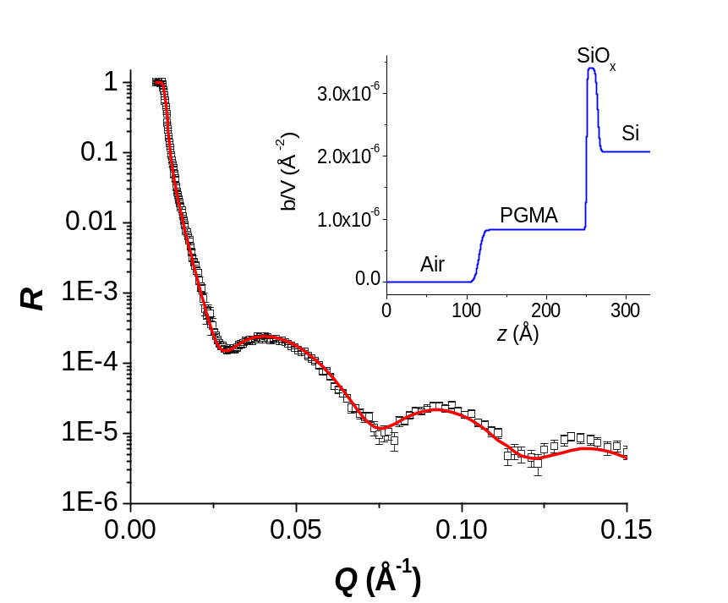
Figure 2-3. Neutron reflectivity profile of a PGMA film made by spin coating a 0.3 % (w/v) PGMA solution in chloroform onto a silicon substrate and annealing at 110 °C for 45 minutes. The black squares are the measured reflectivity and the solid line is the calculated reflectivity based on the model shown in the inset graph (PGMA layer thickness = 135 Å, SLD_{PGMA} = 8.3 × 10⁻⁷ Å⁻² and an interfacial roughness of 10 Å.)

2.3.1B Functionalization with Propargylamine
The reaction between epoxides and propargylamine was used to introduce alkyne groups onto the PGMA-coated silicon substrates as shown in Scheme 2-2. 2-Propanol was used as the solvent because it is known to catalyze the reaction between amines and epoxides⁶⁴ and also because exposing the PGMA coated substrate to propargylamine (neat) for moderate or long times resulted in a decrease in layer thickness, including complete removal from the substrate due to cleavage of the silyl ether bonds at the silicon/polymer interface formed when epoxy groups of PGMA react with silanol groups on the silicon substrate. Figure D-1 in Appendix D shows the increase in film thickness resulting from contacting PGMA films with propargylamine solutions of different concentrations (in 2-propanol) for 20 hours at 55 °C. Increases in ellipsometric thickness are observed up to a propargylamine concentration of 15% v/v, suggesting exhaustive functionalization of the PGMA films at these conditions. While H_{Prop} plateaus at approximately 5.5 nm, at high concentrations there is the possibility of a competition between the addition of propargylamine and cleavage of the PGMA layer by propargylamine, which is alkaline. At 100% propargylamine concentration (i.e. neat) under these conditions of reaction time and temperature, the PGMA film was entirely removed. The RMS roughness of a typical PGMA-Prop film (obtained at 20% v/v concentration for 24 hours) measured using AFM over a 1 μm² area is 1.1 nm. Negative control experiments in which the PGMA films were exposed to pure 2-propanol at 55 °C for 15 h resulted in negligible changes in ellipsometric thicknesses. One way to manipulate the grafting density, σ, of alkyne groups in the surface films is to alter either the concentration of propargylamine in the reaction solution or the exposure (reaction) time. Because the PGMA films are tethered, the addition of propargylamine results in an increase in ellipsometric thickness because of an increase in the molar mass of the average repeat unit. Figure 2-4 shows the increase in film thickness, H_{Prop}, as a function of reaction time upon exposure to a propargylamine solution (2% v/v solution in 2-propanol). Here a set of samples having the same initial PGMA thickness (nominally 14.5 nm) were used. The reactive modification takes place rapidly, with the thickness increasing rapidly over the first 3 h, and then slowing as the residual epoxides are consumed. The alkyne-containing PGMA-Prop films obtained after reaction with propargylamine were studied by neutron reflectometry. Figure 2-5 shows the reflectivity curve from a typical PGMA-Prop film obtained by reaction of a PGMA film with 20% v/v propargylamine in 2-propanol at 55 °C for 30 h. The unmodified (parent) PGMA film from which this PGMA-Prop film was produced was also studied by neutron reflectometry; its calculated reflectivity curve is represented by the dashed blue line, which was calculated using a model consisting of a single “slab” of PGMA with a thickness of 141 Å, an SLD_{PGMA} = 8.4 × 10⁻⁷ Å⁻² and an interfacial roughness of 20 Å (the data points are not shown for clarity, but χ² = 3.6 was obtained with this fit).

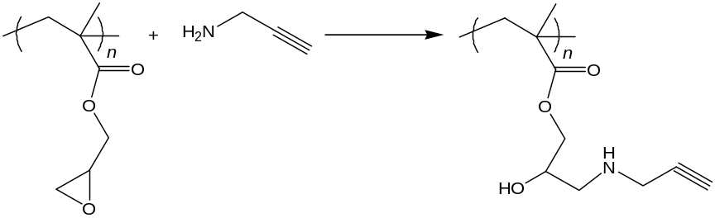
Scheme 2-2. Reaction between PGMA and propargylamine. (No particular extent of reaction is implied).

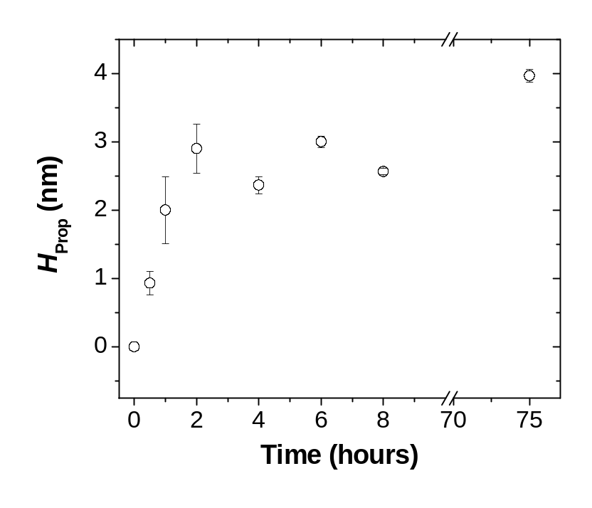
Figure 2-4. Increase in ellipsometric thickness of PGMA-coated silicon surfaces upon reaction with propargylamine (H_{Prop}). The initial PGMA layer thickness was nominally 14.5 nm and the propargylamine solution was 2% v/v in 2-propanol at 55 °C. Here the error bars represent thickness variations across a sample.

Modification of the PGMA layer with propargylamine to install alkyne groups onto the surface (as suggested by Scheme 2-3) increases the total thickness as evidenced by the narrower spacing of the Kiessig fringes as compared to the parent PGMA film. A single slab layer (PGMA-Prop) model was used to calculate the reflectivity curve shown in Figure 2-5 (solid line). The thickness of the PGMA-Prop layer was 190 Å, which corresponds to an increase of 49 Å with respect to the precursor PGMA layer, with an SLD_{PGMA-Prop} = 8.2 × 10⁻⁷ Å⁻² ± 5 × 10⁻⁸ Å⁻² (which translates into a mass density of 0.72 g/cm³) and an interfacial roughness of 25 Å.

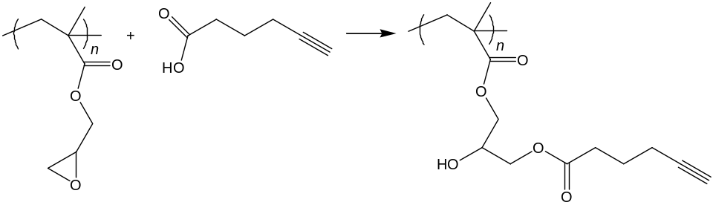
Scheme 2-3. Reaction between PGMA and 5-hexynoic acid. (No particular extent of reaction is implied by this scheme.)

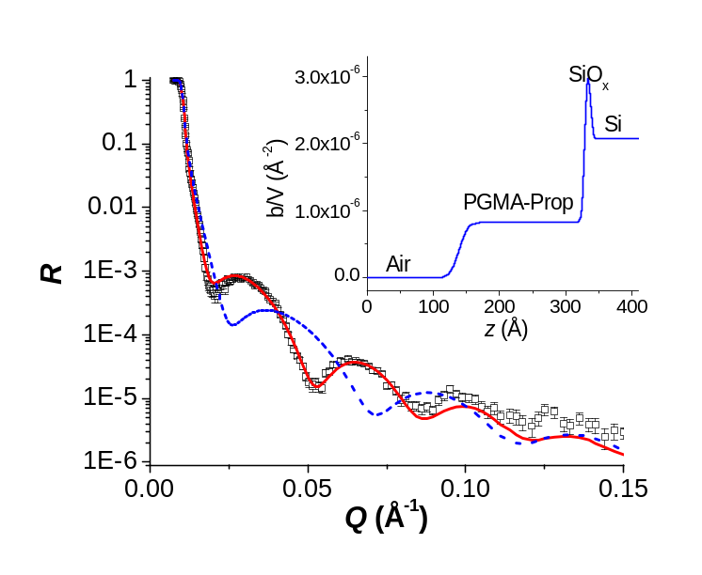
Figure 2-5. Neutron reflectivity profile of a propargylamine-modified PGMA film (PGMA-Prop) obtained by reaction of a PGMA film with 20% v/v propargylamine in 2-propanol at 55 °C for 30 hours. The data are well fit using a model consisting of a single slab of 190 Å thickness, SLD_{PGMA-Prop} = 8.2 × 10⁻⁷ Å⁻² and an interfacial roughness of 25 Å. The black squares are the measured reflectivity values; the continuous line is the reflectivity calculated using the SLD profile shown in the inset graph. The dashed line is the calculated reflectivity curve of the parent PGMA film (thickness 141 Å, SLD_{PGMA} = 8.4 × 10⁻⁷ Å⁻² and an interfacial roughness of 20 Å).

The extent of functionalization can be assessed by measurements of film thickness.⁶⁵ The grafting density, σ, can be expressed as follows:
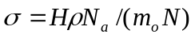 (2.1)
where H is the film thickness, ρ is the polymer density, N_{a} is Avogadro’s number, m_{o} is the molar mass of the monomer and N is the degree of polymerization.
If it is assumed that reaction of propargylamine with the anchored PGMA film changes only m_{o} and not σ (i.e., the number of chains per unit area) or the mass density, then the layer thicknesses can be used to estimate the extent of functionalization. Murata et al. proposed the following equation for determining the extent of conversion, f, based on changes in ellipsometric thickness:^{65a}
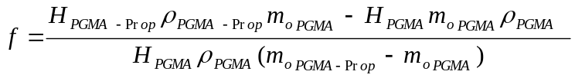 (2.2)
Considering that ρ_{PGMA} = 0.74 g/cm³, ρ_{PGMA-Prop} = 0.72 g/cm³ and using H_{PGMA-Prop} = 190 Å, H_{PGMA} = 141 Å, m_{oPGMA-Prop} = 197 Da, m_{oPGMA} = 142 Da, we find that f = 82% ± 12 for the reaction between propargylamine and the PGMA layer. The uncertainty in f arises from the uncertainty in the SLD of PGMA and the SLD of PGMA-Prop obtained by fitting. (A more precise assessment of the extent of functionalization could be made if there were higher contrast between the functionalizing agent and the surface attached film.) This reported f value is relative to the estimated total number of epoxy groups present before annealing. In the annealing step, a fraction of the epoxy groups react with silanol groups on the silicon surface and another fraction are expected to undergo cross-linking; therefore, the number of epoxy groups available for functionalization after annealing is lower than that for the as-cast PGMA film. I did not quantify the surface density of epoxy groups available for functionalization after annealing. The 82% conversion is likely the maximum achievable under the reaction conditions used, considering that the concentration of propargylamine and reaction time are sufficient to achieve full conversion as inferred from Figure 2-4. (Also see Figure D-1 of Appendix D.) Even though propargylamine is a relatively small molecule, it is likely that it will not completely diffuse into the PGMA layer.
The solvent 2-propanol favors the reaction but is not a good solvent for PGMA; therefore, the film is likely to be collapsed. Nevertheless, a high and tunable areal density of up to 42 alkyne groups/nm² (∼2.2 alkynes/nm³) can be achieved. The high areal density of alkynes reflects that they are not only at the film surface but within the film as well.

2.3.1C Functionalization with 5-Hexynoic Acid.
An alternate route for introducing alkyne groups that takes advantage of the reaction between carboxylic acids and epoxides was also tested.⁶⁶ Scheme 2-3 illustrates the reaction between PGMA and 5-hexynoic acid. Because carboxylic acids tend to be less reactive toward epoxides than amines, these reactions are often performed using a tertiary amine catalyst.⁶⁷ However, in the present work, catalyst was not used because of the potential for side reactions with PGMA.
As before, the change in ellipsometric thickness was used to assess our ability to decorate PGMA interfacial films with alkyne groups. Figure 2-6 shows the increase in PGMA film thickness after treatment with (neat) 5-hexynoic acid at 60 °C. The rate of increase was ∼0.5 nm/hour for the first 4 h before slowing, reaching a thickness increase of nearly 6 nm at 110 h. The slower rate of reaction observed when 5-hexynoic acid was used compared to when propargylamine was used presents an opportunity to more carefully tune the alkyne content of the layers.The rms roughness of a typical PGMA-Hex film (obtained after a reaction time of 48 h) measured by AFM over a 1 μm² area is 0.7 nm. Although both alkyne modified layers (i.e., PGMA-Prop and PGMA-Hex) have greater rms roughnesses than the parent PGMA layers that were spin coated from chloroform, PGMA-Hex layers tend to be smoother than PGMA-Prop layers (rms roughnesses of 0.7 and 1.1 nm, respectively, as shown in Appendix B). Neutron reflectometry was used to study the structure of the films resulting from reaction of PGMA films and 5-hexynoic acid (PGMA-Hex). Figure 2-7 shows the reflectivity curve of a PGMA-Hex film resulting from the reaction of a PGMA film with 5-hexynoic acid at 60 °C for 90 h along with the reflectivity calculated using the SLD profile shown in the inset. The unmodified PGMA film from which this PGMA-Hex film was produced was also studied by neutron reflectometry (shown in Figure 2-4) and the reflectivity data are well described by a single slab model consisting of a 135 Å PGMA layer.

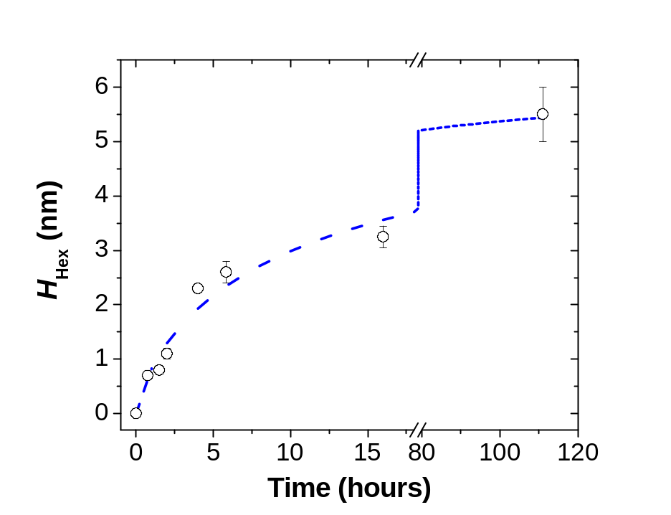
Figure 2-6. Increase in ellipsometric thickness after exposure of PGMA films (initial thickness ~ 13.5 nm) to 5-hexynoic acid at 60 °C. The black hollow points are the measured ellipsometric thicknesses, the dashed blue line is a guide to the eye. The error bars represent the variation (standard deviation) across a film surface.

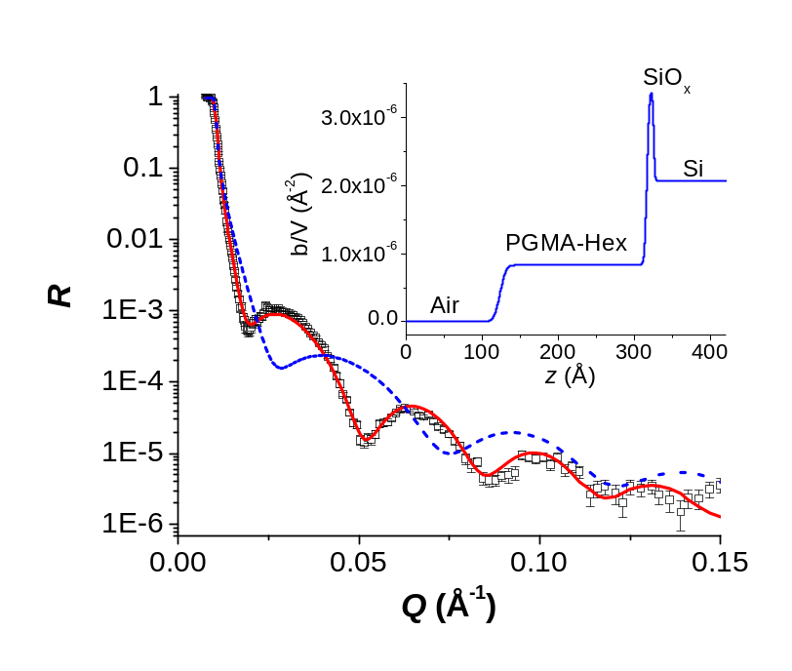
Figure 2-7. Neutron reflectivity profile of a PGMA-Hex film obtained by reaction of a PGMA film with neat 5-hexynoic acid at 60 °C for 90 hours. As observed from the figure, the measured reflectivity data are well fit by the model SLD profile shown in the inset graph. The model consisted of a single slab 193 Å thick PGMA-Hex layer (SLD_{PGMA-Hex} = 8.3 × 10⁻⁷ Å⁻²) with a broad and smoothly decreasing transition (described by an interfacial roughness of 15 Å). The dashed blue line is the calculated reflectivity curve of the parent PGMA film (PGMA layer thickness = 135 Å, SLD_{PGMA} = 8.3 × 10⁻⁷ Å⁻² and an interfacial roughness of 10 Å).

As with PGMA modification using propargylamine, an increase in total thickness was observed, as evidenced by the narrower spacing of the Kiessig fringes of the modified layer compared to the parent PGMA film; to fit the data I first assayed a model having a 193 Å thick single slab consisting of a PGMA-Hex layer, which represents an increase of 58 Å with respect to the precursor PGMA layer. The use of a single slab model is justified by the small difference in scattering lengths between PGMA-Hex (C₁₂H₁₈O₅) and PGMA (C₇H₁₀O₃). The data are well fit by a 193 Å thick PGMA-Hex layer (SLD_{PGMA-Hex} = 8.3 × 10⁻⁷ Å⁻²) having an interfacial roughness of 15 Å. The measured SLDs of PGMA and PGMA-Hex are identical with an uncertainty of ± 4 × 10⁻⁸ Å⁻². The calculated mass density of PGMA-Hex (from its SLD and b) is 0.81 g/cm³ ± 0.04 g/cm³, which is reasonable. Using this mass density for the functionalized film and again invoking the assumption of constant grafting density between the parent and functionalized films, we used equation 2.2 and the following values ρ_{PGMA} = 0.74 g/cm³, ρ_{PGMA-Hex} = 0.81 g/cm³, H_{PGMA-Hex} = 193 Å, H_{PGMA} = 135 Å, m_{oPGMA-Hex} = 254 Da, m_{oPGMA} = 142 Da, to determine that f = 71% ± 10% for the reaction between 5-hexynoic acid and the PGMA layer. As discussed with the example of functionalization with propargylamine, the uncertainty in f could be reduced by enhancing the contrast between the polymer layers and the functionalizing agent. Nevertheless, in both the functionalization with propargylamine and with 5-hexynoic acid, the reaction times used were long enough to reach (nearly) the maximum functionalization possible; under both functionalization conditions, the conversion was similar. Similar to the case of the functionalization with propargylamine, a moderately high density of up to 37 alkyne groups/nm² can be achieved (or 1.9 alkyne groups/nm³, considering the depth of the film) upon functionalization with 5-hexynoic acid. As noted previously, because longer times are needed to functionalize PGMA films with 5-hexynoic acid, it is possible to more widely adjust the density of alkyne groups by altering the reaction time.

2.3.1D Functionalization via Attachment of pGP Copolymers.
Random copolymers of GMA and PMA (pGP copolymers) of various composition were synthesized via free-radical polymerization and investigated as an alternate route to introduce alkyne groups onto surfaces. By varying the copolymer composition, it may be possible to systematically adjust the areal density of alkyne groups available for subsequent modification, rather than rely on chemical reaction between small molecules and the PGMA layer. The properties of the pGP copolymers are given in Table 2-1 and their structure is shown in Figure 2-8. The principle of attachment to the silicon substrates is the same as for the PGMA homopolymers: the epoxy groups of the pGP copolymers react with the silanol groups of the silicon oxide layer.
In concept, the grafting density of alkyne groups may be controlled by changing the copolymer composition or film thickness of the pGP, which is manipulated through the choice of conditions used in the spin coating process. Figure 2-9 shows the dependence of film thickness on the concentration of the four pGP copolymers of different composition spin-coated from 2-butanone. It is generally expected that copolymers of higher molecular weight produce thicker films because their solutions would be more viscous. Thus at constant solution concentration, pGP-2/1 would be expected to produce the thickest films compared to the other pGP synthesized here.
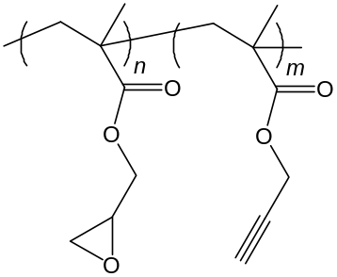
Figure 2-8. Structure of pGP copolymers, which are synthesized by free radical polymerization. Copolymer composition is adjusted by varying the feed ratio of the two monomers.

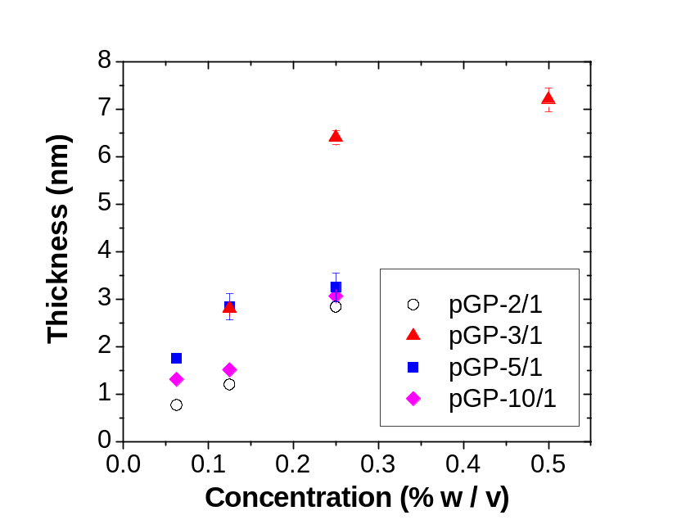
Figure 2-9. Dependence of pGP copolymer film thickness (after spin-coating, annealing and solvent washing) on pGP concentration using 2-butanone as solvent. The error bars represent the standard deviation between different samples (in some instances the error bars are smaller than the symbol).

However, we observed that for a given concentration, pGP-3/1 and pGP-5/1 tend to produce the thickest films, likely because these copolymers have a higher content of epoxy groups, hence more polymer chains can attach to the silicon substrate during the annealing process. Following this argument, it would be expected that the pGP-10/1 copolymer would yield the thickest films; however, pGP-10/1 also has the lowest molecular weight. Cross-linking of the films through the epoxides upon annealing could also be contributing to the observed behavior. Figure 2-10 shows reflectivity data measured for a pGP-3/1 film obtained via spin coating from 2-butanone along with the reflectivity curve calculated using the model SLD profile shown in the inset. The data was fit using a model that treats the surface modifying pGP copolymer as a single layer of thickness 70 Å, SLD_{pGP-3/1} = 1.28 × 10⁻⁶ Å⁻² and an interfacial roughness of 35 Å. The larger SLD of pGP-3/1 (compared to the SLD of PGMA) occurs because the scattering length of propargyl methacrylate is ∼22% larger than the scattering length of PGMA.
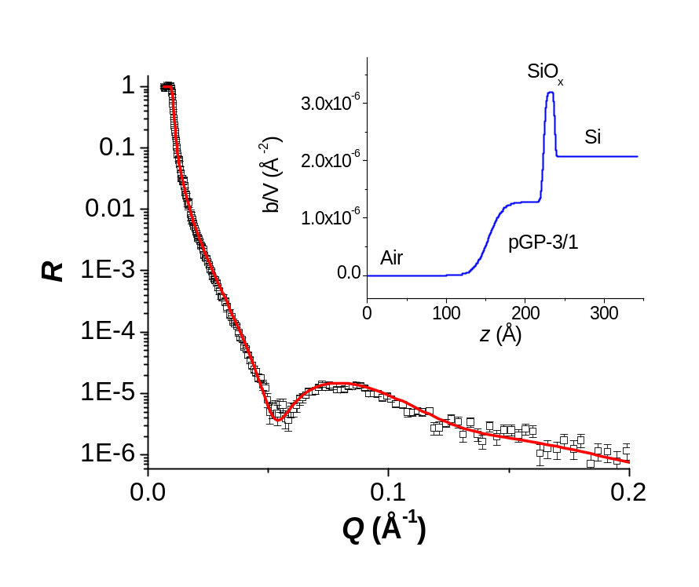
Figure 2-10. Neutron reflectivity profile of pGP-3/1 film made by spin coating from a 0.3 % (w/v) pGP-3/1 solution in 2-butanone. The data are well fit by a model consisting of a single slab of 70 Å thickness having SLD_{pGP-3/1} = 1.28 × 10⁻⁶ Å⁻² and an interfacial roughness of 35 Å.

Click Reactions
PGMA-Hex and pGP-modified surfaces were used as substrates for the azide-alkyne click reactions with either PVDMA-N₃ or PMAA-N₃. PGMA-Prop was used as substrate for the click reaction with PMAA-N3. The properties of the click-modified pGP and PGMA-Hex substrates along with the azide-terminated polymers used are shown in Table 2-2. The grafting densities of the attached polymers are low compared to the grafting densities that can be achieved using “grafting from” approaches or by grafting premade, carboxylic acid-terminated polymers to PGMA layers,^{61-62, 68} but they are comparable to grafting densities achieved attaching azide-capped poly(ethylene oxide), polystyrene and PMMA to alkyne-decorated substrates.⁶⁹ Nonetheless, this “grafting to” approach via copper-catalyzed cycloaddition chemistry offers the ability to capitalize on the orthogonal nature of the chemistry, thus avoiding reactions between polymers bearing reactive groups (such as PMAA or PVDMA) and the surface-modifying “primer” layer. This approach also allows the grafting density to be calculated because the polymers are well-characterized prior to attachment.

Table 2-2 Properties of pGP and PGMA-Hex surfaces, Azide-Capped Polymers and Resulting Click Products
Substrate | H_{alkyne}ª  (nm) | Azide polymer | M_{n}^{b}  g/mol | H_{click}^{c}  nm | σ  (chains/nm²) | D (nm) | D/2R_{g}
pGP-3/1 | 4.8 | PVDMA-N₃ | 38,200 | 4.5 | 0.074 | 4.1 | 0.47
pGP-3/1 | 5.2 | PVDMA-N₃ | 38,200 | 4.6 | 0.076 | 4.1 | 0.47
pGP-3/1 | 6.0 | PVDMA-N₃ | 38,200 | 3.0 | 0.050 | 5.1 | 0.58
pGP-3/1 | 4.8 | PVDMA-N₃ | 38,200 | 5.0 | 0.083 | 3.9 | 0.44
pGP-3/1 | 3.6 | PVDMA-N₃ | 5,000 | 4.6 | 0.582 | 1.5 | 0.58
PGMA-Hex | 5.5 | PVDMA-N₃ | 5,000 | 7.5 | 0.948 | 1.2 | 0.46
PGMA-Hex | 5.5 | PVDMA-N₃ | 29,200 | 3.3 | 0.071 | 4.2 | 0.57
PGMA-Hex | 5.5 | PVDMA-N₃ | 38,200 | 5.1 | 0.084 | 3.9 | 0.44

ª Ellipsometric thickness of pGP layer or increase in thickness upon modification of PGMA by 5-hexynoic acid. ^{b} Number-average molecular weight of the azide-capped polymer. ^{c} Increase in ellipsometric thickness after click reaction to attach azido-capped polymer.

The distance between grafting points, D, which reflects the degree-of-crowding of the chains on the surface, can be calculated from the grafting density, assuming each chain occupies a circular area on the substrate, D = 2/(πσ)^{1/2}.⁷⁰ It is generally accepted that when D < 2R_{g}, end-tethered polymer chains reside in the brush regime when solvated, and when D > 2R_{g} the chains are isolated and noninteracting, adopting coiled structures (often referred to as the “mushroom regime”).⁷⁰ The estimated R_{g} values for PVDMA chains of M_{n} = 38 200, 29 200, and 5000 g/mol are 4.4, 3.7, and 1.3 nm, respectively.⁶² As shown in Table 2-2, based on the D/2R_{g} calculated for the clicked PVDMA chains, the chains are sufficiently crowded such that they will form brushes when solvated. It is also noted that the grafting densities attained by clicking PVDMA-N₃ of M_{n} = 38 200 g/mol on pGP-3/1 or PGMA-Hex substrates of different thicknesses are approximately the same. This likely indicates that the surface density of alkyne groups available for click reactions on these base layers is sufficiently high that it does not have an influence on the click reaction. In other words, the projected area of the tethered chains prevents incoming chains from finding alkyne groups. This self-limiting behavior is emblematic of grafting-to processes.⁷¹ As expected, the grafting densities resulting from grafting the smaller PVDMA-N₃ (M_{n} = 5000 g/mol) is about 1 order of magnitude greater than what results when clicking the much larger PVDMA (M_{n} = 38 200 g/mol) to these surfaces. Also, the smaller PVDMA-N₃ (Mn = 5000 g/mol) clicked at nearly twice the grafting density on PGMA-Hex compared to pGP-3/1, indicating perhaps a higher availability of alkyne groups on the PGMA-Hex layer due to the relatively high degree-of-conversion upon reaction of the PGMA with 5-hexynoic acid.
The click reaction of azide-capped PMAA was performed on alkyne-containing PGMA-Prop substrates. Because of the potential for the carboxylate groups to react with epoxy groups on the surface, this is a case where the orthogonal nature of click reactions provides a robust route to producing a well-defined, responsive polyacid brush. As indicated in Table 2-3, a few azido-terminated PMAA samples were used along with a variety of solvents such as DMF, methanol, and water as well as various copper catalysts, such as CuBr and CuSO₄ plus sodium ascorbate. The estimated R_{g} values for PMAA chains of M_{n} = 102 000, 37 500, and 14 400 g/mol are 8.5, 5.1, and 3.1 nm, respectively.⁷² Table 2-3 shows the properties of the PGMA-Prop surfaces, conditions of the click reactions, properties of the clicked polymers, and characteristics of the “clicked” surfaces.
The carboxylic acid group of the side chain of PMAA can, in principle, react with unreacted epoxy groups in the surface-tethered, modified PGMA film⁵³ remaining after functionalization with propargylamine. To examine this competition with the alkyne-azide click reaction, negative control experiments using PMAA synthesized via RAFT using CMP as CTA (i.e., with no terminal azide group) were conducted. Exposing solutions of these PMAA chains to the alkyne-containing substrate under click reaction conditions resulted in no increase (or negligible increases, < 1 nm) in ellipsometric thicknesses, indicating no adventitious attachment of the PMAA to the PGMA-Prop substrate through carboxylate groups. The results indicate that even at relatively low PMAA concentrations, using MeOH as the click reaction solvent, higher grafting densities are attainable regardless of the molecular weight of the PMAA-N₃ counterpart.

Table 2-3 Properties of PGMA-Prop surfaces, Azide-Capped PMAA Polymers and Resulting Click Products
H_{PGMA-Prop}ª(nm) | Solvent | PMAA Conc. (% w/v) | Catalyst^{b} | M_{n}^{c} g/mol | H_{click}^{d} (nm) | σ (chains/nm²) | D (nm) | D/2R_{g}
0.3 | MeOH | 3.0 | [1] | 102,000 | 2.4 | 0.014 | 9.4 | 0.55
3.1 | MeOH | 2.6 | [1] | 102,000 | 2.1 | 0.013 | 10.1 | 0.59
0.2 | MeOH | 1.6 | [1] | 37,500 | 0.4 | 0.007 | 14.0 | 1.37
3.5 | MeOH | 6.2 | [1] | 37,500 | 9.5 | 0.155 | 2.9 | 0.28
4.6 | DMF | 9.1 | [1] | 37,500 | 3.4 | 0.055 | 4.8 | 0.47
2.5 | DMF | 9.1 | [2] | 14,400 | 4.0 | 0.170 | 2.7 | 0.44
2.4 | DMF | 9.1 | [2] | 102,000 | 3.1 | 0.019 | 8.3 | 0.49
2.3 | DMF | 9.1 | [2] | 37,500 | 2.3 | 0.037 | 5.8 | 0.57
2.4 | DMF | 18.2 | [1] | 37,500 | 4.7 | 0.077 | 4.1 | 0.40
2.0 | H₂O | 9.1 | [1] | 37,500 | 3.7 | 0.060 | 4.6 | 0.45
ª Increase in ellipsometric thickness upon modification of PGMA by propargylamine. ^{b} Source of copper catalyst for click reaction; [1] refers to CuSO₄ + sodium ascorbate, [2] refers to CuBr. ^{c} Number-average molecular weight of PMAA-N₃. ^{d} Increase in ellipsometric thickness after click reaction to attach PMAA-N₃

This is possibly because methanol is a better solvent for PMAA than DMF or water.⁷³ For instance, when PMAA-N₃ M_{n} = 37 500 g/mol is used at a concentration approximately 50% higher in DMF than in MeOH, the thickness of the resulting brush is only approximately one-third of that obtained in MeOH. The tunability of the grafting density of the resulting brushes is achieved by the selection of M_{n}, solvent and concentration. When low PMAA concentrations were used, the resulting grafting densities were very low, as evidenced by the entry showing a PMAA concentration of 1.6% w/v. At this grafting density, the clicked chains exist in the mushroom regime because D/2R_{g} > 1, as opposed to the rest of the examples in which D/2Rg < 1 (only one example is given but at other low concentrations, the resulting polymers had grafting densities likely in the mushroom regime). The thickness of the PGMA-Prop layer does not appear to have an influence on the grafting density of the PMAA chains for the various PMAA-N₃ polymers used, possibly because the areal density of alkyne groups is sufficiently high, similar to the behaviors witnessed when using the pGP and PGMA-Hex substrates. Even at the lowest polymer concentration, the total amount of polymer available is several orders of magnitude higher than the amount that would be needed to react with all of the available alkyne groups on the surface. As expected, PMAA-N₃ of higher molecular weight tended to produce brushes of lower grafting density.

2.4 Conclusions
Thin interfacial films based on chemically modified PGMA and pGP copolymers were studied as a means of creating alkyne-decorated substrates suitable for click reactions with azide- capped polymers under a variety of conditions. In addition to tuning film thicknesses through control of deposition conditions, alkyne content could be tuned via reactive modification with small alkyne-containing molecules of acidic or basic nature or by creating copolymers of different composition. Reactive azide terminated PMAA and PVDMA polymers synthesized via RAFT polymerization were easily tethered to various alkyne-bearing PGMA substrates via click reactions using a variety of solvents and sources of copper catalysts. Moderately high grafting densities were obtained, suggesting that the end-tethered polymers exist in the brush regime. Layers of low grafting density were also obtained, suggesting tunability of the grafting density over a relatively broad range covering the mushroom and brush regimes. The present work offers several facile methods for preparing alkyne-containing substrates amenable for click chemistry. This opens additional possibilities for immobilizing azide terminated, reactive macromolecules on flat surfaces. Additionally, insights into the nanophase structure of the chemically modified, alkyne-containing films obtained via neutron reflectometry suggest the potential of this method for examining chemical modifications of reactive interfacial films.

- Hydration in Weak Polyelectrolyte Brushes
[As submitted to ACS Macro Letters with minor revisions]

Weak polyelectrolytes (PEs) are complex because intertwined connections between conformation and charge are regulated by the local dielectric environment. While end-tethered PE chains – so called PE “brushes” – are archetypal systems for comprehending structure-property relationships, it is revealed that the reference state nominally referred to as “dry” is, in fact, a situation in which the chains are hydrated by water vapor in the ambient. Using charge-negative PE homopolymer brushes based on methacrylic acid and copolymer brushes that incorporate methacrylic acid and 2-hydroxyethylmethacrylate, I determine self-consistently the water content of PE films using neutron reflectometry under different hydration conditions. Modeling multiple data sets, I obtain dry polymer mass density and layer thickness, independent of adsorbed water, and PE brush profiles into different pH solutions. It is shown that hydration of the chains distorts, here by as much as 30%, the quantification of these important physical parameters benchmarked to films in ambient conditions.

3.1 Introduction
Wet and dry are concepts familiar to everyone. The ubiquity of liquid water on blue Earth and its remarkable properties as a solvent make hydration crucial to such disparate processes as lubrication,⁷⁴ adhesion and growth of biofilms,⁷⁵ partitioning and the fate of ions in soils,⁷⁶ and protein folding and function.⁷⁷ Assessing the degree of hydration is thus crucial to understanding how the nanoscopic structure of materials determines their macroscopic properties yet, at the nanoscale, our comprehension of the role of water is far from complete.⁷⁸ Most synthetic polymers encountered in everyday life, such as polystyrene, polyethylene, and polypropylene, are hydrophobic and thus by construction repel water and serve as barriers between different aqueous environments. Hydrophilic polymers, on the other hand, exhibit a much richer spectrum of interactions with the aqueous world.
Tethered polymer layers where the chains carry a significant number of ionizable groups and are covalently bound at one end to a surface are called polyelectrolyte (PE) brushes.^{3, 12a, 17a, 28, 79} Conceptually, they are important model systems because surface-sensitive probes can be brought to bear to study structure and properties that are inherently coupled because of interactions involving charges and polarization effects. Because of their responsive behavior, PE brushes play an important role in many areas of science and technology, such as colloid stabilization,³ adhesion, and lubrication.⁴ They can be used for designing biomaterial systems that improve the effectiveness of drug delivery or mediate cell/surface interactions to allow the control of the interaction of biological cells and biomolecules with artificial materials.⁸⁰ In such cases the polymer layer properties are tuned to enhance the biocompatibility of an implant or to avoid non-specific adsorption of proteins onto the active surfaces of an analytical device. Especially significant is the role of the areal (grafting) density of chains, which regulates inter-chain interactions and affects the local dielectric environment,^{12a, 79a-e} thereby impacting the range and extent of interactions across the solid/fluid interface. Weak PEs are particularly complex in their behaviors because their degree-of-ionization is pH-dependent and because added salt plays a dual role, affecting both the ionization state and screening charge.^{79b, c}
I describe here a method for determining self-consistently using neutron reflectivity the degree of hydration of polyelectrolyte brushes and unambiguously determine basic physical properties of the brush layer as well as structural changes as a function of pH, a fundamental example of stimulus-responsive behavior. Hydrophilic polymer films take up water from humid air and may indeed require it for structural stability. The presence of this adsorbed water complicates any characterization that aims to quantify layer thickness d, grafting density of polymer chains Γ, or the mass density of the polymer layer ρ because these parameters are intimately linked through the dimensional expression,
 | 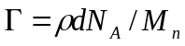 | (3.1)
where M_{n} is the number-average polymer molecular weight and N_{A} is Avogadro's number. This interplay is even more complex in weak PEs because, as alluded to earlier, they have the ability to regulate their structure locally, thereby changing their properties, through trade-offs in chemical (acid-base) equilibrium and physical interactions such as charge screening based on the local dielectric environment.^{12a, 79a, b, 79d} Common approaches for determining Γ involves measuring film thickness using optical ellipsometry, assuming values for film density and refractive index,^{79c, 79i, 80} or by using atomic force microscopy.^{79h} While neutron reflectometry has been used to examine the nanoscale structure of strong as well as weak PE brushes^{17a, 28, 79g} none of the previous neutron reflectometry studies have accounted rigorously for the presence of adsorbed water in polyelectrolyte films. I posit that this accounting is critical for understanding structure-property relationships because without knowledge of the amount of adsorbed water, any calculation of layer thickness, grafting density or film density is in error. Thus, only by taking into account the latent hydration in polymer films can one know the amount of polymer in these films.
In this work, I determine the pH-dependent structure of weak polyelectrolyte brushes, taking into account in a self-consistent manner the amount of adsorbed water. The concept of a “dry” thickness of polymer of a given density is introduced, which represents the material that is truly conserved upon exposure to different buffer solutions and humid air. This polymer inventory is established using neutron reflectometry measurements in humid air and in a liquid/solid solution cell in contact with deuterated water (D₂O) buffer solutions at pH 3, 6, and 8 (10 mM ionic strength). Weak polyelectrolyte brushes made of poly(methacrylic acid) and also random copolymer brushes consisting of methacrylic acid (MAA) and hydroxyethyl methacrylate (HEMA) were studied.

3.2 Experimental section

3.2.1 Polymer Synthesis
All reagents were used as received from the suppliers without further purification unless otherwise noted. Proton and carbon Nuclear Magnetic Resonance (NMR) spectra were obtained in CDCl₃ on a Varian VNMRS 500 NMR spectrometer. Chemical shifts were referenced to TMS at 0 ppm for both proton and ²⁹Si, and to CDCl₃ at 77.23 ppm for carbon.
Homopolymer and copolymer brushes were grown from silicon surfaces that were piranha cleaned and decorated with initiators made of 2-bromo-N-(11-(dichloro(methyl)silyl)undecyl)-2-methylpropanamide, the synthesis of which is described below. The initiator-modified surface, monomers [tert-butyl methacrylate (tBMA) and 2-hydroxyethylmethacrylate (HEMA)], solvent benzene (1:1, v/v) and ethylbromoacetate (8 mM), the sacrificial initiator, were added to a Schlenk flask. The 4,4'-dinonyl-2-2'-dipyridyl ligand, CuBr and CuBr₂ [Monomer/Cu(I)/ Cu(II) = 215/2.70/9.96] were weighed separately, mixed into a paste and then also added to the flask. The reaction mixture was immediately subjected to three freeze-pump-thaw cycles, sonicated for 2 minutes and then placed in an oil bath preheated to 60°C for 18 hours to grow the PtBMA or P(tBMA-co-HEMA) brushes. After polymerization the silicon substrates were rinsed with methanol and dried in a nitrogen stream. The reaction mixture was dissolved in tetrahydrofuran (THF) and passed through a silica gel plug to remove copper species prior to size exclusion chromatography (SEC) analysis of the polymer grown in solution. Recovered and purified polymers were analyzed by ¹H NMR and compositions were found to be consistent with feed compositions (< 3% different). Deprotection of the PtBMA and P(tBMA-co-HEMA) brushes was performed by immersing the brush-modified substrates in a solution of trifluoroacetic acid (TFA) in dichloromethane (30% v/v).

3.2.2 Synthesis of 2-bromo-2-methyl-N-(undec-10-enyl)propanamide
Under nitrogen, an oven-dried 500-mL recovery flask was charged with 1-amino-10-undecene (16.93 g, 0.10 mol), triethylamine (1.13 g, 0.11 mol), 250 mL of dichloromethane, and a stir bar. A 125-mL pressure-equalizing addition funnel with a nitrogen inlet was attached to the flask, and the stirred solution cooled in an ice-water bath under nitrogen flow. A solution consisting of α-bromo-isobutyryl bromide (25.8 g, 0.11 mol) in 50 mL dichloromethane was transferred under nitrogen to the addition funnel, and added drop-wise over the course of 15 min to the stirred reaction mixture at 0°C. Toward the end of the addition, the solution became turbid. The water-ice bath was removed and stirring continued at ambient temperature overnight. The turbid solution was transferred to a separatory funnel and washed with 0.2 M HCl (2 × 300 mL), deionized water (1 × 300 mL), 5% NaHCO₃ (1 × 300 mL), and finally saturated NaHCO₃ (1 × 300 mL). The volatiles were removed from the straw-colored solution to afford the crude product (amber-colored oil) in quantitative yield. The amide (31.7 g) was transferred to a custom glass rig and dried under vacuum for 2 days at ambient temperature; thence small fractions were distilled into all-glass ampules fitted with break-seals. This compound distilled at an external bath temperature of approximately 130-150°C; a small fraction was sampled for confirmation by ¹H and ¹³C NMR, and an early fraction of 5.2 g was reserved for the next synthetic step.
In preparation for the hydrosilylation reaction, HSi(CH₃)Cl₂ (99%, Aldrich), and (CH₃)₃-SiCl (99%, Aldrich) were dried by stirring over CaH₂ overnight and then were distilled into ampules. Hexanes were dried over n-BuLi, benzene and toluene was purified over poly(styryl) lithium, THF was purified over K/Na alloy; these solvents were docked at the vacuum line and out-distilled as needed. Pt catalyst [Platinum(0)-1,3-divinyl-1,1,3,3-tetramethyldisiloxane complex, solution in xylene, Aldrich] was transferred to a vacuum apparatus, diluted with benzene and distributed into ampules.

3.2.3 Synthesis of 2-bromo-N-(11-(dichloro(methyl)silyl)undecyl)-2-methylpropanamide
The hydrosilylation was accomplished, in vacuo, in a specially prepared all-glass apparatus equipped with break-seals for the addition of reagents and constrictions for the closure and transfer of products. The apparatus, built with an integral condenser, was designed to have exactly one low point for effective and unambiguous turnover by reflux, and it was affixed to the high-vacuum line by means of an all-glass bridge equipped with a Teflon stopcock. The apparatus was evacuated under high-vacuum, after which 100 mL THF was in-distilled. The stopcock was closed. The break-seal of (CH₃)₃SiCl was ruptured, so that 0.25 g of TMSCl in 1 mL benzene was added. The solution was left to stir and modestly reflux/silanize overnight from a 40°C bath to the 20°C apparatus and 10°C condenser. The following morning, ampules of Pt catalyst (0.1% in benzene, 1 mL) and 2-bromo-2-methyl-N-(undec-10-enyl)propanamide (5.2 g, 16.3 mmol) were opened and these contents were allowed to reflux under the same conditions for 15 additional minutes. HSi(CH₃)Cl₂ (5.18 g, 45.0 mmol) was then added to the solution to initiate the hydrosilylation reaction. The reaction was allowed to progress for 18 hours at 37-40°C (external T). All volatile contents were then out-distilled from the apparatus and collected to a waste reservoir docked elsewhere on the vacuum line. The product was vacuumed overnight and then 30 mL hexanes were in-distilled. The apparatus was detached by sealing a constriction above the condenser and all of the product solution was then poured and distributed to attached ampules. One of these small ampules was fitted further with an NMR tube; and this aliquot was re-evacuated, constituted with dry CDCl₃, and sealed under vacuum into the NMR tube. A larger ampule was diluted in toluene to a concentration suitable for future use and distributed into break-open ampules.

3.2.4 Polymer Brush Characterization
The weak PE brushes were characterized by optical ellipsometry and atomic force microscopy (AFM). Topographical images acquired by AFM in tapping mode show the films to be uniform and homogeneous. Ellipsometric measurements were made using a Beaglehole Instruments Picometer ellipsometer, with ellipsometric parameters measured at angles of incidence between 60° and 80°, using steps of 1°. Thicknesses were determined by fitting the entire data set using a refractive index nominally constrained to 1.48. The properties of homopolymer and copolymer brushes are listed in Table 3-1. Ellipsometric grafting density is calculated using the formula Γ_{ellipsometry} = d_{ellipsometry} ρ N_{A} / M_{n}, where ρ is the bulk density of the polymer from the literature (1.02 g/cm³ for PtBMA, 1.015 g/cm³ for PMAA, and 1.15 g/cm³ for PHEMA), N_{A} is Avogadro's number, M_{n} is the number average molecular weight of the recovered, free polymer chains, and d_{ellipsometry} is the ellipsometric layer thickness. This standard treatment does not account for adsorbed water in the polymer layer, which can produce anomalously large values of film thickness d_{ellipsometry} or variations in film mass density from bulk literature values. The grafting density values listed above are in fact significantly larger than those derived self-consistently from neutron reflectivity measurements.
Neutron reflectivity measurements were made at the Spallation Neutron Source (SNS) at Oak Ridge National Laboratory using the Liquids Reflectometer (LR). By collecting specular reflectivity data using a continuous wavelength band (2.5 Å < λ < 6.0 Å) at several different incident angles (here θ = 0.19°, 0.27°, 0.34°, 0.48°, 0.62°, 1.11°, and 2.01°), data were acquired over a wavevector transfer (Q = 4π sinθ / λ) range of 0.006 Å⁻¹ < Q < 0.176 Å⁻¹. Setting the incident beam slits at each angle to maintain a constant relative wavevector resolution of δQ/Q = 0.02 allows the data obtained at different θ to be stitched together into a single reflectivity curve. The neutron refractive index depends on the SLD. To model the measured reflectivity, layer compositions, thicknesses, and interfacial widths were adjusted to optimize goodness-of-fit.⁵⁸ Samples were measured in air and against 10 mM buffer solutions at pH 3, 6, and 8 made using D₂O.^{11c} Reflectivity measurements in buffer solutions were performed using an inverted geometry, with neutrons incident on the brush/solution interface through the silicon substrate as shown in Figure 3-1.

Table 3-1 Properties of PMAA and P(MAA_{1-r}-co-HEMA_{r}) brushes. Here r is the mole fraction of HEMA in the copolymer, d_{ellipsometry} is the ellipsometric thickness of the polymer layer in humid air, M_{n} is the number average molecular weight and PDI is the polydispersity index of the polymer chains grown in solution measured by size exclusion chromatography. Grafting density Γ_{ellipsometry} is calculated using the ellipsometric thickness measured in air.
r | d_{ellipsometry} (Å) | M_{n} (g/mol) | PDI | Γ_{ellipsometry} (10⁻² Å⁻²)
0 | 195 | 53,500 | 2.3 | 0.22
0.2 | 219 | 39,000 | 2.1 | 0.36
0.3 | 83 | 23,400 | 1.4 | 0.23

Neutron beam
Aluminum Top
Si – Sample wafer
Si - wafer
-ring
Liquid
O
Macor Base

Filling ports

Figure 3-1. Schematic picture of the neutron reflectometry liquid cell. Reflectivity measurements in buffer solutions were performed using this liquid cell with inverted geometry.

3.2.5 Hydration Calculations
To understand the role of water in PE brushes, we must explicitly account for its presence and its effect on the measured neutron reflectivity. The mass m of a film is given by ρAd, the product of mass density ρ, area A, and thickness d. Area A is not intrinsic to the polymer, but mass per area μ is,
 | 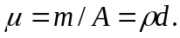 | (3.2)
Neutron scattering-length density (SLD) likewise depends on ρ,^{33c}
 | 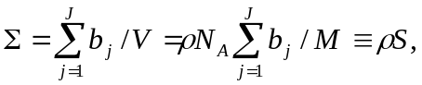 | (3.3)
where M is the molar mass of the J atoms in the compound (e.g. monomer) composed of nuclei of scattering length b_{j}. Since stoichiometry S is known, but mass density ρ may not be, we separate them. The SLD of a layer composed of tethered polymer containing adsorbed water may be written as a volume-fraction weighted sum of the constituent SLDs,
 | 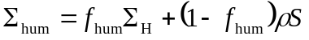 | (3.4)
where f_{hum} is the volume fraction of water in the film, Σ_{H} the SLD of water, and ρS the SLD of the polymer. If the adsorbed water does not react with the polymer and maintains its bulk density, then it may be assumed to swell the film,
 | 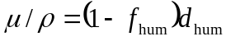 | (3.5)
where d_{hum} is the fitted thickness of the swollen hydrated film and μ/ρ can be understood as the dry thickness of polymer in the absence of adsorbed water [recall Eqn. (3.2)]. A neutron reflectivity measurement of the film in humid air will yield two fitted parameters d_{hum} and Σ_{hum}, but equations (3.4) and (3.5) contain three unknown quantities: ρ, μ/ρ, and f_{hum}. One must therefore perform at least one additional measurement under different hydration conditions, for example against a pH-controlled D₂O buffer solution,
 | 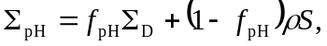 | (3.6)
 | 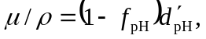 | (3.7)
yielding four equations (Σ_{D} being the SLD of D₂O) to solve for the four unknown quantities ρ, μ/ρ, f_{hum}, and the volume fraction of D₂O in the film against the buffer solution, f_{pH}. The reduced thickness d'_{pH} accounts for the fact that polymer brushes often exhibit volume-fraction profiles ϕ(z) that are observably not “slab-like”', but smoothly decaying, such as the modified parabola, a phenomenological shape derived from a theoretical treatment of uncharged brushes,^{22b}
 | 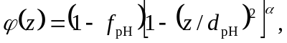 | (3.8)
where varying 0 ≤ α ≤ 1 changes the shape of the profile continuously from block (α = 0) to parabola (α = 1). For such a profile,
 | 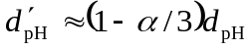 | (3.9)
because mass balance requires that the area under ϕ(z) be preserved.⁸¹ The equations above may be solved for the four parameters ρ, μ/ρ, f_{hum} and f_{pH.} These are presented as Equation 3.10, 3.11, 3.12 and 3.13, respectively, and the most compact is the expression for the mass density of the dehydrated polymer film,
 | 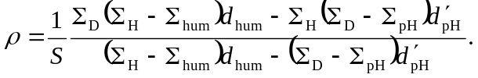 | (3.10)
 | 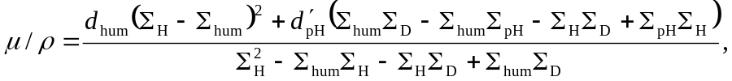 | (3.11)
 | 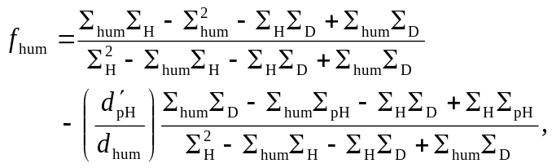 | (3.12)
 | 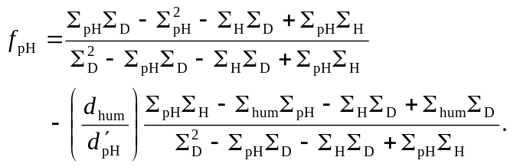 | (3.13)

In each of these equations, the four unknown quantities, ρ (mass density of dry polymer film), μ/ρ (the dry thickness of the polymer film), f_{hum} (volume fraction of water in the film in humid air), and f_{pH} (volume fraction of water in the film exposed to pH-controlled D₂O buffer solution) are expressed in terms of four quantities derived from two fitted reflectivity data sets, d_{hum}, Σ_{hum} (fitted thickness and SLD, respectively, of polymer film in humid air), d'_{pH}, and Σ_{pH} (fitted thickness and SLD, respectively, of polymer film against buffer solution) and three known quantities, S (stoichiometry of monomers comprising the polymer), Σ_{H} (SLD of water adsorbed from air), and Σ_{D} (SLD of pH-controlled D₂O buffer solution).

3.3 Results and Discussion
As described in Section 3.2.1, the polymer brushes were synthesized using surface-initiated atom transfer radical polymerization (SI-ATRP). Brushes were grown from silicon substrates (50 mm diameter, 5 mm thickness) that were first functionalized with the initiator, 2-bromo-N-(11-(dichloro(methyl)silyl)undecyl)-2-methylpropanamide. To alleviate problems with polymerization of the reactive electrolytic form of MAA,^{79c} brushes were made by chemical conversion of neutral, precursor brushes comprised of tert-butyl methacrylate (tBMA). Random P(MAA_{1-r}-co-HEMA_{r}) brushes identified by the mole fraction r of HEMA were also synthesized. Chains simultaneously grown from sacrificial initiator in free solution were recovered and characterized by size exclusion chromatography.
Figure 3-2 shows neutron reflectivity data and model fits for a random copolymer film (r = 0.2) composed of 80% MAA and 20% HEMA monomers [P(MAA_{0.8}-co-HEMA_{0.2})]. Upon deprotection, the film thickness decreases and the SLD increases, indicative of the replacement of tert-butyl groups (C₄H₉) by protons. For pH values above the MAA isoelectric point, the film expands into the solution (pH 8). As can be seen from the profiles in Fig.3-1 (b), changes to the SLD profile may be subtle and will vary depending on the sub-phase. In addition, one must account in the model for the native silicon hydroxide and polymer initiator layers.
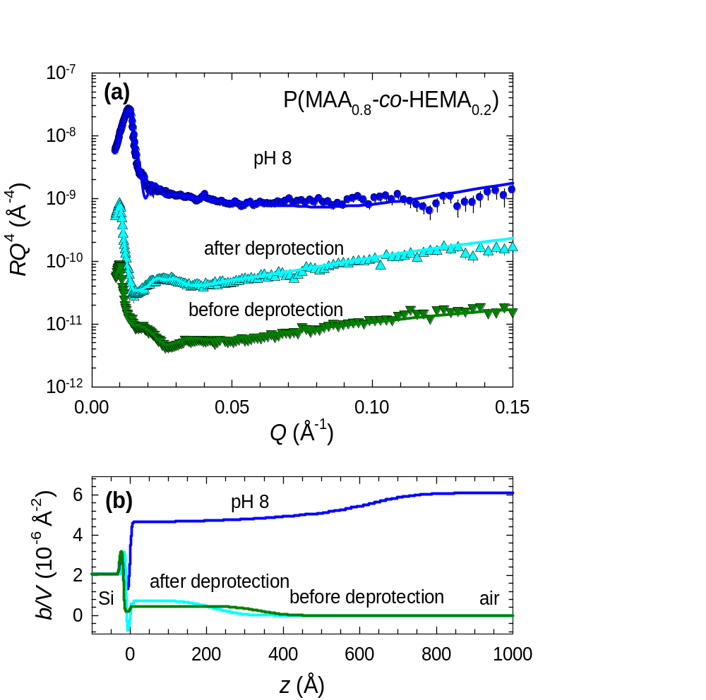
Figure 3-2. Reflectivity curves RQ⁴ vs. wavevector Q (a) and fitted scattering density profiles (b) for an r =0.2 random copolymer film before deprotection [P(tBMA_{0.8}-co-HEMA_{0.2})] and after deprotection [P(MAA_{0.8}-co-HEMA_{0.2})] in humid air and against a pH 8 buffer solution (10 mM) made with D₂O.

For clarity Figure 3-3 shows polymer volume fraction profiles derived from fits like those shown in Figure 3-2, rather than the less intuitive, more cluttered SLD profiles. Shown are profiles for r =0, 0.2, and 0.3 random copolymer films measured in the ambient and against pH 3, 6, and 8 D₂O buffer solutions. The inset to Figure 3-3(c) depicts the MAA and HEMA monomers and their random association in the polymer. At first glance, the variation in thicknesses of the polymer layers measured in humid air stands out. With an areal density of initiators on the order of 10¹⁷ cm⁻², a low number of radicals are generated in SI-ATRP, making growth of these brushes highly sensitive to surface preparation and polymerization conditions and difficult to control,^{79c} so a certain amount of thickness variation is unavoidable. Surface roughnesses in excess of σ_{fwhm} = 80 Å were measured for all of the films,⁸² a consequence both of surface-preparation sensitivity and of the natural stochastic thickness variation of films grown from surface initiator layers on large-diameter (50 mm) wafers. Nonetheless, the swelling response of the PE brushes exhibit clear trends with increasing HEMA fraction r and pH. Upon exposure to buffer solution the pure PMAA film remains collapsed until pH 8, while both of the HEMA-containing copolymers initially swell at pH 3 and pH 6 before further expanding at pH 8. Degree-of-swelling increases both with increasing r and with pH. The apparent shift in the pKa of the PMAA, manifest in the collapsed-to-swollen transition that occurs between 6 < pH < 8 is striking; however it is consistent with the shift to higher pH values Ober et al. determined using contact angle titration experiments, which probe the periphery of the film.^{79f} This shift arises because, as stated previously, the PMAA chains locally regulate their degree-of-dissociation based on the local dielectric environment. In other words, the local volume of fraction of polymer segments dictates whether the carboxylic acid groups dissociate.
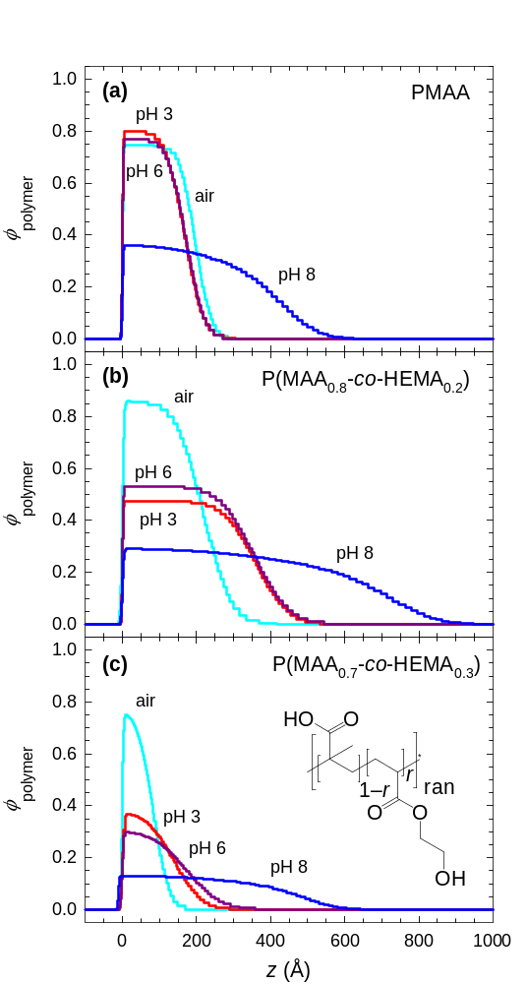
Figure 3-3. Fitted random copolymer P(MAA_{1-r}-co-HEMA_{r}) volume fraction profiles for (a) r = 0, (b) r = 0.2, and (c) r =0.3 for films measured in air and the same films in contact with pH 3, 6, and 8 D₂O buffer solutions at 10 mM ionic strength. The inset in (c) schematically represents MAA and HEMA monomers and their random association in the polymer.
The qualitative observations of the pH-induced swelling behaviors are borne out by the models. Fitted parameters are listed in Table 3-2. In fitting the neutron reflectivity data for different backing media (solutions of different pH), I employed an ad hoc self-consistent approach in which I held the dry polymer mass density ρ and the thickness μ/ρ constant across the solvent series, determining water content and profile shapes in an iterative process. In future studies, self-consistency can be built explicitly into a model that fits all of the data sets simultaneously. Parameter uncertainties were determined statistically from the fitted individual solvent data sets. The uncertainty on the water volume fraction measured in air applies to all volume fraction values for a given sample. The water content of the films in humid air, f_{hum}, varies from 0.15-0.31; and while one might expect such variation between the three films prepared and measured over several months unless humidity is explicitly controlled, there appears to be an inverse correlation between f_{hum} and grafting density of chains, suggesting that less dense layers are able to take in more water. The sensitivity of brush thickness to changes in humidity was demonstrated by Biesalski and Rühe,⁸³ who used optical waveguide spectroscopy to show that the thickness of a cationic brush based on quaternized poly(4-vinylpyridine) increases dramatically (up to 40% increase) as the relative humidity of contacting air is increased. For all three films examined here, mass density ρ is close to 1 g/cm³, but dry thickness μ/ρ exhibits the growth-condition sensitivity discussed above. The stretch ratio between water-swollen and dry thicknesses, d'_{pH} / (μ/ρ) removes this variation, revealing a clear trend for greater swelling with increasing r. For all films, the shape parameter α was 0, indicative of collapsed block-like profiles, except at pH 8, where the data were best fit using α = 0.5±0.2, producing the extended, tapered shape of the pH 8 profiles. The polymer grafting densities Γ_{neutron} were determined from Equation 3.1 using fitted ρ and μ/ρ values.
The differences between structural parameters derived from constrained fits of neutron reflectivity data described above and those derived from ellipsometric measurement of film thickness in air are significant. The greater film thickness and assumed mass density result in values of grafting density Γ_{ellipsometry} = 0.22, 0.36, and 0.23 (10⁻² Å⁻²) for r =0, 0.2, and 0.3, respectively. Clearly, using thicknesses of films hydrated by ambient moisture leads to overestimation of grafting densities and underestimation of stretch ratios, a conclusion also reached by Biesalski and Rühe in their studies of swelling behavior of a very thick brush.⁸³ Due to the variation of film hydration in humid air, this discrepancy cannot easily be corrected in thin film systems. Only by explicitly accounting for adsorbed water by a method similar to that described here can one accurately determine how much polymer is deposited on a surface and how much it expands in contact with solvent.

Table 3-2 Results of iterative fitting of the neutron data. Here, r is the mole fraction of HEMA in the random copolymer, f_{pH} the water volume fraction in the copolymer against D₂O pH buffer, f_{hum} the volume fraction of water in the polymer film in humid air, ρ the mass density of the polymer, μ/ρ the polymer “dry” thickness in the absence of hydrating water. The stretch ratio is wet vs. dry thickness, d'_{pH} /(μ/ρ), and Γ_{neutron} is the neutron-derived grafting density.
r | pH | f_{pH} | f_{hum} | ρ | μ/ρ | Stretch | Γ_{neutron}
 |  |  |  | (g/cm³) | (Å) | Ratio | (10⁻² Å⁻²)
 | 3 | 0.16 | 0.27  ±0.01 | 1.04  ±0.03 | 142.5  ±2.7 | 1.3 | 0.17  ±0.01
0 | 6 | 0.19 | 0.27  ±0.01 | 1.04  ±0.03 | 142.5  ±2.7 | 1.3 | 0.17  ±0.01
 | 8 | 0.62 | 0.27  ±0.01 | 1.04  ±0.03 | 142.5  ±2.7 | 2.8 | 0.17  ±0.01
 | 3 | 0.50 | 0.15  ±0.03 | 0.91  ±0.06 | 187.5  ±6.7 | 2.0 | 0.22  ±0.01
0.2 | 6 | 0.46 | 0.15  ±0.03 | 0.91  ±0.06 | 187.5  ±6.7 | 2.0 | 0.22  ±0.01
 | 8 | 0.72 | 0.15  ±0.03 | 0.91  ±0.06 | 187.5  ±6.7 | 3.5 | 0.22  ±0.01
 | 3 | 0.60 | 0.31  ±0.03 | 1.01  ±0.06 | 57.4  ±2.3 | 2.6 | 0.13  ±0.01
0.3 | 6 | 0.68 | 0.31  ±0.03 | 1.01  ±0.06 | 57.4  ±2.3 | 3.2 | 0.13  ±0.01
 | 8 | 0.87 | 0.31  ±0.03 | 1.01  ±0.06 | 57.4  ±2.3 | 7.8 | 0.13  ±0.01

3.4 Conclusions
In summary, it is clear that material characterization begins with proper accounting. This is particularly important in PE brush systems, where grafting density establishes the local dielectric environment ^{12a, 79a, b, 79d} and sets the balance between intra- and inter-chain interactions, which govern chain extension and thus the range of interactions across a brush-modified interface. Control of these characteristics is central to the utility of brushes as surface-modifying agents. Moreover, it is fully expected that water-soluble thin films in general suffer the same ambiguity between grafting density, mass density, and thickness if measured in the ambient using conventional bench-top methods such as ellipsometry, atomic force microscopy, or quartz crystal microbalance techniques only. While these methods are useful in their own right, the ability of neutron scattering to discriminate between adsorbed water and native polymer chains while simultaneously providing insight into nanoscale structural behaviors offers an important advantage for determining parameters that control structure and physical behaviors of PE brushes and other water-swellable thin films.

- Ion-Specific Effects on Swelling Behavior of Weak Polyelectrolyte Brushes by Neutron Reflectometry

In this work I investigate the influence of monovalent cations from the Hofmeister series on the structure and swelling behavior of polyelectrolyte (PE) brushes consisting of poly(methacrylic acid) (PMAA) chains made by a surface-initiated atom transfer radical polymerization (SI-ATRP). To create dense PE brushes and alleviate problems with direct polymerization of the reactive electrolytic form of the monomer, PMAA brushes were made by chemical conversion of neutral, precursor brushes comprised of t-butyl methacrylate (tBMA). Ion specific effects have been known since 1888, when Hofmeister studied the effect of a series of salts on the solubility of proteins and arranged the ions in order of their ability to strengthen the hydrophobic interactions.⁸⁴ In addition to proteins, other macromolecules like polyelectrolytes are also known to follow the Hofmeister series effect.²¹ Members early in the series strengthen the hydrophobic interactions and decrease the solubility of molecules, causing a “salting out” effect. On the other hand, members later in the series weaken the hydrophobic effect and cause “salting in” that increases the solubility of molecules.⁸⁵ Despite an appreciation for this phenomenon, it is still not very well understood.^{85b} Here I use ellipsometry and neutron reflectometry (NR) to investigate how pH, ionic strength and monovalent salts of the Hofmeister series affect the nanoscale structure of PMAA brushes. A particular advantage of NR is its ability to resolve the structure of solvated layers on nanometer length scales. Neutron reflectivity is also used to investigate the chemical conversion of PtBMA to its “deprotected” form, PMAA. Fitting the specular reflectivity profiles yields the segment density profiles as a function of thickness, pH and type and concentration of salt, also revealing the height of the brush and the width of the diffuse interface. Constrained fittings (i.e. mass balance) are used at all conditions in order to help quantify how the structure of the brush changes as experimental conditions are varied. From the preliminary results, I observe that the scaling behaviors of PMAA brushes with respect to salt concentration are similar in presence of different salts; however, the cross-over salt concentration (from salting in to salting out behavior) at which the transition occurs is different for each type salt. The cross-over salt concentrations for each ion type can be explained by its position in Hofmeister series.

Introduction
In the 1880s, Hofmeister and co-workers studied the relative ability of different salts to precipitate proteins from blood serum and egg whites.⁸⁴ Different concentrations of salt would cause the protein to precipitate out of the solution with the amount specifically related to the ion identities. They classified ions according to their ability to “salt out” or “salt in” proteins. This ordering of salt-protein interactions is known as the “Hofmeister series”.^{85a} A typical anionic series is SO₄²⁻ < CH₃COO⁻ < Cl⁻ < Br⁻ < SCN⁻ < I⁻ < ClO₄⁻, and a typical cationic series is NH₄⁺ < K⁺ < Na⁺ < Li⁺ < Mg²⁺ < Ca²⁺. Members early in the series decrease solubility by strengthening hydrophobic interactions, causing salting out, and members later in the series increase solubility by weakening hydrophobic interactions, causing salting in. The species on the left are generally referred to as “kosmotropes” or “structure makers” and the species on the right are called “chaotropes” or “structure breakers”.⁸⁶ Originally these terms referred to an ion’s ability to make or break the hydrogen binding network of water.⁸⁷ However, recent experimental findings demonstrate that bulk water structure is not the cause of Hofmeister effects. It is now believed that the Hofmeister effects rely on the direct interaction between ion and a macromolecule, as well as the interactions with the water molecules in the first hydration shell of the macromolecule.^{88,89} Hofmeister effects of anions are more pronounced than that of cations.^{85b, 90} Recently, the Hofmeister phenomenon has attracted a lot of attention because of its relevance to a broad range of fields. A number of biological and chemical systems and processes are known to exhibit behaviors that obey Hofmeister series: For example, protein stability,⁹¹ enzyme activity,⁹² protein-protein interactions,⁹³ protein crystallization,⁹⁴ optical rotation of sugar and amino acids,⁹⁵ bacterial growth,⁹⁶ as well as polymer hydrogels⁹⁷ all display behaviors that depend on Hofmeister effects. In spite of the vast body of work, the mechanism of Hofmeister effects is still a mystery. There have been some studies on the interaction of anionic Hofmeister salts on the interactions with macromolecules,^{85b, 86, 90a} but the role that cations play in Hofmeister physiochemistry is still not very well understood. There are very few experimental studies exploring the interactions of cationic Hofmeister series and macromolecules.⁹⁸
Therefore an effective means to study the effects of Hofmeister cations would be to employ a model system, such as weak polyelectrolyte brushes. Polyelectrolyte brushes are polymer chains that are attached to the surface at one end through an anchor group and contain charged groups along the backbone.^{1a, 13} Pinning the polymer chains to the surface imparts a unique set of properties that differentiate them from free polymer chains. As a result of the presence of charged groups, the structure of polyelectrolytes is governed by a balance between strong electrostatic interactions, osmotic pressure of counter-ions and chain stretching. The properties and structure of polyelectrolyte brushes are sensitive to external stimuli such as solvent, temperature, pH and ionic strength of the surrounding medium.^{1b, 11b} Due to these influences polyelectrolyte brushes are attractive systems to be used in variety of fields like stabilization of colloidal dispersions,³ lubrication,⁴ the design of biomaterials that improve the effectiveness of drug delivery and fine tune cell/surface interactions,⁵ and chromatographic devices,⁸ to name a few. Brush-like structures are also found in nature; for example proteins and other biopolymers are structural units in neurofilaments⁹⁹ or bacterial surfaces¹⁰⁰. In addition, stimuli responsive polymer brushes have been described as miniaturized polymeric actuators and sensors that may be used in microfluidics, drug delivery and other fields.¹⁰¹ These aspects emphasize the importance of studying Hofmeister effects on the behavior of polymer brushes, particularly weak polyelectrolyte brushes. There are few studies of Hofmeister effects on polymer brushes,¹⁰² but there are still many unanswered questions about Hofmeister effects on the nanoscale structure of polymer brushes.
In this work, to gain insight into Hofmeister effects on the nanoscale behavior of weak polyelectrolyte brushes, neutron reflectometry is used to study the swelling behavior of homopolymer brushes made of methacrylic acid (MAA) in presence of selected ions from the cationic Hofmeister series. Poly(methacrylic acid) (PMAA) brushes were synthesized by a two-step process. In the first step, silane terminated initiators are deposited on the substrate, forming a covalent bond with the silanol groups on the silicon substrate, and then poly(tert-butyl methacrylate) (PtBMA) brushes are grown by surface initiated atom transfer radical polymerization (SI-ATRP). In the second step, the PtBMA brushes are converted to PMAA brushes by deprotection of tert-butyl groups.¹⁰³ These layers will be studied using neutron reflectivity, which has the ability to reveal the segment density profile of a brush layer. Fitting the specular reflectivity profiles yields the segment density profiles as a function of thickness, pH and type and concentration of salt, also revealing the height of the brush and the width of the diffuse interface. Constrained fittings (i.e. fittings that preserve mass balance) are used at all conditions in order to help quantify how the structure of the brush changes as experimental conditions are varied. Neutron reflectivity was also used to investigate the chemical conversion to deprotected form.

Experimental

Materials and Preparations
Silicon wafers of size 1 cm × 1.2 cm were purchased from Silicon Quest International. Single side polished silicon wafers of 50 mm diameter and 5 mm thickness were purchased from Silicon Valley Microelectronics, Inc. Silicon wafers were cleaned prior to use in a piranha acid solution (3:1 v/v of sulfuric acid and 30% hydrogen peroxide) at 80 °C for 1 hour. After the wafers were removed from piranha acid, they were thoroughly rinsed with deionized water and dried using a stream of nitrogen. Cleaned silicon wafers are used immediately.
tert-Butyl methacrylate (tBMA, Aldrich 98%) was distilled under reduced pressure before use. Copper (I) bromide (CuBr, Fluka 98%) was purified by stirring with glacial acetic acid overnight, then washed with absolute ethanol and dried under vacuum. Methanol (Fisher Scientific 99.9%), benzene (Aldrich 99.9%), copper (II) bromide (CuBr₂, Aldrich 99.9%), 4,4’-Dinonyl-2,2’-dipyridyl (dnNbpy, Aldrich 97%), ethyl α - bromoisobutyrate (Aldrich 98%), ethyl bromoacetate (Aldrich 98%), dichloromethane (DCM, Fisher Scientific 99.5%), trifluroacetic acid (TFA, Aldrich 99%) were used as received.
Buffer solutions of various pH were made from salts, acids and bases. The following chemicals were used as received: Hydrochloric acid (HCl, Fisher), sodium hydroxide ((NaOH, Fisher 99.4%), 4-Morpholinepropanesulfonic acid (MOPS, Aldrich 99.5%), sodium chloride (NaCl, Aldrich 99.5%), lithium chloride (LiCl, Aldrich 99%) and potassium chloride (KCl, Aldrich 99.5%). The recipes for buffer solutions of 0.01mM, 0.05mM, 0.1 mM, 0.5 mM and 1.0 mM ionic strength are listed in Table E-1 in Appendix E. Deionized water was used for their preparation and for ellipsometry measurements, while D₂O was used for neutron reflectometry measurements. Small amounts of 1M hydrochloric acid and 1M sodium hydroxide solutions were added to the buffer solutions to set the final pH.

Instrumentation
The molecular weight of PMAA was measured using aqueous gel permeation chromatography (GPC). The separation module consisted of an Agilent Technologies 1200 series autosampler, Agilent Technologies 1100 series pump and degasser equipped with two Polymer Laboratories PL Aquagel-OH mixed columns 8 μm (300 × 7.5 mm) and one PL Aquagel-OH column guard 8 μm (50 × 7.5 mm), a Wyatt technology Heleos multiangle light scattering detector, and a Wyatt Optilab rEX differential refractive index detector. The mobile phase consisted of 20% acetonitrile and an 80% aqueous solution consisting of 0.01 M Na₂HPO₄ and 0.05 M NaNO₃.⁵⁷ The specific refractive index increment, dn/dc, of PMAA in this mobile phase was measured to be 0.142 mL/g. The flow rate was 1 mL/min. Data acquisition and molecular weight calculations were performed using the Wyatt Technology Astra V software. Thicknesses of polymer thin films were measured using a Beaglehole Instruments Picometer ellipsometer at multiple angles of incidence ranging from 80° to 60° in 1° increments. In-situ measurements of swelling behavior of PMAA brushes in the presence of buffers with different salts and ionic strengths were carried out using a cylindrical flow cell.
Neutron reflectivity measurements were made at the Spallation Neutron Source (SNS) at Oak Ridge National Laboratory using the Liquids Reflectometer (LR). The LR collects specular reflectivity data in a continuous wavelength band (set to 2.5 Å < λ < 6.0 Å) at several different incident angles; here θ = 0.19°, 0.27°, 0.34°, 0.62°, 1.12°, and 2.01° were used. As a result of these instrument settings, data are acquired over a wavevector transfer (Q = 4π sin θ/λ) range of 0.006 Å⁻¹ < Q < 0.176 Å⁻¹. Data were collected at each angle with incident-beam slits set to maintain a constant relative wavevector resolution of δQ/Q = 0.0009, which allows the data obtained at different θ to be stitched together into a single reflectivity curve. The neutron refractive index depends on the scattering length density (SLD), N_{b}, which is determined using the equation N_{b} = b/V, where b is the monomer scattering length (= Σ b_{i}, the sum of scattering lengths of constituent atomic nuclei) and V is the monomer volume. To fit the data, the initial thicknesses measured using ellipsometry were used to calculate the reflectivity and then layer compositions, thicknesses, and interfacial widths were adjusted to optimize the goodness-of-fit⁵⁸ of the model with the neutron reflectivity data. Highly constrained fittings of the type described in Chapter 3 were used to preserve the amount of polymer.

Synthetic Procedures

Synthesis of PtBMA Brushes via SI-ATRP
Surface initiated atom transfer radical polymerization (SI-ATRP) is a versatile controlled radical polymerization technique that allows polymers with low polydispersity and controlled molecular weights to be synthesized.¹⁰⁴ To alleviate problems with polymerization of the electrolytic form of the MAA monomer, PMAA brushes are made by chemical transformation of neutral precursor brushes comprised of tert-butyl methacrylate (tBMA). The overall scheme for formation of PMAA brushes by SI-ATRP is shown in Scheme 4-1. Cleaned silicon substrates were immersed in a solution of silane-terminated initiator, 2-bromo-N-(11-(dichloro(methyl)silyl)undecyl)-2-methylpropanamide in toluene (17 mmol), for 18 hours. The silicon substrates were then rinsed with copious amounts of toluene and dried using a stream of nitrogen. The thickness of the initiator layer was determined with phase modulated multiangle ellipsometry. These initiator modified substrates were then transferred to a Schlenk flask, which are used for SI-ATRP of tBMA. Monomer tBMA (4.385 g, 56.20 mmol), benzene (4.375 g, 30.8 mmol) and a mixture of sacrificial initiators ethylbromoacetate (0.020 g, 0.117 mmol) and ethyl bromoisobutyrate (0.005 g, 0.027 mmol), were added to the Schlenk flask. dnNbpy (0.24 g, 0.587 mmol) was used as ligand, CuBr (0.055 g, 0.303 mmol) and CuBr₂ (0.0086 g, 0.038 mmol) were weighed separately, mixed into a paste and added to the flask. These amounts equate to [Cu(I)]/[Ini] = 2.65, [dnNbpy]/[Cu(I)] = 1.53 and [Cu(I)]/[Cu(II)] = 9.96. The reaction mixture was immediately subjected to three freeze-pump-thaw cycles. The mixture was sonicated for 2 minutes and then placed in the preheated oil bath at 60°C for 20 hours. After polymerization the silicon substrates were recovered, rinsed with toluene and dried in a nitrogen stream. The reaction mixture was dissolved in THF and passed through silica gel to remove the copper species prior to analysis by GPC. The deprotection of the tert-butyl groups of the PtBMA brushes was done by immersing the surfaces in solution of trifluoroacetic acid in dichloromethane (30% v/v) for 20 min to obtain PMAA brushes. After deprotection, the PMAA brushes were rinsed with methanol and dried under a stream of nitrogen. These PMAA brushes were then characterized by ellipsometry and neutron reflectometry.

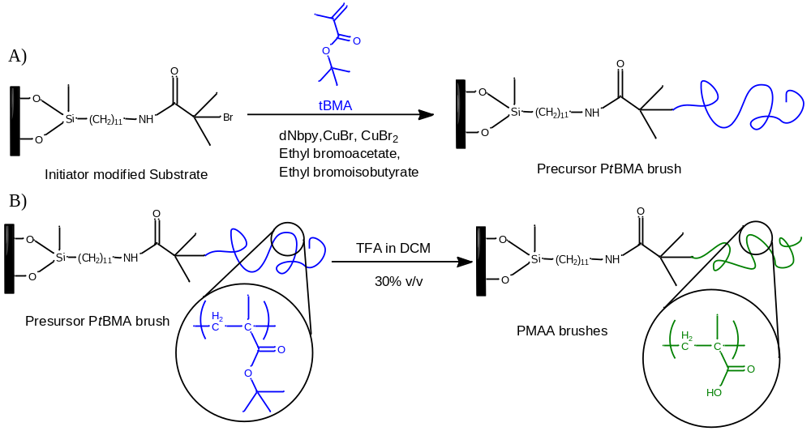
Scheme 4-1 Overall scheme for the synthesis PMAA brushes by SI-ATRP: A) Synthesis of PtBMA brushes by SI-ATRP followed by B) subsequent conversion to PMAA brushes involving deprotection by acid hydrolysis.

Results and Discussion

Synthesis of PMAA Brushes
Scheme 4-1 illustrates the process used for synthesizing PMAA brushes by SI-ATRP. Silicon substrates were modified by the chemisorption of the silane initiator, which attaches initiator molecules by formation of Si-O-Si bonds. Precursor PtBMA brushes were then grown from these modified substrates via ATRP. Many parameters such as Cu(II) to Cu(I) ratio, type of ligand, solvent and initiator influence the performance of SI-ATRP. In my research, I have attempted to optimize brush growth using various recipes and fine-tuning the reaction conditions.
As assessing the molecular weight and PDI of the surface-attached polymers is challenging, sacrificial initiator was added to the reaction mixture. The optimum thicknesses and PDI values were obtained when a combination of two sacrificial initiators, ethylbromoacetate and ethyl bromoisobutyrate, was used. When only ethyl bromoisobutyrate was used as a sacrificial initiator, the reaction was well-controlled and low PDI values were obtained. But the thicknesses of the PtBMA brushes were also very low. On the other hand, when only ethyl bromoacetate was used, thick polymer brushes were obtained with higher PDI values (of the chains recovered from solution). In ATRP, the structure of the alkyl group in the initiator molecule should be similar to the structure of the dormant polymer species.¹⁰⁵ As a result, ethyl bromoisobutyrate gives better control for the ATRP of tBMA. But to obtain thicker polymer layers with comparatively lower PDI values, a combination of ethylbromoacetate (80 %) and ethyl bromoisobutyrate (20%) was used. Benzene was used as a solvent because, it has a low constant for chain transfer. Because CuBr is insoluble in non-polar media, a bipirydyl ligand that possesses long alkyl chains such as dnNbpy was used, which helps to solubilize CuBr.¹⁰⁶ CuBr₂ is a deactivator that helps to control the rate of polymerization. Acid hydrolysis was found to be an effective method for deprotection of PtBMA brushes to obtain PMAA brushes. The grafting density (σ) (chains/nm²) and average distance between grafting points (D) are calculated according to Equations 4.1 and 4.2 respectively.
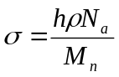 (4.1)
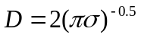 (4.2)
Here, h is the measured thickness of the polymer brush, ρ (g/cm³) is the density of PMAA, which is assumed to be the same as the bulk density (1.015 g/cm³),¹⁰⁷ M_{n} (g/mol) is the measured number-average molecular weight of free chains grown from sacrificial initiator, and N_{a} is Avogadro’s number. The properties of the PMAA brushes used in this study are listed in Table 4-1. The molecular weight, M_{n}, was estimated to be the same as M_{n} of the free polymer chains grown from sacrificial initiator. Thicker PMAA films and higher grafting densities are obtained from the synthesis by SI-ATRP, which is a “grafting from” approach, as compared to the “grafting to” approach. But in the case of the “grafting from” approach, characterization of polymer chains attached to the surface is a challenge, as it is based on certain assumptions.^{26a} In spite of this drawback of the “grafting from” approach it is a preferred technique for synthesizing polymer brushes because it produces thicker films with higher grafting densities. The responsive behavior of polymer brushes with respect to their solution environment can be more easily studied when films having higher grafting densities are used.

Table 4-1. Properties of PMAA brushes
Measured by | M_{n} (g/mol) | PDI | h (nm) | σ (chains/nm²) | D (nm)
Ellipsometry | 32, 600 | 1.7 | 26 | 0.49 | 1.61
Neutron Reflectometry | 43,200 | 1.3 | 24 | 0.34 | 1.94

In situ Swelling Measurements of PMAA Brushes by Ellipsometry
In-situ measurements of PMAA brush using multiangle ellipsometry were carried out to determine the swollen thicknesses and the response to changes in the type of ion and ionic strengths. In particular, the behavior of PMAA brush was studied specific to selected members of the cationic Hofmeister series. The selected members were sodium (Na), potassium (K) and lithium (Li). (Chloride salts of the cations were used to make buffer solutions of 0.01 mM, 0.05 mM, 0.1 mM, 0.5 mM and 1.0 mM ionic strengths.) All of the salt solutions used were adjusted to pH = 7 with small amounts of either NaOH or HCl. The amount of base or acid was very small as compared to the amount of salt added, and as a result the amount of ions added by the acid or base is negligible. Since the pK_{a} of MAA is typically 5.5 and the measurements were conducted at pH 7, the acidic groups of MAA are expected to be deprotonated. Also, as shown in Chapter 3, one of the key results suggests that the apparent pK_{a} of PMAA brush is 6 ≤ pH ≤ 8. The Picometer ellipsometer used for these measurements was set up with a cylindrical liquid flow cell made of annealed glass. The cell contains a Teflon sample mount and each sample is clamped to the Teflon stage such that the sample is at the mid-plane of the cylinder. Subsequently, the cell is sealed and mounted in a holder on the ellipsometer stage. Buffer solutions are injected into the cell before each measurement using a syringe equipped with a 0.45 μm PVDF filter. The Igor Pro software package is used to determine the thickness and the refractive index of the solvated brush and the brush is described using a Cauchy model. As water-based buffer solutions are used, the refractive index obtained by fitting the data is expected to be between that of water (1.33) and the polymer (1.5). When the layer swells, the chains are diluted, so the refractive index of a swollen brush should be closer to water (than to polymer in the dry state).
Figure 4-1 shows results from swelling measurements as a function of ionic strength and type of ion at constant pH. These measurements were carried out to investigate the influence of particular Hofmeister cations on the swollen thickness of the PMAA brush. It can be seen from Figure 4-1 that the brush qualitatively shows the same behavior for Na⁺ and K⁺. For Na⁺ and K⁺ ions, the brush height first increases with salt concentration and then decreases. This is well understood on the basis of osmotic brush regime and salt brush regime, which was discussed in Chapter 1. The cross-over salt concentration C_{s} for both Na⁺ and K⁺ ions is around 0.5 mM. But for Li⁺, a decrease in the brush height with salt concentration is not observed, which suggests that the salted brush regime was not observed for the given set of concentrations. The cross-over salt concentration for each ion should follow the trend as per the position of cations in Hofmeister series. But with these measurements I was unable to resolve the differences in cross-over salt concentration C_{s} as a function of position of the cation in the Hofmeister series. Therefore, this illustrates the limitation of this technique to observe the ion-specific effects on the swelling behavior of PMAA brushes.

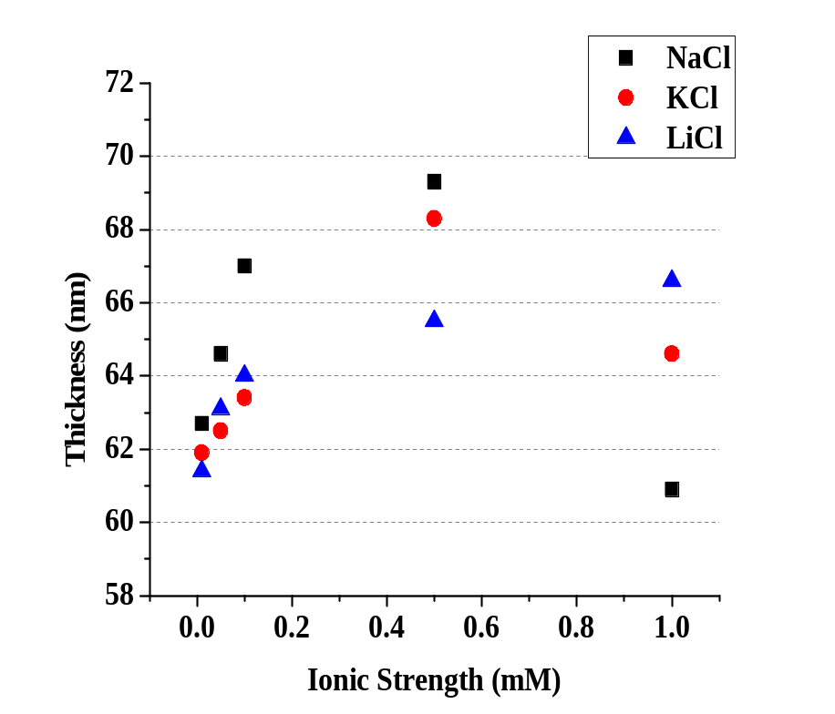
Figure 4-1. Swollen thickness of a 26 nm PMAA brush as a function of ionic strength of NaCl, KCl and LiCl solutions by multiangle ellipsometry.

4.3.3 Ion Specific Behavior of PMAA Brushes Studied by Neutron Reflectometry
Even though ellipsometry is sensitive to overall changes in the structure of the polymer film, it is insensitive to changes in the nanoscale structure of the polymer brush. As mentioned in Section 1.4, neutrons are deeply penetrating with wavelengths on the order of 1Å, they are able to see the buried interfaces and resolve the nanoscale structure of polymer layers in response to different environments. In neutron reflectometry the thicknesses measured are dependent on the local segment concentration and the scattering length densities.^{17b, 34} This information cannot be obtained from ellipsometry. Therefore, neutron reflectometry measurements were performed to study ion specific behavior of PMAA brushes.
Neutron reflectometry measurements were performed at Liquids Reflectometer (BL-4b) of the Spallation Neutron Source at Oak Ridge National Laboratory. Similar to ellipsometric measurements, samples were analyzed at different ionic strengths using NaCl, KCl and LiCl salts at pH 7. These buffer solutions were prepared using D₂O to create a contrast between the hydrogenated PMAA brush and the deuterated solvent. Reflectivity measurements were performed using an inverted geometry, with the neutrons incident on the brush through silicon, which allows the solution structure to be probed. After measurement in each solution the sample was washed with deionized water and dried with a stream of nitrogen. The reflectivity data and preliminary model fits of the dry PtBMA and PMAA brushes are shown in Figure 4-2. PMAA brushes are obtained after deprotection of tert-butyl groups on the neutral precursor PtBMA brushes by acid hydrolysis.
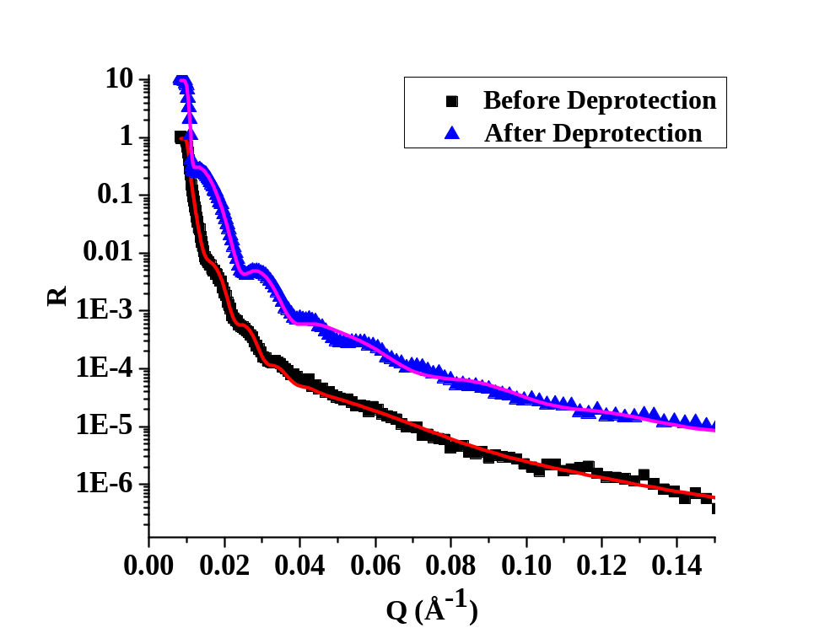
Figure 4-2. Neutron reflectivity data (symbols) and preliminary model fits (continuous lines) for PtBMA and PMAA brushes measured in air. PMAA brushes are obtained after cleaving the tert-butyl groups by acid hydrolysis of the neutral precursor PtBMA brush.

The changes in the brush structure, before and after deprotection are reflected in the fact that the measured reflectivity profile has changed. Fitting of the experimental data is still in progress, but the presence of low frequency fringes in the reflectivity curve for PMAA brush as compared to PtBMA brush indicates that PMAA brush is thinner than the PtBMA brush. Thicknesses based on preliminary fits also indicate that the PMAA brush is thinner (298 Å) than the PtBMA brush (644 Å). The thickness of the brush is expected to decrease after deprotection because of the loss of tert-butyl groups. The presence of well-defined fringes in PMAA reflectivity curve as compared to more featureless curve for PtBMA indicates that the PMAA brush is less rough than the PtBMA brush. Based on preliminary fits, the PtBMA brush has a roughness of 142 Å at the film/air interface, whereas PMAA brush has a film/air interface roughness of 95Å. Figure 4-3 shows reflectivity curves from the dry PMAA brush and the swollen PMAA brush at different ionic strengths (0.01 mM to 1.0 mM) using KCl (Figure 4-3A), NaCl (Figure 4-3B) and LiCl (Figure 4-3C). Though fitting of this experimental data is still in progress, these data sets may be qualitatively compared. The reflectivity curve of the dry PMAA brush has a steep power law decay as compared to the reflectivity curves from PMAA brush in contact with salt solutions. This indicates that PMAA brushes are swollen when they are in contact with salt solution as compared to the dry condition. Reflectivity curves having more moderate or gradual fall offs in reflectivity with q represent more extended brush structures as compared to curves that display a steep power-law decay in reflectivity. Figure 4-3A shows reflectivity curves for the PMAA brush in contact with KCl. In 0.05 mM KCl salt concentration, the brush has a more swollen structure as compared to the brush in the 0.01 mM solution, as reflected by the more gradual decay of reflectivity at 0.05 mM. Above 0.05 mM salt concentration, the brush structure becomes less extended (the chains tend to shrink) as salt concentration is increased. This pattern of behavior suggests that the cross-over concentration for this PMAA brush in KCl is 0.05 mM. Similarly, the cross-over concentration for the brush in NaCl is 0.1mM, as evidenced by the fact that the reflectivity curve measured at 0.1 mM NaCl represents the most swollen structure as compared to other ionic strengths of NaCl. As the order of ions in the Hofmeister series predicts that K⁺ is a stronger precipitator than Na⁺, the cross-over concentration for NaCl should be greater than that for KCl. In other words, with K⁺ being a stronger precipitator than Na⁺, the brush is expected to enter the salted brush regime at lower concentrations of KCl compared to NaCl. Therefore, the relative cross over concentrations of KCl (0.05mM) and NaCl (0.1mM) are consistent with their relative positions in the cationic Hofmeister series.
Figure 4-3C shows the reflectivity curves measured using different concentrations of LiCl. The changes in the reflectivity curves with concentration for LiCl are very subtle. Therefore, it is very challenging to qualitatively determine the cross-over concentration. Highly constrained and mass-balanced data fitting of these data sets will help to determine the exact cross-over concentration for LiCl. At the same time, the study can be extended to more concentrated solutions of LiCl to examine if the cross-over concentration occurs beyond 1.0 mM, which is the highest concentration used in this work.
Having said that, it is observed that the behavior of PMAA brushes in the presence of Li⁺ is different from the behaviors in the presence of Na⁺ and K⁺. Similar observations were made by Zhang and Rühe when they studied the effect of monovalent salts on the behavior of PMAA brushes by ellipsometric measurements.²¹ They observed that the PMAA brush in contact with Li⁺ was much less strongly swollen as compared to other ions. They attributed this behavior of Li⁺ to the high binding constant between Li⁺ and COO⁻. As the chemical bonds in lithium salts are less ionic in nature, the degree of dissociation, the electrostatic repulsion between the carboxylate groups along the PMAA chains and the concentration of mobile ions in the brush are lower. Therefore, the brush height is expected to be much lower if the brush is exposed to Li⁺ as compared to other salts. It will be interesting to investigate this behavior more thoroughly by neutron reflectometry.
The values for the cross-over concentrations, C_{s}, for a particular salt determined using ellipsometry and neutron reflectometry are not expected to match because samples with different grafting densities were measured by these techniques. It is known that the sensitivity of the brush to the salt is influenced by the grafting density of chains in the brush.²¹ The cross-over salt concentration C_{s} increases with increasing grafting density. For PMAA brush having σ = 0.49 chains/nm², which was studied by ellipsometry (Table 4-1), the values of C_{s} for Na⁺ and K⁺ were 0.5mM and for the sample with grafting density 0.34 chains/nm², which was studied by neutron reflectometry (Table 4-1) the value of C_{s} for Na⁺ was determined to be 0.1mM and for K⁺ it was 0.05 mM. These results show a similar trend in the values of C_{s} for a particular salt with grafting density to the results reported earlier.
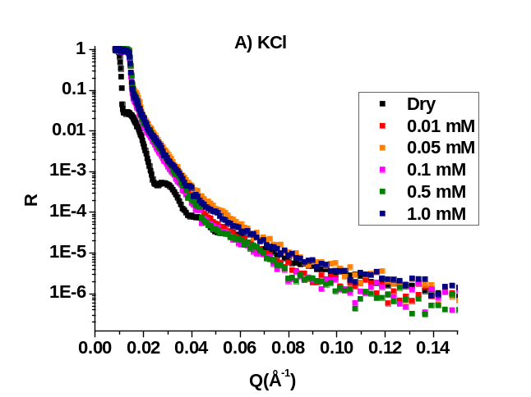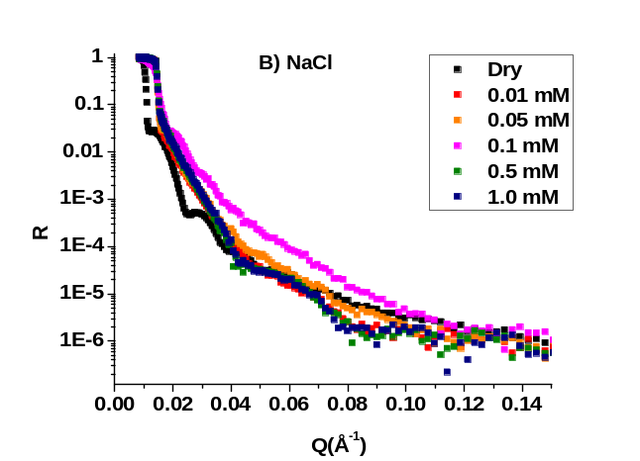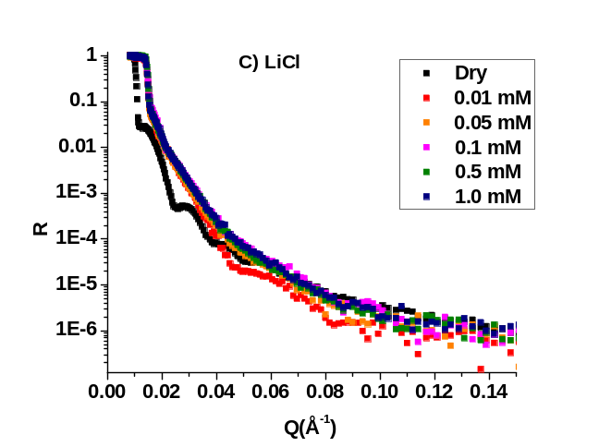
Figure 4-3. Neutron reflectivity curves for PMAA brushes in air (“Dry”) and in buffer solutions at pH = 7 using Hofmeister cations of A) KCl, B) NaCl and C) LiCl at various ionic strengths that are indicated in the figure legends.

Conclusions
The effect of specific cations in the Hofmeister series on swelling behavior of PMAA brushes was studied by ellipsometry and neutron reflectometry. The PMAA brushes were made by SI-ATRP of tBMA and subsequent deprotection by acid hydrolysis. Deprotection by acid hydrolysis was confirmed by neutron reflectometry measurements. For the studies of ion-specific effects the PMAA brushes were exposed to solutions of NaCl, KCl and LiCl having concentrations ranging from 0.01mM to 1.0 mM. In ellipsometric measurements, the scaling behavior of the PMAA brush swelling with the increasing salt concentrations was similar for Na⁺ and K⁺ ions. The cross-over salt concentrations, C_{s,} for both Na⁺ and K⁺ ions were found to be around 0.5 mM, but for Li⁺, a cross-over salt concentration, C_{s,} was not observed in the set of concentrations used. These results demonstrate the limitation of ellipsometry to resolve cross-over concentrations for Na⁺ and K⁺ ions.
Preliminary observations of the trend and qualitative features in the neutron reflectometry data indicate that the cross-over concentrations of KCl (0.05mM) and NaCl (0.1mM) are consistent with their relative positions in the cationic Hofmeister series. However, for LiCl the changes in the reflectivity curves with concentration are very subtle. Therefore, the cross-over concentration could not be identified, even tentatively. Highly constrained and mass-balanced data fitting of these data sets will enable me to investigate the detailed structural response of PMAA brushes to these Hofmeister cations. It will also be very interesting to study the behavior of PMAA brushes in the presence of Li⁺ at concentrations larger than those used in this work. Even with limited analysis, the neutron reflectometry clearly provides important structural clues and detailed information about thickness and roughness values across the series of salts and concentrations examined. A proper and thorough fitting of the data could provide insightful specifics about responsive behavior of brushes to different C_{s} and ion type. The effect of only monovalent ions of the cationic Hofmeister series are studied in this work. To get a more complete picture of mechanism of Hofmeister effects, study of effects of other members of the cationic Hofmeister series is recommended. While such studies are in their infancy this represents first such study in this field, and it provides a promising forecast of results and insights into highly sensitive, responsive behaviors of polyelectrolyte brushes.

- Mineralization of Calcium Carbonate using PMAA Brushes as Templates

Introduction
Biomineralization is a process by which living organisms produce minerals to stiffen existing tissues. These mineralized tissues, referred to as biominerals, perform a variety of roles in organisms such as mechanical support, defense and feeding.¹⁰⁸ Biominerals are formed from the cooperative interaction between inorganic materials with organic macromolecules.¹⁰⁹ Organic macromolecules not only play a structural role, but also control the nucleation, growth, morphology and crystal orientation of the inorganic component.¹¹⁰ The structures of these biocomposite materials are highly organized across length scales that range from nanometers to macroscopic levels, resulting in complex architectures.¹¹¹ This organization and the complex architecture displayed by biominerals imparts strength to these biological tissues as well as protection. Because of the complex architecture and range of control over mineral growth, there is significant interest in understanding and elucidating the mechanisms of biologically controlled mineralization.
Calcium carbonate (CaCO₃) is the most extensively researched biomineral as it is a relatively easy model system to work with and can exist is variety of morphologies.¹¹² There have been abundance of studies on calcium carbonate mineralization either by analyzing biogenic materials¹¹³ or by trying to understand the interactions between inorganic and organic components using synthetic methods.^{79h, 114} Molecularly well-defined substrates have been used to study and direct the growth of CaCO₃, including self-assembled monolayers on gold,¹¹⁵ immobilized organic/polymer films such as poly(acrylic acid)/chitosan membranes,¹¹⁶ and organosilane-based thin films.¹¹⁷ Most of these studies use planar substrates that allow to control the direction of mineralization in two dimensions parallel to the substrate. But the complex mineral structures found in nature are grown in three dimensional microenvironments, and for this reason using polymer brushes as templates to mimic biomineralization of CaCO₃ is an attractive approach.^{79h} Polymer brushes are not just two dimensional surface coatings, but they possess a well-defined interior microenvironment, as described in Chapter 3, that could enable mineral growth to be controlled in three dimensions. The potential of polymer brushes to act as templates for formation of metallic and non-metallic films has been explored in a few reports.^{79h, 118} Another advantage of using polymer brushes as templates for mineralization is that the chemistry of polymer can be controlled or varied through synthetic polymer chemistry. For example, the presence of acidic groups in polyelectrolyte brushes provides a functional matrix that is analogous to acidic matrix macromolecules involved in formation of calcified tissues in Nature.
In nature there are diverse strategies for fabrication of biominerals that are based on soluble as well as insoluble organic matrices to enable organisms to precisely control the size, shape, organization and polymorph of the mineral phase. Based on these strategies found in nature, synthetic strategies have been developed in order to mimic and study the biomineralization processes. The polymer-induced liquid precursor (PILP) method, is one strategy that provides better control over crystal morphology and nanostructure¹¹⁹. PILP is based on the concept of precipitation of minerals in the presence of soluble organic additives, like polyanionic polymers.^{109a} The negatively charged polymer inhibits crystal nucleation and allows the deposition of metastable droplets of mineral precursor on the substrate of interest, which after solidification crystallizes into an anhydrous crystalline phase.¹²⁰ This approach has been demonstrated to be useful in the formation of smooth and continuous calcite films and also more complex structures. In this work, poly(methacrylic acid) (PMAA) brushes synthesized by surface-initiated atom transfer radical polymerization (SI-ATRP) were used as templates to guide the formation of calcium carbonate thin films using PILP strategy. Although a variety of conditions used in PILP could be manipulated, I primarily explored the role of the concentration of organic additive, in order to identify a set of conditions that allow controlled formation of calcium carbonate thin films. The PMAA-guided formation of calcium carbonate thin films was investigated using techniques such as X-ray diffraction, scanning electron microscopy and X-ray photoelectron spectroscopy (XPS).

Experimental Section

Materials
Silicon wafers of size 1 cm × 1.2 cm were purchased from Silicon Quest International. Single side polished silicon wafers of 50 mm diameter and 5 mm thickness were purchased from Silicon Quest. tert-Butyl methacrylate (tBMA, Aldrich 98%) was distilled under reduced pressure before use. Copper (I) bromide (CuBr, Fluka 98%) was purified by stirring with glacial acetic acid overnight, then washed with absolute ethanol and dried under vacuum. Methanol (Fischer 99.9%), benzene (Aldrich 99.9%), copper (II) bromide (CuBr₂, Aldrich 99.9%), 4,4’-Dinonyl-2,2’-dipyridyl (dnNbpy, Aldrich 97%), ethyl α bromoisobutyrate (Aldrich 98%), ethyl bromoacetate (Aldrich 98%), dichloromethane (DCM, Fischer Scientific 99.5%), trifluroacetic acid (TFA, Aldrich 99%), ammonium carbonate ((NH₄)₂CO₃, Across Organics), calcium chloride (CaCl₂, reagent Across Organics), Poly(acrylic acid sodium salt) average M_{w} ~2,100 g/mol (Aldrich) were used as received.

Instrumentation
The molecular weight of PMAA was measured using aqueous gel permeation chromatography (GPC), based on polymer recovered from the polymerization solution (created from the sacrificial initiator), as explained in Chapter 2. The separation module consisted of an Agilent Technologies 1200 series autosampler, Agilent Technologies 1100 series pump and degasser equipped with two Polymer Laboratories PL Aquagel-OH mixed columns 8 μm (300 × 7.5 mm) and one PL Aquagel-OH column guard 8 μm (50 × 7.5 mm), a Wyatt technology Heleos multiangle light scattering detector, and a Wyatt Optilab rEX differential refractive index detector. The mobile phase consisted of 20% acetonitrile and 80% aqueous solution consisting of 0.01 M Na₂HPO₄ and 0.05M NaNO₃.⁵⁷ The specific refractive index increment, dn/dc, of PMAA in this mobile phase was measured to be 0.142 mL/g. The flow rate was 1 mL/min. Data acquisition and molecular weight calculations were performed using the Wyatt Technology Astra V software. Thicknesses of polymer thin films were measured using Beaglehole Instruments Picometer ellipsometer at multiple angles of incidence ranging from 80° to 60° using 1° increments. Calcium carbonate mineralized PMAA brushes were observed using a field emission scanning electron microscope (Zeius Auriga) at an operating voltage of 8 keV to obtain high resolution images. X-ray diffraction was performed using Panalytical Empyrean diffractometer operating at 40 kV and at current of 45 mA with Cu K_{α} radiation. Chemical analysis of the mineralized PMAA brushes was performed on a K-α X-ray photoelectron spectrometer (Thermoscientific, USA) at a base pressure of about 10⁻⁹ Pa. The X-rays used were monochromatic Al K-α photons and photoemitted electrons were analyzed with hemispherical energy analyzer. Survey scans (0 – 1400 eV) and the core level spectra were collected at pass energies of 200 and 50 eV respectively. Data analysis was performed using the Avantage software package (v. 4.61) provided by the manufacturers.

Synthesis of PMAA brushes by SI-ATRP
Cleaned silicon substrates were immersed in a solution of silane terminated initiator, 2-bromo-N-(11-(dichloro(methyl)silyl)undecyl)-2-methylpropanamide in toluene (17 mmol), for 18 hours. The silicon substrates were then rinsed with copious amounts of toluene and dried using a stream of nitrogen. Thickness of the initiator layer was determined with phase modulated multiangle ellipsometry. These initiator modified substrates were then transferred to Schlenk flask, which are used for SI-ATRP of tBMA. Monomer tBMA (4.385 g, 56.20 mmol), benzene (4.375 g, 30.8 mmol) and sacrificial initiators ethylbromoacetate (0.020 g, 0.117 mmol) and ethyl bromoisobutyrate (0.005 g, 0.027 mmol), were added to the Schlenk flask. dnNbpy (0.24 g, 0.587 mmol) was used as the ligand, which along with CuBr (0.055 g, 0.303 mmol) and CuBr₂ (0.0086 g, 0.038 mmol) were weighed separately, mixed into a paste and added to the flask. These amounts equate to [Cu(I)]/[Ini] = 2.65, [dnNbpy]/[Cu(I)] = 1.53 and [Cu(I)]/[Cu(II)] = 9.96. The reaction mixture was immediately subjected to three freeze-pump-thaw cycles. The mixture was sonicated for 2 minutes and then placed in the preheated oil bath at 60°C for 20 hours. After polymerization the silicon substrates were recovered, rinsed with toluene and dried in nitrogen stream. The reaction mixture was dissolved in THF and passed through silica gel to remove the copper species prior to analysis by GPC. The deprotection of the tert-butyl groups of the PtBMA brushes was done by immersing the surfaces in solution of trifluoroacetic acid in dichloromethane (30% v/v) for 20 min to obtain PMAA brushes. After deprotection the PMAA brushes were rinsed with methanol and dried under nitrogen stream.

Mineralization of Calcium Carbonate
Mineralization of calcium carbonate was performed using the ammonia diffusion method¹²¹ based on the PILP strategy. The experimental setup for calcium carbonate mineralization of PMAA brushes via ammonia diffusion method is represented in Figure 5-1. PMAA brushes on silicon substrate were adhered on glass slide with a piece of double-sided tape. These glass slides with adhered PMAA brushes on silicon substrates were placed upside down, supported on a Teflon ring, in a crystallizing dish. This arrangement is to help prevent crystals from settling on the substrates due to gravity. The crystallizing dish was filled with 10 mM calcium chloride solution, into which poly(acrylic acid) with a weight-average molecular weight, M_{w} = 2,100 g/mol was added. The concentration of PAA was varied from 60 μg/L to 120μg/L. The dish was then covered with parafilm that was perforated once with a needle and placed in a dessicator. Along with the crystallizing dish, a vial filled with ammonium carbonate was also placed in the dessicator. The vial containing ammonium carbonate was also covered with parafilm and perforated once with a needle to slow the diffusion (limit the flux) of ammonium carbonate vapor (NH₃ and CO₂ decomposition products) into the solution contained in the crystallizing dish. The mineralization was allowed to proceed for 3 days in the closed dessicator. After the PILP mineralization process was complete, substrates were recovered from the solution, gently dipped in deionized water and dried under a stream of nitrogen. A control experiment was also performed using a PtBMA brush instead of a PMAA brush.

Results and Discussion
In this work, the mineralization process was investigated as function of concentration of the organic additive, PAA (M_{w} = 2,100 g/mol). As proposed by Gower et al.¹²¹ in the PILP method, addition of a small amount of an acidic organic additive to the crystallizing solution causes liquid-liquid phase separation of precursor droplets. These droplets accumulate on the precursor substrate (here the PMAA substrate) to create precursor films that, upon, dehydration while in solution, undergo an amorphous to crystalline transformation. The formation of calcium carbonate occurs via slow decomposition of ammonium carbonate to NH₃ and CO₂, which in turn diffuses into the calcium chloride solution. Figure 5-2 shows X-ray diffraction patterns of calcium carbonate mineralized PMAA brushes obtained as a function of concentration of PAA (60 μg/L to 120 μg/L) as well as for a clean silicon substrate as a reference. The silicon substrate gives a peak at 28.5° that is assigned to Si (100), and this peak is seen in all of the patterns. Other than Si (100) peak, a sharp peak characteristic of calcite at 29.5° is also seen for all of the samples except the one obtained using a PAA concentration of 120 μg/L. The intensity of the peak assigned to calcite at 29.5° for the different samples indicates that as the concentration of PAA is increased, the amount of calcium carbonate formed in the brush decreases. The absence of the peak at 29.5° for the sample obtained using a concentration of 120 μg/L of PAA indicates that very little (or no) calcium carbonate is formed at this concentration.

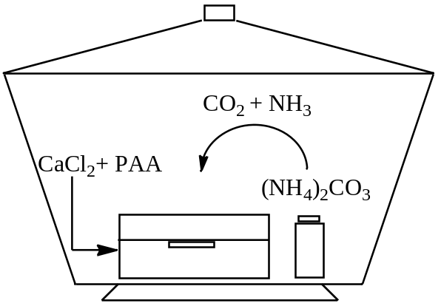
Figure 5-1. Experimental setup for calcium carbonate mineralization of PMAA brushes via ammonia diffusion method.

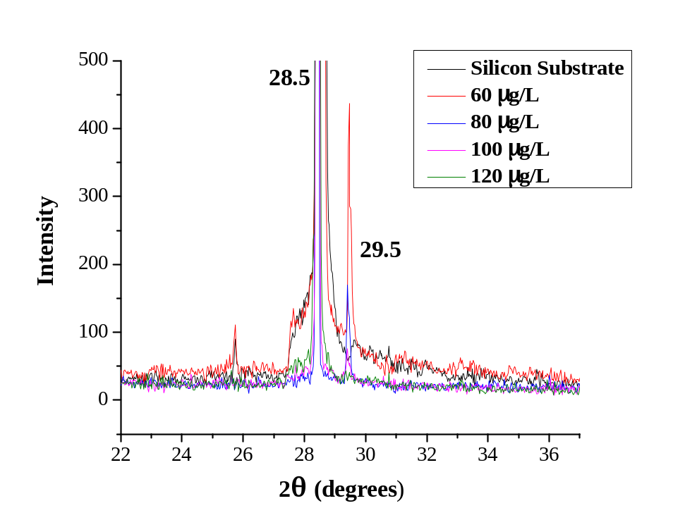
Figure 5-2. X-ray diffraction pattern of calcium carbonate mineralized PMAA brushes obtained as a function of concentration of PAA. The peak at 28.5° is characteristic of Si (100) and the peak at 29.5° is characteristic of CaCO₃.

Scanning electron microscopy (SEM) was used to image the films after calcium carbonate was grown using PMAA brushes as a template. Representative SEM images of calcium carbonate mineralized PMAA brushes are shown in Figure 5-3. The SEM images provide an idea of the overall coverage of mineralized PMAA brushes as a function of added PAA concentration. They show the formation of randomly oriented calcite crystals having a rhombohedral crystal habitat, which is typical for calcite. Figure 5-3A, which represents the sample obtained using a PAA concentration of 60 μg/L in the mineralization process, shows the largest population of calcium carbonate crystals (compared to the other images that were obtained from surfaces mineralized using higher PAA concentrations). This indicates that as the concentration of PAA additive in the crystallizing solution is increased, the mineralization process is suppressed. A high magnification SEM image of the calcium carbonate crystals grown by the PMAA brush sample mineralized at 60 μg/L of PAA is shown in Figure 5-3E. It clearly shows a group of radomly oriented, rhombohedral crystals with sharp edges along with few smaller elongated crytals. A calcium carbonate mineralization experiment was also performed using neutral PtBMA brushes as control experiment. As seen in Figure 5-3F, no calcium carbonate crystals were obtained on the PtBMA brush. This signifies that the tert-butyl protecting groups remain intact, even after immersion for three days in the mineralization solution.

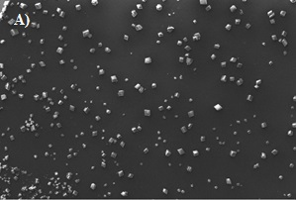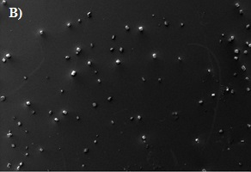
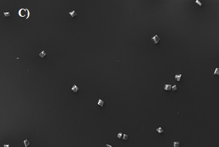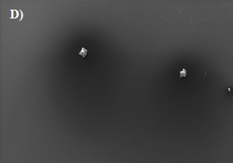
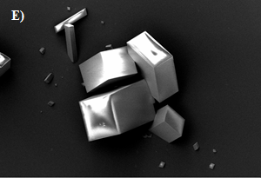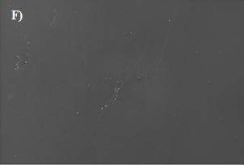
Figure 5-3. SEM images of PMAA brushes mineralized with calcium carbonate using different concentrations of PAA as the organic additive: A) 60 μg/L, B) 80 μg/L, C) 100 μg/L and D) 120 μg/L. E) High magnification image of CaCO₃ crystals grown using concentration of PAA = 60 μg/L. F) Image of the film created in a control experiment that tested whether mineralization occurred when the surface was covered with a PtBMA brush. Magnification: 69x (A – D and F), 1220x (E). Scale bar: 100 μm (A – D and F), 10 μm (E).
X-ray photoelectron spectroscopy (XPS) is one of the most widely used surface analysis techniques because it provides valuable information about chemical composition of the top 80 Å of surface. Not only does this limited penetration depth give XPS a high surface sensitivity, it also offers high molecular and elemental sensitivity. XPS has been applied to differentiate the three polymorphs of calcium carbonate materials, which are calcite, vaterite and aragonite.¹²² From a structural point of view calcite, vaterite and aragonite are different from one another. Calcite has a rhombohedral structure, while the less stable aragonite and vaterite exhibit orthorhombic lattices. Further, there is considerable difference in the arrangement of CO₃²⁻ ions in the lattice. The different orientations of CO₃²⁻ ions in calcium carbonate polymorphs are reflected in the differences in electron density, which can be measured by XPS. Figure 5-4 shows the XPS survey spectra of PMAA and PtBMA brushes mineralized with calcium carbonate at different PAA concentrations. The survey spectrum mainly shows signals from carbon and oxygen, which is in agreement with the elemental composition of PMAA and PtBMA. A small signal for Ca is seen in spectra of PMAA samples, but it is absent in spectrum for PtBMA sample. The absence of an emitted photoelectron due to Ca in spectra of PtBMA brush indicates that no calcium carbonate crystals were formed, and this result is in agreement with XRD and SEM results. The high resolution scans of C_{1s} signal are shown in Figure 5-5. In the C_{1s} high resolution scans, the photoelectrons emitted from carbon atoms of carbonyl groups appear at 288.5 eV, and they can be clearly distinguished from those due to aliphatic carbon atoms, which are seen at 285 eV. The high resolution scans of the C region show that the signal from carbonyl carbons overlaps with the photoelectrons attributed to the carbon of CaCO₃. Thus, the C_{1s} core level spectra are consistent with the presence of PMAA and PtBMA.
PMAA (100 μg/L)
Ca
PMAA (120 μg/L)
O
C
Si
N
0
200
400
600
800
1000
1200
Binding Energy (eV)
PtBMA (60 μg/L)
PMAA (60 μg/L)
PMAA (80 μg/L)
F

Ca
PMAA (100 μg/L)
Figure 5-4. XPS survey spectra of PMAA and PtBMA brushes mineralized with calcium carbonate at different PAA concentrations. The concentration of PAA (M_{w} = 2,100 g/mol) used in each experiment is indicated in brackets labeling each spectrum.

CH

₂
CaCO₃ or C=O
282
286
290
294
Binding Energy (eV)
PMAA (100 μg/L)
PMAA (120 μg/L)
PMAA (60 μg/L)
PMAA (80 μg/L)
PtBMA (60 μg/L)

Figure 5-5. High resolution scans in the C_{1s} region of PMAA and PtBMA brushes mineralized with calcium carbonate at different PAA concentrations. Concentration of PAA (M_{w} = 2,100 g/mol) used in each experiment is indicated in brackets. Solid lines at 288.5 eV and 285 eV are provided as guides to the eye.
Figure 5-6 shows Ca_{2p} core level spectra of calcium carbonate mineralized PMAA and PtBMA brushes. The Ca_{2p} core level spectrum can be used to differentiate between the various polymorphs of calcium carbonate. Two peaks are seen in Ca_{2p} core level spectra, and these are assigned, in order of increasing binding energy (BE), as due to Ca_{2p(3/2)} and Ca_{2p(1/2)}. According to Gopinath et al. the Ca _{2p(3/2)} core level signal for calcite appears at 347.1 eV, for vaterite at 346.9 eV, and for aragonite at 347.4 eV.^{122b} It is clearly seen in Figure 5-6 that the Ca_{2p(3/2)} peak for the mineralized PMAA samples created here appears at 347.1 eV, which indicates that the form of calcium carbonate crystals formed in these samples is calcite. No Ca_{2p} core level signal is seen for PtBMA brush, again indicating the absence of calcium carbonate crystals. The surface compositions, in terms of atomic percentage of all the elements observed by XPS, is given in Table 5-1. For PMAA samples, no definitive trend is seen in percentage of calcium with concentration of PAA added in the crystallizing solution for PMAA brushes. It does seem that when the surface compositions are given in terms of the Ca/C ratio, which is a simplistic way to normalize for slight variations in brush thickness, that there is a decrease with increasing PAA concentration, but the sample at 120 μg/L breaks this trend. These results are generally consistent with the SEM and XRD results, which show that the amount of calcium carbonate formed in the PMAA brushes decreases with increasing concentration of PAA. It should also be appreciated that the intensities measured in an XPS experiment result from photoelectrons emitted from the surface area irradiated with X-rays. Thus, while surface-to-surface variation might explain the observed result (the break in the trend), such variation cannot be easily accounted for when the surfaces are laterally heterogeneous. The absence of signal due to Ca in PtBMA brush is, of course, consistent with previous results.

Table 5-1. Surface composition of calcium carbonate mineralized PMAA and PtBMA brushes derived from XPS results. The concentration of PAA added to the crystallizing solution is given in brackets for each sample.
Surface Composition (at.%) | C | O | Ca | Ca/C
PtBMA(60 μg/L) | 71.4 | 21.1 | 0.0 | 0
PMAA(60 μg/L) | 64.0 | 27.0 | 5.2 | 0.081
PMAA(80 μg/L) | 63.9 | 28.0 | 3.7 | 0.058
PMAA(100 μg/L) | 66.5 | 26.2 | 2.7 | 0.041
PMAA(120 μg/L) | 67.6 | 26.3 | 3.6 | 0.053

344
348
352
356
Binding Energy (eV)
PtBMA (60 μg/L)
PMAA (80 μg/L)
PMAA (60 μg/L)
PMAA (120 μg/L)
PMAA (100 μg/L)

Figure 5-6. Ca_{2p} core level spectra of calcium carbonate mineralized PMAA and PtBMA brushes. The concentration of PAA (M_{w} = 2,100 g/mol) used in each experiment is indicated in brackets, and the solid line at 347.1 eV, which is the binding energy attributed to the CaCO₃ polymorph calcite, is to guide the eye.

Conclusions
PMAA brushes synthesized via SI-ATRP were subjected to PAA-mediated mineralization of calcium carbonate using PILP strategy via the ammonia diffusion method. The mineralization process was investigated as a function of concentration of PAA using X-ray diffraction, SEM and XPS. Randomly oriented rhombohedral calcite crystals were observed by SEM when lower concentrations of PAA were used. Analyses of the binding energy obtained from XPS measurements revealed that the form of the calcium carbonate crystals formed on the PMAA brushes is calcite. X-ray diffraction confirms calcite polymorph as peak characteristic of calcite was observed at 29.5° when the PMAA brushes were mineralized in the presence of PAA at 60, 80 and 100 μg/L. From these preliminary results, the extent of calcium carbonate mineralization was found to decrease with increasing PAA concentration in the mineralization solution. In this work, X-ray diffraction was performed using “in-house” diffractometer. X-ray diffraction analysis of mineralized PMAA brushes using synchrotron X-ray source is suggested in order to more clearly study the microstructure of these films. As synchrotron sources are highly penetrating and intense as compared to laboratory-based instruments, extremely sharp peaks with better resolution are obtained. The effect of grafting density and thickness of polymer brushes on the mineralization process should also be investigated. To advance this work, mineralization experiments with PMAA brushes having different thicknesses and grafting densities is recommended. In order to provide more insights into the mineralization process, characterization of mineralized films with neutron reflectometry is also recommended. Characterization with neutron reflectometry will help to resolve ambiguities concerning the location where calcium carbonate is formed when template by the brush layer. In other words, it may be possible to determine whether calcium carbonate forms only on the top of the PMAA brush or whether it is integrated within the PMAA brush. To extend these studies further, one can explore the possibility of combining lithographic patterning with mineralization to create three dimensional structures or use brush chemistry, such as, copolymerization with neutral monomer, to moderate the growth of calcium carbonate.

– Summary, Conclusions and Future Work
In spite of their significance in fields of biology and medicine, polyelectrolytes are presently the least understood polymeric systems due to their complex behavior that arises because of the intimate connection between charge and conformation. Through this dissertation, I report findings of responsive behavior of weak polyelectrolyte brushes to different stimuli such as pH, type of ion and ionic strength, and their role as templates in calcium carbonate mineralization. To make well-defined polyelectrolyte brush layers, two different routes were pursued. In the first, premade polymer chains were attached using an orthogonal, specific coupling reaction known generally as “click” chemistry. Because these layers proved to be too sparse for detailed studies of structure, a second approach involving surface-initiated polymerization was pursued and optimized. The thin films and polymer brushes were mainly characterized by ellipsometry, neutron reflectometry and atomic force microscopy.
Thin interfacial films based on chemically modified PGMA and pGP copolymers were studied as a means of creating alkyne-decorated substrates suitable for click reactions with azide- capped polymers. A variety of conditions were examined to optimize chain areal density. In addition to tuning film thicknesses through control of deposition conditions, alkyne content could be tuned via reactive modification with small alkyne-containing molecules of acidic or basic nature or by creating copolymers of different composition. Azide terminated PMAA and PVDMA polymers synthesized via RAFT were tethered to various alkyne-bearing PGMA substrates via click reactions. Moderately high grafting densities were obtained, suggesting that the end-tethered polymers exist in the brush regime. Layers of low grafting density were also obtained, suggesting tunability of the grafting density over a relatively broad range covering the “mushroom” and brush regimes. This opens additional possibilities for immobilizing azide-terminated, reactive macromolecules on flat surfaces. Additionally, insights into the nanophase structure of the chemically modified, alkyne-containing films obtained via neutron reflectometry suggest the potential of this method for examining chemical modifications of reactive interfacial films. Studies along these lines were begun by another graduate students.
PMAA brushes were synthesized using surface-initiated atom transfer radical polymerization (SI-ATRP) via the grafting from approach. Precursor PtBMA brushes were grown from initiator modified substrates, which were subjected to acid hydrolysis to obtain PMAA brushes. The optimum thicknesses and PDI values were obtained when a combination of two sacrificial initiators, ethylbromoacetate and ethyl bromoisobutyrate, was used.
A method to self-consistently determine water content of polyelectrolyte films using neutron reflectometry under different hydration conditions is reported. Along with PMAA brushes copolymer brushes made of methacrylic acid and hydroxyethyl methacrylate were studies in this work. Multiple data sets were modeled with constrained fittings to obtain dry polymer mass density, layer thickness and PE brush profiles into different pH solutions. The differences between structural parameters derived from constrained fits of neutron reflectivity data and those derived from ellipsometric measurement of film thickness in air are significant. Clearly, using thicknesses of films hydrated by ambient moisture leads to an overestimation of grafting densities and underestimation of stretch ratios. Due to the variation of film hydration in humid air, this discrepancy cannot easily be corrected in thin film systems. Only by explicitly accounting for adsorbed water by a method similar to that described in my thesis can one accurately determine how much polymer is deposited on a surface and how much it expands in contact with solvents. This represents a significant advance because by this method the true amount of dry polymer in the layer can be determined, providing accurate determinations of the grafting density and degree-of-stretching of the brush chains. Both of these are important parameters because they dictate the range and strength of interfacial interactions between polymer films and their environment.
The influence of monovalent ions from the cationic Hofmeister series on the structure and swelling behavior of weak polyelectrolyte brushes was also investigated. For these studies of ion-specific effects the PMAA brushes were exposed to solutions of NaCl, KCl and LiCl having concentrations ranging from 0.01mM to 1.0 mM. Using ellipsometric measurements, the scaling behavior of the PMAA brush swelling with the increasing salt concentrations was similar for Na⁺ and K⁺ ions. The cross-over salt concentrations, C_{s,} for both Na⁺ and K⁺ ions were found to be around 0.5 mM, but for Li⁺, a cross-over salt concentration, C_{s,} was not observed in the set of concentrations used. These results demonstrate the lack of sensitivity of ellipsometry to specific ions. Preliminary observations of the trend and qualitative features in the neutron reflectometry data indicate that the cross-over concentration of both KCl (0.05mM) and NaCl (0.1mM) is consistent with their relative positions in the cationic Hofmeister series. However, for LiCl the changes in the reflectivity curves with concentration are very subtle. Therefore, the cross-over concentration could not be identified, even tentatively. It would be very interesting to study the behavior of PMAA brushes in the presence of Li⁺ at concentrations larger than those used in this work. In addition, because only monovalent ions of the cationic Hofmeister series are studied in this work, it would be worthwhile to study the effects of other members of the cationic Hofmeister series in order to get a complete picture of Hofmeister effects in a well-defined brush systems. While such studies are in their infancy, this represents first such study in this field, and it provides a promising forecast of results and insights into highly sensitive, responsive behaviors of polyelectrolyte brushes.
Some preliminary results are reported concerning the role of PMAA brushes as templates for mineralization of calcium carbonate. Calcium carbonate mineralization was investigated as a function of concentration of an acidic organic additive: Poly(acrylic acid) (PAA) was used as an organic additive in my work. Calcium carbonate films were obtained by the polymer-induced liquid precursor (PILP) strategy using the ammonia diffusion method. Randomly-oriented rhombohedral calcite crystals were observed by SEM when lower concentrations of PAA were used. Analyses of the distribution of binding energies due to different bonding configurations obtained from XPS measurements reveal that the form of the calcium carbonate crystals formed on the PMAA brushes is calcite. X-ray diffraction confirms that the CaCO₃ polymorph present is calcite, as the peak characteristic of calcite at 29.5° is observed when the PMAA brushes were mineralized in the presence of PAA at 60, 80 and 100 μg/L. From these preliminary results, the extent of calcium carbonate mineralization was found to decrease with increasing PAA concentration in the mineralization solution. X-ray diffraction studies (including grazing incidence small angle X-ray scattering) of mineralized PMAA brushes using a synchrotron X-ray source for higher resolution is suggested in order to more clearly determine the microstructure of these films. The effect of grafting density and thickness of polymer brushes on the mineralization process should also be investigated. To advance this work, mineralization experiments with PMAA brushes having different thicknesses and grafting densities is recommended. In order to provide more insights into the mineralization process, characterization of mineralized films with neutron reflectometry is also recommended because of its sensitivity to different elements and ability to resolve structure on nanometer length scales, neutron reflectometry will help to resolve ambiguities concerning the location where calcium carbonate is formed when templated by the PMAA brush layer.

List of References

1. (a) Milner, S. T., Polymer brushes. Science 1991, 251, 905-14; (b) Rühe, J., Polymer Brushes: On the Way to Tailor-Made Surfaces. In Polymer Brushes, Rigoberto C. Advincula, W. J. B. K. C. C. J. R., Ed. 2005; pp 1-31.
2. de Gennes, P. G., Conformations of Polymers Attached to an Interface. Macromolecules 1980, 13 (5), 1069-1075.
3. Pincus, P., Colloid stabilization with grafted polyelectrolytes. Macromolecules 1991, 24 (10), 2912-2919.
4. Klein, J.; Kamiyama, Y.; Yoshizawa, H.; Israelachvili, J. N.; Fredrickson, G. H.; Pincus, P.; Fetters, L. J., Lubrication forces between surfaces bearing polymer brushes. Macromolecules 1993, 26 (21), 5552-5560.
5. Jensen, M. Ø.; Mouritsen, O. G.; Peters, G. H., Dipolar and chain-linking effects on the rheology of grafted chains in a nanopore under shear at different grafting densities. Physical Review E 2001, 64, 11507.
6. Raphael, E.; De Gennes, P. G., Rubber-rubber adhesion with connector molecules. The Journal of Physical Chemistry 1992, 96 (10), 4002-4007.
7. Tirrell, M.; Kokkoli, E.; Biesalski, M., The role of surface science in bioengineered materials. Surface Science 2002, 500 (1–3), 61-83.
8. van Zanten, J. H., Terminally Anchored Chain Interphases: Their Chromatographic Properties. Macromolecules 1994, 27 (23), 6797-6807.
9. (a) Ito, Y.; Ochiai, Y.; Park, Y. S.; Imanishi, Y., pH-Sensitive Gating by Conformational Change of a Polypeptide Brush Grafted onto a Porous Polymer Membrane. J. Am. Chem. Soc. 1997, 119 (7), 1619-1623; (b) Zhang, H.; Ito, Y., pH Control of Transport through a Porous Membrane Self-Assembled with a Poly(acrylic acid) Loop Brush. Langmuir 2001, 17 (26), 8336-8340.
10. Barker, S. L.; Ross, D.; Tarlov, M. J.; Gaitan, M.; Locascio, L. E., Control of flow direction in microfluidic devices with polyelectrolyte multilayers. Anal Chem 2000, 72 (24), 5925-9.
11. (a) Biesalski, M.; Johannsmann, D.; Rühe, J., Synthesis and swelling behavior of a weak polyacid brush. J. Chem. Phys. 2002, 117 (10), 4988; (b) Biesalski, M.; Johannsmann, D.; Rühe, J., Electrolyte-induced collapse of a polyelectrolyte brush. J. Chem. Phys. 2004, 120 (18), 8807-8814; (c) Rahane, S. B.; Floyd, J. A.; Metters, A. T.; Kilbey, S. M., Swelling Behavior of Multiresponsive Poly(methacrylic acid)-b-poly(N-isopropylacrylamide) Brushes Synthesized Using Surface-Initiated Photoiniferter-Mediated Photopolymerization. Adv. Funct. Mater. 2008, 18 (8), 1232-1240.
12. (a) Gong, P.; Wu, T.; Genzer, J.; Szleifer, I., Behavior of Surface-Anchored Poly(acrylic acid) Brushes with Grafting Density Gradients on Solid Substrates: 2. Theory. Macromolecules 2007, 40 (24), 8765-8773; (b) Manning, G. S., Limiting laws and counterion condensation in polyelectrolyte solutions .I. Colligative properties. Journal of Chemical Physics 1969, 51 (3), 924-&.
13. Halperin, A.; Tirrell, M.; Lodge, T. P., Tethered chains in polymer microstructures. Adv. Polym. Sci. 1992, 100, 31-71.
14. Reis, E. A. O.; Caraschi, J. C.; Carmona-Ribeiro, A. M.; Petri, D. F. S., Polyelectrolytes at charged particles: Particle number density, molecular weight, and charge ratio effects. J. Phys. Chem. B 2003, 107 (32), 7993-7997.
15. Noble, P. F.; Cayre, O. J.; Alargova, R. G.; Velev, O. D.; Paunov, V. N., Fabrication of "hairy" colloidosomes with shells of polymeric microrods. J. Am. Chem. Soc. 2004, 126 (26), 8092-8093.
16. Mika, A. M.; Childs, R. F., Salt separation by charged gel-filled microporous membranes. Industrial & Engineering Chemistry Research 2003, 42 (13), 3111-3117.
17. (a) Mir, Y.; Auroy, P.; Auvray, L., Density Profile of Polyelectrolyte Brushes. Phys. Rev. Lett. 1995, 75, 2863; (b) Romet-Lemonne, G.; Daillant, J.; Guenoun, P.; Yang, J.; Mays, J. W., Thickness and Density Profiles of Polyelectrolyte Brushes: Dependence on Grafting Density and Salt Concentration. Phys. Rev. Lett. 2004, 93, 148301; (c) Balastre, M.; Li, F.; Schorr, P.; Yang, J.; Mays, J. W.; Tirrell, M. V., A Study of Polyelectrolyte Brushes Formed from Adsorption of Amphiphilic Diblock Copolymers Using the Surface Forces Apparatus. Macromolecules 2002, 35 (25), 9480-9486.
18. Currie, E. P. K.; Sieval, A. B.; Fleer, G. J.; Stuart, M. A. C., Polyacrylic Acid Brushes: Surface Pressure and Salt-Induced Swelling. Langmuir 2000, 16 (22), 8324-8333.
19. (a) Zhulina, E. B.; Birshtein, T. M.; Borisov, O. V., Theory of Ionizable Polymer Brushes. Macromolecules 1995, 28 (5), 1491-1499; (b) Zhulina, E. B.; Borisov, O. V., Structure and interaction of weakly charged polyelectrolyte brushes: Self-consistent field theory. Journal of Chemical Physics 1997, 107 (15), 5952.
20. Israels, R.; Leermakers, F. A. M.; Fleer, G. J.; Zhulina, E. B., Charged Polymeric Brushes: Structure and Scaling Relations. Macromolecules 1994, 27 (12), 3249-3261.
21. Zhang, H.; Rühe, J., Swelling of Poly(methacrylic acid) Brushes: Influence of Monovalent Salts in the Environment. Macromolecules 2005, 38 (11), 4855-4860.
22. (a) Kilbey, S. M.; Watanabe, H.; Tirrell, M., Structure and Scaling of Polymer Brushes near the θ Condition. Macromolecules 2001, 34 (15), 5249-5259; (b) Karim, A.; Satija, S. K.; Douglas, J. F.; Ankner, J. F.; Fetters, L. J., Neutron Reflectivity Study of the Density Profile of a Model End-Grafted Polymer Brush: Influence of Solvent Quality. Phys. Rev. Lett. 1994, 73, 3407; (c) Edmondson, S.; Osborne, V. L.; Huck, W. T. S., Polymer brushes via surface-initiated polymerizations. Chem. Soc. Rev. 2004, 33 (1), 14-22.
23. Zhao, B.; Brittain, W. J., Polymer brushes: surface-immobilized macromolecules. Prog. Polym. Sci. 2000, 25 (5), 677-710.
24. Devaux, C.; Chapel, J. P.; Beyou, E.; Chaumont, P., Controlled structure and density of "living" polystyrene brushes on flat silica surfaces. European Physical Journal E 2002, 7 (4), 345-352.
25. Moad, G.; Chong, Y. K.; Postma, A.; Rizzardo, E.; Thang, S. H., Advances in RAFT polymerization: the synthesis of polymers with defined end-groups. Polymer 2005, 46 (19), 8458-8468.
26. (a) Ejaz, M.; Yamamoto, S.; Ohno, K.; Tsujii, Y.; Fukuda, T., Controlled Graft Polymerization of Methyl Methacrylate on Silicon Substrate by the Combined Use of the Langmuir−Blodgett and Atom Transfer Radical Polymerization Techniques. Macromolecules 1998, 31 (17), 5934-5936; (b) Kim, J.-B.; Huang, W.; Miller, M. D.; Baker, G. L.; Bruening, M. L., Kinetics of surface-initiated atom transfer radical polymerization. J. Polym. Sci., Part A: Polym. Chem. 2003, 41 (3), 386-394.
27. Guo, X.; Ballauff, M., Spherical polyelectrolyte brushes: Comparison between annealed and quenched brushes. Physical Review E 2001, 64 (5).
28. Muller, F.; Romet-Lemonne, G.; Delsanti, M.; Mays, J. W.; Daillant, J.; Guenoun, P., Salt-induced contraction of polyelectrolyte brushes. Journal of Physics: Condensed Matter 2005, 17 (45), S3355-S3361.
29. Parnell, A. J.; Martin, S. J.; Dang, C. C.; Geoghegan, M.; Jones, R. A. L.; Crook, C. J.; Howse, J. R.; Ryan, A. J., Synthesis, characterization and swelling behaviour of poly(methacrylic acid) brushes synthesized using atom transfer radical polymerization. Polymer 2009, 50 (4), 1005-1014.
30. Sanjuan, S.; Perrin, P.; Pantoustier, N.; Tran, Y., Synthesis and swelling behavior of pH-responsive polybase brushes. Langmuir 2007, 23 (10), 5769-5778.
31. Wu, T.; Gong, P.; Szleifer, I.; Vlček, P.; Šubr, V.; Genzer, J., Behavior of Surface-Anchored Poly(acrylic acid) Brushes with Grafting Density Gradients on Solid Substrates: 1. Experiment. Macromolecules 2007, 40 (24), 8756-8764.
32. Sears, V., Neutron scattering lengths and cross sections. Neutron News 1992, 3 (3), 26-37.
33. (a) Lu, J. R.; Thomas, R. K., Neutron reflection from wet interfaces. J. Chem. Soc., Faraday Trans. 1998, 94, 995-1018; (b) Higgins, J. S.; Benoit, H. C., Polymers and Neutron Scattering. Oxford Univ. Press: 1994; p 456 pp; (c) Penfold, J.; Thomas, R. K., The application of the specular reflection of neutrons to the study of surfaces and interfaces. Journal of Physics: Condensed Matter 1990, 2, 1369-412.
34. (a) Geoghegan, M.; Ruiz-Perez, L.; Dang, C. C.; Parnell, A. J.; Martin, S. J.; Howse, J. R.; Jones, R. A. L.; Golestanian, R.; Topham, P. D.; Crook, C. J.; Ryan, A. J.; Sivia, D. S.; Webster, J. R. P.; Menelle, A., The pH-induced swelling and collapse of a polybase brush synthesized by atom transfer radical polymerization. Soft Matter 2006, 2 (12), 1076-1080; (b) Hamilton, W. A.; Smith, G. S.; Alcantar, N. A.; Majewski, J.; Toomey, R. G.; Kuhl, T. L., Determining the density profile of confined polymer brushes with neutron reflectivity. J. Polym. Sci., Part B: Polym. Phys. 2004, 42 (17), 3290-3301.
35. Prabhu, V. M.; Vogt, B. D.; Wu, W. L.; Douglas, J. F.; Lin, E. K.; Satija, S. K.; Goldfarb, D. L.; Ito, H., Direct measurement of the counterion distribution within swollen polyelectrolyte films. Langmuir 2005, 21 (15), 6647-6651.
36. Zhulina, E. B.; Borisov, O. V.; Pryamitsyn, V. A.; Birshtein, T. M., Coil-globule type transitions in polymers. 1. Collapse of layers of grafted polymer chains. Macromolecules 1991, 24 (1), 140-149.
37. Hollmann, O.; Steitz, R.; Czeslik, C., Structure and dynamics of α-lactalbumin adsorbed at a charged brush interface. PCCP 2008, 10 (10), 1448-1456.
38. Zanetti, G.; Briggs, J. A. G.; Grunewald, K.; Sattentau, Q. J.; Fuller, S. D., Cryo-electron tomographic structure of an immunodeficiency virus envelope complex in situ. PLoS Pathog. 2006, 2, 790-797.
39. Ryu, D. Y.; Shin, K.; Drockenmuller, E.; Hawker, C. J.; Russell, T. P., A generalized approach to the modification of solid surfaces. Science 2005, 308, 236-239.
40. Iha, R. K.; Wooley, K. L.; Nystrom, A. M.; Burke, D. J.; Kade, M. J.; Hawker, C. J., Applications of Orthogonal "Click" Chemistries in the Synthesis of Functional Soft Materials. Chem. Rev. 2009, 109, 5620-5686.
41. (a) Kolb, H. C.; Finn, M. G.; Sharpless, K. B., Click chemistry: diverse chemical function from a few good reactions. Angew. Chem., Int. Ed. 2001, 40, 2004-2021; (b) Binder, W. H.; Sachsenhofer, R., 'Click' chemistry in polymer and material science: an update. Macromolecular Rapid Communications 2008, 29, 952-981; (c) Lahann, J., Click Chemistry: A Universal Ligation Strategy for Biotechnology and Materials Science. In Click Chemistry for Biotechnology and Materials Science, John Wiley & Sons, Ltd: 2009; pp 1-7; (d) Golas, P. L.; Matyjaszewski, K., Marrying click chemistry with polymerization: expanding the scope of polymeric materials. Chem. Soc. Rev. 2010, 39, 1338-1354.
42. Balachander, N.; Sukenik, C. N., Monolayer transformation by nucleophilic substitution: Applications to the creation of new monolayer assemblies. Langmuir 1990, 6, 1621-7.
43. (a) Ranjan, R.; Brittain, W. J., Combination of Living Radical Polymerization and Click Chemistry for Surface Modification. Macromolecules 2007, 40, 6217-6223; (b) Drockenmuller, E.; Colinet, I.; Damiron, D.; Gal, F.; Perez, H.; Carrot, G., Efficient Approaches for the Surface Modification of Platinum Nanoparticles via Click Chemistry. Macromolecules 2010, 43, 9371-9375.
44. (a) Balamurugan, S. S.; Soto-Cantu, E.; Cueto, R.; Russo, P. S., Preparation of Organosoluble Silica-Polypeptide Particles by "Click" Chemistry. Macromolecules 2010, 43, 62-70; (b) Kar, M.; Vijayakumar, P. S.; Prasad, B. L. V.; Sen, G. S., Synthesis and Characterization of Poly-L-lysine-Grafted Silica Nanoparticles Synthesized via NCA Polymerization and Click Chemistry. Langmuir 2010, 26, 5772-5781.
45. Rozkiewicz, D. I.; Gierlich, J.; Burley, G. A.; Gutsmiedl, K.; Carell, T.; Ravoo, B. J.; Reinhoudt, D. N., Transfer printing of DNA by click chemistry. ChemBioChem 2007, 8, 1997-2002.
46. Collman, J. P.; Devaraj, N. K.; Chidsey, C. E. D., "Clicking" Functionality onto Electrode Surfaces. Langmuir 2004, 20, 1051-1053.
47. Ciampi, S.; Boecking, T.; Kilian, K. A.; James, M.; Harper, J. B.; Gooding, J. J., Functionalization of Acetylene-Terminated Monolayers on Si(100) Surfaces: A Click Chemistry Approach. Langmuir 2007, 23, 9320-9329.
48. Im, S. G.; Kim, B.-S.; Lee, L. H.; Tenhaeff, W. E.; Hammond, P. T.; Gleason, K. K., A directly patternable, click-active polymer film via initiated chemical vapor deposition. Macromolecular Rapid Communications 2008, 29, 1648-1654.
49. Gallant, N. D.; Lavery, K. A.; Amis, E. J.; Becker, M. L., Universal gradient substrates for "click" biofunctionalization. Adv. Mater. 2007, 19, 965-969.
50. Bergbreiter, D. E.; Chance, B. S., "Click"-Based Covalent Layer-by-Layer Assembly on Polyethylene Using Water-Soluble Polymeric Reagents. Macromolecules 2007, 40, 5337-5343.
51. Such, G. K.; Quinn, J. F.; Quinn, A.; Tjipto, E.; Caruso, F., Assembly of Ultrathin Polymer Multilayer Films by Click Chemistry. J. Am. Chem. Soc. 2006, 128, 9318-9319.
52. Vestberg, R.; Malkoch, M.; Kade, M.; Wu, P.; Fokin, V. V.; Sharpless, K. B.; Drockenmuller, E.; Hawker, C. J., Role of architecture and molecular weight in the formation of tailor-made ultrathin multilayers using dendritic macromolecules and click chemistry. J. Polym. Sci., Part A: Polym. Chem. 2007, 45, 2835-2846.
53. Luzinov, I.; Julthongpiput, D.; Malz, H.; Pionteck, J.; Tsukruk, V. V., Polystyrene Layers Grafted to Epoxy-Modified Silicon Surfaces. Macromolecules 2000, 33, 1043-1048.
54. Fleischmann, S.; Hinrichs, K.; Oertel, U.; Reichelt, S.; Eichhorn, K.-J.; Voit, B., Modification of Polymer Surfaces by Click Chemistry. Macromolecular Rapid Communications 2008, 29 (12-13), 1177-1185.
55. (a) Rengifo, H. R.; Chen, L.; Grigoras, C.; Ju, J.; Koberstein, J. T., "Click-functional" block copolymers provide precise surface functionality via spin coating. Langmuir 2008, 24, 7450-7456; (b) Chen, L.; Rengifo, H. R.; Grigoras, C.; Li, X.; Li, Z.; Ju, J.; Koberstein, J. T., Spin-On End-Functional Diblock Copolymers for Quantitative DNA Immobilization. Biomacromolecules 2008, 9, 2345-2352.
56. Ostaci, R.-V.; Damiron, D.; Grohens, Y.; Leger, L.; Drockenmuller, E., Click Chemistry Grafting of Poly(ethylene glycol) Brushes to Alkyne-Functionalized Pseudobrushes. Langmuir 2010, 26, 1304-1310.
57. Ashford, E. J.; Naldi, V.; O'Dell, R.; Billingham, N. C.; Armes, S. P., First example of the atom transfer radical polymerization of an acidic monomer: direct synthesis of methacrylic acid copolymers in aqueous media. Chem. Commun. (Cambridge) 1999, 1285-1286.
58. Russell, T. P., On the reflectivity of polymers: Neutrons and X-rays. Physica B: Condensed Matter 1996, 221 (1-4), 267-283.
59. (a) Chiefari, J.; Chong, Y. K.; Ercole, F.; Krstina, J.; Jeffery, J.; Le, T. P. T.; Mayadunne, R. T. A.; Meijs, G. F.; Moad, C. L.; Moad, G.; Rizzardo, E.; Thang, S. H., Living Free-Radical Polymerization by Reversible Addition−Fragmentation Chain Transfer: The RAFT Process. Macromolecules 1998, 31 (16), 5559-5562; (b) Rizzardo, E.; Chen, M.; Chong, B.; Moad, G.; Skidmore, M.; Thang, S. H., RAFT polymerization: adding to the picture. Macromol. Symp. 2007, 248, 104-116.
60. Gondi, S. R.; Vogt, A. P.; Sumerlin, B. S., Versatile pathway to functional telechelics via RAFT polymerization and click chemistry. Macromolecules 2007, 40, 474-481.
61. Liu, J.; Kadnikova, E. N.; Liu, Y.; McGehee, M. D.; Frechet, J. M. J., Polythiophene Containing Thermally Removable Solubilizing Groups Enhances the Interface and the Performance of Polymer−Titania Hybrid Solar Cells. J. Am. Chem. Soc. 2004, 126 (31), 9486-9487.
62. Lokitz, B. S.; Messman, J. M.; Hinestrosa, J. P.; Alonzo, J.; Verduzco, R.; Brown, R. H.; Osa, M.; Ankner, J. F.; Kilbey, S. M., Dilute Solution Properties and Surface Attachment of RAFT Polymerized 2-Vinyl-4,4-dimethyl Azlactone (VDMA). Macromolecules 2009, 42, 9018-9026.
63. Majkrzak, C. F.; Berk, N. F.; Kienzle, P.; Perez-Salas, U., Progress in the Development of Phase-Sensitive Neutron Reflectometry Methods. Langmuir 2009, 25, 4154-4161.
64. Shechter, L.; Wynstra, J.; Kurkjy, R. P., Glycidyl Ether Reactions with Amines. Ind. Eng. Chem. 2002, 48 (1), 94-97.
65. (a) Murata, H.; Prucker, O.; Rühe, J., Synthesis of Functionalized Polymer Monolayers from Active Ester Brushes. Macromolecules 2007, 40, 5497-5503; (b) Orski, S. V.; Fries, K. H.; Sheppard, G. R.; Locklin, J., High Density Scaffolding of Functional Polymer Brushes: Surface Initiated Atom Transfer Radical Polymerization of Active Esters. Langmuir 2010, 26, 2136-2143.
66. (a) Fedoseev, M.; Gurina, M.; Sdobnov, V.; Kondyurin, A., Study of the reaction of epoxides with carboxylic acids by IR and Raman spectrometry. J. Raman Spectrosc. 1996, 27, 413-418; (b) Kakiuchi, H.; Tanaka, Y., Epoxy compounds. VII. Base-catalyzed reaction of substituted phenyl glycidyl ethers with benzoic acid. J. Org. Chem. 1966, 31, 1559-64.
67. Alvey, F. B., Investigation of the epoxide-carboxylic acid reaction in model compound and polymerization reactions. J. Polym. Sci., Part A-1: Polym. Chem. 1969, 7, 2117-24.
68. Tsujii, Y.; Ohno, K.; Yamamoto, S.; Goto, A.; Fukuda, T., Structure and properties of high-density polymer brushes prepared by surface-initiated living radical polymerization. Adv. Polym. Sci. 2006, 197, 1-45.
69. Ostaci, R.-V.; Damiron, D.; Capponi, S.; Vignaud, G.; Leger, L.; Grohens, Y.; Drockenmuller, E., Polymer Brushes Grafted to “Passivated” Silicon Substrates Using Click Chemistry. Langmuir 2008, 24 (6), 2732-2739.
70. (a) Tian, P.; Uhrig, D.; Mays, J. W.; Watanabe, H.; Kilbey, S. M., II, Role of Branching on the Structure of Polymer Brushes Formed from Comb Copolymers. Macromolecules 2005, 38, 2524-2529; (b) Forster, A. M.; Mays, J. W.; Kilbey, S. M., II, Effect of temperature on the frictional forces between polystyrene brushes. J. Polym. Sci., Part B: Polym. Phys. 2005, 44, 649-655.
71. (a) Alonzo, J.; Huang, Z.; Liu, M.; Mays, J. W.; Toomey, R. G.; Dadmun, M. D.; Kilbey, S. M., II, Looped Polymer Brushes Formed by Self-Assembly of Poly(2-vinylpyridine)-Polystyrene-Poly(2-vinylpyridine) Triblock Copolymers at the Solid-Fluid Interface. Kinetics of Preferential Adsorption. Macromolecules 2006, 39, 8434-8439; (b) Minko, S., Responsive polymer brushes. Polym. Rev. 2006, 46, 397-420.
72. Zhou, Z.; Yan, D., Improved expression of mean-square radius of gyration. I. Vinyl polymers. J. Chem. Phys. 1992, 96, 4792-800.
73. Ho, B. C.; Chin, W. K.; Lee, Y. D., Solubility parameters of polymethacrylonitrile, poly(methacrylic acid) and methacrylonitrile/methacrylic acid copolymer. J. Appl. Polym. Sci. 1991, 42, 99-106.
74. Chen, M.; Briscoe, W. H.; Armes, S. P.; Klein, J., Lubrication at Physiological Pressures by Polyzwitterionic Brushes. Science 2009, 323 (5922), 1698-1701.
75. Bos, R.; van der Mei, H. C.; Busscher, H. J., Physico-chemistry of initial microbial adhesive interactions - its mechanisms and methods for study. Fems Microbiology Reviews 1999, 23 (2), 179-230.
76. Lee, S. Z.; Allen, H. E.; Huang, C. P.; Sparks, D. L.; Sanders, P. F.; Peijnenburg, W., Predicting soil-water partition coefficients for cadmium. Environmental Science & Technology 1996, 30 (12), 3418-3424.
77. Kovács, I. A.; Szalay, M. S.; Csermely, P., Water and molecular chaperones act as weak links of protein folding networks: Energy landscape and punctuated equilibrium changes point towards a game theory of proteins. FEBS Lett. 2005, 579 (11), 2254-2260.
78. Water - From Interfaces to the Bulk. Faraday Discuss. 2009, 141.
79. (a) Kumar, R.; Sumpter, B. G.; Kilbey, S. M., Charge regulation and local dielectric function in planar polyelectrolyte brushes. The Journal of Chemical Physics 2012, 136 (23), 234901-15; (b) Gong, P.; Genzer, J.; Szleifer, I., Phase Behavior and Charge Regulation of Weak Polyelectrolyte Grafted Layers. Phys. Rev. Lett. 2007, 98, 018302; (c) Sankhe, A. Y.; Husson, S. M.; Kilbey, S. M., Direct polymerization of surface-tethered polyelectrolyte layers in aqueous solution via surface-confined atom transfer radical polymerization. J. Polym. Sci., Part A: Polym. Chem. 2007, 45 (4), 566-575; (d) Tagliazucchi, M.; de la Cruz, M. O.; Szleifer, I., Self-organization of grafted polyelectrolyte layers via the coupling of chemical equilibrium and physical interactions. Proceedings of the National Academy of Sciences 2010, 107 (12), 5300-5305; (e) Witte, K. N.; Kim, S.; Won, Y.-Y., Self-Consistent Field Theory Study of the Effect of Grafting Density on the Height of a Weak Polyelectrolyte Brush. The Journal of Physical Chemistry B 2009, 113 (32), 11076-11084; (f) Dong, R.; Lindau, M.; Ober, C. K., Dissociation Behavior of Weak Polyelectrolyte Brushes on a Planar Surface. Langmuir 2009, 25 (8), 4774-4779; (g) Tran, Y.; Auroy, P.; Lee, L. T., Determination of the Structure of Polyelectrolyte Brushes. Macromolecules 1999, 32 (26), 8952-8964; (h) Tugulu, S.; Barbey, R.; Harms, M.; Fricke, M.; Volkmer, D.; Rossi, A.; Klok, H.-A., Synthesis of Poly(methacrylic acid) Brushes via Surface-Initiated Atom Transfer Radical Polymerization of Sodium Methacrylate and Their Use as Substrates for the Mineralization of Calcium Carbonate. Macromolecules 2007, 40, 168-177; (i) Konradi, R.; Rühe, J., Interaction of Poly(methacrylic acid) Brushes with Metal Ions: Swelling Properties. Macromolecules 2005, 38 (10), 4345-4354.
80. de, V. W. M.; Biesheuvel, P. M.; de, K. A.; Kleijn, J. M.; Cohen, S. M. A., Adsorption of the Protein Bovine Serum Albumin in a Planar Poly(acrylic acid) Brush Layer As Measured by Optical Reflectometry. Langmuir 2008, 24, 6575-6584.
81. Ryzhik, I. S. G. a. I. M., Table of Integrals, Series, and Products, seventh ed. . 2007.
82. The full-width-at-half-maximum roughness is ~2.35 times larger than the more commonly used Gaussian standard deviation.
83. Biesalski, M.; Rühe, J., Swelling of a polyelectrolyte brush in humid air. Langmuir 2000, 16 (4), 1943-1950.
84. Hofmeister, F., Zur lehre von der wirkung der salze (about the science of the effect of salts). Arch. Exp. Pathol. Pharmakol. 1888, 24, 247-60.
85. (a) Kunz W, H. J., Ninham BW, ‘Zur Lehre von der Wirkung der Salze’ (about the science of the effect of salts): Franz Hofmeister’s historical papers. Curr Opin Colloid Interface Sci. 2004, 9, 19-37; (b) Tobias, D. J.; Hemminger, J. C., Getting specific about specific ion effects. Science 2008, 319, 1197-1198.
86. Zhang, Y.; Cremer, P. S., Interactions between macromolecules and ions: the Hofmeister series. Curr. Opin. Chem. Biol. 2006, 10 (6), 658-663.
87. Collins, K. D.; Washabaugh, M. W., The Hofmeister effect and the behaviour of water at interfaces. Quarterly Reviews of Biophysics 1985, 18 (04), 323-422.
88. Zhang, Y.; Furyk, S.; Bergbreiter, D. E.; Cremer, P. S., Specific Ion Effects on the Water Solubility of Macromolecules: PNIPAM and the Hofmeister Series. J. Am. Chem. Soc. 2005, 127 (41), 14505-14510.
89. Batchelor, J. D.; Olteanu, A.; Tripathy, A.; Pielak, G. J., Impact of Protein Denaturants and Stabilizers on Water Structure. J. Am. Chem. Soc. 2004, 126 (7), 1958-1961.
90. (a) Zhang, Y.; Cremer, P. S., The inverse and direct Hofmeister series for lysozyme. Proc. Natl. Acad. Sci. U. S. A. 2009, 106, 15249-15253, S15249/1-S15249/4; (b) Chen, X.; Flores, S. C.; Lim, S.-M.; Zhang, Y.; Yang, T.; Kherb, J.; Cremer, P. S., Specific Anion Effects on Water Structure Adjacent to Protein Monolayers. Langmuir 2010, 26, 16447-16454; (c) Swann, J. M. G.; Bras, W.; Topham, P. D.; Howse, J. R.; Ryan, A. J., Effect of the Hofmeister Anions upon the Swelling of a Self-Assembled pH-Responsive Hydrogel. Langmuir 2010, 26 (12), 10191-10197.
91. Broering, J. M.; Bommarius, A. S., Evaluation of Hofmeister Effects on the Kinetic Stability of Proteins. J. Phys. Chem. B 2005, 109, 20612-20619.
92. (a) Bauduin, P.; Nohmie, F.; Touraud, D.; Neueder, R.; Kunz, W.; Ninham, B. W., Hofmeister specific-ion effects on enzyme activity and buffer pH: Horseradish peroxidase in citrate buffer. J. Mol. Liq. 2005, 123, 14-19; (b) Pinna, M. C.; Bauduin, P.; Touraud, D.; Monduzzi, M.; Ninham, B. W.; Kunz, W., Hofmeister Effects in Biology: Effect of Choline Addition on the Salt-Induced Super Activity of Horseradish Peroxidase and Its Implication for Salt Resistance of Plants. J. Phys. Chem. B 2005, 109, 16511-16514.
93. (a) Perez-Jimenez, R.; Godoy-Ruiz, R.; Ibarra-Molero, B.; Sanchez-Ruiz, J. M., The efficiency of different salts to screen charge interactions in proteins: a Hofmeister effect? Biophys. J. 2004, 86, 2414-2429; (b) Curtis, R. A.; Lue, L., A molecular approach to bioseparations: Protein-protein and protein-salt interactions. Chem. Eng. Sci. 2005, 61, 907-923.
94. Collins, K. D., Ions from the Hofmeister series and osmolytes: effects on proteins in solution and in the crystallization process. Methods 2004, 34, 300-311.
95. Lo, N. P.; Ninham, B. W.; Milani, S.; Fratoni, L.; Baglioni, P., Specific anion effects on the optical rotation of glucose and serine. Biopolymers 2006, 81, 136-148.
96. Lo, N. P.; Ninham, B. W.; Lo, N. A.; Pesavento, G.; Fratoni, L.; Baglioni, P., Specific ion effects on the growth rates of Staphylococcus aureus and Pseudomonas aeruginosa. Phys. Biol. 2005, 2, 1-7.
97. Yasumoto, N.; Kasahara, N.; Sakaki, A.; Satoh, M., Ion-specific swelling behaviors of partially quaternized poly(4-vinyl pyridine) gel. Colloid Polym. Sci. 2006, 284, 900-908.
98. (a) Pegram, L. M.; Wendorff, T.; Erdmann, R.; Shkel, I.; Bellissimo, D.; Felitsky, D. J.; Record, M. T., Jr., Why Hofmeister effects of many salts favor protein folding but not DNA helix formation. Proc. Natl. Acad. Sci. U. S. A. 2010, 107, 7716-7721, S7716/1-S7716/4; (b) Klasczyk, B.; Knecht, V.; Lipowsky, R.; Dimova, R., Interactions of Alkali Metal Chlorides with Phosphatidylcholine Vesicles. Langmuir 2010, 26 (24), 18951-18958.
99. Zhulina, E. B.; Leermakers, F. A. M., On the polyelectrolyte brush model of neurofilaments. Soft Matter 2009, 5 (15), 2836-2840.
100. Abu-Lail, N. I.; Camesano, T. A., Role of Ionic Strength on the Relationship of Biopolymer Conformation, DLVO Contributions, and Steric Interactions to Bioadhesion of Pseudomonas putida KT2442. Biomacromolecules 2003, 4 (4), 1000-1012.
101. (a) Huck, W. T. S., Responsive polymers for nanoscale actuation. Mater. Today 2008, 11 (7-8), 24-32; (b) Stuart, M. A. C.; Huck, W. T. S.; Genzer, J.; Mueller, M.; Ober, C.; Stamm, M.; Sukhorukov, G. B.; Szleifer, I.; Tsukruk, V. V.; Urban, M.; Winnik, F.; Zauscher, S.; Luzinov, I.; Minko, S., Emerging applications of stimuli-responsive polymer materials. Nature Materials 2010, 9 (2), 101-113.
102. (a) Bibi, I.; Siddiq, M., Conformational transition of Poly (vinylbenzyltrimethylammonium chloride) (PVBTMAC) brush in the presence of Hofmeister anions. J Polym Res 2012, 19 (9), 1-5; (b) Naini, C. A.; Thomas, M.; Franzka, S.; Frost, S.; Ulbricht, M.; Hartmann, N., Hofmeister Effect of Sodium Halides on the Switching Energetics of Thermoresponsive Polymer Brushes. Macromolecular Rapid Communications 2013, 34 (5), 417-22.
103. Boyes, S. G.; Akgun, B.; Brittain, W. J.; Foster, M. D., Synthesis, Characterization, and Properties of Polyelectrolyte Block Copolymer Brushes Prepared by Atom Transfer Radical Polymerization and Their Use in the Synthesis of Metal Nanoparticles. Macromolecules 2003, 36 (25), 9539-9548.
104. Matyjaszewski, K.; Xia, J., Atom Transfer Radical Polymerization. Chem. Rev. 2001, 101 (9), 2921-2990.
105. Patten, T. E.; Matyjaszewski, K., Atom Transfer Radical Polymerization and the Synthesis of Polymeric Materials. Advanced Materials 1998, 10 (12), 901-915.
106. (a) Patten, T. E.; Xia, J.; Abernathy, T.; Krzysztof, M., Polymers with Very Low Polydispersities from Atom Transfer Radical Polymerization. Science 1996, 272 (5263), 866-868; (b) Percec, V.; Barboiu, B.; Neumann, A.; Ronda, J. C.; Zhao, M., Metal-Catalyzed “Living” Radical Polymerization of Styrene Initiated with Arenesulfonyl Chlorides. From Heterogeneous to Homogeneous Catalysis. Macromolecules 1996, 29 (10), 3665-3668.
107. Bell, C. L.; Peppas, N. A., Water, solute and protein diffusion in physiologically responsive hydrogels of poly(methacrylic acid-g-ethylene glycol). Biomaterials 1996, 17 (12), 1203-1218.
108. Livingston, B. T.; Killian, C. E.; Wilt, F.; Cameron, A.; Landrum, M. J.; Ermolaeva, O.; Sapojnikov, V.; Maglott, D. R.; Buchanan, A. M.; Ettensohn, C. A., A genome-wide analysis of biomineralization-related proteins in the sea urchin Strongylocentrotus purpuratus. Developmental Biology 2006, 300 (1), 335-348.
109. (a) Gower, L. B., Biomimetic model systems for investigating the amorphous precursor pathway and its role in biomineralization. Chem. Rev. 2008, 108, 4551-4627; (b) Currey, J. D., Materials science: Hierarchies in biomineral structures. Science 2005, 309, 253-254.
110. Mann, S.; Webb, J.; Williams, R. J. P.; Editors, Biomineralization. Chemical and Biochemical Perspectives. VCH: 1989; p 541 pp.
111. Sarikaya, M., Biomimetics: Materials fabrication through biology. Proceedings of the National Academy of Sciences 1999, 96 (25), 14183-14185.
112. Sommerdijk, N. A. J. M.; de, W. G., Biomimetic CaCO₃ Mineralization using Designer Molecules and Interfaces. Chem. Rev. 2008, 108, 4499-4550.
113. (a) Nudelman, F.; Gotliv, B. A.; Addadi, L.; Weiner, S., Mollusk shell formation: Mapping the distribution of organic matrix components underlying a single aragonitic tablet in nacre. Journal of Structural Biology 2006, 153 (2), 176-187; (b) Gotliv, B.-A.; Kessler, N.; Sumerel, J. L.; Morse, D. E.; Tuross, N.; Addadi, L.; Weiner, S., Asprich: A Novel Aspartic Acid-Rich Protein Family from the Prismatic Shell Matrix of the Bivalve Atrina rigida. ChemBioChem 2005, 6 (2), 304-314.
114. Xu, X.; Han, J. T.; Cho, K., Formation of Amorphous Calcium Carbonate Thin Films and Their Role in Biomineralization. Chem. Mater. 2004, 16 (9), 1740-1746.
115. Aizenberg, J.; Muller, D. A.; Grazul, J. L.; Hamann, D. R., Direct fabrication of large micropatterned single crystals. Science 2003, 299 (5610), 1205-8.
116. Wada, N.; Suda, S.; Kanamura, K.; Umegaki, T., Formation of thin calcium carbonate films with aragonite and vaterite forms coexisting with polyacrylic acids and chitosan membranes. J. Colloid Interface Sci. 2004, 279 (1), 167-174.
117. Archibald, D. D.; Qadri, S. B.; Gaber, B. P., Modified Calcite Deposition Due to Ultrathin Organic Films on Silicon Substrates. Langmuir 1996, 12 (2), 538-546.
118. Paripovic, D.; Klok, H.-A., Polymer Brush Guided Formation of Thin Gold and Palladium/Gold Bimetallic Films. ACS Applied Materials & Interfaces 2011, 3 (3), 910-917.
119. Meldrum, F. C.; Coelfen, H., Controlling Mineral Morphologies and Structures in Biological and Synthetic Systems. Chem. Rev. 2008, 108 (11), 4332-4432.
120. Kim, Y.-Y.; Douglas, E. P.; Gower, L. B., Patterning Inorganic (CaCO₃) Thin Films via a Polymer-Induced Liquid-Precursor Process. Langmuir 2007, 23 (9), 4862-4870.
121. Gower, L. B.; Odom, D. J., Deposition of calcium carbonate films by a polymer-induced liquid-precursor (PILP) process. J. Cryst. Growth 2000, 210 (4), 719-734.
122. (a) Ni, M.; Ratner, B. D., Differentiating calcium carbonate polymorphs by surface analysis techniques - an XPS and TOF-SIMS study. Surf. Interface Anal. 2008, 40 (10), 1356-1361; (b) Gopinath, C. S.; Hegde, S. G.; Ramaswamy, A. V.; Mahapatra, S., Photoemission studies of polymorphic CaCO₃ materials. Mater. Res. Bull. 2002, 37 (7), 1323-1332.
123. Bruice, P. Y. Organic Chemistry; Prentice Hall: 2004.
124. Hinestrosa, J. P.; Lokitz, B.; Messman, J. M.; Ankner, J.; Kilbey, S. M. II. Polym. Prepr. 2009, 50, 126-127.
125. Bevington, P. R.; Robinson, D. K. Reduction and Error Analysis for the Physical Sciences; McGraw-Hill: 1969.
126. van Krevelen, D. W. Properties of Polymers: Their Correlation with Chemical Structure, Their Numerical Estimation and Prediction from Additive Group Contributions; Elsevier: 1990.

Appendices

Appendix A: Attenuated total reflectance – Fourier transform infrared spectroscopy of alkyne-containing films
Figure A-1 shows the ATR-FTIR spectrum of a pGP-3/1 film (copolymer having a molar ratio glycidyl methacrylate:propargyl methacrylate (GMA:PMA) 3:1). The band at 2125 cm⁻¹ is characteristic of the carbon-carbon triple bond of an alkyne and the more intense band at 3270 cm⁻¹ corresponds to the stretch between the triple bond carbon and the terminal hydrogen atom.¹²³ The presence of these bands confirms the existence of alkyne groups in the film. The important implication is that alkyne groups of the pGP copolymers are retained after the annealing step, which both crosslinks the film and grafts it to the surface through the epoxide groups.

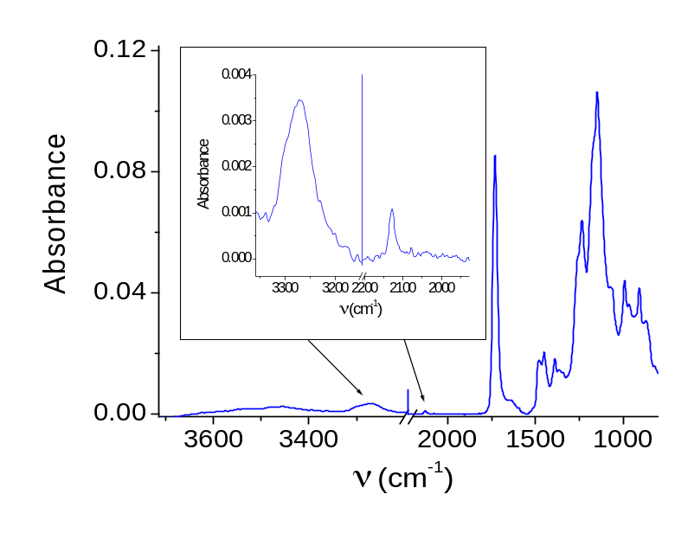
Figure A-1. ATR-FTIR spectrum of pGP-3/1 film. The band at 2125 cm⁻¹ is characteristic of triple bond of an alkyne and the more intense band at 3270 cm⁻¹ is due to a stretching mode between the triple bond carbon and the terminal hydrogen atom. The inset shows these alkyne bands more distinctly.

Appendix B: Atomic force microscopy of PGMA and alkyne-modified films
Poly(glycidyl methacrylate) (PGMA) films were spin coated onto silicon substrates from solutions in chloroform, toluene and 2-butanone. The nature of the solvent and the concentration of PGMA influence the ellipsometric thickness (H_{PGMA}) of the resulting films, except when toluene is used. The PGMA layers prepared using toluene had H_{PGMA} = 2 nm over the studied concentration range. The topography of the PGMA films was imaged using atomic force microscopy (AFM) in tapping mode. Figure B-1 shows the AFM height images of the PGMA films. The film from chloroform is the smoothest and had an RMS roughness of 0.32 nm over 1 μm². The film made from toluene appears to have latex-like particles of ~ 20-40 nm in diameter on the surface, which influences the roughness. The film made from 2-butanone had a measured RMS roughness of 0.42 nm over 1 μm². It was previously shown that the roughness of PGMA films spin coated from 2-butanone depends on the water content of the solvent; drier solvent produced smoother films.¹²⁴
PGMA films treated with propargylamine or 5-hexynoic acid to install alkyne groups were also imaged using tapping mode AFM. The chemical modification tends to roughen the film, as indicated by the images shown on Figure B-2. Treatment with 5-hexynoic acid tended to produce smoother films.

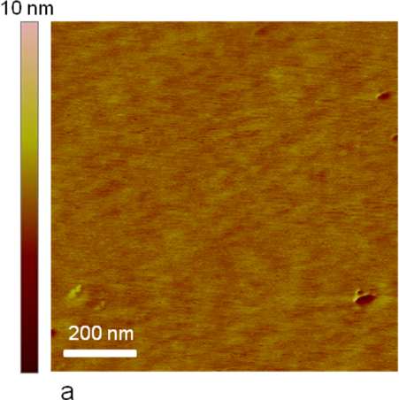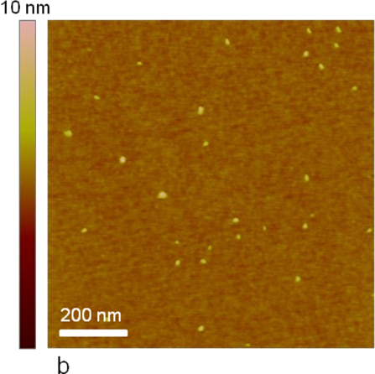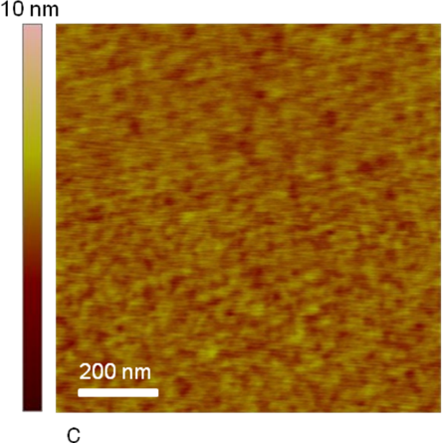
Figure B-1. AFM height images of PGMA films spin coated from different solvents a) chloroform (H_{PGMA} = 10 nm), b) toluene (H_{PGMA} = 2 nm) and c) 2-butanone (H_{PGMA} = 10 nm). Films made using chloroform were consistently smooth and uniform in appearance.

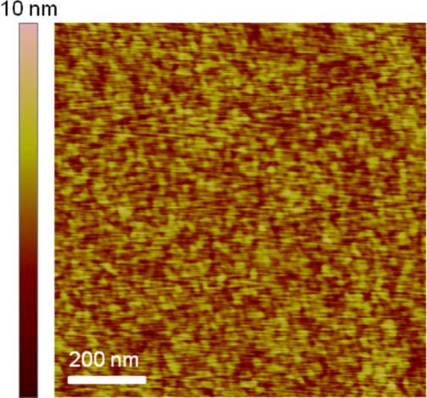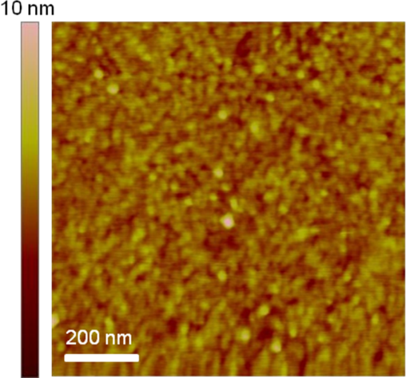
a b
Figure B-2. AFM height images of alkyne-modified PGMA films. a) PGMA-Prop (the initial PGMA layer thickness was 13 nm and the increase after reaction with propargyl amine 20% v/v for 19 hours at 55 °C was 6.0 nm), the measured RMS roughness over a 1 μm² area is 1.13 nm; b) PGMA-Hex (the initial PGMA layer thickness was 12 nm and the increase after reaction with neat 5-hexynoic acid for 80 hours at 60 °C was 5.1 nm), the measured RMS roughness over a 1 μm² area is 0.65 nm.

Appendix C: Scattering length density of PGMA
The scattering length density (SLD) of a material depends on its composition and its mass density. Neutron reflectometry was used to investigate the nanophase structure of PGMA films. The reflectivity data was modeled by calculating the reflectivity curve using an SLD profile consisting of layers of a given thickness and the interfacial roughnesses between these layers. A quantitative way to measure the goodness of fit is by the value of χ²; the closer χ² is to 1 the better the fit.¹²⁵ Figure C-1 shows the variation of χ² as a function of the SLD of PGMA used in the model. A minimum and a pseudo-minimum are observed. The SLD of PGMA equal to 8.1 × 10⁻⁷ Å⁻² was selected because of the lower χ², but also because it translates into a mass density of PGMA of 0.72 g/ cm³; whereas the pseudo-minimum value of 1.5 × 10⁻⁶ Å⁻² equates to a mass density of PGMA of 1.33 g/cm³. Since the density calculated for PGMA using the group contribution method¹²⁶ is 1.05 g/cm³, and because it is physically unrealistic for the PGMA thin film density to exceed its bulk value, a density of 0.72 g/ cm³ reflects a more reasonable scenario for an interfacial thin film, which is entropically constrained due to confinement.
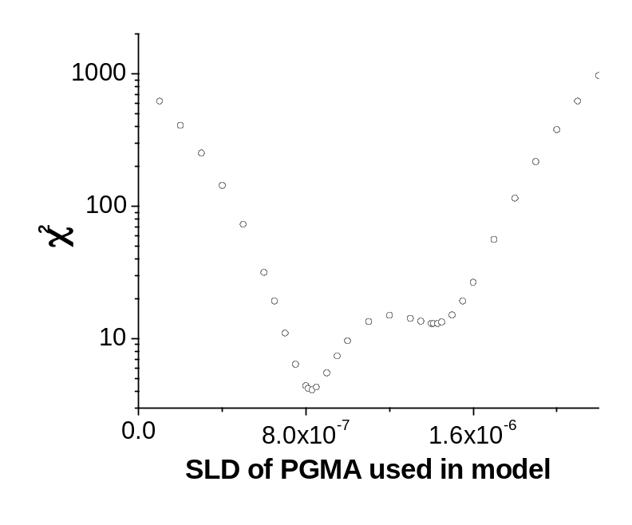
Figure C-1. Variation of χ² as a function of the SLD of PGMA used in the model. A lower χ² value indicates a better statistical fit. All other variables in the SLD model (thicknesses of PGMA and SiO_{x} layers and roughnesses between interfaces) were fixed.

Appendix D: Effect of propargylamine concentration on modification of PGMA films
Figure D-1 shows the increase in film thickness resulting from contacting PGMA films with propargylamine solutions of different concentrations (in 2-propanol) for 20 hours at 55 °C. Increases in ellipsometric thickness are observed up to a propargylamine concentration of 15% v/v, suggesting exhaustive functionalization of the PGMA films at these conditions. While H_{Prop} plateaus at approximately 5.5 nm; at high concentrations there is the possibility of a competition between the addition of propargylamine and cleavage of the PGMA layer by propargylamine, which is alkaline. At 100% propargylamine concentration (i.e. neat) under these conditions of reaction time and temperature, the PGMA film was entirely removed. The RMS roughness of a typical PGMA-Prop film (obtained at 20% v/v concentration for 24 hours) measured using AFM over a 1 μm² area is 1.1 nm.

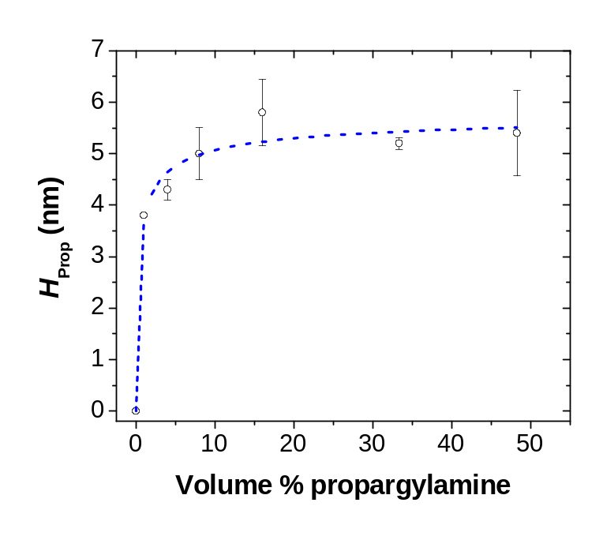
Figure D-1. Increase in ellipsometric thickness of a PGMA-coated silicon surface upon reaction with propargylamine (H_{Prop}). The hollow black points are the measured ellipsometric thicknesses, the dashed lines are simply a guide to the eye. The initial PGMA layer thickness was nominally 13.5 nm and the reaction time was 20 hours at 55 °C. The error bars represent the variation in thickness across a sample.

Appendix E: Buffer Recipes
Amounts of acid/base and given salts required to make 100 ml of buffer solutions of 10 mM ionic strength are given in table E-1. Solutions of ionic strengths 0.01 mM, 0.05 mM, 0.1mM, 0.5 mM and 1.0 mM, were prepared from 10 mM ionic strength buffer solutions, by serial dilutions.

Table E-1. Amounts of acid/base and given salts required to make 100 ml of buffer solutions.

Salt | Ionic Strength (mM) | pH | Acid/Base Used | Mass of acid/bade (g) | Mass of salt (g)
KCl | 10 | 7 | MOPSª | 0.209 | 0.048
NaCl | 10 | 7 | MOPSª | 0.209 | 0.037
LiCl | 10 | 7 | MOPSª | 0.209 | 0.025
ª4-Morpholinepropanesulfonic acid (MOPS)

Procedure:
- Dissolve the given amount of acid/base in approximately 90 ml of deionized water.
- Add the given amount of salt. Dissolve it completely.
- Adjust to pH 7.1 with small amounts of 1M sodium hydroxide (NaOH) or hydrochloric acid (HCl) previously made using deionized water.
- Add deionized water to set the volume to exactly 100 ml.

Vita
Chaitra V. Deodhar was born in Pune, India, to the parents of Vasant and Ashwini Deodhar. She has a younger sibling, Gauri. She attended S.D. Kataria High school and Sir Parshurambhau Junior College in Pune, India. After graduation, she took a keen interest in science and followed the direction of studies in sciences. She enrolled in Fergusson College, an affiliate of University of Pune, and graduated with a B.Sc. Degree in Chemistry and Biotechnology in 2004. She continued her studies in the graduate school at MES Garware College in Pune, India. She earned a M.Sc. Degree in Analytical Chemistry, graduating first in the M.Sc. Class of 2006 and was the recipient of the award for academic excellence in graduate studies. Through campus interviews, she was selected for a position as a Research Associate in the Generic Analytical department of Lupin Pharmaceuticals Ltd., a leading pharmaceutical company, where she worked for 2 years. She continued to pursue her dream of becoming a research scientist by accepting an offer for graduate studies at the University of Tennessee, Knoxville. There she worked toward earning her Ph.D. in Chemistry under the guidance of Prof. S. Michael Kilbey in the Department of Chemistry. She studied the responsive behavior of weak polyelectrolyte polymer brushes under the influence of different stimuli. With this knowledge and experience, she is eager to pursue a career as a scientist in the polymer industry.

