Investigation of Phytophthora species: Phytophthora colocasiae on Taro and Phytophthora Recovered from Streams in Eastern Tennessee

A Thesis Presented for the
Master of Science
Degree
The University of Tennessee, Knoxville

Sandesh Kumar Shrestha
August 2012
Acknowledgements

Abstract

Table of Contents
Chapter One 1
Oomycetes and Phytophthora 1
Introduction 1
Literature Cited 7
Chapter Two 9
Single nucleotide polymorphism diversity of Phytophthora colocasiae recovered from Vietnam, Hawaii, and Hainan Island, China 9
Abstract 9
Introduction 9
Materials and Methods 11
Isolate collection and mating type analysis 11
Genomic DNA 12
SNP identification and selection 14
SNP Genotyping 15
Clonal lineages and allele frequencies 16
Results 17
Samples and mating type 17
Sequencing and SNP identification 17
Genotyping, clonal lineages, and allele frequencies 18
Discussion 27
Literature Cited 30
Chapter Three 32
Phytophthora recovered from streams in eastern Tennessee 32
Abstract 32
Introduction 32
Materials and Methods 34
Sampling and pathogen isolation from streams 34
Long term storage and DNA extraction 38
Internal Transcribed Spacer (ITS) sequencing and species identification 38
Result 40
Discussion 45
Literature Cited 49
Chapter Four 53
Conclusions 53
Vita 54

List of Tables
Table 2.1 SNP loci summary 20
Table 2.2 Summary of multi-locus SNP genotype, a= homozygous, b=Heterozygous, and c=Homozygous alternative. The order of combination is according to the order of SNP ID in Table 1. Clonal sharing and number of isolates in bracket 20
Table 2.3 Allele frequency and chi-square (χ2) value of respective SNP markers 23
Table 3.1 Species found in 10 streams in 2010 and 2011 42

List of Figures
Figure 1.1 Oospores and sporangia (Phytophthora colocasiae) 4
Figure 1.2 Mycelium of Phytophthora colocasiae 4
Figure 1.3 Different phages of Phytophthora spp. in their life cycle 5
Figure 2.1 HR-DMA for genotyping SNP: A, Identification of Homozygous and Heterozygous B, Differentiation of two Homozygous (wild and mutant) by using known amplicon 19
Figure 2.2 Genotype distribution in Hawaii with number of isolates in bracket 24
Figure 2.3 Genotype distribution in Hainan Island with number of isolates in bracket 25
Figure 2.4 Genotype distribution in Vietnam with number of isolates in bracket 25
Figure 2.5 Clonal sharing between countries and number of isolates in bracket 26
Figure 3.1Ten sampling locations in eastern Tennessee 37
Figure 3.2 Baiting of Phytophthora in a stream by using Rhododendron leaves in a mesh bag. 37
Figure 3.3 Mesh bag with four compartments for four rhododendron leaves and nylon rope for tethering the mesh bag. 38
Figure 3.4 Isolation of pathogen from baited leaf onto selected medium (left) and observed growth of mycelium after 1-3 days (right) 38
Figure 3.5 Ribosomal DNA with ITS1 and ITS2 40
Figure 3.6 Number of species found from stream in 2010 and 2011 42

Chapter One

Oomycetes and Phytophthora

Introduction
Plant scientists are concerned about several plant pathogens that can cause damage to numerous agricultural crops. Among them, oomycetes are widely distributed eukaryotic plant pathogenic organisms that are morphologically similar to fungi (Thines and Kamoun 2010). Initially, oomycetes was kept in a Kingdom Fungi (Whittaker 1969). Shaffer suggested rearranging the five kingdom classification and renaming a new kingdom for oomycetes and slime molds because of their distinct evolutionary origin (Shaffer 1975). The Kingdom Straminipila was proposed to describe oomycetes and related organisms (Cavalier-Smith and Chao 2006; Dick 2001). Oomycetes are similar to fungi because of their similar nutritional habit and mycelial systems (Richards et al. 2006). However, there are several characteristics that make oomycetes distinct from true fungi. The presence of a tinsel flagellum with tripartite hairs on the biflagellate motile stage in their life cycle shows that oomycetes are more closely related to algae and diatoms (Thines and Kamoun 2010). The somatic hyphae of oomycetes is diploid and aseptate, which means that hyphae lack cross walls resulting in numerous nuclei floating in the hyphal compartment except in reproductive organs and older hyphae (Alexopoulos et al. 1996). The presence of 1,3-β-glucans, 1,6-β-glucans, and 1,4-β-glucans (cellulose) as the predominant structural component of the cell wall makes this group distinct from true fungi, which cell wall is dominated by chitin (Latijnhouwers et al. 2003) {Alexopoulos, 1996 #26;Latijnhouwers, 2003 #87}. Contrary to true fungi, oomycetes also have tubular mitochondrial cristae and Golgi bodies with flattened cristae (Alexopoulos et al. 1996). The storage carbohydrate compound for oomycetes is mycolaminarin (Kamoun 2003) while fungi store as glycogen similar to animals (Baldauf and Palmer 1993). Most members of Oomycota have motile stages known as zoospores in their life cycle (Alexopoulos et al. 1996). In some species, there are two different motile stages producing primary and secondary zoospores, a condition known as diplanetism (Dick 2001). Primary zoospores are pear-shaped with two flagella attached at the anterior end and secondary zoospores are kidney-shaped with two flagella attached laterally; one tinsel type directed forward and the other whiplash facing backward (Alexopoulos et al. 1996). Some Phytophthora sp., like P. ramorum, produce identical primary and secondary zoospores, a condition known as monomorphic diplanetism (Moralejo and Descals 2010). Oomycetes are also known as ‘water molds’ (Margulis and Schwartz 2000). Several species have marine habitats; however, 60% of species are pathogenic to terrestrial plants (Thines and Kamoun 2010). Among the pathogenic oomycetes, members of the genus Phytophthora are the most devastating pathogens of important economic crop species such as potato, pepper, tomato, soybean and alfalfa (Lamour et al. 2007).
In 1845, Phytophthora infestans caused disastrous epidemic in Europe by damaging potato crop and was responsible for Irish famine that resulted in immigration and death of more than 1.5 million people (Austin Bourke 1964). Phytophthora produces sexual oospores for survival in unfavorable environmental conditions and sporangia for dispersal by water and wind (Alexopoulos et al. 1996). The asexual sporangia are produced in sporangiophores, which can germinate directly or indirectly (Alexopoulos et al. 1996). In direct germination, the sporangium in the presence of water produces a germ tube for host tissue penetrating and infection (Alexopoulos et al. 1996). While in indirect germination, the cytoplasm inside the sporangium cleaves to produce biflagellate zoospores (Hohl and Hamamoto 1967). The motile zoospores are chemotactically attracted towards root exudes, which after releasing flagella, encyst for host infection (Alexopoulos et al. 1996). Sexual reproduction in some Phytophthora requires two different mating types; A1 and A2 (Alexopoulos et al. 1996). Qi et al. suggested that both mating types can produce male (antheridia) and female (oogonia) gametes but hormonal regulation from two compatible groups aids in sexual reproduction and production of oospores (Qi et al. 2005). The nuclei from an antheridium passes into the oogonium through a fertilization tube for fusion and oospore formation (Alexopoulos et al. 1996). Oospores are, resistant resting spores and, consist of thick layers that germinate directly to produce a diploid thallus, or indirectly to produce sporangia (Alexopoulos et al. 1996).
Differences in morphological characteristics among Phytophthora species is very less and simple, which makes this group very difficult in distinguishing among species (Erwin and Ribeiro 1996). There are several morphological characteristics that can be used for the identification of species such as: mycelium, sporangia, zoospores, oospores, chlamydospores, antheridium, and oogonium (Erwin and Ribeiro 1996). Mycelium of Phytophthoras is septate in nature, which produces asexual spores known as sporangia (Figure 1.1) on the stalks called sporangiophores (Erwin and Ribeiro 1996). Sporangiophores may be branched or non-branched (Erwin and Ribeiro 1996). The shape of sporangia are diverse (globose, ovoid, ellipsoid, pyriform, limoniform, etc) among Phytophthora spp., which may or may not have bulged apical structure known as papillae (Erwin and Ribeiro 1996). Sporangia produce biflagellate zoospores, one whiplash and other tinsel flagella, with bean or pear shape (Erwin and Ribeiro 1996). Some of the Phytophthoras are self-fertile (homothallic) while other require compatible mating types (A1 or A2) for the production of the sexual spores known as oospores (Figure1.1) (Erwin and Ribeiro 1996). Oospores are thick cell walled structure, which is derived from female reproductive structure (oogonia) after fertilization by male structure (anteridium) (Erwin and Ribeiro 1996). Oogonia are generally spherical with typical amphigynous (oogonium grows through the antheridium) or paragynous (antheridium grows laterally) (Erwin and Ribeiro 1996). The mycelial colony are white cottony as shown in Figure 1.2.
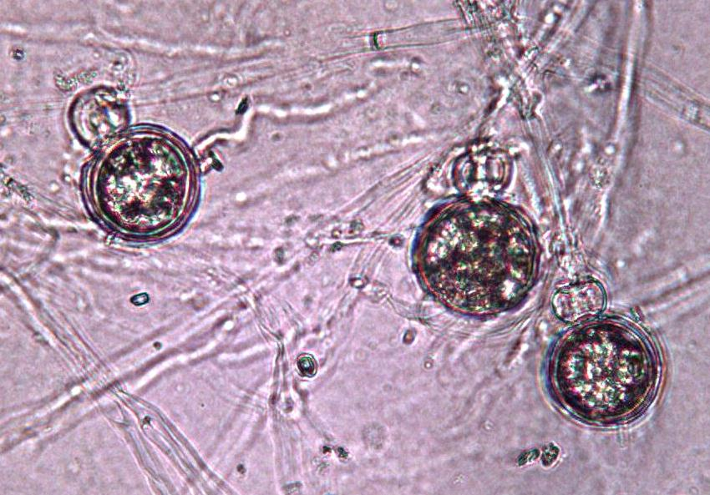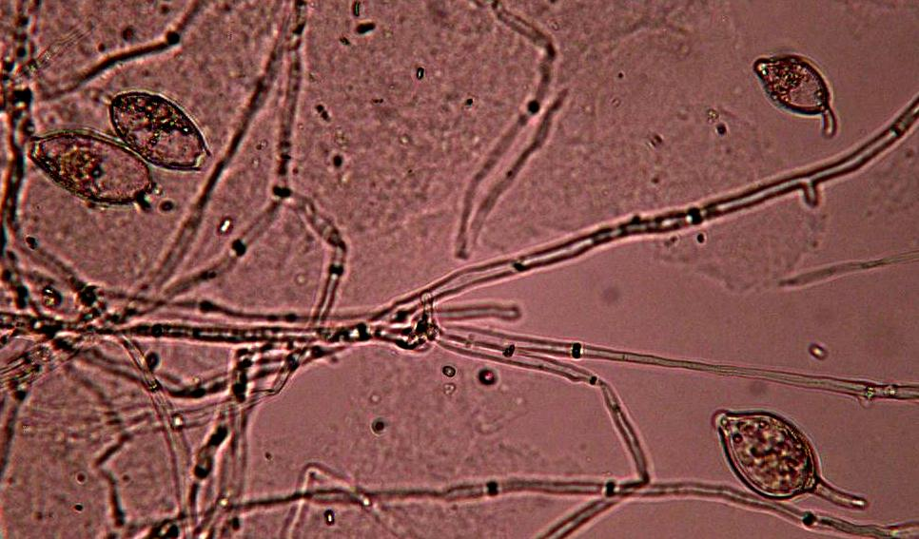
Figure 1.1 Oospores and sporangia (Phytophthora colocasiae)

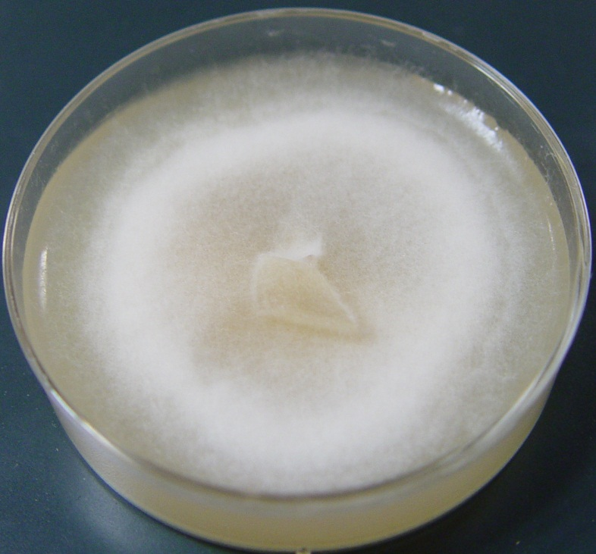
Figure 2 Mycelium of Phytophthora colocasiae
The dispersal of Phytophthora spp. is helped by several means like soil, water splash, air, insect movements, irrigation water, etc (Ristaino and Gumpertz 2000). Different phages of Phytophthora spp. is shown in Figure 1.3. The asexual spores can germinate directly or indirectly to infect the host plant (Ristaino and Gumpertz 2000). Sexual spores can survive in soil for years and act as the overwintering structure for some species of Phytophthora. (Erwin and Ribeiro 1996; Lamour and Hausbeck 2003; Ristaino and Gumpertz 2000).
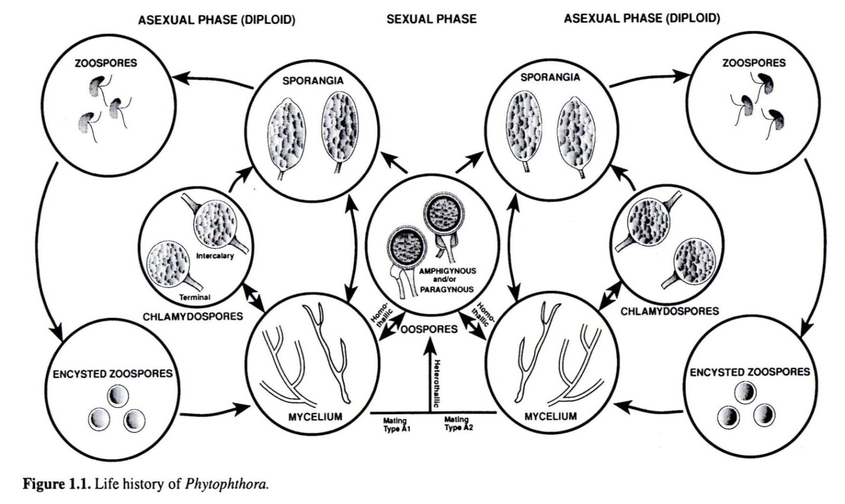

Figure 3 Different phages of Phytophthora spp. in their life cycle
Source: (Erwin and Ribeiro 1996)
Phytophthora is hemibiotrophic organisms, which multiply and obtains nutrients from the living host tissue as biotrophs and later switch to necrotrophic phage for killing and absorbing nutrients (O’Connell and Panstruga 2006). During the infection process, zoospores shed their flagella to form cyst as they come in contact with the host cell and produce appresorium to penetrate the host cell wall (Latijnhouwers et al. 2003). After the penetration, bulged structure is formed inside the host cell known as haustoria, which helps to absorb the nutrients from host (Latijnhouwers et al. 2003). This genus is responsible for causing disease of several dicotyledonous as well as monocot crops (Lamour et al. 2007). Phytophthorha capsici is responsible in damaging several important vegetable crops like pepper, tomato, eggplant, cucumbers and summer squash (Hausbeck and Lamour 2004). Sudden oak death disease caused by Phytophthora ramorum is an important pathogen, which is threatening natural forests of western USA, Canada and Europe (Davidson et al. 2003). Phytophthora colocasiae causes leaf blight of Taro limiting the corm production (Bergquist 1972). Damage of seedlings and older soybean plants caused by Phytophthora sojae incur annual loss of billions of dollar worldwide (Tyler 2007). Since the damage caused by this genus of oomycetes is significant, necessary studies are needed for understanding the pathogen for devising efficient control measures. The following chapters are dedicated in understanding the genetic diversity of Phytophthora colocasiae and monitoring Phytophthora ramorum in natural streams of eastern Tennessee.

Literature Cited
Alexopoulos CJ, Mims CW, Blackwell M. 1996. Introductory mycology. In Phytophthora diseases worldwide. John Wiley and Sons, Inc. p. 683-737.
Austin Bourke PM. 1964. Emergence of Potato Blight, 1843-46. Nature 203(4947):805-808.
Baldauf SL, Palmer JD. 1993. Animals and fungi are each other's closest relatives: congruent evidence from multiple proteins. Proceedings of the National Academy of Sciences of the United States of America 90(24):11558-62.
Bergquist RR. 1972. Efficacy of Fungicides for Control of Phytophthora Leaf Blight of Taro. Annals of Botany 36(2):281-287.
Cavalier-Smith T, Chao EEY. 2006. Phylogeny and megasystematics of phagotrophic heterokonts (kingdom Chromista). Journal of Molecular Evolution 62(4):388-420.
Davidson JM, Werres S, Garbelotto M, Hansen EM, Rizzo DM. 2003. Sudden oak death and associated diseases caused by Phytophthora ramorum. Plant Management Network.
Dick MW. 2001. Straminipilous fungi : systematics of the peronosporomycetes, including accounts of the marine straminipilous protists, the plasmodiophorids, and similar organisms. Dordrecht; Boston: Kluwer Academic Publishers. p. 1-60.
Erwin DC, Ribeiro OK. 1996. Morphology and identification of species In Phytophthora diseases worldwide
American phytopathological society. p. 96-144.
Hausbeck MK, Lamour KH. 2004. Phytophthora capsici on vegetable crops: research progress and management challenges. Plant Disease 88(12):1292-1303.
Hohl HR, Hamamoto ST. 1967. Utrastructural changes during zospore formation in phytophthora parasitica. American Journal of Botany 54(9):1131-&.
Kamoun S. 2003. Molecular Genetics of Pathogenic Oomycetes. Eukaryotic Cell 2(2):191-199.
Lamour KH, Hausbeck MK. 2003. Effect of Crop Rotation on the Survival of Phytophthora capsici in Michigan. Plant Disease 87(7):841-845.
Lamour KH, Win J, Kamoun S. 2007. Oomycete genomics: new insights and future directions. Fems Microbiology Letters 274(1):1-8.
Latijnhouwers M, de Wit PJGM, Govers F. 2003. Oomycetes and fungi: similar weaponry to attack plants. Trends in Microbiology 11(10):462-469.
Margulis L, Schwartz KV. 2000. Five Kingdoms: An Illustrated Guide to the Phyla of Life on Earth. W.H. Freeman& Co., New York.
Moralejo E, Descals E. 2010. Diplanetism and microcyclic sporulation in Phytophthora ramorum. Forest Pathology:no-no.
O’Connell RJ, Panstruga R. 2006. Tête à tête inside a plant cell: establishing compatibility between plants and biotrophic fungi and oomycetes. New Phytologist 171(4):699-718.
Qi JH, Asano T, Jinno M, Matsui K, Atsumi K, Sakagami Y, Ojika M. 2005. Characterization of a Phytophthora mating hormone. Science 309(5742):1828-1828.
Richards TA, Dacks JB, Jenkinson JM, Thornton CR, Talbot NJ. 2006. Evolution of filamentous plant pathogens: Gene exchange across eukaryotic kingdoms. Current Biology 16(18):1857-1864.
Ristaino JB, Gumpertz ML. 2000. New frontiers in the study of dispersal and spatial analysis of epidemics caused by species in the genus Phytophthora. Annual review of phytopathology 38:541-576.
Shaffer RL. 1975. Major groups of basidiomycetes. Mycologia 67(1):1-18.
Thines M, Kamoun S. 2010. Oomycete-plant coevolution: recent advances and future prospects. Current Opinion in Plant Biology 13(4):427-433.
Tyler BM. 2007. Phytophthora sojae: root rot pathogen of soybean and model oomycete. Molecular Plant Pathology 8(1):1-8.
Whittaker RH. 1969. New Concepts of Kingdoms of Organisms. Science 163(3863):150-160.

Chapter Two

Single nucleotide polymorphism diversity of Phytophthora colocasiae recovered from Vietnam, Hawaii, and Hainan Island, China

Abstract

Introduction
Phytophthora colocasiae Raciborski was first described on taro in Java in 1900 and is widely distributed in Asia, the Pacific region, and Africa (CABI/EPPO 1997; Lebot et al. 2003; Raciborski 1900). The disease, known as taro leaf blight (TLB), is most severe when it is warm and wet and often has distinctive foliar lesions. Phytophthora colocasiae also attacks the stems and corms. Leaf infections first become visible as water soaked spots which expand successively to produce sporangia on the newly colonized tissue. As the lesions grow, the older infected tissue becomes necrotic and under dry conditions will fall apart leaving variable sized holes (Bergquist 1972; Trujillo 1967).

Taro varieties have varying levels of resistance to TLB with yield reductions varying from 3-5% in resistant varieties to 25-100% in more susceptible varieties (Paiki 1996; Vasquez 1990). When P. colocasiae was introduced to Samoa in 1993 the resulting epidemics were severe and destroyed almost all of the local varieties (Caillon et al. 2006). In 2005, Hawaii recorded the lowest Taro production since 1946 and TLB was one of the contributing factors for the reduced production (Hawaii Agricultural Statistics Service 2006)(Hawaii 2006).

Since taro is often grown in flooded conditions, the caducous sporangia and swimming zoospores of Phytophthora colocasiae are likely an important factor in disseminating and spreading TLB. Phytophthora colocasiae is heterothallic, requiring the interaction of two different mating types (A1 and A2) for sexual reproduction and production of oospores (Ko 1779). At this point, there have been no reports of progeny produced in the laboratory and the importance of the sexual stage in the life history is not known.

The earliest surveys of diversity in P. colocasiae report the presence of A1 and A2 mating types. An analysis of 114 isolates collected from Hawaii, Maui, and Kauai in the 1970’s found only the A1 mating type and concluded that P. colocasiae was likely an exotic invasive pathogen (Ko 1979). A decade later, a similar study of 799 isolates collected in Taiwan revealed that all were the A2 mating type (Ann et al. 1986). In 1994, Zhang et al. identified the presence of three different mating types (A1, A2 and A0 (unable to produce oospores when paired with either an A1 or A2) for isolates recovered from taro on the agriculturally important Hainan Island in China and the authors suggested that this region may be within the center of origin for P. colocasiae (Zhang et al. 1994). Phytophthora colocasiae has been postulated to originate from Asia (Ko 1979) as this is the center of origin of many wild and cultivated species of taro (Vavilov 1951). Similarly, A2 and A0 mating types were reported from 54 isolates collected from Asia and the Pacific region (Tyson and Fullerton 2007). A more recent investigation of the diversity of P. colocasiae in Taiwan reported on seven isolates that appeared to be homothallic, capable of producing oospore in a single culture. Sub-culturing during mitotic growth produced asexual progeny that are A1, A2, as well as, some that are homothallic and all were able to cause disease (Lin and Ko 2008).

In 2003, Lebot et al. utilized isozyme profiles and RAPD (Random Amplified polymorphic DNA) markers to characterize a large collection of P. colocasiae from Indonesia, Papua New Guinea, the Philippines, Thailand and Vietnam (Lebot et al. 2003). The isozyme profiles varied considerably between countries and even isolates with identical profiles from within the same country were found to be diverse based on the RAPD fingerprints (Lebot et al. 2003). A recent report of 14 isolates from India indicates that all had unique isozyme and RAPD profiles (Mishra et al. 2010).

Efforts to breed for tolerant or resistant varieties of Taro are being conducted. Our overall objectives were to develop single nucleotide polymorphism (SNP) markers for P. colocasiae, determine the diversity of P. colocasiae at diverse locations, and to identify a panel of isolates suitable for screening promising germplasm.

Materials and Methods

Isolate collection and mating type analysis
Phytophthora colocasiae isolates were collected from locations in Vietnam in 2009 and 2010, Hainan Island, China in 2011 and four of the Hawaiian Islands in 2011. Samples were collected from foliar lesions as these are the easiest to see and collect and the collections cause the least disruption to the producer’s crop. The entire leaf and petiole was harvested and a small (approximately 1-cm²) piece of the diseased leaf that included both healthy and necrotic tissue was excised and embedded into PARP-V8 agar (100 ml V8 juice, 3 g CaCO₃, 16 g Bacto agar and 900 ml water amended with 25 ppm pimaricin, 100 ppm ampicillin, 25 ppm rifampicin, and 25 ppm penta-chloro-nitro-benzene) and incubated for 3 to 5 days at room temperature (Gobena et al. 2011). Isolates were then sub-cultured onto water agar or dilute PARP-V8 (substitute 40 ml V8 juice for 100 ml) to produce a hyphal-tip culture. Hyphal-tip cultures were assigned a unique identifier and the isolates stored long term in 2-ml tubes containing 3 to 4 plugs of mycelium, 3 to 4 sterile hemp seeds, and 1 ml water at room temperature.

Mating type was tested using P. colocasiae isolates LT7299 (A1) and LT7291 (A2). As no previously studied P. colocasiae isolates were readily available, the mating type for these isolates was determined using P. capsici tester isolates LT51 and LT263. To determine the mating type, plugs of mycelium from the query and tester isolates were co-inoculated onto dilute PARP-V8 agar and incubated at room temperature for 7 to 14 days. The intersection of the colonies was observed under a light microscope at 400× magnification to determine oospore production.

Genomic DNA
Mycelium was produced in 24-well Uniplate microplates (Whatman Inc., Clifton, NJ) having a capacity of 10 ml per well (Lamour and Finley 2006). Two ml’s of PARP-V8 broth was loaded in each well followed by inoculation with a small weft of mycelia from the surface of agar plates, with care taken to avoid transferring agar to the broth. The plate was sealed with breathable rayon tape and incubated for 6 days at room temperature. The mycelium was then harvested and transferred to a 96-well 2-ml deepwell (DW) plate containing three 3-mm glass beads per well. The deepwell plate was covered by breathable rayon tape and frozen to -80° C for at least 1 h. Samples were then lyophilized for 48 h (24 h at -10° C followed by 24 h at 23° C) using a Labconco Stoppering Tray Drying System (STDS, Labconco Corp., Kansas City, MI). Immediately after removal of the sample from the chamber, a capmat was applied using a Capmat Applicator (CMA, Fischer Scientific) to avoid moisture absorption. The lyophilized sample was disrupted with a Mixer Mill 300 for 30 sec at 30 revolutions per second (QIAGEN, Valencia, CA).

DNA was extracted according to the procedures outlined previously (Lamour and Finley 2006). Briefly, plates containing pulverized dried mycelium was centrifuged 5 min at 5000 rpm (revolution per min), the capmat removed, and 400 µl of lysis mixture added to each well (100mM Tris of pH 8.0, 50 mM EDTA, 500 mM NaCl, 1.33% SDS with 0.8 % Fighter F antifoaming agent (Loveland Industries, Greely, CO) and 0.2 mg per ml RNase A) using an Apricot 96 channel pipette (Apricot Design, Inc., Monrovia, CA), followed by application of a capmat. The plate was shaken vigorously and placed in 65° C oven for 30 min. The capmat was removed gently after centrifuging the plate for 2 min at 5000 rpm. Potassium acetate (150 µl) was added to each well and a new capmat was applied. The sample was kept at -20° C for 30 min. After centrifugation for 10 min at 5000 rpm, 400 µl of supernatant from the sample plate was transferred to new 2 ml 96-well DW plate preloaded with 600 µl guanidine hydrochloride (0.66 M) and ethanol solution (63.3 %), followed by applying the capmat and shaking the mixture vigorously. One ml of the mixture was transferred to a Nunc spin column plate (Nalge Nunc Int., Rochester, NY) on 2-ml 96-well DW plate, centrifuged for 5 min at 5000 rpm and the flow through discarded. The spin column plate was washed further with 500 µl wash solution (10 mM Tris (pH 8.0), 1 mM EDTA, 50 mM NaCl, and 67% ethanol) and 500 µl 95% ethanol followed by centrifugation for 5 min at 5000 rpm simultaneously in both steps. The spin column plate was then incubated at 65° C for 10 min to evaporate the ethanol. Two hundred µl of 10 mM Tris (pH 8.0) was added to each well and the plate incubated for about 30 min at room temperature. The spin column plate is centrifuged onto a new 1-ml DW plate for 5 min at 5000 rpm to elute DNA and the plate with genomic DNA was sealed with aluminum foil and stored at -20° C.

SNP identification and selection
Initial SNP marker discovery was based on sequence data from two isolates of P. colocasiae, LT7299 and LT7291. The sequences were produced in conjunction with the company Floragenex (Floragenex, Inc., Portland, OR) using a technique known as Restriction Site Associated DNA (RAD) sequencing. The RAD technique focuses sequencing to the regions directly adjacent to a restriction enzyme cut site and includes cutting the genomic DNA with a restriction enzyme and modifying the restricted fragments to allow multiplexing and sequencing on the Illumina platform. Any restriction enzyme can be used, although the amount of sequencing needed to cover the fragments will vary based on the frequency of the site in the genome. The restriction enzyme used here was SgrA1 (EC 3.1.21.4). The resulting sequences were aligned against the reference genome of P. capsici (available at http://genome.jgi-psf.org/Phyca11/Phyca11.home.html) and candidate SNP sites identified using CLC genomics workbench (CLC bio, Aarhus, Denmark). Reads were aligned using the following criteria: the reads must have at least 90% similarity to the reference and have an average quality of 20. Only those sites meeting this criteria and with at least 10X coverage in both isolates were considered for SNP identification. Polymorphic sites were scored using the following criteria: loci with an alternate allele frequency between 35-65% were scored as heterozygous (Aa) and loci with an alternate allele frequency >90% were scored as homozygous alternate allele (aa). Only those loci where genotypes could be assigned for both isolates were considered for further marker development.
A subset of SNP markers were selected to analyze the populations based on 1) their distribution among the 18 linkage groups recently described for the vegetable pathogen P. capsici, 2) location within genes that appear to be single copy in P. capsici, and 3) if they had no polymorphic sites within 50bp on either side of the polymorphic site.

SNP Genotyping
Genotypes were assessed using high resolution DNA melting analysis (HR-DMA) with a LightScanner device (Idaho technologies, Salt Lake City, UT). The device provides a sensitive measurement of the melting dynamics for short PCR amplicons (20 to 1000bp) with the sensitivity greatly increased as the amplicon size decreases. The melting dynamics are a measure of the loss of fluorescence that occurs when the LC Green dye is released (and ceases to fluoresce) from double stranded DNA during the melting. Primers were designed to produce amplicons between 45 and 55bp containing a single SNP locus using the LightScanner primer design software 1.0 (Idaho technologies, Salt Lake City, UT). PCR was done in 384-well plates with a 5µl final PCR reaction volume consisting of 10-20 ng genomic DNA, 0.5 µl 10x buffer, 0.2 µl 5 mM dNTPs, 0.05 µl 50 mM MgCl₂, 0.025 µl 100 µM forward and reverse primers, 0.1 units Taq Polymerase and 0.5 µl 10x LCGreen plus dye (Idaho Technologies, Salt Lake City, UT). The PCR cycling parameters are 2 min initial denaturation at 95ºC, 35 cycles of 95ºC for 30 s followed by 64ºC, and finally, 3 cycles of heating at 95ºC for 30 s and cooling to 25ºC for 30 s to produce heteroduplexs in amplicons containing heterozygous SNP loci. Resulting melt curves were analyzed using LightScanner 2.0 software package according to the manufacturer’s guidelines.

The LCgreen plus dye fluoresces when bound to double-stranded DNA. Amplicons containing a heterozygous SNP site will form heteroduplexes and melt differently (at a lower temperature) from either of the possible homoduplex genotypes (AA or aa) (Montgomery et al. 2007). In order to clearly differentiate the homozygous genotypes (AA from aa), a second step is added where a defined homozygous amplicon is added to each reaction following the initial melting and the reactions are re-melted (Gobena et al. 2011). If the known homozygous amplicon is identical to the unknown homozygote, the melt curves remain the same. If they are different, a heterozygote is produced and the curve shifts to a lower temperature (destabilized). The defined homozygous amplicons were produced in a separate PCR reaction using a synthetic template of the same length as the target (the template was ordered from Integrated DNA Technologies, Inc. San Diego, CA). The PCR reaction includes 1µl of 10 µM template synthetic oligonucleotides, 3 µl 10x buffer, 1.2 µl 5 mM dNTPs, 1 µl 10 µM forward and reverse primers, 0.3 units Taq polymerase and water in a 30 µl final reaction volume. The PCR protocol was 95ºC for 2 min for initial denaturation followed by 30 cycles of 95ºC for 30 s and 64ºC for 30 s. For the second melting, 2 µl of the defined homozygous amplicon was added and re-melted as above.

Clonal lineages and allele frequencies
Only isolates with all 12 marker genotypes were included in the analyses. Isolates with identical genotypes are considered clonal lineages and are designated as CL-X-Y, where X is the clonal lineage identifier and Y is the number of isolates in the lineage. Once the clonal lineages were determined, allele frequencies were determined based on the total unique genotypes.

Results

Samples and mating type
A total of 217 isolates were recovered from Hawaii, 98 from Vietnam, and 78 from Hainan Island, China. Isolates were recovered from 12 different sites on four islands (Oahu, Kauai, Maui, and the Big Island) of Hawaii and 8 sites each from Vietnam and Hainan Island. All but 10 isolates recovered from Vietnam produced oospores when crossed in the laboratory with the A1 and A2 query isolates. Hawaii had 215 A2 and two A1 mating types, Vietnam had 95 A2 and three A1 mating types, and Hainan Island had 47 A2 and 21 A1 Mating types.

Sequencing and SNP identification
Illumina sequencing produced 3.7 million reads from LT7291 and 5.5 million reads from LT7299. Alignment to the Phytophthora capsici reference genome resulted in approximately 15% of the reads aligning and a total of 389,269 nucleotide sites (nts) with 10X coverage in both isolates. Scoring based on the above criteria resulted in 1152 polymorphic sites and 24,941 sites fixed for an alternate allele in both isolates compared to P. capsici. Of these polymorphic sites, 821 sites were heterozygous in LT7291 and 776 sites were heterozygous in LT7299. A total of 12 SNP markers were assessed for all isolates

Genotyping, clonal lineages, and allele frequencies
All of the isolates were successfully genotyped with 12 SNPs marker using the HR-DMA analysis (Table 2.1). Figure 2.1 shows representative curves for the first (panel A) and second (panel B) melting analyses for SNP locus Sc4_1087641which is polymorphic for the nucleotides T and A. Panel A is the normalized melting curve showing homozygous (TT or AA) and heterozygous TA (red) curves for 128 isolates from Hawaii. Panel B is the melt curve produced after the addition of the known homozygous amplicon containing AA. Note the shifting of the known TT down when the known PCR AA amplicon were added to the reaction and re-melted.

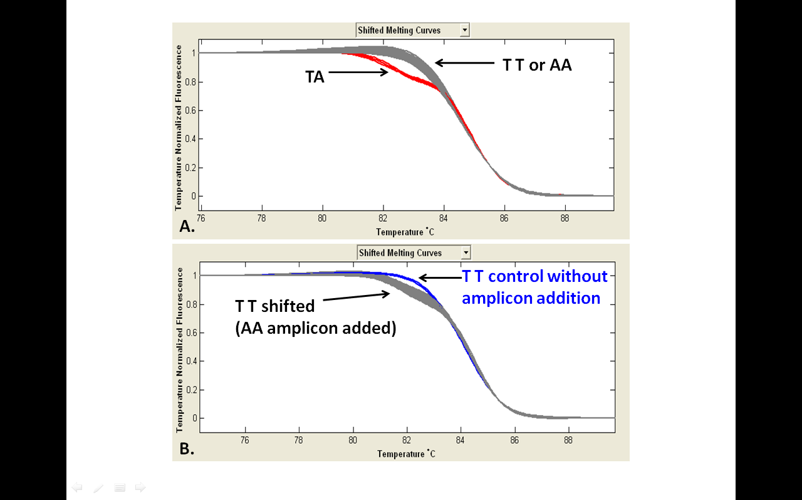
Fig. 2.1 HR-DMA for genotyping SNP: A, Identification of Homozygous and HeterozygousB, Differentiation of two Homozygous (wild and mutant) by using known amplicon
A total of 41 unique multi-locus SNP genotypes were identified. Of these, 16 were shared among more than one isolate and are considered clonal lineages and 25 were unique and only found in a single isolate (Table 2.2). The putative clonal lineages ranged in size from 2 to 196 isolates. Analysis of 217 isolates from Hawaii was able to produce 14 different genotypes as shown in Figure 2.2. There were five clonal lineages and nine unique genotypes within this region. This
region was mainly dominated by CL-4-182 and CL-14-20, which differ only at a single locus Sc26 _165308. CL4 and CL14 were found in all four islands of Hawaii. The dominant CL4 was isolated from all 12 collection sites. CL-2-3, CL-5-1, and CL-7-2 were also different from CL-4 at only one locus Sc47_ 379264, Sc8_ 709842, and Sc2_ 462022 respectively. This helps to predict that single clonal lineage, CL-4, is dominating Hawaii and occurrence of other clonal lineages might be because of the mutation in the particular locus. Isozyme and RAPD analysis revealed high genetic diversity of this pathogen in South Asia because of sexual reproduction (Lebot et al. 2003). The identification of single clone domination in Hawaii might be because of vegetative reproduction, which can be predicted that asexual spores are the main souorce of dispersal, infection, and disease of the taro crop. Earlier research showed that isolates collected from four islands of Hawaii were A1 mating types (Ko 1979), while other finding reported all five isolates to be A2 mating types (Savage et al. 1968). Our study showed A2 domination in all four Islands of Hawaii, which might be because of the asexual reproduction.
Table 2.1 SNP loci summary
SNP ID¹ | Alleles | Forward primer | Reverse Primer
Sc12 _713393 | G/A | AGTTTTTGCACTGAGCAGTATC | CCAACACCTCCGGTCAG
Sc26 _165308 | G/A | CTGGGGATTGAAGTGGCTA | GCCTCCATTTGGAAGCTTGATA
Sc4_637607 | A/T | TCCCTCAAGTTCTCAACTTC | TGGTACGAGCCATGGTCT
Sc77_ 114487 | T/C | AACGAAGAACGCACCAGTGT | CGTTGCGATAGTTCGGGT
Sc11_ 181526 | C/T | GTCCATACTTCCGCGTG | TGCAGCACAACGGATCA
Sc47_ 379264 | T/C | CGGCTCGACCTACGGCTGTC | ACCACGCGTTCCGTCGCCC
Sc2_ 462022 | C/T | CACGAGAGACGCACTACA | CTGGCTACTTTGCCCTG
Sc4_1087641 | T/A | TCGTAAAGCCCAGCACC | TAATGCAGAGGCAAGTGGAG
Sc17_55235 | C/A | TACGTGAGCAACTCAGCAAA | GTGGTCGCGAATGCCAC
Sc6_188972 | C/T | ACCGACCGAATTACTTCG | TGTCGCCATGAGCTACTT
Sc8_ 709842 | C/T | ACGGAGGTCCGGCTTACCCT | GGGTGACATGGTGCTGGC
Sc4_ 622850 | G/A | GTGGCTCTTAACTTGAT | GAGCCTTGGCGTACACAT
¹Location in the reference genome of P. capsici, Sc=Scaffold with SNP locus.

Table 2.2 Summary of multi-locus SNP genotype, a= homozygous, b=Heterozygous, and c=Homozygous alternative. The order of combination is according to the order of SNP ID in Table 1. Clonal sharing and number of isolates in bracket
Clonal Lineage/Unique genotype | Multi-locus SNP combination | Number of Isolates | Country
CL1 | aaaaaaaaabab | 2 | Vietnam
U1 | aaaaabaaaaaa | 1 | Hawaii
U2 | aaabbaaaaaab | 1 | Hainan Island
CL2 | aabbbaaaabaa | 3 | Hawaii
CL3 | aabbbbaaaaaa | 2 | Hainan Island
CL4 | aabbbbaaabaa | 196 | Hawaii(182)+Vietnam(14)
U3 | aabbbbaaabab | 1 | Hawaii
CL5 | aabbbbaaabba | 8 | Hawaii(1)+Vietnam(7)
CL6 | aabbbbababaa | 2 | Vietnam
U4 | aabbbbacabaa | 1 | Vietnam
CL7 | aabbbbbaabaa | 2 | Hawaii
CL8 | abaaaaaaabab | 2 | Hainan Island
U5 | abaaabaaaaaa | 1 | Hawaii
U6 | abaabaaaaaba | 1 | Hainan Island
CL9 | abaabaaaabba | 11 | Vietnam(6)+Hainan Island(5)
U7 | abaabaababaa | 1 | Vietnam
CL10 | ababbaaaaaab | 36 | Hainan Island
CL11 | ababbaaaabab | 2 | Hainan Island
CL12 | ababbaaabaab | 4 | Hainan Island
U8 | ababbbaaabab | 1 | Hainan Island
U9 | abbbbaaaaaaa | 1 | Hainan Island
CL13 | abbbbbaaaaaa | 11 | Hainan Island
CL14 | abbbbbaaabaa | 21 | Hawaii(20)+Vietnam(1)
U10 | abbbbbaaabbb | 1 | Hawaii
U11 | abbbbbaabaaa | 1 | Hainan Island
U12 | abbbbbbaabba | 1 | Hawaii
U13 | abbbbbbbbabb | 1 | Vietnam
U14 | acbbbbaaabaa | 1 | Hawaii
U15 | babbbbaaabaa | 1 | Hawaii
U16 | babbbbacabba | 1 | Vietnam
U17 | bbabbaaaaaab | 1 | Hainan Island
U18 | bbabbaaaabbb | 1 | Hainan Island
U19 | bbabbaabaaab | 1 | Hainan Island
U20 | bbbbbbabaabb | 1 | Vietnam
U21 | bbbbbbabbabb | 1 | Vietnam
U22 | bbbbbbbaabaa | 1 | Hawaii
U23 | bbbbbbbbaaab | 1 | Vietnam
CL15 | bbbbbbbbaabb | 2 | Vietnam
CL16 | bbbbbbbbbabb | 57 | Vietnam
U24 | bbbcabbaaaaa | 1 | Hawaii
U25 | cbabbaaaaaab | 1 | Hainan Island

Altogether, 16 distinct genotypes were identified from the analysis of 71 isolates collected from eight different locations of Hainan Island, China (Figure 2.3). There were seven clonal lineages and nine unique genotypes. CL-10-36 was found in four out of eight collection sites. CL10 differed from CL-11-2 and CL-12-4 at only one locus Sc6_188972 and Sc17_55235 respectively. On the other, this CL10 differed from CL-8-2 and CL-13-11 at three loci, and CL-3-2 and CL-9-5 at four loci. It cannot be predicted that Hainan Island was dominated by CL10 even it was found in four collected locations because of less sample collected from other sites. CL12 and CL11were also found in three and two locations respectively. One collection site (Wanning County) had 53 isolates, which showed diversity. This location had five clonal lineages and seven unique genotypes. This helps to predict that the population of this pathogen is somewhat diverse as compared to Hawaii and is not dominated by single clonal lineage in all locations. Previous research in 1994 showed that three different mating types (A1, A2 and neuter) were scattered in Hainan Island, and the representative isolates from all three mating type showed different growth response and morphological characters (Zhang et al. 1994). Our study also showed that Hainan Island is not dominated by single mating types as in Hawaii and Vietnam.

The analysis of 98 isolates collected from different locations of Vietnam generated 15 distinct multi-locus genotypes (Figure 2.4). There were eight clonal lineages and seven unique genotypes. CL-16-57 was distributed in six locations with highest numbers of isolates. The second highest frequent occurring clonal lineage was CL-4-14, which was present in three sites. CL16 differed from CL4 in eight loci. The minimum difference of CL16 was with CL15 at a single locus and maximum with CL9 at nine different loci. The population of Phytophthora colocasiae seems to be diverse because of large difference among clonal lineages. The previous Isozyme analysis also showed diversity even from small number of isolates from Vietnam (Lebot et al. 2003).

Contrary to the previous finding by Lebot et al. that Phytophthora colocasiae does not vary between the countries (Lebot et al. 2003), this study was able to discover that some of the isolates are common between the countries (Figure 2.5). CL4, CL5 and CL14 were shared between Hawaii and Vietnam while CL9 was present in Vietnam and Hainan Island. This clonal sharing between the countries might be accounted that TLB is caused by pathogen with somewhat similar genetic makeup. The distribution of similar clonal lineages between the countries might be because of the importation of the diseased crop unknowingly.

Allele frequency and chi-square (χ2) value for testing Hardy-Weinberg equilibrium (HWE) for each SNP locus based on the 41 unique multi-locus genotype combination is shown in Table 2.3. The alternate allele frequency ranged from 6 to 44%. Chi-square test showed that five markers were following HWE, while other seven were significantly deviating from the equilibrium at 5% level of significance and one degree of freedom. The chance of occurrence of clonal lineages ranged from 0.0001% for CL16 and 0.18% for CL3. The probability for dominant genotype in Hawaii, CL4 was 0.13%.

Table 2.3 Allele frequency and chi-square (χ2) value of respective SNP markers
SNP ID¹ | SNP | Allele | % | Allele | % | χ2- value
Sc12 _713393 | G/A | G | 83 | A | 17 | 0.046
Sc26 _165308 | G/A | G | 67 | A | 33 | 8.642
Sc4_637607 | A/T | A | 70 | T | 30 | 7.887
Sc77_ 114487 | T/C | T | 60 | C | 40 | 17.72
Sc11_ 181526 | C/T | C | 56 | T | 44 | 25.11
Sc47_ 379264 | T/C | T | 68 | C | 32 | 8.838
Sc2_ 462022 | C/T | C | 90 | T | 10 | 0.479
Sc4_1087641 | T/A | T | 89 | A | 11 | 4.906
Sc17_55235 | C/A | C | 94 | A | 6 | 0.173
Sc6_188972 | C/T | C | 74 | T | 26 | 4.859
Sc8_ 709842 | C/T | C | 85 | T | 15 | 1.205
Sc4_ 622850 | G/A | G | 77 | A | 23 | 3.729
At 5% level of significance

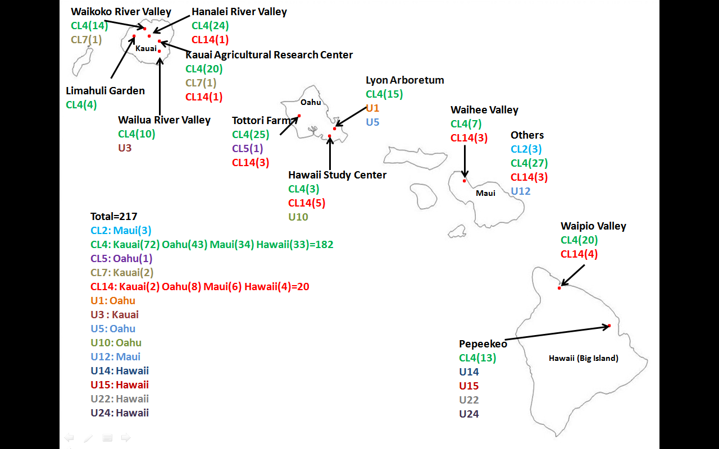
Figure 2.2 Genotype distribution in Hawaii with number of isolates in bracket

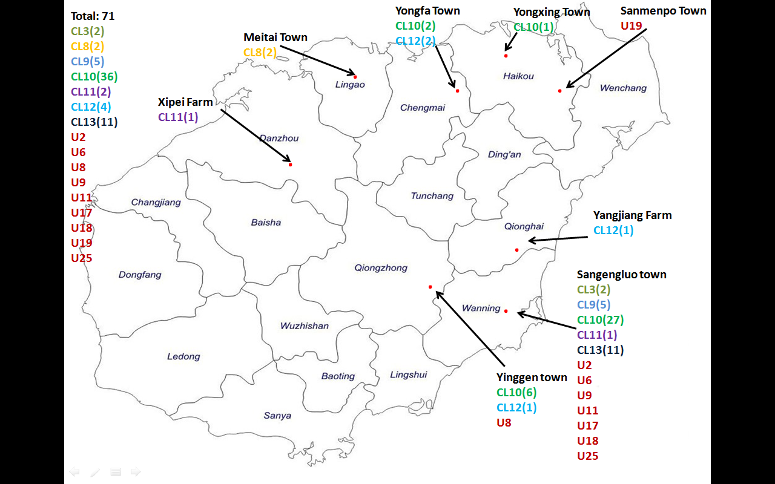
Figure 2.3 Genotype distribution in Hainan Island with number of isolates in bracket
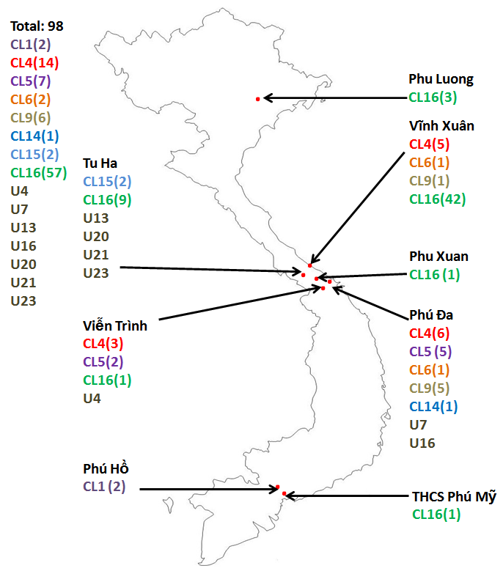
Figure 2.4 Genotype distribution in Vietnam with number of isolates in bracket
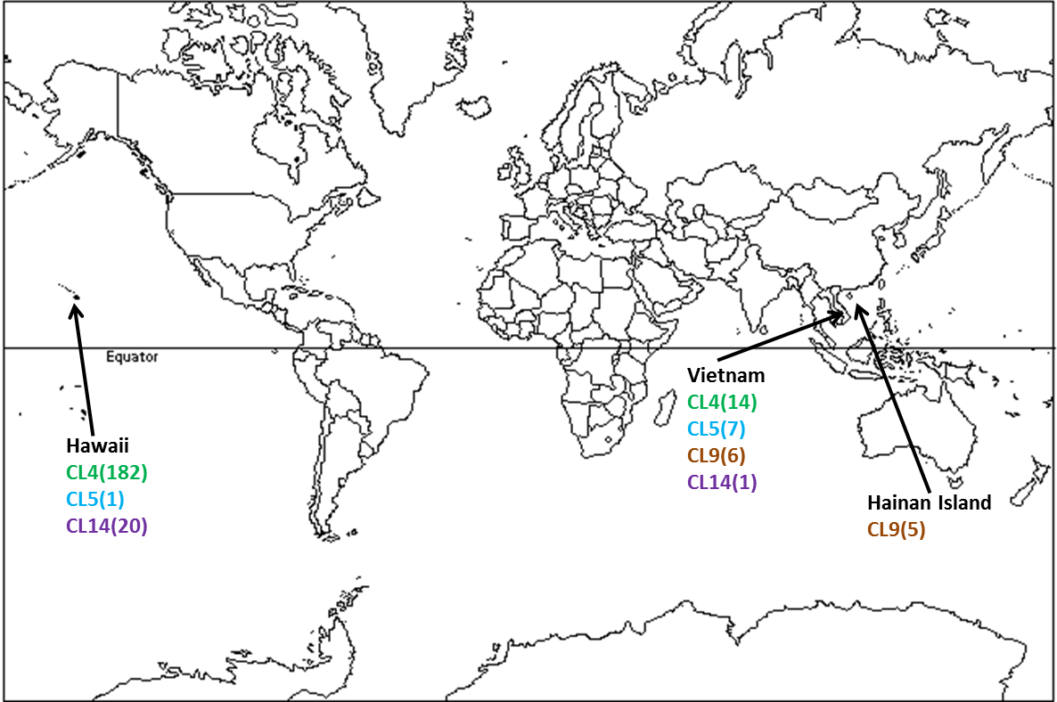
Figure 2. 5 Clonal sharing between countries and number of isolates in bracket

Discussion
Taro is an important food crop in many areas of the world with production of 9 million tons in 2010 (FAO 2012). Taro is mainly grown for its starchy corms which are rich in carbohydrates, proteins, vitamins, and minerals (Sharma et al. 2009), although the leaves and stems are also eaten in some places. Phytophthora colocasiae, which causes TLB, is one of the most important factors limiting taro crop production (Lebot et al. 2003; Sharma et al. 2009). Our objectives were to develop markers useful for characterizing diversity within and among populations of P. colocasiae and to apply these to populations in Hawaii, Vietnam, and Hainan Island. SNP markers have become the marker of choice in many biological systems as they are abundant, often inherited as simple Mendelian characters, and there are many platforms that can be used for accurate genotyping. This is in contrast to the markers used previously to assess P. colocasiae (e.g. RAPDs and isozymes) where resolution using different approaches may give slightly or even significantly different marker attributes (e.g. size of the markers). Although there is nothing known about the P. colocasiae genome, the relatively close phylogenetic relationship to P. capsici proved useful to align the sequences and mine polymorphic sites. The choice of a restriction enzyme for the RAD sequencing was based on previous experience with the P. capsici genome and proved sufficient for our purposes, although different enzymes (e.g. a more frequent cutting enzyme) will likely produce very different results. Despite only 15% of the P. colocasiae sequences aligning using our criteria, it was still possible to assess diversity across >300 Kbp of the P. colocasiae genome and for our purposes, this proved more than adequate. Another approach is to simply compare the small contigs that are produced via the RAD sequencing and to mine out polymorphic sites between the two isolates. Although this would produce many more markers, we thought it more useful to use the P. capsici genome as a guide to the potential distribution of the sites within the genome. Future work using a much larger complement of markers may be useful and will simply involve the investment of more resources to accomplish.

The choice of markers for genotyping was based on information from only two isolates P. colocasiae and the power of the markers could only be assessed after genotyping all the isolates. Those with an alternate allele frequency closest to 50% are the most powerful and the only limitation in this type of study is resources. The 12 markers used here were found on genomic sequences from 10 of the 18 linkage groups recently published for P. capsici and it is reasonable to suspect they are distributed similarly across the P. colocasiae genome. Further investigations of P. colocasiae, in particular, a laboratory cross with parents polymorphic at these sites will be helpful. Overall, it appears that populations of P. colocasiae are dominated by clonal reproduction. This is not surprising as the host plants are present year round and cropping is often conducted at the same sites, using propagation material derived from the previous crop (e.g. a portion of the corm and leaf stem are planted to start a new crop). In addition, although taro can be produced on wet or dry land, much of the sampling here was from wet production sites and there were few obvious barriers to asexual reproduction and dissemination – at least on a local scale.
The most important finding was that clonal reproduction and dispersal appears to spread beyond single islands or countries. At this point it is difficult to assess if this is due to the movement of plant material between discrete locations and/or countries or if there is the possibility of inoculum moving via natural routes (e.g. carried via storms). Regardless of the route, it appears that highly adapted lineages can be spread widely. This is important in the context of breeding as it aides in the choice of inoculum to use to screen accessions for resistance attributes.
Since it is difficult, or even in some cases (e.g. Hawaii), impossible to bring new strains of P. colocasiae into a breeding program, particularly for field trials, the genotypes outlined here may prove valuable when choosing isolates for future work that exploits knowledge of the secreted avirulence proteins that may be interacting with specific resistance genes. For other Phytophthora/host interactions the RxLR effectors family of secreted proteins are being cloned and expressed transiently in the hosts to track known resistance and to identify novel sources of resistance (e.g. P. infestans and potato). The clonal lineages of P. colocasiae that are most widely dispersed may carry important allelic variants of key avirulence genes that could be cloned and expressed transiently in taro and used to guide taro breeding and develop lines with resistance to a wider array of P. colocasiae isolates. In addition, the markers outlined here provide a starting point to characterize P. colocasiae at diverse locations and to track the fate of these clonal lineages over time at these and additional locations.

Literature Cited

Ann PJ, Kao CW, Ko WH. 1986. Mating-type distribution of Phytophthora colocasiae in Taiwan. Mycopathologia 93(3):193-194.
Bergquist RR. 1972. Efficacy of Fungicides for Control of Phytophthora Leaf Blight of Taro. Annals of Botany 36(2):281-287.
CABI/EPPO. 1997. Phytophthora colocasiae. Distribution maps of plant diseases No. 466. CAB International.
Caillon S, Quero-Garcia J, Lescure JP, Lebot V. 2006. Nature of taro (Colocasia esculenta (L.) Schott) genetic diversity prevalent in a Pacific Ocean island, Vanua Lava, Vanuatu. Genetic Resources and Crop Evolution 53(6):1273-1289.
FAO. FAOSTAT. Food and Agriculture Organization [Internet]. Available from: http://faostat.fao.org
Gobena D, McGrath M, Lamour K. 2011. Survival and spread of Phytophthora capsici on Long Island, New York. Mycological Progress:1-8.
Hawaii. 2006. Statistics of Hawaii Agriculture 2005. Honolulu, HI.
Ko WH. 1979. Mating-type distribution of Phytophthora colocasiae on the Island of Hawaii. Mycologia 71(2):434-437.
Lamour K, Finley L. 2006. A strategy for recovering high quality genomic DNA from a large number of Phytophthora isolates. Mycologia 98(3):514-517.
Lebot V, Herail C, Gunua T, Pardales J, Prana M, Thongjiem M, Viet N. 2003. Isozyme and RAPD variation among Phytophthora colocasiae isolates from South-east Asia and the Pacific. Plant Pathology 52(3):303-313.
Lin M-J, Ko W-H. 2008. Occurrence of isolates of Phytophthora colocasiae in Taiwan with homothallic behavior and its significance. Mycologia 100(5):727-734.
Mishra AK, Sharma K, Misra RS. 2010. Isozyme and PCR-based genotyping of epidemic Phytophthora colocasiae associated with taro leaf blight. Archives Of Phytopathology And Plant Protection 43(14):1367-1380.
Montgomery J, Wittwer CT, Palais R, Zhou L. 2007. Simultaneous mutation scanning and genotyping by high-resolution DNA melting analysis. Nat. Protocols 2(1):59-66.
Paiki FA. 1996. Symptoms of taro leaf blight (Phytophthora colocasiae) and relationship with yield component in Biak, Irian jaya. Science in New Guinea 21:153-157.
Raciborski M. 1900. Parasitic algae and fungi, Java. Batavia Bulletin of the New York State Museum 19:189 pp.
Savage EJ, Clayton CW, Hunter JH, Brenneman JA, Laviola C, Gallegly ME. 1968. Homothallism, heterothallism, and interspecific hybridization in the genus Phytophthora. Phytopathology 58:1004-1021.
Sharma K, Mishra A, Misra R. 2009. Identification and characterization of differentially expressed genes in the resistance reaction in taro infected with Phytophthora colocasiae. Molecular Biology Reports 36(6):1291-1297.
Trujillo EE. 1967. Diseases of the Genus Colocasia in the Pacific Area and Their Control. Proceedings of the Second International Symposium on Tropical Root and Tuber Crops. Honolulu, HI, USA: University of Hawaii. p. 136-40.
Tyson JL, Fullerton RA. 2007. Mating types of Phytophthora colocasiae from the Pacific region, India and South-east Asia. Australasian Plant Disease Notes 2:111–112.
Vasquez EA. 1990. Yield loss in taro due to Phytophthora leaf blight. Journal of Root Crops 16(1):48-50.
Vavilov NI. 1951. The origin, variation, immunity and breeding of cultivated plants. Soil Science 72(6):482.
Zhang KM, Zheng FC, Li YD, Ann PJ, Ko WH. 1994. Isolates of Phytophthora colocasiae from Hainan Island in China: evidence suggesting an Asian origin of this species. Mycologia 86(1):108-112.

Chapter Three

Phytophthora recovered from streams in eastern Tennessee

Abstract

Introduction
Phytophthora spp. are best adapted to damp and moist environments. Production of motile zoospores from sporangia before infection of plants, and the requirement of water for zoospore movement essentially helps them to spread by irrigation, drainage and natural waterways (Ghimire et al. 2009). Phytophthora has wide host range, which includes important economical plant species such as Rhododendron, Azalea, Pieris, Tanoak, Douglas-fir, Coast live oak, Coast redwood, Big leaf maple, etc. (Davidson et al. 2003). High density cropping of species in a small site, and use of recycled irrigation water makes the nursery high risk of infestation by Phytophthora spp. (Ribeiro and Linderman 1991). Following Phytophthora spp. have been identified causing diseases in Rhododendron: P. cinnamomi, P. cactorum, P. citricola, P. lateralis, P. cryptogea, P. citrophthora, P. gonapodyides, P. megasperma, and P ramorum (Hoitink and Schmitthenner 1974; Werres et al. 2001). Several species of Phytophthora like P. cinnamomi, P. citricola, P. cryptogea, P. gonapodyides, P. querchina, P. cambivora, and P. cactorum have been found to be associated with the oak tree ecosystem (Balcì and Halmschlager 2003; Vettraino et al. 2002). P. querchina (Vettraino et al. 2002) and P. cinnamomi (Brasier et al. 1993b) are significant in causing oak decline. The new pathogen, Phytophthora ramorum, was first identified in Germany and the Netherlands from Rhododendron and Viburnum (Werres et al. 2001). Phytophthora ramorum can cause diseases in 12 families including Ericaceae and Fagaceae of which Oak species (Quercus spp.) and tanoak (Lithocarpus densiflora) are highly susceptible causing sudden oak death and less susceptible to Rhododendron causing leaf and branch dieback (Davidson et al. 2003). One of the important diagnostic symptoms of this disease is canker and bleeding of brownish-red to dark black sap from the trunk (Davidson et al. 2003). This disease is known as ‘Sudden Oak Death’ (SOD) because of sudden death caused by characteristics girdling of trunk and rapid browning of crown within 2 to 4 weeks (Davidson et al. 2003). SOD is distributed in Europe, western USA, and Canada (Davidson et al. 2003). This disease was first observed in mid 1990s, affecting oak and tanoak of coastal forest in California (Rizzo et al. 2005). The ITS sequencing of P. ramorum from California revealed that sequences were identical to those from isolates found in Europe (Rizzo et al. 2002). This exotic pathogen has been threatening the coastal forests in the USA because of high susceptibility and rapid death of the oaks and tanoaks (Rizzo and Garbelotto 2003). Several surveys and monitoring activities have been conducted so as for early detection and control of the pathogen to avoid the spread into the forests (Donahoo and Lamour 2008; Hulvey et al. 2010; Oak et al. 2008a; Rizzo et al. 2002; Sutton et al. 2009). Fichtner et al. has reported the presence of the pathogen causing sudden oak death in the soil collected from the affected forest (Fichtner et al. 2007). Baiting with Rhododendron leaves have been able to diagnose the presence of P. ramorum in the streams of California, Oregon, and Washington states (Oak et al. 2008b). Since after the first report of the disease, nurseries from 21 states in the USA have been diagnosed with P. ramorum (www.suddenoakdeath.org 2012). Tennessee has also been confirmed positive with this pathogen from two nurseries in 2004 and one (Bradley county) in 2005 (www.suddenoakdeath.org 2012). In 2004-05, seven different species of Phytophthora (P. caclorum, P. citricola, P. citrophthora, P. nicotianae, P. palmivora, P. tropicalis) including a new species (P. foliorum) have been reported from nurseries in Tennessee (Donahoo and Lamour 2008). Another survey in 2008 identified five Phytophthora spp. (P. citrophthora, P. citricola, P. nicotianae, P. syringae, and P. hydropathica) from statewide nurseries in Tennessee and four (P. citrophthora, P. citricola and P. irrigata, and P. hydropathica) from streams of eastern Tennessee (Hulvey et al. 2010).
Tennessee is one of the largest producers of oak trees, so Sudden Oak Disease, caused by P. ramorum, is major concern (CASNR 2003). In 2009, forest contributed 4 % to the Tennessee economy which worth $21 billion (Menard et al. 2011). So, this shows that the forest health is very important for the economy of Tennessee. Eventhough, Phytophthora ramorum has not been detected in Tennessee forests, these forests are at high risk since the pathogen has already been detected from plants in Tennessee nurseries (CASNR 2003). Hence, there is a need to track this pathogen in order to prevent it from entering the forest. Since the genus Phytophthora dispersed by water, monitoring the distribution of this members of this genus is essential (Hulvey et al. 2010). This study is mainly focused in monitoring the pathogen responsible for SOD and identifying different species of Phytophthora by surveying streams present in eastern Tennessee.

Materials and Methods

Sampling and pathogen isolation from streams
Ten key watersheds of eastern Tennessee were selected for monitoring sudden oak death disease (Figure 3.1). There were four sampling: spring and fall of year 2010 and 2011. Each sampling had three different baiting periods with two replication of each location. Generally, asymptomatic Rhododendron leaves were used for baiting purposes. The leaves for baiting were kept at 5° C for one week before each baiting. Four leaves were placed in a mesh bag (Fig. 3.3) and anchored with a 1.5 kg weight. Nylon ropes were used for tethering the bags to the stream shore. The submerged mesh bag was left in water for about 7 days (Figure 3.2). Eight baited leaves from each site (two replications) were washed in tap water. Four randomly selected leaves were processed in the lab and other four were sent to Plant Disease Diagnostic Lab
(Pennsylvania Department of Agriculture) for further analysis. The leaves were processed to obtain mycelium as described here (Figure 3.4): 10-mm leaf disk containing both healthy tissue and necrotic lesion were removed aseptically and transferred to dilute V8-PARP + H agar, 40 mL V8 juice, 3 g CaCO₃, 16 g Bacto agar and 960 mL water amended with 25 ppm pimaricin (Sigma Aldrich, St. Louis, MO), 100 ppm ampicillin (Fisher Scientific, Pittsburg, PA) 25 ppm rifampicin (Sigma Aldrich, St. Louis, MO), 25 ppm penta-chloro-nitro-benzene (Fisher Scientific, Pittsburg, PA) and 71.4 mg/L Hymexazol (Bayer Corporation, Pittsburgh, PA). After incubation for 1-3 days, the hyphal plug was transferred onto water agar (Figure 3.4). Then, single hyphal tip plugs were obtained from the water agar plate and used for culturing in full strength V8-PARP agar as shown in Fig. 4. These cultures were used for the long-term storage, DNA extraction, and species identification.

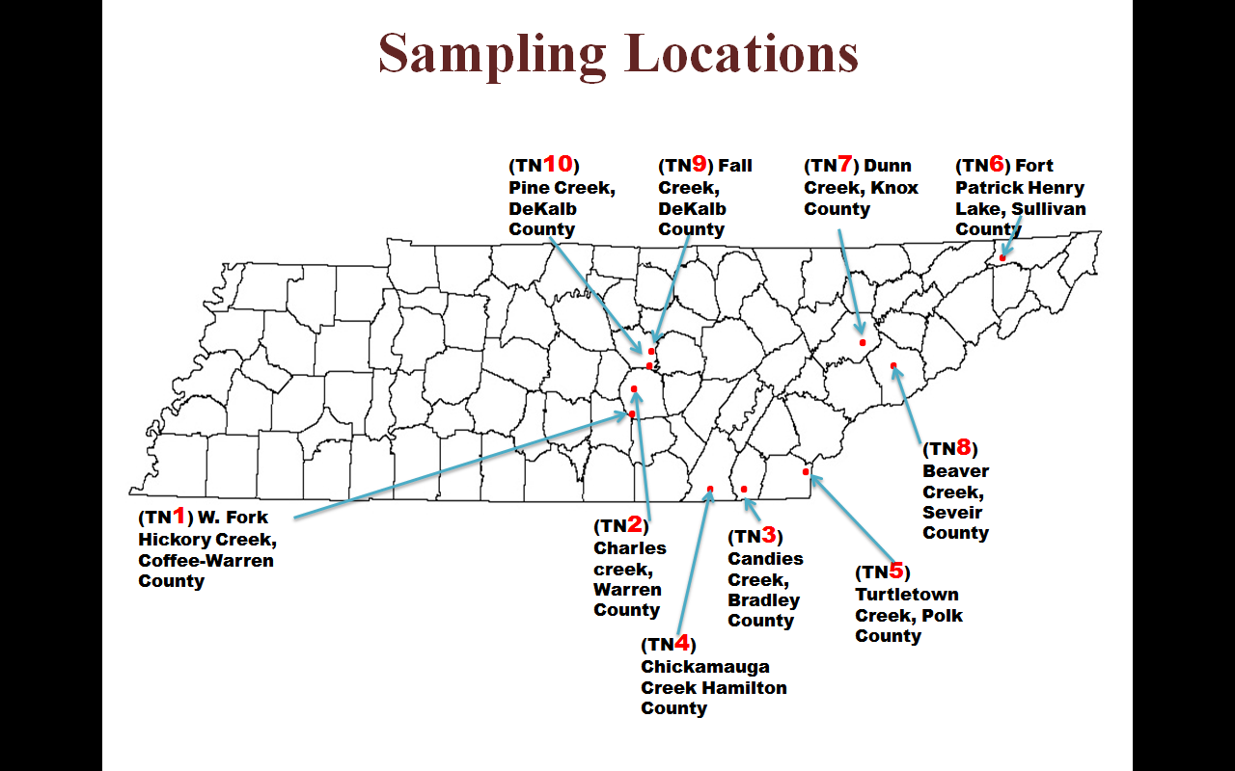
Figure 3.1 Ten sampling locations in eastern Tennessee
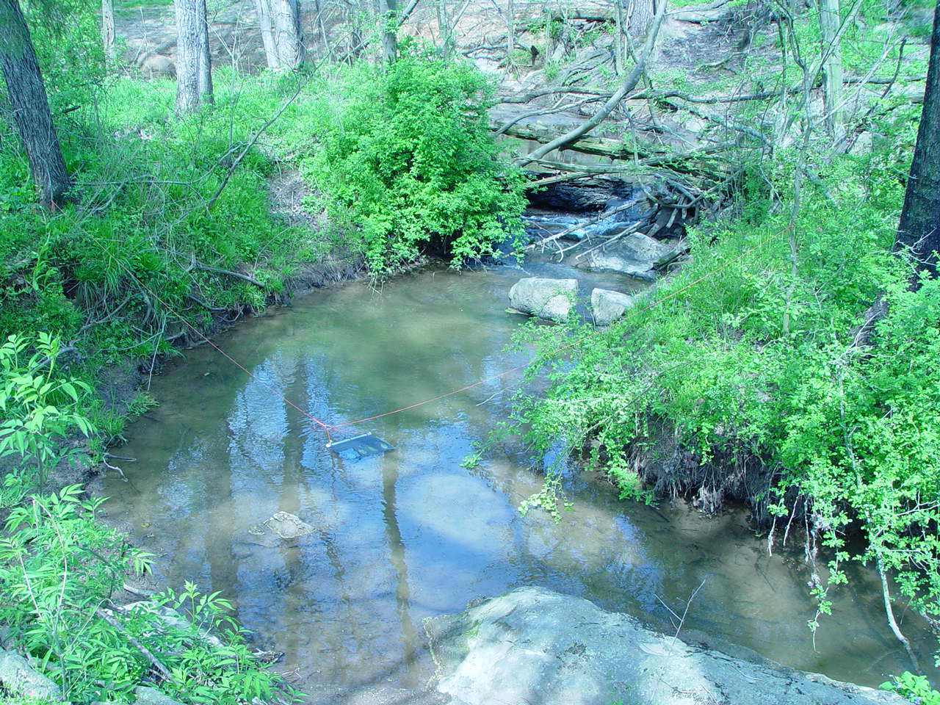
Figure 3.2 Baiting of Phytophthora in a stream by using Rhododendron leaves in a mesh bag.

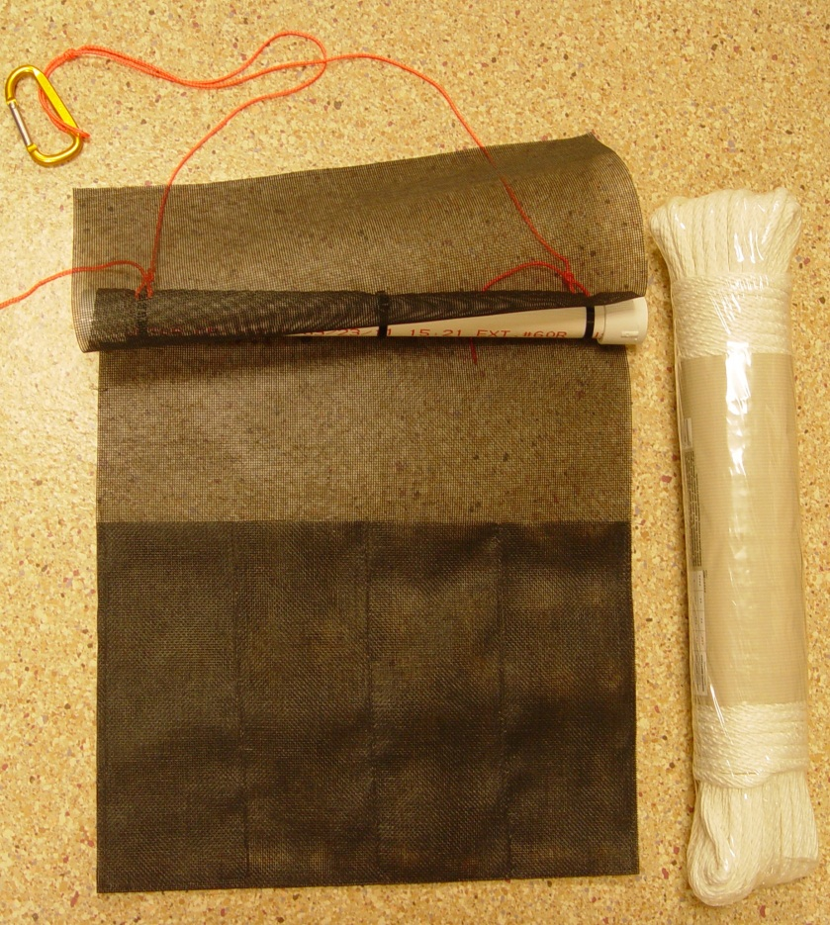
Figure 3.3 Mesh bag with four compartments for four rhododendron leaves and nylon rope for tethering the mesh bag.
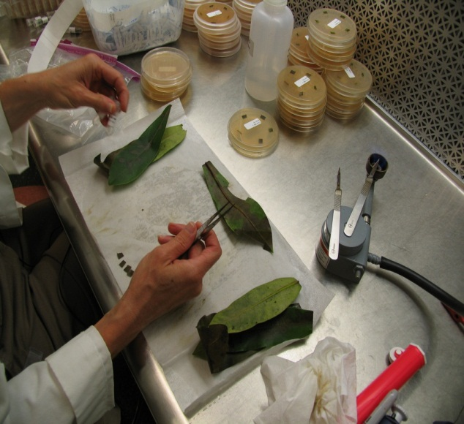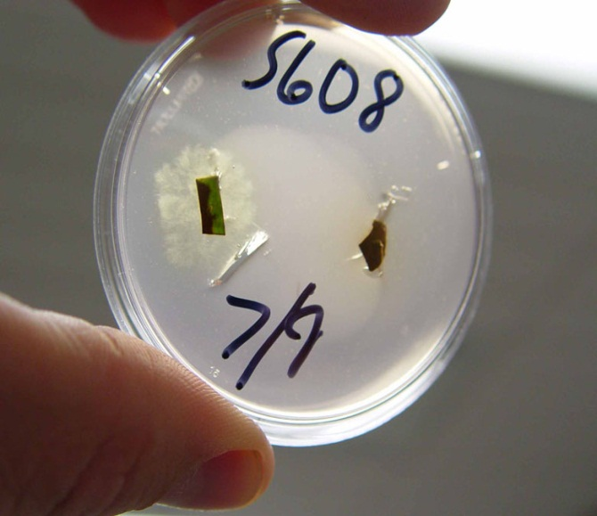
Figure 3.4: Isolation of pathogen from baited leaf onto selected medium (left) and observed growth of mycelium after 1-3 days (right)

Long term storage and DNA extraction
The mycelium obtained from hyphal tip culture was used for preparing long-term storage. Three to four plugs (7-mm diameter) from the culture were transferred into 2-mL tubes preloaded with 1 mL sterilized water and three to four sterilized hemp seeds. DNA from all the isolates were extracted according to the protocol described by Lamour and Finley (Lamour and Finley 2006).

Internal Transcribed Spacer (ITS) sequencing and species identification
Identification of Phytophthora spp. has been done with various methods from morphological study to DNA analysis. Morphological study for species identification and classification of Phytophthoras is not suitable because of the lack of distinctive morphological characters and possibility of similar characteristics among different species (Cooke and Duncan 1997). Protein banding pattern has also been used for identifying different species of the Phytophthora (Brasier et al. 1993a). Identification of different species of Phytophthora was also possible with the isozyme analysis (Oudemans and Coffey 1991). The advancement of the technology has created an opportunity to look at the DNA variation among species for the identification (Cooke and Duncan 1997). Ribosomal RNA gene has been used for the identification and phylogenetic analysis of Phytophthora spp. (Cooke et al. 2000; Cooke and Duncan 1997; Lee and Taylor 1992). The highly repetitive ribosomal RNA gene consist of non-translational sections known as internal transcribed spacer (ITS1 and ITS2) region between 18S and 5.8S genes as shown in Figure 3.5 (Cooke et al. 2000). Interspecific variation of ITS1 and ITS2 regions of the ribosomal RNA gene is high compared to the intraspecific variation among Phytophthora spp. (Lee and Taylor 1992).
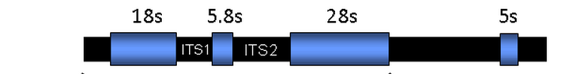
Figure 3.5 Ribosomal DNA with ITS1 and ITS2. Source: http://phytophthora-id.org

Use of ITS1 and ITS2 sequence was helpful in identification of Phytophthora ramorm for the first time and distinguished it from other related species such as P. lateralis (Werres et al. 2001). Similarly, this pathogen was first diagnosed on Viburnum (Lane et al. 2003), Pieris (Inman et al. 2003) and on oak trees (Brasier et al. 2004), by ITS sequence analysis. Since after detection of this pathogen in the USA, stream monitoring and identification has been accomplished by using ITS sequencing (Rizzo et al. 2002; Sutton et al. 2009). In earlier years, streams and nurseries from eastern Tennessee have been monitored for this pathogen with the help of ITS sequencing (Donahoo and Lamour 2008; Hulvey et al. 2010).

ITS region of putative Phytophthora isolates was sequenced. Universal primers ITS5 (5’ GGAAGTAA AAGTCGTAACAAGG 3’) and ITS4 (5’ TCCTCCGC TTATTGATATGC 3’) were used for PCR amplification of both ITS region (ITS1 and ITS2) of ribosomal RNA gene (White T 1990). The PCR reaction of 30 µL final volume consist: 3 µL 10x buffer, 1.2 µL dNTPs at 5 mM conc., 1.5 µL DNA at 50-100 ng/µL, 1 µL TAQ polymerase, and 0.1 µL primers at 100 mM conc. The PCR was done with the following temperature cycles: initial denaturation at 94°C for 2 min followed by 29 cycles of denaturation at 94°C for 20 sec, annealing at 55°C for 25 sec, extension at 72°C for 1 min, and final extension at 72°C for 10 min. Cleaning of the PCR product was done to remove unused primers and dNTPs by ExoSAP-IT reagent (USB Corp, Cleveland, OH). The reagent was added at the rate of 2 µL per 5 µL PCR products and treated at 37 °C for 15 min, followed by 80°C for 15 min (Bell 2008; Dugan et al. 2002). ITS4 primer was used for the sequencing. The PCR products after cleaning were sent to DNA sequencing facility (University of Iowa, Iowa city, IA) for sequencing. The sequence data generated were trimmed for poor quality sequence by using CodonCode Aligner 3.7.1 software (CodonCode, Dedham, MA). Each amplicon sequence from each isolate was searched against the National Center for Biotechnology Information (NCBI) Genbank database and Phytophthora database (http://www.phytophthoradb.org/) for identifying species.

Result
A total of 249 isolates were collected from 10 different streams of eastern Tennessee by surveying in the year 2010 and 2011. The amplicon consisting of ITS1, 5.8S and ITS2 was searched against NCBI and Phytophthora database. The identification of species was done based on 99-100% maximum identity hit on the database. The isolate with less than 99% hit was scored according to top 15 maximum number of hit. In total, 10 different species with two unknown were identified as: P. citricola, P. citrophthora, P. cryptogea, P. drechsleri, P. gonapodyides, P. hydropathica, P. irrigata, P. polonica, Phytophthora spp. (unknown), Pythium helicoides, Pythium litorale, and Pythium spp (unknown). The following species, P. citricola (AF266788), P. citrophthora (AF266785), P. cryptogea (AF266796), P. drechsleri (AF266798), P. gonapodyides (AF266793), and P. palmivora (AF266780) have been mentioned in the literature related to phylogeny of Phytophthora spp. (Cooke et al. 2000). The other identified species were P. hydropathica (GQ505908), P. irrigata, P. polonica (AB511828), Pythium litorale (GQ505911), which are described in the following literature (Hong et al. 2010, Naher et al. 2011, Hulvey 2010). Out of 249 isolates, 52 were not able to make any hit. The number of isolates with respective species is shown in Figure 3.6. The number of Phytophthora spp. in different locations from four sampling periods is given in Table 3.1.

Figure 3.6 Number of species found from stream in 2010 and 2011

Table 3.1 Species found in 10 streams in 2010 and 2011
Location | Year | Sampling Period | Species
TN1 | 2010 | Spring | Pythium litorale (1)  Phytophthora hydropathica (2)  Pythium spp. (1)
TN1 | 2010 | Fall | Phytophthora spp (3)  Pythium litorale (1)  Phytophthora hydropathica (1)
TN1 | 2011 | Spring
  Phytophthora citricola (1)
  Pythium spp (2)
  Pythium sterilum (1)
  Phytophthora hydropathica (1)
TN1 | 2011 | Fall
  Phytophthora hydropathica (1)
  Phytophthora cryptogea (2)
  Phytophthora spp (1)
TN2 | 2010 | Spring | Phytophthora hydropathica (3)  Phytophthora citricola (1)  Phytophthora spp (1)  Pythium litorale (1)
TN2 | 2010 | Fall | Phytophthora spp (2)  Pythium spp. (3)  Phytophthora cryptogea (1)
TN2 | 2011 | Spring
  Pythium spp (3)
  Phytophthora spp (1)
TN2 | 2011 | Fall
  Pythium spp (2)
  Phytophthora spp (3)
  Phytophthora cryptogea (1)
  Phytophthora irrigata (1)
TN3 | 2010 | Spring
  Pythium litorale (2)
  Phytophthora spp (2)
  Pythium litorale (1)
  Phytophthora hydropathica (1)
TN3 | 2010 | Fall
  Pythium litorale (2)
  Phytophthora irrigata (1)
  Pythium spp (2)
  Phytophthora spp (1)
TN3 | 2011 | Spring
  Pythium spp (3)
  Phytophthora citricola (1)
  Phytophthora citrophthora (1)
TN3 | 2011 | Fall
  Pythium spp (2)
  Phytophthora spp (3)
  Phytophthora cryptogea (1)
TN4 | 2010 | Spring
  Pythium spp (1)
  Pythium litorale (1)
  Phytophthora hydropathica (1)
  Phytophthora polonica (1)
  Phytophthora spp (1)
  Phytophthora cryptogea (1)
TN4 | 2010 | Fall
  Phytophthora irrigata (1)
  Pythium spp (1)
  Phytophthora spp (1)
  Phytophthora cryptogea (1)
TN4 | 2011 | Spring
  Pythium spp (2)
TN4 | 2011 | Fall
  Phytophthora spp (1)
  Pythium helicoides (1)
  Phytophthora hydropathica (1)
TN5 | 2010 | Spring
  Pythium spp (2)
  Pythium litorale (1)
  Phytophthora cryptogea (3)
TN5 | 2010 | Fall
  Phytophthora drechsleri (1)
  Pythium litorale (1)
  Phytophthora cryptogea (2)
  Pythium spp (1)
TN5 | 2011 | Spring
  Pythium spp (4)
  Pythium litorale (1)
  Phytophthora spp (2)
TN5 | 2011 | Fall
  Phytophthora citricola (1)
  Phytophthora spp (2)
  Pythium spp (1)
  Pythium litorale (1)
  Phytophthora cryptogea (1)
TN6 | 2010 | Spring
  Phytophthora citricola (1)
  Pythium litorale (1)
  Phytophthora hydropathica (1)
  Phytophthora spp (1)
TN6 | 2010 | Fall
  Pythium spp (3)
  Pythium litorale (1)
TN6 | 2011 | Spring
  Pythium spp (3)
  Phytophthora citricola (1)
  Pythium litorale (1)
TN6 | 2011 | Fall
  Phytophthora gonapodyides (1)
  Pythium spp (2)
  Phytophthora cryptogea (1)
TN7 | 2010 | Spring
  Phytophthora spp (1)
  Phytophthora hydropathica (2)
  Pythium litorale (1)
TN7 | 2010 | Fall
  Phytophthora cryptogea (3)
  Pythium spp (2)
TN7 | 2011 | Spring
  Phytophthora cryptogea (1)
  Pythium litorale (3)
  Pythium spp (2)
TN7 | 2011 | Fall
  Pythium litorale (2)
  Pythium spp (1)
  Phytophthora spp (2)
TN8 | 20140 | Spring
  Pythium litorale (1)
  Phytophthora cryptogea (1)
  Phytophthora irrigata (1)
  Phytophthora spp (1)
TN8 | 20140 | Fall
  Pythium spp (3)
  Pythium litorale (2)
TN8 | 2011 | Spring
  Pythium spp (1)
  Pythium litorale (1)
TN8 | 2011 | Fall
  Phytophthora spp (1)
  Pythium litorale (1)
TN9 | 2010 | Spring
  Pythium spp (1)
  Phytophthora gonapodyides (1)
  Phytophthora cryptogea (1)
  Phytophthora citricola (1)
  Pythium litorale (2)
  Phytophthora spp (1)
  Phytophthora hydropathica (1)
TN9 | 2010 | Fall
  Phytophthora irrigata (1)
  Pythium spp (2)
  Pythium litorale (2)
  Phytophthora cryptogea (1)
TN9 | 2011 | Spring
  Pythium spp (5)
  Pythium litorale (1)
TN9 | 2011 | Fall
  Phytophthora spp (5)
  Pythium litorale (1)
  Phytophthora cryptogea (2)
TN10 | 2010 | Spring
  Pythium spp (4)
  Phytophthora hydropathica (1)
TN10 | 2010 | Fall
  Pythium spp (1)
TN10 | 2011 | Spring
  Pythium spp (4)
  Pythium litorale (2)
TN10 | 2011 | Fall
  Phytophthora spp (4)
  Phytophthora cryptogea (1)

Discussion
Forest industry is very important to the economy of Tennessee, which contributes billions of dollar and employs hundreds of thousands people directly or indirectly (Menard et al. 2011). Tennessee is one of the top producers of hardwood in the United States with the production of 881 million board feet of hardwood lumber in 2008 (Menard et al. 2011). So, it is very important to protect the health of Tennessee hardwood forest, which can be threatened by various invasive pathogens, such as Phytophthora ramorum, by invading different plant species (Hulvey et al. 2010). Phytophthora ramorum, which causes SOD, has already killed thousands of forest oak trees in California since after the first report of unusual bleeding canker in 1995 (Rizzo et al. 2002). The spread of P. ramorum and isolation from streams have already been reported in California, Oregon, and Washington while nurseries in other 18 states have been reported with P. ramorum including Tennessee (www.suddenoakdeath.org). The objective of this survey is mainly focused in tracking Phytophthora ramorum and identifying different species recovered from major streams in eastern Tennessee.
Result of baiting survey showed that Phytophthora spp. and Pythium spp. were dominating the streams in eastern Tennessee. Phytophthora (97) and Pythium (100) were identified from 197 isolates, which were able to produce the hit. The most frequently occurring Phytophthora species was Phytophthora unknown. This unknown Phytophthora was scored according to the first hit and none of the isolates hit Phytophthora ramorum in corresponding lower hits. Previous research on stream survey also reported unknown Phytophthora species in Tennessee (Hulvey et al. 2010). Another survey of irrigation water reservoirs in Virginia also reported nine different species of Phytophthora and hundreds of isolates were identified as unknown taxa of this genus (Hong et al. 2008a). A new Phytophthora species, Phytophthora cryptogea, was reported in this survey, which has not been reported in previous surveys in eastern Tennessee (Donahoo and Lamour 2008; Hulvey et al. 2010). Phytophthora cryptogea has also been isolated from the irrigation water survey in Virginia and water reservoirs in Germany (Bush et al. 2003; Themann et al. 2002). Phytophthora cryptogea causes minor root rot of Rhododendron (Hoitink and Schmitthenner 1974) but the interaction with oak trees is unknown (Balcì and Halmschlager 2003).
Another frequent Phytophthora species recovered from streams was Phytophthora hydropathica. This species was isolated from irrigation reservoirs and first described as a new species in 2010 (Ghimire et al. 2011; Hong et al. 2010). In previous research, Phytophthora hydropathica has also been isolated from the watersheds and nurseries of eastern Tennessee (Hulvey et al. 2010). Phytophthora hydropathica is an important pathogen, common in rivers and irrigation water, of various ornamental species, which causes leaf blight and leaf necrosis of Rhododendron, and root rot of Mountain-laurel (Hong et al. 2008b; Hong et al. 2010). Since Phytophthora hydropathica is widespread in watersheds of eastern Tennessee, this may rise as a threat to the nursery ornamentals as well as forest hosts.
Phytophthora citricola and Phytophthora citrophthora were another two species identified in this study. These species were also reported in similar stream and nursery survey in Tennessee (Donahoo and Lamour 2008; Hulvey et al. 2010). Phytophthora citricola has very wide host range, which include economically important fruit trees such as avocado, walnut, and almond, and forest trees (Bhat and Browne 2007). Similarly, Phytophthora citrophthora causes root rot of citrus and various woody ornamentals (Dirac et al. 2003; Józsa et al. 2011). Both P. citricola and P. citrophthora were also recovered from irrigation water (Ghimire et al. 2011; Hong and Moorman 2005; MacDonald et al. 1994). The previous study has showed that P. citricola and P. citrophthora recovered in Tennessee are genetically diverse, which are transported to different places through nursery stocks (Donahoo and Lamour 2008; Hulvey et al. 2010), and might be threat to more ornamental forest trees.
Phytophthora irrigata is another species found in five isolates during this survey. Phytophthora irrigata is a newly described species, which has been recovered from streams, rivers, and irrigation reservoirs of different places including Tennessee (Ghimire et al. 2011; Hong et al. 2008a; Hong et al. 2008b; Hulvey et al. 2010). Previous experimental inoculation has showed that P. irrigata is pathogenic to azaleas and some vegetable crops like pepper, tomato, and eggplant (Hong et al. 2008b), however the extent of the damage in these plants has yet to be determined in field condition.
Phytophthora drechsleri, P. gonapodyides, and P. polonica are other Phytophthora species which were identified in this survey. These species were not identified in the previous studies in Tennessee. Phytophtora polonica was first described in 2006 from declining Alnus glutinosa and laboratory inoculation showed that it was pathogenic to Alnus glutinosa and Quescus species (Belbahri et al. 2006). Recent study was able to recover P. polonica from nursery irrigation reservoir, which water is used for recycling (Ghimire et al. 2011). Phytophthora gonapodyides has been recovered from stream, reservoirs, soil and stem of declining oak stands (Balcì and Halmschlager 2003; Bush et al. 2003; Ghimire et al. 2011; Jung et al. 1996). Previous study has showed that Phytophthora gonapodyides is pathogenic to conifer trees (Hamm and Hansen 1982) and many other ornamentals (Erwin and Ribeiro 1996). Phytophthora drechsleri, which has been identified in causing root rot disease of safflower, sunflower, sugar beet, Pinus species and cucurbits, has been reported in irrigation reservoirs (Bush et al. 2003; Erwin and Ribeiro 1996; Heather et al. 1977).
This study explored few more Phytophthora species in the streams of eastern Tennessee. Some of the species like Phytophthora citrophthora and Phytophthora hydropathica have already been recovered from both nurseries and streams of Tennessee (Hulvey et al. 2010). Phytophthoras has been efficient in moving through the waterways (Ghimire et al. 2009). Since, Phytophthora ramorum has been reported from the nursery in Tennessee, the usual monitoring is necessary for early detection and to avoid escape into the natural ecosystems.

Literature Cited
Balcì Y, Halmschlager E. 2003. Phytophthora species in oak ecosystems in Turkey and their association with declining oak trees. Plant Pathology 52(6):694-702.
Belbahri L, Moralejo E, Calmin G, Oszako T, García JA, Descals E, Lefort F. 2006. Phytophthora polonica, a new species isolated from declining Alnus glutinosa stands in Poland. Fems Microbiology Letters 261(2):165-174.
Bell JR. 2008. A simple way to treat PCR products prior to sequencing using ExoSAP-IT. Application forum, USB Corporation, Cleveland, OH 44 (6):834.
Bhat RG, Browne GT. 2007. Genetic Diversity in Populations of Phytophthora citricola Associated with Horticultural Crops in California. Plant Disease 91(12):1556-1563.
Brasier CM, Denman S, Rose J, Kirk SA, Hughes KJD, Griffin RL, Lane CR, Inman AJ, Webber JF. 2004. First report of ramorum bleeding canker on Quercus falcata, caused by Phytophthora ramorum. Plant Pathology 53(6):804-804.
Brasier CM, Hamm PB, Hansen EM. 1993a. Cultural characters, protein patterns and unusual mating behaviour of Phytophthora gonapodyides isolates from Britain and North America. Mycological Research 97(11):1287-1298.
Brasier CM, Robredo F, Ferraz JFP. 1993b. Evidence for Phytophthora cinnamomi involvement in Iberian oak decline. Plant Pathology 42(1):140-145.
Bush EA, Hong C, Stromberg EL. 2003. Fluctuations of Phytophthora and Pythium spp. in Components of a Recycling Irrigation System. Plant Disease 87(12):1500-1506.
CASNR. Forest products extension, College of Agricultural Sciences and Natural Resourses, The University of Tennessee [Internet].
Cooke DEL, Drenth A, Duncan JM, Wagels G, Brasier CM. 2000. A Molecular Phylogeny of Phytophthora and Related Oomycetes. Fungal Genetics and Biology 30(1):17-32.
Cooke DEL, Duncan JM. 1997. Phylogenetic analysis of Phytophthora species based on ITS1 and ITS2 sequences of the ribosomal RNA gene repeat. Mycological Research 101(6):667-677.
Davidson JM, Werres S, Garbelotto M, Hansen EM, Rizzo DM. 2003. Sudden oak death and associated diseases caused by Phytophthora ramorum. Plant Management Network.
Dirac MF, Menge JA, Madore MA. 2003. Comparison of Seasonal Infection of Citrus Roots by Phytophthora citrophthora and P. nicotianae var. parasitica. Plant Disease 87(5):493-501.
Donahoo RS, Lamour KH. 2008. Characterization of Phytophthora species from leaves of nursery woody ornamentals in Tennessee. Hortscience 43(6):1833-1837.
Dugan KA, Lawrence HS, Hares DR, Fisher CL, Budowle B, Ann PJ. 2002. An Improved Method for Post-PCR Purification for mtDNA Sequence Analysis. J Forensic Sci 47(4):1-8.
Erwin DC, Ribeiro OK. 1996. Phytophthora diseases worldwide. American phytopathological society

Fichtner EJ, Lynch SC, Rizzo DM. 2007. Detection, Distribution, Sporulation, and Survival of Phytophthora ramorum in a California Redwood-Tanoak Forest Soil. Phytopathology 97(10):1366-1375.
Ghimire SR, Richardson PA, Kong P, Hu J, Lea-Cox JD, Ross DS, Moorman GW, Hong C. 2011. Distribution and Diversity of Phytophthora species in Nursery Irrigation Reservoir Adopting Water Recycling System During Winter Months. Journal of Phytopathology 159(11-12):713-719.
Ghimire SR, Richardson PA, Moorman GW, Lea-Cox JD, Ross DS, Hong CX. 2009. An in-situ baiting bioassay for detecting Phytophthora species in irrigation runoff containment basins. Plant Pathology 58(3):577-583.
Hamm PB, Hansen EM. 1982. Pathogenicity of Phytophthora species to Pacific Northwest Conifers. European Journal of Forest Pathology 12(3):167-174.
Heather W, Pratt B, Chin T. 1977. Pre- and Post-Emergence Damping Off of Seedlings of Pinus Species by Phytophthora cinnamomi and Ph. Drechsleri. Australian Journal of Botany 25(4):385-393.
Hoitink HAJ, Schmitthenner AF. 1974. Relative prevelance and virulence of Phytophthora species involved in Rhododendron root rot. Phytopathology (64):1371–1374.
Hong C, Gallegly ME, Richardson PA, Kong P, Moorman GW. 2008a. Phytophthora irrigata, a new species isolated from irrigation reservoirs and rivers in Eastern United States of America. Fems Microbiology Letters 285(2):203-211.
Hong C, Richardson P, Kong P. 2008b. Pathogenicity to Ornamental Plants of Some Existing Species and New Taxa of Phytophthora from Irrigation Water. Plant Disease 92(8):1201-1207.
Hong CX, Gallegly ME, Richardson PA, Kong P, Moorman GW, Lea-Cox JD, Ross DS. 2010. Phytophthora hydropathica, a new pathogen identified from irrigation water, Rhododendron catawbiense and Kalmia latifolia. Plant Pathology 59(5):913-921.
Hong CX, Moorman GW. 2005. Plant Pathogens in Irrigation Water: Challenges and Opportunities. Critical Reviews in Plant Sciences 24(3):189-208.
Hulvey J, Gobena D, Finley L, Lamour K. 2010. Co-occurrence and genotypic distribution of Phytophthora species recovered from watersheds and plant nurseries of eastern Tennessee. Mycologia 102(5):1127-1133.
Inman AJ, Townend VC, Barnes AV, Lane CR, Hughes KJD, Griffin RL, Eales SJ. 2003. First report of ramorum dieback (Phytophthora ramorum) on Pieris in England. Plant Pathology 52(6):785-785.
Józsa A, Nagy ZÁ, Szigethy A, Fischl G, Bakonyi J. 2011. First Report of Phytophthora citrophthora Causing Root and Basal Stem Rot of Woody Ornamentals in Hungary. Plant Disease 95(9):1193-1193.
Jung T, Blaschke H, Neumann P. 1996. Isolation, identification and pathogenicity of Phytophthora species from declining oak stands. European Journal of Forest Pathology 26(5):253-272.
Lamour K, Finley L. 2006. A strategy for recovering high quality genomic DNA from a large number of Phytophthora isolates. Mycologia 98(3):514-517.
Lane CR, Beales PA, Hughes KJD, Griffin RL, Munro D, Brasier CM, Webber JF. 2003. First outbreak of Phytophthora ramorum in England, on Viburnum tinus. Plant Pathology 52(3):414-414.
Lee SB, Taylor JW. 1992. Phylogeny of five fungus-like protoctistan Phytophthora species, inferred from the internal transcribed spacers of ribosomal DNA. Molecular Biology and Evolution 9(4):636-653.
MacDonald JD, Ali-Shtayeh MS, Kabashima J, Stites J. 1994. Occurrence of Phytophthora species in recirculated nursery irrigation effluents. Plant Disease 78(6):607-611.
Menard J, English B, Jensen K. 2011. Economic impacts of agriculture and forestry in Tennessee, 2009. Agricultural Experiment Station, The University of Tennessee.
Oak S, Hwang J, Jeffers S, Tkacz B. 2008a. 2006 Pilot Survey for Phytophthora ramorum in Forest Streams in the USA. Proceedings of the sudden oak death third science symposium, U.S. Department of Agriculture, Forest Service:59-64.
Oak SW, Hwang J, Jeffers SN, Tkacz BM. 2008b. 2006 pilot survey for Phytophthora ramorum in forest streams in the USA. U.S. Department of Agriculture, Forest Service, Pacific Southwest Research Station:59-64.
Oudemans P, Coffey MD. 1991. Isozyme comparison within and among worldwide sources of three morphologically distinct species of Phytophthora. Mycological Research 95(1):19-30.
Ribeiro OK, Linderman RG. Chemical and biological control of Phytophthora species in woody plants. In: Luca JA, Shattock RC, Shaw DS, Cooke LR, eds. Phytophthora :Symposium of the British Mycological Society; 1991; Cambridge; New York: Cambridge University Press.
Rizzo DM, Garbelotto M. 2003. Sudden oak death: endangering California and Oregon forest ecosystems. Frontiers in Ecology and the Environment 1(4):197-204.
Rizzo DM, Garbelotto M, Davidson JM, Slaughter GW, Koike ST. 2002. Phytophthora ramorum as the cause of extensive mortality of Quercus spp. and Lithocarpus densiflorus in California. Plant Disease 86(3):205-214.
Rizzo DM, Garbelotto M, Hansen EM. 2005. Phytophthora ramorum: integrative research and management of an emerging pathogen in California and Oregon forests. Annual review of phytopathology 43:309-35.
Sutton W, Hansen EM, Reeser PW, Kanaskie A. 2009. Stream Monitoring for Detection of Phytophthora ramorum in Oregon Tanoak Forests. Plant Disease 93
1182-1186.
Themann K, Werres S, Lüttmann R, Diener HA. 2002. Observations of Phytophthora spp. in water Recirculation Systems in Commercial Hardy Ornamental Nursery Stock. European Journal of Plant Pathology 108(4):337-343.
Vettraino AM, Barzanti GP, Bianco MC, Ragazzi A, Capretti P, Paoletti E, Luisi N, Anselmi N, Vannini A. 2002. Occurrence of Phytophthora species in oak stands in Italy and their association with declining oak trees. Forest Pathology 32(1):19-28.
Werres S, Marwitz R, Veld W, De Cock A, Bonants PJM, De Weerdt M, Themann K, Ilieva E, Baayen RP. 2001. Phytophthora ramorum sp nov., a new pathogen on Rhododendron and Viburnum. Mycological Research 105:1155-1165.
White T J. 1990. Amplification and direct sequencing of fungal ribosomal RNA genes for phylogenetics. In PCR Protocols: A Guide to Methods and Applications. M. A. Innis, D. H. Gelfand, J. J. Sninsky and T. J. White, eds. Academic Press, San Diego:315-322.
www.suddenoakdeath.org. 2012. USA Phytophthora ramorum nursery chronology.

Chapter Four

Conclusions

Vita

