Two Studies on Controlling the Outflow from Sediment Basins:

1) Developing Discharge Coefficients for

Circular Orifices in Round Riser Pipes, and

2) Optimizing the Solid State Skimmer

A Thesis Presented for the

Master of Science

Degree

The University of Tennessee, Knoxville

Alex J. McLemore

August 2012

Copyright © 2011 by Alex J. McLemore.
All rights reserved.

ACKNOWLEDGEMENTS

ABSTRACT
Sediment pollution is a major contributor to stream and river impairment. Often, the source of sediment pollution is from a construction site’s runoff stormwater. A sediment retention basin, especially one with skimming outlet, can help minimize the sediment pollution from constructions sites. A sediment retention basin and outlet are specifically designed for each site to retain as much sediment as possible while satisfying other requirements such as peak flow rates and retention times. Because the modern designs needs have increased requirements, there is an increased need to be as accurate as possible when modeling the hydraulics and the sediment trapping efficiency. This research focuses on two components related to the performance of sediment retention basins; 1) flow through a circular orifice cut into the side of a round riser pipes and 2) an optimization process to increase the efficiency of a sediment retention basin when using a Solid State Skimmer. It was determined that the true area of a circular orifice cut into a round riser pipe is greater than the normally assumed area, area of the bit that cut the orifice, and that flow rate varied because of the unique shape formed by the cut. Three area equations are presented to model the orifice area, and an empirical coefficient of discharge equation was developed to increase orifice equation accuracy. The coefficient of discharge decreased as the orifice diameter approached the size of the riser diameter, but slightly increases as head neared the orifice. In order to quantify the efficiency of a sediment basin with a skimming outlet, the commonly applied overflow method was modified to account for the elevation and quantity of discharging polluted stormwater from the basin. The modified overflow method was implemented as the objective function in a MATLAB program that automatically determines the parameters of the Solid State Skimmer for increased sediment trapping efficiency.

TABLE OF CONTENTS

INTRODUCTION 1
CHAPTER I Discussion of “Investigation of Flow through Orifices in Riser Pipes” 4
A version of this chapter was originally published as: 5
Abstract 5
Introduction 5
Discussion 6
Conclusion 8
References 10
CHAPTER II A study of discharge coefficients for orifices cut into round pipes 11
Abstract 12
Introduction 13
Theory 15
Methods 19
Results and Discussion 23
Conclusion 35
Notation 38
References 39
CHAPTER III Optimization of the Soild State Skimmer 41
Abstract 42
Introduction 43
Methods 46
Results and Discussion 56
MATLAB program 56
Sensitivity analysis 60
Conclusion 70
References 71
CONCLUSION 72
BIBLIOGRAPHY 75
Appendix 80
Appendix 1.1 81
Appendix 1.2 83
Appendix 1.3 84
VITA 91

LIST OF TABLES

Table 1. Studied bit diameters, riser pipe diameters, and resulting d/D values. 22
Table 2. R² and RMSE values of fit equation for measured data with all area definitions 29
Table 3. RMSE of two replications for the C_{d} data 31
Table 4. Averaged visual measurements of C_{d} for each orifice size on a 10.2 cm riser when h/d >= 5 34
Table 5. Single storm simulation efficiencies 62
Table 6. Peak flow rates (cfs) for 2, 5, 10, 25, 50, and 100-yr storm events 65
Table 7. Traditional riser efficiencies for the multiple storm simulation 65
Table 8. SSS efficiencies for the multiple storm simulation 65
Table 9. Multiple storm simulation percent increase in efficiency 66

LIST OF FIGURES
Figure 1. Riser pipe, inner area (Ai), outer area, (Ao), and bit area (Ab) 7
Figure 2. Ratio of d/D versus ratio of areas 9
Figure 3. A_{b}, A_{o}, and A_{i} 3-D abstraction from pipe and A_{e} as an approximation, McLemore et al., 2011 17
Figure 4. Circular orifice integration setup 20
Figure 5. Setup for photographic examination of the vena contracta 24
Figure 6. 2D plane comparison of A_{b}, A_{o}, A_{i}, and A_{e} for d/D of 0.5, 0.75, and 1 25
Figure 7. A_{b}, A_{o}, A_{i}, and A_{e} dimensionless comparison, McLemore et al., 2011. 25
Figure 8. Collected h (m) versus t (hr) data for d=2.54 cm and D=5.08 cm 27
Figure 9. C_{d} data versus h/d for d/D = 0.125, 0.25, 0.5, and 0.75 where A = A_{b}, with A_{b} best fit line 28
Figure 10. C_{d} data versus h/d for d/D = 0.125, 0.25, 0.5, and 0.75 where A = A_{e}, with A_{e} best fit line (Eq. (22)) 29
Figure 11. Replicate C_{d} plots 31
Figure 12. Approximation of C_{d, int} (Eq. (21)) for all areas when d/D is 0.125, 0.25, 0.5, 0.75, and 1 32
Figure 13. Vena contracta visual assessment, D = 10.2 cm and d = 7.62 cm. The width of the jet was 3.07cm and the height was 10.6cm at a distance 5.1cm from the orifice 34
Figure 14. Theorized flow lines for d/D = 0.75 (left) and 0.125 (right) 36
Figure 15. Sediment distribution from the inlet, t = 0, and to the outlet, t = i. Green particles are retained while red particles are subject to discharged. 48
Figure 16. Efficiency and storm routing flowchart 51
Figure 17. SSS weir configuration 54
Figure 18. Optimization flowchart 58
Figure 19. Single storm simulation stage discharge and dh curve 61
Figure 20. Single storm simulation inflow and outflow hydrographs 62
Figure 21. Multiple storm simulation stage discharge and dh curves 63
Figure 22. Discharge per elevation at max stage for the multiple storm simulation 68

INTRODUCTION
Many aspects of the water cycle are monitored and managed to ensure quality water is available for drinking, transportation, recreation, and industry related uses. The movement of water via storms can result in fluctuations of quality and quantity if stormwater becomes polluted or concentrated. Ultimately the runoff created by stormwater enters our streams, rivers, lakes, and oceans. The addition of contaminated stormwater or too much stormwater can negatively affect the habitat, reduce hydraulic capacity and result in flooding, decrease the life span of manmade structures, and increase drinking water cost (EPA, 2007).
The Clean Water Act (CWA) of 1972 is the pivotal document that enables the government to mandate regulations related to stormwater quality and quantity (EPA, 2007). The Environmental Protection Agency (EPA) requires that each state inventory the quality of their streams and report the source of issues related to the impairment for the National Water Quality Inventory Report to Congress. According to the report from 2009, there were 514,795 miles of impaired creek and streams reported on the impaired waters list out of 970,781 miles of assessed. Of the 514,795 miles of impaired creeks and streams, 106,057 miles are the result of sediment, which was the second highest contributor to impairment (EPA, 2009). The source of this sediment is usually rain-driven erosion on disturbed lands, including agricultural lands, disturbed forests, mined areas, and construction sites (EPA, 2009).
Each year an estimated 35-45 tons of sediment per acre moves off of construction sites due to rain-driven erosion (EPA, 2007). Additionally, construction sites can lead to increased flow rates during storm events because the physical characteristics of the land are altered to a form that reduces infiltration and the time of concentration (Viessman and Lewis, 2003). The EPA has developed programs and set regulations that mitigate construction site sediment pollution in stormwater. The National Pollutant Discharge Elimination System (NPDES) permitting system, developed by the EPA, mandates that land disturbing construction sites of 10 or more acres are required to have a sediment retention basin (NPDES, 2011). A sediment retention basin not only reduces the amount of discharged sediment, but can also be designed to attenuate peak flow rates so as to minimize downstream impacts.
The design of stormwater basins has progressed over the years to include complex structures and outlet devices that increase the basin’s trapping efficiency and reduce peak discharge rates. A recent addition to these is the surface skimmer outlet, which increases basin trapping efficiency by draining water from near the surface of the water column, which is typically cleaner because the sediment has settled out of this water. With the progression of regulations and increased importance given to controlling and treating sediment -polluted stormwater, the accuracy of the models and approaches used to design a sediment retention basin--and specifically the outlet device--are important in order to ensure optimal basin performance.
The following three chapters are three stand-alone publications that address issues related to the performance of sediment retention basins. Chapter 1 is a published discussion of the true area of a circular orifice cut into the side of a round riser pipe for use as a perforated outlet riser. This is important in order to accurately estimate flow through these openings. In chapter 2, the information presented is chapter 1 is applied to a detailed investigation of flow through circular orifices on round riser pipes, and from this a coefficient of discharge and representative area equation is presented to increase the accuracy of the orifice equation for the orifice and riser configuration. Chapter 3 presents a modified approach to a sediment basin trapping efficiency design method. The modified method is implemented to optimize the design of an innovative skimming outlet, the Solid State Skimmer. The optimal design of the Solid State Skimmer for a sediment retention basin is automated by a program written in MATLAB. An example sediment basin design is presented to illustrate the optimization process and sensitivity of the model.
Taken together, these publications will hopefully allow practitioners to design and construct outlets that will make sediment basins more effective.

CHAPTER I
Discussion of “Investigation of Flow through Orifices in Riser Pipes”

A version of this chapter was originally published as:
Alex J. McLemore, John S. Tyner, Daniel C. Yoder. “A discussion of "Investigation of flow through orifices in riser pipes" by P. D. Prohaska, A. A. Khan, and N. B. Daye.” Journal of Irrigation and Drainage Eng. 137(9) (2011): 632-633.

Abstract
The use of perforated risers to regulate flow rate is common in stormwater basins. Multiple orifices cut into the side of a perforated riser regulate flow. Normally the orifice is cut with circular bit and the area is assumed equal to that of the bit that cut the hole. In a discussion of a study conducted by Prohaska et al. (2010) related to this assumption, areas formed by the curvature of the riser pipe and the cut created by the bit are examined. Two distinct areas were defined, the outer and inner area. Compared to the area of the bit, each increases as the bit diameter increases for a given riser size. When the bit diameter is 3/4 the riser diameter, the outer and inner area are 1.09 times larger than the bit area. When the bit and riser diameters are equal, the outer area is 1.27 times larger and the inner area is 1.41 times larger than the bit area.

Introduction
It is common to meter water flow with orifices cut into the side of riser pipes for stormwater systems. A study conducted by Prohaska et al. (2010) examined the use of such orifices and presented a model to improve the accuracy of the flow rate through the circular orifice. The manuscript states that the holes are cut with a bit, so we assume that A is the area of the bit (we will use the term A_{b} to distinguish the bit area), but this is not the area of the hole, as the hole perimeter formed by a circular bit drilling into a curved surface appears as a 3-D ellipsoid instead of a circle. If the actual orifice area seen by the flowing water could be described, we hypothesize that it might be better definition to use in the orifice equation than A_{b}.

Discussion
We can define two distinct areas that describe a hole cut perpendicularly by a circular bit into the center of a round pipe. The first describes an outer surface (A_{o}) and is equivalent to the area of pipe removed by the bit (Figure 1). The second describes an inner surface (A_{i}) which curves into the riser (Figure 1). A_{o} and A_{i} are always larger than A_{b}, but they approach the value of A_{b} as d/D approaches 0, where d is the bit diameter and D is the riser diameter. Both A_{o} and A_{i} share a common perimeter described by Stockie (1998) as:
$x=\sqrt{{\left(\frac{D}{2}\right)}^{2}-{\left(\frac{d}{2}\right)}^{2}+{\left(\frac{d}{2}\right)}^{2}{cos⁡(θ)}^{2}}$
$y=\frac{d}{2} sin⁡(θ)$ (1)
$z=\frac{d}{2} cos⁡(θ)$
where x, y, and z, describe the Cartesian coordinates, and θ describes rotation around the positive x-axis. An equation for A_{o} can be found from the integral of the product of z and the length of the ellipsoid in the x-y plane through π/2 radians of rotation. Noting the symmetry of the area about θ, multiplying by 4 yields the total area. The equation for A_{i}
Figure 1. Riser pipe, inner area (Ai), outer area, (Ao), and bit area (Ab)

is similar, but with the product of y and the length of the ellipsoid in the x-y plane.
$A_{o}=4\int_{0}^{\frac{π}{2}}{z \sqrt{{\left(\frac{dx}{dθ}\right)}^{2}+{\left(\frac{dy}{dθ}\right)}^{2}}}dθ$ (2)
$A_{i}=4\int_{0}^{\frac{π}{2}}{y \sqrt{{\left(\frac{dx}{dθ}\right)}^{2}+{\left(\frac{dz}{dθ}\right)}^{2}}}dθ$ (3)
The solutions for Eqs. (2) and (3) are complex, including incomplete and complete elliptic integrals of the first, second, and third kind.
Using Maple® computational software, we computed A_{o} and A_{i} across a range of d/D ratios. Figure 2 presents A_{o}/A_{b} and A_{i}/A_{b} versus d/D, with A_{b}/A_{b} lying atop the x-axis plotted at a value of unity for comparison. When d/D is small A_{o}, A_{i}, and A_{b} are similar. For instance, at d/D = 0.25, A_{i}/A_{b} ≈ A_{o}/A_{b} = 1.01. As d/D increases, so does the divergence between A_{o} and A_{i} to A_{b}. At d/D = 0.75, A_{o}/A_{b} ≈ A_{i} /A_{b} = 1.09. As d/D increases further, A_{o} and A_{i} begin to diverge from one another. At the extreme case, where d/D approaches one, A_{o}/A_{b} = 1.27 and A_{i}/A_{b} = 1.41.

Conclusion
Two distinct areas, A_{o} and A_{i}, can be defined for the area created by a circular bit cutting a hole into the side of a round riser pipe. When comparing them to the area of the bit that cut the hole, A_{o} and A_{i} increase as d/D increase. Since the orifice area encountered by water entering a riser is described more accurately by A_{o} or A_{i} than by A_{b}, it is interesting to ponder whether the fits to C_{d} in the referenced manuscript might be further improved with an alternative definition of A.

Figure 2. Ratio of d/D versus ratio of areas

References

Prohaska, P. D., A. A. Khan, and N.B. Kaye. 2010. Investigation of flow through orifices in riser pipes. J. of Irrigation and Drainage Eng., 136(5), 340-347.
Stockie, John M. 1998. The geometry of intersecting tubes applied to controlling a robotic welding torch. MappleTech (Special Issue on Maple in Industry), 5(2-3), 58–66.

CHAPTER II
A study of discharge coefficients for orifices cut into round pipes

The information presented in this chapter is the result of a study that I conducted with the help of Dr. John Tyner, Dr. Daniel Yoder, and Dr. John Buchanan. We are planning on publishing a modified version of this chapter in the American Society of Civil Engineers (ASCE) Journal of Irrigation and Drainage.

Abstract
This research focuses on the discharge coefficient (C_{d}) of orifices cut with a circular bit perpendicular to and along the centerline of a round pipe, a common configuration on perforated risers installed as the principal outlets for stormwater detention or sediment basins. The orifice area is generally defined as the area of the bit used to cut the hole, but the true area of the orifice is larger than the bit due to the curvature of the riser pipe. Four different descriptions for orifice area were tested while attempting to fit C_{d} to measured discharge experiments. The tests showed that C_{d} decreases as the orifice diameter approaches the diameter of the riser. Photographic imagery shows this is due to the lateral flow from the riser’s curved sides decreasing the vena contracta area more than what normally occurs during flow through an orifice on a flat plate. In contrast—but to a lesser extent—C_{d} increases as the water level in the tank decreases and approaches the top of the orifice. Best fit equations to model C_{d} were developed to better estimate flow, with the most applicable having a R² of 89.1% and a RMSE of 0.028.

Introduction
Perforated risers are often made of a vertical pipe with multiple circular orifices cut perpendicular to and along the centerline, and these are commonly used as outlet structures for stormwater detention or sediment basins to regulate stormwater discharge (Jarret 1993). It is within this context that the authors became interested in flow metering with orifices cut into round pipes, as the stormwater discharge needs be as accurate as feasible. Flow through an orifice is commonly calculated from the orifice equation:
, (4)
derived from the Torricelli’s Law and the continuity equation, where A is the cross sectional area of the orifice, g is the acceleration due to gravity, h is the hydraulic head above the center of an orifice, and the discharge coefficient C_{d} is an empirical term added to account for energy lost due to friction and contraction of the water jet area relative to the hole area (Encyclopædia Britannica, 2012; Finnemore and Franzini, 2002).
C_{d} is typically 0.61 for circular, thin-walled, square-edged orifices (Finnemore and Franzini, 2002). In cases where orifices are cut perpendicularly to the centerline along the length of a pipe (e.g., as in a basin riser), A is generally calculated as area of a circle in a 2-D plane, where the circular radius is defined by the bit radius used to cut the orifice (Jarret, 1993). Because of the pipe curvature, however, the actual area of the orifice is larger than the bit area.
Visser et al. (1988) experimentally studied perforated risers with water flowing into a pipe through an orifice with A defined by the bit area, and determined that for a 2.5 cm bit diameter on a 15.0 cm diameter vertical riser the C_{d} is 0.71. The high C_{d} value was considered to be the result of the curved shape of the riser and was believed to be constant for all stages. Prohaska et al. (2010) also studied flow into a riser, also assuming A equal to the bit area, but considered various orifice sizes on two riser diameters. They found that C_{d} varied with the location of the orifice center above the bottom of the reservoir (z_{o}), the ratio of the bit diameter to riser diameter (d/D), and h. Specifically, they claimed that C_{d} increased with decreases in z_{o}/d, d/D, and h/d. Where, z_{o}/d accounts for restricted flow paths to the orifice because the orifice is near the reservoir bottom, d/D describes variation caused by the curvature of the riser pipe, and h/d explains variation associated with a small head relative to the orifice size. They reported C_{d} values as low as 0.4 for d/D = 0.417 and as high as 0.8 for d/D = 0.083.
Gregg et al. (2004) examined the C_{d} when modeling flow out of a circular orifice (as opposed to into the orifice) on a round pipe, with the intent to describe sparging operations. They compared cutting orifices two different ways: 1) using a circular bit as previously described, and 2) laying a template of a circular bit over a pipe and cutting around the perimeter. For both methods, A in the orifice equation was considered to be equal to the bit area. They ultimately recommended cutting an orifice by laying the circular bit template over the riser because the true area of the removed material is known. Their findings conclude that regardless how the orifice was cut, C_{d} increased with increasing d/D, which is opposite of findings from inward flow studies.
The objective of this research is to measure and describe the C_{d} of the orifice equation for flow into an orifice cut into a round pipe as a function of h, z_{o}, d, D, while applying various descriptions for A. In doing so, empirically-derived equations relating these variables to C_{d} will be analyzed. Lastly, we will attempt to explain the results obtained using a photographic examination of flow through the orifices.

Theory
The C_{d} is defined by
(5)
where C_{v} , the coefficient of velocity, and C_{c}, the coefficient of contraction, are defined by
(6)
(7)
and where V is the actual velocity and V_{i} is the ideal velocity$\left(\sqrt{2gh}\right)$. For the case of the orifice cut into the side of a riser pipe, the orifice is considered thin-walled and sharp-edged, with a typical C_{v} value of 0.98. C_{c} is the coefficient of contraction and accounts for reduction of the flow jet area at the vena contracta, A_{vc} is the area of the vena contracta, and A is the orifice area. Common causes of variability in C_{c} are the result of the orifice entrance and exit shape and the smoothness of the cut. For a thin-walled sharp-edged orifice, C_{c} is assumed to be 0.62 (Finnemore and Franzini, 2002).
Numerous descriptions of A for an orifice cut into a round pipe with a bit are possible. McLemore et al. (2011) provided three descriptions of A: 1) the area of the bit used to cut the hole (A_{b}); 2) the outer area (A_{o}), which is the area of the pipe material removed; and 3) the inner area (A_{i}), which is area defined by a plurality of lines running across the perimeter of the orifice in a direction perpendicular to the pipe (Figure 3). A_{b} is defined as
(8)
Stockie (1998) defined the perimeter of a circular orifice cut into a round pipe as:
(9)
(10)
(11)
where x, y, and z are the coordinates of a point located on the perimeter of the cut relative to θ, which is referenced from positive z direction. McLemore et al., (2011) derived equations for A_{o} and A_{i} as:
(12)
(13)
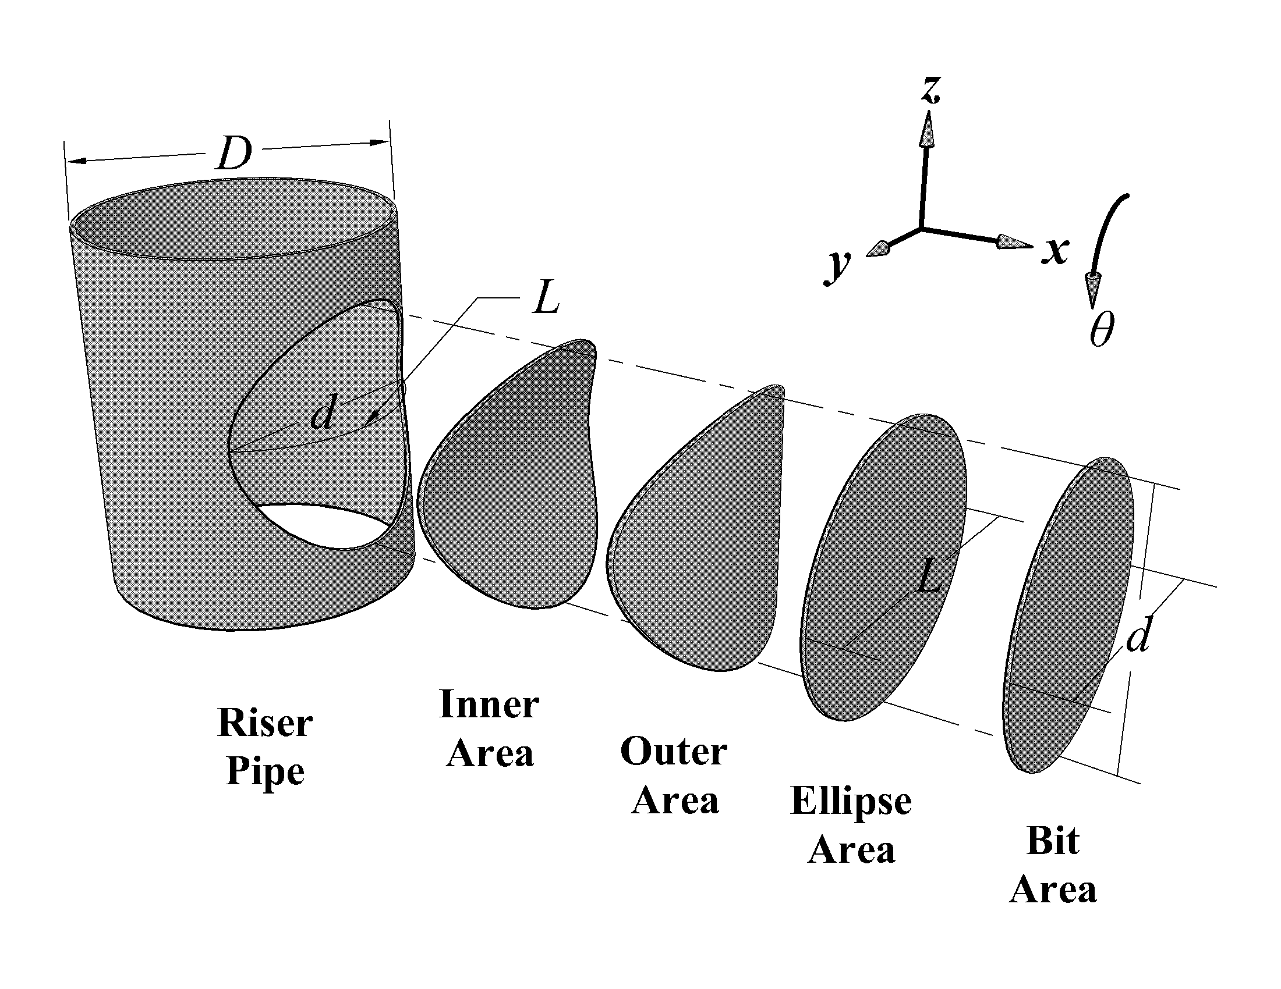
Figure 3. A_{b}, A_{o}, and A_{i} 3-D abstraction from pipe and A_{e} as an approximation, McLemore et al., 2011
and an equivalent and simpler version of A_{o}
(14)
Due to the complexity of the solutions for A_{o} and A_{i}, (i.e., multiple elliptic integrals of the first and second kind), it is desirable to have a simpler definition of A while maintaining the oval shape that is more representative of the actual area (Figure 3). Therefore, we defined an ellipse area (A_{e}) as
(15)
where L is described by the arc length from one side of the cut to the other along the curvature of the pipe, and the minor axis is defined by the bit diameter (Figure 3), or
(16)
Although the A_{e} is less physically related to the orifice and is simply a relationship defined by two terms (D and d), relating these terms to the major and minor axes of an ellipse simplifies calculations for A as compared to solving Eqs. (12) and (13) for A_{o} and A_{i}, respectively.
An assumption common to all the descriptions of A, as they relate to Eq. (4), is that a single h defined at the center of A accurately describes the head across the entire area of A. When an orifice is small compared to head, high head conditions, errors introduced by applying a single h to the entire A are minimal. But, as orifice depth decreases, the error due to this assumption about h increases. This error can be removed by integrating the head across the area (Davis and Sorensen 1969). The basic form of the integrated orifice equation is given as
(17)
where w has a varied definition for each of the four different descriptions of A (Figure 4).
Applying the four definitions of A to Eq. (17) yields:
(18)
(19)
(20)
(21)

Methods
Orifice discharge experiments were conducted in two separate tanks at the University of Tennessee Hydraulics Laboratory. The first tank was a 1.02 m³ stock tank having a depth of 0.56 m and surface area of 1.82 m². A PVC flange was installed in the bottom of the tank in a manner that allowed various vertical risers to be inserted into the flange. We also employed a 14.5 m³ vertically walled concrete tank with 2.44 m depth and 5.95 m² surface area for testing a 15.24 cm diameter riser. A description of all tested
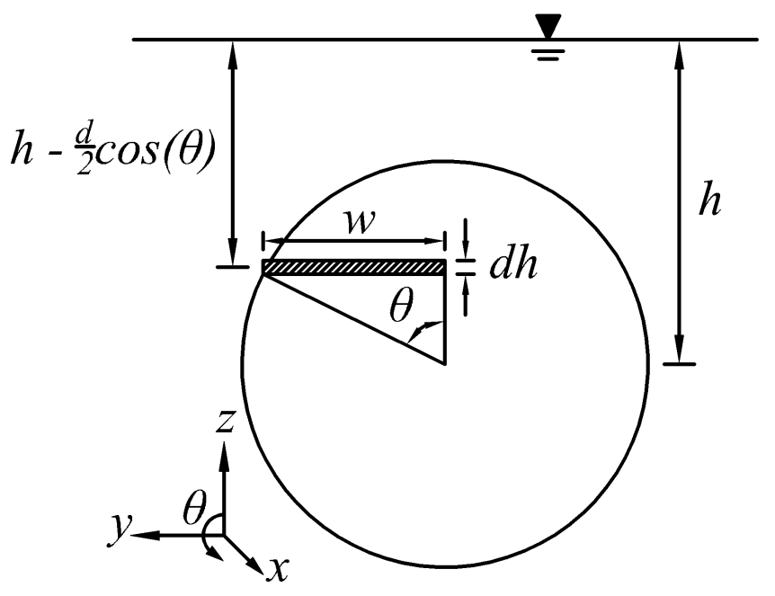
Figure 4. Circular orifice integration setup

pipe and orifice diameter combinations is given in Table 1. Each riser was made from schedule 40 PVC. The orifices were cut using drill bits or hole-saws placed into a drill press to ensure the orifices were perpendicular to and aligned with the center line of the pipes. Then, each orifice was cleaned of burs and other imperfections so that the edges were uniform and sharp with smooth sidewalls on the inside of the orifice. The orifices and risers were designed such that at the interior of the orifices the pressure was always atmospheric.
The testing procedure consisted of filling a tank with water and discharging the water through the orifice while simultaneously recording the tank water level and elapsed time such that Q versus ∆h could be calculated as
(22)
where ∆h is the difference in head between time steps, ∆t is the time step, and A_{t} is the horizontal cross-sectional area of the tank. Measurements of h were visually collected using a meter stick in the stock tank, yielding a resolution of one millimeter. In the larger tank, a HOBO UH-20 depth sensor measured absolute pressure from the bottom of the tank at a sampling rate of 1Hz with a resolution of 1.4 mm (HOBO 2011). A second UH-20 collected atmospheric pressure measurements so the data collected by the submerged pressure sensor could be converted from absolute to gauge. Following the flow experiments, C_{d} values were estimated by inserting the measured discharge data (Eq. (22)) and each of the four defined areas, A_{b}, A_{o}, A_{i}, and A_{e} (Eqs. (8, 12, 13 and 15)) into Eq. (4), as
Table 1. Studied bit diameters, riser pipe diameters, and resulting d/D values.
d/D  ratio | Riser pipe diameters (cm)
d/D  ratio | 5.08 | 7.62 | 10.2 | 15.2
 | Bit diameters (cm)
0.125 | 0.635 | 0.953 | 1.27 | 1.91
0.250 | 1.27 | 1.91 | 2.54 | 3.81
0.500 | 2.54 | 3.81 | 5.08 | 7.62
0.750 | 3.81 | 5.72 | 7.62 | 11.4

(23)
To describe the error introduced by assuming a single head across the entire orifice (using Eq. (4)) instead of applying the actual heads across the orifice (Eq. (18-21)), we calculated an error term:
(24)
The computations were carried out in Maple (Maple, 2010), with h/d varying from 0.5 to 20 and d/D with values of 0.125, 0.25, 0.5, 0.75, and 1.
Early during experimental testing, we noted that the cross-sectional shape of the vena contracta was often not circular. To document this effect, the vena contractas were photographed horizontally and vertically to allow for an approximate measurement of their free-jet height and width, respectively. These photographs required constructing four equally sized half risers with varying sized orifices that discharged water out the side of the tank (Figure 5). The half risers had a diameter of 10.2 cm, with orifice sizes corresponding to d/D values of 0.125, 0.25, 0.5, and 0.75.

Results and Discussion
Differences between the four orifice area definitions are compared in Figures 6 and 7. Figure 6 illustrates the four orifice area definitions flattened onto a 2D plane for d/D values of 0.5, 0.75. and 1.0. Visually, it is evident that the four areas differ just slightly at d/D = 0.5. Beyond this value of d/D = 0.5, the A_{o}, A_{i}, and A_{e} increase
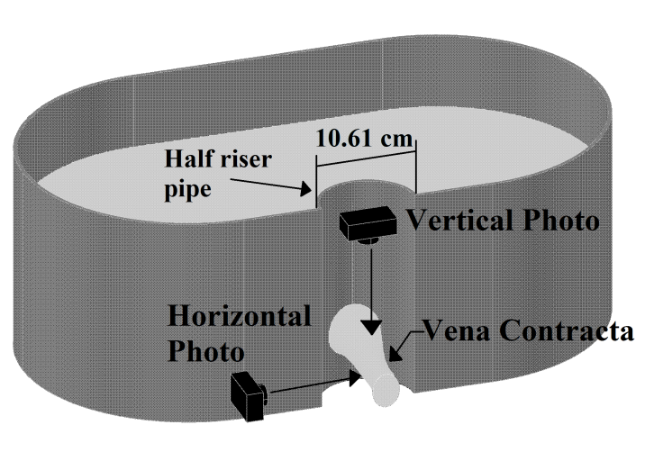
Figure 5. Setup for photographic examination of the vena contracta

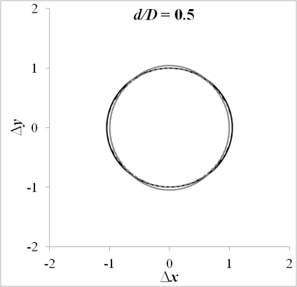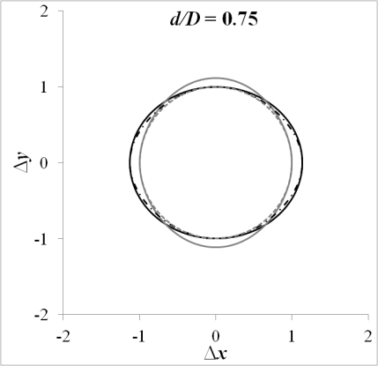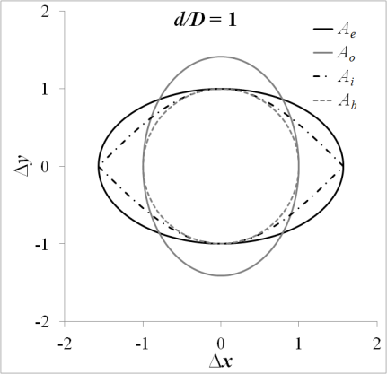
Figure 6. 2D plane comparison of A_{b}, A_{o}, A_{i}, and A_{e} for d/D of 0.5, 0.75, and 1

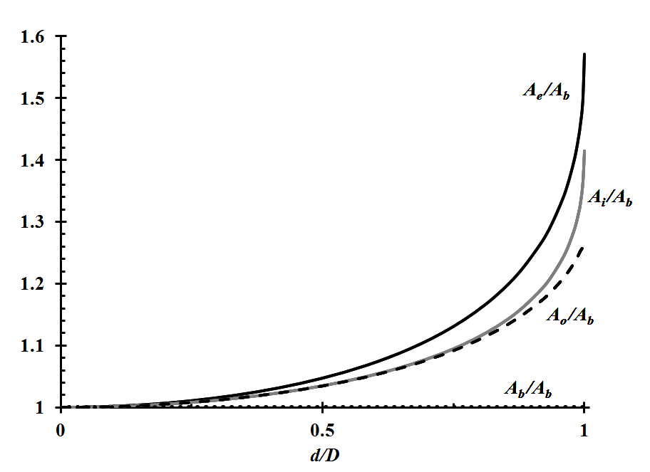
Figure 7. A_{b}, A_{o}, A_{i}, and A_{e} dimensionless comparison, McLemore et al., 2011.

significantly compared to A_{b.} Figure 7 quantifies the differences with a dimensionless plot of A_{o}, A_{i}, and A_{e} relative to A_{b} as a function of d/D. At d/D = 0.25 there is a slight divergence, where A_{o}/A_{b} ≈ A_{i}/A_{b} ≈ A_{e}/A_{b} = 1.01. At d/D = 0.75, A_{o} and A_{i} are 1.09 · A_{b}, and A_{e} = 1.13 · A_{b}. As d/D approaches unity, A_{o} = 1.27 · A_{b}, A_{i} = 1.41 · A_{b}, and A_{e} = 1.57 · A_{b}. These trends suggest that assuming the orifice area is equal to A_{b} may cause significant error as d/D increases.
Measured data set from a single discharge experiment (d=2.54 cm and D=5.08 cm) is presented in Figure 8. Figure 9 shows plots of C_{d} versus h/d for various d/D, while letting area be described by A_{b}. The general trends are similar, with smaller C_{d}’s as d/D increases, and to a lesser extent as h/d increases. Figure 10 is similar to Figure 9 and shows similar trends, but this is with the area described by A_{e}. The differences between Figures 9 and 10 are minimal, but can be seen visually as d/D increases where C_{d} calculated form A_{e} is lower than C_{d} for A_{b}. Similar plots were constructed for A_{o} and A_{i} (not shown), with similar results.
A series of single- and multi-parameter empirical power equations were developed and fit to predict C_{d} from the data presented in Figures 9 and 10, with the best two shown in Table 2. Based on R² and RMSE, A_{e} provides the best fit, followed by A_{i} and A_{o}, which produced similar values. A_{b} consistently produced the poorest results. This is a fortuitous result, given that the mathematical expressions describing A_{e} are simpler than those with A_{o} and A_{i}. The best fit line for A_{b} and A_{e} are also shown on Figures 9 and 10, respectively. The overall best fit relationship includes d/D, h/d, and

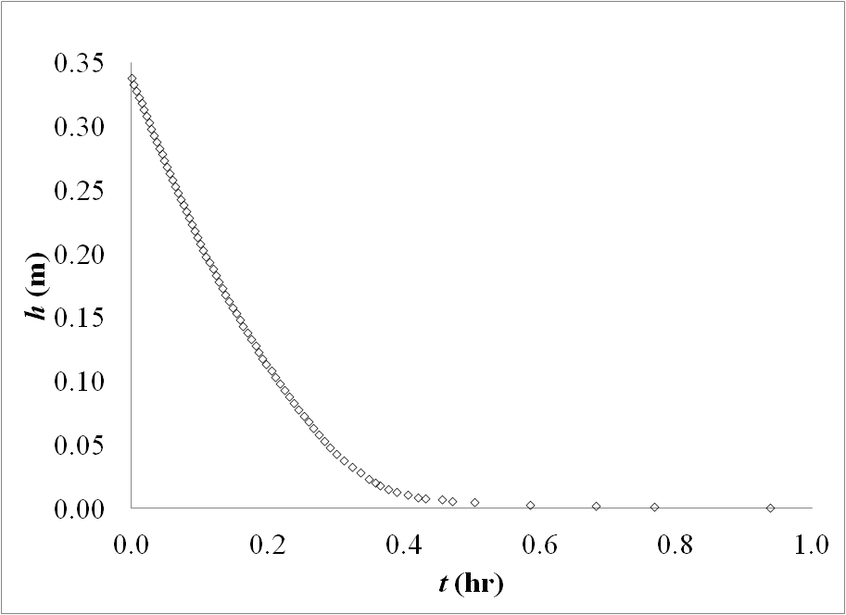
Figure 8. Collected h (m) versus t (hr) data for d=2.54 cm and D=5.08 cm

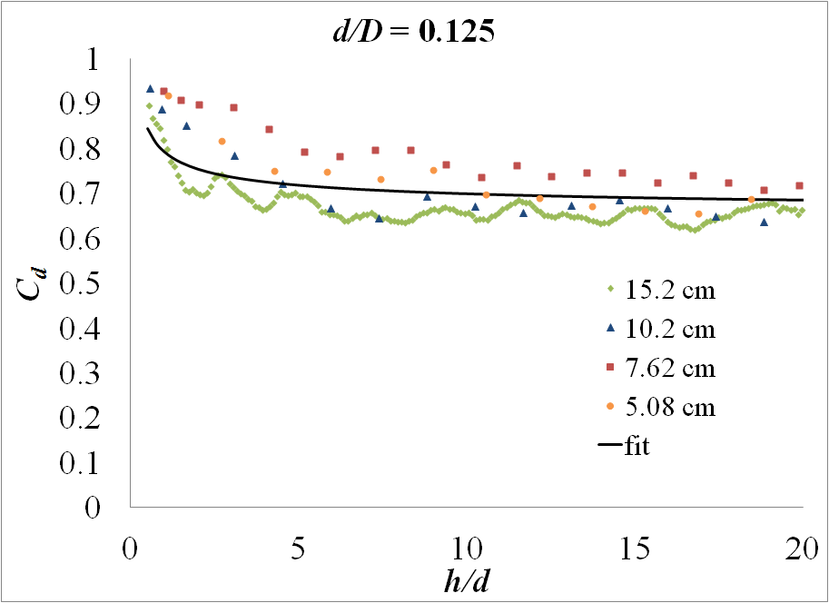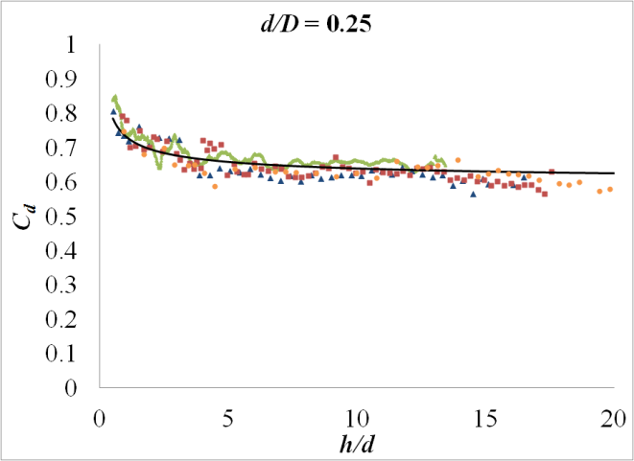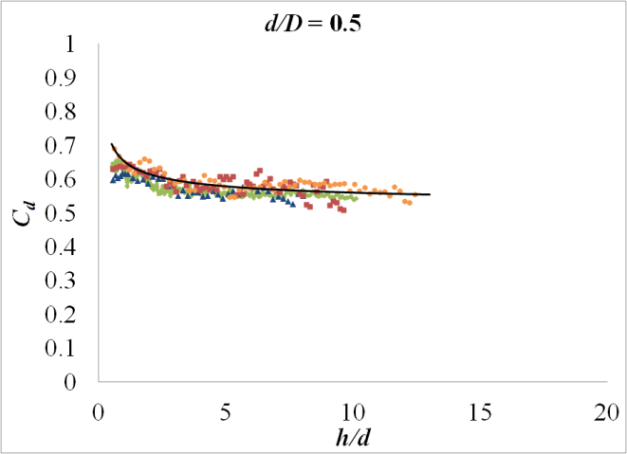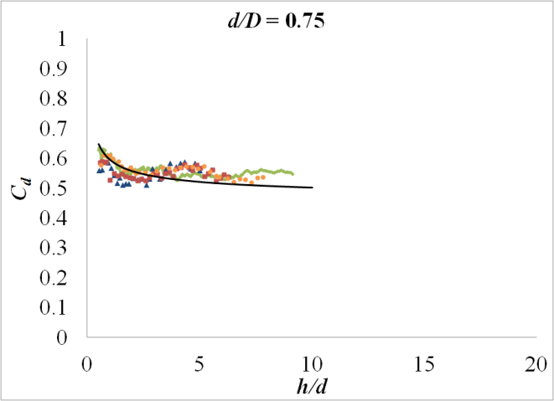
Figure 9. C_{d} data versus h/d for d/D = 0.125, 0.25, 0.5, and 0.75 where A = A_{b}, with A_{b} best fit line

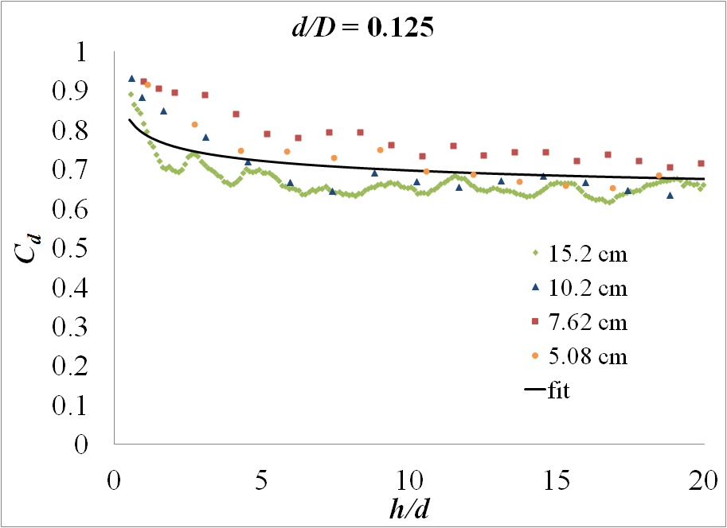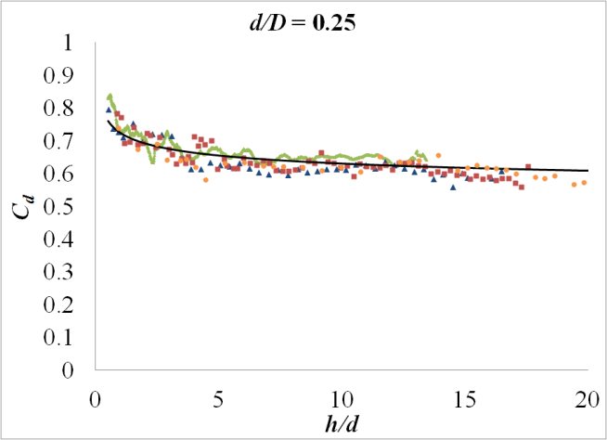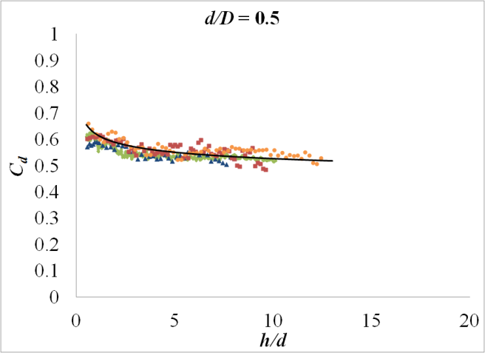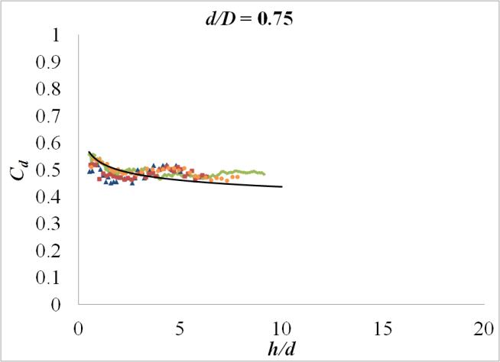
Figure 10. C_{d} data versus h/d for d/D = 0.125, 0.25, 0.5, and 0.75 where A = A_{e}, with A_{e} best fit line (Eq. (22))

Table 2. R² and RMSE values of fit equation for measured data with all area definitions
Fit parameters (R², RMSE)
Equation form | A_{b} data | A_{o} data | A_{i} data | A_{e} data
 | 0.818, 0.030 | 0.875, 0.028 | 0.879, 0.028 | 0.891, 0.028
 | 0.820, 0.029 | 0.880, 0.028 | 0.881, 0.028 | 0.895, 0.027

z_{o}/d, and explains 89.5% of the variation with a RMSE of 0.027. However, it appears that adding the z_{o}/d term was of little benefit since the next to the last equation (Table 2, grey box) does not reference z_{o}, but still has R² and RMSE values almost identical to those of the overall best fit. We therefore suggest that the most useful equation is the first one in Table 2, using A_{e} for area. Fitted with the correct constants, this equation becomes
(25)
One discharge experiment for each orifice and riser combination was conducted to produce the data points presented in Figures 9 and 10 and develop the best fit equation. Figure 11 illustrates the difference between two replicates and fitted lines for the smallest riser with the smallest orifice, 5.08 and 0.635 cm respectively. The fitted lines in Figure 11 were developed for each replication independently, assumed A_{e} for A, to produce a consistent measure of C_{d} for changing h/d. The fitted lines were used to measure variability associated with replications by calculating the absolute difference between replicate’s fit lines for discharge experiments with multiple replications. Then the absolute difference was calculated between the two fit lines from 0.5 to 20 in 0.25 increments of h/d. The averages of the absolute differences are the values located in Table 3 for five orifice-riser combinations that had two replicate data sets for each.
In an attempt to explain the variation of C_{d} with depth--namely, increasing C_{d} with decreasing h/d--we compared the difference in predicted flow assuming a single head across an entire orifice compared to vertical integration of the orifice equation with changing head (Eqs. (18-21)). Figure 12 shows the results of Eq. (24) for each area
Table 3. RMSE of two replications for the C_{d} data
d/D  ratio | Riser pipe diameters (cm)
d/D  ratio | 5.08 | 7.62 | 10.2 | 15.2
 | Average absolute difference
0.125 | 0.022 | - | 0.011 | -
0.250 | - | - | - | 0.009
0.500 | - | - | - | 0.002
0.750 | - | - | - | 0.017

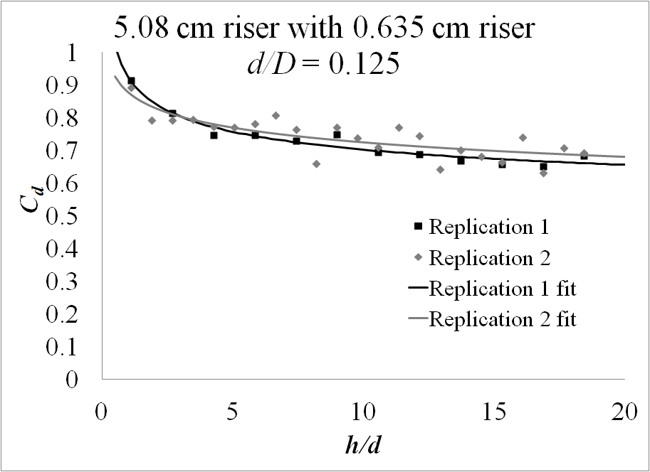
Figure 11. Replicate C_{d} plots

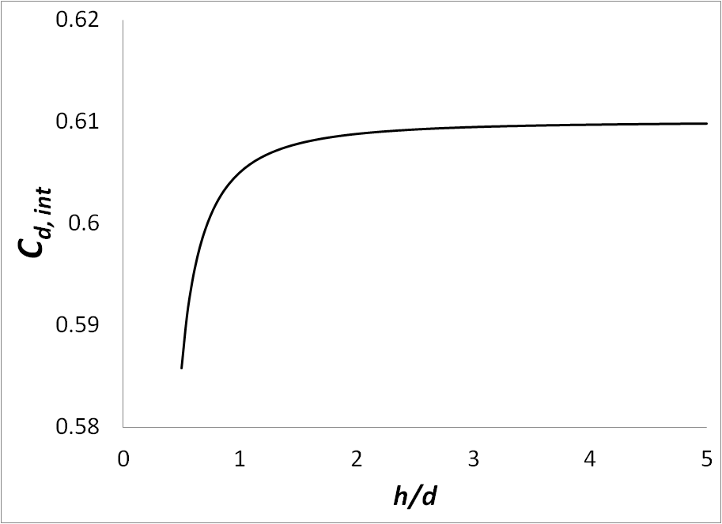
Figure 12. Approximation of C_{d, int} (Eq. (21)) for all areas when d/D is 0.125, 0.25, 0.5, 0.75, and 1

definition and for d/D values of 0.125, 0.25, 0.5, 0.75, and 1. Only one line is presented because the resulting curves from the examination of the four area definitions differed at most by 0.5%. The shape of Figure 12 shows that as h/d decreases below a value of 5, Eq. (4) overestimates discharge, with an error of approximately 4% at h/d = 0.5. The decreasing C_{d} suggests the opposite of the finding from the discharge experiment, which show that C_{d} increases as h/d decrease. Because the findings of the constant h comparison oppose the results of the discharge experiments, the authors’ conducted a visual study in an attempt to explain the differences.
While performing the visual examination of orifice discharge, we noted that the discharge jet fanned out vertically from an orifice placed in a vertical pipe (Figure 13). After photographing the jets in the horizontal and vertical plane, the width (w_{vc}) and height (h_{vc}) of 1.27, 2.54, 5.08, and 7.62 cm orifice diameters were measured photographically to the nearest 0.3 cm. The shape of the flow jet in the vena contracta appeared elliptical, so the basic form of the ellipse equation was applied for A_{vc}:
(26)
Then Eqs. (8 and 26) were substituted into Eq. (7) to solve for the C_{c} and finally C_{d} was calculated (Eq. (5)) assuming that C_{v} is a constant 0.98. Measurements of w_{vc} and h_{vc} were collected for h/d>5d, allowing for the prediction of C_{d} (Table 4). Results indicate that C_{c} decreases with increased d/D and increases with decreasing h/d. These two visually-established trends help explain the results shown in Figures 9 and 10. We theorize that the greater h/d values cause the lateral flow coming around the curved
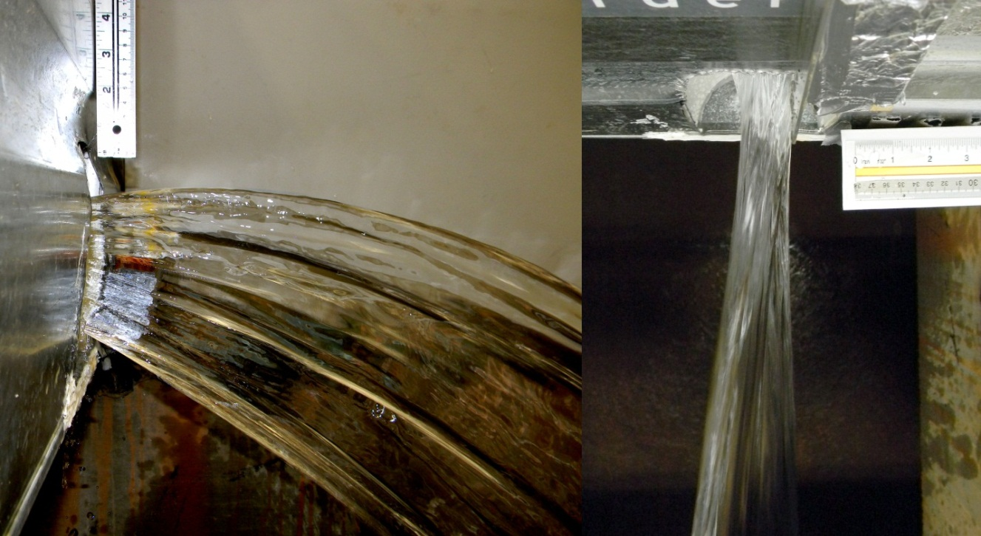
Figure 13. Vena contracta visual assessment, D = 10.2 cm and d = 7.62 cm. The width of the jet was 3.07cm and the height was 10.6cm at a distance 5.1cm from the orifice

Table 4. Averaged visual measurements of C_{d} for each orifice size on a 10.2 cm riser when h/d >= 5
d/D | w_{vc} (cm) | h_{vc} (cm) | A_{vc} (cm²) | A_{b} (cm²) | C_{c} | C_{d}
0.125 | 0.794 | 1.27 | 0.792 | 1.27 | 0.625 | 0.613
0.25 | 1.53 | 2.54 | 3.06 | 5.07 | 0.604 | 0.592
0.5 | 2.94 | 5.08 | 11.7 | 20.3 | 0.578 | 0.567
0.75 | 3.07 | 10.6 | 25.5 | 45.6 | 0.559 | 0.548

surface of the riser to accelerate, driving the vena contracta to become thin in the horizontal direction but tall in the vertical direction (Figure. 14). This curvature effect reduces the area of the vena contracta beyond what normally occurs for an orifice on a flat plate. The velocity slows when h approaches the orifice, reducing the compression effect and allowing the vena contracta area to increase. This increased vena contracta area equates to more flow exiting through the orifice, explaining why the C_{d} increases at low h. This effect is greater than the error associated with an assumed constant h, and explains why the decreasing C_{d} noted in the examination of the integration correction was not present in the discharge data.

Conclusion
Four definitions of A were presented and compared to illustrate the effect of the riser pipe curvature on the orifice area. Discharge experiments were conducted in the lab for four riser pipes, each with four orifices corresponding to d/D ratios of 0.125, 0.25, 0.5, and 0.75. Data from the lab experiments were used to determine C_{d.} Error associated with an assumed h across the entire orifice was analysis by comparing the normally applied orifice equation (Eq. 4) to the integral form (Eq. (17)), while considering the four definitions of A. Additionally, the vena contract was photographed to visually explain the findings of the discharge experiments and the assumed h analysis.
The major trend evident in the measured data is increasing C_{d} values with decreasing d/D and to a lesser extent h/d. Several empirical equations were fitted to the measured C_{d} data and the most applicable fitted model, Eq. (25), indicates that h/d and
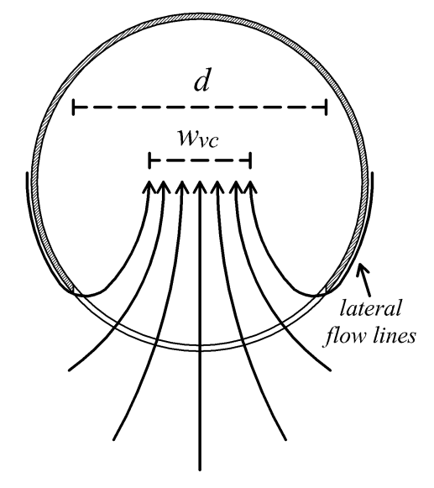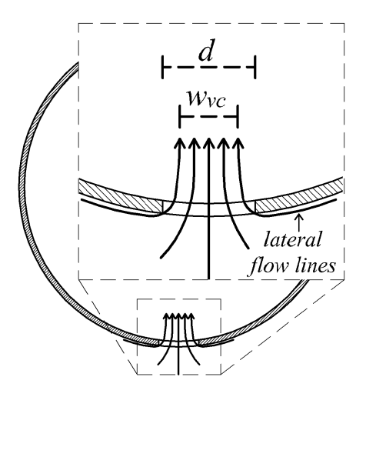
Figure 14. Theorized flow lines for d/D = 0.75 (left) and 0.125 (right)

d/D with area defined by A_{e} can explain 89.1% of the variation in the measures data with a RMSE of 0.028. It was determined from the integral comparison that C_{d} should decrease as h/d decreases, which is the opposite of the measured results. In an attempt to explain this contradiction, the vena contracta was visually assessed and measured. We believe the C_{d} decrease as d/D increases is caused by the flow streams coming around the curved surface of the riser and forcing the vena contracta to become thinner in the vertical plane. Additionally noted from the visual assessment is that as h reduces, the vena contracta area increases. This is what causes C_{d} to increase at low h/d values and why the error associated with assumed h is not evident in the measured discharge data.

Notation
These symbols are used in this chapter:
a, b, c, p, q, and s = generic fit coefficient
A = orifice area (generic)
A_{b} = bit area
A_{e} = ellipse area
A_{i} = inner area
A_{o} = outer area
A_{t} = tank area
A_{vc} = vena contracta area
C_{d(b,o,i,e)} = measured coefficient of contraction for each area definition
C_{c} = coefficient of contraction
C_{d} = orifice discharge coefficient
C_{d, int} = integral orifice discharge coefficient
C_{d, model} = model orifice discharge coefficient
C_{v} = coefficient of velocity
d = orifice diameter
D = riser diameter
g = acceleration due to gravity
h = head above center of orifice
h_{vc} = measure vena contracta height
L = arc length of orifice cut along curved riser pipe
Q = orifice flow rate
Q_{b,o,i,e} = integral form of the orifice equation for each area definition
Q_{int} =basic integral form of the orifice equation
Q_{meas} = measured flow rate
t = time
V = actual velocity
V_{i} = ideal velocity
w_{vc} = measured vena contracta width
x, y, and z = coordinate definitions
z_{o} = height of the orifice center above the tank bed
θ = angle relative to positive z around the orifice cut

References

Davis, C. V., and K. E. Sorensen. 1969. Handbook of applied hydraulics. 3rd ed. New York, NY: McGraw-Hill.
Finnemore, E. J., and J. B. Franzini. 2002. Fluid mechanics with engineering applications. 10th ed. New York, NY: McGraw-Hill.
Gregg, W. B., D. E. Werth, and C. Frizzell. 2004. Determination of discharge coefficients for hydraulic sparger design. ASME J. Pressure Vessel Technol. 126(3), 354–359.
HOBO. 2011. Product specification for the U20-001-04. Bourne, MA.: Onset. Available at: http://www.onsetcomp.com/callback/show-specs?n=2373. Accessed 12 December 2011.
Jarrett, A. R. 1993. Design of perforated risers to control dewatering of sedimentation basins. Appl. Eng. Agric., 9(1), 37–42.
Maple. 2010. Maple for Windows. Ver. 15. Waterloo, ON.: Maplesoft.
McLemore, A. J., J. S. Tyner, and D. C. Yoder. 2011. Discussion of “Investigation of flow through orifices in riser pipes” by P. D. Prohaska, A. A. Khan, and N. B. Kaye. J. of Irrigation and Drainage Eng., 137(9), 632-633.
Prohaska, P. D., A. A. Khan, and N.B. Kaye. 2010. Investigation of flow through orifices in riser pipes. J. of Irrigation and Drainage Eng., 136(5), 340-347.
Stockie, John M. 1998. The geometry of intersecting tubes applied to controlling a robotic welding torch. MappleTech (Special Issue on Maple in Industry), 5(2-3), 58–66.
Encyclopædia Britannica. 2012. Torricelli’s theorem. Chicago, IL.: Encyclopædia Britannica, Inc. Available at: http://www.britannica.com/EBchecked/topic/
600154/Torricellis-theorem. Accessed 19 April 2012.
Visser, K. K., J. M. Steichen, B. M. McEnroe, and J. Hua. 1988. Hydraulics of perforated terrace inlet risers. American Society of Agric. Eng. 31(5), 1451-1454.

CHAPTER III
Optimization of the Soild State Skimmer

This chapter is a continued effort to develop the Solid State Skimmer, an outlet device invented by Dr. John Tyner, Dr. Daniel Yoder, and Mr. Brent Pilon. The results presented in this chapter are original work I conducted with the help of Dr. John Tyner, Dr. Daniel Yoder, Dr. John Buchanan, and Mr. Brent Pilon.

Abstract
This research focuses on development and optimization of the Solid State Skimmer (SSS) as an outlet device in a sediment retention basin. Sediment basins on constructions sites help retain sediment on-site so it cannot enter creeks, streams, rivers, and other water sources. The basin sediment trapping efficiency can be increased by using a skimmer outlet such as the SSS, as it extracts water from the top of the basin, from which the sediment has already been removed by settling. A modified overflow basin design method is herein presented to quantify the efficiency of the SSS based on its ability to increase top water discharge. The new method takes into account the elevation of the exiting water. A program is presented that utilizes this modified overflow method to optimize the design of the SSS for a multi-storm sediment basin. A SSS was successfully modeled to meet peak flows and a minimum retention time for six storm events on a site whose management varied from natural vegetation to bare soil. The SSS increased efficiencies by 12.0, 41.7, and 36.0% for a single storm simulation and 0.0178, 14.9, and 31.4% for a multiple storm simulation. The analyzed particles were a sand, silt, and clay distribution respectively.

Introduction
The Environmental Protection Agency (EPA) is mandated by the Clean Water Act to protect our waterways (EPA, 2007). According to the EPA (2007), one of the major issues is that 35-45 tons of sediment per acre each year may be lost due to erosion from construction sites and ultimately a portion of it enters our streams, rivers, lakes, and estuaries, where the pollutant can reduce hydraulic capacity, convey toxic materials, decrease habitat quality, and increase drinking water cost (EPA, 2007). To combat this issue, the EPA has set requirements for erosion and sediment control. The implementation of a sediment retention basin is one of the requirements for construction sites having a drainage area of 10 or more acres (NPDES, 2011). And often specified by a state, city, town, village, or other public entity that contains a Municipal Separate Storm Sewer System (MS4), peak discharge rates from construction sites must be regulated to mitigate flooding in the MS4s (NPDES, 2011). A stormwater detention basin comprised of storage and an outlet structure can be used to regulate peak discharge rate. In many cases, the roles of sediment retention basin and stormwater detention basin are designed into a single basin, though the outlet control may differ for the two purposes.
Studies indicate that perforated risers and floating skimmers can increase a sediment basin’s trapping efficiency. Jarrett (2001) examined eight studies and summarized that a perforated riser on average is able to retain 82.0% of incoming sediment mass, while a floating skimmer increases the efficiency to 91.1% of the total incoming sediment load for a Hagerstown silt loam “A” horizon soil. A study comparing traditional rock dams, normal and oversized basin configurations with a chemical flocculent additive, and a floating skimmer was conducted by McCaleb and McLaughlin (2008). Normal basins were sized to attenuate a 10-yr Type II 24 hr storm event and the oversized basins were sized for a 25-yr Type II 24 hr storm event. Their findings indicate that traditional rock dams—with and without a larger than normal basin and silt fence baffles—retained less than 45% of the entering sediment. They found that a design with a floating skimmer, larger basin, porous baffles, and stable sides was able to retain 99% of the total sediment that entered the basin over 33 storm events. They did report, however, that the floating skimmer became stuck in the mud and submerged at the bottom the basin, which greatly decreased efficiency.
Pilon (2010) discusses a recently developed outlet structure that uses no moving parts but still combines the higher flows with greater depth of a perforated riser with the skimming effect of a floating skimmer outlet; this device is referred to as the Solid State Skimmer (SSS). The SSS consists of two perforated risers, one inside the other, which are designed to maintain during discharge a water height within a chamber between the two pipes slightly lower than the height of water in the basin. The difference in height between the basin and the chamber defines the differential head on the submerged orifices of the outer pipe. A small difference equates to much less discharge through the submerged orifices, especially those near the bottom, compared to a traditional perforated riser which has increasing head as basin depth increases. Pilon’s (2010) initial proof of concept study of the SSS determined that the flow characteristics can be modeled and implemented with reasonable accuracy. He also found that the SSS, on average, reduced turbidity by 10% compared to a traditional perforated riser, which is similar to the reported performance of floating skimmers. The proof of concept study validated the hydraulics and illustrated the retention benefits, but little consideration was provided as to how the design could be optimized for a sediment retention basin on a specific site.
Sediment basins are commonly designed using the overflow method, which models the stormwater movement in the basin as plug flow, assumes the suspended sediment settles according to Stokes’ law, and that the incoming sediment is evenly distributed throughout the height of the water column (Fifield, 2001). By applying those assumptions, the amount of sediment retained can be determined for a given flow rate, basin geometry, and sediment distribution, or conversely a basin’s size can be determined so as to meet a specific retention requirement. Fifield (2010, pp. 5.1-5.18) presents a basin geometry efficiency parameter for a rectangular basin that functions as a mixing correction factor, referred to as the apparent effective:
(27)
valid for l:w (length:width) values less than 10, and where the effectiveness A_{eff} is a percentage. This relationship indicates that A_{eff} is assumed to be 100% effective when the basin has a length:width (l:w) of 10. The net sediment trapping efficiency (N_{eff}) then becomes the product of the theoretical percent mass of sediment retained and the effective area
(28)
where PEG is the mass Percent Equal to or Greater than the smallest particle size that will settle in a given basin configuration at a given flow rate based on stokes law. N_{eff} as defined by the overflow method does not increase if the outlet is a skimming device. This suggests that the overflow method does not consider whether the water discharges from near the top or bottom of the basin, or can alternatively be defined as assuming that all discharging water has an even concentration of the unsettled sediment and leaves evenly across the vertical distribution of the water column.
The goal of this project is to develop an automated optimization process for peak performance of the Solid State Skimmer (SSS) in a sediment basin. To achieve this goal, the overflow method was investigated and a modified approach is proposed to account for the location, quantity, and quality of water discharging from the basin. The modified approach of the overflow method can be used to track sediment movement in the basin and define a basin’s efficiency. The basin efficiency process is presented and a software version was coded in MATLAB for automated optimization. A multi-storm basin was simulated with the MATLAB program to compare efficiencies between a traditional riser and the SSS.

Methods
The first task was to modify the overflow method to account for the location, quantity, and quality of the discharging water such that a skimmer increases a basin’s efficiency and an outlet draining from the bottom decreases efficiency, while an even vertical distribution of outflow results in efficiencies similar to the standard overflow method. The distribution of unsettled particles in the water column at the outlet of the basin can be determined if the suspended sediment is assumed to retain its location in the plug of water as it moves through the basin, i.e., not evenly distributed but a function of the sediment fall velocity. This is supported by the findings of Jarrett (2001) and McCaleb and McLaughlin (2008), who found that floating skimmers increase sediment trapping efficiency.
To determine the amount of sediment retained, the movement of the particles through the basin will be modeled assuming ideal conditions, i.e., plug flow with no mixing. Initially particles are evenly mixed in the plug, and particles settle according to Stokes’ law. To account for mixing, the A_{eff} factor developed for the overflow method will be used as a correction factor. There are two possible outcomes for a particle as it travels through a basin, assuming the basin does not have an infinite retention time. The first case is that the particle settles on the basin floor, which is the ideal outcome, while the second is that the particle discharges from the basin. Thus the percent mass will be quantified with two separate approaches, 1) account for the percent mass that settles and 2) account for the percent mass that is discharged. Case 2 will make the basin efficiency a function of the location of discharging water.
For a given particle that is evenly distributed in a plug of water, Stokes’ law can be applied to model the particles vertical movement. Figure 15 illustrates a plug of water moving horizontally through the basin and the vertical movement of the particles within the plug. At time 0, there are 8 particles distributed in the plug. As time progresses, the
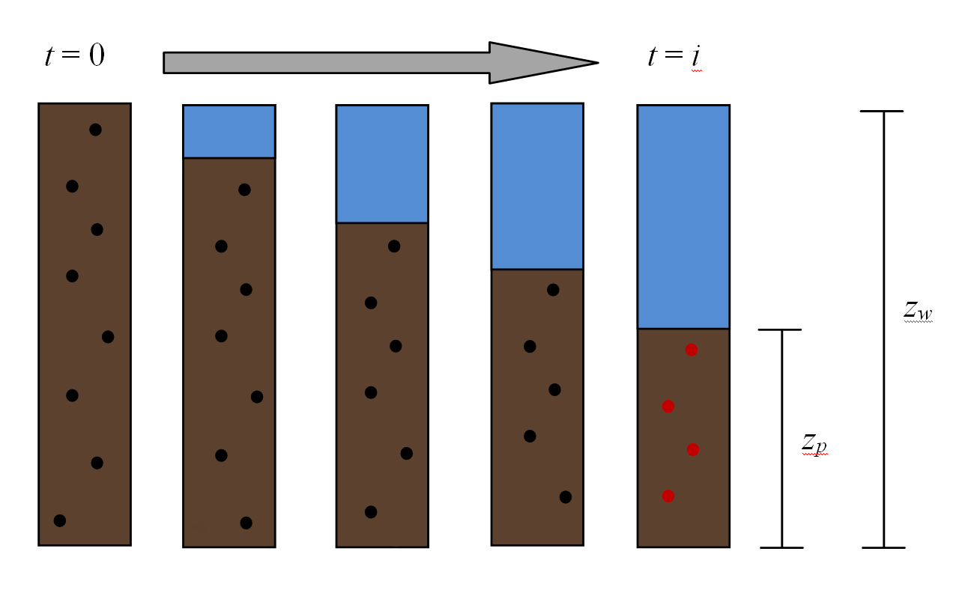
Figure 15. Sediment distribution from the inlet, t = 0, and to the outlet, t = i. Green particles are retained while red particles are subject to discharged.

particles begin to settle to the basin floor, illustrated in green. The green particles signify the percent mass that settles, M_{s}. The percent mass settled can be quantified by relating the clean water mass to the total water mass
(29)
where M_{t} is the percent mass of a given particle size, z_{p} is the contaminated water boundary height from the bottom of the basin, and z_{w} is the height of the plug of water. The percent mass at the outlet, M_{o}, is illustrated as red particles in Figure 15 and is quantified as:
(30)
The description above indicates how many particles are available for discharge at the outlet, but the actual number that gets discharged will be a function of the outlet type, which controls from where the water is discharged. To account for the location the water discharges through the outlet, an outlet correction factor is defined as
(31)
As Q_{eff} approaches 1, the outlet is discharging only clean water, but Q_{eff} = 0 when all the discharging water comes from the contaminated portion. The product of M_{o} and Q_{eff} define the amount of sediment retained as a result of the outlet, so the percent mass retained can be defined as:
(32)
Substituting Eq. (29-31) into Eq. (32) and simplifying produces:
(33)
Then the N_{eff} for single particle size is the product of the percent mass retained and mixing correction factor, defined as:
(34)
To determine the N_{eff} for multiple particle sizes or ranges requires that each particle size or range be modeled with the Eq. (34), and the sum taken to determine the N_{eff}. If the process involves routing a storm through the basin, the discharged volume weighted efficiency for the duration of a storm is:
(35)
where Vol out is the volume of water discharged at time m and Vol_{storm} is the total volume of the routed storm. Figure 16 is a flow chart illustrating the processes and calculations required to determine the efficiency for a known basin and outlet configuration, one incoming storm, and one sediment size.
For this study the SSS is designed to control flow with a single weir rather than discrete orifices as was done in the study by Pilon (2010). Weirs require fewer variables and ultimately are easier to model. The outlet weir of the SSS (from the inter-tube chamber to the outlet) is set as a rectangular weir, so its geometry is defined by a single variable, a_{out} and the flow rate is defined as:
Figure 16. Efficiency and storm routing flowchart
Step 2 – Route Storm
- Repeat below steps on a set time increment, i, until 98% of the incoming storm volume has passed through basin.

Step 1 – Generate information about basin, outlet, and incoming storm
- Generate the stage-discharge, stage-storage, stage-basin length, and stage-basin width curves
- Generate the incoming storm hydrograph
Step 3 – Efficiency
- Repeat below steps for the length of time, i, required to route storm

Figure 16. Continued
(36)
where C_{d} is the discharge coefficient, g is the gravitational constant, and h_{c} is the head in the SSS chamber above the bottom of the weir. The inlet weir needs to increase in area with increasing height, so its shape is defined as a function of a_{in} and b_{in}. Figure 17 is an illustration of a SSS designed with weirs. Inflow to the SSS is the sum of the submerged flow and the non-submerged flow (Figure 17).
(37)
(38)
where h_{b} is the head in the basin above the bottom of the weir and dh is difference between h_{b} and h_{c} (Pillon, 2010).
The efficiency method was utilized in a MATLAB program that automatically solves for the best SSS configure that produces a maximize efficiency. Several design simulations were conducted with the MATLAB program to determine the sensitivity of the model to various inputs. The sensitivity analyses involved simulating the design of a SSS and sizing a basin to attenuate peak flows to pre-construction condition for a single storm event basin compared to multiple storms events basin. The site used for the simulations was a 12 acre site that went from bushy-grassy land use to 8 acres of ½ acre residential lots and 4 acres of open fair-condition grass in Knoxville, Tenn. The single storm simulation involved routing the 10-yr 24-hr return period storm event, while the multiple storm simulation involved routing the 2, 5, 10, 25, 50, and 100 year 24-hour

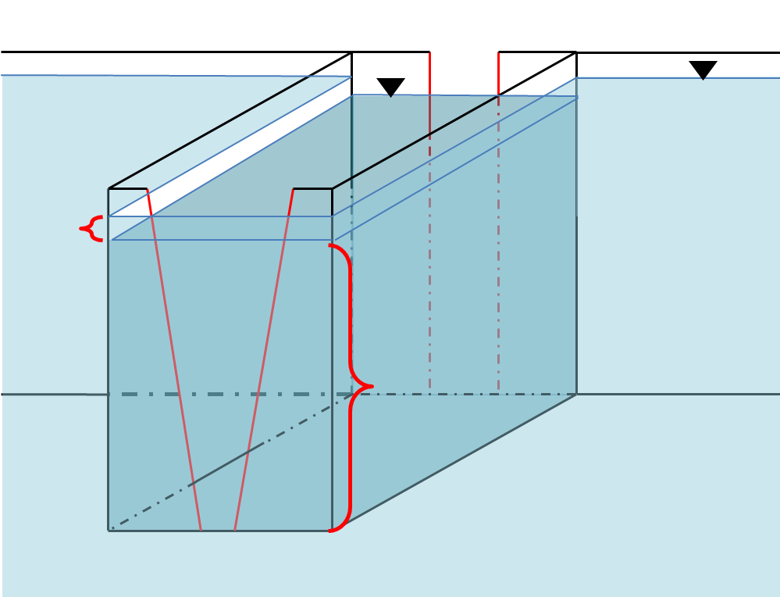
Outlet weir
Figure 17. SSS weir configuration
Q_{sub}
Q_{non-sub}
Inlet weir
return period storm events. Type-II storm distribution was assumed. To analyze the effect of the maximum allowable retention time, it was varied between 48 and 72 hours for the multiple storm simulations while maintaining the same basin size solved for during the multiple storm simulation. Win TR-55 was utilized for storm depths and the time of concentration information for both the pre- and post-construction and storm hydrographs were generated by HydroCAD with the SCS unit hydrograph runoff method (Win TR-55, 2009; HydroCAD, 2012). The basin and SSS were required attenuate peak discharge rates from post-construction state to be less than or equal to peak discharge rates from pre-construction. Each simulation was analyzed with an assumed constant addition of sediment evenly distributed in the incoming water column. Because efficiencies for each sediment type/distribution are determined independently; a distribution for each clay, silt, and sand are analyzed separately for each simulation. For modeling purposes, the clay, silt, and sand were assumed to be spherical and have particle diameters of 0.002, 0.02, and 0.2 mm, respectively. A_{eff} was assumed to be 100%, which meant assuming a l:w (length:width) of 10. The basin walls were assumed vertical with a maximum depth of 8 ft.
The resulting efficiencies from the SSS and basin design simulations were compared to efficiencies that result from the same basin but traditional riser, such as a perforated riser. The tradition riser was simulated to have an equivalent stage discharge curve as the SSS. Flow through the traditional riser, modeled as a weir, was defined as:
(39)

where a and b are the parameters that define the weir shape. To quantify how the flow per elevation differ between the SSS and traditional weir for a given stage, the flow rates per elevation were compared assuming the basin was at the maximum stage for the multiple storm design simulation.

Results and Discussion

MATLAB program
Design of the SSS for use in a sediment basin is optimized by maximizing N_{eff} through a multi-step process. This process is outlined in Figure 18, and has three main components; the input and variable initialization, optimization looping, and output. Due to the complexity of the optimization process, MATLAB functions are utilized to automate variable adjustments, repetition, and optimization (MATLAB, 2011). The MATLAB controlled functions are those located in the Optimization Loop of Figure 18.
The entire process was coded in eight MATLAB files. These eight files can be broken down into three groups; setup/initialization, control processes, and process files. Setup/initialization of the program includes one file that handles the details on the left side of Figure 18 (Appendixes 1.1). Input variables for the optimization include the geometric parameters of the SSS and 20 points to define the dh curve. The initial guess of the dh curve was set to 20 values because this proved to be a good combination of resolution and speed. The inclusion of the basin area as an optimization variable is left to the user because initial testing indicated that the additional variable overwhelmed the optimization function and no solution could be found. Therefore, to achieve an optimal design it is up to the user to make an “educated guess” for the basin area and then iteratively change the value over several optimization runs until a minimum area and/or efficiency is met while meeting constraints.
MATLAB function fmincon automates the optimization process. This function works by minimizing an objective value while meeting constraints. The SQP optimization algorithm was chosen as the variable selection gradient because it was described as the appropriate algorithm for the number of inputs size and constraints required for the optimization. Objective and constraint functions call the process files and generate the inputs for fmincon, thus they are the control process files (Appendix 1.2). The process files are the subroutines that generate the stage discharge curve, increase dh resolution, calculated the distribution of discharge, route storms, and calculate efficiency (Appendix 1.3).
The objective file is organized to first generate the stage discharge curve. Then, a spline function is fit to the 20 dh points to produce a higher interpolation of the dh curve. The high resolution dh curve is used to develop a discharge distribution matrix and stage discharge curve. The stage discharge curve is used by the routing routine to generate the discharge rates per unit time from the basin and the corresponding stage. The discharge distribution matrix includes the incremental flow per unit of height (i.e., numerical integration) for each stage in the basin. Lastly, this matrix along with the discharge from
Optimization
Loop
Read inputs:
-Basin geometry
-Storm hydrographs
-Q peak(s) allowed
-Retention time
-Sediment load
Initialize dh points & SSS geometry values
Define solver parameters
Start solver
Display outputs:
-N_{eff}
-SSS geometry
-dh curve
-Stage discharge curve
- Constraints

Figure 18. Optimization flowchart

the basin per time and stage at each discharge value are used by the efficiency routine to calculate N_{eff} for the basin. The efficiency routing first determines N_{eff} for each storm and then combines them into one value based on the volume the storm to the total volume of all the storms. This approach maximizes N_{eff} for the large storms more so than the smaller storms because the larger storms have more volume. The total efficiency is set as a negative value because the objective is to have the maximum efficiency and fmincon minimizes the objective value.
The constraint function first calculates the difference between the inflow and outflow of the SSS for each stage to ensure that they are equal. This constraint is calculated in the stage discharge routine. Additionally, the stage discharge routine generates constraints that indicate if the peak discharge at the maximum basin height is less than or equal to the peak allowable discharge and if A_{out} is greater than A_{in} at the bottom of the SSS. A_{out} must initially be more than A_{in} to force a flow gradient between the inflow and outflow weirs which creates a difference in head. If no dh is formed at the bottom of the SSS, then no dh will be present as head increases, because the SSS is designed to have increasing area with height on the inlet weir. The increased height on the outer weir means that the inner weir will limit flow and no dh will form.
The final constraints come from the routing subroutine. These include peak discharges and percent of the storms that route through the basin in the allowed maximum retention time. For this study, a storm is defined as fully drained when 98% of the total storm volume has passed through the basin.

Sensitivity analysis
The optimal parameters of the SSS for the single storm were 0.1384 ft, 0.1123 and 0.1384 ft for a_{in}, b_{in}, and a_{out} respectively and the traditional riser parameters were 0.1304 ft and 0.0010 for a and b respectively. The basin area was 3400 ft² with a constant depth of 8 ft. Figure 19 illustrates the stage discharge curves for the SSS and traditional riser and dh for the SSS. Figure 20 is the incoming storm hydrograph, 10-yr Type-II 24 hr, and the outflow hydrograph for the SSS and traditional riser. It is evident in both Figures 19 and 20 that the traditional riser has a similar stage discharge curve and routing discharge values as the SSS. Table 5 displays the trapping efficiencies for the single storm analysis. The SSS increase the efficiencies an average 29.9% for clay, silt, and sand, with the greatest efficiency increase of 41.7% for silt. Even though the efficiency percent difference increases when the SSS is employed, the overall percent of clay and sand retained is still relatively low, especially if compared to silt.
For the multiple storm simulation, the SSS parameters came out to be 0.0603 ft, 0.0896, and 0.3892 ft for a_{in}, b_{in}, and a_{out} respectively and the traditional riser parameters were 0.1986 ft and 0.0214 for a and b respectively. The minimum basin area that produced results capable of meeting all constraints was 6260 ft² with a constant basin depth of 8 ft. It took the MATLAB program approximately 1.3 hours on a 2.9 Ghz PC with 2 GM of RAM to determine the optimal SSS parameters. The stage discharge curves for the SSS and traditional riser are shown in Figure 21 along with the dh curve for the SSS. Both the shape and magnitude differ between the dh curve for the single
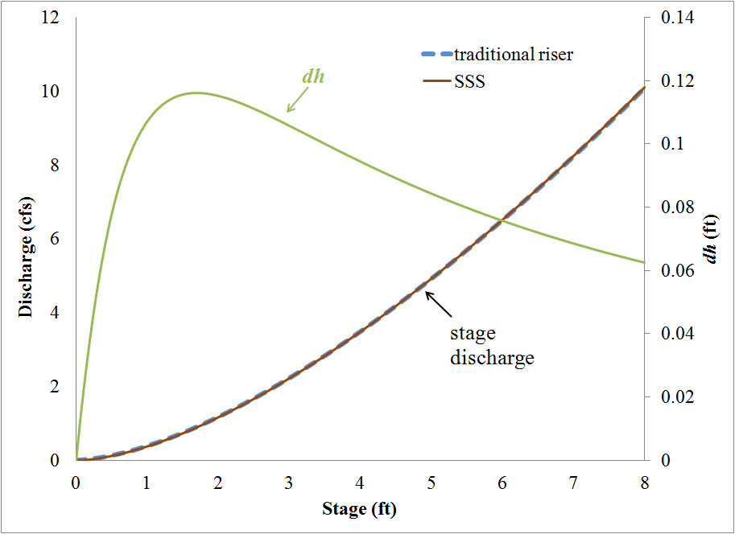
Figure 19. Single storm simulation stage discharge and dh curve
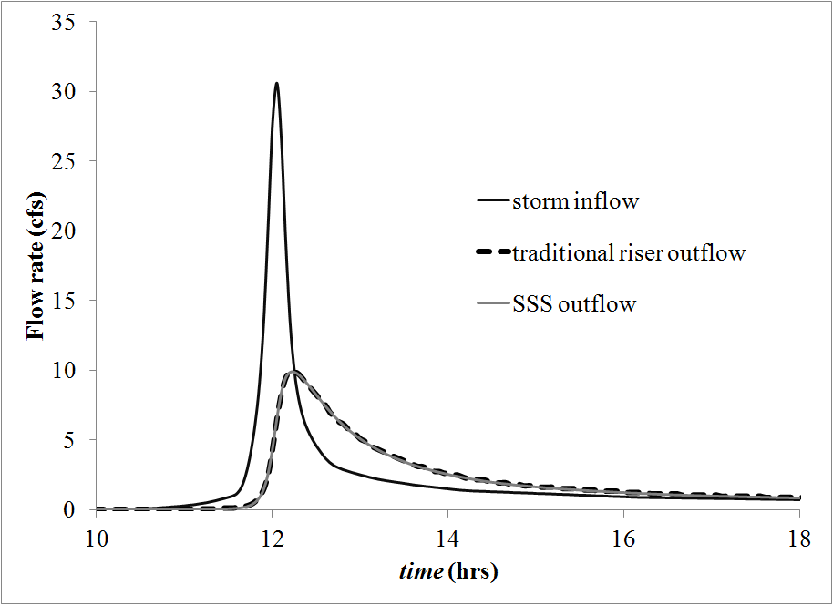
Figure 20. Single storm simulation inflow and outflow hydrographs

Table 5. Single storm simulation efficiencies
 | traditional riser | SSS | % increase
sand | 75.8 | 84.8 | 12.0
silt | 21.4 | 30.3 | 41.7
clay | 2.97 | 4.04 | 36.0

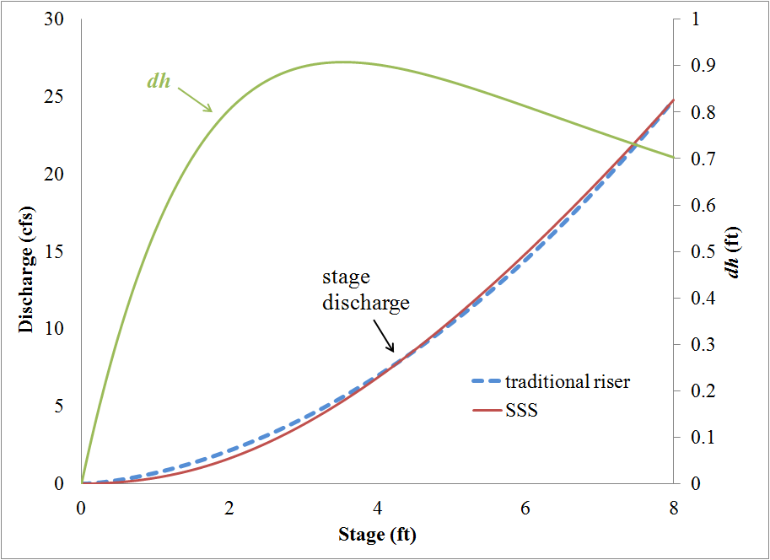
Figure 21. Multiple storm simulation stage discharge and dh curves

and multiple storm event simulations. The increased magnitude for the multiple storm simulation is the result of the peak discharge constraints during storm routing. The smaller storm events force a small shape for the SSS inflow weir so that at low head—typically smaller storm events—the discharge is below maximum allowed and the dh values increase to allow more flow through the submerged section of the SSS to match peak discharge rates at high head—typically larger storm events—and drain the basin within maximum storm retention times. Table 6 lists the pre-construction peak discharges and peak discharges from the basin for the SSS and traditional riser outlet. The only peak discharge that was not attenuated was the 2-yr storm event for the traditional riser. The peak discharge was not meet because the traditional riser does not have equivalent flow at low head, but difference in flow is minimal (Figure 21).
Efficiencies for the multiple storm simulations are located in Tables 7 and 8. The SSS improved efficiency for each storm event and sediment range expect for the sand during the 2-yr storm event, which decreased slightly from 98% to 97% retained. Table 9 displays the percent increase in efficiency when the SSS is employed compared to the traditional riser. The percent increase in efficiency for sand and silt increased as the storm event size increased, but opposite for clay. When analyzing the basin and outlets over a 100 year period (storm event frequency weighted average), the SSS increased efficiency by 0.0178, 14.9, and 31.4% for sand, silt, and clay respectively. These results indicate that the outlet design has little effect on retention of sand because the majority settles before reaching the outlet. It should be noted that the increased efficiencies for
Table 6. Peak flow rates (cfs) for 2, 5, 10, 25, 50, and 100-yr storm events
Storm | 2-yr | 5-yr | 10-yr | 25-yr | 50-yr | 100-yr
 | Q | Q | Q | Q | Q | Q
Pre | 2.20 | 6.80 | 10.1 | 16.2 | 22.2 | 24.8
Trad. riser | 2.52 | 6.09 | 8.59 | 14.5 | 20.3 | 23.1
SSS | 2.20 | 6.06 | 9.13 | 15.0 | 20.9 | 23.4

Table 7. Traditional riser efficiencies for the multiple storm simulation
% efficiencies, traditional riser, 48 hr retention limit
Storm | 2-yr | 5-yr | 10-yr | 25-yr | 50-yr | 100-yr | weighted*
sand | 98.2 | 97.0 | 92.2 | 83.2 | 76.3 | 73.7 | 95.8
silt | 61.7 | 43.3 | 36.7 | 29.3 | 24.9 | 23.3 | 51.8
clay | 11.0 | 6.79 | 5.49 | 4.35 | 3.65 | 3.42 | 8.82
 | *frequency weighted over 100-yr period

Table 8. SSS efficiencies for the multiple storm simulation
% efficiencies, SSS, 48 hr retention limit
Storm | 2-yr | 5-yr | 10-yr | 25-yr | 50-yr | 100-yr | weighted*
sand | 97.0 | 97.2 | 94.5 | 87.5 | 81.5 | 79.2 | 95.8
silt | 70.4 | 50.2 | 42.9 | 34.6 | 29.5 | 27.7 | 59.5
clay | 14.4 | 8.91 | 7.26 | 5.58 | 4.63 | 4.31 | 11.6
 | *frequency weighted over 100-yr period

Table 9. Multiple storm simulation percent increase in efficiency
efficiency % increase, SSS compared to traditional riser, 48 hr retention limit
Storm | 2-yr | 5-yr | 10-yr | 25-yr | 50-yr | 100-yr | weighted*
sand | -1.21 | 0.237 | 2.47 | 5.27 | 6.88 | 7.35 | 0.0178
silt | 14.1 | 16.1 | 17.0 | 18.0 | 18.5 | 19.2 | 14.9
clay | 31.6 | 31.3 | 32.1 | 28.2 | 26.9 | 26.1 | 31.4
 | *frequency weighted over 100-yr period

clay are optimistic because modeling the movement of clay in the basin with Stokes’ law is a greatly simplified approach for such a small particles. Additionally, the overall low efficiencies of clay indicates that the clay is in theory is only slightly below the surface of the exiting water column. The possibility for mixing, especially near the top of the water column, would eliminate any increase in efficiency for any outlet type, even floating skimmers.
Figure 22 illustrates the discharge per elevation for the resulting SSS and traditional riser from the multiple storm simulation at the maximum basin stage, 8 ft. It is evident that the SSS discharge the major of the water from upper portion of the water column compared to the traditional riser. The elevation with 50% flow above and 50% below is 5.4 ft for the SSS and 3.7 ft for the traditional riser. When the maximum retention time was extended to 72 hours from 48 hours, the frequency weighted efficiencies increased by 1.15, 1.45, and 6.86% for sand, silt, and clay respectively. These results suggest that the major benefit of increased retention time is increased clay retention.
Many factors must be considered when implementing the modified overflow method to quantify retention efficiencies. This method relies on several models, many that that rely on other models, to determine efficiency, which can result in compounding error. Additionally, many of the models are simplified to increase speed and reduce the need complex formulas, such as the mixing coefficient, A_{eff}. The mixing parameter is a sole term designed to account for the basin shape. It does not account for the entrance
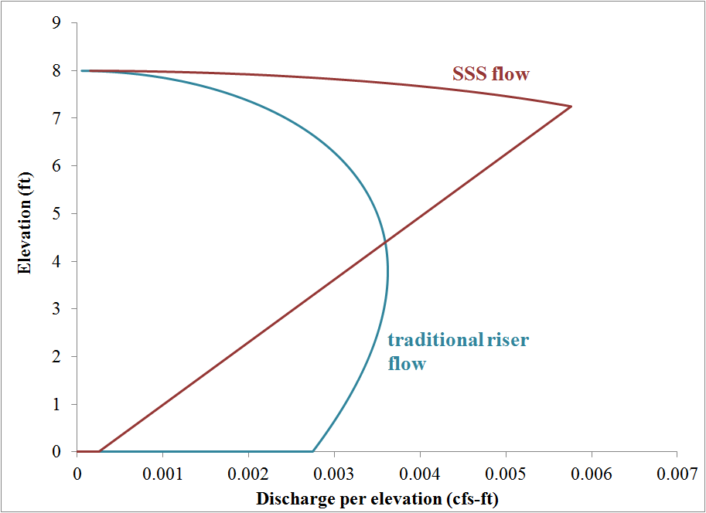
Figure 22. Discharge per elevation at max stage for the multiple storm simulation

type or other basin attributes such as baffles, both of which can alter trapping efficiencies. Another simplification is the assumed plug flow for the horizontal movement in the basin. This assumption becomes less accurate near the entrance and exit of the basin. Assumed plug flow at the outlet is not always accurate because each of the outlets drain differently along the elevation of the exiting water plug. This is especially true for a floating skimmer, because all of discharge is theoretically from the top, but in reality, the discharging water will come from near the top. An additional term may be needed to accurately model and compare a top skimming outlet, such as the Faircloth skimmer, to entire column discharging outlets—such as the SSS and tradition riser.

Conclusion
It is evident that the use of skimmers in sediment basin can improve sediment retention. The SSS, a new type of skimmer, proved in an initial study that it can remove the cleaner upper basin water and thereby reduce turbidity without any complexity or moving parts. Further investigation and refinement of the design is needed to maximize the sediment trapping efficiency of the SSS. The overflow method is commonly practiced method to determine retention efficiency, but lacks a method to account for the outlet type, and especially from what elevation in the basin the outlet withdraws water. A modification to the overflow method was developed that tracks the sediment to the outlet and quantifies the location and quantity of the discharging water so as to determine its sediment load.
MATLAB was utilized as a means to automate the design of a SSS for basin. The program includes a setup file that initializes the fmincon MATLAB function. The fmincon function then takes control by iterating between the objective and constraint routines while changing the SSS geometric parameters and the dh values. Subroutines are utilized by the objective and constraint functions to perform tasks such as generating a stage discharge curve, routing storms, and calculating efficiency. Multiple simulations were conducted with MATLAB program to analysis the sensitivity of the efficiency model. Results from the simulations indicate that the SSS increases trapping efficiencies the mostly for clay and silt, and slightly for sand. Varying the maximum retention time had little effect on efficiencies for an equivalently sized basin.

References
EPA. 2007. Developing your stormwater pollution prevention plan: a guide for construction sites. EPA-833-R-06-004. Washington, DC.: Environmental Protection Agency.
Fifield, J. S. 2001. Designing for effective sediment and erosion control on construction sites. Santa Barbara, CA: Forester Communications.
Jarrett, A.R. 2001. Designing sedimentation basins for better sediment capture. Soil Erosion Research for the 21st Century. ASAE: 701P0007.
MATLAB. 2011. MATLAB for Windows. Ver. 2011a. Natick, MA.: MathWorks.
McCaleb, M. M., and R. A. McLaughlin. 2008. Sediment trapping by five different sediment detention devices on construction sites. Trans. ASABE 51(5): 1613-1621.
National Pollutant Discharge Elimination System (NPDES). 2011. Local ordinances for construction site runoff control. Available at: http://cfpub.epa.gov/npdes/stormwater/menuofbmps/index.cfm?
action=factsheet_results&view=specific&bmp=66. Accessed 15 December 2011.
Pilon, B. S. 2010. Stormwater best management practices: improvement and evaluation. M. S. thesis. Knoxville, TN: Univ. of Tennessee, Department of Biosystems Engineering.

CONCLUSION
Sediment retention basins are thought to be an effective way to reduce the amount of sediment from construction sites that enters our creeks, streams, rivers, and other waterways. The design of a basin has become more complex with the requirement of the basin to perform multiple functions such as limit peak flows, drain within a set time limit, and trapping efficiency. Thus, the design approach and modeling of a basin’s various parameters require greater accuracy. Two independent but relevant issues related to design aspects of a sediment basin were studied. First, I examined the flow through circular orifices on round riser pipe, such as those often used on perforated riser in sediment basins, with mathematical models and laboratory experiments. Secondly, I developed a design process and MATLAB program to optimize the efficiency of a sediment basin with a SSS outlet device.
From the orifice study, the true area that is formed when a circular bit cuts an orifice into the side of a round riser was found to differ. Typically, the area is assumed to be equal to bit area, but we defined two distinct areas, outer and inner area, that are formed by the cut. Both areas increase as the bit diameter approaches the size of the riser diameter. When the bit diameter is half the size of the riser diameter, both areas are 1.09 times the bit area. When the bit and riser have equal diameters, the outer area is 1.27 times the bit area and the inner area is 1.41 times the bit area. The orifice area was also approximated as an ellipse because the ellipse equation is more applicable and follows the increasing area with increasing diameter that the outer and inner areas follow. Laboratory experiments indicated that flow rate predictions with the orifice equation, assuming 0.61 for the coefficient of discharge, overestimated flow as the bit diameter increased for a constant riser diameter and was unable to explain the variation of flow when the head was low. Multiple empirical equations of the coefficient of discharge were developed to model the variation. The fit equations indicate that flow rate decreases per unit area as the bit diameter approaches the size of the riser diameter, but increases slightly when the head is low. The best fit equation explained 89.1% of the variation in the measured data with a RMSE of 0.028 when the orifice area is approximated as an ellipsis.
The SSS optimization for a sediment retention basin began with an examination of the overflow method, a commonly practiced design and efficiency estimation method. A modified approach was presented to account for the location and quantity of the discharging water. The modified overflow method models the sediment movement the same as the standard overflow method but uses the final height of the upper most particle, the particle that started at the top of the water column at time zero, to define a break between clean and contaminated water. This assumes that the incoming particles were evenly distributed at time zero. With this information, the efficiency for a given outlet is defined by the amount of clean water discharged compared to the contaminated discharge for particles that reach the outlet combined with particles that settle before reaching the outlet.
A MATLAB program developed to optimize a SSS for a sediment basin based on the efficiency defined by the modified overflow method. MATLAB was selected because of the diverse mathematical library and optimization functions. Several simulations were conducted with the MATLAB program. The SSS increased efficiencies for both a single storm design and multiple storm design. The single storm efficiencies increased by 12.0, 41.7, and 36.0% for an incoming distribution of sand, silt, and clay respectively. The multiple storm simulation resulted with 0.0178, 14.9, and 31.4% increase in a storm event frequency weighted efficiencies.
Using the coefficient of discharge equation while approximating of the orifice area with an ellipse when designing a perforated riser will increase flow rate prediction accuracy and sediment trapping efficiencies. Implementation of the modified overflow method can provide a more representative efficiency by considering the hydraulics of the outlet device. More specifically, the design program applies the modified overflow method to generate an optimal design for a SSS in a sediment basin to achieve improved sediment trapping. Ultimately, the equations and methods presented can help minimize sediment polluted stormwater and its negative effects.

BIBLIOGRAPHY

Brandes, D., W. T. Barlow, and B. Hendrickson. 2010. An experimental study of stage-discharge relationships for thick-walled concrete orifices. World Env. And Water Res. Congress 2010: Challenges of Change. ASCE. 3329-3338.
Bryant, D. B., A. A. Khan, and N. M. Aziz. 2008. Investigation of flow upstream of orifices. J. of Hyd. Eng. ASCE, Jan. 98-104.
Chow, V. T. 1959. Open-Channel Hydraulics. New York, NY.: MacGraw-Hill Company, Inc.
Davis, C. V., and K. E. Sorensen. 1969. Handbook of Applied Hydraulics. 3rd ed. New York, NY: McGraw-Hill.
Encyclopædia Britannica. 2012. Torricelli’s theorem. Chicago, IL.: Encyclopædia Britannica, Inc. Available at: http://www.britannica.com/EBchecked/topic/
600154/Torricellis-theorem. Accessed 19 April 2012.
EPA. 2009. National Water Quality Inventory: Report to Congress, 2004 Reporting Cycle. EPA-841-R08-001. Washington, DC.: Environmental Protection Agency.
EPA. 2007. Developing your stormwater pollution prevention plan: a guide for construction sites. EPA-833-R-06-004. Washington, DC.: Environmental Protection Agency.
Fangmeier, D. D., W. J. Eliot, S. R. Workman, R. L. Huffman, and G. O. Schwab. 2006. Soil and Water Conservation Engineering. 5th ed. Clifton Park, NY.: Thomas Delmar Learning.
Fennessey, L. A. and A. R. Jarrett. 1997. Influence of principal spillway geometry and permanent pool depth on sediment retention of sedimentation basins. Trans. of the ASAE, 40(1), 53-59.
Fifield, J. S. 2001. Designing for effective sediment and erosion control on construction sites. Santa Barbara, CA: Forester Communications.
Finnemore, E. J., and J. B. Franzini. 2002. Fluid Mechanics with Engineering Applications. 10th ed. New York, NY: McGraw-Hill.
Goldman, S. J., K. Jackson, and T. A. Bursztynsky. 1986. Erosion and Sediment Control Handbook. New York, NY.: McGraw-Hill, Inc.
Gregg, W. B., D. E. Werth, and C. Frizzell. 2004. Determination of discharge coefficients for hydraulic sparger design. ASME J. Pressure Vessel Technol. 126(3), 354–359.
Haan, C. T., B. J. Barfield, and J. C. Hayes. 1994. Design Hydrology and Sedimentology for Small Catchments. San Diego, CA.: Academic Press, Inc.
HOBO. 2011. Product specification for the U20-001-04. Bourne, MA.: Onset. Available at: http://www.onsetcomp.com/callback/show-specs?n=2373. Accessed 12 December 2011.
HydroCAD. 2012. HydroCAD for Windows. Ver. 10.00-4. Tamworth, NH.: HydroCAD Software Solutions LLC.
Jarrett, A.R. 2001. Designing sedimentation basins for better sediment capture. Soil Erosion Research for the 21st Century. ASAE: 701P0007.
Jarrett, A. R. 1993. Design of perforated risers to control dewatering of sedimentation basins. Appl. Eng. Agric., 9(1), 37–42.
Maple. 2010. Maple for Windows. Ver. 15. Waterloo, ON.: Maplesoft.
MATLAB. 2011. MATLAB for Windows. Ver. 2011a. Natick, MA.: MathWorks.
McCaleb, M. M., and R. A. McLaughlin. 2008. Sediment trapping by five different sediment detention devices on construction sites. Trans. ASABE 51(5): 1613-1621.
McEnroe, B. M., J. M. Steichen, R. M. Schweiger. 1988. Hydraulics of perforated riser inlets for underground-outlet terraces. Trans. of the ASAE, 31(4), 1082-1085.
McLaughilin, R. A., S. A. Hayes, D. L. Clinton, M. S. McCaleb, and G. D. Jennings. 2009. Water quality improvements using modified sediment control systems on construction sites. Trans. of the ASABE, 52(6), 1859-1867.
McLemore, A. J., J. S. Tyner, and D. C. Yoder. 2011. Discussion of “Investigation of flow through orifices in riser pipes” by P. D. Prohaska, A. A. Khan, and N. B. Kaye. J. of Irrigation and Drainage Eng., 137(9), 632-633.
Methods, Haestad and S. R. Durrans. 2007. Stormwater Conveyance Modeling and Design. Exton, PA.: Bentley Institute Press.
Millen, J. A., A. R. Jarrett, and J. W. Faircloth. 1997. Experimental evaluation of sedimentation basin performance for alternative dewatering systems. Trans. of the ASAE, 40(4), 1087-1095.
National Pollutant Discharge Elimination System (NPDES). 2011. Local ordinances for construction site runoff control. Available at: http://cfpub.epa.gov/npdes/
stormwater/menuofbmps/index.cfm?action=factsheet_results&view=specific&bmp=66. Accessed 15 December 2011.
Pilon, B. S. 2010. Stormwater best management practices: improvement and evaluation. M. S. thesis. Knoxville, TN: Univ. of Tennessee, Department of Biosystems Engineering.
Prohaska, P. D., A. A. Khan, and N.B. Kaye. 2010. Investigation of flow through orifices in riser pipes. J. of Irrigation and Drainage Eng., 136(5), 340-347.
Win TR-55. 2009. Win TR-55 for Windows. Ver. 1.00.09. Washington DC.: Natural Resource Conservation Service.
Tyner, J., D. C. Yoder, and B. Pilon. 2011. Sediment and detention basin drainage system and method. U.S. Patent No. US 2011/0278212 A1.
Stockie, John M. 1998. The geometry of intersecting tubes applied to controlling a robotic welding torch. MappleTech (Special Issue on Maple in Industry), 5(2-3), 58–66.
Viessman, Jr. W., and G. L. Lewis. 2003. Introduction to Hydrology. 5th ed. Upper Saddle River, NJ.: Pearson Education, Inc.
Visser, K. K., J. M. Steichen, B. M. McEnroe, and J. Hua. 1988. Hydraulics of perforated terrace inlet risers. American Society of Agric. Eng. 31(5), 1451-1454.

Appendix

Appendix 1.1
Solver setup:
% Solver setup -- Alex McLemore

% Reset workspace
clc
clear

%% Inputs
basin_area = 6250; % user guesses
hb_max = 8; %[ft] max basin height
Q_peaks_allowed = [24.8,22.2,16.2,10.1,6.8,2.2]'; %[cfs] peak outflows
Q_peaks_storm = [54.5,50.4,41.0,30.6,24.5,14.2]'; %[cfs] peak inflows
t_ret_allowed = 48; %[hr] max retention time

% storm hydrographs
time_step = 0.05;
time = (0:time_step:t_ret_allowed)'; % [hr]
Qin_hydr = zeros(length(time),length(Q_peaks_allowed));
storm_vol = Qin_hydr;
total_storm_vol = zeros(size(Q_peaks_allowed));

% storm hydrograps removed to conserve space

% storm volumes
for m = 1:length(Q_peaks_allowed)
for n = 1:length(Qin_hydr)
storm_vol(n,m) = Qin_hydr(n,m)*time_step*3600;
end
total_storm_vol(m) = sum(storm_vol(:,m));
end

%efficiency inputs
l_w = 10; % set by user
SPM = [0.33,0.33,0.33]; %percent soil distribution
V_s = [0.2,0.02,0.002]; %soil settling velocity [mm/s]
V_s = V_s./10/2.54/12; %soil settling velocity [ft/s]

% combined inputs to pass through solver
var = [Q_peaks_allowed(1);hb_max;t_ret_allowed;basin_area;l_w];

%% Solver
% Solver intial points
increments = 20; % dh increments (i.e. the resoluation of dh curve)
dh(1:increments) = 0;
x0 = [1;1;1;dh'];
ub(1:increments) = hb_max/2;
ub = [10;10;10;ub'];
lb = zeros(1,increments);
lb(increments) = 0.75/12;
lb = [0;0;0;lb'];

% set solver options
opts = optimset('Algorithm','SQP','LargeScale','on',...
'PlotFcns',@optimplotx,'FunValCheck','on'); %,...
%'MaxFunEvals',100000,'MaxIter',10000);
% create solver problem
problem = createOptimProblem('fmincon',...
'x0',x0,'objective',@(x)objfun(x,var,Qin_hydr,SPM,V_s,...
Q_peaks_allowed,total_storm_vol),'nonlcon',@(x)confun(x,var,...
Qin_hydr,SPM,V_s,Q_peaks_allowed,total_storm_vol),'lb',lb,...
'ub',ub,'options',opts);

% Solver options

% x = ktrlink(@(x)objfun(x,var,Qin_hydr,SPM,V_s,type),x0,[],[],...
% [],[],lb,ub,@(x)confun(x,var,Qin_hydr,SPM,V_s,type))
[x fval] = fmincon(problem) % local min solver
% ms = MultiStart('Display','iter','StartPointsToRun','bounds'); % multiple start random solver
% [x,fval,eflag,output,solutions] = run(ms,problem,10)
% gs = GlobalSearch('Display','iter'); % iterative start point solver
% [x fval eflag,output solutions] = run(gs,problem)

% display constraint values
[c,ceq] = confun(x,var,Qin_hydr,SPM,V_s,type,Q_peaks_allowed,total_storm_vol)

Appendix 1.2
Objective function:
function [obj] = objfun(x,var,Qin_hydr,SPM,V_s,type,Q_peaks_allowed,total_storm_vol)
% Objective funtion

basin_area = var(4);

%increase dh resolution
[dh_hi_res] = SSS_increase_resolution(x,var);

%routing
SSS_par = [x(1),x(2),x(3)];
[Q_hb,Q_dis] = SSS_Q_distribution(dh_hi_res,var,SSS_par);
[c2,ceq,Qout_storm,stage,dis_vol] = routing(basin_area,var,...
Q_hb,Qin_hydr,Q_peaks_allowed,total_storm_vol);

%efficiency
[Neff] = efficiency(x,var,SPM,V_s,Q_dis,Qout_storm,stage,...
dis_vol,basin_area,total_storm_vol);
obj=Neff;

Constraint function:
function [c,ceq] = confun(x,var,Qin_hydr,SPM,V_s,type,Q_peaks_allowed,total_storm_vol)
% Constraint function

basin_area = var(4);
%stage discharge
[c1,ceq1] = SSS_stage_discharge(x,var);

%increase dh resolution
[dh_hi_res] = SSS_increase_resolution(x,var);

%routing
SSS_par = [x(1),x(2),x(3)];
[Q_hb,Q_dis] = SSS_Q_distribution(dh_hi_res,var,SSS_par);
[c2,ceq2] = routing(basin_area,var,Q_hb,Qin_hydr,Q_peaks_allowed,total_storm_vol);
c = [c1;c2];
ceq = [ceq1;ceq2];

Appendix 1.3
Stage discharge routine:
function [c,ceq] = SSS_stage_discharge(x2,var)
% Stage discharge routine

%confun_v1 --> the constraints function that works with all v1 solvers
%c --> are the inequality constraints
% c(x) <= 0
% **variables requiring constraint**
% hc>=0
% hb>=hc
%
%ceq --> are the equality constraints
% ceq(x) = 0
% **variables requiring constraint**
% Qout(max)=Qmax_allowed
% Qout=Qin_total

%% Run SSS function
% var = [Qpeak_allowed;hb_max;t_ret_allowed;basin_area;l_w]
%Variables
% constants
g = 32.2; %gravity [ft/s^2]
Cd = 0.61; %orifice discharge coefficient []
% variables
Qmax = var(1); %Defining the max flow, assumed to be at max depth [gpm]
height = var(2); %input hb height [in]
step = height/(20); %insuring matrices match up
hb = (step:step:height)'; %setting height increments
dh = x2(length(x2)-19:length(x2)); %use 19 to find first dh point, assuming 20 dh points
hc = hb-dh; %solving for height in chamber
Aout = x2(1); %extracting Aout from x
Ain = x2(2); %extracting Ain from x
Bin = x2(3); %extracting Bin from x

%% Flow calculations
%Preallocating flow variables
Qout = zeros(1,length(hb))'; %SSS outflow (i.e. inner weir)
Qin_sub = Qout; %SSS inflow, submerged flow regime
Qin_free = Qout; %SSS inflow, free to atm flow regime
Qin_total = Qin_sub+Qin_free; %total inflow (i.e. outer weir)

% Q for inner riser (i.e., outflow)
for n = (1:length(hb))
Qout(n) = (2/3*Cd*Aout*(2*g)^0.5*hc(n)^1.5); %[ft^3/s]
end

% Q for outer riser (i.e., inflow)
for n = (1:length(hb))
Qin_free(n) = (Cd*(2*g)^0.5*(2/3*Ain+8/15*Bin*hb(n)+4/5*Bin*hc(n))*dh(n)^1.5); %[ft^3/s]
Qin_sub(n) = (Cd*(2*g)^0.5*(Ain*hc(n)+Bin*hc(n)^2)*dh(n)^0.5); %[ft^3/s]
Qin_total(n) = Qin_sub(n)+Qin_free(n);
end

%% Build c vector
dQmax = abs(Qout(length(Qout))-Qmax); %forcing Qtrad at highest head to equal Qmax
c = [Ain-Aout;(-hc)];

%% Build ceq vector
dQ2 = abs(Qout-Qin_total); % insures inflow and outflow are equal
ceq = [dQmax;dQ2];

Interpolate dh curve routine:
function [dh_hi_res] = SSS_increase_resolution(x,var)
% Interpolate dh curve routine

% setup
hb_max = var(2);
dh = x(length(x)-19:length(x));
hb = (0:hb_max/length(dh):hb_max)';
dh = [0;dh];
spline_fit = csapi(hb,dh); %spline fit equation

% create high resolution vectors
hb_hi_res = (0:0.01:hb_max)';
dh_hi_res = (fnval(spline_fit,hb_hi_res));
dh_hi_res(dh_hi_res < 0) = 0;
hc_hi_res = hb_hi_res-dh_hi_res;

% to check spline fit if needed
%subplot(2,1,2); plot(hb_hi_res,dh_hi_res);

Flow rate distribution routine:
function [Qin_total,Q] = SSS_Q_distribution(dh,var,SSS_par)
% Flow rate distribution routine

% var = [Qpeak_allowed;hb_max;t_ret_allowed;basin_area;l_w] for refence

%% Variables
% constaints
g = 32.2; %gravity [ft/s^2]
Cd = 0.61; %orifice discharge coefficient []
% variables
height = var(2); %input hb height [in]
Ain = SSS_par(2); %extracting Ain from x
Bin = SSS_par(3); %extracting Bin from x
step = height/(length(dh)-1); %insuring matrices match up
hb = (0:step:height)'; %setting height increments
hc = hb-dh;
head = 0:0.001:height;
Q = zeros(length(head),length(hb));
Qin_total = zeros(size(dh));
Q_sum = zeros(size(dh));

% building Q_distribution curve
for m = 1:length(dh)
for n = 1:length(head)
if (head(n)<=0) % head below or at zero
Q(n,m) = 0;
elseif head(n)>0 && head(n)<=hc(m) % head between zero and hc
Q_bottom1 = 0.61*(2*32.2)^0.5*(Ain*head(n-1)+Bin*head(n-1)^2)*dh(m)^0.5;
Q_top1 = 0.61*(2*32.2)^0.5*(Ain*head(n)+Bin*head(n)^2)*dh(m)^0.5;
Q(n,m)=Q_top1-Q_bottom1;
elseif head(n)>hc(m) && head(n-1)<=hc(m) && hc(m)>0 && head(n)<=hb(m) % head above hc but previous head is below hc
Q_bottom2 = 0.61*(2*32.2)^0.5*(Ain*head(n-1)+Bin*head(n-1)^2)*dh(m)^0.5;
Q_sub1 = 0.61*(2*32.2)^0.5*(Ain*hc(m)+Bin*hc(m)^2)*dh(m)^0.5;
Q_free1 = 0.61*(2*32.2)^0.5*((2/3)*(hb(m)-hc(m))^(3/2)*Ain+(8/15)*...
(hb(m)-hc(m))^(3/2)*Bin*hb(m)+(4/5)*(hb(m)-hc(m))^(3/2)*Bin*hc(m)-...
(2/3)*(hb(m)-head(n))^(3/2)*Ain-(8/15)*(hb(m)-head(n))^(3/2)*...
Bin*hb(m)-(4/5)*(hb(m)-head(n))^(3/2)*Bin*head(n));
Q_top2 = Q_sub1+Q_free1;
Q(n,m)=Q_top2-Q_bottom2;
elseif head(n)>hc(m) && head(n)<=hb(m) % head blow hb and above hc
Q_sub3 = 0.61*(2*32.2)^0.5*(Ain*hc(m)+Bin*hc(m)^2)*dh(m)^0.5;
Q_free3 = 0.61*(2*32.2)^0.5*((2/3)*(hb(m)-hc(m))^(3/2)*Ain+(8/15)*...
(hb(m)-hc(m))^(3/2)*Bin*hb(m)+(4/5)*(hb(m)-hc(m))^(3/2)*Bin*hc(m)-...
(2/3)*(hb(m)-head(n-1))^(3/2)*Ain-(8/15)*(hb(m)-head(n-1))^(3/2)*...
Bin*hb(m)-(4/5)*(hb(m)-head(n-1))^(3/2)*Bin*head(n-1));
Q_bottom3 = Q_sub3+Q_free3;
Q_sub4 = 0.61*(2*32.2)^0.5*(Ain*hc(m)+Bin*hc(m)^2)*dh(m)^0.5;
Q_free4 = 0.61*(2*32.2)^0.5*((2/3)*(hb(m)-hc(m))^(3/2)*Ain+(8/15)*...
(hb(m)-hc(m))^(3/2)*Bin*hb(m)+(4/5)*(hb(m)-hc(m))^(3/2)*Bin*hc(m)-...
(2/3)*(hb(m)-head(n))^(3/2)*Ain-(8/15)*(hb(m)-head(n))^(3/2)*...
Bin*hb(m)-(4/5)*(hb(m)-head(n))^(3/2)*Bin*head(n));
Q_top3 = Q_sub4+Q_free4;
Q(n,m)=Q_top3-Q_bottom3;
elseif head(n)>hb(m) % head above stage
Q(n,m)=0;
end
end
Q_sum(m) = sum(Q(:,m));
% check with closed form equations below
Qin_free = (Cd*(2*g)^0.5*(2/3*Ain+8/15*Bin*hb(m)+4/5*Bin*hc(m))*dh(m)^1.5); %[ft^3/s]
Qin_sub = (Cd*(2*g)^0.5*(Ain*hc(m)+Bin*hc(m)^2)*dh(m)^0.5); %[ft^3/s]
Qin_total(m) = Qin_sub+Qin_free;
end

Routing routine:
function [c,ceq,Qout_storm,stage_rounded,dis_vol]= routing(basin_area,var,Q_hb,Qin_hydr,Q_peaks_allowed,total_storm_vol)
% Routing routine

% var = [Qpeak_allowed;hb_max;t_ret_allowed;basin_area;l_w]; for reference

%% Variables
hb_max = var(2); %input hb height [in]
t_retention_allowed = var(3); %max retention time [hr]
step = hb_max/(length(Q_hb)-1); %insuring matrices match up
hb = (0:step:hb_max)'; %setting height increments

%% Routing/particle tracking
% Initialize matrices
Qout = Q_hb;
time_step = 0.05;
time = (0:time_step:t_retention_allowed)'; % [hr]
Qout_storm = zeros(size(Qin_hydr)); basin_storage = zeros(size(Qin_hydr)); basin_stage = zeros(size(Qin_hydr));
dis_vol = zeros(size(Qin_hydr)); stage_rounded = zeros(size(Qin_hydr));
percent_dis = zeros(size(Q_peaks_allowed));
Q_peaks_act = zeros(size(Q_peaks_allowed));

% routing process
for n = 1:length(Q_peaks_allowed)
for i = 2:length(time)
basin_storage(i,n) = basin_storage(i-1,n)+((Qin_hydr(i,n)-Qout_storm(i-1,n))*time_step*3600); %[ft^3]
basin_stage(i,n) = basin_storage(i,n)/basin_area; %basin stage [ft]
stage_rounded(i,n) = roundn(basin_stage(i,n),-3); % -3 rounds to nearest 100th, i.e. resolution of hb
if stage_rounded(i,n)< 0 % all water drained
m = 1;
error = 1;
elseif (stage_rounded(i,n)+hb(2)/2)>max(hb) % overflow
error = 2;
m = 1;
else
[m]=find(stage_rounded(i,n)-hb(2)/2+0.000000001<hb & hb<stage_rounded(i,n)+hb(2)/2+0.000000001); %find location of current stage in hb array
if isempty(m)
m = 1;
error = 3;
end
end
Qout_storm(i,n) = Qout(m); % Get flowrate values
dis_vol(i,n) = Qout_storm(i,n)*time_step*3600; %[cf]
end
total_dis_vol = sum(dis_vol(:,n));
percent_dis(n) = total_dis_vol/total_storm_vol(n);
Q_peaks_act(n) = max(Qout_storm(:,n));
end

%% Build constraint vectors
% c vector
storm_drained = 98-(percent_dis.*100); % solving for retention time, assumed to be at 98% of storm discharged
stage_constraint2 = max(max(stage_rounded))-hb_max; % prevents overflow
Q_peaks_con = Q_peaks_act-Q_peaks_allowed; % insures allowable peak flow are meet
c = [stage_constraint2;Q_peaks_con;storm_drained];

% ceq vector
ceq = [];

Efficiency routine:
function [Neff_total] = efficiency(x,var,SPM,V_s,Q_dis,Qout_storm,stage,dis_vol,basin_area,total_storm_vol)
% Efficiency routine

% var = [Qpeak_allowed;hb_max;t_ret_allowed;basin_area;l_w]; for refernce

height = var(2);
l_w = 10;
Q_dirty = zeros(length(Qout_storm),length(V_s),length(total_storm_vol)); %preallocating Q_z
z_p = Q_dirty; Neff = Q_dirty; SPM_eff = Q_dirty;
Neff_i = zeros(length(Qout_storm),length(total_storm_vol));
basin_width = (basin_area/l_w)^0.5; %basin width [ft]
l = basin_width*l_w; %basin length [ft]
Aeff = 20*l_w-l_w^2; %effective area
size_Q_dis = size(Q_dis); %returns x(down) then y(right)
z = (0:height/(size_Q_dis(1)-1):height)'; % makes the "down length" the size from Q_dis
hb = (0:height/(size_Q_dis(2)-1):height)'; % makes the "right length" the size from Q_dis
Neff_storm = zeros(size(total_storm_vol));

%Partcle tracking loop
for m = 1:length(total_storm_vol);
for i = 1:length(Qout_storm)
if Qout_storm(i,m)==0
SPM_eff(i,:,m) = 0;
else
V_hor = Qout_storm(i,m)/(basin_width*stage(i,m)); %horizontal water movement in basin [ft/s]
t_r = l/V_hor; %residence time [sec]
drop = V_s.*t_r; %distance particle drops [ft]
z_p(i,:,m) = stage(i,m)-drop; %particle break location from basin floor [ft]
for n=1:length(V_s)
if (z_p(i,n,m)<=0)
Q_dirty(i,n,m) = 0;
SPM_eff(i,n,m) = SPM(n); %prevents necative z_p(i) values to creat false SMP_eff values
else
[s]=find(z_p(i,n,m)-z(2)/2+0.000000001<z & z<z_p(i,n,m)+z(2)/2+0.000000001); %find location of current z_p in z array
if isempty(s)
s = 1;
error = 2;
end
[r]=find(stage(i,m)-hb(2)/2+0.000000001<hb & hb<stage(i,m)+hb(2)/2+0.000000001); %find location of current stage in hb array
if isempty(r)
r = 1;
error = 1;
end
Q_dirty(i,n,m) = sum(Q_dis(1:s,r));
SPM_eff(i,n,m) = SPM(n)*(1-((z_p(i,n,m)/stage(i,m))*(Q_dirty(i,n,m)/Qout_storm(i,m))));
end
end
end
Neff(i,:,m) = Aeff*SPM_eff(i,:,m);
Neff_i(i,m) = sum(Neff(i,:,m))*dis_vol(i,m)/total_storm_vol(m);
end
Neff_storm(m) = sum(Neff_i(:,m))*storm_freq(m)/sum(storm_freq);
Neff_storms(m) = sum(Neff_i(:,m));
end
Neff_total = -sum(Neff_storm); % weight for larger vol storms not frequency

VITA

Alex McLemore was born in Knoxville, Tennessee September 6, 1987. He grew up in Knoxville, Tennessee where he graduated from South-Doyle High School in 2006. In 2010 he graduated with a B.S. in Biosystems Engineering and a minor in Environmental Engineering from the University of Tennessee. He will graduate in August 2012 with a M.S. in Biosystems Engineering.

