Relationship between Type of Health Insurance, Frequency of Clinic Visits, and Clinic Income
Shelby DeLille
University of Tennessee, College of Social work

Introduction:
Healthcare agencies, especially those that primarily serve low-income communities, are often faced with the decision to either absorb the costs for medical and mental health visits or refuse services for individuals who are uninsured. This often keeps uninsured individuals from accessing healthcare and mental health resources they need as well as strains the resources at smaller agencies that may not be able to absorb visit costs for uninsured individuals. Additionally, these uninsured individuals are frequently eligible for insurance, however they have been unable to apply or maintain insurance for reasons including but not limited to homelessness, lack of education and skills, and the inability to obtain documentation for application or renewal by given deadlines. To address this concern, many agencies have started offering insurance assistance services, helping individuals apply for and obtain health insurance. The purpose of this study is to explore the relationship between type of insurance obtained through insurance assistance services (private versus state-funded), frequency of clinic visits, and clinic income generated by those visits.
While not many similar studies were identified through studying existing literature on the topic, one particular article appeared of interest. According to a 2011 study, adults who obtain health insurance and have a “usual source of care” have increased rates of doctor visits, resulting in decreased unaddressed health needs (DeVoe, Tilloston, Lesko, Wallace, & Angier). The current study will not analyze frequency of clinic visits prior to and post-obtaining insurance, but rather look into different patterns depending on whether individuals obtained private versus state-funded insurance. This study was also completed in a pediatric clinic, analyzing frequency of clinic visits for children rather than adults. Finally, this study will further explore the impact on clinic income of assisting individuals in obtaining insurance rather than solely exploring the impact on the individual and how frequently they seek healthcare services.
Methodology:
This study is a secondary data analysis designed to answer the research question of whether there would be a positive relationship between the independent variable, defined as whether a participant obtained private or state-funded insurance, and the dependent variable, defined as clinic income generated by participant clinic visits after the date of insurance approval, mediated by the mediation variable, defined by the frequency of clinic visits after the date of insurance approval. Data was collected over a 7-month period. All 62 participants received health insurance assistance services at the clinic in which the data was collected within this 7-month time period. A mediation model was used in the SPSS module AMOS to directly test the mediation relationship between these variables.
Insurance type was coded 0 for private insurance and 1 for state-funded insurance, referring to one of the four types of TennCare. Frequency of clinic visits was found by counting visits recorded in the clinic’s Electronic Health Record system since the date of insurance approval. Clinic income was calculated using an average cost for medical visits of $72 and average cost for mental health visits of $53. These averages were calculated by taking the mean of all of the average visit costs for all providers in each category (nurses for medical visits and social workers for mental health visits).
Results:
Results figures can be found at the bottom of this study.*
When Insurance Type, Medical Visits, and Clinic Income were tested utilizing the mediation model (Figure 1), statistically significant direct effects between Insurance Type and Clinic Income and between Number of Medical Visits and Clinic Income were found. However, the relationship between Insurance Type and Clinic Income was not mediated by the Number of Medical Visits. Figure 1 also indicates that TennCare clients contribute, on average, $158.29 less to the clinic than private clients. For each additional medical visit, clinic income increases on average by $67.08. The R² coefficients refer to the proportion of variation in a dependent variable explained by an independent variable. These coefficients revealed that approximately 69% of Clinic Income variation can be explained by both Insurance Type and Number of Medical Visits, representing a significant majority of possible variation. In contrast, a mere .4% of Medical Visit variation can be attributed to Insurance Type, meaning whether someone has private or state-funded insurance has little to no impact on the frequency with which that person will attend medical visits at this clinic.
When Insurance Type, Mental Health Visits, and Clinic Income were tested utilizing the mediation model (Figure 2), a full mediation model was found. This means that there was no statistically significant direct relationship between Insurance Type and Clinic Income, yet there appeared to be a statistically significant mediation relationship between these two variables, mediated fully by the Number of Clinic Visits. Figure 2 shows that TennCare clients, on average, have 3 fewer mental health visits than privately-insured clients at this clinic. For every mental health visit, the clinic gains, on average, $45.43. The total variation in clinic income explained by Insurance Type and Number of Mental Health Visits is 35%. Interestingly, 22% of the variation in the Number of Mental Health Visits appeared to be explained by Insurance Type, a notably larger percentage than was found when analyzing medical visits to the clinic.
When Insurance Type, Total Clinic Visits (Medical and Mental Health combined), and Clinic income were tested utilized the mediation model (Figure 3), a partial mediation relationship was found, as evidenced by all three relationship paths being statistically significant. TennCare clients contributed, on average, $26.71 more to clinic income than did privately-insured clients. This low percentage indicates that many other factors contribute to clinic income variation that were not accounted for in this study. TennCare clients appeared to attend the clinic, on average, for three less appointments than did privately-insured clients. For each additional clinic visit, the clinic gained, on average, an additional $63.15. The vast majority of Clinic Income variation, nearly 98%, was accounted for by Insurance Type and Total Clinic Visits. In contrast, just under 16% of the variation in Clinic Visits was accounted for by Insurance Type. This low percentage indicates that many other factors contribute to the frequency with which individuals attend this clinic that were not accounted for in this study.
Although mediation models are typically accompanied by a Fit Index, measuring how strong the path analysis is, the small sample size in this study left zero degrees of freedom with which to calculate the Fit Index.
Discussion:
Since all study participants obtained insurance through insurance assistance services at the clinic in which the study was conducted, this study indicates how much of an impact on clinic income assisting clients with obtaining insurance can have. Future studies might compare frequency of clinic visits prior to and post-obtaining insurance to further explore the apparent positive impact on clinic income assisting clients in obtaining insurance has, regardless of whether clients obtain private or public insurance.
Implications of these results include the importance of insurance assistance services beyond the direct benefits to clients who become insured. Since assisting individuals in obtaining insurance also appears to contribute to clinic income, it appears financially beneficial for healthcare agencies to offer insurance assistance services. At the clinic in which the study was conducted, insurance assistance services are primarily offered by interns. Since interns are not financially compensated for their work, offering these services is even more financially advantageous for the clinic. Particularly underfunded agencies could benefit from offering insurance assistance services, directly benefitting those who receive insurance as well as enabling the agency to have the financial resources to continue serving its community. This sort of ripple effect from benefitting individual clients, to benefitting clinics and other healthcare agencies, to benefitting entire communities not only justifies insurance assistance services but appears to encourage them.
Under the current political climate, where healthcare reform is constantly a topic of debate, this study’s findings appear increasingly relevant. While there is a moralistic argument for ensuring all individuals have access to health insurance and healthcare services as a human right, this study suggests financial and public health arguments as well. Serving insured individuals helps sustain healthcare businesses. Due to the nature of services offered by these agencies, financially stable healthcare agencies are able to contribute more to the medical and mental health of the communities they serve. Future studies may further explore additional factors that contribute to frequency of clinic visits and clinic income to explore other potential ways of financially supporting healthcare agencies not included in this study. Future studies may also explore the most effective method of assisting clients in obtaining insurance so as to offer timely, effective, and cost-efficient insurance assistance services.
Limitations:
As aforementioned, this study had a small sample size, potentially contributing to biased results. Due to gathering final data remotely, not all study participants’ health insurance approval dates were identified, making it impossible to identify the frequency of clinic visits after insurance approval. This study also only analyzed clients who received insurance assistance at the clinic in which the study was conducted and only accounted for medical and mental health visits at the same clinic. Future studies might adopt a broader scope, accounting for participants’ total medical and mental health visits regardless of what agency they sought services from. Future studies may also include frequency of visits prior to and after obtaining health insurance in order to identify potential changes in visit patterns depending on whether an individual is insured or uninsured. This study merely scratches the surface of a multi-faceted phenomenon, attempting to begin to explain the role of health insurance and clinic visits on clinic income.
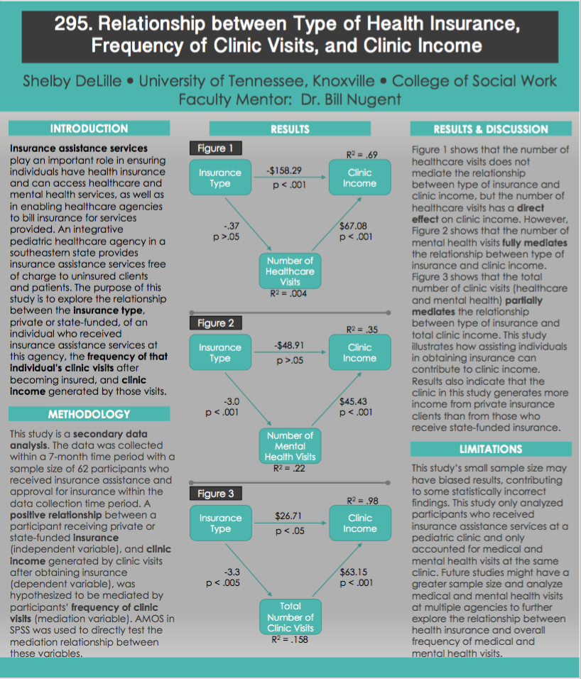

References
DeVoe, J. E., Tilloston, C. J., Lesko, S. E., Wallace, L. S., & Angier, H. (2011). The case for synergy between a usual source of care and health insurance coverage. Journal of General Internal Medicine (26)9, 11059-1066. doi: 10.1007/s11606-011-1666-0

