Transition to Electric Vehicles in the California Automobile Industry

A Dissertation Presented for the
Doctor of Philosophy
Degree
The University of Tennessee, Knoxville

Jinglu Song
December 2016

Copyright © 2016 by Jinglu Song
All rights reserved.

Acknowledgements
I would like to gratefully and sincerely thank Dr. Mingzhou Jin for his guidance, understanding, patience, and most importantly, his professional advising during my graduate studies at the University of Tennessee. He encouraged me to not only grow as a researcher but also as an independent thinker. For everything you’ve done for me, Dr. Jin, I thank you.
I would also like to thank Dr. Zhenhong Lin for his extraordinary assistance and guidance in getting my research started on the right foot and providing me with the database and MA3T simulation model. I believe that his actions provided me with the unique opportunity to gain a wider breadth of experience.
I would like to thank the Department of Industrial & System Engineering at the University of Tennessee and the students in this department who provided valuable discussions and accessibility. I would also like to thank all the members of the my advisory committee, Dr. Mingzhou Jin, Dr. Zhenhong Lin, Dr. Xueping Li, Dr. Bogdan Bichescu, and Dr. James Simonton, for giving me the opportunity to become a more professional graduate student.
Finally, and most importantly, I thank my parents, Peiying Zhang and Qinghe Cai, for their faith in me and allowing me to be as ambitious as I wanted. It was under their watchful eye that I gained so much drive and an ability to tackle challenges head on.
Thank you all!
Abstract

This dissertation presents a comprehensive study on the market adoption of electric vehicle and policy impact of the Zero Emission Vehicle (ZEV) mandate in the California automotive market. This research is primarily consisting of three parts. The author first built a technology innovation pricing model based on multi-nomial logit modelling method. This studies the dynamics among customer preferences, market acceptance and policy impact on vehicle pricing in the California automotive market. Results show that the ZEV mandate could profoundly enhance the market adoption of electric vehicles. There is a threshold on the magnitude of policy intervention. If the number of credits per vehicle is less than the threshold, increasing intervention promotes the EV market penetration; however, beyond the threshold, policy primarily benefits automakers.
In the second step, the author presents a decision model for electric vehicle attributes. This research first characterizes the market adoption rate of electric vehicle models under government subsidy and derives optimal vehicle attributes with respect to consumers' preferences and product-based subsidy. The proposed model was then applied to the California's automotive market. Our results also suggest that industry leaders and followers may choose different product strategy and market segments due to different battery manufacturing costs.
In the last part, the author constructed a series of scenarios for the transition to battery electric cars and used the Market Acceptance of Advanced Automotive Technologies model to analyze the price competition in the California electric vehicle market. Considering the ZEV mandate already in place, this part investigates the role of this regulation in influencing the pricing decisions of different electric vehicle models and enhancing the overall market adoption rate. It was found that the 200-mile range electric vehicle had remarkable unilateral influence on the pricing of the 100-mile range electric vehicle. It suggests that the 200-mile range electric vehicle will become the core driving force in electric vehicle diffusion in the California electric vehicle market. The ZEV mandate remarkably reduced the prices of both models and increased corresponding annual demand. However, this policy showed considerable influence of changing the structure of the California electric vehicle market.

Table of Contents

List of Abbreviations A
Chapter 1 Introduction 3
1.1. Electric Vehicles Background 3
1.2. Electric Vehicles Customers 13
1.3. Electric Vehicles Manufacturers 19
1.4. Policy Support 24
1.5. Purpose Statement 30
Chapter 2 Literature Review 39
2.1. Technology Diffusion Models 39
2.2. Pricing Strategies and Models 44
2.3. Durable Goods Pricing 50
2.4. Discrete Choice Models 53
Chapter 3 Research Results and Analysis 57
3.1. Electrical Vehicle Pricing and Market Adoption: A Study on the California Automotive Market 57
3.1.1. Research Framework 57
3.1.2. Problem Formulation 61
3.2. Policy Impact on Pricing Electric Vehicles 63
3.2.1. Case Study: Market Adoption of the EV100 model in the California Automotive Market 69
3.2.1.1. Market Acceptance of Advanced Automotive Technologies Model 70
3.2.1.2. Results 73
3.2.2. Discussion 78
3.2.3. Conclusions 87
3.3. Policy impact on vehicle attributes in electric vehicle market: the role of the Zero Emission Vehicles mandate 89
3.3.1. Research Framework 90
3.3.2. Policy impact on technology attributes of electric vehicles in the California automotive market 95
3.3.2.1. Data 96
3.3.2.2. Simulation results 98
3.3.2.3. Optimal electric vehicle driving range in the California automotive market 100
3.3.3. The role of the ZEV mandate in the California's automotive market 111
3.3.4. Conclusions 118
3.4. Price Competition and Market Penetration: A Study on the Influence of Policy Incentives on the California Electric Vehicle Market 119
3.4.1. Research Framework for Analyzing the Prices Competition and Assessing Policy Impact 120
3.4.2. Problem Formulation 123
3.4.3. Electrical Vehicle Pricing and Market Adoption in the California Automotive Market 124
3.4.3.1. Market Acceptance of Advanced Automotive Technologies Model 125
3.4.3.2. Results and Discussion 126
3.4.4. Conclusions 139
List of References 141
Appendix 156
Vita 157

List of Tables

Table 1 Eligible ZEV credits for each ZEV model in the market. Source: Jim Motavalli, plugincars (2013). 29
Table 2 Regressed parameter values for EV100 model and customers. 74
Table 3 Regressed parameter values for the conventional passenger car. 75
Table 4 Battery capacity, and driving range of some current EVs. 101
Table 5 Regression results for EV100 and EV200 model. 127

List of Figures

Figure 1 Investment in global energy supply by fossil fuel, non-fossil fuel and power T&D (International Energy Agency 2014). 3
Figure 2 Share of Total U.S. Energy Used for Transportation in 2014. Source: U.S. Energy Information Administration, Monthly Energy Review (2015). 4
Figure 3 Fuel Used for U.S. Transportation by Energy Sources in 2014. Source: U.S. Energy Information Administration, Monthly Energy Review (2015). 5
Figure 4 U.S. net imports of crude oil and petroleum products (U.S. Energy Information Administration 2015). 6
Figure 5 Illustration of the relative features of electric cars and gas-powered cars. HEVs contains both combustion engine and a rechargeable battery that offers many of the benefits of electric cars such as quiet driving environment and high fuel economy while it mitigate some of the drawbacks of EVs, such as limited driving range (Plugincars). 8
Figure 6 Global Electric Vehicle Penetration Rate Estimation by Credit Suisse (Credit Suisse 2009) 10
Figure 7 Summary of Forecast: HEVs, PHEVs, and EVs still represent a small portion of vehicle sales (Credit Suisse 2009) 10
Figure 8 Estimated Market Penetration by Electrification Coalition (Electrification Coalition 2009) 11
Figure 9 Average Daily Miles Driven (per Driver) (Davis et al. 2013). 15
Figure 10 Daily Trip Distances Distribution (Krumm 2012). 15
Figure 11 Willingness to pay estimates for marginal improvements in driving range. Results from studies in the American market. Source: Dimitropoulos et al (2013) 17
Figure 12 Plug-in EVs Range (blue bars) & After Tax Credit Price (green dots) (InsideEVs). 20
Figure 13 Plug-In EVs Base Manufacturer Suggest Retail Price (MSRP) After Federal Credit – United States (April 2015) (InsideEVs). 22
Figure 14 Cost estimates and future projections for electric vehicle battery packs, measured in $US per kilowatt hour of capacity. Each mark on the chart represents a documented estimate reviewed by the study. (Nykvist and Nilsson 2015) 24
Figure 15 Illustration of the Bass Model Simulated Adopters over Time (Mahajan et al. 1995) 40
Figure 16 Long-term Relation between Technology Price and Technology Diffusion Rate 49
Figure 18 Framework of pricing model for automotive technology innovation 59
Figure 19 Framework of the MA³T model. Source: Lin and Greene (2011), Sikes et al. (2010). 71
Figure 20 The demand for different types of vehicles in the California automotive market at different prices of Leaf. 72
Figure 21 Annual demand for the EV100 model and total profit for the company before and after the ZEV mandate takes effect. Solid curve: total profit with the ZEV mandate; dashed curve: total profit without the ZEV mandate; dotted curve: annual demand for the EV100 model. 77
Figure 22. Comparison of the optimal prices under different ZEV credits per EV100 model and ZEV credit prices. Line with square: credit price equals to $3,000; line with dot: credit price equals to $3,929; line with traingle: credit price equals to $5,000. 79
Figure 23. Comparison of number of buyers under different ZEV credits per EV100 model and ZEV credit prices. Line with square: credit price equals to $3,000; line with dot: credit price equals to $3,929; line with traingle: credit price equals to $5,000. 80
Figure 24. Optimal profits the ZEV mandate with different ZEV credits per EV100 model. Solid curve: automaker's total profit; curve with traingle: profit from the conventional passenger car; curve with square: profit from the EV100 model; curve with circle: profit from the ZEV credits. 82
Figure 25. Comparison of the penetration efficiency with different ZEV credits per EV100 model and ZEV credit prices. Curve with square: credit price equals to $3,000; curve with dot: credit price equals to $3,929; curve with traingle: credit price equals to $5,000. 83
Figure 26. Comparison of the stimulation rates with different ZEV credits per EV100 model and ZEV credit prices. Curve with square: credit price equals to $3,000; curve with dot: credit price equals to $3,929; curve with traingle: credit price equals to $5,000. 85
Figure 27 Model concept. 91
Figure 28 Framework of the MA³T model. Source: Lin and Greene (2011), Sikes et al. (2010). 98
Figure 29 Demand curves of EV200 model. 99
Figure 30 Regressed Driving range as a function of battery capacity for EV models. Square: available EV model; triangle: incoming EV model; solid line: regression curve. 102
Figure 31 Total profit of EV200 model over different driving ranges and prices. Total profit is shown in million dollar units. 105
Figure 32 Optimal prices over different driving range configurations and policy incentive offers. Solid curve: 4 credits per vehicle; solid curve with square: 5 credits per vehicle; solid curve with circle: 6 credits per vehicle. 105
Figure 33 Profit per EV200 model at optimal price over different vehicle configurations Solid curve with square: 4 ZEV credits per vehicle; solid curve with triangle: 5 credits per vehicle; solid curve with circle: 6 credits per vehicle. 106
Figure 34 Annual demand for EV200 model at optimal price under different government adoption goals. Solid curve with square: 4 ZEV credits per vehicle; solid curve with triangle: 5 credits per vehicle; solid curve with circle: 6 credits per vehicle. 108
Figure 35 Total Profit from EV200 model at optimal price under different government adoption goals. Solid curve with square: 4 ZEV credits per vehicle; solid curve with triangle: 5 credits per vehicle; solid curve with circle: 6 credits per vehicle. 109
Figure 36 Comparison the effect of the ZEV mandate on profit from 180-mile EV (solid and square curve), 200-mile EV (solid curve), and 220-mile EV (solid and triangle curve), before (black) and after (red) rising of eligible credits per vehicle. 110
Figure 37 Comparison of manufacturing cost per EV200 model by industry leader (solid curve) and follower (solid curve with square). 112
Figure 38 Total profit of EV200 model (by industry follower) over different driving ranges and prices. 113
Figure 39 Comparison of the optimal prices by industry leader and follower over different driving range configurations and policy incentive offers. Solid curve: 4 credits per vehicle (industry leader); solid curve with square: 5 credits per vehicle (industry leader); solid curve with circle: 4 credits per vehicle (industry follower); solid curve with triangle: 5 credits per vehicle (industry follower). 113
Figure 40 Comparison of the profit from each EV200 model at optimal prices by industry leader and follower over different driving range configurations and policy incentive offers. Solid curve: 4 credits per vehicle (industry leader); solid curve with square: 5 credits per vehicle (industry leader); solid curve with circle: 4 credits per vehicle (industry follower); solid curve with triangle: 5 credits per vehicle (industry follower). 115
Figure 40 Comparison of the annual demands for EV200 model at optimal prices by industry leader and follower over different driving range configurations and policy incentive offers. Solid curve: 4 credits per vehicle (industry leader); solid curve with square: 5 credits per vehicle (industry leader); solid curve with circle: 4 credits per vehicle (industry follower); solid curve with triangle: 5 credits per vehicle (industry follower). 116
Figure 41. Illustration of model concept. 121
Figure 43. Framework of the MA³T model. Source: Lin and Greene (2011), Sikes et al. (2010). 126
Figure 44. Optimal prices of EV100 model over different EV200 model prices. 129
Figure 45 Annual Demand for EV100 model over different prices of EV200 model. 130
Figure 46 Prices of EV200 model over different prices of EV100 model. 131
Figure 47 Demand for EV200 model over different prices of EV100 model. 132
Figure 48 Market share of EV100 model in the California automotive market over different prices of EV100 model and policy incentives for EV200 model. 133
Figure 49 Market share of EV200 model in the California automotive market over different prices of EV200 model and policy incentives for EV100 model. 134
Figure 50 Profit from each EV100 and EV200 model under different policy incentives for EV200 model while each EV100 model rewarded by 3 ZEV credits. Green: EV100 model; yellow: EV200 model. 136
Figure 51 Annual demand for EV100 and EV200 model in different policy incentives for EV200 model while each EV100 model rewarded by 3 ZEV credits. Green: EV100 model; yellow: EV200 model. 138
Figure 52 Total profit of EV100 and EV200 model in different policy incentives for EV200 model when each EV100 model rewarded by 3 ZEV credits. Green: EV100 model; yellow: EV200 model. 139

List of Abbreviations
Content | Abbreviation
Agent-based Model | ABM
Advanced Clean Cars | ACC
Alternative Fuel Vehicle | AFV
Battery Electric Vehicle | BEV
California Air Resources Board | CARB
Clean Fuel Vehicle | CFV
Conventional Vehicle | CV
Electric Vehicle | EV
Fuel Cell Vehicle | FCV
Internal Combustion Engine | ICE
Linear Programming | LP
Light Duty Vehicle | LDV
Low Emission Vehicle | LEV
Nested Multinomial Logit | NMNL
Market Acceptance of Advanced Automotive Technologies | MA³T
Multinomial Logit | MNL
Plug-in Electric Vehicle | PEV
Plug-in Hybrid Electric Vehicle | PHEV
Content | Abbreviation
Research and Development | R&D
Random Utility Theory | RUT
Stated Preferences | SP
Willingness-to-pay | WTP
Zero Emission Vehicle | ZEV

Chapter 1
Introduction

Electric Vehicles Background
The dependence relationship between energy consumption and economic development has become closer. In the foreseeable future, economic growth and energy consumption will continue to be of high priority for most countries. In the World Energy Outlook 2014 (International Energy Agency 2014), as shown in Figure 1, about 70% of the energy supply investment today is related to fossil fuel, including the extraction, the transportation and the transformation of energy supplies and the construction of related power plants and storage warehouses. From 2007 to 2030, the estimated global primary energy consumption is expected to increase by 37 % in a central scenario.

Figure 1 Investment in global energy supply by fossil fuel, non-fossil fuel and power T&D (International Energy Agency 2014).

As shown in Figure 2, transportation consumed 27.52 Quadrillion Btu in the United States in 2014. That takes 28% of the total energy consumption in the U.S. (U.S. Energy Information Administration 2015).

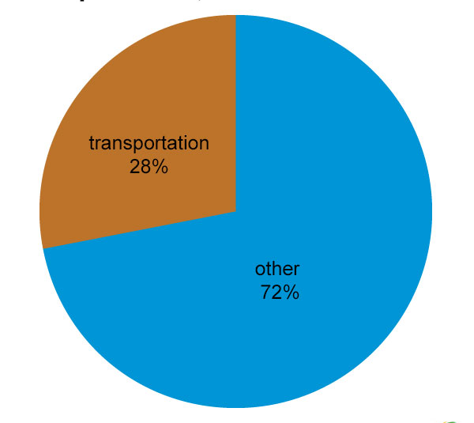
Figure 2 Share of Total U.S. Energy Used for Transportation in 2014. Source: U.S. Energy Information Administration, Monthly Energy Review (2015).

Furthermore, Figure 3 shows that 89% of the transportation consumption in energy was provided by petroleum and its related products (U.S. Energy Information Administration 2015). These facts suggest that transportation significantly contributes to the fossil-fuel consumption. In 2013, greenhouse gas emissions from transportation is attributable to about 27% of total U.S. greenhouse gas emissions, making it the second largest contributor of U.S. greenhouse gas emissions after the Electricity sector (U.S. Environmental Protection Agency 2013). Before 2020, the CO2 emissions could increase by 1.5% (U.S. Environmental Protection Agency 2013). Environmental issues and energy sustainability become increasingly important for future considerations about economic development and energy consumption.

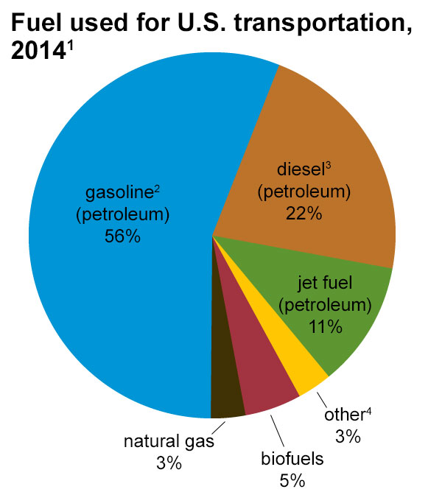
Figure 3 Fuel Used for U.S. Transportation by Energy Sources in 2014. Source: U.S. Energy Information Administration, Monthly Energy Review (2015).

In addition, it is also important to reduce dependence on foreign petroleum import to improve the nation’s energy security. The United States Energy Information Administration provided the historical data of the U.S. net imports of crude oil and petroleum products from 1975 to 2015 (U.S. Energy Information Administration 2015). In 2014, 27% of the petroleum products consumed were imported from foreign sources (U.S. Energy Information Administration 2015). It is the lowest level since 1985. From the plot in Figure 4 U.S. net imports of crude oil and petroleum products (U.S. Energy Information Administration 2015).Figure 4, we can clearly find that the Obama administration has been seeking to reduce the net imports of crude oil and petroleum products and the nation's dependence on the foreign energy sources.

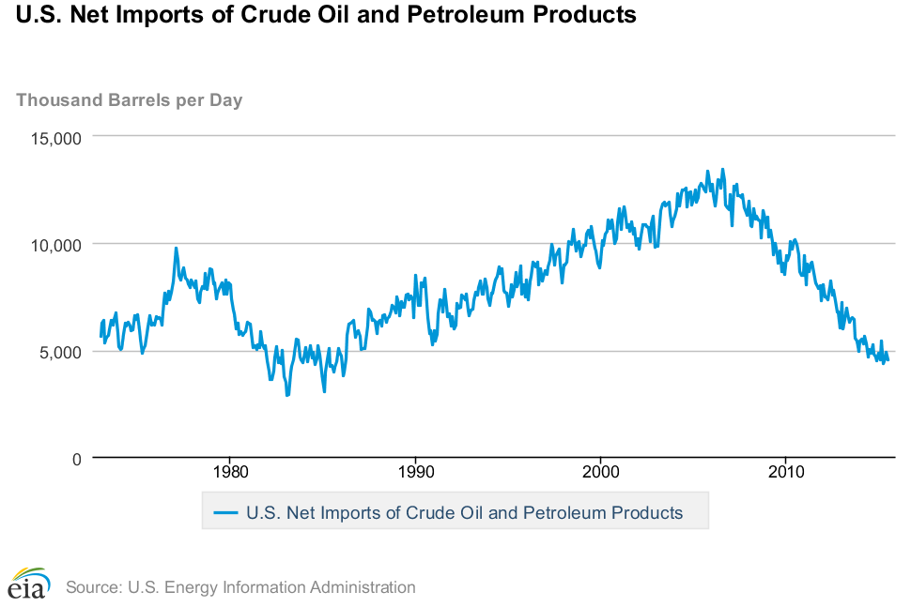
Figure 4 U.S. net imports of crude oil and petroleum products (U.S. Energy Information Administration 2015).

For the above listed considerations, the U.S. government initiated the plan to encourage the adoption of alternative fuel vehicles (AFVs) in the automotive industry, especially hybrid electric vehicles (HEVs) and electric vehicles (EVs). Compared to the conventional gasoline-powered vehicles that consume petroleum and other forms of fossil fuels, EVs are propelled by one or more electric motors powered by rechargeable battery packs are plugged into the electric grid which can be sourced from cleaner energy conversion plants (Daziano 2013). Because of this, HEVs and EVs are often identified to be an alternative solution to promote sustainable passenger and freight transportation and energy independence from foreign energy sources.
Since 1980s, EVs have gained increasing worldwide interest as promising alternative solutions to sustainable individual transportation or vehicle fleets in substitution for conventional ICE vehicles. EVs are capable of reducing fuel consumption, emit less greenhouse gas and cause less trouble to the environment. From the first generation of EVs, they have been promising a number of advantages over gasoline-powered vehicles such as better fuel economy, higher energy efficiency, quiet driving environment, and more importantly, improved environmental externalities. They are capable of converting up to 80% of the electricity from the grid to propelling power whereas conventional gasoline vehicles only convert about 17% – 21% of the energy stored in gasoline to power at the wheels (Department of Energy 2012). Since the gasoline price will probably raise in the future, lower fuel cost on EVs are considered the most obvious advantage financially. Electric motors provide quiet, smooth operation and stronger acceleration and require less maintenance than ICEs. The quiet driving environment in the cabin and better low-speed acceleration contribute to the advantages of EVs. Moreover, zero tailpipe emission when the vehicles operate solely on electricity partially solved the growing concerns from environmental issues.
The mass adoption of EVs are expected to be capable of substantially reducing the dependency on petroleum given that light-duty vehicles consumes nearly 50% of the petroleum in the United States today and that electricity is typically not generated from petroleum products (National Research 2013). According to the monthly electricity aggregation report from U.S. Energy Information Administration (2013), only 39% of the total electricity generate is from coal and a larger part of the total electricity is generated from clean source in recent years (U.S. Energy Information Administration 2013). Furthermore, low tailpipe emission could also contribute to the mitigation of air contamination. As shown in Figure 5, the potential energy conversion possibility and benefit, HEVs and EVs provide a promising and sustainable future in alternative fuel transportation.

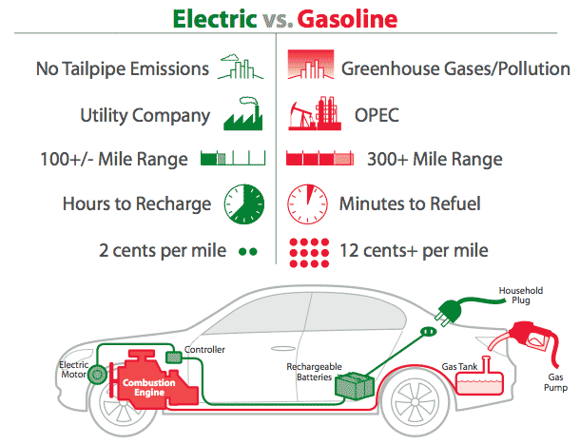
Figure 5 Illustration of the relative features of electric cars and gas-powered cars. HEVs contains both combustion engine and a rechargeable battery that offers many of the benefits of electric cars such as quiet driving environment and high fuel economy while it mitigate some of the drawbacks of EVs, such as limited driving range (Plugincars).

Because of the economically promising future in the market, the market share of EVs has been growing in recent years. In 2010, there were only two or three models in the market that were available to potential buyers (Trigg et al. 2013). Since then, the global EV sales soared up remarkably. Each year, the number of global sales was increased by at least 50%. Right now, there are 19 models show up in the market and the number is still growing. The hidden correlation between the availability of EV models and the sales number was found (Trigg et al. 2013). It suggests that the potential variety of choices in EV market could facilitate the consumer adoption that further in turn helped the manufacturers reinforce the development of EVs. This process forms a positive feedback loop to the EV market growth. According to Credit Suisse (2009), the expected EV sales will raise to over $400 billion by 2030. They forecast the market share of annual global vehicle sales could climb to as high as 7.9% by 2030 and that of HEV could reach 5.9% from 0.6% in 2009 as shown in Figure 6 and Figure 7.

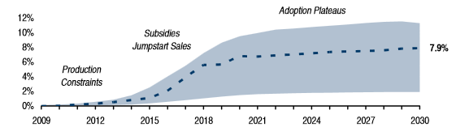
Figure 6 Global Electric Vehicle Penetration Rate Estimation by Credit Suisse (Credit Suisse 2009)

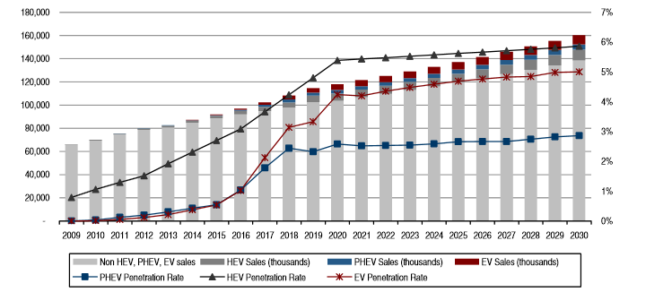
Figure 7 Summary of Forecast: HEVs, PHEVs, and EVs still represent a small portion of vehicle sales (Credit Suisse 2009)

The deeper into this industry, the more optimistic one finds. The Electricrification Coalition (2009) presented a quite promising development plan for EVs. They argued that the global grid-enabled EV sales will reach an uninspiring 12.5 million units per year by 2030 (shown in Figure 8). And they further announced a prediction that 75% of the vehicle miles traveled in the U.S. should be electric miles by 2040.

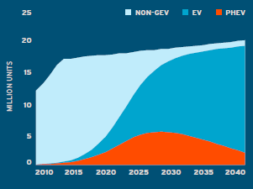
Figure 8 Estimated Market Penetration by Electrification Coalition (Electrification Coalition 2009)

Indeed, it is hard to be blind to the optimism in EV development in the long run. However, this long-term promising future plan requires a concrete solution to the current barriers that prevent potential customers from buying EVs or HEVs. President Obama predicted there would be one million EVs on the road at the end of 2015 and initiated a one-million EV challenge in 2012. The ultimate goal of this challenge is to encourage the technology evolution of the EVs and other green energy technology within a couple of years. During the four-years planning and execution, the U.S. is on her way to become the leader of the EV market. In the July of 2013, Plug In America declared that the 100,000th electric vehicle was sold in the US. The California Plug-In Electric Vehicle Collaborative announced that many EVs have now been sold in California alone (Blanco 2014). However, at the end of 2014, the total number of delivered EVs and HEVs was around 300,000, which is far short than the desired number. This does not mean that EVs will not become a major force in the automotive market. Quite contrary to that, the gas prices are not going to stay low for very long and the predicted price would be $5 per gallon in the future. The EV technology has been improved over the recent years and the customers become increasingly care about EVs. At the same time, the range and other utility function will also potentially contribute to convince future customers to buy EVs. They will finally merge into the core automotive market. Because of this, necessary analysis becomes even more important to explain the gap between expected sales volume and current one on book. Some barriers are technological obstacles, such as limited driving range and high purchase price compared with gasoline vehicles while some others reasons are related to consumer perceptions and attitudes and the need to develop a charging network to support the EVs on the roads.
Given the growing concerns surrounding the potential barriers, a number of analyses address the technological and marketing obstacles of purchasing green energy vehicles in current market (Kieckhäfer et al. 2014, Krupa et al. 2014, Kudoh and Motose 2010, Lieven et al. 2011, Segal 1995, Trigg et al. 2013). The main technological barriers preventing customers from purchasing EVs are the upfront purchasing cost, limited range and accessibility of recharging infrastructure. Most EVs can only navigate for a range around 100 – 200 miles with full battery while most gasoline vehicles can drive over 300 miles with full fuel tank. Few of the EVs can last for 300 miles but the corresponding cost is unaffordable to average American families. At the meantime, fully recharge the battery of an EV is averagely estimated to be 4 to 8 hours. Super Charger could reduce this amount to 30 mins but it is still too long for most drivers compared to 10 mins refueling in a gas station. As the heart of the EV, battery consumes most of the purchase cost and it has to be replaced at least once in the life cycle of an EV. Furthermore, the weight and space occupation of the battery pack can cost more energy and space which is already tight due to current technology.
In addition to that, consumers have little knowledge of EVs and rarely do they have any experience with the EVs before. Lack of familiarity with EVs and maintenance knowledge builds up a substantial barrier to the EV adoption. Limited driving range and lack of accessibility to recharging points with significantly higher price creates limited the willingness-to-pay for the EVs. The transition to electric cars seems to be urgent to government and automakers but consumers apparently does not feel that much sense of urgency on this matter (Tuttle 2015).

Electric Vehicles Customers
The study of customers' preferences in the automotive market could extremely helpful in identifying the barriers of selling EVs and other AFVs. Based on preliminary estimates, the expected number of registered passenger cars in California in 2013 was 1,063,000. At the same time, the sale of Tesla Model S in California was reported to be 8,398. The estimation proportion of Tesla Model S upon these numbers was 0.79% (Loveday 2014). Notable interest in EVs is growing. The question is what are the automotive market customers expecting from EVs?
The adoption of EVs depends not only on costs and prices but also on consumers’ attitudes (Peng 2013). According to a global report in 2011 (Deloitte 2011) that surveyed over 13,000 individuals in 17 countries,, the crucial discrepancy between the customer preferences and technology realization of EVs is found to be the high upfront cost, limited driving range and long recharging time (Deloitte 2011). There was only 12% of U.S. consumers were identified as first movers in EVs while this number was 59% in India and 50% in China. Over 50% of the U.S. consumers expected a driving range longer than 200 miles with full battery but only 41% of all consumers in the U.S. were willing to spend 2 hours on recharging. This result suggests that issues about charging the battery are still the big roadblock. People concern about how far they can drive with a full battery charge, whether public charging stations are near enough when they need them, and how long it takes to charge (Sustainable Business News 2013). Furthermore, in the U.S., the two most desirable types of EVs are mid-size sedan and SUV/crossover. Larger vehicles require higher consumption on the energy storage, which enlarged the disadvantage of limited range. It indicates that the difficulty of the EV penetration in current state and the major technological requirements of U.S. customers in the automotive market.

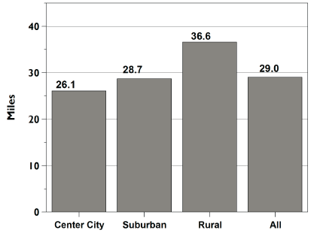
Figure 9 Average Daily Miles Driven (per Driver) (Davis et al. 2013).

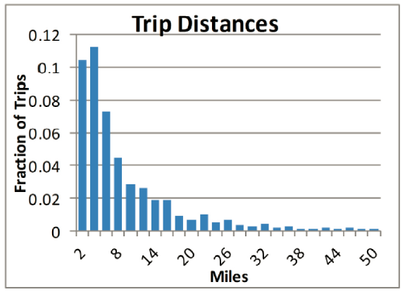
Figure 10 Daily Trip Distances Distribution (Krumm 2012).

It is worth emphasizing that in the Deloitte survey, 85% of the respondents expressed concerns or even extreme concerns on the driving range, accessibility to charge, and cost to charge in considerations for buying or leasing an electric vehicle (Deloitte 2011). As shown in Figure 11, the marginal willingness to pay for extended full battery range was examined in several studies in the U.S. market. From the plotted figure we see that the marginal willingness to pay was stable around $100 per mile since 1990s that shows a range anxiety to some extent for current EV models. The customers in the U.S. seemed to have higher sensitivity toward range than most of the other counties. Figure 9 and Figure 10 show that 50% of the daily driving distance is less than 30 miles; however, the satisfaction on a driving range of 298 miles was only 63%. It appears that consumers have a hierarchy of considerations regarding a purchase decision of EVs starting with range which followed by charge time and purchase cost (Deloitte 2011). When customers consider about buying or leasing an EV or gasoline-powered conventional vehicle, the driving range will be firstly compared and with no doubt that few customer will be satisfied with current technology status.

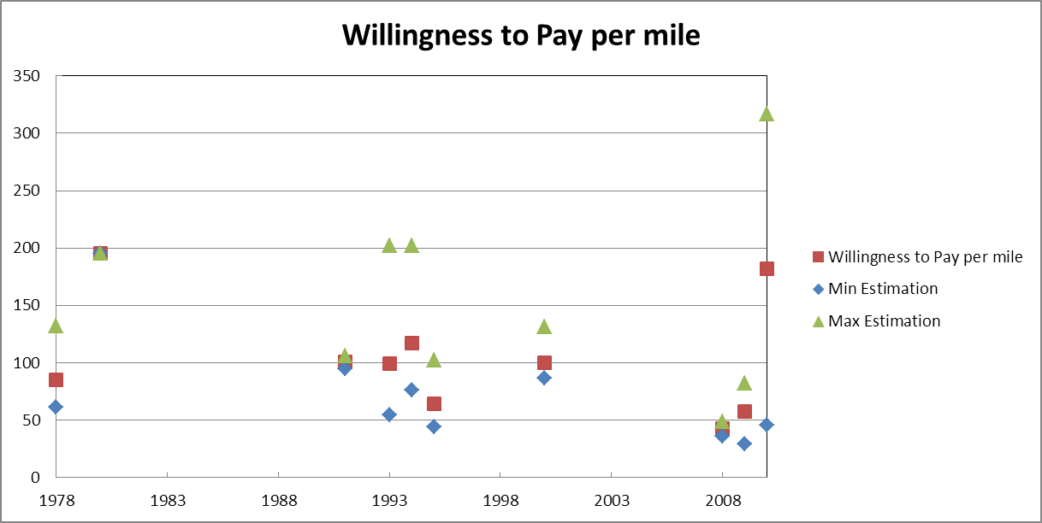
Figure 11 Willingness to pay estimates for marginal improvements in driving range. Results from studies in the American market. Source: Dimitropoulos et al (2013)

Another reason that deters potential customers from buying an EV is the density of recharging infrastructure. Innovation theory states that an innovation can hardly become popular alone. The penetration of one innovation heavily depends on a transformation into a 'whole product solution' (Moore 1991). In other words, the innovation alone is worthless to the majority of consumers in the mass market unless it can provide a complete purchase and usage experience to the customer with a combination of the innovation and a broad variety of complementary goods, such as supplementary products and after-sale service (Serra 2013). For example, the Windows can rarely be so successful without further development of Office Suite, Windows Media Player, and other useful application based on it. The complementary goods provide a secondary opportunity that persuades the consumers decide to buy and enjoy.
There is no doubt that the utility of EVs heavily rely on the accessibility of recharging spot because of currently limited range and long recharging time of EVs. Indeed, the EV adopters desperately need to either recharge or swap the battery before electricity runs out. But this is more like a chicken or egg problem. Without a considerable adoption, installing a widespread recharging network seems to be costly but useless while a limitedly distributed recharging facility system will probably deters customer purchase decision. However, installing a widely available recharging network is inevitably a critical objective yet an expensive system goal. The facilitating the adoption of EVs (Gao et al. 2008). Not surprisingly, the construction of recharging infrastructure can increase the market penetration of EVs which can in turn persuade the potential buyers accommodate EVs after they see an increased appearance of EVs (Blanco 2014). Nevertheless, this requires time and fiscal support which is unlikely to be propelled by any individual or single company.
Other than the dissatisfaction on driving range and the concerns about accessibility of recharging station, Graham-Rowe (2012) found the unfamiliarity of potential customers with EVs as an equally important barrier. Research showed that experienced EV drivers who already drove EV before had lower expected "psychological distance" to EVs. Current potential customers are lack of knowledge of EVs (National Research 2013). Approximately 33% sampled consumers were bothered by ‘unfamiliar technology’ when they were thinking about buying an EV (Hidrue et al. 2011).
The Energy Department found “automobile consumers tend to be risk-averse, preferring well-proven technology”, and “the performance and cost effectiveness of the early EVs in the market will be a major but unknowable factor in how many EVs are on the road by 2015” (Tuttle 2015). Analysts suggest that EV makers and government can emphasize on the education to the potential groups of customers based on their profiles (National Research 2013). The better penetration of the EV knowledge will certainly help with the market adoption.
Further into the effect of customer education, the purchase decision may also be affected by a tradeoff between a higher initial purchase price and a lower total ownership cost (TCO). Actually, an EV have a higher upfront cost than an ICE vehicle at the moment of purchase but a lower TCO due to the fuel economy, lower maintenance cost and other forms of financial saving by EVs (Trigg et al. 2013). But only a few customers know this fact. The purchase price charges on their psychological account and actual saving during usage is hidden and will hardly be taken into account. It needs a solution through introductory education campaigns that highlight the positive attribute of EVs.
Commonly, a very good way to start the education usually starts with the introduction and commercialization of AFVs based on a niche market of potential adopters. Identification of the customer groups that are more interested in the new green transportation technologies will help to convince them (Gärling and Thøgersen 2001, Peters and Dütschke 2014). Consequently, the remaining question on the demand side of this problem is how to identify and convince the seed-users of EVs and facilitate the diffusion of EVs through the social network.

Electric Vehicles Manufacturers
In recent years, automakers and consumers have shown persistent and significant concerns about climate change and environmental impact of human technology evolution. Over the last several decades, the industry dedicates to improve the environmental externality, fuel economy, safety, and customer comfort of new environment-friendly technologies. Among these technologies, EVs have become new forces in the automotive industry. The EVs makers are expected to find out the answers to a few crucial questions. Can customers afford EVs? Will they buy them? How much do government policies impact on the prices and market penetration of EVs? The answers to these questions will be delivered by the computed optimal pricing decision based on a discrete-choice model. The proposed study integrates captured preferences of various consumer segments and government regulations. In doing so, the computational results will reflect the predicted market acceptance and technology transition with policy impact.

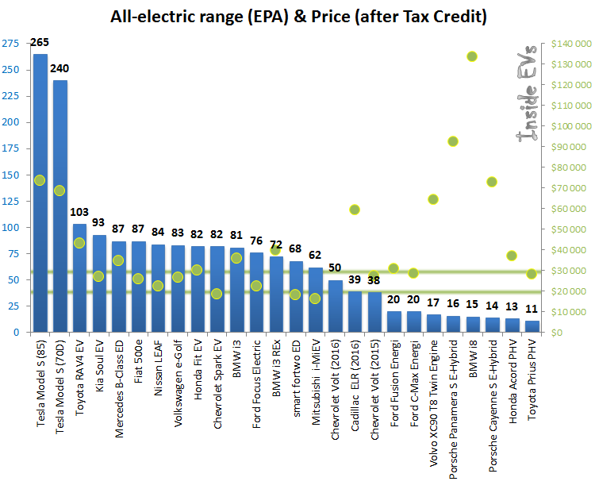
Figure 12 Plug-in EVs Range (blue bars) & After Tax Credit Price (green dots) (InsideEVs).

According to the previous discussion, there are roughly five major economic barriers that lead the consumers to be locked in petroleum powered ICE vehicles (the all-electric range and price in 2015 are listed and shown in Figure 12 and Figure 13) (Greene et al. 2014):
- Current technological limitation of EV powertrain system, energy storage, recharge and conversion.
- The scarcity of supplementary technologies for EVs that makes the EVs to be superior in the automotive market.
- High upfront cost that can be reduced in both learning-by-doing (experience curve) and economy of scale (large volume production).
- Consumer's risk aversion attitude to navel but non-superior technology in the market.
- Limited choice of EV models in the early automotive market.

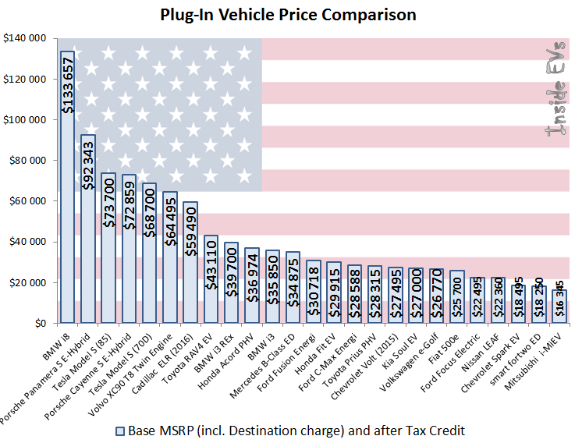
Figure 13 Plug-In EVs Base Manufacturer Suggest Retail Price (MSRP) After Federal Credit – United States (April 2015) (InsideEVs).

During the past decades since 2000, automakers have been focusing on the improvement of the EV technology. Let us take Nissan as a representative example of EV makers. Recently, Nissan just sold 130,000 Leaf in the automotive market and around 5,000 units each month globally at the end of 2014. In California, Nissan Leaf remains to be the best seller. It led the market with an increasing demand by 77 percent to nearly 48,000 cars, which makes up 45 percent of all zero emissions vehicles sold last year (Shankleman 2014). Nissan shifted the manufacturing plant from Japan to the U.S. which enabled them to reduced total price by more than $6,000 to $29,650. Now, Nissan stated that Leaf becomes profitable. This progress is primarily attributed to the reduced manufacturing cost and a growing demand (Sustainable Business News 2013).
In essence, the story about EV penetration could be converted to a simple supply-demand problem. If automakers could not get utilities up and costs down, consumers will not choose a worse commuting vehicle (Schaal 2015). According to the previously discussed customer attitudes, improvements need to be done in a number of topics, such as development of long lasing and abuse-tolerant battery technology, advanced electricity management system, reduced vehicle weight and accessible charging infrastructure. Moreover, the costs of these technologies are also required to be low enough in order to make EVs affordable to middle income U.S. families who will replace their gasoline powered vehicles in a couple of years. Figure 14 shows a perspective of remarkable efforts from EV makers in reducing battery cost. The industry-wide costs fell to around $410 in 2014 from over $1,000 per kilowatt hour in 2007. The market-leading companies could even contributed to an 8% per year falling rate, and they are expected to reach $300 per kilowatt hour in 2014 (green marks) (Clean Technica 2015).

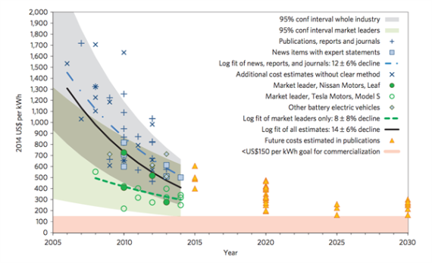
Figure 14 Cost estimates and future projections for electric vehicle battery packs, measured in $US per kilowatt hour of capacity. Each mark on the chart represents a documented estimate reviewed by the study. (Nykvist and Nilsson 2015)

Policy Support
In most cases, the support from government could help with the supply and demand side of EVs and contribute to market adoption (Trigg et al. 2013). As discussed in the previous sections, there are several reasons for the U.S. governments to corporate in the research and development (R&D) of AFVs. First of all, facilitating the market adoption of EVs is the crucial step to reduce U.S. dependence on foreign petroleum import and improve the nation’s energy security. Over the past few decades, the exploration and import of petroleum is becoming increasingly expensive. This has been considered to be a major concern of energy import and consumption for many countries. The governments at all levels are seeking a concrete roadmap for green energy solution for transportation energy consumption in the U.S.
Beyond the consideration for energy security, the worries about environmental sustainability and economic development are also becoming an indispensable concern. Customers care about the environment more than ever. The environmental awareness has been implanted into the consumers' product perception and purchase decision. This forces the automakers to work out their future plan for alternative fuel vehicles (AFVs) that fit well with the customers' expectation.
Last but not least, the research and promising development of AFVs provide fruitful opportunities for economic growth of each state and the entire nation. The facilitating of AFVs will inevitably conduct a construction plan for charging infrastructure which is likely to hit a business of $1.5 trillion in the U.S.. The rising battery industry will also contribute $500 billion to the total business. McKinsey & Co (Gao et al. 2008) forecasted a market value of $220 billion merely in Chinese market. Meanwhile, Credit Suisse (2009) expected the global EV and battery sales could exceed $500 billion by 2030. In addition, Warren Buffett (2009) showed notable confidence in seeing all road vehicles become EVs by 2030. Right now, he is the most famous stockholder of a Chinese green energy automaker BYD and he has been investing in this promising industry for a long time.
Considering the above mentioned reasons, the U.S. government initiated the plan to encourage the adoption of AFVs in the automotive industry, especially hybrid electric vehicles (HEVs) and electric vehicles (EVs). However, it has been proved to be a new conundrum to accomplish the expected goal of energy source transition for transportation. The duration of this transition may last for decades (Gallagher et al. 2012). The answer to this unsolved problem depends on a better understanding of dynamics between public policy makers and other participants in the automotive market. How should the government manage the transition effectively and efficiently?
From the marketing perspective, the interaction between governments, customers and automakers essentially affect the mass adoption of EVs and other AFVs. The success in market share growth and improvement in competitiveness of introduced products are usually derived from a proper pricing strategy. It seems like policy support from the government could present as financial incentive and non-financial incentive. Both forms are bearing fruit in helping market penetration of EVs. From the financial support to customer education, it seems to be safe to state that perhaps government policy will continue to play a significant role in the adoption of EVs (Deloitte 2011). In this proposed study, we will focus on the financial incentives as the first step in understanding and quantitatively assessing the guiding or restricting role of government support.
Since 1980s, governments at all levels have been providing financial incentives to encourage technological evolution and market adoption of green vehicles. A couple of years ago, governments sought opportunities to provide industry subsidies or partnerships to improve the performance characteristics of AFVs, such as the California Fuel Cell Partnership, in which the California state government collaborated among automakers, fuel providers, and a fuel cell developer (Gordon and Sarigöllü 2000). The purpose of such collaboration was to improve the research and development progress and market adoption rate of green energy vehicles.
Needless to say, the ultimate goal of the government intervention in AFVs is to uptake advance transportation technologies rapidly whereas the optimal outcome can only be yielded from the technology-neutral policy in order to avoid the silver bullet bias in the introduction process (Trigg 2013). Collantes and Sperling (2008) optimistically estimated the promoting effects of public policies on encouraging market adoption of new technologies while listed the existence of potential challenge. Actually, market penetration of new technologies has been significantly impacted by some incentive regulations for green technologies. At the federal level, $2,500 - $7,500 tax credit is currently effective, and President Obama has announced a probable increase to $10,000 (Tanaka et al. 2013).
At the state level, California is a pioneer of boosting the market penetration of EVs and other AFVs. Since 1990s, California Air Resources Board (CARB) have published a series of documents to require large volume automakers to deliver electric or equivalent zero emission vehicles in proportion to their delivered all passenger cars and light-duty trucks from 0 to 8500 pounds (lbs.) in California. According to the Zero Emission Vehicle (ZEV) mandate, failure to do this will be subject to financial penalty. Companies that have deficit on the ZEV credits are allowed to purchase credit from the companies who banked excess credit in the previous periods.
The objective of the ZEV mandate is to achieve the state's long-term emission reduction goals in the form of requiring manufacturers to produce and deliver low emission and zero emission vehicles to the California automotive market. The ZEV mandate is part of California’s comprehensive Advanced Clean Cars (ACC) program now. The ZEV mandate is intentionally providing effective driving force for shortening the time frame of the market penetration of EVs and other AFVs (Green Car Congress 2014). The ultimate goal of this policy will be met by gradually introducing encouraged advanced green automotive technologies, which include battery electric vehicle (BEV), fuel cell vehicle (FCV), plug-in hybrid electric vehicle (PHEV), and other corresponding clean cars certificated and available in the market. The commercialization of EVs is expected to be done in a mid-term plan with the help of the ZEV mandate.
In order to ensure the effectiveness of the public policy, before publishing the amendment, government agencies need to find out how the incoming policy will likely affect the automakers and indirectly impact on the consumers' purchase decisions. It is necessarily required to study the dynamics between government policy, automakers' pricing strategies and consumers' purchase decisions. Actually, during the implementation of the ZEV mandate, the requirements have been amended multiple times in order to keep pace with the technology development progress and market situation of ZEVs (CARB 1990, 2014). This study will focus on the ultimate goal of government policy agencies to improve the efficiency of public spending. The later proposed model will measure the market penetration achieved by public policy. With the probable constraints from the policy budget, there is an opportunity and necessity to compare the effectiveness of various government policies. Based on the comparison, the impact of public policies should be clearly figured out under different market conditions so that indicative policy recommendations can be suggested to the related government agencies.

Table 1 Eligible ZEV credits for each ZEV model in the market. Source: Jim Motavalli, plugincars (2013).
Model | Credits | ZEV Type
Scion IQ EV | 2 | Type I
Mitsubishi i-MiEV | 2.5 | Type 1.5
Fiat 500e | 3 | Type II
Smart fortwo electric drive | 3 | Type II
Nissan Leaf | 3 | Type II
Honda Fit EV | 3 | Type II
Ford Focus EV | 3 | Type II
Toyota RAV4 EV | 3 | Type II
Chevrolet Spark EV | 3 | Type II
Mercedes Benz F-Cell | 5 | Type IV
Tesla Model S 60kWh | 5 | Type IV
Honda Clarity FCX | 7 | Type V
Tesla Model S 80kWh | 7 | Type V

Besides the main purpose, since the credits are allowed to be traded between the automakers, the company that produces green technology is permitted to collect remarkable revenue by selling excess credits to the technology laggard companies. For instance, a delivered Tesla S model generates 7 credits due to its range and other technological specs (credit standard can be found in Table 1). Each credit can be sold at the price of $3,910 in the current credit market. Furthermore, there are nine other states following the ZEV mandate and the ZEV mandate brought Tesla a profit of $130 million in 2013. In 2014, Nissan sold 18,960 ZEV credits in California between October 2013 and September 2014. The remarkable profit leads to reinforcement to the green technology evolution. GM has reduced its transfer-in credit from 25,000 to 194 in 2014 by producing and selling Chevy Volt. Theoretically, the revenue from credits will reinforce the research and development (R&D) in green powertrain technology and equally likely, lead to a lower upfront purchase price. This dissertation work will look into the impact from the ZEV mandate on the pricing decisions of large volume automakers.

Purpose Statement
Over the last several decades, there is a need to introduce EVs and other AFVs not only for environmental reasons but also for energy independency considerations. EVs and other green energy vehicles have become new forces in the automotive industry. In this regards, the market adoption of green technologies has been become increasingly attractive to automakers and customers.
The primary objective of this proposed study is to investigate the dynamics of the technology pricing decision at the corporate level considering customer heterogeneity and influence of public policies. Before detailed analysis, we will present a model for the pricing decision of a company that offers an innovative technology (e.g. electric vehicles) and conventional vehicles. In this proposed model, the price of this new technology will affect market demands of both old and new technologies. The total profit from all offered technologies needs to be maximized by the company. The study will firstly address the market demand of an electric vehicles (EVs) model and the counterpart in conventional vehicles and the discussion will be further extended to the public policy impact on the technology pricing decision by the company. Analysis of the pricing decision and the policy impact on it will help to assess how well public policy could enhance the market adoption of electric vehicles. Managerial insights and regulation suggestions will be provided based on the final results.
This proposed research consists of three parts. Firstly, this research will study on the technology pricing decision of a company according to the market acceptance of EVs without government incentives. Secondly, the study will consider the influence of government policies and address the impact on the pricing decision of the company. Thirdly, this dissertation will extend the research to a dynamic control problem. The study will offer insights to the optimal approach that government controls public policy variables indirectly to meet a desired goal. Finally, the research will be possibly extended to an agent-based model (ABM) to investigate the diffusion patterns of EVs.
The first part is to estimate the market adoption rate of EVs in the current market that provides a baseline for further analysis and discussion. In this part, consumer choice is assumed to only choose between an EV and a conventional vehicle. Other than these two given alternatives, no further competition among clean energy vehicles is considered. Estimation on customer choices will be conducted based on a good understanding on the market structure and consumers' preferences. It refers to a detailed study on early adopters, and their willingness-to-pay for EVs. Additionally, the market adoption of EVs also depends on recharging infrastructure, state-of-art EV and other AFV technology specs. This study will lead to a better understanding and improved estimation on the market adoption of EVs. Accordingly, this investigation will help to identify some current barriers of EV adoption in the automotive market and show the necessity of external facilitation, such as policy support.
The research in this part will utilize a discrete choice modeling approach. To the best of our knowledge, multinomial logit (MNL) and nested multinomial logit (NMNL) models are the most popular and efficient method to characterize market heterogeneity. In this dimension, customer utility will be decomposed and projected to technology features. Furthermore, the retail price will be incorporated as a decision variable in consumer choices. The yielded demand helps to address the market adoption rates at different EV prices. Assume the objective of the innovative company is to maximize her total profit from both EVs and conventional vehicles in one period, the result will show the demand of the selected EV adoption rate at an optimized pricing decision of the company. This result of market adoption rate without any government policy inference is defined as a basic scenario.
Based on the proposed model in the basic scenario, the proposed research will introduce public policies into the market dynamics and is expected to show the impact of public policy in facilitating market adoption or improving profits of automakers that produce EVs. In this part, a generalized model for policy assessment will be built based on the model from the first part. Policy parameters and variables will be incorporated into the model. In doing so, the market adoption with policy impact will be forecasted and the magnitude of policy impact will be addressed theoretically based on the model. Furthermore, within this practice, the ZEV mandate in California will be selected as an example for detailed case study to obtain managerial insights for further study and future regulation suggestion.
This part of research will focus on an unanswered question of "how should the government adjust policies to boost the market penetration of EVs in long term"? The research in this part will extend the single company and single period analysis into a dynamic case with multiplayers and multiple periods. The government is assumed to control the credits granted to a new technology according to given initial demand profile and final goal of EV adoption rate by a certain deadline. In doing so, the government is expected to indirectly control the pricing decision and market demand of EVs by dynamically changing control granted credits to the new technology. The study will also investigate the policy impact on the market penetration of EVs.
The analysis will be focused on the optimal control policy of the government. The optimized control will be conducted over time within a finite time horizon with a given goal at the final stage. The final result should reflect an optimal path which consists of optimal policy design from government. Each point on this optimal path will also represent an optimal reaction from the innovative company to the policy background. The final result will represent an optimal solution of controlling technology credit requirements in order to essentially improve the market adoption rate of EVs.
Technology involution refers to a process that a company (she) narrows her investment choice without transition to higher level technologies. This study will address the reason of why technology involution happens and the possibility of preventing involution with policy support.
At this stage, the study will consider a technology choice decision of a company that is capable of consecutively developing several technology generations. A new model describing the decision of this company will be built including benefit and cost for each technology. Benefit and cost of each technology are exogenously given and presumably, lower generations always have less cost and benefit than higher generations. The company needs to make a decision about when to switch from old technology to a new generation. The result at this stage should be able to describe the reason of locking in lower generation technologies even though these technologies have insufficient capability of recovering the overhead cost.
In order to break and prevent the technology involution, government policy support will be considered in an extended model. In this extension, the model will be rewritten into a generalized form that can be deployed for several policies. Then policy parameters will be incorporated into this model and supports for each technology will also be assigned. The result is expected to figure out specific ways that government can proactively prevent technology involution. The comparison will be also conducted for impacts of different policies.
The evidence of this part will be chosen from the case study of the ZEV mandate. Emphasis of this study will be placed on examining the role of the ZEV mandate in boosting technology transition. In this part, three types of vehicles will be chosen as consecutive technologies: conventional fossil-fuel powered car, hybrid electric car, and electric car. Demand curve for each technology will be regressed into polynomial functions in their own prices and will be finally converted and characterized by their overhead costs according to a presumable cost-plus pricing strategy. Based on that, each profit function will be expressed as a function of overhead cost. To address the contribution of public policy, the investigation will compare the profits from products and credits selling, and the differences in their respective peak position will show the role of the ZEV mandate in California EV penetration. The conclusion of this part will mirror a couple of crucial requirements to facilitating technology transition by public policy.
In addition to the above proposed study, this research will be possibly further extended to a technology diffusion branch with policy impact. In this potential study, ABM and network-based diffusion model will be deployed in order to investigate the diffusion process of EVs.
Currently, EVs are introduced intensively in California and have been mostly adopted in several metropolitan areas. Consider a diffusion possibility that EVs are diffused from these metropolitan areas to neighboring areas due to presenting frequency in each area and geographic distances between them. The potential diffusion rate will depend on the geographic, demographic and policy factors. These factors can actively prohibit or facilitate the market penetration of EVs from these cities to a broader area. With this knowledge in mind, research at this stage will find diffusion patterns in defined area and refine the assessment of public policies.
In this step, the proposed approach is expected to model each individual consumer as an agent who decides to buy one of the available vehicle models in the automotive market. In order to characterize the diffusion patterns after any purchase by these agents, geographic, demographic, and policy factors will be introduced into the model and corresponding parameter values will be assigned to each agent. These agents are assumed under influence of others in the market through explosion of advertisement and frequency of presenting EVs nearby. The possibility of purchase will be determined not only by those assigned factors but also by the external influences nearby. This model practically mimics the purchase decision of consumers. The dataset of California automotive market and the results from previous parts will be deployed in this step. In doing so, a set of EV distribution heat-maps are desired to show us the market penetration in different geographic areas and demographic levels. This result will provide an improved understanding of diffusion dynamics and locate critical areas or consumer segments in the market penetration of EVs in California.
Most of the data required for the study will be obtained by the MA³T model from the Oak Ridge National Lab. The utilization of this dataset provides a more precise and promising estimation on the market structure and consumer preferences. The MA³T model forecasts vehicle sales among 1,458 consumer segments in the automotive market. The demand heterogeneity from consumer segments are measured with respect to regions, residential areas, driving patterns, technological attitude, home charging and work charging access.
In the first part of this study, the simulation result from MA³T indicates an estimated market share of targeted EV models and the demand curve can be characterized by pricing decisions of the innovative company. In this endeavor, the optimal price will be derived from a regressed demand curve and further analysis will be capable of characterizing the market penetration with the optimal pricing decision of the innovative company.
The investigation on public policy effectiveness will be built on the analysis and conclusion from above. Utilizing the regressed demand curve, the study will examine the improved market penetration of EVs in California. The regulation impacts of the ZEV mandate on the adoption rate of EVs in the automotive market will be extensively studied and compared with the basic scenario.
In the second part of the study, the study in this part will also utilize provided database for dynamic control approach attempt. The database will help to solve the problem and find an optimal path for a given ultimate goal at the final stage.
As of the benefit of utilizing the MA³T model data, the analysis in the third part will be also conducted with this data set. Demand curves will be regressed into polynomial functions in their own prices and will be finally converted into their overhead costs according to a presumable cost-plus pricing strategy. Each profit function will be expressed as a function of overhead cost. The result will show the role of the ZEV mandate in California EV penetration.
In the final attempt of this study, the estimated demand in California from MA³T model will be break down to county level and provide a geographic distribution of current EV buyers on the map. Along with that, demographic data will be retrieved from the U.S. census database and customers' external influential factors, e.g. explosion strength to EVs, will be assumptively assigned. With these data, an ABM will be built within a hypothetical network. The structure and property of this network should mirror an abstractive representation of the real world. The agents of this model interact through this hypothetical network and affect others' decision on vehicle choices based on their inherent properties and the designed network characteristics. Therefore, the simulation result from this model will show a set of technology diffusion patterns that indicate the properties of EV market penetration. And these patterns will provide implications of some essential focal points in diffusing EVs in the future.

Chapter 2
Literature Review

Technology Diffusion Models
Technology diffusion, or diffusion of innovations, refers to a process that old technologies are gradually replaced by newly invented ones. It is a theory that addresses explanatory solution for how, why, and at what speed innovations are adopted within a given network (Safar 2011). The studies in this field seek to explain the mechanism of the new technology penetration. This dissertation work will adopt this idea in order to study the dynamics of green energy vehicles adoption, especially in the California automotive market.
The earliest and the most popular introduction of the technology diffusion theory is from the book written by Rogers (1983) , which was first published in 1963. In his book, Diffusion of Innovations, he introduced the idea of innovation diffusion process. He argued that the diffusion took place in a wide variety of channels over time among the innovation receivers in the social system. The diffusion within the channel was subject to the influence of environment and adopters' attributes. The key elements in this process would be: innovator, adopter, communication channels, time and social system (Ghoshal and Bartlett 1988, Meyer 2004, Rogers 2010, Strang and Soule 1998).
The innovation diffusion theory was first characterized mathematically by Bass (Bass 1969, Mahajan et al. 1991). The Bass Model consists of a simple differential equation with a set of endogenous given parameters. The basic assumption of the Bass model is that the timing of a consumer's initial purchase is influenced by the existing buyers (Bass 1969). As illustrated in Figure 15, the Bass model characterizes the macro level penetration of technology adopters and describes the diffusion process among a group of adopters. All adopters are classified into innovators or imitators. The innovators invent new technology and sell it in the market. The imitators adopt the innovation with the influence of innovativeness and the degree of imitation among the adopters. The speed of imitation is subject to the degree of innovativeness and other market related parameters such as imitation cost and market demand profile (Bass 1969, Bass 2004). The Bass Model forecasts new products adoption rate at a macro level and provides insights for the entire market.

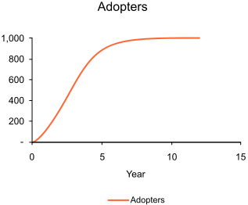
Figure 15 Illustration of the Bass Model Simulated Adopters over Time (Mahajan et al. 1995)

The mathematical model of the Bass model in the diffusion process is described by
$\frac{f(t)}{1-F(t)}=p+qF(t)$, (1)
where:
$f(t)$ is the change of the installed base fraction,
$F(t)$ is the installed base fraction,
$p$ is the coefficient of innovation,
$q$ is the coefficient of imitation.
In the above equation, $f(t)$ describes the adoption rate of imitators whereas $F\left(t\right)$ denotes the fraction of innovators. The proportion of changing imitators to the fraction of current innovators is characterized by $p$, $q$, and $F\left(t\right)$ where $p$ and $q$ are parameters that impact on the changing rate of innovators.
The Bass diffusion model provided a mathematical characterization of the innovation diffusion process. Researchers usually choose the proper parameter values and take them into the Bass equation. The solution of the Bass model represents the forecasted new product penetration process. In order to characterize and study the EV market penetration, this dissertation work will introduce the Bass model and its methodology into our study. In our study, clean energy vehicle automakers will be modeled as innovators. EV as the new technology will be introduced first in some metropolitan areas and distributed through a few channels. The diffusion of EVs takes place in advertising and other possible information distribution channels of the automotive market. Overtime, the message and the features of EVs are spread within the social network. Some customers will have a chance to find EVs early and potentially purchase them. These customers will be treated as early adopters. The more efficient the adopters are convinced by EVs, the higher the adoption rate this system will have. The dynamics of improving the EV adoption rate is characterized as market penetration. In the later proposed model, the process of market penetration will be characterized and studied. This research plans to incorporate the customer perception with the company pricing decision so that we are allowed to study the mechanism of EV adoption and market penetration.
The advantage of using Bass model is its simplicity and easiness to solve. However, there are a few things that may need to stress before using this model. First, the basic Bass diffusion model is mainly focused on the macro-level. It does not explicitly reflect micro-level competition among technologies. Second it cannot forecast demand for future products that have not been introduced yet (Lee et al. 2006). That means the Bass model is impossible to trace the change of adoption rate to the impact of various influential factors. Third, the predicted rates from Bass model are computed based on historical data and market environment parameter settings in the previous studies. The result only reflects the forecast from past and subject to change whenever the environmental factors shift drastically. Finally, the Bass model includes no explicit pricing variables to the forecasted diffusion rate and the customers are treated homogenously. The customers are treated as a homogeneous group of receivers rather than heterogeneous individuals with various preferences. The solution to this model can only be interpreted in a macro level. It will be less effective in disaggregating the result into market segments and. Finally, the Bass model mainly considers the diffusion over time and no spatial parameters are included the equation. Contrary to that, the market penetration of a new product possibly depends on its location or distance between innovators and adopters. The spatial discrepancy of cities and counties may contribute to the significant difference in the parameter values. If that is the case, the forecasted result from the Bass model may be biased.
Because of these problems in the Bass model, a few changes may be needed to yield more precise estimation on micro level market penetration dynamics. There are some other researches that may be valuable to notice. Hohnisch (2008) studied new-product diffusion with a percolation-based model. The model studied the diffusion of a new product in the social network with both timing effect and psychological distance influence. He found learning effects and network effect caused delayed takeoff happens in a percolating regime. Later in the same year, similar study was conducted by Cantono (2009). A lognormal distribution of customer reserved price was adopted instead of uniform distributions in previous studies. The market was latticed and each customer can be and only influenced by the neighboring "lattice points". The new model explained the take-off of new technology diffusion and investigated the influence of subsidy on technology diffusion.
Different from the Bass model, in which the diffusion process is a characterized by single differential equation, the percolation model explicitly consider customer heterogeneity and assign inherent reserved price to each potential customer. The percolation models describe the purchase probability with a given statistical distribution. The distribution is provided based on the psychological or marketing studies. The estimation on the distribution of reserved price may cause bias or misunderstanding on the dynamics of technology penetration. Furthermore, the study of percolation with network effect heavily relies on the construction of social network. The result can be distinctively different in various forms of social networks. In other words, the explanatory insight from percolation model may lead to errors on policy recommendations.
In this dissertation work, our research will utilize the Bass model for macro level understanding of EV market penetration. In addition, discrete choice model, which will be introduced later, will provide a micro level interpretation of EV market penetration including technology features and customer attitudes. These factors will be reflected in the parameter settings in the macro level model. In doing so, the identification of the purchase barriers will be focused on the customer side and the mechanism of market adoption will be studied in a bottom-up way. In the last part of our research, we will adopt the percolation model with an agent-based model, which will be introduced in section 2.6. The integrated model should be allowed to provide insights of diffusion patterns in EV penetration in California automotive market.

Pricing Strategies and Models
When introducing new products, pricing is one of the most important tools in marketing operations. Compared to other methods, the influence of pricing strategy is more direct and effective. The communication based on price is the most efficient channel to interact with prospective buyers. The changing of price can effectively implement promotion or proactively react to opponent's decision.
In marketing science, most previous studies focused on the cost plus pricing strategy. That is, the final price is computed based on the allocation of manufacturing and other related cost and a given profit margin as
$p=(1+α)∙c$. (2)
The advantage of cost plus pricing is its simplicity and easy to adjust. The manager is only required to figure out the cost. Contrary to the consumer based pricing, which requires the company price setter to figure out what the customer really wants, cost plus pricing shows no consideration about consumers. Managers are not required estimate customer preference or even the optimal price. All these things are implicitly included in parameter $α$ which is set up by empirical studies. This simplified pricing strategy may cause significant profit loss for popular products. Sometimes, consumers are willing to pay more for popular product such as iPhone, but it is not explicitly considered in the above equation. However, this pricing logit takes responsibility of long-run survival and contributes to the stable total profit.
There are several more sophisticated pricing methods in marketing science, such as market skimming, market penetration, competitive pricing, perception pricing, and value pricing (Grunenwald and Vernon 1988). The first two pricing strategies correspond to the market share competition, either penetrating in a new market or proactively protecting the occupied market share. Perception pricing and value pricing are usually determined by the estimated market condition such as an understanding of perspective consumers. Before a pricing decision is made, the vendor assesses the percept value of product to potential customers. Usually, this value is consistent with the utility over attributes of the product can offer from purchasing and utilizing. However, a closer look at pricing strategies relies on the mathematical modeling rather than qualitative discussion.
Our review on pricing models primarily focused on two areas of topics: single period pricing (Little and Shapiro 1980, Mesak and Clelland 1979), dynamic pricing (Gaskins Jr 1971, Kalish and Lilien 1983, Magee 1977). The first line of research is in static pricing (Little and Shapiro 1980, Mesak and Clelland 1979). Lots of studies on static pricing could be dated back to 1970s and 1980s. Static pricing assumes that the product price is determined in a defined period and it can be derived for any scenarios by solving the equality equation of marginal revenue and marginal cost. Often, researches in this topic use the demand and supply information to measure the revenue and cost respectively. The measurement of revenue and cost reflect how much customers are willing to pay and indicates an optimum price to maximize the profit or the market share in the defined horizon.
The second line of research is dynamic pricing which has been discussed intensively. The focal points of the researches in dynamic pricing seem to be emphasized on new products because dynamic pricing appears to be more effective in seeking optimal prices for new introduced products (Bass 1969, Jeuland and Dolan 1979, Kalish and Lilien 1983, Simon 1979). Theoretical study in this field correlates the research in life cycle, experience curve, and market growth. Furthermore, dynamic pricing has also been extensively and efficiently deployed in the studies on the diffusion of innovation. It seems to be worth of stressing the research progress in dynamic pricing.
The study of dynamic pricing started from 1960s. Arrow (1962) studied on the long term resource allocation in economic development. He introduced the concept of appropriability and developed the conceptual framework for optimal resource allocation problems. The discussion of this paper was taken from the welfare economic perspective. Arrow (1962) concluded that the innovative firm who invented a new product could extract profit from the market but the total collected profit would depend on the technological characteristics of the invention and the market nature.
Later after that, a wealth of information was found in various papers (Dockner and Jorgensen 1988, Gaskins Jr 1971, Kalish and Lilien 1983, Magee 1977, Robinson and Lakhani 1975, Solomon and Georgianna 1987). Relevant researches about this topic have been dedicated to study the relation between pricing a new technology and the long-term profit from this new technology. Normally, after a new technology is invented, the imitators will copy the invention and catch up with a speed that depends on the difficulty of this innovation. During this process, the profit for the innovator erodes as imitation catches up. The research showed a necessity for innovative company to decide an optimal price for the new technology. The objective should either be maximizing the long-term profit or reinforcing the short-term profit.
Further studies in dynamic pricing field were built on the theoretical basis of control theory. Control theory refers to interdisciplinary studies of engineering and mathematics problems. These problems are either requiring the researchers to achieve a given final state or asking for the final state given that the system is controlled in a predefined way. In economic related topics, researchers are often desired to control the system state by changing some predefined variables until the system reaches the final state. The state of the system is represented by a state variable and it is connected with the input variables through a Hamiltonian equation. The solution of this type of problem reflects an optimal philosophy to control the system in order to reach the final state. The extensive application of control theory can refer to the research in economics, ecology, sociology, biology, and engineering.
The studies in the new product pricing problems often connect the pricing decision with time dependent demand and investigate the optimal path to the final state. A large number of papers seek to explain the interaction between the innovation and its derived demand in the market. In 1971, Gaskins (1971) developed a mathematical model for dynamic pricing problem of a new product. The innovative company can either charge for the short-term profit by increasing price or for the long-term profit by limiting the price (as shown in Figure 16: thick line for optimal path and thin line for short-term profit pricing path). Gaskins (1971) found that companies choosing short-term profit usually ignored the entry threat from potential imitators and the market share was gradually eroded by late movers. By contrary, Gaskins (1971) introduced an optimal pricing dynamics for long-term gaming between innovators and imitators and justified a balance between short-term and long-term profits. Robinson and Lakhani (1975) proved this conclusion by modeling new products penetration. Magee (1977) applied the Gaskins model (1971) to the pricing problem of technologies. He derived the optimal path of long-term technology pricing for the dominant innovator. As shown Figure 16, the curve $AJ$ characterizes an optimal path for pricing the new technology whereas the thinner solid curve describes a pricing decision that is more emphasized on the short-term profit. The intersection of the two curves can be found by an equilibrium point where the demand for the new technology starts to drop because of the cheaper products from the followers in the market. This paper gives an insight to the optimal pricing path with respect to the non-cooperative followers.

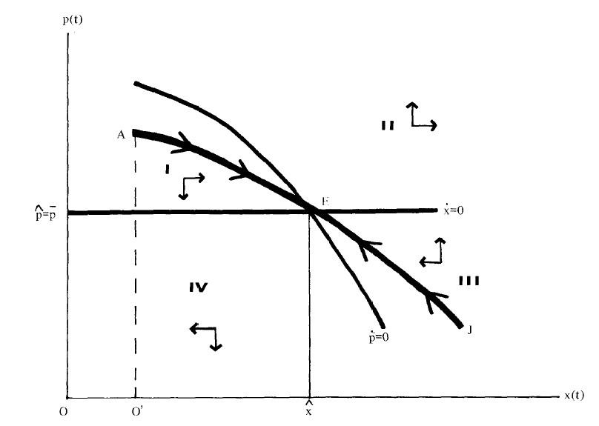
Figure 16 Long-term Relation between Technology Price and Technology Diffusion Rate

Kalish and Lilien (1983) studied on the Federal government subsidized programs for alternative energy sources in the market. The price of the alternative fuel supply was incorporated in their model and subsidized over time. Both learning effect and work-of-mouth effects are considered in the model. The new technology met a number of standards after multi-period control by the government. The result justified the need of government support in new technology development and penetration. Based on their study, Dockner and Jorgensen (1988) attempted to provide answers to the competition problems in dynamic pricing (Kalish and Lilien 1983). They found remarkable contribution of learning effect and demand expectation in dynamic pricing. Solomon and Georgianna (1987) extended the discussion of subsidizing new energy sources to a few more conditions. They found the significance of regional value added and the distortion from externalities in the market. The consideration was incorporated into the Baumol and Bradford theorem (1970) on optimal deviation from marginal cost pricing and suggestion on optimal subsides were provided at the end of the study. More related to this research topic, Peng (2013) studied on optimal subsidy policy that was designed to accelerate the green products diffusion. They considered a dynamic duopoly market with one company sold conventional products and the other one sold green products. They found the subsidy level was highly correlated to the energy performance and the initial purchase cost of the green products and the awareness of the consumers.
In summary, price modelling is a crucial part of pricing research. It is extremely important to find the correct technique to study pricing decisions. Based on the estimation of demand, it provides the basis for quantitative analysis of optimum operation pricing points and competitor responses. Pricing at optimum points in marketing operation can differ one company from others in the long-run. However, it still depends on various conditions in the market and product attributes. The previous mentioned studies treat the product as an entire entity without further considering the dimensional utility of the product, which is fine for the daily consumer good. In this proposed dissertation work, the technology and more specifically the green energy technology in automotive industry will be likely to perform as durable goods which ignore depreciation in the pricing period.

Durable Goods Pricing
A durable good is a good that usually is not completely consumed in one time. It often last long and could be consumed repeatedly in multiple periods. This means that the utility of a durable product endures over time so that a durable good may be qualified to be resold as a used good in a second-hand market.
Pricing a durable good is complicated in many ways. Durable goods can last for longer time than perishable goods and therefore the estimated demand is often in a discrete manner. In addition, repeat purchase is often impossible for limited budget or long-lasting utility for consumers. Because of these, durable goods production faces a crucial problem of being either sold out or held as inventory for multiple periods.
It is worth to stressing that most of the research in durable goods pricing appeared in the 1960s and 1970s. Among these studies, Swan and Sieper (1973, 1970, 1971, 1972) made the major contribution for establishing the theoretical framework. They built a series of models in their papers and compared the production outcome of a company with or without price regulations. They (1972) showed that monopoly and competitive firms selected the same degree of durability to minimize the cost of providing service, and this durability choice were not influenced by the price or demand condition as long as the firms were allowed to operate under elastic demand. In some specific conditions, price regulations may appear to control the maximum allowed price in the market. They proved that the regulations had no effect on the product durability choice unless the regulator attempts to force the firm to operate in the inelastic demand portion.
In this proposed study, the consideration about both the new technology and old technologies fits well with the previous modeling for durable goods pricing with secondary market. An invented technology can often last for a longer time than consumer goods such as food and office supplies. This new technology and the products that equipped with the technology can be treated as durable goods and ideas in durable goods pricing can be borrowed accordingly. Since this work will consider the influence of existing technologies, the new technology pricing problem will be treated as a durable goods pricing problem. In this durable goods model, quality improvement exists over time and used products will be or not be allowed to be resold in the secondary market.
The analysis of relation between improved quality and used durable goods will indicate a potential opportunity to optimize new technology pricing. In, 2007, Esteban and Shum (2007) analyzed the correlation between durability and equilibrium firm behavior in the secondary automobile market. They found the elimination of the secondary market led to an increased output from the manufacturer. Waldman (1996) considered a durable goods pricing and durability decision problem of a monopolist. He found the trade of old products in the secondary market put limitation on the charge of the new product. Due to this depending relation, the monopolist had motivation to reduce the durability of the product from social optimal level. Complementary to this study, Baranski and Peck (2013) addressed the subtle interaction between the new products price and the old products resale price. Interestingly, in the secondary market, the sales volume of used products is not monotonic in quality gap improvement of the new products compared to the old products. Nicholas Economides (2000) extended the study of competition between old and new products. He built a multi-period monopoly model for the software market. The model further considered the effect of network externality which could affect the sales of old and new products due to their compatibility. He found the network externalities could essentially impact on the introduction of new products and contribute to the successful market entry.
In this dissertation work, we will consider further consider the network externality in the final step which is possibly the additional extension to our study. The result of this part should indicate the externality of the new technology purchase and the effect of government policy on this externality.

Discrete Choice Models
Discrete choice models, or qualitative choice models, describe, explain, and predict choices between two or more discrete alternatives (McFadden 1978, 2001, Train 1986, Train 2009), such as decision to develop electric or conventional ICE powertrain technologies. Discrete choice modeling is a common, tractable and parsimonious method in trajecting customer preferences over product characteristics.
Common multinomial choice models with correlation among alternatives, include nested logit model (Heiss 2002, Heiss 2002, Kling and Thomson 1994, Kling and Thomson 1996, Train et al. 1987), generalized extreme value model (Goldberg and Verboven 2001), conditional probit model (McFadden 1974), and mixed logit model (Batley et al. 2004, Brownstone et al. 2000, Brownstone and Train 1998, McFadden and Train 2000, Train and Winston 2007). The multinomial choice models enable researchers to decompose consumer's choice by technology features. In doing so, the given knowledge of product characteristics provides a deeper insight for estimating the desired market demand (Berry 1994). The estimated demand considers customer heterogeneity and correlates the desired produce properties with customer preferences in order to examine the probability of market penetration.
Over the past fifty years, a better understanding of market heterogeneity helped automakers to realize the increasing importance of customer preferences. An inconsistence between technology features and customer preferences will often lead to a failure in product introduction. A successful product manager is required to understand his customer before making decisions (Sudhir 2001). Some manufacturers have required their engineers to be involved in the marketing decision process. Therefore, customer perception becomes the origin of the marketing decision and customer choices are able to be explained by technology attributes. The pilot studies enabled followers to evaluate the purchase probability by quantitative decomposing customer choices and connected those choices with product features including selling price. Industries then incorporated the implications of these research results into business practices (Clark and Fujimoto 1991) for identifying the barriers and the motivations to purchase electric vehicles (Ziegler 2012) and responded accordingly. In this process, discrete choice models take the central and crucial position to investigate various markets.
There is a long history for discrete choice models and they have been received increasing attention in both theoretical and empirical studies. The earliest and the most notable study can be dated back to 1974. McFadden (1974) proposed a consumer theory that linked unobserved preference heterogeneity to a fully consistent description of the distribution of demands. Train (1987) considered nested choices and improved the model for local telephone service study. In the same year, Bresnahan (1981) investigated the automotive market price setting condition with discrete choice model. In his model, the product characteristics are treated as exogenous parameters but the product prices are determined within the model. The discussed automotive market was filled with vertically differentiated products. Consumers evaluated product quality based on the observed product characteristics.
Train and Winston (2007) investigated the declining market share of U.S. automakers with a mixed logit model. The paper developed a consumer-level model of vehicle choices and shed light on the erosion of the U.S. automakers' market share over the past decades. Vehicle attributes, brand loyalty, product line characteristics, and dealerships were examined and a significant share of the loss in market share can be interpreted by downward shifting in basic vehicle attributes. Over time, the literature has expanded beyond to the socio-demographic factors and environmental awareness (Ziegler 2012) as important factors that affect vehicle type choice (Helveston et al. 2015).
The above models were built based on the given knowledge about product characteristics. Different from the previous models, Berry (1994) estimated market demand in a substantially different path in the presence of unobserved product characteristics. He considered a more generalized circumstance in which the product may be differentiated with customers' perceptions or nominal variables that are rarely quantified, decomposed or parametrically measured but are frequent and crucial determinant of demand patterns. The proposed model allowed the econometric studies deal with endogenous prices and inherent difficulties of observing all product properties. It provided a further interpretation possibility in the inspection of market demand structure.
While some researches touched customer heterogeneity and measured potential market size of new technologies, no integrated pricing model with customer preference has been proposed. Among the previous studies, the most popular econometric models by far for forecasting market adoptions for new products are logit and nested logit (Ben-Akiva and Lerman 1985, McFadden 1974, 1978). However, prices were incorporated into the model as a fixed parameter. The given upfront prices only represent the real or hypothetical vehicle attributes. Such attributes are considered to be an influential parameter rather than a decision variable which is capable of facilitating market penetration. In this proposed dissertation work, a pricing model will be built to connect the market penetration with company pricing decision and extensively discuss policy impact on the pricing decision based on this proposed model.

Chapter 3
Research Results and Analysis

Electrical vehicle pricing and market adoption: a study on the California automotive market
This dissertation presents a comprehensive study on the market adoption of electric vehicle and policy impact of the Zero Emission Vehicle (ZEV) mandate in the California automotive market. This research is primarily consisting of three parts. The author first built a technology innovation pricing model based on multi-nomial logit modelling method. This studies the dynamics among customer preferences, market acceptance and policy impact on vehicle pricing in the California automotive market. Results show that the ZEV mandate could profoundly enhance the market adoption of electric vehicles. There is a threshold on the magnitude of policy intervention. If the number of credits per vehicle is less than the threshold, increasing intervention promotes the EV market penetration; however, beyond the threshold, policy primarily benefits automakers.

Research Framework
This study aims to examine the impact of California's EV policy on the market penetration of EVs. The analysis framework is illustrated in Figure 17, which follows from previous studies that investigated the demand for large-screen television sets (Jun and Park 1999) and alternative fuel vehicles (Brownstone et al. 2000, Brownstone and Train 1998). The model that we are going to use adds to the literature on the comprehensive considerations of market acceptance, vehicle features, and government policy. We will first conduct a theoretical analysis, which is followed by an application of our model to real market analysis. In order to reflect customer heterogeneity in the automotive market, customer utilities projected over vehicle features are captured by the real market data of the 2015 California automotive market from the MA³T model. The forecasted demand for all models we consider will contribute to a regression for customer's utility over those vehicle models. A multinomial logit (MNL) model is used to study the price and policy influence on market acceptance (Train and Winston 2007).

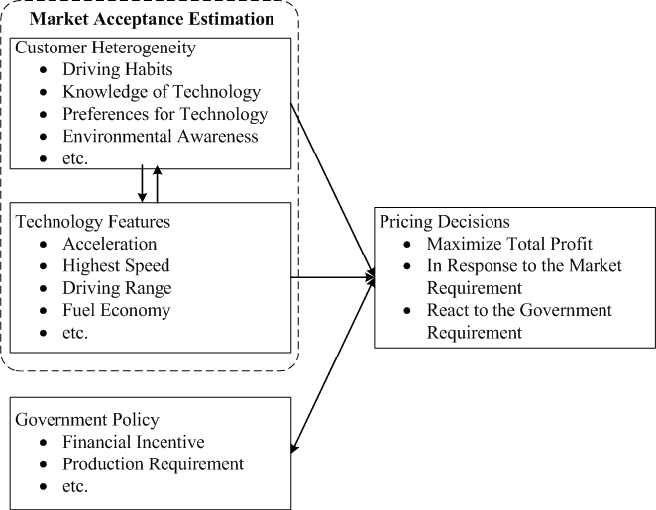
Figure 17 Framework of pricing model for automotive technology innovation

                - In an automotive market, an automaker (she) introduces a new EV model; and she also offers several existing vehicle models. Her goal is to maximize the total profit from both the new EV model and existing vehicles in a planning horizon, such as one year, by deciding the price of the new EV model. In the same market, there are other automakers (they) who only sell existing vehicle models. The prices for all existing vehicles are exogenously given and are assumed to be unchanged within the planning horizon.
                - We further assume that each consumer in the market finally chooses a vehicle model from all potential choices and the criteria that each consumer follow to choose a vehicle model is to maximize each individual's own utility according to the random utility theory (RUT) (Manski 1977, McFadden 1974). RUT assumes a consumer's selection on one product is based on the relative preference over a set of technologies. To simulate consumers' choices based on their preferences, we will incorporate the evaluation of all vehicles for each customer segment, which are finally used to estimate the probability of adopting each vehicle model.
                - The planning horizon of this study is one year, during which the market size, automotive market segmentations and consumer preferences are assumed to be known and remain unchanged. Each potential vehicle consumer can choose one and only one vehicle. All automakers in the market do not perform price discrimination among consumers. That means the price of each vehicle model, once decided, is the same across all customer segments. The unit production costs of all vehicles are constant and do not change in the planning horizon.
This study primarily follows three steps. First, we consider a pricing model for a new EV without government interference and name it the basic model. This model captures preferences of each consumer segment and based on customer preferences, the adoption probability of all offered models will be measured and we will be allowed to predict their potential market demands (Nevo 2000). Then, we will conduct a regression for the derived demands and fit the demands by our MNL model with selected parameters. After we capture all required parameters from the MNL model, the pricing model will incorporate corresponding manufacturing costs of each vehicle, including the new EV, offered by the manufacturer with market demands and the pricing model will yield an optimal price of the new EV. At this optimal price the total profit from all vehicles she offered is maximized. The adoption rate at this step establishes a baseline of the EV adoption and reflects customer perception of EVs, which provides us a basis for later analysis and discussion. In the last step, we introduce a tradable credit policy, such as the ZEV mandate, into the basic model in order to study the impact of the policy on the optimal price and demand of the new EV. In this step, policy parameters are incorporated into the pricing model and these parameters deviate the adoption rate and the optimal price from the results in the basic model. This enhanced model is used to forecast market adoption under policy impact and quantitatively assess policy effect on the market penetration of EVs. To obtain deeper insights, California's ZEV mandate will be selected for a detailed case study. This case study is expected to identify consumer preferences of EVs and the interference degree of the ZEV mandate on the mass adoption of EVs. This study will allow us to measure the barriers of mass adoption of EVs in the California automotive market.

Problem Formulation
Consider a set of existing vehicles $Q$ in a market, $q$ is its index. The price of vehicle $q$ is known as $p_{q}$. Among all existing vehicles, the automaker (she) who offers the new EV model sells a set of existing vehicles, $Q_{1}$, and $Q_{1}⊆Q$. The set of vehicles sold by other companies is $Q_{2}$. Here, $Q_{1}⋃Q_{2}=Q$. We are interested in investigating the optimal price of a new EV model, $a$, which is also offered by her.
                - The market is divided into $n$ customer segments. The size of customer segment $i$ is denoted by $s_{i}$, where $i=1,2,…,n$. Customers consider a set of features, denoted by $M$ and indexed by $m$. The utility measured in monetary value of feature $m$ for a customer in segment $i$ is assumed to be $β_{i}^{m}$. In other words, the vector of $β_{i}=\left\{β_{i}^{m}\right\}$ represents the opinions of segment $i$ over all features. For a given vehicle $q$, $X_{q}=\left\{x_{q}^{m}\right\}$ represents the values of vehicle $q$ over all features. Under the additivity assumption over utilities, $U_{iq}=β_{i}∙X_{q}$ represents the total utility of vehicle $q$ for a customer in segment $i$. Specifically, for the new EV, $a$, $U_{ia}=β_{i}∙X_{a}$ is its utility for consumer segment $i$.
                - The basic model decides a non-discriminating price $p_{a}$ for vehicle $a$. The probability of a customer in segment $i$ to choose vehicle $a$ over other alternatives is denoted by $P_{ia}\left(p_{a}\right)$. Based on the discrete choice theory (Anderson et al. 1992, Train 2009), the probability by which a consumer chooses the new EV model, $a$ is given by
$P_{ia}\left(p_{a}\right)={\exp\left[α_{i}\left(β_{i}∙X_{a}-p_{a}\right)\right]}/{\left\{\sum_{q∈Q}{\exp\left[α_{i}\left(β_{i}∙X_{q}-p_{q}\right)\right]}+\exp\left[α_{i}\left(β_{i}∙X_{a}-p_{a}\right)\right]\right\}}$. (1)
Here $α_{i}$ is the utility sensitivity coefficient of customer segment $i$. In equation (1), $β_{i}∙X_{a}-p_{a}$ is the net utility of vehicle $a$ for a consumer in segment $i$.
                - The purchasing probability of existing vehicle $q$ that she offers is characterized by
$$P_{iq}\left(p_{a}\right)=\frac{\exp\left[α_{i}\left(β_{i}∙X_{q}-p_{q}\right)\right]}{\sum_{q∈Q}{\exp\left[α_{i}\left(β_{i}∙X_{q}-p_{q}\right)\right]}+\exp\left[α_{i}\left(β_{i}∙X_{a}-p_{a}\right)\right]} for q∈Q_{1}.$$ | (2)
                - Therefore, the total expected demand for vehicle $a$ under a given $p_{a}$ can be calculated by
$N_{a}\left(p_{a}\right)=\sum_{i=1}^{n}{s_{i}P_{ia}\left(p_{a}\right)}$, (3)
whereas the total expected number of buyers of vehicle $q$ in $Q_{1}$ under $p_{a}$ is computed by
$N_{q}\left(p_{a}\right)=\sum_{i=1}^{n}{s_{i}P_{iq}\left(p_{a}\right)}$. (4)
                - The objective of the basic model is to maximize her total profit, which is
$\max_{p_{a}}\left(p_{a}-c_{a}\right)∙N_{a}\left(p_{a}\right)+\sum_{q∈Q_{1}}{\left(p_{q}-c_{q}\right)∙N_{q}\left(p_{a}\right)}$, (5)
where the manufacturing costs of the new EV and existing vehicle are denoted by $c_{a}$ and $c_{q}$, $q∈Q_{1}$, respectively. Here, $p_{q}$ is known and certain for each $q∈Q_{1}$.
                - After the government implements a tradable credit policy, she will be awarded (or charged) $d_{a}$ credits from each sold new EV and $d_{q}$ credits for each existing vehicle $q$. Each rewarded credit can be sold at the price $θ$. In the enhanced model, the credit revenue is incorporated into the total revenue and the model can be written as
$\max_{p_{a}} π\left(p_{a}\right)=(p_{a}-c_{a}+θd_{a})∙N_{a}\left(p_{a}\right)+\sum_{q∈Q_{1}}{\left(p_{q}-c_{q}+θd_{q}\right)∙N_{q}\left(p_{a}\right)}$. (6)
                - Please note that we put no sign restriction on $d_{q}$ in equation (6). This parameter is positive if any credits are earned by vehicle $q$ according to policy or it is negative if each vehicle $q$ is required to be matched with a certain amount of any credit.

Policy Impact on Pricing Electric Vehicles
In this section, we will proceed to derive the theoretical optimal solution according to the models we proposed in the last section. Differentiating the purchase probability of vehicle $a$ for customer segment $i$ with respect to $p_{a}$ can result in the changing rate:
$$\frac{dP_{ia}}{dp_{a}}=\frac{-α_{i}∙\exp\left[α_{i}\left(β_{i}∙X_{a}-p_{a}\right)\right]+α_{i}∙{\left\{\exp\left[α_{i}\left(β_{i}∙X_{q}-p_{q}\right)\right]\right\}}^{2}}{{\left\{\sum_{q∈Q}{\exp\left[α_{i}\left(β_{i}∙X_{q}-p_{q}\right)\right]}+\exp\left[α_{i}\left(β_{i}∙X_{a}-p_{a}\right)\right]\right\}}^{2}}$$
$$=α_{i}P_{ia}\left(P_{ia}-1\right),$$
and the first order derivate of demand for vehicle $a$ with respect to $p_{a}$ is
$$\frac{dN_{a}}{dp_{a}}=\sum_{i=1}^{n}{α_{i}s_{i}P_{ia}\left(P_{ia}-1\right)}.$$
                - Differentiating the purchase probability of vehicle $q$ for customer segment $i$ with respect to $p_{a}$, we are able to get
$$\frac{dP_{iq}}{dp_{a}}=\frac{α_{i}∙\exp\left[α_{i}\left(β_{i}∙X_{q}-p_{q}\right)\right]∙\exp\left[α_{i}\left(β_{i}∙X_{q}-p_{q}\right)\right]}{{\left\{\sum_{q∈Q}{\exp\left[α_{i}\left(β_{i}∙X_{q}-p_{q}\right)\right]}+\exp\left[α_{i}\left(β_{i}∙X_{a}-p_{a}\right)\right]\right\}}^{2}}$$
$=α_{i}P_{ia}P_{iq}$,
and the changing rate of demand for vehicle $q$ with respect to $p_{a}$ can be computed by
$\frac{dN_{q}}{dp_{a}}=\sum_{i=1}^{n}{α_{i}s_{i}P_{ia}P_{iq}}$.
                - The optimal pricing under government incentive should satisfy the first-order condition, which is described by
$\frac{dπ}{dp_{a}}=N_{a}\left(p_{a}\right)+ \left(p_{a}-c_{a}+θd_{a}\right)∙\frac{dN_{a}\left(p_{a}\right)}{dp_{a}}+\sum_{q∈Q_{1}}{\left(p_{q}-c_{q}+θd_{q}\right)∙\frac{dN_{a}\left(p_{a}\right)}{dp_{a}}}=0$, (7)
                - or
${p_{a}}^{*}=c_{a}-θd_{a}-{N_{a}\left({p_{a}}^{*}\right)}/{\sum_{i=1}^{n}{α_{i}s_{i}P_{ia}}\left(P_{ia}-1\right)}- {\sum_{q∈Q_{1}}{\left[\left(p_{q}-c_{q}+θd_{q}\right)\sum_{i=1}^{n}{α_{i}s_{i}P_{ia}}P_{iq}\right]}}/{\sum_{i=1}^{n}{α_{i}s_{i}P_{ia}}(P_{ia}-1)}$, (8)
as long as the second order condition can be met. Here, in equation (8), both sides contain decision variable $p_{a}$ and unfortunately it is difficult to find a close form solution from equation (8). However, we are able to show that equation (8) guarantees the yield of the optimal solution.

Proposition 1: The solution to the first order condition in equation (8) yields the optimal price.
Proof. From (6), we can have the second order derivative of the total profit function as
$\frac{d^{2}π}{d{p_{a}}^{2}}=2{dN_{a}\left(p_{a}\right)}/{dp_{a}}+ \left(p_{a}-c_{a}+θd_{a}\right)∙{d^{2}N_{a}\left(p_{a}\right)}/{dp_{a}^{2}}+\sum_{q∈Q_{1}}{\left(p_{q}-c_{q}+θd_{q}\right)∙{d^{2}N_{a}\left(p_{a}\right)}/{dp_{a}^{2}}}$
$=2\sum_{i=1}^{n}{α_{i}s_{i}P_{ia}\left(P_{ia}-1\right)}+\left(p_{a}-c_{a}+θd_{a}\right)∙\left[\sum_{i=1}^{n}{α_{i}^{2}s_{i}P_{ia}}\left(P_{ia}-1\right)\left(2P_{ia}-1\right)\right]$
$+\sum_{q∈Q_{1}}{\left[\left(p_{q}-c_{q}+θd_{q}\right)∙\sum_{i=1}^{n}{α_{i}^{2}s_{i}P_{ia}}P_{iq}\left(2P_{ia}-1\right)\right]}$. (9)
Taking equation (8) to equation (9) and replace $\left(p_{a}-c_{a}+θd_{a}\right)$, in doing so, one can get
$$\frac{d^{2}π}{d{p_{a}}^{2}}={\left\{2{\left[\sum_{i=1}^{n}{α_{i}s_{i}P_{ia}\left(P_{ia}-1\right)}\right]}^{2}-\left(\sum_{i=1}^{n}{s_{i}P_{ia}}\right)∙\left[\sum_{i=1}^{n}{α_{i}^{2}s_{i}P_{ia}}\left(P_{ia}-1\right)\left(2P_{ia}-1\right)\right]\right\}}/{\left[\sum_{i=1}^{n}{α_{i}s_{i}P_{ia}\left(P_{ia}-1\right)}\right]}$$
$+{\left\{\begin{aligned}\sum_{q∈Q_{1}}{\left(p_{q}-c_{q}+θd_{q}\right)∙\left[\sum_{i=1}^{n}{α_{i}^{2}s_{i}P_{ia}}P_{iq}\left(2P_{ia}-1\right)\right]}∙\left[\sum_{i=1}^{n}{α_{i}s_{i}P_{ia}\left(P_{ia}-1\right)}\right]- \\ \sum_{q∈Q_{1}}{\left(p_{q}-c_{q}+θd_{q}\right)∙\left[\sum_{i=1}^{n}{α_{i}s_{i}P_{ia}}P_{iq}\right]}∙\left[\sum_{i=1}^{n}{α_{i}^{2}s_{i}P_{ia}}\left(P_{ia}-1\right)\left(2P_{ia}-1\right)\right]\end{aligned}\right\}}/{\left[\sum_{i=1}^{n}{α_{i}s_{i}P_{ia}\left(P_{ia}-1\right)}\right]}$.
Here we term the first numerator as
$$f_{1}\left(p_{a}\right)=2{\left[\sum_{i=1}^{n}{α_{i}s_{i}P_{ia}\left(P_{ia}-1\right)}\right]}^{2}-\left(\sum_{i=1}^{n}{s_{i}P_{ia}}\right)∙\left[\sum_{i=1}^{n}{α_{i}^{2}s_{i}P_{ia}}\left(P_{ia}-1\right)\left(2P_{ia}-1\right)\right]$$
$$=2\sum_{j=1,j≠i}^{n}{\sum_{i=1}^{n}{\left[α_{i}α_{j}s_{i}s_{j}P_{ia}P_{ja}\left(P_{ia}-1\right)\left(P_{ja}-1\right)\right]}}-\sum_{j=1,j≠i}^{n}{\sum_{i=1}^{n}{\left[α_{i}^{2}s_{i}s_{j}P_{ia}P_{ja}\left(P_{ia}-1\right)\left(2P_{ia}-1\right)\right]}},$$
$$=\sum_{j=1,j≠i}^{n}{\sum_{i=1}^{n}{\left\{α_{i}s_{i}s_{j}P_{ia}P_{ja}\left(P_{ia}-1\right)\left[2α_{j}\left(P_{ja}-1\right)-α_{i}\left(2P_{ia}-1\right)\right]\right\}}}$$
Since $α_{i}, α_{j}≥0$, we have
$f_{1}\left(p_{a}\right)≥0$.
Similarly, we term the second numerator as
$f_{2}\left(p_{a}\right)=\sum_{q∈Q_{1}}{\left(p_{q}-c_{q}+θd_{q}\right)∙\left[\sum_{i=1}^{n}{α_{i}^{2}s_{i}P_{ia}}P_{iq}\left(2P_{ia}-1\right)\right]}∙\left[\sum_{i=1}^{n}{α_{i}s_{i}P_{ia}\left(P_{ia}-1\right)}\right]$
$$-\sum_{q∈Q_{1}}{\left(p_{q}-c_{q}+θd_{q}\right)∙\left[\sum_{i=1}^{n}{α_{i}s_{i}P_{ia}}P_{iq}\right]}∙\left[\sum_{i=1}^{n}{α_{i}^{2}s_{i}P_{ia}}\left(P_{ia}-1\right)\left(2P_{ia}-1\right)\right]$$
Expanding $f_{2}\left(p_{a}\right)$ results
$$f_{2}\left(p_{a}\right)=\sum_{q∈Q_{1}}{\left(p_{q}-c_{q}+θd_{q}\right)∙\left\{\sum_{j=1,j≠i}^{n}{\sum_{i=1}^{n}{\left[α_{i}^{2}α_{j}s_{i}s_{j}P_{ia}P_{ja}P_{iq}\left(2P_{ia}-1\right)\left(P_{ja}-1\right)\right]-\sum_{j=1,j≠i}^{n}{\sum_{i=1}^{n}{\left[α_{i}^{2}α_{j}s_{i}s_{j}P_{ia}P_{ja}P_{jq}\left(P_{ia}-1\right)\left(2P_{ia}-1\right)\right]}}}}\right\}}$$
$=\sum_{q∈Q_{1}}{\left(p_{q}-c_{q}+θd_{q}\right)∙\sum_{j=1,j≠i}^{n}{\sum_{i=1}^{n}{\left\{α_{i}^{2}α_{j}s_{i}s_{j}P_{ia}P_{ja}P_{iq}\left(2P_{ia}-1\right)\left[P_{iq}\left(P_{ja}-1\right)-P_{jq}\left(P_{ia}-1\right)\right]\right\}}}}$.
Because $f_{2}\left(p_{a}\right)$ has a symmetric structure, that indicates
$f_{2}\left(p_{a}\right)=0$.
Because $\sum_{i=1}^{n}{α_{i}s_{i}P_{ia}\left(P_{ia}-1\right)}$, we have
$\frac{d^{2}π}{d{p_{a}}^{2}}={\left[f_{1}\left(p_{a}\right)+f_{2}\left(p_{a}\right)\right]}/{\left[\sum_{i=1}^{n}{α_{i}s_{i}P_{ia}\left(P_{ia}-1\right)}\right]}≤0$,
                - which guarantees the solution from equation (8) is optimal.

Corollary 1: The optimal price of the new EV model increases in $c_{a}$, but decreases in subsidy $θd_{a}$.
Proof. Under government policy impact, the first order condition is given as
${p_{a}}^{*}+{\sum_{i=1}^{n}{s_{i}P_{ia}}}/{\sum_{i=1}^{n}{α_{i}s_{i}P_{ia}}(P_{ia}-1)}=c_{a}-θd_{a}-{\sum_{q∈Q_{1}}{\left[\left(p_{q}-c_{q}+θd_{q}\right)\sum_{i=1}^{n}{α_{i}s_{i}P_{ia}}P_{iq}\right]}}/{\sum_{i=1}^{n}{α_{i}s_{i}P_{ia}}(P_{ia}-1)}$. (10)
We differentiate the second term on left hand side with respect to price, $p_{a}$, which results
$1-{\sum_{i=1}^{n}{s_{i}P_{ia}}}/{\sum_{i=1}^{n}{α_{i}s_{i}P_{ia}}\left(P_{ia}-1\right)}∙{\sum_{i=1}^{n}{α_{i}s_{i}P_{ia}}\left(P_{ia}-1\right)\left(2P_{ia}-1\right)}/{\sum_{i=1}^{n}{α_{i}s_{i}P_{ia}}\left(P_{ia}-1\right)}$.
Because $0<P_{ia}<1$, we are able to get $-1<{\sum_{i=1}^{n}{s_{i}P_{ia}}}/{\sum_{i=1}^{n}{α_{i}s_{i}P_{ia}}(P_{ia}-1)}<0$ and $-1<2P_{ia}-1<0$. Hence, it is easy to see
$1-{\sum_{i=1}^{n}{s_{i}P_{ia}}}/{\sum_{i=1}^{n}{α_{i}s_{i}P_{ia}}(P_{ia}-1)}∙{\sum_{i=1}^{n}{α_{i}s_{i}P_{ia}}(P_{ia}-1)(2P_{ia}-1)}/{\sum_{i=1}^{n}{α_{i}s_{i}P_{ia}}\left(P_{ia}-1\right)}>0$.
That means the second term on the left hand side, ${\sum_{i=1}^{n}{s_{i}P_{ia}}}/{\sum_{i=1}^{n}{α_{i}s_{i}P_{ia}}(P_{ia}-1)}$, increases in $p_{a}$. Furthermore, as we proved in Proposition 1, the third term maintains constant in $p_{a}$, which indicates the price, ${p_{a}}^{*}$, increases in $c_{a}$ but decreases in $θd_{a}$.
                - Proposition 1 proves the optimality of any solution from equation (8) and Corollary 1 state that the optimal price of the new EV model $a$ can be primarily increased by production cost, $c_{a}$, and reduced by policy subsidy, $θd_{a}$. Corollary 1 provides a piece of indicative evidence for government agency to subsidize the new EV model so as to reduce its price, which further promotes the market penetration of EVs.

Proposition 2: At the introduction stage, the upper bound and lower bound for the new EV model price exists.
Proof. At the introduction stage of a new vehicle model, presumably we have $1-P_{ia}≥0.5$ for any customer segment $i$. We denote $δ=min⁡\left\{α_{i}, for i=1,2,…n\right\}$, and one can get
${p_{a}}^{*}-2/δ≤p_{a}-{\sum_{i=1}^{n}{s_{i}P_{ia}}}/{\sum_{i=1}^{n}{α_{i}s_{i}P_{ia}\left(P_{ia}-1\right)}}$. (11)
Since we know each vehicle model $q$ is only one alternative choice among a set of existing vehicle models, it gives us $P_{iq}≤1-P_{ia}$, which further indicates
$${\sum_{q∈Q_{1}}{\left[\left(p_{q}-c_{q}+θd_{q}\right)\sum_{i=1}^{n}{α_{i}s_{i}P_{ia}}P_{iq}\right]}}/{\sum_{i=1}^{n}{α_{i}s_{i}P_{ia}}\left(1-P_{ia}\right)}≤{\sum_{q∈Q_{1}}{\left[\left(p_{q}-c_{q}+θd_{q}\right)\sum_{i=1}^{n}{α_{i}s_{i}P_{ia}}\left(1-P_{ia}\right)\right]}}/{\sum_{i=1}^{n}{α_{i}s_{i}P_{ia}}\left(1-P_{ia}\right)}$$
$$≤\sum_{q∈Q_{1}}{\left(p_{q}-c_{q}+θd_{q}\right)}$$
This contributes to an indicative inequality:
${p_{a}}^{*}≤c_{a}-θd_{a}+2/δ+\sum_{q∈Q_{1}}{\left(p_{q}-c_{q}+θd_{q}\right)}$, (12)
where the first and second terms on the right hand side are the cost and the policy parameters, the third term reflects customers sensitivity in price, and the last term are parameters related to existing models in the current market, which forms a reference for the new EV model pricing.
On the other hand, we term $γ=max⁡\left\{α_{i}, for i=1,2,…n\right\}$. Because $P_{ia}<0.5$, we can get
$-{\sum_{i=1}^{n}{s_{i}P_{ia}}}/{\sum_{i=1}^{n}{α_{i}s_{i}P_{ia}\left(P_{ia}-1\right)}}≥1/γ$,
which indicates that $p_{a}$ follows
${p_{a}}^{*}≥c_{a}-θd_{a}+1/γ$, (13)
since ${\sum_{q∈Q_{1}}{\left[\left(p_{q}-c_{q}+θd_{q}\right)\sum_{i=1}^{n}{α_{i}s_{i}P_{ia}}P_{iq}\right]}}/{\sum_{i=1}^{n}{α_{i}s_{i}P_{ia}}(1-P_{ia})}≥0$. Inequality (13) gives us the lower bound of the new EV model price. Thus for given market condition and policy parameters, we are able to find the optimal price of the new EV model in the region between $c_{a}-θd_{a}+1/γ$ and $c_{a}-θd_{a}+2/δ+\sum_{q∈Q_{1}}{\left(p_{q}-c_{q}+θd_{q}\right)}.$
                - Proposition 2 states that the optimal price ${p_{a}}^{*}$ is substantially affected by customer perceptions, income levels, policy parameters, and existing vehicle models. In fact, the homogeneity of customer segments and policy promotions can essentially narrow the gap between the lower bound and upper bound of the optimal price of the new EV model, which in turn makes its optimal price less flexible and more determined. With regard to this possibility, we derive the sufficient and necessary condition for reducing the new EV model price to considerable level of existing vehicle models, which eliminates possible premium in price.

Corollary 2: At most $1/θ∙\left(\sum_{q∈Q_{1}, q≠b}{\left(p_{q}-c_{q}+θd_{q}\right)}+2/δ\right)$ credits will be needed to eliminate the extra premium from the new EV model price compared to the price of a benchmark vehicle model; furthermore, at most $1/θ∙\left(c_{a}-c_{b}+2/δ+\sum_{q∈Q_{1}, q≠b}{\left(p_{q}-c_{q}+θd_{q}\right)}\right)$ credits will be required to equalize the new EV model price and the price of a benchmark vehicle model.
Proof. Assume there is a benchmark vehicle model, $b$, which gives the reference price and cost information. Set $p_{a}-p_{b}=c_{a}-c_{b}$, and inequality (12) becomes
$d_{a}-d_{b}≤1/θ∙\left(\sum_{q∈Q_{1}, q≠b}{\left(p_{q}-c_{q}+θd_{q}\right)}+2/δ\right)$. (14)
That means at most $1/θ∙\left(\sum_{q∈Q_{1}, q≠b}{\left(p_{q}-c_{q}+θd_{q}\right)}+2/δ\right)$ more credits rewarded to each new EV model, EV producer of the new EV model only include incremental manufacturing cost into the price of the new EV model without charging any premium. Furthermore, we equate the new EV model price with the existing vehicle price, we can have
$d_{a}-d_{b}≤1/θ\left(c_{a}-c_{b}+2/δ+\sum_{q∈Q_{1}, q≠b}{\left(p_{q}-c_{q}+θd_{q}\right)}\right)$. (15)

                - Corollary 2 indicates a set of effective regions for the credit rewards to the new EV model in order to reduce the new EV model price to different levels. When regulators are indicated by these regions and provide enough financial support to each new EV model, it can be priced at more reasonable level so as to enhance the adoption rate of EVs in the market.

Case Study: Market Adoption of the EV100 model in the California Automotive Market
In this section, we will proceed to conduct a case study on practical electric vehicle pricing decision and on compliance with the ZEV mandate in California. The data of the case study will be first explained, followed by the simulation result. An analysis of pricing strategy with the ZEV mandate in the California automotive market will be carried out. Annual demand for EV model is first simulated independently from the MA³T Model and compliance with the ZEV mandate is then analyzed accordingly. The results show the impact of the ZEV mandate through a deviation from original pricing decision before the ZEV mandate. The resulting findings allow us to provide indicative insights with regard to the influence of the ZEV mandate.

Market Acceptance of Advanced Automotive Technologies Model
Recognizing the market perception of EVs and measuring the influence of public policy is the crucial part of determining the optimal EV price in the current market under the ZEV mandate. The market adoption rate is estimated by the MA³T Model (Lin and Greene 2011). The inner core of the MA³T model is a nested multi-nominal logit model that incorporates influential factors of customers' behavior into their purchase decision. The simulation results are expected to reflect the market acceptance at different prices and vehicle attributes over all segments and across 50 states in the United States. Its framework is shown in Figure 18. It forecasts the sales of vehicle choices among over 1,400 consumer segments and characterize demand heterogeneity with respect to states, residential areas, driving habits, technological attitude, charging accessibility (Lin and Greene 2011). In order to analyze the influence of price and driving range on market adoption, we created a series of scenarios so that the MA³T model can yield corresponding demand rate in the California automotive market. Afterwards, we fit the estimated market demand for the selected EV models into our MNL model and derive the optimal price from the regressed demand curve. This fitted demand function will be brought back into our profit function and then it will be used to characterize the market penetration with the optimal price determined by auto makers and address policy impact offered by the government agency.

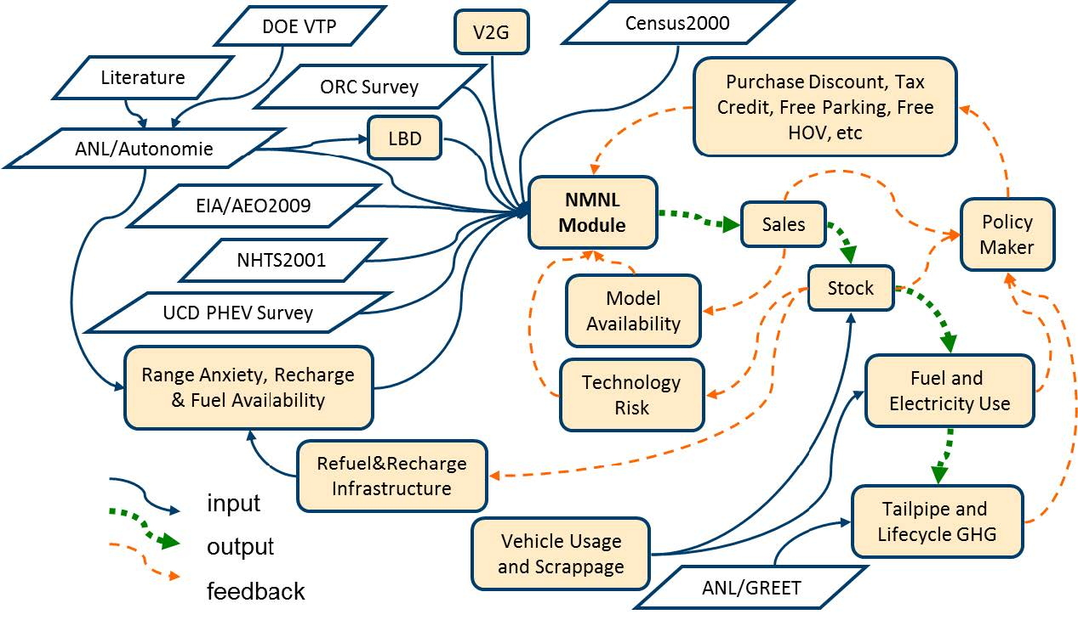
Figure 18 Framework of the MA³T model. Source: Lin and Greene (2011), Sikes et al. (2010).

                - In this paper, we choose 100-mile range EV (EV100 model) and the same size conventional gasoline powered passenger car (conventional vehicle) as our research subjects. Figure 19 depicts the simulated demands for major vehicle types in current California automotive market at different prices of the EV100 model. It shows that there exists significant variation between the EV100 model and the conventional vehicle, and negligible substitution effects between the EV100 model and other vehicle models. Hence, we only need take into account the EV100 model and its counterpart in gasoline powered vehicles for profit maximization. There is a company (she) offers both the EV100 model and the conventional vehicle in the California automotive market where some other conventional vehicle models are offered by the other companies.

Figure 19 The demand for different types of vehicles in the California automotive market at different prices of EV100 model.

Results
According to the simulation result illustrated in Figure 19, the demand function for the EV100 model is regressed into a function of the price of the EV100 model by
$$D_{EV100}=\sum_{i=1}^{n}{s_{i}P_{iEV100}\left(p_{EV100}\right)}$$
$$=\sum_{i=1}^{n}{s_{i}{\exp\left[α_{i}\left(U_{iEV100}-p_{EV100}\right)\right]}/{\left\{\sum_{q∈Q}{\exp\left[α_{i}\left(β_{i}∙X_{q}-p_{q}\right)\right]}+\exp\left[α_{i}\left(U_{iEV100}-p_{EV100}\right)\right]\right\}}}$$
$=\sum_{i=1}^{n}{s_{i}1/{\left\{1+w_{i}\exp\left[α_{i}\left(p_{EV100}-U_{iEV100}\right)\right]\right\}}}$, (16)
where $p_{EV100}$ denotes the selling price of the EV100 model, and $D_{EV100}$ represents the demand for the EV100 model in the California automotive market (Larsen 2014). $w_{i}=\sum_{q∈Q}{\exp\left[α_{i}\left(β_{i}∙X_{q}-p_{q}\right)\right]}$ and $U_{iEV100}$ are both positive constants describing the willingness-to-pay by customer segment $i$ to conventional gasoline cars and the EV100 model, respectively. Please note that the willingness-to-pay for the conventional gasoline cars can be partially absorbed into the exponential term and therefore the regressed value of $w_{i}$ may not exactly reflect the willingness-to-pay by the consumers.
                - The size of the California automotive market is defined by the total number of households in California, which is given by U.S. Census Bureau (2014). In this market, five customer segments are recognized, including innovators (customer segment 1), early adopters (customer segment 2), early majority (customer segment 3), later majority (customer segment 4), and laggards (customer segment 5). The proportions of them are 2.5%, 13.5%, 34%, 34%, and 16%, respectively (Rogers 1983). Given all these information, the regressed values of the parameters in equation (16) are listed in Table 2.

Table 2 Regressed parameter values for EV100 model and customers.
Parameters | Value | Goodness of fit | Value
$$α_{1}$$ | 0.0001734 | SSE | 4.548e-07
$$α_{2}$$ | 0.0002257 | R-square | 0.9996
$$α_{3}$$ | 0.004594 | Adjusted R-square | 0.9988
$$α_{4}$$ | 0.004594 | RMSE | 0.0002549
$$α_{5}$$ | 0.01606
$$U_{1EV100}$$ | $19,000
$$U_{2EV100}$$ | $14,136
$$U_{3EV100}$$ | $11,973
$$U_{4EV100}$$ | $10,013
$$U_{5EV100}$$ | $7,381
$$w_{1}$$ | $2.631
$$w_{2}$$ | $5.574
$$w_{3}$$ | $3.731
$$w_{4}$$ | $3.731
$$w_{5}$$ | $0.5765

                - It can be found that the price sensitivity $α_{i}$ descends from customer segments 1 to 5. That indicates later adopters are increasingly sensitive on the price of the EVs whereas they consist a large proportion of the automotive market. This part of the market will contribute to the market penetration of the EVs later than the innovators and early adopters.
                - We used the parameter values in Table 2 to fit for the parameters in the demand function for the Conventional passenger car. The demand can be expressed as
$D_{CV}=\sum_{i=1}^{n}{s_{i}P_{iCV}\left(p_{EV100}\right)}$
$=\sum_{i=1}^{n}{s_{i}{\exp\left[α_{i}\left(U_{iCV}-p_{CV}\right)\right]}/{\left\{w_{i}+\exp\left[α_{i}\left(p_{EV100}-δ_{iEV100}\right)\right]\right\}}}$. (17)
                - Here, $D_{CV}$ is the demand for the selected conventional gasoline powered passenger cars in the California automotive market, which is measure by the product of the total demand derived from the MA³T model and the corresponding market share (Good Car Bad Car 2014). Because EV100 model is almost the same size and configuration with Nissan Versa, for practical purposes, we used the market share data of Nissan Versa as a representative case study. $U_{iCV}$ reflects the willingness-to-pay for the selected conventional ICE cars a by customer segment $i$. The price of the selected conventional ICE cars, $p_{CV}$, is given by the MA³T database. The regressed values of the parameters in equation (17) are listed in Table 3.

Table 3 Regressed parameter values for the conventional passenger car.
Parameters | Value | Goodness of fit
$$U_{1CV}$$ | $18,520 | SSE | 3.998e-07
$$U_{2CV}$$ | $16,490 | R-square | 0.998
$$U_{3CV}$$ | $10,930 | Adjusted R-square | 0.9975
$$U_{4CV}$$ | $10,920 | RMSE | 0.0001581
$$U_{5CV}$$ | $10,920 | Goodness of fit

                - With the regressed parameter values in Table 2 and Table 3, the total profit of the company, $π$, can be written as
$π=\left(p_{EV100}-c_{EV100}+θ∙d_{EV100}\right)∙D_{EV100}+\left(p_{CV}-c_{CV}+θ∙d_{CV}\right)∙D_{CV}$, (18)
where $c_{EV100}$ and $c_{CV}$ are the manufacturing costs of the EV100 model and conventional vehicle, respectively, which were set according to the market information from the MA³T database. $d_{EV100}=3$ is the credits granted to each produced EV100 model, $d_{CV}$ is the required number of credits to be fulfilled for the conventional passenger car, and $θ$ is the market credit price. Note that here $d_{CV}=-0.14$ since 14% of delivered conventional passenger cars are required to be matched with the ZEV credits. The negative sign of $d_{CV}$ indicates a net deficit brought by each delivered conventional passenger car to the California automotive market.

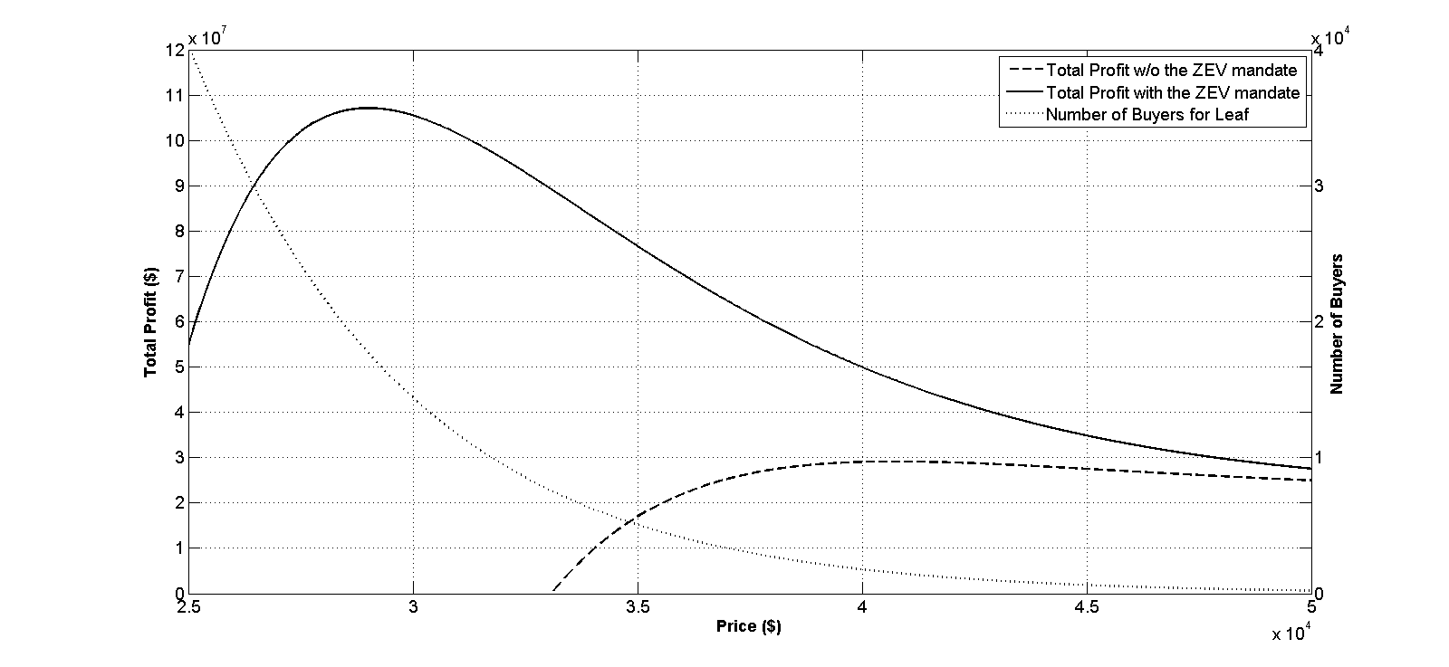
Optimal Price
$29,010
Optimal Sales Number
22,089
Optimal Price
$ 40,750
Optimal Sales Number
2,405
Figure 20 Annual demand for the EV100 model and total profit for the company before and after the ZEV mandate takes effect. Solid curve: total profit with the ZEV mandate; dashed curve: total profit without the ZEV mandate; dotted curve: annual demand for the EV100 model.

                - Figure 20 depicts the market demand for the EV100 model and the company's total profit without and with the ZEV mandate. The dotted curve shows that the demand for the EV100 model decreases in its price. Before the ZEV mandate took place, the company's total profit grew up to a peak at $40,750, where the corresponding number of buyers was 2,405. After implementing the ZEV mandate, the maximized total profit was obtained with a lower price, $29,010, and the corresponding number of customers was increased to 22,089. The ZEV mandate helped the company reduce the EV100 model price by $11,740 and induced 10 times greater demand than before the ZEV mandate. That indicates the ZEV mandate encouraged the company to sell the EV100 model with lower profit margins but notably higher sales that finally yields greater total profit.
                - We know that from the ZEV mandate, the company is awarded 3 credits per EV100 model, and each credit can be transferred to another company at a market price of $3,929 (Watts 2014). After fulfilling the requirement, each produced EV100 model earns about $11,787. This part of revenue helped the company to reduce the current price gap between the EV100 model and the conventional passenger car. Our simulation results show that it is reasonable to optimistically expect the ZEV mandate to benefit both the automotive manufacturers and the consumers. The total profit became remarkably higher than that without the ZEV mandate, which means the company could have a broader range for pricing decision in non-optimal regions without losing money for making the EV100 model. The ZEV mandate provides extra pricing space for the EV manufacturers for flexible pricing strategies. We believe continuing our investigation will contribute to the understanding of the crucial role of the credit revenue in supporting the market adoption of the EV100 model.

Discussion
In this section, we will proceed to provide deeper insight for the impact of the ZEV mandate by varying policy credits per EV100 model and the price of each ZEV credit which examines when changing financial allowances per EV model, how the automaker will react by changing the pricing decision as well as transferred policy incentive to end customers. We are interested to know how this company reacts to increased level of rewards from the ZEV mandate. We separately compared optimal prices in Figure 21, the annual demand for the EV100 model at corresponding optimal prices in Figure 22, and the profits from the conventional passenger car, the EV100 model and the ZEV credit in Figure 23. In all these three figures, with numbers increases along the vertical axis, the company is awarded by a growing number of credits per EV100 model. Each point in this figure represents the sale number corresponding to the optimal price and the ZEV mandate parameters, while each curve in these figures represent the automaker's decision, or its corresponding demand or profit under a given credit price.

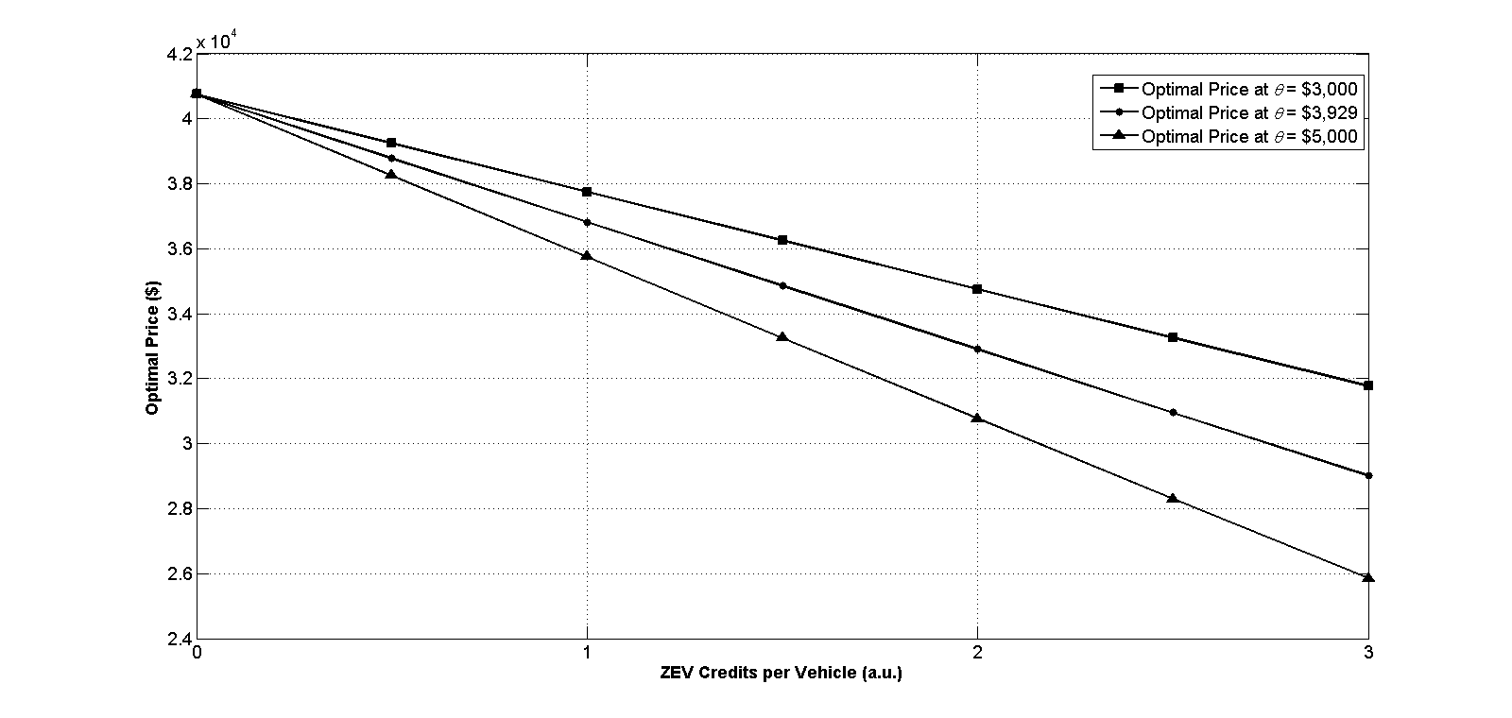
Figure 21. Comparison of the optimal prices under different ZEV credits per EV100 model and ZEV credit prices. Line with square: credit price equals to $3,000; line with dot: credit price equals to $3,929; line with traingle: credit price equals to $5,000.

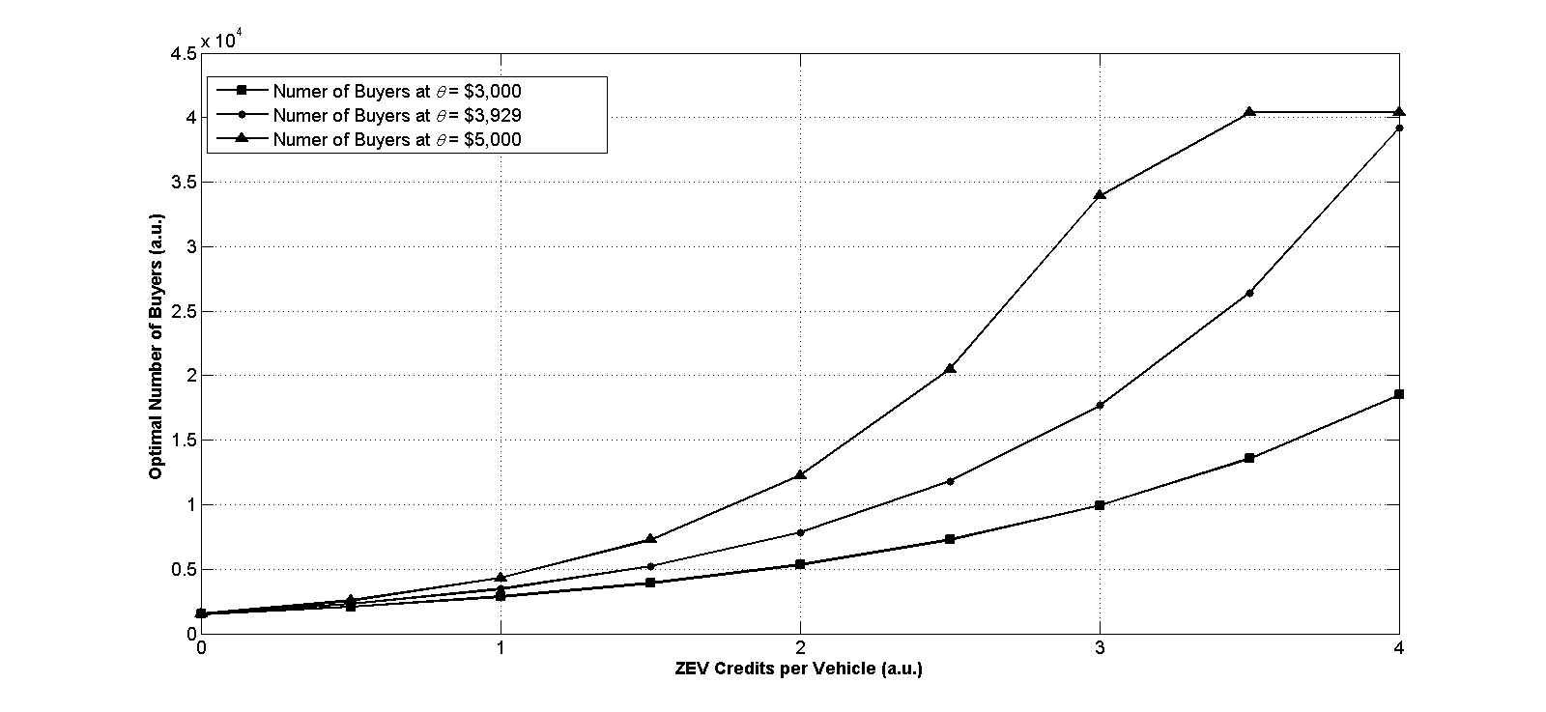
Figure 22. Comparison of number of buyers under different ZEV credits per EV100 model and ZEV credit prices. Line with square: credit price equals to $3,000; line with dot: credit price equals to $3,929; line with traingle: credit price equals to $5,000.

                - First, we found in Figure 21 that the optimal price drops linearly in credits per EV100 model that indicates the automaker's willingness to transfer policy benefit did not change in the designed experimental policy region. Because of the reduced price, as shown by Figure 22, we found the sales of the EV100 model increased in credits per EV100 model because the company is growingly capable to decrease prices and attract more customers in Figure 21. Consumers gradually switch from the conventional passenger car to the EV100 model. The increased demand contributes to an increased profit from the credit market and the company's total profit in Figure 23. However, the profit from the conventional passenger car gradually decreases in credits. That might indicate the automaker might shift her product focus from conventional vehicles to EVs in the future because of aggressive policy intervention and increased profitability of EV models due to technology improvement and cost reduction from economy of scale.
                - It is also noted that the profit from the EV100 model also decreases when the number of credits per EV100 model grows. This part of the profit becomes negative after the credits per EV100 model grow beyond 1 credit per EV100 model. It shows that this company's strategy of selling the EV100 model is heavily supported and influenced by the credit income from the ZEV mandate rather than the consumer market itself. We found similar reports showing that every Fiat 500E EV results in a $14,000 loss to Fiat (DeMorro 2014) and this huge amount of deficit would have led to serious problems without credit revenue support. The ZEV mandate is seemingly indispensable to the EV market penetration process in the California automotive market.
                - Credit price, on the other hand, represents financial support magnitude of each credit to electric vehicle producers. In Figure 22, it can be observed that the slope of sales volume becomes steeper when credit price rises. That implies the credit price represents how aggressive the government agency provides the company financial support and encourage her to reduce price and trigger large scale diffusion of EV to conventional vehicle drivers in the California automotive market.

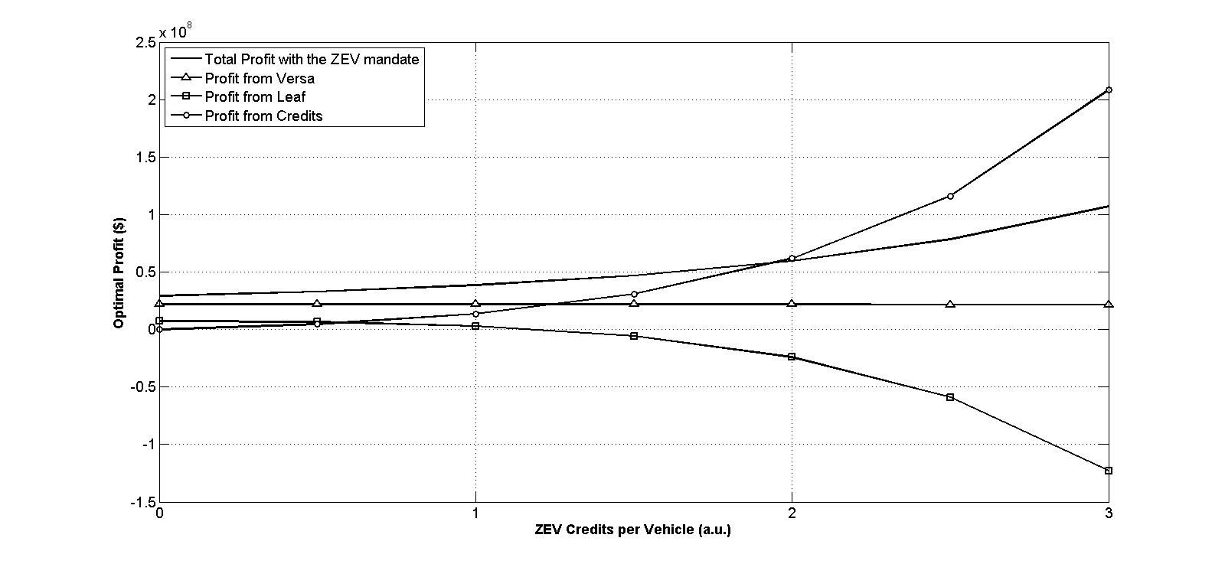
Profit from conventional car
ZEV Credit Revenue
Profit from EV100 model
(exclude credit revenue)
Total Profit
Figure 23. Optimal profits the ZEV mandate with different ZEV credits per EV100 model. Solid curve: automaker's total profit; curve with traingle: profit from the conventional passenger car; curve with square: profit from the EV100 model; curve with circle: profit from the ZEV credits.

                - We next investigated the impact of the ZEV mandate on the dynamics between the automaker and the end consumers. First, we characterized the penetration efficiency of the ZEV mandate by dividing the number of additional buyers by the total credit revenue per EV100 model, which is described by
$$r_{penetration}=\frac{N_{a,enhanced}^{*}-N_{a,basic}^{*}}{θd_{a}}.$$
                - This formula tells us how many additional customers are captured by each dollar earned from the credit market. Greater penetration efficiency is desirable for policy designers because that shows policy subsidy is invested more efficiently and customer base of electric vehicle can be expected to grow faster.

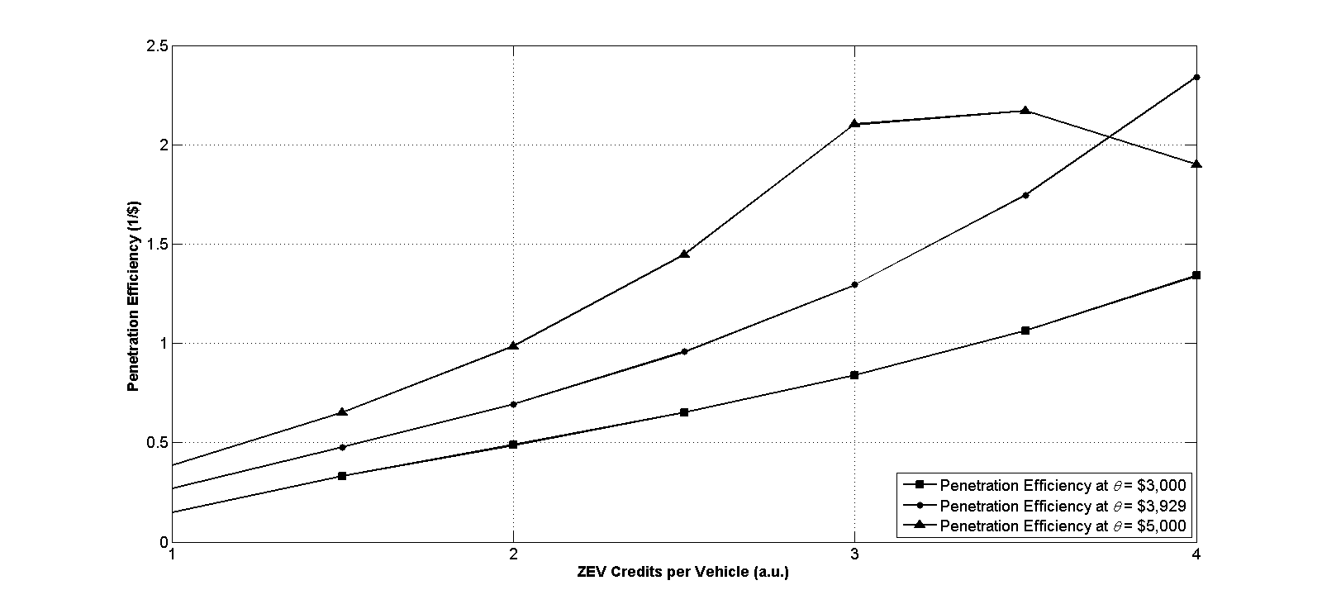
Figure 24. Comparison of the penetration efficiency with different ZEV credits per EV100 model and ZEV credit prices. Curve with square: credit price equals to $3,000; curve with dot: credit price equals to $3,929; curve with traingle: credit price equals to $5,000.

                - As depicted in Figure 24, the curves in general indicate increasing penetration efficiency for a growing number of credits per EV100 model and an increasing price of the ZEV credit. The penetration efficiency grows to around 2.5 customers per dollar, which indicates that the company is capable of attracting around 2 gasoline car buyers to purchase an EV100 model by each dollar subsidized for an EV100 model. The curve of $3,000 per credit shows that low credit profitability limits the capability of the policy to penetrate EVs. However, a spike was found in the curve of $5,000 per credit between 3 to 4 credits per EV100 model. It shows that, below the critical value, higher profitability of the ZEV credit led to a larger capability of capturing additional customers and therefore promotes the market penetration; however, above the threshold point, the ZEV credit became less effective to capture new customers for the EV100 model. It implies that the ZEV mandate helps the company attract early buyers rather than average or later buyers.
                - We then measured how much greater profit the ZEV mandate can provide to the company by stimulation rate. Stimulation rate is computed by the ratio of increased profit compared to the profit before the ZEV mandate to the total credit revenue earned by the EV100 model. Its mathematical formulation can be described by
$$r_{stimulation}=\frac{π_{a,basic}^{*}-π_{a,enhanced}^{*}}{θd_{a}∙N_{a,enhanced}},$$
where $π_{a,basic}^{*}$ and $π_{a,enhanced}^{*}$ are the optimal profit without and with the ZEV mandate, respectively. The difference between these two terms measures the amount of extra profit brought by the ZEV mandate. $N_{a,enhanced}$ is noted as the total number of consumers in the enhanced model. The denominator of this measurement characterizes the total credit revenue earned by the EV100 model from the credit market. The stimulation rate shows how much excess profit is induced by the ZEV mandate for the company. It shows the effectiveness of the ZEV mandate in providing financial support to electric producers.

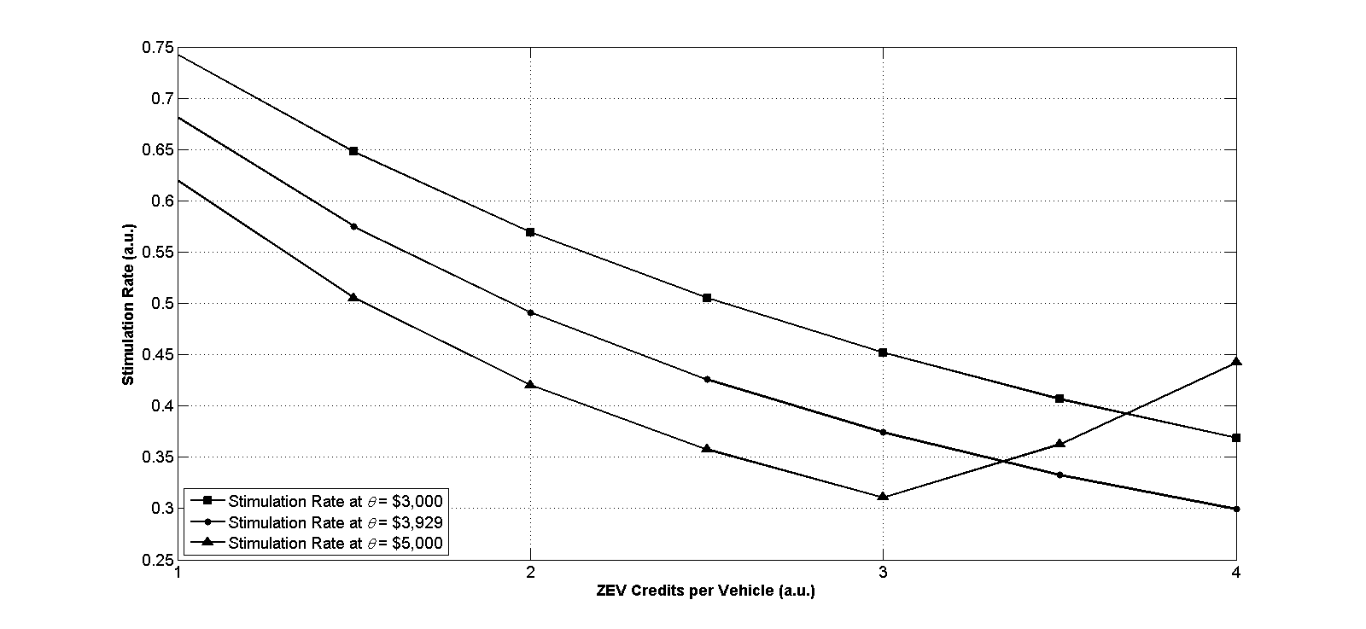
Figure 25. Comparison of the stimulation rates with different ZEV credits per EV100 model and ZEV credit prices. Curve with square: credit price equals to $3,000; curve with dot: credit price equals to $3,929; curve with traingle: credit price equals to $5,000.

                - We plotted the stimulation rates under different credits per EV100 model in Figure 25. The solid line shows that the stimulation rate gradually falls down to 0.3 at 4 credits per EV100 model. That means at least 30% of the electric vehicle related profit originates from the policy under current profitability of the ZEV credit. The descending curve shows less financial dependency on policy and weaker capability to capture additional customers by policy. When credit price was reduced to $3,000, the stimulation rate was found at a remarkable higher level which indicates the company's incapability to diffuse the EV100 model and reserve credit profit. Due to the current state policy configuration, The ZEV mandate triggered a nearly 40% increase in total profit for the company by promoting electric vehicle with credit reward by as much as 3 credits per EV100 model. The turning point was found at the same position as penetration efficiency at $5,000 per credit curve. An increasing stimulation rate indicates the company keeps credit revenue without transferring to customers (i.e., reducing retail prices). Below the critical value in the ZEV credits per EV100 model, the company passes a significant amount of their credit revenue to the customers. However, beyond the turning point, the company reserved their credit revenue, and the policy becomes only beneficial the automotive manufacturers.
                - Combing the findings from Figure 24 and Figure 25, we find that critical value exists in the measuring of the impact of the ZEV mandate. Below that threshold value, the company is willing to reduce the price of the EV100 model to attract new buyers, who are most likely early buyers. The revenue from credits was transferred to the consumers. However, over the threshold value, the ZEV mandate becomes less effective, and the company reserves more credit revenue as profit. A higher profitability of the ZEV credit could help the company to reach its potential customer faster.
                - Due to current state, the ZEV mandate rewards 3 credits to each produced and delivered EV100 model. From Figure 24, it can be clearly seen that the penetration efficiency is around 2 customers per credit. It seems like the current policy configuration is more focused on benefiting early buyers. An increment in credits per EV100 model can attract more customers meanwhile it could also provide a greater amount of financial support to the company. The deviation of the current state and the optimal setting endorses our motivation for a further study.

Conclusions
In summary, this paper developed a discrete choice model to estimate the market acceptance for a new electric vehicle model in the automotive industry. The customer preferences were captured based on the utility of various vehicle features in customer segments. The model further incorporated the government policy and studied the impact of government regulation on the optimization of new EV model price.
                - With the goal of generating deeper insights into the EV market penetration, we conducted a case study for the EV100 model in the California automotive market. According to our simulation results, we did not find a limitation on the influence of the ZEV mandate from the size of the California automotive market. Plausible effects of the ZEV mandate could be found in our simulation. Provided with an appropriate credit price, the company can effectively capture customers with the facilitation from the ZEV mandate. Furthermore, a growing demand for EV100 model models in turn yielded considerable profits for the company not only by selling EV100 model models but also by credit revenue. The revenue from the credit actually could offer the company an additional opportunity to commercialize the EV100 model.
                - During the process of catalyzing the adoption of the EV100 model, we find the number of credits per EV could remarkably affect the impact of the ZEV mandate. A threshold on the number of credits granted to each electric vehicle was found for facilitating the market adoption of EVs. Results show that, if the number of credits per EV is less than a threshold, increasing the ZEV credits promotes the EV market penetration; however, beyond the threshold, the ZEV mandate only benefits automakers. In current stage and policy configuration, the ZEV mandate is less effective in market penetration but more focused on benefiting early buyers. If more credits can be granted to affordable EVs, more consumers will be attracted and benefit from this policy.
                - As a final remark, we acknowledge that all of these results are based on the up-to-date data set and MA3T simulation results, which could be improved with the updated market data in the future. The proposed characterizations provide us with different perspectives in analyzing the impact of the ZEV mandate. These measurements entitled us to deeply understand the ZEV mandate and its role in EV adoption. The ZEV mandate appears to change remarkably based on our observations from these measurements.
                - In the current automotive market, the ZEV mandate offers two crucial assistances to the EVs. First, the CARB established a credit market, parallel to the automotive market, for the inventors who produce and deliver the EVs to the California automotive market. These companies can receive allowance from the credit market and transfer various amount of allowance into reinforcement in technology evolution or the enforcement in the EV market penetration. Based on this purpose, the credit market provides additional but necessary operation space for the inventors. On the other hand, the potential credit revenue will be transferred to consumers who are most likely to buy EVs. In this way, the early buyers benefit from lower price and are highly likely to enjoy better EVs from innovations. A possible future study could be to explore the competition between EV and gasoline vehicle producers. In doing so, we can study the policy impact on innovation competition from a deeper perspective.

Policy impact on vehicle attributes in electric vehicle market: the role of the Zero Emission Vehicles mandate
In this section, we present a decision model for electric vehicle attributes, in which vehicle attributes are influenced by market adoption and government policy. This paper first characterized the market adoptions of electric vehicle models under government subsidy. The demands were used to compute optimal vehicle attributes. The authors evaluated the impact of tradable credit policy based on variances of vehicle attributes in different scenarios. The proposed model was then applied to the California automotive market. The demand of the selected electric vehicle model was derived from simulation results of the Market Acceptance of Advanced Automotive Technologies model developed by the Oak Ridge National Lab. Results show that electric vehicle driving range is heavily influenced by manufacturer's battery cost and the Zero Emission Vehicle mandate. The regulation effectively elicits improvement of driving range and stabilizes electric vehicle price. Our results also suggest that industry leaders and followers may decide to produce electric vehicles with different driving ranges and serve separated market segments according to their battery manufacturing costs.

Research Framework
In this section, we will proceed to introduce our methodology for deciding optimal vehicle attribute. Understanding the dynamics between market adoption rate and vehicle attribute with regard to vehicle price is of central importance. Figure 26 illustrates our modeling concept. A government agency subsidizes automakers and expects to promote EV attribute $x$ such as driving range with full battery to ultimately enhance EV adoption. We assume that the government agency has complete information about how EV makers determine the optimal price and vehicle attributes based on policy offered to them. From this, the government aims to design an appropriate menu list of subsidy so that the company will choose an optimal vehicle attribute that fits government's objective.

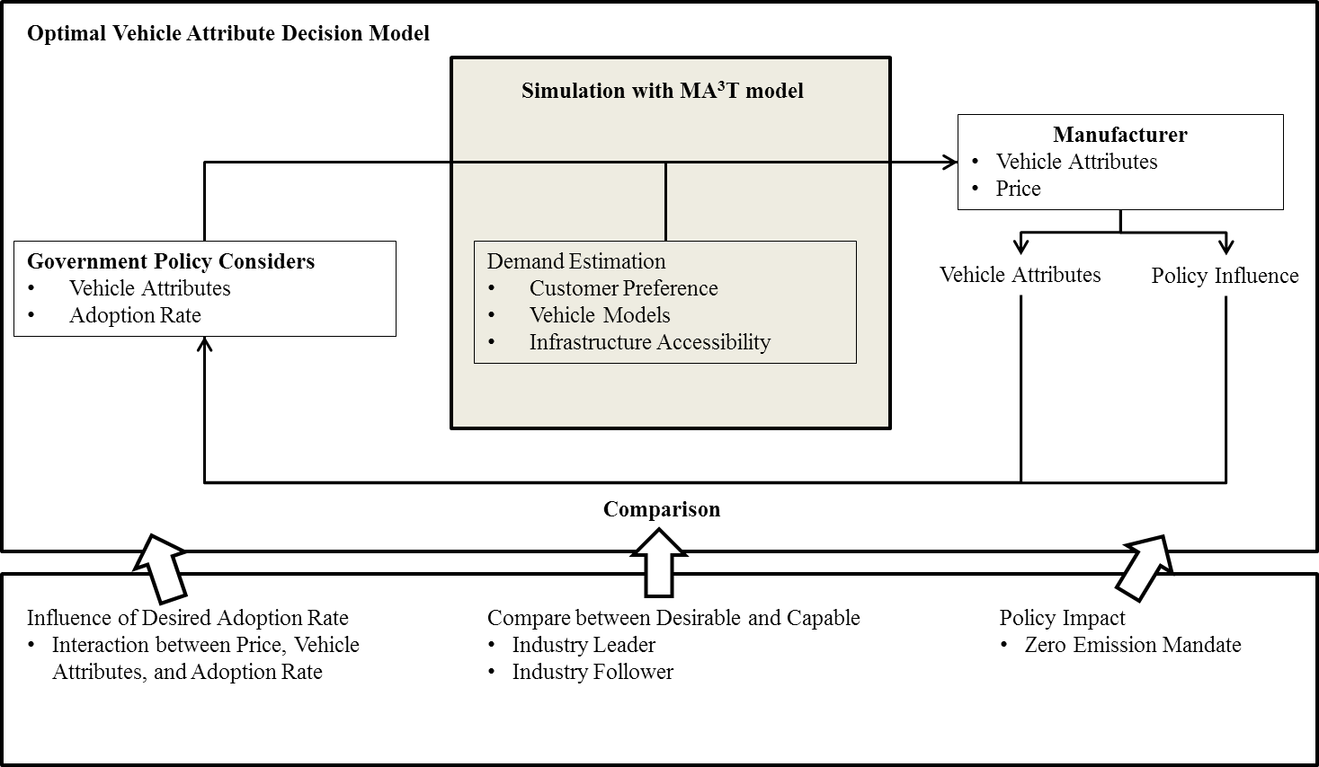
Figure 26 Model concept.

                - Consider an automotive market where several companies sell a number of vehicles in the automotive market. Those vehicles are defined as existing vehicles whose prices and vehicle attributes are assumed to be given parameters. In this market, one EV maker (she) introduces a new EV model. The dynamics between government and company is processed as following:
- Government agency proposes policy subsidies in the form of a menu list that contains multiple pairs of vehicle attribute lower bound $x_{LB}$ and tradable credit $d$ as $\left(x_{LB},d\right)$. That means any produced EV that aims to earn $d$ credits per vehicle must have vehicle attribute value greater or equal to $x_{LB}$.
- EV maker is allowed to choose one among all available alternatives, and determine vehicle price and attribute according to its profit maximization objective.
                - The vehicle attribute $x$ and the vehicle price $p$ are independent decision variables of the EV producer. For any attribute value, under the additivity assumption over utilities, the utility of the vehicle is a function of the vehicle attribute which can be described by $U=f\left(x\right)$. The vehicle attribute determines the utility of the vehicle and influences the market adoption of the EV model. The annual demand in the market for the new EV model is measured by $N\left(p, x\right)$. $N\left(p, x\right)$ is affected by both the vehicle price $p$ and the vehicle attribute $x$. Given these information, the EV maker needs to decide an optimal value of the vehicle attribute $x$ and the price $p$ in order to maximize her profit that can be written as
$\max_{p,x}\left[p-c\left(x\right)+θ∙d\left(x\right)\right]∙N\left(p, x\right)$, (18)
where $p$ is the vehicle price, $c\left(x\right)$ denotes the manufacturing cost that is determined by vehicle attribute level $x$. $d\left(x\right)$ is the policy parameter associated with vehicle attribute level and describes how many credits each electric vehicle model is rewarded and $θ$ is the credit price that measures monetary benefit from each credit. It is worth noting that in the ZEV mandate, $d\left(x\right)$ is discretized into a series of steps due to regulated levels of attribute. In doing so, $d\left(x\right)$ becomes a piecewise function in $x$. Given that, one can get ${dd\left(x\right)}/{dx}=0$ within each level of subsidy on the policy menu list.
                - Assume the government provides $n$ levels of combination of vehicle attribute and credit reward. The amount of credit is constant within each segment and $d\left(x\right)$ equals to $d_{i}$ for $x_{i}≤x<x_{i+1}$, $i=1,2,3,…,n$. For all the combination of vehicle attribute and corresponding credits, $\left(x_{1},d_{1}\right)$, $\left(x_{2},d_{2}\right)$, $\left(x_{3},d_{3}\right)$,…, $\left(x_{n},d_{n}\right)$, they follow a sequential relation as $x_{1}<x_{2}<x_{3}<…<x_{n}$ and $d_{1}<d_{2}<d_{3}<…<d_{n}$. For example, the government offers 3 levels of subsidy and the EV maker is allowed to choose any one out of all three options. For each EV model with $x_{1}≤x<x_{2}$, the manufacturer will be rewarded $d_{1}$ credits.

                - According to Karush–Kuhn–Tucker condition, the optimal vehicle attribute is achieved according to the first-order conditions of profit function with respect to both vehicle price $p$ and vehicle attribute $x$, which is written as
$\left\{\begin{aligned}\frac{dπ}{dp}=\left[p\left(x\right)-c\left(x\right)+θ∙d\left(x\right)\right]∙\frac{∂N\left(p,x\right)}{∂p}+N\left(p,x\right)=0 \\ \frac{dπ}{dx}=\left[p\left(x\right)-c\left(x\right)+θ∙d\left(x\right)\right]∙\frac{∂N\left(p,x\right)}{∂x}-\frac{dc\left(x\right)}{dx}∙N\left(p,x\right)=0\end{aligned}\right.$. (18)
                - We can rewrite the first equation in (18) as $N\left(p,x\right)=-\left[p\left(x\right)-c\left(x\right)+θ∙d\left(x\right)\right]∙\frac{∂N\left(p,x\right)}{∂p}$. Bringing it to the second equation and replace $N\left(p,x\right)$ yields
$\frac{∂N\left(p,x\right)}{∂x}+\frac{dc\left(x\right)}{dx}∙\frac{∂N\left(p,x\right)}{∂p}=0$, (3)
where $\frac{∂N\left(p,x\right)}{∂x}$ is demand sensitivity with respect to vehicle attribute while $\frac{∂N\left(p,x\right)}{∂p}$ is the demand sensitivity with respect to vehicle price. $\frac{dc\left(x\right)}{dx}$ is assumed to be achievable and will be later used to compute $x^{*}$.
                - We assume the EV model has an exponential demand function in price as
$N\left(p,x\right)=β_{1}\left(x\right)∙exp\left(β_{2}∙p\right)$, (19)
which is common for innovation product in early introductory stages (Hanssens and Parsons 1993, Jeuland and Shugan 1988, Song et al. 2008). $β_{1}\left(x\right)$ is the customer base at zero price and it is also influenced by vehicle attribute. $β_{2}<0$ guarantees that demand for the EV model is always decreasing in price.
$\frac{∂N\left(p,x\right)}{∂x}=\frac{∂β_{1}\left(x\right)}{∂x}∙exp\left(β_{2}∙p\right)$, (20)
and
$\frac{∂N\left(p,x\right)}{∂p}=β_{2}∙β_{1}\left(x\right)∙exp\left(β_{2}∙p\right)=β_{2}∙N\left(p,x\right)$. (21)
                - We assume the first order derivative of the manufacturing cost with respect to vehicle attribute $x$ can be denoted by
$\frac{dc\left(x\right)}{dx}=g\left(x\right)$, (22)
where $g\left(x\right)$ represents an increasing function in $x$ that indicates the convexity of the manufacturing cost in $x$. Bringing equation (20), (21), and (22) into equation (19) yields
$g\left(x^{*}\right)=-\frac{{∂β_{1}\left(x\right)}/{∂x}}{β_{1}\left(x\right)∙β_{2}}$. (23)
                - Hence, we are able to solve equation (23) and find the optimal vehicle attribute $x^{*}$ by
$x^{*}=g^{-1}\left(-\frac{{∂β_{1}\left(x\right)}/{∂x}}{β_{1}\left(x\right)∙β_{2}}\right)$. (24)
                - Replacing $x$ in the first equation of (19) with optimal vehicle attribute value, $g^{-1}\left(-\frac{{∂β_{1}\left(x\right)}/{∂x}}{β_{1}\left(x\right)∙β_{2}}\right)$, the optimal price of this EV model can be then calculated by
$p^{*}=-\int_{0}^{x}{\frac{{∂β_{1}\left(z\right)}/{∂z}}{β_{1}\left(z\right)∙β_{2}}dz}-θ∙d\left(-\frac{{∂β_{1}\left(x\right)}/{∂x}}{β_{1}\left(x\right)∙β_{2}}\right)-\frac{1}{β_{2}}$. (25)
                - From equation (24) and (25), the EV manufacturer can determine the optimal vehicle attribute by studying the market acceptance with respect to vehicle attributes and price. Furthermore, the government agency can accordingly design the regulation menu list based on the computational result of $x^{*}$ and $p^{*}$, and their corresponding market adoption rate.

Case study: driving range and optimal price of electric vehicles in the California automotive market
In this section, we will conduct a case study of the EV models in the California automotive market under the influence of the ZEV mandate. To analyze the impact of the ZEV mandate on the manufacturer's decision of vehicle attribute, the following approach is chosen. (1) The MA³T model will be first introduced in detail before an analysis for the ZEV mandate is carried out. We use the data and parameters in the MA³T model to simulate the market adoption rate of the California automotive market. The simulation results allow us to capture the market perception of EV technology features and price. (2) We estimate manufacturing cost based on EV driving range. In this step, we begin with a regression of EV driving ranges into a function of battery capacity. (3) Afterwards, we construct stepwise policy incentives with respect of vehicle attribute levels and figure out the optimal driving range and price in each incentive level. Accordingly, we assess the role of the ZEV mandate in facilitating EV attribute improvement. (4) We will separate EV makers in this industry by battery cost. One type of EV makers is industry leader who have a lower battery manufacturing cost than the other type of EV makers, industry follower. The heterogeneous of EV makers will contribute to our analysis of EV market and it will entitle us to find out separated focuses on vehicle design in the market. From this, we derive conclusions based on the achieved results and our analysis will make contribution to the literature for deeper understanding of the ZEV mandate.

Optimal electric vehicle driving ranges and optimal price in the California automotive market
This study considers the determination of driving range and price of the EV model that has a driving range of 200 miles. This model represents middle range EVs and will be noted as EV200 model in the following discussions. We forecasted annual demand for EV200model from the MA³T model based on the 2016 California automotive market data by increasing its price from $29,000 to $48,000 and its driving range from 142 miles to 264 miles. The result is plotted in Figure 27. Each curve in this figure describes the annual demands over different vehicle prices and different marks separates vehicles with driving ranges. It shows that, with same driving range, vehicle demand declines sharply in price that indicates very high price sensitivity to vehicle price in the market. At the same price, annual demand increases in driving range. Because longer driving range usually indicates a higher cost and potentially higher price, there is a need to balance improved vehicle attribute and increased cost. As a consequence of this, we will investigate the tradeoff between them and how government provides promotional incentives to reconcile the conflict between driving range and price.

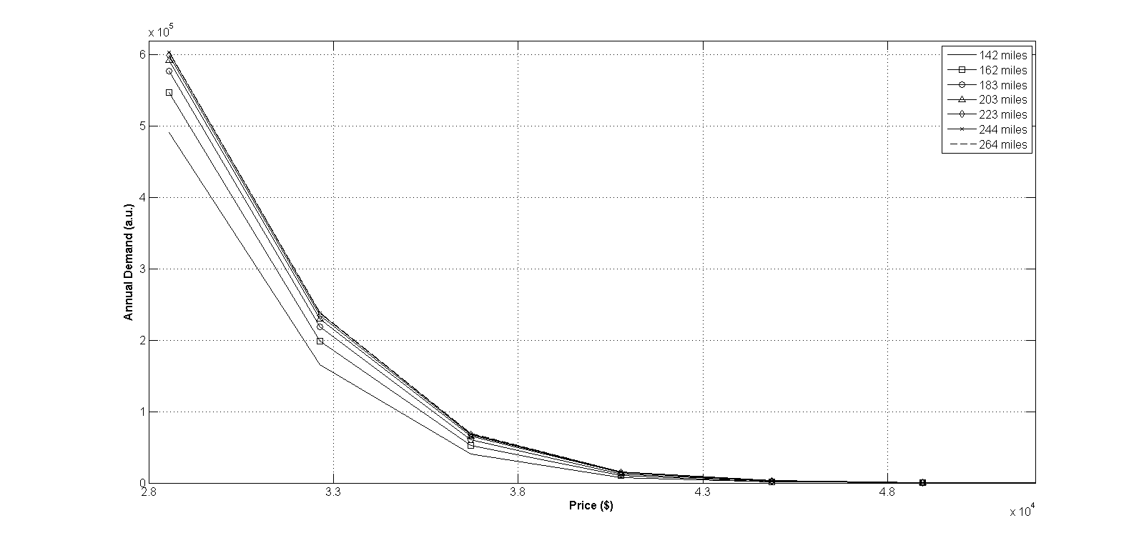
Figure 27 Demand curves of EV200 model.

                - The demand data for EV200 model was input to Matlab and regressed into a demand surface by biharmonic method. Afterwards, the two-dimension demand function was brought back to compute the EV maker's profit at each point. As a consequence of this, we were able to describe the demand for and the profit from EV200 model when its price is between $29,000 and $48,000 and its driving range is between 180 miles and 230 miles.
                - We next investigated the relation between driving range and battery capacity that can further contribute to our computation for manufacturing cost. We searched over the current EV market and summarized 15 EVs. The designing parameters of these models were listed in Table 4. The driving range of EV models and regression curve are plotted in Figure 28. The filled squares in this figure are the real data points for current EV models in the market whereas the filled triangles are the incoming models, i.e. Tesla Model 3, Tesla model S60, and Chevy Bolt. The solid curve in the same figure represents the regressed curve.

Table 4 Battery capacity, and driving range of some current EVs.
Vehicle Models | Battery Capacity (kilowatt hour) | Driving Range (mi)
Mitsubishi i Miev | 16 | 62
Smart ED | 17 | 68
GM Spark EV | 19 | 82
Honda Fit EV | 20 | 82
BMW i3 | 22 | 81
Ford Focus Electric | 23 | 76
Fiat 500E | 24 | 87
Nissan Leaf | 30 | 107
Mercedes B | 36 | 85
Toyota RAV4-EV | 41.8 | 113
Tesla Model 3 (incoming) | 44 | 220
Tesla Model S60 (incoming) | 60 | 218
Chevy Bolt (incoming) | 60 | 200
Tesla Model S85 | 85 | 253
Tesla Model S90 | 90 | 294

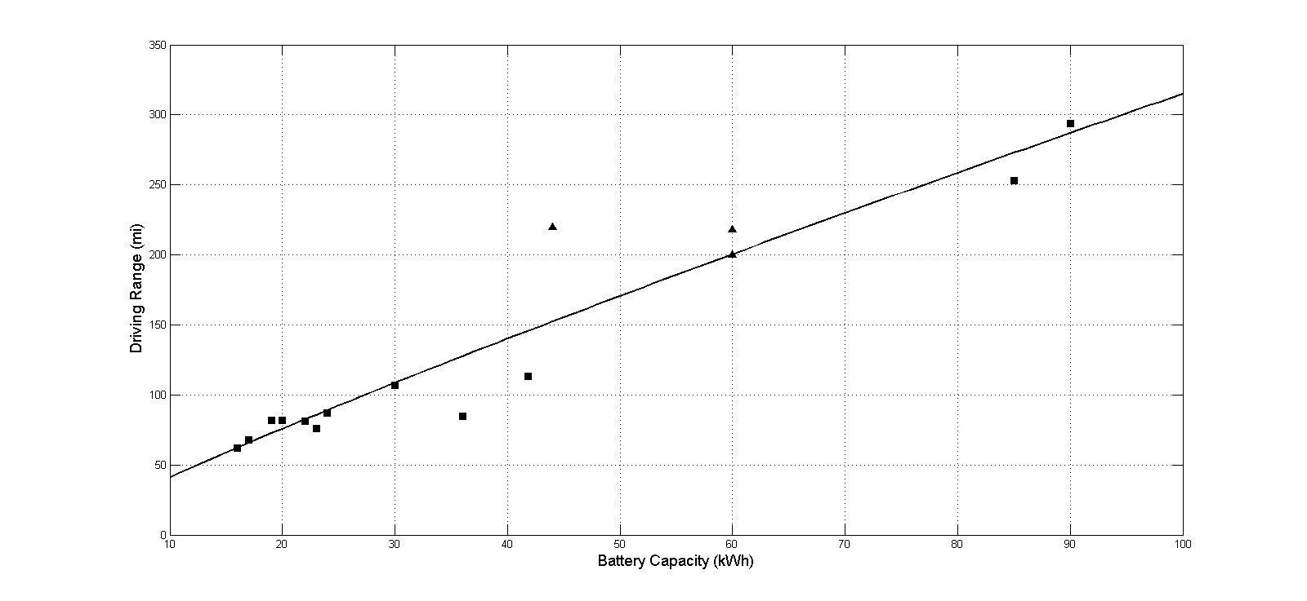
Figure 28 Regressed Driving range as a function of battery capacity for EV models. Square: current EV model; triangle: incoming EV model; solid line: regression curve.

                - In Figure 28, it can be observed that the solid curve is slightly bended to the upper left corner. That indicates longer range EVs consumes larger portion of energy by its self-weight than shorter range EVs. Under same energy density, longer driving range requires larger capacity of battery pack and a greater number of battery cells. Hence, the driving range based on battery capacity is computed by
$R={a∙\left(BC\right)}^{b}$,
where $R$ is the driving range of any EV model while $BC$ denotes the battery capacity. From current market data, we have $a=5.6393$, and $b=0.8845$. In this experiment, battery costs were resulted from the data provide by Bullis (2013). From this, the estimated manufacturing cost is described by
                - $R=a∙{\left(\frac{c∙γ-u_{0}}{u}\right)}^{b}$,
or
$c=\frac{1}{γ}∙\left[u_{0}+u∙{\left(\frac{R}{a}\right)}^{\frac{1}{b}}\right]$.
where, $γ$ is a constant and denotes the percentage of budget that battery consumes in manufacturing, $u_{0}$ is the battery management system (BMS) cost, and $u$ is the unit cost of battery pack, which is measured by dollars per kilowatt. Both $a$ and $b$ are positive constants. For conservation purpose, we presumably calibrated the battery cost percentage with real market data and let $γ=0.44$, which assumes 44% total cost is consumed by vehicle's battery pack. In addition, we reserved $8,600 for BMS from an empirical computation from the same source. For manufacturing cost of battery pack per kilowatt hour, we assume industry leaders follow an estimation of $190 per kilowatt hour whereas industry followers have an estimated cost of $270 per kilowatt hour (Cole 2014, Voelcker 2014).
                - The simulation results leads to indications by three folds. (1) The data displayed in Figure 28 shows very few vehicle models have driving range between 150 and 220 miles. One reason is because high battery cost that prohibit EV producers to make that EV model. Another reason might because EV makers strategically decide not entering that market even though they might be able to physically produce that type of EV model. We will show in the following analysis that producers should be able to find out a new niche market of 200-mile range vehicle and that will also remarkably contribute to EV penetration. (2) Due to a recent report, consumers show constrained incremental willingness-to-pay for long range EV models (Kochhan and Hörner 2015) but considerable interest in middle-range EVs. It is of notable interest to study how producers figure out a balance between outperforming driving range and corresponding manufacturing cost. Since the MA³T model takes into account the consumer willingness-to-pay, we will show this balance can be attained by EV200 model. (3) This study could also help government agencies further investigate the role of the policy in transition to EVs. The analysis below will show that the policy remarkably diffuse 200-mile range EV.

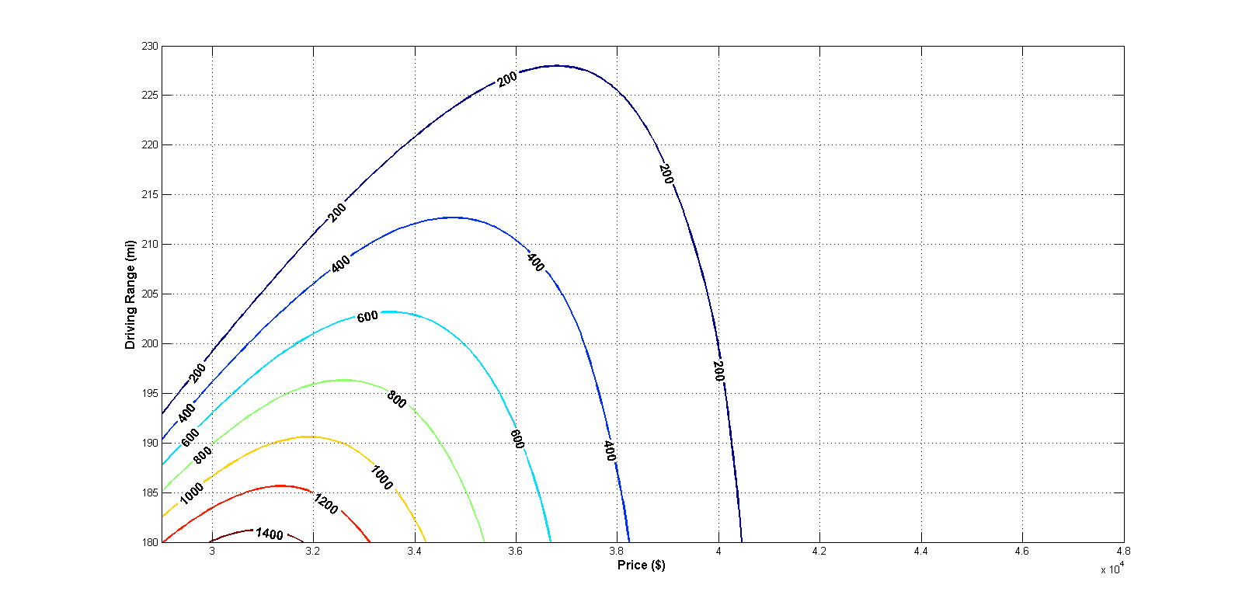
Figure 29 Total profit of EV200 model (driving range from 180 miles to 230 miles and price between $28,000 and $48,000). Total profit is shown in million dollars.

                - Based on the demand for EV200 model from the MA³T model and the estimated manufacturing cost, we computed the total profit from EV200 model that has driving range from 180 miles to 230 miles and price between $28,000 and $48,000 with presumably 4 credits per vehicle. The total profits with different combinations of vehicle driving range and selling price are shown in Figure 29. We can observe that the highest profit can be found at a combination of roughly $30,000 to $32,000 with a driving range of 180 miles. It is also worth noting that the profit surface decline faster in driving range than price because extended range leads to higher cost.

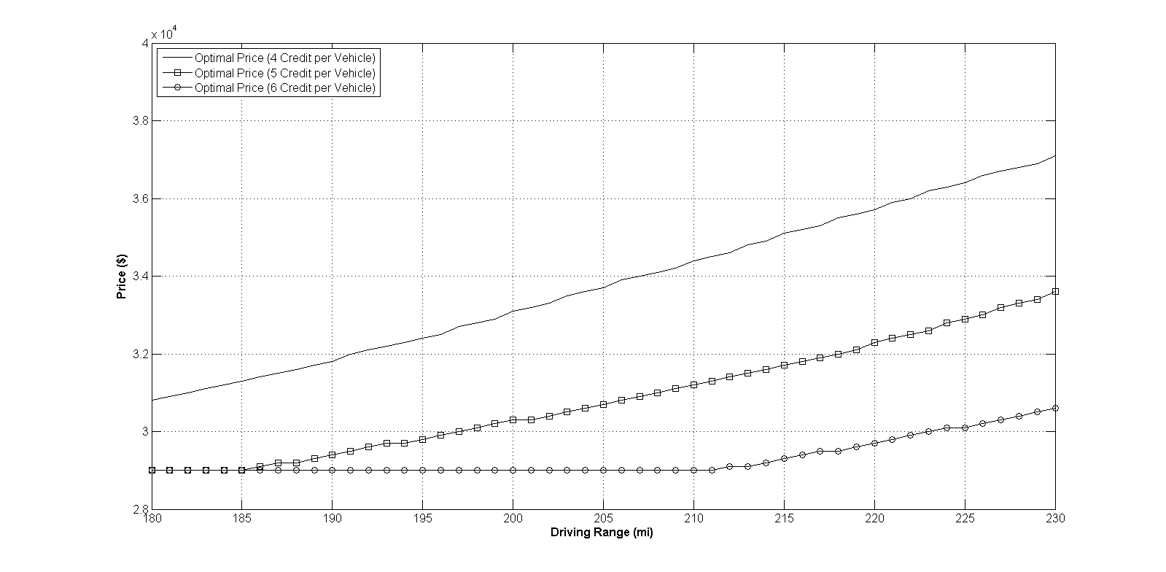
Figure 30 Optimal prices with different policy incentives (driving range from 180 miles to 230 miles).Solid curve: 4 credits per vehicle; solid curve with square: 5 credits per vehicle; solid curve with circle: 6 credits per vehicle.

                - According to the computed total profit, we found the optimal prices at each driving range configuration and the results were plotted in Figure 30. In addition, we also calculated total profits from EV200 model with 5 and 6 credits per vehicle and both results were illustrated in the same figure. The optimal prices of EV200 model increases in driving range which can be explained by the increased cost due to extended driving range. Meanwhile, when the EV maker is rewarded with more rewards, the optimal price of EV200 model is reduced significantly. The optimal price of the same model drops to less than $30,000 with 6 credits per vehicle. As shown in Figure 31, increased credits leads to higher profit per vehicle and that will possibly increase EV maker's capability of reducing price for the same EV model and attract more customers.

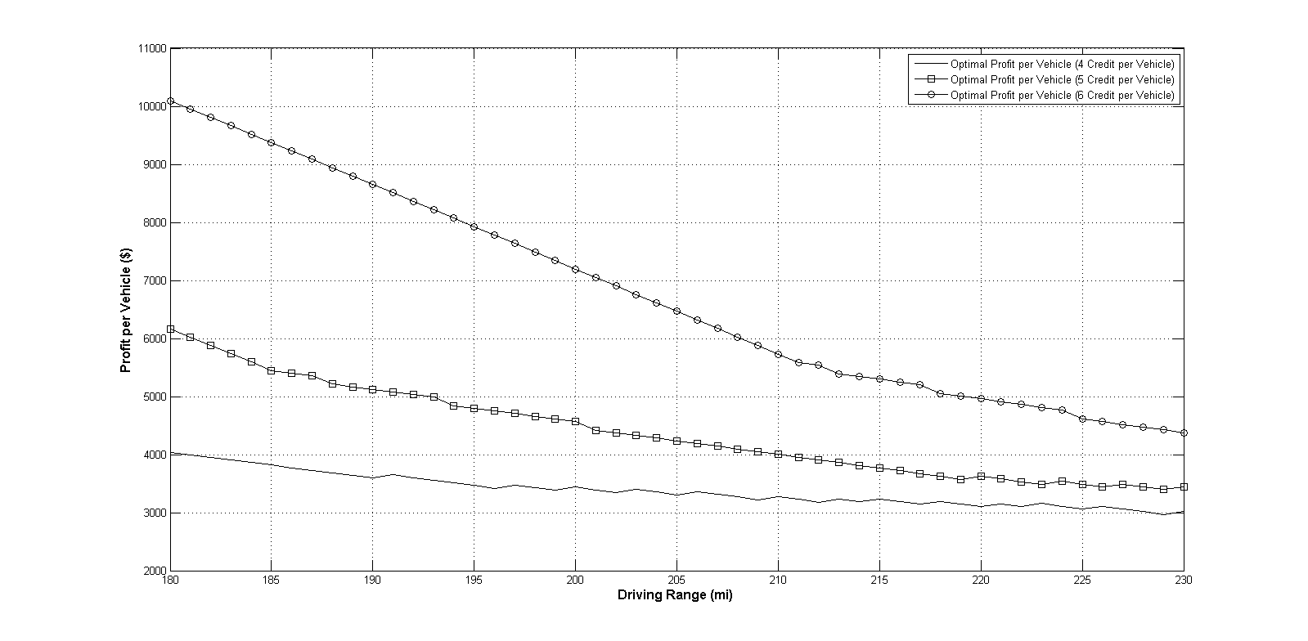
Figure 31 Profit per EV200 model at optimal price with different policy incentives (driving range from 180 miles to 230 miles). Solid curve with square: 4 ZEV credits per vehicle; solid curve with triangle: 5 credits per vehicle; solid curve with circle: 6 credits per vehicle.

                - The corresponding demands for EV200 model at optimal prices were plotted in Figure 32. In this figure, curves show demands for EV200 model declines in driving range drastically due to its increased price, which shows the market is more sensitive in price than driving range. However, under more aggressive policies, market demands slightly increases for longer driving range that implies the market has potential to respond to upgraded vehicle. With 5 credits per vehicle, the annual demand for EV200 model can be attained above 500,000 in California. That indicates a huge customer base of 200-mile range EV in the California automotive market. Because of the policy triggered price reduction and attracted customers to EV200 model, as shown in Figure 33, the ZEV mandate elicited higher total profit from EV200 model for the same vehicle driving range. Consequently, EV maker can be motivated to produce EV200 models.

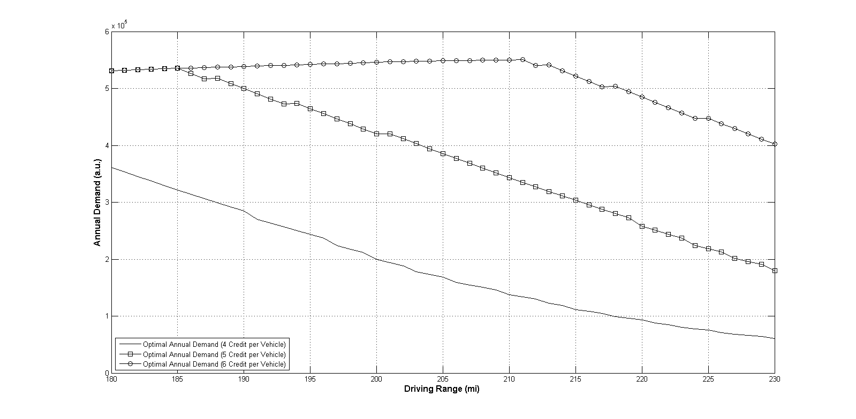
Figure 32 Annual demand for EV200 model at its optimal prices with different policy incentives (driving range from 180 miles to 230 miles). Solid curve with square: 4 ZEV credits per vehicle; solid curve with triangle: 5 credits per vehicle; solid curve with circle: 6 credits per vehicle.

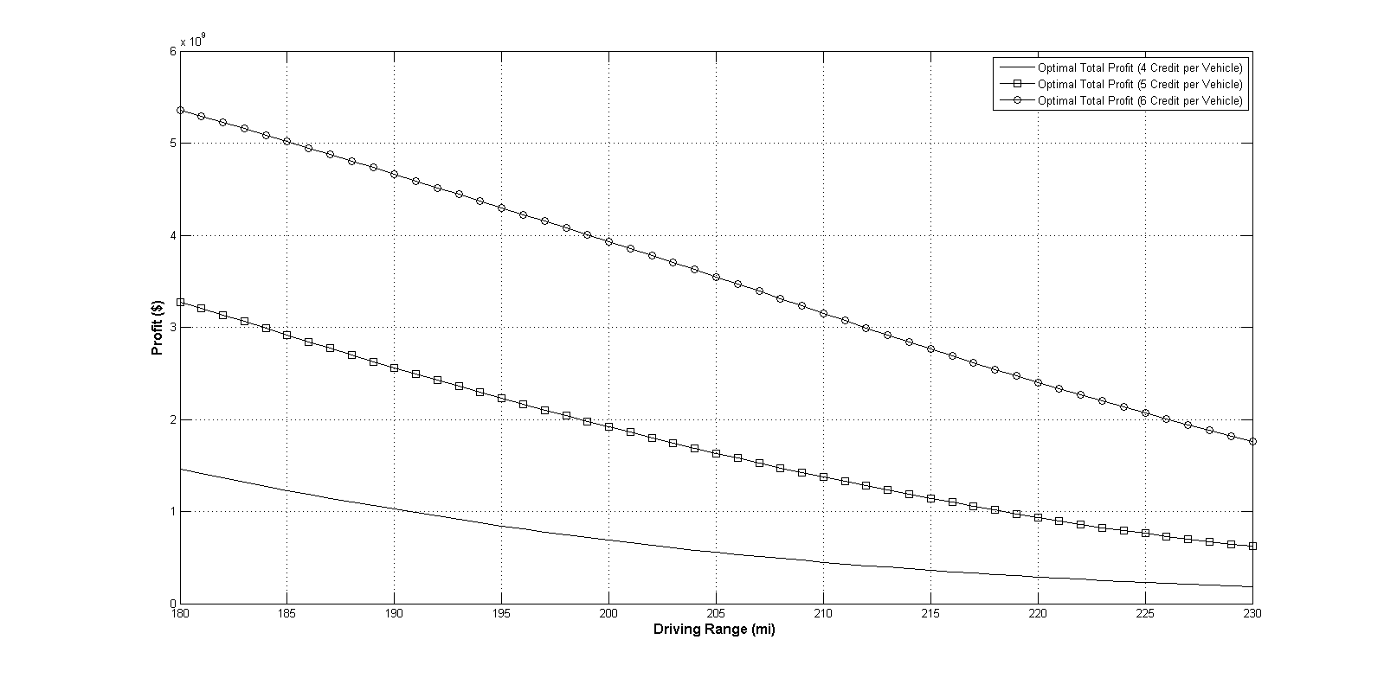
Figure 33 Total Profit from EV200 model at optimal price with different policy incentives (driving range from 180 miles to 230 miles). Solid curve with square: 4 ZEV credits per vehicle; solid curve with triangle: 5 credits per vehicle; solid curve with circle: 6 credits per vehicle.

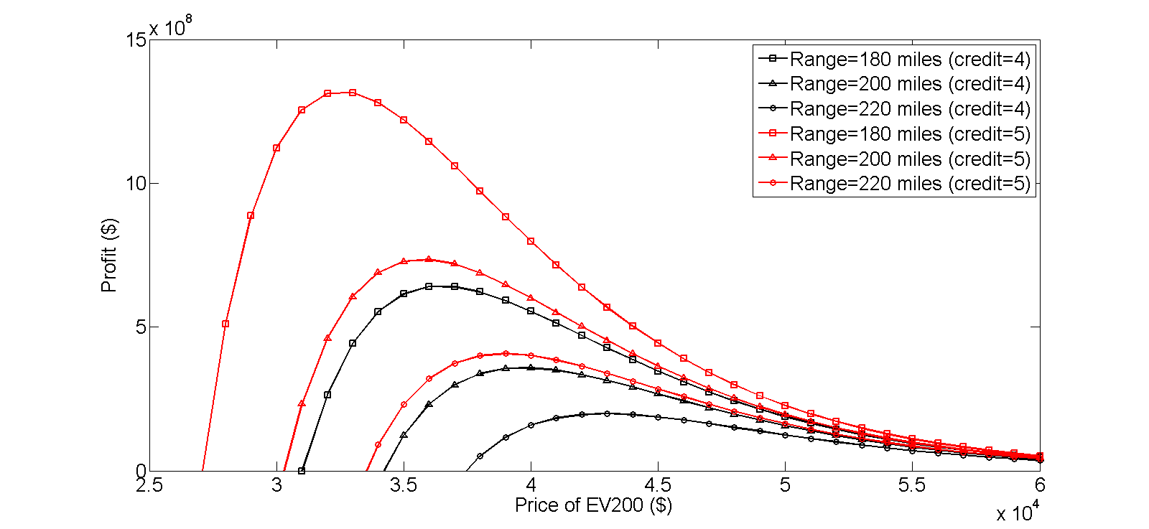
Figure 34 Comparison the effect of the ZEV mandate on profit from 180-mile EV (solid and square curve), 200-mile EV (solid curve), and 220-mile EV (solid and triangle curve), before (black) and after (red) rising of eligible credits per vehicle.

                - Against this background, we did another experiment to investigate the role of the ZEV mandate in EV technology evolution. In this experiment, we assume there are three types of EV200 model vehicles that have different driving ranges, 180 miles, 200 miles, and 220 mile. Each one of them is qualified for the same amount of ZEV credits, 4 credits per vehicle (black curves). The experiment results are all plotted in Figure 34. It is not surprising that lower range vehicles show higher profits because shorter range vehicles saves money as long as they are eligible for the same reward and the shorter range vehicles can probably trigger higher demand due to its lower price.
                - We then raised the incentive to 5 credits per vehicle and compared with the case of 4 credits per vehicle. The ZEV mandate raised profit curve of all vehicle models. The profit curve of vehicle with 200 miles with 5 credits per vehicle successfully reaches an even higher profit level than 180-mile vehicle with 4 credits per vehicle. That demonstrates two important points: (1) Growth in profit shows solid financial supports from the ZEV mandate to automotive makers that reliefs the pressure from necessary vehicle attribute requirement from the market. The ZEV mandate enables them to improve vehicle attributes such as driving range without increase its price. It seemingly shows that the ZEV mandate essentially facilitates EV technology evolution. (2) Automakers are allowed to reduce the EV price with the ZEV mandate. This provides considerable product designing space for automakers and these automakers will be entitled to avoid price or vehicle attribute competition at the early stage of EV diffusion.

The role of the ZEV mandate in the California automotive market
In this section, we will address the role of the ZEV mandate in constructing California automotive market. We consider there is an industry follower (he) in the same market and he produces EV200 model with a battery cost of $270 per kilowatt hour (Cole 2014). As compared in Figure 35, it is not surprising to find the cost of industry follower is remarkably higher than leading company and this gap increases in driving range. That indicates the industry follower has weaker capability of improving the EV driving range.

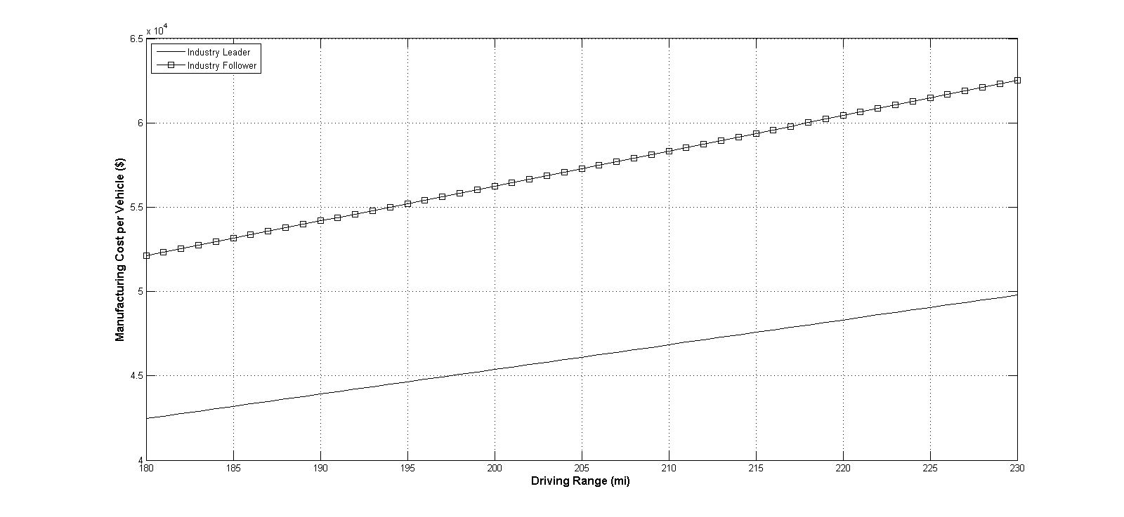
Figure 35 Comparison of manufacturing cost per EV200 model by industry leader (solid curve) and follower (solid curve with square).

                - Due to the increased manufacturing cost per vehicle, the total profit from EV200 model of industry leader is significantly lower than leading companies. The maximum of the total profit is shifted to higher price regions (shown in Figure 36). The total profit of the industry follower is heavily right skewed that indicates the vehicle price rises faster in driving range than leading company. As the optimal prices increased rapidly, the industry follower shows a weakened motivation and ability to transfer policy incentives to end-users because a larger portion of the received subsidy is consumed by greater incremental battery cost than industry leader. Figure 37 depicted his weaker ability to maintain vehicle price of EV200 model.

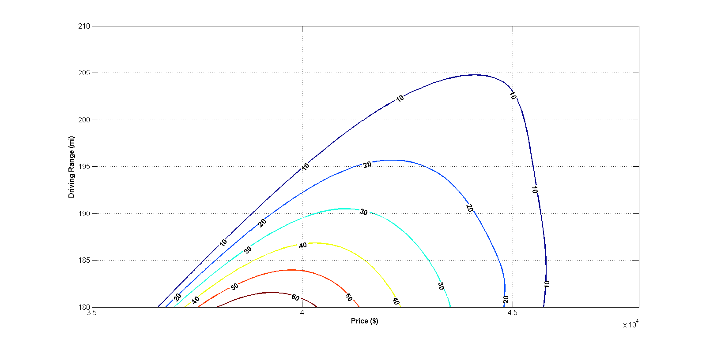
Figure 36 Total profit of EV200 model (by the industry follower) (driving range from 180 miles to 230 miles and price between $28,000 and $48,000).The total profit is shown in million dollars.

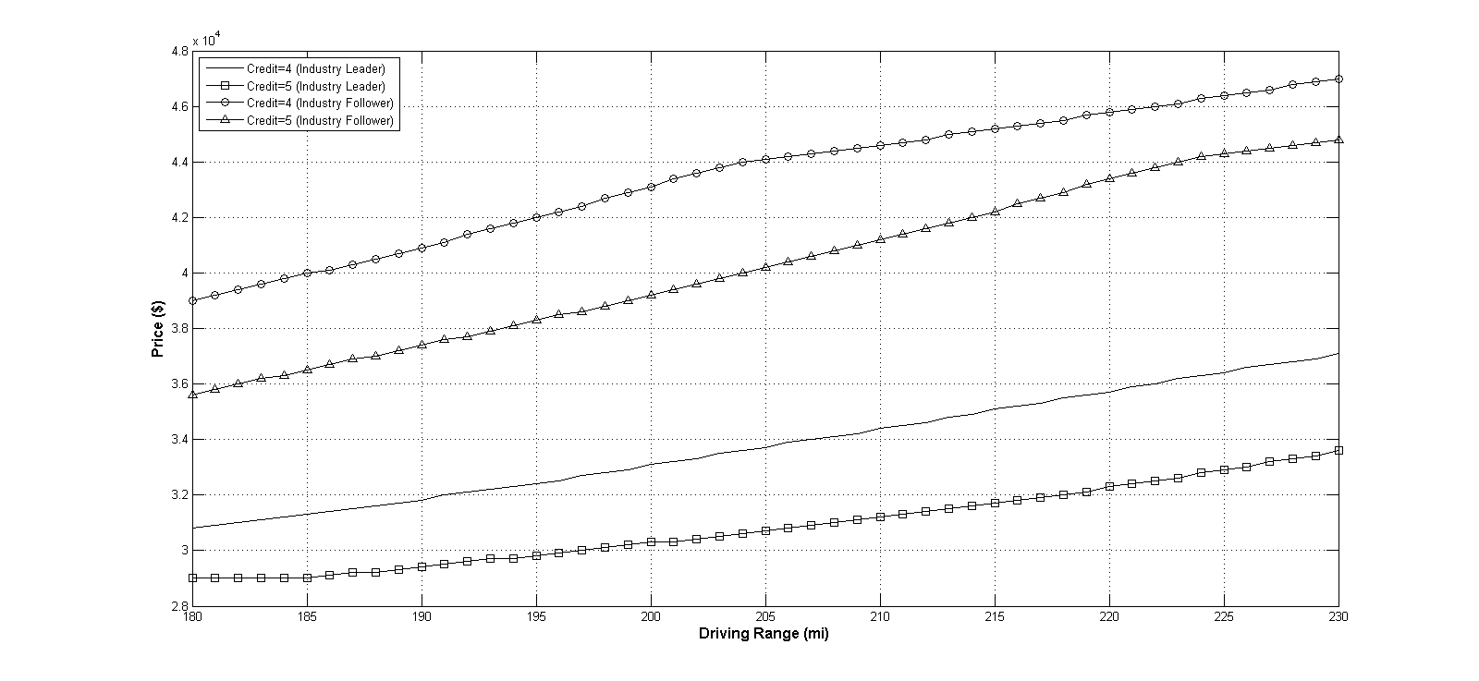
Figure 37 Comparison of the optimal prices by industry leader and follower with different policy incentives (driving range from 180 miles to 230 miles). Solid curve: 4 credits per vehicle (industry leader). Solid curve with square: 5 credits per vehicle (industry leader); solid curve with circle: 4 credits per vehicle (industry follower); solid curve with triangle: 5 credits per vehicle (industry follower).

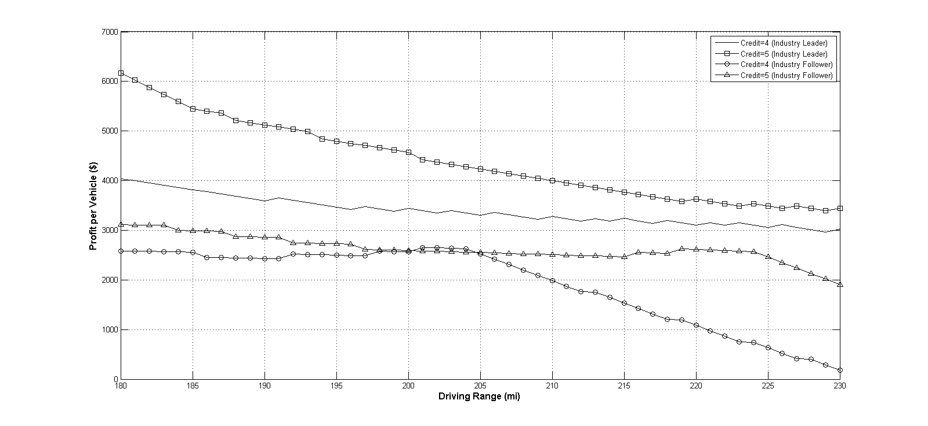
Figure 38 Comparison of the profit from each EV200 model at optimal prices by industry leader and follower with different policy incentives (driving range from 180 miles to 230 miles). Solid curve: 4 credits per vehicle (industry leader). Solid curve: 4 credits per vehicle (industry leader); solid curve with square: 5 credits per vehicle (industry leader); solid curve with circle: 4 credits per vehicle (industry follower); solid curve with triangle: 5 credits per vehicle (industry follower).

                - In Figure 38, industry follower shows very limited ability to maintain profitability of the EV200 model. The reason is attributed to higher manufacturing cost from extended cruising range. When vehicle range increased above 215 miles, industry leader can only have roughly $1,000 profit from each vehicle which is roughly 2% profit margin while this number is almost 10% by industry leader. The gap in profitability will be then translated into weaker convertibility of transfer policy incentive into lower prices which finally shown as differences in the capability of transferring policy supportive benefit to end buyers. Due to the results shown in this figure, it seems reasonable to conjecture that the ZEV mandate can potentially separate industry leader and follower in making 200-mile EV models.

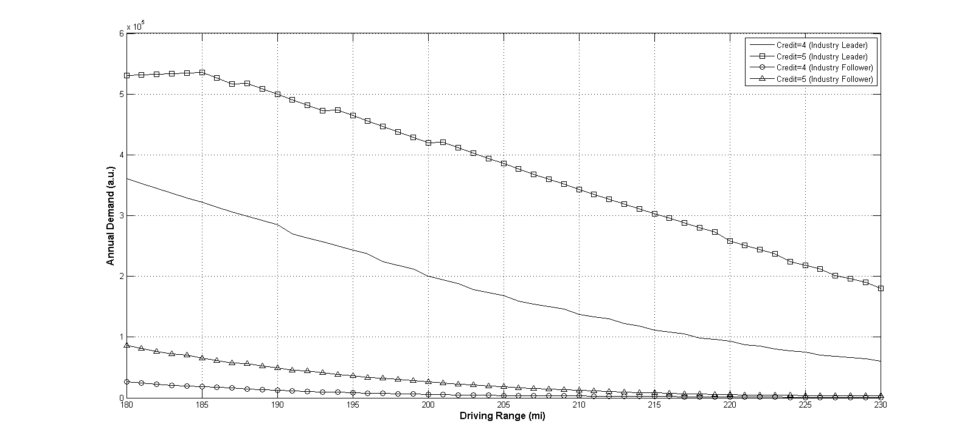
Figure 39 Comparison of the annual demands for EV200 model at optimal prices by industry leader and follower with different policy incentives (driving range from 180 miles to 230 miles). Solid curve: 4 credits per vehicle (industry leader). Solid curve: 4 credits per vehicle (industry leader); solid curve with square: 5 credits per vehicle (industry leader); solid curve with circle: 4 credits per vehicle (industry follower); solid curve with triangle: 5 credits per vehicle (industry follower).

                - In Figure 39, the demand for EV200 model by industry leader is overwhelming to industry follower. With 4 ZEV credits per EV200 model, the industry leader is able to make vehicle driving range at least 215 miles and trigger the demand for EV200 model above 100,000 which is roughly 10% of the overall demand for new passenger cars in the California automotive market. This demand is almost 10 times greater than that induced by the industry follower. Even with more credits subsidized to the follower, the demand is still severely limited and far from government adoption goal. This gap displayed in this figure indicates that, from economics perspective, the industry leader is entitled to make EV200 model while the follower is less capable of producing the same model even with the same promotional offer. The ZEV mandate actually performs a separation in the California automotive market and divided it into two distinct divisions where the industry leader enters the 200-mile EV market while the industry follower makes shorter range EV models. In this regards, both the leading company and follower are able to focus on EV models with driving ranges at various levels and serves consumers with different requirement on EV models. Consequently, the uncertainty of demand and supply might be narrowed in the California automotive market and EVs can diffuse more efficiently. This will be our future research focus.

Conclusions
Our study adds new insights into the market adoption of electric vehicles and confirmed some earlier findings about the ZEV mandate. According to market adoption data from the MA³T model, the demand function of electric vehicle fits well with exponential function of its corresponding selling price. That built up our base for further experiment and discussion.
                - Our analysis also confirmed some findings from earlier study about the role of the ZEV mandate in the California automotive market. The ZEV mandate can dramatically raise the profits from EVs that provides approaches for helping EV makers to be more flexible in pricing and designing EV models. We also find the ZEV mandate shifts optimal prices of each EV model to a lower level. That indicates higher demand level in the California automotive market.
                - Given the large incentive in the California automotive market and sizeable investment by automakers for future EV technology evolution, it is important to understand the dynamics of determination of vehicle attribute levels. In this paper, we proposed a method for optimal vehicle attributes of electric vehicle. Automakers, for instance, can gauge their vehicle attributes like driving range against the tradeoff between manufacturing cost and annual demand. Our research provides relevance between market perception and vehicle design. Moreover, government agencies can correspondingly predict industry's respond to enacted or amended regulations by varying their vehicle attributes.
                - From a policy perspective, our experiments about 200-mile range EV model shed light on a possible reaction. We found the current EV market will be disparate and it will not be surprising to know most automakers choose a different vehicle attribute level than industry leaders due to higher battery cost. Industry leaders might soon merge into 200-mile electric vehicle market and savor less competitive market and considerable profit. Our results may also be used to investigate future EV industry development.

Price competition and market penetration: a study on the influence of policy incentives in the California electric vehicle market
In the last part, scenarios of the transition to battery electric cars are created and analyzed using the Market Acceptance of Advanced Automotive Technologies model, which was developed by the Oak Ridge National Lab. Technology features and corresponding market perception were included in the derivation of the market adoption rates of two battery electric vehicle models in the California automotive market. Considering the Zero Emission Vehicle mandate already in place, this paper investigates the role of this regulation in impacting the pricing decisions of different electric vehicle models and enhancing market adoption rate of electric vehicles. It was found in the analysis that the 200-mile range electric vehicle model, which will be entering the electric vehicle market shortly, had significant unilateral influence on the pricing decision of 100-mile range electric vehicle models and there was found dominating demand for the 200-mile range electric vehicle model. That implies 200-mile range electric vehicle will become a core driving force in penetrating electric vehicles and it will perform as the leader of the mass electric vehicle market in California. The Zero Emission Vehicle mandate remarkably reduced the prices of both models and increased their corresponding annual demand but the regulation also enlarged the advantage of 200-mile range vehicle models, which would encourage automakers to produce greater range electric vehicles. This policy showed important influence and it will change the structure of the California electric vehicle market and probably enhance technology evolution of electric vehicles.

Research Framework for Analyzing the Prices Competition and Assessing Policy Impact
This study aims to examine the impact of the ZEV mandate of California on the market penetration of EVs. The analysis framework is shown in Figure 40. The model we are going to use adds to the literature on the comprehensive considerations of market acceptance, vehicle features, and government policy. We first introduce our modeling concept and then, in order to reflect customer heterogeneity in the automotive market, we derive annual market demand with the real market data of the 2016 California automotive market from the MA³T model. The forecasted demand for all models we consider will contribute to the regressions of market demand for two selected vehicle models, which are 100-mile range EV and 200-mile range EV. Afterwards, we bring policy parameters into the model and compare the influence of the ZEV mandate in a series of scenarios. The differences in prices, annual demands, and total profits of automakers in various scenarios will finally reflect the impact of the ZEV mandate on the California EV market, which will entitle us to provide indicative insights and suggestion for future policies.

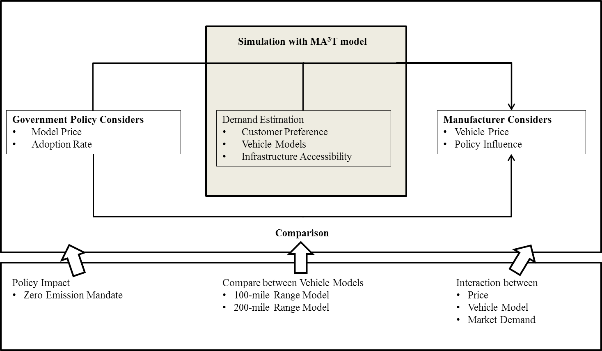
Figure 40. Illustration of model concept.

                - In an automotive market, two automakers sell two different EV models: one automaker (he) offers a 100-mile range EV model (EV100 model), and the other automaker (she) offers a 200-mile range EV model (EV200 model). Their goals are the same which is to maximize total profit from their respectively offered EV in the planning horizon by deciding the price of their own EV model. All automakers in the market do not perform price discrimination among consumers. That means the price of each vehicle model, once decided, is the same across all customer segments. The unit production costs of all vehicles are constant and do not change in the planning horizon. The planning horizon of this study is one year, during which the market size, automotive market segmentations and consumer preferences are assumed to be known and remain unchanged.
                - We further assume that each potential vehicle consumer can choose one and only one vehicle. Each consumer choose vehicle model to maximize each individual's own utility according to the random utility theory (RUT) (Manski 1977, McFadden 1974). RUT assumes a consumer's selection on product is based on the relative preference for the technologies. To simulate consumers' choices based on their preferences, we will achieve the market adoption rate by the MA³T Model (Lin and Greene 2011). The inner core of the MA³T model is a nested multi-nominal logit model that incorporates influential factors of customers' behavior into their purchase decisions. The simulation results are expected to reflect the market acceptance at different prices and vehicle attributes over all segments and across 50 states in the United States.
                - This study primarily follows three steps. First, we construct generalized profit maximization model and setup a series of scenarios of both automakers' pricing decision for their respective vehicle model. Based each scenario configuration, we capture market perception and demand for both vehicle models from the MA³T Model. The derived demand will be incorporated into each the profit maximization model of each individual automaker. In this step, we do not take into account the effect of the ZEV mandate and this model is named the basic model. This basic pricing model will yield an optimal price of each EV model where the total profit from each EV model they offered is maximized. The adoption rate at this step establishes a baseline of EV adoption and reflects customer perception of EVs, which provides us a basis for later analysis and discussion. Second, we introduce tradable credit policy, specifically the ZEV mandate in our empirical study, into the basic model in order to examine the impact of policy on the optimal price of each EV model. In this step, policy parameters are incorporated into the pricing models and these parameters raise up or drop down the adoption rates of two EV models and the optimal prices from the basic model. This enhanced model is used to investigate market adoption under policy impact and quantitatively assess policy effect on the market penetration of EVs. Last, in order to obtain deeper insights, we vary the incorporated policy parameters and compare the optimal price of each vehicle model in different policy settings. The results from this stage should provide us both qualitative and quantitative view of the influence of the ZEV mandate to these two different vehicle models. The conclusion of this study will also allow us to measure the impact of incoming warmly discussed Tesla Model 3 on the current EV market.

Problem Formulation
This study aims to examine the impact of the ZEV mandate on the market penetration and price competition between EVs in the California automotive market. The model we will use contributes to the literature on the comprehensive considerations about market acceptance, vehicle features, and government policy. We will first introduce our modeling concept shown in Figure 41. In order to reflect customer heterogeneity in the automotive market, we will derive annual market demand with the real market data of the 2016 California automotive market from the MA³T model. The forecasted demands for two selected EVs will be regressed into respective demand functions in each own price in different scenarios. Afterwards, we will bring policy parameters into the model and compare the influence of the ZEV mandate in each scenario. The differences in optimal prices, annual demands, and total profits of automakers in these scenarios will finally reflect the impact of the ZEV mandate on the California EV market, which will entitle us to provide indicative insights and suggestion for future policies.

Figure 41 Illustration of model concept.

                - Consider an automotive market, in which two automakers sell two different EV model. One automaker (he) offers a 100-mile range EV model (EV100 model), and the other automaker (she) offers a 200-mile range EV model (EV200 model). Their goals are maximizing total profit from their own EV model in the planning horizon by deciding its price. No automaker will perform price discrimination among consumers. That means the price of each EV model, once decided, is the same for all customers. The unit production costs do not change in the planning horizon. The planning horizon of this study is one year, during which the market size, automotive market segmentations and consumer preferences are assumed to be known and remain unchanged.
                - We further assume that each potential vehicle consumer will finally choose one and only one vehicle. Each consumer chooses a vehicle model in order to maximize each consumer's own utility according to the random utility theory (RUT) (Manski 1977, McFadden 1974). RUT assumes a consumer's selection on product is based on the relative preference among multiple technologies. To simulate the consumers' choices based on their preferences, we will use the MA3T Model to calculate the adoption rate in the automotive market. The MA3T model incorporates a nested multi-nominal logit model that takes into account the influential factors of customer behaviors. Based on the simulation of customers' purchase decisions, the results from the MA3T model will reflect the market acceptance at different prices and vehicle attributes across 50 states in the United States (Lin and Greene 2011).
                - This study primarily follows three steps. First, we construct a series of scenarios for both vehicle models that describe each vehicle's price range from 50% to 150% of its original price. Based each scenario configuration, we capture market perception and demand for both vehicle models from the MA³T Model. The derived demand will be incorporated into each automaker's generalized profit maximization model that will be used to find out an optimal price to maximize each automaker's own profit. Second, we introduce tradable credit policy, specifically the ZEV mandate in our empirical study, into the profit maximization model in order to examine the impact of policy on the pricing decision of each EV model. Last, the policy parameter represents the intensity that government imposes on the EV market. In order to obtain deeper insights, we vary the incorporated policy parameter and compare the optimal price of each vehicle model under different policy incentives. The results from this stage should provide us both qualitative and quantitative view of the influence of the ZEV mandate to these two different vehicle models. The conclusion of this study will also allow us to measure the impact of incoming warmly discussed 200-mile range EV on the current EV market.
                - This paper is organized as follows. Section 2 introduces our modelling framework and scenario construction approach. After a description of our method, we describe the dataset we used in our work and the advantage of using it in Section 3. Afterwards, Section 4 discusses the results for predicted optimal electric vehicle attribute in this section and the role of the Zero Emission Vehicle mandate in the California automotive market. Finally, in section 5, we conclude with a discussion of proposed approach and possible extension in the future.

Model Specifications
Consider an EV market that has two EV models offered by two separate automakers, indexed 1 and 2 respectively. The price of vehicle is known as $p_{1}$ and $p_{2}$. The manufacturing costs of EV models are defined by $c_{1}$ and $c_{2}$. The demand for vehicle models are denoted by $N_{1}$ and $N_{2}$. Hence, given the knowledge about the pricing decision of one EV model, the objective of the other automaker is to maximize the total profit from the EV model they offer, which is
$\max_{p_{i}}\left(p_{i}-c_{i}\right)∙N_{i}\left(p_{i}\right)$, (1)
where $i=1, 2$ represents the profit for vehicle 1 and 2 respectively.
                - The government implements a tradable credit policy. According to this policy, each EV model 1 is awarded $d_{1}$ credits while each EV model 2 is qualified for $d_{2}$ credits. Each rewarded credit can be sold at price $θ$. In doing so, the profit maximization model in (1) can be rewritten as
$\max_{p_{i}} π\left(p_{i}\right)=(p_{i}-c_{i}+θd_{i})∙N_{i}\left(p_{i}\right)$, (2)
where $i=1, 2$ represents the total profit, including that from policy offers, for vehicle 1 and 2 respectively. Please note that we put no sign restriction on $d_{i}$ in equation (2). This parameter is positive if any credits are earned by vehicle $i$ according to policy or it is negative if each vehicle $i$ is required to be matched with a certain amount of any credit. In the first case, vehicle $i$ is considered as another subsidized vehicle while in the second case, vehicle $i$ is levied a relative tax compared to the other EV model.

Results and Discussion
In this section, we will proceed to the result from the MA³T model and regress demand function in vehicle's own price in each scenario. In order to analyze the influence of policy incentives on the pricing decisions of two different EV models, we created a series of scenarios that describes 121 combinations that representing different prices of each EV model. The price of EV100 model covered the price region from below $15,000 to over $40,000 meanwhile the price of EV200 model were priced from around $20,000 to over $61,000. Both price range took care of the current market price of each EV model and most potential pricing possibilities. Based each scenario configuration, the MA³T model was used to yield corresponding annual demand for each EV model in California. We were enabled to capture market perception and demand for both vehicle models. The yielded results were then be regressed into exponential demand function of the vehicle's own price in each scenario, which are summarized in Table 5.

Table 5 Regression results for EV100 and EV200 model.
EV200 Price | EV100 Parameters |  | Goodness of Fit |  | EV100 Price | EV200 Parameters |  | Goodness of Fit
EV200 Price | $$β_{1}$$ | $$β_{2}$$ | SSE | R² | EV100 Price | $$β_{1}$$ | $$β_{2}$$ | SSE | R²
$20,396 | 2.201e+06 | -0.0003768 | 12.18 | 1 | $14,286 | -0.000171 | 2.655e+10 | 2.655e+10 | 0.994
$24,475 | 1.224e+07 | -0.0003637 | 8.425e+04 | 1 | $17,143 | -0.0001649 | 2.935e+10 | 2.935e+10 | 0.9934
$28,554 | 1.793e+07 | -0.0003069 | 3.674e+07 | 0.9992 | $20,000 | -0.0001612 | 3.043e+10 | 3.043e+10 | 0.9932
$32,633 | 8.38e+06 | -0.0002264 | 4.513e+08 | 0.9959 | $22,858 | -0.000159 | 2.957e+10 | 2.957e+10 | 0.9934
$36,713 | 5.965e+06 | -0.0001974 | 3.407e+08 | 0.9974 | $25,715 | -0.0001579 | 2.828e+10 | 2.828e+10 | 0.9937
$40,792 | 5.61e+06 | -0.0001909 | 2.038e+08 | 0.9985 | $28,572 | -0.0001573 | 2.72e+10 | 2.72e+10 | 0.9939
$44,871 | 5.425e+06 | -0.0001881 | 1.839e+08 | 0.9987 | $31,429 | -0.0001571 | 2.649e+10 | 2.649e+10 | 0.994
$48,950 | 5.359e+06 | -0.0001872 | 1.696e+08 | 0.9988 | $34,287 | -0.0001569 | 2.609e+10 | 2.609e+10 | 0.9941
$53,029 | 5.346e+06 | -0.0001871 | 1.649e+08 | 0.9988 | $37,144 | -0.0001569 | 2.588e+10 | 2.588e+10 | 0.9942
$57,108 | 5.344e+06 | -0.000187 | 1.64e+08 | 0.9988 | $40,001 | -0.0001569 | 2.578e+10 | 2.578e+10 | 0.9942
$61,188 | 5.344e+06 | -0.000187 | 1.639e+08 | 0.9988 | $42,858 | -0.0001568 | 2.573e+10 | 2.573e+10 | 0.9942

                - After we have all demand functions, we are entitled to study the pricing decisions of both automakers in the market as well as how each automaker reacts to the price changes from the other one. The demand data for the selected EV models was input to Matlab and we used biharmonic method to regress demand matrix into a unique demand surface for each EV model. Afterwards, the interpolated demand functions were brought back to each automaker's individual profit function and used to compute the profits of both companies. We simply used one dimensional search to find optimal prices of each EV model. Furthermore, we took into account the ZEV mandate and change the policy parameters from 0 to 3 credits for EV100 model and from 4 to 6 for EV200 model. The resulting changes of the optimal prices of both EV model provided indicative clues about the influence of promotional policy to the price competition between the two models.
                - Figure 42 depicts the resulting optimal prices that yielded maximized profit from EV100 model when the price of EV200 model increases from $20,000 to $60,000. We can clearly observe that, in all policy promotion scenarios, when the price of the EV200 model is between $20,000 and $45,000, the price of EV100 model increases in the price of the EV200 model. That indicates when EV200 model comes into the California EV market, EV100 model does not have to change their current price. However, if EV200 model is promoted later with higher amount of incentives that enables the automaker of EV200 model to lower its price, EV100 model has to reduce price accordingly. The lowest price EV100 model will get finally is around $26,000 that will be $3,000 lower than current market price.
                - It is also found that before the ZEV mandate, the optimal price of EV100 model is over $40,000 when EV200 model is priced normally at around $35,000. Later with increased incentive magnitude of the ZEV mandate, the price of the EV100 model can be reduced to around $29,000, which is very close to the price of Nissan Leaf whose newest testified driving range is 117 miles.

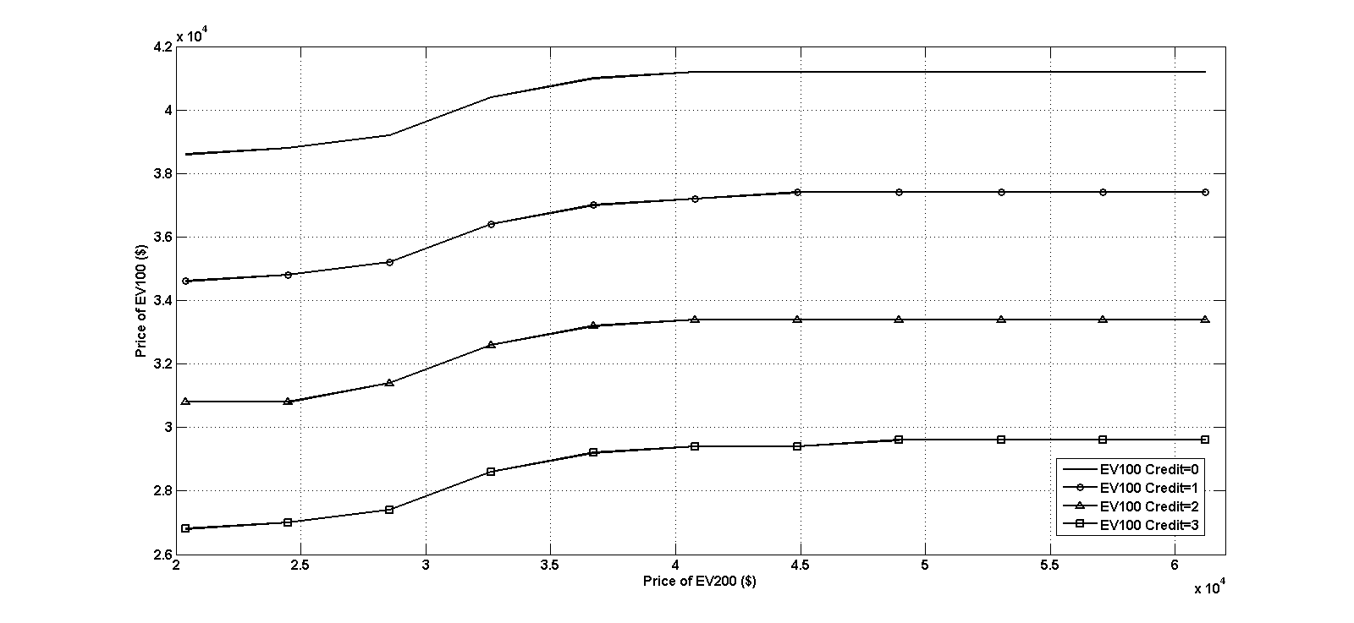
Figure 42 Optimal prices of EV100 model over different EV200 model prices.

                - The annual demands for EV100 model in each scenario were plotted in Figure 43. This figure depicts the corresponding market adoption rate at each optimal price. From Figure 42, we found the price of EV100 increases in EV200 price. However, the demand for EV100 still grows in this process. When the price of EV200 is greater than $35,000 and each produced EV100 vehicle is rewarded 3 ZEV credits, the annual demand for the EV100 model can rise up to 20,000. It indicates that the ZEV mandate can effectively relief the impact of incoming new EV200 vehicle model on the demand for existing EV100 models.
                - It is worth noting that when EV200 is in its low price region, which is around $20,000 to $30,000, the demand for EV100 model is less than 10,000 even with adequate policy incentives. That implies when EV200 model can be priced below $30,000, EV100 model will still face limited demand and difficulty in market penetration. In order to ensure the healthy operation of the automaker of EV100 model, the government needs to control the intensity of promoting EV200 model. In doing so, the price of EV200 model will not be fall below $30,000.

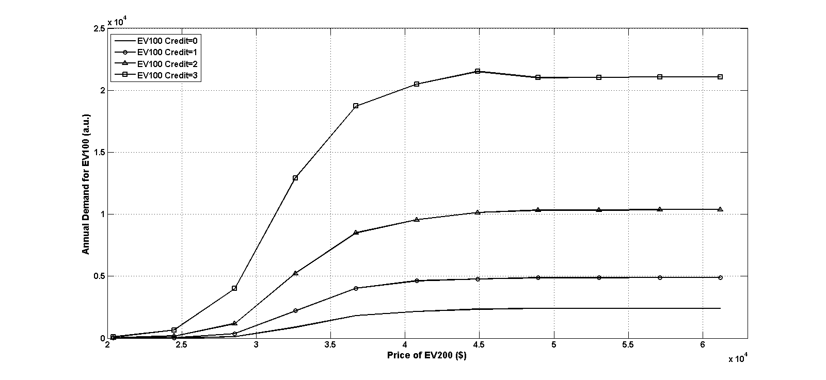
Figure 43 Annual Demand for EV100 model over different prices of EV200 model.

                - On the other hand, we also studied the influence of the price of EV100 on the pricing decision of EV200 model. The results were plotted in Figure 44. This figure shows that the price of EV200 was merely affected by the price of EV100 in all policy configurations, which indicates, in the pricing process, the EV maker of EV200 model only considered market perception and policy incentives without caring about how EV100 model was priced.

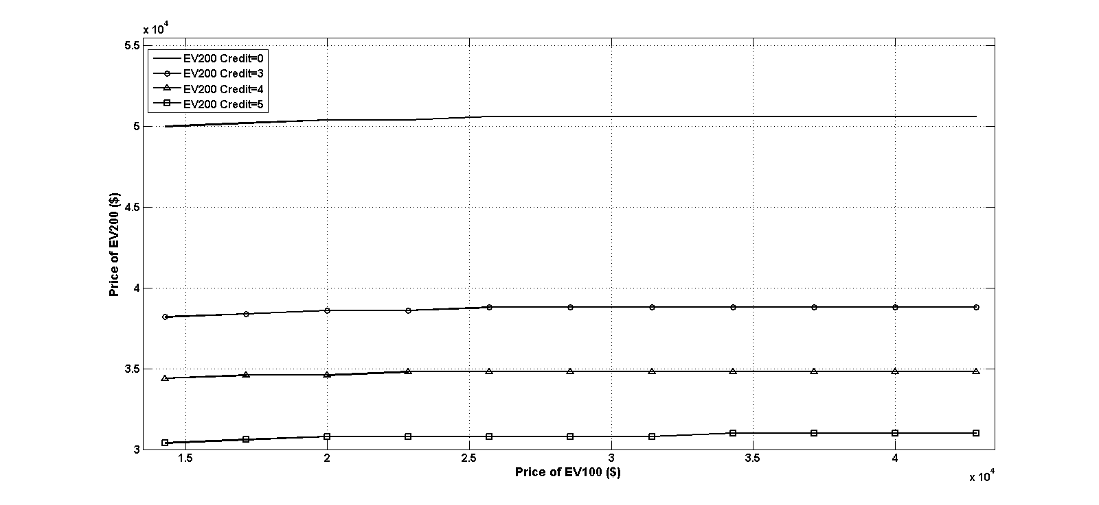
Figure 44 Prices of EV200 model over different prices of EV100 model.

                - Afterwards, we figured out the corresponding annual demand for EV200 model in each scenario. As shown in Figure 45, with the price of EV100 increases from below $15,000 to over $40,000, the annual demand for the EV200 model was only slightly increased. From this figure, we can clearly see that if EV200 was introduced to the California automotive market before the ZEV mandate takes place, the probable demand would be below 20,000, which is even less than the current average demand for 100-mile range EV models. In that case, producing EV200 model will be of less meaningful to EV diffusion. However, if this 200-mile range EV model is introduced with adequate policy incentive, the annual demand will be highly likely to approach over 200,000 in California, even 10 times higher than the result without the ZEV mandate.

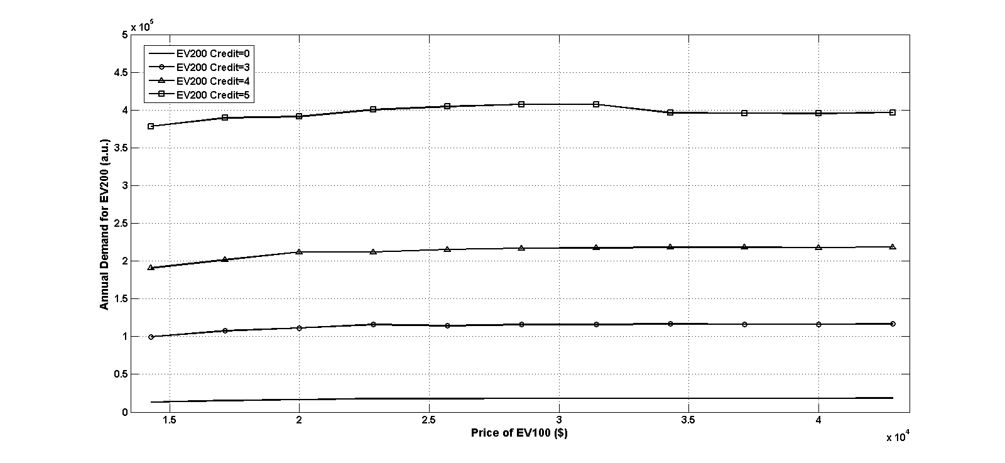
Figure 45 Annual demand for EV200 model over different prices of EV100 model.

                - Compared to the results from EV100 model, it seems reasonable to conjecture that EV200 model will have remarkably greater demand than EV100 model. More intuitively, the price difference between two models is round $6,000 and EV200 model provides 100 miles longer driving range. It appears that EV200 model is more attractive to the mass market. Theoretically, the annual demand for EVs can be elicited by EV200 model to a level around 10 times greater than current market demand. Due to this fact, EV200 model will lead the market instead of EV100 model when production capacity enables them to roll out from factory streamlines.
                - To take a deeper look of this issue, we convert the annual demands into market shares of both models when they are promoted independently and differently by the ZEV mandate (shown in Figure 46 and Figure 47). The overall presumable new vehicle registered per year is set as 2.5 million. Figure 46 shows how the market share of EV100 model changes in its own price when the EV200 model is promoted with an increasing amount of ZEV credits per vehicle while EV100 model is fixed to be promoted with 3 ZEV credits.
                - The solid curve on the top shows the highest possible market share when the ZEV mandate does not promote EV200 model and its price is above $40,000. The EV100 model can occupy around 4% of the market when it is priced under $22,000. This number decreases in its own price horizontally. It falls to roughly 1% of the entire market theoretically at its current price, $29,000. After the ZEV mandate subsidizes the EV200 model, the ZEV mandate can remarkably reduce the price the EV200 model. The lower priced EV200 model limited the market adoption of EV100 model. With growingly subsidization for EV200 model from the ZEV mandate, the highest possible market share of shrink to below 2% in the California automotive market. This prediction falls below 0.5% as the price grows to its current price level. That means, assuming a normal level of subsidy will be provided to the EV200 model (4 ZEV credits per vehicle), in the near future, the diffusion of the EV100 model is expected to be occupy less than 1% of the overall California automotive market. As a matter of fact, this number indicates potentially limited market size to automakers of EV100 model unless EV makers of this model can reduce the price to below $22,000 in the future that will likely to maintain their market share above 1%.

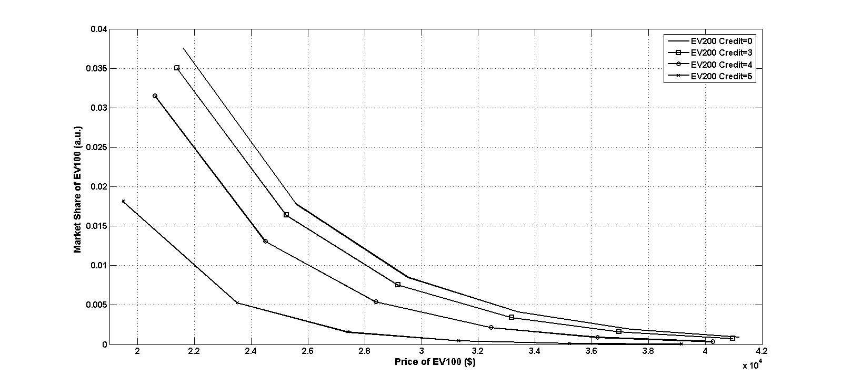
Figure 46 Market share of EV100 model in the California automotive market over different prices of EV100 model and policy incentives for EV200 model.

                - The pricing decision of the EV100 model, on the other hand, impacts negligibly on the market share of the EV200 model, which is described in Figure 47. Based on our examination result, its market share is only under the influence of its own price. The highest possible market share of EV200 model can be attained at around 25% of the overall California automotive new vehicle market. As its price increases to its most possible level, which is between $35,000 and $40,000, the most likely market share of EV200 model is around 5-10% of the overall California automotive market which endorses the promising future of 200-mile range EVs.

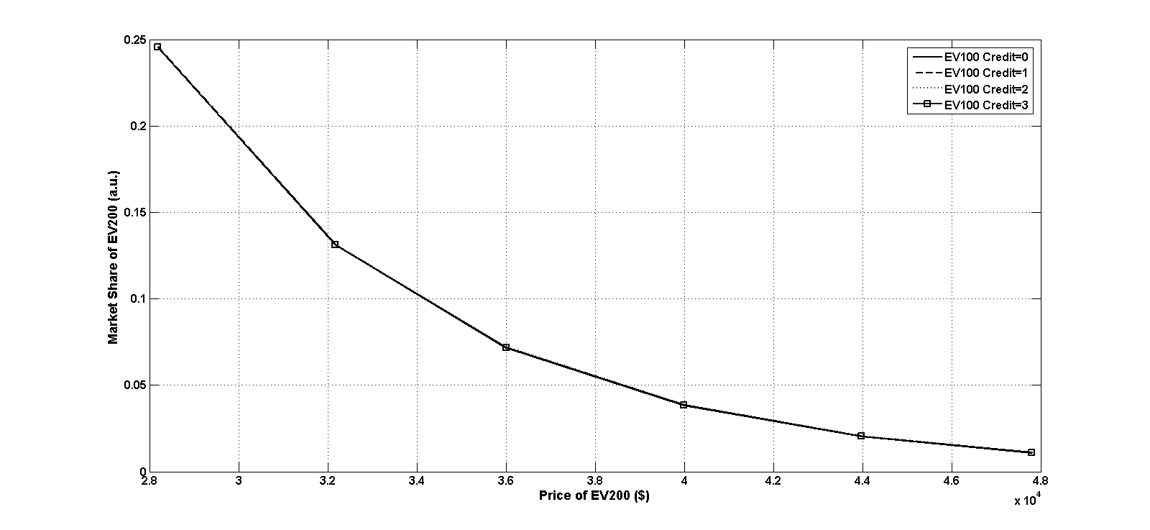
Figure 47 Market share of EV200 model in the California automotive market over different prices of EV200 model and policy incentives for EV100 model.

                - In order to further investigate the role of the ZEV mandate, we investigated this problem form a more of economic perspective in each case. Figure 48 shows a comparison of profit per vehicle between EV100 model and EV200 model. The green bars are the profits from each EV100 model. It shows that, when the ZEV mandate provides an increasing number of credits to EV200 model, the unit profit of EV100 model gradually drops from $5,000 per vehicle to around $3,000 per vehicle. The profit margin of EV100 model falls below 10% of the overall vehicle price even taking into account the incentive. The profitability of EV200 model, on the other hand, maintains at the same level, which is roughly $7,500 per vehicle. Its profit margin is around 20% of the vehicle price. The huge difference in profitability in their product implies a gap in the capability to reinvest into technology development and to suffer market volatility and risk.

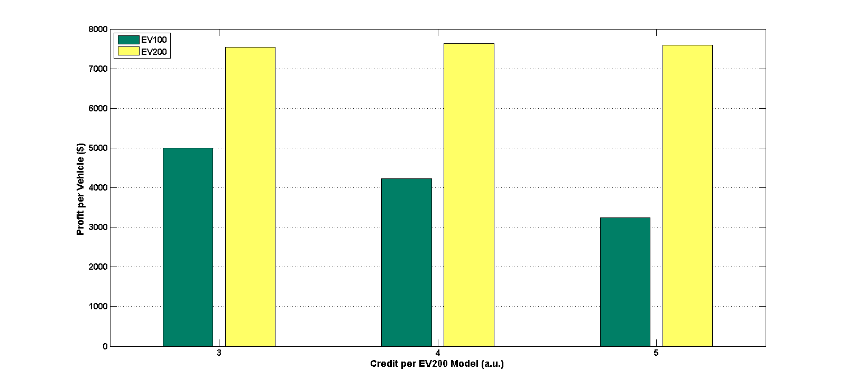
Figure 48 Profit from each EV100 and EV200 model with different policy incentives for EV200 model while each EV100 model rewarded 3 ZEV credits. Green: EV100 model; yellow: EV200 model.

                - The annual demands for both models were summarized and compared in Figure 49. The annual demands for the EV100 model falls from almost 20,000 per year to 4,000 per year. Under the medium subsidy to each produced EV200 (4 credits per vehicle), the corresponding demand for the EV100 model is roughly 13,500, which is slightly lower than the current level of demand for the EV100 models. That indicates that policy reward to EV200 model will constraint the demand for EV100 model because lower price of the EV200 model will attract higher customers to longer range EVs. According to the data shown in this figure, another noteworthy fact is that the annual demand for the EV200 model grows from 180,000 to over 614,000 in California. The ZEV mandate can remarkably stimulate the demand for the EV200 model. It leads to an indication that the ZEV mandate can effectively boost the demand for the 200-mile range EV while limits the demands for the 100-mile range EV.

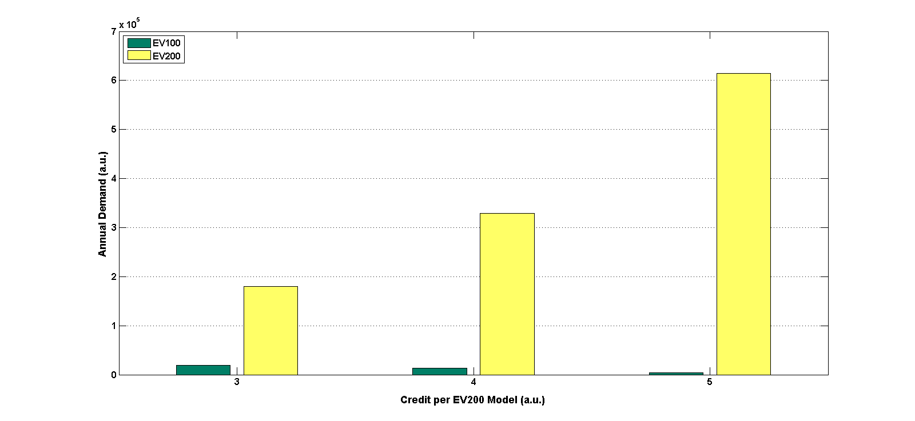
Figure 49 Annual demand for EV100 and EV200 model with different policy incentives for EV200 model while each EV100 model rewarded 3 ZEV credits. Green: EV100 model; yellow: EV200 model.

                - From Figure 48 and Figure 49, EV200 model shows outperforming profitability and annual demand than EV100 model. The comparison between corresponding total profits from each model is plotted in Figure 50. This figure provides indications from two folds: 1) the total profit from EV200 model is significantly greater than that from EV100 model, which indicates producing EV200 model may be more favorable and the corresponding market of EV200 model is essentially larger than EV100 market in the future; 2) the ZEV mandate can increase the total profit from EV200 model by 50% while reduce the total profit from the EV100 model to 50% of the original policy incentive level. That means EV makers can have higher financial solvent and pricing flexibility by producing EV200 model. In this sense, EV makers in this niche market will be highly likely to lead the market in the future.

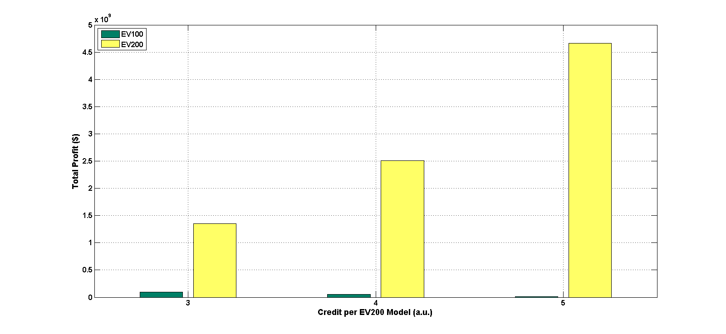
Figure 50 Total profit of EV100 and EV200 model with different policy incentives for EV200 model when each EV100 model rewarded 3 ZEV credits. Green: EV100 model; yellow: EV200 model.

                - Combining the findings from above figures, it led us to an indication that, though the EV100 model could be protected and boosted at the same time, the ZEV mandate shows greater positive effect on encouraging the production and diffusion of the EV200 model. In the future, the 200-mile range EV will lead the market with pricing advantage and policy focal encouragement. EV makers can have broader pricing range of EV200 model than EV100 model. Compared to the 200-mile range EV, the 100-mile range EV is highly likely to be sensitive to the pricing decision of the competitor company. Automakers in this niche market need to care about the relative subsidy to all EV models and position their EV models in the right market position. According to this fact, government agency needs to emphasize on the reaction of automakers offering EV200 model because they are expected to be better capable of impacting on the adoption situation of the entire EV market.

Conclusions
Our study adds new insights into the market adoption of EVs and confirmed some earlier findings about the ZEV mandate. According to market adoption data from the Market Acceptance of Advanced Automotive Technologies model, the demand functions of two selected electric vehicles were well fitted by interpolation in Matlab. The demand function for each EV model was described by a smooth surface and depicted mathematically into a bivariate function in selling prices of both models. That built up our base for further experiment and discussion.
                - Our analysis also confirmed some findings from earlier study about the role of the ZEV mandate in the California automotive market. The ZEV mandate can dramatically raise profits from electric vehicles which maintains automakers financial healthy. We also find in the analysis that the 200-mile range EV, which will enter the market shortly, has significant unilateral impact on the prices of the 100-mile range EV. This implies longer range electric vehicle will become the leader of the California electric vehicle market.
                - Given the ZEV mandate effective in the California automotive market and sizeable investment by automakers for future EV technology evolution, it is important to understand the dynamics of pricing decisions between various electric vehicle models. In this paper, it was shown that the ZEV mandate substantially promotes 200-mile range EV and encourages automakers to produce longer range EVs. This important influence will enhance technology evolution of EVs.
                - From a policy perspective, our experiments about two different EV models shed light on a possible reaction. We found the current EV market will be led by the 200-mile range EV and it will not be surprising to know producers of 100-mile range EV become the followers of the EV market. 200-mile EVs will soon become the focal point for both market study and policy design. Our results may also be used to investigate future EV industry development.

List of References

1.S. P. Anderson, A. De Palma and J. F. Thisse (1992). Discrete choice theory of product differentiation, MIT press.
2.K. J. Arrow (1962). Economic Welfare and the Allocation of Resources for Invention, în Richard Nelson (ed.),“The Rate and Direction of Inventive Activity”, Princeton, NJ, Princeton University Press.
3.A. Baranski and J. Peck (2013). "Durable Goods Monopoly with Quality Improvements and a Continuum of Consumer Types."
4.F. M. Bass (1969). "A New Product Growth for Model Consumer Durables." Management Science 15(5): 215-227.
5.F. M. Bass (2004). "Comments on “a new product growth for model consumer durables the bass model”." Management science 50(12_supplement): 1833-1840.
6.R. Batley, J. Toner and M. Knight (2004). "A mixed logit model of UK household demand for alternative-fuel vehicles." International Journal of Transport Economics/Rivista internazionale di economia dei trasporti: 55-77.
7.W. J. Baumol and D. F. Bradford (1970). "Optimal departures from marginal cost pricing." The American Economic Review: 265-283.
8.M. E. Ben-Akiva and S. R. Lerman (1985). Discrete choice analysis: theory and application to travel demand, MIT press.
9.S. T. Berry (1994). "Estimating Discrete-Choice Models of Product Differentiation." The RAND Journal of Economics 25(2): 242-262.
10.S. Blanco. (2014). "California has sold 102,440 EVs since Volt, Leaf went on sale in 2010." from http://www.autoblog.com/2014/09/09/california-has-sold-102440-evs-since-volt-leaf-went-on-sale/.
11.T. F. Bresnahan (1981). "Departures from marginal-cost pricing in the American automobile industry: Estimates for 1977–1978." Journal of Econometrics 17(2): 201-227.
12.D. Brownstone and K. Train (1998). "Forecasting new product penetration with flexible substitution patterns." Journal of Econometrics 89(1–2): 109-129.
13.D. Brownstone, D. S. Bunch and K. Train (2000). "Joint mixed logit models of stated and revealed preferences for alternative-fuel vehicles." Transportation Research Part B: Methodological 34(5): 315-338.
14.W. Buffett (2009). Speech to Rice University Business School Students.
15.K. Bullis (2013). How Tesla Is Driving Electric Car Innovation. MIT Techonlogy Review.
16.S. Cantono and G. Silverberg (2009). "A percolation model of eco-innovation diffusion: The relationship between diffusion, learning economies and subsidies." Technological Forecasting and Social Change 76(4): 487-496.
17.C. A. R. B. CARB (1990). Proposed Regulation for Low-Emission Vehicles and Clean Fuels. C. A. R. Board.
18.C. A. R. B. CARB (2014). STAFF REPORT: INITIAL STATEMENT OF REASONS FOR RULEMAKING.
19.K. B. Clark and T. Fujimoto (1991). Product development performance, Boston: Harvard Business School Press.
20.Clean Technica. (2015). "EV Battery Costs Already 'Probably' Cheaper Than 2020 Projections." from http://cleantechnica.com/2015/03/26/ev-battery-costs-already-probably-cheaper-than-2020-projections/.
21.J. Cole. (2014). "Nissan Prices LEAF Battery Replacement at $5,499, New Packs More Heat Durable." from http://insideevs.com/breaking-nissan-prices-leaf-battery-replacement-5499-new-packs-heat-durable/.
22.G. Collantes and D. Sperling (2008). "The origin of California’s zero emission vehicle mandate." Transportation Research Part A: Policy and Practice 42(10): 1302-1313.
23.Credit Suisse (2009). "Electric Vehicles." Credit Suisse Equity Research 1.
24.S. C. Davis, S. W. Diegel and R. G. Boundy (2013). Transportation energy data book: Edition 32, United States. Department of Energy.
25.R. A. Daziano (2013). "Conditional-logit Bayes estimators for consumer valuation of electric vehicle driving range." Resource and Energy Economics 35(3): 429-450.
26.Deloitte (2011) "Electric vehicle realities versus consumer expectations."
27.C. DeMorro (2014) "Fiat CEO: We Lose $14,000 On Every Fiat 500E EV We Sell."
28.Department of Energy. (2012). "Top 10 Things You Didn't Know About Electric Vehicles." from http://energy.gov/articles/top-10-things-you-didn-t-know-about-electric-vehicles.
29.A. Dimitropoulos, P. Rietveld and J. N. van Ommeren (2013). "Consumer valuation of changes in driving range: A meta-analysis." Transportation Research Part A: Policy and Practice 55(0): 27-45.
30.E. Dockner and S. Jorgensen (1988). "Optimal Pricing Strategies for New Products in Dynamic Oligopolies." Marketing Science 7(4): 315-334.
31.N. Economides (2000). "Durable goods monopoly with network externalities with application to the PC operating systems market." Available at SSRN 246471.
32.Electrification Coalition (2009). "Electrification Roadmap: Revolutionizing transportation and achieving energy security." November. Electrification Coalition.
33.S. Esteban and M. Shum (2007). "Durable‐goods oligopoly with secondary markets: the case of automobiles." The RAND Journal of Economics 38(2): 332-354.
34.K. S. Gallagher, A. Grübler, L. Kuhl, G. Nemet and C. Wilson (2012). "The Energy Technology Innovation System." Annual Review of Environment and Resources 37(1): 137-162.
35.P. Gao, A. Wang and A. Wu (2008). "China charges up: The electric vehicle opportunity." Mckinsey & Company.
36.A. Gärling and J. Thøgersen (2001). "Marketing of electric vehicles." Business Strategy and the Environment 10(1): 53-65.
37.D. W. Gaskins Jr (1971). "Dynamic limit pricing: Optimal pricing under threat of entry." Journal of Economic Theory 3(3): 306-322.
38.S. Ghoshal and C. A. Bartlett (1988). "Creation, adoption, and diffusion of innovations by subsidiaries of multinational corporations." Journal of International Business Studies: 365-388.
39.P. K. Goldberg and F. Verboven (2001). "The Evolution of Price Dispersion in the European Car Market." The Review of Economic Studies 68(4): 811-848.
40.Good Car Bad Car (2014). Sales Stats
41.E. Gordon and E. Sarigöllü (2000). "Assessing Consumer Preferences for Clean-Fuel Vehicles: A Discrete Choice Experiment." Journal of Public Policy & Marketing 19(1): 106-118.
42.E. Graham-Rowe, B. Gardner, C. Abraham, S. Skippon, H. Dittmar, R. Hutchins and J. Stannard (2012). "Mainstream consumers driving plug-in battery-electric and plug-in hybrid electric cars: A qualitative analysis of responses and evaluations." Transportation Research Part A: Policy and Practice 46(1): 140-153.
43.Green Car Congress (2014). "California ARB mods to ZEV regulations for IVMs would result in ~1.9% drop in total ZEV/TZEV units 2018-2025; no impact on air quality requirements."
44.D. L. Greene, S. Park and C. Liu (2014). "Analyzing the transition to electric drive vehicles in the U.S." Futures 58(0): 34-52.
45.J. P. Grunenwald and T. T. Vernon (1988). "Pricing decision making for high-technology products and services." Journal of Business & Industrial Marketing 3(1): 61-70.
46.D. M. Hanssens and L. J. Parsons (1993). Chapter 9 Econometric and time-series market response models. Handbooks in Operations Research and Management Science, Elsevier. Volume 5: 409-464.
47.F. Heiss (2002). "Specification(s) of Nested Logit Models."
48.F. Heiss (2002). "Structural choice analysis with nested logit models." Stata Journal 2(3): 227-252.
49.J. P. Helveston, Y. Liu, E. M. Feit, E. Fuchs, E. Klampfl and J. J. Michalek (2015). "Will subsidies drive electric vehicle adoption? Measuring consumer preferences in the US and China." Transportation Research Part A: Policy and Practice 73: 96-112.
50.M. K. Hidrue, G. R. Parsons, W. Kempton and M. P. Gardner (2011). "Willingness to pay for electric vehicles and their attributes." Resource and Energy Economics 33(3): 686-705.
51.M. Hohnisch, S. Pittnauer and D. Stauffer (2008). "A percolation-based model explaining delayed takeoff in new-product diffusion." Industrial and Corporate Change 17(5): 1001-1017.
52.InsideEVs. "Compare EVs." from http://insideevs.com/compare-plug-ins/.
53.International Energy Agency (2014). "World Energy Outlook 2014."
54.A. P. Jeuland and R. J. Dolan (1979). An aspect of new product planning: Dynamic pricing, University of Chicago, Center for Research Marketing.
55.A. P. Jeuland and S. M. Shugan (1988). "Note-channel of distribution profits when channel members form conjectures." Marketing Science 7(2): 202-210.
56.D. B. Jun and Y. S. Park (1999). "A Choice-Based Diffusion Model for Multiple Generations of Products." Technological Forecasting and Social Change 61(1): 45-58.
57.S. Kalish and G. L. Lilien (1983). "Optimal Price Subsidy Policy for Accelerating the Diffusion of Innovation." Marketing Science 2(4): 407-420.
58.K. Kieckhäfer, T. Volling and T. S. Spengler (2014). "A Hybrid Simulation Approach for Estimating the Market Share Evolution of Electric Vehicles." Transportation Science 48(4): 651-670.
59.C. Kling and C. Thomson (1994). "The Implications of Model-Specification for Welfare Estimation in Nested Logit-Models." American Journal of Agricultural Economics 76(5): 1254-1254.
60.C. L. Kling and C. J. Thomson (1996). "The implications of model specification for welfare estimation in nested logit models." American Journal of Agricultural Economics 78(1): 103-114.
61.R. Kochhan and M. Hörner (2015). Costs and Willingness-to-Pay for Electric Vehicles. Sustainable Automotive Technologies 2014, Springer: 13-21.
62.J. Krumm (2012). How people use their vehicles: Statistics from the 2009 national household travel survey, SAE Technical Paper.
63.J. S. Krupa, D. M. Rizzo, M. J. Eppstein, D. Brad Lanute, D. E. Gaalema, K. Lakkaraju and C. E. Warrender (2014). "Analysis of a consumer survey on plug-in hybrid electric vehicles." Transportation Research Part A: Policy and Practice 64(0): 14-31.
64.Y. Kudoh and R. Motose (2010). "Changes of Japanese Consumer Preference for Electric Vehicles." World Electric Vehicle Journal 4.
65.M. Larsen. (2014). "Market Share of Plug-in Vehicles to Date in USA." from http://insideevs.com/us-electric-vehicle-market-share-model-model-breakdown/.
66.J. Lee, Y. Cho, J.-D. Lee and C.-Y. Lee (2006). "Forecasting future demand for large-screen television sets using conjoint analysis with diffusion model." Technological Forecasting and Social Change 73(4): 362-376.
67.T. Lieven, S. Mühlmeier, S. Henkel and J. F. Waller (2011). "Who will buy electric cars? An empirical study in Germany." Transportation Research Part D: Transport and Environment 16(3): 236-243.
68.Z. Lin and D. L. Greene (2010). Who will more likely buy PHEV: a detailed market segmentation analysis, Oak Ridge National Laboratory (ORNL); National Transportation Research Center.
69.Z. Lin and D. Greene (2011). "Promoting the market for plug-in hybrid and battery electric vehicles: role of recharge availability." Transportation Research Record: Journal of the Transportation Research Board(2252): 49-56.
70.Z. Lin, J. Dong, C. Liu and D. Greene (2012). "Estimation of energy use by plug-in hybrid electric vehicles: validating Gamma distribution for representing random daily driving distance." Transportation Research Record: Journal of the Transportation Research Board(2287): 37-43.
71.Z. Lin, J. Dong and D. L. Greene (2013). "Hydrogen vehicles: Impacts of DOE technical targets on market acceptance and societal benefits." International journal of hydrogen energy 38(19): 7973-7985.
72.J. D. Little and J. F. Shapiro (1980). "A theory for pricing nonfeatured products in supermarkets." Journal of Business: S199-S209.
73.E. Loveday. (2014). "In 2013, 8,400 Tesla Model S Sedans Were Sold in California." from http://insideevs.com/in-2013-8398-tesla-model-s-sedans-were-sold-in-california/.
74.S. P. Magee (1977). "Application of the Dynamic Limit Pricing Model to Price of Technology and International Technology-Transfer." Carnegie-Rochester Conference Series on Public Policy 7: 203-224.
75.V. Mahajan, E. Muller and F. M. Bass (1991). New product diffusion models in marketing: A review and directions for research. Diffusion of technologies and social behavior, Springer: 125-177.
76.V. Mahajan, E. Muller and F. M. Bass (1995). "Diffusion of new products: Empirical generalizations and managerial uses." Marketing Science 14(3_supplement): G79-G88.
77.C. Manski (1977). "The structure of random utility models." Theory and Decision 8(3): 229-254.
78.D. McFadden (1974). "Conditional Logit Analysis of Qualitative Choice Behavior." Academic Press.
79.D. McFadden (1978). Modelling the choice of residential location, Institute of Transportation Studies, University of California.
80.D. McFadden and K. Train (2000). "Mixed MNL models for discrete response." Journal of Applied Econometrics 15(5): 447-470.
81.D. McFadden (2001). "Economic Choices." American Economic Review 91(3): 351-378.
82.H. I. Mesak and R. C. Clelland (1979). "A competitive pricing model." Management Science 25(11): 1057-1068.
83.G. Meyer (2004). "Diffusion methodology: Time to innovate?" Journal of Health Communication 9(S1): 59-69.
84.G. A. Moore (1991). Crossing the Chasm: Marketing and selling high-tech goods to mainstream customers, New York, HarperBusiness.
85.J. Motavalli. (2013). "Tesla Still the Big Winner in California ZEV Credit Sales ", from http://www.plugincars.com/tesla-still-big-winner-california-zev-credit-sales-128593.html.
86.C. National Research (2013). "Overcoming Barriers to Electric-Vehicle Deployment:Interim Report (2013)."
87.A. Nevo (2000). "A Practitioner's Guide to Estimation of Random-Coefficients Logit Models of Demand." Journal of Economics & Management Strategy 9(4): 513-548.
88.B. Nykvist and M. Nilsson. (2015). "Rapidly falling costs of battery packs for electric vehicles." from http://www.nature.com/nclimate/journal/v5/n4/full/nclimate2564.html.
89.H. Peng (2013). "Optimal subsidy policy for accelerating the diffusion of green products." Journal of Industrial Engineering and Management 6(2): 626.
90.A. Peters and E. Dütschke (2014). "How do consumers perceive electric vehicles? A comparison of German consumer groups." Journal of Environmental Policy & Planning 16(3): 359-377.
91.Plugincars. "What Is an Electric Car?", from http://www.plugincars.com/electric-cars.
92.B. Robinson and C. Lakhani (1975). "Dynamic Price Models for New-Product Planning." Management Science 21(10): 1113-1122.
93.E. M. Rogers (1983). "Diffusion of innovations." New York: Free Press 18(20): 271.
94.E. M. Rogers (2010). Diffusion of innovations, Simon and Schuster.
95.M. Safar (2011). Social Networking and Community Behavior Modeling: Qualitative and Quantitative Measures: Qualitative and Quantitative Measures, IGI Global.
96.E. Schaal. (2015). "How Did Obama's Goal of 1 Million Electric Vehicles Fall Short?", from http://www.cheatsheet.com/automobiles/how-did-obamas-goal-of-1-million-electric-vehicles-fall-short.html/?a=viewall.
97.R. Segal (1995). "Forecasting the Market for Electric Vehicles in California Using Conjoint Analysis." The Energy Journal 16(3): 89-111.
98.J. V. F. Serra (2013). Electric vehicles: technology, policy and commercial development, Routledge.
99.J. Shankleman. (2014). "Nissan Leaf accelerates to 45 percent market share." from http://www.greenbiz.com/blog/2014/02/11/leaf-45-percent-market-share.
100.E. Sieper and P. L. Swan (1973). "Monopoly and competition in the market for durable goods." The Review of Economic Studies: 333-351.
101.K. Sikes, T. Gross, Z. Lin, J. Sullivan, T. Cleary and J. Ward (2010). Plug-in hybrid electric vehicle market introduction study: final report, Oak Ridge National Laboratory (ORNL).
102.H. A. Simon (1979). "Rational decision making in business organizations." The American economic review: 493-513.
103.B. D. Solomon and T. D. Georgianna (1987). "Optimal subsidies to new energy sources." Energy Economics 9(3): 183-189.
104.Y. Song, S. Ray and S. Li (2008). "Structural properties of buyback contracts for price-setting newsvendors." Manufacturing & Service Operations Management 10(1): 1-18.
105.D. Strang and S. A. Soule (1998). "Diffusion in organizations and social movements: From hybrid corn to poison pills." Annual review of sociology: 265-290.
106.K. Sudhir (2001). "Competitive pricing behavior in the auto market: A structural analysis." Marketing Science 20(1): 42-60.
107.Sustainable Business News (2013). "How Nissan revved up sales and turned a profit on its electric Leaf ", from http://www.greenbiz.com/blog/2013/11/22/nissan-electric-leaf-profit-bmw-vw.
108.Sustainable Business News (2013). Sales of Hybrids, Electric Cars Rising Fast, Sustainable Business News.
109.P. L. Swan (1970). "Durability of consumption goods." The American Economic Review: 884-894.
110.P. L. Swan (1971). "The durability of goods and regulation of monopoly." The Bell Journal of Economics and Management Science: 347-357.
111.P. L. Swan (1972). "Optimum durability, second-hand markets, and planned obsolescence." The Journal of Political Economy: 575-585.
112.M. Tanaka, T. Ida, K. Murakami and L. Friedman (2013). "Consumers' Willingness to Pay for Alternative Fuel Vehicles: Comparative Analysis Between US and Japan." University of California Berkeley, Goldman school of Public Policy.
113.K. Train (1986). Qualitative choice analysis: Theory, econometrics, and an application to automobile demand, MIT press.
114.K. E. Train, D. L. McFadden and M. Ben-Akiva (1987). "The Demand for Local Telephone Service: A Fully Discrete Model of Residential Calling Patterns and Service Choices." The RAND Journal of Economics 18(1): 109-123.
115.K. E. Train and C. Winston (2007). "Vehicle Choice Behavior and the Declining Market Share of U.S. Automakers." International Economic Review 48(4): 1469-1496.
116.K. E. Train and C. Winston (2007). "VEHICLE CHOICE BEHAVIOR AND THE DECLINING MARKET SHARE OF U.S. AUTOMAKERS*." International Economic Review 48(4): 1469-1496.
117.K. E. Train (2009). Discrete choice methods with simulation, Cambridge university press.
118.T. Trigg (2013). Understanding the Asian EV landscape unitl 2020.
119.T. Trigg, P. Telleen, R. Boyd, F. Cuenot, D. D’Ambrosio, R. Gaghen, J. Gagné, A. Hardcastle, D. Houssin and A. Jones (2013). "Global EV outlook: understanding the electric vehicle landscape to 2020." Int. Energy Agency: 1-40.
120.B. Tuttle. (2015). "So About That Goal of 1 Million Electric Cars by 2015 ...", from http://time.com/money/3677021/obama-electric-cars-gas/.
121.U.S. Census Bureau (2014). State & County QuickFacts. U. C. Bureau.
122.U.S. Energy Information Administration (2013). Electric Power Monthly.
123.U.S. Energy Information Administration (2015). How much oil consumed by the United States comes from foreign sources? .
124.U.S. Energy Information Administration (2015). U.S. Energy Facts. U. S. E. I. Administration.
125.U.S. Energy Information Administration (2015). U.S. net imports of crude oil and petroleum products.
126.U.S. Energy Information Administration (2015). Use of Energy in the United States. U. S. E. I. Administration.
127.U.S. Environmental Protection Agency (2013). Sources of Greenhouse Gas Emissions.
128.J. Voelcker. (2014). "Nissan Leaf New Battery Cost: $5,500 For Replacement With Heat-Resistant Chemistry
", from http://www.greencarreports.com/news/1092983_nissan-leaf-battery-cost-5500-for-replacement-with-heat-resistant-chemistry.
129.M. Waldman (1996). "Durable goods pricing when quality matters." Journal of Business: 489-510.
130.A. Watts (2014) "Analysis: Tesla may have made over $100 million off the CARB enabled battery swap ZEV credit scheme."
131.A. Ziegler (2012). "Individual characteristics and stated preferences for alternative energy sources and propulsion technologies in vehicles: A discrete choice analysis for Germany." Transportation Research Part A: Policy and Practice 46(8): 1372-1385.

Appendix

Vita
Jinglu Song is a Ph.D. student of the Department of Industrial and Systems Engineering in the University of Tennessee. His research is mainly focused on technology pricing and supply chain management. Since 2012, he joined Logistic, Transportation and Supply Chain Lab and began his research on the technology pricing in the California electric vehicle market. The study uses the Market Acceptance of Advanced Automotive Technologies Model from the Oak Ridge National Lab to investigate the market acceptance of alternative fuel vehicles, especially electric vehicles, with the impact of government police on electric vehicle pricing decisions. His study considers demand heterogeneity from over 1,400 consumer segments with respect to regions, residential areas, driving patterns, technological attitude, home charging and work charging access.

