The Effects of Urbanization on the Avian Gut Microbiome

A Dissertation Presented for the
Doctor of Philosophy
Degree
The University of Tennessee, Knoxville.

Mae Berlow
May 2021
Abstract

The gut microbiome influences and is influenced by the host, and can affect the host organism by contributing to health, development and immunity. Similarly, the host can influence this community; it’s makeup can vary with host species, locality, diet, social stressors, and environmental stressors. Some of these environmental stressors have arisen due to human-induced rapid environmental change, like urbanization. The physiology and behaviors of organisms that are able to persist in urban environments are often different from their non-urban congeners. Nutrition, development, and immunity—all of which are affected by the gut microbiome—are important factors that can determine survival in urban environments. Ecologists are therefore asking new questions about how an urban environment shapes gut microbial communities, and how the numerous services gut fauna provide affect host success in an urban context.
My dissertation research demonstrated that urbanization changes the bacterial communities of birds as well as provided correlational and experimental evidence for the biotic and abiotic traits driving these changes. Urban birds differed from rural ones by multiple measures. I also found evidence that noise pollution explains some variation in alpha diversity among urban and rural birds. Building upon this finding, I experimentally showed that the gut microbiome changes with exposure to noise, as does food intake and plasma corticosterone. However, contrary to my hypothesis, food intake and corticosterone were not the mediating factors between noise and the gut microbiome. All of this work was accomplished using noninvasive cloacal swabs to measure the gut microbiome, which my dissertation research found are reflective of the large intestine and capture individual variation in the microbiome. The work that comprised my dissertation will impact methods decisions in future microbiome studies in both free-living and captive birds. It will also contribute to the way we look at the relationships between host environment, host, and the gut microbiome, as well as influence how we think about urban ecology as a whole. Altogether, my dissertation research accomplished my goal to work in an emerging field at the interface of urban and microbial ecology.

Table of Contents
Introduction 1
Abstract 2
Background 2
Dissertation Aims 7
Intellectual Merit 9
References 10
Chapter 1 - Evaluation of non-lethal gut microbiome sampling methods in a passerine bird 16
Abstract 17
Introduction 17
Methods 19
Results 22
Discussion 24
Data statement 26
References 27
Chapter 2 - Effects of Urbanization and Landscape on Gut Microbiomes in White-Crowned Sparrows 29
Abstract 30
Introduction 30
Methods 31
Results 35
Discussion 38
References 43
Chapter 3 - Experimental exposure to noise alters gut microbiota in a songbird 47
Abstract 48
Introduction 48
Materials & Methods 50
Results 54
Discussion 55
Acknowledgements 57
Data Accessibility 58
References 59
Conclusion 62
Future steps 65
Career trajectory 66
References 67
Appendix 69
Tables 69
Figures 74
Vita 93

Introduction

Abstract
The gut microbiome functions as a community of bacteria, fungi, viruses, and protists that influences and is influenced by the host organism ^{1–3}. This community can affect the host organism by contributing to host health, development and immunity ^{4,5}. Similarly, the host can influence this community; gut bacterial species composition, richness, and relative abundance can vary with host species, locality, diet, social stressors, and environmental stressors ^{6–8}. Some of these environmental stressors have arisen due to human-induced rapid environmental change ⁹. Ecologists are therefore asking new questions about how an urban environment shapes gut microbial communities, and how the numerous services gut fauna provide affect host success in an urban context ^{10–16}.

Urbanization is one form of human-induced rapid environmental change ⁹, and the physiology and behaviors of organisms that are able to persist in urban environments are often different from their non-urban congeners ^{17,18}. Examining how species persist in these novel evolutionary environments can provide insight into the complex ways in which urbanization affects wildlife ¹⁸. Nutrition, development, and immunity—all of which are affected by the gut microbiome ^{4,5,19}—are important factors that can determine survival in urban environments ^{20,21}. Thus, the potential for the gut microbiome to be a mediating factor in an animal’s ability to adapt to urbanization is an exciting potential avenue for urban ecological studies. In fact, a recent spate of papers on variation in gut fauna in urbanized habitats points to a growing recognition of the need to investigate this aspect of urban ecology. A first step is to examine what is known about the bidirectional relationship between the gut microbiome and its host and how this bidirectional relationship may be influenced by urbanization.

Background

Gut microbiomes

Bidirectional relationship between host and gut microbiome

In my dissertation I focus on bacteria, but viruses, fungi and protists also play a critical role in gut microbial communities. Viruses in the gastro-intestinal tract not only result in disease for the host and consequential changes in digestion and gut physiology, but they can also provide selective pressure on the bacterial community as bacteriophages ²². Fungi are present at low levels in the gastrointestinal tract and may interact in significant ways with host physiology, such as inflammatory bowel diseases, and can act opportunistically in immunocompromised hosts ²³. Though these non-bacterial components of the gut microbiome play an important role in host health, and likely impact the bacterial community, my research focuses on bacteria because they are the most prevalent members of the gut microbiome and provide important biological services to their host animal. Because of this central role, as well as an overwhelming dominance of bacterial research compared to other members of the gut microbiome, the term “microbiome” is frequently used to describe only the bacterial community of the gut. In this document I have used the terms “bacterial community” and “microbiome” interchangeably, but do not wish to erase important non-bacterial components of the digestive system.

The composition of the gut microbiome has direct and indirect effects on host health and physiology. Bacteria in the digestive tract—especially the large intestine—help the host glean important nutrients from their diet that they are not able to get on their own ^{24,25}, breaking down large unusable molecules into useful products like short-chain fatty acids ²⁶. Bacteria can also help animals exploit otherwise inedible food sources by degrading and neutralizing toxic plant secondary compounds ^{27,28} and breaking down some energy sources like amino acids ²⁹ as well as detoxify compounds in hosts’ diet that would otherwise harm them ²⁷. Besides aiding in digestion, gut bacteria play an important role in host immune function, including protecting the host from harmful infections ^{19,30}. This happens indirectly through competition with potential pathogens, but also plays a crucial role in the development and maintenance of the host’s overall immune system ^{2,31}. Bacterial communities in the gut can also interact in consequential ways with the host enteric nervous system, affecting host behavior ¹⁹. Studies in germ-free mice have been very useful in demonstrating direct impacts of the gut microbiome on hypothalamic-pituitary-adrenal reactivity, as well as interactions between the gut microbiome and the central nervous system through the enteric nervous system ^{32–35}. Altogether, some of these interactions between the host and the gut microbiome are direct, as with detoxification, and some are more indirect, such as the effect of secondary bacterial compounds on the host GI physiology, which is detected by the brain and can drive behavior ^{36,37}. These direct and indirect effects of the gut microbiome on host nutrition, immunity and behavior may play an important role in how the host can respond to rapid environmental changes, such as those found in urban environments.

Elements of host organism physiology, behavior, and environments can shape the composition of the gut microbiome. One obvious factor that shapes the bacterial community of the gut is diet. Gut bacteria depend on their host to provide them with the materials necessary to persist. The composition of an animal’s diet serves as a selective force in the gut bacterial community, just as resource availability in any ecosystem would ^{38,39}. Host physiology provides the environmental conditions that shape the gut microbiome. Both large-scale differences between hosts, such as gastro-intestinal volume, and smaller differences, such as pH or intestinal wall permeability, provide different conditions that favor some bacterial taxa or traits over others. For example, digestive tract size is positively correlated with bacterial alpha diversity across taxa ⁴⁰. On a smaller scale, within the same animal, changes in intestinal function such as compounds in intestinal mucous may shift bacterial communities ⁴¹. Further, changes in an animal’s environment can dramatically change their physiology, thus indirectly impacting the gut microbiome ⁴². For example, the sage grouse gut microbiome is affected by changing seasons ⁴³. Of course, these factors shaping gut bacterial communities are often not independent from one another, e.g. seasonal changes may result in dietary shifts. Given how urbanization changes the environment and acts as a selective pressure on host morphology, one can predict that gut microbiomes will vary across urbanization gradients.

Bacterial taxa and measures of community diversity

There are many ways to measure the gut microbiome, with each method having advantages and disadvantages. For a cursory assessment of diversity present, culture-based methods may be used ⁴⁴. However, these methods are heavily biased toward bacterial strains that can be grown in culture. Another way to survey a bacterial community is through direct analysis of all microbial DNA from an environmental sample. Analyzing all microbial DNA can be accomplished through various fingerprinting methods which, depending on the method, can identify dominant taxa of bacteria and qualitative structure of communities. We can also use these metagenomic samples to target conserved regions of bacterial DNA (often the 16s rRNA region) in order to assess taxonomic diversity of a community ⁴⁵. Furthermore, there are options for analyzing microbial communities based on functional genes rather than individual identity, such as shotgun metagenomics and metabarcoding.

Metabarcoding using 16s is currently one of the most common methods of analyzing microbial communities ^{46,47}. This method produces a library of sequences from the same bacterial region and can yield up to millions of sequences per sample. These data can tell us about the taxonomic diversity of community members in a gut and how abundant bacterial taxa are relative to one another. Taxonomic information can give us some idea of what functions the community members may be serving ⁴⁸. However, the same metabolic processes may be carried out by distantly related bacteria, and likewise closely related bacteria can be carrying out drastically different metabolic processes ⁴⁹. Taxonomic information alone cannot definitively tell us about bacterial function; therefore, care should be taken in interpreting functional information from metabarcoding approaches. Despite the limitations of metabarcoding, these data can be useful in describing bacterial communities and making various comparisons between communities. One can estimate measures of community membership and structure, including alpha and beta diversity.

Avian microbiomes

Much of our understanding of the role of the gut microbiome in the life of its host comes from research conducted on mammals ^{1,50}. However, significant differences in the gastro-intestinal anatomy and physiology between mammals and birds make for different microbial habitats. Thus, it may be unwise to extrapolate findings in mammalian systems to avian ones. For example, mechanical digestion in mammals takes place in the mouth, but in the gizzard for birds. Further, there is variation across avian taxa in digestive strategy. There are examples of dietary convergence through different digestive strategies, with both rhea (Rheidae) and ostriches (Struthionidae) possessing an elongated colon for fermentation of high fiber diets, but hoatzins (Opisthocomidae) instead using an enlarged crop for fermentation of a similar diet ⁵¹. These examples illustrate that a trend or mechanism found in one group should not be assumed to be identical in disparate systems. Thus, the uniquely avian traits that distinguish birds from mammals warrant further investigation into avian gut microbiomes.

Though the volume of research on avian microbiomes pales in comparison to that of mammalian microbiomes, there has certainly been some excellent research on the topic. As reviewed by Grond et al. (2018), avian microbiomes are dominated by Bacteroidetes, Firmicutes, Actinobacteria, and Proteobacteria. These same bacterial phyla are found in other vertebrate families, but in different proportions. Beyond this type of general characterization of avian gut microbial communities, studies have emerged in many subject areas new to avian gut microbiome research. These topics include endocrinology ⁵², developmental biology ⁵³, ecology ⁵⁴, behavior ⁵⁵, evolution ⁵⁶, and conservation ⁵⁷. A majority of experimental research on avian gut microbiota thus far has been conducted in poultry, as these animals are of economic significance. Most studies of wild avian gut microbiomes are observational and use taxonomic characterization of bacterial communities.

Urban microbial ecology

The rapid effects of human land development present relatively recent but stark changes in the environment. These changes shift the diversity and composition of environmental microbiomes found in the air, water, and on structural surfaces ^{58–62}. Recent work in birds, lizards, and humans suggests that urbanization may also affect the composition of animal gut microbiomes ^{10,11,14–16,63,64}. A number of recent studies find that urban and rural populations have different gut microbiomes ^{10,16}. For example, humans living in rural agricultural communities in Nigeria have distinct and more diverse fecal microbiota from those living in cities (Ayeni et al., 2018). Similarly, house sparrows (Passer domesticus) were found to have differing gut microbial community structure between urban and rural locations in Belgium, with urban areas more diverse in terms of community membership, and small spatial scale measures of urbanization having a significant impact on this pattern ¹⁶. Further, gut microbial communities were less diverse in rural areas ¹⁵. These complex and in some cases conflicting findings raise the question of how urbanization is shaping gut microbial communities, and if, in some cases, microbial communities buffer populations against certain urban stressors.

Factors driving differences in gut microbiomes between urban and rural areas are unknown. There are several possible mechanisms that could explain these differences in gut microbes, including diet ^{65,66}, landscape cover ⁶⁷, geography ^{68,69}, novel stressors like increased social stress due to population density ⁷⁰, disruptions in light/dark cycles ^{18,71}, and chronically high levels of noise ⁷². A few of these potential mechanisms underlying patterns of urban and rural gut microbial differences have been experimentally tested. For example, a lab experiment on mice showed that gut bacterial diversity and richness were decreased when a subject was socially stressed ⁷³. In Siberian hamsters, increased day length impacted gut microbial community structure ⁶. However, few of these mechanisms have been tested in relevant systems, such as species persisting in urban environments.

A biologically relevant stressor in urban environments is noise pollution ^{74,75}; however, very little is known about whether noise could be shaping the avian gut microbiome. Noise pollution can interfere with many aspects of an animal’s life. It can mask communication ^{76–78} and consequently change social behaviors ¹⁸. It can interfere with prey or predator identification, leading to modified feeding ⁷⁹ and vigilance behaviors ⁸⁰. Excess noise can also indirectly alter an animal’s behavior by increasing stress hormones ^{74,81}. As reviewed in Kight and Swaddle (2011), these sustained increases in stress hormones can have wide ranging behavioral and physiological repercussions, such as compromised feeding and metabolism, cognition, and immunity. Given the known relationships between those same biological functions and the gut microbiome ^{38,82–84}, the potential for the gut microbiome to act as a mediating factor between urbanization and the gut microbiome needs to be investigated.

The stress response to noise may be one mechanism by which noise pollution affects the gut microbiome. Previous work in birds suggests that exposure to noise activates a stress response, such that levels of corticosterone increase ^{81,85,86}. Broiler chicks (Gallus gallus domesticus) in an agricultural setting showed elevated corticosterone when exposed to 10 minutes of very high amplitude noise ⁸⁷. Similarly, wild, lekking male sage grouse ﻿(Centrocercus urophasianus) showed an increase in fecal corticosterone metabolites when exposed to chronic noise on their breeding sites ⁸¹. House wrens (Troglodytes aedon) collected from the city had higher baseline corticosterone than rural house wrens ⁸⁶. Although rural house wrens showed an increase in corticosterone as a result of one-day of noise exposure, urban birds did not ⁸⁶. In contrast, three bird species exposed to oil drilling noise throughout their breeding period showed evidence of hypocorticism, a negative relationship between noise and corticosterone as a result of hormone depletion ⁸⁵. Similarly, a field study found lower corticosterone response to restraint in nestling white-crowned sparrows (Zonotrichia leucophrys) exposed to noise, and no difference in baseline corticosterone ⁸⁸. In any case, a change in corticosterone may change the substrate for intestinal microbes through alterations in gut physiology such as increased intestinal motility ⁸⁹, and permeability ⁹⁰ leading to a change in the composition and relative abundances of gut microbiota. A study in rats (Rattus norvegicus domestica) used restraint as a stressor and found that stress increased gastro-intestinal motility, and that this relationship was mediated by glucocorticoid pathways ⁸⁹. As reviewed by Soderholm and Perdue in 2001 (though this review included only mammals), physical stress such as wounds elsewhere in the body, as well as stressors with both a physical and psychological component such as restraint or water submersion, can cause increased intestinal permeability ⁹¹. Changes in gut permeability as a result of compromised mucosal barrier can also cause inflammation, as seen in inflammatory bowel syndrome ⁹². Thus, stress and stress hormones have the potential to shape gut communities.

Another, not mutually exclusive mechanism that may mediate the relationship between gut bacteria and urbanization is the potential impact of noise exposure on feeding behavior. Previous experimental work in chaffinches (Fringilla coelebs) and owls (Asio flammeus and Asio otus) found that noise exposure reduced feeding efficiency due to increased time spent on vigilance and decreased prey detectability, respectively ^{79,80}. A study that focused on white-crowned sparrows also found a decrease in foraging duration and an increase in vigilance behavior when birds were experimentally exposed to noise ⁹³. A change in feeding behavior may also have consequences for the gut microbial community, both as a result of changes in dietary composition, and food intake volume ⁹⁴. In humans, a dietary shift was shown to dramatically change the gut microbiome in less than a week ⁹⁵. There is also evidence that dietary composition drives gut bacterial community composition in birds. In broiler chickens, the source of feed predicted cecal bacterial community ⁹⁶, and in house sparrows simulated urban and rural diets resulted in shifted gut bacterial communities ⁶⁶. When food intake decreases, as in the extreme case of fasting, changes in the phylogenetic diversity, relative abundance, and microbial diversity may change, though this pattern is not uniform across taxa. Interestingly, while fasting increased phylogenetic diversity of gut bacteria in fish, toads, and mice, a decrease of phylogenetic diversity was seen in quail ⁹⁴. Altogether, changes in feeding behavior will likely have an impact on gut microbial communities although the nature of the change may vary across species.

The field of urban microbial ecology is in its nascent stages, and key first steps still remain, from how best to collect non-lethal samples of the gut microbiome to describing patterns of variation in gut microbiomes across urbanization gradients, as well as steps to push this field forward into experimental and functional assays of how the gut microbiome may or may not facilitate a host adapting to urban environments. My dissertation addresses these gaps, from developing and comparing protocols to experimental tests of urban drivers of gut microbial diversity. Together, my work refines our understanding of why and how urbanization affects the composition of the gut microbiome, building a foundation for future research to continue exploring the role of the gut microbiome in urban ecology.

Dissertation Aims

Aim 1: Evaluation of non-lethal sampling methods for use in avian systems.

A key step in studying drivers of the gut microbial community is evaluating the methods used to sample this community. Different physical and chemical microhabitats are present along a host organism’s intestines, and digestive physiology and anatomy vary among host taxa and feeding guilds. These differences in microhabitat select for different bacterial species, as well as different community compositions ⁹⁷. In some cases, investigation of the function of gut microbiota requires repeated sampling of an individual, which necessitates non-lethal sampling. Such cases include behavioral, dietary, environmental modulation, and long-term studies. Fecal or cloacal/rectal swabs are often used to research bird and mammal gut microbiomes ^{98,99}. However, non-lethal samples could be problematic to use as direct representation of internal, functional gut microbial communities because they represent different microhabitats. Therefore, a critical step in the use of non-lethal sampling is to quantify the extent to which different non-lethal sampling methods capture information about functional gut microbial communities.
I addressed this gap in knowledge for passerine birds by comparing the microbial communities of feces and cloacal swabs, two common non-lethal sampling methods in birds ⁹⁹, to the microbial communities of functionally relevant large and small intestinal samples ¹⁰⁰, as well as the more physiologically distinct proventriculous as a point of contrast. I conducted this study in a model system, Zebra Finches, (Taeniopygia guttata) using metabarcoding data from 16s rRNA. I asked which, if any, gut functional communities that non-lethal samples represent. I also assessed whether cloacal swabs or fecal samples are more representative of the large intestinal community. The results from this study inform interpretation of past studies and the methods of future studies using non-lethal approaches to sampling the gut microbial communities of songbirds. Characterization of the gut microbiome using both internal and multiple non-lethal samples has been done only once in birds, on an ostrich which has a different diet and anatomy than songbirds ¹⁰¹. My data set thus fills the knowledge gap that exists regarding the use of non-lethal sampling techniques in songbirds, which are granivorous passerines. Further, these results inform how samples are collected and interpreted in my subsequent studies that used non-lethal sampling techniques with a songbird.

Aim 2: Effects of urbanization on the avian gut microbiome.

A first step to understanding why urbanization influences gut microbial communities is to investigate how different urban metrics correlate with gut microbial diversity. Urbanization brings dramatic landscape changes ⁶⁷, which alter the available surfaces and plant communities ^{21,102,103}. This in turn may shape the gut microbiome through different available food sources, as well as different communities of environmental bacteria. I investigated the impact of the landscape on gut microbial communities and found that variation in ground cover on individual territories explained a significant but small amount of variation in alpha diversity of gut microbial communities ¹⁵. The next step was to consider urban stressors, as changes in stress levels are known to have short and long-term effects on the gut microbial community ^{30,104}. There are many different possible stressors to consider. I decided to start with noise pollution because noise is a biologically relevant ^{74,88} and widespread source of pollution in the landscape ¹⁸ and is known to have negative consequences for animal health ⁸⁶, but has not yet been considered in the context of examining animal gut microbial communities.
To address this gap in knowledge, I sampled gut microbial communities of white-crowned sparrows (Zonotrichia leucophrys) holding territories on ten transects in and near to San Francisco, CA. These transects occurred both in wildlife areas as well as in urban parks. Each transect contained both relatively quiet and loud territories in order to tease apart the effects of noise from other urban stressors on the composition of gut microbial communities. I also investigated whether any of the sampled environmental variables, such as noise and territory land cover, or morphological variables, such as bill depth and body size, correlated with microbial diversity and community structure. Altogether, I was able to examine which environmental and morphological factors predict how gut microbiome community membership and composition change between urban and rural areas.

Aim 3: Isolation of an urban-associated variable (noise) and mechanistic investigation

The next step in further understanding what shapes gut bacterial communities is experimentally testing variables that have been found to be important in wild populations and investigating mechanisms that explain these relationships. One obvious area to manipulate is diet. In a recent study, Teyssier et al. showed that diets mimicking those of urban and rural house sparrows produce different gut bacterial communities, and in some cases higher bacterial diversity can result in higher body mass for the host ⁶⁶. So differences in diet are clearly one factor associated with urbanization that determines the composition of a bird’s gut bacterial community. However, this experiment also found a significant shift in the composition of the gut microbiome before and after bringing the birds into captivity, even in control groups fed diets from their own habitat type. This is likely because other aspects of a bird’s environment besides food sources can influence a bird’s physiology, thus shaping the gut microbiome. To determine the causes of differences we see in avian gut bacterial communities in different habitats, we need to experimentally isolate other variables associated with those habitats.
Among the variables found to be important for predicting gut bacterial communities in the wild, noise is ecologically relevant and can be manipulated. Noise has an array of behavioral and physiological consequences for birds that may determine the gut microbiome. In captivity, there may be physiological processes that result from the stress of prolonged noise exposure. Stress hormones can influence gut physiology ^{105–107}, which in turn changes environmental conditions for bacterial communities. Noise can also change the way a bird forages, and changes in diet can shift gut bacterial communities ^{39,66,108}. To determine the relative contribution of these two variables (stress hormones and feeding behavior), and the overall impact of noise, I experimentally tested these relationships. I used prolonged exposure to excessive noise as a source of stress due to its prevalence in wild white-crowned sparrow habitats, and measured stress hormones (plasma corticosterone) and feeding behavior as two potential mechanisms mediating the relationship between urban noise and the gut microbiome. In this study I was able to examine multiple potential consequences of noise exposure on the avian gut microbiome as well as provide a framework for further experimental work in this field.

Intellectual Merit

My dissertation research provides important advances to the fields of microbial and urban ecology. Aim 1 provided the opportunity to implement and refine cutting edge research techniques such as non-lethal sampling of gut microbial communities. This information was needed for the quickly increasing number of studies that are examining avian gut microbial communities using non-lethal sampling techniques. Aim 2 was the first to examine associations between noise pollution and the avian gut microbiome in wild populations. It also provided significant advances to the sparse literature regarding gut microbiomes of wild birds. Aim 3 was the first experimental test of how a key urban stressor (noise pollution) affects the gut microbial community. It advanced how we think about the impact of urbanization on animal health. Altogether, these studies advance our understanding of how human alterations of the landscape affect avian gut microbial communities and how we conduct research at the interface of gut microbial ecology and urban ecology.

References

1. Grond, K., Sandercock, B. K., Jumpponen, A. & Zeglin, L. H. The avian gut microbiota: community, physiology and function in wild birds. J. Avian Biol. 49, 1–19 (2018).
2. Lyte, M. The microbial organ in the gut as a driver of homeostasis and disease. Med. Hypotheses 74, 634–638 (2010).
3. Trevelline, B. K., Fontaine, S. S., Hartup, B. K. & Kohl, K. D. Conservation biology needs a microbial renaissance: A call for the consideration of host-associated microbiota in wildlife management practices. Proc. R. Soc. B Biol. Sci. 286, (2019).
4. Kurilshikov, A., Wijmenga, C., Fu, J. & Zhernakova, A. Host Genetics and Gut Microbiome: Challenges and Perspectives. Trends Immunol. 38, 633–647 (2017).
5. Vlasova, A. N., Takanashi, S., Miyazaki, A., Rajashekara, G. & Saif, L. J. How the gut microbiome regulates host immune responses to viral vaccines. Current Opinion in Virology vol. 37 16–25 (2019).
6. Bailey, M. T., Walton, J. C., Dowd, S. E., Weil, Z. M. & Nelson, R. J. Photoperiod modulates gut bacteria composition in male Siberian hamsters (Phodopus sungorus). Brain. Behav. Immun. 24, 577–584 (2010).
7. Forsythe, P., Sudo, N., Dinan, T., Taylor, V. H. & Bienenstock, J. Mood and gut feelings. Brain. Behav. Immun. 24, 9–16 (2010).
8. Neufeld, K. M., Kang, N., Bienenstock, J. & Foster, J. a. Reduced anxiety-like behavior and central neurochemical change in germ-free mice. Neurogastroenterol. Motil. 23, 255-e119 (2011).
9. Sih, A. Understanding variation in behavioural responses to human-induced rapid environmental change: a conceptual overview. Anim. Behav. 85, 1077–1088 (2013).
10. Ayeni, F. A. et al. Infant and Adult Gut Microbiome and Metabolome in Rural Bassa and Urban Settlers from Nigeria. Cell Rep. 23, 3056–3067 (2018).
11. Berlow, M., Phillips, J. N. & Derryberry, E. P. Effects of Urbanization and Landscape on Gut Microbiomes in White-Crowned Sparrows. Microb. Ecol. (2020) doi:10.1007/s00248-020-01569-8.
12. Drovetski, S. V et al. Spatial Organization of the Gastrointestinal Microbiota in Urban Canada Geese. 1–10 (2018) doi:10.1038/s41598-018-21892-y.
13. Gadau, A. et al. A comparison of the nutritional physiology and gut microbiome of urban and rural house sparrows (Passer domesticus). Comp. Biochem. Physiol. Part B Biochem. Mol. Biol. 237, 110332 (2019).
14. Littleford-Colquhoun, B. L., Weyrich, L. S., Kent, N. & Frere, C. H. City life alters the gut microbiome and stable isotope profiling of the eastern water dragon (Intellagama lesueurii). Mol. Ecol. 28, 4592–4607 (2019).
15. Phillips, J. N., Berlow, M. & Derryberry, E. P. The Effects of Landscape Urbanization on the Gut Microbiome: An Exploration Into the Gut of Urban and Rural White-Crowned Sparrows. Front. Ecol. Evol. 6, (2018).
16. Teyssier, A. et al. Inside the guts of the city: Urban-induced alterations of the gut microbiota in a wild passerine. Sci. Total Environ. 612, 1276–1286 (2018).
17. Sih, A., Ferrari, M. C. O. & Harris, D. J. Evolution and behavioural responses to human-induced rapid environmental change. Evol. Appl. 4, 367–387 (2011).
18. Swaddle, J. P. et al. A framework to assess evolutionary responses to anthropogenic light and sound. Trends Ecol. Evol. 30, 550–560 (2015).
19. Lyte, M. Microbial Endocrinology in the Microbiome-Gut-Brain Axis: How Bacterial Production and Utilization of Neurochemicals Influence Behavior. PLoS Pathog. 9, 9–11 (2013).
20. Bailly, J. et al. Negative impact of urban habitat on immunity in the great tit Parus major. Oecologia 182, 1053–1062 (2016).
21. McKinney, M. L. Urbanization, Biodiversity, and Conservation. Bioscience 52, (2002).
22. Mirzaei, M. K. & Maurice, C. F. Ménage à trois in the human gut: Interactions between host, bacteria and phages. Nat. Rev. Microbiol. 15, 397–408 (2017).
23. Huseyin, C. E., O’Toole, P. W., Cotter, P. D. & Scanlan, P. D. Forgotten fungi-the gut mycobiome in human health and disease. FEMS Microbiol. Rev. 41, 479–511 (2017).
24. Barnes, E. M. & Mead, G. C. The avian intestinal flora with particular reference to the possible ecological significance of the cecal anaerobic bacteria. Am. J. Clin. Nutr. 25, 1475–1479 (1972).
25. McBee, R. H. Significance of intestinal microflora in herbivory. Annu. Rev. Ecol. Syst. 165–176 (1971) doi:10.1146/annurev.es.02.110171.001121.
26. Bergman, E. N. Energy contributions of volatile fatty acids from the gastrointestinal tract in various species. Physiol. Rev. 70, 567–590 (1990).
27. Kohl, K. D., Weiss, R. B., Cox, J., Dale, C. & Dearing, M. D. Gut microbes of mammalian herbivores facilitate intake of plant toxins. Ecol. Lett. 17, 1238–1246 (2014).
28. Sundset, M. A. et al. Microbial degradation of usnic acid in the reindeer rumen. Naturwissenschaften 97, 273–278 (2010).
29. Neis, E. P. J. G., Dejong, C. H. C. & Rensen, S. S. The role of microbial amino acid metabolism in host metabolism. Nutrients 7, 2930–2946 (2015).
30. Bailey, M. T. et al. Stressor exposure disrupts commensal microbial populations in the intestines and leads to increased colonization by Citrobacter rodentium. Infect. Immun. 78, 1509–1519 (2010).
31. Umesaki, Y. & Setoyama, H. Structure of the intestinal flora responsible for development of the gut immune system in a rodent model. Microbes Infect. 2, 1343–1351 (2000).
32. Bercik, P. et al. The Intestinal Microbiota Affect Central Levels of Brain-Derived Neurotropic Factor and Behavior in Mice. Gastroenterology 141, 599-609.e3 (2011).
33. Bravo, J. A. et al. Communication between gastrointestinal bacteria and the nervous system. Curr. Opin. Pharmacol. 12, 667–672 (2012).
34. Foster, J. a. & McVey Neufeld, K. A. Gut-brain axis: How the microbiome influences anxiety and depression. Trends Neurosci. 36, 305–312 (2013).
35. Sudo, N. et al. Postnatal microbial colonization programs the hypothalamic-pituitary-adrenal system for stress response in mice. J. Physiol. 558, 263–275 (2004).
36. Ezenwa, V. O., Gerardo, N. M., Inouye, D. W., Medina, M. & Xavier, J. B. Animal behavior and the microbiome. Science (80-. ). 338, 198–199 (2012).
37. Li, W., Dowd, S. E., Scurlock, B., Acosta-Martinez, V. & Lyte, M. Memory and learning behavior in mice is temporally associated with diet-induced alterations in gut bacteria. Physiol. Behav. 96, 557–567 (2009).
38. Bolnick, D. I. et al. Individuals’ diet diversity influences gut microbial diversity in two freshwater fish (threespine stickleback and Eurasian perch). Ecol. Lett. 17, 979–987 (2014).
39. Turnbaugh, P. J. et al. The effect of diet on the human gut microbiome: a metagenomic analysis in humanized gnotobiotic mice. Sci. Transl. Med. 1, 6ra14 (2009).
40. Godon, J. J., Arulazhagan, P., Steyer, J. P. & Hamelin, J. Vertebrate bacterial gut diversity: Size also matters. BMC Ecol. 16, 1–9 (2016).
41. Marcobal, A., Southwick, A. M., Earle, K. A. & Sonnenburg, J. L. A refined palate: Bacterial consumption of host glycans in the gut. Glycobiology 23, 1038–1046 (2013).
42. Lucas, F. S. & Heeb, P. Environmental factors shape cloacal bacterial assemblages in great tit Parus major and blue tit P-caeruleus nestlings. J. Avian Biol. 36, 510–516 (2005).
43. Drovetski, S. V., O’Mahoney, M. J. V., Matterson, K. O., Schmidt, B. K. & Graves, G. R. Distinct microbiotas of anatomical gut regions display idiosyncratic seasonal variation in an avian folivore. Anim. Microbiome 1, 1–11 (2019).
44. Lagier, J. C. et al. Culturing the human microbiota and culturomics. Nat. Rev. Microbiol. 16, 540–550 (2018).
45. Abdelfattah, A., Malacrinò, A., Wisniewski, M., Cacciola, S. O. & Schena, L. Metabarcoding: A powerful tool to investigate microbial communities and shape future plant protection strategies. Biol. Control 120, 1–10 (2018).
46. Bharti, R. & Grimm, D. G. Current challenges and best-practice protocols for microbiome analysis. Brief. Bioinform. 00, 1–16 (2019).
47. Knight, R. et al. Best practices for analysing microbiomes. Nat. Rev. Microbiol. 16, 410–422 (2018).
48. Langille, M. G. I. et al. Predictive functional profiling of microbial communities using 16S rRNA marker gene sequences. Nat. Biotechnol. 31, 814–21 (2013).
49. Poretsky, R., Rodriguez-R, L. M., Luo, C., Tsementzi, D. & Konstantinidis, K. T. Strengths and limitations of 16S rRNA gene amplicon sequencing in revealing temporal microbial community dynamics. PLoS One 9, (2014).
50. Kohl, K. D. Diversity and function of the avian gut microbiota. J. Comp. Physiol. B Biochem. Syst. Environ. Physiol. 182, 591–602 (2012).
51. Józefiak, D., Rutkowski, A. & Martin, S. A. Carbohydrate fermentation in the avian ceca: A review. Anim. Feed Sci. Technol. 113, 1–15 (2004).
52. Escallón, C. et al. Testosterone levels are positively correlated with cloacal bacterial diversity and the relative abundance of Chlamydiae in breeding male rufous-collared sparrows. Funct. Ecol. 31, 192–203 (2017).
53. Kohl, K. D., Brun, A., Caviedes-Vidal, E. & Karasov, W. H. Age-related changes in the gut microbiota of wild House Sparrow nestlings. Ibis (Lond. 1859). (2018) doi:10.1111/ibi.12618.
54. Ambrosini, R. et al. Cloacal microbiomes and ecology of individual barn swallows. FEMS Microbiol. Ecol. 95, 1–13 (2019).
55. Davidson, G. et al. Diet-induced changes to host gut microbiota is linked to foraging innovation in a wild bird. pre-print 1–18 (2019) doi:10.1101/827741.
56. Capunitan, D., Johnson, O., Terrill, R. S. & Hird, S. M. Evolutionary signal in the gut microbiomes of 74 bird species from Equatorial Guinea. (2020). doi:10.1111/mec.15354.
57. Waite, D. W., Eason, D. K. & Taylor, M. W. Influence of hand rearing and bird age on the fecal microbiota of the critically endangered kakapo. Appl. Environ. Microbiol. 80, (2014).
58. Jumpponen, A. & Jones, K. L. Seasonally dynamic fungal communities in the Quercus macrocarpa phyllosphere differ between urban and nonurban environments. New Phytol. 186, 496–513 (2010).
59. Kembel, S. W. et al. Architectural design influences the diversity and structure of the built environment microbiome. ISME J. 6, 1469–1479 (2012).
60. Lehtimäki, J. et al. Patterns in the skin microbiota differ in children and teenagers between rural and urban environments. Sci. Rep. 7, 0–11 (2017).
61. Leung, M. H. Y., Wilkins, D., Li, E. K. T., Kong, F. K. F. & Lee, P. K. H. Indoor-air microbiome in an urban subway network: Diversity and dynamics. Appl. Environ. Microbiol. 80, 6760–6770 (2014).
62. McLellan, S. L., Fisher, J. C. & Newton, R. J. The microbiome of urban waters. Int. Microbiol. 18, 141–149 (2015).
63. Dinan, T. G. & Cryan, J. F. Regulation of the stress response by the gut microbiota: Implications for psychoneuroendocrinology. Psychoneuroendocrinology 37, 1369–1378 (2012).
64. Mancabelli, L. et al. Meta-analysis of the human gut microbiome from urbanized and pre-agricultural populations. Environ. Microbiol. 19, 1379–1390 (2017).
65. De Filippo, C. et al. Impact of diet in shaping gut microbiota revealed by a comparative study in children from Europe and rural Africa. Proc. Natl. Acad. Sci. 107, 14691–14696 (2010).
66. Teyssier, A. et al. Diet contributes to urban-induced alterations in gut microbiota: experimental evidence from a wild passerine. Proceedings. Biol. Sci. 287, 20192182 (2020).
67. Grossinger, R. M., Striplen, C. J., Askevold, R. A., Brewster, E. & Beller, E. E. Historical landscape ecology of an urbanized California valley: Wetlands and woodlands in the Santa Clara Valley. Landsc. Ecol. 22, 103–120 (2007).
68. Hird, S. M., Carstens, B. C., Cardiff, S. W., Dittmann, D. L. & Brumfield, R. T. Sampling locality is more detectable than taxonomy or ecology in the gut microbiota of the brood-parasitic Brown-headed Cowbird ( Molothrus ater ). PeerJ 2, e321 (2014).
69. Suzuki, T. A. & Worobey, M. Geographical variation of human gut microbial composition. Biol. Lett. 10, 20131037–20131037 (2014).
70. Shochat, E., Warren, P., Faeth, S., McIntyre, N. & Hope, D. From patterns to emerging processes in mechanistic urban ecology. Trends Ecol. Evol. 21, 186–191 (2006).
71. Dominoni, D. M. & Partecke, J. Does light pollution alter daylength ? A test using light loggers on free-ranging European blackbirds ( Turdus merula ) Does light pollution alter daylength ? A test using light loggers on free-ranging European blackbirds ( Turdus merula ). Philos. Trans. R. Soc. Lond. B. Biol. Sci. 370, (2015).
72. Barber, J. R., Crooks, K. R. & Fristrup, K. M. The costs of chronic noise exposure for terrestrial organisms. Trends Ecol. Evol. 25, 180–189 (2010).
73. Galley, J. D. et al. Exposure to a social stressor disrupts the community structure of the colonic mucosa-associated microbiota. BMC Microbiol. 14, 189 (2014).
74. Kight, C. R. & Swaddle, J. P. How and why environmental noise impacts animals: An integrative, mechanistic review. Ecol. Lett. 14, 1052–1061 (2011).
75. McClure, C. J. W., Ware, H. E., Carlisle, J. D. & Barber, J. R. Noise from a phantom road experiment alters the age structure of a community of migrating birds. Anim. Conserv. 20, 164–172 (2017).
76. Brumm, H. The impact of environmental noise on song amplitude in a territorial bird. J. Anim. Ecol. 73, 434–440 (2004).
77. Potvin, D. a. & MacDougall-Shackleton, S. a. Experimental chronic noise exposure affects adult song in zebra finches. Anim. Behav. 107, 201–207 (2015).
78. Vargas-Salinas, F. & Amezquita, A. Traffic noise correlates with calling time but not spatial distribution in the threatened poison frog Andinobates bombetes. Behaviour 150, 569–584 (2013).
79. Senzaki, M., Yamaura, Y., Francis, C. D. & Nakamura, F. Traffic noise reduces foraging efficiency in wild owls. Sci. Rep. 6, 30602 (2016).
80. L. Quinn, J., J. Whittingham, M., J. Butler, S. & Cresswell, W. Noise, predation risk compensation and vigilance in the chaffinch Fringilla coelebs. J. Avian Biol. 37, 601–608 (2006).
81. Blickley, J. L., Blackwood, D. & Patricelli, G. L. Experimental Evidence for the Effects of Chronic Anthropogenic Noise on Abundance of Greater Sage-Grouse at Leks. Conserv. Biol. 26, 461–471 (2012).
82. Collins, S. M., Kassam, Z. & Bercik, P. The adoptive transfer of behavioral phenotype via the intestinal microbiota: Experimental evidence and clinical implications. Curr. Opin. Microbiol. 16, 240–245 (2013).
83. Nicholson, J. K. et al. Host-Gut Microbiota Metabolic Interactions. 108, 1262–1268 (2012).
84. Tremaroli, V. & Bäckhed, F. Functional interactions between the gut microbiota and host metabolism. Nature 489, 242–249 (2012).
85. Davies, S., Haddad, N., Ouyang, J. Q. & Ouyang, J. Q. Stressful city sounds : glucocorticoid responses to experimental traffic noise are environmentally dependent. (2017).
86. Kleist, N. J., Guralnick, R. P., Cruz, A., Lowry, C. A. & Francis, C. D. Chronic anthropogenic noise disrupts glucocorticoid signaling and has multiple effects on fitness in an avian community. Proc. Natl. Acad. Sci. 201709200 (2018) doi:10.1073/pnas.1709200115.
87. Chloupek, P. et al. Stress in broiler chickens due to acute noise exposure. Acta Vet. Brno 78, 93–98 (2009).
88. Crino, O. L., Johnson, E. E., Blickley, J. L., Patricelli, G. L. & Breuner, C. W. Effects of experimentally elevated traffic noise on nestling white-crowned sparrow stress physiology, immune function and life history. J. Exp. Biol. 216, 2055–62 (2013).
89. Nakade, Y. et al. Restraint stress stimulates colonic motility via central corticotropin-releasing factor and peripheral 5-HT3 receptors in conscious rats. Am. J. Physiol. Liver Physiol. 48, 1037–1044 (2006).
90. Ait-Belgnaoui, A., Bradesi, S., Fioramonti, J., Theodorou, V. & Bueno, L. Acute stress-induced hypersensitivity to colonic distension depends upon increase in paracellular permeability: Role of myosin light chain kinase. Pain (2005) doi:10.1016/j.pain.2004.10.002.
91. Soderholm, J. D. & Perdue, M. H. Stress and gastrointestinal tract. II. Stress and intestinal barrier function. Am. J. Physiol. Gastrointest. Liver Physiol. 280, G7–G13 (2001).
92. Hart, A. & Kamm, M. A. Review article: mechanisms of initiation and perpetuation of gut inflammation by stress. Aliment. Pharmacol. Ther. 2017–2028 (2002) doi:10.1046/j.0269-2813.2002.01359.x.
93. Ware, H. E., McClure, C. J. W., Carlisle, J. D. & Barber, J. R. A phantom road experiment reveals traffic noise is an invisible source of habitat degradation. Proc. Natl. Acad. Sci. 112, 12105–12109 (2015).
94. Kohl, K. D., Amaya, J., Passement, C. A., Dearing, M. D. & Mccue, M. D. Unique and shared responses of the gut microbiota to prolonged fasting: A comparative study across five classes of vertebrate hosts. FEMS Microbiol. Ecol. 90, 883–894 (2014).
95. David, L. a et al. Diet rapidly and reproducibly alters the human gut microbiome. Nature 505, 559–63 (2014).
96. Fisinin, V. I. et al. Broiler Chicken Cecal Microbiocenoses Depending on Mixed Fodder. Microbiol. Egorov 85, 26–2617 (2016).
97. Suzuki, T. A. & Nachman, M. W. Spatial heterogeneity of gut microbial composition along the gastrointestinal tract in natural populations of house mice. PLoS One 11, 1–15 (2016).
98. Kohl, K. D., Luong, K. & Dearing, M. D. Validating the use of trap-collected feces for studying the gut microbiota of a small mammal (Neotoma lepida). J. Mammal. 96, 90–93 (2015).
99. Vo, a.-T. E. & Jedlicka, J. a. Protocols for metagenomic DNA extraction and Illumina amplicon library preparation for faecal and swab samples. Mol. Ecol. Resour. 14, 1183–1197 (2014).
100. Gong, J. et al. 16S rRNA gene-based analysis of mucosa-associated bacterial community and phylogeny in the chicken gastrointestinal tracts: from crops to ceca. FEMS Microbiol. Ecol. 59, 147–157 (2007).
101. Videvall, E., Strandh, M., Engelbrecht, A., Cloete, S. & Cornwallis, C. K. Measuring the gut microbiome in birds : comparison of faecal and cloacal sampling. Preprint 1–22 (2017).
102. Hsu, T. et al. Urban Transit System Microbial Communities Differ by Surface Type and Interaction with Humans and the Environment. mSystems 1, e00018-16 (2016).
103. McKinney, M. L. Effects of urbanization on species richness: A review of plants and animals. Urban Ecosyst. 11, 161–176 (2008).
104. Bangsgaard Bendtsen, K. M. et al. Gut Microbiota Composition Is Correlated to Grid Floor Induced Stress and Behavior in the BALB/c Mouse. PLoS One 7, (2012).
105. Dinan, T. G. & Cryan, J. F. Melancholic microbes: A link between gut microbiota and depression? Neurogastroenterol. Motil. 25, 713–719 (2013).
106. Husebye, E., Hellström, P. M., Sundler, F., Chen, J. & Midtvedt, T. Influence of microbial species on small intestinal myoelectric activity and transit in germ-free rats. Am. J. Physiol. Liver Physiol. 280, G368–G380 (2001).
107. Söderholm, J. D. et al. Chronic stress induces mast cell-dependent bacterial adherence and initiates mucosal inflammation in rat intestine. Gastroenterology 123, 1099–1108 (2002).
108. Bolnick, D. I. et al. Individual diet has sex-dependent effects on vertebrate gut microbiota. Nat. Commun. 5, 4500 (2014).

Chapter 1 - Evaluation of non-lethal gut microbiome sampling methods in a passerine bird

The materials in this chapter were published in Ibis is 2020

Abstract
Gut microbial communities play critical roles in the biological functions of their host, such as mediating nutrient absorption, digesting food components the host cannot, and offering protection against enteric pathogens. Extensive research on gut microbial communities has been conducted on mammals, including humans and rodents, but much less work has been done in birds. Furthermore, much of the research on host-microbe interactions make use of faecal samples and rectal/cloacal swabs as a proxy for intestinal samples, which can be difficult to obtain directly. However, little is known about the overlap between the microbial communities of the gut, faeces, and swabs, which limits interpretability of results based on faecal samples and swabs. To address this gap in knowledge, we compared the microbiome from five sample types – proventriculus, small intestine, large intestine, cloacal swabs, and faeces – across individual Zebra Finches Taeniopygia guttata housed in constant conditions with a standardised diet. We compared diversity and community composition through 16S rRNA sequencing. Our results show that microbial communities from both cloacal swabs and faeces were distinct from proventriculus and small intestinal samples, but indistinguishable from large intestinal samples, indicating that these non-lethal samples may be useful proxies for large intestinal bacterial communities. Gaining insight into noninvasive sampling techniques for passerines has implications for studies of gut microbial diversity and abundance in wild bird populations. Further, reliable non-lethal sampling is necessary for experiments where repeated sampling is required.

Introduction

Gut microbial communities play critical roles in the biological functions of their host, such as mediating nutrient absorption, digesting food components the host cannot, and offering protection against enteric pathogens. Extensive research on gut microbial communities has been conducted on mammals, including humans and rodents, but much less work has been done in birds. Furthermore, much of the research on host-microbe interactions make use of faecal samples and rectal/cloacal swabs as a proxy for intestinal samples, which can be difficult to obtain directly. However, little is known about the overlap between the microbial communities of the gut, faeces, and swabs, which limits interpretability of results based on faecal samples and swabs. To address this gap in knowledge, we compared the microbiome from five sample types – proventriculus, small intestine, large intestine, cloacal swabs, and faeces – across individual Zebra Finches Taeniopygia guttata housed in constant conditions with a standardised diet. We compared diversity and community composition through 16S rRNA sequencing. Our results show that microbial communities from both cloacal swabs and faeces were distinct from proventriculus and small intestinal samples, but indistinguishable from large intestinal samples, indicating that these non-lethal samples may be useful proxies for large intestinal bacterial communities. Gaining insight into noninvasive sampling techniques for passerines has implications for studies of gut microbial diversity and abundance in wild bird populations. Further, reliable non-lethal sampling is necessary for experiments where repeated sampling is required.
The importance of the gut microbiome to host biology is an area of research that is rapidly growing. Gut microbiota can facilitate use of new ecological niches by breaking down food sources not otherwise digestible by the host ¹, thereby affecting host nutrition, immunity, and behaviour ^{2–4}. For example, in Japanese Quails Coturnix japonica the microbiome influences fear reactivity ⁵, and in the Zebra Finch Taeniopygia guttata sexual behaviour transmits and alters gut bacteria ⁶. The fields of medicine, ecology and behaviour in particular are quickly expanding their research scope to include measurements of the diversity, structure, and function of the gut microbiome ⁷.
One outcome of this recent focus on the gut microbiome is an appreciation of the heterogeneity in the diversity, structure and function of the gut microbiota across the host gastrointestinal (GI) tract ^{8,9}. This spatial heterogeneity affects sampling design depending on the systems or questions being addressed. The most direct way to sample the gut microbial community is through lethal sampling of intestinal contents that represent both mucosal (i.e. associated with the mucous layer of the intestine) and luminal (i.e. associated with the internal space and bolus) microbial communities ¹. For example, studying foregut fermentation requires sampling microbial communities directly from the foregut, while questions regarding hindgut fermentation may be addressed by collecting gut samples from the cecum or colon. Therefore, a key component of microbiome research is consistency in sampling methodology ^{10,11}.
One aspect of experimental design that may influence sampling methodology is whether animals are able to be sacrificed or must remain alive. For instance, in behavioural experiments it is often required that we sample the same individual repeatedly over time to measure changes within that individual. When studying animals of conservation concern, or sampling very large numbers of animals we may be limited in how many can be sacrificed. Thus, it may not be possible to collect samples from the gut directly in all studies (e.g. Callaway et al. 2006, Zheng et al. 2016, Escallón et al. 2017). Therefore, identifying sampling protocols that are feasible, repeatable, but still informative and relevant is imperative for advancing the field of host-microbe interactions.
Faecal samples and rectal/cloacal swabs are two common, non-lethal sampling methods, chosen due to their physical proximity to the gastro-intestinal tract and their ease of collection (Fig. 1) ¹⁵. However, these samples may not accurately capture the profile of gut microbial communities. When investigating the microbial communities of faeces, the relative abundances of particular microbes may differ from intestinal communities depending on their generation time, depth in the intestinal mucous layer, or other factors that impact rates of bacterial sloughing ¹⁶. In birds, amphibians and reptiles, researchers can collect information about gut microbial communities from swabs of the cloaca (analogous to the mammalian rectum), the single orifice for both reproductive and excretory products. Although swabbing of the cloaca is a convenient method of sample collection, the cloaca is an aerobic environment, which may create different conditions for bacteria than the anaerobic conditions of the intestines ¹⁷. Therefore, a critical step in the use of non-lethal sampling is to quantify the extent to which different non-lethal sampling methods capture information about gut microbial communities of interest.
Several comprehensive studies in various host species have demonstrated that non-lethal sampling is possible, though it is unclear whether their results are widely applicable across other host species ^{8,9,18} Recent studies conducted in House Mice Mus musculus ⁸, lizards (Liolaemus parvus, Liolaemus ruibale, and Phymaturus williamsi; Kohl et al. 2016), and Ostriches Struthio camelus ¹⁸ have compared non-lethal samples to direct sampling of the gastro-intestinal tract. These studies have shown that non-lethal samples such as faeces accurately represent large intestinal communities, but do not capture the bacterial communities of the foregut, small intestine or cecal chambers. To date, the only avian species with studies of non-lethal sampling techniques have been Ostriches and Chickens Gallus gallus ^{18,19}. However, differences in digestive anatomy and physiology across host species may make it difficult to extrapolate these findings to other species.
Avian diets vary widely, including nectivorous hummingbirds (Apodiformes), herbivorous Ostriches (Struthioniformes), carnivorous birds of prey (Accipitriformes, Falconiformes etc.), and a wide variety of diets across passerines (Passeriformes) ^{18,20,21}. Further, digestive anatomy varies dramatically among species. For example, cecal chambers (paired, sacculated diverticula that host gut microbial communities) vary across avian species in their anatomy, presence and number ²². Both Chickens and Ostriches consume large amounts of fibrous plant material and thus rely on a community of fermenters in their ceca for digestion ²². In contrast, fermentative processes are largely absent in passerines ²³ and passerine ceca are largely vestigial ²². Because of these differences in digestive anatomy, studies comparing non-lethal sampling techniques need to be replicated in various species.
Passerines, or perching birds, are the largest avian radiation and one of the most widely studied taxonomic groups ²⁴. Therefore, establishing adequate non-lethal methodology to collect gut bacteria in this group is a pressing issue. Passerines rely on the action of multiple gut regions for food processing. Their stomachs are split into two parts: the proventriculus, which is comparable to mammalian stomachs in that it is acidic, and the gizzard, which is muscular and carries out mechanical breakdown of food using small stones and hard keratinized plates ²². Enzymatic digestion as well as some nutrient absorption takes place in the small intestine, while the large intestine is thought to be the primary site for microbial break down of food, as well as nutrient and water absorption by the bird ^{3,25}. Thus, when investigating bacterial communities of the gut as they relate to host nutrition in passerines, most research studies focus on the large intestinal community ²².
The present study tests the scope of non-lethal microbiome sampling techniques in passerine birds. We compare the microbial communities of faeces and cloacal swabs, two common non-lethal sampling methods in birds, to the nutritionally relevant large and small intestinal samples, as well as the more physiologically distinct proventriculus as a point of contrast. We assess which, if any, internal gut communities are best represented by non-lethal samples. We predict that inventories of cloacal swabs and faeces will be more representative of large intestinal communities than those of other gut regions, due to the proximity and physiological similarity to the large intestine. We also assess which non-lethal sampling technique (cloacal swabs or faecal samples) better captures the diversity of the large intestinal community. Previous work in Ostriches ¹⁸ suggests that faecal samples will be more representative of the large intestinal bacterial community than are cloacal swabs ¹⁸, and we test that prediction here in a passerine. Last, we test which non-lethal samples best capture individual variability in gut microbial community composition, which may be important for experiments involving repeated sampling.

Methods

Housing conditions
We conducted our study in captive Zebra Finches, a passerine widely used as a study organism in the fields of medicine, neuroscience and behaviour ²⁶. There is evidence in other systems for sex-dependent variation in gut microbial communities ^{27,28}. To reduce this variation, our study focused only on female Zebra Finches. Ten female Zebra Finches were housed in individual cages in controlled conditions (22-23 °C, 13:11 hr light/dark photoperiod) at the Tulane vivarium facility for three months prior to sample collection. All birds received Kaytee Forti-Diet Finch seed, grit, cuttlebone and water ad libitum. All care and research protocols were conducted in compliance with Tulane University’s Institutional Animal Care and Use Committee (IACUC Protocol #0427R).

Sample collection
In this study, we compared three samples that require sacrificing the animal (contents from the proventriculus, small intestine, and large intestine) and two non-lethal sampling techniques (collecting faeces and cloacal swabs). To collect faecal samples, we placed birds individually in a cage inside an aseptic biosafety cabinet. Cages were sterilized with a 5% bleach solution, rinsed with sterile water and finally rinsed with 75% ethanol and dried before housing a new bird. An autoclaved foil bottom was then placed on the bottom of the cage for ease of collection. Birds remained in the cage until two droppings were collected, or up to ten minutes. If ten minutes elapsed without sufficient sample collection, we returned birds to their regular enclosure and collection was attempted the next day. Faeces were stored in RNAlater (Qiagen, U.S.A.), immediately frozen on dry ice, and stored at -80°C. We collected faecal samples within four days prior to sacrifice ²⁹.
To collect cloacal swabs, we cleaned the outside of the cloaca with an alcohol pad, inserted a sterile swab (Puritan 25-3316-U Ultra Flocked Swab, U.S.A.) fully into the cloaca, turned for 3-5 seconds, and preserved them in RNAlater. Less than 5 minutes after swabs were collected, birds were euthanised using isoflurane as a primary method of euthanasia and decapitation as a secondary method. Immediately after euthanasia, we de-feathered the belly and transported the carcass to an aseptic biosafety cabinet. We dissected birds using sterile tools and collected approximately 6 mm segments from the proventriculus, small intestine, and large intestine (Fig. 1). Gut content samples were stored in RNAlater, immediately frozen on dry ice, and stored at -80°C.

Sample processing
We extracted DNA from all samples using the MoBio Powersoil extraction kit (Mo Bio Laboratories, Inc., Canada), with some modifications to the standard protocol as recommended by Vo and Jedlicka (2014). DNA was extracted from whole gut segments to ensure all bacteria contained therein was captured. Swab handle and head were removed from the extraction process after the cell lysing step. Additionally, to further increase DNA yield, solutions C2 and C3 were combined when precipitating non-DNA substances from the spin column at the recommendation of a MoBio technician (personal communication).
We amplified the V4 region of the 16S rRNA gene using 515F/806R (resulting in ~292 bp amplicon) universal primers in a 25 µL final volume (Integrated DNA Technologies, USA) ³¹. Each reaction contained: 12 µL sterile, molecular grade water, 1 µL bovine serum albumin, 10 µL 5’ hot Mastermix (Thermo Fisher, U.S.A.), 0.5 µL of each primer (at 100µM concentration), and 2 µL of DNA template. Each reaction was performed in triplicate to reduce PCR bias. Water was used as a negative control for each set of reactions. Denaturation of DNA was initially performed at 94°C for 2 minutes, then cycling was carried out as follows: 94°C for 8 seconds, annealing at 50°C for 20 seconds, extension at 72°C for 30 seconds; for 35 cycles. A final elongation was performed at 72°C for 10 minutes. PCR success was verified with gel electrophoresis.
Samples with fewer than two successful amplifications were re-amplified, and two or three successful reactions of each sample were pooled in preparation for addition of Illumina tags. Samples that did not have at least two successful amplifications from the six attempted were not included in sequencing and are not reflected in our results. In total we had 42 samples successfully amplify from 10 birds (8 proventriculus, 10 small intestine, 9 large intestine, 5 cloacal swabs, 10 faecal samples). Dual-end barcodes modelled after TruSeq HT primers were used to provide a unique combination for each sample (Integrated DNA Technologies, U.S.A.). Successful tag addition was confirmed with gel electrophoresis by comparing size fragment with untagged PCR products. After tag addition, concentrations of all samples were normalised using a SequalPrep normalisation kit (Thermo Fisher, U.S.A.). The resulting PCR product was pooled and purified using Agencort AmPure beads (Beckman Coulter, U.S.A.), then sent to GeneWiz, LLC (U.S.A.) for sequencing on an Illumina MiSeq platform with v2 reagent kit and paired-end 250 bp protocol.

Sequence Processing
All sequence processing was completed using QIIME2 version 2019.7 ³². We obtained a total of 12,433,478 sequences, with a median of 247,049 and a mean of 282,579 sequences per sample. The lowest number of reads in a sample was 769, the highest was 1,920,361. Quality filtering and read assembly was performed in QIIME2, using the divisive amplicon denoising algorithm (DADA2) pipeline ³³. We identified a total of 442 amplicon sequence variants (ASVs), comparable to operational taxonomic unit (OTU) picking at a 100% sequence similarity threshold (see Tables S1 and S2 for read and ASV counts per sample). A representative set of sequences from all ASVs was made, and a tree was constructed from this set using a maximum likelihood method implemented in FastTree ³⁴. Taxonomy was assigned with the SILVA database, and sequences identified as chloroplast, mitochondria or archaea were removed ³⁵. Samples were rarefied to the lowest acceptable read depth at 1041 reads for statistical analyses ¹⁶. See the Data Statement section below for sequences and processing/analysis reproducibility.

Statistical Analyses
We next compared the microbiome communities found in the non-lethal samples (faecal and cloacal swabs) to the communities found in the lethal samples (proventriculus, small and large intestine). We first examined variation in alpha diversity among samples. We calculated Shannon diversity index in QIIME2 on the rarefied ASV table. Alpha diversity indices were compared across all samples from all individuals using an ANOVA with post-hoc Tukey tests. These tests were used to compare differences in alpha diversity between each of the non-lethal sample types and the lethal sample types. We also used an ANOVA with post-hoc tests to examine our assumption that the physiologically distinct proventriculus had a distinct microbiome.
We then examined beta diversity among samples. We calculated pairwise weighted and unweighted UniFrac distances using QIIME2. UniFrac distances are a measure of community dissimilarity that takes into account phylogenetic relatedness of members. Unweighted UniFrac distance only considers presence/absence of taxa and can be thought of as a measure of dissimilarity of microbial community membership among samples. Weighted UniFrac distance takes into account the relative abundance of taxa between samples and is considered a measure of dissimilarity of community structure among samples. Lower UniFrac distances between samples indicate more similar communities. To test our hypothesis that our non-lethal samples are representative of an internal community of interest, we compared variance of beta diversity of the cloacal swabs and faecal samples to the variance of beta diversity of the large intestines and small intestines using adonis in the R package vegan ³⁶ and a t-test comparison of mean distances. To visualise the dissimilarity measures among communities we used a PCoA generated in R with ggplot2 ³⁷.
Because each bird had multiple sample types (repeated measures), we assessed the ability of non-lethal samples to capture individual variation in large intestinal microbial communities. For this, we compared pairwise weighted UniFrac distances from the non-lethal sample within a focal individual to the large intestinal community from that same bird (e.g., large intestines vs. cloaca, large intestines vs. faeces; all within-individual distances). We then calculated UniFrac distances between the large intestinal community of the focal individual and the non-lethal samples of all other individuals (i.e. between-individual distances) and averaged these distances so that each focal individual only had a single ‘between-individual’ distance. Finally, we compared these within-individual distances to the between-individual distances using a paired t-test. Unless otherwise mentioned, all statistical analyses were conducted in R ³⁸.

Results

Dominant Taxa
The class of bacteria (Epsilonproteobacteria) dominant in our community of interest (large intestine, 71.7%) was also the dominant class of bacteria in our non-lethal samples, faeces (65.8%) and cloacal swabs (82.5%) (Fig. 2). This class of bacteria was present at much lower levels in the small intestines (17%) and proventriculus (12.7%). The only class that was in the top three most abundant across all our sample types was bacilli (cloaca 14.4%, faeces 22.0%, large intestines 27.4%, small intestines 79.1%, proventriculus 29.0%; Fig. 2). For most of our samples a small portion of bacteria were not assigned to class level (small intestines=1.33%, large intestines=0.10%, cloacal swab=0.07%, faeces=0.22%), but a considerably higher portion of the proventricular bacteria were not assigned to class (6.63%).

Alpha Diversity
There was a significant effect of sample type on the Shannon diversity index (One-way ANOVA F_{4, 38} = 5.383, P = 0.001). Cloacal swabs (mean (m) = 1.13, standard deviation (sd) = 0.40) and faecal samples (m = 1.23, sd = 0.70) did not differ significantly from any other sample type except the proventriculus in terms of Shannon diversity (post-hoc Tukey, all P > 0.05). The bacterial community of the proventriculus (m = 2.25, sd = 0.51) had significantly higher alpha diversity than the small intestines (m =1.14, sd = 0.51), the large intestine (m = 1.05, sd = 0.54), and both non-lethal samples (post-hoc Tukey HSD, all P < 0.05; Fig. 3).

Beta Diversity : Comparison among lethal and non-lethal samples
We conducted a principal coordinates ordination on unweighted and weighted UniFrac distances to examine community membership and structure among the bacterial communities of lethal and non-lethal samples. Weighted UniFrac distances (Fig. 4B) explained more variation in gut microbial community than unweighted UniFrac distances (Fig. 4A) (weighted PCO1 = 58.56%, unweighted PCO1 = 34.17%). Weighted UniFrac distances (which take relative abundances of microbial taxa into account) explained a greater proportion of variation among all sampled bacterial communities than unweighted Unifrac distances (which only consider presence/absence of taxa).

Evaluation of cloacal swabs
First, we compared the community membership and structure of cloacal swab bacterial communities to each lethal sample type. Cloacal swab bacterial community structure did not differ significantly from the large intestine in terms of community membership, but was significantly different from the large intestine in terms of community structure (unweighted P=0.253, weighted P=0.01; adonis on unweighted and weighted UniFrac distances; Fig. 4; Table 1). Cloacal swabs were also significantly different from the small intestine and proventriculus both in terms of community membership and structure (weighted and unweighted P<0.005; adonis on weighted UniFrac distances; Fig. 4; Table 1).
We then compared the relative distances between various bacterial communities and the cloacal swab bacterial communities in terms of membership and structure. The cloacal swab communities exhibited significantly higher distances to the small intestine than to the large intestines in terms of community membership (P<0.001; t-test on unweighted UniFrac distances; Fig. 5; Table 2). The proventriculus was significantly further from the cloacal swabs than both the small intestine and large intestine in terms of community membership (both P<0.001). No sample was significantly closer than another to cloacal swabs in terms of community structure (sm. v lg. P=0.75, pr. v lg. P=0.36, pr. v sm. P=0.23; t-test on weighted UniFrac distances; Fig. 5; Table 2).

Evaluation of faeces
We compared the community membership and structure of faecal samples to each lethal sample type. Faecal bacterial communities did not differ significantly in terms of community membership or structure from the large intestinal communities (unweighted P=0.913, weighted P=0.4; adonis on weighted UniFrac distances; Fig. 4; Table 1). Fecal samples were significantly different from the small intestine and proventriculus both in terms of community membership and structure (adonis on unweighted UniFrac distances; Fig. 4; Table 1).
We then compared the relative distances of the gut bacterial communities to the faecal bacterial communities in terms of membership and community structure. The faecal sample communities exhibited significantly higher distances to the small intestine than large intestines in terms of community membership and structure (unweighted P<0.001, weighted P=0.03; t-test on unweighted and weighted UniFrac distances; Fig. 5; Table 2). The proventriculus was significantly further from the cloacal swab than both the small intestine and large intestine in terms of both community membership and structure (all P<0.005 t-test on unweighted UniFrac distances; Fig. 5; Table 2).

Paired Non-lethal Sample Comparison
Cloacal swabs captured some individual variation of bacterial diversity in the large intestine. Pairwise distance measurements between faecal samples and large intestine bacterial communities within an individual were significantly smaller than pairwise distances measured across individuals for community membership, but not community structure (t-test on unweighted and weighted UniFrac distances; Fig. 6, Table 2). In comparison, faecal samples did not capture individual variation in bacterial diversity of the large intestine (t-test on unweighted and weighted UniFrac distances; Fig. 6, Table 2). There were no significant differences between within-individual distances and distances across individuals (t-test on unweighted and weighted UniFrac distances; Fig. 6, Table 2). In other words, the microbial community of an individual's faeces was just as similar to the microbial community of the large intestine of a different individual as to its own large intestine.

Discussion

We found that non-lethal sampling techniques are representative of relevant gut microbial communities (large intestinal samples) in a passerine bird. Both cloacal swabs and faecal samples were most representative of the large intestinal gut microbial community (see Figs. 3-5), and distinct from the community residing in the proventriculus (Fig. 5). Furthermore, bacterial communities sampled with both cloacal swabs and faeces were distinct from those sampled in the small intestine. Additionally, although both non-lethal sample types were representative of the large intestine, cloacal swabs better captured individual variation in community membership than did fecal samples (Fig. 6). Below we discuss potential mechanisms for these differences, as well as the implications they could have for designing and interpreting microbiome research in passerine birds.
The dominant class of bacteria in our large intestinal samples (Epsilonproteobacteria) has also been found in a Zebra Finch study using bacterial culturing techniques to study gut microbiota ²⁹ and was found at low levels in a broader study of 12 Darwin’s finch species, which included several granivorous species, using 16S rRNA inventories as our study did ³⁹. Both studies used faecal samples as a proxy for gut communities.
We identified five classes of bacteria not found in the previous study of Zebra Finch gut microbiota. These classes were: Cytophagia, Deltaproteobacteria, Alphaproteobacteria, Betaproteobacteria and Fusobacteriia. Most of these five classes comprised less than 1% of any faecal sample. Since Benskin et al. (2010) only used faecal samples in their study of Zebra Finch microbiota, this could explain why they did not find these classes of bacteria. Coriobacteriia, Cytophagia and Deltaproteobacteria were not found in any of the faecal samples of 12 Darwin's finch species studied by Michel et al. (2018), and these bacteria were not found in our faecal samples. Six classes of bacteria identified by Michel et al. (2018) were not present in any of our samples and were also not present in their granivorous species, except for Clostridia.
As predicted, we found that when comparing across all sampled Zebra Finches, both faecal samples and cloacal swabs capture the bacterial diversity of large intestine microbial communities in a passerine (Figs. 3-5). These non-lethal sample types were not significantly different from the large intestinal samples in terms of alpha diversity measures, or microbial community membership, and fecal samples did not differ from the large intestine in terms of community structure. Other studies have also found that non-lethal samples can capture information about the gut microbial community ^{8,9,18}. For example, one study found that faecal samples were representative of hindgut bacterial communities in three lizard species (but did not measure cloacal swabs) ⁹. Our findings somewhat agree with those of Videvall and colleagues (2017) on ostriches, in which they compared faeces and cloacal swabs to the ileum (small intestine before the ceca), ceca, and colon (large intestine after ceca). They found that faecal samples were an accurate representation of the colon, but unlike our study they found cloacal swabs to be distinct from the colon in terms of community composition. This difference in results may be due to anatomical differences between these species. Due to size, cloacal swabs of a small Zebra Finch may be sampling an area much closer to the colon than a cloacal swab of an ostrich. Additionally, animal and gut size can affect the diffusion of oxygen into the lumen, which may result in different abundances of oxygen-tolerant bacteria between large and small birds ⁴⁰. Smaller birds with smaller luminal space in the large intestine may support more oxygen-tolerant bacteria, and therefore cloacal swabs may capture communities more similar to the semi-aerobic environment of the large intestine. Conversely, larger birds such as ostriches might harbor a highly anaerobic community in the large intestine, and so cloacal swabs may not capture a representative community.
We also found that cloacal swabs are better at capturing individual variation in the gut microbiome than cloacal swabs in Zebra Finches (Fig. 6). This result suggests that cloacal swabs most closely represent the large intestine of the specific bird they were collected from in terms of which bacteria are present. In contrast, fecal samples were just as similar to another bird’s large intestine microbial community as to the large intestine of the bird from which they were both collected. As non-lethal sampling is often used in behavioural studies, a key aspect is capturing slight individual variation in microbial communities. This finding suggests that for studies of passerine birds, cloacal swabs are better than faeces for capturing fine scale variation of microbial community membership of the large intestine among individuals.
In accordance with Vo and Jedlicka (2014) and Kohl (2017) we also recommend using properly collected and stored cloacal swabs to address questions about the composition of the large intestines and fine scale individual variation in gut microbial diversity. Faecal samples are sufficient when the goal is to characterise or survey the gut microbial communities of a population or across experimental groups. Choosing between these two sample types may depend on the circumstances of sampling. For example, cloacal samples are ideal if time is constrained and birds are already being handled, whereas faecal samples may be preferable when a less invasive method is desired ⁴¹. It is important to note that we sampled only males, which means additional studies may be needed to assess if there are any sex-specific effects on the similarity between lethal and non-lethal microbial communities. Overall, we found that both types of non-lethal sampling are useful in passerines.
Our study indicates that replication of sampling validation across different digestive strategies and diets are important. Comparing our findings for non-lethal sampling in passerines to one conducted in ostriches ¹⁸, which have distinct digestive physiology, is informative. Both studies suggest that faecal samples are representative of gut bacterial communities in the large intestine. However, the studies do not agree on the use of cloacal swabs. The ostrich study found that cloacal swabs are significantly less representative than are faecal samples, but we find that cloacal swabs do capture information about the bacterial community in the large intestine. These findings suggest that one should not use cloacal swabs in ostriches whereas they are useful for work in passerines. Future work in birds should assess the usefulness of non-lethal sampling in different avian lineages, especially those with different GI anatomy as it is a proxy for alternative physiological strategies for processing food. For example, we still do not know if non-lethal samples are representative of the large intestine (or other gut region of interest) for taxa such as carnivorous raptors or nectivorous hummingbirds. These types of comparison studies are fundamental to provide researchers with tools to better select the appropriate sampling technique for their study system.

We are grateful for the help of Emily Norris in sample collection and preparation, Casey M. Coomes, Jennifer N. Phillips, Sara Lipshutz, Kimberly Micotto, and the vivarium staff at Tulane University for bird care. We thank the Associate Editor Ben Smit, Editor Rauri Bowie, and two anonymous reviewers for comments on the manuscript. This study was supported in part by funding from the Ecology and Evolutionary Biology department at Tulane University.

Data statement
All scripts and files needed to reproduce our analyses are available on GitHub (https://github.com/mBerlow/ibis2019) and sequences are available from the Sequence Read Archive (accession # PRJNA575875)

References

1. O’Hara, A. M. & Shanahan, F. The gut flora as a forgotten organ. EMBO Rep. 7, 688–693 (2006).
2. Maslowski, K. M. & MacKay, C. R. Diet, gut microbiota and immune responses. Nat. Immunol. 12, 5–9 (2011).
3. Stevens, C. E. & Hume, I. D. Contributions of microbes in vertebrate gastrointestinal tract to production and conservation of nutrients. Physiol. Rev. 78, 393–427 (1998).
4. Johnson, K. V & Foster, K. R. Why does the microbiome affect behaviour? Nat. Rev. Microbiol. 647–655 (2018) doi:10.1038/s41579-018-0014-3.
5. Kraimi, N., Calandreau, L., Biesse, M., Rabot, S. & Guitton, E. Absence of Gut Microbiota Reduces Emotional Reactivity in Japanese Quails ( Coturnix japonica ). 9, 1–9 (2018).
6. Kulkarni, S. & Heeb, P. Social and sexual behaviours aid transmission of bacteria in birds. Behav. Processes 74, 88–92 (2007).
7. Moran, N. A., Ochman, H. & Hammer, T. J. Evolutionary and Ecological Consequences of Gut Microbial Communities. Annu. Rev. Ecol. Evol. Syst. (2019) doi:10.1146/annurev-ecolsys-110617-062453.
8. Suzuki, T. A. & Nachman, M. W. Spatial heterogeneity of gut microbial composition along the gastrointestinal tract in natural populations of house mice. PLoS One 11, 1–15 (2016).
9. Kohl, K. D. et al. Gut microbial ecology of lizards: insights into diversity in the wild, effects of captivity, variation across gut regions, and transmission. Mol. Ecol. (2016) doi:10.1111/mec.13921.
10. Goodrich, J. K. et al. Conducting a Microbiome Study. Cell 158, 250–262 (2014).
11. Kohl, K. D. An introductory ‘how-to’ guide for incorporating microbiome research into integrative and comparative biology. Integr. Comp. Biol. 57, 674–681 (2017).
12. Zheng, P. et al. Gut microbiome remodeling induces depressive-like behaviors through a pathway mediated by the host’s metabolism. Mol. Psychiatry 21, 786–796 (2016).
13. Escallón, C. et al. Testosterone levels are positively correlated with cloacal bacterial diversity and the relative abundance of Chlamydiae in breeding male rufous-collared sparrows. Funct. Ecol. 31, 192–203 (2017).
14. Callaway, T. R. et al. Social stress increases fecal shedding of Salmonella typhimurium by early weaned piglets. Curr Issues Intest Microbiol 7, 65–71 (2006).
15. Sturkie, P. Avian physiology. Chemical Senses (1999). doi:10.1007/978-1-4612-4862-0.
16. Momozawa, Y., Deffontaine, V., Louis, E. & Medrano, J. F. Characterization of bacteria in biopsies of colon and stools by high throughput sequencing of the V2 region of bacterial 16s rRNA gene in human. PLoS One 6, (2011).
17. Miyamoto, T. et al. Lactobacillus flora in the cloaca and vagina of hens and its inhibitory activity against Salmonella enteritidis in vitro. Poult. Sci. 79, 7–11 (2000).
18. Videvall, E., Strandh, M., Engelbrecht, A., Cloete, S. & Cornwallis, C. K. Measuring the gut microbiome in birds : comparison of faecal and cloacal sampling. Preprint 1–22 (2017).
19. Yan, W. et al. Efficacy of fecal sampling as a gut proxy in the study of chicken gut microbiota. (2018) doi:10.1101/313577.
20. Gartrell, B. D. The Nutritional, Morphologic, and Physiologic Bases of Nectarivory in Australian Birds. J. Avian Med. Surg. 14, 85–94 (2000).
21. Levey, D. J. & Karasov, W. H. Gut passage of insects by European Starlings and comparison with other species. Auk 111, 478–481 (1994).
22. Klasing, K. C. Avian gastrointestinal anatomy and physiology. Semin. Avian Exot. Pet Med. (1999) doi:10.1016/S1055-937X(99)80036-X.
23. Józefiak, D., Rutkowski, A. & Martin, S. A. Carbohydrate fermentation in the avian ceca: A review. Anim. Feed Sci. Technol. 113, 1–15 (2004).
24. Oliveros, C. H. et al. Earth history and the passerine superradiation. Proc. Natl. Acad. Sci. U. S. A. 116, 7916–7925 (2019).
25. Gong, J. et al. 16S rRNA gene-based analysis of mucosa-associated bacterial community and phylogeny in the chicken gastrointestinal tracts: from crops to ceca. FEMS Microbiol. Ecol. 59, 147–157 (2007).
26. Zann, R. A. The zebra finch: a synthesis of field and laboratory studies. New York (1996).
27. Markle, J. G. M. et al. Sex Differences in the Gut Microbiome Drive Hormone-Dependent Regulation of Autoimmunity. Science (80-. ). 339, 1084–1088 (2013).
28. Bolnick, D. I. et al. Individual diet has sex-dependent effects on vertebrate gut microbiota. Nat. Commun. 5, 4500 (2014).
29. Benskin, C. M. H., Rhodes, G., Pickup, R. W., Wilson, K. & Hartley, I. R. Diversity and temporal stability of bacterial communities in a model passerine bird, the zebra finch. Mol. Ecol. 19, 5531–5544 (2010).
30. Vo, a.-T. E. & Jedlicka, J. a. Protocols for metagenomic DNA extraction and Illumina amplicon library preparation for faecal and swab samples. Mol. Ecol. Resour. 14, 1183–1197 (2014).
31. Caporaso, J. G. et al. Ultra-high-throughput microbial community analysis on the Illumina HiSeq and MiSeq platforms. ISME J. 6, 1621–1624 (2012).
32. Bolyen, E. et al. Reproducible, interactive, scalable and extensible microbiome data science using QIIME 2 (Nature Biotechnology, (2019), 37, 8, (852-857), 10.1038/s41587-019-0209-9). Nat. Biotechnol. 37, 852–857 (2019).
33. Rosen, M. J., Callahan, B. J., Fisher, D. S. & Holmes, S. P. Denoising PCR-amplified metagenome data. BMC Bioinformatics 13, (2012).
34. Price, M. N., Dehal, P. S. & Arkin, A. P. FastTree 2 - Approximately maximum-likelihood trees for large alignments. PLoS One 5, (2010).
35. Quast, C. et al. The SILVA ribosomal RNA gene database project: Improved data processing and web-based tools. Nucleic Acids Res. 41, 590–596 (2013).
36. Oksanen, J. Vegan: Community Ecology Package. R package version 2.4-3. https://CRAN.R-project.org/package=vegan (2015) doi:10.1038/sj.leu.2402722.
37. Wickham, H. ggplot2 : Elegant graphics for data analysis. Book 35, 211 (2009).
38. Team, R. D. C. & R Development Core Team, R. R: A Language and Environment for Statistical Computing. R Found. Stat. Comput. (2016) doi:10.1007/978-3-540-74686-7.
39. Michel, A. J. et al. The gut of the finch: uniqueness of the gut microbiome of the Galápagos vampire finch. Microbiome 6, 167 (2018).
40. Albenberg, L. et al. Correlation between intraluminal oxygen gradient and radial partitioning of intestinal microbiota. Gastroenterology 147, 1055-1063.e8 (2014).
41. Knutie, S. A. & Gotanda, K. M. A Non-invasive Method to Collect Fecal Samples from Wild Birds for Microbiome Studies. Microb. Ecol. 1–5 (2018) doi:10.1007/s00248-018-1182-4.

Chapter 2 - Effects of Urbanization and Landscape on Gut Microbiomes in White-Crowned Sparrows

The materials in this chapter were published in Microbial Ecology in 2021

Abstract

Habitats are changing rapidly around the globe and urbanization is one of the primary drivers. Urbanization changes food availability, environmental stressors, and the prevalence of disease for many species. These changes can lead to divergence in phenotypic traits, including behavioral, physiological and morphological features between urban and rural populations. Recent research highlights that urbanization is also changing the gut microbial communities found in a diverse group of host species. These changes have not been uniform, leaving uncertainty as to how urban habitats are shaping gut microbial communities. To better understand these effects, we investigated the gut bacterial communities of White-Crowned Sparrow (Zonotrichia leucophrys) populations along an urbanization gradient in the San Francisco Bay area. We examined how gut bacterial communities vary with the local environment and host morphological characteristics. We found direct effects of environmental factors, including urban noise levels and territory land cover, as well as indirect effects through body size and condition, on alpha and beta diversity of gut microbial communities. We also found that urban and rural birds’ microbiomes differed in which variables predicted their diversity, with urban communities driven by host morphology, and rural communities driven by environmental factors. Elucidating these effects provides a better understanding of how urbanization affects wild avian physiology.

Introduction

Urbanization is rapidly transforming habitats around the globe ¹, leading to the extirpation of several species ², and numerous novel selection pressures on animal behavior and physiology ³. Urban and rural habitats are often different in a number of factors important to native organisms, including food availability ⁴, environmental stressors ⁵, and prevalence of disease ⁶, which can lead to divergence in phenotypic traits, including behavioral, physiological and morphological features ⁷.
Recent research highlights that urbanization is also changing the gut microbial communities found in a diverse group of hosts, including birds ⁸, mammals ⁹, and reptiles ¹⁰. Notably, the effects of urbanization on gut microbiomes have not been uniform – with some studies finding higher microbial diversity and others lower diversity in urban hosts ^{11,12} – leaving uncertainty as to how urban habitats are shaping gut microbial communities. There is a clear need to understand these effects, because changes in the gut microbial community can affect an animal’s development ¹³, nutrient absorption ¹⁴, and pathogen defense ¹⁵, among many other traits likely important to the host persisting in urban environments ^{16,17}. A first step is to ask whether certain features of the urban environment, or of host morphology as it varies with the urban environment, can explain differences in the gut microbiome among urban and rural host populations.
Environmental factors associated with urbanization—such as landscape cover—can have both direct and indirect effects on the gut microbiome. The type of landscape cover present can filter which bacteria are present in the environment and thus available to colonize animal’s intestinal tract ¹⁸. Additionally, landscape differences influence host diet which can in turn select for different gut bacterial communities ¹⁹. Urbanization can also indirectly affect the gut microbiome via habitat degradation. Increased impervious surfaces, decreased plant diversity, disruptions in light/dark cycles and noise are all types of habitat degradation which can act as environmental stressors with physiological consequences ²⁰, which could change gut bacterial communities ²¹. For example, chronic excessive noise increases the stress hormone corticosterone in birds ²², and corticosterone can affect digestive physiology ²³. Noise can also disrupt social interactions between animals ²⁴, foraging behaviors ²⁵, and predator-prey interactions ²⁶, and all of these behaviors have been associated with shifts in bacterial community structure and membership ²⁷. However, relatively little is known about how specific urbanization metrics such as landscape cover and noise pollution co-vary with the gut microbiome.
Host morphology is another effect of urbanization that can impact gut bacterial communities. Urbanization can affect some aspects of an animal’s morphology, for example urban house sparrows are smaller with lower body condition than their rural counterparts ¹². Urbanization can also cause chronic stress which has lasting, even trans-generational effects on body size ²⁸. Host size and condition have been associated with bacterial diversity and community structure, although the direction and cause of these relationships is often unclear. Gut volume and animal size predict bacterial diversity across vertebrate taxa, which suggests morphology impacts the microbiome ²⁹. However, bacterial diversity can also feed back and impact morphology, as evidenced by the induction of obesity in rodents via microbiome transplants ³⁰. Alternatively, a third variable, such as differences in diet between urban and rural locations, may change both host development and ultimately size, condition, and gut bacteria ¹⁹. Regardless of the direction of the effect, including morphological information in studies of wild gut microbiomes is critical because morphology can vary with urbanization, and morphology is related to gut bacteria.
Here, we investigated how gut bacterial communities vary along an urban-rural gradient of a native species persisting in urban environments, White-Crowned Sparrows (Zonotrichia leucophrys). This study expands on a previous study that found urban birds had higher Shannon Diversity than rural birds, and an association between Shannon Diversity and one measure of territory land cover, but left many questions unanswered regarding how environmental and morphological variables might contribute to gut microbial diversity in urban landscapes. We first assessed differences between urban and rural habitats in a bird's environment, morphology and gut bacterial community. We then addressed how aspects of a bird’s environment and morphology co-vary with their gut bacterial community. We predicted that alpha and beta diversity would vary with environmental and morphological variables. In this species, we have reason to predict that alpha diversity will be higher in more urbanized landscapes (e.g. higher impervious surface and high noise levels), because our previous work suggests that at least one measure of alpha diversity is higher in urban areas ¹². We also predict that higher levels of alpha diversity will be associated with birds in higher condition. We predicted that higher beta diversity would occur between, rather than within, urban and rural populations, reflecting environmental differences between these landscapes and morphological and physiological differences between these populations ³¹. Overall, we designed our study to assess how urbanization is shaping gut bacterial communities of a songbird.

Methods

Study species
The Nuttall's White-Crowned Sparrow (Zonotrichia leucophrys nuttalli; NWCS), a sub-species of White-Crowned Sparrow, is an ideal candidate for studying the effects of urbanization on wild avian gut microbiomes. They are a coastal scrub species that breeds in both rural scrub habitats and urban parks, including in the San Francisco Bay Area ³². Males defend a small territory during the breeding season and are residents year-round, making it feasible to identify important environmental variables that might affect their gut microbiome. They are relatively easy to capture, facilitating taking morphological measurements and collecting non-lethal samples of gut microbial communities (via cloacal swabs) ³³.

Study locations
We sampled a total of 82 male birds during the breeding season between May 30th and July 1st 2016. We sampled male birds holding territories along ten transects. These transects occurred in both urban (n = 7) and rural (n = 3) locations (Fig. 7, Fig. S1; also described in [12]). Each transect was approximately 2 kilometers long (range 1.7 – 2.6 km) and we sampled approximately 10 males holding territories along each transect (see below). All transects occurred within a sampling area approximately 1400 sq km. These transects were designed for a separate study investgating the relationship between bird song production and noise levels, and so the transects occurred along noise gradients within both urban and rural landscapes ¹². Noise transects also reflect changes in landscape, including increasing impervious surfaces in urban areas, where the main noise source is roads, and more open areas in rural areas, where the main noise source is ocean surf. There were seven urban transects: five within the Presidio, one in Fort Funston near Lake Merced within San Francisco and one in the area of Richmond in the East Bay (Fig. 7). Presidio territories were in heavily trafficked park areas, many near the Golden Gate Bridge and other high traffic roads. Although Fort Funston is within the city of San Francisco and receives recreational foot traffic, it also contains areas closed to foot traffic where a number of sampled sparrows held territories. Richmond territories were largely in or near a suburban park or adjacent to residential yards. There were three rural noise transects: one each in Abbotts Lagoon, Limantour Beach, and Commonweal. All three of these sites occur within the Point Reyes National Seashore (Fig. S1). All rural sites were almost entirely scrub habitat of varying densities. Commonweal territories sometimes experience cattle grazing, Limantour territories were relatively close to the ocean compared to other rural territories, and Abbot’s Lagoon territories were inland along a freshwater to brackish pond.

Sampling and morphological measurements
Males were captured using mist nets (Avinet Research Supplies; Portland, ME) set up on their breeding territory with playback of a local NWCS song as a lure between 7:00am and 1:00pm (﻿inMotion iMT320 speaker (Altec Lansing, New York, NY, U.S.A.). North and west coordinates were recorded using a Garmin GPS (Table S1), at the approximate center of each male's territory, as determined by multiple visits and observation of banded birds ³⁴. We sampled only males because they are the more aggressive defenders of the breeding territory and attacked the speaker more often, making them easier to capture. We did not include any females netted (n=4) because we wanted to achieve a sufficient sample size at each location, and sex differences in the gut microbiome are probable ³⁵. For each bird, we recorded fat score, plumage wear, plumage fade, wing chord, mass, tarsus length, bill length, bill width, and bill depth measurements, following Pyle, 1997. We estimated body condition by calculating the scaled mass index using tarsus as the length variable ³⁷. We collected cloacal swabs by cleaning the cloaca with an aseptic alcohol swab and inserting a sterile swab (Puritan 25-3316-U 6" Sterile Mini-Tipped Nylon Ultra Flocked Swab with Polystyrene Handle) completely into the cloaca and gently turning for 3-5 seconds. We used RNAlater to preserve swabs and stored them in a -20° C freezer within 12 hours of collecting. Sampling techniques were approved by Tulane University Institutional Animal Care and Use Committee (protocol 0427-R), Bird Banding Laboratory Permit (23900), California State Collecting Permit (6799), Golden Gate National Recreation Area (GGNRA) Scientific Research and Collecting Permit (GOGA-00079), San Francisco Parks and Recreation Permit (032014), and Point Reyes National Park Scientific Research and Collecting Permit (PORE-0014).

Environmental measurements
For each bird, we also collected data from their breeding territory on: ambient noise level (LAeq ﻿dB re: 20 ﻿ μPa, 8–20 kHz), percent tree, grass, scrub and impervious surface cover, distance to minor road, and distance to freeway. Noise level was recorded using a Larson Davis Model 831 sound level meter with a preamplifier (Larson Davis, Depew, New York, USA). We recorded one minute of sound in each cardinal direction and calculated the average noise reading for each territory (following Brumm 2004). Readings interrupted by high wind or sudden noise were discarded and re-recorded. NWCS defend a territory with an approximately 50-meter radius, so we analyzed land cover data for a 50-meter radius around our GPS coordinates to calculate land cover. We created polygons using the polygon measuring tool for each land type (impervious, tree, shrub, grass) within our territory using Google Earth Pro high resolution imagery (Google, Mountain View, California, USA). To measure distance from freeways and minor roads, we used the Google Earth measuring tool to measure from the center of the territory to the closest small road and major road.

DNA Extraction and 16s Library Preparation
We extracted DNA from cloacal swabs using the MoBio Powersoil extraction kit and recommended protocol, with modifications recommended by Vo and Jedlicka ³⁹. Additionally, we combined solutions C2 and C3, which precipitate non-DNA substances to increase DNA yield as recommended by MoBio technicians (personal communication 2016). We also included an extraction blank to control for possible contamination, which did not successfully amplify after 6 PCR attempts.
We amplified the V4 region of the 16s rRNA gene using 515F/806R primers in 25ul reactions (Integrated DNA Technologies, Coralville, IA, USA)⁴⁰. Each reaction contained: 12 uL sterile, molecular grade water, 1 uL bovine serum albumin, 10 uL 5’ hot Mastermix by Thermo Fisher, 0.5 uL of each primer, and 2 uL of DNA template. Each reaction was performed in triplicate to reduce PCR bias. Water was used as a negative control for each set of reactions. Denaturation of DNA was initially performed at 94°C for 2 minutes, then cycling was carried out as follows: 94°C for 8 seconds, annealing at 50°C for 20 seconds, and extension at 72°C for 30 seconds; for 35 cycles. A final elongation was performed at 72°C for 10 minutes. PCR success was verified with gel electrophoresis.
We pooled each sample’s amplicon triplicates and added dual-end Illumina barcodes in the style of TruSeq HT primers (Illumina Inc., California USA). We used gel electrophoresis alongside untagged PCR product to confirm successful addition of tags. We normalized concentrations of all samples using a SequalPrep normalization kit from Thermo Fisher, then pooled PCR product and purified using Agencourt AmPure beads. GeneWiz, LLC sequenced our library on an Illumina MiSeq platform with v2 reagents, two by 250 base pairs.

Sequence processing
Sequences were processed in QIIME2 version 2018.4 (qiime2.org) ⁴¹. We used the Divisive Amplicon Denoising Algorithm (DADA) to remove sequence errors, and trim primers from sequences ⁴². We aligned sequences, then generated a phylogeny using FastTree, then rooted the tree at the midpoint ⁴³. Sequences were grouped at 100% similarity (i.e. amplicon sequence variants). We assigned taxonomy using GreenGenes ⁴⁴. Finally, we filtered out all mitochondrial, chloroplast, and archaeal sequences. We obtained a total of 5,973,986 sequences (mean=104,859, SD=73,186; see Table S1 for sequence and OTU counts for each sample). All sequences are available on the NCBI sequence repository (PRJNA634155). Scripts for processing sequences and replicating all analyses are available on Git Hub (https://github.com/mBerlow/urbangutmicrob2020).

Data Analyses
Environmental and morphological variables
We analyzed whether our measured environmental and morphological variables varied between urban and rural habitats and among the ten transects using Welch’s two sample t-tests.

Bacteria taxa
To identify bacterial taxa that are differentially abundant between urban and rural populations we performed linear discriminant analysis effect size (LEfSe). This was accomplished by uploading a rarefied ASV table to the Galaxy project platform, and using the LEfSe module by the Huttenhower lab ⁴⁵. LEfSe uses a Kruskal-Wallis rank-sum test to identify taxa that differ between groups and to test for uniformity among groups. Last, to determine effect size of differential taxa, it uses linear discriminant analysis (LDA) and creates a histogram.

Alpha diversity analyses
Alpha diversity metrics were calculated from an OTU table rarefied to a depth of 1000 sequences. Alpha diversity was measured using Hill numbers, which provide multiple measures of alpha diversity in the same units (effective number of species). Hill number transformations are calculated as orders of q, written as ^{q}D, with q of 0 (⁰D) representing bacterial richness, q of 1 (¹D) representing exponential of Shannon entropy, including both richness and evenness, and q of 2 (²D) representing the inverse of Simpson’s index wherein species are weighted according to their abundance ⁴⁶. This means that the effective number of species is less sensitive to rare bacteria (diversity) as q increases. Hill numbers were calculated using the ‘d’ function in the R package ‘vegetarian’ ⁴⁷. We also calculated Faith’s Phylogenetic diversity in QIIME2 to account for phylogenetic relatedness of bacteria in alpha diversity ⁴¹. Building on our previous work that found differences in Shannon diversity index between urban and rural gut bacterial communities ¹², we assessed whether urban and rural samples are different in all measures of alpha diversity (⁰D, ¹D, ²D, and Faith’s pd) using t-tests.
We next ran model selection to determine the importance of environmental and morphological variables in explaining variation in bacterial alpha diversity. We did this first with urban and rural samples combined and then second with urban and rural samples treated separately. We z-scaled all variables (response and predictor variables) before inputting them into our models. To determine if any of our predictor variables were collinear, we conducted a variance inflation factor analysis (VIF). VIF is a method of measuring multicollinearity between independent variables which can be used to inform adjustments to a model that will increase it’s ability to detect realtionships between dependant and independent variables. West coordinate, percent scrub, and distance to freeway had VIF scores above ten (high collinearity). We removed those variables and ran VIF analysis again, at which point no variables had a VIF above five. We ran model comparison using the remaining 14 variables (8 morphological: fat score, plumage wear and fade, wing chord, condition, bill length, width, and depth; 6 environmental: noise, north coordinate, percent tree, grass and impervious surface cover, and distance to minor road). We ran all possible linear models (total 16,383) using the lm function from the “stats” package in R ⁴⁸. We then calculated AICc values and weights for all models using the function aictab from the “AICcmodavg” package in R ⁴⁹. From these we calculated the weights of each predictor variable using the importance function, which adds the weights from all models including each variable to determine their overall contribution. We then unconditionally averaged all models using the modavg function from the “AICcmodavg” package to obtain our final model and variable weights ⁴⁹. Important variable scatter plots were generated using ggplot 2 ⁵⁰.

Beta diversity – ordination and dbRDA
We next calculated beta diversity, a measure of how much of a community changes from one point to the next. We calculated four standard measures of beta diversity using QIIME2 ⁴¹: weighted UniFrac, Jaccard, unweighted UniFrac, and Bray-Curtis distances. The former two can be considered to represent microbial community membership, and the latter two to represent microbial community structure ⁵¹. UniFrac distances account for phylogenetic relatedness. Using QIIME2, we created dissimilarity matrixes for each distance measure and reduced dimensionality using principal coordinates analyses (PCoA). To assess dissimilarities in community membership and structure between urban and rural birds, we visualized the first two PCoAs for each distance measure, using ggplot2 ⁵⁰.
Next, we examined variation in beta diversity in terms of community membership and structure. In this context, we are examining how much microbial community membership and structure are changing from one bird to the next. We examined beta diversity both across all birds and separately for urban and rural birds using all four measures of distance. We first asked whether groups differed according to habitat using a PERMANOVA performed with the function adonis in the R package vegan ⁵². We then asked whether environmental and morphological variables can explain beta diversity using ANOVAs within the distance-based redundancy analyses (dbRDA) with 10,000 permutations in the vegan package in R ⁵².

Results

Environmental and morphological variables
Our sample sites were chosen as either rural or urban sites, and to quantify this categorization we measured many potential indicators of urbanization. All of the measured environmental variables were significantly different between urban and rural locations (Welch’s t-test, p < 0.05; Table 3), except for percent grass (t=-1.53, P=0.134). Percent tree (t=6.14, P<0.001) and impervious surface cover (t=4.83, P<0.001), and noise (t=7.33, P<0.001) were significantly higher in urban areas, whereas percent scrub cover (t=-4.46, P<0.001) was significantly higher in rural areas. The only morphological feature different between urban and rural areas, after Bonferroni correction for multiple tests, was plumage wear (Welch’s t-test, p < 0.001; Table 3). Bill size, plumage fade, wing chord, cloacal protuberance, fat scores and body condition were not significantly different between urban and rural areas.

Bacterial taxa
We found 23 families to be differentially abundant between urban and rural birds (LDA scores > 3, Fig. 8). Urban birds had significantly higher abundances of Enterobacteriaceae, Camplylobacteraceae, Phormidiaceae and 11 others. Rural birds had significantly more Mycoplasmataceae, Ktedonovacteraceae, Diplorickettsiaceae, and six others.

Bacterial richness is higher in urbanized landscapes
We found support for our prediction that alpha diversity is higher in the urban as compared to the rural habitat; however, this pattern was significant only for bacterial richness (⁰D) (t=2.077, P=0.041, urban mean=107.2, rural mean=80; Fig. 9; Table S2). We did not find a significant difference in ¹D, ²D, or Faith’s phylogenetic diversity between birds from urban and rural habitats (t=1.174, 0.884, & -1.8484 respectively, P=1.174, 0.379, & 0.071, urban mean=21.6, 11.6 & 9.31, rural mean=16, 9.2 & 7.76; Fig. 9; Table S2).

Alpha diversity predictors differ according to weight of rare bacteria
In the final overall averaged model combining urban and rural samples, percent grass cover was the most important predictor for richness (⁰D w⁺ =1; Table S3&4, Fig. 10). North coordinate i.e. geographic location was the most important predictor for ¹D and ²D (¹D w⁺ =0.71; ²D w⁺ =0.61; Table S3&4, Fig. 10) The next three most important predictors for bacterial richness (⁰D) were bill depth (w⁺=0.73), north coordinate, (w⁺=0.7) and noise (w⁺=0.58). For both ¹D and ²D the next three most important predictor variables after north coordinate were wing chord (w⁺=0.56, 0.56; respectively), noise (w⁺=0.54, 0.52), and bill depth (w⁺=0.51, 0.46). All other predictor variables for all levels of q were less than 0.5. Three of these environmental variables (percent grass, north coordinate, and noise) drop in importance, as rare species are down-weighted. We also ran our models with Faith’s PD as the response variable, but the results did not differ notably from those of the hill numbers (Table S2, S3).
To further examine patterns in alpha diversity, we plotted important variables separately against orders of q, for all birds combined (Fig. S2; Fig. S3). These ordinations showed us that although some variables – such as percent grass cover – were the most important variable in our averaged model, most of these variables alone were not tightly correlated with alpha diversity. Richness (⁰D) had a relatively high R² value when plotted against bill depth.

Predictors of alpha diversity differ for urban and rural birds
We next ran all possible models separately for urban and rural samples. We found that the most important predictors of alpha diversity were not the same for urban and rural samples (Fig. 10). For bacterial richness (⁰D) in urban models, bill depth was the most important variable (w⁺=0.72), followed by bill length (w⁺=0.58), percent tree cover (w⁺=0.57), and noise (w⁺=0.54). However, in rural samples, percent grass (w⁺=0.99) and tree cover (w⁺=0.57) best predicted species richness. When rare bacteria are down-weighted (¹D or the exponential of Shannon index, ²D or inverse Simpson’s index) urban gut bacterial alpha diversity is best predicted by bill length (¹D w⁺=0.93, ²D w⁺=0.93) and depth (¹D w⁺=0.59, ²D w⁺=0.58), and wing chord (¹D w⁺=0.67, ²D w⁺ =0.65). In contrast, in rural areas, alpha diversity is best predicted by percent grass (¹D w⁺=0.95, ²D w⁺=0.79) and tree cover (¹D w⁺=0.5, ²D w⁺=0.57), north coordinate (¹D w⁺=0.89, ²D w⁺=0.83), and distance to minor road (²D w⁺=0.78) as rare bacteria are down-weighted. Altogether, we find that urban gut alpha diversity is best explained by morphological variables whereas rural gut alpha diversity is best explained by environmental variables.
We then considered how predictor variables change in importance, as rare species are down-weighted within urban and rural samples. We find that for urban samples, the morphological variables increase or stay the same in importance as rare species are down-weighted. In contrast, the environmental variables are only above 0.5 in importance for ⁰D and drop precipitously for higher orders of q. We find that for rural samples, percent grass and percent tree cover decrease slightly as q increases but north coordinate increases in importance as q increases. This latter pattern is nearly the opposite of what was found for environmental variables when urban and rural samples were combined.
To further examine patterns in alpha diversity, we plotted important variables separately against orders of q, for both rural and urban birds (Fig. S2, Fig. 9). These ordinations showed us that although some variables – such as percent grass cover – were the most important variable in our averaged model, most of these variables alone were not tightly correlated with alpha diversity. Richness (⁰D) had a relatively high R² value when plotted against bill depth and bill length for urban birds, such that richness increases with increase in bill size, whereas percent tree cover had relatively high R² for all orders of q in rural birds, but the direction of the relationship varied with Hill number. This pattern is consistent with the overall pattern we see in model averages, that urban gut bacterial communities are best predicted by morphological variables, whereas environmental variables are more important for rural gut bacteria.

Beta diversity is greater in community membership than structure between urban and rural birds
Our principal coordinates ordinations of community membership showed some grouping of urban versus rural birds (Fig. 11 a&b; unweighted UniFrac and Jaccard). In other words, the beta diversity in gut microbial community membership is higher between urban and rural birds than it is within those groups, as we predicted. This visualization is supported by the PERMANOVA results that show a significant difference in community membership beta diversity between urban and rural birds (Table 4). In contrast, there was no obvious clustering according to urban versus rural sites for distance measures of community structure (Fig. 11 c&d). This means that the beta diversity in gut microbial community structure is not greater between urban and rural birds as compared to within those groups. This visualization is supported by PERMANOVA results. We found no significant differences between communities in different habitat types when phylogenetic relatedness was accounted for (i.e., Bray-Curtis and weighted UniFrac) (Table 4). Altogether, urban and rural birds differ more in terms of beta diversity of community membership (i.e. presence/absence of taxa), and less so in terms of beta diversity of community structure (i.e. accounting for relative abundance).
We ran distance based redundancy analysis (dbRDA) with a full model for all samples together including all non-covarying variables (as determined by VIF above) for each of our four distance measures (Jaccard, Bray-Curtis, unweighted and weighted UniFrac distances, Table 5). For all distance measures, the full model consistently explained about 17% of variation in beta diversity of gut microbial communities among individuals (Table S5a-d). We found that percent tree cover explained a significant amount of variation in phylogenetic community membership (unweighted UniFrac, ANOVA P=0.03). No variable explained variation in beta diversity of community structure (Jaccard, Bray-Curtis, weighted UniFrac). When urban and rural populations were examined separately, only urban weighted UniFrac distances were significantly explained by one of our variables (bill width, ANOVA P=0.04).
To examine if drivers of bacterial beta diversity differ for urban and rural birds, we repeated these dbRDA analyses for urban and rural birds separately for both community membership and structure. A model including all non-covarying environmental and morphological variables explained approximately 25% of the variation in beta diversity of gut bacterial communities for urban sites, and about 55% of variation in beta diversity for rural sites, for all measures of community membership and structure. None of the environmental or morphological variables explained beta diversity in bacterial community membership or structure among rural birds (dbRDA ANOVA, all P>0.05; Table 5; Table S5a-d). In contrast, bill width explained some of the beta diversity in bacterial community structure among urban birds (dbRDA ANOVA P=0.04; Table 5; Table S5d). However, overall, not much of the variation in beta diversity among urban birds or among rural birds is explained by the environmental or morphological variables measured in this study.

Discussion

Our intent was to understand how gut bacterial communities vary along an urban-rural gradient for a native species persisting in urban environments (Fig. 7), and whether the host's environment and morphology co-vary with their gut bacterial community. As predicted, we found significant differences between urban and rural locations in hosts' gut microbial communities (abundance of different bacterial families (Fig. 8), alpha (Fig. 9) and beta diversity (Fig. 11), and these differences appeared driven mainly by rare bacteria (Fig. 9). We also found significant differences among urban and rural birds in their territory's land cover (such as tree cover) and degree of urbanization (such as noise levels) as well as in their morphological and physiological characteristics (mainly measures of beak size and body condition) (Table 3). We also found evidence that some of these environmental factors and morphological characteristics can explain variation in host gut microbial communities. Consistent with our previous work ¹², alpha diversity was higher in urban areas (Fig 9); however, not for the reasons we expected. We predicted that environmental factors associated with urbanized landscapes, such as impervious surface and noise levels, would be most important in explaining higher alpha diversity in urban areas. Instead, environmental factors such as grass and tree cover were more important (Fig. 10, 11), with urban areas having higher tree cover and higher levels of alpha diversity (Table 3). Further, we found no association between alpha diversity and body condition, counter to our predictions. Most unexpected was finding that different types of variables explain variation in alpha diversity within urban versus within rural areas – specifically environmental factors (such as grass cover) appear more important within rural areas whereas morphological factors (such as bill size) are more important within urban areas in explaining host gut microbial community diversity (Fig. 10, 11). As we predicted, beta diversity (beta diversity) was greater between, rather than within, urban and rural populations, but only for community membership, not structure (Table 4, Fig. 11). The key difference among urban and rural habitats that appeared to explain this beta diversity was an environmental variable, percent tree cover (Table 5) similar to our findings for alpha diversity. On further examination of predictive variables for beta diversity within urban and rural areas separately revealed subtle but informative associations between beta diversity across urban individuals and host body condition and bill width (Table 5), also in line with our findings that morphological factors are important in explaining alpha diversity in urban gut microbiomes. Altogether, our analyses provided insight into how urbanization is shaping gut bacterial communities of a songbird that persists in both urban and rural habitats.

Urban and rural songbirds differ in morphology, physiology and territory features
Our previous work in this system provided good evidence that we would find significant differences among urban and rural White-Crowned Sparrows in their morphology, and physiology; however, we had never before compared together this number of different morphological, physiological and environmental factors. Urban and rural territories were significantly different along nearly all of the dimensions of environmental variables we considered, including noise levels and different types of cover (scrub, tree, and impervious surfaces; Table 3). Only the relative level of grass cover was similar, on average, between urban and rural territories. We found many fewer significant differences among morphological features and condition measures, with only bill length slightly longer and plumage wear greater in more rural populations. These comparisons demonstrate the many dimensions along which these urban and rural locations differ from one another, all of which could contribute to differences in host gut microbial communities.

Urban and rural songbirds differ in bacterial communities
Urban and rural male White-Crowned Sparrows share many of the same bacterial taxa, despite holding territories in different locations, consistent with findings from other studies comparing urban and rural songbirds ⁸. However, we did find 23 families to be differentially abundant between urban and rural birds (Fig. 8). Because our data on bacterial taxa comes from 16S sequencing, we cannot make functional interpretations. However, urban birds did have a significantly higher abundance of Camplylobacteraceae, and some members of this family are pathogenic ⁵³. This finding is broadly consistent with that of other work in urban songbirds. For example, urban house sparrow gut microbial communities are enriched with microbes from the phylum Proteobacteria, which can cause intestinal diseases in mammals ⁸. Future work is needed to examine potential functional differences, or differences that might impact host health, in the gut microbial communities of urban and rural songbirds.
Urban birds also have higher gut bacterial richness (⁰D) than rural birds (Fig. 11). These findings are also similar to those of urban Eastern Water Dragons (Intellagama lesueurii), which have higher bacterial richness than eastern water dragons in native habitats ¹⁰. However, the opposite is the case in other songbirds, including house sparrows (Passer domesticus) ¹¹ and Darwin's finches (Geospiza fuliginosa & Geospiza fortis) ⁵⁴. Both of these songbirds have lower bacterial richness in more urbanized areas. It is particularly interesting that although both house sparrows and White-Crowned Sparrows persist and to a certain extent thrive in urban environments, they show different effects of urbanization on bacterial richness. These differences may be due to how selection pressures for each species vary across urban and rural habitats. Additionally, there is a wide range of landscape compositions among urban areas around the world with some comprised of more greenspace than others, therefore it may not be useful to draw comparisons between urban areas with drastically different environmental features. More work is needed to assess why some hosts have higher bacterial richness in urban environments while others have lower richness. Our results on bacterial richness add to the growing number of studies investigating gut bacterial communities across urbanization gradients, which could contribute to future meta- or comparative analyses.
When we examined beta diversity (beta diversity), we found significant differences between urban and rural males (Fig. 11, Table 4). These differences were driven by community membership (i.e. presence/absence), not structure (i.e. accounting for relative abundance). Other studies that have examined beta diversity in urban versus rural locations have found similar results. For example, in both Darwin's finches and Eastern waterdragons there are more differences in beta diversity between urban and rural areas in community membership than structure ^{10,54}, similar to our findings. Finding differences in membership and not structure suggest that rare bacteria drive these differences. Thus, rare bacteria may be a key component of the gut bacterial community to examine in urban environments.

Differences between urban and rural bacterial communities driven by rare bacteria
Our results show differences between urban and rural populations in alpha diversity and beta diversity decreased as rare species were down weighted (i.e., higher orders of q). This means that rare bacteria drive the differences found in gut microbial communities between urban and rural White-Crowned Sparrows (Fig 9 & 11). A similar pattern is seen in house sparrows, such that urban and rural birds are not different in alpha diversity as rare species are down-weighted ⁸. Therefore, because measures of alpha and beta diversity that account for relative abundance show weakened differences between urban and rural populations, our results suggests that dominant bacteria are present in relatively similar proportions across birds in these populations. Why might rare species drive observed differences in gut microbial communities? Rare bacteria may be transient and sourced from the environment. If urban and rural habitats have different environmental bacteria, then this could explain why rare species are driving these apparent differences in gut bacterial communities. Urban areas have been shown to host different bacterial communities on different surface types, and thus differences in urban and rural surfaces may explain differing rare gut bacteria ⁵⁵. We do not know what role these rare and potentially transient bacteria play in host health and development; the differences we see may be neutral, or could be the result of novel pathogen exposure in urban birds. Future research is needed to examine functional components of shared bacterial communities between urban and rural birds to determine what essential functions ubiquitous bacteria might serve, and if perhaps more rare bacteria that differ are occupying similar or different functional roles.

Drivers of gut diversity reveal potential mechanisms of urban impacts
Our central question was whether any environmental or morphological characteristics of these wild songbirds might explain differences in their gut microbial communities between urban and rural habitats. A number of the factors we measured were important in explaining bacterial alpha diversity, specifically bill size (length and depth), territory noise level, percent tree cover and percent grass cover (Fig. 10). Bacterial richness (⁰D) increased with bill size and percent tree cover and decreased with territory noise levels and percent grass cover (Fig. 11). When we examined how these factors varied between urban and rural hosts, we found that rural birds tend to have larger bills, lower noise levels and slightly higher amounts of grass whereas urban birds have territories with significantly more trees (Table 3). Taken together, the higher levels of alpha diversity in urban hosts seem most likely to be associated with differences in tree cover between urban and rural territories. Urban birds have more trees on their territories, and bacterial richness increases with tree cover in both urban and rural habitats (Fig. 11). Grass cover may also contribute to this pattern, as bacterial richness decreases with grass cover, and rural birds have slightly more grass cover, but this relationship is not as strong, even though grass cover is important, overall, in explaining variation in bacterial richness. Bill size and noise levels seem unlikely to explain divergence in bacterial richness between urban and rural hosts, as urban birds have higher richness but also higher noise levels on their territories as well as smaller bills. Originally, we predicted that it would be urbanized features of the landscape (such as distance from roads or noise levels) that would explain differences in bacterial richness between urban and rural habitats, but our results suggest the opposite. Instead, shifts in more 'natural' features of the landscape seem to be most important. White-Crowned Sparrows are thriving in the big city, but their territories are becoming more and more restricted to urban park boundaries over time ³⁴. This means that the composition and management of urban parks is becoming ever more important to their persistence and the types of selective pressures these sparrows are experiencing.
When we examined urban and rural birds separately, however, we found that different factors are important for each type of habitat – morphology in urban hosts and environment in rural hosts. Alpha diversity in urban males was best predicted by morphological traits like bill length and depth (Fig. 11). Although Knutie et al. 2019 did not find an association between body mass or bill size and the gut microbiome of Darwin’s Finches, they did find that body mass was impacted by human activity ⁵⁴. Urban birds may have a more diverse diet available to them as a result of human development as with human activity comes food litter, and the insects that follow. Which food sources a bird can exploit can be determined by bill morphology (Price, 1987), and diet is likely a good predictor of gut microbiome. For example, in both lizards (Liolaemus sp.) and desert woodrats (Neotoma lepida) the gut microbiome has significant overlap with plants and insects comprising their diets ^{57,58}. Altogether, this may explain the link between urban microbiomes and urban host morphology. Another possible explanation is that a more diverse diet affects the microbiome as we see here, which then affects developmental growth, leading to changes in bill morphology. While our study doesn’t provide data on how specific bacteria affect bird development, this would be a ripe direction for future research. In contrast, alpha diversity was best predicted by environmental traits like percent of territory covered by grass or trees for rural males (Fig. 11). A number of other studies in non-urbanized habitats – including in fish, birds and salamanders – have also found evidence for environmental factors explaining alpha diversity in gut microbial communities. Experimental work in fish, such as carp (Hypophthalamichthys sp.), has demonstrated that the gut microbiome is often sourced from the environment ⁵⁹. Nest environment has been shown to be more important for cloacal bacterial community assemblage than genetic relationships in great tits (Parus major) and in blue tits (Parus caeruleus), providing evidence that a bird’s environment plays a large role in shaping their bacterial communities. A habitat signature was also found in fire salamanders (Salamandra salamandra), such that a change in environment induced a change in gut bacteria (Bletz 2016). Availability of certain food sources may be accurately reflected in landscape cover measures in rural areas, where the ground cover types occur naturally. However, in urban areas much of the landscape is artificially comprised, which may reduce the association between the gut microbiome and the host's environment. Thus, if landscape cover more closely maps onto diet for rural birds than urban ones, this could explain why landscape predicts the gut microbiome only for rural birds. Overall, our sampling of multiple sites within both urban and rural habitats allowed us to further elucidate the potential associations between landscape, host morphology and gut microbial alpha diversity. However, our findings also highlight the need to further investigate the link between urbanization, landscape cover and diet.
Gut bacterial community beta diversity was significantly correlated with a morphological feature (bill width) and a physiological one (body condition), although these features only explained a small portion of the variation in beta diversity between urban and rural hosts (Table 5). The other few studies of songbirds have not found any association between host morphology and beta diversity. For example, barn swallow (Hirundo rustica) morphology was not correlated with beta diversity ⁶⁰ and in Darwin’s finches (Geospiza fuliginosa and fortis), bacterial beta diversity was explained by host species but not bill morphology or body mass ⁵⁴. These results tell us that bacterial beta diversity between songbirds in general may not be sensitive to differences in host morphology, although our results offer an intriguing suggestion that such associations may be detectable with enough sampling. Within urban birds alone, measures of condition (body condition and plumage fade) also explained significant albeit small amounts of variation in beta diversity across urban individuals. One reason plumage fade might be important is that urban birds have higher tree coverage (e.g. lower levels of sunlight) on their territories which might explain why urban birds have lower plumage fade. A number of experimental studies suggest condition and gut microbial communities should be associated, and our study of a free-living bird finds some evidence of this predicted association.

Conclusions
Together, our results present a detailed picture of the potential drivers of avian gut biodiversity in urbanized landscapes. Our approach of sampling multiple transects in urban and rural locations across an environmental gradient allowed us to tease apart the relative contribution of environmental factors and morphological traits in explain alpha and beta diversity of the gut microbiome. Although a growing number of studies are beginning to examine urban wildlife gut microbiomes, few have examined as many potential contributing variables limiting our understanding of what is driving gut microbial variation across urbanized landscapes. Perhaps most notable is our work found that different factors are important in urban versus rural landscapes, suggesting that the selective forces shaping avian gut microbiomes are different in cities than in the rural landscapes in which these species evolved. More studies similar to this are needed to understand the degree to which these patterns are consistent or not across species as well as experimental work to begin to test causal relationships.

Acknowledgements
We would like to thank a number of undergraduates who helped collect data in the field and lab for this project, especially Siyang Hu, Leanne Norden, and Nicole Moody. We thank Dr. James Fordyce for his extensive help with analyses. We also thank the members of the UTK writing workshop group for help with our manuscript, particularly Jonathan Dickey for sharing his data analysis scripts. This study was supported in part by funding from the Ecology and Evolutionary Biology Department at Tulane University, Newcomb Scholars Grant to L. Norden, and a National Science Foundation award to EPD (NSF IOS 1827290).

References

1. Liu, Z., He, C. & Wu, J. General spatiotemporal patterns of urbanization: An examination of 16 world cities. Sustain. 8, 1–15 (2016).
2. Blouin, D., Pellerin, S. & Poulin, M. Increase in non-native species richness leads to biotic homogenization in vacant lots of a highly urbanized landscape. Urban Ecosyst. 22, 879–892 (2019).
3. Swaddle, J. P. et al. A framework to assess evolutionary responses to anthropogenic light and sound. Trends Ecol. Evol. 30, 550–560 (2015).
4. Seress, G. et al. Impact of urbanization on abundance and phenology of caterpillars and consequences for breeding in an insectivorous bird. Ecol. Appl. 28, 1143–1156 (2018).
5. Brans, K. I., Stoks, R. & De Meester, L. Urbanization drives genetic differentiation in physiology and structures the evolution of pace-of-life syndromes in the water flea Daphnia magna. Proc. R. Soc. B Biol. Sci. 285, (2018).
6. Costantini, D., Greives, T. J., Hau, M. & Partecke, J. Does urban life change blood oxidative status in birds? J. Exp. Biol. 217, 2994–2997 (2014).
7. Putman, B. J., Gasca, M., Blumstein, D. T. & Pauly, G. B. Downsizing for downtown: limb lengths, toe lengths, and scale counts decrease with urbanization in western fence lizards (Sceloporus occidentalis). Urban Ecosyst. 22, 1071–1081 (2019).
8. Gadau, A. et al. A comparison of the nutritional physiology and gut microbiome of urban and rural house sparrows (Passer domesticus). Comp. Biochem. Physiol. Part - B Biochem. Mol. Biol. 237, 110332 (2019).
9. Ayeni, F. A. et al. Infant and Adult Gut Microbiome and Metabolome in Rural Bassa and Urban Settlers from Nigeria. Cell Rep. 23, 3056–3067 (2018).
10. Littleford-Colquhoun, B. L., Weyrich, L. S., Kent, N. & Frere, C. H. City life alters the gut microbiome and stable isotope profiling of the eastern water dragon (Intellagama lesueurii). Mol. Ecol. 28, 4592–4607 (2019).
11. Teyssier, A. et al. Inside the guts of the city: Urban-induced alterations of the gut microbiota in a wild passerine. Sci. Total Environ. 612, 1276–1286 (2018).
12. Phillips, J. N., Berlow, M. & Derryberry, E. P. The Effects of Landscape Urbanization on the Gut Microbiome: An Exploration Into the Gut of Urban and Rural White-Crowned Sparrows. Front. Ecol. Evol. 6, 1–10 (2018).
13. Heijtz, R. D. et al. Normal gut microbiota modulates brain development and behavior. Proc. Natl. Acad. Sci. 108, 3047–3052 (2011).
14. Bäckhed, F., Ley, R. E., Sonnenburg, J. L., Peterson, D. A. & Gordon, J. I. Host-bacterial mutualism in the human intestine. Science 307, 1915–1920 (2005).
15. Lyte, M. The microbial organ in the gut as a driver of homeostasis and disease. Med. Hypotheses 74, 634–638 (2010).
16. West, A. G. et al. The microbiome in threatened species conservation. Biol. Conserv. 229, 85–98 (2019).
17. Trevelline, B. K., Fontaine, S. S., Hartup, B. K. & Kohl, K. D. Conservation biology needs a microbial renaissance: A call for the consideration of host-associated microbiota in wildlife management practices. Proc. R. Soc. B Biol. Sci. 286, (2019).
18. Leung, M. H. Y., Wilkins, D., Li, E. K. T., Kong, F. K. F. & Lee, P. K. H. Indoor-air microbiome in an urban subway network: Diversity and dynamics. Appl. Environ. Microbiol. 80, 6760–6770 (2014).
19. De Filippo, C. et al. Impact of diet in shaping gut microbiota revealed by a comparative study in children from Europe and rural Africa. Proc. Natl. Acad. Sci. 107, 14691–14696 (2010).
20. Kight, C. R. & Swaddle, J. P. How and why environmental noise impacts animals: An integrative, mechanistic review. Ecol. Lett. 14, 1052–1061 (2011).
21. Ellis, R. D., McWhorter, T. J. & Maron, M. Integrating landscape ecology and conservation physiology. Landsc. Ecol. 27, 1–12 (2012).
22. Blickley, J. L. et al. Experimental Chronic Noise Is Related to Elevated Fecal Corticosteroid Metabolites in Lekking Male Greater Sage-Grouse (Centrocercus urophasianus). PLoS One 7, (2012).
23. Elnif, J. & Sangild, P. T. The role of glucocorticoids in the growth of the digestive tract in mink (Mustela vison). Comp. Biochem. Physiol. - A Physiol. 115, 37–42 (1996).
24. Potvin, D. a. & MacDougall-Shackleton, S. a. Experimental chronic noise exposure affects adult song in zebra finches. Anim. Behav. 107, 201–207 (2015).
25. Senzaki, M., Yamaura, Y., Francis, C. D. & Nakamura, F. Traffic noise reduces foraging efficiency in wild owls. Sci. Rep. 6, 30602 (2016).
26. Phillips, J. N., Ruef, S. K., Garvin, C. M., Le, M. L. T. & Francis, C. D. Background noise disrupts host–parasitoid interactions. R. Soc. Open Sci. 6, (2019).
27. Archie, E. A. & Tung, J. Social behavior and the microbiome. Curr. Opin. Behav. Sci. 6, 28–34 (2015).
28. Partecke, J., Schwabl, I. & Gwinner, E. Stress and the city: Urbanization and its effects on the stress physiology in European Blackbirds. Ecology 87, 1945–1952 (2006).
29. Godon, J. J., Arulazhagan, P., Steyer, J. P. & Hamelin, J. Vertebrate bacterial gut diversity: Size also matters. BMC Ecol. 16, 1–9 (2016).
30. Turnbaugh, P. J., Bäckhed, F., Fulton, L. & Gordon, J. I. Diet-induced obesity is linked to marked but reversible alterations in the mouse distal gut microbiome. Cell Host Microbe 3, 213–23 (2008).
31. Meillère, A., Brischoux, F. & Angelier, F. Impact of chronic noise exposure on antipredator behavior: An experiment in breeding house sparrows. Behav. Ecol. 26, 569–577 (2015).
32. Grossinger, R. M., Striplen, C. J., Askevold, R. A., Brewster, E. & Beller, E. E. Historical landscape ecology of an urbanized California valley: Wetlands and woodlands in the Santa Clara Valley. Landsc. Ecol. 22, 103–120 (2007).
33. Berlow, M., Kohl, K. D. & Derryberry, E. P. Evaluation of non-lethal gut microbiome sampling methods in a passerine bird. Ibis (Lond. 1859). ibi.12807 (2019) doi:10.1111/ibi.12807.
34. Phillips, J. N., Gentry, K. E., Luther, D. A. & Derryberry, E. P. Surviving in the city: higher apparent survival for urban birds but worse condition on noisy territories. Ecosphere 9, 1–12 (2018).
35. Bolnick, D. I. et al. Individual diet has sex-dependent effects on vertebrate gut microbiota. Nat. Commun. 5, 4500 (2014).
36. Pyle, P. Identification Guide to North American Birds. in (1997).
37. Peig, J. & Green, A. J. New perspectives for estimating body condition from mass/length data: The scaled mass index as an alternative method. Oikos 118, 1883–1891 (2009).
38. Brumm, H. The impact of environmental noise on song amplitude in a territorial bird. J. Anim. Ecol. 73, 434–440 (2004).
39. Vo, a.-T. E. & Jedlicka, J. a. Protocols for metagenomic DNA extraction and Illumina amplicon library preparation for faecal and swab samples. Mol. Ecol. Resour. 14, 1183–1197 (2014).
40. Caporaso, J. G. et al. Ultra-high-throughput microbial community analysis on the Illumina HiSeq and MiSeq platforms. ISME J. 6, 1621–1624 (2012).
41. Bolyen, E. et al. Reproducible, interactive, scalable and extensible microbiome data science using QIIME 2 (Nature Biotechnology, (2019), 37, 8, (852-857), 10.1038/s41587-019-0209-9). Nat. Biotechnol. 37, 852–857 (2019).
42. Rosen, M. J., Callahan, B. J., Fisher, D. S. & Holmes, S. P. Denoising PCR-amplified metagenome data. BMC Bioinformatics 13, (2012).
43. Price, M. N., Dehal, P. S. & Arkin, A. P. FastTree 2 - Approximately maximum-likelihood trees for large alignments. PLoS One 5, (2010).
44. McDonald, D. et al. An improved Greengenes taxonomy with explicit ranks for ecological and evolutionary analyses of bacteria and archaea. ISME J. 6, 610–618 (2012).
45. Segata, N. et al. Metagenomic biomarker discovery and explanation. Genome Biol. 12, R60 (2011).
46. Chao, A., Chiu, C.-H. & Jost, L. Unifying Species Diversity, Phylogenetic Diversity, Functional Diversity, and Related Similarity and Differentiation Measures Through Hill Numbers. Annu. Rev. Ecol. Evol. Syst. 45, 297–324 (2014).
47. Jost, L. Partitioning diversity into independent alpha and beta components. Ecology 90, 3593 (2009).
48. Team, R. D. C. & R Development Core Team, R. R: A Language and Environment for Statistical Computing. R Found. Stat. Comput. (2016) doi:10.1007/978-3-540-74686-7.
49. Mazerolle, M. Model Selection and Multimodel Inference Based on (Q)AIC(c) Version 2.2-2 Date. 1–212 (2019).
50. Wickham, H. ggplot2 : Elegant graphics for data analysis. Book 35, 211 (2009).
51. Lozupone, C. & Knight, R. UniFrac : a New Phylogenetic Method for Comparing Microbial Communities UniFrac : a New Phylogenetic Method for Comparing Microbial Communities. Appl. Environ. Microbiol. 71, 8228–8235 (2005).
52. Oksanen, J. Vegan: Community Ecology Package. R package version 2.4-3. https://CRAN.R-project.org/package=vegan (2015) doi:10.1038/sj.leu.2402722.
53. Hubálek, Z. An annotated checklist of pathogenic microorganisms associated with migratory birds. J. Wildl. Dis. 40, 639–659 (2004).
54. Knutie, S. A., Chaves, J. A. & Gotanda, K. M. Human activity can influence the gut microbiota of Darwin’s finches in the Galapagos Islands. Mol. Ecol. 28, 2441–2450 (2019).
55. Hsu, T. et al. Urban Transit System Microbial Communities Differ by Surface Type and Interaction with Humans and the Environment. mSystems 1, e00018-16 (2016).
56. Price, T. Diet Variation in a Population of Darwin ’ s Finches. 68, 1015–1028 (1987).
57. Kohl, K. D. et al. Gut microbial ecology of lizards: insights into diversity in the wild, effects of captivity, variation across gut regions and transmission. Mol. Ecol. 26, 1175–1189 (2017).
58. Wilderman, P. R. et al. Functional characterization of cytochromes P450 2B from the desert woodrat Neotoma lepida. Toxicol. Appl. Pharmacol. 274, 393–401 (2014).
59. Dehler, C. E., Secombes, C. J. & Martin, S. A. M. Environmental and physiological factors shape the gut microbiota of Atlantic salmon parr (Salmo salar L.). Aquaculture 467, 149–157 (2017).
60. Ambrosini, R. et al. Cloacal microbiomes and ecology of individual barn swallows. FEMS Microbiol. Ecol. 95, 1–13 (2019).

Chapter 3 - Experimental exposure to noise alters gut microbiota in a songbird

Abstract

Noise pollution is an unprecedented evolutionary pressure on wild animals that can lead to alteration of stress hormone levels and changes in foraging behavior. Both corticosterone and feeding behavior can have direct effects on gut bacteria, as well as indirect effects through changes in gut physiology. Therefore, we hypothesized that exposure to noise will alter gut microbial communities via indirect effects on stress hormones and foraging behaviors. We exposed captive white-crowned sparrows to city-like noise and measured each individuals' corticosterone level, food intake and gut microbial diversity at the end of four treatments (acclimation, noise, recovery, and control) using a balanced repeated measures design. We found evidence to support our prediction for a causal, positive relationship between noise exposure and gut microbiota. We also found evidence that noise acts to increase corticosterone and decrease food intake. However, noise appeared to act directly on the gut microbiome or, more likely, through an unmeasured variable, rather than through indirect effects via corticosterone and food intake. Our results help to explain previous findings that urban, free-living white-crowned sparrows have higher bacterial richness than rural sparrows. Our findings also add to a growing body of research indicating noise exposure affects stress hormone levels and foraging behaviors. Altogether, our study indicates that noise affects plasma corticosterone, feeding behavior, and the gut microbiome in a songbird and raises new questions as to the mechanism linking noise exposure to gut microbial diversity.

Introduction

Urbanization acts as an unprecedented evolutionary pressure on wild animals ¹. Human-induced changes in the environment, such as noise and light pollution, can interfere with animal behaviors, such as foraging and communication ^{2,3}. There can also be physiological consequences such as increased stress hormones ⁴, and differences in bacterial diversity between animals in urban and rural areas ^{5–7}. The mechanisms underlying these relationships are in many cases unknown, and we have yet to test some of the more complex interactions. For example, we know that cities often have higher levels of noise pollution, and noise levels can directly impact stress hormones ⁸ and feeding behavior ⁹ in animals. We also know that both stress and diet can impact gut physiology ^{10,11}. What is not known is the extent to which noise pollution alone affects gut bacterial communities, and how these effects might be mediated by feeding behavior and stress responses to noise. Addressing such gaps in knowledge will aid in furthering understanding of how urbanization affects wild animal populations.
Experimental manipulations of noise levels can lead to alteration of stress hormone levels and changes in foraging behavior. Short, high intensity noise elevated plasma corticosterone (CORT) levels in broiler chickens (Gallus gallus) ⁴. Likewise, in wild sage grouse (Centrocercus urophasianus) ﻿long exposure (chronic) to high noise levels elevated fecal CORT levels ⁸, although this effect is not seen with exposure to low chronic noise levels (in spotted owls (Strix occidentalis), see Tempel & Gutierrez 2003). Noise stress can also alter foraging behaviors. For example in three-spined sticklebacks (Gasterosteus aculeatus) noise shifted fishes’ attention, resulting in decreased food-handling ability ². Noise can also reduce foraging efficiency ¹³ and increase predator vigilance behaviors in multiple species, including white-crowned sparrows (Zonotrichia leucophrys) and chaffinches (Fringilla coelebs) ^{9,14,15}. These negative effects of noise on foraging behaviors do not seem to be via effects of noise stress on appetite, as in lizards (Lacerta vivipara) stress hormones (corticosterone) increase appetite (Cote et al. 2006, but see Saldanha et al. 2000). Together, these experimental studies suggest that exposure to noise can have both behavioral and physiological consequences in many animals, including birds.
Both corticosterone and feeding behavior can have direct effects on gut bacteria, as well as indirect effects through changes in gut physiology. Corticosterone and other stress hormones can induce changes in intestinal motility and intestinal permeability, as well as cause intestinal inflammation ^{18–20}. These alterations in gut physiology can have lasting effects on gut bacterial communities. For example, maternal separation stress can increase corticosterone, causing gut inflammation and changing gut bacterial communities ¹⁸. Changes in feeding behavior, such as reduction in food intake, could also alter gut bacterial communities. For example, hibernation in ground squirrels (Ictidomys tridecemlineatus) and fasting in penguins (﻿Eudyptula minor, ﻿Aptenodytes patagonicus) cause shifts in which bacterial taxa dominate gut microbial communities ^{21,22}. Even small changes in food intake, like intermittent fasting schedules, can restructure the gut microbiome through effects on which bacteria are able to survive with fewer types or less regular food substrates ²³. Irrespective of the external stimulus, a number of studies have demonstrated that changes in either corticosterone or feeding behavior can affect gut bacterial communities. Thus, overall, it is likely that noise pollution could have multiple direct and indirect effects on host gut microbiome; however, no study to our knowledge has experimentally manipulated noise levels and measured effects on feeding behavior, corticosterone and the composition and structure of gut microbial communities.
Here, we exposed white-crowned sparrows to city-like noise and measured each individuals' corticosterone level, food intake and gut microbial diversity. Birds were acclimated for five days and then exposed to five days of noise or five days of no noise (control) in a balanced order design. The noise period was immediately followed by a five-day recovery period of no-noise. In other words, one set of birds had five days noise, five days recovery and five days control and a second set of birds had five days control, five days noise and five days recovery. We collected food intake data for each bird in the morning and in the afternoon on each day of the experiment. We collected plasma corticosterone levels and a cloacal swab to assay gut microbial diversity on the fifth (last) day of each of the four treatment periods (acclimation, noise, recovery and control) for each bird. We considered both average food intake and total food intake during each treatment. We predicted that gut microbial diversity and function (predicted using PICRUSt) would increase in noise based on our correlational data from free-living sparrows where birds in noisier, urban areas had higher alpha diversity (q0)^{24,25}. We hypothesized that this effect of noise on the microbiome would be indirect and would occur through direct effects of corticosterone and food intake on gut microbial diversity. We predicted that corticosterone would increase in response to noise. If noise directly impacts feeding behavior, then food intake should decrease when noise is present. If noise instead affects feeding behavior through stress hormones, then food intake should increase during noise and highly correlate with corticosterone levels. Altogether, testing these predictions should provide insight into whether and how noise pollution affects the gut microbiome.

Materials & Methods

Study animal

Nuttall’s white-crowned sparrows (Zonotrichia leucophrys nuttalli) are a useful system to test potential mechanisms driving variation in gut microbial communities. They can be found breeding in both urban and rural habitats along the west coast of North America, on territories that vary in noise levels ²⁶. They are also amenable to hand-rearing and experimental work in captive settings ^{27–29}.
Our experimental subjects were collected as nestlings (day 2—4 of age from 12 nests, males = 14, females = 12, total subjects = 26) from territories in San Francisco, CA and then hand-reared in captivity. Importantly, all birds received the same diet, and the diet changed as appropriate between hand-rearing and after fledging. Briefly, we fed birds by hand at half hour intervals from dawn to dusk until 10–12 days post hatch, then at 1–hour intervals until 18 days post hatch, and thereafter at 3-hour intervals until the birds were feeding independently at about 4–5 weeks of age. Young birds were hand-reared using the Marler diet ³⁰ delivered from 1–cc syringes. Older birds were fed dry seed and water ad libitum, along with greens, soaked seed, hard-boiled eggs and a vitamin supplement. At the time of this experiment, all birds were three years old.
Once the noise exposure experiment started, all birds received only dry seed and water ad libitum. Birds were fed seed from automatic feeders with graduated marks to make food intake measurements unobtrusive. Grit and cuttlebone calcium supplement were also provided ad libitum. Diet was not otherwise supplemented during the experiment. Each bird received cage maintenance to ensure the above standards daily.
Birds were individually housed in sound attenuation chambers (Industrial Acoustics Model Mac-1). Chamber dimensions were 68.6cm wide x 53.3cm deep x 63.5cm high (outside) and 58.4cm x 40.6cm x 35.6cm (inside). Each chamber contained a light, a fan for ventilation, and a loudspeaker (Altec Lansing iM227 Orbit MP3). Birds were kept on a natural photoperiod for San Francisco, controlled by time clocks (Hydrofarm TM01715D). During the time of the experiment, lights came on at 6AM and went off at 9PM for a 15:9 light to dark schedule. The ambient temperature was maintained at 23°C. Within the chamber, males were housed in cages that measured 48.5 x 31 x 26 cm.

Experimental design

We used a repeated measures design. All birds received four treatments. The acclimation treatment was for five days of no noise and occurred at the start of the experiment for all birds. All birds also received a noise treatment of five days immediately followed by a recovery treatment of no noise for five days. All birds also received a control treatment of five days of no noise, with half of the birds receiving the control treatment before the noise+recovery treatments and half after the noise+recovery treatments. In other words, one set of birds had five days noise, five days recovery and five days control and a second set of birds had five days control, five days noise and five days recovery (Figure 12).

Noise exposure

We exposed birds to city-like noise, resulting in noise levels of 74—74.8 dBA within chambers. During ‘no-noise’ treatments, noise levels were 48.5—60 dBA (chambers varied in baseline ambient noise levels). A change of 6dBA is a doubling of sound pressure levels. Noise exposure started with lights on and lasted for six hours.
The ‘city-like’ noise playback was informed by noise recordings made on white-crowned sparrow breeding territories in San Francisco, CA. Briefly, we recorded two minutes of background noise using a Sennheiser ME62 omnidirectional microphone mounted facing upwards on a 1m tripod. We simultaneously measured the maximum sound pressure level every 10s using a tripod mounted 407736 Extech Sound Level Meter (response time = 125ms, accuracy = ±1.5dB, weighting = A). We calibrated the noise spectrum with the paired sound pressure levels using the Sound Level Meter function in SIGNAL, dropping outliers. We dropped outliers because the goal was to find the calibration constant for each background noise recording. Short temporal events (e.g., a dog bark or a person shout) can bias calibration. We determined outliers using a standard method based on quartiles. This was Q2 ± 1.5 * (Q3-Q1). To limit any bias in the calibration, we dropped identified outliers from both the recording and the SPL estimates for the calibration. We then averaged these 16 noise spectra and generated a noise file in Reaper 4.76 ³¹ to mimic this noise spectrum by applying an FFT filter to white noise, which decreased the spectral energy by 6 dB per octave up to 2.5 kHz and 9 dB per octave above 2.5kHz. This was the noise file that was used during the noise treatments.

Plasma corticosterone sampling

Blood was collected on the 5th (last) day of each treatment period between 10am and 12pm (noon), in capillary tubes after pricking the brachial artery with a 26G ½ Precision Glide needle. All blood samples were collected within 3 minutes of opening the chamber door to avoid the effects of handling on plasma corticosterone levels. Samples were then spun in a microcentrifuge to separate plasma from other blood components. Plasma corticosterone levels were determined using commercial corticosterone enzyme immunoassay kits (Enzo Life Sciences, cat no. ADI-900-097). This assay was optimized previously for zebra finch plasma ³². Following the same procedure, samples were diluted 1:40 and 1% plasma volume of steroid displacement buffer was added. Samples from each individual were run on the same plate while samples within each plate were randomized within the plate. Out of 104 samples, 21 samples fell under the detection limit, thus the detection limit for the particular plate was assigned for those samples. Inter- and intra-plate coefficient of variations were 4.9% and 1.3%, respectively.

Food intake

To collect food data with minimal interruption of normal behavior, we pre-labeled the automatic food dispensers so that food consumption could be recorded without disturbing the birds, and without food mess from an open dish being recorded as consuption. We did this by weighing each food cylinder on a balance and making a mark on the cylinder with the addition of 5 grams of seed. Thus, each cylinder had a series of graduated marks per 5 grams of food. Each day, we recorded the level of food in the dispenser and calculated food intake, and observed the cleanliness of the cage bottom to ensure food was not removed from the dispenser but not consumed. These data were collected at noon (when sound ended) and just before lights off (~8:30pm) each day.

Gut bacterial sampling

Cloacal swabs were collected on the 5th (last) day of each treatment period directly after blood was collected. The outside of the cloaca was cleaned with an alcohol swab, and sterile water was used to ease the swab into the cloaca. Once fully inserted, the swab was turned gently for 3-5 seconds. Swabs were stored in RNA later (Invitrogen; Carlsbad, CA USA) and frozen at -20 °C. Our work in another passerine has shown that cloacal swabs capture information about gut bacterial communities in the large intestine ³³.
DNA was extracted from cloacal swabs using the Qiagen PowerSoil DNA isolation kit (Qiagen; Hilden, Germany) following the provided protocol, with some modifications to the standard protocol as suggested by Vo and Jedlicka (2014). To further increase DNA yield, the two steps (solutions C2 and C3) which precipitate non-DNA substances were combined per the recommendation of a Qiagen technician (pers. commun.).
We amplified the v4 region of the 16s rRNA bacterial gene using 515F/806R universal primers (~292 bp amplicon) in a 25 ﻿µL final volume (Integrated DNA Technologies; Coralville IA, USA) ³⁵. Each PCR reaction contained: 12 µL sterile, molecular grade water, 1 µL bovine serum albumin, 10 µL 5’ Hot Mastermix (Thermo Fisher; Waltham MA, USA), 0.5 µL of each primer (at 100 µM conc.) and 2 µL of DNA template. Each reaction was carried out three times to reduce PCR bias. Water was used as a negative control for each set of reactions. Denaturation of DNA was performed initially at 94 °C for 2 minutes, then the following program was cycled 35 times: 94 °C for 8 s, annealing at 50 °C for 20 s, extension at 72 °C for 30 s. A final elongation was performed at 72 °C for 10 minutes. PCR success was verified with gel electrophoresis.
Samples with fewer than two successful amplifications were re-amplified, and two or three successful PCR products were pooled for each sample in preparation of Illumina tag addition. Samples with fewer than two successful amplifications were not included in sequencing and were not considered in our results. After sequence ng we had 68 samples from 19 birds; 15 acclimation, 18 control, 18 noise, 17 recovery. Dual-end barcodes in the style of TruSeq HT primers were used to provide a unique combination for each sample (Integrated DNA Technologies). Successful tag addition was confirmed using gel electrophoresis wherein tagged samples were compared to untagged samples to ensure the amplicon was longer. Samples then had their concentrations normalized using a SequalPrep normalization kit (Thermo Fisher). The resulting PCR product was pooled and purified using Agencort AmPure magnetic beads (Beckman Coulter; Brea CA, USA), then sequenced at the University of Tennessee Genomics Core on an Illumina MiSeq platform with v2 reagent kit and paired-end 250-bp protocol.
16S sequences were processed using the QIIME2 pipeline version 2019.10 ³⁶. To remove sequence errors and trim primers from sequences we used the Divisive Amplicon Denoising Algorithm (DADA) ³⁷. Then we aligned sequences, and generated a phylogeny using FastTree, rooting at the midpoint ³⁸. We used amplicon sequence variants to group sequences (100% similarity). We used the Silva database to assign taxonomy ³⁹. Lastly, we removed all sequences matching mitochondria, chloroplast, or archaea. We obtained a total of 1,429,415 sequences (mean=21,020, SD=13.944, see Table S1 for sequence and OTU counts for each sample).
Bacterial community metrics

Gut bacterial alpha diversity was measured using hill numbers, which were calculated from an ASV table after rarefying samples to a depth of 1000 sequences. Hill numbers provide multiple measures of alpha diversity using the same units (effective number of species). Hill number transformations are calculated as orders of q, written as ^{q}D, with q of 0 (⁰D) representing bacterial richness, q of 1 (¹D) representing exponential of Shannon entropy, including both richness and evenness, and q of 2 (²D) representing the inverse of Simpson’s index wherein species are weighted according to their abundance ⁴⁰. Essentially, the effective number of species is less sensitive to rare bacteria as q increases. We calculated hill numbers using the ‘d’ function in the R package ‘vegetarian’ ⁴¹. We also measured alpha diversity using Faith’s phylogenetic diversity, calculated in Qiime2 ³⁶.
Gut bacterial beta diversity was calculated in Qiime2 using Jaccard, unweighted UniFrac, Bray-Curtis, and Weighted Unifrac. The former two include information about presence/absence of bacterial taxa and the latter two account for relative abundances of bacterial taxa. UniFrac distances account for phylogenetic relatedness.
To predict the functional role played by bacterial taxa present in the gut, we used Phylogenetic Investigation of Communities by Reconstruction of Observed States (PICRUSt)⁴². This analysis predicts abundances of gene families from 16s using the Kyoto Encyclopedia of Genes and Genomes (KEGG). Only OTUs that are present in the GreenGenes database (version 13.5) were included, as required by PICRUSt. To assess how well represented our samples were by the reference genome, we used weighted Nearest Sequence Taxon Index (NSTI). To determine which predicted metabolic gene abundances differed between treatment groups, we used Linear Discriminant Analysis Effect Size (LEfSe).

Data analysis

To determine whether treatment had an effect on gut bacterial diversity (⁰⁻²D and Faith’s pd), food intake, and plasma corticosterone levels, we ran mixed linear models using the packages “lme4” and “nlme” in R ^{43,44}. We performed ANOVAs on our models to determine model significance. To determine specific significant relationships and their directions, we used a Tukey post-hoc test from the package “TukeyC” in R ⁴⁵.
Then, to determine the relative impact of noise, stress hormones, and food intake on gut bacterial communities, we conducted a path analysis with the specific predictions that exposure to noise would increase alpha diversity, either directly, or indirectly through corticosterone and/or food intake. Path analysis is a form of structural equation modelling that is useful for comparing complex models and evaluating hypothesis that include causality ⁴⁶. For each order of q (^{q}D) we ran the full model with no interaction terms and included models for indirect relationships (^{q}D ~ noise + cort + food intake, cort ~ noise, food intake ~ noise). In all models we included the order of treatments and bird ID nested within sex as random effects.
Last, in order to determine whether beta diversity was different between treatment groups, we used the adonis function in vegan to perform a PERMANOVA on the four measures of beta diversity mentioned above ⁴⁷.

Results

Some bacterial taxa were shared by a majority of birds

We found that the most common phyla among white-crowned sparrow individuals were Proteobacteria, Actinobacteria, Firmicutes, and Bacteroidota. These four phyla were the only ones present in more than 50% of samples (Table 6; Table S2). The most prevalent (found in the highest number of samples) genera of bacteria were Staphylococcus (76% of samples), Rothia (71%), Pantoea (62%), Acinetobacter (60%), and Corynebacterium (54%). These genera also had some of the highest average abundances, although the highest average abundance was less than 10% (Table S3; Figure 13).

Gut bacterial communities varied across noise exposure treatments

We found that noise exposure treatment (i.e. acclimation, noise, recovery, and control) explained variation in ¹D and Faith’s phylogenetic diversity (ANOVA, ¹D F=3.2, P=0.03; faith pd F=4.4, P=0.007; Table 7, Table S4), and was close to significant for ²D (ANOVA, ²D F= 2.7, P=0.06; Table 7, Table S4). A post-hoc comparison of alpha diversity across treatments revealed that the recovery period had the highest alpha diversity and was significantly higher than control for most measures of alpha diversity (Tukey post-hoc; Table 7; Table S4). To remind, our prediction was that alpha diversity would be highest during the noise treatment, and although alpha diversity was higher in noise than in control, it was highest during the recovery treatment (Figure 14), which is the period always immediately following noise exposure. We did not find a difference in beta diversity between treatments (PERMANOVA, Table S5).
Predicted gut bacterial function also differed between treatment groups (LDA > 3; Figure 15). Consistent with alpha diversity findings, the largest difference was seen between the control and recovery periods (11 genes different), suggesting a delayed effect of noise on the gut microbiome. However, an NSTI analysis showed that many of our samples had poor representation in the reference genome (average NSTI = 0.17 ± 0.14; Table S6).

Noise exposure had direct effects on the microbiome

We predicted there would be indirect effects of noise exposure on alpha diversity via corticosterone and food intake. Because feeding behavior varied between the morning (when birds were exposed to noise) and the afternoon (when they were not), we examined this prediction considering total food intake and then morning and afternoon food intake separately. In most of our models, we did not find support for our prediction that noise exposure would have an indirect effect on alpha diversity via corticosterone and/or feeding behavior. Instead, we found evidence for direct effects of noise exposure on alpha diversity, particularly when considering total food intake or afternoon food intake (Table S7, Figure 16). In the case of afternoon food intake, noise exposure treatment had direct effects on most measures of alpha diversity, except for ⁰D (path analysis; Table S7; Figure 16). In the case of overall food intake, noise exposure treatment did have a direct effect, but only on Faith’s phylogenetic diversity (Table S7, Figure 16).
When we examined the predicted effects of corticosterone and feeding behavior on alpha diversity, we did not find direct effects of corticosterone or food intake (afternoon or overall) on alpha diversity. The only model in which food intake was important was when noise exposure had an indirect effect on ⁰D (richness) via morning food intake; however, this was not the case for any other measure of alpha diversity (Table S7, Figure 16).

Noise exposure had effects on corticosterone and food intake

As predicted, we found that noise exposure had direct effects on corticosterone (path analysis; Table S7, Figure 16). corticosterone levels varied across treatments, such that corticosterone levels tended to be lowest during acclimation (the first treatment period for all birds) as compared to all other treatments (ANOVA, Tukey post-hoc, A vs R P=0.04, A vs C P=0.03; Table S8; Figure 17). Although corticosterone levels were not at their highest during noise exposure (as we predicted) they did increase with noise exposure and stayed elevated (Figure 16. 17).
We also found evidence for direct effects of noise exposure on feeding behavior (path analysis; P<0.001; Table S7; Figure 16). We had predicted that if noise exposure directly affected feeding behavior, then food intake should go down during noise treatments. Consistent with this prediction, we found that food intake varied with treatment and tended to be highest during acclimation (at the start of the experiment) and lowest during the noise treatment (ANOVA, Tukey post-hoc, all acclimation comparisons P<0.001; Table S9; Figure 18). However, inconsistent with this prediction was our finding that during the noise treatment, food intake was actually higher in the morning (when the birds were exposed to noise) than in the afternoon (when they were not). However, food intake in the mornings during noise treatment was still less than morning food intake during acclimation (Table S7, Fig 17, 18).

Discussion

In our study we experimentally manipulated noise levels to examine potential causal relationships between noise exposure and gut microbiota, as well as potential mechanisms that might mediate this relationship, including stress hormones and food intake. We found evidence to support our prediction for a causal, positive relationship between noise and gut microbiota. We also found evidence that noise acts to increase corticosterone and decrease food intake. However, we did not find support for our prediction of an indirect effect of noise on gut microbial diversity via corticosterone and/or food intake; instead, noise appeared to act directly on the gut microbiome or, more likely, through an unmeasured variable. The timing of these effects was different as well, with the greatest effects of noise on gut microbial diversity, function and food intake being seen not during noise exposure but afterwards, in recovery periods.
These results help to explain our previous findings that urban white-crowned sparrows have higher bacterial richness than rural sparrows. In our previous work, we found that noise levels were higher in urban areas, suggesting that birds in areas of higher noise levels have higher alpha diversity ⁶. However, in follow up work, we did not find a strong correlation between territory noise levels and alpha diversity; instead, habitat and morphological traits were more important in explaining variation in gut microbial diversity ²⁴. The influence of these other aspects of a bird’s environment could obscure the role of individual variables such as noise levels. Experimentally testing the effect of individual aspects of urbanization on the gut microbiome should lead to a better understanding of what shapes gut microbial communities, particularly as the relationship between urbanization and gut microbial diversity appears to vary across systems ^{5,7,33}. Here, our experiment isolated noise from other variables associated with the urban-rural gradient, such as diet (Teyssier et al 2020), and showed that noise alone does explain variation in gut microbiota, specifically with exposure to noise increasing alpha diversity and shifting bacterial function (however, high NSTI values indicate that accuracy of functional results are limited, and thus our interpretation is restricted). This experimental finding is consistent with our original work with wild birds (Phillips et al. 2018), that suggested a positive relationship between noise levels and alpha diversity. Our work highlights the importance of considering noise levels when investigating variation in gut microbial communities across urbanization gradients.
Noise exposure increased plasma corticosterone levels; and this effect had residual consequences in that corticosterone levels remained elevated even after noise playback stopped. A study on wild white-crowned sparrows found that male birds had higher baseline corticosterone levels in urban areas as compared to nearby rural areas ⁴⁸. In fact, the Bonier et al. (2007) study was conducted in the same locations and on same species as our own work ²⁴, and captive birds used for this study were also collected from locations in the same urban populations. Although the Bonier et al. (2007) study did not explore possible mechanisms underlying the relationship between urbanization and corticosterone levels, our results suggest that as there is higher background noise in urban areas ²⁶. Thus noise may be one of the factors contributing to higher baseline corticosterone in some urban birds. Our study also adds to general knowledge of the relationship between noise and corticosterone, with some studies showing that noise increases corticosterone levels ^{4,8}, and others showing there is no relationship ¹² depending on the duration and intensity of the noise exposure. These studies examined a range of noise amplitudes and durations, from 10 minutes to 24hrs/day for weeks at a time. Noise levels have generally been chosen according to biological relevance in each system, for example 24/7 drilling sounds on a sage-grouse lek ⁸. We chose relatively long exposure times in the morning and a noise profile to mimic traffic patterns. However, had our treatment periods been longer than five days it may have better reflected life on an urban territory, and we may have observed corticosterone levels peak during noise treatment with a return to lower baseline corticosterone during recovery. The question of how noise affects stress hormones would benefit from an in-depth examination of what duration and intensity of noise triggers a glucocorticoid response, as this would guide experimental design in studies examining down-stream effects of noise stress. What is clear is that noise can trigger a hormonal stress response, and thus is likely to be involved in the physiological consequences of urbanization.
Our finding that food intake was reduced during periods of noise playback supported our prediction that noise would affect feeding behavior. This finding is consistent with studies in other systems that find various measures of foraging behavior are impacted by noise exposure ^{2,13,15,49}. Specifically, white-crowned sparrows have been experimentally shown to decrease foraging duration during short (8 minutes) noise playbacks at amplitudes lower than our experiment (61 and 55 dbA)⁹. Our alternative prediction was that noise might affect food intake indirectly through direct effects of corticosterone on feeding behavior. In that case, we would have expected a positive relationship between corticosterone levels and food intake. Our work suggests that noise exposure affects food intake most likely through effects on feeding behavior (consistent with previous work on this species) but we cannot rule out an effect of corticosterone on appetite also influencing food intake.
Counter to our predictions, we did not find support for the hypothesis that noise indirectly impacts the gut microbiome through corticosterone or food intake, and there are a couple of possible explanations for this result. Because of the apparent delayed response of corticosterone and food intake to noise exposure as seen in this study, longer treatment periods may be needed to capture the indirect effects of noise on the gut microbiome via stress hormones or feeding behavior. The delayed response we observed may be due to a delay in the physiological response of the digestive tract to elevated stress hormone levels or decrease in food intake, in which case a longer noise exposure period might have resulted in a clearer relationship between noise, stress hormones or food intake, and the gut microbiome. Alternatively, there may be a variable responsible for the observed relationship between noise exposure and gut microbial diversity which has not been measured in this experiment. For example, perhaps a hormone other than corticosterone such as catecholamines which impacts gut physiology is affected by noise ^{50,51}. It is hard to imagine a direct effect of noise exposure internally on gut microbial community composition. Although diet is a relevant factor in the differences between urban and rural birds ⁵², we do not think diet drove differences observed before and after noise treatments, as birds were provided the same diet. It is possible that noise may change habitat usage or food choices in wild populations, thus affecting what surfaces a bird interacts with and therefore what bacteria are available to colonize the gut. In our study birds were confined to a small cage with homogenous surface types, therefore it is unlikely that this potential relationship between habitat use and noise level would explain the effect of noise on gut microbial diversity. However, it could be that noise exposure altered their use of materials in the environment, such as their cuttlebone or shredding of newspaper, that in turn changed microbial exposure. These are empirical questions which bear consideration in the design of future studies examining how noise may affect animal gut microbial communities.
Our study indicates that noise affects plasma corticosterone, feeding behavior, and the gut microbiome in a songbird. Our finding that noise increases corticosterone helps to clarify a complicated body of research with conflicting findings about the effect of various types of noise exposure on stress hormones. Although noise has previously been shown to impact many aspects of foraging behavior such as time spent foraging and foraging efficiency, this study adds volume of food consumed to the myriad ways in which noise can impact feeding behavior. Finally, we found support for an impact of noise on alpha diversity of gut bacterial communities and found that after 5 days of noise exposure we were not able to determine whether corticosterone and food intake were the mechanisms underlying this relationship. In the future, research at the intersection of urban ecology and microbiology would benefit from more experimental research to complement findings in the field. This would help us better understand the contribution of specific variables on the gut microbiome, as well as what mechanisms are responsible for those relationships. Integration of functional research such as a multi-omics approach would pair well with these experiments, and provide a next step in understanding the consequences of environmental disturbance for wild animals.

Acknowledgements
We would like to thank Brittany Maldonado and Jessica Tir for their help with bird care and sample collection during the noise experiments. We would also like to thank Jonathan Dickey for help with bioinformatics. This study was supported in part by funding from the Animal Behavior Society to MB (A18-1243-001), and NSF awards to HW (IOS-1553657)﻿ and EPD (IOS-1827290). ﻿Tulane Institutional Animal Care and Use Committee (IACUC) and National Park Service IACUC approved this research (IACUC proto- col 0427-R). The US Fish and Wildlife Service (MB679782-1), the California National Resources Agency (SC-6799), the Golden Gate National Recreation Area (SCI-00017), the San Francisco Parks and Recreation (041415) and The Presidio Trust granted permission for this research.

Data Accessibility
All files necessary for replicating our processing and analysis are available on GitHub ﻿(https://github.com/mBerlow/WCSPnoise2020) and sequences are available through the Sequence Read Archive ﻿(accession number SUB8852031).

References

1. Swaddle, J. P. et al. A framework to assess evolutionary responses to anthropogenic light and sound. Trends Ecol. Evol. 30, 550–560 (2015).
2. Purser, J. & Radford, A. N. Acoustic noise induces attention shifts and reduces foraging performance in three-spined sticklebacks (gasterosteus aculeatus). PLoS One 6, (2011).
3. Slabbekoorn, H. & den Boer-Visser, A. Cities Change the Songs of Birds. Curr. Biol. 16, 2326–2331 (2006).
4. Chloupek, P. et al. Stress in broiler chickens due to acute noise exposure. Acta Vet. Brno 78, 93–98 (2009).
5. Littleford-Colquhoun, B. L., Weyrich, L. S., Kent, N. & Frere, C. H. City life alters the gut microbiome and stable isotope profiling of the eastern water dragon (Intellagama lesueurii). Mol. Ecol. 28, 4592–4607 (2019).
6. Phillips, J. N., Berlow, M. & Derryberry, E. P. The Effects of Landscape Urbanization on the Gut Microbiome: An Exploration Into the Gut of Urban and Rural White-Crowned Sparrows. Front. Ecol. Evol. 6, 1–10 (2018).
7. Teyssier, A. et al. Inside the guts of the city: Urban-induced alterations of the gut microbiota in a wild passerine. Sci. Total Environ. 612, 1276–1286 (2018).
8. Blickley, J. L. et al. Experimental Chronic Noise Is Related to Elevated Fecal Corticosteroid Metabolites in Lekking Male Greater Sage-Grouse (Centrocercus urophasianus). PLoS One 7, (2012).
9. Ware, H. E., McClure, C. J. W., Carlisle, J. D. & Barber, J. R. A phantom road experiment reveals traffic noise is an invisible source of habitat degradation. Proc. Natl. Acad. Sci. 112, 12105–12109 (2015).
10. Dinan, T. G. & Cryan, J. F. Melancholic microbes: A link between gut microbiota and depression? Neurogastroenterol. Motil. 25, 713–719 (2013).
11. Soderholm, J. D. & Perdue, M. H. Stress and gastrointestinal tract. II. Stress and intestinal barrier function. Am. J. Physiol. Gastrointest. Liver Physiol. 280, G7–G13 (2001).
12. Tempel, D. J. & Gutierrez, R. J. Fecal corticosterone levels in California spotted owls exposed to low-intensity chainsaw sound. Wildl. Soc. Bull. 31, 698–702 (2003).
13. Senzaki, M., Yamaura, Y., Francis, C. D. & Nakamura, F. Traffic noise reduces foraging efficiency in wild owls. Sci. Rep. 6, 30602 (2016).
14. L. Quinn, J., J. Whittingham, M., J. Butler, S. & Cresswell, W. Noise, predation risk compensation and vigilance in the chaffinch Fringilla coelebs. J. Avian Biol. 37, 601–608 (2006).
15. McClure, C. J. W., Ware, H. E., Carlisle, J., Kaltenecker, G. & Barber, J. R. An experimental investigation into the effects of traffic noise on distributions of birds: Avoiding the phantom road. Proc. R. Soc. B Biol. Sci. 280, (2013).
16. Cote, J., Clobert, J., Meylan, S. & Fitze, P. S. Experimental enhancement of corticosterone levels positively affects subsequent male survival. Horm. Behav. 49, 320–327 (2006).
17. Saldanha, C. J., Schlinger, B. A. & Clayton, N. S. Rapid effects of corticosterone on cache recovery in mountain chickadees (Parus gambeli). Horm. Behav. 37, 109–115 (2000).
18. Amini-Khoei, H. et al. On the role of corticosterone in behavioral disorders, microbiota composition alteration and neuroimmune response in adult male mice subjected to maternal separation stress. Int. Immunopharmacol. 66, 242–250 (2019).
19. Nakade, Y. et al. Restraint stress stimulates colonic motility via central corticotropin-releasing factor and peripheral 5-HT3 receptors in conscious rats. Am. J. Physiol. Liver Physiol. 48, 1037–1044 (2006).
20. Ait-Belgnaoui, A., Bradesi, S., Fioramonti, J., Theodorou, V. & Bueno, L. Acute stress-induced hypersensitivity to colonic distension depends upon increase in paracellular permeability: Role of myosin light chain kinase. Pain (2005) doi:10.1016/j.pain.2004.10.002.
21. Dewar, M. L. et al. Influence of fasting during moult on the faecal microbiota of penguins. PLoS One 9, (2014).
22. Dill-Mcfarland, K. A. et al. Hibernation alters the diversity and composition of mucosa-associated bacteria while enhancing antimicrobial defence in the gut of 13-lined ground squirrels. Mol. Ecol. 23, 4658–4669 (2014).
23. Beli, E. et al. Restructuring of the gut microbiome by intermittent fasting prevents retinopathy and prolongs survival in db/db mice. Diabetes 67, 1867–1879 (2018).
24. Berlow, M., Phillips, J. N. & Derryberry, E. P. Effects of Urbanization and Landscape on Gut Microbiomes in White-Crowned Sparrows. Microb. Ecol. (2020) doi:10.1007/s00248-020-01569-8.
25. Phillips, J. N., Berlow, M. & Derryberry, E. P. The Effects of Landscape Urbanization on the Gut Microbiome: An Exploration Into the Gut of Urban and Rural White-Crowned Sparrows. Front. Ecol. Evol. 6, (2018).
26. Derryberry, E. P. et al. Patterns of song across natural and anthropogenic soundscapes suggest that white-crowned sparrows minimize acoustic masking and maximize signal content. PLoS One 11, 1–17 (2016).
27. Marler, P. A comparative approach to vocal learning: Song development in white-crowned sparrows. J. Comp. Physiol. Psychol. 71, 1–25 (1970).
28. Nelson, D. A., Marler, P. & Palleroni, A. A comparative approach to vocal learning: Intraspecific variation in the learning process. Anim. Behav. 50, 83–97 (1995).
29. Derryberry, E. P. Evolution of bird song affects signal efficacy: An experimental test using historical and current signals. Evolution (N. Y). 61, 1938–1945 (2007).
30. Searcy, W. A., Peters, S. & Nowicki, S. Effects of early nutrition on growth rate and adult size in song sparrows Melospiza melodia. J. Avian Biol. 35, 269–279 (2004).
31. Eksteins, M. REAPER. in Solar Dance (2012). doi:10.4159/harvard.9780674064942.c49.
32. Wada, H., Hahn, T. P. & Breuner, C. W. Development of stress reactivity in white-crowned sparrow nestlings: Total corticosterone response increases with age, while free corticosterone response remains low. Gen. Comp. Endocrinol. 150, 405–413 (2007).
33. Berlow, M., Kohl, K. D. & Derryberry, E. P. Evaluation of non-lethal gut microbiome sampling methods in a passerine bird. Ibis (Lond. 1859). ibi.12807 (2019) doi:10.1111/ibi.12807.
34. Vo, a.-T. E. & Jedlicka, J. a. Protocols for metagenomic DNA extraction and Illumina amplicon library preparation for faecal and swab samples. Mol. Ecol. Resour. 14, 1183–1197 (2014).
35. Caporaso, J. G. et al. Ultra-high-throughput microbial community analysis on the Illumina HiSeq and MiSeq platforms. ISME J. 6, 1621–1624 (2012).
36. Bolyen, E. et al. Reproducible, interactive, scalable and extensible microbiome data science using QIIME 2 (Nature Biotechnology, (2019), 37, 8, (852-857), 10.1038/s41587-019-0209-9). Nat. Biotechnol. 37, 852–857 (2019).
37. Rosen, M. J., Callahan, B. J., Fisher, D. S. & Holmes, S. P. Denoising PCR-amplified metagenome data. BMC Bioinformatics 13, (2012).
38. Price, M. N., Dehal, P. S. & Arkin, A. P. FastTree 2 - Approximately maximum-likelihood trees for large alignments. PLoS One 5, (2010).
39. Quast, C. et al. The SILVA ribosomal RNA gene database project: Improved data processing and web-based tools. Nucleic Acids Res. 41, 590–596 (2013).
40. Chao, A., Chiu, C.-H. & Jost, L. Unifying Species Diversity, Phylogenetic Diversity, Functional Diversity, and Related Similarity and Differentiation Measures Through Hill Numbers. Annu. Rev. Ecol. Evol. Syst. 45, 297–324 (2014).
41. Jost, L. Partitioning diversity into independent alpha and beta components. Ecology 90, 3593 (2009).
42. Langille, M. G. I. et al. Predictive functional profiling of microbial communities using 16S rRNA marker gene sequences. Nat. Biotechnol. 31, 814–21 (2013).
43. Pinheiro J, Bates D, DebRoy S, S. D. and R. C. T. nlme: Linear and Nonlinear Mixed Effects Models. R package version 3.1-131, https://CRAN.R-project.org/package=nlme. R Packag. version 3.1-131, https//CRAN.R-project.org/package=nlme. (2017) doi:10.1016/j.tibs.2011.05.003.
44. Bates, D., Mächler, M., Bolker, B. & Walker, S. Fitting linear mixed-effects models using lme4. J. Stat. Softw. 67, 51 (2015).
45. Faria, J. C., Jelihovschi, E. G. & Allaman, I. B. Package ‘TukeyC’. CRAN Repository (2015).
46. Streiner, D. L. Finding Our Way : An Introduction to Path Analysis. 50, (2005).
47. Oksanen, J. Vegan: Community Ecology Package. R package version 2.4-3. https://CRAN.R-project.org/package=vegan (2015) doi:10.1038/sj.leu.2402722.
48. Bonier, F. et al. Sex-specific consequences of life in the city. Behav. Ecol. 18, 121–129 (2007).
49. L. Quinn, J., J. Whittingham, M., J. Butler, S. & Cresswell, W. Noise, predation risk compensation and vigilance in the chaffinch Fringilla coelebs. J. Avian Biol. 37, 601–608 (2006).
50. Gesi, M. et al. Brief and repeated noise exposure produces different morphological and biochemical effects in noradrenaline and adrenaline cells of adrenal medulla. J. Anat. 200, 159–168 (2002).
51. Mittal, R. et al. Neurotransmitters: The Critical Modulators Regulating Gut–Brain Axis. J. Cell. Physiol. 232, 2359–2372 (2017).
52. Teyssier, A. et al. Diet contributes to urban-induced alterations in gut microbiota: experimental evidence from a wild passerine. Proceedings. Biol. Sci. 287, 20192182 (2020).

Conclusion

My dissertation research demonstrated that urbanization changes the community structure and membership of avian gut microbiomes as well as provided correlational and experimental evidence for the biotic and abiotic traits driving these changes. Urban birds differed from rural ones in terms of community composition measured both by alpha and beta diversity ¹. I also found evidence that noise pollution – the aspect of urbanization that originally motivated my dissertation work – explains some variation in alpha diversity among urban and rural birds ². Building upon this finding, I experimentally showed that the gut microbiome changes with exposure to noise, as does food intake and plasma corticosterone (Berlow et al. in prep). However, contrary to my hypothesis, food intake and corticosterone were not the mediating factors between noise and the gut microbiome. All of this work was accomplished using noninvasive cloacal swabs to measure the gut microbiome, which my dissertation research found are reflective of the large intestine and capture individual variation in the microbiome ³. The work that comprised my dissertation will impact methods decisions in future microbiome studies in both free-living and captive birds. It will also contribute to the way we look at the relationships between host environment, host, and the gut microbiome, as well as influence how we think about urban ecology as a whole. Altogether, my dissertation research accomplished my goal to work in an emerging field at the interface of urban and microbial ecology.

To assess the impact of my findings within the broader field of gut microbial ecology, I consider whether and how my dissertation research has changed how we study or think about gut microbial ecology. Many studies using non-lethal or indirect sampling methods to investigate the gut microbiome are rightfully hesitant to draw conclusions about gut bacterial communities from their samples. However, this limits our ability to interpret results and draw conclusions that are biologically relevant to the animals we study. My first chapter provided evidence that cloacal swabs and fecal samples in passerines most closely resemble the large intestine ³. This will allow us to more confidently interpret results from non-lethal samples as being reflective of processes taking place in the large intestine specifically. In addition to sampling methodology, my research has also increased our understanding of avian gut microbiomes. Most of what we know about gut microbiomes comes from studies conducted on mammals, primarily humans and captive rodents ⁴. This deficit limits our ability to understand what role the gut microbiome plays in the lives of wild birds, as the development and physiology of birds differs in many ways from mammals, and captivity itself has the potential to significantly change gut bacterial communities ^{5,6}. Studying wild bird species whose gut microbiomes have not yet been investigated also adds valuable breadth to our understanding of what makes avian gut microbiota unique and reveals important areas for future investigation ⁷.

To assess the impact of my findings within the broader field of urban ecology, I consider whether and how my dissertation research has changed how we study or think about urban ecology. My research tells us that the gut microbiome should not be omitted from discussions about the physiological consequences of urbanization. This should be of interest to urban ecologists at multiple scales, from the microbial community up to the broader ecosystem containing the host. The gut microbiome is itself a community shaped by urbanization. Further, as I have discussed throughout my dissertation, the gut microbiome has consequences for many areas of an animal’s life. Thus, changes in gut microbiota could impact how vertebrates interact with their larger communities through social interactions, foraging choices, disease resistance and more ^{8–11}. Though there was already evidence that urbanization affected the gut microbiomes of other taxa such as mammals ^{12,13}, there are unique implications for the finding that this impact extends to birds. For example, unlike many mammals found in urban areas, birds that are long-distance migrants may face disproportionate consequences for an “urbanized” gut microbiome, or conversely may not be able to exploit urban environments without an urban-adapted gut microbiome. Finally, over the course of my dissertation, I have come to see the gut microbiome not only as another area where animals face negative consequences of urbanization, but also as a potential trait that could buffer an animal from the consequences of urbanization.

When I started my dissertation research in 2015, there were very few studies at the interface of urban and microbial ecology. There is now a substantial body of evidence showing that urbanization is associated with differences in gut bacterial communities, and several of the key papers in this emerging field are chapters from my dissertation ^{1,12,14–16}. There is also building evidence of the mechanisms underlying variation in gut microbial communities along urban gradients. One obvious contributing factor is diet, as many species exploit different food sources in such drastically different habitat types ⁶. However, this does not explain all of the variation we see in the gut microbiome across landscapes. My dissertation research suggests that less obvious, but ubiquitous, features of the urban environment such as noise pollution are also important in shaping gut microbial communities (Phillips et al. 2018b, Berlow et al. 2020, Berlow et al. in prep). My work highlights the need for more experimental studies at the interface of urban and microbial ecology.

My dissertation research also highlights a need for a strategic approach in this emerging field rather than a series of studies characterizing gut microbial communities across urban dwellers. Although we have some broad understanding of how urbanization could directly and indirectly impact the gut microbiome, even within one species different specific variables predict gut bacterial diversity ¹. Thus, it is certainly possible that a variable that explains the relationship between urbanization and a physiological consequence in one animal may not be the mechanism underlying all such relationships across taxa. My work suggests a need to refine the purpose of the questions we ask, because the mechanisms underlying differences in animal biology due to urbanization will likely differ drastically depending on the system. There is of course a need to characterize the gut microbiome across multiple systems, but perhaps a more powerful approach is to ask, “how might the gut microbiome play a role in which species (hosts) persist and which are excluded from urban environments?” In this case, one could compare the gut microbiomes of pairs of closely-related species that vary in how well they do in urban environments. Going forward, I am interested in continuing to work at the interface of urban ecology and gut microbial ecology, because I think that gut microbiomes may play a very important role in facilitating host responses to urban environments.

Another aspect to consider is incorporating the gut microbiome into how we think vertebrates plastically respond to rapidly shifting environments (figure 19). Plasticity is a key trait in the ability of organisms to respond to human-induced rapid environmental change ¹⁷, but most work has focused on behavioral plasticity. The gut microbiome could also facilitate such plastic responses. While behavioral plasticity is an innate trait that an animal brings to a new environmental challenge, the gut microbiome is to some degree an acquired trait that can be shaped by the same environmental challenge in question. The gut microbiome has the potential to provide a buffer or means of adaptation to large-scale environmental change through dietary assistance, immune system support, and pathogen resistance, all of which have been shown to be impacted by urbanization ^{18–20}. Many species acquire their gut microbiome through vertical or horizontal transmission from conspecifics; therefore changes incurred over an animal’s lifetime as a result of environmental change can be passed down to offspring ²¹. If the bacteria (or bacterial genes) needed to provide these advantages are present, the environmental circumstances may lead them to increase in abundance, creating an urban-adapted microbiome. Alternatively, individuals lacking these bacteria, or individuals with other components of their bacterial communities that prevent the proliferation of more helpful members, may not be as successful in urban environments. Finally, as with behavioral plasticity ¹⁷, there may be a limited range of possible adaptations that the gut microbiome can facilitate, with some challenges being too great for the microbiome to accommodate or buffer. This range of potential benefits provided by the gut microbiome may be part of what determines whether a species is able to persist in urban environments.

Future steps

One crucial next step in avian gut microbial research is experimental follow-up for correlations found in the wild. It would be especially informative to conduct microbial transplant experiments, for example inoculating captive birds with microbiota from either urban or rural wild birds and observing their behavioral and physiological responses to environmental manipulation. These kinds of experiments have been very helpful in mammals for isolating the effects of the gut microbiome from other host factors such as genotype and past experience, especially in addressing human medical questions ^{22–24}. Except in chickens ^{25,26}, these microbial transplants have not been conducted in birds, likely due to serious logistical challenges. While germ-free mice have been raised in lab settings for many generations, we do not currently have a lab bird with a comparable germ-free husbandry protocol. It is possible that microbial transplants may be achieved after administration of heavy-duty antibiotics; however, this poses an issue for our ability to interpret the results of an experiment, as there are effects of the antibiotics alone on the host animal that are then impossible to discern from the effects of the microbial community transplanted ²⁷. Further, due to the necessity for larger enclosures, high levels of air flow, and, in some species, group housing unique to keeping birds in captivity, it is much harder to prevent the introduction and exchange of bacteria between birds, and with the environment. However, none of these challenges are impossible to overcome. When solutions are found and microbial transplants are successfully and reproducibly possible in non-poultry birds, we will have the opportunity to answer important questions about the precise role played by the gut microbiome in birds.

Another important next step in urban microbial ecology is to investigate the functional consequences of the changes we see in gut bacterial communities for their hosts. Thus far, studies (including my dissertation) have focused on finding taxonomic differences between urban and rural gut bacterial communities. While this is informative for our understanding of how bacterial communities assemble under different circumstances, these methods are not able to tell us about what roles the bacterial communities are serving for their hosts. To address this issue, future research needs to use multi -omics approaches to discover what bacterial genes are present in the community (metagenomics), which of these bacterial processes are operating (transcriptomics), and what the functional results of these processes are (metabolomics) ²⁸. This is an important step toward a mechanistic understanding of how the microbiome may aid in an animal’s persistence in landscapes heavily impacted by humans.

Career trajectory

The goal of my research overall is to incorporate the gut microbiome into our understanding of how animals respond and adapt to urbanization. Over the course of my dissertation I have learned important methodological and analytical techniques that will provide a foundation for future microbiome research. The results of my dissertation have laid a foundation for future investigation into whether and how differences in gut microbiomes serve different roles for their hosts, and what repercussions that has for an animals’ success in urban landscapes. These questions are crucial and timely to expanding how we think about the effects of urbanization on vertebrate physiology and ecology.

References

1. Berlow, M., Phillips, J. N. & Derryberry, E. P. Effects of Urbanization and Landscape on Gut Microbiomes in White-Crowned Sparrows. Microb. Ecol. (2020) doi:10.1007/s00248-020-01569-8.
2. Phillips, J. N., Berlow, M. & Derryberry, E. P. The Effects of Landscape Urbanization on the Gut Microbiome: An Exploration Into the Gut of Urban and Rural White-Crowned Sparrows. Front. Ecol. Evol. 6, 1–10 (2018).
3. Berlow, M., Kohl, K. D. & Derryberry, E. P. Evaluation of non-lethal gut microbiome sampling methods in a passerine bird. Ibis (Lond. 1859). ibi.12807 (2019) doi:10.1111/ibi.12807.
4. Grond, K., Sandercock, B. K., Jumpponen, A. & Zeglin, L. H. The avian gut microbiota: community, physiology and function in wild birds. J. Avian Biol. 49, 1–19 (2018).
5. McKenzie, V. J. et al. The effects of captivity on the mammalian gut microbiome. Integr. Comp. Biol. 57, 690–704 (2017).
6. Teyssier, A. et al. Diet contributes to urban-induced alterations in gut microbiota: experimental evidence from a wild passerine. Proceedings. Biol. Sci. 287, 20192182 (2020).
7. Hird, S. M. Evolutionary Biology Needs Wild Microbiomes. Front. Microbiol. 8, 725 (2017).
8. Moeller, A. H. et al. Social behavior shapes the chimpanzee pan-microbiome. Sci. Adv 2, 1500997 (2016).
9. Alcock, J., Maley, C. C. & Aktipis, C. A. Is eating behavior manipulated by the gastrointestinal microbiota? Evolutionary pressures and potential mechanisms. BioEssays 36, 940–949 (2014).
10. Johnson, K. V & Foster, K. R. Why does the microbiome affect behaviour? Nat. Rev. Microbiol. 647–655 (2018) doi:10.1038/s41579-018-0014-3.
11. Jiménez, R. R. & Sommer, S. The amphibian microbiome: natural range of variation, pathogenic dysbiosis, and role in conservation. Biodivers. Conserv. 26, 763–786 (2017).
12. Ayeni, F. A. et al. Infant and Adult Gut Microbiome and Metabolome in Rural Bassa and Urban Settlers from Nigeria. Cell Rep. 23, 3056–3067 (2018).
13. Das, B. et al. Analysis of the Gut Microbiome of Rural and Urban Healthy Indians Living in Sea Level and High Altitude Areas. Sci. Rep. 8, 10104 (2018).
14. Phillips, J. N., Berlow, M. & Derryberry, E. P. The Effects of Landscape Urbanization on the Gut Microbiome: An Exploration Into the Gut of Urban and Rural White-Crowned Sparrows. Front. Ecol. Evol. 6, (2018).
15. Teyssier, A. et al. Inside the guts of the city: Urban-induced alterations of the gut microbiota in a wild passerine. Sci. Total Environ. 612, 1276–1286 (2018).
16. Littleford-Colquhoun, B. L., Weyrich, L. S., Kent, N. & Frere, C. H. City life alters the gut microbiome and stable isotope profiling of the eastern water dragon (Intellagama lesueurii). Mol. Ecol. 28, 4592–4607 (2019).
17. Sih, A., Ferrari, M. C. O. & Harris, D. J. Evolution and behavioural responses to human-induced rapid environmental change. Evol. Appl. 4, 367–387 (2011).
18. French, S. S., Fokidis, H. B. & Moore, M. C. Variation in stress and innate immunity in the tree lizard (Urosaurus ornatus) across an urban-rural gradient. J. Comp. Physiol. B Biochem. Syst. Environ. Physiol. 178, 997–1005 (2008).
19. Fokidis, H. B. & Deviche, P. Plasma corticosterone of city and desert Curve-billed Thrashers, Toxostoma curvirostre, in response to stress-related peptide administration. Comp. Biochem. Physiol. - A Mol. Integr. Physiol. 159, 32–38 (2011).
20. Bailly, J. et al. Negative impact of urban habitat on immunity in the great tit Parus major. Oecologia 182, 1053–1062 (2016).
21. Funkhouser, L. J. & Bordenstein, S. R. Mom Knows Best: The Universality of Maternal Microbial Transmission. PLoS Biol. 11, 1–9 (2013).
22. Collins, S. M., Kassam, Z. & Bercik, P. The adoptive transfer of behavioral phenotype via the intestinal microbiota: Experimental evidence and clinical implications. Curr. Opin. Microbiol. 16, 240–245 (2013).
23. Dinan, T. G. & Cryan, J. F. Melancholic microbes: A link between gut microbiota and depression? Neurogastroenterol. Motil. 25, 713–719 (2013).
24. Davenport, E. R. Elucidating the role of the host genome in shaping microbiome composition. Gut Microbes 7, 178–184 (2016).
25. Siegerstetter, S. C. et al. Fecal microbiota transplant from highly feed-efficient donors shows little effect on age-related changes in feedefficiency- associated fecal microbiota from chickens. Appl. Environ. Microbiol. 84, 1–13 (2018).
26. van der Eijk, J. A. J. et al. Early-life microbiota transplantation affects behavioural responses, serotonin and immune characteristics in chicken lines divergently selected on feather pecking. Sci. Rep. 10, 1–13 (2020).
27. Kohl, K. D., Dearing, M. D. & Bordenstein, S. R. Microbial communities exhibit host species distinguishability and phylosymbiosis along the length of the gastrointestinal tract. Mol. Ecol. 27, 1874–1883 (2018).
28. Franzosa, E. A. et al. Sequencing and beyond: Integrating molecular ‘omics’ for microbial community profiling. Nat. Rev. Microbiol. 13, 360–372 (2015).

Appendix

Tables

Table 1. Results of adonis comparing non-lethal samples to lethal samples. Adonis was used to compare the diversity of two sample types.

 | Unweighted UniFrac Distances |  |  |  |  |  | Weighted UniFrac Distances
 | cloacal swab |  |  | faeces |  |  | cloacal swab |  |  | faeces
 | R² | P-value |  | R² | P-value |  | R² | P-value |  | R² | P-value
Large intestines | 0.09 | 0.253 |  | 0.07 | 0.913 |  | 0.21 | 0.01* |  | 0.05 | 0.4
Small intestines | 0.6 | 0.004* |  | 0.43 | 0.003* |  | 0.21 | 0.004* |  | 0.14 | 0.031*
proventriculus | 0.47 | 0.002* |  | 0.41 | 0.001* |  | 0.28 | 0.002* |  | 0.23 | 0.001*

Table 2. Results of paired t-tests comparing relative distances from non-lethal samples to lethal samples.
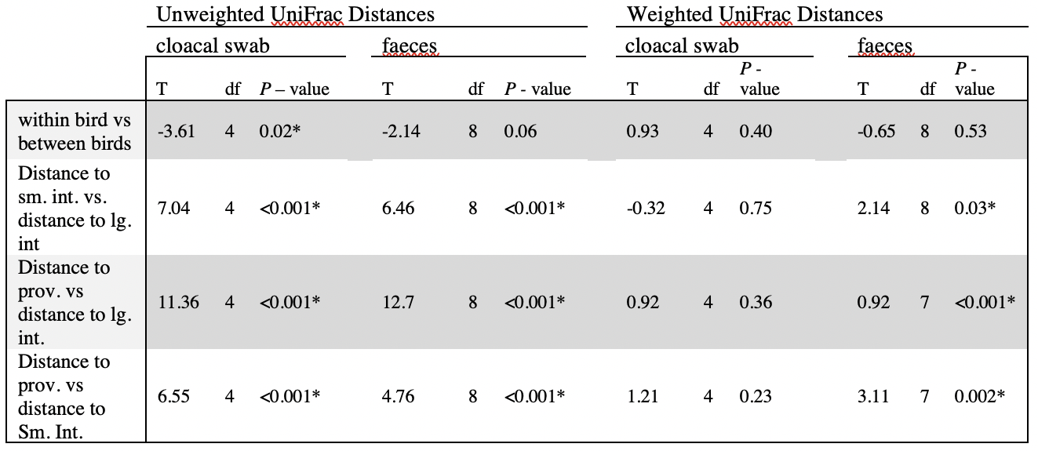

Abbreviations: small (sm.), large (lg.), intestine (int.), proventriculus (prov.)

Table 3. All morphological and environmental variables included in analyses. Variables were compared between urban and rural sites using Welch’s two-sample t-test for means. Variables with an asterisk are ones that are significantly different between urban and rural sites (Bonferroni adjusted alpha (0.003).
 | variable | t-stat | df | p |  | Urban mean | Rural mean
morphological | Bill length (mm) | -2.52 | 65 | 0.014 |  | 12.37 | 12.64
morphological | Bill width (mm) | 1.7 | 74 | 0.094 |  | 6.23 | 6.13
morphological | Bill depth (mm) | 1.17 | 56 | 0.247 |  | 6.88 | 6.81
morphological | Wing chord (mm) | -0.18 | 72 | 0.861 |  | 71.15 | 71.23
morphological | Plumage wear | -4.85 | 46 | <0.001 | * | 1.34 | 2.19
morphological | Fat | -0.94 | 63 | 0.353 |  | 1.17 | 1.35
morphological | Plumage fade | -1.63 | 76 | 0.108 |  | 0.49 | 0.71
morphological | Body condition | -1.02 | 57 | 0.312 |  | 31.16 | 31.54
environmental | Noise (dB) | 7.33 | 80 | <0.001 | * | 55.45 | 46.4
environmental | North coordinate | -12.27 | 48 | <0.001 | * | 37.8 | 38.03
environmental | West coordinate | 21.04 | 43 | <0.001 | * | -122.46 | -122.86
environmental | % trees | 6.14 | 59 | <0.001 | * | 0.21 | 0.02
environmental | % scrub | -4.46 | 67 | <0.001 | * | 0.43 | 0.73
environmental | % impervious | 4.83 | 80 | <0.001 | * | 0.31 | 0.12
environmental | % grass | -1.53 | 42 | 0.134 |  | 0.07 | 0.14

Table 4. PERMANOVA results on beta diversity distances between communities in urban and rural habitats.
distance measure | df | Pseudo-F | P
Jaccard | 1 | 1.408 | 0.001
unweighted UniFrac | 1 | 1.978 | <0.001
Bray-Curtis | 1 | 0.914 | 0.5044
weighted UniFrac | 1 | 1.018 | 0.3296

Table 5. dbRDA both combined and separately on rural and urban birds. Results showing percent explained for each distance measure, and significant variables if any. Jaccard and unweighted UniFrac distances represent community membership, Bray-Curtis and weighted UniFrac distances represent community structure, UniFrac distances are corrected for phylogenetic relatedness. Full model used in each case: distance measure ~ fat + wear + fade + wing chord + noise + bill length + bill width + bill depth + body condition + % trees + % grass + % impervious + % scrub.

 | URBAN |  |  | RURAL |  |  | COMBINED
diversity measure | dbrda1 % explained | dbrda2 % explained | significant variables | dbrda1 % explained | dbrda2 % explained | significant variables | dbrda1 % explained | dbrda2 % explained | significant variables
Jaccard | 4% | 3% | condition | 8% | 5% | none | 2% | 2% | none
unweighted UniFrac | 4% | 4% | none | 9% | 86% | none | 3% | 2% | % trees
Bray -Curtis | 9% | 3% | none | 10% | 7% | none | 4% | 2% | none
weighted UniFrac | 20% | 2% | Bill width | 49% | 4% | none | 80% | 6% | none

Table 6. Prevalence and average abundance of common phyla.
Phylum | prevalence (% of samples occurring in) | average abundance
Actinobacteriota | 94% | 29%
Bacteroidota | 57% | 1%
Firmicutes | 94% | 27%
Proteobacteria | 97% | 41%

Table 7. Mixed linear model results assessing the effect of treatment on alpha diversity. All models included treatment order, and individual bird nested within sex as random effects (+ 1|order + 1|sex/bird). P-values for all post-hoc comparisons can be found in Table S4
 | lm anova |  |  | Tukey post-hoc
Alpha diversity measure | model F | P |  | significant comparisons | P
⁰D | 1.9449 | 0.131 |  | n/a
¹D | 3.2003 | 0.029 | * | Recovery - Control | 0.029 | *
²D | 2.6617 | 0.056 | . | Recovery - Control | 0.06 | .
faith's pd | 4.3798 | 0.007 | * | Recovery - Control | 0.02 | *
 |  |  |  | Recovery - Noise | 0.016 | *

Figures

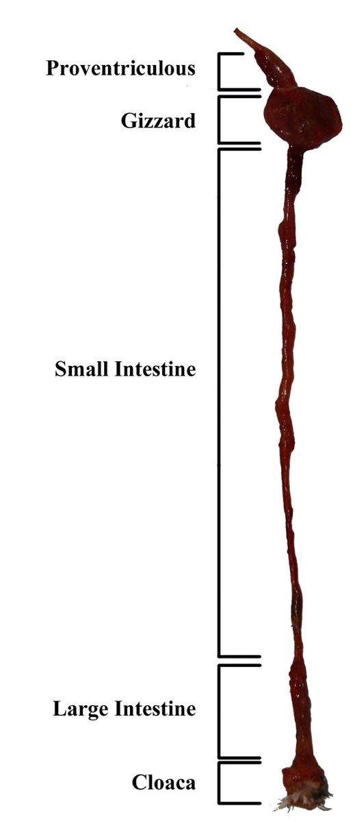
Figure 1. Gastrointestinal tract of a Zebra Finch. The proventriculus attaches to the esophagus which terminates in the oral cavity. The cloaca is the single external orifice for the passerine gastro-intestinal tract. We sampled the proventriculus, small intestine, large intestine, collected a swab from the cloaca, and sampled faeces.

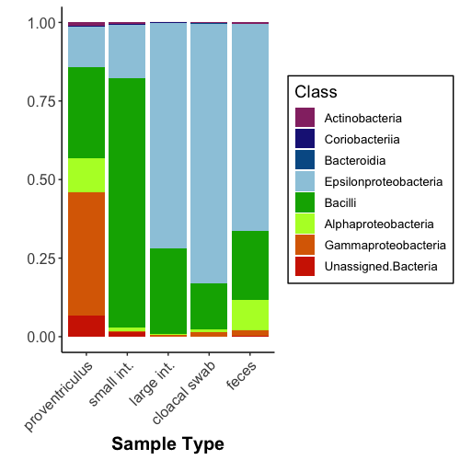
Figure 2. Relative abundance of bacterial classes by sample type: all classes shown comprised at least 1% of at least one sample. Based on unrarefied amplicon sequence variants’ (ASVs). Sample types are proventriculus, small intestine, large intestine, cloacal swab and faeces. Colours represent different classes of bacteria with the proportions of taxa averaged across individuals for each sample type.
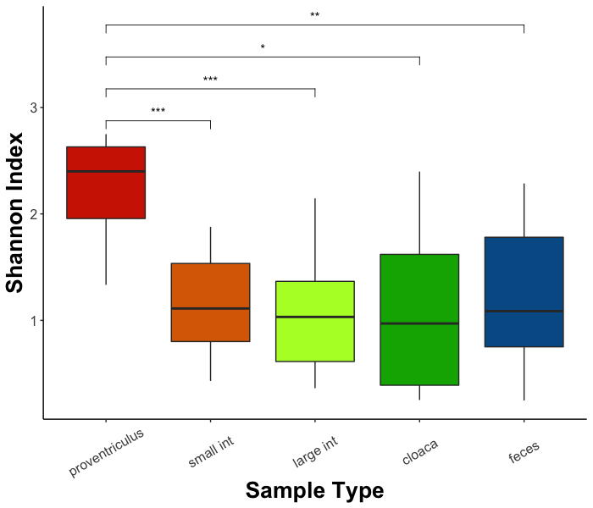

Figure 3. Box plot shows average Shannon diversity indices of all sample types.
Significant t-test results are indicated by an asterisk, *, **, and *** represent p= 0.05, 0.01 and 0.001, respectively.

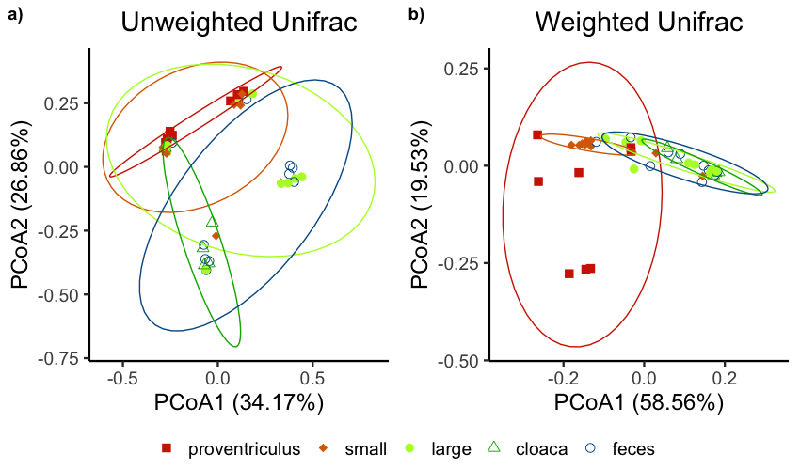
Figure 4. PCoA plot of (a) unweighted UniFrac distances (community membership) and (b) weighted UniFrac distances (community structure, accounting for relative abundances). Variation explained by each PCoA axis is provided in parentheses. Each data point represents one sample, with each sample type having a different colour and shape. Ellipses represent 90% confidence intervals.

Figure 5. Boxplots of unweighted (community membership) and weighted (community structure, accounting for relative abundances) UniFrac distances between non-lethal sample types, cloacal swabs and faeces, as compared to lethal sample types (proventriculus, small intestine, and large intestine). Significant t-test results are indicated by an asterisk (*), non-significant results are indicated by ns. *, **, and *** represent p= 0.05, 0.01 and 0.001, respectively.

Figure 6. Individual variation captured by non-lethal samples. Graph shows average unweighted (community membership) and weighted (community structure, accounting for relative abundances) UniFrac distances from large intestine to cloacal swabs and faeces across birds (between-individuals) as compared to distance from the large intestine to these non-lethal samples taken from the same bird (within-individuals). Significant differences between comparisons are indicated by an asterisk (*).

Figure 7. Transects were sampled in ten locations in urban and rural areas. Transects from Abbotts Lagoon, Limantour, and Commonweal were designated rural, while Richmond, Presidio and Ft. Funston transects were considered urban. Each dot represents a sampled bird. Transects were originally designed to sample across a noise gradient, and so dots are on a color scale from green to purple; light green is quietest and dark purple is loudest (dBA). See supplement Figure S1 for locations of all transects on one map.

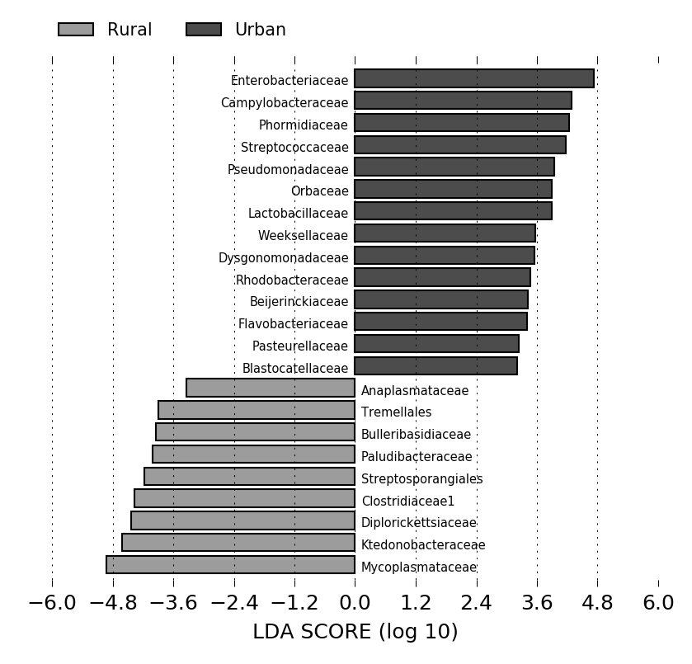
Figure 8. Linear discriminant analysis effect size (LEfSe) comparing bacterial families between urban and rural groups. Colors correspond to which group was found to have disproportionately more abundance of that bacterial family.

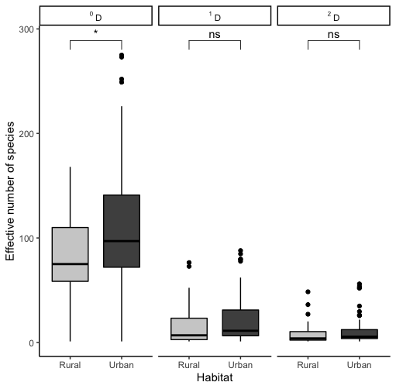
Figure 9. Variation in alpha diversity (effective number of species) measured in Hill numbers (three orders of q). Effective number of species is less sensitive to rare bacteria as q increases. ⁰D is bacterial richness, ¹D is the exponential of Shannon entropy, and ²D is the inverse of Simpson's Index. Color corresponds to habitat type for sampled birds. * indicates significance difference (p<0.05).

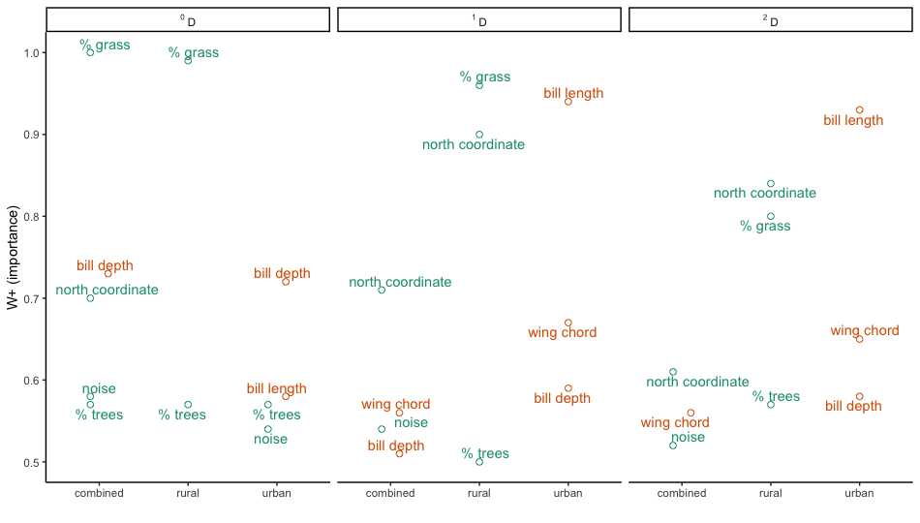
Figure 10. Important variables ranked by importance for averaged model for all data (combined) and urban and rural locations separately. Shown are all variables above .5 importance. Points and labels colored by variable type (environmental=green; morphological=orange). For example, for ⁰D combined dataset, the most important variable is % grass, followed by bill depth, north coordinate, noise, and finally % trees. Overall, urban gut bacterial communities are best predicted by morphological characteristics, whereas rural gut bacterial communities are better predicted by environmental factors.

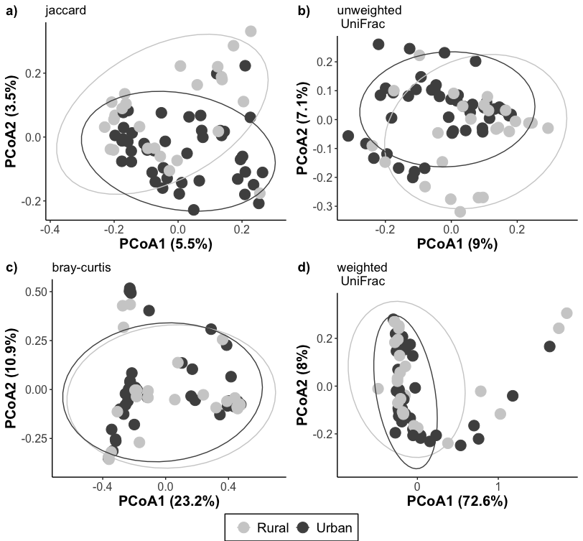
Figure 11. Principal coordinates plot (PCoA) of (a) Jaccard, (b) unweighted UniFrac, (c) Bray-Curtis, and (d) weighted UniFrac distances. Variation explained by each axis is provided in parentheses. Each data point represents one sample.

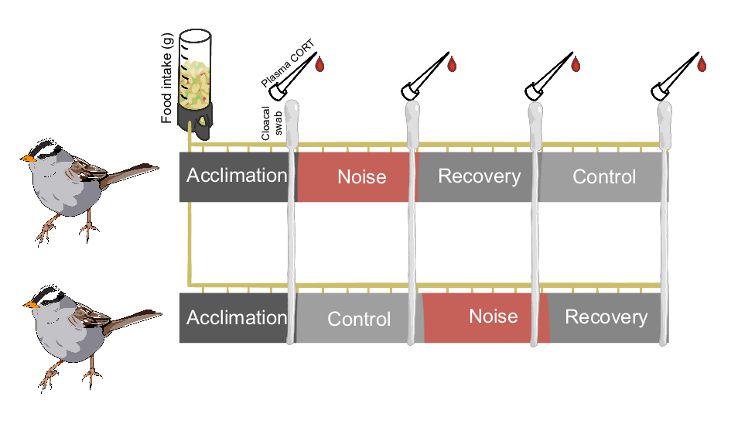
N=13
N=13
Figure 12. Experimental design diagram. Each treatment group had 13 birds, with one group receiving noise and recovery first, and the other group receiving control first. Blood for plasma cort and cloacal swabs were collected on the last (5th) day of each treatment period, and food intake was recorded twice daily.

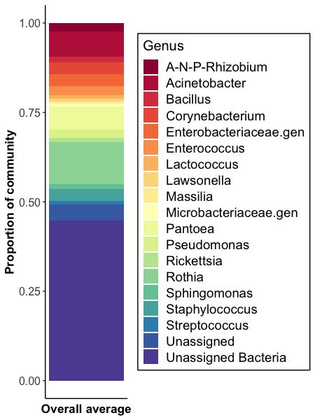

Figure 13. Relative abundances of bacterial genera in captive white-crowned sparrows combined from samples across all treatments. Figure of relative abundances of bacterial phyla can be found in the supplemental figures (Figure S1).

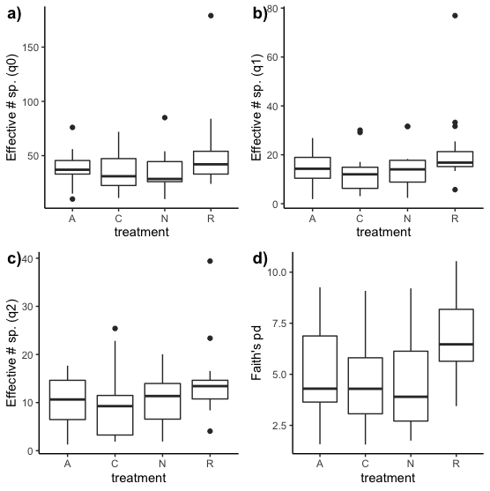

Figure 14. Alpha diversity in response to noise treatment by order of treatment received (A=acclimation, C=control, N=noise, R=Recovery). Noise exposure has an effect on alpha diversity.

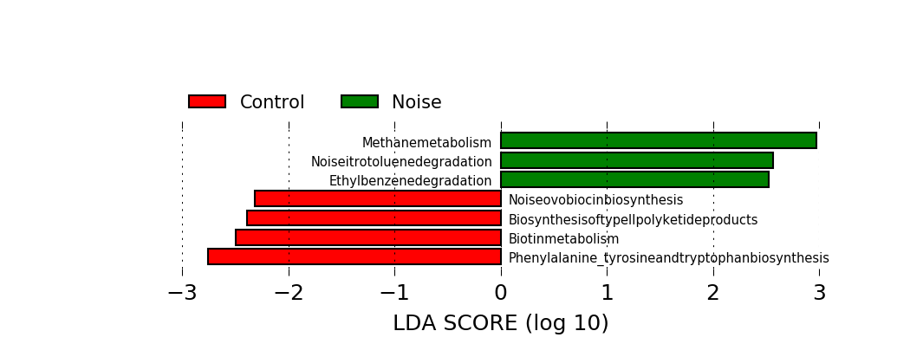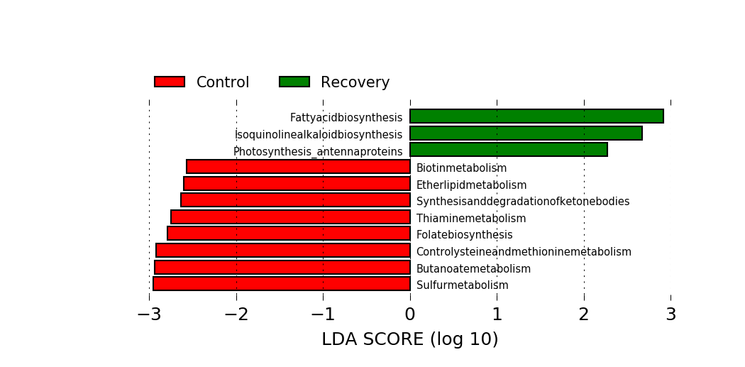
Figure 15. ﻿Linear discriminant analysis effect size (LEfSe) comparing predicted gene abundances (PICRUSt) between control and noise treatments (top), and control and recovery treatments (bottom). Colors correspond to which treatment was found to have disproportionately more abundance of that gene. More predicted genes differed between control and recovery than between control and noise, suggesting a delayed effect of noise on the gut microbiome.

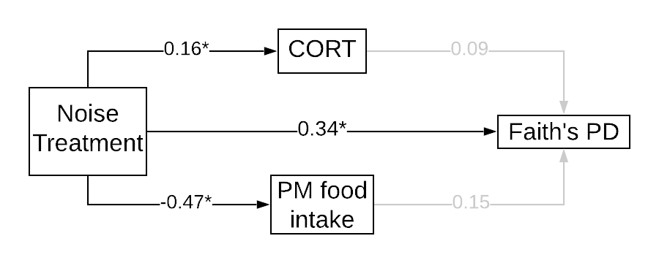
Figure 16. Path analysis results assessing relative contributions of noise treatment, corticosterone (CORT), and food intake to Faith’s phylogenetic diversity. Path analysis figures for other measures of food intake and alpha diversity can be found in the supplemental materials (Figure S2). * indicated significant relationships, gray arrows indicate non-significant relationships. Order of treatment and individual bird nested within sex were included as random effects.

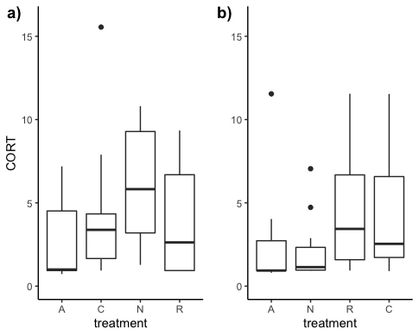
Figure 17. CORT response to noise treatment by order of treatment received (A=acclimation, C=control, N=noise, R=Recovery). Noise exposure has an effect on corticosterone levels and does not return to normal after noise playback has stopped.

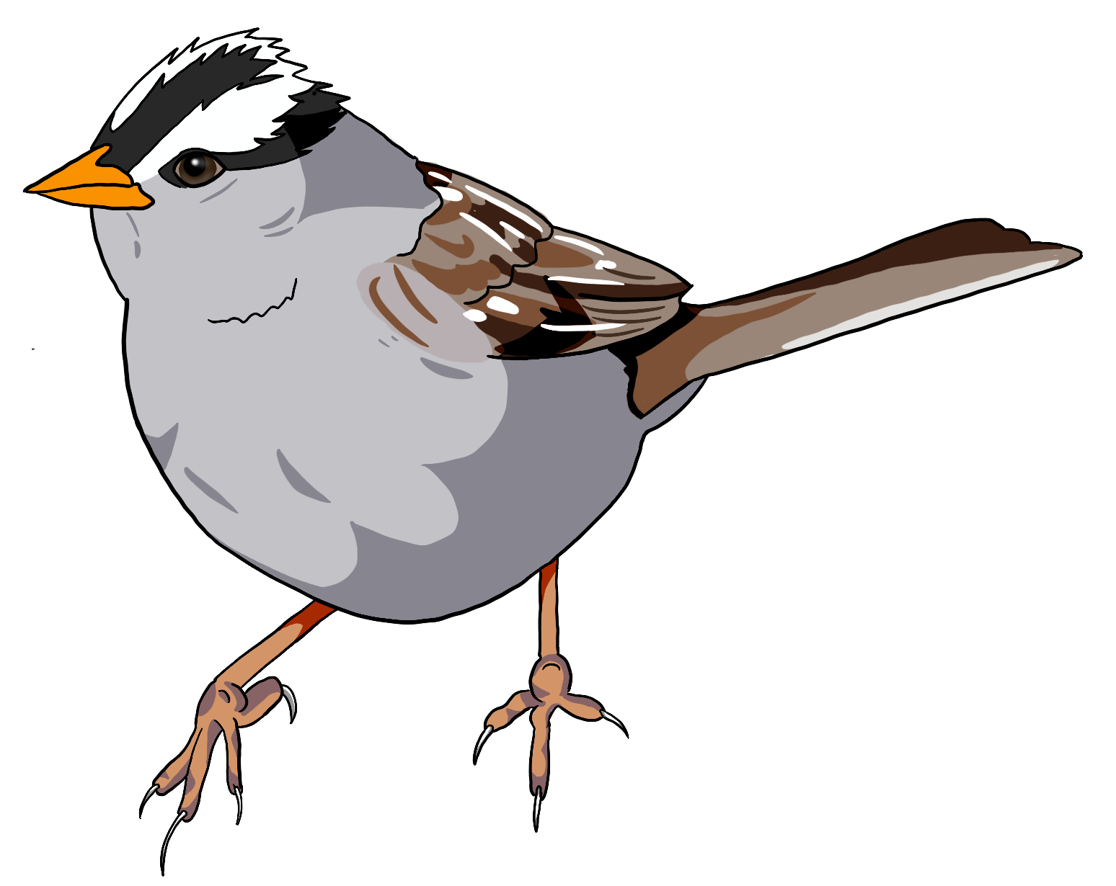
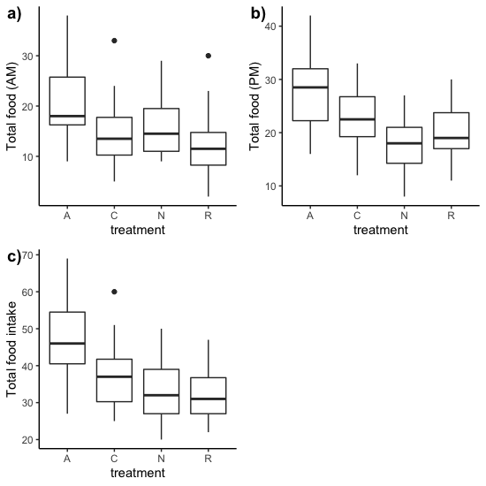
Figure 18. Food intake for each treatment a) in the morning during noise playback for noise treatment, b) in the afternoon after noise playback for noise treatment, c) all day food intake. Black points indicate outliers.

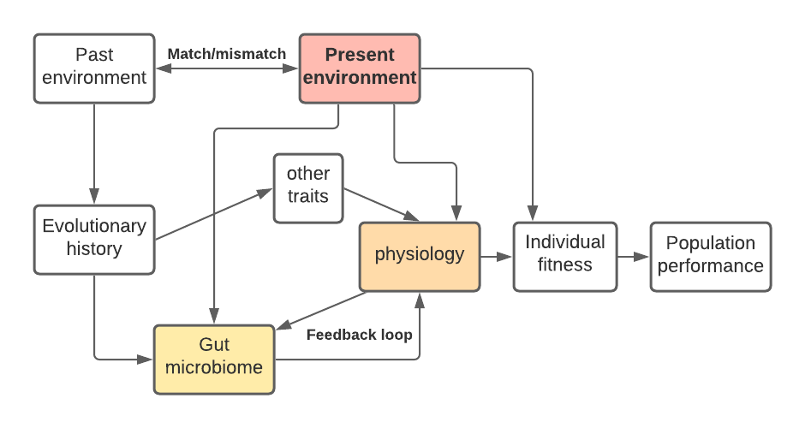

Figure 19. Figure inspired by Sih 2011. Gut microbiomes could be viewed as a plastic trait, that may play a role in an animal’s ability to respond to human induced rapid environmental change. Similar to previous frameworks presented about the role of behavior as a plastic trait influencing how animals respond to human development, our understanding of the physiological capacities and limitations on adaptation to urbanization might benefit from considering microbiomes in a similar way.

Vita

Mae is interested in the role played by microbiota in urban ecology and other kinds of landscape change.
Mae received her Bachelor of Science degree in Conservation Biology at Warren Wilson College, where she worked on the effects of stream contaminants on fish morphology and growth. She then worked as a joint research assistant for the Derryberry and Van Bael labs before joining the Derryberry lab in 2015 to start her Ph.D. Her dissertation research focused on avian gut microbial diversity and effects of shifts in gut microbial community on avian behavior.

