Carbon Footprint and Cost Minimization for Grid Systems Through Day-ahead Order and Battery Size Optimization

A Dissertation Presented for the
Doctor of Philosophy
Degree
The University of Tennessee, Knoxville

Omid Daniel Pourkhalili
August 2022

Copyright © 2022 by Omid D. Pourkhalili.
All rights reserved.

To mom, dad, Azadeh, Azin, and my late grandmother
who always wished to see my graduation

To future generations
who may suffer from global warming
Acknowledgments

The success and outcome of this dissertation required a lot of guidance and assistance from many people, and I am incredibly privileged to be given great opportunities during my Ph.D. life. First and foremost, I am grateful to my committee for all the helps, insights, and support. Professor Rapinder Sawhney has done more than anyone to teach me about systems engineering and inspired me to realize the power of critical thinking. My dissertation benefited from his careful and thorough feedback. From the start, Professor John Kobza had a faith in my abilities and helped me to become an independent researcher. I am grateful to Professor Andrew Yu for his attention to details in my research. Finally, I am grateful to Professor Russel Zaretzki for his practical guidance and empathy.
Beyond my committee, I owe a special thank you to category manager Peter Poggi from Tennessee Valley Authority and postdoctoral research associate Dr. Ninad Pradhan, who helped me in this research from the initial phases. I am also grateful to my fellow graduate students Hadi Parsian, Sajjad Biyouki, Ebrahim Sharifnia, and Phil Scruggs for their invaluable guidance in mathematical modeling, coding, and computational analysis of this research. None of this would have been possible without such assistance.
Words cannot express how grateful I am to my family, Hamidreza, Esmat, Azadeh, and Azin; Aman, and little Kian and Clara; and the extended highly educated Pourkhalili, Fattahi, and Terman clan, for their unconditional love and endless support. My hope is to make their life happier by accomplishing what they have always wished for me.

Abstract

We modeled the problem of peak hours day-ahead order for smart grid companies integrating renewable energy and power storage systems. This results in optimizing day-ahead order, battery storage size, and consequently lowering the use of fossil fuels and emissions. The utility-scale power storage can balance the difference between the day-ahead forecasts and real-time consumer demand through energy arbitrage and transmission deferral for peaking capacity. We define system parameters and their associated costs and run a suggested algorithm to minimize the grid operating cost by optimizing day-ahead order amount and battery storage capacity. The model is designed to prioritize and take power resources depending on their availability and associated costs in real-time. The resources include day-ahead reserve, wind power, utility-scale storage system, and two-stage real-time power, which can be adjusted by users based on their available resources. Multiple comparisons on a finite feasible set of discrete decision variables through simulation optimization provide us with the optimal day-ahead order and battery size. Furthermore, the model will be tested and validated based on data provided by the U.S Energy Information Association. The model can be used by grid operators to evaluate their potential savings, can be used by energy regulatory agencies for simulating and examining their rules and policies, and can be used by state and local air pollution control agencies to evaluate the impact of different energy resources such as batteries on power generation.

Keywords: Battery modeling, Simulation optimization, Grid systems, Lithium-ion battery, Renewable energies, Polynomial regression

Table of Contents

Introduction 1
1.1 Background 1
1.2 Problem Statement 2
1.3 Research Context 3
1.4 Scope and Limitation 4
1.5 Approach 4
1.6 Mathematical Modeling 4
1.6.1 Optimization 5
1.7 Industry Overview 6
1.8 Power Distribution 10
1.8.1 Electricity Market 11
1.9 Grid Systems 13
1.10 Wind Energy 16
1.10.1 Primary Challenges of Wind Energy Implementation 23
1.11 Utility Scale Power Storage 23
1.12 Summary 27
1.13 Outline 28
Literature review 29
2.1 Day-Ahead Order Optimization 29
2.1.1 Asymptomatic Properties of Prediction Error 36
2.2 Smart Grid Systems 38
2.3 Demand Side Management (DSM) 40
2.3.1 Components of DSM 40
2.3.2 DSM Optimization Models 42
2.4 Real-time Power Optimization 45
2.4.1 Components of Real-time Optimization 45
2.4.2 Optimization Models 46
2.5 Wind Power Optimization 50
2.5.1 Hybrid Wind Power 50
2.5.2 Gearbox Equipped Turbines 52
2.6 Utility Scale Power Storage 59
2.6.1 Battery Development 60
2.6.2 Battery State of the Charge 63
2.6.3 Battery life and cost projections 64
2.7 Summary 66
Methodology 67
3.1 Research Objectives 67
3.2 Problem Statement 67
3.3 Research Model 69
3.3.1 System Parameters 71
3.4 Mathematical Formulation 72
3.4.1 Notations 72
3.4.2 Supply Transition Functions 72
3.4.3 Storage System Transition Functions 75
3.4.4 Supply and Storage Integration 76
3.5 Model Assumptions 77
3.6 Simulation Optimization 78
3.7 Decision Variables 79
3.8 Objective Function 81
3.9 Scenario-Based Objective Function and Constraints 82
3.10 Input Parameters 85
3.11 Demand Forecasting (${\hat{q}}_{i}\left(t\right)$) 87
Results within a Case Study 90
4.1 Model Verification 90
4.1.1 Explanation of Case Study and Measurements 90
4.2 Day-ahead Order ($P_{d}$) 92
4.2.1 Day-ahead Order Forecasting $\left(\text{α × }\hat{q}\right)$ 92
4.2.2 Day-ahead Order Forecasting ($(1-\text{α) × }q_{Previous-day}$) 96
4.3 Input Values 96
4.4 Numerical Results 98
4.4.1 Day-ahead Order Results 98
4.4.2 Sensitivity Analysis on Storage Size 100
4.4.3 Carbon Footprint Reductions 103
4.4.4 Sensitivity Analysis of Carbon Footprint Reductions (2020-2050) 104
Conclusion and Future Work 106
Bibliography 108
Vita 119

List of Tables

Table 1.1: Energy storage applications 26
Table 2.1: Characteristics of Renewable Energy and Its Challenges (Cochran et al., 2015) 39
Table 2.2: Summary of Virtual Models and Their Assumptions for Day-Ahead Market 41
Table 2.3: Wind turbine-gearbox manufacturers and product specifications. 53
Table 4.1: System parameters and their values. 100
Table 4.2: Yearly savings of battery utilization between the years 2020 to 2050. 106

List of Figures

Figure 1.1: Electricity Supply Chain. 7
Figure 1.2: Alameda County Microgrid. 12
Figure 1.3: North American Electric Reliability Corporation (NERC). 14
Figure 1.4: Daily Power Demand (Pattern). 15
Figure 1.5: Wind Electricity Generation and Share of Total U.S. Electricity Generation, 1990-2019 (U.S. Energy Information Administration, N.D.). 17
Figure 1.6: Global market share of wind turbine 20
Figure 1.7: Wind turbine drivetrain. 20
Figure 1.8: Algorithm for Establishing Land-based Wind Facilities (Lantez et al., 2016). 22
Figure 2.1: Bias and Variance effects on prediction (Fortmann-roe, S. 2014). 35
Figure 2.2: Bias and Variance Response to Model. 37
Figure 2.3: Dynamic optimization method depending on uncertainty. 47
Figure 2.4: Schematic view of gearboxes depending on generation capacity (Qiu et al., 2017). 55
Figure 2.5: different types of gear transmission units’ connection (a: series, b: parallel, c: hybrid) (Qiu et al., 2017). 55
Figure 2.6: Planetary gearbox (S=Sun gear and R=ring gear) (Qiu et al., 2017). 56
Figure 2.7: Constant power generation for turbines with gearbox and pitch control. 58
Figure 2.8: Battery and Natural Gas Combustion Turbine Costs are Shown as a Comparison. 62
Figure 2.9: Battery cost reduction (NREL - Cole et al., 2021). 66
Figure 2.10: Battery lifetime from various published resources 66
Figure 3.1: Schematic Representation of System Circuit. 68
Figure 3.2: Schematic representation of system validation. 70
Figure 3.3: Flowchart of supply chain. 73
Figure 3.4: Schematic representation of two factors involved in day-ahead order. 80
Figure 4.1: Flowchart of supply chain and involved resources. 92
Figure 4.2: Tennessee Electricity Demand and Supply Balance (Source: eia.gov). 94
Figure 4.3: 5x 365 Days of Tennessee Region (TVA) Demand, Overlapped Charts. 94
Figure 4.4: 5x 365 Days of Tennessee Region (TVA) Demand, Stacked charts. 96
Figure 4.5: Fitting the forecasted demand on the 2019-2020 actual demand. 96
Figure 4.6: Tennessee Electricity Demand and Supply Balance (Source: eia.gov). 98
Figure 4.7: Previous-day demand is known for day-ahead order. 98
Figure 4.8: Schematic view of day-ahead order calculation. 100
Figure 4.9: Day-ahead order and battery size effects on operation cost. 102
Figures 4.10: The impact of battery size on the operation cost. 103
Figure 4.11: SC-CO2 Savings of battery operation 2020-2050. 106

Chapter 1

Introduction

Background
The concept of renewable and sustainable energy systems is a key issue in global policies. These policies promote the transition from fossil fuels to environmentally friendly renewable energies such as wind power, solar energy, and fuel cells (Foster et al., 2017). Global efforts to enhance renewable and sustainable energy, including energy management, focus on reducing dependency on fossil fuels to reduce the adverse environmental effects associated with fossil fuels (Esfahani et al., 2015; Hwangbo et al., 2018). The U.S. Department of Energy report evaluates the feasibility of renewable energies to generate 20% of the nation’s electricity demand by 2030. These goals require as a prerequisite a transmission infrastructure enhancement and reliably incorporates renewable energy systems (U.S. Department of Energy, 2008).
United States Federal Energy Regulatory Commission passed order No. 841 in 2018 that requires energy market operators in their jurisdiction to allow storage resources to be utilized as a capacity source. This is an additional welcome to international rules on reducing greenhouse gas emission caused by traditional power generation methods. Considering these rules require a methodology that grid companies utilize to stabilize power generation, optimize day-ahead orders, and minimize the real-time balancing orders.
The stakeholders involved in this domain work on a competitive basis, still under governmental and states regulations. The governmental policies exist to administer and align the activities with public welfare in mind. Stakeholders in the power generation and distribution supply chain are diverse and include power generators (natural gas, coal, wind energy, sunshine, and others), as well as stakeholders raising funds for power-related projects. The electricity market consists of retail and wholesale, which are mainly connected through grid systems. Retail markets distribute electricity to consumers, and wholesalers trade power before distribution to consumers. In some regions, the Federal Energy Regulatory Commission determines the wholesale prices based on market rates or cost-based rates. The factors that affect power price are fuel costs, capital costs, and resources utilized for power generation. Change in demand also affects the price as well. For example, peak hours require instant power generation, which is more expensive (Federal Energy Regulatory, 2020).

Problem Statement
Humans have had an unprecedented impact on global warming, and the main reason is the emission caused by the burning of fossil fuels for energy consumption. Long-term decarbonization provisions highlight the power industry as the primary industry that needs to reduce its carbon footprint. This immediate need highlights renewable energies and battery storage as sustainable solutions. The complexity of the problem is that both renewable energy and electricity demand are uncertain.
Day-ahead electricity order is an important element in the power industry. Grid systems place their day-ahead electricity order for the next 24 hours based on supply and demand estimates. Further real-time power is available at a higher overall price and emission. Real-time generation usually involves gas turbines, which are expensive and produce greenhouse gas emissions. Hence, predictive models and new technologies such as utility-scale battery are required to reduce the dependency on real-time electricity. The lack of specific models that include all key parameters and their ability to consider various scenarios is causing inconsistency in how day-ahead orders are placed. The development of such a model can give an insight to grid companies on how to integrate renewable energies and how to deploy utility-scale batteries. In addition, it can provide the grid companies the ability to assign a cost to each power source and understand the cost portfolio.
This dissertation addresses day-ahead order and the appropriate battery size to address the gap between conflicting regulatory rules and cost considerations. The model allows the necessary flexibility to be adopted by different grid companies. Grid companies can optimize costs based on the company’s specific cost allocation, their day-ahead policy, and the size of the battery. Specifically, the grid companies can make decisions regarding the value of integrating a battery and, if so, the most appropriate battery size.

Research Context
The model predicts demand and places optimum day-ahead orders for smart grid companies utilizing a battery storage system. This becomes a complex issue when considering the uncertainties associated with peak-hour electricity demand. However, the benefits are lowering fossil fuel usage without any negative cost implications. The primary objective of this work is as follows:
- Making a relation between the dependent variable (demand) and the independent variable (time) to predict the day-ahead electricity demand. This prediction considers both the previous years and the previous day demand for a more precise estimate.
- A mathematical model is developed that can include and exclude available power resources to match the real-time supply and predicted demand at its lowest cost. This considers every potential scenario and helps grid companies calculate the benefits of integrating utility-scale storage systems. Also, it allows grid systems to choose/optimize the battery capacity (if there are different capacity options).
- Finally, we take Tennessee Valley Authority (TVA) to verify the model within a case study. The model is adjustable and adaptable to other grid companies depending on their inputs and system characteristics.

Grid operators can also use the objectives mentioned above to evaluate their potential savings, can be used by energy regulatory agencies for simulating and examining their rules and policies, and can be used by state and local air pollution control agencies to evaluate the impact of different energy resources such as batteries on power generation.

Scope and Limitation
This study investigates the possibility of implementing utility-scale storage for grid systems integrated with renewable energies and fluctuant demand during peak hours. The presented approach and methodology can be used for any grid with similar procedures. The challenge was originated by Federal Energy Regulatory Commission to enforce grid companies on adding batteries as a capacity source to minimize the real-time power generation through low efficient natural gas, which is costly and causes emissions. Also, batteries can provide the grid system with benefits such as energy arbitrage and ancillary services. Given that grid companies know their resources and their associated costs, and information related to batteries such as levelized cost and life span are easier to access than before, a solution can be reached. Furthermore, the solution helps them to evaluate the cost/benefit associated with battery deployment.
The limitation of this study is that the detailed costs of all involved resources and system players need to be available for exact results. We have made some assumptions on transmission efficiency and overall costs for each power resource based on the literature review, which may cause minor errors. More in-depth cost evaluation can be done by individual users who want to adopt the model with their own procedures.

Approach
The selected approach in this dissertation is classified into two tasks Mathematical Modeling of a problem and the Simulation Optimization approach. This will be summarized in the following subsections and will be more discussed in Chapter 3.

Mathematical Modeling
We consider a regular grid system consisting of six major power inputs and outputs. The five power inputs are day-ahead order, wind power, storage system, real-time order, and real-time penalty-added order. Also, there is a power output, which is the real-time consumer demand. Next step, we define system parameters for all these involved resources (inputs and output) to make a cost function that calculates system cost for all potential scenarios. The real-time scenario happens through transition functions that automatically include or exclude involved resources in real-time depending on consumer demand.
It is important to note that resources are prioritized and utilized based on their costs. The system automatically and dynamically utilizes the cheaper source and adds the next available cheaper source to maintain the supply-demand balance steadily. Involving a source means adding its cost into the cost function and excluding a source means removing its cost from the cost function. Various scenarios may happen in real-time depending on supply-demand balance due to uncertainty involve with real-time demand.

1.6.1 Optimization

According to the previous sections, the problem is minimizing the overall cost of the grid system during the peak hours. We have designed transition algorithms for storage system and grid system during different supply-demand scenarios and finally merged the algorithms to build the cost function. The model constraints are designed in a way to prioritize the cheapest available power resources to match the supply and demand. Each scenario happens depending on real-time demand, and it considers its involved energy resources and their associated costs. With this, each scenario includes/excludes some resources and their costs. Below are the scenarios that may happen for the grid system in terms of supply-demand (detailed information presented in Chapter 3).

- Day-ahead order + Renewable energy production exceeds the demand; then we store the excess electricity. (In case demand and supply are equal, the battery level does not change)
- Day-ahead order + renewable production falls under demand; we discharge the storage system to meet the demand.
- Day-ahead order + renewable production falls under demand, and the storage system is emptied: grid system orders up to 1000MWh real-time power without emission penalty.
- Day-ahead order + renewable production falls under demand, the storage system is emptied, and 1000MWh emission penalty-free real-time power is used: penalty included real-time order adds in this scenario.

Furthermore, the optimization is based on multiple comparisons on a finite feasible set of discrete decision variables. Final outcomes minimize the overall cost and carbon footprint of the grid through day-ahead order and battery size optimization. On the other side, regulatory agencies could use the model for decision-making purposes and customize the regulations for grid companies depending on region and grid resources.

Industry Overview
Electric power plays a vital role in the industry, and all the economic sectors and infrastructures are downstream dependents of electric power. Power generation and supply were used to be limited to urban districts through local power plants and with direct current (DC) circuits. With the increase in demand, the industry adapted its structure by alternating current (AC) generation, different voltages, and new distribution methods. Therefore, cutting-edge technologies and new policies are taking place in this industry as demand increases and spreads geographically. Although smart grids and new technologies have improved the reliability and efficiency of the electricity supply chain (Figure 1.1), it requires new business models, updated operation methods, and regulatory structures. All parties involved, including federal, state, and private sectors, play a vital role in supporting the delivery of reliable and environmentally friendly power at its lowest price.
As demand increased through the years, Direct Current (DC) circuits were replaced with Alternation Current (AC) circuits to lower the generation, operation, and supply costs. The first AC power station in the United States was built north at Niagara for long-distance purposes. This generation method later outpaced the DC circuits and extended through all the states as a robust generation method.

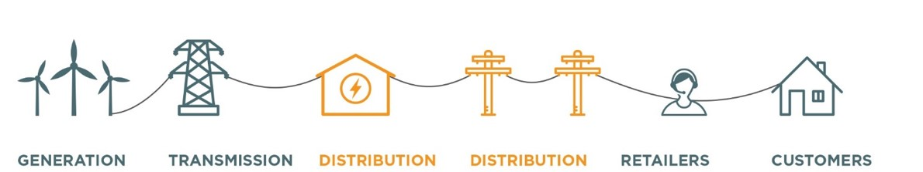
Figure 1.1: Electricity Supply Chain.

With the continuing increase of power demand on one side and the development of environment-friendly power generation methods, the US power section is influenced by federal, state, and philanthropic rules. The state and federal agencies are responsible for ensuring that power infrastructure is reliable by considering the vulnerability of power generation and transmission and by implementing regulatory and ownership rules on both structures and utility companies.
Federal Energy Regulatory Commission was established in 1977 and plays a significant role in implementing Department of Energy policies under the federal power act within the U.S. and the availability of energy resources such as natural gas and oil. These regulatory rules include utility companies that generate, transmit, and distribute power to final consumers. The decisions by this commission can only be questioned by U.S. Federal Courts, and there is no other organization or person has the right to override their decisions. According to the report by the United States Office of Electricity Delivery and Energy Reliability (2015), the Federal Energy Regulatory Commission (FERC) has the following responsibilities:
- Reviews the electric companies' profit and restrict the potential concessions
- Reviews the wholesale prices within the nation
- Reviews the contracts related to the transmission project
- Hydroelectricity projects inspection
- Energy market monitoring
- Enforcing the rules by imposing civil penalties
- Inspection of financial reports and conduct of regulated companies.
Federal Energy Regulatory Commission (FERC) designed North America Electric Reliability Corporation (NERC) as a non-profit agency to evaluate the reliability of bulk power systems within North America. The jurisdiction area includes the United States, Canada, Mexico, and all operators, owners, and users are under NERC supervision. As a governmental agency, NERC has the power to regulate, audit power companies, and levy fines for non-compliance in the electric market according to standards set by FERC. NERC responsibilities are including of:
- Enforcing reliability codes
- Evaluating short-term and long-term reliability standards
- Evaluating power system through system awareness
- Training and certifying industry personnel
Federal Energy Regulatory (FERC) designed Regional Transmission Organizations (RTO) and Independent System Operators (ISO) for regional administration within the United States. ISOs are responsible for operating the region’s electricity grid, the region’s wholesale electricity market, and ensuring the reliability of the region’s electricity system. RTOs have similar duties to ISOs, such as controlling and monitoring the operation of bulk systems and controlling the transmission networks within their region. Both the RTOs and ISOs are involved in ensuring the full functionality of the infrastructure. There are some areas without active RTO and ISO; however, electric utilities perform the same responsibilities to meet NERC and FERC reliability standards.
Besides the federal responsibilities on regulatory rules, States have regulatory agencies with different agendas to regulate the electric industry. We can categorize them as the State Public Service Commission and the State Department of Environmental Protection. The State Public Service Commission regulates the electric service rates, evaluates the economic and environmental impact of utility operations, and protects the public’s safety and interest. They also perform maintenance of assets and facility inspections. On the other side, the State Department of Environmental Protection ensures public safety by evaluating the state’s air, land, and water resources. In addition, they inspect pollutant assets throughout the state and implement an emission-related standards set by state and federal.
Utility companies provide the public with the services such as electric power generation, transmission, and distribution. There are more than 3,300 of them are operating within the United States, serving about 150 million subscribers. According to the U.S. Department of Energy Office of Electricity Delivery and Energy Reliability and depending on ownership and interest, they are categorized as:
- Investor-Owned Utilities: These companies are established by stakeholders for profit. Their operations and interests are monitored by Federal and State Regulatory Commissions.
- Public Power Utilities: They are usually established in the cities and counties they serve. They are owned and regulated by their local governments and work as non-profit companies.
- Cooperatives: They are usually established in small towns by a board of directors and are categorized as non-profit companies.
- Federal Power Programs: They are four large wholesale companies that provide services such as generation and transmission to smaller utility companies.
- Independent Power Producers: They are private companies with their own generation facilities and sell power to other utilities. This includes wind turbines and solar panel owners.
The electricity market ranges from electricity provider to final consumer. This includes competitive wholesale market or utility-owned rate-based generation companies ruled by federal and state regulations. Depending on state retail competition options or utility company ownership, price is determined by specific calculations on end-user fees or average annual costs, enforced by federal or state regulatory commissions before utility companies are allowed to serve customers.

Power Distribution
The power supply chain and distribution leads to final consumers and is the last chain of the electricity supply chain. Power distributions can be linked to high-voltage networks or sub-transmission networks. Substations decrease high-voltage through power lines and send low-voltage power to commercial and residential customers. There is local Power distribution microgrids that can supply power to final consumers. They do not need to be connected to the transmission network; instead, they are located after the transmission network near load centers. This system is called a microgrid, and it can generate power independently at the time of outage or peak hours. Microgrids are contained but not limited to diesel or gas generators, Energy Resources Management System (ERMS), and fuel cells to reduce peak demand during regular grid-connected operation or during a demand response event. They also may include wind or solar energy and power storage system. Figure 1.2 is an example of a commercial microgrid implemented in the County of Alameda, California.

1.8.1 Electricity Market
The electricity market is the final stage, where electricity provider sells electricity to final consumers under the state and federal rules. These rules regulate rates for the delivery of electricity to end-users through regular distribution wires. The final consumer can be large or small businesses or an individual household. Although every state may have a different retail competition setting, the electricity is sold through a wholesale market, utility-owned rate-based generation, or a combination of them. In states with full retail competition, there is an option for customers to choose between different suppliers. Retail suppliers offer various service plans and business options, and consumers choose their providers based on those options.
We will further discuss the retail price (the price end-users pay) is set based on an average of annual wholesale market pricing, not the real-time prices. Utility suppliers are not making profits at certain times; however, they are committed to supplying power according to regulations. For investor-owned utilities, the retail price is regulated by the state regulatory commission. These commissions are called Public Utility Commission or Public Service Commission, which is responsible regulates the utility’s costs and rate of return. There are also municipally owned utility companies that are subject to state regulations; however, they self-regulate their prices. They have more freedom to set prices because of being non-profit and not earning a return on capital invested. Commissions have two approaches depending on the state retail competition system:
- States with Retail Competition: Commission requires competitive suppliers to be licensed to be allowed to serve customers.
- States without Retail Competition: Commissions place regulations on rate return on capital invested of utility companies.

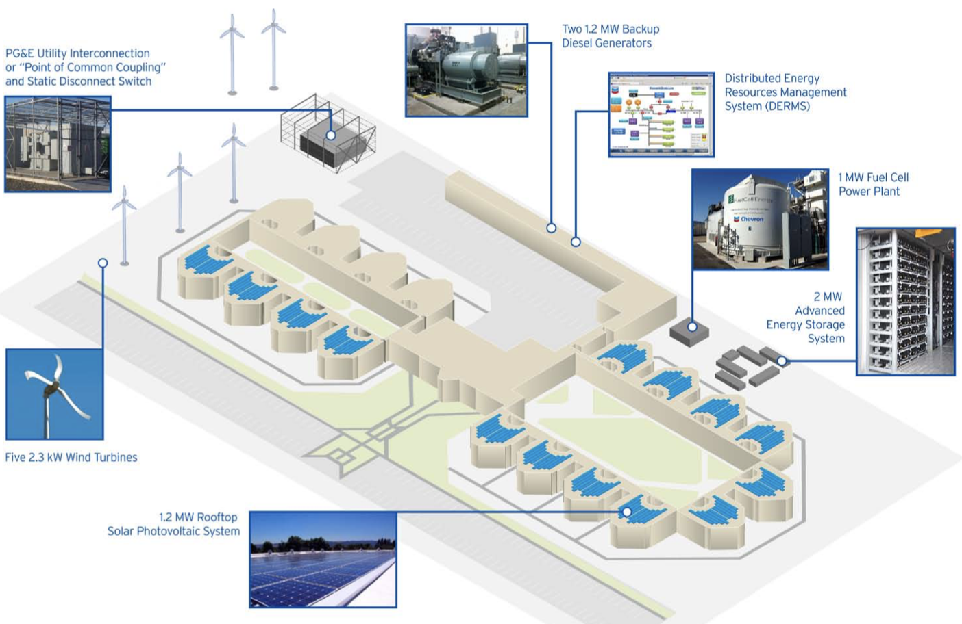
Figure 1.2: Alameda County Microgrid.
Source: www.acgov.org

Grid Systems
Grid systems have responsibility for the transmission and distribution of power. There are four major power grids throughout the North America (shown in Figure 1.3). They are called Eastern Interconnections, Western interconnections, Texas interconnections, and Quebec interconnections. Utility providers in each interconnection are usually tied to normal operation. Although demand fluctuates during the day across all regions, the grid has the responsibility to balance the power constantly. The transmission system sector sends continuous signals to generation facilities and demands for power dispatch. Power plants experience fluctuating demand rates during a normal day. It usually increases and stays high during the day until the evening time, when businesses experience busy hours and people at home prepare dinner. Power plants dispatch base-loading power, which is usually constant and is based on demand estimates.
To meet federal and state requirements, grids must ensure that load-serving entities can constantly supply power to meet day-ahead predictions; depending on location, the timing of capacity commitments and prices vary. Capacity Markets in regions with RTO and ISO authority are set to ensure power availability in both the short and long term. Capacity Markets deal with generation resources to lock the price well in advance. Also, during the demand response, they ask customers to reduce their demand in exchange for some rewards. These rewards equally reduce the grid payments to generation resources.
As consumption increases during work hours and meets peak hours in the evenings (shown in Figure 1.4), peak-power plants come into the circle to meet high fluctuating peak loads. Base-loading power plants, which usually work with coal or nuclear power, take hours to start operation. Peaking power plants usually operate with gas turbines, which gives a fast response at a higher operation cost. We consider renewable energies such as wind and solar as base loading power since they cannot raise generation in response to peak loads.

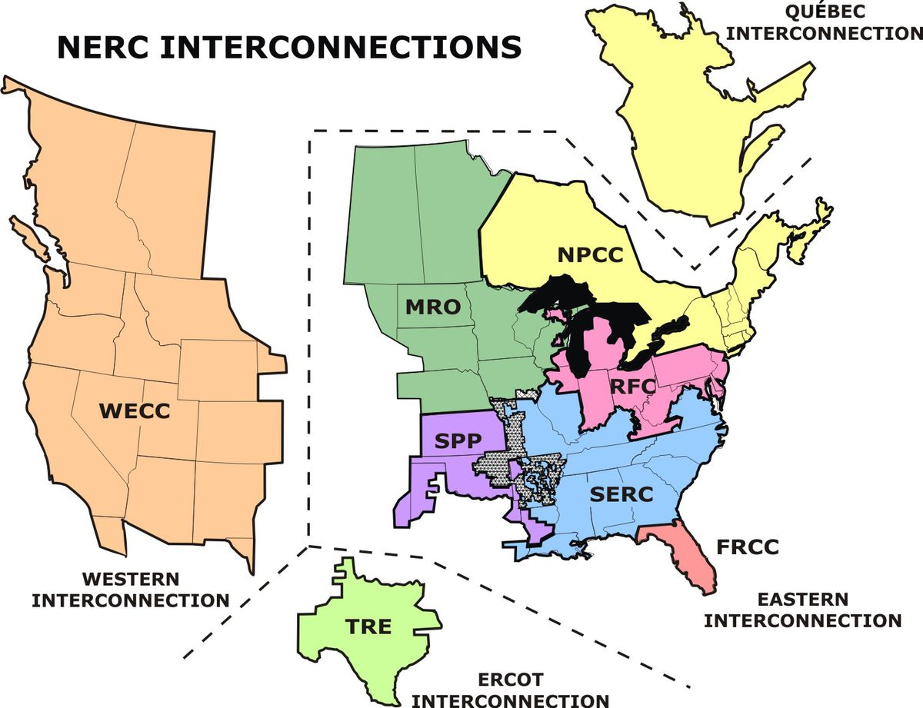
Figure 1.3: North American Electric Reliability Corporation (NERC).
Source: www.EIA.gov

Figure 1.4: Daily Power Demand (Pattern).
Source: www.solairgen.com

Power transmission lines connect electricity from power plants to local distribution networks. This includes structural frames, conductors, cables, circuit brakes, and substations. These networks transport power with minimum power losses by boosting voltage at specific points. Reactive Power flow is another vital component for stabilizing electricity flowing from power plants or utility-scale power storage to load centers. It stabilizes the voltage by supplying electricity through static capacitors. The Source of reactive power should be close enough to demand centers to minimize resistance during transmission distance. By adding transmission capacity utilization, more reactive power is required to stabilize system voltage and eliminate the voltage drop at the time utilization is increased. On the other side, at the time voltage drops, power cannot be transferred from distant power plants to load centers, and blackouts happen. Furthermore, substations are used (for different voltage levels) as critical nodes to link transmission lines to end-use customers. They mainly include transformers, protective equipment, and switches to control the voltage and monitor the power flow.
The utility companies must ensure that load-serving entities have enough resources to maintain supply-demand balance, including peak hours. This needs a reserve margin to meet unexpected high demands or potential loss of a supply resource. Capacity markets may have constant or fluctuating prices. Demand response programs can be seen as market prices, where consumers adjust their demand for financial benefits. This will be more discussed in Chapter 2 literature review section.

Wind Energy
Considering government incentives and public pressures on using fossil fuels alternatives, power system planners and regulators are convinced to integrate as much as renewable energies with the grid systems. Figure 1.5 provides the annual U.S. Department of Energy updates on wind electricity generation and its share of total generation between the years 1990-and 2019. It indicates the increasing proportion of wind electricity as an alternative to fossil fuels in the market.

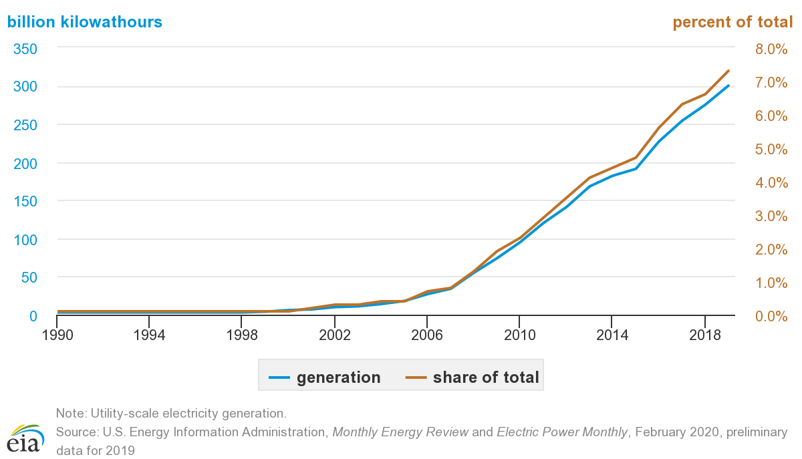
Figure 1.5: Wind Electricity Generation and Share of Total U.S. Electricity Generation, 1990-2019 (U.S. Energy Information Administration, N.D.).
On the other side, state-of-the-art integration methods are required to utilize renewable energies and integrate them with the power systems. The traditional power system operation methods are insufficient to manage the supply and maintain a smooth wind electricity integration. Therefore, updating and developing the generator interconnections and operations are necessary to adapt the traditional systems for renewable energy penetration (National Renewable Energy Laboratory, 2016).
According to the wind electricity generation growth shown in Figure 1.5 and the Renewable Energy by 2030 report provided by the U.S. Department of Energy (NREL, 2015), achieving the 2030 scenario requires about 300 gigawatts of renewable generating capacity to meet the 20% wind share of total U.S. electricity by 2030. It proves there are affordable and enough accessible resources to support the 2030 scenario. No limitation of raw material or financing resources was determined, and manufacturing capability was recognized to be possible through the domestic industry. The report predicts $2 trillion in investments in generation, transmission, and distribution from the early stage in 2007 to the future in 2030. This is also recognized to positively impact communities by creating jobs and raising revenues to $2 billion per year in 2030 from lease payments from wind farmers and property tax. Most of the measures are desirable from the perspective of a clean energy future based on not only an 18% decrease in fossil fuels but also a decrease in coal power plants' capacity. Natural gas consumption decreases by 11%, which lowers the overall gas price for other purposes, such as the steady demand of industries and households. It is also expected to reduce greenhouse gas emissions, and consequently, carbon dioxide would drop by 825 million metric tons. This reduction supports one-third of the U.S energy sector goal to meet International Energy Agency’s worldwide plans to reduce greenhouse gas emissions by the year 2050. Monetizing these reductions results in saving regulatory costs by $98 billion.
The 20% Renewable Energy Report (NREL, 2015) provided by the Department of Energy predicts that 46 states would generate more than 100 megawatts of wind electricity, which makes 180.000 direct jobs in this industry. Additionally, it makes more than 100,000 indirect jobs through the manufacturing of equipment, financial services, and maintenance.
Wind turbine technology has matured significantly and is becoming more reliable. As a result, multinational and world-leading companies such as Vestas, General Electric, and Siemens are funding many research projects and involve state-of-the-art technologies in their products to respond to the high demand and achieve higher market share. Figure 1.6 shows the Global Wind Energy Council report on companies with the highest market share.
New features and options are added, such as advanced controls and variable-speed generators through progressive power-split configuration (shown in Figure 1.7). This feature consists of a torque gear that lets the rotor function as either booster or diverter. It transmits mechanical power from slow rotation gears attached to the turbine rotor to boost or divert power to stabilize the generator's rotational speed. This synchronizes and matches the alternating current with the frequency of the grid, which is generally 50-60 hertz.
On the other side, state and federal regulatory agencies monitor the market potential and overall reliability of renewable energies to welcome the current share and demand more. Wind farms and generating companies are stepping in and sending bids to grid systems (depending on grid characteristics). Regulatory rules push grids, and financial benefits push generating companies to increase their collaboration. Generation production cost models have been researched to help all involved parties regulate prices.
Given the uncertainty on how market players encounter changes, applying models to electric markets gives intuition on how to optimize the overall benefit of wind electricity. These models cover uncertainty involved with wind power, from capacity credit and economic benefits to wind power forecasting. Whether the utility company is a monopolistic industry working under regulations or working on a competition basis, the models try to minimize the company's overall cost subject to constraints set by power plants. Although the cost models are vital because they analyze the interaction between load (demand) and generators (supply), they are still missing accuracy in terms of start-up and costs associated with load commitment. These models and applied costs of day-ahead order commitments will be discussed more in Chapter 3.
Figure 1.6: Global market share of wind turbine
manufacturers (Global Wind Energy Council, 2018).

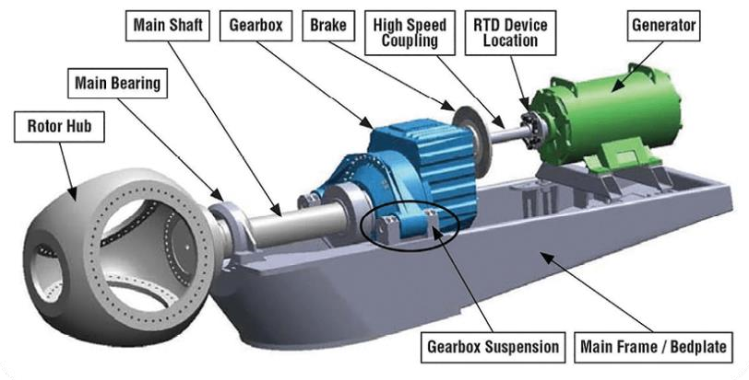
Figure 1.7: Wind turbine drivetrain.
sources: www.nrel.gov

Wind energy supply is assumed to use the state-of-the-art gearbox and pitch-control equipped turbines that stabilize the generators, and the wind speed is predictable 24 hours in advance. The uncertain electricity demand by consumers is the factor that requires the up-to-date functionality of grid systems, specifically in peak hours. They are the points that integrate power from dispatchable units, namely fossil fuel generators, as well as power from renewable generators, storage systems, and are connected to demand-side management systems (Chowdhury et al., 2009). They are also responsible for power exchange between (1) day-ahead orders and (2) real-time orders to always balance the supply and demand. In this research, we consider integrating two additional electricity sources with the power system, which are (3) wind electricity and (4) storage system. We describe these four energy resources as follows:
- Grid systems reserve and purchase day-ahead electricity from power plants 24 hours in advance.
- Grid systems also purchase real-time electricity from power plants, which is an additional order in real-time at a higher cost to compensate for the shortcoming of the day-ahead reserve and to balance the supply and demand.
- Wind electricity is generated by wind turbines.
- The storage system provides the system with two simultaneous benefits. The first benefit is mitigating the uncertainty of wind electricity production and the second benefit is reducing the expensive real-time electricity orders.

According to research done by Lantz et al. (2016), wind developers follow the same process and algorithm for establishing land-based wind facilities (shown in Figure 1.8). The decision-making process starts from land prospecting and finishes with the construction phase of the planet. The approximate direct costs for a regular project are Environmental review and permit, Interconnection, land, land use permitting, navigation and communication, off-take, public relations, and resource evaluation. Indirect costs are usually related to projects delays and redo studies, which significantly affect the profitability and viability of the industry.

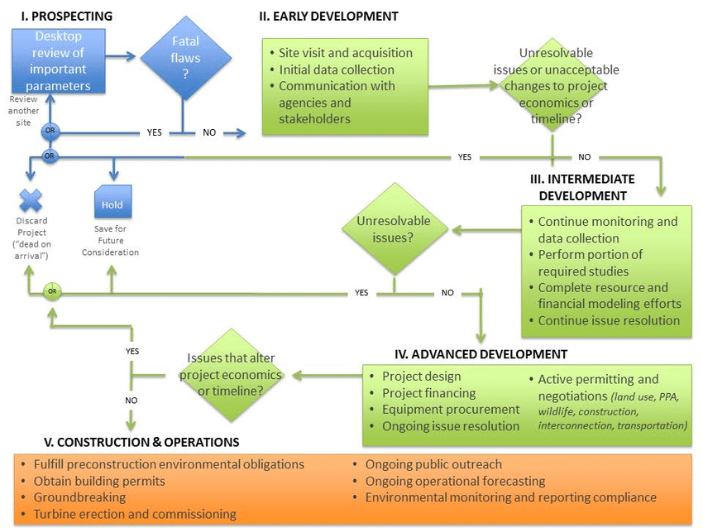
Figure 1.8: Algorithm for Establishing Land-based Wind Facilities (Lantez et al., 2016).

1.10.1 Primary Challenges of Wind Energy Implementation

There are several challenges identified to increasing the share of wind power. First, wind farms are usually located in remote places, so significant investment in transmission lines is required to reach remote areas, and consequently, higher transmission capacity requires current infrastructures. Second, long transmission needs permitting and financing of new equipment. Third, wind variability and uncertainty require costly technologies such as gearbox and pitch control that alter the slowly rotating, high torque power which you get from the wind turbine rotor to high speed, low torque power. Finally, other methodologies such as demand response methods and the process of studying, modeling, implementing, and maintaining such systems also add up to the wind technology cost.
Moreover, Transmission line setting and permitting may cause visual and environmental concerns that need to be addressed. This includes human health and wildlife effects that need to be addressed by further research and sincerity. Finally, due to the high expenses of wind power over traditional power, federal and state regulators and incentives are required for continued wind growth.

Utility Scale Power Storage
Utility-scale battery storages are new technologies that charge from a power plant or grid system to discharge the energy later or provide the grid with other services such as ancillary. Several battery chemistries are studied for utility-scale storage systems, including lithium-ion, Redox flow, and lead acid. Although each material may have advantages and disadvantages, lithium-ion batteries have the highest share among others. Lithium-ion batteries are becoming popular, causing a price decline of more than 70% from 2010, and it is predicted to decline due to technology improvements and mass production (Curry 2017). The increasing share of battery storage is due to an increase in the deployment of variable and uncertain renewable energies such as wind and solar. It will be more discussed in Chapter 2 how these batteries allow grid systems to enhance their operation and receive high levels of renewable energy. This lets the power sector safely and reliably integrate renewable energies.
In Chapter 5, we show how it can reduce the overall cost of power plants and consequently reduce their air pollutants. Depending on demand fluctuation and availability of renewable energies, other alternatives might be more profitable than batteries and still provide the grid with flexibility. These alternative resources are demand response programs, pumped-hydro storage, or simply investing in conventional generation flexibility.
Moreover, depending on battery characteristics such as rated power capacity, energy capacity, storage duration, cycle life, self-discharge, and round-trip efficiency, they can provide the following services:
- Arbitrage Services: Arbitrage is a source of income for the grid and one of the main reasons to utilize batteries. It means charging the battery when electricity prices are low and discharging the battery during peak hours at the times electricity price is high. This is also very functional and important when it comes to renewable energies. Assuming we want to use as many low-cost, emission-free renewable energies, the batteries minimize the mismatch of renewable energy supply and demand. For example, instead of curtailment of excessive wind generation during the night, the power can be stored for the peak hours of demand during the day. Moreover, the same functionality can be used for load leveling. Excess power generation can be stored and dispatched during the high demand.
- Firm Capacity or Peaking Capacity: Peak demands are usually balanced with expensive and pollutant methods such as gas turbines. Although Variable renewable energies are not considered firm capacities, batteries can help them to be regarded as firm capacity by storing and shifting the power to high-demand peak hours. This feature helps grid operators to install and integrate more and more renewable power resources.
- Ancillary Service: Grid reliability maintains through ancillary services. There are different timescale ancillary services from sub-seconds to hours to keep supply and demand always balanced. Batteries rapidly charge/discharge and play a significant role as ancillary servicer. Hence, batteries can be used instead of traditional methods such as thermal plants for both the short term and long term. Long term ancillary service needs larger battery capacity.
- Upgrade Deferrals: The grid must have the functionality to meet the peak hours. Increased peak demand in recent years may require grid operators to upgrade the grid system and expand transmission and distribution capacity. However, in many cases, batteries simply reserve adequate power to meet those peak demands, which are out of grid’s supply capacity.
- Black Start: Generators themselves need power at the time of starting up, so they can get prepared to generate electricity for the grid. This starting up power is provided by grid or an on-site independent diesel generator in normal situations. However, in cases like system failure, the grid cannot provide power, and batteries can send electricity to generators to perform key functions and startup.
The battery applications, potential service duration, and its potential efficiency is summarized in the table 1.1.

The United States Federal Energy Regulatory Commission passed order No. 841 in 2018, which requires energy market operators in their jurisdiction to allow storage resources to be utilized as capacity recourses (Federal Energy Regulatory Commission, 2020). It opens the way for transmission grid operators in the U.S to accept offers from the energy storage market, including aggregated Lithium-ion batteries connected to the distribution grid. In addition, this new order enabled each market operator to specify a minimum storage source that meets or exceeds peaking capacity.
Based on the above discussion, grid systems facilitate the integration of intermittent renewable energy sources and storage systems in a regular power system; however, balancing demand and supply specifically in peak hours remains a problem that needs to be solved and optimized. To address this issue, an optimized day-ahead order for peak hours can be formulated to take full advantage of renewable energies and minimize the real-time order. This optimization benefits the grid companies with cost reduction and society by reducing the air pollution and the use of fossil fuels.

Table 1.1: Energy storage applications.
Application | Description | Service Duration | Is it efficient?
Arbitrage | Charging during off-peak and discharging during peak | Hours | Yes, Depending on real-time price
Firm Capacity | Reliable low risk power | Hours | Yes
Ancillary Services | Frequency Response during variable supply | Seconds needed | Yes, depending on frequency
Upgrade Deferral | No need to increase grid capacity | Hours | Yes
Black Start | Start generators | Minutes needed | No, Diesel generators are more economy

Summary
We take the following steps to model and solve the problem:

- All involved power resources with grid systems are specified. Power inputs are Day-ahead order, Wind Power, Storage system, Real-time order, Emission-Penalty added Real-time order. Power output is consumer demand.
- Storage system transition functions are designed in a way to meet every possible scenario in terms of supply-demand.
- Grid system transition functions are designed to meet every possible scenario in terms of supply-demand.
- Transition functions are merged based on the supply-demand scenario, associated cost with each power source is added, and cost functions are designed that include all the power sources. Finally, model constraints are designed in a way that involves the cheapest available source. Running the model for a given period provides us with the aggregated cost of system operation.
- Forecasting the demand is used for day-ahead order optimization (day-ahead order is one of the model inputs). An optimized weight will be calculated for the forecasted demand, and an optimized weight will be calculated for the previous-day actual demand
- Finally, the model will be verified based on a case study. This cost minimization model provides the user with a practical approach to placing optimized day-ahead order when the optimized size of the battery is integrated.
- Consequently, Chapter 5 explains how such models help grid systems remain profitable and help regulatory agencies in legislation. At the same time, the use of fossil fuels and emissions is considered.

Outline
This dissertation includes five chapters. Chapter 1 reviews the power industry and introduces the context of the studied problem. Chapter 2 presents an extensive literature review. Chapter 3 explains the system modeling and methodology chosen for solving the problem. Chapter 4 presents the results within a case study. Chapter 5 summarizes the findings and suggests future multidisciplinary work.

Chapter 2

Literature review

The day-ahead electricity market has had many updates during the last decades. Most of these updates are because of new low polluting power generation methods and international rules on the deployment of low emission power sources such as sustainable energies. Variability of power generation sources and demand fluctuation has always been a challenge for power optimization, even though the generation and transmission costs are getting more economical. The expensive cost of utility-scale batteries prevented the researchers and authorities from considering any chance for it as the capacity source. However, battery property improvements and cost reductions have been established in recent years, confirming it as a sustainable source of power for grid systems. The combination of day-ahead order optimization and battery utilization as the capacity source is the foundation of this research towards cost and carbon footprint minimization of grid systems adopting cutting-edge technologies. Integrating other storage systems like pumped hydro, liquid, or air is well studied and utilized in some cases; however, these storage systems still have their limitations compared to the new generation of Lithium-ion batteries. From classical methodologies to multi-objective heuristic techniques, various optimization methods are developing robust strategies looking for the global optimum of energy cost. In the following literature review, we have reviewed the optimization models/techniques related to the family of power optimization, explained details related to each power source in subsections, and introduced how the new lithium-ion utility-scale batteries may have the revolutionary potential for change in grid systems, and simultaneously clarified the research gap.

Day-Ahead Order Optimization
The family of day-ahead electricity prediction has been extensively researched; however, there is a gap between those studies and the emerging utility-scale battery, which has recently become an essential player in power systems. One of the earliest review papers was done by Bajay (1983), which is an extensive bibliography related to demand analysis and forecasting for power systems. The paper pertains to the rapid growth of demand forecasting and believes the main reason concerning of growth was the 1973 energy crisis which notified the society regarding the importance of energy planning. The paper discusses the methodologies and techniques that have been used for electricity demand forecasting and divides them into four main categories of extrapolation, correlation, inquiry, or a combination of those categories. Furthermore, they can be classified as deterministic, probabilistic, or stochastic (Sullivan, 1977).
Extrapolation techniques fit trend curves to historical data and speculate the future growth to continue at past rates. Other methods use the average historical energy/output ratio to predict future demand. Correlation techniques relate demand to different demographic or economic factors. Although this technique helps the user to realize the interrelationship between demand patterns and other factors, demographic and economic predictions might be needed for exact results (Bajay, 1983).
An extrapolation methodology was used by Goh et al. (1983), that believes forecasting requires realizing the available data properties and projecting it into the future. They believe econometric methods have uncertainties in model specifications and are subject to errors. However, data characteristics errors can only be affected by methods of prediction, not missing factors in the model or model specification. In time series forecasting, Goh et al. (1983) took 78 demand points of a public utility in Singapore and used the Box-Jenkins methodology of stochastic modeling for forecasting. They did not use the last 12 points of 78 points so that they could check those points for the accuracy of the model based on the first 66 points. Mean Squad Error was used to evaluate the accuracy of forecasts. They received two main conclusions. First, Mathematical models that take the presence of any trend, seasonality, and stochastic dependence of past data are shown to be more practical and give better results in comparison to data older exploration methods such as exponential smoothing and data weightage. Second, the combination of sectors of homogeneous end users would provide more accurate results in comparison with a single aggregate model.
A correlation methodology was used by Spann et al. (1979) to forecast demand for the Virginia Electric Power Company based on the data between the years 1960 to 1973 for the months June, July, August, and September. Their econometric model relates peak demand to marginal electricity prices, temperature, and industry income. The results show:
- Price elasticities during peak hours demand are statistically significant. Price elasticities of peak hours demand were less than existed estimates of price elasticities of sale. It means that increasing electricity prices may lower demand (Relative to peak demand), or load factors deteriorate, and the optimal demand changes toward more peaking demand.
- Industry income elasticity of peak hours demand is usually more than the income elasticity of peak hours electricity sale. It means, increasing industry income makes industry less worried about the utilization of electricity resulting in greater electricity purchases (demand) and greater use of appliances and equipment.
- Peak demand is sensitive to alternative fuel prices. It means electricity can be replaced by alternative fuels depending on their availability and price. Therefore, it could imply that the factors such as alternative fuels, industry income, and other economic variables should be considered in peak demand estimation models (Spann et al., 1979).

Renewable power generation methods are associated with challenges and uncertainties depending on location, weather, and regional climate, making utility power storage systems necessary. In addition, power storage transforms the intermittent nature of renewable energy to a firm capacity and gives other beneficial services. Those services include but are not limited to the stored energy that can be used when the generated power is insufficient, provides services such as ancillary and arbitrage, and acts as reactive power to enhance grid stability (Desai et al., 2005).
Based on the uncertainties involved with renewable power generation and the benefits of storage systems in terms of ancillary and arbitrage services, many researchers used modeling and simulation techniques to optimize the functionality of energy systems. However, due to recent developments of utility-scale lithium-ion batteries, they are missing important features that this new technology has to offer. Lyden et al. (2018) studied modeling tools that support the design of power systems, including different power resources. They offer a process that considers Capability Categorization and Stepwise Tool Selection. The capability tools cover input data characteristics, available outputs, supply factors, storage, and practical factors. The Stepwise Selection Process that covers tool selection are score-based on Essential, Desirable, or Not Applicable. The scores are then calculated to select the tool. The tool may have data entry requirements, which are related to demand profile, local climate, and generation profile. They usually find the minimum or maximum of a defined objective function according to a mathematical algorithm. Design optimization takes a combination of sources and sizing of components (Sawhney et al., 2020). Most of these use a deterministic approach according to data inputted by the user to solve the optimization problem. The output gives information on a different aspect of a grid system, mainly related to the cost of generated energy, the amount of power exchange between grids, considering total generation emission, or can be focused on matching supply-demand. (Dufo-Lopez et al., 2016).
Some modular models are used for demand forecasting considering human behaviors (Taylor and Letham, 2018). Power demand predictions can depend on different factors that repeat in specific periods. For example, temperature change during different seasons causes similar power demand adjustment that follows the same trend. The simple definition of time series and regression analysis is a predictive modeling technique that finds the connection between dependent and independent variables. It gives the best fit line or regression equation for making predictions. Regressions are not necessarily linear regression models to find a linear relationship between input and output variables; many more extensions exist. They can be Polynomial Regression to model the relationship between independent variable $x$, and dependent variable $y$ is an n^{th} degree polynomial with a curve shape. Moreover, they can be Logistic regression with a sigmoid shape (s-shape) to model a binary dependent variable.
A model is linear when its parameters are linear:
$$y x x2$$
Τηε $k^{th}$ polynomial model in one variable is:
$$y {}_{0}{ + }_{1}x {}_{2}x2 ... {}_{k}xk$$
If $x_{j}=x^{j}, j 1, 2, ..., k$ model is a multiple linear regression model in $k$ explanatory variables, $x_{1}, x_{2}, …, x_{k}$. Hence, the same techniques that we use for fitting linear regression models can be used for fitting polynomial regression models.
To fit polynomial in one variable, we need to consider the following points:
Order of the Model: We have to increase the order of polynomial as one by one and keep it as low as possible. Arbitrary fitting results misleading and wrong regression analysis. Although a polynomial of high degree can be a good fit for the data, it does not necessarily reveal a correct function or precise predictor.
Model building: There are two approaches to finding the best order of a polynomial regression. Forward Selection Procedure puts lower orders and tests the model by adding orders until the model gives a significant t-statistic. Backward Elimination starts with the highest orders and then deletes higher orders one by one until the model provides a significant t-statistic.
Extrapolation: Make sure that the region of data and the region of extrapolation are the same. Otherwise, the prediction is not correct, and the model is not reflecting data behavior. It happens due to polynomial curvature in the wrong direction, which causes false interpolation and extrapolation.
Ill-conditioning: X-matrix is full column rank in linear regression, and as the polynomial order increases, $X’ X$ matrix turns to ill-conditioned. Hence, ${(X’ X)}^{-1}$ the matrix may cause parameters to give wrong estimates due to considerable error. Furthermore, small amounts of change in $x$ causes ill-conditioning to increase, which eventually shows multicollinearity in columns of $X$ matrix. This shows high multicollinearity between x and x². For example, if $x$ changes from 3 and 4, then x² changes from 9 to 16.
Hierarchy: All polynomial models should increase hierarchically from $x$ to $x^{1}, x^{2},x^{3}, …, x^{k}$ to be invariant in linear transformation. The following model is hierarchical because it has all orders up to its maximum order:
$$y {}_{0}{ + }_{1}x {}_{2}x2, {}_{3}x3{}_{4}x4+$$
The following model is not hierarchical because it does not have order x³.
$$y {}_{0}{ + }_{1}x {}_{2}x2 {}_{4}x4+$$
Orthogonal polynomials: Orthogonal Polynomials are primarily accepted for their practical importance in numerical integration using quadrature rules and approximation theory. This is widely used in rational and polynomial approximation and numerical quadrature in engineering and applied problems. Orthogonal polynomials start with a linear regression model and then develop into a quadratic, cubic model, and so on. We usually have to start the modeling from the base for each step. In some cases, we can refine and develop the model by increasing the order. This cannot be done by increasing the powers $x^{0}= 1, x, x^{2}, x^{3}…, x^{k}$ because fitting polynomial while using one variable causes ill-conditioning. However, it can be done through Gram-Schmidt orthogonal (Bultheel et al., 2005). It does not meet the ill-conditioning because of high levels of multicollinearity, and it does not satisfy the multiple linear regression because, in multiple linear regression, all the independent variables are independent.
Understanding sources of bias and variance errors guide us to improve the data fitting process and better electric demand predictions. We consider bias and variance in three schemes.
Conceptual Definition: The error caused by bias is because of the difference between the expected (or average) demand of the model and the actual demand that we are trying to predict. Due to randomness in different years’ demands, different models in different years give various range of predictions. Bias calculates how far these predictions are from the actual value. The error caused by variance is the variability of demand predictions for different data points. The variance shows how various data points give different predictions.
Graphical Definition: Bulls-eye diagrams show in Figure 2.1 can be used to show graphical visualization of bias and variance. If the center of the target is the correct predicted amount, moving away from the center worsens the prediction. We can consider different data sets to compare different prediction models and see how far our prediction is from the bull-eye. Outliers or non-standard values caused poorer predictions. Different predictions result in scatter points on the diagram (Fortmann-roe, S. 2014).
Mathematical Definition: If the predicted variable, $X$ is covariate, and $ε$ is the error with an average mean of around zero, they are related to each other as$Y=f\left(X\right)+ε$. We can estimate $f\left(X\right)$ using linear regressions. The expected squared prediction error at point x is:

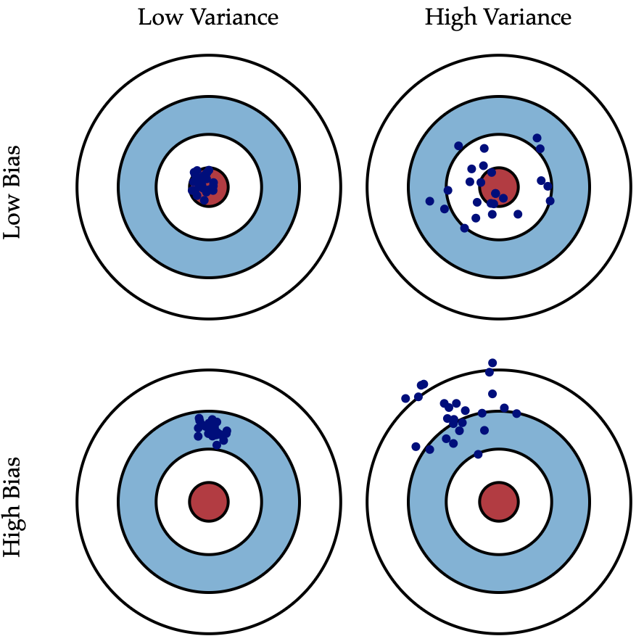
Figure 2.1: Bias and Variance effects on prediction (Fortmann-roe, S. 2014).

$$Err(x)=E[(Y-f^(x))^{2}]$$
The error decomposes to Bias and Variance components:
$$Err(x)=(E[f^(x)]-f(x))^{2}+E [ (f^(x) - E [f^(x)])^{2}]+σ_{e}^{2}$$
$$Err\left(x\right)={Bias}^{2} + Variance + Irreducible Error$$
Irreducible error is the noise term that cannot be reduced. With the proper model and infinite data, we could minimize both the bias and variance to zero. However, there is always a tradeoff between minimizing bias and minimizing variance due to imperfect models and finite data (Hastie et al., 2009).

2.1.1 Asymptomatic Properties of Prediction Error
We consider the Asymptotic consistency and asymptotic efficiency of prediction algorithms. Asymptotic consistency means as the sample size goes to infinity, the model’s bias goes to 0. Asymptotic efficiency means as the sample size goes to infinity, the model’s variance gets to the optimum amount. Although these are the desired properties of a model, an infinite sample size does not exist, and asymptotic properties cannot be reached. Because zero bias comes with infinitive data points: however, in practice, we have a few hundred data points which are associated with some bias.
Furthermore, as shown in Figure 2.2 bias and variance have opposite functionality. Bias decreases as variance increases. Although both the bias and variance are important to find the behavior of the model, the overall error should be the focus. The optimum error is equal to the point that bias - variance cut each other.
$$\frac{dBiasd}{Complexity}=\frac{-dVarianced}{Complexity}$$
There is no analytical approach to finding the point that bias and variance cut each other; however, we can find a prediction error by trying different levels of model complexity and choosing a complexity that provides us with the overall minimum error.

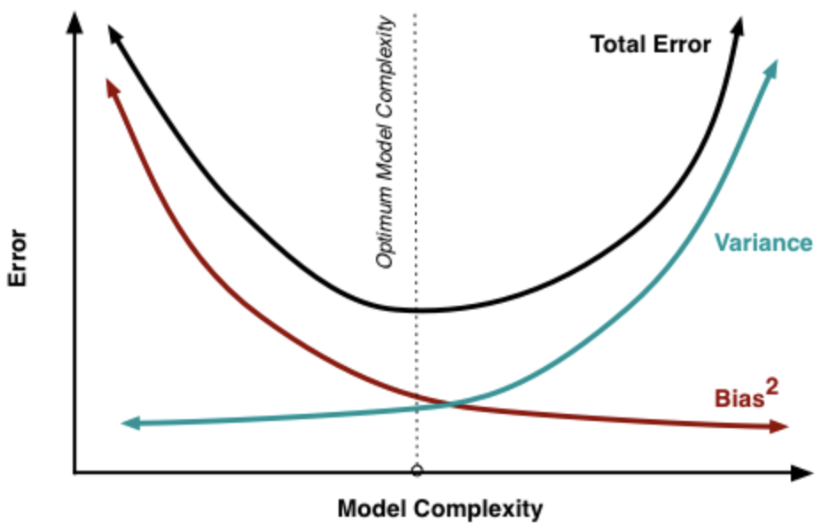
Figure 2.2: Bias and Variance Response to Model.
(Source: https://github.com/ImadDabbura/blog-posts)

Smart Grid Systems
With the emergence of grid systems, matching the demand and supply has become a major subject to study. Although the existing models are wide-ranging from the setting and concept perspective, the primary purpose of studies is to ensure the constant supply of electricity at its minimum cost. Also, new power generation methods and technologies, such as utility scale batteries, update the energy market, which require state-of-the-art scientific approaches to utilize them (Weschenfelder et al., 2020). Furthermore, new studies are trying to hire updated energy production methods and tools to match the supply and demand not only at its minimum cost, but also with respect to other factors such as air pollution (Lehtola and Zahedi, 2019).
The proposed models and methods may consider the uncertainty of both supply and demand to minimize the cost function or assume one side as an adjustable factor to optimize the system’s overall “social welfare” (Jiang and Low, 2011). In recent years, power storage systems such as Batteries, Thermal, Mechanical storage, hydrogen, and Pumped hydropower, have had enormous development and are widely accepted to play as resilient energy infrastructure and bring cost savings for grid operators and consumers (Lehtola and Zahedi, 2019). Cochran et al. (2015) published a report associated with the National Renewable Energy Laboratory named Grid Integration and the Carrying Capacity of the U.S. Grid to Incorporate Variable Renewable Energy, explaining the challenges that exist for integrating solar and wind energy with grid systems. Table 2.1 addresses these challenges that give grid systems operational flexibility.
The standard method to balance the demand and supply for grid companies is to order day-ahead energy for specific periods, 24 hours in advance, and real-time power is available at a higher cost to compensate for the shortcoming of day-ahead prediction. Most of these methods and models suggest an optimized day-ahead order for grid companies considering actual demand in real-time (Ferruzzi et al., 2016). Having involved an uncertain amount of renewable power requires microgrids, a promising technology to enable the utilization of different energy resources in an efficient and reliable process. Scheduling these flexible loads with the existence of power storage systems can be a practical approach to optimizing the efficiency and reliability of grids (Mirzaei et al., 2020).

Table 2.1: Characteristics of Renewable Energy and Its Challenges (Cochran et al., 2015).
Wind power Characteristics | Specifications | Potential Grid Integration Challenges
Variability | Generator output can vary as underlying resource fluctuates. | Balancing generation with electricity load requires more flexibility.
Uncertainty | Generation cannot be predicted with perfect accuracy (day-ahead). | System operators could need additional reserves and/or an improved ability to dispatch generation.
Location- specificity | Generation is more economical where highest quality resources are available. | More transmission and more advanced planning could be needed.
Non- synchronous generation | Generators provide voltage support and frequency control in a different manner than traditional resources. | Voltage and frequency stability from variable RE generators or additional equipment comes at added capital and/or opportunity costs.
Low-capacity factor | Availability of the underlying energy resource limits the run- time of the plant. | Existing conventional generators could be needed to meet demand, but run less than originally anticipated, affecting cost recovery.

Optimization simulation or stochastic optimization methods are used to address the demand uncertainties and real-time generation, thus, lowering the aggregation cost of day-ahead orders and real-time orders (Zakaria et al., 2020; Kuang et al., 2019). On the other side, some groups of works consider the scheduling of user demand through mathematical programming to adjust the demand response; it needs linking and cooperation of consumer and supplier (Behboodi et al., 2018; Soares et al., 2017; Zhao et al., 2013). They used stochastic Optimization methods to maximize the welfare of society (summarized in Table 2.2). The social welfare of a system is defined as the difference in total benefits of buyers from that of sellers, so maximizing social welfare means lowering the demand and consequently lowering the energy generation cost that mainly pays for expensive real-time orders. An example of this approach can be scheduling consumers’ appliances to be used according to supplier decisions (Abhindranath et al., 2015).

Demand Side Management (DSM)

2.3.1 Components of DSM

The main purpose of Demand Side Management (DSM) systems is to transfer peak-load demand to off-load demand to minimize the real-time orders and operational costs (Esther et al., 2016). Although DSM employs methods that control customers over their energy consumption by giving incentives, some consumers, especially industry sections, find it difficult to involve in demand response programs (Zhang and Grossmann, 2016). Before emerging power storage systems, demand-side management was one of the most important subjects that could help electricity day-ahead optimization. Smart grid systems can integrate the electricity supply chain through collecting and analyzing energy usage of households and optimally manage the generation resources. The main services provided by demand-side information systems are load shifting from peak-demand hours to low-demand hours, peak clipping, and flexible load through using storage systems and demand reduction by participant users (Barbato et al., 2014). Peak clipping reduces the difference between peak and valley demand.

Table 2.2: Summary of Virtual Models and Their Assumptions for Day-Ahead Market.
Reference | Model | Assumption | Application
Jiang and Low, 2011 | Primal-dual algorithm simulation | Demand response based on the supply | Increase of Social welfare through demand response
Lehtola and Zahedi, 2019 | Literature review | Vehicle-to-grid (V2G) capability for the system | Reliability of grid systems
Ferruzzi et al., 2016 | Discission making model & Risk management | Island grids mode | potential impact of a wrong decision including forecasts
Mirzaei et al., 2020 | hybrid two-stage optimization model | tie-line and sectionalizing switches | Maximizing the grid profit
Kuang et al., 2019 | Stochastic dynamic Optimization | Cooling, heating and power System (CCCHP) | High energy efficiency
Behboodi et al., 2018 | Agent-based approach | Thermostatically controlled loads (TCLs) | Demand response limited to Thermostatic loads (Heat pumps & Air conditioners)
Soares et al., 2017 | Stochastic Model for energy scheduling | Fixed contract price | Demand scheduling

Esther et al. (2016) summarize important elements of DSM systems as follows:
- Sensors: They constantly monitor the appliances based on information such as temperature and light.
- Smart Devices: They are designed to constantly report their energy consumption and work according to the DSM mechanism.
- Storage Systems: It is designed to help DSM mechanism with ancillary and arbitrage services.
- Energy Management Unit: It is designed within the DSM system to allocate the available energy to appliances.
- Local Generators: The generated power can be used for appliances within the DSM system or injected into the grid according to DSM info.
- Smart Grid Domains: it is generally the utility company that distributes power and provides services to users based on energy rates. Smart grid domains and demand-side management are connected to adjust and shave the load, especially during the peak hours.
In summary, demand response tries to adjust consumer behavior and shift the power demand through electricity price change during the on and off-peak hours, enforcing penalties or incentives.

2.3.2 DSM Optimization Models

Minimization of peak hours demand through demand response can be categorized into two main groups: price-based and incentive-based. The price-based programs require the volunteering cooperation of consumers for social welfare or real-time pricing. The incentive-based programs motivate consumers to flatten the peak-demand curve in exchange for benefits (Hajibandeh et al., 2017).
Chavali et al. (2014) modeled a cost function for aggregated appliances of each user and designed constraints for appliances. Each user can schedule its appliances depending on electricity price and independent from other users. In the designed algorithm, each user only needs the real-time electricity price, which depends on the aggregated load profile of all users. Furthermore, a penalty coefficient in the function penalizes demand changes between integrations, which triggers cooperation between the users. The simulation results show lower electricity prices for users and lower generation costs due to lower real-time peak demand.
Xu et al. (2021) pertain to state-of-the-art metering and control technologies of DSM and energy price-varying depending on time. First, they provide the retailers with monetary incentives, and retailers make real-time price adjustments for consumers. Then, they evaluate the effectiveness of this mechanism through the Stackelberg approach. Their hybrid demand response mechanism shifts the peak demand and lowers the effects of uncertain renewable energy. Their numerical simulation approach shows around 25% peak demand reduction.
Waseem et al. (2021) present a scheduling methodology with several constraints and a demand response program to schedule household appliances. They basically consider appliances are time-varying shiftable consumers, and they normalize the constraints through game theory. They schedule appliances to optimize the cost and bring the peak demand close to the average ratio. Moreover, a risk factor in resolving the absence of power supply in case of intermittent renewable energy presence.
Kinhekar et al. (2014) presents a multi-objective algorithm that lowers the cost for both generation and consumer. They simulate the data for a time of the day situation when consumers try to shift and schedule the load to the low-demand time of the day.
Mansoor et al. (2020) compared Echo Neural Networks and Feed Forward Neural Networks for demand estimation with the existence of demand response. They divided one main location into four locations. The demand of each sub-location compared to aggregated demand of all four. K-means clustering performed and differentiated to different types of times in terms of humidity and temperature. Different clusters were used for day-ahead order as a deterministic method depending on tomorrow’s weather, humidity, and temperature. Two types of day-ahead order prediction models were considered. Echo Neural Networks and Feed Forward Neural Networks. The results of the two models were compared, and the results can be used for demand response programs by grid systems that can establish user-based profiles.
Tsao et al. (2021) present blockchain technology to improve real-time demand response programs. A fuzzy multiple objective optimization approach is used to optimize the location, number, and capacity of renewable generation sites with the existence of adjustable prices under uncertain demand. The results show a 1.6% increase in grid probability; also, blockchain technology helps sustainable goals such as the economy and the environment by improving the adaptiveness ability of grid systems to demand change.
Hajibandeh et al. (2017) propose a model for grid systems integrated with wind power and demand response strategy. The optimization improves both supply and demand response through price adjustments depending on the time of use or monetary incentives during the peak hours to flatten the curve. The model is a stochastic heuristic multi-objective that minimizes operation costs and emissions. It finally verifies that by increasing the participants, electric demand decreases, and the peak demand curve can be flattened. It consequently reduces real-time orders and emissions caused by real-time power generation. On a smaller scale, Conte et al. (2017) model a grid system integrated with a solar system connected to a battery. The objective function maximizes the delivery of solar power based on day-ahead estimates, solar power generation estimates, and transmission constraints. Eventually, they proposed two algorithms for day-ahead order and real-time charging/discharging battery based on a stepwise linear daily generation profile. During the real-time operation, the grid dynamically predicts the long-term and short-term solar power generation and regulates the charging and discharging battery according to the above-mentioned estimates and constraints. The chance-constrained stochastic methodology used in this model provides the grid with optimal solar energy penetration and consequently facilitates day-ahead estimates and optimizes the real-time operation.
Azimi et al. (2021) present a model that includes demand response and electric vehicles jointly cooperating for energy management. The objective function is based on production planning models that include distributed power plants, demand response, and electric vehicles connected to the network. The objective function maximizes the power plant's benefits. To evaluate the model performance, they simulate the network with the connection of electric vehicles to the network. The results show the reduction of full capacity use of the grid and operation cost. Hakimi et al. implemented demand response to improve the energy efficiency of microgrids integrated with renewable resources. They introduce a new smart cooling system with an active controller adjustable by both inside setting (consumer) and outside signals depending on microgrid load. It improves the reliability of microgrids, minimizes the price of microgrids, and minimizes the order/load on the distribution grid.

Real-time Power Optimization

2.4.1 Components of Real-time Optimization

Some degrees of uncertainty always exist in industrial processes, and the values calculated by designers need to meet that safety and requirements. Day-ahead order has a certain amount of freedom, depending on integrated power sources. Real-time optimizations reduce the cost of process variations. Real-time optimization is even more critical for grids involved in trade-offs, which brings excellent monetary benefits to process control (Costello et al., 2016). The models and algorithms must address the following criteria:
- It is essential for models to specify exact constraints; otherwise, the system may experience expensive operational costs or black-out.
- It is important to verify that the algorithm and nominal optimal solution meet the power plant optimum generation.
- There is usually a delay for the algorithm to converge, send the signals, and for the operation to apply the change.
- The algorithm should be methodologically and functionally simple enough for implementers. They may not have detailed knowledge to design the process according to rigorous process models Day-ahead order estimates and real-time optimization may become mismatched and ineffective if the above-mentioned criteria are ignored in modeling the system.
Mathematical calculations are usually done with algorithmic frameworks, and real-world problems are generally associated with dynamics and uncertainty. In terms of power optimization, we plan (ahead of time), and there are changes happening over time that requires real-time updates and optimizations. Different optimization approaches can be taken depending on the problem (Bianchi et al., 2009).
- Deterministic optimization works for problems without uncertainty when finding a global solution is the answer.
- Stochastic optimization generalizes deterministic methods for deterministic problems and can be used when discrete or continuous probability distributions are given.
- Fuzzy optimization defines the fact that we make decisions based on blurred and estimated information, which is used to consider the concept of partial truth. Constraints are considered as Fuzzy sets, and random variables are taken as Fuzzy numbers. The Fuzzy models give the option to manipulate and use the available information, though the data may come with uncertainty.
- Robust optimization considers some degrees of robustness against the uncertainty that can be regarded as deterministic variability for both the problem and solution parameters. As a result, the optimal solution is acceptable for all scenarios and realizations.
- Dynamic or On-line Optimization is used for problems that we have incomplete knowledge about their future. Several decisions are taken as time goes by based on piece-by-piece information that becomes available. Furthermore, the information may change over time and as time passes. Therefore, it concentrates on real-time optimization as time passes and the solution needs updating.
Figure 2.3 shows the appropriate optimization approach depending on the level of uncertainty and level of dynamicity.

2.4.2 Optimization Models
Marzband et al. (2016) present an algorithm to schedule energy for microgrids with a multi-layer ant colony, considering time-dependent economic constraints. They try to find an optimum load on the microgrid to reduce power generation costs for both day-ahead and real-time scheduling.

Dynamic Optimization

Robust Optimization

Level of uncertainty
Fuzzy Optimization

Stochastic Optimization

Deterministic Optimization

Level of dynamicity

Figure 2.3: Dynamic optimization method depending on uncertainty.
The algorithm attempts to minimize the microgrid's load demand, which reduces the grid
system's energy cost. Moreover, the electric vehicle capability in real-time is considered in different scenarios, and the system performance is validated. The results show that the performance of multi-layer ant colony optimization compared to energy management systems that use particle swarm optimization is 20% in terms of energy cost. Evangeline et al. (2021) introduces multiple real-time objectives to optimize demand. It becomes a dynamic optimization problem that optimizes control variables.
The feasibility of the model is tested with a particle swarm optimization algorithm, and the model results in minimizing generation cost and, consequently, emission. Namilakonda et al. (2021) are taking the same integrated intermittent renewable resources into the grid system and are proposing real-time hierarchical congestion management that optimizes the real-time supply based on the load on the transmission lines. The load depends on the availability of renewable energy on one side and demand response on the other side. They perform particle swarm optimization to optimize the demand response and have their renewable energies generated based on a probability density function. The results show load reduction on transmission lines, generation costs, and consequently power loss.
Liu et al. (2021) modeled a dynamic grid dispatch problem to minimize the cost of power dispatch and reactive power dispatch and, at the same time, maintain the reliability of the grid system. They also predict the intermittent renewable energy by neural network and integrate it into the grid as a power source to evaluate it in optimization of dynamic grid system (power dispatch and reactive power dispatch). They eventually introduced a multi-objective algorithm based on unbalanced power resources to be able to optimize a dynamic power dispatch model. The model investigates the internal relationship of that power dispatcher and reactive power dispatch and tries to have a collaborative optimization based on them and the intermittent renewable energy. In Guan et al. (2020), power dispatch is considered a sequential decision-making problem to optimize real-time dispatch power in periods of 5 minutes. They used a deep learning algorithm with continuous control. The results show that data richness positively affects the deep learning policy for power dispatch, and deep learning improves the implementation of the policy network and decreases learning costs for the system in slightly different scenarios.
Mahmoudian et al. (2017) present an adaptive real-time management methodology to optimize the real-time power congestion based on adaptive thermal ratings. The suggested algorithm provides ancillary service where consumers are bidding to buy power from generation companies. A demand response program feature and a real-time optimization algorithm are merged to calculate the optimal real-time power immediately in real-time. The methodology uses an adaptive artificial neural network with Particle Optimization approach. The numerical results show the algorithm is cost-effective and reliable when power congestion exists, and one-step real-time adjustment fails to remove the congestion.
Zacher and Daoutidis (2016) propose a stochastic scheduling model for grids based on day-ahead commitments. The constraints help the system to decrease the cost of power distribution. Also, Chance Constrained Optimization is used to optimize the operational cost based on day-ahead and energy exchange commitments. Having merged two subjects, the model turned into a mixed integer programming problem that evaluates the effects of risk aversion on grid operating costs. Baheri et al. (2017) use a data-driven method known as Bayesian Optimization to optimize real-time load based on maximizing wind energy penetration. The optimization is used to determine the optimal operating altitude of wind turbines because wind speed changes depending on time and altitude. They used Gaussian Process modeling and Bayesian Optimization in real-time to optimize the wind turbine altitude without using ancillary equipment. The model is designed so that the objective function is modeled by Gaussian Process, and Bayesian Optimization is utilized to predict uncertainties involved with Gaussian Process. This finds the optimum altitude that maximizes wind power generation with consideration to different times. The results show context dependent Bayesian optimization increases the wind generation in comparison to other control methods.
Shaabani et al. (2017) apply deterministic and stochastic approaches to optimize the dispatch and reduce the emission. First, they use a deterministic model to compare their work with previous works. Then, they apply Monte Carlo simulation to solve a stochastic model with case study data and evaluate the range of output values to realize the uncertainties associated with the model. They believe deterministic models cannot meet some real-time conditions because of uncertainty involved with renewable energies, which cause errors in practice. On the other hand, their simulation results show stochastic models improve power dispatching by eliminating risks (Sharifnia et al., 2021).

2.5 Wind Power Optimization
The reliability of power resources is a key factor to be considered in terms of power optimization, and wind power variability reduction demands new technologies and methods to be utilized. Recent improvements in wind hybrid power systems show utility-scale batteries and developed gearboxes have opened a path toward optimizing wind resources to meet the predicted load demand. The family of wind power optimization is mainly researched, and the most recent studies can be categorized into two main sections of hybrid wind power and gearbox-equipped wind turbines, which will be discussed in the following sections.

2.5.1 Hybrid Wind Power

Hybrid renewable energy systems can be combinations of different renewable energies, storage systems, or regular fossil fuels. However, the stochastic nature of renewable energies such as wind and solar generates complex non-linear problems. The optimization results come with errors that can be very costly in the power industry. This encouraged researchers to offer new methods and technologies for more deterministic and precise optimization results. On the other side, the advanced techniques and their applications in hybrid wind power optimization need to be reviewed and understood for us to present our grid system integrated with wind and utility-scale batteries.
Classical optimization techniques are more deterministic mythologies looking for a definite answer. They aim to find a global optimum (usually cost optimization) based on the formulations such as Linear Programming, Non-linear Programming, Dynamic Programing, or Iterative Techniques, etc. On the other side, user-friendly commercial software facilitates applying this Technique for optimization problems. Modern optimization techniques such as machine learning can optimize several parameters of multi-objective problems simultaneously in a low computation time (Memon and Patel, 2021). In some cases, graphical techniques are used to present how changing the components’ size affects the target parameters. For example, Borowy and Salameh (1996) model a system with solar-wind power generation integrated with a battery and used Loss of Power Supply Probability as a reliability factor and overall cost as an economic factor to evaluate the impact of wind turbine numbers on reliability and cost optimization.
Linear Programming has been used in industry and business models for assignment and root problems. The wind power industry adds some assumptions to design and sizing problems to be able to employ robust linear programing (Curto et al., 2020). The proposed models are linear programming applied to reliability criteria for grid-connected and standalone systems by Chedid and Rehman (1997). Mixed-Integer Programming for hybrid power systems cost minimization by Dai and Mesbahi (2013). And the combined Heat and Power system is optimized to improve the use of renewable energies based on the day ahead weather prediction through Linear Programing by Wang et al. (2015).
Many researchers have seen hybrid renewable energy systems as non-linear because of the non-linear behavior of involved resources from generation to consumption. Although new technologies are invented to reduce the power generation variation of different resources, such as wind power, non-linear programming has been widely used in literature to optimize the hybrid system optimization problems (Memon and Patel, 2021). For example, Belfkira et al. (2011) propose a non-linear algorithm to optimize hybrid systems based on solar radiation, temperature, and wind speed data. In addition, Alsayed et al. (2013) developed several multi-criteria optimization methods for hybrid renewable systems based on weight assignment. The multi-criteria analysis includes the Weighted Sum method, Preference Ranking method, and Technique for Order Preference by Similarity to Ideal.
The iterative technique is a relatively simple method for finding the optimal variable values through a running combination of possible variables and looking for the optimum output of objective function values. The output of each iteration is compared to the previous iteration's output, and it continues until finding the optimal values of the objective function. Hocaoglu et al. (2009) are taking alternative and deterministic approaches for a wind-solar-battery system. In this cost minimization study, they find the maximum capacity of the battery based on maximum wind-solar power generation. Then an iterative method is used to find the deterministic values of optimal objective function configuration, resulting in an optimal number of solar panels and wind turbines for a minimum cost. Kaabeche et al. (2011) optimize an integrated solar-wind hybrid system connected to a battery. The constraints are based on supply probability, excess power probability, total constant costs, and maintenance probability to achieve enough reliability at a minimum cost. Additionally, a sensitivity analysis is performed to illustrate the practical factors influencing the hybrid system cost.

2.5.2 Gearbox Equipped Turbines

Wind power is a key factor and solution for the energy crisis and emission issues, developed from different aspects of efficiency. One of the practical components is gearboxes that make turbines more efficient through speed control technologies and procedures. According to the Global Wind Energy Council reports, the development of new wind farms and new technologies results in wind power generation growth of 17,500MW to 432,420MW from 2000 to 2016, and it is expected to increase by 880GW and 5,810GW by 2030 and 2050, respectively (GWEC, 2016).
Table 2.3. Shows the wind power manufacturers and their product specifications.
Without loss of generality, wind speed prediction provides us with an almost constant wind power generation amount on a day-ahead basis. This assumption has two strong reasonings; First, wind speed is predictable for at least the next 24 hours. Second, the new generation of wind turbines provides us with constant power generation because the more recent versions of turbines are equipped with gearbox and pitch control to increase the ability of the constant generation rate of the gearbox technology. Gearboxes change the slow speed high torque turbine shaft to a higher speed depending on generator settings. The gearbox lifetime expectancy is high under standard conditions (Nicholas et al., 2020). According to the Global Wind Energy Council reports, 1.5MW turbines were the most prevalent turbines worldwide from 2004 to 20015, and new technologies, which are now replaced with 2MW and 5MW.

Table 2.3: Wind turbine-gearbox manufacturers and product specifications.
Manufacturer | Power (MW) | Feature description
Vestas  (+740GW- worldwide) | 2 | Double fed generator  3 speed-gear
Vestas  (+740GW- worldwide) | 9 | Semi-direct drive
Siemens-Gamesa  (100GW-worldwide) | 2 | Double fed generator  3 speed-gear
Siemens-Gamesa  (100GW-worldwide) | 8 | Direct drive
General Electric  (62GW-worldwide) | 2 | Double fed generator  2 planetary – 1 parallel
General Electric  (62GW-worldwide) | 12 | Direct drive
Nordex  (66GW-worldwide) | 2.5 | Double fed generator  3 speed-gear
Nordex  (66GW-worldwide) | 6 | Direct drive
Bosch Rexroth  (<20GW – 25% of gearboxes used in turbines produced by ZF-Bosch). | 0.8 | Double fed generator  3 speed-gear
 | 8 | Double fed generator  3 speed-gear  1 parallel Power-split system

As they develop large power turbines, the transmission system is becoming more important for generating steady power and minimizing the variable and intermittent nature of wind power (Qiu et al., 2017). Furthermore, having reduced variability decreased the need for an embedded battery for turbines. Therefore, utility-scale batteries can directly be integrated with the grid for a faster response to peak-hours high and fluctuating demand. The current speed control gearboxes can be categorized into three types fixed axis, planetary gearboxes, and differential gearboxes are shown in Figure 2.4.
The gearbox systems can be an intermixture of several gears that are designed according to a specific equation. Two gear transmission systems can be connected as series, parallel, and hybrid (which is the combination of series and parallel). Figure 2.5 shows the possible connections respectively as a, b, and c. Qui et al. (2017) describe different types of internal/external gear mesh gearboxes developed for wind turbines located in unsteady wind speed conditions (On-shore and off-shore). Figure 2.6 shows a planetary gearbox, which adjusts the (internal gearbox in section a, and [external gear] planetary gearbox in section b). As shown in Figure 2.6, the planetary gearbox consists of a merged internal and external gearbox. The planetary gearbox allows the generator to speed more or less than the actual blade speed, which adjusts the generation rate by reducing the wind speed variation. The gears can be designed as a single degree of freedom, as shown in Figure 2.6 (section c), or can consist of two gears with single degree of freedom. These gearboxes are designed with an input shaft speed indicator $R_{i}= {\left(ω_{i} M_{i} r_{i}\right)}^{T}$and an output shaft speed indicator of
$$R_{0}= {\left(ω_{0} M_{0} r_{0}\right)}^{T}$$
and the input/output gears are related according to their state vectors:
$$R_{0}= A_{j}. R_{i}$$
Where $A_{j}$ consists of $λ_{wi}$, $λ_{Mi}$, $λ_{ri}$, are sub-matrix indicating vectors of speed, torque, and structure. The gearbox transmission equation shows the relationship between input/output gears and dual vectors, and they make a transformation matrix $A_{j}$. A planetary gearbox is a combination of a transmission unit with a single degree of freedom and two transmission units (with a single degree of freedom) connected as parallel. With the increase of turbine capacity, the structure of gearbox becomes more complex for speed increase/decrease purposes.

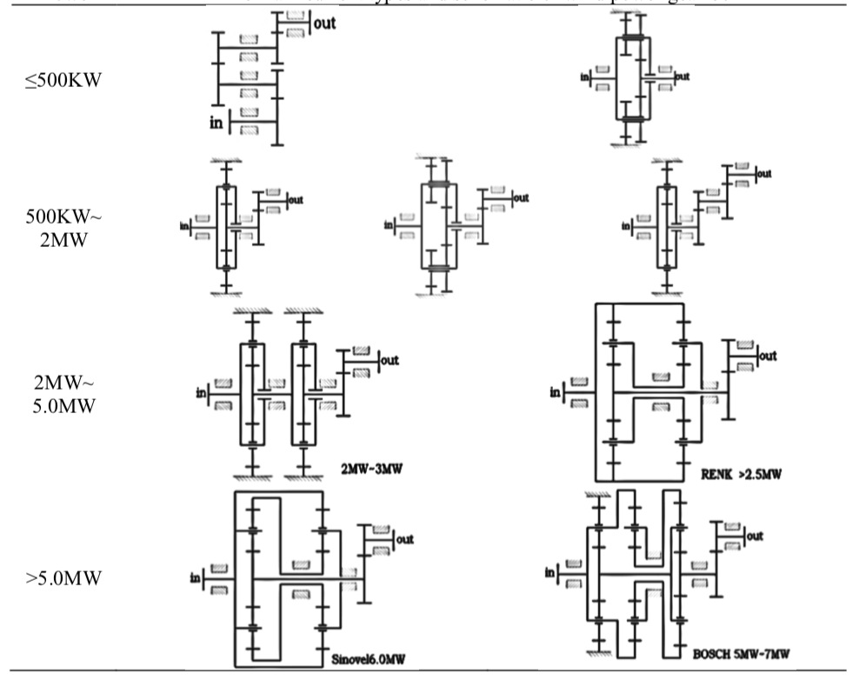
Figure 2.4: Schematic view of gearboxes depending on generation capacity (Qiu et al., 2017).

a: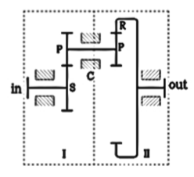b: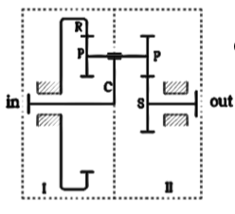c: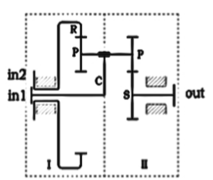
Figure 2.5: different types of gear transmission units’ connection (a: series, b: parallel, c: hybrid) (Qiu et al., 2017).

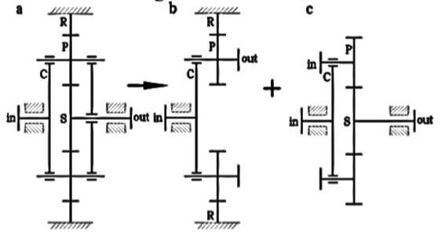
Figure 2.6: Planetary gearbox (S=Sun gear and R=ring gear) (Qiu et al., 2017).

With the emergence of wind turbines, both horizontal-axis and vertical-axis wind turbines were developed until horizontal-axis turbines became the dominant design (Kamp et al., 2004). The same happened for two-bladed wind turbines versus three-bladed wind turbines. The battle between the gearbox wind turbines with pitch control and direct drive wind turbines is dominating the gearbox wind turbines (Van Deka et al., 2020).
Seasonal wind speed difference and daily wind speed prediction error convinced scientists to use gearbox turbines with pitch control, shown in Figure 2.7 (Muljadi et al., 2013 & Morren et al., 2006). Gearbox turbine converts between slowly rotating, high torque power, which you get from the wind turbine rotor - and high speed, low torque power, which is needed for the generator. The primary purpose is typically to increase rotational speed from a low-speed rotor to a higher-speed electrical generator. The gearbox increases the rotation speed of the blades from 15 to 20 rotations per minute up to the about 1,800 rotations per minute that is required.
Along with the above-mentioned research, some recent studies are taking wind energy uncertainty into account. This is an additional factor that needs probabilistic distribution of some parameters in different scenarios to increase the accuracy of models (Kekatos et al., 2014). Due to a high number of different scenarios, some studies are taking the robust optimization approach to get a certain amount of robustness that changes the uncertain parameters to deterministic variables. Wang et al. (2017) bounded energy supply and demand as a scheduling problem and approached it with robust optimization. Dividing time periods into shorter times decreases the system's uncertainties when we have penetration of renewable power and makes the problem approachable as a deterministic model (Olivares et al., 2014). A deterministic approach can save variables against the worst-case scenarios specially for renewable energy production (Aboli et al., 2019). As a response to the worst-case scenario and to compensate for the shortcoming of power supply, some studies used a pumped storage hydro unit which, during the low demand periods, when electricity is less costly, pumps send water from a lower reservoir to an upper reservoir.

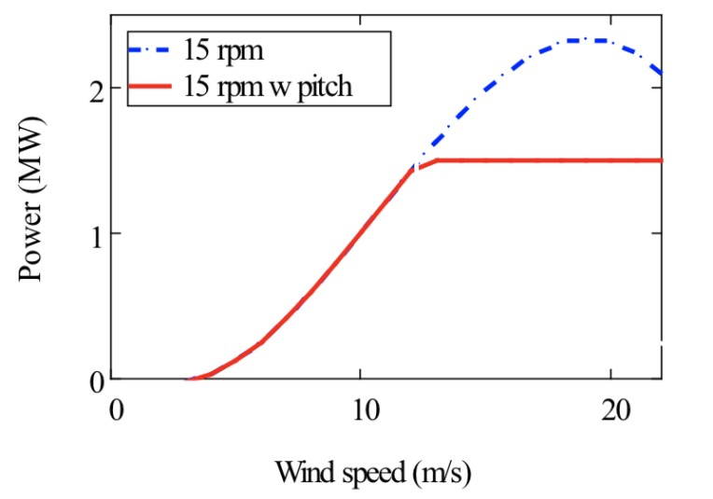
Figure 2.7: Constant power generation for turbines with gearbox and pitch control.
Source: www.nrel.gov (Muljadi. E. et al., 2013)
When the grid is experiencing high demand during peak hours, water flows down through generating turbines to produce power. Although it uses more power than it generates, it becomes an effective source that helps the grid during peak hours to balance the supply and demand (Jiang et al., 2011). Although pumped storage hydro can increase power supply, the locational and geographical limitations do not make it a realistic choice to mitigate the worst-case scenario (Zhao et al., 2013).

2.6 Utility Scale Power Storage
The battery is a general word in the literature that refers to three main electrical storage systems. Electrochemical are generally referred to lithium-ion and acidic batteries. Electromagnetic refers to supercapacitors. Mechanical refers to compressed air energy storage, hydro pumps, and flywheels (Lyden et al., 2018). The models and batteries are summarized as follows:

- Kinetic battery model was presented in hybrid energy systems. It has two tanks, one of the tanks stores the energy to support charge and discharge, and the other one stores the bound energy to support the available tank. The model covers charge and discharge mechanisms based on the general features of Kinetic Battery properties.
- Flow battery models are limited to systems that balance capacity through the charging and discharging capability of flow cell batteries such as acidic batteries.
- Pumped Hydro battery is presented in models as part of capacity and generation rate, as well as reservoir capacity. The efficiency of the pump is adjustable depending on system properties.
- Compressed Air-Energy battery is deployed to balance the power supply of systems integrated with highly intermittent sources of photovoltaics and wind.
- Thermal storage is deployed for systems that can store sensible or latent heat for later use. An example of thermal batteries is the energy that can be saved during summertime for wintertime or daytime and nighttime. In addition, the energy can be saved as hot water, brick stores, or phase change material, to name but a few, and it can be used for small-scale locations such as buildings. The models that include a thermal battery as the source set a higher bound and lower bound for the tank temperature. The amount of stored energy is calculated according to the thermocline indicator (Steen et al., 2015).
- Synfuel or Synthetic storage is derived from natural gas, coal, or biomass. The synfuel can be produced within a system and stored to be used for a later time or in a different sector. The models that include synfuel as an energy source consider the size of fuel and therefore can estimate the potential energy to be used.
- Lithium-ion battery works by lithium-ions moving from negative electrode to positive electrode during the discharge stage and from positive electrode to negative electrode during the charging stage. Therefore, they are categorized as high energy density and low self-discharge.
Although different types of utility-scale storage systems are embedded in power system models, lithium-ion batteries are experiencing fast development and dominating the market due to their advantages such as high energy density, service life, low self-discharge, and low emission (Chen et al., 2021). They are employed in different ranges of industries such as power section, automated and non-automated electric vehicles, electronic devices, aerospace, etc. Their main economic developments are related to technology, mass production, and price reduction. Simultaneously, there are studies optimizing energy density, instability, environmental protection, and life of them (Osara et al., 2021).

2.6.1 Battery Development

Although the general expensive cost of batteries is limiting the growth of utility-scale battery deployment, many incentives support their implementation. This emerging technology and its benefits are getting known by the government, environment authorities, regulators, and power plants. At the same time, policy incentives such as capacity payment, direct grants, feed-in-tariffs, and tax credits are being designed to develop battery integration. For example, in the United States, the American Recovery and Reinvestment Act of 2009 is participating in financing projects related to (Hart and Sarkissian, 2016):
- Utility-scale storage for load shifting
- Ancillary services
- Distributed storage for grid systems

Li et al. (2020) studied the dispatchability of battery energy storage systems that facilitate the intermittent use of renewable energy. Their power flow model allows long-term performance and supports the long-term use of Lithium-ion batteries for dispatch control tasks. They offer an optimization algorithm incorporated into a computational algorithm that determines the optimum battery capacity and power rating. Numerical data used for the optimization confirms the hourly-constant power dispatchability of Lithium-ion batteries. These batteries have become more prevalent in recent years. While they are becoming the main alternative to other types of energy storage, their cost is reducing due to product development as well as mass production. They can also act as reactive power control, voltage regulation, and ancillary service to shave the peak with minimizing the voltage deviations and losses. (Yang et al., 2014; Kumar et al., 2019)
Frazier et al. (2020) evaluated energy storage buildout and system operation through 2050 in the United States. They found out there is an economic potential of more than 100 GW for periods of ten hours and even less. This amount of storage meets the peaking capacity of many regions in the United States. Battery costs are predicted and separated by their energy and capacity illustrated in Figure 2.8. They considered the storage systems as Lithium-ion batteries with a lifespan of 15 years and round-trip efficiency of 85%, which will be assumed 100% in our research. They have added Natural Gas Combustion Turbine to compare operational costs of it, as a regular low-cost power generation, with Lithium-ion batteries. Both the costs and future predictions support the storage systems as an acceptable electricity source for peak hours.
Grid systems can choose the batteries based on specific factors:
- Physical factors: Expected lifetime considering different aging stress, charge/discharge currents, depth of discharge, temperature, and operation schedule.

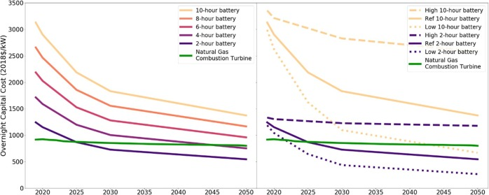
Capital Cost (2018$/KW)

Year

Figure 2.8: Battery and Natural Gas Combustion Turbine Costs are Shown as a Comparison.
(Left) Reference Based Costs. (Right) Best Practices Costs (Frazier, A. et al., 2020).
- Chemical factors: Grid supply-demand big data helps the battery designers to optimize the battery based on some adjustable battery elements such as electrodes, electrolytes, formulation, etc. (Dos Reis et al., 2021).
- Day-ahead prediction error: The average difference between polynomial regression and previous years' demand can be an effective factor in predicting the battery size (Pourkhalili et al., 2021). This will be more discussed in sections 4 and 5.
Based on digital transformation and the development of battery management systems, monitoring the real-time battery status, and collecting large-scale data is facilitated and possibly more than before. The big data can be used to detect the efficiency and useful life of the battery. Furthermore, monitoring the battery status alerts the need for preventive maintenance, preventing additional costs and sudden device failures (Chen et al., 2021).

2.6.2 Battery State of the Charge
Storage systems are becoming a vital technology to improve electric vehicles and smart grids and modeling them as an integrated system is necessary to evaluate the implementation of grid systems integrated with batteries. The data-driven methods dominate such models as they can learn the charge/discharge process through large input/output data. The common data-driven methods are approaching the functionality and state of charge estimations. These models not only manage the charge/discharge processes but also protect batteries from under-voltage/over-voltage and over-current limits (amps). The fuzzy Logic method, Deep Learning method, and Neural Network method are among the well-known methods.
Fuzzy Logic captures the nonlinear dynamics of the battery. Burgos et al. (2015) present a Fuzzy model that relates the battery open-circuit voltage, the real-time charge amount, and the discharge current using experimental data to design the system through different test profiles. Furthermore, standard tests are performed to evaluate the model’s open-circuit voltage and state of charge curve. The curve is affected and can consider charge/discharge amounts, usage period, battery temperature, and self-discharge effects. Lee et al. (2007) presents a state of charge learning method due to battery nonlinear discharge characteristics. The method considers controllers and fuzzy neural networks that predict nonlinear characteristics of the battery and, consequently, battery consumption under work situations. Moreover, detailed information such as time remained to discharge for electric vehicles.
The Neural Network method was used by Dang et al. (2016) to find the relationship between circuit voltage and the state of the charge. They show the neural network battery model can identify the first and second-order parameters of the electrochemical model. Machine learning models and artificial intelligence are applied to battery state of health. Nuhic et al. (2013) use a support vector machine through the state of health and remaining useful life to control uncertain external factors as well as uncertain electrochemical processes.
Our model has considered different scenarios based on the supply and demand balance, power source availability, and their prices. The constraints allocate supply to the power resources based on their priority and availability. At the same time, the battery system is charging and discharging depending on supply-demand scenarios, and the state of the battery at the first of each time epoch is what remained from the previous time epoch.

2.6.3 Battery life and cost projections
National Renewable Energy Laboratory (NREL) releases reports/updates that review published values on the cost and life of utility-scale batteries (Cole et al., 2021). The cost and life are reported based on publications focused on utility-scale lithium-ion battery systems for use in power capacity expansion models. The main advantage of this report is to overcome the relatively limited dataset for existing battery systems and the rapidly changing properties of such batteries.
The report calculated normalized battery pack prices for 2020, 2025, and 2030 and the efficiency and depth of discharge are accounted for in the price of the battery pack (BNEF 2019). It also shows the anticipated cost reductions for future years to the battery price in the bottom-up cost model from Feldman et al. (2021). The overall results from the reviewed publications show the capital cost of batteries will be reduced from $143/KWh in 2020 to $87/KWh in 2050. Figure 2.9 shows the price continues to decrease. Figure 2.10 shows the battery life in various research. We have selected 15 years for our study, which is near the median of published values.

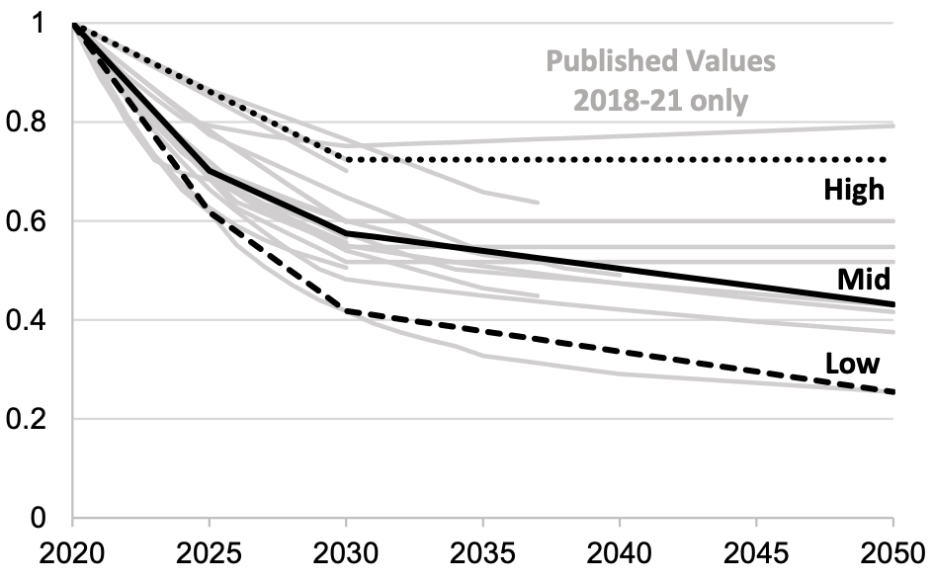
Battery Cost Projections
Relative to 2020

Figure 2.9: Battery cost reduction (NREL - Cole et al., 2021).
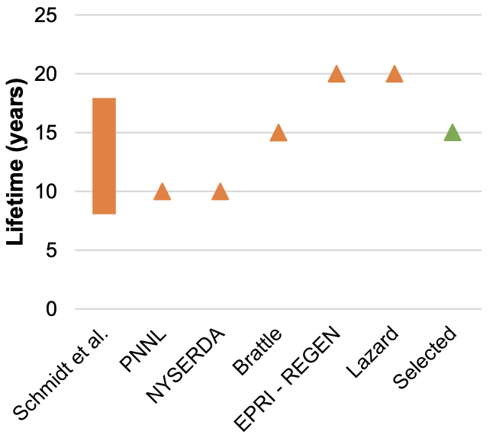
Figure 2.10: Battery lifetime from various published resources
(NREL - Cole et al., 2021).
Published values of
Battery Lifetime

Hence, the battery will be replaced every 15 years, and in our research, the cost of replacement is compensated by the operation cost of the battery.

2.7 Summary
We have reviewed the optimization models/techniques related to the family of power optimization, explained details related to each power source in subsections, and introduced how the new lithium-ion utility-scale batteries have the potential for change in grid systems, and simultaneously clarified the research gap. This identifies the opportunity of cost and carbon footprint minimization by battery size and day-ahead order optimization for grid systems adopting cutting-edge technology of utility-scale battery as a capacity source.

Chapter 3

Methodology

3.1 Research Objectives
One of grid operators' main tasks and challenges is matching supply and demand at its lowest cost, specifically during Peak hours when the system encounters the fluctuant high demands. In this research, we modeled a system that includes all the grid parameters (Figure 3.1) to capture what happens during the power supply. Furthermore, we propose a day-ahead and battery optimization method that minimizes the overall system cost and, consequently, the carbon footprint of the grid system. Evaluation of historical data provided by the U.S Energy Information Association allows us to test/run the model to verify the methodology and outcome. It is notable that the model works without time correlation and is adjustable for different regions. Hence, the time epoch is adjustable for different users, and the time length does not make any difference in the model's functionality.

3.2 Problem Statement
United States Federal Energy Regulatory Commission passed order No. 841 in 2018 that requires energy market operators in their jurisdiction to allow storage resources to be utilized as a capacity source. This is an additional welcome to international rules on reducing greenhouse gas emissions caused by traditional power generation methods. Having these requirements and the U.S Department of Energy plans to generate 20% wind energy from the total U.S power generation by 2030, requires grid companies to implement utility scale batteries.
The uncertainty of peak hours consumer demand requires a methodology that grid companies utilize to prioritize available resources, stabilize power supply, optimize the utility scale power storage, optimize day-ahead orders, and minimize the real-time balancing orders.

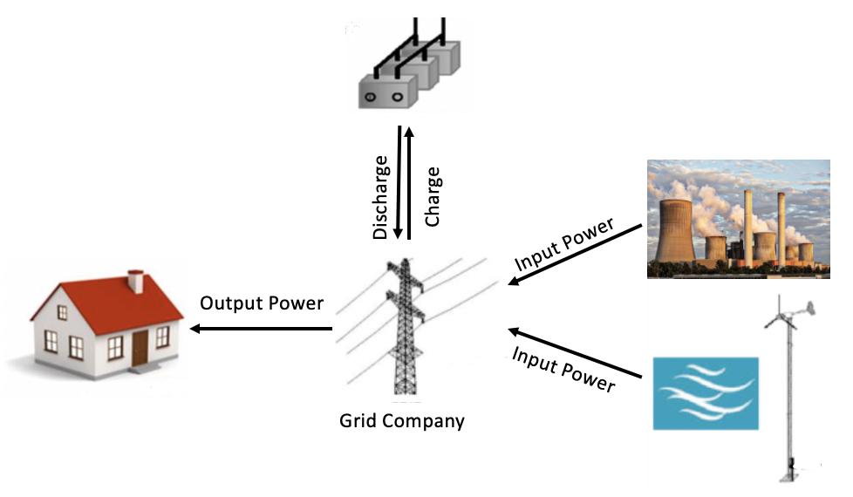
Figure 3.1: Schematic Representation of System Circuit.

3.3 Research Model
This research aims to optimize day-ahead order and battery size during peak hours for grid systems integrating wind energy and power storage resources. Demand uncertainty has been a significant factor distorting day-ahead estimations; on the other side, the charge amount left in the battery from the previous period is a factor that affects supply and demand balance, specifically during peak hours. We observe an actual grid system, define the system parameters, model the system considering all potential scenarios, and run the system to optimize the decision variables (Figure 3.2). As a first step, we categorize all the possible scenarios in terms of supply and demand uncertainty. Furthermore, we translate these potential scenarios as analytical expressions consisting of all the players in the system.
The following scenarios can happen in real-time, and the cost function must be formulated in a way that calculates the aggregated cost for that scenario.
- Day-ahead order + Renewable energy production exceeds the demand; then we store the excess electricity (in case demand and supply are equal, the battery level does not change).
- Day-ahead order + renewable production falls under demand; we discharge the storage system to meet the demand.
- Day-ahead order + renewable production falls under demand, and the storage system is emptied: grid system orders up to 1000MWh real-time power without emission penalty.
- Day-ahead order + renewable production falls under demand, the storage system is emptied, and 1000MWh emission penalty-free real-time power is used; Penalty included real-time order adds in this scenario.

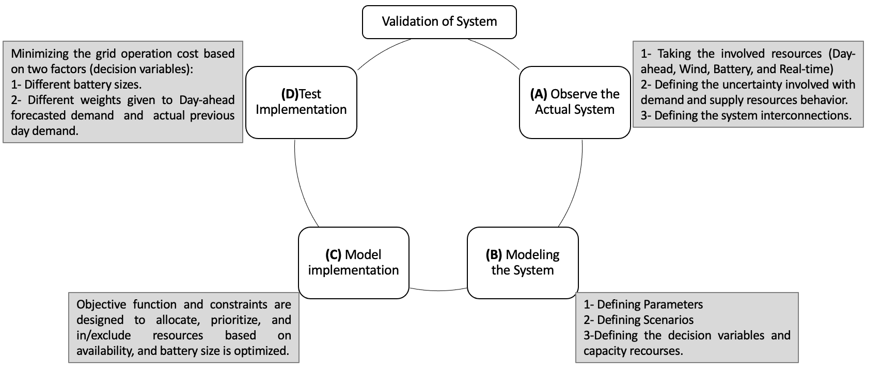
Figure 3.2: Schematic representation of system validation.

3.3.1 System Parameters

We define system parameters for each player in the system:

- $q_{i}\left(t\right):$ Actual demand in time $t$ of consumer $i$.
$q_{i} is a$ggregated power demand by consumers.

- ${\hat{q}}_{i}\left(t\right):$ Predicted demand in time $t$ of consumer $i$.
${\hat{q}}_{i} is$ forecasted power demand by consumers.

- $P_{d}\left(t\right)$: Day-ahead reserve (Decision Variable)
- $C_{d}\left(P_{d} \left(t\right);t\right)$= Day-ahead order cost
$P_{d}$, is the amount of day-ahead reserve that grid companies order/reserve for period t of next day. It costs $C_{d}P_{d}$.
$P_{d}\left(t\right)= \text{α} ×$ $\hat{q}\left(t\right)$ + (1- $\text{α}$)$×q_{Previous-day}\left(t\right)$ 0 ≤ $\text{α}$ ≤ 1 ( 1 )
We take combination of two factors for actualizing the day-ahead order:
- $(\text{α} ×$ $\hat{q}(t))$: Forecasted demand weight. Demand is predicted based on trend, seasonality, and events.
- (1- $\text{α}$)$×q_{Previous_{day}}\left(t\right)$: Previous-day actual demand weight. The previous-day actual demand for the year 2019-2020 (previous-day demand is known at the time of day-ahead order).
- $P_{r} \left(t\right)$= Wind power generated at the period of t.
- $C_{r}\left(P_{r} \left(t\right);t\right)$= Wind power electricity cost
$P_{r}$ is the wind energy realized at the time of day-ahead order for time period t. It costs $C_{r}P_{r}$

- $P_{s} \left(t\right)$= Storage energy in battery (Decision Variable)
- $C_{s}\left(P_{s} \left(t\right);t\right)$= Cost of battery use
$P_{s}$ is the amount of charge/discharge at the period of t. It costs $C_{s}P_{s}$.

- $P_{b} \left(t\right)$= Real-time balancing order
- $C_{b}\left(P_{b} \left(t\right);t\right)$= Cost of real-time order
$P_{b}$ is the power that grid has to order to balance the supply and demand at time period of t. It costs $C_{b}P_{b}$.

- $P_{b-e} \left(t\right)$= Penalty added real-time balancing order over 1000MWh
- $C_{b-e}\left(P_{b-e} \left(t\right);t\right)$= Cost of penalty added real-time order
$P_{b-e}$ is the real-time power order over 1000MWh. It costs $C_{b-e}P_{b-e}.$ Natural gas power plants can emit no more than 1,000 pounds of carbon dioxide per megawatt-hour (MWh) of electricity produced (www.c2es.org).
Figure 3.3 shows the parameters through out of flowchart of the supply chain algorithm.

3.4 Mathematical Formulation

3.4.1 Notations
Table 3.1 summarizes the notations used throughout the mathematical formulation.

3.4.2 Supply Transition Functions

The following supply transition functions enable our model to calculate the abovementioned scenarios' aggregated cost. Each scenario considers its own involved energy resources and their associated costs. This is the path towards making a total-cost objective function.
Depending on the power demand, the following scenarios may happen at the period of t. Each scenario may add an energy source and its associated cost or automatically removes the unused source and its associated cost.

$C_{d}\left(P_{d} \left(t\right);t\right)$+ $C_{s}\left(P_{s\left(charge\right)} \left(t\right);t\right)$ (2)
When $\sum_{i}{q_{i}\left(t\right)}$≤ $P_{d}$

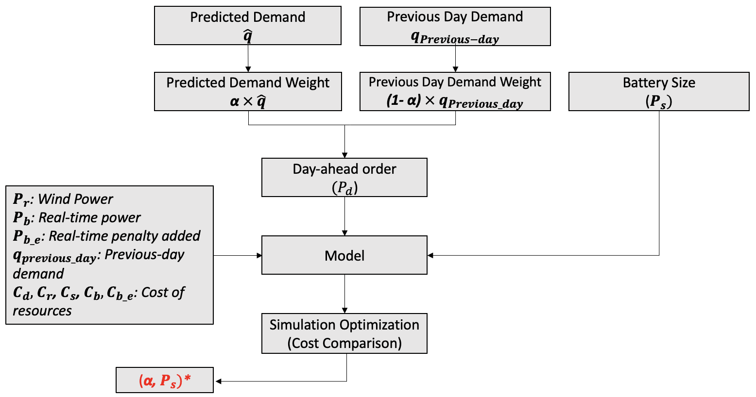
Figure 3.3: Flowchart of supply chain.

Table 3.1: Notations used in mathematical modeling.
System Parameters | Values
$$P_{d}$$ | Day-Ahead Order
$$C_{d}$$ | Day-ahead order cost
$$P_{r}$$ | Wind power
$$C_{r}$$ | Wind power electricity cost
$$P_{s}$$ | Battery storage
$$C_{s}$$ | Cost of battery
$$P_{b}$$ | Real-time balancing order
$$C_{b}$$ | Cost of real-time order
$$P_{b_e}$$ | Penalty added real-time balancing order
$$C_{b_e}$$ | Cost of penalty added real-time order
$$q_{i}$$ | Actual Demand
$${\hat{q}}_{i}$$ | Forecasted Demand
$$\text{α}$$ | 0-100% (weights given to Forecasted Demand and Actual Demand))
$${Capacity}_{max}$$ | Maximum Capacity of Battery - 1200MWh (market availability or residual-standard-error (2367MWh), whichever is smaller)
$${Capacity}_{\left(t^{-}\right)}$$ | Initial state of battery
$${Capacity}_{\left(t\right)}$$ | State of battery after operation

$C_{d}\left(P_{d} \left(t\right);t\right)$ + $C_{r}\left(P_{r} \left(t\right);t\right)$ + $C_{s}\left(P_{s\left(charge\right)} \left(t\right);t\right)$ (3)
When $\sum_{i}{q_{i}\left(t\right)}$ ≤ $P_{d}+P_{r}$

$C_{d}\left(P_{d} \left(t\right);t\right)$ + $C_{r}\left(P_{r} \left(t\right);t\right)$ + $C_{s}\left(P_{s\left(discharge\right)} \left(t\right);t\right)$ (4)
When $P_{r}+P_{d}$ < $\sum_{i}{q_{i}\left(t\right)}$≤ $P_{d}+P_{r}+P_{s}$

$C_{d}\left(P_{d} \left(t\right);t\right)$ + $C_{r}\left(P_{r} \left(t\right);t\right)$ + $C_{s}\left(P_{s\left(discharge\right)} \left(t\right);t\right)+ C_{b}\left(P_{b} \left(t\right);t\right)$ (5)
When $P_{r}+P_{s}+P_{d}$ <$\sum_{i}{q_{i}\left(t\right)}$ ≤ $P_{d}+P_{r}+P_{s}+P_{b}$

$C_{d}\left(P_{d} \left(t\right);t\right)$ + $C_{r}\left(P_{r} \left(t\right);t\right)$ + $C_{s}\left(P_{s\left(discharge\right)} \left(t\right);t\right)+ C_{b}\left(P_{b} \left(t\right);t\right)+C_{b-e}\left(P_{b-e} \left(t\right);t\right)$ (6)
When $P_{r}+P_{s}+P_{d}+P_{b}$ <$\sum_{i}{q_{i}\left(t\right)}$ ≤ $P_{d}+P_{r}+P_{s}+P_{b}+P_{b-e}$

3.4.3 Storage System Transition Functions
The following storage system transition functions are used to make the objective function. It shows how the battery works depending on supply-demand scenarios. Lithium-ion batteries are assumed to have a 10-year lifetime, full round-trip efficiency, and a fixed operating cost including maintenance.
Battery scenarios:

- $P_{s Max}$* $\sum_{i}{q_{i}\left(t\right)}< P_{d} \left(t\right)+P_{r} \left(t\right)$ (Battery is full) (7)
- $P_{s Charge}$ $\sum_{i}{q_{i}\left(t\right)}<$ $P_{d} \left(t\right)+P_{r} \left(t\right)$ (8)
- $P_{s Stable}$ $\sum_{i}{q_{i}\left(t\right)}=$ $P_{d} \left(t\right)+P_{r} \left(t\right)$ (9)
- $P_{s Discharge}$ $\sum_{i}{q_{i}\left(t\right)}>$ $P_{d} \left(t\right)+P_{r} \left(t\right)$ (10)
- $P_{s Emptied}$ $\sum_{i}{q_{i}\left(t\right)}>$ $P_{d} \left(t\right)+P_{r} \left(t\right)$ (Battery is empty) (11)
* The extra wind power generation (When the storage is full) will be vented, or blades will be locked.

3.4.4 Supply and Storage Integration
The utility company reserve the day-ahead, $P_{d}$ amount of power for the period of t next day. The amount of this reserve is based on demand predictions and wind speed forecast 24 hours in advance. On the next day, depending on actual demand, wind power amount and power storage level, company determines whether it needs to order real-time energy or not. The transition functions are as follow:

$P_{d} \left(t\right)+P_{r} \left(t\right)=[\sum_{i}{q_{i}\left(t\right)}]_{0}^{P_{d}+P_{r}}$ (12)
$P_{s} \left(t\right)=$ [$\sum_{i}{q_{i}}\left(t\right)-\left(P_{d} \left(t\right)+P_{r} \left(t\right)\right)]_{Discharge}^{Charge}$ (13)
$P_{b} \left(t\right)=\left[\sum_{i}{q_{i}\left(t\right)}-{(P}_{d} \left(t\right)+P_{r} \left(t\right)+P_{s} \left(t\right)\right)]_{P_{d}+P_{r}+P_{s \left(empty\right)}}^{1000MWh}$ (14)
$P_{b-e}\left(t\right)=\left[\left(\sum_{i}{q_{i}}(t)-{(P}_{d}(t)+P_{r}(t)+P_{s}(t\right)+1000\right)]_{P_{d\left(used\right)}+P_{r\left(used\right)}+P_{s \left(empty\right)}+1000MWh}^{\sim 5000MWh}$ (15)

- The equation (12) covers a scenario in which “day-ahead order” + “renewable energy” exceeds the demand (or equal).

- The equation (13) covers scenarios when the battery is involved and is charging or discharging depending on the demand-supply balance.

- The equation (14) covers the scenario that “Day-ahead order” + “Renewable production” + “Battery” falls under demand; then real-time power is needed to match the supply and demand.

- The equation (15) covers the scenario that “Day-ahead order” + “Renewable production” + “Battery” + “Penalty-free real-time” falls under demand; then penalty-added real-time power is needed to match the supply and demand.
Although the objective function calculates the cost for each period of t, we can think of this model without the time correlation as the time epoch is the same through calculations. One hour is the standard period for grid transactions. Writing the model without time correlation does not affect the functionality of our model since it calculates the cost for each period separately. Therefore, without time correlation, we have:
$P_{d}+P_{r}=[\sum_{i}{q_{i}}]_{0}^{P_{d}+P_{r}}$ (16)
$P_{s}=\left[\sum_{i}{q_{i}}-(P_{d}+P_{r}\right)]_{P_{s\left(Discharge\right)}}^{P_{s\left(Charge\right)}}$ (17)
$P_{b}=\left[\sum_{i}{q_{i}}-{(P}_{d}+P_{r}+P_{s}\right)]_{P_{d\left(used\right)}+P_{r\left(used\right)}+P_{s \left(empty\right)}}^{1000MWh}$ (18)
$P_{b-e}=\left[\left(\sum_{i}{q_{i}}-{(P}_{d}+P_{r}+P_{s}+1000\right)\right)]_{P_{d\left(used\right)}+P_{r\left(used\right)}+P_{s \left(empty\right)}+1000MWh}^{\sim 5000MWh}$ (19)

3.5 Model Assumptions
Without loss of generality, we consider the following assumptions for the system. These assumptions do not introduce any restrictions on implementing United States Federal Energy Regulatory rules.
- We assume high efficiency for power transitions from the generator to the grid system and storage system (model users can consider their own conversion loss if it does not hold).
- The grid system pays for all its day-ahead reserves.
- Cost assumptions for power resources. The priority of source utilization goes with day-ahead, wind power, storage, real-time, penalty added real-time power.
- According to the report Cost Projections for Utility-Scale Battery Storage: 2021 Update by National Renewable Energy Laboratory, the selected lifetime for the battery is 15 years (Cole et al., 2021).
- Wind speed is predictable on a day-ahead basis.
- At the time of day-ahead${(P}_{d})$ order (demand prediction), the grid operator subtracts the wind power generation$\left(P_{r}\right)$ from the day-ahead order.
- Historical wind power share of total generation is known for model users (Accessible through the U.S Energy Information Administration). 1% of the Tennessee region's electricity demand is supplied from wind power.

3.6 Simulation Optimization
The optimization is based on multiple comparisons on a finite feasible set of discrete decision variables. The model specifies the order of power transitions and the amount needed from each source according to its priority and then availability. Having the problem modeled, the decision variables are the day-ahead ($P_{d}$) order and battery size ${(P}_{s})$. Thus, selecting the minimum cost gives us the optimized day-ahead order and battery size.
The day-ahead ($P_{d}$) order will be calculated based on different weights (from 1% to 100%) given to forecasted demand (based on the years 2015-2016, 2016-2017, 2017-2018, and 2018-2019) and different weights given to previous day actual demand. This method considers the seasonal, trend, events, and previous day demand impact for an optimal day-ahead order. Details of this method are discussed in Chapter 4.
Wind power ($P_{r})$ is a small source and accounts for 1% of day-ahead order. It is predictable, and wind turbines are assumed to be the new generation equipped with planetary gearboxes (discussed in Chapter 3). It is worth mentioning that although we expect a low amount of penalty added real-time ($P_{b-e}$) order, this model provides the grid company with the option to calculate the real-time penalty added cost (if enforced by District Air Quality Management). We take the actual 2019-2020 demand to test the model. This will be discussed more in Chapter 4. According to constraints and costs, power transitions are done from the day-ahead reserve to wind power, to charge/discharge battery, to real-time order, and to penalty added real-time order.
The maximum potential battery size is assumed to be 1200MWh. The maximum capacity is determined based on current technology and market availability or residual standard error. The battery will be chosen for the system based on its cost and capacity rate that provides constant release of power (Amps) for our designated period. The levelized costs associated with each source (wind power, day-ahead, storage, real-time, and penalty added real-time) are based on average prices presented by Energy Information Administration. It is important to note that all the power resources and their costs are adjusted and can be updated for different grid systems. This is discussed in Chapter 3, as many researchers believe the power generation methods continue their updates/growth depending on new technologies and regulations.

3.7 Decision Variables
- Day-ahead order $P_{d}\left(t\right)$: Two factors are considered for calculating the day-ahead order. Figure 3.4 shows the following two factors considered for day-ahead order.
- Forecasted demand weight $(\text{α} ×\hat{q}(t))$: Demand is forecasted based on trend, seasonality, and events. This research predicts 2019-2020 based on previous years of 2015-2019.
- Previous-day actual demand weight (1- $\text{α}$)$×q_{Previous-day}\left(t\right)$: The previous-day actual demand for the year 2019-2020 (previous-day demand is known at the time of day-ahead order).
$P_{d}\left(t\right)= \text{α} ×\hat{q}\left(t\right)$ + (1- $\text{α}$)$×q_{Previous-day}\left(t\right)$ 0 ≤ $\text{α}$ ≤ 1. ($\text{α}$ increments 0.01 in the simulation).
The model will be run for the year 2019-2020. Day-ahead order is placed based on forecasted demand as one factor and the actual previous-day demand as another factor. Giving different weights (1% to 100%) to the forecasted demand and previous-day actual demand provides us with different final costs. The lowest cost is the best combination of weights for prediction and previous-day actual demand. This will be discussed in Chapter 4.
- Storage size: The battery size can be within the range of 0MWh to 1200MWh. The maximum potential storage size is limited to the current market availability and technology or residual standard error (section 4.2.1), whichever is smaller.
Giving different weights to these two factors considers both the day-ahead forecast (which is based on trend, seasonality, and event) and previous-day actual demand. Running the simulation optimization model based on different weights and different battery sizes leads to determining

Predicted Demand Weight
$\text{α} ×$ $\hat{q}$
Previous Day Demand Weight
(1- $\text{α}$) $×$ $q_{Previous-day}$
Day-ahead order
$(P_{d}$)

Figure 3.4: Schematic representation of two factors involved in day-ahead order.
the optimum weights for the day-ahead order amount and the optimum battery size for the system operating at the minimum cost. This happens after using different power sources (depending on their priority, cost, and availability) through the constraints designed for the mathematical model.
It is important to clarify we did not use the 2019-2020 data for the day-ahead order predictions for two reasons. First, we are taking that data as actual demand at the time of running/testing our model. Second, it could bias our 2019-2020 day-ahead order calculations. Also, the year 2020-2021 data is ignored due to the Covid-19 pandemic and stay-at-home order impact on power demand (Haxhimusa & Liebensteiner, 2021).

3.8 Objective Function
Based on the transition functions (scenarios) (16), (17), (18), and (19), we have the following objective function:
$$f\left(\text{α},P_{s}\right): Min C_{d}\text{[(}\text{α} ×\hat{q})\text{ + (1-}\text{ α}\text{)}×q_{Previous-day}]+C_{r}P_{r}+{C_{s_{0}} P}_{s}+|C_{s} [P_{s}]_{discharged}^{charged}+[C_{b}[P_{b}]_{P_{d\left(used\right)}+P_{r\left(used\right)}+P_{s \left(empty\right)}}^{1000}+C_{b-e}[P_{b-e}]_{P_{b}}^{+}$$
(20)
Equal to:
$f\left(P_{d}, P_{s}\right): Min C_{d}P_{d}+C_{r}P_{r}+[|C_{s} \left[(\sum_{ i}{q_{i}}-\left(P_{d}+P_{r}\right)\right.{)]}_{discharged}^{charged}|]+\left[C_{b}\left[(\sum_{ i}{q_{i}}-(P_{d}+P_{r}+P_{s}\right))\right]]_{P_{d\left(used\right)}+P_{r\left(used\right)}+P_{s\left(empty\right)}}^{1000MWh}+ [C_{b-e}\left[\left(\sum_{i}{q_{i}}-{(P}_{d}+P_{r}+P_{s}+ P_{b}\right))\right]]_{P_{d\left(used\right)}+P_{r\left(used\right)}+P_{s \left(empty\right)}+1000MWh}^{\sim 5000MWh\left(black-out\right)}$
(21)
Equal to:
$Min f\left(P_{d}, P_{s}\right): \sum_{i=1}^{365}{f_{i}\left(scenario 1\right)+ f_{i} \left(Scenario 2\right)+ f_{i} \left(Scenario 3\right)+ f_{i} \left(Scenario 4\right)}$
(22)
Depending on supply-demand, a different scenario happens for each day (each time epoch), and the aggregation of 365 days is equal to the grid operation cost over a year.

3.9 Scenario-Based Objective Function and Constraints
We have the following scenario-based objective functions:

- Scenario 1: Battery is charging
Day-ahead order + Renewable energy production exceeds the demand; we store the excess power. (In case demand and supply are equal, the battery level does not change)
${Capacity}_{\left(t\right)}=\left({Capacity}_{\left(t^{-}\right)}\right)- (\sum_{i}{q_{i}}$ $–{(P}_{d}+P_{r}))$ (23)
Based on this scenario corresponding to (16):
$f\left(P_{d}, P_{s}\right): C_{d}P_{d}+C_{r}P_{r}+[|C_{s} [\sum_{i}{q_{i}}-\left(P_{d}+P_{r}\right)]_{discharged}^{charged} |$] (24)
Subject to:
$P_{d},P_{r},{and P}_{s}≥0$ (25)
$C_{d},C_{r},{and C}_{s}≥0$ (26)
$0 ≤ {Capacity}_{max}≤$ 1200MWh (27)
${Capacity}_{\left(t^{-}\right)}≤[P_{s}]^{Charge} ≤{Capacity}_{\left(Max\right)}$ (28)
${Capacity}_{\left(t\right)}- {Capacity}_{\left(t^{-}\right)}≥0$ (29)
According to (30), $\sum_{i}{q_{i}}$ $–{(P}_{d}+P_{r})$ is less than 0, so we must use (charge) battery.
$\sum_{i}{q_{i}}$ $–{(P}_{d}+P_{r})≤0$ (30)
According to the constraint (31), $\sum_{i}{q_{i}}-{(P}_{d}+P_{r}$) determines the battery level change.
$\sum_{i}{q_{i}}-{(P}_{d}+P_{r})=({Capacity}_{\left(t\right)}-{Capacity}_{\left(t^{-}\right)})$ (31)

- Scenario 2: Battery is discharging
Day-ahead order + renewable production falls under demand, we discharge the storage system to meet the demand.
${Capacity}_{\left(t\right)}=\left({Capacity}_{\left(t^{-}\right)}\right)-(\sum_{i}{q_{i}}$ $–{(P}_{d}+P_{r}))$ (32)
Based on the scenario corresponding to (17):
$f\left(P_{d}, P_{s}\right): C_{d}P_{d}+C_{r}P_{r}+[|C_{s} [\sum_{i}{q_{i}}-\left(P_{d}+P_{r}\right)]_{discharged}^{charged} |$] (33)

Subject to:
$P_{d}, P_{r},{and P}_{s}≥0$ (34)
$C_{d},C_{r},{and C}_{s}≥0$ (35)
$0 ≤ {Capacity}_{max}≤$ 1200MWh (36)
$0≤[P_{s}]_{Discharge}≤{Capacity}_{\left(t^{-}\right)}$ (37)
${{Capacity}_{\left(t^{-}\right)}-Capacity}_{\left(t\right)}≥0$ (38)
According to (39), $\sum_{i}{q_{i}}$ $–{(P}_{d}+P_{r})$ is more than 0, so we must use (discharge) battery.
$\sum_{i}{q_{i}}$ $–{(P}_{d}+P_{r})≥0$ (39)
According to the constraint (40), $\sum_{i}{q_{i}}-{(P}_{d}+P_{r}$) is equal to battery level change.
$\sum_{i}{q_{i}}-{(P}_{d}+P_{r})=({{Capacity}_{\left(t^{-}\right)}-Capacity}_{\left(t\right)})$ (40)

- Scenario 3: Real-time power is added:
Day-ahead order + renewable production falls under demand and the storage system is emptied. Grid system orders up to 1000MWh penalty-free real-time power.
${Capacity}_{\left(t\right)}=\left({Capacity}_{\left(t^{-}\right)}\right)-(\sum_{i}{q_{i}}$ $–{(P}_{d}+P_{r}+P_{s})$ (41)
Based on the scenario corresponding to (18),

$f\left(P_{d}, P_{s}\right): C_{d}P_{d}+C_{r}P_{r}+|C_{s} \left[(\sum_{i}{q_{i}}-\left(P_{d}+P_{r}\right)\right.{)]}_{discharged}^{charged}|+\left[C_{b}\left[(\sum_{ i}{q_{i}}-(P_{d}+P_{r}+P_{s}\right))\right]]_{P_{d\left(used\right)}+P_{r\left(used\right)}+P_{s\left(empty\right)}}^{1000MWh}$
(42)
Constraints:
$P_{d}, P_{r},P_{s}, and P_{b}≥0$ (43)
$C_{d},C_{r},C_{s},and C_{b}≥0$ (44)
$0 ≤ {Capacity}_{max}≤$ 1200MWh (45)
$0≤[P_{s}]_{Discharge}≤{Capacity}_{\left(t^{-}\right)}$ (46)
${{Capacity}_{\left(t^{-}\right)}-Capacity}_{\left(t\right)}≥0$ (47)
According to (48), $\sum_{i}{q_{i}}$ $–{(P}_{d}+P_{r}+P_{s})$ is more than 0, and the battery is emptied, so we have to order real-time balance.
$\sum_{i}{q_{i}}$ $–{(P}_{d}+P_{r}+P_{s})≥0$ (48)
According to constraint (49), demand and supply difference is equal to negative amount of battery level.
$\sum_{i}{q_{i}}$ $–{(P}_{d}+P_{r}+P_{s})={Capacity}_{\left(t\right)}-{Capacity}_{\left(t^{-}\right)}$ (49)
$P_{b}$ value is calculated by (50):
${Capacity}_{\left(t\right)}=\left({Capacity}_{\left(t^{-}\right)}\right)-(\sum_{i}{q_{i}}$ $–{(P}_{d}+P_{r}+P_{s})$ (50)
- Scenario 4: Real-time balancing plus penalty is added:
Day-ahead order + renewable production falls under demand, the storage system is emptied, and 1000MWh emission penalty-free real-time power is used. The penalty included real-time order adds in this scenario.
${Capacity}_{\left(t\right)}=\left({Capacity}_{\left(t^{-}\right)}\right)-(\sum_{i}{q_{i}}$ $–{(P}_{d}+P_{r}+P_{s}+P_{b})$ (51)
Based on scenario corresponding to (19):

$f\left(P_{d}, P_{s}\right): C_{d}P_{d}+C_{r}P_{r}+ |C_{s} \left[(\sum_{ i}{q_{i}}-\left(P_{d}+P_{r}\right)\right.{)]}_{discharged}^{charged}|+\left[C_{b}\left[(\sum_{i}{q_{i}}-(P_{d}+P_{r}+P_{s}\right))\right]]_{P_{d\left(used\right)}+P_{r\left(used\right)}+P_{s\left(empty\right)}}^{1000MWh}+ [C_{b-e}\left[\left(\sum_{i}{q_{i}}-{(P}_{d}+P_{r}+P_{s}+ P_{b}\right))\right]]_{P_{d\left(used\right)}+P_{r\left(used\right)}+P_{s \left(empty\right)}+1000MWh}^{\sim 5000MWh\left(black-out\right)}$
(52)

Subject to:
$P_{d}, P_{r},P_{s}, P_{b}, P_{b-e}≥0$ (53)
$C_{d},C_{r},C_{s},C_{b}, and C_{b-e}≥0$ (54)
$0 ≤ {Capacity}_{max}≤$ 1200MWh (55)
$0≤[P_{s}]_{Discharge}≤{Capacity}_{\left(t^{-}\right)}$ (56)
${{Capacity}_{\left(t^{-}\right)}-Capacity}_{\left(t\right)}≥0$ (57)
According to (58), $\sum_{i}{q_{i}}$ $–{(P}_{d}+P_{r}+P_{s}+P_{b})$ is more than 0, the battery is emptied, real-time balance is used, so we must order real-time penalty added.
$\sum_{i}{q_{i}}$ $–{(P}_{d}+P_{r}+P_{s}{ + P}_{b})≥0$ (58)
According to constraint (59), demand and supply difference is equal to negative amount of battery level.
$\sum_{i}{q_{i}}$ $–{(P}_{d}+P_{r}+P_{s}+P_{b})={Capacity}_{\left(t\right)}-{Capacity}_{\left(t^{-}\right)}$ (59)
$P_{b-e}$ value is calculated by (60):
${Capacity}_{\left(t\right)}=\left({Capacity}_{\left(t^{-}\right)}\right)-(\sum_{i}{q_{i}}$ $–{(P}_{d}+P_{r}+P_{s}+P_{b})$ (60)

3.10 Input Parameters
- Day-Ahead Order ($P_{d}$): Day-ahead is placed based on forecasted demand and actual previous-day demand (discussed in section 4.2). The order must be placed one day before the operating day.
- Day-ahead order cost ($C_{d}$): Day-ahead order cost during peak hours is averaged $45. The order is placed one day in advance; the price is paid even if the order amount is not fully used.

- Wind Power ($P_{r}$): TVA currently generates ~1.5% wind power of the total generation and has plans to increase it.
- Wind power cost ($C_{r}$): According to International Renewable Energy Agency (IRENA), the levelized wind power generation cost is estimated at $25 to $45 per megawatt-hour. This research assumes $35 per MWh.
- Storage energy ($P_{s}$): We run the model for the 24 battery sizes ranging from 0MWh to 1200MWh with increments of 50MWh, with the constant release of power-amps. Increments of 50MWh help the grid and regulators to evaluate different battery sizes and their benefits for the system in terms of cost.
- Battery cost ($C_{s}$): The levelized cost of the battery is estimated at $80 per megawatt-hour. U.S. National Renewable Energy Laboratory projects the cost of Utility-Scale battery storage continues to decrease (can be adjusted by the user). Chapter 2 contains more information on battery benefits and government incentives.

- Real-time order ($P_{b-e}$): The real-time order is needed when day-ahead, wind power, and the battery is used, and demand is still higher than supply. The real-time generation comes from the spinning reserve, non-spinning reserve (supplemental reserve), or other interconnected grids.
- Real-time order cost ($C_{b-e}$): Based on the Energy Information Administration reports and depending on real-time power generation used in grids, peak hours real-time generation cost is estimated at $300MWh.

- Penalty added real-time order ($P_{b-e}$): U.S. Environmental Protection Agency (EPA) is considering a fine to limit the use of coal and liquid petroleum that is largely used for real-time power generation (www.c2es.org). Fast response natural gas turbines are cleaner burning sources but still emit large amounts of CO₂ and Methane.
- Penalty added real-time order cost ($C_{b-e}$): Penalty added real-time order is estimated at $600 MWh for the generation above 1000MWh, including fines leveraged by some district Air Quality Management.
- Predicted demand (${\hat{q}}_{i}$): Based on previous years (2015-2019).
- Real-time actual demand ($q_{i}$): Consumer demand (2019-2020).

3.11 Demand Forecasting (${\hat{q}}_{i}\left(t\right)$)
As part of the Day-ahead order process and to forecast the demand, we use the open-source FB-Prophet* forecasting model that combines more than twelve configurable models with analyst-in-the-loop performance analysis, implemented in the R and Python. It addresses periodic and non-periodic effects on power demand that naturally arise and can be expected in time series generated by human actions (Taylor and Letham, 2018). This procedure captures and represents the main components of trend, seasonality, and holidays of the previous four years of Tennessee region power demand (TVA) available at the U.S. Energy Information Administration website (www.EIA.com).
The models are combined in the following equation (with normally distributed error term of $ε_{t}$).
$$y\left(t\right)= g\left(t\right)+ s\left(t\right)+ h\left(t\right)+ εt$$
- Trend $g\left(t\right)$: The general non-periodic direction of demand, affected by the value of time series.
- Seasonality $s\left(t\right)$: Represents periodic changes in the demand, which depends on factors such as temperature changes throughout the year.
- Holidays $h\left(t\right)$: Represents the repetitive specific events on demand such as holidays.
- Trend $g\left(t\right)$:
For growth forecasting, the main component of data generating is a model that captures how the demand of users has grown and how it is expected to grow in the future. This is captured such as population growth in natural ecosystems, where nonlinear growth exists with carrying capacity. The logistic g(t) trend model that FB-Prophet captures is:
$g\left(t\right)=\frac{C}{1+exp⁡(-K(t-m)}$ (61)
With C is time-varying carrying capacity, k the growth rate, and m an offset parameter.
In trend forecasting, carrying capacity and growth rate is not constant. The model incorporates trend changes in the growth model by specifically characterizing changepoints. Let’s say there are S change points $s_{j}$, j=1, …, S. The model characterizes a vector of rate adjustments $δ∈{ R}^{s},$ where $δ_{j}$ is the change that happens in the rate at the time of $s_{j}$.
This can be shown by defining a vector $a\left(t\right)∈\left\{0, 1\right\}$^{s} as:
$a_{j}\left(t\right)=\left\{\begin{aligned}1, if t ≥s_{j}, \\ 0, otherwise.\end{aligned}\right.$ (62)
The rate at time $t$ is $k+a(t)^{T}δ.$ The rate $k$ and offset parameter m must become adjusted to connect the endpoint of segments. The adjustment at change point $j$ is calculated as:
$γ_{j}=\left(s_{j}-m- \left.\sum_{ι<j}{γ_{ι}}\right)\right.\left(1-\frac{k+\sum_{ι<j}{δ_{ι}}}{k+\sum_{ι≤j}{δ_{ι}}}\right)$ (63)
The growth model is then
$g\left(t\right)= \frac{C(t)}{1+exp⁡(-(K+a(t)^{τ}δ)(t-(m+a\left(t)^{τ}γ\right)))}$ (64)
- Seasonality $s\left(t\right)$:
Demand time series usually experience different seasonality, based on human behaviors. For example, 5-day work week affects time series that repeat each week; likewise, different seasons and temperatures make effects that repeat each season. To fit and predict these effects, the FB-Prophet uses seasonality models that are periodic functions of t. There are factors such as temperature that affect human-industry behavior in power demand.
$s\left(t\right)=\sum_{n=1}^{N}{(a_{n}\cos\left(\frac{2πnt}{P}\right)+b_{n}\sin\left(\frac{2πnt}{P}\right)}$ (65)
The model, approximate arbitrary smooth seasonal effects with a standard Fourier series. To capture the periodic effect, the model considers P the regular 365 days of the year. Fitting seasonality requires making a matrix of seasonality vector for the time t. For example, with yearly seasonality, fitting seasonality needs estimating 2N parameters ${β=\left[a_{1},b_{1}, …, a_{N},b_{N}\right]}^{γ}$ and constructing a matrix of seasonality vectors for each value of t. For instance, with a yearly seasonality and $N=4,$ we have:
$X\left(t\right)=[\cos\left(\frac{2π\left(1\right)t}{365}\right), …, \sin\left(\frac{2π\left(4\right)t}{P}\right)$ (66)
The seasonal component is then $s\left(t\right)=X(t$)β. And β ~ (0, $σ^{2}$) to capture a smoothing prior on seasonality.
- Holidays $h\left(t\right)$:
Specific days and events such as Christmas, Thanksgiving, Super Bowl, etc., may cause shocks in demand and usually do not follow a periodic pattern. For instance, Thanksgiving is on the fourth Thursday in November. Super Bowl is one of the largest televised events on a Sunday in January or February, which is difficult to capture programmatically. This is true for many major holidays and events around the world. However, the impact of each specific event on the time series is often similar for each year. Hence, it is important to incorporate them into forecasting.
The FB-prophet model adds an indicator function for time t during holiday $i$ and gives each holiday a specific parameter $k_{i}$. For each holiday $D_{i}$, the model gives $k_{i}$which is the corresponding change to the forecast.
$Z\left(t\right)=1 \left(t ∈ D_{1}\right), … , \left(t ∈ D_{L}\right)$ (67)
$h\left(t\right)=Z\left(t\right)$κ (68)
Same as the seasonality, we use $K \sim$ $Normal\left(0, υ^{2}\right).$

Besides the mean-squared error, measures the quality estimate, with a good visualization tool and when the fit is plotted over historical data, it is visible if there were change points that were missed (Taylor and Letham, 2018).
Chapter 4

Results within a Case Study

4.1 Model Verification

4.1.1 Explanation of Case Study and Measurements
The recent Order No. 841 from Federal Energy Regulatory Commission requires market operators to establish a utility-scale storage capacity-load to be able to participate in the capacity market. The operators have to revise their tariffs and establish a participation model according to market rules, including the physical characteristics of the storage system. Tennessee Valley Authority (TVA) can be an appropriate setting to be taken as a case for implementing utility-scale electric storage source as capacity, energy, ancillary, arbitrage, and, more importantly, to reduce the power generation emission during the peak hours demand. TVA is an independent, government-owned corporation and provides a range of electric service functions to other utilities for distribution to end-users. It owns more than 90% of Tennessee’s electric generating capacity and more than 60% of the power plants, including the ten largest power plants in the state.
The United States Energy Information Center (www.eia.gov) releases detailed and regional information regarding the energy within the United States as well as connected grids of Canada and Mexico to the United States. We used EIA to extract Tennessee regional data related to the daily electricity demand curve shown in Figure 4.1. Furthermore, we have assigned overall costs and general assumptions to the involved power resources based on International Renewable Energy Agency (IRNA), and TVA data catalogs discussed in the literature review. Costs and other selected parameters can be updated depending on participants’ measurements to have the model synched with the user processes. For example, TVA or any entity using this model can update the parameters based on the availability of the source, rates, and measures. Figure 4.1 shows all the involved parameters.

Figure 4.1: Flowchart of supply chain and involved resources.
According to the recent four years data, the peak hours, such as 5pm to 6pm (can be different in different seasons), are the periods that cause the most uncertainty and error in day-ahead ($P_{d}$) order. This uncertainty results in higher costs on real-time ($P_{b}$) order and consequently more emission. With this in mind, we have taken 365 days of the Tennessee region electricity demand (shown in Figure 4.2) for the most variable period (5pm to 6pm) to run/test our model on the data and evaluate how optimized day-ahead order ($P_{d}$) and battery size ($P_{s}$) reduce the overall cost of the system over a year. Detail will be discussed in section 4.4.
The intelligent battery software and computerized control systems use real-time information to charge/discharge battery storage depending on the supply-demand balance. Based on current technology and market availability, we input different battery sizes between 0MWh to 1200MWh with increments of 50MWh. This capacity can be updated by the grid depending on the system characteristics.
According to the literature review, the levelized cost of lithium-ion batteries is experiencing a fall of 76% from 2012 and has arrived at $150 per megawatt-hour in 2018, and it is predicted to continue its decrease to less than $70 by 2030 due to mass production and battery material development. On the other side, current environmental issues and excess greenhouse gasses continue to increase the cost of fossil fuels being used for real-time power generation. The above-mentioned points support the Federal Energy Regulatory Commission's decision on using the batteries as the capacity source.

4.2 Day-ahead Order ($P_{d}$)

4.2.1 Day-ahead Order Forecasting $\left(\text{α} \text{× }\hat{q}\right)$

Day-ahead demand forecasting is performed to use it as day-ahead order. We have collected the previous five years of data for the peak hour 5pm to 6pm, and the results follow a similar pattern throughout these 356 days. The schematic view of these years is shown as Stacked Daily Demand in the following data series. Figure 4.3 represents the 365 days between 26/7/2015 to 25/7/2016 (as series 1) until 26/7/2019 to 25/7/2020 (as series 5 - on the top).
Figure 4.2: Tennessee Electricity Demand and Supply Balance (Source: eia.gov).

Figure 4.3: 5x 365 Days of Tennessee Region (TVA) Demand, Overlapped Charts.
X-axis=day; Y-axis=MWh

The Figure 4.4 has the same approach; however, the series are plotted on each other to show the demand pattern similarity over the five years.
According to the FB-Prophet forecasting method discussed in Chapter 3, to make a relation between the dependent variable (demand) and the independent variable (time), and to find the best fit line for the power demand, we considered the available data for 365 days of each year from 2015 to 2019 and used open-source FB-prophet model to predict the demand for day-ahead order. It is a forecasting model that addresses periodic and non-periodic effects that naturally arise and can be expected in time series generated by human actions.
As discussed in Chapter 3, we use the first four years of data to predict the 5th year, and furthermore we run/test the model on the 5th year as a case study. Pattern visualization shows the forecast is fitted and can describe the data. Also, we have received an R-squared of 0.74 within the Residual standard error of 2367 MWh. In summary:
- Predicted demand is fitted on actual demand.
- Pattern visualization and low residual standard error of 2367 MWh confirm the prediction estimates the actual demand.
- The average daily demand of peak hour is 19884 MWh
- R-squared (Coefficient of determination): 0.74
Figure 4.5 shows how the forecasted demand is fitted on the actual demand (5th year).
As discussed in Chapter 3, we use the first four years of data to predict the 5th year, and furthermore we run/test the model on the 5th year as a case study. Pattern visualization shows the forecast is fitted and can describe the data. Also, we have received an R-squared of 0.74 within the Residual standard error of 2367 MWh. In summary:
- Predicted demand is fitted on actual demand.
- Pattern visualization and low residual standard error of 2367 MWh confirm the prediction estimates the actual demand.
- The average daily demand of peak hour is 19884 MWh
- R-squared (Coefficient of determination): 0.74
Figure 4.5 shows how the forecasted demand is fitted on the actual demand (5th year).

Figure 4.4: 5x 365 Days of Tennessee Region (TVA) Demand, Stacked charts.
X-axis=day; Y-axis=MWh

$q_{i}$-_{Actual}
${\hat{q}}_{i}$_{- Prediction}
Figure 4.5: Fitting the forecasted demand on the 2019-2020 actual demand.

4.2.2 Day-ahead Order Forecasting ($(1-\text{α) × }q_{Previous-day}$)
The U.S. Energy Administration website releases the regional hourly demand amount. Hence, the actual previous day demand is known for grid systems. Figures 4.6 and 4.7 show the previous-day actual demand ${(q}_{Previous-day})$ is known at the time of day-ahead order and will be taken as a factor in determining the day-ahead order ($P_{d}$).

4.3 Input Values
Day-Ahead Order ($P_{d}$): Two factors are considered for calculating the day-ahead order. Forecasted demand ($\text{α} ×\hat{q}(t))$ and Previous-day actual demand weight (1- $\text{α}$)$×q_{Previous-day}\left(t\right)$ (discussed in sections 3.10 and 4.2). The order must be placed one day before the operating day.
Day-ahead order cost ($C_{d}$): Day-ahead order cost during peak hours is higher than during regular hours, and according to TVA, it costs an average of $45 per megawatt-hour. The order is placed one day in advance, and the price is paid even if the order amount is not fully used.
Wind Power ($P_{r}$): TVA currently generates ~1.5% wind power of the total generation and has plans to increase it. This research assumes that wind power supplies 1% of electricity demand (Tennessee region) (discussed in Chapter 2).
Wind power cost ($C_{r}$): According to International Renewable Energy Agency (IRENA), the levelized wind power generation cost is estimated at $25 to $45 per megawatt-hour. This research assumes $35 per MWh.
Battery Size ($P_{s}$): We run the model for the 24 battery sizes ranging from 0MWh to 1200MWh with increments of 50MWh, with the constant release of power-amps. It helps the grid and regulators to evaluate different battery sizes and its benefits for the system in terms of cost. It is important to note the maximum capacity for the battery is determined by market availability (1200MWh) or residual standard error (2,367MWh) of forecasted and actual demand, whichever is smaller.
Battery cost ($C_{s}$): The levelized cost of battery operation is estimated at $80 per megawatt-hour and the average battery lifetime is 15 years based on literature. U.S. National Renewable Energy Laboratory projects the cost of Utility-Scale battery storage continues to decrease (adjustable by

Figure 4.6: Tennessee Electricity Demand and Supply Balance (Source: eia.gov).

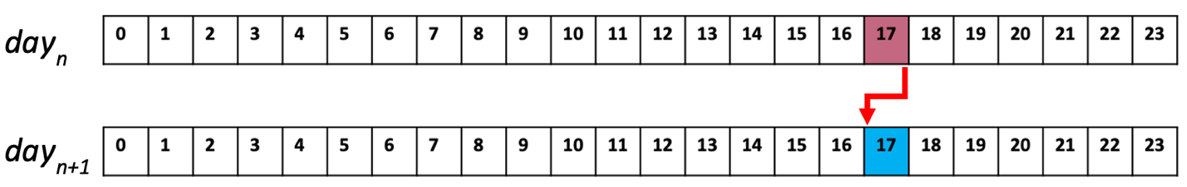
Figure 4.7: Previous-day demand is known for day-ahead order.

the user). Chapter 2 contains more information on battery costs, benefits, and government incentives for users.
Real-time balancing order ($P_{b}$): It is needed when demand is more than forecasted demand.
Real-time order cost ($C_{b}$): The average peak-hours real-time order cost is estimated at $300 per megawatt-hour for spinning and non-spinning reserve (supplemental reserve).
Penalty added real-time order ($P_{b-e}$): U.S. Environmental Protection Agency (EPA) is considering a fine to limit natural gas power plants (mainly used for real-time power generation) on the amount of carbon dioxide per megawatt-hour of electricity produced (www.c2es.org).
Penalty added real-time order cost ($C_{b-e}$): Penalty added real-time order is estimated at $600 per megawatt-hour for the real-time generation above 1000MWh, which may come from fast-start generators or other interconnected grids/power plants.
Predicted demand $\left({\hat{q}}_{i}\right):$ Based on previous years (2015-2019)
Real-time actual demand ($q_{i}$): Consumer demand (2019-2020).
Table 4.1 summarizes the system parameters and their values. It is worth mentioning the involved resources, and their values are adjustable for different grids.

4.4 Numerical Results

4.4.1 Day-ahead Order Results

Running the model for one peak hour during 365 days of the year 2019-2020 results in a minimum cost of $412,266,808 by utilizing ~850MWh battery, giving 13% weight to the forecasted demand and by giving 87% weight to the previous-day actual demand. The problem is solved by the simulation optimization model explained in sections 3.7 and 3.8. The year 2020-2021 is ignored due to the impact of covid-19 pandemic on power demand (Haxhimusa & Liebensteiner, 2021).
The objective of the optimization model is to minimize the grid cost, and the minimum cost happens by optimizing the battery size and giving optimum weights to the forecasted day-ahead$(\text{α}×\hat{q}(t))$ and previous-day demand [(1- $\text{α}$)$×q_{Previous-day}]$. Hence, the optimized day-ahead order amount is based on combining these two parameters’ weights, ranging from 0% to 100% with 1% increments. Shown in Figure 4.8.

Table 4.1: System parameters and their values.
System Parameters | Values
$$P_{d}$$ | Day-Ahead Order
$$C_{d}$$ | $45/MWh
$$P_{r}$$ | 0.01$P_{d}$
$$C_{r}$$ | $35/MWh
$$P_{s}$$ | ${\left[\sum_{i}{q_{i}}-\left(P_{d}+P_{r}\right)\right]}_{P_{s\left(Discharge\right)}}^{P_{s\left(Charge\right)}}$
$$C_{s}$$ | $80/MWh
$$P_{b}$$ | ${\left[\sum_{i}{q_{i}}-\left(P_{d}+P_{r}+P_{s}\right)\right]}_{P_{d\left(used\right)}+P_{r\left(used\right)}+P_{s \left(empty\right)}}^{1000MWh}$
$$C_{b}$$ | $300/MWh
$$P_{b-e}$$ | ${\left[\sum_{i}{q_{i}}-\left(P_{d}+P_{r}+P_{s}+1000\right)\right]}_{P_{d\left(used\right)}+P_{r\left(used\right)}+P_{s \left(empty\right)}+1000}^{5000MWh}$
$$C_{b-e}$$ | $600/MWh
$$q_{i}$$ | Previous-Day Actual Demand Is Taken as Sample (June2019 to June2020)
$${\hat{q}}_{i}$$ | Forecasted Demand

Predicted Demand Weight
$\text{13\%} ×$ $\hat{q}$
Previous Day Demand Weight
87% $×$ $q_{Previous-day}$
Day-ahead order
$(P_{d}$)

Figure 4.8: Schematic view of day-ahead order calculation.

- Day-ahead order: Two factors are considered to optimize the day-ahead order amount.
- 13% forecasted demand: This addresses periodic and non-periodic effects naturally arise and can be expected in time series generated by human actions.
- 87% Previous-day demand: This considers the similarity of power consumption for two consequent days. For example, today’s power consumption between the hours 5pm to 6pm is a factor to calculate day-ahead order for the next day between the hours 5pm to 6pm.
- Storage size: The minimum operation cost for the year 2019-2020 is obtained with an 850MWh battery. The maximum potential storage size is 1200MWh. This is based on current market availability and technology.
Figure 4.9. shows the impact of battery capacity and day-ahead order on the cost. As discussed in Section 4.4.1, day ahead order comes from combining two factors. Day-ahead forecast and previous-day demand. With this, the percentage is the given weight (0% to 100%) to these two factors to calculate the optimum combination that results in minimum operation cost. Chapter 5 discuss the results and explains how grid operators and regulatory agencies can utilize the results.
The results show that utilizing an 850MWh battery can lower the operation cost from $417,802,000 to $412,266,000. This means yearly savings up to ~$5,536,000 if TVA utilizes battery one-hour per day for 365 days.

4.4.2 Sensitivity Analysis on Storage Size

Figure 4.10 shows the impact of different battery sizes on the operation cost. The potential battery size ranges from 0MWh to 1200MWh with increments of 100MWh. Running the model for different battery sizes helps grid systems to evaluate their potential savings. At the same time, it helps regulatory agencies to examine their rules and design policy incentives such as capacity payment, direct grants, feed-in-tariffs, and tax credits to encourage developing the battery integration.

Figure 4.9: Day-ahead order and battery size effects on operation cost.

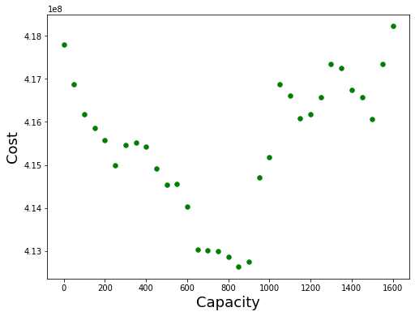
Figures 4.10: The impact of battery size on the operation cost.

It is important to note that the model input values are adjustable based on price changes and by different grids/users depending on their sources and specifications. For example, a grid with a higher supply rate and higher generation cost is likely to need larger batteries to proportionally save more on the costs.

4.4.3 Carbon Footprint Reductions

According to the U.S. Environmental Protection Agency (EPA), the national average carbon dioxide output rate for electricity generated in 2018 was 947.2 lbs CO2 per megawatt-hour (EPA, 2020). With this, utilizing 850MWh battery saves up to 364.65 metric tons of CO₂ over a year during one peak-hear without penalizing operation.
947.2 lbs CO2 per MWh x 850 MWh = ~805,120 lbs CO₂ (69)
Equal to:
0.429 metric ton CO2 per MWh x 850 MWh= ~364.65 metric tCO₂ (70)
A robust assessment of the social cost of carbon (SC-CO2) is performed by Interagency Working Group on Social Cost of Greenhouse Gasses under executive order 13990 (www.Whitehouse.gov). It allows different sections to understand the social benefits of reducing emissions of greenhouse gases. The social cost of greenhouse gases is the monetary value of the net harm to society associated with adding the emission (one metric ton) to the atmosphere each year.
It considers the total climate change impacts in:
- Agricultural productivity
- Human health effects
- Property damage based on flood risk
- Disruption of energy systems,
- Risk of conflict
- Environmental migration
- Value of ecosystem services
Theoretically, the social cost of CO₂ is the appropriate value to use in conducting cost analyses of research/policies that affect emissions.

4.4.4 Sensitivity Analysis of Carbon Footprint Reductions (2020-2050)

The Social Cost of CO₂ (SC-CO₂) is assigned $14 with a 5% discount rate. The Discount Rate in environmental science means the rate at which society (based on the factors mentioned above) is willing to trade off the present for future benefits. Based on equation (41), we calculate the potential saving of using 850MWh battery for one-hour peak-hour during 365 days of operation:
In addition to the operation cost savings calculated in section 4.4.1, the social cost of CO₂ for the year 2020 is:

364.65 metric tCO₂ x $14 x 365= $1,836,362 (71)

Table 4.2 and Figure 4.11 represent the details on potential cost savings of utility-scale battery deployment.
According to Executive Order 12866, the marginal estimate of CO2 social cost will differ by the year in which the emissions change occurs. The SC-GHGs is theoretically the value to use in conducting benefit-cost calculations/analyses of policies affecting GHG emissions.

Table 4.2: Yearly savings of battery utilization between the years 2020 to 2050.
Emission year | 5% Discount Rate (DR) | SC-CO₂ yearly savings of battery operation | Aggregated SC-CO₂ and operation cost savings (5% DR)
2020 | $14 | $1,836,362 | 7,372,362
2025 | $17 | $2,229,868 | 8,042,668
2030 | $19 | $2,492,205 | 8,595,645
2035 | $22 | $2,885,711 | 9,294,323
2040 | $25 | $3,279,217 | 10,008,259
2045 | $28 | $3,672,724 | 10,738,218
2050 | $32 | $4,197,398 | 11,616,167

Figure 4.11: SC-CO2 Savings of battery operation 2020-2050.

Chapter 5

Conclusion and Future Work

The fact that power generation is one of the main sources of producing emissions and extra greenhouse gasses such as carbon dioxide and methane in the earth's atmosphere, requires power section procedures to be optimized and the share of sustainable energies to increase. Considering that, regulatory agencies have been promoting the regulations to accelerate the transition from fossil fuels to environmentally friendly and sustainable energies. The recent order No. 841 by Federal Energy Regulatory Commission that requires grid operators to integrate utility-scale battery storage as a capacity source is among the improvements mentioned above toward power optimization.
This study aims to provide both the regulators and operators with a model that evaluates the integration of utility-scale storage systems with power grids. The model calculates the minimum cost through the day-ahead order and battery size optimization. We categorized the problem as simulation-based optimization with discrete decision variables that give a finite feasible set of input for multiple comparisons of those decision variables. Running the model based on different weights given to two factors impacting day-ahead order amount and different sizes of battery during peak-hear 5pm to 6pm over a year optimizes the decision variables discussed in Section 4.4.
We have taken TVA data as the case for our calculations; however, the model can be customized and adjusted for different grids depending on their resources and costs associated with their resources. On the other side, regulatory agencies can apply the model on different grids and customize the regulations according to the grid characteristic and available power generation resources. For example, the following factors can directly impact the results:
- The higher power demand on a grid system increases the day-ahead prediction error, and consequently, larger battery size is needed.
- As the battery becomes less expensive, the larger battery size can be utilized.
- The more expensive real-time power and penalty added real-time power become, the larger battery size will be calculated.

Numerous industries are planning to shift their products from burning liquid petroleum to using Lithium-ion batteries. One of the popular industries is car manufacturers. All these updates are based on future expectations of mass production, material improvements, and the higher efficiency of batteries. At the same time, battery cost reduction is expected to facilitate the utilization process. Our proposed research will lead to improvements in the following future works:
- User-friendly software can be developed to receive grid characteristics and demand-related data as input and provide the user with day-ahead order amount and battery size.
- Future researchers may involve transmission efficiency rats for all involved resources for a more exact answer. For example, the power transmission efficiency from/to the battery can be added to the model based on the system specifications.
- Different grid systems may have different approaches to calculating day-ahead prediction. In this case, the model can receive the grid day-ahead prediction as a constant value and calculate the battery size as the decision variable.
Government and regulatory agencies may develop and link this model to calculate tariffs or incentives for specific market operators. For example, the results on the battery size prediction can be a factor in evaluating monitory incentive on a battery installment project.

Bibliography

Abhindranath, A., & Tiwari, P. K. (2015). Social Welfare Calculation and Comparison for Different Operating Strategy of Wind-Pumped Storage Hybrid Plant in Competitive Power Market. Procedia Technology, 21, 68-75.

Aboli, R., Ramezani, M., & Falaghi, H. (2019). Joint optimization of day-ahead and uncertain near real-time operation of microgrids. International Journal of Electrical Power & Energy Systems, 107, 34-46.

Advanced Wind Turbine Drivetrain Concepts – workshop report (2010):
https://www.nrel.gov/docs/fy11osti/50043.pdf

Alsayed, M., Cacciato, M., Scarcella, G., & Scelba, G. (2013). Multicriteria optimal sizing of photovoltaic-wind turbine grid connected systems. IEEE Transactions on energy conversion, 28(2), 370-379.

Amanda County Santa Rita Microgrid components (2020).
http://www.acgov.org/pdf/SRJMicrogrid.pdf

Analysis and Projections By Energy Information Administration (Form EIA-411 Data)
https://www.eia.gov/electricity/data/eia411/#tabs_NERC-2

Baheri, A., Bin-Karim, S., Bafandeh, A., & Vermillion, C. (2017). Real-time control using Bayesian optimization: A case study in airborne wind energy systems. Control Engineering Practice, 69, 131-140.

Bajay, S. V. (1983). Long-term electricity demand forecasting models: a review of methodologies. Electric power systems research, 6(4), 243-257.

Barbato, A., & Capone, A. (2014). Optimization models and methods for demand-side management of residential users: A survey. Energies, 7(9), 5787-5824.

Behboodi, S., Chassin, D. P., Djilali, N., & Crawford, C. (2018). Transactive control of fast-acting demand response based on thermostatic loads in real-time retail electricity markets. Applied Energy, 210, 1310-1320.

Belfkira, R., Zhang, L., & Barakat, G. (2011). Optimal sizing study of hybrid wind/PV/diesel power generation unit. Solar Energy, 85(1), 100-110.
Bianchi, L., Dorigo, M., Gambardella, L. M., & Gutjahr, W. J. (2009). A survey on metaheuristics for stochastic combinatorial optimization. Natural Computing, 8(2), 239-287.

Finance, B. N. E. (2019). Long-Term Energy Storage Outlook. Bloomberg NEF: New York, NY, USA.

Borowy, B. S., & Salameh, Z. M. (1996). Methodology for optimally sizing the combination of a battery bank and PV array in a wind/PV hybrid system. IEEE Transactions on energy conversion, 11(2), 367-375.

Bultheel, A., Cuyt, A., Van Assche, W., Van Barel, M., & Verdonk, B. (2005). Generalizations of orthogonal polynomials. Journal of computational and applied mathematics, 179(1-2), 57-95.

Burgos, C., Saez, D., Orchard, M. E., & Cárdenas, R. (2015). Fuzzy modelling for the state-of-charge estimation of lead-acid batteries. Journal of Power Sources, 274, 355-366.

Costello, S., François, G., & Bonvin, D. (2016). A directional modifier-adaptation algorithm for real-time optimization. Journal of Process Control, 39, 64-76.

Chavali, P., Yang, P., & Nehorai, A. (2014). A distributed algorithm of appliance scheduling for home energy management system. IEEE Transactions on Smart Grid, 5(1), 282-290.

Chedid, R., & Rahman, S. (1997). Unit sizing and control of hybrid wind-solar power systems. IEEE Transactions on energy conversion, 12(1), 79-85.

Chen, J. C., Chen, T. L., Liu, W. J., Cheng, C. C., & Li, M. G. (2021). Combining empirical mode decomposition and deep recurrent neural networks for predictive maintenance of lithium-ion battery. Advanced Engineering Informatics, 50, 101405.

Chowdhury, S. P., & Crossley, P. Microgrids and Active Distribution Networks (Energy Engineering). Published by The Institution of Engineering and Technology (June 24, 2009).

Cochran, J., Denholm, P., Speer, B., & Miller, M. (2015). Grid integration and the carrying capacity of the US grid to incorporate variable renewable energy (No. NREL/TP-6A20-62607). National Renewable Energy Lab (NREL), Golden, CO (United States).
Cole, W., Frazier, A. W., & Augustine, C. (2021). Cost projections for utility-scale battery storage: 2021 update (No. NREL/TP-6A20-79236). National Renewable Energy Lab (NREL), Golden, CO (United States).

Conte, F., Massucco, S., & Silvestro, F. (2017). Day-ahead planning and real-time control of integrated pv-storage systems by stochastic optimization. IFAC-PapersOnLine, 50(1), 7717-7723.

Curry, Claire. “Lithium-Ion Battery Costs and Market.” Market Report. Bloomberg New Energy Finance. July 5, 2017. https://data.bloomberglp. com/bnef/sites/14/2017/07/BNEF-Lithium-ion-battery-costs-and- market.pdf.

Curto, D., Franzitta, V., Guercio, A., Thuy, H. L. T., Giap, L. N., Montana, F., & Sanseverino, E. R. (2020, October). Introduction of Offshore Wave, Wind and Solar Energies in Vietnam. In Global Oceans 2020: Singapore–US Gulf Coast (pp. 1-10). IEEE.

Dai, R., & Mesbahi, M. (2013). Optimal power generation and load management for off-grid hybrid power systems with renewable sources via mixed-integer programming. Energy Conversion and Management, 73, 234-244.

Dang, X., Yan, L., Xu, K., Wu, X., Jiang, H., & Sun, H. (2016). Open-circuit voltage-based state of charge estimation of lithium-ion battery using dual neural network fusion battery model. Electrochimica Acta, 188, 356-366.

Desai, N., Gonzalez, S., Pemberton, D. J., & Rathjen, T. W. (2005). The Economic Impact of CAES on Wind in TX, OK, and NM. Ridge Energy Storage & Grid Services LP, Texas State Energy Conservation Office June, 27.

Dos Reis, G., Strange, C., Yadav, M., & Li, S. (2021). Lithium-ion battery data and where to find it. Energy and AI, 100081.

Dufo-López, R., Cristóbal-Monreal, I. R., & Yusta, J. M. (2016). Optimisation of PV-wind-diesel-battery stand-alone systems to minimise cost and maximise human development index and job creation. Renewable Energy, 94, 280-293.

EPA (2020). eGRID,, U.S. annual national emission factor, year 2018 data. U.S. Environmental Protection Agency, Washington, DC.
Esfahani, I. J., Lee, S., & Yoo, C. (2015). Extended-power pinch analysis (EPoPA) for integration of renewable energy systems with battery/hydrogen storages. Renewable Energy, 80, 1-14.

Esfahani, M. M., Sheikh, A., & Mohammed, O. (2017). Adaptive real-time congestion management in smart power systems using a real-time hybrid optimization algorithm. Electric Power Systems Research, 150, 118-128.

Esther, B. P., & Kumar, K. S. (2016). A survey on residential demand side management architecture, approaches, optimization models and methods. Renewable and Sustainable Energy Reviews, 59, 342-351.

Evangeline, S. I., & Rathika, P. (2021). A real-time multi-objective optimization framework for wind farm integrated power systems. Journal of Power Sources, 498, 229914.

Federal Energy Regulatory Commission, 2020 (https://www.ferc.gov/sites/default/files/2020-06/energy-primer-2020.pdf)

Feldman, D., & Margolis, R. (2020). Q4 2019/Q1 2020 Solar Industry Update (No. NREL/PR-6A20-77010). National Renewable Energy Lab (NREL), Golden, CO (United States).

Ferruzzi, G., Cervone, G., Delle Monache, L., Graditi, G., & Jacobone, F. (2016). Optimal bidding in a Day-Ahead energy market for Micro Grid under uncertainty in renewable energy production. Energy, 106, 194-202.

Fortmann-Roe, S. (2014). Methods for Comparative Model Selection and Parameter Estimation in Diverse Modeling Applications (Doctoral dissertation, UC Berkeley).

Foster, E., Contestabile, M., Blazquez, J., Manzano, B., Workman, M., & Shah, N. (2017). The unstudied barriers to widespread renewable energy deployment: Fossil fuel price responses. Energy Policy, 103, 258-264.

Frazier, A. W., Cole, W., Denholm, P., Greer, D., & Gagnon, P. (2020). Assessing the potential of battery storage as a peaking capacity resource in the United States. Applied Energy, 275, 115385

Dabbura, I. (2018). Coding Neural Network – Regularization:
https://github.com/ImadDabbura/blog-posts/blob/master/notebooks/Coding-Neural-Network-Regularization.ipynb
Global wind energy outlook scenarios. In: Fried L, Shukla S, Sawyer S, Teske S, editors. Global wind energy outlook 2016. Bressels: GWEC Inc; 2016. p. 15-22.

Goh, T. N., Choi, S. S., & Chen, S. B. (1983). Forecasting of electricity demand by end-use characteristics. Electric Power Systems Research, 6(3), 177-183.

Hajibandeh, N., Shafie-Khah, M., Osório, G. J., Aghaei, J., & Catalão, J. P. (2018). A heuristic multi-objective multi-criteria demand response planning in a system with high penetration of wind power generators. Applied energy, 212, 721-732.

Hakimi, S. M., Hajizadeh, A., Shafie-khah, M., & Catalão, J. P. (2020). Demand response and flexible management to improve microgrids energy efficiency with a high share of renewable resources. Sustainable Energy Technologies and Assessments, 42, 100848.

Hastie, T., Tibshirani, R., & Friedman, J. (2009). The elements of statistical learning: data mining, inference, and prediction. Springer Science & Business Media.

Hart, D., & Sarkissian, A. (2016). Deployment of grid-scale batteries in the United States. unpublished case study prepared for DOE Office of Energy Policy and Strategic Analysis, Washington, DC.

Haxhimusa, A., & Liebensteiner, M. (2021). Effects of electricity demand reductions under a carbon pricing regime on emissions: lessons from COVID-19. Energy Policy, 156(C).

Hocaoğlu, F. O., Gerek, Ö. N., & Kurban, M. (2009). A novel hybrid (wind–photovoltaic) system sizing procedure. Solar Energy, 83(11), 2019-2028.

Hwangbo, S., Nam, K., Han, J., Lee, I. B., & Yoo, C. (2018). Integrated hydrogen supply networks for waste biogas upgrading and hybrid carbon-hydrogen pinch analysis under hydrogen demand uncertainty. Applied Thermal Engineering, 140, 386-397.

Jain, A., Varshney, A. K., & Joshi, U. C. (2001). Short-term water demand forecast modelling at IIT Kanpur using artificial neural networks. Water resources management, 15(5), 299-321.

Jiang, L., & Low, S. (2011, December). Multi-period optimal energy procurement and demand response in smart grid with uncertain supply. In 2011 50th IEEE conference on decision and control and European control conference (pp. 4348-4353). IEEE
Jiang, R., Wang, J., & Guan, Y. (2011). Robust unit commitment with wind power and pumped storage hydro. IEEE Transactions on Power Systems, 27(2), 800-810.

Kaabeche, A., Belhamel, M., & Ibtiouen, R. (2011). Sizing optimization of grid-independent hybrid photovoltaic/wind power generation system. Energy, 36(2), 1214-1222.

Kamp, L. M., Smits, R. E., & Andriesse, C. D. (2004). Notions on learning applied to wind turbine development in the Netherlands and Denmark. Energy policy, 32(14), 1625-1637.

Kekatos, V., Wang, G., Conejo, A. J., & Giannakis, G. B. (2014). Stochastic reactive power management in microgrids with renewables. IEEE Transactions on Power Systems, 30(6), 3386-3395.

Kuang, J., Zhang, C., & Sun, B. (2019). Stochastic dynamic solution for off-design operation optimization of combined cooling, heating, and power systems with energy storage. Applied Thermal Engineering, 163, 114356.

Kumar, A., Meena, N. K., Singh, A. R., Deng, Y., He, X., Bansal, R. C., & Kumar, P. (2019). Strategic integration of battery energy storage systems with the provision of distributed ancillary services in active distribution systems. Applied Energy, 253, 113503.

Lantz, E., Sigrin, B., Gleason, M., Preus, R., & Baring-Gould, I. (2016). Assessing the Future of Distributed Wind: Opportunities for behind-the-meter Projects (No. NREL/TP-6A20-67337). National Renewable Energy Lab.(NREL), Golden, CO (United States).

Lehtola, T., & Zahedi, A. (2019). Solar energy and wind power supply supported by storage technology: A review. Sustainable Energy Technologies and Assessments, 35, 25-31.

Li, Y., Vilathgamuwa, M., Xiong, B., Tang, J., Su, Y., & Wang, Y. (2020). Design of minimum cost degradation-conscious lithium-ion battery energy storage system to achieve renewable power dispatchability. Applied Energy, 260, 114282.

Lyden, A., Pepper, R., & Tuohy, P. G. (2018). A modelling tool selection process for planning of community scale energy systems including storage and demand side management. Sustainable cities and society, 39, 674-688.
Marzband, M., Yousefnejad, E., Sumper, A., & Domínguez-García, J. L. (2016). Real time experimental implementation of optimum energy management system in standalone microgrid by using multi-layer ant colony optimization. International Journal of Electrical Power & Energy Systems, 75, 265-274.

Memon, S. A., & Patel, R. N. (2021). An overview of Optimization Techniques used for sizing of Hybrid Renewable Energy Systems. Renewable Energy Focus.

Mirzaei, M. A., Hemmati, M., Zare, K., Abapour, M., Mohammadi-Ivatloo, B., Marzband, M., & Anvari-Moghaddam, A. (2020). A novel hybrid two-stage framework for flexible bidding strategy of reconfigurable micro-grid in day-ahead and real-time markets. International Journal of Electrical Power & Energy Systems, 123, 106293.

Morren, J., Pierik, J., & De Haan, S. W. (2006). Inertial response of variable speed wind turbines. Electric power systems research, 76(11), 980987.

Muljadi, M., Singh, M., & Gevorgian, V. (2013). Fixed-Speed and Variable-Slip Wind Turbines Providing Spinning Reserves to the Grid. National Renewable Energy Laboratory (NREL). Tech. Rep.

Namilakonda, S., & Guduri, Y. (2021). Chaotic darwinian particle swarm optimization for real-time hierarchical congestion management of power system integrated with renewable energy sources. International Journal of Electrical Power & Energy Systems, 128, 106632.

Nicholas, G., Howard, T., Long, H., Wheals, J., & Dwyer-Joyce, R. S. (2020). Measurement of roller load, load variation, and lubrication in a wind turbine gearbox high speed shaft bearing in the field. Tribology International, 148, 106322.

Nuhic, A., Terzimehic, T., Soczka-Guth, T., Buchholz, M., & Dietmayer, K. (2013). Health diagnosis and remaining useful life prognostics of lithium-ion batteries using data-driven methods. Journal of power sources, 239, 680-688.

Olivares, D. E., Cañizares, C. A., & Kazerani, M. (2014). A centralized energy management system for isolated microgrids. IEEE Transactions on smart grid, 5(4), 1864-1875.
Osara, J. A., Ezekoye, O. A., Marr, K. C., & Bryant, M. D. (2021). A methodology for analyzing aging and performance of lithium-ion batteries: Consistent cycling application. Journal of Energy Storage, 42, 103119.

Pourkhalili, O., Sawhney, R., Biyouki, S. A., & Parsian, H. (2021, August). Utility Scale Battery as Capacity Source for Electric Grid Systems. In 2021 IEEE 9th International Conference on Smart Energy Grid Engineering (SEGE) (pp. 32-35). IEEE.

Qiu, J., Liu, B., Dong, H., & Wang, D. (2017). Type Synthesis of Gear-box in Wind Turbine. Procedia computer science, 109, 809-816.

Sawhney, R., Treviño-Martinez, S., Anda, E. M. D., Tortorella, G. L., & Pourkhalili, O. (2020). A conceptual people-centric framework for sustainable operational excellence.

Shaabani, A.Y., Seifi, A. R., & Kouhanjani, M. J. (2017). Stochastic multi-objective optimization of combined heat and power economic/emission dispatch. Energy, 141, 1892-1904.

Sharifnia, S. M. E., Biyouki, S. A., Sawhney, R., & Hwangbo, H. (2021). Robust simulation optimization for supply chain problem under uncertainty via neural network metamodeling. Computers & Industrial Engineering, 162, 107693.

Soares, J., Ghazvini, M. A. F., Borges, N., & Vale, Z. (2017). A stochastic model for energy resources management considering demand response in smart grids. Electric Power Systems Research, 143, 599-610.

Solar Blog; news and information about the solar industry (April 25, 2019)
https://solairgen.com/how-solar-pv-can-become-the-primary-electrical-energy-source/

Steen, D., Stadler, M., Cardoso, G., Groissböck, M., DeForest, N., & Marnay, C. (2015). Modeling of thermal storage systems in MILP distributed energy resource models. Applied Energy, 137, 782-792.

Sullivan, R. L. (1977). Power system planning.

Taylor, S. J., & Letham, B. (2018). Forecasting at scale. The American Statistician, 72(1), 37-45.
Tsao, Y. C., Thanh, V. V., & Wu, Q. (2021). Sustainable microgrid design considering blockchain technology for real-time price-based demand response programs. International Journal of Electrical Power & Energy Systems, 125, 106418.

U.S Department of Energy. (2008, July). https://www.nrel.gov/docs/fy08osti/41869.pdf

U.S. Energy Information Administration. (N.D).
https://www.eia.gov/energyexplained/wind/electricity-generation-from-wind.php

U.S. National Renewable Energy Laboratory, 2016
(https://www.nrel.gov/docs/fy16osti/66724.pdf).

U.S. National Renewable Energy Laboratory, 2015
(https://www.nrel.gov/docs/fy15osti/63197-3.pdf).

Van de Kaa, G., van Ek, M., Kamp, L. M., & Rezaei, J. (2020). Wind turbine technology battles: Gearbox versus direct drive-opening up the black box of technology characteristics. Technological Forecasting and Social Change, 153, 119933.

Wang, L., Li, Q., Ding, R., Sun, M., & Wang, G. (2017). Integrated scheduling of energy supply and demand in microgrids under uncertainty: A robust multi-objective optimization approach. Energy, 130, 1-14

Waseem, M., Lin, Z., Liu, S., Zhang, Z., Aziz, T., & Khan, D. (2021). Fuzzy compromised solution-based novel home appliances scheduling and demand response with optimal dispatch of distributed energy resources. Applied Energy, 290, 116761.

Weschenfelder, F., Leite, G. D. N. P., da Costa, A. C. A., de Castro Vilela, O., Ribeiro, C. M., Ochoa, A. A. V., & Araújo, A. M. (2020). A review on the complementarity between grid-connected solar and wind power systems. Journal of Cleaner Production, 120617.

Wind Energy (20%) by 2030: Increasing Wind Energy’s Contribution to U.S. Electricity Supply. DOE/GO-102008-2567. Washington, DC: U.S. Department of Energy, 2008. Accessed Dec. 13, 2014.http://energy.gov/eere/wind/20-wind-energy-2030-increasing-wind-energys-contribution-us-electricity-supply.
Xu, B., Wang, J., Guo, M., Lu, J., Li, G., & Han, L. (2021). A hybrid demand response mechanism based on real-time incentive and real-time pricing. Energy, 231, 120940.

Y. Yang, H. Li, A. Aichhorn, J. Zheng, M. Greenleaf Sizing strategy of distributed battery storage system with high penetration of photovoltaic for voltage regulation and peak load shaving. IEEE Trans Smart Grid, 5 (2014), pp. 982-991

Zachar, M., & Daoutidis, P. (2016). Dynamic real-time optimization of microgrids with day-ahead commitments for external power exchange. In Computer Aided Chemical Engineering (Vol. 38, pp. 103-108). Elsevier.

Zakaria, A., Ismail, F. B., Lipu, M. H., & Hannan, M. A. (2020). Uncertainty models for stochastic optimization in renewable energy applications. Renewable Energy, 145, 1543-1571.

Zhao, C., Wang, J., Watson, J. P., & Guan, Y. (2013). Multi-stage robust unit commitment considering wind and demand response uncertainties. IEEE Transactions on Power Systems, 28(3), 2708-2717.

Wang, H., Abdollahi, E., Lahdelma, R., Jiao, W., & Zhou, Z. (2015). Modelling and optimization of the smart hybrid renewable energy for communities (SHREC). Renewable Energy, 84, 114-123.

Vita

Omid Daniel Pourkhalili was born in Isfahan, Iran. He graduated from high school in 2007 with a mathematics diploma. He received a B.S in Mechanical Engineering in 2011 and a M.S in Industrial Management - Operation Research in 2014, both from Iran. Having finished with education, he worked in Ohio, United States for Jeni’s Splendid Ice Creams from 2014 to 2016. He pursued higher levels of growth by starting a Ph.D. in Industrial and Systems Engineering at the University of Tennessee, Knoxville. Omid is a member of the Institute of Electrical and Electronics Engineering (IEEE), and the Institute for Operation Research and the Management Sciences (INFORMS). He is awarded Professional Promise graduate student in 2021 by the University of Tennessee, Office of the Provost and his research interest is Mathematical Modeling and Optimization.

