STAR WARS, PARASOCIAL RELATIONSHIPS AND BREAKUPS, AND THE FORCE…OF FANDOM

A Thesis Presented for the
Master of Science
Degree
The University of Tennessee, Knoxville

Alexandria Paige Sutherland
August 2020

Copyright © 2020 by Alexandria Paige Sutherland.
All rights reserved.

ACKNOWLEDGEMENTS

Thank you to my parents and family for believing in and supporting me. Thank you to my thesis committee, Dr. Mark Harmon, Dr. Lori Amber Roessner, Dr. Laura Miller, Dr. Courtney Childers, and Dr. Nick Geidner for always being supportive. Thank you to the University of Tennessee’s College of Communication and Information’s School of Journalism and Electronic Media for having me as a Graduate Teaching Assistant for the last two academic years, and for placing me with Clinton Elmore – it has been one of the greatest joys of my life. Thank you to the University of Tennessee Police Department’s Kelley Kain. Thank you to my friends for listening to me talk about Star Wars for years, and for talking about it with me.
To my younger self: don’t give up. There’s so much left to explore.
ABSTRACT

As we live our lives in an increasingly growing digital world, like-minds tend to gather. These like-minds, when gathered around a media franchise, become known as a fandom. Fandom culture can often shape an individual’s identity, as they become more heavily engrossed in the lore surrounding the media. Permeating this individual identity is the group identity, which allows for the fandom to be labeled as a community. When belonging to a very popular media’s fandom, such as Star Wars, it is rather easy to become completely engrossed in the characters and their stories, long after the credits roll, and that is the very nature of franchise media: there are books, television shows, video games, comic books, collecting, and conventions that foster an added sense of community and belonging. Fandom in the age of social media makes for a constantly-connected experience, making it easy for a participant to constantly exist within the fandom, blurring the lines between reality and fiction.
Parasocial breakup is a very real phenomenon, and when considering the nature of modern fandom, one can observe nonfictional emotions that exist in response to the fictional world. This work documents the parasocial breakup anxieties that existed within the Star Wars Twitter fandom after the death of the sequel trilogy’s villain, Kylo Ren.

Keywords: Star Wars, parasocial breakup, parasocial relationships, fandom, bots, social media analytics.

Table of Contents

Chapter One Introduction and General Information 1
Fandom and Entertainment 1
The hill on which the fandom was built 2
“A new [era] will rise.” 2
#SaveBenSolo 4
Parasocial Interaction, Parasocial Breakup, and Fandom 6
Fandom as an academic field, and research question 8
Chapter Two Literature Review 10
What is Fandom? 10
Capitalism, Brand Loyalty, and Ownership 11
”You want t-shirts? I’ve got 20.” 12
Making a name for yourself. 12
Fan Works and Theories 14
Your fan fiction isn’t canon. 14
”Anakin, you’re breaking my [headcanon]!” 16
Fandom as a Religion 17
”You were the chosen one, [Star Wars fandom]!” 17
Fandom Politics and ‘Stan’ Culture 19
”I have the {political) high ground.” 19
”Did you ever hear the tale of [George Lucas] the Wise?” 20
”I am the [bots and trolls]!” 20
I have no choice but to stan. 22
“So, this is how [the fandom] dies, with thunderous applause.” 23
Loss of a Parasocial Relationship, AKA Parasocial Breakup 24
Parasocial Breakup 101 24
“You are a dyad in the [fandom].” 25
Parasocial Breakup and Shipping 26
Parasocial relationships and psychological impact 26
“I ship it.” 28
Shipping in fandom 30
Fandom and gender 31
Literature Review Synthesis 32
Chapter Three Social Media Data Analytics 33
Data Analysis Basics 33
Data Analysis, Set 1 34
Keywords, Set 1 34
Volume and Sentiment, Set 1 36
Tweet Author Volume Averages, Set 1 41
Tweet Influencers, Set 1 41
Tweet Author Data, Set 1 42
Data Analysis, Set 2 43
Restructuring My Keywords, Set 2 43
Volume and Sentiment Data, Set 2 44
Tweet Author Volume Averages, Set 2 49
Tweet Influencers, Set 2 50
Tweet Author Data, Set 2 50
Data Analysis Conclusions 52
Chapter Four Materials, Methods, and contributions 55
Literature review and data synthesis 55
Data analysis/Methodology 56
Contributions to the further study of fandom and parasocial breakup 57
Chapter Five Conclusions and Recommendations 59
Research Question, Revisited 59
The ongoing study of parasocial breakup 60
What Is Fandom(?), Revisited 62
The light and dark sides of fandom 62
Fandom as a target 63
“But we have hope.” 65
List of References 66
Vita 75

LIST OF FIGURES

Figure 1.1. Tweet by @xspaceangelsx (@xspaceangelsx, 2020). 4
Figure 2.2. Tweet by @KimiStarr (@KimiStarr, 2020). 4
Figure 3.3. Tweet by @ObiwanxKannoli (@ObiwanxKannoli, 2020). 5
Figure 4.4. Tweet by @Capt_Crappy (@Capt_Crappy, 2020). 5
Figure 4.1. Tweet by @marvelheros (@marvelheros, 2020). 37
Figure 4.2. Tweet by @Amie1392 (@Amie1392, 2020). 37
Figure 4.3. Tweet by @emdashlondon (@emdashlondon, 2020). 38
Figure 4.4. Retweet by @RevivinngRenSolo, original tweet by @reyishungry 9 (@RevivingRenSolo & @reyishungry, 2020). 39
Figure 4.5. Retweet by @Brooklyn_J9, original tweet by @Reylo4Life (@Brooklyn_J9 & @Reylo4Life, 2020). 40
Figure 4.6. Retweet by @vainillamorada, original tweet by @adawsackler (@vainillamorada & @adawsackler, 2020). 40
Figure 4.7. Tweet by @NanoGearr (@NanoGearr, 2020). 45
Figure 4.8. Tweet and artwork by @benismyprecious (@benismyprecious, 2020). 45
Figure 4.9. Retweet by @DrCustoSalazar, artwork by @RBriidge (@DrCustoSalazar & @RBriidge, 2020). 46
Figure 4.10. Retweet by @ICU_Insomnia, original tweet by @mseggy1 (@ICU_Insomnia & @mseggy1, 2020). 47
Figure 4.11. Retweet by @black_tik_tak, original tweet by @umswfan (@black_tik_tak & @umswfan, 2020). 48
Figure 4.12. Retweet by @PitaGonzolezMe, original tweet and artwork by @colleenquint (@PitaGonzalezMe & @colleenquint, 2020). 48

Introduction and General Information

Fandom and Entertainment

Humans have long been engrossed with entertainment media, and since the dawn of the internet, that symbiotic relationship has become even more distinct. You can now engage with your favorite media franchises online via every social media platform and app, and you can interact with fellow fans across the globe, as well. It is a whole new world for the land of fandom.
Fandom is a term often used to describe communities that center around entertainment media, but as we are evolving as a society, we are seeing that this world of action figures and movies has more to offer than online discussion; fandoms are politically and gender-charged communities that use a media franchise as a building block. Does the synthesis of community, media franchises, politics and gender merit academic dialogue? By discussing one topic through the lens of another, we can begin to understand certain subjects in new and enlightening ways. Communication theory is a subject where information synthesis plays a large role, as some theories work together and can be used to explain strengths and weaknesses of others. We can understand aspects of human interaction and human emotion via the lens of communication theory. Media studies serves the same purpose: how do we as a human race handle the media that we choose to consume? Can we study human interactions and experiences by studying how they digest the media they are given?

The hill on which the fandom was built

Enter Joseph Campbell, the author of The Hero with a Thousand Faces (Campbell, The Hero With A Thousand Faces, 1949). Campbell explains that most hero-and-villain stories all play out the same way: hero discovers awesome, sometimes god-like abilities, questions oneself and the capabilities of said powers, then uses those powers for good to defeat the evil that has been there since the beginning of the story. Campbell’s work on the hero’s journey states that a well-planned story should make any reader or viewer be able to see themselves in the hero, but also understand why the villain stands by their beliefs. This work was used by storytelling giant George Lucas, the creator of the Star Wars saga. Lucas cites Campbell’s work as essential to the story of Star Wars (Campbell, Joseph Campbell and the Power of Myth with Bill Moyers | Star Wars | PBS, 2012). Campbell does not think that any of these stories are insignificant, but rather that they explain human life through a different lens and allow us to discover ourselves through someone else’s story.

“A new [era] will rise.”

After Disney’s purchase of Lucasfilm, Limited in 2012, it was announced that the House of Mouse planned on releasing a new trilogy of Star Wars movies. Some of the original cast already had agreed to appear in the new films, but Disney made it clear that there would be new characters for a new generation. Star Wars would not be Star Wars if there was not a villain, and that villain, Kylo Ren/Ben Solo, played by Adam Driver of HBO’s Girls fame, quickly became a fan favorite.
Kylo Ren was different than Darth Vader, but also so similar; both used the dark side of the Force, but only Darth Vader ever aligned with the ideology of the Sith. Vader was very polished, and always maintained composure, despite the circumstances; Kylo Ren acted out in rage regularly, and his emotions were like a livewire, just like his lightsaber. While we did not learn how Anakin Skywalker became Darth Vader until the prequel trilogy of films (released from 1999-2005), we start to uncover why Princess Leia and Han Solo’s son turned to the dark in the first film he appeared in, Star Wars, Episode VII: The Force Awakens. Also, unlike Vader, we get to see the man under the mask a little over halfway through the film. Already knowing he is the son of two of the (fictional) galaxy’s greatest and most storied heroes, the audience already felt some sort of attachment to him, despite his misdeeds. As Kylo Ren’s story developed through the next film, Star Wars, Episode VIII: The Last Jedi, so did his following of real-life acolytes. Through fan fiction, artwork, and theories, the online discussion about the leader of the Knights of Ren grew and developed into something more than admiration, but it was almost like a form idolatry, especially amongst women fans.
In Star Wars, Episode IX: The Rise of Skywalker, Kylo Ren turns back to the light, but ultimately dies, seemingly as punishment for his wrongs, as happens to many a villain in fiction. Some fans did not, and still do not see it this way.

#SaveBenSolo

When preparing for my research, I noticed the following tweet and found that it quite interesting. This tweet author was exhibiting anxieties that lined-up with Parasocial Interaction Theory, more specifically, parasocial breakup.

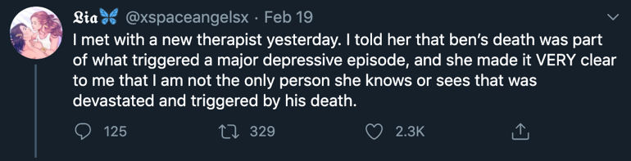

Figure 1.1. Tweet by @xspaceangelsx (@xspaceangelsx, 2020).

And the tweet author was not alone – the following tweets were replies to her own grief, all while expressing theirs, as well:

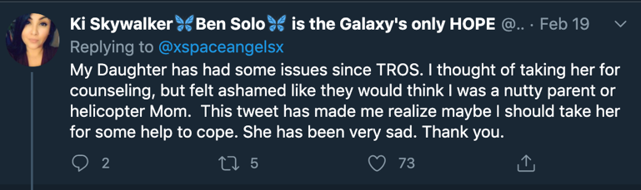
Figure 2.2. Tweet by @KimiStarr (@KimiStarr, 2020).

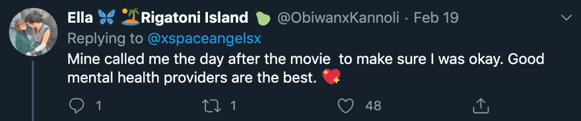
Figure 3.3. Tweet by @ObiwanxKannoli (@ObiwanxKannoli, 2020).

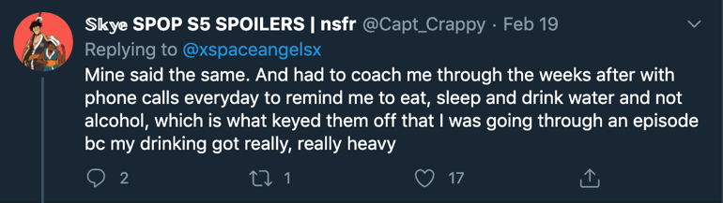
Figure 4.4. Tweet by @Capt_Crappy (@Capt_Crappy, 2020).

The Twitter posts in Figures 1.1-4 are perfect examples of the phenomenon of parasocial breakup. This Twitter user in Figure 1 experienced what she called a “major depressive episode” (@xspaceangelsx, 2020) exactly two months after the release of The Rise of Skywalker (on February 19, 2020). This means that the death of a fictional character that this person did not know in a face-to-face reality was so impactful on this person, that two months later, this person had to talk to a therapist about it. While one might think that this type of person is rare, the data on the tweet would beg to differ: the tweet has over 100 replies, over 300 retweets, and over two-thousand likes. This person is not alone in grief, and the selected replies are additional proof.
Star Wars is a myth that is larger than life; it is a multi-billion-dollar franchise that, as of today, spans twelve feature-length films, three cartoon television shows, one live-action television show, literature for all ages, and comic books. The way that this story has permeated our world-wide popular culture is something that deserves academic analysis.

Parasocial Interaction, Parasocial Breakup, and Fandom

As fandom media becomes more prevalent in popular culture across the globe, a natural question for any academic to ask is, how are fandom members reacting to the events in media franchises? Not how are they interacting with the story, but how are they reacting to the story? If popular culture plays such a major role in how we understand our overall culture, would it not be imperative to analyze how people are impacted by these stories? That is why communication theory is so important to the study of popular culture, as is media studies. Media and culture scholar Stuart Hall’s concept of Reception Theory can be used as the basis for most forays into the study of media impact: how does the media we involve ourselves with impact us (Shaw, 2017)?
While Para-Social Interaction Theory (PSI) has certainly been studied before, the parameters by which we understand the theory have changed. Published in 1956, researchers Donald Horton and R. Richard Wohl analyzed how people interacted with mass media icons, primarily newscasters; they did not analyze their physical interactions with them, but rather, how these people perceived these newscasters to be their friends – how they trusted these newscasters and put them on a very high pedestal (Wohl & Horton, 1956). This is where the term Para-Social Interaction was born. While others have taken this communication theory model and have applied it to other mass media icons, such as actors, musicians, and fictional characters, the boundaries and findings of the article hold true: it is possible for one to create a relationship with someone that one does not know, and only know through a mediated experience.
In 2006, Keren Eyal and Jonathan Cohen coined a term for a subcategory of Horton and Wohl’s earlier work. Called parasocial breakup, Eyal and Cohen’s research consisted of surveying 279 students surrounding the ending of the popular sitcom Friends, and found that many people were in distress over the ending of their favorite television show (Cohen & Eyal, 2006). Since then, the duo’s findings have been the basis of a plethora of research surrounding how fans of behave when a popular television show or movie franchise ends, and in some cases, how fans react when a character dies.
In order to understand fandom from an academic standpoint, one must also understand communication theory and media studies, as well as have a basic understanding of how one builds such an intense relationship with characters that one can never realistically meet or converse with, that they have never had a conversation with. One must go beyond the conventional understanding of fandom and must reach beyond the surface definition in order to fully grasp how one can become so entrenched in a fictional world.

Fandom as an academic field, and research question

Fandom, as I have stated, is not fleeting, and Star Wars, as evidenced by time, is not fleeting either. The depth with which you can immerse yourself in this fictional world is indicative of how much it can also consume a person just as people consume it. Fandom has taken on different iterations over the years, but as I am analyzing it in the context of this research, it is also being analyzed through a modern lens. Fandom, as it stands today, lives largely online, and allows for a person’s opinion to suddenly become the shared opinion; in the terms of this research, it is a place where fans have gone to collectively mourn (Harju, 2014). Additionally, fandom tends to attract participants that feel disenfranchised in other areas of their lives, looking for a place to belong (O'Donovan, 2016). In the case of Star Wars, fans go online and find a strong online community on Twitter, and see a place to belong. This is not unique to Star Wars, but the model certainly applies to the Star Wars fandom (Seregina & Schouten, 2018).
Understanding popular culture, and most importantly, fandom at an academic level is imperative to understanding peoples’ real-world reactions to fictional actions. Just as evidenced in Eyal and Cohen, and Horton and Wohl’s research, to spend time with a person through the screen (or book), is to build an attachment to that person, whether one realizes that you are creating that attachment or not, and in most cases, while one electively consumes the media, one does not electively decide to build a para-social relationship. It just happens.
Not only are fandom studies essential to understanding the impact of media on the human psyche, but also that fandom interaction also plays a large role in how individuals understand the media going forward. Fandom studies is a fairly new topic in terms of the history of academia, but I think that it is, in simpler terms, another layer of media and communication studies.
In this research, I will be observing parasocial breakup via fan reactions to the death of Kylo Ren in Star Wars, Episode IX, The Rise of Skywalker (TROS), with the research question being, what were the Star Wars Twitter fandom reactions to the death of Kylo Ren and do those reactions align with what one might expect from parasocial breakups?

Literature Review

What is Fandom?

Fandom means many things to many people, but in fandom ethnography it typically takes on a meaning of identity just as much as or more as it does a meaning of love for a story. Fandom is more than enjoying a certain piece of media, but additionally is an identifier – it is a state of mind, a subgroup of media viewers, and a cultural phenomenon. The author of the tweet in Figure 1’s Twitter profile photo is a fanart piece of Kylo Ren and fellow Star Wars character, Rey – not a photo of the author of the tweet themselves, even though this user has posted personal pictures before. This is the identity that this person has taken on, and as Coppa explains, fandom as an identity (Coppa, Fuck Yeah, Fandom Is Beautiful, 2014) both inwardly and outwardly. Furthermore, this tweet author, and all other tweet authors referenced in this research, are each living proof of Hall’s Reception Theory: much like the phrase “you are what you eat,” you will closely identify with the media you consume, which is the antithesis of fandom (Shaw, 2017).
If we understand that people who have high-levels of fandom participation tend to be in search of belonging (Seregina & Schouten, 2018), it is easy to see how someone could fall head first into a fandom. As they have assumed this identity of Star Wars, they assume many more components that associate with the brand, subconsciously in an effort to prove their worth within the group. This effort to prove worthiness consists of many elements, such as the purchase and use of Star Wars-branded merchandise, a vast knowledge of the history of the Star Wars story (movies, television shows, video games, books, comic books, etc.), and a very strong effort to make their voice heard and respected within the fandom space.
This fandom space might seem like a galaxy far, far away to most, but it is within your reach if you are willing to join an almost cult-like tribe. While there are different sects of the Star Wars fandom tribe, they all attend the same family reunion, of sorts. This family all drinks from the same watering hole, and that watering hole is the brand, and the brand could not exist without capitalism.

Capitalism, Brand Loyalty, and Ownership
From a purely capitalistic standpoint, fandom plays a large role in how we engage with popular culture as a society. Coppa relates that because fandom is something that we use to form our identity, it is something that we feel comfortable with and find comfort in. We use fandom as an escape from our real-world lives, while still tying our real-world selves to it. Fandom is a place beyond reality, but it is also not of another world, meaning that it might be just the perfect amount of escape for some people, and there are many ways that one can exhibit one’s escapism: t-shirts, action figures, and other proofs of love are central to fandom participation, making it impossible for fandom exist in a society without capitalistic intentions.

”You want t-shirts? I’ve got 20.”

Star Wars would not be the worldwide phenomenon that it is today were it not for its branding on items for purchase outside of the theater (Geraghty, 2018). Geraghty explains that the more time and money someone pours into fandom, the more ownership that person feels over the narrative that the fandom is centered around. For most people who belong to a fandom, it is not the ownership of one shirt and the movies on digital download, but it is multiple shirts, action figures, art work, traveling to conventions, watch parties, and other things that cost money. While a t-shirt here and there might not seem like a large investment, when combining those shirts with the cost of other goods in addition to the time spent talking and thinking about your fandom’s media, one easily could begin to feel as if you have poured your heart, soul, and wallet into fandom, and many have.
When George Lucas was filming Star Wars, he asked for the merchandizing rights to the property, which 20th Century Fox, the studio through which the original films were made, had no problem handing over the rights, as the company thought that the movie would be a complete failure at the box office (Phillips, 2015). When Disney purchased the IP from Lucas in 2012 for over four billion dollars, the purchase price was not mostly based on the success of its films, but rather, the success of its merchandise.

Making a name for yourself.
In addition to the material goods of the Star Wars fandom, there are also podcasts, websites, and YouTube channels dedicated to the reporting on and the discussion of Star Wars. Some people have been so successful in turning their love of Star Wars into a fulltime job, the best example being Star Wars Explained, a popular YouTube channel where Alex and Mollie Damon of Atlanta, Georgia, talk about the fictional history of the Star Wars universe, among other Star Wars-related topics. Since starting the channel in November 2014, the Damon’s have amassed more than 600,000 subscribers (Damon & Damon, 2014). The couple’s ability to drop their former careers for a 9-5 job dedicated to the dissection of Star Wars material is rare, but the number of YouTube channels, podcasts and websites dedicated to the Star Wars brand – that have no formal ties to the brand itself – is astounding and speaks to the brand power and loyalty that the IP holds.
This is where the idea of ownership starts to fold into the topic of consumption. Just because one goes to McDonald’s every day does not mean that one owns a stake in the company’s stock. That person does not get to decide what goes on the menu next, and that same philosophy can be applied to fandom, and in this case, Star Wars. Star Wars is something that is being consumed by fans, and despite how often they decide to ‘visit’ that galaxy far, far, away, they have no ownership whatsoever over the brand itself. They are consumers of that story and their characters, but just because they pay for a movie ticket (or a few hundred movie tickets), does not mean that they get to decide how the story moves forward. Until Star Wars enters the public domain, Disney owns and controls the story and characters, despite how much time and money one might dispose of all for the love of a character and his arc.
Despite this lack of literal-ownership, the fandom can begin to own one’s identity, as I previously touched upon by the work of Coppa (2014). Combining the topic of the emotional side of fandom (how it can become one’s identity) and the material side of fandom (how one spends time and money on the media), we see how one could develop an emotional attachment to these characters that persons have spent so much time and money on, AKA, how they can form a parasocial relationship with them.

Fan Works and Theories

Your fan fiction isn’t canon.
Fandom is a highly-participatory beast; as explained earlier, fandom is not just about the things you can buy to show off your fandom, but it is also about the things you can create, like art, stories, and fan films, and the intellect that you bring to the conversation, through theories or extreme analyzation of the material (much like I am doing with this research).
A large part of modern fandom culture is dedicated to fan works, which consist of art and literature devoted the media. The work of podcasts, blogs, and YouTube channels like the Damons’ cannot be put under the same umbrella as fan works, though, because these fan works take the existing IP and add to it in ways not-intended by the brand. These creations – made by fans – can contribute to feelings of ownership that one might have over the brand (Black, 2006).
What is fan fiction? Fan fiction are the stories that fans write and publish to online forums, like Fanfiction.net and ArchiveOfOurOwn.org (AO3) that are not canon to the overarching narrative put out by the brand. While fan fiction might not be a phrase used in most peoples’ everyday vernacular, works of fan fiction have eventually hit the mainstream. As an example, popular adult novel series, Fifty Shades of Grey, was originally published online as Twilight fan fiction (James, 2011), and the book series spawned a film franchise.
Currently, on AO3, there are more than 41,000 stories dedicated to Kylo Ren/Ben Solo alone. These stories – as with all works of fan fiction – range in genre, rating, and length. Some of these stories are set in the Star Wars universe and some are set in places as mundane and ordinary to us as New York City, stripping the characters of any of their magical abilities. In her work, Black analyzed fan fiction based upon popular Japanese anime titles, but states that fan fiction plays a large role in building one’s identity in the online fan space, and how reading and writing fan fiction can impact one’s understanding of the canon story.
In another article also by Black (2007), she further discusses how this construction of stories creates new fan spaces, inherently creating new subgroups within fandoms. Because these are works created by fans, surely fan fiction writers have a greater sense of ownership over a character and a property than the average fan, because they have spent a lot of time developing a pre-existing character’s traits and story (Coppa, 2017). Taking into consideration the sheer number of fan fiction works about Kylo Ren, it would be easy to assume that not only is he a fan-favorite, but he is likely one of the most fan “owned” in a way.
That would certainly be an explanation as to why some grieved the way that they did. While the story of Kylo Ren always can continue in fan-created works, the Star Wars brand has killed him off, which might be understood by fans so devoted to his story as to write their own works about him as a slap in the face to the character that they had grown to love, and largely built on their own. His personality – as written by the fans – was likely not the intention of the owners of the IP, which is a more academic and formal way of saying that the character that fans are mourning is not the one that we saw in the movies, but rather, the one that they created in their online communities. This relationship and devotion to this character not only speaks to the power of storytelling, but also to the devotion that some people experience within fandom.

”Anakin, you’re breaking my [headcanon]!”
Ellithorpe and Brookes (2018) explore how people react when a television show reaches its series finale, and how fan theories interplay with our enjoyment of media. Fan theories are very much a part of the fandom experience. When one spends any amount of time contemplating what will happen next in one’s favorite franchise media, then one is creating fan theories, often called headcanons. Whether they share those ideas with others or not, people are knowingly or unknowingly setting expectations for what will happen in the story, and if it does not go the way they had envisioned, they will either be pleasantly or unpleasantly surprised; these fan theories have much of the same outcome on fan reactions as fan fiction does. As discussed earlier, just as one invests monetarily in fandom, one also invests mentally. Fans often begin to repeat their theories to themselves and to others so often that they become interlaced and woven into their overall experience with the media to the point that the experiences of the sanctioned-by-the-studio media cannot be separated from the created-by-the-fan idea.
All of these actions, works and behaviors are collectively called “textual poaching,” which means to appropriate media for one’s own creative use (Jenkins, 1992, 2012). Not only do fan works such as fiction, art, fan theories, and fan films count as textual poaching, but as do the blogs, podcasts, and YouTube channels dedicated to Star Wars (and any other fandom). While Jenkins’ original work published in 1992 looks at television fandom that existed around Saturday Night Live and Star Trek, and how the reprocessing of the content, whether that was by watching episodes over and over or discussing the content of the episodes with friends, and how this media, because of a person’s extreme-levels of involvement, gets inserted into other areas of a person’s life, a devotion that one might consider to be that of a religious nature.

Fandom as a Religion

”You were the chosen one, [Star Wars fandom]!”
Much of the ideology of fandom can be applied to faith and religion (Lyden, 2012). On the surface, one might not see the similarities, but when comparing components, it is hard to deny that the Star Wars fandom does not resemble a religion in any way. People who identify as being a part of the Star Wars fandom, and not simply as fans, likely know the story of the entire 11-film collection to a point that might be considered fanatical (that is where the term ‘fan’ comes from). Beyond that, many fans might know the story of the television shows that tie into the movies, and beyond that, many of them know the stories of the canon and non-canon books and comics from Star Wars’ present and past.
Compare that to Christianity and the canon Bible, for example: a churchgoer who is adherent to their church’s teachings will likely not only know the story of Christ, but the person who is at the church for every service and every Bible study might also know the stories of Christ’s disciples, the stories of the prophets, and everything that led up to the birth of Christ, even down to the small chapters of the Old Testament that most could not name. Time spent on something means knowledge learned, and the combination of that time spent on and information gained on a subject often translates to a feeling of having a relationship with the material; just as a Christian might say that they have built a relationship with Christ by interacting with the text of the bible through various routes, members of the Star Wars fandom might say that they have built a relationship with the characters in the story.

Fandom Politics and ‘Stan’ Culture

”I have the {political) high ground.”
If you synthesize the information about the basic meaning of fandom, fandom as an identity, fandom as a tribe, fandom participation, fandom as its own economy, fandom as a space for people to create their own works, and fandom as a religion, you might naturally wonder what a fandom can do when it gathers together. No, not at a convention, but in average, everyday life. This is a politically powerful group, and world governments know that. In 2018, research found that the same tactics used by Russian trolls to control the online narrative around the 2016 American presidential election were implemented to control the conversation after the release of 2017’s Star Wars, Episode VIII: The Rise of Skywalker (TLJ) (Bay, 2018). It might be hard to understand why a foreign entity would find any appeal in interfering with the online discussion of a movie’s plot, but if you consider that this is a sect of the population that feels disenfranchised to begin with and uses a franchise as a personal identifier, using their frustration with a fictional story for political gain is actually a rather ingenious move.
These bots and trolls did not just spread opinions about the film, but they trolled other Twitter accounts that were talking about their likes and dislikes of the movie, as well, and started an anti-liberal, anti-woman conversation around the movie. “Fantagonists,” as they are called in the article, then saw these tweets, which were created by bots and trolls, and assumed that most people hated the movie, when that was not the case. With that being said, how could one even politicize Star Wars in the first place? Well, it would actually be hard not to.

”Did you ever hear the tale of [George Lucas] the Wise?”
George Lucas, in a genius fashion, was able to himself synthesize different storytelling tropes and different real-world stories in order to create his space opera. While employing the mythology of Joseph Campbell, he wrote a story about a fantastical world that looked lived-in and real, despite the epic not taking place on Earth. Additionally, his story was allegory for the United States’ invasion of Vietnam, the draft, and how American Imperialism (that bad guys are the Empire, after all…) was doing more harm than good. His story also borrowed elements from Nazi Germany’s actions, making the fiction Empire humanists, in the fictional galaxy, that means that the Empire was anti-alien. The uniforms of the Imperial officers strongly resembled that of Nazi officers (Klein, 2018). To say that the series is strictly popcorn fare is undercutting the implicit messaging in the film, which is inherently political.

”I am the [bots and trolls]!”
If one acknowledges that the story of Star Wars is blatantly political, that the Star Wars fan community has immense buying power, has a cult-like following and devotion, and has the pop culture force behind it that will allow this group to steer the narrative, no wonder foreign enemies could be interested in interfering with the conversation surrounding the move that had (at the time) the most racial and gender diversity ever seen in a Star Wars picture.
The Twitter trolls and bots catered to the people that felt as if The Last Jedi had forgotten them (Bay, 2018), because this movie did not revolve around a white male as the lead hero, a Korean-American woman was given a large supporting role, and the leading military figure in the film was a purple-haired woman who wore a dress, presenting as overtly-feminine while commanding an army. Those choices made by the studio and the director were seen by some as great advancements for the franchise, and others saw them as deeply upsetting, as if Star Wars was no longer for them (Daubney, 2017). This group of (largely) men congregated online, and used their power of numbers to antagonize the studio, the director, and fans. Teaming with anti-Disney-era-Star Wars sentiment, The Fandom Menace (as a few had named themselves years before) began to see their numbers grow (Coffin & Joubert, 2019). These fans claim that the new era of Disney-owned Lucasfilm Star Wars does not represent them because they cannot see more clear-cut representations of themselves. They feel as if Star Wars has been politicized in this new era, as if it were never political before (Martinelli, 2018; Klein, 2018). Gaining numbers for The Fandom Menace (done by the work of trolls and bots) was potentially done to shape the narrative, as had been done by Russian bots and trolls during the 2016 Presidential election (Bay, 2018).
Was Star Wars ever for the women and non-white people who had enjoyed it before, if that was the case? It most certainly was, but if you are a government that wants to interfere in the pop culture discourse of a country that you see is a threat, why would you now prey upon the insecurities of a group that has had their identity threatened? Would you not want to help them find that belonging somewhere else, that somewhere else being with your political ideology and manifesto?

I have no choice but to stan.
Recognizing that fandom is not only a political entity, but also can be politically-driven, is intrinsic to understanding the power that fans have as a group. Blending politics and fandom further, since the Obama administration, and even more so during the Trump administration, we have seen a ‘fandomization’ of American politics, making it harder to separate the two (Hess, 2019).Words like ‘stan,’ which means to exhibit extreme fandom, are now being used about politicians in a way that used to only be used about people and media in the entertainment industry. The term ‘stan’ itself does not derive from healthy behavior, as the term was appropriated from Eminem’s 2000 song titled Stan, in which the rapper tells a story about an obsessive fan who goes too far (Marshall Mathers). Fandom Twitter cannot be separated from the concept of ‘stanning,’ which plays into a groupthink mentality.
Just like many things in life, if we set-up expectations beforehand, and reality does not match what we had anticipated for, we will be disappointed. If a section of the fandom had spent years forming theories about how Kylo Ren was going to live to see the sun go down on the Skywalker saga, had shared those theories with others, and those others also believed in the same theory, they would have created an echo chamber for their ideology, and they did. The responses to the tweet (Figure 1) indicate that this grief does not belong solely to the author of the tweet, but rather, that their feelings echo that of others.
Star Wars Twitter provides an avenue by which fans can meet and discuss their favorite subject. While many of these people might eventually create other forums by which they can communicate with each other, Star Wars Twitter, and even fandom Twitter, is what really has the staying power and the majority of the conversation is taking place.

“So, this is how [the fandom] dies, with thunderous applause.”
Just as the case was with the bots and trolls during the post-TLJ era, I think that it might be plausible that bots and trolls also are adding to the conversation surrounding the death of Kylo Ren, making the conversation continue, and therefore, making real-life people’s grief regenerate. If we are to understand this fandom, this stan twitter, this groupthink capability as a politically powerful tool, would it not make sense for the same bot systems as were used before to drive the narrative now? In this instance, they would be further contributing to the grief of the same people who they had been trying to demean for liking the previous movie – essentially, they would be contributing to the grief of liberal-minded young women, who, has evidenced in other research I have presented, tended to love The Last Jedi (Bay, 2018; Daubney, 2017).

Loss of a Parasocial Relationship, AKA Parasocial Breakup

Parasocial Breakup 101
Knowing what we know about Parasocial Interaction Theory, parasocial breakups, fandom, and all that fandom entails, the content of the tweet in Figure 1 and the numbers around it should not be shocking, but rather are a perfect example of parasocial breakup and the life of a fan. The content of the tweet exemplifies what it means to be a fan and a member of a fandom and the natural human experience of loss and grief. As Ellithorpe and Brookes (2018) make clear, when we are very invested in media franchises or a long-lasting television series, it becomes such a large part of our life that it is hard to separate fact from fiction in our brains. Sometimes, characters are not just beings that exist in media, but characters that we spend a great deal of time with can eventually take up as much space in our brains as real-life people do.
If the fandom is mourning the death of a character that they have invested time, money, identity, and brain-space in, a character that they feel empathy toward and identify with because of said character’s moral conflict, are they actually mourning that character or are they mourning a part of their identity? I believe that both could be true.
Think of how you have reacted when you have experienced a real breakup, whether that be the death of a loved one or the end of a relationship. If you saw the end coming for some time, when that finality does happen, you are likely to handle it better, as you have had more time to digest the possibility – you have thought it over. If you were not anticipating that finality – if you had thought about the future of that person or your future with them – the end of it all comes to you all at once. While grieving is a process, the news of death or end either comes to a person in a period of time before it happens or comes to the person all at once. Surely details can emerge later, but no one can die more after the fact, and nothing can end more after it has ended: when it’s over, it’s over, largely. Just like in a murder, while details might emerge later, after the murder has taken place, it does not make the person’s death any less, or rather, it does not bring any more of them back to life.

“You are a dyad in the [fandom].”

In research published in 2019, a study analyzed how participants interpreted and identified with the characters of the first movie in the sequel trilogy, The Force Awakens. The results concluded that while at first glance, one might not think that people would easily identify with the villain of the story (Kylo Ren), participants were more able to, and were willing to because his obvious moral conflict made him more relatable to the audience, and “[i]n addition, much of the audience may anticipate that the character will return in sequels and may not be confident that his alliance with evil is permanent. This is, after all, a narrative world in which even Darth Vader famously returned to the light. They may be interpreting Kylo Ren’s story as the first part of a redemption narrative, which could also contribute to a sense of meaning” (Hall, 2019).
Taking out all of our preconceived ideas and prior knowledge about Star Wars and its story, the story of this singular movie (The Force Awakens) conveyed that this character would be redeemed by the end of the trilogy (he was). If this was the message that the storytellers were trying to convey, it is easy to interpret that viewers might want to empathize with this character, and according to Hall’s study, they clearly did. This empathy, when combined with fandom and its multi-faceted components, could, would, and did result in an emotional attachment and connection with the character. People formed a relationship with the character of Kylo Ren via interaction with the media, ownership of the media and material goods, time invested with the story and the character, and an identification with the character’s narrative of moral confliction.

Parasocial Breakup and Shipping

Parasocial relationships and psychological impact
As exhibited earlier, people identified with the character of Kylo Ren, and saw that he would be redeemed eventually (Hall, 2019). If you know the story of Star Wars, and of Joseph Campbell’s prose on mythology, the death of Kylo Ren should not have been shocking. With that in mind, what is it about fandom Twitter and fandom in general that intensifies the feelings of parasocial relationships and parasocial breakups?
Knowing what we know about how fandom is used as a basis for personal identity, it should not be shocking to know that when a component of your identity is stripped away, one can feel extreme emotions. In the tweet in Figure 1, the Twitter user mentions receiving psychological therapy in which she talked about the death of Kylo Ren/Ben Solo, and how two months after the movie, she was still grieving. One factor that did not exist in media consumption during the release of the original 1977 film is the accessibility of media. If you wanted to see the original Star Wars, you would have to go to a theater, and once the film was out of theaters, you would have to wait for a special screening, as the majority of the world did not have access to home video at this point. Now, the same media are just a click or a slide-of-the-thumb away. People surely were creating their own stories about the characters, or drawing their own art, but there were no online pathways by which to become more engrossed in the topic.
The accessibility that we have now that is permeated into our society is what enables us to see whatever we want to see, whenever we want to see it, strengthening our bond to the media and the characters in said work. In fact, it is not uncommon for therapists to work through issues with patients who exhibit parasocial breakup through that person’s parasocial relationship with whatever media or characters a person has an affinity toward (Gannon, 2018).
Gannon’s research states that people tend to form parasocial relationships with which they most strongly identify with, which gives credence to Hall’s findings that people in her study identified with Kylo Ren more so than any other character introduced in The Force Awakens (Hall, 2019). From this, we could gather that Kylo Ren is the most popular character from the sequel trilogy, making him the most likely character for people to create a parasocial bond with, suggesting that even if one knew and understood the Star Wars mythology expressed in previous trilogies, his death would be no less shocking to the people that took him on as a part of their own persona. This knowledge makes fandom not only something to be studied from a marketing perspective, and how best you can capitalize on someone’s willingness to ‘stan,’ but also as something that can be studied for the understanding of media’s impact on the population beyond consumerism – something that is not simply numbers and gains, but also, a glimpse into the human emotional experience. Going further, combining what we know about fandoms; these are many individual experiences of parasocial breakup that make up a collective parasocial breakup. The platforms available to us as a society have given us the ability to mourn together across the globe, which might not allow for a person to move on, if the information is being shoved in their face every second of the day. We are more than ever before, and sometimes not for the better (O'Donovan, 2016).

“I ship it.”

In addition to ‘stanning,’ there is something called ‘shipping’, which means to desire to see two characters get together in a romantic way. Many in the Star Wars fandom who were fans of Kylo Ren desired to see him get together with the heroine in the story, Rey. The name of the ‘ship’ of Rey and Kylo is called Reylo, and Reylo was ranked by Tumblr as 2019’s seventh most popular ‘ship,’ and that is not the seventh most popular out of the Star Wars franchise, but the seventh most popular overall on the internet (2019’s Top 100 Ships, 2019). The list consisted of 100 ‘ships,’ suggesting that the fan power behind Reylo, and, more specifically, behind Kylo Ren is massive, permeating beyond Star Wars Twitter, and contributing to an overarching narrative about the state of fandom.
‘Shipping,’ in addition to fandom itself, has political power, and when a much-desired fictional relationship does not play out in the way that fans had desired, fans retaliate by threatening to cut themselves off from the ongoing story, and suggest that the creators of the story do not care about them as fans, ignoring the fact that storytelling is a business and that fandom is not something that the mass general audience participates in. In addition to having such a staunch desire to see two characters get together romantically, these ‘ships’ and ‘shippers’ (people who support the fictional couples) often take on political ideology and apply it to the narrative that they desire to see be played out in the story. They might also adopt other political opinions that are loosely tied to or exist completely outside of the fictional relationship, further accelerating their presence as an online political power that can be manipulated (Romano, 2016).
In data research published in January 2020 that suggested that Reylo shippers were the target of much online harassment following the release of TLJ. Her research concluded that the majority of Reylo shippers and Kylo Ren fans were women, and she talked about her own experience as a participant in the online discourse surrounding the movie. She goes onto state that Reylos experienced harassment over the death of Kylo Ren, as well as inherently political harassment that included sexist and racist taunts. She also noted that while she does not think that the harassment would be at such a magnitude in a face-to-face scenario, the internet makes it very easy to harass without guilt or fear of consequences (Harrison, 2020).

Shipping in fandom

As Star Wars and other media provide a form of escape from reality for viewers, we do know that many fans bring this fiction into their lives and make it a part of their reality. We know that many people join an online fandom in search of belonging and friendship, and while the parasocial relationships that they form with characters could impact their own emotional state (O'Donovan, 2016). While many people – specifically women – might ship Reylo (Harrison, 2020), they are first and foremost fans of Kylo Ren, and are likely using Rey as an audience surrogate of sorts, or rather, they are placing themselves in Rey’s shoes, desiring to be Rey and desiring to be with Kylo Ren romantically, which makes sense given what we know about parasocial relationships and parasocial breakups.
Fan fiction had such a prominent place in the Kylo Ren-centric Star Wars fandom because readers were able to place themselves in the shoes or Rey, and through fan-created stories, were able to carry on a romance with Kylo Ren. This means that Kylo Ren’s death was in a way, the loss of a lover of sorts to some members of the fandom. Their identity had been constructed around the idea and love for him, and in their eyes, now that he no longer gets to have a happy ending with their surrogate character, neither do they. They ship this couple (or any fictional couple), because they likely desire to have such a passionate relationship as the one they had desired to see on screen. Rey and the person that they perceived her to be was a proxy for themselves (Black, 2007).

Fandom and gender

Just as was found in Harrison’s research, that most of the people shipping Reylo and considered themselves Kylo Ren fans were women, research also says that the majority of fan fiction authors and readers are women (Coppa, 2017). Those targeted by The Fandom Menace and Twitter bots and trolls in the anti-TLJ backlash were women (Daubney, 2017; Bay, 2018; Coffin & Joubert, 2019). The synthesis of this knowledge proves that the majority of those experiencing parasocial breakup tendencies over the death of Kylo Ren are surely women. Women, just as they have power in the story of Star Wars, have always had power within fandom spaces in terms of buying power, but now, thanks to the internet, their voices are being heard, too. Women in the fandom suddenly have some clout as to what the narrative of the Star Wars fandom is, and there are forces that were clearly bothered by the idea that women could have a say in the future of the story (Bay, 2018; Coffin & Joubert, 2019; Daubney, 2017), and those forces were largely male. While it might seem as if women just arrived to fandom, they have actually been there the whole time (Coppa, 2017).
Further driving home the narrative that fandom is a female-driven space, Fifty Shades of Grey, the Twilight fan fiction which was retooled into a completely original piece, was written by a woman (James, 2011). Women inhabit large and powerful spaces across multiple fandoms – James’ work spawned a movie series, as well. Fandom built by women is a billion-plus dollar industry.

Literature Review Synthesis

This religious nature of fandom integrated with the sense of ownership and appropriation (Lyden, 2012), presents itself as a viable formula for stirring feelings of parasocial breakup within fans. Jenkins was studying the magnitude of impact that fandom immersion levels had on peoples’ lives as early as 1992 (Jenkins, 1992, 2012), and that was before we were in a digital media age of being constantly connected to other fans (Gannon, 2018). Additionally, we know that the majority of those immersed in the Kylo Ren-centric Star Wars fandom are women, so we can infer that women are the ones who are most-highly experiencing parasocial breakup over this character. We should be able to prove this via social media analyzation.
That being said, we could run into bot and/or troll activity, as evidenced in previous Star Wars Twitter fandom research (Bay, 2018). While we have to assume that there are men that were upset by the death of Kylo Ren, all of the other research suggests that because women are the most-likely to participate in the online fandom culture that this parasocial breakup anxiety exists within, they are the most likely to be expressing their grief openly on social media.

Social Media Data Analytics

Data Analysis Basics

While data analysis can help us to better understand a social phenomenon, social media analytics can only look at things on a binary-based metric. Social media analytics cannot yet measure for sarcasm, dry-humor, and gender identifications that exist outside of the binary male and female, man and woman.
SocialStudio, a platform hosted by Salesforce, allows analysts to listen across social media on all types of platforms, but for the purposes of this study, I am only looking at data from Twitter. SocialStudio is used by academics and other researchers across the globe in order to better understand and analyze consumer attitudes about almost every topic imaginable, or at least the ones people will post on the internet.
Additionally, Twitter does not release its algorithm(s) to the public, so these numbers, while thought-provoking, can only be taken at face-value. As consumers, we are not privy to how Twitter mines its data – we have no knowledge as to how Twitter decides if a tweet was produced by a male or female, or how old the tweeter is, we just have to believe the data given at face value, and take it with a side of precaution. We know that gender can be codified on social media (Schwartz, et al., 2013), and that language used by fandoms can be codified by gender, as well (Yoder, 2019).
Taking into consideration what we already know about online participatory fandom and those who considered themselves to be the most devoted of Kylo Ren fans, we can expect to see tweets largely produced by women. Bot and troll accounts also have to be categorized as personal accounts. Knowing what we know about language being able to be codified by gender, one must assume that if we see any activity that suggests that a sizeable amount of tweets surrounding the death of Kylo Ren are published by men, these are likely bot and/or troll accounts at work, as they were in 2018 (Bay, 2018; Coffin & Joubert, 2019).
While there will be tweets from brands and outlets that report on films, or tweets from the Star Wars brand itself, it is safe to assume that the majority of tweets, especially those expressing parasocial breakup, will not be from media outlets, but rather, from individuals on personal accounts.
Furthermore, tweets posted to private, or locked accounts will not be visible on SocialStudio – only public Twitter accounts’ data can be mined under these circumstances. Neither Twitter nor Salesforce/SociaStudio indicate whether or not a tweet comes from a suspicious account, so we must work with the data it presents in order to draw our conclusions.

Data Analysis, Set 1

Keywords, Set 1

Using the Adam Brown Social Media Command Center and SocialStudio, I analyzed tweets that were made from December 19, 2019 to March 19, 2020, which was the release of the movie and the three months following. I used the following in my primary keyword group (both names, titles, hashtags, and acronyms) in order to find my data: #bensolo, #kyloren, #starwars, #thelastjedi, #theriseofskywalker, #tlj, #tros, Ben Solo, Kylo, Kylo Ren, Ren, Last Jedi, Star Wars, The Rise of Skywalker, TLJ, and TROS.
For my secondary keyword group, I included other names and titles that I would like to see included with those tweets: #bensolodeservedbetter, #savebensolo, Abrams, ao3, Archive of Our Own, death, deserve, deserved, die, died, fan fic, fan fiction, fanfic, fanfiction, JJ, JJ Abrams, mourn, mourning, pain, redeem, redeemed, redemption, Rey, Reylo, Rian, and Rian Johnson.
The words from my primary keyword group were chosen because those were my subjects: the movies and the character (both of his names). The words from my secondary keyword group were included because they were/are the emotions and the contributing factors that surround the parasocial breakup experienced. I chose to include JJ Abrams and Rian Johnson because they are both directors in the sequel trilogy and controlled the narrative. I chose to include the hashtags #bensolodeservedbetter and #savebensolo because they were being heavily used by Kylo Ren fans that were exhibiting parasocial breakup and being vocal about their grief. I chose to include anything related to fan fiction (such as ao3, Archive of Our Own, fan fic, fan fiction, fanfic, and fanfiction) because these seemed to be outlets that Kylo Ren fans heavily invested in. I also chose to include death, deserve, deserved, die, died, mourn, mourning, pain, redeemed, redeemed, and redemption because these were words that were being used in tweets that were expressing sadness about Kylo Ren’s death.
In the world cloud, which consists of words and phrases that may or may not have appeared in the keywords entered, but appeared in the tweets they generated, the word ‘love’ appeared prominently.

Volume and Sentiment, Set 1

Over this three-month period, tweets containing any combination of these words, phrases, titles, names, emotions, etc., combined volume resulted in 1.9 million tweets. For sentiment, 43.3% of tweets were negative, but when factoring in the potential for a tweet to be neutral, the negative-neutral combination of tweets totaled for 59.5% (30.9% negative, 28.6% neutral) of the conversation. Sentiment trend indicated that there were spikes in all neutral, negative, and positive tweets for the two weeks following the release of The Rise of Skywalker, but from January 2 to January 30, sentiment of all three classifications was unmeasured, meaning that there was no sentiment recorded whatsoever during this time. From February 1 to March 19, neutral, negative, and positive sentiment was all fairly even. Negative and positive sentiment both received exhibited spikes days prior to the time of The Rise of Skywalker’s novelization release (spikes were observed from February 29 to March 5), when some fans had been able to receive a copy of the book a few days before the official release at Chicago’s C2E2 pop culture convention.
I noticed a slight uptick in positive tweets in this keyword group posted on March 14, 2020, so I decided to take a look at just how positive they were. The following (Figures 4.1-3) are not indicative of positivity at all, but were likely coded that way due to the nature of the algorithm, which Twitter and SocialStudio do not make public:

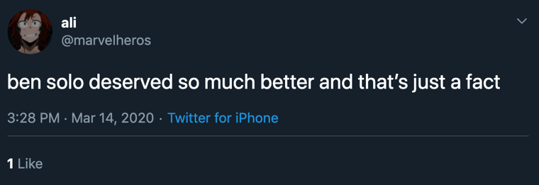

Figure 4.1. Tweet by @marvelheros (@marvelheros, 2020).

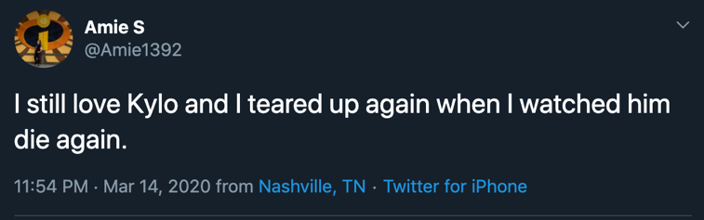

Figure 4.2. Tweet by @Amie1392 (@Amie1392, 2020).

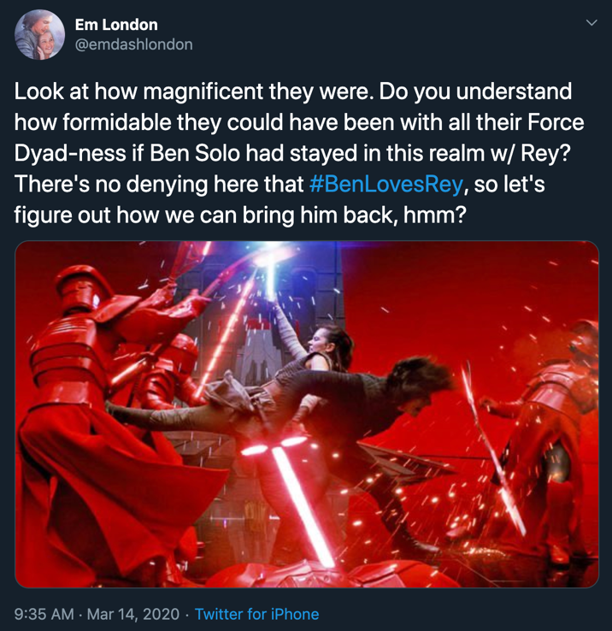

Figure 4.3. Tweet by @emdashlondon (@emdashlondon, 2020).

I would not venture to say that these three tweets are positive in the slightest – each of them displays evidence of parasocial breakup anxieties, and all three were posted nearly three months after the release of the movie. Additionally, the Twitter accounts of these three authors, particularly that of Figure 4.3, predominantly featured images from a scene in The Rise of Skywalker where Rey and Ben finally kiss, indicating that the Twitter user has not moved on from the fictional death of Kylo Ren.
In response, I looked at some tweets from the same day (March 14, 2020) which SocialStudio coded as negative (Figures 4:4-6):
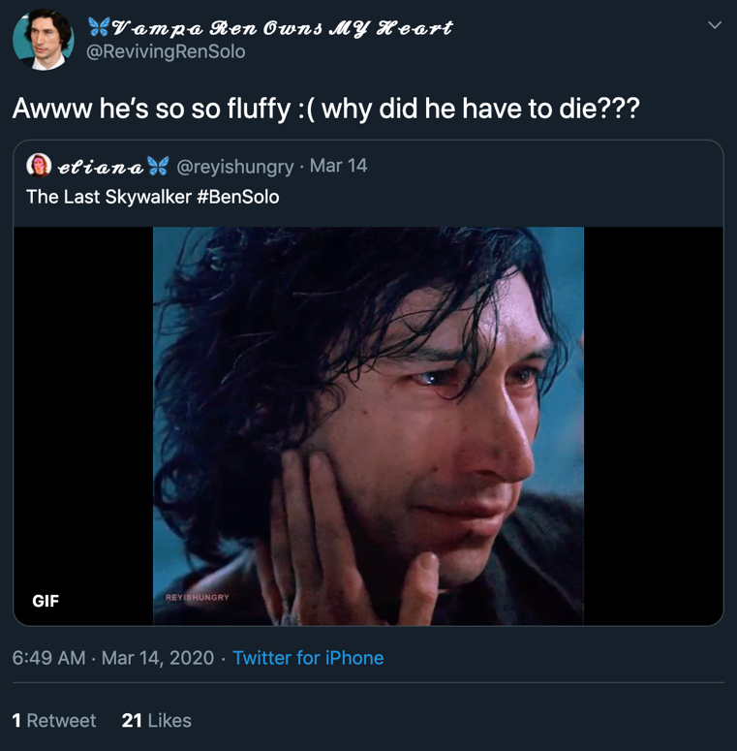
Figure 4.4. Retweet by @RevivinngRenSolo, original tweet by @reyishungry 9 (@RevivingRenSolo & @reyishungry, 2020).

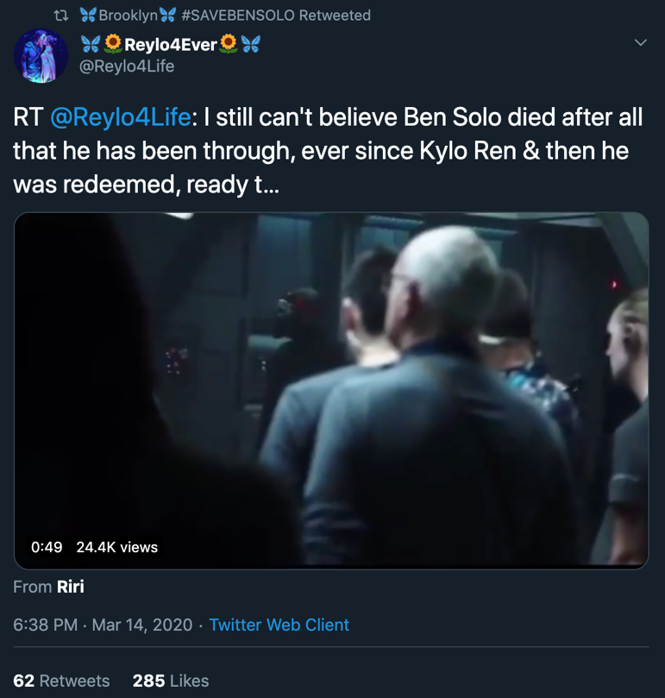

Figure 4.5. Retweet by @Brooklyn_J9, original tweet by @Reylo4Life (@Brooklyn_J9 & @Reylo4Life, 2020).

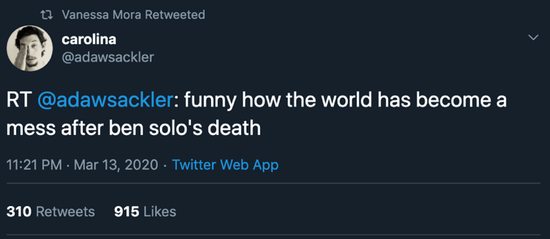

Figure 4.6. Retweet by @vainillamorada, original tweet by @adawsackler (@vainillamorada & @adawsackler, 2020).

The tweets featured in Figures 4:4-6 not only are negative, but they feature parasocial breakup anxiety indicators.

Tweet Author Volume Averages, Set 1

When analyzing the Persona Group Summary of the tweets containing the keywords from earlier, the 1.9 million total tweets over the three-month period belonged to a total of 31,111 authors, meaning that on average, each author tweeted about the death of Kylo Ren 61 times during the three-month course. December 19, 2019 to March 19, 2020 totals to 148 days, meaning that tweet authors were expressing grief – on average – every two and a half days. With this in mind, these are the averages, but the Twitter users exhibiting extreme effects of parasocial breakup over the death of Kylo Ren are impacting the average number, giving such a high number for the average viewer who might have been upset about the character’s end. Additionally, with volume, we must assume that some tweets are being retweeted and liked, which would give an author influencer power.

Tweet Influencers, Set 1

I noticed in my Persona Group that top influencers (meaning their influencer score given by SocialStudio is of 90 or above) were all news or entertainment outlets that would be reporting on Star Wars and/or Kylo Ren’s death. These were not fan-run personal accounts, so they were likely not the ones expressing behaviors indicative of parasocial breakup. The tweet authors of Figures 4:1-3 all had influencer scores of 61 or below.

Tweet Author Data, Set 1

Out of the 31,111 tweet authors, only 6,374 of the accounts had their locations listed on their profile (24,737 accounts have no known location), meaning that nearly 80% of tweeters have chosen to not reveal their location/country of residency.
Of those authors, around 2,000 mentioned ‘Star Wars’ in their profile biographies, and 804 of them used ‘Reylo’ in their bio – these 804 likely account for making the average tweet volume per-author so high.
More than half of the authors (15,289) in this monitor had 100-1,000 followers, meaning that they had some reach but would not merit a high influencer score. Nearly one-third of the accounts (9,453) had zero to 100 followers. Of those authors, 37% (11,574) of them had on average authored 1,000 to 10,000 tweets on all subject matters (Star Wars-related or not), and 32% (10,189) of tweet authors had posted anywhere from 10,000 to 50,000 tweets, giving merit to the idea that smaller accounts with lower influencer scores were accounting for the majority of the tweets that exhibited signs of parasocial breakup.
Around two-thirds of tweet authors (20,107) had followers of around 100-1,000 other Twitter users, and 6,460 authors had followers that measured 1,000-10,000.
This is where I started to get suspicious of my data, most of the tweet authors whose gender could be codified (15,747 out of 31,111; roughly 50%), over half (55.7%) were men. Of those 31,111 tweet authors, only 649 could be codified by age (2%). This led me to wonder about the possibility of bots and trolls adding to the conversation, especially since a report in 2017 found that up to 15% of Twitter accounts are bots (Chong, 2017).
Additionally, according to Harrison’s research, while there are men in the Kylo Ren-centric fandom, the majority of them are women (Harrison, 2020). As exhibited in the data about bots and trolls and their role in the post-The Last Jedi discourse (Bay, 2018), the bots and trolls were there to ignite and stoke feelings of political hatred for a movie, which in turn turned into an anti-woman rhetoric (Daubney, 2017).

Data Analysis, Set 2

Restructuring My Keywords, Set 2

A commonality amongst Kylo Ren fans is to not call him Kylo Ren, but rather, to call him by his birth name of Ben Solo. Using the same time frame, I created a new Keyword Group using the following words, names, phrases, hashtags, etc. My primary keyword group specified to look for Ben Solo not Kylo Ren. I could not use the singular name of Ben because it is too common a name, and could throw off the numbers when being combined with other words that can be used outside of the narrative around Star Wars. I used all of the same words, names, acronyms, and phrases in my secondary keyword group. Additionally, I chose for none of the tweets to include Kylo Ren’s name at all, and only search for tweets containing Ben Solo as it related to Star Wars; I excluded Kylo, Kylo Ren, and Ren.

Volume and Sentiment Data, Set 2

From December 19, 2019 to March 19, 2020, there were 1.4 million tweets about the death of Kylo Ren that included only his birth name and had no mention of the name that he had assumed for himself.
Only 43.8% of the tweets analyzed coded as containing positive sentiment, with the combined neutral-positive sentiment being 56.3%. There was zero sentiment of any kind measured from January 1 to January 17, and tweets posted on January 25 that exhibited positive sentiment largely centered around the hashtag ‘#savebensolo’. Knowing what we know of this hashtag – that it was used by people who were exhibiting elements parasocial breakup – we can gather that reading sentiment in these tweets is not going to add much to the discussion, because something that is actually about grief is being coded as positive by the analytics platform. The following tweets, posted on January 25, expressed parasocial breakup anxieties, and were coded as positive, despite being their actual negative nature:

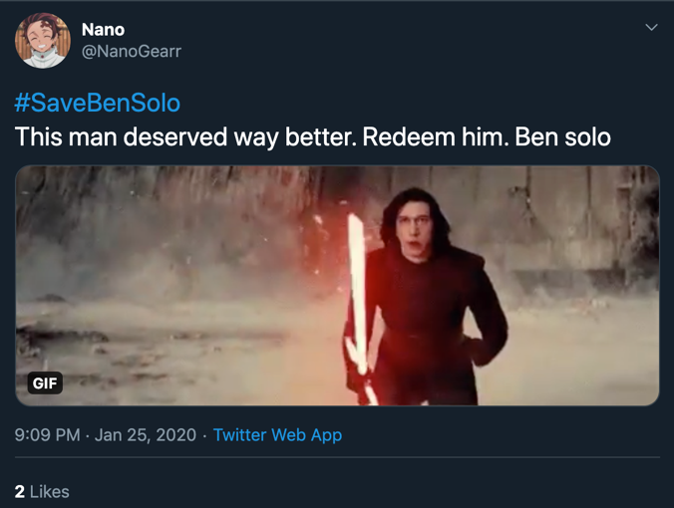
Figure 4.7. Tweet by @NanoGearr (@NanoGearr, 2020).

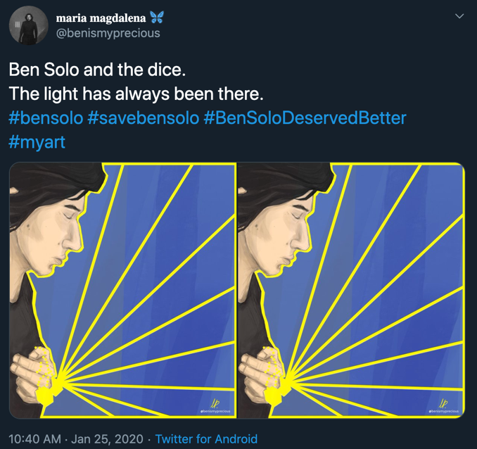

Figure 4.8. Tweet and artwork by @benismyprecious (@benismyprecious, 2020).

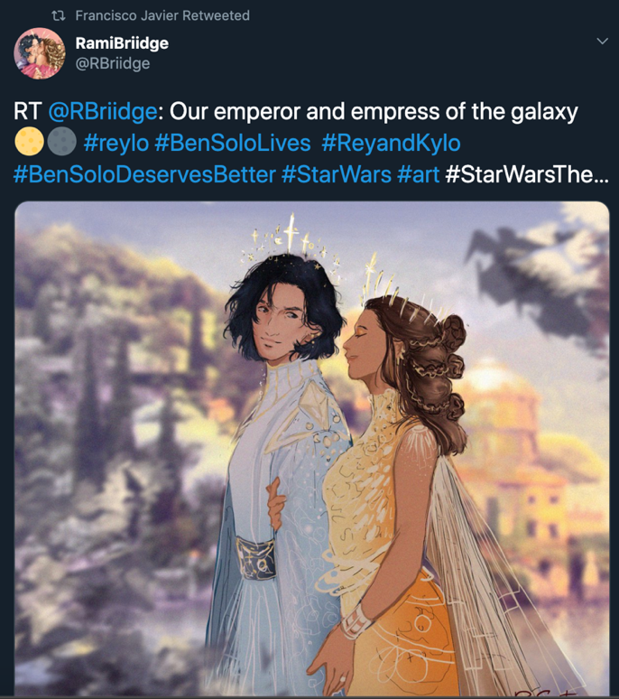

Figure 4.9. Retweet by @DrCustoSalazar, artwork by @RBriidge (@DrCustoSalazar & @RBriidge, 2020).

As I did with the tweets featured in Set 1, in Figures 4:1-6, I decided to sample some tweets made on this same day (January 25, 2020) that SocialStudio coded as negative:
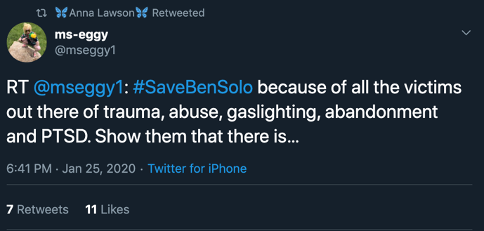

Figure 4.10. Retweet by @ICU_Insomnia, original tweet by @mseggy1 (@ICU_Insomnia & @mseggy1, 2020).

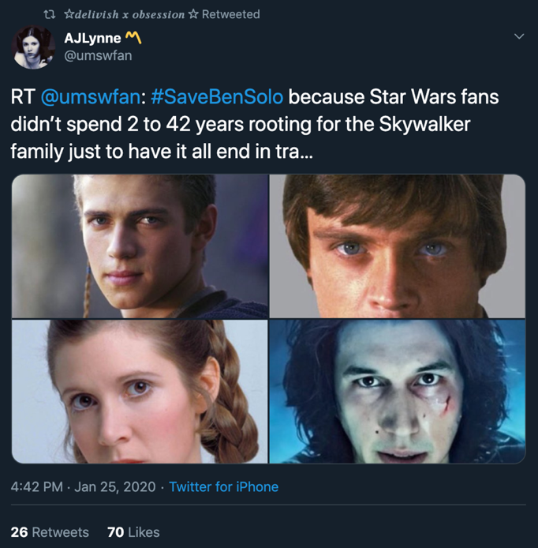
Figure 4.11. Retweet by @black_tik_tak, original tweet by @umswfan (@black_tik_tak & @umswfan, 2020).

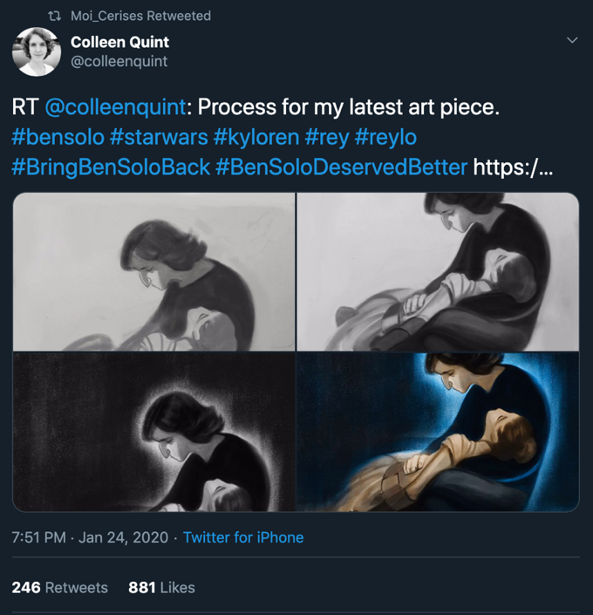
Figure 4.12. Retweet by @PitaGonzolezMe, original tweet and artwork by @colleenquint (@PitaGonzalezMe & @colleenquint, 2020).

The interesting thing about Figures 4.8-9 and 12, is that they all showcase works of fan art, as referenced in Chapter Three, and how fan works can contribute to feelings of ownership, which might contribute to the experience of parasocial breakup anxiety. Also, these tweets code, to a human reader, and not a computer algorithm, as negative, since we understand that nature of them and the topic at hand. Additionally, I was not looking specifically for tweets that had the hashtag “#SaveBenSolo” included – I was looking for positive tweets concerning the subject matter, but Figures 4.4-5 both used the hashtag. Figure 4.6 used variations upon the hashtag, but they have the same connotations. These tweets sampled here in Set 2 are extremely similar to the tweets sampled in Set 1, where they coded as positive, but actually showed us prolonged cases of parasocial breakup anxiety.

Tweet Author Volume Averages, Set 2

When analyzing the New Persona Group Summary of the tweets containing the new keywords, the 1.4 million total tweets over the three-month period belonged to a total of 36,960 authors, which is 5,849 more authors than the previous keyword group generated, indicated that there were more authors despite a lower volume of tweets. This means that on average, each author tweeted about the death of Kylo Ren 37 times during the three-month course. December 19, 2019 to March 19, 2020 totals to 148 days, meaning that tweet authors were expressing grief – on average – roughly every 4 days. As with the previous tweet volume averages, these are just that: averages; the Twitter users exhibiting extreme effects of parasocial breakup over the death of Kylo Ren are impacting the average number, giving such a high number for the average viewer who might have been upset about the character’s end. Additionally, with volume, we must assume that some tweets are being retweeted and liked, which would give an author influencer power.

Tweet Influencers, Set 2

As was with the previous set of influencers, I noticed in my Persona Group that top influencers (meaning their influencer score given by SocialStudio is of 90 or above) were all news or entertainment outlets that would be reporting on Star Wars and/or Kylo Ren’s death. These were not fan-run personal accounts, so they were likely not the ones expressing behaviors indicative of parasocial breakup. The tweet authors of Figures 4:4-6 all had influencer scores of 50 or below.

Tweet Author Data, Set 2

Out of the 36,960 tweet authors, only 7,784 of the accounts had their locations listed on their profile (29,176 accounts have no known location), meaning that nearly 79% of tweeters have chosen to not reveal their location/country of residency, which is congruent with the average of 80% of tweet authors that had no known location in the tweet author analysis data.
Of those authors, around 2,100 mentioned ‘Star Wars’ in their profile biographies (also congruent with the last persona group analysis), and 810 of them used ‘Reylo’ in their bio, which is six more users than in the last analysis – these 810, as before, likely account for making the average tweet volume per-author so high.
Over half of the authors (18,732) in this monitor had 100-1,000 followers, meaning that they had some reach but would not merit a high influencer score. Nearly one-third of the accounts (11,015) had zero to 100 followers. Of those authors, 36% (13,296) of them had on average authored 1,000 to 10,000 tweets (congruent with the last persona group) on all subject matters (Star Wars-related or not), and 33% (12,493) of tweet authors had posted anywhere from 10,000 to 50,000 tweets (also congruent to the last set), giving merit to the idea that smaller accounts with lower influencer scores were accounting for the majority of the tweets that exhibited signs of parasocial breakup.
Around half of tweet authors (18,732) had followers of around 100-1,000 other Twitter users (this is a stark increase from the last set), and 6,391 authors had followers that measured 1,000-10,000 (which is a miniscule decrease from the last set).
I once again went into looking at gender and age was even more perplexed than before. Of tweets that could be codified into gender (19,366 out of 36,960; roughly 52%), more than half (60.2%) were men once again. Of those 36,960 tweet authors, only 831 could be codified by age (2%) – the same as before. This furthered my earlier suspicions about bots and trolls adding to the conversation. In a section of the fandom that is largely women-driven, why would male voices be taking up such a large area of the space? Are they actually male voices, or are they bots like the ones before, trying to turn fans’ upset with the outcome of a movie into something more extreme?

Data Analysis Conclusions

Taking what we know of fandom and identity, it would make sense that there would be an intersection of fandom identity and gender identity. There is language used amongst fans that can be codified as male and female – in fact, fandom can be very gendered based on the sheer nature of fandom (Yoder, 2019). If fandom and the language around it can be codified by gender, it makes no sense that half of the language around it could not be gendered. Therefore, troll-created tweets were likely able to be codified by gender, whereas bot-created tweets were not. In the case of bots and trolls post-The Last Jedi, the goal was to win disenfranchised fans (largely white men) for their anti-woman, anti-social justice cause (Bay, 2018), but in this case, could the bots and trolls be attempting to heighten feelings of grief, heighten the feelings of parasocial breakup, in the same people that they sought to defeat two years prior? By my data, absolutely.
Because neither Twitter nor SocialStudio tell you if an account is a bot or troll, it would be impossible to scan all 31,111 (Set 1) and 36,960 (Set 2) accounts that tweeted about the death of Kylo Ren. Based on previous data, we have to assume that a great deal of those authors are bots, and that due to the nature of fandom, many of the authors are trolls (Chong, 2017; Bay, 2018). Additionally, we can safely assume that there is some overlap in authors between the calculated author numbers of Set 1 and Set 2.
I also could not figure out as to why there was no sentiment measured in those few weeks in January 2020 in both keyword sets. My estimate is that this was a glitch in Twitter’s algorithm that neither SocialStudio nor myself had any control over.
I do believe that the tweets sampled in Figures 4:1-12 are indicative of parasocial breakup, and that they serve as examples of the overarching and continuing narrative around the death of Kylo Ren in some subgroups of the fandom. While the tweets that could not be coded by gender and the tweets that coded by gender as male could indicate bot and troll activity, is does not diminish the parasocial breakup anxieties exhibited in Figures 4:1-12, and other tweets that I viewed but could not include due to the volume of posts. Additionally, giving even more credence to the ideology that fandom members act as a part of the group in more ways than they act as individuals, I noticed that tweet authors in Figures 4:4, 5, 8, and 11 all had blue butterfly emojis in their Twitter display names. I went to see if this had any connection to the Kylo Ren fandom, and indeed, it did. On March 25, 2020, one of the official YouTube channels of Star Wars released a cartoon video of a young Kylo Ren, and at this point, Ben Solo, playing with some blue butterflies (Ben Solo and the Bug Hunters – Chapter 2 | Star Wars Roll Out, 2020). The fans used this as another symbol of their unity around the character, and fandom-centric news outlets speculated on the topic, as well (Romain, 2020).
Overall, I believe that the data I found proves that the effects of parasocial breakup over the death of Kylo Ren were not fleeting, and that the breakup anxiety is still ongoing.

Materials, Methods, and contributions

Literature review and data synthesis

Through academic journal articles, other graduate theses, and journalistic pieces, I have analyzed and synthesized the components of fandom, by explaining what modern fandom means, the several entities that factor into the sense of belonging that it gives, the marketability of a fandom, its cult-like tendencies, and its political power. Additionally, I reviewed and synthesized pre-existing literature about parasocial relationships and breakups within the fan community. Reapplying what we understand to be Stuart Hall’s Reception Theory (Shaw, 2017)to modern online fandom and reviewing Alice E. Hall’s study on Star Wars (Hall, 2019), Episode VII and audience reception, we know that people identified with Kylo Ren from the beginning, and with continued viewings of the movies, reading of books, comics, fan fiction, and other media activities, we can begin to better understand why the collective parasocial breakup anxiety has lasted as long as it has and is as prominent in the online fandom.
The gendered aspect of online media fandom makes it impossible to ignore that this case of group parasocial breakup anxiety was driven by women, based on research about women in fandom and their involvement in the fan art and fan fiction communities, which both drove and continue to drive the Kylo Ren-centric subgroup of the Star Wars fandom (Coppa, The Fanfiction Reader: Folk Tales for the Digital Age, 2017). Understanding the identification that viewers shared with Kylo Ren, and how the media we consume permeates other areas of our life, the effects of fan fiction writing and reading certainly had an effect on how the women-dominated Kylo Ren fandom subgroup, as many of them used the character of Rey as a proxy for themselves (Black, Fanfiction Writing and the Construction of Space, 2007; Black, Language, Culture, and Identity in Online Fanfiction, 2006), and upon Kylo Ren’s death, effectively lost a lover of sorts, if you can consider a fictional character to be a real-life lover. The synthesis of the many components of fandom, the nature of social media, fandom participants’ individual identities, and collective mourning equate to a clear pathway for fans to experience parasocial breakup anxieties.

Data analysis/Methodology

Through SocialStudio and the Adam Brown Social Media Command Center at the University of Tennessee, I analyzed tweets that occurred for three months (December 19, 2019 to March 19, 2020) after the release of Star Wars, Episode IV: The Rise of Skywalker, and see as to whom the conversation around the death of Kylo Ren is being driven by. To best do this, I chose words, phrases, and names that pertained to the death and character of Kylo Ren. In order to come to a decision on this data, I analyzed previous research done on bots and trolls that exist within the Star Wars Twitter fandom. While I do not doubt that there are people grieving the death of this character, I was interested to see if the online talk around the subject was actually impacting as many people as it appeared to have been, or if this is a situation where bots and trolls were driving up the numbers in order to make the situation appear worse than what it was in actuality. To be more specific about the bots and trolls online, one must define the term, and for the purposes of this research, I used the same terminology as given in other Star Wars online fandom-related research: bots are, in the case of this research, Twitter accounts with little to no human interference. Troll accounts are run by humans, but exist to drive a narrative by means of antagonization, humiliation, and the belittlement of other Twitter users (Bay, 2018).

Contributions to the further study of fandom and parasocial breakup

While there is much research currently on parasocial breakup, character deaths and/or the end of certain media, fandoms and the field of social media analyzation is on the rise, the study of emotions expressed online and the meaning behind them is a relatively new field of study; the research that has been done on the topic of fandoms, social media, and and parasocial breakup has mostly focused on fandoms surrounding musicians and reality shows, which all center around real-life people, not fictional villains. The study of communication theory, media studies, and specifically, parasocial breakup and its application to online fandoms is a very new (Garimella, Cohen, & Weber, 2017).
This being said, previous research on parasocial breakup, parasocial relationships, fandom, and fandom experiences are imperative to moving forward in the study of fandoms, fan reactions, and fanalytics. I believe that my research, literary synthesis, and data findings can all contribute to the future understanding of fandom and the emotional experience that comes along with being a fan of fictional media. While not every fan will experience the extreme levels of parasocial breakup anxiety, such as what I discuss in my work, research as to why some fans do experience such emotions is paramount to understanding the current fandom culture.
As for my research on social media and fandom, modern fandom culture does not exist without social media, and had I sat and interviewed people about the death of Kylo Ren, I do not believe I would have been able to observe the raw emotion that I was afforded. People find it easier to say things to like-minded individuals, as opposed to someone who has plainly stated that she is a researcher and would like to speak with them. Star Wars fandom Twitter gives us the unique ability to analyze emotions without ever interviewing these people at all, which makes my study different than that of most who are researching parasocial breakup.

Chapter Five
Conclusions and Recommendations

Research Question, Revisited

What were the Star Wars Twitter fandom reactions to the death of Kylo Ren and do those reactions align with what one might expect from parasocial breakups?
The Twitter reactions to the death of Kylo Ren were great in their scale and grief, and as they expressed grief over a three-month period of time, expressed feelings of parasocial breakup. Considering the time span, the negativity of the tweets, the volume of the tweets, and the average tweets-per-user concerning the character’s death, we can say that these tweets did indicate that parts of the fandom were (and still are) exhibiting parasocial breakup. While there appears to be bot and troll activity afoot, it does not take away from the fact that there were hundreds of thousands of tweets expressing grief over the death of a fictional character, which, again, would classify them as parasocial breakup.
The frequency with which people were posting about the character’s death indicates that this is an on-going phenomenon that is not likely to lull unless they revive the character, as while the initial wave of tweets was greater in number than the tweets that followed, the number of tweets that pertained to the character’s death were of constant numbers over the last month and a half of the time reviewed (December 19, 2019 to March 19, 2020). Those initial tweet numbers were to be expected, but while they certainly would qualify as exhibiting parasocial breakup anxieties, the tweets that were occurring during the last-half of the time observed further prove that the feeling is long-lasting.
The tweets also had a lot of similarities amongst each other that are indicative of fandom and fandom behaviors, as tweet authors not only expressed their grief, but displayed fan art, which is an example of textual poaching, which comes back to the idea of ownership within fandoms. Additionally, the blue butterflies that were present in the sampled tweets in Figures 4:1-12, as well as tweets that I did not feature, indicates the power of the group to brand themselves inside of a pre-existing brand. All of these components, when synthesized, are indicative of fandom and parasocial breakup anxieties.
The indicated male presence found in both keyword sets 1 and 2 suggests that the same powers that worked behind the scenes in 2018 to control the narrative around The Last Jedi are at play once more. The same people who were so aggravated by in 2018 are now the ones who are grieving, giving them a clear and omnipresent opportunity to strike back at their ideological opponents.

The ongoing study of parasocial breakup

As we continue to expose more and more of our lives online, conversations that exist firstly on the web need to be analyzed in the same manner than conversations in person do. While I do believe that the nature of digital media allows for us to be a tad more flamboyant than we might be in our real lives, it could also open up another avenue of study, and why digital reactions are so much more extreme than those that someone might have in real life. Are those digital reactions even changing the nature of the reactions that one might have in their physical lives? While my research touches upon a smaller topic of fandom, my research gives merit to thought that parasocial breakup anxieties of fans can be observed online – while interviews are great, social media analytics tools such as SocialStudio allow us to get reactions, or rather, emotions from people without personally engaging with the fans.
We can understand and better analyze fans in this environment where they are already comfortable, as opposed to the environment one might be in when they conduct a study from a sample group in person. Additionally, this allows us to analyze the emotions of thousands upon thousands more subjects that we otherwise could. Anthropologists, sociologists, psychologists, and communication and media scientists can conduct their future research in a manner similar to my own, and gather reactions and data without ever sending out the first poll or research survey.
Furthermore, I believe that my research adds value not only to the future study of parasocial breakup and fandoms, but also gives more merit to the literature that I synthesized, as had it not been for the research and work of the scholars that I mentioned, I would not have been able to come to my own conclusions, which made my data possible. As communication studies evolves, the digital world expands, and the ways in which we participate in online fandoms changes, so should the way we research the topics. If we do not evolve the way we study and observe, neither will our findings.

What Is Fandom(?), Revisited

The light and dark sides of fandom

While fandom is an amazing avenue for meeting friends and discussing a topic you love, fandoms are so much more. Fandoms support economies, promote brand loyalty and capitalism; fandoms foster fan-created works of art and fiction, and other creative avenues, but fandoms can also be outlets where insecurities are preyed upon and cult-like behavior is exhibited. Were it not for the nature of online media fandom and social media, the perpetuated feelings of parasocial breakup surrounding the death of Kylo Ren would likely not be as noticeable across the fandom population, as our obsession with media fandoms has increased due to its accessibility (Gannon, 2018). Because of social media’s ability to keep us constantly connected, we have another outlet through which to voice our opinions, because we have a community that centers around our fandom: a gathering of like minds, suddenly mourning collectively (Harju, 2014). Due to the nature of being constantly connected, we are being repeatedly confronted by the object we are mourning, and therefore, might be more inclined to experience prolonged parasocial breakup anxieties.
We must assume that while there would likely be some outliers experiencing extreme grief post-TROS in a non-digital world, we can infer that because we are constantly connected and that media are instantly accessible, the sheer nature of online fandom is what allows these extreme reactions to be occurring even three months post-release and onward. Fandom goes beyond the reaches of regular fan behavior, and those that participate in fandoms can often exhibit signs of other insecurities, such as disenfranchisement, which is why they likely joined a fandom in the first place (O'Donovan, 2016; De Oca, 2015). The concept of ‘stanning’ (Hess, 2019) in today’s pop culture and fandom environment, combined with the accessibility that we have today that we have never had before (Gannon, 2018), creates an environment where it is hard to take a break from the pressures and emotions that one might experience online, which would deeply contribute to feelings of parasocial breakup, and inherently, make them worse. Fans are willingly going to the watering hole where they replenish themselves with their own grief.

Fandom as a target

Additionally, fandom is an easy target for enemies who are seeking to use potentially-disenfranchised people who have their guards down as a tool for their personal or political gain. While on a surface level this might seem like a flippant statement, if they (the bots and trolls) have done it before, why would they not do it again? Seeing as the social listening data I gathered does not resemble earlier research about women in the online Star Wars subgroup of Kylo Ren-centric fandom, it almost certainly appears as if there are great numbers bots and trolls contributing to the discourse. The women in the fandom are statistically proven to have strong political ideologies that go against those of foreign enemies (Bay, 2018; Daubney, 2017; Romano, 2016)
This subgroup of the Star Wars fandom had immense hope that Kylo Ren would live, and when he did not, it gave those wishing to see a very-political piece of pop culture fall down, paving the way for controlled bots and troll accounts to make fans even more disgruntled with the property than they otherwise might have been.
Joseph Campbell’s The Hero With A Thousand Faces (1949) suggests that any one of us can see ourselves as the hero if the story is structured in such a way and George Lucas created a world within a movie that allowed the people to pretend to be the hero. With the pop culture presence that the brand and story have, it is actually a stroke of genius for bots and troll accounts to try and control the narrative as they did in 2018. This is a group with immense buying power, online presence, and strong personal ties to the brand, so to try and make them hate the brand is to make them hate a piece of Americana. To drive them to hate a piece of Americana could further drive the conversation toward an anti-western ideology, and while that could seem far-fetched to the average person not involved in fandom, we have seen it happen before, and they would surely do it again given the opportunity. To co-opt the emotions of fans over feelings of parasocial breakup would not be new to them, as you could easily qualify the emotions of members of The Fandom Menace as parasocial breakup; they are just experiencing the breakup anxiety over different items within the overarching Star Wars narrative.

“But we have hope.”

In Rogue One: A Star Wars Story, Jen Erso, the hero of the movie, delivers the line, “But we have hope. Rebellions are built on hope!” (Kennedy, Shearmur, & Emanuel, 2016), and I think that the line is one of the best descriptors of the entirety of the Star Wars saga and the Star Wars fandom: group of people with large quantities of hope. The fandom, despite the efforts of those who have tried to take it down, has never lost its drive – it is filled with more greatness than evil, and the intense connections that fans collectively form with the characters only speak to the majesty and masterfulness of Star Wars, which is nothing short of other worldly, as if it truly were in a galaxy far, far away (Opening crawl, n.d.).

List of References

@Amie1392. (2020, March 14). Retrieved May 2020, from Twitter: https://twitter.com/Amie1392/status/1239037113720594432
@benismyprecious. (2020, January 25). Retrieved May 2020, from Twitter: https://twitter.com/benismyprecious/status/1221095382727393281
@black_tik_tak, & @umswfan. (2020, January 25). Retrieved May 2020, from Twitter: https://twitter.com/black_tic_tak/status/1221293480716251136
@Brooklyn_J9, & @Reylo4Life. (2020, March 14). Retrieved May 2020, from Twitter: https://twitter.com/Brooklyn_J9/status/1239035286404784129
@Capt_Crappy. (2020, February 19). Retrieved May 2020, from Twitter: https://twitter.com/Capt_Crappy/status/1230258155944321024
@DrCustoSalazar, & @RBriidge. (2020, January 25). Retrieved May 2020, from Twitter: https://twitter.com/DrCustoSalazar/status/1221296453152399360
@emdashlondon. (2020, March 14). Retrieved May 2020, from Twitter: https://twitter.com/emdashlondon/status/1238821174475399169
@ICU_Insomnia, & @mseggy1. (2020, January 25). Retrieved May 2020, from Twitter: https://twitter.com/ICU_Insomnia/status/1221293872430637056
@KimiStarr. (2020, February 19). Retrieved May 2020, from Twitter: https://twitter.com/KimiStarr/status/1230245275312295938
@marvelheros. (2020, March 14). Retrieved May 2020, from Twitter: https://twitter.com/marveIheros/status/1238909858755289091
@NanoGearr. (2020, January 25). Retrieved May 2020, from Twitter: https://twitter.com/NanoGearr/status/1221253679170408450
@ObiwanxKannoli. (2020, February 19). Retrieved May 2020, from Twitter: https://twitter.com/ObiwanxKannoli/status/1230246076684394502
@PitaGonzalezMe, & @colleenquint. (2020, January 25). Retrieved May 2020, from Twitter: https://twitter.com/PitaGonzalezMe/status/1221293007523074048
@RevivingRenSolo, & @reyishungry. (2020, March 14). Retrieved May 2020, from Twitter: https://twitter.com/RevivingRenSolo/status/1238779195360268291
@vainillamorada, & @adawsackler. (2020, March 14). Retrieved May 2020, from Twitter: https://twitter.com/vainillamorada/status/1239031020932005888
@xspaceangelsx. (2020, February 19). Retrieved from Twitter: https://twitter.com/xspaceangelsx/status/1230225796725399552
2019’s Top 100 Ships. (2019, December 2). Retrieved April 2020, from Tumblr: https://fandom.tumblr.com/post/189431747929/2019-ships
Bay, M. (2018, November 5). Weaponizing the haters: The Last Jedi and the strategic politization of pop culture through social media manipulation. First Monday, 23(11).
Ben Solo and the Bug Hunters – Chapter 2 | Star Wars Roll Out. (2020, March 25). Retrieved May 2020, from YouTube: https://www.youtube.com/watch?v=kS7H75jQu0A&feature=emb_title
Black, R. W. (2006). Language, Culture, and Identity in Online Fanfiction. E-Learning, 3(2), 170-184.
Black, R. W. (2007). Fanfiction Writing and the Construction of Space. E-Learing, 4(4), 384-397.
Campbell, J. (1949). The Hero With A Thousand Faces. New York, New York, USA: Pantheon Books.
Campbell, J. (2012, Jan 23). Joseph Campbell and the Power of Myth with Bill Moyers | Star Wars | PBS. Joseph Campbell and the Power of Myth. (B. Moyers, Interviewer)
Chong, Z. (2017, March 14). Up to 48 million Twitter accounts are bots, study says. Retrieved April 2020, from C|Net: https://www.cnet.com/news/new-study-says-almost-15-percent-of-twitter-accounts-are-bots/
Coffin, J., & Joubert, A. M. (2019). Handbook of Research on the Impact of Fandom in Society and Consumerism; Theorizing Less Visible Forms of Fandom: Practices, Assemblages, Liquidity, and Other Directions. IGI Global.
Cohen, J., & Eyal, K. (2006). When Good Friends Say Goodbye: A Parasocial Breakup Study. Journal of Broadcasting & Electronic Media, 50(3), 502-523.
Coppa, F. (2014). Fuck Yeah, Fandom Is Beautiful. The Journal of Fandom Studies, 2(1), 73-82.
Coppa, F. (2017). The Fanfiction Reader: Folk Tales for the Digital Age. Ann Arbor, Michigan, USA: University of Michigan Press.
Damon, A., & Damon, M. (2014, November 24). Star Wars Explained. Retrieved May 2020, from YouTube: https://www.youtube.com/channel/UCIKlsX1qfGqKPt4KAW-JOZg
Daubney, M. (2017, December 20). Liberal identity politics has ruined Star Wars for the fanboys. Retrieved April 2020, from The Telegraph: https://www.telegraph.co.uk/men/thinking-man/liberal-identity-politics-has-ruined-star-wars-fanboys/
De Oca, S. M. (2015). "Breaking Up Is Hard To Do": An Analysis of Parasocial Relationships and Breakups Among "How I Met Your Mother" Viewers. Las Vegas: University of Nevada, Las Vegas.
Ellithorpe, M. E., & Brookes, S. E. (2018, July). I Didn’t See That Coming: Spoilers, Fan Theories, and Their Influence on Enjoyment and Parasocial Breakup Distress During a Series Finale. Physchology of Popular Media Culture, 7(3), 250-263.
Gannon, K. (2018, May 18). Parasocial Relationships with Fictional Characters in Therapy. Retrieved April 2020, from DigitalCommons@Lesley: https://digitalcommons.lesley.edu/cgi/viewcontent.cgi?article=1075&context=expressive_theses
Garimella, K., Cohen, J., & Weber, I. (2017). Understanding Para Social Breakups on Twitter. WebSci '17: Proceedings of the 2017 ACM on Web Science Conference, (pp. 383-384).
Geraghty, L. (2018). Class, Capital, and Collecting in Media Fandom. In M. A. Scott, The Routledge Companion to Media Fandom (pp. 212-220). New York, New York, USA: Routledge.
Hall, A. E. (2019). Identification and Parasocial Relationships With Characters From Star Wars: The Force Awakens. 8(1), 88-98.
Harju, A. (2014, December 6). Socially shared mourning: construction and consumption of collective memory. New Review of Hypermedia and Multimedia, 21(1-2), 123-145.
Harrison, R. (2020, January 17). It’s a Trap: Reylos, Racism, and the Whiteness of Data in the Harassment of Women Online. Retrieved 2020 April, from Medium: https://medium.com/@beccaeharrison/its-a-trap-reylos-racism-and-the-whiteness-of-data-in-the-harassment-of-women-online-be3a7fed040b
Hess, A. (2019, September 11). How Fan Culture Is Swallowing Democracy. Retrieved April 2020, from The New York Times: https://www.nytimes.com/interactive/2019/09/11/arts/how-fan-culture-is-swallowing-democracy.html
James, E. L. (2011). Fifty Shades of Grey. New York, New York, USA: Vintage Books.
Jenkins, H. (1992, 2012). Textual Poachers; Second Edition. USA: Routledge.
Kennedy, K., Shearmur, A., Emanuel, S. (Producers), Chris Weitz, T. G. (Writer), & Edwards, G. (Director). (2016). Rogue One: A Star Wars Story [Motion Picture]. United States: Walt Disney Studios Motion Pictures.
Klein, C. (2018, August 22). The Real History That Inspired “Star Wars”. Retrieved April 2020, from History: https://www.history.com/news/the-real-history-that-inspired-star-wars
Lyden, J. C. (2012). Whose Film Is It, Anyway? Canonicity and Authority in Fandom. Journal of the American Academy of Religion, 80(3), 775-786.
Marshall Mathers, D. A. (n.d.). Stan [Recorded by Eminem]. On The Marshall Mathers LP.
Martinelli, M. (2018, October 2). Study Finds Russian Trolls Likely Meddled in Our Most Sacred American Institution: Star Wars Fandom. Retrieved May 2020, from Slate: https://slate.com/culture/2018/10/last-jedi-star-wars-twitter-backlash-russia-trolls.html
O'Donovan, R. (2016). ‘To Boldly Go Where No Psychologist Has Gone Before”: Effects of Participation in Fandom Activities on Parasocial Relationships. Journal of Applied Psychology and Social Science, 2(1), 41-61.
Opening crawl. (n.d.). Retrieved April 2020, from Wookieepedia: The Star Wars Wiki: https://starwars.fandom.com/wiki/Opening_crawl
Phillips, I. (2015, December 4). The ingenious path George Lucas took to making billions off of 'Star Wars'. Retrieved May 2020, from Business Insider: https://www.businessinsider.com/how-star-wars-made-george-lucas-a-billionaire-2015-12
Romain, L. (2020, April 6). Could Blue Butterflies Hint at Ben Solo’s Future? Retrieved May 2020, from Nerdist: https://nerdist.com/article/star-wars-ben-solo-blue-butterflies/
Romano, A. (2016, August 7). Social justice, shipping, and ideology: when fandom becomes a crusade, things get ugly. Retrieved April 2020, from Vox: https://www.vox.com/2016/8/7/11950648/fandom-shipping-social-justice-ideological-warfare
Schwartz, H. A., Eichstaedt, J. C., Kern, M. L., Dziurzynski, L., Ramones, S. M., Agrawal, M., . . . Ungar, L. h. (2013, September 25). Personality, Gender, and Age in the Language of Social Media: The Open-Vocabulary Approach. PLOS|One: A Peer-Reviewed, Open Access Journal, 8(9).
Seregina, A., & Schouten, J. W. (2018). Resolving identity ambiguity through transcending fandom. 1-59.
Shaw, A. (2017, February 13). Encoding and decoding affordances: Stuart Hall and interactive media technologies. Media, Culture, and Society, 39(4), 592-602.
Wohl, R. R., & Horton, D. (1956). Mass Communication and Para-Social Interaction. Psychiartry, 215-229.
Yoder, M. M. (2019, December 13). Computational Models of Identity Presentation in Language. Retrieved April 2020, from http://www.cs.cmu.edu/~mamille2/yoder_thesis_proposal.pdf

Vita

Alexandria P. Sutherland is a lifelong geek and Star Wars fan, if you could not tell. She holds a Bachelor of Arts degree in government with a minor in media studies from the University of Virginia, and is a Master’s of Science candidate and Graduate Teaching Assistant at the University of Tennessee’s College of Communication and Information’s School of Journalism and Electronic Media. She enjoys making media as much as she enjoys consuming it.
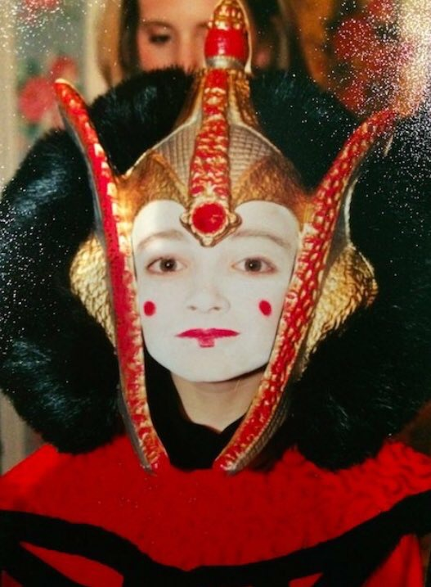
Sutherland at age 7, dressed as Queen Amidala from Star Wars, Episode I: The Phantom Menace.

