Development of Data Science Tools for Part Qualification in Additive Manufacturing

A Dissertation Presented for the
Doctor of Philosophy
Degree
The University of Tennessee, Knoxville

Sujana Chandrasekar
May 2021

Copyright © 2021 by Sujana Chandrasekar.
All rights reserved.
Dedication

எல்லாப் புகழும் இறைவனுக்கே!

Dedicated to Amma

ACKNOWLEDGEMENTS

An African proverb goes “It takes a village to raise a child”. It sure has taken a lot of people’s help, support and goodwill to get me to where I am today. I would like to express my deepest gratitude to my parents, and teachers in school and college for the many thankless hours they put in to provide me a good education and system of values to live by.

Over the course of the last few years, I have been incredibly fortunate to have unconditional support from my family. I believe that my success is equally all of theirs. I simply cannot overstate how encouraging my husband has been, throughout my grad school days. His patience and level-headedness are traits that have contributed immensely to make me a better person, and kept me sane! My parents-in-law, brother-in-law, father, sister, brother, sister-in-law and brother-in-law have all been pillars of support that I have leaned on often. Regular phone calls with all of them has helped me feel their presence, despite being many thousand miles away. My nephews always brought a smile to my face with their sheer curiosity about the world and seeing it in a way that only children can! My uncles, aunts, and cousins, both in Houston and California, have been extremely supportive along the way. I am unable to list every single person who has helped me along the way, but my extended family and their close friends have all helped in their own way to make my journey that much easier. My heartfelt thanks go to every one of them.

I enjoyed my time at the University of Tennessee and will cherish these as some of the best years of my life. My advisor Dr.Jamie Coble gave me the opportunity to pursue very interesting research, and spent countless hours overseeing my work along the way. She never stopped me from exploring new and interesting research avenues. I am grateful to her for trusting me and letting me learn by doing. Dr.Vincent Paquit took a chance on me and co-advised me as one of his first PhD students. I thank him for his guidance, motivation and humor along the way! Prof.Suresh Babu made a bet on me when I asked him if a PhD in data science for additive manufacturing was something that held any promise at all. I thank him for the many days when he made time for me on his calendar and encouraged me. His infectious enthusiasm and work ethic are truly inspiring. I have learned a lot from him along the way. Dr.Anahita Khojandi has been a very supportive member of my doctoral committee, bringing an outsider’s perspective to my research. I thank her for her help. I am grateful to Prof.Wes Hines in the nuclear engineering department for encouraging me to pursue research in a relatively new field and supporting my work. Prof.Russell Zaretzki believed in me from the day I stepped into the DSE program and has been very supportive. I thank him for his encouragement. At ORNL, I have been extremely fortunate to have worked with Fred List, Keith Carver, Luke Scime, Derek Rose and many others at the Manufacturing Demonstration Facility. I am grateful to them for helping me understand additive manufacturing processes and image processing techniques. Fred’s attention to detail and meticulous planning made me learn a lot about the value of a rigorous and thorough approach to work. So many people at the MDF gave me a lot of their time and worked with me, despite their busy schedules. I’d like to thank them for mentoring me and helping me become a better professional. I am thankful to Dr. Bruce Wilson at ORNL for helping me develop an understanding of time series analysis and allied domains. Allie Burns, Wanda Davis, Rebecca Christ, and Shannon Brown at the Bredesen Center, Anita Monroe, Rita Ayers, Jessie McPeters and Christy Gambrelle at ORNL and Michelle McBee & Ashly Pearson at the Nuclear Engineering department have all helped me a ton with policies and procedures at UT and ORNL. A big thanks to them for making my time in grad school easy!

Knoxville is a city that welcomed me in more ways than I can count. The employees of the KAT bus service, which I used many times, played an important part in helping me get to class and back home on many cold and rainy days! My thanks to them. The Knox county public library has been a source of tremendous reading pleasure during many stressful times and I am deeply grateful to them for the service they lend to the community.

I have had the wonderful opportunity of meeting many people with varied backgrounds at both ORNL and UT. Being part of the Babu research group, Coble group and the Imaging and data analytics group (ORNL) has helped me appreciate different facets of my research. My friends in each of these groups and from the Bredesen Center, including Sabina, Michael (H. and P.), Cody, Kevin, Eric, Serena, Amy, Devanshu, Carissa, William, Vanshika, Vidya, Alka, the Knoxville Tamil group and many others, have all made my grad school experience a truly memorable one. Each of my friends in Knoxville has played their own role in making me feel safe and happy. Thank you!

Research funding is very important to keep students like me focused on solving the research problem at hand. My sincere thanks to the Lloyd Register Foundation (LRF) and the U.S. Department of Energy for funding a significant portion of my research. I am also grateful to EPRI and Praxair for their interest in additive manufacturing, that enabled me to work on interesting problems of part qualification using data science tools.

Above all, I am grateful to the Almighty for all the opportunities I have got in life and helping me tide over challenges time and again.
ABSTRACT

In recent years, metal additive manufacturing processes are often being considered for part production especially for low volume, high complexity parts. To enable widespread adoption of these methods, it is essential to understand the link between process parameters and part properties. This is particularly because additive manufacturing processes cause inherently complex thermo-mechanical cycles and different local process conditions within a part, compared to conventional manufacturing processes like casting and forging. Additionally, properties of feedstock material like metal powder impact final part properties. The focus of this dissertation is on development of data-driven methods using in situ monitoring, as a step towards part qualification.

The primary contributions are:
(a) In situ monitoring of powder feedstock: Monitoring in situ powder spreading in powder bed AM is important to avoid part defects. Data-driven methods are developed to study new and recycled powder feedstock in the Electron beam Powder Bed Fusion (E-PBF) process, using log files generated in the Arcam ™ system. Results indicate that powder raking behavior reflects powder spreadability on the powder bed and is closely related to powder morphology.
(b) In situ monitoring of thermal behavior in the Laser Powder Bed Fusion (L-PBF) process: Thermal signatures in metal AM processes are closely linked to phase transformations, part microstructure and properties. Thermal signatures vary as a complex function of scan strategy, part geometry and process parameters. A similarity analysis methodology is developed to identify regions of self-similar thermal signatures in the L-PBF process, monitored using infrared imaging. Similar thermal signatures are identified, reflecting localized solidification conditions and pointing to similar regional microstructures.
(c) Demonstration of generalizability of the similarity analysis methodology to lattice structures: To demonstrate validity of similarity analysis methodology to different geometries, the algorithm is applied to lattice structures to evaluate the effect of geometry and process parameters on thermal signatures. Results indicate dependence of thermal signatures on nodal connectivity in the lattice and on inert gas used. Builds in Helium are observed to cool faster than in Argon. The observed thermal signature difference may lead to different part microstructures and associated properties.

Table of Contents

Chapter 1 1
Introduction 1
1.1 Introduction to Additive Manufacturing 2
1.2 Classification of metal additive manufacturing 4
1.3 Literature review on part qualification in metal AM 7
1.3.1 Feedstock analysis 8
1.3.2 Process qualification 14
1.3.3 Finished part inspection 36
1.3.4 Summary of literature 38
1.4 Novel contributions 38
Chapter 2 DATA MINING TO STUDY RECYCLABILITY OF TI-6-4 AND INCONEL 718 POWDER in electron beam powder bed fusion 40
2.1 Abstract 42
2.2 Keywords 42
2.3 Introduction 43
2.4 Experimental details 45
2.5 Operation of Arcam EBM and rake control logic 48
2.6 Data analysis approach 57
2.7 Results 64
2.8 Conclusions 75
2.9 Funding 76
2.10 Declaration of competing interests 76
2.12 Acknowledgements 77
2.14 Appendix 78
Chapter 3 79
Similarity analysis for thermal signature comparison in metal additive manufacturing 79
3.1 Abstract 81
3.2 Keywords 81
3.3 Introduction 82
3.4 Experimental details and data collection 86
3.4.1 Build details 86
3.4.2 Data collection details 92
3.5 Similarity analysis methodology 94
3.5.1 Extraction and filtering of data 99
3.5.2 Down-sampling of pixels for data analysis 99
3.5.3 Similarity analysis based on reference pixels 100
3.5.4 Interpreting similarity analysis results 102
3.6 Similarity analysis and associated microstructure results 103
3.6.1 Similarity analysis results 105
3.6.2 Effect of part geometry on cooling behavior 105
3.6.3 Layer 568 in build section 2 105
3.6.5 Layer 754 in build section 3 108
3.6.6 Layer 952 in build section 4 108
3.6.9 Observed microstructure corresponding to varying thermal signatures 111
3.6.10 Anomaly detection using similarity analysis 117
3.8 Conclusions 120
3.9 Acknowledgements 121
3.10 Appendix A. Effect of median filter on IR intensity signal 122
3.11 Appendix B. Use of moving windows to compute distance using the MASS algorithm 124
3.13 Appendix C. Details of computation for similarity analysis 126
3.14 Appendix D. Similarity analysis results for section 5 of the build 130
3.15 Appendix E: Quantitative correlation of IR signature to microstructure 130
Chapter 4 137
VALIDATION OF SIMILARITY ANALYSIS USING TI-6AL-4V LATTICE STRUCTURES 137
4.1 Introduction 138
4.2 Build geometry and imaging details 142
4.3 Similarity analysis of thermal signatures in lattice cubes 150
4.3.1 Similarity analysis of pixels in a few nodes 152
4.4 Effect of nodal connectivity on thermal signatures 155
4.5 Effect of inert gas on thermal signatures 160
4.5.1 Differences in mass of identically printed cubes 160
4.5.2 Comparison of compressive properties of lattice cubes 164
4.5.3 Differences in thermal signatures due to inert gas 168
4.6 Comparison of microstructure and hardness 177
4.7 Conclusions 179
4.8 Appendix 180
4.8.1 Coarse strut cubes, medium energy input (Argon) vs. high energy input (Helium)—Comparison of layers 130 to 137 in the same nodal plane 180
4.8.2 Fine strut cubes, medium energy input (Argon) vs. high energy input (Helium)—Comparison of layers 130 to 137 in the same nodal plane 183
Chapter 5 187
FUTURE WORK 187
5.1 Matrix profile analysis for study of thermal signatures 188
5.2 Wavelet transform-based analysis of thermal signatures 195
5.3 Graph networks for thermal signature analysis 204
5.4 Reinforcement learning for tailoring of microstructure using scan strategy 209
5.5 Conclusions 211
References 212
Vita 238

LIST OF TABLES

Table 2-1: Re-raking in Inconel 718 before hoppers empty out 67
Table 2-2: Re-raking in Ti-6Al-4V before hoppers empty out 68
Table 3-1: Process parameters for the build 89
Table 3-2: Sections of the build 91
Table 3-3: Algorithm for similarity search 100
Table 4-1: Energy density associated with lattice cubes 144

LIST OF FIGURES

Figure 1-1: Schematic representation of common metal additive manufacturing processes. (a) DED using laser beam and powder; (b) DED using electron beam and wire feedstock; (c) DED using Gas Metal Arc (GMA); (d) PBF using laser (L-PBF); (e) Ultrasonic AM; (f) Binder jetting. Adapted from [12] 6
Figure 1-2: Schematic showing classification of different aspects of part qualification in powder bed fusion processes. Literature around each aspect is discussed in this chapter. 9
Figure 1-3: Ishikawa diagram showing different factors influencing powder properties. Source: Spierings et al. [32] 12
Figure 1-4: Process map for Ti-6Al-4V in the electron beam, wire-fed DED process (source: Gordon et al. [66]) 17
Figure 1-5: High-speed X-ray imaging to understand powder particle dynamics from Leung et al. [75]. (a) Time series images showing melt pool formation; (b) Denudation surrounding the melt pool; (c) Melt pool wetting; (d) Powder entrainment; (e) Spatter evolution; (f) Resulting porosity. Adapted from Leung et al. [75] 19
Figure 1-6: Steps used in machine learning algorithm trained by Scime and Beuth [81] to identify melt-pool anomalies. 22
Figure 1-7: Identification of defects using IR-thermography in E-PBF systems. Adapted from Mireles et al. [60] 24
Figure 1-8: 2-D plots (top row) and 3-D plots (bottom row) showing T² metrics for different layers of a build. High values (shown in yellow) indicate regions of overheating. Adapted from Grasso et al. [98] 28
Figure 1-9: Process workflow for part quality and manufacturability optimization at the part level. Adapted from Chowdhury et al. [105] 31
Figure 1-10: Porosity associated with a layer seen in high-definition optical microscopy (a); Same section seen in a CT scan (b); Zoomed in images show pores at beam turning points (c) and between hatch space lines (d). Adapted from [109] 34
Figure 2-1: (a) Schematic of build design used in recyclability study [47]. After each build, the height of the next build was reduced to allow for the reduction in the total available powder; (b) Partially sintered powder can be seen on the exterior surface of the build before the powder recovery operation. (c) Final finished builds are shown with 1 failed build 47
Figure 2-2: Schematic of powder recycling process used in recyclability study. Adapted from [47]. 47
Figure 2-3: Arcam EBM® system schematic (Source: http://www.arcam.com/technology/electron-beam-melting/hardware/) 49
Figure 2-4: Inside view of Arcam EBM ® system. Powder hoppers, powder sensors, build platform and heat shield are seen.. Adapted from: http://www.arcam.com/technology/electron-beam-melting/hardware/ 50
Figure 2-5: Two rake events are shown alongside position on the build platform. A normal rake event has three rake passes whereas an abnormal rake event has more than three rake passes. 53
Figure 2-6: Rake control regulation logic based on rake pulse values 55
Figure 2-7: Schematic showing rake near end and far end corresponding to the current rake position 56
Figure 2-8: Flowchart showing data analysis steps in analyzing log files from Arcam EBM® system 58
Figure 2-9: Rake position data point count plotted against layer number for Ti-6Al-4V Build 1 shows a rapid increase in re-rake events at around layer number 2500 60
Figure 2-10: Rake extreme positions shown for each fetch powder pass in each rake event for the first build of Ti-6Al-4V 63
Figure 2-11: Data analysis results for Inconel 718 builds 65
Figure 2-12: (left) SEM images showing particle shape of Inconel 718 powder after each reuse cycle and (right) particle size distribution of Inconel 718 powder after each powder reuse cycle (reproduced from [47] with permission) 70
Figure 2-13: Data analysis results for Ti-6Al-4V builds 71
Figure 2-14: SEM images showing Ti-6Al-4V particle shapes after each recycling cycle and (right) particle size distribution of Ti-6Al-4V powder after different number of powder recycling cycles (reproduced from [8] with permission) 72
Figure 3-1: Build 3D view and cross-section 88
Figure 3-2: Sections of the primary geometry, referred to as ”build”. (Right) Layer time for each layer of the entire part (primary + secondary geometry). 90
Figure 3-3: Imaging setup used to collect infrared video of the build process 93
Figure 3-4: Imaged region of build, with dimensions 384 X 88 pixels. Grey grid lines indicate pixels down-sampled at a 1:5 ratio. The solid green line indicates the position of the outer diameter of the cylindrical wall, while the dotted green line indicates that of the inner diameter. 93
Figure 3-5: Effect of median filtering on IR data. The filter is a moving window filter with window size=9 frames 95
Figure 3-6: Examples of thermal signatures at different pixels within a layer. The sharp dip seen near 4000 ms is due to powder recoater movement across the powder bed. 96
Figure 3-7: Key analysis steps involved in similarity analysis of a layer of the build 98
Figure 3-8: Guide to reading a similarity analysis map: Results for layer 257- section 1 104
Figure 3-9: Thermal signatures in layer 568 from section 2. Comparison with section 4 indicates that layers in section 2 have slow cooling rates due to limited heat transfer through the underlying powder bed and support structures 107
Figure 3-10: Similarity analysis results for layer 754- section 3 109
Figure 3-11: Thermal signatures in layer 952 from section 4. This layer has nearly the same geometry and scan strategy as layer 568 in section 2. The difference in thermal signatures is due to underlying layers being solid metal as in section 4 or powder bed and support structures as in section 2. 110
Figure 3-12: EBSD images from the interfaces between sections 2 to 3 and 3-4 as discussed in the text. The bottom row images from [a to e] show a gradual decrease in the columnar austenite (FCC) grain size as we traverse from disk to wall region due to changes in the thermal signatures. In case of the images from top side, i.e., sections 3-4 (f to i) show only large austenite grains close to the open region of the disk and the rest of the region appears to be similar. The EBSD colors correspond to the inverse pole figures corresponding to various crystallographic directions shown in the key. No changes in crystallographic texture was observed between the sections. 112
Figure 3-13: Grain size distributions corresponding to sections 2,3 and 4 of the build, as obtained from EBSD images 115
Figure 3-14: Optical images from the interfaces between sections 2 to 3 and 3-4 as discussed in the text. The images from (a) disk regions at the interface between sections 2 and 3 contain coarse solidification dendrites within a large melt pool, while the (b) wall regions show fine dendrites and also small melt pools. The images from (c) disk zones between sections 3 and 4 show predominantly fine dendritic structure, except for the free surface regions. The images from the (d) wall regions at the same sections show fine dendritic microstructure as that of sections 3-4. 116
Figure 3-15: Detection of a hotspot in a layer and associated anomaly in IR data, using similarity analysis and appropriate probing using reference pixels. 119
Figure 3-16: Effect of median filter window size on filtering 123
Figure 3-17: Concatenated thermal signatures of 3 pixels, along with a few moving windows that are used to identify best possible match between the pixel and reference pixel’s thermal signature 125
Figure 3-18: Corrected distance maps for layer 1050 in section 5 131
Figure 3-19: Comparison of raw IR signals from five pixels in layers #568 and #952 where large changes in solidification microstructures were observed. 134
Figure 3-20: Summary of solidification microstructure prediction using published models: (a) Overlaid phase selection map for the sets of G and R for layers #568 and #952; Statistical distribution of (b) G and (c) R for the same layers show stark differences; (d) calculated primary dendrite arm spacing based on the empirical equations [176]. 135
Figure 4-1: Unit cell of lattice 143
Figure 4-2: Build plate showing all 24 cubes built using different parameter combinations 145
Figure 4-3: Parameter combinations of the 24 built cubes. Coarse and Fine indicate strut size, while A,M and H indicate volumetric energy density. The number of each cube indicates its group ID, since 4 replicates were built for each parameter combination. 146
Figure 4-4: Isometric view of coarse (left) and fine (right) strut cubes and their dimensions. 147
Figure 4-5: Details of imaging setup used to collect IR data 148
Figure 4-6: Types of nodal connectivity in each lattice cubes. There are 4 types of nodes, with the majority being 2-Strut nodes. 149
Figure 4-7: Nodal connectivity of nodes in a 8x8 layer (left) and a 9x9 layer (right) 150
Figure 4-8: Effect of homography transformation on infrared data. Thermal signatures before and after projection are plotted on the left panel, for three chosen pixels whose x,y coordinates are labeled. The chosen pixels are shown as red dots in the center and right panels, before and after projection respectively. 152
Figure 4-9: Thermal signature similarity maps for 6 nodes in a layer. Reference pixel is pointed out by the orange arrow, while red dots indicate the most similar pixels. Similarity maps indicate that outer pixels of each node don’t get very hot and cool fast, compared to inner pixels near the center. 154
Figure 4-10: Thermal signature similarity maps for 6 nodes in a layer, showing nodes cooling from outside in 155
Figure 4-11: Thermal signature similarity maps of a 9x9 layer, using a corner node pixel (top) as reference and a wall node pixel (bottom) as reference. Orange arrows point out the reference pixels. Red dots indicate the most similar pixels. 157
Figure 4-12: Thermal signature similarity maps of a 9x9 layer, using interior node pixels as reference. Orange arrows point out the reference pixels. Red dots indicate the most similar pixels. 158
Figure 4-13: Thermal signature similarity maps of a 8x8 layer, using a wall node pixel (top) as reference. Orange arrows point out the reference pixels. Red dots indicate the most similar pixels. 159
Figure 4-14: Thermal signature similarity maps of a 8x8 layer, using an interior node pixel (top) as reference. Orange arrows point out the reference pixels. Red dots indicate the most similar pixels. 160
Figure 4-15: Comparison of masses of lattice cubes built using identical parameters but using Argon and Helium as cover gases 162
Figure 4-16: Comparison of spatter generation in Ar (left) vs He (right) build. Helium generates less spatter as observed visually. 163
Figure 4-17: Compression test results for 16g (fine strut, low energy density) cubes indicate early failure of He cubes compared to Ar cubes. 165
Figure 4-18: Compression test results for 18g (fine strut, medium energy in Argon and high energy in Helium) cubes indicate early failure of He cubes compared to Ar cubes. 166
Figure 4-19: Compression test results for 40g (coarse strut, medium energy in Argon and high energy in Helium) cubes indicate early failure of He cubes compared to Ar cubes. 167
Figure 4-20: Compression test results for all cubes indicate early failure of He cubes compared to Ar cubes. 168
Figure 4-21: Thermal signature analysis of 40g cube (Coarse, medium energy density Argon) using wall node pixels as reference 171
Figure 4-22: Thermal signature analysis of 40g cube (Coarse, high energy density He) using wall node pixels as reference 172
Figure 4-23: Thermal signature analysis of 40g cube (Coarse, medium energy density Argon) using interior node pixels as reference 173
Figure 4-24: Thermal signature analysis of 40g cube (Coarse, high energy density Helium) using interior node pixels as reference 174
Figure 4-25: Layer 132; Thermal signature comparison of Ar vs. He using reference pixels in the wall and interior. The pixels chosen are the same as seen in Figure 4-21 (diagonal and wall node) and Figure 4-24 (interior node). 175
Figure 4-26: Composite IR image showing maximum IR intensity at 2 different layers of the Ar build. There is a drastic change in maximum IR intensity due to soot deposition on the mirror inside the chamber. 176
Figure 4-27: Composite IR image showing maximum IR intensity at 2 different layers of the He build 177
Figure 4-28: Microstructure consisting of a mixture of basket-weave and martensitic needles are seen in both Ar and He builds. The proportions of the two phases seem to vary, depending on cooling rates. 178
Figure 4-29: Hardness maps across Ar and He builds indicate softer microstructure in Ar compared to He builds 179
Figure 4-30: Layer 130, Coarse cubes, Ar (Medium) vs He (High) energy input 181
Figure 4-31: Layer 131, Coarse cubes, Ar (Medium) vs He (High) energy input 181
Figure 4-32: Layer 133, Coarse cubes, Ar (Medium) vs He (High) energy input 182
Figure 4-33: Layer 134, Coarse cubes, Ar (Medium) vs. He (High) energy input 182
Figure 4-34: Layer 130, Fine cubes, Ar (Medium) vs He (High) energy input 183
Figure 4-35: Layer 131, Fine cubes, Ar (Medium) vs He (High) energy input 184
Figure 4-36: Layer 133, Fine cubes, Ar (Medium) vs He (High) energy input 185
Figure 4-37: Layer 134, Fine cubes, Ar (Medium) vs He (High) energy input 186
Figure 5-1: Matrix profile analysis of energy consumption data. Adapted from Yeh et al. [166] 190
Figure 5-2: Time series snippet of length 800, from thermal signature time series. This illustration shows why it is necessary to be careful while using results from the Matrix Profile algorithm. Matches like this are not physically relevant since they combine data from 2 different layers. The dip here is due to laser recoater movement which happened to exist between the time series of 2 layers. 193
Figure 5-3: Matrix profile results showing the best match for each layer of data at a given pixel. Dotted lines indicate transition sections in the build. The color indicates matrix profile value, with 0 indicating a perfect match and 1 indicating a bad match. 194
Figure 5-4: Selected matches of layers from matrix profile analysis of 1383 layers at a single pixel. 196
Figure 5-5: Daubechies D4 scaling function (left) and D4 wavelet (right). Adapted from [193] 199
Figure 5-6: Maximal Overlap Discrete Wavelet Transform decomposition of thermal signatures of 6 layers. Coefficients from level 5 to 7 are shown. X-axis is the time scale and y-axis is the wavelet coefficient at each level. 200
Figure 5-7: Maximal Overlap Discrete Wavelet Transform decomposition of thermal signatures of 6 layers. Coefficients from level 1 to 4 are shown. X-axis is the time scale and y-axis is the wavelet coefficient at each level. 201
Figure 5-8: Thermal signatures (median filtered) for 24 layers studied, grouped by scan angle 202
Figure 5-9: Wavelet energy decomposition of thermal signatures of the 24 layers that were studied. 203
Figure 5-10: Graph clustering of 492 layers analyzed using Markov clustering approach. A total of 27 clusters were found and are plotted here, based on their connectivity. Each dot represents a layer and colors indicate clusters. 206
Figure 5-11: Clustering of 492 layers, with results showing cluster 0 to 7 207
Figure 5-12: Clustering of 492 layers, with results showing cluster 8 to 15 208

Introduction

Introduction to Additive Manufacturing
Additive Manufacturing (AM), or 3D printing as it is often called, is a relatively new manufacturing method that has caught the attention and imagination of many industries. Additive manufacturing broadly refers to any process that enables direct creation of part from a digital file without the intermediate step of process planning, fixture design, tool specification, etc. [1] This definition is applicable to a wide variety of AM processes that can be used with different materials including metals and polymers. Additive manufacturing was first introduced in the 1980s to selectively melt polymer layers to form a part [2]. Significant advances have been made in the field in the following decades. Additive manufacturing holds a lot of promise in many areas of application like nuclear[3] , biomedical [4] and aerospace domains [5]. The aerospace industry has been an early adopter, with the introduction of many additively manufactured components in aircraft engines [6]. The nuclear industry has also been eager to adopt additive manufacturing as a method for production of low-volume components [3,7–9]. Additive manufacturing methods are well-suited for personalized implants for patients and used in the biomedical field to manufacture parts like hip joints and dental implants [10,11].

In this dissertation, the focus is on part qualification in metal additive manufacturing. Before delving into current challenges, a discussion on advantages of metal additive manufacturing processes is relevant. Comprehensive reviews of AM processes and the physics behind it have been presented by Sames et al. [2], Debroy et al. [12] and Frazier [13]. One reason for the popularity of metal additive manufacturing processes is that they enable creation of complex geometrical shapes without the need for process planning and tool or die designing. Traditional manufacturing processes necessitated tool path planning, die and fixture designing, etc. as preliminary steps, before even a prototype was made. This made trial and error processes costly and time consuming. With the advent of AM, prototyping new designs and testing them has become much easier than before. Further, metal AM processes can also be used to create functionally graded parts that are designed to have different material compositions or microstructures (grain size, texture, grain orientation, porosity) at different locations to tailor part properties [14]. For example, functionally graded porous scaffolds can be used in bone implants since they resemble natural bone structure of porous inner layers with a solid outer layer [15]. AM also lends itself to new alloy development and application due to the fundamentally different paradigm that it represents. New alloys are being created primarily for use in AM processes [16] and resulting microstructures indicate new potential applications for these alloys. For example, pre-treated Aluminum feedstock powder has been shown to change printed alloy microstructure due to the presence of Zirconium nanoparticles from the pre-treatment [17].

However, a key challenge with broad adoption of metal AM processes is the lack of predictability of material properties, when compared to traditional manufacturing processes. This is primarily due to the complex physics that govern AM processes and dependance of part properties on inputs like properties of feedstock, process parameters and post-process heat or surface treatments. AM processes involve an intricate play of metal powder absorptivity [18], fluid dynamics of melt pool[19], thermal history due to repeated reheat cycles [20], scan strategy [21], beam-material interactions (laser or electron beam) [22] and chosen process parameters leading to a wide array of possible microstructure evolution modes [23]. Controlling for all variations in the process is nearly impossible and leads to the idea that in situ monitoring of the process may be the best solution to understand what occurred during the process and account for part properties accordingly.

An overview of existing research into part qualification in Additive Manufacturing is presented in the literature review section of this chapter. However, gaps exist in the part qualification space, as discussed at the end of the chapter. The aim of this dissertation is to address some of those gaps by developing data driven part qualification paradigms for metal additive manufacturing. Briefly, data driven algorithms are developed and demonstrated for in situ powder recyclability evaluation and thermal signature analysis. The algorithms are validated using microscopy and microstructure characterization.

The rest of this chapter is divided into the following sections: Section 1.2 provides details of different classes of metal additive manufacturing. Section 1.3 presents a review of literature on part qualification and quality control in metal additive manufacturing. Section 1.4 provides a summary of novel contributions that are made in this research work.

Classification of metal additive manufacturing
Before diving deeper into additive manufacturing, a broad classification of AM processes for metals needs to be discussed. Metal AM process classification is shown in (insert figure). The ISO/ASTM 52900:2015(E) standard [24] delineates AM processes into 7 broad process categories. These are: binder jetting, material extrusion, material jetting, powder bed fusion (PBF), directed energy deposition (DED), sheet lamination and, vat photopolymerization. Some of these processes are applicable to both polymers and metals, while others are specific only to either one material category. A brief description of each process category is given below:
- Binder jetting: A binder or adhesive-like material is sprayed at specific locations of a metal powder bed and used to consolidate metal powder into desired shapes. These “green” parts are then sintered and post-processed to remove porosities and produce parts of final shape.
- Material extrusion: Similar to injection molding of polymers, this process involves squeezing metal through a nozzle or orifice and depositing it into desired shapes.
- Material jetting: Droplets of material are sprayed to form a near net-shape and then post-processed. Primarily applicable to polymer materials.
- Powder Bed Fusion (PBF): Metal powder is spread on a flat surface and melted along pre-defined contours using an energy source such as laser or electron beam to form a single layer. Multiple layers are formed on top of each other to form the final part.
- Directed Energy Deposition (DED): Material deposition and melting occur simultaneously. In other words, the energy source is directed into a stream of raw material (metal powder or wire) from a nozzle and resulting melted metal is deposited along the path of the nozzle.
- Sheet lamination: Thin metal foils are bonded together by applying a normal force on them and moving a sonotrode vibrating at ultrasonic frequencies over them. Ultrasonic consolidation of the foils occurs at relatively low temperatures, much below the melting point of the metals involved. Involves bonding together of metallic sheets using solid state phase transformations.
- Vat photopolymerization: A polymer AM process in which light at specific wavelengths, say ultraviolet light, is used to cure polymers along specific shapes that are exposed to the light through the use of a mask.

Out of the processes described above, metal AM processes fall into 4 primary categories: Powder Bed Fusion (PBF), Directed Energy Deposition (DED), binder jetting and sheet lamination. These processes are shown schematically in Figure 1-1. Both PBF and DED processes are considered direct-to-metal processes since the finished part is produced in near final form. Sheet lamination is a form of indirect AM process and is followed up by Computerized Numeric Control (CNC) processes to finish the product into desired shapes. It is evident from the brief description above that each category of metal AM processes has unique underlying physics that drive final part properties. In PBF processes, microstructure and part properties are primarily driven by thermal cycles induced by repeated exposure to laser or electron beam energy sources. In DED processes, key factors, other than thermal history, that determine final part properties include droplet dynamics, fluid flow within the nozzle, effect of shielding gas, etc. Ultrasonic AM processes depend on solid state transformations and are influenced by factors that include surface roughness of metal foils and, normal pressure on the metal foils [25].
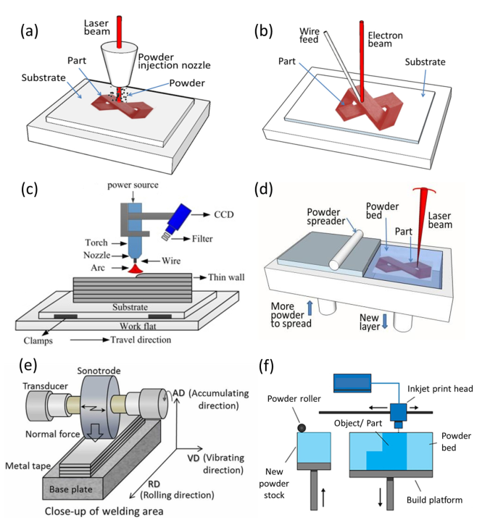
Figure 1-1: Schematic representation of common metal additive manufacturing processes. (a) DED using laser beam and powder; (b) DED using electron beam and wire feedstock; (c) DED using Gas Metal Arc (GMA); (d) PBF using laser (L-PBF); (e) Ultrasonic AM; (f) Binder jetting. Adapted from [12]
The focus of this dissertation is on powder bed fusion (PBF) processes. PBF processes are layer-wise processes where metal powder is melted to form each layer of the part atop the previous layer. L-PBF (laser energy source) process is shown in Figure 1-1 (d). E-PBF (electron beam energy source) is a similar process that differs primarily in the energy source i.e. electron beam rather than laser beam. Use of electron beam also necessitates a vacuum chamber rather than an inert gas chamber as used in L-PBF. The challenges involved in part qualification in PBF processes are discussed in detail in the next section.

Literature review on part qualification in metal AM
To understand why part qualification is challenging in AM, we first need to understand traditional manufacturing processes. In traditional manufacturing processes like rolling and forging, grain structure is dictated by gross processing conditions and remains fairly uniform across the entire structure like billets or rolled sheets. Therefore, testing properties of the material using a few exemplar samples is sufficient to understand average properties and determine variations around the mean. In AM processes, grain structure is significantly influenced by the build process itself. This has been demonstrated by many research groups [26–28]. However, due to lack of other well-developed approaches, AM parts continue to be tested using similar approaches to traditional manufacturing. Russell et al. [29] indicate that the approach to qualification being currently adopted includes qualification at every step of the pipeline i.e., design, process and material, quality control, non-destructive part evaluation and maintenance. This approach is largely based on statistical process control (SPC) concepts and relies on health monitoring of both the feedstock and the equipment. In principle, qualification of every aspect of the AM process may sound feasible. In reality, it is very difficult to put into practice without a significant waste of time, material and manpower resources. Furthermore, such an approach defeats the flexibility associated with additive manufacturing since qualification of every step of the production pipeline in a rigid manner can lead to significant waste generation and slow down production. Therefore, qualification on a part-by-part approach, with in situ monitoring approaches seems a much better solution.

Several papers have been published primarily in the last two decades on in situ monitoring and associated algorithms that enable a better understanding of AM processes. Based on an analysis of literature in part qualification and quality control of additive manufacturing parts, it is observed that most part qualification efforts focused on one of three aspects of AM processes: feedstock, process and final part quality. This categorization of AM qualification process is presented schematically in Figure 1-2 and discussed in subsections here.

Feedstock analysis
Metal additive manufacturing processes typically start with consideration of the quality of feedstock. In powder bed fusion, the feedstock is the metal powder while it is metal wire in case of wire arc additive manufacturing, a type of DED process. The focus of this dissertation is powder bed fusion processes and therefore this discussion is focused only on metal powder feedstock.

Several papers have been published by researchers interested in understanding the effect of different aspects of metal powder. Early on, before additive manufacturing became a potential avenue for part production, metal powders were studied for powder metallurgical purposes. In powder metallurgy, the primary purpose was to make metal powders into near-net shapes using compaction processes on powders and heating the compacted part to temperatures just below the sintering temperature [30]. Therefore, the field of powder metallurgy naturally fed into feedstock studies for powder bed fusion processes.
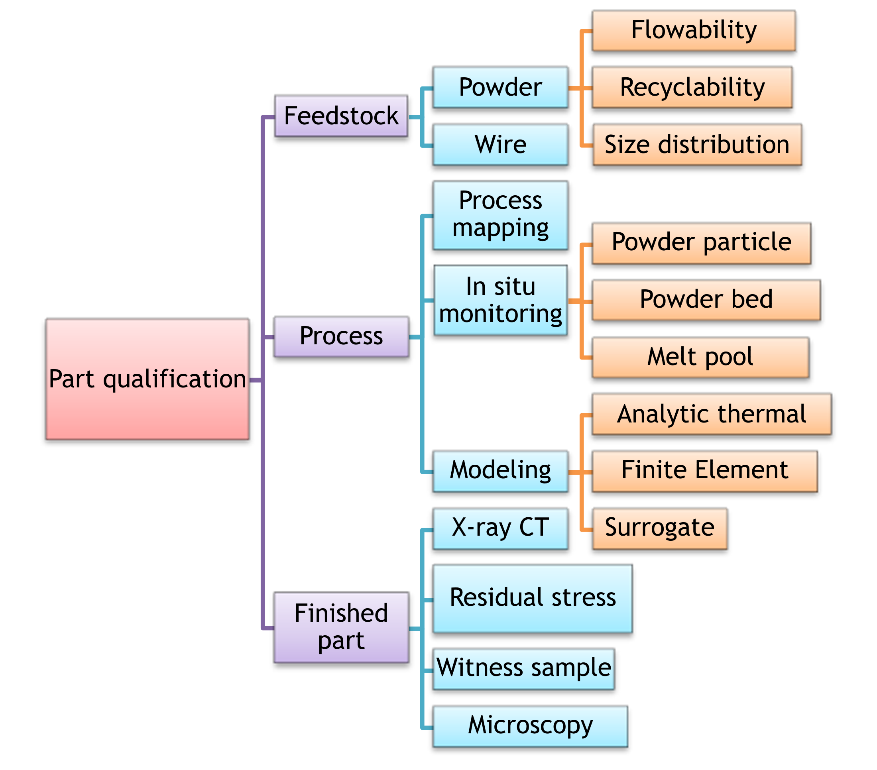
Figure 1-2: Schematic showing classification of different aspects of part qualification in powder bed fusion processes. Literature around each aspect is discussed in this chapter.
In the field of additive manufacturing, the focus is less on powder behavior in terms of sintering but much more on powder spreading and particle interactions that may lead to defects in parts. The economics of additive manufacturing also depend significantly on powder cost due to its influence on both direct material cost and indirect scrapped part cost [31]. Therefore, the trade-offs involved in powder selection and its influence on part properties have been studied by many authors. Several factors influence powder properties for additive manufacturing. Some of these are depicted in an Ishikawa diagram by Spierings et al. [32]. In this dissertation, studies that evaluate three major properties of powder: powder flowability, powder recyclability and powder size distribution are summarized. Alloy composition is not dealt with since the dissertation is not focused on any one alloy but on general method development and application for metal additive manufacturing.

Powder flowability refers to the ability of powder to flow through an orifice or a channel without being sticky or without self-agglomeration. This is important in metal powder bed fusion systems due to the need for a uniform layer of metal powder at the start of the process, leading to good quality layers that form a part [33] . However, in additive manufacturing itself, there has been no clear definition of powder flowability and consequently no specific method to measure it. Several approaches have been put forth in literature. Spierings et al. [32] demonstrated a method to calculate powder flowability as a function of avalanche angle, powder surface fractal and particle shape. Another way to measure powder flowability is by measuring dynamic flow characteristics using a rheometer. The Freeman rheometer [34] is a cylindrical device inside which powder is swirled using a blade like system that enables measurement of axial and rotational forces. The parameters measured include Basic Flow Energy (BFE) which indicates the ease of flow in a constrained environment and Specific Energy (SE) which indicates unconstrained flow properties [34,35]. Kiani et al. [36] used three different methods- the Freeman rheometer [34], a Mercury powder analyzer and a custom-built funnel method- to measure powder flow properties. They found that different aspects of powder properties influenced static vs. dynamic flow. Particle aspect ratio dictated static flow initiation, whereas particle size was better correlated to dynamic flow.

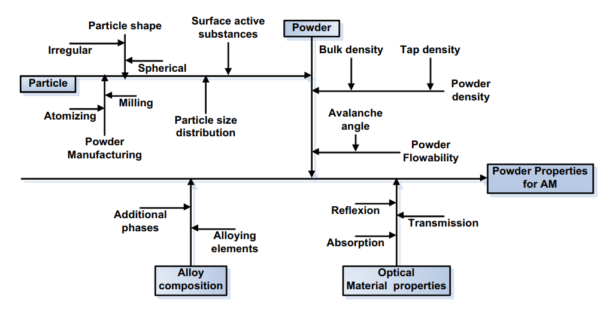
Figure 1-3: Ishikawa diagram showing different factors influencing powder properties. Source: Spierings et al. [32]
Beyond flowability, part properties are influenced by size and shape of powder particles. Spierings et al. [37] showed that particle size influences final part properties in laser powder bed fusion, with varying levels of fusion of particles depending on size distribution. Bierwagen and Sanders [38] came up with an analytical method to study the density of packing based on having a mixture of particle sizes. Boley et al. [18,39] showed that the packing of metal powders could lead to change in laser absorptivity in a powder bed, which may influence part properties. Bai et al. studied the effect of bi-modal size distribution of powders in binder jet printing [40], and showed that having a broad particle size distribution led to good powder bed coverage and flowability. However, some other powder studies [41–43] showed that the presence of fine particles led to poor powder spreadability and increased cohesiveness of the particles, leading to questions about the benefits of a broad powder size distribution.

A more granular approach to studying powder particle behavior is to carry out in situ imaging of the powder spreading process or use modeling approaches to study powder particle interactions. Nan et al. [44] modeled particle spreading and jamming in the powder bed fusion process using Discrete Element Method. They showed that the jamming behavior is dependent on the gap between the powder spreader blade and powder bed, with both particle velocity and spread particle volume depending on the gap height. Parteli and Poschel [42] developed a numerical tool to study the spreading of powder particles. They concluded that having a broad size distribution of powder particles may hinder powder flow, due to increased effective surface roughness of the powder and tendency of fine particles to form agglomerates. Escano et al. [41] used high speed X-ray imaging to understand powder spreading dynamics, including the dynamic angle of repose and coefficient of friction between powder and boundaries. They concluded that large particle size led to higher dynamic angle of repose and average slope flow velocity. They expressed similar conclusions as Parteli and Poschel on the effect of particle clusters leading to poor flowability. Snow et al. [45] proposed a set of metrics to quantify flowability of powders. These included (a) percentage cover of the build plate, (b) rate of change of avalanching angle and (c) rate of powder deposition. These metrics were shown to correlate well with powder spreadability.

Recyclability of metal powder is an important consideration especially for viable costs of PBF processes. Many studies focused on the effect of recycling powder on the final part properties and intermediate aspects like powder morphology [5], chemical composition due to in-process element pickup [5,46] and particle size distribution [5,46,47]. The results of these studies depend on the alloy chosen for study. In general, Ti-6Al-4V powders are shown to absorb oxygen during the Electron beam Powder Bed Fusion (E-PBF) process [5,46–49], which becomes a limiting factor for specific applications. Inconel 718 powders are shown to demonstrated powder particle agglomeration over increases reuse cycles [47,50–52]. These results are experimentally observed after the PBF process, i.e. through ex situ study of powder after multiple process cycles.

An important gap observed in powder studies is that most methods rely on experimental characterization of powder before and after use in the PBF process. Alternately, they predict the behavior of powder using models, but do not have direct experimental validation of the predicted behavior in real-world PBF systems. One of the aims of this dissertation is to fill that gap by developing an in-situ monitoring method to evaluate powder spreading in the E-PBF process. The developed method is data-driven, based on log files generated in the E-PBF process on the ArcamTM system. Details are discussed in chapter-2 and have been published as Chandrasekar et al. [53]

Process qualification
Reviews of in situ monitoring methods for additive manufacturing have been presented by Everton et al. [54] and Tapia et al. [55]. They indicated that several modalities of monitoring are applicable to additive manufacturing processes. For example, Everton et al. indicate many studies that have been conducted using imaging of the powder bed fusion process to identify defects associated with printing or to identify issues like overheating or curling of the part which may cause secondary damage to the system or the recoater blade. The primary modalities of monitoring are optical and infrared imaging [56–58] and pyrometry to monitor temperature [59]. Early efforts at feedback control [60] are also reviewed by Everton et al. Pyrometry is limited by speed of imaging and increasingly, infrared cameras are being used to monitor thermal behavior in PBF processes.

More recent reviews of quality control procedures in metal additive manufacturing are presented by Charalampous et al. [61], Lee et al. [62] and Kim et al. [63]. Charalampous et al. [61] focus on several Non-Destructive Evaluation (NDE) methods have been developed for part quality control in AM. They classify the stages as feedstock, in-process and, post-process phases of quality control. They also mention that there is a need for development of statistical and machine learning based quality control algorithms as opposed to ones that resemble traditional NDE methods. Lee et al. [62] took a different approach to the review of quality control methods in metal additive manufacturing, by comparing existing methods for metal additive manufacturing and welding. They indicate that similarities between welding and metal additive manufacturing processes lead to learning lessons from one and applying to the other. This similarity has been pointed out by other researchers [64,65] too. Lee et al. [62] point out that some methods e.g. acoustic methods for monitoring are well-developed for welding processes but not well utilized in the metal AM space. This points to a potential gap to be filled in research literature and real-world applications. Kim et al. [63] studied quality control methods in different modalities of additive manufacturing and compared the state of development in each of them. The conclusion from each of these reviews is that there is a need for integrated in situ monitoring systems that can relate process parameters to final part properties and identify regions of potential defects.

In this work, a broad classification of process monitoring literature is presented along the lines shown in Figure 1-2. Each of the following paragraphs deals with one of the following aspects of monitoring: process mapping, process monitoring and modeling approaches.

Process mapping
Process mapping refers to study of effect of different sets of parameters on sample geometries. Typical sample geometries are cubes or single bead welds and the effect of parameters like hatch spacing, laser power, exposure time, laser velocity, etc. on properties like melt pool depth, solidification parameters, final microstructure, etc. is studied. An example of a process map for Ti-6Al-4V is shown in Figure 1-4 [66]. This map indicates a way to determine a process window for each material, within which defects are expected to be minimal. The key idea is that porosity and defects in AM processes are dictated by a combination of laser power vs. beam velocity, since these parameters dictate the net volumetric energy density incident upon the material. This is analogous to weld literature. Process mapping and allied approaches have enabled insights into the physics of melting and solidification kinetics at play in AM processes. Relevant work has been done by various groups [26,67–70] for different material systems.

However, the process mapping approach may not be able to predict ideal parameters for part quality since varying part geometry also contributes to change in melt pool shape [71,72] and phase transformations. Therefore, solidification patterns and resulting properties of the part change as a function of part geometry, laser power, beam velocity, scan parameters and beam shape [73]. The usefulness of volumetric energy density alone has been questioned by Prashanth et al.[74]. This leads to alternate approaches based on process monitoring or modeling.
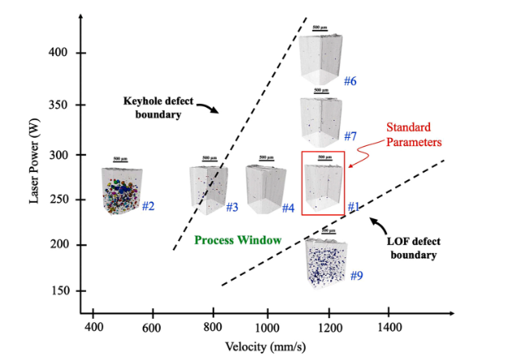
Figure 1-4: Process map for Ti-6Al-4V in the electron beam, wire-fed DED process (source: Gordon et al. [66])

Process monitoring
Process monitoring refers to developing an understanding of the AM process using sensors and/or algorithms, to observe the process and glean information about it. The data collected through monitoring could be used for defect identification or for further understanding of the effect of process parameters on physics of the process e.g. to understand thermal gradients and use them for microstructure tailoring. Process monitoring for AM processes can be done at different time and length scales. The different length scales can broadly be classified as: particle level, melt pool level and part geometry level. Time resolution typically decreases with decreasing length scale i.e. fine time resolution is required at small length scales while coarse time resolution is sufficient at high length scales. Particle level is not considered process monitoring in the broader sense since monitoring at this level enables a basic understanding of physics of the AM process, but cannot be scaled up to enable part quality monitoring. However, it is included in this review for completeness.

Powder particle monitoring
Powder particle interaction forms the basis of metal bonding in powder bed fusion processes. Studying powder level dynamics of PBF processes was done by Leung et al. [75]. They observed powder behavior in the melt pool, that can be used to build first principle models to study particle mixing dynamics and physical phenomenon in the melt pool. Figure 1-5 shows the development of denuded zone, powder entrapment, spatter and pore generation in a laser PBF process of Invar-36. Resolution at short time scales and fine length scales can be used to understand phenomena like spatter evolution, wetting of powder by melt pool, particle interactions, etc. Other groups have also used high-frame rate videos to study particle kinetics [76] in PBF processes and powder spreading dynamics [41].

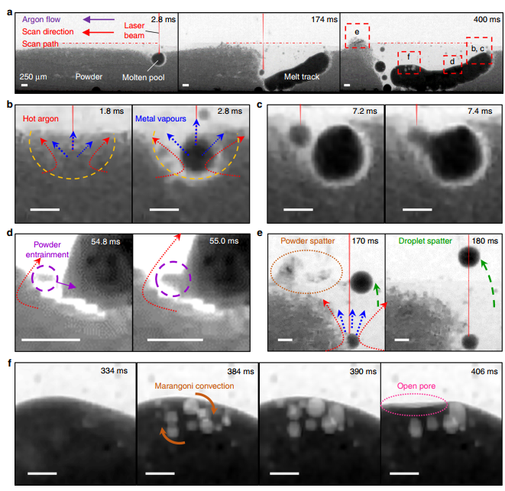
Figure 1-5: High-speed X-ray imaging to understand powder particle dynamics from Leung et al. [75]. (a) Time series images showing melt pool formation; (b) Denudation surrounding the melt pool; (c) Melt pool wetting; (d) Powder entrainment; (e) Spatter evolution; (f) Resulting porosity. Adapted from Leung et al. [75]

Melt pool monitoring
Melt pool level studies are commonly found in PBF literature. Several groups have used high speed videos in the optical or infrared range to study melt pool dynamics. These studies are mostly carried out over a single bead pass in laser PBF. A brief overview of some of these studies is provided here. Yuan et al. [77] used a convolutional neural network (CNN) to predict the track width, standard deviation of track width and track continuity of tracks printed using the SLM process. CNN layers are those in which spatial relationships are maintained in images using an appropriate mapping algorithm. They are most often used in image processing to capture spatial variations corresponding to specific image categories. For labeling the images, Yuan et al. used labels obtained using a height map of the printed tracks. The input to the CNN consisted of frames from a high-speed video recorded at 1000 Hz i.e. 1 frame per millisecond. Both regression and classification were carried out using three separate CNN networks: one each for track width, standard deviation and track continuity. This approach shows promise in eliminating post-build characterization of layers.

Kwon et al. [78] used a deep neural network to predict laser power based on melt pool images in a SLM process. They created a custom neural network for their application. The input to the network consisted of 60 X 60 pixel images of the meltpool that were cropped from high speed camera images obtained at a frame rate of 2500 Hz during the build process. These images were pre-processed using the “sum-of-pixel-intensity” histograms to remove noise. The neural network was trained to predict laser power for each input image, thereby acting as a regression model. The authors also studied the network’s classification performance by labeling any inference of laser power within a certain range of the correct value as correct and other classifications as incorrect.

It has been recognized that additive manufacturing of metals using SLM is similar to laser multi-pass welding except for complex boundary conditions being imposed. It is therefore relevant to point out that Jager and Hamprecht [79] demonstrated the use of principal components for abnormal melt pool identification in dynamic laser welding. They borrowed a concept called "Eigenfaces" that has been popularly used in face recognition [80]. The idea behind eigenfaces is that most faces can be decomposed into a weighted sum of components and these underlying components can be discovered using Principal Component Analysis (PCA). Similarly, Jager and Hamprecht decomposed melt pools into principal components. "Regular" melt pools that were known to be from error-free welding sequences were used in PCA to identify the principal components, using which each melt pool could be expressed as a weighted sum. A new melt pool to be analyzed could then be scored depending on how well it could be decomposed into a combination of principal components of regular weld pools. The score metric is called Distance From Feature Space (DFFS) error, which is a residual reconstruction error. Melt pools with high DFSS values could be identified as "abnormal" and the underlying weld process analyzed.

Scime and Beuth [81] used a computer vision-based approach for identification of anomalies in melt pools. Figure 1-6 shows their approach, where they extracted features of melt pool images using Scale Invariant Feature Transforms (SIFT) and Histogram of Oriented Gradients (HOG). These features were used to extract a dictionary of SIFT words from meltpools. Each meltpool was represented by a histogram of known words and used as fingerprints (histograms) to cluster similar meltpools. Classification of new meltpools was done in this framework using Support Vector Machines (SVM).

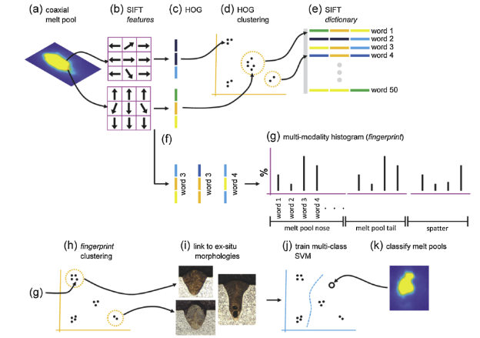
Figure 1-6: Steps used in machine learning algorithm trained by Scime and Beuth [81] to identify melt-pool anomalies.

Zhang et al. [82] demonstrated the use of Kalman filter to extract the region of interest from high speed images of the L-PBF process. They extracted features of interest from three categories: melt pool, plume, spatter. In all, Zhang et al. [83] extracted 18 features including melt pool area, plume area, plume major axis length, plume minor axis length, spatter velocity, mean spatter intensity, etc. These features were down-selected using PCA and used to classify between different quality of build scenarios. Classification performance was compared between CNN and SVM with hand crafted features used only in SVM. Results indicated that CNN was able to perform better than SVM, thereby indicating potential for use in quality monitoring in AM.

Part level monitoring: Sensor-based methods
Initial efforts in process monitoring were generally applied using thresholds on in situ monitoring data, to analyze for the presence of defects. These will be reviewed briefly before delving into process monitoring using algorithms to extract process insights.

Most of the early work in part quality monitoring for AM included in situ part monitoring through various sensors. A review of in situ process monitoring and in situ metrology for metal AM was presented by Everton et al. [54], who in turn built their work on an earlier review of process monitoring and control by Tapia et al. [55]. Everton et al. mention that most metal AM machine manufacturers provide an instrument or two for in situ process monitoring in their system. For example, ArcamTM , a company that makes E-PBF systems, integrates a near IR (infrared) camera in their system. In E-PBF systems, Rodriguez et al. [84], Schwerdtfeger et. al. [85] and other researchers showed that it is possible to integrate an IR camera into EBM systems and identify defects since the IR intensity signal depends on local thermal conductivity of the part. Defects such as pores typically have poor thermal conductivity and can be identified as hotspots in many thermal images. Similarly, Mireles et al. [60] showed that in-situ IR imaging could detect defects within a size resolution of 600 microns but smaller seeded defects may not have been detected either because they were healed when layers on top were melted or because they were too small for IR imaging to capture as a change in thermal conductivity. Defects detected using IR thermography by Mireles et al. is shown in Figure 1-7. Cordero et al. [86] compared a multi-wavelength pyrometer with an infrared camera for detection of seeded defects in a part. They showed that both modalities performed well in detecting process anomalies, as indicated by ground truth data from CT scans. Infrared cameras require emissivity calibration which can be part dependent but can still be used effectively to capture thermal differences arising due to changes in the process. Boone et. al. [87] showed that using silicon camera technology in EBM can enable higher resolution images to be collected at high speeds that enable melt pool tracking and defect detection. Their work included correction of estimated temperature using an emissivity mask that was made possible due to high-speed imaging and image processing algorithms. Grasso et. al. [88] demonstrated the value of log file analysis and control chart monitoring to differentiate out-of-control EBM builds vs. in-control builds.

In L-PBF systems, an in situ monitoring method that went from research lab to commercial application is the coaxial camera and photodiode setup for SLM process that was developed and patented by Kruth and Mercelis [89]. Their setup was licensed by Concept Laser, which developed the mechanism further for their L-PBF systems. Toeppel et al. [90] demonstrated that high speed IR camera and photodiode signals can be used to find porosities in a part in the SLM process. Melt pool size and intensities are captured by an IR camera and photodiode integrated into the system. The camera operates at a sampling rate of 15 kHz while photodiode signals are captured at 50 kHz. Image reconstruction in 3-D is done for each layer at the end of a layer print. The reconstruction can be used to identify part defects. As detailed by Everton et al. [54] , various groups used pyrometers and high-speed cameras to monitor phenomenon like balling [91], powder consolidation [59], melt pool monitoring [57], etc.

The studies cited above used in situ monitoring to extract information about the PBF process but most did not make explicit use of machine learning methods to infer process behavior or underlying physics. The next section deals with research work that uses algorithms to extract information about the AM process, using data obtained during the AM build process.

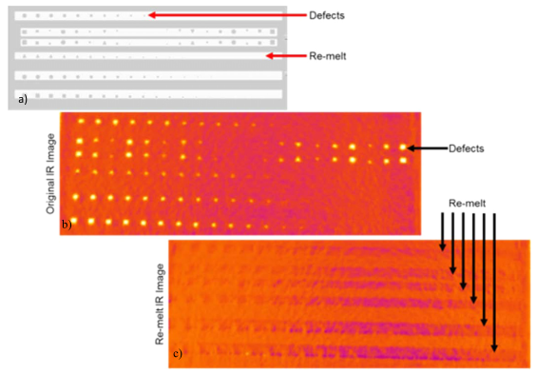
Figure 1-7: Identification of defects using IR-thermography in E-PBF systems. Adapted from Mireles et al. [60]

Part level monitoring: Algorithm driven methods
Scime and Beuth [33,92] used optical images captured at the beginning of each layer in a L-PBF process to evaluate powder spreading and detect potential failures that may lead to issues in part quality. They used different approaches to detect powder spreading instabilities. One approach [33] was to extract “features” manually for classification of powder spreading defects. This was done using image processing approaches like Scale Invariant Feature Transforms (SIFT), using which each image was converted into a “fingerprint”. These fingerprints were then used for classification of the image into various defect categories or non-defective category. Another approach [92] was to extract features automatically from powder bed images using neural networks. This approach used the concept of “transfer learning”. Transfer learning refers to the idea that a neural network that has been trained on an unrelated task can be used as a feature extractor for another image classification task. For instance, AlexNet [93] is a neural network that was developed for the purpose of competing in the ImageNet Large Scale Visual Recognition Challenge (ILSVRC-2010), which involved classification of images into 1000 categories, like refrigerator, microwave oven, scissors, scorpion, walnut, cashew, etc. This network has 2 broad parts to it: the feature extraction and classification parts. The idea behind transfer learning is that the feature extraction layers of the neural network can be used without further training to extract features for other image classification tasks. Scime and Beuth used AlexNet to extract information about powder bed images. They then built a custom classifier to classify powder images into relevant categories like powder streaking, recoater hoping, etc. Scime et al. [94] developed the method further to enable real-time monitoring across different PBF machines. This system has been integrated into a tool suite termed Peregrine for monitoring powder bed systems [95]. Liu et al. [96] proposed a system to optimize laser powder bed fusion processes using prior knowledge from other PBF systems and a machine learning framework to transfer knowledge. Grasso et al. [97] used image segmentation to extract Regions of Interest from the plume emitted during L-PBF process. They then use control charting to identify unstable melting regimes in the process.

Grasso et al. [98] used a video stream from an IR camera to detect areas in a L-PBF build that were prone to overheating. The key idea was to use Principal Component Analysis on time series data and compute an anomaly detection metric i.e. Hoteling’s T² metric. This is shown in Figure 1-8. Clustering of regions using the T² metric enables detection of regions that overheated in the build. Khanzadeh et al. [99] used multilinear PCA to analyze infrared data streams and combined it with a control charting approach to identify process changes as it occurs. Aminzadeh and Kurfess [100] used Bayesian classification to identify non-defective (smooth) layers of a build versus defective (rough) layers. They tried using percentage of black areas in a thresholded image after segmentation as the feature based on which Bayesian classification could be done. But this approach did not result in good segregation between desired zones of interest. Feature extraction using Fast Fourier Transform on input images led to frequency-based features from thresholded images. These led to better classification results.

Imani et al. [101] aimed to understand the effect of laser velocity, power and hatch spacing on porosity. They carried out X-ray CT analysis of specimens. They also investigated optical images captured during the build process. The analysis included post laser scan and post recoat images for every layer. Features were extracted based on spectral graph theory and multifractal lacunarity analysis. Classification was carried out using various methods (SVM, Complex tree, Linear Discriminant Analysis, K-Nearest Neighbors, Ensemble (bagged trees) and feed forward neural networks). Combining spectral and multifractal analysis led to best results in terms of classification F-score.

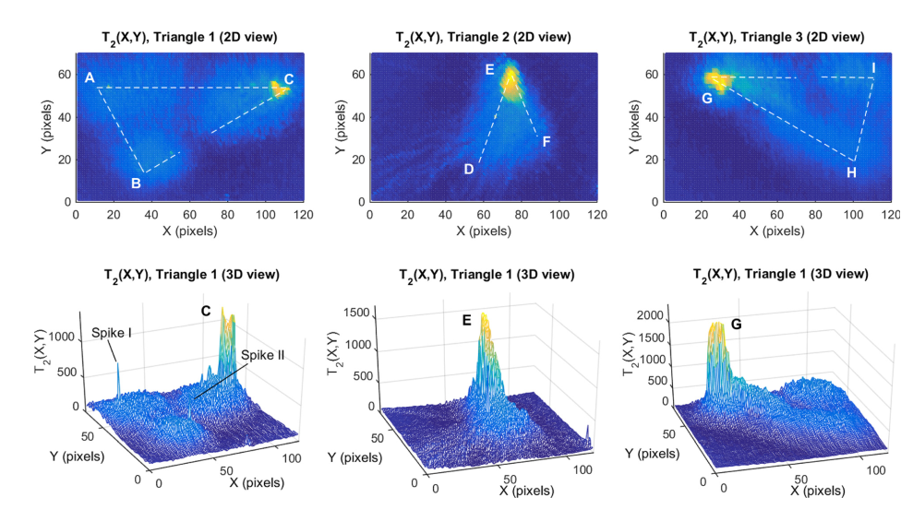
Figure 1-8: 2-D plots (top row) and 3-D plots (bottom row) showing T² metrics for different layers of a build. High values (shown in yellow) indicate regions of overheating. Adapted from Grasso et al. [98]

Imani et al. [102] developed a deep learning based anomaly detection process, which involved specific changes made for image processing of optical images in AM. Their approach addressed issues like insufficient contrast, changing layer geometry and lack of consistent region of interest to be sampled. They used CAD geometry to register layer-wise images, and partitioned each layer into multiple sub regions of interest, on which a deep learning algorithm was implemented.

Modeling approaches: Surrogate models
Rather than using data from sensors, it is possible to use data from models or simulations to determine part quality under varying input parameters. Such models are called surrogate process models.

Kamath [103] described the surrogate modeling process in detail. Their work takes an iterative approach to alternate between experiments, physics-based model and data driven models for laser powder bed fusion. A physics-based model (Eager Tsai model) was used to predict melt pool depth, width, etc. using a Gaussian beam on flat plate theory. Experiments were used to verify that these values were within reasonable error limits. The physics-based model was used to sample a dense feature space and create data points to build a surrogate model. The surrogate model can be used to identify viable regions in the build parameter space for desired melt pool depth. This approach was repeated using a more complex physics-based model (Verhaeghe model) that took powder effects into consideration. The same iterative approach was followed to build a Gaussian Process model which was then used to identify viable regions in design space. This paper demonstrates possible ways to combine physics-based models, experiments and data driven surrogate models to optimize parameters for laser AM.

Stathatos et al. [104] used a surrogate model approach to predict temperature and relative density along an arbitrarily long laser weld path. Their surrogate modeling approach consists of a master Artificial Neural Network that is trained using 450 FE models that each replicate a short random walk scenario. The master ANN is used in an iterative fashion. It takes as input 17 features- 8 to describe the long-term memory trajectory of the path, 8 for the short-term memory trajectory of the path and 1 for temperature feedback. The feedback term is updated iteratively till certain conditions are met. Thus, this approach combines FE modeling along with ANN to predict AM relevant physical quantities in real-time and can be used in a real-time monitoring application.

Chowdhury et al. [105] used a surrogate model to compensate for part distortion due to residual stresses. Their approach was to use a finite element simulation to predict thermal distortions for an AM part. The resulting distorted geometry was used as input to a neural network. The neural network was trained to produce the original part geometry (without distortions) as the output. This approach made the network learn compensation required in input part geometry in AM to arrive at desired output geometry. Their process workflow also included identification of optimal build orientation as part of the Design for AM (DfAM) process. The workflow is shown in Figure 1-9.

Modeling approaches: Thermal modeling
Modeling approaches discussed in the previous section were primarily concerned with predicting broad variables of value in the AM process e.g. melt pool depth, temperature and part distortion. However, many analytic models were also developed with varying degrees of assumptions, for specific use in understanding the underlying thermal processes and associated part properties in materials. Specifically, prediction of thermal histories, thermal gradients and cooling rates are especially important for microstructure tailoring in AM.[27,28].
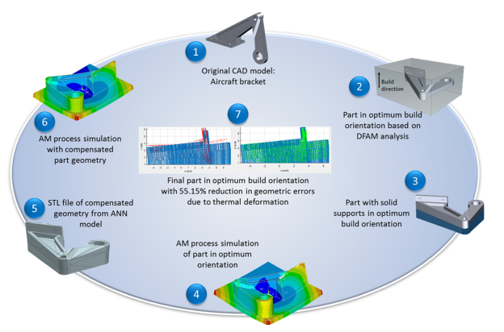
Figure 1-9: Process workflow for part quality and manufacturability optimization at the part level. Adapted from Chowdhury et al. [105]

Roy and Wodo [106] developed a surrogate model to predict thermal signatures in the L-PBF process. Their model was based on the underlying idea that there is a significant amount of periodicity and repetitive computation that occurs in thermal models of the AM process. Their model is built to work using features extracted from the G-code of the part build and predict thermal signatures using a neural network. The neural network is initially trained using a physics-based model but once trained, produces thermal histories in significantly lower time than a physics-based thermal model.

Schwalbach et al. [107] created an analytic discrete source model that simplifies the moving heat source as a series of discrete point sources and determines the effective thermal signature at each point in the part. This model, while making many assumptions, enables computational tractability of heat transfer modeling in the L-PBF process. Donegan et al. [108] used symbolic time series analysis methods to analyze thermal history obtained from the discrete heat source model [107]. Symbolic time series analysis resulted in symbol sequences corresponding to temperature history for each point in the build. These symbol sequences were then analyzed using a clustering method. Analysis of different scan strategies led to insights about the effect of various scan strategies on heat transfer within the build. For example, using a snake scan raster pattern led to regions near turn around points where heat accumulation occurred. This could be identified by clustering analysis. Similarly, using an interleaved scan pattern (see [108]) led to a more uniform spread of heat as evidenced by the relatively uniform clustering. Use of symbols to delineate phase transition, melting point and boiling point enabled interpretability of symbols during the clustering process. Donegan et al.’s work is unique from the perspective that it uses modeling in conjunction with time series analysis to give a peek at possibility of tailoring scan strategy for given geometry to produce desired heat transfer characteristics. A similar study by Groeber et al. [109] indicated that thermal modeling using the discrete source model [56] could be effective in explaining porosity and even the orientation of pores with reference to scan strategy. They compared high resolution images of porosity in certain sections of a build with beam stripe patterns and associated thermal fields. They found that stripe boundaries of scan patterns seemed to lead to porosity (Figure 1-10), while insufficient fusion between neighboring scan tracks also led to lack of fusion porosity. This work hints at the possibility of using thermal modeling in conjunction with data analytics to understand heat transfer, defects and microstructure evolution.

Microstructure control in AM has been demonstrated by various groups [21,22,28,110]. The ability to control cooling rates and thermal gradients in AM leads to the ability to control microstructures in certain materials which have an accessible range of temperatures in which microstructure variation is exhibited (e.g. Inconel 718 [28,110]). Variation in properties of AM parts compared to conventionally manufactured parts is primarily due to the variation in microstructure that is inherent to AM parts. In this context, it is essential to understand the process parameters that lead to different microstructures. Basak et al. [111] present a review of microstructure evolution in AM parts, based on solidification kinetics. They emphasize the role played by process parameters like scan speed, energy source power, thermal diffusivity of the material, substrate temperature on resulting microstructure.

Given the large number of parameters that influence microstructure evolution, it is essential to have modeling approaches that approximate and predict microstructure based on heat transfer modeling within the part. The original steady state temperature field after one pass of welding was analyzed by Rosenthal [112,113] who developed an equation to predict steady state temperature due to a moving, point heat source on a semi-infinite plate. Extensions of Rosenthal model include variants to predict transient temperature [114,115] and different shapes of the heat source (Gaussian, elliptical, etc. [116].
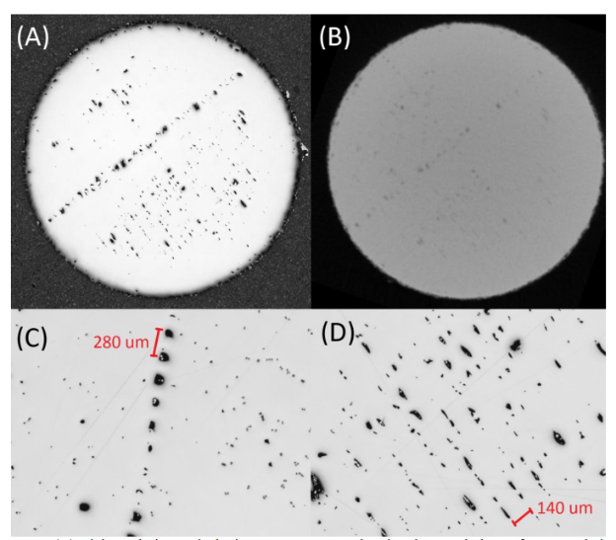
Figure 1-10: Porosity associated with a layer seen in high-definition optical microscopy (a); Same section seen in a CT scan (b); Zoomed in images show pores at beam turning points (c) and between hatch space lines (d). Adapted from [109]

Current models being used include a semi analytical heat transfer model [117–119], graph theory-based model [120] and discrete source model [107]. Based on these models, it is possible to predict resulting microstructure of a part using the Columnar to Equiaxed Transition(CET) theory [121], though there are limitations associated with it due to assumptions. Raghavan et al. [27] showed that numerical modeling is useful to understand variations in texture associated with parts printed in E-PBF systems. Their work points out that preheat temperature and dwell time are important factors associated with thermal gradients and associated texture evolution in AM.

However, solving the inverse problem of tailoring scan strategy based on desired microstructure remains a challenge. One approach to pre-determine scan strategy to obtain desired microstructure is detailed by Halsey et al. [122]. They used genetic algorithms combined with a greedy search optimization to come up with scan strategy pertaining to desired microstructure. Limited work has been done on scan strategy optimization for microstructure control in varying geometries. This is an open area of research.

Finished part inspection
In traditional manufacturing processes, inspection of representative coupons or samples from finished parts was often sufficient to ensure part quality. However, in additive manufacturing such inspection is often insufficient due to the factors discussed in the introduction to this chapter. An analogous way to determine part quality is to use “witness coupon” testing. In this approach, the key idea is to build a specimen on the powder bed as a “witness” to the process parameters used and in situ process conditions. Shrestha et al. [123] showed that witness coupon based calibration may be sufficient to ensure tensile properties of a part, but insufficient for fatigue properties where the local nature of porosity may influence behavior significantly. Going beyond tensile properties, witness coupons are unlikely to be sufficient to capture the effect of geometry, scan strategy, hatch parameters on a part’s microstructure and properties. For instance, Prashanth et al. [74] asked the important question “is energy density a reliable parameter for material synthesis by selective laser melting” in the title of their paper. They indicate that while energy density has been an oft-used parameter to indicate the quality of melt and associated porosity in L-PBF parts, it is insufficient to capture hatch spacing and scan parameters. It is in this context that in situ process monitoring becomes important to validate properties of parts in the PBF process.

Going beyond witness coupons, X-ray computed tomography is a popular method to look “inside” a part and understand part quality especially with regard to porosity levels. Du Plessis et al. [124] presented a study of micro-CT tests of different specimens with varying defects, as evaluated by different laboratories in a blind setting. While the “defects” were identified by all the participants, the authors discuss the variations in quantification of micro-CT results and further steps in the direction of part qualification using CT techniques. Rodriguez-Sanchez et al. [125] present a review of sources of noise in X-ray CT. They also discuss why it is essential to account for not only noise but also other sources of error like beam hardening, scattering and blurring while post-processing results from X-ray CT techniques. Several researchers have published work on improving the capabilities of CT at detecting pores in AM. Lifton and Lui [126] proposed an adaptive thresholding algorithm for segmentation of pores in metal samples from AM. Their algorithm aims to remove beam hardening effects that occur especially when scanning high density metal parts in the X-ray CT process. Ziabari et al. [127] developed a deep-learning based algorithm to remove beam-hardening artifacts and enable detection of pores, at faster speeds than iterative image processing algorithms while maintaining equal levels of accuracy.

Given the challenges around part qualification and standardization of processes for further adoption, standard test artifacts have been proposed to encourage collaborative and comparative analysis from research groups. Taylor et al. [128] proposed a new test artifact that could enable part level inspection e.g. dimensional inspection, tolerances, distortion, and deeper inspection e.g. effect of overhangs, lattices, channels, thin features on thermal history, anomaly detection. Such efforts could enable more standardization in the AM research community, though the merit in alternate approaches is not diminished.

Summary of literature
This chapter reviewed published literature on determination of part quality in AM parts. A brief overview of research on feedstock quality, process mapping, and in situ monitoring was given. A detailed look at various data-driven approaches to part quality inspection was provided at the particle, melt pool and part levels. Surrogate models that use simulated data rather than measured data were also described briefly. A few approaches to thermal modeling to predict microstructure evolution was presented. Finally, new research into the field of tailoring scan strategy for desired microstructure was presented.

The objective of the literature review is to identify suitable challenges pertaining to gaps seen in literature, especially in in situ monitoring and part qualification. Of course, the challenges facing the research community in AM will require broader and sustained efforts on many fronts, including in situ monitoring, to fully realize benefits.

The key gaps identified in literature are summarized below:
- Lack of well-developed methodology to analyze thermal signatures in real builds. This is exacerbated by both the quality and quantity of data emerging from in situ thermal monitoring.
- Need for ways to understand powder behavior during the PBF build process.
- Study of inert gas atmosphere and effects on thermal behavior in PBF processes.
These are addressed in the research work presented in this dissertation.

Novel contributions
The key contributions in this dissertation lie in the development of data science tools and algorithms towards enabling in situ monitoring-based part qualification in AM. To this end, the primary contributions can be summarized as listed below:
- Development and demonstration of a data-driven methodology to understand powder spreadability in E-PBF process using log file data generated in the Arcam system.
- Development of a similarity analysis algorithm to compare thermal signatures across different regions of a part using in situ infrared monitoring of the AM process.
- Validation of generalizability of the similarity analysis approach to thermal signature evolution in lattice structures.

The rest of this dissertation is organized as follows. Chapter-2 contains research on in situ monitoring of powder spreadability in the E-PBF process. The effect of recycling Ti-6Al-4V powder and Inconel 718 powder on powder spreadability in the E-PBF process are studied using log file data mining. Results are correlated with microscopy and analyzed. Chapter-3 contains details of a novel similarity analysis algorithm developed for thermal signature analysis in metal AM. Results from application of the algorithm to study differences in thermal signatures arising from part geometry are presented. Corresponding microstructure from different regions of the part are analyzed and correlations between thermal signature and microstructure are presented. Chapter-4 demonstrates generalizability of the similarity analysis algorithm to thermal signature analysis in lattice builds. The effect of inert gases on thermal signatures in lattice nodes is studied and conclusions are drawn about the interplay of geometry, scan strategy and inert gas in thermal behavior in L-PBF processes. Chapter-5 contains directions for future work and conclusions.

DATA MINING TO STUDY RECYCLABILITY OF TI-6-4 AND INCONEL 718 POWDER in electron beam powder bed fusion

In this chapter, the details of log file data mining that enabled an understanding of powder spreading behavior in Electron beam Powder Bed Fusion (E-PBF) are presented. The analysis presented here indicates that log files that are created during the E-PBF process in the Arcam ™ system can be used to understand powder raking behavior. Raking behavior refers to the movement of powder rake across the powder bed in the duration between layer prints. Information about rake movement, specifically the number of times it moves across the powder bed to create an evenly thick layer of powder for creation of the next layer, one of the best indicators of powder spreadability in situ in the Arcam ™ EBM system. Deciphering patterns in the raking system behavior enables an indirect inference of powder clumping and sintering that occurs before layer print in the E-PBF process.

The work presented in this chapter was published in the journal “Additive Manufacturing” and has been reproduced with minor modifications in section 2.5 . The paper can be cited as:
S. Chandrasekar, J.B. Coble, S. Yoder, P. Nandwana, R.R. Dehoff, V.C. Paquit, S.S. Babu, Investigating the effect of metal powder recycling in Electron beam Powder Bed Fusion using process log data, Additive Manufacturing. 32 (2020)

Sujana Chandrasekar and Jamie Coble designed the data analysis methodology. Sujana Chandrasekar created and executed the analysis and wrote the manuscript draft. Jamie Coble contributed to the analysis and manuscript editing. Sean Yoder, Ryan Dehoff and Vincent Paquit contributed toward discussion of results. Peeyush Nandwana designed the experimental study and provided discussions on powder sintering behavior. Suresh Babu conceptualized the study, supported discussion of powder sintering and contributed to manuscript writing and editing.

Abstract

Recycling metal powders in the Additive Manufacturing (AM) process is an important consideration in affordability with reference to traditional manufacturing. Metal powder recyclability has been studied before with respect to change in chemical composition of powders, effect on mechanical properties of produced parts, effect on flowability of powders and powder morphology of parts. However, these studies involve ex situ characterization of powders after many use cycles. In this paper, we propose a data-driven method to understand in situ behavior of recycled powder on the build platform. Our method is based on comprehensive analysis of log file data from various sensors used in the process of printing metal parts in the Arcam Electron Beam Melting (EBM) ® system. Using rake position data and rake sensor pulse data collected during Arcam builds, we found that Inconel 718 powders exhibit additional powder spreading operations with increased reuse cycles compared to Ti-6Al-4V powders. We substantiate differences found in in situ behavior of Ti-6Al-4V and Inconel 718 powders using known sintering behavior of the two powders. The novelty of this work lies in the new approach to understanding powder behavior especially spreadability using in situ log file data that is regularly collected in Arcam EBM® builds rather than physical testing of parts and powders post build. In addition to studying powder recyclability, the proposed methodology has potential to be extended generically to monitor powder behavior in AM processes.

Keywords

Electron beam Powder Bed Fusion (E-PBF); Ti-6Al-4V; Inconel 718; Data-driven analysis; Powder recycling

Introduction

Additive Manufacturing (AM) has evolved to become a viable option for industrial production of parts with complex geometry, especially in the aerospace, medical and nuclear industries [3,5,129]. This is primarily because of reduced waste generated in the AM process, the ability to manufacture parts that have intricate and complex geometric features for specific functions, and aerospace parts that have high buy-to-fly ratio compared to traditional manufacturing [5]. These enablers are especially desirable for parts made of expensive metals like titanium where waste reduction leads directly to cost savings. In this context, the affordability of material feedstock used in AM can be further improved with recycling of metal powders used in the process. However, given the critical function performed by the AM parts, particularly in safety-critical applications like aerospace and nuclear power, it is important to ensure quality of parts made by recycled powders is equivalent to that of fresh powders.

Many studies have been performed to understand powder recyclability with regard to its effect on particle morphology [46], flowability [46,48,130], particle size distribution [5,46,49], and oxygen pickup [5,46–49]. A brief review of powder recyclability studies in the Electron beam- Powder Bed Fusion (E-PBF) process and Selective Laser Melting (SLM) process literature is given here. Common trends emerge since both processes are powder bed fusion processes. Recycling of Ti-6Al-4V powders led to an increase in oxygen content [5,46–49], which was the limiting factor in powder reuse for various applications [5,47]. The effect of increased oxygen content on mechanical properties of titanium parts has been studied by various groups with the conclusion that oxygen increased part strength but lowered ductility and toughness [131–134]. These conclusions were shown to hold for parts made of recycled titanium powder [49] due to the increase in oxygen content in powder. Contradictory conclusions were reached by research groups [46,130] on effect of recycling on flowability of powder. A study on the effect of recycling on fatigue life [135] indicates that recycled Ti-6Al-4V powder led to parts with lower elongation and reduced breakage area even after Hot Isostatic Pressing that typically closes pores and improves properties. In summary, effects of recycling Ti-6Al-4V powder on part and powder properties have been studied using ex situ analysis methods by different research groups.

There is limited literature on recycling of Inconel718 powder. In general, research papers [47,50,51] report an increase in powder agglomeration and particles becoming less spherical in shape with increased recycling of Inconel718 powder.

Recyclability studies cited above have varied in their approach but a general framework was proposed by Cordova et al. [52]. The framework consisted of tests to decide whether a powder can be reused in the SLM process based on measured properties like particle shape, powder flowability, chemical composition, and density. It can potentially be extended to the E-PBF process too. Standards developed for characterization of metal powders for AM and their systematic use has been provided by Slotwinski et al. [136].

The above-mentioned studies around recyclability have focused on ex situ characterization to understand the effect of recycling Ti-6Al-4V and Inconel718 powders in the E-PBF or SLM processes. Ex situ characterization can be time consuming and expensive. We propose in situ characterization of powder behavior using data stored in log files, i.e. data from in-built sensors in the Arcam Electron Beam Melting (EBM)® system. Information about Arcam EBM ® software and log files can be found in chapter 5 of [137]. To our knowledge, only one other published work i.e. Grasso et al. [88] has focused on using log file data to understand build characteristics. While Grasso et al. focused on distinguishing between in-control and out of control builds, our work is focused on understanding powder behavior using log file data. In this paper, we demonstrate a data analysis method to study powder behavior, especially spreadability, in the E-PBF process. Our hypothesis is that data collected in the log file of the Arcam EBM® system can be used to understand rake motion and thereby powder spreading during the build process. We expect powder behavior on the build table to change due to reuse of powder and want to explore whether the change can be detected using log file data. We therefore use data collected during powder recyclability tests of Inconel 718 and Ti-6Al-4V alloy powders that has been published earlier [47].

The paper is organized as follows: Section 2.4 contains a brief description of E-PBF builds used in this study. Section 2.5 presents an overview of the relevant mechanics of the Arcam machine and outlines the data available in log files used in this study. Section 2.6 describes the data analysis approach in detail. Section 2.7 contains results of this data analysis method on recycled powder build log files. Conclusions drawn from this study and potential areas of future work are summarized in Section 2.8 .

Experimental details

Experimental data in this paper is based on log files, generated by the Arcam EBM® system, of builds used to study powder recyclability by Nandwana et al. [47]. The Arcam EBM® system is an E-PBF system to build metallic parts layer-by-layer. In their work, Nandwana et al. studied recyclability of Inconel 718 and Ti-6Al-4V alloy powders in the EBM® process using an Arcam A2 machine. They built six builds using Inconel 718 and five builds using Ti-6Al-4V powder. The build geometry is shown in Figure 2-1. The first two Ti-6Al-4V builds reached >88% of planned build height but failed to complete due to arc trip issues. They are therefore excluded from recyclability analysis but presented for completeness by Nandwana et al. [47]. We consider log file data from all five builds of Ti-6Al-4V in our analysis to aid comparison with results presented by Nandwana et al. [47]. Similarly, the fifth build of Inconel 718 failed to complete but is included for completeness in comparison with Nandwana et al. [47].

The recycling process is depicted schematically in Figure 2-2 and described here. The build process started with approximately 100 kg of the alloy powder. The first build was intended to be the tallest and its height was designed to target complete emptying of powder hoppers at the end of the build. This was done to ensure that all powder would be exposed to electron beam before being recycled. Build heights did not line up in descending order due to powder spillage and failed builds, as described in the results section of this paper.

Once completed, the build was removed from the Arcam build chamber (dotted red arrows in Figure 2-2) and leftover powder in the chamber was vacuumed (dashed blue arrows in Figure 2-2) and collected. A small quantity of powder fell through the powder sensors as required by the Arcam EBM ® rake control system. This will be explained in the following section of the paper. Powder in powder sensors was discarded from the study. Partially sintered powder from the external surface of the build was recovered using the Powder Recovery System (PRS) in the Arcam EBM® system. The vacuumed powder was mixed with recovered powder from PRS and sieved on a vibratory sieve through a 100-mesh (150 microns). Powder particles remaining in the sieve, i.e. particles bigger than 150 micron, were discarded.

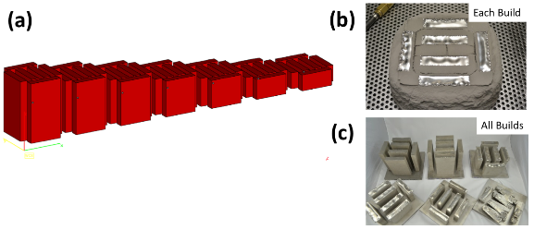
Figure 2-1: (a) Schematic of build design used in recyclability study [47]. After each build, the height of the next build was reduced to allow for the reduction in the total available powder; (b) Partially sintered powder can be seen on the exterior surface of the build before the powder recovery operation. (c) Final finished builds are shown with 1 failed build

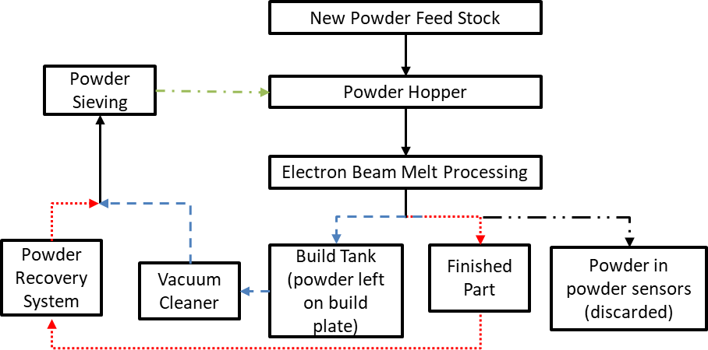
Figure 2-2: Schematic of powder recycling process used in recyclability study. Adapted from [47].
A sample was collected from the sieved powder for ex situ analysis. The sieved, recycled powder (dot-dash green arrow in Figure 2-2) was then emptied into the two powder hoppers and the next build was printed. This process was repeated till the target number of builds had been built. As a part of the qualification and validation of AM processes, the underlying log files were stored, but never analyzed. This research focuses on using these data to understand powder behavior, specifically powder spreadability, during the build process.

Operation of Arcam EBM and rake control logic

A brief description of the working of the Arcam EBM® system is presented here. The Arcam EBM ® system is shown schematically in Figure 2-3, Figure 2-4 and Figure 2-7. The system consists of a vacuum chamber which contains an electron beam generation and deflection system, two powder hoppers, a build platform, a rake and two powder sensor collection bins beneath the build table. The powder hoppers are gravity driven and deposit powder as mounds at the two ends of the build platform.

The rake starts the build process by spreading a preset thickness of powder across the build platform. Some powder on the build plate falls through the powder sensor at either end and is used as a control signal for rake movement as described later in this section. A de-focused electron beam pre-heats powder that has been spread on the build table at the start of the build. The aim of pre-heating is to partially sinter powder so that these powders melt without issues like “smoking” [138] during the build process. After the pre-heat step, a focused electron beam traces a path along the powder bed that corresponds to the cross-section to be built.

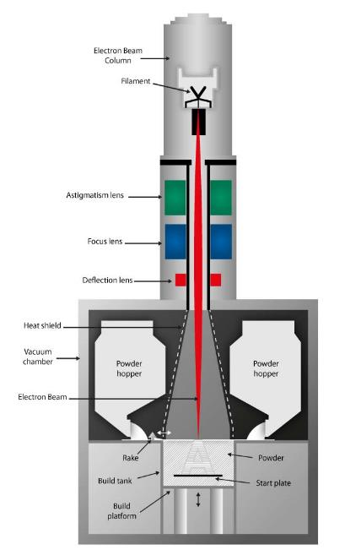

Figure 2-3: Arcam EBM® system schematic (Source: http://www.arcam.com/technology/electron-beam-melting/hardware/)

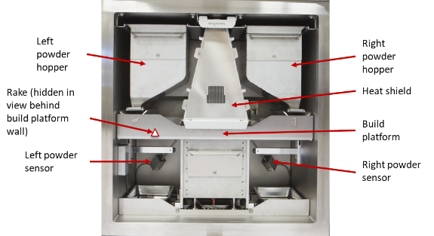

Figure 2-4: Inside view of Arcam EBM ® system. Powder hoppers, powder sensors, build platform and heat shield are seen.. Adapted from: http://www.arcam.com/technology/electron-beam-melting/hardware/

Powder along the beam path melts and forms a layer of the part being built. Once a layer is completed, the build platform is lowered by a preset height and the steps above are repeated to build the next layer. For each of the builds described in Section 2.4 , log file data were generated by Arcam EBM® and stored. Arcam log files record process parameters over the course of the build. The parameters used in this paper are rake position, rake sensor pulse and layer height, all recorded with corresponding time stamps. Rake position is the horizontal position of the rake along the build platform. Rake position changes as a function of time when powder is being spread on the build platform. Rake sensor pulse signal measures the time for which powder falls through the powder sensor as the rake spreads powder. It is an indirect measure of quantity of powder that falls through the powder sensors. Layer height records the height of the build after each layer is completed.

The data associated with analysis in this paper has been archived and is available at the link provided in the appendix.

The analysis in this research focuses on rake motion as an in situ indicator of powder characteristics, specifically powder spreadability. For ease of reference, we define terms associated with data analysis. A “layer print” is the period over which the electron beam is turned on and a layer is being printed. “Rake event” refers to the motion of the rake across the build platform. This occurs between successive layer prints. Figure 2-5 shows two rake events and a layer print in between. During a layer print, the rake position remains constant as the rake is stationary at one end of the build platform. A “rake pass” refers to motion of the rake from one end of the build platform to the other. The set of rake passes that occur between two layer prints comprise the rake event.

Our analysis is based on data collected during rake events i.e. when the rake is in motion and interacting with the powder. Rake motion may proceed under default or abnormal conditions depending on rake sensor pulse values. Under normal conditions, the rake event consists of three rake passes, shown in Figure 2-5. In the first pass, the “fetch powder” pass, the rake moves into the powder mound closest to it, fetches powder and spreads it across the build platform. The next two passes are “spread powder” passes where the rake does not fetch additional powder but only spreads existing powder across the build platform. In an abnormal condition, also shown in Figure 2-5, the rake carries out additional fetch powder passes till a stopping criterion is met and then spreads powder in two spread powder passes. The additional fetch powder passes are referred to as “re-raking” passes.

The decision to re-rake or not is based on rake sensor pulse values measured during the fetch powder pass [139]. This is described in Figure 2-6. Each rake sensor pulse is only labeled as left or right sensor pulse in the log file. To understand rake control logic, we re-label this as near end or far end pulse depending on rake position at the start of the rake event. As the names indicate, near end pulse refers to pulse of rake sensor nearer to the rake starting position while far end pulse is the pulse of rake sensor farther from the rake starting position. Each rake sensor has a minimum and maximum acceptable pulse value associated with it. It also has a maximum allowable count of invalid pulses. If the far end rake sensor pulse during the fetch powder pass is outside acceptable rake pulse values, an invalid pulse is generated. Additional fetch powder passes are carried out till one of two conditions is met : The far rake sensor pulse value is within prescribed limits OR number of far end invalid pulses exceeds set threshold. When this happens, the system determines that the far end sensor is temporarily broken and proceeds with two spread powder passes to complete the rake event. Interestingly, the invalid pulse count is carried over between layers and reset only when a valid pulse is encountered. Upon checking log files, it was found that re-raking control logic described in Arcam EBM ® manual did not hold for 4 out of more than 20000 layers that were analyzed. These layers do not change results of the study in any way since we analyze gross re-raking trends and not layer-specific ones (see results section).

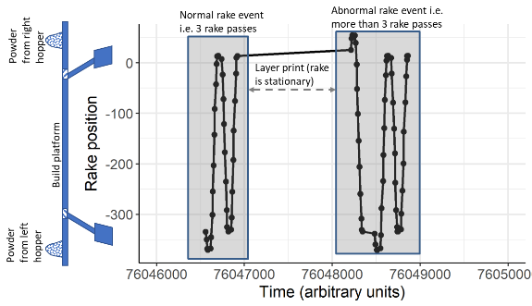
Figure 2-5: Two rake events are shown alongside position on the build platform. A normal rake event has three rake passes whereas an abnormal rake event has more than three rake passes.

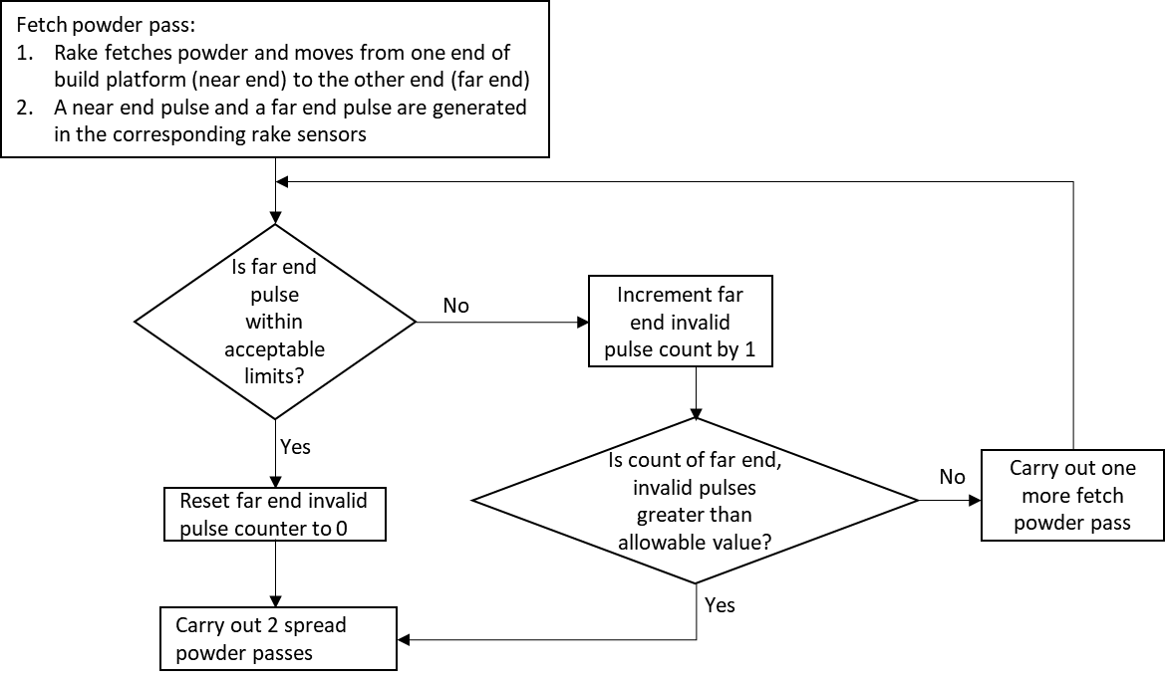
Figure 2-6: Rake control regulation logic based on rake pulse values

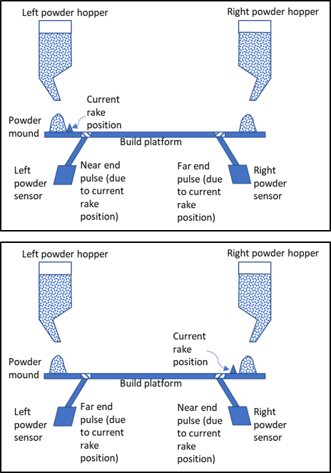
Figure 2-7: Schematic showing rake near end and far end corresponding to the current rake position

Data analysis approach

This section describes the data analysis approach used in this paper. A flowchart that depicts data analysis of rake position and rake sensor pulses is given in Figure 2-8. The details of each step of the flowchart are explained in the following subsections.

Step A:
Step A extracts rake position data from the build log files. The rake position data are divided into separate rake events by indexing rake position off the time stamp associated with build platform height. Build platform height is a variable in the log file that gets updated when the build platform is lowered at the end of each layer print. Its time stamp can be used as an indicator commencement of a rake event based on which rake position data can be indexed by layer. After the log file data are divided into individual rake events, each rake event i is evaluated in turn to determine if each layer (a) exhibits evidence of powder problems, or (b) indicates that one or both hoppers have emptied and insufficient powder is available, in which case analysis is halted. These steps are explained in detail below.

Step B:
Step B analyzes rake position data for a specific layer to compute the total number of rake passes and determine if re-raking has occurred. The number of rake passes per rake event can be computed by counting rake position data points, which are collected at fairly regular intervals of time during rake motion, and thus the number of rake position data points per fetch powder pass or spread powder pass is roughly constant.
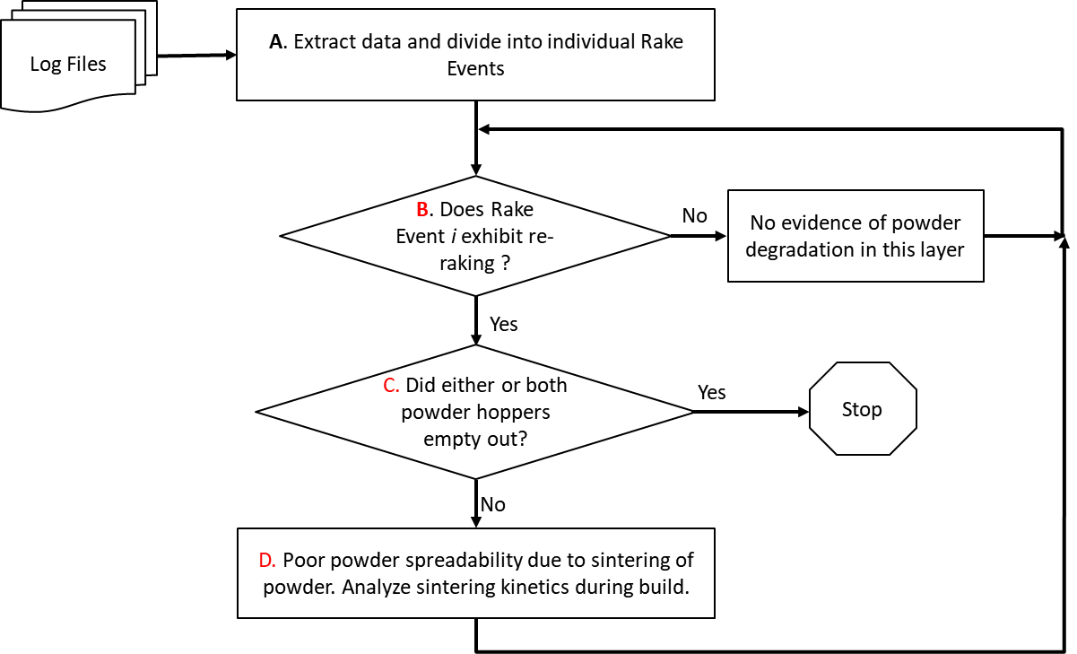

Figure 2-8: Flowchart showing data analysis steps in analyzing log files from Arcam EBM® system

The number of rake passes, N_{r} , can be calculated according to equation (1) after determining the average number of data points per spread powder pass, N_{s} , and fetch powder pass, N_{f} , manually from the first few layers.
$N_{r}= \left\|\frac{N-2N_{s}}{N_{f}}\right\|+2$ (1)
where N is number of data points in rake event and $\left\| .\right\|$ indicates rounding to nearest integer. This method of calculating the number of rake passes has been verified by plotting rake position over time from the log file for ten randomly selected rake events per build to ensure that the method calculates the correct number of rake passes per rake event. Across the available builds, Inconel 718 builds and Ti-6Al-4V builds have different frequency of data collection of rake position and therefore have different numbers of data points, N_{s} and N_{f} , per spread powder and fetch powder pass, respectively; however, the consistency of data collection within builds of each material type remains.

Figure 2-9 shows the number of data points for each rake event (i.e. at the end of each build layer) in the first build of Ti-6Al-4V as indicated in the primary y-axis (on the left) while the secondary y-axis (on the right) indicates the number of rake passes per rake event. The color and shape also indicate the number of rake passes. A “normal” rake event would have 3 rake passes. Figure 2-9 shows that, in this build, mostly normal raking (3 passes) or 1 additional pass (4 passes in all) occurred prior to layer 1500. After layer 1500, the number of layers with 1 additional pass increased significantly. After layer 2500, the number of rake passes began to increase beyond 4 until all additional raking stopped at layer 2729. The cause of this behavior is explored in step C.

Figure 2-9: Rake position data point count plotted against layer number for Ti-6Al-4V Build 1 shows a rapid increase in re-rake events at around layer number 2500

If rake position data are collected at irregular intervals of time, this method of computing number of rake passes would not be appropriate. In that case, the number of rake passes could be determined by calculating the total distance traveled by the rake in each rake event:
$d= \sum_{i}{\left|r_{i}-r_{i-1}\right|}$ (2)
where r_{i} is the rake position at the i^{th} data point. The distance traveled would be proportional to number of fetch and spread powder passes per rake event.

If analysis of rake position indicates there are no additional rake passes beyond 3, then there is no evidence of powder problems in the current layer i and the analysis moves to the next layer i+1. If additional passes occurred, potential causes are investigated in steps C and D.

Step C:
In step C, analysis of rake position and rake sensor pulse data determines if additional rake passes are a result of one or both hoppers emptying. Hopper emptying can be identified by evaluating the extreme rake position for the fetch powder pass of each rake event. Figure 2-10 shows plots of the extreme rake position during fetch powder passes of rake events for a given build. The corresponding positions on the build platform are shown schematically on the left. In other words, Figure 2-10 shows the position inside the powder mound where the rake moved to fetch powder. The plot on the left shows the left and right fetch powder positions while the two sides are zoomed in on the right. In the initial layers of the build, the rake does not go deep into the powder mound to fetch powder. As the part is printed, the rake moves further into the powder mound to fetch powder because the rake finds insufficient powder close to its resting position. The Arcam EBM® system uses rake sensor pulse as a control signal to compute the depth inside the powder mound to which the rake must move to “fetch” powder [139]. A characteristic sign of powder hopper emptying is that the rake moves to the maximum allowable position on the build platform to fetch powder. This is referred to as “rake position max out” and has been observed consistently across a variety of builds when either hopper empties. When the rake finds that no more powder is available, it moves to the other end of the platform to fetch powder. When both hoppers empty, the rake re-rakes repeatedly until the maximum allowable invalid pulse count is reached (as seen at layer 2729 in Figure 2-9). At this point, the rake sensor is deemed temporarily broken by the system and the layer is completed with 2 spread powder passes. It is important to note that even after hoppers empty out as indicated by extreme end positions of the rake, the Arcam EBM ® system continues building the part. This may be because the system accounts for the possibility of a broken rake sensor. When part build occurs beyond hopper emptying, the part may be prone to defects due to insufficient powder availability during final build layers. Figure 2-10 illustrates extreme rake positions across layers of the build for which rake passes are shown in Figure 2-9. Figure 2-10 exhibits insufficient powder due to hopper emptying. As inferred from Figure 2-10, the right hopper empties out approximately at layer 1500 while the left hopper empties out approximately at layer 2500.

Rake position analysis described above indicates if either (or both) hopper(s) emptied. If log files indicate that rake hoppers did not empty out during the build, then additional rake passes detected in Step B were caused by other reasons of low rake sensor pulse. This is investigated in Step D.

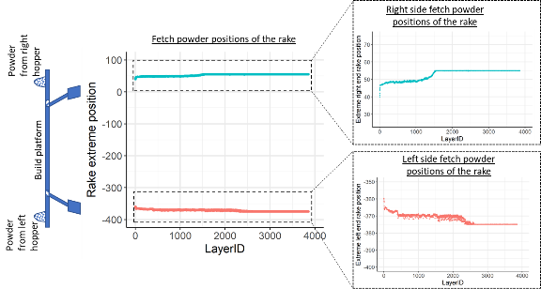
Figure 2-10: Rake extreme positions shown for each fetch powder pass in each rake event for the first build of Ti-6Al-4V

Step D:
If hoppers did not empty but additional rake passes occurred, we hypothesize that particle sintering occurred on the build platform, leading to low rake sensor pulse. Particle sintering can lead to powder agglomeration, resulting in poor powder spreadability on the build platform and therefore insufficient powder flowing through the rake sensor. There is no existing metric to evaluate in situ powder spreadability [45] but we can use basic sintering kinetics to analyze if our hypothesis points in the direction of powder agglomeration. We can also use ex situ SEM images of powder samples to check for powder agglomeration. A note of caution with SEM images is that ex situ powder analysis is done on powder after it is put through the PRS system and the sieve. So, signs of particle sintering and agglomeration may not be seen clearly. Ultimately, the effects of poor powder spreadability on part quality must be understood. Particle sintering and part quality analysis are beyond the scope of the current research and are potential areas of future work.

Results

Results from data analysis described in the previous section are presented for all builds described in Section 2.4 and included in previous work by Nandwana et al [47].
We start with Inconel 718 builds, which had five successful builds (build 5 failed at less than 35% of intended build height). Figure 2-11 shows the rake position-based analysis results for the number of rake passes in Inconel 718 builds.

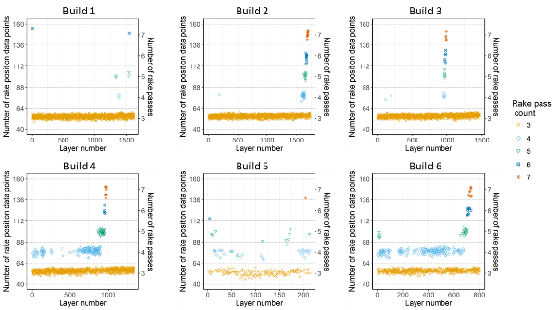
Figure 2-11: Data analysis results for Inconel 718 builds

Build 1 was made with virgin powder while Build 6 has powder that has been recycled four times (Build 5 failed, and powder was not exposed to the electron beam from that build). Build 1 did not have pulse data recorded in the log file due to lack of positional orientation between powder sensors and build platform, resulting in default rake passes. Results presented in this section do not change when we exclude build 1 from the discussion; we have included it for ease of comparison with Nandwana et al. [47]. Following the steps in the data analysis flowchart (Figure 2-8), there is evidence of hopper emptying in all Inconel718 builds except build 5. Ignoring layers built after either hopper started emptying, we are left with fewer layers to analyze powder behavior change due to recycling. Table 2-1 summarizes the percentage of layers that had additional rake passes due to powder-related issues and not due to hopper-emptying issues for Inconel 718 builds. From Table 2-1, we observe that increased powder recycling led to increased rake passes after build 3, and this increase cannot be attributed to hopper emptying. We use sintering kinetics to explain powder agglomeration that may have happened and support our hypothesis using SEM images. Sintering kinetics are presented later in this section. SEM images published by Nandwana et al. [47] (reproduced in Figure 2-12) indicate powder particle agglomeration in Inconel718 powder with multiple reuse cycles. Since SEM images were taken after recycling powder through the PRS and sieve, they are not completely representative of changes in powder on the build plate but indicate broad trends. From the PSD (Figure 2-12), we observe an increase in large-sized particles with increased powder recycling and an accompanying increase in average powder particle diameter. The PSD indicates that virgin powder had many large particles but, after Build 1, the PSD changed significantly, hinting that large particles present in virgin powder may have been sieved out. Our finding of powder agglomeration in recycled powder is in agreement with findings of other research groups [47,50,51,140,141] who studied Inconel 718 powder recycling in the SLM and E-PBF processes.

Table 2-1: Re-raking in Inconel 718 before hoppers empty out

Build serial number | Number of layers printed | Layer number at which first hopper showed evidence of emptying | Number of re-raked layers prior to hopper emptying | Percentage of layers before hopper emptying with re-raking
1 (excluded from analysis due to improper alignment of powder sensor) | 1618 | 1300 | 1 | 0.1 %
2 | 1733 | 1500 | 1 | 0.1%
3 | 1467 | 900 | 2 | 0.2%
4 | 1333 | 700 | 62 | 8.9 %
5 (excluded from analysis since it failed early) | 214 | No clear trend seen due to erratic build | - | -
6 | 800 | 550 | 143 | 26 %

Table 2-2: Re-raking in Ti-6Al-4V before hoppers empty out

Build serial number | Number of layers printed | Layer number at which first hopper showed evidence of emptying | Number of re-raked layers prior to hopper emptying | Percentage of layers before hopper emptying with re-raking
1 | 3858 | 1500 | 45 | 3 %
2 | 1854 | 1500 | 174 | 11.6 %
3 | 4500 | 4000 | 516 | 12.9 %
4 | 3500 | 2000 | 298 | 14.9 %
5 | 2500 | 1500 | 225 | 15.0 %

The results of analysis of the five Ti-6Al-4V builds are shown in Figure 2-13. It is to be noted that builds 1 and 2 were failed builds as mentioned by Nandwana et al. [47] and are included only for comparison and completeness. They do not affect our conclusions in any way.

Only builds 1 and 4 indicate emptying of both powder hoppers. The percentage of layers experiencing re-raking not attributable to hopper emptying, summarized in Table 2-2, remains roughly constant across Ti-6Al-4V builds after the first build. This is in contrast to the results seen in Inconel 718 builds. We examine sintering kinetics of Ti-6Al-4V later in this section to reason out this behavior. SEM images of powder samples and resulting Powder Size Distributions (PSDs) are shown in Figure 2-14 (reproduced from Nandwana et al. [47]). The PSDs were analyzed using a Horiba LA-950 Laser Diffraction Particle Analyzer [47]. The SEM images look similar across reuse cycles and all of them indicate the presence of a few satellite particles as shown by red arrows on most large powder particles. The PSD also indicates that powder sampled after Builds 2, 3, and 5 all have very similar size distributions. The PSD in Figure 2-14 suggests that Ti-6Al-4V powder does not exhibit an appreciable and persistent change in particle size that persists across powder with increased reuse cycles. This finding is in agreement with results in [52]where Ti-6Al-4V powder size distribution showed little variation after eleven cycles of reuse in a SLM process.

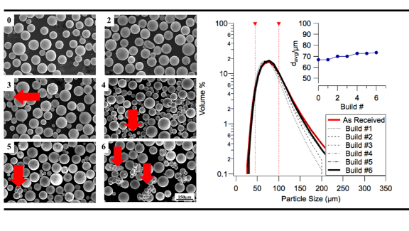
Figure 2-12: (left) SEM images showing particle shape of Inconel 718 powder after each reuse cycle and (right) particle size distribution of Inconel 718 powder after each powder reuse cycle (reproduced from [47] with permission)

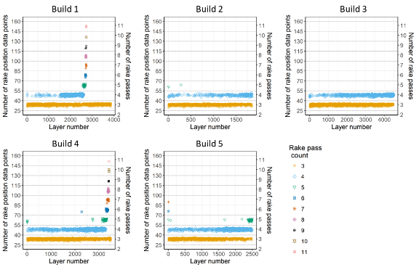
Figure 2-13: Data analysis results for Ti-6Al-4V builds

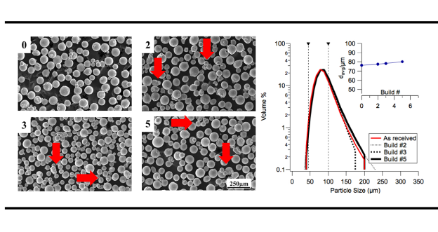
Figure 2-14: SEM images showing Ti-6Al-4V particle shapes after each recycling cycle and (right) particle size distribution of Ti-6Al-4V powder after different number of powder recycling cycles (reproduced from [8] with permission)

Comparing the effect of recycling on Ti-6Al-4V powder and Inconel 718 powder, we note that Inconel 718 powder exhibits increased rake passes with increase in powder recycling after build 3 whereas Ti-6Al-4V powder exhibits nearly constant re-raking from the second build itself. Following the data analysis framework proposed in this paper, we reach conclusions about the in situ powder spreadability of Inconel 718 and Ti-6Al-4V powders based on their sintering.

The sintering kinetics of powders depend on the particle size distribution, surface, boundary and volume diffusivities [142,143]. In this paper, we focus on the diffusivity effects alone to rationalize the observed behavior. The processing temperature of Ti-6Al-4V builds range from 500 to 700°C. At this temperature, both BCC (β-phase) and HCP (α-phase) structures are expected in this alloy. Because the diffusivity of elements in β-phase is higher than that of the α-phase, we can assume that the sintering kinetics may be accelerated by the presence of β-phase. The self-diffusivity of titanium in β-phase is on the order of 10⁻¹⁵ m²/s at 700°C [144]. From the build log files, we found that the median build time for Ti-6Al-4V builds is 38 seconds per layer and while for Inconel 718 builds, it is 84 seconds per layer. This can be considered the median residence time for powder in the powder mound, waiting to be spread on the build platform. During this wait time, the powder could be sintered due to contact with the heated build plate. Using the residence time, we can calculate the random walk diffusion distance ($2 X \sqrt{Diff X Time} )$to be 39 µm for titanium. In contrast, the processing temperature of Inconel 718 build ranges from 850°C to 1000°C. At these temperatures, the stable phase is FCC structure and the self-diffusivity of nickel in FCC-phase is on the order of 10⁻¹⁶ m²/s at 850°C [145]. By using the measured residence time for each layer in Inconel 718 (84 seconds), the diffusion distance is 18 µm. It is indeed clear from the calculations that the sintering kinetics of Ti-6Al-4V will be at least twice as fast as Inconel 718 for every layer.

The calculated sintering kinetics and observed rake behavior may explain in situ powder spreadability: In the first few layers of a Ti-6Al-4V build, mostly fresh, un-sintered powder is spread across the powder bed and therefore there is minimal re-raking. We hypothesize that over time the powder deposited from the hopper -as a mound on either end of the powder bed- sinters due to heat from the powder bed. After sufficient time has passed, partially sintered powder from either end of the powder bed is being spread on the bed. This leads to short rake sensor pulses due to poor spreadability of powder with sintered agglomerates. Since this behavior is not dependent on powder recycling but on the sintering kinetics of Ti-6Al-4V itself, we expect to observe re-raking in the early builds itself; re-raking is seen from build 2 (i.e. after 1 reuse cycle). However, fast sintering would also lead to large particles that get sieved out at the end of each build and thus sintered agglomerates would not persist across builds. This conclusion is supported by SEM images in Figure 2-14. In Inconel 718, sintering in powder mound is expected to be sluggish in the time between replenishment of the powder mounds, compared to Ti-6Al-4V. But, slow sintering of all the Inconel 718 powder is expected to sustain across reuse cycles since slow sintering leads to particles that are small enough to pass through the sieve. This explains why powder sintering is seen in later builds of Inconel 718 (after Build 3) and increases visibly with recycling beyond three cycles (see red arrows in Figure 2-12).

In the series of Ti-6Al-4V builds, the first build exhibits significantly lower re-raking compared to other builds. We believe that this is because of the dryness of fresh powders and lack of oxygen pickup in fresh powder. With just one cycle of reuse, sufficient moisture and oxygen pickup may have occurred during the build process and during powder recovery and that may have led to significant increase in sintering in Build 2 and in further recycled powders.

Understanding in situ powder behavior during powder recycling of two commonly used alloys Ti-6Al-4V and Inconel 718 is an important result of log file data analysis as done in this paper. In terms of additional build time due to re-raking: each re-rake pass takes ~3-4 seconds of time. For a 21 hour build (Inconel 718- build 6) that had maximum re-raking (276 re-rake passes), the additional time due to re-raking is ~ 10-18 minutes which is less than 2% of the total build time. So, time taken by itself may not indicate build abnormalities. Using log file data analysis demonstrates a non-invasive method to understand in situ powder spreadability which can lead to build quality issues.

Conclusions

In this paper, the effect of powder recycling on in situ powder spreadability in the E-PBF process was studied. This study demonstrated that it is possible to extract value from log file data by using it to infer powder particle behavior during a build.

Based on data analysis of parts built using recycled powder, we found that Inconel 718 powder tends to agglomerate over multiple cycles of recycling. This is in contrast to Ti-6Al-4V powder where the powder seems to sinter quickly, irrespective of recycling. This indicates that additive manufacturing of Ti-6Al-4V powders needs different process conditions to account for its quick sintering behavior compared to Inconel 718. This study can also be extended by using the data analysis methodology described here to understand in situ powder spreadability in E-PBF process for other powders. This makes log file analysis a valuable tool for analysis of Arcam EBM ® builds.

Further validation of results about in situ powder behavior and spreadability in this paper could be done using Discrete Element Method (DEM) simulations of powder behavior [42,146–149], though this is beyond the scope of the current work. Integrating sintering kinetics with a DEM based approach could enable better appreciation for the physics involved in AM and translate into better parameter choice for AM builds.

Funding

This research was funded in part by the Lloyd’s Register Foundation and the International Joint Research Center for the Safety of Nuclear Energy. Experimental work in this paper was sponsored by the U.S. Department of Energy, Office of Energy Efficiency and Renewable Energy, Advanced Manufacturing Office, under contract DE-AC05-00OR22725 with UT-Battelle, LLC. Experimental work at the Oak Ridge National Laboratory’s High Temperature Materials Laboratory was sponsored by the U.S. Department of Energy, Office of Energy Efficiency and Renewable Energy, Vehicle Technologies Program.

Declaration of competing interests
None

Acknowledgements

The authors would like to acknowledge the Lloyd’s Register Foundation and the International Joint Research Center for the Safety of Nuclear Energy for funding of this research. Lloyd’s Register Foundation helps to protect life and property by supporting engineering-related education, public engagement, and the application of research. Experimental work in this paper was sponsored by the U.S. Department of Energy, Office of Energy Efficiency and Renewable Energy, Advanced Manufacturing Office, under contract DE-AC05-00OR22725 with UT-Battelle, LLC. Experimental work at the Oak Ridge National Laboratory’s High Temperature Materials Laboratory was sponsored by the U.S. Department of Energy, Office of Energy Efficiency and Renewable Energy, Vehicle Technologies Program.

Notice: This manuscript has been authored by UT-Battelle, LLC, under Contract No. DE-AC05-00OR22725 with the U.S. Department of Energy. The United States Government retains and the publisher, by accepting the article for publication, acknowledges that the United States Government retains a non-exclusive, paid-up, irrevocable, world-wide license to publish or reproduce the published form of this manuscript, or allow others to do so, for United States Government purposes.

Appendix

The log file data used for analysis in this paper is available at: https://doi.org/10.7290/n8lx7b8

Similarity analysis for thermal signature comparison in metal additive manufacturing

This chapter contains details of the similarity analysis algorithm developed for comparison of thermal signatures in the L-PBF process. Development of this algorithm and its application to study the effect of geometry on thermal signature evolution is a key contribution in this dissertation. The significance of the developed algorithm is that it is directly applicable to study differences in thermal signature using data from infrared monitoring of a part during the L-PBF process. Differences in thermal signature may be caused by a combination of multiple factors like scan path, part geometry, and process parameters. It is difficult to study the effect of these parameters using modeling approaches alone to study thermal signatures. A similarity analysis algorithm makes it possible to study similarities, and by extension differences, in thermal signatures across a part. It is relevant to point out that similarity search can be used on data obtained from thermal modeling of L-PBF processes too, but that aspect is not demonstrated in this dissertation.

The contents in this chapter have been submitted for publication in the Additive Manufacturing journal. The submission is under review. The final version, after completion of peer reviews, is expected to be cited as: Sujana Chandrasekar, Jamie B. Coble, Fred List, Keith Carver, Serena Beauchamp, Amy Godfrey, Vincent Paquit, Sudarsanam S. Babu, “Similarity analysis for thermal signature comparison in metal additive manufacturing”.

Contributions to the paper by each author is described in this paragraph. S.Chandrasekar carried out data analysis, reviewed literature, and authored the manuscript draft. J.B.Coble and V.C.Paquit made substantial contributions to design of the algorithm and visualization of results. F.List performed the in situ data collection setup, contributed significantly to IR data analysis and manuscript editing. K.Carver was instrumental in design of the part for study of heat transfer in SLM and also designed the setup of the data collection system. S.Beauchamp and A.Godfrey performed microstructural characterization and analysis of the samples and aided in discussion of results. S.S.Babu conceptualized the study, aided in interpretation of results and helped to write the manuscript.

Abstract
Metal additive manufacturing differs from traditional manufacturing processes primarily due to repeated heating and cooling cycles that are inherent to the process. Such thermal cycling leads to different thermal signatures and associated solidification, microstructure and properties of the printed part. It is, therefore, of significant interest to develop methods to study thermal signatures at different locations of an additively manufactured part, and develop part qualification criteria based on thermal signatures. In this work, we develop and demonstrate a similarity analysis procedure to compare thermal signatures of different locations in a part to each other. The signatures are extracted from in situ infrared (IR) thermography of a part built using laser powder bed fusion. Layer-wise variations in thermal signature that are associated with part geometry are identified using the proposed similarity analysis. Ex situ microstructure characterization is used to validate findings from similarity analysis. Results indicate that similarity analysis is a useful tool for comparison of thermal signatures within a part and to understand the effect of geometry and scan strategy on thermal signature evolution. Similarity analysis proposed here is also shown to be useful in identification of anomalous thermal signatures. The analysis method paves the way for improved in situ monitoring of AM parts and wider adoption of metal additive manufacturing processes.

Keywords
Thermal signature, Similarity analysis, Time series analysis, Infrared thermography, In situ monitoring, 316L Stainless steel

Introduction
Additive Manufacturing (AM) has rapidly gained traction as a viable method
of part production and comes under consideration for various applications in aerospace [29], nuclear [3], and biomedical fields [11]. The ability to create complex parts with near-net shape, combined with the cost advantage of small batch sizes for unique parts make additive manufacturing processes very attractive in niche industries [12]. Additive Manufacturing processes are also being investigated widely for the ability to produce parts using functionally graded materials [14]. While AM has multiple advantages over conventional manufacturing processes, a key challenge is the qualification of parts for application-specific requirements [150]. In conventional manufacturing like forging, rolling, casting, etc., material microstructure is fairly uniform across a roll or billet of material and can be reasonably predicted due to legacy knowledge and uniform processing methods. It is, therefore, reasonable to qualify coupons of the material and assume bulk properties to be similar to test coupons. However, in Additive Manufacturing, microstructure and part properties can vary significantly across a part [110]. This is primarily due to thermal cycling in AM processes and associated non-equilibrium solidification and solid-state phase transformation conditions across a part. Anisotropic properties are also caused by pores and other defects that are not easy to predict in AM processes [151]. Therefore, research efforts by many groups are focused on novel pathways toward part qualification.

One approach to build high quality parts with desired properties and limited porosity is to develop process maps [66,68,69] that indicate correlations between process parameters and properties. However, these do not account for part-to-part variation that occurs due to position on the build plate [73], complex geometries, and scan strategy variations [152]. To qualify a part for specific applications, it is necessary to understand thermal cycling patterns i.e., multiple oscillations in peak temperatures, large variations in heating and cooling rate, as well as, changes to ambient temperature in every layer across a part [23,152]. Modeling approaches that account for the complexity of AM processes, are time-consuming to run and contain multiple assumptions about heat transfer mechanisms, powder interaction and fluid flow effects [23] . An alternate path to part qualification is to use in situ monitoring methods [92,98,153,154]. We propose understanding thermal cycling in the laser powder bed fusion process using time series similarity analysis of data from in situ infrared (IR) thermography. Time series similarity analysis can help to identify regions of similar thermal history in the part, while also highlighting anomalous zones. This information can be used as an integral component of a larger part qualification system.

Reviews of monitoring methods in AM are presented by Everton et al. [54] and Tapia et al. [55]. Some common modalities that have been used for monitoring include acoustic sensors, infrared thermography using IR cameras, pyrometers, bolometers, and optical imaging. While most of these monitoring methods are effective, they are demonstrated only on representative geometries like cylinders and cubes. Also, recent advances in imaging modalities enable capture of process details especially in the melt pool [155], but the frame rate is very high and thus not easily scalable to reasonably sized builds. Going beyond monitoring, some research groups have developed and applied mathematical data analysis techniques to identify patterns in sensor data corresponding to defects in AM parts. Grasso et al. [98] and Colosimo and Grasso [153] developed anomaly detection methods based on Principal Component Analysis (PCA) of in situ monitoring data in spatial and temporal domains. Scime et al. [33,81,94] developed image processing and neural network-based algorithms for identification of melt pool and powder bed anomalies in AM parts. Montazeri and Rao [154] employed spectral graph theory for dimensionality reduction and identification of anomalous build conditions caused by thin sections and overhangs, using infrared (IR) monitoring. Rather than dimensionality reduction, Lough et al. [156] and Williams et al. [157] directly applied statistical methods to extract parameters like intra-layer cooling time, peak intensity, maximum cooling rate and, time above threshold from IR data, and used these parameters as indicators of build quality. Paulson et al. [158] developed machine learning models to correlate thermal history with porosity levels seen in the part. Mitchell et al. [159] showed that two-color pyrometry, combined with image processing, can be used to detect porosity that correlates with anomalous thermal signatures. While all these studies represent important contributions toward part qualification using in situ thermal monitoring methods, they are primarily intended as anomaly detection frameworks. We develop and demonstrate an analysis method to extract information about both similarities and anomalies in thermal history within a part. Using the proposed analysis, zones of “similar” thermal behavior within a normal melt zone are identified, while anomalous melting is also spotted, using in situ infrared monitoring. Thermal history dictates solidification dynamics and consequently, part microstructure [26,160,161]. Therefore, identification of zones of similar thermal signature can lead to an understanding of microstructures within a part and thus to a similarity-based part qualification paradigm. It also has the potential to aid in tailoring of microstructure, by varying process parameters and thermal signatures appropriately to achieve specific thermal signatures in different regions.
A brief survey of time series similarity analysis is relevant, since our analysis builds on existing concepts of similarity. For detailed reviews of time series analysis, the reader may refer to review papers by Fu [162] and Atluri et al. [163]. Time series similarity analysis deals with the problem of finding similar patterns across a time series. Comprehensive evaluations of different time series similarity search methods are presented by Echihabi et al. [164]. Some commonly used distance metrics for similarity search include Euclidean distance and Dynamic Time Warping distance. Similarity analysis can be carried out on the numeric time series directly, or using transformed time series data using Fourier, PCA, wavelet or other transform techniques. Alternatively, symbolic time series analysis involves replacing numerical values by symbols, thus enabling the use of string matching and querying methods to mine time series. Using a symbolic approximation typically enables faster analysis and lower data storage requirements. Symbolic time series analysis and clustering has been demonstrated in studying thermal signatures in AM by Donegan et al. [108]. They studied the effect of different scan strategies on thermal cycles in a layer using symbolic approximations of thermal signatures from numerical simulations of temperature evolution in an AM part.

Our analysis approach computes similarity of thermal profiles at different pixels. The key contributions in this paper are as follows:
- An algorithm is proposed for similarity analysis i.e., identification of locations of similar layer-wise thermal history within a part. The distance metric to determine similarity is derived specifically for thermal signatures in AM.
- The algorithm can also be used to identify anomalous thermal histories in the part by comparing regions of high dissimilarity with the intended part geometry.
- The proposed algorithm is demonstrated on a realistic part geometry using an IR camera frame rate of 100 Hz, paving the way for mapping and analyzing in situ data from an entire build of reasonable size (3” X 3” in this case).
- Changes induced in thermal history due to varying layer cross-sectional geometry are studied using the similarity analysis procedure. The important role played by the geometry of underlying layers in determining thermal history and cooling rate in the current layer are analyzed.
The rest of this paper is organized as follows: Section 2 describes details of the build used to capture in situ IR data and the data collection system. Section 3 gives an overview of different steps in the proposed similarity analysis algorithm. Section 4 consists of results of the algorithm, as implemented on IR data from the build in section 2. Microstructure characterization results are also presented for specific regions of the build, to validate results from similarity analysis. Section 5 contains a summary of results and concludes with ideas for future work.

Experimental details and data collection

Build details
The part design used in this study is described in this section. The Renishaw AM250 laser melting system was used to print parts shown in Figure 3-1. The Laser-Powder Bed Fusion (L-PBF) process is an AM process in which a part is built by melting metal powder repeatedly to form layers of a part, using a focused laser beam as the energy source. The material used was 316L stainless steel. The build geometry is shown in Figure 3-1. The primary geometry consists of a cylinder, with a solid disk section in the central portion of the cylinder along its height. The secondary geometry is the inverse of the primary geometry i.e. the primary and secondary geometry, when combined together, form a solid cylinder (see Figure 3-1). The aim of the part design was to keep the build area, and thus layer time, constant in every layer. The change in primary part geometry – from a cylindrical wall section to a solid disk section and back to a cylindrical wall section - was designed to cause a change in heat transfer conditions along the height of the cylindrical wall. The change in heat transfer enabled a study of the effects of changing geometry on thermal history and part microstructure in L-PBF.

The parameters used for the build process are shown in Table 3-1. The final part dimensions were within +/-0.076mm of designed dimensions.

Using the process parameters listed above, the mean laser beam velocity was computed to be 638 mm/s, while the volumetric energy input was calculated to be 53 J/mm³.

The primary geometry, referred to as “build” in the rest of this paper, is divided into 5 sections and labeled as shown in Figure 3-2. Table 3-2 summarizes the layer numbers and description of each section. Sections 1 and 5 are “wall” sections, while sections 2 and 4 are “transition” sections and section 3 is a solid disk section. Layers of sections 2 and 4 that are closest to section 3 have nearly the same cross-section as section 3, but have split lines defined between the walls and the disk in each layer. Figure 3-2 shows the variation of layer time over different sections of the build. Though the printed area per layer remained constant, the change in laser scan path length in sections 2 and 4 led to an increase in layer time in these sections. These are not expected to change the interpretation of results, since analysis is done one layer at a time.

Data collection details

A schematic of the experimental setup used to collect infrared videos of the build using an IR camera is shown in Figure 3-3 [26]. The IR camera used was a FLIR(R) SC8203 camera with a 100-mm focal length germanium lens. The IR camera was mounted external to the L-PBF build chamber. The entire build process was captured as a continuous video stream at 100 frames per second, in the medium wavelength IR (MWIR) range of 1.5-5 μm. A 1-mm thick sapphire window was used to attenuate wavelengths over 5 μm. A mirror (also called front surface or first surface mirror) was needed to reflect the visible/IR image of the build into the camera lens. The constraints of the experimental geometry did not allow the camera to capture a good image of the build without the mirror. The use of the first surface mirror adds some distortion and attenuation of the intensity of the image. Even at a low frame rate of 100 Hz, the quantity of data collected built up quickly. To control the amount of data collected and ensure a reasonable resolution for further analysis, a limited region of each layer, corresponding to 384 X 88 pixels was imaged. This is highlighted in Figure 3-4.

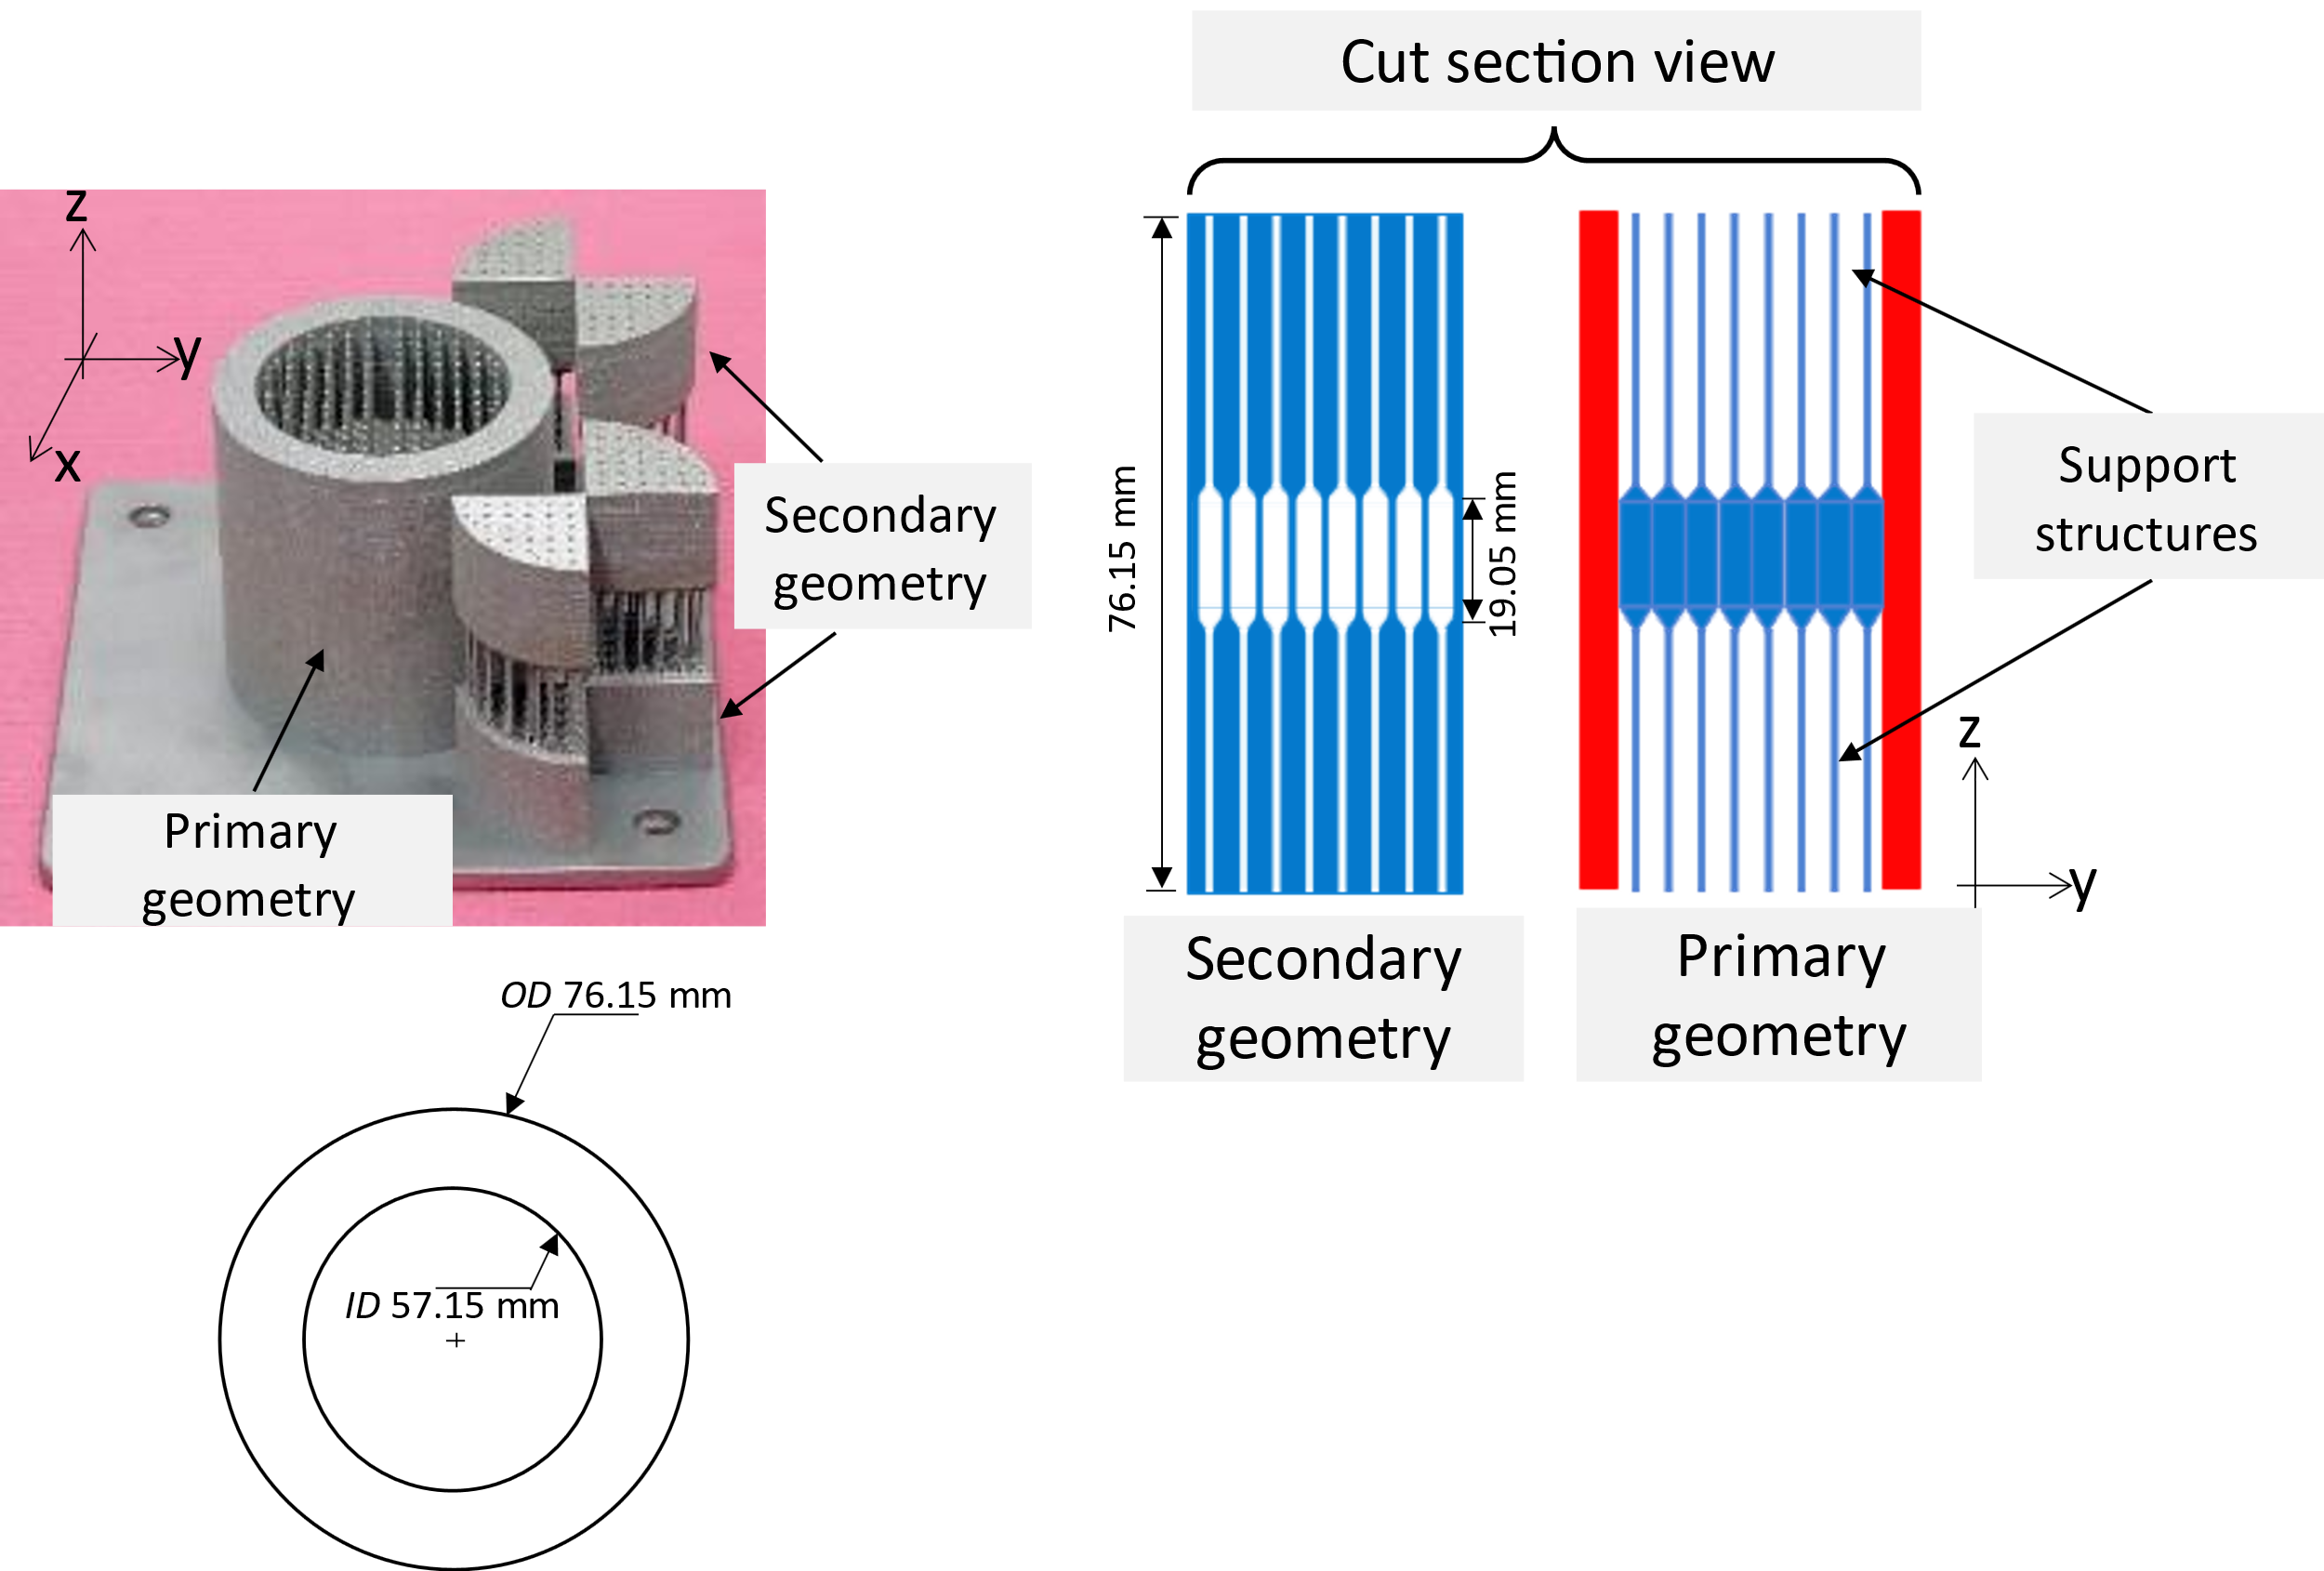
Figure 3-1: Build 3D view and cross-section

Table 3-1: Process parameters for the build
Process parameter | Value
Powder and Substrate material | 316L-SS
Substrate size | 6 in x 6 in x 0.25 in
Powder size | 15-45 µm
Layer thickness | 50 µm
Laser power | 200W
Point spacing | 60 µm
Hatch spacing  Hatch Rotation | 100 µm  30°
Exposure time | 80 µs
Beam diameter | 70 μm
Melt strategy | Meander
Number of layers | 1524
Build time | 36.43 hours

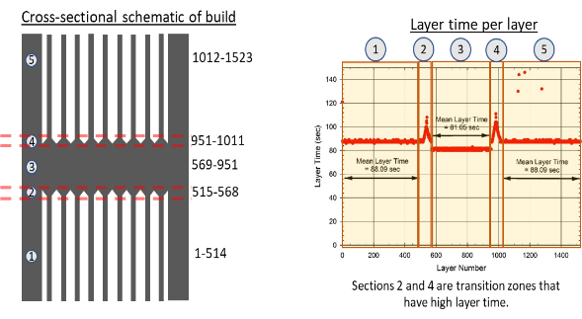
Figure 3-2: Sections of the primary geometry, referred to as ”build”. (Right) Layer time for each layer of the entire part (primary + secondary geometry).

Table 3-2: Sections of the build
Section number | Layer numbers | Description
1 (Wall) | 1-514 | Wall section and thin supports
2 (Transition) | 515-568 | Transition from wall section to disk section. Gradual thickening of supports. Wall and disk zones are printed separately
3 (Disk) | 569-951 | Continuous disk section
4 (Transition) | 952-1011 | Transition from disk to wall section. Gradual thinning of supports. Wall and disk zones are printed separately.
5 (Wall) | 1012-1523 | Wall section and thin supports

Each pixel has an area resolution of ≈100 X 100 μm². The size of the dataset collected for the build over ≈37 hours is ≈800 GB. While the entire build process was stored as an IR video file in 16-bit integer binary file format, it may be possible to reduce the volume of data stored in future using real-time similarity analysis described in this paper and discard the raw data.

Similarity analysis methodology

The proposed similarity analysis procedure is described in this section. The “thermal signature” or “thermal history” in this paper refers to the heating and cooling pattern that each pixel undergoes over time in each layer (Figure 3-5- Raw data). The goal of this analysis is to identify pixels within each layer that have similar thermal signature to each other.

Figure 3-5 (top) shows the IR intensity curve associated with a pixel over a single layer of the build. The IR intensity curve captures accumulative thermal effects induced due to repetitive laser beam passes at each point in the build. It is important to point out that the recorded IR intensity captures only surface thermal effects in the given layer. Significant subsurface thermal cycles may occur during the build and, may contribute to the final microstructure. Figure 3-6 shows varying thermal signatures at different pixel locations within a single layer. It is to be noted that the sharp dip in IR intensity near 4000 ms is due to powder recoater movement across the powder bed, at the start of the layer. The geometry of underlying layers determines the area available for heat removal, and thus magnitude and shape of thermal signatures. These thermal signatures are difficult to extract and quantify using knowledge of scan parameters or geometry alone.

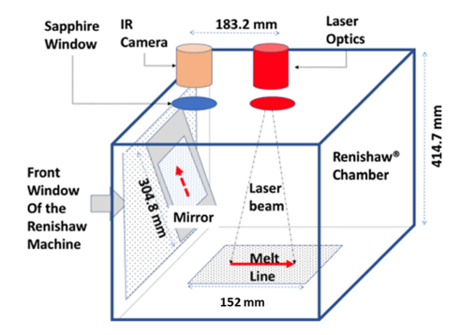
Figure 3-3: Imaging setup used to collect infrared video of the build process

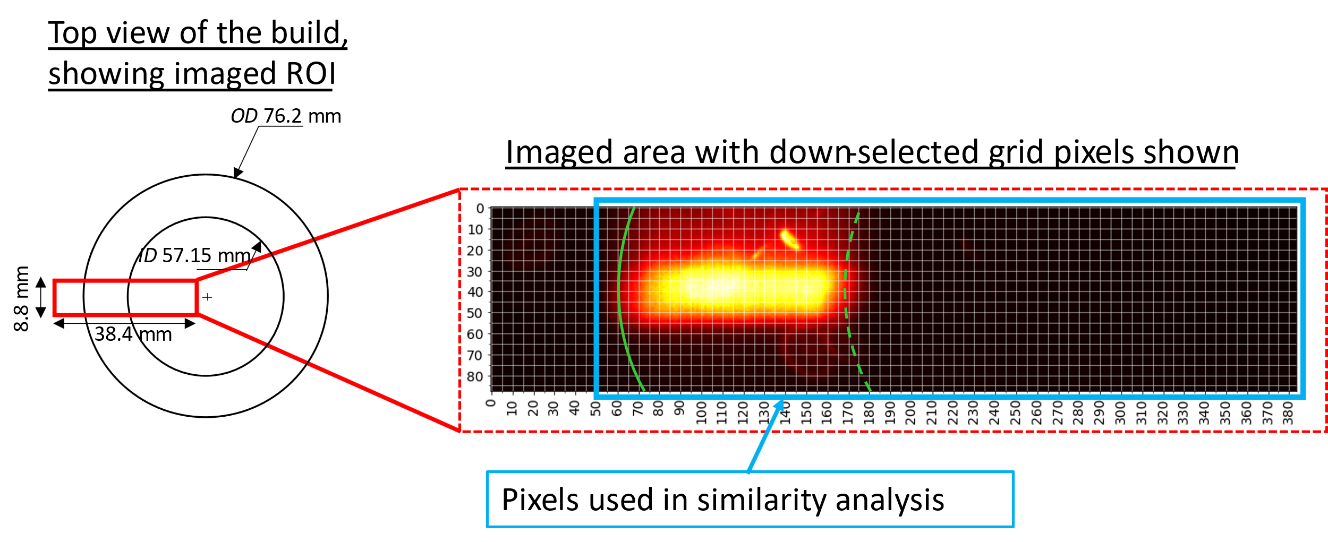
Figure 3-4: Imaged region of build, with dimensions 384 X 88 pixels. Grey grid lines indicate pixels down-sampled at a 1:5 ratio. The solid green line indicates the position of the outer diameter of the cylindrical wall, while the dotted green line indicates that of the inner diameter.
It may be possible to obtain pixel-wise thermal signatures using a thermal simulation model, but running a model for an entire build composed of ~1500 layers can be computationally intractable, depending on the level of detail. Further, while using simulated data informs the user of ideal thermal signatures, they are not necessarily representative of what occurs during the build. Instead, an in situ monitoring method combined with a fast and interpretable algorithm like the one proposed in this paper, can help to identify regions of similar thermal signatures.

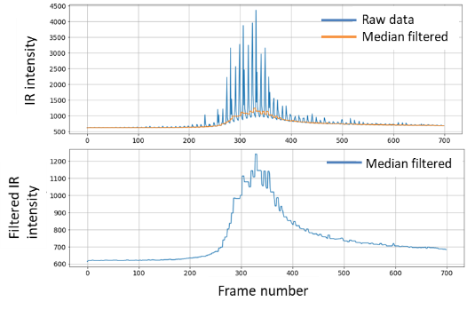
Figure 3-5: Effect of median filtering on IR data. The filter is a moving window filter with window size=9 frames

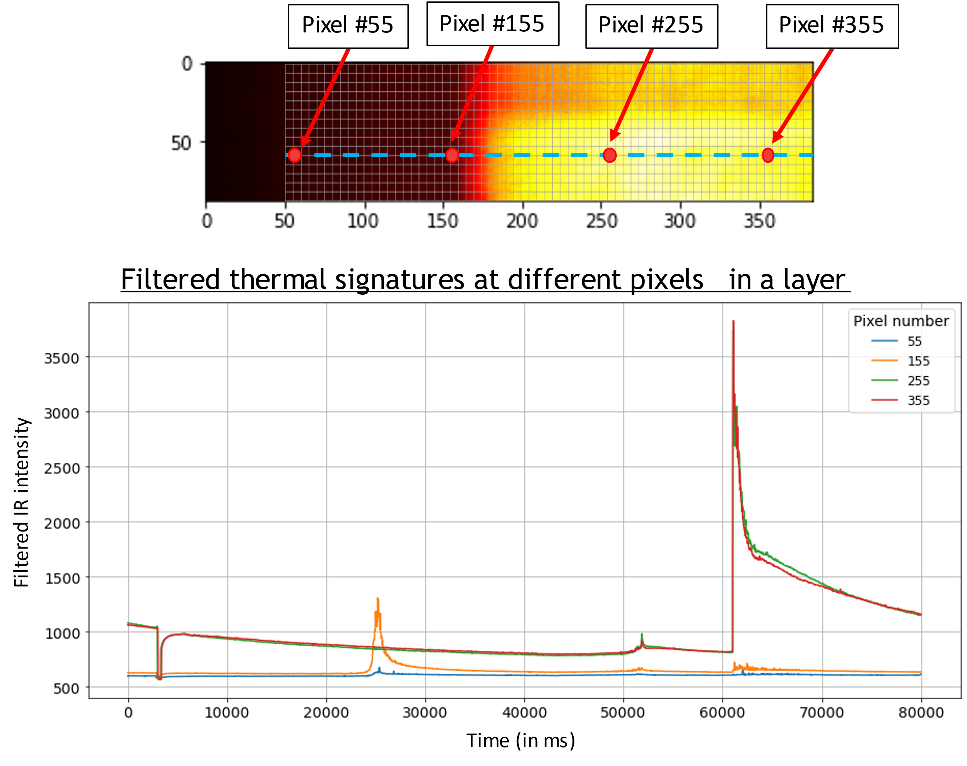
Figure 3-6: Examples of thermal signatures at different pixels within a layer. The sharp dip seen near 4000 ms is due to powder recoater movement across the powder bed.

The key steps involved in the similarity analysis of IR data are listed below and explained graphically in Figure 3-7.

1. Extraction and filtering of IR data corresponding to a selected layer for analysis
2. Down-sampling of pixels for data analysis
3. Similarity analysis based on different reference pixels
4. Summarizing similar thermal signatures and identifying their locations
All code required for this work was scripted in Python 3.7.

When dealing with infrared data, it is essential to decide whether to convert data to temperature or not. In our work, we chose to work directly on raw IR intensity values rather than converting them to temperature values. This is similar to the approach taken by some research groups [22,30], where the authors extract features based on IR intensity directly. The advantage in dealing directly with IR data is that issues arising from emissivity calibration and associated errors in temperature conversion can be sidestepped. It has been pointed out by various authors [26,156,165] that IR intensity can be used directly for part qualification or with minimal calibration to account for phase change only [87,157]. We affirm this suggestion, especially since part qualification could involve comparing thermal cycles across multiple batches of production or acceptance testing using thermal cycle comparison for single part runs. An element of acceptance testing using a layer-wise approach could be anomaly detection and similarity confirmation within each layer, by comparison of relevant thermal cycles. These do not necessarily involve temperature conversion and associated calibration since absolute temperature values are not being studied.

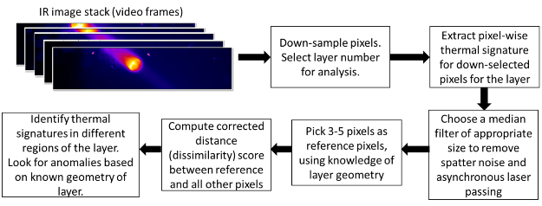
Figure 3-7: Key analysis steps involved in similarity analysis of a layer of the build

Extraction and filtering of data
The first step in data analysis is to extract data for the layer to be analyzed. The stored IR video data exists in what is essentially a large p x q x N matrix with p and q being the dimensions (in pixels) of the view region and N being the number of frames of data. To put the quantity of data in perspective, the matrix for this build is a 384 x 88 x 13X10⁶ matrix since the number of data frames is ≈13 million frames. Each layer has between 8000-15000 frames of data, corresponding to 80-150 seconds of layer print time. Once layer-wise data has been extracted for all pixels in a layer, we have a p x q x N_{l} matrix, where N_{l} is the number of frames in the layer. Before further use of the data, it is essential to remove noise from it.
Noise exists in an IR signal primarily due to spatter particles that are generated during the L-PBF process and fly across the field of view. These particles are typically present only for a single frame and can be removed using a median filter on pixel-wise time series data. The median filter smooths out a signal by removing short-duration extreme values. For the IR signal in this work, the median filter not only removes spatter noise but also smooths out differences due to asynchronous sampling of the signal w.r.t. the laser beam speed (see Figure 3-5(bottom)). In other words, filtering the raw IR signal helps to avoid differences in peak IR signal intensities arising from low frame rate of data capture. The median filter is discussed further in Appendix A.

Down-sampling of pixels for data analysis
The next step in similarity analysis of IR data is to down-select pixels along a regular grid (Figure 3-4) for simplified analysis of the data in a layer. It was observed that adjacent pixels have similar thermal signatures, and the level of similarity depends on the spatial resolution of the IR camera and the geometry of the part. Therefore, analyzing a subset of data is sufficient to indicate trends in thermal signature within a layer. To this end, the view region is simplified into a grid of pixels shown in Figure 3-4. The grid consists of pixels down-selected at a ratio of 1 pixel for every 5 pixels, separately along the horizontal and vertical directions. Note that no averaging of IR intensities is done in this process and every fifth pixel is chosen along the x- and y-axes of the field of view for further analysis. The first 50 pixels along x-axis correspond to a region where no print occurs and therefore are discarded for further analysis. These steps decrease the computation from an area of 334 x 88 pixels to 67 x 18 pixels.

Similarity analysis based on reference pixels
Existing time series similarity analysis methods compare different time series sequences and identify those that are similar in shape. In an analogous yet significantly modified fashion, we use time series similarity analysis to compare both the shape and magnitude of the underlying thermal signature of pixels, based on in situ IR data.

To use similarity analysis for IR data, we developed an original algorithm described in Table 3-3. Similarity is computed between a reference pixel and all other pixels in each layer. Multiple similarity computations can be done using different reference pixels. Choice of reference pixel is discussed further in the results section. Euclidean distance between normalized time series sequences is known to reflect shape similarity[166]. We term this the “shape distance”. To compare magnitudes, we develop a function of time series variances and term it “magnitude distance”. A combination of shape and magnitude distances represents “corrected distance” that can be used for comparison of the time series sequences. These ideas are explained in detail in Appendix C and summarized step-wise in Table 3-3.
Table 3-3: Algorithm for similarity search

Algorithm to compute corrected distance between thermal signature of a reference pixel and other pixels
- Extract thermal signature of each pixel in a layer l.
- Filter thermal signatures using median filter algorithm and an appropriate window size (Appendix A).
- Down-sample pixels for analysis. IR data is now available as a p X q X N_{l} matrix.
- Select a reference pixel and subset a portion of its thermal signature for comparison with other pixels. The dimension of this query time series is m X 1. (See Appendix B for further details)
- Concatenate thermal signatures of all pixels, leading to a dataset of dimensions N_{t} x 1 where N_{t} = p x q x N_{l}
- Compute normalized Euclidean distance d_{norm} between the reference pixel’s thermal signature and all moving windows of size m in the concatenated time series, using MASS algorithm [167]. (Appendix C)
- Compute shape distance from normalized Euclidean distance as: $d_{shape}=(1+\frac{d_{norm}}{10})$
This represents distance based on shape similarity between reference pixel and each pixel in a layer. (Appendix C)
- Compute variance σ² of IR intensity for each pixel and reference variance σ_{ref}² for the reference pixel.
- Compute $σ^{2}/σ_{ref}^{2}$ for each pixel. If the ratio is less than 1, compute its reciprocal so that the final ratio is always greater than or equal to 1.
- Compute magnitude distance as: $d_{mag}=(1+\log_{10}{\frac{σ^{2}}{σ_{ref}^{2}}})$
This represents distance based on magnitude similarity of thermal signatures between each pixel and the reference pixel.
- Compute corrected distance as the product of shape distance and magnitude distance. $d_{corr}=d_{shape}*d_{mag}=\left(1+\frac{d_{norm}}{10}\right)\left(1+\log_{10}{\frac{σ^{2}}{σ_{ref}^{2}}}\right)$
- Corrected distance is the dissimilarity score between reference pixel and each pixel. Pixels with identical thermal signatures have a corrected distance of 1.

In summary, Table 3-3 indicates that corrected “distance” is computed as a measure of dissimilarity between thermal signatures. Corrected distance of 1 indicates perfect similarity between the reference pixel and current pixel, both in shape and magnitude. Higher values indicate an increase in dissimilarity.

Interpreting similarity analysis results
For a brief overview on reading similarity results, we present results for an exemplar layer in Figure 3-8 and provide guidance on reading the plot. The contour plot on the left and the thermal signatures on the right are both integral to understand the results of each similarity analysis. The following key aspects are important in understanding the corrected distance maps in Figure 3-8:
- Corrected distance maps are plotted as filled contour maps. In a layer with no anomalous melting, the corrected distance map reflects the geometry of the printed layer as contour outlines. This is because of different thermal signatures at pixels where melting occurred compared to those where no melting occurred.
- Each corrected distance map is plotted with respect to a reference pixel’s thermal signature, based on which distance was computed.
- A small value of corrected distance indicates high similarity between reference pixel and pixel under analysis. While choosing pixels that are “similar” to the reference pixel, a similarity threshold is used. In this paper, $d_{corr}<2$ was used as the definition of similar. A reasonable value for high similarity would be between 1-2. This value is derived based on inspection of distance maps and how similar thermal signatures are desired to be for a given application.
- An equivalent dissimilarity score means that the pixels are equally different from the reference pixel, but not necessarily different in the same way. The exact nature of the difference in thermal signatures needs to be probed further using other reference pixels (see next point).
- The choice of reference pixels is key in understanding different thermal signatures across a layer. Different reference pixels can be chosen based on prior knowledge of build geometry and by inspection of the distance contours for a single reference pixel. The important consideration is that each reference pixel produces a low value of corrected distance across different areas in a layer. For example, in Figure 3-8, plots (b) and (c) highlight similar thermal signatures in support structures while plots (a) and (d) highlight similar thermal signatures in the wall zone of the layer. Plot (e) highlights similarity of pixels on the edge of the wall section.
- Beyond identification of similar thermal signatures, it is possible to identify anomalies in each layer by using a corrected distance map and comparing it to intended print geometry. Sharp discontinuities in the distance map indicate a sharp change in geometry. By comparing the contour map with intended layer geometry, one can tell if the discontinuity was due to a change in geometry or if it was an anomaly. This is highlighted in subsection 4.3 in this work.

Similarity analysis and associated microstructure results
In this section, results of similarity analysis are presented for a few layers of the build. Microstructure characterization in the transition sections 2 and 4 of the build support insights derived from similarity analysis and are also presented.

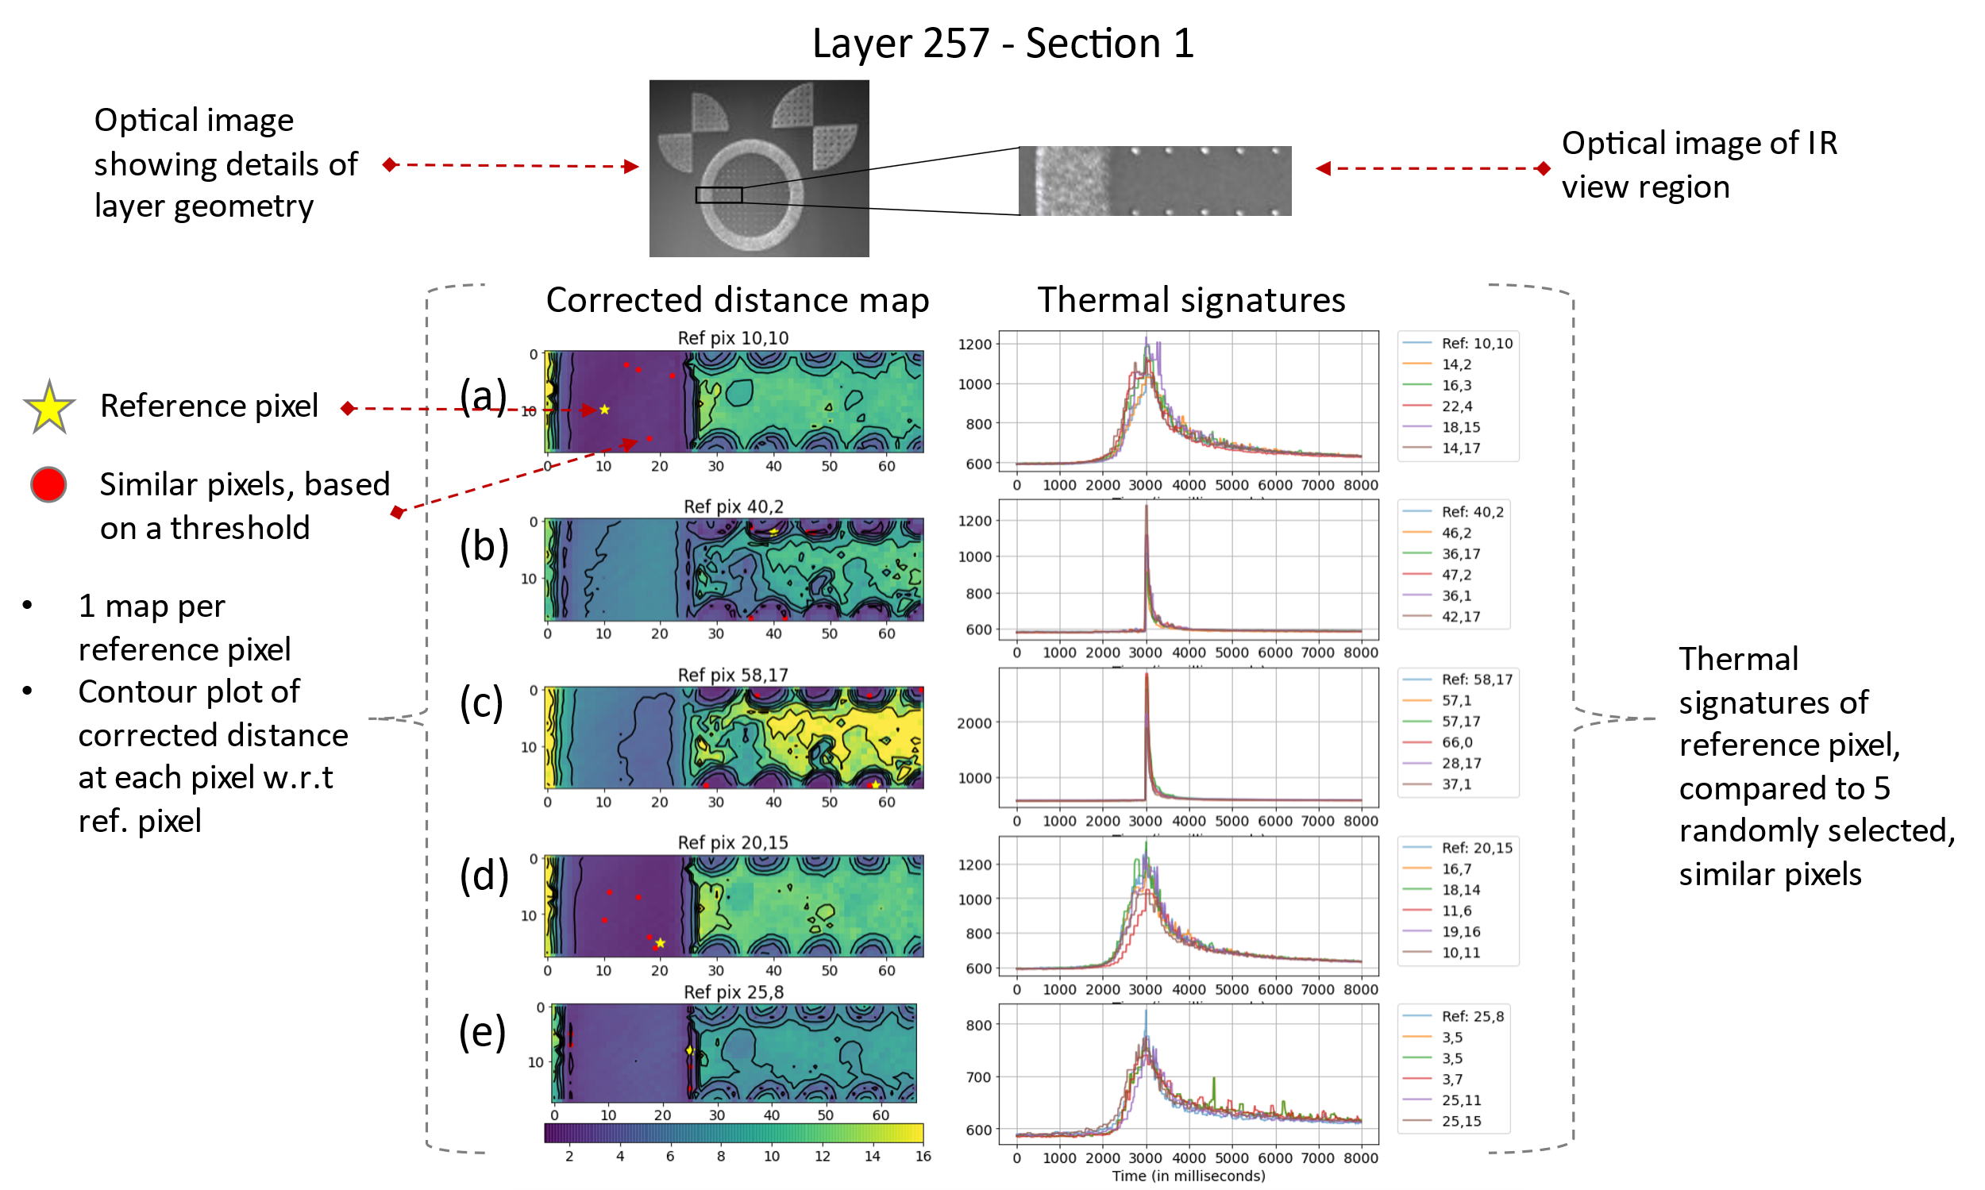
Figure 3-8: Guide to reading a similarity analysis map: Results for layer 257- section 1

Similarity analysis results
Figure 3-8- Figure 3-11 highlight similarity analysis results for different layers, one per section of the build. Note that all these results have the same three reference pixels used for comparison of thermal signatures. These pixels correspond to regions where we expect a difference in thermal signature, based on part geometry. Results for section 5 are not significantly different from section 1 and are presented in Appendix D.

Effect of part geometry on cooling behavior
The primary geometry was designed to study the effect of underlying geometry on thermal signatures in a layer. To confirm that the presence of the disk region (build section 3) changed heat transfer dynamics significantly, we compared layer 568 in section 2 and layer 952 in section 4 (see Figure 3-9 and Figure 3-11). These layers were chosen since they are at the interfaces between build sections 2-3 and sections 3-4. Therefore, their geometries were nearly the same as section 3, but the underlying layers were of a different geometry. All compared layers were printed using a 0° scan angle and therefore do not have scan angle changes to account for. Similarity analysis results indicate that the thermal signatures across layer 952 are uniform across the wall and disk zones (Figure 3-11), primarily due to solid metal underneath it. This trend is not seen in layer 568 (Figure 3-9). The effect of different thermal signatures in the wall and disk zones is seen in microstructures characterized around these layers and presented in the latter half of the section (Figure 3-12 - Figure 3-14).

Layer 568 in build section 2
Figure 3-9 shows layer 568 in build section 2. Being in section 2, it has both the central disk zone and the cylindrical wall zone being printed separately. Due to the scan direction of 0°, it is expected that thermal signatures are nearly constant across the wall zone, and separately constant across the disk zone of the layer. Corrected distance maps corresponding to the three reference pixels indicate three zones of similar thermal signatures: wall zone, upper disk zone, and lower disk zone. These correspond well to the actual zones printed in the layer.

Upon examination of thermal signatures, interesting trends are observed in each of the three zones. Pixels in the wall zone heat up, melt and then cool down to nearly the original layer temperature. This indicates fast cooling rates. Pixels in the upper disk zone are hot to start with, compared to the wall region. This may be because of underlying hot material from the previous layer. The melt event causes significantly higher IR intensity than the wall region. The cooling rate seems high initially, but gets slower than the wall zone at lower IR intensities. The final IR intensity after cooling remains high. Pixels in the lower disk zone exhibit lower cooling rates than the rest of the layer. This is likely due to the scan order being wall followed by the upper disk zone and finally lower disk zone. This leads to high temperature material surrounding the lower disk zone, leading to fewer avenues for heat removal and a slower cooling rate.

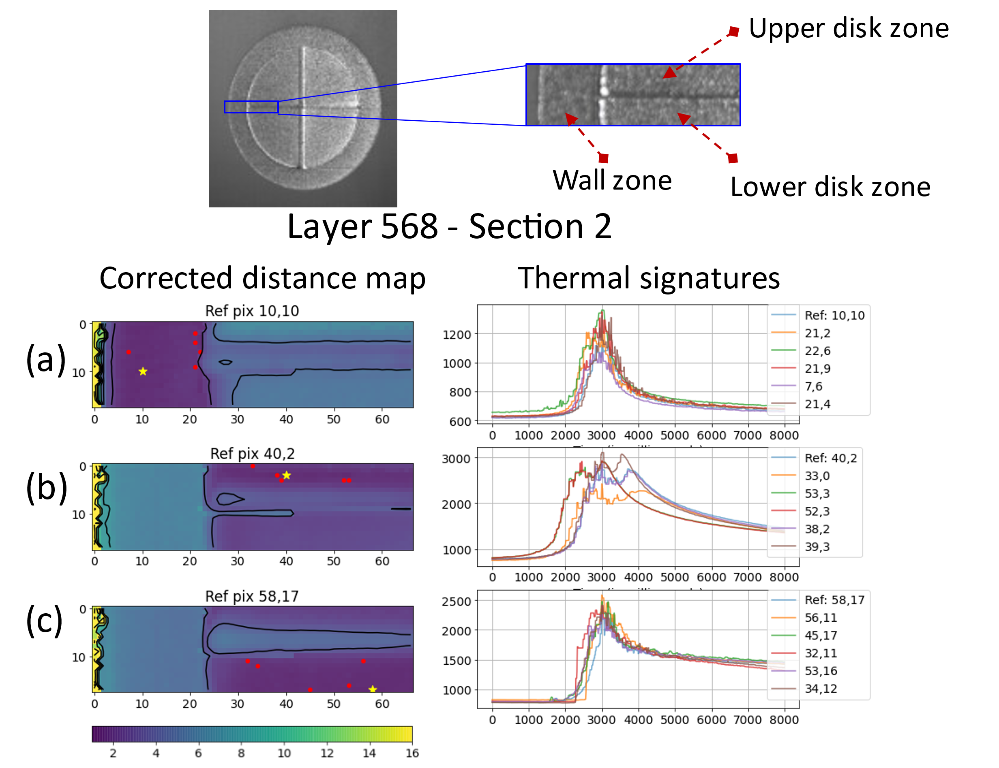
Figure 3-9: Thermal signatures in layer 568 from section 2. Comparison with section 4 indicates that layers in section 2 have slow cooling rates due to limited heat transfer through the underlying powder bed and support structures

Layer 754 in build section 3
Figure 3-10 shows layer 754 from build section 3. Since the layer was in section 3 of the build, the entire disk and wall regions were built using a continuous pass of the laser beam rather than different zones as in section 2. Figure 3-10 indicates that thermal signatures across the layer are uniform, both in the corrected distance maps (left) and in the extracted thermal signature plots (right). This is expected since layer 754 is positioned around mid-height of the disk section 3. Therefore, sufficient solid material exists underneath the layer to enable uniform heat transfer across the layer into the rest of the build and eventually to the build plate.

Layer 952 in build section 4
Figure 3-11 shows results for layer 952 in build section 4. Section 4 is a transition section, but was built on top of a solid disk region, unlike section 2 which was built atop support structures. This is expected to cause a significant difference in cooling rates between sections 2 and 4. Figure 3-11 shows that all three zones of layer 952 (wall, upper disk zone and lower disk zone) have similar thermal signatures. The corrected distance values are mostly between 1-4, indicating largely similar thermal signatures rather than the wide range of distance between 1-8 in layer 568 (Figure 3-9). This seems to be due to the thick disk section underneath, leading to uniform heat transfer. This is an important observation since it indicates the crucial role of geometry in dictating thermal signatures and cooling rates in an AM part.

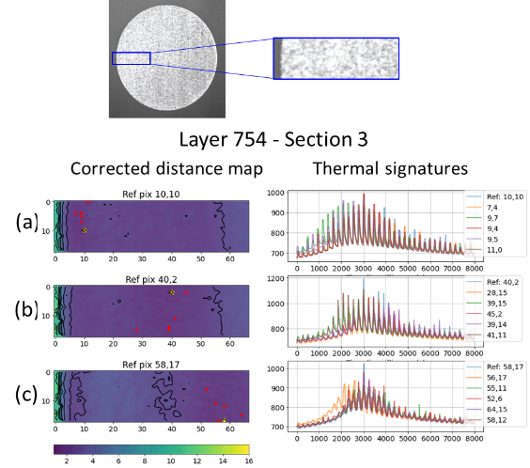
Figure 3-10: Similarity analysis results for layer 754- section 3

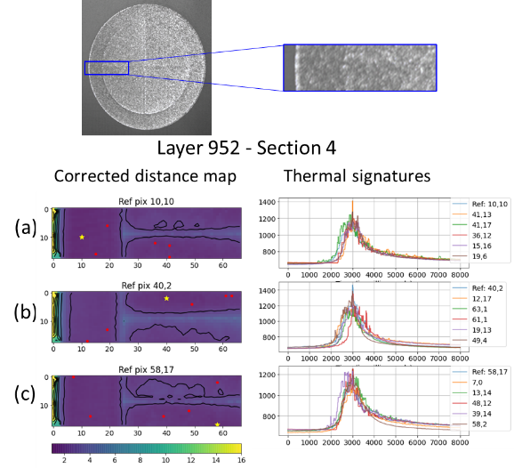
Figure 3-11: Thermal signatures in layer 952 from section 4. This layer has nearly the same geometry and scan strategy as layer 568 in section 2. The difference in thermal signatures is due to underlying layers being solid metal as in section 4 or powder bed and support structures as in section 2.

Observed microstructure corresponding to varying thermal signatures
To rationalize observed differences in thermal signatures in layers 568 and 952, the microstructure in these regions was characterized using optical and scanning electron microscopy. Optical microscopy of the etched surfaces was used to evaluate the melt pool shape and dendrite shape and size characteristics. In case of scanning electron microscopy, the electron backscattered diffraction imaging (EBSD) was used to evaluate the crystallographic misorientations and the shape of the FCC (austenite) grains. Specifically, the build was sectioned and imaged near the interfaces between sections 2-3 and sections 3-4. It should be noted that similarity analysis is carried out at the layer-wise (XY section) level, whereas optical and EBSD images correspond to polished slices of the build parallel to the build direction (i.e. XZ direction). Since each layer is ≈ 50 µm thick, it is difficult to determine the exact layer number corresponding to EBSD or optical microscopy images. Schematic diagrams in Figure 3-12 and Figure 3-14 show the approximate locations of EBSD and optical images with reference to the build cross-section.

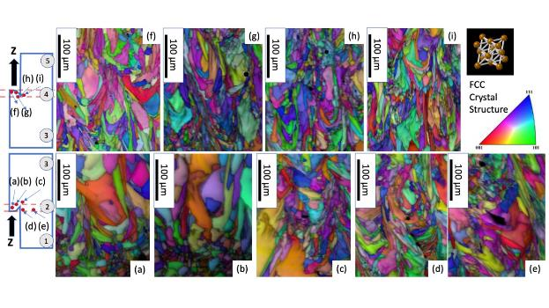
Figure 3-12: EBSD images from the interfaces between sections 2 to 3 and 3-4 as discussed in the text. The bottom row images from [a to e] show a gradual decrease in the columnar austenite (FCC) grain size as we traverse from disk to wall region due to changes in the thermal signatures. In case of the images from top side, i.e., sections 3-4 (f to i) show only large austenite grains close to the open region of the disk and the rest of the region appears to be similar. The EBSD colors correspond to the inverse pole figures corresponding to various crystallographic directions shown in the key. No changes in crystallographic texture was observed between the sections.

Figure 3-12 shows EBSD grain maps of the disk zone and the wall zone of layers near the interfaces of sections 2-3 (a - e) and sections 3-4 (f - i). These maps reveal that the grains in the disk zone (a, b and c), are much larger than those in the wall zone (d and e). Many grains in the disk zone are longer than 100 µm and have widths greater than 50 µm. In contrast, grains in the wall zone have shorter length and their width ranges between 10-50 µm. Figure 3-12 (f – i) show EBSD grain maps corresponding to layers near the interface of sections 3-4. These maps indicate uniform grain size distribution across the disk and wall zones, with grain sizes and shapes similar to the regions shown in Figure 3-12 (d) and (e). The grain size distributions for build sections 2,3 and 4 are shown in Figure 3-13. There is a clear difference in grain size distribution in section 2, with a mix of large and small grains. Sections 3 and 4 have similar grain size distributions with predominantly smaller grains.

Optical micrographs of a few layers sampled near the section 2-3 interface and section 3-4 interfaces are presented in Figure 3-14. High magnification images from these locations indicate varying primary dendrite arm spacing in different regions of the build.

In the L-PBF process, the cooling rate is the product of liquid-solid interface velocity R and thermal gradient G. Various research studies [161,168–170] indicate that rapid cooling rates of the order of 10⁶ − 10⁷ K/s occur in L-PBF, based on process parameters like laser power, scan speed and scan rotation between layers. This leads to non-equilibrium solidification conditions and the formation of dendritic microstructures in 316L with dominant austenitic phase. Scipioni-Bertoli et al. [168] point out that primary dendrite arm spacing (PDAS) or cell spacing varies inversely with cooling rate and follows an inverse power law of the form d = A(T˙)^{n}, where d refers to cell size, T˙ refers to cooling rate and A and n are constants.

We observed qualitative evidence (Figure 3-14) for the change in PDAS in optical microscopy and solidification grains measured by electron backscattered diffraction (EBSD) (Figure 3-12) techniques. The optical microstructures from the bulk region with rapid cooling rate conditions (similar to layer #952) and edge region with slow cooling rate conditions (similar to layer #568) showed fine and coarse primary dendrite arm spacing. By drawing lines across the primary dendrites and measuring the intercepts, we estimated the PDAS for both conditions. The PDAS for the bulk region was found to be 0.72±0.16 µm and the edge regions were found to be around 2.07±0.35 µm.

Since the PDAS measurements are often influenced by the sectioning effects, we performed further analyses on EBSD data by measuring the solidification grain size based on boundaries drawn between grains with high angle crystallographic misorientation. Here we make a hypothesis that the large primary dendrite arm spacing will eventually lead to larger solidification grain size. To confirm this hypothesis, detailed grain size analyses (Figure 3-13) were performed with EBSD data in three different cross-sections 2-4 (XZ section) corresponding the regions showing different thermal signatures. The analyses confirmed that the solidification grain size does change from coarse (> 90 µm) to fine (< 40 µm), as we transition from section 2 (slow cooling rate) to section 4 (rapid cooling rate).

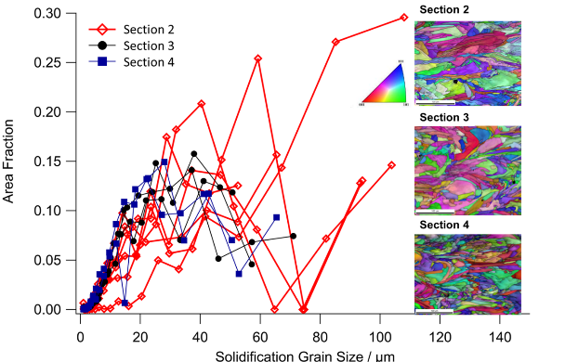
Figure 3-13: Grain size distributions corresponding to sections 2,3 and 4 of the build, as obtained from EBSD images

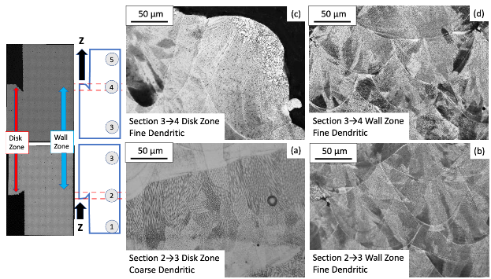
Figure 3-14: Optical images from the interfaces between sections 2 to 3 and 3-4 as discussed in the text. The images from (a) disk regions at the interface between sections 2 and 3 contain coarse solidification dendrites within a large melt pool, while the (b) wall regions show fine dendrites and also small melt pools. The images from (c) disk zones between sections 3 and 4 show predominantly fine dendritic structure, except for the free surface regions. The images from the (d) wall regions at the same sections show fine dendritic microstructure as that of sections 3-4.

Although the focus of this paper is not quantitative correlation of IR thermal signatures to microstructure size distribution, an attempt was made to evaluate the possibility. The analysis, using IR data and published welding metallurgy knowledge, is summarized in Appendix E. The analysis supports the notion that IR thermal signatures can be used as a proxy for microstructural heterogeneity.

An important finding here is that cooling rates of a part can be significantly influenced by the geometry of underlying layers. This effect has been studied by other groups [157,160] but a method to observe it directly using data from in situ monitoring is provided in our work.

Anomaly detection using similarity analysis
Similarity analysis can be extended to identify anomalous regions in a layer of a build or even across layers in some cases. A brief overview of this capability is shown in Figure 3-15. Here, layer 355 from section 1 is analyzed using the similarity analysis procedure. This layer was printed using a 90° scan angle. Plots (a), (b) and (c) in Figure 3-15 show an unlikely contour similar to the support structures appearing in a region where no melting was intended. To investigate this further, a reference pixel was picked to “probe” the anomalous region. Results in plot (d) show that pixels in the anomalous region exhibited similar thermal signature to some pixels in support structures. The layer was checked on the IR video, and a hot particle was found to land at the region highlighted (inset of Figure 3-15). This example shows that similarity analysis can be used to identify anomalies that lead to potential defects in the build. Ex situ CT analysis was not carried out on the part. It is possible that the hotspot either healed in subsequent layers or led to an irregularity in the build. The take-away is that identifying such hotspots during the build process can enable informed ex situ analysis or act as input to feedback systems to avoid propagation of defects into subsequent layers of the build. Analysis of thermal signatures based on IR data for other builds using a similar setup as Figure 3-3 shows that IR cooling rate is significantly slower at porosity[171].

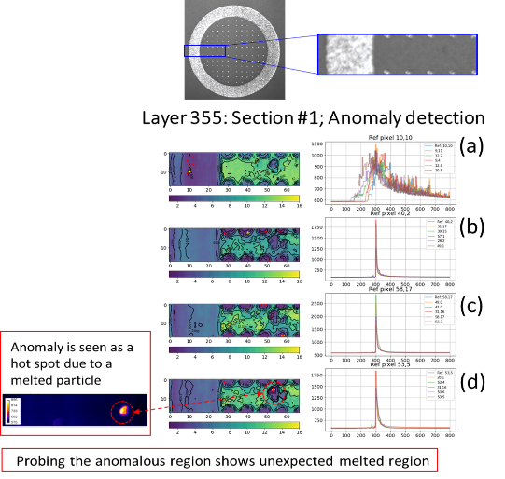
Figure 3-15: Detection of a hotspot in a layer and associated anomaly in IR data, using similarity analysis and appropriate probing using reference pixels.

Similarity analysis is expected to be able to identify such pores due to slow cooling and dissimilar thermal signatures.

Conclusions
In this paper, a novel method to study similarity of thermal cycles and associated thermal signatures in the L-PBF process has been presented. The key contributions of this paper are listed below.
1. A similarity analysis algorithm has been presented for comparison of thermal signatures across a layer of a part. This method combines both shape similarity and magnitude similarity to compare thermal signatures in a part.
2. An application of similarity analysis is demonstrated to study variation in thermal signatures associated with change in part geometry. Results indicate uniform cooling rates in layers with solid layers underneath, and varying cooling rates in layers with part solid and part powder bed underneath.
3. Comparison with microstructure characterized using EBSD and optical microscopy indicated that similarity analysis could be validated using observed microstructure. Regions of uniform cooling rates had similar grain size distributions, while varying cooling rates led to varying grain size distributions. Slow cooling led to large grains while fast cooling led to small ones.
4. Similarity analysis can also be used to identify anomalous regions corresponding to potential defects in the part. While the anomaly detection capability has not been explored in detail, a proof of concept has been presented.

The similarity analysis method developed here could be extended to identify differences in thermal signatures in comparable parts across the build table, based on part position. For similarity analysis to be used as a tool for part qualification, corrected distance limits for part acceptance need to be defined. These limits could be based on ex situ part testing for a few builds. The acceptance limits will vary for each part, based on material, geometry and application. Once defined, acceptance limits can be applied using principles of statistical process control to determine parts that are good or bad, for further use in various applications.

Acknowledgements
Authors acknowledge partial support from the U.S. Department of Energy, Office of Energy Efficiency and Renewable Energy, Advanced Manufacturing Office, under contract DE-AC05-00OR22725 with UT- Battelle, LLC. Part of the research is also supported by the Office of Nuclear Energy, Nuclear Energy Enabling Technologies program under DE-NE0000544 contract with Electric Power Research Institute.

This manuscript has been authored in part by UT-Battelle, LLC, under contract DE-AC05-00OR22725 with the US Department of Energy (DOE). The US government retains and the publisher, by accepting the article for publication, acknowledges that the US government retains a nonexclusive, paid-up, irrevocable, worldwide license to publish or reproduce the published form of this manuscript, or allow others to do so, for US government purposes. DOE will provide public access to these results of federally sponsored research in accordance with the DOE Public Access Plan (https://www.energy.gov/downloads/doe-public-access-plan)

S.C. would like to thank Eric Heikkenen for early help with Python scripting for binary file handling. S.C. would also like to thank Caitlin Hensley and Travis McFalls for discussions about the build used for analysis in this work. The authors also thank Kevin Sisco for developing the optical imaging hardware and software. The authors would like to thank David Gandy of EPRI for discussions of AM applications and support for the project.

Appendix A. Effect of median filter on IR intensity signal
Consider the IR signal at a pixel during a layer of the build. At low frame rates, the laser beam moves much faster between pixels than the speed at which successive data points are captured. This can lead to variation in peak IR intensity at pixels that experience the same laser beam pattern in a layer, but “see” different patterns. This occurs due to the capture of peak laser pulse in one instance versus laser decay in another instance. Thus, low frame rates lead to asynchronous sampling of data with reference to the laser beam motion.

Using a median filter captures only long-term trends in the signal and differences due to low sampling rate effects are eliminated. The length of the captured global trend is decided by the filter window size. This is illustrated in Figure 3-16, which indicates the effect of median filtering on raw IR data corresponding to a single pixel for a single layer. While using a median filter, the size of the moving window plays an important role in the balance between discarding too much information and retaining spatter noise and/or asynchronous laser beam information. It is seen that window sizes between 7 – 13 yield nearly the same result (see Figure 3-16 - inset). Therefore, a value of 9 was chosen for this work.

By visually comparing the raw IR intensity to the video, we observe that the oscillations in raw IR signal are correlated to the laser speed and frame rate. Each “oscillatory peak” arises from laser passing at the given pixel or adjacent to it. Therefore, an appropriate window size depends on imaging parameters like frame rate and resolution, and build parameters like scan strategy and geometry.

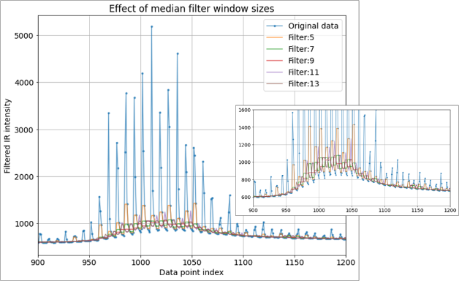
Figure 3-16: Effect of median filter window size on filtering

Generally, median filter is used only with an odd number for the window size to avoid artifacts being introduced into the signal. The median of an odd number of values is the value at the center when the data is sorted in ascending or descending order. The median of an even number of values is the mean of the central two numbers when the data is sorted in ascending or descending order. Therefore, an odd window size does not introduce data points that do not exist in the original signal. A small window size will lead to noise being retained while a large window size will lead to only too much smoothing with limited long-term trends being retained in the signal. It is essential to find a balance between the two extremes using an appropriate window size.

Appendix B. Use of moving windows to compute distance using the MASS algorithm
An illustration of the use of moving windows to compute Euclidean distance between reference thermal signature and all possible locations of thermal signature of a pixel is shown in Figure 3-17. The reason this is required is that the thermal signature may have specific alignment at which it matches best with the reference thermal signature.

Computing this alignment would require a model that captures the exact beam scan strategy, layer geometry and camera frame rate. We are not aware of such a model to predict thermal signature and its alignment for each pixel. We prefer to compute distance over all possible moving windows using MASS and select the alignment with minimum distance as the most appropriate alignment with the reference pixel.

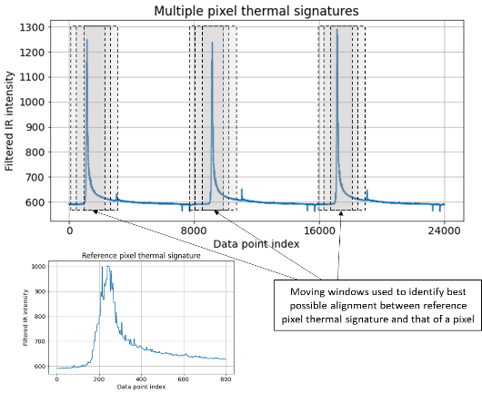
Figure 3-17: Concatenated thermal signatures of 3 pixels, along with a few moving windows that are used to identify best possible match between the pixel and reference pixel’s thermal signature

Appendix C. Details of computation for similarity analysis
C.1. Shape distance
Euclidean distance is the metric of choice to compare shapes of thermal signatures. Euclidean distance between discrete time series sequences x_{i} and y_{i} of length n is given by equation C1.

$d_{Euc}= \sqrt{\sum_{i=1}^{n}{{\left(x_{i}-y_{i}\right)}^{2}}}$ (C1)

When Euclidean distance is computed between z-normalized time series sequences, it eliminates differences due to magnitude of the time series being compared [166]. Euclidean distance can thus compute dissimilarity i.e. “distance” based on the shape of the time series curves. Euclidean distance between z-normalized time series can be rearranged and written as given in equation C2, where m is the length of the time series sequences being compared and corr(x,y) is the correlation coefficient between two time series. The correlation coefficient is 1 for perfectly matching curves, -1 for a perfect inverse match and 0 for no match between the curves. A value of zero for normalized Euclidean distance indicates exact shape similarity between the normalized time series sequences being compared. For example, two sine waves having the same phase and frequency but different amplitudes will have a normalized Euclidean distance of 0 between them.

$d_{norm}=\sqrt{2m(1-corr\left(x,y\right))}$ (C2)

The normalized Euclidean distance for each layer ranges from 0 to 57 since correlation ranges between -1 to 1 and m is chosen to be 800 for each layer, as explained below. To compute the shape distance, the normalized Euclidean distance is scaled down by a factor of 10 and increased by 1, so that the result is between 1-6. This is done to balance the effect of magnitude distance and shape distance in overall corrected distance (equation C5). The magnitude distance varies between 1-6 as discussed in equation C4.

$d_{shape}=1+\frac{d_{norm}}{10}$ (C3)

The choice of m =800 works for this specific dataset since the duration of IR activity at a single pixel for each layer was ~8 seconds (800 frames). Note that layer time per layer is ~ 80 seconds (8000 frames). The difference is that layer time is the time taken to print an entire layer of the part, while each pixel gets heated and cooled only for a fraction of that time. The duration of IR activity depends on scan strategy, laser scan speed and geometry. The value of m is thus case-specific. It can be identified by inspecting the moving standard deviation of IR data and identifying regions of IR activity.

C.2. Magnitude distance
Comparison of thermal signatures across pixels requires magnitudes to be compared as well, since the magnitude of IR intensity is a proxy for the temperature of a pixel. In our work, we use the variances of the time series sequences being compared to represent the difference in their magnitudes. The function developed is represented in equation C4.

$d_{mag}=1+\log_{10}\left(\frac{σ^{2}}{σ_{ref}^{2}}\right)$ (C4)

In equation C4, the reciprocal of variance ratio is used in cases where the reference pixel’s variance is higher than that of the current pixel, thus ensuring that the variance ratio is always >1. We use log of the variance ratio to compute magnitude distance. This is because variance ratio is an expression of magnitude difference between curves, and varies linearly with variance. IR intensity varies over a wide range of 0-16384 (2¹⁴), for a 14-bit IR signal representation. Using a linear function of variance ratio leads to overwhelming of magnitude distance by large variances. This leads to problems with computation of corrected distance as explained in the latter part of this section. Using log of the variance ratio leads to comparison across variances based on the order of magnitude rather than a linear scale of magnitude. An addition of 1 is done for convenience, to ensure that the minimum magnitude distance is 1 rather than 0. Note that the magnitude distance varies between 1-6 due to the range of variance being 1-16384.

C.3. Corrected distance between time series
We compute corrected distance to account for both shape and magnitude of the underlying time series. We formulate corrected distance as the product of shape and magnitude distances (Eq C5).

$d_{corr}=d_{shape}*d_{mag}=\left(1+\frac{d_{norm}}{10}\right)\left(1+\log_{10}{\frac{σ^{2}}{σ_{ref}^{2}}}\right)$ (C5)

The key idea is that the shape of the thermal signature indicates heating and cooling rates at each pixel, while magnitude accounts for the temperature range of each pixel. The cooling rate is especially important in microstructure evolution, as pointed out in both AM and stainless steel literature [27,160,161,168,172]. While some authors have numerically estimated the cooling rate to be the slope of the cooling curve [168,172], our approach involves a combination of shape and magnitude comparison numbers. Our method is based on a direct comparison of cooling rates based on observed IR signals and therefore independent of noise arising due to numerical computation of the slope.
C.4. Computational details
Similarity is computed between a reference pixel and pixels in a layer. Considering a total of T = p X q pixels, it is easy to imagine Euclidean distance being computed between each of the pixels and the reference pixel, leading to a total of T distance computations. However, this assumes that the thermal signatures of pixels are well-aligned and registered i.e. their alignment in terms of peak melt event and start/end of heating and cooling sequences are known apriori. This is not the case with IR data. An illustration of this challenge is presented in Appendix B. To find a way around this problem, we compute Euclidean distance between the reference pixel and all possible moving windows of length m in the pixel’s thermal signature, where m is the relevant length of the thermal signature of the reference pixel. We use the MASS algorithm for efficient computation of normalized Euclidean distance. MASS is a fast algorithm that computes normalized Euclidean distance between z-normalized time series [167], using convolutions and the Fast Fourier Transform (FFT) for computational efficiency. We use the MASS algorithm to compute the shape distance and multiply the result by the magnitude distance to determine the corrected distance. Recall from Table 3-3 that the length of the vector of concatenated thermal signatures of all pixels is N_{t} = T x N_{l}. Therefore, the number of moving windows of length m is N_{t} − m + 1, which is now the total number of distance computations required. The MASS algorithm provides an efficient way to compute z-normalized distance between a long vector and a shorter reference vector, as in our case.
One shortcoming of concatenating all thermal signatures into a long vector before distance computation is it allows for the possibility of thermal signatures of different pixels to be combined in a moving window. This could lead to “spurious” thermal signatures, based on moving windows that overlap thermal signatures of different pixels, during distance computation. The signatures are spurious since they belong to no single pixel and thus lack meaning. This pitfall is avoided by considering only valid moving windows around the peak IR intensity for each pixel. The minimum normalized Euclidean distance for each pixel is chosen as the position of best alignment between its thermal signature and the reference pixel. The shape distance is now equal to the minimum normalized Euclidean distance, thus picking the best alignment between the reference pixel and pixel of interest. This is similar to cross-correlation between two time series, to identify the location of best alignment.

Appendix D. Similarity analysis results for section 5 of the build
Similarity analysis results for layer 1050, which was built using a laser scan angle of 60° to the horizontal direction, are shown in Figure 3-18. It is interesting to note that contours of corrected distance are aligned along the laser scan path direction. A hotspot based “anomaly” can also be seen in this layer.

Appendix E: Quantitative correlation of IR signature to microstructure
In the main body of the paper, the correlation of infrared thermal signatures to solidification microstructures was discussed in a qualitative manner. In this section, an attempt is made to quantify these correlations based on welding metallurgy theories. The principles of weld microstructure evolution in stainless steel are indeed mature and predictions can be made by calculating the thermal gradient (G) and liquid-solid interface velocity (R) as a function of welding conditions.

For example, using G and R, one can estimate the onset of phase selection in 316 stainless steels, i.e., emanation of ferrite (BCC) or austenite (FCC) solid phase from the liquid [173,174]. In the current research, the complexity of microstructure evolution arises due to spatial and temporal variations of G and R, while the G and R do not change drastically during steady state welding conditions. This leads to the question: can we use the IR thermal signatures as proxy for evaluating microstructural heterogeneity. To validate this notion, detailed analyses were performed close to the transition regions (layers #568 and #952) that showed major change in cross-section in the cylindrical geometry.

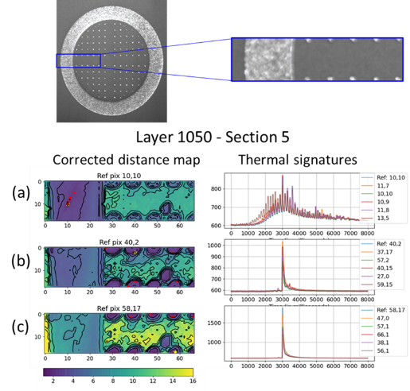

Figure 3-18: Corrected distance maps for layer 1050 in section 5

E.1 Estimation of G and R from thermal signatures
In the main section of the paper, we have indicated that the IR data cannot be converted into absolute temperature due to the spatially and temporally varying emissivity values [175]. Therefore, we invoked the following relationship.

$T_{x,y,time}=C×{IR}_{x,y,yime}$ (E1)

Since we do not know the emissivity values, to avoid further uncertainties, we assumed C to be 1. We understand that this assumption will overestimate the temperature. To estimate the maximum G (units in K/m) at a given pixel local at a given time t, we extracted the infrared intensities of surrounding pixels and estimated the maximum IR gradient using the central difference formulation for numerical differentiation.

$G=(T_{x1,y1,t}-T_{x2,y2,t})/\left(2*pixelsize\right) =\left({IR}_{x1,y1,t}-{IR}_{x2,y2,t}\right)/\left(2* 100×{10}^{-6}\right)$ (E2)

Five pixels were chosen in these layers (Figure 3-19) and thermal gradients (G) and cooling rates (in the units of K/s) were extracted as a function of time using the following relationship, since our temporal resolution is 0.01 second.

$CoolingRate=({IR}_{x1,y1,time1}-{IR}_{x1,y1,time2})/\left(0.01\right)$ (E3)

Now the liquid-solid interface velocity (R, in the units of m/s) can be calculated by dividing the cooling rate by thermal gradient (G). Since we are interested in the G and R corresponding the melting temperature or above, we make another assumption of the IR magnitude that corresponds to the solidification temperature of stainless steel. Since we do not know this value a priori, we analyzed the IR signatures of these two layers (Figure 3-19), i.e., layers #568 and #952 and set this IR value to be 1000. Using the calculated G and cooling rate for all the IR value at 1000 or above, the R values were calculated for these pixels.

E.2 Calculation of Solidification Microstructure

The sets of calculated G and R are overlaid on the phase selection map (Figure 3-20) predicted with modified interface response function [49] model.

It is indeed clear that the G and R values spread across many orders of magnitudes. Based on the statistical distribution of G values shown in Figure 3-20 (b), it is indeed clear that there is no significant change in G values for layers #568 and #952. This is indeed expected since our pixel resolution is only 100µm and gradients above 10⁶ K/m are not accessible by our measurement technique. In contrast, the calculated R values do show a statistically distinct differences between layers (Figure 3-20 (c)). These variations were indeed expected from the slow cooling rates for the layer #568 (Figure 3-19).

The phase selection map indicates that, for most of the thermal signatures, layer #952 will lead to austenitic dendritic mode of solidification, while the locations within the layer #568 will solidify either as ferrite or austenite. Although, preliminary electron backscattered diffraction (EBSD) analyses and X-ray diffraction analyses have shown the evidence for the presence of residual ferrite at room temperature, further detailed compositional analyses is needed to confirm the same which is part of a separate paper. We also calculated the primary dendrite arm spacing (Figure 3-20 d). The calculations indicate that the PDAS in the layer #952 will be finer than layer #568. It is important to note that magnitude of the PDAS estimate is indeed very sensitive the factor “C” we used in the conversion from IR to temperature. However, we can safely conclude that the PDAS of thermal signatures with rapid cooling conditions will indeed lead to finer PDAS compared to that from slowly cooling regions.

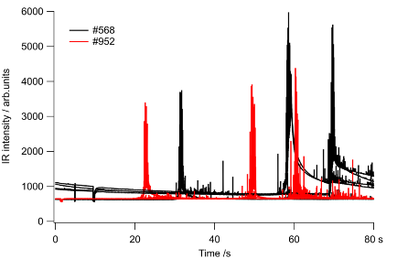
Figure 3-19: Comparison of raw IR signals from five pixels in layers #568 and #952 where large changes in solidification microstructures were observed.

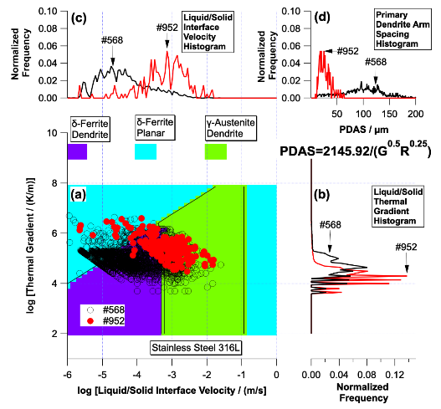

Figure 3-20: Summary of solidification microstructure prediction using published models: (a) Overlaid phase selection map for the sets of G and R for layers #568 and #952; Statistical distribution of (b) G and (c) R for the same layers show stark differences; (d) calculated primary dendrite arm spacing based on the empirical equations [176].

Although the above analyses confirmed direct correlations between thermal signatures to microstructural heterogeneity based on solidification grain size, there are limitations in our current analyses. The estimation of G and R may be systematically lower or higher depending on the proportionality constant “C.” In addition, the confidence in spatial correlation of thermal signatures measured in layer surface (XY sections) to the microstructure observed in XZ section cannot be reliable due to limitations of sample sectioning and also remelting of the ith layer by (i+1)th melt process.

VALIDATION OF SIMILARITY ANALYSIS USING TI-6AL-4V LATTICE STRUCTURES

This chapter contains details of a study that explores thermal signatures of different locations in Ti-6-4 lattice cubes built using L-PBF process. Lattice nodes that have different geometric connectivity exhibit clear differences in thermal signature as recorded using an IR video monitoring of the process. Differences in thermal signatures that occur due to different inert gas atmospheres i.e., between Argon and Helium inert gas atmospheres are also explored, in conjunction with effects of geometry. This study is being drafted as a journal paper and will be submitted in the near term. The appendix includes images that are meant for completeness of the dissertation but not included in the proposed paper.

The expected citation for this paper is: Sujana Chandrasekar, Fred List, Sabina Kumar, Jamie Coble, Keith Carver, Vincent Paquit, Sudarsanam S. Babu, “Effect of inert gas atmosphere on thermal behavior in Ti-6-4 lattice structures”.

Sujana Chandrasekar was responsible for methodology development, software implementation, data analysis and manuscript writing. Fred List and Keith Carver conceptualized the study, designed lattice geometries and built them in the Renishaw M250 AM system. They also collected designed and set up the imaging system to collect IR data associated with the build. Fred List also aided in manuscript writing. Sabina Kumar carried out microstructural characterization and associated interpretation of results. Jamie Coble and Vincent Paquit were involved in methodology development and supervision. Sudarsanam S. Babu was responsible for discussion of microstructural results and interpretation of thermal data trends.

Introduction
Additive Manufacturing processes are increasingly popular for manufacture of parts with complex geometry and open up the design space in a significant manner. They are being actively considered or in service in the aerospace, nuclear and biomedical domains[6,8,10] . However, part qualification poses a significant challenge in additive manufacturing processes. This is primarily because repetitive melting in the AM process leads to complex thermo-mechanical cycles that in turn lead to intricate phase transitions and associated microstructure and mechanical properties in different regions of the part [28] . Defects that occur due to porosity, lack of fusion, keyholing and poor powder spreading can also lead to premature part failure [66] . In this context, a similarity analysis methodology was proposed by Chandrasekar et al. to study thermal signature similarities across regions of a part using in situ monitoring. In their work, Chandrasekar et al. applied the similarity analysis algorithm to study the effects of change in cross-sectional geometry on thermal signatures and associated microstructure. In this paper, the similarity analysis algorithm is used to study the interplay between the effect of different inert gases, changing part geometry and scan strategy on thermal signatures in the L-PBF process. Specifically, the differences in thermal signature that occur in the presence of Argon vs. those in the presence of Helium are studied. It is important to understand the effect of different inert gases since their selection has not been standardized in the additive manufacturing community. Use of appropriate inert gases may lead to significant control over thermal behavior of parts built by the L-PBF process. To date, the study of the effect of inert gases in additive manufacturing has been limited. Pauzon et al. [177] studied the effect of Argon and varying proportions of Helium-Argon mixtures on the L-PBF process by building Ti-6-4 samples. They found that samples built in Helium atmospheres were brittle compared to those built in Argon atmospheres. This has been explained using the significantly higher thermal conductivity of Helium (~10x of Argon) and thermal capacity of Helium. Ruiz et al. [178] showed that use of Helium as a cover gas led to increased melt pool depth, smaller clad heights and lower wetting angle in the laser melt deposition process, which is a directed energy deposition method. Similar trends have been shown in welding literature, where Helium as a cover gas is shown to increase depth of penetration in tungsten inert gas welding [179]. Bidare et al. [180] studied different inert gases under varying pressures in the inert gas chamber. They found that the increased pressure levels of Ar and He led to increased melt pool temperature in both cases. However, Argon had an increase in the amount of spatter generated and poor quality of beads. Helium, on the other hand, did not have increased spatter due to less laser plume and spatter. They suggested that the use of Helium at high pressures may be more efficient than use of Argon at atmospheric pressures, since the higher pressure of Helium allowed higher scan speeds while maintaining high melt pool temperature without associated degradation due to spatter. This led to maintaining good surface finish at faster print speeds. But they also indicated the need for further investigation due to the high complexity and cost involved in using He in PBF systems. Wei et al. [181] studied thermal conductivity of metal powder under different pressures of Argon, Helium and Nitrogen inert gases. Their measurements indicated that the gas pressure is an important determinant of thermal conductivity of powder. They postulate that this is due to infiltration of the powder by inert gas. Helium in particular leads to a significant increase in powder thermal conductivity at high pressures. Their study indicates that metal powder and inert gas should not be considered as separate factors but rather as a combination that determines thermal conductivity of powder in the L-PBF process.

The above-mentioned studies are valuable in understanding the effect of inert gas on powder and part properties in L-PBF. However, a direct observation of thermal behavior could provide additional insights into the effect of inert gases and this has not been carried out. In this study, we demonstrate the use of in situ monitoring of the build process using a high-speed infrared camera and similarity analysis of thermal signatures to understand effect of inert gas on the L-PBF process. The results from thermal signature analysis are validated using microscopic characterization of the builds and hardness measurements. Such a study would enable a better understanding of the interplay between parameters like scan strategy, part geometry and inert gas. It could also act as a validation tool for thermal simulation models to evaluate different inert gas atmospheres.

Specifically, we study the effects of Ar vs. He using identical lattice structures of Ti-6-4 that were built using the L-PBF process. A lattice cube was chosen to follow thermal trajectories during L-PBF process, similar to bead-on-plate experiments in welding literature. When a layer of the lattice is laser processed, small spatially dispersed areas of the powder bed are melted and allowed to cool. The effects of melting of adjacent areas in the layer on the thermal profile of the area of interest are minimal, which significantly simplifies interpretation of results. Using lattice structures also makes it possible to understand the effect of nodal geometric connectivity on thermal signatures in lattice structures. This is important to isolate the effect of geometry versus process parameters. Lattices are also relevant
for various biomedical applications where lattice structures are widely used [182]. Understanding the underlying thermal signatures and associated microstructures could enable more informed decisions on the type of lattice structure to choose for end use.

The novel findings in this paper are the following:
- The validity of using thermal signature analysis is first demonstrated by studying the effect of nodal connectivity on thermal signatures in lattice structures. Results show that thermal signatures vary in a pronounced manner with nodal connectivity in lattice structures, as expected based on fundamental heat transfer mechanisms.
- The effect of Ar vs. He on thermal signatures in the L-PBF process is evaluated. Results show that He inert gas cools faster than Ar in most cases, but the cooling rate is dependent on scan strategy and nodal connectivity. This paper is the first to study cooling rates using in situ thermal monitoring in lattice cubes.
- Lattice cubes built in He atmosphere are lighter by ~2.5% than identical cubes built in Ar atmosphere. The reason for this is hypothesized based on thermal properties of Helium and Argon gases and observed mechanical property variations are explained.

The rest of this paper is organized as follows: Section 4.2 contains details of the builds including the lattice cube geometries and imaging setup used. Section 4.3 contains details of the analysis parameters chosen for similarity analysis and results for a few nodes in a lattice cube. Section 4.4 contains results that indicate the effect of nodal connectivity on thermal signatures. Section 4.5 contains a comparison of thermal signatures for cubes built in Ar vs. He atmospheres. Section 4.6 contains a discussion of microstructure, hardness and mechanical compression test results. Section 4.7 contains conclusions and points towards future work.

Build geometry and imaging details
The geometries used for this study were lattice structures made using Ti-6-4 alloy powder in the L-PBF process. A Renishaw M250 machine was used for the builds. The unit cell of the lattice structure is shown in Figure 4-1, with illustrations of how they are stacked and arranged together to form layers of the lattice. The struts in the lattice cube have a square cross-section. 24 lattice cubes were built on a build plate (Figure 4-2 and Figure 4-3). These consisted of 4 replicates each of 6 parameter combinations. The two parameters that were varied are: lattice strut size was coarse (1.25 mm) or fine (0.8mm) and volumetric energy density was low (A), medium (M) or high (H). Accordingly, there were 6 possible combinations of strut size and volumetric energy density. The cubes had a constant design dimension of 32 x 32 x 36 mm (Figure 4-4), with the filled volume ratio changing with strut size. The details of the energy density used is given in Table 4-1. Two separate builds were carried out: one each under Helium and under Argon atmosphere. Argon is the default atmosphere in the Renishaw M250 system that was used in this study. Argon was provided from the vapor over a liquid argon source, and Helium was supplied from a pressurized cylinder of Ultra High Purity (99.999% purity) Helium gas. The high thermal conductivity of Helium relative to other common build gases (e.g., Argon, Nitrogen) presented a problem for the high temperature, Yttria-stabilized Zirconia Oxygen sensors used within the LPB system. When exposed to Helium rich gas, these sensors failed to maintain temperature (~650°C) and faulted. In order to operate with Helium, the oxygen sensors were bypassed, and He was introduced into the system with several cycles of evacuation and backfilling to assure that argon had been sufficiently displaced.

To gather infrared (IR) data for thermal monitoring of the builds, a Flir SC 8203 camera was set up outside the build chamber as shown schematically in Figure 4-5. The images were recorded at a frame rate of 371 Hz with an integration time of 22.2 µsec and a sensitivity range of 200-450 °C through a 50-mm focal length Germanium lens. Each pixel of the 1024 x 1024 camera sensor collected the thermal intensity emitted from a ~200 µm x 200 µm area of the build plane. The infrared thermography was done in the Mid-Wavelength IR spectral range of 1.5-5 μm. The frame rate of the IR videos was set at 371 Hz to control the amount of data collected and ensure data for every nodal layer over the duration of the build. The entire build plate was not imaged. Instead, 6 cubes at the center (group 2, indicated by cubes starting with 2 in Figure 4-3) were fit into the field of view so that all 6 parameter combinations could be studied. Some of the replicates were used in compression tests to evaluate mechanical properties of samples made in Ar vs. He atmospheres. This are discussed in section 4.5.

The lattice geometry with unit cell shown in Figure 4-1 leads to 4 types of nodal connectivity in each cube as shown in Figure 4-6. Cooling rates are expected to decrease in the following order: 2S > 1S-W > 1S > 1W, based on area available to remove heat from the current node. This hypothesis is studied in section 4.4. Further, the nodal connectivity only changes within certain planes of the lattice structure, termed as 9x9 nodal planes. The other type of nodal plane is a 8x8 nodal plane which has only 2-strut nodes. This is demonstrated in Figure 4-7.

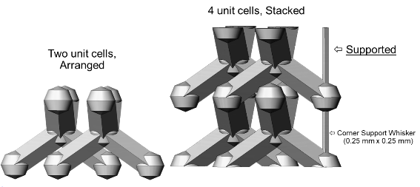
Figure 4-1: Unit cell of lattice

A (Low Heat Input-50 J/mm³)
Wattage: 200W
Hatch: 115 microns
Exposure Time: 60 micro-seconds
Point Distance: 70 microns
M (Medium Heat Input-68 J/mm³)
Wattage: 200W
Hatch: 110 microns
Exposure Time: 64 micro-seconds
Point Distance: 57 microns
H (High Heat Input-77 J/mm³)
Wattage: 200W
Hatch: 105 microns
Exposure Time: 67 micro-seconds
Point Distance: 55 microns
Table 4-1: Energy density associated with lattice cubes
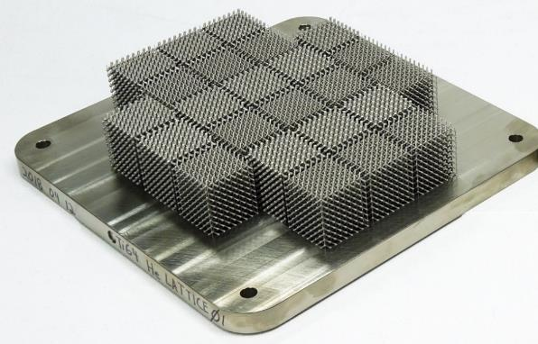
Figure 4-2: Build plate showing all 24 cubes built using different parameter combinations
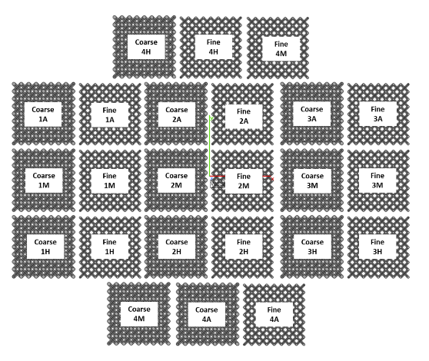
Figure 4-3: Parameter combinations of the 24 built cubes. Coarse and Fine indicate strut size, while A,M and H indicate volumetric energy density. The number of each cube indicates its group ID, since 4 replicates were built for each parameter combination.

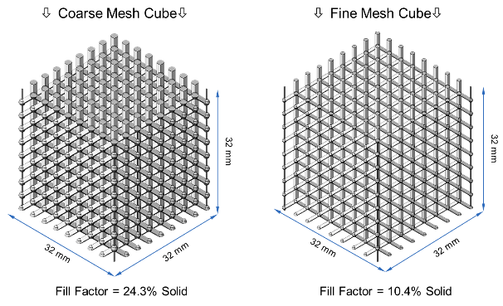
Figure 4-4: Isometric view of coarse (left) and fine (right) strut cubes and their dimensions.

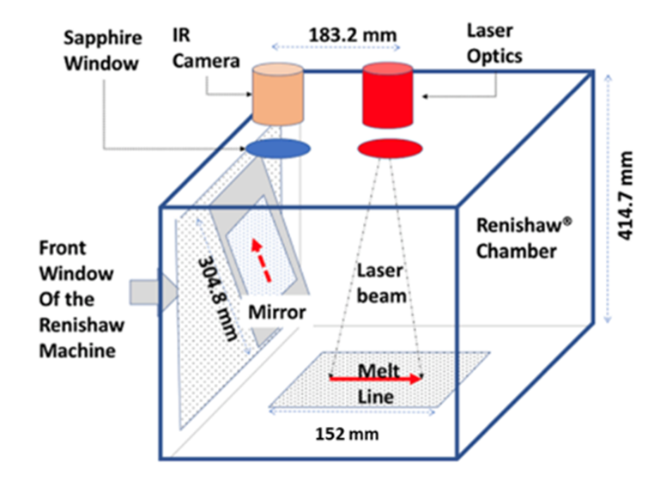
Figure 4-5: Details of imaging setup used to collect IR data

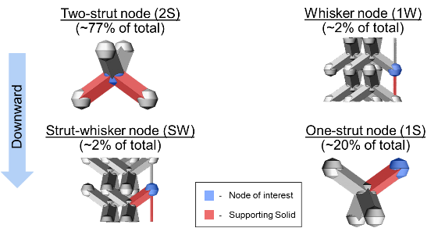
Figure 4-6: Types of nodal connectivity in each lattice cubes. There are 4 types of nodes, with the majority being 2-Strut nodes.

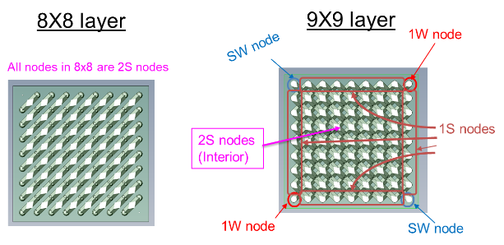
Figure 4-7: Nodal connectivity of nodes in a 8x8 layer (left) and a 9x9 layer (right)

Similarity analysis of thermal signatures in lattice cubes
The similarity analysis procedure described by Chandrasekar et al. is employed in this study to analyze thermal signatures. The primary modification from their work was that log of IR intensity vs. time was used to describe thermal signatures, rather than IR intensity vs. time. This difference is due to the range of IR intensities spanned in the builds used in this study. The IR intensity ranged from 500 units to 16384 units. Using IR intensity vs. time to reflect thermal behavior will lead to poor differentiation between thermal signatures since the signature will be dominated by high intensity levels. Therefore, the log transform is used. The maximum IR intensity value was determined by the active dynamic range of the camera being 14-bits, due to which the IR intensity saturated at 2¹⁴ = 16384 units. Temperature calibration and conversion of IR intensity is not done in this work. As mentioned by Chandrasekar et al., several studies have demonstrated the value in studying IR intensity as a proxy for temperature, without calibration and conversion to temperature. Moreover, the aim is to compare thermal signatures between nodes of different connectivity and using different inert gases. Therefore, temperature conversion is not required for comparative purposes.

Another pre-processing step was to use homography transforms to project IR data into a top-down view of the build plate. The raw images have a perspective distortion associated with the camera and use of a mirror. To correct for this, the homography transformation is computed using CAD layer geometry of the lattice cubes and applied to IR data. The result of homography transformations is shown in Figure 4-8, where three pixels are chosen before and after homography projection for a single layer. The original and projected images indicate the visual effect of projection. The effect on thermal signatures is shown in the first vertical panel. The thermal signatures remain nearly the same and do not suffer from drastic changes due to projection.

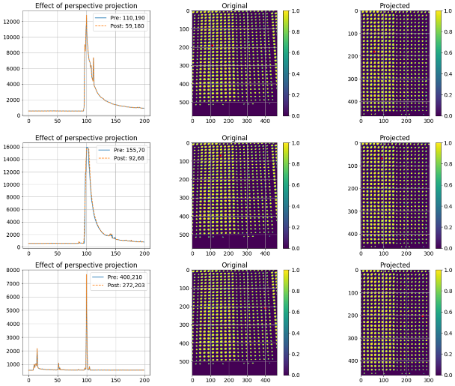
Figure 4-8: Effect of homography transformation on infrared data. Thermal signatures before and after projection are plotted on the left panel, for three chosen pixels whose x,y coordinates are labeled. The chosen pixels are shown as red dots in the center and right panels, before and after projection respectively.

Similarity analysis of pixels in a few nodes
Similarity analysis is first carried out for pixels in a subset of nodes in a single layer of a lattice cube. Results are shown in Figure 4-9, where a black star represents the chosen reference pixel and red dots represent the most similar pixels to the reference pixel. The thermal signatures of reference and similar pixels are shown in the right-hand panel. The chosen time frame for thermal signatures was 80 frames, which corresponds to a time of 216 milliseconds. This was deemed a suitable time scale to capture thermal signature of heating, melting and solidification at each pixel, since the thermal data returns to nearly pre-melt level in this span of time. Similarity of thermal signatures is measured with respect to the reference pixel. Five different reference pixels were chosen for the single node analysis. A small value for corrected distance indicates high similarity, with a value of 1 indicating a perfect match. Higher values indicate poor similarity. Determining a “good” value for similarity depends on applications and is beyond the scope of this paper. Instead, an assumption is made that for any reference pixel, a total of 0.2 percent of pixels are very similar to it. Therefore, the threshold for similarity analysis is set using the corresponding value by which 0.2 percent of pixels are similar to a given pixel. This works because of the number of pixels being analyzed per lattice cube (between 12,000 – 13,000 pixels depending on layer). Figure 4-9 and Figure 4-10 indicates that thermal signatures vary within each lattice node. The outside of the node cools fast compared to the interior, as evidenced by the differences in final cooled IR intensity. The behavior captured by thermal signature analysis lends credibility to the overall analysis since it is expected that a node behaves like a spot melt with cooling occurring from outside in. This has been supported by simple thermal models like the Rosenthal equation, which indicates that the center of the melt pool is the last to cool [112].

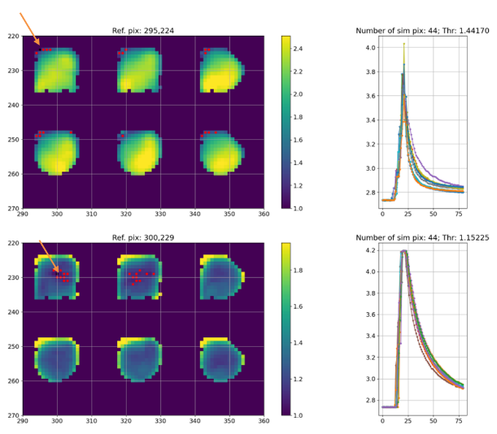
Figure 4-9: Thermal signature similarity maps for 6 nodes in a layer. Reference pixel is pointed out by the orange arrow, while red dots indicate the most similar pixels. Similarity maps indicate that outer pixels of each node don’t get very hot and cool fast, compared to inner pixels near the center.

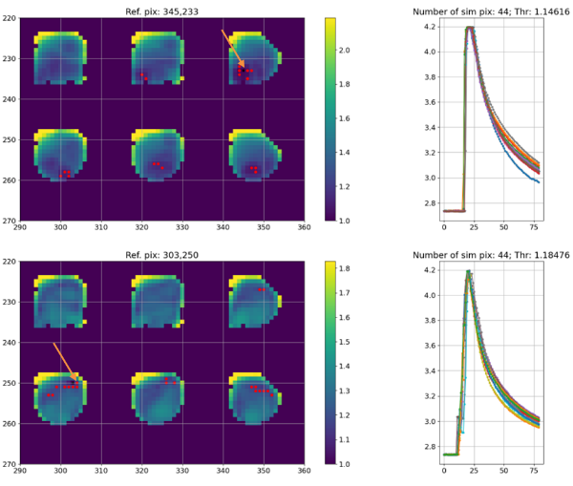
Figure 4-10: Thermal signature similarity maps for 6 nodes in a layer, showing nodes cooling from outside in

Effect of nodal connectivity on thermal signatures
It is expected that the nodal connectivity of lattice nodes influences thermal signatures significantly due to difference in available heat conduction paths. A 2-strut node has a large heat conduction path in terms of area, compared to a 1-strut node, which in turn is larger than a 1-whisker node. Therefore, the thermal signatures were expected to demonstrate a change in cooling rate in the order 2S > 1S-W > 1S > 1W. Similarity analysis was conducted on a layer of a cube corresponding to a 9x9 layer and a 8x8 layer. Results are shown in Figure 4-11 to Figure 4-14. It is important to note from Figure 4-7 that all the wall nodes in a 9x9 layer are 1-S nodes, while the diagonal corner nodes are 1S-W or 1-W nodes. The interior nodes are all 2-S nodes. In contrast, all nodes of an 8x8 layer are 2-S nodes. From Figure 4-11, we observe that the wall nodes have similar thermal signatures to each other as seen by choosing a reference pixel in the wall region. Analogously, interior nodes have a similar thermal signatures to each other(Figure 4-12). It is interesting to note that diagonal nodes that are 1-whisker nodes are not similar to wall nodes. These results indicate that nodal connectivity indeed influences thermal signatures in lattice cubes. To validate this further, we studied a single 8x8 layer’s thermal signatures. Figure 4-13 and Figure 4-14 show that in a 8x8 layer, all nodes have similar thermal signatures irrespective of being wall or interior nodes. This confirms the hypothesis that nodal connectivity is a driving factor behind thermal signatures in the lattice nodes studied and that area available for heat transfer influences the rate of cooling.

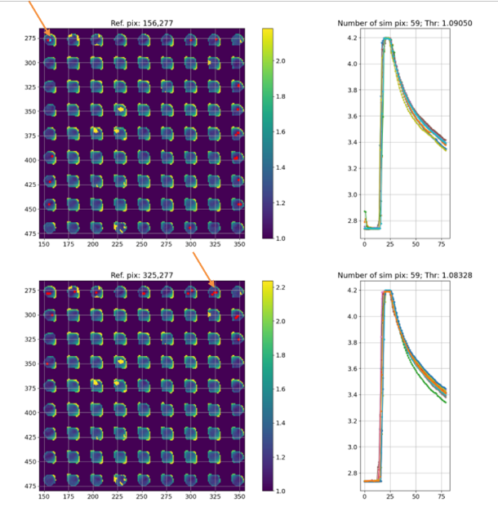
Figure 4-11: Thermal signature similarity maps of a 9x9 layer, using a corner node pixel (top) as reference and a wall node pixel (bottom) as reference. Orange arrows point out the reference pixels. Red dots indicate the most similar pixels.

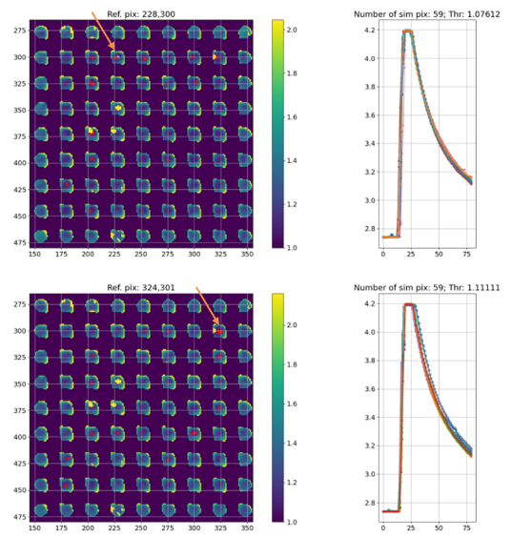
Figure 4-12: Thermal signature similarity maps of a 9x9 layer, using interior node pixels as reference. Orange arrows point out the reference pixels. Red dots indicate the most similar pixels.

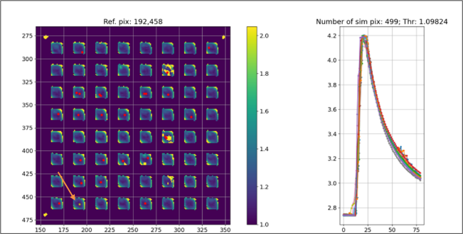
Figure 4-13: Thermal signature similarity maps of a 8x8 layer, using a wall node pixel (top) as reference. Orange arrows point out the reference pixels. Red dots indicate the most similar pixels.

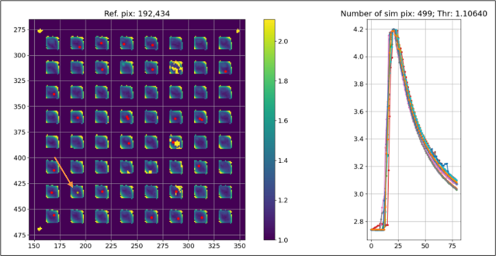
Figure 4-14: Thermal signature similarity maps of a 8x8 layer, using an interior node pixel (top) as reference. Orange arrows point out the reference pixels. Red dots indicate the most similar pixels.

Effect of inert gas on thermal signatures

Differences in mass of identically printed cubes
To study the effect of Ar vs. He on nodal thermal signatures, it was essential to choose cubes that were equivalent. This could be done by choosing cubes built with identical parameters. However, we discovered that cubes built in Helium were much lighter than cubes built using Argon atmosphere. The difference in mass of three sets of cubes with identical process parameters is shown in Figure 4-15. It is noted that for both fine and coarse strut cubes, those built in He with high volumetric energy density are about the same mass as cubes built in Ar with medium volumetric energy density. This points to potential differences in resulting dimensions or porosity, both of which may be associated with difference in inert gas. This is an important finding for practitioners of additive manufacturing, since it indicates that inert gas atmosphere potentially plays an important role in part dimensions. The hypothesis about difference in part dimensions is further strengthened by the observation of significantly more spatter in the Ar process vs. He process in the infrared videos of the builds (Figure 4-16). Williams et al. [157] mention that increased spatter is indicative of more powder being drawn into the melt pool and therefore a larger melt pool. A comparison of spatter between Ar and He builds was observed by Bidare et al. too, who indicated that Ar produced higher levels of spatter under the same process conditions as Helium[180]. Rui et al.[178] noticed that Helium builds result in smaller clad height than Ar. This may explain why builds in Ar are heavier than builds in He. Comparison of optical images of the powder bed at every layer of the build could be carried out to look for differences in built dimensions, under identical process parameters. The difference has not been quantified in this work. Further investigation of dimensional differences will be done as part of a future study of material properties of the lattice cubes.

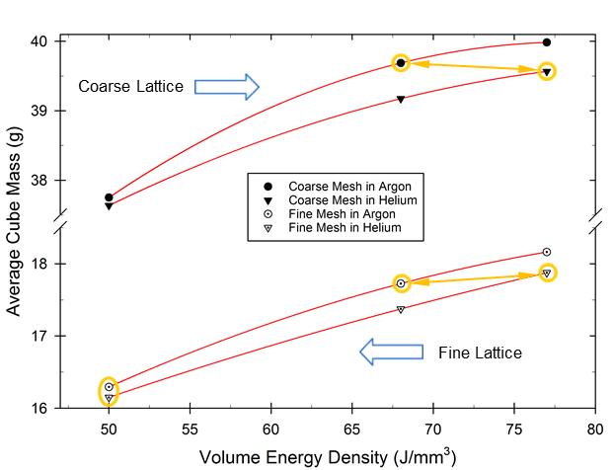
Figure 4-15: Comparison of masses of lattice cubes built using identical parameters but using Argon and Helium as cover gases

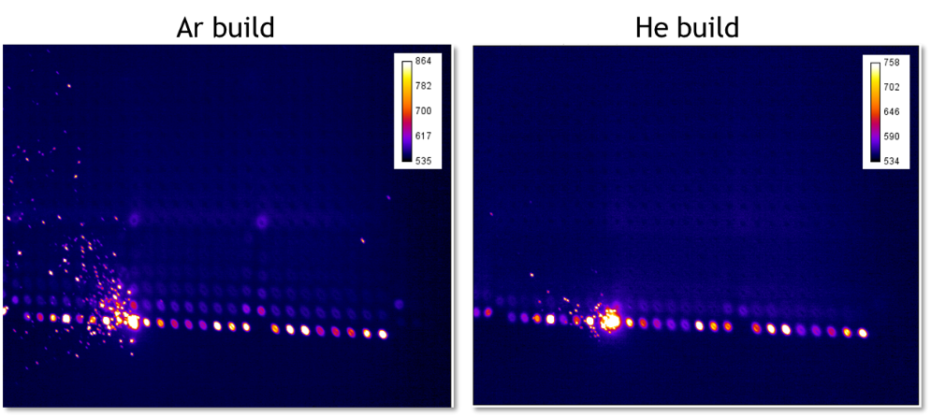
Figure 4-16: Comparison of spatter generation in Ar (left) vs He (right) build. Helium generates less spatter as observed visually.

Comparison of compressive properties of lattice cubes
To compare mechanical properties of the lattice cubes built under different inert gas atmospheres, compression testing was carried out as is standard for lattice cube analysis [182]. The lattice cubes were tested in compression using a 45,000 lbs. load frame and a constant head displacement rate of 1.265 mm/min. Prior to testing, the cubes were separated from the build plate using a wire Electric Discharge Machining (EDM). Two replicates each of cubes built in He and Ar atmospheres were tested for each of the 3 masses of approximately 16, 18 and 40 g (see Figure 4-15). The cubes are named as per the mass i.e., 16g cubes, 18g cubes and 40g cubes. The stress-strain curves for each set of cubes is shown in Figure 4-17 to Figure 4-20. It is evident that the cubes have nearly identical yield stress irrespective of build atmosphere. However, cubes built in Helium atmosphere fail faster and at lower strain rates than those built in Argon. Succinctly, cubes built in Ar seem to be more ductile than those built in He. This suggests that there may have been differences in ductility that were induced by microstructure. It is well-known that Ti-6-4 microstructure depends on cooling rates [183]. Specifically, martensitic microstructure gets frozen in place at high cooling rates, versus a basket-weave microstructure typically associated with lower cooling rates. We hypothesized that Helium enables faster cooling due to higher thermal conductivity than Argon. To verify this hypothesis, we carried out thermal signature analysis of equivalent He and Ar cubes.

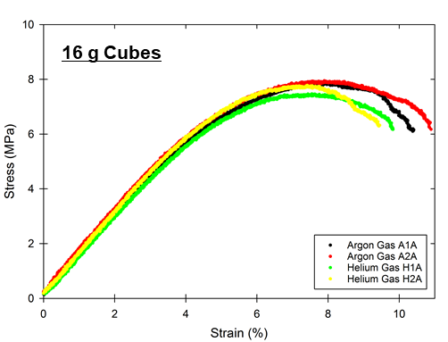
Figure 4-17: Compression test results for 16g (fine strut, low energy density) cubes indicate early failure of He cubes compared to Ar cubes.
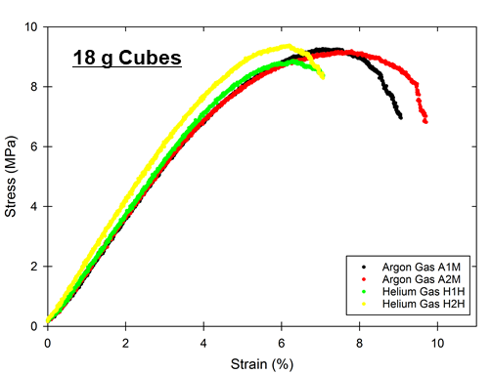
Figure 4-18: Compression test results for 18g (fine strut, medium energy in Argon and high energy in Helium) cubes indicate early failure of He cubes compared to Ar cubes.

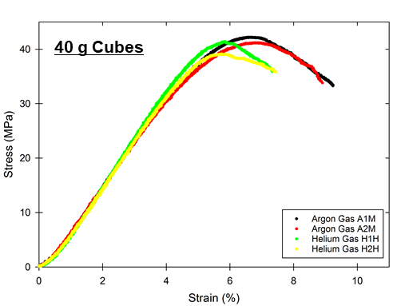
Figure 4-19: Compression test results for 40g (coarse strut, medium energy in Argon and high energy in Helium) cubes indicate early failure of He cubes compared to Ar cubes.

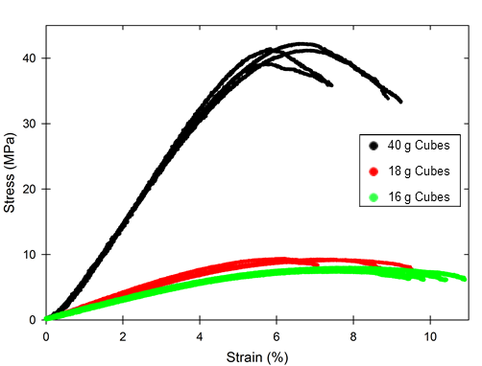
Figure 4-20: Compression test results for all cubes indicate early failure of He cubes compared to Ar cubes.

Differences in thermal signatures due to inert gas
Thermal signature analysis of 40g cubes using wall and interior nodes separately as reference pixels is shown in Figure 4-21 to Figure 4-24. The analysis suggests that Helium consistently cools faster than Argon, even under higher volumetric energy density conditions. This difference is seen by the slope of the cooling curves under visual inspection. To further compare cooling behavior between Ar and He, thermal signatures of corresponding cubes of similar mass are plotted in Figure 4-25, with gray zones indicating the spread in thermal signature corresponding to each gas. The plots seem to indicate a difference in cooling rates that is especially pronounced in the diagonal and wall nodes compared to interior nodes. This hints at the interplay between nodal connectivity and inert gas when determining cooling rate. Specifically, it seems apparent that inert gas has a lower influence on cooling behavior in 2-strut nodes (interior nodes) compared to 1-strut nodes (diagonal and wall). This points to the heat transfer being dominated by heat conduction paths. With a higher heat conduction path, the conduction of heat by the inert gas is not as significant (2-strut nodes). With a smaller heat conduction path, the higher thermal conduction effect of Helium takes center-stage and leads to faster cooling in He atmosphere than Ar atmosphere (1-strut nodes).

To confirm this trend, thermal signature comparison was also carried out for adjacent layers in the same nodal plane. The term “nodal plane” is explained here. Each layer of the build is 30 μm while each nodal diameter is 1.13 mm (fine strut) or 1.77 mm (coarse strut). Therefore, each node has 37 (fine) or 59 (coarse) layers in it. All these layers are referred to as the same “nodal plane” but are different layers. The layers that have been imaged and analyzed in this study are near the center of each nodal plane. The 10 layers where thermal videos were captured near the center of each nodal plane were analyzed to confirm the dependence of thermal behavior on both inert gas and nodal connectivity. Results are shown in figures in the appendix (Figure 4-30 to Figure 4-33). The comparison indicates that some layers (e.g. layer 132) in the same nodal plane have a pronounced difference between Ar and He thermal signatures, while other layers (e.g. 133, 134) have virtually no difference. What changes between the layers within a nodal plane is (a) a small difference in cross-sectional area being printed, (b) differences in scan angle. This observation suggests that thermal signature comparison between Ar and He builds depend not only on nodal connectivity and inert gas but also on scan strategy and cross-sectional geometry that vary from layer to layer. Specifically, scan strategy variations can lead to a difference in heat conduction paths and significant changes in heat transfer. These trends are consistently observed for coarse strut cubes built at low energy density as well.

Strikingly, for fine strut cubes, heat transfer is consistently faster in Helium builds than in Argon builds, irrespective of layer and nodal connectivity! Figures in the appendix (Figure 4-34 to Figure 4-37) show the results for layers 130-137 for fine strut cubes (18 g). These results indicate that the trend in fine strut cubes is that Helium always cools faster than Argon. This confirms the hypothesis that under small geometric conduction path, the effect of inert gas atmosphere is much more than under large geometric conduction paths. This points to the important role of geometry in determining the degree of influence that inert gas has on thermal conduction.

The above evidence points to a significant role of nodal geometry in determining thermal behavior of lattices, and an interdependence between inert gas and other factors in AM processes. This is an important takeaway from this study, since most AM practitioners consider the effect of inert gas as being independent of part geometry in the AM process.

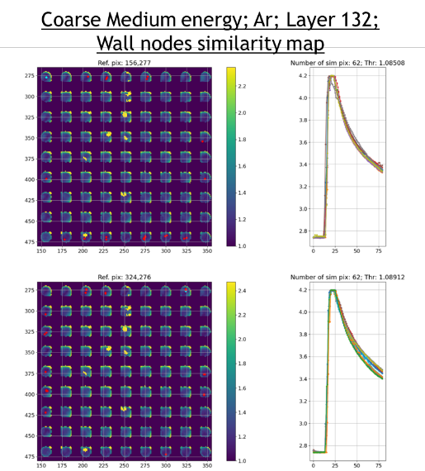
Figure 4-21: Thermal signature analysis of 40g cube (Coarse, medium energy density Argon) using wall node pixels as reference

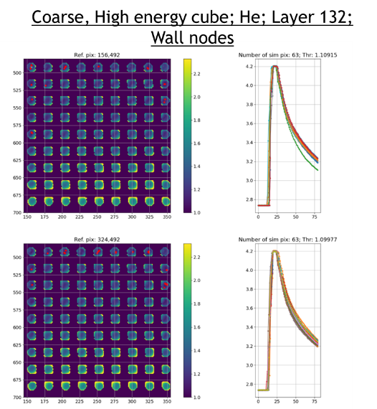
Figure 4-22: Thermal signature analysis of 40g cube (Coarse, high energy density He) using wall node pixels as reference

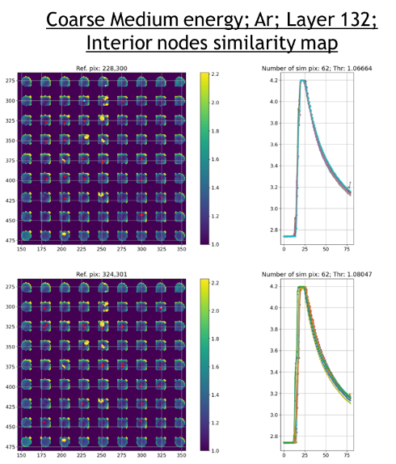
Figure 4-23: Thermal signature analysis of 40g cube (Coarse, medium energy density Argon) using interior node pixels as reference

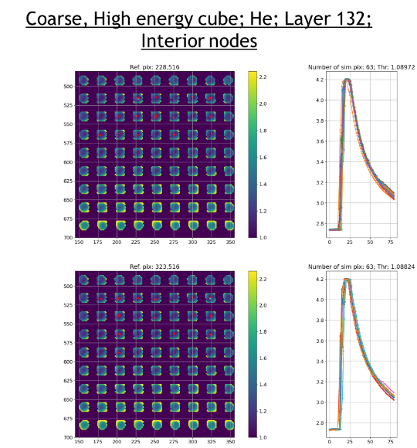
Figure 4-24: Thermal signature analysis of 40g cube (Coarse, high energy density Helium) using interior node pixels as reference

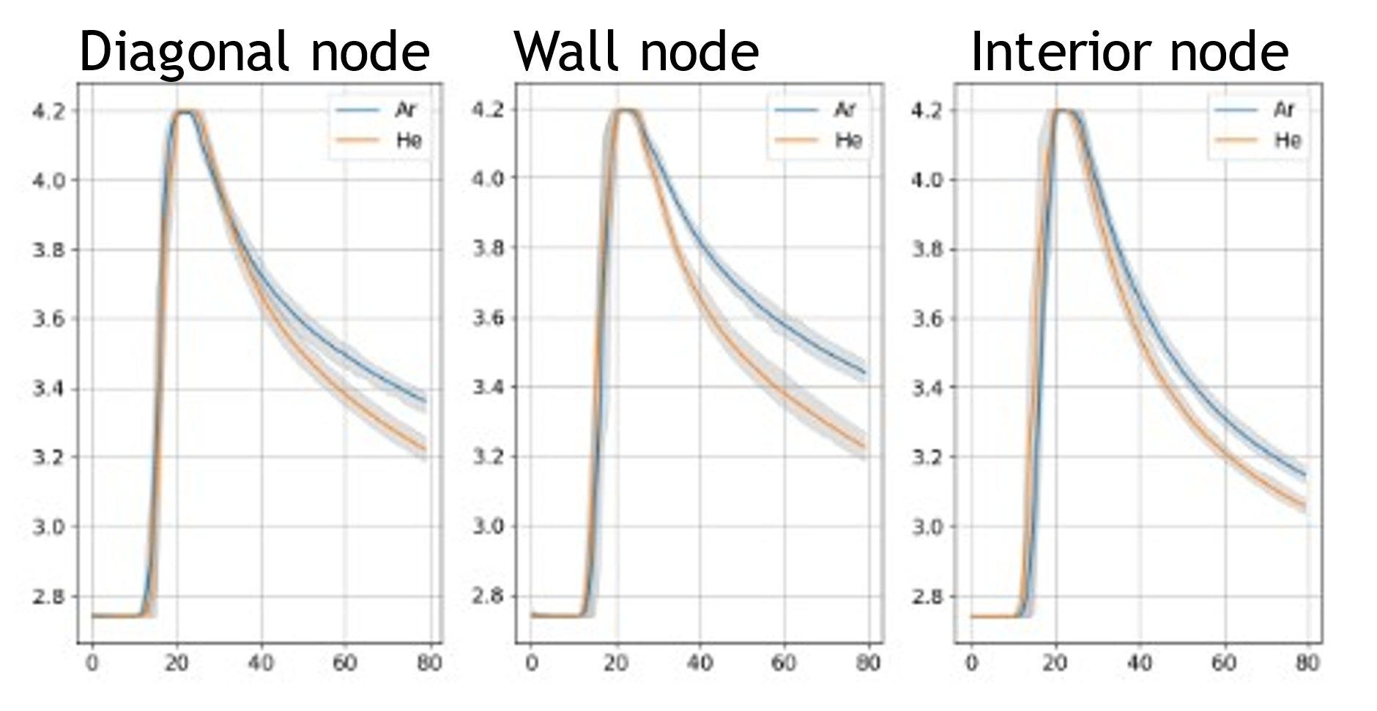
Figure 4-25: Layer 132; Thermal signature comparison of Ar vs. He using reference pixels in the wall and interior. The pixels chosen are the same as seen in Figure 4-21 (diagonal and wall node) and Figure 4-24 (interior node).

It is to be noted that high energy density cubes are harder to analyze due to reduced infrared intensity seen in the last few rows of nodes. This is due to soot deposition on the mirror. This effect becomes pronounced in higher layers of the build, which is the primary reason for analysis of lattice nodes in the lower heights of the build where soot deposition is not sufficient to obscure IR data. The effect of soot deposition can be seen in composite IR images shown in Figure 4-26 and Figure 4-27. Interestingly, it was observed that the soot deposition was more pronounced in the Argon builds than Helium builds. This may have to do with the density of Ar vs. He. Argon being a heavier gas may have carried more soot particles with it across the powder bed, compared to Helium.

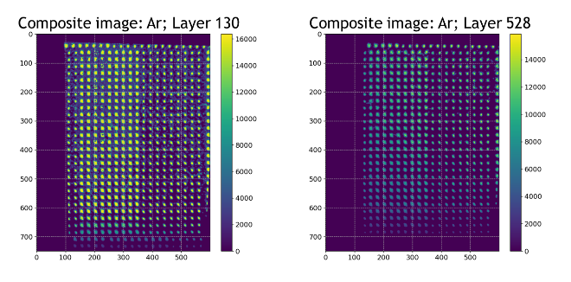
Figure 4-26: Composite IR image showing maximum IR intensity at 2 different layers of the Ar build. There is a drastic change in maximum IR intensity due to soot deposition on the mirror inside the chamber.

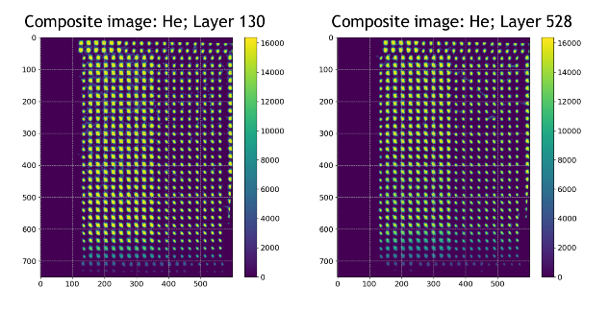
Figure 4-27: Composite IR image showing maximum IR intensity at 2 different layers of the He build

Comparison of microstructure and hardness
A preliminary comparison of microstructure associated with 1-strut nodes in Ar and He builds is shown in Figure 4-28. The microstructures were extracted from the coarse strut, low power cubes of group 4 in the Ar and He builds (Figure 4-3). The microstructures seem to indicate a mixture of basket-weave and martensitic needles in both the builds. However, the proportion of basket-weave microstructure seems more pronounced in the Ar build than He, upon visual examination of the microstructures. This correlates with the observed differences in thermal signatures, specifically because Ar cools slower than He in most layers. It has been shown by other researchers [183] that slow cooling of Ti-6-4 in the L-PBF process can lead to decomposition of α’-martensite into basket-weave structure of α+β structure. This behavior is seen to a limited extent in this study, with slow cooling in Ar atmosphere leading to more decomposition of martensitic needles, compared to fast cooling in He atmosphere. However, the differentiation in observed microstructure is not significant enough to draw conclusions about the cooling behavior in Ar and He. For further evidence of difference in cooling rates, hardness mapping was done across a single 2-strut node extracted from coarse, low power cubes. The resulting values are shown in Figure 4-29 for hardness mapped across a single node. The hardness values of Ar node are consistently lower than that of He built node. This is a clear indication of fast cooling behavior in Ar compared to He, leading to softer microstructure and lower hardness value. This behavior also supports higher ductility and ultimate tensile strength of Ar compared to He builds (Figure 4-20). However, further microstructure characterization is needed to understand the effect of nodal connectivity and strut size on microstructure. Characterization of Ar and He cubes at higher energy densities and with fine struts are underway and results will be reported in a future publication.

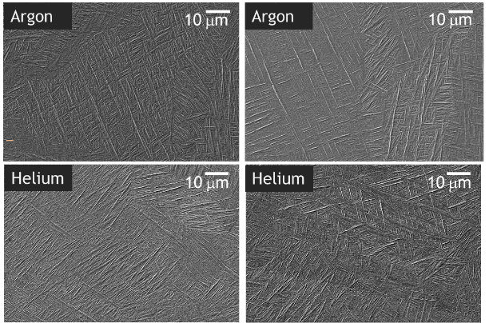
Figure 4-28: Microstructure consisting of a mixture of basket-weave and martensitic needles are seen in both Ar and He builds. The proportions of the two phases seem to vary, depending on cooling rates.

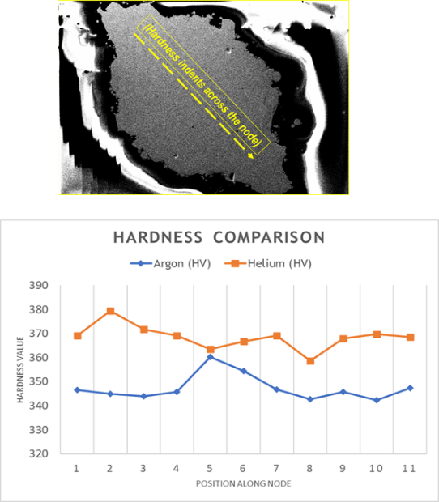
Figure 4-29: Hardness maps across Ar and He builds indicate softer microstructure in Ar compared to He builds

Conclusions
The thermal signature analysis in this paper and associated compression, microstructure and hardness testing indicates faster cooling and associated loss of ductility but increase in hardness in Ti-6-4 in the L-PBF process using He inert gas rather than Ar. However, care must be taken to not overestimate the effect of inert gas atmosphere in cooling behavior. Specifically, the research in this paper indicates that geometry and scan strategy play an important role in determining cooling rate. This further highlights the point that inert gas atmosphere is not an independent factor that speeds up or slows down cooling in L-PBF process. A holistic understanding of the conduction path, effect of inert gas and other geometric factors need to be taken into account and modeled to determine the changes that may be associated with replacing one inert gas with another. Further studies on the effect of inert gas and modeling approaches that consider the L-PBF process in a holistic manner need to be taken up for a better approach to part processing and qualification in the L-PBF process.

Appendix

Coarse strut cubes, medium energy input (Argon) vs. high energy input (Helium)—Comparison of layers 130 to 137 in the same nodal plane

In all the plots in this section, the reference pixels are ordered as follows: Plot 1 (left)- Ref. pixel in diagonal corner node (1-Strut node), Plot 2 (middle)- Ref. pixel in wall node (1-Strut, 1-Whisker node), Plot 3 (Right)- Ref. pixel in interior node (2-Strut node).
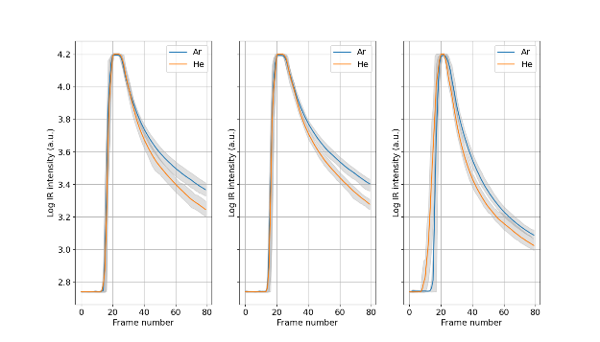
Figure 4-30: Layer 130, Coarse cubes, Ar (Medium) vs He (High) energy input
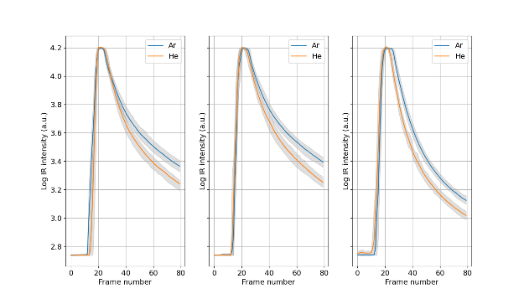
Figure 4-31: Layer 131, Coarse cubes, Ar (Medium) vs He (High) energy input

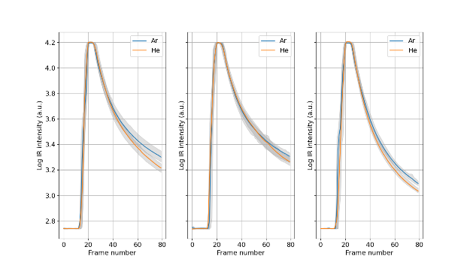
Figure 4-32: Layer 133, Coarse cubes, Ar (Medium) vs He (High) energy input

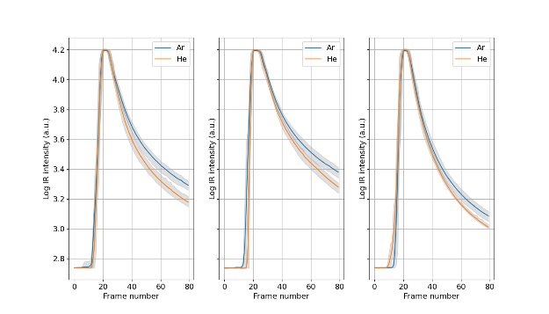
Figure 4-33: Layer 134, Coarse cubes, Ar (Medium) vs. He (High) energy input

Fine strut cubes, medium energy input (Argon) vs. high energy input (Helium)—Comparison of layers 130 to 137 in the same nodal plane

In all the plots in this section, the reference pixels are ordered as follows: Plot 1 (left)- Ref. pixel in diagonal corner node (1-Strut node), Plot 2 (middle)- Ref. pixel in wall node (1-Strut, 1-Whisker node), Plot 3 (Right)- Ref. pixel in interior node (2-Strut node).

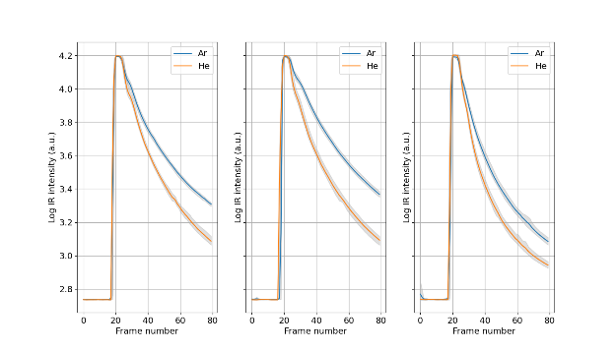
Figure 4-34: Layer 130, Fine cubes, Ar (Medium) vs He (High) energy input

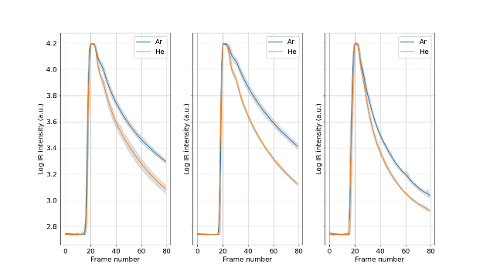
Figure 4-35: Layer 131, Fine cubes, Ar (Medium) vs He (High) energy input

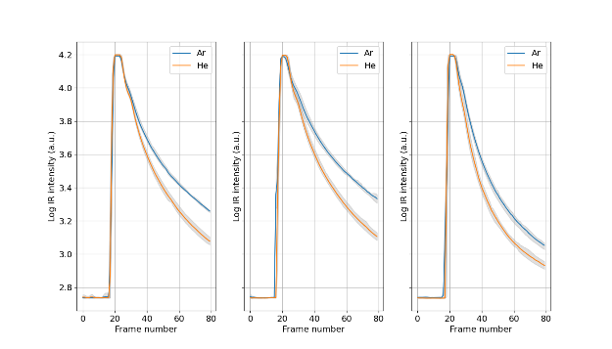
Figure 4-36: Layer 133, Fine cubes, Ar (Medium) vs He (High) energy input

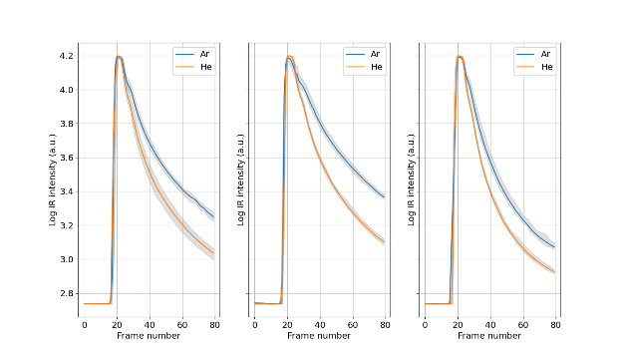
Figure 4-37: Layer 134, Fine cubes, Ar (Medium) vs He (High) energy input

FUTURE WORK

The qualification of feedstock, process and finished parts using data-driven approaches in metal additive manufacturing and associated qualification pathways is an area of active research. In this chapter, some analysis pathways that seem imminent are discussed and preliminary results presented in some cases. The goal is to provide research threads that can be pursued in future for further development in the field of part qualification for additive manufacturing.

In today’s world of highly interdisciplinary research, it is common to see algorithms and methods developed in one domain, being applied to effective use in other domains. For example, neural networks were a topic of research primarily in the field of computer vision, for facial recognition and object identification in the 1990s and early 2000s [184]. Today, neural networks are ubiquitous in almost any field where a non-linear relationship exists between an input and an output. Recently, neural networks have been used for time series analysis [185], for identification of objects in remote sensing databases [186] and even for adversarial learning in music content analysis [187]. The ability to cross-pollinate research in this manner has been aided by many factors. The primary ones include:
- Easy access to information through online publication of journals
- Inter-disciplinary tracks in conferences and research institutions
- Collection of large volumes of data in many fields and open data consortia
- Relatively inexpensive compute power
- The rise of data science as a horizontal domain that connects multiple verticals like life sciences, social sciences and engineering.
It is therefore conceivable that there are several algorithms that were developed for specific applications but can be extended or repurposed for use in additive manufacturing. The following broad areas of inter-disciplinary research are relevant for application in additive manufacturing and are discussed in this chapter:
- Matrix profile for study of similarity of thermal signatures
- Energy decomposition of thermal signatures using wavelet analysis
- Graph networks to study patterns in thermal signatures
- Reinforcement learning for microstructure tailoring in additive manufacturing
Each of these areas is discussed in a separate section of this chapter. The chapter ends with broad conclusions about the future of the field of additive manufacturing.

Matrix profile analysis for study of thermal signatures
Matrix profile is a simple but powerful algorithm to study time series datasets. In this section, the matrix profile algorithm is first described briefly, followed by an exposition of its applicability to thermal signature analysis in additive manufacturing.

Matrix profile [166] is an algorithm that computes the Euclidean distance between every snippet of a time series to other snippets in itself. Some of its primary uses include similarity analysis, motif finding, anomaly detection, drift identification and time series chain analysis. The algorithm was first published by Yeh et al. [166] but faster and expanded versions of it have been published successively by the parent Keogh group [188]. The underlying idea in the algorithm is that two time series snippets that have a similar shape have a high correlation coefficient between each other. For an exact match or perfect proportionality between the analyzed shapes, the Euclidean distance between the shapes is 0. The Euclidean distance between two time series sequences x and y of equal length n is given by equation (5a).
$d_{Euc}= \sqrt{\sum_{i=1}^{n}{{\left(x_{i}-y_{i}\right)}^{2}}}$ (Equation 5a)
The matrix profile algorithm uses many mathematical tricks to reduce the computational burden of finding the Euclidean distance between every time series snippet and its nearest counterpart in a Euclidean distance sense. Computation of Euclidean distance between every time series snippet to every other snippet is a computationally and memory-intensive task due to the huge matrix of numbers that needs to be stored. For example, to compute distances between 100 time series snippets with each other, a matrix of dimension 100-x-100 will need to be stored. This is a matrix of size 10,000. Increasing the number of time series snippets by a factor of 10 leads to an increase in matrix size by a factor of 100. To make this computation tractable, the matrix profile algorithm uses many mathematical tricks. Equally importantly, it stores only the smallest Euclidean distance for every time snippet and thus avoids memory overload. The results of the MP algorithm are two new time series: One representing the minimum Euclidean distance for every time series snippet and the other representing the location of the best match. It is therefore O(n) in space for a time series of length n, rather than being O(n²) as is the case with the complete distance matrix. The computational speed of MP algorithm is O(n log n) in many applications and can be made faster with certain approximations [189]. In essence, the matrix profile algorithm provides a computationally efficient way to compute minimum Euclidean distance between scaled time series snippets. Note that Matrix profile is relatively free of “tuning” parameters since the only parameter it needs is the time series snippet length.

The primary implication of using the matrix profile algorithm is that long time series, of the order of billions of data points, can be analyzed quickly [190] to identify motifs, anomalies, time series chains and more. This is because Euclidean distance is the key to many of these time series analysis tasks. The underlying idea to find the similar shapes or motifs in a long time series is to find snippets with the least Euclidean distance between them. This is exactly what matrix profile does. An example is shown in Figure 5-1, which shows the matrix profile values determined for a time series of energy consumption data [166]. Motif analysis is done by identifying least distances as indicated by smallest values of the matrix profile. It is clear that energy consumption patterns repeat and such a motif can be found using Matrix Profile algorithm. An obvious extension to motif finding is the concept of anomaly detection. The snippet that has highest distance is the anomaly since no better match could be found for it in the given time series.

Moving on to thermal signature analysis using the matrix profile: We employed a direct implementation of the SCAMP version of matrix profile to identify layers with the most similar thermal signatures. To do this, the dataset used was from a single pixel of a cylindrical build described in section 3.2 in chapter 3 (see Figure 3-1). Unlike work in chapter-3, the analysis here aimed at identifying the most similar layers based on data from a single pixel. This analysis is termed “single pixel, multi-layer analysis” rather than “single layer, multi-pixel analysis” as done in chapter-3. The aim is to study whether the change in layer-wise geometry, as seen in sections 1 vs. 3 vs. 5 in Figure 3-2, could be identified using the matrix profile similarity analysis. The hypothesis used was that part geometry influences thermal signatures and would therefore be spotted in the matrix profile results as different “motifs” corresponding to geometry.

The build consisted of 1524 layers and ~13,000,000 frames of data collected over ~37 hours of build time. The input time series would be exceedingly long if data for the entire build were to be used, with long periods of time when the data would be flat with no thermal activity at the relevant pixel being studied. Therefore, the pixel data was cropped to 2000 frames per layer, leading to a time series length of 2,766,000 for 1383 layers that were analyzed. Before cropping, the layerwise data were median filtered with a filter size of 9 to remove effects of spatter and laser speed vs. frame rate mismatch (see section 3.3 for more details). Note that data from successive layers was appended to create a single time series. The time series needs to be analyzed with care since data corresponding to different layers are appended and lead to non-physical discontinuities at appending points. For example, consider Figure 5-2 which shows data from 2 layers that have been appended.

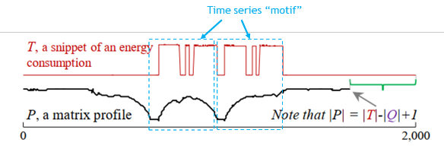
Figure 5-1: Matrix profile analysis of energy consumption data. Adapted from Yeh et al. [166]
The time series motif corresponding to the snippet shown does not have any physical relevance and needs to be discarded. A matrix profile analysis was run on the time series with a snippet length of 800. The analysis was run on Tesla V100 GPU (using the Nvidia-DGX A100 workstation) and a docker containerized version of SCAMP from Zimmerman et al. [190]. The computational muscle enabled by GPUs and using the many mathematical divide-and-conquer paradigms developed by Zimmerman et al. led to matrix profile being computed in ~5-10 seconds for a time series of length 2.6 million and a snippet length = 800. The matrix profile results needed to be cleaned to remove artifacts arising from appending of layers, as discussed in appendix B of chapter-3. Instead, the approach taken was to find the “best matching layer” for each thermal signature by using a “minimum matrix profile” poll. For each layer, the thermal signature was 2000 frames long while the matrix profile window size was 800. Therefore, time series snippets starting at any point in the first 1200 frames contained “valid” data for the layer i.e., data belonging to 1 layer only. These snippets/windows were used to determine the best match between the current layer and the rest of the layers, by finding the minimum matrix profile distance in these windows. This is illustrated in Figure 3-17. By following this minimum MP approach, the best matching layer for each layer was found and plotted as shown in Figure 5-3. The x-axis of the figure indicates layer number and y-axis indicates best matching layer number. Dotted lines in the plot show geometric boundaries of sections 1 to 5 in the build. The color of the points plotted indicates the matrix profile value, with 0 indicating a perfect match and 1 indicating a poor match. It is evident from the plot that layers having similar geometry tend to cluster together in terms of thermal signature. This is evidence that the matrix profile does a good job of identifying regions of similar thermal signature, corresponding to sections of a build.

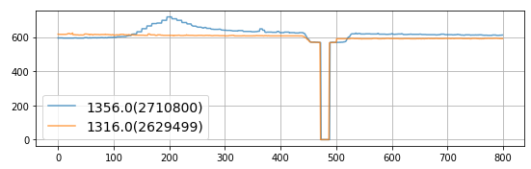
Figure 5-2: Time series snippet of length 800, from thermal signature time series. This illustration shows why it is necessary to be careful while using results from the Matrix Profile algorithm. Matches like this are not physically relevant since they combine data from 2 different layers. The dip here is due to laser recoater movement which happened to exist between the time series of 2 layers.

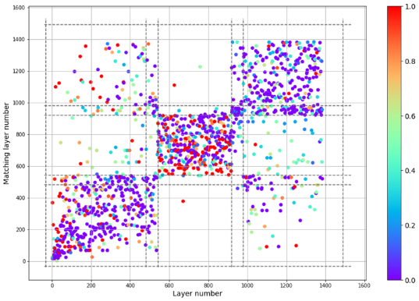
Figure 5-3: Matrix profile results showing the best match for each layer of data at a given pixel. Dotted lines indicate transition sections in the build. The color indicates matrix profile value, with 0 indicating a perfect match and 1 indicating a bad match.
It is interesting to also note that good matches exist within layers in sections 1,3 and 5 to other layers in their own sections. Matches between layers in sections different from their own are characterized by poor matrix profile values (close to 1) and thus indicate bad matches. These are potentially indicative of anomalies as evidence by the poor match value. Some matches are chosen at random from the figure and plotted separately in Figure 5-4. It is clear that in some cases, the magnitude of the thermal signatures in the matching layers do not match at all while the shapes match very well. For example, layer 1089 matches layer 218 but their magnitudes do not match well. Such a problem is to be expected when using the matrix profile since it is a shape matching technique at its root. This needs to be corrected to include magnitude similarity as done in the similarity analysis algorithm in section 3.3 of chapter 3. However, the procedure may be challenging since the similarity analysis algorithm of section 3.3 considered one reference pixel at a time, and is therefore a one-to-all match and computationally light. The matrix profile algorithm compares all-to-all and is much more computationally heavy, but also more powerful. Incorporating magnitude similarity into it is a non-trivial task and is set aside for future work.

Wavelet transform-based analysis of thermal signatures
The goal in this section is to explore wavelet decomposition of thermal signatures, due to the unique time-frequency localization properties exhibited by wavelet transforms. A brief introduction to wavelets is provided first, followed by a proof-of-concept demonstration of wavelet transform in thermal signature analysis. Wavelets are “small waves” that are used in signal processing for time-frequency decomposition. The wavelet transform is analogous to Fourier transforms, but with a major difference in the ability to localize changes in a signal.

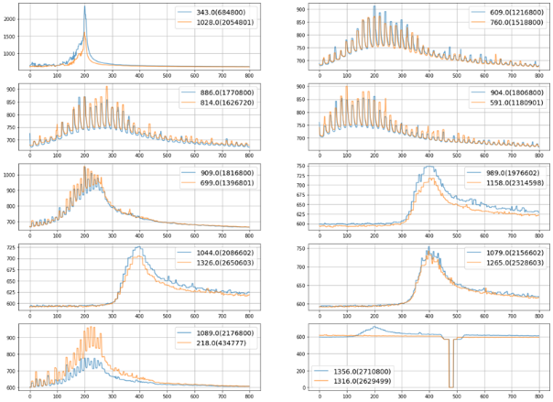
Figure 5-4: Selected matches of layers from matrix profile analysis of 1383 layers at a single pixel.
Wavelet transforms decompose a signal in time-frequency space and thus retain the ability to identify the time location corresponding to different “scales” or frequencies of the signal, while the Fourier transform decomposes a signal into frequency space and loses time localization. Analysis of chirp signal by wavelet transform [191] is a well-used example to highlight the advantage of wavelet transforms. The chirp signal consists of a series of frequencies in ascending order. It is a non-stationary signal i.e., the frequencies of the signal do not stay constant over time. Fourier analysis of the time series signal results in extraction of frequencies but with no localization. The continuous wavelet transform indicates the increase in frequencies over time.

Wavelet transforms are especially relevant for thermal signature analysis in additive manufacturing. Infrared monitoring of additive manufacturing leads to thermal signatures in which frequencies are stacked over each other and vary over time. The frequencies commonly seen in thermal signatures include the slow thermal decay associated with the physics of part melting and cooling, laser passing frequency associated with part geometry and laser beam speed and, spatter associated with powder bed fusion process. There may also be intermittent frequencies associated with the frame rate of the imaging method. The goal of using wavelet transforms is to decompose a signal into its component frequencies over time. To demonstrate effectiveness of wavelet transforms, a simple study was carried out using different scan angles and associated thermal signatures in a part. For this analysis, the part discussed in section 3.2 was used. However, unlike section 3.3 where a single layer was analyzed at multiple pixels, the analysis here is a “single pixel, multi-layer” analysis. Data was extracted for a single pixel in the center of the cylindrical wall region over 24 layers. The thermal signatures associated with the pixel were cropped to 2000 frames per layer, since the rest of the frames per layer consist mostly of flat regions corresponding to no thermal activity. As before, the thermal signatures are median filtered, but using a filter size of 3 this time to remove only data corresponding to spatter that occurs as noise at intermittent frames. A filter of size 3 ensures that patterns that last 3 or more frames are only retained in the signal.

The choice of wavelets is an important aspect of wavelet transform. This is because there is no standard wavelet that suits all applications. Choice of wavelet is almost an art as much as science, and some rules exist around choosing the correct wavelet for an application. For example, Percival and Walden [192] mention that the choice of wavelets is dependent on both the application and the analysis goal. This requires trial and error using different wavelets to achieve sufficient removal of artifacts from the wavelet used but also being computationally inexpensive. For the study of thermal signatures, the Daubechies-4 wavelet was chosen due to being somewhat similar to thermal signatures being studied (Figure 5-5). The Daubechies-4 wavelet has an ascending and a descending portion that are asymmetric just like the heating and cooling sections of the thermal signature. The appended time series of 24 layers, consisting of a total of 48000 data points, is analyzed using the Maximal Overlap Discrete Wavelet Transform (MODWT) in the pywavelets package in Python. Note that the Daubechies wavelet of 4th order is termed D-2 in pywavelets. The MODWT is chosen rather than the Continuous Wavelet Transform (CWT) due to its applicability to discretely sampled data. The DWT is not used here since it is shift variant i.e., the results depend on the exact shift of the time series, but thermal signatures are not perfectly aligned in any specific manner. In other words, using the DWT will lead to different wavelet coefficients depending on whether the time series peaks at t=1000 or t=1200 or any other position. This shift variance does not occur in MODWT due to its rolling window filtering of the time series using the wavelet. In other words, MODWT is shift invariant at the expense of redundancy in the coefficients, while DWT is shift variant but results in no redundancy due to down-sampling of the signal. For more details, the reader may refer to Percival and Walden [192].
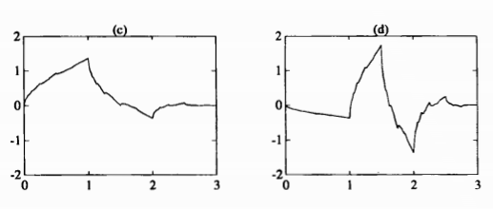
Figure 5-5: Daubechies D4 scaling function (left) and D4 wavelet (right). Adapted from [193]

Once the MODWT decomposition of thermal signatures corresponding to 24 layers is completed, the wavelet coefficients can be analyzed by considering their magnitudes at various scales. The results are shown for the first 6 layers in Figure 5-6 and Figure 5-7. Upon visual examination, it seems that some layers have a similar wavelet coefficient across all scales. This suggests that wavelets are useful in extracting time and frequency localized information in thermal signatures. To make this demonstration simple and in an analogous manner to Fourier transforms, the energy decomposition of each layer’s thermal signature was carried out. This can be executed easily using wavelets since the DWT spectrum can be used for energy decomposition by analysis of variance of the coefficients [192]. Succinctly, this means that the energy stored in a time series signal can be expressed as a sum of energies at various scales. This is similar to energy decomposition by frequency in Fourier transforms. However, the wavelet spectrum has fewer scales due to the definition of wavelet scales in dyadic (powers of 2) order. Also, further interrogation and interpretation of scale-wise coefficients is possible using wavelets but not so using Fourier transforms. The energy decomposition using wavelets is given by equation 5b.
${\hat{σ}}_{X}^{2}=\frac{1}{N}\sum_{j=1}^{J}{{\left\|W_{j}\right\|}^{2}}$ (Equation 5b)
Where: ${\hat{σ}}_{X}^{2}$ is the sample variance of the time series X, N is the number of data points in X and W_{j} is the set of wavelet coefficients associated with the time series under a complete dyadic decomposition. The essence of the statement is that the variance of the signal or loosely “energy” is decomposed into components at different scales using the wavelet transform. Note that this equation holds for any orthonormal transform like Principal Component Analysis or Fourier transforms.

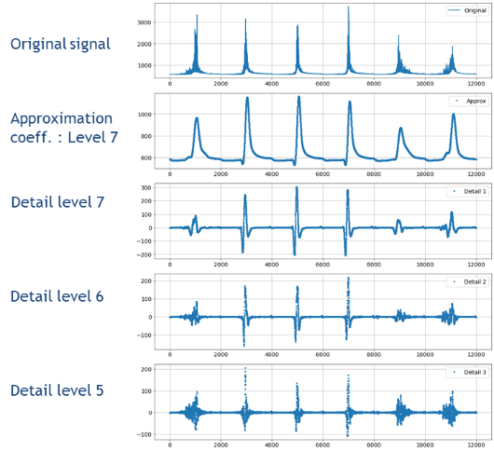
Figure 5-6: Maximal Overlap Discrete Wavelet Transform decomposition of thermal signatures of 6 layers. Coefficients from level 5 to 7 are shown. X-axis is the time scale and y-axis is the wavelet coefficient at each level.

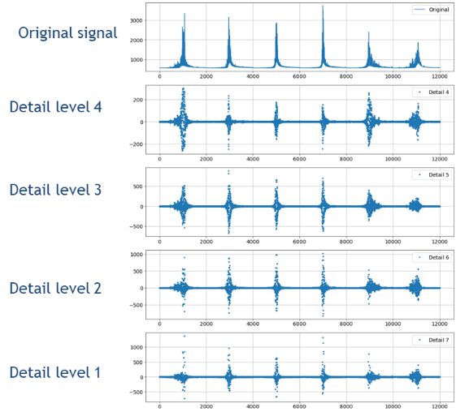
Figure 5-7: Maximal Overlap Discrete Wavelet Transform decomposition of thermal signatures of 6 layers. Coefficients from level 1 to 4 are shown. X-axis is the time scale and y-axis is the wavelet coefficient at each level.

Energy decomposition at different levels of the time series can be carried out using equation 5b above. Normalization of the energy levels at each scale can be done using min-max normalization, i.e., subtracting the minimum value and dividing by the maximum value. This leads to a value of variance at each scale between 0 to 1. Plotting energy levels vs. decomposition scale leads to a clear pattern at each scan angle. Figure 5-8 indicates that the thermal signatures look visually similar for similar scan angles. Figure 5-9 shows the energy decomposition corresponding to filtered thermal signatures of each of the 24 layers studied. This study was possible since the scan angle was set to be in 30-degree increments for each successive layer and could be used as the ground truth data. This ground truth was used to determine whether wavelet-based decomposition works or not. It is observed that the 60- and 120-degree scans have a very similar decomposition pattern, while the 30- and 150- degree scans have similar decompositions. The 0- and 90-degree scans do not match well with the other scan angles.

The wavelet transform-based study of thermal signature decomposition indicates that scan strategy differences can be picked up in thermal signatures using wavelets. This points towards a promising use of wavelets for thermal signature analysis in future work. Wavelet transforms have not been used to a significant extent in additive manufacturing for monitoring applications but have the potential to be used because of their localization ability and because of the reasonable computational cost. The DWT for instance has a computational cost of O(n) while the MODWT has a computational cost of O(n log n) which is of similar order to Fast Fourier Transforms (FFT).

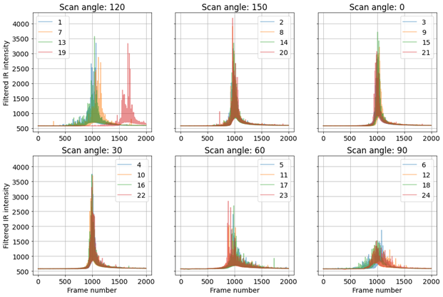
Figure 5-8: Thermal signatures (median filtered) for 24 layers studied, grouped by scan angle

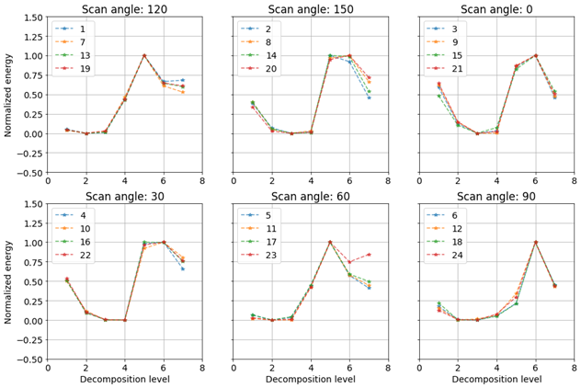
Figure 5-9: Wavelet energy decomposition of thermal signatures of the 24 layers that were studied.

Graph networks for thermal signature analysis
In this section, a brief overview of graph theory for thermal analysis in additive manufacturing is first provided. This is followed by first cut analysis results of graph clustering applied to thermal signature analysis.

Graph theory or network theory is a broad domain of analysis of systems that are inherently connected through a complex network structure. Graphs have been used to study systems in many domains such as computer networks, biological systems, disease spread pathways and river water networks. An excellent introduction to networks is provided by Newman [194,195]. In the context of additive manufacturing, graph theory has been used by Yavari et al. [120,196] to describe heat flow and the effect of geometry on thermal signatures in metal additive manufacturing. Thermal modeling of additive manufacturing processes is made possible by use of the discrete Laplacian operator to replace the continuous Laplacian function in the Fourier heat transfer equation. The Fourier heat conduction equation is given by equation 5c [120].
$\frac{∂T}{∂t}-α\left(\frac{∂^{2}}{∂x^{2}}+\frac{∂^{2}}{∂y^{2}}+\frac{∂^{2}}{∂z^{2}}\right)T=0$ (Equation 5c)
Where: T is the temperature as a function of space and time ; t is the time variable; x,y and z are spatial variables. The boundary condition is given by the starting temperature:
$T\left(x,y,z,t=0\right)=T_{0}(x,y,z)$ (Equation 5d)
The Laplacian (second derivative) in the governing equation (5c) can be replaced by the graph Laplacian when setting up the problem using graph theory and using a discrete set of nodes. The problem then becomes tractable as it involves solution of a linear differential equation, which can in turn be solved as an Eigen value problem [120].
$\frac{∂T}{∂t}+αLT=0$ (Equation 5e)
The solution to equation 5e, along with boundary conditions, produces a reasonable approximation within an error of 10% in additive manufacturing applications [120].
Beyond thermal modeling, graph theory can be used for graph clustering as well. In this approach, the main idea is that clusters of thermal signatures can be identified by first extracting similarities between them. The advantage of this approach beyond traditional clustering is that it considers underlying network connections to identify groups of thermal signatures. In other words, the similarity of a thermal signature to multiple other thermal signatures is taken into account while clustering.

For example, consider the dataset from the geometry discussed in section 3.2. Thermal signatures corresponding to multiple layers at a single pixel were extracted and similarities between them were found using matrix profile analysis (section 5.1). The difference from regular clustering is that instead of finding only the most similar thermal signature for every layer, the top 5 most similar layers were extracted for each layer. This enables defining a graph of thermal signatures such that each node indicates thermal signature at a layer. Signatures that are most similar (top 5 for each layer) are connected by graph edges, with the value of the edge denoted by the inverse of the similarity score. A high edge value indicates high distance and thus poor graph connectivity. A low edge value indicates close proximity between the nodes and good connectivity. Using this approach, graph clustering was evaluated using Markov cluster algorithm on thermal signatures of 492 layers. The Markov clustering algorithm considers the problem of graph clustering through a random walk approach. Edges indicate the distance between nodes and are used to compute the probability of walking from one node to another. Two parameters are used to derive the final clusters: expansion and inflation. The expansion parameter controls the number of steps in the random walk, while the inflation parameter controls the strength of individual edge connections. The inflation parameter effectively makes weak connections weaker and strong ones stronger in the graph by raising edge weights to a power given by the inflation parameter. This incentivizes intra-cluster walks, since a strong connection is favored by low edge weight. An increase in expansion parameter results in longer walks in the graph. The underlying concept is that longer walks will lead to more traversals within a cluster than between clusters. By iterating over the two parameters, it is possible to converge at a certain number of clusters. The results are shown in Figure 5-10 for inflation set to 1.7 and expansion set to 2.0. Colors in the figure indicate different graph clusters. While the results do not lend themselves to an obvious interpretation, it was found that the thermal signatures at clustered nodes were similar visually. This is shown in Figure 5-11 and Figure 5-12.

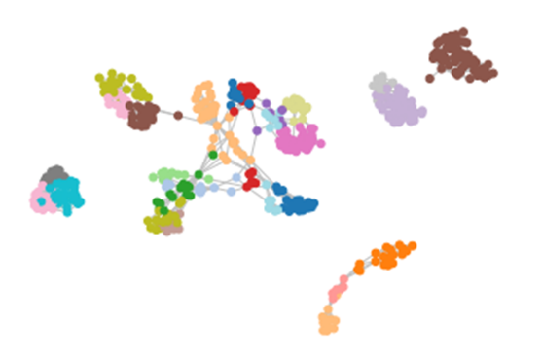
Figure 5-10: Graph clustering of 492 layers analyzed using Markov clustering approach. A total of 27 clusters were found and are plotted here, based on their connectivity. Each dot represents a layer and colors indicate clusters.

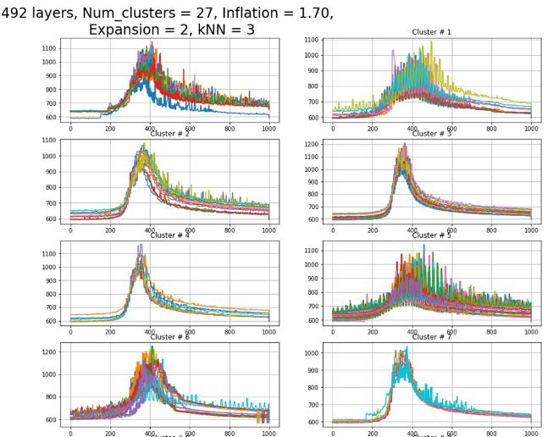
Figure 5-11: Clustering of 492 layers, with results showing cluster 0 to 7

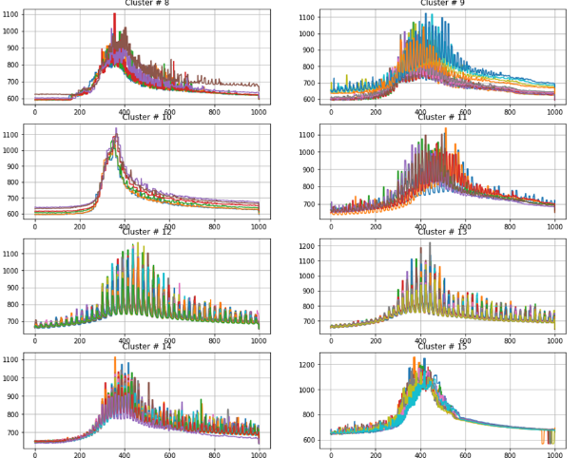
Figure 5-12: Clustering of 492 layers, with results showing cluster 8 to 15

It is seen in the clustering of thermal signatures that graph clustering indeed identifies reasonable clusters based on similarity scores from matrix profile, used as “features” to weight edge connections. However, some clusters seem anomalous and need further study. For instance, cluster #6 in Figure 5-11 indicates one layer that seems to have a different thermal signature than others in the cluster. Another aspect that is essential to understand in graph clustering is the parametric optimization and procedure for the same for the two parameters—inflation and expansion – in graph clustering. These parameters need to be balanced in an equilibrium state for the number of clusters to converge. Arriving at equilibrium clustering also necessitates a metric to evaluate clustering goodness. For example, modularity of clusters is a metric that indicates whether there are more edges between vertices than would be expected purely by chance. Modularity maximization is one approach to determine goodness of clustering.

Beyond graph clustering or community detection that has been described here, many other algorithms in graph partitioning may lend themselves to additive manufacturing. Specifically, the combination of underlying geometry and scan strategy effects, along with thermal conduction pathways, could lead to an apriori evaluation of similarities expected in thermal behavior across a part in additive manufacturing. Going a step further, graph models could enable tailoring of scan strategy to arrive at desired thermal signatures and associated microstructures.

Reinforcement learning for tailoring of microstructure using scan strategy
The holy grail of additive manufacturing is the control of microstructure using scan strategy or other build parameters. Many attempts have been made to achieve this. Dehoff et al. [28] first showed that microstructure control was possible using appropriately planned scan strategy, by control of thermal gradients and cooling rates. Their work was followed up by work on thermal modeling by Plotkowski et al. [117], thereby paving way for planning of thermal gradients by varying scan strategy. Raghavan et al. [27] showed that preheat temperature and scan order were important parameters in determining microstructure in electron beam powder bed fusion systems. Halsey et al. [122] followed up with work that demonstrated the possibility of optimizing scan path using genetic algorithms and thermal modeling to tailor thermal gradients and associated microstructure in a given part geometry. Fernandez-Zelaia et al. [197] showed that controlling thermal gradients by the use of insulating boundaries at appropriate locations led to microstructure control. Groups outside ORNL have also studied microstructure control. Application of laser beam modulation to control microstructure has been demonstrated by [22].

However, most studies described above were proven on standard part geometries like cubes or were tailored manually. The use of artificial intelligence seems a natural progression towards automated microstructure control. While supervised learning methods may represent the first step towards enabling computers to “learn” from data, they suffer from inability to go beyond the training data space. In this context, reinforcement learning represents an exciting prospect to develop novel scan strategies for microstructure control in additive manufacturing. This is especially because reinforcement learning allows the computer to explore pathways beyond the training dataset and infer the best policy possible to reach a goal. While intricacies exist in training an “agent” in reinforcement learning (there is no free lunch!), the possibilities it opens up for microstructure tailoring seem to be many. The basic idea in reinforcement learning is to have an agent, a policy and a suitable reward function [198]. The agent explores different policies to take action at each step of the process. The reward it gets at the end of each episode enables it to learn the nature of the “game” and optimize its policy choices to gain maximum reward. The simplest way to formulate microstructure tailoring through reinforcement learning is to have the “agent” explore multiple scan paths as a part of “policy selection”. At the end of each traversal of the given geometry, the agent is given a “reward” depending on the match between predicted microstructure using a thermal model and desired microstructure. The agent then explores multiple other policies till it eventually lands at the best policy for the given geometry to achieve certain microstructure distribution. Recently, Ogoke and Farimani [199] published a preprint on the use of reinforcement learning for thermal control in metal additive manufacturing. They used a thermal model to inform the agent of the reward corresponding to every step in the scan path that it took. This is a promising first step. However, challenges may exist in tailoring scan strategy using this approach, especially the challenge of reward allocation along sub-steps of the reinforcement learning process and making the process computationally tractable for general use cases. There is potential for further analysis, especially in combining simulation and monitoring approaches to inform microstructure tailoring in additive manufacturing.

Conclusions
Data science, in its new interdisciplinary form, is a relatively young, emerging field with huge potential to transform the industrial and manufacturing domains. Many algorithms and methods in data science are well-developed, but have been well-kept secrets in disciplines like signal processing, scientific computing and image processing. With the flood gates being thrown open to their use in seemingly disparate domains, progress in data-driven methods research is bound to happen quickly. The development and application of data science algorithms to an industry-relevant problem like qualification of additive manufacturing parts is one such area of active research. Having more researchers enter this field, with a willingness to balance physics-informed analyses with data-driven ones, will benefit the research community, create opportunities of collaboration with the industry, and enable mutually beneficial partnerships in the field of additive manufacturing.

References

[1] I. Gibson, D.W. Rosen, B. Stucker, Introduction and Basic Principles, in: I. Gibson, D.W. Rosen, B. Stucker (Eds.), Additive Manufacturing Technologies: Rapid Prototyping to Direct Digital Manufacturing, Springer US, Boston, MA, 2010: pp. 20–35. https://doi.org/10.1007/978-1-4419-1120-9_1.
[2] W.J. Sames, F.A. List, S. Pannala, R.R. Dehoff, S.S. Babu, The metallurgy and processing science of metal additive manufacturing, International Materials Reviews. 61 (2016) 315–360. https://doi.org/10.1080/09506608.2015.1116649.
[3] Y. Zhong, L.-E. Rännar, L. Liu, A. Koptyug, S. Wikman, J. Olsen, D. Cui, Z. Shen, Additive manufacturing of 316L stainless steel by electron beam melting for nuclear fusion applications, Journal of Nuclear Materials. 486 (2017) 234–245. https://doi.org/10.1016/j.jnucmat.2016.12.042.
[4] X.P. Tan, Y.J. Tan, C.S.L. Chow, S.B. Tor, W.Y. Yeong, Metallic powder-bed based 3D printing of cellular scaffolds for orthopaedic implants: A state-of-the-art review on manufacturing, topological design, mechanical properties and biocompatibility, Materials Science and Engineering: C. 76 (2017) 1328–1343. https://doi.org/10.1016/j.msec.2017.02.094.
[5] V. Petrovic, R. Niñerola, Powder recyclability in electron beam melting for aeronautical use, Aircraft Engineering and Aerospace Technology. 87 (2015) 147–155. https://doi.org/10.1108/AEAT-11-2013-0212.
[6] G.J. Schiller, Additive manufacturing for Aerospace, in: 2015 IEEE Aerospace Conference, 2015: pp. 1–8. https://doi.org/10.1109/AERO.2015.7118958.
[7] N. Sridharan, M.N. Gussev, K.G. Field, Performance of a ferritic/martensitic steel for nuclear reactor applications fabricated using additive manufacturing, Journal of Nuclear Materials. 521 (2019) 45–55. https://doi.org/10.1016/j.jnucmat.2019.04.020.
[8] J. Simpson, J. Haley, C. Cramer, O. Shafer, A. Elliott, B. Peter, L. Love, R. Dehoff, CONSIDERATIONS FOR APPLICATION OF ADDITIVE MANUFACTURING TO NUCLEAR REACTOR CORE COMPONENTS, 2019.
[9] A. Hehr, J. Wenning, K. Terrani, S.S. Babu, M. Norfolk, Five-Axis Ultrasonic Additive Manufacturing for Nuclear Component Manufacture, JOM. 69 (2017) 485–490. https://doi.org/10.1007/s11837-016-2205-6.
[10] T.T. Oliveira, A.C. Reis, Fabrication of dental implants by the additive manufacturing method: A systematic review, The Journal of Prosthetic Dentistry. 122 (2019) 270–274. https://doi.org/10.1016/j.prosdent.2019.01.018.
[11] X.Z. Zhang, M. Leary, H.P. Tang, T. Song, M. Qian, Selective electron beam manufactured Ti-6Al-4V lattice structures for orthopedic implant applications: Current status and outstanding challenges, Current Opinion in Solid State and Materials Science. 22 (2018) 75–99. https://doi.org/10.1016/j.cossms.2018.05.002.
[12] T. DebRoy, H.L. Wei, J.S. Zuback, T. Mukherjee, J.W. Elmer, J.O. Milewski, A.M. Beese, A. Wilson-Heid, A. De, W. Zhang, Additive manufacturing of metallic components – Process, structure and properties, Progress in Materials Science. 92 (2018) 112–224. https://doi.org/10.1016/j.pmatsci.2017.10.001.
[13] W.E. Frazier, Metal Additive Manufacturing: A Review, J. of Materi Eng and Perform. 23 (2014) 1917–1928. https://doi.org/10.1007/s11665-014-0958-z.
[14] C. Zhang, F. Chen, Z. Huang, M. Jia, G. Chen, Y. Ye, Y. Lin, W. Liu, B. Chen, Q. Shen, L. Zhang, E.J. Lavernia, Additive manufacturing of functionally graded materials: A review, Materials Science and Engineering: A. 764 (2019) 138209. https://doi.org/10.1016/j.msea.2019.138209.
[15] P. Gonzalez, E. Schwarzer, U. Scheithauer, N. Kooijmans, T. Moritz, Additive Manufacturing of Functionally Graded Ceramic Materials by Stereolithography, JoVE (Journal of Visualized Experiments). (2019) e57943. https://doi.org/10.3791/57943.
[16] N. Li, S. Huang, G. Zhang, R. Qin, W. Liu, H. Xiong, G. Shi, J. Blackburn, Progress in additive manufacturing on new materials: A review, Journal of Materials Science & Technology. 35 (2019) 242–269. https://doi.org/10.1016/j.jmst.2018.09.002.
[17] J.H. Martin, B.D. Yahata, J.M. Hundley, J.A. Mayer, T.A. Schaedler, T.M. Pollock, 3D printing of high-strength aluminium alloys, Nature. 549 (2017) 365–369. https://doi.org/10.1038/nature23894.
[18] C.D. Boley, S.C. Mitchell, A.M. Rubenchik, S.S.Q. Wu, Metal powder absorptivity: modeling and experiment, Applied Optics. 55 (2016) 6496. https://doi.org/10.1364/AO.55.006496.
[19] S.A. Khairallah, A.T. Anderson, A. Rubenchik, W.E. King, Laser powder-bed fusion additive manufacturing: Physics of complex melt flow and formation mechanisms of pores, spatter, and denudation zones, Acta Materialia. 108 (2016) 36–45. https://doi.org/10.1016/j.actamat.2016.02.014.
[20] B. Blackford, G. Zak, I.Y. Kim, The effect of scan path on thermal gradient during selective laser melting, Int J Adv Manuf Technol. 110 (2020) 1261–1274. https://doi.org/10.1007/s00170-020-05899-2.
[21] Y.S. Lee, M.M. Kirka, J. Ferguson, V.C. Paquit, Correlations of cracking with scan strategy and build geometry in electron beam powder bed additive manufacturing, Additive Manufacturing. 32 (2020) 101031. https://doi.org/10.1016/j.addma.2019.101031.
[22] T.T. Roehling, S.S.Q. Wu, S.A. Khairallah, J.D. Roehling, S.S. Soezeri, M.F. Crumb, M.J. Matthews, Modulating laser intensity profile ellipticity for microstructural control during metal additive manufacturing, Acta Materialia. 128 (2017) 197–206. https://doi.org/10.1016/j.actamat.2017.02.025.
[23] J. Smith, W. Xiong, W. Yan, S. Lin, P. Cheng, O.L. Kafka, G.J. Wagner, J. Cao, W.K. Liu, Linking process, structure, property, and performance for metal-based additive manufacturing: computational approaches with experimental support, Comput Mech. 57 (2016) 583–610. https://doi.org/10.1007/s00466-015-1240-4.
[24] ISOASTM52900, (n.d.).
[25] M.M. Francois, A. Sun, W.E. King, N.J. Henson, D. Tourret, C.A. Bronkhorst, N.N. Carlson, C.K. Newman, T. Haut, J. Bakosi, J.W. Gibbs, V. Livescu, S.A. Vander Wiel, A.J. Clarke, M.W. Schraad, T. Blacker, H. Lim, T. Rodgers, S. Owen, F. Abdeljawad, J. Madison, A.T. Anderson, J.-L. Fattebert, R.M. Ferencz, N.E. Hodge, S.A. Khairallah, O. Walton, Modeling of additive manufacturing processes for metals: Challenges and opportunities, Current Opinion in Solid State and Materials Science. 21 (2017) 198–206. https://doi.org/10.1016/j.cossms.2016.12.001.
[26] S.J. Foster, K. Carver, R.B. Dinwiddie, F. List, K.A. Unocic, A. Chaudhary, S.S. Babu, Process-Defect-Structure-Property Correlations During Laser Powder Bed Fusion of Alloy 718: Role of In Situ and Ex Situ Characterizations, Metallurgical and Materials Transactions A. 49 (2018) 5775–5798. https://doi.org/10.1007/s11661-018-4870-2.
[27] N. Raghavan, S. Simunovic, R. Dehoff, A. Plotkowski, J. Turner, M. Kirka, S. Babu, Localized melt-scan strategy for site specific control of grain size and primary dendrite arm spacing in electron beam additive manufacturing, Acta Materialia. 140 (2017) 375–387. https://doi.org/10.1016/j.actamat.2017.08.038.
[28] R.R. Dehoff, M.M. Kirka, W.J. Sames, H. Bilheux, A.S. Tremsin, L.E. Lowe, S.S. Babu, Site specific control of crystallographic grain orientation through electron beam additive manufacturing, Materials Science and Technology. 31 (2015) 931–938. https://doi.org/10.1179/1743284714Y.0000000734.
[29] R. Russell, D. Wells, J. Waller, B. Poorganji, E. Ott, T. Nakagawa, H. Sandoval, N. Shamsaei, M. Seifi, Qualification and certification of metal additive manufactured hardware for aerospace applications, in: F. Froes, R. Boyer (Eds.), Additive Manufacturing for the Aerospace Industry, Elsevier, 2019: pp. 33–66. https://doi.org/10.1016/B978-0-12-814062-8.00003-0.
[30] I. Chang, Y. Zhao, eds., Advances in Powder Metallurgy, in: Advances in Powder Metallurgy, Woodhead Publishing, 2013: pp. i–iii. https://doi.org/10.1533/9780857098900.frontmatter.
[31] B.M. Colosimo, S. Cavalli, M. Grasso, A cost model for the economic evaluation of in-situ monitoring tools in metal additive manufacturing, International Journal of Production Economics. 223 (2020) 107532. https://doi.org/10.1016/j.ijpe.2019.107532.
[32] A.B. Spierings, M. Voegtlin, T. Bauer, K. Wegener, Powder flowability characterisation methodology for powder-bed-based metal additive manufacturing, Prog Addit Manuf. 1 (2016) 9–20. https://doi.org/10.1007/s40964-015-0001-4.
[33] L. Scime, J. Beuth, Anomaly detection and classification in a laser powder bed additive manufacturing process using a trained computer vision algorithm, Additive Manufacturing. 19 (2018) 114–126. https://doi.org/10.1016/j.addma.2017.11.009.
[34] R. Freeman, Measuring the flow properties of consolidated, conditioned and aerated powders — A comparative study using a powder rheometer and a rotational shear cell, Powder Technology. 174 (2007) 25–33. https://doi.org/10.1016/j.powtec.2006.10.016.
[35] J. Clayton, Optimising metal powders for additive manufacturing, Metal Powder Report. 69 (2014) 14–17. https://doi.org/10.1016/S0026-0657(14)70223-1.
[36] P. Kiani, U.S. Bertoli, A.D. Dupuy, K. Ma, J.M. Schoenung, A Statistical Analysis of Powder Flowability in Metal Additive Manufacturing, Advanced Engineering Materials. 22 (2020) 2000022. https://doi.org/10.1002/adem.202000022.
[37] A.B. Spierings, N. Herres, G. Levy, Influence of the particle size distribution on surface quality and mechanical properties in AM steel parts, Rapid Prototyping Journal. 17 (2011) 195–202. https://doi.org/10.1108/13552541111124770.
[38] G.P. Bierwagen, T.E. Sanders, Studies of the Effects of Particle Size Distribution on the Packing Efficiency of Particles, Powder Technology. 10 (1974) 111–119. https://doi.org/10.1016/0032-5910(74)80036-7.
[39] C.D. Boley, S.A. Khairallah, A.M. Rubenchik, Calculation of laser absorption by metal powders in additive manufacturing, Applied Optics. 54 (2015) 2477. https://doi.org/10.1364/AO.54.002477.
[40] Y. Bai, G. Wagner, C.B. Williams, Effect of Particle Size Distribution on Powder Packing and Sintering in Binder Jetting Additive Manufacturing of Metals, J. Manuf. Sci. Eng. 139 (2017) 081019. https://doi.org/10.1115/1.4036640.
[41] L.I. Escano, N.D. Parab, L. Xiong, Q. Guo, C. Zhao, K. Fezzaa, W. Everhart, T. Sun, L. Chen, Revealing particle-scale powder spreading dynamics in powder-bed-based additive manufacturing process by high-speed x-ray imaging, Scientific Reports. 8 (2018). https://doi.org/10.1038/s41598-018-33376-0.
[42] E.J.R. Parteli, T. Pöschel, Particle-based simulation of powder application in additive manufacturing, Powder Technology. 288 (2016) 96–102. https://doi.org/10.1016/j.powtec.2015.10.035.
[43] C. Meier, R. Weissbach, J. Weinberg, W.A. Wall, A.J. Hart, Critical influences of particle size and adhesion on the powder layer uniformity in metal additive manufacturing, J. Mater. Process. Technol. 266 (2019) 484–501. https://doi.org/10.1016/j.jmatprotec.2018.10.037.
[44] W. Nan, M. Pasha, T. Bonakdar, A. Lopez, U. Zafar, S. Nadimi, M. Ghadiri, Jamming during particle spreading in additive manufacturing, Powder Technology. 338 (2018) 253–262. https://doi.org/10.1016/j.powtec.2018.07.030.
[45] Z. Snow, R. Martukanitz, S. Joshi, On the development of powder spreadability metrics and feedstock requirements for powder bed fusion additive manufacturing, Additive Manufacturing. 28 (2019) 78–86. https://doi.org/10.1016/j.addma.2019.04.017.
[46] H.P. Tang, M. Qian, N. Liu, X.Z. Zhang, G.Y. Yang, J. Wang, Effect of Powder Reuse Times on Additive Manufacturing of Ti-6Al-4V by Selective Electron Beam Melting, JOM. 67 (2015) 555–563. https://doi.org/10.1007/s11837-015-1300-4.
[47] P. Nandwana, W.H. Peter, R.R. Dehoff, L.E. Lowe, M.M. Kirka, F. Medina, S.S. Babu, Recyclability Study on Inconel 718 and Ti-6Al-4V Powders for Use in Electron Beam Melting, Metall and Materi Trans B. 47 (2016) 754–762. https://doi.org/10.1007/s11663-015-0477-9.
[48] A. Mohammadhosseini, D. Fraser, S.H. Masood, M. Jahedi, A Study of Morphology of Titanium Powder Used in Electron Beam Melting, Applied Mechanics and Materials. 541–542 (2014) 160–163. https://doi.org/10.4028/www.scientific.net/AMM.541-542.160.
[49] Y. Sun, M. Aindow, R.J. Hebert, The effect of recycling on the oxygen distribution in Ti-6Al-4V powder for additive manufacturing, Materials at High Temperatures. 35 (2018) 217–224. https://doi.org/10.1080/09603409.2017.1389133.
[50] L.C. Ardila, F. Garciandia, J.B. González-Díaz, P. Álvarez, A. Echeverria, M.M. Petite, R. Deffley, J. Ochoa, Effect of IN718 Recycled Powder Reuse on Properties of Parts Manufactured by Means of Selective Laser Melting, Physics Procedia. 56 (2014) 99–107. https://doi.org/10.1016/j.phpro.2014.08.152.
[51] Q.B. Nguyen, M.L.S. Nai, Z. Zhu, C.-N. Sun, J. Wei, W. Zhou, Characteristics of Inconel Powders for Powder-Bed Additive Manufacturing, Engineering. 3 (2017) 695–700. https://doi.org/10.1016/J.ENG.2017.05.012.
[52] L. Cordova, M. Campos, T. Tinga, Revealing the Effects of Powder Reuse for Selective Laser Melting by Powder Characterization, JOM. 71 (2019) 1062–1072. https://doi.org/10.1007/s11837-018-3305-2.
[53] S. Chandrasekar, J.B. Coble, S. Yoder, P. Nandwana, R.R. Dehoff, V.C. Paquit, S.S. Babu, Investigating the effect of metal powder recycling in Electron beam Powder Bed Fusion using process log data, Additive Manufacturing. 32 (2020) 100994. https://doi.org/10.1016/j.addma.2019.100994.
[54] S.K. Everton, M. Hirsch, P. Stravroulakis, R.K. Leach, A.T. Clare, Review of in-situ process monitoring and in-situ metrology for metal additive manufacturing, Materials & Design. 95 (2016) 431–445. https://doi.org/10.1016/j.matdes.2016.01.099.
[55] G. Tapia, A. Elwany, A Review on Process Monitoring and Control in Metal-Based Additive Manufacturing, J. Manuf. Sci. Eng. 136 (2014) 060801-060801–10. https://doi.org/10.1115/1.4028540.
[56] S. Berumen, F. Bechmann, S. Lindner, J.-P. Kruth, T. Craeghs, Quality control of laser- and powder bed-based Additive Manufacturing (AM) technologies, Physics Procedia. 5 (2010) 617–622. https://doi.org/10.1016/j.phpro.2010.08.089.
[57] S. Clijsters, T. Craeghs, S. Buls, K. Kempen, J.-P. Kruth, In situ quality control of the selective laser melting process using a high-speed, real-time melt pool monitoring system, The International Journal of Advanced Manufacturing Technology. 75 (2014) 1089–1101. https://doi.org/10.1007/s00170-014-6214-8.
[58] H. Krauss, T. Zeugner, M.F. Zaeh, Thermographic process monitoring in powderbed based additive manufacturing, in: Boise, Idaho, 2015: pp. 177–183. https://doi.org/10.1063/1.4914608.
[59] T. Furumoto, T. Ueda, N. Kobayashi, A. Yassin, A. Hosokawa, S. Abe, Study on laser consolidation of metal powder with Yb:fiber laser—Evaluation of line consolidation structure, Journal of Materials Processing Technology. 209 (2009) 5973–5980. https://doi.org/10.1016/j.jmatprotec.2009.07.017.
[60] J. Mireles, S. Ridwan, P.A. Morton, A. Hinojos, R.B. Wicker, Analysis and correction of defects within parts fabricated using powder bed fusion technology, Surf. Topogr.: Metrol. Prop. 3 (2015) 034002. https://doi.org/10.1088/2051-672X/3/3/034002.
[61] P. Charalampous, I. Kostavelis, D. Tzovaras, Non-destructive quality control methods in additive manufacturing: a survey, Rapid Prototyping Journal. 26 (2020) 777–790. https://doi.org/10.1108/RPJ-08-2019-0224.
[62] J. Lee, H.J. Park, S. Chai, G.R. Kim, H. Yong, S.J. Bae, D. Kwon, Review on Quality Control Methods in Metal Additive Manufacturing, Applied Sciences. 11 (2021) 1966. https://doi.org/10.3390/app11041966.
[63] H. Kim, Y. Lin, T.-L.B. Tseng, A review on quality control in additive manufacturing, Rapid Prototyping Journal. 24 (2018) 26.
[64] J.P. Oliveira, T.G. Santos, R.M. Miranda, Revisiting fundamental welding concepts to improve additive manufacturing: From theory to practice, Progress in Materials Science. 107 (2020) 100590. https://doi.org/10.1016/j.pmatsci.2019.100590.
[65] Sudarsanam Suresh Babu, Toward Process-Based Quality through a Fundamental Understanding of Weld Microstructural Evolution, WJ. 97 (2018) 1–16. https://doi.org/10.29391/2018.97.001.
[66] J.V. Gordon, S.P. Narra, R.W. Cunningham, H. Liu, H. Chen, R.M. Suter, J.L. Beuth, A.D. Rollett, Defect structure process maps for laser powder bed fusion additive manufacturing, Additive Manufacturing. 36 (2020) 101552. https://doi.org/10.1016/j.addma.2020.101552.
[67] D.R. Clymer, J. Cagan, J. Beuth, Power–Velocity Process Design Charts for Powder Bed Additive Manufacturing, J. Mech. Des. 139 (2017) 100907. https://doi.org/10.1115/1.4037302.
[68] J. Gockel, J. Beuth, Understanding Ti-6Al-4V Microstructure Control in Additive Manufacturing via Process Maps, Solid Free Form Symposium. (2013). https://sffsymposium.engr.utexas.edu/Manuscripts/2013/2013-53-Gockel.pdf (accessed January 27, 2020).
[69] S.P. Narra, R. Cunningham, J. Beuth, A.D. Rollett, Location specific solidification microstructure control in electron beam melting of Ti-6Al-4V, Additive Manufacturing. 19 (2018) 160–166. https://doi.org/10.1016/j.addma.2017.10.003.
[70] C. Guo, W. Ge, F. Lin, Effects of scanning parameters on material deposition during Electron Beam Selective Melting of Ti-6Al-4V powder, Journal of Materials Processing Technology. 217 (2015) 148–157. https://doi.org/10.1016/j.jmatprotec.2014.11.010.
[71] A. Plotkowski, Geometry-Dependent Solidification Regimes in Metal Additive Manufacturing, WJ. 99 (2020) 59s–66s. https://doi.org/10.29391/2020.99.006.
[72] C.L. Frederick, A. Plotkowski, M.M. Kirka, M. Haines, A. Staub, E.J. Schwalbach, D. Cullen, S.S. Babu, Geometry-Induced Spatial Variation of Microstructure Evolution During Selective Electron Beam Melting of Rene-N5, Metall and Mat Trans A. 49 (2018) 5080–5096. https://doi.org/10.1007/s11661-018-4793-y.
[73] S. Yoder, P. Nandwana, V. Paquit, M. Kirka, A. Scopel, R.R. Dehoff, S.S. Babu, Approach to qualification using E-PBF in-situ process monitoring in Ti-6Al-4V, Additive Manufacturing. 28 (2019) 98–106. https://doi.org/10.1016/j.addma.2019.03.021.
[74] K.G. Prashanth, S. Scudino, T. Maity, J. Das, J. Eckert, Is the energy density a reliable parameter for materials synthesis by selective laser melting?, Materials Research Letters. 5 (2017) 386–390. https://doi.org/10.1080/21663831.2017.1299808.
[75] C.L.A. Leung, S. Marussi, R.C. Atwood, M. Towrie, P.J. Withers, P.D. Lee, In situ X-ray imaging of defect and molten pool dynamics in laser additive manufacturing, Nat Commun. 9 (2018) 1–9. https://doi.org/10.1038/s41467-018-03734-7.
[76] Q. Guo, C. Zhao, M. Qu, L. Xiong, S.M.H. Hojjatzadeh, L.I. Escano, N.D. Parab, K. Fezzaa, T. Sun, L. Chen, In-situ full-field mapping of melt flow dynamics in laser metal additive manufacturing, Additive Manufacturing. 31 (2020) 100939. https://doi.org/10.1016/j.addma.2019.100939.
[77] B. Yuan, G.M. Guss, A.C. Wilson, S.P. Hau‐Riege, P.J. DePond, S. McMains, M.J. Matthews, B. Giera, Machine‐Learning‐Based Monitoring of Laser Powder Bed Fusion, Advanced Materials Technologies. 3 (2018) 1800136. https://doi.org/10.1002/admt.201800136.
[78] O. Kwon, H.G. Kim, M.J. Ham, W. Kim, G.-H. Kim, J.-H. Cho, N.I. Kim, K. Kim, A deep neural network for classification of melt-pool images in metal additive manufacturing, J Intell Manuf. (2018). https://doi.org/10.1007/s10845-018-1451-6.
[79] M. Jager, F.A. Hamprecht, Principal Component Imagery for the Quality Monitoring of Dynamic Laser Welding Processes, IEEE Transactions on Industrial Electronics. 56 (2009) 1307–1313. https://doi.org/10.1109/TIE.2008.2008339.
[80] M.A. Turk, A.P. Pentland, Face recognition using eigenfaces, in: 1991 IEEE Computer Society Conference on Computer Vision and Pattern Recognition Proceedings, 1991: pp. 586–591. https://doi.org/10.1109/CVPR.1991.139758.
[81] L. Scime, J. Beuth, Using machine learning to identify in-situ melt pool signatures indicative of flaw formation in a laser powder bed fusion additive manufacturing process, Additive Manufacturing. 25 (2019) 151–165. https://doi.org/10.1016/j.addma.2018.11.010.
[82] Y. Zhang, J.Y.H. Fuh, D. Ye, G.S. Hong, In-situ monitoring of laser-based PBF via off-axis vision and image processing approaches, Additive Manufacturing. 25 (2019) 263–274. https://doi.org/10.1016/j.addma.2018.10.020.
[83] Y. Zhang, G.S. Hong, D. Ye, K. Zhu, J.Y.H. Fuh, Extraction and evaluation of melt pool, plume and spatter information for powder-bed fusion AM process monitoring, Materials & Design. 156 (2018) 458–469. https://doi.org/10.1016/j.matdes.2018.07.002.
[84] E. Rodriguez, J. Mireles, C.A. Terrazas, D. Espalin, M.A. Perez, R.B. Wicker, Approximation of absolute surface temperature measurements of powder bed fusion additive manufacturing technology using in situ infrared thermography, Additive Manufacturing. 5 (2015) 31–39. https://doi.org/10.1016/j.addma.2014.12.001.
[85] J. Schwerdtfeger, R.F. Singer, C. Körner, In situ flaw detection by IR‐imaging during electron beam melting, Rapid Prototyping Journal. 18 (2012) 259–263. https://doi.org/10.1108/13552541211231572.
[86] P.M. Cordero, J. Mireles, S. Ridwan, R.B. Wicker, Evaluation of monitoring methods for electron beam melting powder bed fusion additive manufacturing technology, Prog Addit Manuf. 2 (2017) 1–10. https://doi.org/10.1007/s40964-016-0015-6.
[87] N. Boone, C. Zhu, C. Smith, I. Todd, J.R. Willmott, Thermal near infrared monitoring system for electron beam melting with emissivity tracking, Additive Manufacturing. 22 (2018) 601–605. https://doi.org/10.1016/j.addma.2018.06.004.
[88] M. Grasso, F. Gallina, B.M. Colosimo, Data fusion methods for statistical process monitoring and quality characterization in metal additive manufacturing, Procedia CIRP. 75 (2018) 103–107. https://doi.org/10.1016/j.procir.2018.04.045.
[89] J.-P. Kruth, P. Mercelis, Procedure and apparatus for in-situ monitoring and feedback control of selective laser powder processing, EP2032345B1, 2010. https://patents.google.com/patent/EP2032345B1/en?oq=EP2032345B1 (accessed July 4, 2019).
[90] T. Toeppel, P. Schumann, M.-C. Ebert, T. Bokkes, K. Funke, M. Werner, F. Zeulner, D.F. Bechmann, F. Herzog, 3D ANALYSIS IN LASER BEAM MELTING BASED ON REAL-TIME PROCESS MONITORING, in: 2016: p. 10.
[91] M. Islam, T. Purtonen, H. Piili, A. Salminen, O. Nyrhilä, Temperature Profile and Imaging Analysis of Laser Additive Manufacturing of Stainless Steel, Physics Procedia. 41 (2013) 835–842. https://doi.org/10.1016/j.phpro.2013.03.156.
[92] L. Scime, J. Beuth, A multi-scale convolutional neural network for autonomous anomaly detection and classification in a laser powder bed fusion additive manufacturing process, Additive Manufacturing. 24 (2018) 273–286. https://doi.org/10.1016/j.addma.2018.09.034.
[93] A. Krizhevsky, I. Sutskever, G.E. Hinton, ImageNet classification with deep convolutional neural networks, Commun. ACM. (2012) 1097–1105. https://doi.org/10.1145/3065386.
[94] L. Scime, D. Siddel, S. Baird, V. Paquit, Layer-wise anomaly detection and classification for powder bed additive manufacturing processes: A machine-agnostic algorithm for real-time pixel-wise semantic segmentation, Additive Manufacturing. 36 (2020) 101453. https://doi.org/10.1016/j.addma.2020.101453.
[95] L. Scime, W. Halsey, J. Haley, A. Singh, M. Sprayberry, A. Ziabari, V. Paquit, Development of Monitoring Techniques for Laser Powder Bed Additive Manufacturing of Metal Structures (Progress Report), Oak RIdge National Lab, Oak Ridge, Tennessee, 2020. https://www.osti.gov/biblio/1675044.
[96] S. Liu, A.P. Stebner, B.B. Kappes, X. Zhang, Machine Learning for Knowledge Transfer Across Multiple Metals Additive Manufacturing Printers, Additive Manufacturing. (2021) 101877. https://doi.org/10.1016/j.addma.2021.101877.
[97] M. Grasso, A.G. Demir, B. Previtali, B.M. Colosimo, In situ monitoring of selective laser melting of zinc powder via infrared imaging of the process plume, Robotics and Computer-Integrated Manufacturing. 49 (2018) 229–239. https://doi.org/10.1016/j.rcim.2017.07.001.
[98] M. Grasso, V. Laguzza, Q. Semeraro, B.M. Colosimo, In-Process Monitoring of Selective Laser Melting: Spatial Detection of Defects Via Image Data Analysis, Journal of Manufacturing Science and Engineering. 139 (2017) 051001. https://doi.org/10.1115/1.4034715.
[99] M. Khanzadeh, W. Tian, A. Yadollahi, H.R. Doude, M.A. Tschopp, L. Bian, Dual process monitoring of metal-based additive manufacturing using tensor decomposition of thermal image streams, Additive Manufacturing. 23 (2018) 443–456. https://doi.org/10.1016/j.addma.2018.08.014.
[100] M. Aminzadeh, T.R. Kurfess, Online quality inspection using Bayesian classification in powder-bed additive manufacturing from high-resolution visual camera images, J Intell Manuf. (2018). https://doi.org/10.1007/s10845-018-1412-0.
[101] F. Imani, A. Gaikwad, M. Montazeri, P. Rao, H. Yang, E. Reutzel, Process Mapping and In-Process Monitoring of Porosity in Laser Powder Bed Fusion Using Layerwise Optical Imaging, J. Manuf. Sci. Eng. 140 (2018) 101009. https://doi.org/10.1115/1.4040615.
[102] F. Imani, R. Chen, E. Diewald, E. Reutzel, H. Yang, Deep Learning of Variant Geometry in Layerwise Imaging Profiles for Additive Manufacturing Quality Control, Journal of Manufacturing Science and Engineering. 141 (2019) 111001. https://doi.org/10.1115/1.4044420.
[103] C. Kamath, Data mining and statistical inference in selective laser melting, Int J Adv Manuf Technol. 86 (2016) 1659–1677. https://doi.org/10.1007/s00170-015-8289-2.
[104] E. Stathatos, G.-C. Vosniakos, Real-time simulation for long paths in laser-based additive manufacturing: a machine learning approach, Int J Adv Manuf Technol. (2019). https://doi.org/10.1007/s00170-019-04004-6.
[105] S. Chowdhury, K. Mhapsekar, S. Anand, Part Build Orientation Optimization and Neural Network-Based Geometry Compensation for Additive Manufacturing Process, J. Manuf. Sci. Eng. 140 (2017) 031009. https://doi.org/10.1115/1.4038293.
[106] M. Roy, O. Wodo, Data-driven modeling of thermal history in additive manufacturing, Additive Manufacturing. 32 (2020) 101017. https://doi.org/10.1016/j.addma.2019.101017.
[107] E.J. Schwalbach, S.P. Donegan, M.G. Chapman, K.J. Chaput, M.A. Groeber, A discrete source model of powder bed fusion additive manufacturing thermal history, Additive Manufacturing. 25 (2019) 485–498. https://doi.org/10.1016/j.addma.2018.12.004.
[108] S.P. Donegan, E.J. Schwalbach, M.A. Groeber, Zoning additive manufacturing process histories using unsupervised machine learning, Materials Characterization. 161 (2020) 110123. https://doi.org/10.1016/j.matchar.2020.110123.
[109] M.A. Groeber, E.J. Schwalbach, S.P. Donegan, K.J. Chaput, T. Butler, J. Miller, Application of characterization, modelling, and analytics towards understanding process-structure linkages in metallic 3D printing, IOP Conf. Series: Materials Science and Engineering. 219 (2017). https://doi.org/10.1088/1757-899X/219/1/012002.
[110] M.M. Kirka, Y. Lee, D.A. Greeley, A. Okello, M.J. Goin, M.T. Pearce, R.R. Dehoff, Strategy for Texture Management in Metals Additive Manufacturing, JOM. 69 (2017) 523–531. https://doi.org/10.1007/s11837-017-2264-3.
[111] A. Basak, S. Das, Epitaxy and Microstructure Evolution in Metal Additive Manufacturing, Annu. Rev. Mater. Res. 46 (2016) 125–149. https://doi.org/10.1146/annurev-matsci-070115-031728.
[112] D. Rosenthal, The theory of moving sources of heat and its application to metal treatments, Transaction of the American Society of Mechanical Engineers. 68 (1946) 849–866.
[113] D. Rosenthal, Mathematical theory of heat distribution, Welding Journal. 20 (1941) 220–234.
[114] R. Komanduri, Z.B. Hou, Thermal analysis of the arc welding process: Part I. General solutions, Metall and Materi Trans B. 31 (2000) 1353–1370. https://doi.org/10.1007/s11663-000-0022-2.
[115] R. Komanduri, Z.B. Hou, Thermal analysis of the arc welding process: Part II. effect of variation of thermophysical properties with temperature, Metall and Materi Trans B. 32 (2001) 483–499. https://doi.org/10.1007/s11663-001-0034-6.
[116] E. Mirkoohi, D.E. Seivers, H. Garmestani, S.Y. Liang, Heat Source Modeling in Selective Laser Melting, Materials (Basel). 12 (2019). https://doi.org/10.3390/ma12132052.
[117] A. Plotkowski, M.M. Kirka, S.S. Babu, Verification and validation of a rapid heat transfer calculation methodology for transient melt pool solidification conditions in powder bed metal additive manufacturing, Additive Manufacturing. 18 (2017) 256–268. https://doi.org/10.1016/j.addma.2017.10.017.
[118] B. Stump, A. Plotkowski, An adaptive integration scheme for heat conduction in additive manufacturing, Applied Mathematical Modelling. 75 (2019) 787–805. https://doi.org/10.1016/j.apm.2019.07.008.
[119] B. Stump, A. Plotkowski, Spatiotemporal parallelization of an analytical heat conduction model for additive manufacturing via a hybrid OpenMP + MPI approach, Computational Materials Science. 184 (2020) 109861. https://doi.org/10.1016/j.commatsci.2020.109861.
[120] M.R. Yavari, K.D. Cole, P. Rao, Thermal Modeling in Metal Additive Manufacturing Using Graph Theory, Journal of Manufacturing Science and Engineering. 141 (2019) 071007. https://doi.org/10.1115/1.4043648.
[121] W. Kurz, C. Bezençon, M. Gäumann, Columnar to equiaxed transition in solidification processing, Science and Technology of Advanced Materials. 2 (2001) 185–191. https://doi.org/10.1016/S1468-6996(01)00047-X.
[122] W. Halsey, J. Ferguson, A. Plotkowski, R. Dehoff, V. Paquit, Geometry-independent microstructure optimization for electron beam powder bed fusion additive manufacturing, Additive Manufacturing. 35 (2020) 101354. https://doi.org/10.1016/j.addma.2020.101354.
[123] R. Shrestha, N. Shamsaei, M. Seifi, N. Phan, An investigation into specimen property to part performance relationships for laser beam powder bed fusion additive manufacturing, Additive Manufacturing. 29 (2019) 100807. https://doi.org/10.1016/j.addma.2019.100807.
[124] A. du Plessis, S.G. le Roux, J. Els, G. Booysen, D.C. Blaine, Application of microCT to the non-destructive testing of an additive manufactured titanium component, Case Studies in Nondestructive Testing and Evaluation. 4 (2015) 1–7. https://doi.org/10.1016/j.csndt.2015.09.001.
[125] Á. Rodríguez-Sánchez, A. Thompson, L. Körner, N. Brierley, R. Leach, Review of the influence of noise in X-ray computed tomography measurement uncertainty, Precision Engineering. 66 (2020) 382–391. https://doi.org/10.1016/j.precisioneng.2020.08.004.
[126] J. Lifton, T. Liu, An adaptive thresholding algorithm for porosity measurement of additively manufactured metal test samples via X-ray computed tomography, Additive Manufacturing. 39 (2021) 101899. https://doi.org/10.1016/j.addma.2021.101899.
[127] A. Ziabari, M. Kirka, V. Paquit, P. Bingham, S. Venkatakrishnan, X-Ray CT Reconstruction of Additively Manufactured Parts using 2.5D Deep Learning MBIR, Microsc Microanal. 25 (2019) 376–377. https://doi.org/10.1017/S1431927619002617.
[128] H.C. Taylor, E.A. Garibay, R.B. Wicker, Toward a common laser powder bed fusion qualification test artifact, Additive Manufacturing. 39 (2021) 101803. https://doi.org/10.1016/j.addma.2020.101803.
[129] L.E. Murr, E.V. Esquivel, S.A. Quinones, S.M. Gaytan, M.I. Lopez, E.Y. Martinez, F. Medina, D.H. Hernandez, E. Martinez, J.L. Martinez, S.W. Stafford, D.K. Brown, T. Hoppe, W. Meyers, U. Lindhe, R.B. Wicker, Microstructures and mechanical properties of electron beam-rapid manufactured Ti–6Al–4V biomedical prototypes compared to wrought Ti–6Al–4V, Materials Characterization. 60 (2009) 96–105. https://doi.org/10.1016/j.matchar.2008.07.006.
[130] A. Strondl, O. Lyckfeldt, H. Brodin, U. Ackelid, Characterization and Control of Powder Properties for Additive Manufacturing, JOM. 67 (2015) 549–554. https://doi.org/10.1007/s11837-015-1304-0.
[131] R.I. Jaffee, I.E. Campbell, The effect of oxygen, nitrogen, and hydrogen on iodide refined titanium, JOM. 1 (1949) 646–654. https://doi.org/10.1007/BF03398910.
[132] M. Yan, W. Xu, M.S. Dargusch, H.P. Tang, M. Brandt, M. Qian, Review of effect of oxygen on room temperature ductility of titanium and titanium alloys, Powder Metallurgy. 57 (2014) 251–257. https://doi.org/10.1179/1743290114Y.0000000108.
[133] G. Welsch, W. Bunk, Deformation Modes of the alpha-Phase of Ti-6AI-4V as a Function of Oxygen Concentration and Aging Temperature, MTA. 13 (1982) 889–899. https://doi.org/10.1007/BF02642403.
[134] Z. Liu, G. Welsch, Effects of oxygen and heat treatment on the mechanical properties of alpha and beta titanium alloys, MTA. 19 (1988) 527–542. https://doi.org/10.1007/BF02649267.
[135] V.V. Popov, A. Katz-Demyanetz, A. Garkun, M. Bamberger, The effect of powder recycling on the mechanical properties and microstructure of electron beam melted Ti-6Al-4 V specimens, Additive Manufacturing. 22 (2018) 834–843. https://doi.org/10.1016/j.addma.2018.06.003.
[136] J.A. Slotwinski, E.J. Garboczi, P.E. Stutzman, C.F. Ferraris, S.S. Watson, M.A. Peltz, Characterization of Metal Powders Used for Additive Manufacturing, Journal of Research of the National Institute of Standards and Technology. 119 (2014) 460. https://doi.org/10.6028/jres.119.018.
[137] W. Sames, Additive Manufacturing of Inconel 718 using Electron Beam Melting: Processing, Post-Processing, & Mechanical Properties, Thesis, 2015. https://oaktrust.library.tamu.edu/handle/1969.1/155230 (accessed July 24, 2019).
[138] Z.C. Cordero, H.M. Meyer, P. Nandwana, R.R. Dehoff, Powder bed charging during electron-beam additive manufacturing, Acta Materialia. 124 (2017) 437–445. https://doi.org/10.1016/j.actamat.2016.11.012.
[139] Arcam, Arcam A2 user manual, Arcam EBM User’s Manual. (2011).
[140] M. Renderos, F. Girot, A. Lamikiz, A. Torregaray, N. Saintier, Ni Based Powder Reconditioning and Reuse for LMD Process | Elsevier Enhanced Reader, Physics Procedia. 83 (2016) 769–777. https://doi.org/10.1016/j.phpro.2016.08.079.
[141] M. Renderos, A. Torregaray, M.E. Gutierrez-Orrantia, A. Lamikiz, N. Saintier, F. Girot, Microstructure characterization of recycled IN718 powder and resulting laser clad material, Materials Characterization. 134 (2017) 103–113. https://doi.org/10.1016/j.matchar.2017.09.029.
[142] M.F. Ashby, A first report on sintering diagrams - ScienceDirect, Acta Metallurgica. 22 (1974) 275–289. https://doi.org/10.1016/0001-6160(74)90167-9.
[143] F.B. Swinkels, M.F. Ashby, A second report on sintering diagrams, Acta Metallurgica. 29 (1981) 259–281. https://doi.org/10.1016/0001-6160(81)90154-1.
[144] Diffusion in titanium and titanium alloys, in: Technical Documentary Report No. ASD-TDR-62-561, 1962: p. 67. http://www.dtic.mil/dtic/tr/fulltext/u2/290336.pdf.
[145] E.W. De Reca, C. Pampillo, Self-diffusion of Ni in Ni-Fe alloys, Acta Metallurgica. 15 (1967) 1263–1268. https://doi.org/10.1016/0001-6160(67)90001-6.
[146] J.C. Steuben, A.P. Iliopoulos, J.G. Michopoulos, Discrete element modeling of particle-based additive manufacturing processes, Computer Methods in Applied Mechanics and Engineering. 305 (2016) 537–561. https://doi.org/10.1016/j.cma.2016.02.023.
[147] W.-H. Lee, Y. Zhang, J. Zhang, Discrete element modeling of powder flow and laser heating in direct metal laser sintering process, Powder Technology. 315 (2017) 300–308. https://doi.org/10.1016/j.powtec.2017.04.002.
[148] S. Haeri, Y. Wang, O. Ghita, J. Sun, Discrete element simulation and experimental study of powder spreading process in additive manufacturing, Powder Technology. 306 (2017) 45–54. https://doi.org/10.1016/j.powtec.2016.11.002.
[149] Y.S. Lee, W. Zhang, Mesoscopic Simulation of Heat Transfer and Fluid Flow in Laser Powder Bed Additive Manufacturing, in: International Solid Freeform Fabrication Symposium, 2015: pp. 1154–1165.
[150] S.S. Babu, N. Raghavan, J. Raplee, S.J. Foster, C. Frederick, M. Haines, R. Dinwiddie, M.K. Kirka, A. Plotkowski, Y. Lee, R.R. Dehoff, Additive Manufacturing of Nickel Superalloys: Opportunities for Innovation and Challenges Related to Qualification, Metall and Mat Trans A. 49 (2018) 3764–3780. https://doi.org/10.1007/s11661-018-4702-4.
[151] Y. Kok, X.P. Tan, P. Wang, M.L.S. Nai, N.H. Loh, E. Liu, S.B. Tor, Anisotropy and heterogeneity of microstructure and mechanical properties in metal additive manufacturing: A critical review, Materials & Design. 139 (2018) 565–586. https://doi.org/10.1016/j.matdes.2017.11.021.
[152] M. Seifi, M. Gorelik, J. Waller, N. Hrabe, N. Shamsaei, S. Daniewicz, J.J. Lewandowski, Progress Towards Metal Additive Manufacturing Standardization to Support Qualification and Certification, JOM. 69 (2017) 439–455. https://doi.org/10.1007/s11837-017-2265-2.
[153] B.M. Colosimo, M. Grasso, Spatially weighted PCA for monitoring video image data with application to additive manufacturing, Journal of Quality Technology. 50 (2018) 391–417. https://doi.org/10.1080/00224065.2018.1507563.
[154] M. Montazeri, P. Rao, Sensor-Based Build Condition Monitoring in Laser Powder Bed Fusion Additive Manufacturing Process Using a Spectral Graph Theoretic Approach, J. Manuf. Sci. Eng. 140 (2018) 091002. https://doi.org/10.1115/1.4040264.
[155] J.A. Kanko, A.P. Sibley, J.M. Fraser, In situ morphology-based defect detection of selective laser melting through inline coherent imaging, Journal of Materials Processing Technology. 231 (2016) 488–500. https://doi.org/10.1016/j.jmatprotec.2015.12.024.
[156] C.S. Lough, X. Wang, C.C. Smith, R.G. Landers, D.A. Bristow, J.A. Drallmeier, B. Brown, E.C. Kinzel, Correlation of SWIR imaging with LPBF 304L stainless steel part properties, Additive Manufacturing. 35 (2020) 101359. https://doi.org/10.1016/j.addma.2020.101359.
[157] R.J. Williams, A. Piglione, T. Rønneberg, C. Jones, M.-S. Pham, C.M. Davies, P.A. Hooper, In situ thermography for laser powder bed fusion: Effects of layer temperature on porosity, microstructure and mechanical properties, Additive Manufacturing. 30 (2019) 100880. https://doi.org/10.1016/j.addma.2019.100880.
[158] N.H. Paulson, B. Gould, S.J. Wolff, M. Stan, A.C. Greco, Correlations between thermal history and keyhole porosity in laser powder bed fusion, Additive Manufacturing. 34 (2020) 101213. https://doi.org/10.1016/j.addma.2020.101213.
[159] J.A. Mitchell, T.A. Ivanoff, D. Dagel, J.D. Madison, B. Jared, Linking pyrometry to porosity in additively manufactured metals, Additive Manufacturing. 31 (2020) 100946. https://doi.org/10.1016/j.addma.2019.100946.
[160] A. Yadollahi, N. Shamsaei, S.M. Thompson, D.W. Seely, Effects of process time interval and heat treatment on the mechanical and microstructural properties of direct laser deposited 316L stainless steel, Materials Science and Engineering: A. 644 (2015) 171–183. https://doi.org/10.1016/j.msea.2015.07.056.
[161] F.L. Vecchiato, H. de Winton, P.A. Hooper, M.R. Wenman, Melt pool microstructure and morphology from single exposures in laser powder bed fusion of 316L stainless steel, Additive Manufacturing. 36 (2020) 101401. https://doi.org/10.1016/j.addma.2020.101401.
[162] T. Fu, A review on time series data mining, Engineering Applications of Artificial Intelligence. 24 (2011) 164–181. https://doi.org/10.1016/j.engappai.2010.09.007.
[163] G. Atluri, A. Karpatne, V. Kumar, Spatio-Temporal Data Mining: A Survey of Problems and Methods, ACM Comput. Surv. 51 (2018) 1–41. https://doi.org/10.1145/3161602.
[164] K. Echihabi, K. Zoumpatianos, T. Palpanas, H. Benbrahim, The Lernaean Hydra of Data Series Similarity Search: An Experimental Evaluation of the State of the Art, ArXiv:2006.11454 [Cs]. (2020). http://arxiv.org/abs/2006.11454 (accessed September 25, 2020).
[165] P.A. Hooper, Melt pool temperature and cooling rates in laser powder bed fusion, Additive Manufacturing. 22 (2018) 548–559. https://doi.org/10.1016/j.addma.2018.05.032.
[166] C.-C.M. Yeh, Y. Zhu, L. Ulanova, N. Begum, Y. Ding, H.A. Dau, D.F. Silva, A. Mueen, E. Keogh, Matrix Profile I: All Pairs Similarity Joins for Time Series: A Unifying View That Includes Motifs, Discords and Shapelets, in: 2016 IEEE 16th International Conference on Data Mining (ICDM), IEEE, Barcelona, Spain, 2016: pp. 1317–1322. https://doi.org/10.1109/ICDM.2016.0179.
[167] A. Mueen, Y. Zhu, M. Yeh, K. Kamgar, K. Viswanathan, C. Gupta, E. Keogh, The Fastest Similarity Search Algorithm for Time Series Subsequences under Euclidean Distance, (2015). http://www.cs.unm.edu/~mueen/FastestSimilaritySearch.html.
[168] U. Scipioni Bertoli, G. Guss, S. Wu, M.J. Matthews, J.M. Schoenung, In-situ characterization of laser-powder interaction and cooling rates through high-speed imaging of powder bed fusion additive manufacturing, Materials & Design. 135 (2017) 385–396. https://doi.org/10.1016/j.matdes.2017.09.044.
[169] A. Leicht, M. Rashidi, U. Klement, E. Hryha, Effect of process parameters on the microstructure, tensile strength and productivity of 316L parts produced by laser powder bed fusion, Materials Characterization. 159 (2020) 110016. https://doi.org/10.1016/j.matchar.2019.110016.
[170] A. Leicht, C.H. Yu, V. Luzin, U. Klement, E. Hryha, Effect of scan rotation on the microstructure development and mechanical properties of 316L parts produced by laser powder bed fusion, Materials Characterization. 163 (2020) 110309. https://doi.org/10.1016/j.matchar.2020.110309.
[171] J.L. McNeil, K. Sisco, C. Frederick, M. Massey, K. Carver, F. List, C. Qiu, M. Mader, S. Sundarraj, S.S. Babu, In-Situ Monitoring for Defect Identification in Nickel Alloy Complex Geometries Fabricated by L-PBF Additive Manufacturing, Metall Mater Trans A. (2020). https://doi.org/10.1007/s11661-020-06036-0.
[172] J. Raplee, A. Plotkowski, M.M. Kirka, R. Dinwiddie, A. Okello, R.R. Dehoff, S.S. Babu, Thermographic Microstructure Monitoring in Electron Beam Additive Manufacturing, Scientific Reports. 7 (2017) 43554. https://doi.org/10.1038/srep43554.
[173] S. Fukumoto, W. Kurz, The delta to gamma transition in Fe-Cr-Ni Alloys during laser treatemtn, ISIJ International. 37 (1997) 677–684.
[174] S.S. Babu, J.M. Vitek, J.W. Elmer, T.A. Palmer, S.A. David, Nonequilibrium phase selection during weld solidification of FE-C-MN-AL steels, in: Solidification Processes and Microstructures: A Symposium in Honor of Wilfried Kurz, 2004.
[175] J. Raplee, A. Plotkowski, M.M. Kirka, R. Dinwiddie, A. Okello, R.R. Dehoff, S.S. Babu, Thermographic Microstructure Monitoring in Electron Beam Additive Manufacturing, Scientific Reports. 7 (2017). https://doi.org/10.1038/srep43554.
[176] N. Raghavan, R. Dehoff, S. Pannala, S. Simunovic, M. Kirka, J. Turner, N. Carlson, S.S. Babu, Numerical modeling of heat-transfer and the influence of process parameters on tailoring the grain morphology of IN718 in electron beam additive manufacturing, Acta Materialia. 112 (2016). https://doi.org/10.1016/j.actamat.2016.03.063.
[177] C. Pauzon, P. Forêt, E. Hryha, T. Arunprasad, L. Nyborg, Argon-helium mixtures as Laser-Powder Bed Fusion atmospheres: Towards increased build rate of Ti-6Al-4V, Journal of Materials Processing Technology. 279 (2020) 116555. https://doi.org/10.1016/j.jmatprotec.2019.116555.
[178] J. Ruiz, M. Cortina, J. Arrizubieta, A. Lamikiz, Study of the Influence of Shielding Gases on Laser Metal Deposition of Inconel 718 Superalloy, Materials. 11 (2018) 1388. https://doi.org/10.3390/ma11081388.
[179] S. Tathgir, A. Bhattacharya, Activated-TIG Welding of Different Steels: Influence of Various Flux and Shielding Gas, Materials and Manufacturing Processes. 31 (2016) 335–342. https://doi.org/10.1080/10426914.2015.1037914.
[180] P. Bidare, I. Bitharas, R.M. Ward, M.M. Attallah, A.J. Moore, Laser powder bed fusion in high-pressure atmospheres, Int J Adv Manuf Technol. 99 (2018) 543–555. https://doi.org/10.1007/s00170-018-2495-7.
[181] L.C. Wei, L.E. Ehrlich, M.J. Powell-Palm, C. Montgomery, J. Beuth, J.A. Malen, Thermal conductivity of metal powders for powder bed additive manufacturing, Additive Manufacturing. 21 (2018) 201–208. https://doi.org/10.1016/j.addma.2018.02.002.
[182] T. Maconachie, M. Leary, B. Lozanovski, X. Zhang, M. Qian, O. Faruque, M. Brandt, SLM lattice structures: Properties, performance, applications and challenges, Materials & Design. 183 (2019) 108137. https://doi.org/10.1016/j.matdes.2019.108137.
[183] W. Xu, E.W. Lui, A. Pateras, M. Qian, M. Brandt, In situ tailoring microstructure in additively manufactured Ti-6Al-4V for superior mechanical performance, Acta Materialia. 125 (2017) 390–400. https://doi.org/10.1016/j.actamat.2016.12.027.
[184] M.Z. Alom, T.M. Taha, C. Yakopcic, S. Westberg, P. Sidike, M.S. Nasrin, B.C. Van Essen, A.A.S. Awwal, V.K. Asari, The History Began from AlexNet: A Comprehensive Survey on Deep Learning Approaches, (n.d.). https://arxiv.org/ftp/arxiv/papers/1803/1803.01164.pdf (accessed January 21, 2020).
[185] H. Ismail Fawaz, G. Forestier, J. Weber, L. Idoumghar, P.-A. Muller, Deep learning for time series classification: a review, Data Min Knowl Disc. (2019). https://doi.org/10.1007/s10618-019-00619-1.
[186] L. Ma, Y. Liu, X. Zhang, Y. Ye, G. Yin, B.A. Johnson, Deep learning in remote sensing applications: A meta-analysis and review, ISPRS Journal of Photogrammetry and Remote Sensing. 152 (2019) 166–177. https://doi.org/10.1016/j.isprsjprs.2019.04.015.
[187] C. Kereliuk, B.L. Sturm, J. Larsen, Deep Learning and Music Adversaries, IEEE Transactions on Multimedia. 17 (2015) 2059–2071. https://doi.org/10.1109/TMM.2015.2478068.
[188] K. Kamgar, S. Gharghabi, E. Keogh, Matrix Profile XV: Exploiting Time Series Consensus Motifs to Find Structure in Time Series Sets, in: 2019 IEEE International Conference on Data Mining (ICDM), IEEE, Beijing, China, 2019: pp. 1156–1161. https://doi.org/10.1109/ICDM.2019.00140.
[189] Y. Zhu, C.-C.M. Yeh, Z. Zimmerman, K. Kamgar, E. Keogh, Matrix Profile XI: SCRIMP++: Time Series Motif Discovery at Interactive Speeds, in: 2018 IEEE International Conference on Data Mining (ICDM), IEEE, Singapore, 2018: pp. 837–846. https://doi.org/10.1109/ICDM.2018.00099.
[190] Z. Zimmerman, K. Kamgar, Y. Zhu, N.S. Senobari, B. Crites, G. Funning, E. Keogh, Scaling Time Series Motif Discovery with GPUs: Breaking the Quintillion Pairwise Comparisons a Day Barrier, (n.d.) 14.
[191] R. Carmona, W.L. Hwang, B. Torrésani, Identification of Chirps with Continuous Wavelet Transform, in: A. Antoniadis, G. Oppenheim (Eds.), Wavelets and Statistics, Springer New York, New York, NY, 1995: pp. 95–108. https://doi.org/10.1007/978-1-4612-2544-7_7.
[192] D.B. Percival, A.T. Walden, Wavelet methods for time series analysis, n.d.
[193] J.R. Williams, K. Amaratunga, Introduction to wavelets in engineering, Int. J. Numer. Meth. Engng. 37 (1994) 2365–2388. https://doi.org/10.1002/nme.1620371403.
[194] M. Newman, Networks: An introduction, n.d. 10.1093/acprof:oso/9780199206650.001.0001.
[195] M.E.J. Newman, The Structure and Function of Complex Networks, SIAM Rev. 45 (2003) 167–256. https://doi.org/10.1137/S003614450342480.
[196] M. Roy, R. Yavari, C. Zhou, O. Wodo, P. Rao, Prediction and Experimental Validation of Part Thermal History in the Fused Filament Fabrication Additive Manufacturing Process, Journal of Manufacturing Science and Engineering. 141 (2019). https://doi.org/10.1115/1.4045056.
[197] P. Fernandez-Zelaia, M.M. Kirka, S.N. Dryepondt, M.N. Gussev, Crystallographic texture control in electron beam additive manufacturing via conductive manipulation, Materials & Design. 195 (2020) 109010. https://doi.org/10.1016/j.matdes.2020.109010.
[198] R.S. Sutton, A.G. Barto, Reinforcement Learning: An Introduction, A Bradford Book, Cambridge, MA, USA, 2018.
[199] F. Ogoke, A.B. Farimani, Thermal Control of Laser Powder Bed Fusion Using Deep Reinforcement Learning, ArXiv:2102.03355 [Physics]. (2021). http://arxiv.org/abs/2102.03355 (accessed February 12, 2021).

Vita

Sujana Chandrasekar was born in Chennai, India into a family of engineers, physicists and mathematicians. She graduated top of her class from the College of Engineering, Guindy, being one of just 6 women in a class of 77 in Mechanical Engineering! She pursued her Masters degree at the University of Illinois at Urbana-Champaign with a research focus on tribology and contact mechanics. A desire to work in the industry and apply her education to real-world problems took her to GE Aviation, where she designed and analyzed the structural mechanics of aircraft engine components. At GE, she was introduced to data-driven approaches to common fleet management issues and moved into an applied analytics engineer role where she applied algorithms to enable better fleet management and maintenance.

Sujana decided to pursue a doctoral degree in data science and engineering, with a focus on manufacturing analytics. Her doctoral research on data-driven approaches to part qualification in additive manufacturing has been a rewarding experience and has set her on the path to pursuing a career in research. She intends to focus on advanced manufacturing, data-driven condition monitoring, computer vision systems, machine learning for the internet of things ecosystem and Industry 4.0.

