

Finisher Alignment Project
Mechanical Engineering Senior Design
December 16, 2017


PREPARED FOR
John Borsuk
Bill Brown
Jennie Campbell
Jie Chen
Patrick Ransom
PREPARED BY
Thomas Frye
Eric Heikkenen
Nick Leineweber
John Sanders

Executive Summary

Lexmark tasked our senior design team with refining the finisher alignment system to increase reliability. The approach we took to understand and begin counteracting the problem was to meticulously measure and document the individual forces acting on this system. Do characteristics of the system, we began running test that included multiple iterations of various coefficient of friction tests and tests to determine the normal forces acting on the paper. Conducting and recording these tests occupied our time for the majority our first semester. These tests allowed us to develop a math model of the system and to understand the underlying issue in the system, which is an imbalance of forces around the centroid caused mainly by the flaps, and an inadequate force from the paddles to overcome the friction from the flaps. To address these problems, we focused on reducing the frictional forces of the flaps due to the complexity of changing the paddles. We began making 3D printed iterations utilizing the math model to determine the required weight reductions in the flaps. The weight reductions were determined to be optimal when the right flap’s weight is reduced by 33% and the left flaps weight is reduced by 26%.

Table of Contents

- Previous Semester Summary

- Problem Definition
  - Problem Scope
  - Technical Review
  - Design Requirements

- Evaluation
  - Testing
  - Assessment

- Conclusion

- Appendix

Previous Semester Summary

In the previous semester, our group was tasked with understanding the physics of the finisher alignment system. Tests were conducted to solve for multiple variables: friction, normal forces, locations, etc. After conducting tests, our group had a value for paper to paper, flap to paper and paddle to paper coefficient of friction. These values were all approved by the Lexmark engineers. Furthermore, the locations of where the flaps and paddles touch at each stack height was determined. All these values were then used within a math model of the system to determine the angular acceleration and direction of rotation of the top sheet of paper within the system. We compared our output from the math model with physical data from testing. Our math model proved to be accurate for the rotation of the top sheet of paper. It proved that there was a high angular rotation that needed to be decreased. We then decided to change the design of the flaps, as the friction between the flaps and paper were a major cause of the angular rotation.

Problem Definition

Problem Scope
The current alignment system does not work as reliably as desired. Certain paper sizes and stack heights are known to cause an increased probability of misalignment beyond the desired operating specification. While Lexmark understands the basic system operation, they asked our senior design team to derive a more detailed theoretical model of the system and improve on the given design.

Technical Review
With the current finisher alignment system, approximately 1 in every 6000 alignment operations results in a misalignment in either the A or B direction, as indicated by Figure 1 below.

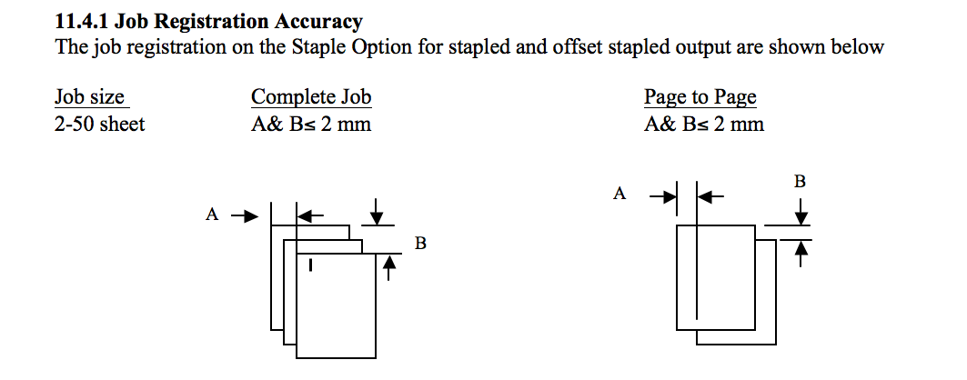
Figure 1: Misalignment Criteria

Page to page offsets or complete job offsets in either direction by more than 2 mm are classified as a misalignment. To the printer customer, misalignments of the stapled stack are aesthetically unappealing. The operating conditions given for a known worst case scenario: Temperature and humidity of a typical office environment, legal size paper, and a maximum initial distance from back wall of 10mm. We are to analyze misalignment data at stack heights of 2, 25, and 50 pages.

Design Requirements
Allowable design modifications include changes to both the material and geometry of the paddles and flaps; however, the paddle speed must stay within the current stepper motor and finisher limits. We were also given a noise requirement that the system noise must not be too loud or grating. Major geometry of the printer must remain unchanged, and any changes must also consider other existing components inside the printer. Lexmark does not want a major redesign of the system mechanics. Instead, they want a refinement of the current finisher alignment system. Other designs may be considered, but they must be approved by Lexmark.

Evaluation

Solution Approach
Given our design requirements, we determined that the only possible solutions were to either change the paddle design or change the flap design . The paddles are a complex shape, it is hard to model the forces exactly, and they are integrated into the system in such a way that makes them challenging to change out. Given our limited resources, it was determined that changing the flaps would be the best approach. In order to correct the misalignment, the frictional forces in the left and right flap needed to be reduced. Two factors affect the frictional force: the flap normal force and the flap to paper coefficient of friction. The coefficient of friction for flap to paper is challenging to determine accurately given the resources available, so the our first approach began with the flap normal force, which is due to the flap weight.

From there, we pursued multiple 3D printing services to print the iterations of the flaps due to the speed at which 3D printing could deliver parts. We decided to utilize a Stereolithography (SLA) printer in the Innovative Collaborative Studio (ICS) at the University of Tennessee, on an SLA printer through a third party vendor called 3D Hubs, and on a Fused Deposition Modeling (FDM) printer at the University of Tennessee. We first printed a pair of baseline flaps from each printer where the baseline flaps were the original flap designs. We printed the baselines to see how the 3D printed parts performed compared to the original parts given to us by Lexmark. From there, we tested the baseline pairs from each printer to determine the most effective form of 3D printing.

Testing
We began by running a baseline test for Lexmark’s original part using a procedure for the displacement tests that had been changed from last semester. The new procedure consisted of taking measurements from the back of the paper using a borescope instead of the front, changing the top sheet of paper regularly, and ensuring the scale page doesn’t move. Doing this, we recorded the data shown in Figure 2. From this Figure 2, the main issue is the 50 sheet stake, which is shown in Figure 2a. Here both the left and the right side are outside of the maximum acceptable displacement from the back wall, which is considered out of spec. Only the right side is out of spec in Figure 2b. Figure 2 also shows that there is a clockwise rotation of the paper across all of the stack heights.

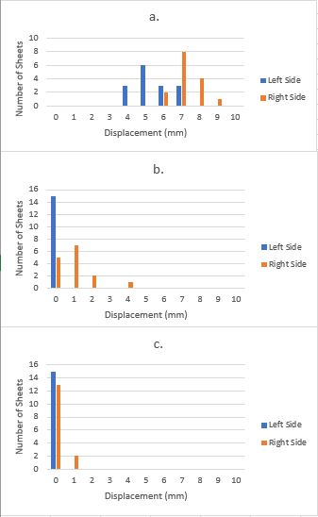
Figure 2: Original Lexmark flaps resultant displacement at a) 2 Sheets. b) 25 sheets. c) 50 sheets.

For the 3D printed parts, baseline pair of flaps that performs similar to or better than the baseline for lexmark’s original flaps are desired. For the FDM flaps, we first took observational data and then run displacement tests on them. Observationally, their geometries were not as accurate as the other parts, and the surface finish was not very smooth. These flaps were tested at 2, 25, and 50 paper stakes heights with an initial displacement of 10mm. The paper moved less than a mm on every trail for every stack height. Considering the poor results, we decided against the method of FDM printing.

For the 3D Hubs SLA flaps, we first took observational data and then ran displacement tests on them. Observationally, the parts had very accurate geometries, and the surface finishes were very smooth. The flaps were then tested at 2, 25, and 50 paper stakes heights with an initial displacement of 10mm. The results are shown in Figure 3. The results for the 3D Hubs flaps were very different from Lexmark’s original flaps. Therefore, because of the poor displacement test results and the long delivery time that we experienced when procuring the flaps, we decided against using the 3D Hubs flaps.

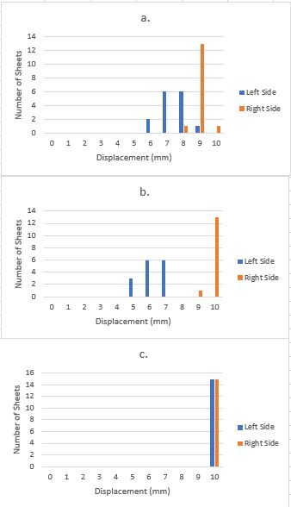
Figure 3: 3D Hubs flaps resultant displacement at a) 2 Sheets. b) 25 sheets. c) 50 sheets.

For the UTK SLA flaps, we first took observational data and then run displacement tests on them. Observationally, the parts had very accurate geometries, but their surface finish seemed to be less smooth than the 3D Hubs flaps. The flaps were then tested at 2, 25, and 50 paper stakes heights with an initial displacement of 10mm. The results are shown in Figure 4. The results for the UTK SLA flaps were also very different from Lexmark’s original flaps. We determined that the cause of the differences from Lexmark’s original flaps was a combination of a higher coefficient of friction and an abnormality in the UTK SLA flaps that caused them to sit improperly on the paper. To address the higher coefficient of friction, we put Kapton tape on the surface that contacts the paper and reduced the pin diameter where the flaps connected to the printer so that they would rotate freely and better rest on the paper.

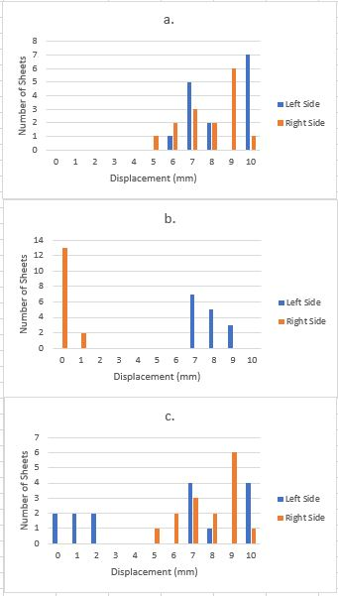
Figure 4: UTK SLA flaps resultant displacement at a) 2 Sheets. b) 25 sheets. c) 50 sheets.

The UTK SLA parts with Kapton tape added were then tested using the displacement test. The results are shown in Figure 5. These parts provided similar results to Lexmark’s original flaps, which allowed them to be put through design iterations and the results would be comparable to using the same manufacturing process as that Lexmark’s original flaps were made with.

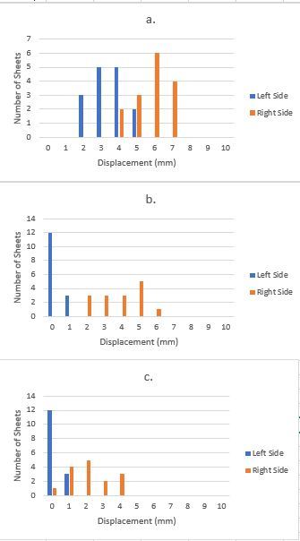
Figure 5: UTK SLA flaps with tape resultant displacement at a) 2 Sheets. b) 25 sheets. c) 50 sheets.

In order to make a design that would approach the design specifications, we first determine the mass of both flaps and coefficient of friction between the UTK SLA flaps and the paper. To get the mass, we weighed the flaps, and they were determined to be 9.39 g for the left flap and 7.87 g for the right flap. To get the coefficient of friction needed to determine the normal and friction forces between the flaps and the paper. We conducted a normal force test were we taped one end of a fishing line to the bottom of a flap and the other end to a gram force gauge. We gently lifted the force gauge until the flap no longer touched the paper. We recorded the value at that the force gage read at this point.

To determine the friction force, we put a sheet of metal under the small sheet of paper. Under the metal was a stack of paper so that the thickness of the metal and the paper equalled twenty-five sheets of paper. the metal was used because it had a low coefficient of friction with paper, so we could neglect the friction force underneath the small piece of paper. We also used a small piece of paper so that we could neglect the mass of the paper. We then taped one end of a fishing line to the paper, the other end of the fishing line to the gram force gauge, put a flap on top of the small sheet of paper, and pulled the small sheet of paper. We repeated this ten times, and averaged the value. We then calculated the kinetic coefficient of friction between the flaps and the papex, which was determined to be 0.9.

We then added this data to the math model, and used the math model to predict the masses of the flaps that would perform in spec. The math model gave us a left flap mass of 6.85 g and a right flap mass of 6.01 g. We then designed flaps in CAD with the required masses and printed them with the UTK SLA printer. After printing the flaps, which we are calling the UTK SLA Iteration 1 flaps, they had a mass of 6.92 for the left flap and 6.29 for the right flap. We then ran a displacement test on the flaps, and Figure 6 shows the results. The flaps displacement was reduced across all of the stack heights from the baseline UTK SLA flaps. Based on the data, the right flap was in need of further weight reduction. Going back into math model, we determined that the right flap needed a weight reduction to 5.18 g. We printed this part, and called it UTK SLA flap Iteration 2 with a mass of 5.25 g for the right flap.
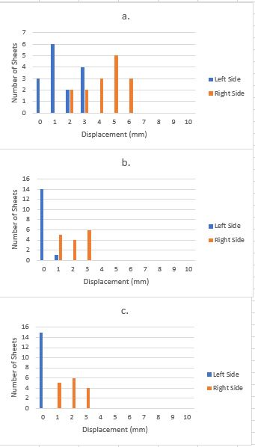
Figure 6: UTK SLA flaps with tape Iteration 1 resultant displacement at a) 2 Sheets. b) 25 sheets. c) 50 sheets.

We then ran the displacement test with the left flap from UTK SLA Iteration 1, and the right flap from UTK SLA Iteration 2. The results are shown in Figure 7. Stack heights 2 and 25 were completely in spec. For stack height 50, one data point is far away from the others. This is likely an outlier due to experimental error. Besides that data point though, there is one data point out of spec.
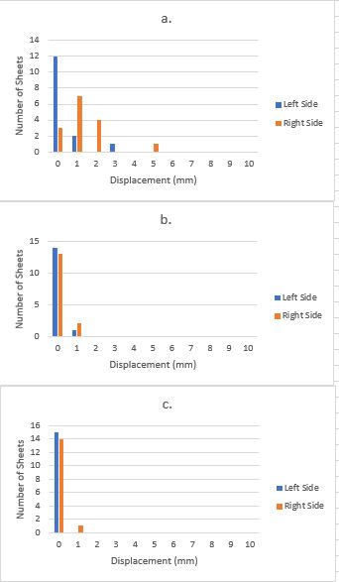
Figure 7: UTK SLA flaps with tape Iteration 2 resultant displacement at a) 2 Sheets. b) 25 sheets. c) 50 sheets.

Assessment

After conducting misalignment tests for the original Lexmark parts, we noticed that there was greatest displacement with a 2 page stack height. At 25 and 50 page stack height the misalignment was nearly always in spec. This testing was done to ensure the data collected the previous semester stayed the same. After testing the original design, our group had 3D Hubs, a contracted company, create the flaps with a high detail resin. We ran misalignment tests with these, but the data collected showed that these parts would not suffice for the flaps. There was never a displacement less than 5 millimeters for each stack height. Because of time constraints, cost and material, we did not continue to print parts with 3D Hubs. Moreover, we found a promising process of 3D printing parts with the SLA printer at the University of Tennessee. After multiple iterations, our final design reduced the weight of the left flap by 26% and the right flap by 33%. Our target misalignment criteria was 1 error in 25,000 sheets printed. Because the Lexmark finisher we were given to work with did not actually print sheets, we were unable to conduct 25,000 trials. To simulate the finish and material of the original Lexmark flaps, our group placed a low friction Kapton tape on the bottom of the flaps. Our misalignment tests ran 30 trials, and our final design was within the 2 millimeter misalignment criteria 99.7% of the time. This was as near the criteria as possible with the time given, resulting our 2nd SLA iteration as our final design.

Conclusion

In conclusion, our group changed the design of flaps on the Lexmark finisher. After making multiple iterations with an SLA printer from the University of Tennessee and using our math model as a guide, our final design met the misalignment criteria as best as possible with the supplies we had. The design was within the operating specifications and met the functions and requirements of the system. The math model guided us to reduce weight and friction, which would in return reduce the angular rotation of the top sheet of paper. The final design had a weight reduction of the left flap by 26%, final mass of 6.85 grams, and the right flap by 33%, final mass of 6.01 grams.

Appendix

Appendix A: Matlab Code for Calculating Paper Angular Rotation
%% Senior Design Free Body
% April 27 2017

%Paddles
mu_p = 1.12;

%Left Flap
F_nlf = 4.9/2; %grams at 25 sheets
mu_lf = 0.86;
F_flf = (F_nlf).*(mu_lf); %Friction force left flap
xlfo=101.6; %Moment arm left flap outside (mm)
xlfi=50.8; %Moment arm left flap inside (mm)

%Right Flap
F_nrf = 2.85/2; %grams at 25 sheets
mu_rf = 0.98;
F_frf = (F_nrf).*(mu_rf)
xrfo=101.6; %Moment arm right flap outsie (mm)
xrfi=57.15; %Moment arm right flap inside (mm)

%Paper
mu_pap = 0.6;
m = 6.25 %grams
F_fpap = m*mu_pap
w = 215.9; %millimeters
h = 355.6; %millimeters
I = (m./12).*(h.^2 + w.^2)
syms Fn Fnp
eq1= 0== -(Fnp)*3 - 2*F_nrf - m + Fn; %Sum Forces y 2 pgs
eq2= 0== (Fn*mu_pap) - 3*(Fnp*mu_p)+ F_frf; %Sum Forces X 2 pgs
[A,B] = equationsToMatrix([eq1, eq2], [Fn,Fnp]);
Ans2=vpa(linsolve(A,B));
fnp2=Ans2(2)
eq3= 0== -(Fnp)*3 - 2*F_nlf - 2*F_nrf - m + Fn; %Sum Forces y 25 pgs
eq4= 0== (Fn*mu_pap) - 3*(Fnp*mu_p)+ 2*F_frf + 2*F_flf; %Sum Forces X 25 pgs
[C,D] = equationsToMatrix([eq3, eq4], [Fn,Fnp]);
Ans25=vpa(linsolve(C,D));
eq5= 0== -(Fnp)*3 - 2*F_nlf - 2*F_nrf - m + Fn; %Sum Forces y 50 pgs
eq6= 0== (Fn*mu_pap) - 3*(Fnp*mu_p)+ F_frf+2*F_flf;%Sum Forces X 50 pgs
[E,F] = equationsToMatrix([eq5, eq6], [Fn,Fnp]);
Ans50=vpa(linsolve(E,F));
fnp2=Ans2(2)
fnp25=Ans25(2)
fnp50=Ans50(2)
F_fp2 = (fnp2).*(mu_p);
F_fp25 = (fnp25).*(mu_p);
F_fp50 = (fnp50).*(mu_p);
alpha_2 = [-(F_fp2)*88.9 + (F_fp2)*8.89 + (F_fp2)*64.77 - (2*F_frf)*xrfi]./I;
alpha_25 = [-(F_fp25)*88.9 + (F_fp25)*8.89 + (F_fp25)*64.77 + (F_flf)*xlfo + (F_flf)*xlfi - (F_frf)*xrfi - (F_frf)*xrfo]./I;
alpha_50 = [-(F_fp50)*88.9 + (F_fp50)*8.89 + (F_fp50)*64.77 + (F_flf)*xlfi - (F_frf)*xlfi - (F_frf)*xrfo]./I;
alpha2=sprintf('%4.3f',alpha_2)
alpha25=sprintf('%4.3f',alpha_25)
alpha50=sprintf('%4.3f',alpha_50)

Appendix B: Reflection– Thomas Frye
As a group, we generally split responsibilities so that the projects work load was evenly distributed. The project can be split into two separate sections: Test Phase and Design Phase. During the Test Phase, I was in charge interfacing between our mentor at UT. This required me to be up to date with what the other members of the group were doing, where we were in terms of our schedule, and what our next steps were. This was communicated to our mentor in a weekly group meeting. I was also in charge of developing one of our experiments to determine qualities of our system. These tests were difficult because it was difficult to produce tests that returned consistent and realistic data. Several iterations were generally required.

During the Design Phase, I was still the interface between our mentor and our group, I fabricated our test parts, and a tested one set of the test parts. To fabricate the test parts, I had to learn how to use a stereolithography 3D printer, and how to properly cure the parts. This was a difficult process due to the sensitivity of the 3D printing machine. The orientation was essential. If the part being printed was not oriented properly, the part would either have an unacceptable surface finish or be deformed. This generally resulted in trial and error. Testing the parts was far easier. We reused some of our tests from the Test Phase were applicable, and the new tests were generally simple.

Through this project, I learned a few principles applicable to real engineering problems. One of which is pay attention to the schedule. We were often forced to work overtime because we did not complete the work when we had originally scheduled it. Another principle was to find out where the real problem is before looking for solutions. At the beginning of our project we were convinced that the problem was the paddles. After many tests, we determined that it was actually the flaps. We wasted a lot of time thinking of solutions to fix the paddles. In my opinion, the main point of the project is learn this lessons now in school and to find a way to complete the project on time.

