Holly Black
Chancellor’s honors program | Spring 2018
Closing the Relinquishment Gap
How removing firearms from abusers reduces Domestic violence against women

Hello,

My name is Holly Black and I am a senior in the University of Tennessee Chancellor’s Honors Program. The following thesis is titled “Closing the Relinquishment Gap - How Removing Firearms From Abusers Reduces Domestic Violence Against Women”, and it is my senior final project. However, this is not a traditional thesis per se, but rather a useful and easily digestible source of information on a portion of America’s gun violence crisis and what can be done legislatively to fight it.
As a passionate advocate for sensible gun control measures, I was startled to discover that there are still a variety of loopholes in our laws today that allows domestic abusers to own firearms. I soon began searching for more information on existing policy, which then led to a semester of research on the issue. My research then grew to encompass other facets of the issue, partially from curiosity, but also because I was hoping to find a solution. After a semester and a half of research, I realized that perhaps the only real solution was to enact comprehensive policy change to legally remove firearms from the possession of individuals with domestic violence charges. From that viewpoint, it seemed only logical to take this information and create a lobbying packet – a useful and compelling source of information that I could use to inspire others to make a change.
For this reason, this thesis is not intended to be a lengthy scholarly essay on the subject of domestic violence and gun control. But rather, this packet is intended to be something new. In this thesis I aim to connect existing studies, legislation, and current trends to drive lawmakers to create lasting policy change in our state and federal governments. It is then my hope that these policies can be put into action to protect women against domestic abusers.
Upon completion, I hope to reach out to legislative offices as well as domestic violence advocacy groups to begin working towards my ultimate goal of lasting policy change to remove firearms from the possession of domestic abusers.

Closing the Relinquishment Gap: How Removing Firearms from Domestic Abusers Reduces Domestic Violence against Women
THE PROBLEM: FIREARM RELATED INTIMATE PARTNER VIOLENCE
With the number of firearm related incidents steadily increasing from 51,852 in 2015 to 61,631 in 2017, it is obvious that the United States is in the midst of a serious gun violence crisis. Although, what may not be so obvious is that a majority of this gun violence is committed in a domestic setting, against someone close to the shooter, usually a domestic partner. This specific type of violence, often labeled intimate partner violence (IPV), is a cause of death for over 1800 Americans per year, and around 50 percent of those cases involve a firearm. Intimate partners are responsible for about 40 percent of homicides of women, while only about seven percent of those against men.
What is even more startling is that the majority of these IPV instances are carried out by an abuser with a documented history of aggression and domestic violence charges against a partner, and generally these abusers still have access to firearms. With this in mind, studies have shown that in situations of existing IPV, allowing an abuser any capacity to access firearms can increase the likelihood of intimate partner homicide (IPH) by five times the original amount. Furthermore, based on partner reports, 20% of domestic violence offenders repeatedly assault their partners. Therefore, it would seem only intuitive that in order to reduce the amount of IPV in America, this capacity for abusers to obtain and use guns should be completely eliminated.
A textbook definition of America’s gun control laws would make it seem like the United States has been tightly regulating the distribution and possession of firearms since 1996. With the Lautenberg Amendment to the Violence Against Women Act, a specific law against felons obtaining guns, it seems almost impossible that anyone convicted of an intimate partner violence related felony could use a gun against a partner. However, even today, our federal government still has limited ability to enforce these laws.
However, there are still glaring gaps in the Unites States’ gun control policy that continue to allow abusers access to firearms. This then allows for abusers to use these firearms against their partners, and as a result, over 700 women are killed by their partners every year.
Considering these statistics, it is almost painfully obvious that something must be done to close these firearm relinquishment loopholes. As legislators, it is up to you to create a set of common-sense federal relinquishment laws; to not only end this senseless violence, but to give American women the protection and safety they deserve.

THE PROBLEM: LOOPHOLES IN CURRENT DOMESTIC VIOLENCE GUN LAWS
One of the most egregious of the loopholes in current domestic violence gun laws is that despite federal legislation specifically prohibiting it, many states still allow those convicted of IPV related felonies access to firearms. This issue was partially addressed in the 2005 reauthorization of the Violence Against Women Act and persons convicted of an IPV related felony are now required to be notified of the specific restrictions placed upon their firearm ownership. This reauthorization did not, however, require said felons to relinquish their firearms to the federal government.
Addressing this lack of relinquishment policy may be the crucial step for reducing the likelihood of firearm related intimate partner homicide and gun deaths in America overall.
Currently, the Bureau of Alcohol, Tobacco, and Firearms is responsible for the initiation of federal forfeiture action involving firearms in very limited circumstances. Mainly, the seizure and forfeiture must be acceptable under the Gun Control Act of 1968, and this seizure can only take place if state or local law does not authorize firearm seizure in the particular case.
Because the federal statute bans the possession of firearms, but does not require those convicted of IPV related felonies to surrender their firearms to the government, several states have created explicit firearm relinquishment laws to rectify this issue. As of now, states have taken two main approaches to enact relinquishment policies.
The first is that upon being convicted of an IPV related offense, the offender is given official notice of how long he or she has to transfer all firearms in his or her possession to a law enforcement official, or a federally licensed gun dealer. This time frame, for example in California, is twenty four hours, and in Pennsylvania it has recently been lowered to forty-eight hours. As of 2016, only eleven states require this type of firearm relinquishment.
The second approach is that law enforcement officials simply remove all firearms from a scene of an IPV related incident. Although eighteen states have this sort of policy, the language in these policies varies. In nine states, policy dictates that law enforcement officials “shall remove” firearms while in six other states, officials “may remove” said firearms. Additionally, there are three states with policy including both terms. In these states, relinquishment can be mandatory or discretionary and is dependent entirely upon the situation.
Additionally, there are currently three different categories by which states have the authority by law to remove firearms from the scene of an IPV-related crime. This authority applies to both “shall remove” and “may remove” policies. The categories: police authority, court authority, and a combination of the two, and the states which enforce them are denoted on the map below (figure 1). It is important to note the startling number of states which have granted no authority for police or courts to seize firearms from the scene of an IPV- related crime.
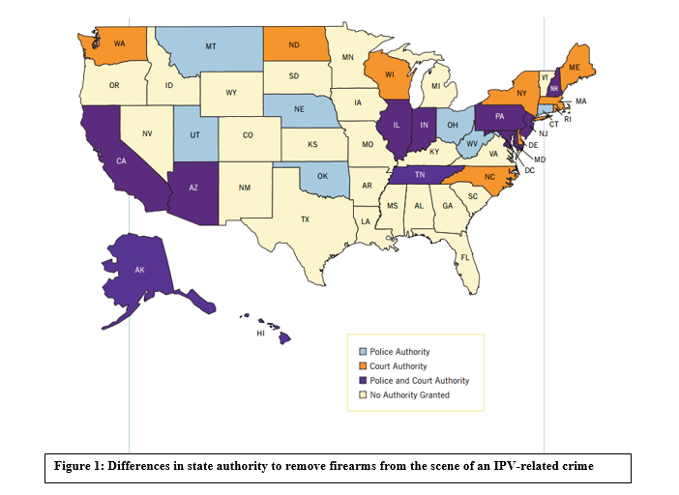
It is also important to note that these relinquishment policies have been proven to be effective in reducing firearm related IPH by 14%. According to the Annals of Internal Medicine, IPV- related firearm relinquishment laws are significantly associated with 9.7% lower total IPH rates and 14.0% lower firearm-related IPH rates. As seen in the figure below (figure 2) in almost every state with restraining order firearm relinquishment laws, the number of yearly intimate partner homicides decreases drastically, and in general, states with more policies see greater success in lowering the rate of firearm-related intimate partner homicide.
For example, in Pennsylvania, a state with four total IPV-related firearm law provisions, the firearm-related IPH rate per 100,000 people is .38. Although not the lowest in the nation, it still is one of the lowest, and with new Pennsylvania state laws concerning firearm relinquishment recently passed, that number is likely to decrease in the coming years. These low rates are also supported by the fact that Pennsylvania has both court and police authority in regards to firearm relinquishment laws.
In California with six total IPV-related firearm law provisions, the total IPH rate per 100,000 people is .48. Furthermore, the firearm-related IPH rate per 100,000 people was only .26. Each of these numbers is one of the lowest on the chart, and the combination of two low statistics makes California one of the best examples of how common-sense IPV related firearm law provisions combined with court and police relinquishment authority prevents homicides in America.
Similarly, New York State, with five total IPV-related firearm provisions, has extremely low rates of both firearm-related IPH and total IPH. Most notably, the state’s firearm-related IPH rate was only .15 and the total number of IPH related deaths for 2015 was 76. In combination with the fact that as of 2015 New York State had the third highest population in the nation, this number shows the success of comprehensive firearm relinquishment laws.
However, in states like Mississippi with zero IPV-related firearm law provisions, the total IPV rate per 100,000 people in 2015 was .97 and the amount of firearm-related IPH was almost as high at .81. Considering the population of the state of Mississippi, these numbers are staggeringly high. These high number, however, are an example of exactly why specific laws designed to close these loopholes must be put in place. Also it is important to note that Mississippi also does not have any system of court or police authority in place to enforce these relinquishment policies if they were to ever be put in place. Therefore, one must also remember that these laws are only successful with proper and consistent enforcement.
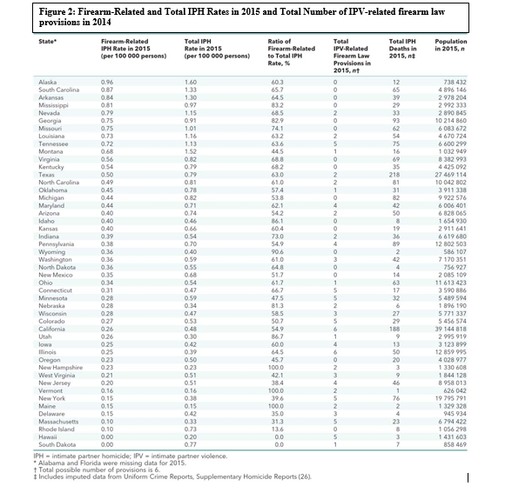

THE PROBLEM: LACK OF FUNDS FOR CDC GUN VIOLENCE RESEARCH
Since the passage of the Dickey Amendment in 1996, the Federal Government has not allowed the Center for Disease Control to fund research on gun violence as a public health issue. This lack of funding has caused almost all research institutions to no longer study this issue. Unfortunately, without intense scientific research backing progressive legislators’ policies to close the Relinquishment Gap, legislation is less likely to garner bipartisan support. It seems almost common sense, but you cannot truly debate an issue if you do not have all the facts. Therefore, the conversation about gun violence cannot proceed in America until further research has been done to truly analyze the effects of gun violence on Americans, and to realize the true effects of all possible solutions.
In 2014, the CDC released a report entitled “Connecting the Dots: An Overview of the Links among Multiple Forms of Violence”. The report contains extensive research on what causes IPV and how insanely prevalent it is, but no research on how firearms play into this. Because of this, there is a glaring gap in information because we know what puts people at risk for committing or experiencing IPV, but we don’t have research on the effects of this violence. Therefore, unless we stop it at the immediate societal source, we cannot stop it. Additionally, from the report’s data concerning the causes of IPV, it seems that limiting firearm possession would be one of the easiest, most direct, and most effective ways to stop IPV.
However, the 2018 Omnibus Spending Bill, signed on March 23, 2018, contains language that could allow for CDC funds to be used for gun violence research. The law’s new wording makes lawmakers’ intent clear that the text of the Dickey Amendment does not prevent research into gun violence.
“It recognizes that science has a tremendous amount to contribute, and that science can be a common ground where both sides come together”
– Mark Rosenberg, former director of research of firearm violence, CDC
With the reversal of the Dickey Amendment, there is the potential to make a breakthrough regarding gun violence research. Finally, we can make up for research that should have been conducted decades ago, and with that research, we can begin enacting common sense policies to close the relinquishment gap.

Current Trends
Although federal statutes are helping reduce the amount of firearm related intimate partner violence, our current system of laws is not enough. This is shown by recent research, but also by recent legislation, and public support for tighter gun control laws from American citizens. As of 2017, 52% of American adults supported stronger gun control measures, and 64% supported tighter firearm restrictions on individuals with felony convictions. Here’s a quick rundown of how our nation is reacting to gun related violence in America and what you can do to listen and to help.
Research
In order to pass legislation to close the Relinquishment Gap, significant barriers must be overcome. However, the passage of such legislation could be made much easier with increased research into gun violence and how it affects the health and safety of Americans. Because firearm related IPV is one of the largest causes of homicides of women, it is important to brand these policy changes as health and safety issues.
Due to the CDC’s lack of funds for the research of gun violence, America’s universities have taken research into their own hands. April Zeoli, Michigan State University associate professor of criminal justice, was primary investigator in a groundbreaking 2017 study. According to the FBI, of the 1,352 intimate partner homicides in 2015, 55% were committed by firearms. One of the most important aspects of the study was the finding that laws requiring individuals with domestic violence restraining orders to relinquish firearms were associated with a 22% reduction in firearm intimate partner homicide.
“Our findings are consistent with prior research, supporting the claim that prohibiting domestic violence abusers from having firearms saves lives. This new evidence suggests that laws that disarm the largest number of people with histories of violence, require permits for handgun purchasers and require relinquishment of firearms for those who are prohibited from having them are effective in reducing domestic homicides.”
– April Zeoli, published gun violence researcher
In the course of the study, it was found that federal statutes prohibiting those convicted of misdemeanor crimes of domestic violence from firearm purchase and possession was also associated with an 11% reduction in firearm intimate partner homicide. Therefore, it is important that the law covers all facets of domestic violence charges and that an individual with any sort of domestic violence charge is prohibited from purchasing and possessing firearms.

Activism
Plain and simple, Americans have had enough. With already 17 school shootings in the United States this year alone, Americans are tired of gun violence. Furthermore, an average of 50 women are shot and killed every month by intimate partners. As of 2013, 83% of Americans supported prohibiting those convicted of violating a domestic violence restraining order from having guns, and with a recent uptick in firearm related deaths that number will only rise.

On March 24, 2018 over 200,000 people attended the Washington D.C March for Our Lives, organized by survivors of the Parkland school shooting. In addition to this, over 800 other marches were held simultaneously across the country with all 50 states participating.
“Remember that policy change is not nearly as difficult as losing a loved one” – Sari Kaufman, a sophomore from Stoneman Douglas High School
In response to this powerful call for change the White House issued a statement saying "We applaud the many courageous young Americans exercising their First Amendment rights today," However, these students need more than applause. They need lasting policy change. They need your help.
“Enough is enough” is not only a popular chant at these rallies, but a call to action for you, our nation’s lawmakers. The time is now. Be a voice for sensible gun control measures, be a voice for your constituents, and most importantly, be a voice for change.

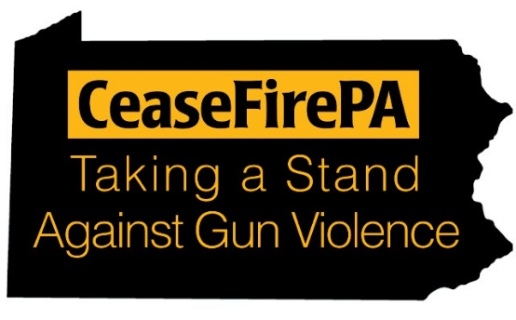
CeaseFirePA is a group of communities across the state of Pennsylvania working together to end gun violence. These groups launch local initiatives focused on “outreach, education, coalition building, and advocacy to reduce gun violence, stop illegal gun trade, and keep guns out of the hands of those who should not have them”. What’s especially interesting about this organization though, is that they operate under two “arms”; the first being education and the second being advocacy.
Through the combination of these arms, CeaseFirePA has become a trusted source of information on gun violence, and the state of gun policy in Pennsylvania. Because Pennsylvania suffers more than 1400 gun deaths per year, the organization has correctly labeled gun violence as a public health issue.
However, this information is virtually useless without community support and activism. CeaseFirePA also strives to mobilize voting citizens to express their views on gun violence and to empower them with the facts, so real changes can be made.
One current issue the organization is watching right now is strengthening Pennsylvania firearms relinquishment policy. CeaseFirePA agrees with countless other Americans that current relinquishment laws are weak and ineffective. Because of this, the organization supports Pennsylvania Senate bill 501 which alters state relinquishment procedures to create a safer and more effective way for individuals with Protection From Abuse (PFA) orders issued against them to relinquish their firearms. This bill is described in greater detail on page 8 of this packet.
Additionally, the group is encouraging legislators to introduce bills allowing local courts to issue “firearms restraining orders” so that “families, friends, and others may petition the court for a firearm restraining order when there is good cause to believe an individual poses an immediate threat to the safety of a family, household member, or other person by possessing or having a firearm in his custody or control”. They also propose making firearm restraining orders mandatory in conjunction with any protection from abuse order.
These proposals are a part of comprehensive, common-sense gun control measures, and similar legislation has already been adopted in the states of Texas, Connecticut, California, and Indiana. By taking these critical steps, you can almost guarantee that domestic abusers do not have access to their firearms. Furthermore, restrictions and relinquishment policies such as this help prevent suicides, homicides, and mass shootings, thus enhancing overall public safety.

Legislation
In the past year, several important pieces of legislation have been proposed in both federal and state governments. Each of these proposed bills focuses on a different type of loophole in the law, from gaps in state policy to loopholes in how certain restrictions are extended or relationships are labeled. This variety of proposed legislation shows that although there are several loopholes to be closed, there are also several approaches to close them.

Federal Legislation

H.R. 4192/ S. 2045 – State Funding Focus
One crucial piece of legislation regarding firearm ownership and possession of those with domestic violence charges is H.R. 4192, also known as S. 2045. Introduced on October 31, 2017, the Domestic Violence Gun Homicide Prevention Act of 2017 aims to establish a Department of Justice grant program to encourage states to adopt certain policies and procedures relating to the transfer and possession of firearms. These grants can be made through the existing Community Oriented Policing Services program. The bill takes an interesting and potentially effective approach to closing the relinquishment gap by encouraging states to close the loopholes themselves. This then allows for each state to work with existing policies to tailor specific methods to closing these loopholes inside the legislative framework already in place. Additionally, these grants may be used to assist police forces and courts to better enforce current state legislation. Although this bill has not yet been passed by the House or the Senate, it is supported by a number of advocacy groups, including the National Coalition Against Domestic Violence, the National Network to End Domestic Violence, the National Domestic Violence Hotline, and Jewish Women International. It also has eight cosponsors in the House and 14 in the Senate.
S. 2044 – Temporary Restraining Order Focus
S. 2044, the Lori Jackson Domestic Violence Survivor Act was introduced on October 31, 2017 by Senator Richard Blumenthal. This bill extends current firearm relinquishment policy to persons with temporary restraining orders. Thus, an individual with any sort of restraining order is unable to purchase or possess a firearm for the entire duration of the order. Currently, this bill has 18 cosponsors and has been referred to the Committee on the Judiciary.
H.R. 2670 – Dating Partner Focus
This bill, the Protecting Domestic Violence and Stalking Victims Act, also addresses the issue of extending relinquishment policy to individuals in classes not currently restricted. This bill focuses on modifying the prohibition on firearm sale or transfer to or purchase or possession by an individual who is subject to a court order that restrains the individual from harassing, stalking, or threatening an intimate partner or child of an intimate partner. This bill also takes the important step of modifying the term “intimate partner” to include dating and former dating partners. Currently this bill has 84 cosponsors and has been referred to the Subcommittee on Crime, Terrorism, Homeland Security, and Investigations.
H.R. 3207 – Stalking Focus
H.R. 3207, the Zero Tolerance for Domestic Abusers Act makes it a crime to knowingly sell or dispose of a firearm to a person who has been convicted of a misdemeanor crime of stalking. It also makes it a crime for such convicted stalker to receive or possess a firearm, thus taking crucial steps to include individuals with stalking charges from possessing firearms. Currently this bill has 87 cosponsors and has been referred to the Subcommittee on Crime, Terrorism, Homeland Security, and Investigations.

State Legislation

Pennsylvania State Legislature SB501 – Relinquishment Deadline Focus

As of March 22, 2018, the Pennsylvania State Senate has approved a bill “to force people with a domestic violence ruling against them to more quickly forfeit their firearms”. The bill requires that those convicted of a domestic violence charge give up their firearms to a law enforcement agency, a federally licensed firearms dealer, or their lawyer in a time frame of 48 hours or less. Additionally, defendants in final protection-from-abuse cases would have a maximum time frame of 24 hours to relinquish their firearms. Failure to relinquish a firearm is a second-degree misdemeanor, punishable by up to two years in prison.

Current Pennsylvania laws allow convicted persons 60 days for forfeiture, and handing guns over to relatives, friends, and neighbors all counts as legal forfeiture. Obviously, this is a dangerous oversight in the law, and abusers could easily re-gain access to their firearms at a later date. Because of this, it is crucial that new bills, like the one described above, are passed so these glaring issues may be corrected.

New York State Legislature Governor’s Program Bill – Broad Relinquishment Focus
Created as part of New York State Governor Andre Cuomo’s 2018 Women’s Agenda, this new law broadens the scope of domestic violence offender firearm relinquishment by not only amending penal law to include additional offenses, but also to establish a procedure for the surrender of firearms, rifles, and shotguns in addition to existing policy on the surrender of handguns. Currently, New York State is known to have passed “the strongest gun control laws in the nation”, and this law helps to ensure the removal of all types of firearms from individuals involved in domestic violence. The passage of this legislation was pushed in the wake of several mass shootings in the United States as well as recent gun control activism in the state of New York through the March for Our Lives organization.

Notes

Past Summary Ledgers.Gun Violence Archive. Retrieved from http:// http://www.gunviolencearchive.org/past-tolls
Koziol-Mclain, J., Webster, D., Mcfarlane, J., Block, C. R., Ulrich, Y., Glass, N., & Campbell, J. C. (2006). Risk Factors for Femicide-Suicide in Abusive Relationships: Results From a Multisite Case Control Study. Violence and Victims, 21(1), 3-21. doi:10.1891/088667006780927358
Startin, R. Hansen, D. Huss, M (2006). Domestic Violence Treatment Response and Recidivism: A Review and Implications for the Study of Family Violence. University of Nebraska – Lincoln Faculty Publications, Department of Psycholog. 85. Retrieved from http://digitalcommons.unl.edu/psychfacpub/85
U. (2013, July). 1117. Restrictions on the Possession of Firearms by Individuals Convicted of a Misdemeanor Crime of Domestic Violence. Retrieved April 09, 2018, from https://www.justice.gov/usam/criminal-resource-manual-1117-restrictions-possession-firearms-individuals-convicted
Federal Firearms Forfeiture and Domestic Violence. Doc. Washington, D.C: United States Department of Justice.
Frattaroli S. Removing Guns from Domestic Violence Offenders: An Analysis of State Level Policies to Prevent Future Abuse
Díez, C., Kurland, R. P., Rothman, E. F., Bair-Merritt, M., Fleegler, E., Xuan, Z.,Siegel, M. (2017, October 17). State Intimate Partner Violence–Related Firearm Laws and Intimate Partner Homicide Rates in the United States, 1991 to 2015. Retrieved April 04, 2018, from http://annals.org/aim/fullarticle/2654047
Omnibus Consolidated Appropriations Act, 1997, Pub. L. No. 104-208 110 Stat. 3009-244 (1996).
(2017). America’s Complex Relationship with Guns: Views on Gun Policy. Pew Research Center Social and Demographic Trends. Retrieved http://www.pewsocialtrands.org/2017/06/22views-on-gun-policy/
April M Zeoli, Alexander McCourt, Shani Buggs, Shannon Frattaroli, David Lilley, Daniel W Webster(2017), Analysis of the Strength of Legal Firearms Restrictions for Perpetrators of Domestic Violence and Their Association With Intimate Partner Homicide, American Journal of Epidemiology, kwx362.
CeasefirePA Logo. Retrieved April 04, 2018, from http://www.ceasefirepa.org/updates/page/34/?page=6
About Us. (n.d.). Retrieved April 04, 2018, from http://www.ceasefirepa.org/about-us/
Other Issues to Watch. (n.d.). Retrieved April 04, 2018, from http://www.ceasefirepa.org/issue-action-center/other-issues-to-watch/
Domestic Violence Gun Homicide Prevention Act of 2017, H.R. 4192, 115th Cong. (2017)
Lori Jackson Domestic Violence Survivor Protection Act, S. 2044, 115th Cong. (2017)
Protecting Domestic Violence and Stalking Victims Act, H.R. 2670, 115th Cong. (2017)
Zero Tolerance for Domestic Abusers Act, H.R. 3207, 115th Cong. (2017)
Pennsylvania (State). Legislature. Assembly. An act amending Titles 18 and 23 of the Pennsylvania Consolidated Statutes, in firearms and other dangerous articles…(S. 501). 2017-2018 Reg. Sess. (March 26, 2018). Pennsylvania State Assembly. Web 26 April 2018.
New York (State). Legislature. Assembly. An act to amend the penal law, the criminal procedure law and the family court act, in relation to the possession of weapons by domestic violence offenders; and to repeal certain provisions of the criminal procedure law relating thereto. (S 6103). 2017-2018 Reg. Sess. (March 30, 2018). New York State Assembly. Web 26 April 2018.

