Strategic Technology Maturation and Insertion (STMI): a requirements guided, technology development optimization process

A Dissertation Presented for the
Doctor of Philosophy
Degree
The University of Tennessee, Knoxville

James Brill Clegern
May 2014

Acknowledgements
I would like to thank my dissertation chairman, Dr. Xueping Li and committee members Dr. James Simonton, Dr. Trevor Moeller, Dr. Joseph Wilck, and Dr. Ahmed Vakili for their advice and patience in dealing with a distance learning PhD candidate during this project. It is an honor and pleasure to have them as my advisory team.
I am greatly thankful to Dr. Gregory Sedrick for his willingness to take a chance on UTSI’s first military distance EM PhD student. His fruitful discussions and valuable suggestions guided my initial classwork and focusing of my dissertation topic.
I am thankful to my father, Dr. Robert Clegern, for his help as a sounding board for ideas and many hours of dissertation editing to help fix things “not just right”.
Finally, I want to thank my lovely spouse, Sarah, and three boys, Ben, Dan and Evan, for putting up with my class time, long research hours and dissertation writing. Many a family event was postponed to support my academic progress. The final results are sure worth it!
Financial support from the Office of Veteran’s Affairs and University of Tennessee Space Institute are gratefully acknowledged.
Abstract

This research presents a Decision Support System (DSS) process solution to a problem faced by Program Managers (PMs) early in a system lifecycle, when potential technologies are evaluated for placement within a system design. The proposed process for evaluation and selection of technologies incorporates computer based Operational Research techniques which automate and optimize key portions of the decision process. This computerized process allows the PM to rapidly form the basis of a Strategic Technology Plan (STP) designed to manage, mature and insert the technologies into the system design baseline and identify potential follow-on incremental system improvements. This process is designated Strategic Technology Maturation and Insertion (STMI).
Traditionally, to build this STP, the PM must juggle system performance, schedule, and cost issues and strike a balance of new and old technologies that can be fielded to meet the requirements of the customer. To complicate this juggling skill, the PM is typically confronted with a short time frame to evaluate hundreds of potential technology solutions with thousands of potential interacting combinations within the system design. Picking the best combination of new and established technologies, plus selecting the critical technologies needing maturation investment is a significant challenge. These early lifecycle decisions drive the entire system design, cost and schedule well into production
The STMI process explores a formalized and repeatable DSS to allow PMs to systematically tackle the problems with technology evaluation, selection and maturation. It gives PMs a tool to compare and evaluate the entire design space of candidate technology performance, incorporate lifecycle costs as an optimizer for a best value system design, and generate input for a strategic plan to mature critical technologies. Four enabling concepts are described and brought together to form the basis of STMI: Requirements Engineering (RE), Value Engineering (VE), system optimization and Strategic Technology Planning (STP). STMI is then executed in three distinct stages: Pre-process preparation, process operation and optimization, and post-process analysis. A demonstration case study prepares and implements the proposed STMI process in a multi-system (macro) concept down select and a specific (micro) single system design that ties into the macro design level decision.

Table of contents

1 Introduction 9
1.1 Background 9
1.2 Research topics 11
1.3 Research objectives 12
1.4 Structure of the dissertation 17
2 Literature review 18
2.1 Decision Support System (DSS) 18
2.1.1 DSS background 18
2.1.2 DSS historical development 19
2.1.3 DSS categories 20
2.1.4 STMI as a DSS process 21
2.2 Requirements Engineering (RE) 23
2.2.1 RE background 23
2.2.2 RE strategies 25
2.2.3 Requirement generation methods 29
2.2.4 Database generation 30
2.2.5 RE placement within the STMI process 32
2.3 Value Engineering (VE) principles 32
2.3.1 VE background 32
2.3.2 VE methodology 33
2.3.3 STMI VE implementation 37
2.4 Optimization and metaheuristic optimization methods 37
2.4.1 Metaheuristic background 38
2.4.2 Metaheuristic history 39
2.4.3 Metaheuristic algorithms 43
2.4.4 Metaheuristic applications 56
2.4.5 Metaheuristic application for STMI 59
2.5 Strategic Technology Planning (STP) 59
2.5.1 STP background 59
2.5.2 Strategic technology planning methods 60
2.5.3 STMI applicability 68
2.6 Post-process analysis options for STMI 70
2.6.1 Trade-off analysis 70
2.6.2 Data and requirement sensitivity analysis 71
2.6.3 Incremental improvement studies 73
3 Process formulation 75
3.1 Stage one: pre-process preparation 75
3.1.1 Generating an operational concept 75
3.1.2 Requirements and constraints generation and tracing 77
3.1.3 Defining key parameters and system models 82
3.1.4 Technology database development 82
3.2 Stage two: STMI core process 88
3.2.1 System design objective function operations (step-1) 89
3.2.2 Incorporating Value Engineering “best value” (step-2), 92
3.2.3 Strategic Technology Plan input (step-3) 93
3.2.4 Optimization process 96
3.2.5 Micro and Macro STMI operation, 101
3.3 Stage 3: Post-process analysis 101
3.3.1 Trade-off study analysis 101
3.3.2 Sensitivity analysis 102
3.3.3 Incremental delivery analysis 107
4 Methodology and case study 108
4.1 Scenario background 108
4.2 FR system options available 112
4.3 Micro analysis: Kinetic FES System 116
4.3.1 STMI stage 1: FES requirements, functions and technology database 118
4.3.2 STMI stage 2a: FES objective function operations and VE optimization 135
4.3.3 STMI stage 3: Post process FES system design analysis 138
4.4 Macro-level STMI FR system selection 147
5 Conclusions and expected contributions 152
6 Future research opportunities and ongoing work 153
List of references 154
Appendices 172
Appendix A: Heat sink design specifications 173
Appendix B: FES rotor designs 177
Appendix C: PM motor mass and cost estimate 198
Appendix D: Detailed FES technology database 199
Appendix E: Detailed STMI “Best Value” VE analysis 203
Vita 216

List of Tables
Table 1: A selection of current academic RE textbook references 25
Table 2: VE phases and questions to address 36
Table 3: A selection of current academic metaheuristic textbook references 40
Table 4: Common metaheuristic methods and sample applications. 57
Table 5: TRL descriptions 61
Table 6: TRL clarifying definitions 62
Table 7: Problems and solutions in technology planning 63
Table 8: Common types of design requirements 80
Table 9: Example decision making under risk (sample probabilities assigned) 87
Table 10: Example of OVAT sensitivity analysis with AAM system design 104
Table 11: FR system requirements, 1000MW market 111
Table 12: Current FR system technologies 112
Table 13: Commercial flywheel technology providers 117
Table 14: Customer Requirements Document (CRD) summary 118
Table 15: FES functional areas and initial technology options 123
Table 16: FES rotor sub-component design specifications 130
Table 17: Magnetic bearing capability length check 132
Table 18: FES database - rotor specifications 133
Table 19: FES database – bearing specifications 133
Table 20: FES database – motor/generator specifications 134
Table 21: FES database – vacuum enclosure specifications 134
Table 22: Top ten FES designs from STMI “best value” optimization +STP input 137
Table 23: FES Trade study results 143
Table 24: STMI FES OVAT cost sensitivity analysis on BV score 145
Table 25: STMI FES DoE cost sensitivity analysis on BV score 146
Table 26: Macro-level FR system design 150

List of Figures

Figure 1: Three stages of the proposed STMI process 14
Figure 2: DSS operation overview 22
Figure 3: Traditional “Waterfall” RE strategy 27
Figure 4: Example RE “Spiral” strategy 28
Figure 5: Example RE incremental strategy 29
Figure 6: Lifecycle VE savings potential 34
Figure 7: Metaheuristic timeline 41
Figure 8: GA evolution flow 45
Figure 9: SA operation visualization 46
Figure 10: Sample exploration path for TS in a potential solution space 49
Figure 11: Ant Colony Optimization pheromone routing 52
Figure 12: Natural swarming behavior of birds and fish 54
Figure 13: Graphical illustration for ILS 55
Figure 14: DoD acquisition “lifecycle” with STP 69
Figure 15: Trade off analysis operators 70
Figure 16: Sample air defense “Macro” operational concept 76
Figure 17: Sample air defense “Micro” operational concept 77
Figure 18: Sample of a functional flow block diagram, single level 83
Figure 19: Sample AAM system design 90
Figure 20: STMI system design Function Flow Block Diagram for AAM example 91
Figure 21: STMI VE process operation for “best value” selection 94
Figure 22: STMI BV system design metadata applied to STP schedule & budget 95
Figure 23: Computational requirements illustration between optimizers 98
Figure 24: STMI macro-micro system optimization process 102
Figure 25: DoE ASQ template, sensitivity analysis for deterministic AAM example 106
Figure 26: Daily profiles of wind power in Tehachapi, California and 5 MW solar power array output over 6 days in Spain 109
Figure 27: FR requirements in a 50MW market daily power cycle operational scenario 111
Figure 28: Worldwide installed storage capacity for electrical energy 113
Figure 29: FR systems operation diagrams 114
Figure 30: Beacon Power FES Facility and STMI Case Study FES Facility 119
Figure 31: Key FES functional areas 122
Figure 32: FES system objective function operation 136
Figure 33: STMI “best value” FES design with Gant chart style inputs for a STP 139
Figure 34: FR facility placement within the utility grid 148

Introduction
This research explores a formalized and repeatable Decision Support System (DSS) process to allow Program Managers (PMs) to systematically tackle the problems (time, bias, interactions, risk, and resources) with technology evaluation and inclusion into a system design. The proposed process incorporates computer based Operational Research techniques which automate and optimize key portions of the decision process. This computerized process provides the PM a DSS tool to rapidly compare and evaluate candidate technology performance, incorporate lifecycle costs for inclusion into a best value system design, and generate input for a Strategic Technology Plan (STP) to mature enabling technologies. This process is designated Strategic Technology Maturation and Insertion (STMI).
Traditionally, to build this STP, the PM must juggle system performance, schedule, and cost issues and strike a balance of new and old technologies that can be fielded to meet the requirements of the customer. To complicate this juggling skill, the PM is typically confronted with a short time frame to evaluate hundreds of potential technology solutions with thousands of potential combinations within the system design. The PM’s STP generation must balance the cost and schedule to mature new technologies against the selection of existing technologies to meet the customer requirements of the system design.

Background
In industry and the Department of Defense (DoD), strategic technology planning is used for critical business growth and procurement of technology intensive equipment. Generating a STP involves satisfying a multitude of stakeholders, meeting internal and external requirements, maturing the technology and finally inserting the technology into a usable system or product. An effective STP directs the focus of industry’s competitive edge, and allows entities like DoD to project requirements and focus development to meet evolving user requirements^{1,2,3}. Typically, for both industry and the DoD, a PM is designated to develop a STP for each system acquisition program. The PM provides direction to the development, production, evaluation and initial deployment of a new technology system. The PM’s goals are to meet the customer requirements efficiently and effectively in the shortest time possible. In order to perform those duties, the PM must have an effective technology planning and investment program early in the system’s lifecycle and be able to track the technology development progress.
The early STPs traditionally require large teams of Subject Matter Experts (SMEs), informal evaluations and “rules of thumb” heuristics to narrow the technology choice options to a manageable subset for detailed evaluation. There are typically five problem areas with the traditional technology evaluation process: time, bias, interactions, risk, and resources. The first problem is that the technology analysis is usually time limited, shortchanging the examination of all the presented alternatives. The second problem incorporates human biases discarding large swaths of potential solutions in favor of known capabilities and development timelines. The third problem is that interactions between technologies are often difficult for SMEs to manually evaluate except through modeling or experimentation. The fourth problem is the American love affair with things new and high tech, and our tendency to accept these higher risk (immature), but “glamorous” technology options and not account for lifecycle cost impacts. The fifth problem is the tendency to ignore the significant amount of resources and time needed to mature a technology for effective insertion into a system design. These five problem areas limit analysis, resulting in potentially poor management decisions. These poor decisions then drive the entire system design, cost and schedule well into production.
While problem areas one through four must be addressed in a technology evaluation for a system design, the fifth problem area also involves an additional requirement. This requirement is for a formalized process identifying which technologies need to be matured and transitions from a lower Technology Readiness Level (TRL-4 or 5) to a TRL-6 prototype for insertion into an integrated system design as outlined in the GAO report NSIAD-99-162⁴. The DoD technology development community and laboratories often refer to this TRL transition effort as the “Technology Chasm”^{5,6,7} owing to the high frequency of great new technologies being shelved due to a lack of development funding. Other researchers have investigated technology transfer processes to facilitate technology maturation, primarily offering manual processes and models^{8,9,10} but, making errors in bridging this “technology chasm” have far reaching impacts to the system in design.
Impacts of unrealistic or unplanned technology maturation within a system design will typically follow this path:
- Unplanned technology maturation raises projected costs over initial estimates and stretches the planned schedule
- Late delivery of technology maturation cause design changes to ripple through the program late in the program cycle
- Failed or undeliverable technologies are replaced by fallback technologies causing expensive additional design and production changes
- Fallback technologies often fail to meet customer requirements
- Customers will often cancel the program when their needs are not met
The PM’s primary goal is the successful design, production and delivery of a system to his customer at an acceptable cost. In order to accomplish this he needs to minimize the risk to the system under development. Tools that reduce this risk through repeatable, analytical processes that can be subjected to rapid trade studies, sensitivity analysis and optimized for certain user preferred variables (schedule, cost, or performance parameters) are highly desired.

Research topics
To help the PM minimize the impacts of spanning the “Technology Chasm” with poor technology maturation planning, an efficient decision support tool is needed. This tool or system must provide a rigorous and repeatable process to examine technology options early in the system design and present an optimized STP path. Some of the common technology planning issues being addressed by PMs make excellent questions addressed by this research.
- Can all candidate technologies be evaluated against a common set of customer requirements, not just trendy or directed technology options?
- Can interactions between technology options be addressed in an initial system design?
- Can a budget and schedule of optimized current and developing technologies be generated to help a PM generate a Strategic Technology Plan for technology investment?
- Can a Value Engineering “best value” system design be incorporated with the proposed system lifecycle design?
- Can trade studies be conducted to illustrate how technology selection and maturation is impacted by changing customer requirements?
- Can sensitivity analyses be conducted to illustrate how technology selection and maturation is impacted by data uncertainty in the estimates of technology performance, cost and schedule?
- Can a technology maturation process provide feedback to inform customers concerning obtainable and unobtainable requirements given current technology levels, funding and schedules?
To answer these research questions, a formalized and repeatable Decision Support System (DSS) process to allow PMs to systematically compare and evaluate candidate technologies against a common set of requirements is explored in this research. This developed DSS process generates data for a recommended STP that identifies immature technologies needed for a system design and helps the PM to plan to bridge the TRL-4 to TRL-6 technology “chasm” with direct applications to technology maturation, transfer and insertion into product systems designs.

Research objectives
STPs have been an active field of research in many areas within the DoD acquisition “lifecycle” timeline. Researchers, developers and program managers have expended enormous time and resources to study and develop methodologies to improve how technology is identified, matured and eventually inserted into a viable product or service. Despite a growing body of literature and government regulations, STP is primarily a subjective methodology conducted by SMEs. Applying a systematic analysis process offers a potential DSS method to make planning and technology forecasting more accurate and defendable given the inter-connected nature of customer requirements and technology interactions.
There are three STMI operational areas or stages developed in this research and illustrated in Figure 1: Pre-process preparation, process operation and optimization, and post-process analysis. The focus of the research will be to demonstrate the proposed process and applicability as a planning tool for the PM. The goal of the STMI process is to provide decision makers with an additional DSS tool to systematically and rapidly evaluate multiple technology options and recommend an optimized technology set for STP generation that will complete a system design ready for TRL-6 prototyping.
Stage one involves the pre-process preparation of customer requirements, operational scenario and technology data. These are inputs to the second STMI process stage and are critical due to the fact that if the requirements are not solid, if the operational scenario models are not representative and if the technology data is not accurate, the results are the traditional GiGO (Garbage In, Garbage Out). This stage confirms a reference Coordinated Requirements Document (CRD) that details measurable, testable and accepted requirements/constraints agreed to by the customer and PM team. After CRD generation and based on the operation scenario, impartial Subject Matter Experts (SMEs) generate system design models and a technology database that identifies potential technology options, documents performance parameters and estimates maturation/lifecycle costs and schedules. This technology database “Metadata” is referenced back to the CRD and follows the technologies as they are evaluated further in the STMI process.
The research objectives of the STMI stage one include:
- Review and summarize the related research in literature
- Provide recommendations for generating a system operational concept and reference CRD
- Provide recommendations for generating the system design models
- Provide recommendations for generating the technology database
- Implement the recommendations in the research case study

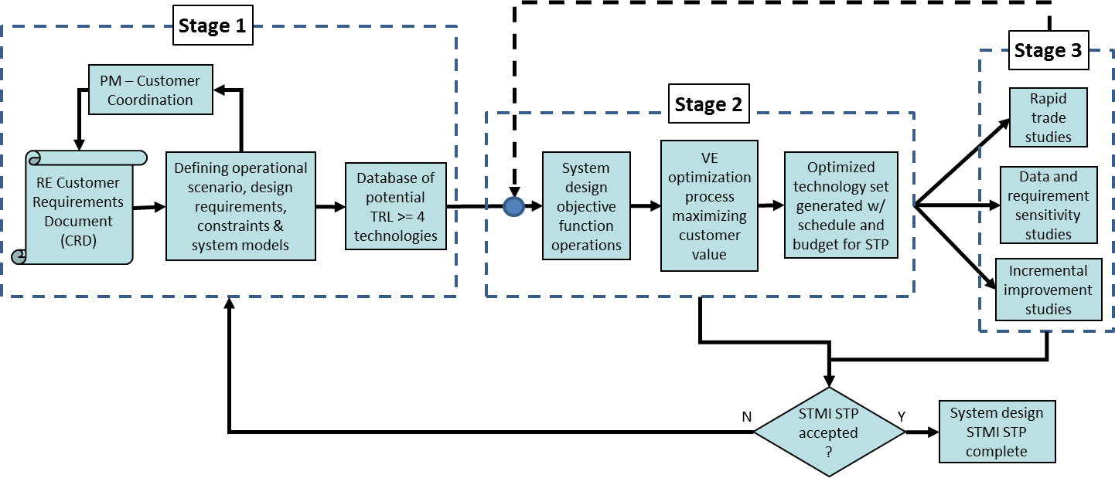
Figure 1: Three stages of the proposed STMI process
.
Once the pre-process preparation of stage one has been completed, STMI stage two engages the principles of Value Engineering (VE) to generate a Best Value system design optimization with the requirements, constraints, models and technology database provided in stage one. Objective functions are generated from the stage one information and system design model recommendations and are used to evaluate the technology sets making up potential system designs. The STMI VE process assesses the value of each successful system design and ranks the designs with the optimum having the best score or “best value”. The outputs of the “best value” solution process allow the PM the flexibility to rapidly evaluate and generate data for a STP which has addressed five of the typical technology evaluation problems:
- Time: Analysis is computer based, greatly decreasing “by hand” analysis calculations and allowing rapid analysis of requirements change or new technology data
- Bias: Eliminates bias by evaluating all candidate technologies against the same customer requirements, not just trendy or directed technical options
- Interactions: Accounts for secondary interactions between technologies that impact multiple areas of a system design through the object function
- Risk: Identifies critical technology areas that require primary development funding and schedule to reduce risk
- Resources: Account for lifecycle resources and cost impacts of each technology option
The research objectives of the second STMI stage include:
- Review and summarize the related research in literature
- Develop a process for STMI to evaluate potential system designs and account for technology interactions
- Design and implement a system design optimizer based on VE “best value” criteria
- Select the optimized “best value” system design and create data inputs for a STP which advances required technologies, including developing TRL-4 through TRL-6 technologies, for system integration
- Adapt process for a spreadsheet “all option” case study analysis
- Identify a potential metaheuristic process to reduce system design computational requirements for follow-on research to implement
The STMI stage three process is the ability to rapidly conduct trade studies, sensitivity analysis and incremental improvement analysis. Requirement trade studies are commonly used in the design of aerospace vehicles and software selection¹¹ to aide customers in fine-tuning requirements and their cascading impacts to system designs. Sensitivity analysis studies would examine the impacts of data uncertainty on the end optimization results¹². Incremental improvement studies would examine significant changes in customer requirement thresholds to justify a new system design delivery or “increment,” and generate a new STP which could be executed in parallel with the original design STP¹³.
The research objectives of the third STMI stage include:
- Review and summarize the related research in literature
- Provide recommendations and examples for conducting trade studies with STMI
- Provide recommendations and examples for conducting single and multiple variable sensitivity studies with STMI
- Provide recommendations for conducting future incremental designs
- Demonstrate recommendations in a case study analysis
This research also provides a case study implementing the proposed process. Since traditional linear programming is not well suited to this type of multi-factor, non-linear optimization, an “all-case” analysis model of this process was used to maximize the “best value” of the solution with the demonstration technology database. The model was developed in the context of a multi-dimensional knapsack problem, and seeks to maximize the best value of the solution while meeting the customer threshold requirements.

Structure of the dissertation
The rest of this dissertation research is organized as follows. Chapter two reviews the existing literature on current DSS development and four enabling concepts that are brought together to form the basis of STMI: Requirements Engineering (RE), Value Engineering (VE), system optimization, and Strategic Technology Planning (STP). Chapter three develops the STMI process model for the technology maturation problem and STP generation. Chapter four presents the proposed research method through a case study and examines optimization speed and data sensitivity within the STMI process. Chapter five provides conclusions and expected contributions. Chapter six outlines future research opportunities.

Literature review

Decision Support System (DSS)
Since the early 1970’s and the advent of computer based systems aiding decision making, DSS has evolved as computer capabilities have grown¹⁴. DSS is a general term for any computer application that enhances a person or group’s ability to make decisions. In order to survey DSS development and applicability, a background review is presented first. Then a historical development, components and applications of DSS are examined. Finally, STMI as a DSS technique is proposed.

DSS background
Decision making is an essential part of management planning¹⁵. To assist a PM analyzing potential technology options for a system design and STP, a Decision Support System (DSS) can be employed to help make decisions in this fluid and rapidly changing technology environment. A typical DSS is interactive and provides the PM with easy access to decision models and data to support decision-making tasks. It utilizes a computer-based information system that supports management, operations, and planning levels of an organization (usually mid and higher management). A DSS can be either fully computerized, human or a combination of both and are typically characterized by¹⁶
- DSS tends to be aimed at the less well structured, underspecified problem that upper level managers typically face
- DSS attempts to combine the use of models or analytic techniques with traditional data access and retrieval functions
- DSS specifically focuses on features which make them easy to use by non-computer people in an interactive mode
- DSS emphasizes flexibility and adaptability to accommodate changes in the technology environment and the decision making approach of the user
DSSs often include knowledge-based systems with an interactive software-based system intended to help decision makers compile useful information from a combination of raw data, documents, and personal knowledge, or business models to identify and solve problems and make decisions.
Since the PM is not likely to have a detailed knowledge of the technology’s options, models or their ability to meet customer requirements, a DSS can help reduce the time required to conduct this level of analyses. It improves the PM’s effectiveness in making decision where a manager’s judgment is still essential¹⁷.

DSS historical development
From the early days, it was recognized that DSS was an applied discipline that used knowledge and theory from many supporting disciplines. For this reason, many DSS research questions have been examined because they were of concern to the people using the specific DSS supporting operations decision making, financial management or strategic decision-making¹⁸. The concept of decision making support evolved early in the era of distributed computing and incorporated two main areas of research: The theoretical studies of organizational decision making done at the Carnegie Institute of Technology during the late 1950s and early 1960s, and the technical work on interactive computer systems through Project MAC¹⁹ from the Massachusetts Institute of Technology in the 1960s²⁰. DSS became an area of research of its own in the middle of the 1970s when business journals began to publish articles on management decision systems²¹ and a dedicated technical journal was devoted to exploring DSS applications²².
The definition and scope of DSS has evolved over the years. In the 1970s DSS was described as "a computer-based system to aid decision making". In the late 1970s the DSS movement started focusing on "interactive computer-based systems which help decision-makers utilize data bases and models to solve ill-structured problems". In the 1980s DSS provided systems "using suitable and available technology to improve effectiveness of managerial and professional activities" within financial planning systems, spreadsheet-based analysis and data warehouses²³. In the middle and late 1980s, executive information systems (EIS), group decision support systems (GDSS), and organizational decision support systems (ODSS) evolved from the single user and model-oriented DSS²⁴. As the turn of the millennium approached, On-line Analytical Processing (OLAP), business intelligence and new Web-based analytical applications were introduced. The advent of better and better computing and reporting technologies has seen DSS start to emerge as a critical component of management system design.
In recent years, the Web has had the most significant impact on the variety, distribution and sophistication of DSS, but handheld PCs, wireless networks, expanding parallel processing coupled with very large data bases and visualization tools are continuing to encourage the development of innovative decision support applications. Future DSS will use faster, real-time access to larger, better integrated databases. Models within the newer DSS will be more complex, interactive and progressively more user friendly. Systems built using simulations and their accompanying visual displays will be increasingly realistic²⁵.

DSS categories
In 1980, Steven Alter published his MIT doctoral dissertation results in an influential book. His case studies provided a firm descriptive foundation of decision support system examples. Alter concluded that decision support systems could be categorized in terms of the generic operations that can be performed by such systems. These generic operations extend along a single dimension, ranging from extremely data-oriented to extremely model-oriented. Alter conducted a field study of 56 DSS that he categorized into seven distinct types of DSS²⁶. His seven types include:
- File drawer systems that provide access to data items.
- Data analysis systems that support the manipulation of data by computerized tools tailored to a specific task and setting or by more general tools and operators.
- Analysis information systems that provide access to a series of decision-oriented databases and small models.
- Accounting and financial models that calculate the consequences of possible actions.
- Representational models that estimate the consequences of actions on the basis of simulation models.
- Optimization models that provide guidelines for action by generating an optimal solution consistent with a series of constraints.
- Suggestion models that perform the logical processing leading to a specific suggested decision for a fairly structured or well-understood task
Taking a look at the internal working of a DSS, Dr. Kailash Joshi, from the University of Missouri-St. Louis²⁷, indicates that each DSS contains three principal subsystems with the following capabilities:
- Data management subsystem of a DSS supplies data to which the models can be applied. It relies, in general, on a variety of internal and external databases. The power of DSSs derives from their ability to provide easy access to data. The database administrator needs to pay particular attention to data consistency and accuracy.
- Model Management Subsystem maintains the libraries of models. A particular advantage of DSS is the decision maker's ability to use a model to explore the influence of various factors on outcomes (trade studies).
- User Interface Subsystem supports the user in applying models to data. The notable feature is support of multiple forms of input and output.
DSS incorporate a wide variety of disciplines and input actors contributing to the DSS design and operation. The basic construction and operations format of a DSS is illustrated in Figure 2.

STMI as a DSS process
The initial proposed STMI DSS process identifies as an “optimizing” DSS and incorporates all three of the primary DSS components in a proof-of-concept spreadsheet model. But, a spreadsheet DSS model is limited in the data-handling capabilities (cannot work with large databases), limited in model complexity, and modifications to spreadsheets are difficult to keep updated²⁸. Future STMI developments will require evolving past the initial proof-of-concept spreadsheet into a dynamic programing environment with a graphical user interface to facilitate user interaction.

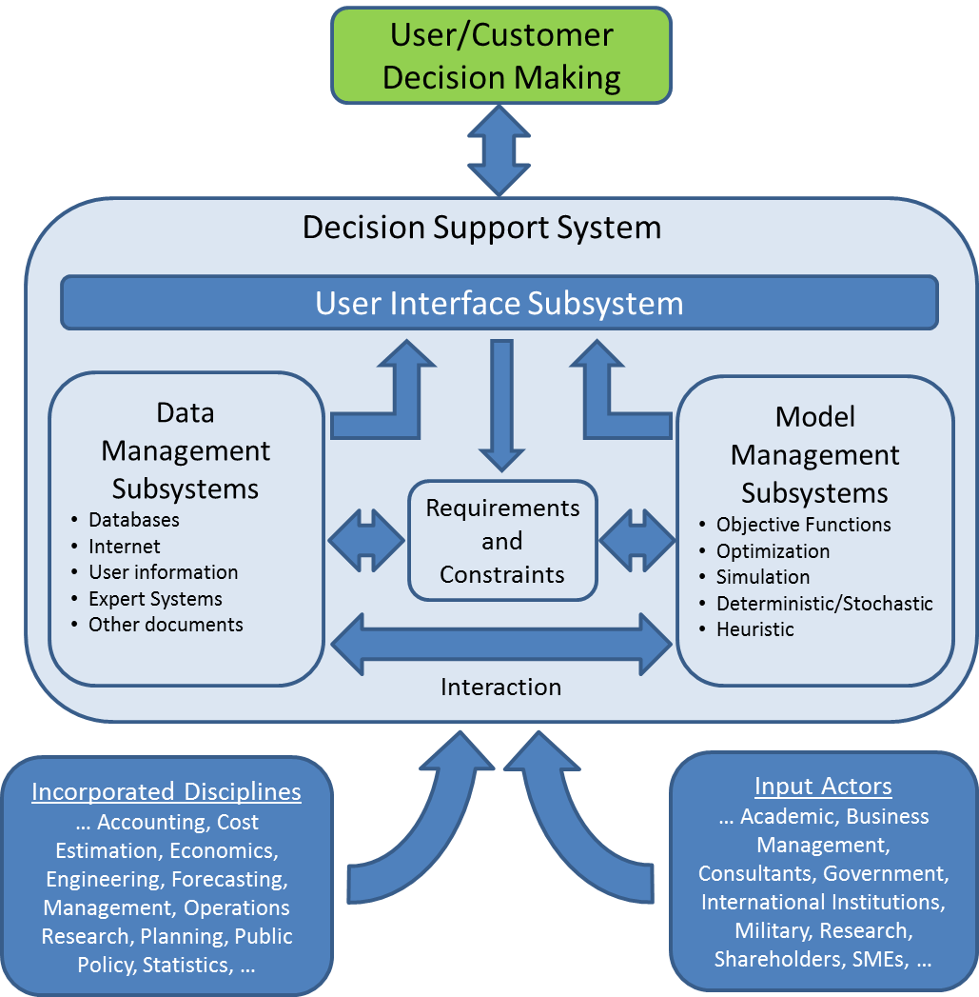

Figure 2: DSS operation overview

Requirements Engineering (RE)
Engineering systems are designed, and anything that is designed has an intended purpose. If a system design is unsatisfactory for the customer, it is because the system was designed without an adequate understanding of its purpose. This problem can be mitigated by careful analysis of purpose throughout a system’s life. Requirements Engineering (RE) provides a framework for understanding the purpose of a system and the operational environment in which it will be used. Or put another way, RE bridges the gap between an initial vague recognition that there is some problem to which we can apply technology, and the completing the task of building the best system to address the problem.

RE background
RE is the general discipline that governs customer requirements generation prior to entering system design, where “customers” are defined as organizations or stakeholders responsible for the primary functions of a system design²⁹. RE was accepted as being coined in a 1979 TRW technical report³⁰ and generally includes the following seven steps³¹:
1. Requirements inception: identification of a system objective. “What does the customer want the system to be able to do?” Without a solid vision of what the system needs to do, the rest of RE becomes unsustainable. This step yields a statement or operational concept detailing the system objectives.
2. Requirements identification: identifying existing and new requirements or constraints that meet the system objective. These must be quantifiable, measurable and testable. This is also known as the requirements gathering or requirements elicitation stage. The primary types of requirements include: Customer (What do they want?), Functional (What should it do?), Performance (How well should it do it?), Interfaces (What should it work with?), Environment (Where should it be able to work?) and Design (What code, regulation or specification must be met?). Typical requirement inputs include needs and objectives, organization missions, lifecycle sustainability concepts, operating environments, technology base, laws/policies, and organizational controls/limitations.
3. Requirements analysis and negotiation: checking requirements and resolving customer conflicts. This is the requirement engineer’s clarification stage with the customer and time for pruning a mass of requirements and constraints to a manageable set. Requirements analysis results in a clear understanding of system functions, expected performance, interfaces, environmental and design constraints.
4. Requirements specification: documenting the requirements in a Customer Requirements Document (CRD) and identifying their references. In the testing community, this is referred to as the Test Requirements Document (TRD). All technology offered for examination in a system must be able to be tied back to the CRD to meet a requirements reference point.
5. System modeling: developing the models and technology databases of the proposed system. These are the mathematical models that become the objective function, the constraints used to limit the system design, and the database of technology used in the modeling to meet the customer requirements. Functional modeling is a common method to integrate Inputs (requirements), Controls (constraints & system concept choices), Enablers (SME databases) and Outputs (results)³².
6. Requirements validation: checking that the documented requirements and models are consistent and meet stakeholder needs. Can the proposed system model actually design something the customer wants that is within the relevant range of the technology specifications?
7. Requirements management: managing changes to the requirements as the system is developed and put into use. This is also known as configuration control to document when a change is requested, why it is needed and any impact to the design that occurs from the changes.
RE is not a single event, but a component of the system lifecycle that tries to keep all the players on the same development path by identifying, agreeing on, documenting, validating and managing the aspects of customer requirements. This feeds into common wisdom of, ‘A system is only as good as the requirements from which it is developed.’

RE strategies
While known as the general discipline of “Requirements Engineering”, RE has been documented in many text books noted in Table 1. RE even has its own technical journal devoted to exploring RE applications³³. RE strategy methods offer users systematic ways to deal with complex systems, mainly by breaking down complex problems into simpler ones that can be understood better.
Table 1: A selection of current academic RE textbook references
Author(s) | Title | Publisher | Year
Hull, E., Jackson, K., and J. Dick | Requirements Engineering | Springer | 2010
Robertson, S., J. Robertson | Mastering the Requirements Process: Getting Requirements Right | Pearson Education | 2012
Pohl, K.. | Requirements Engineering: Fundamentals, Principles, and Techniques | Springer | 2010
Stevens, R., Brook, P., Jackson, K. and Arnold S. | Systems Engineering: Coping with complexity: Chapters 2 & 3. | Prentice Hall Europe | 1998
Sutcliffe, A.G. | The Encyclopedia of Human-Computer interactions (Chapter 13: Requirements Engineering) | Interaction Design Foundation eBooks³⁵ | 2013
Van Lamsweerde, A. | Requirements engineering: From system goals to UML models to software specifications | Chichester: Wiley | 2009
Wieringa, R.J. | Requirements Engineering: Frameworks for understanding | Wiley | 1996

RE strategies can be placed into three broad categories: “Waterfall” or sequential, “spiral” or Iterative, and “staged” or incremental. In each of the categories of RE, the seven steps are completed in various levels of detail, sequence, and repetition. Across all of the categories, one common theme emerges: time spent early in the system design cycle can lead to great economy savings over a system lifecycle.at later stages. System designs can be 50 to 200 times less expensive to fix early with firm, executable requirements than months later when the system parts are being integrated and problems are found³⁴.

Waterfall design model
In the traditional “Waterfall” sequential design process, RE progress is seen as flowing steadily downwards (like a waterfall) and is illustrated in Figure 3.
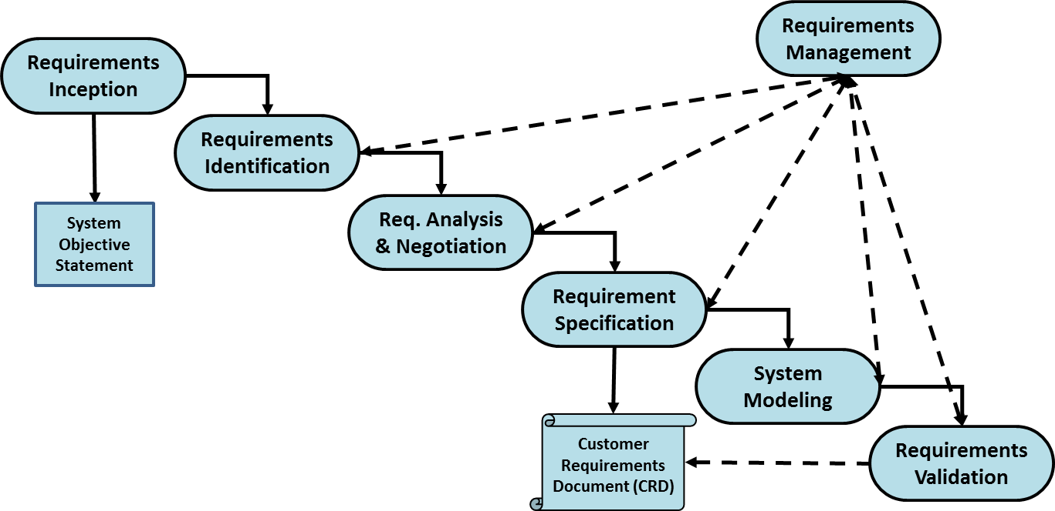
Figure 3: Traditional “Waterfall” RE strategy
The waterfall development model originates in the manufacturing and construction industries were highly structured physical environments in which after-the-fact changes are prohibitively costly, if not impossible³⁶. Companies which outsource projects typically employ a traditional waterfall process to generate a solid set of requirements for the outsourced project contractor to employ³⁷. The first formal description of this model is often cited in a 1970 article by Winston W. Royce³⁸.
Within the Waterfall design process, system design requirements are firmly set before system design modeling begins, requiring limited interaction between the PM’s system design team and the future customers of the product. This often occurs as “requirements given from on high” within an organization and the system design team is told to use the specified requirements to begin the design process. If the waterfall RE phase is done badly (and this is often the case when the business confuses shoddy requirements with faster progress) or the requirements are allowed to evolve, the waterfall method delivers failure or costly re-work, as the end result will only ever be as good as the specifications³⁹.

Spiral design model
In the more conventional “Spiral” iteration design process, the structure is similar to the “Waterfall” sequential design process, but with a key difference illustrated in Figure 4: the ability to cycle back to an earlier stage when questions arise or requirements are modified to meet a changing customer need.
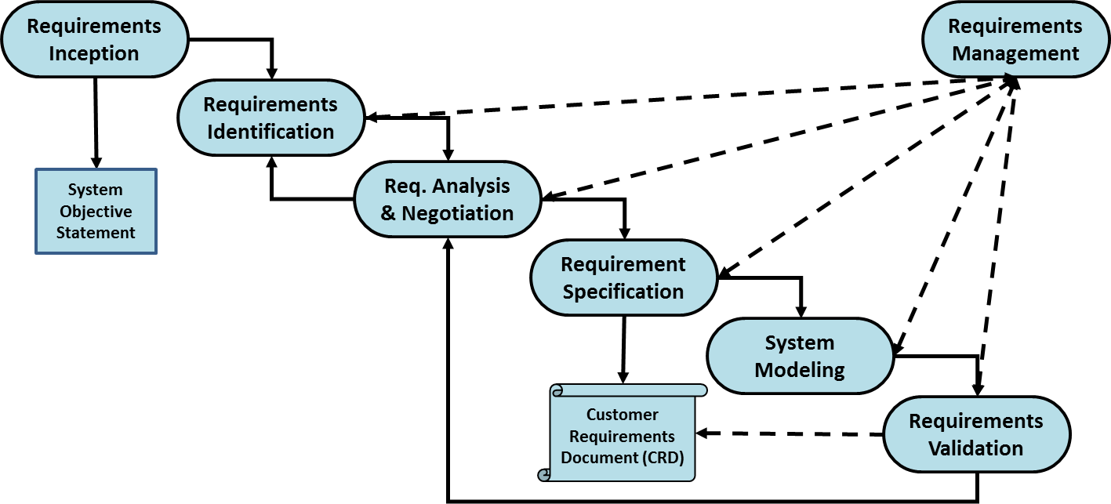
Figure 4: Example RE “Spiral” strategy
The spiral approach required high levels of interaction between the PMs system design team and the customers intending to use the new product. The iterative development model evolved from the software development community where highly dynamic development environments grapple with the abstract and near “invisible” nature of software⁴⁰.
Within a spiral strategy, system design requirements and systems models are iterated back and forth between the customers and the PM’s system design team. While more dynamic and interactive, “spiral” RE strategies have the problem of locking down requirements as “good enough” to initiate actual system design. The spiral design model is illustrated in

Incremental design model
Where the “waterfall’ and “spiral” RE development strategies have specific problems with their implementation, the “staged” or iterative strategy combines the best of both earlier strategies while trying to minimize their associated problems.
The basic idea behind this strategy is to develop a system design through repeated cycles (iterative) and in smaller portions at a time (incremental), allowing system design teams to take advantage of what was learned during development of earlier parts or increments of the system⁴¹. Requirements are iterated and streamlined to identify critical thresholds and provide initial capability. Additional requirements are identified and developed to provide added capability that builds on the existing capability. Learning comes from both the development and use of the system, where possible key steps in the process start with a simple implementation of a threshold set of the system requirements and iteratively enhance the evolving versions until the full system is implemented⁴².
A “staged” or iterative strategy delivers an initial capability to the customer in a timely manner. Issues potentially arise from the customer not getting “the full deal” at once (managing customer expectations) and continuing to secure funding to develop additional system incremental upgrades. The incremental design strategy is illustrated in Figure 5.

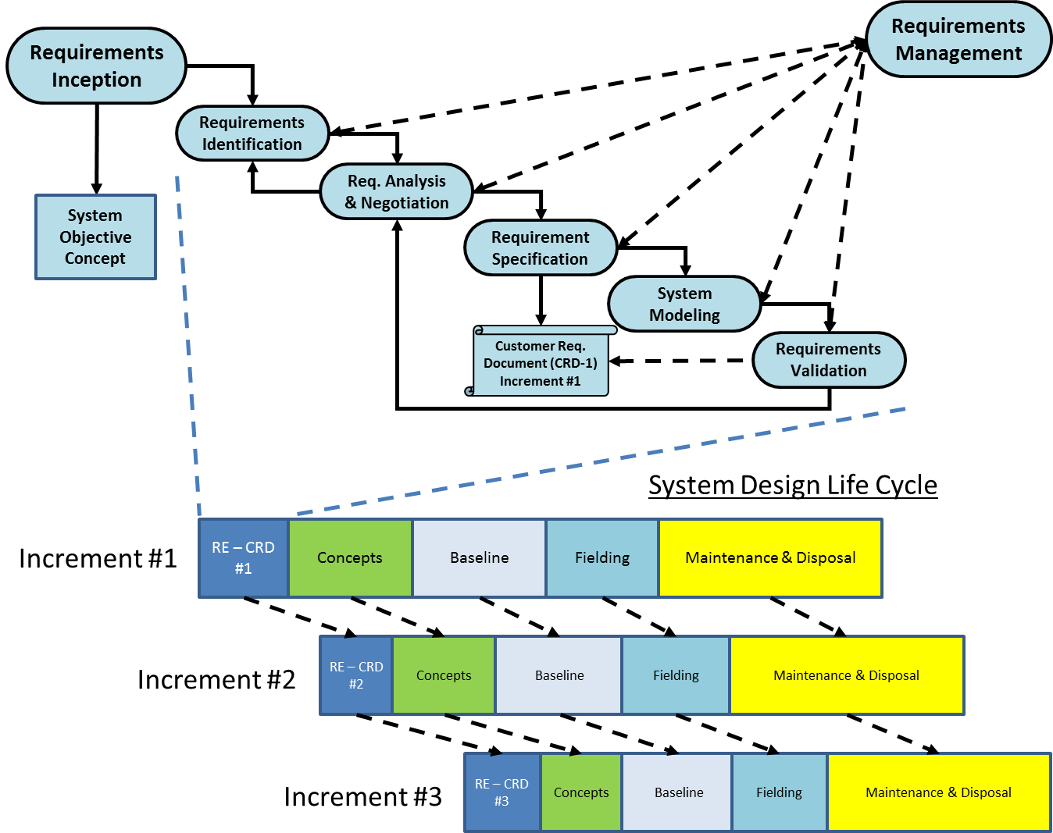
Figure 5: Example RE incremental strategy

Requirement generation methods
Some specific means of requirement generation and solidification utilized by the strategies of RE are summarized next.
- Traditional techniques: Covers a broad class of individual generic data gathering techniques including questionnaires, surveys, interviews and analysis of existing documentation⁴³.
- Group elicitation techniques: Covers general group data gathering with the aim to foster customer agreement and buy-in. These include brain-storming, focus groups, and joint requirement development workshops to elicit requirements, analyze their details and uncover cross-functional implications⁴⁴.
- Model-driven techniques: Attempts to conceptually design the customer’s needed system, with the help of a planning support system which serves as an education base and a planning guide for the customer. Through the user interface and the integration process, the customer can develop a detailed and reliable list of requirements⁴⁵.
- Requirements Triage: Is a fast paced method for selecting the requirements which are aligned with the overall business/customer goals and discard others as early as possible⁴⁶.
- Goal modeling: Considers how the project’s intended system meets organizational goals, why the system is needed and how the stakeholders’ interests may be addressed. Usually, a composed list of requirements are merely clues and "why?" is repeatedly asked to the customer until the actual business purposes are discovered⁴⁷.

Database generation
As a key subcomponent of the RE process, system models require technical data input to effectively test requirements within a system design. This technical data, when placed into a software database, allows software to access the data for key tasks like model evaluation and sorting. Without correct (verified) data that is properly used (validated) within a system model, any analysis, optimization or application will be rendered unreliable.
In general, data verification and validation is used to evaluate whether data has been generated according to specifications, satisfy acceptance criteria, and are appropriate and consistent with their intended use. Data verification is a systematic process for evaluating performance and compliance of a set of data when compared to a set of standards to ascertain its completeness, correctness, and consistency using the methods and criteria defined in the project documentation. Data validation follows the data verification process and uses information from the reference documentation to ascertain the usability of the data in light of its measurement quality objectives and to ensure that results obtained are scientifically defensible⁴⁸.
For the STMI process, the database will hold key information on each technology being evaluated for inclusion into the modeled system design. This includes performance, cost and schedule data that has been referenced from industry sources (verified) and is appropriate for the system model being employed (validated).

Performance Data
Typically, Key Performance Parameters (KPPs) of the system design are identified during the RE process and are included as factors in the technology database (i.e. material properties of density, strength and unit cost). When the SMEs are preparing the technology database, technology performance factors need to be referenced and applicable to the system being designed.
Technologies considered for the database must have achieved a level of maturity to offer a demonstrated capability. On the “Technology Readiness Level (TRL)” scale developed by DoD and NASA, and adopted by industry, DoD program offices tend to start investing in technologies that are TRL-4, and integrating technologies that are TRL-6 or higher⁴⁹. Therefore the STMI database must consist of technology items that are TRL-4 (in development) to TRL-9 (fielded and commercially available). Additional discussion on TRL ratings will be conducted in the strategic technology planning, section 2.4.5.

Cost and schedule estimation
Estimates of cost and time required achieving the systematic steps to a TRL-6 ranking and documenting lifecycle costs are a central pivot point for the STMI database and successful STMI process execution. All the cost estimates must also be verified and validated for use in the planned system design. Optimistic or biased estimates vs. ones linked to historical and engineering estimates can significantly skew the results of the optimized technology mix. The World Wide Web provides an enormous wealth of time and cost estimation guides based on technology or market areas from reputable government agencies and peer reviewed periodicals (i.e. energy⁵⁰, construction⁵¹, and nuclear power⁵² for example). DOE G 430.1-1 (1997)⁵³ and Ereev & Patel (2012)⁵⁴ provide some additional guidelines for estimating specialty costs like R&D maturation and production. Additional “rules-of-thumb” can be applied to help balance the engineering estimate to account for the “unknown-unknowns” (many government offices use % “safety factors” against the engineering estimates that are based on the TRL level and SME experience).

RE placement within the STMI process
For STMI stage one, RE steps 1-6 are negotiated between the customer and PM team and results in the initial CRD being presented, database generated and system models prepared. RE step 7 is an ongoing process that will often reinitiate steps 1-6 in preparation to execute STMI to examine future requirements that change on the system design. So, in a practical since, STMI will be applying the staged or incremental design approach with the ability to rapidly conduct trade studies and requirements analysis with the customer.

Value Engineering (VE) principles
Formalized by the DoD in 1963, Value Engineering (VE) is a fundamental approach which challenges decisions at every level of a design lifecycle and takes nothing for granted. It is applicable to systems, equipment, facilities, procedures, methods, software, and supplies. VE may be successfully introduced at any point in the lifecycle of the product under consideration while improving quality-related features such as durability, reliability, and maintainability⁵⁵. As part of this literature review, the background of VE will be explored. Then VE implementation and applicability to the STMI process will be examined.

VE background
The term Value Engineering was developed during World War II and is widely used in industry and government, particularly in areas such as defense, transportation, construction, and healthcare⁵⁶. The Office of Federal Procurement Policy Act, 1996, requires every federal agency to maintain a VE program⁵⁷, and DoD, taking cues from industry, has had an active VE program since the early 1960s⁵⁸. The federal government's application of VE to projects, processes, and products has demonstrated success, saving a reported $1 billion per year in-house and $250M per year through contractor-led efforts⁵⁹.
VE is defined as "an organized effort directed at analyzing the functions of systems, equipment, facilities, services and supplies for the purpose of achieving the essential functions at the lowest lifecycle cost consistent with required performance.”⁶⁰ It is an effective technique for reducing system costs, increasing productivity, and improving overall quality.

VE methodology
In the early portion of a system’s lifecycle, VE is directed toward analyzing the functions under development. In this respect, it differs from most other cost reduction techniques, were some other techniques may reduce inherent quality by cheapening the product to reduce cost. The VE technique starts with a determination of the required system design functions, identifies the customer threshold requirements to meet that function and then seeks lower cost alternatives to achieve that essential function. The objective is to identify and eliminate unnecessary cost without loss in needed customer requirements, quality or reliability.
Typically, customer requirements go through an extensive vetting process (as described in the section 2.2 RE discussion). The minimal level a requirement must meet is typically denoted as the “threshold” level. Once the minimal capability has been satisfied, customers often will have an “improved” requirement that is a goal or “objective” to be reached. VE focuses only on the “threshold” requirement values to meet the required minimums that a system is required to perform. Future design reviews with VE to meet “objective” requirement levels must be recompleted, as trade studies or incremental improvement designs, and have the documented understanding that requirement thresholds are no longer in operation.
The lifecycle of a system or equipment begins with the determination that an operational deficiency exists or a new capability is needed.
Figure 6 illustrates a common situation in which the savings potential decreases as the program ages⁶¹.
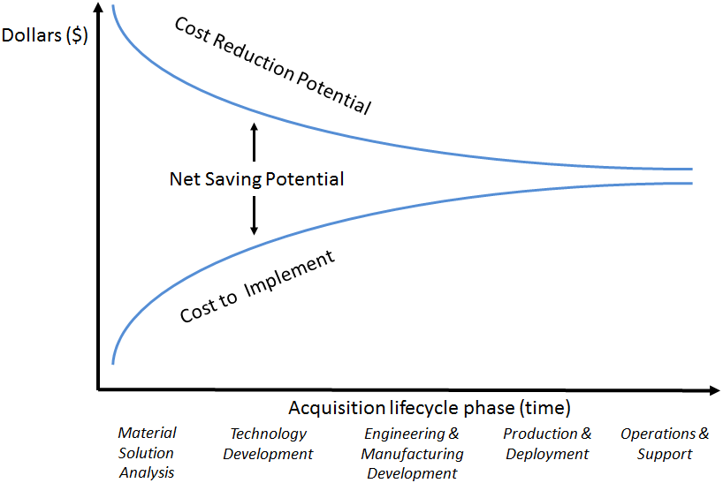
Figure 6: Lifecycle VE savings potential
Early VE tends to produce greater savings or “cost avoidance” for two reasons. First, more actions of the PM’s system design are affected by the savings actions. Second, earlier changes lower implementation costs such as testing, modifications to production lines, retooling expenses, and changes to operational support elements (e.g., spares, manuals, maintenance facilities, etc.). Therefore, it is more cost effective to implement VE as early as possible in the system lifecycle.
The DoD VE framework has developed eight phases to VE implementation with specific questions addressed at each point. A summary of the standard VE phases and questions addressed⁶² are included in Table 2.
As VE is implemented, it is directed toward analyzing the functions of a system or process to determine "best value," or the best relationship between worth and cost. This process is illustrated in Equation 1-4, where i = each system of technologies which meets the threshold requirements⁶³.

Equation 1: Worth_{i} = (DevelopmentCost_{i} + UnitCost_{i})
Equation 2: MinWorth = System with least expenditure (worth) to provide Threshold functionality
Equation 3: LifecycleCost_{i} = DevelopmentCost_{i} + UnitCost_{i} + MaintenanceCost_{i} + OperationsCost_{i} + DisposalCost_{i}
Equation 4: “BestValue_{i}” Function (f) = $\frac{MinWorth}{{LifecycleCost}_{i} }$
System “worth” is basically the cost to develop and acquire the capability. Lifecycle costs generally include any cost to the system, from its “birth” to its “death” when it is disposed of or taken out of service, including development, acquisition and operations. Equation 3 illustrates the most common lifecycle costs, but additional costs such as facilities, storage, testing, certification, or company overhead can be incorporated as separate entries. In some cases, the disposal cost can be positive when there is a salvage value for the system. The “best value" is represented by a design or system that consistently performs the required basic function meeting customer requirements and has the lowest lifecycle cost.

Table 2: VE phases and questions to address
VE Phase | Questions Addressed | STMI process
Orientation | What is to be studied? | System selected for analysis
Information Gathering | What is it?  What does it do?  What does it cost?  What is it worth? | - State system objective  - Specify customer requirements  - Identify primary components and supporting technologies  - Identify existing systems, capabilities and costs
Speculation | What else will do the job? | - Database generation  - Identify alternate technologies
Analysis | What do the alternatives cost?  Which is least expensive? | - Research technology development to reach TRL-6  - Establish maturation costs  - Establish acquisition costs  - Establish operations costs
Development | Will the proposed alternative work?  Will the proposed alternative meet requirements?  What will the proposed alternatives require? | - Model alternate technologies placed into system design  - Identify worth of technologies meeting user requirements
Presentation | What is recommended?  What are the alternatives?  What will it cost?  How much will it save?  What is the implementation schedule? | - System design optimization based on “best value”  - Generate technology development schedule  - Cost to mature selected technologies for TRL-6 system inclusion
Implementation | Who is responsible for implementation?  What actions have to be taken?  Established completion dates?  Have requirements for progress reporting been established? | - Recommendation to PM team  - Compare system design to existing commercial systems
Follow-up | Did the idea work?  Did it save money?  Could it benefit others? | - Sensitivity analysis  - Incremental delivery
Because "costs" are measurable, "cost reduction" is often thought of as the sole criterion for a VE application. However, the real objective of VE is "value improvement," and that may not result in an immediate cost reduction. For example, facilities construction can yield a better value over the lifecycle when construction is approached in a manner that incorporates low maintenance, environmentally-sound and energy-efficient practices and materials, but the initial facility cost might be higher. Therefore, in addition to cost savings, VE often yields system lifecycle benefits such as: improved performance, relative ease of repair and replacement, repeatable manufacture, standardization or simplification of operations, lighter weight, and improved use of resources⁶⁴
Although worth and cost can each be expressed in monetary units, BV is a dimensionless expression of the relationship of these two with a “perfect” BV score equaling a value of one.

STMI VE implementation
The VE phases, questions and best value analysis are implemented in the first and second stage of the STMI process. VE forms the core selection process for determining technology selection within the system design and laying out the technology development schedule for the STP. Early VE implementation integrates well into the STMI process, focusing on early STP technology maturation.

Optimization and metaheuristic optimization methods
Once Requirements Engineering and Value Engineering have identified promising technologies to incorporate into their system design, how does a PM differentiate between potentially thousands of technology options? How does one rank the good, bad and the ugly technologies at their current TRL while trying to meet customer primary requirements, manage your development budget and do it quickly if options change? The answer lies with choosing an optimization method to examine the value engineering objective function and generate a best option for the computational time allowed.
An all option optimization, “brute force” optimization is usually the first choice of analysts looking to examine initial technology combinations with a computer, since a simple series of programming loops to examine all of the technology combinations is usually straight forward to program. Where this method insures finding the optimum technology combination, it also is computationally intensive and can take a long time to process if the numbers of options are considerable. PMs may not have the luxury of time to have their technology optimizer examine all of the possible combinations in this manner.
Another option is to employ metaheuristic algorithms which offer the ability to find an acceptable solution quickly. Metaheuristics provide an excellent means to search complex problems such as STMI technology development challenges. First, the research reviews a developmental history of metaheuristics. Then current techniques are summarized. Finally, current implementations are examined for optimum use by the STMI process.

Metaheuristic background
Researchers, developers and operators have always had to balance computational efficiency and computational accuracy when attempting to solve complex optimization problems. One way this balance manifested itself was with the beginning of metaheuristic methods in the early 1950’s when researchers examined non-gradient methods to solve optimization problems with objective functions that were not continuous or differentiable⁶⁵. These real world objective functions tended to be highly non-linear, incorporated multiple factors and were under complex constraints, making them very lengthy and difficult to solve with calculus based differentiation. Metaheuristics brought in a compromise methodology which offered reduced computational time to yield a “good” solution vs. other computational methods which could require infinite or very long times to compute an optimal solution. The actual term “metaheuristic” was created by Fred Glover in his paper “Future paths for integer programming and links to artificial programing” in 1986⁶⁶, and actually incorporates two important parts of a computational optimization methodology used to evaluate candidate solutions to these complex objective functions.
The first part, or the “heuristic”, is derived from the Greek term “heuriskein” for "find" or "discover,"⁶⁷ and it essentially means to “find by trial and error”⁶⁸. The basic operation of a heuristic is to intensely examine a localized area and identify the best local solution. Therefore, a heuristic might not always find the best or global optimum solution, but it can guarantee to find a good local solution. Techniques like hill climbing⁶⁹, gradient methods⁷⁰ or neighborhood evaluation⁷¹ generate a local optimization “good solution” where the heuristic methodology tends to stop due to its inability to climb out of local minima/maxima and check other points in the global solution space.
The second part, or “meta”, from the Greek preposition “μετά” for "after" or "beyond"⁷² offers an overarching guidance strategy or algorithm. This algorithm allows diversification and provides the underlying heuristics the ability to check multiple areas of a solution space and reduce the probability of getting “stuck” in local minima/maxima condition. This overarching algorithm becomes a random or semi-guided method for global optimization of the solution space. Some basic “meta” examples include random search⁷³, iterated local search⁷⁴ and population methods⁷⁵.
Overall, metaheuristic algorithms are essentially elaborate combinations of local search, and randomization with a global algorithm which directs the sampling of the solution space⁷⁶. New algorithms often incorporate combinations of earlier methods to improve solution performance and continue to adapt them for specific problem sets. Metaheuristic methods offer means to improve the quality of problem solutions within a reasonable time over a global solution space, but there is no guarantee that the optimal solution will be found in the allowed computational timeframe.
The following section of this chapter provides an overview of common metaheuristic methods in use today. Since new variations are constantly being developed to improve solution speed and accuracy, this review should be considered a starting point for future study. Table 3 provides a selection of current academia textbooks dealing with metaheuristics as an additional reference source.

Table 3: A selection of current academic metaheuristic textbook references
Author(s) | Title | Publisher | Year
Gendreau, M. and Potiv, J.Y. | Handbook of Metaheuristics | SpringerLink eBooks | 2010
Gandibleux, X. | Metaheuristics for Multiobjective Optimization | Springer | 2004
Tabli, E.G. | Metaheuristics: from design to implementation | John Wiley & Sons | 2009
Glover, F. and Kochenberger, G.A. | Handbook of Metaheuristics | Springer | 2003
Yang, X.S. | Engineering Optimization: an introduction with Metaheuristic Applications | John Wiley & Sons | 2010
Luke, S. | Essential of Metaheuristics | Http://cs.gmu.edu/~sean/book/metaheuristics | 2012
Mitchell, M. | An introduction to Genetic Algorithms | MIT Press | 1998
Kennedy, J., Eberhart, R.C. and Y. Shi | Swarm Intelligence | Kaufmann Publishers | 2001
Glover, F. and M. Laguna | Tabu Search | Kluwer Academic Publishers | 1997

Metaheuristic history
Many problem-solving processes tend to be heuristic throughout human history; however metaheuristics as a scientific method for optimization is a modern phenomenon⁷⁷. Figure 7 provides a graphical timeline⁸⁰ of the historical development of Metaheuristics from the 1950’s through 2012.
From the 1940s to 1960s, metaheuristic methods have been used in various applications. They started simply with pattern search developed by Fermi and Metropolis⁷⁸ in 1952 where parameters of the object function were varied with steps taken along the axis of the search-space using decreasing step sizes to narrow the search range. In 1963, Rastrigin⁷⁹ demonstrated random search as a means to sample improvements in an object function within a “hypershpere” surrounding the current solution.
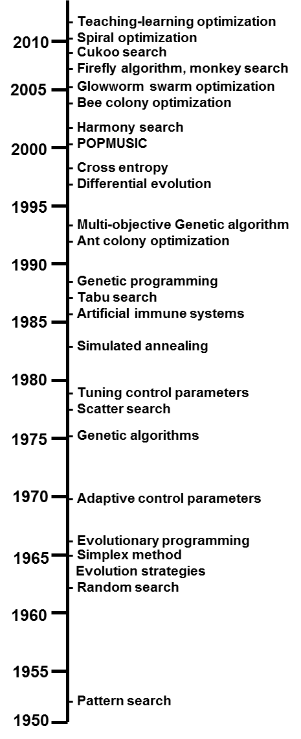
Figure 7: Metaheuristic timeline
The first breakthrough came with the advent of biological evolution inspired evolutionary algorithms, pioneered by Ingo Rechenberg and Hans-Paul Schwefel⁸¹ in 1963 (evolutionary strategies) and L. J. Fogel et al⁸² in 1966 (evolutionary programming). Genetic algorithms (GA) were also developed in the 1960s and 1970s by J. Holland⁸³, and published in 1975. Each of these methods developed “populations” of candidate solutions to the objective functions, and selection of the next generation of solutions was based on a bias toward improved fitness of the solution. “Parent” solutions generated “children” solutions based on crossover of parent solution “genes” or random “mutations” of the solution “genes”. Each new population generation competed with the old generation in a survival of the fittest or “best” object function solution.
In the 1980s and 1990s development of metaheuristic algorithms began to really accelerate, often inspired by naturally occurring processes. Using an example from industry, S. Kirkpatrick et al⁸⁴ developed simulated annealing (SA) in 1983 as an optimization technique inspired by the temperature annealing process of metals. Another important development was the imitation of living organism immune systems by Farmer et al⁸⁵ in 1986.
As computing power and memory became more available in the mid-1980’s, the first use of memory allocation in metaheuristics was pioneered by Glover⁸⁶ in Tabu search methodology. Tabu search basically retained historical search moves recorded in a Tabu list, and future moves would try to avoid revisiting previous solutions.
The same improvements to computing power were again harnessed in the late 1980’s and 1990’s, developing explorative local search methods which expanded traditional calculus based trajectory methods. These include Greedy Randomized Adapted Search Procedure by Feo and Resende⁸⁷, Variable Neighborhood Search by Hanson and Mladenoviĉ⁸⁸, Guided Local Search by Voudouris and Tsang⁸⁹, and Iterative Local Search by Baxterl⁹⁰.
In 1992, Marco Dorigo⁹¹ finished his PhD thesis on optimization and natural algorithms, in which he described his innovative work on ant colony optimization (ACO). ACO was inspired by the swarm intelligence of social ants using pheromones as a chemical marker for directing solutions toward an optimal path. Also in 1992, John R. Koza⁹² published a book on genetic programming which laid the foundation to revolutionize computer programming. Slightly later in 1995, another significant progress was the development of particle swarm optimization by Kennedy and Eberhart⁹³. Around 1996 and later in 1997, R. Storn and K. Price⁹⁴ developed their vector-based evolutionary algorithm, called differential evolution (DE). This algorithm proved to be more efficient than genetic algorithms in many applications⁹⁵.
At the turn of the millennium, Zong Woo Geem et al⁹⁶ developed a music inspired harmony search (HS) algorithm in 2001. In 2002, Pratap et.al.⁹⁷ focused on developing a GA technique to handle multi-objective optimization. In 2004, S. Nakrani and C. Tovey⁹⁸ proposed the honey bee algorithm and its application for optimizing Internet hosting centers. In 2008, X.S. Yahg et al⁹⁹ developed the firefly algorithm (FA). In 2009, Xin-She Yang and Suash Deb introduced an efficient cuckoo search (CS) algorithm, and it has been demonstrated that CS is far more effective than most existing metaheuristic algorithms including particle swarm optimization¹⁰⁰.
During the second decade of the 21st century, metaheuristic developers continued to advance the collective algorithm knowledge through Tamura and Yasuda’s spiral optimization¹⁰¹ and teaching-learning optimization proposed by R. Venkata Rao et al¹⁰².

Metaheuristic algorithms
Metaheuristics are designed to address complex optimization problems where other optimization methods have failed to be effective or efficient in their operation¹⁰³. The following sections describe six prominent metaheuristics optimization methods, ordered by development timeframe, earliest to latest: Genetic Algorithms, Simulated Annealing, Tabu Search, Ant Colony Optimization, Particle Swarm, and Iterative Local Search.

Genetic Algorithms
The term Genetic Algorithm (GA) is a population-based subset of evolutionary computing (EC) which is inspired by nature’s capability to evolve a population to adapt to its environment and pass along the genes of the ”fittest who survive”. Individuals who are more successful in surviving their environment will have a better chance of reproducing, while individuals that are less fit are eliminated. GAs, developed by John Holland in the 1970s, is based on the biological evolution described by Charles Darwin’s theory of natural selection. Holland was the first developer to use crossover (or recombination), mutation and fitness selection for objective function optimization¹⁰⁴. The basics of GA involve the following steps¹⁰⁵:
- Encoding solution set arrays of bits or character strings (chromosomes) for an individual rather than final objective function problem solution. The evolution process is operated over the chromosomes rather than objective function problem solutions.
- Natural selection becomes the mechanism that relates chromosomes with the efficiency of the problem solution they represent, thus allowing those efficient individuals, which are well-adapted to the environment, to reproduce more often than those which are not.
- The initial population is usually randomly generated and can be seeded with known good individuals to bias the initial population.
- The evolutionary process takes place during the reproduction stage. There exist a large number of reproductive mechanisms in Nature. The most common ones are mutation probability (that causes the chromosomes of offspring to be different to those of the parents) and recombination probability (that combines the chromosomes of the parents to produce the offspring).
- The selection stage picks individuals based on a fitness criteria corresponding to the best solutions in the population. Older, less “fit” individuals are replaced by the newer more fit individuals to create a new population for reproduction.
- Reproduction and selection stages are repeated until a certain termination criteria is met.
The framework for the GA algorithm process is laid out in the follow algorithm example.
Generate initial population P(0)
t <- 0
WHILE termination conditions not met DO
Evaluate(P(t))
P'(t) <- Select(P(t))
P''(t) <- ApplyReproductionOperators(P'(t))
P(t+1) <- Replace(P(t),P''(t))
t <- t+1
ENDWHILE
Return best solution found

Notice that the algorithm establishes a trade-off between the exploitation of good solutions P’(t) (selection stage) and the exploration of new zones of the search space P’’(t) (reproduction stage), based on the fact that the replacement policy allows the acceptation of new solutions that do not necessarily improve the existing ones.The GA algorithm, therefore, is an iterative and stochastic process that operates on a set of individuals in a population pool and evaluates cycles of population reproduction based on the fitness criteria and is illustrated in Figure 8. This fitness criteria value is the quantitative information the algorithm uses to guide the search.
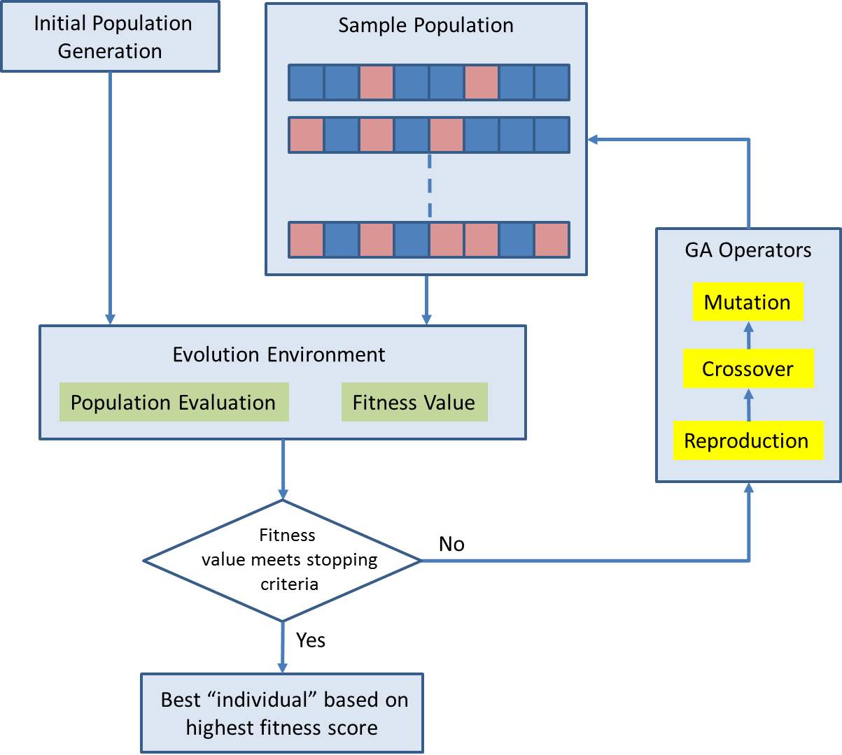
Figure 8: GA evolution flow

Simulated Annealing
Simulated Annealing (SA) is the oldest among the metaheuristics with an explicit strategy to avoid local minima. The origins of the algorithm are in statistical mechanics (Metropolis algorithm), and it was first presented as a search algorithm for optimization problems in 1983 by Kirkpatrick et al¹⁰⁶. The fundamental idea is to allow moves resulting in solutions of worse quality than the current solution (uphill moves) in order to escape from local minima. The probability of doing such a move is decreased during the search. A visualization of SA is shown in Figure 9 and can be described by dropping a set of ping-pong balls onto a global solution set display of the objective function. Initially, the ping-pong balls have “high energy” to bounce up and out of local minima points. As the energy decreases, the ping-pong balls eventually settle into points of deeper or globally optimal minima locations¹⁰⁷.

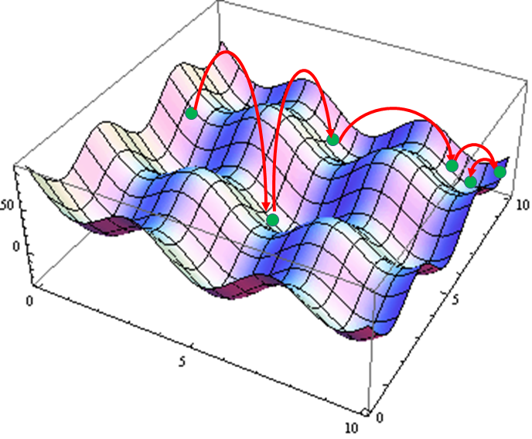
Figure 9: SA operation visualization
The framework of the SA metaheuristic is shown next in an algorithm example and incorporates two search strategies: global random walk and a local iterative improvement.
s := GenerateInitialSolution()
T := T_0
WHILE termination conditions not met
s' := PickAtRandom(N(s))
IF f(s') < f(s)
s := s'
ELSE
Accept s' as new solution with probability p(T,s',s)
ENDIF
Update(T)
ENDWHILE
The algorithm starts by generating an initial solution (either randomly or heuristically constructed) and by initializing the so-called energy or temperature parameter T. Then the following is repeated until the termination condition is satisfied: A solution s' from the neighborhood N(s) of the solution s is randomly sampled, and it is accepted as new current solution depending on objective function f(s), f(s') and T. The temperature T is decreased during the search process, thus at the beginning of the search the probability of accepting uphill moves is high and it gradually decreases, converging to a simple iterative improvement algorithm. This process is analogous to the annealing process of metals and glass, which assume a low energy configuration when cooled with an appropriate cooling schedule.
In the first phase of the search, the bias toward improvements is low and it permits the exploration of the search space. This erratic component is slowly decreased thus leading the search to converge to a (local) minimum. The probability of accepting uphill moves is controlled by two factors: the difference of the objective functions and the temperature. The choice of a cooling schedule for T is crucial for the performance of the algorithm. Small increment cooling schedules, like those that follow logarithmic law in Equation 5, can guarantee convergence to a global optimum, but are typically too slow and impractical for analysis applications. Fast converging cooling schedules, like those following geometric law in Equation 6, are usually adopted in applications where near global optimums are acceptable.
Equation 5: T_{k+1} = Γ/log(k+k₀) were k₀ is a constant
Equation 6: T_{k+1} = αT_{k}
Overall, cooling schedules and initial temperatures must be adapted to the particular problem being examined¹⁰⁸, since the “energy” cost of escaping from local minima depends on the structure of the objective function landscape being searched.
SA is often used to solve discrete, combinatorial optimization problems, but can exceed the time for a complete search of the solution space if the energy (annealing) schedule is extended¹⁰⁹.

Tabu Search
Coined in the same paper where Glover introduced the term metaheuristic in 1986¹¹⁰, Tabu Search (TS) explicitly uses the history of the search (memory), both to escape from local minima, and to implement a global search strategy. The adaptive memory feature of TS allows the implementation of procedures that are capable of searching the solution space economically and effectively.

The framework for TS is shown next in an algorithm example.
k := 1
s := GenerateInitialSolution()
s* := s;
WHILE the termination criteria not met DO
Identify N(s). (Neighbourhood set)
Identify T(s,k). (Tabu set)
Identify A(s,k). (Attribute set)
Choose best s' from N(s,k) = N(s)-T(s,k)+A(s,k).
s := s'
IF f(s') < f(s*) THEN
s* := s'
ENDIF
k := k+1.
END WHILE

Since local choices are guided by information collected during the search, TS contrasts with memoryless designs that heavily rely on semi-random processes that implement a form of sampling. The emphasis on responsive exploration (and hence purpose) in TS, whether in a deterministic or probabilistic implementation, derives from the supposition that a bad strategic choice can often yield more information than a good random choice. The TS emphasis on short-term, adaptive memory makes it possible to exploit the types of strategies that underlie the best of human problem-solving, instead of being confined to mimicking the processes found in lower orders of natural phenomena and behavior¹¹¹. Figure 10 illustrates the local optimum and strategic “non-optimum” path choices to explore the solution space¹¹².
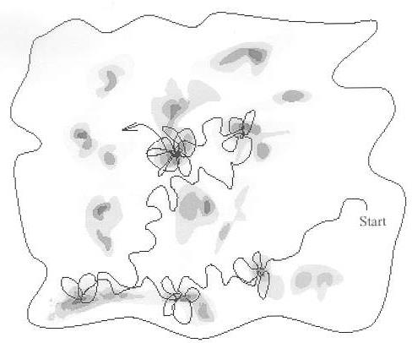
Figure 10: Sample exploration path for TS in a potential solution space
The length of the tabu list controls the memory of the search procedure. Shorter tabu lists will force the search to concentrate on small areas of search space, where longer lists will explore larger regions since they forbid revisiting a higher number of solution attributes. The short-term memory is implemented as a tabu list set (T) that keeps track of the most recently visited solutions and forbids moves toward them. The neighborhood (N) of the current solution is thus restricted to the solutions that do not belong in the tabu list. Instead of recording full solutions, attributive memory structures (A) are based on recording attributes. This type of memory records information about solution properties (attributes) that change in moving from one solution to another.
After each iteration, the best solution from the tabu set is chosen as the new current solution. The use of the tabu list prevents the search from returning to recently visited solutions and therefore prevents endless cycling within the algorithm. TS can be used for solving combinatorial optimization problems, but the size of the tabu list must be tuned for each optimization problem explored since it impacts the solution quality and computational time¹¹³.

Ant Colony Optimization
Ant Colony Optimization (ACO) is a metaheuristic approach proposed by Marco Dorigo in 1992¹¹⁴ and is based on the foraging behavior of real ants following “pheromone” trails to food sources. Ant colonies in nature consist of individual members who interact with each other and their environment to ensure the survival of the colony by finding food sources. When ants attempt to find short paths between their colony and food sources, they communicate indirectly by using pheromone to mark the decisions they made when building their respective paths. As more ants follow the same route, additional layers of pheromone are put in place, creating a favored path. Thus, some favored routes emerge, which are often the shortest or most efficient ones to a food source and the ant colony nest.
In ACO, artificial ants search for good solutions to an optimal “food source” location. Starting from an initial random foraging routine, the routes are updated with a pheromone concentration that decays at a constant rate. When new ants decide about a direction to go, they choose with higher probability paths that are marked by stronger pheromone concentrations as depicted in Figure 11 where “a” is the exploration path and “b” is the return path of the “foraging” ant going from the food source (F) and the ant colony nest (N) leaving an increasingly stronger pheromone path^{115,116}.
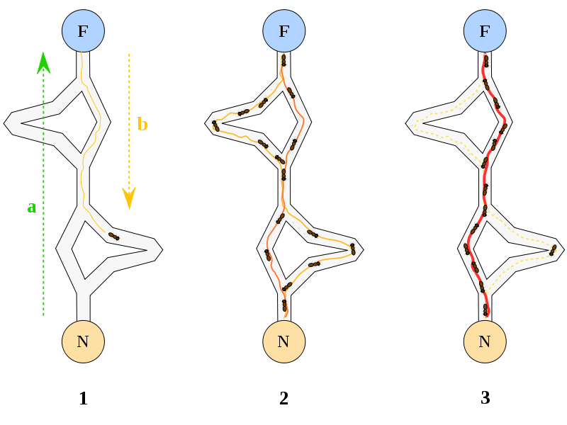
Figure 11: Ant Colony Optimization pheromone routing

Afterwards, the next iteration of ants builds path solutions with the updated pheromone information. When a constrained combinatorial optimization problem is considered, the problem constraints are built into the ants' foraging procedure in such a way that in every step of the path construction process only feasible solution components can be added to the current partial solution¹¹⁷. This basic foraging behavior, tied with path constraints, is the basis for a cooperative interaction which leads to the emergence of shortest paths to an optimum solution.
The framework of the ACO metaheuristic is shown next in an algorithm example. It consists of three parts gathered in the ScheduleActivities construct where these three activities are scheduled and synchronized by the algorithm designer.
InitializePheromonevalues
WHILE termination conditions not met DO
ScheduleActivities
AntBasedSolutionConstruction()
PheromoneUpdate()
DaemonActions() {optional}
END ScheduleActivities
ENDWHILE
AntBasedSolutionConstruction(): An ant constructively builds a solution to the problem by moving through nodes of the construction graph. Ants move by applying a stochastic local decision policy that makes use of the pheromone values and the heuristic values on components and/or connections of the construction graph. While moving, the ant keeps in memory the partial solution it has built in terms of the path it was walking on the construction graph.
PheromoneUpdate(): When adding a component c_{i} to the current partial solution, an ant can update the values of the pheromone trails that were used for this construction step. This kind of pheromone update is called online step-by-step pheromone update. Once an ant has built a solution, it can (by using its memory) retrace the same path backward and update the pheromone trails of the used components and/or connections according to the quality of the solution it has built. This is called online delayed pheromone update. Another important concept in Ant Colony Optimization is pheromone evaporation. Pheromone evaporation is the process by means of which the pheromone trail intensity on the components decreases over time. From a practical point of view, pheromone evaporation is needed to avoid a too rapid convergence of the algorithm toward a sub-optimal region. It implements a useful form of forgetting, favoring the exploration of new areas in the search space.
DaemonActions(): Daemon actions can be used to implement centralized actions which cannot be performed by single ants. Examples are the use of a local search procedure applied to the solutions built by the ants, or the collection of global information that can be used to decide whether it is useful or not to deposit additional pheromone to bias the search process from a non-local perspective. As a practical example, the daemon can observe the path found by each ant in the colony and choose to deposit extra pheromone on the components used by the ant that built the best solution. Pheromone updates performed by the daemon are called offline pheromone updates.
ACO is well suited for optimization of dynamic, multi-objective, stochastic, continuous and mixed-variable optimization problems that can be run and adapted to changes in real-time¹¹⁸.

Particle Swarm Optimization
Particle swarm optimization (PSO) is a population-based stochastic approach developed by Eberhart and Kennedy in 1995¹¹⁹, inspired by social behavior of bird flocking or fish schooling. PSO shares many similarities with evolutionary computation techniques such as Genetic Algorithms (GA). The system is initialized with a population of random solutions and searches for optima by updating generations that are attracted toward the current global best solution and its own best known location, while exhibiting a tendency to move randomly¹²⁰. However, unlike GA, PSO has no evolution operators such as crossover and mutation. PSO maintains a single status population that responds to new discoveries about its solution space. PSO belongs to the class of swarm intelligence techniques that are used for solving continuous and discrete optimization problems¹²¹.
In PSO, simple software agents, called particles, are initially set to move randomly in the search space of an optimization problem. The position of a particle represents a candidate solution to the optimization problem at hand. The movement of a swarming particle consists of a stochastic component and deterministic component. At each iteration, each particle searches for better positions or “fitness” in the search space by changing its velocity vector base on these components by “emulating” successful neighbors. Each particle is attracted toward the position of the current global best solution and its own best known location, while exhibiting a tendency to move randomly¹²².
The framework of the PSO metaheuristic is shown next in an algorithm example and its mimicking of natural operations like birds and fish^{124,125} are illustrated in Figure 12.
RandomlyGenerateInitialPopulation
WHILE termination conditions not met DO
ParticleFitnessEvaluation
UpdateGlobalFitness+Location
UpdateParticleVelocity+Postion
ENDWHILE



The PSO framework consists of three parts: fitness evaluation of each particle, global update and particle update. Fitness evaluation is conducted by supplying the candidate solution to the objective function. Individual and global best fitness and positions are updated by comparing the newly evaluated fitness against the previous individual and global best fitness, and replacing the best fitness and positions as necessary. The velocity and position update step is responsible for the optimization ability of the PSO algorithm¹²³.
Figure 12: Natural swarming behavior of birds and fish

Iterative Local Search Optimization
Iterative Local Search (ILS) is a trajectory based method that combines local search and perturbations of the solution around the local minima, as illustrated in Figure 13¹²⁷. The basic technique was developed by Baxter in 1981 and summarized by Lourenço, et al¹²⁶ in 2003. The essential idea of Iterated Local Search lies in focusing the search not on the full space of solutions but on a smaller subspace defined by the solutions that are locally optimal for a given optimization engine.
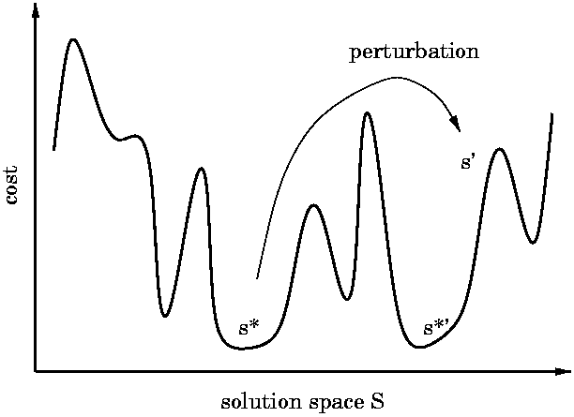
Figure 13: Graphical illustration for ILS

The potential power of ILS lies in its biased sampling of the set of local optima. The efficiency of this sampling depends both on the kinds of perturbations and on the acceptance criteria. Interestingly, even with the most naive implementations of these parts, ILS is much better than random restart. Much better results can be obtained if the ILS modules are optimized. First, the acceptance criteria can be adjusted empirically as in simulated annealing without knowing anything about the problem being optimized. Second, the Perturbation routine can incorporate as much problem-specific information as the developer is willing to put into it. In practice, a rule of thumb can be used as a guide: a good perturbation transforms one excellent solution into an excellent starting point for a local search. A sample framework for ILS is provided next in an algorithm example and its operation is illustrated in Figure 13.

s=GenerateInitialSolution
s*=ExecuteLocalSearch(s)
WHILE termination conditions not met DO
s' = Perturbation(s*,history)
s^’=ExecuteLocalSearch(s’)
s^=ApplyAcceptanceCriterion(s^,s^’,history)
ENDWHILE

ILS explores the search of local minima (denominated as S*) with respect to some given embedded heuristic, called LocalSearch. ILS achieves this heuristically as follows. Given the current s*, we first apply a change or perturbation that leads to an intermediate state s' (which belongs to S). Then LocalSearch is applied to s' and we reach a solution s*' in S*. If s*' passes an acceptance test, it becomes the next element of the walk in S*; otherwise, one returns to s*. The resulting walk is a case of a stochastic search in S*, but where neighborhoods are never explicitly introduced. This ILS procedure should lead to good biased sampling as long as the perturbations are neither too small nor too large. If they are too small, one will often fall back to s* and few new solutions of S* will be explored. If on the contrary the perturbations are too large, s' will be random, there will be no bias in the sampling, and we will recover with a random restart type algorithm.
Iterated Local Search was designed for and has been predominately applied to discrete domains, such as combinatorial optimization problems. For these problems, ILS iterates values for discrete variables until the stopping conditions are satisfied¹²⁸.

Metaheuristic applications
Table 4 provides a sampling of current metaheuristic method applications. This is not an all-encompassing list of applications, but a selection of industry, engineering and design examples to give the reader a flavor of areas that have been explored with these metaheuristic methods.
Table 4: Common metaheuristic methods and sample applications.

Metaheuristic |  | Author(s) | Application
Name | Type | Author(s) | Application
Genetic Algorithm (GA) | Naturally inspired, population based | Altshuler and Linder, 1997¹²⁹ | Wire antenna EM property designs
Genetic Algorithm (GA) | Naturally inspired, population based | Beasley, et al, 2001¹³⁰ | Aircraft airport routing
Genetic Algorithm (GA) | Naturally inspired, population based | Benini and Toffolo, 2002¹³¹ | Design of wind turbines for electrical power
Genetic Algorithm (GA) | Naturally inspired, population based | Giro, et al, 2002¹³² | Electrically conductive carbon materials
Genetic Algorithm (GA) | Naturally inspired, population based | Howley, 1996¹³³ | Spacecraft orientation maneuvering
Genetic Algorithm (GA) | Naturally inspired, population based | Keane and Brown, 1996¹³⁴ | Orbital structures load bearing truss
Genetic Algorithm (GA) | Naturally inspired, population based | Kewley and Embrechts, 2002¹³⁵ | Military tactical planning
Genetic Algorithm (GA) | Naturally inspired, population based | Mahfoud and Mani,  1996¹³⁶ | Financial market predictions
Genetic Algorithm (GA) | Naturally inspired, population based | Obayshi, et al, 2000¹³⁷ | Supersonic vehicle wing design
Genetic Algorithm (GA) | Naturally inspired, population based | Porto, et al, 1995¹³⁸ | Sonar acoustics recognition software training
Genetic Algorithm (GA) | Naturally inspired, population based | Sambridge and Gallagher, 1993¹³⁹ | Earthquake hypocenter location
Genetic Algorithm (GA) | Naturally inspired, population based | Sato, et al, 2002¹⁴⁰ | Acoustics of concert halls
Genetic Algorithm (GA) | Naturally inspired, population based | Schechter, 2002¹⁴¹ | Diesel engine design and efficiency
Genetic Algorithm (GA) | Naturally inspired, population based | Williams, et al, 2001¹⁴² | Satellite orbital placement and spacing
Simulated Anealing (SA) | Physics inspired, Trajectory with a random walk | Benvenuto, et al, 1992¹⁴³ | Digital filters
Simulated Anealing (SA) | Physics inspired, Trajectory with a random walk | Brünger, et al, 1997¹⁴⁴ | X-ray crystallography
Simulated Anealing (SA) | Physics inspired, Trajectory with a random walk | Dougherty and Maryott, 1991 | Groundwater management
Simulated Anealing (SA) | Physics inspired, Trajectory with a random walk | Emden-Weinert and Proksh, 1999¹⁴⁶ | Airline crew scheduling
Simulated Anealing (SA) | Physics inspired, Trajectory with a random walk | Fan and Machemehl,  2006¹⁴⁷ | Transit routing
Simulated Anealing (SA) | Physics inspired, Trajectory with a random walk | Kolahan, et al, 2007 | Structural optimization
Simulated Anealing (SA) | Physics inspired, Trajectory with a random walk | Sarker and Yao, 2003¹⁴⁸ | Manufacturing batch sizing
Simulated Anealing (SA) | Physics inspired, Trajectory with a random walk | Spinellis and Papadopoulos, 2000¹⁴⁹ | Product line buffering
Simulated Anealing (SA) | Physics inspired, Trajectory with a random walk | Wilson and Cui,  1990¹⁵⁰ | Bipolymer-peptide design

Table 4: Common metaheuristic methods and sample applications, continued.

Metaheuristic |  | Author(s) | Application
Name | Type | Author(s) | Application
Tabu Search (TS) | Trajectory with memory | Betttinger, et al, 1997¹⁵¹ | Timber harvest scheduling
Tabu Search (TS) | Trajectory with memory | Crainic, et al, 1993¹⁵² | Supply chain allocation
Tabu Search (TS) | Trajectory with memory | Drezner, et al, 2001¹⁵³ | Financial predictions
Tabu Search (TS) | Trajectory with memory | Gendreau, et al, 2010¹⁵⁴ | Vehicle dispatch/routing
Tabu Search (TS) | Trajectory with memory | Hubscher and Glover, 1994¹⁵⁵ | Multiprocessor scheduling
Tabu Search (TS) | Trajectory with memory | Laguna, et al, 1993¹⁵⁶ | Job scheduling
Tabu Search (TS) | Trajectory with memory | Muthuselvan, et al, 2009¹⁵⁷ | Power control systems
Tabu Search (TS) | Trajectory with memory | Reves, 1993¹⁵⁸ | Machine sequencing
Tabu Search (TS) | Trajectory with memory | Zhang, et al, 2009¹⁵⁹ | Image retrieval
Ant Colony Optimization (ACO) | Naturally inspired, population based | Doerner, et al, 2004¹⁶⁰ | Investment management
Ant Colony Optimization (ACO) | Naturally inspired, population based | Hani, et al, 2007¹⁶¹ | Industrial layout
Ant Colony Optimization (ACO) | Naturally inspired, population based | Kumar, 2007¹⁶² | Disaster relief logistics
Ant Colony Optimization (ACO) | Naturally inspired, population based | Levine and Ducatelle, 2004¹⁶³ | Inventory
Ant Colony Optimization (ACO) | Naturally inspired, population based | Parpineli and Lopes, 2002¹⁶⁴ | Data mining
Ant Colony Optimization (ACO) | Naturally inspired, population based | Rizzoli, et al, 2007¹⁶⁵ | Vehicle routing
Ant Colony Optimization (ACO) | Naturally inspired, population based | Serra and Venini, 2006¹⁶⁶ | Plane truss design
Ant Colony Optimization (ACO) | Naturally inspired, population based | Shyu, et al, 2004¹⁶⁷ | Job shop scheduling
Ant Colony Optimization (ACO) | Naturally inspired, population based | Sim, 2002¹⁶⁸ | Network routing
Particle Swarm Optimization (PSO) | Naturally inspired, population based | Alrashidi and El-Hawary, 2009¹⁶⁹ | Electrical power systems
Particle Swarm Optimization (PSO) | Naturally inspired, population based | He, et al, 2004¹⁷⁰ | Mechanical design
Particle Swarm Optimization (PSO) | Naturally inspired, population based | Juang, 2004¹⁷¹ | Network design
Particle Swarm Optimization (PSO) | Naturally inspired, population based | Liao, et al, 2005¹⁷² | Flow shop scheduling
Particle Swarm Optimization (PSO) | Naturally inspired, population based | Liu, et al, 2006¹⁷³ | Architectural design
Particle Swarm Optimization (PSO) | Naturally inspired, population based | Mahmoud, et al, 2007¹⁷⁴ | Electronic beam steering
Particle Swarm Optimization (PSO) | Naturally inspired, population based | Miranda and Fonseca, 2002¹⁷⁵ | Power distribution
Particle Swarm Optimization (PSO) | Naturally inspired, population based | Omran, et al, 2002¹⁷⁶ | Image classification
Particle Swarm Optimization (PSO) | Naturally inspired, population based | Robinson, et al, 2004¹⁷⁷ | Electromagnetic antenna
Particle Swarm Optimization (PSO) | Naturally inspired, population based | Venter and Sobieszczanski-Sobieski, 2004¹⁷⁸ | Transport aircraft wing design
Iterated Local Search (ILS) | Trajectory with perturbation | Besten, et al, 2001¹⁷⁹ | Single machine scheduling
Iterated Local Search (ILS) | Trajectory with perturbation | Blum, 2007¹⁸⁰ | Software code design
Iterated Local Search (ILS) | Trajectory with perturbation | Cordón and Damas, 2006¹⁸¹ | Image processing
Iterated Local Search (ILS) | Trajectory with perturbation | Dirk, et al, 2005¹⁸² | Communications
Iterated Local Search (ILS) | Trajectory with perturbation | Dong, et al, 2009¹⁸³ | Multi-stage production schedule
Iterated Local Search (ILS) | Trajectory with perturbation | Vansteenwegen, et al, 2009¹⁸⁴ | Team orienteering schedule
Iterated Local Search (ILS) | Trajectory with perturbation | Walker, et al, ¹⁸⁵ | Vehicle Routing

Metaheuristic application for STMI
Due to the complex, non-continuous nature of the technology populations examined, and the non-linear objective functions explored in the initial development of the STMI process, parallels to reviewed GA applications in Table 4 have been noted. This research therefore explored a detailed Genetic Algorithm (GA) search optimization algorithm in Chapter three. By using a system design objective functions and VE based “best value” as the fitness criteria, GA appeared to be well suited for a fast, deterministic global solution set optimization. Since the GA code can generate slight variations to the “optimal solution” due to the random nature imbedded within the population generation, Beasley & Chu (1996)¹⁸⁶ recommends averaging at least 10 runs to establish the reliability of the objective function used within the GA. In the eventual implementation, averaged answers of the GA STMI optimizer would be tested against the “All case” analysis to assess the objective function’s reliability and accuracy.

Strategic Technology Planning (STP)
In the past 15 years, strategic planning has evolved from a senior level “art” to a more rigorous and systematic process. First, a background review on strategic technology planning purpose and standard Technology Readiness Levels (TRLs) notations are presented. Then current technology planning capabilities will be examined. Finally, current strategic technology planning techniques are noted were applied within the DoD acquisition framework, illustrating STMI applicability.

STP background
The companies and DoD programs that will survive and succeed in the future will be those that plan and manage their technology planning process, deriving a business benefit from it. Federal entities like the DoD have not effectively planned or managed their technology planning processes. Too many times DoD programs have slipped schedule or overrun costs due to immature (<TRL-6) technologies driving system designs¹⁸⁷. The U.S. Government Accountability Office (GAO), which watches over the fiscal performance of federal programs, has reported that in the past, numerous DoD acquisition programs have failed to adequately plan their technology developmental decisions and rely on immature information to make key system design decisions¹⁸⁸. The GAO has stated that TRL-6 is the risk reduction target plateau that subsystem technologies must reach prior to program offices integrating them into full system prototyping, as outlined in the GAO report NSIAD-99-162¹⁸⁹. In response to these findings, the DoD has revamped its primary instruction (DODI) document to conduct DoD acquisition programs. This instruction, the new DoDI 5000.2, was published 08 December 2008 and places a stronger emphasis on maturing technologies earlier in the “pre-system acquisition” portion of a program lifecycle¹⁹⁰ and requiring TRL-6 or greater matured technologies into formal system acquisition.
The standard notation for tracking technology development is based on DoD’s TRLs¹⁹¹. Originally developed by NASA in the 1990’s¹⁹², DoD adopted the notation in 2001¹⁹³ as a common means to assist new technology development and improve communication among technology developers through a common reference set. They provide a systematic metric/measurement system that supports assessments of the maturity of a particular technology and the consistent comparison of maturity between different types of technology¹⁹⁴. This consistency provides a significant input to risk assessment dealing with incorporating a technology into a system design.
TRLs have been traditionally assigned to the developing technologies and tracked as they mature. Each TRL, starting at basic research ideas (TRL-1) to mature and producible technologies (TRL-9), have key development milestones which differentiate each maturation level. Technology maturation therefore can be carefully tracked and identified at each level, with the common reference points. TRLs have been applied by multiple branches of the Federal government for the past 15+ years. Table 5 is taken from the “DoD Technology Readiness Assessment Deskbook (2005)” and provides a TRL summary¹⁹⁵. Table 6 provides the common TRL assessment definitions¹⁹⁶.

Strategic technology planning methods
Various methods for STPs identified in literature and their use in the sample DoD acquisition lifecycle are reviewed in this section and summarized in Table 7.

Table 5: TRL descriptions
TRL | Description
1. Basic Principles | Basic scientific research begins to be translated into applied R&D
2. Technology concept and/or application formulated | Invention begins. Designs are limited to analytical studies. Applications are speculative and there may be no proof or supporting detailed analysis
3. Analytical and experimental critical function and/or characteristic proof-of-concept | Active R&D is initiated. Analytical and laboratory studies are initiated to validate predictions of separate elements of the technology that have not yet been integrated
4. Laboratory environment validation of technology components and/or breadboard | Basic technological components are integrated to establish that they will work together in the lab.
5. Relevant environmental validation of component and/or breadboard | High fidelity integration of technological components with realistic supporting elements tested in a relevant, high fidelity laboratory environment or simulated operational environment.
6. Relevant environmental demonstration of a system or sub-system model/prototype | Representative integrated model or prototype tested in a relevant, high fidelity laboratory environment or simulated operational environment.
7. Operational environmental demonstration of system prototype | Prototype near or at planned operational system operating in an operational environment such as an aircraft, vehicle, ship or space.
8. Actual system completed and qualified through test and demonstration | Technology has been proven to work in its final form and under expected conditions. Developmental test and evaluation of the system has been conducted to determine if the technology meets design specifications.
9. Actual system proven through successful mission operations | Actual application of the technology in its final form and under mission conditions like those encountered in Operational Test and Evaluation.

Table 6: TRL clarifying definitions
Term | Definition
BREADBOARD: | Integrated components that provide a representation of a system/subsystem and which can be used to determine concept feasibility and to develop technical data. Typically configured for laboratory use to demonstrate the technical principles of immediate interest. May resemble final system/subsystem in function only.
HIGH FIDELITY: | Addresses form, fit and function. High fidelity laboratory environment would involve testing with equipment that can simulate and validate all system specifications within a laboratory setting.
LOW FIDELITY: | A representative of the component or system that has limited ability to provide anything but first order information about the end product. Low fidelity assessments are used to define trend analysis.
MODEL: | A reduced scale, functional form of a system, near or at operational specification. Models will be sufficiently hardened to allow demonstration of the technical and operational capabilities required of the final system.
PROTOTYPE: | The first early representation of the system which offers the expected functionality and performance expected of the final implementation. Prototypes will be sufficiently hardened to allow demonstration of the technical and operational capabilities required of the final system.
RELEVANT ENVIRONMENT: | Testing environment that simulates the key aspects of the operational environment.
SIMULATED OPERATIONAL ENVIRONMENT: | Environment that can simulate all of the operational requirements and specifications required of the final system or a simulated environment that allows for testing of a virtual prototype to determine whether it meets the operational requirements and specifications of the final system.
OPERATIONAL ENVIRONMENT: | Environment that addresses all of the operational requirements and specifications required of the final system to include platform/packaging.

Table 7: Problems and solutions in technology planning
Technique | Problem addressed | Solution technique
Technology roadmapping¹⁹⁷ | Aligning knowledge assets and management with business objectives | Knowledge asset roadmap
Technology roadmapping¹⁹⁷ | Implementing design project planning strategy | Program planning roadmap
Technology roadmapping¹⁹⁷ | Insertion of technology into manufactured products | Product planning (Philips) roadmap
Technology roadmapping¹⁹⁷ | Integration and evolution of advanced technology | Integration planning roadmap
Technology roadmapping¹⁹⁷ | Long-range planning | Integrated manufacturing technology roadmap
Technology roadmapping¹⁹⁷ | Strategic planning | T-plan roadmap
Technology roadmapping¹⁹⁷ | Technology to support organizational capabilities | Service/capability planning roadmap
TDS¹⁹⁸ | Long-term technical data requirements | Data management strategy
TDS¹⁹⁸ | Manpower and functional competency requirements | Time-phased workload assessment
Dynamic strategic planning | Electric vehicle policy planning¹⁹⁹ | - Vehicle performance models  - Spreadsheet simulation and sensitivity analysis  - Manual probability estimates and decision analysis
Dynamic strategic planning | Semiconductor industry-wide strategic technology plan²⁰⁰ | - Hierarchical decision models  - Sensitivity analysis
System optimization | Parallel maturation of advanced spacecraft system component technologies²⁰¹ | - Manual selection of system risk reducing options  - Genetic algorithm to “auto select” risk reducing options
System optimization | System readiness levels²⁰² | Evolutionary algorithms
Production scheduling | Integrated process planning/ production scheduling²⁰³ | Integrated Process Planning/ Production Scheduling (IP3S)
Production scheduling | Job shop scheduling²⁰⁴ | Genetic algorithms
Production scheduling | Medium-range production  scheduling in a multi-product batch plant²⁰⁵ | Large-scale mixed-integer linear programming
Table 7: Problems and solutions in technology planning – continued-
Technique | Problem addressed | Solution technique
Investment planning / capacity management | Capacity acquisition, planning and replacement^{206,207} | - Regenerative dynamic programming  - Multi-stage integer programming
Investment planning / capacity management | Capacity investment decisions^{208,209} | - Best-response functions with Markov-perfect Nash equilibrium  - Stochastic capacity-portfolios
Investment planning / capacity management | Evaluating investments in production technology²¹⁰ | - Large-scale linear programs  - Mixed-integer programming  - Stochastic dynamic models  - Heuristic solutions
Investment planning / capacity management | Expansion and equipment replacement²¹¹ | Heuristics and linear programming
Investment planning / capacity management | Justification and implementation of Advanced Manufacturing Technologies²¹² | Statistical survey data analysis with linear regression relationships
Investment planning / capacity management | Long-term capital investment planning²¹³ | Advanced queuing network model
Investment planning / capacity management | Optimal management of capacity²¹⁴ | Two period capacitated Cournot game
Investment planning / capacity management | Production technology installation²¹⁵ | Mixed-integer program with bilinear objective
Inventory management | Available manufacturing capability²¹⁶ | Decision support system base on linear programming
Inventory management | Inventory requirements planning²¹⁷ | Decision support tool with heuristic approach
Inventory management | Launch vehicle availability²¹⁸ | Integer linear programming
Inventory management | Tactical capacity planning²¹⁹ | Advanced queuing network model
Supply chain management | Allocation to global supply sites²²⁰ | Mixed integer program with multi-commodity network flow
Supply chain management | Large-scale supply chain optimization²²¹ | Mixed integer program with supporting heuristics
Supply chain management | Optimal allocation of business to suppliers²²² | REV, an industry-independent optimization-based market-clearing tool
Supply chain management | Supply chain networks²²³ | Multi-echelon inventory optimization
Supply chain management | Supply chain performance²²⁴ | Multi-echelon inventory optimization
Supply chain management | Supply network production and distribution²²⁵ | Mixed integer program with bilinear objective

Technology Roadmapping
This is a structured, manual technique best applied pre-MS-B to visualize when technology is being matured and initially integrated into a preliminary design. Technology roadmapping is widely used within industry, with 26% of the companies aware of the process and 10% actively engaged in the year 2000²²⁶. The generic technology roadmap is a time-based chart used to develop, represent and communicate strategic plans. The most common roadmap involves planning to insert technology into manufactured products. Another highly applicable roadmap is integration planning, which involves the integration and/or evolution of technology as it combines within products or systems. One major drawback occurs when competing technologies are compared with constraints since variables can quickly become multi-dimensional and difficult to visualize as the options increase in complexity²²⁷.

Science and Technology Strategic Planning
This method is an overarching manual process that can be applied to individual industries, state governments and DoD to organize pre-MS-B technology planning, resources and leadership support^{228,229}. This type of planning assesses existing technical resources and determines whether they can be leveraged better and identifies areas that must be addressed to support technology intensive and driven programs. Key processes include: bringing key stakeholders to develop consensus; providing opportunities for industry, academia, community and government viewpoints; thorough understanding of available industrial and technical resources; identifying performance measures; identifying specific actions, assigned responsibilities and established timelines; being tied to a budgeting process; and finally, having a champion to lead the planning with support from senior leadership to implement the strategy over the long term.

Dynamic Strategic Planning
A process of using OR techniques combined with computer simulation and manual analysis methods, Dynamic Strategic Planning^{230,231}, can help identify strategic plans for the development and implementation of early technology policy agreed to by all involved stakeholders. Evolving from traditional systems analysis and decision analysis, Dynamic Strategic Planning is used to develop technology or large scale engineering projects from objectives, including a technically efficient plan prepared through optimization or simulation methods and an evolution of the plan over time. Dynamic Strategy Planning is best suited to help planners prepare a technology plan prior to the selection of a specific technology system required for a detailed system design.

Technology Development Strategy (TDS)
A manual DoD process outlined in DoDI 5000.2, that is drafted after the MS-A. The TDS documents the technology risk reduction and determines the appropriate set of technologies to mature and integrate into a full system. The TDS includes a rationale for the selected acquisition strategy, cost estimates, development schedule, performance goals and specific exit criteria to advance a system design beyond the Technology Development Phase.

System Optimization
Once a system design and specific technology capabilities have been approved at MS-B, system optimization becomes a priority, involving the interaction of multiple technologies to form a functioning product. Two current types of system optimization involve minimizing the overall risk of system components to drive the system design²³² and optimizing the “system readiness level (SRL)” of a design maturity²³³. Both methods utilize OR methodologies like generic and evolutionary algorithms to optimize system design elements.

Investment Planning/Capacity Management
As the system design is being completed and integrated, post MS-B focus begins to shift toward production of the new product. The DoD and manufacturers must evaluate investments in production technologies to best manage the production and stockpiling of parts for maturing system designs. These long-term decisions establish the overall level of resources and extend over a time horizon long enough to obtain resources. Capacity decisions affect the production lead time, operating costs and industry’s ability to compete. Standard OR methodologies are often applied including Mixed-Integer programming, heuristics and network models.

Production Scheduling
Once the final product design has been completed and initial prototypes have demonstrated manufacturing capabilities, the ramp-up to full production begins. Planners must allocate the available production resources over time to best satisfy stakeholder criteria. DoD stakeholders typically specify delivery time, quantity, and quality confirmations. Industry stakeholders want to minimize cost, meet schedules and deliver a product that meets customer expectations. OR techniques of scheduling optimization involve meeting a set of tasks to be performed, performing tradeoffs between early and late completion of a task, and balancing inventory for the task with frequent production changeovers.

Inventory Management
As low rate production is approved post MS-C, "Inventory" is one of the more visible and tangible aspects of doing business and maintaining production. Raw materials, goods in process and finished goods all represent various forms of inventory. In a literal sense, inventory refers to stocks of anything necessary to produce a product. These stocks represent a large portion of the business investment and must be well managed in order to maximize profits. Unless inventories are controlled, they are unreliable, inefficient and costly²³⁴.

Supply Chain Management
As production is initiated during Low Rate Initial Production (LRIP), the management of the supply network involves all movement and storage of raw materials, work-in-process inventory, and finished goods from point of origin to point of consumption. Supply Chain Management is the systemic, strategic coordination of the traditional business functions and the tactics across these business functions within a particular company and across businesses within the supply chain, for the purposes of improving the long-term performance of the individual companies and the supply chain as a whole²³⁵.
Placed in context with the new DoDI 5000.2 program acquisition lifecycle depicted in Figure 14, early technology planning (TRL 1-3) usually involves a manual process, like technology roadmapping, or using Operation Research (OR) based dynamic strategic planning tools. These early planning tools are used to forecast user needs and identify key technology components to develop for a Material Development Decision (MDD). Initial planning strategies help develop basic Research and Development (R&D) plans to fill technology gaps and to lay out overall strategies for management and maturation of the technology²³⁶, stepping from basic research ideas (TRL-1) to active research (TRL-3). These technologies are identified from sources including academia, government labs and commercial industry.
At the completion of the MDD, the PM’s office conducts manual technology roadmapping and builds a Technology Development Strategy (TDS) to evaluate the multitude of technology options to help guide the technology maturation from TRL-3 to prototyped TRL-6 technologies for inclusion into the initial system design.
Once the technologies have been developed and matured sufficiently to TRL-6, a PM can employ additional OR techniques and begin to assist with system integration and maturation during the product’s Engineering and Manufacturing Development phase. As the matured system approaches production, OR based investment evaluation or planning is used to optimize the best production level technology capacity improvements. Later in a product or program lifecycle, additional OR methodologies help technology intensive users focus on real problems involving production, scheduling, inventory management and supply chain management.

STMI applicability
Current applications for Strategic Technology Planning (STP) are summarized and placed in typical areas with respect to the DoD acquisition lifecycle and TRL ratings in Figure 14. Laying out the current STP applications also denotes a key finding in that there appears to be little or no published OR type analysis occurring to help bridge the TRL-3 to TRL-6 technology maturation “chasm”. This discovery led to the foundation of this research - to develop a STMI process to fill this analytical OR “hole” for technology planning, transition and maturation.

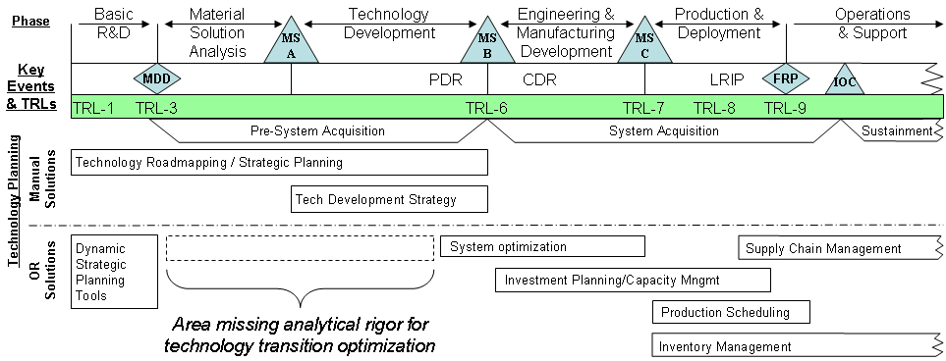

Figure 14: DoD acquisition “lifecycle” with STP

Post-process analysis options for STMI

Trade-off analysis
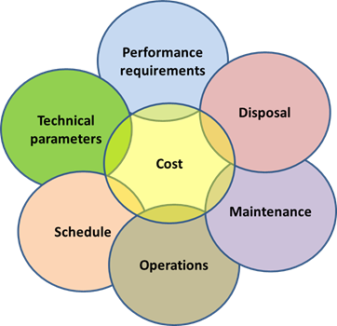
A tradeoff analysis (also called a trade study) is an analytical method for evaluating and comparing system designs based on customer-defined criteria. Trade-offs are always based on the constraints of the system design. Many factors go into the decision to sacrifice schedule, cost or performance, and it is not always possible to change one without affecting the others²³⁷.
Figure 15: Trade off analysis operators

In the broadest sense, a trade-off is giving up one thing to get another. Some choices entail trade-offs, while others do not. Choices that do not entail trade-offs we’ll call optimization choices. Examples of trade-offs could be:
- Increasing a development budget to reduce the development time (although this is usually not linear)
- Increasing the development time to stretch out the development budget into multiple fiscal years
- Substituting lower cost materials without changing the project specifications
- Depot or frontline maintenance
- Smaller, constellation units or larger omnibus unit
- Upgradeable or replacement
Tradeoff studies are important because²³⁸:
- They create an objective mechanism for evaluating systems
- They document the decision process
- The preference structure is quantified
- The tradeoff study process educates the customer
- They help validate system requirements by providing a measurable quantity that helps determine if and how well a design satisfies the requirements²³⁹
- They assist in selecting the preferred alternative

Data and requirement sensitivity analysis
All PMs have had to make program decisions where there was uncertainty about key factors that where relevant to the decision process (technology performance, schedule, costs, and funding). This “decision making under uncertainty” occurs when the information needed to make a decision is incomplete, potentially inaccurate, or just educated guesses. Risk management becomes the means to identify, assess and prioritize the effects of uncertainty on a decision maker’s objectives²⁴⁰. A powerful tool available for risk management analysis is the field of sensitivity analysis, which can give the PM an indication of how sensitive one or more of the factors within the system design are to uncertainties in their value.
Sensitivity analysis is very useful when attempting to determine the impact on the actual outcome if a particular variable differs (i.e. uncertainty) from what was previously assumed as a baseline. By creating a given set of scenarios, the analyst can determine how changes in one variable(s) will impact the target variable. The analyst can also establish a range of values for the object value coefficients where the optimal values of the decision variable will not change²⁴¹. This is also known as the “relevant range²⁴²” or “range of optimality of the input coefficients for a specific output decision variable.
There the many methods for conducting sensitivity analysis like graphical analysis^{243,244}, scatter plots²⁴⁵, variance-based methods^{246,247} and screening^{248,249}. One of the simplest and most common approaches to sensitivity analysis is that of changing of factors to see what effect this produces on the output²⁵⁰. Two common methods are one-variable-at-a-time (OVAT) and a multifactor approach called Design of Experiments (DoE),
OVAT customarily involves moving one input variable, keeping others at their baseline (nominal) values, then returning the variable to its nominal value, and repeating for each of the other inputs in the same way. Sensitivity may then be measured by monitoring changes in the output, e.g. by range analysis, partial derivatives or linear regression. This appears a logical approach as any change observed in the output will unambiguously be due to the single variable changed. Furthermore, by changing one variable at a time, one can keep all other variables fixed to their central or baseline values. This increases the comparability of the results (all ‘effects’ are computed with reference to the same central point in space) and minimizes the chances of computer program crashes, which is more likely when several input factors are changed simultaneously. OVAT is frequently preferred by modelers because of practical reasons, as it is easy and fast. In case of model failure under OVAT analysis the modeler immediately knows which input factor is responsible for the failure²⁵¹.
Despite the simplicity of the OVAT approach, it does not fully explore the input space, since it does not take into account the simultaneous variation of input variables. This means that the OFAT approach cannot detect the presence of interactions between input variables²⁵². An option to OVAT is to conduct the sensitivity analysis with a Design of Experiments (DoE) analysis that changes multiple variable at once. DoE allows an analyst to reduce computational time, increase robustness of the analysis, and be able to check variable interactions, especially if more than one input factor is suspected of influencing an output²⁵³.
DoE is a branch of applied statistics deals with planning, conducting, analyzing and interpreting controlled tests to evaluate the factors that control the value of a parameter or group of parameters. Many of the current statistical approaches to designed experiments originate from the work of R. A. Fisher in the early part of the 20th century. Fisher demonstrated how taking the time to seriously consider the design and execution of an experiment before trying it helped avoid frequently encountered problems in analysis. Key concepts in creating a designed experiment include blocking, randomization and replication²⁵⁴.
Blocking: When randomizing a factor is impossible or too costly, blocking lets you restrict randomization by carrying out all of the trials with one setting of the factor and then all the trials with the other setting.
Randomization: Refers to the order in which the trials of an experiment are performed. A randomized sequence helps eliminate effects of unknown or uncontrolled variables, including bias.
Replication: Repetition of a complete experimental treatment, including the setup.
DoE incorporates purposeful changes to the inputs of a process and an efficient analysis of the corresponding changes to the outputs to accurately predict how the inputs affect the mean and variability of the outputs. A well–performed experiment may provide answers to questions such as:
- What are the key factors in a process?
- At what settings would the process deliver acceptable performance?
- What are the key, main and interaction effects in the process?
- What settings would bring about less variation in the output?
DoE is applicable to both physical processes and computer simulation models and is an effective tool for maximizing the amount of information gained from a study, while minimizing the amount of data to be collected. DoE factorial designs allow estimation of the sensitivity to each factor and also to the combined effect of two or more factors²⁵⁵.

Incremental improvement studies
An incremental approach produces a working product much earlier than a monolithic approach. The initial reaction to seeing this is usually "This is not what I want", leading to an initial loss of confidence, although the delivery of an increment on time is generally a refreshing change for customers. Confidence is initially high with both incremental and monolithic approaches, but during a lengthy development, customer confidence drops off, as no working product is yet visible. If delivery of the system comes before all confidence is lost, there is hope of recovery, but if confidence goes below a certain point, then no matter how good the system is technically, it will not be accepted by users²⁵⁶.
If incremental improvements are planned from the start of a project and can be scheduled out as part of a Strategic Technology Plan, showing deliveries and improvements, customers are more willing to get something vs. a single monolithic delivery that may never happen. Keep in mind that the incremental improvements are based on many, small changes rather than the radical changes that might arise from Research and Development. Small improvements are also less likely to require major capital investment than major process changes.

Process formulation

Fundamentally, the proposed STMI process is a formalized and repeatable computer based DSS tool which allows PMs to systematically compare and evaluate candidate technology performance for inclusion into a program STP. Utilizing VE principles, STMI generates a recommended STP based on meeting the customer’s requirements for an optimized “best value (BV)” technology set. Stage one utilizes RE concepts to document and validate customer requirements and technology database generated as precursors to the formal STMI process in stage two. Stage two is the core of the STMI process. System design objective functions are developed from the user requirements and technology database in stage one, and then used to conduct a VE based best value optimization to identify the best technology set to place in the system design STP. Stage three provides follow-on analysis with the STMI core process to conduct trade studies, sensitivity analysis and incremental improvement studies.

Stage one: pre-process preparation

Generating an operational concept
The general purpose for an operational concept is to describe to the customers and the development team how the system will function in practice. It describes the main operational concepts, operating environment, and main interactions between the environment and external systems. The operational concept is often illustrated in a graphical representation to depict what the problem is and give an idea of players and operations involved. The graphic gives a quick, high level description of what the concept is supposed to do, and how to do it.
The initial operational concept is useful in establishing the context for a suite of related operational systems. This context may be in terms of options, phase, a time period, a mission and/or a location. By laying out the concept in high level terms, system solutions can be developed to meet the customer’s problem. The graphical representation of the operational concept can be used to orient and focus detailed discussions, allowing for a brain storming approach to potential system solutions to evaluate.
In the context for STMI operations, the high level operational concept describes the problem and helps generate many potential solutions at the “Macro” level. A specific system solution can be pulled from the “Macro” level solutions to be evaluated in detail at the “Micro” level. “Micro” level solutions are optimized based on the STMI “best value” which can be lifted up to the “Macro” level system analysis for a final common “best value” analysis and determination of the best overall system concept that meets the customer needs.
Figure 16 and Figure 17 depict a sample “Macro” and “Micro” graphical operational concept for a customer needing a “line-of-sight” aircraft defense against another aircraft during combat. Figure 16 identifies the mission and scope of what needs to be done, and summarizes potential system options to explore.

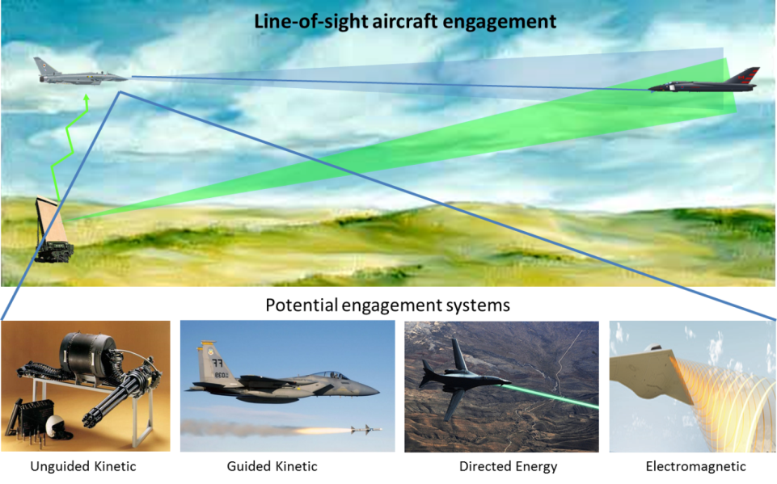
Figure 16: Sample air defense “Macro” operational concept

Figure 17 specifically selects one potential system option and presents its ability to meet the operational concept required by the customer.

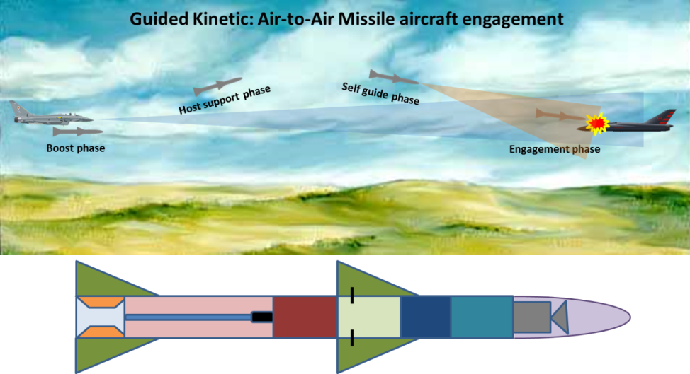
Figure 17: Sample air defense “Micro” operational concept

Requirements and constraints generation and tracing
The PM team performing the system design with STMI must have the initial set of requirements and constraints generated by the customer, approved by senior management and documented in a document like a CRD. Requirements are typically something to be obtained, while constraints provide boundaries or limits on the system for developing an acceptable system design. Sample constraints include maximum weight, dimensional limits, no hazardous materials, or cost limits. The aim should be to add as few constraints as possible, so as not to artificially restrict the search domain.
The following are guidelines for coordinating with the customer to create an executable CRD (adapted from Karl E. Wiegers’ “Writing quality requirements”²⁵⁷). Each of the customer requirements must be:
- Correct: Each requirement must accurately describe the functionality to be delivered. The reference for correctness is the source of the requirement, such as an actual customer or a higher-level system requirements specification. Only user representatives can determine the correctness of user requirements, which is why it is essential to include them, or their close surrogates, in inspections of the requirements. Requirements inspections that do not involve users can lead to developers saying, "That doesn’t make sense. This is probably what they meant." This is also known as "guessing."
- Feasible: It must be possible to implement each requirement within the known capabilities and limitations of the system and its environment. To avoid infeasible requirements, have a PM’s SME work with the requirements analysts or marketing personnel throughout the elicitation process. This SME can provide a reality check on what can and cannot be done technically, and what can be done only at excessive cost or with other tradeoffs.
- Necessary: Each requirement should document something the customers really need or something that is required for conformance to an external requirement, an external interface, or a standard. Another way to think of "necessary" is that each requirement originated from a source you recognize as having the authority to specify requirements. Trace each requirement back to its origin, such as a use case, system requirement, regulation, or some other voice-of-the-customer input. If you cannot identify the origin, perhaps the requirement is an example of "gold plating" and is not really necessary.
- Prioritized: Assign an implementation priority to each requirement, feature, or constraint to indicate how essential it is to include it in a particular system design. Customers or their surrogates have the lion’s share of the responsibility for establishing priorities. Adding lower priority constraints forms the basis for additional trade studies and design refinement.
- Unambiguous: The reader of a requirement statement should be able to draw only one interpretation of it. Also, multiple readers of a requirement should arrive at the same interpretation. Natural language is highly prone to ambiguity, so avoid subjective words like user-friendly, easy, simple, rapid, efficient, several, state-of-the-art, improved, maximize, and minimize. Words that are clear to the customer may not be clear to readers. Write each requirement in succinct, simple, straightforward language of the user domain, not in industry jargon. Effective ways to reveal ambiguity include formal inspections of the requirements specifications, writing test cases from requirements, and creating user scenarios that illustrate the expected behavior of a specific portion of the product.
- Verifiable: See whether you can devise tests or use other verification approaches, such as inspection or demonstration, to determine whether each requirement is properly implemented in the system design. If a requirement is not verifiable, determining whether it was correctly implemented is a matter of opinion. Requirements that are not consistent, feasible, or unambiguous also are not verifiable.
- Threshold Values: SMEs must only include the threshold values (minimal requirements that must be met) from the customer. A key attribute of the STMI VE process in stage-2 requires that the minimum (threshold) requirements be met to accurately define a system’s “best value”. Requirements above and beyond the minimums are considered “gold plating” and should be renegotiated with the customers.
The PM’s team does not want to be stuck with unattainable requirements or constraints. Since the quality of any product depends on the quality of the raw materials fed into it, poor requirements cannot lead to excellent system design. On the other hand, having too many requirements can lead to contradictory conditions (achieving one requirement limits or fails another) and can generate an extremely limited design space. An overabundance of unnecessary requirements limits the PM team’s trade space to explore the variety of system design options. Keeping only the necessary requirements in the initial design and potentially adding in secondary requirements during trade studies can be a good compromise to illustrate how a design evolves with each added requirement. Table 8 provides a summary of common system design requirements adapted from a traditional project design requirement guide²⁵⁸.

Table 8: Common types of design requirements
General Types | Specific Design Requirements
Cost Target | - Cost to develop  - Cost to purchase  - Cost to use  - Cost to maintain  - Cost to repair  - Cost to dispose
Physical Characteristics | - Weight  - Density  - Melting, boiling point  - Color  - Transparency  - Reflectance  - Surface texture (polished, rough)  - Elasticity  - Hardness  - Ductility (ability to be drawn into a wire)  - Magnetic properties  - Electrical properties (resistance, impedance, etc.)  - Impact resistance  - Bending strength  - Viscosity (the thickness and stickiness of a fluid)  - Acoustics (pitch, sound transmission, resonance)
Aesthetics (how it looks) | - Style (art deco, Victorian, modern, medieval)  - Color  - Fit and finish (Is it built with care and attention to detail?)
Performance characteristics | - Accuracy  - Strength  - Reproducibility, repeatability (Does it always do the same thing given the same input?)  - Speed  - Acceleration  - Deceleration, braking  - Rolling resistance  - Friction  - Adhesion  - Absorbency  - Permeability (Do things leak through it?)  - Resolution  - Flammability (ability to set on fire)  - Insulation value

Table 8: Common types of design requirements - continued
General Types | Specific Design Requirements
Geometry | - Size, overall dimensions  - Curvature  - Volume, capacity
Manufacturing considerations | - Difficulty of making  - Equipment or manufacturing techniques required to build the invention (You don't want to build something from metal if all you have is a woodworking shop.)  - Number of component parts  - Labor requirements  - Means of shipping or delivery
Environmental requirements | - Operating temperature range  - Storage temperature range  - Water resistance  - Resistance to corrosion  - Compatibility/interoperability with ___________  - Ability to withstand radiation (called radiation hardness)
Inputs/Outputs | - Energy consumption  - Fuel consumption  - Labor  - Product produced  - Power  - Pollution  - Undesirable side effects ___________
Usability | - Ease of use  - Ease of learning  - Ease of repair/maintenance  - Operator training  - Service requirements  - Reliability/Maintainability  - Lifespan  - Disposability
Regulatory & licensing considerations | - Meets government rules  - Meets company or league rules (a sporting product)  - Does it require paying a patent or license fee?
System specific | - Human factors  - Specifically based on unique system

Once the requirements and constraints have been defined and documented, they become the basis for defining the key design requirements, system design models and constraints within which the system design must operate to meet its customer requirements.

Defining key parameters and system models
Every system design will have a primary set of requirements or Key Performance Parameters (KPPs) that must be achieved by the system design in order to be successfully accepted by the customer. Usually 2-4 performance characteristics are identified by the customer/user and are of critical importance (design power levels, weapon range, unit mass, etc.). Most of the system models that develop into objective functions used in the STMI stage two processes are based on meeting the KPPs. The KPPs are also the primary candidates for conducting single and multivariable sensitivity analysis in the STMI stage three processes.
System modeling describes the mathematical representation of the system component or overall system concept under consideration. It represents a solution method to evaluate input data based on meeting KPP criteria that is limited by the defined constraints. A common type of systems modeling is function modeling²⁵⁹, with specific techniques such as the Functional Flow Block Diagram (FFBD). Once the basic system design has been established in the operational concept (like an Air-to-Air missile to engage combat aircraft at long range), these functional models can defined for each missile component and extended using functional flow blocking to link requirement models for further systems partitioning. Top level functional blocks can be rolled up sub-functions (levels) which are diagramed separately. Figure 18 provides an illustration of functional modeling and a functional flow block diagram for a single level of operations.

Technology database development
The technology database generation for STMI input is a vital precursor requirement for executing the STMI VE optimization process. Without correct (verified) data that is properly used (validated), any analysis, optimization or application will be rendered unreliable. In general, data verification and validation is used to evaluate whether data has been generated according to specifications, satisfy acceptance criteria, and are appropriate and consistent with their intended use. Data verification is a systematic process for evaluating performance and compliance of a set of data when compared to
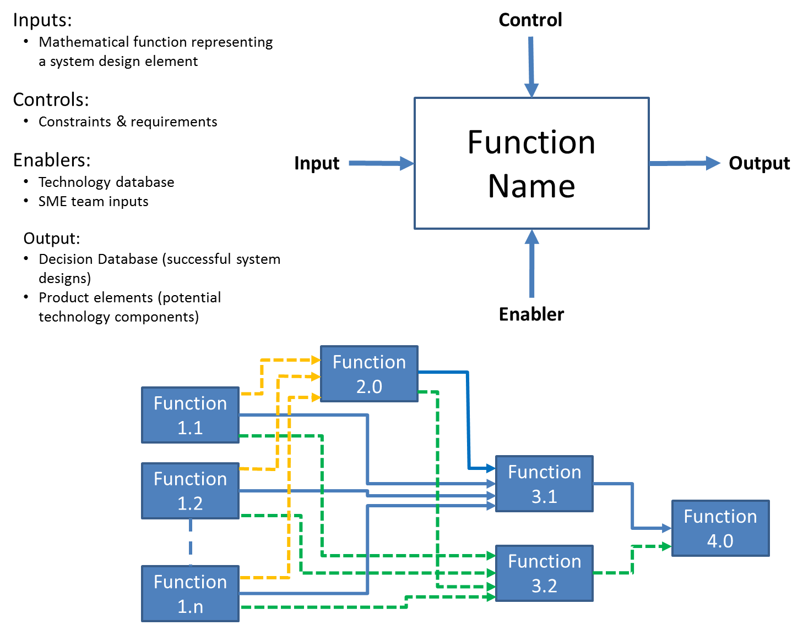
Figure 18: Sample of a functional flow block diagram, single level

a set of standards to ascertain its completeness, correctness, and consistency using the methods and criteria defined in the project documentation. Data validation follows the data verification process and uses information from the reference documentation to ascertain the usability of the data in light of its measurement quality objectives and to ensure that results obtained are scientifically defensible²⁶⁰.

Database guidelines
SMEs on the PM team will typically generate the technology database. The following are guidelines for completing this task:
- Technologies considered for the database must have achieved a level of maturity to offer a demonstrated capability. Industry and DoD program offices tend to start investing in technologies that are TRL-4, and integrating technologies that are TRL-6 or higher. Therefore the STMI database must consist of technology items that are TRL-4 (in development) to TRL-9 (fielded and commercially available). This gives the technology added to the STMI database at least a basic level of credibility and demonstrated proof-of-concept in a laboratory environment²⁶¹.
- Each of the technology entries and their performance capabilities must be verified and validated with a supportable reference and applicability to the design based on the customer requirements. SMEs must make judgment calls when including or disregarding technologies for evaluation. Tying a decision to a CRD reference is the most defensible method (i.e. if the CRD has a “no environmentally hazardous materials” constraint, then radioactive components could be removed from evaluation).
- The development schedule must include an estimated time to expend the development funds to bring the technology up to a TRL-6.
- Lifecycle costs should include the following:
  - Development cost: the cost to mature the technology to at least a TRL-6 level for insertion into the system design. It could be zero if the technology is an exact fit for the system design.
  - Unit cost: per unit purchase price for a defined block of units (i.e. 10, 100, 1000, or 10000).
  - Operations Cost: cost for users to operate the technology per year (i.e. power, training, and special consumable components).
  - Maintenance Cost: costs per year to keep an item in good condition and/or good working order. SME’s should emphasize early and preventative maintenance in their cost estimates. Assuming no failures or costing out part failure leads to inaccurate and excessive maintenance budgets²⁶².
  - Disposal Cost: end of life costs of an individual unit for recycling, hauling away to the dump, any residual sale value, or hazardous material charges).
As an example, a database entry for “Technology1” might look something like this for use in the system analysis, including performance measures, development costs and schedule, and lifecycle cost:

Technology1 (Name, mass (kg), power required (w), cost to develop to TRL-6 ($), schedule to develop to TRL-6 (months), unit cost ($), operational cost per year ($), maintenance cost per year($), disposal cost($))
or
Technology1 (Propulsion igniter #1, 1.1, 120, 4738000, 18.9, 250, 120, 200, 2000)

Performance data
Typically, key performance parameters of the technology are identified during the requirements engineering stage and are included as factors in the database (e.g.. material properties of density, strength and unit cost). When the SMEs are preparing the technology database, technology performance factors need to be referenced and applicable to the system being designed.

Cost and schedule estimation
Estimates of cost and time required achieving the systematic steps to a TRL-6 ranking and documenting lifecycle costs are a central pivot point for the STMI database and successful STMI process execution. All the cost estimates must also be verified and validated for use in the planned system design. Optimistic or biased estimates vs. ones linked to historical and engineering estimates can significantly skew the results of the optimized technology mix. The World Wide Web provides an enormous wealth of time and cost estimation guides based on technology or market areas from reputable government agencies and peer-reviewed periodicals (e.g. energy²⁶³, construction²⁶⁴, and nuclear power²⁶⁵). DOE G 430.1-1 (1997)²⁶⁶ and Ereev & Patel (2012)²⁶⁷ provide some additional guidelines for estimating specialty costs like R&D maturation and production. Additional “rules-of-thumb” can be applied to help balance the engineering estimate to account for the “unknown-unknowns” (many government offices use % “safety factors” against the engineering estimates that are based on the TRL level and SME experience).

Cost and schedule uncertainty model
SME estimates for technology costs and schedules are subjective and can be considered to be operating under uncertainty, holding the largest risk to the integrity of the technology database. In order to do better than a SME WAG (Wild Approximate Guess), the estimates can be further enhanced by incorporating a certain amount of statistical decision making which allows the decision maker to factor in acceptable risk levels and/or probability. If probabilities can be assigned, SMEs can now operate in a “decision making under risk” environment, where risk can be viewed as outcomes with attached probabilities. The probabilities are often estimated or defined from experimental data or historical data²⁶⁸. The best choice strategy becomes identifying the action with the best “Expected Value” (E_{i}) which is the summation of the reward (r_{ij}) times the probability of occurrence ($p_{j})$ of the reward for each state (s_{j}). The expected value with probability analysis is also known as a “realistic” risk decision view and is illustrated in Equation 7.

Equation 7: $E_{i}=\sum_{j=1}^{N}{r_{i,j}∙p_{j}}$

Expected values do not always accurately reflect choices made in practice; and this is particularly true when losses or gains involved are large, compared with the resources available²⁶⁹. There are problems associated with just going with the “results” of the decision making tools, given the reward (outcome) of either under-running or over-running your budget action. Selecting an action that yields a higher expected value means a reduced risk of failure, but a higher initial capital investment (which may be harder to secure). In the government acquisition community, having a higher expected value indicates you did not spend your entire budget, and that can mean money being removed from your program or a reduced budget in the future. Having a high or low expected value also indicates poor budget planning and resource management by the decision maker. The example presented in Table 9 illustrates the expected value calculations where a budgeted “action” is planned to develop a technology over a scheduled time period, with probabilities of completion assigned for each schedule option.
Table 9: Example decision making under risk (sample probabilities assigned)
The rewards (outcomes) are based on coming in over or under budget due to fixed and monthly variable costs of the technology development project. A recommendation for the SME (and use within the STMI database building process) would be to find the action (initial budget) that would yield an expected value as close to zero as possible, thus balancing the possibilities for a realistic budget to build a threshold technical capability coming in on the expected schedule. This is in effect applying a personal user utility (U_{i,j}) to the results, forcing the expected value equation to zero²⁷⁰ as illustrated in Equation 8.
Equation 8: $E_{i}=\sum_{j=1}^{N}{U_{i,j}{∙r}_{i,j}∙p_{j}}=0$

Operationally, iteration with a spreadsheet EV payout matrix (as illustrated in Table 9) can also meet the $E_{i}≈0$. When applied to the STMI database, the SME meta-tags the interested technology with the threshold performance capability, the budget (action) that forces the EV equation to zero, and the composite schedule ID defined by summing the products of the probabilities and schedule states.

Stage two: STMI core process
Like the classic problem faced by someone who is constrained by a fixed-size knapsack and must fill it with the most valuable items, STMI exercises the same practice, evaluating the best technologies for a system design. STMI stage two executes this technology evaluation process through three basic steps. Step one functions evaluate technology components from the STMI technology database for potential inclusion into a system design based on meeting a fixed set of customer requirements and constraints. These system components are then evaluated for interactions between the selected technology options and establish a successful system design. Step two takes all of the successful systems designs and ranks them by best value (BV), yielding the overall best BV system design. Step three takes the BV system design and lays out the individual technologies as a STP development schedule input, noting costs and time required to develop the technology mix. To illustrate this process, a sample system of an Air-to-Air Missile (AAM) designed to engage combat aircraft as described in the operation concept graphic in Figure 17 will be used and is presented in Figure 19.
This AAM example is not a complete system design, but is used to demonstrate the STMI stage-2 processes and the potential complexity of evaluating over 185 million potential system designs.

System design objective function operations (step-1)
To execute STMI stage-2, step-1, the system design component objective functions are applied from the STMI stage-1 system models developed by the SMEs. These objective functions are usually a deterministic set of design equations that form the basis to evaluate candidate technologies for each system component in a potential system design. They are the first “test” of a technology combination to see if they meet threshold customer requirements, which include the KPPs. For our AAM example, the first set of component objective functions are illustrated in Figure 20 and are designated 1.x. They evaluate the step-1 system design and technology matrix which is designated in matrix Equation 9 with the technology increments indicated by a-k.

Equation 9: AAM System Design (a, b, c, d, e, f, g, h, I, j, k)

Once successful components in the potential system design have been evaluated against the customer requirements/constraints, the interactions with other technology components are evaluated. Many of the technologies have interactive input to the system design (i.e. geometry, mass, power, temperature) and depending on the technology combination chosen, they can end up being ruled out due to system design constraints. Returning to our AAM example, the interactions include component power, mass and length contributions and are designated as 2.x, 3.x, 4.x and 5.x functional blocks. Each of the interaction functional blocks are still bound by the customer requirements and constraints, and access their appropriate section of the technology database for that particular evaluation increment.

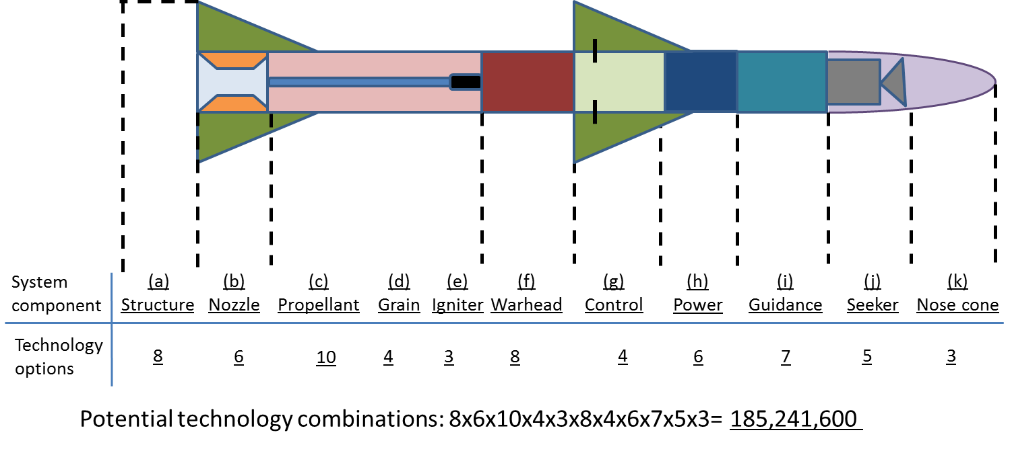
Figure 19: Sample AAM system design

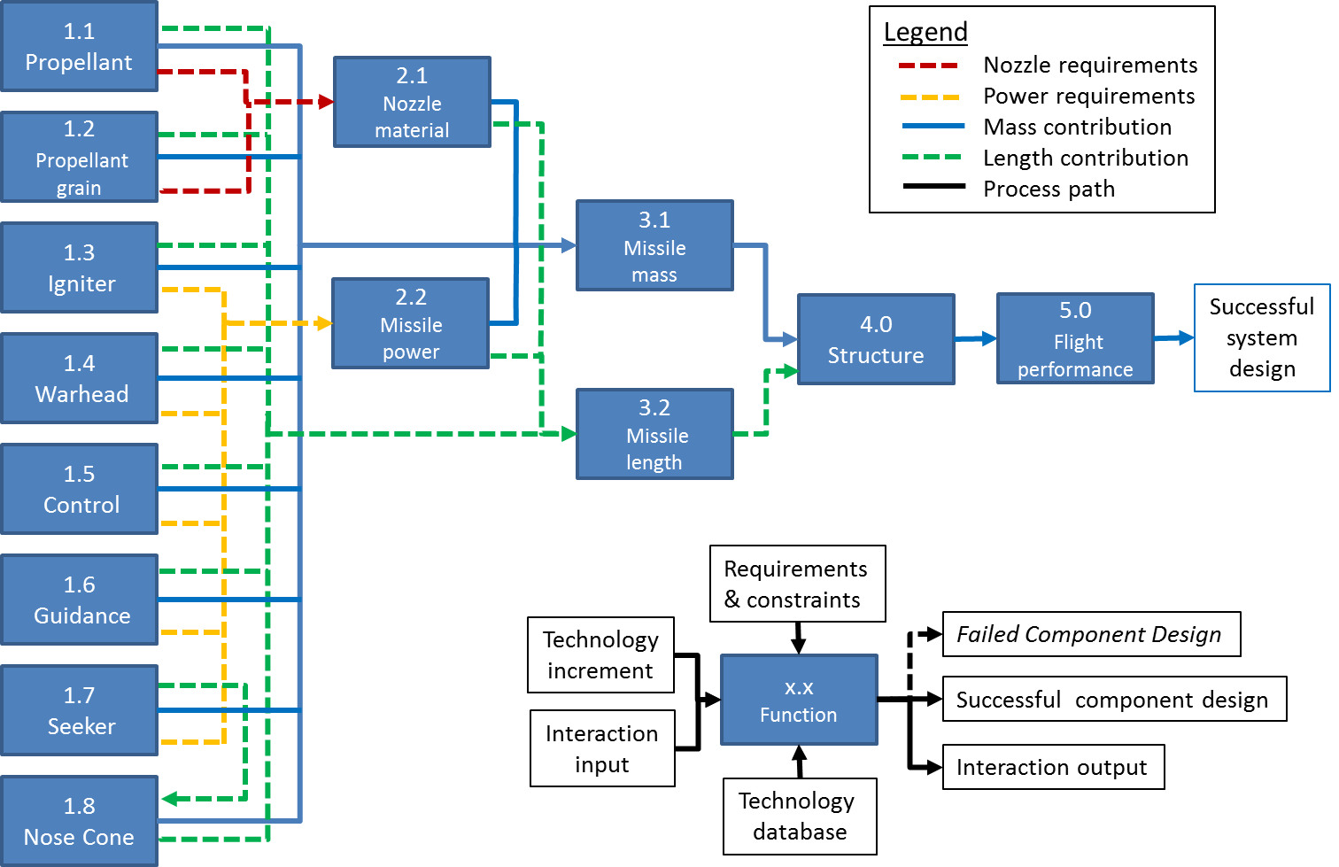
Figure 20: STMI system design Function Flow Block Diagram for AAM example

A failed component design fails the entire system design combination and the failed system design is removed from further evaluation. Successful system designs meeting the customer threshold requirements with solution sets of technologies are then passed along to the next step of the STMI stage-2 process to be ranked by the VE best value process.

Incorporating Value Engineering “best value” (step-2),
To execute STMI stage-2, step-2, the Value Engineering (VE) best value (BV) process becomes the primary determiner for the final system design. VE focuses on selecting the best successful system design from step-1 based on its overall lifecycle costs, from development through disposal. For each successful system design, the technology metadata tags are indicated by the design matrix noted in Equation 9. These technology metadata tags allow the STMI VE process to collect the cost data for each successful system design.
STMI VE uses the cost metadata to calculate a local “worth” value for each successful system design based on the technology solution set maturation cost to a Technology Readiness Level six (TRL-6) for system incorporation and unit cost. The lowest “worth” value of all of the successful system designs becomes the global system design worth or “minworth”. This “minworth” indicates the lowest cost to develop and purchase a system that meets the minimal (threshold) customer requirements.
STMI VE continues to use the cost metadata to calculate a local lifecycle “cost” value for each successful system design based on the customer specified design life of the system. This “cost” value is based on the technology solution set’s combined development maturation, unit, operational, maintenance, and disposal costs. This gives the specific system design a truer indication of the total costs over its expected lifespan.
Finally, STMI VE utilizes the global “minworth” divided by the local system design “cost” to generate a system BV which optimizes the costs associated with meeting the customer’s threshold system requirements. The technology set within the system design that yields the highest BV is the optimum system and get its costs and schedule requirements pulled from the technology database metadata and presented STMI stage-2, step-3 input data for the Strategic Technology Plan.
Figure 21 illustrates the STMI VE process for determining a BV for the AAM example for a representative 20 year operational lifetime with a purchase of 500 units. A successful system design’s individual worth (${Worth}_{System}$) are determined for this example with the number of units purchased (unit buy) in Equation 10. The overall minimum worth (${Worth}_{min}$) of the successful system designs is selected as the smallest ${Worth}_{System}$ of all successful system designs. Successful system lifecycle costs (${Cost}_{Lc})$ are determined for this example with yearly operations and maintenance costs in Equation 11. Individual system “best values” are calculated with Equation 12. The overall “best value” system has the highest “Best value” score and contains the recommended technology solution set for system development

Equation 10:${ Worth}_{System}= {Cost}_{Maturation}+{Cost}_{Unit}*\left(unit buy\right)$

Equation 11: ${Cost}_{Lc}={Cost}_{Maturation}+ {Cost}_{Unit}*\left(unit buy\right)$
$$+ {Cost}_{Operations}*\left(unit buy\right)*\left(operational lifetime\right)$$
$$+ {Cost}_{Maintenance}*\left(unit buy\right)*\left(operational lifetime\right)$$
$$+ {Cost}_{Disposal}*\left(unit buy\right)$$

Equation 12: ${Best Value}_{System}= \frac{{Worth}_{min}}{{Cost}_{Lc}}$

Trade studies in STMI stage-3 can focus on system designs with constrained developmental budges, which can yield different BV solutions (see note in Figure 21).

Strategic Technology Plan input (step-3)
STMI stage-2, step-3 takes the best value optimized system design and extracts the technology solution set developmental schedule and cost metadata. This metadata provides a listing of the best technologies, their required development schedule to attain a TR-6 maturity and the estimated cost to achieve that maturity level.
For the AAM example, the BV optimized system from Figure 21 is designated system design AAM-11,069,111 and is laid out for STP input in Figure 22.

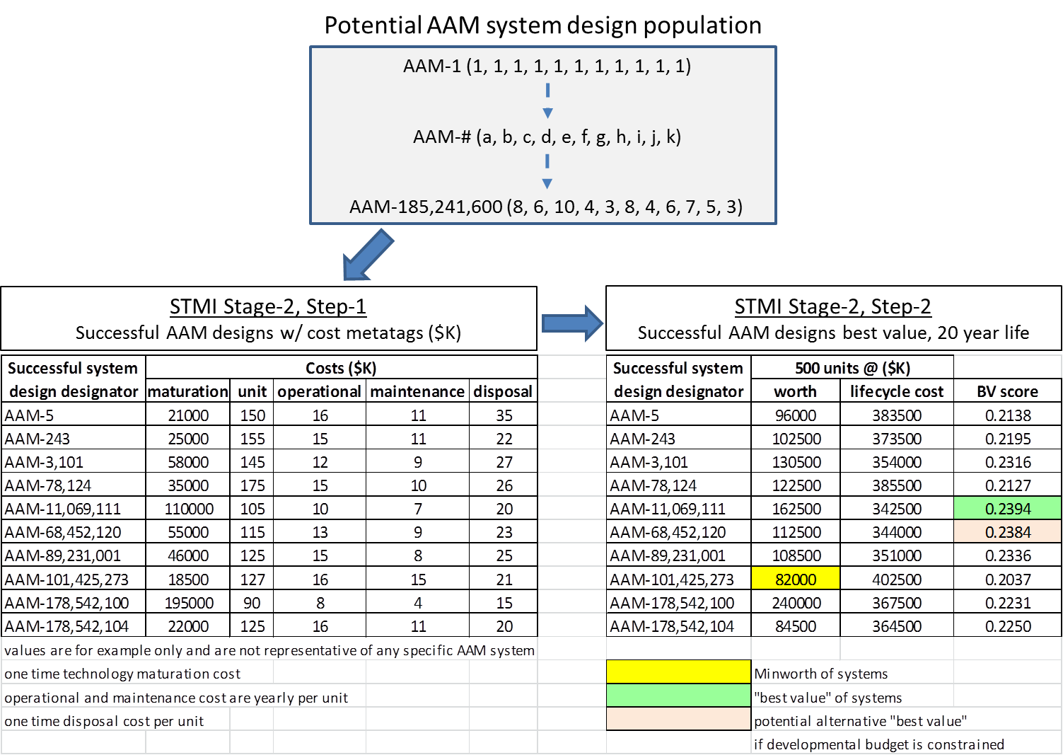
Figure 21: STMI VE process operation for “best value” selection
Figure 22: STMI BV system design metadata applied to STP schedule & budget
Its correlating technology dataset would be taken from the technology set matrix noted in Equation 9. With the matrix notation, the correct technology database entries would be accessed and provided for inclusion for the STP with a project planning software such as Microsoft Project²⁷¹. The PM’s team would use the STMI optimized technology data set to plan out the technology maturation schedule, noting where technology development could be overlapped (completed in parallel) given adequate budgetary support. Using the Functional Flow Block Diagram in Figure 20, dependencies of the technology interactions can be taken and modeled within the STP schedule input. Long lead items (technology requiring more maturation time) would be identified and accommodated within the STP. The completed STP would incorporate all of the technology component schedules and a proposed master yearly budget that can be prepared for the system design development. This master yearly budget would be based on the maturation cost for each technology and where their maturation schedule was placed on the STP.

Optimization process
To smoothly transition between STMI stage-2 steps, an evaluation methodology must be incorporated to examine the “population” of potential system designs. Two overarching optimization methods are presented to allow STMI stage-2 to evaluate the pool of potential technology combinations through its three step process. The first method is a looping algorithm designed to be an “all options” analysis, which guarantees finding the optimum BV design, but at a cost of time and computer processing power. The second method is a modern genetic algorithm (GA) metaheuristic analysis which can greatly reduce the analysis time at the cost of potentially generating just a “near” optimum BV solution.

All options optimization
The all-options optimization for STMI is set-up to evaluate all of the technology options for each system component and track the highest BV score.
The basic framework for the STMI all options algorithm is laid out next.

Technology matrix D(t)[a,b,c,d,e,f,g,h,….] (pulled from database)
t =0; t’=0; BestBV=0; BestSDt=0
minworth = 1
WHILE technology evaluation loops [a,b,c,d,e,f,g,h,….] are not complete DO
Evaluate system component designs D(t) against objective functions
IF D(t) is a successful design THEN
Establish system Worth(t) and Cost(t) score from technology matrix
IF Worth(t) < minworth THEN minworth =Worth(t)
BV(t)=minworth/Cost(t)
ELSE BV(t) = 0; Worth(t)=0; Cost(t)=0
ENDIF, t = t+1
ENDWHILE
WHILE t’<t DO (Best Value calculation for successful system designs)
IF BV(t’) > 0 THEN
BV(t’) = minworth/cost(t’)
IF BestBV>BV(t’) THEN
BestBV = BV(t’)
BestSDVt = t’
ENDIF
ENDIF, t’=t’+1
ENDWHILE
Return best BV solution found + best system design BestSDt

The first loop set becomes a series of nested DO-LOOPs, one for each technology component. Within these loops, the system components for each potential system design are evaluated against the threshold customer requirements, and interactions between components are addressed. Successful system designs are then tagged with their VE cost and worth values. The global minworth is tracked and an initial BV calculation is determined based on the current minworth. Unsuccessful system designs are removed from the BV calculations.
The second loop takes the final global minworth value and updates each successful system design with its final BV calculation. The best BV system design is tracked and provided as a final output. At the end of the optimization run, the best BV score is used for the step-3 final technology recommendation and maturation schedule for the system design. While this method is guaranteed to find the “optimum” BV score, it is computationally intensive and can take long periods of time to complete the analysis for systems with large technology component databases and complex interactions.

Metaheuristic search optimization
Since the majority of the computational power required for the optimization occurs during the object function evaluation, if solutions could be evaluated without every single technology option explored, a significant computational time savings can be realized. Metaheuristics offer a means to balance computational efficiency while retaining acceptable accuracy. Given the non-continuous nature of the technology “population” being evaluated, a population based Genetic Algorithm (GA) metaheuristic was developed to speed-up the STMI stage-2, step-2 optimization process.
The reduction of system computational requirements is illustrated in Figure 23 when comparing “all-options” optimization and the GA optimization.
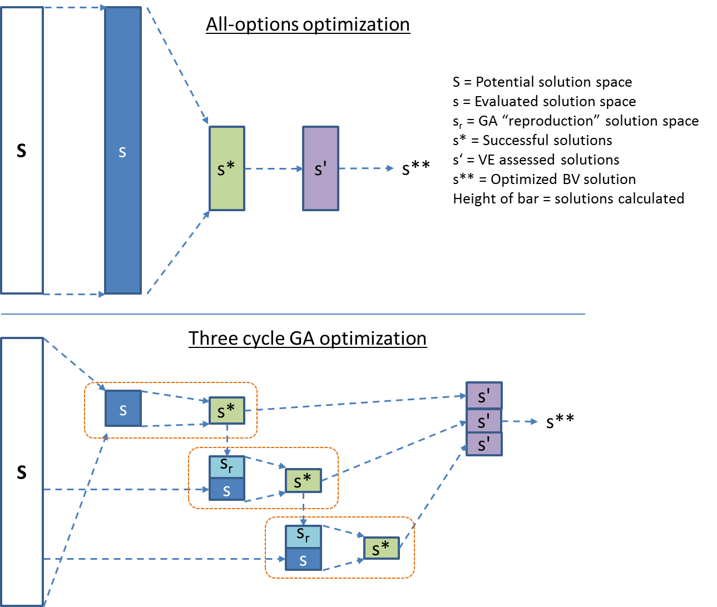
Figure 23: Computational requirements illustration between optimizers
This GA offers several advantages over traditional parameter optimization techniques. Given the non-differentiable or otherwise ill-behaved (non-continuous) problem associated with the STMI technology analysis, many traditional optimization techniques are of no use or tend to converge to a local optimum once they are in its vicinity. Since the GA does not require gradient information, it can be used to search highly nonlinear spaces for global optima. GAs conduct search from many random points simultaneously, and are therefore more likely to find a global optimum, especially when examining real-world, multi-objective optimization where meeting various requirements are specified²⁷².
The framework for the STMI GA algorithm is laid out next.

Generate initial random population P(0) with s samples
Hash table generation/check
Termination condition (set by user)
t =0
minworth = 1
BVdesign = 0
WHILE termination conditions not met DO
Evaluate new P(t) population against objective functions
Execute VE operations
Calculate Cost(t) and Worth(t) for new surviving s* sample of P(t)
IF Worth(s*) < minworth THEN minworth =Worth(s*)
Establish BVscores(s*) for all surviving s* sample of P(t)
IF BVscore(s*) > BVdesign THEN BVdesign2 = BVscore(s*)
Execute genetic operators
P'(t) = Select s*/2 of the best (P(t)) based on BV scores
P''(t) = Apply Reproduction Operators(P'(t)) to fill (s-s*)/2 population samples
Hash table check
P(t+1) = P(t) + P’’(t) + new random population fill based on (s-s*)/2 samples
(brings population back up to s samples)
Hash table check
Check termination condition
IF (BVdesign – BVdesign2) < termination condition
THEN termination condition met
ELSE BVdesign = BVdesign2
t = t+1
ENDWHILE
Return best solution found

To initiate the GA algorithm, STMI first generates an initial random population out of the total system design population pool. The number of samples “s” is user selectable and finding the best starting value is traditionally difficult²⁷³ and system dependent. GA experts recommend having at least 50 to 500 random samples of the total population pool to get an initial starting population²⁷⁴, depending on the number of factors being addressed (more factors, higher sample number). The algorithm also checks each generated member against a “hash table” which tracks all designs placed in the “s” sample group. When a new potential design is to be added to the sample population (either randomly or through the reproduction operators), the algorithm checks the hash table for any duplicates. If the new potential design is a duplicate, it is thrown out and the design operator is repeated until a new design is generated that is unique to the “s” sample pool.
The GA algorithm starts and ends with a set sample population pool “s” placing it in the “steady state” population style of GA designs. This is beneficial from the standpoint of creating a reduced memory load, but runs the risk of prematurely converging to a few highly fit individuals²⁷⁵. The other advantage of the SMTI GA algorithm is that the number of fittest “parents” in P’(t) and consequently “children” in P’’(t) are variable, based on number of system designs surviving the objective function fitness criteria. To minimize premature convergence, the GA algorithm injects additional random population picks at the P(t+1) stage to diversify the population through the next fitness assessment with the objective functions.
Within the STMI VE algorithm, the objective functions for each system component are the first survival “fitness” tests for each system design population member. Unsuccessful designs “die” and are removed from the population list, (s). “Survivors” or successful system designs population (s*) flow into the VE best value analysis. The successful system designs within the top 50% of the BV scores are chosen to “procreate” with the genetic operators. New system design “children” are generated and replace half of the “dead” (s) population. An additional round of random population generation fills in the second half of the “dead” (s) population. This cycle repeats until the best BV score only changes by a user selected amount.

Optimization for STMI
For this research, a Microsoft Excel spreadsheet was selected demonstrate the STMI “all case” algorithm operations. The main advantage of this approach was twofold. First, that the spreadsheet analysis provides an excellent “visual” of the operations and the specific factors that most impact the overall system design. Second, the initial implementation guaranteed an optimum result for the system design solution space, demonstrating the applicability of the STMI process. The limitation of this approach was that the spreadsheet tends to be resource limited to a smaller system population sets.

Micro and Macro STMI operation
The STMI process also allows a PM to conduct apples-to-apples comparisons of BV for macro-level system designs (i.e. a final system selection for production) while optimizing micro-level systems (i.e., demonstration prototypes vying for a development decision). For example, let’s expand out the illustration in Figure 24.

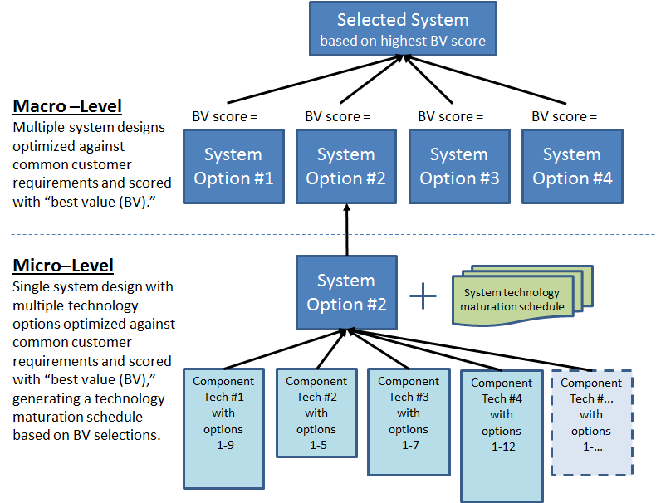
Figure 24: STMI macro-micro system optimization process
STMI offers a micro-level BV design for one macro-level system design proposal that meets the primary customer requirements. The PM has had all the macro-level systems optimized in a similar manner. Since the “worth” basis for each system was defined at the micro-level, it is carried up and compared at the macro-level with its peers. The lowest macro-level “worth” is selected as the overall macro worth and a new BV score is generated for each of the designs based on the overall macro worth divided by the individual macro-level lifecycle cost. The recommended overall design has the highest BV score and its corresponding technology database entry provides the specific technologies to develop by the PM team.

Stage 3: Post-process analysis

Trade-off study analysis
Once the initial STMI plan is generated, additional “what if” trade study scenarios can be rapidly performed to:
- Examine additional alternative technologies early in a program concept (add new technologies to the database for consideration)
- Analyze available trade-space within the design (change the requirements)
- Show impacts to system cost and schedule if component technology timelines and/or costs are constrained (limited development budget, or limited schedule availability)

Sensitivity analysis
To address PM’s concerns with data uncertainty and propagation through the STMI objective functions, two types of sensitivity analysis are recommended. The first type is a One-Variable-at-a-Time (OVAT) sensitivity analysis, where a single key factor is varied and results examined. The second type is a Design of Experiments (DoE) approach that allows multiple key factors to be purposefully varied together and then accurately predict how the inputs and their interactions affect the outputs.
For the AAM system design example, primarily cost data will be the variables of choice to examine. The system’s technology performance levels are held constant while the cost associated with developing them are allowed to vary in the maturation costs. Further sensitivity analysis runs could also be performed in a similar manner by changing the technology performance levels and examining the design changes in the BV results.

OVAT approach
A common approach to executing the OVAT for a sensitivity analysis is to identify the critical input variables (performance, schedule and cost) for the top BV system design technology mixes, and vary them upon an optimistic (best case) value, most likely (expected or baseline) value, and pessimistic (worst case)²⁷⁶.
The resulting BV scores are then recorded and compared. The range of the BV scores, indicated in Equation 13, gives an indication of risk level (larger the range, higher the risk due to changes in the input variable) and an example is illustrated in Table 10 where the lowest range values are noted in blue highlight.

Equation 13: OVAT BV Range = (BV “best cost” score) – (BV “worst cost” score)

Upon review of the Table 10 OVAT sensitivity analysis, the PM’s team would then offer the best designs (ones with lowest ranges of BV change for a given high/low input set) for each of the critical input variables. A PM concerned with cost changes due to a potentially longer system operational lifetime might select the technology set within the AAM-11,069,111 design which shows a lower BV range (risk indicator) compared to all of its competing designs. A PM primarily concerned with operational lifecycle costs impacts would also have a clear winner with the AAM-11,069,111 design due to four of the five cost BV ranges (risks indicators) being lowest. If near term fiscal realities where the driving force, either in defending the budget for the number of units bought or defending the research and development funding to mature the new system’s technologies, the AAM-101,425,273 or AAM-3,101 system designs might be less risky options to explore.

Table 10: Example of OVAT sensitivity analysis with AAM system design
All of the AAM options presented in the sensitivity analysis are viable AAM system designs just by the nature of the VE analysis. The PM would be using the sensitivity analysis to help balance the risks associated with picking the final design. Additional detailed analysis would follow-up the initial design to confirm risk indicators noted in the sensitivity analysis.

DoE approach
A strategically planned and executed sensitivity analysis may provide a great deal of information about the effect on a response variable due to one or more factors. Initial analysis may involve holding certain factors constant and altering the levels of another variable.
The OVAT approach to process knowledge is, however, inefficient when compared with changing factor levels simultaneously. If the PM had additional concerns over multiple technologies, schedule or cost factors impacting the design at once, the PM would direct the design team to evaluate multifactor changes to the design with DoE instead of the single factor OVAT methodology. DoE allows for multiple input factors to be manipulated in determining their effect on a desired output (response). By manipulating multiple inputs at the same time, DOE can identify important interactions that may be missed when experimenting with one factor at a time.
For each factor under consideration, the extreme but realistic high and low levels to be analyzed must be selected. The extreme levels selected should be realistic, not unreasonable. The factors and levels are entered into the analysis design matrix and STMI conduct the BV analysis to provide the result for analysis.
The American Society of Quality (ASQ) maintains an excellent website (http://asq.org/learn-about-quality/data-collection-analysis-tools/overview/design-of-experiments.html) within which design teams can learn about applying DoE principles and utilize template DoE spreadsheets which allow fairly fast-turn DoE analysis. Utilizing the ASQ DoE template, Figure 25 illustrates a 3-factor DoE sensitivity analysis approach with the deterministic STMI AAM system design data applied. Using the “best value” AAM-11,069,111 design from Figure 22 as the system base, and maturation cost, unit cost and expected lifecycle time as example factors with the same ranges as

Figure 25: DoE ASQ template, sensitivity analysis for deterministic AAM example

used in the OVAT analysis, the DoE sensitivity analysis yielded the following conclusions:
- The lifecycle time (Factor C) yielded the highest impact on the BV scores. The AAM-11,069,111 design becomes a less attractive option from a BV standpoint the longer the system lifecycle is drawn out.
- When maturation cost (Factor A) and lifecycle time (Factor C) change, they have the highest interacting effect, which is fairly minimal compared with the individual factors.
- All three factors taken together have very little interacting effects.
As single trial of the DoE approach was conducted due to the deterministic nature of the system design equations. If the system design and/or database incorporated data variability (stochastic), multiple trials of the DoE would be conducted and averaged to generate the complete DoE analysis.

Sensitivity Analysis with optimizer
As a precautionary note, the sensitivity analysis should be recompleted with the “all-option” STMI process to be able to address the same system of DoE interest run after run. Utilizing metaheuristic optimizer like the GA may yield different system designs due to the random analysis factors inherent within the process. If the metaheuristic did not select the system design of interest being examined by the multi-factor DoE analysis, it would interfere with the overall analysis.

Incremental delivery analysis
The STMI optimization for BV can also be adapted to generate incremental deliveries for a proposed system as customer requirements are updated or additional technologies are identified to be inserted into a system design. By changing the optimization threshold or evaluating updated technologies, the STMI process can strive to meet the new customer requirements, and lay out a new STP. This would allow the PM team to layout incremental upgrades to the baseline system design and identify key changes in the technology mixture that must be matured to meet the upgraded system capability.

Methodology and case study
Chapter four presents a case study example of the STMI process through all three process steps to build a long term Strategic Technology Plan (STP) to meet a long term customer need. Each step of the STMI methodology will be conducted in the context of the case study scenario. The case study scenario background will be provided to set the stage for STMI operation by a PM team examining options to meet the customer need (macro level) and also include a specific system design to become one of those options considered (micro level). The STMI process will be used to create a common “best value” evaluation criterion across all options and to present a technology set recommendation for inclusion into the capability STP.
The case study is meant to be a detailed example of the STMI methodology, providing additional insight into the process steps compared with the AAM example provided in Chapter Three.

Case study: National electric grid Frequency Regulation (FR) options

Scenario background
The Federal Government’s growing concern for national power grid Frequency Regulation (FR) has jumped dynamically as renewable energy sources (solar and wind) have been increasingly integrated in the regional power supply mix. However, solar and wind are not constant and reliable sources of power. The variable nature of these renewable sources causes significant challenges for the electric grid operators because other power plants (usually fossil fueled power plants) need to compensate for the variability. During the day, wind power can be a few gigawatts (GW) at some moments and only a few megawatts (MW) and even zero at others, as illustrated in Figure 26 Similarly, Figure 26 also indicates solar power is generated only during the daytime and varies when clouds pass by²⁷⁸. A 2007 report from California Independent System Operators (CAISO) indicated that with the addition of renewable energy sources and their inherent power variability (due to clouds, day/night cycles, wind sources), there would be a need in California alone for 730 MW of additional regional FR capability by 2015 and growing at a rate of 120 MW per year²⁷⁷.

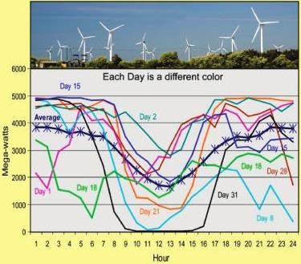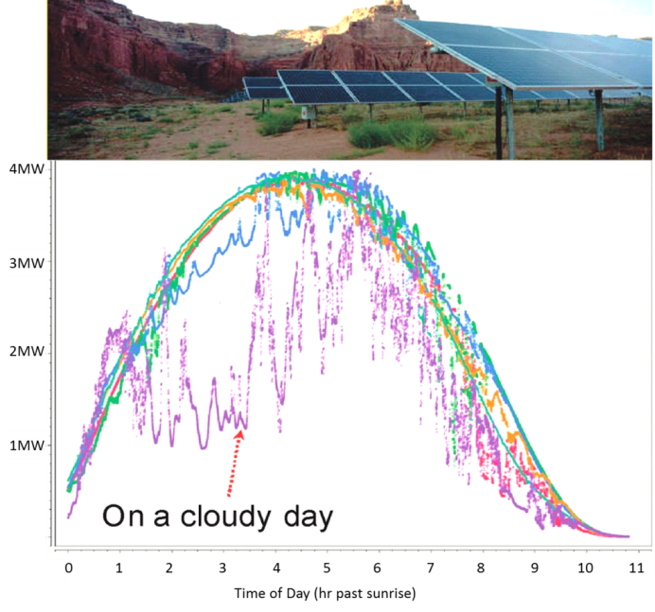
Figure 26: Daily profiles of wind power in Tehachapi, California and 5 MW solar power array output over 6 days in Spain

FR involves Independent System Operators (ISOs) that operate regional power grids to contract with smaller power providers to help balance loads on the grids under their control. On a perfect grid, consumer electrical demand would match utility electrical supply, allowing ISOs to keep the standard electrical grid frequency at 60 Hz. But as electrical demand waxes and wanes during daily cycles, primary power suppliers take time to ramp-up or ramp-down power plant output. This causes variation in the 60 Hz standard electric frequency, and any significant variation can cause damage to utility and customer electrical systems. However most fluctuations are of short duration since primary power utilities take 10-20 minutes to ramp up or down large generating systems. Therefore, FR requires mega-watts of power instantaneously, with 98% of the fluctuations being handled within 15 minutes²⁷⁹. Figure 27 illustrates a daily power grid cycling operational scenario and areas were FR is required to help balance the load between power plant output changes²⁸¹. Once the variability of renewable energy sources is included in the daily power grid cycle, FR becomes a critical feature to maintain the grid. Table 11 illustrates the basic threshold requirements for a FR power system.
Another key attribute is that ISOs pay FR system owners for the power that is pulled or pushed into the grid to maintain the grid frequency. Although the payment per Megawatt (MW) per year varies by ISO, it is typically $175,000 to $250,000, with an average value of $212,500²⁸⁰.
To examine this issue, the PM’s company was commissioned to do a study by the US Department of Energy (DOE) and Federal Energy Regulatory Commission (FERC) exploring the best near term (0-5 yrs) methods for national power grid FR. DOE and FERC want a recommendation of technologies that can be developed and implemented within those time frames. Key trade studies will include relaxed system mass and geometry requirements, FR capability compensation and composite material costs. A data sensitivity analysis is also requested to examine system development, unit and lifecycle cost variation by 20% to identify key areas that must be watched for cost impacts. Finally, a future upgraded FES that is smaller and lighter by 25% for potential integration into vehicle and mobile applications.

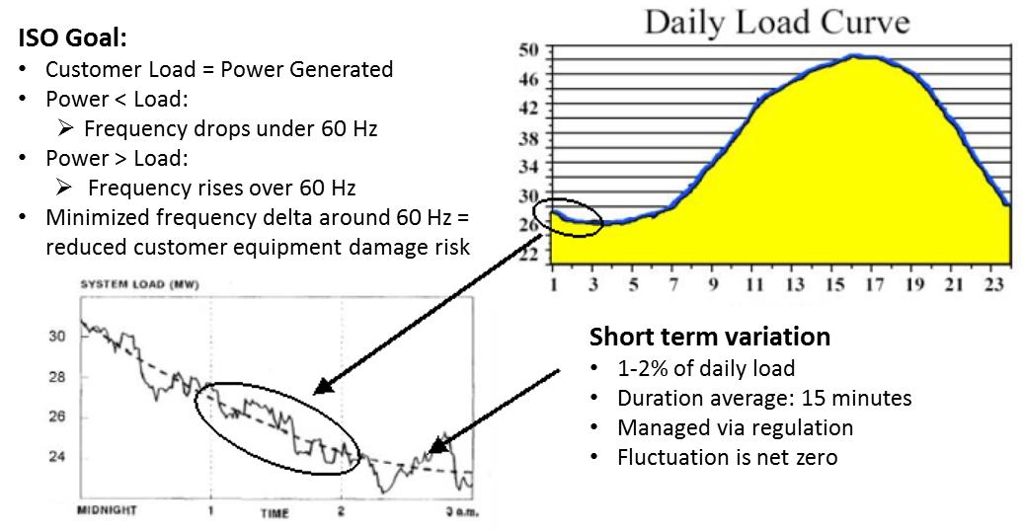
Figure 27: FR requirements in a 50MW market daily power cycle operational scenario

Table 11: FR system requirements, 1000MW market
Requirement | Threshold level | Notes
Power reserve²⁸² | 20 MW for 15 minutes (5MWh) | 2% of 100MW
Response time²⁸³ | Full reserve capability within 5 minutes | Based on ramp times
Cycles per day | 48 power up + 48 power down cycles of 15 minutes each | Based on a 24 hr day cycle

The DOE and FERC want an unbiased analysis from a third party (non-utility) and insist that the STMI “best value” methodology be employed to create an “apples-to-apples” comparison of the technologies available when lifecycle costs are compared.

FR system options available
Current systems able to meet FR operational scenario have been reviewed in reports from the California Energy Storage Alliance (2010)²⁸⁴ and Department of Energy (2013)²⁸⁵ and are summarized in Table 12.
Table 12: Current FR system technologies
FR system | Power type | Typical ramp rate  (% power in 5 minutes) | Round trip system efficiency
Combustion Turbine^{286,287} | Generated | 25.4-100% | 31.5%
Pumped Storage Hydropower (PSH)^{288,289} | Stored/ Generated | 100% | 81%
Compressed Air Energy Storage (CAES)^{290,291} | Stored/ Generated | 50% | 55%
Lithium Ion Chemical Battery^{292,293} | Stored | 100% | 80%*
Dry Cell Chemical Battery²⁹⁴ | Stored | 100% | 86%*
Sodium-Sulfur Chemical Battery²⁹⁵ | Stored | 100% | 80%*
Flywheel Kinetic Battery^{296,297} | Stored | 100% | 85%
*Does not include battery temperature conditioning losses of 1-3%
Pumped Storage Hydropower (PSH), chemical battery arrays and kinetic Flywheel Energy Storage (FES) technologies are energy storage technologies uniquely capable to handle high load, short duration FR power requirements. These energy storage technologies can rapidly recycle electricity from the grid by absorbing it when the supply is greater than demand, and injecting it back when needed to meet demand, thus helping to stabilize the frequency of the grid. These responsive technologies have the ability to inject or absorb their full load rating instead of having a reserve capability due to system ramp rates.
Figure 28 provides a 2010 current worldwide summary of energy storage technology use²⁹⁸. Figure 29 provides an illustration of FR system operational scenarios.
Figure 28: Worldwide installed storage capacity for electrical energy

Combustion Turbine: As the most common type of FR capability, combustion turbines generate power on demand, typically utilizing natural gas as a fuel source. The main advantages are a highly reliable, established technology that can be incorporated into existing power plant facilities with the ability to be powered up and down rapidly when operation is required. Disadvantages include slow ramp-up times which require excess capability to be available to meet FR requests, low efficiencies, high carbon footprint, and medium level of capital building costs.

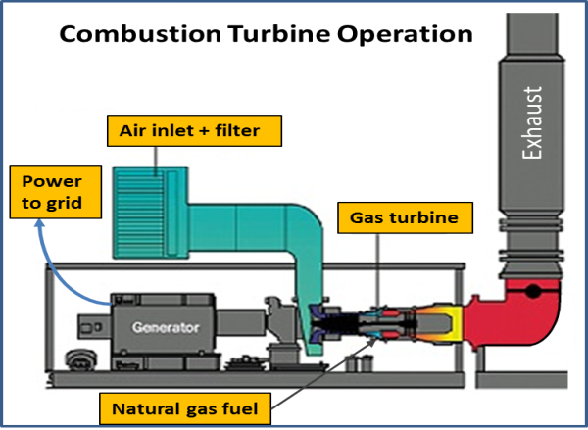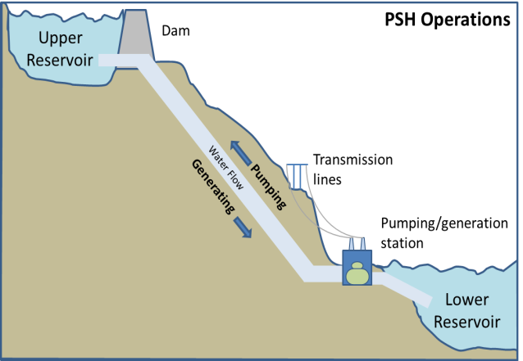
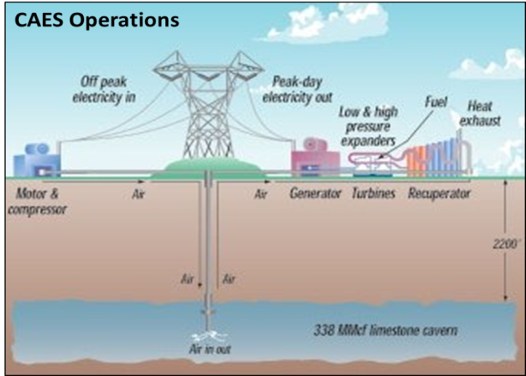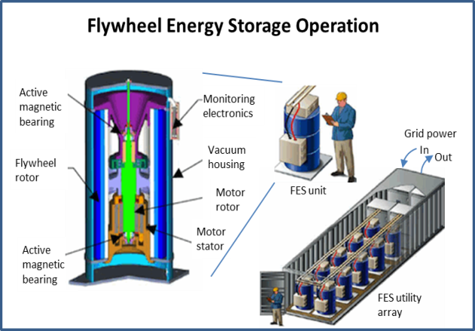
Figure 29: FR systems operation diagrams

Pumped Storage Hydropower (PSH): PSH operates by moving water between two reservoirs at different heights by means of a pumping system and a hydroelectric generation plant. Electricity is generated from the kinetic energy of water as it flows downhill through a generator turbine and is stored as potential energy when it is pumped uphill. Most PSH systems are located in hilly or mountainous regions with sufficient rainfall or access to a water resource (river or lake). Advantages are high capacity, low maintenance and long operational life. Drawbacks are its high initial capital cost, fixed geographical and environmental restrictions placed on a reservoir or dam site, and sensitivity to drought conditions.

Compressed Air Energy Storage (CAES): In a CAES system, a large underground space (usually an unused mine) is used to contain air at a high pressure. Excess power from the grid is used to compress air and pump it into the storage space. When power is needed, the air is released, expanded and used to drive power turbines. Current CAES systems are located above old mines or natural caverns which serve as the compressed air storage facility. Advantages are similar to PSH with moderate capacity, low maintenance and long operational life. Disadvantages include fixed geographical restrictions/access, and dealing with efficiently expanding the compressed gas (usually coupled with a combustion turbine in a “supercharger” mode, reducing fuel requirements by 40%)²⁹⁹.

Electrochemical Battery Energy Storage: An electrochemical battery is a device capable of either deriving electrical energy from chemical reactions or facilitating chemical reactions through the introduction of electrical energy. FR grid scale electrochemical batteries absorb excess electricity directly from the grid when the power load is too high, and returns the electricity directly to the grid when power load drops too low. Current grid scale systems include Lithium-ion (A123 technologies), Dry-acid (Xtreme Power Inc.) and molten sodium-sulfur (EaglePicher Tech). Advantages include medium to high energy densities, low cost, scalable, and relocateable based on utility needs. Disadvantages include limited depth of discharge, decreased performance over time, high levels of monitoring/maintenance, temperature sensitivity, environmental and safety hazardous materials, unknown exact charge level, and chemical battery replacement after 4-7 years.

Flywheel Kinetic Battery - Flywheel Energy Storage (FES): FES systems absorb excess power from the grid and store it as kinetic energy in a high speed (16,000-60,000 rpm) spinning rotor spinning in a near frictionless vacuum enclosure. A high efficiency motor-generator provides the transfer between electrical and kinetic energy to and from the grid and spinning rotor. Like chemical battery systems, FES units can be placed where ever rapid reaction FR capability is required. Advantages include high energy densities, high power throughput, fast power response time (20 milliseconds)³⁰⁰, low maintenance, negligible environmental impact, temperature insensitivity, exact charge status (rotor rpm = energy) and 20+ year operational lifecycle³⁰¹ with unlimited deep charge and discharge cycles. Disadvantages include high rotor material costs, scalability of power and energy components, and standby frictional power losses.

Micro analysis: Kinetic FES System
The PM’s team subdivided the FR system analysis and assigned the kinetic FES system analysis to this research case study. All of the individual FR systems will then recombine for the final analysis and recommendation in the Macro-level STMI process in section 0.

FES system background
The idea of storing energy in a rotating wheel has been utilized since 2400 BC, when Egyptians used hand-turned stone wheels to craft pottery and millers used powered millstones to crush grains³⁰². In the years between 1800 and 1950, traditional steel-made flywheels gained application areas in train, car and bus transportation, and smoothing power draw from electrical sources. Modern FES systems began in the 1970’s and began with systematic improvements utilizing high strength composite materials, magnetic lift bearings, efficient power electronics and modern control systems.
Flywheel based energy storage applied to electrical grid FR management has also become a potential “green energy” alternative. FES systems provide a rapid, low impact response capability to match utility fluctuations in power more effectively and reliably than either chemical battery systems or rapid cycling natural gas fired generators³⁰³. Modern FES systems are environmentally friendly, incorporating zero hazardous chemicals, generating a zero CO₂ footprint, and have round trip energy efficiency of over 85%³⁰⁴. For customers comparing system lifecycle costs, the 20+ year FES design life with unlimited power cycles and nearly maintenance free operation is very attractive.
For comparison, only one Flywheel company, Beacon Power³⁰⁵, has expanded into the larger, flywheel technologies usable for commercial high power FR vs. smaller applications, such as Uninterruptable Power Supply (UPS), as illustrated in Table 13. Beacon Power’s Smart Energy 25 flywheel design will be the “immediately available” FES system while the case study FES micro level design and optimization is conducted for the near technology development system improvements.
Table 13: Commercial flywheel technology providers
Tech Company | Flywheel Application | Power Rating  (KWh) | Rotational Speed (max) | Flywheel Materials
Beacon Power³⁰⁶-Smart Energy 25 | Frequency Regulation | 25 | 16,000 rpm | Carbon Fiber / Fiberglass Rim  w/ Steel Rotor
KineticTraction³⁰⁷ | Kinetic energy recovery | 1.5 | 36,000 rpm | Carbon Fiber
Vycon³⁰⁸ | UPS | 0.83 | 36,750 rpm | Steel
PowerThru^{309,310} | UPS | 0.53 | 56,000 rpm | Carbon Fiber
ActivePower³¹¹ | UPS | 0.33 | 30,000 rpm* | Steel
Temporal Power³¹²  (new to market in 2014) | Frequency Regulation | 50 | 20,000 rpm* | Steel
* Approximation based on material strength, size and power rating

STMI stage 1: FES requirements, functions and technology database

FES design requirements and constraints
In examining the FES FR facility for this case study, the PM and customer have established a few baseline assumptions and Key Performance Parameters (KPPs) used to address the requirements in Table 11 and are summarized in Customer Requirement Document (CRD) on Table 14.
Table 14: Customer Requirements Document (CRD) summary
Reference | Category | Requirement/constraint  description | Threshold  value
1.1 | Geometry | FES kinetic rotor  radius | 0.45m
1.2 | Geometry | FES system length = 3 x rotor diameter | 2.7m
2.1 | Safety | Metal rotor safety  factor | 40%
2.2 | Safety | Composite rotor safety  factor | 25%
3.1 | Efficiency | FES system round trip  efficiency | 85% (KPP)
4.1 | Power | FES rotor sized for 50KWh +15% reserve | 58.9KWh (KPP)
4.2 | Power | FES motor/generator rated output power level | 200KW (KPP)
5.1 | Mass | FES system mass limit for 2Ton forklift transport at 80% load | 1600kg (KPP)

First, the FES FR facility will be set up in a modular style array, similar to the Beacon Power facility in Stephentown, New York³¹³ pictured in Figure 30. Given the customer requirement for a 20 MW (5MWh) facility, the FES FR modules will be designed for a KPP power output of 200KW and a storage level of 50KWh with a 15% reserve to account for round trip electrical losses. This yields a FES FR facility requiring 100 individual FES units linked together as illustrated in Figure 30.
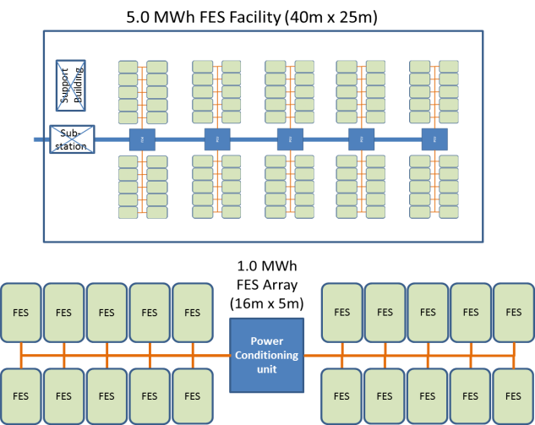
Figure 30: Beacon Power FES Facility and STMI Case Study FES Facility
Second, the individual FES units must be able to be lifted and repositioned with a standard light duty two metric ton forklift at 80% load. This provides an upper limit to the system mass KPP at 1600 Kg or 3528 pounds and addresses a key manufacturing, installation and maintenance cost reduction that plagued Beacon Power systems (just the Smart Energy 25 FES rotor unit weighed in over 2500 lbs each with the FES unit weighing in over 5000lbs and required loading cranes to move each unit)³¹⁴.Using the 2T forklift also imposes a PM recommended physical size limit on the FES system for the length to be less than three times the rotor diameter.
Third, the FES rotor units will have an embedded 25% safety factor for composite material technology and 40% safety factor for metal component technologies based on the material tensile strength resistance to rotor hoop and radial stress. This is based on the historic catastrophic failure modes for composites (many smaller, rotational fragments with low energy) and metal alloys (few large, translational sharp edged fragments with high energy) and their potential for penetrating the FES containment shell³¹⁵.
Fourth, the FES unit will have a KPP minimum 85% round trip energy efficiency to meet levels offered by other advertised FES systems. This efficiency is defined as energy put into the motor/generator from the utility grid, transferred to the flywheel, stored in the flywheel, pulled from the flywheel by the motor/generator and then returned to the grid through the motor/generator. The rotor system will be sized 15% higher than the 50KWh (50/0.85 = 58.9KWh, rounded up) to account for potential losses. Systems with common energy loss areas are the bearings, vacuum environment, control system and efficiencies of the motor/generator.

Note: Any FES system with round trip energy efficiency greater than 85% will be given an “earning bonus” in the operations costs based on the FR payment (lowers ops cost for system). For example, when comparing an 85% and 92% efficient FES, at 92% efficient system will have an additional 4.1 KWh or 16.4 KW available on a baseline 50KWh, 200 KW FES system design. Based on FR payment average noted in section 4.1 ($212.5/KW/yr), the 92% efficient FES would earn $3485 more per year (noted as negative operations cost) over the baseline 85% efficient FES design.

FES system overview, key parameters and system models
The core concept to understand regarding flywheels has to do with the conversion of energy. FES energy is stored as kinetic energy, for however long it may be required. To accomplish this, a rotor spinning inside a casing which provides vacuum and structural support, spins at higher angular velocities as more energy is stored. As energy is removed the angular velocity is consequently decreased. To do this and create a complete system that is useful for energy storage, several components are required, including the flywheel itself, the vacuum enclosure, bearings, power transmission motor/generator, cooling, and system controls. For the purposes of this illustrative STMI case study, a limited selection of potential technologies listed in Table 15 for the FES system design presented in Figure 31 will be examined.
Based on the number of technology options, there are up to 1800 potential FES design combinations to be analyzed. Final unit costs will be based on costs to build 100 units. Installation and power conditioning electronics for the full FES FR facility are assumed to be two times the final unit costs³¹⁶.
Flywheel design and material
The flywheel is undoubtedly the heart of the FES system. Also commonly called rotors, flywheels can vary in shape, size, and material. One way of characterizing its shape depends on its geometry, and therefore moment of inertia. This is commonly referred to as the ‘shape factor’, ‘K’, which is a dimensionless quantity. The amount of energy ‘E’ stored in a flywheel varies linearly with moment of inertia ‘I’ and with the square of the angular velocity ‘ω’, which can be calculated with Equation 14 and Equation 15.
Equation 14: Flywheel kinetic energy $E= KIω^{2}$

Where common ‘K’ shape factors are tapered disk (1.0), constant stress disk (0.931), constant thickness disc (0.606), thin rimmed cylinder (0.5), and constant stress bar (0.5)³¹⁷.

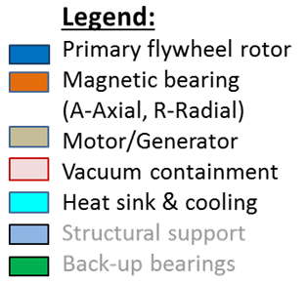
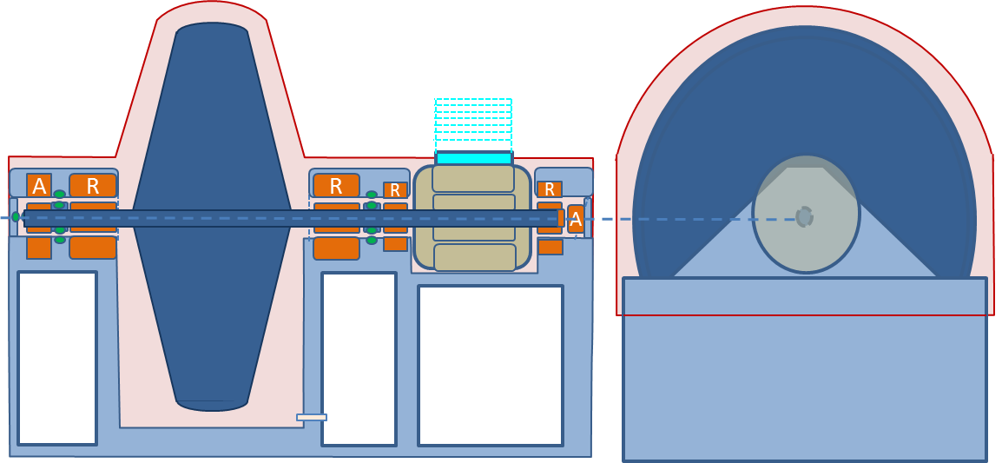

Figure 31: Key FES functional areas

Table 15: FES functional areas and initial technology options
Functional  Area | Technology
Functional  Area | 1 |  | 2 | 3 | 4 | 5 | 6
Flywheel  design | Disk | Hub & Cylinder | Advanced  3-D | Advanced  3-D
Flywheel  material | Steel  ASTM A514 | Aluminum 2014-T6 | Composite Laminate  (E-glass) | Composite Laminate  (S-glass) | Composite Laminate (AS4C) | Composite Laminate (IM10) | Composite Laminate (Advanced CNT)
Magnetic bearings | Permanent Neodymiun N42 | Permanent Samarium Cobalt-24 | Ferrite  Ceramic class-5 | Active magnetic bearing
Motor/  Generator | Standard  (93% efficient) | Efficient  EPAct  (95% efficient) | Premium  NEMA  (96% efficient) | Ultra-NEMA  (97.5% efficient)
Heat sink &  cooling | Passive | Active (fan) | Active (fan) + TEG
Vacuum  containment | Active pumped | Sealed  vacuum

The moment of inertia is a physical quantity, which depends on the mass and shape of the flywheel. It is defined as the integral of the square of the distance ‘x’ from the axis of rotation to the differential mass ‘dmx’.

Equation 15: Moment of Inertia $I= \int_{0}^{m}{\int{x^{2}}}{dm}_{x}$

The solution for classic flywheels of mass ‘m’ and inner and outer radius ‘r’ will be³¹⁸:

Equation 16: Moment of inertia for a cylindrical mass $I=\frac{1}{2}mr_{o}^{2}$

Equation 17: Moment of inertia for a hollow circular cylinder $I= \frac{1}{2}m(r_{o}^{2}+r_{i}^{2}$)

Equation 18: Moment of inertia for a solid cone $I= \frac{3}{10}mr_{o}^{2}$

Since the energy stored is proportional to the square of angular velocity, increasing the angular speed increases stored energy more effectively than increasing mass. The speed limit is set by the stress developed within the wheel due to inertial loads, called tensile stress ‘σ’, where the two primary loads that must be checked are radial and hoop tensile stresses³¹⁹. Lighter materials develop lower inertial loads at a given speed, therefore composite materials, with low density and high tensile strength, are excellent candidates for storing kinetic energy³²⁰.
For the purposes of the FES design, the rotor outer diameter will be set at 0.45 meters to balance maximum rotational speed, rotor stability and available motor/generator operating speed ratings. Rotor material tensile strength and density are the primary factors contributing to the rotor geometry and mass. Development funding is based on rotor shape complexity. Rotor unit costs are based on material and manufacturing costs. Lifecycle costs are minimal since the rotor is designed for 20 year operational life with no serviceable parts.
Details of the rotor designs will be provided in Appendix B and will be the source for the technology database.
Vacuum enclosure
For most flywheel systems, some type of housing is required to keep a vacuum, to eliminate atmospheric drag on the flywheel, and to provide a shield for contact and also from possible rotor failure. In FES designs where speeds can reach as high as 60,000 rpm, atmospheric drag can contribute significant losses. The aerodynamic drag acting on the flywheel can be expressed as shown in Equation 19 where ‘Ta’ is the torque experienced by the flywheel, ‘ρ’ is the density of air, $ω$ is the angular velocity, ‘r’ is the radius, and ‘C_{m}’ is a dimensionless coefficient relying on Reynolds number, Knudsen number, and the Mach number (relation of the radius, angular velocity and speed of sound).

Equation 19: Rotational Drag in an atmosphere $T_{a}= ρ_{g}ω^{2}r_{0}^{5}C_{m}$

For the purposes of the FES design, the main impact of the vacuum enclosure is the physical mass (based on the geometry of the flywheel components and rotor failure mode), parasitic drag from residual atmosphere, and power required to maintain the required vacuum level (active pump system). Development funding required is based on the complexity of the vacuum system and “hardness” of the vacuum emplaced on the system (design complexity). Lifecycle impacts focus on any operational power consumption and maintenance requirements (active systems require routine maintenance, while sealed systems can be remotely monitored and inspected yearly).
Magnetic Bearings
To minimize the rotation friction generated by potential contact between the rotor shaft and supports, a bearing system is required. Due to the high speed nature of the FES rotor operating in a vacuum and the need for very low frictional losses, high speed metal and ceramic bearings were ruled out due to 1-3% frictional losses, lubrication difficulties in vacuum and increased maintenance requirements of routine bearing inspection and repacking³²¹. Permanent magnetic bearings and active electromagnet bearings are considered for the FES system to suspend the rotating rotor and shaft in a near frictionless environment. Sizing of the permanent magnetic lift system is based on the magnet’s field strength, measured in megagauss-oersteds (MGOe), and the cross-sectional bearing area of the ring magnet (sizing based on the rotor shaft cross-section geometry). The sizing “rule-of-thumb” for permanent magnetic lift is noted in Equation 20 and Equation 21³²² and includes a 25% safety factor.

Equation 20: Magnetic bearing lift capability (radial) in Kg:
$$1.25x\frac{0.1 kg/{cm}^{2}}{1 MGOe}x Field strength x Cross section of the shaft bearing area$$

Equation 21 Magnetic bearing lift capability (axial) in Kg:
$$1.25x\frac{0.14 kg/{cm}^{2}}{1 MGOe}x Field strength x Cross section of the shaft bearing area$$

Losses from a permanent magnet bearing system would center on the axial mechanical or active magnet bearing required for stability purposes³²³. Losses for the stabilizing mechanical or active magnet bearing would approach 25w/hr, resulting in a 0.05% power draw for 50 KWh FES (99.95 efficient component).
Active bearings are much smaller in size and mass for the field strength produced compared with permanent magnets, but have a larger number of complex components for operation. Power draw for active magnetic bearings for the rotor mass support is approximately 1 watt per 1.8 kg³²⁴ and sizing for load is available from commercial websites like www.synchrony.com. For a 300 Kg FES rotor, a 167 Whr power draw could be expected, resulting in a 0.34% power/hr for a 50 KWh FES (99.66% efficient component).
Development funding required is based on the complexity of the active magnetic bearings and integrating either type of magnet bearing system. Unit cost for permanent magnetic bearings is principally the physical magnet rings, while the active magnet system requires ten electromagnets, five displacement sensors, one evaluation unit, one control unit, five power amplifiers, one uninterruptable power supply and one constant current source³²⁵. Lifecycle impacts focus on operational power consumption and maintenance requirements (active systems require routine maintenance, while permanent systems can be remotely monitored and inspected as needed).
Motor/Generator
The motor/generator and power electronics form the energy transfer system of the FES, transferring electrical grid power to and from mechanically stored energy within the flywheel. When acting as a motor, the electric energy supplied to the stator winding is converted into mechanical energy, increasing the speed of the flywheel. In generator mode, kinetic energy stored in the rotor is transformed into electrical energy. A motor/generator with both low no-load losses and low load losses is needed, as electrical energy has to be converted to mechanical energy and vice versa at high efficiencies to make the FES system competitive for FR applications.
The flywheel motor/generator incorporates a radially polarized permanent magnet (PM). PM machine uses permanent magnets to provide field excitation, providing high rpm, high efficiency and reduced size for an equivalent power when compared with other types of machines such as induction and switched reluctance machines³²⁶. The motor/generator consists of a rotor assembly and a stator assembly. The rotor assembly contains the permanent magnets, which are constrained by a high strength steel retaining sleeve. The sleeve also provides the structural connection to the flywheel shaft. The three-phase stator is conventionally wound, allowing a simple low cost construction. To ensure effective operation in the vacuum environment, the motor/generator design was optimized to minimize rotor losses (high efficiencies).
Due to the unique requirement for high rpm speed (25,000-35,000) and high input/output power (200kW, 260 HP), Commercial off the Shelf (COTS) motor/generator systems are virtually nonexistent. Therefore, for the purposes of this study, parametric scaling of existing PM motor/generator systems is used to estimate mass and unit costs (see Appendix C for PM motor details). Development funding is based on a factor of 10 vs. the unit cost and TRL ranking. Lifecycle impacts focus on operational power consumption and maintenance requirements, where higher efficiency motor/generators require less operational costs and maintenance costs.
Heat sink/Cooling
Even the most highly efficient motor/generator will generate a certain amount of waste heat, which in a vacuum environment, must be removed through conduction and dispensed outside the vacuum enclosure. Three actively cooled designs are offered for the FES analysis to allow trade-off of heat sink size and fan power consumption. The third design includes a set of ten Thermoelectric Generator (TEG) power cells that captures a 200w portion of the waste heat and converts it to power the blower fan and control electronics³²⁷.
External heat sink temperature levels are targeted at 200$℃$ to minimize potential structural material damage and external fire hazards³²⁸. The heat sink exchanger is designed to sit on top of the motor/generator. Designs of the three thermal control systems will be based on designs at www.heatsinkcalculator.com and are documented in Appendix A. Included within the heatsink/cooling cost, mass and power budget is $1000, 10 kg, and 150 watts for control electronics and sensors.
Development funding required for the cooling is based on the complexity of the simpler passive cooling system vs. the active design. Unit cost is based on material costs for the copper heatsink and/or cooling fan. Lifecycle impacts focus on operational power consumption, fan and electronics replacement after 10 years (100,000 hrs MTBF - Mean Time Before Failure) and maintenance requirements (routine cleaning of the heat sink radiator and/or fan units).

Technology database
The main purpose for Technology database is to record the key elements of the technologies to be evaluated and to apply any parametric estimates across all data entries. This allows the FES technologies to be compared consistently against each other for all potential designs.
In building the technology database, initial analysis into certain technology areas often needs to be done for a sub-component design prior to the final technology database build. In the case of the FES system, initial analysis was required on the kinetic rotor and motor/generator to conduct sizing and mass determination. The initial analysis adhered to the customer requirements and constraints and actually became a “first cut” of the rotor technology options.
The data entries for the supporting FES technologies (bearings and e-glass composite vacuum enclosure) are parametric based calculations with inputs from the mass, length and power consumption of the rotor and motor/generator. Structural support (non-vacuum enclosure) is estimated at 25% of the combined rotor and motor/generator mass. Back-up chaser bearings, which provide emergency support for unaccounted for rotor dynamics or power failure of the active magnet bearings, are included within the structural mass. Detailed notes on the parametric assumptions are provided in the detailed technology database in Appendix D.
FES Rotor: In the rotor sub-component analysis, seven referenced rotor materials, based on tensile strength, density and Poisson’s ratio (*=approximated), were matched against three separate rotor technology designs.
  - Aluminum 2014-T6 alloy (414 MPa, 2.80 g/cm³ and 0.33)³²⁹
  - Steel ASTM A514 alloy (690 MPa and, 7.85 g/cm³ and 0.29)³³⁰
  - E-Glass laminate composite (1408 MPa and 2.12 g/cm³ and 0.28)³³¹
  - S-2 Glass laminate composite (2000 MPa, 2.02 g/cm³ and 0.28)³³²
  - AS4C carbon laminate composite (2206 MPa, 1.47 g/cm³ and 0.25*)³³³
  - IM10 carbon laminate composite (3310 MPa, 1.47 g/cm³ and 0.25*)³³⁴
  - In development Carbon Nanotube (CNT) reinforced laminate composite (65% AS4C + 35% CNT = 3728 MPa, 1.35 g/cm* and 0.25*)³³⁵

For the purposes of this case study, one material at a time was used in the rotor design model. Due to the high power level requirement of 50kWh for the rotor, many of the metal alloy options (aluminum and steel) exceeded the 1600Kg total FES mass threshold and had to be excluded as entries into the technology database. The final technology options for the rotors consist of 16 designs with steel and composite materials. Appendix B provides a complete listing of the individual rotor analysis for reference. Table 16 provides a summary of the rotor analysis, and successful rotors will be added to the STMI FES database for system analysis and optimization.
Table 16: FES rotor sub-component design specifications
Rotor | Mass | Material Cost | Shaft Length | Requirements and Constraints
Designation | (kg) | ($/kg)³³⁶ | (m) | 1.1 | 1.2 | 4.1 | 5.1 | Pass/Fail
AL 2014-T6 (S) | 8690 | 2.20 | 5.08 |  |  |  |  | Fail
AL 2014-T6 (C&H) | 5655 | 2.20 | 5.56 |  |  |  |  | Fail
AL 2014-T6 (3-D) | 2972 | 2.20 | 3.97 |  |  |  |  | Fail
Steel A514 (S) | 14147 | 1.80 | 3.05 |  |  |  |  | Fail
Steel A514 (C&H) | 9349 | 1.80 | 3.39 |  |  |  |  | Fail
Steel A514 (3-D) | 4914 | 1.80 | 2.44 |  |  |  |  | ?
E-glass (S) | 1597 | 2.70 | 1.39 |  |  |  |  | Pass
E-glass (C&H) | 1073 | 2.70 | 1.55 |  |  |  |  | Pass
E-glass (3-D) | 668 | 2.70 | 1.32 |  |  |  |  | Pass
S-glass (S) | 863 | 16 | 0.893 |  |  |  |  | Pass
S-glass (C&H) | 602 | 16 | 1.03 |  |  |  |  | Pass
S-glass (3-D) | 426 | 16 | 0.819 |  |  |  |  | Pass
AS4C (S) | 703 | 23 | 0.953 |  |  |  |  | Pass
AS4C (C&H) | 484 | 23 | 1.09 |  |  |  |  | Pass
AS4C (3-D) | 358 | 23 | 0.823 |  |  |  |  | Pass
IM10 (S) | 465 | 64 | 0.697 |  |  |  |  | Pass
IM10 (C&H) | 323 | 64 | 0.794 |  |  |  |  | Pass
IM10 (3-D) | 273 | 64 | 0.553 |  |  |  |  | Pass
CNT (S) | 313 | 200 | 0.562 |  |  |  |  | Pass
CNT (C&H) | 213 | 200 | 0.623 |  |  |  |  | Pass
CNT (3-D) | 215 | 200 | 0.383 |  |  |  |  | Pass
S = Solid Rotor, C&H = Hollow Cylinder & Hub, and 3-D = Advanced 3-D rotor.
Requirements check: Green = accepted, Red = failed
Motor/Generator + Heat Sink: Mass and cost estimate are based on a varying efficiency, 200KW, high speed brushless permanent magnet (PM) motor/generator with sintered NdFeB PMs and laminated stator and rotor cores. The motor cost is calculated based on the cost estimation principles in text “Permanent Magnet Motor Technology” by J.F. Gieras³³⁷ with the design spreadsheet in Appendix C. Heat sink calculations are included in Appendix A.
Bearings: In the magnetic bearing sub-component technology, four different magnetic bearing materials, based on magnetic load capability, density and power consumed were considered for the STMI FES system design. Permanent magnet capabilities are based on information from www.magnetsource.com³³⁸. The active magnetic bearing technology is a COTS capability available from Synchony³³⁹.
  - Neodymium (NeFeB) permanent magnets, N-42 class, radial load capability (4.2 kg/cm²), axial load capability (5.95 kg/cm²), density (8400 kg/m³) and power use (0 watts/cm).
  - Samarium Cobalt (Sa-Co) permanent magnets, 24 grade, radial load capability (2.4 kg/cm²), axial load capability (3.40 kg/cm²), density (7400 kg/m³) and power use (0 watts/cm).
  - Ferrite Ceramic permanent magnets, class 5, radial load capability (0.34 kg/cm²), axial load capability (0.48 kg/cm²), density (4900 kg/m³) and power use (0 watts/cm).
  - Active Electromagnets, radial load capability (5.1 kg/cm²), axial load capability (3.24 kg/cm²), density (3636 kg/m³) and power use (9.26 watts/cm).
Based on a 4.5cm radius bearing rotor on the rotor shaft, a quick check of the magnetic bearing capability vs. required bearing length was done and recorded in Table 17 with the rotor masses listed in Table 16. Due to the length limits of the motor, ceramic magnets were eliminated as a potential technology based on over 80% of the predicted lengths being longer than the FES allowed length (max length minus rotor length).
The final technology dataset to be evaluated for the FES system design is included in Table 18 through Table 21 and has had the failed aluminum and steel rotor designs and the ferrite ceramic permanent magnets removed from analysis. Parametric values assigned within the database, especially for the bearing and vacuum enclosure designs, are the FES STMI team’s best SME estimates and details are included in in Appendix D. Estimates for the development funding execution profile are based on current company manning and can change based on personnel hiring or reassignment.

Table 17: Magnetic bearing capability length check
Rotor | Mass | Rotor shaft | NeFeB | SaCo | Ceramic | Active | Requirement 1.2 system length check with longest motor/generator length (0.98m) and vacuum enclosure bulk (0.15m)
Designation | (kg) | (m) | (m) | (m) | (m) | (m) | NeFeB | SaCo | Ceramic | Active
Steel A514 (3-D) | 4914 | 2.44 | 1.30 | 2.28 | 16.06 | 1.07 | 4.87 | 5.85 | 19.63 | 4.64
E-glass (S) | 1597 | 1.39 | 0.42 | 0.74 | 5.22 | 0.35 | 2.94 | 3.26 | 7.74 | 2.87
E-glass (C&H) | 1073 | 1.55 | 0.28 | 0.50 | 3.51 | 0.23 | 2.96 | 3.18 | 6.19 | 2.91
E-glass (3-D) | 668 | 1.32 | 0.18 | 0.31 | 2.18 | 0.15 | 2.63 | 2.76 | 4.63 | 2.60
S-glass (S) | 863 | 0.893 | 0.23 | 0.40 | 2.82 | 0.19 | 2.25 | 2.42 | 4.84 | 2.21
S-glass (C&H) | 602 | 1.03 | 0.16 | 0.28 | 1.97 | 0.13 | 2.32 | 2.44 | 4.13 | 2.29
S-glass (3-D) | 426 | 0.819 | 0.11 | 0.20 | 1.39 | 0.09 | 2.06 | 2.15 | 3.34 | 2.04
AS4C (S) | 703 | 0.953 | 0.19 | 0.33 | 2.30 | 0.15 | 2.27 | 2.41 | 4.38 | 2.24
AS4C (C&H) | 484 | 1.09 | 0.13 | 0.22 | 1.58 | 0.11 | 2.35 | 2.44 | 3.80 | 2.33
AS4C (3-D) | 358 | 0.823 | 0.09 | 0.17 | 1.17 | 0.08 | 2.05 | 2.12 | 3.12 | 2.03
IM10 (S) | 465 | 0.697 | 0.12 | 0.22 | 1.52 | 0.10 | 1.95 | 2.04 | 3.35 | 1.93
IM10 (C&H) | 323 | 0.794 | 0.09 | 0.15 | 1.06 | 0.07 | 2.01 | 2.07 | 2.98 | 1.99
IM10 (3-D) | 273 | 0.553 | 0.07 | 0.13 | 0.89 | 0.06 | 1.76 | 1.81 | 2.58 | 1.74
CNT (S) | 313 | 0.562 | 0.08 | 0.14 | 1.02 | 0.07 | 1.77 | 1.84 | 2.71 | 1.76
CNT (C&H) | 213 | 0.623 | 0.06 | 0.10 | 0.70 | 0.05 | 1.81 | 1.85 | 2.45 | 1.80
CNT (3-D) | 215 | 0.383 | 0.06 | 0.10 | 0.70 | 0.05 | 1.57 | 1.61 | 2.22 | 1.56
S = Solid Rotor, C&H = Hollow Cylinder & Hub, & 3-D = Advanced 3-D rotor.
1.2 length requirements check (max 2.7m): Green = accepted, Red = failed

Table 18: FES database - rotor specifications

Table 19: FES database – bearing specifications
Table 20: FES database – motor/generator specifications

Table 21: FES database – vacuum enclosure specifications

STMI stage 2a: FES objective function operations and VE optimization
The initial design options for the 50KW-hr FES revolve around rotor design (16 options), vacuum enclosure design (2 options), bearing materials (3 options), and electric motor/generator (12 options) listed in Table 18 through Table 21 with a total of 1152 potential designs in a four dimensional design matrix. The FES components interact with each other through component mass, length and power usage and are illustrated in Figure 32 FES functional diagram.
During the Microsoft Excel spreadsheet “all case” analysis capability build, special care had to be given to track technology component interactions. The main advantage of the spreadsheet analysis methodology was to be able to visually inspect the analysis progress. The main disadvantage of utilizing an Excel spreadsheet on an AMD Athlon-II x4 processor personal computer with 4.0 GB RAM, was that the large STMI design spreadsheet started lagging as it ran out of allocated processing resources.
The STMI VE BV analysis performed exceptionally well, providing a rigorous and repeatable process which generated 407 successful FES designs out of 1152 potential design combinations, based on the documented customer requirements and constraints listed in Table 11Table 14. Table 22 provides a summary of the top ten designs, and the analysis spreadsheet is provided in Appendix E as a reference. The BV FES system design, FES(11,5,1,2), incorporated the simpler rotor design with higher-end IM10 composites (#11), a moderately efficient motor/generator (#5), permanent magnetic lift bearings with an active axial magnet bearing (#1), and the sealed vacuum enclosure (#2). The BV design indicated that the FES design did not need all of the “best or “most complex” technologies to meet the customer requirement expectations. Identifying these technology options early in the system design allows for an optimized STP path.
Taking the #1 FES BV system design development cost and schedule from Table 22, the PM can use these as inputs to build the STP for the optimized FES system.

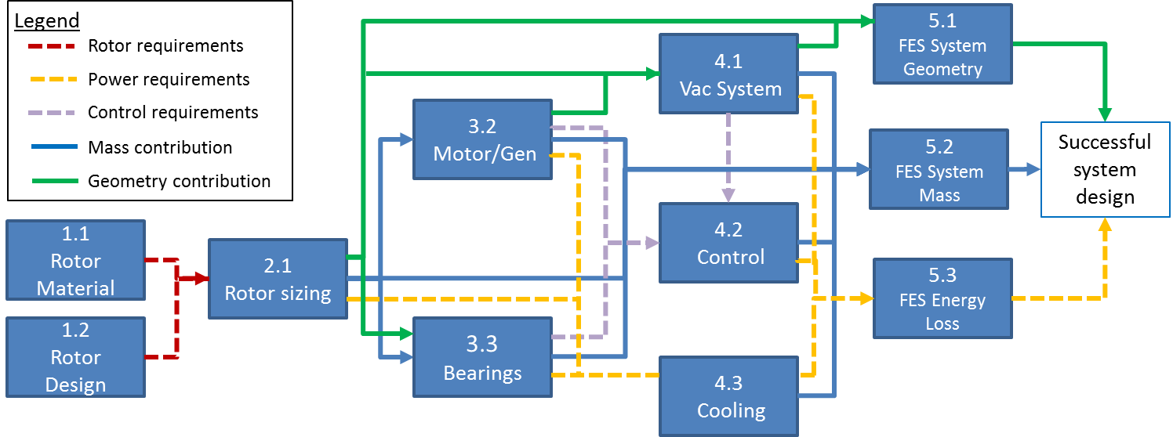
Figure 32: FES system objective function operation

Table 22: Top ten FES designs from STMI “best value” optimization +STP input
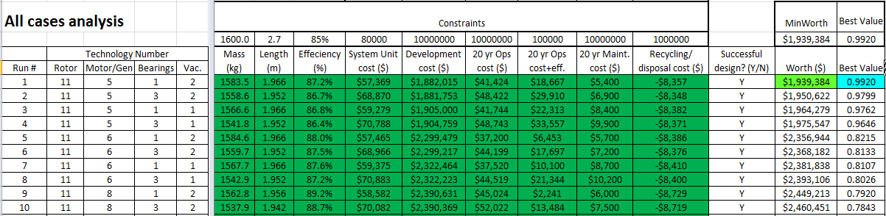
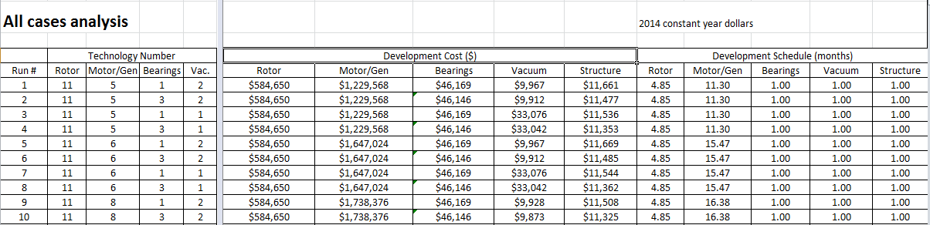

Allowing for six months of integration testing, the first operational FES prototype would be available in a 17.3 to 24.15 months timeframe, depending on funding and parallel development efforts. A sample STP option is presented in a traditional Gant chart type schedule illustrated in Figure 33. The technology maturation funding profiles would be integrated into the master budget and provide support for budget negotiations. Production and operational testing of the FES prototype would be dependent on capital funding and orders from utility companies, which is beyond the scope of the STMI process.
The STMI FES analysis spreadsheet was able to directly address the common problems previous PM teams had experienced when doing system designs. First, engineering design time required was reduced over 2000 man-hrs using the STMI FES analysis build (~12 hours) verses spending 1-2 hours manually for each of the 1152 system designs. Second, all of the technology options entered within the database were analyzed and examined with their mass, geometry and power interactions. Third, the specific technologies for the “Best Value” (BV) design were identified for development, providing a risk reduction path for technology maturation and system integration. Finally, the lifecycle costs and resources played a decisive role in the final BV system design. The spreadsheet was also set up to handle rapid trade studies and data sensitivity analysis inputs from the PM for post run analysis.

STMI stage 3: Post process FES system design analysis
Once the FES team proposed the formal FES design, the PM instructed them to conduct a series of rapid trade studies, sensitivity analysis and an incremental improvement analysis. The requirement trade studies were to focus on customer requirement changes that could impact the system designs. The sensitivity analysis was to examine the impacts of cost data uncertainty on the end optimization results. The incremental improvement study was to examine significant changes in customer mass and length requirement thresholds to justify a new, compact system design delivery or “increment.”
Figure 33: STMI “best value” FES design with Gant chart style inputs for a STP

Trade studies
After reviewing the design team’s FES recommendation, the PM requested trade studies to examine the trade space (changing requirements up and down slightly), and the adjustment of a few of the key input estimates that could change between formal design start and prototype production in three years. The PM also wanted the FES team to re-examine the ferrite ceramic magnetic bearings as a technology replacement for the Sa-Co magnets. The specific trade studies and goals are listed next.

Trade study #1: maximum FES mass variance +/- 10%
This trade study allowed the maximum FES system mass to vary an additional +/-10% of the lift capacity of the 2T fork lift (1500-1700 kg). The study’s purpose was to see if the number of successful FES design changed, if the top BV system changed from the baseline optimization, and if a lower system cost BV winner could be achieved.

Trade study #2: maximum FES system length variance +/- 10%
This trade study allowed the maximum FES system length to vary an additional +/-10% of the three times rotor diameter specification (2.43 - 2.97m). The study’s purpose was to see if the number of successful FES design changed, if the top BV system changed from the baseline optimization, and if a lower system cost BV winner could be achieved.

Trade study #3: FR compensation variance +/- $45,000
This trade study allowed the FR compensation to vary from the low of $175K to a high of $250k. The study’s purpose was to see if the changes in FR and the corresponding impact on operations costs for motor efficiency changed the number of successful FES designs, if the top BV system changed from the baseline optimization, and if a lower system cost BV winner could be achieved.

Trade study #4: Composite material price drop – 25% and -50%
This trade study allowed for the evolving prices of composite materials to drop after the three year FES development period. Current trends with automobile and aircraft manufacturers integrating high strength carbon composites into their vehicles are creating an increased demand and composite production capability, and carbon composite prices could see a 50% reduction in 3 years³⁴⁰. The study’s purpose was to see if a 25% and the expected 50% change in composite prices changed the number of successful FES designs, if the top BV system changed from the baseline optimization, and if a lower system cost BV winner could be achieved for the production FES models in three years.

Trade study #5: replace Sa-Co with ferrite ceramic magnetic (FeCM) bearings
This trade study substituted the Samarium-Cobalt (Sa-Co) permanent magnets with the lower cost/lower density/lower power ferrite ceramic magnets. The study’s purpose was to see if the number of successful FES design changed, if the top BV system changed from the baseline optimization, and if a lower system cost BV winner could be achieved.
Results from the trade studies are presented in Table 23 and are summarized below:
- Trade study #1, maximum FES mass variance +/- 10%:
  - Reducing the maximum FES mass yielded fewer successful designs (277 vs. 407). The top ten BV designs varied significantly from the baseline systems and relied on the higher complexity tech rotors utilizing higher tensile strength composite materials. The new BV designs required increased funding to build and develop over the baseline systems.
  - Increasing the maximum FES mass yielded 63 additional successful designs, but the FES(11,5,1,2) design remained top BV system.
- Trade study #2, maximum FES system length variance +/- 10%:
  - Reducing the maximum FES system length yielded two fewer successful designs over the baseline analysis of 407. There was no change to the top BV FES system design compared with the baseline analysis.
  - Increasing the maximum FES system length yield no changes to the baseline number of successful designs, and no changes to the top baseline BV ranked FES system design.

Table 23: FES Trade study results
 | Baseline study |  | Trade Study
 |  |  | 1  (-10%/+10%) | 2  (-10%/+10%) | 3  ($175K/$250K) | 4  (-25%, -50%) | 5  FeCM
successful design #s | 407 |  | 299 / 470 | 405 / 407 | 407 / 407 | 407 / 407 | 284
Top Ten FES designs | Rotor, Motor/Generator, Bearing, Vacuum enclosure
#1 | 11,5,1,2 | 14,5,1,2 / 11,5,1,2 |  | 11,5,1,2 / same | 11,5,1,2 / same | 11,5,1,2 / same | 11,5,1,2
#2 | 11,5,3,2 | 14,5,3,2 / 11,5,3,2 |  | 11,5,3,2 / same | 11,5,3,2 / same | 11,5,3,2 / same | 11,5,3,2
#3 | 11,5,1,1 | 14,5,2,2 / 11,5,1,1 |  | 11,5,1,1 / same | 11,5,1,1 / same | 11,5,1,1 / same | 11,5,1,1
#4 | 11,5,3,1 | 14,5,1,1 / 11,5,2,2 |  | 11,5,3,1 / same | 11,5,3,1 / same | 11,5,3,1 / same | 11,5,3,1
#5 | 11,6,1,2 | 14,5,3,2 /11,5,3,1 |  | 11,6,1,2 / same | 11,6,1,2 / same | 11,6,1,2 / same | 11,6,1,2
#6 | 11,6,3,2 | 14,5,2,2 /11,5,2,1 |  | 11,6,3,2 / same | 11,6,3,2 / same | 11,6,3,2 / same | 11,6,3,2
#7 | 11,6,1,1 | 14,5,2,1 /11,6,1,2 |  | 11,6,1,1 / same | 11,6,1,1 / same | 11,6,1,1 / same | 11,6,1,1
#8 | 11,6,3,1 | 12,5,2,1 /11,6,3,2 |  | 11,6,3,1 / same | 11,6,3,1 / same | 11,6,3,1 / same | 11,6,3,1
#9 | 11,8,1,2 | 12,5,3,2 / 11,6,1,1 |  | 11,8,1,2 / same | 11,8,1,2 / same | 11,8,1,2 / same | 11,8,1,2
#10 | 11,8,3,2 | 12,5,2,2 / 11,6,2,2 |  | 11,8,3,2 / same | 11,8,3,2 / same | 11,8,3,2 / same | 11,8,3,2
#1 Best value score | 0.9920 | 0.9956 / 0.9920 |  | 0.9920 / same | 0.9899 / 0.9940 | 0.9914 / 0.9908 | 0.9920
Development cost ($K) | $1,882 | $2,530 / $1882 |  | $1,882 / same | $1,882 / same | $1,882 / same | $1,882
Unit cost ($K) | $57.4 | $86.5 / $57.4 |  | $57.4 / same | $57.4 / same | $50.3 / $43.2 | $57.4
Notes |  | (1) |  | (2) | (3) | (4) | (5)
- (1) lower mass requirements required higher tech rotors, (2) length change had minimal impact, (3) slightly shifted the BV score by increasing/ reducing the Operations cost with the lower/higher FR payment, (4) only lowers unit cost, (5) no change, Fe-ceramic magnets don’t even appear in the top 100 designs.

- Trade study #3, FR compensation variance +/- $45,000:
  - Reducing the FR compensation made no changes to the top FES system list, but the BV scores decreased slightly due to the reduced FR credit being added to the operations cost.
  - Increasing the FR compensation made no changes to the top FES system, but the BV scores increased slightly due to the increased FR credit being added to the operations cost.
- Trade study #4, Composite material price drop – 25% and -50%:
  - Reducing the composite prices by either 25% or 50% did not change the top baseline BV ranked FES system design. What did change were a reduction in individual unit prices and a slight reduction in the BV scores.
- Trade study #5, replace Sa-Co with FeCM bearings:
  - Utilizing FeCM bearings instead of Sa-Co yielded a reduced number of successful FES designs (284 vs, 407). There were no change to the top baseline BV ranked FES system design, and the FeCM bearing designs did not have any units within the top 100 BV ranked FES systems designs.

Note: The trade studies required 10,368 additional design runs, which were completed in 1.5 man-hrs with the STMI FES analysis. This represents a consistent and rapid analysis capability with a significant time savings over completing the runs manually (~10,368 design team man-hrs).

Sensitivity analysis OVAT and DoE for cost estimates
A data sensitivity analysis was requested to examine system lifecycle cost variation by 20% to identify key components to watch for cost impacts in case initial cost estimation methods were incorrect. OVAT was recommended for examining all of the cost variables, and a DoE analysis was requested to determine if there is any significant interaction between the three OVAT variables that showed the highest potential for variability. The results from the 20% variation OVAT of the system cost components are shown in Table 24.

Table 24: STMI FES OVAT cost sensitivity analysis on BV score
With the resulting ranges between the high BV and low BV response variables being less than 0.01, the analysis indicates that the overall BV scoring system for the top ranked FES designs were very insensitive to cost variation. So, once the BV scoring system found the recommended “best value” system, changes in the cost estimates created insignificant impacts to the final recommendations.
The #1 ranked BV system design and its corresponding technology set recommendation remained unchanged with the 20% cost variations. The operations cost had the largest variation range (0.00954) and therefore has the largest potential risk impact for cost changes on the BV solution.
The three highest cost variation scores from the OVAT analysis where selected (A=unit cost, B=development cost and C=operations cost) and placed into a three factor DoE analysis to determine factor interactions with the deterministic FES system design functions. The DoE analysis is shown in Table 25 and indicates that factor C has the highest impact to the BV calculations (same as OVAT), and that while minimal, the BxC interactions account for the largest multi-factor interaction.
Explanation note: a couple of the DoE BV scores were higher than the normalized 1.0. This is due to a bonus, described in section 4.3.1.1, where the motor/generator being examined is a higher effeciency than the 85% baseline and an effeciency credit was given, reducing the operations cost.

Incremental improvement FES design
An incremental improvement analysis for a future “advanced FES” design for potential emergency power and mobile applications was requested by the customer. The changed design requirements have a 25% mass and 25% length reduction over the current FES(11,5,1,2) design, plus a 87.5% efficiency rating. This new design technology maturation STP would be implemented in parallel with the original design STP. The customer also wants to know the tentative budget requirements and timeframe for the advanced prototype delivery.

Table 25: STMI FES DoE cost sensitivity analysis on BV score

After completing the STMI analysis runs, only four FES system designs were generated with the new system requirements:
- FES(15,11,3,1), Dev. cost = $4,27M, unit cost = $80.5K, Dev. timeline = 43 months
- FES(15,12,3,1), Dev. cost = $4.75M, unit cost = $80.6K, Dev. timeline = 48 months
- FES(16,11,3,1), Dev. cost = $5.00M, unit cost = $83.7K, Dev. timeline = 50 months
- FES(16,12,3,1), Dev. cost = $5.48M, unit cost = $83.8K, Dev. timeline = 55 months
The four “advanced FES” designs were under the 1200kg mass and two meter length requirement, but each depended on the advanced technologies in the CNT composite rotor design and ultra-high efficiency motor/generator. The new rotors were more expensive than the baseline design by $23,000-$26,300 each, and required nearly double the developmental funding ($4.27M vs $2.3M) with over 43 months of development schedule. If the “advanced FES(15,11,3,1)” system was fully funded and started development at the same time as the baseline FES(11,5,1,2) schedule in Figure 33, it would be ready for TR-6 prototype testing in ~1.5 years after the baseline system.

Macro-level STMI FR system selection
Now that the PM’s FES team has completed the micro FES BV analysis, it is time to apply the individual FES units to the FES 20MW utility plant and insert it into the Macro-FR STMI system analysis.
The original FES FR facility overview in Figure 30b, contains 100 of the individual FES units to create a 20MW (5MWh) facility capable for 15 min of FR service operation. Twenty FES units are connected in parallel to a transformer which increased the FES 480v output to 13.8kV. The entire FES utility plant connects to the utility grid with a utility switchyard transformer, which increases the plant output voltage from 13.8kV to the standard grid 115-138kV transmission line voltage³⁴¹. Figure 34 illustrates the FES facility plan placement within a typical utility grid.
Using the 14.5 months of FES technology maturation to design and build the pilot plant to manufacture 100 FES units in a six month period, plus six months to conduct the install and Operational Test and Evaluation (OT&E), the first FES utility plant could be operational within 26.5 months from project initiation. This places the FES utility plant within the near-term (0-5yr) project window requested by the case study customers.

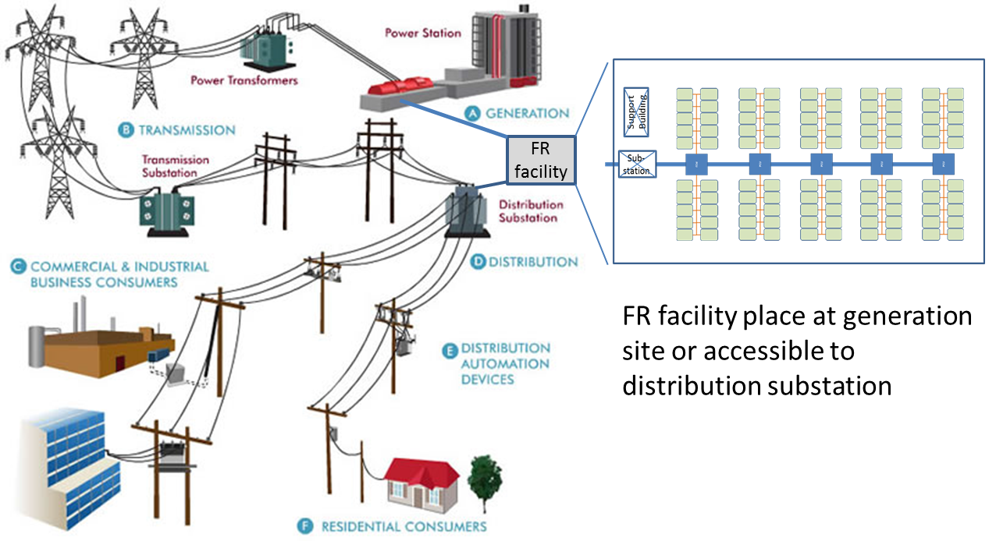
Figure 34: FR facility placement within the utility grid
The components of the FES utility plant cost estimates include:
- 100 individual FES(11,5,1,2) units with 480v, 200kW output
- Development cost (TRL-6) = $1.88M
- Maturation cost (TRL-9) = 4*($1.88M) + $5M = $12.52M (OT&E & pilot plant)
- Units cost = 100*($57.4K) + 100*($26K G&A) + 100*($5K install) = $8.84M
- 20 yr Maintenance cost = 100*($41.4K) = $4.14M
- 20 yr Operations cost = 100*($18.7K) = $1.87M
- Disposal/recycling cost = 100*(-$8.4K) = -$0.84M
- 10, 480v to 13.8kV step-up transformers³⁴²
- Development cost to link arrays= $2.8M
- Units cost = 10*($100K/unit) + 10*($5K install/unit) = $1.05M
- 20 yr Maintenance cost = 10*($1K)*20 = $0.2M
- 20 yr Operations cost = 10*($1.5K)*20 = $0.3M
- Disposal/recycling cost = 10*($25K) = $0.25M
- Land next to distribution substation, security and monitoring facility
- Development cost = $1.5M (includes permits and access fees)
- Facility unit cost = $2.5M
- Shipping & delivery unit costs = 100*($10K) + 10*($8K) = $1.08M
- 20 yr Maintenance cost = ($20K)*20 = $0.4M
- 20 yr Operations cost = ($25K)*20 = $0.5M
- Disposal/recycling/resale cost = -$1.0M
Total estimated costs associated with the FES utility plant:
- Development/maturation cost = $1.88M + $12.52M + $2.8M + $1.5M = $18.7M
- Facility unit build cost = $8.84M + $1.05M + $2.5M + $1.08M = $13.47M
- 20 yr Maintenance cost = $4.14M + $0.2M + $0.4M = $4.74M
- 20 yr Operations cost = $1.87M + $0.3M + $0.5M = $2.67M
- Disposal/recycling/resale cost = -$0.84M + $0.25M + -$1.0M = -$1.59M

The overall BV score for potential 20 MW FR systems is provided in Table 26. Other systems examined are taken from historical data, government parametrics and developed together for the FR application comparison.

Table 26: Macro-level FR system design
FR System description  (20 MW) | Development cost | Facility ramp rate in 5 min | Facility capitol cost | 20 Year O&M cost | Disposal/ recycling cost | BV Score (overall minWorth / system cost)
STMI designed FES  100 units FR plant | $18.7M | 100% | $13.47M | $7.41M | -$1.59M | 0.754
Beacon Power FES^{343,344,345} 200 units FR plant | $150M**** | 100% | $62M | $15M | -$6.2M | 0.130
A123 Li-ion  Batteries*^{346,347} | $132M**** | 100% | $27.2M | $16.7M* | $2.720M | 0.160
Xtreme Power Dry Cell Batteries*^{348,349,350} | $29.5M**** | 100% | $24.2M | $10M* | $1.63M | 0.438
Sodium-Sulfur  Batteries*^{351, 352, 353} | $7.9M**** | 100% | $21.75M | $13.32M* | $2.18M | 0.634
Gas turbine power  plant^{354, 355} | $2.6M | 100% (with two units) | $26.04M | $27.65M* | $3.3M*** | 0.481
Pumped Hydropower storage (PSH)³⁵⁶ | $4.6M** | 100% | $45.94M | $12.32M | $11.5M*** | 0.381
Compressed Air Energy Storage (CAES)^{357, 358} | $54.5M**** | 100% (with two units) | $36M | $11.95M | $4.5M*** | 0.268
Overall minWorth = Gas Turbine Development + facility cost = $28.64M
System Cost = Development cost+ Facility cost + O&M cost + disposal/recycling cost
Systems are assumed to be gov/utility owned, so potential commercial earnings are not considered in the system design EV BV analysis.
Systems are sized to meet full power requirements at 5 min based on ramp-up rate (Gas turbine sources had two different rates, split difference)
Dry cell batteries O&M costs are 25% less than NaS batteries, Lithium-ion 25% more than NaS due to battery replacement costs
* Costs do not include CO2 fees or costs to recycle batteries. Battery systems are replaced every 50000hrs (~5.9 yrs).
** Assume that appropriate local geology is available; fees include plans, permits and surveys.
*** Assumed decommission at 25% of capitol build cost.
****Development funds are based on published DOE energy grant development fund usage

The final results for the STMI Macro FR system selection indicates that the FES FR facility, with a BV score of 0.754, would be significantly competitive compared to all of the researched FR options. The FES FR facility requires a lower start-up costs and a moderately low development cost. The FES system’s saving gain comes from the inherent, very low Operations and Maintenance (O&M) costs, making its lifecycle costs one of the lowest in the field of FR capabilities. When a PM is looking at technologies to invest technology R&D money into, a system with a high BV score compared to its peers will yield the lowest lifecycle cost and lower risk for failure once produced.

Conclusions and expected contributions
Strategic Technology Planning has been an active field of research in many areas within industrial and the DoD acquisition “lifecycle” timeline. Researchers, developers and program managers have expended enormous time and resources to study and develop methodologies to improve how technology is identified, matured and eventually inserted into a viable product or service. Despite a growing body of literature and government regulations, Strategic Technology Plan (STP) generation has primarily been a manual, subjective methodology conducted by subject matter experts.
The introduction of the STMI process to assist in building a STP offers to change this manual paradigm by providing a computer-based Decision Support System (DSS) tool. The STMI DSS research brings together a combination of previously unsynchronized tools to create a systematic, best value analysis process for decision makers evaluating technology options. This STMI DSS offers users a demonstrated method to:
- Evaluate system concepts with the best available combination of technologies, with a focus on technology maturation and lifecycle costs, that yield a best value system design for the customer
- Automate technology selections to help eliminate bias and utilize a common evaluation methodology across all system designs
- Account for secondary technology interactions within the system design
- Provide repeatable, analytical input for a Strategic Technology Plan designed to mature required technologies to a TRL-6 and prepare them for full system prototyping
- Make technology planning and maturation efforts more accurate and defendable given the inter-connected nature of customer requirements
- Allow rapid trade and incremental improvement studies to examine “what if” scenarios with changes to technology performance, customer requirements, maturation schedule and budgeted cost
- Assess data sensitivity impacts to the system design technology selections

Future research opportunities and ongoing work
Future research can be directed to develop and expand the presented STMI process for implementation in a true DSS software environment. These capabilities could include:
- Linked graphical user interface and database management
- Apply a metaheuristic (like Genetic Algorithm) to optimize run time vs. accuracy
- Ranked listing of the user selected top number of BV system design solutions for review and trend analysis
- Batch processing to conduct sensitivity analysis with OFAT or with multi-factor Designs of Experiments (DOE) analysis
- Incorporate MS Excel “At RiskTM” or similar method for adding stochastic variability into the STMI technology database to account for uncertainty in technology performance, cost and schedule
Ongoing work includes commercializing the STMI process methodology to provide potential customers with the early lifecycle analysis capability.

List of references
¹ Betz, F., Managing Technological Innovation: Competitive Advantage from Change, 2nd Ed., New York, Wiley, 2003.
2 State Science and Technology Institute, Science and Technology Strategic Planning: Creating Economic Opportunity,” Economic Development Administration, Department of Commerce, 1997.
3 DOD, DODI 5000.2 Operation of the Defense Acquisition System, USD (AT&L), Ed. Washington DC: Department of Defense, 2008.
4 "Best Practices: Better Management of Technology Can Improve Weapon System Outcomes ,” GAO/NSIAD-99-162, General Accounting Office, Jul 1999
5 Carr, R. K., “Doing technology transfer in federal laboratories (Part 1),” The Journal of Technology Transfer, Vol. 17, No. 2-3, pp. 8-23, 1992.
6 Singh, R. P., “Improving technology transfer through the management of stakeholder networks: theoretical perspectives,” International Journal of Technology Transfer and Commercialization, Vol. 2, No. 1, pp. 1-17, 2004.
7 Wang, M. Y.D., Pfleeger, S. L., Adamson, D. M., Bloom, G., Butz, W., Fossum, D., Gross, M., Kofner, A., Rippen, H., Kelly, T. K., and C. T. Kelley, Jr.,“Technology Transfer of Federally Funded R&D: Perspectives from a Forum,” RAND conference proceedings, 2003.
8 B. Bozeman, “Technology transfer and public policy: a review of research and theory,” Research Policy, Vol. 29, pp. 627–655, 2000.
9 Allen, T. J.,“Managing the Flow of Technology: Technology Transfer and the Dissemination of Technological Information Within the R&D Organization,” 1st Edition, MITpress, 1984.
10 Thamhain, H.,J., Management of Technology: Managing effectively in Technology-intensive organizations, Wiley & Sons, New Jersey, 2005.
11 Phillips, B. C. and S.M. Polen, “Add decision analysis to your COTS selection process,” Crosstalk, 2002
12 Saltelli, A., Ratto, M., Andres, T., Campolongo, F., Cariboni, J., Gatelli, D. Saisana, M., and S. Tarantola, “Global Sensitivity Analysis: The Primer,” John Wiley & Sons, 2008.
13 Craig Larman, Victor R. Basili, "Iterative and Incremental Development: A Brief History," IEEE Computer, Vol. 36, No. 6, pp. 47–56, 2003.
14 H. G. Sol et al, Expert systems and artificial intelligence in decision support systems: proceedings of the Second Mini Euroconference, Lunteren, The Netherlands, 17–20 November 1985, Springer, ISBN 90-277-2437-7. pp.1-2., 1987.
15 Morse, L.C. and D.L. Babcocl, Managing Engineering and Technology, 5th edition, Pearson Publishing, 2010.
16 Sprague, R;. “A Framework or the Development of Decision Support Systems.” MIS Quarterly. Vol. 4, No. 4, pp.1-25, 1980.
17 Grammas, G.W, Lewin, L. and S.P. DuMont-Bays, “Decision Support, Feedback and Control,” in J.E. Ultman, Ed., Handbook of Engineering Management New York, Wiley & Sons, Inc., 1986.
18 Power, D.J. A Brief History of Decision Support Systems. DSSResources.COM, World Wide Web, http://DSSResources.COM/history/dsshistory.html, version 2.8, May 31, 2003.
19 Power, D.J. A Brief History of Decision Support Systems. DSSResources.COM, World Wide Web, http://DSSResources.COM/history/dsshistory.html, version 4.0, March 10, 2007.
20 Keen, P. G. W. Decision support systems: an organizational perspective. Reading, Mass., Addison-Wesley Pub. Co, 1978.
21 Sprague, R. H., Jr. and H. J. Watson, "Bit by Bit: Toward Decision Support Systems", California Management Review, Vol. XXII, Iss.1, pp.60-68, 1979.
22 Decision Support Systems, ISSN: 0167-9236, 56 volumes, available from 1985 to 2013, http://www.journals.elsevier.com/decision-support-systems.
23 Ibid Sol et al, 1987.
24 http://www.dssresources.com/ visited 25 Nov 2013
25 Ibid Power 2003
26 Alter, S.L., Decision Support Systems: Current Practice and Continuing Challenge, Reading, MA: Addison-Wesley, 1980.
27 http://www.umsl.edu/~joshik/msis480/chapt10.htm visited 11/25/13.
28 http://www.umsl.edu/~joshik/msis480/chapt10.htm visited 11/25/13.
29 “System Engineering Fundamentals,” Defense Acquisition University Press, 2001.
30 Alfor, N.W., and J.t. Lawson, “Software Requirements Engineering Methodology (Development), TRW Defense and Space Systems Group. 1979.
31 Kononya G. & Sommerville I., “Requirements Engineering – Processes and Techniques”, John Wiley & Sons, Chichester. 1998.
32 Defense Acquisition University, “Systems Engineering Fundamentals,” DAU Press, 2001.
33 Journal of Requirements Engineering, ISSN: 0947-3602, 18 volumes, 70 issues and 386 articles available from 1996 to 2013.
34 McConnell, S Rapid Development: Taming Wild Software Schedules, Microsoft Press, ISBN 1-55615-900-5, pp.72, 1995.
35 http://www.interaction-design.org/books/hci.html visited 20 Oct 2013
36 Benington, H. D. "Production of Large Computer Programs". IEEE Annals of the History of Computing Vol. 5, Issue 4, pp. 350–361,. 2008.
37 Robertson, S and J. Robertson, “Mastering the requirements process: Getting requirements right,” 3rd Ed, Addison-Wesley, 2013.
38 Royce, Winston, "Managing the Development of Large Software Systems", Proceedings of IEEE WESCON 26, pp.1–9, 1970.
39 http://www.learnaccessvba.com/application_development/waterfall_method.htm, visited 19 Oct 2013.
40 Nuseibeth, B., and S. Easterbrook, “Requirements Engineering: A Roadmap,” In Proc. of the IEEE Int. Conf. on Soft. Eng. (ICSE), pp. 35–46, 2000.
41 Farkas, K., and P. Thurston, “Evolutionary Acquisition Strategies and Spiral Development Process,” Program Manager, 2003.
42 Cockburn, A., "Using Both Incremental and Iterative Development". STSC CrossTalk (USAF Software Technology Support Center) . Vol. .21, No. .5, pp.27–30, 2008.
43 Ibid Nuseibeth, 2000.
44 Graham, I., “Requirements engineering and rapid development: An object oriented approach,” Addison-Wesley, 1998.
45 Albegami, N., “A methodology for customer requirements generation in communication systems planning,” Engineering Management Conference, 1992. Managing in a Global Environment., IEEE International, pp. 230-233, 1992.
46 Khurum, M., Aslam, K.; and Gorschek, T., “A Method for Early Requirements Triage and Selection Utilizing Product Strategies,” 14th Asia-Pacific Software Engineering Conference, 2007.
47 Yu, E., “Towards Modeling and Reasoning Support for Early-Phase Requirements Engineering,”, Proceedings of the Third IEEE International Symposium on Requirements Engineering, 1997.
48 EPA/240/R-02/004, Guidance on Environmental Data Verification and Data Validation (G-8) Nov. 2002.
49 Ibid GAO/NSIAD-99-162, 1999.
50 “Cost and performance data for power generation,” National Renewable Energy Laboratory, Feb 2012.
http://bv.com/docs/reports-studies/nrel-cost-report.pdf
51 “Capital Budget Cost Estimating Guidelines,” Bureau of Portfolio Management Project Development and Building Program Section, Sate of Wisconsin, 2009. http://doa.wi.gov/docs_view2.asp?docid=5512
52 “Cost estimation guidelines for generation IV nuclear energy systems,” revision 4.2, GIF/EMWG/2007/004, 2007. http://www.gen-4.org/Technology/horizontal/EMWG_Guidelines.pdf
53 “Estimating specialty costs,” DOE G 430.1-1, Chp. 20, 1997.
54 Ereev, S.Y. and M.K. Patel, “Standardized cost estimation for new technologies (SCENT) - methodology and tool,” Journal of Business Chemistry, No. 2, 2012 http://www.businesschemistry.org/article/?article=150
55 DOD 4245.8-H, “Value Engineering” 1986.
56 DOD Value Engineering Program, OMB Circular A-131, 1993.
57 41 USC Sec. 171, Pub. L. 93-400, Sec. 36, as added Pub. L. 104-106, title XLIII, Sec. 4306(a), 110 Stat. 665, Feb. 10, 1996.
58Ibid DOD 4245.8-H, 1986.
59 Ibid DOD 4245.8-H, 1986.
60 Finley, J.I., “A strategic Plan for Value Engineering in DoD,” Memo from Deputy Undersecretary of Defense, Acquisition and Technology, 2008.
61 Heller, E.D., General Dynamics Corp, San Diego, CA 92112, 1986.
62 Ibid DOD 4245.8-H, 1986.
63 Ibid DOD 4245.8-H, 1986.
64 Ibid DOD 4245.8-H, 1986.
65 Davidon, W.C. "Variable metric method for minimization". SIAM Journal on Optimization, Vol. 1, No.1, pp.-17, 1991
66 Glover, F. "Future Paths for Integer Programming and Links to Artificial Intelligence". Computers and Operations Research, Vol. 13, No. 5, pp. 533–549, 1986.
67 Liddell, H.G. and R. Scott, A Greek-English Lexicon, on Perseus Digital Library
68 Yang, Xin-She, “Metaheuristic Optimization,” Camberidge University, UK, www.scholarpedia.org/artilce/Metaheuristic_Optimization. Visited June 2012.
69 Luke, S., “Essential of Metaheuristics” available at hhtp://cs.gmu.edu/~sean/book/metaheuristics 2009
70 Winston, Wayne L. “Operations Research: Applications and Algorithms,” 4th Ed. Thomson, Books/Cole publishers, 2004.
71 Mladenovic, N and P. Hanson, “Variable Neighborhood Search,” Computers Ops Res. Vol. 24, No.11, pp 1097-1100, 1997.
72 Ibid Glover, 1986.
73 Rastrigin, L.A. "The convergence of the random search method in the extremal control of a many parameter system". Automation and Remote Control, Vol. 24, No. 10, pp. 1337–1342, 1963.
74 Strutzle, T, “Iterated local search & variable neighborhood Search,” MN Summerschool, Tenerife, 2003.
75 Ibid Sean, 2009.
76 Ibid Yang, 2012.
77 Ibid Yang, 2012.
78 Ibid Davidon, 1991.
79 Ibid Rastrigin, 1963.
80 http://en.wikipedia.org/wiki/Metaheuristic. Visited July 2012.
81 Rechenberg, I. Cybernetic Solution Path of an Experimental Problem. Royal Aircraft Establishment Library Translation, 1965.
82 Fogel, L.; Owens, A.J.; and M.J. Walsh, Artificial Intelligence through Simulated Evolution. Wiley, 1966.
83 Holland, J.H. Adaptation in Natural and Artificial Systems. University of Michigan Press, 1975
84 Kirkpatrick, S., Gelatt Jr., C.D., and M.P. Vecchi, "Optimization by Simulated Annealing". Science Vol. 220, No.4598, pp. 671–680, 1983.
85 Farmer, J.D., Packard, N., and A. Perelson, "The immune system, adaptation and machine learning". Physica D, Vol. 22, No.1-3, pp. 187–204, 1986.
86 Ibid Glover, 1986.
87 Feo, T. and M. Resende, “A probabilistic heuristic for a computationally difficult set covering problems,” Operational research letters, Vol. 8, pp. 67-71, 1989.
88 Hanson, P. and N. Mladenoviĉ, “An introduction to variable neighborhood search,” Meta-heuristics: advances and trends in local search paradigms for optimization, Chp 30, pp. 433-458, Kluwer Academic Publishers, 1999.
89 Voudouris, C. and E. Tsang, “Guided Local Search,” European Journal of Operational Research, Vol. 113, No. 2, pp. 469-499, 1999.
90 Baxter, J. “Local optima avoidance in depot location,” Journal of the Operational Research Society, Vol. 32, pp. 815-819, 1981.
91 Dorigo, M. Optimization, Learning and Natural Algorithms (PhD Thesis). Politecnico di Milano, Italie, 1992.
92 Koza, J.R. Genetic Programming: on the programming of computers by means of natural selection. MIT Press, 1992.
93 Kennedy, J. and R. Eberhart, "Particle Swarm Optimization". Proceedings of IEEE International Conference on Neural Networks. IV, pp. 1942–1948, 1995.
94 Storn, R. and K. Price, "Differential evolution - a simple and efficient heuristic for global optimization over continuous spaces". Journal of Global Optimization Vol. 11, No. 4, 1997, pp. 341–359.
95 Ibid Yang, 2012.
96 Geem, Z.W., Kim, J.H., and G.V. Loganathan, "A new heuristic optimization algorithm: harmony search". Simulation, Vol. 76, No. 2, pp. 60–68, 2001.
97 Deb, K., Pratap, A., Agarwal, S., and T. Meyarivan, "A Fast and Elitist Multi-objective Genetic Algorithm: NSGA-II". IEEE Transactions on Evolutionary Computation, Vol. 6, No. 2, pp. 182–197, 2002.
98 Nakrani, S. and S. Tovey, "On honey bees and dynamic server allocation in Internet hosting centers". Adaptive Behavior 12, 2004.
99 Yang, X.-S. Nature-Inspired Metaheuristic Algorithms. Luniver Press, 2008.
100 Yang, X.-S. and S. Deb, Cuckoo search via Levy flights, in: World Congress on Nature & Biologically Inspired Computing (NaBIC 2009). IEEE Publication, pp. 210–214, 2009.
101 Tamura, K., and K. Yasuda, "Spiral Dynamics Inspired Optimization". Journal of Advanced Computational Intelligence and Intelligent Informatics, Vol.15, No. 8, 1116–1122, 2011.
102 Venkata Rao, R. and V.J. Savsani, Mechanical Design Optimization Using Advanced Optimization Techniques. Springer-Verlag London, 2012.
103 S. Olafsson, “Metaheuristics” in Nelson and Henderson (eds) Handbook on Simulation, Handbooks in Operation Research and Management Science VII, Elsevier, pp. 633-654, 2006.
104 Ibid, Holland, 1975.
105 http://www.metaheuristics.net. Visited July 2012.
106Ibid Kirkpatrick et al, 1983
107 Ibid Yang, 2012.
108 Ibid Blumm and Roli, 2012, pp. 7.
109 Granville, V.; Krivanek, M.; Rasson, J.-P. "Simulated annealing: A proof of convergence". IEEE Transactions on Pattern Analysis and Machine Intelligence, Vol. 16, No. 6, pp. 652–656, 1994.
110 F. Glover and C. McMillan, "The general employee scheduling problem: an integration of MS and AI". Computers and Operations Research. 1986.
111 Glover, F., Laguna, M., and R. Marti, “Principles of Tabu Search,” http://www.uv.es/~rmarti/paper/docs/ts1.pdf, visited Aug, 2012.
112 http://www.cp.eng.chula.ac.th/~piak/teaching/algo/algo2001/local-search.htm, visited Aug 2012.
113 Tsubakitani, S., and J.R. Evans, “Optimizing tabu list size for the traveling salesman problem,” Computers Ops Researchm Vol. 25, No.2, pp. 91-97. 1998.
114 Ibid Dorigo, 1992.
115 M. Dorigo et L.M. Gambardella, “Ant Colony System : A Cooperative Learning Approach to the Traveling Salesman Problem”, IEEE Transactions on Evolutionary Computation, Vol. 1, No. 1, pages 53-66, 1997.
116 Dréo, J, “Shortest path find by an ant colony,” created 27 May 2006
117 M. Guntsch, M., M. Middendorf, M., Scheuermann, B., Diessel, O., ElGindy, H., H. Schmeck, H., and K. So, “Population based Ant Colony Optimization on FPGA,” http://www.cse.unsw.edu.au/~odiessel/papers/fpt02guntsch.pdf, 2002.
118 Dorigo, M., Scholarpedia, 2(3):1461, 2007.
119 J. Kennedy, R.C. Eberhart, “Particle swarm optimization”, IEEE Conf. on Neural Networks IV, pp. 1942–1948, 1995.
120 Dorigo, M., et al. “Particle swarm optimization”. Scholarpedia, 3(11):1486, 2008.
121 Ibid Dorigo, 2008
122 Marco Dorigo et al. “Particle swarm optimization”. Scholarpedia, Vol. 3, No.11, pp.1486, 2008.
123 Blondin, J., ‘Particle Swarm Optimization: A Tutorial,” http://cs.armstrong.edu/saad/csci8100/pso_tutorial.pdf, 2009.
124 Barribeau, T. “How do birds in a flock all make the same decisions at the same time? http://io9.com/5638708. Visited July 2012.
125 Miller, P. “Swarm Theory,” National Geographic, 2007.
126 Lourenço, H., Martin, O., and T. Stutzle,”Iterative Local Search,” Handbook of Metaheuristics, Springer, pp.320-353, 2003.
127 http://www.metaheuristics.net. ILS page, visited Aug 2012.
128 Browlee, J., “Clever algorithms: Nature-iInspired programming recipes,” 1st Ed., Lulu Enterprises, 2011.
129 Altshuler, E., and D. Linden, "Design of a wire antenna using a genetic algorithm," Journal of Electronic Defense, vol.20, no.7, pp.50-52, 1997.
130 Beasley, J.E., Sonander, J., and P. Havelock, "Scheduling aircraft landings at London Heathrow using a population heuristic," Journal of the Operational Research Society, vol.52, no.5, p.483-493, 2001.
131 Benini, E. and A. Toffolo, "Optimal design of horizontal-axis wind turbines using blade-element theory and evolutionary computation," Journal of Solar Energy Engineering, vol.124, no.4, p.357-363, 2002.
132 Giro, R., M. Cyrillo and D.S. Galvão, "Designing conducting polymers using genetic algorithms," Chemical Physics Letters, vol.366, no.1-2, pp.170-175, 2002.
133 Howley,B. “Genetic programming of near-minimum-time spacecraft attitude maneuvers,” GECCO '96 Proceedings of the First Annual Conference on Genetic Programming, pp.98-106, 1996.
134 Keane, A.J. and S.M. Brown, “The design of a satellite boom with enhanced vibration performance using genetic algorithm techniques,” Proceedings of ACEDC, 1996.
135 Kewley, Robert and Mark Embrechts, "Computational military tactical planning system," IEEE Transactions on Systems, Man and Cybernetics, Part C - Applications and Reviews, vol.32, no.2, pp.161-171, 2002.
136 Mahfoud, Sam and Ganesh Mani, "Financial forecasting using genetic algorithms," Applied Artificial Intelligence, vol.10, no.6, pp.543-565, 1996.
137 Obayashi, S., Sasaki, D., Takeguchi, Y., and N. Hirose, "Multiobjective evolutionary computation for supersonic wing-shape optimization," IEEE Transactions on Evolutionary Computation, vol.4, no.2, pp.182-187, 2000.
138 Porto, V. Fogel, D, and L. Fogel, “Alternative neural network training methods,” IEEE Expert: Intellegent systems and their applications, Vol. 10, 2, pp. 16-22, 1995.
139 Sambridge, Malcolm and Kerry Gallagher, "Earthquake hypocenter location using genetic algorithms," Bulletin of the Seismological Society of America, vol.83, no.5, pp.1467-149, 1993.
140 Sato, S., Otori, K., Takizawa, A., Sakai, H., Ando, Y., and H. Kawamaura, “Applying genetic algorithms to the optimum design of a concert hall,” Journal of sound and vibration, Vol. 258, No. 3, pp.517-526, 2002.
141 Schechter, Bruce. "Putting a Darwinian spin on the diesel engine." The New York Times, p. F3, September 19, 2000.
142 Williams, E., Crossley, W., and T. Lang, "Average and maximum revisit time trade studies for satellite constellations using a multiobjective genetic algorithm," Journal of the Astronautical Sciences, Vol. 49, No. 3, pp. 385-400, 2001.
143 Benvenuto, N., Marchesi, M., and A. Uncini, “Applications of simulated annealing for the design of special digital filters,” Vol. 40, No. 2, pp. 323-332, 1992.
144 Brünger, A.T., Adams, P.D., and L. M. Rice, “New applications of simulated annealing in X-ray crystallography and solution NMR,” Structure, Vol. 5, No. 3, pp. 325-336, 1997.
145 Dougherty, D., and R. Maryott, “Optimal Groundwater Management: 1. Simulated Annealing,” Water Resources Research, Vol. 27, No. 10, pp. 2493, 1991.
146 Enden-Weinet, T., and M. Proksch, “Best Practice Simulated Annealing for the Airline Crew Scheduling Problem,” Journal of Heuristics archive, Vol. 5, No. 4, pp. 419 – 436, 1999.
147 Wei Fan, W. and R.B. Machemehl, “Using a Simulated Annealing Algorithm to Solve the Transit Route Network Design Problem,” Journal of Transportation - Transportation Engineering, pp. 122-132, 2006.
148 Sarker, R., and X. Yao, “Simulated Annealing and Joint Manufacturing batch sizing,” Yugoslav Journal of Operations Research, Vol.13, No. 2, pp. 245-259, 2003.
149 Spinellis, D.D., and CC T. Papadopoulos, “A Simulated Annealing Approach for Buffer Allocation in Reliable Production Lines,” Annals of Operations Research, Vol. 93, pp. 373–384, 2000.
150 Wilsonm S.R., and W. Cui, “Applications to simulated annealing to peptides,” Biopolymers, Vol. 29, No. 1, pp. 225-235. 1990.
151 Bettinger, P., Sessionsb, J., and K. Boston. “Using Tabusearch to schedule timber harvests subject to spatial wildlife goals for big game,” Vol. 94, No. 2–3, pp. 111–123, 1997.
152 Crainic, T.G., M. Gendreau, P. Soriano, and M. Toulouse, "A Tabu Search Procedure for Multicommodity Location/Allocation with Balancing Requirements," Annals of Operations Research, Vol. 41, No. 1-4, pp. 359-383, 1993.
153 Drezner, Z., Marcoulides, G.A., and M.H. Stohs, “Financial Applications of a Tabu Search Variable Selection Model,” Journal of Applied Mathematics and Decision Sciences, Vol. 5, No. 4, pp. 215–234, 2001.
154 Gendreau,M., Guertin, F., Potvin, J. and Éric Taillard, “Parallel Tabu Search for Real-Time Vehicle Routing and Dispatching,” Transportation Science, Vol. 33, No. 4, pp. 381-390, 1999.
155 Hubscher, R. and F. Glover, "Applying Tabu Search with Influential Diversification to Multiprocessor Scheduling," Computers and Operations Research, Vol. 21, No. 8, pp. 877-884, 1994.
156 Luguna, M., Barnes, J.W., and F. Glover,”Intelligent scheduling with tabu search: an application to jobs with linear delay penalties and sequence-dependent setup costs and times,” Journal of applied intelligence, Vol. 3, pp. 159-172, 1993.
157 Muthuselvan, N.B, and P. Somasundaram, “Application of Tabu Search algorith to security constrained economic dispach,” Journal of Theoretical and Applied Information Technology, pp. 602-608, 2009.
158 Reeves, C.R., “Improving the Efficiency of Tabu Search for Machine Sequencing Problems,” The Journal of the Operational Research Society, Vol. 44, No. 4, pp. 375-382, 1993.
159 Zhang, C., Li, H., Guo, Q., Jia, J., and I-Fan Shen, “Fast Active Tabu Search and its Application to Image Retrieval,” Joint Conference on Artificial Intelligence, pp. 133-1338, 2009.
160 Karl Doerner, K., Gutjahr, W.J., Hartl, R.F., Strauss, C. and C.Stummer, “Pareto Ant Colony Optimization: A Metaheuristic Approach to Multiobjective Portfolio Selection,” Annals of Operations Research, Vol. 131, No. 1-4, pp. 79-99, 2004.
161 Hani Y., Amodeo L., Yalaoui F., and H. Chen, “Ant colony optimization for solving an industrial layout problem,” European Journal of Operational Research, Vol 183, No. 2, pp. 633–642, 2007.
162 Kumar, A., “Ant colony optimization for disaster relief operations,” Transportation Research Part E: Logistics and Transportation Review, Vol. 43, No. 6, pp. 660–672, 2007.
163 Levine, J., and F. Ducatelle, “Ant colony optimization and local search for bin packing and cutting stock problems,” Journal of the Operational Research Society, Vol. 55, pp.705–716, 2004.
164 Parpinelli, R.s., and H.S. Lopes, “Data mining with an ant colony optimization algorithm,” IEEE Transactions on Evolutionary Computation, Vol. 6, No. 4, pp. 321-332, 2002.
165 Rizzoli, A. E., Montemanni, R., Lucibello, E., and L. M. Gambardella, “Ant colony optimization for real-world vehicle routing problems,” Swarm Intelligence, Vol. 1, No. 2, pp. 135-151, 2007.
166 Serra, M and P. Venini, “On some applications of ant colony optimization metaheuristic to plane truss optimization,” Structural and Multidisciplinary Optimization, Vol. 32, No. 6, pp. 499-506, 2006.
167 Shyua,S.J., Linb, B.M.T., and Y. Yinc, “Application of ant colony optimization for no-wait flowshop scheduling problem to minimize the total completion time,”Computers & Industrial Engineering, Vol. 47, No. 2–3, pp. 181–193, 2004.
168 Sim, W.M., “Multiple ant-colony optimization for network routing,” First International Symposium on Cyber Worlds, Proceedings, pp. 277-281, 2002.
169 AlRashidi, W.R., and M.E. El-Hawary, “A Survey of Particle Swarm Optimization Applications in Electric Power Systems,” IEEE Transactions on Evolutionary Computation, Vol. 13, No. 4, pp. 913-918, 2009.
170 He, S., Prempain, E., and Q. H. Wu, “An improved particle swarm optimizer for mechanical design optimization problems,” Engineering Optimization, Vol. 36, No. 5, 2004.
171 Juang, C., “A hybrid of genetic algorithm and particle swarm optimization for recurrent network design,” IEEE Transactions on Systems, Man, and Cybernetics, Part B: Cybernetics, Vol. 34, No. 2, pp. 997-1006.
172 Liaoa, C., Liaoa, Tsengb, C., and P. Luarnb, “A discrete version of particleswarmoptimization for flowshop scheduling problems,” Computers & Operations Research, Vol. 34, No. 10, pp. 3099–3111, 2007.
173 Liua, X., Liud, H., and H. Duanb, “Particleswarmoptimization based on dynamic niche technology with applications to conceptual design,” Advances in Engineering Software, Vol. 38, No. 10, pp. 668–676, 2007.
174 Mahmoud K.R., Eladawy, M., Bansal, R., Zainud-Deen, S., and S. M. M. Ibrahem, “Analysis of uniform circular arrays for adaptive beamforming applications using particle swarm optimization algorithm,” International Journal of RF and Microwave Computer-Aided Engineering, Vol. 18, No. 1, pp. 42–52, 2008.
175 Miranda, V., and N. Fonseca, “EPSO-evolutionary particle swarm optimization, a new algorithm with applications in power systems,” Transmission and Distribution Conference and Exhibition 2002: Asia Pacific. IEEE/PES, Vol. 2, pp. 745-750, 2002.
176 M Omran, M., Salman, A., and AP Engelbrecht, “Image Classification using Particle Swarm Optimization,” Proceedings Proceedings of the 4th Asia-Pacific Conference on Simulated Evolution and Learning, pp. 370-374, 2002.
177 Robinson, J., and Y. Rahmat-Samii, “Particle swarm optimization in electromagnetics,” Vol. 52, No. 2, pp. 397-407, 2004.
178 Venter, G., and J. Sobieszczanski-Sobieski, “Multidisciplinary optimization of a transport aircraft wing using particle swarm optimization,” Structural and Multidisciplinary Optimization, Vol. 26, No. 1-2, pp. 121-131, 2004.
179 Besten, M., Stützle, T., and M. Dorigo, “Design of Iterated Local Search Algorithms,” Proceedings of the EvoWorkshops on Applications of Evolutionary Computing, pp. 441-451, 2001.
180 Blum, S., “Iterated local search and constructive heuristics for error correcting code design,” International Journal of Innovative Computing and Applications, Vol.1 No.1, Pages 14-22, 2007.
181 Cordón, O., and S. Damas, “Image registration with iterated local search,” Journal of Heuristics, Vol.12 No. 1-2, pp. 73 – 94, 2006.
182 Dirk, R., Peter, G., and L. Sebastian, “A study of an iterated local search on the reliable communication networks design problem,” Applications of evolutionary computing, Springer, pp. 156-165, 2005.
183 Dong, X., Huang, H., and P. Chen, “An iterated local search algorithm for the permutation flowshop problem with total flowtime criterion,” Journal of Computers and Operations Research, Vol. 3, No. 5, pp. 1664-1669, 2009.
184 Vansteenwegen, P., Souffriau, W., Berghe, G.V., and D. Van Oulheusden, “Iterated local search for the team orienteering problem with time windows,” Journal Computers and Operations Research, Vol. 36, No. 12, pp. 3281-3290, 2009.
185 Walker, J.D., Ochoa, G., Gendreau, M., and E. K. Burke, “Vehicle Routing and Adaptive Iterated Local Search within the HyFlex Hyper-heuristic Framework,“ www.cs.nott.ac.uk/~gxo/papers/VRPHyflex.pdf, visited Aug 2012.
186 Beasley, J.E. and P.C. Chu, “A genetic algorithm for the set covering problem,” European Journal of Operational Research, Vol. 9, pp. 392-404, 1996
187 GAO Defense Acquisitions: Assessments of Selected Major Weapon Programs, Vol. GAO-05-301, Ed. Washington DC: U.S. Government Accountability Office, 2005
188 Denton, B. T., Forrest, J. and R. J. Milne, “IBM solves a mixed-integer program to optimize its semiconductor supply chain,” Interfaces, Vol. 36, No. 5, pp. 386-399, 2006
189 Ibid GAO/NSIAD-99-162, 1999
190 Ibid DOD, DODI 5000.2, 2008
191 DoD, Technology Readiness Assessment (TRA) Deskbook, DUDS(S&T), Ed. Washington DC: Department of Defense, 2005
192 Minning, C.P, P.I Moynihan, and J.F. Stocky, “Technology Readiness Levels for the New Millennium Program,” 0-7803-7651-X/03, IEEE, 2003
193 Ibid DoD, Technology Readiness Assessment (TRA) Deskbook, 2005
194 Mankins, J. C., “Technology Readiness Levels,” NASA white paper, 1995
195 Ibid DoD, Technology Readiness Assessment (TRA) Deskbook, 2005
196 Ibid DoD, Technology Readiness Assessment (TRA) Deskbook, 2005
197 Ibid Phaal, 2003.
198 Ibid DOD, DODI 5000.2, 2008.
199 Ibid Neufville, 2000.
200 Chen, H., Ho, J. C. and D. F. Koaoglu, “A Strategic Technology Planning Framework: A Case of Taiwan’s Semiconductor Foundry Industry,” IEEE Transactions on Engineering Management, Vol. 56, No.1, 2008.
201 Ibid Cornford, 2002.
202 Ibid Ramirez-Marquez, 2009.
203 Sadeh, N. M., Hildum, D. W., Laliberty, T. J., McA’Nulty, J., Kjenstad, D., and A. Tseng, “A Blackboard Architecture for Integrating Process Planning and Production Scheduling,” Concurrent engineering research and applications,” Vol. 6; No. 2, pp. 88-100, 1998.
204 Bierwirth, C., and D. C. Mattfeld, “Production Scheduling and Rescheduling with Genetic Algorithms,” Evolutionary Computation, Vol. 7, No.1, pp. 1-17 1999.
205 Lin, X., Floudas, C. A., Modi, S., and N. M. Juhasz, “Continuous-Time Optimization Approach for Medium-Range Production Scheduling of a Multi-Product Batch Plant,” Ind. Eng. Chem. Res, ACS Publications, 2002.
206 Rajagopalan, S. and M. R. Singh, “Capacity expansion and replacement with uncertain technological breakthroughs,” Technical report 92-3, Department of Industrial and Operations Engineering, University of Michigan, 1992.
207 Huang, K. and S. Ahmed,“the value of multistage stochastic programming in capacity planning under uncertainty,” Operations Research, Vol. 57, No.4, pp. 893-904, 2009.
208 Goyal, M. and S. Netessine, “Strategic technology choice and capacity investment under demand uncertainty,” Management Science, Vol. 53, No. 2, pp. 192-207, 2007.
209 Mieghem, J. A. V., “Capacity Management, Investment and hedging: Review and recent developments,” INFORMS, Vol 5, No. 4 pp. 269-302, 2003.
210 Katok, E., Tarantino, W. and R. Tiedeman,“Improving performance and flexibility at Jeppesen: the world’s leading aviation information company,” Interfaces, Vol. 31, pp. 7-29, 2001.
211 Rajagopalan, S.,“Capacity expansion and equipment replacement: a unified approach,” Operations Research, Vol. 46, No. 6, pp. 846-857, 1998.
212 Efstathiades, A., Tassou, S., and A. Antoniou, “Strategic planning, transfer and implementation of Advanced Manufacturing Technologies (AMT). Development of an integrated process plan,” Technovations, Vol. 22, pp. 201-212, 2002.
213 Brown, S. M., Hanschke, T., Meents, I., Wheeler, B. R. and H. Zisgen, “Queing model improves IBM’s semiconductor capacity and lead-time management,” Interfaces, Vol. 50, No. 5, pp. 397-407, 2010.
214 Ye, Q. and I. Duenyas,“Optimal capacity investment decision with two-sided fixed-capacity adjustment costs,” Operations Research, Vol. 55, No. 2, pp. 272-283, 2007.
215 Luedtke, J. and G. Nemhauser, “Strategic planning with start-time dependent variable costs,” H. Milton Stewart School Industrial and Systems Engineering, Georgia Institute of Technology, 2008.
216 Bermon, S.t and S. J. Hood, “Capacity optimization planning system (CAPS),” Interfaces, Vol. 29, No. 5, pp. 31-50,1999.
217 Bangash, A., Bollapragada, R., Klein, R., Raman, N., Shulman H. B., and D. R. Smith, “Inventory requirements planning at Lucent technologies,” Interfaces, Vol. 34, No. 5, pp. 342-352, 2004.
218 Brown, G. G., Dell, R. F., Holtz, H. and A. M. Newman, “How US Air Force Space Command optimizes long-term investment in space system,” Interfaces, Vol. 33, No. 4, pp. 1-14, 2003.
219 Brown, S. M., Hanschke, T., Meents, I., Wheeler, B. R. and H. Zisgen, “Queing model improves IBM’s semiconductor capacity and lead-time management,” Interfaces, Vol. 50, No. 5, pp. 397-407, 2010.
220 Fleischmann, B., Ferber, S. and P. Henrich,“Strategic planning of BMW’s global production network,” Interfaces, Vol. 36, No. 3. pp. 194-208, 2006.
221 Denton, B. T., Forrest, J. and R. J. Milne, “IBM solves a mixed-integer program to optimize it’s semiconductor supply chain,” Interfaces, Vol 36, No. 5, pp. 386-399, 2006.
223 Sandholm, T., Levine, D., Concordia, M., Martyn, P., Hughes, R., Jacobs, J. and D. Begg, “Changing the game in strategic sourcing at Procter & Gamble: Expressive competition enables by optimization,” Interfaces, Vol. 36, No. 1, pp. 55-68, 2006.
224 Billington, C., Callioni, G., Crane, B., Ruark, J. D, Rapp, J. U., White, T., and S. P. Willems, “Accelerating the profitability of Hewlett-Packard’s supply chains,” Interfaces, Vol. 34, No. 1, pp. 59-72, 2004.
225 Manary, M. P., Willams, S. P, and A. F. Shihata, “Correcting heterogeneous and biased forecasting error at Intel for supply chain optimization,” Interfaces, Vol. 39, No. 5, pp. 415-427, 2009.
226 Luedtke, J. and G. L. Nemhauser, “Strategic planning with start-time dependent variable costs,” Operations Research, Vol. 57, No. 5, pp. 1250-1261, 2009.
227 Phaal, R., and C. J.P. Farrukh, “Technology Planning Survey – Results,” Centre for Technology Management, University of Cambridge, 2000.
228 Phaal, R., C. J.P. Farrukh, and D. R. Probert, “Technology roadmapping-A planning framework for evolution and revolution,” Technology Forecasting and Social Change, Vol. 71, pp. 5-26, 2003.
229 State Science and Technology Institute, Science and Technology Strategic Planning: Creating Economic Opportunity,” Economic Development Administration, Department of Commerce, 1997.
230 Laidlaw, F.J., “Supporting internal technology transfer with knowledge management at Motorola: a case study,” International Journal of Technology Transfer and Commercialization, Vol. 2, No. 1, pp. 18-31, 2003.
231 Neufville, R. de.,“Dynamic Strategic Planning for Technology Policy,” International Journal of Technology Management, Vol. 19, No.3, 2000.
232 Chen, H., Ho, J.C., and D. F. Koaoglu, “A Strategic Technology Planning Framework: A Case of Taiwan’s Semiconductor Foundry Industry,” IEEE Transactions on EM, Vol. 56, No.1, 2008.
233 Cornford, S. L., Dunphy, J., and M. S. Feather, “Optimizing the design of spacecraft system using risk as currency,” IEEE 0-7803-7231-X/01, 2002.
234 Ramirez-Marquez, J. E. and B. J. Sauser, “System development planning via system maturity optimization,” IEEE transactions on Engineering Management, Vol. 56, No. 3, pp. 533-548, 2009.
235 Hedrick, F. D., Barnes, F. C., Davis, E. W., Whybark, D. C., and M. Krieger, “Inventory Management,” MP-22, U.S. Small Business Administration, Washington D.C, 2007.
236 Mentzer, J. T, DeWitt, W., Keebler, J., S, M., Soonhong, “Defining Supply Chain Management,” Journal of Business Logistics, Vol. 22, No. 2, pp. 1–25, 2001.
237 Elder, J., Meyer-Krahmer, F., and G. Reger, “Changes in the strategic management of technology: results of a global benchmarking study,” R&D Management, Vol. 32, No. 2, 2002.
238 Ibid Kerzner, 2006.
239 Daniels, J., Werner, P.w., and A.T. Bahill. “Quantitative methods for tradeoff analysis,” Systems Engineering, Vol. 4, No. 3, 2001.
240 J.O. Grady, J.o.,” System engineering deployment,” CRC Press,Boca Raton, FL, 2000.
241 ISO 31000:2009 “Risk Management – Principles and Guidelines” http://www.iso.org/iso/home/standards/iso31000.htm
242 Stevenson, W.J., ”Operations Management,” 10th Ed., McGraw-Hill Irwin , New York, 2009.
243 Horngren, C.T., Sundem, G.L., Stratton, W.O., Burgstahler, D., and J. Schatzberg, “Introduction to Management Accounting,”15th Ed., Prentice Hall, New York, 2011.
244 Ibid Horngren et.al. 2011.
245 Ibid Winston, 2004.
246 Paruolo, P., Saisana, M., and Saltelli, A., Ratings and rankings: voodoo or science? The Royal Statistical Society: Journal Series A, 2012.
247 Homma, T. and A. Saltelli, “Importance measures in global sensitivity analysis of nonlinear models,” Reliability Engineering and System Safety, Vol. 52, pp. 1–17, 1996.
248 Saltelli, A., K. Chan, and M. Scott (Eds.) “Sensitivity Analysi,”. Wiley Series in Probability and Statistics. New York: John Wiley and Sons, 2000.
249 Morris, M. D., “Factorial sampling plans for preliminary computational experiments,” Technometrics, Vol. 33, pp.161–174, 1991.
250 Campolongo, F., J. Cariboni, and A. Saltelli, “ An effective screening design for sensitivity analysis of large models,” Environmental Modeling and Software, Vol. 22, pp. 1509–1518, 2007.
251 Ibid Kerzner, 2006.
252 Saltelli, A., Annoni, P.,” How to avoid a perfunctory sensitivity analysis,” Environmental Modeling and Software , Vol. 25, pp. 1508-1517, 2010.
253 Ibid Czitrom, 1999.
254 Dziuban, Steve, “Intermediate Design of Experiments,” participants guide, Northrup Grumman, 2008.
255 Bower, Keith, http://asq.org/learn-about-quality/data-collection-analysis-tools/overview/design-of-experiments.html, visited Oct 2013.
256 Telford, J.K., “A Brief introduction to design of Experiments,” John Hopkins APL Technical Digest, Vol. 27, No. 3, pp. 224-232, 2007.
257 Graham, D. R., "Incremental development: review of nonmonolithic life-cycle development models", Information and Software Technology, 1989, Vol. 31, No. 1,pp. 7-20, 1989.
258 Wiegers, K.E., “Writing quality requirements,” www.processimpact.com, visited February 2013.
259 http://www.sciencebuddies.org/engineering-design-process/design-requirements-examples.shtml, visited 13 December 2013.
260 Ibid DAU 2001.
261 EPA/240/R-02/004, Guidance on Environmental Data Verification and Data Validation (G-8) Nov. 2002.
262 Ibid Minning, 1995.
263 Geaslin,D., “The Effect of the "Inverse-Square Rule for Deferred Maintenance" on Operational Readiness, White paper, http://www.geaslin.com/inverse-square_rule.htm, visited February 2013.
264 “Cost and performance data for power generation,” National Renewable Energy Laboratory, Feb 2012. http://bv.com/docs/reports-studies/nrel-cost-report.pdf.
265 “Capital Budget Cost Estimating Guidelines,” Bureau of Portfolio Management Project Development and Building Program Section, Sate of Wisconsin, 2009. http://doa.wi.gov/docs_view2.asp?docid=5512.
266 “Cost estimation guidelines for generation IV nuclear energy systems,” revision 4.2, GIF/EMWG/2007/004, 2007. http://www.gen-4.org/Technology/horizontal/EMWG_Guidelines.pdf.
267 “Estimating specialty costs,” DOE G 430.1-1, Chp. 20, 1997.
268 Ereev, S.Y. and M.K. Patel, “Standardized cost estimation for new technologies (SCENT) - methodology and tool,” Journal of Business Chemistry, No. 2, 2012. http://www.businesschemistry.org/article/?article=150.
269 Ikerzner, H.,”Project Management,” 9th Ed., Wiley & sons, Inc., New Jersey, 2006.
270 Males, R.M,” Beyond Expected Value: Making decision under risk and uncertainty,” US Army Corps of Engineers, Task order #27, Contract No. DACW72-99-D-0001, 2002.
271 Moore, P. G., “Risk in Business Decision”, Longman Group Limited, Great Britain, 1972.
272 http://office.microsoft.com/en-us/project/ visited 12 January 2014.
273 Ibid Sasaki, 2000.
274 Diaz-Gomes, P. A and D.F. Hougen, “Initial population for Genetic Algorithms: a metric approach,” GEM, pp. 43-49, 2007.
275 Leardi, R, Boggia, R., and M Terrille, “Genetic Algorithms as a strategy for feature selection,” Journal of Chemometrics, Vol. 6, pp. 267-281, 1992.
276 Luke, S., “Essentials of Metaheuristics,” George Mason University, 1st Ed, Rev. C, Online version 1.3, 2012.
277 Ibid Kerzner, 2006.
278 C. Loutan and D. Hawkins Principal Investigators, “Integration of Renewable Resources, Transmission and operating issues and recommendations for integrating renewable resources on the California ISO-controlled grid”, CAISO, Nov. 2007.
279 Yang, Z., Zhang, J., Kinter-Meyer, M. C., Lu, X., Choi, D., Lemmon, J. P., and J. Lui, “Electrochemical energy storage for green grid,” Chemical Review, Vol. 111, Iss. 5, pp 3577-3613, 2011.
280 http://solarcellcentral.com/storage_page.html, visited 13 December 2013.
281 http://viridityenergy.com/wp-content/uploads/2012/10/Viridity-Energy-PJM-Regulation-pdf.pdf, visited 13 December 2013.
282 Adapted from Brendan Kirby, W., “Ancillary Services: Technical and Commercial Insights,” July 2007.
283 Brendan Kirby, W., “Ancillary Services: Technical and Commercial Insights,” July 2007.
284 ISO-NE’s three part compensation mechanism: Section III.3.2.2 (b) and (c) of the ISO-NE Market Rule 1. http://www.iso-ne.com/, visited 13 December 2013.
285 Lin, J., D. Giovanni, and P. Hand, “Energy Storage – a cheaper, faster & Cleaner alternative to conventional Frequency Regulation,” CESA White paper, 2011.
286 “Grid Energy Storage“ DOE, 2013.
287 Ibid Lin et al, 2011.
288 “Energy Storage for Power Systems Applications: A Regional assessment for the Northwest Power Pool (NWPP),” DOE contract report PNNL-19300, 2010.
289 “An Assessment of hydroelectric pumped storage,” US Army Corp of Engineers, DACW -31-80 -C -0090, 1981.
290 Ibid PNNL-19300.
291 Hoexter, M., “The renewable electron economy Part VII: Stationary energy storage – Key to the renewable grid,” www.Futerlab.net, visited 05 February 2014.
292 http://energystorage.org/, visited 05 February 2014.
293 http://www.a123systems.com/lithium-iron-phosphate-battery.htm visited 05 February 2014.
294 Ibid PNNL-19300.
295 http://www.energyxtreme.net/main/images/Xtremeinfo-general/LSbrochure.v.1.00.pdf, visited 5 Feb 2014.
296 Ibid PNNL-19300.
297 “Flywheel fact sheet,” Beacon Power, http://www.beaconpower.com/files/Flywheel_FR-Fact-Sheet.pdf, visited 10 Oct 2013.
298 http://energystorage.org/energy-storage/technologies/flywheels, visited 05 February 2014.
299 Rastler, d., “Electricity energy storage technical options,” EPRI white paper, 2010.
300 http://energystorage.org/ visited 05 February 2014.
301 Ibid Lin, 2011.
302 http://www.activepower.com/ visited 13 December 2013.
303 G. Genta, Kinetic Energy Storage, University Press, Cambridge, 1985.
304 Levy, Davis L., “Overcoming hurdles to clean energy commercialization,” Alt Energy Stocks, Nov. 2011.
305 www.beaconpower.com/products/presentations-reports.asp, fact sheet, “Frequency Regulation and Flywheels,” visited October 2012.
306 http://www.wikinvest.com/stock/Beacon_Power_(BCON), visited 13 December 2013.
307 http://www.beaconpower.com/ visited 13 December 2013.
308 http://www.kinetictraction.com/ visited 13 December 2013.
309 http://www.vyconenergy.com/pages/flywheeltech.htm visited 13 December 2013.
310 http://www.power-thru.com/ visited 13 December 2013.
311 Ibid Roger, 2009.
312 http://www.activepower.com/ visited 05 February 2014.
313 http://temporalpower.com/ visited 05 February 2014.
314 Kaufmann, R., “Upgrading the electric grid with flywheels and air,” National Geographic Daily News, http://news.nationalgeographic.com/news/energy/2011/2/110223-electric-grid-flywheels-compressed-air/ 2011.
315 http://www.beaconpower.com/ visited 05 February 2014.
316 Widmer, J., “Failure mode and safely considerations of high speed rotors,” ASPES AG, http://www.aspes.ch/publications/EnerComp2.pdf visited 05 February 2014.
317 http://www.beaconpower.com/ press release 2011.
318 Ibid Genta, 1985.
319 Mechanics of Materials 2, Chapter 4, http://www.ewp.rpi.edu/hartford/users/papers/engr/ernesto/poworp/Project/4.%20Supporting_Material/Books/32669_04.pdf, 1997.
320 Ibid Mechanics of Materials 2, Chapter 4, 1997.
321 Gabrys CW. High Performance Composite Flywheel, US patent Pub. No.: US 2001/0054856 A1; 27 Dec 2001.
322 Discussions with bearing designers at www.NMB.com, 5 February 2014.
323 Paden, B., Groom, N., and J. F. Antaki, “Design formulas for permanent-magnet bearings,” Transactions of the ASME, Vol. 124, 2003.
324 Ibid Paden, 2003.
325 Commercial Fusion active magnetic bearing example http://www.synchrony.com/frequently-asked-questions/default.aspx#36, visited 10 Feb 2014.
326 Hillyard, J., “Magnetic Bearings,” Department of Mechanical Engineering, Technical University of Munich, 2006.
327 Garcia, J. E., B. L. Wardle, Hart, A. J. and N. Yamamoto, “Fabrication and multifunctional properties of a hybrid laminate with aligned carbon nanotubes grown in situ,” Composites Science and Technology, Vol. 68, pp. 2024-2041, 2008.
328 http://www.shop.customthermoelectric.com/Power-Generators_c12.htm visited 13 December 2013.
329 Azwa Z.M., and B.F. Yousif, “Thermal degradation study of Kenaf fiber/epoxy composites using thermo gravimetric analysis,” 3rd Malaysian Postgraduate Conference, 2013.
330 AL 2014-T6 data sheet, http://asm.matweb.com/search/SpecificMaterial.asp?bassnum=MA2014T6 visited 05 February 2014.
331 ASTM A514 Steel datasheet, http://www.matweb.com/search/datasheet.aspx
332 E-Glass datasheet visited 05 February 2014. http://agy.com/technical_info/graphics_PDFs/HighStrengthTechPaperEng.pdf
333 S-Glass datasheet visited 05 February 2014. http://agy.com/technical_info/graphics_PDFs/HighStrengthTechPaperEng.pdf
334 AS4C datasheet http://www.hexcel.com/Resources/DataSheets/Carbon-Fiber-Data-Sheets/AS4C_4000.pdf visited 05 February 2014.
335 IM10 datasheet http://www.hexcel.com/Resources/DataSheets/Carbon-Fiber-Data-Sheets/IM10.pdf visited 05 February 2014.
336 Weeber,K., “Advanced electric machines technology,” Workshop on future large Co2 compression systems, NIST, 2009.
337 Roe, G., “Boeing flywheel energy storage technology,” Boeing Research & Technology presentation 2012.
338 Gieras, J.F. “Magnetic motor technology: design and application,” 3rd edition, CRC Press, 2013.
339 http://www.magnetsource.com/ visited 05 February 2014.
340 http://www.synchrony.com/products/magnetic-bearings/novaglide-magnetic-bearings.aspx visited 05 February 2014.
341 “Cutting costs of carbon composites,” SAE international, articles.sae.org/11618/, 2013.
342 Pelter, R., “Beacon Power makes a comeback,” POWER magazine, July 2013.
343 www.alibaba.com, 13.8Kv transformers visited 05 February 2014.
344 www.reuters.com, “ Beacon Power finds buyer, Energy department sees return,” Feb 6, 2012.
345 McCarty, Dawn, “Beacon Power, backed by U.S. loan guarantees, files bankruptcy,” Bloomberg, October 31, 2011.
346 http://www.beaconpower.com/financials visited 15 Oct 2013.
347 Garthwatte, J., “Battery maker A123 System’s bankruptcy by the numbers,” National Geographic, 2012. http://energyblog.nationalgeographic.com/2012/10/17/battery-maker-a123-systems-bankruptcy-by-the-numbers/
348 “Cost and performance data for power generation technologies,” Cost Report, National Renewable Energy Laboratory (NREL), 2012.
349 Crowe, Robert, “Energy Storage Industry Grows To Integrate Wind, Solar,” www.renewableenergyworld.com, August 1, 2011.
350 Ibid NREL, 2012.
351 Kolodny, L., “Xtreme power gets $29.5 Million to stor more power from renewables,” http://techcrunch.com/2010/07/27/xtreme-power-funding/, 2010.
352 C. Loutan and D. Hawkins Principal Investigators, “Integration of Renewable Resources, Transmission and operating issues and recommendations for integrating renewable resources on the California ISO-controlled grid”, CAISO, Nov. 2007
353 Ibid NREL, 2012.
354 Behr, P., “molten metal batteries return for renewable energy storage,” Scientific American, 2011.
355 Ibid NREL, 2012.
356 Ibid PNNLl, 2010.
357 Ibid NREL, 2012.
358 Ibid Crowe, 2011.

359 Ibid NREL, 2012.

Appendices

Appendix A: Heat sink design specifications

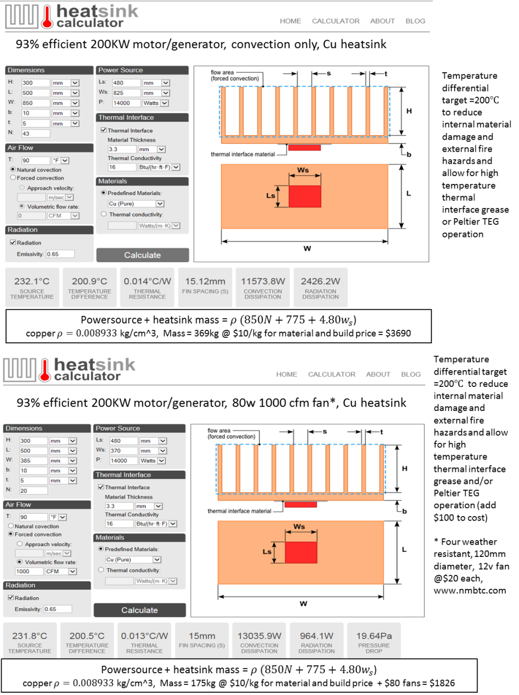
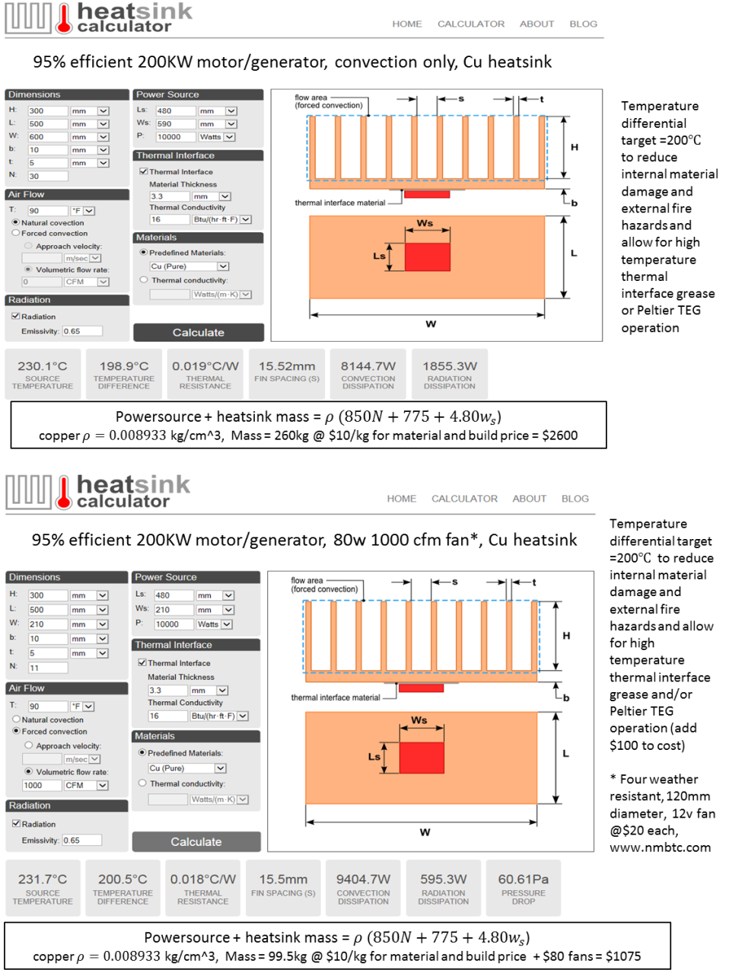

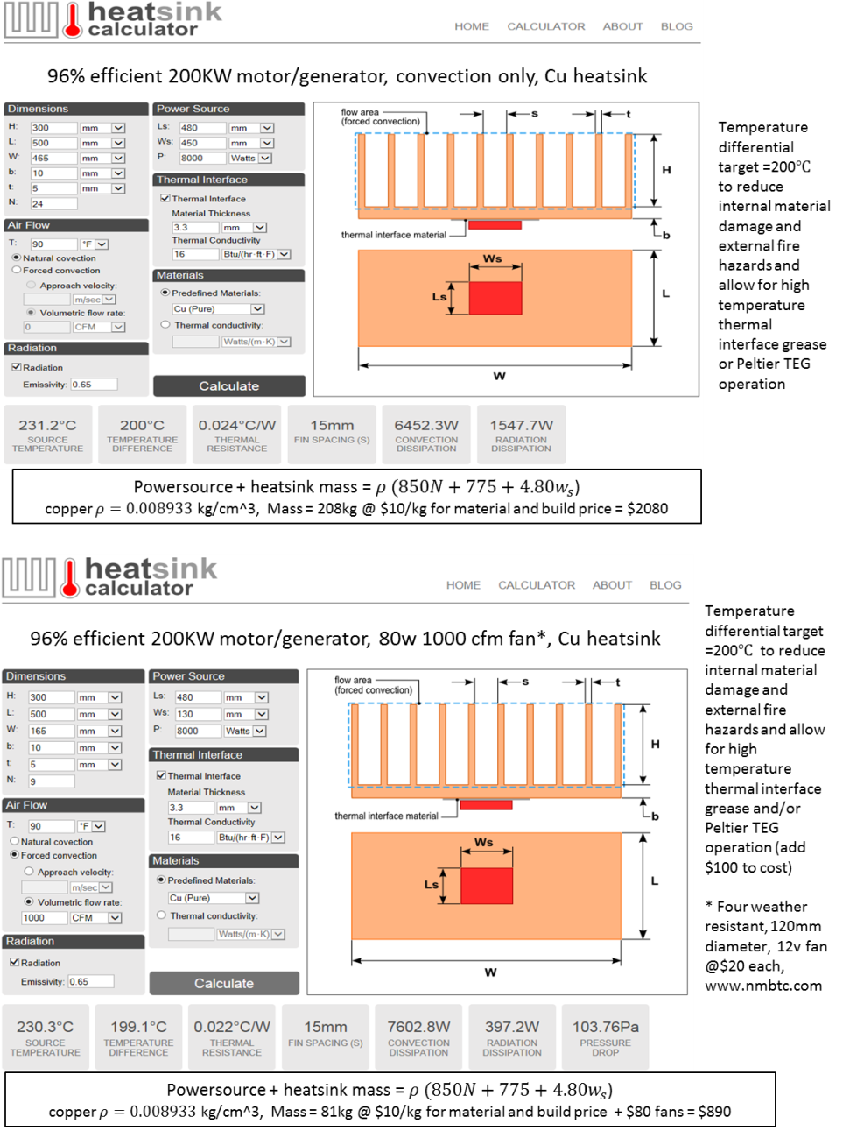

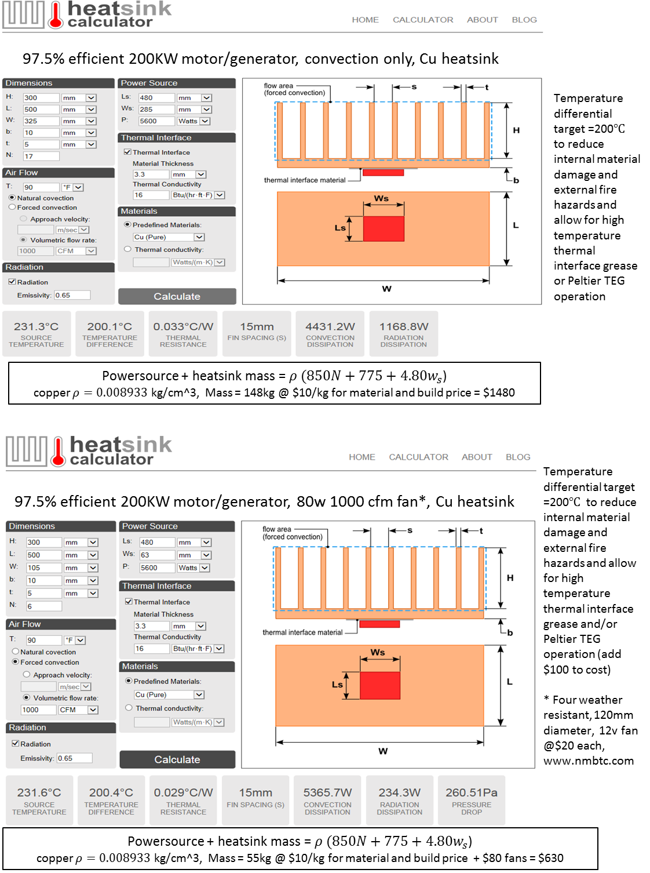

Appendix B: FES rotor designs

Appendix C: PM motor mass and cost estimate

Appendix D: Detailed FES technology database

Appendix E: Detailed STMI “Best Value” VE analysis
All successful baseline FES design runs + last page of unsuccessful designs which did not meet customer requirements

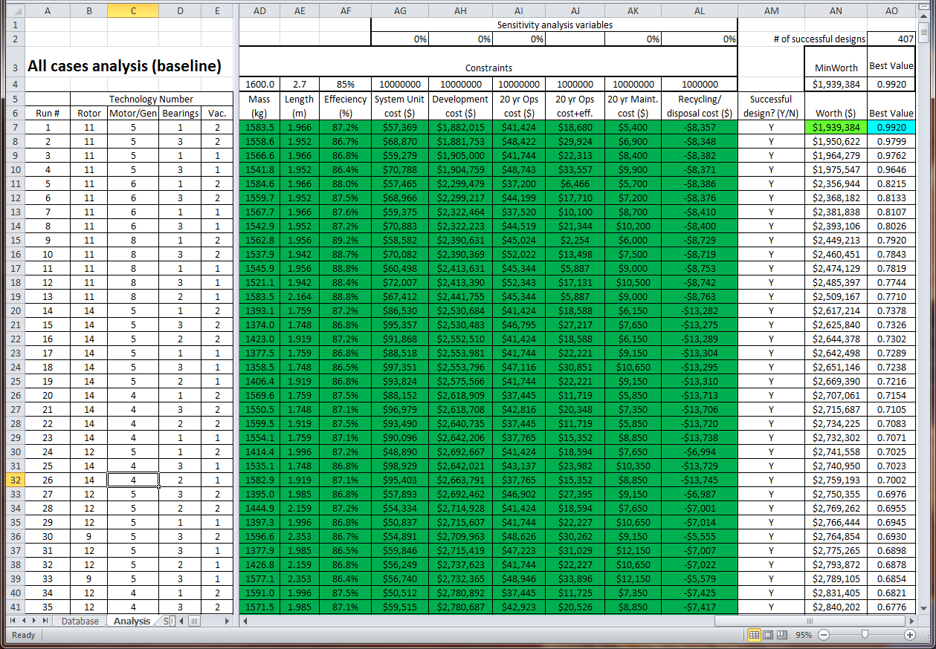
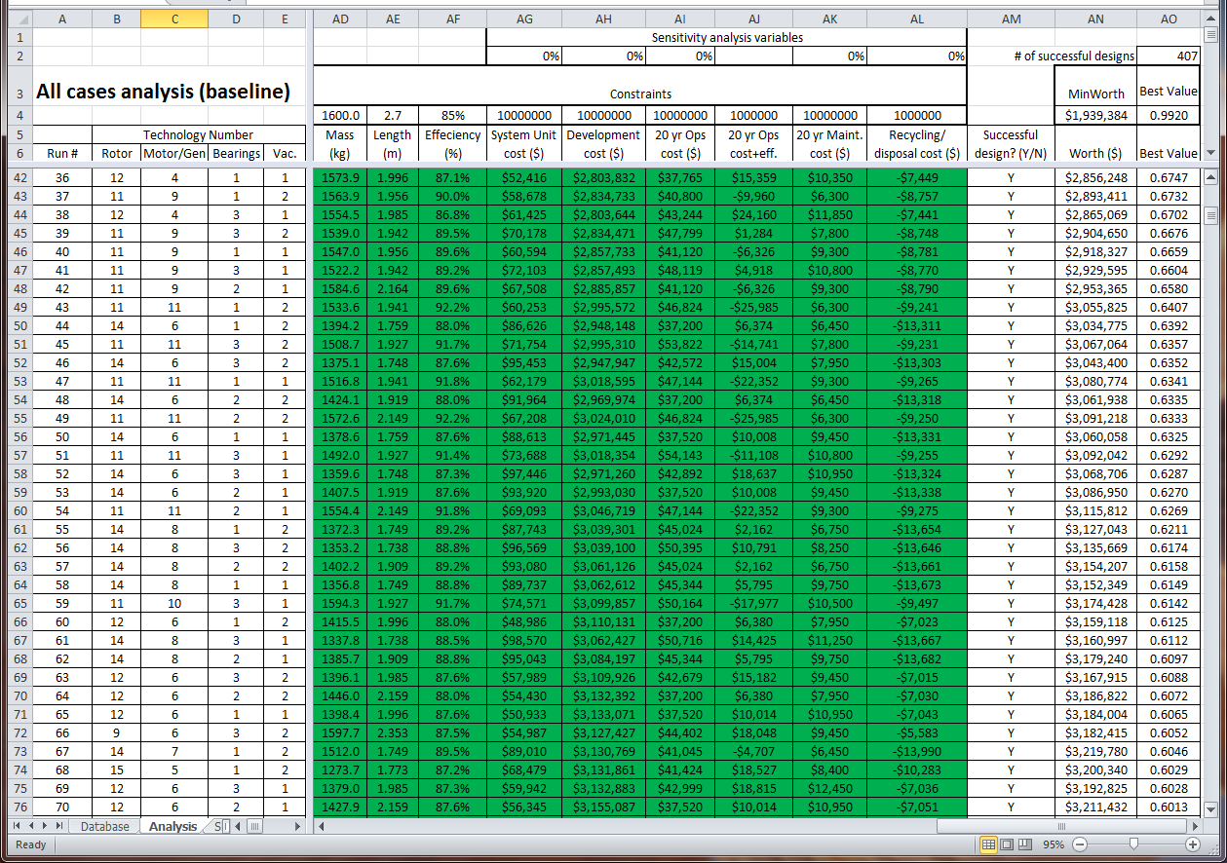
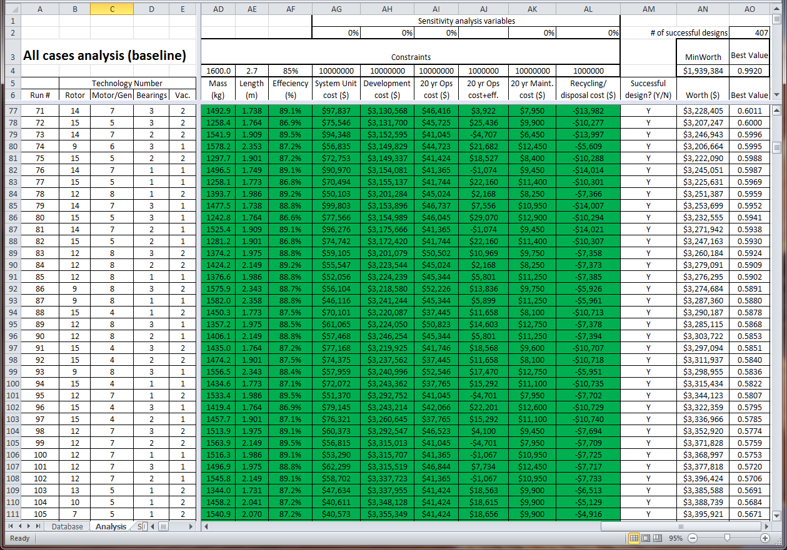
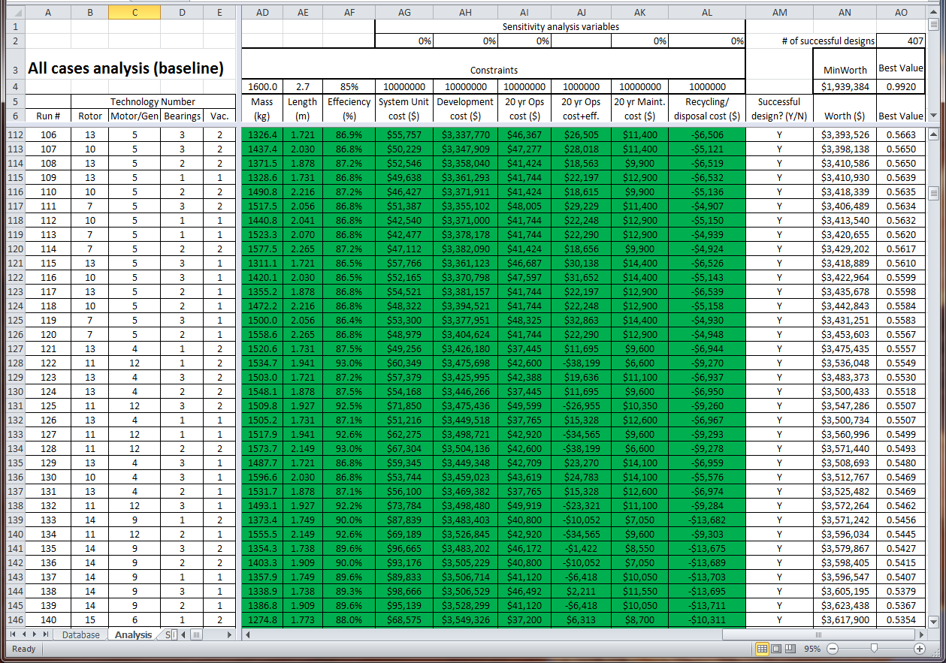
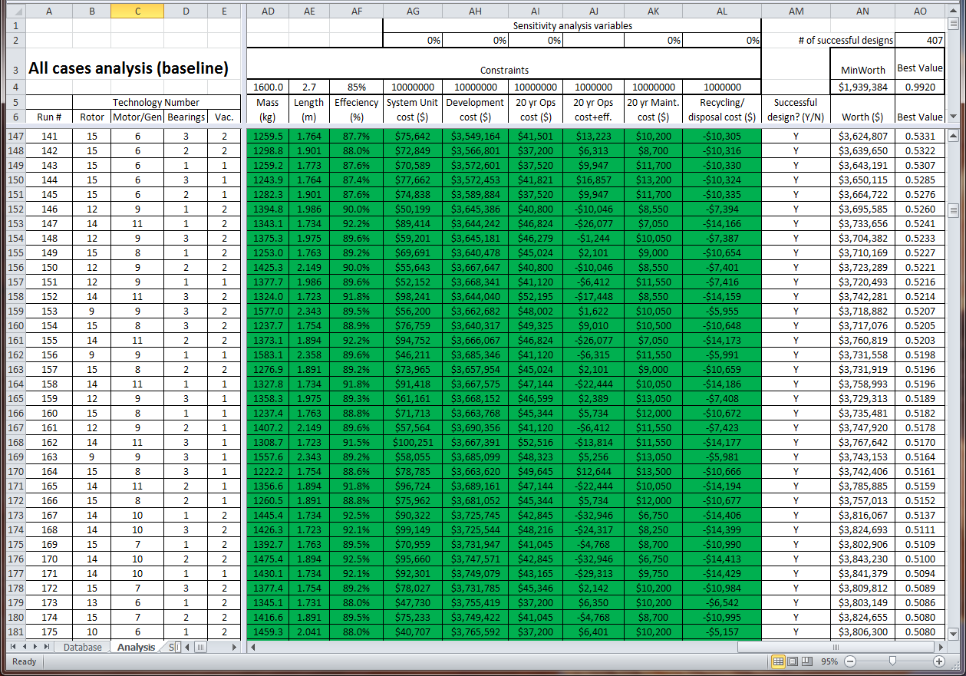
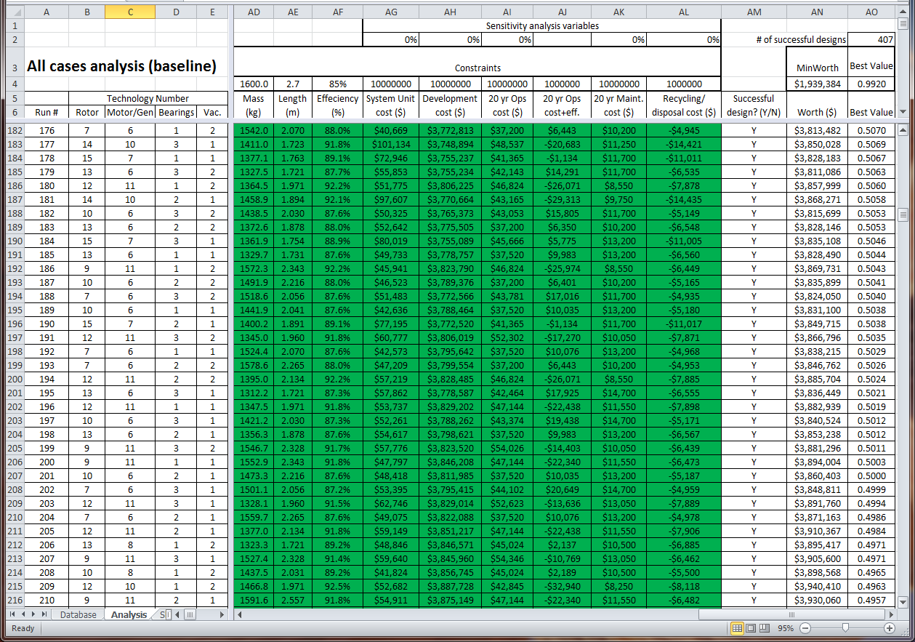
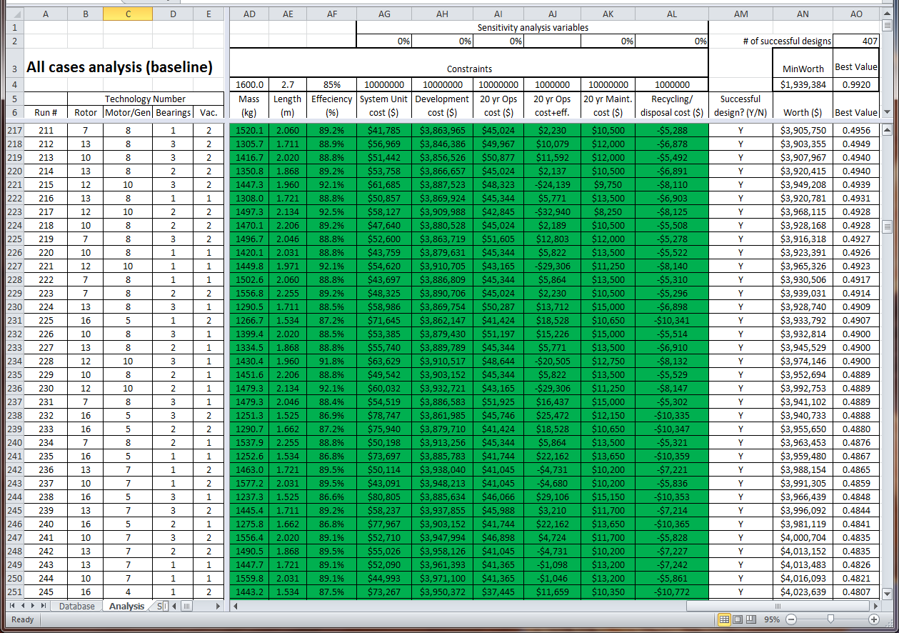
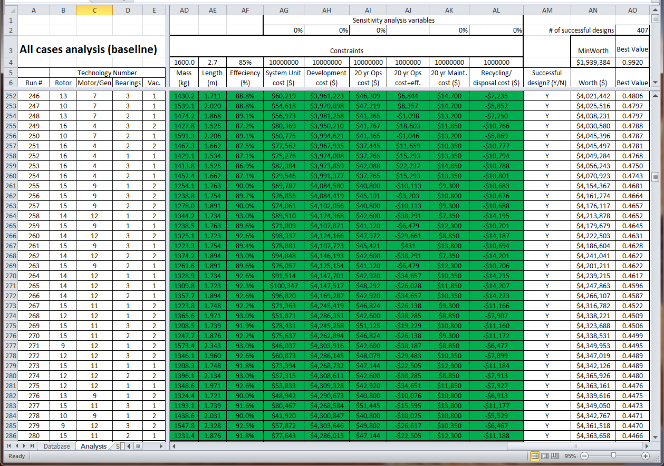
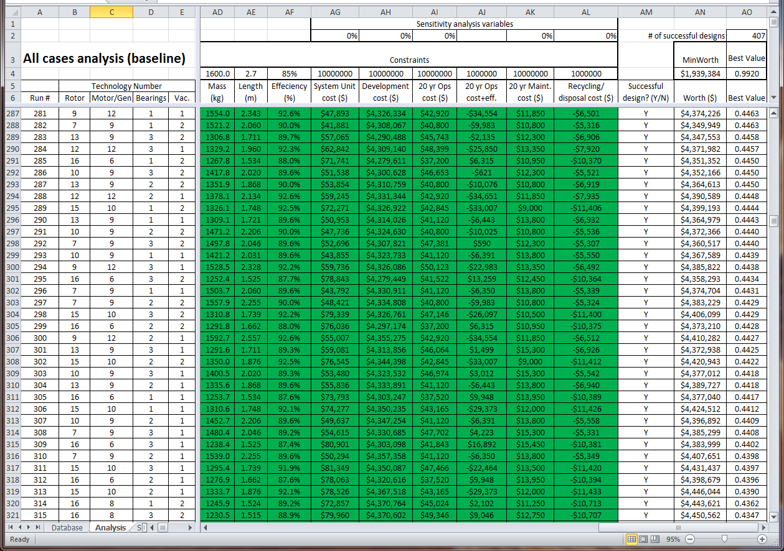
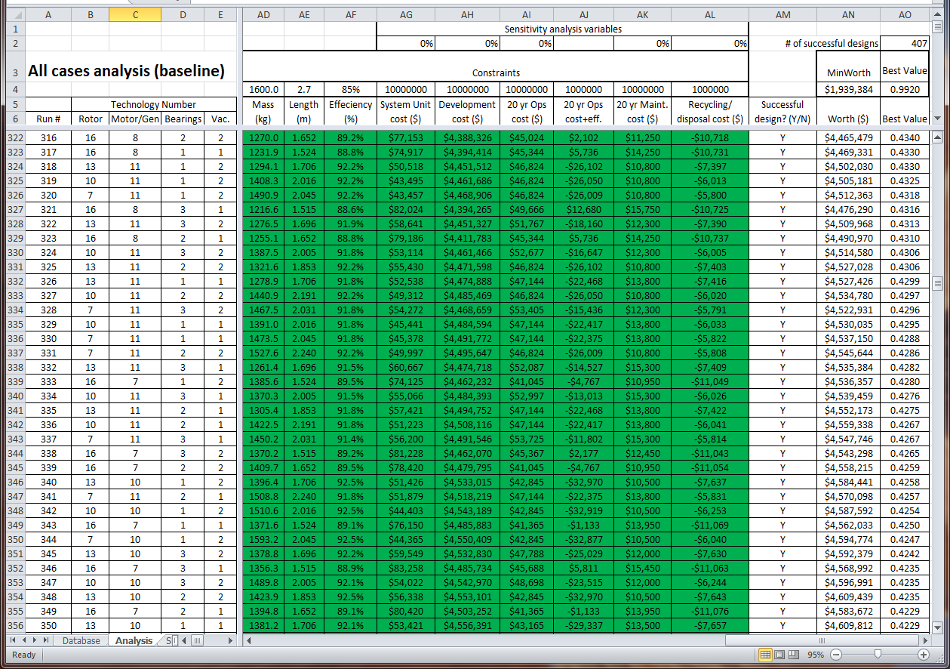
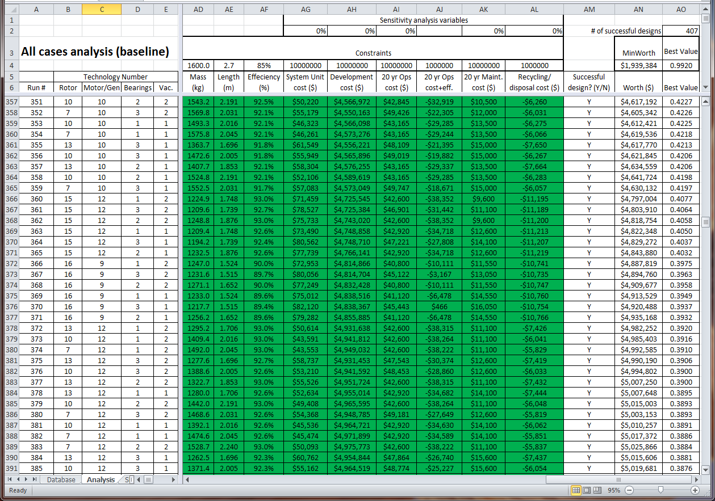
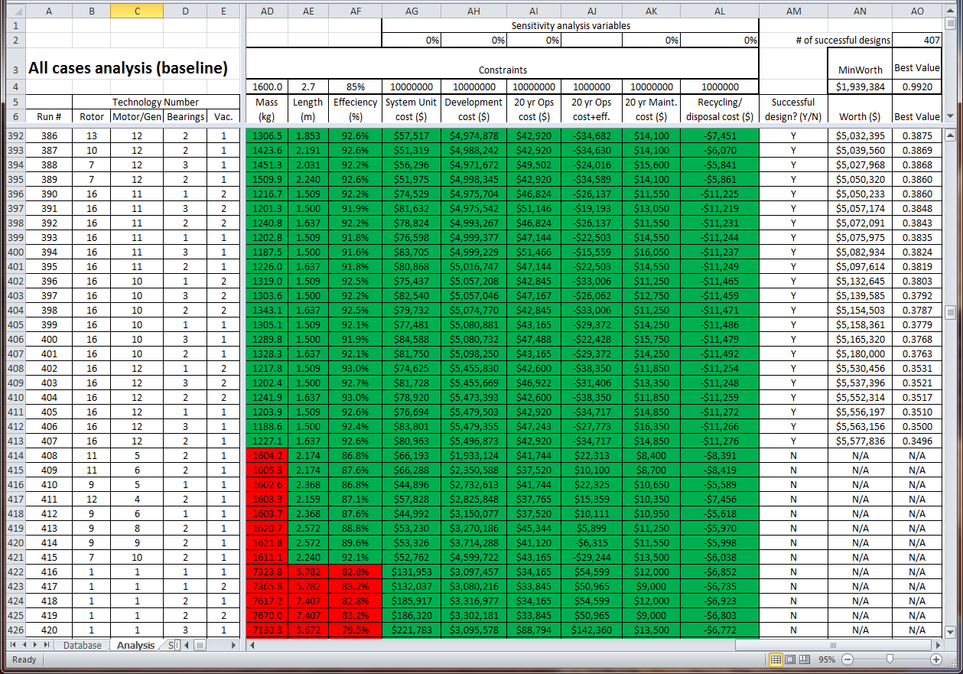
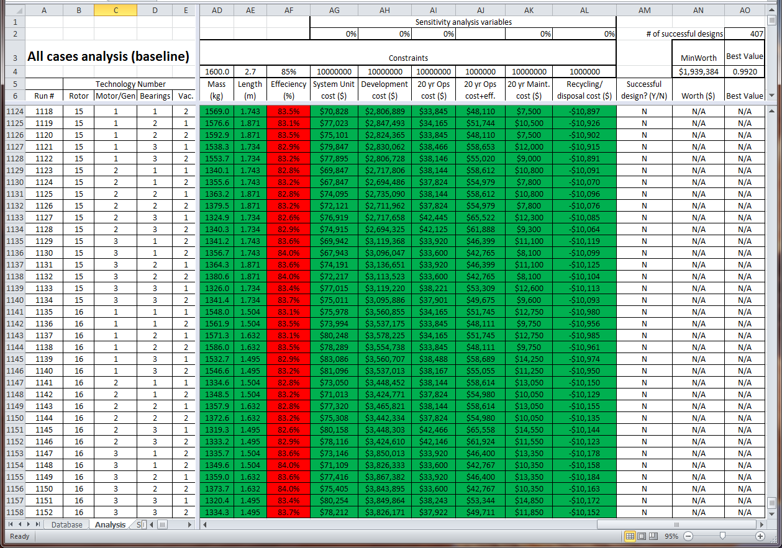

Vita

James Brill Clegern was born in Enid, OK, to the parents of Robert and Carol Clegern. He is the first of three children, with a brother, David, and sister, Judith. He attended High School at Sherwood High School, Maryland. After graduation in 1987, he attended the University of Maryland, College Park, where he completed his Bachelors of Science degree in Aerospace Engineering in December 1991. He also completed his Air Force Reserve Officer Training Corps program and was commissioned into the United States Air Force (USAF) as an acquisitions/engineering officer. He accepted a delay to active duty in 1992 and attended the University of Tennessee Space Institute, Tullahoma TN in their Aerospace Engineering program. James graduated with a Masters of Science degree in Aerospace Engineering in May 1993.

From May 1993 to May 2013, James served on active duty in the USAF, completing tours in Dayton, OH, Colorado Springs, CO, Lancaster, CA, Bellevue, NE and Albuquerque, NM as an Developmental Engineer, Staff Engineer, Test Director, Developmental Test Engineer, Chief Engineer, and Group Test Director. While serving at Kirtland AFB, NM in 2009, he reenrolled with the University of Tennessee Distance Learning program in the Industrial Engineering program. He is continuing his education with a Doctorate of Philosophy in Industrial Engineering at the University of Tennessee, Knoxville, TN.

