Effects of Molecular Crowding on Binding Affinity of Dihydrofolate to Dihydrofolate Reductase

Nidhi Niranjan Desai
The University of Tennessee-Knoxville
Department of Biochemistry and Cellular & Molecular Biology
4/28/14
Research Mentor and Advisor: Dr. Liz Howell
Email: lzh@utk.edu

ABSTRACT

The enzyme dihydrofolate reductase (DHFR) is a critical enzyme in the biosynthetic pathway for nucleotides and proteins in the cell. DHFR contributes to the production of purines by forming tetrahydrofolate (THF) using dihydrofolate (DHF) as the reactant and NADPH as the cofactor. Furthermore, tetrahydrofolate acts as a carbon donor to promote the synthesis of thymine, a pyrimidine. Thus, DHFR contributes to the growth of cells and dysfunction of the enzyme can have deleterious results. Because of this, DHFR has become a focus-point in the fields of cancer research and antibiotic-resistance.
In recent years, other forms of the DHFR enzyme have been discovered, specifically the plasmid form R67 found in E.coli. Since DHFR catalyzes such an important reaction, it is critical that the enzyme is studied to gain insight on how it reacts to changes in osmotic pressure, for instance. Because DHFR is located in the cytosol of a cell, there are many other proteins in the cell that may have an effect on the production of THF and cell growth. Using proteins of various weights and charges, we hypothesize that the efficiency of the reaction catalyzed by DHFR will decrease with the presence of proteins. To measure how these proteins or crowders alter DHFR’s activity, Michaelis-Menten kinetics and progress curves will be used to generate information about the enzyme’s binding affinity Therefore, studying how proteins will affect the reaction rate in vivo is important to understand how the cellular environment may mediate the efficacy of the antifolate drugs used in cancer treatment.
INTRODUCTION
The folate cycle plays an important role in the synthesis of nucleic acids and amino acids. One enzyme of great interest is DHFR or dihydrofolate reductase. This enzyme catalyzes the conversion of dihydrofolate (DHF) to tetrahydrofolate (THF) using NADPH as a cofactor. The THF can then be used as a one carbon carrier in other processes like amino acid metabolism. DHFR is not only found in mammals, but also in bacteria. One isoform is the R67 DHFR, which is carried by an R-plasmid or resistance plasmid. In comparison to the chromosomal DHFR, R67 has different characteristics. For instance, R67 DHFR has a lower affinity for DHF than the chromosomal form ¹. Additionally, the two structures are dissimilar. Chromosomal DHFR has one active site, specific for NADPH and DHF ¹. R67, on the other hand has one binding site that binds both NADPH and DHF ligands ¹. The enzyme efficiency of DHFR changes when DHF interacts with other molecules.
DHF Interaction with Osmolytes and Solutes
According to Grubbs’s model (Appendix B), without the presence of the osmolyte in the cell, the binding of DHF to DHFR expels water molecules. Previous studies have shown that molecules known as osmolytes, like Dimethyl sulfoxide and betaine , weakly interact with the DHF molecule prior to binding to the DHFR²; this weakens the binding affinity of DHF to DHFR ¹³. In the presence of osmolytes or these solute molecules, they bind to the DHF molecule and weaken DHF-DHFR binding. Similar to this, molecular crowders, or molecules that take up space in the cell, are of interest because of the similar functional groups crowders share with osmolytes. Furthermore, because crowders can be proteins, it is also important to observe what effects certain characteristics of proteins like molecular weight and charge have on the catalytic efficiency (k_{cat}/K_{m}), substrate affinity (K_{m}), and turnover rate (k_{cat}).
Here, progress curves and steady-state kinetics were used to determine these kinetic parameters for both R67 and chromosomal forms of DHFR in the presence of various molecular crowders. The results were verified by comparing the dissociation constants (K_{D}) of isothermal calorimetry data to ensure that only binding was measured.
Choosing Molecular Crowder
The molecular crowders were chosen based on characteristics like crystal structure, availability, net charge at physiological pH, prevalence in the cytosol, and solubility. During the course of the study, some of the proteinaceous crowders chosen were bovine serum albumin, lysozyme, and casein, where casein was purified using milk.
Table 1.1- An Overview of Crowders Used.
 | BSA | Lysozyme | Casein
Structure | 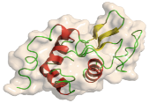 | 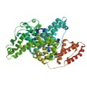 | 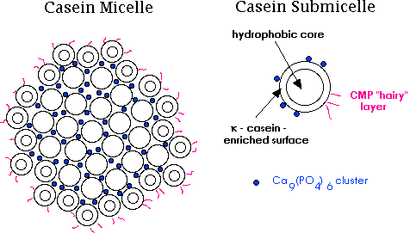
Molecular Weight (g/mol) | 66,000 | 14,307 | α-s1: 22,068-23,724 α-s2: 25,230 β: 23,944-24,092 κ: 19,007-19,039
Isoelectric Point (pI) | 4.7-4.9 | 11.35 | α-s1&s2: 4.2-4.76 β: 4.6-5.1 κ: 4.1-5.8
Table 1.1- BSA or Bovine serum albumin is a transport protein found in the blood cells of cows. It has an ordered structure, being negatively charged at physiological pH. Like BSA, lysozyme has an organized structure, but the P.I. is much higher and it is more negatively charged at physiological pH. Casein is the most disordered out of these crowders and forms micelles.

Overall, we hypothesize that the crowders may bind to the DHF molecule (Fig. 1) and decrease catalytic efficiency and substrate affinity. We ask whether the interaction is driven by hydrophobicity via methlyene groups or electrostatics.
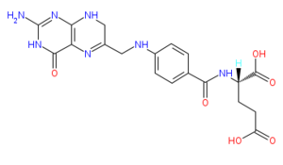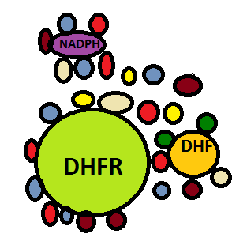
Fig.1: A) -Structure of Dihydrofolate-
Crowders may interact either electrostatically or hydrophobically with dihydrofolate. B) Crowders (different colored spheres) can interact with DHF, NADPH, or DHFR inside the cell.

B
A

MATERIALS AND METHODS
R67 and chromosomal DHFR were purified using techniques described by Reece for R67³ and Grubbs for Chromosomal DHFR⁴.
Crowder Preparation
BSA and lysozyme were purchased from Fisher Bioreagents. Stock solutions of 15 mg/ml of BSA and lysozyme, weighed out by mass only, were prepared using MTA (100mM Tris, 50mM MES, 50mM Acetic Acid) pH 7.0 buffer. Dilutions were made to attain the correct concentrations of the crowder for each set of experiments.
Casein was isolated by acidifying milk⁵. First, about 4.0 g of dry nonfat milk was dissolved into 10 mL of water. This solution was heated to 40°C and then 10mL of 1% acetic acid was added into the milk drop-wise. During the addition of acetic acid, the milk solution was continually stirred and the temperature was kept constant. When the casein began to form, a spatula was used to separate the casein from the whey of the milk. After separating the casein, it was transferred into a falcon tube with water. The pH was increased to 10 and then dropped to 5 to remove the impurities 2-3 times. After this, the casein was extracted and placed into another falcon tube, covered with Parafilm, to be lyophilized or dried. A 30 mg/ml stock of casein was made in MTA pH 7.0 buffer, with the overall pH adjusted to 7.0. The stock was allowed to go into solution overnight. After this, the solution was centrifuged and the supernatant was transferred to a new falcon tube. From this new solution, the concentration was calculated by measuring the absorbance at 280 nm and using the extinction coefficient 10.1¹¹ with Beer’s Law.
Progress Curves
In order to observe what kinds of effects these crowders were having on enzyme efficiency, substrate affinity, and turnover, progress curves were used. A progress curve integrates the sum of the rates of the reactions (Fig. 2), from which these parameters can be calculated¹². Three different types of assays were performed: limiting DHF and saturating NADPH conditions for EcDHFR, limiting NADPH with saturating DHF for EcDHFR, and limiting DHF with saturating NADPH for R67 DHFR. Various concentrations of enzyme, crowder, cofactor, and substrate were used for each set. For instance, the DHF limiting assays of EcDHFR used 10 μM of DHF, 90μM NADPH, various concentrations of the crowder (5, 10, 15 mg/ml), and 3-12 nM of EcDHFR (Table 2). The chromosomal DHFR reactions were mostly conducted in MTA buffer with 0.1mM EDTA and 5mM BME. The R67 assays, on the other hand, used MTA without any additions.
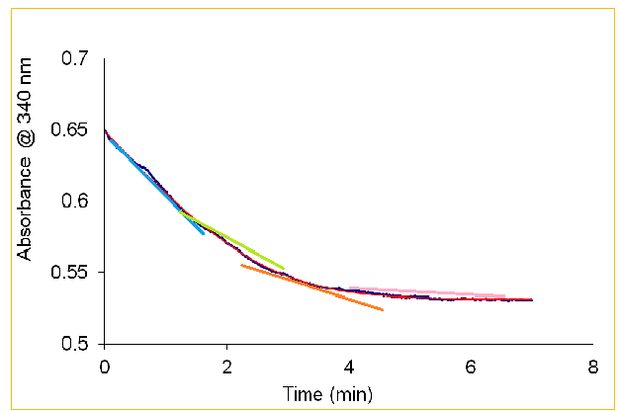
Fig.1: The Slopes of a Progress Curve
Fig. 2: A progress curve adds the slopes over the course of the reaction as shown. The different colors demonstrate the various slopes that would be incorporated into the calculations.
Table 2: The Varying Concentrations of Substrate, Cofactor, Crowder, and Enzyme
[DHF] (μM) | [NADPH] (μM) | [DHFR] (nM) | [Casein] (mg/ml)
10 | 90 | 3 | 0  EcDHFR DHF Limiting
10 | 90 | 4 | 5
10 | 90 | 5 | 10
10 | 90 | 6 | 15
110 | 10 | 4 | 0
110 | 10 | 4 | 5
110 | 10 | 5 | 10
110 | 10 | 5 | 15
10 | 100 | 200 | 0
10 | 100 | 200 | 5
10 | 100 | 200 | 10
10 | 100 | 200 | 15

EcDHFR NADPH Limiting

R67 DHF Limiting

Table 2: The concentrations of DHF, NADPH, DHFR, and crowder (casein) varied based on the limiting reagent and isoform of DHFR. All reactions were performed in MTA buffer.

Overall, the progress curves result in an L-shaped curve as time increases. The raw data which consisted of the absorbance measured every minute were transferred into an Excel document. These data were exported into MATLAB and fit (Appendix A). From this, the K_{m} and V_{max} are generated. Then, these values were used to calculate k_{cat} (enzyme turnover) and k_{cat}/K_{m} (catalytic efficiency).
Michaelis-Menten Kinetics
Michaelis-Menten or inital-state kinetics is another way of measuring the interaction that crowders have with the substrate and their effect on efficiency. The purpose of using Michalis-Menten kinetics was to support the data attained through progress curves. In these experiments, the assays were carried out for one minute in MTA pH 7.0. The concentrations used for the experiments were not the same as those in the progress curves. The concentration of enzyme, especially with R67, was determined based on the rate of the reaction with the stock solution of the DHFR enzyme (Fig. 3). For instance, if the concentration of the stock solution of R67 was 30μM, 10μL of this was used in the assay with 10μL of DHF and NADPH. If the rate of this trial was above the range of 0.025-0.030 s⁻¹, then the enzyme was diluted accordingly in order to ensure initial rates were measured⁶.
Fig 3: A Schematic of R67 Dilution.
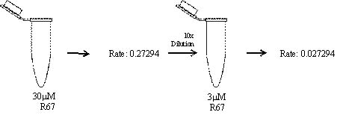
Additionally, the concentration of DHF was decreased by a factor of two with each triplicate set (Fig.4). If the substrate concentration is saturating, the rate does not change. As the substrate concentration approaches and goes below the K_{m} value, the rate descreases These raw data are then transferred into SigmaPlot, where they were plotted with the Michaelis-Menten equation (Fig.4C), generating a K_{m}, V_{max}, and a curve. For the Michaelis-Menten assays, only R67-DHF limiting with casein and lysozyme was completed.
DHF(μL) | A340 | NADPH(μL) | R67 (μL) | Rate
10 | 0.4883 | 10 | 10 | 0.02876
10 | 0.4633 | 10 | 10 | 0.02853
10 | 0.461 | 10 | 10 | 0.02742
10 | 0.23 | 10 | 10 | 0.027
10 | 0.23 | 10 | 10 | 0.027
10 | 0.25 | 10 | 10 | 0.028
10 | 0.11 | 10 | 10 | 0.024
10 | 0.12 | 10 | 10 | 0.023
10 | 0.12 | 10 | 10 | 0.022
10 | 0.07 | 10 | 10 | 0.017
10 | 0.07 | 10 | 10 | 0.018
10 | 0.07 | 10 | 10 | 0.02
10 | 0.035 | 10 | 10 | 0.013
10 | 0.036 | 10 | 10 | 0.011
10 | 0.038 | 10 | 10 | 0.014
$V=\frac{V_{max} [S]}{K_{m}+[S]}$
B
A
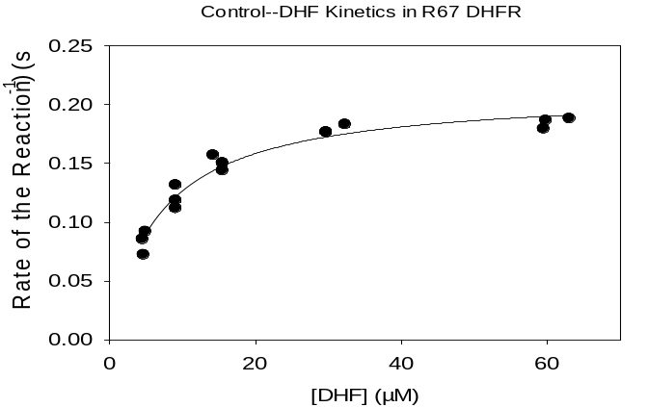
C

Fig 4: A) To the left, the table displays an example of the raw data collected by the assays. B) The Michaelis-Menten equation is used to fit the steady-state kinetic data. C) Sigma Plot fits this data to the Michaelis-Menten equation.

Isothermal Titration Calorimetry (ITC)
One final way of corroborating the results is through isothermal titration calorimetry. As it requires the use of large concentrations of enzyme, it is not used as much as the kinetic assays. This technique utilizes a thermodynamic approach and measures K_{D} or dissociation constants. This technique was only practiced, but in the future will yield results. The K_{D} is derived by analyzing the heat release when the substrate binds to the enzyme in comparison to the reference cell (Fig.5a) ⁷. To perform experiments on the ITC, the concentrations of the ligand and the enzyme were calculated beforehand, using spectroscopy and bicinchoninic acid (BCA) assays, respectively.
To utilize the ITC, first, remnant liquid from the last experiment was removed from the sample cell and injection syringe. They were both washed with water 5-6 times and then with MTA buffer, as a secondary wash. After this, the protein solution was loaded into the sample cell via syringe, with a small fraction left in the tube. Bubbles in the sample cell were eliminated by moving the syringe in an upward-downward motion and the Hamilton syringe and excess fluid was removed. Using a clean injection syringe, buffer was loaded and dispelled from the injection syringe with the tubing. Then, the ligand, DHF, sample was taken up by injection syringe until seen in the syringe, after which the fill port is closed. Using the ITC program, the purge and refill option was selected twice. After this, excess liquid from the sides of the injection syringe was wiped. Finally, the syringe was inserted into the sample cell, ensuring proper fit⁸. Then, the ITC parameters were set up. For the entire ITC experiment, there were 75 injections, an initial delay of 60s after the first injection, and slightly varying volumes for injection (Fig. 5b).
B))
Fig 5: Isothermal Calorimetry (ITC) Schematic and Parameters
Injection number | Volume | Duration | Spacing
1 | 2 | 10 | 240
2 | 2 | 10 | 240
3 | 3 | 10 | 240
4 | 3 | 10 | 240
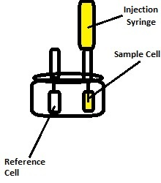
Fig. 4: A) An ITC injects ligand into the enzyme complex via the injection syringe. This binding will emit heat and with comparison to the reference cell, enthalpy and entropy can be measured. B) The table below displays the injection parameters for the first four injections after setting up the ITC. To compensate for error, the volume is returned to 3 after the first two injections.
A)

Results
Crowder:
For the crowders purchased from Fisher, the assays were consistent. To examine the role of electrostatics in the casein effects, we added increasing concentrations of salt. However, the the results were not consistent (Table 3). For the trials during October, a new casein prep had been performed and fresh casein was used in the progress curves. With a comparison to the control, the k_{cat} and
the K_{m} stay relatively similar to one another prior to the introduction to the new casein.When comparing the new casein experiments with the control, the K_{m} increases about 4-5 times and k_{cat} increases by a factor of 1.25, and thus decreases the catalytic efficiency.
Table 3: Salt Effects on Casein and Effects on DHF-limiting EcDHFR in MTA (0.1mM EDTA, 5mM BME)
K_{m}(μM) | V_{max} (mM/min) | [Protein] (nM) | k_{cat} (s⁻¹) | k_{cat}/K_{m} | [NaCl] (mM) | [Casein] mg/ml | Date
1.94 ± 0.47 | 7.18 ± 1.3 | 3 | 39.9 ± 7.7 | 2.18E +07 ± 0.7 | 0 | 0 | Control
1.67 | 4.11 | 3.33 | 20.4 | 1.34E+07 | 100 | 0
2.11 | 7.94 | 6 | 22.1 | 1.05E+07 | 100 | 10 | 9-4-13-2
1.24 | 8.26 | 6 | 22.9 | 1.85E+07 | 100 | 10 | 9-5-13-2
1.35 | 5.99 | 5 | 20.0 | 1.48E+07 | 100 | 10 | 9-6-13-2
2.03 ± 0.30 | 5.7 ± 1.5 | 3 | 31.7 ± 8.4 | 1.57 E+07 ± 0.43 | 0 | 0 | Control
4.5 | 7.06 | 4 | 29.4 | 6.54E+06 | 100 | 10 | 10-22-13-3
5.59 | 6.2 | 4 | 25.8 | 4.62E+06 | 100 | 10 | 10-23-13-3
5.07 | 6.2 | 4 | 25.8 | 5.10E+06 | 100 | 10 | 10-23-13-3
Table 3: The data show that after the new casein prep, the K_{m} roughly doubles, the k_{cat} increases, and the k_{cat}/K_{m} also decreases. Even though the concentrations of DHFR differ, the calculations account for this difference.

Progress Curves versus Michaelis-Menten: DHF Limiting
Since progress curves can show effects due to product inhibition, Michaelis-Menten kinetics was also used to assess the validity of the crowding effects on DHFR function.The K_{m} and k_{cat} values for both techniques were compared for the plasmid and chromosomal forms of DHFR. As an example, the comparison is shown for the R67 enzyme with limiting amounts of DHF (Table 4). The substrate affinity of the enzyme is the same as the control for the Michaelis-Menten assays with 5 and 10 mg/ml casein and 25mg/ml lysozyme. With respect to the progress curves, the substrate affinity for casein at 5mg/ml is the same as the control. However, for all other concentrations and lysozyme, the K_{m}s do not agree, but show 1.5 times larger K_{m} for 10mg/ml casein and 50mg/ml lysozyme. For the k_{cat}s, there is much variation between Michaelis-Menten and progress curves.
For the chromosomal DHF-limiting assays, only progress curves have been performed thus far, so a comparison to Michaelis-Menten assays is not available. However, from the data of the progress curves, with increasing concentration of crowder, the K_{m} increases, which is roughly what is seen with R67-DHF limiting. In addition to this, the k_{cat}s for the casein assays increases with increasing concentration. For the lysozyme assays, though, the k_{cat}s are similar to one another, but half of the control. Additionally, BSA was also used as a crowder in this assay. However, this assay was slowed greater than the lysozyme or the casein (Appendix B). In fact, in the 10 minute duration that progress curves are performed, the BSA assay appeared not to have finished.

Table 4: A Comparison of Kinetic Data between Michaelis-Menten and Progress Curves of R67-DHF Limiting
Variable | Control | Casein 5mg /ml | Casein 10mg / ml | Lysozyme 25mg / ml | Lysozyme 50mg / ml
K_{m}-Michaelis-Menten (μM) | 7.0 ± 0.6 | 6.4 ± 1.2 | 7.2 ± 0.4 | 6.9 ± 0.7 | 8.9 ± 0.9
K_{m}-Progress Curves (μM) | 8.3 ± 0.7 | 7.5 ±1.2 | 10.0 ± 1.5 | 6.7 ± 0.3 | 14.0 ± 0.9
k_{cat}- Michaelis-Menten (s⁻¹) | 0.54 ± 0.02 | 0.57 ± 0.08 | 0.85 ± 0.2 | 1.0 ± 0.06 | 0.75 ± 0.12
k_{cat}- Progress Curves (s⁻¹) | 1.0 ± 0.1 | 0.75 ± 0.1 | 1.0 ± 0.2 | 0.41 ± 0.01 | 0.45 ± 0.02
Table 4: The table compares the data of the same experiments utilizing two different techniques---Michaelis-Menten kinetics and progress curves. When comparing the K_{m}s of the two techniques, they are mostly within error of each other, except at the highest concentrations of casein and lysozyme. However, for the enzyme turnover number, there is much variation between the two assays

Progress Curves versus Michaelis-Menten: NADPH Limiting
As mentioned previously, the Michaelis-Menten assays have not yet been performed for R67-NADPH or EcDHFR-NADPH limiting. However, the progress curve data is available (Table 5). R67-NADPH limiting assays with casein were not conducted because the casein interacted too greatly with the DHFR. The same can be said for lysozyme concentrations above 25mg/ml. The substrate affinity for both EcDHFR and R67 do increase with increasing concentrations, as seen with the other assays. Furthermore, like the k_{cat}s of lysozyme in the R67-DHF limiting reactions, the casein assays also have k_{cat}s within error of each other.

Table 5: A Comparison of Progress Curve Data between R67 and EcDHFR for NADPH Limiting Assays

Variable | Control | Casein 5mg /ml | Casein 10mg / ml | Lysozyme 15mg / ml
K_{m}-R67-NADPH (μM) | 1.76 ± 0.06 | N/A | N/A | 25.5 ± 9.0
k_{cat}- R67- NADPH (s⁻¹) | 24.2 ±1.0 | N/A | N/A | 1.2 ± 0.4
K_{m}-EcDHFR-NADPH (μM)* | 1.76 ± 0.06 | 3.4 ± 0.2 | 3.3± 0.4 | 14.3 ± 0.6
k_{cat}- EcDHFR-NADPH (s⁻¹) | 24.2 ±1.0 | 29.1 ±1.8 | 32..1 ±4.0 | 39.6 ± 2.3
Table 5: Because the Michaelis-Menten kinetics is still in progress, progress curve data can be analyzed. Neither casein nor lysozyme concentrations above 15mg/ml could be measured.

Michaelis-Menten Comparison with Varying Concentrations of Casein (Fig. 6A)
In order to observe what effect each isoform has on the crowder casein with different limiting reagents, a plot can be generated comparing the catalytic efficiencies (k_{cat}/K_{m}) to the water activity or the osmolality multiplied by -0.018. 1.00 is the activity of pure water ⁹. According to Fig. 6, at higher water activity (the points to the farthest right), most conditions have the greatest catalytic efficiency. The greatest change in catalytic efficency occurs with limiting amounts of DHF in chromosomal DHF. EcDHFR-NADPH limiting and R67-DHF limiting have less steep slopes.
Michaelis-Menten Comparison with Varying Concentrations of Lysozyme (Fig.6B)
The effects of lysozyme on the EcDHFR and R67 are similar to the trends observed with casein. The EcDHFR- DHF limiting assay once again has the steepest slope, while EcDHFR-NADPH is second, and R67-DHF limiting does not have much of a slope. Between the two crowders, lysozyme has a bigger change in catalytic efficiency than casein for chromosomal DHFR with limiting amounts of NADPH and DHF. Additionally, EcDHFR and R67 with limiting amounts of NADPH have similar slopes. Finally, like casein, the lysozyme assay with R67-DHF limiting has almost no slope.
Fig. 6-A Comparison of Enzyme Efficiency with Increasing Crowder Concentration in Different Conditions

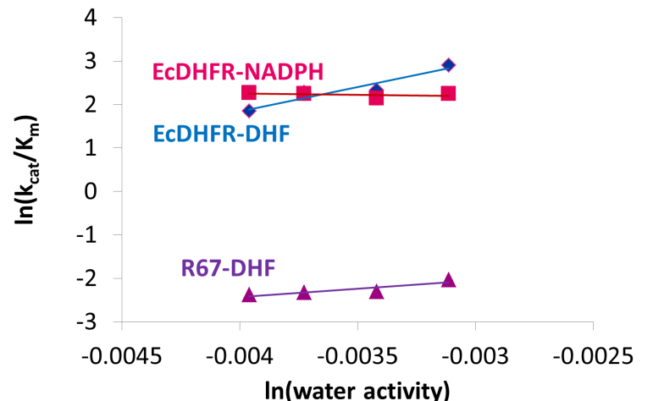
Fig. 5A)-The graph plots the natural log of water activity (a_{H2O}) against the natural log of catalytic efficiency. For casein, the chromosomal DHFR is more sensitive to the casein than the R67 DHFR.
5A) Casein
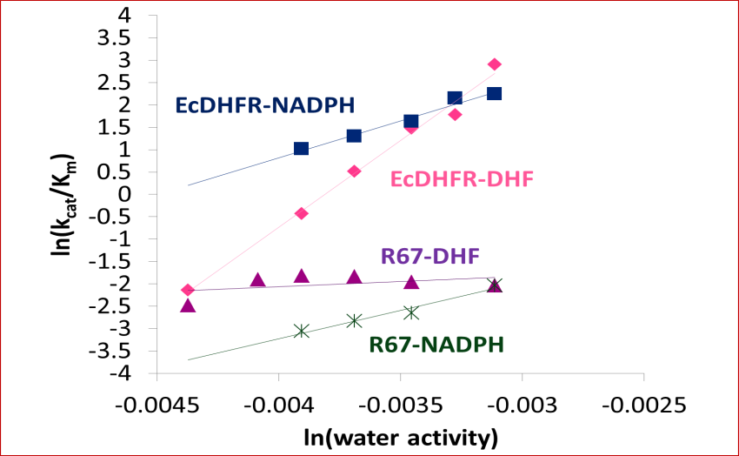
Fig. 5B)-The graph plots essentially the concentration of crowder (through water activity) versus the efficiency in the presence of lysozyme. Once again, the chromosomal DHFR with limiting amounts of DHF has a greater slope than other conditions. Additionally, R67-DHF once again has a very small slope.
5B) Lysozyme
Discussion
Overall, our hypothesis that crowders interact with DHF to DHFR’s substrate affinity and catalytic efficiency was partly true. According Fig. 6A, casein does interacts with DHF to decrease catalytic efficiency. In fact, using Grubbs’s model⁴, it appears crowders behave similarly to the osmolytes in that they bind to the DHF molecule and can act as alternate solvents. If removal of the osmolyte or crowder is more difficult than desolvation (removal of water), this makes it difficult for the DHF to bind to the DHFR, resulting in weaker binding, interactions with the enzyme, or interactions with the cofactor NADPH.
To test the type of interaction that may be occurring between crowder and DHF, we added NaCl. Salf addition acts to shield charges, which should decrease electrostatic effects. Any electrostatic effect associated with casein would be clearer if the results of the ionic trials, presented in Table 3 were more consistent. Some of the causes of the inconsistency included the aging of the MTA buffer, the presence of excess salt in the purified casein, and EcDHFR’s viability. Previously, the buffer had aged acetic acid, which yielded irreproducible results. After ordering a new stock of glacial acetic acid, the ionic studies appeared to work temporarily (Table 3), but started becoming inconsistent again. To pinpoint the source of the irreproducibility in the buffer, a progress-curve assay was performed with and without the 0.1mM EDTA and 5mM BME. According to Table 6, when 5mM BME was added to the buffer, the reaction took longer to finish. Additionally, when BME was removed, the reaction proceeded more quickly, completing within 3to 4 minutes. After removing BME from the buffer, the assays were remedied temporarily. However, when a new casein stock was used, there was variability in the results once again.
Buffer Type (+) | [EcDHFR] | Graphical Speed  Table 6: Pinpointing the Contaminant of the Buffer—the table provides an overview of how the contaminant, BME, was found by using kinetic analysis.
5mM BME only | 3nM | Slow
50mM Acetic Acid only | 3nM | Fast
5mM BME and 50mM Acetic Acid | 3nM | Slow
With the newly prepared casein, there was a problem with keeping results consistent once again. It was hypothesized that fluctuation of the pH during the casein prep could cause excess salt to go into solution and bind to the casein. This will affect the salt assays. The purpose of the salt assay is to test for interactions between DHF and the casein in the presence of salt. Thus, when casein has excess salt present, there will be a greater concentration of salt in the assay than expected. This “extra” salt can affect the enzyme by electrostatic shielding ¹⁰, which could have contributed to our loss in consistency. Lastly, after resolving these previous issues, the inconsistencies still existed, so it was hypothesized that EcDHFR used during the experiment was no longer viable. As a result, our focus turned to R67 and its interactions with the casein and lysozyme using Michaelis –Menten kinetics, as mentioned earlier.
From the graph in Figure 6B, lysozyme appeared to show a more interesting trend. Examining the slopes for EcDHFR-NAPDH and R67-NADPH, they are similar, which means that the difference in catalytic efficiency likely originates from effects of the crowders on NADPH. Since the proteins are different, yet the slopes are similar, the difference must be due to weak crowder interactions with the cofactor.
In terms of which kinetic technique is better, Michaelis-Menten kinetics is a more accurate option because it will not have any product inhibition effects as initial rates are measured. However, it is not very time or materially efficient. The progress curves are mostly supported by their Michaelis-Menten counterparts, except at higher concentrations. These issues can be examined by other techniques like ITC, which can provide an independent measure to confim weak interactions between crowder and DHF and/ or DHFR.
Conclusion
In conclusion, by understanding how different crowders interact with the enzyme DHFR, new information on how crowded environments affect enzyme function can be gained. Since the cell is a crowded environment, this may have implications on how efficacious antifolates are in treating cancer. Just from this study alone, the crowders like lysozyme and casein, displayed how proteins with different functional groups can be used to slow the catalytic efficiency of DHFR. However, because the cell contains 300-400 mg/ml of protein, predicting how crowders will interact in vivo will become more challenging, though the study provides a good starting point additionally, proteins like ribulose bisphosphate carboxylase (Rubisco), ovalbumin, keratin, and some other plant-based proteins are also being examined to use as a crowder and gain a better understanding of how crowders with different properties interact. Some future goals of this work could be to observe how two or more different crowders can interact in the presence of DHF and DHFR. In the process, these discoveries will make cancer medications more accurate and perhaps even less deleterious.
Acknowledgements
I would like to sincerely thank my advisor Dr. Liz Howell for her support and the opportunity to be part of such a great laboratory. I would also like to thank Dr. Michael Duff (Mike), the lab’s postdoctoral scholar, for being so patient with me and spending countless hours helping and teaching me. Finally, I would like to thank the lab’s graduate students--- Purva Bhojne and Timkhite Berhane--- and my fellow undergraduate students--- Greyson Dickey and Nick Mattson--- for being so supportive and making the lab a very cheerful place.

REFERENCES
- Howell, E. 2005. Searching Sequence Space: Two Different Approaches to Dihydrofolate Reductase Catalysis. 6:590-600.

- Duff, M., Grubbs, J., Serpersu, E., Howell, E. 2012. Weak Interactions between Folate and Osmolytes in Solution. Biochemistry. 51: 2309-2318.

- Reece, L. J., Nichols, R., Ogden, R. C., and Howell, E. E. 1991. Construction of a synthetic gene for an R-plasmid-encoded dihydrofolate reductase and studies on the role of the N-terminus in the protein. Biochemistry. 30: 10895−10904.

- Grubbs, J., Rahmanian, S., DeLuca A., Padmashali, C., Jackson, M., Duff, M., Howell, E. 2011. Thermodynamics and Solvent Effects on Substrate and Cofactor Binding in Esherichia coli Chromosomal Dihydrofolate Reductase. Biochemistry. 50: 3673-3685.

- Strange, E.D., Van Hekken, L.V., Holsinger, V.H. 1994. Salt Effects on Casein Solubility. Journal of Dairy Science. 77: 1216-1222.

- Cleland, W.W. 1990. Steady-State Kinetics. In Sigman, D.S. & Boyer, P.D. (Eds.), The Enzymes (101-104). San Diego: Academic Press, Inc.

- Freyer, M.W., Lewis, E.A. 2008. Isothermal Titration Calorimetry: Experimental Design, Data Analysis, and Probing Macromolecule/Ligand Binding and Kinetic Interaction. In Correia, J.J. & Detrich, H. W. (Eds). Methods in Cell Biology (79-82). London: Elsevier, Inc.

- Duff, Jr., M. R., Grubbs, J., Howell, E. E. Isothermal Titration Calorimetry for Measuring Macromolecule-Ligand Affinity. J. Vis. Exp. (55), e2796, doi:10.3791/2796 (2011).

- Sivasankar, B., 2002. Solute-Water Interactions. Food Processing and Preservation. (12-13). New Delhi: Prentice-Hall of India Limited.

- Wright, D.B., Banks, D.D., Lohman, J.R., Hilsenbeck, J.L, Gloss, L.M. 2002. The Effects of Salts on the Activity and Stability of Esherichia coli and Haloferax volcanii Dihydrofolate Reductases. Journal of Molecular Biology. 323: 327-344.

- Thompson, M.P., C.A. Kiddy.1964. Genetic polymorphism in casein’s of cow’s milk. J. of Dairy Science. 47: 626

- Philo, R.D., Selwyn, M.J. 1973. Use of Progress Curves to Investigate Product Inhibition in Enzyme-Catalyzed Reactions. Biochem.J. 135: 525-530.

- Chopra, S., Dooling, ,R.M., Horner, C.G., Howell, E.E. 2008. A balancing act between net uptake of water during dihydrofolate binding and net release of water upon NADPH binding in R67 dihydrofolate reductase. J. Biol Chem. 283:4690-4698.

Appendix A: MATLAB Program for Fitting Progress Curves

%<div class="moz-text-flowed" style="font-family: -moz-fixed"
input_file = 'RO432.xls'
input_sheet = 'Sheet1';
[input_data] = xlsread(input_file,input_sheet);
Xdata = input_data(:,1);
Ydata = input_data(:,2);
S0 = input_data(1,3);
Km = input_data(2,3);
Vmax = input_data(3,3);
Ainf = input_data(4,3);
Pini = [S0 Km Vmax Ainf -.001];

options.TolX=1e-10;
%oldoptions=optimoptions(@lsqcurvefit,'sqp','MaxIter');
options=optimset('algorithm','levenberg-marquardt');
[Pfit,SD,residual,exitflag,output,lambda,J] = lsqcurvefit(@func1,Pini,Xdata,Ydata,[],[],options);

R2_lsq=1-SD/sum((Ydata-mean(Ydata)).^2)

%Jacobian error
N = length(Xdata) - length(Pfit);
stdErrors = sqrt(diag(inv(J'*J)*SD/N)); %of global fit

[Pfit', stdErrors]

Yfit = Ydata + residual; % Create fitting curve
plot(Xdata,Ydata,'b')
hold on; % Deny refresh plot window
plot(Xdata,Yfit,'r')
hold off; % Allow refresh plot window
%promptx=':';
%A=input(promptx, 's');
%Q=[Xdata,Ydata,Yfit]
%xlswrite(A,Q);
%</div>

Appendix B: Other Figures

Fig: 1: Osmolyte Model
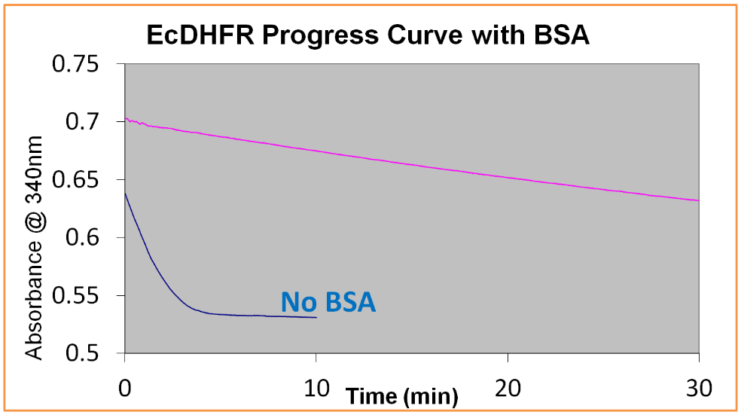
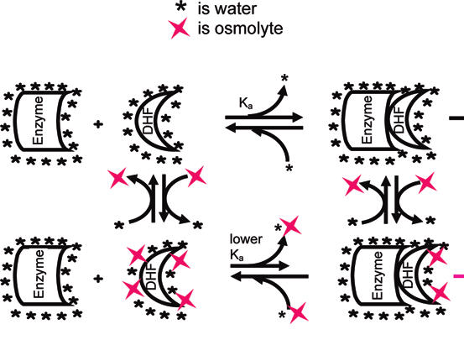
Figure 2- The progress curve of BSA used as a crowder with EcDHFR shows that the conversion of DHF to THF with NADPH present takes a long time to complete. This could also be a consequence of product inhibition
Figure 1: In Grubbs’s model, the osmolytes prevent the DHF from binding to the DHFR as tightly. This model can also be applied to how molecular crowders function in vitro since the crowders and osmolytes can have similar functional groups.
+ BSA
Grubbs, 2011
Fig. 2: Progress Curve with Bovine Serum Albumin

