Symbolism, Sensuality, and the Space In-Between:

Contextualizing the Queer Expression of Mikhail Kuzmin in Russia’s Fin de Siècle

Avery Noe
anoe4@vols.utk.edu
Dr. David Salkowski
May 14, 2024

Abstract
After the Revolution of 1905, the Russian political and cultural landscape became extremely chaotic. Aesthetically, by the fin de siècle, the Realist “Golden Age” of Russian literature had been replaced by the “Silver Age,” known for its embrace of Symbolism. The Russian Symbolist movement, while short lived and often literature-focused, found inspiration in the gray area created between Realist and nascent Symbolist tropes. The chaos of the Revolution of 1905 led to the “Old Order” of Russian music being uprooted and space for queer artistic experimentation began to open within the milieu of modernist fears of degeneration and societal collapse. The aesthetic chaos caused by both the material conditions of St. Petersburg and the philosophical debates that they ignited provide the context to understand the work of the queer poet and musician Mikhail Kuzmin. In the gray areas created by economic, social, political, and artistic upheaval, spaces for Kuzmin’s queer indulgence in works such as Wings (1906), The Chimes of Love (1908), and The Trout Breaks the Ice (1927) are presented. Kuzmin’s artistic aim in these works is to express queer beauty and love within an environment of fear and loathing and to find self-acceptance in the space between traditionalism and sensuality, obfuscation and confession, and mysticism and realism.

In a 1962 article for Harper’s Magazine, Leo Steinberg wrote that “modern art always projects itself into a twilight zone where no values are fixed. It is always born in anxiety.” What Steinberg recognized is that because 20th-century art cannot anchor itself within an everchanging world, it must create a liminal space which it can use to express itself. Late Imperial Russia, for instance, was a space in which one could certainly struggle to anchor themselves. While it was clear that something was changing, it was not clear to most Russians if this change was good. Nikolay Berdyaev wrote on the subject in 1946 that, “Russians are either apocalypticists or nihilists…Russia is an apocalyptic revolt against antiquity.”
The 1905 Revolution brought the imperial political structure to a position that it would never truly recover from. While there was not a certain winner after 1905, there were many losers. Although Vladimir Lenin would later boast of 1905 as a “dress rehearsal” to 1917, it is no secret that the Bolsheviks came out of the conflict just as every other faction had: disorganized and weakened. Notably, the imperial bureaucracy itself was as destabilized as the political factions that it put down. The revolution not only created a noticeable strain on the imperial personnel who were already exasperated by the Russo-Japanese War, but it also strained the coffers that it required to govern the country. To many Russians, the material problems that had sparked the revolution such as missed pension payments to Russo-Japanese War veterans and lack of democratic reforms were not addressed by the Tsar afterwards. In the ashes of the fighting, there was not, as the British diplomat to Russia at the time writes, “any proof that there existed anywhere the elements of a permanent reorganization of society.” Despite the instability, many Russians saw the inevitable collapse as harboring potential for the realization of utopia, a change from the “thousand-year-old ‘Before,’” as the revolutionary poet Vladimir Mayakovsky described it.
The instability of 1905 was not contained to Russian politics but rippled through art and society, as well. For instance, societal destabilization caused by post-1905 bureaucratic chaos can be seen in the shift in how homosexuals in St. Petersburg were policed. After 1905, the resources of St. Petersburg’s police force were stretched remarkably thin. Due to the fear that those in positions of power would lead the masses astray, efforts became centered on exposing “high-ranking” homosexuals as opposed to those who would just “cruise” in public spaces such as the Summer Garden. One of most notable St. Petersburg cruisers was the poet and composer Mikhail Kuzmin who describes in his journals an outing in public parks as a “dama” (literally “lady” in English: a euphemism used by law enforcement for men wearing women’s clothing in public). The dynamic queer milieu of St. Petersburg went hand-in hand with the city’s ever-changing art world in creating the cosmopolitan cultural context of Kuzmin’s work. For example, in Kuzmin’s novella Wings, the Summer Garden provides the backdrop to the book’s young protagonist Vanya’s queer realization where he is told by his older mentor that he must become a “modern man” by freeing himself through an embrace of divine love.
Kuzmin’s work exists in a time of flux and transition. It reflects and responds to the physical and existential displacement of queerness in Late Imperial St. Petersburg. In a similar way that Modest Mussorgsky found a place between two different art movements in Sunless thirty years prior, Kuzmin pulls from and critiques various tropes and tendencies in Symbolism and Acmeism, carving out a space between the two movements while also in an “apocalyptic revolt against antiquity.” When the wall is crumbling, the space in between the rubble provides a space for an abnormal mold.
During the first decade of the 20th century, two opposing ideas pulled at Kuzmin’s art, mirroring the way that they pulled at the society of fin de siècle St. Petersburg. As the power of the aristocracy waned after the abolition of serfdom and subsequent reforms, the old estate system began to crumble. New classes of well-educated, urban bourgeoisie along with urban factory workers began to appear in the city alongside the moral panics that accompanied such movements in the West. The imagined threat of degeneration, the idea that those with “poor” genetics would corrode the genetic character of the nation as a whole, became central to justifications of suppression of queerness, especially among men. There was a fear among the upper classes that the “unwashed masses” of the working class would cause degeneration to seep into their ideal modern liberal society. Laura Engelstein writes,
After 1905 the nature of class relations shifted, a new political arena opened up, the rules of censorship softened, and elite men were both freer to act more threatened by action from the lower ranks. Only then did the Russian professional establishment begin to adopt more ‘Victorian’ sexual attitudes. The laboring classes, once seen as volatile yet unformed, now began to resemble the dangerous classes of European ill repute, criminal and debauched…Further, the upper-class guardians of moral order and cultural hierarchy, having gained access to institutionalized power, feared that they themselves might succumb to the force of desire and the lure of personal gratification and began to focus on the problem of male self-control.
Conversely, there was a fear that the decadence and modern sensibilities of the upper classes would corrupt the “mindless masses” of the working class. Olga Petri explains that in a dossier that used police records to catalog the queer milieu of St. Petersburg belonging to a government official that “aunties” (tantes) are the driving force behind queer proliferation in the city. According to the anonymous author of the dossier, “aunties” were, “well-to-do individuals for whom sexual intercourse with women had become repugnant as a result of sexual oversaturation,” and that at the center of the “problem” of queer proliferation in the city were rich men who took advantage of “property-less” young men by exchanging sex for money. Here, the dynamic that the author of the dossier projects is one where men use money from the rapid industrialization to overconsume sex and now have the ability to degenerate the folk as opposed to the other way around. Fears of degeneration due to male homosexuality in St. Petersburg at this time bely fears of modernity. Kuzmin, who was acutely aware of this dynamic playing out around him, wrote in 1901,
I see now that it was as if there were two extreme points between which fluctuated the clock’s pendulum…On the one hand, I wanted nothing except churchliness, the old way, the way of the people, and I rejected all art and our present, while on the other, I was delirious about D’Annunzio, the new art, and sensuality.
More specific to the music world, the Rimsky-Korsakov scandal marked a major inflection point in the setting and purpose of Russian art music. As a result of his solidarity with student protests at the St. Petersburg Conservatory and in Moscow, Rimsky-Korsakov was ousted from his position, disrupting the preestablished order of Imperial Russian art society. In the wreckage, private salons began to take the place that the more official Imperial-backed art organizations once held. While salons had played a notable role in Russian art society prior, they often had a more conservative angle. The disintegration of institutionalized Russian art was less like a catalyst for new art and more like a wildfire clearing underbrush. An assortment of artistic movements began to gain more notoriety via salons and private publications that were beyond the bounds of imperial institutions with the Symbolists chief among them. While Russian Symbolism as a movement began in the 1890s, it did not truly gain a foothold in the wider Russian art world until the mid-1900s. The main driver of Symbolism’s relevance was Vesy, a journal that published Symbolist literature, poetry, music, and visual art. However, the work that Vesy originally published was not new. Joslyn Green explains that the most prominent work that Vesy published in the early years of its existence by writers such as Dmitri Merezhkovsky were from the 1890s. As she explains it, Vesy’s main contribution was “consolidation, not creation.” While the Symbolist tendencies of Vesy were present in Imperial Russia for over a decade before the journal’s existence, it provided a tangible conduit for Symbolism to reach beyond insular art circles. Moreover, a formal publication brought an air of authority to the Symbolists that they did not previously have. Mainstream Russian art critics often saw Symbolists as “psychopathic” with the pejorative “decadents” often being employed to discount the group on account of their perceived hedonism. One of Vesy’s goals was to essentially legitimize what was a marginal movement. In 1906, Kuzmin would see his breakout work be published in Vesy. As a former student of Rimsky-Korsakov himself, Kuzmin’s career was had its roots within the old guard of Russian art but was ignited by its destruction.
Russian Symbolism as an art movement was concerned with decadence and what the Symbolists saw as the inevitable fall of civilization. A pilar of Symbolist expression was Nietzsche’s Apollon/Dionysian dichotomy with the Apollon urge in art being one that prioritizes reason and structure while the Dionysian leaned towards passion and sensuality. Nietzsche argues that both halves are needed in art, but the Symbolist tendency often skewed toward the Dionysian as a reaction to the mechanical (or Apollon) nature of capitalistic modernity. The Wagnerian ideas of phantasmagoria and Gesamtkunstwerk (synthesis of all the arts) also play a significant role in symbolist understandings of atmosphere. Symbolists seek to achieve a transcendental and Dionysian artistic experience by combining artistic mediums in order to create a state of “flux” for the listener through chromaticism, modulation, and diminished sevenths. However, Nietzsche had a complicated view of this, calling Wagner’s work a “neurosis” and a “Protean character of degeneration that here conceals itself in the chrysalis of art and artist.” The view of phantasmagoria as being tied to modern fears of degeneration, of a society full of escapists and decadents, did not scare the Symbolists but infatuated them.
Symbolism’s concern with decadence and degeneration and its position beyond institutionalized avenues of art made homosexuality an interesting subject within the Symbolist framework. While some Symbolists rejected the “Decadent Utopians” among them, there was a contingent of homosexuals in the movement who saw queerness as the quintessential form of transcendence: the purely decadent and Dionysian end to civilization. In an almost self-deprecating way, homosexual Symbolists found solace in becoming what Western Modernists believed they were. Coined by art historian Richard Meyer, “outlaw representation” describes a tendency in queer art that will “[rework] the phobic construction of homosexuality so as to counter that construction within the space of their art,” embracing and embodying the fearful architype projected by the heterosexual world. Queer Symbolists engage with ideas of degeneration and turn-of-the-century decadence in a similar way, but Kuzmin’s place in this is complicated.
Kuzmin expresses a view of decadence and degeneration that runs counter to the Symbolists’ embrace of degeneration by creating atmospheres and using moods as symbols. I will use Hans Ulrich Gumbrecht’s concept of “stimmung” (literally “atmosphere” in German) in order to better ground the more esoteric elements of Kuzmin’s work to time and place. Gumbrecht understands stimmung as the “objective form [of] the intangible things [artists] encounter.” This tangible form can express itself in many ways. In this context, the way that Gumbrecht understands setting’s role as the objective form is key to understanding the “intangible” such as Thomas Mann’s use of a city in the thralls of an epidemic to express the horror of old age in Death in Venice. Within Kuzmin’s work, especially Wings and Alexandrian Songs, there is an idealization of destruction and of uprooting the foundation of society expressed through settings reflecting apocalypse, rebirth, and growth. However, the cause of this destruction is not placed on “degenerates” nor “decadents” but on the society that rejects them. Where the “Decadent Utopians” see queerness as inevitable decay, Kuzmin sees it as the beginning of a world fit for queerness.
Kuzmin’s break onto the St. Petersburg Symbolist art scene with Wings in 1906 was right on the heels of the Revolution of 1905. Wings follows the story of a middle-class teenager named Vanya Smurov and his attraction to his mentor Larion Stroop. Vanya, in fear of Stroop’s and his own homosexuality, attempts to pursue a “normal” heterosexual relationship, which overwhelms and disgusts him. The plot unfolds against the backdrop of lofty philosophical conversations and idealistic fantasies of ancient Greco-Roman civilization and utopia in the aforementioned gay cruising grounds of the Summer Garden. Stroop’s descriptions of a “modern man” to Vanya is one that is both guided by a type of divine love and has the ability (or wings) needed to pursue it. Ultimately, the message is clear: in order for his conflict regarding his sexuality to resolved, Vanya must learn that “every sort of Beauty, every sort of love, was from the gods,” including his queer love. Moreover, Vanya must free himself from his roots and his inhibitions in order to fully immerse himself in the pure, esoteric love that Stroop describes. Eventually, Vanya accepts his feelings for Stroop and accompanies him to Italy. The book ends with Vanya, “[throwing] open the window onto a street flooded with sunlight,” in Italy. Within Wings, there is a human desire to destroy the past while also to build on top of its ruins. It is in Italy, on top of the rubble of an ancient empire, that Vanya is able to find his utopia.
Utopianism is a part of Symbolism that Kuzmin toys with and distorts in his work constantly. In Wings, Vanya runs away to Italy in order to reunite with his love interest and find a form of queer utopia amongst the idealized images of the ancient Greco-Roman world that is crafted by his teacher. The “stimmung” that surrounds Vanya in Russia is one of stagnation and inevitable decay, but it is the moment that the rot causes the metaphorical walls to crumble that presses him to leave in search for something more. Through an environment that becomes more and more suffocating as the book progresses, fear of decay as a consequence of modernity is the intangible being expressed here. Where this is subverted, however, is in the decay being linked to heterosexuality as opposed to homosexuality.
The use of setting and mood to construct the dialectic between progress and decay and queerness’s role within it is a constant in Kuzmin’s musical work, as well. Kuzmin’s song cycle Alexandrian Songs uses weather, seasons, and the time of day to set a series of dialogues that attempt to somatically craft a form of human existence that reframes the fear of degeneration. Chimes of Love, another song cycle, works in a similar way with weather but focuses on a more material subject. The intimate settings of these pieces’ original performances are also noteworthy. In a society in which one can be arrested for homosexual acts in public, intimate spaces become central to queer atmospheres. The presence of intimate spaces in Kuzmin’s work are another way in which queer utopia is constructed.
While it is doubtful that Kuzmin ever truly found a queer utopia by the end of his life, his work dismisses a self-deprecating view of queer modernity in pursuit of one that is idealized but hopeful. His work carves out its own artistic niche in order to say what it wants to say in its own terms, moving between contemporary artistic languages in order to both deconstruct and rework them. Like plants pushing up concrete in order to reach the sun, his art finds a space for realization in the cracks between utopianism, decadence, and degeneration.

Mussorgsky’s Sunless: A Spiritual Predecessor
While predating the Symbolist movement by about 20 years, Modest Mussorgsky’s 1874 song cycle entitled Sunless represented a substantial break in the aesthetic trajectory of his previous work for styles that behave as a form of proto-Symbolism. Despite being panned by contemporary and Soviet critics alike for its rejection of realism and of the populist image that Mussorgsky’s patron Vladimir Stasov created, Sunless is an early musical embrace of decadence.
What makes Sunless of particular note in relation to Kuzmin’s work beyond his artistic reverence for Mussorgsky is the cycle’s homoerotic context. According to Richard Taruskin, Sunless betrays Mussorgsky’s homoerotic infatuation with the lyricist of the cycle, Count Arseny Arkad’evich Golenishchev-Kutuzov with whom Mussorgsky was living with at the time. Golenishchev-Kutuzov writes of Mussorgsky in his memoir that the composer’s goal with Sunless was to eradicate everything except for pure feeling, a clear pivot from the style of his more famous works such as Pictures at an Exhibition and Night on Bald Mountain. Golenishchev-Kutuzov’s view of his influence fell in line with the common perception of him as pulling Mussorgsky away from his previous populist sympathies and towards “aristocratic aestheticism.”
The line in Sunless between real and imaginary is abstracted, only being hinted at through use of modal motif. Interestingly, the same chromatic disorder and the fantastical style that Mussorgsky is criticized for in Sunless by contemporary (and, later, Soviet) critics would later be praised by the Symbolists. The loose plot of Sunless features a speaker who is rotting alone in his room while thinking of what he had lost romantically and spiritually. It is uniquely surreal for Mussorgsky and is more focused on creating an atmosphere than it is with telling a traditional narrative. Within Sunless, there are three distinct “moods” which can be understood as hope, despair, and longing. Hope is underscored in the cycle by vertical consonance, despair by vertical dissonance, and longing by horizontal motion. Moreover, both hope and despair are implied to take place in the present while moments of longing are meant to showcase a scene from the past. Moments of longing specifically take on a more mystical feeling when marked by chromatic horizontal motion in the piano accompaniment, which Simon Perry has labeled “synthetic chromaticism.” Perry describes it as “octave symmetry, to signify the world of magic and fairy tale (evil or benign).” The atmosphere created by this effect deliberately obfuscates and mythologizes the past. The cycle uses the blurriness between reality and fiction in the setting to express a queer longing, which is the intangible.
Sunless is important to touch on as a sonic and thematic departure from Mussorgsky’s typical output. When taking on a queer subject, Mussorgsky choses to make atmosphere and mood the sole drivers of Sunless’s substance. The distortion of atmosphere is almost Wagnerian and particularly significant considering Nietzsche’s association of phantasmagoria and pure Dionysian art as being degenerate. Considering the homoerotic context of the cycle, the choice to employ an atypical sonic voice that has a philosophical tie to hedonism certainly sets a tone for how queer subjects ought to be framed in a modern world.
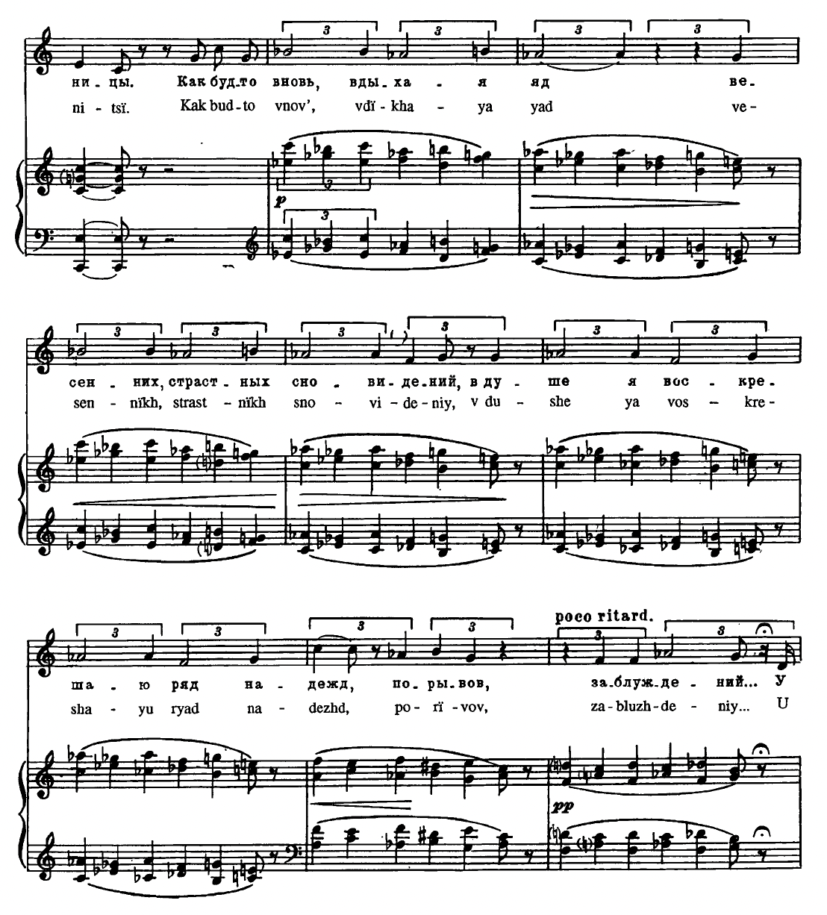
Example 1: In the third song of Sunless "The Noisy, Busy Day is Over," the past mood is introduced. The piano accompaniment moves horizontally in a whole tone scale, giving the piece an otherworldly and dream-like feel and acting as a symbol for the past mood.

Kuzmin, Symbolism, and Utopia
It is not a secret that Kuzmin’s artistic life was heavily intertwined with his personal one nor that the themes of his work drew real-life inspiration. His biographer writes,
The ‘aesthetic potentiality’…of [Kuzmin’s] own life and experience presented the models that the fiction and verse of others, where openly gay thematics remained taboo, could not. As he realized them (and broke the taboo) in his works, he became less and less direct, as he was able, with the years, to make incidents from his own life ‘disappear’ into personal myth. No matter how subtle the practice, Kuzmin continued so often to compound matters of fact and matters of fiction that he encouraged invasions of his private life…for those who wondered about the methods and extent of the intricate encoding of the life in the art, a process of self-awareness in which the author, in the interdependency…of creative subject and the figures he creates, reflects and realizes himself in the characters.
Because of the fascination with his personal life, Kuzmin often played different roles in his public life, confusing his examinators to no end, especially when his connection to the Old Believers was considered. Reviewer Eugene Znosko-Borovsky writes on Kuzmin,
The confusing mixture of contradictory connections and combinations which mark Kuzmin will not surprise us. Those who know the famous portrait of him painted by Somov will imagine him in the guise of the dandy and modernist. Many will also remember a photograph, in which Kuzmin appears in a peasant’s heavy overcoat and with a long beard. Some conceive of him as an aesthete, a partisan of form in art, almost of the doctrine ‘art for art’s sake,’ while to others he is an adherent and creator of moralizing and tendentious literature.
Znosko-Borovsky specifically became obsessed with finding continuity between the cosmopolitan and traditionalist versions of Kuzmin. However, the contradiction was the point. Symbolism’s metaphysical opaqueness paired with the never-ending tension between tradition and modernity was a useful tool in blurring direct connections between fact and fiction in Kuzmin’s openly queer art such as Wings and Alexandrian Songs. His later shift towards a more Acmeist approach, however, sees a version of Kuzmin’s queerness that derives its “beautiful clarity and warmth” from the “light of the sun,” opposed to “mystical stars, sweet dreams, and ghastly apparitions.”
Moral panics caused by industrialization and liberal modernism seeped into Symbolism. Symbolist poets in particular became fixated on exploring the newly discovered disconnect of Western-style puritanism and traditionalism. At its core, Symbolism, especially later “mystic Symbolism,” is a vague rejection of modernity and bourgeois morality. Simon Morrison writes,
The “mystic” Symbolists set out to create ritual-based dramas that would resurrect the forgotten heritage. The endeavor became all-important to poets who emerged as a cultural force during a period of political and spiritual crisis in Russia and who sought through their art to bridge the chasm that had opened between the ruling elite and the rural populace, Church and State, adherents of theological doctrine and adherents of bourgeois morality. Although ridiculed by their opponents (one of them being Rimsky-Korsakov), the “mystic” Symbolists clung to the belief that communal art represented a possible solution to the problem of social disintegration.
Moreover, Symbolism, as a form of romantic anti-capitalism, sought to escape perceived moral failings of modern liberal society more than it sought to critique it. The modern panic over degeneration would have been a part of the modernism they wanted to escape. The dialectic between tradition and sensuality that became central to Russian Symbolist art reflected broader social and material anxieties concerned with modernity.
Within the Symbolist movement of fin-de-siécle Russia, the moral panic around homosexuality began to seep into internal discourses. Like the broader discussions about homosexuality and degeneration, fears towards queerness were contradictory and exaggerated. In 1914, Symbolist writer Dmitry Merezhkovsky writes, “The decadents [are] those who are perishing and driving the refined cultivation of the decrepit world to the brink of disease, insanity, bad taste; the symbolists…[are in the process of] being reborn prophesying…the coming of a New World.” However, Merezhkovsky’s distinction between “real” Symbolists and “decadents” is blurred as the groups he distinguishes are interspersed and overlap regularly.
Although Russian Symbolism was similar to its French counterpart, the movement distinguished itself in many important ways. While also emphasizing decadence and esotericism, the Russians drew from primarily German and Russian philosophers and artists such as Wagner, Dostoyevsky, Tolstoy, Schopenhauer, and Nietzsche. Motifs of ancient western civilizations such as Greece and Egypt also feature heavily within their work. Like most modernists, the evocation of a mythicized past is done so in a way that verges on utopianism. There is a tension between modernity and tradition here. Symbolists use this tension to build utopias using ancient ruins. Schopenhauer’s concept of the Will features heavily in the philosophy of the Symbolists, as well. Schopenhauer believed that within a world that was full of meaninglessness and beyond rationality (blind flux), there existed pure being without thought (the Will). Within Symbolist music, Schopenhauer’s Will can be represented by tonal ambiguity, modulation, chromaticism, and diminished sevenths. The search for the Will can also be seen as inherently Dionysian.
At the same time, the Russian music world was forever shaken by the ousting of Nikolai Rimsky-Korsakov from the St. Petersburg Conservatory. As Lynn Sargent argues, the scandal proved to be a lightning rod for educated society’s discontent with the imperial Russian government. Prior to 1905, the Imperial Russian Musical Society (IRMO) dominated Russian professional music life, but while it wielded a lot of power, it was a voluntary association led my musical amateurs as professional musicians’ status as middle-class professionals was tenuous at best. The aggravation that musicians had towards the IRMO’s control over them blended with Russian educated society’s general frustrations with the government as a whole (even though the IRMO was not a government institution). The aggravation of musicians in Moscow attracted the support of approximately 600 St. Petersburg Conservatory students and Rimsky-Korsakov. The result was the further outrage of the professional musician class towards the IRMO, the fueling of the educated class’s qualms with the aristocracy, and the creation of a void in the Russian music world.
While the Symbolists were active in Russia in the 1890s, it is not until Vesy began circulation in 1904 did the movement have any real organization. The brush that was cleared after the chaos of 1905 space in the Russian Art world for a movement that was previously on the fringes. Kuzmin’s break onto the Russian Art scene would be through Vesy in 1906 with the publications of Wings and his song cycle Alexandrian Songs. The association between Kuzmin and Vesy is notable due to Vesy (and by extension its sister publishing house Skorpion) being a key consolidator of Russian Symbolist trends between 1904 and 1910. Joslyn Green writes in her dissertation on the magazine,
For the beginnings of the magazine were not the beginnings of the movement, and the task of Vesy…was in many respects one of consolidation, not creation. A number of major developments had taken place in Russian literature five, ten, and even fifteen years before the publication of Vesy, and only when the nature of these developments is clear can we understand the role the magazine actually played…Why this change took place when and as it did is, as with every such shift of sensibility, difficult to state with any exactness…What is important for our purposes is the fact that a change did take place, that it began some fifteen years before the publication of Vesy, and that the new trend was from the first described by supporters and detractors alike as “symbolism.”
Kuzmin jumped onto the Symbolist train and was not one of its conductors. By the time he had published Wings and Alexandrian Songs in 1906, Vesy was in its twilight years. Meanwhile, Kuzmin was seen by the frequenters of Ivanov’s tower, often those who had associated with the Symbolists for a decade at that point, as a promising upstart.
While Kuzmin lived at Ivanov’s tower, associated with Symbolists, and published his work in Symbolist journals, he also explored early elements of what would become Acmeism that were floating in the air of St. Petersburg’s art circles by the second half of the first decade of the 20th century. The name “Acmeist” was coined by Ivanov himself with the movement striving to distance itself from the more metaphysical aspects of Symbolism. As Klara Moricz explains, the goal of the Acmeists was to “describe the upper crust of meaning as opposed to the Symbolists’ attraction to its depth.” While not truly active until the 1910s, Kuzmin’s notoriety within Symbolist circles just happened to coincide with its twilight years. His 1910 essay “On Beautiful Clarity,” described by his biographers as “pre-manifesto” of Acmeism, put forth a scathing critique of Symbolism as “incomprehensible, dark cosmic trappings.” He contrasts Symbolism with what he labels “clarism,” which is another term from Ivanov. He describes “clarism” as “[thriving] in the light of the sun…foreign and inhospitable to it is the night with…ghastly apparitions.” Even before he published “On Beautiful Clarity,” his 1909 song cycle Chimes of Love critiques Symbolist metaphysics and toys with various Acmeist tropes, which are further cemented by his 1927 poetry cycle The Trout Breaks the Ice.

Intimate Utopia
After 1905, the queer milieu of St. Petersburg became much less rigid as anti-homosexual policing became more focused on more high-profile targets. However, St. Petersburg’s gay male population was still heavily monitored by the department (even if it was inconsistent depending on the area of the city one was in), making coding and priivate spaces extremely important in queer realization (or the expression of queerness without fear of consequence). These motifs appear in Alexandrian Songs and Chimes of Love because they are baked into the fabric of queerness in St. Petersburg during the first decade of the 20th-century.
Vyacheslav Ivanov’s tower became a central location for Symbolists to present their art. When compared to concert halls and galleries, the personal home of a notable individual is a much more intimate and isolated setting for art music to be presented in. Kuzmin himself favored this setting for his work, writing that he “[prefers] intimate music, but not quartets.” This kind of setting is why explicitly queer works such as Kuzmin’s Wings were allowed to exist within this space. Moreover, even pieces that were not explicitly queer such as Chimes of Love and Alexandrian Songs were still products of this setting and wear the intimacy of the atmosphere. In A History of Russian Symbolism, Avril Pyman writes,
At one reception, Mikhail Alekseevich Kuzmin, a distant relative of Ivanov, a subtle writer and near-professional musician, sang his ‘Aleksandriiskie pesni’ (Alexandrine Songs) to his own music. Sapunov was to do the décor for Blok’s Balaganchik, though Kuzmin, who wrote the enchanting music, would have preferred another artist, Sergei Sudeikin, with whom he was in love. Indeed, everyone at these galleries was – in an ephemeral kind of way – a little in love with someone else and it is not surprising that the boundaries between life and stage were soon blurred.
Within this, it is worth pointing out the fact that Kuzmin himself sung the debut of Alexandrian Songs. There is something almost voyeuristically intimate about singing your own poetry while playing the accompaniment you composed alongside it. However, this private space, a queer utopia in of itself, allowed it.
In his dissertation, Brad M. Damaré argues that Kuzmin expresses a “lyrical detachment” and a “disaffected attitude towards established social norms” in Alexandrian Songs in the wake of 1905 and the very active St. Petersburg political scene. He goes on to claim that Kuzmin’s work, especially Wings, which is published around the same time as Alexandrian Songs, was only publishable due to the relaxed censorship in the fallout of the 1905 revolution. Despite Alexandrian Songs, as Damaré points out, being a product of Kuzmin’s rejection of political and historical trends around him, its existence as a published work is directly influenced by them.
The conflict between association and disassociation is reflected in the music of the cycle, as well. While the form of the cycle rarely deviates from a simple binary form, there are clear moments of unrest in the music. In the first song of the first of two sections called “Evening Dusk” (“Vechernij sumrak”), chromaticism populates the first half on the song with the accompaniment picking up speed after the poco piu mosso, giving the effect of someone stumbling. The lyrics depict a progression from dusk to dawn. Moments describing dusk are almost unmetered, slowing to a crawl over time, while the moments at dawn are more rigidly metered and accelerando with chromatic interruption to an imperfect authentic cadence in the song’s tonic, F major. Particular attention is paid to establishing stimmung that reflects an impending darkness and uncertainty towards it.
Themes that the verse of the cycle tends to focus on are more often than not metaphysical. Man’s relationship to nature is a key theme, and in addressing it, Kuzmin talks about death, destruction at the hands of modernization, and of course, love. For example, in the third song of the first part titled “So What” (“Chto zh delat’”), he writes,
So What, / if the purple of the evening clouds / in the greenish sky / when the moon can already be seen on the left, / and the giant moppy star / a harbinger of the morning, / is getting pale so fast, is melting / right before my eye? / If the way down the wide road / between the trees and passed the mills / that were mine once…
There is a sense of apathy and distaste, as Damaré recognizes, towards cosmic questions and rationalizations of nature and humanity. However, there is also an undercurrent of irony in that sentiment. If the speaker is apathetic towards the metaphysical, why does he go to such lengths to describe not just the natural world but its existential character?
In the fourth song on the first part “I Asked” (“Ia sprashival”), Kuzmin writes from the point of view of a “wise man of the universe” that, “Humans are born / to lose their beloved lives / and to give birth to others for death.” The question therefore emerges: what does Kuzmin see as being worthwhile in life in Alexandrian Songs? He provides and answer in the very last song of the cycle titled “There Were Four” (“Ikh bylo chetvero”). He writes,
Now you were not rich, you spoke not / of daybreaks and nights, you were not handsome, / and when I threw a carnation / flower at Adonis feast, / you looked at me indifferently with you light eyes, but you were the one I loved!
The final message of Alexandrian Songs is that meaning does not come from the heavens nor the Earth, but from the love that exists in both realms.
Chimes of Love presents a very different idea of utopia. While both works see a form of utopia in humanity, Alexandrian Songs finds it in man’s soul and in the natural world, reflective of the Symbolist obsession with depth and metaphysics. In contrast, Chimes of Love sees utopia in the intimacy between two people. It is hidden and simple but beautiful, nonetheless, reflective of Acmeist surface. Chimes was jointly published by Vesy and its sister publishing house Skorpion Publishing in 1909. This October-November 1909 issue was the penultimate issue of the magazine as a whole, featuring poetry by contemporaries of Kuzmin and leading Symbolists such as Konstantin Balmont, Alexander Blok, Valery Bryusov, Andrei Bely, and Dmitri Merezhkovsky.
For artists of fin de siècle St. Petersburg and readers of Vesy, depictions of sensuality thrust upon the backdrop of traditionalism, such as the contents of Vesy’s publication of Chimes of Love, provides the “existential predicament” that Steinberg describes in Harper’s in 1962, a direct confrontation between a type of hedonistic modernity and the tradition it supposedly corrupts. The presentation of the score for Chimes of Love is no exception. The cycle consists of four movements: I. “Vesna” (Spring), “Leto” (Summer), “Osen’” (Autumn), and “Zima” (Winter).
The “Spring” and “Summer” movements are accompanied by illustrations of erotic scenes set to natural backdrops while the “Autumn” and “Winter” movements are accompanied by contrasting scenes of romantic melancholy. The picture of “Spring” depicts three women, one of them clothed, one partially clothed, and the last nude. The nude woman is depicted in the arms of a demon-like creature as the other two women look down upon her. A violin and a music book lay at her feet. The print for “Summer” depicts a young nude man who is strolling in a garden. However, the illustration that accompanies “Autumn” shows two widows crying with each other in front of two rows of leafless trees and a barren wasteland. Lastly, the print for “Winter” shows a man in a robe playing a small harp in a rocking chair as he is surrounded by shadows of lovers, angels, the snow outside his window, a fireplace, and a depiction of Hades lurking in the corner of the room. Each of these scenes accompany the story of a love igniting and dying out that Chimes of Love describes. Time is strangely fluid yet stagnant in the cycle’s plot, a common trope in later Acmeist work where there is an “antagonistic relationship between time…which allows past, present, and future to coexist.”
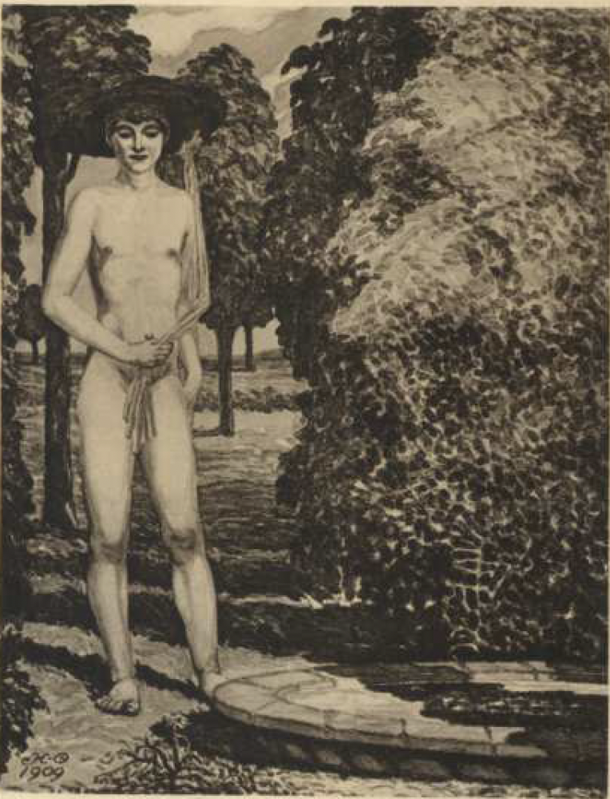
Example 2: The artwork for the second movement of Chimes of Love, “Summer” (“Leto”) depicting a young, nude man against the backdrop of a garden. Drawn by Nikolai Feofilaktov
The fourth movement “Winter” perfectly demonstrates the cycle’s use of symbols to create Stimmung along with a focus on meaning from the tangible without metaphysical undertones, a preference for more Acmeist aesthetics. This movement consists of six sub-movements and each features a reoccurring bell chime motif that ties them together sonically. The first movement “Gatekeeper” sets a single stanza poem for voice and piano. The piece features a considerable amount of doubling in unison and doubling at the octave between the vocal melody and the piano accompaniment (and occasionally between the two hands of the piano). According to Damaré, this is a direct reference to Old Believer znamenny chant, mingling the traditionalist parts of Kuzmin’s persona with the modernist ones. However, as the movement progresses, the voice and the piano accompaniment fall more and more out of sync, possibly representing a break from tradition. As Martha Kelley explains in Unorthodox Beauty, “In his own way, [Kuzmin] understands precisely the project of the intelligentsia – to create sites in which sacred tradition and worldly culture could meet, and where religion and sexuality might share a broader expanse.” Chimes of Love, is exemplary of this larger artistic project.
Throughout the sub-movement’s five distinct sections, it oscillates between B mixolydian and C major. The use of modes, especially B mixolydian, is notable considering their tendency to break rules of Western counterpoint in a modernist sense and in a traditional sense. For example, sections 1, 3, and 5 in B mixolydian feature a distinct lack of resolution, never being able to cadence fully within the mode. The sub-movement eventually cadences in E major. A clear violation of the rules of Western counterpoint, the leading tone is absent for the majority of the piece, depriving it both of tension and resolution and affecting a mood of stagnation. As the movement is meant to create the atmosphere of winter, there is a sense that the piece is frozen, unable to be incited to do anything. In this way, the lack of leading tone is a Modernist attempt at creating atmosphere and stimmung. Moreover, the mixolydian mode’s prevalence in Old Believer chant gives the choice a double meaning. It is both traditional and modern, a full embrace of the two. While there is a break from the octave/unison piano accompaniment that appears in the first submovement, mixolydian mode remains as the movement progresses. While the tree may have been cut down, its roots are clearly still intact.
“Winter” (“Zima”) | Submovement | Section
“Winter” (“Zima”) | I. “Gatekeeper” | - unison  - bell motif  - unison  - bell motif  - unison
“Winter” (“Zima”) | II. “Poet”
“Winter” (“Zima”) | III. “Cupid”
“Winter” (“Zima”) | IV. “Dance” (instrumental) | - 8-bar thematic statement (repeated)  - Development  - Recapitulation
“Winter” (“Zima”) | V. “Cupid and the Poet” | - Poet talks with doubling in accompaniment and drone triplets in left hand  - Recap of i  - Recap and resolution of i
“Winter” (“Zima”) | VI. “Gatekeeper”

In contrast, the 2nd and 4th sections of “Gatekeeper” in C major not only end with perfect authentic cadences, but the piano accompaniment is more fleshed out, not just doubling the melody and/or doubling the other hand. Most notably, sections 2 and 4 feature the “bell motif” of this sub-movement. The first three bars (see Example 3) of each section have a block chord in the right hand that’s bass note is played by the left hand on beat one that creates an effect similar to a bell. The melody in the voice moves diatonically in contrary motion with the bass, the first instance of contrapuntal motion in the sub-movement. The effect that this has is a bell-like ringing that is then interrupted in the fourth measure of the section by a double chromatic motif and then contrapuntal motion in the left and right hands.
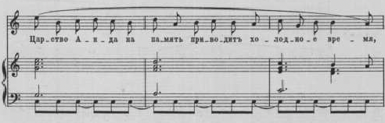
Example 3: The bell motif in the second section of "Gatekeeper," measures 16-18, from."
Moreover, section 2 begins on the lines, “The cold time brings to mind the realm of Hades, / The realm of shadows without love, without radiant joy.” This is contrasted with the first two lines of section 1 that are sung in unison with the piano, which read, “Frozen lakes and tame waters in winter, / The fireplaces are burning brightly, inviting passers-by.” While section 2 is more resolute, fuller, and more tonal, its lyrics are much more melancholic than those from section 1. Lyrics from section 1 are descriptions of the setting, and despite describing a scene in winter, are comforting and, to some extent, warm.
There is a lot that can be extrapolated from this very clear distinction that Kuzmin creates between these two moods in “Gatekeeper.” The fact that sections 1, 3, and 5 of the sub-movement are in unison, feature a church mode, and give almost nostalgic descriptions of winter imply a more traditional aesthetic. Conversely, sections 2 and 4 feel more like laments, grieving the loss of a partner, representing the sensual voice in the piece. As mentioned previously, the dialectic that Kuzmin presents in his 1901 writing is not between tradition and just modernity but between tradition and the sensuality of the “new art.” In “Gatekeeper,” the two sides clash stylistically where transitions between the two become quite jarring.
As “Winter” progresses, the two sides vie for control of the piece until the fifth sub-movement of the movement entitled “Cupid and the Poet.” Unlike the sub-movements before it, “Cupid and the Poet” begins as a sonic mess marked as molto agitato with the bass-range melody being doubled by the left hand of the piano while the right hand plays muddy lower-range triplet eight notes, clashing with the duple meter melody. The sub-movement’s melody switches between alto and bass ranges, labeled the titular “cupid” and “poet” respectively. The subtle tension between tangible and intangible breaks into outright chaos in this movement.
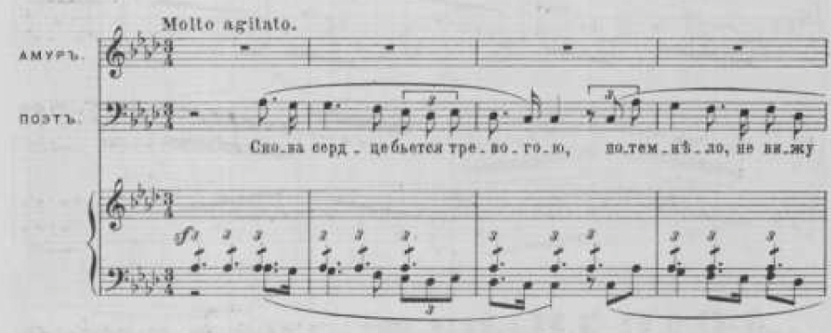
Example 4: The first four bars of "Cupid and the Poet."
The last sub-movement of “Winter” also titled “Gatekeeper,” is a strophic setting that combines the two sections of the first “Gatekeeper” into one complete musical idea. The doubling between the accompaniment and the voice along with the bell chime motif appear once again but simultaneously. The piano accompaniment both fills space and doubles the melody, returning to the chant-like quality of the first “Gatekeeper.” The piece ends with a perfect authentic cadence in F major, shedding the stagnant and opaque mood of the first “Gatekeeper” for something fully realized and tangible. Symbolist obfuscation is dead by the end of “Winter,” and in its stead is a surface-level depiction of a winter scene.
Chimes of Love represents an inflection between Symbolism and Acmeism that also incorporates traditional aesthetics in order to subvert, synthesize, and reform the various artistic ideas stemming from the chaotic environment of Late-Imperial St. Petersburg in 1909. While it is both Alexandrian Songs and Chimes of Love seem to yearn for an escapist and immaterial ending, they both are products of the post-1905 turmoil in Russian art circles, born out of the anxiety of the crisis of liberal modernity.

Conclusion
Kuzmin’s final poetic cycle, which he published at the beginning of the Soviet era, The Trout Breaks the Ice (1927), is a complex cycle that includes two distinct endings, one utopian and one realist. Trout very much exemplifies Kuzmin’s tendency to interlace his personal life into his “fiction” as the cycle was meant to “conjure up” a happy future for himself and his life partner Yuri Yurkun. Starting in 1920, Yurkun became involved with a girl from Leningrad named Olga Gildebrandt. During this affair in January 1921, Kuzmin wrote in his diary that, “Today, as usual, I had a terrible day. [Yurkun], as I thought, is involved with [Olga Gildebrandt], and, it seems, seriously. At any rate, things are falling apart.” Similarly, the speaker in Trout, a self-insert for Kuzmin, watches as his love, a stand-in for Yurkun, slowly becomes more distant as he falls for a lady of status. However, there are two endings, one in which the speaker’s love interest doesn’t return, and one in which he does. Trout brings the question of the queer utopia presented in Wings and in Chimes of Love into question as “things fall apart,” but it also cannot seem to let go of the idea that a queer utopia exists somewhere.
Moreover, Trout, as Lada Panova explains, stylistically falls between “Pushkin’s fatal love triangles, [Kuzmin’s] polemics with Symbolists, his use of Christian and pagan mythology,” along with, I argue, Acmeist aesthetics. Kuzmin’s mingling of Symbolism, which favored abstraction, and Acmeism, which favored clarity, is particularly distinctive in Trout. Throughout the cycle, Kuzmin implies certain events are occurring by describing the setting or imagery that seemingly is unrelated to what is occurring in the story. For example, in the first poem (called “First Prologue”), he writes,
The fleeting bird shadows / Are you not weary of them? / The fiercer your convulsions / The brighter their echo (friendship’s return). / On the ice a peasant stands. / The trout breaks the ice.
The point this passage is to create a mood or stimmung in order to ensure that before the cycle starts describing the plot, the audience understands how they must aesthetically contextualize it. However, when the plot is filled in, it also contextualizes the metaphorical imagery like that in this passage. It is the space created between the tension of these two styles that Kuzmin seems to reside within in Trout.
After his death in 1936, Kuzmin’s journals that were confiscated by Soviet authorities. They were used as evidence against his surviving friends in Leningrad in a 1938 writers purge in which five were executed and the remaining few were sent to labor camps. Kuzmin’s biographers John E. Malmstad and Nikolay Bogomolov argue that had he not died in 1936, Kuzmin would have met a similar fate. The idea of a queer utopia, a space in which queerness was not only understood but beautiful or as “pure eros,” that Kuzmin presents in Wings, Chimes of Love, and Alexandrian Songs was pushed past the queer dystopia of the decadents. However, this was a place that Kuzmin never saw, only being the alternative, fantastical ending that, while comforting, was never realized. But there is something to be said about believing such a place could exist while no one else even dares to even dream of it. It is quite bold to attempt to build even fictional utopias from ashes.

Bibliography
Ascher, Abraham. The Revolution of 1905: Russia in Disarray. Stanford: Stanford University Press, 1988.
Bartlett, Rosamund. “Wagner and Russian Symbolism.” In Wagner and Russia, 126–30. Cambridge Studies in Russian Literature. Cambridge: Cambridge University Press, 1995.
Bohac, Rodney. “The Promise of the Road.” Russian History 45, no. 1 (2018): 101–16.
Bullock, Philip Ross. “Ambiguous Speech and Eloquent Silence: The Queerness of Tchaikovsky’s Songs.” 19th-Century Music 32, no. 1 (2008): 94–128.
———. “By the Waters of the Tiber: Viacheslav Ivanov, Aleksandr Grechaninov and Russian Culture in Interwar Europe.” Journal of European Studies 51, no. 3–4 (November 1, 2021): 337–54. https://doi.org/10.1177/00472441211033399.
———. “From the Shores of a Distant Homeland: Russian Song Recorded.” Nineteenth-Century Music Review 9, no. 2 (December 2012): 353–61. https://doi.org/10.1017/S1479409812000390.
Clark, Katerina. Petersburg, Crucible of the Revolution. Cambridge: Harvard University Press, 1995.
Damaré, Brad M. “Music and Literature in Silver Age Russia: Mikhail Kuzmin and Alexander Scriabin.” Dissertation, University of Michigan, 2008.
Dmitriev, Pavel. “Mikhail Kuzmin: Alexandrian Songs Sacred Verses.” Translated by Sergey Suslov. St. Petersburg Music Archive, 2010. Naxos Music Library.
Engelstein, Laura. The Key to Happiness: Sex and the Search for Modernity in Fin-de-Siècle Russia. Ithaca: Cornell University Press, 1992.
Fisk, Charles. “Endangered Tenderness: Schubert, Chopin, and Schumann.” In The Oxford Handbook of Music and Queerness, edited by Fred Everett Maus, Sheila Whiteley, Tavia Nyong’o, and Zoe Sherinian, 339–52. New York: Oxford University Press, 2022.
Gasparov, Boris. Five Operas and a Symphony: Word and Music in Russian Culture. New Haven: Yale University Press, 2005.
Green, Joslyn. “Vesy: Russian Symbolism in the Balance.” Dissertation, Indiana University, 1975.
Gumbrecht, Hans Ulrich. Atmosphere, Mood, and Stimmung: On a Hidden Potential of Literature. Translated by Erik Butler. English. Stanford: Stanford University Press, 2012.
Karlinsky, Simon. “The Death and Resurrection of Mikhail Kuzmin.” In Freedom from Violence and Lies: Essays on Russian Poetry and Music, edited by Robert P. Hughes, Thomas A. Koster, and Richard Taruskin, 125–32. Academic Studies Press, 2013.
Kelly, Martha M. F. “Sex, Love, Liturgy: Mikhail Kuzmin’s Revisions of Sophia.” In Unorthodox Beauty: Russian Modernism and Its New Religious Aesthetic, 66–107. Evanston: Northwestern University Press, 2016.
Klimovitsky, Arkadii. “Tchaikovsky and the Russian Silver Age.” In Tchaikovsky and His World, translated by Alice Dampman Humel, 319–30. Princeton: Princeton University Press, 1998.
Kuzmin, Mikhail A. “Kuranty lyubvi.” Vesy/Skorpion, 1909. IMSLP. https://imslp.org/wiki/Chimes_of_Love_(Kuzmin%2C_Mikhail).
———. “The Trout Breaks the Ice.” In Selected Prose and Poetry: Mikhail Kuzmin, translated by Michael Green, 214–29. New York: Ardis Publishers/The Overlook Press, 2013.
———. “Wings.” In Selected Prose and Poetry: Mikhail Kuzmin, translated by Michael Green, 23–87. New York: Ardis Publishers/The Overlook Press, 2013.
Malmstad, John E., and Nikolay Bogomolov. Mikhail Kuzmin: A Life in Art. Cambridge: Harvard University Press, 1999.
Matich, Olga. Erotic Utopia. Madison: The University of Wisconsin Press, 2005.
Meyer, Richard. Outlaw Representation: Censorship and Homosexuality in Twentieth-Century American Art. Boston: Beacon Press, 2002.
Mitchell, Rebecca. Nietzsche’s Orphans: Music, Metaphysics, and the Twilight of the Russian Empire. Illustrated Edition. New Haven: Yale University Press, 2016.
Moricz, Klara, and Simon Morrison, eds. Funeral Games in Honor of Arthur Vincent Lourié. Oxford: Oxford University Press, 2014.
Morrison, Simon. Russian Opera and the Symbolist Movement. California Studies in 20th-Century Music. Berkeley: University of California Press, 2002.
Mussorgsky, Modest, and A. A. Golenishchev-Kutuzov. Sunless. Edited by N. Rimsky-Korsakov. London: J. & W. Chester, 1908.
Panteleeva, Olga. “How Soviet Musicology Became Marxist.” Slavonic and East European Review 97, no. 1 (January 2019): 73–109. https://doi.org/10.5699/slaveasteurorev2.97.1.0073.
Perry, Simon. “A Voice Unknown: Undercurrents in Mussorgsky’s Sunless.” 19th-Century Music 28, no. 1 (2004): 15–49.
Petri, Olga. Places of Tenderness and Heat: The Queer Milieu of Fin-de-Siècle St. Petersburg. Ithica: Cornell University Press, 2022.
Pyman, Avril. A History of Russian Symbolism. Cambridge: Cambridge University Press, 1994.
Roberts, Peter Deane. Modernism in Russian Piano Music: Skriabin, Prokofiev, and Their Russian Contemporaries, Vol. Volume 1. Bloomington: Indiana University Press, 1993.
Rosenthal, Bernice. “The Spirit of Music in Russian Symbolism.” Russian History 10, no. 1 (1983): 66–76.
Sargeant, Lynn. “A New Class of People: The Conservatoire and Musical Professionalization in Russia, 1861-1917.” Music & Letters 85, no. 1 (2004): 41–61.
———. “Kashchei the Immortal: Liberal Politics, Cultural Memory, and the Rimsky-Korsakov Scandal of 1905.” The Russian Review 64, no. 1 (2005): 22–43.
Steinberg, Leo. “Contemporary Art and the Plight of Its Public.” Harper’s Magazine, March 1962.
Steinberg, Mark D. “Wings of Utopia.” In Russian Utopia, 6–22. Russian Shorts 3. New York: Bloomsbury Publishing Inc., 2021.
Taruskin, Richard. Musorgsky: Eight Essays and an Epilogue. Princeton: Princeton University Press, 1997.
Tcherkassova, Farida. “Erotic Ascent in the Poetry of Mikhail Kuzmin: Nets (Seti) as a Unity in Multiplicity.” Dissertation, Yale University, 2012.
Vladiv-Glover, Slobodanka. “Fin-de-Siècle Lyrical Drama and the European Modernist Sensibility on the Eve of World War One.” Transcultural Studies 11, no. 2 (2015): 242–59. https://doi.org/doi 10.1163/23751606-01102006.
Walker, James. “Mussorgsky’s ‘Sunless’ Cycle in Russian Criticism: Focus of Controversy.” The Musical Quarterly 67, no. 3 (1981): 382–91.

Leo Steinberg, “Contemporary Art and the Plight of Its Public,” Harper’s Magazine, March 1962, 39.
Klara Moricz and Simon Morrison, eds., Funeral Games in Honor of Arthur Vincent Lourié (Oxford: Oxford University Press, 2014), 7.
Abraham Ascher, The Revolution of 1905: Russia in Disarray (Stanford: Stanford University Press, 1988), 337.
Ascher, The Revolution of 1905, 1.
Ascher, The Revolution of 1905, 337-9.
Ascher, The Revolution of 1905, 338.
Mark D. Steinberg, “Wings of Utopia,” in Russian Utopia, Russian Shorts 3 (New York: Bloomsbury Publishing Inc., 2021), 18.
Olga Petri, Places of Tenderness and Heat: The Queer Milieu of Fin-de-Siècle St. Petersburg (Ithica: Cornell University Press, 2022), 32.
Petri, Places of Tenderness and Heat, 61-2; Laura Engelstein, The Key to Happiness: Sex and the Search for Modernity in Fin-de-Siècle Russia (Ithaca: Cornell University Press, 1992), 6, 62; Steinberg, “Wings of Utopia,” 20.
Petri, Places of Tenderness and Heat, 35.
Steinberg, “Wings of Utopia,” 20.
Moricz and Morrison, Funeral Games in Honor of Arthur Vincent Lourié, 7.
Olga Petri, Places of Tenderness and Heat, 39.
Matich, Erotic Utopia, 15-16, 284.
Engelstein, The Key to Happiness, 5-6.
Petri, “St. Petersburg and Its Familiar Strangers,” 33-41.
John E. Malmstad and Nikolay Bogomolov, Mikhail Kuzmin: A Life in Art (Cambridge: Harvard University Press, 1999), 63.
Lynn Sargeant, “Kashchei the Immortal: Liberal Politics, Cultural Memory, and the Rimsky-Korsakov Scandal of 1905,” The Russian Review 64, no. 1 (2005): 22–43.
Avril Pyman, A History of Russian Symbolism (Cambridge: Cambridge University Press, 1994), 168-71.
Joslyn Green, “Vesy: Russian Symbolism in the Balance,” (Dissertation, Bloomington, Indiana University, 1975), 4-7.
Green, “Vesy: Russian Symbolism in the Balance,” 2.
Green, “Vesy: Russian Symbolism in the Balance,” 11; Pyman, A History of Russian Symbolism, 168.
Olga Matich, Erotic Utopia (Madison: The University of Wisconsin Press, 2005), 11.
Bernice Rosenthal, “The Spirit of Music in Russian Symbolism,” Russian History 10, no. 1 (1983): 69.
Rosenthal, “The Spirit of Music in Russian Symbolism,” 73.
Rosenthal, “The Spirit of Music in Russian Symbolism,” 68.
Rosenthal, “The Spirit of Music in Russian Symbolism,” 67-8.
Matich, Erotic Utopia, 11.
Matich, Erotic Utopia, 15-6
Matich, Erotic Utopia, 11-2.
Richard Meyer, Outlaw Representation: Censorship and Homosexuality in Twentieth-Century American Art (Boston: Beacon Press, 2002), 12.
Hans Ulrich Gumbrecht, Atmosphere, Mood, and Stimmung: On a Hidden Potential of Literature, trans. Erik Butler, English (Stanford: Stanford University Press, 2012), 8.
Gumbrecht, Atmosphere, Mood, and Stimmung, 72-81.
Matich, Erotic Utopia, 16.
Steinberg, “Wings of Utopia,” 20.
Steinberg, “Wings of Utopia,” 21.
Mikhail A. Kuzmin, “Wings,” in Selected Prose and Poetry: Mikhail Kuzmin, trans. Michael Green (New York: Ardis Publishers/The Overlook Press, 2013), 87.
Engelstein, The Key to Happiness, 10.
Simon Perry, “A Voice Unknown: Undercurrents in Mussorgsky’s Sunless,” 19th-Century Music 28, no. 1 (2004): 16.
Brad M. Damaré, “Music and Literature in Silver Age Russia: Mikhail Kuzmin and Alexander Scriabin” (Dissertation, Ann Arbor, University of Michigan, 2008), 117.
Richard Taruskin, Musorgsky: Eight Essays and an Epilogue (Princeton: Princeton University Press, 1997), 30.
Perry, “A Voice Unknown: Undercurrents in Mussorgsky’s Sunless,” 17.
Perry, “A Voice Unknown: Undercurrents in Mussorgsky’s Sunless,” 16.
Rosenthal, “The Spirit of Music in Russian Symbolism,” 68.
Perry, “A Voice Unknown: Undercurrents in Mussorgsky’s Sunless,” 21.
Modest Mussorgsky and A. A. Golenishchev-Kutuzov, “The Noisy, Busy Day is Over,” from Sunless, ed. N. Rimsky-Korsakov (London: J. & W. Chester, 1908), 290.
Malmstad and Bogomolov, Mikhail Kuzmin: A Life in Art, 120.
Malmstad and Bogomolov, Mikhail Kuzmin: A Life in Art, 4.
Malmstad and Bogomolov, Mikhail Kuzmin: A Life in Art, 4-5.
Malmstad and Bogomolov, Mikhail Kuzmin: A Life in Art, 166.
Morrison, Russian Opera and the Symbolist Movement, 4-5.
Rosenthal, “The Spirit of Music in Russian Symbolism,” 66–76.
Matich, Erotic Utopia, 16, 284.
Damaré, “Music and Literature in Silver Age Russia: Mikhail Kuzmin and Alexander Scriabin,” 142.
Rosenthal, “The Spirit of Music in Russian Symbolism,” 67.
Rosenthal, “The Spirit of Music in Russian Symbolism,” 68.
Rosenthal, “The Spirit of Music in Russian Symbolism,” 69.
Sargeant, “Kashchei the Immortal,” 22.
Sargeant, “Kashchei the Immortal,” 23-5.
Sargeant, “Kashchei the Immortal,” 26.
Sargeant, “Kashchei the Immortal,” 38-40.
Green, “Vesy: Russian Symbolism in the Balance,” 2.
Green, “Vesy: Russian Symbolism in the Balance,” 2-3.
Pyman, A History of Russian Symbolism, 173.
Klara Moricz, “Reinventing What Time Destroys,” from Funeral Games in Honor of Arthur Vincent Lourié (Oxford: Oxford University Press, 2014), 152.
Malmstad and Bogomolov, Mikhail Kuzmin: A Life in Art, 165.
Malmstad and Bogomolov, Mikhail Kuzmin: A Life in Art, 166.
Petri, Places of Tenderness and Heat, 32.
Petri, Places of Tenderness and Heat, 72-76.
Damaré, “Music and Literature in Silver Age Russia: Mikhail Kuzmin and Alexander Scriabin,” 117.
Pyman, A History of Russian Symbolism, 292.
Damaré, “Music and Literature in Silver Age Russia: Mikhail Kuzmin and Alexander Scriabin,” vii.
Pavel Dmitriev, “Mikhail Kuzmin: Alexandrian Songs Sacred Verses,” trans. Sergey Suslov (St. Petersburg Music Archive, 2010), Naxos Music Library, 19.
Damaré, “Music and Literature in Silver Age Russia: Mikhail Kuzmin and Alexander Scriabin,” 41.
Dmitriev, “Mikhail Kuzmin: Alexandrian Songs Sacred Verses,” 21.
Dmitriev, “Mikhail Kuzmin: Alexandrian Songs Sacred Verses,” 18.
Joslyn Green, “Vesy: Russian Symbolism in the Balance” (Dissertation, Bloomington, Indiana University, 1975), 144.
Mikhail A. Kuzmin, “Kuranty lyubvi,” Vesy/Skorpion, 1909, IMSLP, 1, 7, 15, 23, https://imslp.org/wiki/Chimes_of_Love_(Kuzmin%2C_Mikhail).
Kuzmin, “Kuranty lyubvi,” 1.
Kuzmin, “Kuranty lyubvi,” 7.
Kuzmin, “Kuranty lyubvi,” 15.
Kuzmin, “Kuranty lyubvi,” 23.
Moricz, “Reinventing What Time Destroys,” 153.
Kuzmin, “Kuranty lyubvi,” xviii.
Damaré, “Music and Literature in Silver Age Russia: Mikhail Kuzmin and Alexander Scriabin,” 118.
Martha M. F. Kelly, “Sex, Love, Liturgy: Mikhail Kuzmin’s Revisions of Sophia,” in Unorthodox Beauty: Russian Modernism and Its New Religious Aesthetic (Evanston: Northwestern University Press, 2016), 70.
Damaré, “Music and Literature in Silver Age Russia: Mikhail Kuzmin and Alexander Scriabin,” 119.
Kuzmin, “Kuranty lyubvi,” 59-60.
Kuzmin, “Kuranty lyubvi,” 60.
Farida Tcherkassova, “Erotic Ascent in the Poetry of Mikhail Kuzmin: Nets (Seti) as a Unity in Multiplicity” (Dissertation, New Haven, Yale University, 2012), 226, Kuzmin, “Kuranty lyubvi,” 25, 60.
Kuzmin, “Kuranty lyubvi,” 25, 59.
Kuzmin, “Kuranty lyubvi,” 68-69.
Kuzmin, “Kuranty lyubvi,” 68.
Lada Panova, “Legitimizing Gay Relationships: Shakespeare, Wilde and Marriage Myths in Mikhail Kuzmin’s Cycle ‘the Trout Breaks the Ice,’” New Zealand Slavonic Journal 47/48 (2013): 27; Malmstad and Bogomolov, Mikhail Kuzmin: A Life in Art, 288.
Malmstad and Bogomolov, Mikhail Kuzmin: A Life in Art, 289.
Mikhail A. Kuzmin, “The Trout Breaks the Ice,” in Selected Prose and Poetry: Mikhail Kuzmin, trans. Michael Green (New York: Ardis Publishers/The Overlook Press, 2013), 214–29.
Panova, “Legitimizing Gay Relationships,” 28.
Kuzmin, “The Trout Breaks the Ice,” 214.
Malmstad and Bogomolov, Mikhail Kuzmin: A Life in Art, 362-63.
Panova, “Legitimizing Gay Relationships,” 28.

