
The Four-Hour Film Festival
James Agan

Table of Contents
Acknowledgements……………………………………………………………………......3
Introduction………………………………………………………………………………..4
Mission Statement…………………………………………………………………………5
History……………………………………………………………………………………..6
Learning Outcomes for Students..………………………………………………………...9
The Creation of the Four-Hour Film Festival…..……………………………………......11
Marketing…………………………………………………………………………….11
Sponsorships and Funding…………………………………………………………...14
Logistics……………………………………………………………………………...15
Evaluation………………………………………………………………………………..18
Conclusion……………………………………………………………………………….21
Appendix…………………………………………………………………………………23
Bibliography……………………………………………………………………………..38

Acknowledgements
The Four-Hour Film Festival that brought joy to many students at the University of Tennessee was made possible by a number of individuals and sponsors. Thank you to Jerry Adams, Jeff Alshie, Bria Bannister, Miles Basehart, Ryan Bedell, Sarah Bedell, Ben Bergman, Thomas Boleyn, Matt Bowers, Caleb Boyd, Michelle Brannen, Austin Burnett, Meghan Byrge, Joseph Carr, Jesse Combs, Kendra Duncan, Bridgette Givand, Jessica Hathorn, Jeannie Hopper, Toni Jackson, Meghan Jagnow, Matt Klein, Asante Knowles, Joel Kramer, Josh Lampley, Dr. Charles Maland, Chris Masuo, Keith McDaniel, Ryan McGill, Altaf Nanavati, Elizabeth Nichols, Katie Perry, Clinton Ricks, Trey Rollins, Ingrid Ruffin, Jacob Seifert, Seth Shephard, Elizabeth Steen, Wiley Stidham, Bethany Tognocchi, Kelvin Walters, Alex Wiederspahn, Andrew Wilmoth, Grace Wilson, Jeremy Wright, all participants, Resident Assistants, and the UT Film Committee. The following sponsors were instrumental to the event’s success: Barberitos, Central Area Housing, the Egg and I, Hard Knox Pizzeria, Hess Hall, Jersey Mike’s, the Knoxville Film Festival, Massey Hall, Menchie’s Frozen Yogurt, Noodles and Company, Papa Murphy’s, Planet Beach, Red Bull, River Dog Bakery, Serendipity, Sergeant Pepperoni’s, Shuck, Sport Clips, UT Libraries, United Residence Halls Council, and University Housing.

Introduction
In The Element, Ken Robinson, an expert on modern education, implores schools to stimulate student creativity, and he advises, “To be creative you actually have to do something” (Robinson, 2009). In accordance with Mr. Robinson’s hopes and advice, the Four-Hour Film Festival gives college students the opportunity to do something creative - to create a short film quickly. Subcommittees of students spend four hours planning, shooting, and editing five-minute films. During the process, students interact with each other and, simultaneously, learn about filmmaking and campus resources.
This document presents how the Four-Hour Film Festival came into existence, the objectives and learning outcomes for students. It also provides an outline of the film festival’s logistical processes and marketing operations to lay a framework for others to use. The conclusion section discusses future possibilities for the program.

The Mission Statement
The Four-Hour Film Festival gives students the opportunity
to express their creativity through filmmaking.

History
In February of 2014 while working as a Resident Assistant in Hess Hall at the University of Tennessee, Josh Lampley, a fellow Resident Assistant, and I created an engaging and educational event for residents to fulfill our job expectations. Josh and I collaborated with the University of Tennessee librarians, Ingrid Ruffin and Michelle Brannen, to develop the Four-Hour Film Festival.
For this first event, twenty of our residents met in UT Libraries and formed subcommittees. The library provided each subcommittee the camera equipment and laptops necessary to produce a five-minute film. After instruction by the librarians, the four-hour timer started, and the subcommittees began to create their short films. At the end of the allotted time, students sat in a classroom in the library, watched the movies, ate pizza, and voted on the winning subcommittee. Through informal feedback in the form of a five question survey organizers learned that students loved the interactive nature of the event and creative outlet that the event delivered.
The success of the first Four-Hour Film Festival inspired us to repeat the competition again in Spring 2015. The event was opened to all 900-plus students in Hess Hall. The Director of Hess Hall designed a logo for the event, and advertisements were placed throughout the building. The United Residence Halls Council funded the event to provide dinner for participants; businesses in the Knoxville area donated prizes; and a resident in Hess Hall designed a 3D-printed trophy. The process began to gain Institutional Review Board (IRB) approval in order to discover the event’s correlation between student engagement with the library and student success.
On February 21, 2015 over forty residents participated and created seven short films. At the end of the four hours, the films debuted in the auditorium of Hodges library. The audience viewing the films contained around seventy-five people and a panel of faculty judges. The Four-Hour Film Festival elicited overwhelmingly positive responses from the librarians and most importantly the student participants, so the planning began for the third annual Four-Hour Film Festival.
In Fall 2015, Josh Lampley and I organized a leadership team that included librarians, Resident Assistants, and students to produce the most extensive version of the Four-Hour Film festival yet. Over three months, the leadership team designed a plan and created subcommittees to achieve specific incremental goals. These subcommittees included marketing, fundraising, logistics, day of coordination, assessment and feedback, and design. The design subcommittee created a new, official logo, and the marketing subcommittee designed posters, flyers, t-shirts, and a fully functioning website that allowed students to register online. These promotional materials were printed using the library’s resources and posted around campus. In addition to the printed materials, the marketing subcommittee designed a multimedia marketing campaign that included promotional videos, email marketing and word-of-mouth advertising to spur on students to attend the event. The fundraising subcommittee played a key role in acquiring funding from local businesses. The logistics subcommittee planned the schedule, recruited volunteers, managed purchases, and facilitated communication between group members.
On October 24, 2015 the third annual Four-Hour Film Festival was presented to all of campus with a focus on undergraduate students living in residence halls. 59 students arrived to create short films. After an effective day of operations, eleven short films were created. Run up to the final show included a jazz interlude, and then over 75 people watched the final showing of films. Faculty members and a Hollywood stunt coordinator served as judges ranking the films and choosing a winner. Participants expressed a desire to continue the film festival for many years in their informal responses and in responses to a survey sent out several days after the event.

Learning Outcomes for Students
Over the past three years, our leadership team set goals of learning outcomes for students to determine the success of the festival. The learning outcomes focused on student engagement among participants and creating a collaborative learning experience, because socially integrated students are less likely to think about leaving university (Thomas, 2014). Also, students who interact with faculty and spend a significant amount of time with friends tend to enjoy their college experiences and succeed academically (Hughes 2014). The outcomes presented in the IRB-approved research proposal included:
- Fostering learning communities among participants
  - Students work in teams from residence hall communities
  - Students meet and interact with new students
- Provide a collaborative learning experience
  - Students will work as teams to develop videos for the contest
- Increase undergraduate engagement with the library
  - Contest being hosted in the library
  - Successful participation in the contest by multiple teams of students.
  - Participants will learn about engagement opportunities in the library
  - Students not involved in the contest will be able to participate in the screening and awards through attendance and audience vote
- Increasing student understanding of media literacy
  - Participation will allow students to share skills and techniques
  - Instruction will be provided on basic video editing
- Sharing information about library services
  - Participants will learn of equipment services
  - Participants will learn about studio services
  - Participants will learn about engagement opportunities in the library (Brannen, Ruffin, Agan & Lampley, 2015)
With these objectives in mind, the leadership team worked to achieve undergraduate engagement with the library faculty, housing staff, and other students; promote an understanding of media literacy; and give students an outlet for creative expression. The success of these learning outcomes was evaluated based on data from free response surveys given to participants after the contest, as well as participation numbers, and leadership team observations of participants.

The Creation of the Four-Hour Film Festival
The leadership team worked for several months to create the third annual Four-Hour Film Festival. The team learned how to organize and the festival and documented the systems and processes. After three years of trial and error, the framework for the Four-Hour Film Festival has proved to be successful. In the future, the structure will hopefully be used to continue the film festival at more colleges and high schools.

Marketing
The goal for the third installment included having fifty students to participate in the film festival (ten teams of five students). Based on funding and library resources, the festival could support the equipment and food requirements for around fifty people, which determined the basis for our goal. In conjunction with the design subcommittee, the marketing subcommittee was tasked with achieving this goal. The marketing subcommittee targeted students living in residence halls on campus, so the students were advertised to in the most appropriate manner. The following is an overview of the marketing and design subcommittees’ efforts to inspire future marketing strategies for the Four-Hour Film Festival.

Creating the Brand
In the first year of the film festival, the event did not have a brand. In the second year of the film festival, a logo was designed. The caricature presented the University of Tennessee’s mascot Smokey holding a video camera. This began the endeavor to brand the event to foster student familiarity with the film festival
For the third annual film festival, the design and marketing subcommittees desired to create a simple brand to convey the idea of the film festival; to permit the development of the program on other campuses; and serve as a permanent fixture for the organization. At first the logo revolved around the university’s iconic “Power T” image, but to avoid copyright infringement with the university and give the organization independence, the logo was tailored to suit the Four-Hour Film Festival. The design subcommittee featured a filmstrip in the shape of the number four. An old movie countdown wheel was added to the design to signify the passing of four hours that occurs during the competition. The logo went through iterations with different layouts and color schemes before becoming its final form. (See Appendix, Figures 11-18)

Word-of-Mouth
According to Nielsen, 83% of people say they trust recommendations from friends over other types of advertising, so the marketing subcommittee chose to recruit college residents living on campus through word-of-mouth advertising (Global Trust in Advertising, 2015). The marketing subcommittee spoke to Resident Assistant staffs on campus to tell them to talk to their residents about signing up for the event. The Resident Assistants became the conduit for the most effective marketing. From the survey results, organizers learned that more than 50% of the participants discovered the Four-Hour Film Festival through their Resident Assistant or a friend.

Posters and Mural
The marketing and design subcommittee developed posters that were strategically placed in residence halls on campus. Small and large versions of posters and business cards were created to send people to sign up on the website. A mural was painted advertising the event in the library’s main corridor to advertise as well. 25% of respondents to our survey mentioned that the posters or mural were how they heard about the festival. (See Appendix, Figures 25-27)

Videos
The marketing subcommittee produced promotional videos and circulated the videos among Resident Assistants to tell their residents about the event. Dr. Charles Maland, chair of the University of Tennessee’s Cinema Studies Department, challenged participants to create a film in such a short amount of time in one of the promo videos. The video production subcommittee also created two promotional videos we played to excite the crowd of participants during the event’s presentations. The films added professional flare to the film festival and were well received by the audience. (See Appendix, Figures 21-24)

Website
In an effort to encourage students to sign up for the film festival prior to the day of the event, the marketing subcommittee designed and hosted a website: http://www.filmfor4.com. The domain name was chosen, because it was easy to remember and explained the film festival in a few words. The website helped in marketing efforts, because it gave potential participants more information about the event, allowed organizers to keep track of the amount of participants, and added to the event’s professionalism. Nearly half of the participants used the website to sign up.
(See Appendix, Figures 19 and 20)

Sponsorships and Funding
The fundraising subcommittee raised over $1500 to pay for the catering, shirts, ads, prizes, and live music. They asked local businesses for donations to create the prize package, and the businesses donated prizes such as a gift cards and coupons.
Our fundraising subcommittee pitched the film festival to the United Residence Halls Council, and they donated $500 to our cause. University Housing’s Central Area Programming Committee nominated our event to become the area’s official program for the fall semester, so they donated another $500. Hess Hall and Massey Hall, residence halls with Resident Assistants who played a major role on the film festival subcommittee, decided to pitch in an extra $250. The library donated the use of technology (laptops, cameras, tripods, microphones, green screens, and editing software), printing services, and the space to hold the event. The event could not have taken place without all of the support from our sponsors and work from the fundraising subcommittee. (See Appendix, Figures 28 and 29)

Logistics
The leadership team of devoted students and librarians met weekly for several months to develop the film festival. The primary team delegated tasks to six subcommittees who were responsible for marketing, design, fundraising, logistics, day of logistics for the event, and assessment and feedback. Heads of subcommittees would report back to the leadership team with updates at the weekly meetings. The distribution of assignments was necessary to accomplish the complex goal of setting up the film festival.
The logistics subcommittee was assigned the role of coordinating movements of supplies and persons. Catering, live jazz, participants, and volunteers all fell under the control of the logistics subcommittee. This subcommittee had the crucial role of developing a plan to manage the event with many variables while displaying a seamless show to participants. A majority of the work of the film festival was given to the logistics subcommittee. Much of their work depended on factors specific to our event. The schedule shared on the following pages is specific to this event, but it may provide insight for individuals who plan to reproduce the film festival.
The event lasted from 8 a.m. to 8 p.m. for staff members and 10 a.m. to 8 p.m. for participants. The University of Tennessee’s Hodges Library sponsored and provided classrooms and an auditorium for all of the day’s events as well as audiovisual equipment. (As noted in the History section, participants created a short film in four hours, lunch and dinner were catered, and a live jazz duo opened the evening premiere of films.

Schedule of Events for Participants
10:00 a.m. Registration
10:30 a.m. Welcome Presentation (Auditorium)
11:00 a.m. Lunch (Large Room)
11:30 a.m. Equipment Checkout and Final Preparation (Auditorium)
12:00 p.m. Four-Hour Filming Begins
4:00 p.m. Four-Hour Filming Ends
4:15 p.m. Dinner (Large Room)
5:30 p.m. Live Jazz (Auditorium)
6:00 p.m. Four-Hour Film Festival Premiere (Auditorium)

The subcommittee also developed a more detailed schedule of events for the staff members. Event organizers referred to the schedule for planning purposes and to stay on schedule during the event. Volunteers looked over the schedule to understand where they could be of most help and to give them an idea of the event’s layout as a whole. Below is a detailed schedule of the film festival:

Detailed Schedule of Events
8:00 a.m. Roll Call and Instructions (Crew Only)
- Event Set Up
- Breakfast for crew

9:00 a.m. Volunteers Arrive

10:00 a.m. Contestants Arrive (Auditorium)
- Sign in sheet, Safety Waiver, and Name Tag Distribution

10:25 a.m. Welcome Presentation PowerPoint (Auditorium)
- Introduction Video
- Rules

10:30 a.m. Catered lunch arrives (Large Room)

11:00 a.m. Lunch (Large Room)
- Speakers play music in background

11:30 a.m. Equipment Checkout

11:50 a.m. Final Questions (Auditorium)
- Hand Out Mandatory Elements

12:00 p.m. Four-Hour Filming Begins

3:30 p.m. Catered dinner arrives (Large Room)

4:00 p.m. Four-Hour Filming Ends
- Films are turned in on flash drives at a specified location
- There is a fifteen-minute grace period to allow subcommittees to compensate for technological difficulties

(From 4 p.m. to 6 p.m. the crew will prepare all of the films for the showing and edit a PowerPoint accordingly for the showing)

4:15 p.m. Dinner Begins (Large Room)

4:30 p.m. Judges Arrive and Eat (Large Room)

4:45 p.m. Live Jazz Duo Sets-Up (Auditorium)

5:30 p.m. Live Jazz, Popcorn, Drinks, and Photographer (Auditorium)

6:00 p.m. Four-Hour Film Festival Premiere (Auditorium)
- Thank You and Congrats
- Recap Video (Members of the crew document the day in a video)
- Judges Introduction
- Film Showing (each film will have a brief two minute introduction followed by a five minute showing)

7:40 p.m. Wrap Up and Experience Surveys
- Audience Voting
- Judges Scores Totaled

7:50 p.m. Awards
- Audience Award and Judges Award

Evaluation
An assessment and feedback subcommittee sent out an online survey after the event to determine if learning outcomes were met. A third of the participants completed the survey and gave valuable feedback to the subcommittee. As stated previously, a total of 59 students participated in the contest to create a film. We received over $1500 in funding from the campus and local community allowing us to provide both lunch and dinner for all participants, live jazz, and prizes. Nearly 100 people showed up for the premiere of the films. Participants in the film festival thoroughly enjoyed the event and learned about library resources. 100% of survey respondents said they would recommend the film festival to a friend. Here are a few unedited survey responses from the Four-Hour Film Festival participants describing the event’s success:

Why did you decide to participate in the film festival?
- “This is my first year at UT and I am a theatre major so I wanted to get involved and act for the first time in college. Plus I got to meet new people and I started to feel more like this is where I belong.”

What new thing(s) did you learn about the libraries during the festival?
- “I learned where everything was which was nice and I got to meet some of the library staff. The best thing I learned about was the studio and all it has to offer for students, this is extremely helpful and awesome for projects.”
- “I learned that the library has a green screen room.”
- “That there was so much equipment available for students.”
- “The studio has staff that are very helpful.”

How did this program affect how you feel about being a part of the UTK community?
- “I feel like this is one of those programs that enrich the culture in UT.”
- “I met a man who had started a filmmaking club at this event, and now I am joining the filmmaking club. Previously, I did not participate in any clubs.”
- “It showed me a cool facet of campus creativity.”
- “I felt closer to the community and made several new friends.”
- “It made me realize that the UTK has a phenomenal community.”
- “I felt more apart of the community, like I said I had never met anyone that was in my group and I met people outside my group and to watch everyone cheer for each other and have fun was great.”
- “I suppose it reinforces how much I like it here. The students and staff are so outgoing and nice.”
- “I met a lot of new people and I think the Four Hour Film Festival helps bring UT students together to create a fun project.”

Please explain why you would recommend or not recommend participation to a friend.
- “Film fest was fun from start to finish and before it I didn’t know any of the guys on my floor who I made the movie with.”
- “…involved great resources and most of all it was extremely entertaining.”
- “I learned a lot about film and it was just so much fun to work with a group of people to create something you can be very proud of.”
- “It was a great time and the experience was enjoyable and well worth spending a Saturday on.”

Please provide any comments about this program or suggestions for future library events in which you would be interested in participating.
- “This was an amazing event and I hope it goes on for a very long time and just continues to get larger and larger and I can’t wait to participate in other events.”

Self-Evaluation
The production of the film festival challenged me to grow, and I came away with several lessons learned:
- Teamwork is challenging. In order to overcome this particular challenge, the team used a central source of communication, used brief messages, provided agendas for meetings, and shared a calendar with time-based objectives.
- Effective planning is key. The team had to think in detail about the potential problems and create contingency plans to mitigate risks.
- Give everyone credit. Recognizing everyone’s efforts throughout the process helped people realize their valued contribution to the organization.
- I cannot achieve worthy goals without the help of others. While teamwork is challenging, the difficulties must be overcome to achieve worthy goals.
- Follow-up is important to the organization’s longevity and reputation. While motivation is low after the day of the event, it is necessary to bring the whole process to a conclusion.

Conclusion
The Four-Hour Film Festival succeeded in providing students with an opportunity to interact with each other, learn about library resources, and have fun along the way. Many of the original organizers will graduate this 2016, but they have passed the torch down to the sophomores and juniors who worked on the project with us. Librarians will continue to write their research on the event and will hopefully encourage other libraries to setup similar events on other college campuses. Matt Bowers will make the Four-Hour Film Festival a part of his Leadership Studies project. He plans to keep the tradition alive at the University of Tennessee. Matt particularly hopes to institute systems and processes to ensure that the event will continue on campus for years to come by partnering with the Center for Leadership and Service and searching for educational grants. In time, the event may be opened up to high school students who would be allowed to participate in the event at the university. And one day, the leadership teamss hopes the festival will spread to other campuses too. In the future, the subcommittee hopes that the Four-Hour Film Festival will exist to serve as a reminder that learning is fun and that everyone can find a home at the University of Tennessee.

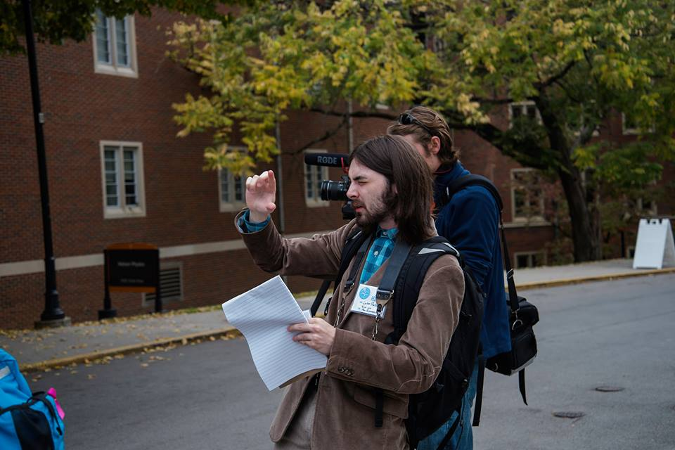
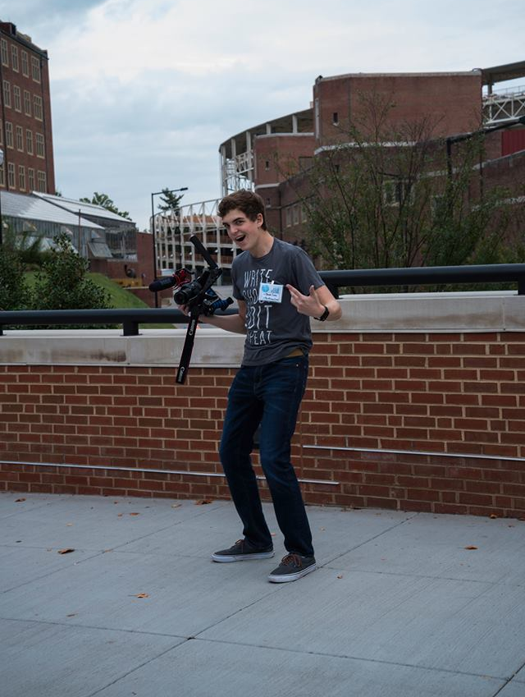
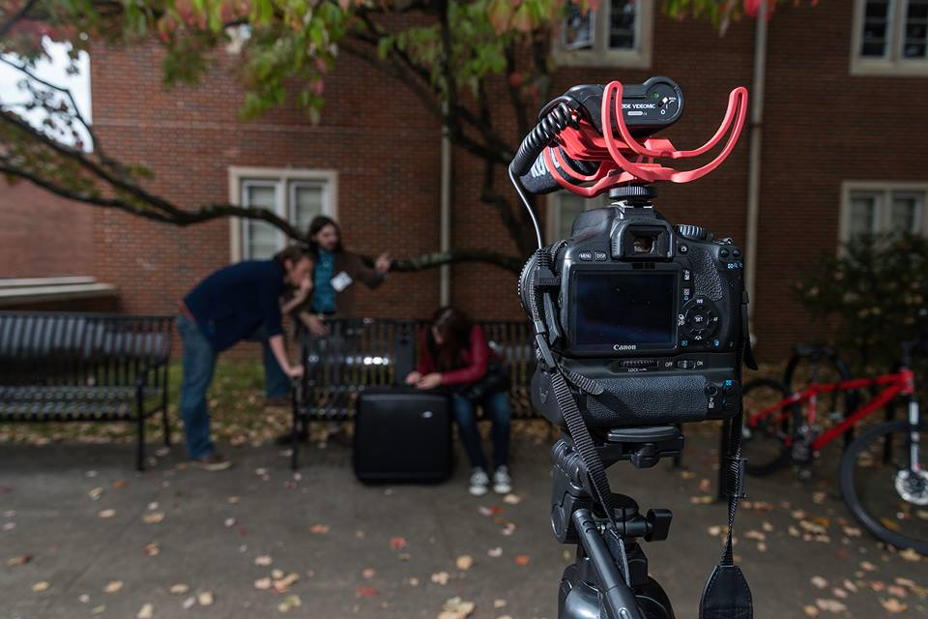
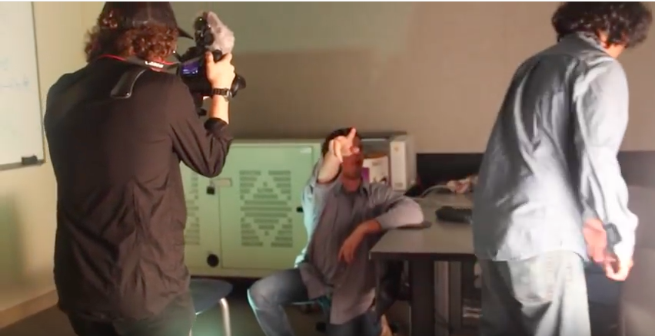
Appendix

Figures 1 (top left), 2 (top right), 3 (middle), and 4 (bottom)
(Participants in the film festival - Photos by Ryan McGill and Altaf Nanavati)
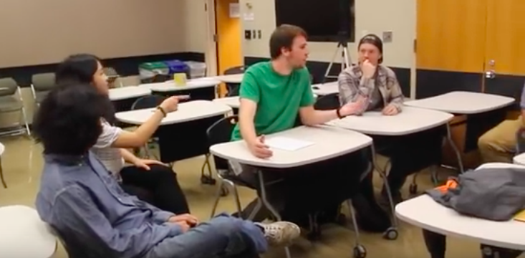
Figure 5
(Participants brainstorming during the event - Photo by Altaf Nanavati)

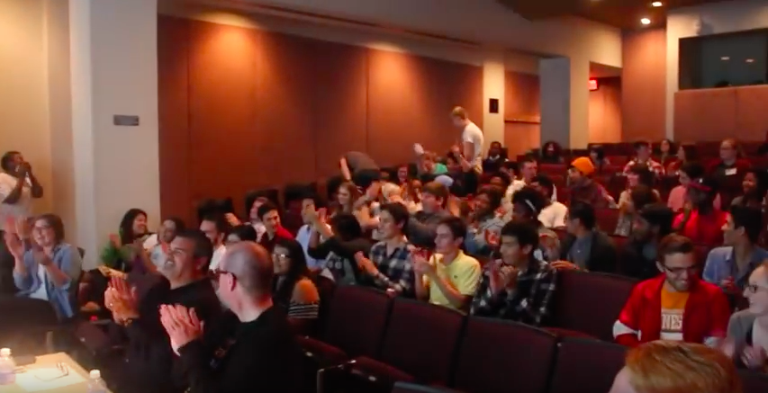
Figure 6
(Premier of the films - Photo by Altaf Nanavati)

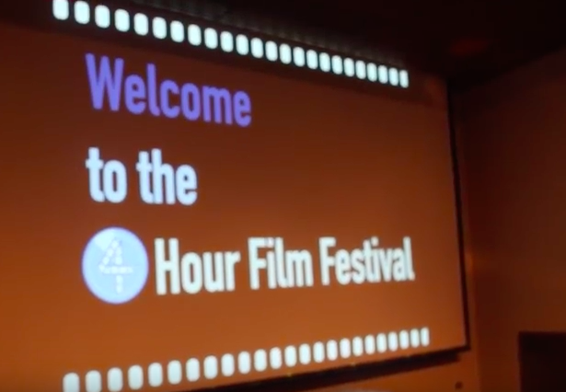
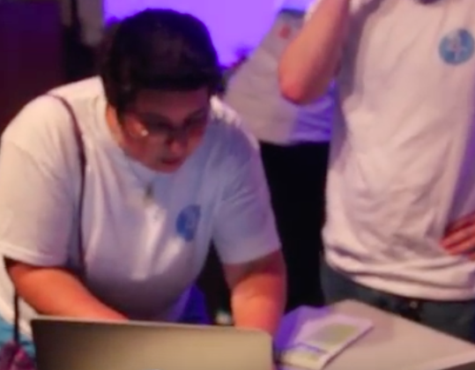
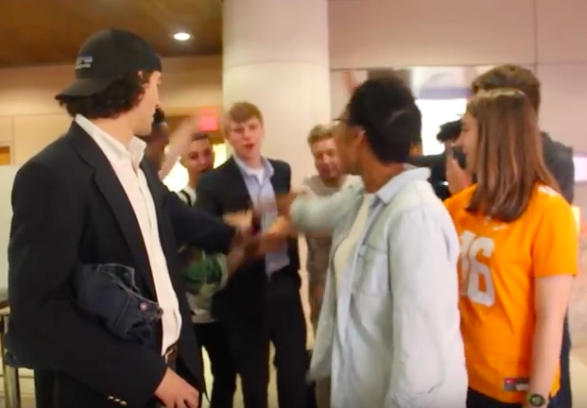
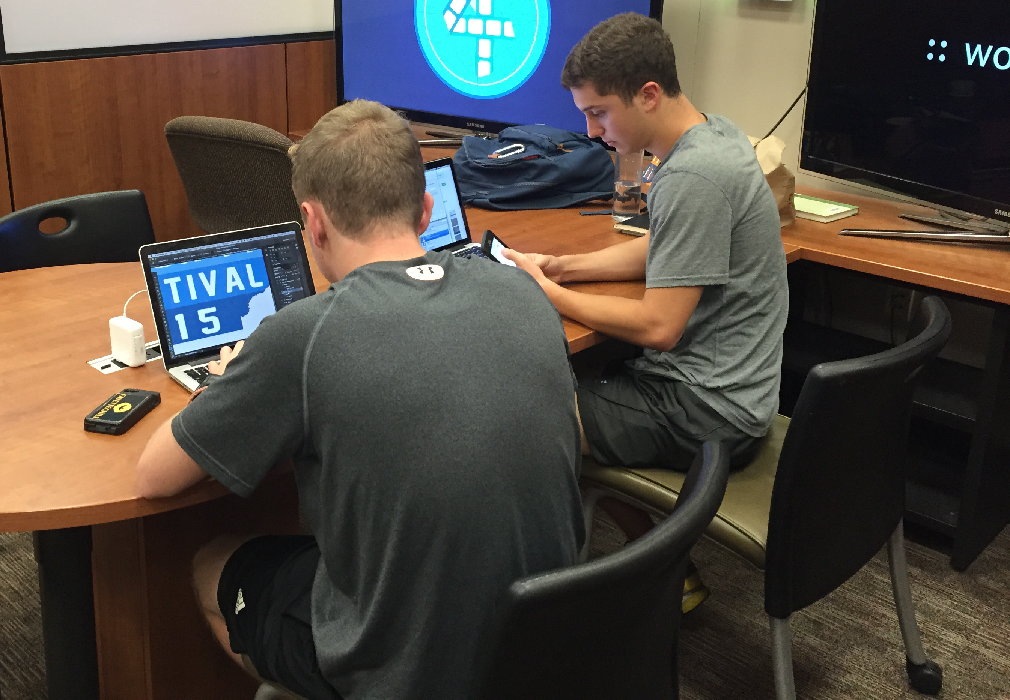

Figures 7 (top left), 8 (top right), 9 (bottom left), and 10 (bottom right)
(Leadership team at work - Photos by James Agan and Altaf Nanavati)
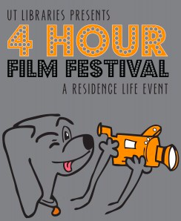
Figure 11
(Poster from second annual film festival - Designed by Bethany Tognocchi)
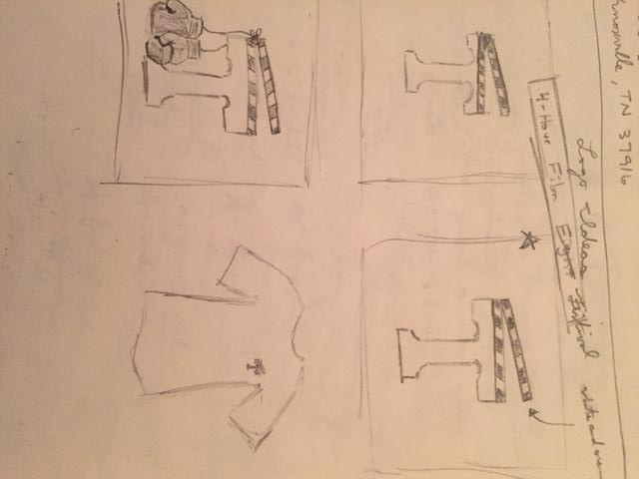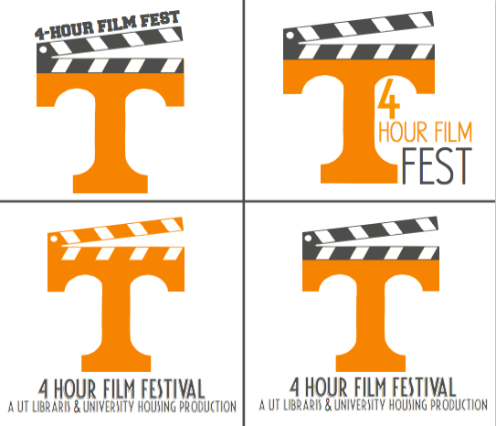
Figures 12 (left) and 13 (right)
(Logo sketch - Drawn by James Agan; Digital logo - Designed by Bethany Tognocchi)
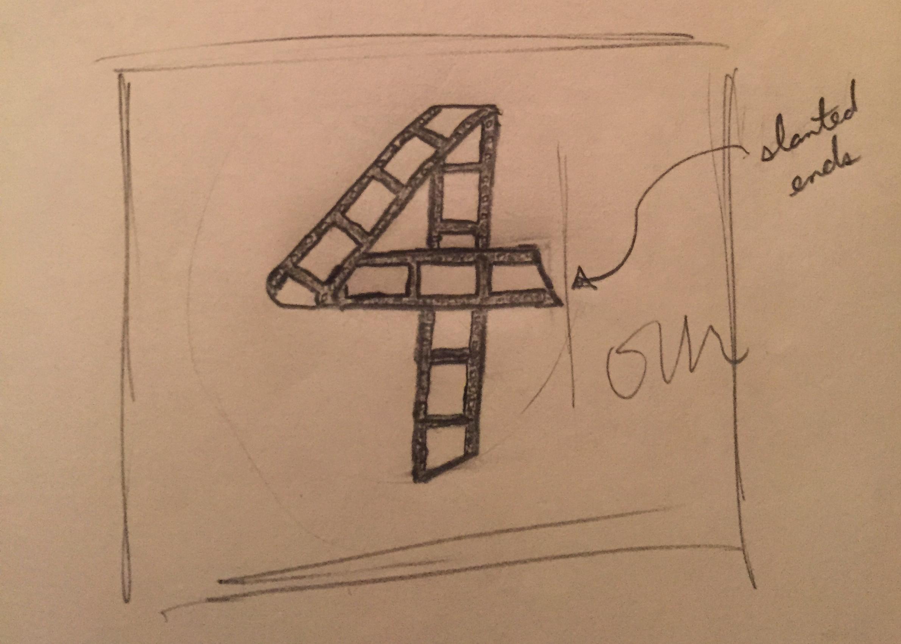

Figures 14 (top), 15 (bottom left), and 16 (bottom right)
(Logo sketch - Drawn by James Agan; Left Digital Logo - Designed by Sarah Bedell; Right Digital Logo - Designed by Bethany Tognocchi)
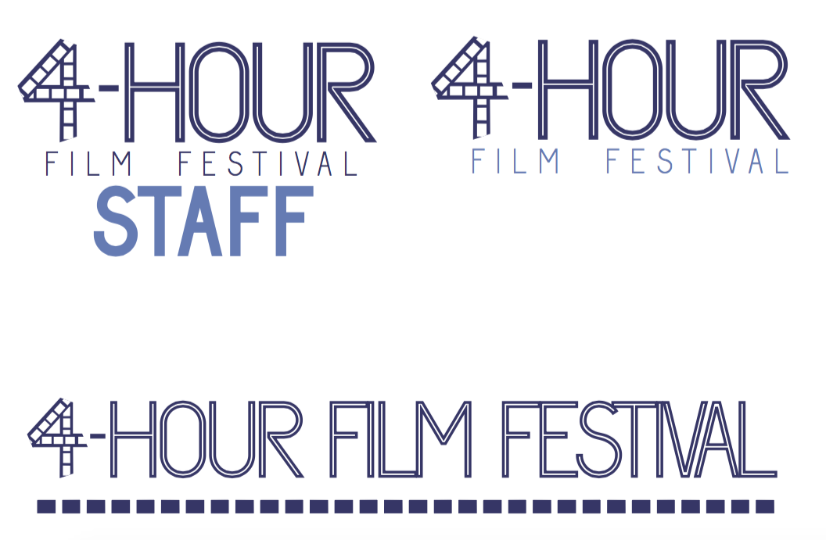


Figures 17 (top) and 18 (bottom)
(Logo Type - Designed by Bethany Tognocchi; Final Logo - Designed by Matt Bowers)

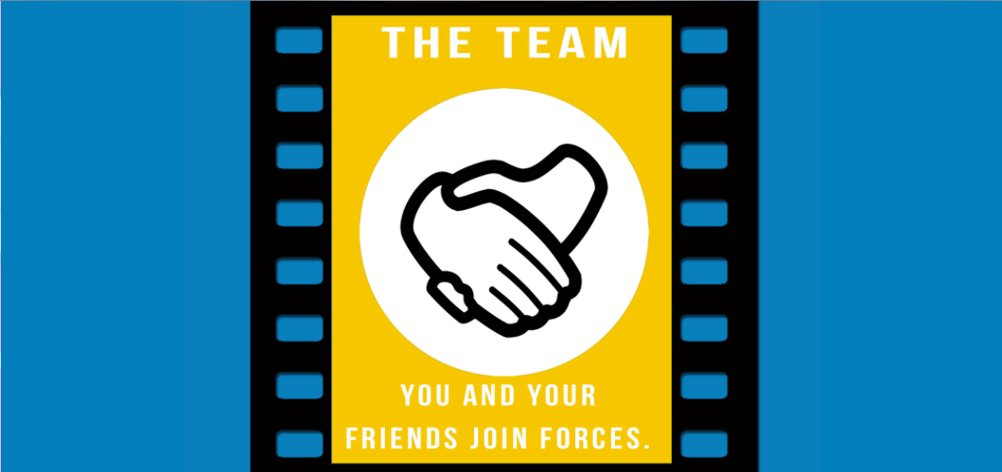
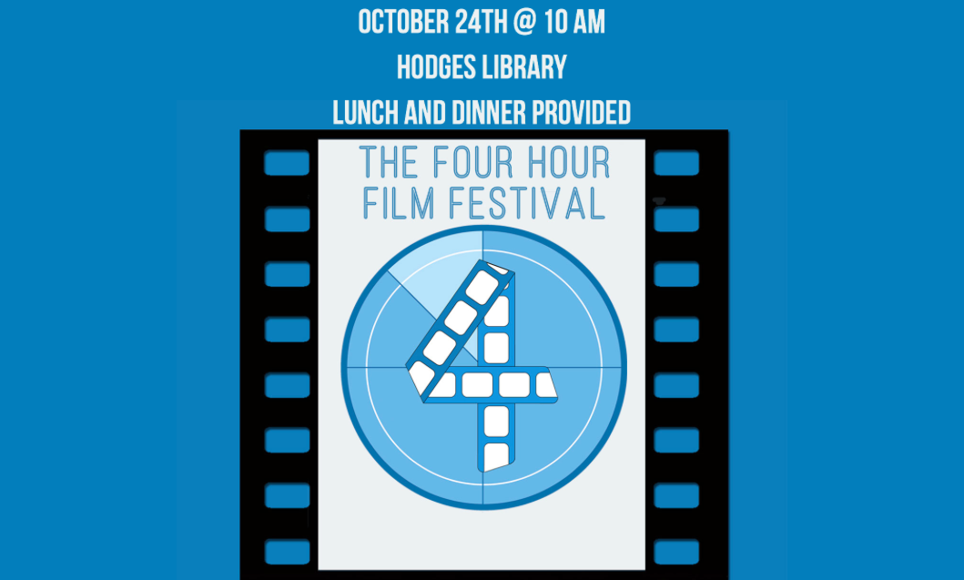

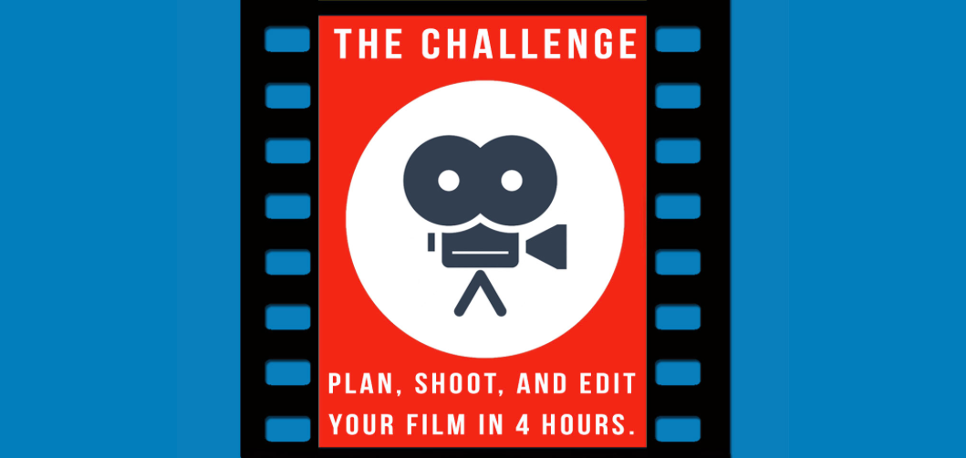

Figure 19
(Website - Designed by Matt Bowers and Andrew Wilmoth)

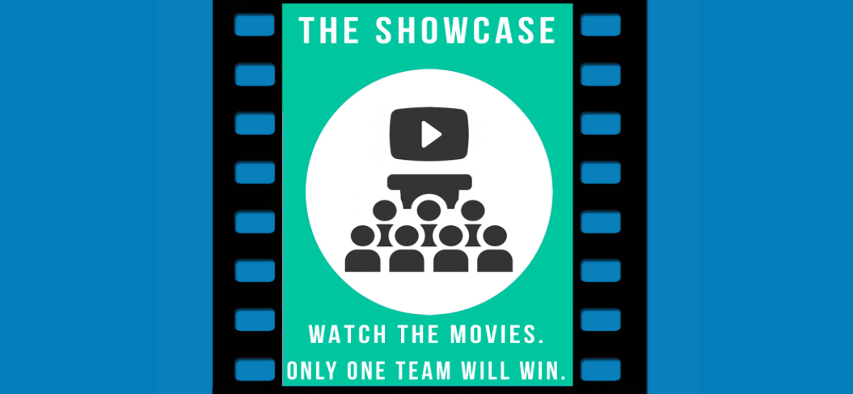

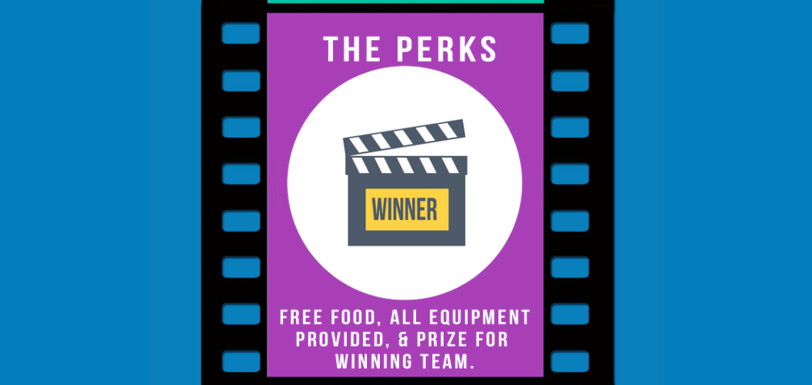

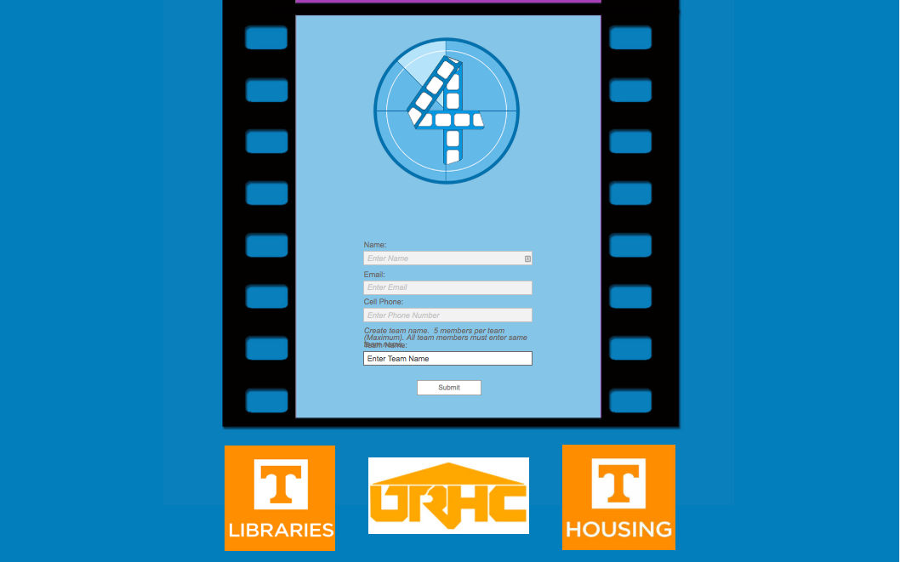
Figure 20
(Website - Designed by Matt Bowers and Andrew Wilmoth)

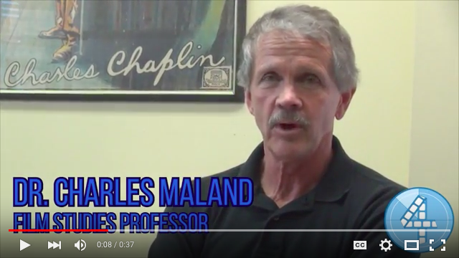
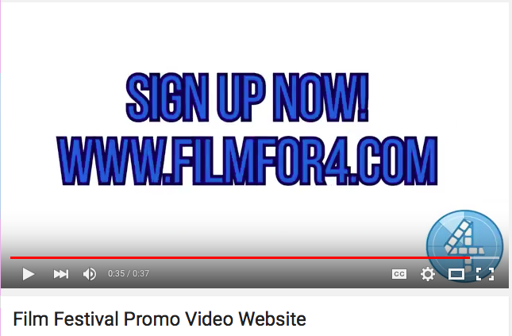
Figure 21 (top) and 22 (bottom)
Link to the promotional video #1: https://www.youtube.com/watch?v=f2tB1cxk-dI
(Promotional video #1 for the event - Created by Josh Lampley, Clinton Ricks, and Alex Wiederspahn)

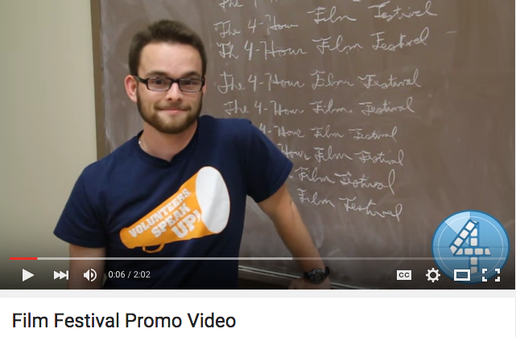
Figure 23
Link to the promotional video #2: https://www.youtube.com/watch?v=Wfu_A3cNC2c
(Promotional video #2 for the event - Created by Josh Lampley, Clinton Ricks, and Alex Wiederspahn)

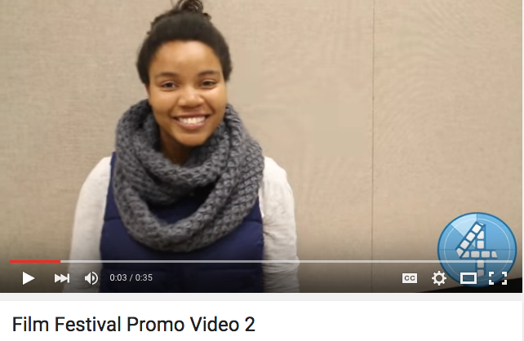
Figure 24
Link to promotional video #3: https://www.youtube.com/watch?v=VNmbGtMGfK8
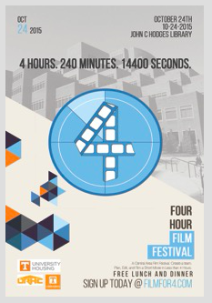
(Promotional video #3 for the event - Created by Josh Lampley, Clinton Ricks, and Alex Wiederspahn)
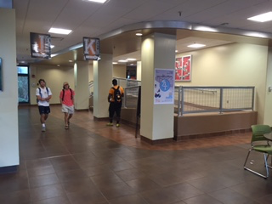
Figures 25 (left) and 26 (right)
(Poster for event - Created by Matt Bowers; Poster in Hess Hall - Photo by James Agan)
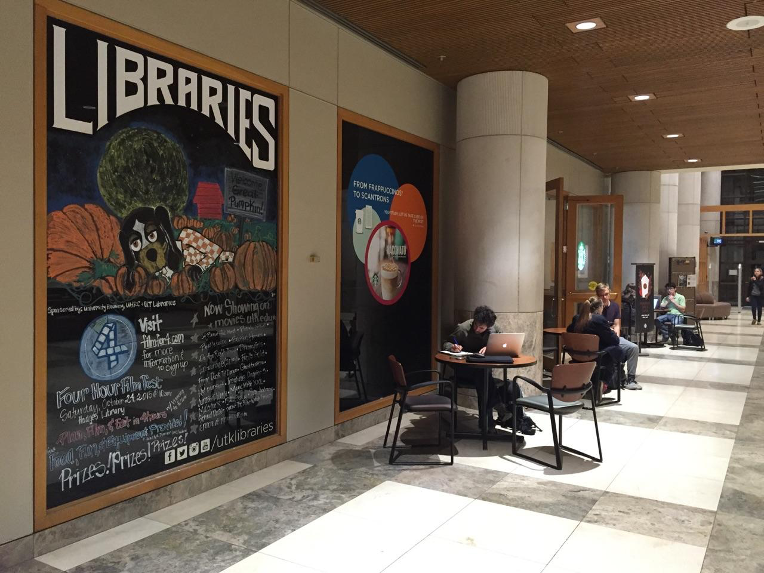
Figure 27
(Mural in library - Painting by Ingrid Ruffin; Photo by James Agan)


Figure 28
(PowerPoint slide with business sponsors - Created by James Agan)

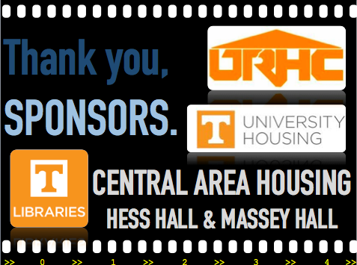
Figure 29
(PowerPoint slide with campus sponsors - Created by James Agan)

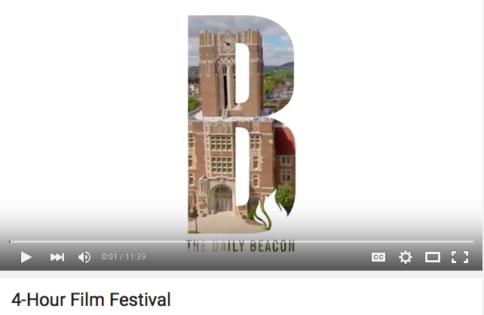
Figure 30
Link to video #4: https://www.youtube.com/watch?v=fWd2qZYwGdo
Altaf Nanavati is a student that writes for the campus newspaper, the Daily Beacon. Rather than write a story about the film festival, he thought it appropriate to document the event through video. He documented one team of participants’ journey through the film festival.
(Daily Beacon Video: Recap of Events - Created by Altaf Nanavati)

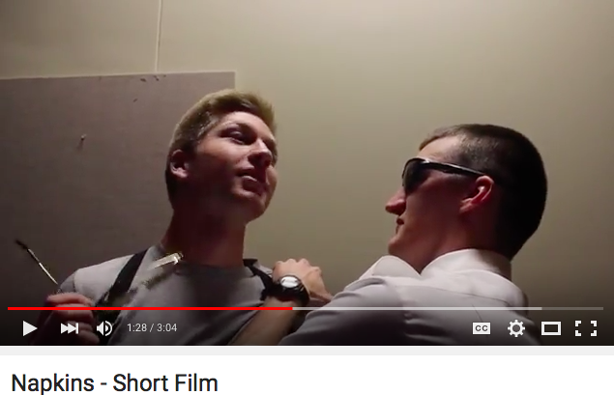
Figure 31
Link to video #5: https://www.youtube.com/watch?v=I7WaMoQm3gM
The Massey Crew created the winning video of both the judges’ award and the audience vote. Here is a link to the winning video of the third annual Four-Hour Film Festival:
(Napkins, 2015 Winner of the Four-Hour Film Festival - Created by The Massey Crew)

Bibliography
Brannen, M., Ruffin, I., Agan, J., & Lampley, J. (2015). Engaging On-Campus Students: A Study of a 4-Hour Film Festival, a Residence Life Event.
Global Trust in Advertising. (2015). Nielsen Report. Retrieved November 30, 2015, from www.nielsen.com
Hughes, G., & Smail, O. (2014). Which aspects of university life are most and least helpful in the transition to HE? A qualitative snapshot of student perceptions. Journal of Further and Higher Education, 39(4), 466-480. Retrieved September 2, 2015, from Academic Search Premier.
Lamb, S. (2006). How to Write It: Business Plans and Reports. Business & Economic Review, 17-24. Retrieved August 31, 2015, from Academic Search Premier.
Robinson, K., & Aronica, L. (2009). The Element: How Finding Your Passion Changes Everything. London: Allen Lane.
The World's Largest Student Film Festival | Campus MovieFest. (2015). Retrieved December 1, 2015, from http://www.campusmoviefest.com
Thomas, G., & Henson, J. (2014). Developing social integration to enhance student retention and success in higher education: The GROW@BU initiative. Widening Participation and Lifelong Learning, 16(3), 58-70. Retrieved September 2, 2015, from Education Source.

