SLOW TOURISM: A MEANS-END APPROACH TO THE MOTIVATIONS OF SLOW TRAVELERS

A Dissertation Presented for the
Doctor of Philosophy
Degree
The University of Tennessee, Knoxville

Eunkyeong Jung
May 2021

Copyright © 2021 by Eunkyeong Jung
All rights reserved.

DEDICATION

This dissertation is dedicated to my father Jongman Jung and my mother Jeongrye Kim who have always supported me with their unconditional love.
제 박사학위논문을 존경하고 사랑하는 부모님께 바칩니다.

ACKNOWLEDGEMENTS
It is my pleasure for me to acknowledge all those people who helped me successfully complete my dissertation. First and foremost, I would like to express my sincere gratitude to my advisor, Dr. Sejin Ha, for her consistent support and guidance. Without her help and care, I could not have finished my dissertation, and I am deeply thankful for her having walked me through this long and challenging Ph.D. journey. I would also like to extend my thanks to my committee members: Dr. Kim, Dr. Williams, and Dr. Ladd for their insightful suggestions and guidance, which helped me improve my research in a better way with their invaluable knowledge and interest. I am also grateful to RHTM faculty members and colleagues for their support and friendship.
My special appreciation also goes to my beloved parents, my sister, and my fiancé, all of whom provided continuous love, trust, encouragement, care, and support. Thank you for giving me the strength to persevere and finally close out my Ph.D. journey. I am truly blessed to have this amazing family in my life.

*This dissertation was funded by the Department of Retail, Hospitality and Tourism Management at the University of Tennessee, Knoxville.

ABSTRACT

The primary objective of this dissertation was to examine the phenomenon of slow tourism by exploring tourists’ motivations and end-state values of slow tourism. Two research questions were developed: What are the important attributes, consequences/ benefits, and end-state values of slow tourism that travelers perceive? What are the structural relationships among attributes, consequences, and values of slow tourism? To address the questions, this dissertation applied a mixed method design by which both qualitative and quantitative investigations were performed.
First, building upon means-end chain theory (Reynolds & Gutman, 1988), in-depth interviews with slow travelers were conducted and were analyzed by laddering and hierarchical value map (HVM). The findings of the qualitative study (Study 1) identified nine important attributes of slow tourism (i.e., hiking, self-paced activities, slow mobility, solo travel, culture/history/art, volunteering, local cuisine/restaurants/cafés, local shops, and concern for the environment) representing local and personal attributes); ten consequences associated with attributes in slow travel experiences (i.e., intimate contact with nature, flexibility in planning and time constraints, exploring local destinations, connections with people, supporting communities, environmental cleanup, mental unwinding and relaxation, fun/enjoyment/excitement, local immersion, and enrichment.) reflecting operative and psychological consequences; and seven personal values driving from the consequences of instrumental and terminal values (slow lifestyle, defying stereotypes, genuine and authentic experiences, happiness, self-awareness, self-confidence, and sense- of achievement) in slow tourism context.
Next, based on the findings of Study 1, the survey study (Study 2) tested the proposed conceptual model and hypothesized relationships using Structural Equation Modeling (SEM) analysis. The findings of Study 2 offered overall support for the dynamics of attributes – consequences – values – loyalty intentions links while two paths (local attributes to psychological consequences and operative consequences to terminal values) associations were turned out to be insignificant. Slow tourists may not experience psychological effects from experiencing certain local attributes in that local features may attract travelers to a destination and involved them in travel activities, rather than directly influencing their emotional outcomes. In addition, a variety of slow travel activities may not motivate tourists to achieve end-states.

TABLE OF Contents

CHAPTER ONE: INTRODUCTION 1
1.1. Phenomenon Statement 1
1.1.1. The Emergence of Slow Tourism 1
1.2. Problem Statement 4
1.3. Purpose of Research 6
1.3.1. Research Objectives 6
1.3.2. Research Questions 6
1.4. Definitions of Key Terms 7
1.5. Dissertation Organization 8
CHAPTER TWO: LITERATURE REVIEW AND HYPOTHESES DEVELOPMENT 10
2.1. Slow Tourism 10
2.1.1. Slow Tourism and Alternative Types of Tourism 12
2.1.2. Defining Slow Tourism 12
2.1.3. Slow Tourism and Slow Travel 15
2.1.4. Consumer Value as Travelers’ Motivation Toward Slow Tourism 15
2.2. Means-End Chain (MEC) Model 16
2.2.1. Development of Means-End Chain Model 16
2.2.2. Means-End Chain Model in Hospitality and Tourism Research 21
2.2.3. Laddering Technique in Means-End Chain (MEC) 22
2.3. Research Hypotheses 24
2.3.1. Slow Tourism Attributes 24
2.3.2. Slow Tourism Attributes and Subsequent Consequences 26
2.3.3. Perceived Consequences and End-State Values 26
2.3.4. End-State Values and Behavioral Outcomes 27
2.3.5. Mindfulness as a Moderator of the Relationship Between Attributes and Consequences 29
2.4. Summary 33
CHAPTER THREE: QUALITATIVE RESEARCH 34
3.1. Exploratory Sequential Design 34
3.2. Interviews 36
3.2.1. Interviews: Soft Laddering Technique 36
3.2.2. Interview: Sample 36
3.2.3. Interview: Procedure 38
3.2.4. Interview: Analysis and Results 40
3.3. Summary 49
CHAPTER FOUR: QUANTITATIVE RESEARCH 50
4.1. Instrument Development 50
4.1.1. Measurement Development 51
4.2. Pre-test 53
4.2.1. Content Validity Test 53
4.2.2. Pre-Test: Procedure 55
4.2.3. Pre-Test: Survey Description 55
4.2.4. Pre-Test: Data Collection and Sample 57
4.2.5. Pre-Test: Common Method Bias 57
4.2.6. Pre-Test: Analysis and Result 58
4.3. Main Study: Survey 58
4.3.1. Main-Test: Procedure and Survey Description 58
4.3.2. Main-Test: Sample 59
4.3.3. Main Test: Sample Demographics 60
4.3.4. Main-Test: Respondents’ Characteristics 60
4.3.5. Main-Test: Common Method Bias 61
4.3.6. Main-Test: Preliminary Analysis 61
4.3.7. Exploratory Factor Analysis (EFA) 62
4.3.8. Main-Test: Measurement Model Evaluation 65
4.3.9. Main-Test: Structural Model Evaluation and Hypothesis Testing 67
4.3.10. Main-Test: Mediation Evaluation 69
4.3.11. Main-Test: Moderation Evaluation 70
4.4. Summary 72
CHAPTER FIVE: DISCUSSION AND IMPLICATIONS 73
5.1. Overview 73
5.2. Discussion of Results 74
5.2.1. Discussion of Qualitative Research (Study 1) 74
5.2.2. Discussion of Quantitative Research (Study 2) 78
5.3. Theoretical Contributions 84
5.4. Practical Implications 86
5.5. Limitations and Suggestions for Future Research 88
REFERENCES 90
APPENDICES 112
VITA 188

LIST OF TABLES

Table 1. Definition of sustainable tourism-related terms 12
Table 2. Definition of slow tourism 16
Table 3. Means-end chain model in hospitality and tourism research 25
Table 4. Comparing meditative and socio-cognitive mindfulness 40
Table 5. Demographic information of interview participants 50
Table 6. Guide of the interview 52
Table 7. Overview of attributes, consequences, and values 55
Table 8. Summary of attributes, consequences, and values of slow tourism 59
Table 9. Implication matrix (Attributes – Consequences) 61
Table 10. Implication matrix (Consequences – Values) 62
Table 11. Original scale items for constructs (behavioral outcomes and mindfulness) 75
Table 12. Pre-test: summary of final measurement 78
Table 13. Pre-test: demographic characteristics 83
Table 14. Pre-test: assessment of normality 86
Table 15. Pre-test: reliability of the constructs 88
Table 16. Main-test: demographic characteristics 91
Table 17. Main-test: respondents’ travel characteristics 92
Table 18. Main-test: assessment of normality 94
Table 19. Main-test: reliability of the constructs 96
Table 20. Main-test: summary of final measurement 97
Table 21. Main-test: summary of final measurement (Continued) 98
Table 22. Results of exploratory factor analysis 100
Table 23. Main-test: measurement model improvement 106
Table 24. Main-test: correlation matrix with the final measurement 107
Table 25. Main-test: final measurement model and convergent validity 109
Table 26. Main-test: average variance extracted (AVE) and discriminant validity 112
Table 27. Main-test: structural model evaluation and hypotheses testing 115
Table 28. Main-test: mediation evaluation 118
Table 28. Main-test: moderating effects of mindfulness 120

LIST OF FIGURES

Figure 1. A six-level MEC model. Adapted from Olson and Reynolds (2001) 23
Figure 2. The conceptual model of the present research 43
Figure 3. Exploratory sequential design 46
Figure 4. Hierarchical Value Map (HVM) 64
Figure 5. Revised research model of the present research 104
Figure 6. The conceptual model of the present research 104
Figure 7. Main-test: hypotheses testing results (moderating effect) 120

CHAPTER ONE

INTRODUCTION

1.1. Phenomenon Statement

1.1.1. The Emergence of Slow Tourism
Slow tourism has stemmed from the broader slow movement, which arose from two interconnected initiatives in Italy, the Slow Food movement and the Slow City. The Slow Food movement began in 1986 as a stand against industrialized fast food, unhealthy eating habits and the disappearance of regional cuisine (Petrini, 2001), supporting healthy, traditional, sustainable and fair food (Chaudhury & Albinsson, 2015). The Slow City movement (also known as Cittaslow) was launched in 1999 by the Cittaslow organization (Mayer & Knox, 2006) to “promote and spread the culture of good living through research, testing and application of solutions for the city organization promoting the identity, memory, environmental protection, justice and social inclusion, community as well as an active citizenship” (CittaSlow International Charter, 2017, p.5). As of 2019, 262 municipalities with populations of fewer than fifty thousand have registered as Slow Cities in 30 countries and territories around the world. The Slow Food and Slow City movements are complementary in that both movements support the protection of local and traditional cultures and sustainable local economies, and resist globalization and big business (Chaudhury & Albinsson, 2015; Mayer & Know, 2009; Ozdamar-Ertekin & Atik, 2015).
Over time, the slow aesthetic has spread into other aspects of human life such as slow fashion, slow art, slow cinema, and slow living (Hall, 2006; Paul, 2014). ‘Slow’ does not imply progress at a snail’s pace (Honore, 2009), but “doing things at the right speed, changing attitudes towards time and the use of it, and seeking quality over quantity” (Dickinson et al., 2011, p. 282). In the last few years, the slow concept has enacted a cultural shift toward slowing the pace of our daily lives in response to an ever-changing society and its emphasis on fast eating and rapid travel (Honore, 2005). In a similar fashion, slow travel is a dynamic sub-movement.
Slow tourism is best explained in the broad sociocultural context of the slow movement (Fullagar et al., 2012; Groenendaal, 2012). People live hectic and fast-paced lives in our industrialized and technology-driven society (Chi & Han, 2020). People want vacations free from their daily routines of rigid plans, deadlines and agendas (Wang, 2000). Slow travel rose as a trend along with the modern lifestyle as a way of travelling to explore a destination without time or pressure and devoid of meaningless visits to crowded must-visit attractions (Germann Molz, 2009; Lumsdon & McGrath, 2011; Rawlinson, 2011). Slow tourists desire immersion in their destination while being connected to the local community, culture, people, and food (Dickinson et al., 2010; Kazandzhieva & Lukanova, 2016). Such a slow philosophy in the tourism industry is similar to other slow movements in respecting local culture and history, supporting local industries, and interacting with locals (Kapchikova, 2018).
Environmental damage inflicted by tourism has also increased recognition of the significance of slow tourism in the sustainable tourism industry (Eslami et al., 2019; Meng & Choi, 2016). Tourism features from long-haul flights to high-impact lodging contribute to the carbon footprint worldwide (Losada & Mota, 2019). Tourists exacerbate environmental crises such as pollution, ecological destruction and traffic congestion as their carbon footprints expand rapidly (Hwang & Lee, 2019; Tang et al., 2017). Slow travel emphasizes minimizing negative impacts on the environment (Gardner, 2009). Tourists applying the slow concept in their trips tend to travel to a destination more slowly by low-carbon modes of transport and stay at a destination longer, thus traveling less (Dickinson & Lumsdon, 2010). Italia Slow Tour (2019) reports that Italy, the pioneer of the slow travel movement, has become the main destination of travelers seeking to avoid mass tourism (Italia Slow Tour, 2019). In addition, the vast majority of Canadian travelers (84%) are considering more sustainable travel for future vacations, according to the report by Booking.com (2018). Thus, environmentally conscious travelers and the principle of slow tourism provide a sustainable direction for future tourism (Meng & Choi, 2016; Shang et al., 2020).
Slow Tourism is relatively new in the USA (Heitmann et al., 2011; Oh et al., 2016; Wemovedabroad.com, 2019), gradually having begun to participate in the new tourism trend. For example, as part of the Slow City movement, Sonoma Valley in California received the first designation of Cittaslow (slow city in Italian) by Cittaslow International in 2009. Recently, Fairfax and Sebastopol in California have also joined Cittaslow (Cittaslow, 2019). Additionally, Slow Adventure, a travel agent, provides slow-paced travel products for California tourists. One of the most popular slow tourism products is “Walk the Bay”, a walking tour along the entire Monterey Bay coastline from Santa Cruz to Monterey along the entire coastline in six days. In addition, Amtrak provides train routes for slow tourism, such as The California Zephyr and The Coast Starlight. The California Zephyr runs through five states, beginning from Chicago and passing through Omaha, Denver, and Salt Lake City before arriving in San Francisco. The Coast Starlight runs south from Portland to San Francisco Bay and down to Los Angeles. Travelers can take this slower mode of transport across the USA. Thus, slow tourism is a growing niche in the U.S. tourism industry.

1.2. Problem Statement

Despite the growing recognition and popularity of Slow Tourism, a very few studies on slow tourism exist. So far, research on slow tourism has concentrated on two issues: 1) pro-environmental development and 2) goal-driven consumption.
The first stream of research views slow tourism in line with sustainable and pro-environmental development (Dickinson & Lumsdon, 2010; Dickinson et al., 2010; Di Clemente et al., 2015; Scott & Becken, 2010; Timms & Conway, 2012). Within this realm, slow tourism has generally been defined in relation to speed and mobility, with a particular interest in transportation to and from destinations. This definition emphasizes the pro-environmental aspect of slow tourism: slow travel, not only reduces environmental pollution through use of low-carbon emission vehicles but, also reduces energy resource depletion (Oh et al., 2016). Most research approached slow tourism as a way of engaging in pro-environmental activities in relation to environment sustainability, as well as travel activities at a destination.
The second stream of research describes that slow tourism is more than slow movement for the environment (Meng & Choi, 2016; Oh et al., 2016). Researchers have begun to conceive slow tourism more broadly from the goal-driven consumption perspective, such as personal satisfaction and well-being (Parkins & Craig, 2006). With this viewpoint, Dickinson et al. (2010) argued that slow travel focuses, not only on transportation for the sake of environmental protection, but also on participation in relatively slower forms of travel for the sake of exploring local communities, history, cultures and people. Timms and Conway (2012) also described slow tourism encompasses three aspects of sustainability: environmental, sociocultural, and economic sustainability. Later, Oh et al. (2016) defined slow tourism as “a trip or a series of trips taken at a subjectively determined, mentally slow pace of actions or movement for realization of the motivations and goals that are specific to the trip(s)” (p. 208). They examined why people engaged in slow types of travel and what goals they pursued in such a purposefully slow traversal of time and space. Meng and Choi (2016) also provided an empirical understanding of slow travelers’ goal-directed behaviors that slow travelers become involved in slow tourism to relieve time pressure during trip.
Slow Tourism is a rising trend that attracts current attention in tourism literature. Most research on slow tourism has focused on pro-environmental activities through travel on a slower mode of transport and engagement in local experiences. However, the tourism literature has provided limited insight into travelers’ perceptions of slow tourism. Little attention has been given to psychological motivations of slower modes of travel. In modern society, people are developing a desire to slow down and relax through travel because they live with schedules that overflow and run at an ever-increasing pace (Geddo, 2018). Oh et al. (2016) first investigated why people get involved in slow tourism from the perspective of a goal-driven consumption process. They clarified the process for slow tourism goal attainment. However, there have been a few studies related to slow tourism in tourism and hospitality industry research, raising questions: What motivate travelers to engage in slow tourism? What are the underlying values travelers seek during their slow tourism experiences?

1.3. Purpose of Research

1.3.1. Research Objectives
This study aims to address the questions by exploring tourist motivations and end-state values of slow tourism based on the means-end chain theory (Reynolds & Gutman, 1988). First, this study intends to identify: (1) key attributes of slow tourism, (2) consequences associated with attributes in slow travel experiences, and (3) the end-state values driving from the consequences in the slow travel experience context. Existing studies have not offered clear identification of important attributes, consequences, and end-state values in slow tourism. Identifying these factors is the first step to understanding the specific perceptions that travelers use to evaluate slow travel experiences. Furthermore, this study will explore dynamics among the attributes, consequences, and end-states/values identified to be critical to slow tourism.

1.3.2. Research Questions
This study develops two research questions:
- Research Question 1: What are the important attributes, consequences/ benefits, and end-state values of slow tourism that travelers perceive?
- Research Question 2: What are the structural relationships among attributes, consequences, and values of slow tourism?

1.4. Definitions of Key Terms
The key terms used in this study are defined as follows.
Attributes: “Features or properties of products or services” (Valette-Florence &
Rapacchi,1991, p. 31).
Consequences: Positive and/or negative valences regarding consumption (Gutman, 1982;
Rokeach, 1973).
Values: “An enduring belief that a specific mode of conduct or end-state of existence is
personally, and socially preferable to alternative modes of conduct or end-state of
existence” (Rokeach, 1968, p. 167).
Future Intention: The willingness to continue slow-paced travel in the near future (e.g.,
Ajzen, 1991; Ashraf et al., 2020; Lai et al., 2020; Oh et al., 2007)
Referral Intention: The willingness to recommend or spread positive anecdotes about a
slow travel experience at a particular destination (Lam & Hsu, 2006; Oh, Fiore, &
Jeong, 2007).
Mindfulness: “A state of conscious awareness in which the individual is implicitly aware
of the context and content of information characterized by a state of openness to
novelty in which the individual actively constructs categories and distinctions”
(Langer, 1992, p.89).
Means: Concrete aspects of a product, service, or activity that encourage people to
engage in and finally accomplish certain ends (Gutman, 1982)
End: Valued states that individuals desire to achieve in their lifetime such as happiness,
and accomplishment (Gutman, 1982)
Means-end chain: The chain connecting sequentially attributes (A) to consequences upon
consumption (C) and to personal values (V) that are ultimately desired (Reynolds
& Gutman, 1988).
Laddering: “An interviewing technique that can be used to elicit means-end connections
and attribute-consequence-value networks” (Reynolds & Whitlark, 1995).
Implication Matrix: A matrix of attributes- consequences- values associations (Heinze et
al., 2017)
Hierarchical Value Map: The summary of the linkages across levels of abstraction,
(Reynolds & Gutman, 1988), which provides an overview of the most significant
relations (Heinze et al., 2017).

1.5. Dissertation Organization
This dissertation consists of five chapters. Chapter ONE describes the recent phenomenon of slow tourism and significance of the study, purpose of the study, and research questions. Chapter TWO serves to review the extant literature on slow tourism, consumer values, means-end chain (MEC) model, and laddering techniques. The chapter also illustrates proposed research hypotheses based on the literature. Chapters THREE and FOUR discuss both qualitative and quantitative methods used in this study, respectively. In Chapter THREE, procedures, samples, analyses and results of the interviews are described, and in Chapter FOUR those of the pre-test and main-test are illustrated. Chapter FIVE presents the discussions of the study, theoretical and practical implications, and limitations of the current study and suggestions for future studies.

CHAPTER TWO

LITERATURE REVIEW AND HYPOTHESES DEVELOPMENT

The present research is designed to explore what attributes, consequences, and values travelers desire to obtain, and how their ultimate values affect travel behavioral outcomes in the setting of slow tourism. This chapter consists of three sections. The first section begins with reviewing how slow tourism was emerged and extant literature that discusses slow tourism. The second section provides an overall review of previous studies to establish the theoretical foundation and its application of means-end chain model within the hospitality and tourism context. The last section generates a set of research hypotheses proposing structural relationships of attributes, consequences, values, behavioral outcomes, and a moderator in the context of slow tourism.

2.1. Slow Tourism
Slow tourism “encompasses the environmental sustainability concerns of ecotourism, addresses social and cultural sustainability interests of community-based tourism and pro-poor tourism, and advances economic sustainability ideals” (Timms & Conway, 2012, p. 405). The concept of slow tourism is relatively new. Slow tourism stems from the social
movements, Slow Food and Slow Cities (also known as Cittáslow) which began in Italy in the 1980s and 1990s (Dickinson & Lumsdon, 2010; Fullagar et al., 2012; Hall, 2012). The Slow Food movement started when Carlo Petrini led a protest against the opening of the McDonald’s franchise in the center of Rome in 1986. The Slow Food Manifesto was officially signed in Paris by delegates from 15 counties three years later, and it has since grown into over 100,000 members across 150 countries (Slow Food, 2019). The Cittáslow movement, an offshoot of Slow Food, began in 1999 when locals integrated slow philosophy into their day-to-day lives in order to foster the development of places based on sustainable economics, healthy food & environment, and traditional community (Cittáslow, 2019).
Slow travel is about making conscious and responsible choices and slowing down rather than speeding up. According to Booking.com (2019), more than half of travelers do not care how much time it takes to reach their travel destinations if they are traveling by a unique means of transportation. Travelers who care about the environment are more likely than less environmentally conscious travelers to be interested in sustainable forms of transportation such as trains or boats. In this regard, it is interesting to note that cycle trip reservations were increased of 140% between 2014 and 2018 in North America, according to Saddle Skedaddle, which provides niche cycling adventures. Motivated to avoid crowds (overtourism), vacationers are longing for the benefit of checking out destinations slightly off the usual path. Booking.com (2019) states that 54% of the world’s tourists are seeking out destinations that are similar to but less crowded than their usual choices.

2.1.1. Slow Tourism and Alternative Types of Tourism
Table 1 presents definitions of sustainable tourism and other related tourism. Slow tourism bridges tourism and sustainability by supporting the virtues of slowness and the authentic travel experience (Losada & Mota, 2019). There are alternative forms of tourism (e.g., ecotourism, cultural heritage tourism, responsible tourism, sustainable tourism, and ethical tourism) (Conway & Timms, 2012; Dickinson & Lumsdon, 2010; Meng & Choi, 2016; Moira et al., 2017). Similarly, slow tourism “encompasses the environmental sustainability concerns of ecotourism, addresses social and cultural sustainability interests of community-based tourism and pro-poor tourism, and advances economic sustainability ideals” (Timms & Conway, 2012, p. 405). As such, slow tourism and other types of pro-environment tourism share theoretical grounds with environmental concerns and sustainable modal choices.

2.1.2. Defining Slow Tourism
Slow travel movement originally came out as an alternative to travel by flight and car that people reach destinations more slowly and travel less distance (Dickinson & Lumsdon, 2010). Slow tourism generally represents traveling more slowly, engaging with local places and people (Dickinson & Lumsdon, 2010; Gardner, 2009). Researchers have proposed definitions of slow tourism, however, “there is little consensus on what ‘slow’ actually means, and how it is interpreted in relation to different tourism contexts and cultures” (Fullagar et al., 2012, p. 3). According to Dickinson and Lumsdon (2010), any definition of Slow Travel should include essential principles for transportation that seek to protect the environment and to promote relatively slow types of travel, such as exploring the local culture, history and community. They describe slow tourism as “a conceptual framework that involves people who ‘travel to destination more slowly overland, stay longer and travel less’ and who incorporate travel to a destination as itself an experience and, once at the destination, engage with local transport options and ‘slow
food and beverage,’ take time to explore local history and culture, and support the environment” (Dickinson & Lumson, 2010, p. 1-2). In particular, within the slow tourism principle, tourists should take only low-carbon modes of transportation such as bicycles and trains or zero-emission modes such as walking or running to reach their destination (Dickinson et al., 2011; Serdane, 2020; Stradling & Anabele, 2008). As a key factor of Slow Tourism, Lipman and Murphy (2012) identify sustainable consumption through “slower” transportation and products, not involving long-distance travel. Slow Tourism motivates travelers to decrease their travel frequency, stay longer at their destination, visit fewer places slowly, take a favorable approach toward local resources, and pursue short-distance travel, using more sustainable modes of transport (Dickinson & Robbins, 2010; Dickinson et al., 2010).
Across several studies, slow tourism is viewed as the full travel experience, ranging from modes of transportation to activities at the destination (Dickinson, 2015) while mitigating carbon footprints (Dickinsonet al., 2011; Meng & Choi, 2016; Lumsdon & McGrath, 2011; Scott & Becken, 2010; Timms & Conway, 2012). Thus, slow tourism has been characterized as behavioral forms (e.g., pro-environmental activities) in relation to environmental sustainability while focusing on the slow physical mobility of a tourist. However, it may be difficult to reach long-distance travel destinations in an environmentally friendly way and taking airplanes may be a necessary part of travel (de la Barre, 2012; Serdane, 2020). In this sense, the combination of slow and fast modes of travel to reach destinations can be accepted within the trend of slow tourism (Oh et al., 2016). Saving traveling time in reaching destinations makes more time in destinations for engaging in the slow travel experience (Sun & Lin, 2018).
In recent studies, researchers have approached slowness in tourism as the practice of time and space which reflect travelers’ psychological aspects such as well-being and satisfaction, rather than their behavioral modes (Parkins & Craig, 2006). Oh, Assaf, and Baloglu (2016) note that ‘slowness’ in tourism is subjectively determined and associated with mentally slow actions or movements to achieve the specific goals of the trip. They define slowness as an attitudinal perspective rather than a behavioral one. Serdane et al. (2020) also identify slowness with tourists’ subjective perception of time while on holiday, which complements Oh et al. (2016)’s work. Moore (2012) refers to slow tourism as eschewing fast tourism to mitigate the feelings of a lack of time under the pressure that travelers feel to fulfill their identity.
Table 2 presents definitions of slow tourism in past research. In summary, most studies focused on pro-environmental activities with the transport mode as a way to reduce carbon footprint in slow tourism while more recent research focus has been turned to travelers’ psychological well-being and satisfaction. Based on the review of research, this study emphasizes on psychological aspects of slow tourism (Moore, 2012; Oh et al., 2016) and defines slow tourism as a holistic travel type in which a traveler pursues slowness while traveling to explore local life, to connect to a place and people, to consume local food, and/or to desire ‘slow down’ mentally from fast pace of life, without any certain criteria of destinations, travel genres, and time.

2.1.3. Slow Tourism and Slow Travel
There has been some dispute about the use of ‘slow tourism’ and ‘slow travel’ among scholars (Conway & Timms, 2012; Dickinson et al., 2011; Lumsdon & McGrath, 2011; Matos, 2004). Slow travel generally refers to the use of low-carbon modes of transportation such as trains or buses on one’s journey, while slow tourism refers to all tourism activities, the full travel experience, from modes of transportation to experiences at a destination (Dickinson, 2015; Meng & Choi, 2016a, 2016b; Timms & Conway, 2012). Slow tourism is therefore a hypernym of slow travel. As the terms are used interchangeably in literatures, mass media, and blogs (Dickinson et al., 2011; Serdane et al., 2020), ‘slow tourism’ and ‘slow travel’ are used interchangeably in this study.

2.1.4. Consumer Value as Travelers’ Motivation Toward Slow Tourism
Consumer value is a crucial factor that affects the consumption process, such as buying behaviors (Babin et al., 1994; Jones et al., 2006; Park, 2004). In the context of slow tourism, slow travelers’ values can determine their behaviors and choices in consumption situations. Consumer values can be well explained by the model of means-end chain (MEC) introduced by Rokeach’s research (1968, 1973). Values are considered certain goals or end-states that customers seek to achieve through consumption of products or services (Reynolds & Olson, 2001). Rokeach (1968, 1973) categorized values into two types: terminal values and instrumental values. Instrumental values (e.g., independence) provide the means through which desired end goals can be achieved, whereas terminal values (e.g., sense of accomplishment), are defined as end goals in their lifetime (Lin & Fu, 2017; Peter et al., 1999). Gutman (1982) further advanced Rokeach’s model and highlighted how terminal values (preferred end-states) influence consumption behavior (e.g., product choice) (Kim, 2014).
Following them, according to Woodruff’s (1997) customer value hierarchy model, consumers wish for specific outcomes or benefits that will help them achieve their ultimate goals. Consumer value is determined based on concrete knowledge or thoughts (attributes) of a product, service or experiences which advance to more abstract knowledge or thoughts (e.g., psychological and social consequences) and even more abstract thoughts (e.g., values) (Gardial et al., 1994; Reynolds & Gutman, 1988; Woodruff, 1997). In brief, the model asserts the attributes – consequences – values hierarchical structure. Applying this to a slow tourism setting, this study presumes that travelers evaluate the attributes of slow tourism which then form meaningful associations with consequences (benefits) they can obtain from the attributes to accomplish their end-state goals.

2.2. Means-End Chain (MEC) Model

2.2.1. Development of Means-End Chain Model
A Means-End Chain (MEC) model (Gutman, 1988; Reynolds & Gutman, 1988) is applied as a theoretical framework in this study. The Means-End Chain (MEC) model has been extensively used to explore consumer goal structures in response to marketing (e.g., Jeng & Yeh, 2016; Walker & Olson, 1991). Specifically, the Means-End Chain (MEC) guides to develop a hierarchical cognitive model that explains consumer motivations and perceptions toward a product, service, or activity (Lin et al., 2019; Reynolds & Gutman, 1988) from concrete thoughts (e.g., attributes of a slow travel destination), to more abstract thoughts (e.g., psychological and social consequences of slow travel and in turn end goals sought from slow travel) in a sequence processing. The term “means” refers to concrete aspects of a product, service, or activity that encourage people to engage in and finally accomplish certain ends, and the term “end” indicates valued states that individuals desire to achieve in their lifetime such as happiness, and accomplishment (Gutman, 1982). The means-end point of view is similar to the expectancy-value theory that Rosenberg (1956) developed to explain consumers’ attitudes toward a given object or action (Fishbein & Ajzen, 1975). Both theories have been applied to identify consumers’ beliefs and values in consumer behaviors. However, while the expectancy-value theory has been frequently used in quantitative research, the MEC approach has been widely used in qualitative research since its means-end chain entails interviewing methods (Kim, 2014).
A Means-End Chain (MEC) model consists of three constructs: attributes, consequences, and values. The chain connects sequentially attributes (A) to consequences upon consumption (C) and to personal values (V) that are ultimately desired (Reynolds & Gutman, 1988). The A-C-V sequence structures the means-end chain (MEC) or ladder by which a lower level component leads to a higher-level component (Gutman, 1982, 1991). The model describes why and how a product/service/activity is important to consumers (Veludo-de-Oliveira et al., 2006). The MEC model presumes that customers are more likely to value the benefits along with a product, service, or activity, rather than just purchasing a product or engaging in a service or activity for its own sake (Nunkoo & Ramkissoon, 2009; Ter Hofstede et al., 1998). Consumers desire products/service/activity that give self-related consequences and eventually support them to enact their personal values (Gutman, 1982). In this sense, the linkages among a consumer’s perceptions of a product/service/activity, self-related consequences upon the consumption, and values as end goals are important in terms of consumption behaviors (Grunert, 2005). Means-end chains are subjective to individuals (Grunert, 2005). In other words, an individual’s motivations toward a particular consumption may differ from others in the same circumstances and so do his/her attribute–consequences–value chains from consumption experiences.
In this study, each construct (attributes, consequences, and values) was classified into six-level means-end chain by Olson and Reynolds (2001) as shown in Figure 1.
According to Olson and Reynolds (2001), each abstraction level can be divided into two subdivisions, which leads to the six-level means-end model ranging from low to high abstraction. This study employed the six-layer MEC model to identify particular paths to attain slow tourists’ values by dividing each key level of MEC into two subcategories (Gutman & Miaoulis, 2003; Creswell et al., 2003). The framework could provide a guide for understanding why travelers pursue slow travel and how slow tourists reach to their desired values.
Attributes. Attributes are the most concrete element in the means-end chain model (Lin & Fu, 2017; Lin et al., 2018; Patrick & Xu, 2018). Attributes are “features or properties of products or services” (Valette-Florence & Rapacchi, 1991, p. 31). Such characteristics can be classified into concrete (tangible) and abstract (intangible) attributes (Lin, 2002; Olson & Reynolds, 1983). Concrete attributes refer to physical and tangible characteristics of a product or service such as local food and local souvenirs (Olson & Reynolds, 1983; Vriens & Hofstede, 2000). On the other hand, abstract attributes refer to subjective characteristics of a product or service that often exist only in one’s minds, such as service quality (Botschen et al., 1998; Olson & Reynolds, 1983). In the context of slow tourism concreate attributes include local culture, local cuisine, and slow accommodations, while abstract attributes include concern for the environment.

Consequences. Consequences, located in the middle in the MEC are more abstract than attributes (Gengler et al., 1999). Consequences reflect what a consumer can get from product’s or service’s attributes (Gengler et al., 1999; Ter Hofstede et al., 1998). Generally, drawn from the specific attributes uncovered, consequences refer to positive or negative valences regarding consumption (Gutman, 1982; Rokeach, 1973). Desirable consequences are what consumers want to gain from a product or service experience, whereas undesirable consequences contain negative results that consumers want to avoid (Peter & Olson, 2010). Olson and Reynolds (1983) identified two types of consequences regarding consumers’ purchase: functional and psychosocial consequences. Functional consequences refer to practical benefits and performance outputs consumers can gain directly from consuming a product or service while psychosocial consequences are psychological feelings or social considerations (e.g., perceived quality) arising from functional consequences (Olson & Reynolds, 2001). Functional consequences represent direct outcomes from consuming attributes such as comfort, convenience, and ease-of-use (Vriens & Hofstede, 2000). Psychosocial consequences, more subjective than functional ones, specify why the functional consequences are considered important for consumers and explain how a product or a service makes the consumer think and feel (Kim, 2014; Peter & Olson, 2010). Psychosocial consequences are formed by functional consequences (Valette-Florence & Rapacchi, 1991). In the context of slow tourism, functional consequences are benefits such as learning other cultures, history, and places or supporting communities whereas psychosocial consequences involve positive influences on travelers’ mental health such as relaxation.
Values. Values represent the most abstract component and thus the highest level of the chain in MECs (Kitsawad & Guinard, 2014; Ter-Hofstede et al., 1998). Value can be viewed as “an enduring belief that a specific mode of conduct or end-state of existence is personally and socially preferable to alternative modes of conduct or end-state of existence” (Rokeach, 1968, p. 167). Values are focal beliefs that mirror consumers’ behaviors (Gutman, 1990; Hofstede, 1980; Rokeach, 1973; Watkins & Gnoth, 2011). Consumer values are viewed as a key construct that determines consumers’ behaviors when they consume a product, service, or activity (Babin et al., 1994; Jones et al., 2006; Park, 2004). In MEC, personal values are classified into instrumental and terminal values (Olson & Reynolds, 1983). According to Rokeach (1973), instrumental values refers to ways of behaving that further generate terminal values, while terminal values are defined as preferred end-states of being such as self-esteem and sense of competence (Peter & Olson, 2010; Rokeach, 1973; Veludo-de-Oliveira et al., 2006). Specifically, instrumental values is related to short-term related end states while terminal values are end states that consumers desire to achieve (Rokeach, 1968). Generally, terminal values consist of self-oriented and society-oriented values; self-oriented values are internal standards of what is beneficial, important and good (Rokeach, 1973), whereas social values care about negative consequences to environmental damages to all living organisms and to people (Schultz & Zelezny, 2003).

2.2.2. Means-End Chain Model in Hospitality and Tourism Research
The MEC model has been adopted by various studies in hospitality and tourism research (Bagozzi & Dabholkar, 1994; Jeng & Yeh, 2016; Klenosky et al., 1993; Mattila, 1999; Yeh et al., 2015). Table 3 summarizes hospitality and tourism research applying Means-End Chain (MEC) model. Studies have identified attributes–consequences–values associations of consumption through the hierarchical cognitive structure of the means-end chain (MEC) in a variety of contexts: restaurant (Ha & Jang, 2013; Jeng & Yeh, 2016; Lin et al., 2019), destination choice (Klenosky et al., 1993; Klenosky 2002; Pezeshki et al., 2019; Watkins & Gnoth, 2011), museum and heritage tourism (Abascal, 2019; Crotts & van Rekom 1998; Jewell & Crotts 2001; McIntosh & Prentice 1999; Thyne 2001), nature-based experiences (Frauman & Cunningham 2001; Frauman et al., 1998), luxury hotel (Mattila 1999), pilgrimage tourism (Kim et al., 2016), cycling tourism (Ho et al., 2015), and wine tourism (Yeh et al., 2015). For example, Ha and Jang (2012) investigated consumer-dining values by restaurant segment (i.e., fast food/casual/fine dining restaurant) and found that, for each restaurant segment, customers are attracted to unique attributes and pursue different personal values. Ho et al. (2015) examined the psychological values of leisure cyclists. They focused on how the features of leisure cycling are connected to consequences, which lead to the achievement of life values. In tourism context, Jiang et al. (2019) demonstrated six key means-end chains in outbound tourists’ motivations: 1) natural scenery hedonism & pleasure, 2) natural scenery happiness, 3) local customs an exciting life, 4) local food self-realization, 5) natural scenery the beauty of the world, and 6) shopping hedonism & pleasure. More recently, Wen & Huang (2020) revealed six key means-end patterns based on means-end chains in the Chinese outbound tourism context. Six dominant attributes (the locals, local culture, history, well-known places, religions, geographical locations) contributed to tourists’ relaxation and learning new things, which lead to life enrichment, self-esteem, and achievement. Considering these previous research, little research on slow tourism in the US exists; an exploratory approach would be reasonable to find in-depth values of slow travelers. Accordingly, this study aims to reveal US consumers’ motivations, beliefs and goals with respect to slow tourism based on the MEC model.

2.2.3. Laddering Technique in Means-End Chain (MEC)
The means-end chain approach has its origin in the psychology of the construct by Kelly (1955). The author developed the psychotherapeutic interviewing method to identify and analyze individuals’ psychological profiles. Following Kelly’s (1955)’ method, Hinkle (1965) developed a method to model people’s belief structures (e.g., goals, values, and dimensions) at higher levels of abstraction in a hierarchical system, namely the laddering technique (Grunert & Grunert, 1995; Reynolds & Gutman, 1988).
Laddering is a common method used to gather essential elements in MEC research (e.g., Gutman, 1997; Klenosky et al., 1993; Klenosky, 2002; Lee et al., 2010; Reynolds & Gutman, 1988). The technique is widely used in psychology, advertising, information technology, marketing and tourism management (Rugg et al., 2002). The “ladder” is composed of important factors across the three levels (attributes, consequences or benefits, and end-state values) (Trocchia et al., 2007). Laddering involves an in-depth, one-on-one interview or semi-structured interview technique to reveal which attributes of a product, service, or activity are relevant to achieve higher order values in people’s life (Gutman, 1982). Laddering has been well confirmed by research using the Means-End Chain (MEC) model to elicit hierarchical constructs and related personal values (Botschen et al., 1999; Dibley & Baker, 2001; Gengler et al., 1999; Gengler & Reynolds, 1995; Lin, 2002; Reynolds & Gutman, 1988; Reynolds & Whitlark, 1995; Valette-Florence & Rapacchi, 1991; Vriens & Hofstede, 2000; Wansink, 2000; Woodruff & Gardial, 1996).
A laddering method identifies concrete meanings of attributes in the first place (Watkins & Gnoth, 2011). The main attributes discovered are used as the beginning point for an interview, where interviewees are guided to explain consequences and values of each attribute. Interviewers repeatedly ask them, “Why is it important to you?”, until the respondent has no more answers. Each interviewee’s answers are organized based on a level of abstraction, resulting in multiple ladders that consists of attributes, consequences, and values. Finally, the thought process of respondents from the interviews is organized through a hierarchical value map (HVM), which reflects the associations across all levels of abstraction by representing the most frequently emerging connections (Reynolds & Gutman, 1988).

2.3. Research Hypotheses

Based on the literature review, research hypotheses on the relationships among attributes, consequences, values, behavioral outcomes, and mindfulness are constructed. In the context of slow tourism, attributes of slow tourism are features or aspects of slow tourism perceived by a traveler. Perceived consequences of slow tourism indicate relative advantages that a traveler may gain from slow tourism. The perceived values of slow tourism are the ultimate goals which determine a traveler’s behaviors (See Figure 2 for the conceptual mode of the present research).

2.3.1. Slow Tourism Attributes
Experiences arising from engagement in slow tourism activities and the surrounding environment are often depicted as having both tangible and intangible attributes (e.g., Walker & Olson, 1991). In the tourism field, an objective property of a tourism destination is considered a tangible attribute (e.g., cultural architecture), whereas an intangible attribute is relative, instrumental, or reflective (e.g., the local environment) (Jiang, 2017). Experience attributes can be more motive-specific and explain the reasons underlying the preference for them more clearly (Jiang, 2017). Slow travelers intend to explore their destinations more deeply, reduce their carbon footprints, and have authentic travel experiences (Dickinson & Lumsdon, 2010; Marson, 2011). Slow tourism commonly involves connections with local people and places and exploring local culture, history, food, and the environment (Matos, 2004; Valls et al., 2019).
There are two studies investigating the characteristics of a slow city and slow events in relation to slow tourism (Chi & Han, 2020; Werner et al., 2020). Chi and Han (2020) explored the dimensions of slow city in the context of Chinese CittaSlow. Using interviews, they found 43 items and extracted 8 factors: tourism friendliness, handcrafts and shopping, physiography and communication, local cuisine, local transportation, accommodations, social environment, and activities. In Werner et al. (2020), interviews identified nine characteristics of slow events: concern for the environment, economic contribution, community and social cohesion, social responsibility, local environment, authenticity, consciousness and awareness, slow food, and art and culture.
Among many characteristics relevant to slow cultural encounters, authenticity has been identified as an important aspect of slow movement (Chung et al., 2018; Dickinson et al., 2010; Howard, 2012; Lee et al., 2016; Lumsdon & McGrath, 2011; Meng & Choi, 2016a, 2016b; Pawlusinki & Kubal, 2018; Serdane et al., 2020; Werner et al., 2020). Authenticity in tourism research refers to tourists' perceptions of the genuineness of their experiences (Kolar & Zabkar, 2010). Authenticity is a significant motivator for travelers to engage in slow tourism (Meng & Choi, 2016a, 2016b). Existential authenticity has recently been studied to understand contemporary travel behaviors and experiences (Kim & Jamal, 2007). Travelers experience existential authenticity by forming relationships with places, objects, and subjects of their trips (Ram et al., 2016; Yi et al., 2018). Existential authenticity is defined as “an existential state of being to be activated by tourism” (Wang, 1999, p.359). It exists in the subject (i.e., the tourist) rather than in the toured object.

2.3.2. Slow Tourism Attributes and Subsequent Consequences
Consequences indicate why people engage in slow travel, reflecting travelers’ motivations (Oh et al., 2016). Past studies have applied MEC theory to reveal the relationships between attributes and consequences of slow tourism. They identified connections between attributes and consequences in general travel contexts such as senior, heritage, cycling, pilgrimage, wine tourism, and slow city (Abascal, 2019; Chi & Han, 2020; Ho et al., 2015; Kim et al., 2016; Pezeshki et al., 2019). For example, travelers engaging in heritage tourism experience understand different cultures and develop knowledge about heritages (benefits) by exploring local places, culture, history and art (attributes) (Abascal, 2019). Ho et al. (2015) found that leisure cyclists prioritized access to the natural environment, low energy consumption, cycling with family and friends, and physical activities in cycling tourism. Those characteristics enhanced their health, encouraged environmental preservation and autonomy and relaxation and escapism (benefits). Most recently, Chi and Han (2020) showed that multiple attributes of slow cities enhance tourists’ sense of belonging and mental well-being. Based on the literature review, the following hypothesis is proposed:

Hypothesis 1. Perceived attributes of slow tourism lead to perceived consequences of slow travel experiences.

2.3.3. Perceived Consequences and End-State Values
The attribute-consequence-value (A-C-V) association assumes that consequences derived from slow tourism attributes (e.g., slow mobility, slow accommodations, and local cuisine) are the intermediate stage by which travel generates value. Self-interest drives one’s travel behaviors in slow tourism, provoking consequences of tourism experiences (Dickinson et al., 2011; Gossling, 2011; Lumsdon & McGrath, 2011; Steg & Vlek, 2009; Verbeek & Mommaas, 2008). Slow tourists seek to obtain specific travel experiences; for example, relax mentally, gain a new perspective on their lives, reflect more upon themselves, or escape everyday routines. Others may seek opportunities to meet new people or do new things, immerse themselves in local culture, or learn something new (Oh et al., 2016). Such tourism experiences contribute to the creation of value. According to Oh et al. (2007), the experience of a destination becomes the foundation for tourists’ perceived value of the destination. Well-staged experiences create personal value (Pine & Gilmore, 1999). Past studies have examined the influence of tourism experiences on the perceived value of travel (Song et al., 2015; Pine & Gilmore, 1999). Song et al. (2015)’s study of temple stays classified tourism experiences into four categories: entertainment, educational, escape, and aesthetic, and revealed that those experiences played important roles in the creation of value. Therefore, a following hypothesis is proposed:

Hypothesis 2. Perceived consequences of slow travel experiences lead to end-state value.

2.3.4. End-State Values and Behavioral Outcomes
According to Rokeach (1973), “culture, society, and personality are the major antecedents of values and …attitudes and behavior are their major consequences” (p. 326). The author suggests that in psychology, values are considered independent variables which guide behaviors. In addition, some researchers found that perceived value influences behavioral intentions (e.g., Cronin et al., 2000; Lee et al., 2007; Oh, 2000; Yoon et al., 2010).
Travel decision-making is a hierarchical goal-setting process, where the final goal is to determine a behavioral outcome (Bettman, 1979; Gutman, 1997). In this study, behavioral outcomes are examined in two ways: (1) future intention and (2) referral intention (Baker & Crompton, 2000; Bowen & Clarke, 2009; Lam & Hsu, 2006; Yoon & Uysal, 2005). Future intention is the willingness to continue slow-paced travel in the near future (e.g., Ajzen, 1991; Ashraf et al., 2020; Lai et al., 2020; Oh et al., 2007). Referral intention is the willingness to recommend or spread positive anecdotes about a slow travel experience at a particular destination (Lam & Hsu, 2006; Oh et al., 2007). Oh et al. (2016) showed that once tourists attain their goals such as self-enrichment or revitalization through slow travel, they tend to return to and recommend the destination.
Researchers generally agree that future intentions following slow travel predict actual behavior (Grunert & Grunert, 1995). The higher the level of goal attainment, the greater the future intentions travelers are likely to have toward slow tourism (Gutman, 1997). Thus, the perceived value of a slow travel experience likely affects travelers’ behavioral outcomes, revisit and referral intentions, prompting the following hypotheses:

Hypothesis 3. End-state value leads to future intentions of slow travel.
Hypothesis 4. End-state value leads to referral intentions of slow travel.

2.3.5. Mindfulness as a Moderator of the Relationship Between Attributes and Consequences
This study expects that a tourist’s individual characteristic, specifically mindfulness. would influence the relationship between the attributes of slow tourism and their consequences. The rationales for this proposition are as follows. Mindfulness has been applied to a variety of disciplines such as business, communication, psychology, education, and medicine (Langer & Moldoveanu, 2000). Researchers have approached the concept of mindfulness from two different perspectives: socio-cognitive mindfulness (SCM) and meditative mindfulness (MM).

Socio-cognitive mindfulness (SCM) from Langer’s perspective
Socio-cognitive mindfulness describes mindfulness as a cognitive process. Langer and other researchers conceptualized a dual information-processing model that compares the dual concept of mindfulness and mindlessness (Bodner & Langer, 2001; Langer, 1989, 1992; Langer & Moldoveanu, 2000; Moscardo, 1996). Mindfulness is “a state of conscious awareness in which the individual is implicitly aware of the context and content of information characterized by a state of openness to novelty in which the individual actively constructs categories and distinctions” (Langer, 1992, p.89). The fundamental elements of mindfulness are attention and awareness. Attention is a reaction to external stimuli, and awareness is the consciousness of a powerful stimulus (Brown et al., 2007). People may have different capacities to concentrate on their attention in particular situations (Grossman et al., 2004). This ability to concentrate results in mindfulness, which allows people to focus on their experiences in a certain context. In contrast, mindlessness is “a state of mind characterized by an overreliance on categories and distinctions drawn in the past aspects of the situation” (Langer, 2000, p. 89). This active cognitive state change individual’s novelty seeking and ongoing alertness into expectations and differentiation of latest experiences (Pirson et al., 2012). According to Langer and Moldoveanu (2000), increasing mindfulness can reduce specific concerns and change people’s awareness. Other characteristics of socio-cognitive mindfulness include the assimilation of multiple perspectives, involvement in the present, and openness to novelty (Langer, 1992; Langer & Moldoveanu, 2000).
Tourism literature has mostly focused on SCM in the tourism communication and interpretation effectiveness contexts (e.g., Chan, 2009; Choe et al., 2014; Frauman, 2011; Moscardo, 1996, 2008; Ying et al., 2020). Previous research explains how information and other factors drawn from mindfulness can help improve visitors’ experiences and social situation, and enhance learning, enjoyment, and satisfaction (Moscardo, 2009).

Meditative mindfulness (MM) from Buddhist perspective
The concept of meditative mindfulness (MM) originated from Buddhism and healing philosophy. Kabat-Zinn (2003, p. 145) defined meditative mindfulness (MM) as “the awareness that emerges through paying attention on purpose, in the present moment, and non-judgmentally to the unfolding of experience, moment to moment”. The author highlighted three important points. First, mindfulness enables people to focus on the present moment (Kuan, 2012) while being open to ongoing experiences (Brown & Ryan, 2003). Second, mindfulness is related to present-oriented awareness, “a state of attentiveness to” and awareness of the present (Brown & Ryan, 2003, p. 5). Present-oriented awareness means individuals pay attention to their immediate circumstances (Dreyfus, 2011; Kabat-Zinn, 2002; Siegel, 2009) without being distracted by the past or future (Baer, 2003). Last, mindfulness is not reactive (Weick & Putnam, 2006) and does not judge expression of awareness (Brown & Ryan, 2003; Kabat-Zinn, 2003), which indicates the acceptance of an individual’s emotions and thoughts in the current moment (Bishop et al., 2004; Bodhi, 2011; Kabat-Zinn, 2003). Therefore, mindfulness represents both an ongoing psychological experiential process and the quality of consciousness, including attention and focus on the present (Brown & Ryan, 2003; Brown et al., 2007). The key to mindfulness is the consciousness of present experiences and events (Brown et al., 2007).
The meditative mindfulness perspective has received only limited attention in understanding the tourism experience. Kang and Gretzel (2012) used the MM perspective in a study of tourists’ engagement with their surroundings at a national park, listening to podcasts. The current study adopts the MM perspective, defining it as a state of mind with present-focus attention to and awareness of ongoing slow travel by awareness and acceptance of individual’s present emotions and thoughts. Table 4 presents a comparison of meditative and socio-cognitive mindfulness.
Previous research in tourism has investigated mindfulness in different contexts: museum (Choe et al., 2014; Frauman, 2011; Ying et al., 2020), heritage (Moscardo, 1996), sustainability (Barber & Deale, 2014; Chan, 2018; Lenyyel, 2018), destination (Loureiro et al., 2020), outdoor adventure (Kirwin et al., 2019), and e-mindfulness (Stankov et al., 2020). Mindfulness has been shown to be important in managing tourists’ experiences at a destination (Frauman & Norman, 2004; Moscardo, 2009). Researchers found positive outcomes linked to mindfulness. More mindful travelers tend to approach new experiences such as culture and food enthusiastically, feel more satisfied, look back on their experiences more positively, and recommend their experiences to others, compared to less mindful travelers (Frauman & Norman, 2004; Moscardo & Pearce, 1986; Moscardo, 1999). Travelers with high levels of mindfulness are more open to experiences, activities, and realities (Brown et al., 2007) than those with low levels of mindfulness (Cherie & Dianne, 2010). Loureiro et al. (2020) found that mindfulness enhances perceived value of travel experiences by amplifying the effect of affective travel experiences (e.g., feelings of pleasure, enjoyment, excitement, and fun). In addition, highly mindful travelers tend to generate more positive destination images (Cherie & Dianne, 2010), thus deriving more enjoyment from their experiences (Kang & Gretzel, 2012).
In the context of slow tourism, mindfulness can be found in slow-paced trips (Sheldon, 2020). Slowness creates a sense of comfort and openness to the current environment (Sheldon, 2020). When traveling slowly, tourists become more mindful and aware of their current surroundings and tend to build closer connections with others (Holladay & Ponder, 2012). Based on a stream of reviews, this study assumes that mindfulness moderates the relationship between attributes of slow tourism and their consequences. Mindful slow travelers tend to focus more on the present environment and be more open to the travel experience of the moment than less mindful travelers. This focus on slow travel at the moment in turn brings travel consequences of better quality. Thus, greater mindfulness of slow travelers will strengthen the relationships between attributes of slow tourism and their consequences. Based on this stream of review, the present study generates the following hypothesis:

Hypothesis 5. Slow travelers’ mindfulness moderates the relationships between perceived attributes and perceived consequences of slow tourism such that high mindfulness (versus low mindfulness) strengthens (lessens) the associations between perceived attributes and perceived consequences of slow tourism.

2.4. Summary

Chapter TWO described the emergence of slow tourism and reviewed slow tourism literature. Specifically, the first section clarified the difference between other alternative types of tourism (e.g., ecotourism, responsible tourism, ethical tourism, and heritage tourism) and slow tourism. This section also introduced definitions of slow tourism by two different approaches and discussed the consumer value as travelers’ motivations toward slow tourism. The next section provided a comprehensive review of prior research applying means-end chain model to establish the theoretical foundation of the proposed study. The conceptual model of this study was based on a literature review of means-end chain model comprised of the three levels: attributes, consequences, and values. Attributes lead to consequences and consequences lead to values as the ultimate goals. The last section generated hypotheses proposing structural relationships of attributes, consequences, values, mindfulness, and behavioral outcomes in the context of slow tourism.

CHAPTER THREE

QUALITATIVE RESEARCH

To develop and test a model of slow travelers’ perceptions of slow tourism, this study used a mixed-method design with qualitative (i.e., interviews) and quantitative (i.e., descriptive, survey research) approaches. This method is well suited to explore how the means-end hierarchy applies to the slow tourism experience. A qualitative study presented as Study 1 in this chapter and a quantitative survey study is presented as Study 2 in the next chapter. The first purpose of Study 1 is to explore central themes of consumer perceptions of slow tourism by discovering the important attributes, consequences, and end-state values of overall means-end chain network that slow travelers perceive from their slow travel experience. The second purpose is to develop a conceptual model of travelers’ perceptions of slow tourism by connecting attributes, consequences, and end-state values.

3.1. Exploratory Sequential Design

To develop and test a model of slow travelers’ perceptions of slow tourism, this study was conducted based on an exploratory sequential design (Creswell et al., 2003), with interviews of qualitative method in the first step (Study 1) and surveys of quantitative method in the second step (Study 2). In an exploratory design, qualitative data was first collected and analyzed, and the findings are used to develop quantitative instruments (Creswell et al., 2011). Figure 3 visualizes the exploratory sequential design.
The concurrent mixed-method design is well-suited to this study for two reasons. First, slow tourism is a research topic about which existing tourism literature has little knowledge. A qualitative investigation helps the researcher discover new information about slow tourism and provide a basic understanding of slow travelers’ perceptions, particularly in regard to a rising new trend in academia (e.g., Bryman, 1988). Second, a quantitative study is necessary for this study to test the proposed model empirically for generalization of the results to a greater population (Creswell, 2003).
This chapter discusses a qualitative study (Study 1) and a quantitative survey study (Study 2) is presented in the next chapter. Purposes of Study 1 are: (1) to explore central themes of consumer perceptions of slow tourism by discovering the important attributes, consequences, and end-state values of overall means-end chain network that slow travelers perceive from their slow travel experience and (2) to develop a conceptual model of travelers’ perceptions of slow tourism by connecting attributes, consequences, and end-state values. This dissertation was reviewed and exempted by the University of Tennessee Institutional Review Board (Approval No: UTK IRB-19-05603-XM; Appendix A).

3.2. Interviews

3.2.1. Interviews: Soft Laddering Technique
To gain a deeper insight into slow tourism, individual interviews using the laddering technique (Olson & Reynolds, 1983; Reynolds & Gutman, 1988) were applied. An interview is a means of generating detailed experiential information (i.e., qualitative data) (Polkinghorne, 2005). Through the interview method, participants talk freely about their experiences, opinions, attitudes, and behaviors with details about the discussion topic (Lepp, 2007). Particularly, Study 1 used soft laddering interviews to collect data from slow tourists. Interviews are effective in collecting in-depth information about a new research topic such as subjects’ experiences (Flick, 2002). In means-end chain studies, the soft laddering technique probes interviewees to think of consequences and values that link to attributes of a research topic (e.g., Amatulli & Guido, 2011). Soft laddering can reveal a more representative structure of means-end chain from participants’ answers by using flexible interview questions not a predetermined structure of interview questions (Russell et al., 2004). This helps researchers find the rationales as to why people pursue specific activities or attitudes toward a certain topic (Powell et al., 1996).

3.2.2. Interview: Sample
Slow tourists were chosen as the participants of this research. Slow tourists are those who have slow travel experiences including using a slower mode of transport to a travel destination or in a destination, exploring local places (e.g., local markets, historical attractions) slowly, interacting with local people, enjoying an authentic restaurant or café at a destination, walking or cycling in the surrounding of a destination, staying at a destination longer than usual, or traveling more sustainable for environment. Moreover, participants needed to be 20 years of age or older, resided in U.S.A, had at least five-year slow travel experience, and had traveled domestically or internationally within the past year (between January 2019 and December 2019).

Based on the criteria, the researcher recruited participants using the purposeful sampling approach. The purposeful sampling allows the researcher to choose participants who can provide rich information in regard to a study topic (Patton, 2002). In addition, a combination of the snowballing sampling and advertisements was used to recruit qualified subjects. The snowballing technique is a recruitment method in which the interview participants encourage other potential participants to take part in the study, so that the researcher can reach more people (Bailey, 1994).
Interview participants were recruited in three ways. First, some participants were recruited at a Slow Food event that took place in Knoxville, TN. Since people who support slow food emphasize the principles of slow living in their lifestyle, the researcher assumed that slow food enthusiasts might apply the slow philosophy to their tourism activities. Flyers with a sign-in sheet were distributed at the event to find slow travel veterans interested in participating in an interview (See a flyer in Appendix A). After the event, volunteers who provided their names and email addresses were contacted to arrange an interview with the researcher. In addition, applying snowball sampling, the researcher asked them to refer to their friends and acquaintances who were qualified to interview. Second, flyers had also been posted on the bulletin board at the Jessie Harris building and at the Hodges library, University of Tennessee Knoxville for a week. Lastly, emails were sent to American slow travelers who have posted their travel experiences on online blogs. The researcher also asked the bloggers to refer to acquaintances who do slow travel.
As a result, the researcher recruited nine participants from slow food event, thirteen participants from slow food event participants’ acquaintances and slow travel bloggers’ acquaintances (snowballing), and two participants from email contacts to bloggers. There was no response from flyers posted on the bulletin board. Following the sample size recommended by Olson and Reynolds (1983), twenty-four slow travelers were recruited and participated in individual laddering interviews. See Table 5 for the detailed information about the participants.

3.2.3. Interview: Procedure
Individual interviews were held between February 3rd and 24th, 2020 using a combination of face-to-face interviews, phone interviews, Skype video call, and Facebook messenger. Each participant selected an interview method they preferred. Five people participated in the interview in places where they feel comfortable such as a local coffee shop or a study room at the library of the University of Tennessee. The rest of 19 participants used Skype video call, telephone, or Facebook messenger. Each interview lasted for about 40 minutes on average and each participant was compensated with a $10 Starbucks gift card. All interviews were audio-recorded and transcribed verbatim.
First, each participant signed a consent form approved by the University Institutional Review Board. The researcher began with a brief introduction of the purpose of the interview and asked participants some general questions (e.g., When was your most recent travel? How often do you travel per year?). Next, interview questions were designed to find the answers for the following questions: (1) What are the important attributes of slow tourism? (2) What consequences does each attribute generate? (3) What end-state values does each consequence generate?
The researcher asked semi-structured questions: “What motivates you to engage in slow travel? You might have several reasons so you can just say what comes to your mind”. Once the interviewee listed his/her reasons (attributes), the researcher repeated the question by asking “Why is that important to you?” for each reason until the interviewee had nothing left to answer. Below is an example of the laddering interview with one participant named Laura.

Researcher: What motivates you to engage in slow travel?
Laura: I kind of wish I was a foodie. I think I love seeing new food and trying
new food. That’s my top motivation for slow tourism.
Researcher: Why is trying new food important to you?
Laura: Because food is a part of culture and I want to learn new culture. I
remember when I went to Indonesia and they had some of the hottest chili on the
fish. I couldn’t finish eating the food, but it was memorable experience for me.
Researcher: Why do you want to learn new culture?
Laura: I feel better about myself when I get to learn something new about other
country.

In this case, Laura’s slow travel experience evolved around the attribute of local food, the consequence of learning new culture, and the end-state value of sense of achievement. The conversation illustrates the way how the laddering interview proceeded to find out attributes, consequences, and values associated with respondents’ slow travel experiences. The interview procedure and questions pitched in the interview are listed in Table 6.

3.2.4. Interview: Analysis and Results
For interview analysis, three steps laid out in Reynolds and Gutman (1988) were proceeded: content analysis – implication matrix – hierarchical value map.

Content Analysis
Data from interviews were coded into attributes, consequences, or end-state values. The researcher read respondents’ interview transcripts to divide content components into three categories (attributes, consequences and values) in a means-end chain. The researcher then grouped codes into master codes based on their similar themes. Each attribute, consequence, and value were then assigned a number. All procedures described above followed the method of Dedoose (2018).
Laddering interview data should be interpreted from the respondents’ perspectives, without any intervention by researchers’ cognitive structures, to secure the credibility of findings (Creswell & Miller, 2000). Following the suggestions of Creswell and Miller (2000), the researcher randomly picked two coded transcripts and sent them to the corresponding respondents by email. The two corresponding respondents read their interview transcripts and left comments. Then, the researcher had discussion time about the comments with the respondents individually.
As a result of the coding process, 76 concept codes were identified and were condensed to 45 master codes that represent 13 attributes, 19 consequences, and 13 values. Table 7 illustrates the number of quotes in the category and its percentage in the according level (i.e., attributes, consequences, and values), and the number of participants who mentioned the category and the corresponding percentages, while providing the meanings of each items in attributes, consequences, and values. Table 8 shows the summary of the codes in the according level.

Implication Matrix
After the content identification, a matrix of Attributes-Consequences-Values associations was formed as all ladders were presented in a table, which is referred as the implication matrix (Heinze et al., 2017). Ladder UX software was used to develop the implication matrix using the MEC approach based on the interviews the researcher conducted. The frequencies of different connections were computed by the number of ladders. Implication matrix provides the base to sort out dominant ladders by collecting all direct and indirect linkages. Indirect linkages happen when two categories are connected through a mediator in a ladder. For example, Blue-White-Pink has a direct connection between Blue-White and White-Pink and an indirect connection between Blue and Pink. The implication matrix plays an important role in means-end chain research since it changes findings of qualitative research to quantitative representations of means-end chain relationships (Makatouni, 2002).
Tables 9 and 10 describe the results of the implication matrix. The numbers in the implication matrix describes the number of times that a row element directly linked to the corresponding column element. The successive chains indicate they are strongly connected with responses while the number increases. Table9 displays how attributes are connected to functional consequences (C1-C10) and how functional consequences are connected to psychosocial consequences (C11-C19). Table 10 indicates the implication matrix for the relationship between psychosocial consequences and instrumental values (V1-V6) and the relationship between instrumental values and terminal values (V7-V13).

The Hierarchical Value Map (HVM)
In the final step for analysis, the hierarchical value map (HVM) was created based on the implication matrix. Ladder UX software was also used to develop the HVM using the MEC approach. The HVM visually summarizes links between levels of abstraction for all respondents (Reynolds & Gutman, 1988), offering an overview of the most significant relations (Heinze et al., 2017). According to the cut-off level, a high cut-off level offers a relatively simple map with less information. On the other hand, a low cut-off level offers a more complex map with richer information, demanding the challenge of interpretation (Kaciak & Cullen, 2006; Lopez-Mosquera & Sanchez, 2011). Based on the prior literature (e.g., Klenosky, 2002; Reynolds & Gutman, 1988), the cut-off level is usually chosen between two and five so that the key relationships in the matrix can be shown (Jiang et al., 2015). In this present study, a cut-off value of 4 was considered most appropriate to represent the data result. Therefore, links with frequency of above 4 are shown on the HVM. The thicker the line, the more frequently the relation was mentioned by the respondents as shown in Figure 4. The numbers that look in each arrow indicates the frequency of the connections.

Result of Interview analysis
In this qualitative investigation, narratives of the 24 informants in slow tourism experiences were explored to find major A-C-V associations. As shown in Figure 4, this study revealed that happiness, self-awareness, self-confidence, and sense of achievement are four major self-oriented end-state values slow travelers desire to achieve from slow tourism.

End-State Values: Happiness
Means-End Chain (MEC) 1: Hiking, Intimate Contact with Nature, Mental Relaxation, Slow Lifestyle, and Happiness
Hiking was one of the most commonly mentioned slow tourism attributes. While hiking (A12), participants grow more intimate with nature (C5) and feel more relaxed (C11). These relaxed feelings allow them to experience a slower lifestyle (V5) during travel and these individuals are subsequently rewarded with a sense of happiness (V11).
Maria explained how her hiking activities linked to happiness:
I like hiking and trekking. Being surrounded by nature makes feel so calmed. I can forget everything that I have been concerned in my life. I can just forget and concentrate on myself in nature. Relaxation during the trip helps me to do something at the right speed instead of rushing. That makes me feel happy.

Especially, for the relationship between consequence and values, mental relaxation, slow lifestyle, and happiness were found to be strongly associated. Tony elaborated:
My main goal of slow travel is to feel slow down being away from my busy daily life. I do like making a room for myself to be relaxed not doing something in tight schedule. Once a year, I leave somewhere for two months and during that time, I fully immerse into my slow lifestyle while traveling.

MEC 2: Self-paced Activities, Flexibility in Planning and Time Constraints, Mental Relaxation, Slow Lifestyle, and Happiness
Self-paced activities were mentioned by most of the participants and had the highest number of quotes on the level of attribute, indicating its importance for slow tourism experience. Participants prefer having their own pace (A8) during travel because they have more flexibility in terms of planning and time (C6), and that flexibility make them feel relaxed (C11). This relaxation encourages them to have a slower lifestyle (V5) and gain a sense of happiness (V11). Ethan explained how his self-paced activities link to happiness in the end:
A lot of people travel with rigid plans. When they desire to do everything before they come back, they become tired. For my travels, I have many changes in my travel schedule. For example, last year, when I was in Paris, I was going to a museum, but I found a beautiful lake. I just changed my plans and spent about an hour walking along the lake. I remember I felt so calm in that moment. Feeling relaxed is important to me because it helps maintain a slow travel experience that enables me to feel happy as well.

MEC3: Self-paced Activities, Exploring Local Destinations, Fun/Enjoyment/Excitement, and Happiness
Self-paced activities additionally allow participants to explore local destinations (C3) and feel enjoyment and excitement (C12). These feelings further promote happiness (V11). Ashely explained:
I can remember when my mother-in-law bought us a cruise package for my family. We all went on a cruise and I hated every minute of it. I think it’s because it’s so touristy. You’re forced to go to dinner at a certain time, you’re forced to see shows, you’re tapped, they take you to a port, you can only go to a small area right before you have to get back on the ship. That was my last fast travel. I like to go anywhere I can do something at my own pace. I often begin my first day of travel by wandering the neighborhood where I stay. No plans often give me more opportunities to find fun things looking around the place. I find excitement from there.

MEC4: Slow Mobility, Exploring Local Destinations, Fun/Enjoyment/Excitement, and Happiness
Slow mobility such as walking, cycling, cars, trains, and buses were perceived as an important attribute of slow tourism. With access to slow mobility, participants can explore local places (C3) and engage in an experience that provides excitement and enjoyment (C12), which further promotes feelings of happiness (V11). Four participants shared their slow mobility experience and explained how slow mobility helps them explore local places, which in turn link to happiness.

Public transportation is definitely a big aspect of travel. I love it. Sometimes, I just get on a bus without a destination and just ride the bus and see the city. It’s fun to incorporate all of the different ways to get around. (David)

I did enjoy riding a bicycle when I was in Amsterdam. I was riding a bicycle throughout the town. It was safe and everyone in Amsterdam also used bicycles. My morning routine was to visit a new neighborhood by riding a bicycle and then to come back home with coffee. It was fun. (Peggy)

I visited my dad in Boston and stayed there for about two months. We had a lot of road trips together. I drove from Boston to Vegas basically with some stops here and there. We had so much fun stopping at a lot of small cities that we had never visited before. (Hannah)

We traveled with a van and a camper and we traveled around the United States. I am in Georgia and we traveled out to the California coast into Canada. And then we came back down through Yosemite in that area. Our road trips were the best. We stopped by small towns and spent a day or sometimes two days to look around the place. That gave me much joy. (Chris)

End-state value: Self-awareness
MEC5: Slow Mobility, Exploring Local Destinations, Defying Stereotypes, Self-awareness
Slow mobility also allows participants to explore local destinations (C3). By exploring a place, participants can break their stereotypes (V2), which increases their level of self-awareness (V7). Kimberly explained the chain from slow mobility to self-awareness:
I like to be proved wrong. Before I go visit a country, I make a list of stereotypes. This is what I believe about the country. And then, at the end, I make another list of the things that were wrong. I usually like walking through local places, exploring destinations, and meeting local people. Through these times, I break my stereotypes. I feel like I am able to grow up, like my small world is getting bigger through my travels.

MEC6: Solo Travel, Culture/History/Art, Volunteering, Local Food/Restaurant/Café, Connections with People, Local Emersion, Authentic Experience, Self-awareness
Amongst the participants, building connections with people (C1) was the most identified consequence of slow tourism. Various attributes were referenced as the mediums used to build connections with people: solo travel (A11), the destination’s culture, history, and art (A1), local food, restaurants, and cafés (A4), and volunteering (A9).
Solo travel:
I guess another reason for engaging in slow travel is because I’m traveling solo. Solo travel gives me many chances to get to know local people, including visitors. (Dave)

Culture, history, and art:
Experiencing the local culture is a big part of my travelling. I often make friends by talking about the local history and culture. Not only do I receive knowledge, but I also build connections with locals. (Megan)

Local food, restaurant and café:
I like trying local food and going to local restaurants because I feel like I’m living like the locals. I eat what they eat, and I have some coffee with them. Building connections with locals is very important to me for slow tourism. (Joseph)

Volunteering:
Everywhere I visit, I go for an extended period of time. I always do volunteer work because that helps me connect to the community. And it’s a very rewarding and gratifying experience. (Glynnis)

Through these various attributes, participants build connections with people (C1). The connections increase their immersion with the locals (C18). This in turn provides an authentic experience (V1) and increases their self-awareness (V7). Haley explained the chain from her slow travel experience:
Having warm and genuine interactions with local people helps me to have authentic travel experiences as I feel like I am a person who has been living there. I always try to see through the locals’ perspective and do the things that locals do. That brings me a unique and different travel experience that I had not experienced in my typical travels, which ultimately increases my self-awareness.

End-state value: Self-confidence
MEC7: Local Food/Restaurant/Café, Local Shops, Supporting Communities, Enrichment, Self-confidence
Participants generally eat and shop locally to support the community (C2). These behaviors enrich their life (C14) and increase self-confidence (V8). For the slow tourism attribute, participants talked the most about local food, restaurants, and cafés. Many participants preferred consuming local food and visiting local restaurants, rather than franchises. Kassandra elaborated:
I think it is a way to put yourself in the best position to give back to a community instead of just taking from the community. Even when I lived in New York I tried to avoid the big franchise restaurants. I believe local food supports the local community. It is a really important aspect of my travel. For example, going to a local café, having lunch or dinner at a local restaurant. Consuming local food supports local businesses and the local economy. That enrich my life and feel more self-confidence.

End-state value: Sense of achievement
MEC8: Concern for the Environment, Environmental Cleanup, Enrichment, Sense of Achievement
Having concern for the environment encourages participants to engage in slow tourism and promotes pro-environmental actions (C7) that protect local destinations. The pro-environmental behaviors further help the participants to enrich their lives (C14), which in turn increases their levels of self-achievement (V12). Environmentally friendly travel is one of the most important attributes among slow travelers. Caleb explained how his pro-environmental behavior links to enrichment and sense of achievement:
I try to do my part as much as I can. When at home, we recycle everything. For example, if I'm in a new country or any case and I'm shopping for something, I always have foldable bags with me, so I try to help out and pick up extra waste from stores. I try to do my part in that sense and just be conscious. My little effort makes my life feel more meaningful and I feel a sense of achievement.

Also, Anthony elaborated his experience:

I toured India for 10 months two years ago. I carried a reusable plate container

whenever I went to a restaurant. I requested that they put the food in my

container. And I was able to reduce plastic at fast food places every time because

I used my own material. Caring about nature and environmental protection bring

my life more meaningful and fulfilled.

3.3. Summary

The chapter discussed the qualitative research approach aiming at receiving insights as to why travelers engage in slow tourism. Specifically, the chapter described soft laddering technique, interview sample, procedure, analysis and results. The analysis followed three steps: content analysis, implication matrix, and hierarchical value map. Thereafter, key eight means-end chains of slow tourism that this study discovered were explained.

CHAPTER FOUR

QUANTITATIVE RESEARCH

The chapter presents quantitative empirical investigation that tested the proposed relationships in the conceptual model developed. The quantitative research used a self-administered online survey with slow travelers in the US. The chapter consists of four sections. The first section describes how initial measurement items was developed, and the second section illustrates the procedure of data collection and results of the pre-test. The third section presents the main test in which analysis of the measurement model and the structural model were done to test the hypotheses). The fourth section describes the summary of the quantitative research conducted in this study. The survey of this study was reviewed and exempted by the University of Tennessee Institutional Review Board (Approval No: UTK IRB-19-05603-XM; Appendix B).

4.1. Instrument Development

As shown in Figure 2, the proposed model of slow travelers’ perceptions conceptualizes the relationships among four components: (1) attributes, (2) consequences, (3) end-state values, (4) mindfulness, and (5) behavioral outcomes in relation to slow tourism. For the attributes, consequences, and values associated with slow travel, measurement items were developed by the researcher based on the hierarchical value map generated from the interviews. For behavioral outcomes and mindfulness, the measurement scales were adapted from previous literature and modified to fit the slow tourism context.

4.1.1. Measurement Development
Measurements included attributes, consequences, values, behavioral outcomes (i.e., future intention, and referral intention), and a moderator (i.e., mindfulness). All the items were measured on a 7-point Likert scale.

Attributes. Attributes are “features or properties of products or services (Valette-Florence & Rapacchi, 1991, p. 31). Such characteristics are classified into tangible (physical aspects of products/services/activities) and intangible (abstract aspects of products/services/activities) attributes (Lin, 2002; Olson & Reynolds, 1983). Using interview quotes in Study 1, a 21-item scale was developed to measure the attributes of slow tourism. All the items were measured on a 7-point Likert scale ranging from ‘not important at all’ (1) to ‘very important’ (7).

Consequences. Consequences, more abstract than attributes in the MEC, refer to positive and/or negative valences of consumption (Gutman, 1982; Rokeach, 1973). Consequences are divided into two types: functional and psychosocial consequences (Olson & Reynolds, 1983). Functional consequences represent direct outcomes by consuming attributes such as convenience and ease-of-use (Vriens & Hofstede, 2000). Psychosocial consequences are related to consumers’ feelings and thought followed by functional consequences (Valette-Florence & Rapacchi, 1991). A 23-item scale was developed to measure the consequences of slow tourism. All items were created from interview quotes in Study 1.

Values. Values, the most abstract component at the highest level of the MEC, is defined as “an enduring belief that a specific mode of conduct or end-state of existence is personally and socially preferable to alternative modes of conduct or end-state of existence” (Rokeach, 1968, p. 167). Values can be classified into ‘instrumental’ and ‘terminal’ values. Instrumental values guide consumer behavior toward their end-state goals, and terminal values are their end states goals that consumers desire to achieve (Rokeach, 1968). A 16-item scale was developed to measure the values of slow tourism. All items were created from interview quotes in Study 1.

Behavioral Outcomes. Behavioral outcomes were measured with regard to referral intention and future intention. For referral intention of slow tourism, four items were adapted from previous studies (Altunel & Erkurt, 2015; Oh et al., 2016; Oliveira, Araujo, & Tam, 2020) and modified to fit the context of slow tourism. For future intention, four items were adapted from past studies (Ajzen, 1991; Ashraf et al., 2020; Lai et al., 2020) and modified to fit the context of slow tourism.

Moderator. Mindfulness was examined as a moderator in this study. A five-item scale was adopted from Frauman and Norman (2004). Since the original items were developed in the context of tourism in Frauman and Norman (2004)’s study, no revision has been made. Table 11 provides original scales of referral intention, future intention and mindfulness.

4.2. Pre-test

For the initial measurement, a pre-test survey was conducted to refine the measurement items developed on a small sample. A pre-test was performed for three main purposes. First, it intended to examine whether the questions asked in the survey were understood by participants (Hilton, 2017). Second, it aimed to check if there were any questions for revisions to increase the questionnaire accuracy (De Leeuw, 2001). Third, it aimed to evaluate whether a new measure developed by the interviews worked as intended (Del Greco & Walop, 1987).

4.2.1. Content Validity Test
To ensure content validity, four academic experts in Retail, Hospitality, and Tourism Management at the University of Tennessee reviewed the measurement scale items that were developed. Content validity is defined as “the degree to which elements of an assessment instrument are relevant to and representative of the target construct for a particular assessment purpose” (Haynes et al., 1995, p. 238). These experts assessed the measurement items in terms of the clarity, readability of the questions, and content validity. Particularly they from tourism industry carefully evaluated each item statement.

The academic experts made several suggestions. In terms of ‘attributes’ items, one of the experts recommended to add a measurement related to sustainability because some people are motivated by slow tourism to be more sustainable and to preserve the environment. Thus, a new item ‘Sustainable stay’ was added. There was another suggestion about making the measurement ‘Practicing yoga’ and ‘Learning how to cook local food at the place I visit’. Other than adding new items, there were more changes that were made based on their feedback: (1) revising ‘Culture, history and art’ to ‘Local culture and art’, and ‘Local history and heritage sites’, (2) revising ‘Local shops’ to ‘Shopping in local stores (e.g., local farmer’s markets, souvenir stores), (3) revising ‘Self-paced activities’ to ‘Self-paced travel’, and (4) giving an example of the items ‘Volunteering’ (e.g., teaching and youth support, community services, wildlife conservation) and ‘Concern for the environment’ (e.g., reducing your environmental footprint). Next, regarding ‘consequences’ items, one expert recommended to make the measurement of ‘Enrichment’ to be clearer by changing to ‘Enrich myself’ and ‘Enrich my life’. In addition, vague expressions were revised along with experts’ recommendations: (1) revising ‘Environmental cleanup or reclamation’ to ‘Environmental cleanup’, (2) revising ‘Learning another way of life’ to ‘Learning another way of life from the locals’, (3) revising ‘Mental unwinding, relaxation, and taking one’s time’ to ‘Relax and unwind mentally’, and (4) revising ‘Novelty, engagement and interest’ to ‘Seek novel experiences’. Finally, there were some revisions in ‘values’ items based on the experts’ suggestions: (1) revising ‘Reaping reward’ to ‘Receiving emotional rewards’, (2) revising ‘Getting local emersion’ to ‘Experiencing local emersion’, (3) revising ‘Defying stereotypes’ to ‘Defying stereotypes of a destination’, (4) revising ‘Learning knowledge’ to ‘Gaining knowledge of local culture’, and (5) revising ‘Expansion of perspective’ to ‘Broadening my perspective’. The researcher revised the scale items based on the suggestions accordingly. With the revised items, the academic experts verified all of the measurement items looked clear and reflected definitions of each construct.
The survey items were also reviewed by two experienced slow tourists who had previously participated in the interview for the qualitative study. Since both were familiar with many aspects of slow tourism, they were able to assess the survey items effectively. They indicated the items look as intended, thereby content validity was achieved. The revised measurement was used for pre-test (See Table 12).

4.2.2. Pre-Test: Procedure
The measurement items were reflected to the survey of Qualtrics to collect data online. The pre-test survey was administered through Mechanical Turk, a crowdsourcing internet marketplace, from July 01, 2020 for ten consecutive days. The researcher added one condition in the Mechanical Turk survey settings: the researcher confined the location of respondents who live in the United States. The survey is consist of four sections: (1) consent (see Appendix C for consent statement) and a question asking age, (2) the definition of slow tourism, (3) main questions (i.e., attributes/consequences/values of slow tourism, referral intention, revisit intention, and mindfulness), and (4) demographic information (i.e., gender, ethnicity, marital status, education, and annual household income). Once they complete the survey successfully, participants received an incentive of $3.00.

4.2.3. Pre-Test: Survey Description
At the beginning of the survey, the respondents were given a general description: “This survey is about the motivations and goals of slow travel, asking about your slow travel experiences.” It also provided contact information for both the researcher and the University of Tennessee IRB compliance officer. Then, the survey respondents were asked to participate in the survey. If they disagreed to participate, they were screened out of the survey. The survey confined the age of the respondents to 20 years of age or older. Participants who were less than 20 years of age were also screened out.
To verify qualified respondents among the participants, additional screening questions adapted from Oh et al. (2016) were included at the beginning of the survey. For example, participants were asked to answer yes or no to four questions: (1) In my travel, I usually take time to travel at my own pace, (2) In my travel, I usually slowdown in my overall pace of travel, (3) In my travel, I usually try to see a destination as much as possible in a limited amount of time, and (4) In my travel, I usually try to do more things at a destination under a time constraint. The respondents who answered yes to the screening question #1 and #2 (indicating slow-paced travel) were considered slow tourists. However, those who answer yes on the screening question #3 and #4 (indicating fast-paced travel) were discontinued from the survey. Also, the respondents who answered they had no slow travel experience were screened out before the main survey questions. Thereafter, the definition of slow tourism (i.e., ‘Slow tourism or slow travel is defined as a holistic travel type in which travelers pursue slowness while traveling to explore local life, to connect to a place and its people, to consume local food, to be more sustainable and preserve the environment, and/or to desire ‘slow down’ from fast pace of life’) was provided to guide respondents to understand the focal context. Those who passed the above screening questions were asked to proceed the survey followed by questions asking demographics and slow travel experiences (e.g., when was your most recent slow travel?, where was your best destination for slow travel?).

4.2.4. Pre-Test: Data Collection and Sample
A total of 169 data were collected in the pre-test survey. Among them, 76 data were removed because participants were not eligible, or they did not take part in the survey questions carefully. The pre-test survey added three qualification questions. Respondents who (i) had no slow travel experiences, (ii) selected ‘yes’ for the screening questions asking about fast-paced travel preference, or (iii) finished too quickly within 3 minutes were excluded. In addition to the screening questions, the survey included four attention-checking questions: (i) please select ‘strongly disagree’ (in the measurement items for consequences), (ii) please select ‘neutral’ (in the measurement items for values), (iii) please select ‘agree’ (in the measurement items for mindfulness), and (iv) please select ‘disagree’ (in the measurement items for revisit intention). If respondents marked wrong answers for any of these attention-checking questions, they were ruled out later. As a result, valid data for the pre-test survey was 93 data. the response rate was 55.03%. The demographic characteristics of the respondents are displayed in Table 13.

4.2.5. Pre-Test: Common Method Bias
Considering the data in this study were based on self-reporting measures, there was a possibility of the common method bias. Harmen's single factor test (Harman, 1976) was conducted for all variables to identify common method bias (Podsakoff, 2003). If the amount of variability explained by the first factor was 50% or more, it would show a major issue of common method bias. The analysis found six factors with eigenvalues larger than 1.0, which accounted for 95% of the total variance. The first factor accounted for 36.21%. In conclusion, the results confirmed that common method bias was not a significant problem in this study.

4.2.6. Pre-Test: Analysis and Result
The results of the descriptive statistics for measurement items are presented in Table 14. Values for skewness and kurtosis were checked in order to identify the univariate normality of data. The absolute values of skewness values ranged from 0.002 to 2.525, and the absolute value of kurtosis ranged from 0.102 to 3.674. The kurtosis value of ATT 13 (traveling with pets) was greater than the threshold value of ±3.0 (Bollen, 1989), demonstrating that the distribution of the item is not normal. Hence, the item was eliminated.
To check the quality of each construct, reliability was examined using Cronbach’s alpha coefficient. The reliabilities of the constructs are presented in Table 15. The reliability results showed that all constructs are reliable. All constructs ranged from .774 to .935, indicating reliable levels of internal consistency (Nunnally & Bernstein, 1994). The summary of final measurement from pre-test is shown in Table 12.

4.3. Main Study: Survey

4.3.1. Main-Test: Procedure and Survey Description
A survey was administered to test the proposed hypotheses. The main test survey was conducted with participants recruited in two ways: (1) using Mechanical Turk and (2) using snowball sampling with help of interviewees participating in Study 1. To use the same sampling frame with the pre-test, the survey setting confined respondents to Mechanical Turk Masters who were slow travelers and living in the United States.
When respondents opened the link of the online survey, they were given the survey questionnaire consisting of four sections: (i) informed consent and age, (ii) the definition of slow tourism, (iii) main questions (i.e., attributes/consequences/values of slow tourism, referral intention, revisit intention, and mindfulness), and (iv) demographic information (i.e., gender, ethnicity, marital status, education, and annual household income). The pre-test survey embedded three qualification questions. Respondents who (i) have no slow travel experiences, (ii) selected ‘yes’ for the screening questions asking about fast-paced travel preference, or (iii) finished too quickly within 3 minutes were not qualified. In addition, as in the pretest, five forced-choice attention check questions remained same in the main survey. If respondents wrongfully responded to any of these attention-checking questions, they were further ruled out. Upon completion of a full survey, participants received an incentive of $2.00. A sample questionnaire of the main-test survey is presented in Appendix E.

4.3.2. Main Test: Sample
The main test recorded a total of 473 data. Among them, 302 passed both the screening and attention-checking questions and finished the survey. A total of 129 responses were completed by those recruited using snowball sampling and the rest were obtained from Amazon MTurk workers. The researcher examined why 171 was excluded in this survey. Most of the them had not pay attention to the attention check questions (e.g., please check ‘Disagree’ for this question), and some of them copy-pasted their answers with same numbers and finished the survey within 2 minutes. As a result, the final dataset included 302 valid responses that were used for data analysis (response rate = 63.8%).

4.3.3. Main Test: Sample Demographics
The demographic characteristics of the respondents are presented in Table 16. The analysis of respondents’ demographic information showed that 55.3% of the respondents were female and 44.7% were male. With respect to ethnicity, majority of the respondents (52.7%) were Caucasian, followed by Asian or Pacific Islander (20.5%), African-Hispanic (12.3%), African American (10.3%), and other (2.7%). In terms of marital status, 67.9% of the respondents were single or never married; 26.2% were married; and 6.0% were separated, divorced, or widowed. Regarding education, majority of the respondents (54%) earned a bachelor’s degree, followed by high school or less (18.9%), an associate degree (17%), and graduate degree (10%). With respect to annual household income, 30.1% of the respondents had incomes of $40,000 ~ $59,999, 20.5% had $20,000 ~ $39,999, 18.5% had $60,000 ~ $79,999, 14.2% had $80,000 ~ $99,999, and 8% had less than $20,000.

4.3.4. Main-Test: Respondents’ Characteristics
The description of the respondents’ slow travel is presented in Table 17. Most of the respondents (n = 193, 64%) answered that they took one or two longer trips in 2019, followed by 3-4 times (46, 15%), 5-6 times (34, 11%), 9-10 times (12, 4%), and 7-8 times (9, 3%) for the frequency of slow travel. In addition, as for the duration of slow travel, 40% of the respondents indicated ‘1 month to 3 months’ per trip, followed by ‘7month to 9month’ (19%), ‘more than 9month’ (18%), and ‘5month to 7month’ (15%).

4.3.5. Main-Test: Common Method Bias
Considering the data in this study were based on self-report measures, there was a possibility of the common method bias. Harmen's single factor test (Harman, 1976) was conducted for all variables to identify common method bias (Podsakoff, 2003). If the amount of variability explained by the first factor was over 50%, it would show a major issue of common method bias. The analysis found six factors with eigenvalues greater than 1.0, which accounted for 95% of the total variance. The first factor accounted for 32.05%. In conclusion, the results confirmed that common method bias was not a significant problem in this study.

4.3.6. Main-Test: Preliminary Analysis
Preliminary analyses of the main-test data were examined. The six parts (minimum values, maximum values, mean values, standard deviation, skewness, and kurtosis of measurement items) were assessed as shown in Table 18. Values of skewness and kurtosis verified the univariate normality of the main-test data. The absolute values of skewness were from .015 to 1.725, which were all within an reasonable range of ±1.96. The absolute values of kurtosis were from .096 to 4.635. The kurtosis values of CON14 (4.635), CON15 (3.911), and MIN3 (3.901) were greater than the threshold value of ±3.0 (Bollen, 1989), demonstrating the distribution of the items is not normal. Accordingly, CON14, CON15, and MIN3 were removed from both the measurement model and the structural model. The reliabilities of constructs using Cronbach’s alpha coefficient ranged from .781 to .962, confirming satisfactory levels of internal consistency (see Table 19). The final measurements are represented in Table 20.

4.3.7. Exploratory Factor Analysis (EFA)
An exploratory factor analysis was performed to identify the underlying dimensions of three levels (attributes, consequences, and values) of slow tourism. Maximum likelihood factor analysis with a Varimax rotation was used to extract factors. As shown in Table 21, the results of EFA demonstrated that each variable had two dimensions: Attributes consisted of local attributes and personal attributes, while consequences comprised operative consequences and psychological consequences. Values had two components named instrumental values and terminal values.
In the current study, local attributes concern the distinct characteristics of local destinations that slow tourists prefer. They are features intrinsic to the destinations such as local culture, natural landscape, festivals, and cuisine. Personal attributes are defined as slow travel activity-related characteristics such as walking, hiking, and volunteering. Specifically, cycling or taking a train (slow mobility), staying at Airbnb (slow accommodations) or environmentally conscious accommodations (sustainable stay), solo traveling, and doing pro-environmental activities represent activities that slow tourists participate in. With regards to consequences, operative consequences refer to benefits that slow tourists can acquire directly from being active on consuming local and personal attributes. Psychological consequences refer to intangible and emotional outcomes of slow travel experiences such as excitement, enrichment of one’s life, relaxation, and patience. In terms of values, instrumental values capture modes of behaving including engaging in authentic experience or experiencing slow lifestyle, which further generate terminal values. Terminal values are related to end-states that slow tourists aim to achieve from slow travel such as happiness and self-awareness.
Based on the results of EFA, the research hypotheses were revised as follows. Figure 5 presents a revised research model of the present study.

H1a. Perceived local attributes of slow tourism lead to perceived operative
consequences of slow travel experiences.
H1b. Perceived local attributes of slow tourism lead to perceived psychological
consequences of slow travel experiences.
H2a. Perceived personal attributes of slow tourism lead to perceived operative
consequences of slow travel experiences.
H2b. Perceived personal attributes of slow tourism lead to perceived
psychological consequences of slow travel experiences.
H3. Perceived operative consequences lead to perceived psychological
consequences of slow travel experiences.
H4a. Perceived operative consequences of slow travel experiences lead to
instrumental values.
H4b. Perceived operative consequences of slow travel experiences lead to
terminal values.
H5a. Perceived psychological consequences of slow travel experiences lead to
instrumental values.
H5b. Perceived psychological consequences of slow travel experiences lead to
terminal values.
H6. Instrumental values lead to terminal values.
H7a. Instrumental values lead to future intentions of slow travel.
H7b. Instrumental values lead to referral intentions of slow travel.
H8a. Terminal values lead to future intentions of slow travel.
H8b. Terminal values lead to referral intentions of slow travel.
H9a. Slow travelers’ mindfulness moderates the relationships between perceived
local attributes and perceived operative consequences of slow tourism such
that high mindfulness (versus low mindfulness) strengthens (lessens) the
associations between perceived local attributes and perceived operative
consequences of slow tourism.
H9b. Slow travelers’ mindfulness moderates the relationships between perceived
local attributes and perceived psychological consequences of slow tourism
such that high mindfulness (versus low mindfulness) strengthens (lessens)
the associations between perceived local attributes and perceived
psychological consequences of slow tourism.
H9c. Slow travelers’ mindfulness moderates the relationships between perceived
personal attributes and perceived operative consequences of slow tourism
such that high mindfulness (versus low mindfulness) strengthens (lessens)
the associations between perceived personal attributes and perceived
operative consequences of slow tourism.
H9d. Slow travelers’ mindfulness moderates the relationships between perceived
personal attributes and perceived psychological consequences of slow
tourism such that high mindfulness (versus low mindfulness) strengthens
(lessens) the associations between perceived personal attributes and
perceived psychological consequences of slow tourism.

4.3.8. Main-Test: Measurement Model Evaluation
Structural equation modeling consists of two sections: a measurement model and a structural model. The measurement model identifies the relationships of latent variables and their corresponding indicators, while the structural model specifies the associations among latent variables. Following the two-step approach of Anderson and Gerbing (1988), the researcher examined a measurement model and then a structural model.
The measurement model was assessed by Confirmatory Factor Analysis (CFA) using maximum likelihood estimation via AMOS 26. The model fit of the measurement model was assessed based on several criteria: the chi-square (χ² or CMIN), the ratio of chi-square to degrees of freedom (χ²/df), the goodness-of-fit index (GFI), the comparative fit index (CFI), the normed fit index (NFI), the Tucker-Lewis coefficient (TLI), and the root mean square of approximation (RMSEA). Regarding the chi-square, an acceptable model fit is considered to be insignificant at a threshold of .05 (Barrett, 2007). However, since the chi-square test is subjective to sample size, researchers rather focus on the value of χ²/df ratio (Schermelleh-Engel et al., 2003). The value of χ²/df ratio should be below 5.0 to be considered an acceptable model fit (Wheaton et al., 1977). Values over .90 on the four indexes GFI, CFI, NFI and TLI indicate reasonable model fit (Wupperman et al., 2008). RMSEA indicates the discrepancy per degree of freedom (Hair et al., 1998) and the value below .08 is regarded as an acceptable model fit (Hu & Bentler, 1999).

Measurement model improvement. The fit of the initial measurement model was: χ² (1025) = 2530.17 (p = .000), χ²/df = 3.472, GFI = .902, NFI = .899, CFI = .913, TLI = .891, RMSEA = .078, thus requiring improvement (See Table 22). To enhance the measurement model, three parts (standardized regression weights, standardized residual covariance, and modification indices) were examined for all of the measurement items. Seven items (ATT6, CON9, CON17, MIN3, VAL3, VAL 13, RF4) were confirmed that they had low standardized regression weights and high standardized residual covariance. Therefore, these items were removed from the measurement model. Moreover, highly correlated error variances in the modification indices were examined. Three pairs of error variance had high modification indices: ATT5 and ATT7 (MI= 56.024), CON5 and CON8 (MI=45.039), CON 12 and CON13 (MI=51.022). The three pairs of errors were then correlated.
The final measurement model was consisted of 6 constructs measured by 62 observed variables. The factor loadings for all items ranged from .716 to .954, and all paths were significant (p < .001). The composite reliabilities of each construct ranged from .75 to .93, meeting the minimum criteria of .70 (Nunnally & Bernstein, 1994). The final measurement model showed an acceptable fit to the data: χ² (842) = 1389.12 (p = .000), χ²/df = 2.570, GFI =.973, NFI = .966, CFI = .935, TLI = .928, RMSEA = .061.

Construct validity. As the final measurement model achieved a good model fit, this study tested the construct validities of the latent constructs via convergent validity and discriminant validity. Convergent validity is defined as the extent to which the measures of constructs that should be theoretically relevant, are actually statistically related (Trochim & Donnelly, 2008). Discriminant validity is defined as the extent to which constructs that should be relevant, are not related (Trochim & Donnelly, 2008).

In terms of the convergent validity, these findings confirmed the convergent validity: (1) factor loadings of all items were significant (p < .001) (as displayed in Table 24), (2) the composite reliability of all constructs was greater than .70 which is the recommended value (as displayed in Table 24); (3) the average variance extracted (AVE) of all latent variables exceeded the threshold value of .50 (ranging from .699 to .865) (Fornell & Larcker, 1981) (as displayed in Table 25). Moreover, discriminant validity was tested by two standards: all of the correlations for constructs must be less than the threshold of .85 (T. Brown, 2006; Kenny, 2012), and the AVEs must be greater than the shared variances between all of the possible constructs pairs (Fornell & Larcker, 1981). As shown in Table 25, AVEs were larger than the shared variances. Thus, construct validity was demonstrated for all the latent variables successfully.

4.3.9. Main-Test: Structural Model Evaluation and Hypothesis Testing
The proposed conceptual model and the hypothesized relationships were examined in the structural model. The fit indices of the structural model provided a satisfactory model fit: χ² (709) = 1140.57 (p = .000), χ²/df = 2.847, GFI =.978, NFI = .950, CFI = .961, TLI = .923, RMSEA = .056. Thus, hypotheses testing was performed. As shown in Table 26, all the hypothesized relationships except for H1b and H4b were supported.
In regard to H1a, local attributes of slow tourism had a positive significant effect on operative consequences, thus supporting H1a (β = .557, p < .001), while local attributes of slow tourism had no significant effect on psychological consequences, thus rejecting H1b (β = .305, p > .05).
As for H2a and H2b, personal attributes of slow tourism had positive significant effects on both operative and psychological consequences, confirming H2a (β = .245, p < .001) and H2b (β = .603, p < .001). Hypothesis 3 predicted a positive relationship between operative consequences and psychological consequences. The results demonstrated a significant positive effect of operative consequences on psychological consequences (β = .188, p < .001), confirming H3. Regarding H4a and H4b, the relationship between operative consequences and instrumental values had a positive significant effect (β = .430, p < .001), suggesting H4a was supported. However, the relationship between operative consequences and terminal values had no effect (β = .126, p > .05). Therefore, H4b was not supported. The associations between psychological consequences and instrumental values showed a positive significant effect (β = .150, p < .001). Thus, H5a was supported. Psychological consequences also had a positive significant effect on terminal values (β = .200, p < .001), thus H5b was supported. Hypothesis 6 posited that a positive relationship between instrumental values and terminal values. The results showed a significant positive effect of instrumental values on terminal values (β = .431, p < .001), confirming H6. In regards to H7a and H7b, instrumental values had significant positive effects on both future intention (β = .498, p < .001) and referral intention (β = .239, p < .001), thus supporting H7a and H7b. Lastly, terminal values also had significant positive effects on both future intention (β = .315, p < .001) and referral intention (β = .606, p < .001). Therefore, H8a and H8b were supported.
Table 26 and Figure 6 illustrate the summary of results of all hypotheses from SEM analysis.

4.3.10. Main-Test: Mediation Evaluation
Additionally, the researcher re-ran the model by dropping off the two arrows between (i) operative consequences and psychological consequences, and (ii) instrumental values and terminal values in order to see if the rejected hypotheses show different results. The fit indices of the structural model provided a satisfactory model fit: χ² (699) = 1123.06 (p = .000), χ²/df = 2.806, GFI =.981, NFI = .969, CFI = .965, TLI = .930, RMSEA = .052. When compared to the previous model fit (χ² (709) = 1140.57 (p = .000), χ²/df = 2.847, GFI =.978, NFI = .950, CFI = .961, TLI = .923, RMSEA = .056), no distinct difference was found. As a result of hypotheses testing, all the hypothesized relationships except for H1b and H4b were supported.
Based on the results, the researcher assumes that (i) operative consequences moderate the relationships between local attributes and psychological consequences, and (ii) instrumental consequences moderate the relationships between operative consequences and terminal values. Therefore, additional mediation analysis was conducted. Indirect effects were calculated through bootstrapping (n = 5000) with a 95% CI (confidence interval) through AMOS 26. Significant indirect effects of perceived local attributes on psychological consequences via operative consequences were found as shown in Table 27. Moreover, instrumental values significantly moderated the relationships between operative consequences and terminal values. p values were all < .001, and all path coefficients were in the confidence intervals of the bootstrap results (i.e., bootstrap confidence intervals of significant paths did not include zero) (Hayes, 2017). Hence, the results of bootstrap showed the significant mediating roles operative consequences in the relationships between perceived local attributes and psychological consequences, as well as the significant mediating roles instrumental values in the relationships between operative consequences and terminal values.

4.3.11. Main-Test: Moderation Evaluation
To test the moderation effect, a moderation analysis was conducted using RROCESS macro (Hayes, 2017). This study selected Model 1 of PROCESS macro, which analyzes using an independent variable (X), a dependent variable (Y), and a moderator (W). Accordingly, the moderation analysis was conducted four times to examine the moderator effect on each relationship (local attributes and operative consequences, local attributes and psychological consequences, personal attributes and operative consequences, and personal attributes and psychological consequences) in Model 1. PROCESS macro was developed by Andrew F. Hayes to process moderation, mediation, and conditional process analyses (Hayes, 2017). PROCESS analyzes a path model with multiple mediators and moderators at the same time by utilizing bootstrapping to calculate the standard error of the indirect effect. Specifically, PROCESS estimates indirect and direct effect coefficients and confidence intervals based on the moderator values by examining multiple regression equations simultaneously. In this study, PROCESS macro generate 95% bias-corrected confidence intervals with 10,000 bootstrap samples to calculate the significance of the indirect effects in the conceptual model. If the 95% corrected confidence interval includes zero, then the results are not significant (Hayes, 2017). Figure 7 depicts the moderation model (model 1) for this study.
Results showed that interaction effect between local attributes and mindfulness on operative consequences was not significant (β = .028, p > .05, 95% CI = [-.058, .053]), suggesting that the associations between local attributes and operative consequences does not depend on the level of mindfulness. Therefore, H9a is not supported. In regard to H9b, the interaction effect between local attributes and mindfulness on psychological consequences was significant (β = .030, p < .001, 95% CI = [.046, .166]), indicating that the relationships between local attributes psychological consequences were stronger (vs. weaker) by high mindfulness (vs. low mindfulness). Thus, H9b is supported. Mindfulness significantly moderated the associations between personal attributes and operative consequences (β = .042, p < .001, 95% CI = [.085, .250]), suggesting that high mindfulness (vs. low mindfulness) strengthens (vs. weakens) the relationships between personal attributes and operative consequences. Therefore, Hypothesis 9c is supported. Lastly, the interaction effect between personal attributes and mindfulness on psychological consequences were significant (β = .046, p < .001, 95% CI = [.017, .197]), stating that the associations between personal attributes and psychological consequences were stronger for tourists who have higher level of mindfulness than those who have lower level of mindfulness. Thus, H9d is supported.
Table 28 and Figure 7 presents the results of moderating effect of mindfulness on the relationships between local/personal attributes and operative/psychological consequences.

4.4. Summary

The chapter discussed the quantitative study in this dissertation. This chapter discussed three phases of quantitative research (i.e., instrument development, pre-test and main-test surveys), to empirically test the conceptual model and hypotheses proposed in Chapter TWO. The process of instrument development was explained in the first section. In the second section, the pre-test results were illustrated in which the clarity and readability of the measurements were determined. The second section also discussed the results of content validity of the survey questionnaire. In the third section, the main-test analysis was conducted: (i) descriptive analyses of slow travelers, (ii) CFA analysis for measurement model evaluation, (iii) SEM analyses for structural model evaluation and hypotheses testing, and (iv) moderation analysis for assessing the role of mindfulness as a moderator. Overall, the chapter demonstrated that the conceptual model and the hypotheses proposed in this study were all statistically supported. Moreover, the chapter verified the significant moderating role of mindfulness in the relationship between attributes and consequences.

CHAPTER FIVE

DISCUSSION AND IMPLICATIONS

The current chapter discusses the findings and explores the theoretical and managerial implications. The limitations of the study and future research suggestions are also provided.

5.1. Overview

The present dissertation explored the phenomenon of slow tourism. Drawing on Means-End Chain (MEC) model (Gutman, 1988; Reynolds & Gutman, 1988), the study identified dynamics among the attributes of slow tourism, consequences associated with attributes in slow travel experiences, and end-state values driving from the consequences. Moreover, the study investigated whether the attributes of slow tourism lead to consequences, the consequences lead to end-state value which ultimately influences behavioral intentions (i.e., future intentions, referral intentions), as well as whether mindfulness moderate the effects of attributes on consequences. In order to test them, a mixed method was applied: a qualitative investigation (i.e., interview) was undertaken to explore slow tourists’ A-C-V associations, and next, a quantitative approach (i.e., pre-test and main-test) was used to test and validate the conceptual model and hypotheses in this study as displayed in Figure 2. Based on the findings, the chapter discusses the results of qualitative and quantitative research, theoretical contributions and managerial implications. Then, the chapter concludes with the limitations of the study and recommendations for future research.

5.2. Discussion of Results

5.2.1. Discussion of Qualitative Research (Study 1)
The theoretical foundation for this study was the means-end chain (MEC) model developed by Gutman (1982). The MEC is a hierarchical cognitive structure which explains slow tourists’ motivations towards and perceptions of travel experiences in a sequential process. Adapting from Olson and Reynolds (2001), this study employed a six-level means-end chain (i.e., concrete-abstract attributes, functional-psychological consequences, and instrumental-terminal values). The hierarchical value map (HVM) of this study indicated links from concrete attributes to terminal values to explain why slow tourists engage in slow tourism and what values they desire to achieve from their slow travel experiences. The study revealed eight patterns with 26 dominant means-end chain elements using laddering technique. Nine key attributes (hiking, self-paced activities, slow mobility, solo travel, culture/history/art, volunteering, local cuisine/restaurants/cafés, local shops, and concern for the environment) were identified in this study. These findings partially align with Chi and Han (2020)’s study which revealed shopping, local cuisine, and nature-based activities as some slow city attributes. At the next level, six key functional consequences (intimate contact with nature, flexibility in planning and time constraints, exploring local destinations, connections with people, supporting communities, and environmental cleanup), and four key psychological consequences (mental unwinding and relaxation, fun/enjoyment/excitement, local immersion, and enrichment) were identified in this study. In the last level, three instrumental values (slow lifestyle, defying stereotypes, and genuine and authentic experiences) and four dominant terminal values (happiness, self-awareness, self-confidence, and sense- of achievement) were identified. These findings of consequences and values partially align with Oh et al.’s (2016) study which discovered six slow tourism motivations and two goals based on the goal-driven theory. Pointing out a difference, Oh et al. (2016) found self-enrichment as a slow tourism goal, but the present study identified enrichment as a means to an end.
Local food emerged as one of the most important attributes of slow tourism, confirming the perspective of Heitamann et al. (2011) and Serdane et al. (2020). Many respondents were interested in local food when they traveled to local destinations. Consuming local food, they endeavored to eat like a local. Dining at local restaurants and trying out new food allowed them to learn new aspects of the local culture, people and place.
Self-paced activities were considered the most important attributes of slow tourism. Respondents prioritized traveling at their own pace when they participated in activities during traveling. This indicates that the ‘slowness’ of slow tourism implies traveling not solely at slow speed but at the tourists’ preferred speed. This finding supports Dickinson et al. (2011) stating that slow tourism is “doing things at the right speed…..” (p. 282). Respondents were more likely to be flexible in planning and have no time pressure in their travel schedules on their pace, which made them mentally unwind and relax. They were also able to explore each destination thoroughly and the deep exploration of and learning about local culture helped them refute stereotypes they had in terms of culture, food, and local customs.
Activities at destinations were meaningful for the respondents. In particular, many respondents mentioned hiking as an important activity in their slow travel. Hiking promotes the slow traversal of a territory by foot. This finding is aligned with Serdane (2020) stating that hiking was identified as a part of slow tourism because it was associated with a healthy lifestyle. In the present study, respondents enjoyed hiking frequently to relax in nature during slow travel. They engaged in slow travel for to unwind mentally and desired to experience a slow lifestyle away from their busy daily lives, which brought them happiness in the end.
Environmental concerns were mentioned many times among respondents in this study. This finding shows the opposite view of Serdane (2020)’s slow tourism study. The author argues that “although acknowledging the importance of their experience in a pleasurable environment, tourists did not express much consideration about their collective responsibility for the environment” (p.7). In contrast, respondents expanded their concern for the environment to travel activities and tried to reduce their environmental impact. Making a conscious effort to leave less of a carbon footprint allowed them to engage in slow-pace travel while being environmentally conscious, which in turn increased their sense of achievement. An example is the use of on-the-go water purifiers to avoid buying disposable plastic water bottles.
Slow mobility emerged as another important aspect of slow tourism. Respondents mostly used slow mobility when they explored local destinations, rather than in reaching those destinations. This finding is the opposite of the slow tourism principle set by several authors (Dickinson et al., 2011; Stradling & Anabele, 2008) stating that tourists should take only low-carbon modes of transportation such as bicycles and trains or zero-emission modes such as walking or running to reach their destination. On the other hand, this finding confirms Oh et al. (2016)’s argument that both fast and slow modes of travel are used in the context of slow tourism. Respondents usually used cars in combination with walking or cycling when they traveled relatively close to their destinations. On the other hand, they often arrived by plane and then used public transportation or private cars. This study revealed that there are no particular patterns in the use of transportation for slow tourism (Serdane, 2020).
Solo travel was found to be related to slow travel. Slow travel experience can be a self-indulgent solo experience. Respondents who traveled solo were able to have genuine and authentic experience in local destinations as they built connections with local people and got immersed into the local culture. Moreover, respondents were very interested in local culture, history, cuisine (including local restaurants and cafes), local shops, and volunteer activities when they visited local places for slow travel. Those attributes guided them to experience local immersion as they had relationships with people, which in turn bought authentic experience and increased self-awareness from travel experiences. Supporting the statement that slow travel is about connection to local people, culture, and food (Slow Movement, 2020), this study identified that connections are the key concept in slow travel so that respondents can have an authentic experience in the end.
Supporting communities were also counted as an important activity for respondents in slow tourism. Respondents intentionally tried to use local restaurants and cafes rather than franchises to support the local communities they visited. They support local communities to enrich themselves and their lives, and the enrichment helped them enhance their self-confidence. The slow tourism philosophy supports traveling at a destination for a longer time than short period of time (e.g., Serdane, 2000). Although this current study does not limit the travel period for slow tourism, the results of Study 1 show that the majority of respondents travel more than two months on average. This may imply that the more they stay longer period of time at a travel destination, the more they spend money and contribute to the local economy (Dickinson et al., 2010; Matos, 2004).
Finally, it is interesting that the qualitative study found that slow tourists desired to achieve self-oriented values (happiness, self-awareness, self-confidence, and sense of achievement), rather than self and others or others-oriented from slow travel experiences. According to Wu et al. (2020), self-oriented values are mainly related to enjoying the natural landscape and local lifestyle, feeling relaxed and happiness. The focus is on the travelers’ own general well-being through being in and gazing at the travel environment. Considering the point, in this study the linkage of relaxation, slow lifestyle and happiness was the most noticeable relationship in the means-end chain, which may explain the reason why all the values of slow tourism were self-oriented.

5.2.2. Discussion of Quantitative Research (Study 2)
On the basis of the means-end chain elements identified in the qualitative research, the quantitative research tested and validated the structural relationships among the local and personal attributes, operative and psychological consequences, instrumental and terminal values, mindfulness, and behavioral outcomes.

Effects of attributes on consequences
The study has shown that attributes are the lowest-level components of the MEC hierarchy for slow tourism which lead to positive consequences (i.e., operative and psychological consequences). This result is consistent with previous qualitative studies in the tourism context (Jeng & Yeh, 2016; Kim et al., 2016; Lin et al., 2019). However, it is interesting to note that the current study has identified two distinct dimensions of attributes (i.e., local and personal attributes) in the slow tourism context. Those dimensions were tested to examine the extent to which attributes of slow tourism correspond to operative and psychological consequences. This study found that perceived local attributes of slow tourism led to perceived operative consequences of slow travel experiences (H1a), implying that characteristics intrinsic to local destinations such as natural scenery, local history, cuisine, and events encourage slow tourists to participate in slow travel activities. For example, travelers explore local destinations by visiting local heritage sites or shopping in local stores. Another example is that they can learn another way of life from locals while eating local food or participating in local festivals. On the other hand, perceived local attributes of slow tourism had no significant impact on perceived psychological consequences of slow travel experiences (H1b), suggesting that slow tourists may not experience psychological effects from experiencing certain local attributes, suggesting that those relationships are not theoretically relevant. This is because local features such as culture, history, and food may attract travelers to a destination and involve them in slow travel activities, rather than directly influencing their emotional outcomes such as relaxation and local immersion.
This study revealed that perceived personal attributes of slow tourism led to both perceived operative consequences (H2a) and perceived psychological consequences of slow travel experiences (H2b). Result H2a indicates that a variety of activities (e.g., solo travel, yoga, hiking, and volunteering) in slow travel grant slow travelers functional and practical benefits (e.g., traveling economically, exploring destinations, and building connections with people). For instance, volunteering for youth education can support the local community, hiking a mountain can engender intimate contact with nature, and traveling at one’s own pace allows visitors to take more time in the places they visit, without time constraints. Result H2b implies that unlike local attributes, performing certain slow travel-related activities (e.g., using slow mobility and staying at sustainable accommodations) result in psychological benefits during travel. That is, slow travelers can immerse themselves into the local population using public transportation and survey the neighborhood in which they are traveling. Also, doing yoga and meditation in a calm place surrounded by nature may help them escape the challenges of their everyday life.

Effects of operative consequences on psychological consequences
Perceived operative consequences of slow travel experiences led to perceived psychological consequences of slow travel experiences (H3). This result is consistent with Olson & Reynolds (2001)’s means-end approach where consequences exist at different levels of abstraction from immediate functional outcomes to more personal psychological consequences. This study divides consequences into different levels: operative and psychological consequences. The result implies that doing certain activities in destinations under the slow tourism concept (e.g., flexible planning and seeking novel experiences) make slow travelers experience psychological outcomes. For example, building connections with local people can immerse them into a place, and trying unique and different experiences during slow travel can be personally enriching. Moreover, this study showed that perceived operative consequences of slow travel experiences mediated the relationships between perceived local attributes and perceived psychological consequences.

Effects of consequences on values
This study found that perceived operative consequences of slow travel experiences led to instrumental values (H4a), but not terminal values (H4b). The result is consistent with previous qualitative studies in tourism context, proving that consequences link to values (Jeng & Yeh, 2016; Kim et al., 2016; Lin et al., 2019). It is interesting that this study identified two distinct dimensions of consequences in the slow tourism context: operative and psychological consequences. In regards to H4a, the result implies that engaging in activities in a slow travel style helps slow tourists achieve desired modes of behaving. That is, performing environmental cleanup during trips lead them to receive emotional rewards, learning about other cultures defies stereotypes and broadens their perspectives, and exploring local destinations motivates them to have genuine and authentic experiences. However, slow tourists did not attain terminal values such as self-awareness and a sense of belonging through taking part in activities. The result suggests that a variety of slow travel activities may not motivate tourists to achieve end-states.
The study showed that perceived psychological consequences of slow travel experiences led to instrumental values (H5a) and terminal values (H5b). The result implies that emotional benefits obtained from traveling to local destinations and engaging in activities related to slow tourism help tourists achieve desired values. Interestingly, unlike the operative consequences, psychological consequences significantly influence terminal values. Slow tourists feel happiness and peace of mind when they have fun and feel relaxed by consuming attributes of slow tourism. The result also suggests that slow tourists enhance their self-confidence when they enrich their life through slow travel.

Effects of instrumental values on terminal values
This study reveals that instrumental values significantly led to terminal values in slow tourism (H6). This result is consistent with previous research suggesting that instrumental values provide means through which terminal values can be achieved (Lin & Fu, 2017; Peter et al., 1999; Rokeach, 1973). The result of this study indicates that travel experiences that slow tourists can obtain in the end (e.g., gain knowledge of local culture, broaden one’s perspective, and engage in authentic experiences) guide them to accomplish their most desired end-state. Some examples are as follows: (1) slow tourists experiencing a slow lifestyle by travelling slowly can replenish themselves as an end-state, (2) slow tourists who gain knowledge of local culture can increase a sense of achievement, and (3) slow tourists who engage in authentic experiences can feel a sense of belonging toward the local places. In addition, this study demonstrated that instrumental values mediated the relationships between perceived operative consequences and terminal values.

Effects of values on behavioral outcomes
This study found that instrumental values significantly led to future intentions of slow travel (H7a) and referral intention of slow travel (H7b). In addition, terminal values significantly led to future intentions of slow travel (H8a) and referral intention of slow travel (H8b). The results are consistent with previous research suggesting that values eventually influence consumers’ actions (Gutman, 1997; Hall & Lockshin, 2000; Kim, 2014). The result implies that slow tourists who attain desired values take actions such as telling friends and family about their positive travel experiences and planning future slow travel. For example, when slow tourists attain desired values such as engaging in authentic experiences, they tend to recommend their meaningful experiences to others and engage in slow travel on future vacations.

Moderating effects of mindfulness between attributes and consequences
This study shows that slow travelers’ mindfulness moderated the relationships between perceived local attributes and perceived psychological consequences of slow travel experiences (H9b), between perceived personal attributes and perceived operative consequences of slow travel experiences (H9c), and between perceived personal attributes and perceived psychological consequences of slow travel experiences (H9d). The results of this study suggest that mindfulness is an important factor in the relationships between attributes of slow tourism and consequences of slow travel experiences. The results provide theoretical evidence of Sheldon (2020)’s argument that mindfulness can be found in slow-paced trips. Slow tourists who have higher levels of mindfulness tend to focus more on the present environment and be more open to the travel experience of the moment, and thus derive meaningful benefits from slow tourism attributes. However, mindfulness did not significantly have impacts on the relationships between perceived local attributes and perceived operative consequences of slow tourism (H9a). The result suggests that regardless of mindfulness, when slow tourists consume local attributes such as local cuisine, shops, and cafes, they can explore destinations, build connections with people, and learn about other cultures. Interestingly, mindfulness played an important role in the associations between local attributes and psychological consequences. As reported in Result H1b, local attributes did not lead to psychological consequences, but greater mindfulness strengthens relationships. That is because when mindful slow tourists travel in pursuit of local attributes (e.g., participating in local events, using local languages, and eating local food), they are more likely to immerse themselves into ongoing experiences, and thus, the concentration on the moment may lead to psychological consequences.
In summary, this study demonstrates that local attributes are means whereby slow tourists obtain desired-ends through operative consequences, and personal attributes are means whereby slow tourists obtain desired ends through operative and psychological consequences.

5.3. Theoretical Contributions

Despite the growing trend of slow tourism, there has been little insight into slow tourists’ perceptions of slow tourism. This dissertation has made important contributions to the literature. First, this study advanced slow tourism literature in several ways, in integrating qualitative and quantitative research and by conceptualizing slow tourism motivations by uncovering the hierarchical transition of travel experiences. Through disclosure of slow travel episodes from laddering interviews, this study explored how tourists engage in slow tourism, discerned the consequences of slow travel experiences, and responded to its end-state values which slow tourists seek. Based on the findings of qualitative research, a hierarchical transition of slow travel experiences demonstrated how attributes of slow tourism link with perceived consequences and associated values, leading to a more profound understanding for quantitative research. The mixed-method design compensated for the weaknesses of each individual research approach (Creswell, 1994), strengthening the validity of the overall findings.
Second, drawing on the means-end chain (MEC) model, this study clearly identified the attributes, consequences, and values of slow travel experiences. Specifically, this study provided important insights into the preferred attributes motivating slow tourists to engage in slow travel but also indicated the consequences slow tourists would like to derive from these specific attributes, and what values could be satisfied by such consequences. Since there have been few empirical investigations into how slow tourism motivations and values are developed along a journey, the findings of the present study contributed to understanding slow travelers’ cognitive value structures. Therefore, this study drew a comprehensive picture of slow travel motivations and values on three hierarchical levels, particularly for American travelers.
Third, this study provided slow tourism literature with insight by proposing mindfulness as the prime moderator in the relationships between attributes and consequences. This study confirmed that mindfulness plays a critical role in enhancing the perceived consequences generated by attributes of slow tourism. When traveling slowly, tourists can become more mindful, aware of their surroundings, and build stronger connections with people (Holladay & Ponder, 2012); thus, slow travelers’ levels of mindfulness influence the quality of their travel experiences.

5.4. Practical Implications

Understanding the motivations and values of slow tourists is important for developing marketing and management strategies. This study suggests a number of practical implications for the development of the slow tourism industry for destination marketers, tourism planners, and tourism policy makers. First, slow accommodations were determined to be an important attribute of slow travel in this study, although the attribute was not addressed in the HVM. Respondents’ interviews identified economical travel as a benefit of slow travel, indicating that slow tourists tend to be cost-conscious. Destination marketing organizations should suggest accommodation infrastructures (e.g., Airbnb, couchsurfing, or worldpackers) to enable slow travelers to stay economically. Meanwhile, slow accommodations play an important role in builiding connections with local people. Slow tourists demand authentic and experience-based opportunities with active interactions with locals in their tourism destination. In meeting this demand, developing slow accommodations at travel destinations can create critical opportunities for tourists to develop connections with locals, feel more immersed in the local culture, and have more authentic travel experiences. Sharing a host’s living space establishes a closer relationship between host and guest, leading to an authentic experience through exposure to the local culture. Other than lodging, local restaurants, shops, festivals, museums, and arts should also be implemented in overall slow travel experiences, allowing travelers to immerse themselves in the local culture while enjoying benefits such as mental relaxation, enrichment, enjoyment, and a slow lifestyle. Destination marketing organizations and slow-stay hosts should remember that slow tourists want to ‘live like a local’, and staying at slow accommodations and other factors can enable them to achieve their goals.
Second, slow tourists tend to behave in such a way as to reduce negative environmental impacts. The findings of this study indicate that concern for the environment makes slow tourists engage in slow travel and intentional sustainable behavior to enrich their lives and feel a sense of achievement. Destination marketing organizations can develop messages which emphasize the benefits of participating in slow tourism by engaging in environmentally conscious behavior while traveling. At the same time, stakeholders of tourist destinations should also have a greater awareness of the importance of sustainablility in the competitiveness of slow travel destinations and attract more slow travelers consicous of the impact of their travel behaviors on the local environment. Above all, slow travel destinations should accommodate tourists’ pro-environmental activities and inclinations while traveling. For example, travel destinations should have public transportation such as buses or trains, or bike-friendly roads.
Third, to attract more potential slow travelers to slow travel destinations, destination marketing management should promote campaigns through social media platforms (e.g., Instagram, Facebook, and YouTube) or city websites (e.g., Visit Knoxville) by highlighting specific experiences identified by the qualitative research in this study. This study found that slow tourists enjoy exploring local destinations, being close to nature, establishing connections with local people, supporting communities, and being environmentally friendly. Destination marketing management can highlight those activities in marketing campaigns for slow travel destinations. Moreover, this study found that many tourists are not familiar with the terms slow tourism or slow travel, even though they have already engaged in slower modes of travel on past trips. Building awareness of slow travel activities (e.g., eating like a local, cycling through a neighborhood, staying at slow stays, and slowly exploring local places) using various resources will support tourists’ familiarity with slow tourism and methods of slow travel. Promoting marketing campaigns will help inform tourists and provide opportunities to engage in slow tourism.

5.5. Limitations and Suggestions for Future Research

The current research provides implies several inherent limitations to opportunities for future research. First, the lack of diversity of the qualitative research participants’ regions of origin may weaken the generalization of the findings. The interviewees for the qualitative research were recruited in three ways: a slow food event held in Knoxville, Tennessee promoted by flyers posted on the bulletin board at the department building and library, and email solicitations to bloggers who posted their slow travel experiences. Most of the participants were recruited through the slow food event and the event participants’ acquaintances. 63% of the interview participants were from Southeastern states (e.g., Tennessee, North Carolina, South Carolina, Florida, Texas, Georgia, and Kentucky), which are not necessarily representative of the entire cultural diversity of the United States. Data from a greater geographic region would allow for a more accurate representation of the slow tourism market.
Second, this study did not limit the slow travel destinations to domestic regions in the United States. Participants reflected on their slow travel experiences in the interview in Study 1 and the survey in Study 2. Many of them had traveled to overseas destinations (e.g., Asia and Europe) and only a few of them had traveled to destinations in the United States. The means-end chains identified in the current study may not apply to domestic slow travelers. Future research should compare means-end chain content and structure across slow tourists’ various travel destinations (i.e., domestic versus international trips), which may reveal meaningful differences in benefits and values they sought in traveling slowly.

REFERENCES

Abascal, T. E. (2019). Indigenous tourism in Australia: understanding the link between
cultural heritage and intention to participate using the means-end chain
theory. Journal of Heritage Tourism, 14(3), 263-281.
Ajzen, I., & Driver, B. L. (1991). Prediction of leisure participation from behavioral,
normative, and control beliefs: An application of the theory of planned behavior. Leisure sciences, 13(3), 185-204.
Altunel, M. C., & Erkurt, B. (2015). Cultural tourism in Istanbul: The mediation effect of
tourist experience and satisfaction on the relationship between involvement and
recommendation intention. Journal of Destination Marketing & Management,
4(4), 213-221.
Amatulli, C., & Guido, G. (2011). Determinants of purchasing intention for fashion
luxury goods in the Italian market: A laddering approach. Journal of Fashion
Marketing and Management: An International Journal, 15(1), 123-136.
Anderson, J. C., & Gerbing, D. W. (1988). Structural equation modeling in practice: A
review and recommended two-step approach. Psychological bulletin, 103(3), 411.
Ashraf, M. S., Hou, F., Kim, W. G., Ahmad, W., & Ashraf, R. U. (2020). Modeling
tourists' visiting intentions toward ecofriendly destinations: Implications for
sustainable tourism operators. Business Strategy and the Environment, 29(1), 54-
71.
Babin, B. J., Darden, W. R., & Griffin, M. (1994). Work and/or fun: measuring hedonic
and utilitarian shopping value. Journal of Consumer Research, 20(4), 644-656.
Baer, R. A. (2003). Mindfulness training as a clinical intervention: A conceptual and
empirical review. Clinical Psychology: Science and Practice, 10(2), 125-143.
Bagozzi, R., & Dabholkar, P. (1994). Consumer recycling goals and their effect on
decisions to recycle: A means‐end chain analysis. Psychology and
Marketing,11(4), 313-340.
Bailey, K. D. (1994). Methods of social research. New York: Free Press.
Baker, D. A., & Crompton, J. L. (2000). Quality, satisfaction and behavioral
intentions. Annals of Tourism Research, 27(3), 785-804.
Baloglu, S., & McCleary, K. W. (1999). A model of destination image formation. Annals
of Tourism Research, 26(4), 868–897.
Barber, N. A., & Deale, C. (2014). Tapping mindfulness to shape hotel guests’
sustainable behavior. Cornell Hospitality Quarterly, 55(1), 100-114.
Barrett, P. (2007). Structural equation modelling: Adjudging model fit. Personality and
Individual differences, 42(5), 815-824.
Bettman, J. R., & Zins, M. A. (1979). Information format and choice task effects in
decision making. Journal of Consumer Research, 6(2), 141-153.
Bishop, S. R., Lau, M., Shapiro, S., Carlson, L., Anderson, N. D., Carmody, J., ... &
Devins, G. (2004). Mindfulness: A proposed operational definition. Clinical
psychology: Science and Practice, 11(3), 230-241.
Bodhi, B. (2011). What does mindfulness really mean? A canonical
perspective. Contemporary Buddhism, 12(1), 19-39.
Bodner, T. E., & Langer, E. J. (2001, June). Individual differences in mindfulness: The
mindfulness/mindlessness scale. In Poster presented at the 13th annual American
Psychological Society Convention, Toronto, Ontario, Canada.
Boley, B. B. (2015). To travel or not to travel? Both have implications for sustainable
tourism. Tourism Planning and Development, 12(2), 208–224.
Bollen, K. A. (1989). A new incremental fit index for general structural equation models.
Sociological methods & research, 17(3), 303-316.
Booking.com (2018). Where Sustainable Tourism is Headed in 2018. Retrieved from
https://news.booking.com/where-sustainable-travel-is-headed-in-2018-ca/
Botschen, G., & Hemetsberger, A. (1998). Diagnosing means-end structures to determine
the degree of potential marketing program standardization. Journal of Business
Research, 42(2), 151-159.
Botschen, G., Thelen, E. M., & Pieters, R. (1999). Using means-end structures for benefit
segmentation: An application to services. European Journal of Marketing, 33(1/2),
38-58.
Bowen, D., & Clarke, J. (2009). Contemporary tourist behavior: Yourself and others as
tourists. Wallingford, Oxfordshire, UK: CAB International.
Brown, K. W., & Ryan, R. M. (2003). The benefits of being present: mindfulness and its role in psychological well-being. Journal of Personality and Social Psychology, 84(4), 822.
Brown, K. W., Ryan, R. M., & Creswell, J. D. (2007). Addressing fundamental questions
about mindfulness. Psychological Inquiry, 18(4), 272-281.
Brown, T. (2006). Confirmatory factor analysis for applied research. New York, NY:
Guilford.
Bryman, A. (1988). Quantity and quality in social research. London: Unwin Hyman.
Caffyn, A. (2012). Advocating and implementing slow tourism. Tourism Recreation
Research, 37(1), 77–80.
Chatzisarantis, N. L., & Hagger, M. S. (2007). Mindfulness and the intention-behavior
relationship within the theory of planned behavior. Personality and Social
Psychology Bulletin, 33(5), 663-676.
Chen, C. F., & Tsai, D. (2007). How destination image and evaluative factors affect
behavioral intentions?. Tourism Management, 28(4), 1115-1122.
Cherie, L., & Dianne, V. B. (2010). Savouring and mindfulness as predictors of
subjective well-being. School of Psychology. Psychiatry and Psychological
Medicine, Monash University.
Chi, X., & Han, H. (2020). Exploring slow city attributes in Mainland China: Tourist
perceptions and behavioral intentions toward Chinese Cittaslow. Journal of
Travel & Tourism Marketing, 37(3), 361-379.
Choe, Y., Lee, S. M., & Kim, D. K. (2014). Understanding the exhibition attendees’
evaluation of their experiences: A comparison between high versus low mindful
visitors. Journal of Travel & Tourism Marketing, 31(7), 899-914.
Chung, J. Y., Kim, J. S., Lee, C. -K., & Kim, M. J. (2018). Slow-food-seeking behaviour,
authentic experience, and perceived slow value of a slow-life festival. Current
Issues in Tourism, 21(2), 123–127.
Cittaslow International (2019). International Network of Cities Where Living is Good.
Retrieved from www.cittaslow.org
Clancy, M. (2015). What’s at stake in the slow movement? Consumption, responsibility
and citizenship. The Association of American Geographers Annual Meeting,
Chicago.
Conway, D., & Timms, B. F. (2010). Re-branding alternative tourism in the Caribbean:
The case for 'slow tourism'. Tourism and Hospitality Research, 10(4), 329–344.
Conway, D., & Timms, B. F. (2012). Are slow travel and slow tourism misfits,
compadres or different genres? Tourism Recreation Research, 37(1), 71–76.
Creswell, J. W. (2003). A framework for design. Research design: Qualitative,
quantitative, and mixed methods approaches (2nd ed). Thousand Oaks CA: Sage.
Creswell, J. W., Klassen, A. C., Plano Clark, V. L., & Smith, K. C. (2011). Best practices
for mixed methods research in the health sciences. Bethesda (Maryland):
National Institutes of Health, 2013, 541-545.
Creswell, J. W., & Miller, D. L. (2000). Determining validity in qualitative inquiry.
Theory into practice, 39(3), 124-130.
Creswell, J. W., Plano Clark, V. L., Gutmann, M. L., & Hanson, W. E. (2003). Advanced
mixed methods research designs. Handbook of mixed methods in social and
behavioral research, 209(240), 209-240.
Cronin Jr, J. J., Brady, M. K., & Hult, G. T. M. (2000). Assessing the effects of quality,
value, and customer satisfaction on consumer behavioral intentions in service
environments. Journal of retailing, 76(2), 193-218.
Crotts, J. C., & Van Rekom, J. (1999). Exploring and enhancing the psychological value
of a fine arts museum. Journal of International Hospitality, Leisure & Tourism
Management, 1(4), 37-48.
Dedoose (2018). Dedoose web application for managing, analyzing, and presenting
qualitative and mixed method research data (Version 8.0.35). Los Angeles, CA:
SocioCultural Research Consultants, LLC. Retrieved from: www.dedoose.com
de la Barre, S. (2012). Travellin’around on Yukon time in Canada’s north. Slow tourism:
Experience and mobilities, 157-169.
De Leeuw, E. D. (2001). Reducing missing data in surveys: An overview of methods.
Quality and Quantity, 35(2), 147-160.
Del Greco, L., & Walop, W. (1987). Questionnaire development: 5. The pretest. CMAJ:
Canadian Medical Association Journal, 136(10), 1025.
De Salvo, P., Mogollón, J. E. H., & Di Clemente, E. (2013). “Repellent tourists versus
“slow” tourists. European Journal of Tourism, Hospitality and Recreation, 4(2),
131-148.
Dibley, A., & Baker, S. (2001). Uncovering the links between brand choice and personal
values among young British and Spanish girls. Journal of Consumer Behaviour:
An International Research Review, 1(1), 77-93.
Dickinson, J. (2015). Slow travel. In C. M. Hall, S. Gössling, & D. Scott (Eds.). The
Routledge handbook of tourism and sustainability (pp. 481–489). London:
Routledge.
Dick, A. S., & Basu, K. (1994). Customer loyalty: toward an integrated conceptual
framework. Journal of the Academy of Marketing Science, 22(2), 99-113.
Dickinson, J., Robbins, D., & Lumsdon, L. (2010). Holiday travel discourse and climate
change. Journal of Transport Geography, 18, 482–489.
Dickinson, J., & Lumsdon, L. (2010). Slow travel and tourism. London: Earthscan.
Dickinson, J. E., Lumsdon, L. M., & Robbins, D. (2011). Slow travel: Issues for tourism
and climate change. Journal of Sustainable Tourism, 19(3), 281-300.
Di Clemente, E., Hernández-Mogollón, J. M., De Salvo, P., & Campón-Cerro, A. M.
(2015). Slow tourism: An alternative model for local and tourist development. Sustainable performance and tourism: A collection of tools and best
practices, 23-37.
Dreyfus, G. (2011). Is mindfulness present-centred and non-judgmental? A discussion of
the cognitive dimensions of mindfulness. Contemporary Buddhism, 12(1), 41-54.
Fishbein, M., & Ajzen, Icek. (1975). Belief, attitude, intention, and behavior: An
introduction to theory and research (Addison-Wesley series in social
psychology). Reading, MA: Addison-Wesley Publishing Co.
Flick, U. (2002). Qualitative research-state of the art. Social science information, 41(1),
5-24.
Fullagar, S., K. Markwell, and E. Wilson. (2012). Slow Tourism: Experiences and
Mobilities. Bristol, UK: Channel View.
Fornell, C., & Larcker, D. F. (1981). Evaluating structural equation models with
unobservable variables and measurement error. Journal of marketing research,
18(1), 39-50.
Fullagar, S., Markwell, K., & Wilson, E. (Eds.). (2012). Slow tourism: Experiences and
mobilities. Channel View Publications: Bristol.
Frauman, E., & Cunningham, P. H. (2001). Using a Means-End Approach to understand
the factors that influence greenway use. Journal of Park & Recreation
Administration, 19(3).
Frauman, E., Norman, W. C., & Klenosky, D. B. (1998). Using means-end theory to
understand visitors within a nature-based interpretive setting: A comparison of
two methods. Tourism Analysis, 2(3-4), 161-174.
Frauman, E. (2011). Incorporating the concept of mindfulness in informal outdoor
education settings. Journal of Experiential Education, 33(3), 225-238.
Frauman, E., & Norman, W. C. (2004). Mindfulness as a tool for managing visitors to
tourism destinations. Journal of Travel Research, 42(4), 381-389.
Gardner, N. (2009). A manifesto for slow travel. Hidden Europe Magazine, 25(1), 14.
Gardial, S. F., Clemons, D. S., Woodruff, R. B., Schumann, D. W., & Burns, M. J.
(1994). Comparing consumers' recall of prepurchase and postpurchase product
evaluation experiences. Journal of Consumer Research, 20(4), 548-560.
Geddo (2018). Tourists are taking things slow with the new 'slow travel' trend. Retrieved
From: https://www.lonelyplanet.com/articles/new-tourist-trend-slow-travelling
Gengler, C. E., Mulvey, M. S., & Oglethorpe, J. E. (1999). A means–end analysis of
mothers’ infant feeding choices. Journal of Public Policy & Marketing, 18(2),
172-188.
Gengler, C. E., & Reynolds, T. J. (1995). Laddermap. Computer Software]. Camden, NJ:
Means-End Software.
Goodwin, H., & Francis, J. (2003). Ethical and responsible tourism: Consumer trends in
the UK. Journal of Vacation Marketing, 9(3), 271-284.
Gossling, S. (2011). Carbon management in tourism. New York: Routledge.
Groenendaal, E. (2012). Slow tourism initiatives: an exploratory study of Dutch lifestyles
entrepreneurs in France. Slow tourism: experiences and mobilities, 54, 201.
Grossman, P., Niemann, L., Schmidt, S., & Walach, H. (2004). Mindfulness-based stress
reduction and health benefits: A meta-analysis. Journal of Psychosomatic
Research, 57(1), 35-43.
Grunert, K. G. (2005). Food quality and safety: consumer perception and demand.
European Review of Agricultural Economics, 32(3), 369-391.
Grunert, K., & Bech-Larsen, T. (2005). Explaining choice option attractiveness by beliefs
elicited by the laddering method. Journal of Economic Psychology, 26(2), 223-
241.
Grunert, K. G., & Grunert, S. C. (1995). Measuring subjective meaning structures by the
laddering method: Theoretical considerations and methodological
problems. International journal of research in marketing, 12(3), 209-225.
Gursoy, D., E. Spangenberg, & D. Rutherford. (2006). The hedonic and utilitarian
dimensions of attendees’ attitudes toward festivals. Journal of Hospitality &
Tourism Research, 30(3): 279-94.
Gutman, J. (1982). A means-end chain model based on consumer categorization
processes. Journal of Marketing, 46(2), 60-72.
Gutman, J. (1991). Exploring the nature of linkages between consequences and
values. Journal of Business Research, 22(2), 143-148.
Gutman, J. (1997). Means–end chains as goal hierarchies. Psychology & marketing,
14(6), 545-560.
Gutman, J., & Miaoulis, G. (2003). Communicating a quality position in service delivery:
an application in higher education. Managing Service Quality: An International
Journal, 13(2), 105-111.
Ha, J., & Jang, S. (2013). Attributes, consequences, and consumer values: A means-end
chain approach across restaurant segments. International Journal of
Contemporary Hospitality Management, 25(3), 383-409.
Hanh, T. N. (1976). The miracle of mindfulness: A manual for meditation. Boston:
Beacon.
Hair, J. F., Black, W. C., Babin, B. J., Anderson, R. E., & Tatham, R. L. (1998).
Multivariate data analysis. Upper Saddle River, NJ: Prentice hall.
Hall, C. M. (2012). The contradictions and paradoxes of slow food: Environmental
change, sustainability and the conservation of taste. Slow tourism: Experiences
and mobilities, 53-68.
Hall, J., & Lockshin, L. (2000). Using means-end chains for analyzing occasions-not
buyers. Australasian Marketing Journal (AMJ), 8(1), 45-54.
Harman, H. H. (1976). Modern factor analysis. University of Chicago press.
Hayes, A. F. (2017). Introduction to mediation, moderation, and conditional process
analysis: A regression-based approach. Guilford publications.
Haynes, S. N., Richard, D., & Kubany, E. S. (1995). Content validity in psychological
assessment: A functional approach to concepts and methods. Psychological
assessment, 7(3), 238.
Heinze, J., Thomann, M., & Fischer, P. (2017). Ladders to m-commerce resistance: A
qualitative means-end approach. Computers in Human Behavior, 73, 362-374.
Heitmann, S., Robinson, P., & Povey, G. (2011). Slow food, slow cities and slow
tourism. Research themes for tourism, 114-127.
Hill, E., Goldenberg, M., & Freidt, B. (2009). Benefits of hiking: A means-end approach
on the Appalachian Trail. Journal of Unconventional Parks, Tourism &
Recreation Research, 2(1), 19.
Hilton, C. E. (2017). The importance of pretesting questionnaires: a field research
Example of cognitive pretesting the Exercise referral Quality of Life Scale (ER-
QLS). International Journal of Social Research Methodology, 20(1), 21-34.
Hinkle, D. N. (1965). The change of personal constructs from the viewpoint of a theory of
construct implications [Unpublished doctoral dissertation]. The Ohio State
University.
Hofstede, G. (1980), Culture’s Consequences: International Differences in Work-related
Values, Sage, Beverly Hills, CA.
Holladay, P. J., & Ponder, L. M. (2012). Identification-of-self through a yoga-travel-spirit
nexus. Akademisk kvarter|Academic Quarter, 308-318.
Honoré, C. (2005). In Praise of slow: How a worldwide movement is challenging the cult
of speed. London: Orion Books Ltd.
Howard, C. (2012). Speeding up and slowing down: Pilgrimage and slow travel through
time. Slow tourism: Experiences and mobilities, 11-24.
Ho, C. I., Liao, T. Y., Huang, S. C., & Chen, H. M. (2015). Beyond environmental
concerns: using means–end chains to explore the personal psychological values
and motivations of leisure/recreational cyclists. Journal of Sustainable
Tourism, 23(2), 234-254.
Hu, L. T., & Bentler, P. M. (1999). Cutoff criteria for fit indexes in covariance structure
analysis: Conventional criteria versus new alternatives. Structural equation
modeling: a multidisciplinary journal, 6(1), 1-55.
Italia SlowTour (2019). 2019: The Slow Tourism Year. Retrieved from
https://www.italiaslowtour.com/2019-slow-tourism-year/
Jeng, M. Y., & Yeh, T. M. (2016). The effect of consumer values on the brand position of
green restaurants by means-end chain and laddering interviews. Service
business, 10(1), 223-238.
Jewell, B., & Crotts, J. C. (2002). Adding psychological value to heritage tourism
experiences. Journal of Travel & Tourism Marketing, 11(4), 13-28.
Jiang, S., Scott, N., & Ding, P. (2015). Using means-end chain theory to explore travel
motivation: An examination of Chinese outbound tourists. Journal of vacation
marketing, 21(1), 87-100.
Jiang, S. (2017). Exploring Experience and Motivation Using Means-end Chain Theory.
N. Scott, J. Gao, & J. Ma.(Eds.), Visitor Experience Design, 53-67.
Jiang, S., Scott, N., & Ding, P. (2019). Motivations of experienced leisure travellers: A
means-end chain study on the Chinese outbound market. Journal of Vacation
Marketing, 25(2), 225-238.
Jones, M. A., Reynolds, K. E., & Arnold, M. J. (2006). Hedonic and utilitarian shopping
value: Investigating differential effects on retail outcomes. Journal of business
research, 59(9), 974-981.
Kabat‐Zinn, J. (2003). Mindfulness‐based interventions in context: past, present, and
future. Clinical psychology: Science and practice, 10(2), 144-156.
Kaciak, E., & Cullen, C. W. (2006). Analysis of means-end chain data in marketing
research. Journal of Targeting, Measurement and Analysis for Marketing, 15(1),
12-20.
Kahle, L. (1983). Social values and social change : Adaptation to life in America. New
York, N.Y.: Praeger.
Kang, M., & Gretzel, U. (2012). Effects of podcast tours on tourist experiences in a
national park. Tourism Management, 33(2), 440-455.
Kapchikova, D., & Durany, M. A. (2018). Investigating slow tourism: A case study of
selected areas in the range of Rhodope mountains in Bulgaria [Unpublished
Master's thesis]. University of Stavanger.
Kazandzhieva, V., & Lukanova, G. (2016). Advantages of the concept slow tourism in
the context of the transformations in tourism. Agraren Universitet Plovdiv-
Nauchni Trudove/Scientific Works of the Agrarian University-Plovdiv, 60(1), 85-
92.
Kelly, G. A. (1955). The psychology of personal constructs. New York, US: Norton.
Kenny, D. A. (2012). Multiple latent variable models: Confirmatory factor analysis.
Retrieved from davidakenny. Net/cm/mfactor. htm.
Kienesberger, S., Brastad, S., Spreadborough, A., Gjona, E., Martisova, N., & Mikolasik,
L. (2020). Defining Slow Travel: A multi-method approach. In ISCONTOUR
2020 Tourism Research Perspectives: Proceedings of the International Student
Conference in Tourism Research (p. 270). BoD–Books on Demand.
Kim, Yun Hee. (2014). Organic Food Consumption: Application of the Means-end
Theory [Unpublished Doctoral Dissertation]. The University of Tennessee.
Kim, B., Kim, S. S., & King, B. (2016). The sacred and the profane: Identifying pilgrim
traveler value orientations using means-end theory. Tourism Management, 56,
142-155.
Kim, S-S., Lee, C-K., & Klenosky, D. B. (2003). The influence of push and pull factors
at Korean national parks. Tourism Management, 24(2), 169–180.
Kirwin, M., Harper, N. J., Young, T., & Itzvan, I. (2019). Mindful adventures: a pilot
study of the outward bound mindfulness program. Journal of Outdoor and
Environmental Education, 22(1), 75-90.
Kitsawad, K., & Guinard, J. (2014). Combining means-end chain analysis and the Portrait
Value Questionnaire to research the influence of personal values on food
choice. Food Quality and Preference, 35(C), 48-58.
Klenosky, D. B. (2002). The “pull” of tourism destinations: A means-end
investigation. Journal of travel research, 40(4), 396-403.
Klenosky, D. B., Gengler, C. E., & Mulvey, M. S. (1993). Understanding the factors
influencing ski destination choice: A means-end analytic approach. Journal of
leisure research, 25(4), 362-379.
Kolar, T., & Zabkar, V. (2010). A consumer-based model of authenticity: An oxymoron
or the foundation of cultural heritage marketing?. Tourism management, 31(5),
652-664.
Kozak, M. (2002). Comparative analysis of tourist motivations by nationality and
destinations. Tourism Management, 23(3), 221–232.
Kuan, T. F. (2012). Cognitive operations in Buddhist meditation: Interface with Western
psychology. Contemporary Buddhism, 13(1), 35-60.
Lai, M. Y., Wang, Y., & Khoo-Lattimore, C. (2020). Do food image and food neophobia
affect tourist intention to visit a destination? The case of Australia. Journal of
Travel Research, 59(5), 928-949.
Lam, T., & Hsu, C. H. (2006). Predicting behavioral intention of choosing a travel
destination. Tourism management, 27(4), 589-599.
Langer, E. J. (1989). Mindfulness. Addison-Wesley/Addison Wesley Longman.
Langer, E. J. (1992). Matters of mind: Mindfulness/mindlessness in
perspective. Consciousness and cognition, 1(3), 289-305.
Langer, E. J., & Moldoveanu, M. (2000). Mindfulness research and the future. Journal of
social issues, 56(1), 129-139.
Lee, W. I., Chang, C. Y., & Liu, Y. L. (2010). Exploring customers’ store loyalty using
the means-end chain approach. Journal of Retailing and Consumer
Services, 17(5), 395-405.
Lee, J. S., Lee, C. K., & Choi, Y. (2011). Examining the role of emotional and functional
values in festival evaluation. Journal of Travel Research, 50(6), 685-696.
Lee, S., Phau, I., Hughes, M., Li, Y. F., & Quintal, V. (2016). Heritage tourism in
Singapore Chinatown: A perceived value approach to authenticity and
satisfaction. Journal of Travel & Tourism Marketing, 33(7), 981-998.
Lee, K. H., Scott, N., & Packer, J. (2014). Habitus and food lifestyle: In-destination
activity participation of Slow Food members. Annals of Tourism Research, 48,
207–220.
Lee, C. K., Yoon, Y. S., & Lee, S. K. (2007). Investigating the relationships among
perceived value, satisfaction, and recommendations: The case of the Korean
DMZ. Tourism management, 28(1), 204-214.
Lengyel, A. (2018). Spatial aspects of sustainability mindfulness and tourism. Szent Istvá
n University.
Lepp, A. (2007). Residents’ attitudes towards tourism in Bigodi village, Uganda. Tourism
management, 28(3), 876-885.
Lin, C. F. (2002). Attribute-consequence-value linkages: A new technique for
understanding customers' product knowledge. Journal of targeting, measurement
and analysis for marketing, 10(4), 339-352.
Lin, C. F., & Fu, C. S. (2017). Advancing laddering and critical incident technique to
reveal restaurant niches. The Service Industries Journal, 37(13-14), 801-818.
Lin, C. F., Fu, C. S., & Li, C. C. (2018). Integrating means-end chains and the Kano
model to understand tourists’ cognitive structure toward leisure and recreational
resources of suburban-mountains. Asia Pacific Journal of Tourism
Research, 23(2), 183-199.
Lin, C. F., Fu, C. S., & Chen, Y. T. (2019). Exploring customer perceptions toward
different service volumes: An integration of means–end chain and balance
theories. Food quality and preference, 73, 86-96.
Lin, C. S., Jeng, M. Y., & Yeh, T. M. (2018). The elderly perceived meanings and values
of virtual reality leisure activities: A means-end chain approach. International
journal of environmental research and public health, 15(4), 663.
Lipman, M. B., and L. Murphy. (2012). “‘Make Haste Slowly’: Environmental
Sustainability and Willing Workers on Organic Farms.” In Slow Tourism:
Experiences and Mobilities (S. Fullagar, K. Markwell, and E. Wilson, Eds).
(pp. 84-98). Bristol, UK: Channel View.
López-Mosquera, N., & Sánchez, M. (2011). The influence of personal values in the
economic-use valuation of peri-urban green spaces: An application of the means-
end chain theory. Tourism Management, 32(4), 875-889.
Losada, N., & Mota, G. (2019). 'Slow down, your movie is too fast': Slow tourism
representations in the promotional videos of the Douro region (Northern
Portugal). Journal of destination marketing & management, 11, 140-149.
Loureiro, S. M. C., Stylos, N., & Miranda, F. J. (2020). Exploring how mindfulness may
enhance perceived value of travel experience. The Service Industries
Journal, 40(11-12), 800-824.
Lumsdon, L. M., & McGrath, P. (2011). Developing a conceptual framework for slow
travel: A grounded theory approach. Journal of Sustainable Tourism, 19, 265-279.
Lynn, I., Chen, L., Scott, N., & Benckendorff, P. (2017). Mindful tourist experiences: A
Buddhist perspective. Annals of Tourism Research, 64, 1-12.
MacCannell, D. (1973). Staged authenticity: Arrangements of social space in tourist
settings. American journal of Sociology, 79(3), 589-603.
Makatouni, A. (2002). What motivates consumers to buy organic food in the UK? Results
from a qualitative study. British Food Journal, 104(3/4/5), 345-352.
Marson, D. (2011). From mass tourism to niche tourism. In Robinson S. Heitmann, &
P. U. C Dieke (Eds.), Research themes for tourism (pp. 1-15). Oxfordshire: CAB
International.
Matos, R. (2004). CanSlow Tourism BringNew Lifeto Alpine Regions? Can Slow Tourism Bring New Life to Alpine Regions?. In K. Weiermair & C. Mathes
(Eds.) The tourism and leisure industry: Shaping the future. (pp 93-103). New
York: The Haworth Hospitality Press.
Mattila, A. (1999). An Analysis of Means-End Hierarchies in Cross-Cultural Context:
What Motivates Asian and Western Business Travelers to Stay at Luxury
Hotels? Journal of Hospitality & Leisure Marketing, 6(2), 19-28.
McIntosh, A. J., & Prentice, R. C. (1999). Affirming authenticity: Consuming cultural
heritage. Annals of tourism research, 26(3), 589-612.
McIntyre, G., Hetherington A., & Inskeep E. (1993). Sustainable tourism development:
guide for local planners. Madrid: World Tourism Organization (WTO).
Meng, B., & Choi, K. (2016a). Extending the theory of planned behavior: Testing the
effects of authentic perception and environmental concerns on the slow-tourist
decision-making process. Current Issues in Tourism, 19(6), 528-544.
Meng, B., & Choi, K. (2016b). The role of authenticity in forming slow tourists’
intentions: Developing and extended model of goal-directed behavior. Tourism
Management, 57, 397–410.
Mitchell, A. (1984). The nine American lifestyles : Who we are and where we're
going (Warner Books ed.). New York, NY: Warner Books.
Moira, P., Mylonopoulos, D., & Kondoudaki, A. (2017). The application of slow
movement to tourism: is slow tourism a new paradigm?. Journal of Tourism and
Leisure Studies, 2(2), 1-10.
Molz, J. G. (2009). Representing pace in tourism mobilities: Staycations, slow travel and
the amazing race. Journal of Tourism and Cultural Change, 7(4), 270-286.
Moore, K. (2012). “On the Periphery of Pleasure: Hedonics, Eudaimonics, and Slow
Travel.” In S. Fullagar, K. Markwell, and E. Wilson (Eds.), Slow Tourism: Experiences and Mobilities (pp. 25-35). Bristol, UK: Channel View.
Moscardo, G. (1996). Mindful visitors: Heritage and tourism. Annals of tourism
research, 23(2), 376-397.
Moscardo, G. (1999). Making visitors mindful: principles for creating quality sustainable
visitor experiences through effective communication. Sagamore publishing.
Moscardo, G. (2009). Understanding tourist experience through mindfulness
theory. Handbook of tourist behavior, 99-115.
Moscardo, G., & Pearce, P. L. (1986). Visitor centres and environmental interpretation:
An exploration of the relationships among visitor enjoyment, understanding and
mindfulness. Journal of Environmental Psychology, 6(2), 89-108.
National Trust for Historic Preservation (2008). Heritage Tourism Planning Services.
Retrieved from https://nevadapreservation.org/heritage-tourism-planning/
Nunkoo, R., & Ramkissoon, H. (2009). Applying the means-end chain theory and the
laddering technique to the study of host attitudes to tourism. Journal of Sustainable Tourism, 17(3), 337-355.
Nunnally, J., & Bernstein, I. (1994). Psychometric theory (3rd ed.). New York: McGraw-
Hill.
Oh, H., Assaf, A. G., & Baloglu, S. (2016). Motivations and goals of slow tourism.
Journal of Travel Research, 55(2), 205–219.
Oh, H., Fiore, A. M., & Jeong, M. (2007). Measuring the tourist experience using
experience economy concepts. Journal of Travel Research, 46(2), 119-132.
Oh, H. C., Uysal, M., & Weaver, P. A. (1995). Product bundles and market segments
based on travel motivations: A canonical correlation approach. International
Journal of Hospitality Management, 14(2), 123–137.
Oliver, R. L. (1999). Whence consumer loyalty?. Journal of marketing, 63, 33-44.
Oliveira, T., Araujo, B., & Tam, C. (2020). Why do people share their travel experiences
on social media?. Tourism Management, 78, 104041.
Olson, J.C. and Reynolds, T.J. (2001). The means-end approach to understanding
consumer decision making. In T.J. Reynolds and J.C. Olson (Eds.)
Understanding Consumer Decision Making: The Means-End Approach to
Marketing and Advertising Strategy (pp.3-23), Mahwah, NJ: Erlbaum.
Park, C. (2004). Efficient or enjoyable? Consumer values of eating-out and fast food
restaurant consumption in Korea. International Journal of Hospitality
Management, 23(1), 87-94.
Parkins, W., & Craig, G. (2006). Slow Living. Oxford: Berg.
Patrick, K., & Xu, Y. (2018). Exploring Generation Y Consumers’ Fitness Clothing
Consumption: A Means-end Chain Approach. Journal of Textile and Apparel,
Technology and Management, 10(3).
Patton, M. Q. (2002). Two decades of developments in qualitative inquiry: A personal,
experiential perspective. Qualitative social work, 1(3), 261-283.
Pawlusinski, R., & Kubal, M. (2018). A new take on an old structure? Creative and slow
tourism in Krakow (Poland). Journal of Tourism and Cultural Change, 16(3),
265–285.
Peter, J. P., Olson, J. C., & Grunert, K. G. (1999). Consumer behavior and marketing
Strategy (5th ed.), New York: McGraw Hill Irwin.
Peter, J.P., & Olson, J.C. (2010). Consumer behavior & marketing strategy (9th ed). New
York: McGraw-Hill Irwin
Pezeshki, F., Ardekani, S., Khodadadi, M., Alhosseini Almodarresi, S., & Hosseini, F.
(2019). Cognitive structures of Iranian senior tourists towards domestic tourism
destinations: A means-end chain approach. Journal of Hospitality and Tourism
Management, 39, 9-19.
Pietrykowski, B. (2004). You are what you eat: The social economy of the slow food
movement. Review of social economy, 62(3), 307-321.
Pine, B., & Gilmore, J. H. (1999). The experience economy. Boston, MA: Harvard
Business School Press
Pirson, M., Langer, E. J., Bodner, T., & Zilcha-Mano, S. (2012). The development and
validation of the Langer mindfulness scale-enabling a socio-cognitive perspective
of mindfulness in organizational contexts. Fordham University Schools of
Business Research Paper.
Pizam, A., & Calantone, R. (1987). Beyond psychographics — values as determinants of
tourist behavior. International Journal of Hospitality Management, 6(3), 177-181.
Podsakoff, N. P. (2003). Common method biases in behavioral research: a critical review
of the literature and recommended remedies. Journal of Applied
Psychology, 885(879), 10-1037.
Polkinghorne, D. E. (2005). Narrative psychology and historical consciousness.
Relationships and perspectives. In. Straub, J. (Ed.), Narration, identity, and
historical consciousness (pp. 3-22). New York, NY: Berghahn.
Powell, R. A., Single, H. M., & Lloyd, K. R. (1996). Focus groups in mental health
research: enhancing the validity of user and provider questionnaires. International
Journal of Social Psychiatry, 42(3), 193-206.
Prentice, R. C., Witt, S. F., & Hamer, C. (1998). Tourism as experience: The case of
heritage parks. Annals of tourism research, 25(1), 1-24.
Ram, Y., Björk, P., & Weidenfeld, A. (2016). Authenticity and place attachment of major
visitor attractions. Tourism Management, 52, 110-122.
Reynolds, T. J., & Gutman, J. (1988). Laddering theory, method, analysis, and
interpretation. Journal of advertising research, 28(1), 11-31.
Reynolds, T. J., & Olson, J. C. (Eds.). (2001). Understanding consumer decision making:
The means-end approach to marketing and advertising strategy. Psychology
Press.
Reynolds, T. J., & Whitlark, D. B. (1995). Laddering data to communications strategy
and advertising practice. Journal of advertising research, 35(4), 9-18.
Rokeach, M. (1968). The role of values in public opinion research. Public Opinion
Quarterly, 32(4), 547-559.
Rokeach, M.J. (1973), The Nature of Human Values, The Free Press, New York, NY.
Rosenberg, M. J. (1956). Cognitive structure and attitudinal affect. The Journal of
abnormal and social psychology, 53(3), 367.
Rugg, G., Eva, M., Mahmood, A., Rehman, N., Andrews, S., & Davies, S. (2002).
Eliciting information about organizational culture via laddering. Information
systems journal, 12(3), 215-229.
Russell, C. G., Busson, A., Flight, I., Bryan, J., Van Pabst, J. V. L., & Cox, D. N. (2004).
A comparison of three laddering techniques applied to an example of a complex
food choice. Food quality and preference, 15(6), 569-583.
Russell, C. G., Flight, I., Leppard, P., Van Pabst, J. V. L., Syrette, J. A., & Cox, D. N.
(2004). A comparison of paper-and-pencil and computerised methods of “hard”
laddering. Food quality and preference, 15(3), 279-291.
Scott, N., Laws, E., & Boksberger, P. (2009). The marketing of hospitality and leisure
experiences. Journal of Hospitality Marketing & Management, 18(2-3), 99-110.
Serdane, Z. (2020). Slow philosophy in tourism development in Latvia: the supply side
perspective. Tourism Planning & Development, 17(3), 295-312.
Schermelleh-Engel, K., Moosbrugger, H., & Müller, H. (2003). Evaluating the fit of
structural equation models: Tests of significance and descriptive goodness-of-fit
measures. Methods of psychological research online, 8(2), 23-74.
Schultz, P. W., & Zelezny, L. (2003). Reframing environmental messages to be
congruent with American values. Human ecology review, 126-136.
Scott, D., & Becken, S. (2010). Adapting to climate change and climate policy: Progress,
problems and potentials. Journal of Sustainable tourism, 18(3), 283-295.
Sheldon, P. J. (2020). Designing tourism experiences for inner transformation. Annals of
Tourism Research, 83, 102935.
Sheth, J. N., B. I. Newman, and B. L. Gross. (1991). “Why We Buy What We Buy: A
Theory of Consumption Values.” Journal of Business Research, 22(2), 159-70.
Siegel, D. J. (2009). Mindful awareness, mindsight, and neural integration. The
Humanistic Psychologist, 37(2), 137.
Slow Food (2019). About us: Our history. Retrieved from
https://www.slowfood.com/about-us/our-history/
Slow Movement (2020). What is slow travel. Retrieved from
https://www.slowmovement.com/slow_travel.php
Song, H. J., Lee, C. K., Park, J. A., Hwang, Y. H., & Reisinger, Y. (2015). The influence
of tourist experience on perceived value and satisfaction with temple stays: The
experience economy theory. Journal of Travel & Tourism Marketing, 32(4), 401-
415.
Stankov, U., Filimonau, V., & Vujičić, M. D. (2020). A mindful shift: an opportunity for
mindfulness-driven tourism in a post-pandemic world. Tourism Geographies, 1-
10.
Steg, L., & Vlek, C. (2009). Encouraging pro-environmental behaviour: An integrative
review and research agenda. Journal of Environmental Psychology, 29, 309 317.
Stradling, S. , & Anabele, J. (2008). Individual transport patterns. In R.Knowles, J.Shaw,
& I.Docherty (Eds.), Transport geographies: Mobilities, flows and
spaces (pp. 179–195). Oxford: Blackwell.
Sun, Y. Y., & Lin, Z. W. (2018). Move fast, travel slow: the influence of high-speed rail
on tourism in Taiwan. Journal of Sustainable Tourism, 26(3), 433-450.
Sweeney, J. C., G. N. Soutar, A. Whiteley, and L. W. Johnson. (1996). “Generating
Consumption Value Items: A Parallel Interviewing Process Approach.” Asia
Pacific Advances in Consumer Research, 2: 108-15.
Tam, D. (2008). Slow journeys: what does it mean to go slow?. Food, Culture & Society,
11(2), 207-218.
Ter Hofstede, F., Audenaert, A., Steenkamp, J., & Wedel, M. (1998). An investigation
into the association pattern technique as a quantitative approach to measuring
means-end chains. International Journal of Research in Marketing,15(1), 37-50.
The International Ecotourism Society (2015). What is Ecotourism?. Retrieved from
https://ecotourism.org/what-is-ecotourism/
Thyne, M. (2001). The importance of values research for nonprofit organizations: The
motivation‐based values of museum visitors. International Journal of Nonprofit
and Voluntary Sector Marketing, 6(2), 116-130.
Timms, B. F., & Conway, D. (2012). Slow tourism at the Caribbean's geographical mar-
gins. Tourism Geographies, 14(3), 396–418.
Trocchia, P. J., Swanson, D. L., & Orlitzky, M. (2007). Digging deeper: The laddering
interview, a tool for surfacing values. Journal of Management Education, 31(5),
713-729.
Trochim, W. M., & Donnelly, J. P. (2008). Research methods knowledge base (3rd ed.)
Mason, OH: Atomic Dog Publishing.
Uriely, N., Yonay, Y., & Simchai, D. (2002). Backpacking experiences: A type and form
analysis. Annals of tourism research, 29(2), 520-538.
Valette-Florence, P., & Rapacchi, B. (1991). Improvements in means-end chain
analysis. Journal of Advertising Research, 31(1), 30-45.
Valls, J. F., Mota, L., Vieira, S. C. F., & Santos, R. (2019). Opportunities for Slow
Tourism in Madeira. Sustainability, 11(17), 4534.
Veludo-de-Oliveira, Tania Modesto, Ikeda, Ana Akemi, & Campomar, Marcos Cortez.
(2006). Discussing laddering application by the means-end chain
theory.(Report). The Qualitative Report, 11(4), 626-642.
Verbeek, D., & Mommaas, H. (2008). Transitions to sustainable tourism mobility: The
social practices approach. Journal of Sustainable Tourism, 16(6), 629 644.
Vriens, M., & Hofstede, F. (2000). Linking attributes, benefits, and consumer values.
Marketing Research, 12(3), 4–10.
Wang, N. (1999). Rethinking authenticity in tourism experience. Annals of tourism
research, 26(2), 349-370.
Wansink, B. (2000). New techniques to generate key marketing insights. Marketing
Research (Summer 2000), 28-36.
Walker, B. A., & Olson, J. C. (1991). Means-end chains: Connecting products with
self. Journal of business research, 22(2), 111-118.
Watkins, L. J., & Gnoth, J. (2011). Japanese tourism values: A means–end
investigation. Journal of Travel Research, 50(6), 654-668.
Weeden, C. (2002). Ethical tourism: An opportunity for competitive advantage?. Journal
of vacation marketing, 8(2), 141-153.
Weeden, C. (2005). A qualitative approach to the ethical consumer: The use of focus
groups for cognitive consumer research in tourism. In B. Ritcie, P. Burns and C.
Paler (Eds) Tourism Research Methods. Integrating Theory with Practice.
Wallingford: CABI.
Wen, J., & Huang, S. (2020). Chinese tourists’ motivations of visiting a highly volatile
destination: a means-end approach. Tourism Recreation Research, 45(1), 80-93.
Weick, K. E., & Putnam, T. (2006). Organizing for mindfulness: Eastern wisdom and
Western knowledge. Journal of management inquiry, 15(3), 275-287.
WeMovedAbroad.com (2019). Slow Travel- The Next Trend in Travel?. Retrieved from
https://wemovedabroad.com/posts/2019/2/20/slow-travel-the-next-trend-in-travel
Werner, K., Griese, K. M., & Bosse, C. (2020). The role of slow events for sustainable
destination development: a conceptual and empirical review. Journal of
Sustainable Tourism, 1-19.
Wheaton, B., Muthen, B., Alwin, D. F., & Summers, G. F. (1977). Assessing reliability
and stability in panel models. Sociological methodology, 8, 84-136.
Woodruff, R. B. (1997). Customer value: the next source for competitive
advantage. Journal of the academy of marketing science, 25(2), 139.
Woodruff, R.B. and Gardial, F.S. (1996). Know Your Customer: New Approaches to
Understanding Customer Value and Satisfaction. MA: Blackwell Business:
World Tourism Organization (2004). Definitions. Retrieved from.
https://sustainabletourism.net/sustainable-tourism/definitions/
Wupperman, P., Neumann, C. S., & Axelrod, S. R. (2008). Do deficits in mindfulness
underlie borderline personality features and core difficulties?. Journal of
Personality Disorders, 22(5), 466-482.
Wu, T. C., Lin, Y. E., Wall, G., & Xie, P. F. (2020). A spectrum of indigenous tourism
experiences as revealed through means-end chain analysis. Tourism
Management, 76, 103969.
Yeh, T. M., Wu, S. N., & Jeng, M. Y. (2015). Using means-end chains and hierarchical
value maps in leisure winery tourism values for Taiwanese and Chinese tourists.
International Journal of Services and Operations Management, 21(3), 265-288.
Yi, X., Fu, X., Yu, L., & Jiang, L. (2018). Authenticity and loyalty at heritage sites: The
moderation effect of postmodern authenticity. Tourism Management, 67, 411-424.
Ying, T., Tan, X., Ye, S., Ka, X., & Zhou, Y. (2020). Examining tourist mindfulness in
museums: the roles of familiarity and motivation. Asia Pacific Journal of Tourism
Research, 25(9), 981-996.
Yoon, Y., & Uysal, M. (2005). An examination of the effects of motivation and
satisfaction on destination loyalty: a structural model. Tourism
management, 26(1), 45-56.

APPENDICES

Appendix A: Tables

Table 1. Definition of sustainable tourism-related terms
Term | Definition | Authors
Sustainable Tourism | Sustainable tourism is an alternative tourism provides authentic tourist experiences, while it creates socio-economic benefits for the local community and protects natural environments | McIntyre et al. (1993)
Ecotourism | Ecotourism is a way of travel to “natural areas that conserve the environment, sustains the well-being of the local people, and involves interpretation and education”. | The International Ecotourism Society (2015)
Responsible Tourism | Responsible tourism is tourism which “minimize negative social, economic and environmental impacts, generates benefits for local community, and provides enjoyable experiences for tourists though connections with local people and place” | World Tourism Organization (2004)
Ethical Tourism | Ethical tourism refers to a way of travel keeping in mind the consequences of tourists’ behaviors on the environment and local community. | Weeden (2002)
Heritage Tourism | Heritage tourism is “traveling to experience the places, artifacts, and activities that authentically represent the stories and people of the past and present. It includes cultural, historic and natural resources”. | National Trust for Historic Preservation (2008)

Table 2. Definition of slow tourism
Authors | Definition of slow tourism
Molz (2009) | “Slow travel refers to a grass-roots movement that encourages tourists to travel locally, to stay in one place rather than packing a lot of destinations into their itineraries, and to reject motorized transportation like air or automobile travel in favor of walking or cycling.” (p.277)
Dickinson and Lumsdon (2010) | Slow tourism is defined as "a conceptual framework that involves people who 'travel to destinations more slowly overland, stay longer and travel less' and who incorporate travel to a destination as itself an experience and, once at the destination, engage with local transport options and 'slow food and beverage', take time to explore local history and culture, and support the environment." (p. 1-2)
Timms and Conway (2012) | Slow tourism is described as an inclusive alternative model that encompass the “environmental sustainability concerns of ecotourism, addresses social and cultural sustainability interests of community-based tourism and pro-poor tourism, and advances economic sustainability ideals such as maximizing local linkages thorough agri-tourism.” (p.405)
Moore (2012) | Slow tourism is “to alleviate the feelings of a lack of time in the midst of the pressure for identity fulfillment by eschewing fast tourism.” (p.32)
Oh et al. (2016) | “Slow tourism refers to a trip or a series of trips taken in the subjectively determined, mentally slow pace of actions or movement for realization of the motivations and goals that are specific to the trip(s).” (p.208)
Kienesberger et al. (2020) | “Slow travel is a lifestyle and way of travelling more sustainably where travelers stay in a destination for a longer period of time and accept a slower pace as a part of discovering local culture and enjoying nature” (p. 279)

Table 3. Means-end chain model in hospitality and tourism research
Authors | Context | Participants | Analysis | Major findings
Ha and Jang (2013) | Restaurant | A total of 71 respondents participated in the interviews: 23 people in fast food restaurants, 23 people in casual dining restaurant, 25 people in fine dining restaurant | Means-end chain approach / Laddering technique (Hierarchical value map) | This study found customers’ dining values for each restaurant type (fast food restaurants, casual restaurants, and fine dining restaurants) by using a means-end chain model. The results showed that each attribute is associated with different restaurant segments.  - Attributes:  - [fast food restaurant] convenience, success, and economic values  - [casual dining restaurant] emotional and belonging values  - [fine dining restaurant] emotion and quality life values
Pezeshki et al. (2019) | Senior tourism | A total of 30 Iranian senior citizens over 50 years | Means-end chain approach / Laddering technique (Hierarchical value map) | This study examined how Iranian senior travelers related tourism destinations to consequences and personal values.  - Attributes: historic attractions, culture and natural landscapes  - Consequences: better feeling, joy, relaxation, and know more.  - Values: security, universalism, positive emotion, benevolence, and salvation
Abascal (2019) | Heritage tourism | A total of 209 visitors to the Visitor Information Center at Cairns, Queensland | Means-end chain approach / Laddering technique (Hierarchical value map) | This study identified the connection between tourist perceptions of the cultural heritage attributes and their intention to take part in two types of indigenous tourism (short tour and performance).  - Attributes: history/art/culture and local  - Consequences: experience differences, understanding other culture, developing knowledge and understanding about country/heritage  - Values: self-development and belonging

Table 3. (Continued)

Authors | Context | Participants | Analysis | Major findings
Kim et al. (2016) | Pilgrimage tourism | A total of 104 travelers visiting Camino de Santiago | Means-end chain approach / Hard Laddering technique (Hierarchical value map) | This study investigated the pilgrimage values through attributes and consequences. The results showed that long contemplation and self-reflection are the most notable attributes.  - Attributes: long contemplation, self-reflection, socializing with people, natural environment, culture-seeking  - Consequences: beauty of nature, communication with foreign friend, recharging myself and health-oriented life  - Values: personal happiness, social bonds, cross-cultural understanding, religious belief
Ho et al. (2015) | Cycling | A total of 60 cyclists in Taiwan | Means-end chain approach / Laddering technique (Hierarchical value map) | This study examined the psychosocial values for leisure and recreational cyclists.  - Attributes: gaining access to natural environments, low energy consumption, cycling with family and friends, physical activities,  - Consequences: relaxation/escapism, rejuvenation, enhancing health, environmental protection, autonomy  - Values: happiness, belongingness, self-esteem, and self-actualization
Watkins and Gnoth (2011) | Destination choice | A total of 14 Japanese travelers (package tourists and backpackers) visiting New Zealand | Means-end chain approach / Laddering technique (Hierarchical value map) | This study examined Japanese tourist values of destination choice for New Zealand. The results showed that ultimate values include inner harmony/spirituality, security, convenience, privacy, human relationships, fulfilment, freedom, self-respect, happiness, refresh, new knowledge, and accomplishment.

Table 3. (Continued)

Authors | Context | Participants | Analysis | Major findings
Yeh et al. (2015) | Wine tourism | 20 Taiwanese and 20 Chinese tourists | Means-end chain approach / Laddering technique (Hierarchical value map) | This study identified winery consumers’ values through the attributes and consequences that they perceive in winery experiences.  - Attributes: nature, DIY leisure, local agricultural products, landscape, local cuisine  - Values: relationships with others, personal enjoyment, quality of life, social belonging and fond memories
Mattila (1999) | Luxury hotel | Asian and Western business travelers | Means-end chain approach / Laddering technique | This study investigated what motivates customers choose luxury hotels (two ethnics: Asian and Western).  Speedy service was the most important attribute for Asian business travelers, whereas price was the most frequently mentioned as an attribute for Western business travelers. Also, both business travelers think time management was the most critical consequence in order to do work-related activities.
Jeng and Yeh (2016) | Green restaurant | Restaurant customers | Means-end chain approach / Laddering technique (Hierarchical value map) | This study examined consumer values for green restaurants.  - Attributes: taste, using recyclable or biodegradable products, local ingredients, energy conservation, and carbon reduction.  - Consequences: feelings of health benefits, environmental protection, increased consumption frequency, happy mood, and an ability to help the environment  - Values: relationships with others and a happier life

Table 3. (Continued)

Authors | Context | Participants | Analysis | Major findings
Klenosky et al. (1993) | Destination choice (ski) | 90 ski show attendees | Means-end chain approach / Laddering technique (Hierarchical value map)/ Cluster analysis | This study identified what factors influence ski destination choice.  - Attributes: friendly people, entertainment, local culture, familiarity, snow conditions, resort services, ski packages, lodging, and close to home  - Consequences: challenging, save money and time, social atmosphere, and ski variety  - Values: belonging, fun & excitement, achievement, and safety
Klenosky (2002) | Destination choice | 53 college students | Means-end chain approach / Laddering technique (Hierarchical value map) | This study showed the attributes as pull factors for potential spring break destinations. The results found that people put more values on excitement, accomplishment, self-esteem and enjoyment when they select destinations.
Lin et al. (2018) | Destination choice | A total of 303 individuals over 50 years old enjoying hiking | Means-end chain approach / Laddering technique (Hierarchical value map) / Kano model | This study investigated what attributes the elderly prefers for the leisure and recreation resources from suburban mountains.  - Attributes: water resources (e.g., lake, falls, hot spring, and reservoir), animal resources, insect resources, plant resources, fresh air, hiking trails, cultural and educational facilities, resting areas, clear road signs, clean restrooms, and scenic overlook and pavilion  - Consequences: joyful, relaxed, thrilled, scared, satisfactory, weary, safe, thoughtful, good for health, and feeling attached afterwards  - Values: self-respect, self-fulfillment, being well respected, warm relationships with others, security, sense of accomplishment, excitement, sense of belonging, and fun and enjoyment life

Table 3. (Continued)

Authors | Context | Participants | Analysis | Major findings
Lin et al. (2019) | Restaurant | A total of 64 participants who have dining experiences in classy restaurants | Means-end chain approach / Laddering technique (Hierarchical value map) | This study revealed consumer cognitive structure toward services of classy restaurants and psychosocial state according to different volumes of services. The results showed that  - Attributes: great service attitude, elegant design, flavor, and convenient transportation  - Consequences: comfortable, warm, delightful, satisfactory, affordable, meeting the requirement  - Values: self-esteem, sense of accomplishment, security, sense of belonging, exciting, happiness, comfort life, gaining the respect of others, and self-gratification

Table 4. Comparing meditative and socio-cognitive mindfulness
Features | Meditative mindfulness (MM) | Socio-cognitive mindfulness (SCM)
Theoretical origins | Buddhist philosophy | Western social psychology
Definitions  (awareness) | Awareness of being aware  Being aware of awareness | Conscious awareness  Being aware of contexts and information
Psychological constructs | - Purposeful monitoring  - Present-oriented awareness  - Non-judgmental awareness | - Seeking multiple perspectives  - Active engagement in the present  - Awareness of cognitive distinctions
Processing mode | Meditative processing of experiencing | Cognitive processing of conceptualizing
Mental state | Openhearted presence with acceptance | Novelty seeking and alertness
Outcomes (benefits) | - Mental health  - Relaxation | - Goal-oriented learning  - Competence
Applications | - Clinical psychology  - Therapeutic interventions  - Meditative training | - Social psychology and tourism  - Interpretative interventions  - Education
Note. Source: adopted from Lynn et al. (2017)

Table 5. Demographic information of interview participants (n=24)
Name | Gender | Age | Ethnicity | Marital status | Education | Residence | Frequency of slow travel  (in 2019)
Anthony | M | 33 | Caucasian | Married | MA | NY, USA | 5 times
Kimberly | F | 32 | Caucasian | Married | MA | TN, USA | 6 times
Ethan | M | 53 | Caucasian | Married | BA | TN, USA | 1-2 times
Courtney | F | 32 | Caucasian | Single | MA | AZ, USA | 2-3 times
Chris | M | 54 | Caucasian | Married | BA | TN, USA | 6 times
Maria | F | 24 | Caucasian | Single | BA | FL, USA | 3 times
Caleb | M | 29 | Caucasian | Single | BA | IL, USA | 5 times
Laura | F | 31 | Caucasian | Single | BA | GA, USA | 1-2 times
Tony | F | 43 | Caucasian | Single | BA | OH, USA | 5-10 times
Kassandra | F | 23 | Caucasian | Single | BA | TX, USA | 4-5 times
Mickey | M | 34 | Caucasian | Single | MA | KY, USA | 1-2 times
Haley | F | 23 | Caucasian | Single | BA | CA, USA | 1-2 times
Tory | M | 51 | Caucasian | Married | BA | GA, USA | 2 times
Hannah | F | 26 | Caucasian | Single | BA | TN, USA | 2-3 times
Dave | M | 42 | Caucasian | Married | BA | PA, USA | 3 times
Ashely | F | 28 | African American | Single | BA | NJ, USA | 1-2 times
Glynnis | F | 31 | Caucasian | Married | BA | NC, USA | 3-4 times
John | M | 29 | Caucasian | Single | BA | SC, USA | 7-8 times
Megan | F | 26 | Caucasian | Single | BA | TN, USA | 12 times
David | M | 36 | African American | Married | BA | MD, USA | 1-2 times
Joseph | M | 49 | Caucasian | Married | PhD | TN, USA | 4-5 times
Tonya | F | 51 | Caucasian | Married | BA | OR, USA | 6 times
Connie | F | 27 | Caucasian | Single | BA | TN, USA | 4 times
Peggy | F | 63 | Caucasian | Married | BA | TN, USA | 5 times

Note: Names are pseudonyms.

Table 6. Guide of the interview
Procedure | Semi-Structured Procedure and Questions
Opening | - Introduction of Interviewer  - Explaining the research background and purpose
Generation of Attributes | - How would you define slow tourism? (what’s your definition of ST?) – this would help understand how consumers view ST.  - Any questions asking their involvement in ST? How often have you done ST? since when? Where? Etc.  - What motivates you to engage in slow tourism?  - What other reasons can you think of?  - If this still did not yield five reasons, they are further asked, “What would happen if you didn’t do slow travel?”
Laddering | - Explaining the Laddering Method  - Repeating questions, no right or wrong answers  - Starting from the most to the least important attribute  - Why is that important to you?  - If difficulties are encountered, the interviewer probed with the question, “What would happen if [importance given] did not take place?
Closing | - Concluding questions  - We have talked about your slow travel experiences along with motivations and reasons to engage in slow tourism. Thank you for taking your time for this interview. Your interview participation is really helpful for my research development.

Table 7. Overview of attributes, consequences, and values
No. | Category | Citationsª |  | Respondentsª |  | Explanation
Attributes
01 | Culture, history and art | 40 | 12% | 9 | 38% | The customs and heritage of the destination, for example, traditional lifeways of the people in the destination, the history of those people, their art, architecture, and other factors that shape their way of life
02 | Slow mobility | 26 | 8% | 7 | 30% | Ways of moving slowly from place to place that allow tourists to experience locations while moving by trains, walking, bicycling, except in the case that tourists can only reach to travel destinations by planes or cars because of the location
03 | Slow accommodations | 23 | 7% | 6 | 25% | Accommodations that allow tourists to seek insight into the daily lives of the local people by opting for homestays, Airbnb or camping over luxury or franchise hotels
04 | Local cuisine, restaurant, cafes and street food | 42 | 13% | 19 | 79% | A travel destination’s local dishes, as well as local restaurants and cafes where tourists can experience what the locals eat
05 | Local shops | 18 | 5% | 6 | 25% | Shopping opportunities such as local stores and authentic souvenir shops
06 | Local events, festivals | 11 | 3% | 7 | 30% | Events and festivals, such as Nashville, TN music events, that are held in a travel destination
07 | Local languages and dialects | 10 | 3% | 6 | 25% | Languages and dialects spoken by local people at the destination, for example, interactions that tourists have in local languages such as shopping, ordering food, having conversations
08 | Self-paced activities | 54 | 16% | 20 | 83% | Travel activities that are designed and carried out at a tourist’s own pace without time limits or a fixed schedule
09 | Volunteering | 15 | 5% | 8 | 34% | Unpaid work aiming to benefit the local community where tourists travel. For example, a tourist can teach languages or support youth as a volunteer in a destination where they stay
10 | Traveling with pets | 5 | 2% | 2 | 0.8% | Traveling together with tourists’ pets
11 | Solo travel | 26 | 8% | 6 | 25% | Traveling alone
Notes. ª The numbers represent the number of quotes for the category and its percentage in the according level (i.e., attributes, consequences, and values). ^{b} The numbers represent the number of participants who mentioned the category and the corresponding percentage.
Table 7. (Continued)

No. | Category | Citationsª |  | Respondentsª |  | Explanation
12 | Hiking | 32 | 10% | 19 | 79% | Long, vigorous walks on trails or footpaths in the countryside
13 | Concern  for the environment | 27 | 8% | 11 | 46% | Behaviors that demonstrate a consciousness of the environmental impacts of tourism on the destination (e.g., carbon footprint)
Consequences
14 | Connections with people | 58 | 11% | 21 | 89% | Fostering relationships with local people that live in a travel destination
15 | Supporting communities | 23 | 4% | 5 | 21% | Supporting local communities and businesses to build a sustainable tourism economy
16 | Exploring local destinations | 27 | 5% | 24 | 100% | Experiencing places, people and things of local destinations
17 | Economical travel | 22 | 4% | 16 | 68% | Saving money on travel
18 | Intimate contact with nature | 23 | 4% | 8 | 34% | Being close to nature
19 | Flexibility in planning and time constraints | 46 | 9% | 10 | 42% | Freedom to set one’s own schedule without time limits while traveling
20 | Environmental cleanup or reclamation | 25 | 5% | 7 | 30% | Acting in an environmental-friendly way. An example is using a tumbler instead of plastic bottle.
21 | Unique and different experiences | 15 | 3% | 5 | 21% | Having unique and different travel experiences that a tourist cannot experience from other types of travel
22 | Learning another way of life | 26 | 5% | 9 | 38% | Experiential learning about local people’s ways of life
23 | Learning other cultures, history, people, and places | 21 | 4% | 10 | 42% | Experiential learning about the travel destination’s culture, history, people, and places
24 | Mental unwinding, relaxation | 43 | 8% | 18 | 76% | Mentally slowing down and relaxing
Notes. ª The numbers represent the number of quotes for the category and its percentage in the according level (i.e., attributes, consequences, and values). ^{b} The numbers represent the number of participants who mentioned the category and the corresponding percentage.

Table 7. (Continued)

No. | Category | Citationsª |  | Respondentsª |  | Explanation
25 | Fun, enjoyment and excitement | 24 | 5% | 23 | 97% |  | Feeling happy and amused by the experiences in local destinations
26 | Novelty | 19 | 4% | 12 | 51% |  | Having novel experiences from travel destinations
27 | Enrichment | 39 | 8% | 18 | 76% |  | Feeling that one’s own life is enriched by the travel experiences
28 | Intellectual and social challenges | 12 | 0.4% | 4 | 17% |  | Coping with challenges faced during travel in terms of knowledge and interactions with other people
29 | Patience | 13 | 0.3% | 6 | 25% |  | Cultivating a sense of patience during travel
30 | Meaning | 20 | 4% | 14 | 59% |  | Discovering meaning and purpose about their lives while traveling
31 | Local immersion | 29 | 6% | 18 | 75% |  | Feeling surrounded by and connected to the local environment
32 | Escape | 34 | 7% | 15 | 63% |  | Feeling freedom from one’s ordinary life
Values
33 | Authentic experiences | 20 | 7% | 22 | 93% |  | The value of experiencing what people living in the destination see and do in their everyday lives, including food, culture, language, etc.
34 | Defying stereotypes | 16 | 6% | 9 | 38% |  | The value of defying stereotypes that the tourists tend to have about local places, people, and food, etc.
35 | Reaping reward | 8 | 3% | 8 | 34% |  | The value of benefiting from one’s own efforts or achievements
36 | Expansion of perspective | 11 | 4% | 14 | 59% |  | The value of broadening one’s perspective. For example, a tourist may widen their perspective to view different ways of life in a destination
37 | Slow lifestyle | 36 | 13% | 20 | 83% |  | The value of living in a slower-paced life. For example, a tourist can apply their slow philosophy from travel to their daily life
38 | Learning knowledge | 13 | 5% | 19 | 79% |  | The value of learning new information, skills, or objects. For example, a tourist may learn something about the destination’s culture, history, and lifestyle of local people
39 | Self-awareness | 29 | 11% | 18 | 76% |  | The value of the ability to see oneself clearly and objectively
Notes. ª The numbers represent the number of quotes for the category and its percentage in the according level (i.e., attributes, consequences, and values). ^{b} The numbers represent the number of participants who mentioned the category and the corresponding percentage.
Table 7. (Continued)

No. | Category | Citationsª |  | Respondentsª |  | Explanation
40 | Self-confidence | 26 | 10% | 15 | 63% | The value of belief or trust in one’s own ability
41 | Self-improvement and personal growth | 21 | 8% | 19 | 79% | The value of being a better version of oneself
42 | Refreshment | 23 | 9% | 20 | 83% | The value of feeling de-stressed and relaxed
43 | Happiness | 40 | 15% | 23 | 97% | The value of feeling pleasure
44 | Sense of achievement | 16 | 6% | 7 | 30% | The value of a proud feeling of having done something worthwhile, for example, tourists may feel a sense of achievement about their environmentally friendly behavior in travel
45 | Peace of mind | 11 | 4% | 6 | 25% | The value of a feeling safe and calm
Notes. ª The numbers represent the number of quotes for the category and its percentage in the according level (i.e., attributes, consequences, and values). ^{b} The numbers represent the number of participants who mentioned the category and the corresponding percentage.

Table 8. Summary of attributes, consequences, and values of slow tourism
Attributes | Consequences | Values
A1. Culture, history and art | C1. Building connections with  people | V1. Authentic experiences
A2. Slow mobility (e.g.,  walking, bikes, cars, and  trains) | C2. Supporting communities | V2. Defying stereotypes
A3. Slow accommodations,  (e.g., homestays, Airbnb,  camping) | C3. Exploring local destinations | V3. Reaping reward
A4. Local cuisine, restaurants,  cafes and street food | C4. Economical travel | V4. Expansion of  perspective
A5. Local shops | C5. Intimate contact with nature | V5. Slow lifestyle
A6. Local events, festivals | C6. Flexibility in planning and  time constraints | V6. Learning knowledge
A7. Local languages and  dialects | C7. Environmental cleanup or  reclamation | V7. Self-awareness
A8. Self-paced activities | C8. Unique and different  experiences | V8. Self- confidence
A9. Volunteering | C9. Learning another way of life | V9. Self-improvement  and personal growth
A10. Traveling with pets | C10. Learning other cultures,  history, people, and places | V10. Refreshment
A11. Solo travel | C11. Mental unwinding,  relaxation | V11. Happiness
A12. Hiking | C12. Fun, enjoyment and  excitement | V12. Sense of  achievement
A13. Concern for the  environment | C13. Novelty | V13. Peace of mind
 | C14. Enrichment
C15. Intellectual and social
challenge
C16. Patience
C17. Finding meaning in the
moment
 | C18. Getting local immersion
 | C19. Escape

Table 9. Implication matrix (Attributes – Consequences)
 | C1 | C2 | C3 | C4 | C5 | C6 | C7 | C8 | C9 | C10 | C11 | C12 | C13 | C14 | C15 | C16 | C17 | C18 | C19
A1 | 6 |  | 1 |  |  |  |  | 1 |  | 1 |  |  | 1
A2 |  |  | 4 | 2 |  |  |  |  |  |  |  |  |  |  |  | 1
A3 | 3 |  |  | 1 |  |  |  |  | 1 |  |  |  |  |  |  |  |  | 2
A4 | 12 | 5 |  |  |  |  |  | 3 |  |  |  |  |  |  |  |  |  | 1
A5 |  | 4 |  |  |  |  |  |  |  | 2 |  | 5
A6 |  |  |  |  |  |  |  | 1 |  |  |  | 1 |  | 1 |  |  |  | 3
A7 | 2 |  |  |  |  |  |  |  |  |  |  |  | 1
A8 |  |  | 9 |  |  | 14 |  |  | 1 | 1
A9 | 6 | 2 |  |  |  |  |  |  |  |  |  |  |  |  | 1
A10 |  |  |  |  |  |  |  | 1 |  |  |  | 1
A11 | 4 |  | 1 |  |  | 1 |  |  |  |  | 3 | 1 |  |  |  |  | 1 |  | 1
A12 |  |  |  |  | 13 |  |  |  |  |  |  | 1 | 1 |  |  | 1 | 3 |  | 1
A13 |  | 2 |  |  |  |  | 8 |  |  |  |  |  |  | 3 |  |  | 1
C1 |  |  |  |  |  |  |  |  |  |  | 1 | 4 | 1 | 2 |  |  | 2 | 12
C2
C3 |  |  |  |  |  |  |  |  |  |  |  | 8 |  |  |  |  |  | 2 | 1
C4
C5 |  |  |  |  |  |  |  |  |  |  | 9 | 4 |  | 1 |  |  | 2 |  | 3
C6 |  |  |  |  |  |  |  |  |  |  | 4
C7 |  |  |  |  |  |  |  |  |  |  |  | 1 |  | 2 |  |  | 1
C8 |  |  |  |  |  |  |  |  |  |  |  | 1 | 3 |  |  |  |  |  | 1
C9 |  |  |  |  |  |  |  |  |  |  |  | 5 |  |  | 1 |  |  | 1
C10 |  |  |  |  |  |  |  |  |  |  |  |  | 2 |  | 1 |  |  | 3
C11 |  |  |  |  |  |  |  |  |  |  |  |  |  |  |  | 1 |  |  | 2
C12
C13 |  |  |  |  |  |  |  |  |  |  |  | 5 |  |  |  |  | 2 |  | 1
C14 |  |  |  |  |  |  |  |  |  |  |  |  |  |  |  |  | 1
C15 |  |  |  |  |  |  |  |  |  |  |  |  |  |  |  | 1
C16
C17 |  |  |  |  |  |  |  |  |  |  |  |  |  |  |  |  |  | 1 | 1
C18 |  |  |  |  |  |  |  |  |  |  |  |  |  |  |  |  | 1 |  | 2
C19 |  |  |  |  |  |  |  |  |  |  |  |  |  |  |  |  |  | 1
Note. A1-A13 = Attributes, C1-C19 = Consequences. Linkages of greater than 8 are highlighted in bold.

Table 10. Implication matrix (Consequences – Values)
 | V1 | V2 | V3 | V4 | V5 | V6 | V7 | V8 | V9 | V10 | V11 | V12 | V13
C1 |  |  |  | 3 | 1 | 1 |  |  |  | 1
C2 |  |  | 1 |  |  |  | 1 | 2 | 1 |  |  | 1
C3 | 1 | 8 |  | 2 |  | 2 |  |  |  | 1 | 1
C4 |  |  |  |  | 1
C5 |  |  |  |  |  |  | 1 |  |  | 3 | 2 |  | 4
C6 | 1 |  |  |  | 2 | 1 |  |  |  |  | 1 |  | 2
C7 |  |  | 2 |  |  |  |  |  | 1
C8 |  | 1 |  |  | 1 |  |  |  |  | 2 | 1
C9 | 1 |  |  | 1 |  | 2 | 1 |  | 3 |  |  | 1
C10 |  | 2 |  |  |  | 1 |  | 4 | 1 |  | 1 | 1
C11 |  |  |  |  | 18 |  |  |  |  |  | 2 |  | 1
C12 |  |  |  |  |  |  |  |  |  | 2 | 9
C13 | 3 |  | 1 | 1 |  |  |  |  |  | 1 |  | 1
C14 |  |  |  |  |  |  | 2 | 12 | 1 |  | 1 | 4
C15 |  |  |  |  |  | 1
C16 |  |  |  |  |  |  |  |  | 2
C17 |  |  |  | 1 |  |  | 1 |  |  |  | 1 | 2 | 1
C18 | 13 |  |  | 2 |  | 1 |  |  |  | 1
C19 |  |  |  | 1 |  |  |  |  |  | 3 | 2
V1 |  |  |  |  |  |  | 4 | 1 | 1 | 1
V2 |  |  |  |  |  |  | 14 |  | 3 |  |  | 1
V3 |  |  |  |  |  |  |  |  |  |  | 2 | 1
V4 |  |  |  |  |  |  |  | 2 | 1
V5 |  |  |  |  |  |  |  |  |  |  | 21 |  | 1
V6 |  |  |  |  |  |  |  |  | 1 |  |  | 1
Note. C1-C19 = Consequences, V1-V13 = Values. Linkages of greater than 8 are highlighted in bold.

Table 11. Original scale items for constructs (behavioral outcomes and mindfulness)
Future intention | References
I am willing to visit an ecofriendly destination in the future. | Ajzen (1991); Ashraf et al. (2020).
I plan to visit an ecofriendly destination in the future. | Ajzen (1991); Ashraf et al. (2020).
I will expend effort on visiting an ecofriendly destination in the  future. | Ajzen (1991); Ashraf et al. (2020).
I intend to choose Australia as a food destination in the near future | Lai, Wang & Khoo-Lattimore (2020)
I will travel to Australia as a destination because of its food | Lai, Wang & Khoo-Lattimore (2020)
I intend to travel to Australia and taste its food | Lai, Wang & Khoo-Lattimore (2020)
I am willing to eat Australian food in the near future | Lai, Wang & Khoo-Lattimore (2020)
Referral intention | References
How likely are you to recommend Hawaii to others? | Oh et al. (2016)
How likely are you to talk about Hawaii positively when you are asked? | Oh et al. (2016)
Would you recommend Sultanahmet to others (including your family  and friends)? | Altunel & Erkurt (2015)
Every time I travel I share photos | Oliveira et al. (2020)
Every time I travel I share personal blogs | Oliveira et al. (2020)
Every time I travel I share videos | Oliveira et al. (2020)
Every time I travel I share reviews on TripAdvisor or other websites from hostels and restaurants I visited. | Oliveira et al. (2020)
Mindfulness | References
When at state parks I like to have my interest captured | Frauman & Norman (2004)
When at state parks I like to search for answers to questions I may have | Frauman & Norman (2004)
When at state parks I like to have my curiosity aroused | Frauman & Norman (2004)
When at state parks I like to inquire further about things in the park | Frauman & Norman (2004)
When at state parks I like to explore and discover new things | Frauman & Norman (2004)
When at state parks I like to feel involved in what is going on around me | Frauman & Norman (2004)

Table 12. Pre-test: summary of final measurement

Construct | Item
Attributes | ATT1: Local culture, art
Attributes | ATT2: Local history, heritage sites
Attributes | ATT3: Slow mobility (e.g., bikes, cars, and trains)
Attributes | ATT4: Slow accommodations (e.g., homestays, Airbnb, camping)
Attributes | ATT5: Local cuisine
Attributes | ATT6: Local cafes
Attributes | ATT7: Local street food
Attributes | ATT8: Shopping in local stores  (e.g., local farmer’s markets, souvenir stores)
Attributes | ATT9: Local events, festivals
Attributes | ATT10: Local languages and dialects
Attributes | ATT11: Sustainable stay (eco-friendly accommodations)
Attributes | ATT12: Self-paced travel (i.e. your own travel schedule)
Attributes | ATT13: Walking
Attributes | ATT14: Hiking
Attributes | ATT15: Volunteering (e.g., teaching and youth support, community  services, wildlife conservation)
Attributes | ATT16: Practicing yoga
Attributes | ATT17: Learning how to cook local food at the place I visit
Attributes | ATT18: Solo travel
Attributes | ATT19: Concern for the environment  (e.g., reducing your environmental footprint)
Attributes | ATT20: Natural landscape
Consequence | CON1: Explore local destinations
Consequence | CON2: Travel economically
Consequence | CON3: Enjoy intimate contact with nature
Consequence | CON4: Be flexible in planning
Consequence | CON5: Have no time constraints
Consequence | CON6: Perform environmental cleanup
Consequence | CON7: Try unique and different experiences
Consequence | CON8: Relax and unwind mentally
Consequence | CON9: Take more time
Consequence | CON10: Feel excitement, fun, and enjoyment
Consequence | CON11: Seek novel experiences
Consequence | CON12: Enrich myself
Consequence | CON13: Enrich my life
Consequence | CON14: Face intellectual challenges
Consequence | CON15: Face social challenges
Consequence | CON16: Develop more patience
Consequence | CON17: Find meaning in the moment
Consequence | CON18: Experience local immersion

Table 12. (continued)

Construct | Item
Consequence | CON19: Escape from the challenges or issues of daily life
Consequence | CON20: Build connections with people and places
Consequence | CON21: Support communities
Consequence | CON22: Learn another way of life from the locals  (e.g., different lifestyle)
Consequence | CON23: Learn about other cultures, history, people, and places
Value | VAL1: Engage in genuine and authentic experiences
Value | VAL2: Defy stereotypes of a destination
Value | VAL3: Receive emotional rewards
Value | VAL4: Broaden my perspective
Value | VAL5: Experience a slow lifestyle
Value | VAL6: Gain knowledge of local culture  (e.g., local arts, history, places, and people)
Value | VAL7: Self-awareness
Value | VAL8: Self-confidence
Value | VAL9: Self-improvement
Value | VAL10: Personal growth
Value | VAL11: Replenish myself
Value | VAL12: Happiness
Value | VAL13: A sense of achievement
Value | VAL14: Peace of mind (i.e., mental and emotional calmness)
Value | VAL15: A sense of belonging
Value | VAL16: A feeling of freedom
Future intention | FI1: I am planning to travel by slow tourism in the near future
Future intention | FI2: I will try to travel by slow tourism in the near future
Future intention | FI3: I will certainly invest time and money to travel by slow tourism in  the near future
Future intention | FI4: I am willing to travel by slow tourism in the near future
Referral intention | RF1: How likely are you to recommend slow travel to others?
Referral intention | RF2: How likely are you to talk about your slow travel experiences  positively when you are asked?
Referral intention | RF3: How likely are you to encourage friends and relatives to do slow  travel?
Referral intention | RF4: How likely are you to share or post on social media or blog about  your slow travel?
Mindfulness | MIN1: It is important to have my interest captured
Mindfulness | MIN2: It is important to search for answers to questions I may have
Mindfulness | MIN3: It is important to have my curiosity aroused
Mindfulness | MIN4: It is important to inquire further about things in the destination
Mindfulness | MIN5: It is important to explore and discover new things
Mindfulness | MIN6: It is important to feel involved in what is going on around me

Table 13. Pre-test: demographic characteristics (n=93)

Demographics |  | Frequency | Percentage
Gender | Male | 57 | 38.7%
Gender | Female | 36 | 61.3%
Age | 18-30 | 34 | 36.5%
Age | 31-40 | 31 | 33.3%
Age | 41-50 | 16 | 17.3%
Age | 51-60 | 7 | 7.5%
Age | 61-70 | 5 | 5.4%
Age | 71+ | 0 | 0%
Ethnicity | African American | 17 | 18.3%
Ethnicity | Caucasian | 59 | 63.4%
Ethnicity | Native American Indian | 2 | 2.2%
Ethnicity | Asian or Pacific Islander | 7 | 7.5%
Ethnicity | Hispanic | 6 | 6.5%
Ethnicity | Other | 2 | 2.2%
Marital Status | Married | 66 | 25.8%
Marital Status | Single, never married | 24 | 71%
Marital Status | Separated, divorced, or widowed | 3 | 3.2%
Education | High school or less | 6 | 6.5%
Education | Bachelor’s degree | 50 | 54.3%
Education | Associate degree | 1 | 1.1%
Education | Graduate degree | 34 | 37%
Education | Other | 1 | 1.1%
Annual Household Income | Less than $20,000 | 9 | 10%
Annual Household Income | $20,000 ~ $39,999 | 17 | 18.9%
Annual Household Income | $40,000 ~ $59,999 | 26 | 28.9%
Annual Household Income | $60,000 ~ $79,999 | 15 | 16.7%
Annual Household Income | $80,000 ~ $99,999 | 14 | 15.6%
Annual Household Income | $100,000 ~ $119,999 | 6 | 6.7%
Annual Household Income | $120,000 ~ $139,999 | 0 | 0%
Annual Household Income | $140,000 ~ $159,999 | 2 | 2.2%
Annual Household Income | $160,000 or more | 1 | 1.1%

Table 14. Pre-test: assessment of normality

Construct | Item | Min | Max | Mean | STD | Skewness | Kurtosis
Attributes | ATT1 | 4 | 7 | 6.31 | 1.018 | -1.525 | 0.610
Attributes | ATT2 | 4 | 7 | 6.18 | 1.237 | -1.461 | 1.987
Attributes | ATT3 | 1 | 7 | 3.41 | 2.187 | 0.311 | -1.635
Attributes | ATT4 | 4 | 7 | 6.07 | 1.042 | -1.043 | 0.651
Attributes | ATT5 | 1 | 7 | 5.46 | 1.660 | -0.832 | 0.097
Attributes | ATT6 | 1 | 7 | 5.23 | 1.755 | -0.874 | -0.97
Attributes | ATT7 | 1 | 7 | 4.02 | 1.797 | -0.209 | -0.785
Attributes | ATT8 | 1 | 7 | 5.86 | 1.273 | -1.335 | 2.210
Attributes | ATT9 | 1 | 7 | 5.93 | 1.018 | -0.982 | 0.565
Attributes | ATT10 | 3 | 7 | 5.23 | 1.650 | -0.772 | -0.29
Attributes | ATT11 | 1 | 7 | 5.17 | 1.826 | -0.769 | -0.455
Attributes | ATT12 | 4 | 7 | 6.20 | 1.058 | -1.050 | -0.219
Attributes | ATT13 | 1 | 7 | 4.01 | 1.576 | -1.473 | 3.674
Attributes | ATT14 | 3 | 7 | 6.35 | 0.815 | -1.433 | 0.620
Attributes | ATT15 | 2 | 7 | 5.02 | 1.842 | -0.85 | -0.466
Attributes | ATT16 | 1 | 7 | 3.73 | 1.736 | 0.005 | -0.845
Attributes | ATT17 | 1 | 7 | 5.73 | 1.036 | -0.227 | -0.845
Attributes | ATT18 | 1 | 7 | 4.38 | 1.640 | -0.329 | -0.551
Attributes | ATT19 | 1 | 7 | 5.28 | 1.479 | -0.664 | -0.442
Attributes | ATT20 | 3 | 7 | 6.76 | 0.841 | -1.293 | 0.873
Attributes | ATT21 | 1 | 7 | 5.15 | 1.406 | -0.861 | 0.549
Consequences | CON1 | 1 | 7 | 5.36 | 1.335 | -0.655 | 0.232
Consequences | CON2 | 1 | 7 | 2.71 | 1.480 | -1.331 | 1.731
Consequences | CON3 | 1 | 7 | 3.80 | 1.808 | 0.140 | -1.013
Consequences | CON4 | 1 | 7 | 5.53 | 1.984 | -0.635 | -0.295
Consequences | CON5 | 1 | 7 | 5.12 | 1.689 | -0.902 | 0.283
Consequences | CON6 | 1 | 7 | 4.92 | 1.954 | -0.497 | -0.869
Consequences | CON7 | 1 | 7 | 5.97 | 1.982 | -0.772 | -0.397
Consequences | CON8 | 1 | 7 | 5.86 | 1.933 | 0.071 | -1.025
Consequences | CON9 | 1 | 7 | 3.90 | 1.907 | 0.130 | -1.028
Consequences | CON10 | 1 | 7 | 5.82 | 1.554 | -0.799 | 0.127
Consequences | CON11 | 1 | 7 | 4.76 | 1.673 | -0.507 | -0.243
Consequences | CON12 | 1 | 7 | 4.10 | 1.689 | -0.172 | -0.686
Consequences | CON13 | 1 | 7 | 4.00 | 1.400 | -0.193 | -0.653
Consequences | CON14 | 1 | 7 | 5.85 | 1.688 | -0.145 | -0.635
Consequences | CON15 | 1 | 7 | 5.07 | 1.732 | -0.763 | -0.911
Consequences | CON16 | 1 | 7 | 5.32 | 1.245 | -0.342 | -0.883
Consequences | CON17 | 1 | 7 | 3.87 | 1.730 | 0.002 | -0.845
Consequences | CON18 | 1 | 7 | 5.52 | 1.548 | -0.397 | -0.837
Consequences | CON19 | 1 | 7 | 4.67 | 1.743 | -0.487 | -0.724
Consequences | CON20 | 1 | 7 | 3.65 | 1.655 | -0.118 | -0.887
Consequences | CON21 | 1 | 7 | 5.73 | 1.849 | -0.775 | -0.78
Consequences | CON22 | 1 | 7 | 5.46 | 1.701 | -.0.668 | -0.84
Consequences | CON23 | 1 | 7 | 4.58 | 1.820 | -0.116 | -1.018
Table 14. (continued)

Construct | Item | Min | Max | Mean | STD | Skewness | Kurtosis
Values | VAL1 | 1 | 7 | 4.11 | 1.995 | 0.189 | -1.032
Values | VAL2 | 1 | 7 | 4.57 | 1.902 | -0.469 | -0.102
Values | VAL3 | 1 | 7 | 3.95 | 1.620 | -0.201 | -0.963
Values | VAL4 | 1 | 7 | 5.98 | 1.982 | -0.849 | -0.488
Values | VAL5 | 1 | 7 | 4.24 | 1.982 | -0.576 | -0.722
Values | VAL6 | 1 | 7 | 3.51 | 1.818 | 0.145 | -0.387
Values | VAL7 | 1 | 7 | 3.73 | 1.854 | -0.731 | -0.211
Values | VAL8 | 1 | 7 | 5.02 | 1.702 | -0.239 | -0.866
Values | VAL9 | 1 | 7 | 4.43 | 1.690 | -0.344 | -0.221
Values | VAL10 | 1 | 7 | 4.50 | 1.770 | -0.627 | -0.920
Values | VAL11 | 1 | 7 | 3.42 | 1.818 | 0.179 | -1.333
Values | VAL12 | 1 | 7 | 4.78 | 1.782 | -0.005 | -0.790
Values | VAL13 | 1 | 7 | 4.48 | 1.655 | -0.799 | -0.238
Values | VAL14 | 1 | 7 | 3.32 | 1.812 | -0.180 | -1.096
Values | VAL15 | 1 | 7 | 4.78 | 1.967 | -0.632 | -1.022
Values | VAL16 | 1 | 7 | 4.47 | 1.804 | -0.457 | -0.203
Future intention | FI1 | 2 | 7 | 5.65 | 1.507 | -1.405 | 0.788
Future intention | FI2 | 1 | 7 | 5.63 | 1.421 | -1.385 | 1.970
Future intention | FI3 | 3 | 7 | 4.99 | 1.763 | -0.451 | -0.647
Future intention | FI4 | 1 | 7 | 5.72 | 1.329 | -0.778 | 0.544
Referral intention | RF1 | 1 | 7 | 5.02 | 1.525 | -0.803 | -0.088
Referral intention | RF2 | 1 | 7 | 4.73 | 1.621 | -0.504 | -0.063
Referral intention | RF3 | 1 | 7 | 5.58 | 1.741 | -1.021 | -0.187
Referral intention | RF4 | 2 | 7 | 5.77 | 1.308 | -0.488 | -0.753
Mindfulness | MIN1 | 1 | 7 | 3.76 | 1.734 | -0.118 | -0.847
Mindfulness | MIN2 | 1 | 7 | 4.00 | 1.500 | -0.344 | -0.436
Mindfulness | MIN3 | 1 | 7 | 4.35 | 1.675 | -0.887 | -0.901
Mindfulness | MIN4 | 1 | 7 | 5.07 | 1.443 | -1.429 | 2.134
Mindfulness | MIN5 | 1 | 7 | 5.32 | 1.608 | -1.365 | 2.009
Mindfulness | MIN6 | 1 | 7 | 4.26 | 1.865 | -0.352 | -0.843

Table 15. Pre-test: reliability of the constructs
Construct | Number of items | Reliability (Cronbach’s alpha)
Attributes of Slow Tourism
Attributes of Slow Tourism | 21 | .853
Consequences of Slow Tourism
Consequences of Slow tourism | 23 | .921
Values of Slow Tourism
Values of Slow Tourism | 17 | .935
Mindfulness
Mindfulness | 6 | .774
Slow travelers’ behavioral intentions
Referral intention | 5 | .801
Future intention | 5 | .829
Total | 77 | -

Table 16. Main-test: demographic characteristics (N=302)
Demographics |  | Frequency | Percentage
Gender | Male | 135 | 44.7%
Gender | Female | 167 | 55.3%
Age | 18-30 | 109 | 36.1%
Age | 31-40 | 118 | 39.0%
Age | 41-50 | 46 | 15.3%
Age | 51-60 | 20 | 6.6%
Age | 61-70 | 6 | 2%
Age | 71+ | 3 | 1%
Ethnicity | African American | 31 | 10.3%
Ethnicity | Caucasian | 159 | 52.7%
Ethnicity | Native American Indian | 5 | 1.7%
Ethnicity | Asian or Pacific Islander | 62 | 20.5%
Ethnicity | Hispanic | 37 | 12.3%
Ethnicity | Other | 8 | 2.7%
Marital Status | Married | 79 | 26.2%
Marital Status | Single, never married | 205 | 67.9%
Marital Status | Separated, divorced, or widowed | 18 | 6.0%
Education | High school or less | 57 | 18.9%
Education | Bachelor’s degree | 163 | 54%
Education | Associate degree | 52 | 17%
Education | Graduate degree | 30 | 10%
Education | Other | 6 | 2%
Annual Household Income | Less than $20,000 | 24 | 8%
Annual Household Income | $20,000 ~ $39,999 | 62 | 20.5%
Annual Household Income | $40,000 ~ $59,999 | 91 | 30.1%
Annual Household Income | $60,000 ~ $79,999 | 56 | 18.5%
Annual Household Income | $80,000 ~ $99,999 | 43 | 14.2%
Annual Household Income | $100,000 ~ $119,999 | 11 | 3.6%
Annual Household Income | $120,000 ~ $139,999 | 6 | 2%
Annual Household Income | $140,000 ~ $159,999 | 7 | 2.3%
Annual Household Income | $160,000 or more | 2 | 0.7%

Table 17. Main-test: respondents’ travel characteristics (n=302)
Slow travel |  | Frequency | Percentage
Frequency of slow travel | 1~2 times | 193 | 64%
Frequency of slow travel | 3~4 times | 46 | 15%
Frequency of slow travel | 5~6 times | 34 | 11%
Frequency of slow travel | 7~8 times | 9 | 3%
Frequency of slow travel | 9~10 times | 12 | 4%
Frequency of slow travel | More than 11 times | 8 | 3%
Average length of trips | Less than 1 month | 11 | 4%
Average length of trips | 1month ~ 3month | 122 | 40%
Average length of trips | 3month ~ 5month | 20 | 7%
Average length of trips | 5month ~ 7month | 45 | 15%
Average length of trips | 7month ~ 9month | 51 | 19%
Average length of trips | More than 9month | 53 | 18%
Note. Answers are based on their travel in 2019

Table 18. Main-test: assessment of normality
Construct | Item | Min | Max | Mean | STD | Skewness | Kurtosis
Attributes | ATT1 | 2 | 7 | 6.31 | 1.018 | -1.725 | .610
Attributes | ATT2 | 2 | 7 | 6.18 | 1.237 | -1.461 | 1.987
Attributes | ATT3 | 1 | 7 | 5.42 | 1.187 | -0.311 | 2.635
Attributes | ATT4 | 1 | 7 | 6.07 | 1.042 | -1.043 | .651
Attributes | ATT5 | 1 | 7 | 5.46 | 1.660 | -0.832 | 1.097
Attributes | ATT6 | 1 | 7 | 5.23 | 1.755 | -0.874 | -.977
Attributes | ATT7 | 1 | 7 | 4.02 | 1.797 | -0.209 | .785
Attributes | ATT8 | 1 | 7 | 5.86 | 1.273 | -1.335 | .210
Attributes | ATT9 | 1 | 7 | 5.93 | 1.018 | -0.982 | 1.565
Attributes | ATT10 | 2 | 7 | 5.23 | 1.650 | -0.772 | 2.293
Attributes | ATT11 | 1 | 7 | 5.17 | 1.826 | -0.769 | -.455
Attributes | ATT12 | 2 | 7 | 6.20 | 1.058 | -1.050 | -.219
Attributes | ATT13 | 1 | 7 | 6.35 | 0.833 | -1.433 | 2.620
Attributes | ATT14 | 1 | 7 | 5.02 | 1.842 | -0.85 | 1.466
Attributes | ATT15 | 1 | 7 | 4.73 | 1.736 | -0.015 | 1.845
Attributes | ATT16 | 1 | 7 | 5.73 | 1.036 | -0.227 | .845
Attributes | ATT17 | 1 | 7 | 5.38 | 1.640 | -0.329 | 2.551
Attributes | ATT18 | 1 | 7 | 5.28 | 1.479 | -0.664 | .442
Attributes | ATT19 | 2 | 7 | 5.76 | 0.841 | -1.293 | .873
Attributes | ATT20 | 1 | 7 | 5.15 | 1.406 | -0.861 | -.549
Consequences | CON1 | 1 | 7 | 5.36 | 1.335 | -0.655 | .232
Consequences | CON2 | 1 | 7 | 5.71 | 1.480 | -1.331 | 1.731
Consequences | CON3 | 1 | 7 | 6.10 | 1.708 | -0.140 | 1.013
Consequences | CON4 | 1 | 7 | 5.53 | 1.684 | -0.635 | 0.295
Consequences | CON5 | 1 | 7 | 5.12 | 1.689 | -0.902 | 2.283
Consequences | CON6 | 1 | 7 | 4.92 | 1.854 | -0.497 | .869
Consequences | CON7 | 1 | 7 | 5.97 | 1.882 | -0.772 | -.397
Consequences | CON8 | 1 | 7 | 5.86 | 1.733 | -0.071 | 1.025
Consequences | CON9 | 1 | 7 | 5.90 | 1.807 | -0.130 | .088
Consequences | CON10 | 1 | 7 | 5.82 | 1.554 | -0.799 | .127
Consequences | CON11 | 1 | 7 | 5.76 | 1.673 | -0.507 | .243
Consequences | CON12 | 1 | 7 | 5.10 | 1.689 | -1.172 | 1.686
Consequences | CON13 | 1 | 7 | 4.34 | 1.400 | -1.193 | .653
Consequences | CON14 | 1 | 7 | 5.85 | 1.688 | -0.145 | 4.635
Consequences | CON15 | 1 | 7 | 5.07 | 1.732 | -0.763 | 3.911
Consequences | CON16 | 1 | 7 | 5.32 | 1.245 | -0.342 | .883
Consequences | CON17 | 1 | 7 | 6.13 | 1.730 | -0.419 | 1.845
Consequences | CON18 | 1 | 7 | 5.52 | 1.548 | -0.397 | .837
Consequences | CON19 | 1 | 7 | 4.67 | 1.743 | -0.487 | .724
Consequences | CON20 | 1 | 7 | 5.65 | 1.655 | -1.118 | .887
Consequences | CON21 | 1 | 7 | 5.73 | 1.849 | -1.775 | 2.781
Consequences | CON22 | 1 | 7 | 5.46 | 1.701 | -1.668 | -.840
Consequences | CON23 | 1 | 7 | 4.58 | 1.820 | -0.116 | -1.018

Table18. (continued)

Construct | Item | Min | Max | Mean | STD | Skewness | Kurtosis
Values | VAL1 | 1 | 7 | 6.11 | 1.695 | -0.189 | 1.032
Values | VAL2 | 1 | 7 | 5.57 | 1.802 | -0.469 | .102
Values | VAL3 | 1 | 7 | 5.95 | 1.620 | -0.201 | 1.963
Values | VAL4 | 1 | 7 | 6.08 | 1.782 | -0.849 | -.488
Values | VAL5 | 1 | 7 | 6.24 | 1.034 | -0.576 | .722
Values | VAL6 | 1 | 7 | 5.51 | 1.818 | -0.145 | .387
Values | VAL7 | 1 | 7 | 5.73 | 1.854 | -0.731 | 2.211
Values | VAL8 | 1 | 7 | 6.02 | 1.702 | -0.239 | .866
Values | VAL9 | 1 | 7 | 5.43 | 1.690 | -0.344 | 1.221
Values | VAL10 | 1 | 7 | 5.50 | 1.770 | -0.627 | -.920
Values | VAL11 | 1 | 7 | 5.42 | 1.818 | -0.179 | -1.333
Values | VAL12 | 1 | 7 | 6.18 | 1.782 | -1.322 | 1.790
Values | VAL13 | 1 | 7 | 5.48 | 1.655 | -0.799 | .238
Values | VAL14 | 1 | 7 | 5.32 | 1.812 | -0.180 | .098
Values | VAL15 | 1 | 7 | 5.78 | 1.867 | -0.632 | 1.022
Values | VAL16 | 1 | 7 | 4.47 | 1.804 | -0.457 | -.203
Future intention | FI1 | 2 | 7 | 5.65 | 1.507 | -1.405 | 1.788
Future intention | FI2 | 1 | 7 | 5.63 | 1.421 | -1.385 | 2.970
Future intention | FI3 | 3 | 7 | 6.29 | 1.763 | -0.451 | .647
Future intention | FI4 | 1 | 7 | 5.72 | 1.329 | -1.778 | 3.014
Referral intention | RF1 | 1 | 7 | 5.02 | 1.525 | -0.803 | 1.088
Referral intention | RF2 | 1 | 7 | 4.73 | 1.621 | -1.504 | -.183
Referral intention | RF3 | 1 | 7 | 5.58 | 1.741 | -1.021 | 1.187
Referral intention | RF4 | 2 | 7 | 5.77 | 1.308 | -0.488 | .753
Mindfulness | MIN1 | 1 | 7 | 5.76 | 1.734 | -0.118 | .847
Mindfulness | MIN2 | 1 | 7 | 4.90 | 1.502 | -0.344 | 2.436
Mindfulness | MIN3 | 1 | 7 | 3.99 | 1.675 | -0.887 | 3.901
Mindfulness | MIN4 | 1 | 7 | 5.87 | 1.443 | -1.429 | 2.134
Mindfulness | MIN5 | 1 | 7 | 5.32 | 1.608 | -1.365 | .096
Mindfulness | MIN6 | 1 | 7 | 6.05 | 1.865 | -0.352 | .843

Table 19. Main-test: reliability of the constructs
Construct | Number of items | Reliability (Cronbach’s alpha)
Attributes of Slow Tourism
Attributes of Slow Tourism | 20 | .886
Consequences of Slow Tourism
Consequences of Slow tourism | 21 | .904
Values of Slow Tourism
Values of Slow Tourism | 17 | .927
Mindfulness
Mindfulness | 5 | .781
Slow travelers’ behavioral intentions
Referral intention | 4 | .830
Future intention | 4 | .962
Total | 71 | -

Table 20. Main-test: summary of final measurement
Construct | Item
Attributes | ATT1: Local culture, art
Attributes | ATT2: Local history, heritage sites
Attributes | ATT3: Slow mobility (e.g., bikes, cars, and trains)
Attributes | ATT4: Slow accommodations (e.g., homestays, Airbnb, camping)
Attributes | ATT5: Local cuisine
Attributes | ATT6: Local cafes
Attributes | ATT7: Local street food
Attributes | ATT8: Shopping in local stores  (e.g., local farmer’s markets, souvenir stores)
Attributes | ATT9: Local events, festivals
Attributes | ATT10: Local languages and dialects
Attributes | ATT11: Sustainable stay (eco-friendly accommodations)
Attributes | ATT12: Self-paced travel (i.e. your own travel schedule)
Attributes | ATT13: Walking
Attributes | ATT14: Hiking
Attributes | ATT15: Volunteering (e.g., teaching and youth support, community  services, wildlife conservation)
Attributes | ATT16: Practicing yoga
Attributes | ATT17: Learning how to cook local food at the place I visit
Attributes | ATT18: Solo travel
Attributes | ATT19: Concern for the environment  (e.g., reducing your environmental footprint)
Attributes | ATT20: Natural landscape
Consequence | CON1: Explore local destinations
Consequence | CON2: Travel economically
Consequence | CON3: Enjoy intimate contact with nature
Consequence | CON4: Be flexible in planning
Consequence | CON5: Have no time constraints
Consequence | CON6: Perform environmental cleanup
Consequence | CON7: Try unique and different experiences
Consequence | CON8: Relax and unwind mentally
Consequence | CON9: Take more time
Consequence | CON10: Feel excitement, fun, and enjoyment
Consequence | CON11: Seek novel experiences
Consequence | CON12: Enrich myself
Consequence | CON13: Enrich my life
Consequence | CON14: Develop more patience
Consequence | CON15: Find meaning in the moment
Consequence | CON16: Experience local immersion
Consequence | CON17: Escape from the challenges or issues of daily life
Consequence | CON18: Build connections with people and places
Consequence | CON19: Support communities
Consequence | CON20: Learn another way of life from the locals
Consequence | CON21: Learn about other cultures, history, people, and places
Table 20. (Continued)
Construct | Item
Value | VAL1: Engage in genuine and authentic experiences
Value | VAL2: Defy stereotypes of a destination
Value | VAL3: Receive emotional rewards
Value | VAL4: Broaden my perspective
Value | VAL5: Experience a slow lifestyle
Value | VAL6: Gain knowledge of local culture  (e.g., local arts, history, places, and people)
Value | VAL7: Self-awareness
Value | VAL8: Self-confidence
Value | VAL9: Self-improvement
Value | VAL10: Personal growth
Value | VAL11: Replenish myself
Value | VAL12: Happiness
Value | VAL13: A sense of achievement
Value | VAL14: Peace of mind (i.e., mental and emotional calmness)
Value | VAL15: A sense of belonging
Value | VAL16: A feeling of freedom
Future intention | FI1: I am planning to travel by slow tourism in the near future
Future intention | FI2: I will try to travel by slow tourism in the near future
Future intention | FI3: I will certainly invest time and money to travel by slow tourism in  the near future
Future intention | FI4: I am willing to travel by slow tourism in the near future
Referral intention | RF1: How likely are you to recommend slow travel to others?
Referral intention | RF2: How likely are you to talk about your slow travel experiences  positively when you are asked?
Referral intention | RF3: How likely are you to encourage friends and relatives to do slow  travel?
Referral intention | RF4: How likely are you to share or post on social media or blog about  your slow travel?
Mindfulness | MIN1: It is important to have my interest captured
Mindfulness | MIN2: It is important to search for answers to questions I may have
Mindfulness | MIN3: It is important to inquire further about things in the destination
Mindfulness | MIN4: It is important to explore and discover new things
Mindfulness | MIN5: It is important to feel involved in what is going on around me

Table 21. Results of exploratory factor analysis
Construct | Factor loadings | Eigenvalue | Variance Explained (%) | Cronbach’s alpha
Attributes
Local attributes |  | 5.30 | 38.44 | .794
Local culture, art | .931
Local history, heritage sites | .950
Local cuisine | .825
Local cafes | .754
Local street food | .738
Shopping in local stores | .803
Local events, festivals | .794
Local languages, dialects | .659
Natural landscape | .942
Personal attributes |  | 2.47 | 29.07 | .826
Slow mobility | .839
Slow accommodations | .717
Sustainable stay | .728
Self-paced travel | .689
Walking | .909
Hiking | .877
Volunteering | .842
Yoga | .740
Learning how to cook local cuisine at the place I visit | .658
Solo travel | .700
Pro-environmental activities | .862
Consequences
Operative consequences |  | 2.02 | 33.61 | .913
Explore local destinations | .858
Travel economically | .766
Enjoy intimate contact with nature | .830
Be flexible in planning | .812
Have no time constraints | .911
Perform environmental cleanup | .936
Try unique and different experiences | .652
Take more time | .669
Seek novel experiences | .783
Build connections with people and places | .861
Support communities | .810
Learn another way of life from the locals | .732
Learn about other cultures, history, people, and places | .738
Table 21. (Continued)

Psychological consequences |  | 1.50 | 25.08 | .908
Relax and unwind mentally | .927
Feel excitement, fun, and enjoyment | .905
Enrich myself | .729
Enrich my life | .734
Develop more patience | .649
Find meaning in the moment | .723
Experience local immersion | .855
Escape from the challenges or issues of daily life | .879
Values
Instrumental Values |  | 5.82 | 39.09 | .805
Engage in genuine and authentic experiences | .775
Defy stereotypes of a destination | .732
Receive emotional rewards | .655
Broaden my perspective | .841
Experience a slow lifestyle | .800
Gain knowledge of local culture | .883
Terminal Values |  | 1.37 | 19.45 | .866
Self-awareness | .911
Self-confidence | .923
Self-improvement | .777
Personal growth | .748
Replenish myself | .600
Happiness | .821
A sense of achievement | .809
Peace of mind | .640
A sense of belonging | .681
A feeling of freedom | .629

Table 22. Main-test: measurement model improvement
CFA analysis | χ²(df) | χ²/df | GFI | NFI | CFI | TLI | RMSEA
1st CFA | 2530.17(1025) | 3.472 | .902 | .899 | .913 | .891 | .078
2nd CFA | 1389.12(842) | 2.570 | .973 | .961 | .935 | .928 | .061
- Modification

Removed seven items: ATT6, CON9, CON17, MIN3, VAL3, VAL 13, RF4

Correlated the measurement errors of three pairs:
ATT5 and ATT7 (MI= 56.024), CON5 and CON8 (MI=45.039), CON 12 and CON13 (MI=51.022)

Table 23. Main-test: correlation matrix with the final measurement
Construct | 1 | 2 | 3 | 4 | 5 | 6 | 7 | 8 | 9
1. Local attributes | 1.000
2. Personal attributes | .501 | 1.000
3. Operative  consequences | .525 | .423 | 1.000
4. Psychological  consequences | .277 | .250 | .449 | 1.000
5. Instrumental values | .132 | .087 | .183 | .246 | 1.000
6. Terminal values | .475 | .203 | .372 | .228 | .366 | 1.000
7. Future intention | .298 | .306 | .246 | .355 | .358 | .202 | 1.000
8. Referral intention | .170 | .341 | .322 | .208 | .351 | .330 | .452 | 1.000
9. Mindfulness | .366 | .412 | .358 | .331 | .279 | .118 | .134 | .201 | 1.000

Table 24. Main-test: final measurement model and convergent validity
Factor and Items |  | Factor loading | t-value (Sig.) | Composite reliability
Local Attributes
ATT1 | [Local culture, art] is important to me when I engage in slow travel. | .903 | 21.03*** | .93
ATT2 | [Local history and heritage sites] is important to me when I engage in slow travel. | .861 | 16.36*** | .93
ATT5 | [Local cuisine] is important to me when I engage in slow travel. | .839 | 21.90*** | .93
ATT7 | [Local street food] is important to me when I engage in slow travel. | .732 | 20.19*** | .93
ATT8 | [Shopping in local stores] is important to me when I engage in slow travel. | .857 | 16.94*** | .93
ATT9 | [Local events and festivals] are important to me when I engage in slow travel. | .910 | 18.25*** | .93
ATT10 | [Local languages and dialects] is important to me when I engage in slow travel. | .923 | 20.16*** | .93
ATT20 | [Natural landscape] is important to me when I engage in slow travel. | .893 | 19.22*** | .93
Personal Attributes
ATT3 | [Slow mobility] is important to me when I engage in slow travel. | .788 | 17.21*** | .88
ATT4 | [Slow accommodations] is important to me when I engage in slow travel. | .796 | 15.82*** | .88
ATT11 | [Sustainable stay] is important to me when I engage in slow travel. | .833 | 18.20*** | .88
ATT12 | [Self-paced travel] is important to me when I engage in slow travel. | .789 | 17.43*** | .88
ATT13 | [Walking] is important to me when I engage in slow travel. | .613 | 16.38*** | .88
ATT14 | [Hiking] is important to me when I engage in slow travel. | .729 | 20.03*** | .88
ATT15 | [Volunteering] is important to me when I engage in slow travel. | .846 | 19.59*** | .88
ATT16 | [Yoga] is important to me when I engage in slow travel. | .855 | 13.50*** | .88
ATT17 | [Learning how to cook local food at the place I visit] is important to me when I engage in slow travel. | .921 | 14.40*** | .88
ATT18 | [Solo travel] is important to me when I engage in slow travel. | .803 | 18.54*** | .88
ATT19 | [Concern for the environment] is important to me when I engage in slow travel. | .745 | 11.73*** | .88
Note: *** p < .001

Table 24. (continued)

Factors and Items |  | Factor loading | t-value  (Sig.) | Composite reliability
Operative Consequences
CON1 | Slow travel helps me to [explore local destinations] during a trip. | .793 | 18.69*** | .86
CON2 | Slow travel helps me to [travel economically] during a trip. | .954 | 14.30*** | .86
CON3 | Slow travel helps me to [enjoy intimate contact with nature] during a trip. | .877 | 16.51*** | .86
CON4 | Slow travel helps me to [be flexible in planning] during a trip. | .700 | 18.82*** | .86
CON5 | Slow travel helps me to [have no time constraints] during a trip. | .923 | 20.03*** | .86
CON6 | Slow travel helps me to [perform environmental cleanup] during a trip. | .888 | 20.54*** | .86
CON7 | Slow travel helps me to [try unique and different experiences] during a trip. | .931 | 21.90*** | .86
CON11 | Slow travel helps me to [seek novel experiences during a trip. | .773 | 11.94*** | .86
CON18 | Slow travel helps me to [build connections with people and places] during a trip. | .755 | 27.63*** | .86
CON19 | Slow travel helps me to [support communities] during a trip. | .855 | 19.81*** | .86
CON20 | Slow travel helps me to [learn another way of life from the locals] during a trip. | .913 | 17.43*** | .86
CON21 | Slow travel helps me to [learn about other cultures, history, people, and places] during a trip. | .773 | 26.92*** | .86
Psychological Consequences
CON8 | Slow travel helps me to [relax and unwind mentally] during a trip. | .923 | 17.23*** | .90
CON10 | Slow travel helps me to [feel excitement, fun, and enjoyment] during a trip. | .810 | 15.52*** | .90
CON12 | Slow travel helps me to [enrich myself] during a trip. | .808 | 21.30*** | .90
CON13 | Slow travel helps me to [enrich my life] during a trip. | .722 | 19.50*** | .90
CON14 | Slow travel helps me to [develop more patience] during a trip. | .835 | 14.64*** | .90
CON15 | Slow travel helps me to [find meaning in the moment] during a trip. | .801 | 15.02*** | .90
CON16 | Slow travel helps me to [experience local immersion] during a trip. | .793 | 28.67*** | .90
Note: *** p < .001

Table 24. (continued)

Factors and Items |  | Factor loading | t-value (Sig.) | Composite reliability
Instrumental Values
VAL1 | I believe slow travel helps me to [engage in genuine and authentic experiences] in the end. | .782 | 30.23  *** | .87
VAL2 | I believe slow travel helps me to [defy stereotypes of a destination] in the end. | .866 | 17.42  *** | .87
VAL4 | I believe slow travel helps me to [broaden my perspective] in the end. | .912 | 20.54  *** | .87
VAL5 | I believe slow travel helps me to [experience a slow lifestyle] in the end. | .843 | 25.04  *** | .87
VAL6 | I believe slow travel helps me to [gain knowledge of local culture] in the end. | .720 | 18.28  *** | .87
Terminal Values |  |  |  | .87
VAL7 | I believe slow travel helps me to attain [self-awareness] in the end. | .799 | 17.20  *** | .87
VAL8 | I believe slow travel helps me to attain [self-confidence] in the end. | .840 | 16.33  *** | .87
VAL9 | I believe slow travel helps me to attain [improvement] in the end. | .902 | 16.84  *** | .87
VAL10 | I believe slow travel helps me to attain [personal growth] in the end. | .823 | 21.30  *** | .87
VAL11 | I believe slow travel helps me to [replenish myself] in the end. | .716 | 14.78  *** | .87
VAL12 | I believe slow travel helps me to attain [happiness] in the end. | .805 | 16.74  *** | .87
VAL14 | I believe slow travel helps me to attain [peace of mind] in the end. | .788 | 15.93  *** | .87
VAL15 | I believe slow travel helps me to attain [a sense of belonging] in the end. | .754 | 19.50  *** | .87
VAL16 | I believe slow travel helps me to attain [a feeling of freedom] in the end. | .822 | 20.11  *** | .87
Future intention
FI1 | I am planning to travel by slow tourism in the near future. | .944 | 18.03  *** | .84
FI2 | I will try to travel by slow tourism in the near future. | .853 | 24.64  *** | .84
FI3 | I will certainly invest time and money to travel by slow tourism in the near future. | .907 | 19.25  *** | .84
FI4 | I am willing to travel by slow tourism in the near future. | .863 | 20.11  *** | .84
Note: *** p < .001

Table 24. (continued)

Factors and Items |  | Factor loading | t-value (Sig.) | Composite reliability
Referral intention
RF1 | I am likely to recommend slow travel to others. | .917 | 15.03  *** | .84
RF2 | I am likely to talk about my slow travel experience positively. | .875 | 19.58  *** | .84
RF3 | I am likely to encourage friends and relatives to do slow tourism. | .813 | 16.23  *** | .84
Mindfulness
MIN1 | It is important to have my interest captured. | .843 | 11.97  *** | .75
MIN2 | It is important to search for answers to questions I may have. | .702 | 20.76  *** | .75
MIN4 | It is important to explore and discover new things. | .931 | 25.11  *** | .75
MIN5 | It is important to feel involved in what is going on around me. | .798 | 17.08  *** | .75
Note: *** p < .001

Table 25. Main-test: average variance extracted (AVE) and discriminant validity
Construct | 1 | 2 | 3 | 4 | 5 | 6 | 7 | 8 | 9
1. Local attributes | .739
2. Personal attributes | .008 | .841
3. Operative  consequences | .189 | .154 | .790
4. Psychological  consequences | .385 | .023 | .216 | .865
5. Instrumental values | .390 | .042 | .202 | .327 | .802
6. Terminal values | .117 | .183 | .192 | .124 | .338 | .751
7. Future intention | .205 | .155 | .042 | .074 | .443 | .187 | .699
8. Referral intention | .175 | .300 | .014 | .273 | .105 | .209 | .316 | .710
9. Mindfulness | .064 | .100 | .233 | .328 | .205 | .177 | .293 | .302 | .808

Note. Diagonal entries show the average variance extracted by the construct. Off-diagonal entries represent the variance shared (squared correlation) between constructs.

Table 26. Main-test: structural model evaluation and hypotheses testing

Hypothesis | Structural path | Standardized regression weight | Standard error | t-value (Sig.) | Result
H1a | Local attributes Operative consequences | .557 | .041 | 12.78  *** | Supported
H1b | Local attributes Psychological consequences | .305 | .075 | 4.122 | Rejected
H2a | Personal attributes Operative consequences | .245 | .066 | 3.558*** | Supported
H2b | Personal attributes Psychological consequences | .603 | .054 | 8.160  *** | Supported
H3 | Operative consequences Psychological consequences | .188 | .046 | 4.410*** | Supported
H4a | Operative consequences Instrumental values | .430 | .050 | 8.645*** | Supported
H4b | Operative consequences Terminal values | .126 | .018 | 3.241 | Rejected
H5a | Psychological consequences Instrumental values | .150 | .048 | 2.006  *** | Supported
H5b | Psychological consequences Terminal values | .200 | .077 | 3.786  *** | Supported
H6 | Instrumental values Terminal values | .431 | .082 | 8.580  *** | Supported
H7a | Instrumental values Future intention | .498 | .089 | 7.994  *** | Supported
H7b | Instrumental values Referral intention | .239 | .063 | 6.392  *** | Supported
H8a | Terminal values Future intention | .315 | .059 | 6.556  *** | Supported
H8b | Terminal values Referral intention | .606 | .038 | 9.340  *** | Supported
Fit statistics
χ²(df) | 1140.57 (709)
χ²/df | 2.847
CFI | .961
GFI | .978
NFI | .950
TLI | .923
RMSEA | .056
Note: *** p < .001; ** p < .01

Table 27. Main-test: mediation evaluation
Path | Standardized indirect effect | Bootstrap standard error | Bias corrected 95% confidence interval
Path | Standardized indirect effect | Bootstrap standard error | Lower bound | Upper bound
Mediation effects of operative consequences
Local attributes  Psychological consequences | .314*** | .047 | .205 | .391
Mediation effects of instrumental values
Operative consequences  Terminal values | .209*** | .033 | .157 | .284
Note. ***p < .001

Table 28. Main-test: moderating effects of mindfulness
Hypothesis | Structural path | β | 95% CI  [LLCI, ULCI] | P | Result
H9a | Local attributes Operative consequences | .028 | -.058, .053 | P > .05 | Rejected
H9b | Local attributes Psychological consequences | .030 | .046, .166 | P < .001 | Supported
H9c | Personal attributes Operative consequences | .042 | .085, .250 | P < .001 | Supported
H9d | Personal attributes Psychological consequences | .046 | .017, .197 | P < .05 | Supported

APPENDIX B: Figures

Figure 1. A six-level MEC model. Adapted from Olson and Reynolds (2001)
MEC: means-end chain

Elements that consist of slow tourism
Slow travel experiences from the attributes
Slow tourists’ ultimate goals
of slow tourism
Slow tourists’ performance outcomes
Consequences
Future intention
Mindfulness
Referral
intention
Values
Attributes

H5
H4
H3
H2
H1

Figure 2. The conceptual model of the present research

Qualitative data collection and analysis
Development of instruments
Quantitative data collection and analysis
Phase one: interview
Phase two: survey
Interpretation of entire analysis

Figure 3. Exploratory sequential design

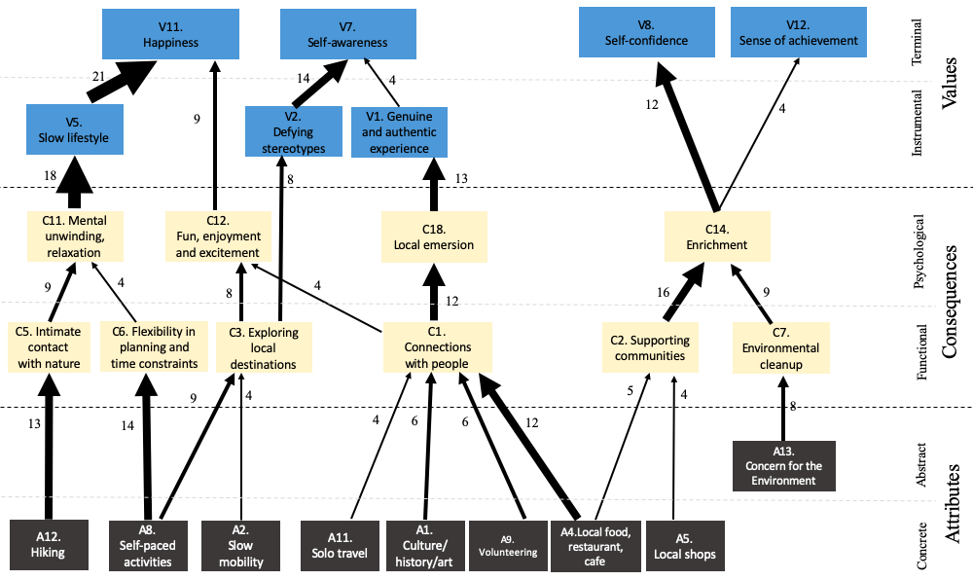

Figure 4. Hierarchical Value Map (HVM)

Elements that consist of slow tourism
Slow travel experiences from the attributes
Slow tourists’ ultimate goals
of slow tourism
Slow tourists’ performance outcomes

H7a
H4a
Operative consequences
Psychological consequences
Local attributes
Personal attributes
Instrumental values
Terminal values
Future intention
Referral intention
H1a
H1b
H2a
H7b
H4b
H8b
H6
H3
H5b
H2b
H5a
H8acc

H9d
H9a

H9b
H9c
Mindfulness

Figure 5.Revised research model of the present research

Elements that consist of slow tourism
Slow travel experiences from the attributes
Slow tourists’ ultimate goals
of slow tourism
Slow tourists’ performance outcomes

Operative consequences
Psychological consequences
Local attributes
Personal attributes
Instrumental values
Terminal values
Future intention
Referral intention
H7a: 7.99*** (.498)
H5b: 3.79*** (.200)
H4b: 3.24 (.126)
H4a: 8.65*** (.430)
H2b: 8.16*** (.603)
H1a: 12.78 ***(.557)
H1b: 4.122 (.305)
H2a: 3.56*** (.245)
H3: 4.41*** (.188)
H5a: 2.01*** (.150)
H6: 8.58*** (.431)
H7b: 6.39*** (.239)
H8a: 6.56*** (.315)

H8b: 9.34*** (.606)

Hypothesis: t-value ^{(Sig.)} (standardized regression weight)

Figure 6. Main-test: hypotheses testing results

Operative consequences
Local attributes
Psychological consequences
Personal attributes
Mindfulness
H9a: β = .028
H9b: β = .030***
H9c: β = .042***
H9d: β = .046**

Note: *** p <.001, ** p <.05

Figure 7. Main-test: hypotheses testing results (moderating effect)

APPENDIX C
IRB Approval (1)

January 27, 2020

Eunkyeong Jung
UTK - Coll of Education, Hlth, & Human - Retail, Hospitality, and Tourism Mgmt

Re: UTK IRB-19-05603-XM
Study Title: Exploring motivations and values of Slow Tourism: A means-end chain approach

Dear Eunkyeong Jung:

The Human Research Protections Program (HRPP) reviewed your application for the above referenced project and determined that your application is eligible for exempt review under 45 CFR 46.101. Category 2: Research that only includes interactions involving educational tests (cognitive, diagnostic, aptitude, achievement), survey procedures, interview procedures, or observation of public behavior (including visual or auditory recording) if at least one of the following criteria is met: i. The information obtained is recorded by the investigator in such a manner that the identity of the human subjects cannot readily be ascertained, directly or through identifiers linked to the subjects; ii. Any disclosure of the human subjects' responses outside the research would not reasonably place the subjects at risk of criminal or civil liability or be damaging to the subjects' financial standing, employability, educational advancement, or reputation; or iii. The information obtained is recorded by the investigator in such a manner that the identity of the human subjects can readily be ascertained, directly or through identifiers linked to the subjects, and an IRB conducts a limited IRB review to make the determination required by .111(a)(7).

Your application has been determined to comply with proper consideration for the rights and welfare of human subjects and the regulatory requirements for the protection of human subjects. This letter constitutes full approval of your application (Version 1.3).

Approval Information:
Downgrade to Exempt Category 2 with limited IRB review
530 participants
Written informed consent for interviews; consent cover statement at beginning of online survey

Approved Documents:
Application version 1.3
Informed consent_Interview_final version_Slow Tourism - Version 1.3
Informed consent form_survey final version_Slow tourism - Version 1.0
Permission - Version 1.0 – acknowledged
Recruitment material - Version 1.0
Flyer - Version 1.0
Interview process_laddering - Version 1.2
In the event that volunteers are to be recruited using solicitation materials, such as brochures, posters, web-based advertisements, etc., these materials must receive prior approval of the IRB.
Any alterations (revisions) in the protocol must be promptly submitted to and approved by the UTK Institutional Review Board prior to implementation of these revisions. You have individual responsibility for reporting to the Board in the event of unanticipated or serious adverse events and subject deaths.

Sincerely,


Colleen P. Gilrane, Ph.D.
Chair


APPENDIX D
IRB Approval (2)

July 02, 2020

Eunkyeong Jung,
UTK - Coll of Education, Hlth, & Human - Retail, Hospitality, and Tourism Mgmt

Re: UTK IRB-19-05603-XM
Study Title: Exploring motivations and values of Slow Tourism: A means-end chain approach

Dear Eunkyeong Jung:

The UTK Institutional Review Board (IRB) reviewed your application for revision of your previously approved project, referenced above. The IRB determined that your revision application is eligible for expedited review under 45 CFR 46.110(b), and that your study remains eligible for exempt status. The following revisions to your project were approved as complying with proper consideration of the rights and welfare of human subjects:

- Adding survey for Study 2
- Final survey questionnaire - Version 1.0

In the event that subjects are to be recruited using solicitation materials, such as brochures, posters, web-based advertisements, etc., these materials must receive prior approval of the IRB. Any alterations (revisions) in the research project must be submitted to and approved by the UTK Institutional Review Board prior to implementation of these revisions. In addition, you are responsible for reporting any unanticipated serious adverse events or other problems involving risks to subjects or others in the manner required by the local IRB policy.

Sincerely,

Colleen P. Gilrane, Ph.D.
Chair

APPENDIX E
Consent form

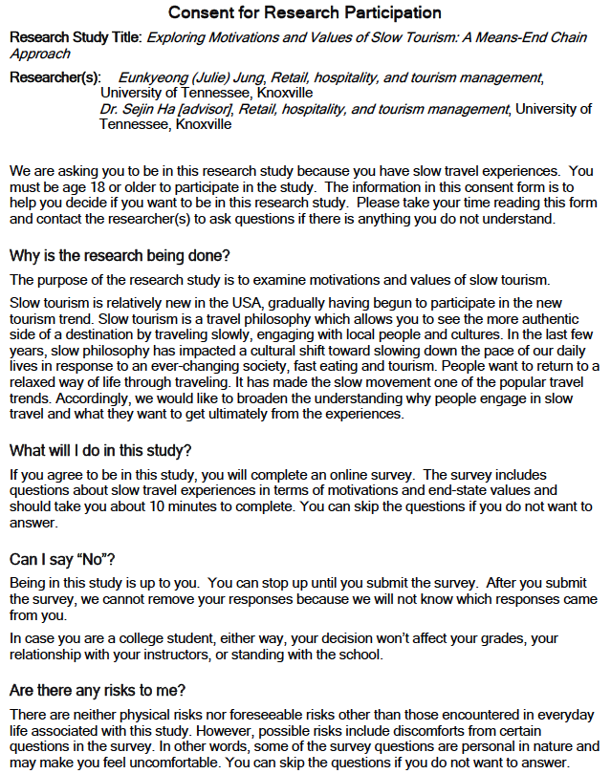

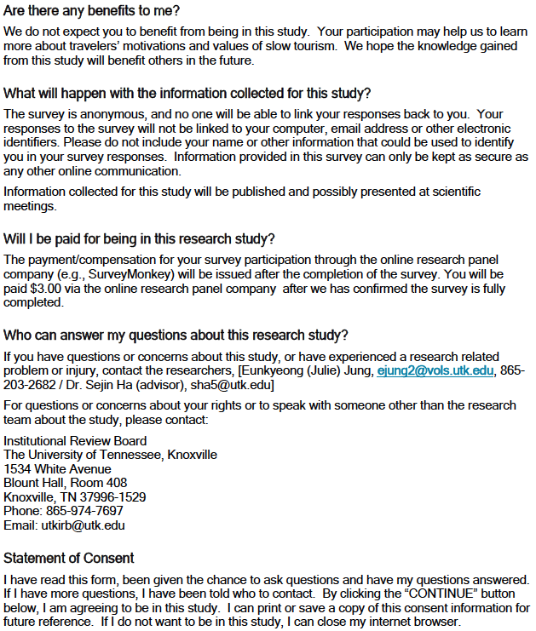

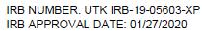

APPENDIX F
A Sample Questionnaire (Pre-Test Survey)

Welcome to the survey!
In this survey we’re interested in travelers’ motivations and goals toward Slow Tourism.

Slow tourism or slow travel is defined as a holistic travel type in which travelers pursue slowness while traveling to explore local life, to connect to a place and its people, to consume local food, to be more sustainable and preserve the environment, and/or to desire ‘slow down’ from fast pace of life. For example, slow travel experiences include enjoying an authentic restaurant or cafe, exploring local places slowly, interacting with local people, walking or cycling in the surrounding of a destination, and using a slower mode of transport.

The survey will take no longer than 5 minutes to complete.
Your participation in this study is completely voluntary and confidential. You may decline to answer specific questions and withdraw from the study at any time. By participating in this study, you are providing your consent.
All the information you provide in this survey will remain completely confidential. Should you have any questions at any time about the study or the procedures, you may contact the researcher, Eunkyeong (Julie) Jung, at ejung2@vols.utk.edu or 865-203-2682.
If you have questions about your rights as a participant, you may contact the University of Tennessee IRB Compliance Officer at utkirb@utk.edu or 865-974-7697.
Thank you in advance for your time and effort in completing the survey.

------------------------------------------------------------------------------------------------
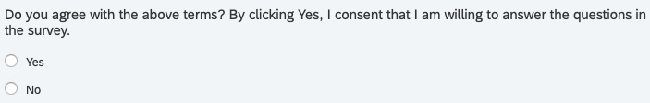

Screening questions
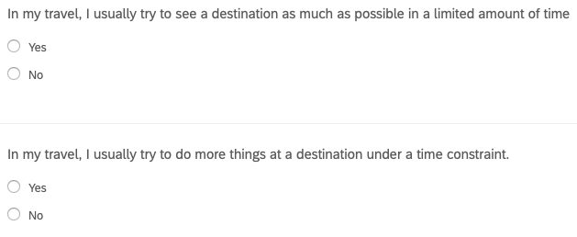
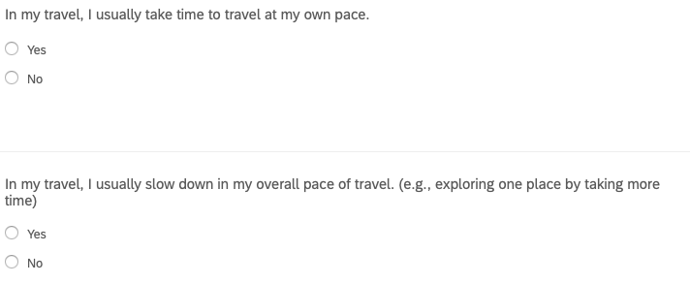

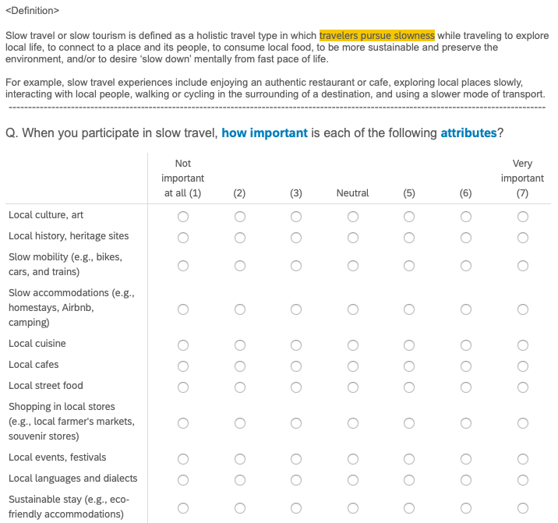

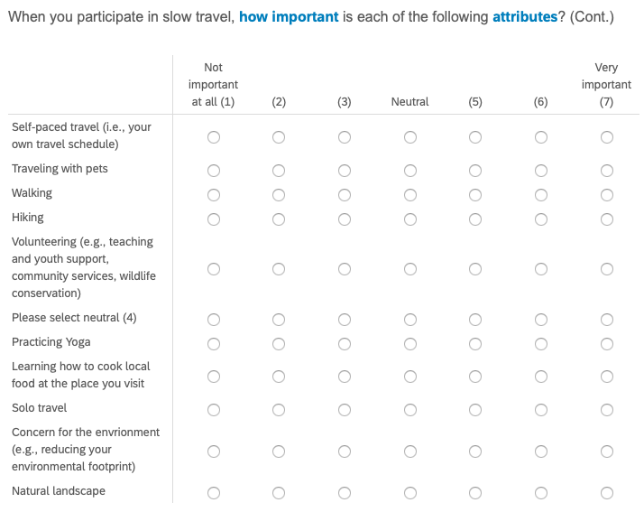

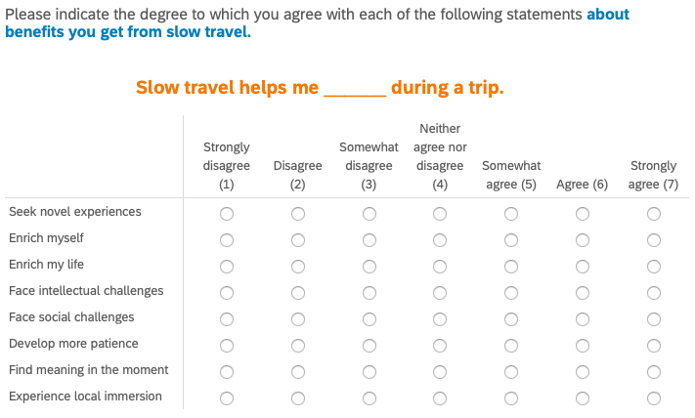
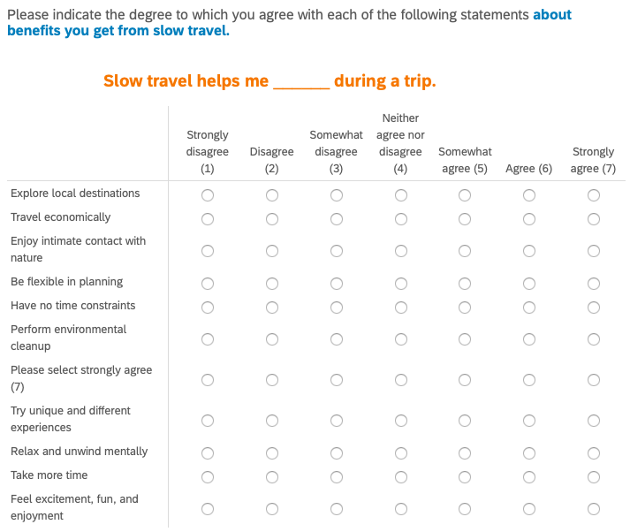

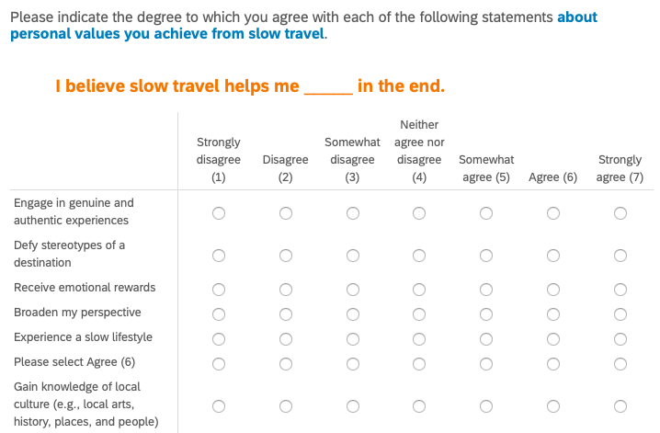
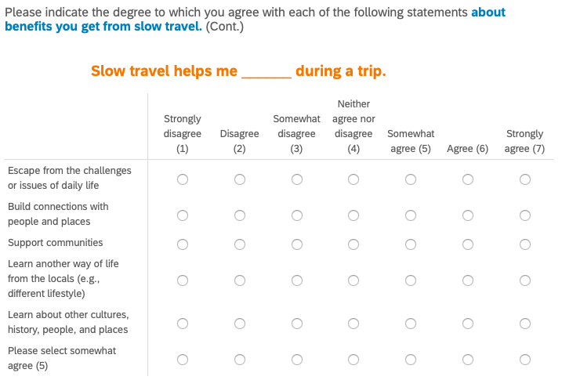

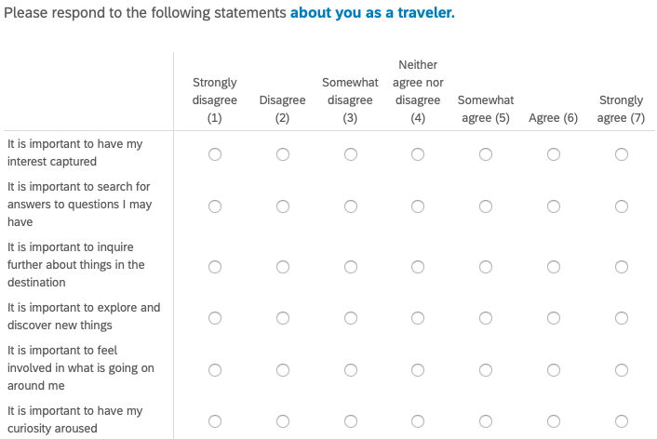
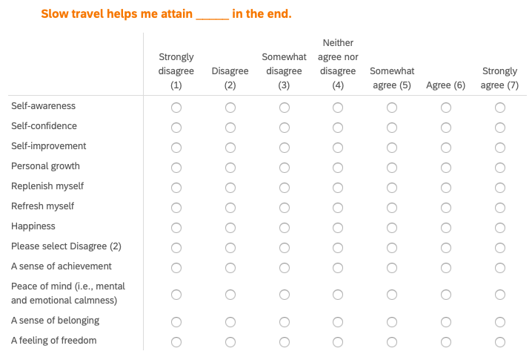
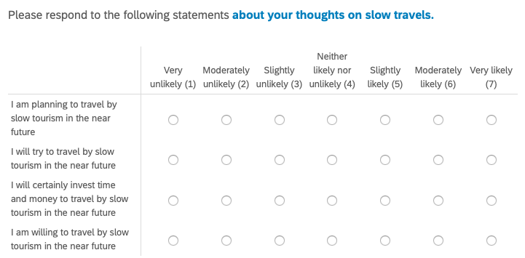

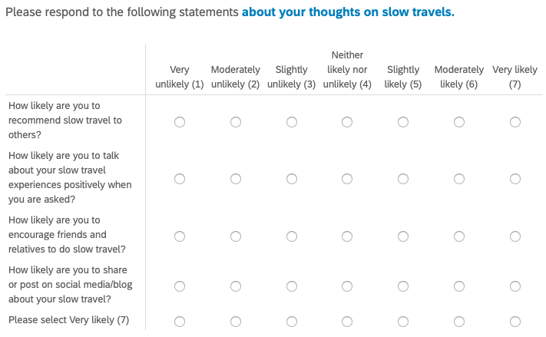

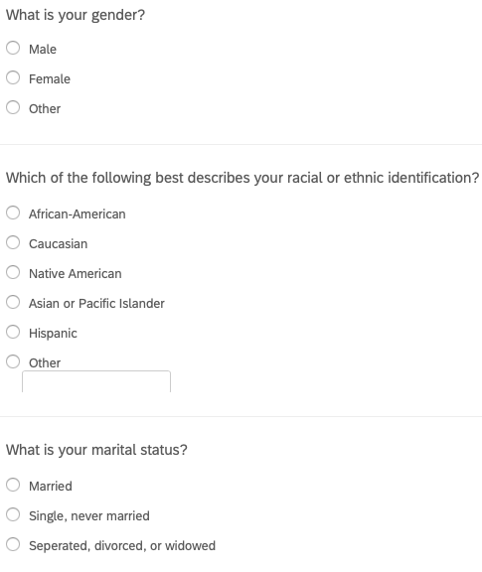

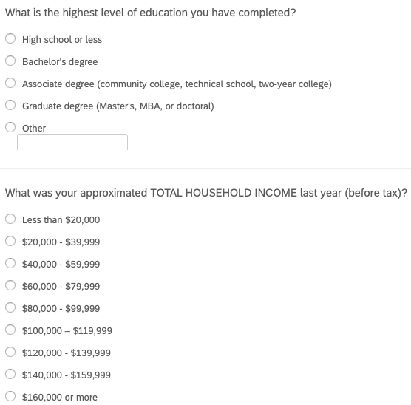

APPENDIX G
A Sample Questionnaire (Main-Test Survey)

Welcome to the survey!
In this survey we’re interested in travelers’ motivations and goals toward Slow Tourism.

Slow tourism or slow travel is defined as a holistic travel type in which travelers pursue slowness while traveling to explore local life, to connect to a place and its people, to consume local food, to be more sustainable and preserve the environment, and/or to desire ‘slow down’ from fast pace of life. For example, slow travel experiences include enjoying an authentic restaurant or cafe, exploring local places slowly, interacting with local people, walking or cycling in the surrounding of a destination, and using a slower mode of transport.

The survey will take no longer than 5 minutes to complete.
Your participation in this study is completely voluntary and confidential. You may decline to answer specific questions and withdraw from the study at any time. By participating in this study, you are providing your consent.
All the information you provide in this survey will remain completely confidential. Should you have any questions at any time about the study or the procedures, you may contact the researcher, Eunkyeong (Julie) Jung, at ejung2@vols.utk.edu or 865-203-2682.
If you have questions about your rights as a participant, you may contact the University of Tennessee IRB Compliance Officer at utkirb@utk.edu or 865-974-7697.
Thank you in advance for your time and effort in completing the survey.

------------------------------------------------------------------------------------------------

Screening questions

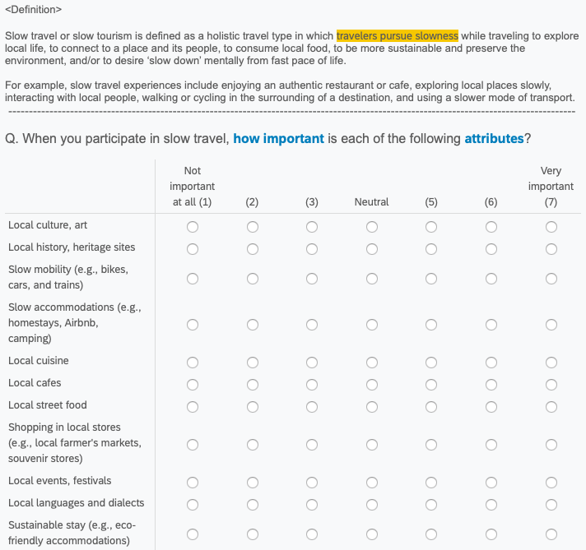

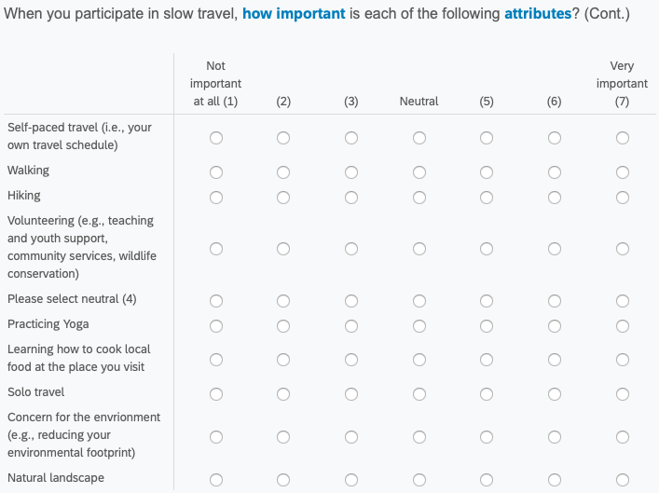

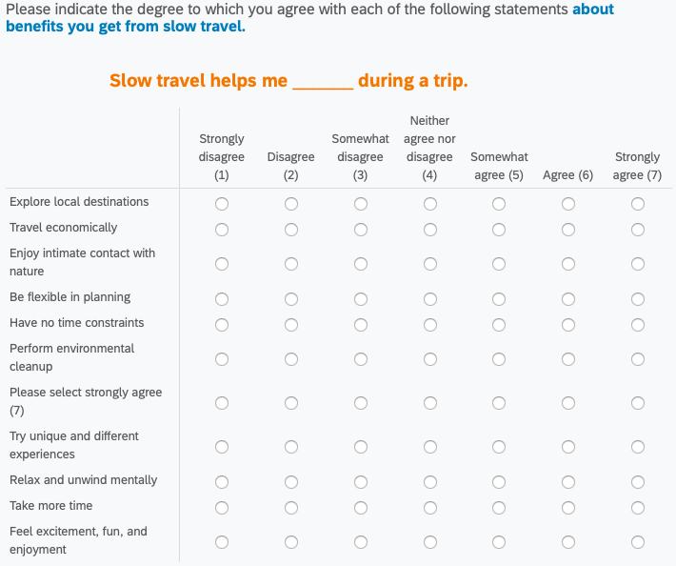
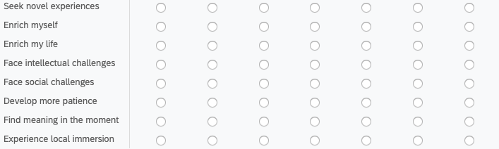

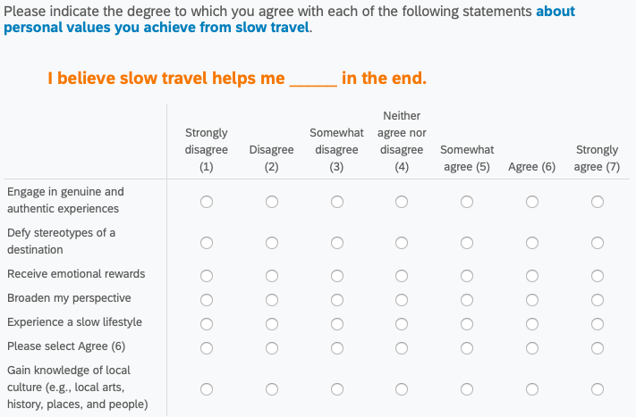
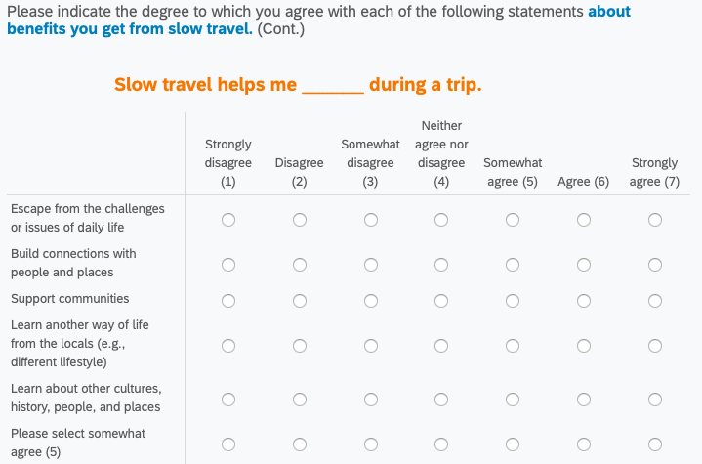
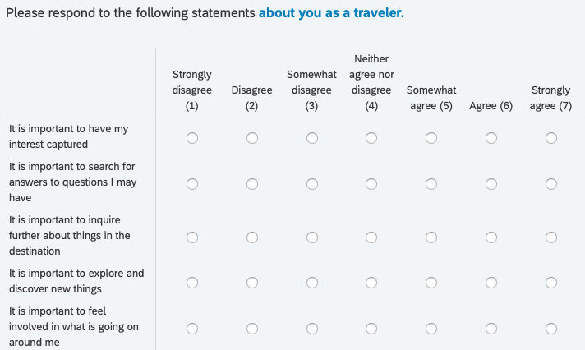
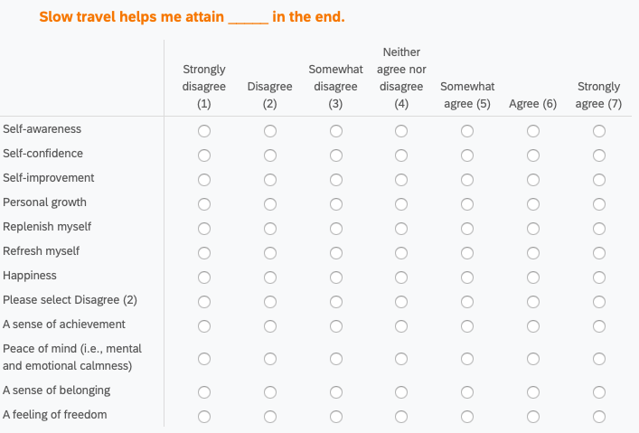

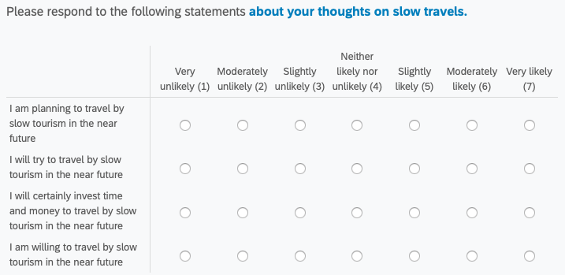

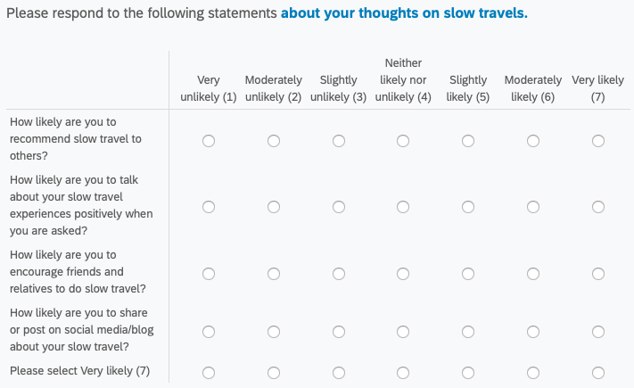
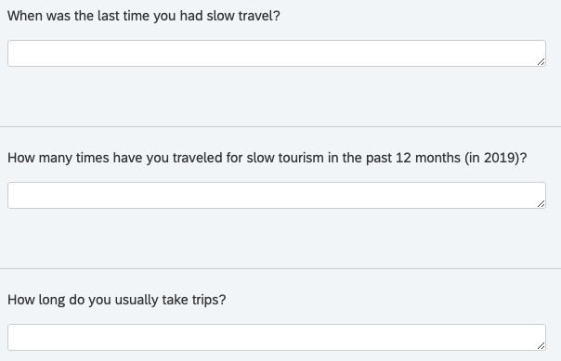

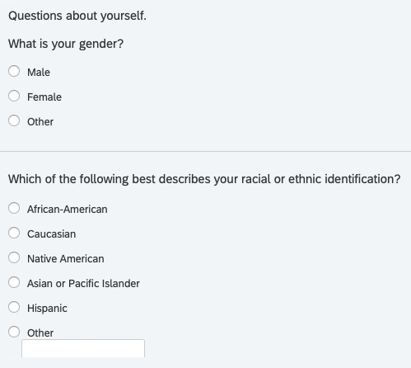

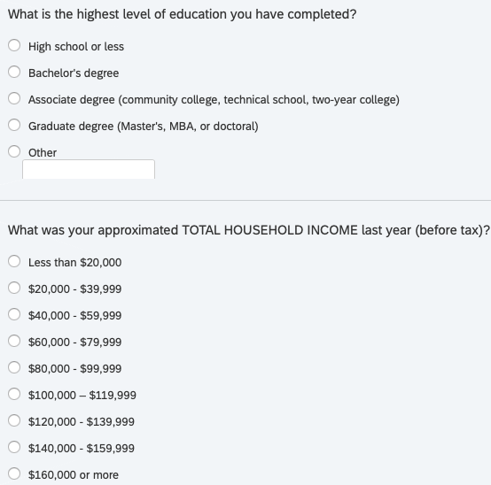

VITA

Eunkyeong (Julie) Jung was born in ChunCheon, Republic of Korea, on September 10, 1988. She received an M.S. degree in Hospitality and Tourism management from Sejong University in Febraury 2016, and a B. S. in Hospitality and Tourism management from from Semyung University in February 2012. To build the industrial experience, she worked as a client manager in a sales team at Finnair in 2011. She decided to further her education and entered the doctoral program in Retail, Hospitality, and Tourism Management at the University of Tennessee in the fall of 2016. While in the Graduate School, she worked as a Graduate Teaching Assistant and a Graduate Teaching Associate. Her research interests are service experience in hotel and restaurants, consumer behavior in the hospitality and tourism, slow tourism, and destination marketing.

All tables and figures are located in the Appendix.

