To the Graduate Council:

I am submitting herewith a dissertation written by Thomas Stewart Carpenter entitled “New Optical and Electrochemical Probes for Trace Chemicals with Health and Environmental Impacts”. I have examined the final electronic copy of this dissertation for form and content and recommend that it be accepted in partial fulfillment of the requirements for the degree of Doctor of Philosophy, with a major in Chemistry.

__________________________
Ziling Xue, Major Professor

We have read this dissertation
and recommend its acceptance:

________________________________ ___ ___ _
Michael J. Sepaniak

________________________________________ _
Brian Long

____________________________ ___ ___ ___ _
Brandon Horvath

Accepted for the Council:

Carolyn R. Hodges______________________
Vice Provost and Dean of the Graduate School

New Optical and Electrochemical Probes for Trace Chemicals with Health and Environmental Impacts

A Dissertation Presented for the

Doctor of Philosophy

Degree

The University of Tennessee, Knoxville

Thomas Stewart Carpenter

August 2017

Copyright © 2017 by Thomas S. Carpenter
All rights reserved.

DEDICATION

To my parents, Patricia and Burwell
my brother, Edward
You have helped me achieve more than I had ever imagined.

ACKNOWLEDGEMENTS

Firstly, I need to thank my advisor, Dr. Zi-Ling Xue for the countless hours of work that he has put into me. I am eternally grateful for his constant patience he has had with me, and for never letting me give up. I would not be where I am today without the constant encouragement and help of other members of the Xue group. I would like to thank Dr. Bruce Bursten for being a friend and mentor. I am particularly indebted to the members of the Xue research group who were here when I started. Dr. Stefanie Bragg became a friend immediately. She gave her time to show me the ropes of adjusting to life in graduate school and taught me most of what I know about the operation electrochemistry instruments. Dr. Samuel Rosolina was my closest colleague as we shared many similar projects. His passion for his research was unparalleled and served as a constant source of motivation to push myself further in my own work. Dr. Tabi Cook’s passion for teaching was a constant source of comfort and relatability when the research seemed overwhelming. I would like the thank the current group members for their continued support and wish them all the best in their continuing research efforts. There are many others in the department who deserve praise, but I must single out Dr. Brian Morgan, my closest friend throughout the process with whom I may have not finished this process.

ABSTRACT

The work in this dissertation focuses on the development of probes for the analysis of trace chemicals in samples with health and environmental impacts. A paper, Cu(copper)-based colorimetric probe was developed for the detection of toxic hydrogen sulfide (H₂S) gas. A modified Kipp’s apparatus was used to generate desired concentrations of H₂S in a total volume of 1.35 L (liters). The probe shows a qualitative response down to 60 ppb (parts per billion), indicating its ability to be used in industrial settings as a replacement for the commonly used lead acetate strips. When used in conjunction with a handheld colorimeter and smartphone, the probe can quantitatively detect the gas to a concentration of 16 ppb, which is below concentrations responsible for bad human breath. A method for the electrochemical detection and speciation of inorganic arsenic in pharmaceutical components has also been optimized. A gold electrode modified with a pyridine-functionalized layer has been developed to preconcentrate hexavalent chromium [Cr(VI)] anions for analysis by cathodic stripping voltammetry (CSV). The gold electrodes were modified through chemical deposition of a thiol sol-gel layer on the electrode surface, followed by the incorporation of gold nanoparticles (AuNPs) and a 2-pyridine functional group. The utilization of AuNPs has increased the sensitivity for detection of Cr(VI) in aqueous solutions, providing a detection limit of 93 ng L⁻¹.

TABLE OF CONTENTS

1. Introduction and background of the dissertation 2
1.1. Forward 2
1.2. Analysis techniques used in the current research 2
1.2.1. Electrochemical techniques 2

1.2.2. Color space 2
1.2.3. Overview of sol-gel processes and their applications 2
1.3. Summary of dissertation parts 2
1.3.1. Part 2 2

1.3.2. Part 3 2

1.3.3. Part 4 2

1.3.4. Part 5 2

References 2

2. Colorimetric Copper(II)-based Paper Probe for Hydrogen Sulfide Gas. Qualitative Analysis 2
Abstract 2

2.1. Introduction 2
2.2.1. Apparatus and materials 2
2.2.2. Preparation of the Cu-PAN probe 2

2.2.3. Generation of hydrogen sulfide gas 2

2.3. Results and discussion 2
2.3.1. Sensing of S²⁻_{(aq)} and mercaptans by Cu-PAN 2

2.3.2. Sensing of H₂S gas 2

2.3.3. Probe optimization 2

2.4. Conclusions 2
References 2

3. Colorimetric Copper(II)-based Paper Probe for Hydrogen Sulfide Gas. Quantitative Analysis 2
Abstract 2

3.1. Introduction 2
3.2. Materials and methods 2
3.3. Results and discussion 2
3.3.1. Node Chroma used for data collection and data collected 2

3.3.2. Lab colorspace analysis 2

3.3.3. Interference studies 2

3.4. Conclusions 2
References 2
4. Electrochemical Analysis of Trace Inorganic Arsenic and Its Speciation in Organic Matrices at Unmodified Glassy Carbon Electrodes 2
Abstract 2

4.1. Introduction 2
4.2. Materials and methods 2
4.2.1. Chemicals reagents 2

4.2.2. Instrumentation 2

4.2.3. Analysis procedure 2

4.3. Results and discussion 2
4.3.1. Method optimization 2

4.3.2. Anodic stripping voltammetry (ASV) of As(III) 2

4.3.3. Total arsenic detection 2

4.3.4. Interferences 2

4.4. Conclusions 2
References 2

5. Modification of a Gold Electrode for Chromium(VI) Detection by Cathodic Stripping Voltammetry 2
Abstract 2

5.1. Introduction 2
5.2. Materials and methods 2
5.2.1. Apparatus and materials 2

5.2.2. Fabrication of the pyridinium-functionalized AuNP electrode 2

5.2.4. Measurement procedures 2

5.3. Results and discussion 2
5.3.1. AuNP preparation 2

5.3.2. Pyridinium-functionalized AuNP electrode 2

5.3.3. Analytical performance 2

5.3.4. Comparison to previous work 2

5.4. Conclusions 2
References 2

Vita 2

LIST OF TABLES

Table Page
3.1. CIELAB data for the exposure of the Cu-PAN probe to gaseous H₂S ....……….49

3.2. b* for 600 ppb H₂S gas at varying levels of humidity ………………….................58

4.1. Selected analytical figures of merit ……………………………..…........................79

LIST OF FIGURES

Figure Page
1.1. Schematic of a typical three-electrode electrochemical cell……………...……... 4
1.2. Square wave diagram …………………….……………………………..……......... 6
1.3. Maxwell’s triangle depicting the RGB color space……………………………….. 9
1.4. Illustration of the CIELAB colorspace with gradient L*, a*, and b* axes…….10, 50
1.5. Depiction of incident light with specular and diffuse reflection…………….…... 13
2.1. Schematic for in-house H₂S gas generation………………………………..……. 28
2.2. Photo of the in-house H₂S generator…………………………………………..…. 29
2.3. Probe before and after exposure to 5 µL of MPTMS……………………….…... 30
2.4. Exposure of Cu-PAN probes to increasing concentrations of Na₂S _{(aq)}….…….. 31
2.5. Cu-PAN probe before and after exposure to 5 ppm H₂S for 10s………….…... 32
2.6. Cu-PAN probe after exposure to different concentrations of H₂S gas…….….. 33
2.7. Optimization of Cu-PAN concentration exposed to 3000 ppb H₂S _{(g)}……..…... 34
2.8. Optimization of NaOH concentration exposed to 1000 ppb H₂S _{(g)}……….…... 35
3.1. Schematic of the Node Chroma used in the current research……………..…... 48
3.2. Node Chroma placed upon microscope glass slide and a blank probe.…........ 48
3.3. Calibration curve of the a* axis data for concentrations of H₂S gas……..….… 51
3.4. Plot of b* data vs [H₂S] with two apparent linear ranges…………………….…. 51
3.5. Calibration curve of the b* axis data of low [H₂S]………..…………………….... 52
3.6. Calibration curve of the data from the b* axis for high [H₂S] gas..…………….. 52
3.7. Plot of the ratio of b*/a* vs concentrations of H₂S gas………………………...... 54
3.8. Calibration curve showing the b*/a* ratio for high [H₂S]……………………....... 54
3.9. ∆E between the given concertation of H₂S gas and the blank probe…..……… 55
3.10. Calibration curve of ∆E with low concentrations of H₂S gas…………………...... 56
3.11. Calibration curve of ∆E with high concentrations of H₂S gas…………….......... 57
3.12. Calibration curves of data from the b* axis of sulfur compounds……………… 59
4.1. Effect of the deposition potential on the arsenic stripping peak area………..... 73
4.2. Effect of the deposition time on peak area…………………….……………........ 74
4.3. Effect of the concentration of Cu(II) on the arsenic peak……………………….. 75
4.4. Effect on the concentration of the supporting electrolyte on the arsenic peak.. 76
4.5. Voltammogram of increasing concentrations of As(III)…………………...…….. 78
4.6. Standard addition calibration of As(III) in triplicate……………………..…......... 79
4.7. Standard addition calibration of As(III) and pre-reduced As(V)................……... 82
5.1. Flask of HAuCl₄ and sodium citrate before and after AuNP formation………… 98
5.2. Schematic illustration of the electrode fabrication ………………………………. 99
5.3. Photos of a bare gold electrode and a functionalized gold electrode…………. 99
5.4. Voltammagram of Cr(VI) over the range of 250-1000 ng L⁻¹………………….100
5.5. External calibration curve of Cr(VI) in triplicate………………………...………. 101

LIST OF SCHEMES
Scheme Page
1.1 Sol-gel reactions……………………………………………………………....……… 11

2.1 Synthesis of Cl-Cu-PAN………………………………………….………................ 26

2.2 Reaction to generate H₂S gas ……………………………..….............................. 28
2.3 H₂S sensing mechanism…………………………………………………………….. 31
4.1 Oxidation of L-cysteine resulting in the reduction of As(V) to As(III)……….…… 80

5.1 Reduction of HAuCl₄ by sodium citrate resulting in two Au⁰ nucleation sites..... 97

NOMENCLATURE AND ABBREVIATIONS

A amps
API active pharmaceutical ingredients
ASV anodic stripping voltammetry
AuNPs gold nanoparticles
ºC degrees Celsius
CAdSV catalytic adsorption stripping voltammetry
CV cyclic voltammetry
DI deionized
E potential
EPA Environmental Protection Agency
EtOH ethanol
g gram
GCE glassy carbon electrode
h hour
Hz hertz
ICP-OES inductively coupled plasma optical emission spectrometer
ICH International Conference on Harmonisation
i current
L liter
m meter
MeOH methanol
mM millimolar
M Molar
MΩ megaohm
mA milliamp
min minutes
mg milligram
mL milliliter
MPTMS mercaptopropyltrimethoxysilane
nm nanometer
OSHA Occupational Safety and Hazard Administration
PET pyridine ethane thiol
ppb/µg kg⁻¹ parts per billion
ppm/mg kg⁻¹ parts per million
ppt/ng kg⁻¹ parts per trillion
R² square of correlation coefficient
RGB Red Green Blue color space
RSD relative standard deviation
s second
SWV square wave voltammetry
t time
TMOS trimethoxysilane
UV-Vis ultraviolet-visible
USP United States Pharmacopeia
V volts
µA microamps
µg microgram
µL microliter

Part 1

Introduction and background of the dissertation

1.1. Forward
In January 2010, the United States Pharmacopeia (USP) proposed new methods for the preparation and analysis of elemental impurities in pharmaceuticals. These new USP chapters, 232 and 233, served to update existing regulations on heavy metals in active pharmaceutical ingredients (APIs) and excipients originally passed in 1905. These chapters address fifteen elements with various concentration limits based on the mode of intake; however, there is an emphasis on lead, cadmium, mercury, and arsenic, known as “the big four”, due to their toxicity and ubiquity in the industry [1]. These elements not only pose a health risk when deliberately taking pharmaceuticals, but are often also found in natural drinking waters, such as in Bangladesh, where arsenic levels led to the highest infant mortality rate in the world prior to strict regulations and heavy remediation efforts [2]. In addition to the elements commonly known to be dangerous, other molecules such as hydrogen sulfide (H₂S) pose serious health risks at low concentrations and poses a risk in several industrial applications such as mining and hydraulic fracturing [3].
These same trace chemicals are found not only in pharmaceuticals, drinking water in under-developed countries, or mining operations, but also in the human breath, the food we eat, and human blood. The pervasiveness of these potential toxins in our everyday life leads to the need for continuing advancements in their detection. Efforts to advance the analysis of these targets includes developing new methods that decrease the cost and speed of analysis as well as introducing portability to the detection methods.
This dissertation focuses on the detection of trace analytes that have a direct environmental or health impact via new electrochemical methods and optical sensors. A new method for the electrochemical detection of arsenic in the presence of water soluble pharmaceuticals and excipients has been optimized, eliminating the need of a lengthy acid digestion pretreatment. A novel, copper (Cu) based colorimetric probe was developed for the quantitative detection of H₂S gas. The probe exhibits a detection limit of 16 parts per billion (ppb) in 1.35 liters (L) of H₂S gas generated in the laboratory by a modification of a Kipp’s apparatus, making it suitable for use in industrial applications.

1.2. Analysis techniques used in the current research

1.2.1. Electrochemical techniques
Voltammetry is a form of electrochemical analysis that utilizes varying of the potential of an electrode while simultaneously measuring and recording the corresponding induced current to generate a graph relating voltage to current known as a voltammogram. Qualitative and quantitative information, including reaction kinetics, regarding the reduction and oxidation of the target species can be obtained from the analysis of these voltammograms. Voltammetry offers the ability to detect multiple analytes that have different reduction potentials simultaneously. Most electrochemical analysis is performed with a three-electrode electrochemical cell and a potentiostat instrument. The three electrodes are the working electrode, reference electrode, and the counter electrode. The setup of a typical three-electrode cell is depicted in Fig. 1.1.
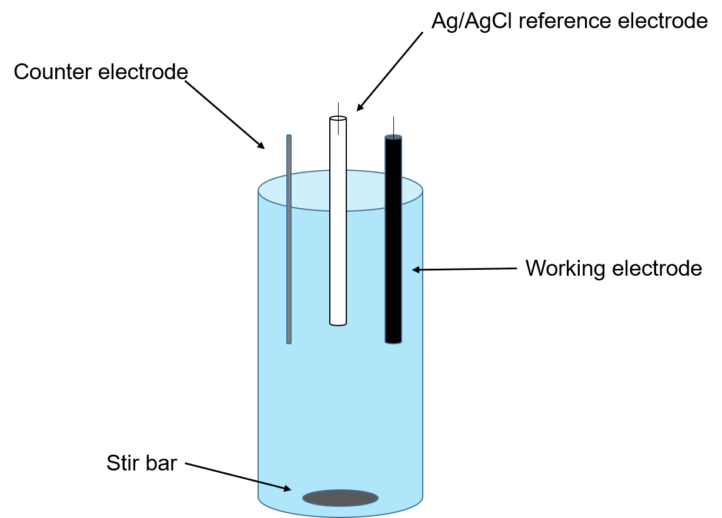
Fig. 1.1. Schematic of a typical three-electrode electrochemical cell.

The working electrode is a semi-conductive or conductive electrode, allowing potential to flow through the solution to conduct a current and is the surface where the redox reactions of the analytes occur. The electrode can serve as either a cathode or anode depending on the reduction or oxidation of the analyte. The counter electrode, made of an inert material such as platinum wire, allows current flow through the electrochemical cell to ensure that current does not flow towards the reference electrode. The reference electrode (typically Ag/AgCl), is used as a reference potential that is independent of the electrolyte in solution or the reactions at the working electrode. The difference between the standard potential of the reference electrode and the measured potential at the working electrode gives the potential of the redox reactions occurring at the working electrode. The potentiostat is the instrument used to control the voltage at the working and counter electrodes in three-electrode voltammetric experiments.
The voltammetric technique used in the research presented, both cathodic and anodic, is square wave voltammetry (SWV). SWV sweeps through a defined potential range, but a square wave is applied to the scan as opposed to scanning linearly through the range. The sensitivity of the technique is dependent on the kinetics of the redox system and can be improved by increasing the amplitude or the frequency of the square wave. The advantage of SWV compared to linear techniques is that the background capacitive currents are lowered as the current is measured at the end of the half waves, minimizing the current of the double electrical layer [4–8]. A square wave pattern with the forward and reverse sample measurement points is depicted in Fig. 1.2.

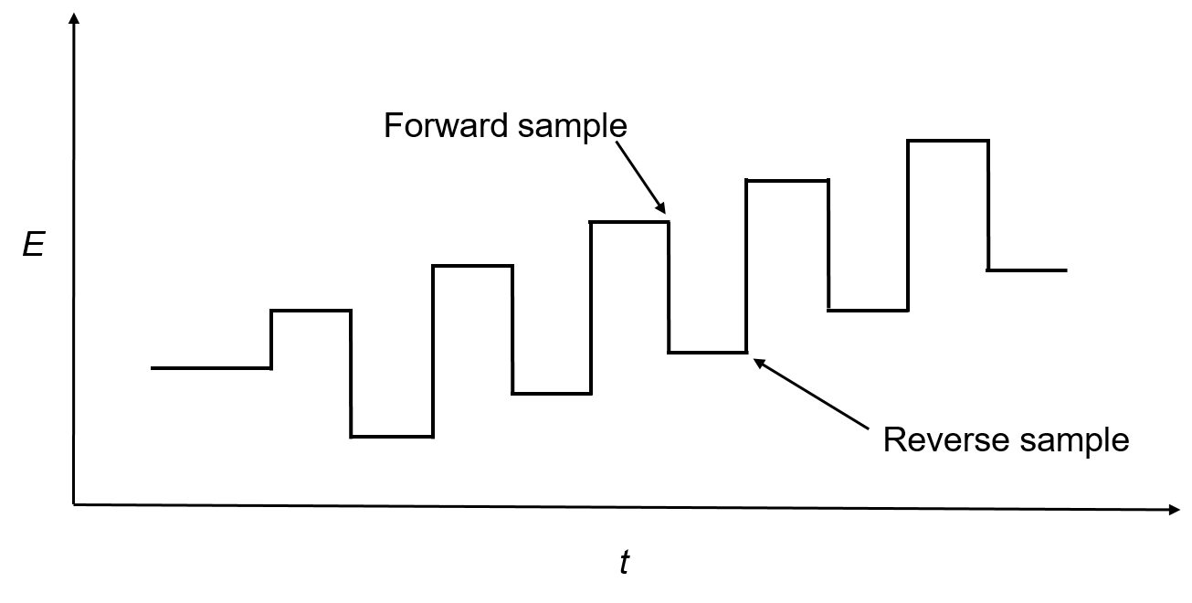
Fig. 1.2. Square wave diagram annotated with the points of measurements in the forward and reverse sample.

Anodic stripping voltammetry (ASV) is a voltammetric method for the detection of specific cationic species in solution, typically heavy metals. The analytes are electrodeposited on the working electrode by holding the working electrode at a sufficiently negative potential to reduce the analyte to zero oxidation state. This preconcentration is proceeded by a stripping step in which the electrode potential is swept in the anodic (positive) direction. This potential sweep results in the oxidation of the analyte, producing a current which can be measured that is proportional to the concentration of the analyte. A final cleaning step is conducted by holding the electrode at a sufficiently positive potential as well as constant stirring to ensure that all the analyte is removed from the electrode surface. Cathodic stripping voltammetry (CSV) is essentially the same process for anionic species in solution. In CSV the accumulation of the analyte is conducted at positive potentials and stripping occurs in the cathodic (negative) direction.

1.2.2. Color space
Color space is a specific model of describing colors in a specific manner which easily allows for the reproduction of a given color. There are two competing theories as to how humans perceive color: trichomatic theory and opponent pairs theory. Trichomatic theory, proposed by Young, Helmholtz, and Maxwell, suggests that there are three sets of cone cells in the human eye that respond specifically to one of the three primary colors (red, green, and blue), and that the relative responses give rise to the color humans perceive [9,10]. Opponent-pair theory, proposed by Hering, suggests that color perception arises from three antagonistic processes involving three pairs of colors, black-white, red-green, and yellow-blue. The theory proposes that a color is only perceived when the stimulation of that process is greater than its antagonistic partner, with an equal mix resulting in a gray color. It has been suggested that this is why we do not perceive reddish-green or yellowish-blue colors [11–14]. While evidence has arisen to show neither of these theories likely detail exactly the neurological process for human color perception, they did lead to two of the most widely used color spaces: RGB and CIELAB.
RGB is perhaps the more well-known of the two color spaces due to its use in electronic displays and light emitting diodes. RGB is based in part on the trichomatic theory of color perception and is named after the three primary colors it utilizes: red, green, and blue. RGB is an additive color space, meaning when zero of the three colors are mixed together the resulting color is black. When equal portions of the three colors are added together, white is the resultant color. Additive color spaces such as RGB are useful when starting with a black background, such as a television screen. A subtractive color space such as CMYK (cyan, magenta, yellow, black) is useful when starting with a white background such as paper, as when none of the colors are added together the resulting color is white, and mixing them in equal proportions yields black. While both color spaces are useful in producing colors when mixing pigments or light, they are limited in that they do not cover all of the colors humans can perceive and are not considered to be visually uniform, that is the change in the values of RGB are not proportionate to the perceived color change [15–19]. A diagram representing the RGB color space is shown in Fig. 1.3.


Fig. 1.3. Maxwell’s triangle depicting the RGB color space.

The CIELAB colorspace is an updated version of the Lab colorspace initially developed by Hunter [20,21]. Hunter sought to develop a color model based on the opponent pair theory of human color perception. CIELAB is considered the most accurate, visually uniform color space model available [20,21]. CIELAB colorspace reports colors in terms of three variables, L*, a*, and b*, to describe color in a three-dimensional space, making it more robust than traditional RGB colorspace. The L* index represents the luminosity, with values from L* = 0 (true black) to L* = 100 (true white). The a* axis has positive values for red color and negative values for green color. The b* axis has positive values for yellow color and negative values for blue color. The result is a colorspace that uniformly covers the visible spectrum illustrated in Fig. 1.4. The L*, a*, b* data point is known as a chromaticity coordinate, which describes where in the three-dimensional color space the color is located. The Euclidean distance between two chromaticity coordinates, ∆E, is numerically representative of the perceived difference in two colors [16]. Several studies have used CIELAB colorspace measurements to provide an objective image analysis, increasing the sensitivities of methods versus naked eye analysis [22–25]. CIELAB is often used in quality control processes in the production of pigments and pharmaceuticals with a target chromaticity coordinate and a defined ∆E tolerance [26,27].

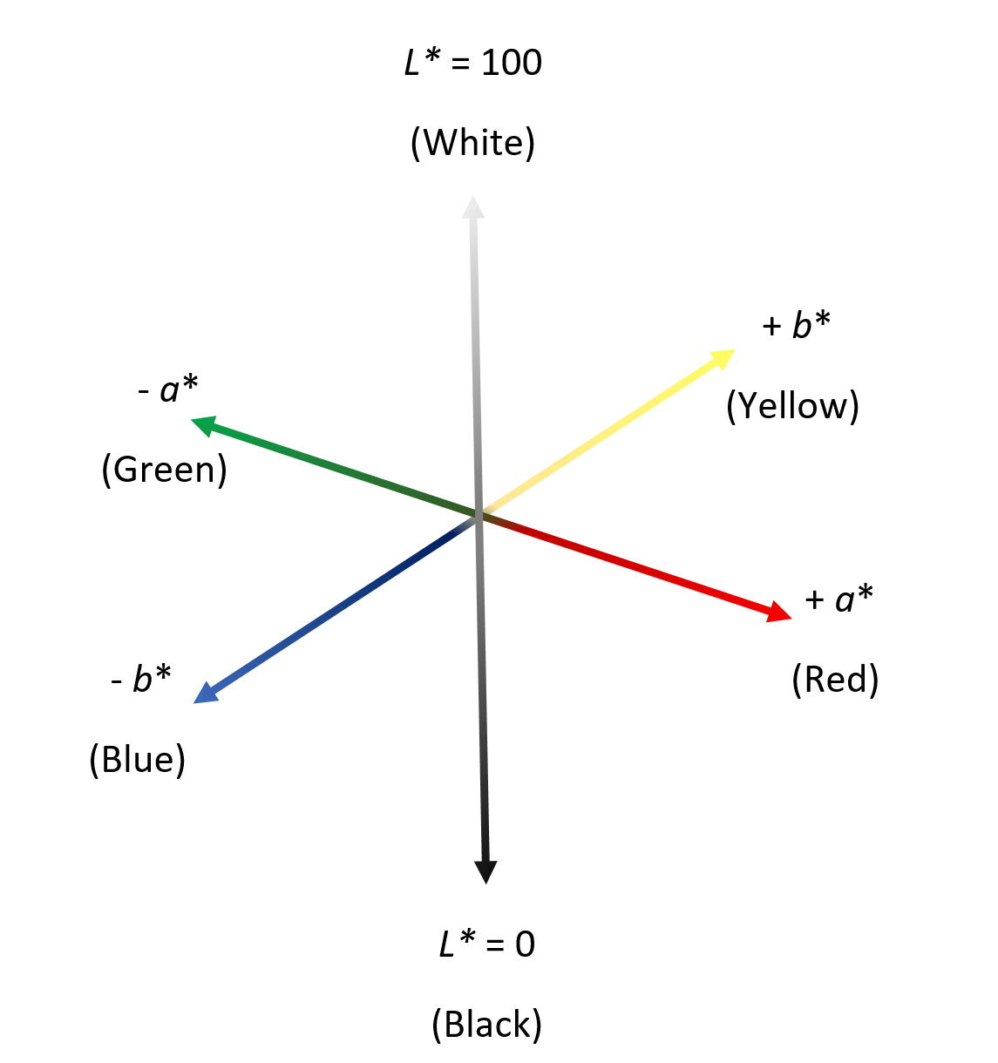
Fig. 1.4. Illustration of the CIELAB colorspace with gradient L*, a*, and b* axes.

1.2.3. Overview of sol-gel processes and their applications
The sol-gel process is the transformation of a colloid (sol) into a rigid non-fluid network (gel). Alkoxysilanes, such as tetramethoxysilane (TMOS), tetraethoxysilane (TEOS), and 3-mercaptopropyltrimethoxysilane (MPTMS) are commonly used for the production of mesoporous silica gels [28]. Altering the conditions of the condensation and hydrolysis reactions such as reagent concentrations, solvent, and pH allow for controlling the bulk properties of the silica. Scheme 1.1 shows the general reaction of the sol-gel process.

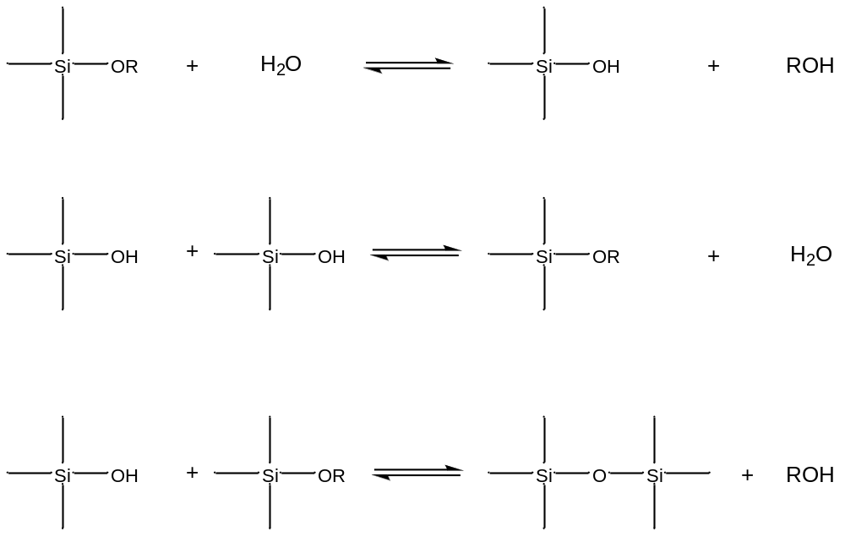

Scheme 1.1. Sol-gel reactions.

Sol-gels are widely used in the formation of mesoporous silicate materials and are also incorporated into a wide variety of analytical techniques, including the fabrication of optical sensors and the modification of electrode surfaces.

1.2.4. Diffuse reflectance
Reflectance is often used in the analysis of solids and powders with poor transparency. The process of reflection occurs when light bounces off a surface, opposed to transmittance where light travels through a material. When light hits a smooth surface, the angle of the incident light relative to the surface is equal to the angle of reflectance. This type of reflectance is known as specular reflectance. However, when a surface is rough, light can scatter in a variety of directions. In a fibrous material such as cloth or paper, the numerous interactions of the light with the randomly oriented fibers results in the light reflecting off the surface at any angle with equal probability [29–31]. A schematic of these types of reflectance is illustrated in Fig. 1.5 with the incident light depicted in blue, specular reflectance in green, and the diffuse reflectance in red.



Fig. 1.5. Depiction of incident light (blue) with specular (green) and diffuse (red) reflection.

1.3. Summary of dissertation parts
This dissertation reports our work to develop new optical and electrochemical probes for trace chemicals with health and environmental impacts. These chemicals include H₂S gas, As(III) and As(V) in water soluble active pharmaceutical ingredients and excipients, and Cr(VI) in aqueous solution.

1.3.1. Part 2
This part of the dissertation describes a new, disposable, optical probe for the detection of hydrogen sulfide gas, a toxic gas often encountered in the mining and hydraulic fracturing industries as well as being a contributor to bad breath. The probe uses a copper-pyridylazonaphthol compound (Cu-PAN) impregnated porous, paper substrate along with a basic solution. The weakly acidic H₂S reacts with the purple Cu-PAN, generating CuS and the yellow azo dye (H-PAN). A modified Kipp’s generator is used to generate a fixed volume of low-level concentrations of H₂S. In this part ppb refers to µg H₂S per kg N₂. The probe demonstrated a naked eye, qualitative limit of detection of 30 ppb H₂S.

1.3.2. Part 3
The third part of this dissertation discusses the use of a portable reflectometer that pairs to a smartphone to obtain quantitative information from the previously reported Cu-PAN H₂S probe. The reflectometer utilizes CIELAB colorspace to describe the color of the probe. Tracking the color change along the b*, yellow-blue, axis provides a linear correlation with H₂S concentration. Incorporating this technique with the previously discussed probe yields an improved limit of detection of 16 ppb. In this part ppb refers to µg H₂S per kg N₂.

1.3.3. Part 4
The fourth part of this work reports the use of SWASV to analyze As(III) and As(V) in water soluble active pharmaceutical ingredients and excipients. The method uses a simple bare glassy carbon electrode and does not require lengthy acid digestion of the sample prior to analysis. The method has a reported limit of detection in the low ppb concentrations, possibly providing an alternative method of analysis to the much more expensive inductively coupled plasma-mass spectroscopy (ICP-MS) which is routinely used for this analysis in the pharmaceutical industry.

1.3.4. Part 5
The detection of hexavalent chromium, a known carcinogen, was studied using a gold electrode modified by a gold nanoparticle doped sol-gel and capped with a pyridinium thiol. The use of a sol-gel expands the electrode surface area, while the pyridinium groups help preconcentrate the chromium at the surface, enhancing the sensitivity compared to a bare electrode. The reported method has a limit of detection of ~300 ppb.

References

[1] United States Phamacopeia - USP, <232> Elemental impurities- Limits, Http://www.usp.org/usp-Nf/key-Issues/elemental-Impurities. (2016) 1–3. www.usp.org, accessed 2016.
[2] R. Nickson, J. McArthur, W. Burgess, K.M. Ahmed, P. Ravenscroft, M. Rahman, Arsenic poisoning of Bangladesh groundwater. Nature 395 (1998) 338. doi:10.1038/26387.
[3] B.S. Kasinath, a. N. Startsev, O. V. Kruglyakova, Y. a. Chesalov, S.P. Ruzankin, E. a. Kravtsov, et al., Present technologies for hydrogen sulfide removal from gaseous mixtures, J. Chem. Phys. 46 (2013) 1–12. doi:10.5194/amtd-7-6205-2014.
[4] W.D. Ellis, Anodic stripping voltammetry, J. Chem. Educ. 50 (1973) A131. doi:10.1021/ed050pA131.
[5] Autolab Application Note EC08, Basic overview of the working principle of a potentiostat/galvanostat (PGSTAT) – Electrochemical cell setup, Metrohm Autolab.B.V. (2011) 1–3.
[6] G. Charlot, J. Badoz-Lambling, B. Tremillon, Electrochemical Reactions, Elsevier, Amsterdam, 1962.
[7] D. Sawyer, A. Sobkowiak, J. Roberts, Electrochemistry for Chemists, John Wiley & Sons, Inc. New York, 1995.
[8] J. Wang, Analytical Electrochemistry, Wiley-VCH, New York, 2000, p. 86.
[9] E. Perales, F.M. Martínez-Verdú, J.M.M. Linhares, S.M.C. Nascimento, Number of discernible colors for color-deficient observers estimated from the MacAdam limits, J. Opt. Soc. Am. A. 27 (2010) 2106. doi:10.1364/JOSAA.27.002106.
[10] G. Sharma, H.J. Trussell, Digital color imaging, IEEE Trans. Image Process. 6 (1997) 901–32. doi:10.1109/83.597268.
[11] D.H. Foster, R.S. Snelgar, Test and field spectral sensitivities of colour mechanisms obtained on small white backgrounds: action of unitary opponent-colour processes? Vision Res. 23 (1983) 787–97. http://www.ncbi.nlm.nih.gov/pubmed/6623938.
[12] R.S. Snelgar, D.H. Foster, M.O. Scase, Isolation of opponent-colour mechanisms at increment threshold, Vision Res. 27 (1987) 1017–27. http://www.ncbi.nlm.nih.gov/pubmed/3660645.
[13] J.L. Nieves, A. Garci’a-Beltran, J. Romero, Response of the human visual system to variable illuminant conditions: An analysis of opponent-colour mechanisms in colour constancy, Ophthalmic Physiol. Opt. 20 (2000) 44–58. doi:10.1046/j.1475-1313.2000.00471.x.
[14] P. Gouras, H. Eggers, Hering’s opponent colour channels do not exist in the primate retinogeniculate pathway, Ophthalmic Res. 16 (1984) 31–35. http://www.ncbi.nlm.nih.gov/pubmed/6728423.
[15] M. Anderson, R. Motta, S.C.M. Stokes, A Standard Default Color Space for the Internet - sRGB, in: Color Imaging Conf. 1996: pp. 238–245. http://www.ingentaconnect.com/content/ist/cic/1996/00001996/00000001/art00061.
[16] G.D. Hasting, A. Rubin, Colour spaces - a review of historic and modern colour models*, African Vis. Eye Heal. 71 (2012) 133-143. doi:10.4102/aveh.v71i3.76.
[17] P. Blomgren, T.F. Chan, Color TV: total variation methods for restoration of vector-valued images, IEEE Trans. Image Process. 7 (1998) 304–309. doi:10.1109/83.661180.
[18] M. Teixidó, D. Font, T. Pallejà, M. Tresanchez, M. Nogués, J. Palacín, Definition of linear color models in the RGB vector color space to detect red peaches in orchard images taken under natural illumination, Sensors (Basel) 12 (2012) 7701–7718. doi:10.3390/s120607701.
[19] A. Sharma, B. Starr, Evaluation of ink optimization technology in offset color printing, J. Imaging Sci. Technol. 54 (2010) 1-13. doi:10.2352/J.ImagingSci.Technol.2010.54.6.060504.
[20] Hunter Laboratories, Measuring color using Hunter L, a, b versus CIE 1976 L*a*b*, Hunt. Lab. (2012) 1-4. doi:10.1128/AEM.02997-13.
[21] T. Basics, O. Color, HunterLab presents the basics Of color perception and measurement, Hunt. Lab. (2001).
[22] B. Gonclaves, A.P. Silva, J. Moutinho-Pereira, E. Bacelar, E. Rosa, A.S. Meyer, Effect of ripeness and postharvest storage on the evolution of colour and anthocyanins in cherries (Prunus avium L.), Food Chem. 103 (2007) 976–984. doi:10.1016/j.foodchem.2006.08.039.
[23] R.K. Toor, G.P. Savage, Effect of semi-drying on the antioxidant components of tomatoes, Food Chem. 94 (2006) 90–97. doi:10.1016/j.foodchem.2004.10.054.
[24] J.-F. Gonnet, Colour effects of co-pigmentation of anthocyanins revisited—1. A colorimetric definition using the CIELAB scale, Food Chem. 63 (1998) 409–415.
[25] J. Bakker, C.F. Timberlake, Isolation, identification, and characterization of new color-stable anthocyanins occurring in some red wines, J. Agric. Food Chem. 45 (1997) 35–43.
[26] Y. Kann, A. Maznev, Color control of interference pigments dispersed in translucent media, Color Res. Appl. 27 (2002) 83–87. doi:10.1002/col.10032.
[27] H. Vakili, J.O. Nyman, N. Genina, M. Preis, N. Sandler, Application of a colorimetric technique in quality control for printed pediatric orodispersible drug delivery systems containing propranolol hydrochloride, Int. J. Pharm. 511 (2016) 606–618. doi:10.1016/j.ijpharm.2016.07.032.
[28] M. Nogami, Y. Moriya, Glass formation through hydrolysis of silicon acetate witih ammonium hydroxide and hydrochloric acid solution, J. Non. Cryst. Solids. 37 (1980) 191–201.
[29] S. Juds, Photoelctric Sensors and Controls: Selection and Application, First, CRC Press, New York, 1988.
[30] D. Harris, Quantitative Chemical Analysis, Seventh, W. H. Freeman and Company, New York, NY, 2007.
[31] J.B. Reeves, Near- versus mid-infrared diffuse reflectance spectroscopy for soil analysis emphasizing carbon and laboratory versus on-site analysis: Where are we and what needs to be done? Geoderma. 158 (2010) 3–14. doi:10.1016/j.geoderma.2009.04.005.

Part 2

Colorimetric Copper(II)-based Paper Probe for Hydrogen Sulfide Gas. Qualitative Analysis

A version of this work titled “Quantitative, colorimetric paper probe for hydrogen sulfide gas” has been accepted to Sensors and Actuators: B. Chemical

Abstract

A new probe utilizing the copper(II) complex of 1-(2-pyridylazo)-2-naphthol (Cu-PAN) on a moist porous paper-like substrate has been developed to replace commercial lead acetate-based test papers for the detection of low concentrations of hydrogen sulfide (H₂S) gas. The reaction between H₂S gas and the copper complex produces a distinct color change from purple to yellow/orange. The color change is observable to the naked eye for concentrations as low as 60 ppb H₂S in a small 1.35-L volume of the gas, a typical volume of human breath. In comparison, the commercial Pb(II)(acetate)₂ test papers require large volumes of 5 ppm H₂S gas. Incorporating a base in the probe aids in trapping the weakly acidic H₂S. The moist probe enhances the kinetics of the reaction between H₂S gas and the base/Cu-PAN. These features increase the sensitivity of the probe, making it potentially suitable for both human breath tests and industrial H₂S monitoring. The probe, offering rapid detection, is easy to prepare, inexpensive, disposable, and a green alternative to the commonly used lead acetate test papers.

2.1. Introduction
Hydrogen sulfide (H₂S) is a highly toxic, odorous gas that has been associated with oral hygiene and oil and mining industry and recently found to be a neurotransmitter [1–8]. Hydrogen sulfide can cause blood poisoning even at brief exposures to low level concentrations as it rapidly absorbed by the lungs, while immediate danger to life or health occurs at exposures of 100 ppm [9]. Hydrogen sulfide acts by inhibiting the cytochrome oxidase enzyme, resulting in a lack of oxygen use in the cells. While there is no proven antidote for exposure to hydrogen sulfide, it is frequently treated by nitrite therapy, a combination of the inhalation of amyl nitrite and intravenous sodium nitrite to remove sulfide combination in tissue [10].
Hydrogen sulfide occurs naturally as it is produced by several species of bacteria and decaying organic matter. In addition it is released from sewage, manure, sulfur springs, and natural gas [11–14]. The global economy has seen a rapid expansion in the hydraulic fracturing (fracking) due to the increased demand for natural gas, with 2014 setting a global record for natural gas production [15]. While the purpose of fracking is to release natural gas from bedrock, it also has a large risk for the release of H₂S at dangerous levels, as nearly 40% of the world’s natural gas reserves contain H₂S [16–18]. The Occupational Safety and Health Administration (OSHA) has set a general industry exposure limit of 20 ppm over ten minutes, while the characteristic rotten egg odor is generally recognized by the human nose at levels as low as 20 ppb. However, olfactory nerve fatigue readily occurs upon exposure with a maximum sensitivity of roughly 5 ppm and thus odor is not a reliable indicator of the presence of hydrogen sulfide [19]. There has therefore been a rise in the need for a cheap, fast, sensitive, environmentally friendly probe for the detection of H₂S below toxic levels.
Current detection techniques include iodiometric based sensors, lead acetate impregnated test papers, electrochemical, and spectrophotometric methods. The classical technique for the determination of H₂S is the titration of sulfide with iodine. The technique is simple although lacks sensitivity and selectivity, and is typically reserved for sulfide standardization [20]. A popular, readily available probe for the detection of H₂S are commercial lead acetate test strips. These white strips turn black upon the formation of PbS. While the lead acetate test papers have proven to be superior to the iodiometric sensors in terms of convenience, the test papers have been shown to have several drawbacks, including the use of the toxic metal lead and low sensitivity [20,21]. Electrochemical methods tend to be far more sensitive than either of these techniques. Such techniques may employ silver or mercury electrodes reacting with H₂S to form the respective metal sulfide. The metal sulfide is the reduced back to the metal with the application of a suitably negative potential, in essence a cathodic stripping technique [22–24]. These techniques can suffer from significant interferences including humidity and oxygen concentration. In addition, these techniques often employ instrumentation that can lack portability and be prohibitively expensive to consumers and researchers unlike the commercial lead acetate test strips.
Several photometric methods are also employed for the detection of H₂S. Perhaps the most well-known is the Methylene Blue test first reported by Emil Fisher [25]. The test involves the reaction of aqueous sulfide ions with N,N-dimethylphenyl-1,4-diamine to form a thiazine dye with a characteristic blue color, Methylene blue. A variation of the test that involves the pre-concentration of H₂S gas in a stationary alkaline acceptor solution has been able to achieve a detection limit of 10 ppb utilizing a standard UV-visible spectroscopy [26]. While the method does offer an attractive limit of detection (LoD) for industrial and commercial applications, the pre-concentration step makes it difficult to implement in terms of commercial availability. We have recently reported bismuth-based probe exhibiting a color change from white to brown upon exposure to H₂S gas has been reported [27]. The bismuth probe does offer several advantages over the methods mentioned above due the high sensitivity and the detection of gas phase H₂S. However, it is a purely qualitative through the formation of black Bi₂S₃. In addition, the bismuth coating is sensitive to air. It reacts with CO₂ in air, perhaps forming (BiO)₂CO₃ and thus reducing probe sensitivity [27]. An electro-optical technique based on the use of copper acetate has been reported by Sarfraz et. al [28]. While the electrical component of the sensor is still impacted by humidity, the optical detection by the formation of copper sulfide did not suffer from this interference. The optical method showed detection of 1 ppm H₂S. However, these levels of sensitivity had a 45 min onset time of detection.
Detection of sulfides in aqueous solutions by a copper(II) pyridylazonaphthol (abbreviated as Cu-PAN) complex has been reported as a fast optical technique for sulfide ions, S²⁻, providing a distinct color change from purple to yellow providing a more prominent color gradient with increasing concentration [29]. While the reported complex has been demonstrated to be a robust probe for aqueous sulfides, to our knowledge, no optical probe based on this complex has been reported for the detection of gaseous H₂S. The current work demonstrates the rapid detection of gaseous H₂S by a paper substrate impregnated with Cu-PAN and NaOH is selective and sensitive. In addition the H-PAN is non-toxic [30]. The inclusion of a base on the wet paper probe helps convert the acidic H₂S gas to aqueous sulfide and increase the sensitivity of our probe. The current part focuses on qualitative detection of H₂S gas. Quantitative analysis will be provided in Part 3.

2.2. Materials and methods

2.2.1. Apparatus and materials
H₂S gas was generated in a reaction vessel, which was fabricated in-house. The following chemicals were used as received: CuCl₂ (Mallinckrodt), 95% EtOH (5% water), Na₂S nonohydrate (Acros Organics), 1-(2-pyridylazo)-2-naphthol (H-PAN) (>98% Alfa Aesar), NaOH (certified ACS, Fisher Scientific), Prozorb® (46% cellulose, 54% polyester), manufactured by Contec (Osaka, Japan), was obtained from Amplitude™. The Prozorb® substrate was cut to 2 × 2 cm² squares. Ultrapure water from a Millipore water purified system (≥18 MΩ•cm, Barnstead) was used in all assays. Other reagents were of analytical grade and used as received. All glassware was soaked in 1 M nitric acid bath and thoroughly rinsed with deionized (DI) water before use.

2.2.2. Preparation of the Cu-PAN probe
The copper-pyrildylazo naphthol complex was synthesized according to the methods reported in the literature (Scheme 2.1) [29,31].

CuCl_{2(aq)} + H-PAN_{(aq)} → Cl-CuPAN_{(s)} + HCl_{(aq)}
Scheme 2.1. Synthesis of Cl-Cu-PAN. Cl-CuPAN is abbreviated as Cu-PAN

A solution of CuCl₂•2H₂O (0.5 mmol) in water (3 mL) was added to a solution of PAN (0.5 mmol) in 95% ethanol (75 mL). The solution was stirred overnight at room temperature. The black solid of Cl-CuPAN_{(s)} (abbreviated hereafter as Cu-PAN) was filtered, washed with ethanol (3 × 3 mL), and dried under nitrogen. The dried solid was then dissolved in EtOH to make a Cu-PAN solution. A 2000 µM stock solution of Cu-PAN was prepared in ethanol with 0.1 M NaOH. The 2 × 2 cm² squares of Prozorb® porous substrate were dipped for about 5 s in the Cu-PAN solution until the substrate was saturated. While the stock solution does not appear to have any issues in terms of shelf life, the paper probes were prepared as needed and used while moist.

2.2.3. Generation of hydrogen sulfide gas
Details of the setup, including a photo, have been reported [27]. A summary of the process is given here.
A 1.35-L glass chamber was fabricated in house at the University of Tennessee. This volume is analogous to an average human breath. The vessel has a closed top, three in/outlets and an open bottom that sits upon a stir plate. The chamber has one outlet for the generated H₂S, and one inlet used for purging the chamber with nitrogen gas, and subsequently with water to evacuate the gas from the chamber. An additional inlet with an attached capillary tubing is used for bubbling nitrogen gas in the chamber while water is flowing. Prior to the generation of H₂S gas, an appropriate amount of basic Na₂S solution to generate the desired concentration of H₂S gas was placed in a small vial with a large stir bar. The vial was set in a crystallizing dish filled with 70 mL of HCl at pH 1. The vessel is sealed to the stir plate using household Vaseline grease with a weight placed atop the vessel to ensure a water tight seal. To prevent the oxidation of S²⁻ ions to S, the reaction chamber is purged with nitrogen gas through Tube II, and the acidic solution is bubbled through the capillary attached to Tube I for 20 min. The ultrapure DI water in container B is simultaneously bubbled with nitrogen gas before filling the vessel. A freshly prepared probe is placed on a wire mesh as a stand. The stir plate is then turned on at a high rate, knocking the vial of the Na₂S solution into the HCl dish, resulting in the formation of H₂S by the reaction shown in Scheme 2.2. At this point, the water tower is opened and water is allowed to slowly fill the reaction vessel. As the vessel is filled with water, it pushes out the generated H₂S gas through the outlet tube and onto the probe. A pipette tip directs the generated H₂S to a spot approximately 3 mm in diameter on the surface of the probe. This pipette tip is positioned so that it is nearly touching the probe. The proximity between the pipette tip of and the probe allows for the gas to pass through the probe, which allows for increased interaction between the H₂S gas and Cu-PAN on the probe. The acidity of solution in the container is enough that even when diluted to 1.35 L after mixing, its pH is still 3, implying the HCl is present in excess. This was done to help prevent diffusion of H₂S into the water, giving a presumably quantitative formation of H₂S. A schematic of the generation is shown in Fig. 2.1. A photo of the in-house H₂S generator is given in Fig. 2.2.

Na₂S_{(aq)} + 2HCl_{(aq)} → H₂S_{(g)} + 2NaCl

Scheme 2.2. Reaction to generate H₂S gas.

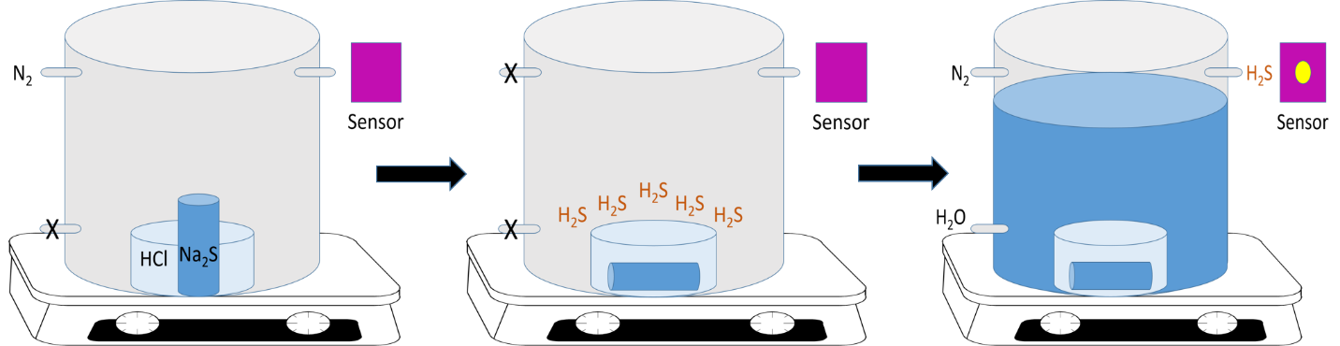

Fig. 2.1. Schematic for in-house H₂S gas generation.

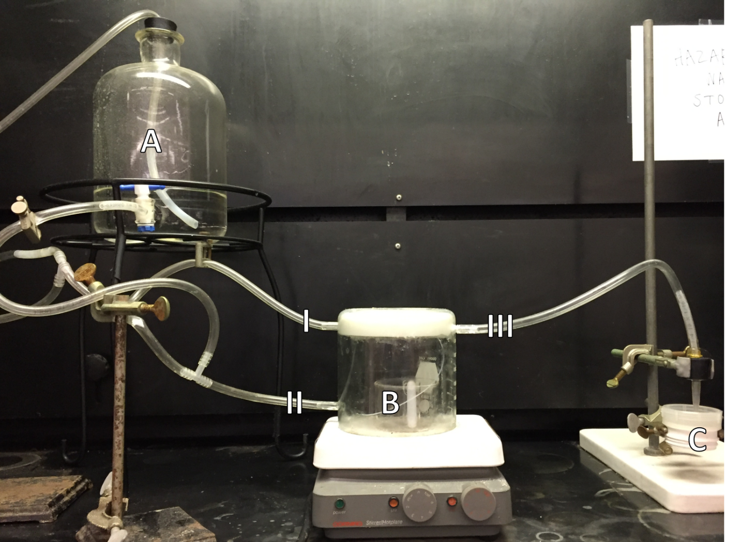

Fig. 2.2. Photo of the in-house H₂S generator. Featured are the nitrogen gas capillary inlet (I), the nitrogen gas/water inlet (II), H₂S outlet (III), water tower (A), acid dish and sulfide vial (B), and the wire mesh probe stand (C).

2.3. Results and discussion

2.3.1. Sensing of S²⁻_{(aq)} and mercaptans by Cu-PAN
In order to provide proof of concept, reactivity of the paper-based probes was studied using sulfide solutions before adapting it to a gas-based approach. A strong correlation was observed with both Na₂S and mercaptans such as (3-mercaptopropyl)trimethoxysilane (MPTMS) shown in Fig. 2.3.

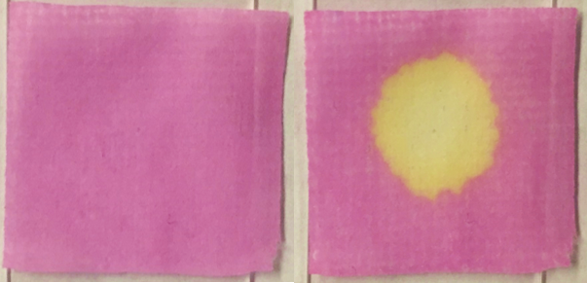

Fig. 2.3. Probe before (left) and after (right) exposure to 5 µL of MPTMS.

Fig. 2.4 shows the response of the Cu-PAN probe with various concentrations of “gas phase equivalent” Na₂S_{(aq)}. That is to say, the amount of Na₂S required producing the given concentration of 1.35 L H₂S gas.

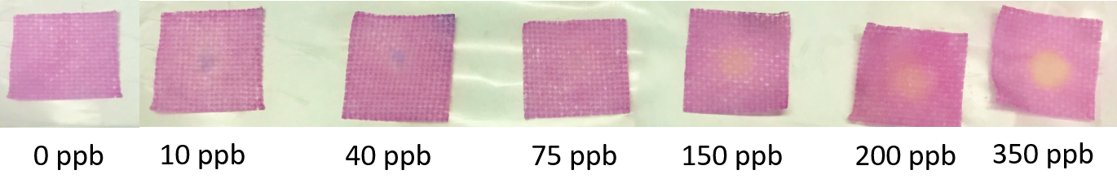
Fig. 2.4. Exposure of Cu-PAN probes to increasing “gas phase equivalent” concentrations of Na₂S_{(aq)}.

The color change from the pink color of the Cu-PAN complex to yellow is the result of the formation of the azo-dye itself, free of binding to Cu(II), as shown in Scheme 2.3. The formation of the black spot at low concentrations may be the formation of CuS which is then dissolved by the HCl produced by the reaction. This is supported by the controlled experiments. The black spot diminishes after exposure to a small amount of dilute (0.01 M) HCl.

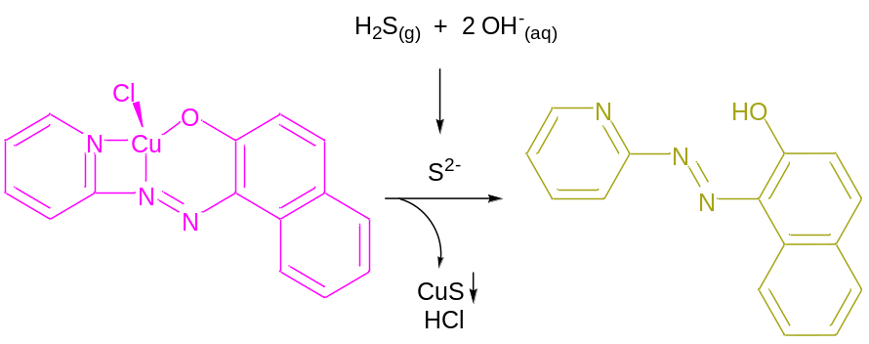

Scheme 2.3. Sensing mechanism: Trapping of H₂S gas by OH⁻_{(aq)}, followed by the reaction of the Cu-PAN complex with S²⁻.

2.3.2. Sensing of H₂S gas
To ensure that the setup for the generation of H₂S gas did not yield a response from our probe when no analyte was present, a blank was run with no Na₂S present and it did not produce a color change. When exposed to gaseous H₂S, the probe exhibited a clear colorimetric response related to the concentration of H₂S. A positive control was conducted to ensure the probe was responding to H₂S by exposing the probe to a small volume of 5 ppm gaseous H₂S from a lecture cylinder (Fig. 2.5). We recently tested lead acetate paper for comparison for NaHS solution, mercaptan solution, and H₂S gas [27]. Often no visible change was observed for H₂S gas at <1 ppm, although the exposure to 5 ppm H₂S from the lecture cylinder did produce a dark black spot on the lead acetate strip indicating both probes respond to high concentrations of H₂S.

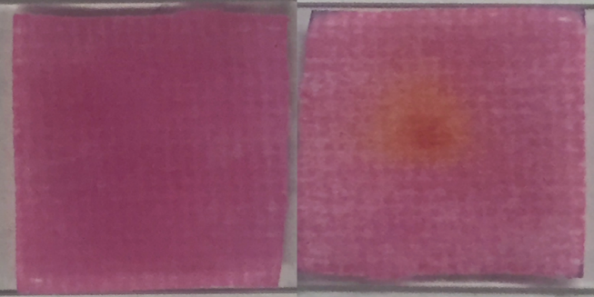

Fig. 2.5. Cu-PAN probe before (left) and after (right) exposure to 5 ppm H₂S for 10 s.

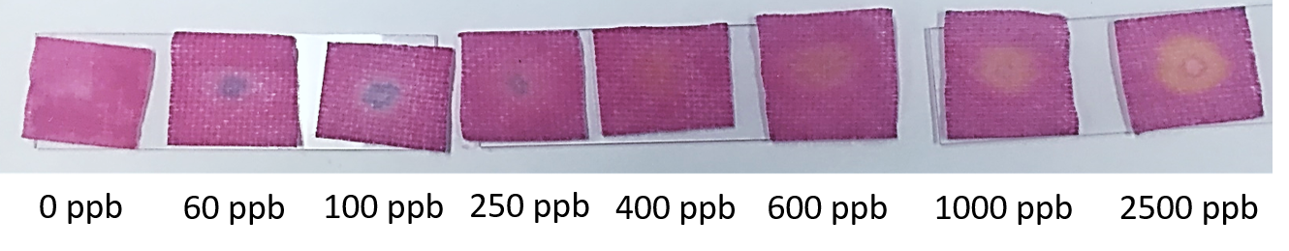
Fig. 2.6. Cu-PAN probe after exposure to different concentrations of H₂S gas.

The current naked eye detection limit for the probe is 60 ppb H₂S in 1.35 L of gas, as lower concentrations do not show a visible change to the naked eye. The same gradient color response is observed for the gas phase as for the solution phase. The response of the probe as it was exposed to increasing concentrations of H₂S is shown in Fig. 2.6. The color change for the gas phase appears to happen at slightly higher concentrations compared to the aqueous solution tests. This is probably a result of incomplete H₂S gas capture by the probe surface during the exposure. The concentric pattern that seems to appear in the gas phase tests is likely due to the probe being damp and the gas flow displacing some of the Cu-PAN upon hitting the substrate.

2.3.3. Probe optimization
Optimization of the detection conditions for the reaction of the probe with H₂S was performed under various experimental conditions such as pH, solvent media, gas flow rate, substrate selection, and concentration of the Cu-PAN solution used.

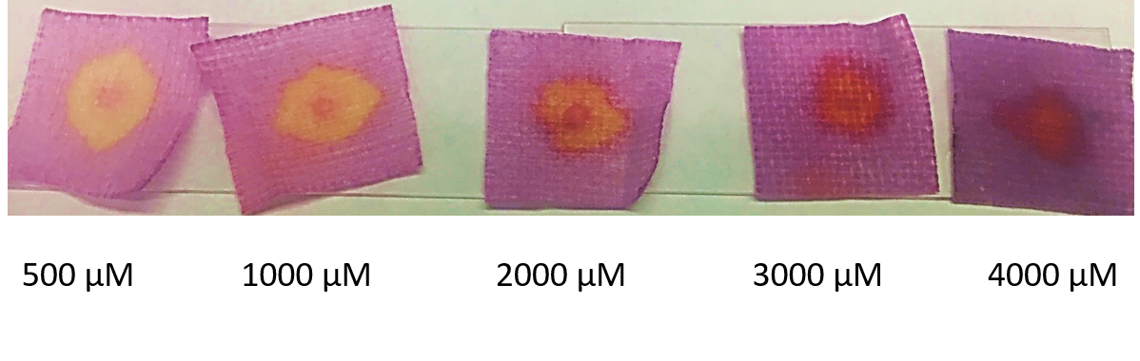Fig. 2.7. Optimization of Cu-PAN concentration exposed to 3000 ppb H₂S _{(g)}.

In the concentration experiment, a variety of concentrations of Cu-PAN solutions were made ranging from 500 to 4000 µM as shown in Fig. 2.7. The best response from the probe for low concentrations of H₂S was found to be 1000 µM, while the best response for high concentrations was found to be 3000 µM.
The solvent media have been found to impact the performance of the probe. Dissolving the Cu-PAN in 95% ethanol showed a dramatic improvement for both detection limit and response range over the 10% ethanol cited in the literature [29]. The probe response was strong at lower gas flow rates, which resulted in an increase of the residence time of the gas with the probe. The selection of the Prozorb substrate over various filter papers provided a substantial increase in performance due to the high porosity and highly absorbent properties. Specifically, the porosity allowed for the H₂S_{(g)} to pass through the probe, preventing pressure build up in the reaction chamber. The absorbent nature of the Prozorb allowed for the probe to stay damp throughout the exposure to H₂S_{(g)}.

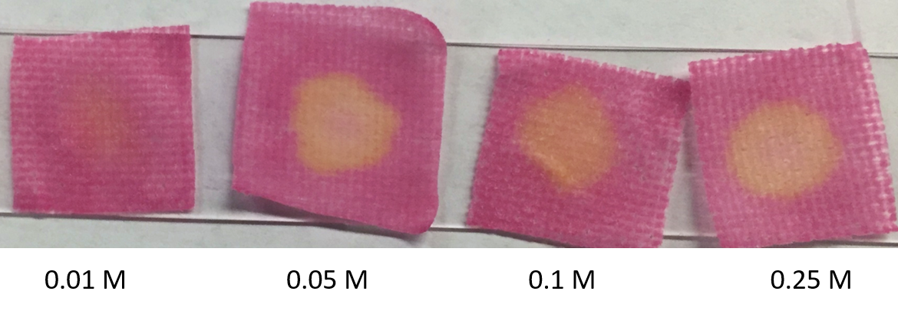Fig. 2.8. Optimization of NaOH concentration exposed to 1000 ppb H₂S _{(g)}.

The inclusion of NaOH resulted in a better detection limit, as it likely converts acidic H₂S_{(g)} to soluble Na₂S_{(aq)}, trapping it in the probe and giving the sulfide anion a greater chance of reacting with the Cu complex. Various concentrations of NaOH from 0–0.5 M were tested, with 0.1 M giving the best increase in color change, depicted in Fig. 2.8.
Probes were prepared fresh by adding prepared ethanol solutions of Cu-PAN to the 2 × 2 cm² squares of Prozorb® porous substrate, as allowing the probes to dry resulted in a decrease in sensitivity even if moistened again before use. The solution in the moist probe enhances the kinetics of the reaction between gaseous H₂S and base NaOH, trapping the former in the solution as the S²⁻ ion which then reacts with Cu-PAN to give the color change. In contrast, with a dry probe, the heterogeneous reactions of gaseous H₂S with solid NaOH and Cu-PAN are probably much slower. During the short exposure time, much of the H₂S in the 1.35-L gas is lost, reducing the sensitivity of the probe.
The flow rate from the reaction vessel was also investigated. With high flow rates (>2 L min⁻¹), the Cu-PAN coating could be blown away, leaving a blank spot on the probe. Lowering the flow rates prevented the loss of the Cu-PAN coating on the substrate and allowed for the color change to be observed. Rates below 0.27 L min⁻¹ did not improve the sensitivity of the probe. Based on the above, the best experimental results in the present system were given under the reaction medium of 2000 µM Cu-PAN, 0.1 M NaOH, 95% ethanol, and a flow rate of approximately 0.27 L min⁻¹ H₂S.

2.4. Conclusions
The detection of H₂S gas by a copper complex on a porous substrate has been achieved. The sensitivity of this approach is greater than that of commercially available optical H₂S probes and the probe offers a non-toxic alternative to the popular lead acetate test paper strips. The low cost and easy preparation of the probe make it a useful potential candidate in many environmental and industrial applications. The development of a sufficiently sensitive H₂S detector may be developed into a commercial portable bad-breath detector as well. The probe’s large range of response with a naked eye detection limit of 60 ppb in only 1.35 L of gas make it especially suitable as an optical probe for oral hygiene and industrial monitoring of H₂S. It is capable of detecting the average concentration of bad breath (80 ppb) and the OSHA Permissible Exposure Limit (10 ppm). Although the exact H₂S gas concentration and flow profile from the home-made generator is not known, concentrations given are the maximum based on the amount of Na₂S used. The probe reported includes several key features that contribute to the enhanced sensitivity for the detection of gaseous H₂S. A moist, basic surface improves the kinetics of trapping H₂S gas and the reaction between S²⁻ and Cu-PAN. The formation of two colored products gives a qualitative sensing for H₂S. Further investigation into additional M-PAN complexes could yield more sensitive probes, as copper is not the only metal shown bind reversibly with H-PAN [32,33].

References
[1] R.J. Reiffenstein, W.C. Hulbert, S.H. Roth, Toxicology of hydrogen sulfide, Annu. Rev. Pharmacol. Toxicol. 32 (1992) 109–134. doi:10.1146/annurev.pa.32.040192.000545.
[2] M.M. Gadalla, S.H. Snyder, Hydrogen sulfide as a gasotransmitter, J. Neurochem. 113 (2010) 14–26. doi:10.1111/j.1471-4159.2010.06580.x.
[3] L.K. Spiegel, T.C. Dao, The occurrence of hydrogen sulfide gas in San Joaquin kit fox dens and rodent burrows in an oil field in California, Calif. Fish Game. 83 (1997) 38–42.
[4] G.A. Tarver, P.K. Dasgupta, Oil field hydrogen sulfide in Texas: Emission estimates fate, Environ. Sci. Technol. 31 (1997) 3669–3676. doi:10.1021/es970406k.
[5] Q. Wang, Generation mechanism and control measures for H₂S in oil wells, Liaohe Oilfield, Pet. Explor. Dev. 35 (2008) 349–354. doi:10.1016/S1876-3804(08)60082-8.
[6] C. Gammons, S. Poulson, J.J. Metesh, T.E. Duaime, Geochemistry and isotopic composition of H₂S-rich water in flooded underground mine workings, Butte, Montana, USA, Mine Water Environ. 22 (2003) 141–148. http://medcontent.metapress.com/index/A65RM03P4874243N.pdf\nhttp://link.springer.com/article/10.1007/s10230-003-0014-y.
[7] M. Whiteman, J.S. Armstrong, S.H. Chu, S. Jia-Ling, B.S. Wong, N.S. Cheung, et al., The novel neuromodulator hydrogen sulfide: An endogenous peroxynitrite “scavenger”? J. Neurochem. 90 (2004) 765–768. doi:10.1111/j.1471-4159.2004.02617.x.
[8] R. Wang, Two’s company, three's a crowd: can H₂S be the third endogenous gaseous transmitter? FASEB J. 16 (2002) 1792–8. doi:10.1096/fj.02-0211hyp.
[9] R.O. Beauchamp, J.S. Bus, J.A. Popp, J. Boreiko, D.A. Andjelkovich, P. Leber, A critical review of the literature on hydrogen sulfide toxicity, CRC Crit. Rev. Toxicol. 13 (1984) 25–97.
[10] Medical Management Guidelines for Hydrogen Sulfide. www.atsdr.cdc.gov/MHMI/mmg114.pdf.
[11] T. Wahlund, C. Woese, R. Castenholz, M. Madigan, A thermophilic green sulfur bacterium from New Zealand hot springs, Chlorobium tepidum sp. nov. Arch. Microbiol. 156 (1991) 81–90.
[12] J. Ball, D.K. Nordstrom, R.B. McCleskey, M. Schoonen, Y. Xu, Water-chemistry and on-site sulfur-speciation data for selected springs in Yellowstone National Park, Wyoming, USGS 1996-1998, 2001.
[13] L. Zhang, P. De Schryver, B. De Gusseme, W. De Muynck, W. Verstraete, Chemical and biological technologies for hydrogen sulfide emission control in sewer systems: A review, Water Res. 42 (2008) 1–12.
[14] J. Arogo, R.H. Zhang, G.L. Riskowski, D.L. Day, Hydrogen sulfide production from stored liquid swine manure: a laboratory study, Trans. ASAE. 43 (2000) 1241–1245.
[15] I.E. Organizatin, Key Natural Gas Trends, Nat. Gas Inf. www.iea.org/publications/freepublications/publication/KeyNaturalGasTrends.pdf.
[16] H. Thompson, Fracking boom spurs environmental audit, Nature 485 (2012) 556–557. doi:10.1038/485556a.
[17] R.B. Jackson, A. Vengosh, J.W. Carey, R.J. Davies, T.H. Darrah, F. O’Sullivan, et al., The environmental costs and benefits of fracking, Annu. Rev. Environ. Resour. 39 (2014) 1–36. doi:10.1146/annurev-environ-031113-144051.
[18] TOTAL S.A. A Sour Gas History of Expertise. http://www.total.com/sites/default/files/atoms/file/total-sour-gas-history-expertise.
[19] U.S. Occupatioinal Safety and Health Administration, Hydrogen Sulfide in Work Places. https://www.osha.gov/SLTC/hydrogensulfide/hydrogensulfide_found.html.
[20] N.S. Lawrence, J. Davis, R.G. Compton, Analytical strategies for the detection of sulfide: A review, Talanta 52 (2000) 771–784. doi:10.1016/S0039-9140(00)00421-5.
[21] N.C. Papanikolaou, E.G. Hatzidaki, S. Belivanis, G.N. Tzanakakis, A.M. Tsatsakis, Lead toxicity update. A brief review, Med. Sci. Monit. 11 (2005) RA329–A336.
[22] N. Batina, I. Ciglenecki, B. Cosovic, Determination of elemental sulphur, sulphide and their mixtures in electrolyte solutions by a.c. voltammetry, Anal. Chim. Acta 267 (1992) 157–164.
[23] J.S. Redinha, C. Paliteiro, J.L.C. Pereira, Determination of sulfide by square-wave polarography, Anal. Chim. Acta 351 (1997) 115–125.
[24] G. Schiavon, G. Zotti, Electrochemical detection of trace hydrogen sulfide in gaseous samples by porous silver electrodes supported on ion-exchange membranes (solid polymer electrolytes), Anal. Chem. 67 (1995) 318–323.
[25] E. Fischer, Bildung von Methylenblau als Reaktion auf Schwefelwasserstoff, Chem. Ber. 16 (1883) 2234.
[26] V. Kuban, P. Dasgupta, J. Marx, Nitroprusside and Methylene Blue methods for silicone membrane differentiated flow injection determination of sulfide in water and wastewater, Anal. Chem. 64 (1992) 36–43.
[27] S.M. Rosolina, T.S. Carpenter, Z.-L. Xue, Bismuth-based, disposable sensor for the detection of hydrogen sulfide gas, Anal. Chem. 88 (2016) acs.analchem.5b04489. doi:10.1021/acs.analchem.5b04489.
[28] J. Sarfraz, P. Ihalainen, A. Määttänen, T. Gulin, J. Koskela, C.E. Wilén, et al., A printed H₂S sensor with electro-optical response, Sensors Actuators, B Chem. 191 (2014) 821–827. doi:10.1016/j.snb.2013.10.011.
[29] D. Zhang, W. Jin, Highly selective and sensitive colorimetric probe for hydrogen sulfide by a copper(II) complex of azo-dye based on chemosensing ensemble approach, Spectrochim. Acta - Part A Mol. Biomol. Spectrosc. 90 (2012) 35–39. doi:10.1016/j.saa.2012.01.013.
[30] 1-(2-Pyridylazo)-2-naphthol; MSDS No. 82960 http://www.chemistry.mcgill.ca/msds/msds/85-85-8.pdf.
[31] H. Adams, R.M. Bucknall, D. Fenton, M. Garcia, J. Oakes, Self association in the structures of two copper(II)-Azo-dye complexes, Polyhedron 17 (1998) 4169–4177.
[32] W. Guo, ICP-AES determination of Cu, Zn, Cd, Mn, Fe, Co, and Pb in natural water after preconcentration of their PAN-chelates on foam, Lihua Jianyan Huaxue Fence. 30 (1994) 289.
[33] Simunicova, Complex-forming properties of 1-(2-pyridylazo)-2-naphthol and 1-(2-thiazolylazo)-2-naphthol in a dimethyl sulfoxde and N,N-dimethylformamide medium, Chem. Zvesti. 33 (1979) 64.

Part 3

Colorimetric Copper(II)-based Paper Probe for Hydrogen Sulfide Gas. Quantitative Analysis

A version of this work titled “Quantitative, colorimetric paper probe for hydrogen sulfide gas” has been accepted to Sensors and Actuators: B. Chemical

Abstract
A new approach for the quantitative determination of low concentrations of hydrogen sulfide (H₂S) gas utilizing the previously reported copper based probe and a handheld colorimeter has been developed. The reaction between H₂S gas and the copper complex produces a distinct color change from purple to yellow which is monitored using a Node Chroma colorimeter in CIELAB colorspace coupled with a smartphone. The color change for concentrations as low as 60 ppb H₂S is observable to with the naked eye; however, it is difficult to differentiate the color change among the detection range. In comparison, utilization of the CIELAB data allows for the determination of the concentration of H₂S gas reacting with the probe. The use of the disposable copper-based probe coupled with simple reporting of the data from the handheld colorimeter make this approach extremely portable, inexpensive alternative to traditional quantitative methods.

3.1. Introduction
Hydrogen sulfide (H₂S), a highly toxic, odorous gas, is associated with oral hygiene and oil and mining industries [1–8], as discussed in Part 2. It can cause blood poisoning even at brief exposures to low level concentrations, while immediate danger to life or health occurs at exposures of 100 ppm [9, 10]. H₂S occurs naturally and is released from sewage, manure, sulfur springs, and natural gas [11–14]. Recent hydraulic fracturing (fracking) for natural gas also increases the risk for the release of H₂S [15–17]. Olfactory nerve fatigue readily occurs upon exposure with a maximum sensitivity of roughly 5 ppm and thus odor is not a reliable indicator of the presence of hydrogen sulfide [18].
Current detection techniques include iodiometric based probes [19], lead acetate impregnated test papers [19,20], and electrochemical [21–23] methods. Several photometric methods have also been employed for the H₂S detection. The Methylene blue test first reported by Fisher [24] involves the reaction of S²⁻ ions with N,N-dimethylphenyl-1,4-diamine to form methylene blue with a blue color. Using a stationary alkaline acceptor solution to trap and pre-concentrate H₂S gas, coupled with standard UV-visible spectroscopy, achieves a detection limit of 10 ppb utilizing [25]. We recently reported a bismuth-based probe to qualitatively detect H₂S gas [26]. It changes color from white to brown upon exposure to H₂S gas. Sarfraz et. al. reported an electro-optical technique based on the use of copper acetate through the formation of copper sulfide [27]. The detection limit is 1 ppm H₂S by the optical method with a 45 min onset time of detection.
Zhang and Jin recently reported detection of sulfides S²⁻ in aqueous solutions by Cu-PAN [28]. Cu-PAN reacts with S²⁻ in solutions, leading to a distinct color change from purple to yellow with a more prominent color gradient with increasing concentration. Part 2 has reported our work in developing an optical probe based on Cu-PAN for qualitative sensing of gaseous H₂S.
UV-visible spectroscopy is often used in the characterization of colored compounds; however, the use of various color space models are used to describe the color of a substance and how that color changes. Perhaps the most well-known color space is RGB due to its use in electronic displays. It is not frequently used in industrial applications as the colorspace is unintuitive and not considered visually uniform [29].
CIELAB is currently the most popular used color space in industrial applications ad is considered the basis of modern colorimetry [30]. CIELAB arranges colors along a set of three axes: L*, a*, and b*. The L*axis is the vertical axis and relates the luminance of the color, ranging from 100 (pure white) to 0 (pure black). The a* axis ranges from red (+) to green (-), while the yellow (+) and blue (-) colors are arranged along the b* axis. The L*, a*, b*, values of a given color are known as the chromaticity coordinates, allowing for the colors to be described in a three-dimensional space. CIELAB color space is one of the most widely used color spaces for industrial applications as it results in Euclidean distances between chromaticity coordinates that closely match the perceived differences in colors. CIELAB is device independent and there are a variety of instruments that yield data in CIELAB including spectrometers, reflectometers, and colorimeters, and objective image analysis software is being developed that can extract this information from a photograph [29].

3.2. Materials and methods
A handheld colorimeter (Node Chroma), obtained from Variable Technologies, that transmits data to a smartphone, was employed in order to remove the subjectivity of naked eye analysis and provide quantitative results for the sensing of H₂S.

3.3. Results and discussion

3.3.1. Node Chroma used for data collection and data collected
The Node Chroma has been previously validated as comparable to benchtop colorimeters that report data in CIELAB color space coordinates [32]. The Node Chroma uses a ring of 5 broad-spectrum, white LEDs and a specialized end cap to block out ambient light. With all surrounding light removed, the white LED light onto the surface, reflecting into the light receptor. The clear, red, blue, and green sensors capture that color and process the data into a color data in CIELAB color space. A schematic of the device is shown in Fig. 3.1. A small 2 x 2 cm² microscope slide was cut as a sample holder to ensure that both the probes and Node Chroma were consistently placed during data collection. The probes, described in Part 2, were exposed to 30-2500 ppb H₂S. Three probes were exposed individually to the given concentrations, with three measurements by the Node Chroma per probe. The Node Chroma was lifted and replaced onto the probe between measurements, a photo of the setup is shown in Fig. 3.2. The CIELAB data obtained from these exposed probes are shown in Table 3.1.

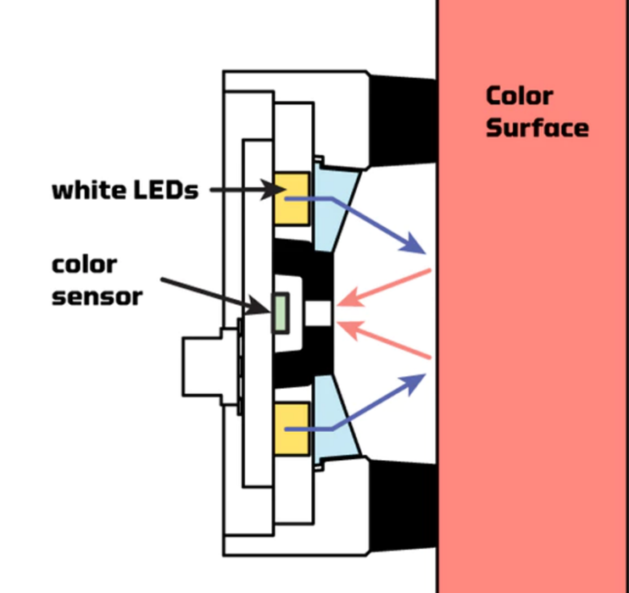

Fig. 3.1. Schematic of the Node Chroma used in the current research [31].

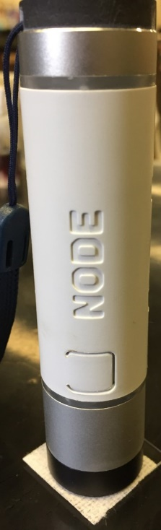
Fig. 3.2. Node Chroma placed upon 2 x 2 cm² microscope glass slide and a blank probe.

Table 3.1 CIELAB data for the exposure of the Cu-PAN probe to gaseous H₂S (n = 3)
[H₂S] (ppb) | 0 | 30 | 60 | 100 | 150 | 250 | 400 | 600 | 1000 | 1750 | 2500
L* | 69.56 | 72.37 | 74.68 | 73.68 | 70.55 | 72.60 | 72.04 | 72.04 | 72.09 | 74.07 | 74.27
a* | 15.46 | 9.38 | 6.77 | 7.42 | 9.31 | 8.88 | 9.51 | 10.65 | 8.86 | 9.30 | 7.56
b* | -15.72(3) | -10.92(6) | -11.44(3) | -12.03(10) | -12.49(10) | -13.48(14) | -1.63(15) | -1.19(9) | -0.46(10) | 0.81(20) | 1.78(15)

3.3.2. Lab colorspace analysis

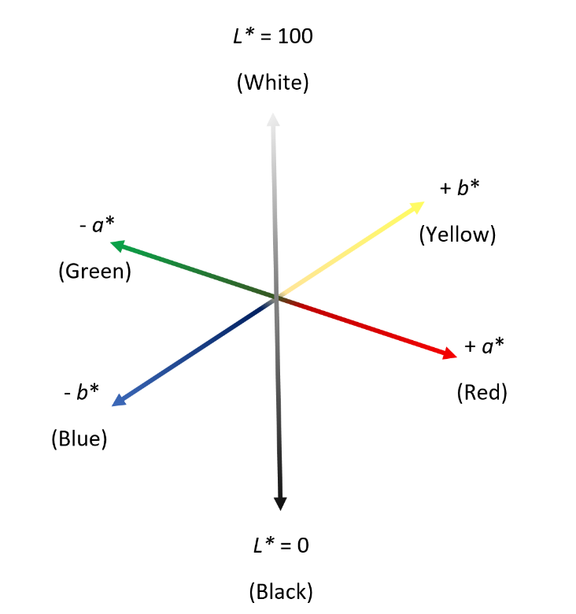
Fig. 1.4. Illustration of the CIELAB colorspace with gradient L*, a*, and b* axes.

Color space, with gradient L*, a*, and b* axes, has been described in Section 1.2.2 with Fig. 1.4 reproduced above. After the probe in Part 2 is exposed to H₂S gas, the b* axis, with positive values for yellow color and negative values for blue color, was found to demonstrate the greater correlation to the color change of the current probe than the a* axis (Fig. 3.3), which has positive values for red color and negative values for green color. The b* data is shown in Fig. 3.4, two apparent ranges of linearity are observed. Calibration curves for low and high concentrations of H₂S gas are shown in Figs. 3.5 and 3.6, respectively.
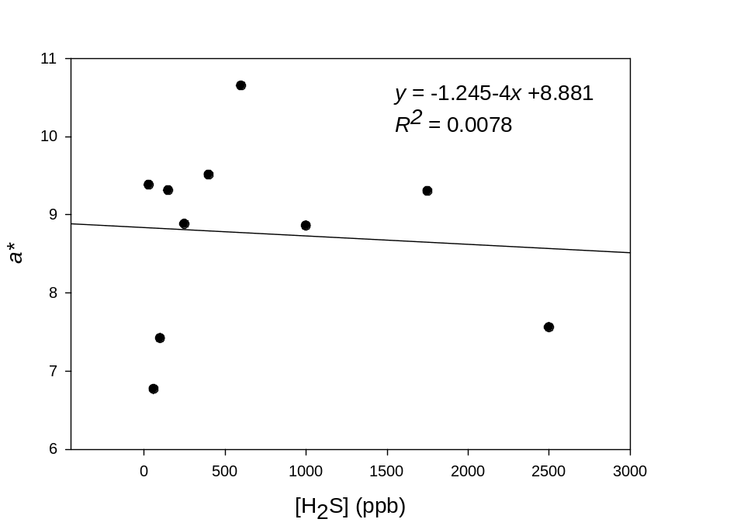
Fig. 3.3. Calibration curve showing the correlation of data from the a* axis for all concentrations of H₂S gas.
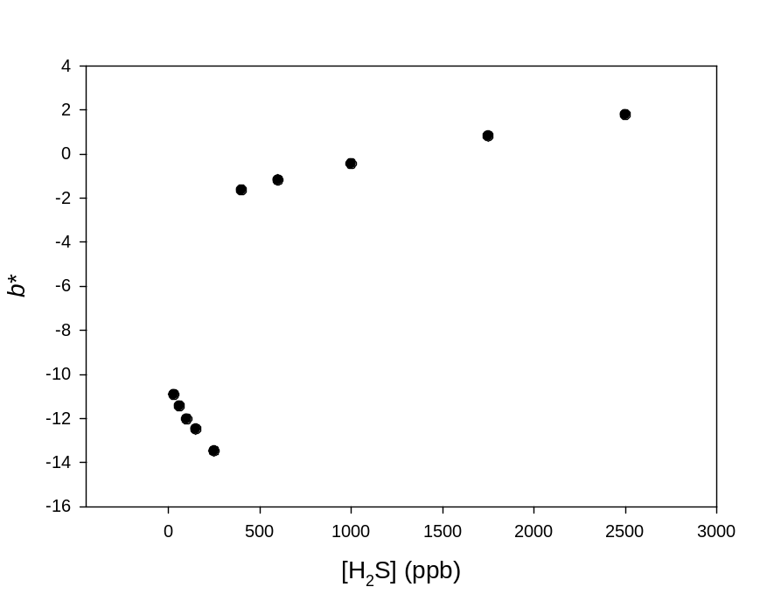
Fig. 3.4. Plot of b* data vs [H₂S] with two apparent linear ranges.

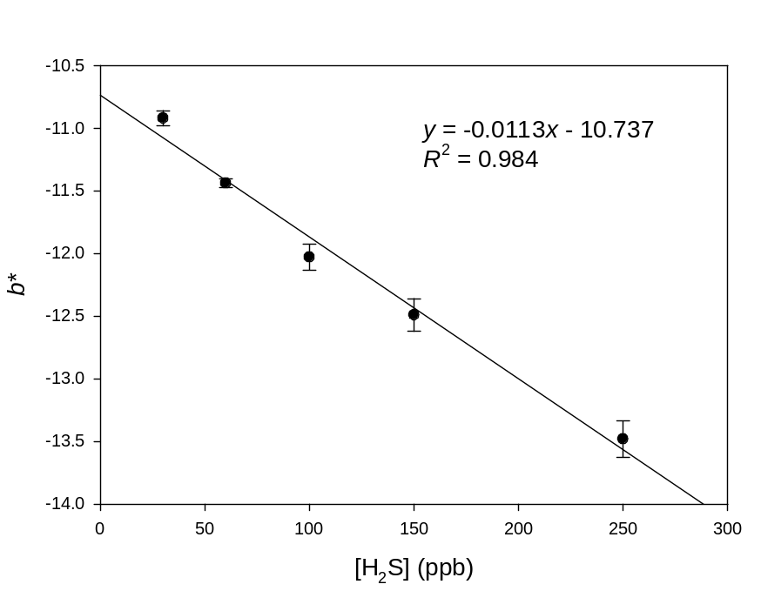
Fig. 3.5. Calibration curve showing the correlation of data from the b* axis with low concentrations of H₂S gas.
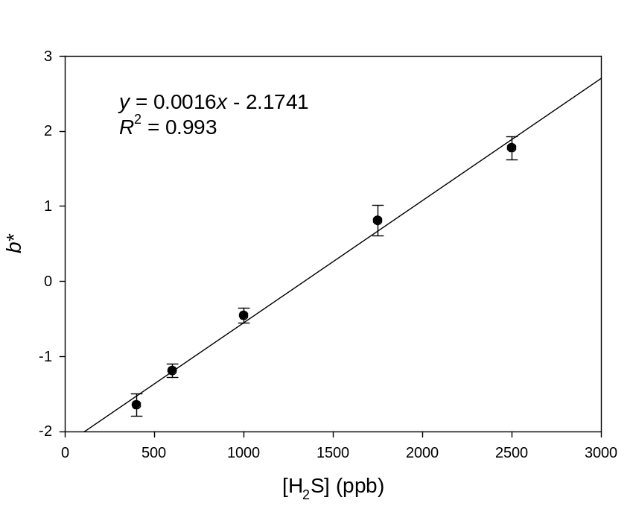
Fig. 3.6. Calibration curve showing the correlation of data from the b* axis for high concentrations of H₂S gas.
For exposure to H₂S gas, the change in probe color of the Cu-PAN complex has a significant contribution from the b* axis. The b* data initially decrease upon exposure to the low concentrations of H₂S, corresponding to the formation of black CuS and the conversion of Cu-PAN to the yellow compound H-PAN. Upon the dissolution of the solid CuS by HCl, the b* data then sharply increase as more H-PAN is formed and the color of the probe turned yellow. While there is no linear correlation from the range of 250-400 ppb, the b* values do not overlap with either the low or high concentration ranges, so there is no concern of a false reading from this range. Using the CIELAB colorspace data, linear correlations for both the low concentrations (Fig. 3.5, R² = 0.984) and high concentrations of H₂S were determined (Fig. 3.6, R² = 0.993). A limit of detection (LoD) of 16 ppb (3σ/n) and a limit of quantification (LoQ) of 53 ppb (10σ/n) were determined, not only providing a lower level of detection than naked eye analysis, but also making it possible to objectively differentiate between smaller differences in concentrations of gaseous H₂S. In addition to examining the a* and b* data, the ratio of b*/a* and ∆E, the Euclidean distance between two points in three-dimensional space, were investigated to see if either provided an increase in the linear response or sensitivity of the system.
In the ratiometric investigation, there are again two clear regions shown in Fig. 3.7. In the low-end concentrations, there is a clear lack of linear correlation; however, there is a strong linear correlation among the high-end concentrations as shown in Fig. 3.8.

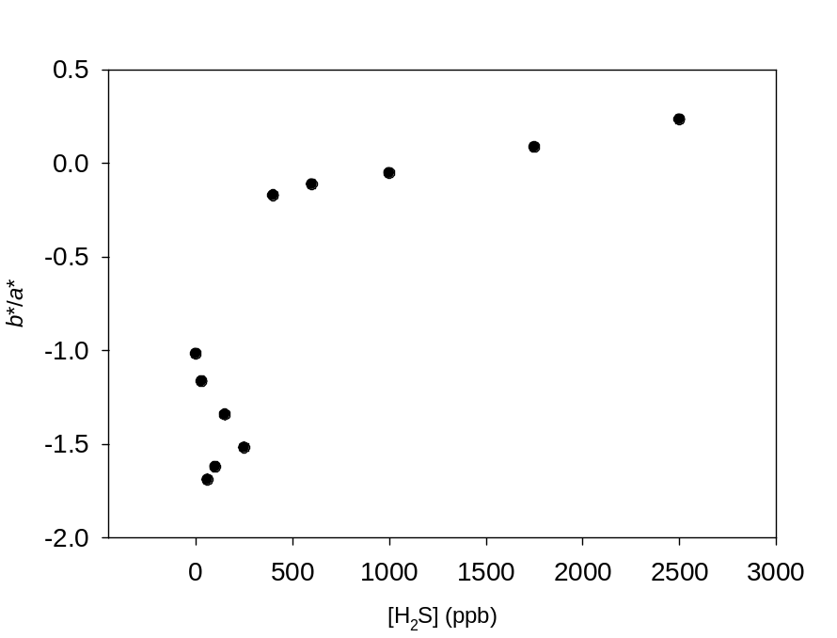
Fig. 3.7. Plot of the ratio of b*/a* vs concentrations of H₂S gas.

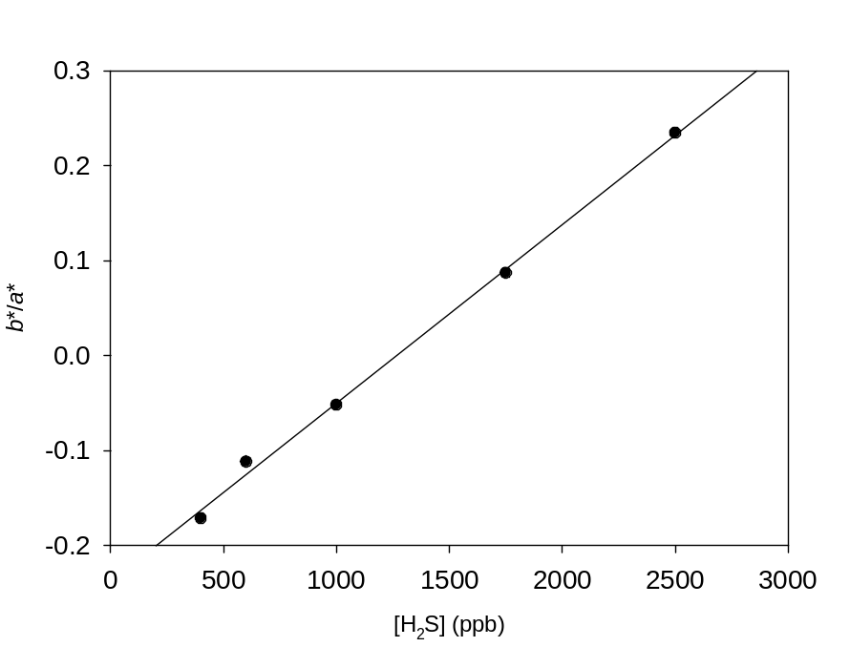
y = 0.0002x - 0.2378
R² = 0.9974
Fig. 3.8. Calibration curve showing the correlation of the b*/a* ratio for high concentrations of H₂S gas.
While incorporating the a* data with the b* data slightly improves the correlation of the system at high-end concentrations, the sensitivity drops by roughly one order of magnitude. However, incorporating a* data into the analysis still yields a highly linear correlation suggesting that the color of the probe is indeed directly related to the concentration of H₂S present.
As CIELAB is a three dimensional colorspace, the distance between these data points were investigated to see if there was a correlation. ∆E was calculated per Eq. 3.1 and plotted against H₂S concentrations as shown in Fig. 3.9.

∆E = √[(L*₂ – L*₁)² + (a*₂ – a*₁)² + (b*₂ - b*₁)²] (Eq. 3.1)

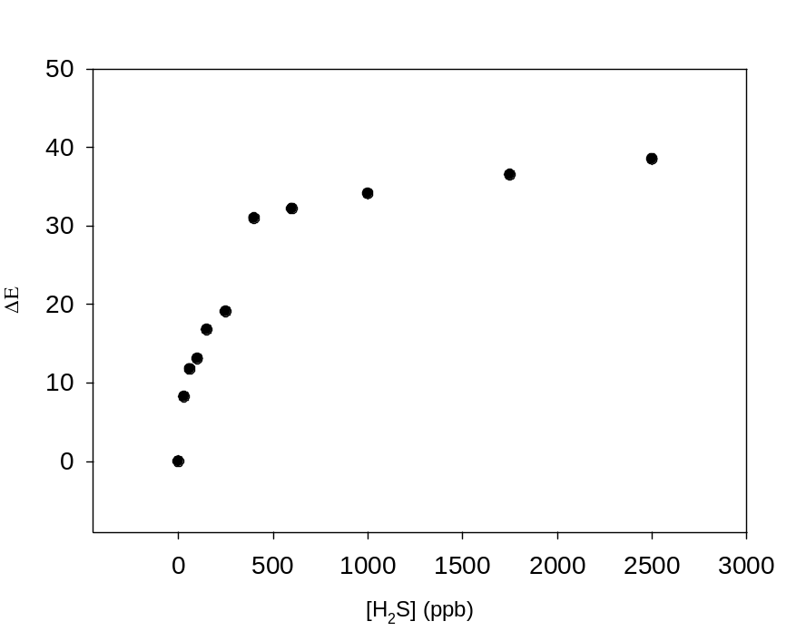
Fig. 3.9. Plot of the Euclidean distance in the CIELAB coordinates between the given concertation of H₂S gas and the blank probe.
Plotting the ∆E vs concentration shows a seemingly logarithmic relationship (R² = 0.948) across all ranges of H₂S data. This suggests that the probe is reaching the upper limit of its detection range. There is again a linear correlation at the low-end concentrations (R² = 0.971) and the high-end concentrations (R² = 0.980) shown in Figs. 3.10 and 3.11, respectively.

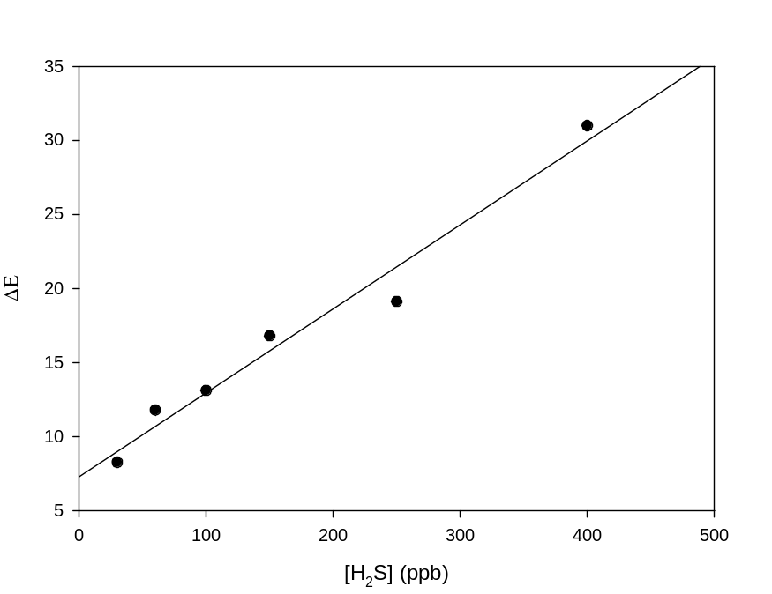
y = 0.0567x + 7.3025
R² = 0.9707

Fig. 3.10. Calibration curve showing the correlation of ∆E with low concentrations of H₂S gas.

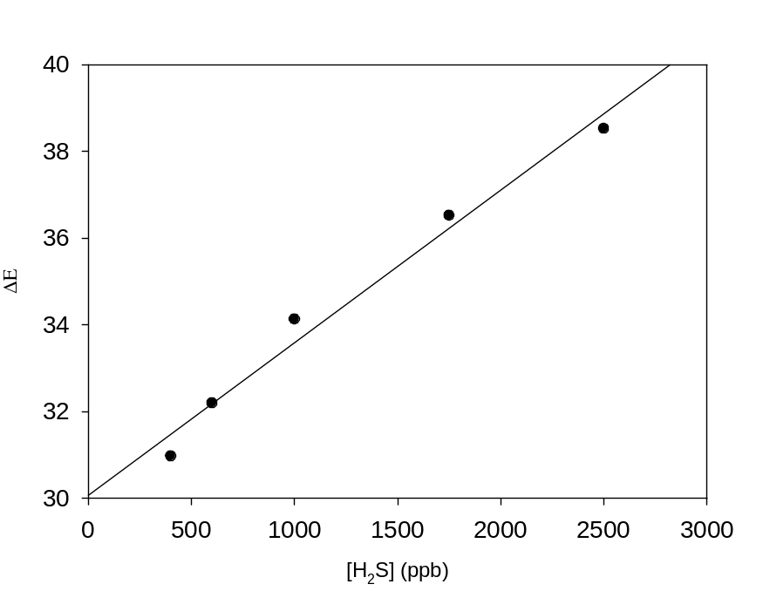
Fig. 3.11. Calibration curve showing the correlation of ∆E with high concentrations of H₂S gas.

3.3.3. Interference studies
The effect of air and water vapor on the probe response were investigated. In the case of air, the reaction chamber was purged with air from an in-house air supply instead of N₂, followed by the generation of 600 ppb H₂S as described previously. The b* value for this reading was -1.14. As shown in Table 3.2, when the tests were conducted under N₂, the b* value for 600 ppb H₂S is -1.19. Thus, the result of the test under air is within the error for the tests under N₂. The effect of water vapor was investigated by purging the reaction chamber with N₂, slightly opening the valve to the water reservoir, and then allowing the humidity to rise. No significant impact on the b* value for a probe exposed to 600 ppb H₂S was observed at 25, 50, 75, or 82% humidity as shown in Table 3.2.
Table 3.2. b* for 600 ppb H₂S gas at varying levels of humidity
Humidity (%) | 10 | 25 | 50 | 75 | 82
b* | -1.19 | -1.14 | -1.20 | -1.24 | -1.21

The effect of the probe response in the presence of natural gas was also investigated. The probe was exposed to 1.35 L of natural gas from the in-house supply with 0 ppb H₂S generated. The probe changed to yellow and yielded a b* value of 2.31, correlating to 2.8 ppm H₂S. This response is likely due to the reactions of Cu-PAN with mercaptans in the natural gas, typically in the 1-10 ppm range as an odorant for safety [33].
The sensitivity and selectivity of the probe was examined by comparing the response of the b* value upon exposure of the probe to H₂S_{(g)} and equal “gas phase equivalent” concentrations of S₂⁻_{(aq)} and (3-mercaptopropyl)trimethoxysilane (MPTMS), a mercaptan. Fig. 3.12 shows the response of the probe to S₂⁻_{(aq)}, H₂S_{(g)}, and MPTMS_{(aq)} with R² values of 0.993, 0.984, and 0.954, and slopes of -0.0225, -0.0113, and -0.011, respectively.

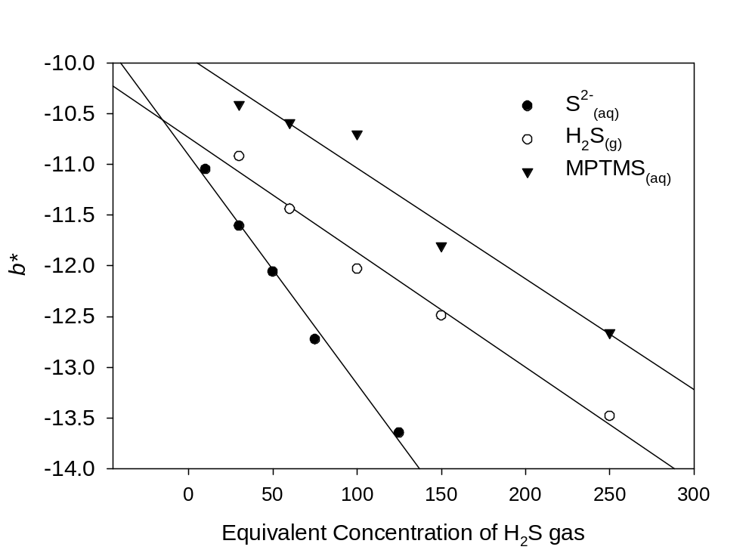
Fig. 3.12. Calibration curves showing the correlation of data from the b* axis for high concentrations of various sulfur containing compounds.

The probe exhibits a higher sensitivity to aqueous sulfides than to gaseous H₂S, as seen in the naked eye results, suggesting an incomplete capture of the hydrogen sulfide gas. The reduced sensitivity in the response to aqueous mercaptans, thiol-containing compounds (HSR), is possibly due to steric hindrance of the R groups reducing the reaction rate.

3.4. Conclusions
The detection of H₂S gas by a copper complex on a porous substrate has been achieved. The sensitivity of this approach is greater than that of commercially available optical H₂S probes and the probe offers a non-toxic alternative to the popular lead acetate test paper strips. The low cost and easy preparation of the probe make it a useful potential candidate in many environmental and industrial applications. The development of a sufficiently sensitive H₂S detector may be developed into a commercial portable bad-breath detector as well. The probe’s large range of response with a naked eye detection limit of 60 ppb in only 1.35 L of gas make it especially suitable as an optical probe for oral hygiene and industrial monitoring of H₂S. It is capable of detecting the average concentration of bad breath (80 ppb) and the OSHA Permissible Exposure Limit (10 ppm). Although the exact H₂S gas concentration and flow profile from the home-made generator is not known, concentrations given are the maximum based on the amount of Na₂S used. Further investigation into additional M-PAN complexes could yield more sensitive probes, as copper is not the only metal shown bind reversibly with H-PAN [34,35].
The probe reported includes several key features that contribute to the enhanced sensitivity for the detection of gaseous H₂S. A moist, basic surface improves the kinetics of trapping H₂S gas and the reaction between S²⁻ and Cu-PAN. The formation of two colored products gives a qualitative sensing for H₂S.

References
[1] R.J. Reiffenstein, W.C. Hulbert, S.H. Roth, Toxicology of hydrogen sulfide, Annu. Rev. Pharmacol. Toxicol. 32 (1992) 109–134. doi:10.1146/annurev.pa.32.040192.000545.
[2] M.M. Gadalla, S.H. Snyder, Hydrogen sulfide as a gasotransmitter, J. Neurochem. 113 (2010) 14–26. doi:10.1111/j.1471-4159.2010.06580.x.
[3] L.K. Spiegel, T.C. Dao, The occurrence of hydrogen sulfide gas in San Joaquin kit fox dens and rodent burrows in an oil field in California, Calif. Fish Game 83 (1997) 38–42.
[4] G.A. Tarver, P.K. Dasgupta, Oil field hydrogen sulfide in Texas: Emission estimates fate, Environ. Sci. Technol. 31 (1997) 3669–3676. doi:10.1021/es970406k.
[5] Q. Wang, Generation mechanism and control measures for H₂S in oil wells, Liaohe Oilfield, Pet. Explor. Dev. 35 (2008) 349–354. doi:10.1016/S1876-3804(08)60082-8.
[6] C. Gammons, S. Poulson, J.J. Metesh, T.E. Duaime, Geochemistry and isotopic composition of H₂S-rich water in flooded underground mine workings, Butte, Montana, USA, Mine Water Environ. 22 (2003) 141–148. http://medcontent.metapress.com/index/A65RM03P4874243N.pdf%5Cnhttp://link.springer.com/article/10.1007/s10230-003-0014-y.
[7] M. Whiteman, J.S. Armstrong, S.H. Chu, S. Jia-Ling, B.S. Wong, N.S. Cheung, et al., The novel neuromodulator hydrogen sulfide: An endogenous peroxynitrite “scavenger”? J. Neurochem. 90 (2004) 765–768. doi:10.1111/j.1471-4159.2004.02617.x.
[8] R. Wang, Two’s company, three’s a crowd: can H₂S be the third endogenous gaseous transmitter? FASEB J. 16 (2002) 1792–8. doi:10.1096/fj.02-0211hyp.
[9] R.O. Beauchamp, J.S. Bus, J.A. Popp, J. Boreiko, D.A. Andjelkovich, P. Leber, A critical review of the literature on hydrogen sulfide toxicity, CRC Crit. Rev. Toxicol. 13 (1984) 25–97.
[10] Medical Management Guidelines for Hydrogen Sulfide. www.atsdr.cdc.gov/MHMI/mmg114.pdf (accessed January 1, 2017).
[11] T. Wahlund, C. Woese, R. Castenholz, M. Madigan, A thermophilic green sulfur bacterium from New Zealand hot springs, Chlorobium tepidum sp. nov., Arch. Microbiol. 156 (1991) 81–90.
[12] J. Ball, D.K. Nordstrom, R.B. McCleskey, M. Schoonen, Y. Xu, Water-chemistry and on-site sulfur-speciation data for selected springs in Yellowstone National Park, Wyoming, USGS 1996-1998, 2001.
[13] L. Zhang, P. De Schryver, B. De Gusseme, W. De Muynck, W. Verstraete, Chemical and biological technologies for hydrogen sulfide emission control in sewer systems: A review, Water Res. 42 (2008) 1–12.
[14] J. Arogo, R.H. Zhang, G.L. Riskowski, D.L. Day, Hydrogen sulfide production from stored liquid swine manure: a laboratory study, Trans. ASAE. 43 (200AD) 1241–1245.
[15] H. Thompson, Fracking boom spurs environmental audit, Nature 485 (2012) 556–557. doi:10.1038/485556a.
[16] R.B. Jackson, A. Vengosh, J.W. Carey, R.J. Davies, T.H. Darrah, F. O’Sullivan, et al., The environmental costs and benefits of fracking, Annu. Rev. Environ. Resour. 39 (2014) 1–36. doi:10.1146/annurev-environ-031113-144051.
[17] TOTAL S.A. A Sour Gas History of Expertise. http://www.total.com/sites/default/files/atoms/file/total-sour-gas-history-expertise.
[18] U.S. Occupatioinal Safety and Health Administration, Hydrogen Sulfide in Work Places. https://www.osha.gov/SLTC/hydrogensulfide/hydrogensulfide_found.html.
[19] N.S. Lawrence, J. Davis, R.G. Compton, Analytical strategies for the detection of sulfide: A review, Talanta 52 (2000) 771–784. doi:10.1016/S0039-9140(00)00421-5.
[20] N.C. Papanikolaou, E.G. Hatzidaki, S. Belivanis, G.N. Tzanakakis, A.M. Tsatsakis, Lead toxicity update. A brief review, Med. Sci. Monit. 11 (2005) RA329-A336.
[21] N. Batina, I. Ciglenecki, B. Cosovic, Determination of elemental sulphur, sulphide and their mixtures in electrolyte solutions by a.c. voltammetry, Anal. Chim. Acta 267 (1992) 157–164.
[22] J.S. Redinha, C. Paliteiro, J.L.C. Pereira, Determination of sulfide by square-wave polarography, Anal. Chim. Acta 351 (1997) 115–125.
[23] G. Schiavon, G. Zotti, Electrochemical detection of trace hydrogen sulfide in gaseous samples by porous silver electrodes supported on ion-exchange membranes (solid polymer electrolytes), Anal. Chem. 67 (1995) 318–323.
[24] E. Fischer, Bildung von Methylenblau als Reaktion auf Schwefelwasserstoff, Chem. Ber. 16 (1883) 2234.
[25] V. Kuban, P. Dasgupta, J. Marx, Nitroprusside and Methylene Blue methods for silicone membrane differentiated flow injection determination of sulfide in water and wastewater, Anal. Chem. 64 (1992) 36–43.
[26] S.M. Rosolina, T.S. Carpenter, Z.-L. Xue, Bismuth-based, disposable sensor for the detection of hydrogen sulfide gas, Anal. Chem. 88 (2016) acs.analchem.5b04489. doi:10.1021/acs.analchem.5b04489.
[27] J. Sarfraz, P. Ihalainen, A. Määttänen, T. Gulin, J. Koskela, C.E. Wilén, et al., A printed H₂S sensor with electro-optical response, Sensors Actuators, B Chem. 191 (2014) 821–827. doi:10.1016/j.snb.2013.10.011.
[28] D. Zhang, W. Jin, Highly selective and sensitive colorimetric probe for hydrogen sulfide by a copper(II) complex of azo-dye based on chemosensing ensemble approach, Spectrochim. Acta - Part A Mol. Biomol. Spectrosc. 90 (2012) 35–39. doi:10.1016/j.saa.2012.01.013.
[29] G.D. Hasting, A. Rubin, Colour spaces - a review of historic and modern colour models*, African Vis. Eye Heal. 71 (2012). doi:10.4102/aveh.v71i3.76.
[30] S. Westland, C. Ripamonti, V. Cheung, CIELAB and Colour Difference, Comput. Colour Sci. Using MATLAB®. (2012) 49–74. doi:10.1002/9780470710890.ch5.
[31] G. Yu, NODE Chroma, a wireless color scanner for iOS and computers, (2013). https://www.kickstarter.com/projects/soldermaster/node-chroma-an-accurate-bluetooth-40-color-sensor.
[32] L.J. Loh, G.C. Bandara, G.L. Weber, V.T. Remcho, Detection of water contamination from hydraulic fracturing wastewater: a μPAD for bromide analysis in natural waters, Analyst 140 (2015) 5501–5507. doi:10.1039/C5AN00807G.
[33] M. Saadatmand, H. Foroughi, T. Dai, T. Misra, T. Bensabath, R. Farnood, Odor fading in natural gas distribution systems, Process Saf. Environ. Prot. 94 (2015) 131–139. doi:10.1016/j.psep.2015.01.005.
[34] W. Guo, ICP-AES determination of Cu, Zn, Cd, Mn, Fe, Co, and Pb in natural water after preconcentration of their PAN-chelates on foam, Lihua Jianyan Huaxue Fence. 30 (1994) 289.
[35] Simunicova, Complex-forming properties of 1-(2-pyridylazo)-2-naphthol and 1-(2-thiazolylazo)-2-naphthol in a dimethyl sulfoxde and N,N-dimethylformamide medium, Chem. Zvesti. 33 (1979) 64.

Part 4

Electrochemical Analysis of Trace Inorganic Arsenic and Its Speciation in Organic Matrices at Unmodified Glassy Carbon Electrodes

Abstract

A new electrochemical method utilizing copper at glassy carbon electrodes has been developed to detect, quantify, and speciate inorganic arsenic in aqueous media. Square wave anodic stripping voltammetry (SWASV) has been used in aqueous samples with and without the presence of organic compounds, caffeine and lactose, as mimics of active pharmaceutical ingredients (APIs) and excipients. Limits of detection (LODs) in the µg L⁻¹ [or parts per billion (ppb), mass/volume] range were obtained. The lack of electrode fabrication coupled with the adequate sensitivity of this technique suggests this may be an inexpensive alternative to other voltammetric detection methods for arsenic.

4.1. Introduction
Arsenic is widely abundant in nature, and found in both soil and water sources. Since arsenic is highly toxic, one of the main concerns for human health is the exposure to arsenic contaminated groundwater. Consumption of arsenic containing groundwater can lead to several illnesses such as vomiting and diarrhea, while chronic exposure may lead to more serious health problems including cancer of many organs. [1-3]. Inorganic arsenic is prominently found in groundwater in two oxidation states, As(III) and As(V) [4, 5]. The World Health Organization (WHO) has set a recommended limit of the maximum contaminant level of total inorganic arsenic at 10 µgL⁻¹ (ppb) although many countries are still in the process of reducing the limit from 50 µg L⁻¹ [6].
In addition to water contamination, stricter guidelines were proposed in January 2010 for the regulation of elemental impurities in pharmaceutical products with implementation currently scheduled for January 1, 2018. The United States Pharmacopeia is in the process of implementing these guidelines in the form of USP 232 and USP 233 to update the requirements originally implemented in 1905. The new guidelines impact 15 elemental impurities with a focus on the “Big Four”: arsenic, cadmium, mercury and lead, in pharmaceutical ingredients (APIs) and excipients. The proposed limits are dictated by the toxicity of the given impurity and the mode of intake. These new guidelines would reduce the permissible daily oral intake of inorganic arsenic to 1.5 µg g⁻¹ based on a 10 g daily dose [7-9].
Many methods exist to determine µg L⁻¹ and even ng L⁻¹ levels of arsenic in the laboratory including ICP-MS, ICP-OES, and various chromatographic and spectroscopic techniques [10-11]. While these techniques are typically recommended by regulatory agencies, they are hindered by the lack of portability and “in the field” testing capabilities [9,11]. In addition, these methods typically require both expensive instrumentation and trained operators. Electrochemical methods provide an alternative to these approaches that are both inexpensive and readily portable with commercially available, miniaturized potentiostats.
In recent years, there has been a significant advancement in the development of electrochemical methods based on anodic stripping voltammetry (ASV) [13-15] for the arsenic detection. Previous studies utilizing anodic stripping voltammetry of arsenic have compared various working electrode surfaces including silver, gold, platinum, thin gold film deposited on carbon, and boron doped diamond [16-27]. Due to the high sensitivity, most work over the past 40 years has focused on using ASV on gold electrodes or modifying an electrode surface with gold [28]. Several of these methods are only applicable to As(III) as As(V) is considered to be mostly electro-inactive at potentials below the hydrogen overpotential [16,25]. With the exception of work in the 1960s-1970s, little research has been conducted to utilize an unmodified glassy carbon electrode (GCE) for the quantification of inorganic arsenic by ASV [30-34]. Glassy carbon electrodes offer several advantages over gold electrodes including low cost, less prone to fouling and memory effects, and having a more negative hydrogen overvoltage [20]. While copper(II) is known to be a significant interference of arsenic analysis on a gold working electrode, it has shown to actually increase the size of the arsenic stripping peak at a silver electrode surface under certain conditions [28].
This work utilizes the co-deposition of copper with arsenic on working glassy carbon electrode surface to enhance the sensitivity, resulting in detection limits in an analytically relevant range. The use of a simple, brief, chemical pre-reduction of As(V) to As(III) allows for the detection and quantification of the concentrations of As(III), As(V), and total inorganic arsenic in the low µg L⁻¹ levels by square wave anodic stripping voltammetry (SWASV).

4.2. Materials and methods

4.2.1. Chemicals reagents
The following chemicals were used as received without further purification, and all but lactose monohydrate, were analytical grade: lactose monohydrate (Lab Grade, Fisher Scientific), caffeine (Acros Organics), L-cysteine (Acros Organics), NaNO₃ (Fisher Scientific), sodium acetate (NaOAc, Fisher Scientific), NaCl (Fisher Scientific), ethanol (95%, Decon Laboratories, Inc.), hydrochloric acid (Trace metal grade, Fisher Scientific), arsenic(III) oxide (Acros Organics), arsenic(V) oxide (Acros Organics). Standard solutions of Cu(II) with concentrations of 1000 mg L⁻¹ in 8% nitric acid (Fisher Scientific) were diluted in supporting electrolytes to form stock solutions. Arsenic stock solutions were prepared by dissolving arsenic oxides in trace metal grade hydrochloric acid and diluted. Ultrapure water from a Millipore water purified system (≥18 MΩ•cm, Barnstead) was used in all assays.

4.2.2. Instrumentation
Prior to use, GCEs were polished to a mirror-like surface on a standard electrode polishing kit (CH Instrument) including a 1200 grit Carbimet disk, 1.0 and 0.3 µm alumina slurry on a nylon cloth, and 0.05 µm alumina slurry on a microcloth polishing pad. After polishing, GCEs were successively sonicated with deionized (DI) water, ethanol, and DI water again for 5 min each. Electrochemical measurements were carried out on a CHI 650a Electrochemical Workstation (CH Instruments). A three-electrode configuration consisted of a bare GCE (3 mm in diameter, BAS Inc.), Ag/AgCl (saturated KCl solution, CH Instruments) and a platinum wire (CH Instruments) as working, reference, and counter electrodes, respectively.

4.2.3. Analysis procedure
All experiments were conducted at room temperature without deaeration. The bare GCE, Ag/AgCl, and Pt wire electrodes were placed in the electrochemical cell which contained a 20 mL solution of 0.1 M HCl. Prior to analysis, 10.0 µL of 100 µg L⁻¹ Cu(II) standard solution was added to give 49.9 µg L⁻¹ of total Cu(II). Copper and arsenic were co-deposited on the electrode surface by holding the potential at -0.6 V for 180 s. This was followed by stripping the analytes from the surface of the electrode by sweeping the potential from -0.6 V to +0.6 V using a frequency of 25 Hz, a step potential of 4 mV, and amplitude of 25 mV. The solution was stirred vigorously during the accumulation step; however, the stirring was stopped during the stripping step. In order to ensure the surface of the electrode had been restored to the original state, the potential was held at +0.6 V for 300 s in the sample solution while stirring in a solution at high speed.

4.3. Results and discussion

4.3.1. Method optimization

4.3.1.1. Deposition potential optimization
The deposition potential was varied from 0 to -1.0 V. Specific conditions of the concentrations of As(III), Cu(II), hydrochloric and deposition time (100 µg L⁻¹ As(III) 100 µg L⁻¹ Cu²⁺, 0.1 M HCl, 300s) were chosen to show that at a deposition step of -0.3 V and more positive no arsenic stripping peak was observed (Fig. 4.1). As the deposition potential is shifted to a more negative voltage, the arsenic stripping peak increases with a maximum of -0.6 V. More negative voltage values for the deposition potential resulted in a sharp decrease in the arsenic response. This is attributed to the formation of hydrogen gas at the electrode surface, which is common at this voltage potential in an acidic system, inhibiting the deposition of arsenic at the working electrode surface. An optimal deposition potential of -0.6 V was chosen for subsequent ASV experiments.

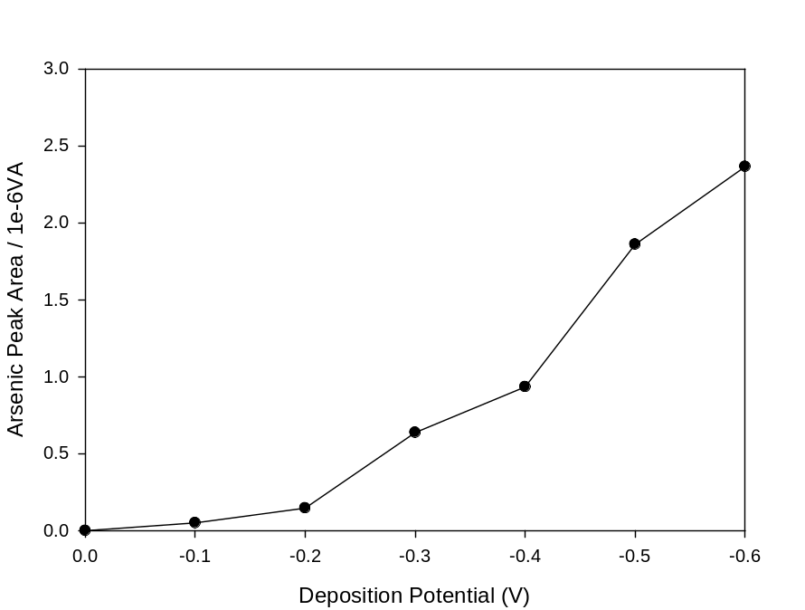
Fig. 4.1. Effect of the deposition potential on the arsenic stripping peak area. As(III) concentration was held constant at 100 µg L⁻¹.

4.3.1.2. Optimization of deposition time
The deposition time was varied from 60 s to 300 s. Under standard conditions of a 100 µg L⁻¹ As(III) and 100 µg L⁻¹ Cu(II) solution in 0.1 M hydrochloric acid with a deposition potential of -0.6 V, it is shown that no arsenic stripping peak is present until 30 s (Fig. 4.2). The peak increased with increasing deposition time until a plateau was achieved at 180 s. The optimal deposition time of 180s was chosen for subsequent ASV experiments.

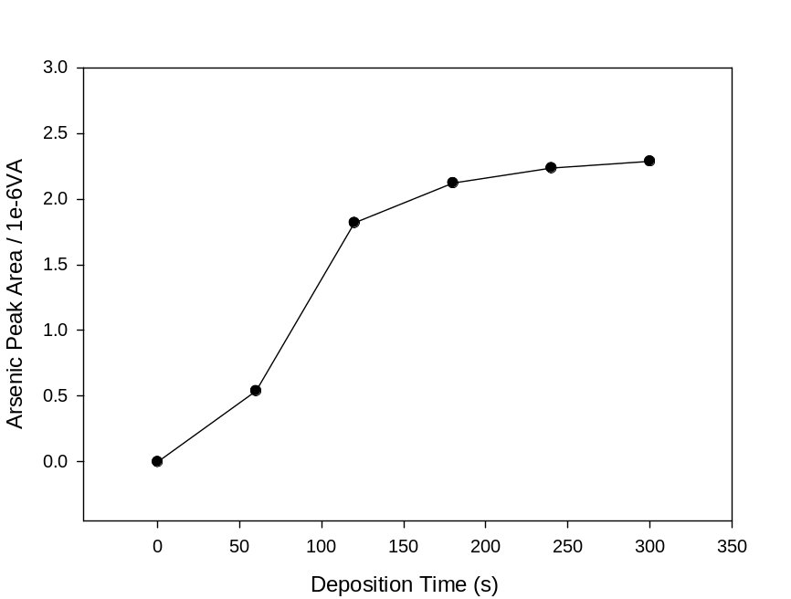

Fig. 4.2. Effect of the deposition time on peak area. As(III) concentration was held constant at 100 µg L⁻¹.

4.3.1.3. Optimization of Cu(II) concentration
The Cu(II) concentration was varied 0-100 µg L⁻¹. Under the standard conditions established above, it is shown that when no Cu(II) is present, there is no response in the form of an arsenic stripping peak (Fig. 4.3). With the addition of 10 µg L⁻¹ Cu(II), both a copper peak and an arsenic peak appear. As the Cu(II) concentration increases, both the arsenic peak and copper peak increase in concentration until a 1:1 ratio is achieved. After this ratio is reached, a new peak began to overlap with the arsenic stripping peak. This new peak is likely due to the formation of copper arsenide on the electrode surface and subsequent stripping [35]. For this reason it is important that the copper be carefully regulated in this system. Samples may need to be pre-treated if they contain high levels of copper by using an ion exchange resin as demonstrated by Zakharova et al. [23]. The optimal Cu(II) concentration for the range of arsenic concentrations analyzed in this work was found to be 50 µg L⁻¹.

[Cu] (
μ
g L⁻¹)
0
20
40
60
80
100
120
0.0
0.5
1.0
1.5
2.0
2.5
3.0
As Peak Area / 1e-6 VA
Fig. 4.3. Effect of the concentration of Cu(II) on the arsenic peak.

4.3.1.4. Optimization of the electrolyte
Hydrochloric acid was the electrolyte of choice as it has been shown that the chloride ion may assist in the deposition of arsenic at the electrode surface [28]. The concentration of hydrochloric acid was varied from 0 to 0.5 M under standard conditions. It is shown that as the concentration of hydrochloric acid increases after 0.1 M there is a decrease in the arsenic stripping peak. This is attributed to the formation of hydrogen gas at the electrode surface due to the hydrogen overpotential. The optimum concentration of hydrochloric acid was 0.1 M and used in subsequent experiments (Fig. 4.4).

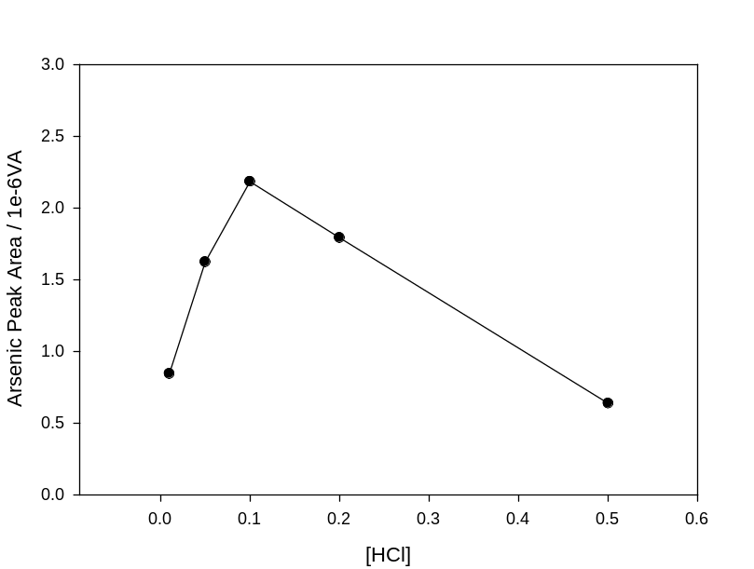
Fig. 4.4. Effect on the concentration of the supporting electrolyte on the arsenic peak.

4.3.2. Anodic stripping voltammetry (ASV) of As(III)
Standard addition was the chosen method for all calibration studies in this work so as to replicate the analysis of real samples. It is important to note that no data present was subject to background subtraction.
Utilizing the optimized parameters above, As(III) was analyzed in aqueous solution of 0.1 M HCl and 50 µg L⁻¹ Cu(II). The As(III) stripping peak was observed at -0.05 V while a copper stripping peak was observed at -0.15 V (Fig. 4.5). The mechanistic details of the As stripping peak is not clear and beyond the scope of this work. The experiments determining the limit of detection (3σ/n) and quantification (10σ/n) were conducted in triplicates over the concentration range of 50-150 µg L⁻¹ As(III) and was found to be 20.96 and 83.80 µg L⁻¹ respectively as shown in Fig. 4.6. Other analytical figures of merit investigated in all studies are reported in Table 4.1. The peak areas were determined using CHI software.

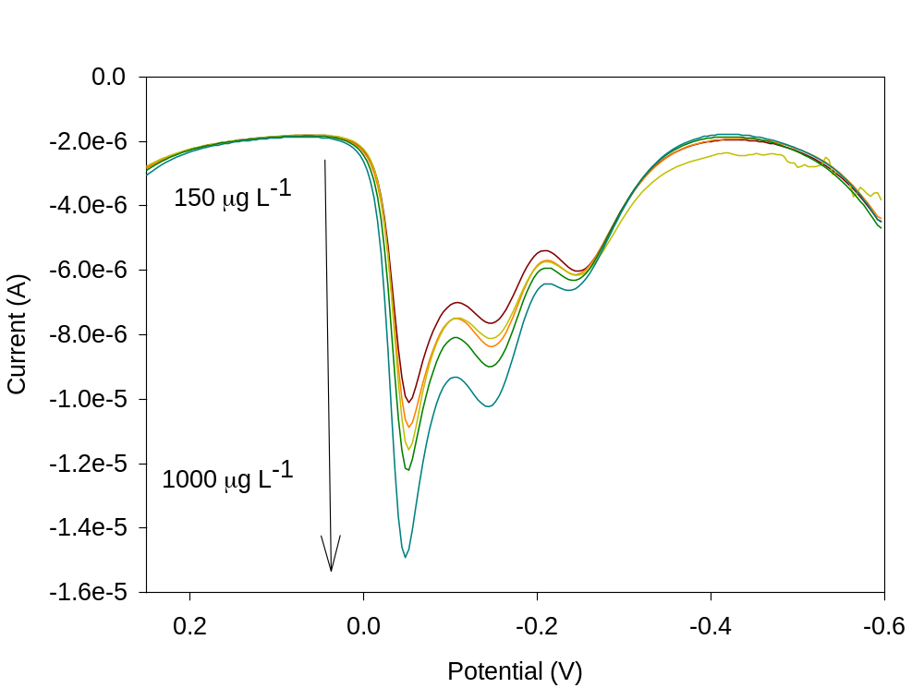

Fig. 4.5. Voltammogram of increasing concentrations of As(III) in the presence of 50 µg L⁻¹ Cu(II). The arsenic stripping peak is at -0.05 V while the more negative peaks are attributed to Cu(II).

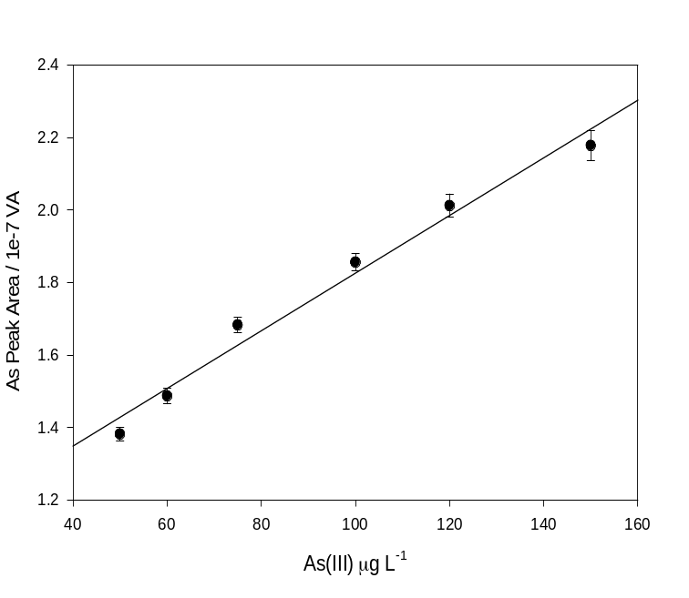

Fig. 4.6. Standard addition calibration of As(III) in triplicate over the range of 50-150 µg L⁻¹, the sample matrix contains 0.1 M HCl, 50 ppb Cu(II), and 1% L-cysteine.

Table 4.1. Selected analytical figures of merit
Analyte | Regression | R² | LOD (µg L⁻¹) | LOQ (µg L⁻¹)
As(III) | y = 7.9e-3x + 1.023 | 0.9854 | 20.96 | 83.80
As(V) | y = 1.53 e-2x + 0.349 | 0.9870 | 10.80 | 35.99
As(III), 1000 ppm caffeine | y = 9.2e-3x + 0.428 | 0.9837 | 22.30 | 74.35
As(III), 1000 ppm lactose | y = 7.02e-3x + 0.827 | 0.9914 | 16.41 | 54.7

4.3.3. Total arsenic detection

4.3.3.1. Reduction of As(V) to As(III)
In unknown samples the content of the inorganic arsenic may be present as both As(III) and As(V). In samples that have been treated by wet-ashing processes using strong oxidizing agents such as nitric acid or perchloric acid, the inorganic arsenic is most likely to be in the As(V) oxidation state [16]. Due to the inability of As(V) to electrochemically reduced, a chemical reducing agent must be used. As the selection of reducing agent has already been extensively studied, L-cysteine was chosen as the reducing agent [10,18]. The pre-reduction is achieved by the oxidation L-cysteine to the disulfide and the As(V) is reduced to As(III) (Scheme 4.1). The L-cysteine was added to solutions of As(V) so that the concentration was 1% m/v. The solution was allowed to stir for 30 minutes before analysis to ensure the complete reduction of As(V). Recoveries were determined by comparing the peak areas of the reduced As(V) solutions to those of prepared standard As(III) solutions. Both systems showed similar sensitivities and the average percent recovery was 95.2% for six concentrations of As(V) reduced by L-cysteine, which suggests a near full reduction to As(III) (Fig. 4.6).

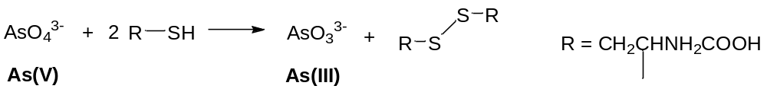

Scheme 4.1. Oxidation of L-cysteine resulting in the reduction of As(V) to As(III).

4.3.3.2. Detection of As(III) and total inorganic arsenic
The detection of total inorganic arsenic is made possible by dividing a sample into two aliquots and only reducing one of them with L-cysteine. The result is one sample that contains both As(III) and As(V) and another which contains As(III). In this work, a 50 mL sample was divided into two 20 mL aliquots (A and B) with the excess discarded. Aliquot A was analyzed without further workup resulting in the detection of the As(III) present in the system. Aliquot B was treated with 1% L-cysteine and stirred for 30 min which reduced all As(V) present to As(III), resulting in the detection of total inorganic arsenic. As aliquot A resulted in the concentration of As(III) present in the system, it was subtracted from aliquot B to give the concentration of As(V). A comparison between the analysis of pre-reduced As(V) and As(III) is shown in Fig. 4.7 with comparable results obtained for both samples. As the method is reliant on the complete reduction of As(V), systems with strong oxidizing agents may present challenges for analysis.

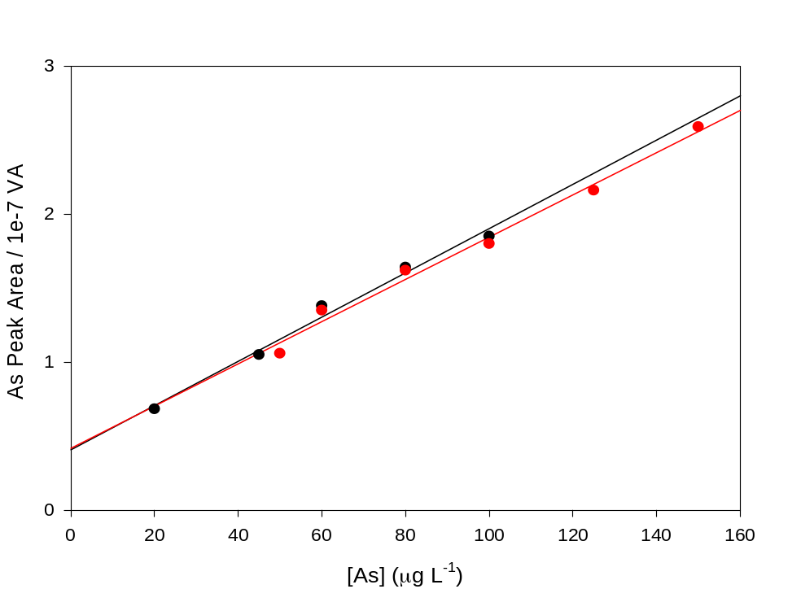

Fig. 4.7. Standard addition calibration of As(III) (black circles) and pre-reduced As(V) (red circles).

4.3.4. Interferences
A study was conducted to examine the interference of excess copper on the arsenic stripping peak. Holding the arsenic concentration constant at 100 µg L⁻¹, the concentration of copper in the system was steadily increased from the optimal 50 µg L⁻¹. As the ratio of copper to arsenic increased, the copper peak began to overlap with the arsenic peak making it difficult to differentiate the two. These results clearly show the need to maintain a low concentration of copper in real samples, the means of which is outside the scope of this work.
In addition, two organic substances, lactose and caffeine, were examined individually as two separate mimics of excipients and active pharmaceutical ingredients, respectively. Inorganic arsenic was separately analyzed in the presence of 1000 mg g⁻¹ of caffeine and lactose. These samples were prepared simply by dissolving the caffeine and lactose in water, no wet or dry ashing was performed for these samples. The most notable impact of these compounds was a voltage shift in the arsenic stripping peak from -0.05 V to +0.4 V. The cause of the shift in the voltage requires further study but may be due to a coordination between the arsenic and the organics. While there was a slight decrease in sensitivity exhibited by both compounds, a good limit of detection was still obtained for caffeine, 22.30 µg L⁻¹, and lactose, 16.41 µg L⁻¹. While this is not a conclusively representative sample of all pharmaceutical matrices, the method does show promise for the detection of inorganic arsenic in these systems.

4.4. Conclusions
The use of copper to enhance the sensitivity of arsenic detection at an unmodified glassy carbon electrode is found to have sensitivities that lead to detection limits in aqueous systems that would detect harmful levels of inorganic arsenic in aqueous systems. While not as sensitive as gold electrodes, there would be a considerable cost savings for the portable detection of arsenic in systems with low copper concentrations already present. The ability of this method to detect inorganic arsenic in dissolved organic matrices suggests the utility to analyze for analysis in real world water samples or certain dissolved water-soluble active pharmaceutical ingredients or excipients. While the detection limit in organic matrices is higher than presented in the USP guidelines, the detection of inorganic arsenic may be possible in higher concentrations of organic API and excipient concentrations resulting in the necessary limits of detection. Further work is needed to ensure that more complex drug matrices do not interfere with the detection presented in this work. In addition, future studies may show that it is feasible to simultaneously quantitatively detect multiple additional analytes of interest, such as cadmium, mercury, and lead.

References
[1] F. Cortes-salazar, S. Beggah, J. R. van der Meer, H. H. Girault, Electrochemical As(III) whole-cell based biochip sensor, Biosens. Bioelectron. 47 (2013) 237.
[2] D. Chakraborti, M. M. Rahman, K. Paul, U. K. Chowdhury, M. K. Sengupta, D. Lodh, C. R. Chanda, K. C. Saha, S. C. Mukherjee, Arsenic calamity in the Indian subcontinent: what lessons have been learned? Talanta, 58 (2002) 3.
[3] I. Celik, L. Gallicchio, K. Boyd, T. K. Lam, G. Matanoski, X. Tao, Arsenic in drinking water and lung cancer a systematic review, Environ. Res. 108 (2008) 48.
[4] A. Gomez-Caminero, P. Howe, M. Hughes, E. Kenyon, D. R. Lewis, M. Moore, J. Ng, A. Aitio, G. Becking, Environmental Health Criteria 224: Arsenic and Arsenic and Arsenic Compounds, World Health Organization, 2004. http://www.who.int/ipcs/publications/ehc/ehc_224/en/ accessed on May 27, 2017.
[5] B. Radke, L. Jewell, J. Namieśnik, Analysis of arsenic species in environmental samples, Crit. Rev. Anal. Chem. 42 (2012) 162.
[6] World Health Organization Arsenic Fact Sheet Nº372 revised 2001 http://www.who.int/mediacentre/factsheets/fs372/en/ accessed on May 27, 2017 [7] Elemental Impurities: Standards-Setting Record, USP, December 20, 2012, http://www.usp.org/sites/default/files/usp_pdf/EN/USPNF/2012-12-20_elemental_impurities_standards-setting_record-full.pdf accessed on May 27, 2017.
[8] <232> Elemental Impurities—Limits and <233> Elemental Impurities—Procedures, USP, http://www.usp.org/usp-nf/official-text/accelerated-revision-process/accelerated-revision-history/elemental-impurities-limits-and-elemental accessed on May 27, 2017.
[9] A. Liba, E. McCurdy, Proposed New USP General Chapters <232> and <233> for Elemental Impurities: The Application of ICP-MS for Pharmaceutical Analysis, https://www.agilent.com/cs/library/whitepaper/public/5990-9382EN_WhitePaper_ICP-MS_ICP-OES_Pharma.pdf accessed on May 27, 2017.
[10] Y. Feng, J. Cao, Simultaneous determination of arsenic(V) and arsenic(III) in water by inductively coupled plasma atomic emission spectrometry using reduction of arsenic(V) by L-cysteine and a small co-centric hydride generator without a gas-liquid separator, Anal. Chim. Acta 293 (1004) 211.
[11] T. D. Martin, C. A. Brockhoff, J.T. Creed, Method 200.7, Revision 4.4: Determination of metals and trace elements in water and wastes by inductively coupled plasma atomic emission spectroscopy, USEPA, 1994. https://www.epa.gov/sites/production/files/2015-08/documents/method_200-7_rev_4-4_1994.pdf accessed on May 27, 2017.
[12] K. A. Francesconi, D. Kuehnelt, Determination of arsenic species: A critical review of methods and applications 2000-2003, Analyst, 129 (2004) 373.
[13] A.J. Bard, L.R. Faulkner, Electrochemical Methods. Fundamentals and Applications, second edition, Wiley, New York, 2001, p. 458.
[14] R.G. Compton, C.E. Banks, Understanding Voltammetry, second edition, Imperial College Press, London, 2011.
[15] J. Wang, Analytical Electrochemistry, Wiley-VCH, New York, 2000, p. 86.
[16] G. Forsberg, J. W. O’Laughlin, R. Megargle, Determination of arsenic by anodic stripping voltammetry and differential pulse anodic stripping voltammetry, Anal. Chem. 47 (1975) 1586.
[17] Z.-G. Liu, X.-J. Huang, Voltammetric determination of inorganic arsenic, Trends Anal. Chem. 60 (2014) 25.
[18] J. Long, Y. Nagaosa, Determination of trace arsenic(III) by differential-pulse anodic stripping voltammetry within-situplated bismuth-film electrode, Int. J. Environ. Anal. Chem. 88 (2008) 51.
[19] J.H.T. Luong, E. Lam, K.B. Male, Recent advances in electrochemical detection of arsenic in drinking and ground waters, Anal. Methods, 6 (2014) 6157.
[20] D.E. Mays, A. Hussam, Voltammetric methods for determination and speciation of inorganic arsenic in the environment. A review, Anal. Chim. Acta, 646 (2009) 6.
[21] T. Ndlovu, B.B. Mamba, S. Sampath, R.W. Krause, O.A. Arotiba, Voltammetric detection of arsenic on a bismuth modified exfoliated graphite electrode, Electrochim. Acta, 128 (2014) 48.
[22] Y. Song, G.M. Swain, Total inorganic arsenic detection in real water samples using anodic stripping voltammetry and a gold-coated diamond thin-film electrode, Anal. Chim. Acta, 593 (2007) 7.
[23] E.A. Zakharova, G.N. Noskova, S.G. Antonova, A.S. Kabakaev, Speciation of arsenic(III) and arsenic(V) by manganese-mediated stripping voltammetry at gold microelectrode ensemble in neutral and basic medium, Int. J. Environ. Anal. Chem. 94 (2014) 1478.
[24] A. Salimi, Electrochemical detection of trace amount of arsenic(III) at glassy carbon electrode modified with cobalt oxide nanoparticles, Sens. Actuators, B, 129 (2008) 246.
[25] S.B. Rasul, A. K. M. Munir, Z. A. Hossain, A. H. Khan, M. Alaudddin, A. Hassam, Electrochemical measurement and speciation of inorganic arsenic in groundwater of Bangladesh, Talanta, 58 (2002) 33.
[26] M. Kopanica, L. Novotny, Determination of traces of arsenic(III) by anodic stripping voltammetry in solutions, natural waters and biological material, Anal. Chim. Acta, 368 (1998) 211.
[27] T. A. Ivandini, R. Sato, Y. Makide, A. Fujishima, Y. Einaga, Anodic stripping voltammetry of inorganic species of As³⁺ and As⁵⁺ at gold-modified boron doped diamond electrodes, J. Electroanal. Chem. 78 (2008)1286.
[28] A. O. Simm, C. E. Banks, R. G. Compton, The electrochemical detection of arsenic(III) at a silver electrode, Electroanalysis, 17 (2005) 1727.
[29] D.N. Chakraborti, R.; Irgolic, K. Determination of arsenite and arsenate by differential pulse polarography, Fres. Z. Anal. Chem, 319 (1984) 248.
[30] I. Mustafa, A. I. Kamenev, P. K. Agasyan, Study of electropositive analytical signal in arsenic(III)/copper(II) system by means of stripping voltammetry with vitreous carbon electrode, Zh. Anal. Khim. 40 (1985) 1483.
[31] T. A. Krapivkina, E. M. Roizenblat, V. V. Nosacheva, L. S. Zaretskii, V. S. Utenko, Determination of arsenic by stripping voltammetry on a graphite electrode, Zh. Anal. Khim. 29 (1974) 1818.
[32] A. I. Kamenev, A. B. Lyakhov, S. E. Orlov, Determination of arsenic(III) and copper(II) by stripping voltammetry in a mixed EDTA-phosphoric acid supporting electrolyte, J. Anal. Chem. 60 (2005) 156.
[33] E. Y. Neiman, G. B. Ponomarenko, Features of the determination of arsenic, selenium, and tellurium by inverse voltammetry (stripping analysis) on graphite electrodes, Zh. Anal. Khim. 30 (1975) 1132.
[34] I. Mustafa, A. I. Kamenev, P. K. Agasyan, Behavior of components of arsenic(III)/copper(II) system under conditions of stripping voltammetry with a vitreous carbon electrode, Zh. Anal. Khim. 40 (1985) 1475.
[35] T. Kuwabara, S. Suzuki, Determination of arsenic(III) by anodic stripping method using co-depostion with copper, Bull. Chem. Soc. Jpn. 46 (1973) 1690.

Part 5

Modification of a Gold Electrode for Chromium(VI) Detection by Cathodic Stripping Voltammetry

Abstract

Detection of chromium is of particular importance for biomedical and environmental applications. While Cr(III) is essential for mammals, Cr(VI) at its high oxidation state is toxic at relatively low levels. An ultra-sensitive technique has been employed to measure Cr(VI) in aqueous buffer solutions. A gold/gold nanoparticle (Au/AuNP) electrode has been developed as an alternative to traditional mercury-based electrodes for the detection of Cr(VI). An overcoated thiol sol-gel film derived from 3-mercaptopropyltrimethoxysilane (MPTMS) is formed on the surface of the gold electrode and serves as an anchor for a layer of AuNPs. This layer of AuNPs increases the electrochemically active surface area of the electrode. Subsequent functionalization of the secondary AuNPs by a thiol pyridinium and preconcentration of chromate improves both detection limit and linear range.

5.1. Introduction
Hexavalent chromium, Cr(VI) a strong oxidizing agent and known carcinogen, has been linked to environmental contaminations due to the wide use of chromium in industry [1–5]. There has also been a growing interest in highly sensitive and selective assays for trace level Cr(III) determination in biological samples, as it is a popular alternative treatment for diabetes [6]. Numerous sensitive techniques have been employed in the detection of trace levels of chromium. These include: atomic absorption spectrophotometry [7], inductively coupled plasma-mass spectrometry (ICP-MS) [8], spectrofluorimetry [9], spectrophotometry [10], and chemiluminescence [11]. These techniques, however, usually do not have the ng L⁻¹ level sensitivity that is needed for biological Cr detection. In addition, they require long, extensive pretreatment steps, or expensive instrumentation.
Electrochemical methods have demonstrated advantages in the detection of Cr(VI) including speed of analysis, good selectivity, and sensitivity [12–17]. A self-assembled monolayer of pyridinium on the Au electrode surface for sensitive Cr(VI) detection was developed earlier by Turyan and Mandler [18]. Mercury electrodes have also been used for the electrochemical detection of Cr(VI) [19,20]. The toxicity of mercury outweighs the sensitivity of the electrode. Bismuth-film electrodes (BiFEs) have been prepared for Cr(VI) detection through catalytic adsorption stripping voltammetry (CAdSV) as an alternative to the mercury electrodes [21,22]. However, BiFEs require extensive preparation and Cr(VI) detection by BIFEs is difficult to reproduce. It is thus highly desirable to develop a system that is not only sensitive, selective, and reliable but also simple, practical, and economical in its operation.
Gold nanoparticles have been studied extensively due to their attractive properties and potential applications over numerous science and medical fields [23–25]. AuNPs have been used in electrochemistry to develop highly sensitive devices for analytical and bioanalytical applications because of their excellent conducting capability, high surface-to-volume ratio and high surface energy. The amperometric detection of ultratrace amount of Cr(VI) has been developed based on AuNPs growing on a conducting substrate modified with sol-gel-derived thiol functionalized silicate network, but the detection limit was not low enough for Cr(VI) detection at the ng L⁻¹ level [34].
With the aim of developing a sensitive platform for voltammetric Cr(VI) detection without a complexing ligand, a layer of AuNPs have been introduced to design a pyridinium-functionalized self-assembly of AuNPs for sensitive detection of ultra-trace levels of Cr(VI). The chemisorption of a sol-gel coating derived from 3-mercaptopropyl-trimethoxysilane (MPTMS) provided an anchor for the layer of AuNPs. Chemically produced AuNPs were then deposited into the three dimensional (3D) sol-gel matrices by forming Au←S linkages, making a self-assembly of AuNPs. This leads to a significant increase in the active electrode surface by incorporating AuNPs onto the small gold electrode.
When positively charged pyridinium functional groups were attached to the AuNPs surface through Au←S bonds, trace, negatively charged chromate was accumulated on the electrode surface.

5.2. Materials and methods

5.2.1. Apparatus and materials
Electrochemical measurements were carried out on a modulated potentiostat (CHI 650a, CH Instruments). Gold electrodes (2 mm in diameter, CH Instruments) were polished before use, as described in Section 1.3.2. A three-electrode configuration consisted of a AuNPs self-assembled gold electrode, Ag/AgCl (saturated KCl solution, CH Instruments) and a platinum wire (CH Instruments) as working, reference and counter electrodes, respectively. The following chemicals were used as received: Cr(VI) standard solution (1000 mg L⁻¹, Fluka), Mercaptopropyl trimethoxysilane (Gelest), 4-pyridineethanethiol hydrochloride (PET, TCI-EP, Japan), chloroauric acid (HAuCl₄, 99.99%, Aldrich), trisodium citrate (Aldrich), NaF (Certified ACS, Fisher), KCl (Certified ACS, Mallinckrodt). Ultrapure water from a Millipore water purified system (≥18 MΩ•cm, Barnstead) was used in all assays. Other regents were of analytical grade and used as received. All glassware was soaked in 1 M nitric acid bath and thoroughly rinsed with deionized (DI) water before use. AuNP preparation was performed by the methods reported by Guo and Wang [26].

5.2.2. Fabrication of the pyridinium-functionalized AuNP electrode
Prior to use, the gold electrodes were carefully polished to a mirror-like surface on a standard electrode polishing kit (CH Instrument) consisting of three microcloth polishing pad with 1.0, 0.3, and 0.05 μm alumina slurry consecutively. After polishing, the gold electrodes were successively sonicated with deionized (DI) water, ethanol and DI water for 5 min each to remove any residual alumina particles. After being rinsed with acetone, ethanol and DI water, respectively, the gold electrodes were treated in a fresh piranha solution (H₂SO₄/H₂O₂ = 7:3) for 15 min to remove any organic material from the electrode surface and then rinsed again with DI water. The gold electrodes were then electrochemically polished running a CV from 0 V to +1.2 V in 0.5 M H₂SO₄. Next the electrodes were immersed in ethanol for 30 min to ensure a reduced gold surfaced was present. Finally, the electrode was kept under N₂ gas flow for subsequent use. This freshly polished gold surface acts as the anchor for binding to MPTMS in the next step.
MPTMS modification was carried out by soaking the electrode in a 50 mM solution of MPTMS in ethanol for 6 h. The MPTMS self-assembled on the surface of the electrode by forming Au←S bonds and, after hydrolysis of the sol-gel precursor, existed as a 3-D porous silicate network with thiol tail groups (-SH) [27]. The MPTMS-modified gold electrode was then immersed into a solution containing colloidal AuNPs for 24 hours to form a self-assembly of the AuNPs layer. The resulting electrode was then dipped into a 0.5 M H₂SO₄ solution containing10 mM of 4-pyridineethanethiol (PET) for 10 min to attach the pyridinium group to the electrode surface.

5.2.4. Measurement procedures
To carry out the voltammetric measurements for Cr(VI), the AuNPs self-assembled electrode was first put in 20 mL of 0.15 M fluoride buffered solution (pH 4.5) and stirred for 5 min under open-circuit potential. After the accumulation, the determination of Cr(VI) was carried out by transferring the electrode to a Cr(VI) free solution (0.15 M NaF, pH 7.8) and performing cathodic stripping square wave voltammetry (CSSWV) from +0.35 to -0.2 V with frequency of 15 Hz, step potential of 4 mV and amplitude of 25 mV. Stirring at a high speed was required to facilitate mass transport during the accumulation process but not during the stripping step. The electrode surface was regenerated between measurements by cycling the potential from +0.35 to -0.2 V in 0.1 M HClO₄ for the elimination of Cr(VI) from the electrode surface [28].

5.3. Results and discussion

5.3.1. AuNP preparation
Previous work on the synthesis and incorporation of AuNPs into the sol-gel of modified electrode has been reported. The fabrication of nanoparticles is accomplished through a series of steps; reduction, nucleation, and aggregation. The most common and perhaps simplest method of AuNP synthesis is the Turkevich method, in which hot chloroauric acid (HAuCl₄) is reacted with sodium citrate, a reducing agent. The Au³⁺ is reduced to Au⁺, which is then further reduced to Au⁰. The reduction of HAuCl₄ by citrate is shown in Scheme 5.1. The Au⁰ serves as nucleation sites where additional Au⁺ ions are reduced. Additional Au⁺ ions aggregate at the nucleation site until the electrostatic interactions from the citrate, acting as a capping agent, shifts the aggregation to a different nucleation site. Thus, the size of the nanoparticles can be influenced by the concentration of citrate relative to HAuCl₄, as it dictates the number of nucleation sites formed and serves as a capping agent.

Scheme 5.1. Reduction of HAuCl₄ by sodium citrate resulting in two Au⁰ nucleation sites.

This method typically involves bringing the solution of HAuCl₄ to a rapid boil while constantly stirring, adding the citrate solution, and refluxing overnight to ensure uniform size and shape of the nanoparticles. A color change from faint yellow to deep blue and then finally to a deep red-purple is indicative of the successful preparation of AuNPs with a diameter of ~15 nm. Recent reports indicate that simply mixing the HAuCl₄ and citrate in a small vial, followed by microwaving the mixture in 4 x 15 s intervals, allowing the vial to cool for ~10 s between sessions, achieves the same result as overnight reflux. Both methods were used in this work, and it is noted that the microwave method, in addition to being faster, produced more consistent results with less chance of the nanoparticles crashing out of solution as would occasionally happen in the reflux method overnight. A photo of the nanoparticles synthesized by this method is shown in Fig. 5.1. In comparing the two resultant nanoparticle solutions, they were similar in color and UV-Vis spectra, indicating similar size particles were produced.

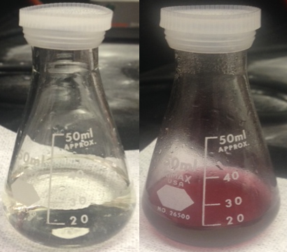

Fig. 5.1. Flask containing HAuCl₄ and sodium citrate before (left) and after (right) microwaving to induce AuNP formation.

5.3.2. Pyridinium-functionalized AuNP electrode
The fabrication process, starting with a bare gold electrode, is shown in Fig. 5.2. A photo of the electrode before and after modification is shown in Fig. 5.3.

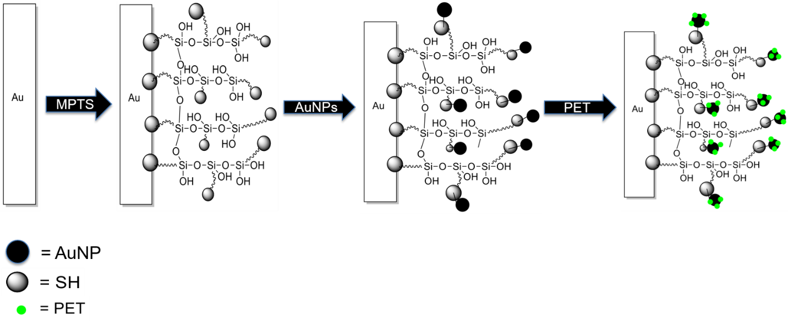

Fig. 5.2. Schematic illustration of the fabrication of the pyridinium-functionalized self-assembly of AuNPs on a gold electrode.

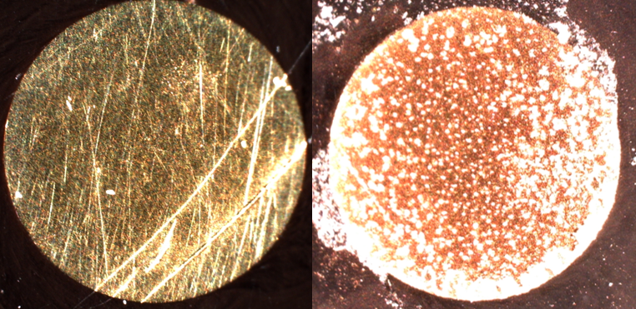
Fig. 5.3. Photos of a bare gold electrode (left) and a pyridyl functionalized gold electrode (right)

5.3.3. Analytical performance
The potential and current for the Cr(VI) reduction are dependent upon the modification of the electrode surface. The pyridinium-functionalized, AuNP-based electrode showcased a typical response for Cr(VI) reduction, presumably from Cr(VI) to Cr(III). The current response of the fabricated electrode towards Cr(VI) in the concentration range of 250–1,000 ng L⁻¹ is displayed in the voltammagram in Fig. 5.4.

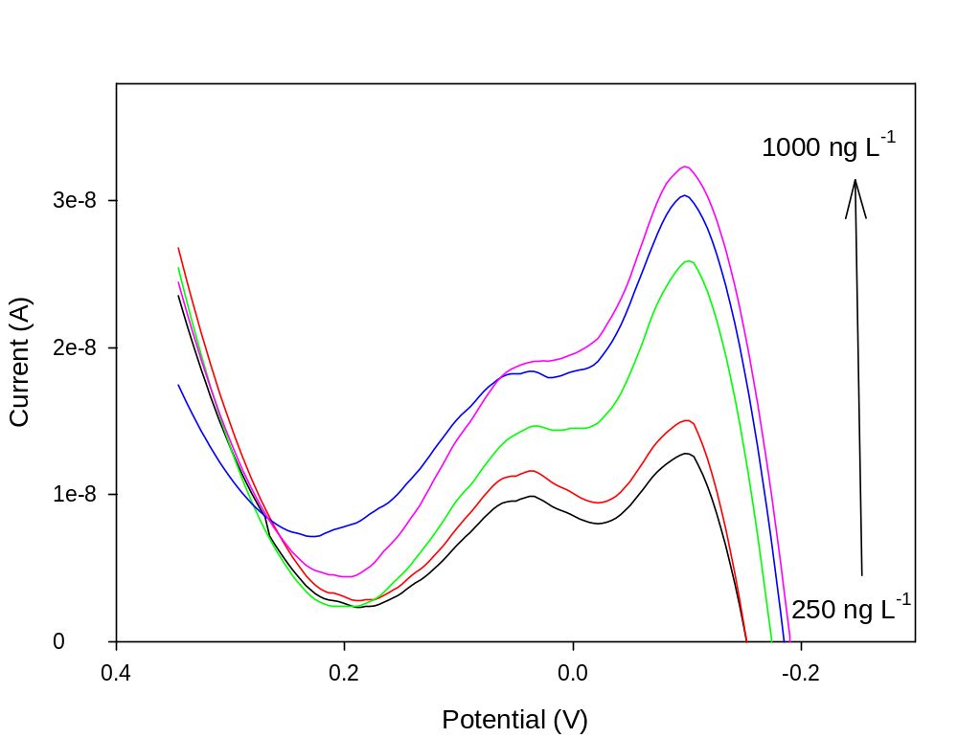
Fig. 5.4. Voltammogram of increasing concentrations of Cr(VI)

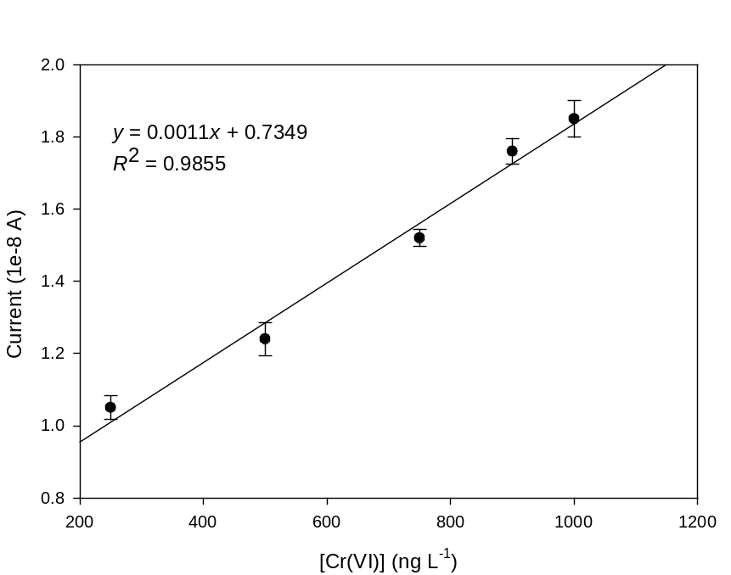
Fig. 5.5. External calibration curve of Cr(VI) in triplicate over the range of 250-1000 ng L⁻¹.

The electrode showed a voltammetric peak at ca. -0.06V and the peak current increased with the increasing concentrations of Cr(VI). The linear correlation (R² = 0.9855) between current and Cr(VI) concentration is shown in Fig. 5.5. The limit of detection (LoD, 3σ/n) and limit of quantification (LoQ, 10σ/n) for this electrode were found to be 93 and 310 ng L⁻¹, respectively.

5.3.4. Comparison to previous work
The work previously reported by Ouyang et al. utilized a similar electrode fabrication process to that reported here, but started with a bare glassy carbon electrode that was subsequently electroplated with a fresh gold surface [28]. The work reports an LoD of 2.9 ng L⁻¹ and a detection range of 25-1000 ng L⁻¹. While the work presented here does offer an alternative electrode surface and a robust detection capability, it is not as sensitive as the carbon electrode. This could be due to several factors, the first being the starting carbon electrode has a diameter of 3 mm while the gold electrode used in this work has a diameter of 2 mm. This results in a 2.5x decrease in surface area for which the sol-gel layer can grow. In addition, despite taking steps to ensure a reduced gold surface on the electrode, it is possible that some of the initial gold is present in oxidized state as the electrode is cleaned with strong oxidizing solution between experiments. This would result in further decreasing the active surface area of the electrode.

5.4. Conclusions
The fabrication of a AuNP-modified gold electrode has shown promise for the detection of Cr(VI) at trace levels. Functionalization by a thiol pyridinium allowed for the preconcentration and detection of Cr(VI). Cr(VI) was reduced at -0.06 V. The presence of the AuNPs and MPTMS sol-layer significantly increase the surface area of the gold electrode, allowing for the detection of trace Cr(VI) with a limit of detection of 93 ppb. The electrode shows promise for a strong linear response with a low detection limit comparable to bismuth-film electrodes (BiFEs) that require the use of a complexing ligand. Further work is required to determine the effects of the thickness of the MPTMS layer and the size of the AuNPs. Studies on the effects of various polishing techniques on the electrode surface can help improve reproducibility. The full analytical practicality of the electrode will be evaluated by measuring Cr(III) in a blood sample. This electrode has the potential to be used for many analytes by taking of advantage of functionalized n-alkyl thiols. Replacing the pyridinium thiol with a different selective functional group would allow for the preconcentration of additional analytes. While this electrode does not demonstrate the same sensitivity as some previously reported work, the simplification of the AuNP synthesis, the ease of electrode fabrication, and good analytical results despite a smaller starting surface area are worthy of note.

References
[1] R. Saha, R. Nandi, B. Saha, Sources and toxicity of hexavalent chromium, J. Coord. Chem. 64 (2011) 1782–1806. doi:10.1080/00958972.2011.583646.
[2] US Department of Labor, Health Effects of Hexavalent Chromium, OSHA Fact Sheet. 2014 (2006). https://www.osha.gov/OshDoc/data_General_Facts/hexavalent_chromium.pdf.
[3] J. Li, C. Yao, Y. Liu, D. Li, B. Zhou, W. Cai, The hazardous hexavalent chromium formed on trivalent chromium conversion coating: The origin, influence factors and control measures, J. Hazard. Mater. 221–222 (2012) 56–61. doi:10.1016/j.jhazmat.2012.04.004.
[4] A.L. Holmes, S.S. Wise, J.P. Wise, Carcinogenicity of hexavalent chromium, Indian J. Med. Res. 128 (2008) 353–372.
[5] A.S. Ellis, Chromium isotopes and the fate of hexavalent chromium in the environment, Science. 295 (2002) 2060–2062. doi:10.1126/science.1068368.
[6] R. A. Anderson, Chromium in the prevention and control of diabetes, Diabetes Metab. 26 (2000) 22–27. doi:MDOI-DM-03-2000-26-1-1262-3636-101019-ART67 [pii].
[7] H. Bag, A.R. Türker, M. Lale, A. Tunçeli, Separation and speciation of Cr(III) and Cr(VI) with Saccharomyces cerevisiae immobilized on sepiolite and determination of both species in water by FAAS, Talanta 51 (2000) 895–902. doi:10.1016/S0039-9140(99)00354-9.
[8] M. V. Balarama Krishna, K. Chandrasekaran, S. V. Rao, D. Karunasagar, J. Arunachalam, Speciation of Cr(III) and Cr(VI) in waters using immobilized moss and determination by ICP-MS and FAAS, Talanta 65 (2005) 135–143. doi:10.1016/j.talanta.2004.05.051.
[9] F.A. Santos, M. Idrees, M. Silva, P.H.E. de Lima, N. Bueno, F. Nome, et al., Cr(III) biosorption by forest wastes from Araucaria angustifolia and Pinus elliottii : biosorbent surface characterization and chromium quantification by spectrofluorimetry in micellar medium, Desalin. Water Treat. 51 (2013) 5617–5626. doi:10.1080/19443994.2012.758600.
[10] S. Matsuoka, Y. Nakatsu, K. Takehara, S. Saputro, K. Yoshimura, On-line electrochemical oxidation of Cr(III) for the determination of total Cr by flow injection-solid phase spectrophotometry, Anal. Sci. 22 (2006) 1519–24. doi:10.2116/analsci.22.1519.
[11] P. Miretzky, A.F. Cirelli, Cr(VI) and Cr(III) removal from aqueous solution by raw and modified lignocellulosic materials: A review, J. Hazard. Mater. 180 (2010) 1–19. doi:10.1016/j.jhazmat.2010.04.060.
[12] Y. Li, H. Xue, Determination of Cr(III) and Cr(VI) species in natural waters by catalytic cathodic stripping voltammetry, Anal. Chim. Acta 448 (2001) 121–134. doi:10.1016/S0003-2670(01)01314-9.
[13] V. Arancibia, E. Nagles, M. Gómez, C. Rojas, Speciation of Cr(VI) and Cr(III) in water samples by adsorptive stripping voltammetry in the presence of pyrogallol red applying a selective accumulation potential, Int. J. Electrochem. Sci. 7 (2012) 11444–11455.
[14] M. Korolczuk, A. Stpniowska, Determination of Cr(VI) in the presence of high excess of a Cr(III) by adsorptive stripping voltammetry, Talanta 88 (2012) 427–431. doi:10.1016/j.talanta.2011.11.012.
[15] A.M. O’Mahony, M.D. Scanlon, A. Berduque, V. Beni, D.W.M. Arrigan, E. Faggi, et al., Voltammetry of chromium(VI) at the liquid|liquid interface, Electrochem. Commun. 7 (2005) 976–982. doi:10.1016/j.elecom.2005.06.011.
[16] V.S. Protsenko, A.A. Kityk, F.I. Danilov, Voltammetry study of Cr(III)/Cr(II) system in aqueous methanesulfonate solutions, J. Electroanal. Chem. 661 (2011) 213–218. doi:10.1016/j.jelechem.2011.08.003.
[17] P. Lakshmipathiraj, G. Bhaskar Raju, M. Raviatul Basariya, S. Parvathy, S. Prabhakar, Removal of Cr(VI) by electrochemical reduction, Sep. Purif. Technol. 60 (2008) 96–102. doi:10.1016/j.seppur.2007.07.053.
[18] I. Turyan, D. Mandler, Selective determination of Cr(VI) by a self-assembled monolayer-based electrode. Anal. Chem. 69 (1997) 894–897. doi:10.1021/ac9607525.
[19] C. Elleouet, F. Quentel, C. Madec, Determination of trace amounts of chromium(VI) in water by electrochemical methods, Anal. Chim. Acta 257 (1992) 301–308. doi:10.1016/0003-2670(92)85183-7.
[20] A. Safavi, N. Maleki, H.R. Shahbaazi, Indirect determination of hexavalent chromium ion in complex matrices by adsorptive stripping voltammetry at a mercury electrode, Talanta 68 (2006) 1113–1119. doi:10.1016/j.talanta.2005.07.015.
[21] L. Lin, N.S. Lawrence, S. Thongngamdee, J. Wang, Y. Lin, Catalytic adsorptive stripping determination of trace chromium(VI) at the bismuth film electrode, Talanta 65 (2005) 144–148. doi:10.1016/j.talanta.2004.05.044.
[22] A. Bobrowski, B. Baś, J. Dominik, E. Niewiara, E. Szalińska, D. Vignati, et al., Chromium speciation study in polluted waters using catalytic adsorptive stripping voltammetry and tangential flow filtration, Talanta 63 (2004) 1003–1012. doi:10.1016/j.talanta.2004.01.004.
[23] K. Saha, S.S. Agasti, C. Kim, X. Li, V.M. Rotello, Gold nanoparticles in chemical and biological sensing, Chem. Rev. 112 (2012) 2739–2779. doi:10.1021/cr2001178.
[24] P. Ghosh, G. Han, M. De, C.K. Kim, V.M. Rotello, Gold nanoparticles in delivery applications, Adv. Drug Deliv. Rev. 60 (2008) 1307–1315. doi:10.1016/j.addr.2008.03.016.
[25] R. Sardar, A.M. Funston, P. Mulvaney, R.W. Murray, Gold nanoparticles: Past, present, and future, Langmuir 25 (2009) 13840–13851. doi:10.1021/la9019475.
[26] S. Guo, E. Wang, Synthesis and electrochemical applications of gold nanoparticles, Anal. Chim. Acta 598 (2007) 181–192. doi:10.1016/j.aca.2007.07.054.
[27] M.-C. Daniel, D. Astruc, Gold nanoparticles: assembly, supramolecular chemistry, quantum-size-related properties, and applications toward biology, catalysis, and nanotechnology, Chem. Rev. 104 (2004) 293–346. doi:10.1021/cr030698+.
[28] R. Ouyang, S.A. Bragg, J.Q. Chambers, Z.L. Xue, Flower-like self-assembly of gold nanoparticles for highly sensitive electrochemical detection of chromium(VI), Anal. Chim. Acta 722 (2012) 1–7. doi:10.1016/j.aca.2012.01.032.

Vita

Thomas S. Carpenter was born on June 30, 1989. In 2011 he received his bachelor’s degree in chemistry at Butler University in Indianapolis, Indiana. After graduating, he entered the chemistry Ph.D. program at UTK in August 2011, joining the Xue analytical lab in December later that year. Thomas’ research interests focus on the development of inexpensive, portable probes for the detection of analytes that may pose an environmental or health concern. He has published the following paper “Bismuth-Based, Disposable Sensor for the Detection of Hydrogen Sulfide Gas” in Anal. Chem. 2016, 88 (3), pp 1553–1558. In addition, he has presented a poster titled “Novel Method for the Detection of Arsenic at a Bare Glassy Carbon Electrode” at the 2015 Pittsburgh Conference and Exposition in New Orleans, LA.

