Whole Genome Sequencing as a Tool for Identifying Phenotypic Properties and Underlying Genetic Mechanisms in Staphylococcus pseudintermedius

A Dissertation Presented for the
Doctor of Philosophy
Degree
The University of Tennessee, Knoxville

Matthew C. Riley
December 2016

Copyright © 2016 by Matthew C Riley.
All rights reserved.

Dedication
Dedication.

Acknowledgements

Acknowledgements.

Abstract

Staphylococcus pseudintermedius is a Gram-positive bacterial opportunistic pathogen commonly associated with dermal infections in canines, but capable of causing serious disease in other species. Reports of human infections caused by S. pseudintermedius along with an increase in resistance to multiple antibiotics highlights the importance of this organism. Whole genome sequencing can allow large scale investigation of genetic mechanisms underlying phenotypic properties that contribute to the expansion of successful S. pseudintermedius clonal lineages.
The increase in multidrug and methicillin-resistant S. pseudintermedius (MRSP) may result from horizontal transfer of genetic material between bacterial isolates, yet is thought to be rare in Staphylococci and no antibiotic resistance plasmids have been identified in this organism. Due to conflicting reports of antibiotic resistance in clinical MRSP isolates, we hypothesized that genes encoding resistance are carried on mobile genetic elements known to encode variable degrees of resistance which are difficult to identify using standard molecular techniques. Whole genome sequencing was performed on six MRSP isolates, including 3 genomes that were completed and circularized using a combination of short reads, long molecule reads and optical genome maps.
A total of nine plasmids, six of which contain known antibiotic resistance genes, were identified from five genomes using a novel plasmid identification pipeline. Resistance to antibiotics was predicted from genes carried in each isolate, yet did not match susceptibility profiles generated using standard assays. Genes encoding resistance to chloramphenicol and gentamicin were located on mobile elements and displayed delayed resistance in in-vitro susceptibility tests. When cultured in these antibiotics and re-tested they displayed significant antibiotic resistance, suggesting standard assay testing time points may be too short to detect certain types of antibiotic resistance.
These findings suggest that horizontal transfer of clinically relevant genes is common in S. pseudintermedius, and that genome sequencing can be used to identify mobile genetic elements. Predicting phenotypes from underlying genome data can reveal potential for antibiotic resistance not identified using standardized assays.

Table of Contents

Dedication iii
Acknowledgements iv
Abstract v
Table of Contents vii
List of Tables ix
List of Figures x
Chapter One: Literature Review 1
Staphylococcus pseudintermedius is an Important Pathogen 1
Introduction 1
Speciation and Typing 3
Relevance to Human Medicine 4
Horizontal Transfer and Spread of Antibiotic Resistance 5
Advances in Whole Genome Sequencing 11
Introduction 11
Uses and Limitations of Whole Genome Sequencing Data 15
Summary and Hypotheses 17
Chapter Two: Genome sequencing of Staphylococcus pseudintermedius 21
Abstract 22
Introduction 23
Applications of Whole Genome Sequencing 23
Methodology 27
DNA Extraction and Library Preparation 27
Data Assembly and Analysis 28
Results and Discussion 34
Genome Sequencing 34
Resistance Gene and Phage Content 39
Plasmid Identification 50
Large Linear Plasmid in 06-3228 53
Chapter Three: comparison of Predicted antibiotic susceptibility genotypes with in vitro susceptibility test results 63
Abstract 64
Introduction 65
Materials and Methods 69
Standard Antibiotic Susceptibility Testing 69
In vitro Broth Dilution Testing of Antibiotic Resistance 71
Antibiotic Susceptibility Testing Following Growth in Antibiotic-containing Broth 73
Presence of Genes and Plasmids 74
Results 76
Observed Antibiotic Resistance 76
Presence of Genes and Plasmids 88
Discussion 92
Chapter Four: Results and Conclusions 103
Genome Sequencing as a Tool for Phenotypic Prediction 103
References 111
Appendices 127
Appendix A. Antibiograms. 128
VITA 163

List of Tables

Table 1. Properties of Major WGS Technologies in Bacterial Genome Sequencing. 12
Table 2. Antibiotic Susceptibilities of Isolates Selected for WGS. 25
Table 3. Genome Assembly Parameters. 29
Table 4. Genome Sequencing Statistics for All Isolates. 37
Table 5. ResFinder Results of Predicted Antibiotic Susceptibilities for Major Clonal Lineage Isolates. 40
Table 6. Average Depth of Coverage and Percent Reads for 08-1661 Select and Non-Select WGS Data. 44
Table 7. Phage Genome Content Summary as Detected by PHAST. 45
Table 8. Plasmids Predicted from WGS Data to Confer Antibiotic Resistance. 52
Table 9: Functional Annotations of Linear Element in 06-3228. 54
Table 10. Primers for Plasmid Amplification. 74
Table 11. Primers for Amplification of Individual Resistance Genes. 75
Table 12. Primers for Amplifying Targets in 06-3228 Linear Element. 75
Table 13. Primers and Probes for RT-PCR Assays. 76
Table 14. Resistance to Antibiotics in Growth Experiments and Re-Testing. 76
Table 15. Initial Susceptibility Testing, Genome Sequence Prediction, Media Growth and Re-Testing of 08-1661, 06-3228, NA12 and NA07. “NEG” refers to culture without antibiotics while “POS” refers to growth in antibiotics. 93
Table 16. Overview of All Sequenced Isolates. 103

List of Figures
Figure 1.Optical Images of DNA Molecules are Converted into Digital Representations. Source: Riley et al., 2011. 15
Figure 2eBURST Analysis of North American Collection of Staphylococcus pseudintermedius. (Manuscript in preparation). 25
Figure 3. The use of Optical Genome Maps as Genome Scaffolds. 30
Figure 4. In silico AflII Optical Maps Generated from Reference Genomes are Inaccurate for Spanning Contig Assembly Gaps. 31
Figure 5. Above Average Depth of Coverage Indicates Potential Plasmid Sequence. 33
Figure 6. Manual Investigation of Genome Sequencing Data for Identification of Plasmid Sequences. 34
Figure 7. Core and Accessory Predicted Coding Sequences among North American Staphylococcus pseudintermedius isolates. 36
Figure 8. Truncated ant(6)-Ia Gene Product in North American Isolates. 43
Figure 9. PanSeq Phylogenetic Tree of Core Genomes of 9 S. pseudintermedius Isolates. 47
Figure 10. Mauve Genome Alignment Reveals Alignment Gaps Caused by Prophage Insertions. 48
Figure 11. Read Mapping to Genetic Element in 06-3228 Reveals Sharp Decline in Coverage and No Overlapping Reads. 56
Figure 12. Circular Plasmid Content in Whole Genome Mapping. 57
Figure 13. High Copy Number Linear Element in 06-3228. 58
Figure 14. Molecule AflII Cut Pattern Matches in silico Pattern of Suspect Contig. 59
Figure 15. Agarose Gel Electrophoresis of 06-3228 and NA45 Plasmid DNA Extraction. 60
Figure 16. BLAST Alignment Between Reference TcaA Sequence and TcaA-like CDS from 06-3228. 61
Figure 17. Plasmid 08-1661B. 67
Figure 18. Vitek MICs and Disc Diffusion Results for Isolate NA45. 70
Figure 19. Example of Disc Diffusion Testing with 6mm Zone Size and 14mm Zone Size. 71
Figure 20. Selective Media Cultures of Isolate 08-1661 in 100µg/mL Chloramphenicol at 24, 48 and 72 Hours. 78
Figure 21. Isolate 08-1661 Grown in Chloramphenicol Displays Reduced Resistance to Gentamicin as Determined by Increased Zone Size in Disc Diffusion Assay. 79
Figure 22. Mueller-Hinton Plate of Direct Plating 08-1661 from Selective Media. 82
Figure 23. Mueller-Hinton Plate of Direct Plating 06-3228 from Selective Media. 83
Figure 24. Mueller-Hinton Plate of Direct Plating NA45 from Non-Selective Media. 84
Figure 25. Mueller-Hinton Plate of Direct Plating NA47 from Non-Selective Media. 85
Figure 26. Individual Sparse Large Colonies Observed on Mueller-Hinton Plates from Selective Cultures of 06-3228. 86
Figure 27. Colony Morphotypes of 06-3228 Colony Picked from Mueller-Hinton Plate Subcultured onto Non-Selective Agar. 87
Figure 28. Subculture of 06-3228 Lawn Picked from Mueller-Hinton Plate on Non-Selective Agar. 88
Figure 29. Amplification of 5 Genes Found on Linear Element in 06-3228. 89
Figure 30. 1Kb Extend DNA Ladder with 06-3228 LinA, 08-1661 tetK and 08-1661 CAT Amplicons. 90
Figure 31. Visualization of DNA using Whole DNA Precipitation. 91
Figure 32. Plasmids Amplified using Full Length Primer Sets. 91

LIST OF ABBREVIATIONS
1. MSSP
2. MRSP
3. SIG
4. CDC
5. CoPS
6. CoNS
7. MIC
8. DNA
9. WGS
10. NGS
11. ST
12. MLST
13. SCCmec
14. NA
15. WGM
16. RNA
17. MGE
18. MDR
19. PCR
20. RT-PCR
21. HGT

Chapter One:
Literature Review

Staphylococcus pseudintermedius is an Important Pathogen

Introduction
Staphylococcus pseudintermedius is a Gram-positive, coagulase-positive hemolytic bacterium commonly associated with opportunistic infections in canines (1, 2, 3). However, it has also been isolated from a variety of other species (4, 5, 6), most recently including humans (7, 8, 9, 10, 11, 12, 13, 8, 14). Of additional concern to both veterinary and human medicine is the increasing frequency of multidrug and methicillin-resistant clones (15, 16, 17, 18, 19), often associated with outbreaks (20, 21, 2). Both methicillin-susceptible S. pseudintermedius (MSSP) and methicillin-resistant S. pseudintermedius (MRSP) have been investigated using whole genome sequencing, but to date few studies have compared predicted antimicrobial genotypes with observed phenotypes.
S. pseudintermedius causes a variety of clinical signs in canines, particularly in dermal lesions (22,23,3). However, it is also associated with disease in bovine mastitis (5), rats (6), other animals and humans. S. pseudintermedius can remain viable on non-animate surfaces such as cell phones (24) and clothing worn by clinical personnel (25), as well as colonization and transfer in healthy animals (26, 27) and veterinary staff (28). Co-habitation of people with animals harboring MSSP or MRSP increases the risk of colonization of nasal passages of owners (30). There is evidence that co-treatment of household animals carrying MRSP may be necessary to resolve nasal carriage or infection of MRSP in humans (13). While treatment of MRSP often involves use of antibiotics, the rate of detection and isolation of methicillin-resistant S. pseudintermedius (MRSP) has increased in multiple countries (15, 31, 32, 16, 17, 18, 33, 34, 21, 35, 19), raising concerns about inappropriate use of antibiotics (3, 5, 12, 19) and potential difficulties in treating increasingly antibiotic-resistant infections (36, 37, 38, 39, 20, 40, 2).
Human infections caused by S. pseudintermedius have only recently been described (7, 11) and were originally thought to be relatively rare (7), but it is possible that difficulties in distinguishing between S. pseudintermedius and other common species of Staphylococcus, such as Staphylococcus aureus (41, 2), could underestimate the frequency of these infections in the human population (42, 14, 41, 8). S. pseudintermedius belongs to a group of coagulase-positive Staphylococcal pathogens commonly referred to as “SIG”, or Staphylococcus intermedius group pathogens (43). This is both a historical as well as biological categorization, as until 2005 S. pseudintermedius was not a distinct species (43, 3). S. intermedius and what became known as the SIG organisms were previously differentiated from S. aureus by lack of pigmentation and inability to produce acid from maltose (44, 43). However, when the S. intermedius species separation was proposed in 1976 it was noted that some biochemical reactions differed from isolate to isolate even within the S. intermedius species grouping (44). Several biochemical and genetic typing methods exist to identify MSSP and MRSP (45, 3, 43, 31, 41), however, no single method has been validated as completely accurate in both positively identifying all S. pseudintermedius while differentiating from other pathogens, including SIG organisms (46, 47).
Devriese et al proposed in 2005 separating what was then S. intermedius into two distinct species; S. intermedius and S. pseudintermedius (3). They justified this primarily based upon DNA-DNA hybridization differences as well as differential results to other Staphylococcal species like S. intermedius and S. delphini due to lack of or little maltose acid production and trehalose acidification (3). From a molecular standpoint, the 16s DNA sequence is>99% identical across the SIG pathogens (3), and debate exists over the most accurate and efficient biochemical and molecular typing methods (3, 46, 48, 46, 49). Species determination is a critical aspect of clinical treatment of infection as determining antibiotic resistance relies upon breakpoints (measurements at which isolates are determined to be clinically “resistant” to an antibiotic) that can be different between species and may complicate treatments of MRSP infections (42, 14, 50). The lowest concentrations of an antibiotic at which growth of bacteria is inhibited is defined as the minimum inhibitory concentration, or MIC. Wu et al, 2015 discovered that some standard testing for methicillin resistance in methicillin-resistant Staphylococcus aureus (MRSA) applied to S. pseudintermedius may miss resistant isolates (51). S. pseudintermedius and the other SIG pathogens may need species-specific MIC breakpoints for accurate determination of resistance (42). Newer technology such as matrix-assisted laser desorption ionization–time of flight (MALDI-TOF) may be a solution to better species-level identification, but it has already been demonstrated that MALDI-TOF cannot reliably distinguish S. pseudintermedius from S. intermedius (47).

Speciation and Typing
Sequencing 16s ribosomal DNA has become a relatively inexpensive and fast method for speciating bacteria (52; 53). However, the SIG pathogens have 16s sequences above 98% identity, making this method unreliable for speciation of these organisms. Many typing methods have been suggested but are often limited to the population of isolates used in each study (49, 14, 45, 46). Apart from speciation, attempting to assign relatedness of individual strains within a species such as S. pseudintermedius has been challenging. Multi-locus sequence typing, or MLST, is currently the best method for typing S. pseudintermedius and a 7-gene typing system has been adopted internationally to assign sequence types, or STs, to S. pseudintermedius isolates (31). MLST involves sequencing DNA fragments from multiple housekeeping genes (in this case seven genes) within a genome and using the combination of mutations, or alleles, to separate isolates into groups. Housekeeping genes are those thought to perform necessary metabolic or other required function for survival, that in theory are under purifying selection (54). This means that the genes and mutations chosen should reflect evolutionary relationships, but not take into account genes responsible for virulence, immune evasion, host adaptation or antibiotic resistance as these are generally under positive selection (55). While adequate for determining genetic evolutionary relatedness, MLST often doesn’t correlate to clinically relevant characteristics. Other genetic tests have been developed to screen for those attributes such as a PCR screen for the mecA gene responsible for resistance to methicillin (56) and the beta-lactamase resistance conferring gene BlaZ (57).

Relevance to Human Medicine
In human medicine, diagnostic laboratories often differentiate Gram-positive Staphylococci as either coagulase-positive Staphylococci (CoPS) or coagulase-negative Staphylococci (CoNS) (58). Gram-positive and coagulase-positive Staphylococci are often assumed to be S. aureus, resulting in antibiotic susceptibility testing being performed using S. aureus specific breakpoints (48). However, SIG organisms are also Gram- and coagulase-positive, and recent reports have suggested that many S. pseudintermedius have been misreported as S. aureus (7, 14). This can have an effect on assays that determine antibiotic resistance, potentially miscalling the resistance profile of individual isolates (42).
The first published case of S. pseudintermedius infection in humans was in 2006; a 60 year old immunosuppressed patient with a S. pseudintermedius heart infection (7). In 2010, an ST71 MRSP was found to be the cause of a human eye infection (59), with a similar report indicating S. intermedius that was likely a S. pseudintermedius (60). Riegel et al in 2011 reported an implant-associated endocarditis caused by S. pseudintermedius likely contracted as a result of contact with a dog (61). In 2013, a 60 year old male bone marrow transplant recipient was hospitalized due to purulent lesions discovered to be caused by MRSP, which may have been related to the patients close proximity to cows and farm dogs (11). A study conducted in 2015 on samples from dog bite wounds in humans re-examined bacterial isolates originally identified as S. aureus and discovered that 13 out of the original 101 isolates were in fact S. pseudintermedius (8). Researchers at the University of California in 2016 revealed that 4 cases of chronic rhinosinusitis, generally assumed to be caused by MSSA or MRSA, were associated with S. pseudintermedius that shared similar antibiotic resistance profiles with dogs the patients owned (13). Also in 2016, 24 cases of disease caused by S. pseudintermedius, commonly resistant to methicillin and multiple antibiotics, were reported by researchers and clinicians from Canada (62). Viau et al in 2015 concluded that not only is human infection caused by S. pseudintermedius frequently misidentified, but it is likely much more common than previously thought due to inaccuracies and regional differences in standard testing techniques (14). Human cases of both MSSP and MRSP may be underreported due to inaccurate diagnostic identification. If so, treatment of these potential cases may be affected by misidentification as antibiotic susceptibilities could be subsequently misinterpreted (42, 14).

Horizontal Transfer and Spread of Antibiotic Resistance
The discovery and spread of multi-drug resistance (MDR) in almost all common bacterial pathogens is a serious concern across all medical fields, prompting the government of the United States of America to create the Task Force for Combating Antibiotic-Resistant Bacteria (39) which ultimately released The National Action Plan for Combating Antibiotic-Resistant Bacteria in March 2015 (39). Among the objectives of this Plan are; strengthening the One Health Initiative and surveillance efforts (One Health being the effort to attain better health for people, animals and the environment (39)); develop new and innovative diagnostic tests; develop better capability to identify pathogens; routine testing for antibiotic susceptibility including zoonotic and animal pathogens and increased validation of antibiotic susceptibility diagnostic tests (40).
Understanding the spread of MDR is critical for any attempt to combat it. Traditionally, it is thought that a successful bacterial isolate that can adapt to its environment better than its peers (in this case acquisition of antibiotic resistance) will spread clonally and therefore increase overall occurrence of resistance, which has been observed with a dominant MDR S. pseudintermedius clone Sequence Type (ST) 71 in many parts of Europe (41). However, in the United States it appears as though multiple independent clones arise frequently and spread locally instead of one dominant clone being responsible for the majority of MDR infections across the country (42, 43).
Despite MRSP ST71 being a dominant clonal lineage in Europe, there are still many other MRSP clonal lineages both there and in other regions (44, 45). There are currently over 100 different S. pseudintermedius STs according to the pubmslt.org website (45), a database that provides information about many bacterial isolates with regard to their identity relative to different typing schemes, primarily MLST-7 (46, 47). Of all the S. pseudintermedius isolates in the database, 45.72% are MRSP (with 54.28% MSSP). With so many unrelated clones being methicillin and multidrug-resistant, the question arises as to how so many instances of antibiotic resistance occur independently. The most likely mechanisms are horizontal gene transfer (HGT) and mobile genetic elements (MGEs) (48).
Horizontal gene transfer is a generic term for the non-vertical movement of genetic elements between different organisms. In the case of S. pseudintermedius, it refers to the transfer of genes or genetic elements from one bacteria to another outside of normal cell division. As opposed to vertical gene transfer where a parent cell passes genetic material to its progeny, HGT occurs between clones that do not share an immediate ancestor, usually via recombination during conjugation (49). HGT can occur between different clones of the same bacterial species, different species and different kingdoms (50). One example of HGT is through a genetic construct termed a plasmid. Generally, plasmids are extrachromosomal, (relatively) small, (normally) circular and (often) capable of replication independent of the chromosome of its host, in addition to being capable of transferring between hosts (51). While thought to move relatively infrequently in Staphylococcal species (52), plasmids play an important role in gene acquisition for many bacterial species (53) and are a major contributor to the spread of antibiotic resistance (54).
Mobile genetic elements are the primarily responsible for movement of genetic material within an individual genome and/or cell, or between cells during recombination. In addition to plasmids, transposons are segments of DNA within a genome or extrachromosomal element that can be excised or duplicated to insert somewhere else in the genome (55). Transposons that contain genes for antibiotic resistance have been found to duplicate within a genome when exposed to the antibiotic, thereby increasing gene copy number and resistance to the antibiotic (56). In one case, this duplication led to a clinical treatment failure after initial susceptibility testing interpreted the isolated pathogen as susceptible but eventually developed resistance (32). In addition to increasing gene copy number through duplication, transposons sometimes replicate inefficiently or have ambiguous target insertion sequences, leading to mixed, truncated or new combinations of genes and regulatory elements that can give rise to new or increased antibiotic resistance which is then transferred to its progeny (47).
MGEs such as those described above are not limited to insertion within its originating host genome. Most clinically relevant plasmids and transposons duplicate and recombine/insert/transfer into a second genome during bacterial recombination, often through conjugation (56). In an early example of spreading antibiotic resistance, researchers investigating Streptococcus tetracycline resistance failed to identify known tetracycline resistance plasmids in some isolates (23, 24); ultimately, they discovered that a conjugative transposon was responsible (23) and that it was even capable of interspecies transfer (21). Transposons are also capable of integrating onto facilitative plasmids that exist extrachromosomally in the cell (22).
Plasmids come in many varieties, from those that transfer between cells during cell division (conjugative plasmids) and those that are mobilizable with the help of a conjugative plasmid co-located in the cell (54). Generally, plasmids are considered “dispensable” in that they lack genes essential to the survival of the cell and instead provide genes or functions that enhance growth or confer a new function altogether, such as antibiotic resistance. In Staphylococci, plasmids are thought to be clonally conserved and rarely move between species or even individual isolates within a species (55). This assumption is based upon both the lack of observed plasmids through traditional detection methods as well as the relatively high sequence identity of plasmids that have been found in unrelated Staphylococci (55). However, this could be an artifact of plasmid detection methods. A recent study using whole genome mapping discovered the presence of a previously undetected large plasmid in Providencia stuartii despite lack of evidence using other traditional methods such as pulse-field gel electrophoresis (PFGE) (63). Identification of plasmids from genome sequencing data is thought to be difficult with no currently published methodology. This is due to the fact that many genome assemblies of bacteria are incomplete, with many unplaced and fragmented assemblies. Identifying an extrachromosomal element among a sea of independent DNA sequence assemblies is not possible when the reads comprising the plasmid cannot be ruled out as part of the main chromosome.
When they are found, plasmids are often identified using searches for gene sequence identity to known plasmid sequences. As one example of a common plasmid-seeking method, Lüthje et al. (64) used detection of a known plasmid gene which confers resistance to lincosamides to screen additional isolates via polymerase chain reaction (PCR). Isolates positive for the gene were then amplified and identified using traditional primer-walking or sequencing of cloned fragments (64). One reason why we may think plasmids are rare or lineage-associated in Staphylococci (and other bacteria) is that current detection methods are unlikely to reveal novel or low copy number plasmids. PCR detection of a plasmid relies upon a known gene with limited natural variation of the primer sequences. This ensures that novel or highly variable plasmids are not likely to be found, potentially underrepresenting overall plasmid carry rates. As the sequence of the gene must be very similar to the sequence used to search, it is likely that plasmids found using that sequence are also conserved across the rest of the plasmid, ensuring that they all seem highly phylogenetically related and thus infrequently transferred. Detecting novel plasmid sequences or combinations of plasmid sequences/genes without prior knowledge is certainly challenging, but as most genome sequencing amplifies all DNA in the cell unambiguously, novel plasmid sequences should be represented in the data. As plasmids are often found at higher copy numbers in individual cells than the main chromosome, plasmids may represent higher read copy numbers from whole genome sequencing (WGS) data than genes located intrachromosomally and identified using this characteristic.
Bacteriophage (and subsequently prophage) are a type of virus that infects bacterial cells and can technically represent both HGT and MGEs (56). When a bacteriophage infects a bacterium, it can follow two different life cycles. Virulent phages integrate themselves into the host genome, replicate using host machinery (and potentially their own) and eventually lyse the infected cell. Temperate phages are capable of a lytic cycle but also a lysogenic cycle where they incorporate themselves into the host chromosome yet remain dormant without lysing the cell, passing on to daughter cells during replication and division. Bacteriophage that are located on the chromosome can replicate themselves and transfer horizontally (67), which in addition to the normal viral life cycle represents a significant mechanism for the movement of genes between bacteria (68). Lysogenic phage often carry a variety of genes not necessary for their own life cycle, but are indirectly beneficial by providing their host with increased survivability (69). Antibiotic resistance (70) and genes encoding virulence factors (71) are commonly associated with phage content in Staphylococci (72), and the benefit these genes carried by the phage provide can increase survivability of the host and lead to expansion of the infected strain. A particular phage, known as Phage Mu, has even been shown to confer host adaptation to human infection of animal-associated pathogens (45, 78).
The idea that MGEs such as plasmids, bacteriophage and transposons are infrequently transferred and are thus mostly lineage-associated in Staphylococcus has been challenged by at least one recent study, which differed from many MGE investigations in that it sought to determine the rate of transfer of MGEs in vivo in guinea pigs (4). McCarthy et al. in 2014 used gnotobiotic piglets combined with WGS to detect in vivo transfer of transposons, plasmids and prophage from two Staphylococcus aureus strains of human origin. Interestingly, one of the strains used, S0385, was isolated from a human infection but was the first CC398 isolated to have its full genome sequenced and annotated (65) and represents a clonal lineage commonly associated with porcine origin; thus, the study also implicated transfer of MGE between animal and human pathogens. Each S. aureus strain had its own unique compliment of MGEs, comprising phage, a transposon and multiple plasmids. Gnotobiotic piglets were inoculated with both strains, swabbed at multiple time points and colonies sequenced using the Ion Torrent Personal Genome Machine (Ion PGM) to determine their natural rate of co-evolution as well as transfer of any of the previously identified MGEs between the two parent strains (4).
While the core genomes of the two strains over multiple days stayed relatively identical to the parent strains, loss, gain and transfer of MGEs was observed at the earliest time point screened- 4 hours. By day 2 of the experiment, one of the parent strain populations had arranged itself into 9 unique, individual compositions of MGEs, or “mobilomes”. Movement of the transposon was not observed for any of the progeny isolates throughout the experiment. These results suggest that plasmid mobilization occurs more frequently than movement of phage, and far more frequently than transposon movement in their in vivo environment. These same two S. aureus strains grown together in a liquid in vitro equivalent parallel experiment revealed that the majority of progeny retained the original mobilome of their parents, suggesting that some unique characteristic of in vivo growth contributes significantly to the movement of MGEs. Thus, the lack of observed movement of MGEs in a laboratory setting could be an artifact of the relatively few in vivo growth experiments investigating this phenomenon. (4)

Advances in Whole Genome Sequencing

Introduction
Whole Genome Sequencing (WGS) traditionally has been interchangeable with the term “next-generation sequencing” (NGS); however, with the advent of 2nd, 3rd and 4th generation technologies using new mechanisms or improved hardware this has fallen out of use (56). Genome sequencing is distinguished from “traditional” or “capillary” sequencing as it uses non-electrophoretic methods to sequence vast amounts of DNA in relatively short periods of time compared to standard capillary DNA sequencing (56, 57). The megabase or gigabase output of these technologies are so high compared to traditional sequencing that they are termed “genome-level” sequencing, as individual experiments can sequence so much DNA it is possible to represent the entire genomes of many organisms (76). Initially, the cost of this mass sequencing of simultaneous, multiple DNA fragments was prohibitively high for any but large consortiums or laboratories (34). However, over the last several years the cost of the technologies themselves as well as reagents have been significantly reduced as WGS has become ubiquitous across multiple disciplines of biology (23). Genome sequencing technology is being used for a wide variety of applications in addition to revealing the entire DNA composition of an organism; gene expression and transcriptome analysis (78), real-time clinical diagnostics (79), mass spectrometry protein identification (34), microbiome analysis (12) and cancer screening and detection (45).
Introduction to Sequencing Technologies
There are several WGS technologies currently available that have variable sequencing methodologies, costs and data output differences (Table 1). The two technologies primarily used in this work were the Illumina MiSeq (Illumina Inc., San Diego, CA) and Ion Torrent (Thermo Fisher Scientific, Inc, USA). Additionally, some isolates were sequenced using PacBio single-molecule real-time (SMRT) sequencing technology (Pacific Biosciences, Menlo Park, CA, USA) and had Whole Genome Maps made using the Argus system (Opgen, Inc, MD, USA).

Table 1. Properties of Major WGS Technologies in Bacterial Genome Sequencing.
Whole genome sequencing technologies evolve at a rapid pace. The Roche 454, the first of such technologies, is now defunct while the MinIon device is the newest generation capable of 100x the read length and >100x the output of the 454. The Ion Torrent produces single reads of >450bp whereas the MiSeq produces 2x300bp paired reads. PacBio sequencing is low quality and expensive but produces extremely long reads. Each technology produces high throughput DNA sequencing data yet can address different genome assembly failures.
Technology | Quality | Read Length | Read Type | Multiplex | Cost/genome
454* | high | 500-750 bp | Single | N/A | N/A
Ion Torrent | high | ~450 bp | Single | 12 to 24 | ~$550.00
MiSeq | high | ~300x2 bp | Paired End | up to 96 | ~$300.00^
PacBio | low** | 1Kb-20Kb | Long Read | unknown | ~$1000.00
MinIon | low | 5Kb-50Kb^^ | Long Read | unknown | unknown

The Illumina sequencing platform uses sequencing-by-synthesis (SBS) technology (66) to determine the order of individual base pairs as they are synthesized. Essentially, single-strand DNA fragments are linked to a flow cell surface through random oligonucleotides, with primers and polymerase added to fuel the synthesis of the second strand. The individual dNTPs are fluorescently labeled (dye) as well as having a 3’ reversible blocker which prevents additional base pairs from being added. Upon the addition of a base pair, the chip is imaged by a camera to capture the fluorescently-labeled bases, a deblocking step removes the 3’ blocker and dye and the next step repeats the first, eventually building an ordered DNA sequence. By doing this thousands to millions of places at the same time, massively parallel sequencing is achieved (66).
Ion Torrent technology uses a different type of SBS called ion semiconductor sequencing (67), in which hydrogen ions released during addition of base pairs to a growing DNA strand are measured by a detector that translates the electrical charges into their corresponding base additions (67). One major difference between the Illumina technology and Ion Torrent is that no cameras, optics or modified dNTPs are used; the added base is detected through a change in pH resulting from the release of the hydrogen ion using an ion-sensitive field-effect transistor (ISFET)(67).
Single molecule real time sequencing, or SMRT, is a real-time WGS method that has significantly longer output read lengths than other technologies (68). It works through the utilization of a device called a zero-mode waveguide, or ZMW (68). A ZMW is a photonic confinement structure that captures light wavelengths in a small enough area to detect single nucleotides incorporating into a DNA strand. Essentially, a DNA polymerase enzyme/DNA strand complex is attached to a ZMW in a confined area and flooded with fluorescently labeled dNTPs. It is considered real-time sequencing because as dNTPs are added naturally by the polymerase, the phosphate bridge attaching the dye is broken, releasing the dye and causing a change in the light wavelength detected by the ZMW- without the need to stop the enzymatic action of the polymerase. This technology has achieved extremely long read lengths of >20,000 base pairs (68).
Whole Genome Mapping (WGM), previously called optical genome mapping, was pioneered by Dr. David Schwartz at NYU, Madison in 1993 as an attempt to image individual DNA molecules cut with restriction enzymes for comparison with DNA sequencing results (69). DNA sequencing is actually not performed; instead, WGM is used as a scaffold for assembling WGS data to create far more accurate and closed genomes (70-72). In brief, extracted high molecular weight DNA (usually >150,000bp) is applied to a chip etched with nano-scale channels along with a fluid in order to flow the DNA molecules through the channel and “stretch” them out. Once electrostatically bound to the chip, restriction enzyme solutions are applied to cut the laid out DNA molecules at specific “cut sites”. This causes the DNA molecules to retract slightly, as if cutting a rubber band, while still being adhered to the chip surface. Last, a universal DNA fluorescing dye is added to illuminate the DNA fragments. A laser or ultra-high definition camera then images the positions of the DNA fragments in relation to each other; meaning that multiple DNA fragments from the same original molecule are measured and annotated with cut sites (71). The images are converted into digital representations (Figure 1, 72) and assembled in a process analogous to WGS assembly by matching cut patterns in the molecules against each other to produce a complete, ordered restriction map of the entire genome (72). These “optical maps” can be used to assist with assembly of WGS data, as artificial “optical maps” can be generated from sequencing contigs in vitro and aligned with the map to ensure proper placement and arrangement (70-72).

Figure 1.Optical Images of DNA Molecules are Converted into Digital Representations. Source: Riley et al., 2011.

Uses and Limitations of Whole Genome Sequencing Data
While access to genome sequencing technology has become more widespread and less costly despite significant advances in capability, there are still limitations that must be kept in mind depending on intended use. In the case of sequencing the genome of an individual bacterium, the first fact to take into account is that, for the vast majority of sequencing protocols, it is not a single cell being sequenced but several hundred to millions of generations of cells grown in a specific environment. DNA intended for WGS is extracted from either liquid media cell cultures or colonies of cells isolated and grown on media impregnated plates. While this ensures the extraction of the quantity and quality of DNA needed for sequencing, the artificial growth conditions as well as subsequent rounds of culture can influence genome content (73).
In addition to the influence of bacterial culture on genome content, assembly of WGS data is complicated by repetitive DNA sequences found throughout the genome (74). Prophage insertions and transposons represent a challenge for genome assembly that does not currently have a solution. While paired-end sequencing (Illumina) was introduced in an attempt to resolve small-scale repeats, recent studies have shown that paired-end reads can actually introduce errors, especially in genomes with high levels of repetitive elements (74). Considering the fact that many clinically relevant features of bacterial isolates, such as antibiotic resistance, are carried on MGEs (70; 75) (such as transposons or phage) that can be highly repetitive, misassembly or failed assembly of these elements can have profound effects on conclusions taken from WGS data.
Because sequenced genomes often contain unexpected genes and mutations that cannot be predicted, specific questions must be asked when pursuing WGS projects. Subsequent analysis of sequenced DNA can be used to help develop tests that can then be standardized. For example, observations of antibiotic resistance can be used to target genomes for sequencing, which when compared to related genomes may allow for identification of the genetic determinants of resistance (76). Once the sequence of a suspect gene is known, simple, PCR-based assays can be developed to screen additional isolates without the need for complete genome sequence (77). Thus, WGS can serve as a guideline for new assay development. This has been used to great extent with the development of microarrays, databases and repositories such as the Comprehensive Antibiotic Resistance Database (76-78, https://card.mcmaster.ca/).
Finally, inferring clinically relevant characteristics about bacterial isolates using WGS technology largely depends upon the correct annotation of assembled genome data. Functional annotation generally consists of comparing predicted coding sequences (CDS) against DNA and protein sequences that have already been assigned functional characteristics and have been made publically available such as those in GenBank (79, 80). There are significant variations in how different annotation pipelines operate, which leads to differences in assigned gene functions. Currently, the most cited annotation software for bacterial genomes with published Genome Announcement articles is the Rapid Annotation using Subsystem Technology server (81, RAST: http://rast.nmpdr.org/). Recently the National Center for Biotechnology Information, which hosts one of the largest international databases for biomedical and genomic information, has released the NCBI Prokaryote Genome Annotation Pipeline (http://www.ncbi.nlm.nih.gov/genome/annotation_prok) which produces output files directly compatible with submission guidelines for deposition of sequence data into publically available online databases (82).

Summary and Hypotheses
As genome sequencing technologies continue to reveal the complete underlying genetic background of microbial pathogens it will become easier to understand the relationships between genetic markers within a pathogen as well as between pathogens. Uncertainties in assembling and annotating whole genome sequence data necessitate asking directed scientific questions when undertaking WGS projects. Clinical, molecular and epidemiological data is routinely collected on clinical isolates of Staphylococcus pseudintermedius at the University of Tennessee College of Veterinary Medicine (UTCVM). Having this data available facilitates the generation of testable hypotheses that can be addressed using a variety of WGS technologies.
Understanding clonal expansion of successful S. pseudintermedius lineages assists in determining important virulence and growth factors. Currently, the MLST-7 typing system with eBURST analysis (83) is the best method for determining MRSP and MSSP clonal relationships. As this system utilizes mutations within seven housekeeping genes to determine relatedness, it should accurately reflect evolutionary divergence of the core, or required, gene set. Sequencing the entire genome of S. pseudintermedius isolates can reveal the entire core genome DNA and phylogenetic analysis using this data should mimic the MLST-7 relationships. Isolates from the same sequence type but isolated from separate geographic locations should have nearly identical core genomes, while isolates from the same region but of different Sequence Types should diverge from each other. These analyses use conserved DNA sequence and are unable to account for horizontally transferred genetic elements that often encode host adaptation genes, virulence factors and antibiotic resistance (4; 55; 84). As horizontally transferred mobile genetic elements (MGEs) require close proximity for movement between bacteria, it is hypothesized that their MGE content may group more geographically than along evolutionarily related lineages revealed by core genome analysis. Whereas whole genome sequencing strategies often have difficulty resolving these areas due to repetitive DNA structures (85), optical genome maps and long molecule sequencing may help assemble these areas (70).
Disagreements in antibiotic susceptibility profiles (ASPs) have been observed when isolates are tested using different methods. Antibiotic disc diffusion and automated testing using microbroth dilution via the Vitek system vary in their protocols and it is not unexpected that results can vary (86, 51, 87). For example, it has been observed that high-level resistance (HLR) to gentamicin is mediated by the aac(6’)-aph(2’’)-Ia gene (88), however a small number of Staphylococcus epidermidis isolates, which are closely related to S. pseudintermedius, can have this gene yet be determined susceptible to gentamicin using standard testing methods (89; 90). When these isolates were grown in the presence of gentamicin increased resistance was observed, suggesting that an unknown mechanism was responsible for an inducible resistance phenotype (89). As horizontally transferred genetic elements such as plasmids and phage can have variable gene copy number and expression (91), antibiotic resistance may be mediated by duplication of these genes within heterozygous cell populations. As genes found on plasmids have been known to increase antibiotic resistance by increasing plasmid copy number when exposed to selection or stress (92), it may be possible that variation in plasmid copy number per cell and not the greater population could influence phenotypic resistance.
Differences in antibiotic resistance observed for MRSP isolates using the two assays may be a result of mixed populations of bacteria with differing degrees of antibiotic resistance based upon gene copy number or regulation. Populations would differ in genomic content in order to provide the best fitness as a culture; those adapted for growth in selection may not be most efficient at non-selective growth. A major difference between the testing methods is the duration of time bacteria are exposed to antibiotics before a reading is taken. In disc diffusion, tests are read at 24 hours for this species while the Vitek instrument interprets results in as few as 4 hours. If isolates show resistance using disc diffusion but not in the shorter timeframe of microbroth dilution, it may reflect the inability of mixed cell populations to adapt quickly to the selective environment. These cultures should display increasing resistance if exposed to the antibiotic in question over longer periods of time as the small subset of highly resistant cells outcompetes less resistant cells in the population. Genome sequencing can reveal the underlying genetic components of antibiotic resistance such as the aac(6’)-aph(2’’)-Ia gene. Isolates with differences in testing results for resistance to gentamicin may contain this or other resistance genes; if so, extended growth in antibiotics will increase observed resistance. Re-testing isolates found able to grow in higher concentrations of antibiotics than initial testing would provide evidence for potential clinically relevant resistance. Therefore, isolates shown to have genotypes for resistance that are not reflected in their phenotypic testing are hypothesized to become resistant when allowed to adapt to a selective environment. This induced resistance should then be capable of detection using standard assays and reflect heterozygous cell populations.

Chapter Two:
Genome sequencing of Staphylococcus pseudintermedius

Abstract
Staphylococcus pseudintermedius is a pathogen of multiple host species with increasing frequencies of resistance to methicillin and multiple antibiotics. Understanding the spread of successful clones and transfer of antimicrobial resistance is important in disease prevention and treatment. Isolates collected across North America were characterized using standard biochemical and antimicrobial susceptibility testing in addition to genetic epidemiologic investigation. While informative, this information does not always provide a complete understanding of evolutionary relationships and horizontal transfer of genetic elements in this species. Particularly, few prophage and no plasmids have been found in this species to date, yet are known to contribute to overall antibiotic resistance and virulence in many bacterial species. While two genomes had been published at the start of this study, they represent methicillin-susceptible S. pseudintermedius (MSSP) and are not closely related to North American clonal lineages.
To better understand genotypes and representative phenotypes of North American methicillin-resistant S. pseudintermedius (MRSP) isolates, 30 MRSP and 6 MSSP were selected for whole genome sequencing. Isolates were selected representing dominant clonal lineages, isolates with conflicting antibiotic susceptibility profiles and unusual or unique lineages for comparative purposes. Whole genome sequencing was performed using four different technologies along with optical genome mapping to resolve the best genome assemblies possible. Genome data were analyzed for core genome relationships, genes contributing to antibiotic resistance and presence of horizontally transferred elements.
Complete, circular genomes were produced for 4 MRSP isolates and assemblies were produced averaging under 100 contigs for the remaining MSSP/MRSP. Out of 120,378 coding sequences predicted from genome content, 838 were found to have predicted contribution to resistance to antibiotics or disinfectants. More than 25 extrachromosomal plasmids were identified using a novel prediction pipeline and 20 intact or incomplete prophage were detected from the dominant clonal North American lineages. Core genome analysis upheld previous typing relationships, yet accessory genomes were found to be highly unique and almost entirely composed of horizontally transferred elements such as transposons and bacteriophage. Antibiotic resistance genes were found to reside on plasmids, prophage and transposons in addition to the core genome, and were not conserved within individual lineages.
This study is the first to report extrachromosomal plasmids in S. pseudintermedius and reveal that 10-20% of MRSP genomes are composed of non-lineage associated mobile genetic elements. Previous studies have suggested plasmids are rare and horizontal genetic elements such as plasmids and phage are conserved within lineages in the Genus Staphylococcus. This study suggests that horizontal transfer of mobile genetic elements is not only far more frequent than expected but also plays a role in antibiotic susceptibility that may bely phenotypic testing assays.

Introduction

Applications of Whole Genome Sequencing
Genome sequence data has become a valuable tool for biomedical research and clinical investigation. In 2014, Hasman et al published a method by which microbial pathogens can be detected and characterized directly from samples submitted to a clinical microbiology laboratory using WGS technology (93). Amazingly, not only were MLST and other traditional typing methods in agreement when comparing the shotgun metagenome samples to cultivated bacteria from the same samples, but predicted antibiotic susceptibilities matched for 17 of the 19 bacteria identified (93).
Prior to this study two S. pseudintermedius genomes were publically available; ED99 and HKU10-03 (94,95). While both of these strains were resistant to some antibiotics, they were not MRSP, were originally isolated outside of North America and are not typical of the major clonal lineages in circulation globally today. Thus, efforts to sequence MRSP genomes from currently circulating clonal lineages, particularly the most clinically problematic MRSPs, were undertaken. New WGS data from dominant MRSP types would provide in-depth epidemiological and molecular data to ascertain the mechanisms responsible for these successful pathogens.
Bacteria are routinely collected and characterized from both infections as well as for routine collection of North American S. pseudintermedius isolates. Biochemical analysis as well as molecular typing and antibiotic susceptibility profiling are conducted for studying molecular, phylogenetic and epidemiological characteristics of this organism to learn more about its success and spread, acquisition of multidrug resistance and qualitative risks to animals and humans (35, 45).
Two primary characteristics were considered in determining which bacterial genomes to sequence. First, a large-scale MLST-7 typing was carried out on a collection of hundreds of North American (NA) S. pseudintermedius isolates (34), followed by an eBURST analysis to determine genetic relatedness (65, 79). Based on the work of Videla et al, six isolates were identified belonging to dominant MRSP clonal lineages, or Sequence Types (STs), in North America and selected for genome sequencing to determine true genetic relatedness and gene content (Figure 2):
- 08-1661 belongs to ST71
- 06-3228 belongs to ST68
- NA45 belongs to ST84
- NA47 belongs to ST303
- NA12 belongs to ST64
- NA07 belongs to ST124

Figure 2eBURST Analysis of North American Collection of Staphylococcus pseudintermedius. (Manuscript in preparation).
Mutations in housekeeping genes identified using MLST-7 determine evolutionary relationships using the eBURST software. The three central points represent ST84, ST68 and ST71 and their expanded lineages. Respective representatives of these STs are NA45, 06-3228 and 08-1661 which were selected for genome sequencing.

Second, antibiotic susceptibility profiles (ASPs) were analyzed for these isolates to investigate similarities or differences that may exist in their resistances that could be related to their STs. While no pattern was observed linking ST to ASP, most of these isolates had unique ASPs. Interestingly, some isolates had discrepancies between disc diffusion and microbroth dilution interpretationssusceptibility results (S=susceptible, R=resistant) for specific antibiotics (Table 2). For these reasons these isolates were sequenced. Sequencing the genomes of these isolates allows for analysis of true divergence between genomes relative to MLST/eBURST and PFGE and reveals genetic elements responsible for their ASPs, resolving the discrepancies between their resistances via different testing methods. Isolates selected for additional sequencing were chosen due to biochemical abnormalities, unique ASPs, ambiguous speciation, comparative purposes or conflicting results between resistance to methicillin and mecA content (Appendix A).
Table 2. Antibiotic Susceptibilities of Isolates Selected for WGS.
Isolates 08-1661 and 06-3228 were selected for whole genome sequencing due to observed conflicting susceptibilities as reported by standard assays. NA12 and NA07 were additionally sequenced as they belong to clonal lineages with high levels of resistance to gentamicin and clindamycin.
Isolate | Antibiotic | Disc Diffusion | Vitek
08-1661 | Chloramphenicol | R | S
08-1661 | Gentamicin | I | S
08-1661 | Clindamycin | R | R
06-3228 | Chloramphenicol | S | S
06-3228 | Gentamicin | S/I | S
06-3228 | Clindamycin | R | R
NA12 | Chloramphenicol | S | S
NA12 | Gentamicin | S | S
NA12 | Clindamycin | S | S
NA07 | Chloramphenicol | S | S
NA07 | Gentamicin | S | S
NA07 | Clindamycin | R | R

Isolates 06-3228, 08-1661 and NA45 were manually assembled and curated for this project because they represent the top 3 dominant lineages of MRSP in the United States, and closed genomes were obtained in order to identify complete SCCmec elements as well as prophage, plasmid and transposon content. Isolate 08-1661 was sequenced a third time after exposure to chloramphenicol, an antibiotic it was previously determined to be resistant to via disc diffusion yet susceptible in microbroth dilution assays (Appendix A: Antibiograms; Table 2), to determine any effects the exposure may have on the underlying genetic elements responsible for resistance.

Methodology

DNA Extraction and Library Preparation

All µL isolates sequenced during the course of this study using Ion Torrent or Illumina MiSeq technologies were grown in TSB overnight at 37°C and harvested during log phase growth. The Epicentre® MasterPure Gram Positive DNA extraction Kit (CAT #: MGP04100, www.epibio.com) manufacturer’s protocol was followed, with modifications (Appendix B: Modified Protocols). Briefly, 2mL overnight growth was centrifuged at 6000g for 6 minutes and suspended in TE buffer. Lysis was performed using 2x the recommended amount (2uL per sample) of Ready-Lyse Lysozyme (CAT #: R1802M, epibio.com) with addition of 2µL lysostaphin (CAT #: L7386-1MG, sigmaaldrich.com). Samples were incubated at 37°C for 3 hours before addition of lysis solution and twice the recommended (2uL) Proteinase K (kit components). Samples were incubated at 70°C for 15 minutes, cooled to 37°C and transferred to ice. 200µL of MPC reagent was added and gentle tube inversion used to mix the sample, on ice, before centrifuging at 10000g for 10 minutes. 2µL RNAse A was added to each sample and incubated for 30 minutes at 37°C. DNA was precipitated from the solution by addition of 650µL ice-cold 99% isopropanol and tube inversion until white DNA precipitate was observed. The solution is centrifuged again at 10000g and 4°C and supernatant discarded, the remaining precipitate was washed with 70% ethanol on ice. Upon removal of excess ethanol through an additional centrifugation (short spin) and micropipette, DNA was eluted using 200µL sterile, DNA and RNA-free water. Samples were stored at -20°C until needed.
Library preparation for Ion Torrent sequencing was performed by Ellen Messenger using the Ion Torrent Library Prep Kit (CAT #: E6285S, NEB) per manufacturers protocol. Sequencing on the Illumina MiSeq was performed using either the Nextera XT DNA Library Prep Kit (CAT #: FC-131-1024, Illumina.com) and Index Kit (CAT #: FC-131-1001, Illumina.com), or the Qiagen FX DNA Library Kit (CAT #: 180473). As the Illumina manufacturers protocol was designed for doing 24 or 96 samples in a plate, the protocol was modified and a custom protocol developed (Appendix B: Modified Protocols) to optimize both individual tube sample processing as well as to minimize use of AMPure Magnetic Beads (CAT #: A63880, beckmancoulter.com). DNA extractions were diluted to 1ng using sterile water and tested for purity using a fluorimeter prior to input into the Nextera modified protocol. DNA input concentrations up to 10ng were also used, with no discernable difference in library output. Samples prepared with the Qiagen kit were completed according to manufacturer’s protocol (https://www.qiagen.com/us/resources/download.aspx?id=6f298961-8e3d-4235-b5b1-5a3a3394dbb0&lang=en).
Additionally, Whole Genome Optical Maps (Opgen, Inc., MD) were generated for isolates 06-3228, 08-1661, and NA45 and PacBio SMRT long-read sequencing (Pacific Biosciences, CA) was performed on 06-3228 and NA45.

Data Assembly and Analysis
Data from Ion Torrent and MiSeq technologies were analyzed, filtered and used for de novo as well as reference genome read-mapping using the bioinformatics software Geneious® v.9.1.3. Reference genomes included the MRSP ST71 isolate E140, MSSP isolate ED99 and MSSP isolate HKU10. PacBio reads were assembled using the beta-test long-read molecule assembly software in CLC Genomics Workbench v.9.0. Contigs from CLC were imported into Geneious for combined assembly with Ion Torrent and MiSeq data. Multiple assembly pipelines and parameters were optimized for this organism and used to generate de novo assemblies (Table 3) for each genome. The default assembly software in Geneious® performed the best giving the highest number of large contigs and estimated genome coverage for almost all assemblies. For this species, all software used for assembly utilized between 250,000-550,000 maximum number of reads per sample for optimal contig creation.

Table 3. Genome Assembly Parameters.
Whole genome data was analyzed using multiple software packages and assembly algorithms. The software Geneious with its specific assembler produced the best de novo assemblies using these parameters for read trimming and extraction, contig assembly and consensus contig generation. Individual parameters were optimized through multiple rounds of manual investigation and assembly; all assemblies were produced de novo without the use of reference sequences.

Optical maps were used to scaffold consensus sequencing contigs with in silico AflII cut sites for strains 06-3228, 08-1661, NA45, NA12, E140, NA47 and NA07 (Figure 3). Using the published genomes of HKU and ED99 as scaffolds for read mapping was useful in placing contigs in order, yet were not used directly to map reads to generate consensus contigs as they would often introduce incorrect errors relative to de novo contig assemblies (Figure 4).

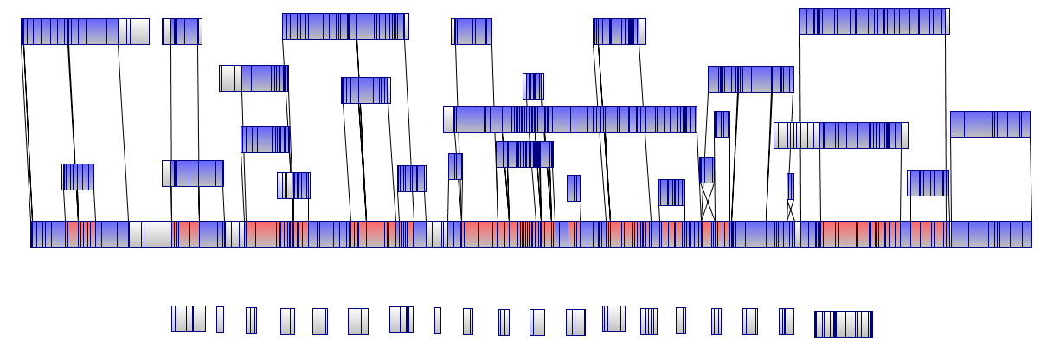
Figure 3. The use of Optical Genome Maps as Genome Scaffolds.
Optical genome maps were generated by imaging DNA molecules digested with a known restriction enzyme resulting in a digital representation of the whole genome with correctly ordered AflII cut sites. De novo genome sequencing contigs were artificially cut in silico and cut patterns of individual contigs were aligned against the optical map to determine correct placement and orientation. These maps along with PacBio long read technology were used to generate complete, circular genomes for 4 MRSP isolates.

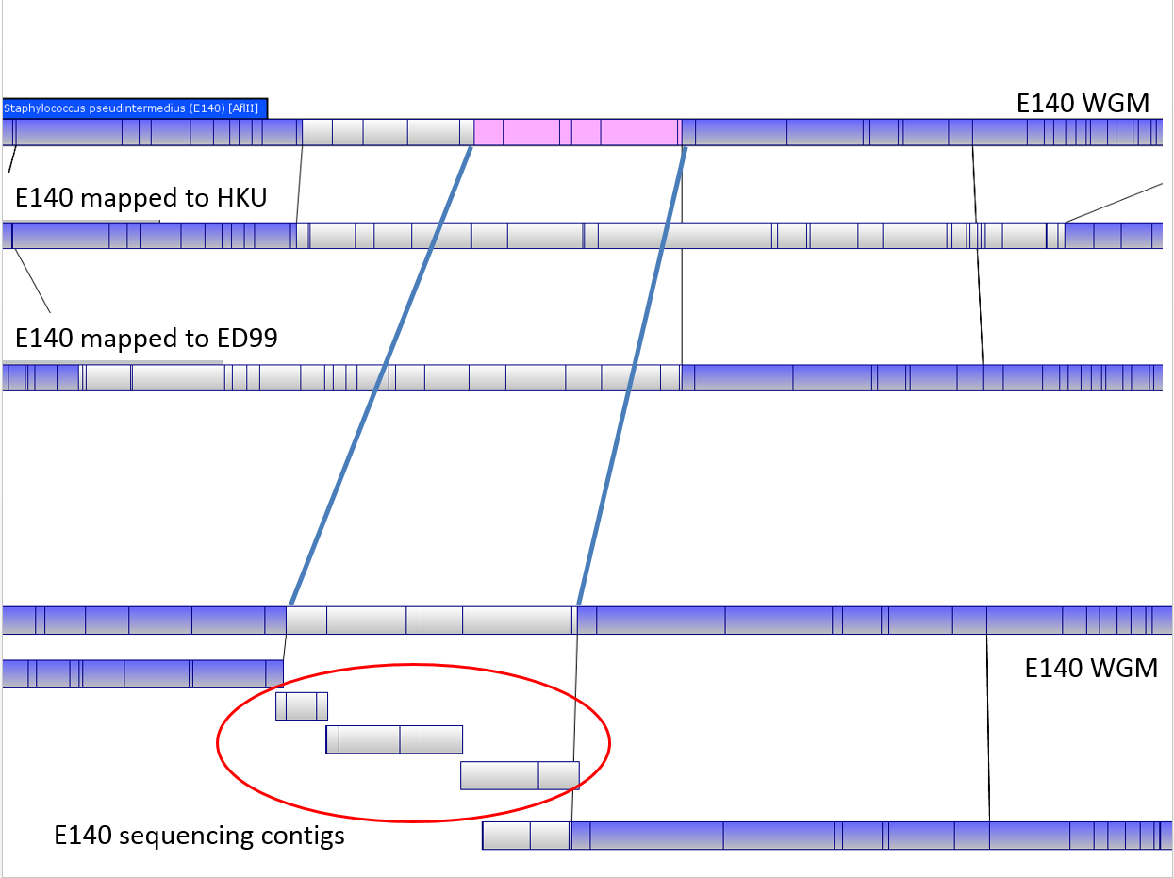
Figure 4. In silico AflII Optical Maps Generated from Reference Genomes are Inaccurate for Spanning Contig Assembly Gaps.
Read mapping to previously sequenced reference genomes was avoided during assembly as it often could not resolve or misrepresented gaps in de novo assemblies. In assembling the E140 genome, small sequencing contigs with AflII cut patterns matching patterns in the true optical map were able to span a gap between two larger contigs. This area would not have been accurately assembled if either the HKU or ED99 reference genomes had been used, as seen by their unique cut patterns for that region.

Long Sequencing reads from Pacific Biosciences sequencing were assembled into consensus contigs and used as references for mapping MiSeq paired end sequencing reads for contig correction and increased accuracy and compared to de novo contigs from MiSeq read assemblies. Large (~5000-10,000bp) errors were occasionally observed between PacBio de novo contigs and MiSeq de novo contigs. In these cases, comparison to the optical maps demonstrated that the MiSeq de novo contigs matched most closely and therefore those contigs were used for final assembly and gap closure. Upon manual assembly investigation it was observed that during the PacBio short-read correction step in the CLC Workbench assembly pipeline, short reads spanning into large repeats such as RNA operons or prophage insertions were often misplaced at the 3’ or 5’ end yet used to “correct” the long read erroneously. Thus use of the MiSeq de novo contigs to correct erroneous PacBio contigs produced the most accurate assembly. Using the optical genome maps, the genomes of 08-1661, 06-3228 and NA45 were closed with no observed gaps in circular arrangements, with small areas of sequencing disagreement represented as ambiguities but without affecting the overall assembly.
Contigs or closed genomes were annotated using the RAST server (http://rast.nmpdr.org/) and/or the NCBI Prokaryote Genome Annotation Pipeline (http://www.ncbi.nlm.nih.gov/genome/annotation_prok). Annotated genomes were imported back into Geneious® in Genbank format for comparative genomic and content analysis. Specific genes of interest were manually investigated using protein domain and orthologous sequence searches. Resfinder (80) and the CARD database (96) were used to predict antibiotic resistances, MAUVE (97) was used for direct genomic content comparison, EDGAR (98) was used to perform core genome analysis and phylogenetic comparisons, and PHAST (99) was utilized to identify active and inactive prophage insertions.
Small extrachromosomal elements (such as plasmids) were identified from sequencing data using two methods. First, small (<6000bp) contigs that had read depth coverage significantly higher than that of the draft genome average were analyzed (Figure 5), and manually investigated using a self-BLAST to see if they had reverse compliment terminal regions that could circularize the contig. If so, the contig was manually trimmed and circularized at these areas, and read mapping was performed to show continuous reads in a circular arrangement around the potential plasmid. This workflow is summarized in Figure 6.

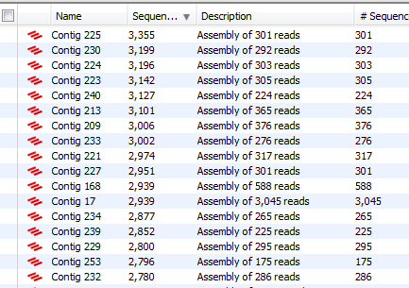
Figure 5. Above Average Depth of Coverage Indicates Potential Plasmid Sequence.
Contigs assembled de novo from WGS reads of approximately the same length should be comprised of similar numbers of reads. Occasionally, contigs with abnormally high read coverage were observed, indicating higher original copy number of these sequences relative to the genome average.

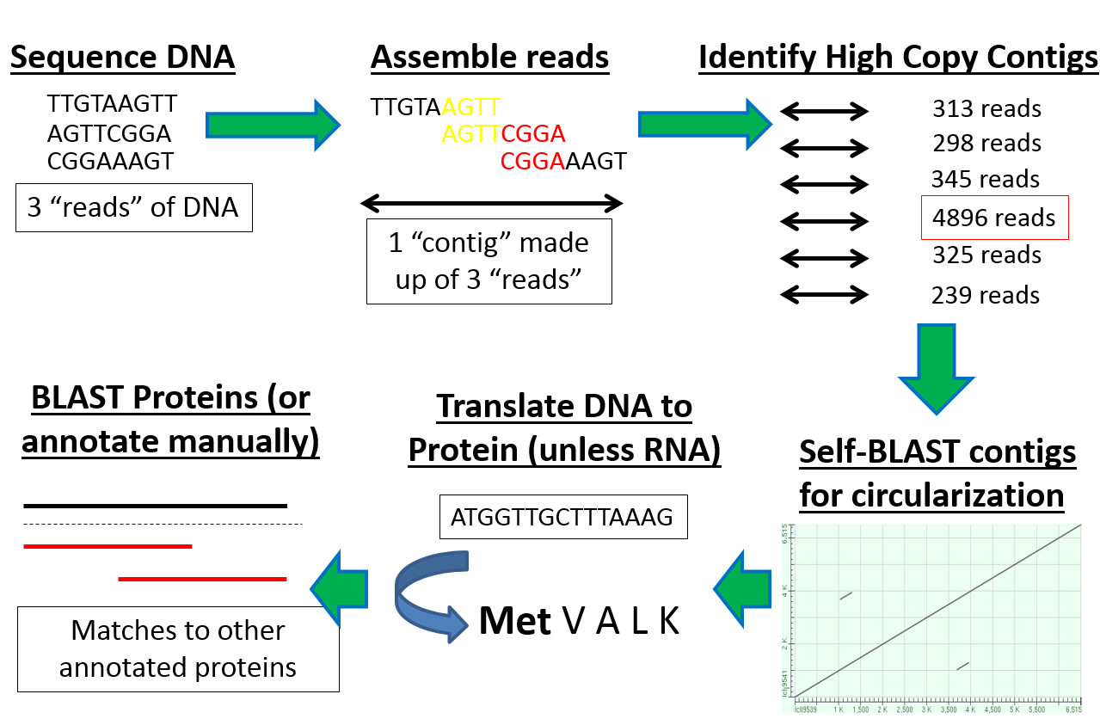
Figure 6. Manual Investigation of Genome Sequencing Data for Identification of Plasmid Sequences.
A workflow was developed to rapidly identify potential extrachromosomal plasmids from raw WGS data utilizing the concept that plasmids are often found in higher copy number per cell than the main chromosome. Genome assemblies were screened for higher than average depth of coverage for contigs of a given size. Successful circularization of high read number contigs was indicative of plasmids, which were analyzed for gene content and function.

Consensus contigs identified as potential extrachromosomal elements were iteratively mapped with the original sequencing reads to confirm either independent circularization or genomic integration.

Results and Discussion

Genome Sequencing
Library preparations were inspected for fragment sizing and quantified on the Agilent Bioanalyzer (CAT #: G2940CA). Results are shown in Appendix C: WGS Library Quantification and Fragment Size Analysis. In summary, libraries prepared with the Illumina kit had average fragment size range between 300bp and 600bp, whereas the Qiagen libraries were generally between 600bp and 1000bp. Interestingly, final sequencing data did not seem affected by this variation as de novo assemblies produced similar results across all isolates. Likely this is due to the lack of using paired-end assemblies, as pairing the reads from the MiSeq runs consistently produced inferior contig assemblies than using them unpaired which has been observed previously (64). Almost all isolates sequenced, regardless of technology used, resulted in initial de novo genome assemblies of less than 250 contigs (Table 4). Using the major clonal lineage genomes for North America minus the European-associated ST71 08-1661, a Venn diagram of shared predicted coding sequences estimates the core genome for S. pseudintermedius from North America to be roughly 2,111 CDS with anywhere from 110 to 436 unique accessory genes (Figure 7.)
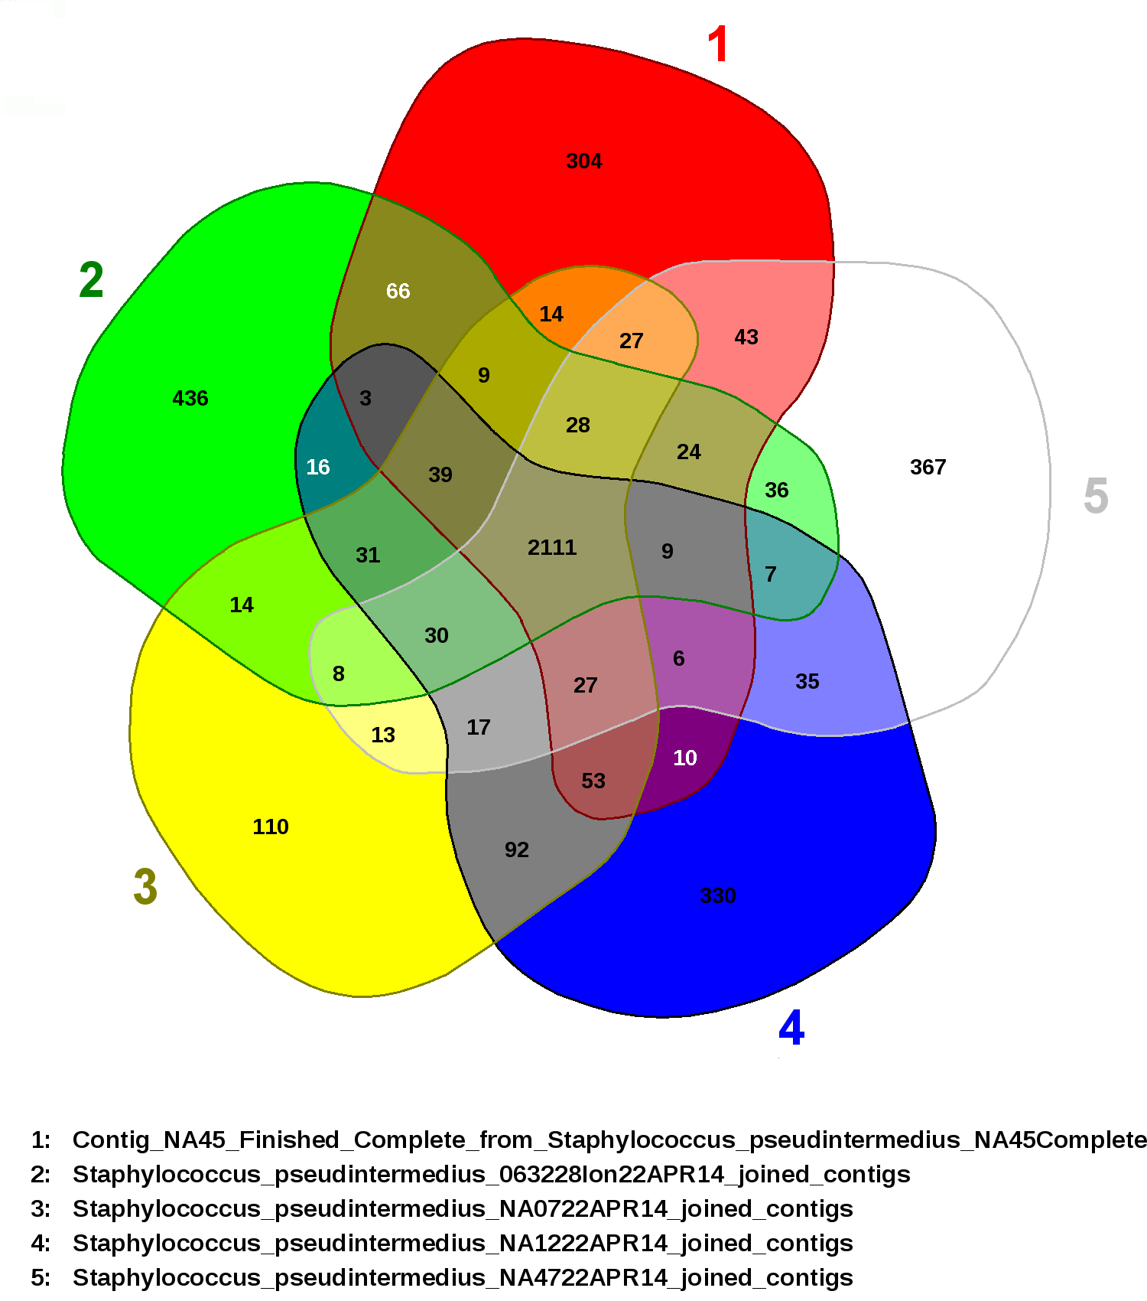
Figure 7. Core and Accessory Predicted Coding Sequences among North American Staphylococcus pseudintermedius isolates.
Coding sequences for 5 representative MRSP isolates were compared using genome-wide BLAST with matches >65% homology. Each colored region represents the entire complement of coding sequences for one genome; overlapping colors represent coding sequences shared between those genomes. The 2111 coding sequences in the center of the Venn diagram therefore represent the core genome shared by all S. pseudintermedius isolates included in the study. The outer single colors show the number of unique genes in each genome.

Isolates 08-1661, 06-3228, NA45, NA07, NA12 and NA47 were investigated in detail as they represent major clonal lineages in North America. To acquire the complete closed genomes for isolates NA45, 08-1661 and 06-3228, the following data were obtained in addition to optical genome maps; the total number of high quality reads for strain NA45 were 29,463 (PacBio), 583,182 (Illumina), 279,674 (Roche) and 4,660,374 (Ion Torrent) resulting in >250-fold overall coverage. The NA45 genome is 2,841,212bp with a 37.3% GC content, 2665 predicted coding sequences and 78 predicted RNAs. High quality reads for strain 08-1661 were 456,358 (Illumina), 129,593 (Roche) and 2,578,704 (Ion Torrent) resulting in >250-fold overall coverage. The 08-1661 genome is 2,731,109bp with a 37.5% GC content, 2610 predicted coding sequences and 87 predicted RNAs. High quality reads for strain 06-3228 were 24,585 (PacBio), 15,886,636 (Illumina), 113,288 (Roche) and 3,864,512 (Ion Torrent) resulting in >250-fold overall coverage. The 06-3228 genome is 2,766,566bp with a 37.4% GC content, 2734 predicted coding sequences and 77 predicted RNAs. Sequencing results for all strains are listed in Table 4.

Table 4. Genome Sequencing Statistics for All Isolates.
Clinical isolates representing dominant clonal lineages of S. pseudintermedius in North America were sequenced to investigate their antibiotic resistance and genetic relatedness. Additional MRSP isolates as well as the S. pseudintermedius type strain were sequenced for comparative purposes, and two isolates similar to S. pseudintermedius yet of undetermined species were sequenced for identification. All but 2 genomes were able to be assembled into less than 250 contigs, with all genomes estimated to have near complete length and CDS content. A total of 120,378 coding sequences were predicted and 838 were found to be associated with resistance to antimicrobials.
Strain ID | Contigs | Length | GC Content (%) | CDS | RNAs
E140 | 1 | 2,769,612 | 37.4 | 2750 | 88
NA45 | 1 | 2,841,212 | 37.3 | 2811 | 76
06_3228 | 1 | 2,766,566 | 37.4 | 2734 | 77
08_1661 | 1 | 2,731,109 | 37.5 | 2640 | 88
NA47 | 160 | 2,610,992 | 37.5 | 2786 | 87
NA07 | 89 | 2,641,987 | 37.3 | 2625 | 83
NA12 | 260 | 2,727,222 | 37.2 | 2817 | 107
LMG22219 | 54 | 2,532,112 | 37.7 | 2367 | 87
ATCC49171/  DSM20771 | 96 | 2,912,067 | 37.4 | 2691 | 86
NCTC11048/  ATCC29663 | 42 | 2,842,653 | 37.4 | 2737 | 81
E15 | 112 | 2,746,849 | 37.5 | 2486 | 98
Wood46 | 44 | 2,824,597 | 32.8 | 2664 | 75
MI 13-1718c | 54 | 2,694,682 | 37.4 | 2570 | 70
06-1066A | 43 | 2,747,982 | 37.3 | 2654 | 76
06-1066B | 50 | 2,752,197 | 37.3 | 2655 | 74
MI 14-243 | 39 | 2,528,901 | 37.6 | 2346 | 78
NA157 | 43 | 2,726,976 | 37.3 | 2598 | 76
MI 14-3285 | 10 | 1,232,915 | 26.5 | 1175 | 39
NA91 | 24 | 2,709,785 | 37.4 | 2613 | 74
NA16 Pre | 41 | 2,774,474 | 37.4 | 2658 | 81
NA16 Post | 55 | 2,815,620 | 37.4 | 2737 | 75
117N | 51 | 2,506,760 | 37.7 | 2323 | 83
111N | 20 | 2,492,699 | 37.7 | 2306 | 71
104N | 18 | 2,627,934 | 37.5 | 2483 | 73
NA189 | 275 | 2,870,341 | 37.6 | 2976 | 91
NA63 | 39 | 2,625,282 | 37.4 | 2462 | 81
NA77 | 77 | 2,526,388 | 37.8 | 2369 | 76
NA104 | 22 | 2,598,667 | 37.5 | 2435 | 80
NA3 | 93 | 2,887,757 | 37.1 | 2805 | 76
NA36 | 37 | 2,779,784 | 37.3 | 2663 | 79
NA38 | 39 | 2,626,861 | 37.4 | 2479 | 75
NA179 | 34 | 2,648,782 | 37.4 | 2474 | 82
NA180 | 37 | 2,534,249 | 37.6 | 2354 | 77
NA184 | 50 | 2,604,494 | 37.5 | 2453 | 76
NA149 | 36 | 2,590,820 | 37.5 | 2439 | 75
NA144 | 75 | 2,689,443 | 37.5 | 2606 | 81
NA125 | 52 | 2,643,586 | 37.3 | 2517 | 77
NA109 | 53 | 2,559,916 | 37.6 | 2406 | 80
MI 16-2909a | 19 | 2,484,103 | 37.7 | 2294 | 73
MI 16-2925a | 24 | 2,537,562 | 37.6 | 2356 | 72
P27B | 46 | 2,724,944 | 38 | 2551 | 82
P50 | 52 | 2,696,881 | 37.9 | 2545 | 93
MI 16-1129A | 51 | 2,727,320 | 37.8 | 2582 | 88
52-006A | 46 | 2,635,079 | 38.3 | 2416 | 89
56-021A | 24 | 2,735,112 | 38.1 | 2558 | 83
B1549 | 99 | 2,765,460 | 37.2 | 3542 | 67
B1553 | 65 | 2,841,072 | 37.2 | 2870 | 84

Resistance Gene and Phage Content
The 08-1661 genome shared 99% identity across 96% coverage of the published ST71 European isolate E140, with the major differences resulting from prophage composition (32). All major ST isolate genomes contained the methicillin resistance gene mecA and the beta-lactamase gene blaZ, as well as non-identical versions of the aminoglycoside resistance gene aac(6’)-aph(2’’)-Ia, with the exception of NA45. Isolates 08-1661, 06-3228 and NA45 contain the aminoglycoside resistance genes aph(3’)-III and ant(6)-Ia. Interestingly, while the CARD database identifies these two genes as functionally providing resistance to the aminoglycoside antibiotics generally and two papers provided as references suggest resistance to the class in general (100, 101), several studies have shown that aph(3’)-III encodes specific resistance to kanamycin (and others but not gentamicin) while ant(6)-Ia encodes resistance to streptomycin alone (102, 88). An extensive literature review concluded that of the 3 “aminoglycoside resistance” genes found in these genomes only aac(6’)-aph(2’’)-Ia has been proven to confer resistance to the major component of gentamicin antibiotic solutions in Staphylococcus (102, 88; 103).
Isolates NA45 and 06-3228 additionally contained genes predicted to encode resistance to tetracycline, fluoroquinolones, daptomycin, macrolide-lincosamide-streptogramins B and fosfomycin. Isolate 08-1661 was predicted to have the same resistances as 06-3228 with the addition of resistance to chloramphenicol and elfamycin. Similar to the reference genome E140, isolate NA07 contains a mutation in the isoleucine-tRNA gene ileS that confers low-level resistance to the polyketide antibiotic mupirocin (40). To date, only the European E140 genome has been shown to have this mutation and it has not yet been investigated experimentally. As mupirocin is an important topical antibiotic used in both animal and human medicine especially in efforts to combat and decolonize MRSA, the existence and spread of this mutation is worth future investigation. A full summary of predicted antibiotic susceptibilities using the resistance gene finder software ResFinder (80) is presented in Table 5.

Table 5. ResFinder Results of Predicted Antibiotic Susceptibilities for Major Clonal Lineage Isolates.
The antibiotic resistance gene finding software ResFinder was used to detect genes predicted to encode resistance to common antibiotics using high level identity to known Genbank sequences for the dominant clonal lineages of MRSP in North America as well as the two previously published MSSP.

Isolate | Resistance gene | Identity | Query/HSP | Phenotype | Accession no.
HKU | aac(6')-aph(2'') | 100 | 1440/1440 | Aminoglycoside resistance | M13771
 | tet(M) | 99.9 | 1920/1920 | Tetracycline resistance | X75073
 | dfrG | 100 | 498/498 | Trimethoprim resistance | AB205645
 | blaZ | 100 | 846/846 | Beta-lactam resistance | AJ400722
ED99 | blaZ | 95.74 | 846/846 | Beta-lactam resistance | AP003139
 | aph(3')-III | 100 | 795/795 | Aminoglycoside resistance | M26832
 | ant(6)-Ia | 100 | 909/909 | Aminoglycoside resistance | AF330699
 | erm(B) | 100 | 738/738 | Macrolide resistance | AF299292
 | blaZ | 100 | 846/846 | Beta-lactam resistance | AJ400722
 | tet(M) | 100 | 1920/1920 | Tetracycline resistance | FN433596
E140 | aac(6')-aph(2'') | 100 | 1440/1440 | Aminoglycoside resistance | M13771
 | aph(3')-III | 100 | 795/795 | Aminoglycoside resistance | M26832
 | ant(6)-Ia | 100 | 909/909 | Aminoglycoside resistance | AF330699
 | erm(B) | 99.86 | 738/738 | Macrolide resistance | JN899585
 | blaZ | 100 | 846/846 | Beta-lactam resistance | AJ400722
 | mecA | 100 | 2010/2010 | Beta-lactam resistance | AB505628
81661 | tet(K) | 99.6 | 1380/1251 | Tetracycline resistance | U38428
 | cat(pC221) | 97.69 | 648/648 | Phenicol resistance | X02529
 | blaZ | 100 | 846/846 | Beta-lactam resistance | AJ400722
 | dfrG | 99.8 | 498/498 | Trimethoprim resistance | AB205645
 | tet(K) | 99.1 | 888/892 | Tetracycline resistance | J01764
 | aph(3')-III | 100 | 795/795 | Aminoglycoside resistance | M26832
 | ant(6)-Ia | 99.89 | 909/909 | Aminoglycoside resistance | AF330699
 | mecA | 100 | 2010/2010 | Beta-lactam resistance | AB505628
 | aac(6')-aph(2'') | 99.86 | 1440/1441 | Aminoglycoside resistance | M13771
 | erm(B) | 99.86 | 738/738 | Macrolide resistance | JN899585
 | tet(K) | 99.86 | 1380/1381 | Tetracycline resistance | U38428
NA45 | aph(3')-III | 100 | 795/795 | Aminoglycoside resistance | M26832
 | ant(6)-Ia | 99.89 | 909/909 | Aminoglycoside resistance | AF330699
 | blaZ | 100 | 846/846 | Beta-lactam resistance | AJ400722
 | mecA | 100 | 2010/2010 | Beta-lactam resistance | AB505630
63228 | dfrG | 99.8 | 498/499 | Trimethoprim resistance | AB205645
 | ant(6)-Ia | 100 | 909/909 | Aminoglycoside resistance | AF330699
 | tet(M) | 99.95 | 1920/1921 | Tetracycline resistance | X92947
 | aac(6')-aph(2'') | 99.93 | 1440/1441 | Aminoglycoside resistance | M13771
 | mecA | 99.95 | 2010/2011 | Beta-lactam resistance | AB512767
 | aph(3')-III | 100 | 795/795 | Aminoglycoside resistance | M26832
 | blaZ | 100 | 846/846 | Beta-lactam resistance | AJ400722
 | lnu(A) | 93.02 | 486/487 | Lincosamide resistance | M14039
 | erm(B) | 99.86 | 738/738 | Macrolide resistance | JN899585
NA12 | lnu(A) | 92.95 | 486/482 | Lincosamide resistance | M14039
 | aac(6')-aph(2'') | 99.72 | 1440/1440 | Aminoglycoside resistance | M13771
 | tet(M) | 100 | 1920/1920 | Tetracycline resistance | FN433596
 | blaZ | 100 | 846/846 | Beta-lactam resistance | AJ400722
 | mecA | 99.95 | 2010/2010 | Beta-lactam resistance | AB505630
NA07 | blaZ | 100 | 846/846 | Beta-lactam resistance | AJ400722
 | lnu(A) | 92.13 | 486/432 | Lincosamide resistance | M14039
 | tet(M) | 100 | 1920/1920 | Tetracycline resistance | FN433596
 | mecA | 99.9 | 2010/2012 | Beta-lactam resistance | AB505630
 | aac(6')-aph(2'') | 100 | 1440/1440 | Aminoglycoside resistance | M13771
NA47 | blaZ | 100 | 846/846 | Beta-lactam resistance | AJ400722
 | mecA | 100 | 2007/2007 | Beta-lactam resistance | AB033763

Isolate NA45 did not contain the gene aac(6’)-aph(2’’)-Ia and was manually investigated due to Resfinder and CARD database prediction of general aminoglycoside resistance despite this missing gene. While NA45 contained the same aminoglycoside resistance genes aph(3’)-III and ant(6)-Ia as many of the other genomes, it was distinctly lacking the aac(6’)-aph(2’’)-Ia gene. This gene, present in HKU10, E140, 08-1661, 06-3228, NA12 and NA07 resides within intact prophages in each of those genomes. Interestingly, the specific phage sequence containing the aac(6’)-aph(2’’)-Ia gene seems to differ between most of the isolates, indicating either that the assembly process generated inaccurate sequence due to large repeats in phage structural genes, or that this gene is located in different bacteriophage and independently acquired in each genome. However, this doesn’t explain why some of these genomes (NA12, NA07, 06-3228) were determined to be susceptible to gentamicin by at least one of the two testing methods. It is worth noting the ant(6)-Ia gene sequence carried on a transposon within all major STs contained a deletion mutation relative to the gene in E140 and other gentamicin-resistant genomes in Genbank. While the ant(6)-Ia gene has been shown to confer resistance to streptomycin (88, 103), it has been implicated in general aminoglycoside resistance in multi-resistant isolates (100, 101). An alignment of the ant(6)-Ia gene within the transposon between E140 and isolates 08-3228, 08-1661 and NA45 revealed a deletion contained within the ant(6)-Ia gene which was predicted to truncate the full length protein product (Figure 8).

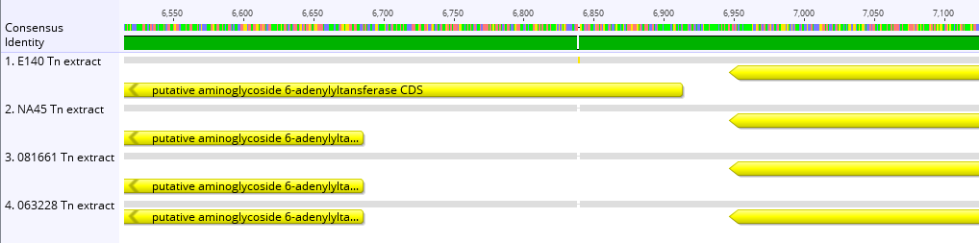
Figure 8. Truncated ant(6)-Ia Gene Product in North American Isolates.
A shared transposon in isolates E140, NA45, 08-1661 and 06-3228 contained the aminoglycoside resistance gene ant(6)-Ia. European Isolate E140 was resistant to gentamicin using both standardized assays while the other isolates were either intermediate or susceptible, potentially due to the ant(6)-Ia gene being truncated in these 3 North American isolates.

If this predicted deletion truncates the protein by shifting the reading frame in the North American isolates, it could result in loss of resistance to streptomycin in these genomes. As some resistance to gentamicin was determined for 08-1661 and 06-3228, but not NA12, NA07 or NA45, the other aminoglycoside resistance gene identified (aac(6’)-aph(2’’)-Ia) could be responsible for the few gentamicin-resistant interpretationsinterpretations in initial testing. Isolates 08-1661 and 06-3228 were determined to be susceptible to gentamicin using microbroth dilution yet intermittently resistant using disc diffusion, while NA12 and NA07 were interpreted as susceptible using both methods. As aac(6’)-aph(2’’)-Ia is supposed to confer high-level resistance (HLR) it is unclear why any susceptible interpretationsinterpretations for these isolates exist.
The genome of isolate 08-1661 was sequenced initially using the standard methodology using overnight growth culture without the addition of antibiotics. The observation that isolate 08-1661 was initially interpreted as resistant to chloramphenicol by disc diffusion yet susceptible by microbroth dilution (Vitek) was investigated by a second round of WGS using the standard overnight growth but with the addition of 25µg/mL chloramphenicol. The chloramphenicol acetyltransferase gene CAT was detected identically in both genomes, however, the WGS data from the culture grown with chloramphenicol resulted in a 10x increased mean depth of coverage relative to the culture absent selection (Table 6). This indicates that the gene copy number increased upon exposure to chloramphenicol allowing increased resistance to this compound.

Table 6. Average Depth of Coverage and Percent Reads for 08-1661 Select and Non-Select WGS Data.
Isolate 08-1661 was predicted to be resistant to chloramphenicol through a resistance gene found on one of the two plasmids discovered in its genome. While it was interpreted as resistant using disc diffusion, it was not by Vitek. Re-sequencing the isolate after exposure to chloramphenicol resulted in greater than 3x increase in plasmid copy number for the chloramphenicol plasmid, as well as an increase in copy number for the second plasmid encoding resistance to tetracycline, suggesting that increased antibiotic resistance is mediated by plasmid copy number.
Selection | Total Reads | 16s Avg. Depth | CAT Avg. Depth | TetK Avg. Depth | Ratio
Negative | 2578704 | 919 | 1205 |  | 1:1.311
Positive | 456358 | 242 | 1596 |  | 1:6.595
Negative | 2578704 | 919 |  | 4073 | 1:4.432
Positive | 456358 | 242 |  | 3745 | 1:15.475

Resistance to lincosamides was predicted through multiple genes in 06-3228, NA12 and NA07, yet isolate NA12 was interpreted as susceptible to clindamycin using both disc diffusion as well as microbroth dilution. Clindamycin is a lincosamide used to determine resistance, generally, to that class of antibiotics. Some of these lincosamide resistance genes in these genomes are most similar to genes predicted to encode only resistance to lincomycin (104), a commonly used antibiotic in veterinary medicine (105); thus, it is possible that resistance to lincomycin and lincosamides in general is not accurately represented using clindamycin as a surrogate in susceptibility assays (106).
Bacteriophage and prophage content of the major STs was assessed using the PHAge Search Tool (99), and results are shown in Table 7. Full PHAST hit results can be found in Appendix D: PHAST Intact and Incomplete Phage Insertions.

Table 7. Phage Genome Content Summary as Detected by PHAST.
The software PHAST was used to identify prophage sequence in genomes of the dominant lineages of MRSP in North America as well as the previously published MSSP. A total of 40 prophage insertions were identified and were more associated with MRSP than MSSP. In addition, 1579 genes were located within these insertions and accounted for a large percentage of the accessory genome for each isolate.
Genome | Intact Phage | Incomplete | Total Kb | Total CDS
ED99 | 0 | 0 | 0 | 0
HKU10-03 | 1 | 2 | 141 | 154
E140 | 3 | 4 | 307 | 387
NA07 | 1 | 1 | 56 | 81
NA12 | 0 | 2 | 26 | 37
NA45 | 2 | 6 | 272 | 304
NA47 | 2 | 3 | 122 | 130
63228 | 3 | 5 | 210 | 255
81661 | 2 | 3 | 195 | 231

MSSP genomes were found to have fewer overall phage, with the reference genomes ED99 predicted to contain none (although phage structural genes are present indicating significant pseudogenezation), HKU having 3 and the MRSP genomes averaging 5 each. The lack of intact or incomplete phage sequence detected in ED99 could be the result of an assembly artifact; as mentioned in the introduction, phage sequence can be very repetitive and repetitive DNA sequence is difficult to assemble. Thus, it is possible that phage sequences exist in ED99 yet were not included in the final assembly. This hypothesis is supported by the fact that an optical map of ED99 created outside of the scope of this project showed roughly 50,000bp of DNA to be missing relative to the published genome sequence. As HKU also represents an MSSP and has 1 intact prophage and 2 incomplete, comprising ~141,000bp and ~154 genes, it seems reasonable to assume ED99 does have some phage content. As the MSSP genomes are generally smaller than MRSP genomes and contain less prophage insertions, it can be generalized that prophage content increases genome size and is positively associated with successful S. pseudintermedius clonal lineages.
Isolates NA07 and NA12 belong to closely related ST64 and ST124, respectively, which makes the observation that they both have 2 phage potentially meaningful considering the fact that the other MRSPs all have at least 5 phage insertions. Their genomes were assembled de novo independently, yet when compared using MAUVE they show surprising genome arrangement and identity of >99%. Results from a core genome phylogenetic analysis using the software PanSeq (107) show an almost identical relatedness when compared with the other genomes (Figure 9). Aside from the core SNP genome analysis and phylogenetic tree providing validation of the MLST-7 typing system (as the relationships shown are similar to those from eBURST analysis), it also reveals that the ST71 isolates 08-1661 and E140 have >99% identity and are closely related, which is to be expected if MLST-7 predicts them to be the same sequence type. In fact, the majority of genome content variation between the ST71 isolates 08-1661 and E140, as well as the S. pseudintermedius isolates in general, are genes contributed by phage whereas differences in shared genes result from DNA mutation. Figure 10 shows a whole genome alignment between E140, 08-1661, 06-3228 and NA45 complete genomes. Each colored block represents global syntenic regions of DNA colineation, while the large white gaps in each genome represent prophage insertions not found in at least one corresponding location in another genome.

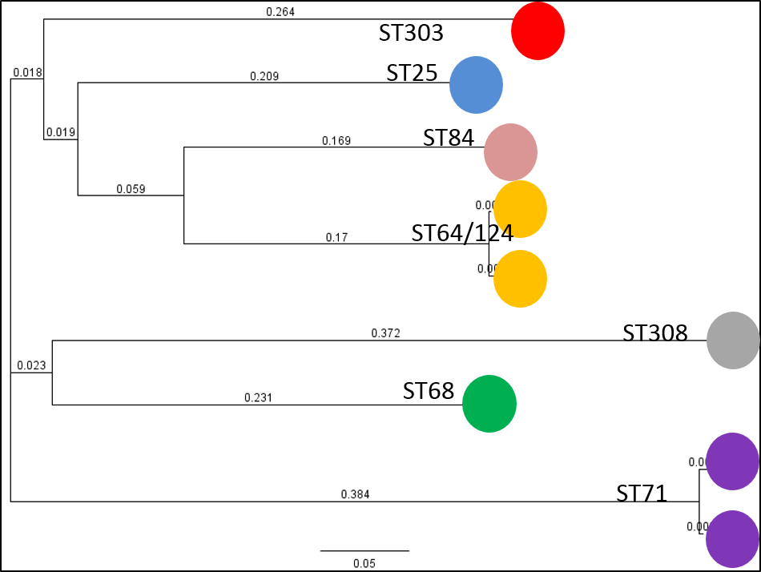
Figure 9. PanSeq Phylogenetic Tree of Core Genomes of 9 S. pseudintermedius Isolates.
Core genomes identified using genome-wide BLAST were concatenated and aligned, and phylogenies determines using maximum likelihood for dominant lineages of MRSP in North America. The North American ST71 isolate 08-1661 and European ST71 isolate E140 were found to have almost identical core genomes.

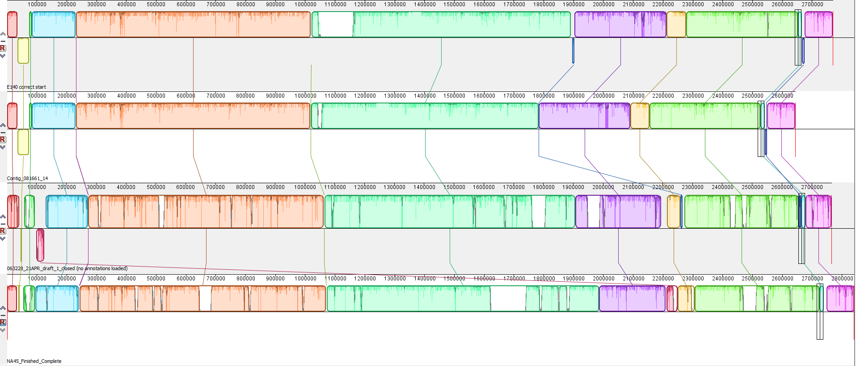
Figure 10. Mauve Genome Alignment Reveals Alignment Gaps Caused by Prophage Insertions.
Complete genomes of E140, 08-1661, 06-3228 and NA45 (descending) were aligned using MAUVE. Colored blocks show highly conserved genomic regions with average sequence identities represented graphically within. Most of the large unaligned white gaps resulted from unique prophage insertions.

It is interesting, however, that ST64 and ST124 are >99% identity yet belong to different STs. Perhaps the 08-1661/E140 relationship and the NA07/NA12 relationship represent the upper and lower limits of MLST-7.
As with the ST71 isolates E140 and 08-1661, this nearly identical relationship would be expected if the MLST-7 typing system is accurate in determining evolutionary genetic relatedness. However, phage content is determined by horizontal transfer and bacteriophage infection, which theoretically operates independently of traditional phylogenetic evolution and would not necessarily correspond to the same relatedness as the core genome. Without closing the NA07 and NA12 genomes it is impossible to determine their exact insertion location, but one of the 2 phage shared between them is identical and the other is unique to each genome. The ability of bacteriophage to infect and transpose themselves within a genome may be related to other genome content, such as CRISPR (108), which could explain the reduced phage content in these ST64 isolates as well as their 50% shared phage sequence. Interestingly, the shared phage in NA07 and NA12 contains a fosfomycin resistance protein which is found in all but 1 of the other major North American genomes and missing from the European MRSP isolate E140.
Phage content for isolate NA45 appears to be the highest of all sequenced major STs with 2 intact and 6 incomplete phage contributing ~272,000bp to the overall genome. The MRSP isolates besides NA45 had 100,000bp to 210,000bp of their genome attributed to phage content, with multiple fibronectin-binding proteins being the highest non-structural genes found within complete and incomplete phage. This supports the commonly held idea that phage contribute to virulence primarily through assisting with host adaptation and cell binding (109). Additional common phage-associated genes include the Streptococcal Superantigen SsaA, organic hydrogen peroxide resistance genes, ion efflux pumps associated with antibiotic resistance and variations of holins, lysins and hydrolases which facilitate cell invasion. These are all generally considered to be virulence factors and additionally support the association of phage content with virulence when compared with lower phage content of the MSSP isolates ED99 and HKU10.
Genomic location of phage insertions can be determined for isolates with complete, circular genomes, namely 08-1661, 06-3228, NA45, E140, ED99 and HKU10. Maps of phage content and insertion locations can be found in Appendix E: Prophage Genome Insertion Locations. It is interesting to note that while phage content does not seem to be associated with Sequence Type, it does seem to be at least loosely correlated to geographic region (North American versus non-North American). Conversely, phage insertion location appears to be somewhat conserved across Sequence Types, yet not across geographic regions. These relationships make sense in light of genome and virulence concepts. Sequence Type indicates genetic relatedness, which means having similar DNA sequence. Thus, genomic recognition sites for bacteriophage insertion being conserved within related genomes is supported by this data. Individual phage are thought to be host associated and often provide increased growth adaptation and success within individual host populations. Thus, the sharing of phage within geographic regions which, in theory, have unique host populations (whether human, animal or bacterial) would lead to specific phage being transferred regionally. If these patterns hold up across more MSSP and MRSP genomes with known histories, phage content and insertion site could represent a valuable, untapped resource for determination of virulence and evolutionary relatedness. Larger studies have not revealed these relationships prior to this project; however, this is likely due to the fact that genomes are often not completed (as in a closed, circular genome) and thus location cannot be determined. The phage themselves contribute significantly to problematic genome assemblies due to their very high repetitive DNA sequence in structural genes such as tail proteins. Many genomes that are in fact circular are done so using a reference genome to span gaps in the assembly. This method was tried during this study using ED99, E140 and HKU10 as references; actual optical maps of 08-1661, 06-3228 and NA45 were then aligned to the referenced-closed genomes and large sections of DNA were missing. In almost all cases, these missing segments were prophage sequence, often only overlapping the structural genes at the two edges of the phage without including the internal content. It is likely that the use of reference genome mapping, lack of verification using optical or long-read mapping and unfinished multi-contig genomes has prevented this trend in phage content and location insertion from being detected before.

Plasmid Identification
Extrachromosomal plasmids were presumptively identified in all major ST isolates except NA45 and E140 using both the manual method described above as well as the automatic Geneious circularization during assembly setting (See Section 2.12, Data Assembly and Analysis). Surprisingly, 4 of the 5 isolates with presumptive plasmids contained at least two, and isolate NA12 is predicted to have 3. At least 20 additional presumptive plasmids were identified from the remaining sequenced isolates. Table 8 shows plasmids predicted to confer resistance to select antibiotics in isolates selected to represent dominant lineages in North America; 08-1661, 06-3228, NA07, NA12 and NA47.

Table 8. Plasmids Predicted from WGS Data to Confer Antibiotic Resistance.
Extrachromosomal plasmids were predicted from genome sequence data using manual and automated annotation for isolates 08-1661, 06-3228, NA07, NA12 and NA47. No extrachromosomal elements were identified for isolate NA45. Important genes are those found in the plasmid sequence related to resistance to antibiotics or disinfectants.
Strain ID | Sequence Type (ST) | Size (bp) | Structure | Important Gene | Functional Annotation
08_1661 | 71 | 3785 | Inactivating protein | CatA | chloramphenicol resistance
 |  | 4439 | 7 domain pump | tetK | tetracycline resistance
06_3228 | 68 | 2360 | Inactivating protein | LinA | lincomycin resistance
 |  | 2730 | Inactivating protein | fosB | fosfomycin resistance
NA07 | 124 | 2653 | Inactivating protein | LinA | lincomycin resistance
 |  | 2745 | 3 domain pump | QacG | quaternary Ammonium compound resistance
NA12 | 64 | 2653 | Inactivating protein | LinA | lincomycin resistance
 |  | 2742 | 3 domain pump | QacG | quaternary Ammonium compound resistance
 |  | 3660 | 7 domain pump | CcmA | lantibiotic and multidrug resistance pump
NA47 | 56 | 2258 | Compound Transporter | Hypothetical CDS | unknown; completely novel

Plasmid identification using MiSeq paired end reads did not result in any high depth of coverage or circular contig assemblies, and was therefore unable to identify extrachromosomal plasmids. One reason for this is that the common and conserved origin of replication gene “Rep” is found not only on almost all small resistance plasmids but also in multiple locations throughout the genome, including many SCCmec cassettes (110). Analysis of mapping paired reads back to plasmids- identified using the manual method from single-read assemblies- resulted in either low depth of coverage or contig breaks directly tied to the location of the Rep gene on these plasmids. It is likely that when one read from a paired read set sits within the Rep gene, it is placed randomly throughout the genome on any plasmids that match that Rep sequence or even vary slightly in content. Because the initial placement may be in the incorrect location for the paired set, the second read will fail to place into the larger assembly or will place erroneously. This leads to a failure to match other overlapping paired reads to this hit and results in either a failed/gapped assembly or inaccurate sequence with very low depth of coverage. Using paired reads as unpaired reads eliminates this problem by allowing reads falling in and overlapping with Rep sequence to place accurately into that location without the constraint of a second read forcing placement a certain distance away.

Large Linear Plasmid in 06-3228
A large extrachromosomal DNA fragment was detected for isolate 06-3228; it is not easily identified as a bacteriophage (as it lacks necessary phage structural genes) nor is it similar to any known plasmids. It is 43,416bp long with 42 predicted coding sequences, of which only 7 have predicted functions from the RAST annotation. The 5’ and 3’ ends have identical yet terminal inverted repeats, meaning that while they could bind to each other in the same direction, they could not circularize the sequence (Table 9).

Table 9: Functional Annotations of Linear Element in 06-3228.
Isolate 06-3228 was found to contain a linear, extrachromosomal genetic element not associated with typical bacteriophage or plasmid genes and validated through WGS data, optical mapping and gel electrophoresis. It is completely novel and does not match more than 1% to any known DNA sequence in Genbank and appears to encode resistance to teicoplanin and an E. coli toxin/antitoxin system ensuring passage to daughter cells. It may be capable of self-replication and horizontal transfer as it also contains the cell division protein FtsK along with the DNA partition protein ParA. It contains the virulence and secretory antigen SsaA traditionally associated with transposons yet the contig was unable to be placed in the genome.
Name | Length | Direction
hypothetical protein CDS | 960 | forward
hypothetical protein CDS | 429 | forward
hypothetical protein CDS | 483 | forward
hypothetical protein CDS | 837 | reverse
hypothetical protein CDS | 1,215 | reverse
ATP-dependent Clp protease ATP-binding subunit ClpA CDS | 1,929 | reverse
hypothetical protein CDS | 3,264 | reverse
hypothetical protein CDS | 288 | reverse
hypothetical protein CDS | 900 | reverse
hypothetical protein CDS | 528 | forward
replication initiator protein A CDS | 1,518 | reverse
hypothetical protein CDS | 306 | reverse
DNA double-strand break repair Rad50 ATPase CDS | 2,184 | reverse
hypothetical protein CDS | 882 | reverse
hypothetical protein CDS | 2,025 | reverse
hypothetical protein CDS | 576 | reverse
hypothetical protein CDS | 312 | reverse
hypothetical protein CDS | 1,002 | forward
hypothetical protein CDS | 726 | forward
hypothetical protein CDS | 594 | reverse
hypothetical protein CDS | 672 | reverse
hypothetical protein CDS | 249 | reverse
hypothetical protein CDS | 384 | forward
Secretory antigen SsaA-like protein transposon-related CDS | 1,335 | reverse
hypothetical protein CDS | 537 | reverse
hypothetical protein CDS | 594 | reverse
hypothetical protein CDS | 363 | reverse
hypothetical protein CDS | 270 | forward
DNA partition protein ParA CDS | 813 | forward
hypothetical protein CDS | 168 | reverse
hypothetical protein CDS | 726 | reverse
hypothetical protein CDS | 375 | reverse
Cell division protein FtsK CDS | 2,355 | reverse
hypothetical protein CDS | 666 | reverse
hypothetical protein CDS | 297 | reverse
Teicoplanin resistance associated membrane protein TcaA CDS | 1,341 | reverse
hypothetical protein CDS | 765 | reverse
hypothetical protein CDS | 177 | reverse
hypothetical protein CDS | 402 | forward
MazE antitoxin | 483 | reverse
MazF toxin | 429 | reverse
hypothetical protein CDS | 960 | reverse

A BLASTn and MegaBLAST search resulted in a 78% identity over 1% of the sequence and 79% identity over 4% of the sequence, respectively, indicating a unique and novel genetic element. Read mapping the consensus contig resulted in blunt end drop off in coverage with no overlapping reads, suggesting it exists freely outside of the chromosome (Figure 11).

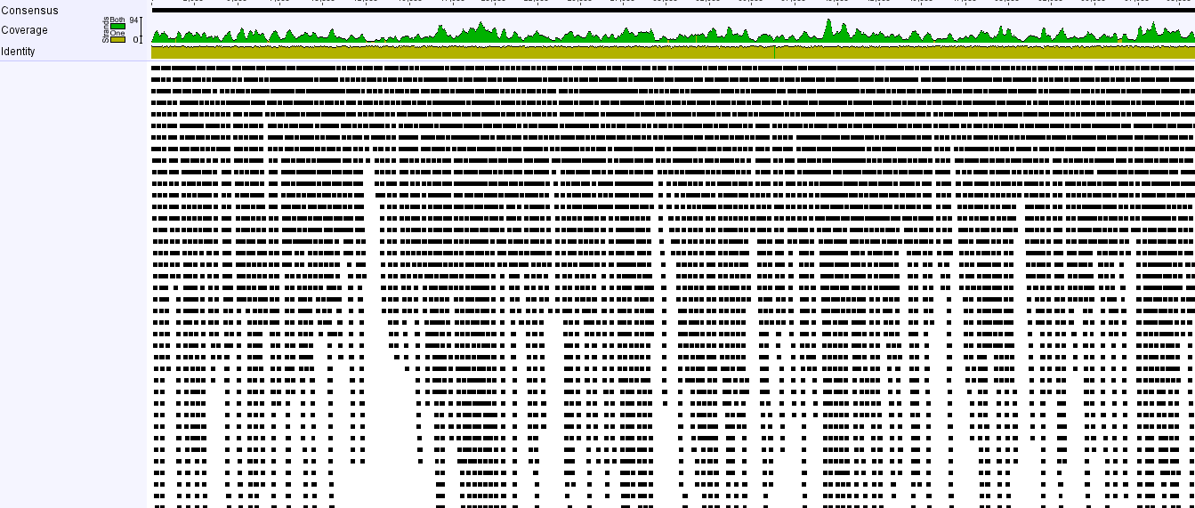
Figure 11. Read Mapping to Genetic Element in 06-3228 Reveals Sharp Decline in Coverage and No Overlapping Reads.
Isolate 06-3228 contained a large, ~40Kb contig unable to be placed into the de novo assembly or optical genome map. Mapping original sequencing reads back to this contig revealed higher than average depth of coverage with blunt terminal ends. No reads were found to span beyond the edge of the sequence, nor were inverted terminal repeats present suggesting the element exists independent of the main chromosome yet is not circular.

In optical mapping data, it is evident as an independent DNA fragment not found in the chromosomal DNA and at fairly high copy number in a linear format with an AflII digestion pattern that matches the in silico pattern created using the contig from the WGS data (Figures 12, 13, 14).

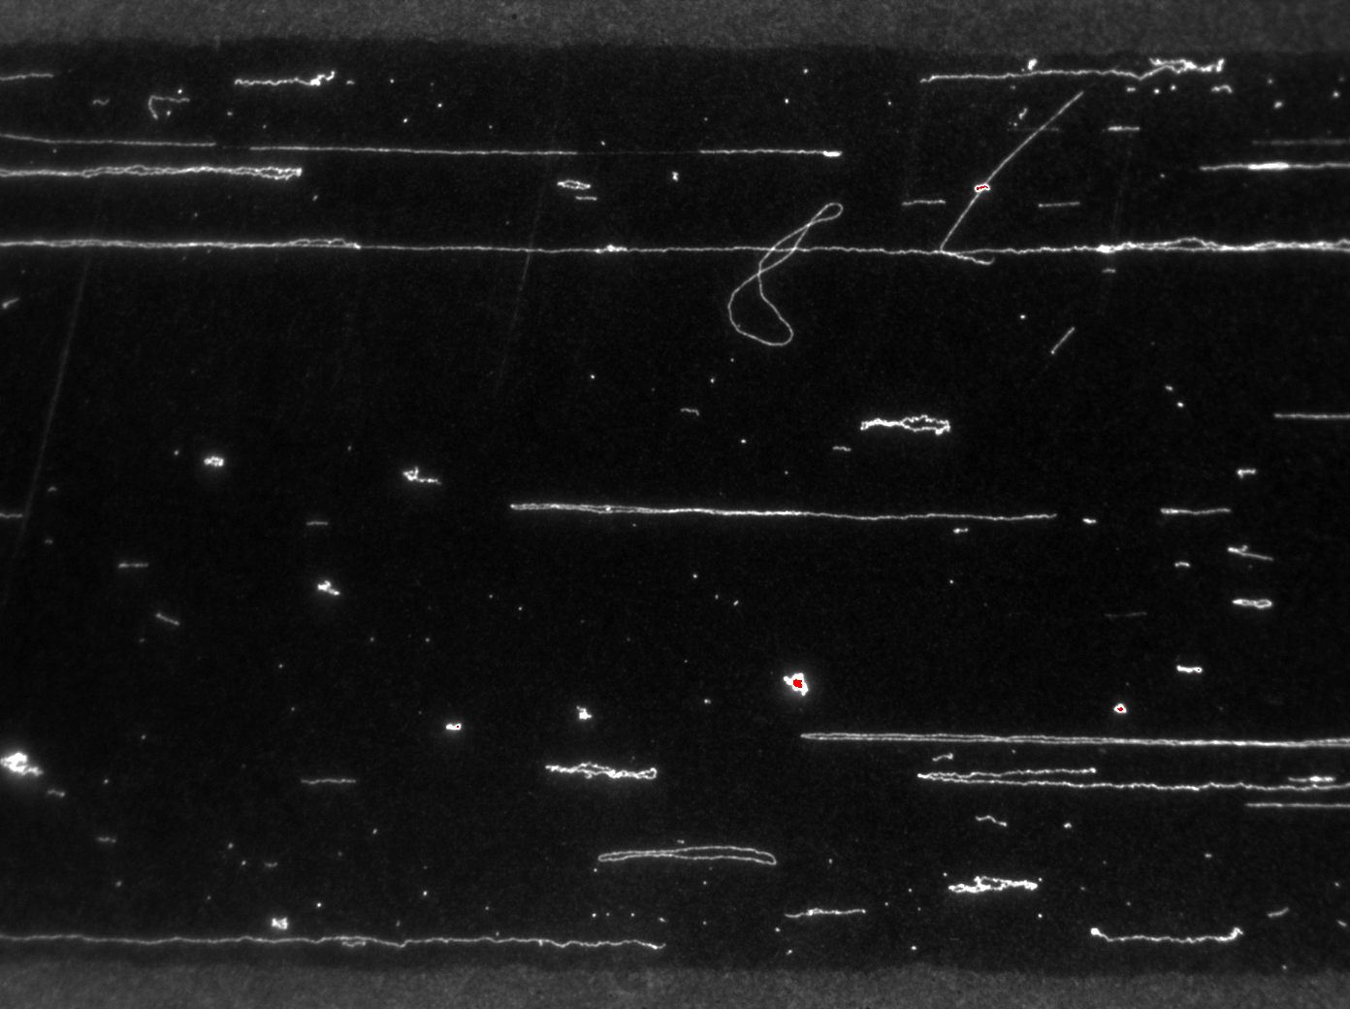
Figure 12. Circular Plasmid Content in Whole Genome Mapping.
Circular extrachromosomal plasmids were easily identified in multiple isolates using optical genome mapping and observed in both relaxed and supercoiled formations. This image is typical for isolates found to contain circular plasmids. The circular structure is retained after enzymatic cutting because the DNA molecules are electrostatically bound to the mapping surface.

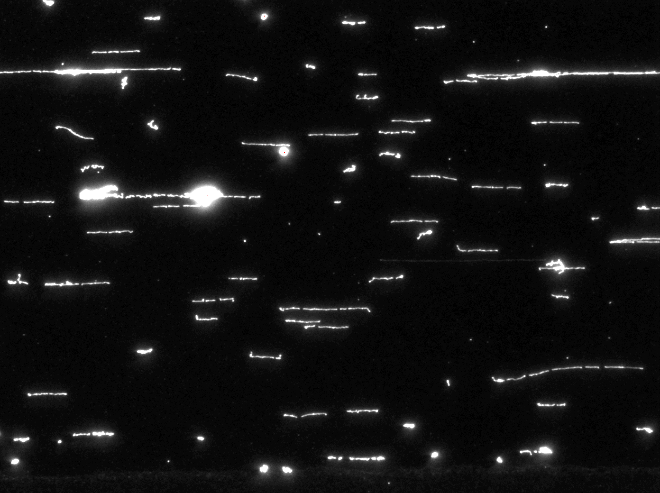
Figure 13. High Copy Number Linear Element in 06-3228.
In isolate 06-3228 a uniform length DNA fragment was observed at high frequency in optical mapping raw images. This molecule is estimated to be ~40,000bp and has two unique cut sites using AflII.

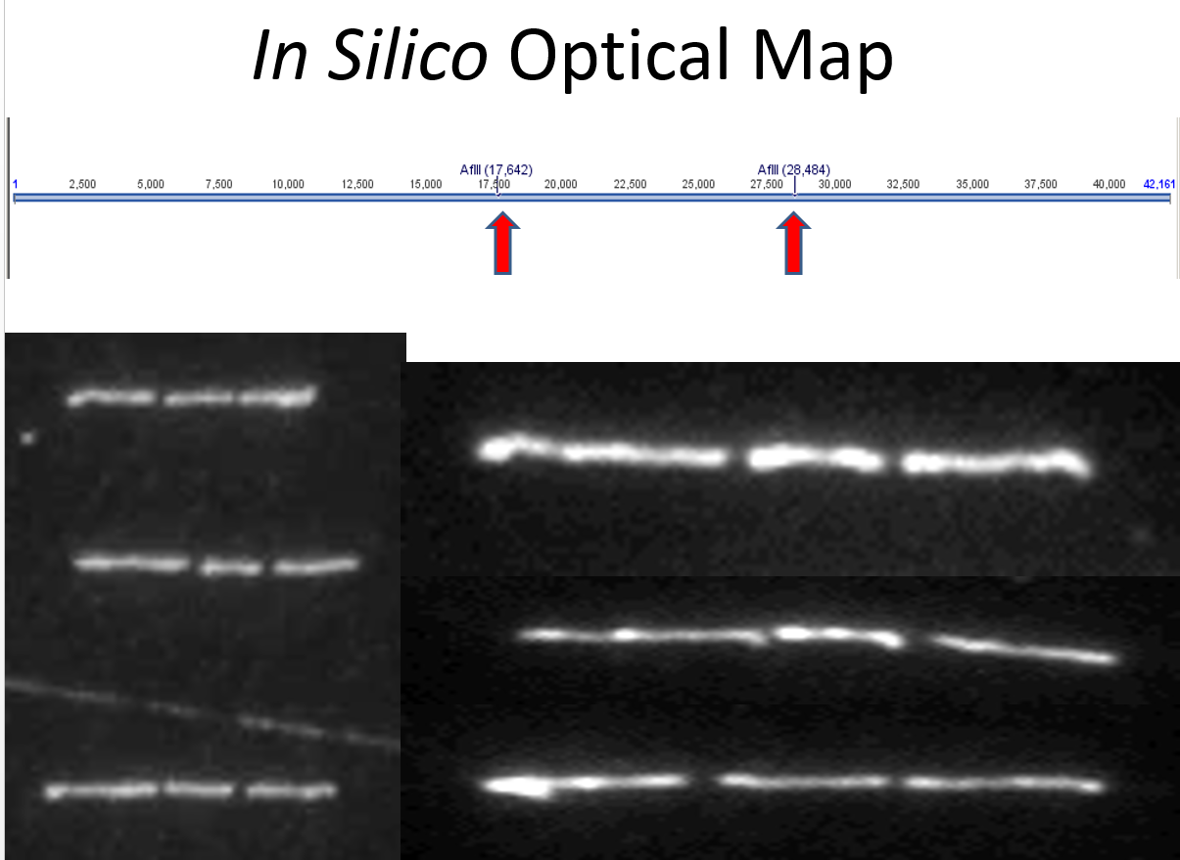
Figure 14. Molecule AflII Cut Pattern Matches in silico Pattern of Suspect Contig.
The 06-3228 de novo sequencing contig contained two AflII cut sites that matched the cut site pattern of the high copy number linear element from the optical mapping images, reinforcing the extrachromosomal and linear properties suggested by the WGS assembly.

This element is easily distinguished from genomic DNA when extracted using Qiagen (CAT #: 27104), Invitrogen (CAT #: K210010) and Sigma (CAT #: PLN10) plasmid extraction kits and visualized using DNA electrophoresis (Figure 15).

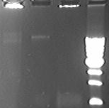
Figure 15. Agarose Gel Electrophoresis of 06-3228 and NA45 Plasmid DNA Extraction.
Lane 1: isolate 06-3228 plasmid extraction resulting in two faint bands, one above the highest 40Kb marker in the ladder (lane 4) and one approximately equal with it. Lane 2: genomic DNA extraction of isolate 06-3228 showing a single band just above the 40Kb ladder marker indicating high molecular weight genomic DNA. Lane 3: plasmid extraction of isolate NA45 devoid of plasmids in WGS data.

Taken together, this element likely represents a novel large, linear plasmid-like MGE with an unknown function. It does, however, contain the E. coli associated MazE-MazF toxin-antitoxin module, which functions to ensure the replication and carry of this element in the cell. The MazF gene encodes an endoribonuclease toxin that can be neutralized by the MazE antitoxin (111). As the toxin is more stable than the antitoxin, a dividing daughter cell lacking the genetic element containing the genes would be unable to produce the antitoxin and therefore die as a result of the longer life of the toxin after the antitoxin degrades (111). It has not yet been found to date in any Staphylococcal genome and its function in this role is unknown. Finally, one predicted gene has a functional annotation from RAST encoding resistance to Teicoplanin, a semisynthetic glycopeptide antibiotic similar to the last line of defense antibiotic vancomycin (112). The gene used to annotate this function is TcaA, which encodes a trans-membrane protein thought to confer intermediate level resistance to teicoplanin and vancomycin (112). However, a direct protein BLAST of the S. aureus reference sequence for TcaA against the “TcaA-like” protein from 06-3228 returns a very poor hit with only 26% identity over 92% of the sequence (Figure 16).

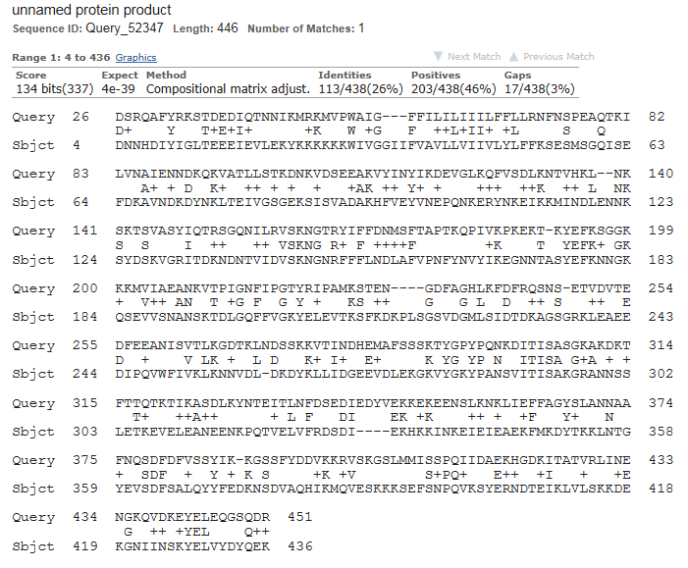
Figure 16. BLAST Alignment Between Reference TcaA Sequence and TcaA-like CDS from 06-3228.
The predicted TcaA protein on the linear element in isolate 06-3228 aligned to TcaA from Staphylococcus aureus using BLASTp. An Except Value of 4e-39 indicates little chance of non-random alignment, however, 26% protein identity displays remarkable variation of the protein sequence which may not retain the same function.

The best BLAST result against the non-redundant Genbank protein database hits to several “hypothetical protein” results at best 64% identity over 100% query coverage. If search constraints are loosened, these proteins align to the reference TcaA gene at about 54% identity; there are several at this level of identity that have been deposited with the identifier “TcaA-like protein” and inferred resistance to teicoplanin without any experimental data. With these extremely poor results for all of these entries except the good experimental data for TcaA from S. aureus, it seems possible that many authors have submitted protein sequence with extremely poor matches to TcaA that are actually unrelated to that genes function. However, as the top BLAST hit can often be an extremely poor hit, it frequently happens that authors use the top hit regardless of quality when assigning a hypothetical function to their submissions. Therefore, the role of the 06-3228 protein in resistance to teicoplanin or vancomycin seems suspect.

Chapter Three:
comparison of Predicted antibiotic susceptibility genotypes with in vitro susceptibility test results

Abstract

Whole genome sequencing was performed on 30 MRSP clinical isolates and revealed genes predicted to contribute to antibiotic resistance on previously unknown mobile genetic elements such as plasmids and prophage. Four isolates with discrepant antibiotic susceptibilities representing dominant clonal lineages in North America were found to have genes predicted to encode resistance to antibiotics that they tested susceptible or intermediate for using standard assays. A novel media-based growth assay was developed to investigate resistance to these antibiotics beyond the standard time points of 4 and 24 hours.
All isolates predicted genotypically to be resistant to antibiotics not originally interpreted as resistant to were found to be able to display high level resistance in the growth assay but only after at least 24 hours adaptation in selective media. When removed from selection for 24 hours and re-tested using the same assays, resistance was maintained at the highest observable level using these methods. Phenotypic resistance observed in the growth assays and re-testing matched the antibiotic resistance genotype predicted from whole genome sequencing data for each isolate.
A gene encoding resistance to chloramphenicol was found to be located on a plasmid that appeared to increase copy number in response to exposure to chloramphenicol. Resistance to gentamicin was investigated in four isolates, 2 of which were repeatedly interpreted as susceptible using both assays and 2 of which were reported either susceptible or intermediate using disc diffusion but reliably susceptible in microbroth dilution. High level gentamicin resistance was observed in all 4 isolates after longer than 24 hours initial exposure to the antibiotic in the growth assay and was maintained 24 hours after removal from selection using both standard assays. The aac(6’)-aph(2’’)-Ia gene known to encode high level gentamicin resistance was found in all 4 isolates, so susceptible determinations using standard assays may not reflect true resistance profile for this antibiotic.
While the growth assay used in this study did not correlate directly to clinical resistance, re-testing using standardized assays suggested the ability to display high level antibiotic resistance could be inferred from gene content. In cases where phenotypic assays disagreed, isolates ultimately determined to have resistance were found to contain resistance genes on mobile genetic elements.

Introduction
Staphylococcus pseudintermedius is an important pathogen in part due to the high level of resistance to multiple antibiotics it displays across multiple host species around the world. Treatment of antibiotic resistant bacterial infections relies upon both proper identification of the pathogen as well as accurate characterization of associated resistance to antimicrobials. Two common antibiotic susceptibility assays used to screen isolates for potentially useful treatment options are antibiotic disc diffusion and microbroth dilution (113; 114). Both of these methods measure the ability of the pathogen to grow in the presence of various concentrations of antibiotic compounds either in agar or liquid broth. As such, they both represent phenotypic observations of displayed resistance and do not directly identify underlying genetic mechanisms. Phenotypic assays measure the ability of the bacteria to survive and/or grow in the presence of the antibiotics over time; they do not indicate the underlying mechanism providing this characteristic. With these assays, there is a risk that clinically relevant resistance could exist, but not be detected under growth or exposure conditions being provided in the test (115, 116). Conversely, it is possible for an organism to have a gene known to provide antibiotic resistance in certain circumstances but the resistance is not high enough to overcome the concentration of antibiotics that could be used in a clinical setting.
Methods have been developed to use genetics to predict antibiotic resistance by searching for antibiotic resistance genes and/or mutations and creating assays to detect them (90, 77, 76). However, one limitation of using genetic markers to predict, not determine, antibiotic resistance; simply having a gene that can provide resistance does not necessarily mean that it will, at least at a clinically relevant level (115, 89). Researchers have discovered bacteria containing genes for resistance to an antibiotic or class of antibiotics without showing phenotypic resistance (116, 89; 90, 117). This could result from one of many possible reasons, the first of which being that these genes may play different roles in different organisms facilitating their spread but not necessarily the resistance characteristic.
Clinical isolates of S. pseudintermedius were sequenced using multiple whole genome sequencing technologies. Several antibiotic resistances were predicted from the results of genome sequencing and functional annotation of hypothetical coding sequences in all S. pseudintermedius isolates sequenced. While many of the genes identified during WGS match to the ASPs from their initial testing results, there were disagreements in specific antibiotic resistances as well as disagreements between the two testing methods- disc diffusion and Vitek microbroth dilution (86; 114).
Isolate 08-1661 represents a sequence type (ST71) commonly associated with European MRSP yet is also a major clonal lineage in North America (75, manuscript in preparation). Two plasmids were predicted to exist extrachromosomally in isolate 08-1661, both of which encode antibiotic resistance determinants. Plasmid 08-1661B encodes chloramphenicol acetyltransferase, an inactivating enzyme with no previous association with Staphylococcus pseudintermedius (Figure 18). While the isolate was determined to be resistant to chloramphenicol using disc diffusion, it was interpreted as susceptible using the Vitek according to the MIC set for S. aureus (CLSI M100-S18).

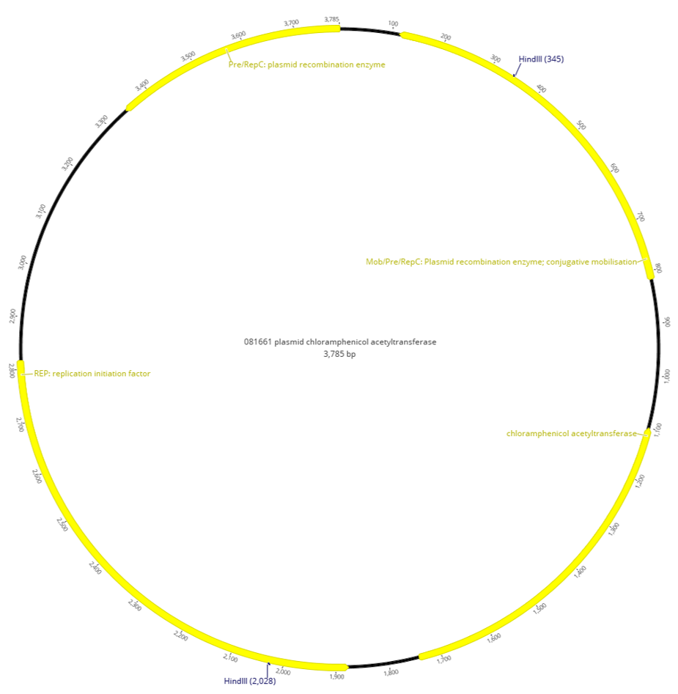
Figure 17. Plasmid 08-1661B.
Plasmid 08-1661B contains four predicted coding sequences, one of which is chloramphenicol acetyltransferase identical to that found in S. aureus plasmids. However, the rest of the plasmid sequence is completely novel with no hits to any known sequence other than the required RepC replication initiation factor. Two additional recombination enzymes are co-located on this plasmid which may be capable of independent movement between isolates.

All major lineage isolates except NA45 have the aac(6’)-aph(2’’)-Ia aminoglycoside resistance gene, however, 08-1661 and 06-3228 were determined to be intermediate to gentamicin by disc diffusion and susceptible using the approved Vitek card. Isolates NA07 and NA12 were determined as susceptible using both assays. The aac(6’)-aph(2’’)-Ia gene known to encode high level gentamicin resistance was found in all 4 isolates located on distinct prophage within each genome.
MRSP from North America characterized by both assays occasionally display discrepant results between the two testing methods. One difference between the assay methods is the time point at which the results are read; 24 hours for disc diffusion and as short as 4 hours for microbroth dilution. As mobile genetic elements have been known to contribute variable degrees of antibiotic resistance, it is possible these elements play a role in producing these discrepancies.
While genotypic assays can predict antibiotic susceptibility profiles for bacterial isolates, they can only infer the possibility of resistance. Phenotypic assays have been correlated to animal and human studies for validation that observed resistance phenotypes are clinically relevant. Genome sequencing of 30 MRSP and 6 MSSP revealed that horizontal transfer of mobile genetic elements in S. pseudintermedius is likely more frequent than previously suspected. If antibiotic resistance is mediated by genes carried on mobile genetic elements and can vary phenotypic detection time points past what are commonly used in standard assays, it would suggest that the most accurate determination of antibiotic resistance for a given bacterial isolate may be a combination of phenotypic and genotypic testing. Furthermore, the role of mobile genetic elements in antibiotic resistance appears to be important.
Due to the significant discrepancies in calling antibiotic resistance to chloramphenicol, gentamicin and lincosamides, a novel in vitro testing method was developed to determine what level of resistance each isolate had to these antibiotics, and if any level of resistance was seen they would be re-tested using the standard clinically accepted assays. The plasmids and genes predicted to code for antibiotic resistance being tested using the growth assay were screened for using genomic and plasmid DNA extraction as well as PCR amplification.

Materials and Methods

Standard Antibiotic Susceptibility Testing
Initial antibiotic susceptibility testing was performed according to standardized guidelines outlined in the Clinical and Laboratory Standards Institute 2008 informational supplement M100-S18. Minimum inhibitory concentrations (MICs) were determined by susceptibility testing using the Vitek 2 automated antimicrobial testing system (BioMerieux, Durham, NC) according to the manufacturer’s protocol. MICs for chloramphenicol have not been standardized for S. pseudintermedius. Vitek cards AST-GP67 or the newer AST-GP69 was used to test S. pseudintermedius isolates; a representative output with isolate NA45 is shown in Figure 19 with disc diffusion results recorded manually for all antibiotics tested.

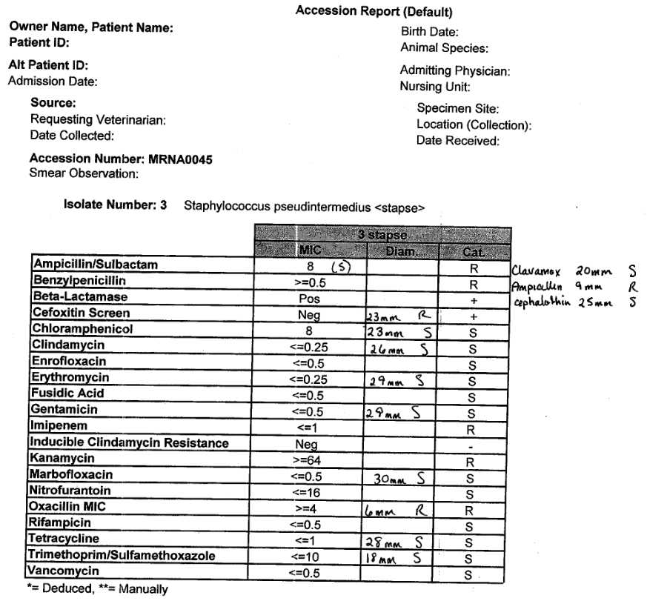
Figure 18. Vitek MICs and Disc Diffusion Results for Isolate NA45.
A representative antibiotic susceptibility profile containing information on disc diffusion zone sizes and Vitek MICs. Isolate NA45 displayed resistance using disc diffusion to cefoxitin, oxacillin and ampicillin which are in agreement with the MIC data. Antimicrobials tested using the Vitek but not disc diffusion are left blank for the Diameter column, whereas antimicrobials tested using disc diffusion are written in by hand either next to their Vitek result or outside for those not found on the Vitek card.

Initial ASPs were determined via direct plating and dilution in saline to 0.5 McFarland per standard protocol (For disc diffusion, purified isolates were plated onto Mueller-Hinton agar plates (Thermo Scientific, CAT #: R04050) impregnated with antibiotic discs and incubated at 35°C for 24 hours. Zone sizes were determined manually, with the “edge” of the zone being the closest colony or streak in the entire zone to the disc (Figure 20).

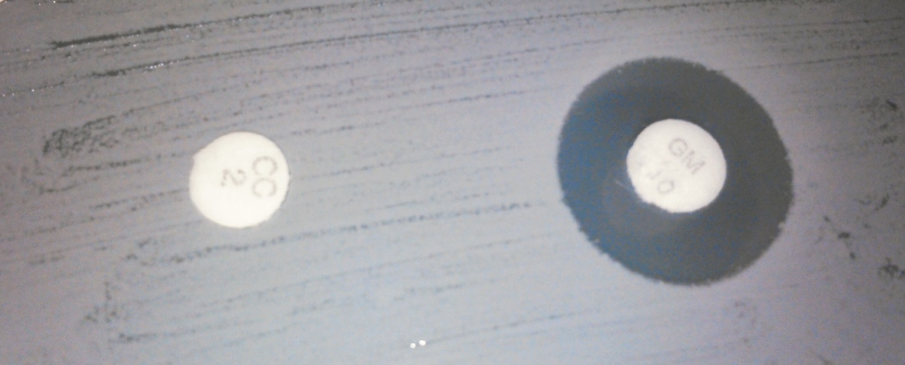
Figure 19. Example of Disc Diffusion Testing with 6mm Zone Size and 14mm Zone Size.
Disc diffusion measures the ability of an antibiotic-impregnated paper disc to inhibit growth of a lawn of bacteria. This representative image shows an isolate highly resistant to the antibiotic on the left with the minimum possible zone size of 6mm (the diameter of the disc), and a 12mm zone with the antibiotic on the right displaying a zone of inhibition.

Vitek testing was performed per manufacturer’s protocol; briefly, purified isolates were diluted in sterile saline and provided as a reservoir for the machine which automatically inoculates small wells with varying concentrations of antibiotics, with results coming back as soon as 4 hours later.

In vitro Broth Dilution Testing of Antibiotic Resistance
A novel growth assay was developed induce or select antibiotic resistances that were predicted by genotype but not observed phenotypically. Experiments were carried out in 10mL conical polystyrene culture test tubes with caps using both tryptic soy broth (TSB)(Sigma, CAT #: 43592) and the nutrient rich Antibiotic Broth (Sigma, CAT #: 70184) to examine media-driven differences in growth and resistance. Chloramphenicol (Sigma, CAT #: C3175) dissolved in 100% ethanol, gentamicin (VetOne Cat #: 510209, injectable) and lincomycin (Bimeda, CAT #: 1LIN019, injectable) were used for testing antibiotic resistance.
Isolates 06-3228, 08-1661, NA07 and NA12 were obtained from the UTCVM Bacteriology Laboratory on a trypticase soy blood agar (BA) plate (BD, CAT # 221261). A single colony was picked for each isolate using a sterile 5µL loop and used to inoculate 3mL TSB from the glycerol stock, with overnight incubation and shaking at 210rpm and 37°C. From these initial cultures, 10µL was used to inoculate 3mL fresh media with select antibiotics based on predicted resistances specific for each isolate. For chloramphenicol, gentamicin and lincomycin the initial concentration was 25µg/mL; subsequent increases were contingent upon successful growth to log phase within 96 hours in the current concentration and were increased in increments of 25µg/mL. Time points at which growth occurred in each concentration were recorded and maximum growth was defined by the maximum concentration at which no growth was observed for 96 hours. Each antibiotic containing growth assay was performed in duplicate and replicated three times.
Negative controls were used to confirm the potency and concentrations of the antibiotics used. Negative control strains were NA45 for chloramphenicol and lincomycin, and NA47 for gentamicin as they were phenotypically susceptible and the genomes were not predicted to contain resistance genes for these antibiotics. Antibiotic stability was tested using 15µg/mL of each antibiotic in 3mL TSB with growth recorded daily for 5 days for the negative control isolates. All growth experiments were carried out in duplicate and replicated 3 times using new inoculum from the glycerol stock. BA plates containing antibiotics were used to confirm antibiotic resistance as well as allowing individual colonies to be picked for further experimentation. Isolates able to grow past an optical density (OD) of 0.5 in >100µg/mL of each antibiotic in <24 hours µg/mL were considered resistant. µg/mL Resistant isolates were plated onto Antibiotic Agar No. 1 (Sigma, CAT #: 70181) plates containing 50µg/mL of each antibiotic.
The <24 hour time point for growth in cultures to be considered resistant while the negative control does not grow >48 hours post inoculation exceeds standard testing times (51; 114). The MIC₉₀ of these antibiotics in Staphylococcus species are generally considered >25µg/mL-32µg/mL (42; 88; 105; 118), therefore growth at or above 100µg/mL was used to ensure the best chance the MIC has been met or exceeded.

Antibiotic Susceptibility Testing Following Growth in Antibiotic-containing Broth
Isolates 08-1661, 06-3228, NA45, NA47, NA12 and NA07 were grown in Antibiotic Broth No. 1 (Sigma, CAT #: 70181) without selection overnight from glycerol stock as described and plated directly onto non-selective BA plates. At 24 hours, colonies were picked from these plates were tested as per the standard disc diffusion and Vitek protocols described above. These experiments were labeled as media (negative) and plate (negative) controls as they were not subjected to selection in either the growth assay or the subsequent BA plate.
Isolates 08-1661, 06-3228, NA12 and NA07 were grown in selective Antibiotic Broth No. 1 overnight and plated directly onto non-selective BA plates. Selection with chloramphenicol at 50µg/mL was used for isolate 08-1661, gentamicin at 100µg/mL for 06-3228, NA12 and NA07, and 100µg/mL lincomycin for all 4 isolates. At 24 hours, colonies were picked from these plates per the standard disc diffusion and Vitek protocols described above and re-tested. These were labeled as media (positive) and plate (negative) samples as they were grown in selection in the growth assay but on BA plates without selection prior to retesting. NA47 was used as a negative control in this experiment and was media (negative) and plate (negative).
Isolates 08-1661, 06-3228, NA12 and NA07 were grown in selective Antibiotic Broth No. 1 overnight, washed and diluted to 0.5 McFarland with non-selective broth. Cultures were then plated onto Mueller-Hinton agar plates for disc diffusion and subjected to testing on the Vitek 2. Selection with chloramphenicol at 50µg/mL was used for isolate 08-1661, gentamicin at 100µg/mL for 06-3228, NA12 and NA07, and 100µg/mL lincomycin for all 4 isolates. These were labeled as media (positive) samples as they were grown in selection during the growth assay and re-tested directly. NA47 was used as a negative control in this experiment but was media (negative).

Presence of Genes and Plasmids
The WGS data and assemblies revealed potential plasmid sequences and genes both in the genome as well as on plasmids that may confer antibiotic resistance. To confirm the presence of these plasmids and genes, genomic DNA extraction, plasmid DNA extraction and PCR gene amplification were performed in combination with visualization of DNA and products via electrophoresis and fluorescent dye. Primers used for amplifying full length plasmids are listed in Table 10. Primers used to amplify individual genes are in Table 11. Primers used to Screen for linear element in 06-3228 are in Table 12. Primers and probes for RT_PCR are in Table 13.
RT-PCR was carried out on the CAT gene as it resides on a plasmid and was shown to have increased copy number from WGS data when grown in selection. Isolate 08-1661 was grown in parallel in either no selection or in 150µg/mL chloramphenicol to log phase growth, and DNA was extracted using the Epicentre® MasterPure Gram Positive DNA extraction Kit (CAT #: MGP04100, www.epibio.com). Primers and a probe were based upon the consensus sequence from 08-1661 WGS data, which was identical for all rounds of sequencing. Primers and a probe for the 16s sequence were used for comparison of copy number, although it should be noted that there are multiple copies (6) of the 16s sequence per genome.

Table 10. Primers for Plasmid Amplification.
Target ID/Primer Name | Origin Strain | Length | Tm | F Primer | R Primer
08 CAT plasmid | 08_1661 | 3785 | 55/59 | AAATCCGGATCCTGGTTGTTATAC | TTTTTTCCTAGGTGGTTGCTGGTGTT
08 TetK plasmid | 08_1661 | 4439 | 59/57 | AAATTTGGATCCCTGCGAGGCTTAA | TTGGGGCCTAGGTATTAACGACT
06 LinA plasmid | 06_3228 | 2360 | 54 | AAATTCGGATCCCAAATATGAGC | TTTTGGCCTAGGAAGAGCTTAT
06 FosB plasmid | 06_3228 | 2730 | 55/54 | AAACCCGGATCCATACAATGAAT | TTTTGGCCTAGGCAATTTTCAG
NA12 EmrE plasmid | NA12 | 2742 | 54 | AAATTCGGATCCTAAGTGTCTAGC | TTTTGGCCTAGGTACATTACTAGG
NA12 EtBr plasmid | NA12 | 2700 | 55 | ACGTACAGTAATAACACTTG | GACAGACGAAACAAATGA

Table 11. Primers for Amplification of Individual Resistance Genes.
Target ID/Primer Name | Origin Strain | Length | Tm | F Primer | R Primer
NA12 ABC | NA12 | 486 | 57 | CAGTCATGTATTCTGGTAAATAA | CTCAAATGGAAGAAATAGTGG
08chl | 08_1661 | 959 | 52/53 | ATGGTGGTTGTTATACGTTCAT | CCAGTCGATTTAACGGACTTAAT
08tetK | 08_1661 | 723 | 55/54 | AGTCGTTAATACGTGTGCTCTG | CATTCCGTTTATGCTTGGTTTGT
06LinA | 06_3228 | 735 | 54 | CACATCAAGGCTTTAAGGGTAAC | CGTTGAGAAGAACCCTTAACTAAAC
NA07 LinA | NA07 | 722 | 55 | GTGCGTTGAGAAGAACCCTTA | GCCGGCAATAGTTACCCTTAT
general AAC6_APH2 | Generic | 337 | 57 | CACAAATGTTAAGGCAATGA | TTGTTCTTCTTCTGACATAGTA
NA12 EmrE | NA12 | 265 | 48/47 | TCTCAATTGCAACAGAAATA | CCTATAACAATTAAGCCAATAGA

Table 12. Primers for Amplifying Targets in 06-3228 Linear Element.
Target ID/Primer Name | Origin Strain | Length | Tm | F Primer | R Primer
06 40Kb/TCA | 06_3228 | 673 | 55 | GTTTCAGGATATACCTTCCGGAC | AGATAAGCCTTTAAGTGGCTCAG
06 40Kb/FtsK | 06_3228 | 676 | 54 | GGATATTTACAGATTTACCTGAACCAG | GAATGGTGAAGAACACGATGAAC
06 40Kb/BPR | 06_3228 | 489 | 54 | TTATTGACTTTGTGCATACCCTTAC | CTATATGACTGTTAGCGAAGGACA
06 40Kb/MazE | 06_3228 | 323 | 54 | TACTAACATGTGGTGTGTGAGG | TAGATCCCACTCGAGGTAAAGA
06 40Kb/virb4 | 06_3228 | 954 | 55/54 | TTTGTTTAAGCTCGGAGGACA | TAGGATAAGTGTTAGGAGGAGGG

Table 13. Primers and Probes for RT-PCR Assays.
Target ID/ Primer Name | Origin Strain | Length | Tm | F Primer | R Primer | Probe
AAC6_APH2/  AA6AP2 | Generic | 160 | 56 | CACCAGAAATTT  ATTCTACTATG | CGCAACAATATA  TACTCTTCTA | TTTAAGACAAATGCACGGTTTAGA
08CAT | 08-1661 | 120 | 57 | AGGATTTAACTT  ATCCCAATAAC | GGATATGAAATT  TATCCCTCTTT | CACTATTAATTCCTGTTCTAAACACT
NA12EmrE | NA12 | 142 | 57 | AGAGGGTTTCA  CAAAGTTAT | TGTTAATACTAA  TCCTAGACCTG | TACACTACTTTCGTTTGGAATTTG

Results

Observed Antibiotic Resistance
Isolates 08-1661, 06-3228, NA12 and NA07 recovered from antibiotic containing broth and plates displayed increased antibiotic resistance when re-tested (Table 14).

Table 14. Resistance to Antibiotics in Growth Experiments and Re-Testing.
Isolates 08-1661, 06-3228, NA12 and NA07 were grown in media containing antibiotics. 08-1661 revealed resistance to chloramphenicol and all isolates revealed resistance to gentamicin but both phenotypes were delayed beyond the typical 24 hour time point. When re-tested using standard assays they demonstrated resistance despite removal from selection for 24 hours prior to re-testing.
Strain | Drug | Media Growth | Non-selective disc diffusion | Non-selective Vitek 2 | Selective disc diffusion | Selective Vitek 2
81661 | Chloramphenicol | R- delayed | R (9mm) | R | R (6mm) | R
81661 | Gentamicin | R-delayed | I (15mm) | I | R (6mm) | R
81661 | *Lincomycin/ Clindamycin | R | R | R | R | R
06-3228 | Chloramphenicol | S | S | S | S | S
06-3228 | Gentamicin | R- delayed | S (17.5mm) | I | R (6mm) | R
06-3228 | *Lincomycin/ Clindamycin | R | R (6mm) | R | R (6mm) | R
NA12 | Chloramphenicol | S | S | S | S | S
NA12 | Gentamicin | R-delayed | I (13mm) | I | R (6mm) | R
NA12 | *Lincomycin/ Clindamycin | R (Lin) | S (21.5) | S | S (22mm) | S
NA07 | Chloramphenicol | S | S | S | S | S
NA07 | Gentamicin | R- delayed | S (16mm) | S | R (6mm) | R
NA07 | *Lincomycin/ Clindamycin | R | R (6mm) | R | R (6mm) | R

Resistance in media was not readily observed at 24 hours in chloramphenicol or gentamicin growth. Isolate 08-1661 was able to grow to log phase in 25µg/mL chloramphenicol between 24-48 hours, with no observed growth during the first 24 hours post inoculation. Additionally, 08-1661 was able to grow in gentamicin 25µg/mL between 20-34 hours post inoculation. Upon reaching log phase growth in each level of concentration, the media was used to inoculate new subcultures at the same concentration and grow to log phase within 24 hours. At this point, the next level of concentration was inoculated with the 24 hour growth. Isolate 08-1661 was able to grow within 24 hours to log phase at each concentration above 100µg/mL chloramphenicol without needing additional inoculations. In gentamicin, upon an initial delay of 24-48 hours at 25µg/mL gentamicin, no further delay was observed at each increasing level. Maximum concentrations this isolate was able to grow in upon successive increases in concentration were 250µg/mL for chloramphenicol and 200µg/mL for gentamicin. An example of growth at 72 hours is shown in Figure 32.

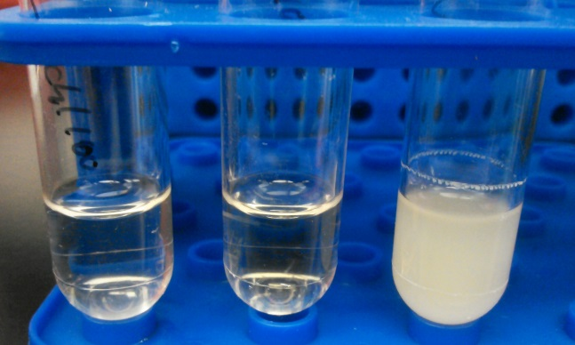
Figure 20. Selective Media Cultures of Isolate 08-1661 in 100µg/mL Chloramphenicol at 24, 48 and 72 Hours.
Isolate 08-1661 in a chloramphenicol growth assay is shown as a representative example of 24, 48 and 72 hour growth experiments. Each isolate with each concentration was replicated at least 5 times and often displayed variable and inconsistent initial growth time points as measured by optical density exceeding 0.5. Time points in 24 hour increments were used to account for this variability which is likely due to a heterologous population of inoculating cells.

Upon re-testing chloramphenicol and gentamicin growth cultures of isolate 08-1661 with the standard disc diffusion and microbroth dilution using the media (negative) and plate (negative) method described above, resistant interpretations were observed for both methods with chloramphenicol while intermediate resistance was observed for gentamicin. Upon re-testing chloramphenicol and gentamicin growth cultures of isolate 08-1661 with the standard disc diffusion and microbroth dilution using the media (positive) and plate (negative) method described above, resistant interpretations were observed for both methods with both antibiotics (Table 14). Interestingly, when isolate 08-1661 was grown in high (>100µg/mL) levels of chloramphenicol, resistance to gentamicin decreased, giving a susceptible call, whereas when grown in 100µg/mL gentamicin resistance to both antibiotics increased.
Isolate 08-1661 displayed increased susceptibility to gentamicin in the disc diffusion assay when selectively grown in chloramphenicol (Figure 31). While the zone size still resulted in a resistant determination the zone was consistently larger during the growth assay testing with chloramphenicol. This was not observed when grown in the presence of gentamicin.

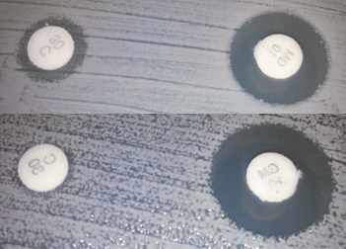
Figure 21. Isolate 08-1661 Grown in Chloramphenicol Displays Reduced Resistance to Gentamicin as Determined by Increased Zone Size in Disc Diffusion Assay.
Isolate 08-1661 was subjected to exposure to chloramphenicol in the growth assay, ultimately increasing its phenotypic resistance as demonstrated by reduced zone of inhibition in disc diffusion assays. Conversely, growth in chloramphenicol led to an increased zone size and reduced resistance to gentamicin, potentially through competitive gene expression.

Isolate 06-3228 reached log phase growth in 25µg/mL gentamicin between 48-72 hours post-inoculation, with no observed growth for the first 24 hours. Upon reaching log phase growth in each level of concentration, the media was used to inoculate new subcultures at the same concentration and grow to log phase within 24 hours. At this point, the next level of concentration was inoculated with the 24 hour growth. Isolate 06-3228 displayed a delayed growth phenotype at each level of gentamicin exposure, taking between 48-72 hours at each concentration to adapt. Once adapted, 24 hour growth in a new inoculum at the previous concentration was observed. The maximum gentamicin concentration isolate 06-3228 was able to grow in was 200µg/mL. Upon re-testing gentamicin growth cultures of isolate 06-3228 with the standard disc diffusion and microbroth dilution using the media (negative) and plate (negative) method described above, disc diffusion determined gentamicin as susceptible whereas microbroth dilution determined intermediate level resistance. Upon re-testing gentamicin growth cultures of isolate 06-3228 using the media (positive) and plate (negative) method described above, resistant interpretations were observed for both methods (Table 14).
Isolate NA12 reached log phase growth in 25µg/mL gentamicin between 24-48 hours post-inoculation, with no observed growth for the first 24 hours. Upon reaching log phase growth in each level of concentration, the media was used to inoculate new subcultures at the same concentration and grow to log phase within 24 hours. At this point, the next level of concentration was inoculated with the 24 hour growth. Isolate NA12 displayed a delayed growth phenotype at concentrations of 25µg/mL and 50µg/mL, taking between 24-48 hours at each concentration to adapt. Once adapted, 24 hour growth in a new inoculum at the previous concentration was observed. The maximum gentamicin concentration isolate NA12 was able to grow in was 150µg/mL. Upon re-testing gentamicin growth cultures of isolate NA12 with the standard disc diffusion and microbroth dilution using the media (negative) and plate (negative) method described above, both assays interpreted as intermediate level resistance. Upon re-testing gentamicin growth cultures of isolate NA12 using the media (positive) and plate (negative) method described above, resistant interpretations were observed for both methods (Table 14). While all 4 isolates were grown in lincomycin selection using this approach, NA12 was the only isolate that was interpreted as susceptible in the standardized assays. The standardized assays used clindamycin to approximate resistance to lincosamides, whereas the media culture used lincomycin.
Isolate NA07 reached log phase growth in 25µg/mL gentamicin between 48-72 hours post-inoculation, with no observed growth for the first 24 hours. Upon reaching log phase growth in each level of concentration, the media was used to inoculate new subcultures at the same concentration and grow to log phase within 24 hours. At this point, the next level of concentration was inoculated with the 24 hour growth. Isolate NA07 displayed a delayed growth phenotype at all levels of concentration up to 100µg/mL, taking between 24-48 hours at each concentration to adapt. Once adapted, 24 hour growth in a new inoculum at the previous concentration was observed. The maximum gentamicin concentration isolate NA07 was able to grow in was 150µg/mL. Upon re-testing gentamicin growth cultures of isolate NA07 with the standard disc diffusion and microbroth dilution using the media (negative) and plate (negative) method described above, both assays called it gentamicin susceptible. Upon re-testing gentamicin growth cultures of isolate NA07 using the media (positive) and plate (negative) method described above, resistant interpretations were observed for both methods (Table 14).
Isolates 08-1661, 06-3228, NA45 and NA47 were also grown in selective media and tested directly using each assay without using a non-selective BA plate. Images of disc diffusion plates were taken as 08-1661 and 06-3228 failed to grow sufficiently on both the Mueller-Hinton plates (Figures 22 and 23) as well as in the Vitek control well. Isolates NA45 and NA47 grew normally (Figures 24 and 25). The Vitek instrument did indicate growth of 08-1661 and 06-3228 in non-control, antibiotic containing wells. The Mueller-Hinton plates appeared to have irregular growth and colony size distribution.

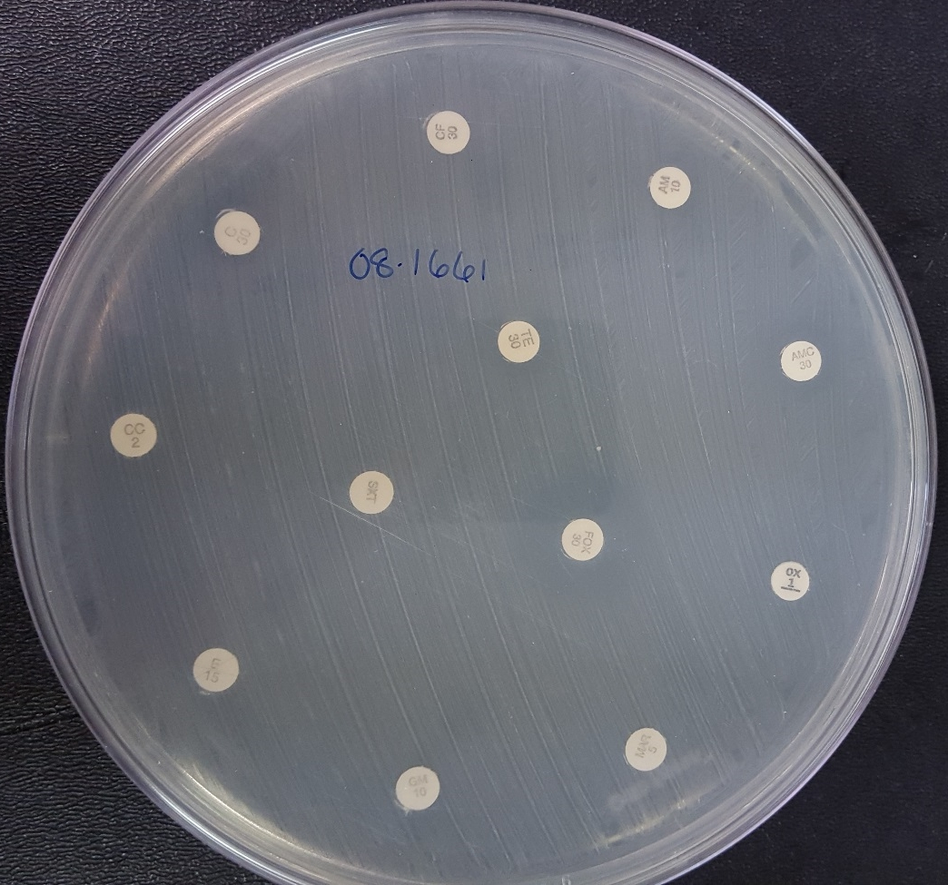
Figure 22. Mueller-Hinton Plate of Direct Plating 08-1661 from Selective Media.
Isolate 08-1661 failed to grow to a readable concentration by 24 hours on Mueller-Hinton plates when taken directly from media containing high concentrations of chloramphenicol in the growth assay. Two large colonies were observed (one near the chloramphenicol disc) among a lawn of small colony variants. Multiple experimental replicates produced similar results of a heterologous population with few large colonies. Cultures grown in the growth assay without selection produced normal Mueller-Hinton plate results.

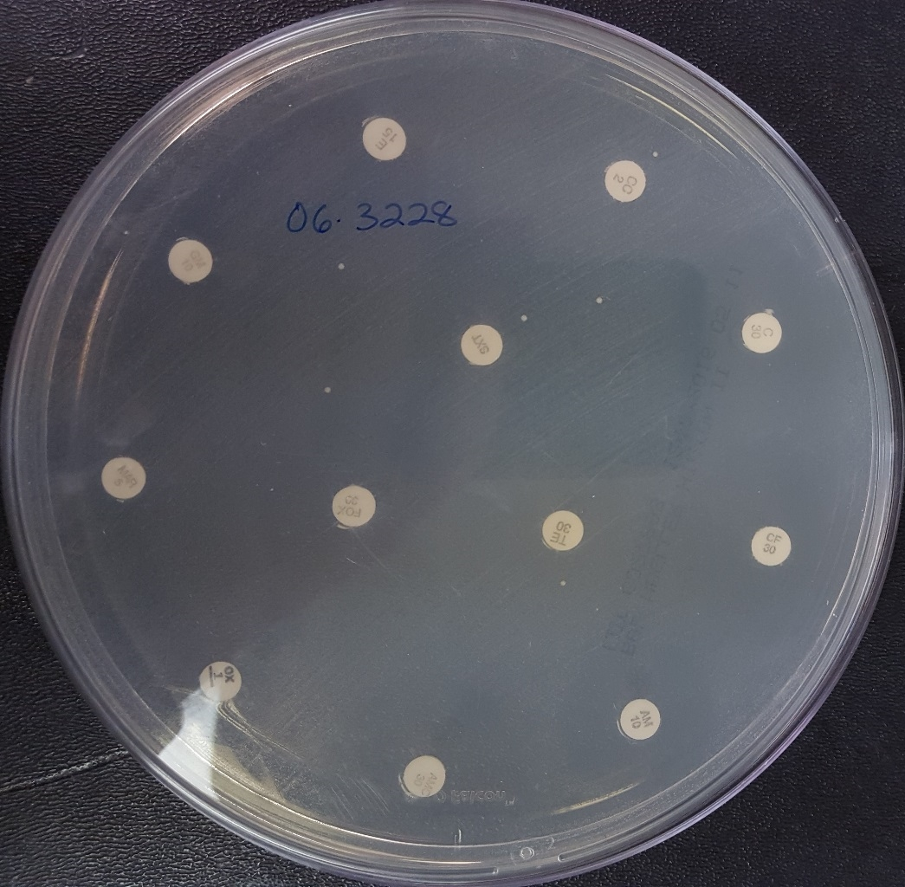
Figure 23. Mueller-Hinton Plate of Direct Plating 06-3228 from Selective Media.
Isolate 08-1661 failed to grow to a readable concentration by 24 hours on Mueller-Hinton plates when taken directly from media containing high concentrations of gentamicin in the growth assay. Eight large colonies were observed among a lawn of small colony variants. Multiple experimental replicates produced similar results of a heterologous population with few large colonies. Cultures grown in the growth assay without selection produced normal Mueller-Hinton plate results.

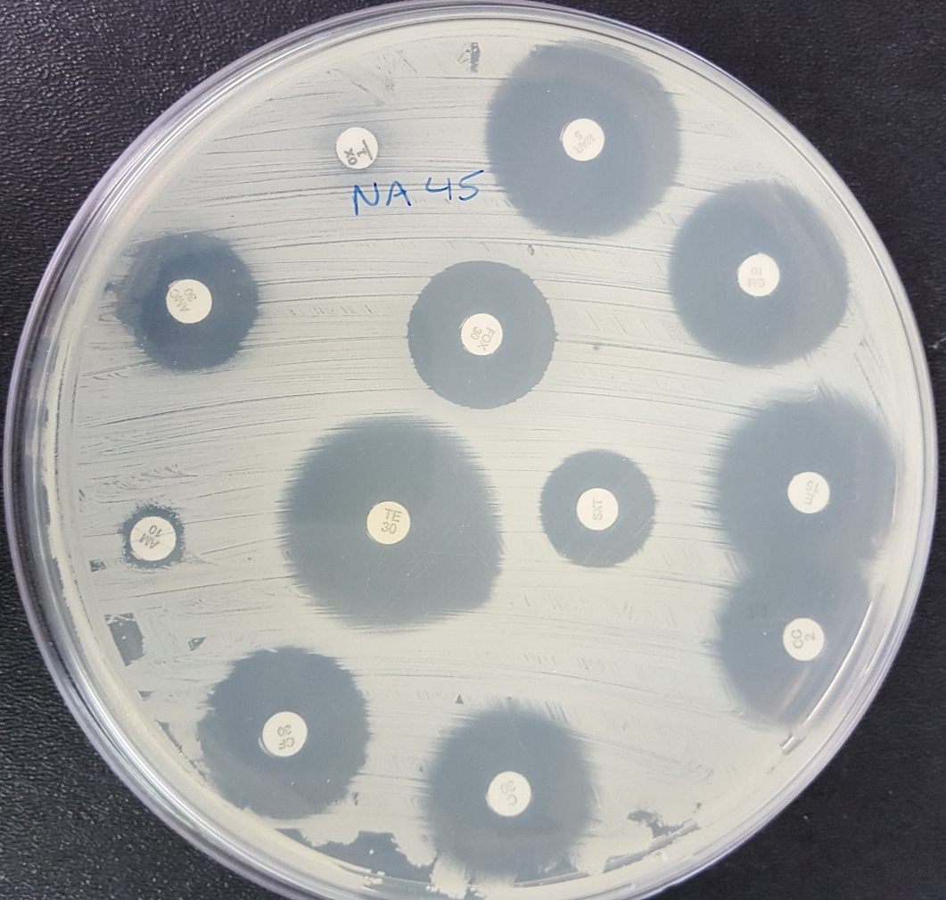
Figure 24. Mueller-Hinton Plate of Direct Plating NA45 from Non-Selective Media.
Isolate NA45 was able to grow a uniform, visible lawn at 24 hours on Mueller-Hinton for disc diffusion testing when taken directly from non-selective media in the growth assay.

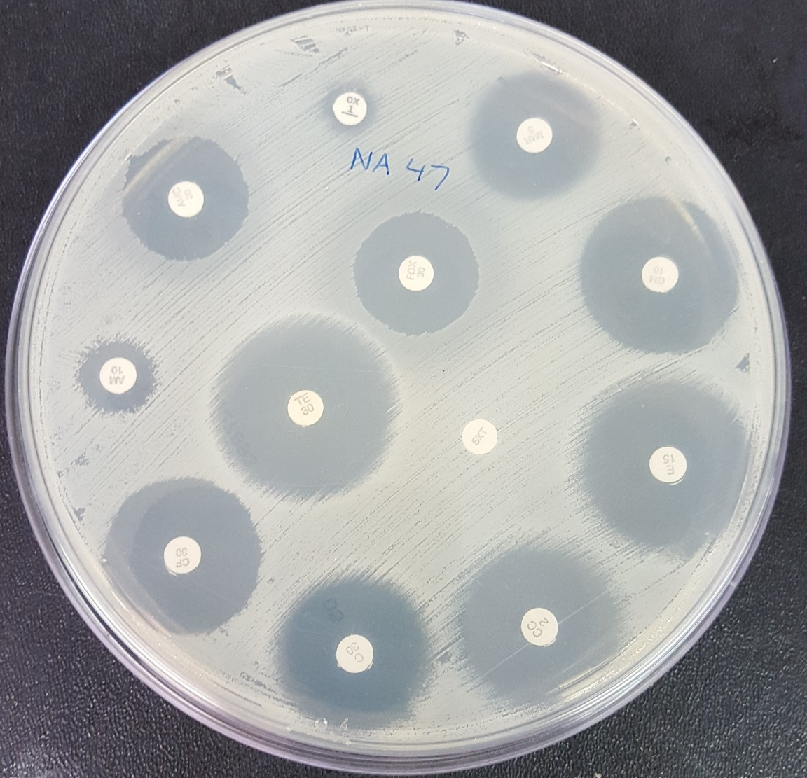
Figure 25. Mueller-Hinton Plate of Direct Plating NA47 from Non-Selective Media.
Isolate NA47 was able to grow a uniform, visible lawn at 24 hours on Mueller-Hinton for disc diffusion testing when taken directly from non-selective media in the growth assay.

The Mueller-Hinton plates of 06-3228 inoculated directly from selective media displayed a large colony and small colony variant (Figure 26.).

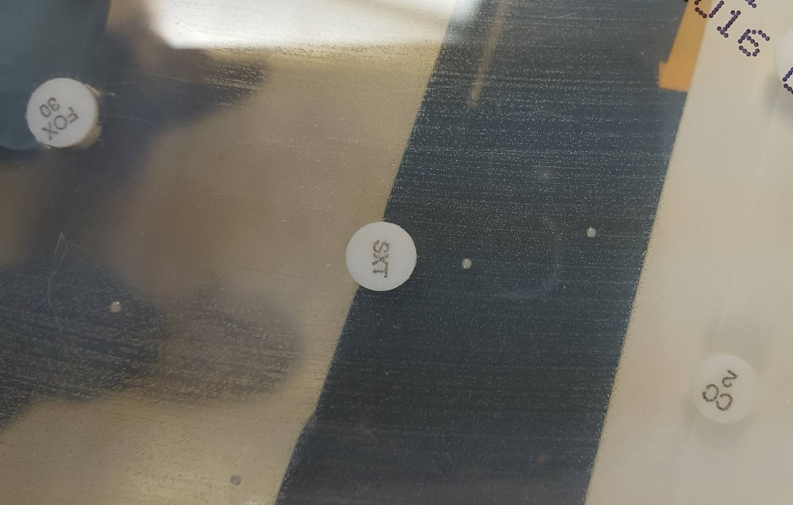
Figure 26. Individual Sparse Large Colonies Observed on Mueller-Hinton Plates from Selective Cultures of 06-3228.
Large and small colony variants were observed on Mueller-Hinton plates during disc diffusion assays re-testing isolates 08-1661 and 06-3228 after increasing antibiotic resistance in vitro. Subculture of these colonies revealed two colony variants, likely small colony variants hidden by the large on this original plate.

One colony from the large colony variant shown in Figure 21 was picked from the 06-3228 Mueller-Hinton plate and plated onto non-select Antibiotic Agar No. 1, resulting in two extreme colony variant types- very large and very small (Figure 27).

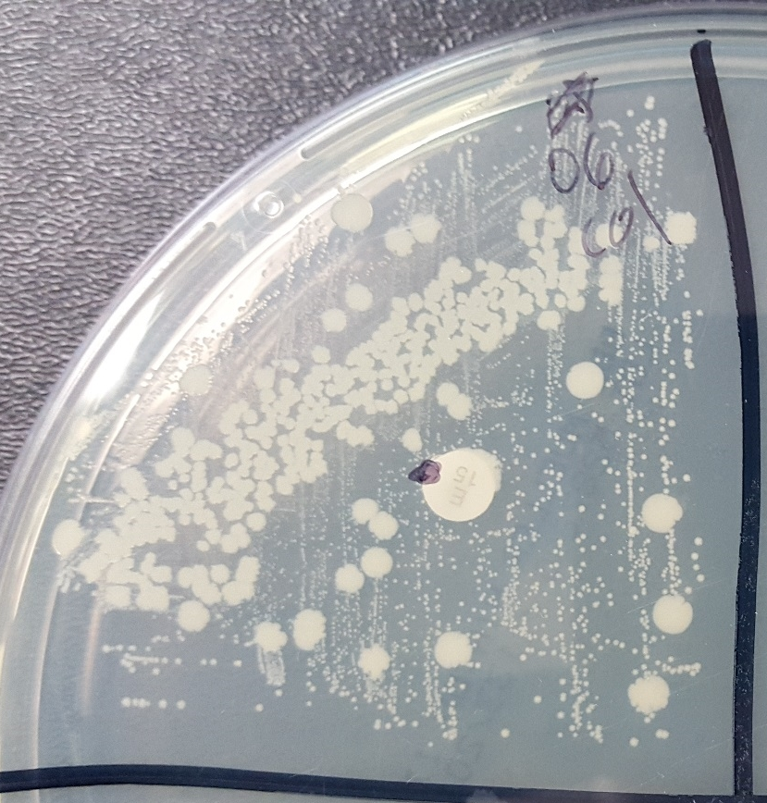
Figure 27. Colony Morphotypes of 06-3228 Colony Picked from Mueller-Hinton Plate Subcultured onto Non-Selective Agar.
The large colonies observed on Mueller-Hinton plates after selective growth assays for isolates 06-3228 and 08-1661 grew two clear subpopulations of cells when further subcultured without selection. This likely represents a heterologous population in the large colony picked being unable to prevent transfer of small colony variants.

A streak was taken from the lawn of the same Mueller-Hinton plate and subsequently re-plated, revealing a small but relatively uniform colony formation (Figure 28).

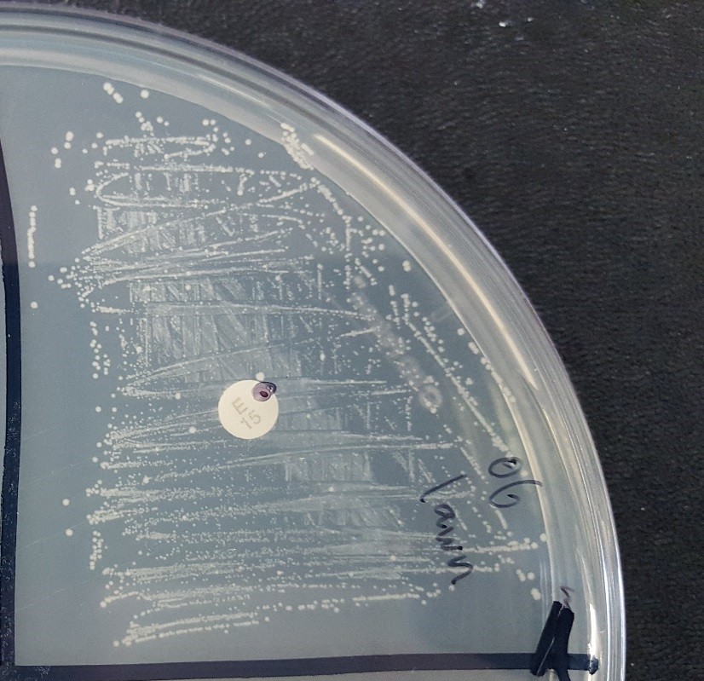
Figure 28. Subculture of 06-3228 Lawn Picked from Mueller-Hinton Plate on Non-Selective Agar.
Small colony variants on Mueller-Hinton plates after selection in the growth assay subcultured into a mixed but mostly small colony variants for both 08-1661 and 06-3228. While all colonies observed are considered small for 24 hour growth, the variability in size observed is repeatable and likely represents small variability due to the inability to pick individual small colonies from the original plate. No large colony variants are observed after subculture of more than 5 small streaks.

Presence of Genes and Plasmids
Not all primer sets for amplification of full length plasmids and genes were successful. To verify the presence of the large linear element found in isolate 06-3228, 5 primer sets were developed using the sequences of 5 CDS found in the sequence that do not match to any hit in any S. pseudintermedius in Genbank. Standard PCR cycling conditions with a 55°C annealing temperature at 40 cycles resulted in successful, single band amplification which was verified by sequencing the PCR product of each reaction (Figure 26).

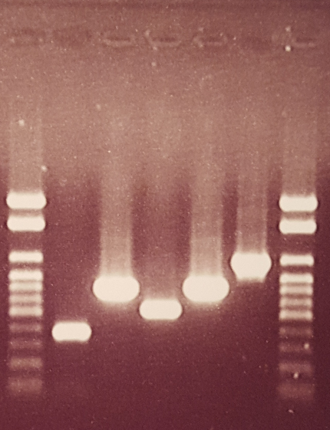
Figure 29. Amplification of 5 Genes Found on Linear Element in 06-3228.
The linear genetic element in isolate 06-3228 contained 5 predicted coding sequences matching to genes in other species, yet with no sequence above 45% identity in any S. pseudintermedius sequence in Genbank. PCR was used to verify the presence of these sequences in this MRSP isolate. Five genes unique to the linear element sequence are flanked by DNA ladders on the right and left.

The plasmid-borne LinA gene identical in 06-3228, NA07 and NA12 amplified from 06-3228 as expected, as well as the functionally annotated tetK gene and CAT gene from 08-1661 (Figure 27).

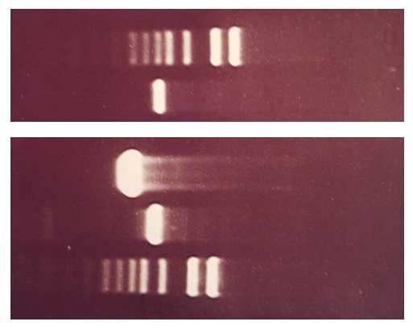
Figure 30. 1Kb Extend DNA Ladder with 06-3228 LinA, 08-1661 tetK and 08-1661 CAT Amplicons.
Primers were designed to amplify the plasmid-borne LinA gene found in 06-3228, NA12 and NA07 (lane 2), and the plasmid-borne CAT and tetK genes in 08-1661 (lanes 3, 4). DNA ladders are in lanes 1 and 5 for sizing estimate.

Purified plasmids were difficult to visualize on agarose gels, and even when grown in selection visualization was only achieved in some replicates despite significant modifications to the protocol for lysis times, starting concentration and elution techniques (Figure 28).

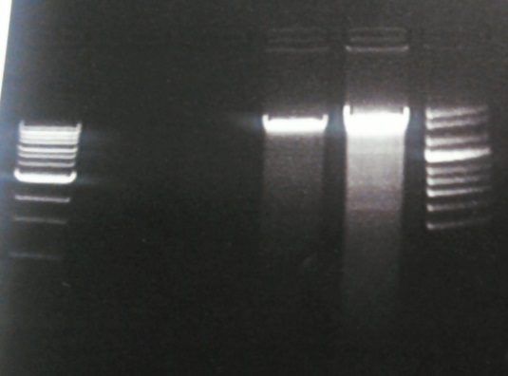
Figure 31. Visualization of DNA using Whole DNA Precipitation.
Total DNA precipitation and plasmid extraction followed by gel electrophoresis was performed on isolates NA12 and NA07. Lanes 2 and 3 show the lack of plasmids in NA12 and NA07 using the plasmid extraction kits. Total DNA precipitation for the same cultures were run in Lane 4 and 5. Lane 4 shows NA07 with genomic DNA and potentially two light plasmid bands; lane 5 is NA12 genomic DNA with potentially 3 light plasmid bands.

The tetK-carrying plasmid from isolate 08-1661, the chloramphenicol resistance plasmid from 08-1661 and the LinA-carrying plasmid from isolate 06-3228 were amplified using extended PCR extension times of 5 minutes (Figure 29).

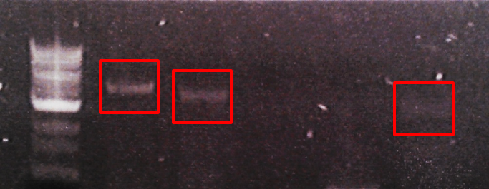
Figure 32. Plasmids Amplified using Full Length Primer Sets.
PCR amplification was performed using inverted primer sets for 5 plasmids from isolates 08-1661 (tetK, CAT), NA12 (LinA), NA07 (LinA) and 06-3228 (LinA). Lane 1 is ~4439bp tetK plasmid from isolate 08-1661; lane 2 is CAT plasmid from isolate 08-1661; lane 5 is LinA plasmid from isolate 06-3228. NA12 and NA07 were PCR positive for the plasmid genes but unable to amplify full length plasmids. Primers were designed inverted facing outwards, requiring a circular construct for amplification and verifying circularization.

Real-Time Quantitative PCR was performed as described on the CAT gene sequence relative to 16s sequence to determine if there was an increase in gene copy number, which would reflect a likely increase in plasmid copy number per cell. Isolate 08-1661 was grown in parallel in non-selective media and 150µg/mL chloramphenicol, and each sample was run with a 16s control primer set. The copy number of the sample grown in selection (CT= 21.28) was higher than its 16s control (CT=26.52) while the non-selective sample had almost identical CT values for both (CT= 13.99; CT=14.50).

Discussion
Antibiotic resistance was predicted from genome sequencing for several sequenced isolates, and 4 were selected for individual investigation. Isolate 08-1661 was tested with chloramphenicol and gentamicin and all isolates were tested with gentamicin and lincomycin. These isolates were selected because one or both of the initial standard assays- disc diffusion or microbroth dilution- conflicted either with each other or with the predicted resistance from the genome sequence data. Additionally, the chloramphenicol and lincomycin resistance genes were predicted to be located on extrachromosomal plasmids, while the gentamicin genes of interest were located in transposons or prophage. The ability of plasmids and repetitive genomic elements such as phage and transposons to have variable copy number combined with the conflicting susceptibility interpretations suggested they may be influencing resistance profiles. A complete table showing initial susceptibility determinations, genome predictions, media growth and re-testing can be found in Table 15.

Table 15. Initial Susceptibility Testing, Genome Sequence Prediction, Media Growth and Re-Testing of 08-1661, 06-3228, NA12 and NA07. “NEG” refers to culture without antibiotics while “POS” refers to growth in antibiotics.
Strain | Antibiotic | Initial DD call | Initial Vitek call | WGS prediction | Media Growth | DD Re-Test NEG | Vitek Re-Test NEG | DD Re-Test POS | Vitek Re-Test POS
08-1661 | Chloramphenicol | R | S | R | R- delayed | R (9mm) | R | R (6mm) | R
08-1661 | Gentamicin | I | S | R | R-delayed | I (15mm) | I | R (6mm) | R
08-1661 | *Lincomycin/ Clindamycin | R | R | R | R | R | R | R | R
06-3228 | Chloramphenicol | S | S | S | S | S | S | S | S
06-3228 | Gentamicin | S | S | R | R- delayed | S (17.5mm) | I | R (6mm) | R
06-3228 | *Lincomycin/ Clindamycin | R | R | R | R | R (6mm) | R | R (6mm) | R
NA12 | Chloramphenicol | S | S | S | S | S | S | S | S
NA12 | Gentamicin | S | S | R | R-delayed | I (13mm) | I | R (6mm) | R
NA12 | *Lincomycin/ Clindamycin | S | S | R | R (Lin) | S (21.5) | S | S (22mm) | S
NA07 | Chloramphenicol | S | S | S | S | S | S | S | S
NA07 | Gentamicin | S | S | R | R- delayed | S (16mm) | S | R (6mm) | R
NA07 | *Lincomycin/ Clindamycin | R | R | R | R | R (6mm) | R | R (6mm) | R

The in vitro growth assay using chloramphenicol and gentamicin indicated there may be inducible or dose-dependent resistance in some of these isolates. Negative controls ensured that increasing resistance to the antibiotics was not a result of mutations accumulated over time while growing in increasing concentrations of antibiotics. Stability of the antibiotics was ensured using negative controls allowed to incubate significantly longer than the experimental samples. While NA47 served as a control for gentamicin as it lacked both aminoglycoside resistance genes of interest, it is worth noting that NA45 was also unable to grow in any concentration of gentamicin. As mentioned before, NA45 contains the same ant(6)-Ia aminoglycoside resistance gene as the other North American isolates, it does not contain the aac(6’)-aph(2’’)-Ia gene carried by the prophage in the isolates that demonstrated resistance to gentamicin. This supports the conclusion that ant(6)-Ia does not provide general aminoglycoside resistance and that aac(6’)-aph(2’’)-Ia is likely responsible for resistance to gentamicin. The North American isolates that have aac(6’)-aph(2’’)-Ia had susceptible or intermediate initial determinations to gentamicin, but over time demonstrated resistance when exposed to gentamicin. Taken together, this could indicate that the aac(6’)-aph(2’’)-Ia gene carried on the prophage provides gentamicin-inducible resistance.
To rule out indirect resistance effects to gentamicin such as reduced ion flow through the outer cell wall that may have arisen while being subcultured repeatedly in liquid media, the media (NEG) and plate (NEG) control was implemented. It is interesting that 3 of the 4 isolates were interpreted as intermediate with the Vitek method and 2 out of 4 were interpreted as intermediate via disc diffusion. This would suggest that there was some level of resistance provided by growth in liquid media. However, as the negative controls did not display resistance when cultured in the growth assay without selection, the growth assay itself does not confer resistance indirectly. Perhaps growth in liquid media exposes the isolates to conditions similar (less or more stress) to those that would exist during an infection, increasing expression of the aac(6’)-aph(2’’)-Ia gentamicin resistance gene. However, the results from the media (POS) and plate (NEG) method were conclusively more resistant in each case, with determinations for all 4 isolates using both methods being resistant, including the 3 susceptible interpretations from the media (NEG) plate (NEG) testing. Additional testing using a media (POS) and plate (POS) was not necessary as the interpretations from the media (POS) plate (NEG) testing were the highest level of resistance that could be determined by these assays. It is worth noting that the isolates grown in both chloramphenicol and gentamicin selective media were plated for 24 hours on a non-selective plate prior to testing in this protocol. A loss of resistance when removed from selection may take more time than 24 hours.
Conversely, when isolate 08-1661 was grown in chloramphenicol and tested for gentamicin, a reduction in resistance to gentamicin was observed. This could reflect an unknown enzymatic reaction or cell process, or that energy being used for generation of chloramphenicol acetyltransferase led to a reduction in expression of resistance to gentamicin. In theory, this means that co- or serial-treatment strategies may in fact have some success in organisms with multiple resistances.
Isolate 08-1661 was the only isolate predicted to contain the chloramphenicol acetyltransferase (CAT) gene, which appeared to be carried on an extrachromosomal plasmid. While the initial disc diffusion determination was resistant, the Vitek result indicated susceptibility. However, the Vitek card available at the time of testing was not validated for chloramphenicol for S. pseudintermedius, possibly because this conflict in testing had been observed previously. When exposed to chloramphenicol, 08-1661 displayed resistance only after 24 hours but less than 72. This may explain the conflict in the initial testing, as the microbroth dilution assay tests samples at time points as low as 4 hours relative to the disc diffusion 24 hour reading. In the media (NEG) and plate (NEG) experiment, resistance was in fact determined to be present using both methods, although the zone size for the disc diffusion was slightly larger than it was for the media (POS) plate (NEG) experiment. As the negative controls (all 3 other isolates) remained susceptible via both assays when re-tested in media (NEG) plate (NEG) experiments, it again suggests that the observed increase in resistance to chloramphenicol after non-selective growth in media is a result of an increase in expression of inherent resistance and not an indirect byproduct of the growth methodology.
The observed delay in resistance to gentamicin by all experimental isolates (08-1661, 06-3228, NA12 and NA07) with neither negative control (NA45 and NA47) showing resistance in any assay leads to the conclusion that they do in fact retain inherent resistance to gentamicin but it may not be detected when tested at time points less than 24 hours. Each isolate displayed variable time points at which they passed the growth threshold of OD>0.5 in selection at each concentration. This likely reflects minute differences in heterogeneous populations, very small differences in inoculating cell numbers or slightly different time points in growth phase at which inoculum was taken. The time points of 24, 48 and 72 hours were selected due to this variability and the fact that current assays use a maximum of 24 hour readings.
The location of the resistance genes within the genome (or extrachromosomally) may suggest a mechanism for this observed inducible resistance. As stated previously, the CAT gene resides on a plasmid in 08-1661 which based upon average read depth of the initial genome sequencing and the inability to visualize it from multiple plasmids extractions must be, if present, in very low copy numbers. The read depth of the original WGS for this plasmid compared to the genome average is roughly 3x higher, suggesting a likely copy number of 3 copies per genome. The read depth in the second round of sequencing, from the culture of 08-1661 that was grown in selection, was 10x the previous depth, suggesting a copy number per genome of around 30-40. While that is still a relatively small copy number for extrachromosomal plasmids, it could potentially allow significantly increased levels of resistance to chloramphenicol. If the increase in resistance to chloramphenicol seen in 08-1661 was due to an increase in plasmid copy number, we would expect to see an increase in both the DNA sequence of the CAT gene as well as an increase in the CAT RNA production relative to a housekeeping gene. If however an increase in RNA is observed but not one in the DNA, it may be that only expression of the gene has increased and not plasmid copy number.
Alternately, the gene of interest for resistance to aminoglycosides, specifically gentamicin, are both located on the chromosome. The aac(6’)-aph(2’’)-Ia fusion gene resides within unique prophage sequence in each genome. The gene aph(3’)-III is also found in each of these isolates and annotated as “aminoglycoside resistance”, yet it has been proven to provide direct resistance only to kanamycin, neomycin, paromycin, amikacin and gentamicin B (102). Gentamicin B is a minor component of many commercially available gentamicin antibiotic solutions yet has an unknown mechanism of action as it is a terminal alternate pathway in gentamicin production (119). While gentamicin B does occur in some gentamicin antibiotic solutions, it has not been shown in Staphylococcus to confer direct resistance to the major gentamicin component in most commercial solutions. The fusion gene aac(6’)-aph(2’’)-Ia which provides resistance to gentamicin, tobramycin and amikacin in Staphylococci and Enterococci is the logical target for conferring gentamicin resistance in these isolates; that correlates to the resistance patterns we observe with the exception that instead of providing high level resistance (HLR), it seems to provide low level or transient resistance. The sequence of this gene does not contain any synonymous mutations relative to many other sequences in Genbank and so it is likely that the mechanism is either gene duplication or increased gene expression. Gene duplication is likely as prophage can in fact duplicate themselves within a genome especially when under stress, and possibly cut themselves out when cell fitness is adversely affected. However, in these genomes, there are several annotated stress response regulatory genes surrounding the aac(6’)-aph(2’’)-Ia gene, which could simply provide increased expression when stressed by the antibiotic. If gene copy number is the reason behind the increased resistance, both DNA and RNA expression levels would be expected to increase relative to a housekeeping gene. If increased gene expression is responsible, an increase in RNA but not DNA would be seen.
While plasmid copy number can be regulated by a variety of factors and can easily be reduced and increased, genomic expansion doesn’t have a readily available explanation as to how, if resistance is gained through duplication of phage or transposons, that duplication would be lost when not under selection in order to retain energy efficiency. One answer could be in a study that found a transposon carrying an antibiotic resistance gene duplicated itself up to 90 times, contributing an extra 300,000+bp to the genome, after exposure to the antibiotic during treatment (my paper-ref). The authors, and namely the person responsible for the optical map data which discovered and verified the duplications, found that a variety of resistant clones from the same original colony when subcultured had varying degrees of gene expansion (120). This would indicate heterogeneous populations of bacteria exist within an individual sample.
While gene and DNA loss from the genome is typically done through pseudogenization, that process can take a long time and leaves behind remnants of the duplications. However, if bacteria that did not contain duplications for the resistance gene were able to survive within a larger population that had gained the duplications and thus resistance during selection, they may outcompete the resistant genotypes if removed from the selective environment. In this theoretical case, it would seem as though the isolate rapidly loses resistance when in fact a rapid change in heterogeneous population makeup could happen instead. There is some indirect evidence that this has happened with strains 08-1661 and 06-3228. These were subjected to an additional experiment where they were grown in selective media and sent directly for disc diffusion and microbroth dilution testing without going onto a non-selective BA plate first (Materials and Methods, Figures 22, 23).As NA45 and NA47 grew as expected, the failed growth of 08-1661 and 06-3228 is either a result of the presence of minute amounts of carry-over antibiotic in 06-3228 and 08-1661 somehow affecting growth on Mueller-Hinton plates or potentially inefficient growth of the majority of the population from the selective media. For both isolates, most of the plate surfaces were either empty of obvious bacterial lawn or nearly so, with the exception of infrequent large colonies.
This evidence supports the following scenario; first, a majority-susceptible population (containing only 1 copy of the resistance gene) was picked from a non-select BA plate and used to inoculate media with selection. After some delay, many cells or a small portion duplicated the resistance gene in order to become more resistant and successful in the media. When taken from the selective environment and plated onto the Mueller-Hinton agar directly, a very small population retained the original single-copy genome variant and were able to grow normally at 24 hours, while the multi-copy resistant variants were unable to grow sufficiently due to the large and abnormal energy consumption from the resistance gene duplication and expansion. Picking the large, normal susceptible colony from the plate resulted in a higher proportion of large colonies at 24 hours but still contained the inefficient resistant clones (as they were likely under or mixed in with the large colony). This gave rise to two distinct populations upon re-plating. The lawn, containing only the resistant, small colonies, resulted in a more uniform yet small colony variant when re-plated.
If in fact this phenomena of a heterogeneous population is responsible for these observations, it would also explain the variability observed in duplicate and replicate growth experiment timelines for length of time until log phase growth. If gene duplication is responsible for increased resistance, it is likely that either a) several independent cells acquire the duplications randomly and each culture is unique, or b) an extremely small portion of the cell population has gene duplications and small differences in inoculating numbers would have a consequently large effect on growth each time the experiment is performed. Many attempts were made to inoculate with the exact same number of cells, the same time of day, the same time points, the same volume, the same concentration of antibiotic and the same incubation conditions yet variation in growth in gentamicin still varied even between triplicates in the same experiment.
Lincomycin was also used to test isolates 08-1661, 06-3228, NA12 and NA07 using the novel in vitro growth assay with NA45 used as a negative control. As isolates 06-3228, NA12 and NA07 all contained a plasmid encoding the lincomycin resistance gene LinA (alias lnuA), they should have demonstrated resistance to lincosamides. Clindamycin is used as a representative for lincosamides; 08-1661 lacked the gene/plasmid yet was determined to be resistant using both assays, with no observed growth delay. It should be noted, however, that there are other genes encoding resistance to clindamycin, such as the emr(A/B/C/E) family, of which multiple were found in each isolate. Thus, it isn’t surprising that 08-1661, 06-3228 and NA07 displayed resistance in all initial and follow-up testing. However, NA12 was interpreted as susceptible using both disc diffusion as well as microbroth dilution in initial testing, which was unexpected as it contains not only LinA on a plasmid which may confer resistance to lincosamides, but an additional plasmid with the emr(E) gene that belongs to a well-known family of genes conferring resistance through efflux pumps to multiple antibiotics as well as quaternary ammonium compounds (QACs), although this particular allele hasn’t been well studied. It does contain significant homology to qacG which has been implicated in resistance to multiple biocides and antibiotics (121).
Isolate 08-1661, despite being resistant to clindamycin throughout the experiment, was unable to grow in the lincomycin used in the growth assay. Conversely, NA12 was able to grow at 24 past log phase in lincomycin. NA45 served as a good negative control with no growth past 72 hours while NA07 and 06-3228 growing within 24 hours in media. The two findings here that are unexpected are first that 08-1661 was unable to grow in lincomycin despite being resistant to clindamycin, and second that NA12 was able to grow in lincomycin yet unable to demonstrate any resistance to clindamycin at any time. The conclusion drawn from this experiment is that clindamycin resistance is not directly tied to resistance to lincomycin, and vice versa. The reason why NA12 was susceptible in all assays to clindamycin despite being resistant to lincomycin as well as possessing two genes involved in resistance to lincosamides remains unknown.
These growth experiments demonstrate that potential clinically relevant resistance may exist in bacterial isolates even when determined to be susceptible using standardized antibiotic resistance assays. Two CLSI approved methods, disc diffusion and microbroth dilution, were compared to a novel media-based time-delay growth experiment where the critical factor was allowing the bacteria to grow past the 24 and 4 hour time points, respectively, that each standard assay is limited to. Not only were resistances predicted on gene content from WGS data demonstrated where susceptible interpretations were initially made using one or both methods, but the isolates were able to exhibit in some cases the highest level of resistance able to be measured. The most significant findings of resistance to gentamicin and chloramphenicol displayed a delay in expression up to 72 hours after exposure to the antibiotic, yet were able to maintain this resistance when removed from selection and placed back into the standard susceptibility testing techniques. The genes likely responsible for the resistance observed are located on mobile genetic elements which may function by increasing copy number or gene expression. One piece of evidence to support this is the RT-PCR performed on isolate 08-1661 grown in selection displaying higher plasmid copy number relative to 16s sequence than when not grown in selection (Figure 30).

Chapter Four:
Results and Conclusions

Genome Sequencing as a Tool for Phenotypic Prediction
In this project, clinical isolates of Staphylococcus pseudintermedius were screened using standard biochemical and molecular approaches during routine collection. This organism is important not only as a veterinary pathogen (2; 15; 20; 21) but increasingly as a human opportunistic pathogen (7, 12, 13) that may in fact be more commonly causing disease than currently believed (8; 14; 41) due to a lack of accurate identification tools (8; 45-47). Several collected isolates of S. pseudintermedius displayed conflicting or unusual phenotypic and genetic properties or were representative of major successful clonal lineages in North America and were selected for further investigation using WGS technology (Table 16).

Table 16. Overview of All Sequenced Isolates.
A total of 47 genomes were sequenced comprising multiple species and Genera, with a focus on clinical isolates of S. pseudintermedius. Sequence Type was determined using the MLST-7 scheme, unless it was unable to be performed (“unknown”) or failed to generate sequence for all alleles (“N/A”). S. delphini were characterized by “Type” A or B, respectively. The Justification for sequencing ranged from attempting to identify isolates unable to be characterized using standard techniques, conflicting genotypes and phenotypes, comparative analysis of dominant clonal lineages of MRSP and characterization of the first MRSP isolates from Botswana.
Species | Strain ID | Sequence Type | Justification | Contigs
S. species (unknown) | B1549 | N/A | Unknown species | 1
S. species (unknown) | B1553 | N/A | Unknown species | 1
S. pseudintermedius | 117N | unknown | Canine from Botswana | 1
S. pseudintermedius | 111N | unknown | Canine from Botswana | 1
S. pseudintermedius | 104N | unknown | Canine from Botswana | 160
S. pseudintermedius | NA45 | ST84 | Dominant NA Lineage | 89
S. pseudintermedius | 06_3228 | ST68 | Dominant NA Lineage | 260
S. pseudintermedius | NA47 | ST56 | Dominant NA Lineage | 54
S. pseudintermedius | NA07 | ST124 | Dominant NA Lineage | 96
S. pseudintermedius | NA12 | ST64 | Dominant NA Lineage | 42
S. pseudintermedius | E15 | N/A | Electrocompetent | 112
S. pseudintermedius | E140 | ST71 | European ST71 | 44
S. pseudintermedius | MI 13-1718 | N/A | Lytic against MRSP/MRSA | 54
S. pseudintermedius | NA91 | ST71 | MecA(-) ST71 | 43
S. pseudintermedius | 08_1661 | ST71 | North American ST71 | 50
S. pseudintermedius | NA16 Pre | N/A | Phage lysis study | 39
S. pseudintermedius | NA16 Post | N/A | Phage lysis study | 43
S. pseudintermedius | LMG22219 | N/A | Type Strain | 10
S. pseudintermedius | NA149 | ST160 | Typing verification | 24
S. pseudintermedius | NA63 | ST162 | Typing verification | 41
S. pseudintermedius | NA144 | ST56/CC84 | Typing verification | 55
S. pseudintermedius | NA189 | ST159/CC84 | Typing verification | 51
S. pseudintermedius | NA179 | ST148/CC71 | Typing verification | 20
S. pseudintermedius | NA184 | ST80/CC68 | Typing verification | 18
S. pseudintermedius | NA36 | ST154 | Typing verification | 275
S. pseudintermedius | NA109 | N/A | Typing verification | 39
S. pseudintermedius | NA104 | ST139 | Typing verification | 77
S. pseudintermedius | NA125 | ST141/CC68 | Typing verification | 22
S. pseudintermedius | NA180 | ST106 | Typing verification | 93
S. pseudintermedius | NA3 | ST152 | Typing verification | 37
S. pseudintermedius | NA77 | ST134 | Typing verification | 39
S. pseudintermedius | NA38 | ST142 | Typing verification | 34
S. pseudintermedius | 06-1066A | N/A | Unusual ASP | 37
S. pseudintermedius | 06-1066B | N/A | Unusual ASP | 50
S. pseudintermedius | MI 14-243 | N/A | Unusual ASP | 36
S. pseudintermedius | NA157 | N/A | Unusual ASP | 75
S. pseudintermedius | MI 16-2909a | N/A | Unusual ASP | 52
S. pseudintermedius | MI 16-2925a | N/A | Unusual ASP | 53
S. intermedius | NCTC11048 | N/A | Type Strain | 19
S. delphini | 52-006A | Type A | Species verification | 24
S. delphini | MI16-1129A | Type A | Species verification | 46
S. delphini | 56-021A | Type A | Species verification | 52
S. delphini | P27B | Type B | Species verification | 51
S. delphini | P50 | Type B | Species verification | 46
S. delphini | DSM20771 | N/A | Type Strain | 24
S. aureus | Wood46 | N/A | Lab reference strain | 99
Caviibacter abscessus | MI 14-3285 | N/A | Unknown species | 65

Molecular typing using any of several different methods is challenging when trying to compare between studies or collections as no single typing method for MRSP or MSSP has been agreed upon to date. In this study the relationships between isolates between an MLST-7 eBURST analysis (83) and a core genome SNP analysis were very similar (Figure 9, reinforcing the relationships between the dominant clonal lineages in North America. As both MLST-7 and core genome SNP analysis rely upon DNA sequence that is highly conserved and under purifying selection, it is not surprising that the ST relationships do not necessarily correlate to clinical characteristics of these isolates (Videla et al). Clinical characteristics include antibiotic susceptibilities and resistances, virulence and immune evasion and are often carried by mobile genetic elements under positive selection (84) and thus would not be part of the MLST typing system nor the core genome analysis.
It has been suggested that MGEs in Staphylococci are relatively rare and, when present, conserved within clonal lineages (122; 123). In this study, a novel method to detect potential plasmids from WGS data directly was used to identify >30 potential plasmids, of which 9 were studied in depth. As these 9 plasmids come from only 4 isolates it seems likely that plasmid content in S. pseudintermedius is much higher than previous studies would suggest. As 3 identical plasmids (LinA) are found across completely different major clonal lineages (ST64, ST124 and ST68), conservation within lineages of MGE does not appear to be true and recent horizontal transfer is likely. The results of this study also conclude that even when these plasmids can be isolated or amplified, they are present at very low copy number per genome and easily missed by more traditional plasmid isolation techniques (64). None of the 9 plasmids investigated matched to any complete plasmid sequence to date in Genbank, further proving that using known plasmid sequence to design primers to screen for plasmids is unlikely to be a good novel plasmid discovery technique. Plasmids found using this approach will in fact appear lineage-conserved simply because the screening method requires that they be closely related (64). The novelty of the majority of plasmids discovered in this study also highlights the likelihood of rapid and recent horizontal transfer between lineages.
Bacteriophage insertions in the completed genomes of HKU10, ED99, E140, 08-1661, 06-3228 and NA45 indicate that phage content is not lineage conserved, which directly conflicts with previous studies (123). When comparing prophage insertion sites and specific prophage sequences between these completed genomes two patterns emerge (Appendix E). First, phage insertion sites within the genome appear to be lineage conserved. However, the actual prophage sequence within these sites are most similar among isolates that are geographically related. As insertion sites reflect specific DNA sequence within each genome, conservation among evolutionarily related organisms is logical due to their core genome sharing more in common than with other lineages. However, as bacteriophage are known to move horizontally between bacteria and do not generally reflect evolutionary relationships, specific phage content is more closely tied to geographic region than clonal lineage. This conclusion may have been missed by previous studies simply because repetitive phage insertions frequently create problems for genome assembly and incomplete genomes may lack these sequences (85). The inclusion of PacBio long reads as well as optical genome maps to assist with scaffolding assemblies in order to close genomes was essential in clarifying these repetitive phage insertions.
Of the major clonal lineage representatives for North America, isolates 08-1661, 06-3228, NA12 and NA07 appeared to have conflicting antibiotic susceptibilities during initial testing using two standardized methods; disc diffusion and microbroth dilution. Some of these resistances were predicted from the WGS data to be conferred through genes found in MGEs such as prophage, transposons and plasmids (Table 8). Isolate 08-1661 was shown to harbor a plasmid with the chloramphenicol resistance gene CAT yet was interpreted as susceptible using microbroth dilution. Disc diffusion correctly determined resistance, and while the Vitek card used was not certified for chloramphenicol resistance in pseudintermedius it still should have given an MIC within the resistant range to correlate with disc diffusion. As one major difference between these techniques is the amount of time the bacteria has to grow before a call is made, it appeared likely that resistance was time dependent. When exposed to chloramphenicol in a novel liquid media growth experiment, isolate 08-1661 did in fact display resistance relative to a negative control but only after 24 hours had passed from initial exposure. When re-tested using both original clinical assays, it was determined to be highly resistant.
As the CAT gene was located on a plasmid, one explanation that could account for a delay in phenotypic resistance would be the necessity of increasing plasmid copy number. While this was experimentally tested using traditional RT-PCR and found to have increased copies of the gene when exposed to chloramphenicol, a novel WGS approach was also used to assess copy number variation and reached the same conclusion. When cultures growing in chloramphenicol were removed from selection and tested using standard clinical assays, they retained this increased resistance profile for at least 24 hours post-exposure.
Isolates 08-1661, 06-3228, NA12 and NA07 all were determined to be susceptible to gentamicin by at least one standardized test, yet all were found to carry the aac(6’)-aph(2’’)-Ia aminoglycoside/gentamicin resistance gene. As opposed to being located on a plasmid, this gene is found within unique prophage sequence in each of these isolates. Prophage are known to be able to duplicate themselves within a genome in response to stress, but several of these phage also contained stress-response regulatory genes that could up- or down-regulate gene expression. As both of these scenarios could potentially take time to come into effect, these isolates were subjected to the same novel growth assay but with gentamicin instead of chloramphenicol. All 4 isolates positive for the aac(6’)-aph(2’’)-Ia gene were in fact capable of high-level resistance to gentamicin when given >24 hours exposure to the antibiotic, while an isolate containing two other aminoglycoside resistance genes remained susceptible. As the aac(6’)-aph(2’’)-Ia gene is known to confer high-level resistance (HLR) to gentamicin (88), they were re-tested after adaptation to growth in selective media and were interpreted as resistant at the highest level possible for both standardized assays (Table 14).
Isolate NA12 was initially interpreted as susceptible to the lincosamide antibiotic clindamycin, yet WGS revealed that it had two plasmids carrying genes predicted to confer resistance to lincosamides (Tables 5 and 8). While one of these plasmids carries the LinA gene which may be specific to lincomycin, the other was an emrE family gene directly associated with clindamycin resistance (88; 124; 125). While NA12 was able to demonstrate high level resistance to lincomycin in the novel growth assay (as were all other isolates), when it was re-tested using the standard clinical assays with clindamycin it remained susceptible. This informs on two important points; first, that this gene may not actually confer resistance to clindamycin despite previous studies, and more importantly clindamycin is not able to be used to assume lincosamide-class antibiotic resistance as resistance to lincomycin and clindamycin were shown to be completely independent.
This study investigated the relationship between phenotype and genotype among well-characterized clinical isolates of S. pseudintermedius. Whole genome sequencing and core genome SNP analysis was able to verify evolutionary relationships between bacteria as determined by the MLST-7 typing system providing the highest level of support for this method. Accessary genome components that do not group by genetic relatedness and are associated with mobile genetic elements and horizontal transfer were found in all genomes and did not group by clonal lineage. An average plasmid content of two per genome was discovered, overturning the commonly held belief that plasmid content is rare in Staphylococci. Plasmids from distantly related clonal lineages were found to be identical, and plasmids within closely related lineages were found to be unique, suggesting that plasmid content is not lineage-conserved in this species and is likely to move rapidly between sequence types via horizontal transfer. Prophage content of closed genomes revealed that phage insertion sites are mostly lineage-conserved, whereas actual specific phage content is more associated with geography. Both plasmid and phage sequence were able to be directly identified from WGS data and verified using traditional molecular methods. Having access to closed genomes was essential in this as repetitive phage are often missed in genome assemblies while plasmids can be easily misidentified as unplaced chromosomal contigs.
Increasing resistance to multiple antibiotics has been identified as a global health concern involving both human and animal medicine (111), with increasing surveillance and better diagnostics being critical goals in the plan. Here data has been presented that becoming complacent with standardized assays may lead to missing critical clinical information such as antibiotic resistance. As we surveille bacteria at specific time points (4 hours for microbroth dilution, 24 hours for disc diffusion) for antibiotic resistance and often treat based on these findings, the pathogens have been provided an impetus to evade detection. One simple way to do this is to delay expression of high-level or detectable resistance until after these measurements are taken. While the data presented here cannot show direct clinical relevance for the detected antibiotic resistance without testing in an animal model, significant evidence is provided suggesting that they may in fact be resistant in a manner that has clinical relevance. The observed delay in phenotypic resistance in this study taken with the fact that many antibiotic treatment failures happen 48-72 hours after initiation suggests studies like this are useful for identifying novel mechanisms of resistance to antibiotics.

References

1 van Duijkeren, E., Catry, B., Greko, C., Moreno, M. A., Pomba, M. C., Pyorala, S., Ruzauskas, M., Sanders, P., Threlfall, E. J., Torren-Edo, J., Torneke, K. 2011. Review on methicillin-resistant Staphylococcus pseudintermedius. The Journal of antimicrobial chemotherapy 66: 2705-2714. 10.1093/jac/dkr367,
2 Walther, B., Tedin, K., Lubke-Becker, A. 2016. Multidrug-resistant opportunistic pathogens challenging veterinary infection control. Veterinary microbiology doi:10.1016/j.vetmic.2016.05.017. 10.1016/j.vetmic.2016.05.017,
3 Devriese, L. A., Vancanneyt, M., Baele, M., Vaneechoutte, M., De Graef, E., Snauwaert, C., Cleenwerck, I., Dawyndt, P., Swings, J., Decostere, A., Haesebrouck, F. 2005. Staphylococcus pseudintermedius sp. nov., a coagulase-positive species from animals. International journal of systematic and evolutionary microbiology 55: 1569-1573. 10.1099/ijs.0.63413-0,
4 McCarthy, A. J., Loeffler, A., Witney, A. A., Gould, K. A., Lloyd, D. H., Lindsay, J. A. 2014. Extensive horizontal gene transfer during Staphylococcus aureus co-colonization in vivo. Genome biology and evolution 6: 2697-2708. 10.1093/gbe/evu214, PMC4224341.
5 Pilla, R., Bonura, C., Malvisi, M., Snel, G. G., Piccinini, R. 2013. Methicillin-resistant Staphylococcus pseudintermedius as causative agent of dairy cow mastitis. The Veterinary record 173: 19. 10.1136/vr.101485,
6 Himsworth, C. G., Patrick, D. M., Parsons, K., Feng, A., Weese, J. S. 2013. Methicillin-resistant Staphylococcus pseudintermedius in rats. Emerging infectious diseases 19: 169-170. 10.3201/eid1901.120897, PMC3557998.
7 Van Hoovels, L., Vankeerberghen, A., Boel, A., Van Vaerenbergh, K., De Beenhouwer, H. 2006. First case of Staphylococcus pseudintermedius infection in a human. Journal of clinical microbiology 44: 4609-4612. 10.1128/jcm.01308-06, PMC1698428.
8 Borjesson, S., Gomez-Sanz, E., Ekstrom, K., Torres, C., Gronlund, U. 2015. Staphylococcus pseudintermedius can be misdiagnosed as Staphylococcus aureus in humans with dog bite wounds. European journal of clinical microbiology & infectious diseases : official publication of the European Society of Clinical Microbiology 34: 839-844. 10.1007/s10096-014-2300-y,
9 Wettstein Rosenkranz, K., Rothenanger, E., Brodard, I., Collaud, A., Overesch, G., Bigler, B., Marschall, J., Perreten, V. 2014. Nasal carriage of methicillin-resistant Staphylococcus aureus (MRSA) among Swiss veterinary health care providers: detection of livestock- and healthcare-associated clones. Schweizer Archiv fur Tierheilkunde 156: 317-325. 10.1024/0036-7281/a000601,
10 Youn, J. H., Moodley, A., Park, Y. H., Sugimoto, C. 2013. Genome Sequence of Methicillin-Resistant Staphylococcus pseudintermedius Sequence Type 233 (ST233) Strain K7, of Human Origin. Genome announcements 1. 10.1128/genomeA.00310-13, PMC3707588.
11 Savini, V., Barbarini, D., Polakowska, K., Gherardi, G., Bialecka, A., Kasprowicz, A., Polilli, E., Marrollo, R., Di Bonaventura, G., Fazii, P., D'Antonio, D., Miedzobrodzki, J., Carretto, E. 2013. Methicillin-resistant Staphylococcus pseudintermedius infection in a bone marrow transplant recipient. Journal of clinical microbiology 51: 1636-1638. 10.1128/jcm.03310-12, PMC3647946.
12 Starlander, G., Borjesson, S., Gronlund-Andersson, U., Tellgren-Roth, C., Melhus, A. 2014. Cluster of infections caused by methicillin-resistant Staphylococcus pseudintermedius in humans in a tertiary hospital. Journal of clinical microbiology 52: 3118-3120. 10.1128/jcm.00703-14, PMC4136194.
13 Kuan, E. C., Yoon, A. J., Vijayan, T., Humphries, R. M., Suh, J. D. 2016. Canine Staphylococcus pseudintermedius sinonasal infection in human hosts. International forum of allergy & rhinology 6: 710-715. 10.1002/alr.21732,
14 Viau, R., Hujer, A. M., Hujer, K. M., Bonomo, R. A., Jump, R. L. 2015. Are Staphylococcus intermedius Infections in Humans Cases of Mistaken Identity? A Case Series and Literature Review. Open forum infectious diseases 2: ofv110. 10.1093/ofid/ofv110, PMC4536328.
15 Moodley, A., Damborg, P., Nielsen, S. S. 2014. Antimicrobial resistance in methicillin susceptible and methicillin resistant Staphylococcus pseudintermedius of canine origin: literature review from 1980 to 2013. Veterinary microbiology 171: 337-341. 10.1016/j.vetmic.2014.02.008,
16 Beever, L., Bond, R., Graham, P. A., Jackson, B., Lloyd, D. H., Loeffler, A. 2015. Increasing antimicrobial resistance in clinical isolates of Staphylococcus intermedius group bacteria and emergence of MRSP in the UK. The Veterinary record 176: 172. 10.1136/vr.102651,
17 Couto, N., Monchique, C., Belas, A., Marques, C., Gama, L. T., Pomba, C. 2016. Trends and molecular mechanisms of antimicrobial resistance in clinical staphylococci isolated from companion animals over a 16 year period. The Journal of antimicrobial chemotherapy 71: 1479-1487. 10.1093/jac/dkw029,
18 Priyantha, R., Gaunt, M. C., Rubin, J. E. 2016. Antimicrobial susceptibility of Staphylococcus pseudintermedius colonizing healthy dogs in Saskatoon, Canada. The Canadian veterinary journal = La revue veterinaire canadienne 57: 65-69. PMC4677612.
19 Gomez-Sanz, E., Simon, C., Ortega, C., Gomez, P., Lozano, C., Zarazaga, M., Torres, C. 2014. First detection of methicillin-resistant Staphylococcus aureus ST398 and Staphylococcus pseudintermedius ST68 from hospitalized equines in Spain. Zoonoses and public health 61: 192-201. 10.1111/zph.12059,
20 Kasai, T., Saegusa, S., Shirai, M., Murakami, M., Kato, Y. 2016. New categories designated as healthcare-associated and community-associated methicillin-resistant Staphylococcus pseudintermedius in dogs. Microbiology and immunology 60: 540-551. 10.1111/1348-0421.12401,
21 Gronthal, T., Moodley, A., Nykasenoja, S., Junnila, J., Guardabassi, L., Thomson, K., Rantala, M. 2014. Large outbreak caused by methicillin resistant Staphylococcus pseudintermedius ST71 in a Finnish Veterinary Teaching Hospital--from outbreak control to outbreak prevention. PloS one 9: e110084. 10.1371/journal.pone.0110084, PMC4198203.
22 Weese, J. S., Faires, M. C., Frank, L. A., Reynolds, L. M., Battisti, A. 2012. Factors associated with methicillin-resistant versus methicillin-susceptible Staphylococcus pseudintermedius infection in dogs. Journal of the American Veterinary Medical Association 240: 1450-1455. 10.2460/javma.240.12.1450,
23 Humphries, R. M., Wu, M. T., Westblade, L. F., Robertson, A. E., Burnham, C. A., Wallace, M. A., Burd, E. M., Lawhon, S., Hindler, J. A. 2016. In Vitro Antimicrobial Susceptibility of Staphylococcus pseudintermedius Isolates of Human and Animal Origin. Journal of clinical microbiology 54: 1391-1394. 10.1128/jcm.00270-16, PMC4844724.
24 Julian, T., Singh, A., Rousseau, J., Weese, J. S. 2012. Methicillin-resistant staphylococcal contamination of cellular phones of personnel in a veterinary teaching hospital. BMC research notes 5: 193. 10.1186/1756-0500-5-193, PMC3393609.
25 Singh, A., Walker, M., Rousseau, J., Monteith, G. J., Weese, J. S. 2013. Methicillin-resistant staphylococcal contamination of clothing worn by personnel in a veterinary teaching hospital. Veterinary surgery : VS 42: 643-648. 10.1111/j.1532-950X.2013.12024.x,
26 Kjellman, E. E., Slettemeas, J. S., Small, H., Sunde, M. 2015. Methicillin-resistant Staphylococcus pseudintermedius (MRSP) from healthy dogs in Norway - occurrence, genotypes and comparison to clinical MRSP. MicrobiologyOpen 4: 857-866. 10.1002/mbo3.258, PMC4694142.
27 Davis, J. A., Jackson, C. R., Fedorka-Cray, P. J., Barrett, J. B., Brousse, J. H., Gustafson, J., Kucher, M. 2014. Carriage of methicillin-resistant staphylococci by healthy companion animals in the US. Letters in applied microbiology 59: 1-8. 10.1111/lam.12254,
28 Beca, N., Bessa, L. J., Mendes, A., Santos, J., Leite-Martins, L., Matos, A. J., da Costa, P. M. 2015. Coagulase-Positive Staphylococcus: Prevalence and Antimicrobial Resistance. Journal of the American Animal Hospital Association 51: 365-371. 10.5326/jaaha-ms-6255,
29 Garcia-Graells, C., Antoine, J., Larsen, J., Catry, B., Skov, R., Denis, O. 2012. Livestock veterinarians at high risk of acquiring methicillin-resistant Staphylococcus aureus ST398. Epidemiology and infection 140: 383-389. 10.1017/s0950268811002263,
30 Windahl, U., Gren, J., Holst, B. S., Borjesson, S. 2016. Colonization with methicillin-resistant Staphylococcus pseudintermedius in multi-dog households: A longitudinal study using whole genome sequencing. Veterinary microbiology 189: 8-14. 10.1016/j.vetmic.2016.04.010,
31 Solyman, S. M., Black, C. C., Duim, B., Perreten, V., van Duijkeren, E., Wagenaar, J. A., Eberlein, L. C., Sadeghi, L. N., Videla, R., Bemis, D. A., Kania, S. A. 2013. Multilocus sequence typing for characterization of Staphylococcus pseudintermedius. Journal of clinical microbiology 51: 306-310. 10.1128/jcm.02421-12, PMC3536184.
32 Moodley, A., Riley, M. C., Kania, S. A., Guardabassi, L. 2013. Genome Sequence of Staphylococcus pseudintermedius Strain E140, an ST71 European-Associated Methicillin-Resistant Isolate. Genome announcements 1: e0020712. 10.1128/genomeA.00207-12, PMC3593320.
33 Duim, B., Verstappen, K. M., Broens, E. M., Laarhoven, L. M., van Duijkeren, E., Hordijk, J., de Heus, P., Spaninks, M., Timmerman, A. J., Wagenaar, J. A. 2016. Changes in the Population of Methicillin-Resistant Staphylococcus pseudintermedius and Dissemination of Antimicrobial-Resistant Phenotypes in the Netherlands. Journal of clinical microbiology 54: 283-288. 10.1128/jcm.01288-15, PMC4733195.
34 Damborg, P., Moodley, A., Aalbaek, B., Ventrella, G., Dos Santos, T. P., Guardabassi, L. 2016. High genotypic diversity among methicillin-resistant Staphylococcus pseudintermedius isolated from canine infections in Denmark. BMC veterinary research 12: 131. 10.1186/s12917-016-0756-y, PMC4928297.
35 Chanchaithong, P., Prapasarakul, N., Perreten, V., Schwendener, S. 2016. Characterization of a Novel Composite Staphylococcal Cassette Chromosome mec in Methicillin-Resistant Staphylococcus pseudintermedius from Thailand. Antimicrobial agents and chemotherapy 60: 1153-1157. 10.1128/aac.02268-15, PMC4750692.
36 Gold, R. M., Cohen, N. D., Lawhon, S. D. 2014. Amikacin resistance in Staphylococcus pseudintermedius isolated from dogs. Journal of clinical microbiology 52: 3641-3646. 10.1128/jcm.01253-14, PMC4187778.
37 Maaland, M. G., Mo, S. S., Schwarz, S., Guardabassi, L. 2015. In vitro assessment of chloramphenicol and florfenicol as second-line antimicrobial agents in dogs. Journal of veterinary pharmacology and therapeutics 38: 443-450. 10.1111/jvp.12204,
38 Detwiler, A., Bloom, P., Petersen, A., Rosser, E. J., Jr. 2013. Multi-drug and methicillin resistance of staphylococci from canine patients at a veterinary teaching hospital (2006-2011). The Veterinary quarterly 33: 60-67. 10.1080/01652176.2013.799792,
39 DiCicco, M., Weese, S., Neethirajan, S., Rousseau, J., Singh, A. 2014. Fosfomycin susceptibility of canine methicillin-resistant Staphylococcus pseudintermedius isolates. Research in veterinary science 96: 251-253. 10.1016/j.rvsc.2014.02.004,
40 Godbeer, S. M., Gold, R. M., Lawhon, S. D. 2014. Prevalence of mupirocin resistance in Staphylococcus pseudintermedius. Journal of clinical microbiology 52: 1250-1252. 10.1128/jcm.03618-13, PMC3993510.
41 Lee, J., Murray, A., Bendall, R., Gaze, W., Zhang, L., Vos, M. 2015. Improved detection of Staphylococcus intermedius group in a routine diagnostic laboratory. Journal of clinical microbiology 53: 961-963. 10.1128/jcm.02474-14, PMC4390641.
42 Limbago, B. M. 2016. What's in a Name? The Impact of Accurate Staphylococcus pseudintermedius Identification on Appropriate Antimicrobial Susceptibility Testing. Journal of clinical microbiology 54: 516-517. 10.1128/jcm.03091-15, PMC4767960.
43 HÁJEK, V. 1976. Staphylococcus intermedius, a New Species Isolated from Animals. International journal of systematic and evolutionary microbiology 26: 401-408. doi:10.1099/00207713-26-4-401,
44 Raus, J., Love, D. N. 1983. Characterization of coagulase-positive Staphylococcus intermedius and Staphylococcus aureus isolated from veterinary clinical specimens. Journal of clinical microbiology 18: 789-792. PMC270907.
45 Sasaki, T., Kikuchi, K., Tanaka, Y., Takahashi, N., Kamata, S., Hiramatsu, K. 2007. Reclassification of phenotypically identified staphylococcus intermedius strains. Journal of clinical microbiology 45: 2770-2778. 10.1128/jcm.00360-07, PMC2045239.
46 Savini, V., Polilli, E., Polakowska, K., Marrollo, R., Bialecka, A., Kasprowicz, A., Fazii, P., D'Antonio, D., Carretto, E., Miedzobrodzki, J. 2012. Arginine dehydrolase and beta-gentiobiose cannot discriminate within the Staphylococcus intermedius group. Veterinary microbiology 161: 236-237; author reply 235. 10.1016/j.vetmic.2012.07.039,
47 Silva, M. B., Ferreira, F. A., Garcia, L. N., Silva-Carvalho, M. C., Botelho, L. A., Figueiredo, A. M., Vieira-da-Motta, O. 2015. An evaluation of matrix-assisted laser desorption ionization time-of-flight mass spectrometry for the identification of Staphylococcus pseudintermedius isolates from canine infections. Journal of veterinary diagnostic investigation : official publication of the American Association of Veterinary Laboratory Diagnosticians, Inc 27: 231-235. 10.1177/1040638715573297,
48 Devriese, L. A., Hermans, K., Baele, M., Haesebrouck, F. 2009. Staphylococcus pseudintermedius versus Staphylococcus intermedius. Veterinary microbiology 133: 206-207. 10.1016/j.vetmic.2008.06.002,
49 Kadlec, K., Schwarz, S., Goering, R. V., Weese, J. S. 2015. Direct Repeat Unit (dru) Typing of Methicillin-Resistant Staphylococcus pseudintermedius from Dogs and Cats. Journal of clinical microbiology 53: 3760-3765. 10.1128/jcm.01850-15, PMC4652107.
50 Maaland, M. G., Papich, M. G., Turnidge, J., Guardabassi, L. 2013. Pharmacodynamics of doxycycline and tetracycline against Staphylococcus pseudintermedius: proposal of canine-specific breakpoints for doxycycline. Journal of clinical microbiology 51: 3547-3554. 10.1128/jcm.01498-13, PMC3889732.
51 Wu, M. T., Burnham, C. A., Westblade, L. F., Dien Bard, J., Lawhon, S. D., Wallace, M. A., Stanley, T., Burd, E., Hindler, J., Humphries, R. M. 2016. Evaluation of Oxacillin and Cefoxitin Disk and MIC Breakpoints for Prediction of Methicillin Resistance in Human and Veterinary Isolates of Staphylococcus intermedius Group. Journal of clinical microbiology 54: 535-542. 10.1128/jcm.02864-15, PMC4767974.
52 Clarridge, J. E., 3rd. 2004. Impact of 16S rRNA gene sequence analysis for identification of bacteria on clinical microbiology and infectious diseases. Clinical microbiology reviews 17: 840-862, table of contents. 10.1128/cmr.17.4.840-862.2004, PMC523561.
53 Woo, P. C., Lau, S. K., Teng, J. L., Tse, H., Yuen, K. Y. 2008. Then and now: use of 16S rDNA gene sequencing for bacterial identification and discovery of novel bacteria in clinical microbiology laboratories. Clinical microbiology and infection : the official publication of the European Society of Clinical Microbiology and Infectious Diseases 14: 908-934. 10.1111/j.1469-0691.2008.02070.x,
54 Gil, R., Silva, F. J., Pereto, J., Moya, A. 2004. Determination of the core of a minimal bacterial gene set. Microbiology and molecular biology reviews : MMBR 68: 518-537, table of contents. 10.1128/mmbr.68.3.518-537.2004, PMC515251.
55 Petersen, L., Bollback, J. P., Dimmic, M., Hubisz, M., Nielsen, R. 2007. Genes under positive selection in Escherichia coli. Genome research 17: 1336-1343. 10.1101/gr.6254707, PMC1950902.
56 Louie, L., Matsumura, S. O., Choi, E., Louie, M., Simor, A. E. 2000. Evaluation of three rapid methods for detection of methicillin resistance in Staphylococcus aureus. Journal of clinical microbiology 38: 2170-2173. PMC86755.
57 Pereira, L. A., Harnett, G. B., Hodge, M. M., Cattell, J. A., Speers, D. J. 2014. Real-time PCR assay for detection of blaZ genes in Staphylococcus aureus clinical isolates. Journal of clinical microbiology 52: 1259-1261. 10.1128/jcm.03413-13, PMC3993521.
58 Pfaller, M. A., Herwaldt, L. A. 1988. Laboratory, clinical, and epidemiological aspects of coagulase-negative staphylococci. Clinical microbiology reviews 1: 281-299. PMC358051.
59 Stegmann, R., Burnens, A., Maranta, C. A., Perreten, V. 2010. Human infection associated with methicillin-resistant Staphylococcus pseudintermedius ST71. The Journal of antimicrobial chemotherapy 65: 2047-2048. 10.1093/jac/dkq241,
60 Kempker, R., Mangalat, D., Kongphet-Tran, T., Eaton, M. 2009. Beware of the pet dog: a case of Staphylococcus intermedius infection. The American journal of the medical sciences 338: 425-427. 10.1097/MAJ.0b013e3181b0baa9,
61 Riegel, P., Jesel-Morel, L., Laventie, B., Boisset, S., Vandenesch, F., Prevost, G. 2011. Coagulase-positive Staphylococcus pseudintermedius from animals causing human endocarditis. International journal of medical microbiology : IJMM 301: 237-239. 10.1016/j.ijmm.2010.09.001,
62 Somayaji, R., Priyantha, M. A., Rubin, J. E., Church, D. 2016. Human infections due to Staphylococcus pseudintermedius, an emerging zoonosis of canine origin: report of 24 cases. Diagnostic microbiology and infectious disease 85: 471-476. 10.1016/j.diagmicrobio.2016.05.008,
63 Clifford, R. J., Hang, J., Riley, M. C., Onmus-Leone, F., Kuschner, R. A., Lesho, E. P., Waterman, P. E. 2012. Complete genome sequence of Providencia stuartii clinical isolate MRSN 2154. Journal of bacteriology 194: 3736-3737. 10.1128/jb.00615-12, PMC3393513.
64 Luthje, P., von Kockritz-Blickwede, M., Schwarz, S. 2007. Identification and characterization of nine novel types of small staphylococcal plasmids carrying the lincosamide nucleotidyltransferase gene lnu(A). The Journal of antimicrobial chemotherapy 59: 600-606. 10.1093/jac/dkm008,
65 Schijffelen, M. J., Boel, C. H., van Strijp, J. A., Fluit, A. C. 2010. Whole genome analysis of a livestock-associated methicillin-resistant Staphylococcus aureus ST398 isolate from a case of human endocarditis. BMC genomics 11: 376. 10.1186/1471-2164-11-376, PMC2900268.
66 Bentley, D. R. Balasubramanian, S. Swerdlow, H. P. Smith, G. P. Milton, J. Brown, C. G. Hall, K. P. Evers, D. J. Barnes, C. L. Bignell, H. R. Boutell, J. M. Bryant, J. Carter, R. J. Keira Cheetham, R. Cox, A. J. Ellis, D. J. Flatbush, M. R. Gormley, N. A. Humphray, S. J. Irving, L. J. Karbelashvili, M. S. Kirk, S. M. Li, H. Liu, X. Maisinger, K. S. Murray, L. J. Obradovic, B. Ost, T. Parkinson, M. L. Pratt, M. R. Rasolonjatovo, I. M. Reed, M. T. Rigatti, R. Rodighiero, C. Ross, M. T. Sabot, A. Sankar, S. V. Scally, A. Schroth, G. P. Smith, M. E. Smith, V. P. Spiridou, A. Torrance, P. E. Tzonev, S. S. Vermaas, E. H. Walter, K. Wu, X. Zhang, L. Alam, M. D. Anastasi, C. Aniebo, I. C. Bailey, D. M. Bancarz, I. R. Banerjee, S. Barbour, S. G. Baybayan, P. A. Benoit, V. A. Benson, K. F. Bevis, C. Black, P. J. Boodhun, A. Brennan, J. S. Bridgham, J. A. Brown, R. C. Brown, A. A. Buermann, D. H. Bundu, A. A. Burrows, J. C. Carter, N. P. Castillo, N. Chiara, E. Catenazzi M. Chang, S. Neil Cooley, R. Crake, N. R. Dada, O. O. Diakoumakos, K. D. Dominguez-Fernandez, B. Earnshaw, D. J. Egbujor, U. C. Elmore, D. W. Etchin, S. S. Ewan, M. R. Fedurco, M. Fraser, L. J. Fuentes Fajardo, K. V. Scott Furey, W. George, D. Gietzen, K. J. Goddard, C. P. Golda, G. S. Granieri, P. A. Green, D. E. Gustafson, D. L. Hansen, N. F. Harnish, K. Haudenschild, C. D. Heyer, N. I. Hims, M. M. Ho, J. T. Horgan, A. M. Hoschler, K. Hurwitz, S. Ivanov, D. V. Johnson, M. Q. James, T. Huw Jones, T. A. Kang, G. D. Kerelska, T. H. Kersey, A. D. Khrebtukova, I. Kindwall, A. P. Kingsbury, Z. Kokko-Gonzales, P. I. Kumar, A. Laurent, M. A. Lawley, C. T. Lee, S. E. Lee, X. Liao, A. K. Loch, J. A. Lok, M. Luo, S. Mammen, R. M. Martin, J. W. McCauley, P. G. McNitt, P. Mehta, P. Moon, K. W. Mullens, J. W. Newington, T. Ning, Z. Ling Ng, B. Novo, S. M. O'Neill, M. J. Osborne, M. A. Osnowski, A. Ostadan, O. Paraschos, L. L. Pickering, L. Pike, A. C. Pike, A. C. Chris Pinkard, D. Pliskin, D. P. Podhasky, J. Quijano, V. J. Raczy, C. Rae, V. H. Rawlings, S. R. Chiva Rodriguez, A. Roe, P. M. Rogers, J. Rogert Bacigalupo, M. C. Romanov, N. Romieu, A. Roth, R. K. Rourke, N. J. Ruediger, S. T. Rusman, E. Sanches-Kuiper, R. M. Schenker, M. R. Seoane, J. M. Shaw, R. J. Shiver, M. K. Short, S. W. Sizto, N. L. Sluis, J. P. Smith, M. A. Ernest Sohna Sohna, J. Spence, E. J. Stevens, K. Sutton, N. Szajkowski, L. Tregidgo, C. L. Turcatti, G. Vandevondele, S. Verhovsky, Y. Virk, S. M. Wakelin, S. Walcott, G. C. Wang, J. Worsley, G. J. Yan, J. Yau, L. Zuerlein, M. Rogers, J. Mullikin, J. C. Hurles, M. E. McCooke, N. J. West, J. S. Oaks, F. L. Lundberg, P. L. Klenerman, D. Durbin, R., Smith, A. J. 2008. Accurate whole human genome sequencing using reversible terminator chemistry. Nature 456: 53-59. 10.1038/nature07517, PMC2581791.
67 Rothberg, J. M., Hinz, W., Rearick, T. M., Schultz, J., Mileski, W., Davey, M., Leamon, J. H., Johnson, K., Milgrew, M. J., Edwards, M., Hoon, J., Simons, J. F., Marran, D., Myers, J. W., Davidson, J. F., Branting, A., Nobile, J. R., Puc, B. P., Light, D., Clark, T. A., Huber, M., Branciforte, J. T., Stoner, I. B., Cawley, S. E., Lyons, M., Fu, Y., Homer, N., Sedova, M., Miao, X., Reed, B., Sabina, J., Feierstein, E., Schorn, M., Alanjary, M., Dimalanta, E., Dressman, D., Kasinskas, R., Sokolsky, T., Fidanza, J. A., Namsaraev, E., McKernan, K. J., Williams, A., Roth, G. T., Bustillo, J. 2011. An integrated semiconductor device enabling non-optical genome sequencing. Nature 475: 348-352. 10.1038/nature10242,
68 Eid, J., Fehr, A., Gray, J., Luong, K., Lyle, J., Otto, G., Peluso, P., Rank, D., Baybayan, P., Bettman, B., Bibillo, A., Bjornson, K., Chaudhuri, B., Christians, F., Cicero, R., Clark, S., Dalal, R., Dewinter, A., Dixon, J., Foquet, M., Gaertner, A., Hardenbol, P., Heiner, C., Hester, K., Holden, D., Kearns, G., Kong, X., Kuse, R., Lacroix, Y., Lin, S., Lundquist, P., Ma, C., Marks, P., Maxham, M., Murphy, D., Park, I., Pham, T., Phillips, M., Roy, J., Sebra, R., Shen, G., Sorenson, J., Tomaney, A., Travers, K., Trulson, M., Vieceli, J., Wegener, J., Wu, D., Yang, A., Zaccarin, D., Zhao, P., Zhong, F., Korlach, J., Turner, S. 2009. Real-time DNA sequencing from single polymerase molecules. Science (New York, NY) 323: 133-138. 10.1126/science.1162986,
69 Schwartz, D. C., Li, X., Hernandez, L. I., Ramnarain, S. P., Huff, E. J., Wang, Y. K. 1993. Ordered restriction maps of Saccharomyces cerevisiae chromosomes constructed by optical mapping. Science (New York, NY) 262: 110-114.
70 Onmus-Leone, F., Hang, J., Clifford, R. J., Yang, Y., Riley, M. C., Kuschner, R. A., Waterman, P. E., Lesho, E. P. 2013. Enhanced de novo assembly of high throughput pyrosequencing data using whole genome mapping. PloS one 8: e61762. 10.1371/journal.pone.0061762, PMC3629165.
71 Riley, M. C., Lee, J. E., Lesho, E., Kirkup, B. C., Jr. 2011. Optically mapping multiple bacterial genomes simultaneously in a single run. PloS one 6: e27085. 10.1371/journal.pone.0027085, PMC3221658.
72 Riley, M. C., Kirkup, B. C., Jr., Johnson, J. D., Lesho, E. P., Ockenhouse, C. F. 2011. Rapid whole genome optical mapping of Plasmodium falciparum. Malaria journal 10: 252. 10.1186/1475-2875-10-252, PMC3173401.
73 Sabirova, J. S., Xavier, B. B., Ieven, M., Goossens, H., Malhotra-Kumar, S. 2014. Whole genome mapping as a fast-track tool to assess genomic stability of sequenced Staphylococcus aureus strains. BMC research notes 7: 704. 10.1186/1756-0500-7-704, PMC4197248.
74 Chen, T. W., Gan, R. C., Chang, Y. F., Liao, W. C., Wu, T. H., Lee, C. C., Huang, P. J., Lee, C. Y., Chen, Y. Y., Chiu, C. H., Tang, P. 2015. Is the whole greater than the sum of its parts? De novo assembly strategies for bacterial genomes based on paired-end sequencing. BMC genomics 16: 648. 10.1186/s12864-015-1859-8, PMC4552406.
75 Waterman, P. E., McGann, P., Snesrud, E., Clifford, R. J., Kwak, Y. I., Munoz-Urbizo, I. P., Tabora-Castellanos, J., Milillo, M., Preston, L., Aviles, R., Sutter, D. E., Lesho, E. P. 2013. Bacterial peritonitis due to Acinetobacter baumannii sequence type 25 with plasmid-borne new delhi metallo-beta-lactamase in Honduras. Antimicrobial agents and chemotherapy 57: 4584-4586. 10.1128/aac.00275-13, PMC3754324.
76 Zhu, L. X., Zhang, Z. W., Wang, C., Yang, H. W., Jiang, D., Zhang, Q., Mitchelson, K., Cheng, J. 2007. Use of a DNA microarray for simultaneous detection of antibiotic resistance genes among staphylococcal clinical isolates. Journal of clinical microbiology 45: 3514-3521. 10.1128/jcm.02340-06, PMC2168535.
77 Poritz, M. A., Blaschke, A. J., Byington, C. L., Meyers, L., Nilsson, K., Jones, D. E., Thatcher, S. A., Robbins, T., Lingenfelter, B., Amiott, E., Herbener, A., Daly, J., Dobrowolski, S. F., Teng, D. H., Ririe, K. M. 2011. FilmArray, an automated nested multiplex PCR system for multi-pathogen detection: development and application to respiratory tract infection. PloS one 6: e26047. 10.1371/journal.pone.0026047, PMC3198457.
78 Monecke, S., Muller, E., Schwarz, S., Hotzel, H., Ehricht, R. 2012. Rapid microarray-based identification of different mecA alleles in Staphylococci. Antimicrobial agents and chemotherapy 56: 5547-5554. 10.1128/aac.00574-12, PMC3486549.
79 Benson, D. A., Cavanaugh, M., Clark, K., Karsch-Mizrachi, I., Lipman, D. J., Ostell, J., Sayers, E. W. 2013. GenBank. Nucleic acids research 41: D36-42. 10.1093/nar/gks1195, PMC3531190.
80 Zankari, E., Hasman, H., Cosentino, S., Vestergaard, M., Rasmussen, S., Lund, O., Aarestrup, F. M., Larsen, M. V. 2012. Identification of acquired antimicrobial resistance genes. The Journal of antimicrobial chemotherapy 67: 2640-2644. 10.1093/jac/dks261, PMC3468078.
81 Aziz, R. K., Bartels, D., Best, A. A., DeJongh, M., Disz, T., Edwards, R. A., Formsma, K., Gerdes, S., Glass, E. M., Kubal, M., Meyer, F., Olsen, G. J., Olson, R., Osterman, A. L., Overbeek, R. A., McNeil, L. K., Paarmann, D., Paczian, T., Parrello, B., Pusch, G. D., Reich, C., Stevens, R., Vassieva, O., Vonstein, V., Wilke, A., Zagnitko, O. 2008. The RAST Server: rapid annotations using subsystems technology. BMC genomics 9: 75. 10.1186/1471-2164-9-75, PMC2265698.
82 Tatusova, T., DiCuccio, M., Badretdin, A., Chetvernin, V., Nawrocki, E. P., Zaslavsky, L., Lomsadze, A., Pruitt, K. D., Borodovsky, M., Ostell, J. 2016. NCBI prokaryotic genome annotation pipeline. Nucleic acids research 44: 6614-6624. 10.1093/nar/gkw569,
83 Feil, E. J., Li, B. C., Aanensen, D. M., Hanage, W. P., Spratt, B. G. 2004. eBURST: inferring patterns of evolutionary descent among clusters of related bacterial genotypes from multilocus sequence typing data. Journal of bacteriology 186: 1518-1530. PMC344416.
84 Frost, L. S., Leplae, R., Summers, A. O., Toussaint, A. 2005. Mobile genetic elements: the agents of open source evolution. Nature reviews Microbiology 3: 722-732. 10.1038/nrmicro1235,
85 Treangen, T. J., Salzberg, S. L. 2012. Repetitive DNA and next-generation sequencing: computational challenges and solutions. Nature reviews Genetics 13: 36-46. 10.1038/nrg3117, PMC3324860.
86 Bauer, A. W., Kirby, W. M., Sherris, J. C., Turck, M. 1966. Antibiotic susceptibility testing by a standardized single disk method. American journal of clinical pathology 45: 493-496.
87 van Duijkeren, E., Kamphuis, M., van der Mije, I. C., Laarhoven, L. M., Duim, B., Wagenaar, J. A., Houwers, D. J. 2011. Transmission of methicillin-resistant Staphylococcus pseudintermedius between infected dogs and cats and contact pets, humans and the environment in households and veterinary clinics. Veterinary microbiology 150: 338-343. 10.1016/j.vetmic.2011.02.012,
88 Frey, Y., Rodriguez, J. P., Thomann, A., Schwendener, S., Perreten, V. 2013. Genetic characterization of antimicrobial resistance in coagulase-negative staphylococci from bovine mastitis milk. Journal of dairy science 96: 2247-2257. 10.3168/jds.2012-6091,
89 Martineau, F., Picard, F. J., Lansac, N., Menard, C., Roy, P. H., Ouellette, M., Bergeron, M. G. 2000. Correlation between the resistance genotype determined by multiplex PCR assays and the antibiotic susceptibility patterns of Staphylococcus aureus and Staphylococcus epidermidis. Antimicrobial agents and chemotherapy 44: 231-238. PMC89663.
90 Martineau, F., Picard, F. J., Grenier, L., Roy, P. H., Ouellette, M., Bergeron, M. G. 2000. Multiplex PCR assays for the detection of clinically relevant antibiotic resistance genes in staphylococci isolated from patients infected after cardiac surgery. The ESPRIT Trial. The Journal of antimicrobial chemotherapy 46: 527-534.
91 Marti, E., Variatza, E., Balcazar, J. L. 2014. Bacteriophages as a reservoir of extended-spectrum beta-lactamase and fluoroquinolone resistance genes in the environment. Clinical microbiology and infection : the official publication of the European Society of Clinical Microbiology and Infectious Diseases 20: O456-459. 10.1111/1469-0691.12446,
92 San Millan, A., Santos-Lopez, A., Ortega-Huedo, R., Bernabe-Balas, C., Kennedy, S. P., Gonzalez-Zorn, B. 2015. Small-plasmid-mediated antibiotic resistance is enhanced by increases in plasmid copy number and bacterial fitness. Antimicrobial agents and chemotherapy 59: 3335-3341. 10.1128/aac.00235-15, PMC4432117.
93 Hasman, H., Saputra, D., Sicheritz-Ponten, T., Lund, O., Svendsen, C. A., Frimodt-Moller, N., Aarestrup, F. M. 2014. Rapid whole-genome sequencing for detection and characterization of microorganisms directly from clinical samples. Journal of clinical microbiology 52: 139-146. 10.1128/jcm.02452-13, PMC3911411.
94 Ben Zakour, N. L., Bannoehr, J., van den Broek, A. H., Thoday, K. L., Fitzgerald, J. R. 2011. Complete genome sequence of the canine pathogen Staphylococcus pseudintermedius. Journal of bacteriology 193: 2363-2364. 10.1128/jb.00137-11, PMC3133065.
95 Tse, H., Tsoi, H. W., Leung, S. P., Urquhart, I. J., Lau, S. K., Woo, P. C., Yuen, K. Y. 2011. Complete genome sequence of the veterinary pathogen Staphylococcus pseudintermedius strain HKU10-03, isolated in a case of canine pyoderma. Journal of bacteriology 193: 1783-1784. 10.1128/jb.00023-11, PMC3067675.
96 McArthur, A. G., Waglechner, N., Nizam, F., Yan, A., Azad, M. A., Baylay, A. J., Bhullar, K., Canova, M. J., De Pascale, G., Ejim, L., Kalan, L., King, A. M., Koteva, K., Morar, M., Mulvey, M. R., O'Brien, J. S., Pawlowski, A. C., Piddock, L. J., Spanogiannopoulos, P., Sutherland, A. D., Tang, I., Taylor, P. L., Thaker, M., Wang, W., Yan, M., Yu, T., Wright, G. D. 2013. The comprehensive antibiotic resistance database. Antimicrobial agents and chemotherapy 57: 3348-3357. 10.1128/aac.00419-13, PMC3697360.
97 Darling, A. C., Mau, B., Blattner, F. R., Perna, N. T. 2004. Mauve: multiple alignment of conserved genomic sequence with rearrangements. Genome research 14: 1394-1403. 10.1101/gr.2289704, PMC442156.
98 Blom, J., Albaum, S. P., Doppmeier, D., Puhler, A., Vorholter, F. J., Zakrzewski, M., Goesmann, A. 2009. EDGAR: a software framework for the comparative analysis of prokaryotic genomes. BMC bioinformatics 10: 154. 10.1186/1471-2105-10-154, PMC2696450.
99 Zhou, Y., Liang, Y., Lynch, K. H., Dennis, J. J., Wishart, D. S. 2011. PHAST: a fast phage search tool. Nucleic acids research 39: W347-352. 10.1093/nar/gkr485, PMC3125810.
100 Holden, M. T., Hauser, H., Sanders, M., Ngo, T. H., Cherevach, I., Cronin, A., Goodhead, I., Mungall, K., Quail, M. A., Price, C., Rabbinowitsch, E., Sharp, S., Croucher, N. J., Chieu, T. B., Mai, N. T., Diep, T. S., Chinh, N. T., Kehoe, M., Leigh, J. A., Ward, P. N., Dowson, C. G., Whatmore, A. M., Chanter, N., Iversen, P., Gottschalk, M., Slater, J. D., Smith, H. E., Spratt, B. G., Xu, J., Ye, C., Bentley, S., Barrell, B. G., Schultsz, C., Maskell, D. J., Parkhill, J. 2009. Rapid evolution of virulence and drug resistance in the emerging zoonotic pathogen Streptococcus suis. PloS one 4: e6072. 10.1371/journal.pone.0006072, PMC2705793.
101 Gill, S. R., Fouts, D. E., Archer, G. L., Mongodin, E. F., Deboy, R. T., Ravel, J., Paulsen, I. T., Kolonay, J. F., Brinkac, L., Beanan, M., Dodson, R. J., Daugherty, S. C., Madupu, R., Angiuoli, S. V., Durkin, A. S., Haft, D. H., Vamathevan, J., Khouri, H., Utterback, T., Lee, C., Dimitrov, G., Jiang, L., Qin, H., Weidman, J., Tran, K., Kang, K., Hance, I. R., Nelson, K. E., Fraser, C. M. 2005. Insights on evolution of virulence and resistance from the complete genome analysis of an early methicillin-resistant Staphylococcus aureus strain and a biofilm-producing methicillin-resistant Staphylococcus epidermidis strain. Journal of bacteriology 187: 2426-2438. 10.1128/jb.187.7.2426-2438.2005, PMC1065214.
102 Shaw, K. J., Rather, P. N., Hare, R. S., Miller, G. H. 1993. Molecular genetics of aminoglycoside resistance genes and familial relationships of the aminoglycoside-modifying enzymes. Microbiological reviews 57: 138-163. PMC372903.
103 Hauschild, T., Sacha, P., Wieczorek, P., Zalewska, M., Kaczynska, K., Tryniszewska, E. 2008. Aminoglycosides resistance in clinical isolates of Staphylococcus aureus from a University Hospital in Bialystok, Poland. Folia histochemica et cytobiologica / Polish Academy of Sciences, Polish Histochemical and Cytochemical Society 46: 225-228. 10.2478/v10042-008-0034-3,
104 Wang, J., Shoemaker, N. B., Wang, G. R., Salyers, A. A. 2000. Characterization of a Bacteroides mobilizable transposon, NBU2, which carries a functional lincomycin resistance gene. Journal of bacteriology 182: 3559-3571. PMC101958.
105 Larsen, R., Boysen, L., Berg, J., Guardabassi, L., Damborg, P. 2015. Lincosamide resistance is less frequent in Denmark in Staphylococcus pseudintermedius from first-time canine superficial pyoderma compared with skin isolates from clinical samples with unknown clinical background. Veterinary dermatology 26: 202-205, e243-204. 10.1111/vde.12209,
106 Quiros, L. M., Fidalgo, S., Mendez, F. J., Hardisson, C., Salas, J. A. 1988. Novel mechanisms of resistance to lincosamides in Staphylococcus and Arthrobacter spp. Antimicrobial agents and chemotherapy 32: 420-425. PMC172193.
107 Laing, C., Buchanan, C., Taboada, E. N., Zhang, Y., Kropinski, A., Villegas, A., Thomas, J. E., Gannon, V. P. 2010. Pan-genome sequence analysis using Panseq: an online tool for the rapid analysis of core and accessory genomic regions. BMC bioinformatics 11: 461. 10.1186/1471-2105-11-461, PMC2949892.
108 Brouns, S. J., Jore, M. M., Lundgren, M., Westra, E. R., Slijkhuis, R. J., Snijders, A. P., Dickman, M. J., Makarova, K. S., Koonin, E. V., van der Oost, J. 2008. Small CRISPR RNAs guide antiviral defense in prokaryotes. Science (New York, NY) 321: 960-964. 10.1126/science.1159689,
109 Weidenmaier, C., Goerke, C., Wolz, C. 2012. Staphylococcus aureus determinants for nasal colonization. Trends in microbiology 20: 243-250. 10.1016/j.tim.2012.03.004,
110 Ilyina, T. V., Koonin, E. V. 1992. Conserved sequence motifs in the initiator proteins for rolling circle DNA replication encoded by diverse replicons from eubacteria, eucaryotes and archaebacteria. Nucleic acids research 20: 3279-3285. PMC312478.
111 Aizenman, E., Engelberg-Kulka, H., Glaser, G. 1996. An Escherichia coli chromosomal "addiction module" regulated by guanosine [corrected] 3',5'-bispyrophosphate: a model for programmed bacterial cell death. Proceedings of the National Academy of Sciences of the United States of America 93: 6059-6063. PMC39188.
112 Maki, H., McCallum, N., Bischoff, M., Wada, A., Berger-Bachi, B. 2004. tcaA inactivation increases glycopeptide resistance in Staphylococcus aureus. Antimicrobial agents and chemotherapy 48: 1953-1959. 10.1128/aac.48.6.1953-1959.2004, PMC415614.
113 Abraham, E. P., Chain, E., Fletcher, C. M., Florey, H. W., Gardner, A. D., Heatley, N. G., Jennings, M. A. 1992. Further observations on penicillin. 1941. European journal of clinical pharmacology 42: 3-9.
114 Lo-Ten-Foe, J. R., de Smet, A. M., Diederen, B. M., Kluytmans, J. A., van Keulen, P. H. 2007. Comparative evaluation of the VITEK 2, disk diffusion, etest, broth microdilution, and agar dilution susceptibility testing methods for colistin in clinical isolates, including heteroresistant Enterobacter cloacae and Acinetobacter baumannii strains. Antimicrobial agents and chemotherapy 51: 3726-3730. 10.1128/aac.01406-06, PMC2043258.
115 Band, V. I., Crispell, E. K., Napier, B. A., Herrera, C. M., Tharp, G. K., Vavikolanu, K., Pohl, J., Read, T. D., Bosinger, S. E., Trent, M. S., Burd, E. M., Weiss, D. S. 2016. Antibiotic failure mediated by a resistant subpopulation in Enterobacter cloacae. Nature microbiology 1: 16053. 10.1038/nmicrobiol.2016.53,
116 Proulx, M. K., Palace, S. G., Gandra, S., Torres, B., Weir, S., Stiles, T., Ellison, R. T., 3rd, Goguen, J. D. 2016. Reversion From Methicillin Susceptibility to Methicillin Resistance in Staphylococcus aureus During Treatment of Bacteremia. The Journal of infectious diseases 213: 1041-1048. 10.1093/infdis/jiv512, PMC4760414.
117 Klingenberg, C., Sundsfjord, A., Ronnestad, A., Mikalsen, J., Gaustad, P., Flaegstad, T. 2004. Phenotypic and genotypic aminoglycoside resistance in blood culture isolates of coagulase-negative staphylococci from a single neonatal intensive care unit, 1989-2000. The Journal of antimicrobial chemotherapy 54: 889-896. 10.1093/jac/dkh453,
118 Jorgensen, J. H., Ferraro, M. J. 2009. Antimicrobial susceptibility testing: a review of general principles and contemporary practices. Clinical infectious diseases : an official publication of the Infectious Diseases Society of America 49: 1749-1755. 10.1086/647952,
119 Ni, X., Sun, Z., Gu, Y., Cui, H., Xia, H. 2016. Assembly of a novel biosynthetic pathway for gentamicin B production in Micromonospora echinospora. Microbial cell factories 15: 1. 10.1186/s12934-015-0402-6, PMC4700567.
120 McGann, P., Courvalin, P., Snesrud, E., Clifford, R. J., Yoon, E. J., Onmus-Leone, F., Ong, A. C., Kwak, Y. I., Grillot-Courvalin, C., Lesho, E., Waterman, P. E. 2014. Amplification of aminoglycoside resistance gene aphA1 in Acinetobacter baumannii results in tobramycin therapy failure. mBio 5: e00915. 10.1128/mBio.00915-14, PMC3994513.
121 Correa, J. E., De Paulis, A., Predari, S., Sordelli, D. O., Jeric, P. E. 2008. First report of qacG, qacH and qacJ genes in Staphylococcus haemolyticus human clinical isolates. The Journal of antimicrobial chemotherapy 62: 956-960. 10.1093/jac/dkn327,
122 McCarthy, A. J., Lindsay, J. A. 2012. The distribution of plasmids that carry virulence and resistance genes in Staphylococcus aureus is lineage associated. BMC microbiology 12: 104. 10.1186/1471-2180-12-104, PMC3406946.
123 McCarthy, A. J., Witney, A. A., Lindsay, J. A. 2012. Staphylococcus aureus temperate bacteriophage: carriage and horizontal gene transfer is lineage associated. Frontiers in cellular and infection microbiology 2: 6. 10.3389/fcimb.2012.00006, PMC3417521.
124 Faires, M. C., Gard, S., Aucoin, D., Weese, J. S. 2009. Inducible clindamycin-resistance in methicillin-resistant Staphylococcus aureus and methicillin-resistant Staphylococcus pseudintermedius isolates from dogs and cats. Veterinary microbiology 139: 419-420. 10.1016/j.vetmic.2009.06.016,
125 Chanchaithong, P., Prapasarakul, N. 2016. Occurrence and characterization of inducible clindamycin resistance in canine methicillin-resistant Staphylococcus pseudintermedius. Veterinary journal (London, England : 1997) 208: 99-101. 10.1016/j.tvjl.2015.08.018,

Appendices

Appendix A. Antibiograms.
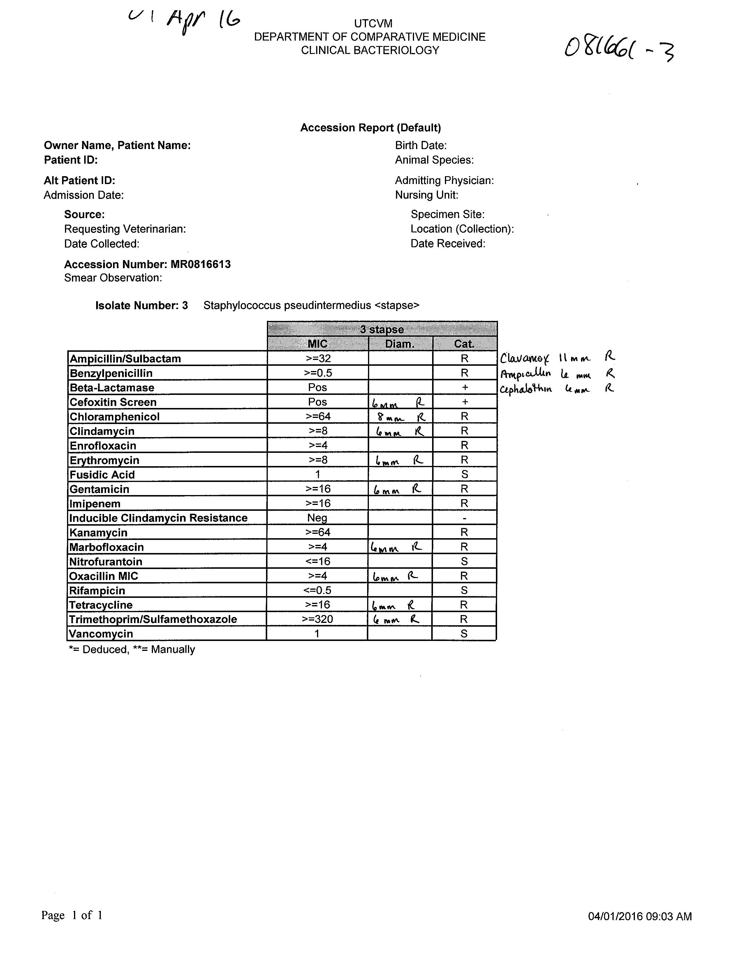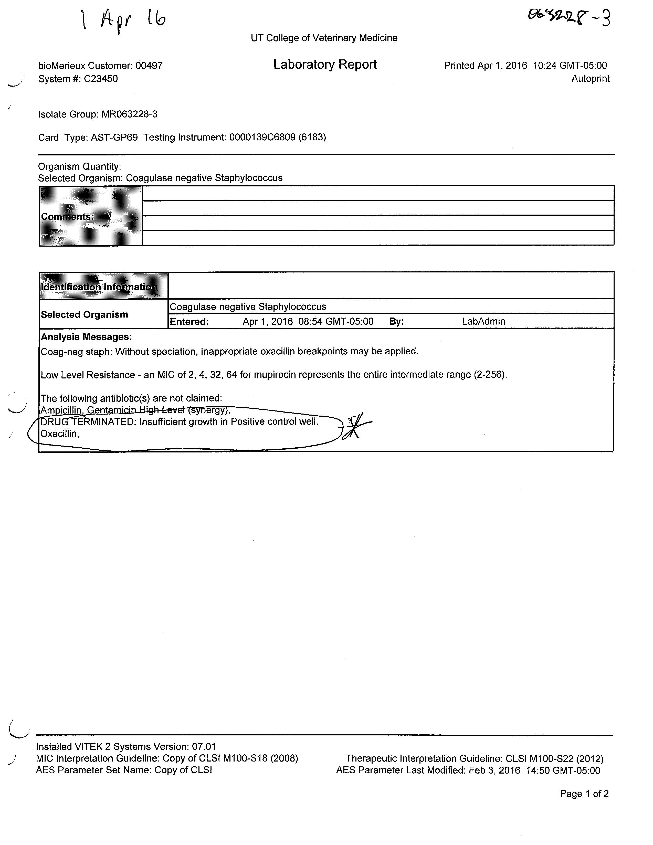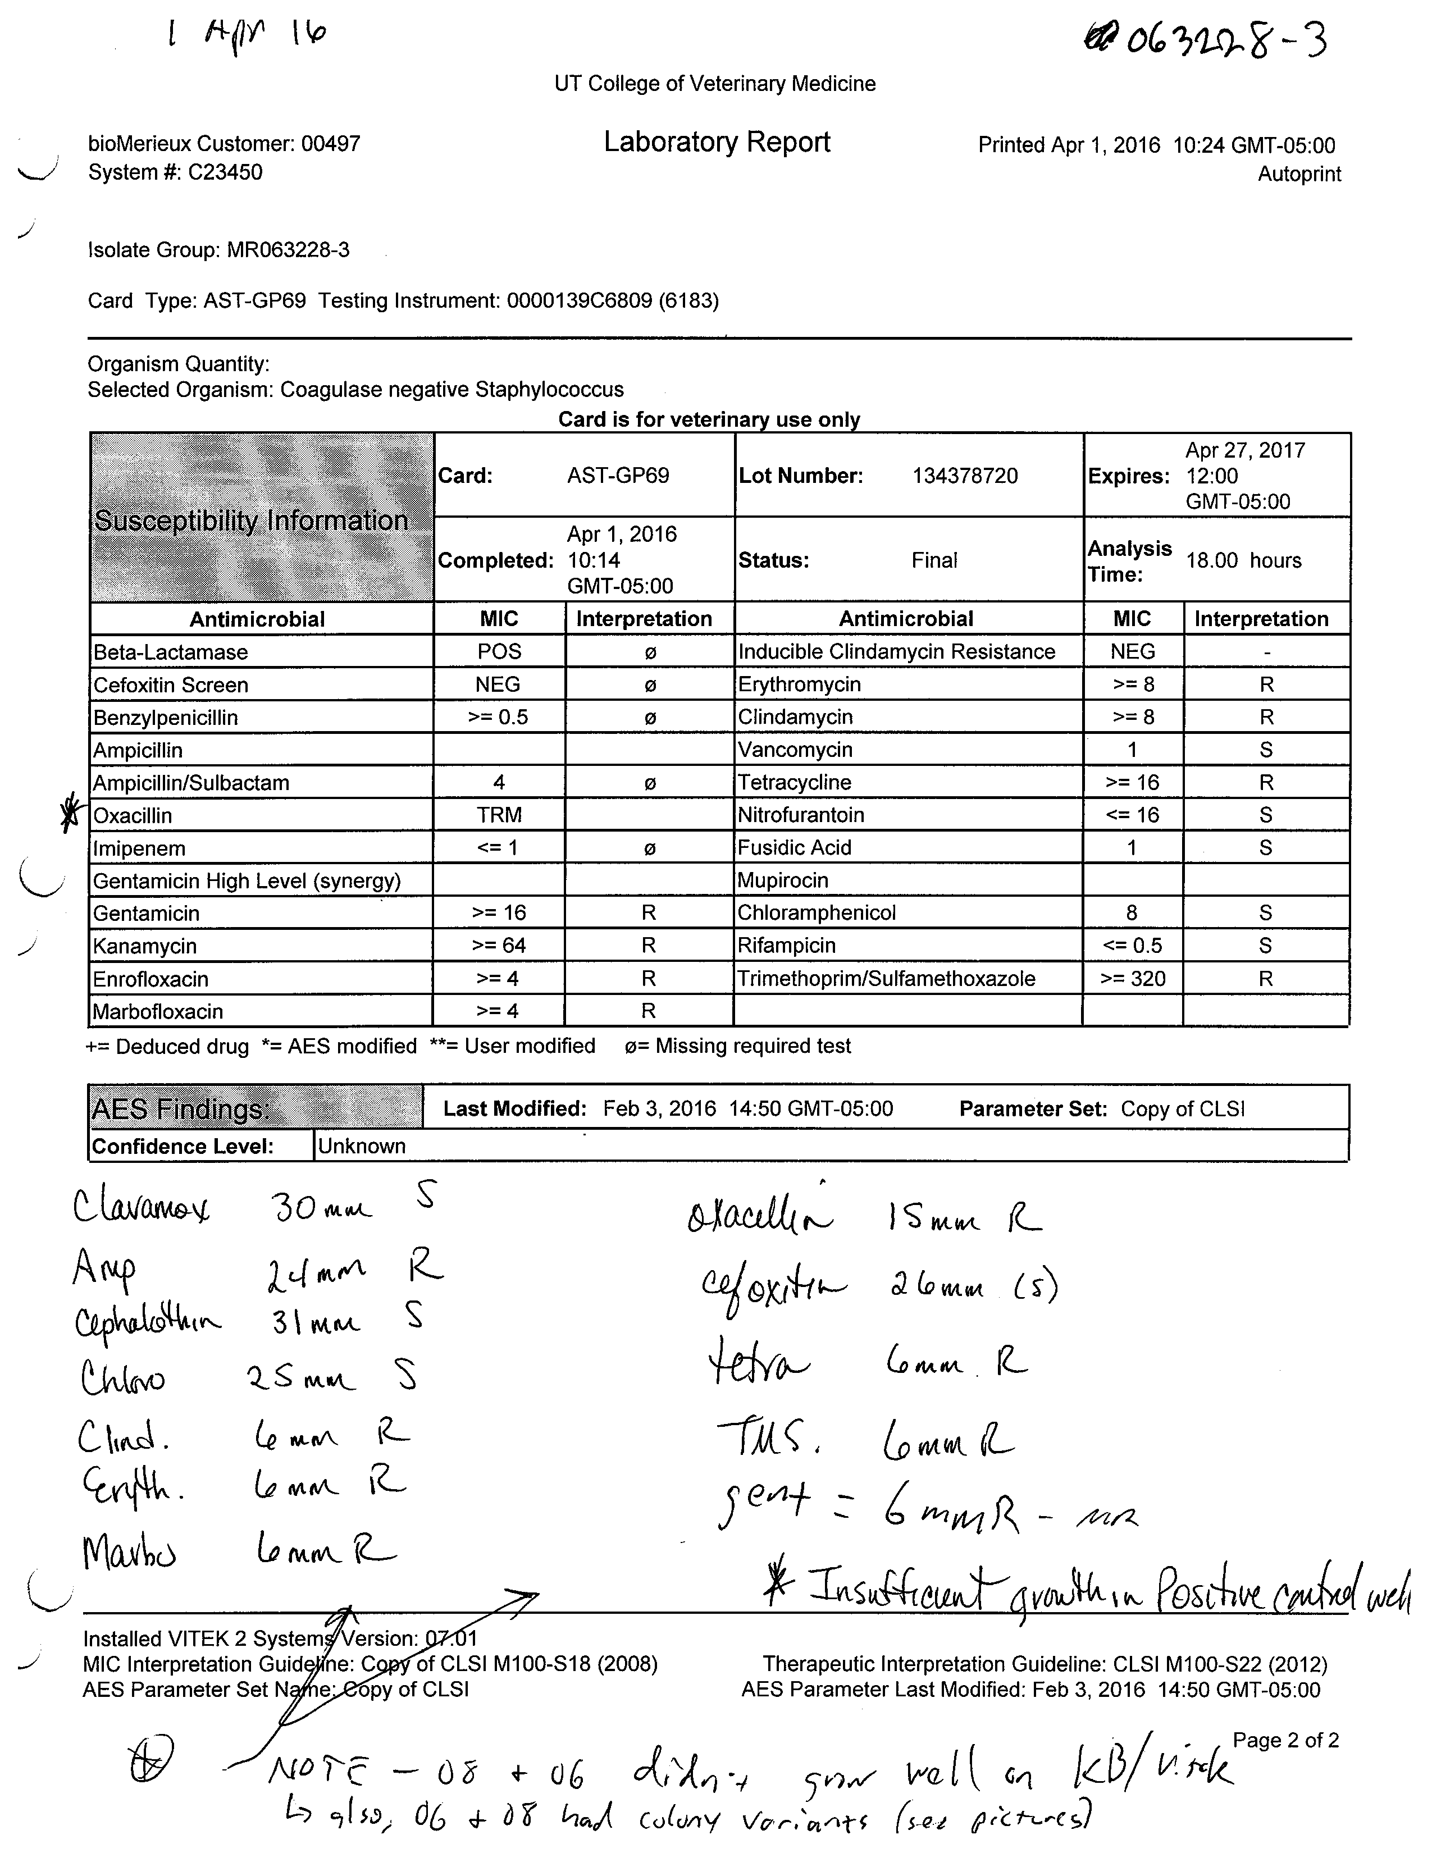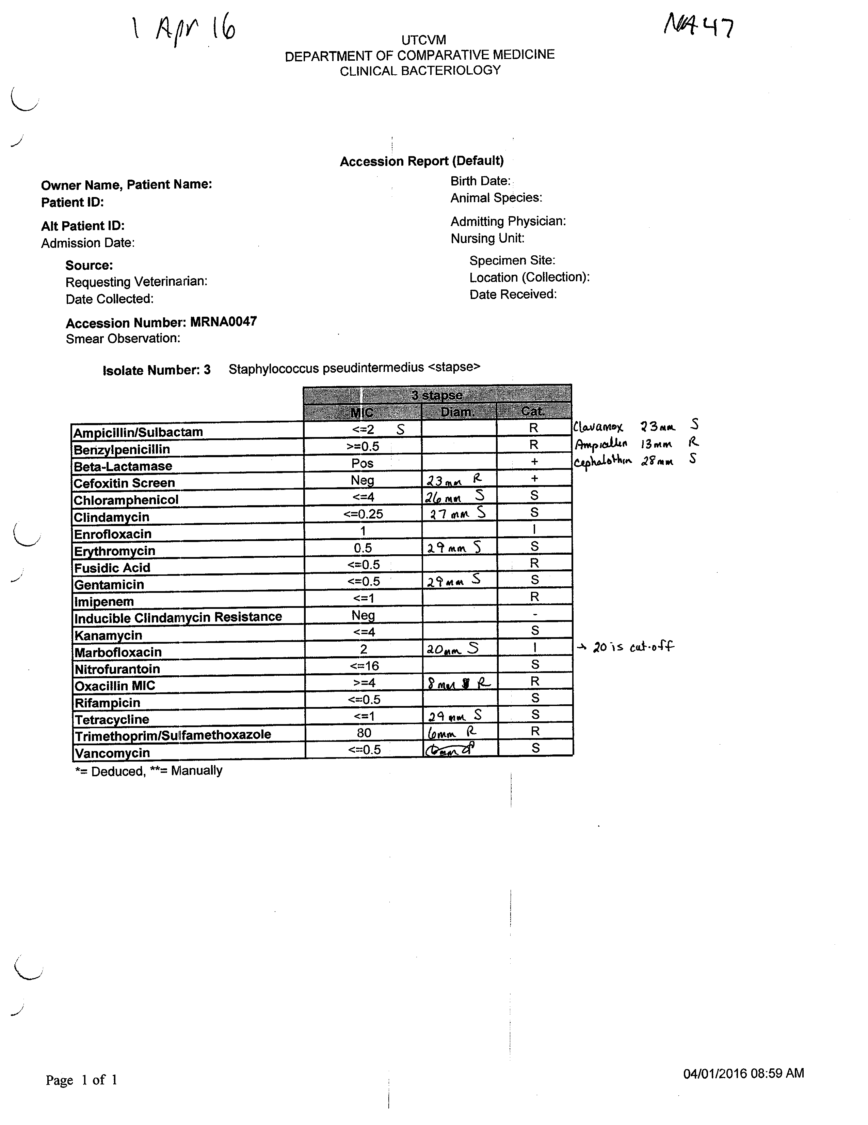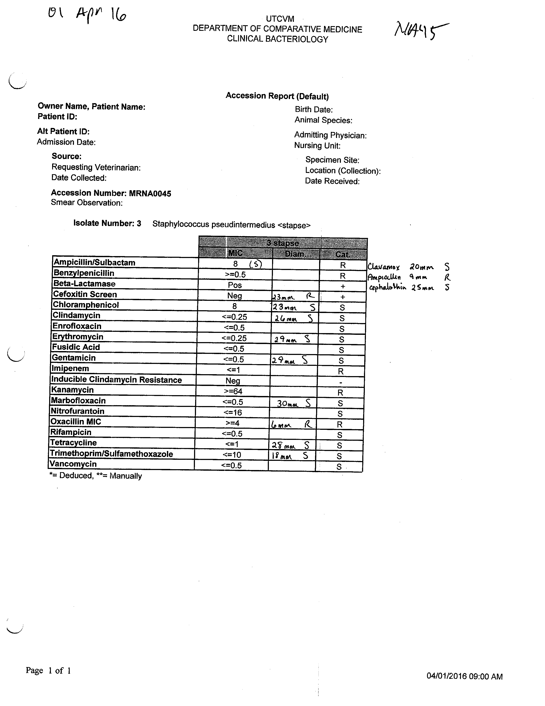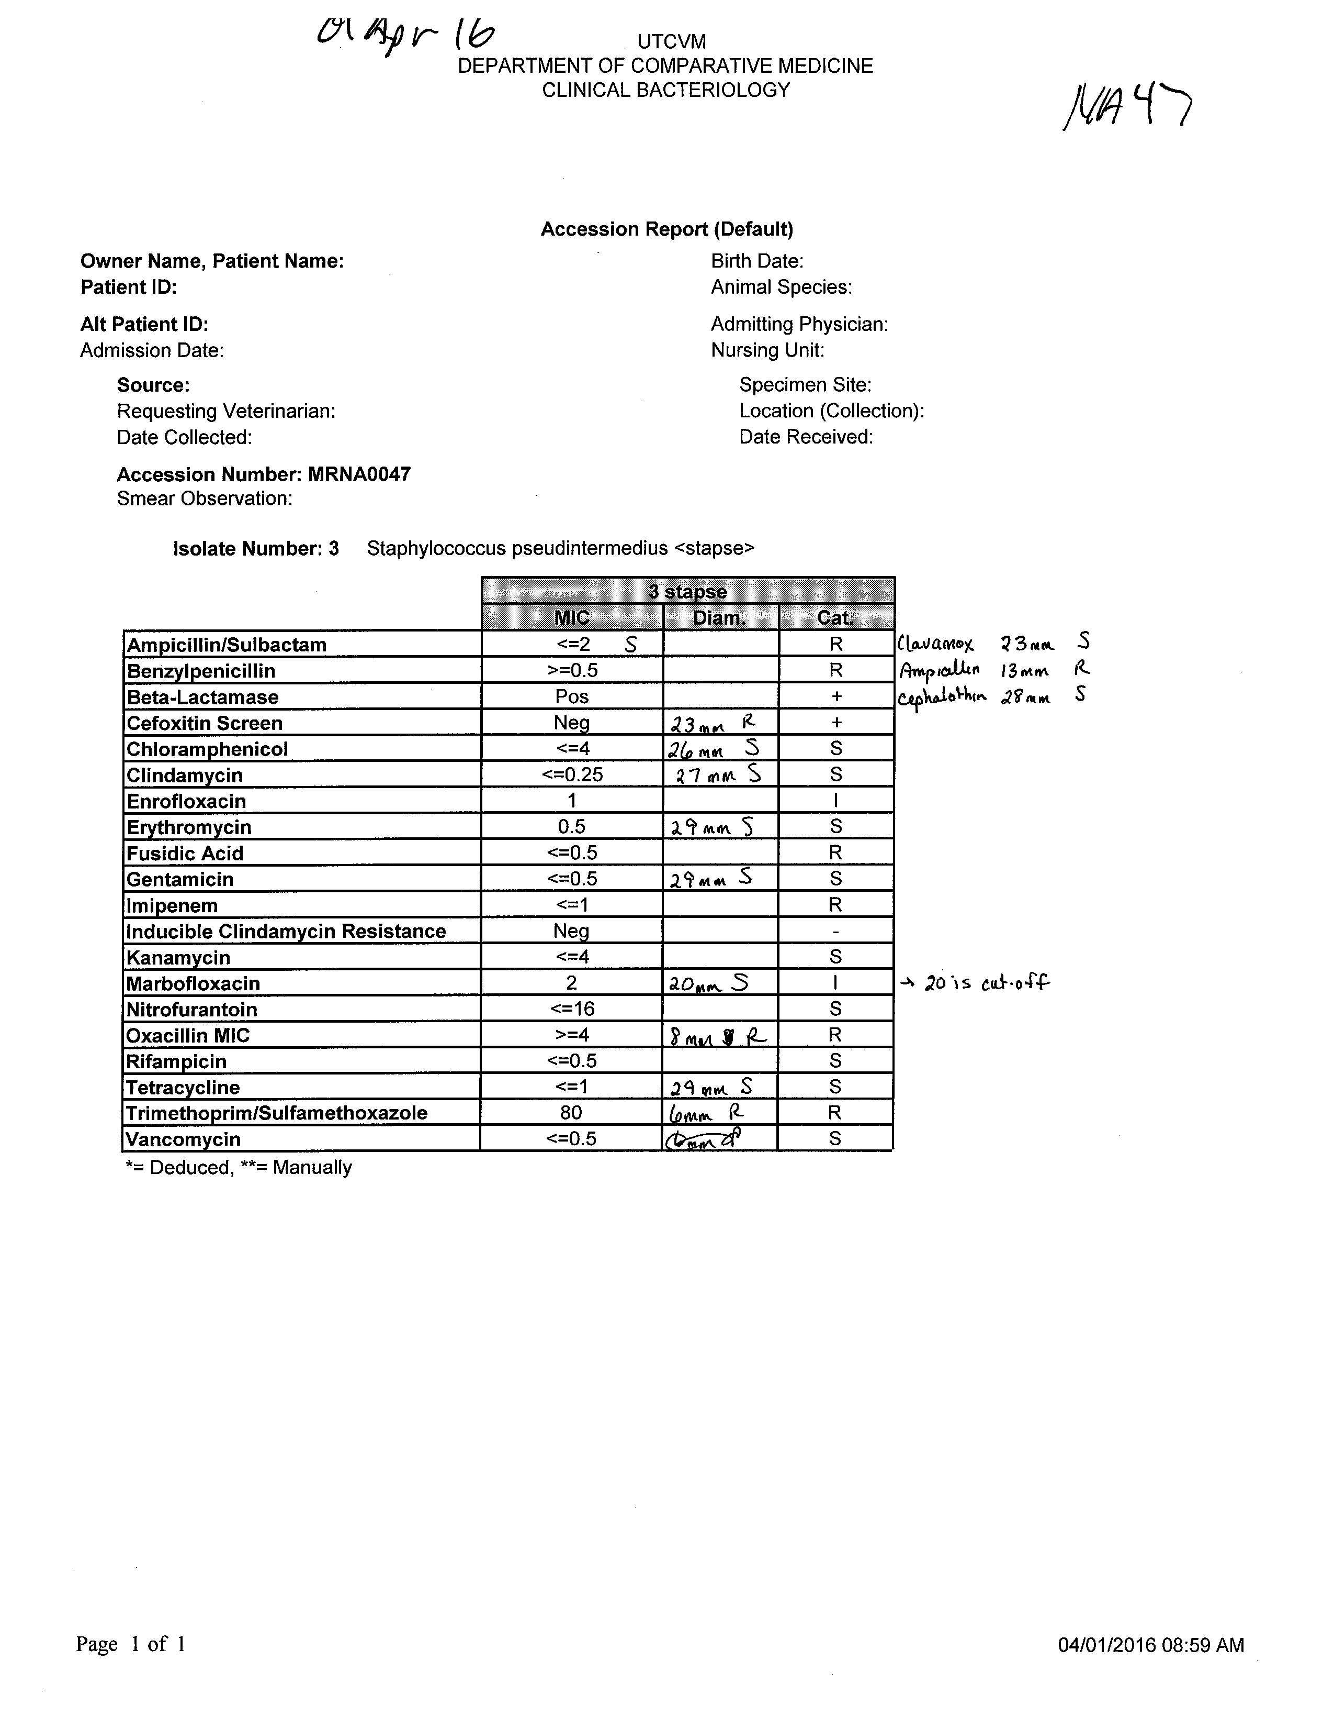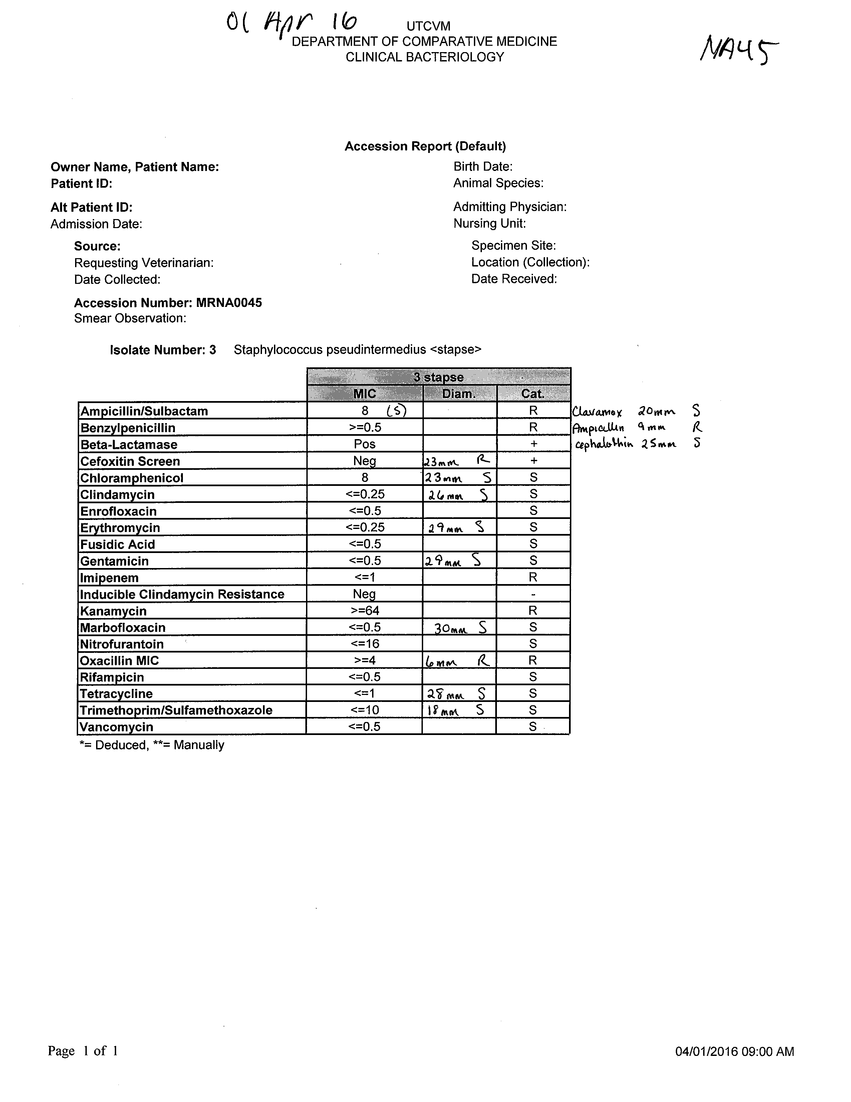

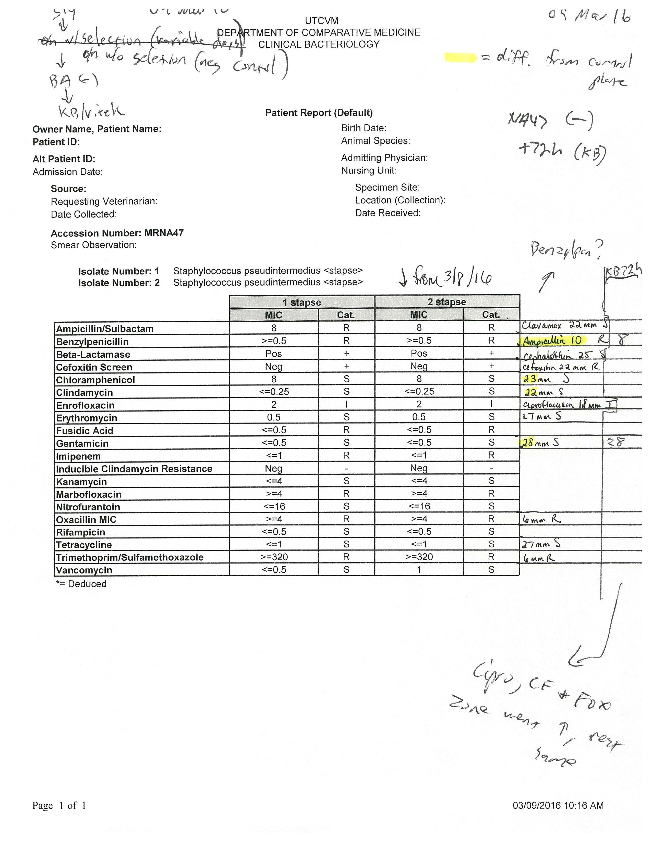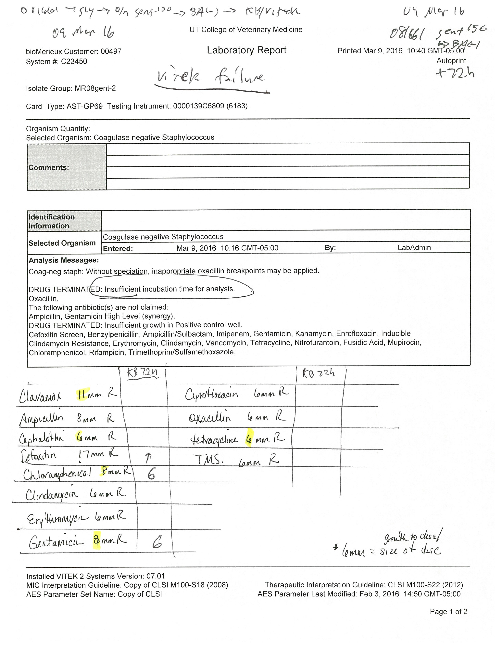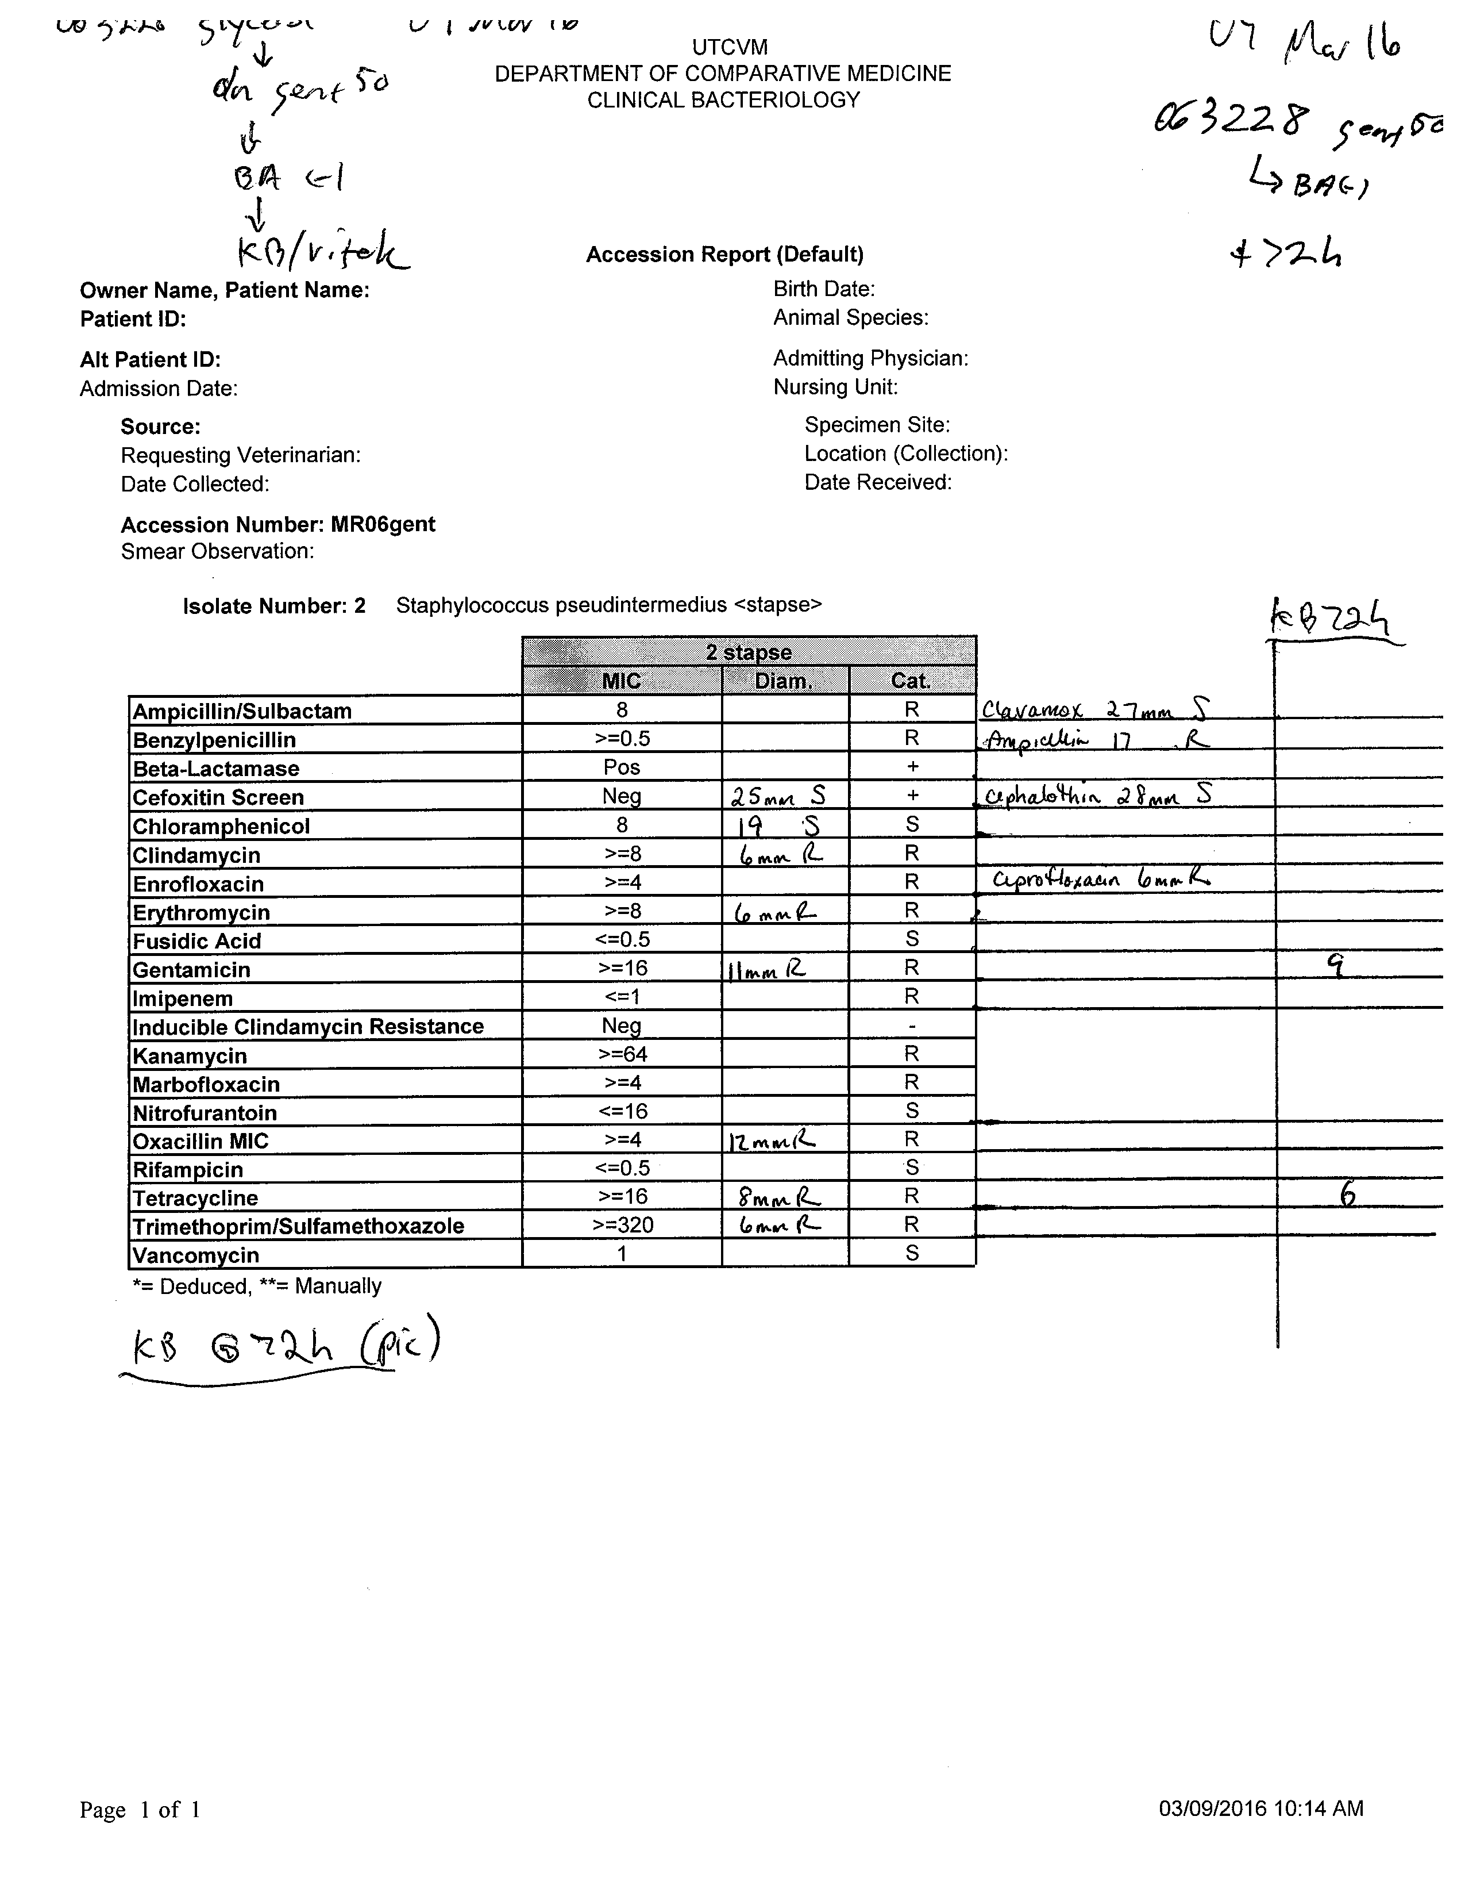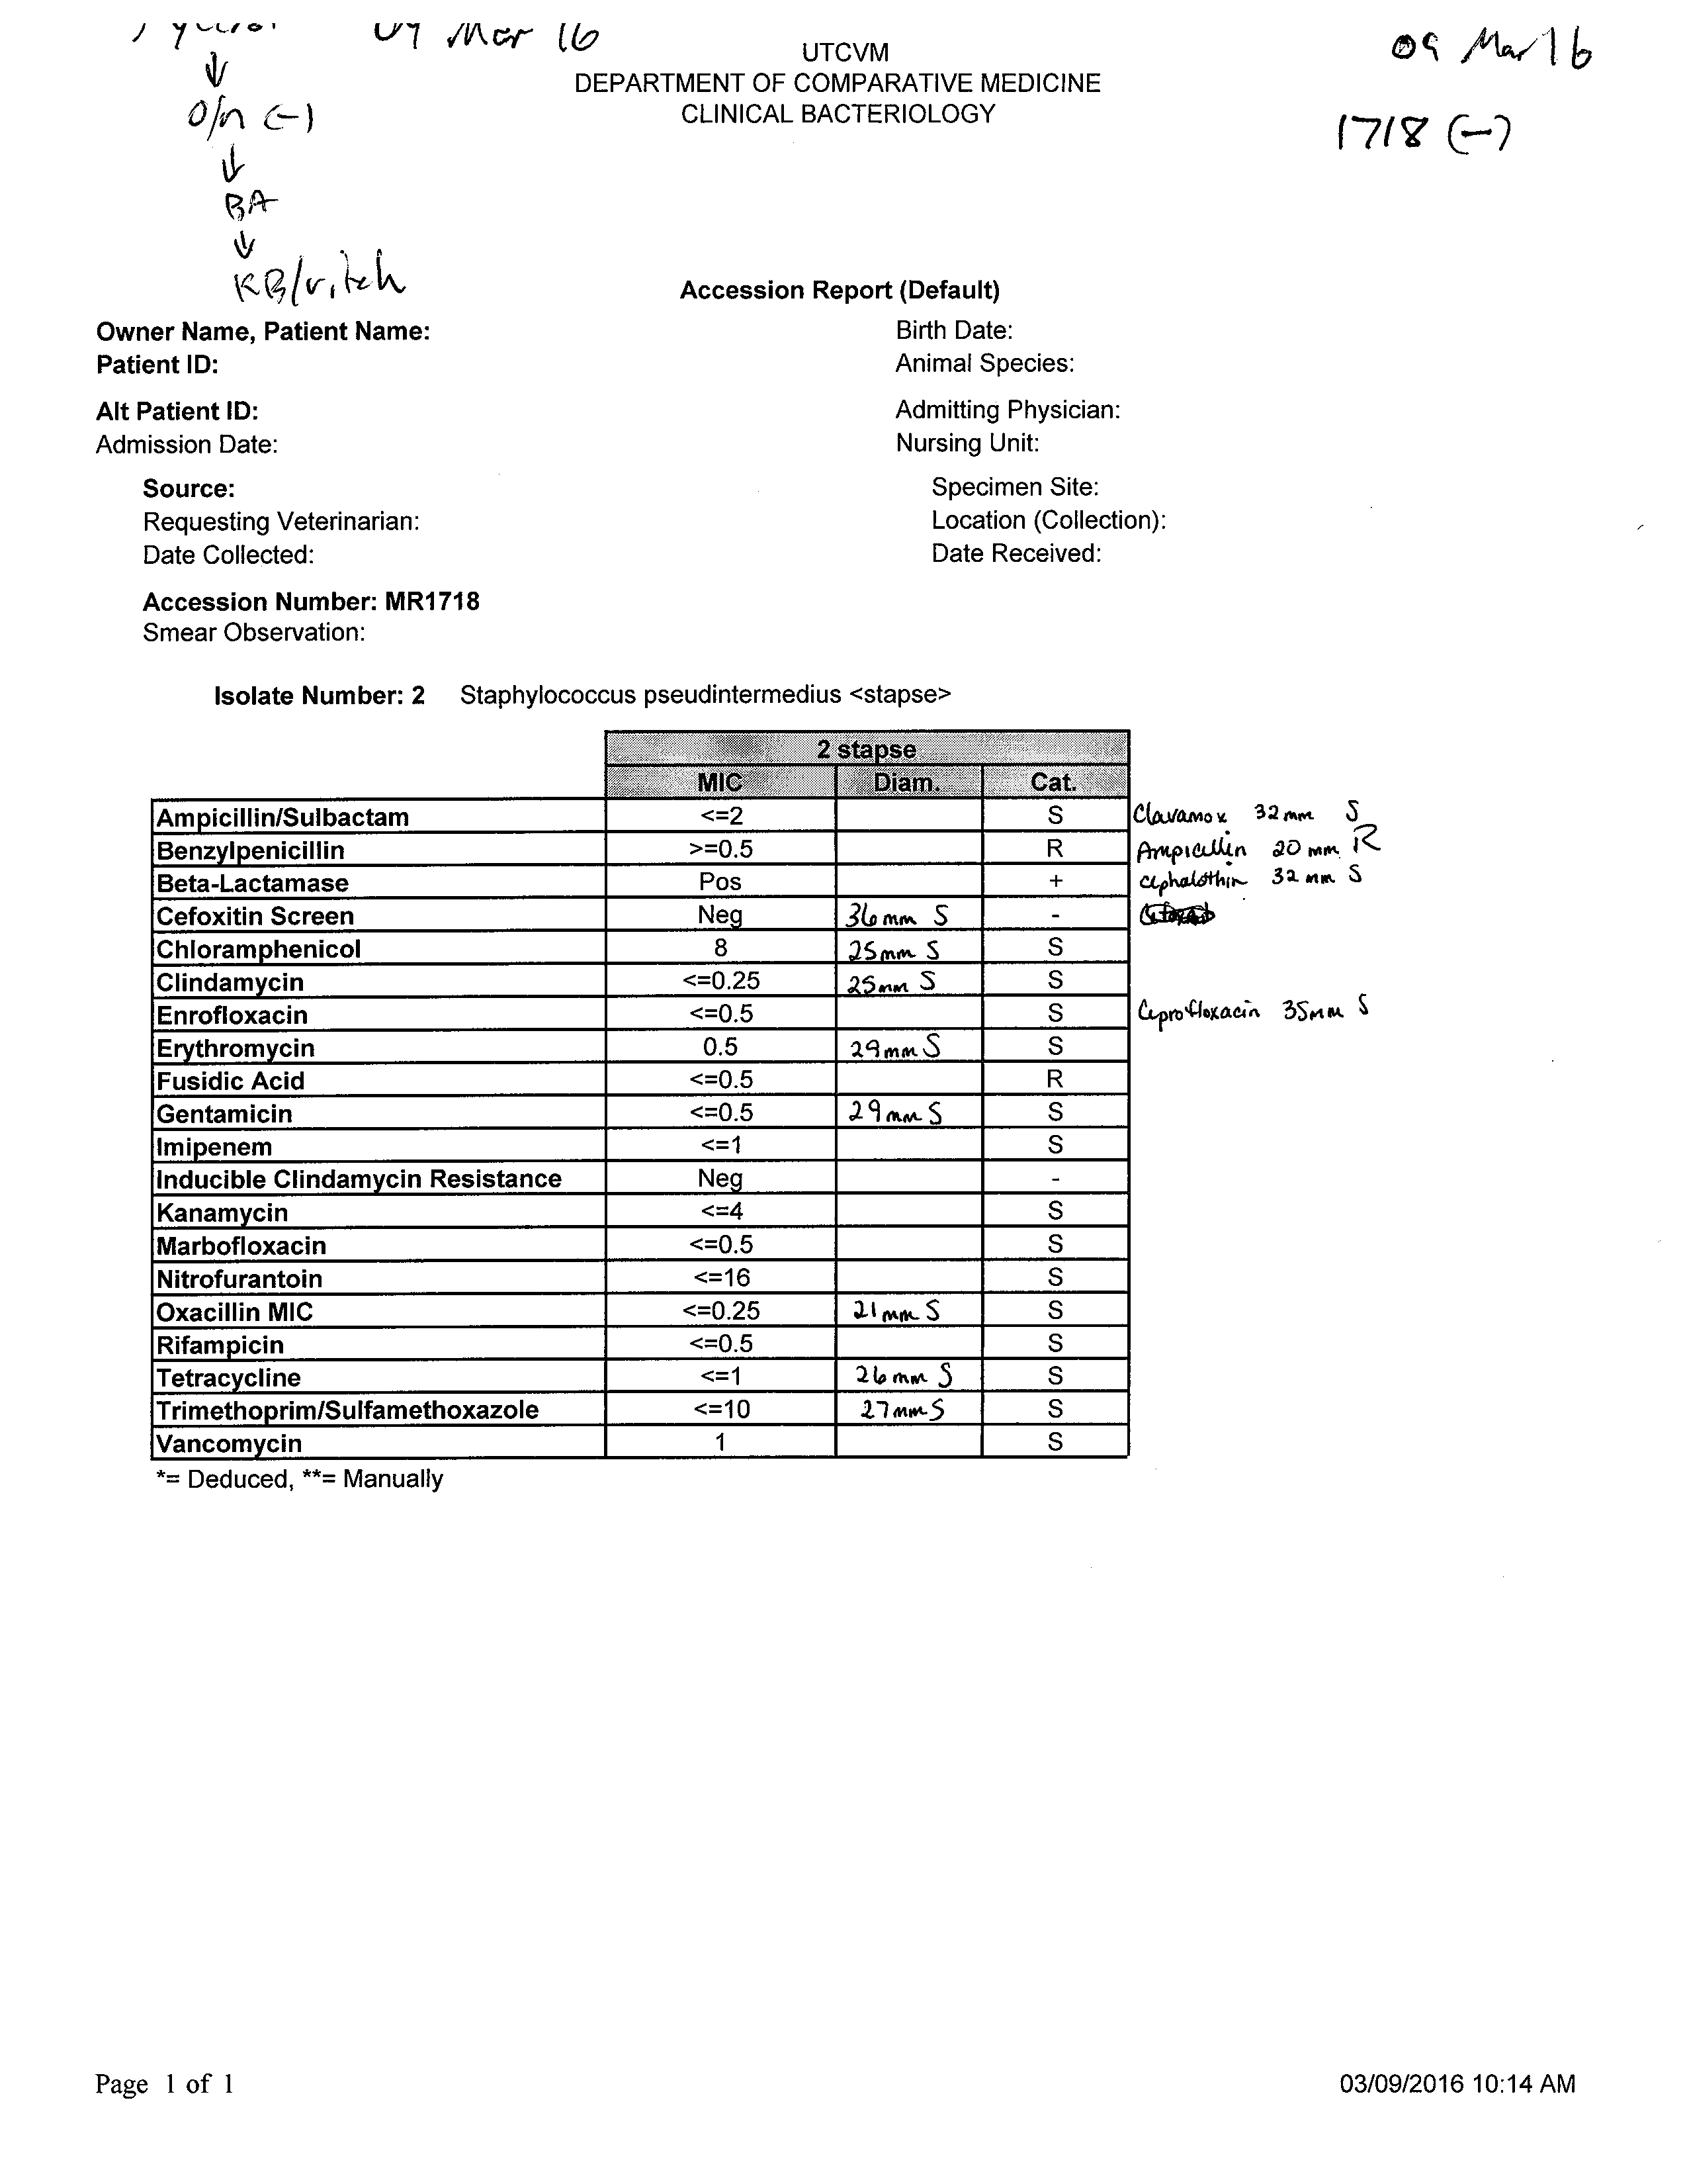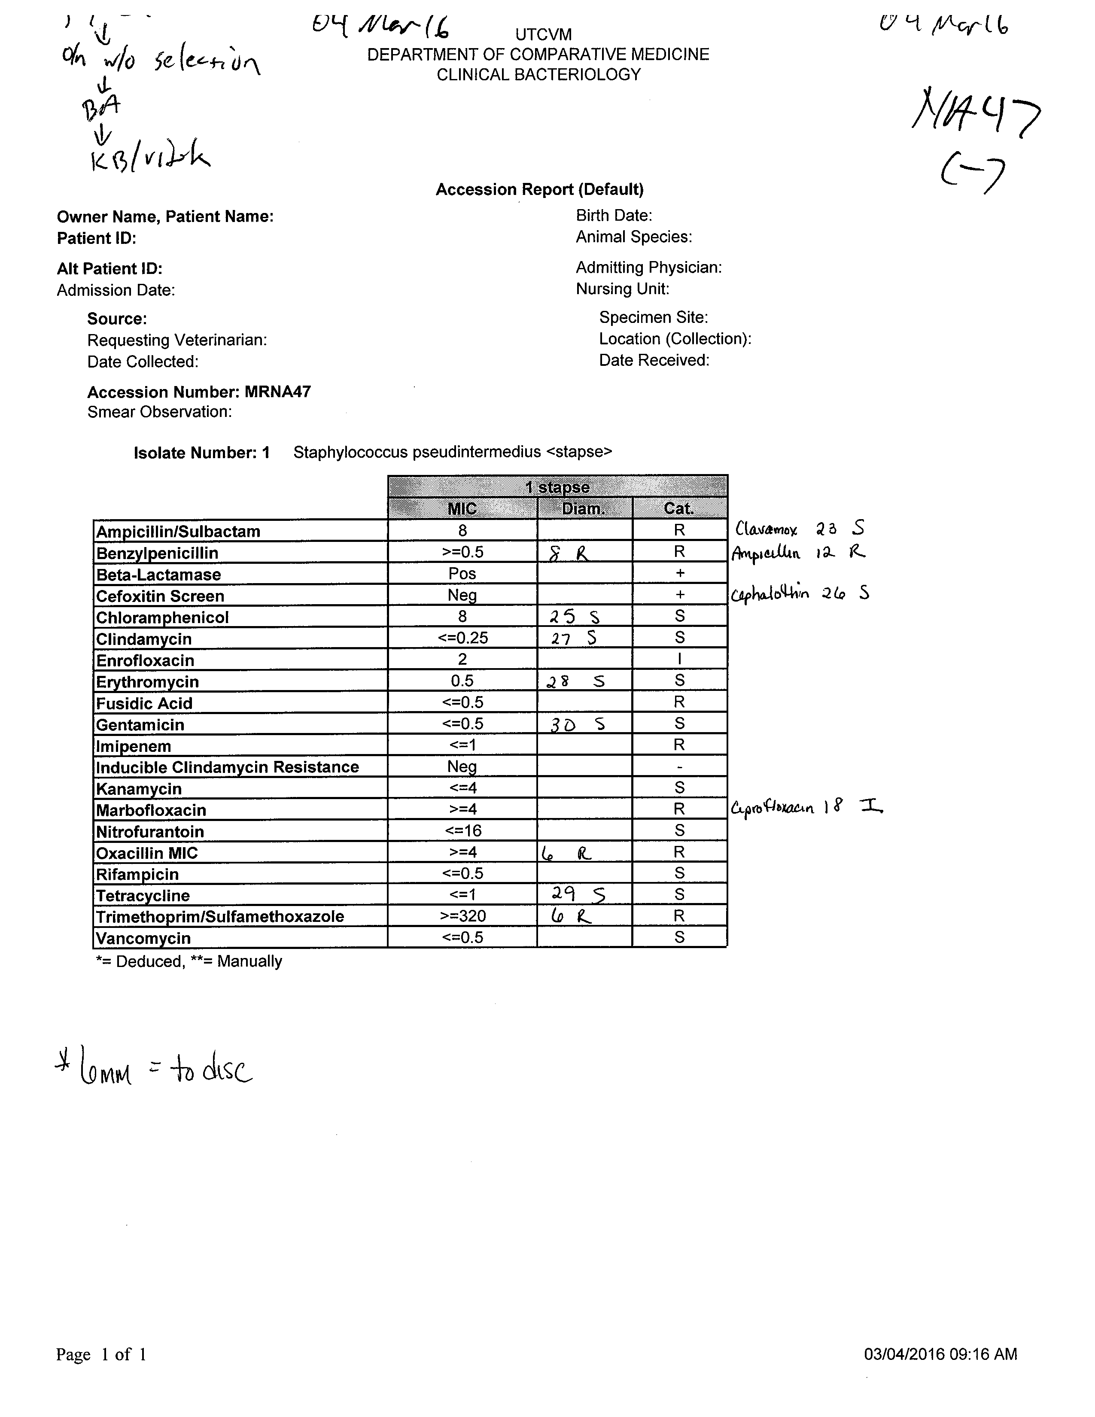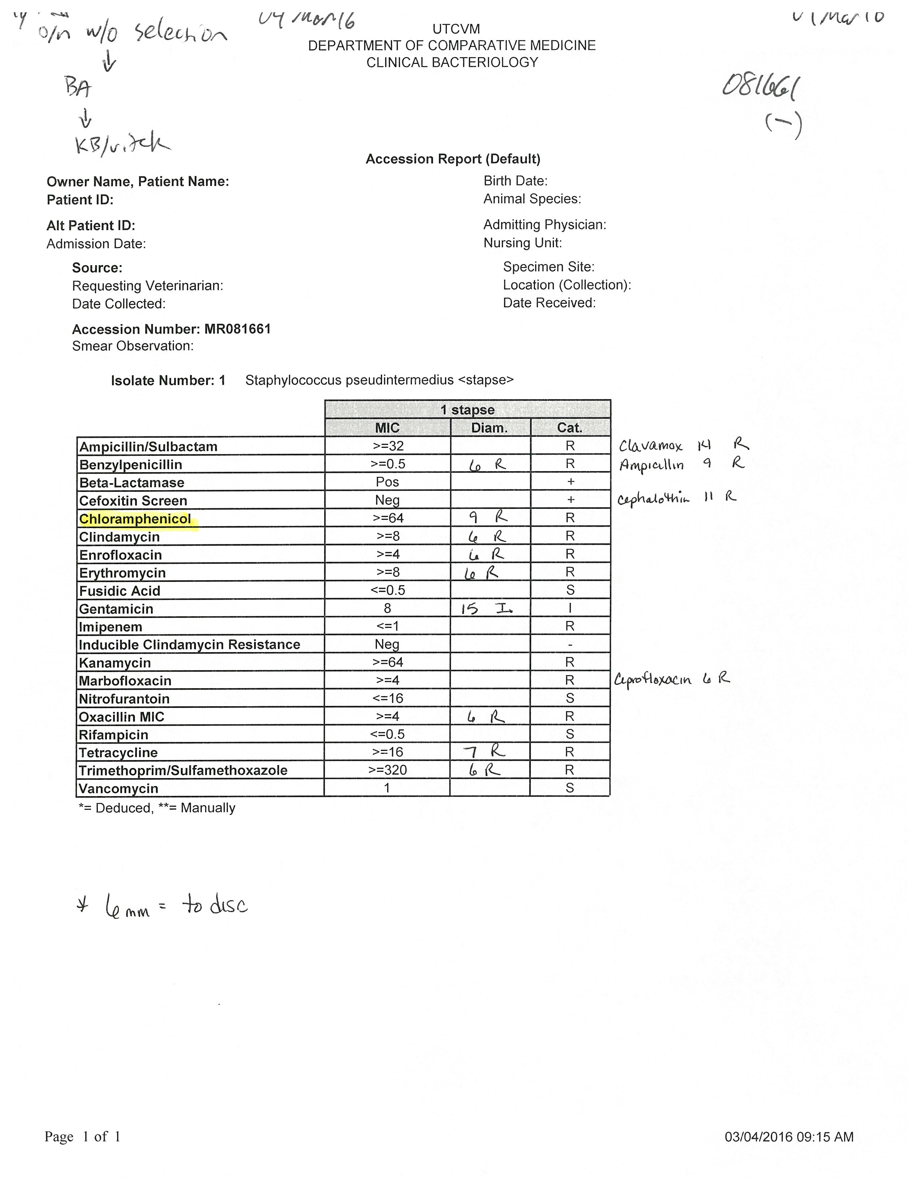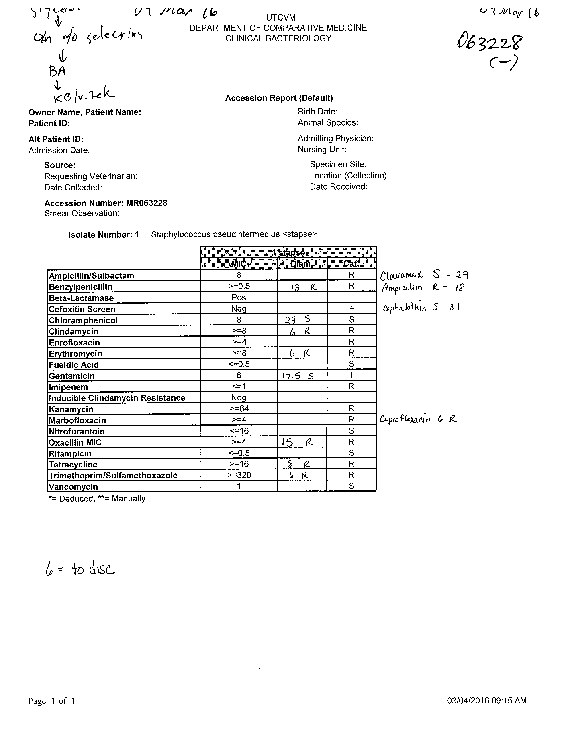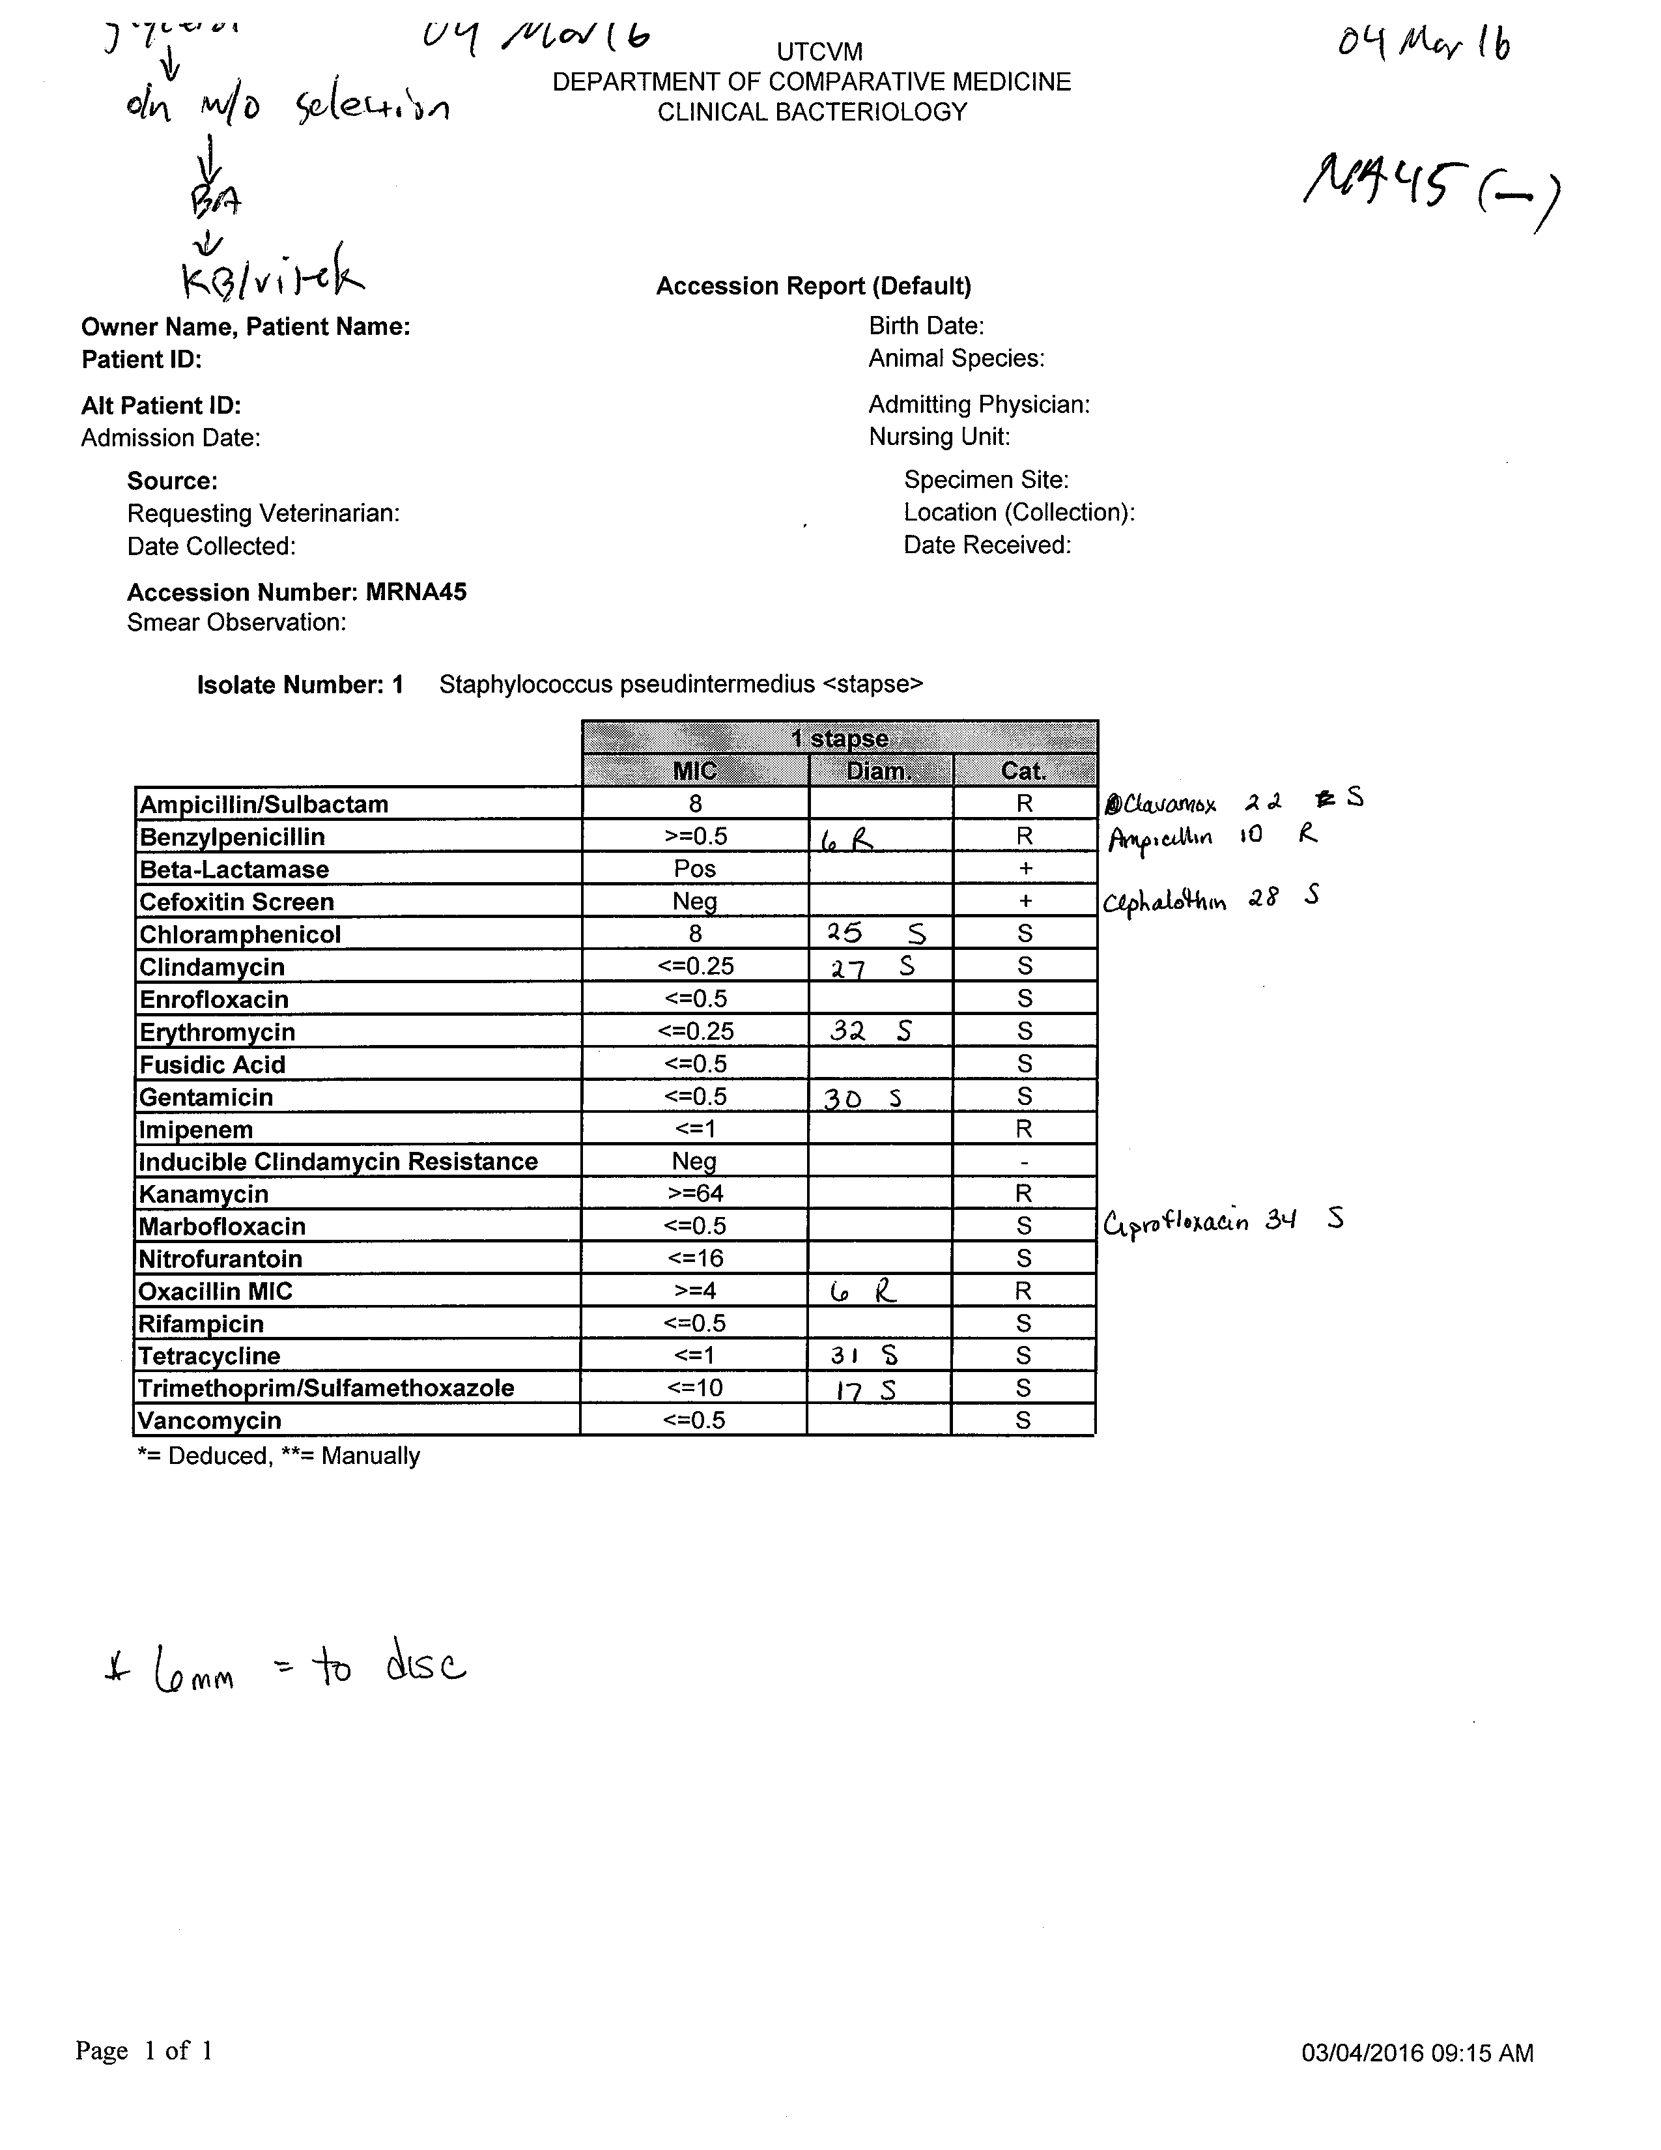

Appendix B. Modified Protocols.
Nextera XT kit, 24, on bacterial genomes for de novo assembly (FASTQ output). Attempt to scale down to 6 samples; written per sample/reaction. MCR 30DEC2015.
Extracted from the Nextera XT library prep guide version E:
Tagmentation of Input DNA
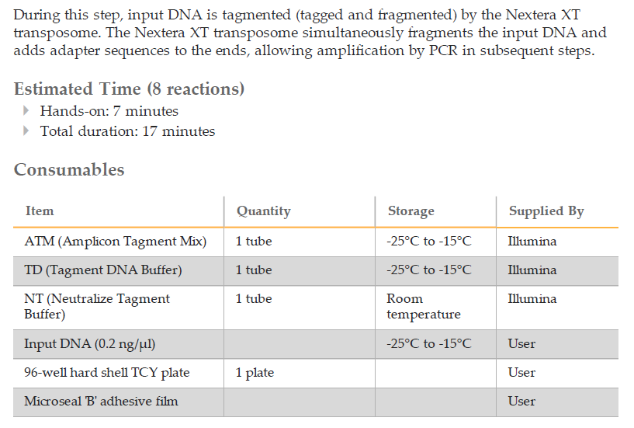
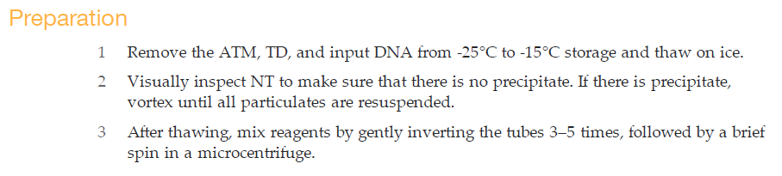
Make NTA
- label microcentrifuge tubes with “NTA” and sample ID
- Add 10 μl TD Buffer to each sample tube.
- Add 5 μl input DNA at 0.2 ng/μl (1 ng total) to each sample tube.
- Gently pipette up and down 5 times to mix.
- Add 5 μl ATM to each sample.
- Gently pipette up and down 5 times to mix.
- Centrifuge at 280 × g at 20°C for 1 minute.
- Place samples in a thermal cycler and run the following program:
  - Make sure that the thermal cycler lid is heated during the incubation.
  - 55°C for 5 minutes.
  - 10°C hold; once sample reaches this, proceed IMMEDIATELY to next step.
Neutralize NTA
- Add 5 μl NT Buffer to each sample.
- Gently pipette up and down 5 times to mix.
- Centrifuge at 280 × g at 20°C for 1 minute.
- Place the sample at room temperature for 5 minutes
- [Optional] Assess tagmentation by running 1 μl of sample on an HS bioanalyzer chip.
PCR Amplification
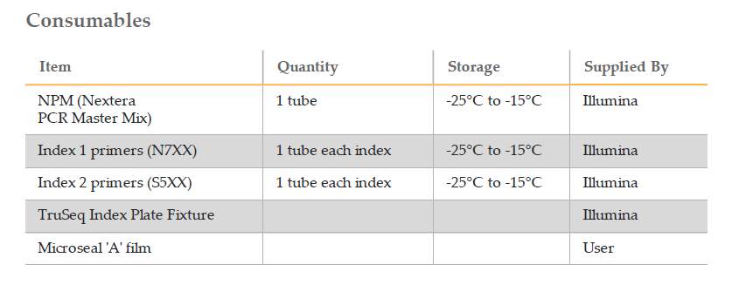
Make sure that the correct index 1 (i7) and index 2 (i5) primers have been selected. Use the Illumina Experiment Manager and the Nextera XT DNA Library Preparation Low-Plex Pooling Guidelines Tech
Note to confirm the selected index primers.
- Remove NPM and the index primers (i5 and i7) from -25°C to -15°C storage and thaw on a bench at room temperature.
- Allow approximately 20 minutes to thaw NPM and index primers.
- Gently invert each primer and NPM tube 3–5 times to mix and briefly centrifuge the tubes in a microcentrifuge.
- Add 15μl NPM to each sample.
- add 5μl index 2 unique [ ] primers (white caps) to each sample. RECORD which index is used for each individual sample.
- add 5μl index 1 unique [ ] primers (orange caps) to each sample, and mix using pipette. RECORD which index is used for each individual sample.
- Centrifuge at 280 × g at 20°C for 1 minute.
- Perform PCR using the following program on a thermal cycler:
- (Make sure that the thermal cycler lid is heated during the incubation)
- 72°C for 3 minutes
- 95°C for 30 seconds
- 12 cycles of:
  - 95°C for 10 seconds
  - 55°C for 30 seconds
  - 72°C for 30 seconds
- 72°C for 5 minutes
- Hold at 10°C
SAFE STOPPING POINT
If you do not plan to proceed immediately to PCR Clean-Up, there are two options for
storage. The NTA plate can remain on the thermal cycler overnight or you can store it at
2°C to 8°C for up to two days.

PCR Clean-Up
This step uses AMPure XP beads to purify the library DNA, and provides a size selection
step that removes short library fragments from the population.

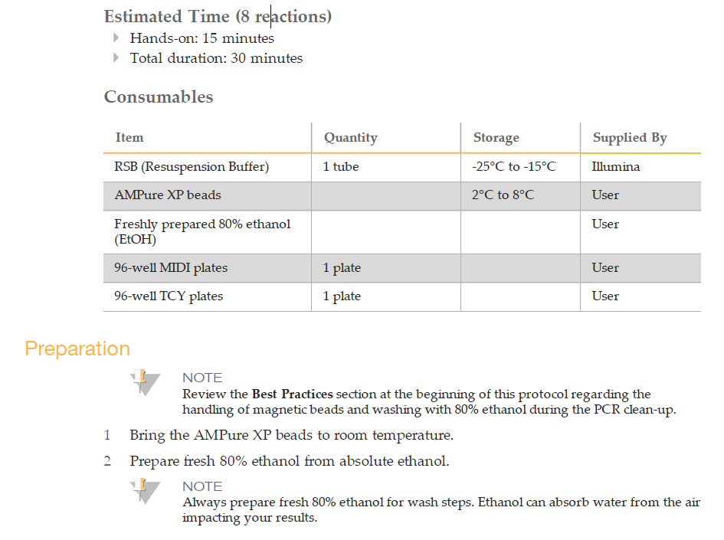
- Centrifuge samples at 280 × g for 1 min (20˚C) to collect condensation.
- Label a new tube CA (Clean Amplified) and sample ID for each sample.
- Transfer the PCR product (~50uL) from the NTA tube to the CA tube.
- Vortex the AMPure XP beads for 30 seconds to make sure that the beads are evenly dispersed.
- Add 25μl of AMPure XP beads to each CA tube (for 2x300 MiSeq; see detailed protocol for variation).
- Gently pipette mix up and down 10 times.
- Incubate at room temperature without shaking for 5 minutes.
- Place tubes on a magnetic stand for 2 minutes or until the supernatant has cleared.
- Use a multichannel pipette to remove and discard the supernatant carefully.
- wash the beads with freshly prepared 80% ethanol as follows:
  - add 200 μl freshly prepared 80% ethanol to each sample
  - Let stand 30 seconds.
  - Remove excess ethanol (Use a P20 multichannel pipette with fine pipette tips to remove excess ethanol).

- Repeat wash step (step 10). Use a P20 multichannel pipette with fine pipette tips to remove excess ethanol.
- While still on the magnetic stand, allow the beads to air-dry for 15 minutes.
- Remove tubes from magnetic stand.
- Add 52.5 μl RSB to each sample, Gently pipette mix up and down 10 times.
- Incubate at room temperature for 2 minutes.
- Place the plate on the magnetic stand for 2 minutes or until the supernatant has cleared.
- Label a new tube CAN (Clean Amplified NTA) and sample ID.
- Transfer 50 μl of the supernatant from the CA tube to the CAN tube.

SAFE STOPPING POINT
If you do not plan to proceed to Library Normalization immediately, seal the CAN tubes
and store it at -25°C to -15°C for up to a week.

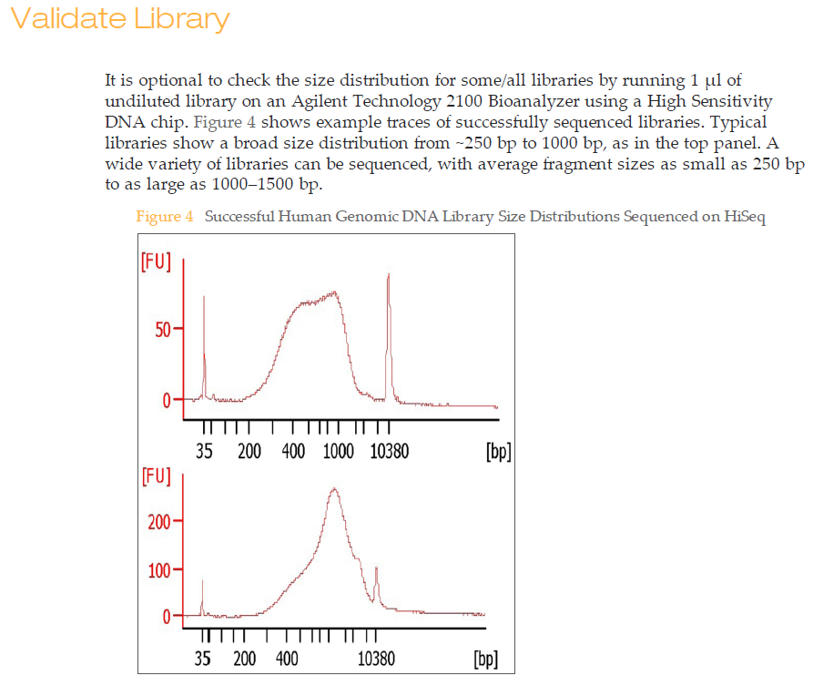

Library Normalization
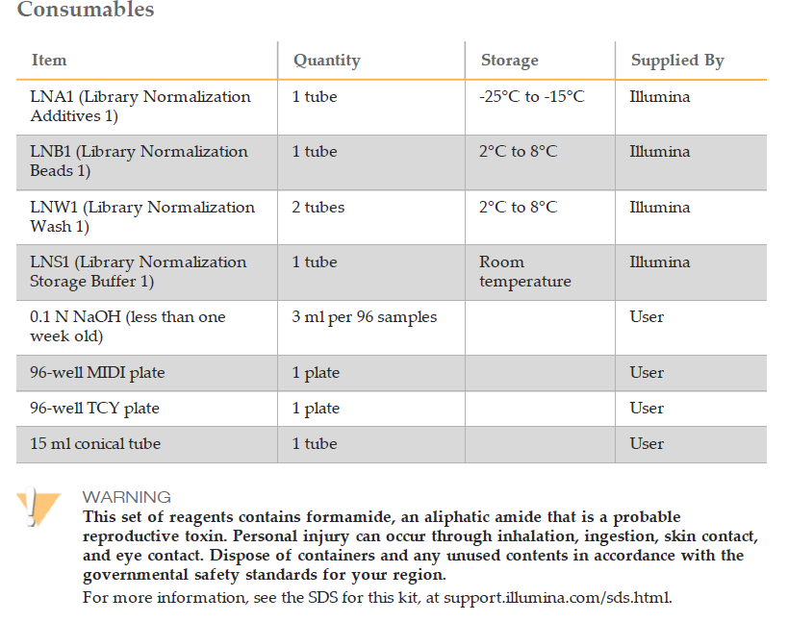
Preparation (Illumina recommends performing the LNA1 preparation step under a fume hood)

- Remove LNA1 from -25°C to -15°C storage and bring to room temperature. Use a 20°C to 25°C water bath as needed. LNA1 might form visible precipitates or crystals. Before use, vortex vigorously, and then hold the tube in front of a light and visually inspect to make sure that all precipitate has dissolved.
- Remove LNB1 and LNW1 from 2°C to 8°C storage and bring to room temperature. Use a 20°C to 25°C water bath as needed.
- Vigorously vortex LNB1 for at least 1 minute with intermittent inversion. Repeat this step until the beads are well-resuspended and no pellet is found at the bottom of the tube when the tube is inverted. Make sure that LNS1 is at room temperature before use.

Elute LNP
- Label a new tube LN (Library Normalization) and sample ID.
- Transfer 20 μl of the supernatant from the CAN tube to the LN tube.
- Prepare master mix (MM) of LNA1 and LNB1 (per sample):
  - Add 45.8µL LNA1 and 8.33µL LNB1 per sample. LNB1 is a precipitate (beads, see important note below), so prepare master mix first for LNA1 per this example (6 samples chosen):
    - 45.80µL LNA1 per sample; 6 samples= 274.8µL LNA1 into MM tube.
    - 8.33µL LNB1 per sample; 6 samples= 49.98uL; add to LNA1 MM tube** SEE BELOW

- IMPORTANT: Before adding LNB1, use 1000µL pipette set to 1000µL to mix LNB1 thoroughly. DO NOT USE 100-200µL pipette to transfer <100µL (always use either a 1000µL pipette tip, or a 200µL tip cut off for larger bore size (or large bore pipette). So, in this example of adding 49.98µL LNB1 to the 274.8µL LNA1, use a cut off/large bore 200µL tip to transfer the ~50µL LNB1.

- Add 45 μl combined LNA1/LNB1 to each LN tube containing libraries.
- Shake at 1800 rpm for 30 minutes at room temperature.
  - NOTE: The 30 minute incubation is critical for proper library normalization. Incubations of greater or less than 30 minutes can affect library representation and cluster density.
- Place tubes on a magnetic stand for 2 minutes and confirm that the supernatant has cleared.
- use a pipette set to 80 μl to remove the supernatant and then discard in an appropriate hazardous waste container.
- Remove the LN tube from the magnetic stand and wash the beads with LNW1, as follows:
  - add 45μl LNW1 to each sample
  - shake at 1800 rpm for 5 minutes
  - Place on the magnetic stand for 2 minutes or until the supernatant has cleared.
  - remove and discard the supernatant
- REPEAT step 8 for a second LNW1 wash.
- Remove the LN tube from the magnetic stand and add 30 μl 0.1 N NaOH (fresh stock solution) to each well to elute the sample.
- Shake at 1800 rpm for 5 minutes.
  - While the elution is shaking, label new tubes with SG (Storage) and Sample ID.
  - Add 30μl LNS1 to each SG tube.
- After 5 minute incubation with shaking LN tubes, place LN tubes on the magnetic stand for 2 minutes or until the liquid is clear.
- Using a pipette set to 30μl, transfer the supernatant from the LN elution tubes while on the magnetic rack to the SG tube containing the 30µL LNS1.
- Centrifuge to 1000 × g for 1 minute.

SAFE STOPPING POINT
If you do not plan to proceed to Library Pooling and MiSeq Sample Loading following the
completion of Library Normalization, store the sealed SGP plate at -25°C to -15°C for up
to one week.

NOTE
Because the final library pool consists of single-stranded DNA, it does not resolve well
on an agarose gel or Bioanalyzer chip. qPCR can be used for quality control if desired.
For more information, please see the Sequencing Library qPCR Quantification Guide (part #
11322363).

Appendix D. PHAST Intact and Incomplete Phage Insertions.
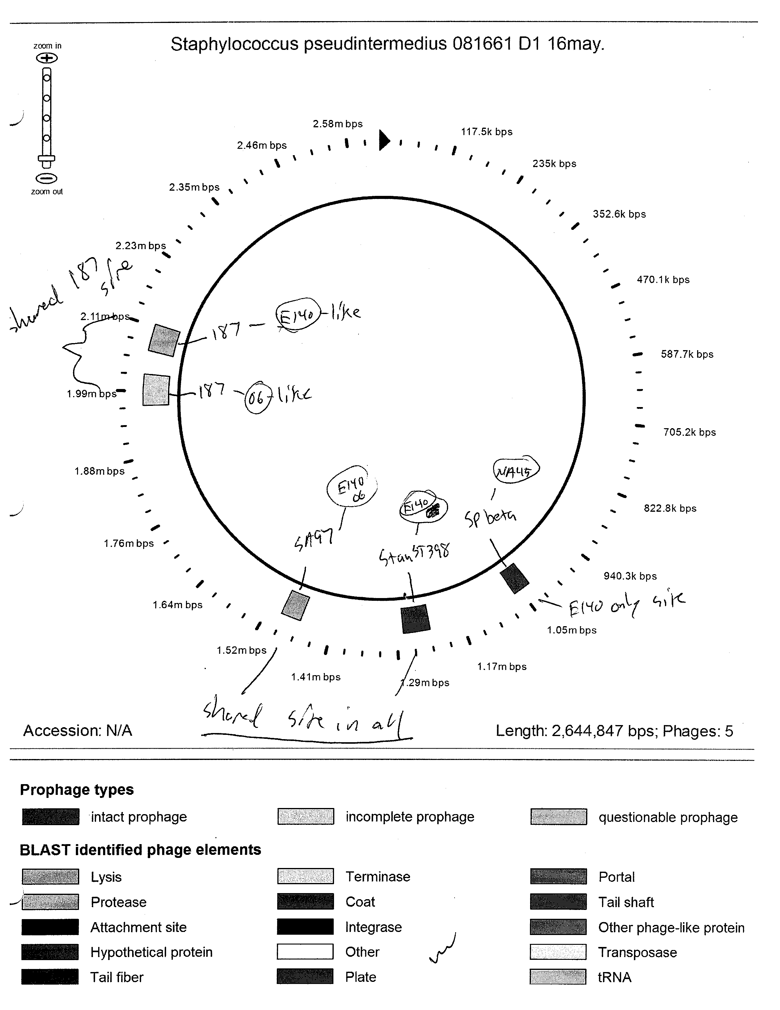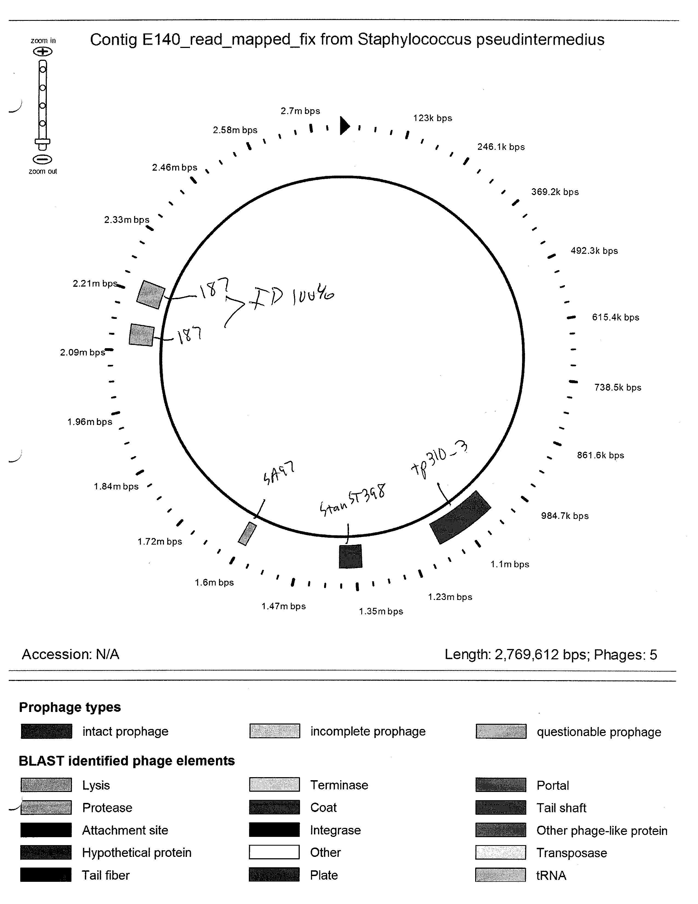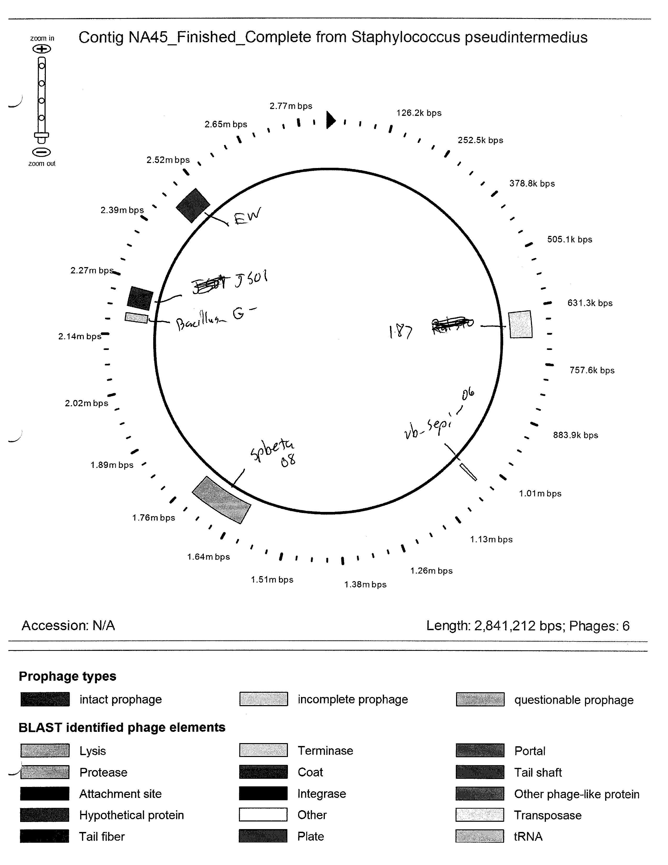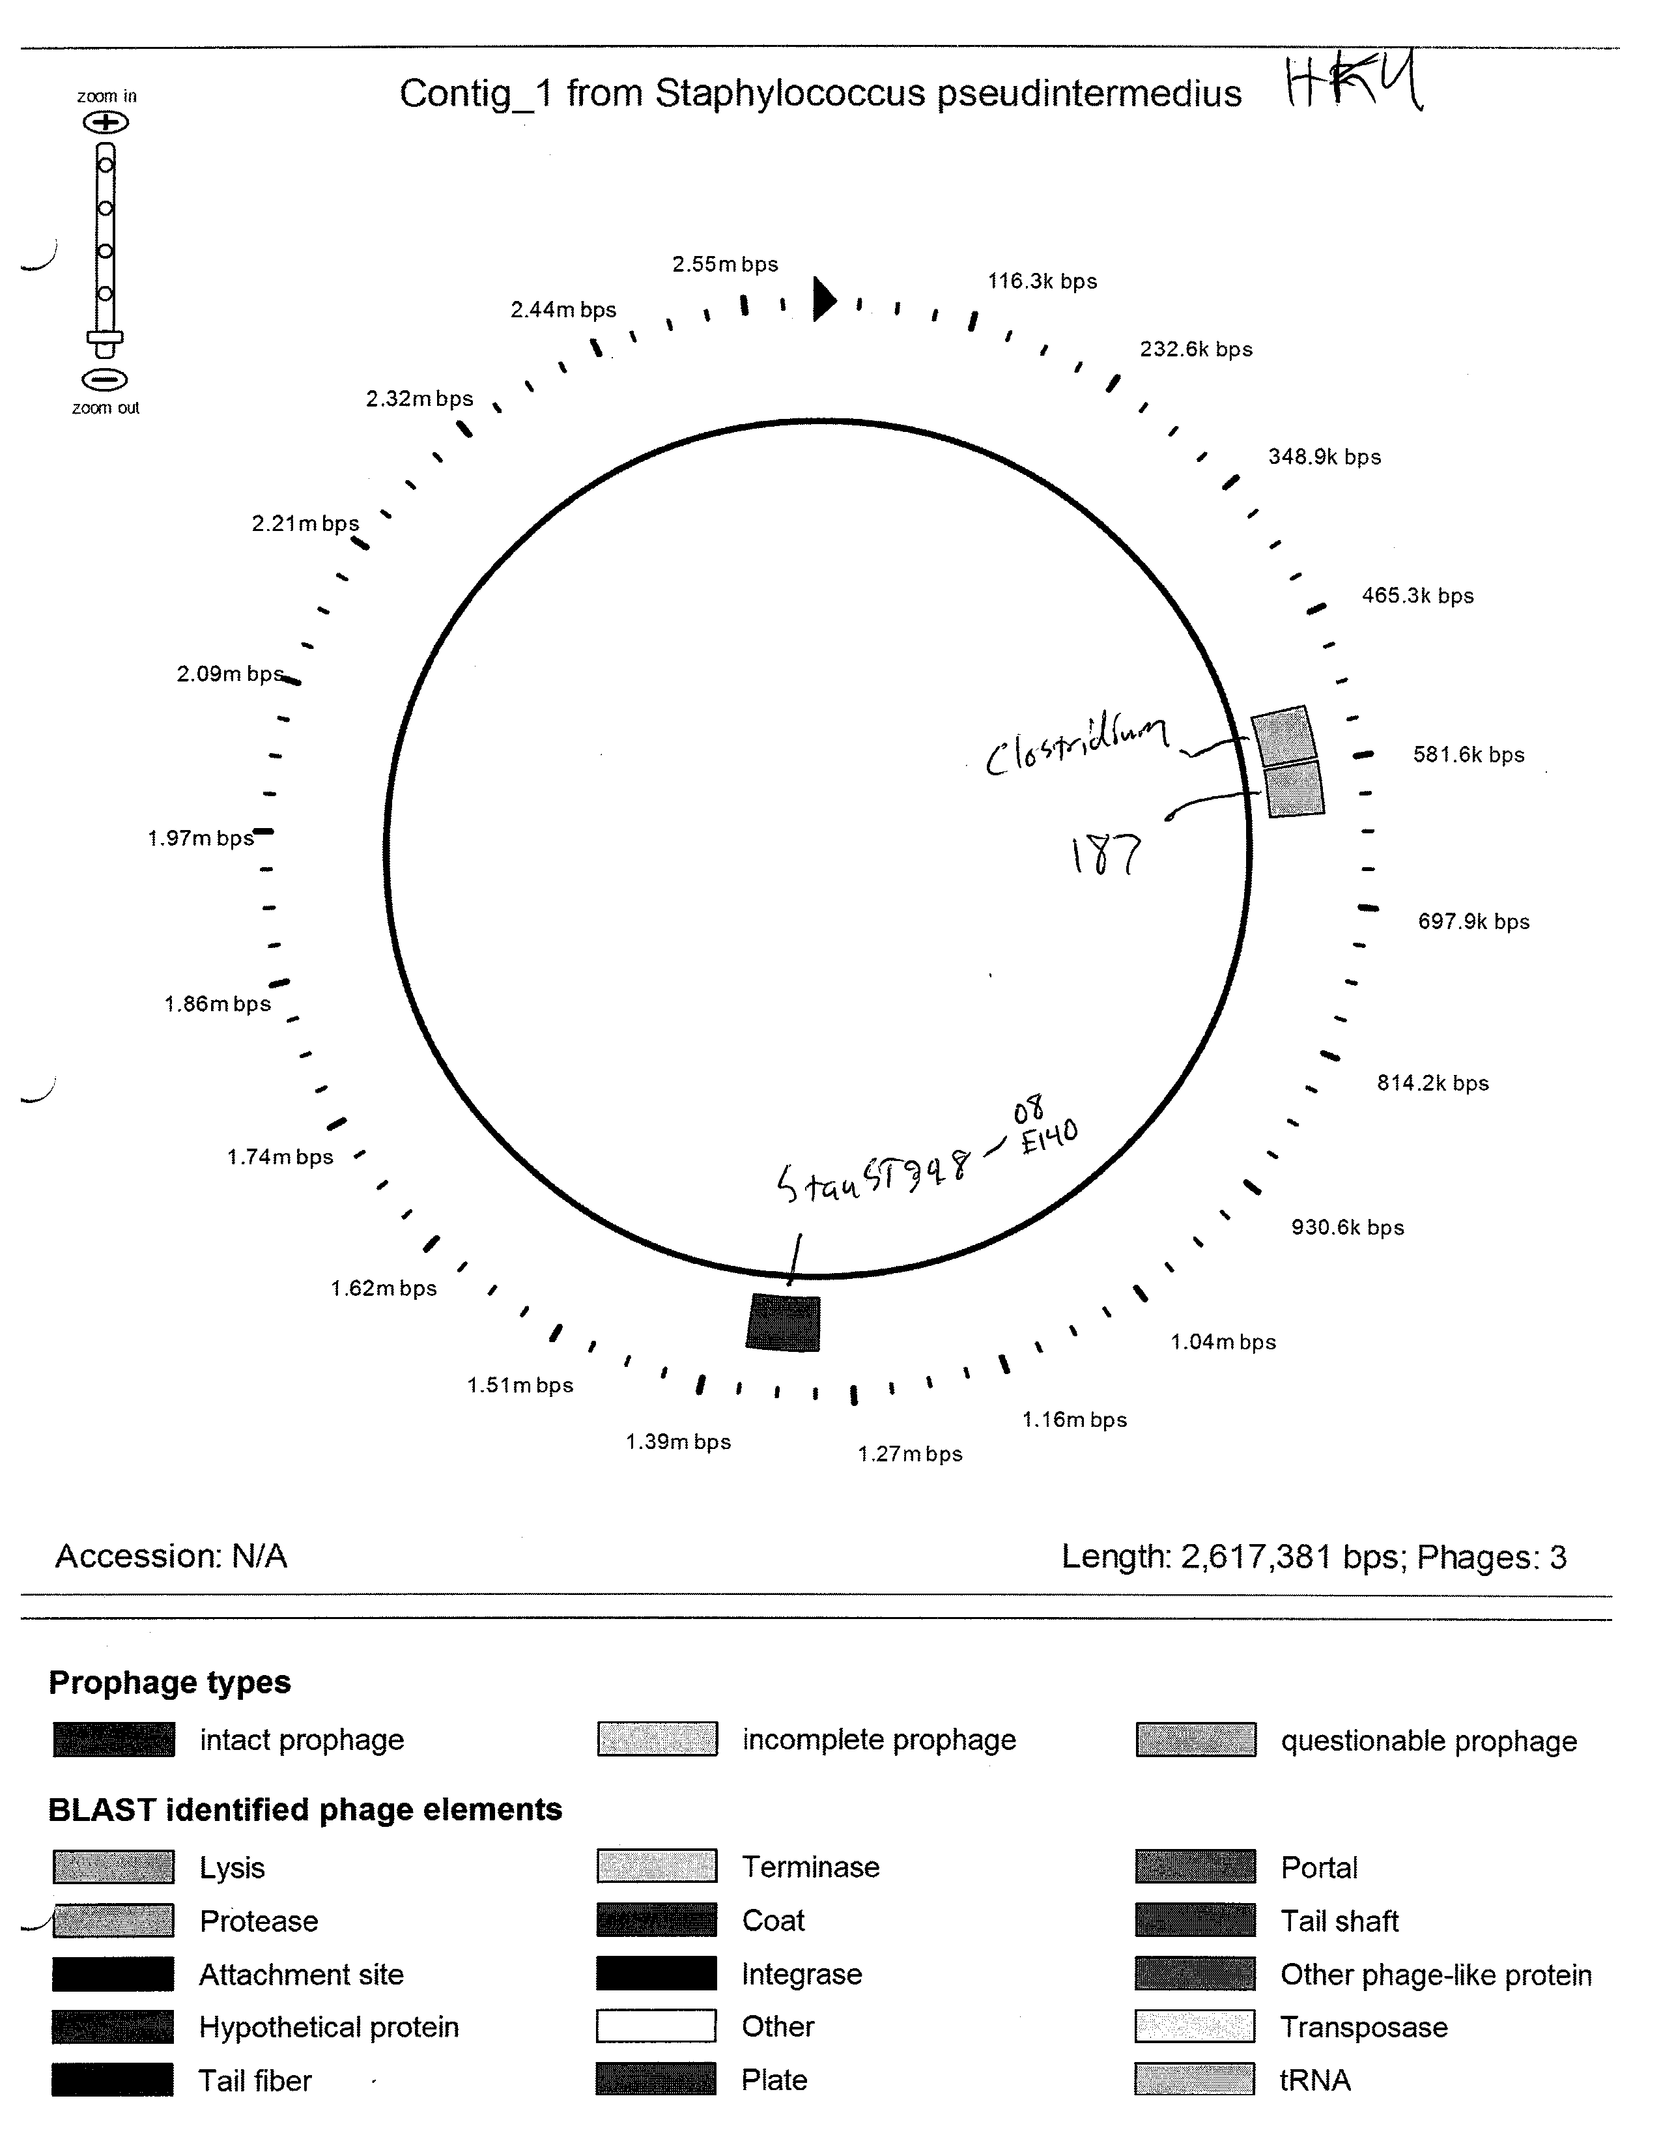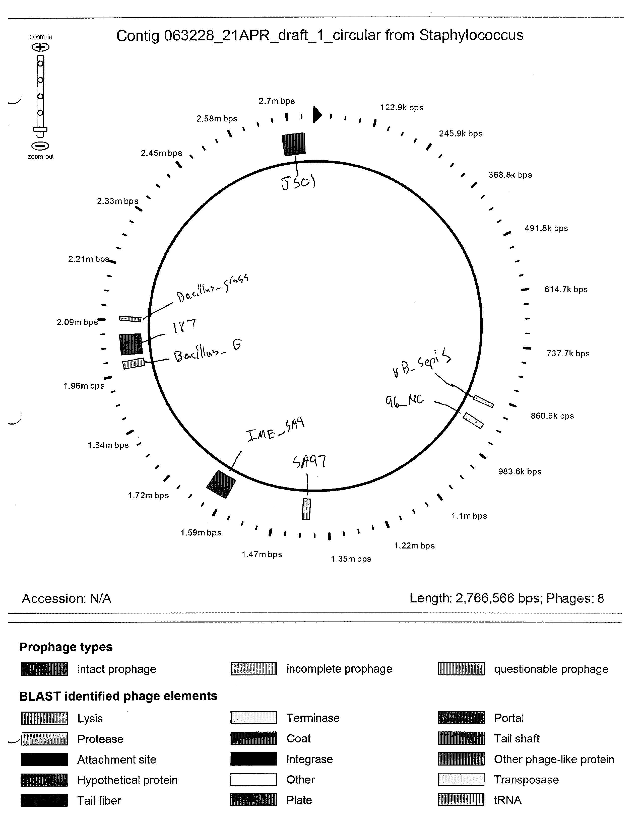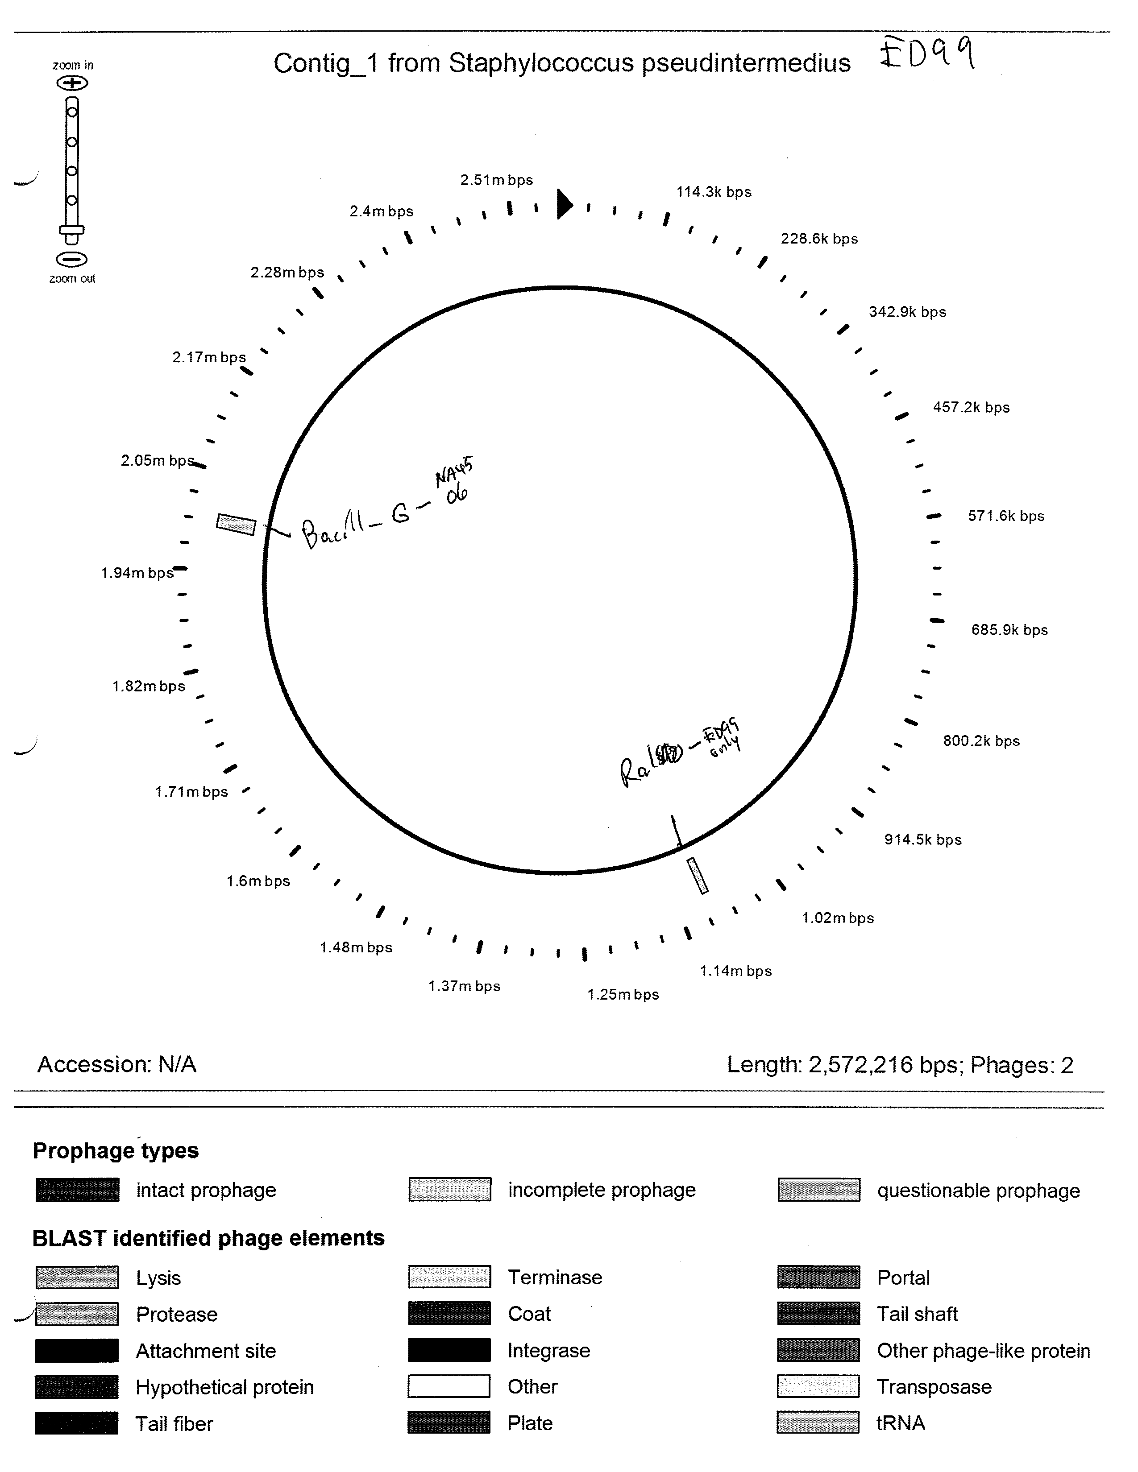

VITA
MAJ Matthew Riley is a native of Fort Wayne, Indiana. He attended Butler University in Indianapolis, IN, where he earned his B.S. in Biology in 2001. During his time at Butler, he won the Seitz Award, enabling him to study genomics with the Medical Research Council Functional Genetics Unit on site at Oxford University in the United Kingdom. After earning his B.S. degree in 2005, MAJ Riley entered the Intercollege Graduate Program in Genetics at the Pennsylvania State University and completed his Masters Degree in Genetics. Following graduation in 2007, he commissioned as a 1st Lieutenant in the United States Army Medical Service Corps and completed the AMEDD Officer’s Basic Course in 2008 in San Antonio, Texas.
MAJ Riley’s first assignment was to the Walter Reed Army Institute of Research (WRAIR) in Silver Spring, Maryland, as a Research Geneticist within the Division of Malaria Vaccine Development. There he developed novel diagnostic tests and genomic technologies to enhance vaccine discovery and detection and treatment of malarial infections. In 2010, he was assigned as the first Chief of the Genomics Laboratory for the Multidrug Resistant Organism Repository and Surveillance Network (MRSN). At the MRSN, MAJ Riley pioneered new optical genome mapping technology, identifying new bacterial pathogens, novel mechanisms of antibiotic resistance, and the spread of hospital disease outbreaks in real time. In 2011 MAJ Riley became Chief of the Overseas Diagnostics Laboratory for Emerging Infectious Diseases in the Bacterial Diseases Branch, where he designed and trained a Mobile Overseas Diagnostics Team to characterize global biological Select Agent strain collections in the former Soviet Union. Additionally, he developed genomic capabilities in support of the Central Public Health Resource Laboratory of Tbilisi, Georgia.
In 2012, MAJ Riley was selected for the Army Medical Department Long Term Health Education Training Program with acceptance into the University of Tennessee, Knoxville, to pursue his PhD in the Comparative and Experimental Medicine graduate program.

