Exploring Enrichment Cultures of Denitrifying
Microorganisms from El Yunque National Forest
Samiha Ahsan, Jenny Onley, Frank Löffler
University of Tennessee, Knoxville, TN
Fall 2016

Abstract
Exploring ways in which bacteria thrive in El Yunque National Forest is crucial to understanding problems that arise within nutrient cycling, such as greenhouse gases, and mitigating these consequences. The first objective was to establish sediment-free cultures from microcosms showing ferric iron or nitrate reduction. The overall goal is to isolate denitrifiers from EYNF soil samples in order to assess the effect of global warming on denitrifiers from EYNF, which can indicate effects on other habitats. Growth conditions for the bacteria in the soil samples obtained include a combination of electron donors and electron acceptors at various elevation levels. Factors tested included nitrate or ferric iron, mixed with either lactate or acetate DCB-1 medium. Consumption of electron acceptors was observed, enrichment cultures were transferred, and a dilution-to-extinction series was executed – taking a step towards isolating a pure culture. Assessment of the microbial communities present in the dilutions was conducted through a DAPI stain.
Introduction
Tropical forests cover almost fifty percent of the world’s total forest area and are more diverse than all other forest types collectively¹. Forests are increasingly being subject to risks from extreme weather, such as droughts, fires, and disease². These environmental concerns may be exacerbated by fluctuations in rainfall, increased levels of greenhouse gases, and air temperature changes. Greenhouse gases, such as the formation of nitrous oxide (N₂O), can be a result of denitrification³. Many microorganisms can reduce nitrate to nitrite. Nitrite can be reduced by denitrifiers to nitrous oxide and subsequently to N₂, or can be reduced to ammonium via dissimilatory nitrate reduction to ammonium⁴.
Tropical forests, such as the tropical montane cloud forests, are known as “the world’s most sensitive and vulnerable ecosystems to climate change”⁵. El Yunque National Forest (EYNF) in Puerto Rico is considered a valuable resource, supporting a huge diversity of tropical organisms. Primarily because of fuel combustion escalation in Puerto Rico, nitrous oxide emissions are expected to increase at a rate of 7.8 percent per year². This flux strongly influences the carbon, nitrogen, and nutrient cycles, and is projected to climb further with global climate change. We are exploring the effects of global warming on soil samples from EYNF to extrapolate possible future occurrences in other types of habitats.
Microorganisms, such as denitrifiers and metabolic reductively dechlorinating bacteria (MRDBs), in the soil can mitigate these problems through pathways, such as nitrous oxide reduction and dehalogenation. “Chemodenitrifiers” can also contribute through reduction pathways for nitrate, N₂O, and ferric iron. These bacteria can thus help improve the environment based on the electron donors or the electron acceptors they use. All known MRDBs grow using acetate, H₂, or a mixture as electron donors⁶. Addition of lactate as a substrate also functions to provide these crucial electron donors since lactate fermentation generates acetate and H₂. This production of acetate combined with CO₂ in the headspace can be reduced to methane, which is also a greenhouse gas. Combinations of lactate, acetate, H₂, and CO₂ feed the microorganisms, allowing for growth and moving a step closer towards obtaining a pure culture. Pure cultures allow us to study individual contributions of community members to geochemical cycling⁶. Our goal is to isolate denitrifiers from EYNF soil samples – the first step towards testing the effect of global warming on denitrifying microorganisms from EYNF, which can serve as precursors to other ecosystems.
Methods
Soil samples were taken by collaborators in Puerto Rico at four different elevation sites and from three different depths. Each of the depths, from 0-5 cm, 5 – 20 cm, and 20 – 30 cm, were combined at their respective elevation heights. Elevation sites 13-1, 15-1, 16-1, and 22-1 are located at altitudes of 434 m, 265 m, 634 m, and 953 m, respectively.
In an anaerobic chamber with 97% nitrogen and 3% hydrogen, sixteen microcosms were set up starting with 1.5 g of each of the soil mixtures at an elevation point (Table 1). Each of eight soil samples were allocated in different microcosms that would each include 20 mM ferric iron with 5 mM acetate or 5 mM lactate in DCB-1 minimal medium at pH 7.2. The other half of the soil samples were set up to grown on 2 mM nitrate and 5 mM acetate or 5 mM lactate medium. After the microcosms were removed from the anoxic chamber and flushed with N₂/CO₂, the minimal medium containing either lactate or acetate was aliquoted into each of the bottles. This DCB-1 minimal medium was made with 100x salts, trace element solution, Se/W solution, and resazurin⁷. Sodium bicarbonate was included as a buffer and L-cysteine was the main source of reductants; sulfide was excluded since it has been shown to inhibit N₂O reduction⁸. Next, after vitamins were added, 20 mM of ferric iron from poorly crystalline Fe (III) oxyhydroxide or 2 mM nitrate was injected into each of the microcosms. Youlboong Sung’s protocol for preparation of ferric oxyhydroxide involves neutralizing a ferric chloride solution, dissolved chloride from FeCl x 6H₂O in aqueous solution through multiple washes, and then making anoxic FeOOH solution.
The initial goal is to establish sediment-free cultures from microcosms exhibiting reductive activity of ferric iron or nitrate³. The ferric iron levels and nitrate concentrations of the microcosms were monitored through ferrozine assays and MQuant™ Millipore nitrate strips. The goal of ferrozine assays is to measure the ferrous iron content and indirectly measure the total iron⁹. Additionally, the nitrate strips test for the presence of nitrite and for a combination of nitrate and nitrite to convey whether a sample contains nitrate. After equating the color shown on the nitrate strip with a value on the nitrate strip chart given, approximate nitrate concentrations were calculated. The nitrate levels were visually estimated according to the color range provided on the nitrate strips manual, and the ranges converted to rough values of the nitrate concentration. While these nitrate strips can determine the presence of nitrate, the nitrate concentrations are not extremely accurate.
The gas chromatograph separates and tests for the presence of different compounds in the given samples. This instrument functions by analyzing the headspace samples from the enrichment cultures, and molecules with increasing boiling point have increased retention times, which help identify the compounds¹⁰. We tested our samples for any nitrous oxide present in the cultures, and the results were also analyzed to determine if any large quantities of methane were in the enrichment cultures.
The enrichment cultures, or transfers, from a particularly successful microcosm showing consumption of the pertaining electron acceptors have been further explored in the hopes of obtaining an isolate. Following multiple transfers, a sample from one of these enrichment cultures was taken and observed under a phase light microscope. The diversity of the microbial communities present was noted and their quantities assessed.
The dilution-to-extinction method was used to decrease the microbial diversity of the enrichments. A dilution-to-extinction series can be conducted in liquid DBC-1 medium from an enrichment culture up to a tenth dilution⁶. The purpose of this dilution-to-extinction technique is a step towards transferring colonies in the hopes of isolating a pure culture. With the fifth transfer from the original microcosm, a dilution-to-extinction sequence was prepared in Balch tubes under similar growth conditions. Samples were taken following inoculation in order to be observed under another microscope via the DAPI (4′,6-diamidino-2-phenylindole) technique. DAPI is a general, nonspecific staining method in which the stain binds to DNA, fluorescing all microorganisms in a sample when exposed to ultraviolet light¹¹. To prepare the samples from the dilutions for the DAPI stain, the samples were washed in phosphate buffered saline, and the cells fixed via paraformaldehyde in a protocol provided by Joy Buongiorno. A few of these dilutions were observed under the microscope with the DAPI staining technique to analyze the microbial communities present.
Results
Consumption of nitrate in the enrichment cultures was closely monitored with nitrate strips following each transfer. After the microcosm showed signs of visibly reducing the ferric iron and consumed the nitrate, the samples were transferred ideally with little sediment. However, several of these enrichment cultures, immersed in ferric iron were exhibiting slow rates of reduction and taking over a month each to display signs of reduction. On the other hand, the enrichment cultures transferred with nitrate demonstrated consumption of nitrate quickly and efficiently within a few weeks. One enrichment culture growing on 5 mM lactate and 2 mM nitrate at the 265 m elevation point consistently consumed the nitrate most quickly within three days while showing high turbidity (Figure 1). In the beginning of the microcosm process, the cultures growing on nitrate and lactate would take about a week to completely consume the nitrate. By the third transfer, the enrichment cultures were increasingly quickly consuming the nitrate within a few days.
Nitrous oxide measurements were taken consistently throughout the nitrate reduction process with the gas chromatograph. Although most of the cultures exhibited no nitrous oxide quantities (or the N₂O levels were below detection), any N₂O produced could be quickly consumed. The production of nitrous oxide was more closely examined in the seventh enrichment culture. Acetylene, which causes inhibition of N₂O reduction by denitrifying bacteria¹², was added to another bottle mimicking the growth conditions of the seventh enrichment culture in lactate and nitrate at elevation site 15-1. Both of these cultures registered nitrous oxide in the gas chromatograph, but the levels were below detection. Similarly, the gas chromatograph did not read any methane peaks in the headspace samples of the enrichment cultures and did not show any significant levels of methane.
As seen with the phase light microscope in the images of the third enrichment culture of focus, there are various rods of different amounts of thickness, length, and brightness (Figures 2 – 4). Although the sample contains predominantly rods, some small cocci, long and single rods with oval-shaped heads, a few spiral-shaped bacteria, and clumps of rods were also observed under the this microscope.
After a week, all of the dilution-to-extinction series up to the ninth dilution had exhibited nitrate consumption and were extremely turbid. However, even after a successive week, the tenth dilution still indicated nitrate on the nitrate strips and failed to become turbid like its preceding dilution. With samples from the fifth, sixth, and seventh dilutions, a DAPI stain was conducted, and the fixed cells from the fifth and sixth dilutions were observed under a Zeiss microscope with a mercury lamp (Figures 5 – 9). Fewer cells are visible in these dilutions compared to the amount seen in the enrichment culture sample shown under the light phase microscope. However, the variety of rods, cocci, and curved cells are still present, with mostly cocci being spotted in the dilution samples.
Discussion
The increasing rate of nitrate consumption observed over time in the enrichment cultures indicates the growth of nitrate reducing microorganisms and suggests steps leading to how a particular microorganism may be favored with each transfer. Additionally, perhaps without as much sediment and possible contaminants such as in the first transfers, the last few transfers demonstrate a higher consumption rate of nitrate. For instance, Figure 1 displays how Transfer 2 consumes the nitrate more slowly than Transfers 5 and 7.
Since nitrous oxide levels were observed to be below detection on the gas chromatograph, the nitrate in the enrichment cultures of focus may be reduced to nitrite and subsequently to ammonium. Exploring the primary product of reduction may also help associate the characteristics with any known denitrifying bacteria, for instance.
Several varieties of the bacteria seen under the phase light microscope are also shown with the DAPI stain. However, especially since the DAPI technique was conducted with enrichment culture dilutions, there appear to be fewer microorganisms observed to be present in the DAPI stain images than those under the phase light microscope. This visual decrease in the microbial diversity of the enrichments with a successive dilution indicates that the dilution-to-extinction method eliminated some types of microorganisms. One of the unknown microorganisms seen in the latter is also shown in the DAPI stain for the fifth dilution. For instance, the curved, lengthy rods in Figure 2 and Figure 4 are comparable to that in the bottom left of Figure 9.
Further Experiments
The vial of the ninth dilution of the enrichment culture grown on 5 mM lactate and 2 mM nitrate at elevation site 15-1 can be used for colony transfers. This vial of the highest dilution with clear growth exemplified by visible turbidity will extend to isolation techniques for dilution-to-extinction in soft agar tubes⁶.
Additionally, since no nitrous oxide peaks were visible on the gas chromatograph, exploring other potential products of nitrate reduction in these enrichment cultures can help towards focusing on certain categories of microorganisms. If the nitrate in the transfers is being reduced to ammonium, quantifying ammonium levels via cations ion chromatography will also be beneficial¹⁰. Moreover, CO₂, acetate, or propionate may provide substrates for contaminants, such as methane, that can interfere with nitrate reduction of denitrifying organisms. In order to determine whether these substrates play a role, an enrichment culture with CO₂, acetate, and propionate and without nitrate can indicate whether any of them may interfere with nitrate reduction.

Tables and Figures
Electron Donors | Electron Acceptors | Elevation Site
Acetate | Nitrate | 13-1; 434 m.
Acetate | Nitrate | 15-1; 265 m.
Acetate | Nitrate | 16-1; 634 m.
Acetate | Nitrate | 22-1; 953 m.
Acetate | Ferric iron | 13-1; 434 m.
Acetate | Ferric iron | 15-1; 265 m.
Acetate | Ferric iron | 16-1; 634 m.
Acetate | Ferric iron | 22-1; 953 m.
Lactate | Nitrate | 13-1; 434 m.
Lactate | Nitrate | 15-1; 265 m.
Lactate | Nitrate | 16-1; 634 m.
Lactate | Nitrate | 22-1; 953 m.
Lactate | Ferric iron | 13-1; 434 m.
Lactate | Ferric iron | 15-1; 265 m.
Lactate | Ferric iron | 16-1; 634 m.
Lactate | Ferric iron | 22-1; 953 m.
Table 1: Microcosm setup with combinations of nitrate or ferric iron in DCB-1 medium with acetate or lactate, each with four different elevation sites.

Figure 1: Nitrate consumption in the enrichment cultures containing 5 mM lactate and 2 mM nitrate

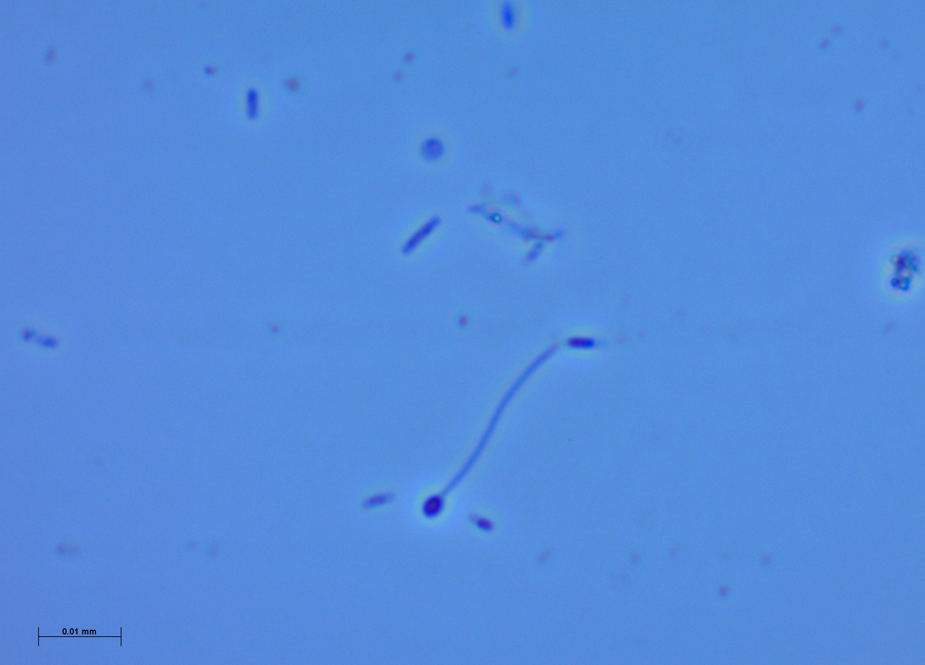
Figure 2: Image (100x) under phase light microscope demonstrates rods, cocci, and curved bacteria of various lengths and sizes. This pertains to the third enrichment culture transferred containing 5 mM lactate and 2 mM nitrate.
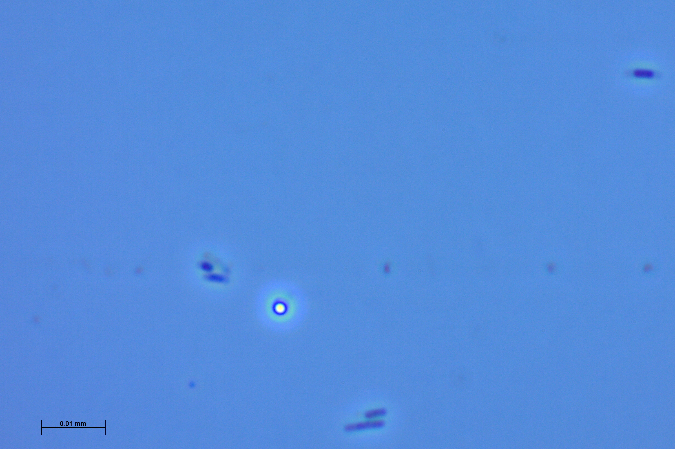
Figure 3: Image (100x) under phase light microscope shows lit spherical-shaped bacteria among several rods of different lengths. This picture corresponds to the third enrichment culture transferred containing 5 mM lactate and 2 mM nitrate.

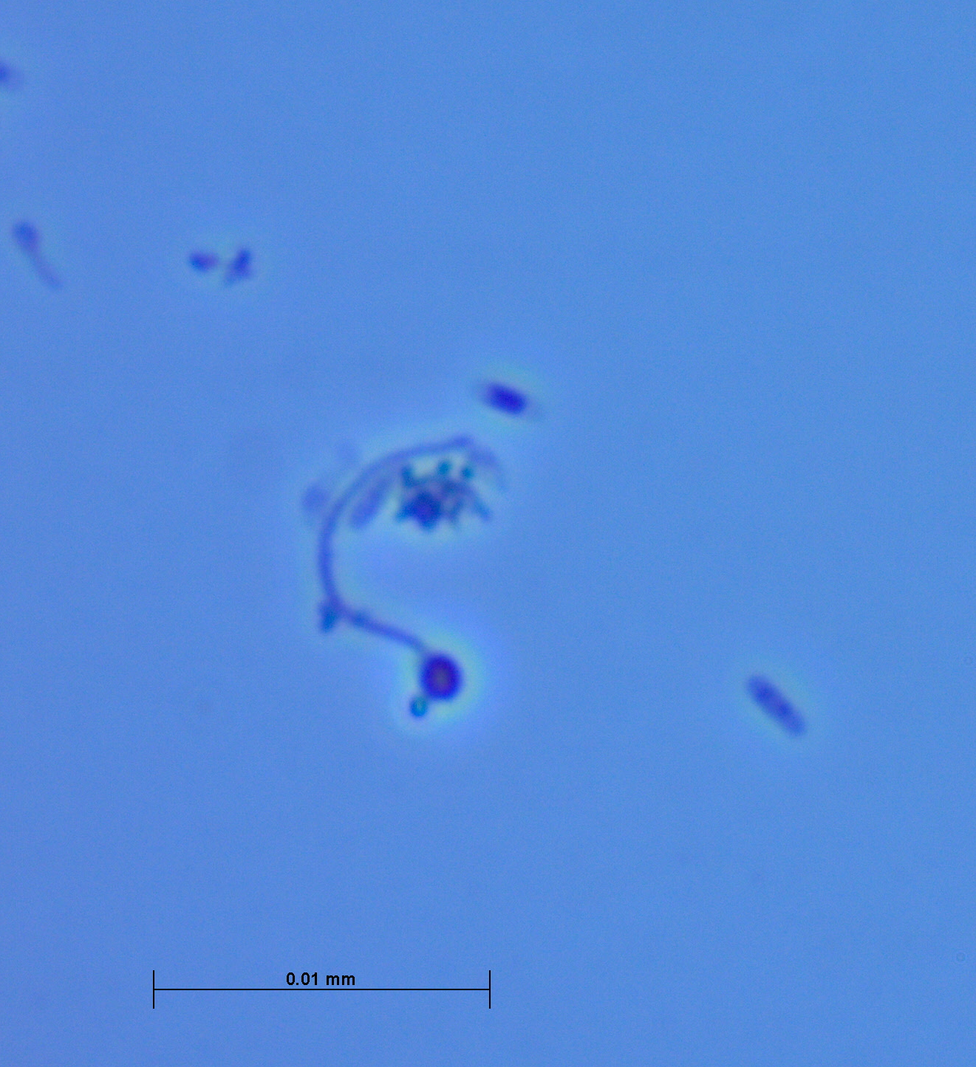
Figure 4: Image (100x) under phase light microscope displays a variety of microorganisms floating in the enrichment culture. This image is of the third enrichment culture transferred containing 5 mM lactate and 2 mM nitrate.

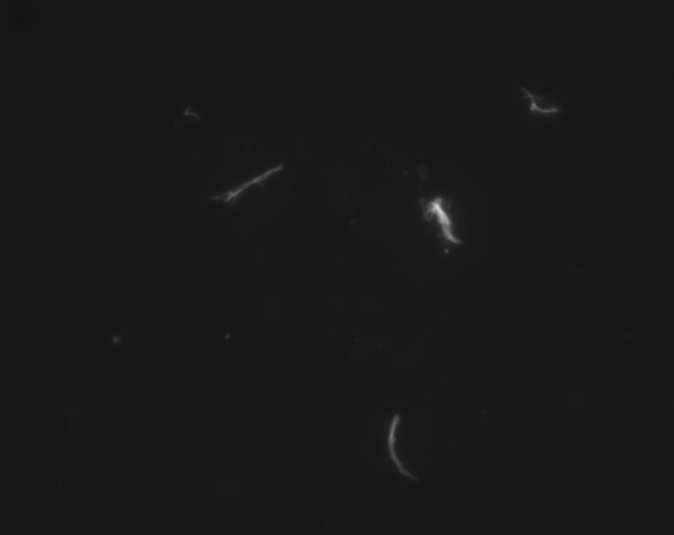
Figure 5: Image (10x) taken during the DAPI stain snaps a few linear and curved bacteria.
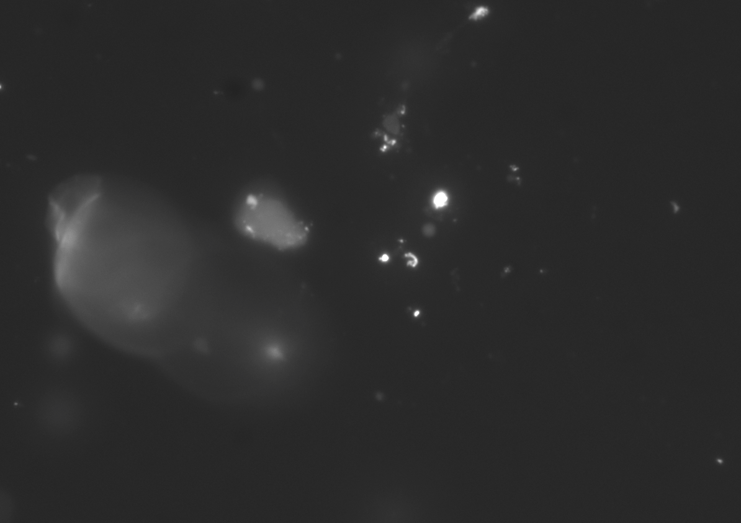
Figure 6: Image (100x) from DAPI stain continues to show a variety of microorganisms in this fifth dilution.

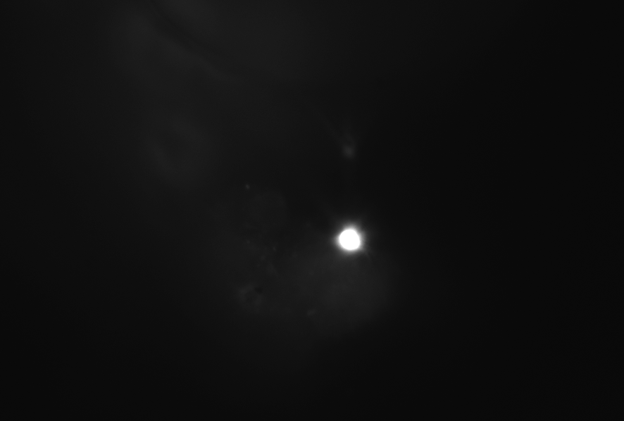
Figure 7: Image (10x) from the DAPI stain exemplifies a circular-shaped bacterium in the sixth dilution.
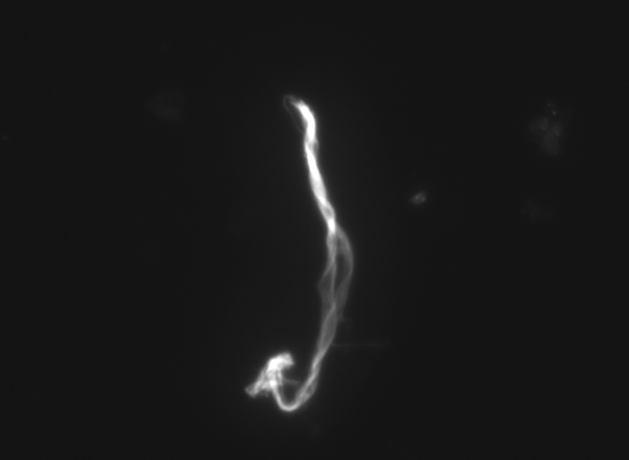
Figure 8: Image (10x) from the DAPI stain for the sixth dilution demonstrates an unknown cell.

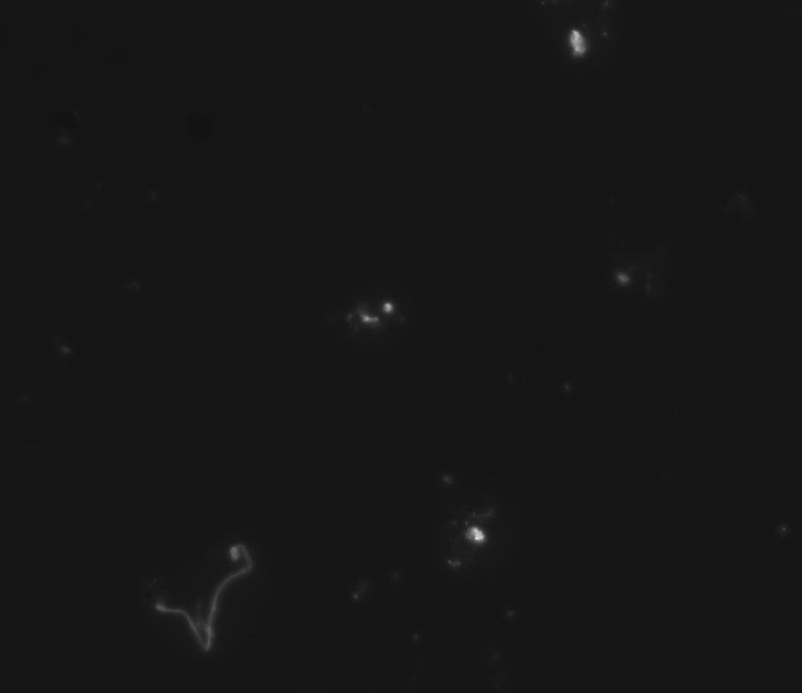
Figure 9: Image (100x) from the DAPI stain in the fifth dilution exhibits a variety of curved, linear, and circular bacteria.

Works Cited
1. Harris, N.L., Lugo, A.E., Brown, S., et al. 2012. “Luquillo Experimental Forest: Research History and Opportunities.” Experimental Forests and Ranges. p152.
2. Jennings, L.N., Douglas, J., Treasure, E., et al. 2014. “Climate Change Effects in El Yunque National Forest, Puerto Rico, and the Caribbean Region.”
3. Sanford, R., Wagner, D.D., Wu, Q., et al. 2012. “Unexpected nondenitrifier nitrous oxide reductase gene diversity and abundance in soils.” Proceedings of the National Academy of Sciences of the United States of America. 109:48.
4. Butterbach-Bahl, K., Baggs, E.M., Dannenmann, M., et al. 2013. “Nitrous oxide emissions from soils: how well do we understand the processes and their controls?” Philosophical Transactions of the Royal Society B: Biological Sciences 368.1621 (2013): 20130122. PMC.
5. Lasso, E.; Ackerman, J.D. 2003. Flowering phenology of Werauhia sintenisii, a bromeliad from the dwarf montane forest in Puerto Rico: an indicator of climate change? Selbyana. 24(1): 95-104.
6. Löffler, Frank E., Robert A. Sanford, and Kirsti M. Ritalahti. "Enrichment, cultivation, and detection of reductively dechlorinating bacteria." Methods in enzymology 397 (2005): 77-111.
7. Löffler et al. 1996 for DCB-1 protocol. “Initial characterization of a reductive dehalogenase from Desulfitobacterium chlororespirans Co23.
8. Sørensen J, Tiedje JM, Firestone RB. (1980). “Inhibition by sulfide of nitric and nitrous oxide reduction by denitrifying Pseudomonas fluorescens.” Appl Environ Microbiol 39: 105–108.
9. Stookey LL. (1970). Ferrozine-a new spectrophotometric reagent for iron. Anal Chem 42: 779–781.
10. "Principles of Chromatography." Khan Academy. <https://www.khanacademy.org/test-prep/mcat/chemical-processes/separations-purifications/a/principles-of-chromatography>.
11. Madigan, M.T., Martinko, J.M., Bender, K.S., et al. 2015. Brock Biology of Microorganisms. (Fourteenth edition.). Boston: Pearson.
12. Yoshinari, T., Knowles, R. 1976. “Acetylene inhibition of nitrous oxide reduction by denitrifying bacteria.” Biochemical and Biophysical Research Communications, 69 (3): 705-710.

