Exploring the Educator’s Perspective when approached with a multicultural classroom

Within the curriculums, policies, and organization of the public education system in the United States, how are teachers today responding to diversity and what type of world are they creating through their work in the classroom?
  - Jodi Brown

Table of Contents ___________________________________________________________
- Acknowledgements 2

- A Brief Look at Latinos and Education in the United States 5

- Latinos in Tennessee and other “New Destination” States 10

- Situating the Ethnographer 14

- Samoa School 18
  - Findings 20
  - Structured Interviews
  - Instructional Methods 21

- Academic Atmosphere and Achievement 31

- Conclusions 34

- Appendix I 41

- References 42

Acknowledgements ____________________________________________________________
First, I would like to thank Karmen Stephenson for introducing me to ethnographic research in the field of education. Her Masters Thesis “Educators' Perspectives and Approaches to Teaching in Culturally and Linguistically Diverse Classrooms” provided the ground work for me to learn how to interview within an elementary school. Karmen’s help with securing IRB approval for this study was invaluable.
I would also like to thank the Chancellor’s Honors Program, the Anthropology Department and the Modern Foreign Language and Literature Department at the University of Tennessee for providing me with a space to excel academically as an undergraduate.
My faculty adviser, Dr. De Ann Pendry, made this research both challenging and rewarding. I cannot extend my gratitude enough for her patience, encouragement, and superb editing skills. To work with Dr. Pendry has solidified my appreciation for and belief in the possibilities of activist anthropology. In showing me how to use academia to engage in the community, Dr. Pendry has provided me with an appreciation for jointly studying and working alongside a cause that is meaningful to me.
Finally, my upmost thanks go to the administration, faculty, and staff of “Samoa School.” I have gained a wealth of knowledge from the teachers I interviewed about the challenges and successes that go alongside education. As I prepare to work within my own classroom in the near future, I will remember the stories and advice you all gave me. Thank you for giving me the opportunity to walk the hallways of your school, to enter your classrooms, and to learn from your valuable experiences about multicultural education.
Exploring the Educator’s Experience when Approached with a Multicultural Classroom _____
As an undergraduate student in Anthropology, I feel that I am always looking for ways in which culture affects how I think and what I do. Do I feel this way because I am American? Or is it because my other major is Spanish? Where did this materialistic motivation arise for me to buy a new watch? Do I like this movie because it tangents with my life as a college student? The influence of culture, though at times taken for granted and often contested, affects people’s lives and their perceptions of the world in meaningful ways. Individually, I am shaped by my culture. Yet, I would also like to think that I can play an active role in responding to the world around me and that society can adjust to new circumstances and conditions. This interplay is not foreign to the field of social science, and a model of structure and agency has been used, most notably by Pierre Bourdieu, to construct this balance between individuals and societal structures (1972). For my senior honors thesis, I wanted to examine how cultural variation related to education in the United States. My central question grounding this research is: within the curriculums, policies, and organization of the public education system, how are teachers today responding to diversity, and in the sense of Bourdieu, what type of world are they creating through their work in the classroom?
To understand this question, research focused on interviewing elementary shool teachers about their methodology when teaching in a multicultural classroom. There has been more migration to East Tennessee of foreign and non-English speaking peoples in the past ten years, and the children of these immigrants gave been entering certain local schools in high numbers. In particular, I was aware of the increasing numbers of Latinos in East Tennessee and originally saw this project as investigating how teachers were responding to this increase. As I will describe later, the students at the elementary school where I conducted my research were more diverse than I had anticipated; they included people from several Latin American countries, children who spoke indigenous languages, and African and Iraqi refugees.
In addition, another surprising result was based on a conversation I had with a teacher about multilingualism in the classroom. The Kindergarten teacher showed me a book they had just read as a class, and it was everything I expected to see for a kindergarten level book – a young child as the protagonist, and bright and colorful cover artwork. The more striking part about this book was that it was written in English and in Spanish. She told me that she read the book to the students in both languages, and I was surprised. Surely a non-Spanish speaking student was feeling imposed upon by this foreign language being spoken in his or her American school, right? I had so many questions about how her students were reacting to this bilingual material, but the teacher was able to answer all of them with a simple and logical explanation that had completely evaded my thought process. She told me that this is what the kids knew. All of the elementary school students at this school had been in classes with Latino students, and Spanish was not as foreign to these children as I had assumed it might be. Instead, this was normal for these five year olds. After all, the emergence of television programs like Dora the Explorer and the Spanish segments on Sesame Street introduce young children to bilingualism at an early age. Their educational experience, though guided by requirements and measurable progress reports, was infused with linguistic diversity.
Each day, students at this local elementary school were arriving with signed permission slips, folders, pencils, and attempted homework assignments. They were also bringing with them their experience as students, their perception of learning, and in an essence, their culture. From what my interviews revealed, teachers take this in, respond to it, and subsequently use it in creating an educational experience for children at this local school. When my own suppositions about multiculturalism in the classroom were challenged, it allowed me to see beyond the policies of education and to instead focus on how learning itself is fluid and changing. If Kindergarten students at an East Tennessee elementary school can become accustomed to (and maybe even benefit from) multiculturalism in the classroom, what sort of implications does this have for education in the United States?

A Brief Look at Latinos and Education in the United States ___________________________
Education plays an extensive role in shaping both the present status and future promise of a nation’s people. Inextricably linked to the shape of society, education is a vital, sustaining, and integral part of creating productivity while also fostering a sense of community. In the United States, institutionalized learning is a central tenet in the lives of the country’s residents as public education has been made available to all. As John Adams once noted, "the whole people must take upon themselves the education of the whole people and be willing to bear the expenses of it.” A useful way to look at education, this quote poses the idea that there is both a legal and a moral obligation to educate children in the United States – including children of immigrants and children who may need extra assistance learning English – which places much responsibility in the hands of teachers.
Frequently viewed as a country of immigrants, the United States has long been a place of cultural variety. Of particular interest is the presence of Latinos in many parts of the country and how this group of people has shaped the American character over the years. In comparison to other parts on the United States, the Latino history in the American Southwest is much longer and more established. With the Southwest United States having been part of Mexico until the end of the Mexican-American War in 1848, author Gregory Stephens notes that “it is impossible for most people in the Southwest to think of the United States and Mexico as completely separate cultures.” With a constant influx of Latino migrants into the United States, however, the border between these two nations is becoming less distinct. American Studies and Human Relations Scholar, Gregory Stephens, advocates thinking of “the border as a region that extends in both directions, rather than a line” 2005:205). This idea of fluidity provides a useful springboard for looking at the role of education of Latinos and other minority in American society.
In the article “Latino Education in Twentieth-Century America: A Brief History,” historian Guadalupe San Miguel, Jr. and education scholar Ruben Donato look at how education policy has been altered over the years and how these changes have impacted the Latino population. Beginning in 1898, immediately after the northern part of Mexico became the southwestern United States, the authors note that education has long been impacted by linguistic and cultural diversity. Alongside the Mexican population, there also came Puerto Rican and Cuban migrants throughout the 19th century. Today, these assemblages of people form the most populous subgroups of Latino residents in the United States (2010:26-28). The authors discuss the difficulties faced by schools, administrators, and teachers in creating a productive learning environment, and “in many cases, the school responded not to the genuine needs of this diverse group of children but to those of other stronger political and economic interests who sought to use schools as instruments of cultural conformity and of social and economic subordination” (2010:29). True not only for Latinos, but also at various points in the past for European immigrants, Native Americans, African Americans, Asians and others in the United States, the authors use historical examples to reach conclusions about minority struggles in schools. The authors make the point that in the past the variety brought to the classroom by these students was not utilized or defended in the overarching goals of public education.
In the years before 1960, there was a tendency toward “cultural conformity” in the education system, which included a lack of multilingual curriculums. Assimilation of immigrants and other minority cultures was the prevalent goal in the practice of education in the United States and was particularly visible in language education over this span of years. In the late 19th and first half of the 20th centuries, diversity was discouraged in public schools. English-only policies were established throughout the nation and most public school systems with significant numbers of Latino students did not allow Spanish to be spoken (even during recreation times) (San Miguel et al 2010:32). Though such a strategy was put in place with the intention of prioritizing English language learning, this course of action had the simultaneous effect of causing discomfort, insecurity, and stress among minority language students, not to mention creating an inevitable period of time where little to no learning occurred for children who entered the school as monolingual Spanish speakers. Psychologically, scholars have noted how equating speaking Spanish with misbehavior concurrently devalues a student’s sense of heritage and custom (Valverde 2005). By promoting English as the correct language, the perception of Spanish and those who spoke it was diminished (San Miguel et al 2010, Valverde 2005).
The early 1960’s marked an important time in the field of American education. Though the three major Latino groups – Mexicans, Cubans, and Puerto Ricans – continued to be present, immigration from Central American and South America began increase. With the reform of immigration laws under U.S. President Lyndon B. Johnson in 1965, the quota system for migrants was abolished, which permitted immigrants from an array of locales to enter the country (Schulman 2001:68). This policy change not only allowed for a rise in the Latino population, but also for other groups, such as Asian and African migrants. Immigrants from Colombia, the Dominican Republic, Guatemala, El Salvador, Nicaragua, Panama, and other Latin American countries increased the numbers of Latinos in the United States. In addition, particularly since the 1980s, Latinos have spread across the United States to areas outside the southwest, Miami, New York, New Jersey, and Chicago (MacDonald et al 2010). The Civil Rights Movement in the United States inspired Latinos who began to push for bilingual education as a means to address the previous social marginalization and cultural devalorization (San Miguel et al YEAR). In the 1974 Supreme Court case, Lau v. Nichols, the court required school systems to take proactive measures to better teach students who had limited English proficiency after a Chinese student in the San Francisco school district claimed he was facing discrimination due to his limited English language proficiency. The Supreme Court made their decision based on Section 601 of the Civil Rights Act of 1964, which prohibits “discrimination based on race, color, or national origin in any program or activity receiving federal financial assistance” (1974). After this Supreme Court decision was implemented nation-wide, the Chicago school system claimed it was not able to fund a massive hiring of bilingual teachers and that the decision was impractical (Schulman 2001:71). Though the Supreme Court decision was never fully actualized, it provides an example of how the effects of new immigration policy and the Civil Rights Movement provided Latinos, as well as other language groups, with a space to reconfigure their social positions.
These same issues have continued to be contested within the education system of the United States until the present. During the 1990s, schools with bilingual curriculums have emerged, there have been efforts to incorporate material important to more international heritages, and textbooks have been revised with an effort to be more inclusive of Latino histories (San Miguel et al 2010:42). Scholars argue that an ideal education system would address the needs of these students more effectively, rather than focusing on assimilation as the ultimate goal. Not only responsive to demography, but also to the legal and political struggles within a nation, it is also possible to note the potential for restructuring in response to the needs of students as the population has been and continues to be shaped by linguistic and cultural diversity.
Education scholar Leonard Valverde notes that as we begin the 21st century, “the one thematic constant in the United States is that change in inevitable. The other social constant is that certain national and historic trends continue. Caught between these two constants are schools” (Valverde 2005:9). The trends Valverde refers to are assimilation and multiculturalism. Given that Tennessee is a “new destination” for Latinos, one can wonder what the effects of these trends may be in Tennessee public schools. Does assimilation play a role in public schools here? Are the languages and customs of Latinos being incorporated into more modern curriculums, and how do teachers respond to increasing multiculturalism in schools?

Latinos in Tennessee and other “New Destination” States _____________________________
Historically, the most powerful factor drawing Latinos to the United States has been the demand for labor created by the nation’s economy. An expansive market for jobs, particularly in the early 1990s and early 2000s, in professional, agricultural, manual-labor, and technical sectors, provided Latinos and other immigrants with a potent reason to relocate to areas like Tennessee. The state of Tennessee has seen substantial growth in Latino residents, and foreign born populations in general, since the early 1990s. In a 2009 article, “Tennessee: A New Destination for Latina and Latino Immigrants,” geographer Anita Drever observes that in 2005, 59 percent of Latinos lived in the state’s three largest cities – Memphis, Nashville, and Knoxville. Yet, the areas that have been most affected by new Latino residents in relation to their current populations are the “small towns dominated by either food processing or manufacturing and those that are regional distribution centers” (Drever 2009:68).
Latino migrants in Tennessee were motivated by a large number of jobs in the state’s thriving service industry and the low cost of living, and were also “much likelier to settle in places where they have friends and family” (Drever 2009:68). This tendency explains why certain areas of the state have experienced larger relative increases in Latino and other migrants. In Knox County in East Tennessee, for example, the Latino population nearly tripled from 2000 to 2010, increasing from 4,803 to 15,012 people. This also occurred in Loudon County where the Hispanic population increased from 894 to 3,395 in the same span of years (Knoxville News Sentinel Co. 2011). Such numbers indicate that the school systems in East Tennessee now have a larger presence of Latino children in local school systems.
The state of Tennessee is not alone in its recent rise in Latino residents. Since the mid 1980a, a number of communities across the United States have seen dramatic changes in population demographics. In the article “State and Local Immigration Policy in Iowa,” anthropologist Mark Grey looks at how certain communities in this Midwestern state have responded to an increased presence of Latinos. Grey attributes a 153 percent increase of Latino Iowan residents in the 1990s to the state’s need to fill jobs in industrial, processing, and agricultural sectors (Grey 2003). Yet, this economic change was not met with open arms, but rather with a response “born of uncertainty, fear, misinformation, and disinformation. The challenges are social and economic, but they are also political” (Grey 2003:18). Despite these new workers filling a gap in the labor market, Iowans were unsure of how to react to such a dramatic change in local populations.
As in Tennessee, in Iowa many Latino immigrants were settling in smaller communities, where food processing (and more specifically, meat packing) plants were located. Though Iowa has a history of welcoming refugees into the state for resettlement, such a dramatic rise in the Latino population was perceived by some long-term residents as disrupting the social fabric of their small towns (Grey 2003:35). In particular, schools transitioned from “predominantly white and English speaking to multiethnic, multinational, and multilingual in a few years’ time” (Grey 2003:36-37). Despite this change, education policy in the 1990s took little action to better prepare teachers or serve students. Much effort centered on classifying student’s English abilities, however only one bilingual program was developed (Grey 2003). Thus what was happening ground-level at Iowan schools was often a reflection of social, economic, and political doubts, rather than a logic related to what would be educationally best for children. Grey, however, did not discuss how individual teachers were responding to the influx of Latino students. This is an area where ethnographic research can shed some light.
As in Iowa, in Tennessee and in other areas across the United States, there have been unenthusiastic responses to the presence of immigrants and Latino citizens. According to Grey Iowa “is not quite sure it wants to make the new immigration work despite every indication that today’s immigrants are to the state’s long term social and economic well-being” (2003:33). Negative narratives include the idea that Latinos and/or immigrants are taking American jobs; consequently new Latino immigrants face the challenge of successfully integrating into an American workforce, where their work is needed, while they and their children face discrimination. This narrative includes negative perceptions of language and culture. Stephens notes “the United States has traditionally perceived ‘foreign languages’ and, indeed, often bilingualism as a problem (2005:209). A characteristic of the United States is its lack of an official language, although English is the most spoken and utilized. The increased presence of new immigrants who speak multiple languages, but particularly Spanish, has fueled a movement to make English not only a de facto, but also de jure, part of United States legislation (Chavez 2008).
These narratives and policy proposals all imply that the economy and society of towns across the United States are being hurt by new migration. Jennie M. Smith, however, argues the opposite in her article “The Latinization of Rome, Georgia.” Georgia also has seen a dramatic increase in its Latino population. From 1990 – 2000, there was a 300 percent rise in the population of Latinos living in Georgia (Smith 2005:224). Smith observed that “negative attitudes toward Latino immigrants are common and have been exacerbated by the fact that local government officials and business owners have been slow to respond to the demographic changes” (2005:225). To counter this, Smith wished to bring more transparency to the process and factors that have brought Latinos to this area of Georgia, with a hope of providing more understanding to the town’s residents about the changing face of their community. To do this, Smith brought students from her anthropology class to local schools since “education is one of the areas where the challenges presented by recent immigration trends have been most dramatically felt” (2005:229). Working alongside students, guidance counselors, teachers, and school administrators, Smith’s class was able to see the value of linguistic and cultural diversity within the local school system. Her students came to the conclusion that there needed to be more bilingual teachers to help multilingual students transition and feel comfortable in English-only classrooms, and that English as a Second Language programs could become more personalized depending on the needs of the students. An integration of the community within local schools was also proposed. For example, Spanish and education majors from local colleges could spend time at the school helping and tutoring students with limited English abilities as they move to an English-only setting (Smith 2005). Overall, when in the schools, the anthropology students began to see immigration as a force that can be confronted with positivity and productivity. A main focus of my research was to dialogue with teachers about ways in which they could feel more prepared in multicultural classrooms. Smith’s activist approach allowed me to see how university and college students can use their familiarity with language, education, migration, or a school setting to provide more information about the lived experience of teachers in the classroom.

Situating the Ethnographer ____________________________________________________ Beginning in high school, language education has formed a top priority of my academic agenda. Although my motivation to become bilingual through Spanish classes began as a personal goal, learning another language has made me more aware of cultural diversity both around the world and in the United States. For this reason, I chose to spend a semester of my undergraduate education as an exchange student in a Spanish-speaking country.
When I was placed in Vigo, Spain, visions of bull fights and flamenco dancers permeated my thoughts. I was in for a surprise, however, when I arrived to the cool and rainy coastal town in northwestern Spain. As Vigo is located in the autonomous province of Galicia, both Spanish (Castellano) and Gallego are spoken. While studying there, I had the opportunity to work in a local elementary school as an English Conversation Assistant. The Gallego language was essential to the identity of those in the region, and in the school where I taught, fifty percent of the classes were conducted in this local language. Spending a significant amount of time in this Spanish school allowed me to begin thinking about the role that languages play in the education system and how educators confront a setting with two prominent languages.
On a six week trip with a professor and several students from my university to Puebla, Mexico, I again explored the interface between language and education. In this location of Mexico, there is a large indigenous population. Often times, the cultures of the indigenous communities are not seen as a seamless fit with Mexican nationalism, which is constructed as being mestizo. Although this mestizo identity is constructed as half-Indian and half-Spanish, there is a presumption in Mexico that mestizos speak Spanish rather than an indigenous language. Living with a host-family, I was given a number of opportunities to talk with my host-mom who was a special education teacher. Over dinner one night, she told me about how she was skeptical about the utility of teaching Nahuatl, the most prominent indigenous language in Puebla, to local children, because Spanish was the more important and dominant form of communication. She thought that the indigenous women who had been recruited to teach were not qualified to assume the important role of instructors within society and doubted their capabilities in the classroom. One day, however, she saw a group of indigenous women training to be teachers on the bus and began to rethink the importance of placing value on language preservation. Like these women, she thought that Nahuatl was an important part of her heritage, yet unlike these women, she was unable to speak it. Instead of doubting the intellectual preparedness of these women, she began to be impressed by their bilingual abilities and was almost envious of their retention of this part of Mexican history. It was not often that my host mom was this candid with me about her perception of indigenous communities within Puebla, but following a few discussions like this about the complexities of culture in the education system, I began to compare what I had observed in Spain and Mexico to the United States, and essentially to the education system in which I had been and continue to be a participant.
Having been exposed to the English as a Second Language (ESL) program while in high school, I was somewhat familiar with the place of bilingualism and multiculturalism in the American education system. At a local church in Memphis, Tennessee, I assisted teaching an ESL class. The teacher did not speak any Spanish, as the curriculum was designed to reach any non-native speaker. Although only having two years of Spanish classes, my limited experience with the language was welcomed by the class of Spanish-speakers. I stayed after every session to help with filling out job applications and important paperwork. Working with the ESL class formed a major inspiration behind my goal to utilize Spanish more often, but it was not until later that I began thinking about how this experience was an introduction to the impact teachers can have in facilitating learning and heightening people’s accessibility to sustain themselves within society.
Still as a student, I lacked the understanding of the intricacies teachers may face when confronted with a linguistically diverse classroom. Until I went abroad, I was unable to relate with those whose language tied them to a minority status. With language, there comes a wealth of links to cultural identity. In the book Through the Language Glass, linguist Guy Deutscher goes so far to argue that individual cultures are inextricably linked with their speakers. In Deutcher’s eyes, language affects a person’s perceptions, descriptive capabilities, and cognition. Developed by linguistic anthropologists Edward Sapir and Benjamin Lee Whorf, Duetcher cites the Sapir-Whorf hypothesis’s idea that the structure of a language is inextricably linked to how its speakers view the world (2005:130). Though many contemporary scholars would not place such a strong linkage on personality and language, Deutcher’s unconventional conclusions point to the importance of speech in shaping how speakers see and identify themselves in the surrounding world (2010). Based on my experiences in Spain and Mexico, I was able to observe and experience how important valorizing language can be for reaching students.
When I worked at the elementary school in Vigo, Spain, I was asked by the English teacher to pretend that I did not speak any Spanish. This was meant to encourage the students to rely on mastering English so they could articulate and express themselves while I was teaching. Knowing that they could fall back to Spanish with their regular English teacher, I was meant to symbolize how learning another language was useful to communicate with other people. When conducting lessons, I could understand the students speaking Spanish to each other, and it was difficult to pretend that I could not comprehend how frustrated they were with learning another language. Each day studying in Spain, I struggled to effectively communicate in my non-native language and could relate to the sheer aggravation that resulted from being unable to adequately express my emotions. One day, I decided to open the class speaking Spanish with my fifth grade students. I was nervous. Even though these children were in elementary school, Spanish was their native language, and I worried about making mistakes. Instead, my students immediately opened up, asking me questions about life in the United States, my family, my favorite movies, and what I liked about their city. I tried speaking Spanish in all of my classes that day and received the same response. One of my students said he hoped to go to the United States one day to practice his English, just like I was in his country learning Spanish.
Hence, in this study, I wished to take an in depth look at the interface between language and education in local school systems. Though the strategy for creating success in American education often revolves around instruction only in English, my research suggests that the reality within schools is a bit more varied. Tennessee’s growing immigrant population has undoubtedly impacted the field of education within local schools and state-wide policy. Yet, as seen, much of the historic and present dialogue surrounding the newfound multiculturalism in the state (and within the United States, in general) seems to exhibit a tendency towards negative and doubting sentiments pertaining to confronting these diverse populations. The works of Gregory Stephens, Leo Chavez, and Jennie Smith suggest that misconceptions about migration, bilingualism, and American jobs can begin to tarnish what is happening at the ground-level in schools and communities. As Valverde (2006) pointed out, schools are caught between the forces of societal change and historical trends. For this reason in the spring of 2011, I conducted open-ended interviews with teachers in a local East Tennessee school about their experiences with confronting demographic changes in their school.

Samoa School _________________________________________________________________
These teachers worked at an elementary school with a high percentage of Latino students within an urban East Tennessee school system. “Samoa School,” which is a pseudonym, services students from kindergarten to the fifth grade. The Samoa student body has grown from 197 students in 2007 to 286 students in 2010. Over 90 students at Samoa School identified themselves as Hispanic during the 2010 school year, meaning there was a 9.2 percent increase in the enrolment of Hispanic students. That means that one-third of the student body is Hispanic. In other words, as can be seen in Table I, Samoa School is one of the schools in Tennessee that has experienced a substantial increase in the number of Latino students. In the past ten years, and even more noticeable from 2007-2010, Hispanic students have become a significant factor in the classrooms of Samoa School.
Table I: Ethnic Composition of Students at “Samoa School”
Ethnic Categories: | 2007 | 2010
Black | 110 | 127
White | 49 | 65
Hispanic | 48 | 92
Asian/Pacific Islander | 1 | 1
Total | 197 | 286
Source: http://edu.reportcard.state.tn.us/pls/apex/f?p=200:1:2269599936747611::NO:::
While doing my research at Samoa School, I learned that 43 percent of the students were classified as English Language Learners (ELLs). By definition, an ELL student is not a native English-speaker and is therefore in the process of acquiring the English language. Knowing that the presence of Latino students and other immigrant children at Samoa School was significant, I began to create and structure interviews based on the presence that teachers were responding to this demographic change in a number of ways.
Through the vice-principal of Samoa School, I was able to arrange interviews with five teachers at the school. Across the nation and in the state of Tennessee, No Child Left Behind policy calls for standardized testing to establish an Annual Yearly Progress (AYP) report based on standardized testing scores. In Tennessee, the Tennessee Comprehensive Assessment Program (TCAP) test is used to evaluate student achievement and teacher effectiveness in designated grade levels each year. Tennessee state education policies require that the TCAP be administered in English, and a student’s classification as an English Language Learner is taken into account when reviewing overall test results (Tn.Gov 2011). The TCAP tests, however, are not given until students reach the 3rd grade. With a great focus placed on meeting AYP standards and attaining positive testing outcomes, TCAP and No Child Left Behind procedures differentially affect upper-grade level instructors. For this reason, I decided to conduct my interviews with teachers from the kindergarten, first, and second grade levels. Though responsible for educating and preparing students for standardized testing in the future, the lower-grade teachers do not have this state-driven obligation, which I assumed, would allow them more flexibility in the management of the curriculum in their classrooms. In all, I was able to interview four teachers from Samoa School about their responses to an increasing linguistic and cultural diversity.

Structured Interviews _________________________________________________________
To address my questions about teaching in a linguistically and culturally diverse classroom, I structured my interviews around a pre-determined list of questions. First, I wished to gather information about how long the teachers had been teaching at Samoa School, in East Tennessee, or as part of other school systems. Then I asked teachers to characterize the demographic change within Samoa School, and how a diverse student body had affected their teaching. Ultimately, I wished to understand if these teachers felt prepared to teach English Language Learners and how these students had influenced the dynamics of the school (See Appendix I for specific questions asked). In conducting this research, I hoped to synthesize the ideas that each educator had about ways in which to create more productive learning environments, so that this information could later be used by the school. Consequently, I asked teachers how they felt they could improve their teaching methods and how they might be better trained to work in a diverse environment. Their suggestions about resources and my findings will be made available to Samoa School’s administration, staff, and teachers when completed.
Although I had a list of questions, I also anticipated creating an atmosphere of casual conversation. Not only would the information gained be useful to write my senior honors thesis, but it also had the potential to help me with my post-graduate plans. Following graduation, I will be moving to New Mexico to teach social studies. In the school system where I will be teaching, one third of the students are American Indians, so I felt I had a lot to learn from teachers who had been teaching in multicultural classrooms for several years. When I mentioned my future plans, the teachers with whom I conducted my interviews were full of helpful advice and guidance. This form of camaraderie infused my time at Samoa School with a sense of pertinence both to better understanding how migration in my home state of Tennessee has impacted schools and in tying the experience of conducting this research with my own future as a teacher.

Findings ____________________________________________________________________
To frame the impact of recent Latino migrations in Tennessee in a light other than that provided by statistics and figures, I began my interviews by talking with teachers about their perceptions of the demographic change that had occurred at Samoa School. Carla Meyers (pseudonym) has been teaching at the school for ten years. Thinking back to when she first began working at Samoa, Carla can only remember one Latino student in the entire school. Similarly, Nadine Gusterson remembers when the first Latino student came to Samoa School in the 2000 – 2001 academic year. Having taught for twelve years at the school, she characterized the demographics before this time as being divided into African American and Caucasian students. In the last ten years, these two teachers agreed that the demographic change in the student body was undeniable. With 43 percent of the students now being classified as ELLs, Carla noted that the staff of the school had also undergone modifications to address the changing population of Samoa School. Interpreters were hired to better communication within the school and outside with parents.
On the other hand, Susanne McKinney (pseudonym) said that the presence of Latinos at Samoa School was “relatively small.” Susanne is another example of changes in faculty that have occurred at Samoa in response to the demographic change. Having moved to East Tennessee from Texas just two years ago, she is one of the only English as a Second Language (ESL) certified teachers at Samoa school. In Texas, Susanne saw a much greater need for ESL instruction at the school where she worked compared to Samoa School.
As mentioned in the introduction, though initially interested in focusing on Latino students and Spanish-speakers, I learned in my interviews that Samoa School has a number of African immigrants. All of the teachers spoke of having Tanzanian children in their classrooms, while Carla said she had students from the Democratic Republic of the Congo and Burundi, though the majority were from Tanzania. It was also noted that Samoa School had received its first Arabic speaker that year from Iraq. Within the Latino population of the school, the teachers were aware that there were students from different countries in South America, and Susanne said she knew she had speakers of the Guatemalan indigenous languages. Able to recall students from Mexico, Guatemala, and Honduras, she said it was hard to “blanket” the group of students as Latino without ignoring “what made them Mexican or Guatemalan.” Spanish is often seen as the amalgamating characteristic of the Latino population, and Nadine Gusterson, a teacher who had been at Samoa School for twelve years, mentioned that she assumed all Latino students were speakers of Spanish. Instead, she has seen three to four different indigenous dialects represented among her students. With these dialects not being a common specialization of interpreters, Nadine said that volunteers from the community were found to aid in bridging the language gap when these students and their parents needed assistance. Thus their classrooms more varied than I had originally imagined.
In Nadine’s class, nine of the fifteen students were classified as ELLs, eight were from Honduras and one was from Tanzania. Marisa Edgemon (pseudonym) who had only been teaching at Samoa School for the past year, was also teaching nine ELL students out of sixteen, meaning she had not been witness to the demographic change but was now confronting it in the classroom. Both Nadine and Marissa agreed that having a high percentage of those whose native language is not English makes teaching more difficult. Nadine described her experience teaching so many language learners as being like “the blind leading the blind.” Nadine’s statement suggests that she was struggling to grasp what the students understand, while the students were struggling to learn in a language that they did not entirely comprehend. Consequently it was interesting to learn from them how their teaching methods had changed in response to the new presence of Latino and African children in their school system.

Instructional Methods __________________________________________________________
The teachers agreed that there had “definitely” been a demographic change and Samoa School, and that the way they taught material and interacted with students had changed. Language barriers, whether minimal or considerable, challenge teachers in assessing their instruction and effectively communicating with their students in general. Yet, the changing faces in Samoa School have not been met with stagnation or immobility. The most captivating part of this research was talking with teachers about how they had made progress in the classroom and kept a focus on creating “excitement” as part of their learning environment. The idea of creating an environment for learning has many possible meanings. How does a school define success? Perhaps the standardized test scores are the ultimate indicator of academic performance, or it seems that national and state policies have prescribed this to be true (especially through the implementation of No Child Left Behind policies). Yet, such an answer leaves something to be desired, as the field of education encompasses more than statistics and percentiles. Instead, a school is a place where learning is possible, a place where community is formed. With this idea in mind, I use the stories of these teachers to picture how a school can adapt successfully to challenges and changes.
With more ELL students, the teachers had incorporated differential practices into their repertoire of instruction. Among these four teachers from kindergarten to second grade, there was a consensus that visual methods had become a necessity. Carla emphasized that it was imperative to “show what you are saying.” For example, when teaching to her class about a garden and plants, Carla had her students each plant a seed. Over the following weeks, the class watched the plant grow. As I interviewed her, the bean plants sat on the window-sill, on display for the class as an example of the process behind plant growth. Susanne jokingly said that she does not know how teachers taught before the internet. For her class on ordinal numbers, she used on-line videos of different races. With these videos, she was able to point out which car, dog, or athlete finished first, second, and third. Having a visual representation of the lesson allowed English Language Learners to apply new vocabulary directly to an object or to a situation.
Carla and Susanne both also talked about addressing the multiculturalism of the Samoa School students in their classrooms. Despite an emphasis on instruction in English in the state of Tennessee (Tn.Gov 2011), both of these teachers tried to incorporate the native languages spoken by children in the class in a variety of ways. Carla, for example, as mentioned in the introduction, read a book to her class entitled Carlos and the Squash Plant written in both English and Spanish. Even though Carla does not speak Spanish, she read the Spanish portions aloud; all the while the Spanish speakers were laughing at her mispronunciations or commending her good efforts. Susanne said that she tries to learn basic phrases in the languages of her students and then teacher those phrases to the entire class. She believes that learning how to say simple phrases such as good morning in Kirundi (a Tanzanian language), helps to create a mutual respect between the students who speak the language, other students, and the teacher. The importance placed on language is evident as these two teachers were willing to use it as a tool to create comfort and acceptance in the classroom.
Though diversity within the classroom had been enriching at times and a fuel for creativity, there also came a struggle with the more concrete elements of classroom management, such as grading and assessing knowledge. Each of the teachers had a different approach to grading assignments of ELL students. One teacher said that she liked to “grade more on effort,” though this is not to say that she disregards requirements. Two both said that they were not permitted to grade based on a child’s language ability. Instead, they relied on outside tutorial programs to help their students in reaching certain academic benchmarks. They also already had the third grade TCAP in mind and did not want to under-prepare their students for future expectations. As permitted by state law, Susanne and the other teachers are allowed to read her ELL students their tests aloud. Yet, Susanne does not like to do this because after one year in her class, the students are expected to enter the next grade reading and completing their tests alone. Therefore, she only reads the test to students who are brand new to the school or are having an extremely hard time reading English. Learning disabilities manifest themselves across all languages, and reading the tests is one way to aid ELL students who struggle academically. Susanne emphasized that ESL education is a “vocabulary issue, not an academic issue.” She had high expectations for her students and did not want to “hinder them” by making too many “accommodations” in the classroom.
On an individual basis, teachers are working to bridge the gap often caused by language. Yet, Samoa School has also made overarching school-wide efforts to serve Latino and African migrants. In the 2010-2011 school year, they initiated an experiment to put all the children in one grade level in an ELL classroom taught by an ESL certified teacher. In accordance with standards put in place by the state of Tennessee, ELL students are pulled out of their classrooms for one hour each day to receive extra instruction specific to their needs as a non-English speaker. Susanne, who taught in Texas, noted that in Texas ELL students were never pulled out of class for supplementary instruction because the majority of the teachers were certified to teach ESL. In Susanne’s experience, compared to Texas, the need at Samoa School is not as great (though at times 60 percent of students in classrooms were ELL ). Other ESL certified teachers at Samoa School met the needs of the grade levels that do not have an all ELL class by pulling children out of their classes per Tennessee state regulations.
In the all ELL class, the teacher described their classroom atmosphere as being “like a family.” Surrounded by other ELLs, the students feel much freer to express themselves and participate in class. Having an exclusive ELL course has created a “safe environment” for those who are transitioning to an English-only school system. This type of classroom has not been implemented at all the grade levels because some teachers believe that such an approach may be too exclusive or isolationist. Overall, this class is evidence of the experiments that this school has undertaken to meet the needs of more linguistically diverse students. .
Another structural change that was observed by the teachers at Samoa School was the First Step Program (FSP, a pseudonym). This program was designed by a teacher within the Knox County school system to better prepare students who were behind for an eventual entrance into kindergarten. Noticing that some kindergarten age students were unprepared to begin the curriculum, FSP is designed to be like an extra year of pre-school preparation. Kindergarteners are tested before the school year begins, and the bottom third of entering students make up the FSP class. This program is not designed explicitly for ELLs, but “there are a large number of ELLs” in the FSP group, according to Nadine. Repeating that for many ELLs, an English-only atmosphere is a “vocabulary issue, not an academic issue,” Susanne noted that the FSP class is often a good way to integrate non-native English speakers into the school. The program has been so successful that the teacher in Knox County who “invented” the program is now working at a state level trying to implement the First Step Program on a wider scale.
One teacher noted, by 2005, the county school system was beginning to acknowledge the increasing diversity at Samoa School. Already the teacher had been noticing each year for the past ten years that more and more Latino students were entering Samoa School, and she believed Samoa School was the first in the area where this type of demographic change was occurring. Consequently, the teachers at Samoa School said that they were faced with a “learning as you go” environment, where they were unsure what to make of these new students or how to address changing academic needs. Carla specifically spoke about being uncertain about the backgrounds and linguistic abilities of the students. Yet, the changing face of Samoa School and the evolving role of teachers was not a focus until, according to Carla, standardized testing scores from the TCAP began to drop, as did the Annual Yearly Progress for the school. In her eyes, these figures were the catalyst motivating the county school system to better prepare teachers. In 2005, the county school system offered to send teachers to a workshop in Nashville about teaching English as a Second Language classes, Carla was eager to participate. Selected on a volunteer basis, the county paid teachers to attend the seminars about ESL instruction for a weekend during the summer in Nashville, TN. At this workshop, Carla mainly learned about sticking to an all-English curriculum when students may or may not speak the language. Though she is not certified as an ESL teacher, Carla has now been exposed to teaching strategies and methodologies that these teachers employ in instruction. After taking this class, the idea was that Carla could go back to Samoa School to present what she had learned at the seminar to other teachers. Speaking for about ten minutes at a staff meeting, Carla shared some of the highlights with fellow colleagues. This is an example that the county school system was taking steps to prepare the teachers for the demographic changes that were occurring in area. The following figures are samples from a binder that was given to Carla at the seminar.

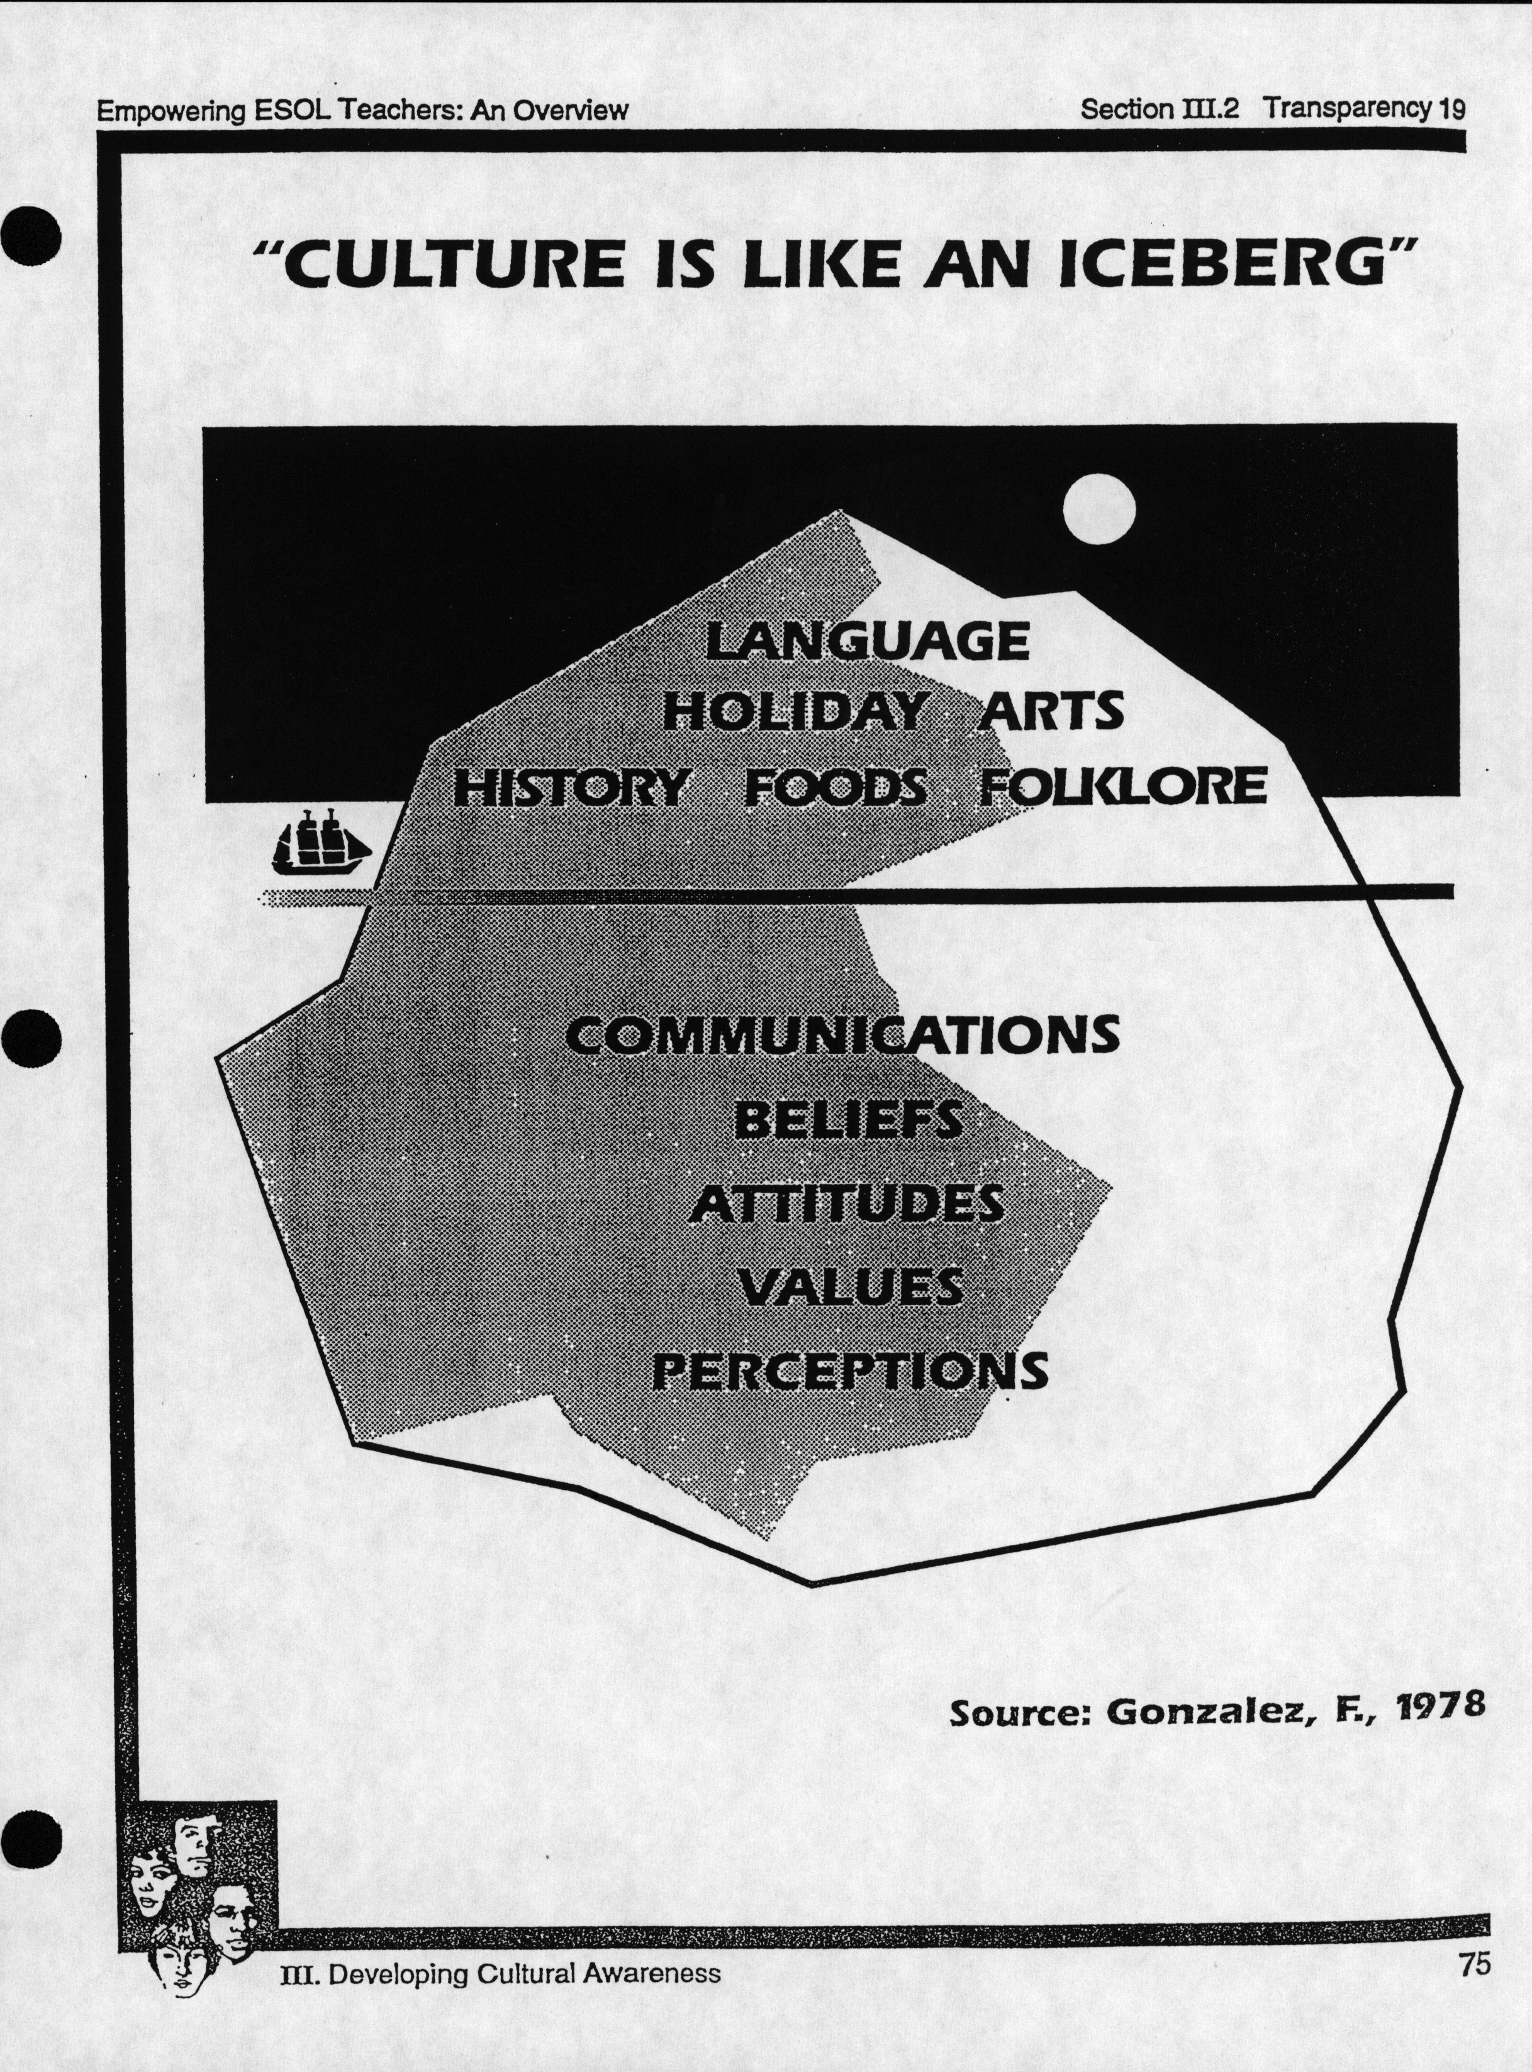
Figure 1
The “Iceberg Model” was used to illustrate that culture manifests itself both in noticeable and subtle ways.

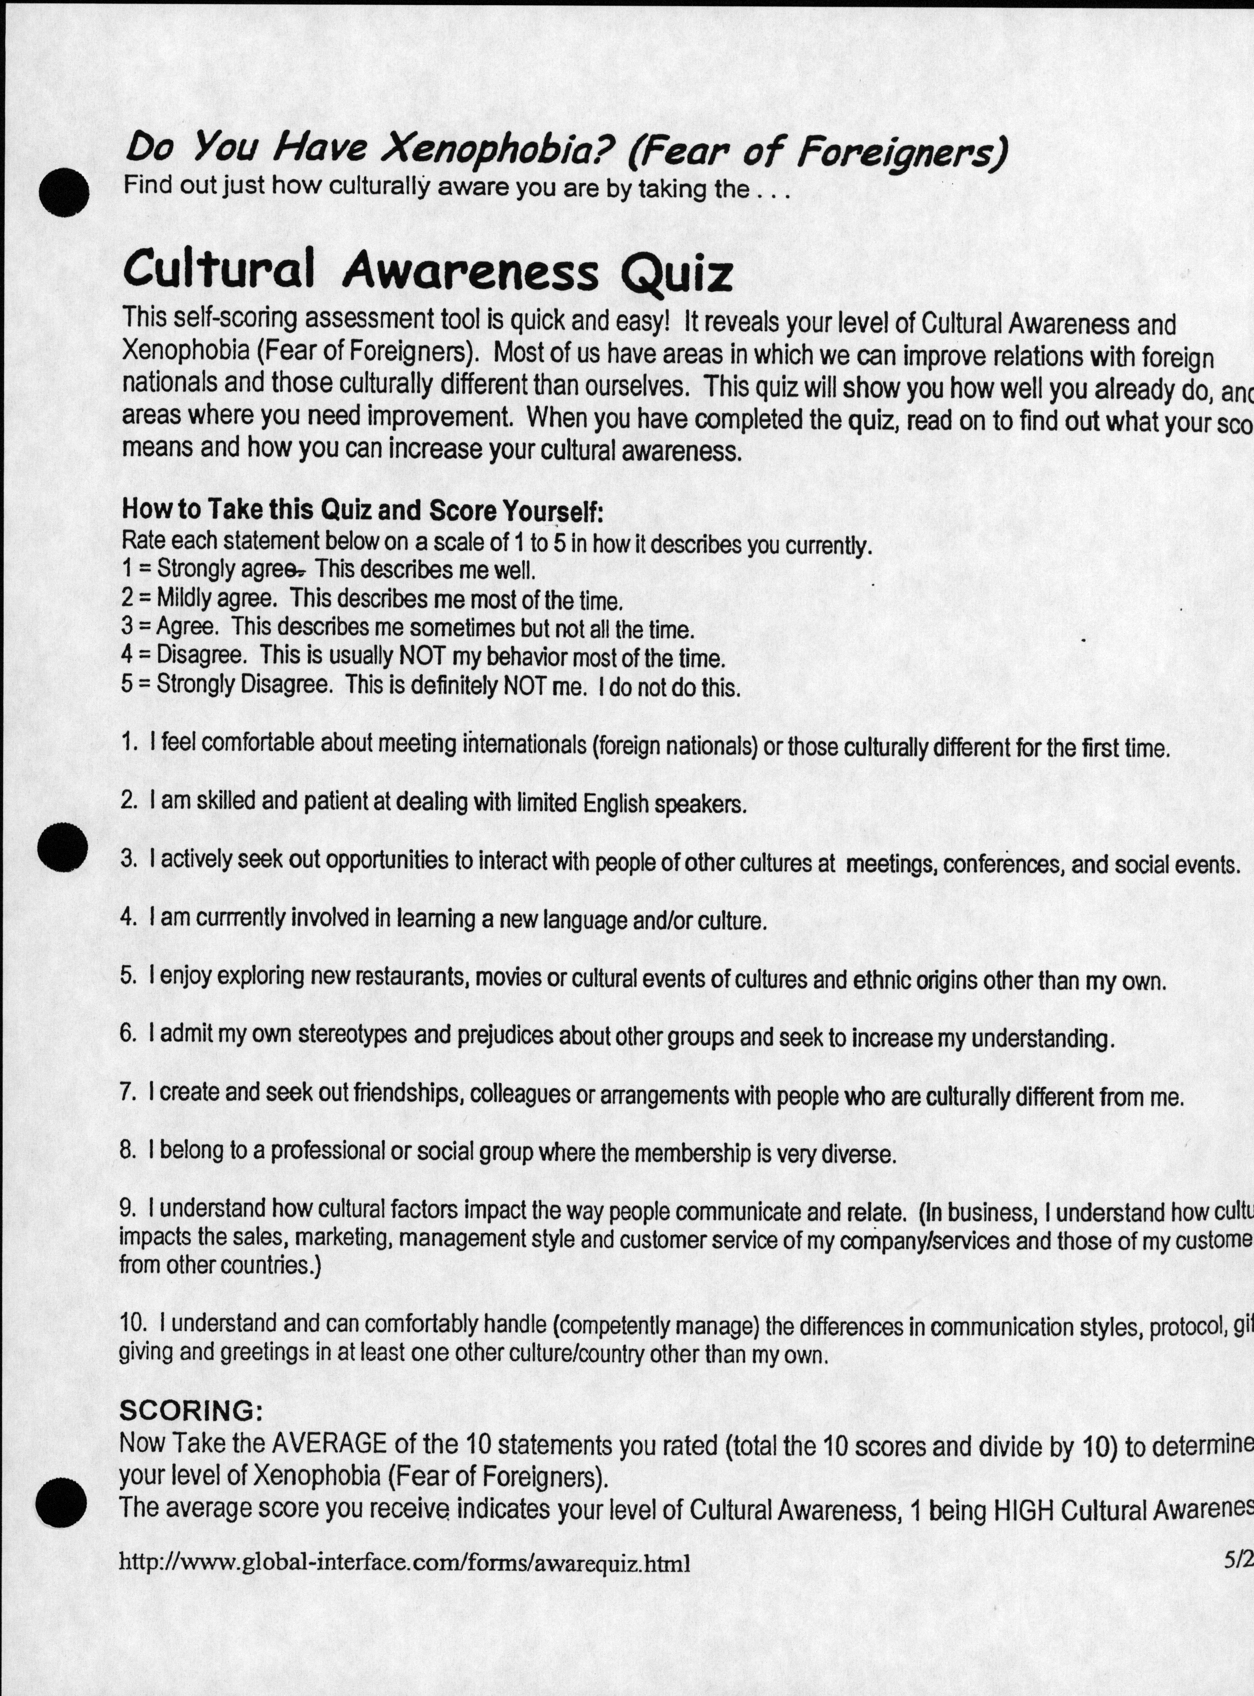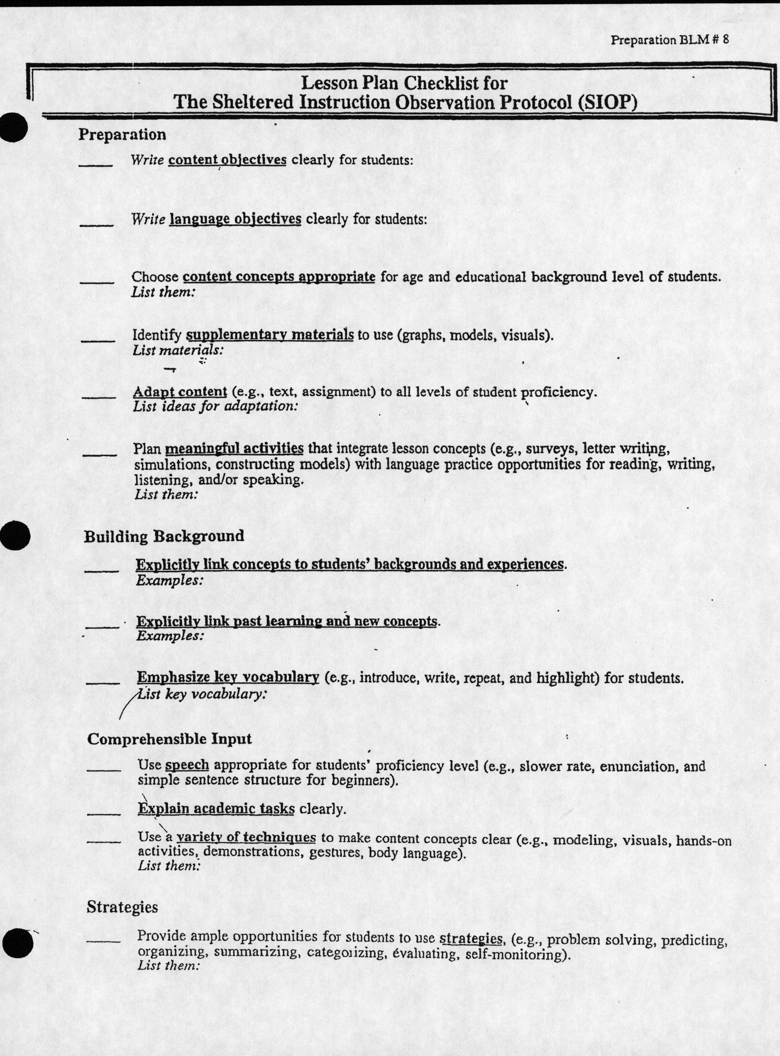
Figure 2
Teachers were able to take a Cultural Awareness Quiz as a quick way of assessing their comfort with classroom diversity.
Figure 3
A checklist for making lesson plans that would aid ELL students was included. One task is to “explicitly link concepts to students’ background and experiences.”

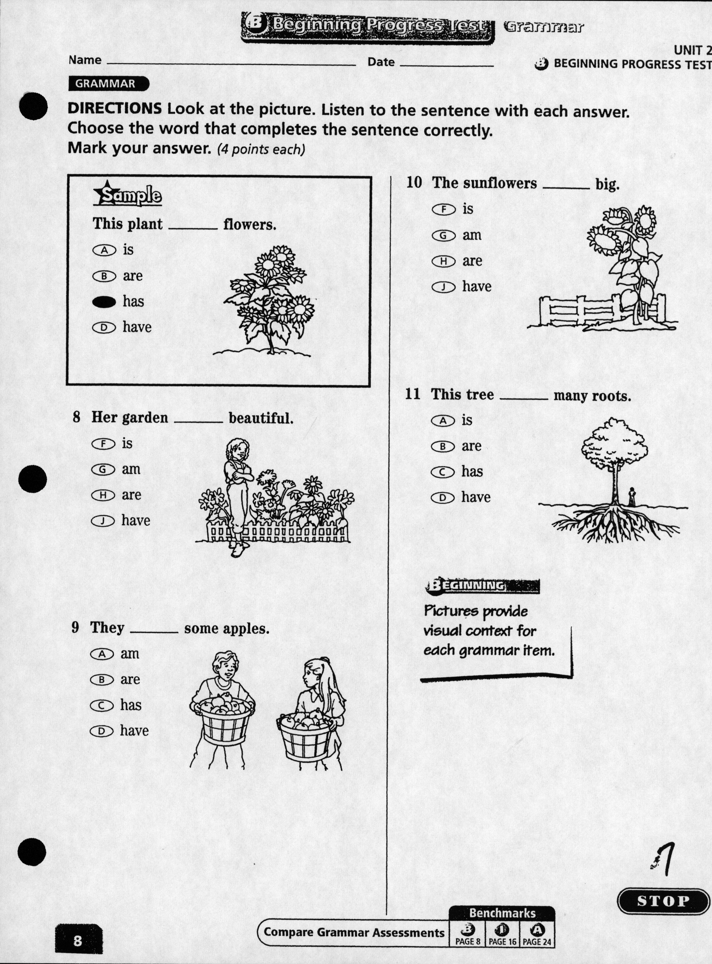
Figure 4
The binder provided worksheets that the teachers could use in their classrooms. This one in particular emphasizes a need for visual materials.

Source: Howell, Susan. “ESL Summer Institute: Knox County Schools, August 2 – August 4 2005”.

Academic Atmosphere and Achievement ___________________________________________
In Samoa School, teachers responded to linguistic diversity by making certain adjustments in the classroom that sought to make an all-English curriculum more relevant and accessible. As we talked about culture, heritage, language, and instruction strageties all of the teachers also individually mentioned a more powerful force that exerted itself at Samoa School: poverty. While the presence of 43 percent ELLs within the student body is a statistic that speaks volumes about the dynamics within Samoa School, 100 percent of the children are on the Free and Reduced Lunch Program. Though teachers faced challenges when the English abilities of their students varied and cultural backgrounds were relatively unknown, all of the teachers cited poverty as a major factor affecting their students.
One teacher used the terminology of a “limited background” to describe the challenges presented to her by teaching children in a low-socioeconomic school. Another agreed, noting that the “isolation” that had occurred in the Samoa School community made it difficult for her students to relate to anything beyond the hardships of living in the surrounding neighborhood. Although the budget is limited, she thought one of the most valuable things that could be done to lessen this lack of exposure was taking trips to locations outside of the Samoa School district. For example, going to a local art museum or taking a trip to the University of Tennessee campus opened children’s eyes to life outside of a community limited by poverty. Once, when taking a field trip to a local grocery store in a more affluent area of town to observe the behind the scenes business, this same teacher said one of the children asked if they were still in Tennessee. Only about twenty to thirty minutes away from Samoa School, students seemed to be unaware of how different life can be outside of poverty.
Carla also talked about the “under-exposure” of the students in her classroom. Growing up in the Samoa School community, it sometimes did not matter if a student spoke English or not. When teaching a lesson about farming, even native English speakers had trouble relating to the concept of a rural lifestyle. Carla was able to bring her own background into the classroom by telling the students about her childhood growing up on a farm. When asked by the children what real farmers were like, she brought in pictures of her own father. Like the incorporation of more visual aids for ELL students, bringing in additional material also proved to be useful for navigating the difficulties created by poverty in the classroom.
When faced with the overall poverty of their students, motivation became a key theme in some of the interviews with the teachers. Both Carla and Susanne made an effort to figure out what each of their students wanted to be when they grew up. When a student was struggling with work or not completing assignments, she would talk to him or her about that goal, with the reminder that “school is the ticket.” Already in elementary school, Susanne would tell children that “if you are going to graduate from high school, you HAVE to read.” Carla had students color pictures of themselves in graduation caps and gowns, also enforcing the idea that they could each graduate from high school. Regardless of their ELL status, she was concerned that academic achievement may not be a focus at home for many of the students.
Returning to the presence of ELL students in Samoa School, teachers were able to differentiate the evolution of parental involvement over the past ten years with the increase in Latino students. Though she thinks the low-income area affects how much parents are able to participate in and contribute to school activities, one teacher has seen a more noticeable presence of Latino parents, especially the mothers. Another teacher recalled a time when one of her students was not doing any of his homework and frequently came to class unprepared. Despite going to an afterschool program that was designed to provide help with homework, her student was still falling behind. She called the father and, despite a language barrier, was able to communicate that his child was not doing the assigned work. Shortly after this, the father arrived at Samoa School and pulled his child out of class. The teacher said she did not “speak Spanish”, however, she was able to understand what the father said in Spanish to his young son about doing well in school. Working in the United States had been hard and difficult work. He was not happy with his job, but he brought his family here so that his son could have something better. If he did not work in school, nothing was going to change. Education was how his son was going to change this, and “your way out is to listen to your teacher.” In this atmosphere of poverty within the community and within the school, these examples suggest that some efforts were being made to instill a mentality of academic success in the students – whether that came from teachers or from parents.

Community Integration _______________________________________________________
As seen both in the classroom and throughout Samoa School, the presence of new immigrants has caused changes in day-to-day instruction and in overall operation. Yet, the growing diversity in the school is just one representation of a shift in the population of the Latino communities (and African and Middle Eastern communities) of Knox County. With this in mind, responses to multiculturalism have not only been limited to the classroom, but also can be seen in the ways that Samoa School participates in the surrounding community.
Carla noted that in the last ten years, Samoa School had become “more about culture.” At the school, there is now recognition of Hispanic Heritage Month, along with Black History Month. Also, one night each year, Samoa School hosts an event for the community that incorporates an important part of Latino heritage as part of a school and community wide gathering. Known as Latino Culture Night, all the Hispanic mothers are invited to come to the school and cook traditional food for the families of Samoa School. All of the supplies and materials are provided, and the mothers are there to prepare the food. Noticing that “Latino mothers are very participatory,” some of the teachers spoke of this event being important for showing parents that the school was interested in working with them. Latino Culture Night draws in members from across the Samoa School community district, as the school stresses it is a way to experience real Hispanic cuisine. This year, there was also the first African Culture Night in response to the large number of African migrant families and their children that now populate the surrounding area.
Though a structural change in the faculty of Samoa School involved hiring certified Knox County interpreters to manage language discrepancies during the school day, all of the teachers also spoke highly of the service the interpreters provided within the community. One of the school interpreters in particular knows the majority of the Latino families who have students at Samoa School. Not only does the interpreter assist with familiarizing parents with school policies and answering questions, but she has also been there to “take children to doctors’ appointments” and “help with filling out important paperwork.” The teachers spoke with a great respect for the services they receive from the interpreters, and it seems that these staff members as an integral part of creating success at Samoa School.
Involvement in the community, however, is not limited by the language barriers that may exist between parents, students, and teachers. Alongside the trajectory of poverty that impacts the school more than multiculturalism alone, the teachers paid notice to their co-workers who have taken the time to become involved in the lives of their students outside of school. One teacher noted that despite being in a low-income area, at Samoa School “somehow everyone’s needs are met.” A colleague had bought Halloween costumes for the students who did not have something to wear, and another teacher talked about the excitement in her classroom when she brought all of the children new toothbrushes. Speaking to the potential of schools to not only educate, but to also be involved in integrating and serving members of the community, Samoa School’s response to recent Latino migrations and multiculturalism has been.

Conclusions ___________________________________________________________________
As an addition to the more methodological questions in the interviews, I always liked to ask the teachers what they found to be inspirational in the classroom – whether this was how they inspired their students or something that kept them coming back to Samoa School every day. In relation to the children of Latino and African immigrants, one teacher spoke of what she perceived must have been very difficult choice for parents to make when deciding to relocate to the United States. Seeing how many parents wanted to be a part of their child’s education despite clear language barriers, this teacher wondered, “Would I have had the courage?” Knowing that many parents chose to migrate with the interests of their children in mind, she said she knew she wanted to be “more supportive of education” for these students and for their parents.
Despite some contestation in national discourse about immigration and education policy, the response I observed at Samoa School to multiculturalism was overall one of positivity and development. This is not to say that teachers had found their jobs to be without challenges or struggles. There are many tests given to teachers by their students each day in the classroom as Samoa School becomes increasingly linguistically and culturally diverse. Realizing that the student body was changing, all of the teachers expressed a vital interest in obtaining further training for the changing demands of their positions. For the conclusion, I would like to highlight some of the suggestions made by teachers, along with my own, for continuing the positive response to multiculturalism in this Knox County School.
Although Carla was able to attend a seminar in Nashville about English as a Second Language Education, there has not been anything similar to her knowledge offered locally. Though not all schools have experienced the same type of demographic change that has occurred at Samoa School, there are a number of schools in the area undoubtedly affected by migrant populations. Two teachers concurred that they would like to observe an ESL-certified teacher in her classroom to learn about different techniques she uses. By making an ESL focused training more readily available in the county, it is possible that teachers would feel more comfortable in addressing the needs of multilingual students. On this same theme, one teacher expressed an interest in learning Spanish. She said she would be willing to take Spanish classes to better improve her communication with the parents of her students. A main factor in both of these types of programming would be that teachers would like to be offered an incentive to participate. In relation to Spanish classes, the teacher mentioned that she would like a class to be offered by the school system, free of cost to her.
The teachers also wished to have some sort of in-service training that would cover more of the “cultural aspects” of their student’s lives. One teacher mentioned correcting a white student when he referred to another Guatemalan student as Mexican. The white student replied that his mom called all of his classmates Mexican, and the teacher said she wished she could have quickly explained some differences in Guatemalan and Mexican culture. In the same line of thinking, another teacher mentioned having presentations at the in-service training about “a day in Guatemala” or a “day in Tanzania.” She felt this would help her relate to her student’s lives in a more meaningful way. Wanting “even to know their superstitions,” this teacher saw this aspect of culture as a way to build relationships. Noting how Latino and African mothers were already involved in the Culture Nights, it could be possible for parents to give these presentations about their heritage, culture, and traditions. This would provide an opening for parents to take part in Samoa School’s operations, and simultaneously allow teachers to be more in tune with the backgrounds of their students.
As an undergraduate in Anthropology, I benefitted from understanding at the ground-level how teachers were responding to multiculturalism. I was able to see the value of anthropological ethnography in aiding my understanding of how national and state wide education policies and migration trends are playing out in the lives of teachers. To link my undergraduate experience with the familiarity I gained at Samoa School, I think it could be useful for the University of Tennessee to form more partnerships with local school. Like Jennie Smith’s article about Latino children in Rome, Georgia, there is a lot to be gained by understanding first-hand how a community institution like a school can be a place of cultural and linguistic intersection. Several initiatives at the University of Tennessee have been made to engage students more in the surrounding communities. Already within the Modern Foreign Language and Literature Department, Dr. Michael Handelsman teaches a service-learning course in which Spanish students go to hospitals, schools, and other similar locations to provide aid through their language skills. Dr. Robert Kronick has also formed a University Assisted Community School project. Students from the university volunteer with this local school after school to facilitate activities that promote learning and cognitive growth. Dr. Gina Barclay-McLaughlin, an Associate Professor at the University of Tennessee, has designed a program to better prepare teachers for urban and multicultural classrooms. In tune with the activist side of anthropology, I feel there could be a potential for undergraduate students to tutor English Language Learners, to provide resources to teachers about the possible heritages represented in their classroom, and to become involved with afterschool programs that provide parents with childcare. This was never an expressed point of conducting the interviews, nor was it a topic covered in the interviews. Yet, with the pervading sense of community at Samoa School, I feel compelled to suggest the building further relationships. Interviewing educators allowed for a critical gaze into how the school had been impacting by linguistic and cultural diversity. Despite challenges, the teachers at Samoa School maintained a clear interest in the well-being of their students that extended beyond academic success.

Appendix I ____________________________________________________________________
Opening Questions:
- What grade do you teach?
- Do you have experience teaching any other grades?
- How long have you been teaching?
- What initially drew you to work in education?
- Can you give me a tour of what your day is like in the classroom?
What did you cover in class today?
How did that go?
Demographic Related:
- What types of overall changes have you seen in education since you began teaching?
How do these changes apply to [Samoa School]?
- Have you seen a change in the student demographics of [Samoa School]?
How does this compare to when you began teaching/2 years ago/5 years
ago/etc.?
- Do you have students whose English ability varies?
- How do you handle this variation in class?
- How are you challenged by students who are not raised speaking English?
- When assessing student progress, do you take into account a student’s comprehension of English?

Method Related:
- Do you change the way you teach material to non-native English speakers?
- With the change in demographics – have you evolved your teaching methods?
If so, how?
How does this compare to previous teaching methods?
Do you have any examples?
- What methods do you use to enhance learning among your students?
- Have you ever received any special training to deal with this demographic change in the classroom?
- If there was a training, what sort of information would you like to be covered?
- Do you feel other teachers are more/less prepared than you are to confront multiculturalism in class?
References ___________________________________________________________________
Chavez, Leo R.
2008 The Latino Threat: Constructing Immigrants, Citizens, and the Nation. Stanford, CA:
Stanford University Press.
Deutcher, Guy.
2010 Through the Language Glass: Why the World Looks Different in Other Languages
New York, NY: Metropolitan Books.
Drever, Anita.
2009 "Tennessee: A New Destination for Latino and Latina Immigrants." Global
Connections and Local Receptors. 'Ed'. Fran Ansley and Jon Shefner. Knoxville, TN:
The University of Tennessee Press.
Grey, Mark A.
2003 "State and Local Immigration Policy in Iowa." Immigration's New Frontiers:
Experiences from the Emerging Gateway States. 'Ed'. Greg Anrig Jr. and Tova Andrea
Wang. New York, NY: The Century Foundation Press.

Lau v. Nichols.,

1974 414 US 563 - Supreme Court
News Sentinal Editorial Board.
2011 “Census reaffirms our quality of life." Knoxville News Sentinel n. pag. Web. 21 March
2011
Portes, Alejando.
2009 "The New Latin Naton: Immigration and the Hispanic Population of the United
States." Global Connections and Local Receptors. 'Ed'. Fran Ansley and Jon Shefner .
Knoxville, TN: The University of Tennessee Press.
San Miguel Jr., Guadalupe and Donato, Ruben,
2010 "Latino Education in Twentieth Century America: A Brief History." Latinos and
Education. 'Ed'. Enrique Murillo, Sofia A. Villenas, Ruth Trinidad Galvan, Juan
Sanchez Munoz, Corinne Martinez, Margarita Machado Casas. New York, NY:
Routledge,

Schulman, Bruce F.
2001 The Seventies. New York, NY: The Free Press.
Smith, Jennie M.
2005 "The Latinization of Rome, Georgia." The American South in a Global World. 'Ed'.
James L. Peacock, Harry L. Watson, Carrie R. Matthews. Chapel Hill, NC: The
University of North Carolina Press.
Stephens, Gregory.
2005 "Monolingualism and Racialism as Curable Diseases: Nuetra America in the
Transitional South." The American South in a Global World. 'Ed'. James L. Peacock,
Harry L. Watson, Carrie R. Matthews. Chapel Hill, NC: The University of North
Carolina Press.
Stephenson, Karmen.
2010 Educators' perspectives and approaches to teaching in culturally and linguistically
diverse classrooms. Thesis (M.A.)--University of Tennessee, Knoxville.
Tn.Gov.
2011 "TCAP Test Results." Tennessee Department of Education n. pag. Web.
<http://www.tennessee.gov/education/assessment/test_results.shtml>.
Valverde, Leonard A.
2006 Improving Schools for Latinos: Creating Better Learning Environments. Lanham, MD:
Rowman and Littlefield Education.

Samoa School in Knox County uses the same terminology as the US Census to identify students as Hispanic. https://ask.census.gov/app/answers/detail/a_id/216/kw/hispanic

