CRISPR-Cas in the Field of Dentistry: A Comprehensive Collection of the Potential Uses of CRISPR-Cas9 in Dental Health Care
Lexi Bales
Chancellor’s Honors Program Senior Project
University of Tennessee, Knoxville
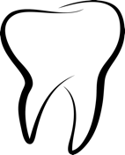

- Introduction
In the summer of 2022, I traveled to Guatemala for a hands-on dental service trip. Each day was a new challenge, as patients came in with various problems. Tooth decay, gingivitis, periodontitis, and dental fluorosis were among the recurring issues. Over 50% of the Guatemalan population lives below the national poverty line, and thus oral care is not a priority for most families there (Zapata, 2019). While there, we set up dental clinics in rural areas around the cities of Solola, Panajachel, and Antigua. One of the biggest issues seen was preventative care. Some patients did not realize they were supposed to brush their teeth every day, or their grandmother had told them fluoride, which is used to prevent cavities and make the teeth stronger through remineralization, is unnatural. Overall, the dentists and other dental health care providers I met in Guatemala are making outstanding efforts to increase access to dental care across Guatemala, but it is still a steep hill to climb.
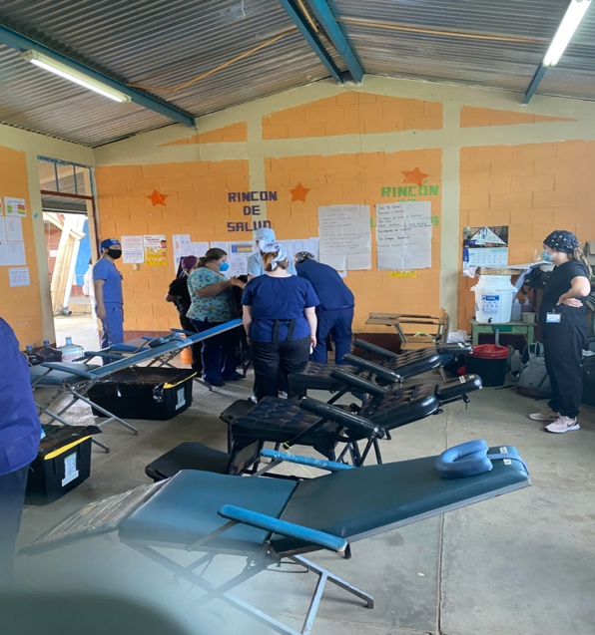
Picture 1: A dental clinic set up in one of the communities near Sololá, Guatemala. Access to dental care in this community was particularly low, but patients were eager for any help they could get. Many patients were in pain, had bleeding gums, or needed a tooth extraction due to severe tooth decay.
Access to dental care is also an issue, though not as drastic, in the United States, especially in the state of Tennessee. Tennessee consistently ranks among the worst in access to dental care (“Explore Dental Visit,” 2021). Dental care is important not just for communication skills, comfortability, or esthetic purposes; it affects your whole body. The mouth is an access point for bacteria into the digestive and respiratory tracts. With good dental hygiene bacterial growth can be managed and harmful infection can be avoided. With poor dental hygiene, the oral bacteria can induce inflammatory responses that not only lead to diseases like periodontal disease, but it has also been shown to increase heart disease risk by 70%, for example. Moreover, people with high levels of a specific oral bacterium are 59% more likely to get pancreatic cancer. It can induce glaucoma by prompting the spread of inflammation to the optic nerve. Interestingly, women who have gum disease are seven times more likely to have a pre-mature baby with low birthweight due to inflammation (“How Oral Health”, 2020).
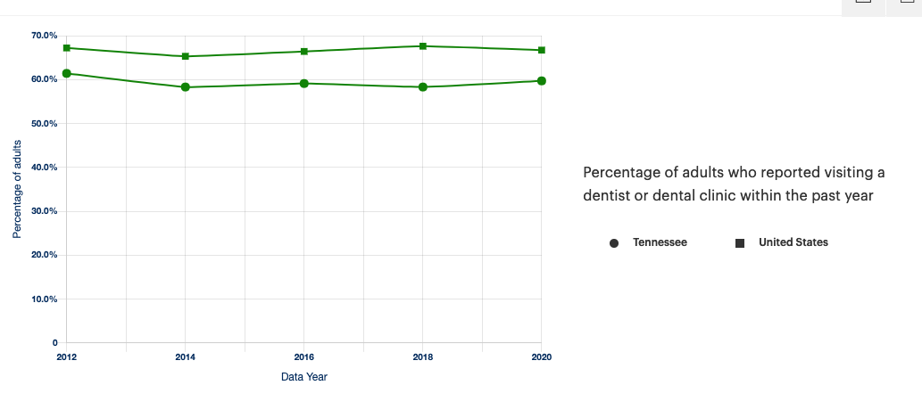
Figure 1: Above the percentage of adults who reported that they visited a dentist or dental clinic for each year from 2012 to 2020 is shown for Tennessee (circles) and the United States (squares). Consistently, Tennessee is under the national percentage every single year. This possibly indicates that Tennessee is lacking in access to dental care, or Tennessee residents do not seek out dental care as much as other residents of other states.
Source: Explore Dental Visit in Tennessee | 2021 Annual Report. (2021). America’s Health Rankings. https://www.americashealthrankings.org/explore/annual/measure/dental/state/TN.

While in Guatemala, I learned about the importance of an educated populous when it comes to dental care, the importance of preventative care along with that, and lastly, different conditions such as dental fluorosis and periodontal disease. I witnessed these cases firsthand and cleaned many patients' teeth while there. I also learned which groups (by age, ethnicity) were more susceptible to having certain diseases or conditions. The volunteer dentist extracted many teeth that were not salvageable due to the severe decay. They performed many scalings, which involves removing built up calculus under the gum line that cannot be removed by simple brushing. If the calculus is not removed early enough, the patient might suffer from periodontal disease. Periodontal disease is a major issue, because tooth loss can impair communication skills, increase discomfort, affect nutrition, and affect esthetics. This review focuses predominantly on periodontal disease and tooth decay (dental caries) as these were two of the most prevalent conditions I witnessed in Guatemala.
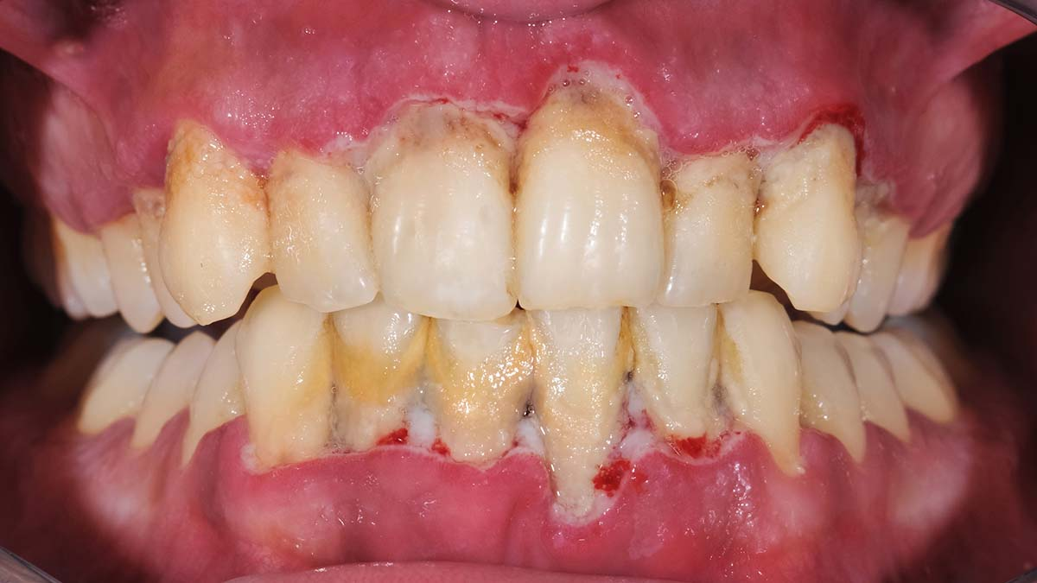
Figure 2: Shown above is a patient with periodontal disease. In this photo, the inflammation/bleeding and recession of the gums is clearly visible. Periodontal disease is preventable with good dental hygiene.
Figure 3: Above shows the progression of decay in a tooth. Decay begins when the enamel is broken down by acids in bacteria. Decay can then reach the dentin, and possibly the pulp if not treated. When the pulp is infected, the tooth dies.
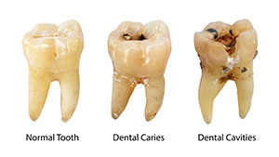

- CRISPR Mechanism and Overview

In 1987, Japanese scientists recognized uncommon sequences in a region of the iap gene (Ishino et al., 1987). In 2000, it was discovered that these sequences were found in other bacteria, but the purpose of these sequences was still unknown (Mojica et al., 2000). Once there was a connection between immunity from viral infections, research on these sequences, and subsequently the mechanisms of CRISPR-Cas9, exponentially increased. CRISPR stands for Clustered Regularly Interspaced Short Palindromic Repeats. CRISPR sequences work in bacteria to form an adaptive immune response against bacteriophage and other invasive DNAs by integrating sequences derived from the invading DNA so that the bacterium may recognize the sequence in the future and destroy it (Pak, 2014). Overall, through the mechanisms of CRISPR-Cas9, bacteria display adaptive immunity from invading DNA by creating specific cuts in DNA – a system that could be used in future gene editing techniques in other organisms.
There are three phases of adaptive immunity: adaptation, expression, and interference. Adaptation consists of inserting parts of the invasive DNA as spacer sequences and involves CRISPR-associated proteins Cas1, Cas2, and Csn1. The protein complex Cas1 and Cas2 first recognizes the viral DNA and cuts out a portion of the DNA which is then embedded into the CRISPR array. The CRISPR repeat-spacer array serves as a way for bacteria to have a memory of the invading viral DNA. It consists of alternating spacer and palindromic regions. These spacer sequences are unique and non-repetitive 32 nucleotide base pair sequences. Each spacer sequence is between palindromic repeats which are 21 to 40 nucleotide base pair sequences that are equal to their reverse complement and not unique (Dounda and Charpentier, 2014). The second phase, expression, describes when the CRISPR array is used as a template and transcribed into a large non-coding pre-crRNA that will aid in recognition of the invading DNA. The non-coding RNA means that the CRISPR array is transcribed, but no protein will be formed; in coding RNA, a protein is formed. The arrays are transcribed to form the longer pre-crRNA, which is the precursor to the short crRNAs that are processed from the pre-crRNA. crRNA contains sequences from both the spacer and palindromic repeats, because the spacer sequences are vital to have memory of the invading DNA, and the palindromic regions are crucial for tracrRNA binding. Lastly, interference is when Cas9 cleaves to the foreign DNA and can destroy it after crRNA activates Cas9, and palindromic repeats allow tracrRNA to bind the complex. tracrRNA, trans-activating crRNA, is needed to bind to the crRNA to activate Cas9. It is a required part of the CRISPR process because it activates crRNA maturation and complexes with the crRNA to guide the CRISPR-Cas9 protein endonuclease (Dounda, 2017).
Guiding the protein complex is the guideRNA, the complex formed between the tracrRNA and crRNA. When Cas9 binds to the guideRNA, it prevents cleavage of other, nontargeted DNA. Though both crRNA and tracrRNA are a crucial part to the CRISPR-Cas9 activation and system, it was shown by Emmanuelle Charpentier and Jennifer Doudna that the two RNAs could be covalently combined to form one single guide RNA, sgRNA (2014). By engineering this, the process was simplified, because only two items were needed to successfully edit DNA, Cas9 and sgRNA. Another key component in guiding the CRISPR-Cas9 system is the PAM sequences. The PAM, which stands for protospacer adjacent motif, is a nucleotide sequence consisting of 2-6 base pairs following the protospacer sequence that is important for proper recognition of viral DNA (“What is PAM?”). For Cas9 to bind to a region of DNA so that it may cleave the DNA, the specific PAM sequence must be recognized. The PAM sequence also acts as a protective mechanism for bacteria because it keeps Cas9 from binding to the CRISPR array spacer sequences. The CRISPR spacers are not followed by the specific PAM sequence, and the repeat sequences are always the same in the CRISPR array. Without the PAM sequence, Cas9 would not be able to find the viral DNA quickly or even at all, and Cas9 may cut its own DNA.
A vital player in the CRISPR-Cas9 system is the Cas9 endonuclease that cleaves phosphodiester bonds of the backbone of DNA. The Cas9 protein has 6 functional domains: Rec I, REC II, HNH, RuvC, bridge helix, and PAM interacting domains. Rec I is responsible for the recognition and binding of the crRNA and tracrRNA complex. Once bound, the HNH is responsible for cutting the strand of DNA that is complimentary to the RNA guide, while RuvC cuts the other DNA strand, creating a double stranded break in the DNA (Dounda, 2017). HNH and RuvC both have endonuclease activities but differ in which strand they are responsible for cutting, which is why it is necessary to have both domains. The bridge helix initiates a conformational change when the guideRNA binds and thus, controls the movement of the other domains (Dounda, 2017). Rec I and HNH are now placed into position by the confirmation change induced by the bridge helix so that they may cleave the foreign DNA. This bridge helix has many arginine residues and is thus effective in binding DNA, because arginine is a positively charged amino acid that has an ionic interaction with the negatively charged sugar-phosphate backbone of DNA. Lastly, the PAM interacting domain is used to identify the PAM sequence.
The confirmational changes that occur in the Cas9 system are crucial to its ability to function. First, it likely plays a role in the unwinding of the DNA. Cas9 will only unwind DNA and form the crRNA and foreign DNA duplex called the R loop if a strand of DNA complementary to a 20-nucleotide region of the crRNA is recognized. The DNA unwinding is done without any energy, so the mechanism for this process is currently unknown, but likely is intertwined with the confirmational changes that takes place in Cas9 (Dounda, 2017). The confirmational changes that occur allow for major movement of the HNH, RuvC, and Rec II and represents Cas9 in its active state. The Rec II complex moves first when Cas9 binds to guideRNA which causes a channel to open up in the center of the complex for the guide RNA (Dounda, 2017). When HNH then binds to the DNA molecule, the Cas9 undergoes even more changes in response to the forming of the RNA and DNA duplex. As mentioned above, the confirmational changes place the domains in the correct positions for proper endonuclease cleavage.
When engineered, Cas9 can also undergo certain mutations that allow it to function as a nickase. By substitution of an alanine for aspartic acid at position 10, Cas9 D10A nickase is formed, and by a substitution of alanine for histidine at position 840, Cas9 H840A nickase is formed. Cas9 D10A and Cas9 H840A have a mutation in either the RuvC or HNH domain which then inactivates that specific domain (Dounda and Charpentier, 2014). With one domain being inactivated only a single-stranded cut can be made. However, when used with two sgRNAs, a staggered double-stranded break can be formed from two different sites (Dounda and Charpentier, 2014). In terms of genetic editing, using Cas9 nickases with two guide RNAs decreases the chance of off-target effects. If these mutations occurred naturally in bacteria, only single stranded DNA breaks would occur; the bacteria would need another tracrRNA and crRNA complex along with another mutated Cas9 to create the needed double-stranded break in the foreign DNA. Therefore, a naturally occurring mutation may inhibit the proper functioning of bacterial adaptive immunity through CRISPR-Cas9.
In short, the CRISPR-Cas9 system plays a crucial role in adaptive bacterial immunity from invading viral DNA. CRISPR-Cas9 works to create a memory of the viral DNA by inserting it into a CRISPR array sequence consisting of alternating spacer and palindromic regions. With the Cas9 complex activated and aided by the guide RNA, the Cas9 system can recognize specific viral DNA and destroy it. The discovery of CRISPR-Cas9 and study of its mechanisms has had and will have significant implications in gene editing techniques.
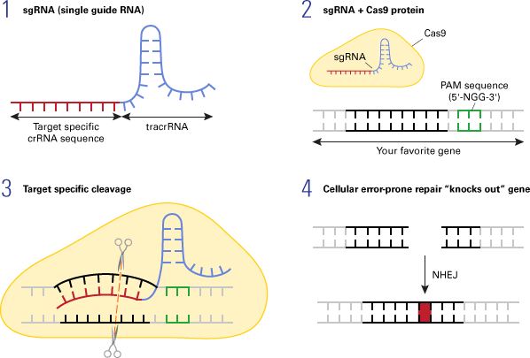

Figure 2: Shown above is a general overview of the CRISPR-Cas9 mechanism. In step 1, an sgRNA has been designed to guide the Cas protein to the target site in the gene. In step 2, the PAM sequence is recognized. In step 3, the specific target site is cleaved by the Cas9 protein. In step 4, the break in the DNA is repaired by non-homologous end joining (NHEJ), a repair system found in eukaryotes to repair double stranded DNA breaks.
Source: Introduction to the CRISPR/Cas9 system. (2018). Takarabio.com. https://www.takarabio.com/learning-centers/gene-function/gene-editing/gene-editing-tools-and-information/introduction-to-the-crispr/cas9-system.

- CRISPR and Dentistry

CRISPR technology opens a whole new realm of therapeutic and treatment strategies. Several oral and craniofacial diseases and conditions have been shown to be associated with certain genes in the human genome; these diseases included: periodontal disease, caries disease, tooth agenesis, orofacial clefts, head and neck cancer, orofacial pain, temporomandibular disorders, and facial shape (Chavez-Granados et al., 2022). Because CRISPR allows the potential to edit the genome with great specificity, it offers potential new treatment strategies for dental conditions and also the chance to better understand genes associated with these conditions.
A benefit to potentially using CRISPR-Cas9 is the chance for a more personalized treatment strategy. Treatments involving CRISPR would take into account the patient’s genetic makeup, environmental factors, and other characteristics that may predispose or put a patient at a higher risk for a certain condition (Barbour et al., 2021). CRISPR also has the potential to eliminate symptoms or eventually, perhaps, be used to cure a condition. For example, CRISPR-Cas9 was used to inhibit the switching of fetal hemoglobin to beta hemoglobin production in adults to treat sickle cell disease by targeting BCL11A, a silencer of fetal hemoglobin. Individuals who possess a mutation, allowing them to produce fetal hemoglobin in adulthood and prevent the sickling of cells, have shown to experience no symptoms related to sickle cell. Thus, CRISPR was used so that individuals were made to produce fetal hemoglobin, eliminating the symptoms of sickle cell (Chapin, 2019).
One benefit to genome editing when compared to other strategies, especially when potentially treating cancers, is the chance to avoid treatment strategies that are especially harmful and detrimental to the patient’s health. By silencing a gene or introducing new genetic information, there is a potential solution to the problem, whereas many strategies are non-specific to cancerous cells. Chemotherapy uses drugs to damage cancer cells; however, it also damages other fast-growing cells like cells of the mouth lining, intestines, and hair growth cells (National Cancer Institute, 2015). Radiation therapy uses high doses of radiation to stop or slow the growth. However, this treatment has significant drawbacks; a person is only able to receive a certain dosage of radiation in his or her lifetime, and similarly to chemotherapy, it can cause damage to healthy cells (National Cancer Institute, 2015). These are two common treatment strategies that lead to significant negative side effects like nausea and extreme fatigue.

- Periodontal Disease and CRISPR

Periodontal disease or periodontitis is the result of bacteria that infect the gums, eventually leading to damage of bone and the soft connective tissue, the periodontal ligament. Plaque is always being constantly formed from bacteria on the teeth, but if it is left too long on the teeth, it hardens to tartar, or calculus (CDC, 2019). Calculus can grow and spread under the gum line, in which the patient needs a dental professional to perform a scaling to remove the disease-causing build up. However, if not treated, it can eventually lead to damage of the alveolar bone that holds the teeth, along with the periodontal ligament and the hard calcified outer layer of tissue that covers the root that anchors the tooth in place. This leads to loosening of the teeth or eventually, tooth loss (Mayo Clinic, 2020). Periodontal disease is usually attributed to poor oral hygiene and can lead to swollen, puffy and/or bleeding gums, painful chewing, loose or sensitive teeth, or a shift in gum or tooth placement. It can create communication, nutrition, comfort, and esthetic issues for the patient. With the right dental care, it is preventable; however, depending on a person’s genetics, he or she may be more at a risk of periodontal disease.
One way the body fights or prevents periodontal disease is through the recruitment of cells from the innate immune system (Barbour et al., 2021). One important type of cells are the predominately polymorphonuclear neutrophils (PMNs) that offer protection from the film bacteria produce on the teeth. However, these cells can become dysfunctional under dysbiotic biofilms or other conditions such as smoking. As discussed before, scaling is usually the method used to remove calculus under the gum line. However, even with the help of the immune cells and dental health care professionals, periodontal disease is still very prevalent and can be hard to prevent in some cases, especially when people may be predisposed due to their genome.
CRISPR-Cas9 can aid with the understanding of the pathogenesis of periodontitis by identifying relevant cellular pathways. CRISPR-Cas9 can be used to knock out genes to test their function. Knockout takes advantage of genetic engineering tools to inactivate or remove one or more genes with specificity to study the gene’s function or how the body functions without that gene (Knockout, 2022). Through using the knockout strategy, certain proteins have been identified in inhibiting periodontal inflammation. In one study conducted by Zhang et al., the PTPN2 gene encoding for a protein downstream of the 25VD3/vitamin D receptor pathway in gingival epithelium was knocked out to determine its effects. Without PTPN2, phosphorylation of periodontal inflammation-related transcription factors JAK1 and STAT3 was increased. Thus, periodontal inflammation was consequently increased (Zhang et al., 2018). PTPN2 expression decreased expression of JAK1 and STAT3 in the gingival epithelium by dephosphorylating protein substrates in the JAK1 and STAT3 pathway. Understanding how PTPN2 works to stop over-inflammatory responses to periodontal irritations can help to prevent increased periodontal inflammation. Another study investigating inflammatory response, utilized CRISPR by creating two cell lines of THP-1 lineage through lentiviral vectors (Xie et al., 2019). This allowed them to analyze the knockout of insulin-like growth factor 2 mRNA-binding protein 1 (IGF2BP1). IGF2BP1 inhibits LPS-induced production of multiple pro-inflammatory cytokines like TNF alpha, interleukin 1 beta, and interleukin 6. When IGF2BP1 was over expressed, this promoted LPS-induced pro-inflammatory cytokines. Since LPS induces the p65-p53 nuclear translocation and activates NF_{K}B, silencing or upregulation of IGF2BP1 plays a role in inflammatory responses. Silencing IGF2BP1 reduces inflammatory responses mediated alveolar bone loss by inhibiting LPS induced functions, while overexpression of IGF2BP1 increases inflammatory response. These are just two studies performed utilizing the genetic engineering tool CRISPR-Cas9; there are many more that have already been performed and many more to come. By understanding processes underlying inflammatory responses, for example, periodontitis could become increasingly preventable or treatable. Dental health care professionals can better understand how to treat their patients and what puts certain patients at more risk.
CRISPR-Cas9 can also be used to create potential therapeutic tools to treat patients with diseases or genetic predispositions to diseases. One gene that could possibly be edited is the interleukin-8 gene that encodes for a haplotype of interleukin 8. One research study generated human kidney cells with specific interleukin haplotypes using CRISPR-Cas9. One interleukin haplotype significantly increased a person’s risk for elevated levels of inflammation within lesions (Mlachkova et al., 2020). Altering the genome can come with significant consequences, which is a reason why there is hesitancy to use them in clinical settings. Recently, scientists have been developing alternative genome editing CRISPR systems for more sequence specific control of gene expression, which include CRISPRa, CRISPRi, and Cas13 (Barbour et al., 2021). These tools can modify transcriptomes and gene expression without altering the DNA sequence. CRISPRa, a transcription activator, utilizes dCas9 with different transcriptional activation domains, to increase transcription of the target region (ENg). This upregulates gene expression and could possibly be helpful in creating a therapeutic strategy that does not completely knock out a gene. CRISPRi works to repress various target genes at the same time, with these effects being reversible (Qi et al., 2013). Cas13 can target reporter or endogenous transcripts in regard to RNA interference with great specificity (RNA target). By using these techniques in the dental field, genetic engineering may be used without inducing chronic immunosuppression (Barbour et al., 2021). Furthermore, these systems can enable epigenetic changes to mesenchymal stem cells or dental pulp stem cells or induced pluripotent stem cells that retain self-renewal abilities and the ability to differentiate into different cell lineages. With new and more precise CRISPR system techniques being developed, there is hope that these techniques could be used to beneficially genetically alter patients in the future. Hopefully, by doing this, a patient’s susceptibility or risk for periodontal disease could be decreased or eliminated.
- Dental Caries and CRISPR
Dental caries, or tooth decay, happen when bacteria erode the tooth’s surface (enamel) through production of acids (National Institute of Dental and Craniofacial Research, 2019). When this happens, a small hole can develop in the tooth called a cavity and without dental treatment, the bacteria can move past the enamel into the dentin and eventually into the pulp of the tooth which houses blood vessels and nerves needed for the survival of the tooth. Once the pulp is infected, the tooth can no longer be recovered, as the bacteria have caused irreversible damage (WebMD, 2021). This can result in pain, discomfort, and loss of teeth. Loss of teeth, as already discussed, can have profound effects on a person’s communication skills, nutrition, comfortability, and desired esthetics. In humans, the primary bacterial agent of dental caries is Streptococcus mutans, and along with producing harmful acids, it also synthesizes extracellular polysaccharides that provide adhesion sites the bacteria can thrive in (Gong et al., 2018). Bacteria gather in these sites and biofilm is subsequently produced.
Streptococcus mutans has two major virulence factors, glucotransferases (Gtfs) and polysaccharides (EPS) (Gong et al., 2018). CRISPR has been used in a recent study to target Gtfs in hopes of preventing biofilm formation. In the study, a series of plasmids were constructed to analyze S. mutans own CRISPR-Cas9 system. Following the selection of an appropriate spacer in regard to PAM sites and other key components, these plasmids were transformed into the bacteria. Bacteria which had been successfully induced with all six designed spacers were identified. Next, they selected a PAM site and identified one PAM site (NGG) that could be identified using the CRISPR-Cas9 system. Lastly, spacer 1 designed by the researchers and the PAM sequence TTG could be identified by the CRISPR-Cas9 system. Thus, spacer 1 and TTG were cloned into a plasmid and transformed into S. mutans. Their results showed that Cas9, tracrRNA and RNase III were vital for the functioning of the type II-A CRISPR-Cas9 system in S. mutans. By knowing this, self-targeting CRISPR arrays that contained spacer sequences identifying with a GTF were cloned onto the plasmids and editing templates into a specific strain of S. mutans. The edit of gtfB or gtfBgtfC genes was successful, and editing these genes decreased EPS synthesis and increased ability to breakdown biofilm formation. Thus, this study presents findings that could potentially be used in the future to protect against dental carries. By understanding the leading bacterial agent of dental caries, researchers and dental health care professionals can better understand the processes underlying tooth decay and recognize alternative prevention strategies.
Besides utilizing CRISPR to understand S. mutans, CRISPR could potentially also be used to edit the genome within patients to affect the patient’s susceptibility to dental caries through gene knockout or upregulation. Genetics accounts for up to 65% of inter-individual variation in dental caries experience (Shaffer et al., 2015). In a study conducted by Shaffer et al., it was found that females are slightly more susceptible to dental caries when compared to males, and though it is not clear why, it can be partly attributed to the genetic differences among males and females. Another study also explored the effects of genetics on susceptibility to tooth decay. The University of Pittsburgh School of Medicine analyzed 300+ saliva samples and discovered that people with a mutation in the beta-defensin 1 (DEFB1) gene, the G-20A variant, had a greater risk for developing dental caries (Ozturk et al., 2010). Researchers knew that DEFB1 localizes in the oral cavity, and thus wanted to test if variation in the gene would be associated with caries. By analyzing three polymorphisms of the gene from unrelated individuals, they witnessed that having the G-20A variant increased the decay-missing-filled teeth index (DMFT) index by five-fold. Furthermore, they found that carrying the variant allele for the DEFB1 marker rs179946 (G-52A) is associated with lower DMFT scores. In another study conducted by Zakhary et al., the researchers looked at racial differences in tooth decay. They specifically studied the polymorphic acid proline-rich proteins (PRPs) in saliva that affect the attachment of bacteria. Variants in alleles coding for PRH1 are associated with higher caries risk, and the study found that Caucasians had greater S. mutans colonization (Zakhary et al., 2007).
An important factor in tooth decay prevention is the state of the enamel. There are certain genes that are needed for enamel formation, including amelogenin (AMELX), enamelin (ENAM), matrix metalloproteinase 20 (MMP20), and kallikrein 4 (KLK4). Variants in the genetic code of these genes have been correlated with enamel malformations such as amelogenesis or increased or decrease tooth decay (Wright, 2019). Mutations in the gene coding for laminin type V (LAMA3) is associated with defects in enamel during development from abnormal cell to cell attachment of ameloblasts, which are developmental cells that play a key role in enamel formation (Lacruz et al., 2017). Genetic factors play a significant role in a person’s susceptibility to tooth decay, and it is crucial to understand these genetic factors and their regulation. CRISPR-Cas9 can be used to understand these genes through knockout strategies for example, or CRISPR-Cas9 could be used to edit the genome of the patients as therapeutic strategies. Effects of mutations could possibly be mitigated through genome editing by silencing, or mutations could be corrected via homology directed repair once this technique is improved and more efficient.
- Other Uses: Oral Cancer, Craniofacial Abnormalities, and Tooth Regeneration
Oral cancer refers to any cancer that begins and develops in the oral cavity, including the lips, gums, tongue, inner lining of the cheeks, and roof and floor of the mouth (Mayo Clinic, 2019). It can lead to the loss of teeth, mouth and ear pain, and difficulty swallowing. The most common mouth cancer is squamous cell carcinoma (OSCC) (Mouth Cancer, 2017). One study using CRISPR-Cas9 set out to understand which genes drive OSCC (Chai et al.,2020). The researchers used CRISPR to knockout genes in order to determine what the cancer cells needed to survive. They identified 918 genes linked to the survival of the cancer cells, and some were unique to OSCC. It was found that the cell lines could not survive when genes involved in the Hippo signaling pathway were silenced. When it comes to cancer in general, CRISPR technology could significantly affect treatment strategies. The first CRISPR-made cancer treatment trial began in 2019 at the University of Pennsylvania. By using CRISPR, the researchers made four genetic modifications to T cells, which are immune cells that attack and kill cancerous cells (Stadmauer et al., 2020). CRISPR is used to add one synthetics gene, giving the T-cell the ability to recognize a molecule on some cancer cells, and then CRISPR is used to take out three genes that had prevented the T-cell from killing cancerous cells at maximum efficiency. The therapy initially worked in three of the four individuals but became ineffective over time. Though the treatment strategy did not completely eliminate the cancerous cells or work for longer periods of time, it was still promising to know that the treatment had initially worked and that there is hope for a CRISPR treatment strategy that works. CRISPR treatment of any type of cancer will help design a safe and effective treatment strategy for oral cancers, so any advancement in CRISPR treatment of cancer has potential uses in dentistry.
CRISPR could also help with craniofacial anomalies by targeting the mutation that causes these anomalies or by helping to understand the processes underlying the diseases and how the genes associated with craniofacial abnormalities are regulated. Craniofacial development involves coordination between all three germ layers and neural crest and heavy genetic regulation (Francisco (UCSF), 2017). In one study conducted by Lan et al., it was found that Golgb1 is crucial for mammalian plate development, with mice mutant embryos expressing defects in palatal shelf elevation (Lan et al., 2016). Furthermore, MSCs (mesenchymal stem cells that have multi-lineage differentiation abilities and immunosuppressive properties) are found in the periodontal ligament, dental pulp, and the alveolar bone (Si et al., 2011). CRISPR edited MSCs, therefore, could play a role in correcting oral, periodontal, and craniofacial defects (Yu et al., 2018).
When it comes to regenerating teeth or the components therein, new iPSC (induced pluripotent stem cells) technology combined with CRISPR technology means patient and disease-specific pluripotent stem cell lines that may be used in regenerative treatment strategies (Synthego, 2022). iPSCs are derived from somatic cells and can be programmed to the pluripotent state, allowing them to differentiate into different cell lines in the same way embryonic stem cells do. CRISPR-edited iPSCs can be used to study specific disease-causing mutations by generating cells with the specific mutation, or to create specific cell lines involved in tooth regeneration.
- Conclusions
Periodontal disease and dental caries are common dental issues that could potentially be treated through the use of the CRISPR system. CRISPR-Cas9 is a genetic engineering tool used to cut specific DNA sequences that would offer personalized treatment and the possibility of complete elimination of symptoms. It can be used to learn about dental-related gene functions or S. mutans, one of the major bacterial pathogens in tooth decay. Furthermore, genes associated with dental health, such as the genes that help form the enamel or genes that work in inflammatory response pathways, can be targeted and edited using CRISPR to decrease inflammation or genetic risk to certain conditions. However, the CRISPR-Cas9 system as it exists today does have its downsides, including potential off-target effects and unknowns concerning gene expression. Nonetheless, CRISPR-Cas is an exciting new technique that could be used to revolutionize treatment strategies in dental health care.

References
Barbour, A., Glogauer, J., Grinfeld, L., Ostadsharif Memar, R., Fine, N., Tenenbaum, H., & Glogauer, M. (2021). The role of CRISPR‐Cas in advancing precision periodontics. Journal of Periodontal Research, 56(3), 454–461. https://doi.org/10.1111/jre.12846.
CDC. (2019). Periodontal disease. Centers for Disease Control and Prevention. https://www.cdc.gov/oralhealth/conditions/periodontal-disease.html.
Chai, A. W. Y., Yee, P. S., Price, S., Yee, S. M., Lee, H. M., Tiong, V. K., Gonçalves, E., Behan, F. M., Bateson, J., Gilbert, J., Tan, A. C., McDermott, U., Garnett, M. J., & Cheong, S. C. (2020). Genome-wide CRISPR screens of oral squamous cell carcinoma reveal fitness genes in the Hippo pathway. ELife, 9. https://doi.org/10.7554/eLife.57761.
Chapin, J. (2019). Upregulating hemoglobin F using CRISPR/Cas9 gene editing in beta-thalassemia and sickle cell disease. Leukemia Research, 85, S16. https://doi.org/10.1016/s0145-2126(19)30235-8.
Chavez-Granados, P. A., Manisekaran, R., Acosta-Torres, L. S., & Garcia-Contreras, R. (2022). CRISPR/Cas gene-editing technology and its advances in dentistry. Biochimie, 194, 96–107. https://doi.org/10.1016/j.biochi.2021.12.012.
Doudna, Jennifer & Charpentier, Emmanuelle. (2014, Nov 28). The New Frontier of Genome Engineering with CRISPR-Cas 9. Science magazine. https://science.sciencemag.org/content/346/6213/1258096.
Doudna, Jennifer. (2017, Nov 4). Innovative Genomics Institute [YouTube channel]. August 26, 2021, from https://www.youtube.com/watch?v=47pkFey3CZ0.
Explore Dental Visit in Tennessee | 2021 Annual Report. (2021). America’s Health Rankings. https://www.americashealthrankings.org/explore/annual/measure/dental/state/TN.
Francisco (UCSF), U. S. (2017, June 26). Scientists Are Growing Teeth (and Other Organs) from Scratch. UCSF Magazine. https://medium.com/ucsf-magazine/scientists-are-growing-teeth-and-other-organs-from-scratch-664ebf3a64b4.
Gong, T., Tang, B., Zhou, X., Zeng, J., Lu, M., Guo, X., Peng, X., Lei, L., Gong, B., & Li, Y. (2018). Genome editing in Streptococcus mutans through self-targeting CRISPR arrays. Molecular Oral Microbiology, 33(6), 440–449. https://doi.org/10.1111/omi.12247
How Oral Health Affects Your Whole Body Health. (2020). Willamette Dental Group. https://willamettedental.com/help/patient-education/how-oral-health-affects-your-whole-body-health/.
Introduction to the CRISPR/Cas9 system. (2018). Takarabio.com. https://www.takarabio.com/learning-centers/gene-function/gene-editing/gene-editing-tools-and-information/introduction-to-the-crispr/cas9-system.
Ishino, Y., Shinagawa, H., Makino, K., Amemura, M., & Nakata, A. (1987). Nucleotide sequence of the iap gene, responsible for alkaline phosphatase isozyme conversion in Escherichia coli, and identification of the gene product. Journal of Bacteriology, 169(12), 5429–5433. https://doi.org/10.1128/jb.169.12.5429-5433.1987.
Knockout. (2022, May 9). Genome.gov. https://www.genome.gov/genetics-glossary/Knockout.
Lacruz, R. S., Habelitz, S., Wright, J. T., & Paine, M. L. (2017). Dental Enamel Formation and Implications for Oral Health and Disease. Physiological Reviews, 97(3), 939–993. https://doi.org/10.1152/physrev.00030.2016.
Lan, Y., Zhang, N., Liu, H., Xu, J., & Jiang, R. (2016). Golgb1 regulates protein glycosylation and is crucial for mammalian palate development. Development, 143(13), 2344–2355. https://doi.org/10.1242/dev.134577.
Mayo Clinic. (2019). Mouth Cancer - Symptoms and Causes. Mayo Clinic. https://www.mayoclinic.org/diseases-conditions/mouth-cancer/symptoms-causes/syc-20350997.
Mayo Clinic. (2020). Periodontitis - Symptoms and causes. https://www.mayoclinic.org/diseases-conditions/periodontitis/symptoms-causes/syc-20354473#:~:text=Periodontitis%20(per%2De%2Do%2Ddon.
Mouth cancer. (2017, October 23). Nhs.uk. https://www.nhs.uk/conditions/mouth-cancer/#:~:text=Types%20of%20mouth%20cancer&text=Squamous%20cell%20carcinoma%20is%20the.
Mlachkova, A., Popova, C., & Doseva, V. (2020). Presence of IL-8 Gene Polymorphism and IL-8 Serum Levels in Patients with Chronic Periodontitis - Literature Review. Folia Medica, 62(2), 253–257. https://doi.org/10.3897/folmed.62.e47722.
Mojica, F. J. M., Diez-Villasenor, C., Soria, E., & Juez, G. (2000). Biological significance of a family of regularly spaced repeats in the genomes of Archaea, Bacteria and mitochondria. Molecular Microbiology, 36(1), 244–246. https://doi.org/10.1046/j.1365-2958.2000.01838.x.
National Cancer Institute. (2015). Chemotherapy. National Cancer Institute; Cancer.gov. https://www.cancer.gov/about-cancer/treatment/types/chemotherapy.
National Institute of Dental and Craniofacial Research. (2019).Tooth Decay Overview. Nih.gov. https://www.nidcr.nih.gov/health-info/tooth-decay.
Ozturk, A., Famili, P., & Vieira, A. R. (2010). The Antimicrobial PeptideDEFB1Is Associated with Caries. Journal of Dental Research, 89(6), 631–636. https://doi.org/10.1177/0022034510364491.
Pak, E. (2014, July 31). CRISPR: A game-changing genetic engineering technique. Science in the News; Harvard University. https://sitn.hms.harvard.edu/flash/2014/crispr-a-game-changing-genetic-engineering-technique/.
Qi, Lei S., Larson, Matthew H., Gilbert, Luke A., Doudna, Jennifer A., Weissman, Jonathan S., Arkin, Adam P., & Lim, Wendell A. (2013). Repurposing CRISPR as an RNA-Guided Platform for Sequence-Specific Control of Gene Expression. Cell, 152(5), 1173–1183. https://doi.org/10.1016/j.cell.2013.02.022.
Shaffer, J. R., Wang, X., McNeil, D. W., Weyant, R. J., Crout, R., & Marazita, M. L. (2015). Genetic Susceptibility to Dental Caries Differs between the Sexes: A Family-Based Study. Caries Research, 49(2), 133–140. https://doi.org/10.1159/000369103.
Si, Yi Ling., Zhao, Yi Ling., Hao, H.-J., Fu, X.-B., & Han, W.-D. (2011). MSCs: Biological characteristics, clinical applications and their outstanding concerns. Ageing Research Reviews, 10(1), 93–103. https://doi.org/10.1016/j.arr.2010.08.005.
Stadtmauer, E. A., Fraietta, J. A., Davis, M. M., Cohen, A. D., Weber, K. L., Lancaster, E., Mangan, P. A., Kulikovskaya, I., Gupta, M., Chen, F., Tian, L., Gonzalez, V. E., Xu, J., Jung, I., Melenhorst, J. J., Plesa, G., Shea, J., Matlawski, T., Cervini, A., & Gaymon, A. L. (2020). CRISPR-engineered T cells in patients with refractory cancer. Science, 367(6481). https://doi.org/10.1126/science.aba7365.
Synthego | Full Stack Genome Engineering. (2022). Www.synthego.com. https://www.synthego.com/ipsc-crispr#:~:text=CRISPR%2Dedited%20iPSCs%20can%20be.
WebMD contributors, W. E. (2021, April 12). What Is Pulp Necrosis? WebMD. https://www.webmd.com/oral-health/what-is-pulp-necrosis.
What is the PAM? A CRISPR Whiteboard Lesson. Innovative Genomics Institute [YouTube channel]. Retrieved August 26, 2021, from https://www.youtube.com/watch?v=iSEEw4Vs_B4.
Wright, J. T. (2019, February 21). The Role of Genetics in Caries Risk and Resistance. Dimensions of Dental Hygiene. https://dimensionsofdentalhygiene.com/article/genetics-caries-risk/.
Xie, J., Li, Q., Zhu, X., Gao, Y., & Zhao, W. (2019). IGF2BP1 promotes LPS-induced NFκB activation and pro-inflammatory cytokines production in human macrophages and monocytes. Biochemical and Biophysical Research Communications, 513(4), 820–826. https://doi.org/10.1016/j.bbrc.2019.03.206.
Yu, N., Yang, J., Mishina, Y., & Giannobile, W. V. (2018). Genome Editing: A New Horizon for Oral and Craniofacial Research. Journal of Dental Research, 98(1), 36–45. https://doi.org/10.1177/0022034518805978.
Zapata, K. (2019, July 3). Dental Care in Guatemala, Newsletter, School of Dentistry, UT Health San Antonio. Dental.uthscsa.edu. https://dental.uthscsa.edu/newsletter/showNews.php?rc=31AHWfZakhary, G. M., Clark, R. M., Bidichandani, S. I., Owen, W. L., Slayton, R. L., & Levine, M. (2007). Acidic Proline-rich Protein Db and Caries in Young Children. Journal of Dental Research, 86(12), 1176–1180. https://doi.org/10.1177/154405910708601207.
Zhang, P., Zhang, W., Zhang, D., Wang, M., Aprecio, R., Ji, N., Mohamed, O., Li, Y., Ding, Y., & Wang, Q. (2018). 25-Hydroxyvitamin D₃ -enhanced PTPN2 positively regulates periodontal inflammation through the JAK/STAT pathway in human oral keratinocytes and a mouse model of type 2 diabetes mellitus. Journal of Periodontal Research, 53(3), 467–477. https://doi.org/10.1111/jre.12535.

