Voices from the Sand:
Graffiti and Identity of the Roman Army in the Near East

Emma Pugmire

Thesis Advisors:
Dr. Stephen Collins-Elliott
Dr. Erin Darby

At the height of its empire, Rome ruled across multiple continents and many different peoples. Because of the vastness and diversity of the empire, the Romans had to create ways to control their territorial holdings and the many peoples under their rule. One way to control the empire was a substantial army. Another way was the influence and spread of Roman culture, or “Romanization.” As the empire expanded, more and more soldiers were needed to fill the army. The need was filled through the use of auxiliary soldiers and limitanei, indigenous men throughout the provinces incorporated into the army. There is a question of how “Roman” these men were and how they constructed their cultural and ethnic identities. From the remains they left behind, however, we can start to paint a picture.
One way to shed light on the lives of the limitanei is through their graffiti and dipinti. This paper will examine to what extent textual and figural graffiti and dipinti tell us about the lives of individual indigenous soldiers in the Roman Near East, particularly in Mesopotamia and Arabia. Points to be considered are what particular themes the graffiti and dipinti express, if and how they express their identity, and to what extent they convey their identity with the Roman Empire. Two sites exhibiting graffiti will be used to examine these questions. The unprecedented bathhouse graffiti at ‘Ayn Gharandal in southern Jordan, a Diocletianic-era military fort, will be examined for expressions of cultural identity in its iconography, subject matter, texts, and themes. Dura-Europos will serve as a comparison study as it provides a large corpus of preserved graffiti, even hailed as “the Pompeii of the Syrian desert” by its excavators. The epigraphic and pictorial material in the Dura-Europos graffiti will be similarly examined to see if there is a correlation between the two and how this material sheds light on the lives of the soldiers living there.
I. Graffiti in the Modern and Roman Worlds
Ancient graffiti and dipinti are a rich source of information compared to modern graffiti, which are commonly seen as acts of rebellion, destruction, and vandalism. To transport this idea into the ancient world is an anachronism. In the Roman world, graffiti was a part of everyday life. It can also be difficult to define what constitutes graffiti in the ancient world. As a general definition, graffiti, of either words or figures, can be scratched, drawn, or pounded onto a surface. Painted graffiti is called dipinti. What makes these marks graffiti are their informal nature and context. Examples might include a name incised on a wall, figures drawn on the wall of a bathhouse, or text scratched onto an ostracon. However, this definition in and of itself is a modern construction scholars have created to classify these markings. It is a construct that separates so-called “formal” writings on papyri and stone from scratches and drawings. For the purposes of this paper, this framework will suffice, keeping in mind the importance of the examining the graffiti within its particular context.
Because of their nature, graffiti are vital to understanding ancient peoples’ sentiments. First, graffiti are likely to be closer to spoken language, whereas the language of monumental Roman epigraphy, mostly Latin, is chosen for a specific purpose, most often for official texts or documents. The purpose may be propagandistic in nature, or imperialistic, and thus not as trustworthy for revealing the language of its audience. The everyday language a soldier spoke was likely connected to his cultural and ethnic identity. His speech and thoughts would be in his native tongue, distinguishing him from other peoples. Thus, the closer the writing is to the native language, the closer we can understand the identity and thoughts of the writer. This is more complicated in the Near East, however, as Greek had for centuries already been an international language. Because Greek was so widespread, many writings, including textual graffiti, are written in Greek. Ethnic identity may be seen, therefore, in the appearance of non-Greek personal names or transliterated words in Greek.
Another compelling point to consider is why graffiti were made. Graffiti can be found in public and private contexts of all sorts. Some may speak to a specific, intended audience, while others may not. Even those that address an audience could have been read by any passerby. Thus the interpretation of a graffito regarding the intended audience becomes complicated. Simply put, graffiti communicate specific ideas to an audience. Some graffiti represent commemorative acts, like inscribing one’s name or an important event. Whether done on a whim or with seriousness, these messages still convey a sense of what is important to the writer. In addition, many graffiti can be found in groups or clusters. In this way, graffiti may be viewed as part of a dialogue between each other and the audience. Thus graffiti can be viewed as an act, rather than just a text or image. Writing or drawing was an event that one had the choice to participate in. In doing so, a particular event is recorded in time and space. The graffiti then becomes, in archaeological terms, a cultural artifact. It is in placing this act within context that the most can be gleamed about the meaning of the writer, the dialogue of these messages, and the effect on the audience.
As figural graffiti are a main focus of this paper, it is important to understand the relationship between figural and textual graffiti. In the modern world where literacy is relatively high, the difference between an image and a text as means of communication is great. In the ancient world, however, this was not necessarily the case. Once again, our modern construction of a difference between image and text can lead us astray. In the ancient world, texts and images were used equally to communicate symbolically. In the ancient mind words and images were one in the same, and their differentiation was not clear. As Jennifer Baird and Claire Taylor point out, in a graffito from Pompeii, a name, Cresces the architect, is “written” as the shape of a boat. Thus, as symbols images and words were interchangeable. Such graffiti images are widespread throughout the Mediterranean world. In our modern minds we may assume that such figures indicate that the writer was not literate; but because the relationship between text and image is so intertwined, an image does not indicate illiteracy, nor a text literacy.Literacy was not black-and-white in the ancient world. Rather, it is evidence that there were many degrees of literacy that all worked together as means of communicating. It remained true in the ancient world that a picture was worth a thousand words.
Graffiti, then, are clearly a valuable means of obtaining a clearer picture of the experiences and behaviors of ancient peoples. Making a graffito was an act, done in a specific context to convey to an audience a specific idea or set of ideas. Images and texts were one in the same as symbols. Because graffiti are found in informal contexts, they provided an opportunity for non-elites to express their ideas, which, in turn, provides unprecedented access to the thoughts and feelings of those living on the periphery of the social, political, economic, and cultural boundary. With access to the broader perspectives of a community, it is easier to reconstruct a cultural memory. Graffiti may also provide a look into the climate or unrest of a community, feelings that would have been forbidden from inclusion in formal texts.
Thus when Cassius Dio records graffiti on a statue of Marcus Brutus with disparaging remarks against him, the graffiti reveals how ordinary people felt about their communities, their culture, and their surroundings. They provide compelling evidence, more so than formal inscriptions or official military papers, to better understand the identities and experiences of soldiers. In sum, graffiti represents an avenue where all social classes, ages, and literacy levels have audience and can speak with one another.
II. Historical Context for the Roman Near East
For a proper analysis of the following cases, it is important to view them in historical context. The Roman Empire’s presence in the Near East can at times be hard to discern, as our evidence is scanty, especially in comparison with the Western Empire. However, the Near East was a vital component of the Roman Empire. What follows is a brief survey of the Roman Near East from the early second to third century A.D.
The Near East was changed after Trajan’s victory over the Parthian Empire. From his victory, he made Mesopotamia and Armenia new Roman provinces. This can be seen as a turning point in the relationship between the Roman Empire and the Near East. Because of his campaign, Trajan stayed in the East for an extended period of time, which had not been done since the time of Augustus, and ruled the empire from its provinces. Antioch became a kind of secondary capital. The Via Nova Traiana, an extensive road system through the East, was also built. Thus, Trajan showed the East a renewed spirit of Roman imperialism. The Near East continued to remain important to the Roman emperors.
Hadrian continued Trajan’s precedent of involvement in the Near East. He famously spent much of his time visiting the provinces. In the East, he visited places where no Roman emperor had ever been before, such as Palmyra and Jerash. He also participated in the Bar Kochba War. It is in this period that the Near East became more “Roman” as imperial infrastructure and army garrisons were set in place. Roads continued to be constructed, taxations were enforced, and censuses and tolls were taken.
With the ascension of Marcus Aurelius and Lucius Verus, the Parthians renewed their aggressions, installing a king over Armenia. Lucius Verus launched a campaign, successful in 165, from Antioch and thus gained a new dependent kingdom for Rome. Other campaigns against the Parthians were conducted down the Euphrates River, which regained much of Trajan’s holdings. It is in this time when Dura-Europos, long-held by the Parthians, fell into Roman hands, not to be lost until the late 250s A.D.
Septimius Severus next took the reins of the empire and continued campaigning against the Parthians in Mesopotamia. In this period an evolving Empire is evident. Like the Empire under Trajan, the affairs of Rome were conducted by the emperor in the provinces, and Antioch became an increasingly important pseudo-capital. Severus also reorganized the East. Syria was divided into two parts, Coele Syria and Syria Phoenice which may have been done to lessen the military force the legatus held and thus lessen their threat. Severus also created three new legions from Parthia. Foreshadowings of Diocletian’s empire can also be seen, as the army came into more contact with the Saracens, or Arabs, and began lining defenses on this frontier.
The third century was one of crisis for the Roman Empire. An historical outline becomes problematic, as a series of emperors came and went, vying for power. What is clear in these events is that the Eastern provinces became a main concern for Rome. The Sassanid Empire reemerged and overthrew the Parthian Empire in the 220s A.D. Throughout the rest of the centuries, Rome and Persia fought for claim of the Near East, with Rome trying to retain its provinces and Persia attempting to regain its territory from the glorious days of the Achaemenid Dynasty. It was during these campaigns that Dura-Europos fell to the Persians around 256/7 A.D. It was Emperor Aurelian who finally defeated the Persian conquest and Parthian uprisings, along with Galerius’ victory in 298 A.D. The Persians would not again cross the Euphrates River until the sixth century. It was also during this period when the East reached the height of Romanization. In addition, Caracalla extended Roman citizenship to all free provincial peoples in this time period. Many cities became Roman coloniae, including Antioch, Emesa, Palmyra, Philippoplis, Dura-Europos, Damascus, and Flavia Neapolis. Roman rule was reinforced, Roman culture celebrated, and Antioch continued to become the capital of the East.
Diocletian, who had participated in the Persian campaigns in 283 A.D., was declared Emperor in Nicomedia in 284 A.D. He radically changed the Roman Empire, including the Near East. In 293 A.D., he created the first Roman Tetrarchy, or rule by four emperors. Diocletian and Maximian became the Augusti, or co-Emperors controlling the Eastern and Western Empire, respectively. Galerius and Constantius became the Caesares, the heirs to the empire, and ruled under the Augusti. A treaty was made with Persia around 299 A.D., which gave Rome its largest geographical extent into the Near East. Diocletian also rearranged the provinces, making Syria Palaestina larger, and created the 12 dioceses. A new system of taxation was also implemented to try to combat the economic decline of the third century. A new era of military construction was also ushered in. The Eastern limes were fortified under Diocletian’s orders, carrying with it a new, stronger Tetrarchic order. Increased numbers of smaller, heavier forts were built all the way down from Syria to Aila and the Red Sea. Diocletian also, to increase Rome’s army, implemented the use of limitanei on the frontiers. In sum, Diocletian created a new Roman world order, one that saw increased governmental and military activity in the Near East.
III. Limitanei and Romanization
This paper will examine soldiers in the Roman army, specifically focusing on auxiliary units and the integration of limitanei. With the rise and expansion of the Roman Empire after Augustus, the Roman Empire increased its recruitment of local soldiers, especially in the East. There were many advantages for this strategy. It allowed the Romans to incorporate preexisting armies, the auxilia, into their own structure, which swiftly swelled their numbers. It also served as a way to keep the peace, as the Romans recruited the trained, armed men which would pose a threat to them if not on their side. They would then place these soldiers far from their homeland so that they would not rise against Rome. In addition, absorbing the local power structure allowed a smooth transition into the Roman system and deepened Rome’s power in the provinces. The limitanei appeared in the third century, local soldiers who were stationed near their homeland. The military needs of the East also made the use of local soldiers very advantageous, as they were small mobile units that could be moved quickly when needed.
The limitanei became very important after the reforms of Diocletian. Diocletian strengthened these units to be well-trained and placed in heavily defended forts to maintain his frontier policy of refortifying and defending the limes. Their roles were to protect communication, resources, and to defend against raids. These soldiers were very important to the security and well-being of the Roman Empire. Because these were not soldiers from Italy, a question remains of how these soldiers identified with the Roman Empire or Roman culture.The process of increased contact and acculturation with the Roman world has been termed Romanization.
There is much controversy surrounding the term Romanization, including the applicability of the model and whether the Romans recognized this so-called process. Put simply, it is a phenomenon wherein local people of the provinces adopt Roman culture and behavior. However, in reality it is not that simple. Being suddenly incorporated into the Roman Empire, local people did not immediately change their identity. But because they were absorbed into the Roman system, they had to adapt in order to survive. Instead of abandoning their identity, they had to adjust it to the changing world. Roman culture in some ways was flexible enough for these “joint identities” to be created. This was particularly the case in the eastern Mediterranean, where Eastern cultures had influenced those of the West since the time of Greek colonization and migration and the 8th century B.C. and after the campaigns of Alexander the Great in the 4th century B.C. In addition, citizenship was not based on one’s cultural identity or ethnicity. Thus, although local people may have incorporated Roman behavior into their lives, their own local culture could still remain a large part of their identity.
Another possible feature related to Romanization is the spread of the Latin language, especially its extent within the Roman army. Language and writing has often been called an “instrument of imperialism.” Many imperial documents and inscriptions were written in Latin. Local elites could learn Latin in order to be successful in the Roman world, thereby enabling them to participate and take advantage of the Roman world system as an avenue to gain even more power. Thus, while native languages continued to be used in the provinces, it was only by learning Rome’s official language that one could fully participate in the Roman Empire. While Latin spread, so did Latin literature. Naturally Roman-centric, this literature was another important tool of Romanization.
IV. ‘Ayn Gharandal
‘Ayn Gharandal is the site of a Diocletianic military fort that lies in the Wadi Arabah in southern Jordan. The reason for its occupation seems to be its water source, as it is situated near an artesian spring to the east of the site. ‘Ayn Gharandal was first visited by explorers in the early twentieth century. First to visit the site was Alois Musil, a Czech explorer, who recorded and drew a plan of a Roman castellum at the site in 1902. It was next visited by the famous T.E. Lawrence during the Palestine Survey in 1914, where he observed two structures and cited Musil’s work on the site. Following research and scholarship on the site was mainly done through large surveys of the area. Initial pottery collected from the site showed evidence of Nabataean, Roman, and Byzantine occupations. The site is currently being investigated by the ‘Ayn Gharandal Archaeological Project, directed by Robert and Erin Darby. Epigraphic evidence found at the site in 2013 confirmed it to be the ancient location of fort Arieldela, listed in the Notitia Dignitatum among other towns of Palaestina with a military garrison. Thus, it is clear that this fort was part of a system of forts in the Wadi Arabah controlling water sources along the important trade route. Further, in a broader context ‘Ayn Gharandal was part of the reorganization and fortification of the Roman army on the eastern frontier under Diocletian in the late third and early fourth century A.D.
Evidence at ‘Ayn Gharandal indicates that the garrison stationed there was drawn from limitanei, probably of Nabataean descent. An official dipinto found in the suspected principia of the fort revealed a list of soldiers’ names of Nabataean and Greek origin. Because the limitanei at ‘Ayn Gharandal seem to be Nabataeans, some background on this ancient culture is helpful. The Nabataeans were a culture in Arabia who developed into a kingdom, reaching their peak around the first century B.C. and first century A.D. Our construction of their culture relies on Roman sources and their archaeological remains. They are famously recognizable from their fineware pottery, magnificent architecture, like that at Petra, and the thousands of graffiti from the Sinai desert. They are first noted by Diodorus, who describes them as a nomadic people. Their origins are not entirely known, but it is likely that they migrated to Jordan and southern Arabia from northern Arabia in the first millennium B.C.
Nabataean material culture first appears around 100 B.C., around which time their society became more complex. This is most likely due to their heavy involvement in trade and commerce. The Nabataeans also gained power through their control of water resources. During this time the Nabataeans settled in villages with agriculture, but also built cities with some aspects of urbanism. It was also during this time that the Nabataeans developed continual contact with the Romans. In 106 A.D., the kingdom of Nabataea was annexed by Trajan after the death of its king, Rabbel II. From then on, the Nabataeans were annexed as an imperial province of Rome.
A. Bathouse Graffiti at ‘Ayn Gharandal
1. Data
In the 2010 season of the ‘Ayn Gharandal Archaeological Project, excavation was carried out in the fort’s associated bathhouse, squares D:6/13 and D:6/12. In D:6/13, it was found in the 2009 survey that the north room and south room had been cut through by a bulldozer and looted, most likely during the paving of the modern road adjacent to the site. In 2010, excavation of D:6/13 revealed the north room, the south room, the west room, and an area west of the south room. The north room functioned as the tepidarium of the bathhouse, the south room the caldarium (Figs. 1 and 2), and the west room the frigidarium (Figure 3). In an unprecedented discovery, many in situ graffiti and dipinti were found in the caldarium and fragidarium of the bathhouse on the plastered walls, a rare find compared to other sites of this region and time period. Because of this, the bathhouse graffiti sheds light on the lives of the limitanei living there that no other evidence of the region can.
Although the caldarium was not excavated to floor level, two in situ graffiti were found. These included a Greek text found on the west wall (Figure 4). The second, another Greek text, was found on the east wall (Figure 5). In addition, plaster fragments containing graffiti were also discovered. One such fragment was found along the east wall. It contains part of two lines of a Greek text and a dipinto of a camel (Figs. 6 and 7). This fragment may have been joined with the text found on the east wall. In addition, on the west interior face of the doorway leading to the north room, the tepidarium, there remains a dipinto of a Roman sailing vessel (Figure 8).
The frigidarium produced a wealth of in situ graffiti and dipinti of texts and figures, both human and animal. Many are found on the east wall at differing heights. First, there are two lines of complete Greek text near the top of the wall (Figure 9). Many figures adorn the wall. On the lower part of the wall near the door there are two naked human figures possibly holding strigils (Figure 10). These figures are likely bathers. Next to these figures is a chi rho symbol (Figure 11). Near the top of the wall are figures of a detailed fish and ostrich (Figure 12). Also present is a schematized camel dipinto. In addition, there is an unidentified figure next to the two bathers. Additional faint Greek text can be seen on the wall. On the south wall of the frigidarium were found figures of two anchors attached to lines, possibly attached to boats which were covered in the baulk wall (Figure 13). Above the anchors is an unidentified circular figure or emblem that appears to have been burnt (Figure 14). Above it is another line of Greek text (Figure 15).
2. Interpretation
The recently excavated data provides a possibility of looking into the lives and experiences of the limitanei at ‘Ayn Gharandal to see how they expressed themselves and how they constructed their cultural identity. First, there is the question of what language they chose to write their texts. Although the texts have yet to be translated, all of the graffiti texts recovered in the bathhouse are written in Greek. This is significant. Even though the text of the official foundation stone above the gate of the fort was written in Latin, the unofficial texts seemingly written by the soldiers were not. It is also worth noting here an official dipinto found in fragments in the fort’s principia included texts written in Greek, as well as names transliterated into Greek of a Nabataean origin. From the evidence thus far then, it seems that only the monumental imperial inscription was written in Latin, while Greek was the chosen language for communication.
In addition, it has been noted that often times clustered graffiti can be interpreted as a dialogue with each other. Some of the Greek texts from the bathhouse are written near each other, such as on the east wall of the frigidarium and the east wall of the caldarium. This provides further evidence that Greek was the chosen language the soldiers’ used to communicate to each other. The texts communicate to each other and the audience in Greek. Thus, the chosen language these soldiers used to express themselves was Greek. In terms of their cultural identity, it is interesting that they did not use their native tongue, Nabataean, to personally express themselves. In the context of the fort, they chose Greek, an international language that both people of the Near East and Rome understood.
The graffiti also may shed light on the religion of the limitanei, an important component of cultural identity. The chi rho found on the eastern wall of the frigidarium (Figure 11) is a clear Christian symbol. The figure of the fish above near the top of the wall may perhaps be related as well to Christian symbolism. However, this interpretation remains speculative. In any case, the chi rho symbol is an interesting expression of identity. Christianity was not yet the official religion of the Roman Empire, and cults to the Emperor would have still been practiced at the fort. Making a graffito, as has been noted, is an act voluntarily undertaken. To make such a bold religious statement, then, can be seen as a strong religious assertion and religious act. The act appears to have been a cultural expression much different from Roman religion proper. The graffito was also not defaced or destroyed, unlike the circular figure on the southern wall. Even if the chi rho was not written by a soldier, then, there seems to have been no dispute over it. It was common, however, for soldiers to participate in separate cults at the same time. Further, native cults were important to the army for protection.The chi rho, then, seems to be an expression of a local religious and cultural expression, separate from that of the Roman Empire. Other archaeological evidence from Arabia and Palestine suggests that the Nabataeans began practicing a form of Early Christinaity. The chi-rho may be indicator that the same process was happening at ‘Ayn Gharandal.
One theme that is common in these graffiti is the depiction of animals. These include the fish and ostrich, situated very near each other, and the two camels, one naturalistic and the other schematized. All of these figures have similar characteristics with animal graffiti throughout the Mediterranean world, in that the creator chooses to exaggerate the most unique features of a species in order to make the animal recognizable. In the camel dipinti (Figure 7), both exhibit the camel’s characteristic hump and long legs. In addition, the ostrich’s large clawed feet are the focus of that dipinto (Figure 12). The creators of these animals wanted to make their identifications clear. Though it cannot be certain, if these graffiti are in dialogue with each other, animals were a chosen, perhaps playfully, to communicate with each other.
Another theme present in the graffiti is figures related to sailing. These include the anchors attached to lines (Figure 13), the Roman sailing vessel (Figure 8), and possibly the fish figure (Figure 12). This suggests that the men at the fort were familiar with Aila, present-day Aqaba, an important coastal city for trade, and sailing. It also may indicate a connection between ‘Ayn Gharandal and Aila. Further, the sailing vessel is a Roman ship. The ship perhaps may represent a cargo vessel. In other graffiti of sailing vessels throughout the Mediterranean World, cargo ships are represented with one large sail, no rudders, and with wide and deep hulls. With its large sail depicted triangularly, the ship is depicted as sailing on the sea at full speed.Sailing seems to have been an important idea to these soldiers, as it is a common depiction. In addition, the anchor dipinto is large in comparison to others on the wall, and the ship they may be connected to, currently covered by the baulk wall, is presumably very large and prominent.
These two themes may represent an insight into the experiences of the limitanei at ‘Ayn Gharandal; that is, they represent scenes of everyday life. Further, it has been noted that graffiti are cultural artifacts. These graffiti then also shed light onto the culture these soldiers chose to express. Ostriches, and in particular camels, were a common sight in the frontier desert of Arabia in the Wadi Arabah. These animals were part of life in the desert, and it is these experiences of seeing these animals that the soldiers chose to depict. The fish also may represent a common food item. Fish bones have been found throughout the site, suggesting that fish was a part of the diet. In addition, the two bathing figures (Figure 10) also show a common scene from everyday life. These images represent behaviors, sights, tastes, and perhaps sounds, as camels are particularly vocal, that the limitanei would have experienced in their day to day lives. It is these scenes which they chose to express and to make their mark.
Next there is a question of the identity of these soldiers. Among these images it is possible to see a sense of localness. The depictions of animals common to the desert may represent a familiarity and affiliation with them. Further, camels, which make two appearances so far at the bathhouse, were important for the people of the desert for food, milk, transportation, and trade in camel caravans. They were necessary to maintain desert lifeways. The frequent depictions of sailing themes may also represent a familiarity with Aila, ports, sailing and trading.
Another important question is to what extent the limitanei identified with Roman culture. These graffiti may reveal clues as to the extent of their Romanization. First, the bathhouse is a strong Roman design and idea. The large dipinti of bathers with strigils (Figure 10) is significant. This behavior is a Roman behavior that the soldiers would have participated in frequently, especially from their time spent in the hot desert sun. Such baths used exclusively by soldiers are present throughout the Roman Near East. It has also been argued that incorporating local soldiers with Roman bathing behaviors was a tool for cultural conversion. By depicting bathers, these soldiers acknowledge and accept this behavior as a part of their routine and their identity. By continually participating in this routine, these limitanei were incorporating themselves into Roman culture. In addition, the depiction of a Roman sailing vessel, perhaps also the other sailing scenes, may also be an identification with the Roman world.
The graffiti and dipinti at ‘Ayn Gharandal, then, seem to represent a mosaic of cultural identities and experiences of the soldiers stationed there. They chose to express their ideas and thoughts to each other in Greek, not Latin. Their drawings and figures depict scenes common to the desert life, and figures related to sailing, likely representations of scenes from Aila. The chi rho is a clear religious act and statement. Thus the limitanei seem to express their own local identities through their language, assertions of religion, and scenes common and important to desert life. As Konstantinos Politis has pointed out, the Nabataeans did not lose their cultural heritage after Roman domination, as many have previously thought. There is ample evidence elsewhere, both epigraphic, artistic, and otherwise, that their Nabataean identity was important to them. An element of their Roman identity, however, also seems evident. Bathing with strigils was a very Roman behavior, and the soldiers seem comfortable depicting themselves participating in this Roman behavior. The Roman sailing vessel may also be a connection to the Roman aspects of Roman Aila, one that the limitanei seem to be familiar with. In the bathhouse at ‘Ayn Gharandal, soldiers had a place to relax, bathe, and more freely express themselves outside the regimented, official military fort. It is here that they recorded aspects of their native culture, as well as identified with their new Roman culture and behavior.
V. Dura-Europos
For a comparison of evidence from that at ‘Ayn Gharandal, the site of Dura-Europos in the Syrian desert provides a good example, as it has a large corpus of graffiti, including examples directly related to the Roman army. Dura-Europos lies on the western bank of the Euphrates River on cliffs. It was founded as a Macedonian colony, perhaps under Alexander, by Seleucus I. In the 2nd century B.C. it came under Parthian rule. During this time evidence suggests that Greek was the preferred language of its inhabitants, and was their official language. There was a strong military presence of Palmyrene archers stationed there. These soldiers seemed to also have been bilingual in Greek. In the 160s A.D. the Romans conquered Dura-Europos. The Palmyrene archers continued under Roman rule until the 180s or 190s A.D. when other military units came in. It is this period when Dura-Europos begins to accrue Roman characteristics. However, the city retained a diverse mixture of Greeks, local people, including Parthians, and Romans.
Although Dura-Europos is a large site, it did not receive scholarly attention until after WWI. The site was first explored by Bruno Schulz and Friedrich Sarre in 1898. In 1912, Sarre and Ernst Herzfeld made further explorations. It was not until it was discovered by British soldiers who came upon the site in 1920 that it received major attention. An American archaeologist Henry Breasted carried out excavations of the site, and discovered that its name was “Dura.” In 1922, a Belgian scholar, Franz Cumont, was commissioned by the French Academy to excavate the site. It is he who discovered the name “Europos.” Excavations continued until 1923. Major excavation began when permission was granted to a joint Yale-French Academy team to excavate by the Syrian government. The expedition, led by the Russian scholar Michael Rostovtzeff, excavated the site for ten seasons from 1928 until 1937. Dura Europos was not excavated again until the 1986 expedition led by Pierre Lireche. It has been argued that more scholarly attention needs to be paid to Dura Europos, since it has a wealth of information, and its published findings are opaque and outdated. In addition, many of the graffiti from Dura-Europos are undocumented, as the excavators favored recording more official texts like papyri. This makes the use of graffiti in determining ethnicity more difficult. However, there are many examples of graffiti to work with and examine.
A. Data
An important structure to examine in Dura-Europos is the house in the E4 block (Figure 17). This courtyard house was one of many buildings in Dura-Europos to be taken over by the Roman army and converted for their use. The house in E4 was made into a barracks for the army, seemingly to garrison the Cohors II Ulpia Equitata. However, it remains uncertain if this specific group was housed there. It does seem, however, that a mixture of auxiliary units lived there. In this barracks the soldiers left many graffiti, mainly texts in Greek. This building is important for analyzing expressions of identity because the soldiers lived out their daily lives here, cooking, sleeping, relaxing, and eating. Because of this atmosphere, graffiti may seem to be of a more relaxed and honest nature.
Throughout the barracks there are many graffiti, mainly textual. In Room 11, interpreted as a pantry connected to a kitchen in Room 15, is a record of a cook and meals. On the south wall of Room 20, a long hallway giving access to other rooms of the house, are two texts, one in Latin and one in a mixture of Greek and Latin. Room 21, a hallway or service entrance with access to the outside of the house, provides many examples. Perhaps there is a high number of graffiti in this area because of its high traffic as an entrance. In the door jamb of the south wall are three Greek texts. Elsewhere on the south wall are four other Greek texts. Room 23, interpreted as the room of an officer, includes a parapegma and a Greek text on the south wall, with another Greek text on the north wall. In Room 33, a bath, there is a Greek text with a drawing of a boat on the north wall, with two other Greek texts on the east wall. Finally, in Room 39, a barracks room, there remains a Latin text.
B. Interpretation
As has been noted, the language of the writing is an important choice by the maker of the graffito. In the E4 house, most of the graffiti are written in Greek. There are, though, some examples written in Latin. One text includes a mixture of Greek and Latin letters, while two others are all in Latin. Some of the texts include lists of names, which are important for seeing expressions of cultural identity. One text, found in the door jamb of Room 21, provides a list of name, including a Persian one, transliterated into Greek. Another, found in the same door jamb of Room 21, has a list of Semitic names transliterated into Greek. Another found on the same wall is a list of Roman citizen names also in Greek. An additional text from that wall provides the name “Germanus” in a record of payment, yet again in Greek. On the north wall of Room 33 there is a Semitic name in Greek attached to a possible epithet of Zeus related to a drawing of a boat. A final example, found on the east wall of Room 33, there are remains of names in Greek. Thus there is a great amount of diversity in the personal names recorded in the barracks, including Greek, Semitic, Persian, and Roman names. Already there is an indication that there was a wide diversity of ethnic identities of the soldiers who lived in the E4 house. However, the way they chose to write their names is significant; all names were written or transliterated in Greek letters. Even Roman names favored Greek letters. Perhaps Greek was chosen for better communication, as it was a common language. It may have been more easily understood by other soldiers. The writer also may have felt more competent writing in Greek than in Latin or another language. It may also represent a more colloquial way of expressing oneself, if the writers wished to write in a familiar tone.
The barracks in the E4 block provide two known examples of graffiti drawings, the parapegma and the boat. The parapegma found on the south wall of Room 23, an officer’s room, is a Roman calendar system (Figure 18). In the upper image of the calendar are seven Roman busts, representing the seven days of the week. They include, in order, Saturn, Sol, Luna, Mars, Mercury, Jupiter, and Venus. Above each bust is a hole, used for inserting a wooden peg to track the days of the week. Another drawing is found in Room 33, a bath, of a boat above a Greek text (Figure 19). The boat is shallow, indicating that it is perhaps a river boat made out of reed, with a mast and rigging. Similar depictions of boats can be found in Assyrian reliefs. The depiction of a river boat also shows the importance of the Euphrates river and the economic activities associated with it. Further considerations of these graffiti will be discussed below.
The graffiti from the barracks also shed light onto the religion of the soldiers living there. Throughout Dura-Europos there is a wide range of religious images mixed together with secular images, showing how ethnically diverse and mixed cultures and peoples were and a high level of syncretism. First, religion can be seen in the parapegma in the officer’s quarters (Figure 18). The calendar is clearly Roman with the depiction of the Roman gods representing the days of the week. It provides an example of Roman religion transported into Dura-Europos. Further glimpses of religion can be seen in the graffito containing an acclamation to Zeus, found directly below the parapegma (Table 2, no. 13). The graffiti was interpreted as reading “Εἷς Ζεὺς Σέραπις καλὴν τὴν ἡμέραν.” This graffito, found directly beneath the parapegma, references one of the same gods, but this time using the Greek name, Zeus. Another graffito may also be connected to Zeus. The graffito with the drawing of a boat contains a Semitic name with a possible epithet of Zeus attached to it (Figure 19). Here, too, may be another religious expression of the god. A final possible example of religion may lie in the graffito found in the pantry with a list of meals, perhaps for a sacred festival (Table 2, no. 1). It seems that even though there were many sacred places in Dura-Europos that the soldiers used, such as the Mithraeum, within the domestic context of their barracks the religious sentiments are to the Greek and Roman pantheon of gods.
The graffiti from the barracks in E4 also have a theme of expressions related to everyday life. The graffito in the pantry is perhaps related to a list of meals (Table 2, no. 1). In its context of food preparation, this seems to be a practical, everyday use of graffiti to make a list. Another graffito, found the entrance hallway of Room 21 directly below a list of names, is a text related to a health-wish (Table 2, no. 9). Found in a high-traffic entrance area, this salutation of goodwill may be another friendly everyday communication that the writer wished to record. Another example lies to the left of the former, which is a record of payment (Table 2, no. 10). It is interpreted as reading “Germanus [paid] 76 denarii.” This seems to be another account of an occurrence of everyday life. The graffito served perhaps practically as a record of payment to remember on the plastered walls. A final graffito is another example related to food and cooking. Found in the same hallway is found a text related to food preparations and affairs of everyday military life. The text, seemingly written by a cook, boasts of his skill in cooking, a playful acclamation. The texts related to cooking and meals shed light on the more domestic duties of soldiers. These examples show the practical use of graffiti in the barracks, as well as the common theme of sentiments related to everyday life. Soldiers wished to record affairs they wished to remember, and friendly salutations and achievements.
Although ethnic diversity can be seen in the names among the graffiti in the barracks, the graffiti also show expressions of Roman identity. One graffito found in a barracks room, Room 20, is a large text written by a soldier in honor of his commanding officer (Table 2, no. 2). This seems to be an expression of assimilation into the Roman army and into the Roman system. The command structure of the army was one of its most “Roman” components. Another example is the parapegma (Figure 18). It is clearly a Roman calendar brought in to the barracks. Thus the soldiers there lived through and thought in the Roman construction of time. It is also interesting to note that there other types of calendars, not Roman, were in use at the same time throughout the site. Another expression of Roman identity can be seen in the graffito with the mixture of Greek and Latin letters found in Room 20 (Table 2, no. 3). Even though the text remains obscure, here knowledge of Latin can be seen. As the choice of language is very important to the act of making graffiti, the choice of Latin is an important one as an expression of Romaness.
A final, clearest expression of Roman culture is found in Room 39, another barracks room (Table 2, no. 18). The text, written in Latin, reads “conticuere,” a quotation from Vergil’s Aeneid 2.1. This shows that the writer of this graffito was familiar with the famous Roman epic and Latin. With the spread of Roman culture coincided the spread of Latin. The spread of Latin can even be seen as a way to incorporate peoples into the Roman system, and texts as a way to spread a cultural revolution. By choosing to write a quotation of the Aeneid, the writer expressed his own knowledge of Roman culture, perhaps as part of his identity. In addition, the Aeneid is the quintessential embodiment of the Roman world and Roman culture. No other text could have been closer to an expression of assimilation within the Roman world system.
The graffiti found in the barracks in block E4 at Dura-Europos offer a varied landscape of the identities and ethnicities of the soldiers who lived there. The diversity of names marked on the walls shows how varied the ethnicities of the soldiers were. However, all of the names were written in Greek. The language choice may show solidarity or a desire to communicate in a common language to be understood by all. It may also indicate that the soldiers were more comfortable expressing themselves in Greek and were more competent in that language. In expressions of religion, the graffiti also show a theme of the standard Greek and Roman pantheon, particularly with an emphasis of Zeus/Jupiter. The texts related to everyday life and ones related to Roman identity also show assimilation into the Roman military and cultural system. Finally, the texts from the barracks contain graffiti written in Latin letters, even a literary quotation. The use of Latin may be a significant indicator of their Roman identity. Thus, even though the diverse personal names express many different ethnic identities, they seem to blend in with the other graffiti that seem to assimilate themselves within the Roman system.
VI. Conclusions
The graffiti and dipinti found at ‘Ayn Gharandal and Dura-Europos have similarities and differences in their expressions of cultural identity. Both sites have examples of graffiti with themes of experiences related to everyday life, whether it be their environment, domestic activities, or relationships with each other. Another interesting similarity is that the majority of texts from both sites were written in Greek. It is interesting to note, even though most likely coincidental, that both sites have a depiction of a ship in bathing areas. Perhaps this is related to activities involving water in these areas. However, the sample remains too small. The graffiti and dipinti also exhibit expressions of Roman identity, whether it be depicting involvement in Roman bathing practices or quoting the quintessential work of Roman literature. However, it must be noted that the expressions of Roma identity at Dura-Europos seem to be much more pronounced than at ‘Ayn Gharandal.
The graffiti that Roman soldiers left behind in the Eastern provinces shows clearly that as history and records indicate, not all soldiers were Italians. Rather, they were men from all around the Roman Empire and had their own separate ethnic backgrounds. At Dura-Europos, a large town taken over by the military in the height of the empire, the soldiers seem to identify and express themselves more with Roman culture and identity in everyday domestic contexts through their graffiti. This may be because of the influence of Rome at its height, its size as a large, urban town, and its closer connection with other large urban centers and trade. At ‘Ayn Gharandal, a small fortress in the middle of the desert, a much different environment from Dura-Europos, there is more a sense of local identity, lifeways, and culture chosen to be expressed in the graffiti. The fact that ‘Ayn Gharandal lies on the fringes of the empire, far from any imperial capital, and far from an urban center, may have something to do with the more local expressions of identity. Further study will illuminate the possible historical, political, economic, and geographic reasons of the differences in expressions of identities between the two sites. Looking at these two sites, then, it is clear that these soldiers were aware of their double identity, that is, their role in the Roman army and Roman world system, and their own cultural heritage. The graffiti shows that these men dealt with their double identity differently, constructing their cultural identity in varied ways. Thus the extent to which soldiers express their identity varies through location and time period. It is clear, however, that soldiers chose to express both identities to varying extent.

Works Cited
Baird, Jennifer, and Claire Taylor, eds. Ancient Graffiti in Context. New York: Routledge, 2012.

Ball, W. Rome in the East: The Transformation of Empire. London: Routledge, 2000.

Buisson, Mesnil. Inventaire Des Inscriptions Palmyréniennes de Doura-Europos (32 Avant J.-C.

á 256 Aprés J.-C.). Paris, 1939.

Cooley, Alison, ed. Becoming Roman, Writing Latin? Literacy and Epigraphy in the Roman
West. Journal of Roman Archaeology Supplementary Series 48. Portsmouth: Journal of
Roman Archaeology, 2002.

Cooley, Alison. The Cambridge Manual of Latin Epigraphy. Cambridge: Cambridge University
Press, 2012.

Darby, Erin and Robert Darby. “The 2013 Season of the ‘Ayn Gharandal Archaeological
Project.” Annual of the Department of Antiquities of Jordan 58 (forthcoming).

–. “‘Re’-Covering the Past: How Do We Protect and Study Jordan’s Threatened Ancient Sites?
Approaches at ‘Ayn Gharandal.” Studies in the History and Archaeology of Jordan 11 (2013): 291–303.

Darby, Robert and Erin Darby. “‘Ayn Gharandal.” In “Archaeology in Jordan, 2012
and 2013 Seasons,” edited by Glenn J. Corbett, Donald R. Keller, Barbara A. Porter, and Christopher A. Tuttle, 671–72 . American Journal of Archaeology 118/4 (2014): 627–76.

–a. “The ‘Ayn Gharandal Archaeological Project: A Preliminary Report on the 2010 and 2011
Seasons.” Annual of the Department of Antiquities of Jordan 56 (2012): 405–22.

–b. “‘Ayn Gharandal.” In “Archaeology in Jordan, 2010 and 2011 Seasons,” edited by Donald R.
Keller, Barbara A. Porter, and Christopher A. Tuttle, 742–43. American Journal of Archaeology 116/4 (2012): 693–750.

–. “‘Ayn Gharandal Survey and Preservation Project.” In “Archaeology in Jordan, 2008 and
2009 Seasons,” edited by Donald R. Keller and Christopher A. Tuttle, 534–35. American Journal of Archaeology 114/3 (2010): 505–45.

Darby, Robert, Erin Darby, and Andi Shelton. “The 2009 ‘Ayn Gharandal Survey and
Preservation Project.” Annual of the Department of Antiquities of Jordan 54 (2010): 189–201.

Erickson-Gini, T. “The Nabataean-Roman Negev in the Third Century CE.” In The Late Roman
Army in the Near East from Diocletian to the Arab Conquest: Proceedings of a
Colloquium Held at Potenza, Acerenza, and Matera, Italy (May 2005), edited by A. et al. Lewin, 91–100. BAR International Series 1717, 2007.

Glueck, N. “Explorations in Eastern Palestine II.” Annual of the American Schools of Oriental
Research XV (1935): 1–202.

Farell, J. Latin Language and Latin Culture: From Ancient to Modern Times. Cambridge:
Cambridge University Press, 2001.

Frank, F. “Aus Der Araba.” Zeitschrift Des Deutschen Palästina-Vereins 57 (1934): 231–32.

Frantz, N.P. “Material Culture, Understanding, and Meaning: Writing and Picturing.” Journal of
the American Academy of Religion 66, no. 4 (1998): 791–815.
Gibson, E. Report to the Jordanian Department of Antiquities in Association with an as yet
Unpublished Survey of Ancient Roads in the Region. 2007, n.d.

Goldman, B. “Pictorial Graffiti of Dura-Europos.” Parthica : Incontri Di Culture Nel
Mondo Antico 1, no. 1 (1999): 19–106.

Habinek, T. N. The Politics of Latin Literature: Writing, Identity, and Empire in Ancient Rome.
Princeton: Princeton University Press, 1998.

Hackl, Ursula, Hanna Jenni, and Christoph Schneider. Quellen Zur Geschichte Der Nabatäer:
Textsammlung Mit Übersetzung Und Kommentar. Universitätsverlag Freiburg, 2003.

Haynes, Ian. Blood of the Provinces: The Roman Auxilia and the Making of Provincial Society
from Augustus to the Severans. Oxford: Oxford University Press, 2013.

Henry, D.O. et al. “Survey of Prehistoric Sites, Wadi Arabah, Southern Jordan.” Bulletin of the
American Schools of Oriental Research 323 (2001): 3–8.

Hingley, Richard. Globalizing Roman Culture: Unity, Diversity, and Empire. London:
Routledge, 2005.

Hopkins, Clark. The Discovery of Dura-Europos. Edited by Bernard Goldman. London: Yale
University Press, 1979.

Huskinson, J. “Elite Culture and the Identity of Empire.” In Experiencing Rome: Culture,
Identity and Power in the Roman Empire, edited by J. Huskinson. London: Routledge, 2000.

Kaimio, Jorma. The Romans and the Greek Language. Vol. 64. Commentationes Humanarum
Litterarum. Helsinki: Societas Scientiarum Fennica, 1979.

Keegan, Peter. Graffiti in Antiquity. London: Routledge, 2014.

Kennedy, David, and H. Falahat. “Castra Legionis VI Ferrata: A Building Inscription for the
Late Roman Legionary Fortress at Udruh, Jordan.” Journal of Roman Archaeology 21 (2008): 150–69.

Isaac, Benjamin H. The Limits of Empire: The Roman Army in the East. Oxford: Oxford
University Press, 1990.

King, G.R.D. et al. “Survey of Byzantine and Islamic Sites in Jordan: Third Preliminary Report
(1982), The Wadi ’Arabah (Part 2).” Annual of the Department of Antiquities of Jordan
XXXIII (1989): 212–13.

Langner, Martin. Antike Graffitizeichnungen: Motive, Gestaltung und Bedeutung. Palilia 11.
Wiesbaden: Dr. Ludwigg Reichert Verlag, 2001.

Macdonald, D. “Dating the Fall of Dura-Europos.” Historia 35 (1986): 45–68.

Millar, Fergus. “The Roman Coloniae of the Near East: A Study of Cultural Relations.” In
Roman Eastern Policy and Other Studies in Roman History, edited by Heikki Solin and
Mika Kajava, 7–58. Commentationes Humanarum Litterarum 91. Helsinki, n.d.

Millar, Fergus. The Roman Near East 31 BC - 337 AD. Cambridge: Harvard University Press,
1993.

Milnor, K. “Literary Literacy in Roman Pompeii: The Case of Vergil’s Aeneid.” In Ancient
Literacies: The Culture of Reading in Greece and Rome, edited by W. Johnson and H.
Parker, 288–319. Oxford: Oxford University Press, 2009.

Musil, Alois. Arabia Petraea II Edom. Vienna, 1907.

Parker, S.T. The Roman Frontier in Central Jordan: Final Report on the Limes Arabicus Project
1980-1989. Washington D.C.: Dumbarton Oaks, 2006.

Politis, Konstantinos. “Nabataean Cultural Continuity into the Byzantine Period.” Oriens et
Occidens 15 (2007): 187–200.

Pollard, Nigel. Soldiers, Cities, and Civilians in Roman Syria. Ann Arbor: University of
Michigan Press, 2000.

Schmid, Stephan G. “The Hellenistic Period and the Nabataeans.” In Jordan: An Archaeological
Reader, edited by Russell B. Adams, 353–412. London: Equinox, 2008.

Smith, A.M., M. Stevens, and T.M. Niemi. “The South-East Araba Archaeological Survey: A
Preliminary Report on the 1994 Season.” Bulletin of the American Schools of Oriental
Research 305 (1997): 45–71.

Stoll, Oliver. “The Religions of the Armies.” In A Companion to the Roman Army, edited by
Paul Erdkamp, 451–76. Oxford: Blackwell Publishing, 2007.

Strobel, Karl. “Strategy and Army Structure between Septimius Seerus and Constantine the
Great.” In A Companion to the Roman Army, edited by Paul Erdkamp, 267–85. Oxford: Blackwell Publishing, 2007.

Raikes, T.D. “The Character of the Wadi Araba.” In Studies in the History and Archaeology of
Jordan II, edited by E. Hadidi, 95–101. Amman: Department of Antiquities, 1985.

Reeves, M.B. The Feriale Duranum, Roman Military Religion, and Dura-Europos: A
Reassessment. Buffalo: State University of New York, 2004.
Rostovtzeff, M. I., A. R. Bellinger, C. Hopkins, and C. B. Welles, eds. The Excavations at Dura-
Europos Conducted by Yale University and the French Academy of Inscriptions and Letters: Preliminary Report of Sixth Season of Work October 1932-1933. New Haven: Yale University Press, 1936.

Wheeler, Everett L. “The Army and the Limes in the East.” In A Companion to the Roman Army,
edited by Paul Erdkamp, 236–66. Oxford: Blackwell Publishing, 2007.

Woolf, G. “Inventing Empire in Ancient Rome.” In Empires: Perspectives from Archaeology
and History, edited by K.D. Morrison, S. Alcock, T.N. D’Altroy, and C.M. Sinopoli. Cambridge: Cambridge University Press, 2001.

Woolf, G. “Literacy or Literacies in Rome?” In Ancient Literacies: The Culture of Reading in
Greece and Rome, edited by W.A. Johnson and H.N. Parker, 46–68. Oxford: Oxford University Press, 2009.

Woolley, C., and T.E. Lawrence. “The Wilderness of Zin.” Palestine Exploration Fund Annual 3
(1915): 105–6.

Tables and Figures

Table 1 Graffiti in the Bathhouse at ‘Ayn Gharandal
Location | Image | Subject | Figure
Caldarium west wall | 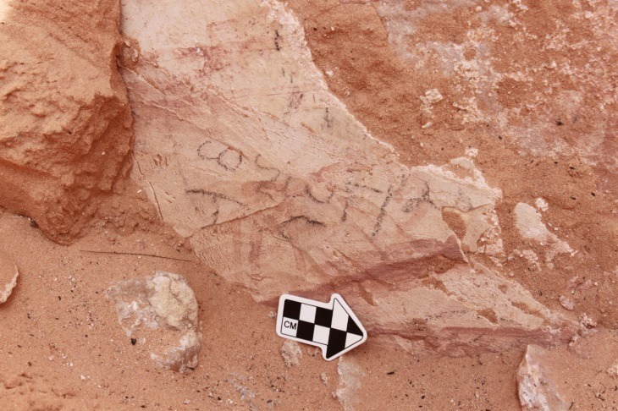 | Greek text | 4
Caldarium east wall | 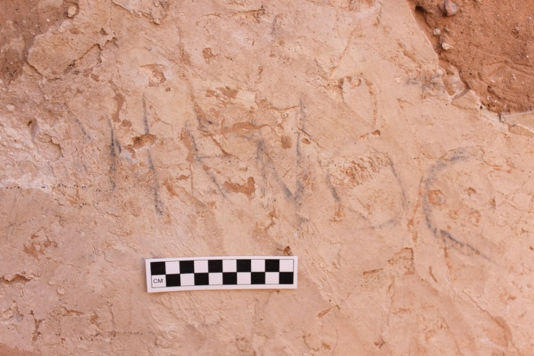 | Greek text | 5
Caldarium east wall | 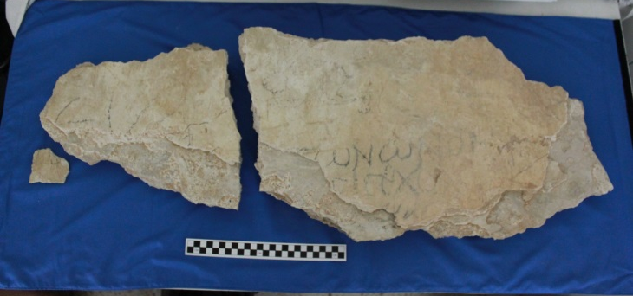 | Greek text and camel | 6
In doorway between caldarium and tepidarium |  | Roman sailing vessel | 8
Frigidarium east wall | 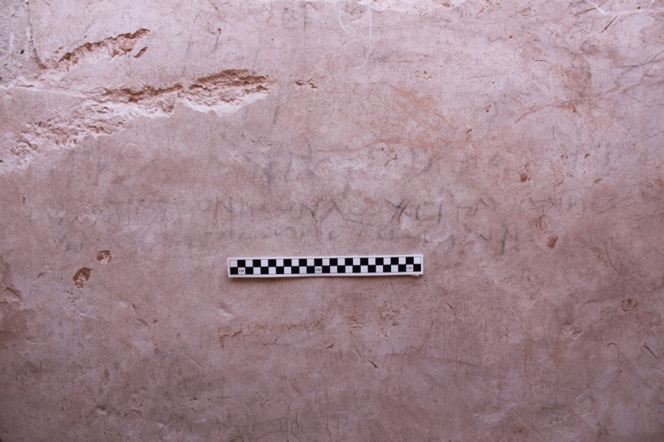 | Greek text | 9
Frigidarium east wall | 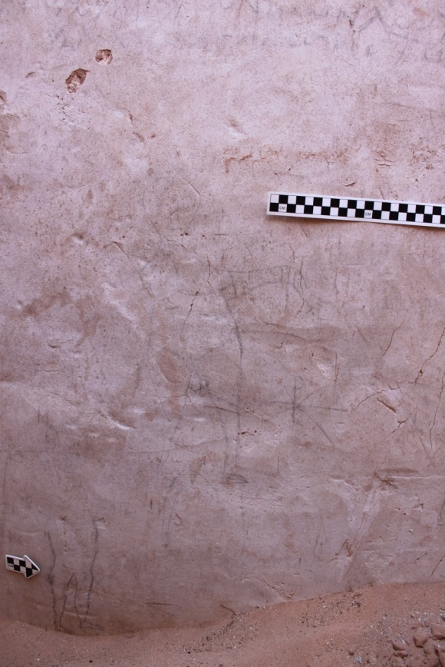 | Two naked bathers | 10
Frigidarium east wall | 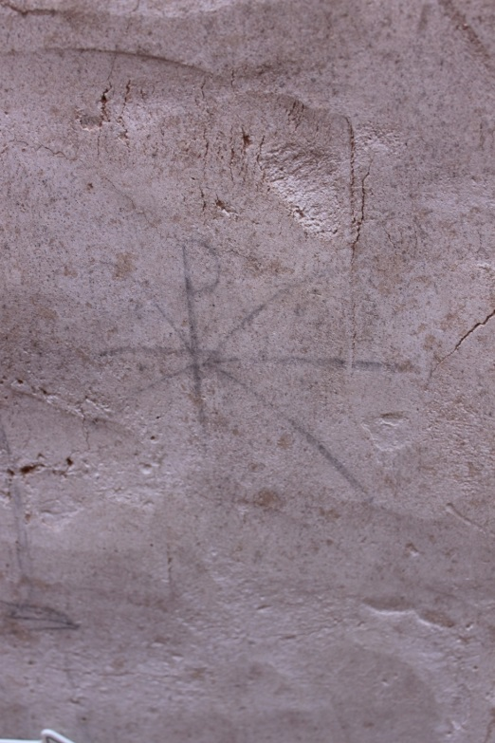 | Chi-rho | 11
Frigidarium east wall |  | Fish and ostrich | 12
Frigidarium south wall | 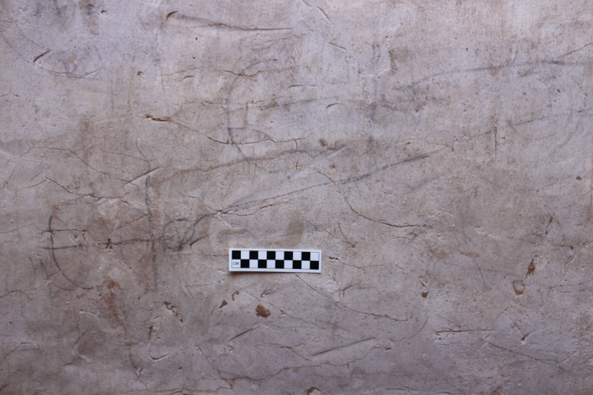 | anchors | 13
Frigidarium south wall | 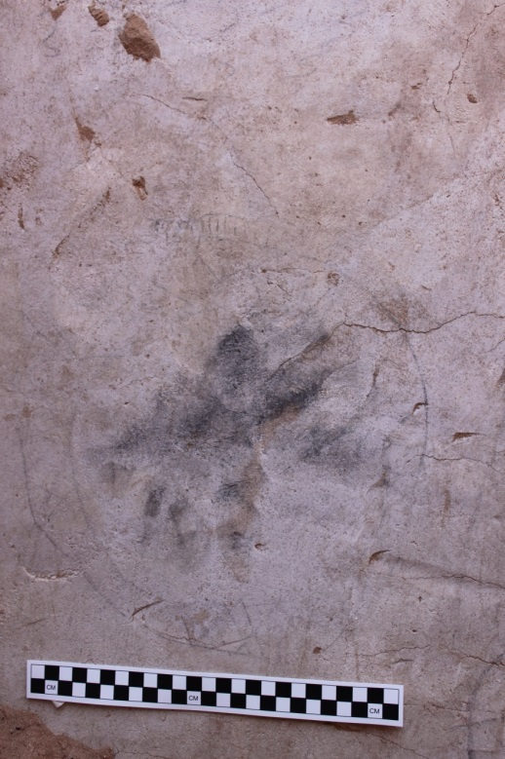 | Unidentified circular figure | 14
Frigidarium south wall | 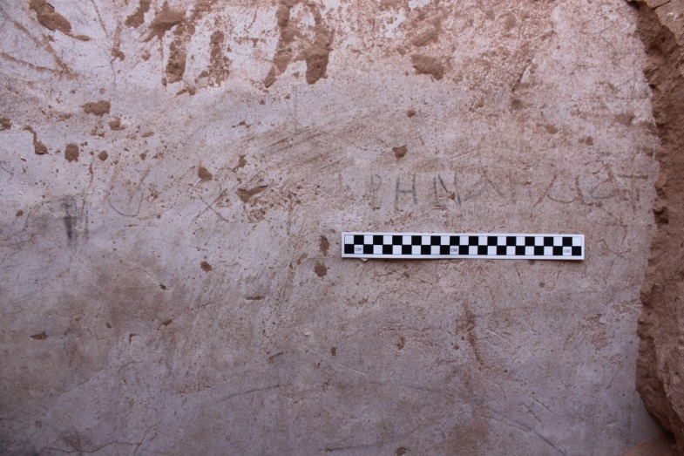 | Greek text | 15

Table 2 Graffiti from house in E4 block at Dura-Europos
Number | Location | Image/Text | Subject | Citation
1 | North wall of room 11 | 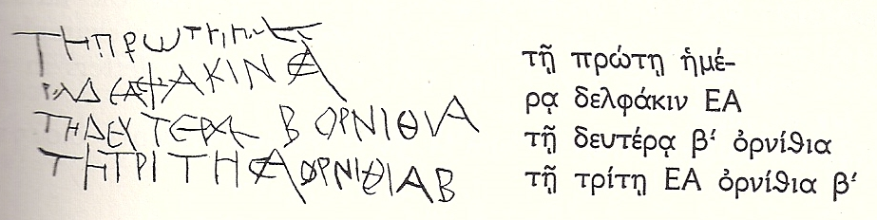 | Record of a cook,  meals for a festival; in Greek | Rostovtz-eff et al. no. 612
2 | South wall of room 20 | 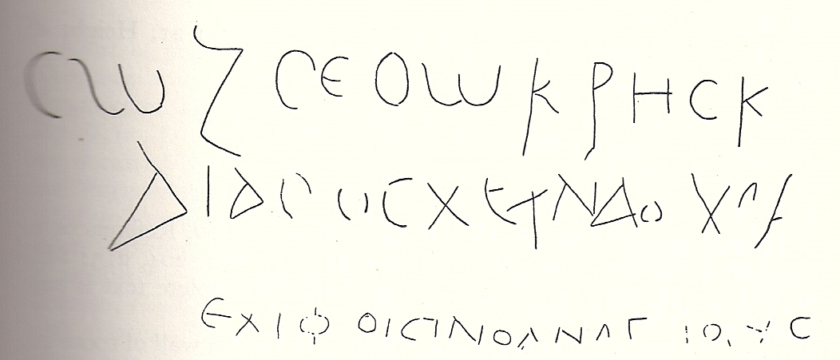 | Soldier honoring his commandin-g officer;  in Greek | No. 613
3 | South wall of room 20 | 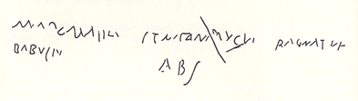 | Obscure text;  Mixture of Greek and Latin letters | No. 614
4 | Door jamb in south wall of room 21 | 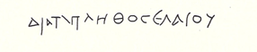 | Text mentioning olive oil; in Greek | No. 615
6 | West side of door jamb in south wall of room 21 | 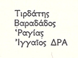 | Names, including Iranian name; in Greek | No. 616
7 | West side of door jamb in south wall of room 21; below 616 | 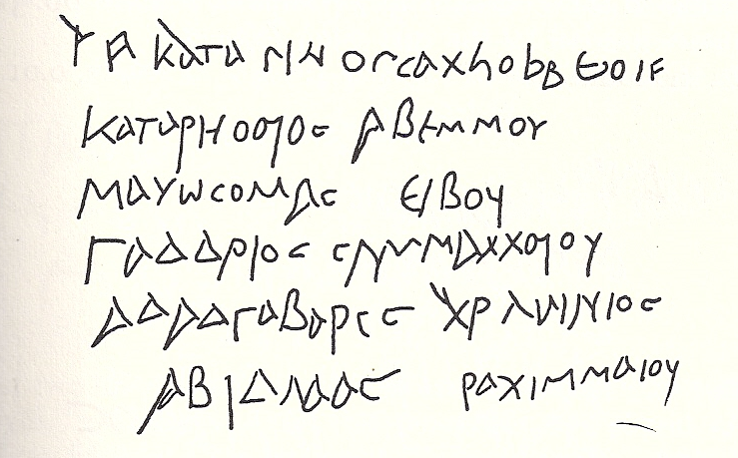 | Semitic names; in Greek | No. 617
8 | South wall of room 21 | 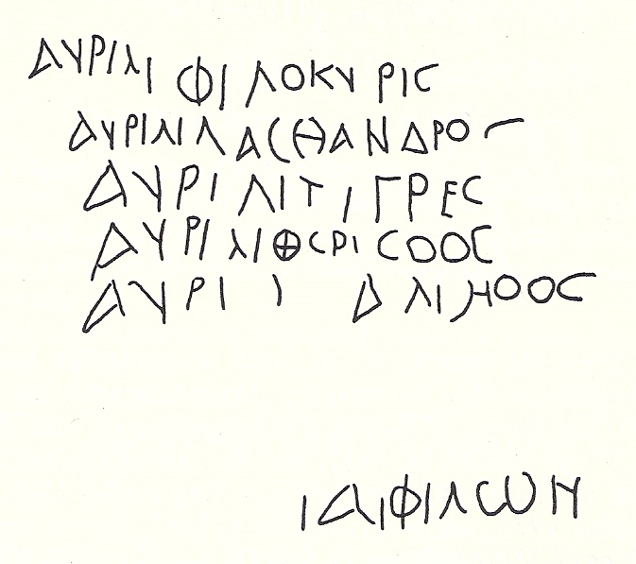 | Names of Roman citizens; in Greek | No. 618
9 | South wall of room 21; below 618 | 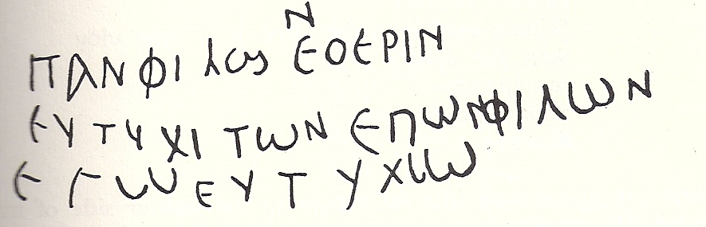 | Text related to "health-wish"; in Greek | No. 619
10 | South wall of room 21; to left of 619 |  | "Germanus (paid) 76 denarii."; in Greek | No. 620
11 | South wall of room 21 | 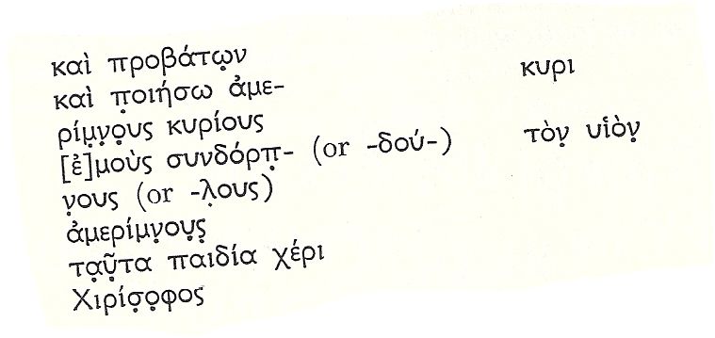 | Poorly preserved text related to military affairs of daily life; in Greek | No. 621
12 | South wall of room 23 | 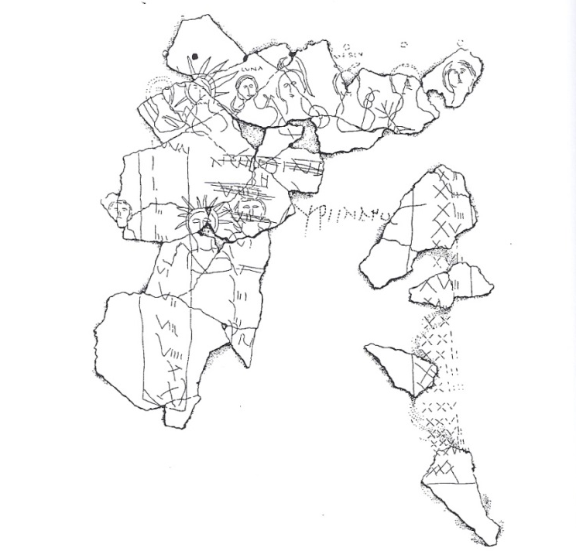 | Parapegma; in Latin | No. 622, fig. 2
13 | South wall of room 23, below no. 622 | 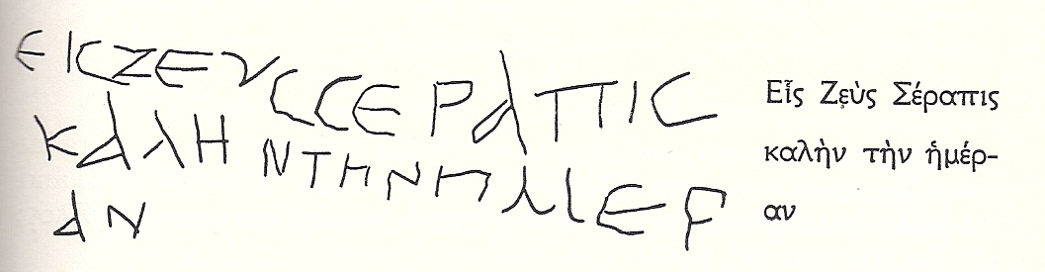 | Acclamation to Zeus; in Greek | No. 623
14 | North wall of room 23 | 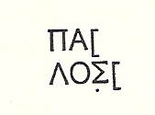 | Possibly a name; in Greek | No. 624
15 | North wall of room 33 | 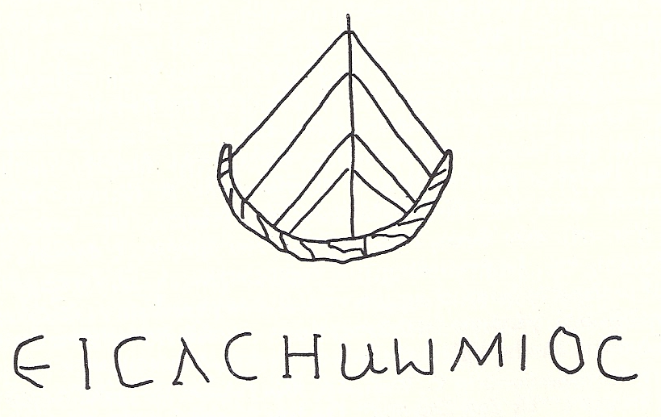 | Text includes a Semitic name and epithet of Zeus; in Greek  Drawing of a boat | No. 625
16 | East wall of room 33 | 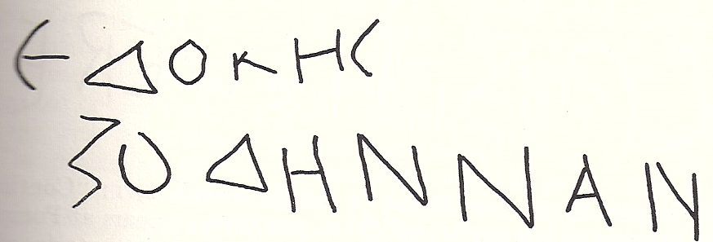 | Possibly a literary quotation; in Greek | No. 626
17 | East wall of room 33 | 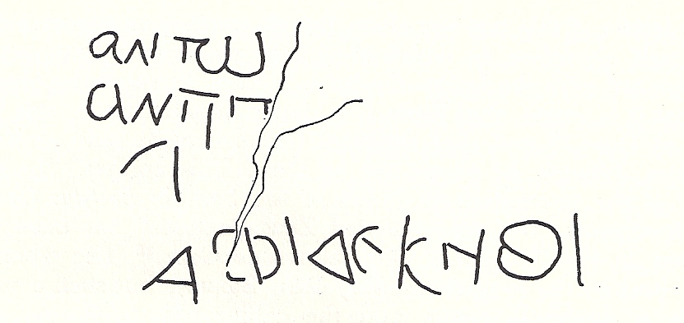 | Names; in Greek | No. 627
18 | South wall of room 39 |  | Quotation from Vergil's Aeneid 2.1 | No. 628

Figures

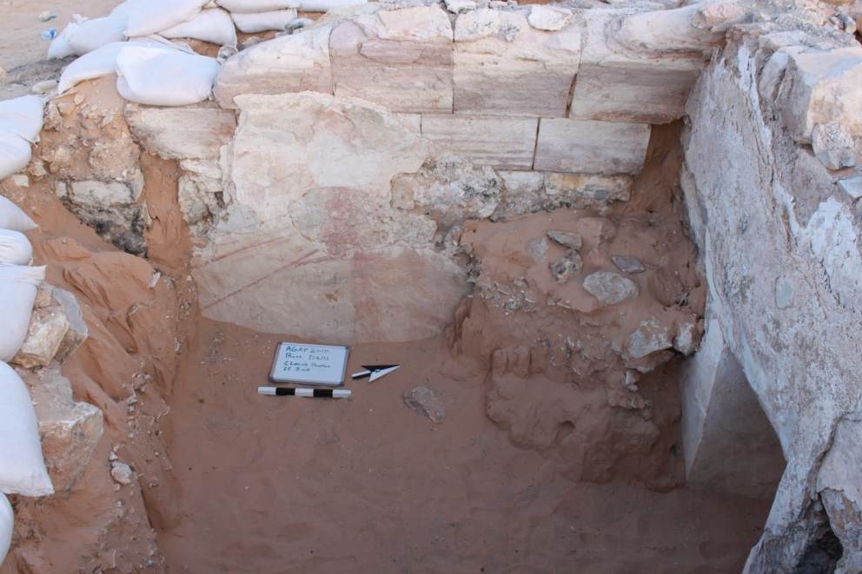
Fig. 1
The caldarium, the west wall. Photo courtesy of AGAP.

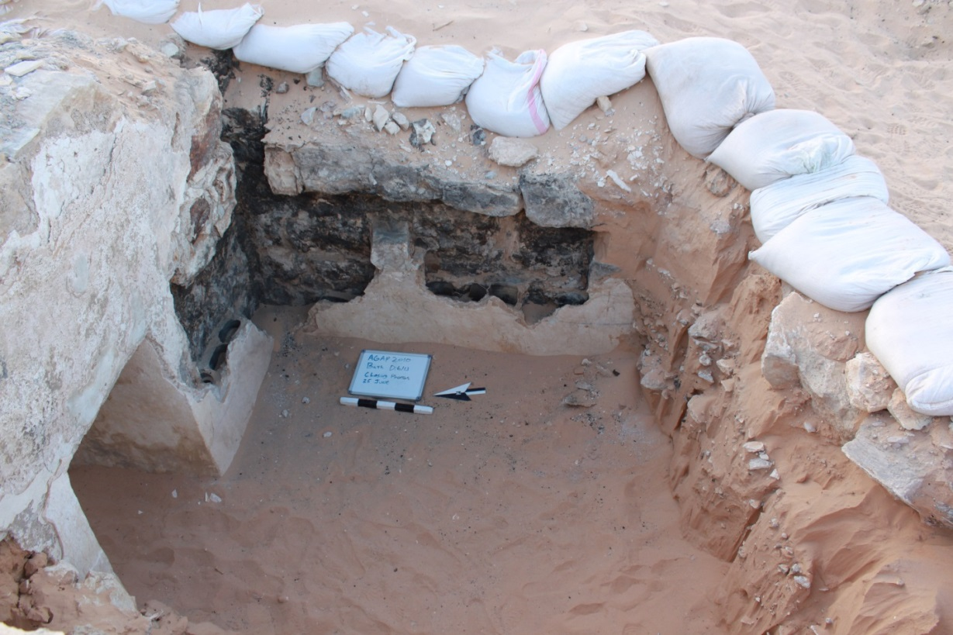
Fig. 2
The caldarium, the east wall. Photo courtesy of AGAP.

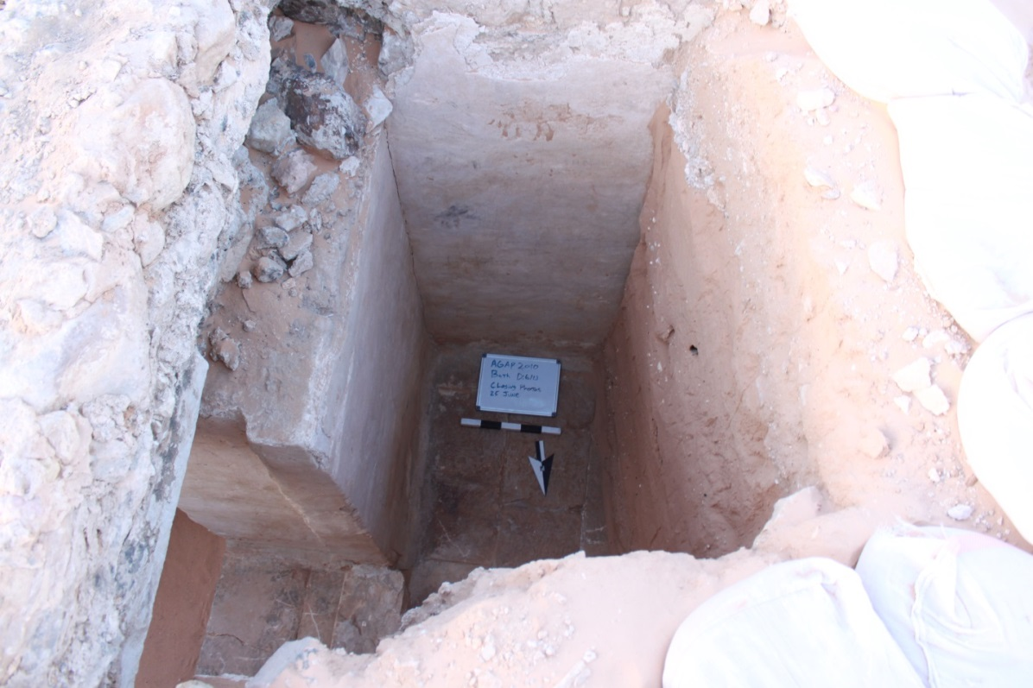
Fig. 3
The frigidarium, south and east walls. Photo courtesy of AGAP.

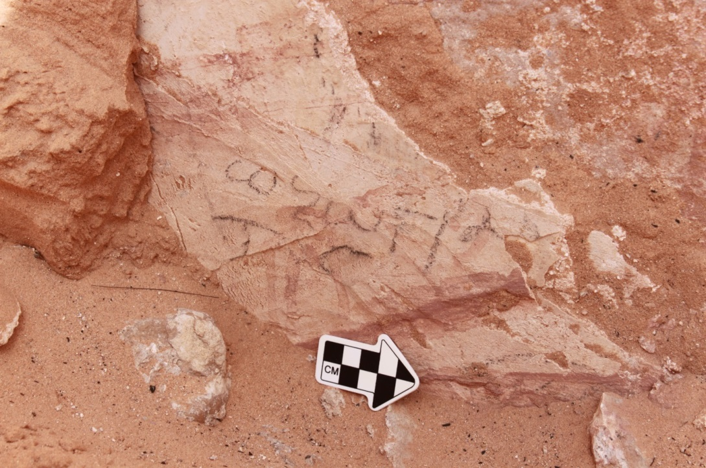
Figure 4
In situ graffito, a Greek text, on west wall of caldarium. Photo courtesy of AGAP.

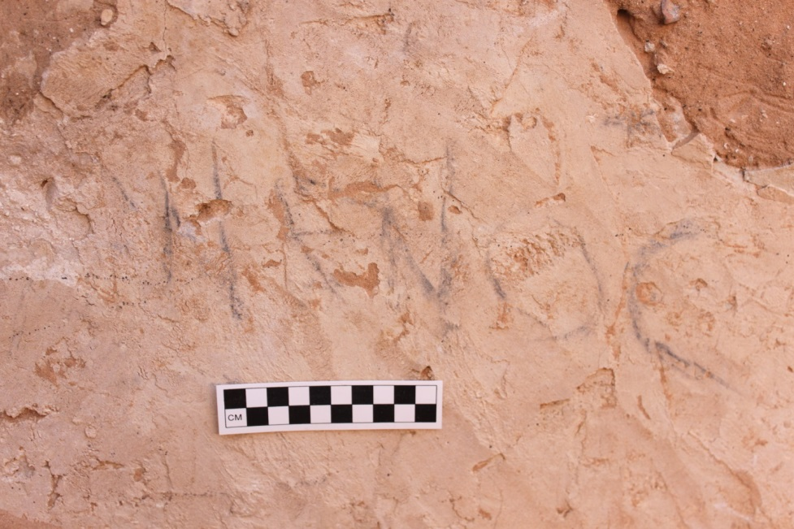
Figure 5
In situ graffito, a Greek text, on east wall of caldarium. Photo courtesy of AGAP.

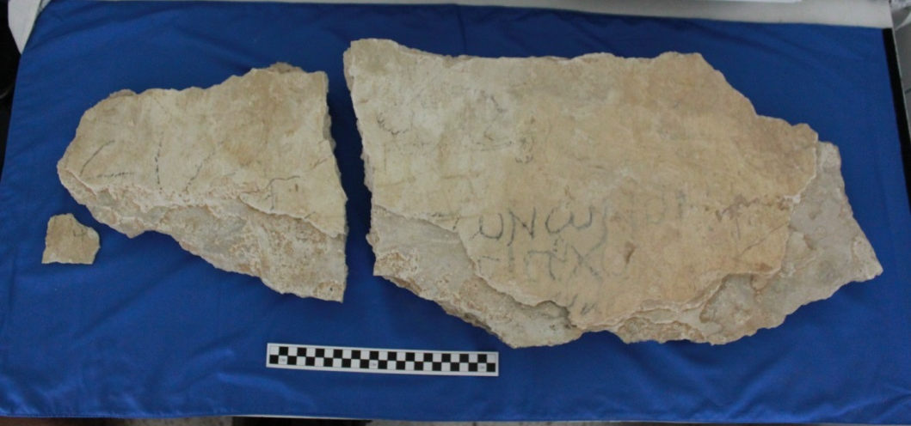
Figure 6
Fallen fragment along east wall of caldarium, Greek texts and camel. Photo courtesy of AGAP.

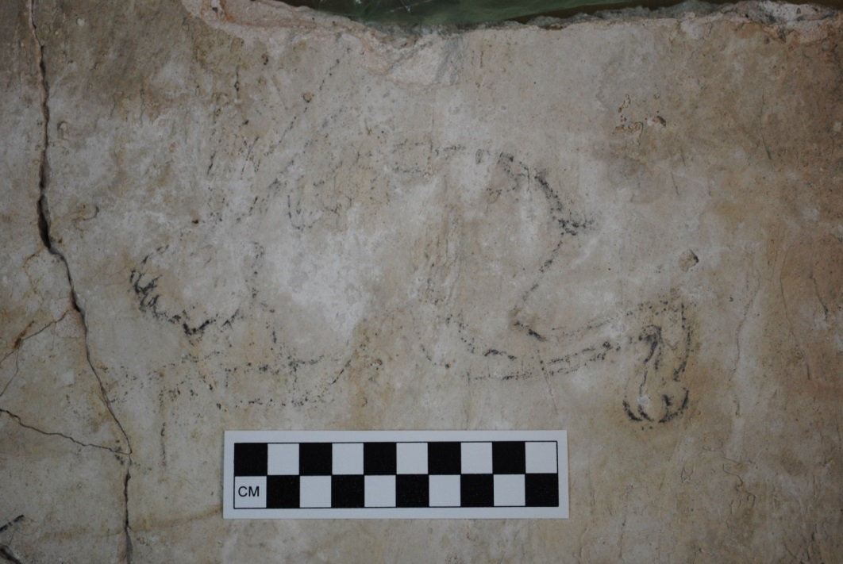
Figure 7
Close-up of camel dipinto on fragment along east wall of caldarium. Photo courtesy of AGAP.

Figure 8
Dipinto of Roman sailing vessel in doorway between caldarium and tepidarium. Photo courtesy of AGAP.

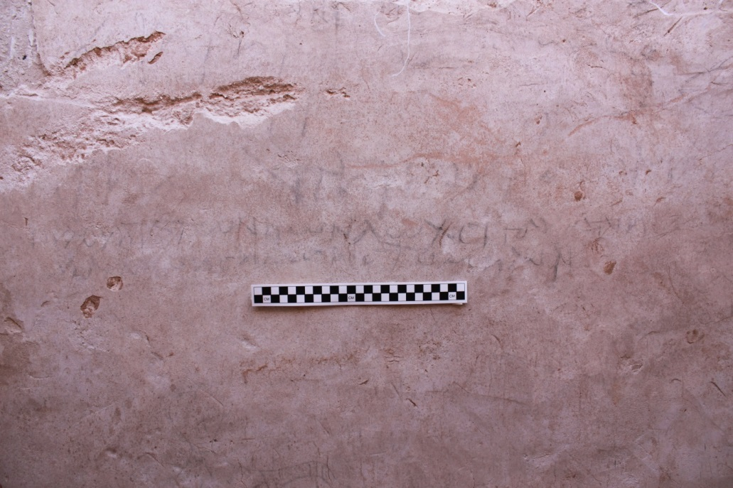
Figure 9
Greek text on east wall of frigidarium. Photo courtesy of AGAP.

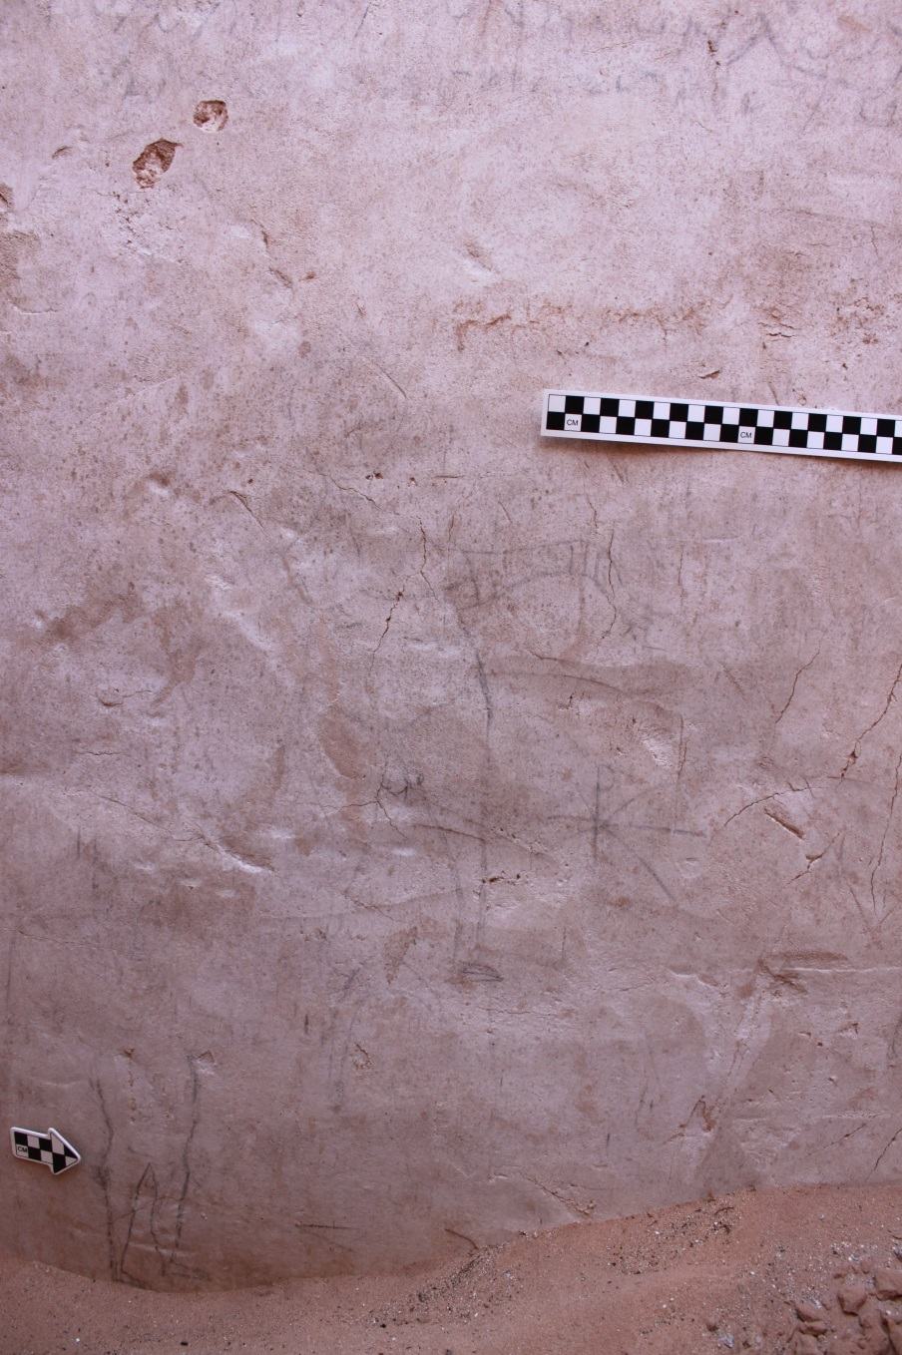
Figure 10
Two naked bathers from east wall of frigidarium. Photo courtesy of AGAP.

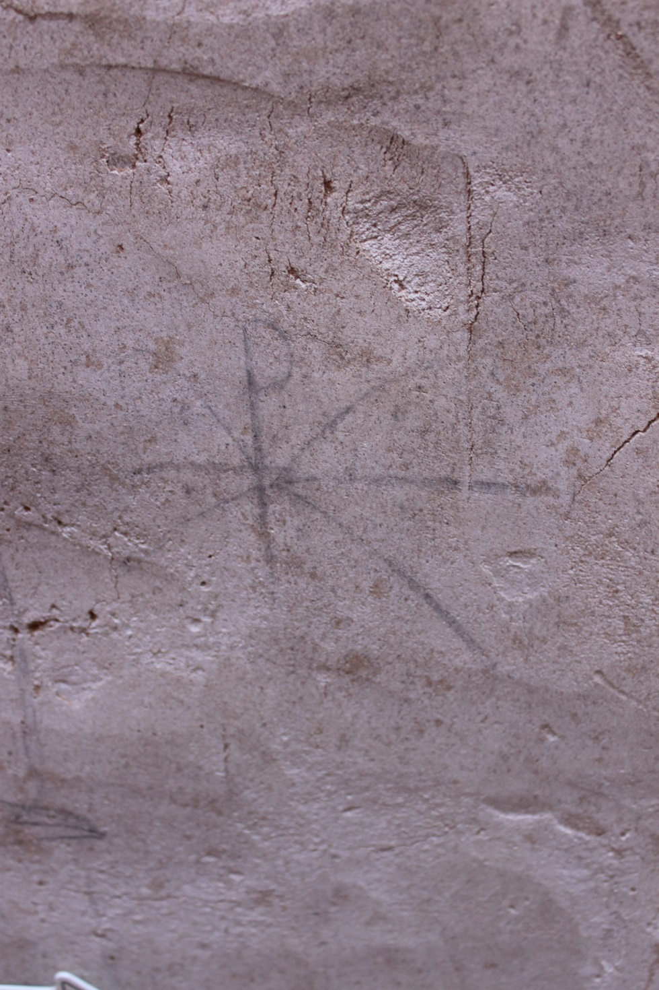
Figure 11
Chi rho symbol from east wall of frigidarium. Photo courtesy of AGAP.

Figure 12
Fish and ostrich from east wall of frigidarium. Photo courtesy of AGAP.

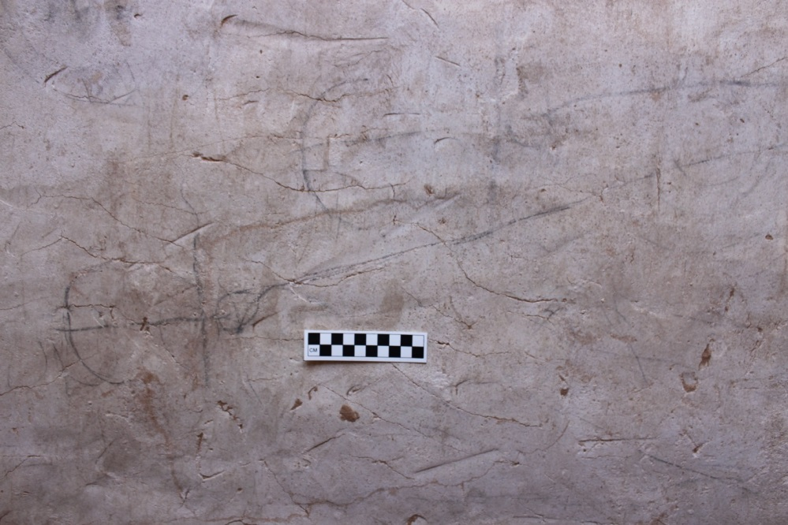
Figure 13
Anchors on south wall of frigidarium. Photo courtesy of AGAP.

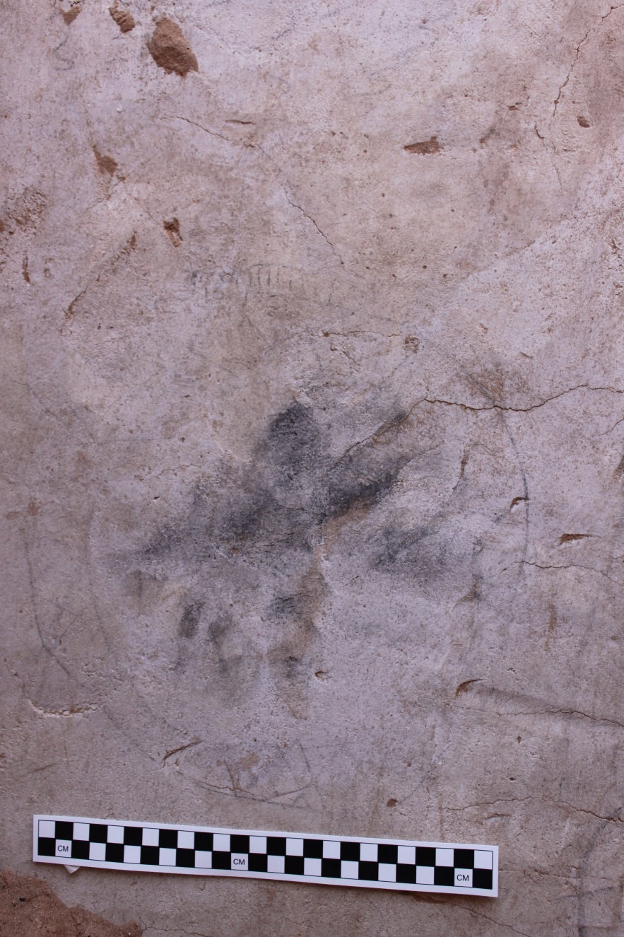
Figure 14
Unidentified circular figure from south wall of frigidarium. Photo courtesy of AGAP.

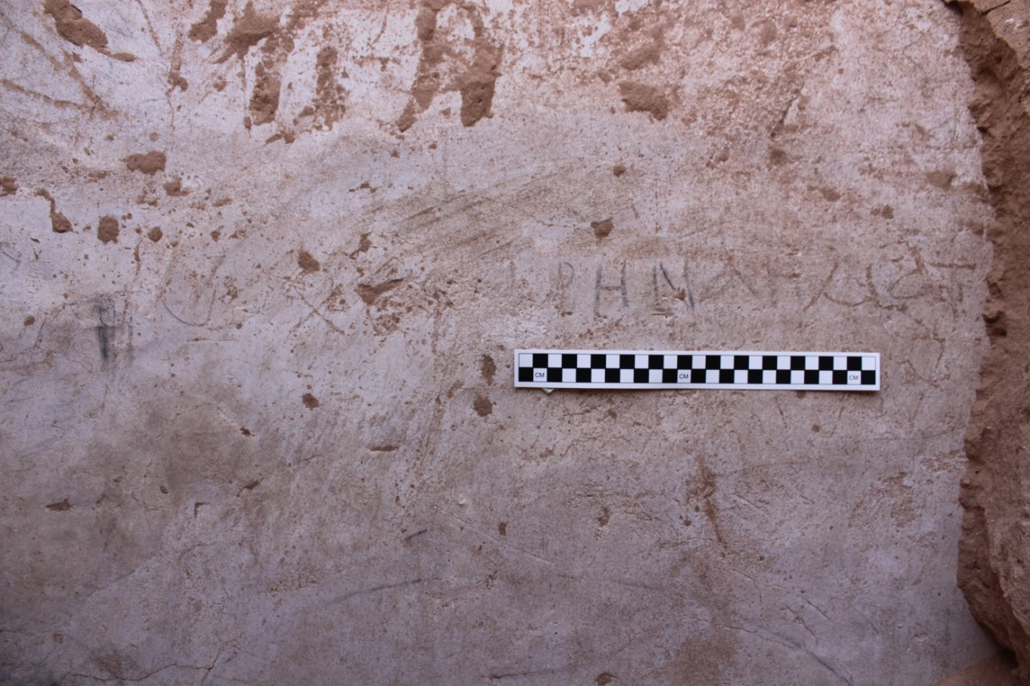
Figure 15
Greek text from south wall of frigidarium. Photo courtesy of AGAP.

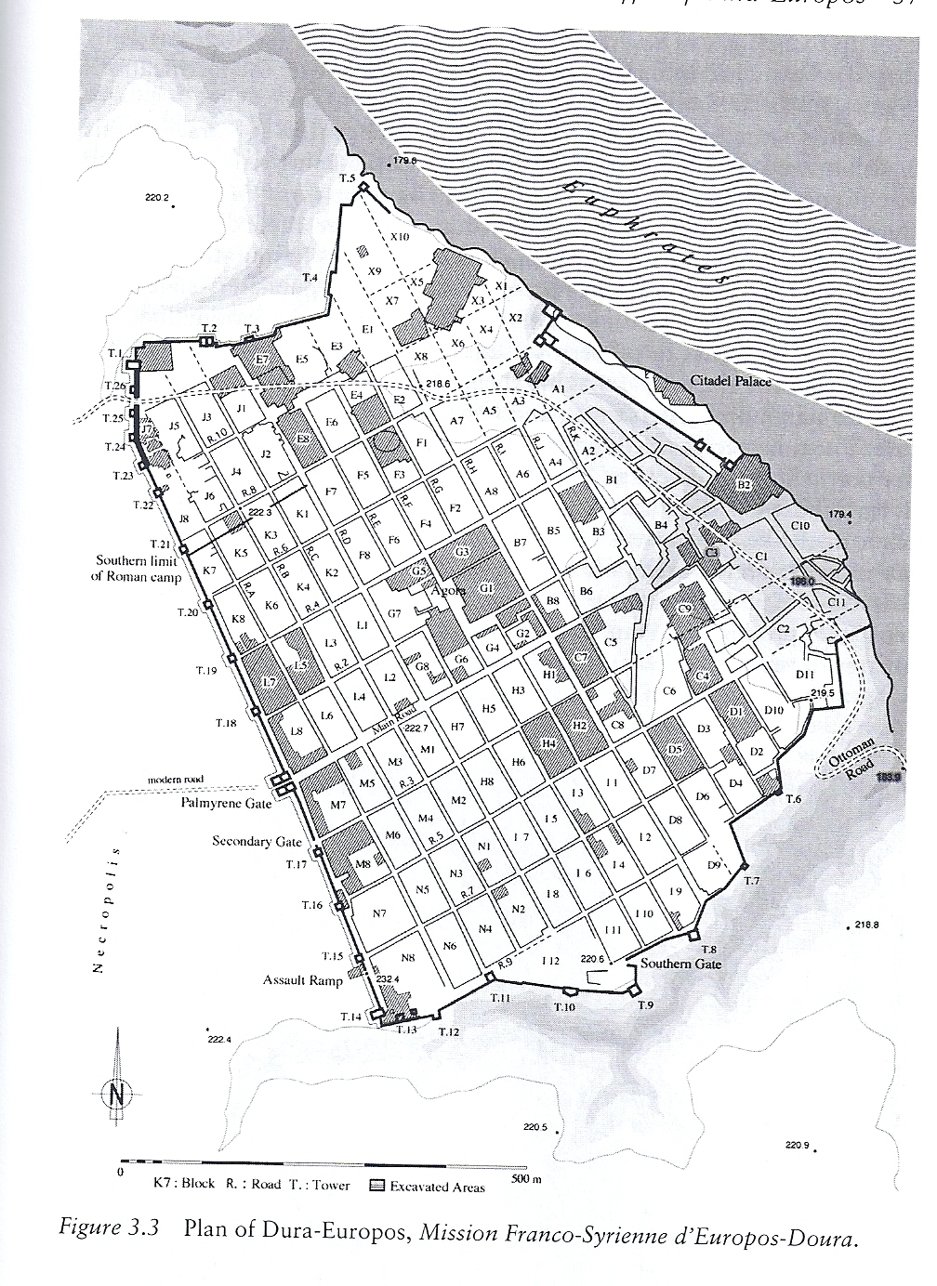
Figure 16
Site map of Dura-Europos

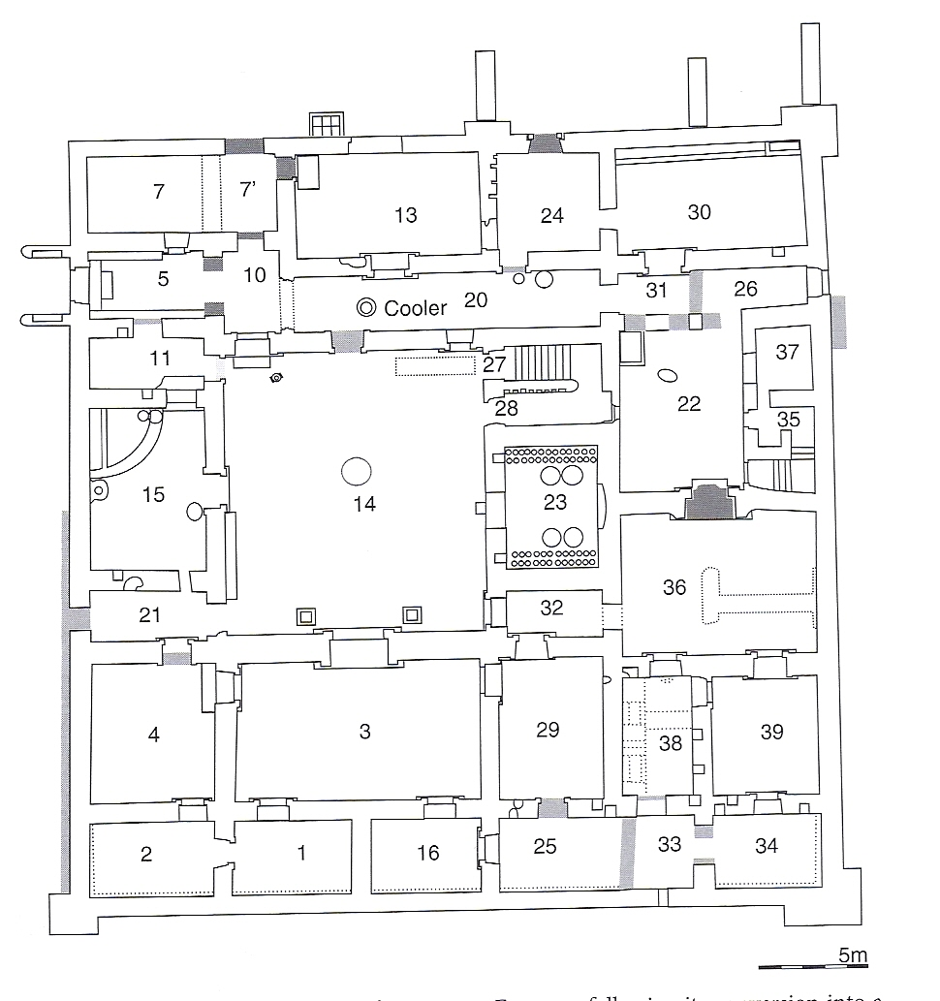
Figure 17
Layout of the house in block E4. From Haynes 2013, 167.

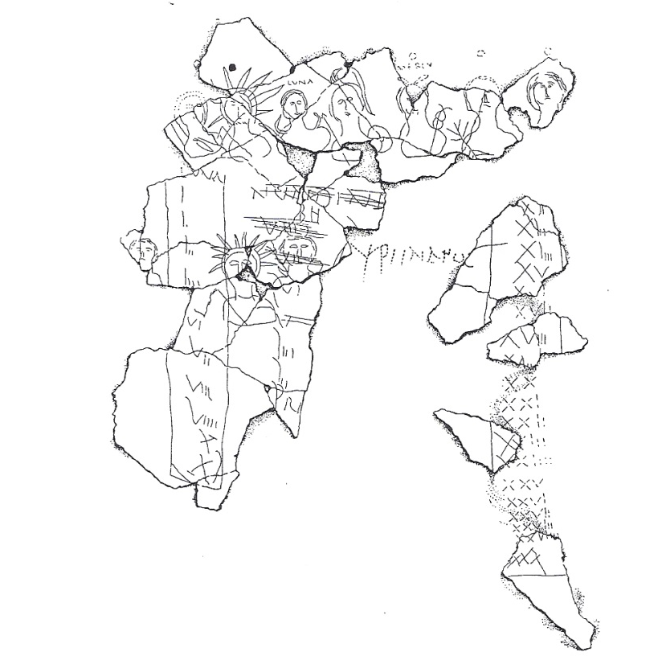
Figure 18
Parapegma from south wall of room 23, E4 house. Rostovtzeff et al., no. 622, fig. 2.

Figure 19
Graffito of a boat and Greek text. Rostovtzeff et al. 1936, no. 625.

Implications of this term will be considered later.
Rostovtzeff 1938, 2.
Baird and Taylor 2012, 4.
Baird and Taylor 2012, 5.
Cooley 2002, 10.
Kaimio 1979, 74.
Cooley 2012, 113.
Baird and Taylor 2012, 3.
Cooley 2012, 113.
Baird and Taylor 2012, 3.
Milnor 2009, 293.
Baird and Taylor 2012, 3.
Keegan 2014, 16.
Keegan 2014, 20.
Frantz 1998, 811.
Baird and Taylor 2012, 8; CIL 4.4755.
Keegan 2014, 22.
Baird and Taylor 2012, 9.
Woolf 2009, 47.
Keegan 2014, 34.
Baird and Taylor 2012, 8.
Keegan 2014, 40.
Keegan 2014, 45.
Millar 1993, 99.
Millar 1993, 102.
Millar 1993 108.
Millar 1993, 121.
Millar 1993, 122.
Millar 1993, 142.
MacDonald 1986, 45.
Millar 1993, 155.
Millar 1990, 52-5.
Millar 1993, 190.
Wheeler 2007, 257.
Haynes 2013, 108-19.
Wheeler 2007, 262.
Strobel 2007, 268.
Isaac 1990.
Hingley argues that the term “Romanization” is a simplistic, modern colonial construction, and suggests “globalization” is a better representation of this phenomenon. 2005, 2, 14.
Hingley 2005, 48.
Hingley 2005, 71; Huskinson 2000, 107-8.
Ball 2000, 449-50.
Hingley 2005, 56.
Hingley 2005 60; Woolf 2001, 315; Farrell 2001, 2-4.
Hingley 2005, 60.
Hingley 2005, 68.
Darby, R. and E. Darby 2012a and 2012b.
Frank 1934, 231-32; Glueck 1935, 39-40.
Musil 1907, 193-7.
Woolley and Lawrence 1915, 14-5.
See Raikes 1985, 101; King et al. 1989, 207; Smith et al. 1997, 59-60; Henry et al. 2001, 1-19; Gibson 2007.
King et al. 1989, 212-13; Smith et al. 1997, 59-60.
The monumental foundation stone found in B:1-2/1-1, the fort’s gate, confirmed the date and historical context of the fort in its Latin inscription, giving the name of the tetrarchy and the unit stationed there, the Cohors II Galatarum. Reference to this unit in the Notitia Dignitatum confirms the ancient name of the site, Arieldela. Partibus Orientis, 34.44.
Darby, R. and E. Darby 2012a and 2012b.
Parker 2006, 541-62; Erickson-Gini 2007, 98; Kennedy and Falahat 2008, 150-69.
Darby, R. and E. Darby, personal communication.
Diodorus 19.94.1, 95.1-97.6.
Schmid 2008, 360; Hackl, Jenni, Schneider 2003, 15-9.
Schmid 2008, 361.
Millar 1993, 405-6.
Schmid 2008, 385.
For a complete list of graffiti from the bathhouse, see Table 1.
Darby, Robert and E. Darby 2012a and 2012b.
Darby, Robert and E. Darby 2012a and 2012b.
Darby, R. and E. Darby 2012a and 2012b.
Darby, R. and E. Darby 2012a and 2012b.
Darby, R. and E. Darby 2012a and 2012b.
Darby, R. and E. Darby 2012a and 2012b.
Baird and Taylor 2012, 3.
Langer 2001, 66.
Milnor 2009, 293.
Stoll 2007, 451, 464.
Politis 2007, 190-4.
Langner 2001, 65.
Darby, R. and E. Darby 2012a and 2012b.
Darby, R. and E. Darby 2012a and 2012b.
Langner 2001, 68.
Langner 2001, 68.
Keegan 2014, 16.
Pollard 1996, 53.
Haynes 2013, 169.
Haynes 2013, 165-188.
Politis 2007.
Millar 1993, 447.
Buisson 1939.
Millar 1993, 467.
Goldman 1990, 5-25.
Hopkins 1979, 1.
Hopkins 1979, 2-3.
Hopkins 1979, 8-22.
Hopkins 1979, 26.
Reeves 2004, 4.
See Figure 16, site map of Dura-Europos, and Figure 17, layout of E4 house.
Rostovtzeff et al. 1936, 31.
Haynes 2013, 166.
See Table 2.
Rostovtzeff et al. 1936, 9; see Table 2; all examples will be enumerated and discussed further below.
Rostovtzeff et al. 1936, 11.
Rostovtzeff et al. 1936, 8.
Rostovtzeff et al. 1936, 9.
Table 2, nos. 1, 2, 3, 4, 5, 6, 7, 8, 9, 10, 11, 13, 14, 15, 16, 17, 18.
Table 2, no. 3; Table 2, nos. 12, 18.
Table 2, no. 6.
Table 2, no. 7.
Table 2, no. 8.
Table 2, no. 10.
Table 2, no. 15.
Table 2, no. 17.
Rostovtzeff et al. 1936, 42-3.
Rostovtzeff et al. 1936, 43.
Goldman 1999, 61.
Goldman 1999, 61.
Langner 2001, 131.
Langner 2001, 130.
Rostovtzeff et al. 1936, 45.
Rostovtzeff et al. 1936, 40.
Rostovtzeff et al. 1936, 40.
Haynes 2013, 167.
Rostovtzeff et al. 1936, 35.
Haynes 2013: 168.
Rostovtzeff et al. 1936, 48.
Hingley 2005, 68.
Habinek 1998, 45.

