Smoking-Related Fires and the Impact of the Fire Standard Compliant Legislation in the States

A Dissertation Presented for the
Doctor of Philosophy
Degree
The University of Tennessee, Knoxville

Christopher Adam Shults
December 2014

ACKNOWLEDGEMENTS

To be completed when finished
ABSTRACT

Smoking material fires are the leading cause of residential fire deaths and the third leading cause of residential fire injuries. . Cigarettes are the primary source of ignition in smoking material fires. Several policies and regulations have attempted d to mitigate the risks associated with smoking cigarettes. This study specifically examines the impact of the states’ fire standard compliant legislation as it relates to smoking-related residential civilian fire deaths, civilian fire injuries, and fire incidents. To test the impact of the states’ FSC policy, panel data for all 50 states from 2005 through 2012 are analyzed using a feasible generalized least squares (FGLS) model. The results indicate that the states’ FSC policy led to fewer smoking related fire deaths and smoking related fire incidents. The findings from this study indicate that the FSC policy was an effective strategy by the states that helped significantly to reduce both home fire deaths and the damage and destruction that attend smoking related fire incidents.

TABLE OF CONTENTS

Chapter I Introduction and General Information 1
Describing Smoking Material Fires 1
Policy Responses: Reducing Smoking-Material Risks 4
The Purpose of the Study 6
Data and Methods 7
Contribution to the Literature 11
Chapter 2 Literature Review: Cigarette Regulations, Fire Risks and Public Safety 13
Regulating Cigarettes 14
Reducing the Health Risks Associated with Smoking 14
Reducing the Fire Risks Associated with Smoking 18
The Evolution of the Fire Standard Compliant Cigarette Policy 22
Are the FSC Laws Effective? 27
Conclusion 34
Chapter 3 Data and Methods 36
Introduction 36
Incident Data 37
National Fire Incident Reporting System (NFIRS) 37
Data Format 40
Incident Case Selection 41
Key Variables 43
Generating Smoking-Related Fire Incident, Injury, and Death Count Totals 43
Operationalization for the FSC Policy 44
Operationalization for the State Adult Smoking Rate 46
State Characteristics 47
Methods 48
Summary 51
Chapter 4 The Impact of State Fire Safe Cigarette Policies on Reducing Smoking- Related Fire Deaths 53
Introduction 53
Characteristics of Smoking-Related Fire Deaths 54
Area of Origin 55
Item First Ignited 56
Human Behavior 57
Variables in the Study and Previous Research 60
Estimation 69
Findings 72
Conclusion 73
Chapter 5 The Impact of State Fire Safe Cigarette Policies on Reducing Fire Injuries 75
Introduction 75
Smoking-Related Fire Injuries 76
Area of Origin 77
Item First Ignited 78
Human Behavior 79
Variables in the Study and Previous Research 82
Estimation 89
Findings 90
Conclusion 92
Chapter 6 The Impact of State Fire Safe Cigarette Policies on Reducing Fire Incidents 93
Smoking-Related Fire Incidents 94
Variables in the Study and Previous Research 99
Estimation 103
Results 103
Conclusion 105
Chapter 7 Conclusion 106
Implications 107
Directions For Future Research 110
References 113
Vita

LIST OF TABLES

Table 3.1. Implementation Years for Fire Safe Cigarette Policies 45 Table 4.1. Descritpive statistics for state demographic 68 Table 4.2. Cross-sectional time series feasible GLS estimates of smoking-related fire death rates 2005-2012 with state fixed effects 72 Table 5.1. Cross-sectional time series feasible GLS estimates of smoking-related fire inury rates 2005-2012 with state fixed effects 91 Table 6.1. Cross-sectional time series feasible GLS estimates of smoking-related fire incident rates 2005-2012 with state fixed effects 104

LIST OF FIGURES

Figure 2.1 Suggested Heath Warning to be placed on all Cigarette Packaging ……………..16
Figure 4.1 Area of origin of Smoking-Related Fire Deaths 2005-2012 56
Figure 4.2 Item First Ignitied in Smoking-Related Fire Fatalities 2005-2012 57
Figure 4.3 Human Factor in Smoking-Related Fire Deaths 2005-2012 58
Figure 4.4 Detector Presence in Smoking-Related Fire Deaths 2005-2012 59
Figure 4.5 Trend in Fire Deaths from 2005-2012 61
Figure 4.6 Average Annual Smoking-Related Fire Death Rates, per mill. 2005-2012 63
Figure 5.1 Area of Origin in Residential Smoking-Related Fire Injuries 2005-2012 78
Figure 5.2 Item First Ignited in Residential Smoking-Related Fire Injuries 2005-2012 79
Figure 5.3 Human Factor in Residential Smoking-Related Fire Injuries 2005-2012 80
Figure 5.4 Smoke Detector Presence in Smoking-Related Fire Injuries 2005-2012 81
Figure 5.5 Severity of Injury in Residential Smoking-Related Fires 2005-2012 83
Figure 5.6 Trend in Smoking-Related Fire Injuries 2005-2012 84
Figure 5.7 Average Annual Smoking-Related Fire Injury Rates, per mill. 2005-2012 86
Figure 6.1 Residential Smoking Related Fire Incidents 2000-2011 95
Figure 6.2 Leading Item First Ignited in Residential Smoking-Related Fire Injuries or Deaths 2005-2012 98
Figure 6.3 Residential Smoking-Related Fire Incidents Involving a civilian 2005-2012 100
Figure 6.4 Average Annual Smoking-Related Incident Rates, per mill. 2005-2012 101

CHAPTER I

Introduction and General Information

Introduction

“Cigarette smoking is the chief preventable cause of premature disease and death in the United States” (Elders et al., 1994 pg. 543). Many policies have been implemented to mitigate the risks associated with smoking cigarettes. This study specifically examines the impact of the states’ fire standard compliant legislation as it relates to smoking-related residential civilian fire deaths, civilian fire injuries and fire incidents.
Describing Smoking-Material Fires

In 2010, fire departments responded to an estimated 90,800 smoking material fires (Hall, 2012). These fires resulted in 610 civilian deaths, 1570 civilian injuries, and 663 million dollars in property damage (Hall, 2012). These numbers reflect both commercial and residential structure smoking material fires, as well as, non-structure smoking material fires. Although smoking material fires can occur in almost any location a disproportionate amount of smoking material fire losses occur in residential structures. For example, in 2010, about 17,500 smoking material fire occurred in residential structures (Hall, 2012). This accounts for only about 20 percent of the total smoking material fires reported. However, these 17,500 fire incidents caused 540 civilian deaths, 1,320 civilian injuries and 535 million dollars in property damage (Hall 2012). Thus, residential smoking-related fires accounted for 88.5 percent of all smoking material fire civilian deaths, 84 percent of all smoking material fire civilian injuries and 81 percent of the cost in property damage. The pattern of losses exhibited in 2010 is not unique to 2010. Each year from 2006 through 2010, 63% of smoking material structure fires (about 18,600 incidents) occurred in residential structures (Hall, 2012). These residential smoking material fires resulted in an average of 620 civilian deaths, 1280 civilian injuries and 510 million dollars in property damage per year from 2006 through 2010 (Hall, 2012).
The impact of smoking material fires are magnified when one considers smoking material fires are more costly than non-smoking fires. Fires resulting from smoking materials are the leading cause of home structure fire deaths and the third leading cause of home structure fire injuries. Further, smoking material fires are responsible for a disproportionate number of fire fatalities and injuries (Ahrens, 2012). For example, the fire death rate for residential smoking material fires is almost eight times higher than the fire death rate for non-smoking residential fires. Specifically, from 2008-2010, the residential smoking-related building fire fatality rate reached a rate of 24.2 fatalities per 1000 fires, while the non-smoking residential fire fatality rate was only 3.1 fatalities per 1000 fires (USFA, 2012). The fire injury rate exhibited a similar pattern with 91 injuries per 1000 fires occurring in smoking-related building fires and only 25 injuries per 1000 fires occurring in non-smoking related building fires (USFA, 2012). The dollar loss for smoking-related residential building fires was also higher than the dollar loss associated with non-smoking fires, with smoking-related residential building fires generally resulting in twice as much dollar loss per fire when compared to non-smoking residential building fires (US Fire Administration National Data Center, 2012). This suggests that although smoking material fires account for far fewer fires than operating equipment (42%), heating equipment (17%), and electrical distribution and lighting equipment (6%), smoking material fires carry a much greater risk associated with fire injury, death, and property loss (Ahrens, 2012).
The risks associated with smoking material fires are likely to be higher than other types of fires because of the characteristics surrounding smoking material fires. Such factors include the time at which residential smoking material fires occur and the personal behavior of smokers. An average of 8% of smoking material fires occur between the hours of midnight and 2:00am. However, 10% of the smoking material fire deaths occur during this time (Hall, 2012). This illustrates that a disproportionate number of fire deaths occur between the hours of midnight and 2:00am. The “reckless” or “careless” behaviors of smokers in the handling and disposal of smoking materials are largely to blame. In essence, as the evening gets later individuals are more likely to become impaired or less alert. This can result either from the use of mood altering substances such as alcohol or nighttime drugs, or simply through individuals becoming drowsy (Hall, 2012). As a person becomes less alert, the risk of careless behavior and improperly discarding smoking materials increases (Alpert, 2007). Improperly discarded smoking materials may fall onto upholstered furniture and mattress bedding where they smolder for hours (Alpert, 2007). This extended smoldering can result in a fire igniting long after residents have fallen asleep. Once an individual has fallen asleep other fire safety measures can become less effective. Thus, the risk of a smoking material fire occurring increases with careless behavior. This point is illustrated by the fact that a person falling asleep while smoking is the most common cause of fire deaths when a fire is ignited by a smoking material and drug or alcohol impairment is the second most common cause of ignition, contributing to 19% of fire deaths when a fire is ignited by a smoking material (Hall, 2012).
One particular policy that was designed to help reduce the risk of deaths, injuries and the occurrence of smoking material fire incidents is the Fire Safety Standards for Cigarettes (FSSC).
Policy Responses: Reducing Smoking Material Risks
In 2004, New York State implemented the FSSC policy. FSSC is a fire safety regulation that requires cigarettes to meet a fire safety performance standard. Vermont followed New York and implemented fire standard compliant legislation in 2006. Vermont was followed by California, Oregon, and New Hampshire in 2007. By July 1, 2011 all fifty states had implemented a form of the fire standard compliant legislation (Coalition for Fire Safe Cigarettes, 2012).
Cigarettes that adhere to fire standard compliant legislation are considered fire standard compliant or fire safe cigarettes (FSC). To be classified as a FSC, a cigarette, if left unattended, must self-extinguish before it exhibits a full length burn (Coalition for Fire Safe Cigarettes, 2012). To test for compliance, a manufacturer must submit cigarettes for a test trial. In the test trial, no more than 25% of the cigarettes tested can exhibit a full length burn when left unattended (Coalition for Fire Safe Cigarettes, 2012). If this standard is not met the cigarette will fail the certification test. Any manufacturer who knowingly sells non-fire standard compliant cigarettes is subject to a 100 dollar fine for each pack sold up to 100,000 dollars during a thirty day period. Any retailer who knowingly sells non-standard compliant cigarettes is subject to a 100 dollar fine for each pack sold up to 25,000 dollars during a thirty day period (Coalition for Fire Safe Cigarettes 2012).
In most cases the self-extinguishing qualification is accomplished through the use of lower permeability bands in the cigarette paper (Hall, 2012). These bands act as “speed bumps” in the cigarette wrapping and require the smoker to continue to puff on the cigarette in order to keep it lit. Without regular puffing the cigarette with self-extinguish once a burning cigarette reaches one of the speed bumps. These criteria are designed to reduce the burn time and the ignition propensity of cigarettes. As a result, the likelihood of an unattended cigarette igniting other material, such as upholstered furniture or bedding, is reduced and the risk of smoking material fires occurring is reduced. Sources are optimistic about the effectiveness of the FSC legislation, and it has been suggested that once all 50 states have implemented the FSC policy, smoking material fire deaths will be reduced by 30% in relation to the level of deaths experienced in 2003 (Hall, 2012).
Since cigarettes are a leading ignition source of residential smoking-related fires, standards reducing the ignition propensity of cigarettes should make them less likely to ignite a fire. If cigarettes are less likely to ignite a fire, fires involving smoking materials should be reduced. The rationale behind FSCs is similar to other technological innovations designed to mitigate risk. Most residential fires started by smoking materials, can be attributed to risky, careless, or impaired behavior on behalf of the smoker. In response to this behavioral risk, cigarette regulations were developed to reduce smoking-related fire risk regardless of smoker behavior. Thus, a technical fix was designed to make cigarettes “safer” and reduce the risks of fire associated with smoker behavior.
The Purpose of the Study
The purpose of this study is to examine whether the states’ FSC laws are responsible for any observable decline in smoking-related fire deaths, injuries, or incidents. For the states’ FSC laws to be considered to be an effective public policy, at least some of any observed reduction in the rate of smoking-related fire deaths, injuries and incidents after implementation of the FSC policy in the states should be statistically attributable to the law, while controlling for other variables relevant to these phenomena. Nationally, data on in fire deaths, fire injuries and fire incidents indicate that each has declined since the late 1970s (Hall 2012; Krater 2012; and Ahrens 2012). Some reports suggest that observed declines may be attributable to the states’ implementing FSC standards (Hall, 2012; Alpert, 2007; NFPA, 2010; Coalition for Fire Safe Cigarettes, 2011b). Besides Folz and Shults (2014) who found evidence that the FSC policy in the states did have an independent causal impact on reducing the rate of fire mortalities in the states during the 2005 through 2011 period, no scholarly work has examined whether the FSC policy had an impact on reducing smoking-related fire mortalities through 2012. No systematic analysis has been performed on the question of whether the FSC policy has a causal impact on the rates of smoking-related fire injuries and incidents during the 2005 through 2012 period.
Data and Methods
The fire incident data were gathered from the U.S. Fire Administration (USFA) National Fire Data Center. USFA maintains the National Fire Incident Reporting System (NFIRS). NFIRS gathers and organizes data that are submitted voluntarily by fire departments in the U.S. This system captures more than 75% of all reported fires that occur annually (USFA, 2013). Because of these factors, the records are not considered to be a complete list of every fire incident, injury or death. Although NFIRS has data limitations, these data represent the best available source of information about individual fire incidents in each state.
The main independent variable in the study is the states’ FSC policy. The FSC policy is operationalized as a binary variable. A value of 0 represents the absence of the FSC policy and a value of 1 represents the presence of the law. Most policy changes did not occur on January 1st. To capture the effect of a policy shift throughout the year, two approaches were used. In one approach if a policy was effective before July 1st the policy was considered in effect as coded as 1 for that year. In another approach the policy variable is coded as the proportion of days for which the law is in effect (Houston and Richardson, 2006). Information about the states’ fire safe cigarette laws was obtained from the Coalition for Fire-Safe Cigarettes.
Another critical variable for this study is the adult smoking rate. From 2005 through 2010 data on the annual adult smoking rate by state were gathered from the annual Behavioral Risk Factor Surveillance System (BRFSS) survey. In 2011, the methodology for selecting the BRFSS sample changed. Due to the changes in sampling procedures and different weighting methods, the BRFSS 2011 survey reported significantly higher estimates of annual adult smoking rates than previous surveys (CDCP 2012a). Because of these methodological differences, 2011 data cannot be compared to previous years (CDCP 2012b). Acknowledging the methodology differences, 2011 data from the BRFSS survey data were not used. To utilize the variable in the analysis, a percent of adults who smoke variable for 2011 was computed for each state. The 2011 percent of adults who smoke variable was computed using a method of extrapolation. To compute each state’s 2011 smoking rate, the annual average amount of change in smoking rates between 2005 and 2010 were added to or subtracted from the state’s 2010 smoking rate. This estimation method allows for comparability with previous measures when data are not available or data are not compatible overtime (Roth, 1994; Schafer and Graham, 2002).
State characteristics are also important in understanding the residential smoking-related fire risks. State characteristics, that may be associated with the occurrence of smoking material fires and subsequent fire deaths and injuries include: housing stock (Eisenberg, 2005; Istre, McCoy, Osborn, Barnard and Bolton, 2001), level of income (Hannon and Shai, 2003; Istre et al., 2001), education (Eisenberg, 2005), age (USFA, 2009; Istre et al., 2001), gender (USFA, 2009; Istre et al., 2001), and race (USFA, 2009; Istre et al., 2001). All state characteristic data are gathered from the American Community Survey reports. The data were gathered for each state for each year for the time period 2005-2012.
This study begins by describing residential smoking-related fire incidents, injuries and deaths in the U.S. between 2005 and 2012, and identifies the various factors associated with the incidence of each. The second stage of the study analyzes the FSC policy’s connection to residential smoking–related incidents, injuries, and deaths.
To test whether the FSC law (the independent variable) has any impact on the occurrence of residential smoking–related fire incidents, a cross-sectional time series regression model will be estimated for state levels of smoking-related fire incident rates per one million population (the dependent variable). Annual data from 2005 through 2012 will be included in the analysis. The number of smoking-related fire related incidents is extracted from the NFIRS v 5.0 reporting system for the years 2005-2012. State population data are gathered from the American Community Survey yearly estimates for the years 2005-2012. To calculate the smoking-related fire incident rates, the total number of smoking-related fire incidents involving a civilian is divided by the total population and then multiplied by 1,000,000. A smoking-related fire incidents rate is calculated for each state for each year of the study. Other variables included in the model consist of those facts identified in the literature as being associated with residential fire incidents. These include various state level population, housing and economic factors as well as other behavioral indicators for the state population such as smoking rate.
To test the effect of the FSC standards on residential smoking-related injuries, a cross-sectional time series regression model will be estimated for state residential smoking-related injury rates per one million population. The number of fire related injuries and smoking-related injuries are extracted from the NFIRS v 5.0 reporting system for the years 2005-2012. State population data are gathered from the American Community Survey yearly estimates for the years 2005-2012. To calculate the smoking-related fire injury rates, the total number of smoking-related fire injuries is divided by the total population and then multiplied by 1,000,000. A smoking-related fire injury rate is calculated for each state for each year of the study. Once again, the key variable is the states’ implementation of the fire standard compliant legislation. Other variables included in the model consist of state characteristics associated with residential smoking-related fire injuries.
To test the impact of the states’ fire standard complaint cigarette law on residential smoking-related deaths, a cross-sectional time series regression model will be estimated for state residential smoking-related death rates. The number of residential fire deaths and residential smoking-related fire deaths were extracted from the NFIRS v 5.0 reporting system for the years 2005-2012. Population data are gathered from the American Community Survey yearly estimates for the years 2005-2012. To calculate the rate of residential smoking-related fire deaths, the total number of smoking-related deaths is divided by the total population for each state, for each year of the study. This annual rate is multiplied by 1,000,000. Other variables included in the model will consist of state characteristics suggested by the literature to be associated with residential smoking-related fire deaths.
Contribution to the Literature
Cigarette smoking is a well-known health hazard. This study examines whether the FSC policy adopted by the states had the desired impact of reducing fires started by smoking materials and more specifically the rate of injuries and deaths related to residential smoking-related fires. Keeping lawmakers informed about policy performance (regardless of the outcome) is an important responsibility of public administrators. The values of efficiency, effectiveness, accountability and responsiveness in a representative republic are advanced when policy makers can make more informed decisions about whether to continue, change, or cancel a strategic policy response to a perceived public health hazard. This study aims to provide a systematic analysis of the performance of the FSC policy to enable policy makers to choose an appropriate course of action in the continuing effort to protect and advance the public’s welfare and safety.

CHAPTER 2

Literature Review: Cigarette Regulations, Fire Risks, and Public Safety

Smoking a cigarette carries certain health risks. The health risks are twofold. First, smoking a cigarette has direct health consequences for the individual smoking and for those exposed to cigarette smoke. Inhaling cigarette smoke has been shown to harm almost every organ in the body and increases the likelihood of developing heart disease, lung cancer, emphysema, chronic bronchitis, stroke and many other detrimental health conditions (CDCP, 2014). A second set health risks, associated with smoking a cigarette, is the potential for a lite cigarette to cause a fire. Fires caused by a cigarette are often devastating both in terms of property loss and lives affected by the fire (Hall, 2012). In response to the health risks associated with smoking, the federal government and different state governments have passed legislation regulating cigarettes. Cigarette regulations are generally designed to discourage smoking or reduce the health risks associated with smoking. A recent policy designed to reduce the health risks associated with smoking is the fire standard compliant cigarette policy. In 2004, New York State passed a fire standard compliant cigarette policy. Other states have follow New York in implementing fire standard compliant cigarette legislation. As of 2011, all fifty states have implemented a fire standard compliant cigarette policy. Although all fifty have implemented a fire standard compliant cigarette policy it is still unclear if the policy is actually successful at reducing smoking-related fire incidents and losses. The goal of this dissertation is to fill that gap in the policy literature and to evaluate the impact of the states’ fire standard compliant cigarette legislation in relation to smoking-related fire incidents and smoking-related fire injuries.
Factors in Policy Decisions
Social problems have two main components. The first component consists of the observable characteristics of a social condition (Rochefort and Cobb, 1993). These characteristics are defined through quantifiable and verifiable measures. . The second component of a social problem often is more subjective. Subjectively, a quantifiable social condition may be perceived as having a negative impact on society (Rochefort and Cobb, 1993). If a social condition can be objectively measured and is perceived as a condition that adversely affects people then it often becomes identified as a problem that attracts the attention of both citizens and public officials (Downs, 1972). Poverty is an example of a social condition that is observable and undesirable circumstance that is considered to be a problem. There are many quantitative elements of poverty measurements. One poverty measure is calculated by comparing the total pre-tax money income (ignoring near- and noncash sources, assets, and all expenditures) for all individuals related by blood or marriage to an income threshold that varies by family size and age composition but not geographic location (Meyer and Wallace, 2009). According to this definition there were 46.2 million people in the United States in 2010 that were considered to be living in poverty. This figure represented 15.1% of the population (Cohen, 2011). However, what it means to be poor in one of the richest nations in the world is much more subjective. One perspective on the concept is that poverty means being forced by social conditions to do without a resource or good that others within society deem as necessary (Haveman, 2009). In this sense, being poor means individuals or families command over resources falls below some minimally acceptable level (Haveman, 2009). Other definitions of poverty include noneconomic factors that affect the well-being of individuals (Haveman, 2009). Such factors include unsafe living conditions, social isolation, or unhealthy living conditions (Havemen, 2009). Ultimately, what makes poverty or any other social condition a “problem” is a matter of perception (Rochefort and Cobb, 1994). People must perceive a social condition as a problem in order for it to be defined as a problem. Many can agree that poverty or lacking necessary resources within society is a negative social condition. In this sense, poverty is objectively and subjectively considered a negative social condition and a problem and once a social condition is considered a problem, it must be analyzed in terms of causes and consequences and solutions must be developed to resolve the problem.
Likewise, the fire situation in the U.S. is a problem. Objectively, fires can be measured and quantified. When a fire occurs it can be recorded as an incident and the losses associated with the fire can be measured and recorded. Subjectively, fires are seen as a negative social condition because of the loss and devastation caused by them. Every year fires cause victim injuries, deaths, and billions of dollars in property damage (Karter, 2012). The causes of residential fires are typically described as rooted in environmental factors and/or human factors. Environmental factors refer to the materials and ignition sources in a home (Rhodes and Reinhold, 1998). Ignition sources are considered any item in an area that may lead to fire ignition such as cigarettes, electronics, appliances, or any other item that produces enough heat to start a fire. Human factors associated with a fire include the actions or behaviors of people that contribute to a fire (Rhodes and Reinholtd, 1998). Human factors that increase the risks of a fire include; careless or reckless behavior, inappropriate use of heatsources such as cooking appliances, and disregard for building or fire safety system maintenance (Rhodes and Reinholtd, 1998).
The devastating consequences of smoking-related fires include the potential loss of life, varying levels of severity of injuries of fire victims, and the potentially substantial financial losses incurred by the property damage and lost income. The terrible tragedies that attend smoking related residential fires often are “burned” in the collective social perception of these events that readily translate into a compassionate desire to “do something” to protect people from harmful products and/ or behaviors. There are various actions or policies governments may pursue to help solve the problem. Government can regulate a good or service, tax a good or service, charge fees for a service, fund research to investigate the problem, or work to educate the public (Kraft and Furlong, 2013). All of these options are available but not all are necessarily considered to be equally effective as viable solutions
For a policy alternative to be considered viable, public officials need to view it as potentially effective, available, acceptable, and affordable (Kraft and Furlong, 2013; Rochefort and Cobb, 1994; Cobb and Coughlin, 1998). Effectiveness considers the likelihood of achieving policy goals and objectives (Kraft and Furlong, 2013). Availability considers whether the means exist to accomplish what needs to be done to solve the problem (Rochefort and Cobb, 1994). In other words, isare there sufficient resources available in terms of time, technology, manpower, or money? The third component is acceptability. “Acceptability does not refer to the effectiveness of action but to whether that action conforms to standard codes of behavior” (Rochefort and Cobb, 1994 pg. 25). Central to the acceptability of a solution are the practical and ethical considerations of the solutions. For example, in wildfire safety and response policy, a commonly prescribed emergency response is to let selected wildfires burn thereby reducing fuels that might result in an even greater, more intense wildfire (Loomis, Bair, and Gonzalez, 2001). However, this policy response may not be acceptable to some people who large sections of the population who would prefer to preserve all forested area (Loomis, Bair, and Gonzalez, 2001). The fourth component is affordability and refers to the question of whether resources are available to pay for a proposed solution (Rochefort and Cobb, 1994).
Both the causes of a problem and the factors that shape the perceived feasibility of a policy solution drive policy responses to defined problems. For residential fires, government action typically focuses primarily on various environmental interventions designed to reduce fire risks that require little active involvement by individuals (Rhodes and Reinholtd, 1998). Examples of environmental interventions include product design standards for fire resistant materials, smoke alarm distribution programs, residential sprinkler systems, and making the tubes for cigarette tobacco fire safe. All of these interventions are technical fixes in that they utilize technology in an effort to reduce fire risks. This type of governmental intervention is regulatory in nature (Kraft and Furlong, 2013).
Another approach to reducing the impact of fires is behavioral intervention. Behavioral intervention focuses on the human factors associated with fires (Rhodes and Reinholtd, 1998). It identifies at risk behaviors and attempts to change them. One way to change behavior is through educational campaigns. Governments disseminate fire safety information through various media sources in an attempt to educate the public about the risks factors and dangers of fires (Rhodes and Reinholtd, 1998). These materials may raise awareness but are unlikely to reach the most at risk populations or change behavior (Rhodes and Reinholtd, 1998). Those that are most at risk (the poor and the uneducated) are less likely to have access or even be interested in the fire safety information. Thus, a public awareness policy approach misses the most at risk populations and is not effective at changing behavior (Rhodes and Reinholdt, 1998; Warda and Ballesteros, 2007). Avoiding the human behavior factor, most fire safety policies have been regulatory in nature and have focused on environmental interventions and technical fixes.
Regulating Cigarettes
Reducing the Health Risks Associated with Smoking
The health risks posed by cigarettes have long been acknowledged. In 1964, the surgeon general released a report on smoking and the health risk associated with smoking. The report suggested that smoking poses serious health risks that merit governmental action (Housman, 2001). Specifically, the report found that cigarette smoking was associated with a 70% increase in age specific deaths rates in males. The report also found that cigarette smoking is causally related to lung cancer in males and is shown to be a causal factor in chronic bronchitis and emphysema (Housman, 2001). The surgeon general’s warnings about the negative consequences associated with cigarette smoking were further supported by subsequent studies that found the nicotine in tobacco products to be highly addictive and that passive or second hand smoke can cause health consequences in nonsmokers (Elders, Perry, Eriksen, and Giovino, 1994). Acknowledging the health risks associated with smoking a cigarette, the public health community contended that “cigarette smoking is the chief preventable cause of premature disease and death in the united states” (Elders et al., 1994 pg. 543).
In response to the health hazards associated with smoking cigarettes, the Food and Drug Administration (FDA) officially took a negative stance on cigarette smoking and took steps to discourage the consumption of tobacco products. In 1966 the FDA required warning labels on cigarettes (Meier and Licari, 1997). In 1966, the warning was very basic, simply requiring the label to indicate that cigarettes smoking may be hazardous to your health. Warning labels continued to evolve and in 1969 they contained the message: “the Surgeon General has determined that cigarette smoking is dangerous to your health” (Thrasher, Rousu, Hammond, and Navarro, 2011 pg. 42). By 2011, cigarette warning labels were required to include warnings about the addictive nature of cigarettes, the potential effects of secondhand smoke, and the potential increased risk associated with cancer, lung disease, strokes, and heart disease (Thrasher et al., 2011). In 2012, new bolder warning labels were scheduled to appear on all cigarette packaging (FDA, 2013). The cigarette health warnings were designed to be pictorial depictions of the effects of smoking. The new federal regulations mandated graphic warning labels to occupy at least twenty percent of the upper area of a cigarette advertisement and the top fifty percent of both the front and rear panels of each pack of cigarettes (FDA, 2013).

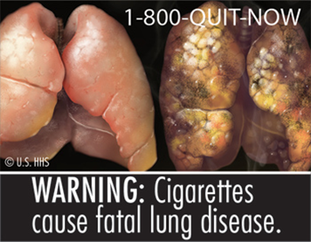
Figure 2.1 Suggested Health Warning to be Placed on all Cigarette Packaging. (Source: CDC)

The figure 2.1 is an example of a suggested health warning label to be placed on all cigarette packaging. These new regulations and images were drafted in compliance with the Family Smoking Prevention and Tobacco Control Act of 2009 and FDA Commissioner Margaret A. Hamburg suggested the “graphic images will give smokers the incentive to quit and prevent potential smokers from ever starting” (FDA, 2011). The FDA contended that these bold graphic images can be seen as a significant advancement in communicating the dangers of smoking (FDA, 2013). However, multiple tobacco companies sued the FDA arguing that the regulation violated their free speech (Bardi, 2012). In the case R.J. Reynolds Tobacco Co. v. Food and Drug Administration, the U.S. District Court Judge Richard J. Leon held that the FDA warning label regulation was a violation of the tobacco companies’ First Amendment rights (Tobacco Control Legal Consortium, 2013). The FDA appealed the decision, but the U.S. Court of Appeals, for the D.C. Circuit, upheld the ruling and found that the warning label regulations exceeded the scope of government authority and violated the First Amendment (Tobacco Control Legal Consortium, 2013). As of March 2013, the FDA decided not to pursue the case any further and instead plans to develop a new graphic warning requirement (Tobacco Control Legal Consortium, 2013).
Requiring warning labels was not the only official step taken against smoking by the FDA. The FDA also used excise taxes and broadcasting bands to discourage smoking cigarettes. “Governments levy excise taxes on cigarettes for two reasons: to raise revenue and to discourage smoking” (Meier and Licari, 1997 pg. 1126). The logic of taxing tobacco is simple. Increasing the tax rate associated with tobacco products increases the cost and presumably will reduce sales (Meier and Licari, 1997). By reducing sales, cigarette prevalence should decrease and fewer people will smoke or be exposed to the health hazards associated with smoking.
Coupled with increased taxes is the idea of greater restrictions on advertising. In 1971 a ban was placed on broadcast cigarette advertising (Bishop and Yoo, 1985). By banning advertisements people, especially adolescents, are not exposed to the “benefits” of smoking, through alluring advertisements (Bishop and Yoo, 1985). Without the influence and romanticism portrayed in advertising, adults and adolescents would be less likely to begin smoking (Chapman, 1996). This acts as a preemptive measure against smoking. If fewer people start smoking the number of adults who smoke should decrease. Thus, exposure to the health hazards associated with smoking should also decrease.
Acknowledging the risk of smoking, educational campaigns, the surgeon general’s warnings, increased taxes, stricter requirements for warning labels and advertising regulations can all be seen as contributing factors in reducing cigarette sales and consumption in the US (Federal Trade Commission, 2013). These factors have worked to reduce the number of people who smoke. This is evident by the trend associated with cigarette sales and cigarette consumption. From 1981 through 2011 cigarette sales reported by cigarette manufacturers exhibited a general pattern of decline dropping from 636.5 billion cigarettes sold in 1981 to 273.6 billion cigarettes sold in 2011 (Federal Trade Commission, 2013). Further, cigarette consumption also exhibited a pattern of decline dropping from 640.0 billion cigarettes consumed in 1981 to 371.0 cigarettes consumed in 2006 (Federal Trade Commission, 2013).
Reducing the Fire Risks Associated with Smoking
Health hazards associated with smoking have led to many different types of policies designed to reduce smoking or to deter people from engaging in this very addictive habit. Besides the immediate adverse health impact on smokers and those exposed to cigarette smoke, another risk associated with cigarette smoking is smoking-related fires. Smoking-related fires are often the result of carelessness in monitoring or extinguishing lighted cigarettes and other smoking materials. This type of careless smoking behavior can have devastating effects both in terms of smoking-related fire incidents and fire losses.
Fires resulting from smoking materials are the leading cause of home structure fire deaths in the U.S. and the third leading cause of home structure fire injuries (Ahrens, 2012). In fact, smoking material fires are responsible for a disproportionate number of fire fatalities and injuries (Leistikow, Martin, and Milano, 2000; Ahrens, 2012). For example, Leistikow, Martin, and Milano (2000) found that in King County Washington, households with a smoker were nearly five times more likely to incur a fire injury when compared to a household without a person who smokes. This pattern is not unique to King County Washington. The US Fire Administration National Data Center (2012) found that the fire death rate for residential smoking material fires is almost eight times higher than the fire death rate for non-smoking residential fires (USFA, 2012). Specifically, the residential smoking-related building fire fatality rate between 2008 through 2010 was 24.2 fatalities per 1000 fires while the non-smoking residential fire fatality rate was only 3.1 fatalities per 1000 fires (USFA, 2012). The fire injury rate exhibited a similar pattern with 91 injuries per 1000 fires occurring in smoking-related building fires and only 25 injuries per 1000 fires occurring in non-smoking-related building fires (USFA, 2012). The dollar loss from smoking-related residential building fires was also higher than the dollar loss associated with non-smoking fires with smoking-related residential building fires generally resulting in twice as much dollar loss per fire when compared to nonsmoking residential building fires (USFA, 2012). These patterns suggest that although smoking material fires account for far fewer fires than operating equipment (42%), heating equipment (17%), and electrical distribution and lighting equipment (6%), there is a much higher risk of fire injury, death, and property loss associated with them (Ahrens, 2012).
A key factor in smoking material fires is cigarettes. Cigarettes are the leading source of ignition in smoking material fires (USFA, 2012). The US fire Administration found that from 2008-2010 cigars or pipes were responsible for 1.7% of residential smoking-related building fires. Heat from an undetermined smoking material was responsible for 12% of residential smoking-related building fires. The remaining 86.3% of residential smoking-related building fires were attributed to cigarettes (USFA, 2012). In response to this situation, policies have been designed to reduce the risk of residential smoking-related fire incidents.
Policies designed to reduce the risks of smoking material fires include the 1953 Flammability Fabrics Act. It was originally implemented to regulate the manufacture of highly flammable clothing such as sweaters. In 1967, the Flammable Fabrics Act was amended to include apparel and home textiles that are deemed an unreasonable flammability risk (UFAC, 1998). In 1968 the National Bureau of Standards examined the flammability risk associated with home textiles such as upholstered furniture and mattresses (UFAC, 1998). This effort led to the Upholstered Furniture Action Council Voluntary Action Program in 1979 (Alpert, 2007; UFAC, 1998). The goal of the Upholstered Furniture Action Council Voluntary Action Program was to acknowledge to fire risks associated with upholstered furniture and to develop construction methods that would make upholstered furniture more fire resistant (UFAC, 1998). Since 1979, flammability policy has continued to evolve until a recent proposal in 2008 (Federal Register 16 CFR Part 1634, 2008).
In 2008, the Standard for the Flammability of Residential Upholstered Furniture required fabrics “not to continue to smolder for longer than 45 minutes or catch fire at any time when a lighted cigarette was placed in the seat and/or back crevice and burns the entire length” (Federal Register 16 CFR Part 1634, 2008 pg. 11705). To comply with this requirement, manufacturers could choose one of two possible methods: (1) utilize a cover material that was sufficiently smolder resistant to withstand the ignition propensity of a lighted cigarette or (2) utilize “fire barriers” that placed between the cover fabric and the interior filling material (Federal Register 16 CFR Part 1634, 2008). This regulation was a response to a research finding that the majority of deaths and injuries resulting from fires involving upholstered furniture started as a result of smoldering ignition sources such as cigarettes (Federal Register 16 CFR Part 1634, 2008).
These policies placed the responsibility of mitigating fire risk on upholstered furniture and furniture producers. All of the policy requirements focused on the flammability of products not the cigarette itself even though they represent the leading ignition source in residential smoking-related fires (USFA, 2012).
The Evolution of the Fire Standard Compliant Cigarette Policy
Recognizing the impact of cigarettes on fire incidents, New York State adopted standards developed by a Congressional study commission and implemented Fire Safety Standards for Cigarettes (FSSC) in 2004 (Alpert, 2007). This act became the model legislation for all other states. Although New York State was the first to adopt and implement Fire Standard Compliant cigarette policies in 2004, the genesis of the policy occurred much earlier. In 1929, a fire caused by a cigarette caught the attention of U.S. Congresswoman Edith Nourse Rogers. Cigarettes were identified as a potential fire hazard, and Rogers “encouraged” the National Bureau of Standards (NBS) to begin research into the development of a “self-snubbing” cigarette (McGuire, 2005). By 1932, the NBS succeeded and developed a self-snubbing cigarette (Coalition for Fire Safe Cigarettes, 2011a). The NBS suggested that cigarette manufactures voluntarily adopt the use of self-snubbing cigarettes, but since the suggestion was not a formal requirement, no cigarette manufactures adopted the use of a self-snubbing cigarettes and the self-snubbing cigarette movement died (McGuire, 2005; Coalition for Fire Safe Cigarettes, 2011a).
Although the production of self-snubbing cigarettes was not required in the 1930s, cigarettes began to be recognized as a preventable factor in fire incidents. By 1947, the National Fire Protection Association urged cigarette manufactures to take some responsibility for the smoking-related fire problem, but cigarette manufacturers remained silent on the issue (Bardeau, Kelder, Ahmen, Mantuefel, and Balbach, 2005; Alpert, 2007). While cigarette manufactures would not publically respond to calls to take responsibility, professional organizations and representatives attempted to move forward by generating public interest and drafting fire safe cigarette legislation. The first bill requiring fire safe cigarettes was introduced in 1974 by Senator Phil Hart of Michigan (Bardeau et al., 2005). The legislation passed the senate but failed in the House of Representative (Bardeau et al., 2005). In 1979, attempts to regulate the ignition propensity of cigarettes continued when U.S. Representative Joe Moakley (D-MA) proposed legislation that authorized the federal Consumer Product Safety Commission to regulate cigarettes as a fire hazard (Sweda, 2010). Although opposed by the tobacco industry, this proposal moved forward in 1984 when President Ronald Regan signed an amended version of Moakley’s Cigarette Safety Act (McGuire, 2005).
The Cigarette Safety Act of 1984 allocated $3 million in research funds to determine whether a reduced ignition propensity cigarette was technically and economically feasible (Sweda, 2010; McGuire, 2005). The research effort was overseen by a fifteen member Technical Strategy Group (TSG). The TSG was comprised of representative from the tobacco and furniture industries, the federal government, medical interests, and fire service professionals (Barillo, Brigham, Kayden, Heck, and McManus, 2000). The three year study concluded that the development and production of fire safe cigarettes was economically and technically feasible (Barillo et al., 2000; McGuire, 2005). In 1989, development of the fire safe cigarette legislation continued at the federal level when President George H.W. Bush signed the Fire Safe Cigarette Act of 1989. The Fire Safe Cigarette Act of 1989 specified that the same TSG would oversee the development of a fire safety test method used in creating fire safety performance standards (Sweda, 2010). By 1993, a test method had been developed, but representatives from cigarette companies disputed the validity of the test method (Coalition for Fire Safe Cigarette history; Barillo et al., 2000; Sweda, 2010). The Fire-Safe Cigarette Act of 1994 proposed that the US Consumer Product Safety Commission establish a fire safe cigarette standard (Barillo et al., 2000). The bill was unsuccessful and stalled in Congress in 1994. Moakley reintroduced the bill in 1999 but the outcome was the same.
The federal government was not the only governing body interested in fire safe cigarettes. By the late 1970s many legislatures also recognized cigarettes as a fire hazard (Sweda, 2010). In 1980, Oregon became the first state to propose fire safe cigarette legislation. By 1983, eight more states had proposed similar legislation requiring fire safe cigarettes (Coalition for Fire Safe Cigarettes, 2011a). Prior to 2000, California, Rhode Island, Maine, Alabama, Hawaii, Alaska, New Jersey, Pennsylvania, Wisconsin, Minnesota, Washington, New Hampshire, Vermont, Texas, Colorado, Georgia, and Kansas recognized cigarettes as a fire hazard and considered fire safe cigarette legislation (Coalition for Fire Safe Cigarettes, 2011; Barillo, 2000). However, no fire safe cigarette policy proposal was successful at the state level until 2000 when t New York became the first state to enact a fire safe cigarette law that eventually became the model for all states.
New York State’s Fire Safety Standards for Cigarettes (FSSC) were implemented in 2004. The FSSC require cigarettes to meet a fire safety performance standard. Cigarettes that adhere to fire standard compliant legislation are considered fire standard compliant or fire safe cigarettes (FSC). To be classified as a FSC, an unattended cigarette must self-extinguish before it burns its entire length (Coalition for Fire Safe Cigarettes, 2012). To test for compliance a manufacturer must submit cigarettes for a test trial. In the test trial, no more than 25% of the cigarettes tested can exhibit a full length burn when left unattended (Coalition for Fire Safe Cigarettes, 2012). If this standard is not met the cigarette brand will fail the certification test. Any manufacturer who knowingly sells non-fire standard compliant cigarettes is subject to a 100 dollar fine for each pack sold up to 100,000 dollars during a thirty day period. Any retailer who knowingly sells non-standard compliant cigarettes is subject to a 100 dollar fine for each pack sold up to 25,000 dollars during a thirty day period (Coalition for Fire Safe Cigarettes 2012).
Vermont implemented fire standard compliant legislation in 2006 and was followed by California, Oregon, and New Hampshire in 2007. By July 1, 2011, all fifty states had implemented a form of the fire standard compliant legislation largely patterned after the New York model law (Coalition for Fire Safe Cigarettes, 2012).
Achieving a fire standard compliant certification requires that 75% of unattended cigarettes tested self-extinguish before a full length burn. To ensure a cigarette will self-extinguish a cigarette manufacturer must modify the burn rate of a cigarette. The burn rate of a cigarette is determined by multiple factors such as, the circumference of the cigarette, the packing density of the tobacco, the propensity of the paper and if the cigarette has a filter or not (Barillo et al., 2000). Altering any of these factors has the potential to affect the cigarette burn rate as well as the propensity to start a fire. In most cases the cigarette self-extinguishing qualification is accomplished through the use of lower permeability bands in the cigarette paper (Hall, 2012). These bands act as “speed bumps” in the cigarette wrapping and require the smoker to continue to puff on the cigarette in order to keep it lit. Without regular puffing the cigarette with self-extinguish once a burning cigarette reaches one of the speed bumps. Using lower permeability bands or speed bumps to reduce propensity may be successful, but if the placement of the speed bumps is not consistent it may also yield inconsistent burn rates and cigarette burn lengths (David Icove, personal correspondence May 2, 2014). Although burn length consistencies may be a factor, these criteria are still designed to reduce the burn time and the ignition propensity of cigarettes. As a result, the likelihood of an unattended cigarette igniting other material, such as upholstered furniture or bedding, is reduced and the risk of smoking material fires occurring is reduced. Sources are optimistic about the effectiveness of the FSC legislation and it has been suggested that once all 50 states have implemented the FSC policy smoking material fire deaths will be reduced by 30% in relation to the level of death experienced in 2003 (Hall, 2012).
The rationale for a FSC is similar to other technological innovations designed to mitigate risk. Most residential fires started by smoking materials can be attributed to risky, carless, or impaired behavior on behalf of the smoker. For example, a person falling asleep while smoking and dropping a lighted material on a burnable surface is the most common cause of fire deaths when a fire is ignited by a smoking material (Hall, 2012). Drug or alcohol impairment is the second most common cause of ignition, contributing to 19% of fire deaths when a fire is ignited by a smoking material (Hall, 2012). When mitigating risk, it is impractical to remove all fuel sources such as mattresses or upholster furniture. Federal regulations and voluntary industry safety standards have made mattresses and upholstered furniture more fire resistant, but they still are not fireproof. Since many smoking-related fires stem from careless behavior, making unattended cigarettes less risky is a logical policy course (Connolly, Alpert, Rees, Carpenter, Wayne, and Koh, 2005). This technical fix designed to make cigarettes “safer” should result in a reduction of smoking-related fires associated with careless behaviors among smokers.
Are the FSC Laws Effective?
Research has consistently identified cigarettes as a factor in fire incidents and losses (Sapp, Huff, Gary, Icove, and Horbert, 1994; Istre, McCoy, Osborn, Barnard and Bolton, 2001; Ahrens, 2012; USFA, 2012; Hall, 2012). Acknowledging the fire risks posed by cigarettes, state FSC policies have been developed and implemented in all 50 states. Although FSC policies have been widely accepted, few studies have evaluated the effectiveness of the states’ FSC policy (Coalition for Fire Safe Cigarettes, 2011b; Frazier, Schaenman, and Jones, 2011; Alpert, Christiani, Orav, Dockery, Connolly, 2014; Folz and Shults, 2014). Much of the FSC research has focused on the economic and technical feasibility of FSC cigarettes, not their effectiveness (Sweda, 2010; Connolly, Alpert, Rees, Carpenter, Wayne, Vallone, and Koh, 2005; Bardeau, Kelder, Ashmed, Matuefel, and Balbach, 2005; Gunta, Wayne, Landman, Connolly, and McGuire, 2002; Barrillo et al., 2000). The goal of this dissertation is to fill that gap in the FSC policy literature and determine whether the FSC legislation enacted by the states is actually effective.
While the FSC legislation was designed primarily to reduce smoking-related fire deaths in structures, the law also should lead to a reduction in smoking-related fire injuries and smoking-related fire incidents. Some reports suggest that the policy has been effective. A National Fire Protection Association (NFPA) study found that New York State has had a “significant reduction” in cigarette related fire deaths since the implementation of the FSC law (Coalition for Fire Safe Cigarettes, 2011b). The study found that from 1997-2003 New York experienced an average of 42 smoking-related fire deaths per year. During this time period, the highest smoking-related fire deaths occurred in 1997 when 49 people died in smoking-related fires. The next highest total smoking-related fire deaths occurred both in 2000 and 2001 when 45 died as a result of a smoking-related fire (Coalition for Fire Safe Cigarettes, 2011b). In 2003, one year prior to the implementation of the FSC policy, 38 people died as a result of a smoking-related fire. In 2004, the year the FSC policy was implemented, the smoking-related fire death annual total dropped to 31 (Coalition for Fire Safe Cigarettes, 2011b). In 2005, the annual smoking-related fire death total increased slightly to 33, but the 33 smoking-related fire deaths is still lower than any other smoking-related fire death annual total that occurred pre-FSC policy implementation, during the study period. After 2005, annual smoking-related fire death totals continued to exhibit a general pattern of decline and in 2009, only 21 smoking-related fire deaths were reported in New York (Coalition for Fire Safe Cigarettes, 2011b).
The NFPA argued that these early results were “extremely positive” but also acknowledged that a more extensive study would be required to ascertain the full impact of the FSC legislation. Acknowledging this limitation, some may argue that finding “extremely positive” results and attributing them to fire safe cigarettes may be premature or even erroneous. This point is supported by the work of Frazier, Schaenman, and Jones (2011). Frazier, Schaenman, and Jones (2011) acknowledged that smoking-related fire deaths decreased but criticized the coalition for Fire Safe Cigarette report arguing that the use of count data overlooks the overall trends in smoking behavior and misrepresents the success of the FSC policy in New York State. Accounting for the decreasing trend in number of people who smoke, Frazier, Schaenman, and Jones (2011) evaluated the effectiveness of reduced ignition propensity, also known as, fire safe cigarettes in reducing cigarette ignited fires. Specifically, they looked at the association between fire safe cigarettes and smoking-related fires and deaths in Ontario and Alberta, Canada and New York State.
In Ontario, Canada smoking-related fires, as well as fire incidents in general, exhibited a pattern of decline from 2000 through 2009. This downward trend is present both before and after the implementation of the FSC standards in 2005 (Frazier, Schaenman, and Jones, 2011). More specifically, from 2000 through 2004 smoking-related fires decreased by about 17%. After the implementation of FSC standards in 2005, there was no real change in the decreasing pattern of smoking-related fire incidents (Frazier, Schaenman, and Jones, 2011).
Smoking-related fire losses exhibited a similar pattern. Between 2000 through 2009 smoking-related fire losses declined. However, there was not a significant change in the pattern of decline after FSC policy implementation in 2005 (Frazier, Schaenman, and Jones, 2011). The findings suggest that the implementation of FSC standards did not have an independent effect on smoking-related fire incidents or fire losses. The decreases in fire incidents and fire losses could be attributed to an overall pattern of decline in smoking incidents most likely attributed to a decrease in the number of people who smoke (Frazier, Schaenman, and Jones, 2011).
According to Frazier, Schaenman, and Jones (2011) Alberta, Canada exhibited similar smoking-related fire loss characteristics between 1998 through 2008. . Between 1998 through 2008 this province experienced a decline in the incidence of all fires, including those ignited by cigarettes (Frazier, Schaenman, and Jones, 2011). The number of smoking-related fires declined by about 60% from 1998 through 2008. At first glance, this decline suggests a positive impact associated with of FSC standards. However, the majority of the decline in smoking-related fires occurred prior to 2003. The FSC policy standards actually were enacted in 2005. After 2005, fires caused by cigarettes increased slightly with more fires caused by cigarettes in 2008 than during the previous five years (Frazier, Schaenman, and Jones, 2011). This pattern suggested that the FSC policy had no independent effect on smoking-related fire incidents in Alberta, Canada.
In Alberta, smoking-related fire deaths and injuries exhibited a pattern similar to fire incidents. Smoking-related fire deaths wavered between 2 and 10 fire deaths per year with a peak of 10 smoking-related fire deaths in 2001 (Frazier, Schaenman, and Jones, 2011). Smoking-related fire deaths increased from three in 2005 to five in 2008 (Frazier, Schaenman, and Jones, 2011). With so few smoking-related fire deaths, Frazier, Schaenman, and Jones, (2011) suggested that enactment of the FSC policy was unrelated to cigarette-ignited fire deaths. Data on smoking-related fire injuries also suggested that that any reduction in injuries could not be attributed to FSC standards. Smoking-related fire injuries exhibited a downward trend from 1999 through 2008 with injuries declining by 65% (Frazier, Schaenman, and Jones, 2011). Although there was a general pattern of decline in the number of smoking-related fire injuries over the study period, the pattern of decline was not different after 2005. The trend in smoking-related fire injuries from 1999 to 2005 was not significantly different from the trend after 2005 which suggested that the FSC law had not impact (Frazier, Schaenman, and Jones, 2011). Thus, the implementation of FSC standards apparently had no impact on decreasing smoking-related fire incidents, deaths, or injuries in Alberta, Canada.
In New York State, smoking-related fire deaths exhibited a general pattern of decline between 2000 through 2007. This trend suggested that the FSC standards in 2004 may have had some impact. However, when one takes into account the general pattern of decline exhibited over the entire study period, the effect, if any, of the FSC standards is not clear. Between 2000 through 2004, the number of smoking-related fire deaths decreased 31% from 45 to 31 (Frazier, Schaenman, and Jones, 2011). Between 2005 through 2007, the number of smoking-related fire deaths decreased from 33 to 27, an 18%reduction. Frazier, Schaenman, and Jones (2011) suggest that these trends show that the FSC policy may not have had any independent effect on smoking-related fire deaths.
In analyzing the three case studies in North America, Frazier, Schaenman, and Jones, (2011) concluded that the implementation of FSC policy standards had no effect on smoking-related fire incidents, injuries, or deaths. On the other hand, Alpert, Christiani, Orav, Dockery, Connolly (2014) found that the FSC policy standards did have an effect on smoking-related fires. Alpert et al. (2014) looked specifically at smoking-related fire incidents and smoking-related fire deaths in Massachusetts between 2004 through 2010. Massachusetts implemented FSC standards in 2008. Alpert et al. (2014) considered 2004 through 2007 to be pre-FSC policy years and 2008 through 2010 to be the post-FSC policy years. Analyzing unintentional, residential smoking-related fires, Alpert et al. (2014) concluded that FSC policy implementation decreased the likelihood of a smoking-related fire incident occurring by 28%. This suggests that FSCs are performing well and are decreasing the likelihood of a smoking-related fire occurring. Although a decrease in the likelihood of an incident occurring can be attributed to the FCS policy, Alpert et al. (2014) found no significant relationship between the FSC policy and smoking-related fire deaths. These findings suggest that the FSC policy substantially decreased the number of smoking-related fire incidents caused by cigarettes even if smoking-related fire deaths were not affected by the FSC policy (Alpert et al., 2014).
The conflicting findings by Frazier, Schaenman, and Jones (2011) and Alpert et al. (2014) offer mixed results about whether the FSC policy is effective. While Frazier, Schaenman, and Jones (2011) found no significant relationship between FSC policies and smoking-related fires, Alpert et al. (2014) found that FSC policies only influenced the likelihood of occurrence of fire incidents. A limitation shared by these studies is that they are case studies of individual states or provinces with a small number of observations. A small number of observations always makes it more difficult to detect a significant connection between variables, in this case the impact of an FSC policy and smoking-related fire losses. Alpert et al. (2014) acknowledged this limitation to explain why there was no significant relationship between the FSC policy and smoking-related fire deaths.
In a broader approach, Folz and Shults (2014) examined the relationship between the states’ FSC policies and the rate of smoking-related civilian fire deaths between 2005 and 2011. Folz and Shults (2014) analyzed the impact of the states’ FSC policy on unintentional civilian residential smoking-related fire deaths in 49 states in the U.S. The data showed that when controlling for factors such as, the adult smoking rate, housing stock and other population demographics the FSC policy still had a statistically significant effect on reducing smoking-related fire deaths. The impact was only modest but still significant. This suggests that FSC policies did help to reduce smoking-related fire deaths.
SUMMARY
Smoking is associated with variety of health hazards. Smoking-related fires for instance are the leading cause of home structure fire deaths in the U.S. and the third leading cause of home structure fire injuries (Ahrens, 2012). In response to smoking-related fire hazards, all states have implemented fire safe cigarette policies. What is not yet clear is the impact, if any, of these policies on smoking-related fire incidents and losses. The findings from the few extant studies are mixed. This dissertation examines whether the FSC policy adopted by the states had the desired impact of reducing smoking-related fire incidents and injuries. A systematic analysis of the state FSC policies will enable policy makers to choose an appropriate course of action in the continuing effort to protect and advance the public’s welfare and safety.

Chapter 3
Data and Methods
Introduction
This dissertation examines the relationship between the states’ fire safe cigarette policy and smoking-related fires from 2005 through 2012. To explore the potential connection between the state’s policy (independent variable) and various aspects of smoking-related fires (the dependent variables), it is necessary to collect data information about specific fire incidents and the various features and characteristics of the states (the unit of analysis) where these fire incidents occur. Incident data provide specific information about each recorded fire incident that occurs annually in each state. Incident data indicate the fire incident characteristics and features that distinguish smoking-related fire incidents and provide the means to calculate the dependent variables for each of the states in this study: a smoking-related fire incident rate, a smoking-related fire injury rate, and a smoking-related fire death rate. These three measures are the main dependent variables in the study. Annual incident data were gathered for 2005 through 2012 for each of the civilian, unintentional, smoking-related fires that occurred in each state. The U.S. Fire Administration (USFA) National Fire Data Center which maintains the National Fire Incident Reporting System (NFIRS) is the source for these data.
State level data were collected for various demographic, housing, and economic features as measured by the US Census in order to examine the various contextual factors in the states that might be related to the dependent variables in the study. The data source for the annual estimates of state profile features is the American Community Survey (ACS) one year estimates for 2005 through 2012. Information about the FSC policy was obtained from the Coalition fir Fire Safe Cigarettes. These data were used to generate the fire safe cigarette policy variable, which is the main independent variable in the study.
Of particular interest in this study are the patterns of change in the state rates of smoking-related fire incidents, fire injuries, and fire deaths from 2005 through 2012. Observations over time for the same units (states) are panel data that have both time-series (longitudinal) and cross-sectional dimensions. Several issues must be addressed when analyzing panel data to avoid the possibility of generating biased estimators (Beck and Katz, 1995; Wooldridge, 2009). Although panel data may have some structural issues, once these issues are corrected these data are still very useful for policy analysis (Wooldridge, 2009). The software used to analyze the data in this study are Excel, the Statistical Package for the Social Sciences (SPSS) and Stata.
Incident Data
National Fire Incident Reporting System (NFIRS)
When exploring the possible factors that might be connected with the rate of smoking-related fire incidents, injuries, and deaths, it is important to examine the characteristics of the fire incidents themselves. The fire incident data were obtained from the U.S. Fire Administration (USFA) National Fire Data Center. USFA maintains the National Fire Incident Reporting System (NFIRS). NFIRS was established in 1975 (USFA 2009). Since 1975, the basic goal of NFIRS has been to gather and maintain information on fire department activities in the U.S. When a fire department responds to a call, a fire service worker collects a common core of information about the incident and any injuries and casualties resulting from the incident (USFA, 2009). The information collected can include things such as: the type of property involved in the incident, the location of the incident, the cause of the fire or incident, how many firefighters responded and what type of materials and equipment were used to respond to the incident. Casualty and injury information can include the victim’s age, race, and gender. It also can include the location and time of the incident. The information available for any fire incident depends on the data entered by the individual(s) assigned that responsibility by the primary responding fire department. These completed reports are supposed to be submitted by the fire department to the relevant state agency responsible for collecting NFIRS data (USFA, 2009). These state agencies use these reports to create a statewide NFIRS database each calendar year. These completed state data records are supposed to be submitted to the National Fire Data Center (NFDC) at USFA (USAF, 2009). The NFDC creates an incident data archive that provides the basis for a variety of studies related to the fire service and fire protection (USFA, 2009). The level of detail in the NFIRS data enables researchers to examine incidents and to identify factors that may be related to smoking-related fires. These data represent a primary resource that researchers have to examine a range of issues related to public safety, fire protection and fire engineering.
The state reports collected by the NFDC are based on incident data submitted voluntarily by fire departments in each state. The designated agency in each state is then supposed to submit the statewide NFIRS data to the NFDC. However that participation is also voluntary. The level of participation by the states has varied since the inception of NFIRS in 1975. In 1976, only six states reported NFIRS data to the NFDC (USFA, 2009). By 2007 however, all 50 states voluntary reported NFIRS data and that level of participation continues (USFA, 2009).
A more problematic aspect of the NFIRS data concerns the variation over time in the level of voluntary reporting by the fire departments within each state. For example, in 2007 only about 13% of fire departments in Rhode Island reported data about their fire incidents using the to the NFIRS template. Similarly, only about 27% of Nevada fire departments reported incidents to the relevant state agency (USFA, 2009). On the other hand, about 97% of fire departments in West Virginia reported their fire department activities using the NFIRS forms to the state Fire Marshall. Likewise, about 95% of Ohio fire departments reported fire incidents to their state Fire Marshall (USFA, 2009). The state fire department reporting rates are shown in table 3.1.

Table 3.1 Fire Departments Reporting to NFIRS v. 5.0 in 2007
State | Percent of Reporting Fire Department to NFIRS v. 5.0
Alabama | 32%
Alaska | 48%
Arizona | 23%
Arkansas | 59%
California | 48%
Colorado | 59%
Connecticut | 89%
Delaware | 98%
Florida | 56%
Georgia | 45%
Hawaii | 100%
Idaho | 68%
Illinois | 77%
Indiana | 85%
Iowa | 37%
Kansas | 78%
Kentucky | 59%
Louisiana | 22%
Maine | 41%
Maryland | 61%
Massachusetts | 92%
Michigan | 75%
Minnesota | 53%
Mississippi | 90%
Missouri | 61%
Montana | 43%
Nebraska | 46%
Nevada | 27%
New Hampshire | 65%
New Jersey | 82%
Table 3.1 Fire Departments Reporting to NFIRS v. 5.0 in 2007 Continued
State | Percent of Reporting Fire Department to NFIRS v. 5.0
New Mexico | 50%
New York | 55%
North Carolina | 63%
North Dakota | 49%
Ohio | 95%
Oklahoma | 45%
Oregon | 73%
Pennsylvania | 31%
Rhode Island | 13%
South Carolina | 63%
South Dakota | 25%
Tennessee | 82%
Texas | 41%
Utah | 53%
Vermont | 70%
Virginia | 78%
Washington | 76%
West Virginia | 97%
Wisconsin | 50%
Wyoming | 64%
Source: USFA, 2009
Despite the reporting variation within states, the NFIRS system as a whole still captures about 75% of all fires that occur annually (USFA, 2013). Consequently, while the NFIRS records are not a complete census of every fire incident, injury or death, these data represent the best available source of information about individual fire incidents in the states.
Data Format
NFIRS has collected fire-related data since the 1970s. Beginning in 2005 fire reports had to follow a new format specified in version 5.0 of the NFIRS manual that guides report coding into several distinct data modules (USFA 2008). Due to differences in data coding schemes with the earlier NFIRS reporting system (version 4.1), USFA personnel suggested using data from 2005 and later for this study (Lawler, 2011).
NFIRS reports provide extensive information about a variety of topics related to fire incidents. For example, the “arson” data section seeks to collect specific information about the possibility of arson. The “basicincident” file provides information that is considered basic to an incident investigation such as the area of origin and location of the incident. Each “file” in the system contains some information about an incident, but no one file contains all incident information. To obtain a complete profile of the fire incidents, data from various forms (files) were merged into one data set for analytical purposes. The three data forms used for this dissertation include the “basicincident” file, the “fireincident” file, and the “casualtycivilian” file. Each file contains five unique identifiers for incidents. These identifiers were used to merge the files into one working file.
Incident Case Selection
This study focuses specifically on civilian, unintentional, residential fire incidents, injuries, and deaths. The use of screens assured that the final data file for analysis contained just those fire incidents that were civilian, unintentional, and residential in nature. The variable “sev” from the civilian casualty file was utilized; this is a measure of the severity of any injury (USFA, 2008). Values associated with sev range from 1, meaning the injury was classified as minor with no danger of death or permanent disability, to 5, meaning the incident resulted in the death of an individual (USFA, 2008). A letter “U” signified that the severity of the injury was undetermined. Any incidents that did not have a “sev” value of 1 through 5 or a U were considered to not involve a civilian and were not included in the final data file.
To assure the data contained only unintentional fire incidents and not cases that resulted from arson, the variable “cause_ign” was used. “Cause_ign” indicates the conditions associated with the ignition of the fire (USFA, 2008). “Cause_ign” values range from 1 through 5 with U being undetermined. A value 1 indicated that the fire was considered intentional and classified as arson. If an incident had a “cause_ign” value of 1 it was not included in the final data file.
To assure the incidents involved a residential structure fire as opposed to a fire in a vehicle or business, the variables “inc_type” and “prop_use were used. “Inc_type” classifies the type of incident to which emergency personnel responded (USFA, 2008). Incidents that involved a structure fire are coded in the 100-123 range. These types of incidents range from a fire in a mobile home to any type of fire that occurred in a structure. Any incident that was not coded as involving a structure fire was not included in the final data file. To assure that incidents included just residential structures the variable “prop_use” was used. “Prop_use” indicates the use of property involved in the incident (USFA, 2008). Properties considered to be residential are coded in the 400-499 range. Any incident that was coded outside this range was not included in the final data file.
On some occasions, multiple fire departments may respond to the same incident. This may occur because of the proximity of a fire department to an incident, the presence of mutual aid agreements, or the severity of the incident (USFA, 2008). Each responding fire department is responsible for reporting its activity to NFIRS. If multiple fire departments respond to the same incident, multiple incidents reports may have been submitted to NFIRS even if all of the reports pertain to the same incident. To eliminate the possible double or triple counting of a fire incident, the variable “aid” was used to determine whether a fire department provided or received aid from a neighboring fire department (USFA, 2008). To eliminate multiple reports of the same incident, incidents with an “aid” value of 3, meaning mutual aid was given to an outside fire service entity on request, or 4, meaning fire departments were automatically dispatched to give aid to a neighboring fire service entity, were excluded from the merged data file.

Key Variables
Generating Smoking-Related Fire Incident, Injury, and Death Count Totals
The smoking-related fire death totals for each state are calculated from NIFRS v 5.0 data for 2005 through 2012. This smoking-related fire death count is used to generate the smoking-related fire death rate (the dependent variable). The smoking-related fire deaths represent a subset of the total deaths from fires for each state in each year. Fire incidents that involved one or more deaths had a “sev” variable value of 5 which indicated a victim death. A death was considered smoking-related if the variable “heatsource” had a value of 60, 61, 62 or 63. These values indicated that a smoking material such as a cigarette was the source of heat involved in ignition. This method for determining if a fire was smoking-related was applied to all three dependent variables.
The smoking-related fire injuries for each state are calculated from NIFRS v 5.0 data for 2005 through 2012. This smoking-related fire injury count is used to generate the smoking-related fire injury rate (the dependent variable). The smoking-related fire injuries represent a subset of the total fire injuries in each state for each year. A fire incident was considered to have a fire injury if the “sev” variable had a value less than 5 which indicated the victim was injured but did not die. If a fire related injury was considered a smoking-related if it met the criteria discussed above.
Another dependent variable in this study is the state smoking-related fire incident rate. Smoking-related fire incidents for each state are also calculated from NFIRS v 5.0 data for 2005 through 2012. The smoking-related fire incidents are a subset of the total fire incidents in each state for each year. The use of the screens previously described assures that every incident in the final combined data file represents a non-arson caused civilian residential fire incident. A fire incident was considered a smoking-related fire incident if it met the criteria discussed above. The smoking-related fire incident count is used to generate the smoking-related incident death rate (the dependent variable).
Operationalization for the FSC Policy
The primary independent variable in the study is the states’ FSC policy. New York was the first state to pass FSC legislation in 2004. New York was followed by Vermont in 2006, and then California, Oregon, and New Hampshire in 2007. As of 2011 all 50 states have passed state FSC legislation as illustrated by Table 3.2.

Table 3.2. Year State Fire Safe Cigarette Policies Went Into Effect
2004 | 2006 | 2007 | 2008 | 2009 | 2010 | 2011
New York | Vermont | California  Oregon  New Hampshire | Illinois  Maine  Massachusetts  Kentucky  Montana  New Jersey  Connecticut  Maryland  Utah  Alaska  Rhode Island  Minnesota | Delaware  Iowa  Oklahoma  Pennsylvania  Texas  Idaho  Indiana  Kansas  West Virginia  Colorado  Arizona  Washington  Louisiana  Hawaii  Wisconsin | Alabama  Arkansas  Florida  Georgia  Michigan  Nebraska  New Mexico  North Carolina  South Carolina  Tennessee  Virginia  Ohio  Nevada  Mississippi  North Dakota | Missouri  South Dakota  Wyoming

The FSC policy is operationalized as a binary variable. A value of 0 represents the absence of the FSC policy and a value of 1 represents the presence of the law. The policy effect for a given year is the measure of key interest, but most policy changes did not occur on January 1st. To capture the effect of a policy shift throughout the year, two approaches were used. In one approach the policy variable is coded as a 1 for the year if the policy became effective prior to July 1st and a 0 if the policy became effective on or after July 1st. This approach is labeled as FSC Policy 1. In a second approach the binary policy variable is coded as the proportion of days for which the law is in effect (Houston and Richardson, 2006). This approach is labeled as FSC Policy 2. Two approaches to measuring the FSC policy were used to address any concern about measurement consistency. The data, in this study, are gathered for each year and are yearly averages. For a time consistent policy measure a simply binary variable (FSC policy 1) is used to capture the effective policy for each year. Although FSC policy 1 may be consistent it may not be the best approach for measuring the effectiveness of the FSC policy because the states’ FSC policy takes effect at differing times throughout the year. To capture the effectiveness of the FSC policy, as accurately as possible, the actual proportion of the year the policy was in effect is also measured as FSC policy 2 (Folz and Shults, 2014). The FSC policy 2 measure is considered to be more accurate and will be the measured used in this study. Information about the states’ fire safe cigarette laws was obtained from the Coalition for Fire-Safe Cigarettes.
Operationalization of the State Adult Smoking Rate
Another critical variable for this study is the adult smoking rate. From 2005 through 2010 data on the annual adult smoking rate by state were gathered from the annual Behavioral Risk Factor Surveillance System (BRFSS) survey. In 2011, the methodology for selecting the BRFSS sample changed. Due to the changes in sampling procedures and different weighting methods, the BRFSS 2011 survey reported significantly higher estimates of annual adult smoking rates than previous surveys (CDCP 2012a). For example, California has exhibited a decreasing pattern in the percent of adults who smoke. In 2005, 15.2 percent of the adult population smoked. By 2010, that smoking rate had dropped to 12.1 percent, with every year experiencing a decrease. In 2011, the percent of adults who smoke was reported to be 13.7 percent by the BRFSS. Because of these methodological differences, 2011 and 2012 data cannot be compared to previous years (CDCP 2012b). This is problematic for analyzing smoking-related fires because there is an established connection between smoking and home fire incidents, injuries and deaths (Hall, 2012; NFPA, 2010; Sweda, 2010; and Alpert, 2007). Because of this connection, it is important to include state smoking rates in any analysis of smoking-related fires.
Acknowledging the methodology differences, 2011 and 2012 data from the BRFSS survey data were not used. Instead, a percent of adults who smoke variable for 2011 and 2012 was computed for each state. The 2011 percent of adults who smoke variable was computed using a method of extrapolation. To compute each state’s 2011 smoking rate, the annual average amount of change in smoking rates between 2005 and 2010 were added to or subtracted from the state’s 2010 smoking rate. To compute the 2012 percent of adults who smoke rate, the annual average amount of change in smoking rates between 2005 and 2011 were added to or subtracted from the state’s 2011 smoking rate. This estimation method allows for comparability with previous measures when data are not available or data are not compatible overtime (Roth, 1994; Schafer and Graham, 2002).
State Characteristics
State characteristics are also important in understanding residential smoking-related fire risks. Such factors have to be included in the evaluation of any independent effect of the FSC legislation on smoking-related fire incidents, injuries and deaths. State characteristics, that may be associated with the occurrence of smoking material fires and subsequent fire deaths and injuries include: housing stock (Eisenberg, 2005; Istre, McCoy, Osborn, Barnard and Bolton, 2001), level of income (Hannon and Shai, 2003; Istre et al., 2001), education (Eisenberg, 2005), age (USFA, 2009, Istre et al., 2001), gender (USFA, 2009, Istre et al., 2001), and race (USFA, 2009, Istre et al., 2001).
Data on particular state demographic, housing and economic characteristics were collected from the American Community Survey’s (ACS) one year estimates for 2005 through 2012. The ACS is an annual nationwide survey that samples about t one in every 38 U.S. households. About two million people respond each year (U.S. Census Bureau, 2014; U.S. Census Bureau, 2008). The ACS survey provides information about the demographic, housing, social, and economic characteristics of communities and states. The information collected by the ACS include: respondents’ race, sex, age, income, marital status, and value of housing as well as other information (U.S. Census Bureau, 2008). The main purpose of the ACS data is to monitor trends in society and measure the changing social and economic characteristics of the U.S. population (U.S. Census Bureau, 2008). In this sense, the ACS is a “moving video image” that is continuously updated to provide timely information (U.S. Census Bureau, 2008).
Methods
The first stage of the analysis describes residential smoking-related fire incidents, injuries and deaths in the U.S. between 2005 and 2012 and identifies the factors associated with each of these dependent variables. The second stage of the analysis examines the potential independent effect of the state FSC policy on residential smoking–related incidents, injuries, and deaths controlling for the effect of other variables included in the models. A summary of the operational definitions for all of the variables used in the study appears in Table 3.3 and the descriptive statistics for variables used in the study appears in table 3.4.

Table 3.3 Variable name and operational definition.
Variable Name | Operational Definition
Smoking Related Fire Death Rate | The total number of smoking-related deaths divided by the total population for each state, for each year of the study. This annual rate is multiplied by 1,000,000.
Smoking Related Fire Injury Rate | The total number of smoking-related injuries divided by the total population for each state, for each year of the study. This annual rate is multiplied by 1,000,000.
Smoking-Related Fire Incident Rate | The total number of smoking-related incidents divided by the total population for each state, for each year of the study. This annual rate is multiplied by 1,000,000.
FSC Policy 1 | A value of 0 represents the absence of the FSC policy and a value of 1 represents the presence of the law. To capture policy shifts that occur during a year the policy variable is coded as a 1 for the year if the policy became effective prior to July 1st and a 0 if the policy became effective on or after July 1st.
FSC Policy 2 | A value of 0 represents the absence of the FSC policy and a value of 1 represents the presence of the law. To capture the policy shifts that occur during a year the policy variable is coded as the proportion of days for which the law is in effect.
Adult Smoking Rate | The percent of adults who smoke in each state.
Gender | The percent of the population male in each state.
Race | The Percent of the population African American in each state.
Housing Stock | Percent of the structures built post 1999 in each state.
Educational Attainment | Percent of the population with a high school degree or higher in each state.
Income | Median household income in each state.
Table 3.4 Descriptive Statistics for the variables in the study.
 | N | Minimum | Maximum | Mean | Std. Deviation
Smoking-Related Death Rate | 392 | .00 | 9.57 | .7168 | .96305
Smoking-Related Injury Rate | 400 | .00 | 16.60 | 2.2091 | 1.73996
Smoking-Related Incident Rate | 400 | .00 | 10.94 | 2.3135 | 1.55089
FSC Policy 1 | 400 | .0 | 1.0 | .460 | .4990
FSC Policy 2 | 400 | .00 | 1.00 | .4746 | .48447
Percent of Adults Who Smoke | 400 | 8.30 | 28.70 | 18.9135 | 3.61788
Percent Structures Built Post 1999 | 400 | 2.92 | 32.70 | 12.8624 | 5.33825
Percent Population Male | 400 | 48.1 | 52.3 | 49.321 | .7393
Percent Population African American | 400 | .3 | 37.9 | 10.212 | 9.5015
Percent Population with a High School Degree or Higher | 400 | 77.9 | 92.8 | 86.658 | 3.5371
Median Household Income | 400 | 32938.0 | 71122.0 | 49771.600 | 8318.5446

To test whether the FSC law (the independent variable) has any impact on the occurrence of residential smoking–related fire incidents, a cross-sectional time series regression model is estimated for state levels of smoking-related fire incident rates per 1 million population (the dependent variable) from 2005 through 2012. The number of fire related incidents and smoking-related incidents are extracted from the NFIRS v 5.0 reporting system for the years 2005-2012. As noted above, state population data are gathered from the American Community Survey yearly estimates for the years from 2005 through 2012. To calculate the smoking-related fire incident rates, the total number of smoking-related fire incidents is divided by the total state population and then multiplied by 1 million. Other variables included in the model consist of those facts identified in the literature as being associated with residential fire incidents. These include various state level population, housing and economic factors as well as other behavioral indicators for the state population such as smoking rate.
To test the effect of the FSC standards on residential smoking-related injuries, a cross-sectional time series regression model is estimated for state residential smoking-related injury rates per 1 million population. The number of fire related injuries and smoking-related injuries are extracted from the NFIRS v 5.0 reporting system for the years 2005-2012. As noted above, state population data are gathered from the American Community Survey yearly estimates for the years 2005-2012. To calculate the smoking-related fire injury rates, the total number of smoking-related fire injuries is divided by the total state population and then multiplied by 1 million. A smoking-related fire injury rate is calculated for each state for each year of the study. Once again, the key variable is the states’ implementation of the fire standard compliant legislation. Other variables included in the model consist of state characteristics associated with residential smoking-related fire injuries.
To test the impact of the states’ fire standard complaint cigarette law on residential smoking-related deaths, a cross-sectional time series regression model is estimated for state residential smoking-related death rates. The number of residential fire deaths and residential smoking-related fire deaths were extracted from the NFIRS v 5.0 reporting system for the years 2005-2012. As noted above, population data are gathered from the American Community Survey yearly estimates for the years 2005-2012. To calculate the rate of residential smoking-related fire deaths, the total number of smoking-related deaths is divided by the total population for each state, for each year of the study. This annual rate is multiplied by 1,000,000. Other variables included in the model will consist of state characteristics suggested by the literature to be associated with residential smoking-related fire deaths.
This study is interested in the patterns of change in the state rates of smoking-related fires, fire injuries, and fire deaths from 2005 through 2012. The data consist of observations over time for the same units (states). These data are panel data having both time-series (longitudinal) and cross-sectional dimensions. A key advantage of panel data is that it allows the user to address problems associated with unobserved factors that differ across units (states), like cultural factors, but are time-invariant within a state (Houston and Richardson, 2008; and Torres-Reyna). Although panel data are useful for analyzing policy effects, several issues must be addressed when analyzing panel data to avoid the possibility of generating biased estimators (Beck and Katz, 1995; Wooldridge, 2009). Potential problems associated with panel data include unit effects, serial autocorrelation, and panel heteroskedasticity (Wooldridge, 2009; Drukker, 2003; Beck and Katz, 1995; and Torres-Reyna). These problems can be addressed by using a fixed or random estimation approach with corrections for serial correlation and/or heteroskedasticity. Theory and diagnostic test guide model specification and determine which approach is appropriate.
Summary
This dissertation examines the relationship between the FSC policy and smoking-related fire incidents, injuries, and deaths from 2005 through 2012. Data are obtained from NFIRS, the ACS one year estimates, the Center for Disease Control, and the Coalition for Fire Safe Cigarettes. The dependent variables are the smoking-related fire death, injury, and incident rates. The rates are generated for each state for each year 2005 through 2012. The main independent variable is the FSC policy. This dissertation is particularly interested patterns of change in the states smoking-related fire death, injury, and incident rates from 2005 through 2012. The data used to analyze the patterns are panel data and have both time-series (longitudinal) and cross-sectional dimensions. Several issues must be addressed when analyzing panel data to avoid the possibility of generating biased estimators (Beck and Katz, 1995; Wooldridge, 2009). Although panel data may have some structural issues, once these issues are corrected these data are still very useful for policy analysis (Wooldridge, 2009).

Chapter 4
The Impact of State Fire Safe Cigarette Policies on Reducing Smoking-Related Fire Deaths
Introduction
Traditionally, the U.S. fire fatality rate is higher than most other industrialized nations (USFA, 2011). A key factor driving the U.S. fire fatality problem is smoking materials, specifically cigarettes. Smoking is the leading cause of fatal residential building fires (USFA, 2011). In response to the smoking material fire problem, fire safe cigarette (FSC) policies have been developed and implemented in all fifty states. States’ FSC policy is a fire prevention safety measure requiring cigarettes to self-extinguish if they are not continually puffed about every 30 to 40 seconds (Kobes, Helsloot, Vries, and Post, 2010). One scholar predicted that once all 50 states implemented a FSC policy, fire deaths would be reduced by up to 30% from the level experienced in 2003 (the year before New York first implemented a FSC policy) (Hall, 2012). To test the impact of the states’ FSC policy, panel data for all 50 states from 2005 through 2012 are analyzed using a feasible generalized least squares (FGLS) model with fixed effects and corrections for heteroskedasticity and autocorrelation. The results suggest that the FSC policy was effective at reducing smoking-related fire deaths. Specifically, the FSC policy is responsible for reducing the state smoking-related fire death rate by .11230 per million population. While this independent effect may be modest it is still significant.
Characteristics of Smoking-Related Fire Deaths
Fires resulting from smoking materials are the leading cause of home structure fire deaths and are responsible for a disproportionate number of fire fatalities (Ahrens, 2012). In 2010, about 17,500 smoking material fires occurred in residential structures in the U.S. (Hall, 2012). This only accounts for about 20 percent of the total residential structure fires reported. Although smoking-related fires only accounted for about one-fifth of the total residential structure fires, they caused 540 civilian residential fire deaths (Hall 2012). The pattern of losses exhibited in 2010 is not unique to 2010. Each year from 2006 through 2010, 63% of smoking material structure fires (about 18,600 incidents) occurred in residential structures (Hall, 2012). These residential smoking material fires caused about 620 civilian deaths each year (Hall, 2012). The disproportionate impact of smoking-related fires is further illustrated when looking at fire death rates. For example, the fire death rate for residential smoking material fires is almost eight times higher than the fire death rate for non-smoking residential fires. The USFA (2012) found that from 2008-2010, the residential smoking-related building fire fatality rate reached a rate of 24.2 fatalities per 1000 fires, while the non-smoking residential fire fatality rate was only 3.1 fatalities per 1000 fires. This suggests that although smoking material fires account for far fewer fires than operating equipment (42%), heating equipment (17%), and electrical distribution and lighting equipment (6%), smoking material fires carry a much greater fire death risk and are responsible for a disproportionate number of fire deaths (Ahrens, 2012).
The risks associated with smoking material fires are likely to be higher than other types of fires because of the characteristics surrounding fatal smoking material fire incidents. Such factors include: the area of origin, the item first ignited, and the behavior of the individual(s) (USFA, 2005; USFA, 2010; USFA, 2011; Ahrens, 2009; and Hall, 2012).
Area of Origin
In a fire incident, the area of origin is defined as the location where the fire started (USFA, 2008). The area of origin may be any number of areas ranging from a specific room, a portion of a room, a vehicle, or an open area (USFA, 2008). From 2005 through 2012 there were a total of 1315 smoking-related fire deaths. Figure 4.1 indicates that the bedroom is the most common area of origin in fatal smoking-related fire incidents with 462 or 35.2% of all smoking-related fire deaths occurring when the bedroom is the area of origin. The family room or den is the second most common area of origin in fatal smoking-related fires.

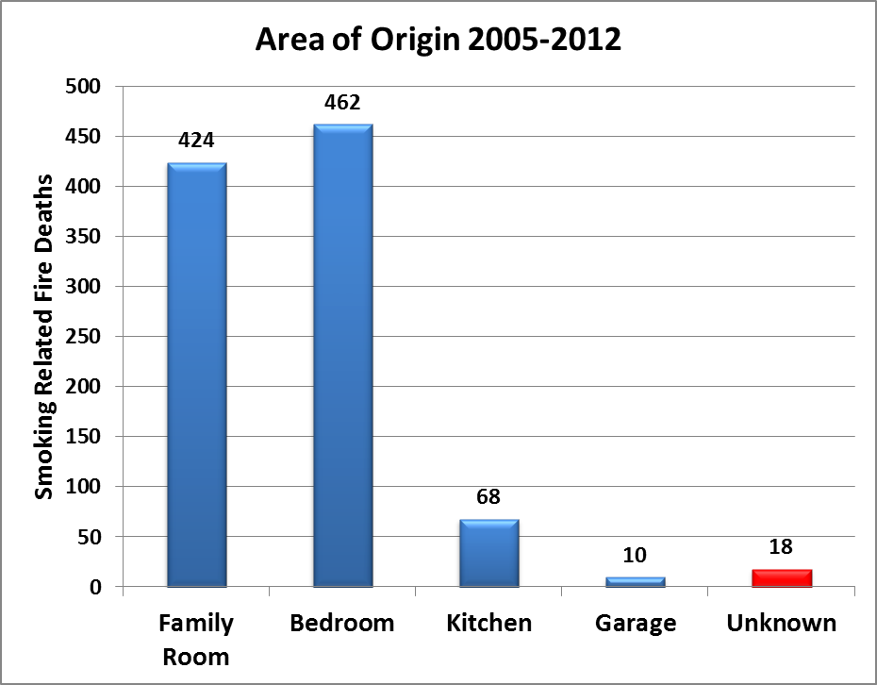
Figure 4.1 Area of Origin of Smoking-Related Fire Deaths 2005-2012. (Source: NFIRS V. 5.0 2005-2012)

Item First Ignited
When a fire incident occurs, the item first ignited is considered to be the first item that had sufficient volume or heat intensity to become an uncontrolled or self-perpetuating fire (USFA, 2008). Figure 4-2 indicates the most common item first ignited in smoking-related fire deaths is furniture, accounting for 440 (34%) smoking-related fire fatalities. The most common piece of furniture ignited is a sofa or chair. The second most common item first ignited is soft goods, wearing apparel. Soft goods, wearing apparel consists of mainly mattresses, pillows, and bedding material such as blankets and sheets.
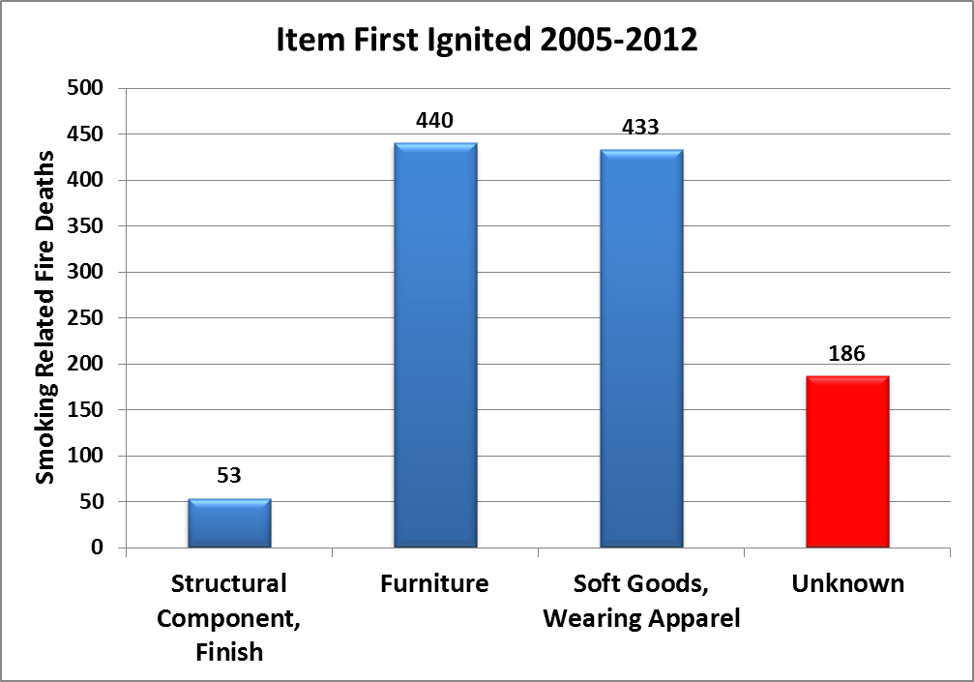
Figure 4.2 Item First Ignited in Smoking-Related Fire Fatalities 2005-2012. (Source: NFIRS V. 5.0 2005-2012)

Human Behavior
When a fire incident occurs, fire service personnel can report any human factors that contributed to the ignition of the fire. Human factors contributing to ignition are defined as any human condition or situation that allowed the heat source and ignition material to combine and ignite into a fire (USFA, 2008). Human factors contributing to ignition can include: being asleep, being unattended, being impaired mentally or physically and being possibly impaired by drugs or alcohol (USFA, 2008). Figure 4.3 indicates that when human factors are a factor in smoking-related fire deaths the most common human factor contributing to the ignition of the fire and the subsequent death is being asleep. A person being asleep was a factor in 364 (28%) smoking-related fire deaths. The second most common human factor contributing to the ignition of a smoking-related fire death was being possibly impaired by drugs or alcohol.

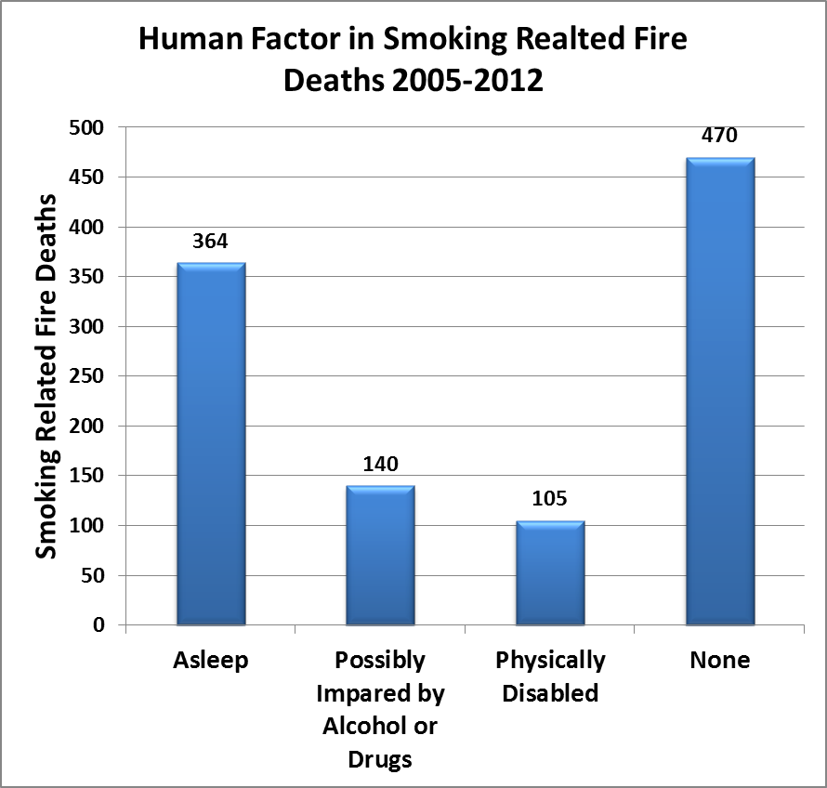
Figure 4.3 Human Factor in Smoking-Related Fire Deaths 2005-2012. (Source: NFIRS V 5.0 2005-2012)
These factors increase the fire fatality risk because they decrease the victim’s capacity to respond to a fire incident and decrease the effectiveness of fire safety measures. If a victim is in the area of origin when a fire starts it greatly increases the risk of a fire fatality. Sprinkler systems, fire barriers, and smoke alarms are not immediate fire response technologies. They all require a certain amount of time after ignition to be effective (Hall, 2012). Due to this factor, if a victim is in the area of origin when a fire starts it is less likely that they will survive long enough for the fire safety measure to be effective This is illustrated by Figure 4.4.

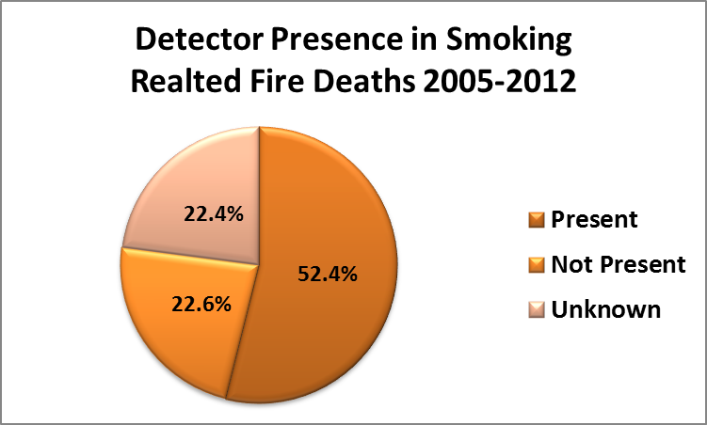
Figure 4.4 Detector Presence in Smoking-Related Fire Deaths 2005-2012.

Figure 4.4 indicates that 52.4% of smoking-related fire deaths occurred when a smoke detector was present. This amounts to 687 smoking-related deaths occurring where a smoke detector was present. Smoke detectors are an established fire safety technology and are successful at reducing residential fire deaths (Warda and Ballesteros, 2007). In fact, reports show that having a working smoke detector reduces the risk of a fire death by half (Ahrens, 2008). However, smoke detectors and other technologies require time to be effective and may be less effective when a victim is in close proximity to the item first ignited, in the area of origin when a fire is ignited, or is asleep or possibly impaired during a fire (Ahrens, 2008; Ahrens, 2009). These factors are more likely to occur in smoking-related fires than with other fires (Hall, 2012). Due to the factors surrounding smoking material fires, they carry a greater risk of fire deaths. The characteristics of smoking-related fire incidents increase the risk of fire fatalities, but there are also various characteristics of state populations, economies and housing that are associated with fire fatality risks.
Variables in the Study and Previous Research
NFIRS data indicates that there were 11,013 civilian residential fire deaths in the U.S. during the 2005 through 2012 study period. Of these deaths 1,312 or 11.9% were smoking-related (based on the definition described in the previous methodology section). As figure 4.5 indicates, civilian residential fire deaths peaked in 2010 with 1470 total fire deaths and then declined in subsequent years. The decline in the residential fire deaths is a desirable outcome and a similar pattern is seen in the smoking-related fire deaths. Smoking-related fire deaths peaked in 2006 with a total of 212 smoking-related fire deaths and declined in subsequent years. From 2010 through 2012 the number of smoking-related fire deaths was consistently lower than previous years (except 2008) ranging from 151 in 2012 then decreasing slightly to 148 in 2011 and then increasing to 150 in 2012.

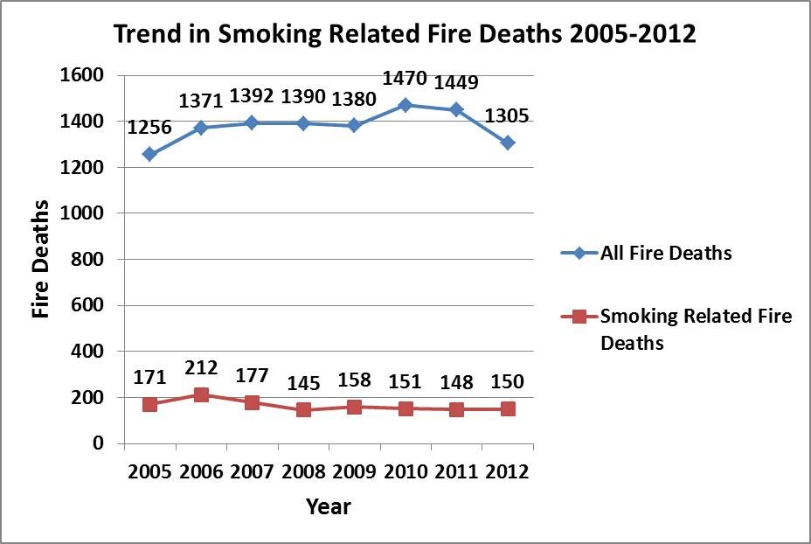
Figure 4.5 Trend in Fire Deaths from 2005-2012

Observed patterns of decline are promising, but to assure an accurate representation of the trend in smoking-related fire deaths, population changes during the study period must be accounted for. This is done by examining the smoking-related fire death rates (the dependent variable). A challenge in estimating fire fatality risk is that the amount of risk associated with fire incidents is not the same across states. States with larger populations, such as California, will naturally experience more fire incidents and more fire deaths than those states with lower populations such as Wyoming. So the risk associated with an event occurring is not the same for each state (Houston, 2007). To normalize for different levels of risk exposure, the dependent variable is the smoking-related fire death rate per 1,000,000 population. Figure 4.6 shows the annual mean rate of smoking-related fire deaths in the states from 2005 through 2012. During this study period, the mean rate for smoking-related fire deaths declined by about 28%. This reduction was mediated by increases in 2006, 2010, and 2012. This pattern of overall decline is highly desirable because it illustrates that smoking-related fire death rates are decreasing over time. For this study, the pattern of decline provides the necessary correlational evidence between implementation of the states’ FSC policy (the independent variable) and a change in the smoking-related fire death rate (the dependent variable).

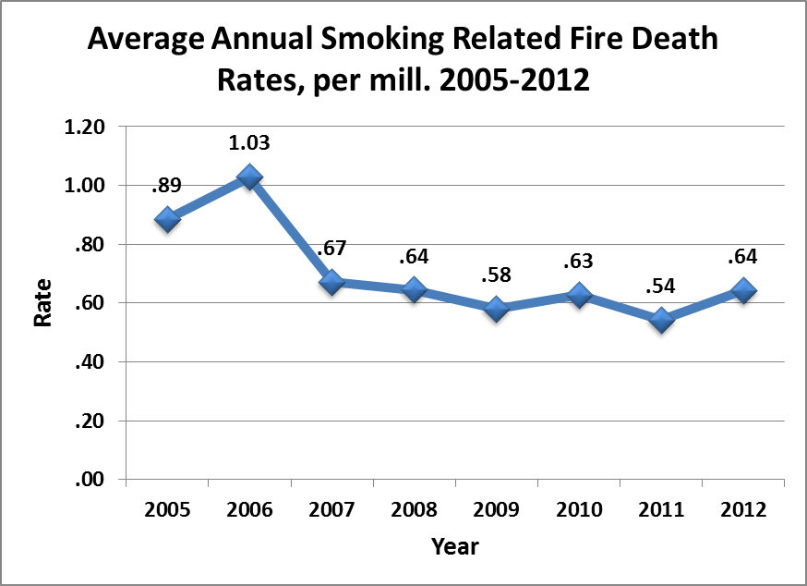
Figure 4.6 Average Annual Smoking-Related Fire Death Rates, Per mill. 2005-2012

Although there is a correlation between the states’ FSC policy and smoking-related fire death rates, there are still other factors that might account for the variation in the smoking-related fire death rate. Other state characteristics that may be associated with the occurrence of smoking material fires and subsequent fire deaths include: the percent of adults who smoke (Hall, 2012; O’Connor et al, 2010; Diekman et al 2008), housing stock (Eisenberg, 2005; Istre, McCoy, Osborn, Barnard and Bolton, 2001), level of income (Hannon and Shai, 2003; Istre et al., 2001), education (Eisenberg, 2005), age (USFA, 2009; Istre et al., 2001), gender (USFA, 2009; Istre et al., 2001), and race (USFA 2009; Istre et al., 2001).
Smoking is the leading cause of fatal residential building fires (USFA, 2011). Since smoking is the leading cause of fatal residential fires, lower rates of cigarette smoking in the states over time should lead to fewer smoking-related fires and fewer smoking-related fire deaths (O’Conner et al, 2010; Diekman et al, 2008). Figure 4.7 shows that the national adult smoking rate declined since 1990. In 1990 the percent of adults who smoke was 25.3%. In 2012, the percent of adults who smoke decreased to 18.2 percent. This is a reduction of 7.1%. Consequently, changes must be accounted for in the level of adult smoking behavior in the states. It is hypothesized that as the rate of adults who smoke in a state increases smoking-related fire deaths will also increase.

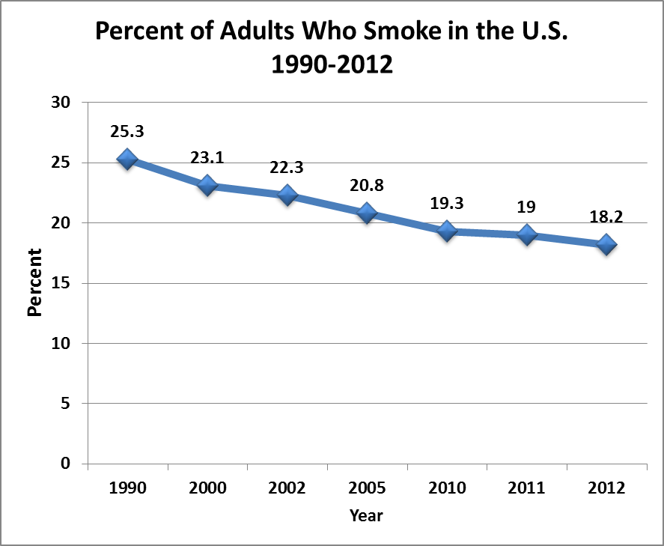
Figure 4.7 National Adult Smoking Rate 1990-2012. (Source: Center for Disease Control (2012a).
Housing stock characteristics such as the age of housing are positively associated with fire fatalities (Eisenberg, 2005). As housing stock ages it is more likely to deteriorate. This deterioration might result in weaker adherence to housing codes. As structures age, the risk of a fire incident occurring increases (Istre et al, 2001). It is hypothesized that as the age of structures in an area increase, the number of fire fatalities will also increase.
Income is negatively associated with fire fatalities. Fahy and Norton (1989) found that cities with poverty rates greater than 25% had a median fire death rate that was more than seven times higher than the fire death rate of cities with poverty rates less than 10%. Their reasoning for this relationship was that low income leads to a lack of resources which may indirectly lead to unintentional fires and increased fire deaths. Examples of unsafe conditions resulting from a lack of resources include using faulty heating sources, improper use of electrical devices, and the use of candles for lighting in place of electricity (Fahy and Norton, 1989). These findings are supported by other studies that show lower socioeconomic status is associated with the wider prevalence of unsafe conditions that increase the risk of fire mortality (Hannon and Shai, 2003). Hannon and Shai (2003) cited substandard housing, overcrowding, vacant buildings, and a lack of access to quality municipal services such as well-funded and well-staffed fire departments and housing regulatory agencies as factors creating unsafe community conditions leading to increased fire fatalities. Typically, levels of formal educational attainment are negatively related to the incidence of fire fatalities (NFPA, 2010; Eisenberg, 2005; Scholer et al.,1998). The National Fire Protection Association found that fire fatalities are higher in states with lower levels of formal education (NFPA, 2010). The risk of fire mortality among children shows a similar pattern ( Scholer et al.,1998). When comparing children whose mothers had a college education to children whose mothers had less than a high school education, Scholer et al. (1998) found that children in the latter group had a 19.4 times higher risk of a fatal fire incident. Therefore, children whose mothers had less than a high school education have a higher risk of being involved with fire fatalities or injuries (Scholer et al., 1998). Education may be correlated with fire injury and fire death risks because those with higher education levels may engage in less risky behaviors (Grossman, 1975). Individuals with higher educational levels may be more likely to be aware of the dangers associated with fire incidents and use smoke detectors, replace smoke detector batteries, and dispose of smoking material properly.Gender, race, and age characteristics of a population also are related to risk of death or injury in fires. Males accounted for 60.3% of the national fire fatalities while females accounted for only 39.7% of fire deaths (USFA 2009). This pattern has remained consistent since 1978 (USFA, 2009).
In terms of a population’s gender and race composition, white males, American Indian males, and African American males and females generally have higher fire fatality rates than the national average (USFA, 2009). African American fire fatality victims comprise a large and disproportionate share of total fire deaths. While African Americans comprise 13 percent of the population, they accounted for 22 percent of fire fatalities (USFA, 2009).
Individuals over 45 have a higher death rate than the national rate (15.0 deaths per million population) (USFA, 2009). For those aged 75 or older, the average death rate is nearly three times the national average. Children 4 years old or younger exhibited a death rate almost equal to the national average with a death rate of 12.3 while the population between the ages of 5 and 9 exhibit a lower death rate of 6.8 per million (USFA, 2009). Consequently, individuals that are very young (4 years old and younger) and those very old (75 years old and older) are at the greatest fire fatality risk.
Following previous research, the model includes controls for a gender variable (the percent of the population male), a race variable (percent of the population African American), a housing stock variable (percent of the structures built post 1999), an education variable (percent of the population with a high school diploma or higher), an income variable (median household income) and the state rate of adult smoking.
Based on previous research, it is hypothesized that;
- States with larger proportions of males will have higher smoking-related fire deaths.
- States with newer housing (built post 1999) will have lower smoking-related fire deaths
- States with greater educational attainment will have lower smoking-related fire deaths
- States with high household income will have lower smoking-related fire deaths,
- States with fewer adult smokers will have lower smoking-related home fire deaths.
Estimation
The data for this project encompass all 50 states covering the 8-year period from 2005-2012. The unit of analysis is the state-year, meaning that for each state a separate observation is created for each year (Houston, 2007). In testing the effect of the states’ FSC policy, a cross sectional time series regression is estimated for the state smoking-related fire death rate. The data are organized as panel data. A key advantage in using panel data is that it addresses the problems associated with the unobserved factors that differ across units but are time-constant (Wooldridge 2002; Houston and Richardson, 2008). Common problems associated with panel data are unit effects, heteroskedasticity, and serial correlation.
The key issue in panel data is consistency in the individual effect of each unit, or in this case state (Parks, 2011). If the individual effect of each state is consistent then all states are characterized by the same regression equation at all points in time (Beck and Katz, 1995). This suggests that OLS regression is unbiased and the preferred approach to analysis (Park, 2011). However, the presence of unit effects suggests that each state systematically differs on the dependent variable. These differences can be attributed to the history, culture, or other characteristics of a state. If the individual effect of each state is not consistent across all states, the states may not have equal variances (Park, 2011). Unequal variance biases the regression and suggests an alternative approach to OLS regression may be the appropriate approach to analysis.
The data exhibited the presence of unit effects but do not exhibit year effects. Two approaches to modeling unit effects are fixed or random effects. Generally, the Hausman test is used to determine the correct approach for modeling unit effects. The Hausman test yielded a chi square value of .0021. This indicated that the error terms are correlated with the regressors and a fixed effects approach would be preferable. Fixed specification accounts for the unobserved factors by including a binary variable for each state, except one, in the model (Park, 2011). In cases in which unobserved factors, such as state culture, are correlated with explanatory variables, fixed effects estimation is preferred because random effects estimation may be inconsistent (Houston and Richardson, 2008). Because unobserved factors are controlled for, the coefficients of the fixed effects model cannot be biased (Oscar Torres-Reyna). Based on model diagnostics and the advantages offered by fixed effects, a fixed effects approach is used in the FGLS model.
The data also exhibit heteroskedasticity and serial correlation. Heteroskedasticity occurs when the variance of the unobserved error, conditional on the explanatory variables, is not constant. Heteroskedasticity yields biased variances that result in confidence intervals and t-statistics that are not valid (Wooldridge, 2009). Serial correlation occurs when a value for a variable is influenced by its own value in a previous time period (Kennedy, 2008). One example of a variable that can be exhibit serial correlation is income. A person’s yearly income depends on their income from the previous year, among other things. This suggests that yearly income values are not independent from year to year, but instead are correlated with previous years. Serial correlation results in biased standard errors and results that are less efficient (Drukker, 2003). From the data diagnostics, it can be concluded that unit effects, heteroskedasticity and serial correlation are present. To address these concerns, the model was estimated using a feasible generalized least squares (FGLS) routine with corrections for heteroskedasticity, serial correlation and state fixed effects. Using a least square based approach to analyze fire problems follows previous research (Eisenberg, 2007; Hannon and Shai, 2003; and Garbacz and Thompson, 2007).
Findings
In analyzing the impact of the FSC policy, smoking-related fire death rates before the FSC policy was implemented are compared to the smoking-related death rates after it was considered effective. The results are displayed in Table 4.2.
Table 4.2 Cross-sectional time series feasible GLS estimates of smoking-related fire death rates 2005-2012 with state fixed effects.
 | Smoking-Related Fire Deaths Rates 2005-2012
 |  |  |  |  | Smoking-Related Fire Death Rate Per 1 Million pop. | Smoking -Related Fire Death Rate Per 1 Million pop.
FCS Policy 1 |  |  |  |  | -0.1130**
FCS Policy 2 |  |  |  |  |  | -.1132**
Percent of Adults Who Smoke |  |  |  |  | -0.0401*** | -.0406***
Percent of Structures Built Post 1999 |  |  |  |  | .0133 | .0135
Percent Population with a High School Degree or Higher |  |  |  |  | -.1019*** | -.1028***
Median Household Income |  |  |  |  | -.000032*** | -.000032***
Percent Population that is Male |  |  |  |  | .2014* | .2015*
Percent Population that is African American |  |  |  |  | -0.0963 | -.9847
*p≤ .10, **p≤ .05, ***p≤ .01
Note: The FGLS model has state fixed effects and corrections for heteroskedasticity and autocorrelation. The Coefficients are unstandardized.

The FSC policy variable is measured in two ways. In one approach the policy variable is coded as a 1 for the year if the policy became effective prior to July 1st and a 0 if the policy became effective on or after July 1st. This approach is labeled as FSC Policy 1. In a second approach the binary policy variable is coded as the proportion of days for which the law is in effect (Houston and Richardson, 2006). In this approach the policy variable is labeled as FSC Policy 2. Coding the policy variable as the proportion of days for which the law is in effect allows for greater variation in the policy effect time. Both models are reported in table 4.2, but the findings are based of the model measuring the policy as FSC Policy 2.
The findings suggest that the FSC policy did have a statistically significant independent effect in helping to reduce smoking-related fire deaths controlling for the effects of other variables. Specifically, the FSC policy is responsible for reducing the state smoking-related fire death rate by .1132 per million population. While this independent effect may be modest it is still significant. Other state variables that were statistically significant include; education, income, and adult smoking rate. The level of educational attainment, and household income performed in the predicted direction. Higher education and income levels led to fewer smoking-related fire deaths.
The adult smoking death rate exhibited a small negative connection with smoking-related fire deaths. In other words, states with higher adult smoking rates had slightly a lower level of smoking-related fire deaths over time. This finding was unexpected and may be due to the fact that smoking-related fire deaths have declined faster than cigarette consumption (Hall, 2013). In addition to declining cigarette consumption, there has also been an increase in the number of smokers who do not allow smoking inside their house (Hall, 2013). These factors taken together could reduce the relative impact that smoking cigarettes has in smoking-related residential fires. The unambiguous finding in this analysis however is the fact that the fire safe cigarette policy is effective in reducing the rate of smoking-related deaths in the states regardless of variations in the level of adult smoking.
Summary
Smoking material fires are the leading cause of residential fire deaths in the U.S. Various policies ranging from increased fire safety regulations for upholstered furniture and mattresses to more efficient smoke detectors have been developed to reduce smoking-related fire risks. A recent fire safety measure is the states’ fire safe cigarette (FSC) policy. The FSC policy is designed to reduce the ignition propensity of cigarettes and was expected to reduce smoking-related fire deaths. This analysis shows that the fire standard compliant designs for cigarettes adopted by the states did indeed lead to lower levels of smoking-related fire deaths. While the impact was only modest, it was statistically significant. This finding is important not only because the policy is demonstrably effective in reducing smoking-related fire deaths, but it also may affect other smoking-related safety concerns, namely fire injuries and smoking-related fire incidents. The next two chapters examine the relationship between the states’ FSC policy and smoking-related fire injuries and incidents.

Chapter 5
The Impact of State Fire Safe Cigarette Policies on Reducing Fire Injuries
Introduction
Extant research has examined the causes and consequences smoking-related fires (Hall, 2012; Ahrens, 2009; USFA, 2010; NFPA, 2010; USFA, 2011). Most studies focus on fire fatalities which is understandable because of the devastating impacts of that the loss of even one life can have on a family and community (Diekman et al, 2008; Eisenberg, 2005; Hannon and Shai, 2003). However, another importance consequence of smoking-related fires is fire injuries. Injuries can range in severity from minor to life threating (USFA, 2008). While fire injuries may not result in death, their effects can be devastating and life changing.
While fire standard compliant cigarettes were intended to help reduce smoking-related fire fatalities, a secondary impact also may be a reduction in smoking-related fire injuries. To study this potential impact of the states’ FSC policy, panel data for all 50 states from 2005 through 2012 are analyzed using a fixed effects feasible generalized least squares model with state fixed effects and a correction for panel heteroskedasticity. In addition to the FSC policy variable, other state attributes are controlled for in the model. It is expected that the FSC policy will reduce smoking-related fire injuries but the findings from this analysis do not indicate that smoking-related fire injuries decline after implementation of the FSC policy.
Smoking-Related Fire Injuries
Smoking material fires are the third leading cause of residential fire injuries. The leading causes of residential fire injuries are cooking equipment (responsible for 38% of all fire injuries) and heating equipment (responsible for 12% of all fire injuries) (Ahrens, 2012). However, unlike operating equipment and heating equipment smoking materials are responsible for a disproportionate number of fire injuries (Ahrens, 2012). Only 5% of all residential fires are caused by smoking materials, but they are responsible for 10% of all residential fire injuries (Ahrens, 2012). These fires resulted in an estimated 1,290 residential smoking-related fire injuries occurring annually from 2005 through 2011 (Hall, 2013). The disproportionate impact of smoking-related fires is further illustrated when looking at fire injury rates. For example, the smoking-related fire injury rate per 1,000 fires is over three times greater fires than non-smoking fire injury rate. Specifically, from 2008 through 2010 an average of 91 injuries per 1000 fires occurred in smoking-related building fires, while only 25 injuries per 1000 fires occurred in non-smoking-related building fires (USFA, 2012).
As with smoking-related fire deaths, the risk of suffering an injury during a smoking-related fire is likely to be higher than non-smoking fires because of the factors surround smoking material fire incidents. Such factors include: the area of origin, the item first ignited, and the behavior of the individual(s) (USFA, 2005; USFA, 2010; USFA, 2011; Ahrens, 2009; and Hall, 2012).
Area of Origin
In a fire incident, the area of origin is defined as the location where the fire started (USFA, 2008). The area of origin may be any number of areas ranging from a specific room, a portion of a room, a vehicle, or an open area (USFA, 2008). From 2005 through 2012 there were a total of 5021 smoking-related fire injuries. Figure 5.1 indicates that the bedroom is the most common area of origin in residential smoking-related fire injuries with 1,775 or 35.4% of all residential smoking-related fire injuries occurring when the bedroom is the area of origin. The family room or den (20.2%) is the second most common area of origin in residential smoking-related fire injuries followed by the Kitchen (11.3%).

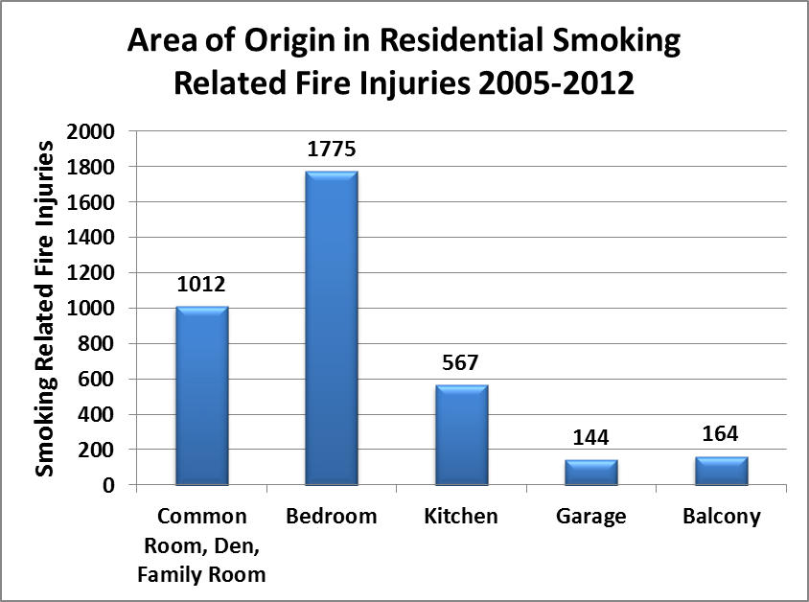
Figure 5.1 Area of Origin for Residential Smoking-Related Fire Injuries 2005-2012
(Source: NFIRS v. 5.0 2005-2012)
Item First Ignited
When a fire incident occurs, the item first ignited is considered to be the first item that had sufficient volume or heat intensity to become an uncontrolled or self-perpetuating fire (USFA, 2008). Figure 5.2 indicates the most common item first ignited in smoking-related fire injuries is soft goods, wearing apparel with 1437 or 28.6% occurring when soft goods, wearing apparel is the time first ignited. Soft goods, wearing apparel consists of mainly mattresses, pillows, and bedding materials such as blankets and sheets. The most common soft goods, wearing apparel first ignited are blankets or sheets and mattresses or pillows. The second most common item first ignited in a smoking-related fire injury is furniture. Furniture consists of mainly sofas, chairs, bookcases and cabinetry. A sofa or chair is the most common piece of furniture first ignited in a smoking-related fire.

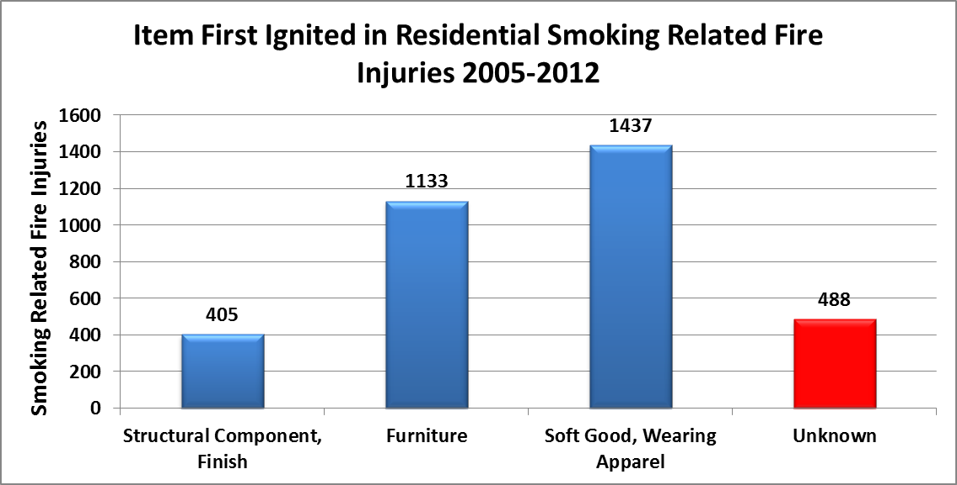
Figure 5.2: Item First Ignited in Residential Smoking-Related Fire Injuries 2005-2012. (Source: NFIRS v. 5.0 2005-2012)

Human Behavior
When a fire incident occurs, fire service personnel can report any human factors that contributed to the ignition of the fire. Human factor contributing to ignition are defined as any human condition or situation that allowed the heat source and ignition material to combine and ignite into a fire (USFA, 2008). Human factors contributing to ignition can include: being asleep, being unattended or being impaired mentally or physically and being possibly impaired by drugs or alcohol (USFA, 2008). Figure 5.3 indicates that when human factors are a factor in smoking-related fire injuries the most common human factor contributing to the ignition of the fire and the subsequent injury is being asleep. A person being asleep was a factor in 1,182 (23.5%) smoking-related fire injuries. The second most common human factor contributing to the ignition of a smoking-related fire death was being possibly impaired by drugs or alcohol.

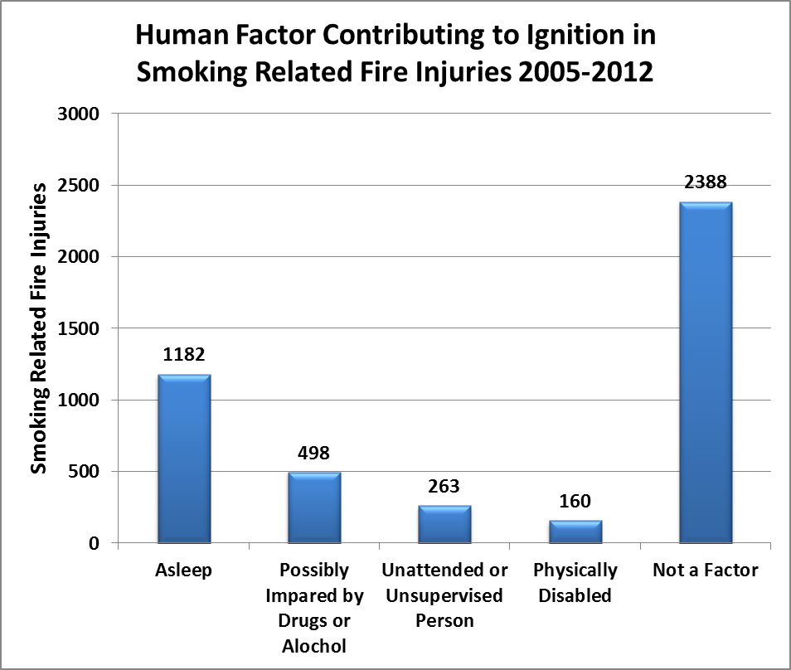
Figure 5.3 Human Factor Contributing to Smoking-Related Fire Injuries 2005-2012.
(Source: NFIRS v. 5.0 2005-2012)
These factors increase the fire injury risk because they decrease the victim’s capacity to respond to a fire incident and decrease the effectiveness of fire safety measures. If a victim is in the area of origin when a fire starts it greatly increases the risk of a fire injury. Fire safety systems all require a certain amount of time after ignition to be effective (Hall, 2012). Since fire safety technologies require time to be effective, if a victim is in the area of origin when a fire starts it is less likely that they will be able to leave the area without injury especially if they are directly involved with the ignition of the fire or are impaired. This is illustrated by Figure 5.4.

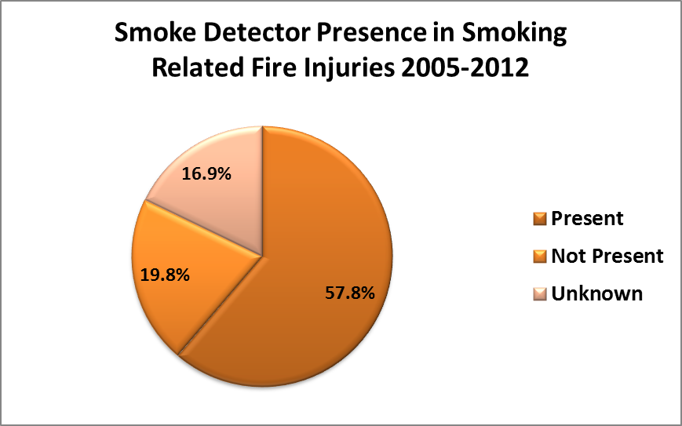
Figure 5.4 Smoke Detector Presence in Smoking-Related Fire Injuries 2005- 2012. (Source: NFIRS v. 5.0 2005-2012)

Figure 5.4 indicates that 57.8% of smoking-related fire injuries occurred where a smoke detector was present. This amounts to 2,904 smoking-related injuries occurring where a smoke detector was present. Smoke detectors are a fire safety measure that alerts a person to the presence of smoke so they can escape the area. Smoke detectors are an established fire safety technology and are successful at reducing fire deaths (Warda and Ballesteros, 2007). However, smoke detectors require time to work. If the victim is in close proximity to the item first ignited, in the area of origin when a fire is ignited, or is asleep or possibly impaired during a fire incident the amount of time to required react to a fire incident is shortened and they may not be able to respond to a fire incident quickly enough to avoid injury (Ahrens, 2008; Ahrens, 2009). These factors are more likely to occur in smoking-related fire than with other fires (Istre et al, 2001; Hall, 2012). Based on these factors, smoking material fires are more dangerous than non-smoking fires even in the presence of fire safety technologies. The characteristics of smoking-related fire incidents may attribute to increase fire injury risk, but there are also state characteristics that are associated with fire injury risks.
Variables in the Study and Previous Research
Compared to fire fatalities, fire injuries occur much more often. When looking at all fire incidents in 2011, the number of all civilian fire injuries reached an estimated 17,500 while the estimated number of civilian fire death only reached 3,005 (Karter, 2012). When looking at smoking-related fire incidents, The USFA (2012) found that on average the number of smoking-related injuries is three times larger than the number of smoking-related deaths. Fire injuries can range from minor non-life threating to severe and life threating. Fire fatalities, on the other hand, are only classified as the victims that actually die as the result of a fire. Figure 5.5 indicates that about 20% (1312) of the victims involved in just residential smoking-related fires died. The remaining 77% (5020) of the victims involved in a fire incident were injured. Many of the injuries were considered minor (2,692 victims or 41.37%).

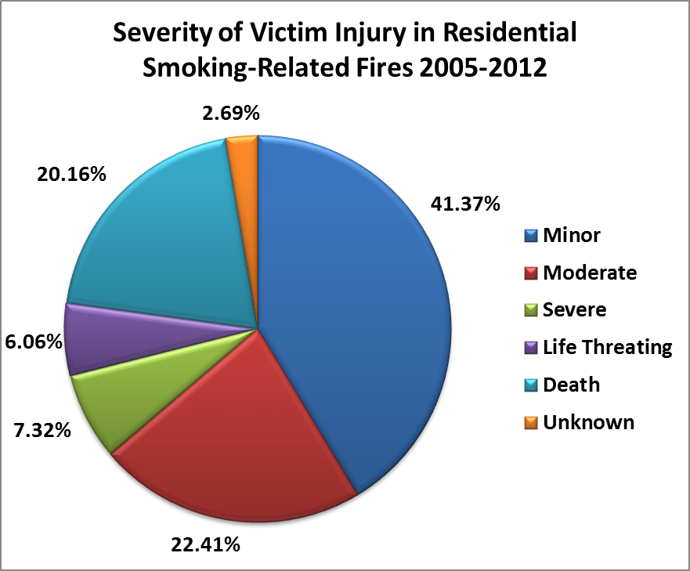
Figure 5.5 Severity of Victim Injury in Residential Smoking-Related Fires 2005-2012. (Source: NFIRS v. 5.0 2005-2012)

NFIRS data indicate that there were 52,068 residential fire injuries in the U.S. from 2005 through 2012. Of these injuries 5,020 or about 10% were smoking-related (based on the definition described in the previous methodology section). As figure 5.6 indicates, civilian residential injuries peaked in 2011 with 7198 total fire injuries and then declined in 2012. The decline in fire injuries is a desirable outcome and a similar pattern over time occurs in smoking-related fire injuries. Smoking-related fire injuries peaked in 2011 with 697 smoking-related fire injuries and then declined in 2012 to 586 smoking-related fire injuries. This represents a decline of about 16% between 2011 and 2012. The decline from 2011 to 2012 is promising, but the overall decline in smoking-related fire injuries from 2005 through 2012 is much smaller at about 8%. The decline in smoking-related fire injuries was mediated by increases in the number of smoking-related fire injuries in both 2010 (687) and 2011 (697).

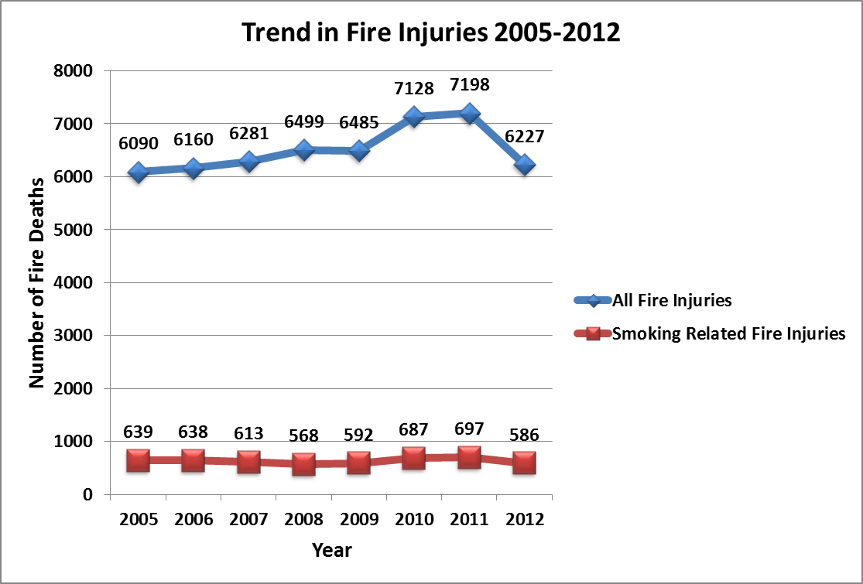
Figure 5.6 Trend in Smoking-Related Fire Injuries 2005-2012

The modest decline in smoking-related fire injuries is desirable, but to assure an accurate representation of the trend, changes in population, must be accounted for by calculating a smoking-related fire injury rate (the dependent variable). A smoking-related fire injury rate³ accounts for population differences and facilitates an accurate comparison of smoking-related injuries across states.
Figure 5.7 shows the annual mean smoking-related fire injury rates in the states from 2005 through 2012. During the study period, the mean rate for smoking-related fire injuries declined by about 8%. This reduction was mediated by increases in 2010 and 2011. An eight percent decline is modest but still desirable because it demonstrates that smoking-related fire injuries are decreasing over time. For this study, the pattern of decline offers some correlational evidence between the states’ FSC policy (the independent variable) and the smoking-related fire injury rate (the dependent variable).

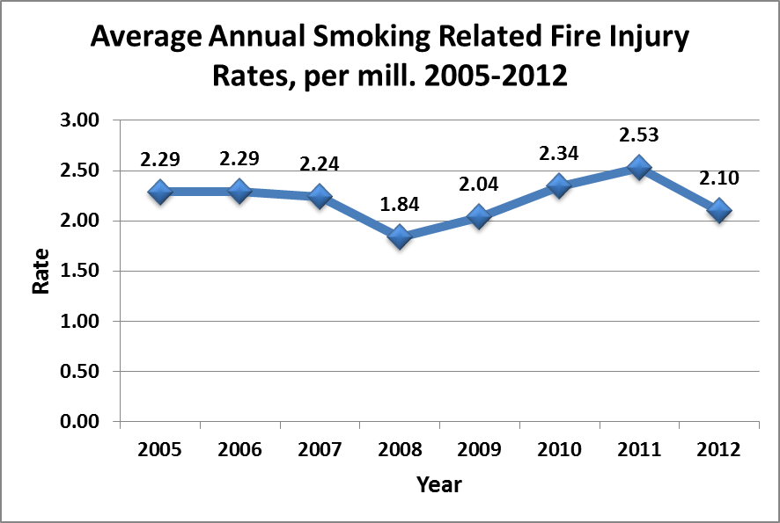
Figure 5.7 Average Annual Smoking-Related Fire Injury Rates, per mill. 2005-2012

Although a correlation exists between implementation of the states’ FSC policy and smoking-related fire injury rates, there are other factors that also might be related to change in the smoking-related fire injury rate. Other state characteristics that may be associated with the occurrence of smoking material fire injuries include: the adult smoking rate (Istre et al, 2001; Hall, 2012) housing stock (Eisenberg, 2005; Istre, McCoy, Osborn, Barnard and Bolton, 2001), level of income (Hannon and Shai, 2003; Istre et al., 2001), education (Eisenberg, 2005), age (USFA, 2009, Istre et al., 2001), gender (USFA, 2009, Istre et al., 2001), and race (USFA, 2009, Istre et al., 2001).
Smoking is the third leading cause of residential building fire injuries (USFA, 2011). Since smoking is the third leading cause of residential fire injuries, lower rates of cigarette smoking in the states over time should lead to fewer smoking-related fires and fewer smoking-related fire injuries (Leistkow et al., 2000).The hypothesis tested in this analysis is that a rise in state rates of adults who smoke will result in an increase in the state rates of smoking-related fire injuries.
It is also hypothesized that larger state proportions of older housing stock are positively associated with fire injuries (Eisenberg, 2005). Istre et al (2001) found that houses built in the 1950s and 1960s were more likely to burn than houses built after the 1960s. As housing stock ages it is more likely to deteriorate. This deterioration might result in weaker adherence to housing codes. Conversely, newer housing is less likely to be involved in a fire incident. Income is negatively associated with fire injuries. Fahy and Norton (1989) found that cities with poverty rates greater than 25% had a median fire death rate that was more than seven times that of cities with poverty rates less than 10%. A similar pattern occurs for fire injuries. Examining census tracts, Istre et al (2001), found that the tracts with the lowest median income were more likely to have a fire incident and had the highest fire injury rates. Specifically, tracts with extremely low income (less than $10,000 per year) experienced fire injury rates that were 20 times higher than the fire injury rates in tracts with high median incomes (Istre et al. 2001).
Studies show that higher levels of formal educational attainment are inversely related to fire fatalities and fire injuries (NFPA, 2010; Eisenberg, 2005; Scholer et al.,1998). Fire injury risk may be lower because people with higher educational levels may engage in less risky behaviors (Grossman, 1975). These individuals may be more likely to use smoke detectors, replace smoke detector batteries, and properly dispose of smoking materials. For these reasons, it is hypothesized that higher levels of educational attainment will lead to lower rate of smoking-related fire injuries.
Gender, race, and age characteristics of a population also are influential characteristics for fire injuries. Males have a higher residential fire related injury risk than females (Istre et al, 2001). In terms of a population’s race composition, African Americans have a higher fire injury risk than non-African Americans; the residential injury rate of the former group is almost three times higher than for non-African Americans (Istre et al., 2001). The elderly, particularly those over 65, exhibit higher residential injury rates than those under 65. Conversely, the very young, those 4 years old and younger, have a higher injury risk than those person in the 5 to 24 age group (Istre et al., 2001).
Following previous research, the model presented in this chapter includes controls for a gender variable (the percent of the population male), a race variable (percent population African American), a housing stock variable (percent of the structures built post 1999), an education variable (percent of the population with a high school diploma or higher), an income variable (median household income) and the state rate of adult smoking.
Based on previous research, it is hypothesized that;
- States with larger proportions of males will have higher smoking-related fire injuries.
- States with newer housing (built post 1999) will have lower smoking-related fire injuries.
- States with greater educational attainment will have lower smoking-related fire injuries.
- States with high household income will have lower smoking-related fire injuries.
- States with fewer adult smokers will have lower smoking-related home fire injuries.
Estimation
The effect of the states’ fire standard complaint cigarette laws is tested using a cross-sectional time series regression model. Again, the key advantage in using cross-sectional time series data is that it addresses the problems associated with the unobserved factors that differ across states but are time-invariant within a state (Houston and Richardson, 2008). The data exhibit unit effects but did not exhibit year effects. Two approaches for modeling unit effects are random effects and fixed effects. The Hausman specification test indicates a fixed effects approach is the best approach for modeling the unit effects. State fixed effects are included in the model to account for unobserved factors that differ across states but are time-invariant within a state (Park, 2011). In cases in which unobserved factors, such as state culture, may be correlated with explanatory variables fixed effects estimation is preferred because random effects estimation is inconsistent (Houston and Richardson, 2008). The state fixed specification accounts for the unobserved factors by including a binary variable for each state, except one in the model (Park, 2011). Diagnostic test also indicate the presence of heteroskedasticity across units (states), but did not suggest the presence of serial correlation. To address these concerns, the model is estimated using a feasible generalized least squares (FGLS) routine with corrections for groupwise heteroskedasticity and state fixed effects.

Findings
In analyzing the impact of the FSC policy, smoking-related fire injury rates before the FSC policy was implemented in the states are compared to the smoking-related injury rates after it was implemented in the states. The results are displayed in Table 5.2.
Table 5.2 Cross-sectional time series feasible GLS estimates of smoking-related fire injury rates 2005-2012 with state fixed effects.
 | Smoking-Related Fire Injury Rates 2005-2012
 |  |  |  | Smoking-Related Fire Injury Rate Per 1 Million pop. | Smoking-Related Fire Injury Rate Per 1 Million pop.
FSC Policy 1 |  |  |  | -.1167
FSC Policy 2 |  |  |  |  | -.2108*
Percent of Adults Who Smoke |  |  |  | .0366 | .0296
Percent of Structures Built Post 1999 |  |  |  | .0772*** | .0886***
Percent Population with a High School Degree or Higher |  |  |  | -.0675 | -.0601
Median Household Income |  |  |  | -.00005** | -.00005**
Percent of the Population that is Male |  |  |  | -.2544 | -.2324
Percent of the Population that is African American |  |  |  | .0292 | -.0029
*p≤ .10, **p≤ .05, ***p≤ .01
Note: The FGLS model has state fixed effects and corrections for heteroskedasticity. The Coefficients are unstandardized.

The findings suggest that the FSC policy just misses attaining statistical significance at the .05 alpha level. In other words, the FSC policy did not have an independent effect in helping to reduce smoking-related fire injuries controlling for the effects of other variables at that level of statistical significance. Median household income and housing stock were the only two variables that were statistically significant. Median household income performed as expected, but housing stock did not. Higher levels of income led to lower rates of fire injuries, but newer housing did not led to lower smoking-related fire injury rates instead newer housing is associated with more fire injuries. Nonetheless, there is at least some very modest support for the FSC policy hypothesis in that there were lower rates rate of injuries in the states observed after the policy was implemented.
Summary
Smoking-related fire incidents are a problem in U.S. The USFA (2012) estimated that U.S. fire departments responded to about 7,600 residential smoking-related fires per year from 2008 through 2010. These fires involved an estimated 370 fire deaths and 930 fire injuries per year from 2008 through 2010 (USFA, 2012). Recognizing the impact of smoking materials, specifically cigarettes, fire standard compliant cigarette legislation was developed in 2004 and, as of 2011, implemented in all fifty states. Research shows that the states’ FSC policy led to a reduction in smoking-related fire deaths (Folz and Shults, 2014). A reduction in smoking-related fire deaths is a desirable outcome, but the consequences of smoking-related fires go beyond fire fatalities. A secondary consequence of smoking-related fires is fire injuries (Sacks and Nelson, 1994). The states’ FSC policy was designed to reduce smoking-related fire deaths, but a secondary effect of the states’ FSC policy may be a reduction in smoking-related fire injuries. In testing the impact of the fire standard compliant cigarette legislation on smoking-related fire injuries, the statistical evidence did not support a causal effect at the .05 alpha level, but the evidence indicates that the rate of smoking-related fire injuries did decline after implementation of the FSC policy was fully implemented (statistically significant at the .10 alpha level).

Chapter 6
The Impact of State Fire Safe Cigarette Policies on Reducing Fire Incidents
Introduction
Smoking materials cause about 5% of all residential structure fires in the U.S. (Ahrens, 2012). These fires cause devastating losses in term of deaths, injuries and property damage. For example, in July 2014 a house fire occurred in Tacoma, Washington. One home caught fire in the early morning and quickly spread to a second home. The fire resulted in the complete loss of one home, severe damage to a second, and hospitalization of two people to the hospital, one of them critically injured (Komonews July 24, 2014). This fire was caused by someone smoking a cigarette near an oxygen tank. This is just one example of the hundreds of fire incidents across the country that are caused by smoking.
While fire standard compliant cigarettes were intended to help reduce smoking-related fire fatalities, a secondary impact also may be a reduction in smoking-related fire incidents. To study this potential impact of the states’ FSC policy, panel data for all 50 states from 2005 through 2012 are analyzed using a fixed effects feasible generalized least squares model with state fixed effects and a correction for panel heteroskedasticity. In addition to the FSC policy variable, other state attributes are controlled for in the model. Butry et al. (2014) found that the FSC policy led to fewer wildland fires caused by cigarettes. This finding suggests the FSC policy may help to reduce residential smoking-related incidents. The analysis of fire incident data in the US between 2005 and 2012 indicates that the FSC policy was responsible for reducing state smoking-related fire incident rate by .1728 per million population.
Smoking Material Fire Incidents
U.S. Fire departments responded to an estimated 371,700 residential structure fires per year between 2006 and 2010. These fires caused an average of 2,590 civilian fire deaths, 12,910 civilian fire injuries and $7.2 billion in direct damage (Ahrens, 2012). This pattern continued in 2011 with U.S. fire departments responding to about 370,000 residential structure fires. These fires caused 2,520 civilian fire deaths, 13,910 civilian injuries and $6.9 billion in property damage (Karter, 2012). These frequencies mean that on average a residential structure fire occurs in the U.S. every 85 seconds (Karter, 2012). Smoking-related fires are responsible for only about 5% of all residential fires (Ahrens, 2012) but unlike more common ignition sources such as cooking equipment and heating equipment, smoking material fires are responsible for a disproportionate number of fire deaths. While smoking materials are responsible for causing fewer fires than cooking equipment, heating equipment, arson and electrical distribution or lighting equipment, they have a disproportionate negative impact on human life.
Overall, the number of smoking-related fire incidents declined from 18,800 in 2000 to 17,600 in 2011 (Hall, 2013). Figure 6.1 indicates that during the study period (2005 through 2012) the greatest decline in smoking-related fire incidents occurred from between 2006 through 2009. Smoking-related fires declined from 21,600 incidents in 2006 to 16,900 incidents in 2009. This represents a t 22% reduction. From 2009 through 2011 smoking-related fire incidents increased 4% from 16,900 incidents in 2009 to 17,600 incidents in 2011 (Hall 2013). But the overall pattern during the study period indicates that smoking-related fires declined over time.

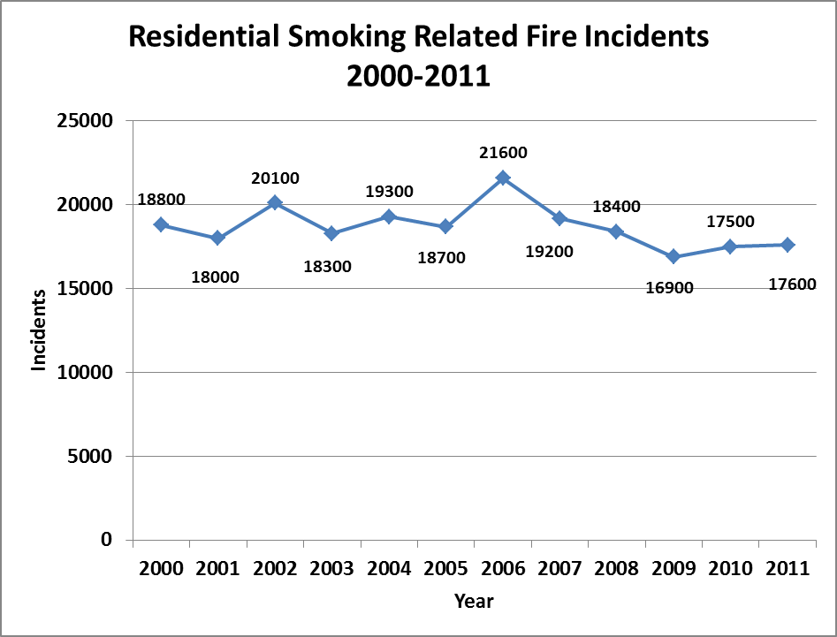
Figure 6.1. Residential-Smoking-Related Fire Incidents 2000-2011. (Source: Hall, 2013)
Factors associated with smoking material fires include: flammable materials in households, smoking, the time of ignition, and reckless behavior. Upholstered furniture and mattress bedding are the two leading items first ignited in all residential fire deaths (Ahrens, 2012). In smoking-related fires, upholstered furniture and mattresses or bedding are also among the most common items first ignited. In 1980, upholstered furniture and mattress or bedding were the items first ignited in 65% of residential smoking-related fires (Hall, 2012). By 2010, upholstered furniture and mattress or bedding were the items first ignited in 19% of residential smoking-related fires (Hall, 2012). This reduction can be attributed to changes in flammability standards of common household materials like upholstered furniture and bedding.
In 1953 the Flammability Fabrics Act was implemented to regulate the manufacture of highly flammable clothing. In 1967, the Flammable Fabrics Act was amended to include “unreasonably” flammable apparel and home textiles (UFAC, 1998). In 1968 the National Bureau of Standards examined the flammability risk associated with home textiles such as upholstered furniture and mattresses (UFAC, 1998). This effort led to the Upholstered Furniture Action Council Voluntary Action Program in 1979 (Alpert, 2007; UFAC, 1998). The goal of the Upholstered Furniture Action Council Voluntary Action Program was to acknowledge to fire risks associated with upholstered furniture and to develop construction methods that would make upholstered furniture more fire resistant (UFAC, 1994). Since 1979, flammability policy has continued to evolve until a recent proposal in 2008 designed to further reduce the flammability of upholstered furniture (Federal Register 16 CFR Part 1634, 2008). The combination of these policies may help to explain why upholstered furniture and mattresses or bedding are less frequently ignited in residential smoking-related fires.
From 2005 through 2012 there were 6,336 civilian residential smoking-related fire injuries or deaths (based on the definition described in the previous methods section). As figure 6.2 indicates, the three leading items first ignited in civilian residential smoking-related fire injuries or deaths were mattresses or bedding, upholstered furniture and trash. Mattresses or bedding were the item first ignited in 1,404 (22.2%) civilian residential smoking-related fire injuries or deaths. Upholstered furniture was the item first ignited in 1,183 (18.7%) civilian residential smoking-related fire injuries or deaths. Trash was the item first ignited in 362 (5.7%) civilian residential smoking-related fire injuries or deaths. Although policies have improved the flammability standards for common household materials such as upholstered furniture and mattresses and bedding, they are still the most common items first ignited in civilian residential smoking-related fire injuries and deaths.

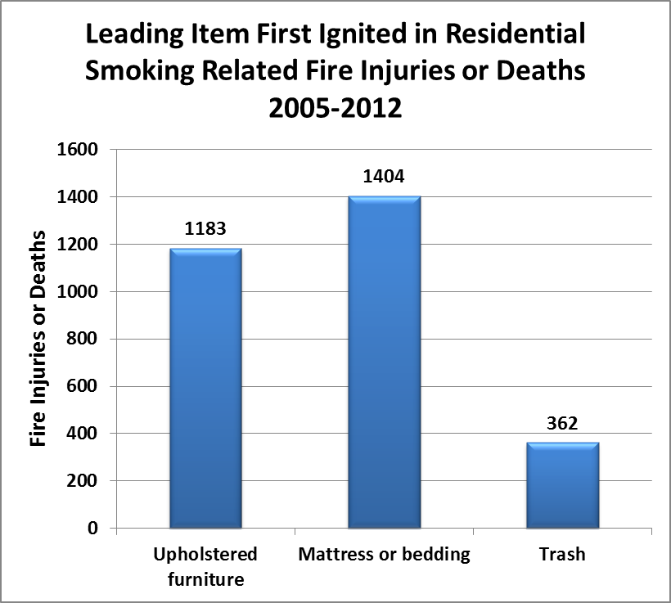
Figure 6.2 Leading Item First Ignited in Residential Smoking-Related Fire Injuries or Deaths 2005-2012. (Source: NFIRS 2005-2012)

Cigarettes are the leading heat source in smoking material fires (USFA, 2012). One study found that cigars or pipes caused 1.7% of residential smoking-related building fires, heat from an undetermined smoking material was responsible for 12% of residential smoking-related building fires and cigarettes accounted for the remaining 86.3% of residential smoking-related building fires (USFA, 2012). Cigarettes are a fire risk because when smoking materials are not properly discarded, they may be dropped onto flammable items that can smolder for hours (Alpert, 2007). This extended smoldering can result in a fire igniting long after residents have fallen asleep and result in more serious injuries and deaths. While cigarettes (rather than other tobacco products) are responsible for the majority of smoking-related fires, the level of smoking among adults has decreased 7.1% between 1999 and 2012 from 25.3% in 1999 to 18.2% in 2012 (CDC, 2012a).
Variables in the Study and Previous Research
NFIRS data indicate that 5,054 civilian residential smoking-related fire incidents occurred in the U.S. during the 2005 through 2012 study period (based on the definition described in the previous methodology section). Figure 6.3 indicates that civilian residential fire incidents involving a civilian peaked in 2011 with 674 total smoking-related fire incidents involving a civilian and then declined in 2012. Over the study period, the number of civilian residential smoking-related fire incidents decreased from 641 in 2005 to 601 in 2012 for a reduction of about 6%.

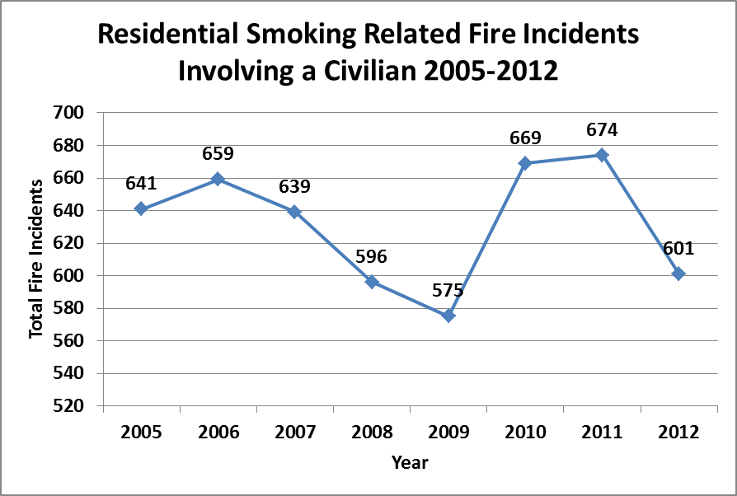
Figure 6.3 Residential Smoking-Related Fire Incidents Involving a Civilian 2005-2012
(Source: NFIRS v 5.0 2005-2012)
A pattern of decline is desirable, but population changes during the study period also must be accounted for by examining the residential smoking-related fire incident rates (the dependent variable). A challenge in estimating fire incident risk is that the amount of risk associated with fire incidents is not the same across states. To account for different levels of risk exposure, the dependent variable is the smoking-related fire incident rate per 1,000,000 population. Figure 6.4 shows the annual mean rate of smoking-related fire incidents in the states from 2005 through 2012. During this study period, the mean rate for smoking-related fire incidents declined by about 12%. This reduction was mediated by increases in 2006, 2010, and 2011. The overall pattern of decline is noteworthy because it provides the necessary correlational evidence between implementation of the states’ FSC policy (the independent variable) and a change in the smoking-related fire incident rate (the dependent variable).

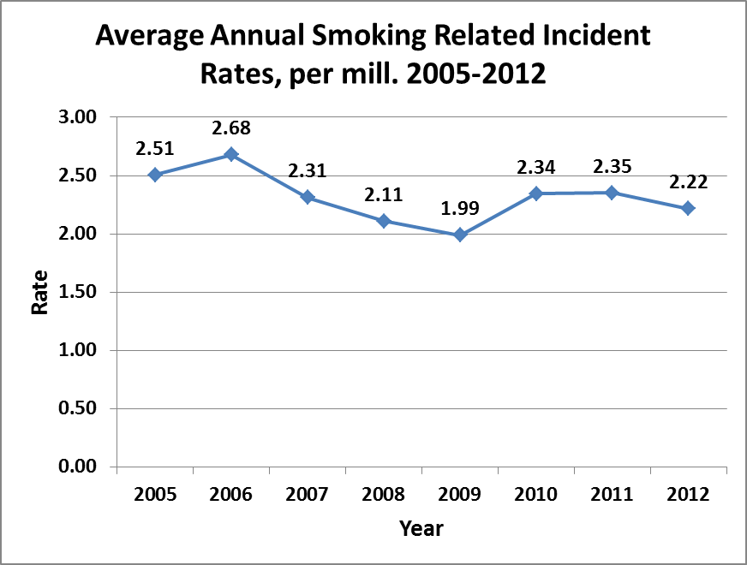
Figure 6.4 Average Annual Smoking-Related Incident Rates, per mill. 2005-2012

In addition to the states’ FSC policies, other factors also may be related to the states’ smoking-related fire death rate. These characteristics include: the percent of adults who smoke (Hall, 2012; O’Connor et al, 2010; Diekman et al 2008), housing stock (Eisenberg, 2005; Istre, McCoy, Osborn, Barnard and Bolton, 2001), level of income (Hannon and Shai, 2003; Istre et al., 2001), education (Eisenberg, 2005), age (USFA, 2009; Istre et al., 2001), gender (USFA, 2009; Istre et al., 2001), and race (USFA 2009; Istre et al., 2001).
Following previous research, the model presented in this chapter includes controls for a gender variable (the percent of the population male), a housing stock variable (percent of the structures built post 1999), an education variable (percent of the population with a high school diploma or higher), an income variable (median household income) and the state rate of adult smoking.
Based on previous research, it is hypothesized that;
- States with larger proportions of males will have higher smoking-related fire incidents involving civilians.
- States with newer housing (built post 1999) will have lower smoking-related fire incidents involving civilians.
- States with greater educational attainment will have lower smoking-related fire incidents involving civilians.
- States with high household income will have lower smoking-related fire incidents involving civilians.
- States with fewer adult smokers will have lower smoking-related home fire incidents involving civilians.
Estimation
A cross-sectional time series regression model is estimated to test the impact of the states’ FSC policy on state smoking-related fire incident rates. The data exhibit the presence of unit effects but do not exhibit year effects. Two general approaches to modeling unit effects are fixed effects and random effects. The Hausman specification test indicated fixed effects is the best approach. Diagnostic test also indicated the presence of heteroskedasticity across states, but did not suggest the presence of serial correlation. To address these concerns, the model was estimated using a feasible generalized least squares (FGLS) routine with corrections for groupwise heteroskedasticity and state fixed effects.
Results
In analyzing the impact of the FSC policy, smoking-related fire incident rates before the FSC policy was implemented in the states are compared to the smoking-related incident rates after it was implemented in the states. The results are displayed in Table 6.1.

Table 6.1 Cross-sectional time series feasible GLS estimates of civilian smoking-related fire incident rates 2005-2012 with state fixed effects
Civilian Smoking-Related Fire Incident Rates 2005-2012
 | Smoking-Related Fire Incident Rate Per 1 Million pop. | Smoking-Related Fire Incident Rate Per 1 Million pop.
FSC Policy 1 | -.1767**
FSC Policy 2 |  | -.2994***
Percent of Adults Who Smoke | .0334 | .0284
Percent of Structures Built Post 1999 | .0758*** | .0857***
Percent Population with a High School Degree or Higher | -.1174** | -.0903
Median Household Income | -.00006*** | -.00007***
Percent of the Population that is Male | -.1203 | -.1029
Percent of the Population that is African American | -.0478 | -.0597
*p≤ .10, **p≤ .05, ***p≤ .01
Note: The FGLS model has state fixed effects and corrections for panel heteroskedasticity. The coefficients are unstandardized.

The findings suggest that the FSC policy had a statistically significant independent effect in helping to reduce smoking-related fire incidents controlling for the effects of other variables. Specifically, the FSC policy reduced the state smoking-related fire incident rate by .2937 per million population. While this independent effect may be modest, it is both statistically significant and substantively important. Other state variables that were statistically significant include: housing stock and income. Household income performed as hypothesized. Higher income levels led to fewer smoking-related fire incidents. Higher levels of newer housing led to more smoking-related fire incidents. This result was unexpected. However, the most important finding is that the FSC policy led to fewer smoking-related incidents.
Summary
Five percent of all residential fires are caused by smoking materials (Ahrens, 2012). Various factors may influence the number of smoking-related fire incidents; these range from human behaviors to the flammability of household materials. This analysis shows that the fire standard compliant designs for cigarettes adopted by the states did lead to lower levels of smoking-related fire incidents. This finding is substantively important for several reasons. Fewer smoking-related fire incidents lead to reduced risk exposure not only for residents but also for fire fighters. Fewer fires started by cigarettes also reduces property and productivity losses. When considering that the states’ FSC policy also resulted in fewer fire mortalities, advocates of the FSC policy rightfully can claim that it helped to save lives and reduce the devastation of residential fires.

Chapter 7
Conclusion
Fire incidents are extremely variable and require solutions that are sensitive to prevalent fire incident characteristics (Dellasala et al, 2004). Policy makers should understand the characteristics surrounding fire incidents and then tailor efforts to those characteristics and the populations that are most at risk for death, injury or loss (Dellasala et al, 2004). The states’ FSC policy is a fire safety measure that targets cigarette smokers. It is designed to reduce the ignition propensity of cigarettes making them less likely to start a fire. The states’ FSC policy was expected to reduce smoking-related fire fatalities (Hall, 2012). Very little research examined the actual impact of FSC policies (Coalition for Fire Safe Cigarettes, 2011b; Frazier, Schaenman, and Jones, 2011; Alpert, Christiniani, Orav, Dockery, and Connolly, 2014; Folz and Shults, 2014). This study examined whether the FSC policy adopted by the states had the desired impact of reducing smoking-related fire deaths, injuries, and incidents.
This study finds that the fire compliant design standards for cigarettes adopted by the states helped to reduce smoking-related fire deaths and incidents. Statistical evidence did not support a causal effect on smoking-related fire injuries at the .05 alpha level, but the rate of smoking-related injuries did decline after implementation of the FSC policy. These findings represent clear and unambiguous evidence that the FSC policy did help to reduce smoking-related fire deaths and incidents controlling for the changes during the study period in the level of adult smoking and various demographic, economic and housing factors. Consequently, there is ample basis for claiming that the FSC policy was successful.
Implications
The states’ FSC policy is a technical solution designed to reduce fire risks. It involved changing the materials used (reduced ignition propensity cigarette papers) to reduce the risk of unintended ignition of materials that lead to residential fires. The success of the FSC policy suggests that other technology fixes might be helpful in reducing fire risks. Advances in smoking alarm technology and distribution for example is likely to lead to continued reductions in smoking-related fire deaths, injuries and incidents.
While the presence of an operational smoke detector is a critical factor in reducing fire fatality risk, smoke detector operation depends primarily on people. In many cases where a smoke detector is present it is not operational. Smoke detector systems may be non-operational because the smoke detector is removed, the smoke detector’s batteries are dead, or the system is not maintained by the residents (Garbacz, and Thompson, 2007). Even if smoke detectors are operational they still do not prevent all fire incidents or deaths. Smoke alarms only provide warnings and are only effective if they are heard. If an occupant does not hear a smoke alarm they are not protected from a fire. Citing these problems, proponents of fire safety technology have supported proactive fire safety systems, such as residential sprinkler systems that are designed to extinguish a fire not just warn the residents. Overcoming interest group opposition to advances in building code provisions and adoption remains an enduring challenge for advancing fire safety in single-family homes.
Fire safety technologies can lead to fewer fire risks. However, I concur with Andrews and Brewer (2010) that the strategies most likely to further reduce fire risks are those that try to change individual behavior and promote a strong sense of community. Andrews and Brewer (2010) find that variations in fire fatalities are significantly associated with social capital. The reasoning is that as people become more civically engaged they become more educated and familiar with the circumstances surrounding an issue. This allows them to overcome risk factors associated with fire incidents and fatalities both individually and as a community (Andrews and Brewer, 2010). This is particularly important for poor communities with very limited resources. Communities with low socioeconomic levels are more likely to experience community disorganization, crime, arson, relaxed housing safety codes and code enforcement (Hannon and Shai, 2003). A combination of these factors creates unsafe community conditions that lead to fires and fire fatalities. Andrews and Brewer (2010) argue that enhancing social capital can reduce fire risks and fire fatalities even in less wealthy communities.
There are five general components of social capital: community organizational life, civic engagement, volunteerism, informal sociability, and social trust. Community organizational life, civic engagement, and informal sociability center on engaging people in social and community activities. These activities expose people to a wide range of ideas and experiences. Through social experiences people learn how to articulate political demands on local municipalities making it much easier on local service providers, such as fire departments, to know and meet the needs of the people (Andrews and Brewer, 2010). Volunteerism is associated with better government (Andrews and Brewer, 2010). If the level of volunteerism in a community is higher individuals may be drawn towards helping others and may be more likely voluntarily to respond to an emergency situation in a positive way (Andrews and Brewer, 2010). Social trust refers to the trust people have in society. People who have a greater level of social trust may be more likely to personally comply with societal laws and regulations (Mazmanian and Sabatier, 1989). Social trust is linked to fire service performance because social trust can relieve public authorities of the “burden of enforcing compliance” (Andrews and Brewer, 2010).
Officials in less wealthy communities that would normally be at a higher risk for fire incidents may take steps to reduce fire risks by enhancing social capital. Social capital may be enhanced by focusing on community building exercises and promoting civic engagement. By enhancing social capital officials may promote the practice of safe habits such as protective neighboring and adhering to building codes, and reduce their fire risks through self-regulation. This is a great advantage to public authorities because the burden of enforcing compliance with regulations is lessened and individuals will voluntarily comply with regulations (Andrews and Brewer, 2010).
Although Andrews and Brewer’s analysis yields important findings, it has limitations. Their study was conducted as a large-scale aggregative analysis of social capital. This method muddles the intricacies of the relationship between citizens and public service outcomes. In response to this criticism Andrews and Brewer argue that more research at the local government and neighborhood level is required to fully explore how social capital affects fire service performance (Andrews and Brewer, 2010).
Limitations
There are several limitations of this study. One limitation concerns data availability and constraints. NFIRS represents the best available source of data on fire incidents but NFIRS is not a complete census of all fire incidents every year. There are variations in fire department reporting levels within states as well as between the among states. So, despite gradual improvements in reporting by individual fire departments over time, the NFIRS data captures most but not all of the data on fire deaths, incidents and injuries. Future research should focus on developing a NFIRS reporting system that is easier (much less burdensome) to prepare and allows fire professionals to prepare reports more quickly and efficiently.
A second limitation of this study concerns the differences in and/or unavailability of data on the various policies across the states that may have some impact on the three dependent measures in this study. While the FSC policy is indeed comparable across the states, other state policies may vary. These include such factors as state taxes on tobacco , the prevalence of and content of community-based fire safety education programs, variations in the fire and emergency response infrastructure across communities, and differences various codes (building, housing, electrical, etc.) adoption and enforcement. Differences among the states in these factors may influence the behavior of individuals and the fire risks in communities. The fixed effects model method employed n this study was intended to correct for these difference a , but a more ideal approach would be to model (measure) these state differences in policies and infrastructure.
Directions for Future Research
Building on Andrews and Brewer (2010) future research needs to examine the relationship between social capital and the unintentional fire death, injury and incident rates at a localized level. Specifically, I would examine the unintentional residential fire death, injury and incident rates of census tracts in relation to social capital.
Another area future research needs to examine is the relationship between fire safety education and unintentional fire deaths, injuries and incidents. The USFA provides fire safety materials for both school age children and adults. Some of the education materials focus on safe routine practices such as safe cooking habits and safe home heating habits. These materials are considered primary prevention education and are designed to develop fire safe habits that prevent fires from ever occurring (Warda and Ballesteros, 2007). Other education materials focus on reacting to a fire in progress. These materials focus on developing the appropriate response behaviors to a fire and are designed to reduce fire related injuries and deaths (Warda and Ballesteros, 2007). Although education campaigns are highly endorsed by the USFA, literature on the behavioral aspects of residential fire prevention is sparse (Warda and Ballesteros, 2007). Research needs to examine if the education materials and programs are effective at modifying behavior and reducing fire risks.
A third area future research needs to focus on is the dynamics of the policy process in relation to emergency management. Fire safety measures such as smoke alarm distribution programs, installation programs for residential sprinkler systems, and FSC cigarettes are all policies. Policies are not made in a vacuum. They are proposed and implemented in a highly contentious political atmosphere that has various constraints ranging from resource scarcity to public acceptance (Kraft and Furlong, 2013). Policy advocates should understand this process and propose new policies when conditions are most favorable for policy success. This is particularly important for emergence management policies because emergency management needs are largely unnoticed by the public and face considerable competition from other more visible problems (Henstra, 2010). The political struggle for public policy attention and implementation is clearly seen when examining residential sprinkler systems. Residential sprinkler systems are effective at reducing fire injuries and deaths (Weatherby, 2009). However, the majority of homes do not have residential sprinkler systems. One deterrent to residential sprinkler systems is the cost of the system, but another deterrent is the political opposition to the systems. If policy advocates understood the policy process in relation to emergency management they may be able to “strike when the iron is hot” and propose policies when the conditions are most favorable (Henstra, 2010).
Another critical aspect of evaluating public policy is accurate and consistent data across time. A problem in measuring the effect of the states’ FSC policy is that the measure for the adult smoking rate changed in 2011. Thus, the CDC’s measure for the level of adults who smoke in each state for 2011 and subsequent years is inconsistent with the measure from previous years. Consistent data is a critical need for evaluating policies. This is especially true for fire safety policies when policy changes not only cost money but may also protect and save lives. The value of having consistently measured variables over time cannot be over-estimated. Such data provide the basis for more accurate program and policy evaluations.

References

Ahrens, Marty. (2008). Home Smoke Alarms- The Data as Context for Decision. National Fire Protection Association. Quincy, MA.
Ahrens, Marty. 2009. Possible Impairment by Alcohol or Drugs as a Contributing Factor in Home Fire Deaths. National Fire Protection Association: Fire Analysis Research Division. Quincy, MA.
Ahrens, Marty. (2012). Home Structure Fires. National Fire Protection Association: Fire Analysis Research Division. Quincy, MA.
Alpert, Hillel R. (2007). Regulating Tobacco for Fire Safety. Tobacco Control Legal Consortium.
Alpert, Hillel R., David C. Christiani, E. John Orav, Douglas W. Dockery and Gregory N. Connolly. (2014). Effectiveness of the Cigarette Ignition Propensity Standard in Preventing Unintentional Residential Fires in Massachusetts. Research and Practice. Vol 104, No. 4.
Andrews, Rhys and Gene A. Brewer. 2010. “Social Capital and Fire Service Performance: Evidence from the U.S. States.” Social Science Quarterly, Volume 91, Number 2: 576-591
Barbeau, E.M., G. Kelder, S. Ahmed, V Mantuefel, and E.D. Balbach. (2005). From Strang Bedfellows to Natural Allies: The Shifting Allegiance of Fire Service Organisation in the Push for Federal Fire-Safe Legislation. Tobacco Control. 14. Pp 338-345.
Bardi, Jason. (2012). Cigarette Pack Health Warning Labels in US Lag Behind World. University of California San Francisco. Retrieved from http://www.ucsf.edu/news/2012/11/13151/cigarette-pack-health-warning-labels-us-lag-behind-world
Barillo, David J., Peter A. Brigham, Debra Ann Kayden, Robert T. Heck, and Albert T. McManus. (2000). The Fire Safe Cigarette: A Burn Prevention Tool. Journal of Burn Care and Rehabilitation. March/April 2000.
Beck, N. & Katz, J. (1995). What to do (and not to do) with time-series cross-section data. American Political Science Review 89, 634-647.
Bishop, John A. and Jang H. Yoo. (1985). Health Scare, Excise Tax and Advertising Ban in the Cigarette Demand and Supply. Southern Economic Journal. Vol. 52 No.2 (402-411).
Burty, David T., Jeffery P. Prestemon, and Douglas S. Thomas. (2014). Investigation of the Decline in Reported Smoking-Caused Wildfires in the USA from 2000-2011. International Journal of Wildland Fire, May 2014.
Center for Disease Control and Prevention (CDCP (2012a). Current cigarette smoking among adults aged 18 and over, by sex, race, and age: United States, selected years 1965–2012. Retrieved from http://www.cdc.gov/nchs/data/hus/2012/054.pdf
Center for Disease Control and Prevention (CDCP) (2012b). Annual survey data, risk factor surveillance system survey data (BRFSS). Retrieved from http://www.cdc.gov/brfss/annual_data/annual_data.htm
Center for Disease Control and Prevention (CDCP) (2014) Health Effects of Cigarette Smoking. Retrieved from http://www.cdc.gov/tobacco/data_statistics/fact_sheets/health_effects/effects_cig_smoking/
Chapman, Simon. (1996). The Ethics of Tobacco Advertising and Advertising Bans. British Medical Bulletin. Vol. 52 No. 1 (121-131).
Coalition for Fire Safe Cigarettes. (2011a). History. Retrieved from
http://www.nfpa.org/safety-information/for-consumers/causes/smoking/coalition-for- fire-safe-cigarettes/history
Coalition for Fire Safe Cigarettes. (2011b) The New York Experience. Retrieved from http://www.nfpa.org/safety-information/for-consumers/causes/smoking/coalition-for-fire-safe-cigarettes/states-that-have-passed-fire-safe-cigarette-laws/the-new-york-experience

Coalition for Fire Safe Cigarettes. (2012). Model legislation. Retrieved from
http://www.nfpa.org/safety-information/for-consumers/causes/smoking/coalition-for- fire-safe-cigarettes/model-legislation

Connolly, G.N., H.R. Alpert, V. Rees, C. Carpenter, G.F. Wayne, D. Vallone, and H. Koh. (2005). Effect of the New York State Cigarette Fire Safety Standard on Ingition Propensity, Smoke Constituents, and the Consumer Market. Tobacco control. 14. Pp 321-327.
Dellasala, Dominick A., Jack E. Williams, Cindy D. Williams, and Jerry F. Franklin. (2004). Beyond Smoke and Mirrors: A Synthesis of Fire Policy and Science. Conservation Biology. Vol. 18 No. 4.

Diekman, S.T., M.F. Ballesteros, L.R. Berger, et al. 2008. “Ecological level analysis of the relationship between smoking and residential-fire mortality.” Injury Prevention 14: 228-231.

Drukker, D. (2003). Testing for serial correlation in linear panel-data models. The Stata Journal. Vol. 3 (2), 168-177.

Eisenberg, F. Elliot. 2005. Fire Deaths in the United States: How Best to Keep Reducing Them. Fire Protection Engineering. Number 25: 6-15. www.sfpe.org

Elders Joycelyn M., Cheryl L. Perry, Michael P. Eriksen and Gary A. Giovino. (1994). The Report of the Surgeon General: Preventing Tobacco Use Among Young People. American Journal of Public Health. Vol. 84 No. 4. (543-547).
Fahy, R., & Nortion, A (1989). How Being Poor Affects Fire Risk. Fire Journal, 83, 29-36.
Federal Trade Commission (2013). Federal Trade Commission Cigarette Report for 2011. Retrieved from http://www.ftc.gov/reports/federal-trade-commission-cigarette-report-2011
Frazier, Patricia, Philip Schaenman, and Erin Jones. (2011). Initial Evaluation of the Effectiveness of Reduced Ignition Propensity Cigarettes in Reducing Cigarette-Ignited Fire: Case Studies of the North American Experience. TriData Division, System Planning Corporation. Retrieved from http://www.fdma.go.jp/html/life/yobou_contents/info/pdf/tabaco/kentou01/sanko04.pdf
Folz, David and Chris Shults. (2014). When the Smoke Clears: The Impact of State Fire Safe Cigarette Policies on Reducing Fire Fatalities. International Fire Service Journal of Leadership and Management.
Garbacz Christopher, and Herbert G. Thompson Jr. (2007) “Are Smoke Detectors as Effective as the Public Health Literature Reports?” Science Direct. Economic Letters 97 (2007) 11-16. www.sciencedirect.com.
Grossman, Michael. 1976. The Correlation between Health and Schooling. In: Terleckjy, N.E. (Ed.), Household Production and Consumption. Columbia University, NewYork, pp. 147-211.
Gunta, M., G. Ferris Wayne, A. Landman, G. Connolly, and A. McGuire. (2002). The Case for Fire Safe Cigarettes Made Through Industry Documents. Tobacco Control. Vol. 11 No. 4 pp. 346-353.
Hall, John R. (2012) The Smoking-Material Fire Problem. National Fire Protection Association: Fire Analysis Research Division. Quincy, MA
Hall, John R. (2013) The Smoking-Material Fire Problem. National Fire Protection Association: Fire Analysis Research Division. Quincy, MA
Hannon, Lance and Donna Shai. 2003. “The Truly Disadvantaged and the Structural Covariates of Fire Death Rates.” The Social Science Journal 40:129-136.
Henstra, Daniel. (2010). Explaining Local Policy Choices: A Multiple Streams Analysis of Municipal Emergency Management. Canadian public Administration. Vol. 53 No. 2 (241-258).
Housman, Michael. (2001). Smoking and Health: The 1964 U.S. Surgeon General’s Report as a Turning Point in the Anti-Smoking Movement. Focus. Vol. 2 No. 1.
Houston, David J. and Lillaird E. Richardson. 2006. “Reducing Traffic Fatalities in American States by Upgrading Set Belt Use Law to Primary Enforcement.” Journal of policy Analysis and Management. Volume 25, Number 3. 645-659
Houston, David J. 2007. “Are Helmet Laws Protecting Young Motorcyclists?” Journal of Safety Research. 38. 329-336
Houston David J. and Lilliard Richardson. 2008. “Motorcyclist Fatality Rates and Mandatory Helmet-Use Laws.” Accident Analysis and Prevention. 40 200-208
Istre, Gregory. R., Mary A. McCoy, Linda Osborn, Jeffery J. Barnard, and Allen Bolton. 2001. “Deaths and Injuries from House Fires.” New England Journal of Medicine. Volume 344 Number 25. 1911-1916.
Krater, Michael. J. (2009). Fire Loss in the United States 2008. National Fire Protection Association: Fire Analysis and Research Division. Quincy, MA.
Karter, Michael. J. (2012). Fire Loss in the United States During 2011. National Fire Protection Association: Fire Analysis Research Division. Quincy, MA.
Kraft, Michael E. and Scott R. Furlong. (2013) Public Policy: Politics, Analysis, and Alternatives. Fourth Edition. Los Angeles, CA: CQ Press.
Kennedy, Peter. (2008). A Guide to Econometrics. Sixth Edition. Malden, MA: Blackwell Publishing.
Kobes, Margethe, Ira Helsloot, Bauke de Vries and Jos G. Post. 2010. “Building Safety and Human Behavior in Fire: A Literature Review.” Fire Safety Journal. 45 1-11.
Komo Staff (2014, July 24). Two Injured as Homes Burn in Neighborhood near Tacoma Dome. Komonews. Retrieved From http://www.komonews.com/news/local/2-homes-RV-ablaze-in-neighborhood-near-Tacoma-Dome-268468082.html
Leistikow, Bruce N., Daniel C. Martin, and Christina E. Milano. (2000). Fire Injuries, Disasters, and Cost from Cigarettes and Cigarette Lights: A Global Overview. Preventive Medicine. 31. Pp 91-99.
Mazmanian, Daniel, and Paul Sabatier. 1989. Implementation and Public Policy: With a New Postscript. Lanham, MD: University Press of America.
McGuire A. (2005). To Burn or Not to Burn: An Advocate’s Report From the Field. Injury Prevention. 11: 264-266.
Meier, Kenneth J. and Michael J. Licari. (1997). The Effect of Cigarette Taxes on cigarette Consumption, 1955 through 1994. American Journal of Public Health. Vol. 87, No.7 (1126-1130).
National Fire Protection Association: Fire Analysis Research Division. (2010). Demographics and other characteristics related to fire deaths or injuries. Quincy, MA. Found at: http://www.nfpa.org/assets/files/PDF/OS.SocFactors.pdf
O’Connor, R. , Fix, B., Hammond, D., Giovino, G., Hyland, A., Fong, G., & Cummings, K. (2010). The impact of reduced ignition propensity regulation on smoking behavior in a cohort of Ontario smokers. Injury Prevention. 16, 420-422.
Park, Hun Myong. 2011. “Practical Guides to Panel Data Modeling: A step by Step Analysis Using Stata.” Tutorial Working Paper. Graduate School of International Relations. International University of Japan.
Rhodes, Alan and Sam Reinholtd. (1998). Beyond Technology: A Holistics Approach to Reducing Residential Fire Fatalities. Australian Journal of Emergency Management. Autumn 1998.
Roth, P. (1994). Missing data: A conceptual review for applied psychologists. Personnel Psychology. 47, 537-560.
Sapp, Allen D., Timothy G. Huff, Gordon P. Gary, David J. Icove, and Philip Horbert (1994). A report of Essential Findings From a Study of Serial Arsonists. National Criminal Justice Reference Center.
Sacks, Jeffery J., and David E. Nelson. (1994). Smoking and injuries: An Overview. Preventive Medicine. 23. pp. 515-520.
Schafer, J. & Graham, J. (2002). Missing data; Our view of the state of the art. Psychological Methods. 7 (2), 147-177.
Scholer, S.J., Hickson, G.B., Mitchel, E.F., & Ray, W.A. (1998). Predictors of mortality from fires in young children. Pediatrics, 101, 1-5.
Sweda, Edward. (2010). New York State’s Reduced Cigarette Ignition Propensity Legislation. The Public Health Advocacy Institute.
Thrasher, James F., Matthew C. Rousu, David Hammond, and Ashley Navarro. (2011). Estimating the Impact of Pictorial Health Warnings and “Plain” Cigarette Packaging: Evidence from Experimental Auctions Among Adult Smokers in the United States. Health Policy. 102 (41-48).
Tobacco Control Legal Consortium (2013) Cigarette Graphic Warnings and the Divided Federal Courts. Public Health Law Center. Retrieved from http://publichealthlawcenter.org/sites/default/files/resources/tclc-fs-ciggraphicwarnings-dividedfedcts-2013.pdf
Torres-Reyna, Oscar. “Panel Data Analysis Fixed and Random Effects (Using Stata 10.x). (PowerPoint Slides). Retrieved from http://www.princeton.edu/~otorres/Panel101.pdf.
Upholstered Furniture Action Council. (1998). Standard Methods of Tests and Classification System for Cigarette Ignition Resistance of Components of Upholstered Furniture. Retrieved from http://www.ufac.org/method11.htm
United States Census Bureau. (Last revised 2014). How the American Community Survey Works for Your Community. Retrieved from http://www.census.gov/acs/www/about_the_survey/how_the_acs_works/
United States Census Bureau. (2008). A Compass for Understanding and Using American Community Survey Data. Retrieved from http://www.census.gov/acs/www/Downloads/handbooks/ACSGeneralHandbook.pdf
United States Fire Administration/National Fire Data Center. (2005) Residential Smoking Fires and Casualties. Tropical Fire Research Series. Vol. 5 Issue 5.
United States Fire Administration (USFA) (2008). U.S. Fire administration national fire incident reporting system 5.0, complete reference guide. Emmetsburg, MD: U.S. Fire Administration.
U.S Fire Administration/ National Fire Data Center (USFA). 2009. Fire in the United States 2003-2007. (15th edition). Emmitsburg, MA. http://www.usfa.dhs.gov/applications/publications
U.S Fire Administration/ National Fire Data Center. 2010. Smoking-Related Fires in Residential Buildings. Topical Fire Report Series. Volume 11, issue 4. September 2010.
United States Fire Administration (USFA) (2011). Civilian fire fatalities in residential buildings. Topical Fire Reports Series. 12 (7), 1-10.
U.S. Fire Administration/National Fire Data Center. (2012) Smoking-Related Fires in Residential Buildings (2008-2010). Tropical Fire Report Series. Vol. 13 Issue 6.
United States Fire Administration (USFA) (2013). About the national fire incident reporting system (NFIRS). Retrieved from http://www.usfa.fema.gov/fireservice/nfirs/about/

U.S. Food and Drug Administration. (2011). FDA Unveils New Cigarette Health Warnings. Consumer Health Report. Retrieved from http://www.fda.gov/downloads/ForConsumers/ConsumerUpdates/UCM259865.pdf
U.S. Food and Drug Administration. (2013). Overview: Cigarette Health Warnings. Retrieved from http://www.fda.gov/tobaccoproducts/labeling/labeling/cigarettewarninglabels/ucm259214.htm
Warda, Lynne J., and Michael F. Ballesteros. (2007). Chapter 6. Interventions to Prevent Residential Fire Injury. In Doll, L., Bonzo, S., Sleet, D., Mercy, J., and Hass E.N., (Eds.), Handbook of Injury and Violence Prevention (97-115). Springer
Weatherby, Steve. “Benefits of Residential Fire Sprinklers: Prince George’s County 15-year History with its Single-Family Residential Dwelling Fire Sprinkler Ordinance.” Home Fire Sprinkler Coalition August, 2009.
Wooldridge, J. (2002). Econometric Analysis of Cross Section and Panel Data. Boston, MA: The MIT Press.
Wooldridge, J.(2009). Introductory econometrics: A modern approach (4th ed.) Mason, OH: South-Western Cengage Learning.

Vita
Christopher Shults was born in West Palm Beach, Florida. He moved to Sevierville, Tennessee at age 8. He attended Sevier County schools and graduated from Sevier County High School in 2004. After graduating high school, Christopher enrolled at the University of Tennessee, Knoxville. He majored in political Science and graduated with a Bachelor’s of Art degree in 2008. After completing a bachelor’s degree, Christopher was accepted into the Masters of Public Administration program at the University of Tennessee, Knoxville. He graduated with his MPA degree in 2008 and accepted a teaching assistant position in the political science department and began work on his PhD in political science in 2010. He will graduate with his PhD in December 2014.

Smoking material fires are fires that are started by lighted tobacco produces. These produce include cigarettes, pipes, cigars, and undetermined tobacco products. Matches and lighters are excluded from the classification. This measure is derived from the National Fire Incident Reporting System (NFIRS). Smoking materials are classified under the variable heat source and are given a value ranging from 60-63.
After the FSC policy was signed into law, manufacturers and retailers were afforded a length of time before the law becomes effective in the state. This time lag allowed manufacturers and retailers to sell their existing stock of non-fire standard compliant cigarettes. To capture any impact of the FSC policy accurately, the policy is not considered be in effect until after the expiration of the respective state time lag.
A challenge in estimating fire risk is that the amount of risk associated with fire incidents is not the same across states. States with larger populations, such as California, will naturally experience more fire incidents and more fire injuries than those states with lower populations, such as Wyoming (Houston, 2007). So the risk associated with an event occurring is not the same for each state. To normalize for different levels of risk exposure, the dependent variable is the smoking-related injury rate per 1,000,000 population
A challenge in estimating fire risk is that the amount of risk associated with fire incidents is not the same across states. States with larger populations, such as California, will naturally experience more fire incidents and more fire injuries than those states with lower populations, such as Wyoming (Houston, 2007). So the risk associated with an event occurring is not the same for each state. To normalize for different levels of risk exposure, the dependent variable is the smoking-related injury rate per 1,000,000 population
Rhode Island was excluded from the study due to data limitations
The unique incident identifiers to link the files are STATE, FDID, INC_DATE, INC_NO, and EXP_NO.
After the FSC policy was signed into law, manufacturers and retailers were afforded a length of time before the law becomes effective in the state. This time lag allowed manufacturers and retailers to sell their existing stock of non-fire standard compliant cigarettes. To capture any impact of the FSC policy accurately, the policy is not considered be in effect until after the expiration of the respective state time lag.
The effect of the FSC policy on smoking-related fire deaths, injuries, and incidents will only be considered significant if it meets a .05 alpha level threshold. A threshold of .05 means that there is a 95 percent confidence level that a causal relationship exists between two variables. Having a confidence level of 95 percent limits the likelihood of type I error and type II error.
A challenge in estimating fire risk is that the amount of risk associated with fire incidents is not the same across states. States with larger populations, such as California, will naturally experience more fire incidents and more fire injuries than those states with lower populations, such as Wyoming (Houston, 2007). So the risk associated with an event occurring is not the same for each state. To normalize for different levels of risk exposure, the dependent variable is the smoking-related incident rate per 1,000,000 population.
The number of fire related deaths and smoking-related deaths were extracted from the NFIRS v 5.0 reporting system for the years 2005-2012. To calculate the rate, population data are gathered from the American Community Survey yearly estimates for each state for the years 2005-2012. The total number of smoking-related deaths is divided by the total population for each state for each year of the study. Then the rate for each state is multiplied by 1,000,000.
The number of smoking-related deaths was extracted from the NFIRS v 5.0 reporting system for the years 2005-2012. To calculate the rate, population data are gathered from the American Community Survey yearly estimates for each state for the years 2005-2012. The total number of smoking-related deaths is divided by the total population for each state for each year of the study. Then the rate is multiplied by 1,000,000.
To test for unit effects a block-F test was used. The block-F test produced a probability value of .0007. This indicates that the residuals are not homogeneous across units and unit effects are present.
To test for year effects a block-F test was used. The block-F test produced a probability value of .339. This indicates that the year effects are not present.
The Hausman test is utilized to determine whether the unique errors are systematically correlated with the regressors (Oscar Torres-Reyna). If they are systematically correlated a fixed effects approach is preferable.
A likelihood ratio test and a Modified Wald Test were used to test for heteroskedasticity. The likelihood ratio test produced a chi-square value of .0000 indicating the data are heteroskedastic and the Modified Wald test produced a chi-square value of .0000 indicating the data are heteroskedastic.
To test for serial correlation a Wooldridge test for serial correlation was used (Drukker, 2003). A probability-F value of .008 indicated the presence of first order autocorrelation.
After the FSC policy was signed into law, manufacturers and retailers were afforded a length of time before the law becomes effective in the state. This time lag is designed to allow manufacturers and retailers to sell their existing stock of non-fire standard compliant cigarettes. To accurately capture the effect of FSC policy, the policy is not considered effective until after the time lag.
A threshold of .05 means that there is a 95 percent confidence level that a causal relationship exists between two variables. Having a confidence level of 95 percent limits the likelihood of type I error and type II error.
The National Fire Incident Reporting System version 5.0 uses the variable “severity” to classify the relative severity of injury. The scale ranges from “less serious” (minor) to “most serious” (death). NFIRS complete reference guide V 5.0 pg. 6-11.
The severity level was classified as unknown for 2.69% of the victims involved in a fire.
The impact of the fire standard compliant law is tested using a binary variable. A value of 0 represents the absence of the FSC policy and a value of 1 represents the presence of the law. Most policy changes did not occur on January 1st. So to capture the effect of a policy shift throughout the year, the policy variable is coded as the proportion of days for which the law is in effect (Houston and Richardson, 2006).
Unit effects were tested for using a Block-F test. The null hypothesis is that that the residuals are homogeneous across units and unit effects are not present. A probability-value of .000 indicated that the null hypothesis should be rejected and unit effects are present.
A block-F test was used to test for year effects. A probability-value of .245 indicated that year effects are not present.
The Hausman test yielded a chi square value of .001. This indicates that the differences in the coefficients are not systematic and fixed effects should be used.
To test for groupwise heteroskedasticity in a fixed effects model a Modified Wald test is used (Torres-Reyna). The null hypothesis of a Modified Wald test is that heteroskedasticity is not present. A chi2 value of .000 indicated that groupwise heteroskedasticity is present.
To test for serial correlation a Wooldridge test for autocorrelation in panel data is used (Torres-Reyna). The null hypothesis of a Wooldridge test for autocorrelation is that no first-order autocorrelation is present (D.M Drukker, 2003). A prob F-value of .348 indicates that the autocorrelation is not present.
After the FSC policy was signed into law, manufacturers and retailers were afforded a length of time before the law becomes effective in the state. This time lag is designed to allow manufacturers and retailers to sell their existing stock of non-fire standard compliant cigarettes. To accurately capture the effect of FSC policy, the policy is not considered effective until after the time lag.
A threshold of .05 means that there is a 95 percent confidence level that a causal relationship exists between two variables. Having a confidence level of 95 percent limits the likelihood of type I error and type II error.
Item first ignited is defined as the first item that had sufficient volume or heat intensity to extend to uncontrollable or self-perpetuating fire. This data permits analysis of how fires start and spread. The definition and coding system are found in NFIRS v 5.0 pg. 4-18.
See Figure 4.7 in chapter 4.
Incident rates are the rate of residential smoking-related fire that involved a civilian.
The total number of smoking-related incidents was extracted from the NFIRS v 5.0 reporting system for the years 2005-2012. To calculate the rate, population data are gathered from the American Community Survey yearly estimates for each state for the years 2005-2012. The total number of smoking-related incidents is divided by the total population for each state for each year of the study. Then the rate for each state is multiplied by 1,000,000.
The factors associated with fire incidents have been develop in chapters 4 and 5.
The Hausman test yielded a chi 2 value of .0022. This indicates that the differences in the coefficients are not systematic and fixed effects should be used.
To test for groupwise heteroskedasticity in a fixed effects model a Modified Wald test is used (Torres-Reyna). The null hypothesis of a Modified Wald test is that heteroskedasticity is not present. A chi2 value of .000 indicated that groupwise heteroskedasticity is present.
To test for serial correlation a Wooldridge test for autocorrelation in panel data is used (Torres-Reyna). The null hypothesis of a Wooldridge test for autocorrelation is that no first-order autocorrelation is present. A prob F-value of .2894 indicates that the autocorrelation is not present.
After the FSC policy was signed into law, manufacturers and retailers were afforded a length of time before the law becomes effective in the state. This time lag is designed to allow manufacturers and retailers to sell their existing stock of non-fire standard compliant cigarettes. To accurately capture the effect of FSC policy, the policy is not considered effective until after the time lag.
A threshold of .05 means that there is a 95 percent confidence level that a causal relationship exists between two variables. Having a confidence level of 95 percent limits the likelihood of type I error and type II error.

