A Rapid and Ultra-sensitive Biosensing Platform based on Tunable Dielectrophoresis for Robust POC Applications

A Dissertation Presented for the

﻿Doctor of Philosophy

Degree

The University of Tennessee, Knoxville

Yu Jiang

August 2022
Copyright © 2022 by Yu Jiang
All rights reserved.

DEDICATION
I dedicate this dissertation and all corresponding works to my beloved mother, Lin Wu and father, Guojian Jiang, whose support and encouragement make it possible for me to finish this work.

ACKNOWLEDGEMENTS
﻿I would like to express my ﻿deepest gratitude to those who offered great help in every aspect of forming the topic, conducting research, and writing this dissertation.
﻿First and foremost, I would like to express my deepest gratitude to my advisor, Dr. Jayne Wu, for her continuous guidance and persistent help for this dissertation and all other research during my Ph.D. study.
﻿I would like to especially thank Dr. Shigetoshi Eda for providing biological reagents and for his generous help in instructing and explaining biological relevant knowledge of my research.
﻿I am very thankful to Dr. Eda Shigetoshi, Dr. Nicole McFarlane, and Dr. Gong Gu for their time and efforts in serving as members of my dissertation committee.

ABSTRACT
With the ongoing pandemic, there have been increasing concerns recently regarding major public health issues such as abuse of organophosphorus compounds, pathogenic bacterial infections, and biosecurity in agricultural production. Biosensors have long been considered a kernel technology for next-generation diagnostic solutions to improve food safety and public health. Significant amounts of effort have been devoted to inventing novel sensing mechanisms, modifying their designs, improving their performance, and extending their application scopes. However, the reliability and selectivity of most biosensors still have much to be desired, which holds back the development and commercialization of biosensors, especially for on-site and point-of-care (POC) usages. Herein, we introduce an innovative two-phase sensing strategy based on tunable AC electrokinetics and capacitive sensing. By dividing the detection process into a sensitivity-priority step and a selectivity-priority step, the specificity and sensitivity of a biosensor can be significantly improved. A capacitive POC aptasensor is fabricated for the implementation of the 2-phase detection and a quasi-single-cell level detection of limit together with an excellent selectivity is achieved simultaneously. The sensor is capable of handling real-world clinic samples without sophisticated pretreatment. Just after a simple one-step dilution, the developed sensor can detect bacteria no less than 2~3 bacteria/10 µL in raw milk samples within 100 s. Alongside whole bacteria detection, the biosensor can also detect endotoxin, the lipopolysaccharide, in bovine serum samples, with a limit of detection of 10 pg/mL. The biosensor is low-cost and easy to use. This work not only demonstrates a biosensor with significant advantages in sensitivity, selectivity and assay time but also opens up a new horizon for further research of all affinity-based biosensors.

TABLE OF CONTENTS
CHAPTER I INTRODUCTION 1
Biosensor: history and development of an epoch-making technology 1
Attributes of biosensor 2
Motivations and synopsis 4
CHAPTER II LITERATURE REVIEW 7
Structures of biosensor 7
Optical transducer 9
Surface plasmon resonance 9
Fluorescence-based transducer 10
Chemiluminescence-based transducer 12
Electrochemical transducer 14
Potentiometry 16
Galvanostatic techniques 18
Chronocoulometry techniques 21
Impedance measurement techniques 22
Filed-effect-transistor (FET) transducer 22
Piezoelectric transducer 24
Microcantilever transducer 26
Comparisons of different transducers 27
Point of care: The future of smart healthcare 29
Challenges of POC biosensor 34
Long assay time: the biggest obstacle 34
Conflicts between sensitivity and selectivity: the current gap 36
2-phase tunable ACEK-based capacitive biosensor: prospective 36
CHAPTER III IMPROVING SPEED: AC ELECTROKINETIC-BASED ENRICHMENT 38
Application of ACEK in biosensor: a small review 38
Different ACEK effects 39
DEP 40
ACEO 41
ACET 44
Comparison of ACEK effects 44
CHAPTER IV IMPROVING SENSITIVITY: CAPACITIVE SENSING 48
Electrical double layer 48
Electrically characterization of the electrode surface 50
Conclusion 56
CHAPTER V PROOF OF CONCEPT: COMBINATION OF ACEK ENRICHMENT AND CAPACITIVE SENSING 57
Detection of DMMP 57
Motivation 57
Experiment setup 57
Results and discussion 59
Detection of miRNA 63
Motivation 63
Experiment setup 64
Results and discussion 66
Detection of bacteria in PDF/PEF 72
Motivation 72
Experiment setup 72
Results and discussion 74
Summary and challenges of capacitive sensing 76
CHAPTER VI IMPROVING SELECTIVITY: TWO-PHASE DETECTION BASED ON TUNABLE ACEK 79
The dynamics of association and dissociation 79
Tunable DEP mechanism 82
Data fusion 84
Summary 85
CHAPTER VII PROTOCOL OPTIMIZATION 87
Electrode optimization 87
Surface optimization 89
Aptamer optimization 93
Voltage optimization 95
Frequency optimization 97
Samples preparation optimization 99
Summary 101
CHAPTER VIII APPLICATION OF COMBINED-PHASE METHOD FOR BACTERIA DETECTION 104
Introduction 104
Materials and methods 107
Frequency switch-based method 108
Voltage switch-based method 111
Analytical samples test 111
Spiked pasteurized milk samples test 116
Board-spectra detection 118
Raw field milk test 118
Summary 120
CHAPTER IX APPLICATION OF COMBINED-PHASE METHOD FOR LIPOPOLYSACCHARIDE DETECTION 122
Materials and methods 122
Analytical samples test 124
Serum samples test 127
Summary 127
CHAPTER X CONCLUSION AND FUTURE PLAN 131
Conclusions 131
Future Scope 132
BIBLIOGRAPHY 137
VITA 164

LIST OF TABLES
Table 1 Some key attributes of biosensors 3
Table 2 Advantages and disadvantages of different biosensor designs. 28
Table 3 ﻿List of commercial and laboratory-developed COVID-19 POC biosensor. 32
Table 4 Maximum DEP or ACET velocities of some commonly seen bio-particles in various mediums. 47
Table 5 Absolute impedance values for circuit elements at 3 kHz and 300 kHz. 53
Table 6 Methods comparison based on 10-fold cross validation 86
Table 7 Some latest publications of bacteria detection in food samples 106

LIST OF FIGURES
Figure 1 Components of a typical biosensor. Figure reproduced from [38]. 8
Figure 2 The scheme of SPR detection (left) and an example of the response curve of an SPR sensor. Recreated from [45]. 11
Figure 3 Two most widely used real-time PCR assays, the SYBR Green method (left) and TaqMan method (right). Both methods give a proportional correction between the fluorescence intensity and the target concentration. 13
Figure 4 Schematically illustration of anodic ECL quenching mechanism based on quantum dots. Figure reproduced from [63]. 15
Figure 5 ﻿(a) Two electrode cell setup and (b)Three electrode cell setup for a typical electrochemical experiment. Figure reproduced from [68]. 17
Figure 6 General configuration for ﻿potentiostatic measurement. Figure reproduced from [68]. 19
Figure 7 The derivation of impedance from voltage and current (left) and a typical Nyquist plot of impedance spectrum. Figure reproduced from [68]. 23
Figure 8 A traditional MOSFET device (left) and an ion selective FET (ISFET, right). The gate of MOSFET is replaced with a reference electrode in ISFET. Figure reproduced from [107]. 25
Figure 9 Demonstrations of some commercialized POC biosensors. Most of them are conventional design containing a measuring device and a disposable testing strip. Figure reproduced from [117,128]. 33
Figure 10 Demonstrations of some recently developed wearable biosensors. Compared with traditional POC sensing platforms, they are more flexible and can be attached to the wrist, fingers, ankle, or even mouth and eye. Figure reproduced from [117]. 35
Figure 11 Different configurations of DEP: a: no DEP force when the electrical filed is uniform, b: negative DEP and c: positive DEP. Figure reproduced from [175]. 42
Figure 12 Configurations of ACEO microflows in symmetric and asymmetric electrodes. Figure reproduced from [158]. 43
Figure 13 schematic of the simplified half-circle electric field. The electrode in the figure represented one pair of interdigital electrodes in the SAW chip. 45
Figure 14 The typical structure of a double layer. Figure reproduced from [183]. 49
Figure 15 (A) EIS fitting for bare and clean PCB IDEs. The nattier blue and pink scatter represent measured impedance and phase angle, respectively. While the azure and orange solid lines are fitted impedance and phase angle, respectively. (B) EIS fitting for PCB IDEs after L-cys incubation and (C) EIS fitting for PCB IDEs after L-cys/copper incubation. 51
Figure 16 The relationship between the measured value of C and extracted value of Q₀. The measurements are implemented using PCB IDEs. The listed concentration represents the buffer solution ranging from 10 µM PBS to 100 mM PBS. 53
Figure 17 (A) Circuit model of EDL. The primary circuit path within the optimized frequency is highlighted in red. (B) and (C) images of PCB IDEs. (D) to (F) the thickness and active surface area of the area dominating case. The shape of EDL and its surface area are depicted using pale blue color. 55
Figure 18 (A) The equivalent circuit model. (B) The simplified equivalent circuit model. (C) to (E) The thickness and active surface area of the area dominating the case. (F) The interfacial capacitance vs. time correction for different concentrations of DMMP. The standard derivations were plotted as error bands. 55
Figure 19 (A) Fitting of the normalized capacitive response at 10 pM versus different applied voltage using a quadratic relation. (B) Responses for the assay optimization. The x-axis represents the applied frequencies, and the different colors represents the applied voltage (all in RMS). (C) Calibration curve for analytical samples. BKG represents the analytical buffer background. 60
Figure 20 (A) Capacitive response of metrifonate, glyphosate, ethephon. The response of DMMP is also given as a reference. (B) Response of simulated real samples with different dilution factor. Analytical buffer is used for the sample dilution. 62
Figure 21 (A) Normalized interfacial capacitance response of analytical samples. (B) Responses of two different incubation buffers (0.05x PBS and 1x PBS/1M NaCl) and two different testing buffers (0.5x PBS nd 0.1x PBS). Test under analytical samples. (C) Capacitance response of spiked serum samples. The linear regression is performed using least square method. The concentration of miRNA-25 is 100 fM. For dummy cell test, 100 fM miRNA-16B sample is applied. 67
Figure 22 Normalized interfacial capacitance response for (A) lysis buffer dilution optimization, in this part, the PBS dilution ratio is kept at 1:10. (B) PBS dilution optimization, in this part, the lysis buffer dilution ratio is kept at 1: 2. (C) voltage optimization and (D) Frequency optimization. The dilution ratios, frequencies and voltages under test are listed in the bottom. For PBS dilution, the notation “Undiluted” means samples without PBS dilution. 70
Figure 23 Normalized interfacial capacitance response for clinic samples test. (A) single point test and (B) averaged data. The TP, FP, TN, FN stood for true positive, false positive, true negative, false negative, respectively, whose areas have been colored (pink for TP, azure for TN, light orange for FT and FN). 73
Figure 24 Dose response for spiked PDF buffer (Bacteria, SAW-based). 75
Figure 25 Dose response for spiked PDF buffer. The targeting analytes is LPS. Based on copper PCB. 75
Figure 26 Dose response of bacteria for spiked PDE samples without centrifuge. 77
Figure 27 Dose response of LPS for spiked PDE samples without centrifuge. 77
Figure 28 A typical curve of response vs. time for SPR sensor. In this figure, the regeneration step is included. Figure reproduced from [205]. 81
Figure 29 schematic diagram of the switch-off detection procedures. (A) Loading of samples. (B) A typical curve of ΔC/Cint versus time during the detection. (C) Schematic of the interface after a strong DEP force was applied. (D) Schematic of the interface after the voltage/DEP force was tuned lower. 83
Figure 30 Performance of different classification algorithm. The dataset has two dimensions, and there are two classes in the dataset. The overall sensitivities are given in the right bottom corner. 86
Figure 31 images of different electrodes used in the experiments. One coin of a quarter dollar is also included for the size comparison. 88
Figure 32 Dose response of different IDEs for analytic samples detection (Bacteria). 88
Figure 33 Microscope images of different polishing methods. 90
Figure 34 a typical curve of CV scan for the gold surface. The cathodic peak is highlighted by yellow. The charge is integrated to calculate the effective electroactive areas. 92
Figure 35 Interfacial capacitance changes for different polishing methods. The baseline (100%) are given as a grey line in all plots. 92
Figure 36 Dose response for two different aptamers (Bacteria, SAW based). 94
Figure 37 dC/dt responses of different voltages for analytical samples. 96
Figure 38 dC/dt responses of capacitive optimization. The unconfident region is marked by the light orange color. 98
Figure 39 dC/dt responses of different dilution ratio. No bacteria is added during the optimization. 100
Figure 40 Specially designed protocols for the raw milk samples pretreatment. 100
Figure 41 Photos (on the left) of raw milk samples with or without centrifugation. The sampling point after centrifugation was marked by a red dot. C vs. time curves (on the right) for raw milk samples with or without centrifugation. 102
Figure 42 Capacitance response vs. time for frequency shift-based 2-phase method. 109
Figure 43 dC/dt responses at phase I and phase II for frequency shift-based 2-phase method. 110
Figure 44 curves of ΔC/Cint versus time for different samples. 112
Figure 45 dC/dt responses of phase I for analytical samples. The linear fitting curve is plotted in yellow. The threshold is given as the dashed line. 112
Figure 46 dC/dt responses of phase II for analytical samples. 113
Figure 47 Decision boundaries of single-phase and combined-phase methods. In all figures, E2, E3, E4, and E5 denote ~10², ~10³, ~10^{4,} and ~10⁵ cells/ml, respectively, and similarly hereinafter. 115
Figure 48 (A) Curves of ΔC/Cint versus time for different samples. (B) and (C): dC/dt responses of phase I and II for analytical samples. The linear fitting and LOD were given in (B). (D) Decision boundaries from single-phase and two-phase methods for 1:1000 diluted milk. The definitions of positive and negative data points were discussed in the supplementary information. In all figures, E2, E3, E4 and E5 denote ~10², ~10³, ~10⁴ and ~10⁵, respectively. (E) Decision boundaries for 1:100 diluted milk samples. 117
Figure 49 (A) and (B), Difference of dC/dt responses between E. coli and P. aeruginosa at phase I and II. (C) Decision boundary from two-phases methods for splitting the P. aeruginosa from negative samples. Datapoints of E. coli in (C) were only used for references, they were not counted for the calculation of the decision boundary. In all figures, P. a dented P. aeruginosa. 119
Figure 50 (A) Curves of ΔC/C_{int} vs. time for 1:1000 diluted field milk samples. (B) Decision boundaries from single phase and two-phases methods for 1:1000 diluted spiked field milk samples. 121
Figure 51 Curves of ΔC/C_{int} versus time for different LPS samples diluted in the analytical buffer. The moment of voltage is illustrated by a dash vertical line. (A) Represents response coming from LPS samples and (B) represents response coming from BSA samples. 125
Figure 52 dC/dt responses of phase I and phase II for LPS samples diluted in analytical samples. The red color indicates the response of LPS and the blue color indicates the response of BSA. 125
Figure 53 Decision boundaries from single-phase and two-phase methods for LPS samples in the analytical buffer. 126
Figure 54 (A) Curves of ΔC/C_{int} versus time for different LPS samples spiked in 1:1000 diluted serum samples. (B) dC/dt responses of phase I and phase II for LPS spiked in1:1000 diluted serum samples. The red color indicates the response of LPS and the blue color indicates the response of serum background. 128
Figure 55 Decision boundaries from single phase and two-phase methods for LPS samples in 1:1000 diluted serum pool samples. 129
Figure 56 Experiment setup for small molecules (PFAS) detection based on 2-phase voltage switch method. 133
Figure 57 Preliminary C vs. time data for PFAS detection based on 2-phase method. 134
Figure 58 Contact angle before and after immobilization and for different mix ratio between PBS buffer and IPA 134

CHAPTER I INTRODUCTION

Biosensor: history and development of an epoch-making technology
Since its first conceptualization in the early 1900s, biosensor, a tiny but fascinating analytical device, has undoubtedly attracted tremendous research efforts in both academia and industry. The concept of biosensors can be traced back to 1906 when M. Cremer first discovered a dependency between the acid concentration and the electric potential arising from two parts of the fluid located on the opposite sides of a glass membrane.[1] It was not until 1922 did W.S. Hughes first realized the pH sensing based on electrodes.[2] The universally accepted inventor of modern biosensor is Professor Leland C. Clark, Jr, who developed the oxygen electrode (also named as ‘Clark electrode’) in 1956 by deploying the enzyme glucose oxidase (GOX) in transducer for quantitively measuring of glucose. For this reason, he is well known as the ‘father of biosensor’.[3] The game-changing breakthrough in the development of biosensors occurred in 1975, where the first commercial biosensor was introduced and launched to the marketplace by Yellow Spring Instruments (YSI).[4] From that moment on, biosensors were not expensive but flashy toys in laboratory, but reliable and powerful tools for wide verities of applications in everyday life. In the following decades, the field of biosensors has become a systematic interdisciplinary area that bridges basic sciences (i.e., biology, chemistry, and physics), optics, electronics, nanotechnology/nanofabrication, and applicatory medicine. The global annual publications containing ‘biosensor’ as keywords have already surpassed 7, 000 since 2017.
Biosensors at early age are based on potentiometric measurements. Their responses are regulated by Nernst equation and typically, a LOD of 1~10 µM can be achieved.[5] Later on, the development of enzymatic sensing and more advanced electrochemical measuring techniques such as differential pulse voltammetry (DPV) and square wave voltammetry (SWV) help to push the LOD from the level of sub-µM to sub-nM. [6] The DPV method has later became the dominant measuring technique for electrochemical biosensors. [7,8] The introduction of optical-based biosensor is another landmark after the invention of laser technology in 1960. The following reported Surface plasmon resonance (SPR), localized SPR (LSPR), and surface-enhanced Raman scattering (SERS) sensing methods not only achieved the LOD of sub-nM to pM level but also provided a convenient and powerful platform for studying the dynamics of interfacial biochemical reaction.[9–11] More recently, nanotechnology and nanofabrication have opened up new horizons for the development of ultra-sensitive biosensors that can realize sub-fM and single-molecule levels of detections. [12–14]

Attributes of biosensor
Nowadays, state-of-art biosensors are expected to be ﻿sophisticated and ﻿high-throughput sensing platforms feature the advantages of highly sensitive, fast response, user-friendly, low-cost, and scalable.[15] There are some common fundamental dynamic or static attributes that most biosensors try to achieve, despite widely diverse working principles and measuring techniques. Some attributes with top priority are listed in Table 1. The development of biosensors is a decision-making process that tries to optimize the pivotal properties but compromise the subordinate others. The overall performance of one biosensor reflects the criteria of optimization.[16]
From some perspective, the history of biosensors is a zigzag and winding journey of lowing the LOD and improving the sensitivity, which vividly shows that LOD and sensitivity are always two inevitable topics that need to be considered. However, other than making biosensors hyper-sensitive to subtle amounts of substances of interest, attributes of selectivity, reproducibility, stability, and storability are like the other side of the same coin, which requires biosensors to be inert enough for withstanding disturbances coming from interfering molecules and harsh environment. So far, chemical or biological recognition elements, sometimes referred to as “bio-probe”, are widely used to guarantee specificity and sensitivity simultaneously. [17–20] Owing to the excellent intrinsic selectivity, the enzyme is the pioneer bio-probe for wide targets, from large proteins [21] to small molecules. [22] The recent discovery of DNAzymes and Ribozyme offers more possibilities for next-generation biosensors. [18,23] Alternative recognition element includes antibodies, complementary ssDNA, and aptamer.[17,20,24]
Table 1 Some key attributes of biosensors
Attributes | Description
Sensitivity | The ability to have large response for a small amount of change.
Limit of detection (LOD) | The lowest concentration a system can measured.
Selectivity | The ability to not response for interfering substances.
﻿Reproducibility | The ability to reproduce identical response no matter the environment and different batches of sensors.
﻿Stability | The ability to preserve performance against harsh environment.
Dynamic range | The measurable range between LOD and highest concentration before saturation.
Assay time | Total time needed from samples to results.
Storability | The ability for long-term preservation.

Modern microbial technology allows further modification of bio-probes for better performance. [25] Alongside biological molecules, abiotic materials can either be candidates for bio-probes. Molecule imprinting, a technique to create template-shaped cavities in polymer matrices with predetermined selectivity and high affinity, theoretically can be used for any target molecules and is generally considered a candidate for future development of high-performance biosensors. [26] Nevertheless, due to substantial interference and disturbance coming from biological fluid and clinical samples such as serum and whole-blood samples pretreatment steps such as filtering, centrifugation and dilution are still widely needed before detection to minimize background noise.
Assay time, or response time, is crucial for portable devices and on-site applications. The average assay time for most conventional amplification methods like polymerase chain reaction (PCR) is usually longer than 2 hours [27] hence they need to be significantly improved. Some feasible ultra-fast signal amplification strategies include target molecule-triggered polymerization [28] and magnetic beads/particles aided aggregation. [29] More compact and more straightforward approaches are to develop amplification-free biosensors. Some commercialized sensors may use capillary effect or microfluidics to enrich the target molecules and stabilize the signal-reading process. However, even though the aforementioned methods can significantly shorten the duration of the detecting process, the sample pretreatments and preparation steps can still be time-consuming, which remains a challenge for high-throughput tests.

Motivations and synopsis
The globalization and rapid expansion of human activities have speeded up paces of people’s life and engagement, at the same time, pathogens, food safety issues, and health and environmental hazards are also globally spread. Demands for developing advanced and reliable biosensors are never so urgent and challenging. As an emerging technology, portable, point-of-care (POC) biosensor platforms are expected to be the solution as they can operate in an out-of-lab environment﻿ without supervision from highly trained experts. [30] In view of those sensors mainly designed for on-site application, the complicity and unpredictability of the complex biological matrix even require more captious standards for lowering LODs. To satisfy the rigid requirements of large-scale commercialization, biosensors with higher sensitivity and lower LOD are preferred. Meanwhile, methodologies for systematically evaluating performance in real-world settings are also urgently demanded.
Our previous work demonstrated how to utilize alternating current electrokinetic (ACEK)-based particle aggregation and capacitive sensing to significantly boost the sensitivity without any extra amplification steps. Great success has been achieved in the detection of bacteria, [31] DNA, [32], polysaccharide [33] and small molecules [34] in various media. However, a significant loss of sensitivity and LOD was observed during measurements of serum and field milk samples as a consequence, a complicated, labor-consuming 1:10000 dilution or centrifugation was required. To get rid of the pretreatment steps and better evaluate the practically reachable LOD in real-world samples, an innovative sensing strategy is proposed. The original single-phase measurement is divided into an aggregation phase and a consecutive maintaining phase. In the aggregation phase, a strong ACEK force IS applied to collect bacteria, thus a higher sensitivity but limited selectivity can be achieved. Then in the maintaining phase, the ACEK force is switched weaker, therefore non-specific particles will be peeling off and an improved selectivity is obtained.
This report is organized as follows.
Chapter 2 reviews the fundamental working principles of biosensors and different kinds of biosensors based on their designs. A brief comparison is also given.
Chapter 3 describes the basics of ACEK enrichment and explains the hidden mechanism. A simulation is also conducted to compare different ACEK effects.
Chapter 4 introduces the theory of electrical double layer (EDL), the simplified model to describe the EDL, and corresponding measuring techniques to quantify the EDL.
As proof of concepts of capacitive sensing, chapter 5 demonstrates two practical applications: micro-RNA (miRNA) biomarker and organophosphorus (OPs) capacitive detection.
Starting in Chapter 6, an innovative sensing strategy, the consecutive 2-phase sensing strategy is introduced. Its working principles and design of the prototype is presented in detail.
Chapter 7 describes the optimization process of the 2-phase sensing methods. Critical parameters such as selection of electrodes, the configuration of aptamer probes, applied frequency, and voltage, are evaluated in the round.
Chapter 8 demonstrates the application of a 2-phase sensing strategy in detecting large bioparticles, the Gram-negative bacteria in analytical buffer, and diluted filed milk samples.
Chapter 9 demonstrates the application of a 2-phase sensing strategy in detecting small bioparticles, the endotoxin, lipopolysaccharide in analytical buffer, and diluted bovine serum samples.
Finally, chapter 10 presents a short summary of all achievements as well as future work.

CHAPTER II LITERATURE REVIEW
﻿ Biosensors are devices used to detect the presence or concentration of a biological analyte, such as a biomolecule, a biological structure or a microorganism. Inspired by rapidly developed technologies in wide verities of areas, a great many innovative designs as well as corresponding sensing mechanisms have occurred in the latest half-century. Whether ingenious, delicate, or not, these distinguished biosensors have their unique advantages and limits and their own scope of application. In this chapter, some widely reported designs of biosensors and their relevant features will be detailly referred. Typically, their strength and deficiency as well as applicability for on-site, POC application and future direction of improvement are extensively discussed.

Structures of biosensor
A typical biosensor system can be generally defined as an analytical transducer that can convert a biological input response to a processable and quantifiable output signal. As shown in Fig. 1, generally, a biosensor usually has the following components: a) a bio-probe that specifically bind to or react with the target analyte; b) an interfacial structure that supports the reaction sites and gives rise to signals that can be captured by c) the transducer architecture for signal recovering, amplifying, and enhancement; and d) digital processing units for data analysis and human-interface display.
Bio-probes can further be classified as affinity-based bio-probes and catalysis-based bio-probes. Just as its name implies, affinity-based bio-probes utilize their specific binding capabilities to capture molecules of interest. ﻿Antibodies and nucleic acid are the most commonly used affinity-based bio-probes both of whose affinity comes from the solid and high-specific structure conjugation or hybridization.[35] Except for biological molecules, some small molecules or inorganic material can also be used as bio-probes due to the strong covalent or coordination bonds between particular functional groups.[36,37] The molecule imprinting technique is another example of non-biological molecules but also relying on structure conjugation.
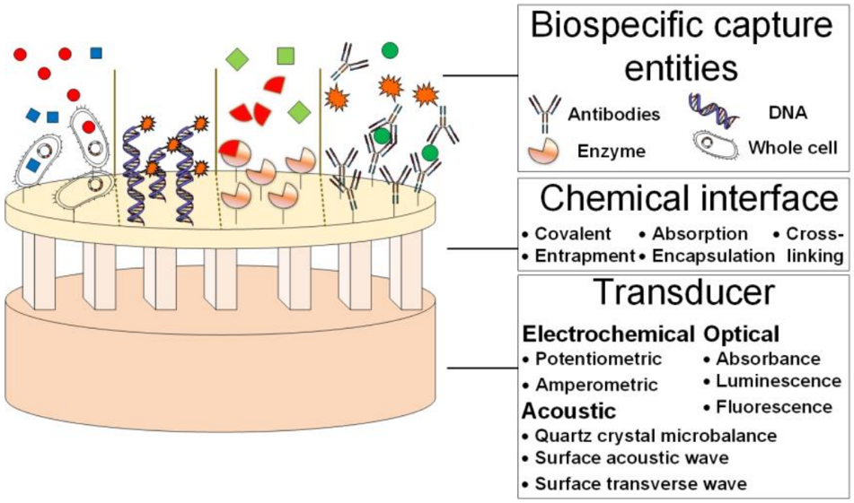
Figure 1 Components of a typical biosensor. Figure reproduced from [38].

For affinity-based sensors, the target molecule is usually the substance under test. During affinity-based recognition, the bio-probe functions in the role of capturing the target, thus other techniques may be required to characterize better the binding event, e.g., fluorescence or enzyme labeling. [39] Those biosensors that don’t require labeling are annotated as label-free biosensors. [40,41] Catalysis-based bio-probes otherwise relies on their intrinsic catalytic activity toward one or several substances. The target molecule can be the reactant, the co-enzyme, or the inhibitor for the catalytic reaction therefore the design of catalysis-based biosensors can be pretty flexible. The most widely used catalysis-based bio-probes are enzymes (including DNAzymes or ribozymes), inorganic noble metal or metal oxide compounds. [42]
The transducer is the pivotal component in a biosensor since the performance and signal quality as well as the peripheral designs are greatly dependent on the working principles and working conditions of the transducer. The transcoder can be an optical device such as optical fiber or reflector, a mass-sensitive device such as a quartz microbalance or a microcantilever, or an electrical for electrochemical and impedance sensing. Sometimes the transducer even is not a solid device, for instance, transducers for most colorimetric biosensors are solutions or colloids of nanoparticles. [43,44] In the following sections, some typical biosensors' working principles and application cases will be introduced based on their transducer designs.

Optical transducer
There may be dozens of designs of optical biosensors that have been reported in the latest decay due to the booming of biophotonics, at this moment, we only focus on the well-developed SPR/LSPR, SERS, fluorescence resonance energy transfer (FRET), and chemiluminescence resonance energy transfer (CRET). These techniques have been successfully commercialized and have achieved great success.

Surface plasmon resonance
The phenomenon of SPR was first observed in 1902. [45] When an incident polarized light at a specific angle irradiates on the interface of two media (usually between solid surface and liquid), the surface plasmons will be stimulated, as a consequence, the intensity of the reflected light will be reduced at s specific angle, which also named as resonance angle. Because there is a proportional correction between the amount of reduced intensity/resonance angle of the reflected light and how much mass onto the interface, the shift of wavelengths and reflectivity angle can be used as a metric for direct quantifying the concentration of the target substance. [46] A practical SPR device usually combines with one layer of affinity-based bio-probes that are immobilized onto the interface for the specific interaction of ligand–analyte. In most cases, a fluidics system will also be deployed for better and more convenient control of the time and amount of applying samples. The general process of SPR detection is schematically illustrated in Fig. 2. One of the essential merits of SPR is its capability to demonstrate the real-time processes of association and dissociation intuitively, therefore it is beneficial to study the dynamics of the interfacial reaction.
Nowadays, the developments of nanomaterial and advanced optical material have significantly improved the performance of SPR biosensors as well as broadened its application scenarios. Magnetic nanoparticles can enhance the SPR signal owing to their high molecule weight and high refractive index. [47] As a semiconductor, Quantum dots are equipped with the properties of high molar extinction coefficients, high quantum yield, and narrow and symmetric emission bands (30–50 nm). [48] When combined with affinity-based bio-probes, the binding signal of SPR assay can be enhanced and the corresponding sensitivity can be improved. [49] Thanks to the metal nanoparticles, a modified SPR assay, localized SPR (LSPR) is developed. In LSPR assay the incident light will interact with metal nanoparticles, causing collective electron charge oscillations localized in nanoparticles and further absorbing ultraviolet-visible light. [50] By controlling the parameters of nanoparticles such as their size, shape, and material, the LSPR can be precisely adapted and more flexible for different targets. [50]

Fluorescence-based transducer
A great many molecules exhibit the capability of fluorescing in a certain condition. By utilizing such features, a massive family of optical biosensors, named fluorescence-based biosensors, have been extensively researched.
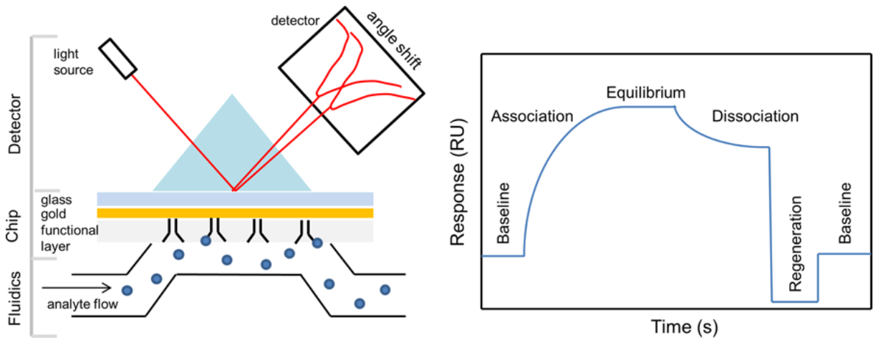
Figure 2 The scheme of SPR detection (left) and an example of the response curve of an SPR sensor. Recreated from [45].

A straightforward example is NAD/NADH pair, where NADH is fluorescent however NAD⁺ is not. Hence, by using NAD/NADH as a coenzyme in many enzymatic reactions, simple but effective fluorescence-based biosensors can be configured for various targets. [22] Similarly, many biomolecules also possess the intrinsic ability to fluoresce (i.e., Flavin nucleotides green fluorescent proteins, nucleic acids), once they are bound with other molecules, or upon a conformation or structure change occurs, their fluorescence characteristics may change, therefore detection can be accomplished based on such phenomenon. [51] These kinds of biosensors can be summarized as direct fluorescence biosensors. However, most target molecules are not fluorescent and a compensatory strategy must apply. Naturally, fluorescence labeling is a feasible solution. Depending on different designs and sensing strategies, the fluorescence label can be attached to the analyte, bio-probes or auxiliary particles/molecules. Usually, the molecules of interest will not interfere with the working condition of the fluorescence label; however, in some rare cases, the presence of biomolecules will enormously change or limit the intrinsic fluorescing ability. This phenomenon is called fluorescence resonance energy transfer (FRET), which describes energy transfer between two light-sensitive molecules. Initially, in its electronic excited state, a donor chromophore may transfer energy to an acceptor chromophore through nonradiative dipole-dipole coupling. [52] Once binding with typical biomolecules, or quencher, due to FRET, the label will become temporally non-fluorescent, however, once upon its released, due to the distance to quencher is greatly enlarged, the fluorescence will be recovered. [51] Since nucleic acid is an ideal quencher, by labeling elaborately designed DNA fragments with fluorescent labels, a well-known, very powerful detection assay, real-time polymerase chain reaction (real-time PCR) was invented for ultra-sensitive detection of DNA or RNA fragments. [27,53,54] This assay has made an Irreplaceable contribution during the epidemic of COVID-19. A schematic diagram is shown in Fig. 3 to illustrate the two most commonly used real-time PCR assays.

Chemiluminescence-based transducer
Chemiluminescence (CL) is another luminescence phenomenon that caused by chemical reaction rather than the absorption of photons in fluorescence. [55] Like
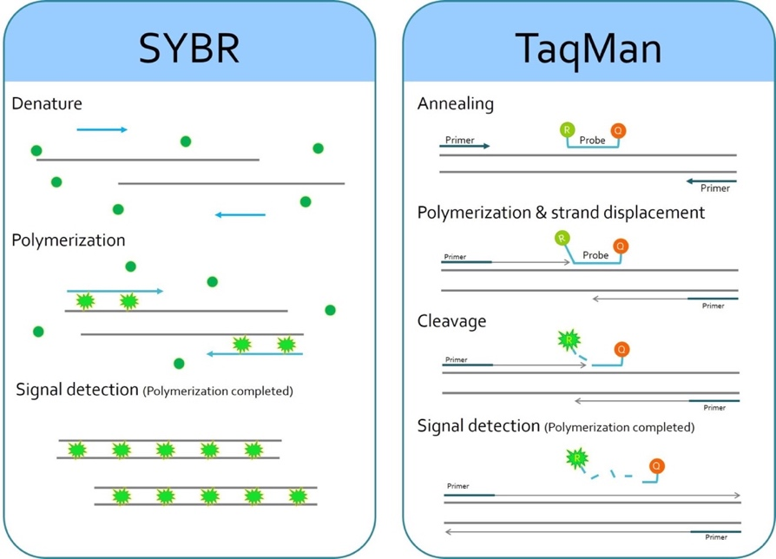
Figure 3 Two most widely used real-time PCR assays, the SYBR Green method (left) and TaqMan method (right). Both methods give a proportional correction between the fluorescence intensity and the target concentration.

fluorescence, a similar quenching effect called chemiluminescence resonance energy transfer (CRET) arises from energy transferring from a chemiluminescent donor to an acceptor molecule [55,56] for detection of reaction or molecules of interest. [56] The mechanism of CRET is also nonradiative dipole-dipole coupling, therefore the CRET is also extremely sensitive to the distance between donor and acceptor. Usually, the distance is within 10 nm. [57] One prominent advantage of CRET compared with FRET is that there is no need for a light source. This feature can significantly improve the selectivity as the external light source often results to non-specific signals in fluorescence detection. [58] Luminol and its derivatives are the most widely used energy donors, while rhodamine and small-molecule fluorophores are commonly used acceptors. [58]
The performance of CRET-based detection can also be significantly enhanced by nanomaterials and nanofabrication due to their superior electric and optical properties. [55] Nanoparticles like gold nanoparticles, quantum dots, and graphene can be used as energy acceptors due to their higher energy-transfer efficiencies and more incredible Stokes shifts. Utilizing these nanoparticles, great successes have been achieved in detecting proteins, DNAs, RNAs, and small molecules. [59–62] A detection process based on CRET is given in Fig. 4 to illustrate better how CRET works in DNA detection.

Electrochemical transducer
Electrochemistry has a long history since the first invention of the battery in 1800 and has been well researched in the following 200 years. Up till now, more than half of the newly developed state-of-art biosensors are subject to electrochemical biosensors, including the first modern biosensor invented by Leland C. Clark. Voltage, current, and impedance are three kernel parameters when describing an electrical system, consequently, they can be utilized as a sensing metric for an electrochemical method. Sensing methodology that primarily relies on the potential, current, and impedance are named potentiometry / galvanostatic techniques, potentiostatic techniques, and impedance measurement techniques. While for some cases when the accurate potential is not important, the reference electrode is not needed, and the system becomes the two-electrode configuration.

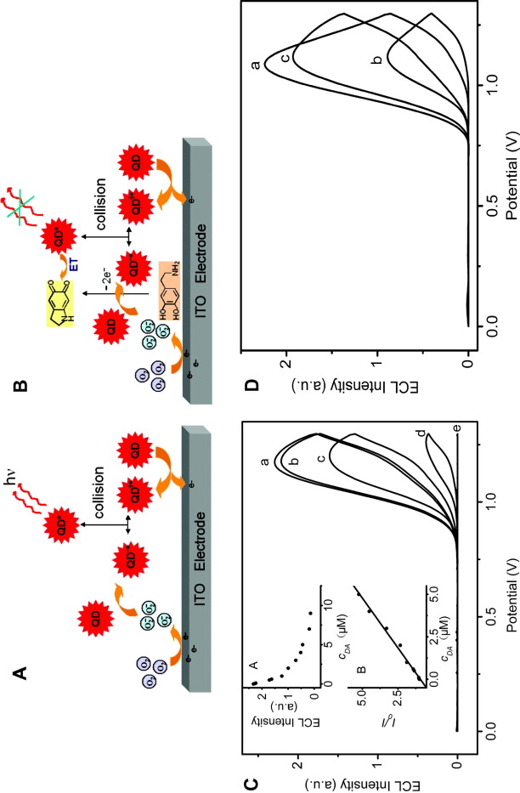
Figure 4 Schematically illustration of anodic ECL quenching mechanism based on quantum dots. Figure reproduced from [63].

A diagram of the two-electrode and three-electrode systems is shown in Fig. 5. In the flowing section, the fundamental working principles, as well as some applications, will be discussed.

Potentiometry
Potentiometry is sometimes also called static potentiometry or open-circuit potentiometry because it measures the potential of an electrochemical cell under static conditions, which means no current, or only a negligible current flows through the electrochemical cell, and its composition remains unchanged. For an equilibrium electrochemical system, the potential of one electrode is related to the concentration of electroactive species in the cell. The relation can be further precisely described using the Nernst equation, as shown in equation (1).
$$E_{\text{red}}=E_{\text{red}}^{⊖}-\frac{RT}{zF}\ln{Q_{r}}=E_{\text{red}}^{⊖}-\frac{RT}{zF}\ln{\frac{c}{a_{\text{Ox}}}}$$ | (1)
Where $E_{\text{red}}$ is the half-cell reduction potential at the temperature of interest, $E_{\text{red}}^{⊖}$ is the standard half-cell reduction potential, $R$ is the universal gas constant and equal to 8.3144626 J•K⁻¹•mol⁻¹, T is the temperature in kelvins, z is the number of electrons transferred in the cell reaction or half-reaction, $F$ is the Faraday constant, the number of coulombs per mole of electrons and equal to 96485.3321233 C•mol⁻¹, $Q_{r}$ is the reaction quotient of the cell reaction, and $a$ is the chemical activity for the relevant species, where $a_{\text{Ox}}$ is the activity of the reduced form and $a_{\text{Ox}}$ is the activity of the oxidized form. Some typical application of potentiometry includes the pH sensor [64] and ion-selective electrode sensor [65]. To selectively measure the ions of interest, a selective membrane is usually adhesive onto the working electrode to only allow some particular molecules to permeate the membrane. [66]
Biofuel cell sensors are another serial of application of potentiometry. The biofuel cell is a specific type of fuel cell that uses enzymes as a catalyst to oxidize its fuel (usually some metabolic or nutrient substance). [67] If carefully designed, the generated electric power can drive some ultra-low-power devices therefore no external battery is needed. Thus, the biofuel cell sensor is especially suitable for implanted or wearable
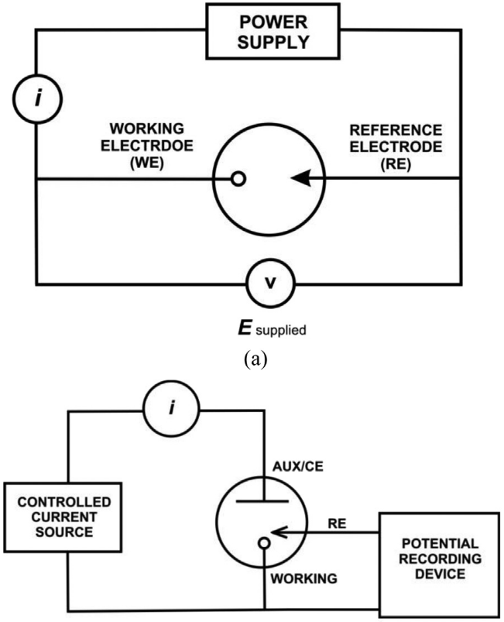
Figure 5 ﻿(a) Two electrode cell setup and (b)Three electrode cell setup for a typical electrochemical experiment. Figure reproduced from [68].

scenarios. [69–71] These devices sometimes are referred as self-powered biosensors. [72] Since the open-circuit potential of biofuel cells is reacted to the concentration or species of biofuel (e.g., glucose, lactic acid, ethanol, and uric acid), the potentiometry is a valuable tool for biofuel cell sensors.

Galvanostatic techniques
Galvanostatic methods also use the potential as the sensing metric, however, it supplies the current through the electrolytic cell in coulometric titrations constant, disregarding changes in the load itself. The galvanostatic method is widely used in the process or characterization of electroplating and electrical polymerization, as the thickness, interfacial morphology, or quality of the coating layer is depended on the applied potential. [73–75] ﻿Compared with potentiostatic techniques, galvanostatic technique requires simpler measuring devices since no reference electrode is required. Unfortunately, it suffers from the enlarged double layer charging screening effects. [76] Efforts for improvement is ﻿galvanostatic stripping chronopotentiometry, which is utilized for precise determination of heavy metals in environmental samples, [77] nevertheless, galvanostatic methods still only have minimal usage in biosensing systems. It is partly because it is more convenient to control most of the electrochemical reactions by applying the potential of interest. At the same time, the current is strongly dependent on the design of the electrode and the setup of the experimental environments; thus, sometimes it can be challenging to stabilize the system and acquire reliable readout when using galvanostatic methods.

﻿Potentiostatic techniques
Contrary to galvanostatic methods, potentiostatic methods supply the potential through the electrolytic cell by adjusting the current at an auxiliary electrode. Synchronously, the current through the working electrode and auxiliary electrode is measured and logged for determining the concentration of analytes. Depending on different input signals (or waveform of the input potential), potentiostatic methods can be classified as amperometry, chronocoulometric, voltammetry, and polarography. A diagram showing the setup of potentiostatic measurement is depicted in Fig. 6. A specially designed instrument called potentiostat that can generate desired waveform is used for all kinds of
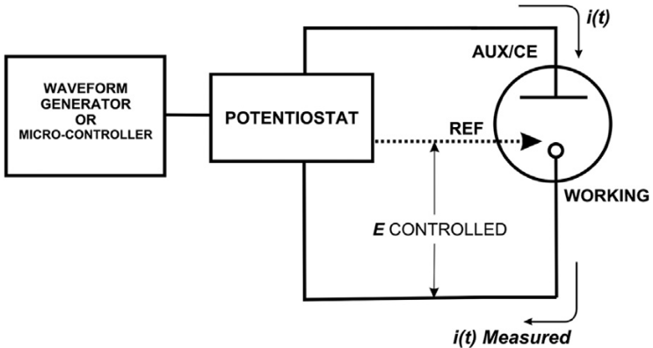
Figure 6 General configuration for ﻿potentiostatic measurement. Figure reproduced from [68].

potentiostatic measurements.
Amperometry is the simplest setup where a fixed potential is supplied. The oxidation or reduction of an electroactive species near the working electrode will induce current flow, which will be recorded as a function of time. [78] By adapting the potential to match the oxidation or reduction potential of analytes of interest, this method can specifically measure only one component of the sample at one time. The analyte will undergo a faradic reaction with some designed polarity during the measurement. But only a tiny fraction of the analyte will react since the electrode surface area is minimal. ﻿Chronoamperometry is a specialized implementation of amperometry, in which case a potential step is applied, and the current vs. time is recorded. The relationship between current and time is described by the Cottrell equation, as shown in equation (2). [79]
$$i=\frac{nFAc_{j}^{0}\sqrt{D_{j}}}{\sqrt{πt}}$$ | (2)
where $i$ is current, in unit A; $n$ is the number of electrons (to reduce/oxidize one molecule of analyte $j$, for example); $F$ is Faraday constant; $A$ is the area of the electrode; $c_{j}^{0}$ is the initial concentration of the reducible analyte $j$; $D_{j}$ is the diffusion coefficient for species $j$ and $t$ is the time in s. Using this equation and some foreknown parameters, the analyte concentration can be calculated.
Cyclic voltammetry is the most widely used model and has been the touchstone in the area of electrochemistry which can provide accurate information about the redox potential, reaction rate, and interface alteration during the immobilization and detection rapidly. [79–81] While testing, the applied voltage will sweep between the upper ($V_{2}$) and lower ($V_{1}$) potentials at a fixed rate. The scan will reserve and sweep back to $V_{1}$ once voltage $V_{2}$ is reached. Usually, the scan rate $\left(V_{2}-V_{1}\right)/duratoin$ will be deliberately chosen to provide sufficient time for electrode reaction [6, 7]. The higher analyte concentration with corresponding intensive redox reaction in faradic electrochemical reaction or better interfacial conductivity of attached biomolecules/films in non-faradic bio-binding reaction will both lead to the relatively higher current peak in the current vs. potential curves of CV measurements. For the reason above, CV is a powerful tool for both detecting analysis and quality control of immobilization. Both faradaic currents coming from charge transfer in reaction and non-faradaic from charging and discharging of double layer capacitance will occur during the electrochemical process. At the same time, only the first one accounts for the interfacial reaction. [80] Unfortunately, CV is not able to distinguish these two current components. Therefore, it is unsuitable for ultra-sensitive detection since the non-faradaic current will interfere with the calculation. The compensation method for this drawback is to use a pulse of voltage instead of the linear sweep. The corresponding techniques are called ﻿differential pulse voltammetry or polarography (DPV) and square wave voltammetry (SWV). DPV superimposes a series of regular voltage pulses on the potential linear sweep or stairsteps. Before each potential change, the current is measured. By doing so, the effect of non-faradaic current is minimized. DPV has become the default methodology for most of nowadays electrochemical biosensors. [7,82–87] The sweeping of SWV is very similar to DPV, which is also a combination of square wave and stairsteps, however, its current is sampled two times - once at the end of the forward potential pulse and again at the end of the reverse potential pulse (in both cases immediately before the potential direction is reversed). As a result of this current sampling technique, the contribution to the current signal resulting from non-faradaic is minimal. SWV is frequently seen in some latest work. [88–90] For small molecules especially metal ions measurement, stripping voltammetry is an advantageous and sensitive method, as the analyte of interest is electroplated on the working electrode during a deposition step, which means they are aggregated before being measured in the following striping steps. Linear sweep anodic stripping voltammetry (LSASV), differential pulse anodic stripping voltammetry (DPASV) and square wave anodic stripping voltammetry (SWASV) are the most adopted stripping voltammetry methods. [91–93]

Chronocoulometry techniques
Chronocoulometry is derived from amperometry by integrating the current over time. Owing to the integration, the signal noise can be minimized. Also, by comparing the accumulative charge coming from reaction and background, the non-faradaic current can be easily separated. [94] Rather than directly sensing the analytes of interest, chronocoulometry is usually used for characterizing the quality of surface immobilization or the density or coverage of the bio-probes during surface functionalization. [95]

Impedance measurement techniques
To efficiently characterize the non-faradic bio affinity reaction, ﻿the electrochemical impedance spectroscopy (EIS) method has been developed to describe detailed architectures of interfacial modification procedures and conjugate combination reactions. In this case, a small sinusoidal voltage 𝑈 is stimulated on the device, then, the amplitude and phase angle of the current response will be recorded. By varying frequency 𝑓 of the input voltage signal in a specific controlled range, the complex impedance of the biosensor, which is usually described as real and imaginary impedance components, or total impendence and phase angle as the function of applied frequency will be readout. The impendence can be simply represented by equation (3). [40] Fig. 7 also illustrates the EIS measuring procedure.
$$Z\left(jω\right)=\frac{U\left(jω\right)}{I\left(jω\right)}=Z_{r}\left(jω\right)+jZ_{i}\left(jω\right),ω=2πf$$ | (3)
﻿Incorporating with the interfacial equivalent circuit, EIS method can turn into an ideal sensing tool for interfacial conductivity, electrical double-layer capacitor and surface charge transfer mechanism study respectively.[96]
The introduction of nanomaterials is a huge leap in the development of impedance-based biosensors. As the conductivities of many nanomaterials (e.g., carbon nanotubes and graphene) can be strongly influenced by the surficial attached biomolecules or surrounding chemical environment. [97] Compared with other approaches, impedance measurement does not rely on chemical reaction, therefore the assay can be simpler, and therefore it is more suitable for on-site or lab-on-a-chip applications. [98–100]

Filed-effect-transistor (FET) transducer
﻿To incorporate electrochemical biosensors with well-developed and low-cost commercial CMOS technology, FET biosensors were frequently reported in recent years.
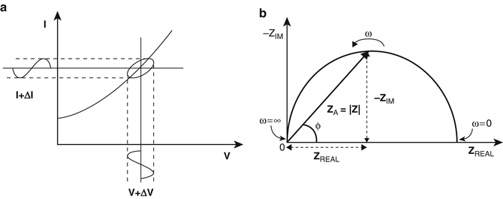
Figure 7 The derivation of impedance from voltage and current (left) and a typical Nyquist plot of impedance spectrum. Figure reproduced from [68].

[101] One traditional MOSFET can be modified into an FET biosensor simply by altering the gate electrode with a biochemically sensitive surface and keeping it in contact with bio analyte when testing (as shown in Fig. 8). [102] During the binding reaction, rearrangements of charge distribution near gate electrode or shift in voltage drop between the diffusion layer of the gate electrode arising from the redox/biding reaction rather than the direct gate voltage change will cause amplified source-drain current variation in response when the target biomolecule exists in the background solution. Benefit from the controllable cost, convenience for mass production, and fairly satisfactory sensitivity, few sensing methods have witnessed such dramatic development in both academic research and commercial operation of FET-based biosensors. [103,104]
A primary limitation of FET sensor in the real-world application is the electrical double layer screening effect. Once a charged object is immersed into an electrolyte (usually the water), a layer of ions with the counter charge will be attracted to the surrounding area of the subject, as a result, the charge will be compensated by these ions. Therefore, bio-FET only will work only when the charged molecules are close enough to the sensor surface (must be within the range of the compensating layer). Since the layer thickness is inversely proportional to the ionic strength, the bio-FETs are only applicable for very diluted samples. [102]

Piezoelectric transducer
﻿Piezoelectricity describes the phenomenon that after an application of mechanical stress, there will be electric charges accumulating in solid materials (usually crystals or ceramics) and vice versa. [105] Frequently used piezoelectric materials including ﻿quartz, ﻿aluminum nitride, and ﻿crystalized topaz. [105] Another important feature of these piezoelectric materials is that when imposing a periodic voltage signal (usually sinusoidal voltage) onto the surface using a pair of electrodes, a ﻿mechanical oscillation will be stimulated at a specific frequency.
The frequency is dependent on the shape, size, material, and surface environment. [106] When analytes are bound to the surface of the crystal, they will slightly change the
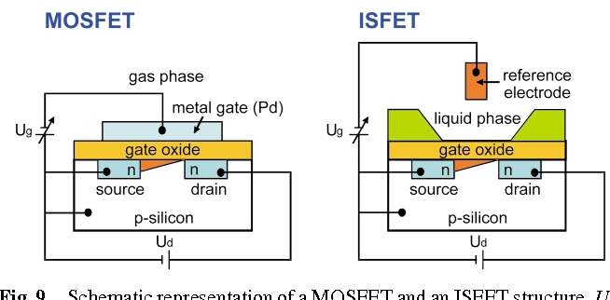
Figure 8 A traditional MOSFET device (left) and an ion selective FET (ISFET, right). The gate of MOSFET is replaced with a reference electrode in ISFET. Figure reproduced from [107].

mass of the crystal surface, therefore the resonant frequency will also change, which makes it possible to construct a transducer than can convert the changes in the surface environment into the signal of oscillation frequency shift. The relation between frequency and attached mass can be described by the Sauerbrey equation [108], as shown in equation (4).
$$Δf=-\frac{2f_{0}^{2}}{A\sqrt{ρ_{q}μ_{q}}}Δm$$ | (4)
where $f_{0}$ is the resonant frequency, $Δf$, $Δm$ are the frequency and mass change, respectively, $A$ is the active area, $ρ_{q}$, and $μ_{q}$ are the density and Shear modulus of the quartz. Based on this principle, a micro biosensing device called quartz crystal microbalance is designed. [109]. This device consists of a small, tick quartz disc, sandwiched between one pair of metal electrodes (usually two gold coating layers). During measurement, the QCM will be placed into a special oscillating circuit where the frequency can be preciously and continuously monitored. By doing so the surface binding events can be measured in a real-time manner. Nowadays the QCM can be responsive to nanogram to microgram level changes in mass per unit area. [108] After surface functionalization with an affinity-based biosensor, the QCM can turn into a sensitive sensor. An important advantage of the piezoelectric sensor is its capability to operate in air or in a vacuum. However, because the liquid molecules possess extra dynamic mass through hydration or entrapment, there will be extra energy loss. A technique named Quartz Crystal Microbalance with Dissipation (QCM-D) is proposed to better handle liquid samples by measuring both frequency change and energy loss. [108]. Another drawback of piezoelectric sensors is their demand for large molecule mass. For small molecule detection, cross-linking or carrier nanoparticles may be required for signal preamplification. [105,108–110]

Microcantilever transducer
Microcantilever is another kind of mass sensor that is sensitive to how many masses are attached to the sensing area. [111] Microcantilever usually referred to as a microdevice mainly contains a tiny diving board that has one end anchored to a comparatively large mass. There are two sensing mechanisms. Just like the piezoelectric sensor, the microcantilever can be excited to generate mechanical resonance, once molecules of interest are absorbed onto the surface, there will be a measurable resonant frequency shift. Alongside the mechanical vibration, the microcantilever will also undergo a bending process due to the load of molecules onto one single side. This is usually caused by different surface stress between the two interfaces of the microcantilever device if the two sides of one microcantilever are posited in different chemical environments. [112,113] Usually, the microcantilever needs to be specially crafted (using bi-material design, or chemically differently treated) for better amplifying the single side binding reaction. Both the shift of vibration frequency and the bending of the microcantilever can be quantified by optical methods such as laser beam deflection, or by microelectromech systems such as piezoresistive, capacitive, and piezoelectric methods.
Compared with piezoelectric sensors, the microcantilever biosensor is less sensitive to the viscous liquid since the bending is relying on the chemical difference. In most cases, the microcantilever biosensor has better sensitivity, especially for small molecules. However, very high-end instruments may be needed for a reliable and accurate measurement. [114,115]

Comparisons of different transducers
Different sensing principles and transducer designs have different merits and drawbacks and have their unique scopes of application. Table 2 generally lists their advantages, disadvantages, and corresponding best-fitted application.
Generally speaking, the most prominent features of optical biosensors are their intuitive, real-time, and visualizable, thus alongside the diagnosis and medical application, optical methods are also widely used for characterizing the biological process and the activities of biomolecules or tissues. The apparent drawback of optical sensing is the requirements of expensive instruments therefore they are more suitable for benchtop detection. Piezoelectric and microcantilever, on the other hand, possess the advantages of ultra-high sensitivity but always suffers from the lack of stability and consistency therefore
Table 2 Advantages and disadvantages of different biosensor designs.
Sensor designs |  | Advantages | Disadvantages | Scenario
Optical | SPR | Real-time, visualized | Expensive instruments and labor | Benchtop
Optical | Fluorescence | Real-time, visualized, high stable | Complicated operation, expensive device | Benchtop
Optical | Chemiluminescence | Low LOD, wide dynamic range | Label required, not very stable | Benchtop, in-lab-test
﻿Electrochemical | Potentiometry | High selectivity, low-cost, easy to preserve | Low sensitivity, high LOD | Portable,  on-site,  implant
﻿Electrochemical | Galvanostatic | Easy to operate, straightforward | Limited suitable applications | Benchtop
﻿Electrochemical | Potentiostatic | Simple, easy to integrate | Poor stability | Portable,  Large scale on-site
﻿Electrochemical | Impedimetric | Easy to operate, low-cost | High LOD, poor selectivity | Portable,  Large scale on-site
﻿Electrochemical | FET | Compact, easy to integrate | Required for low conductivity | Portable,  on-site
Piezoelectric |  | High sensitivity | ﻿Poor repeatability and stability | Benchtop
Microcantilever |  | Low LOD, High sensitivity, compact | Poor repeatability and stability | Benchtop

it is also difficult for deploying them to analyze the real-world and clinic samples.
Electrochemical sensing sometimes can reach the perfect balance between sensitivity, cost, and robustness/reliability. More importantly, most of electrochemical biosensors can be easily modified and integrated into the lab-on-a-chip system, therefore it is one of the most promising sensing methods for large-scale, point-of-care applications outside the laboratory. On account of their label-free nature, impedance biosensors even have more advantages over other electrochemical biosensors as the pruning of the labeling steps will significantly simplify the sample preparing steps, which is important for the out-of-lab environment.

Point of care: The future of smart healthcare
In recent years, POC testing has become more popular in healthcare diagnostics and other fields in resource-limited environments, e.g., in developing countries. [116] The ideal POC biosensor is a smart and low-cost portable system that can realize ‘sample-in-answer-out’. Biosensors can be an ideal one-stop solution for POC diagnosis. To fulfill the emerging demands for POC diagnosis, lots of works have been reported in recent years in multiple aspects of biosensing developing, for example, improving the reliability, improving the long-term, preservability, cutting the manufacture and testing costs, and trying to minimize the testing system of biosensors. [117] POC tests are simple medical tests that can be performed at the bedside. In many cases, the simplicity was not achievable until technology developed not only to make a test possible at all but then also to mask its complexity. For example, various kinds of urine test strips have been available for decades, but portable ultrasonography did not reach the stage of being advanced, affordable, and widespread until the 2000s and 2010s. [118,119]
The driving notion behind POC is to bring the test conveniently and immediately to the patient. This increases the likelihood that the patient, physician, and care team will receive the results quicker, which allows for better immediate clinical management decisions to be made. Right now, wide verities of well-developed devices are already hitting the market. Some of them are affordable hand-held devices that can be applied in complicated daily environments. [120,121] Others are bench-top instruments that can be used in an out-of-lab, clinical environment. Nevertheless, they provide versatile functions such as monitoring the concentration of nutrition components, blood pressure, the pH value, or the existence of some biomarkers. Potential operational benefits include more rapid decision making and triage, reduced operating times, high-dependency, postoperative care time, emergency room time, number of outpatient clinic visits, number of hospital beds required, ensuring optimal use of professional time, and reduced antimicrobial medication. Most of them will provide body indexes accurate enough for supporting the following diagnosis and treatments.
An example of the simplest POC biosensors is the pH meter. Most commercial pH meters are portable devices broadly applied in multiple applications, e.g., environment detection and clinic tests. The concentration of hydrogen can be reflected using the electrochemical-based method. The usage of more advanced enzymes or microfabrication processes can minimize the size and power consumption of a pH sensor while greatly improving its sensitivity and stability. [116,117] Nowadays the pH meter can be integrated into a lab-on-one-chip system together with other sensors for biomarkers detection. Alongside measuring the level of hydrogen ions, the pH sensor can also base on the determination of the photovoltage difference between two pairs of electrodes, which are named as the photoelectrochemical transducer. The later design can provide more flexibility in an electric-optical-based system.
Glucose is one of the most important nutrients in metabolism and can be found in almost all body fluids. Owing to its importance, POC glucose biosensors have long been well commercialized. [122,123] Most of the well-developed POC glucose biosensor are based on electrochemical measurements. Glucose oxidase is the most popular enzyme for catalyzing the oxidation of glucose. Depending on the carrier of electron transfer, the glucose biosensor can be roughly classified as three-generation, in which the first generation utilizes the hydrogen peroxide as charger transfer carrier; the second generation utilize oxide-redox mediator for charge transfer, while the third generation of biosensor relies on the direct charger transfer. Since the level of glucose in the blood is not very low (typically within the range of 0.6-33 mM), [123] sensitivity is not the most important factor to be considered of. On the other hand, robustness and reliability are the key criteria, as they need to be used in more challenging settings, e.g., whole blood samples, sweat or saliva samples, or wastewater. More advanced glucose sensors usually use modified glucose enzymes for better overall performance and extended shelf-life. Some of them even use nano metal or metal oxide-based material for enhanced cost-efficiency. [123] The in-vitro detection of glucose is another direction of future development; in which case the power sources are the biggest challenges. As the glucose itself is a biofuel and it can provide energy to drive some low-power circuit modules, some recent work reported the developments of self-powered glucose, one design that combined the measurement unit and the poser source unit together, opening up a new horizon for in-vitro detection.
Alongside glucose, using different configurations of bio-probes, biosensors for vast kinds of biomarkers can also be developed into POC biosensors. Taking the severe acute respiratory syndrome coronavirus 2 (SARS-CoV-2) as an example, some commercialized POC detecting platforms are summarized in Table 3. Basically, biosensors with all kinds of transducers can be turned into POC biosensors after modification. But the advantages of easier for integration or minimization and needless of labeling make electrochemical transducer become the first choice. [119,120,122] Such transducers can be simply driven and controlled by low-cost electronics device without specially designed optical-electrical transducer or high-frequency components.
The form of biosensor can be a conventional disposable testing strip like a glucose sensor, as shown in Fig. 9. Body fluids like blood samples or saliva samples need to be dropped onto the sensing areas for analysis. The measuring instrument can further be linked to the PCs or smartphones via wired USB/ethernet cable or wireless communication such as Wi-Fi/Bluetooth. The drawback of conventional design is the requirement of blood sampling, which can be torturous in a high-frequent daily testing setting. [121,124–127] More recently, efforts have been put into developing non-invasion wearable biosensors or long-lasting implantable sensing systems. The wearable biosensor can be integrated into wearable devices such as a smart watch, eyeglasses, or headphones or be designed as an
Table 3 ﻿List of commercial and laboratory-developed COVID-19 POC biosensor.
﻿Company name | ﻿Test name | ﻿Test type | ﻿Turnaround time
﻿Roche diagnostics | cobas® SARS-CoV-2 test | Molecular | ∼ 3 h
Roche diagnostics | ﻿Elecsys® Anti-SARS-CoV-2 | ﻿Total antibody | ﻿18 min
﻿Applied biosystems | ﻿TaqPath COVID-19 Combo Kit | ﻿Molecular | ﻿∼ 3 h
﻿Abbott molecular | ﻿Abbott RealTime SARS-C0V-2 | ﻿Molecular | ﻿∼ 24 h
﻿Abbott diagnostics | ﻿ID NOWTM COVID-19 | ﻿Molecular | ﻿5 Min
﻿Abbott diagnostics | ﻿SARS-CoV-2 IgG assay | ﻿Antibody | ﻿N/A
﻿Cephied | ﻿Xpert Xpress SARS-CoV-2 | ﻿Molecular | ﻿30 min
﻿MesaBiotech | ﻿Accula SARS-CoV-2 | ﻿Molecular | ﻿30 Min
﻿Cellex Inc. | ﻿qSARS-CoV-2 | ﻿Antibody IgG/IgM | ﻿15–20 min
﻿Quidel corporation | ﻿Sofia 2 SARS Antigen FIA | ﻿Antibody | ﻿N/A
﻿AccessBio | ﻿CareStart COVID-19 IgG/IgM | ﻿Antibody IgG/IgM | ﻿10 min
﻿Stanford health care | ﻿RT-PCR | ﻿Molecular | ﻿N/A
﻿Rutgers’s university | ﻿Saliva SARS-Cov-2 test | ﻿Molecular | ﻿N/A

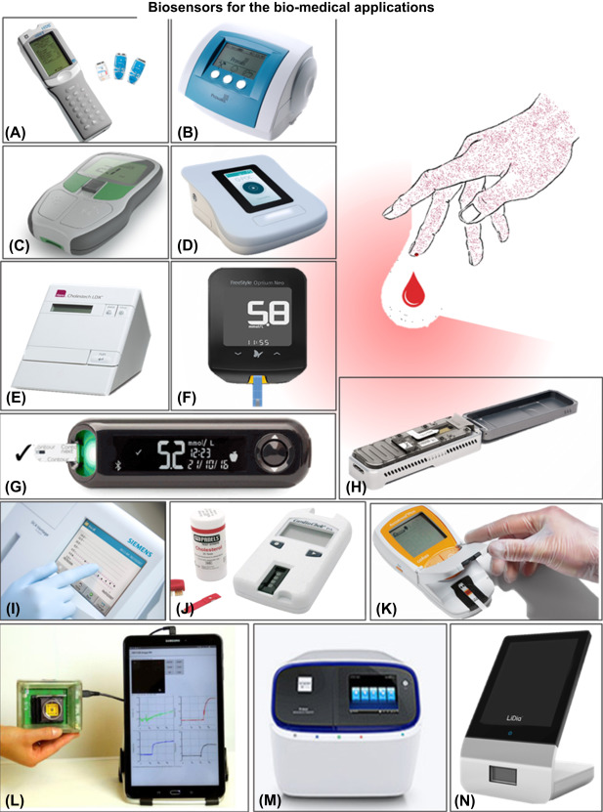
Figure 9 Demonstrations of some commercialized POC biosensors. Most of them are conventional design containing a measuring device and a disposable testing strip. Figure reproduced from [117,128].
individual device such as a body sticker, bracelet, or even necklace. Fig. 10 shows some typical designs of wearable biosensors developed by the industry or academic community. [118,119,129–132]

Challenges of POC biosensor
Even though the above-mentioned different designs of transducers have their own unique characteristics and advantages, and some of them have been already successfully applied to commercial diagnosing products. Some long-existing drawbacks and challenges still needed for improvement. In the following sections, they will be detailly referred. Some current states of art for solving them have also been given.

Long assay time: the biggest obstacle
First, in the aspect of measurement duration, most of the biosensing assays are slow. In the case of passive transportation, analytes are driven by diffusion or Brownian movement, therefore the assay time may be extensively long at the low concentration. One common example is the amplification stage of PCR. They usually need more than 1h for a sufficient, reliable result, and this is not acceptable for the on-site daily usage. Even for those amplification-free assays such as lateral flow immunoassays, a typical measuring period of 20 to 30 minutes is always required, such detection time is more feasible for a daily routine test but is still not optimized in a high-throughput, mass-scale settings.
The most intuitive solution is to increase the surface area, which will increase the probability of analytes colliding with probes. This can be done by deploying porous materials. However, it is still passive transportation, also, the porous materials will impose limits on the analyte size. It is not suitable for detecting large particles. Another possible solution is to use the microfluidic system for active transport. This is a high-efficient approach but it suffers from the drawbacks of being expensive, complicated, and requiring a huge number of reagents. Inspired by nanotechnology, MBs have been recently developed for enrichment. In this case, the analytes will first bind to functionalized MBs, then the MBs can be rapidly dragged to the interface of the transducer by a magnetic field. Nevertheless, the cost and extra surface functionalization steps are still drawbacks.

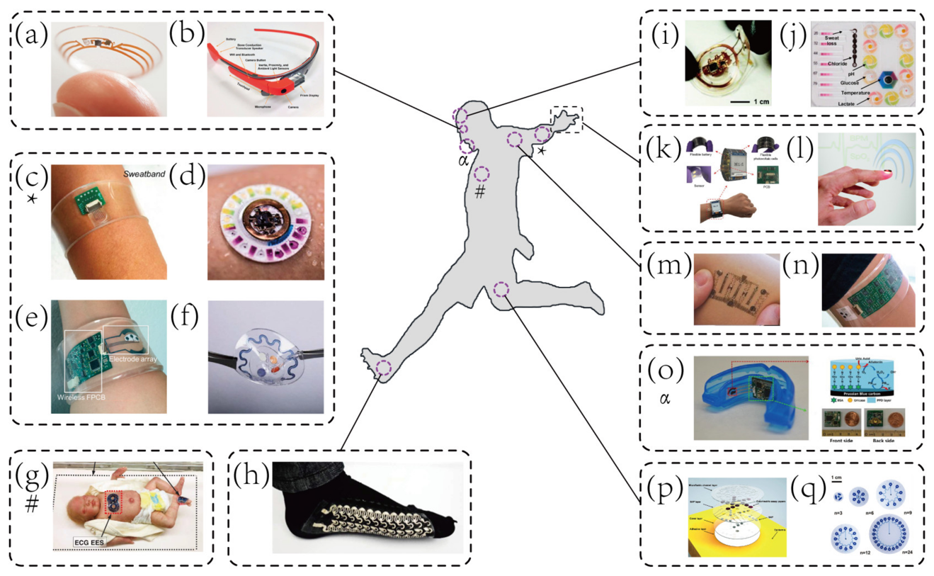
Figure 10 Demonstrations of some recently developed wearable biosensors. Compared with traditional POC sensing platforms, they are more flexible and can be attached to the wrist, fingers, ankle, or even mouth and eye. Figure reproduced from [117].

Conflicts between sensitivity and selectivity: the current gap
On the other hand, the LOD and sensitivity are long time being the Achilles' heel of impedimetric sensors. High sensitivity means the sensor is well capable of responding to subtle changes in the system, therefore the sensor can be fragile, and disturbance-intolerable. This becomes further remarkable when measuring real-world samples and eventually presents in the way of LOD loss. Hereby, trends of LOD loss are quantified by the loss ratio, as is defined by LOD in real-world samples/LOD in analytical samples, which, in most cases is greater than 1. Taking the bacteria detection as an example, Ma et al. reported a colorimetric biosensor powered by ﻿CRISPR-Cas12a and obtained a LOD of 10 CFU/mL for Salmonella in food samples, however, it sufferers from long assay time (90 min) and noteworthy LOD loss [133]. ﻿Capobianco et al reported a ﻿flowthrough immunoelectrochemical biosensor for the detection of E. coli O157: H7 and Salmonella in ground beef, achieving a LOD of 400 CFU/mL with minimal LOD loss, but it is short of sensitivity for food safety surveillance [134]. Most of which encounter severe LOD loss (loss ratio >10). The long assay time is another disadvantage that will significantly diminish the throughput.
In our previous work (Zhang et al., 2020, 2018), we demonstrated how to utilize dielectrophoresis (DEP)-based cell manipulation to boost the sensitivity of a capacitive aptasensor significantly. Interfacial capacitance is extremely sensitive to surface adsorption and is an ideal metric for biosensing (Ertürk and Lood, 2018). Meanwhile, DEP force can create a localized high-density region of bacteria of interest. A LOD of 276 cells/mL was achieved within 30 seconds. However, 10 hours of culture and centrifugation are needed for a successful detection in field milk samples, and the LOD loss is still higher than 10.

2-phase tunable ACEK-based capacitive biosensor: prospective
In our previous work, we demonstrated how to utilize ACEK-based molecules aggregation and capacitive sensing to significantly boost the sensitivity without any enrichment steps. Interfacial capacitance was extremely sensitive to tiny surface morphologic alterations and was an ideal metric for biosensing. Herein, we further evaluate and improve the selectivity and genericity of our sensing platform by superimposing the switching-off mechanism. [135] The original single-time measurement is divided into an aggregation phase and a subsequent maintaining phase. In the aggregation phase, a strong ACEK force is applied to collect bacteria. Thus, a higher sensitivity but limited selectivity can be achieved. Then in the maintaining phase, the DEP force is switched off, therefore non-specific particles are peeling off, and an improved selectivity is obtained. The modified sensor can achieve an ideal balance of sensitivity and selectivity. This work not only presents a novel capacitive biosensor for on-site usage with superior performance, but we also hope the switching-off mechanism can become a designing principle and open a new vision for the development of other kinds of biosensing platforms.

CHAPTER III IMPROVING SPEED: AC ELECTROKINETIC-BASED ENRICHMENT
Once an AC electric field is applied into a conductive fluid body, interactions between the media and electric field will stimulate several electrodynamics and thermodynamics effects. [136] ACEK refers to fluid flows and particle motions in a liquid electrolyte driven by the AC electric field and has been widely adopted for moving/manipulating cells and nanoparticles in nanoscience and biomedical device research. [137] There primarily exist three kinds of ACEK effects, dielectrophoresis (DEP), AC Electro-Osmotic (ACEO), and AC electrothermal effect (ACET), either of them has its unique properties and scope of applications. [31,138–141]
Unless external enrichment or amplification is applied, the passive diffusion process limits the assay time of most affinity-based biosensors, especially for ultra-low concentration detection. It usually takes several hours or even a few days to accumulate enough trace amount of target analytes onto the sensing area to trigger a measurable response, significantly limiting the LOD. Amplification strategies such as PCR, [54] loop-mediated isothermal amplification (LAMP), [142] magnetic beads [143] or target-driven electropolymerization [144] are widely adopted for benchtop and lab-based diagnosis. Unfortunately, most of these methods need sophisticated instruments, therefore, are not suitable for on-site applications.
ACEK, on the other hand, is an easy-to-operate, easy-to-be-integrated, low-cost, robust, tunable, and straightforward method that can be used for particle aggregation and is tailored for on-site usage. [145] In this section, the basic working principles, mechanism, and best-optimized conditions for DEP, ACEO and ACET are elaborately discussed. A very brief simulation of the magnitude of three ACEK effects in different situations is also given to understand the ACEK better.

Application of ACEK in biosensor: a small review
The capability of precisely controlling and manipulating small particles or fluids has excellent potential to be integrated into biosensors to improve the sensitivity further, accelerating the amplification process and shortening the assay time. Numerous works have reported wide varieties of optimized geometrical patterns of electrodes as well as designs of microchannels, some of them are well summarized in the following reviews or research papers: [143,145–153]. Briefly speaking, one pair or an array of micro or nano-sized interdigital electrodes (IDE) are used in most of ACEK-based biosensors. The IDE can either be symmetric or asymmetric, depending on the application. The IDE can be fabricated in a microfluidic channel or chamber for supporting the sample solutions using photolithography or conventional printed circuit board technologies.
ACEO is sensitive to the ionic strength of the testing buffer. It reaches its peak performance in the highly diluted medium. It is widely utilized for micro-pumping or micro/macro-mixing different bio-particles such as proteins, DNA, RNA or small molecules, e.g., metal ions. [154–158] In contrast, ACET prefers higher conductivity; therefore, it is more widely adopted in electrochemical-based sensing systems. Both ACEO and ACET create bulk fluid flow near the electrode surface in which way particles of interest can be driven by the microflow. While on the other hand, DEP will directly impose a small force on the polarizable particles and drug or propel them toward the region with the stronger electric field. DEP is sensitive to the size of the particles and is usually insignificant for small particles (< 1kDa). It is widely used to manipulate large particles such as red cells, bacteria, fungi, etc. Some recent works also utilized it to concentrate proteins and antibodies. [159–164]
Nevertheless, it is crucial to understand the mechanisms and working principles of ACEK effects before we can deep dive into the design and optimization of high-performance, ACEK-based biosensors. The following sections will introduce theories and approximation equations to calculate the maximum speed of DEP, ACET, and ACEO.

Different ACEK effects
The concept of ACEK microfluidics first emerged in the 1990s and in the following decades has been intensively researched. [138] Our group also conducted several fundamental studies on the simulation of ACEK and its influences on biomolecules under low voltages and moderate ionic strength. [165] In the following contents, some simplified approximations of ACEK forces or velocities are given.

DEP
Dielectrophoresis (DEP) is a well-developed particle manipulation technique that is stimulated by the non-uniform electric field and the differences of the electrical and dielectric properties between particles and the solution medium. [166,167] DEP effects are particle size and shape sensitive. According to our previous simulating study, the maximum DEP velocity for a typical spherical particle (e.g., S. au and S. epidermidis) can be represented by equation (5). [167,168]
$$u_{DEP,Sph}=\frac{a^{2}ε_{m}}{6η}R_{e}\left[\frac{ε_{p}^{*}-ε_{m}^{*}}{ε_{p}^{*}+2ε_{m}^{*}}\right]∇{\left|E\right|}^{2}$$ | (5)
where$a$ is the spherical particle radius, $η$ is fluid viscosity, $\left|E\right|$ is the electric field modulus, $ε_{m}^{*}$ and $ε_{p}^{*}$ are the complex relative permittivity of the medium and particles, given as $ε^{*}=ε-jσ/ω$ ($ε$, $σ$, and $ω$ is permittivity, conductivity, and angular frequency, respectively). While for a cylindrical particle (e.g., E. coli and P. aeruginosa), the DEP velocity can be represented by equation (6). [167,169]
$$u_{DEP,Cyl}=1/3πε_{m}lr^{2}R_{e}\left[\frac{ε_{p}^{*}-ε_{m}^{*}}{ε_{m}^{*}}\right]∇{\left|E\right|}^{2}$$ | (6)
where $l$ is the cylindrical particle length and $r$ is the radius of its cross section. We roughly calculate the maximum DEP velocity for S. au, E. coli, P. aeruginosa and two most common large bioparticles in dairy milk: casein micelle (assuming to have a diameter of 150 nm) and milkfat globule (assuming to have a diameter of 2 µm) in the comparing section.
The ratio $\frac{ε_{p}^{*}-ε_{m}^{*}}{ε_{p}^{*}+2ε_{m}^{*}}$ or $\frac{ε_{p}^{*}-ε_{m}^{*}}{ε_{m}^{*}}$ is called ﻿Clausius-Mossotian factor. Since the complex relative permittivity of particles and media is frequency-dependent, Clausius-Mossotian factor also changes with frequency. The sign of Clausius-Mossotian factor determines the direction (or polarity) of DEP force. If it is positive, the particle will move toward to the region with the stronger electric field, which is known as positive DEP. And vice versa. If it is negative, the particle will move away from the region with the stronger electric field. Fig. 11 illustrated three different cases of DEP: no DEP force when the electrical field is uniform, positive and negative DEP.

ACEO
ACEO microfluidic motions usually appear near the electrode surface. [170,171] The applied electric field will induce Coulomb force on liber particles with net eclectic charge in the fluid body. The moving charged particles will further drive the surrounding media because of the viscous effect. Therefore a “bulk flow” will be generated. DC voltage will also arise in microfluidic motions. However, it is usually applicable for fluid pumping as the generating fluid velocity is stable and monodirectional. [170] ACEO flow prefers the low frequencies, in which cases the interfacial impedance is the dominating component. [172,173] Basically there are two major designs of ACEO microflow. The first one uses pairs of electrodes configured as “face-to-face” while the second uses pairs of electrodes configured as “side-by-side”. [173] Considering the “face-to-face” configuration needs at least a bilayer PCB and requires a special fluid pumping system, in this paper, only the “side-by-side” configuration is studied.
From our previous simulation study, the ACEO-induced maximum bulky fluid velocity can be approximated by the equation (7). [170,174]
$$v_{ACEO}=\frac{-ϵ_{m}}{η}*Δξ*E_{t}$$ | (7)
Where $v_{ACEO}$ is the maximum ACEO bulky fluid velocity. $ϵ_{m}$ is the ﻿permittivity of the medium. $η$ is the viscosity of the medium. ﻿∆ξ is the voltage drop between the interfacial component within the range of EDL. ﻿∆ξ represents the overall contribution of the interfacial impedance compared with the bulky solution impedance. $E_{t}$ is the tangential component of the electric field strength close to the electrode surface. Since the strength of ACEO is strongly dependent on the shape and thickness of EDL, the maximum velocity of ACEO is also sensitive to the ionic strength. Fig. 12 illustrates the configurations of ACEO in symmetric and asymmetric electrodes.
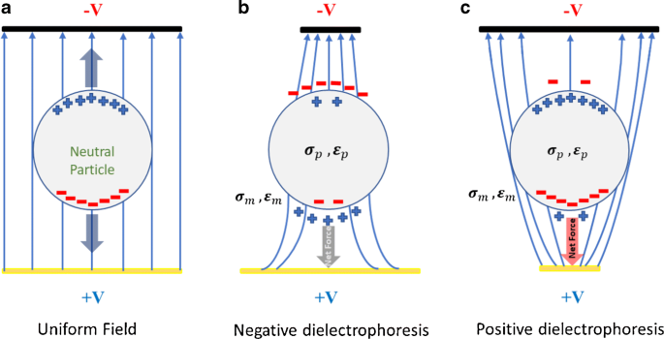
Figure 11 Different configurations of DEP: a: no DEP force when the electrical filed is uniform, b: negative DEP and c: positive DEP. Figure reproduced from [175].

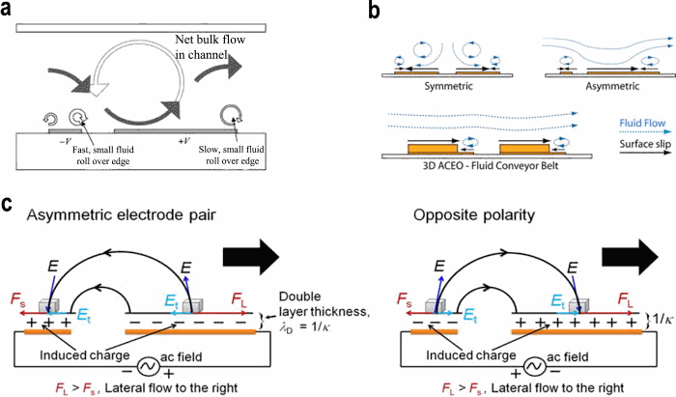
Figure 12 Configurations of ACEO microflows in symmetric and asymmetric electrodes. Figure reproduced from [158].

ACEO effect is prominent only in dilute electrolytes. While in this work, the electrical conductivity of the sample solution is no less than 1.613 mS/cm, therefore the ACEO effect is negligible compared with other ACEK microflows.[171,172]

ACET
ACET flow is primarily driven by dynamic variations in net charge density induced by gradients in fluid properties. [151] It is attributed to local Ohmic heating near the electrode surfaces which gives rise to localized temperature increase. This, subsequently, lead to local conductivity and permittivity change and subsequent variations in net charge density, which will further generate an electrostatic body force. At room temperature (~300 K) and low frequency (<MHz), ACET velocity (Wu, 2007) in an aqueous system can be expressed as equation (8). [151,152]
$$u_{ACET}=\frac{1}{2}R_{e}\left[\frac{ε_{m}\left(α-β\right)}{σ+iωε_{m}}\left(∇\text{T}⋅E\right)E^{*}-\frac{1}{2}ε_{m}α{\left|E\right|}^{2}∇\text{T }\right]l^{2}/η$$ | (8)
Where $η$ and $ε_{m}$ are the viscosity and permittivity of the medium, $∇T$ is temperature gradient in the fluid, $E$ is the electric field, $\left|E\right|$ is the electric field modulus, $α=\left(\frac{1}{ε_{\text{m}}}\right)\left(\frac{∂ε_{\text{m}}}{∂\text{T}}\right)∼-0.004\text{\sim }{\text{K}}^{\text{-1}}$ and $β=\left(\frac{1}{σ}\right)\left(\frac{∂σ}{∂\text{T}}\right)∼0.02\text{\sim }{\text{K}}^{\text{-1}}$for aqueous media. $l$ is the characteristic length of the device, typically on the order of electrode spacing. According to equation (8), the ACET force has no frequency and particle size dependence. [152,176]

Comparison of ACEK effects
To better understand how different ACEK effects can accelerate the particle enrichment in a different experimental setup, in this section, based on the equations motioned above, we conduct a rough calculation on the maximum velocity of DEP and ACET. Several common seen bio-particles, such as bacteria, small size protein (bovine serum albumin, BSA), large size protein (casein micelle), and fragments of nucleic acid (microRNAs) are taken into count.
All calculations are based on the half-circle electric field, as shown in Fig. 13. The
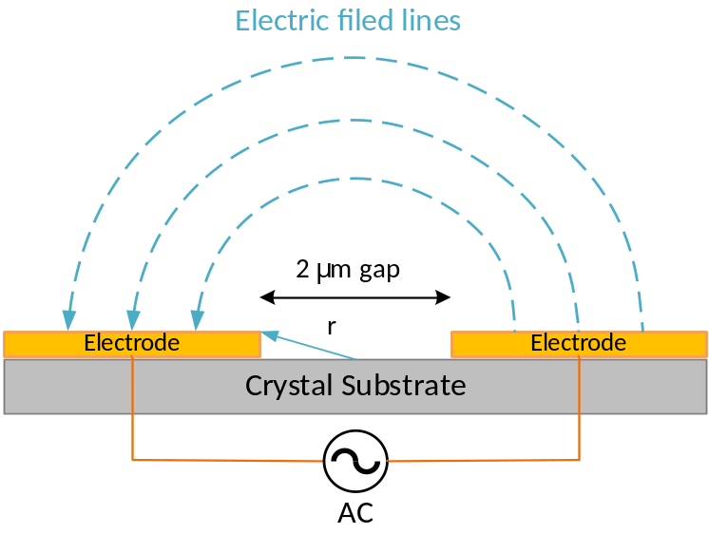
Figure 13 schematic of the simplified half-circle electric field. The electrode in the figure represented one pair of interdigital electrodes in the SAW chip.

electric field starts from the edge of one electrode and ends at another electrode; therefore, the electric file can be calculated by: $E=V/{πr}$.
Some fundamental parameters used in the calculations are listed below:
- Particle size: for S. au (sphere), $a=0.5 μm$. For E. coli (cylinder), $l=1.5 μm$, $a=0.25 μm$. For P. aeruginosa (cylinder), $l=2.2 μm$, $a=0.3 μm$. For casein micelle (sphere), $a=75 nm$. For milkfat globule (sphere), $a=1.5 μm$.
- Voltage applied: 2 mV to 20 mV and 300 mV (RMS), which is equal to around 2.83 mV to 28.29 mV (Amp).
- Permittivity of fluid: $ε_{m}=ε_{r}ε_{0}=80×8.85×{10}^{-12} F∙m^{-1}$.
- Permittivity of bacterial: $ε_{bac}=20×8.85×{10}^{-12} F∙m^{-1}$ [177].
- Permittivity of protein: $ε_{prot}=6.5×8.85×{10}^{-12} F∙m^{-1}$ [178].
- Permittivity of fat: $ε_{fat}=10×8.85×{10}^{-12} F∙m^{-1}$ [179].
- Viscosity of fluid: $η={10}^{-4} kg∙m^{-1}∙s^{-1}$.
- Electrical conductivity of 0.5x PBS: σ = 0.76 S/m; 0.1x PBS: σ = 0.17 S/m; for Milli-Q water: 0.0002 S/m.
- Thermal conductivity of 0.1x/0.5x PBS and water: $k=0.6 W∙m^{-1}∙K^{-1}$.
Based on these assumptions, the maximum velocities for various mediums and particles are given in Table 4. For DEP approximation, a surface acoustic wave (SAW) device with the electrode’s width and gap of 2 µm is used. While for ACET approximation, printed circuit board interdigital electrodes (PCB IDEs) with the electrode’s width and gap of 100 µm is used.
From Table 4, it can be concluded that for large particles in medium with low ionic strength, the DEP force dominates the overall particles' movements. While for small molecules in the medium with high ionic strength, the ACET will dominate the overall particles’ movements.

Table 4 Maximum DEP or ACET velocities of some commonly seen bio-particles in various mediums.
Particle/  Fluid | $$u_{DEP}$$  $$\left(2mV\right)$$ | $$u_{DEP}$$  $$\left(5mV\right)$$ | $$u_{DEP}$$  $$\left(10mV\right)$$ | $$u_{DEP}$$  $$\left(20mV\right)$$ | $$u_{ACET}$$  $$\left(300mV\right)$$
E. coli | $$0.046 μm/s$$ | $$0.29 μm/s$$ | $$1.159 μm/s$$ | $$4.64 μm/s$$ | --
P. aeruginosa | $$0.098 μm/s$$ | $$0.61 μm/s$$ | $$2.447 μm/s$$ | $$9.79 μm/s$$ | --
S. au | $$0.071 μm/s$$ | $$0.44 μm/s$$ | $$1.77 μm/s$$ | $$7.08 μm/s$$ | --
Casein micelle | $$5.86 nm/s$$ | $$36.44 nm/s$$ | $$146.55 nm/s$$ | $$586.19 nm/s$$ | --
Milkfat globule | $$0.22 μm/s$$ | $$1.37 μm/s$$ | $$5.47μm/s$$ | $$21.87μm/s$$ | --
Milli-Q  Water | -- | -- | -- | -- | $$0.67 nm/s$$
0.1x PBS | -- | -- | -- | -- | $$0.57 μm/s$$
0.5x PBS | -- | -- | -- | -- | $$2.54 μm/s$$

CHAPTER IV IMPROVING SENSITIVITY: CAPACITIVE SENSING
It is well known that the solid-liquid interface is far more complicated than an ideal charge transfer resistor. [14] The formation of the micro- or nano-sized localized dynamic equilibrium structure near the interface dominates the motion, conformation, and binding characters of probes and particles of interest thus, it plays a critical role in all kinds of electrochemical sensors, especially the impedance biosensor. Several interface models have been proposed to better understand the characters and behaviors of the solid-liquid interface, in this chapter, the most widely accepted interface model, the Electric Double Layer model is introduced. Besides, a measuring strategy for rapidly and accurately determining the key parameters of Electric Double Layer is also referred.

Electrical double layer
The concept of Electric Double Layer (EDL) is first presented by Klass [180] for modeling the role of water in the process of electrorheological fluid effects. Generally speaking, EDL will form in any situation when two conductive mediums contact with each other at an interface. Due to the unbalanced working function, there will be a small excess charge accumulated on both mediums, which is further compensated by the carriers with countercharge. [181] A famous example is a p-n junction between the p or n doped semiconductor. While for most cases, metal-liquid interfaces are the most concerned since they are widely related to batteries, fuel cells, and biosensors.
The word double-layer refers to a bilayer structure between the interfaces. It consists of two parallel layers of charges with opposite signs. The first layer, usually called the Stern layer or Helmholtz layer, is made up of ions or charged particles adsorbed onto the solid surface due to electrostatic interaction or chemical reaction. The second layer, usually annotated as the diffusion layer, consists of free carriers with countercharge moving in the fluid that is driven by electric attraction or Brownian movement. [181,182] Fig. 14 illustrates a typical structure of a double layer. Because the Stern layer can be significantly affected by the specific chemical or physical adsorption due to the charge redistribution
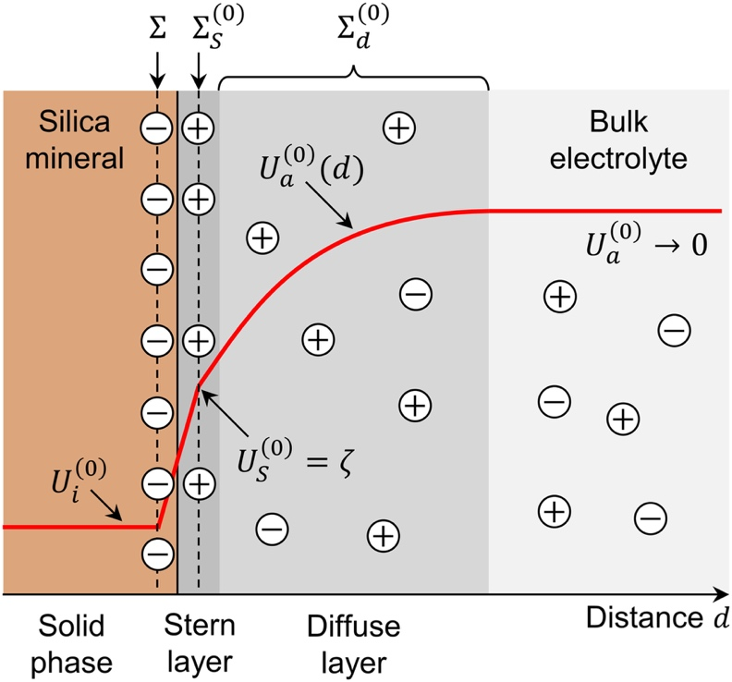
Figure 14 The typical structure of a double layer. Figure reproduced from [183].

near the solid interface, the EDL is very sensitive to the change in the interfacial environment. As a matter of factor, EDL is an ideal metric for biosensing and has the prospect of being developed as ultrasensitive biosensors, especially for small molecule detection.

Electrically characterization of the electrode surface
A successful quantification of interfacial capacitance is the basics of biosensing. From the perspective of electrical characteristics, when contacting with the electrolyte, the metal interface can be modeled by an equivalent circuit [184]. The circuit is made up of two components, (i) solution impedance including bulk resistor (R_{S}) and solution capacitor (C_{S}), (ii) interfacial impedances including interfacial double layer capacitor (represented by a constant phase element, CPE), and the leakage resistor (R_{Leak}) which accounts for the interfacial charge transfer. Within the optimized frequency range, the double layer capacitor and bulk resistor will dominate the interfacial impedance thus the circuit model can be further simplified as serial connected CPE and R_{S}. Therefore, it is important to determine the proper frequency range.
To find the suitable frequency range and verify how well the circuit model can fit the practical interface, the circuit element extraction and simulation are implemented based on PCB IDEs. The EIS data is measured based on (i) one freshly prepared bare PCB IDEs, (ii) one PCB IDEs after L-cys incubation, and (iii) one PCB IDEs after L-cys/copper incubation. The buffer solution for all measurements is 0.1x PBS buffer. The applied signal is 10 mV (RMS) over the frequency range of 10 Hz to 1 MHz. All the measurements are implemented using a potentiostat (Metrohm® Autolab PGSTAT204). The fitting results are demonstrated in Fig. 15.
MATLAB Curve Fitting Toolbox is utilized for the EIS data processing and fitting. Within the desired frequency range (1 kHz to 300 kHz), the fitting results match the measured data very well with the maximum mean squared error of less than 0.1% for all three PCB IDEs.
The impedance of an ideal capacitor and Warburg element could be calculated by
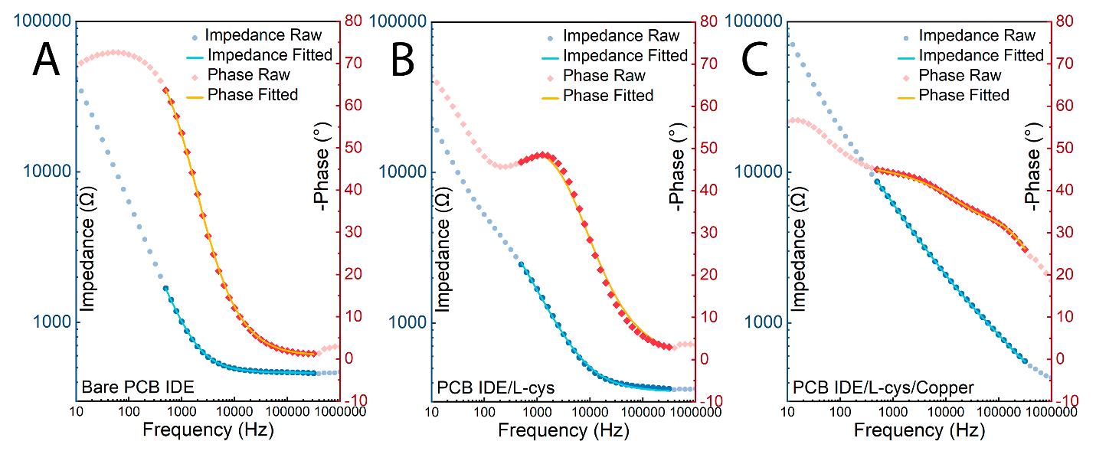
Figure 15 (A) EIS fitting for bare and clean PCB IDEs. The nattier blue and pink scatter represent measured impedance and phase angle, respectively. While the azure and orange solid lines are fitted impedance and phase angle, respectively. (B) EIS fitting for PCB IDEs after L-cys incubation and (C) EIS fitting for PCB IDEs after L-cys/copper incubation.

the following equation:
$$Z_{Capacitor}=\frac{1}{j2πfC}$$ | (9)
$$Z_{CPE}=\frac{1}{Q_{0}{\left(jω\right)}^{n}}=\frac{1}{Q_{0}{\left(j2πf\right)}^{n}}$$ | (10)
where $C$ is the capacitance value, $f$ is the applied frequency, $Q_{0}$ is the CPE admittance coefficient, $n$ is the constant phase, it is within 0 and 1. According to equations (9) and (10), both the impedances of capacitor and CPE are inversely proportional to the applied frequency. The impedances of all circuit elements at 3 kHz (the lowest frequency of the fitting) and 100 kHz (the highest frequency of the fitting) are listed in Table 5.
As can be seen in Table 5, at most frequencies, the impedances of R_{Leak} and C_{s} are much greater than the impedances of CPE and R_{s}, therefore, within all frequency ranges, the CPE and R_{s} will dominate the combined impedance. To sum up, the optimized frequency range is between 1 kHz and 300 kHz.
The CPE electrically represents a non-ideal capacitor due to the surface inhomogeneity where the capacitance value is frequency dependent. [180,185,186] The measured capacitance using the ideal C_{dl}-R_{S} model versus the extracted Q₀ value using the non-ideal CPE-R_{S} model is depicted in Fig. 16. The good linear relationship reveals that an ideal capacitive (C_{dl}) component can sufficiently indicate the behavior of a CPE and can replace the CPE in the circuit model.
Even though the surface of the electrode is not always perfectly smooth, the thickness of the EDL is usually 2 to 3 orders more minor than the surface area, therefore a parallel-plate capacitor model can be used to simplify the interfacial capacitor. After the immobilization of bio-probes, the double layer capacitor can be quantitively described by equation (11).
$\frac{1}{C_{\text{m}}}=\frac{1}{C_{\text{b}}}+\frac{1}{C_{\text{dl}}}$, | (11)
where C_{m} represents the combined capacitance, C_{b} is the bulk capacitance of the monolayer
Table 5 Absolute impedance values for circuit elements at 3 kHz and 300 kHz.
Element Name | Absolute Impedance (1 kHz)
Element Name | Bare PCB IDEs | After Incubation | After Blocking
R_{Leak} | 300.27 kΩ | 18.71 MΩ | 21.32 MΩ
CPE (Q₀) | 165.34 Ω | 372.48 Ω | 61.43 Ω
C_{s} | 385.36 kΩ | 7.84 MΩ | 1.00 MΩ
R_{s} | 454.26 Ω | 347.79 Ω | 384.57 Ω
 | Absolute Impedance (300 kHz)
R_{Leak} | 300.27 kΩ | 18.71 MΩ | 21.32 MΩ
CPE (Q₀) | 1.03 Ω | 4.61 Ω | 3.16 Ω
C_{s} | 1.28 kΩ | 26.13 kΩ | 3.34 kΩ
R_{s} | 454.26 Ω | 347.79 Ω | 384.57 Ω

Figure 16 The relationship between the measured value of C and extracted value of Q₀. The measurements are implemented using PCB IDEs. The listed concentration represents the buffer solution ranging from 10 µM PBS to 100 mM PBS.

and C_{dl} contains the Helmholtz-layer and diffuse-layer capacitances. [187] If C_{dl} > C_{b}, the latter will dominate the interfacial capacitive response and C_{b} then approaches C_{m}. The resultant capacitance C_{m} can further be treated as a plate and can be calculated using equation (12).
$$C_{\text{m}}=\frac{ε_{\text{m}}ε_{0}A}{d}$$ | (12)
where $d$ is the thickness of the dielectric layer, A is the electrical active electrode area, ε_{m} and ε₀ are the SAM dielectric constant and the permittivity of free space, respectively. Both $d$ and A depend on the condition of surface adsorption, which is strongly related to the shape and size of the attached molecules and the coverage density. [180,183] Typically, there are two situations: the thickness dominating and the area dominating. For the thickness dominating, probes or target molecules are tightly packed onto the surface, enlarging the thickness of the dielectric layer therefore, a decreased interfacial capacitance should be observed. While for the area dominating, molecules are loosely attached, thus the electrically active area will be extended. Hence an increasing capacitance response will be observed.
For the case of area dominating, the extended area is directly proportional to the number of analytes of interest attached to the surface, which is depicted in Fig. 17 D to F. By calculating the change of $C_{\text{m}}$ within unit time, the concentration of analytes can therefore be determined.
For the case of thickness dominating, after binding, the interfacial capacitance can be represented by equation (13).
$$C_{m}^{'}=\frac{ε_{\text{m}}ε_{0}A_{1}}{d_{1}}+\frac{ε_{\text{m}}ε_{0}A_{2}}{d_{2}}$$ | (13)
where d₁ and d₂ are the thickness before and after surface binding, as shown in Fig. 18C to E. A₁ and A₂ are the uncovered/covered area, respectively and $A =A_{1}+A_{2}$ always applies
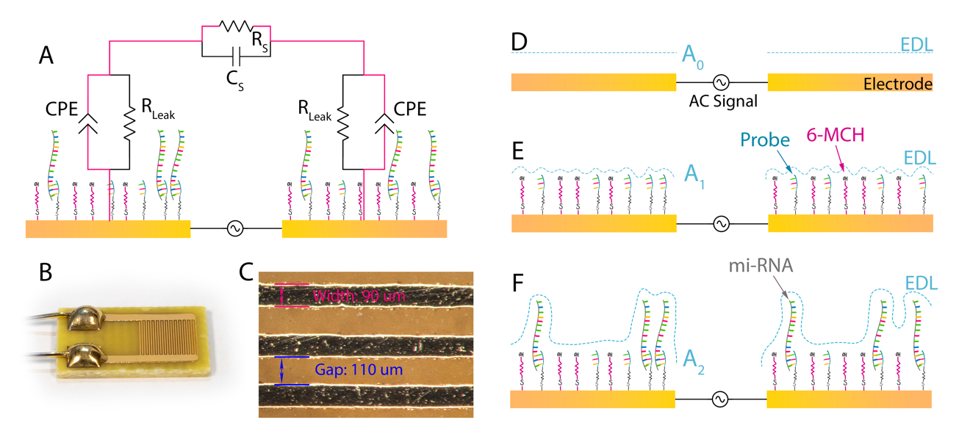
Figure 17 (A) Circuit model of EDL. The primary circuit path within the optimized frequency is highlighted in red. (B) and (C) images of PCB IDEs. (D) to (F) the thickness and active surface area of the area dominating case. The shape of EDL and its surface area are depicted using pale blue color.

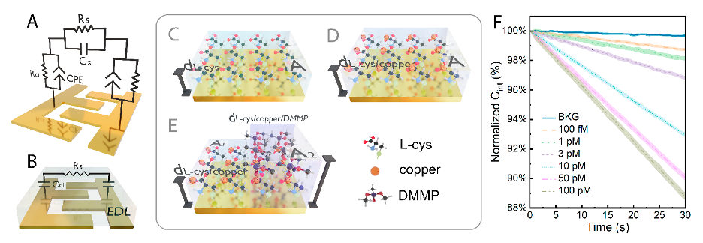
Figure 18 (A) The equivalent circuit model. (B) The simplified equivalent circuit model. (C) to (E) The thickness and active surface area of the area dominating the case. (F) The interfacial capacitance vs. time correction for different concentrations of DMMP. The standard derivations were plotted as error bands.

for all situations. To minimize the inconsistency from sensor to sensor, the normalized capacitance ΔC/C_{int} is adopted as the sensor response metric. Taking the C_{m} as the initial capacitance, the normalized capacitance can be calculated by equation (14).
$$\frac{∆C}{C_{int}}=\frac{∆C}{C_{\text{m}}}=1-\frac{C_{m}^{'}}{C_{\text{m}}}=\frac{d_{2}-d_{1}}{A∙d_{2}}∙A_{2}$$ | (14)
Since $\frac{d_{2}-d_{1}}{A∙d_{2}}$ is a constant, the normalized capacitance, therefore, is linear proportional to how much electrode area are covered (A₂), which is related to the bulk concentration. The relation between ΔC/C_{int} and measuring time for different concentrations is depicted in Fig. 18F. By measuring the ΔC/C_{int} within a specific time (i.e. dC/dt), the concentration of the DMMPs can be precisely determined.

Conclusion

﻿To sum up, compared with the conventional impedimetric sensing method, capacitive sensing has the advantage of higher sensitivity, shorter assay time and the capability of real-time detection. Very similar to impedance-based detection, capacitive sensing also has two primary properties: can be used to study the structure and dynamics of micro- or nano-scale surface structure and adsorption; and support the detection of specific surface biomolecular interactions. In the following sections, the first property will be used for determining the functionalization quality during sensor fabrication, while the second property will be utilized to detect specific biomolecules of interest, such as bacteria, nuclear acid, or heavy metal ions.

CHAPTER V PROOF OF CONCEPT: COMBINATION OF ACEK ENRICHMENT AND CAPACITIVE SENSING
In the following section, the feasibility of capacitive sensing based on area and thickness dominating are comprehensively evaluated. The analytes of interest for these two mechanisms are microRNAs (miRNAs), dimethyl methylphosphonate (DMMP) and bacteria. Since miRNA detection is loosely attached to the surface, there will be an increasing capacitance response. While for DMMP and bacteria, they are tightly bound to the surface, therefore their capacitance responses present a decreasing model. The performance, merits and drawbacks as well as the application scenarios are detailly discussed.

Detection of DMMP

Motivation
Organophosphate (OP) compounds ﻿refer to wide variety of organic compounds containing trivalent and pentavalent phosphorus. They are well-known as pesticides and herbicides and have been widely used in modern agriculture and industry because of their low cost and high efficiency in eradicating insect pests or weeds. [188,189] However, most of OPs, especially the notorious nerve agents Sarin, Tabun, and venomous agent X (VX), are acutely ﻿toxic due to their superior capability of inhibiting acetylcholinesterase even at low concentrations. ﻿[189,190] Over the past five decades, the abuse of OPs had raised serious threats to the ecosystems, leaving bulk of accumulative toxin residues in crops, water and soil. [188] To prevent the potential health hazards caused by rampant OPs usage, sensing technologies for rapidly and sensitively detecting OPs has attracted unprecedented attention. [191,192]

Experiment setup
The general workflow of capacitive sensing is: (1) sensor preparation, (2) sensor functionalization and simultaneous sample preparation, (3) testing and (4) data processing. In this experiment, a monolayer L-cysteine (L-cys) is first self-assembled (SAM) on the gold-coated PCB IDEs. Then a second monolayer of copper is self-assembled through the coordination bond between L-cys and Cu (II). Such a copper/L-cys bilayer can be used to recognize phosphonyl or phosphonyl-derived groups due to the formation of strong P=O−Cu²⁺ bonds. Therefore, DMMP and wide variety of OPs with similar functional groups can be specifically detected.
The reagents used in this experiment are K₂HPO₄, KH₂PO₄, NaOH, KOH, HNO₃, H₂SO₄, NaNO₃, L-Cystine, copper (II) sulfate pentahydrate (CuSO4⋅5H2O), acetone, isopropyl alcohol (IPA) and ethanol, they are purchased from Thermo Fisher Scientific (Waltham, MA, USA). Phosphate buffer saline (PBS) used for CV/Chronoamperometry is prepared by mixing 50 mM K₂HPO₄ and KH₂PO₄ in Milli-Q water. The pH is adjusted to the required value. The analytical buffer used in this work is prepared by diluting 50 mM NaNO₃ in Milli-Q water with pH adjusted to 7. The target reagents, DMMP, Metrifonate, and Glyphosate Ethephon standard samples, are purchased from Sigma Aldrich (St. Louis, MO, USA).
The electrodes used for DMMP detection is the afore-mentioned PCB IDEs. PCB IDEs are first polished by fine lapping films. Then, a thin layer of gold (around 80 nm) is electrically plated onto the surface. Afterwards, the PCB IDEs is rigorously washed using acetone, IPA and Milli-Q water in sequence and then dried by air. Finally, just before incubation, the PCB IDEs is further cleaned using UV ozone for 25 minutes and attached with a silica gel chamber, which is used to hold the samples. 1 mM L-cys is first pipetted into the chamber. The sensor is incubated in a humidor for 24 h. Then, after been rinsed with Milli-Q water and dried by compressed air to remove unbounded L-cys, the sensor is further incubated for another 24 h with 1 mM CuSO4. Finally, after washing with Milli-Q water and drying by compressed air, the sensor is ready for use.
For interfacial capacitance measurement, 10 μL of the analyte is dropped onto the incubated sensor, then an AC signal is applied for 30s for simultaneous ACEK enrichment and impedance measuring. The interfacial capacitance is calculated based on the simplified circuit model. Then, the normalized interfacial capacitance change rate dC/dt (%/min) is adopted as the sensor metric, which is calculated by fitting the time vs. capacitance curves using least-squares method. For each data point, at least three sensors are tested under the same condition to obtain the averaged response as well as the standard deviation.

Results and discussion
Since both ACEK enrichment and capacitive sensing are strongly influenced by the frequency and voltage, assay optimization was necessary. Fig. 19B demonstrates dC/dt of 10 pM DMMP analytical sample for different frequencies with different amplitudes ranging from 50 mV to 350 mV (RMS). At the lower or upper end of the frequency range, the influences of R_{ct} or C_{Sol} become non-negligible, therefore the dC/dt curves present a convex-like pattern with noticeable recession at two terminals. The plateaus on the response curves clearly indicated the optimized frequency range is 10 kHz ~ 50 kHz in our experiment, however, considering the complexity of designing a high-frequency impedance analysis instrument, we finally adopted the lowest 10 kHz as the operating frequency. On the other hand, the capacitance responses are monotonously increased with higher signal amplitude. We fit the corresponding capacitive response versus the applied voltage using a quadratic function (shown in Fig. 19A) at 10 kHz and find that the responses are linearly proportional to the square of the applied voltage within the range of 100 mV to 300 mV (RMS). The lower-than-expected response at 350 mV may be due to the depletion of the DMMP in the nearby area therefore the binding reaction is further restricted by the diffusion process since the ACET-induced vortexes are strong enough only within several µm from the electrode surface according to our previous simulation study. [193] Although the responses reach the peak at 350 mV, the diffusion-controlled limitation can suppress the dynamic range, herein, 300 mV is selected as the optimized parameter.
Then, in the next step, the DMMP and other three OPs are tested under analytical buffer. Fig. 19C illustrates capacitive responses for concentrations ranging from 100 fM to 100 pM. In general, the pattern of the calibration curve roughly fits the Langmuir adsorption model [194] and can be described in the following equation.
$Γ=Γ_{max}\frac{K∙C_{DMMP}}{1+K∙C_{DMMP}}$, | (15)
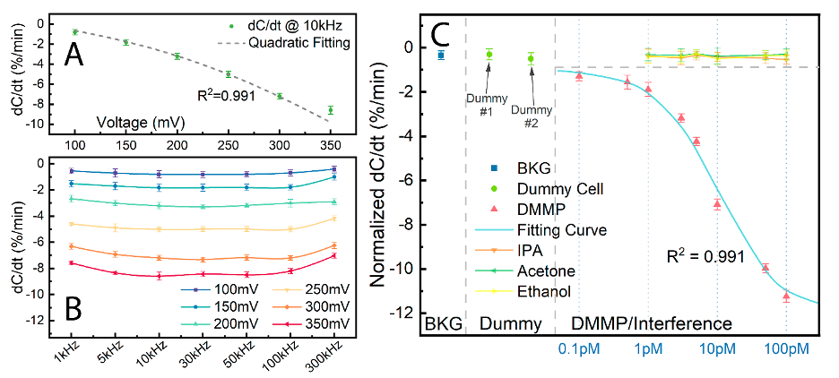
Figure 19 (A) Fitting of the normalized capacitive response at 10 pM versus different applied voltage using a quadratic relation. (B) Responses for the assay optimization. The x-axis represents the applied frequencies, and the different colors represents the applied voltage (all in RMS). (C) Calibration curve for analytical samples. BKG represents the analytical buffer background.

Where $K$ is the equilibrium constant, $C_{DMMP}$ is the concentration of applied DMMP samples and $Γ_{max}$ is the saturation response. The best fitting gives $Γ_{max}=-11.214 \%/min$ ﻿(standard error derived from the Hessian matrix, $σ=0.526 \%/min$) and $K=10.570 {pM}^{-1}$ ($σ=2.304 {pM}^{-1}$). ﻿The response of background buffer (BKG) is only 0.341 ± 0.198 %/min and is negligible in comparison to DMMP above 100 fM. The LOD is calculated to be 57.210 fM based on the fitted Langmuir model and ﻿3 standard deviations (±0.594%/min) away from the analytical buffer.
To further confirm whether the response is caused by artifacts, two kinds of dummy electrode, one without L-cys incubation (annotated as dummy #1) and the other without copper incubation (annotated as dummy #2), are tested under 10 pM DMMP. The comparatively insignificant responses coming from dummy electrodes validats that the capacitive responses are primarily triggered by L-cys/copper − DMMP binding. Fig. 19C also demonstrates responses of three commonly used organic solvent: IPA, acetone, and ethanol, and none of their response outperform the 100 fM DMMP, which is solid evidence that the sensor equips with excellent selectivity against frequently used organic solvents owing to the competitive binding.
One of the most significant advantages of using L-cys/copper instead of aptamer or enzyme-based probes is its capability of ﻿long-term preservation. [20,100] Selecting 10 pM as the testing concentration, freshly prepared sensors after stores in wet and dry conditions are tested to verify the long-term stability. ﻿ After 10 days storage at 20 °C, the wet-preserved sensors recover ~95% of the initial response while the dry-preserved sensors recover ~98% of the initial response, indicting an exceptional shelf life.
Three OPs (Metrifonate, Glyphosate, Ethephon) are also tested to verify the capability for wide spectrum detection. The response is shown in Fig. 20A. Both three OPs present similar response curves compared with DMMP. Using Langmuir adsorption model for fitting, the corresponding saturation responses and equilibrium constants for metrifonate, glyphosate and ethephon are $Γ_{max}=-11.013 ±0.662 \%/min$, $K=12.312 ±2.169 {pM}^{-1}$, $Γ_{max}=-13.007 ±0.825 \%/min$, $K=6.702 ±0.094 {pM}^{-1}$ and $Γ_{max}=-7.878 ±0.419 \%/min$, $K=5.475 ±1.030 {pM}^{-1}$, respectively. While
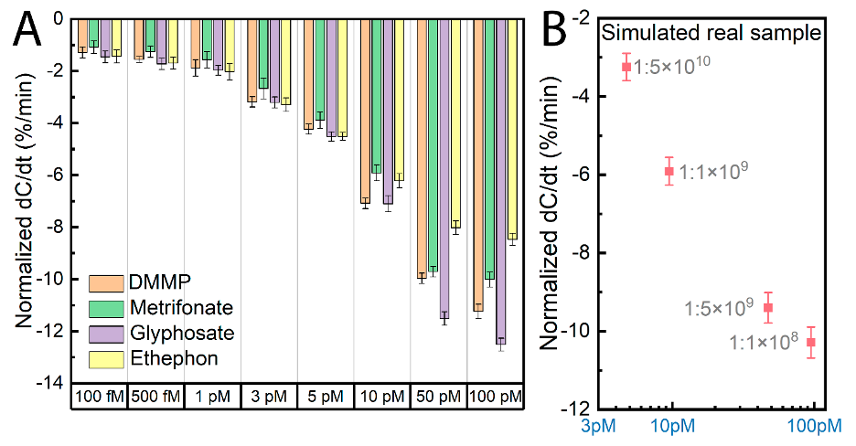
Figure 20 (A) Capacitive response of metrifonate, glyphosate, ethephon. The response of DMMP is also given as a reference. (B) Response of simulated real samples with different dilution factor. Analytical buffer is used for the sample dilution.

the equilibrium constant of metrifonate is close to DMMP, both glyphosate and ethephon have smaller equilibrium constant. Based on the observation, we draw the conclusion that in our system, the phosphonyl group has stronger affinity toward copper comparing with phosphonate group. Meanwhile, glyphosate/ethephon has remarkable higher/lower responses especially at high concentration. We deduce that the amplitude of the response is related to the size of the attached molecules. The relatively longer length of glyphosate as well as the carboxy and amine group in glyphosate may partly contribute to the higher saturation response. The very consistent performance of the sensor toward the three different OPs proves its ability for broad-spectrum detection.
Finally, simulated samples are tested to verify the feasibility for real-world application. To ensure the conductivity is suitable for ACET enrichment, we still use analytical buffer to dilute the simulated samples for obtaining the target concentration. Also, we notice that after lettuce leaf immersion, there is macroscopic floccule in the residual solution, hence we filter the solution before measurements for removing the insoluble debris.
The capacitive responses are given in Fig. 20B. Even after mixing with tap water and lettuce leaf, the sensor can still give responses to the roundup samples. Compared with standard glyphosate, the ﻿recovery ratios are 71.761%, 83.237%, 81.648% and 82.204% for 1:5×10¹⁰, 1:10⁹, 1: 5×10⁹ and 1: 10⁸ dilution. The fitted equilibrium constant is $K=26.173 ±13.442 {pM}^{-1}$, which is significant augmented from the analytical samples. ﻿Considering the complexity of the simulated real samples and analyte loss during the preparation, the response is reasonable and can reflect the real concentration of target OPs. We also find that different dilution ratios have slight influences on the final calculated concentration.

Detection of miRNA

Motivation
In current bovine farming industry, around 58% of pregnancies is lost during gestation. [195,196] A lost pregnancy in dairy cows costs up to $555 per case, therefore pregnancy loss (PL) can be a huge potential economic loss. [195] There is an ever-increasing demand for early diagnosis of bovine pregnancy loss. Traditional diagnosis methods include rectal palpation and ultrasonography provide acceptable accuracy after 25th~28th day post artificial insemination (AI). The drawbacks of traditional methods are high labor-intensity, requirements of sophisticated apparatus and highly skilled veterinarians. [197] Alternatively, chemical diagnosis uses hormones or conceptus-specific substances as indicators of the pregnancy to determine their concentrations. Radioimmunoassay and ELISA are the two most developed approaches that could quantitatively detect bovine pregnancy specific protein B, bovine pregnancy associated glycoprotein or progesterone in serum or milk samples as earlier as 21st day post AI and have been widely commercialized. [198] However, unlike rectal palpation or ultrasonography, most hormone-based detection cannot differentiate embryonic mortality (EM) from normal pregnancy in the early stage. [199] More recently, miRNAs, small noncoding RNAs that govern gene expression, have been intensively studied due to their potential capability as biomarkers. [200,201]

Experiment setup
In this experiment, the target miRNA-16b are released from extracellular vesicles by a simple step of cell lysing. [202] A single-strand DNA (ssDNA) probe is immobilized on PCB IDEs for selectively hybridization. During hybridization, the interfacial morphological change would lead to the thickness or effective area change of the electrical double layer (EDL). The EDL could be further quantitively characterized by electrical impedance spectroscopy (EIS) and represented by the EDL capacitor.
PCB IDEs is used as electrodes therefore the same preparation procedure also applies. The analytical buffer used here is 0.1x PBS. Tris (2-carboxyethyl) phosphine hydrochloride (TCEP) and 6-MCH are purchased from Sigma Aldrich (St. Louis, MO) for DNA probe preparation and surface blocking. The single-stranded DNA (ssDNA) probe, miRNA-16b and interference miRNA-25 samples are purchased from Integrated DNA Technologies, Inc. (IDT, Coralville, IA). The sequence of the probe is 5'- GCCAATATTTACGTGCTGCTGCTA-3' while the 5'-end is modified with a disulfide bond containing side chain (5' Thiol Modifier C6 S-S) which allows the probe to bind to the gold electrode surface after reduction of the disulfide bond to thiols by TCEP. The sequence of target embryonic mortality related miRNA-16b sample [202] is rUrArG rCrArG rCrArC rGrUrA rArArU rArUrU rGrGrC. The sequence of interference miRNA-25 (also embryonic mortality related, reported by Pohler et al [202] sample is rCrArU rUrGrC rArCrU rUrGrU rCrUrC rGrGrU rCrUrG.
For analytical samples, the miRNA-16b and miRNA-25 stock solution (100 µM, in ultrapure water) are further diluted with 0.5×PBS to obtain the concentration of 0.1 fM ~ 10 pM. Before being applied onto the sensors, all the diluted miRNA samples are heated to 95 ⁰C for 15 mins then incubated on ice for 5 mins to denature.
For real serum samples, blood samples are first collected at the day 17 or early day 18 post-AI. Blood serum are harvested by venipuncture into a 10-ml vacutainer tube and a 10 ml ethylenediaminetetraacetic acid (EDTA)-treated vacutainer tube, respectively. The serum tube is allowed to clot at room temperature for 1 hour before being placed in a 4°C refrigerator for approximately 24 hours. Serum is collected following centrifugation and stored at -80 ⁰C.
Pregnancy statues are confirmed by slaughter or flush to confirm the presence of an embryo. Among all 28 collected serum samples, 10 of them are inseminated with high-fertility semen but shows the symptom of embryonic mortality, which are considered as positive samples. 7 of them are inseminated with heated semen and shows no signs of pregnancy. The rest 11 of them are successfully pregnant. Samples from the latter two categories are considered as negative samples. For assay optimization, all positive or negative serum samples are evenly mixed to from the pooled positive or negative sample for ruling out the individual difference.
The lysis buffer for miRNA extraction is prepared by mixing TE buffer with 1% SDS and 2 mg/mL Proteinase K and gently shaking for 30 mins immediately before the experiment. The serum samples (frozen in -80 ⁰C for long-term storage) are first mixed with lysis buffer and incubated at room temperature for 15 mins. Then, the serum samples are heated to 95 ⁰C for 15 mins and cooled on ice for 5 mins. After the heat treatment, the serum samples were further diluted by 0.5×PBS.
For incubation buffer preparation, 0.1 M TCEP is first applied to dissolve and dilute the bulk DNA probe and to make the concentration of 20 µM for stock. Just before experiment, the stock DNA probe solution is further diluted to 2 µM using 0.05x PBS. 10µl of the above-mentioned DNA probe solution is loaded in the silicone chamber for incubation and the PCB IDEs are kept in a humidor for 20 hours. Thereafter, the electrode chip surface is blocked with 1.0 mM 6-MCH for 3 hours.
Very similar to DMMP detection, the interfacial capacitance is measured using EIS. The voltage and frequency are optimized before real sample detection. For each data point, at least three sensors were tested under the same condition to obtain the averaged response as well as the standard deviation.

Results and discussion
To validate the feasibility of interfacial capacitance-based miRNA detection, analytical miRNA-16b samples ranging from 0.1 fM to 1 pM are first tested. The dose response is shown in Fig. 21A. Since the sensor response start to saturate at 1 pM of miRNA-16b, 1 pM is considered as the upper limit of detection range. The background buffer, 0.5×PBS, is also tested as a control group to confirm whether the response is an artifact. It shows a response of only 0.87±0.28 %/min, negligible in comparison to miRNA-16b above 0.1 fM. The dose response is found to be ${dC}/{dt} = 0.84\%×\log_{10}{x}+15.66\%$ with the linear fitting correlation coefficient R²=0.9947, where $x$ is miRNA-16b concentration. The linear range for the sensor response is from 0.1 fM to 100 fM. The LOD is calculated based on 3 standard deviations (±0.84%/min) from the response of the blank solution (0.87%/min). Therefore, the threshold value is determined to be 1.71%/min. Substituting the threshold value in the linear fitting equation, the LOD is calculated to be 0.022 fM or 13.24 copies/mL.
Fig. 21A also shows the responses of dummy sensors as well as the interference miRNA-25 sample at 100 fM. The dummy sensor only has blocking molecules, 6-MCH, but no DNA probes immobilized on the electrode surface. As shown in the Fig. 21A, for dummy sensor, the response is negligible, confirming that the responses are not caused by

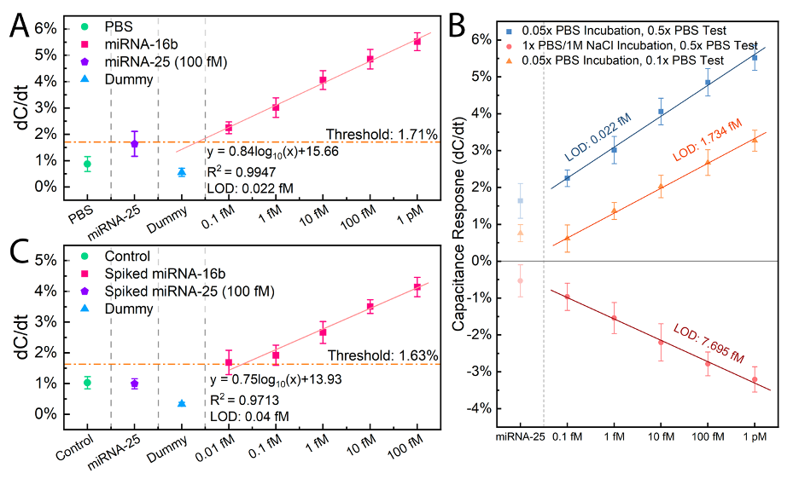
Figure 21 (A) Normalized interfacial capacitance response of analytical samples. (B) Responses of two different incubation buffers (0.05x PBS and 1x PBS/1M NaCl) and two different testing buffers (0.5x PBS nd 0.1x PBS). Test under analytical samples. (C) Capacitance response of spiked serum samples. The linear regression is performed using least square method. The concentration of miRNA-25 is 100 fM. For dummy cell test, 100 fM miRNA-16B sample is applied.

artifacts. The analytical sample test proves that a trace amount of miRNA-16b molecules can be specifically detected.
We also study the influences of incubation buffer and testing buffer. The responses to different incubation and testing conditions are shown in Fig. 21B. For 0.05x PBS incubation, the responses are monotonously increased with higher concentration, while for 1x PBS+1M NaCl incubation, the responses are inversely monotonously decreased. We conclude that the adverse behaviors are due to the different incubation densities. It was well-known that the incubation of thiolate-DNA on gold surface preferers high ionic strength to screen the electrical charges of nuclei acids. [203] Therefore, the incubation density of 1x PBS+1M NaCl can be much higher than 0.05x PBS. During hybridization, the tightly packed miRNA-16b will increase the EDL thickness rather than enlarge the surface area, therefore the EDL capacitance will decrease. The higher LOD of 0.1x PBS testing buffer compared with 0.5x PBS is solid evidence of how the ironic strength can affect the ACET enrichment.
To further validate whether the miRNA-16b can be directly detected in bovine serum, miRNA-16b spiked serum samples are tested. 18 negative serum samples are mixed to prepare the negative serum pool. Then, the negative serum pool is ten-fold diluted using 0.5×PBS. Afterwards, miRNA-16b samples ranging from 0.01 fM to 100 fM are spiked into diluted serum pool to simulate positive serum samples. The dose response is shown in Fig. 21C. The response of diluted negative serum pool is 1.03±0.20%/min, which is slightly higher than the 0.5×PBS but still well below the response of spiked 0.01 fM samples.
The dose response can be represented by the following equation, ${dC}/{dt} = 0.75\%×\log_{10}{x}+13.93\%$ with the linear fitting correlation coefficient R²=0.9713. The sensitivity (or slope) of the spiked serum samples is 83.13% of analytical samples. It is reasonable since large biomolecules such as bovine serum albumin can be attracted to the surface by pDEP effects and hinder the hybridization reaction. [204] The LOD is calculated to be 0.04 fM. The spiked serum test is further proof of concept that the sensor could be applied to the real serum samples.
Unlike analytical and spiked serum sample where miRNA-16b are added artificially, clinical samples carry the miRNA-16b inside extracellular vesicles. Thus, lysis buffer is needed to break down the vesicles and release the miRNAs into serum. Lysis buffer also prevents the serum from forming clusters during denaturing. The mixing ratio between lysis buffer and serum therefore needs to be optimized.
Pooled positive and negative serum samples are first mixed with lysis buffer with the ratio of 1:1.5, 1:2, 1:5 and 1:10. From our observation, the mixing ratio should not excess 1:1.5 to avoid clogging during denaturing. After the treatment, the serum samples are further ten-fold diluted with 0.5×PBS and tested under the AC signal of 5 kHz and 300 mV (RMS). Responses of varied lysis buffer mixing ratios and fixed 0.5xPBS mixing ratio are shown in Fig. 22A. The positive response decreases as the mixing ratio goes from 1:2 to 1:10, which is caused by the decreased effective concentration of miRNA-16b. The lysis buffer not only releases the miRNA from vesicles but also break down the proteins in serum, as a result, the interference of large bio-particles in serum samples will be suppressed. This is confirmed by the descending negative response as the mixing ratio changing from 1:1.5 to 1:10. For the ratio of 1:1.5, the positive response is smaller than the response of 1:2. This might be due to the incomplete breakdown of vesicles or the strong interferences from other biomolecules in serum. From this section, we conclude that the optimized lysis dilution ratio for clinic serum samples is 1:2.
Since lysis buffer will increase the conductivity, the sample/lysis buffer needs to be further diluted with 0.5×PBS, and the dilution factor needs to optimize. Dilution factor raging from 1:20 to 1:5 is tested. Undiluted sample is also tested as a control group. The responses for different 0.5xPBS dilution factors are shown in Fig. 22B. For undiluted sample, the positive response reaches the maximum. Unfortunately, the negative response is also the highest, therefore the separation is poor. Similar situations also observed at 1:5 dilution. Low dilution factor can augment the positive response but also increases the negative response. The ionic strength of lysis buffer is much higher than that of 0.5×PBS and will induce stronger ACET microflow, in which case both the specific hybridization reaction and non-specific surface absorption will be enhanced. For dilution factor of 1:20,
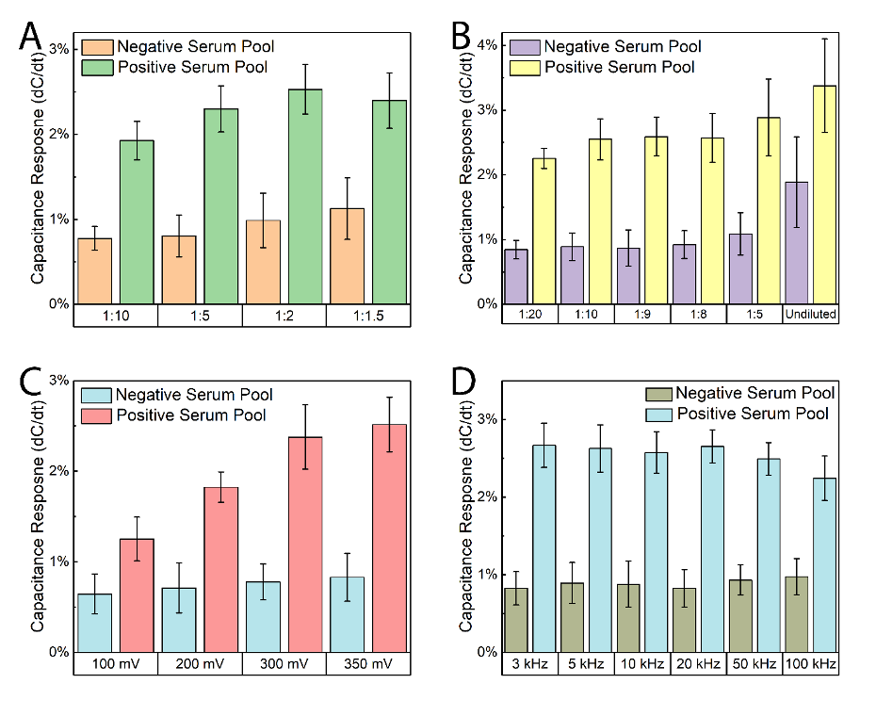
Figure 22 Normalized interfacial capacitance response for (A) lysis buffer dilution optimization, in this part, the PBS dilution ratio is kept at 1:10. (B) PBS dilution optimization, in this part, the lysis buffer dilution ratio is kept at 1: 2. (C) voltage optimization and (D) Frequency optimization. The dilution ratios, frequencies and voltages under test are listed in the bottom. For PBS dilution, the notation “Undiluted” means samples without PBS dilution.

since the effective miRNA concentration is lower, the positive response is slightly decreased. According to the experiment, the most used 1:10 dilution is considered as the optimized value.
To maximize the separation between the positive and negative samples, both voltage and frequency are optimized in two steps. Firstly, the frequency is fixed at 5 kHz while the amplitude is set and tested at 100 mV, 200 mV, 300 mV and 350 mV (RMS); Secondly, the amplitude is fixed at the optimized value while the frequency is varied. The simplified series connected R-C model only can work within the frequency range of 3 kHz ~100 kHz, so the tested frequency is limited as 3 kHz, 5 kHz, 10 kHz, 20 kHz, 50 kHz, and 100 kHz.
The capacitance change ratios of different amplitudes are shown in Fig. 22C. As the voltage goes higher, the capacitance change induced by the positive serum pool (positive response) causes a monotonous increase from 1.25±0.24%/min to 2.52±0.30 %/min. The capacitance change induced by the negative serum pool (negative response) also increases from 0.64±0.22%/min to 0.83±0.26 %/min. The stronger ACET microflow at higher voltage will both enhance the specific and non-specific binding. However, the increment of positive response is more prominent than that of the negative response, which means higher voltage still leads to the better separation. Thus the 350 mV (RMS), which is the peak output value the Autolab® platform could provide, is chosen as the optimized voltage.
The capacitance responses of different frequencies are shown in Fig. 22D. The positive responses fluctuate around 3%/min from 3 kHz to 50 kHz. This is reasonable since the ACET effects is frequency independent. The response at 100 kHz is slightly lower than the other frequencies. This is due to the influence of solution capacitance (C_{S}) because it is not ignorable at higher frequency. In summary, the empirical 5 kHz is still within the optimized frequency range and is selected as the optimized frequency.
Finally, clinical serum samples are tested. The cut-off value for diagnosing embryonic mortality status is based on the 3 standard deviations (±0.82%/min) from the averaged response of the pooled negative serum sample (0.89%/min), i.e., 1.71%/min. There are 10 positive and 18 negative clinical samples (7 dummy Ai and 11 pregnant samples) been tested with 91 individual measurements in total. The sensitivity is calculated by dividing the number of test positives (true positive plus false negative) by that of true positives, and the specificity is calculated by dividing the number of test negatives (true negative plus false positive) by true negatives. The sensitivity is 91.89% while the specificity is 72.22%. The relatively poor specificity is probably due to the existence of the trace amount of miRNA-16b in successful pregnant samples, as can be seen in Fig. 23A, the responses of dummy AI samples are smaller than that of pregnant samples, which is also confirmed by Pohler et al. If all the response for each same serum samples are averaged, then the sensitivity is dropped to 90.00% while the specificity can be further improved to 88.89%. The averaged results are shown in Fig. 23B.

Detection of bacteria in PDF/PEF

Motivation
To rapidly determine whether peritoneal dialysis effluent (PDE) buffer is contaminated by gram-negative bacteria and to early diagnose the bacteria-caused infection during peritoneal dialysis, we propose an interfacial capacitance and ACEK enrichment-based biosensor aiming to achieve the following: (a) specifically detect Escherichia coli (E. coli), one of the most common gram-negative bacteria, in spiked PDE buffer using aptamer functionalized capacitive biosensor, (b) comparatively, detect one gram-positive bacterium, Staphylococcus aureus (S. au) and another gram-negative bacterium, Pseudomonas aeruginosa (P. aeruginosa) in PDF buffer for the verification of the specificity and generality of the proposed biosensor, (c) an alternative detection approach, directly detect lipopolysaccharide (LPS), found in the outer membrane of gram-negative bacteria, in PDE.

Experiment setup
For better sensing, the large-sized bacterial, the SAW device and gold interdigital electrodes array (Au-IDE) with much smaller electrode size are also tested. The SAW device is manufactured by Qualcomm-TDK joint venture. It is a 4-port SAW resonator
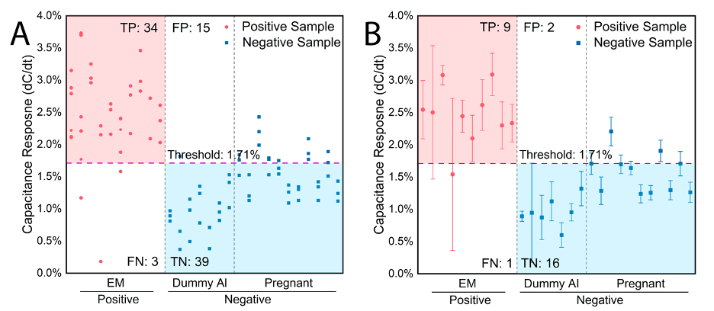
Figure 23 Normalized interfacial capacitance response for clinic samples test. (A) single point test and (B) averaged data. The TP, FP, TN, FN stood for true positive, false positive, true negative, false negative, respectively, whose areas have been colored (pink for TP, azure for TN, light orange for FT and FN).

working at 433.92 MHz. The gap and width of the IDEs array on the interior quartz platform are both 2 µm. The Au IDE is purchased from Micrux technology. It is fabricated by thin-film technologies on a glass substrate. The gap and width of the IDEs array are both 5 µm. The sensing surface is a circle area with a diameter of 3.5 mm.
The cleaning procedures are very similar to previous experiments. For SAW device, it is protected by a metal cover, so before preparation, the metal cap is removed to expose the IDE sensing area. For Au IDE, considering it is reusable, therefore before the further surface cleaning, a CV scan (+1.3 ~ −1.3 V, 100 mV/s in 0.1 M H₂SO₄, at least 35 scans) is added.
The bacteria are first tested in the analytical buffer (0.1x PBS) as a proof of concept. Then, the simulated samples, the spiked, unused peritoneal dialysis effluent (PDF) is further tested. For spiked PDE and PDF samples, the bacteria culture solution is first 1:10 diluted using PDF/PDE buffer. Then the growing media (LB) is also 1:10 diluted using PDE or PDF. Finally, the samples are diluted using the diluted LB buffer to obtain the target concentration.

Results and discussion
The simulated spiked PDF is first tested. The results are demonstrated in Fig. 24. To make sure the response is not coming from the artifacts, dummy electrodes (electrodes without aptamer incubated) are also tested.
The obvious difference between high and low concertation and good separation between E. coli and S. au indicated that the proposed sensor worked very well in the 1:10 diluted PDF buffer. The threshold can be derived from 3 stand derivations from the background buffer, therefore the LOD is calculated to be 903.20 cells/ml.
Similarly, the dose-responses of the spiked LPS samples are shown in Fig. 25. Another large biomolecule, peptidoglycan (PG) is also tested as interference for evaluating the selectivity of our sensor. Although the response is slightly smaller, PCB electrodes can be used to detect LPS in diluted PDF buffer. The LOD is calculated to be 87.23 fg/ml, which is efficient for the diagnosis of gram-negative bacteria.
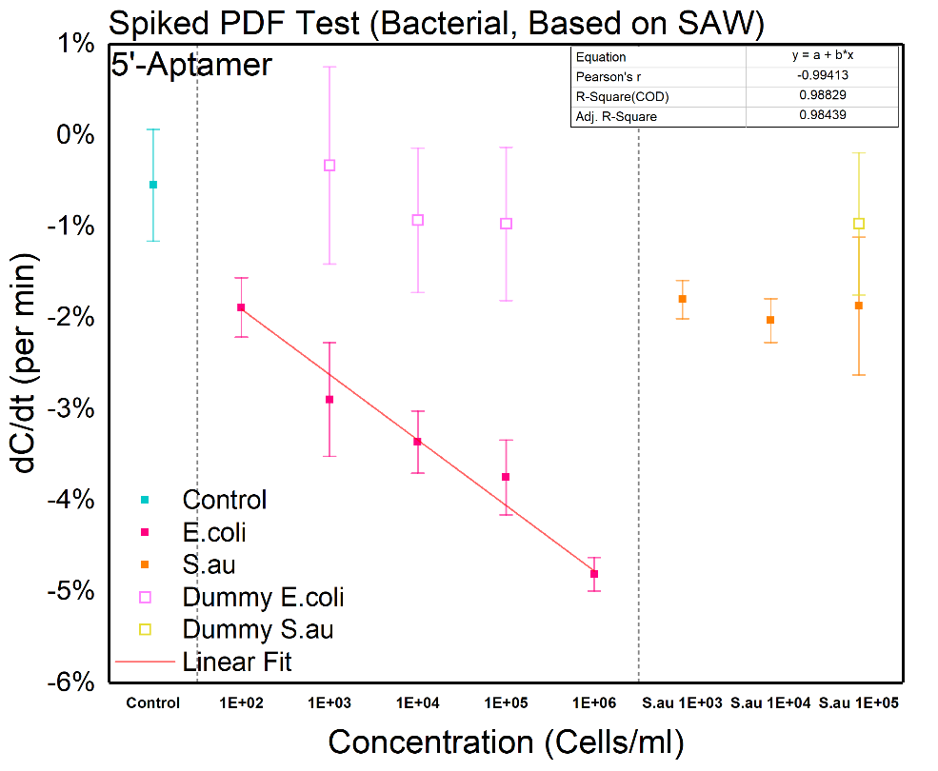
Figure 24 Dose response for spiked PDF buffer (Bacteria, SAW-based).

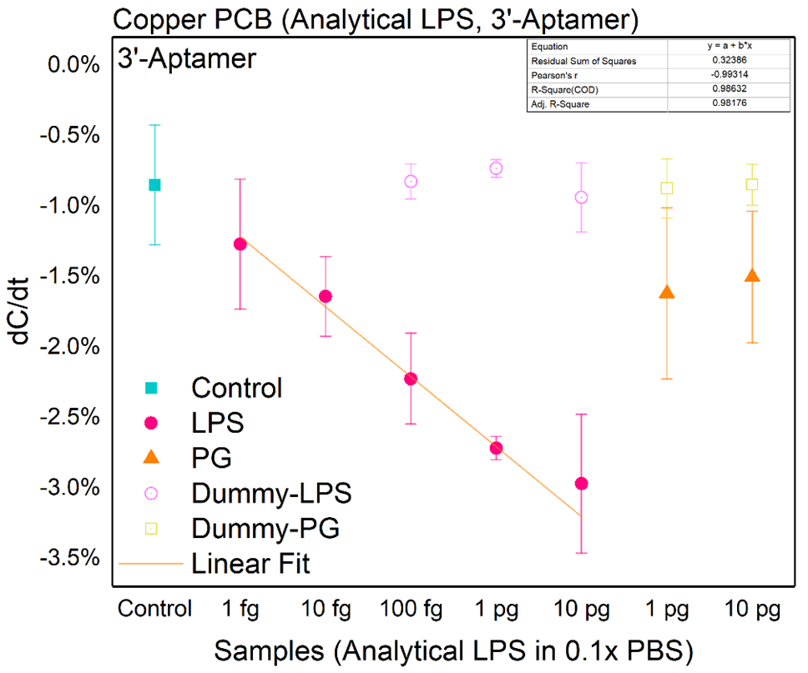
Figure 25 Dose response for spiked PDF buffer. The targeting analytes is LPS. Based on copper PCB.

Finally, the spiked PDE buffer from patients is tested. Using the optimized parameters and electrodes. The results for bacteria and LPS are shown in Fig. 26 and 27.
This project developed an interfacial capacitance and ACEK enrichment-based biosensor to detect gram-negative bacteria in PDE buffer. After comparison and optimization, we find that SAW IDE is suitable for bacteria detection while PCB IDE is suitable for LPS detection. For analytical and spiked PDF samples, the LOD of bacteria detection can reach 1×10² cells/ml with a dynamic range of 1×10³ cells/ml to 1×10⁶ cells/ml. The LOD of LPS detection is also lower than 100 fg/ml. For the PDE samples, the LOD of bacteria detection can reach 1×10² cells/ml with a dynamic range of 1×10³ cells/ml to 1×10⁵ cells/ml. The sensor not only detects E. coli but also works well for P. aeruginosa in complex media such as diluted PDE buffer.

Summary and challenges of capacitive sensing
The afore-mentioned experiments provide solid evidence that the capacitive sensing mechanism works very well for various analytes. By using the EDL capacitance as the metric, the sensor exhibits rapid response times, durability, stability, improved specificity, and sensitivity. With the integration of ACEK enrichment, the performance of the sensor possesses the reliability of LOD down to the sub-femtomolar level of miRNAs in both PBS buffer and bovine serum samples and to multiple OPs with phosphonyl or phosphonyl-derived function groups in both analytical buffer and simulated spiked lettuce leaf samples within 30 seconds. Without any deployments of advanced nanomaterials or complicated nanofabrication, the sensing platform provides an extreme low-cost (bill of material lower than $2 per sensor) and easy-to-operate solution for OPs detection, satisfying the requirements of mass-scale, on-site application. Although the ACET enrichment preferers testing buffer with higher conductivity, by a few simple steps of dilution, commonly used solvents such as tap water and natural water can be modified to meet the requirement easily.
However, the proposed capacitive sensor still suffers from some drawbacks. First, the sensor-to-sensor variations are still too significant for commercial usage, therefore
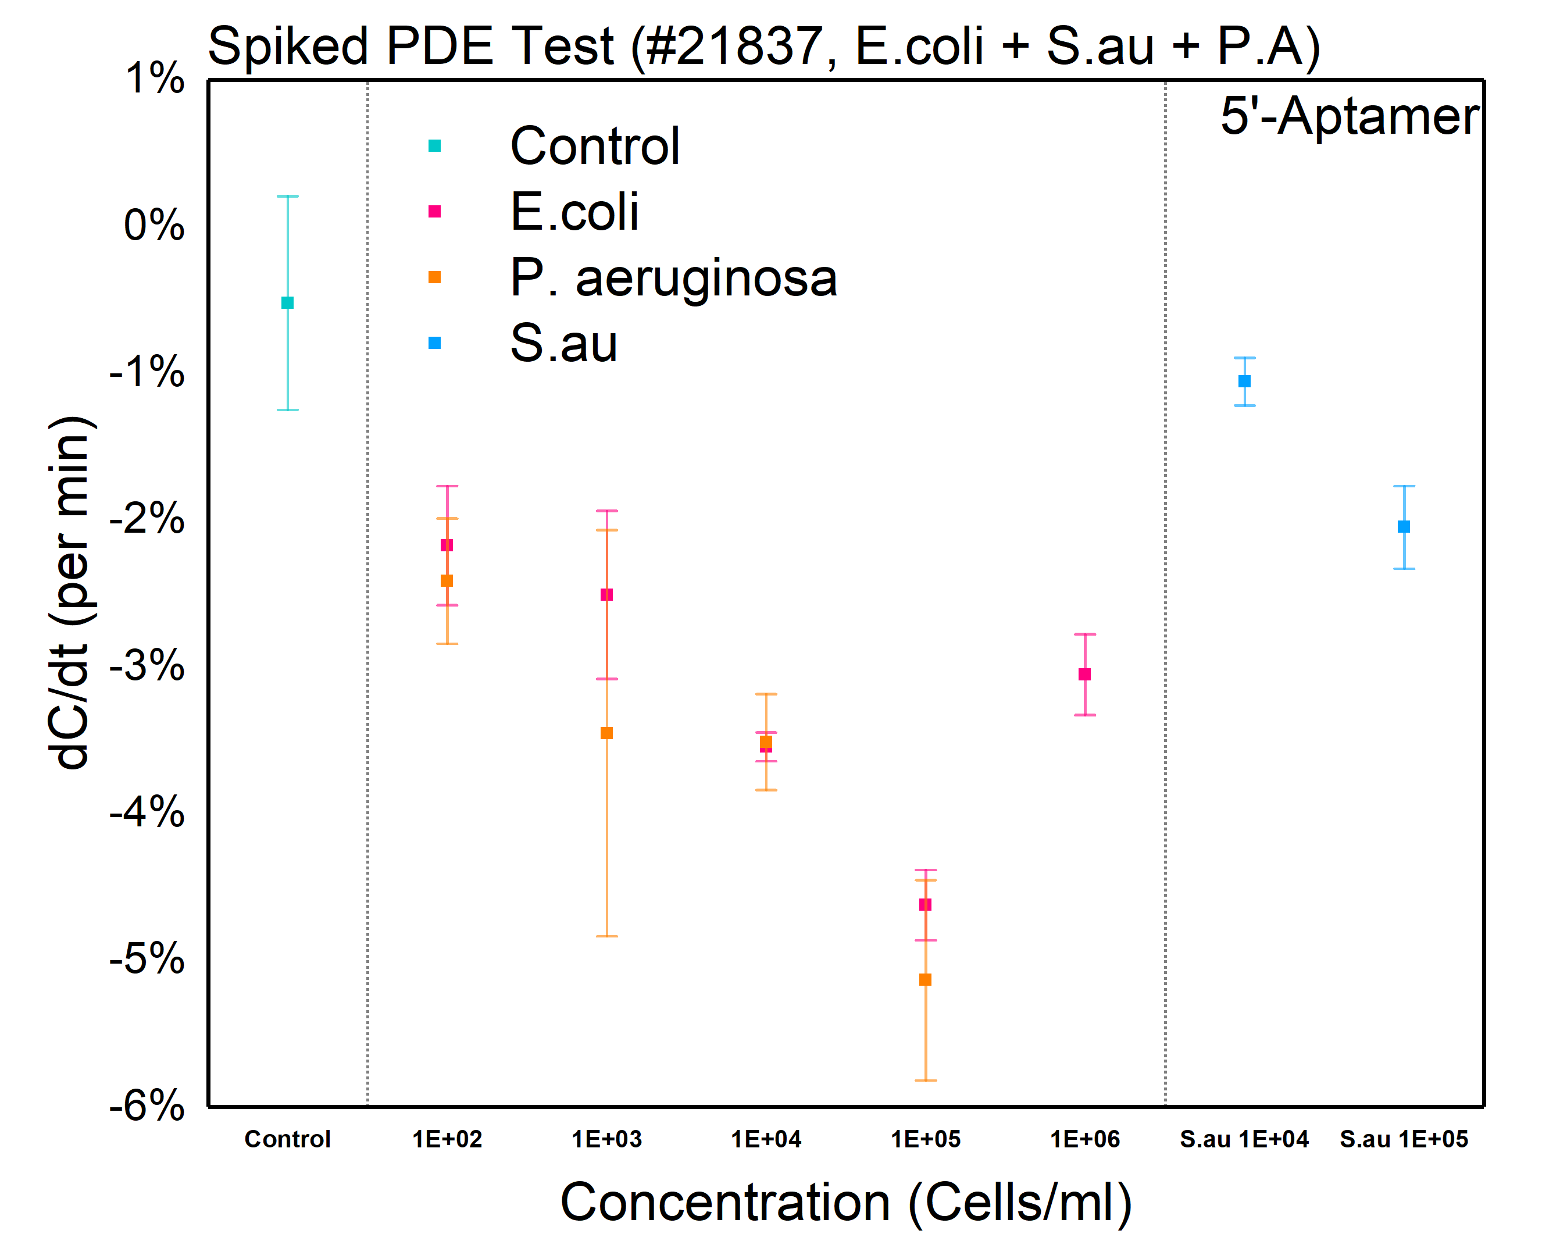
Figure 26 Dose response of bacteria for spiked PDE samples without centrifuge.

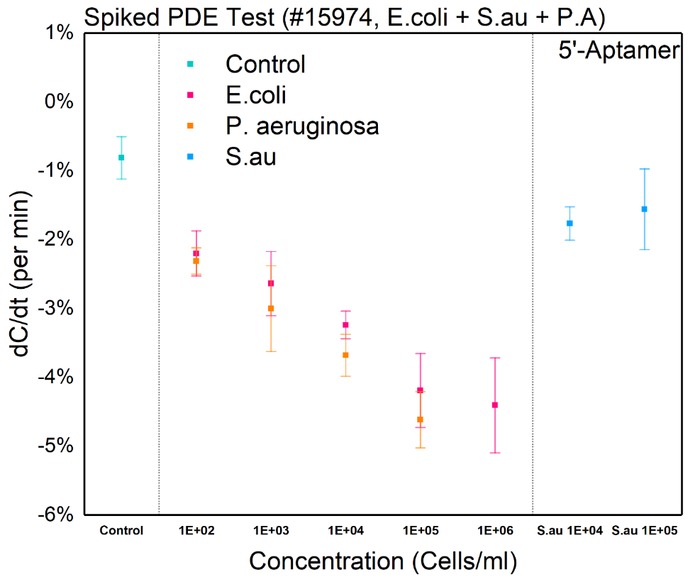
Figure 27 Dose response of LPS for spiked PDE samples without centrifuge.

complicated calibration may be peremptory. Second, for obtaining a stable and reliable read-out with acceptable SNR, dilution is needed, which reduces the adequate sensitivity. Third, it is common to see some loss of performance in real-world samples, because there exist interference substances. In another world, the achievement of efficient selection in the real-world application is at the cost of losing part of the LOD and sensitivity. Hence, more researches are worth contributing to compensate for such disadvantages.

CHAPTER VI IMPROVING SELECTIVITY: TWO-PHASE DETECTION BASED ON TUNABLE ACEK
In the previous chapter, we have demonstrated how to utilize ACEK-based aggregation and capacitive sensing to build sensors with improved sensitivity and reduced assay time. Interfacial capacitance is extremely sensitive to tiny surface morphologic alterations and is an ideal metric for biosensing. Meanwhile, ACEK EFFECTS CAN rapidly gather molecules of interest from the bulk solution onto electrode surfaces, further narrowing the assay time required for the detection of extremely low concentrated targets. Unfortunately, the insufficiency in selectivity against clinic samples and the lack of stability and consistency greatly limits our sensors’ potential for commercialization. In this section, we further evaluate and improve the selectivity and genericity of our sensing platform by superimposing an innovative sensing method inspired by the association and dissociation process in the SPR sensor. Different from our previous works which use constant AC signal for measuring and enrichment, in this work, an AC single with variable voltage is adopted. Some basic knowledge and design principles are presented in detail in this chapter.

The dynamics of association and dissociation
Before profoundly diving into the mechanism of tunable DEP detection, it is necessary to understand the association and dissociation process for affinity-based biosensors. As mentioned in the introduction chapter, SPR sensor is capable of intuitively illustrating the dynamics of the surface binding and detaching process and is often used as useful investigating tool to study the binding/absorption characters of molecules of interest.
Usually, a SPR measurement composes of a baseline measurement, the association step, the dissociation step, and sometimes a regeneration step. An injection system is often used to carry the analytes and support the measurements. The baseline measurement is used to acquire a reference starting point. Then, during the association step, the response will increase because of the binding of analyte–ligand complexes at the surface. Particularly, the binding reaction is a reversible reaction, which means the association and dissociation process happens at the same time, and the direction of the reaction is controlled by the equilibrium constant. After a certain amount of time, the number of binding and dissociating molecules are in equilibrium, and then a steady state is reached, in which step the response will maintain as the same level. Afterward, the analyte injection is terminated, and the response will decrease due to the dissociation of the complexes, defining the dissociation phase. Some assays may require a regeneration step in order to reach the baseline again, in which step, a low pH-buffer such as 10 mM Glycine with pH ranging within 1.5 – 2.5 is injected to help analytes detach from probes. The response of a typical SPR test vs. time is depicted in Fig. 28.
Concentrating in the binding reaction, binding occurs when the analyte and ligand collide due to diffusion, and when the collision has the correct orientation and enough energy. As mentioned before, the binding is a reversible reaction. Considering a binding reaction as follow:
$$R+L⇌RL$$ | (15)
Where R is the analyte and the L is the probe or Ligand, then the reaction is characterized by the on-rate constant $k_{on}$ and the off-rate constant $k_{off}$, which have units of M⁻¹∙s⁻¹ and s⁻¹, respectively. In equilibrium, the forward binding transition R + L → RL should be balanced by the backward unbinding transition RL → R + L. That is,
$$k_{on}\left[R\right]\left[L\right]=k_{off}\left[RL\right]$$ | (16)
Where [R], [L] and [RL] represent the concentration of unbound free analytes, the concentration of unbound free ligand and the concentration of binding complexes. The binding constant $k_{a}$ is defined by:
$$K_{\text{a}}=\frac{k_{\text{on}}}{k_{\text{off}}}=\frac{\left[\text{RL}\right]}{\left[\text{R}\right]\left[\text{L}\right]}$$ | (17)
An often-considered quantity is a dissociation constant $K_{\text{d}}=\frac{1}{K_{\text{a}}}$, which has the unit of concentration, despite the fact that strictly speaking, all association constants are unitless values. The $K_{\text{d}}$ is a very important parameter for probes as it reflects how strong the
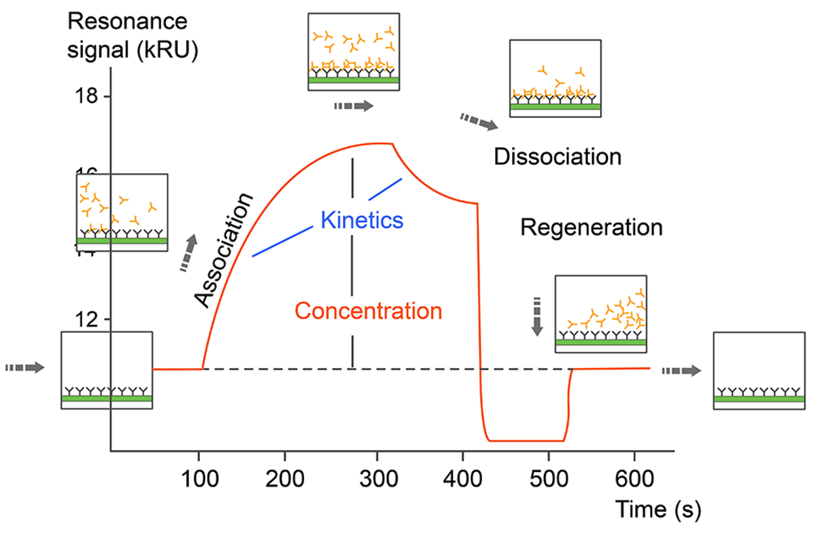
Figure 28 A typical curve of response vs. time for SPR sensor. In this figure, the regeneration step is included. Figure reproduced from [205].

analyte-probe binding is. The smaller the $K_{\text{d}}$ is, the more difficult the analyte will be detached from the probes. Usually, for aptamer-based probes, the $K_{\text{d}}$ is around several nM while for antibody-based aptamer, the $K_{\text{d}}$ can be as low as several pM. Compared with specific binding, the $K_{\text{d}}$ for non-specific binding can be more than 1000 folders larger. The $K_{\text{d}}$ can be directly measured using the response vs. time curve.
Since the specific and non-specific binding has very different $K_{\text{d}}$, therefore, it is possible to differentiate them by utilizing different binding strengths.

Tunable DEP mechanism
One of the most important merits of DEP effects is that it can be extremely sensitive to the amplitude of the external electric field, as demonstrated in equations (16) and (17). For the purpose of improving the sensitivity and diminishing the LOD, a stronger electric field and corresponding more powerful DEP force are preferred. On the contrary, although the immobilized aptamer probes possess excellent selectivity, under a strong electric field, the DEP force is still efficient enough to aggrege large-size interference biomolecules, causing undesired non-specific responses. Hence, from the perspective of specificity, a weaker electric field and DEP effect is more preferred.
To resolve the intrinsic contradiction between sensitivity and selectivity, we introduce a two-phases, switchable DEP sensing strategy that decomposes the sensitivity-priority process and sensitivity-priority process into two subsequent steps based on abrupt switching of stimulating voltage. After samples are applied (shown in Fig. 29 A), an initial high voltage AC signal will first be applied for a short period. All large particles including Gram-negative bacteria will be dragged to the electrode surface in phase I (shown in Fig. 29 B, C). Then, the external AC signal will suddenly be turned lower. The subsequent signal is small enough not to generate adequate maintaining DEP force but can continuously monitor the interfacial capacitance change. For a successful combined-phase detection, it is important to combine the data from both phase I and phase II. Lots of advanced algorithms can efficiently extract features from impedance, however, the challenges are that in phase II, due to the insufficient DEP force, non-specific particles
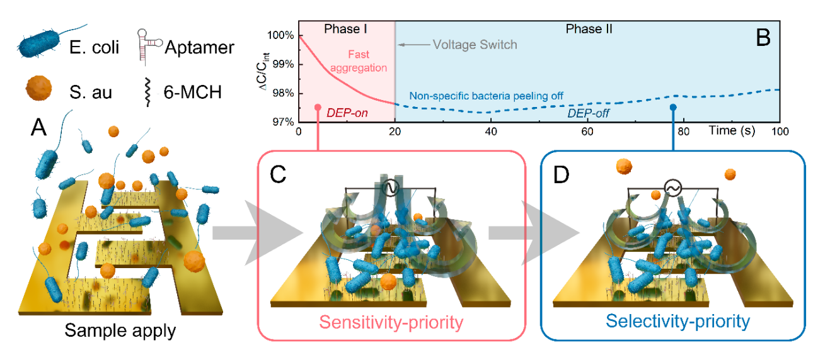
Figure 29 schematic diagram of the switch-off detection procedures. (A) Loading of samples. (B) A typical curve of ΔC/Cint versus time during the detection. (C) Schematic of the interface after a strong DEP force was applied. (D) Schematic of the interface after the voltage/DEP force was tuned lower.

will release from the surface while Gram-negative bacteria will keep attached to the aptamer probe (shown in Fig. 29 B, D). By combining the capacitance responses from both phases, the non-specific response is able to be screened out. Thus, high sensitivity and selectivity can be achieved simultaneously.

Data fusion

There is very limited number of data (around 4 ~ 6 repeated experiments for the same condition) available. To avoid the problem of underfitting, we further simplify the data to the capacitance change ratio of two phases. We choose the change rate of capacitance versus time (i.e., dC/dt [% per second]) as the metric for bacteria binding level. The chase rate was calculated based on linear fitting. For phase I, data from 0 s to 16 s was adopted for change rate calculation, while for phase II, data from 40 s to 80 s was used. For data processing, MATLAB curve fitting and machine learning toolbox were used. This simplification step greatly reduced the complexity of the problem. After the simplification, the problem degenerates into a classification problem in a 2D plane.
Particularly in high-dimensional spaces, data can more easily be separated linearly and the simplicity of classifiers such as naive Bayes and linear SVMs might lead to better generalization than is achieved by other classifiers. But for the low-dimensional dataset, the problem may be different since the data may not be presented in a linear form, which means the dataset cannot be separated by simply using a line. In our cases, the dC/dt from phase I is primarily aroused by a specific binding event but for phase I, the releasing of non-specific analytes will dominate the response. Therefore, the phase I and phase II responses are almost independent of each other. It is highly possible that the responses of phase I and phase II are not linearly distributed, nor they can be separated linearly. Therefore, the selected algorithm should handle the non-linear dataset properly.
The first choice is using deep learning, as it is an end-to-end Blackbox model, it is no need to pay attention to the pretreatment of the dataset. But the drawback is also apparent, first it consumes too much computation power, and a coprocessor such as FPGA is needed if we would like to deploy it in a portable system. Also, it requires massive data for reliable training. After several tries, it did not provide an improved outcome.
Afterward, traditional machine learning methods are then tried. We carefully evaluate some most widely used classification algorithms, including nearest neighbors, support vector machine, decision tree and random forest. The performances of those methods are compared in Fig. 30 and Table 6. As demonstrated, both nearest neighbors, decision tree and random forest are capable of dividing non-linear dataset, which is more common in the two-phase dC/dt dataset. Compared with nearest neighbors, both decision tree and random forest have better precision, they have a sharp, more determinate decision boundary, therefore are better fitted to our experiment. Random forests is an ensemble learning method for classification, regression and other tasks that operates by constructing a multitude of decision trees at training time. For classification tasks, the output of the random forest is the class selected by most trees. Thus, it is much more complicated than the simple decision tree. Considering that the number of data is limited, using random forests may result in overfitting or underfitting. To sum up, a decision tree is adopted as the data fusion algorithm for combined-phase detection.

Summary
In this chapter, the mechanism of probe-analyte binding is deeply described. In order for simultaneously improve the selectivity and sensitivity, we introduce an innovative sensing strategy that combines the response of both specific and non-specific responses. For fusioning the data from both two phases, different classification methods are comparatively studied. It is found that the decision tree best fits the dataset measured in this work. This chapter detailly elaborates on the inspiration, design principles as well as the methodology of the tunable-DEP, combined-phase method.

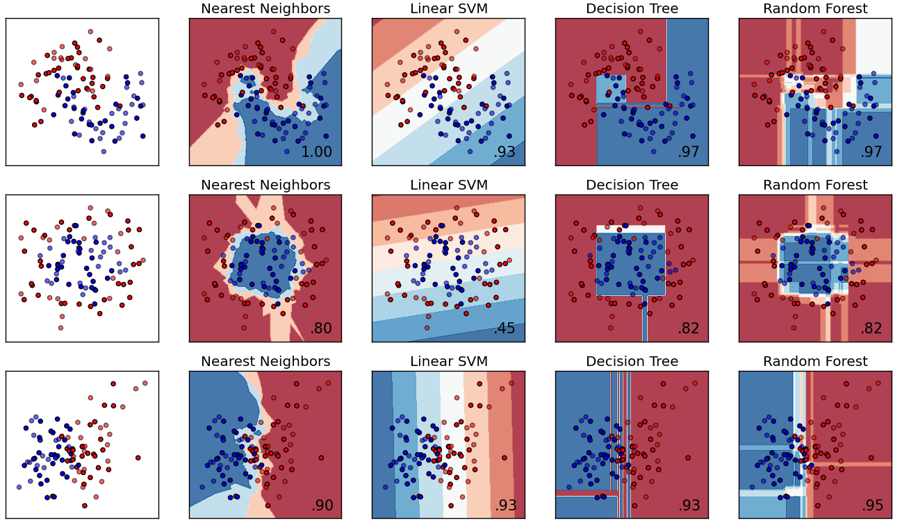
Figure 30 Performance of different classification algorithm. The dataset has two dimensions, and there are two classes in the dataset. The overall sensitivities are given in the right bottom corner.

Table 6 Methods comparison based on 10-fold cross validation
Method | Accuracy
DNN | 54.10%
LSTM | 58.05%
Naive Bayes | 68.31%
KNN | 76.86%
SVM | 70.24%
Decision Tree | 91.30%
Random Forest | 86.42%

CHAPTER VII PROTOCOL OPTIMIZATION
In previous chapters, the feasibility of tunable-DEP-based combined-phase method is theoretically analyzed. As can be concluded, a successful combined-phase detection depends on the proper selections of AC signal for the stimulation of DEP force, the utilization of suitable bio-probes that possess higher enough affinity toward analytes. Meanwhile, the design of the electrode is also important as the shape and size of IDE electrode will also affect the DEP force. In this chapter, the AC signal, design of electrodes, preparation procedures of electrodes, the bio-probes as well as the sample preparation protocols are optimized for the best performance.

Electrode optimization
First, the performances of different electrodes are compared. In this experiment, two categories and 6 different IDE electrodes were tested. PCB IDEs are relatively large electrodes where the gap and width are 100 µm. SAW IDE and gold/glass electrodes, on the other hand, are small electrodes, usually with a gap and width of 2-5 µm. The very different size results in the different electric field strength when the same AC signal is applied. The smaller SAW IDE and gold IDE have advantages in sensitivity as they will have a much stronger DEP force even under a small AC signal. However, PCB IDEs have advantages in cost and the accessibility of modification. Images of different electrodes are shown in Fig. 31.
It is essential to find the most suitable electrodes in consideration of both performance, cost and the complexity of manufacturing. In this section, all the electrodes are tested using the analytical E. coli samples (buffered in 1:100 diluted LB background). The output signal is 100 kHz and 5 mV (RMS) for all the IDEs. The incubation and blocking procedures are kept the same (20 h incubation in 0.05x PBS with 2 uM aptamer, 3 h blocking in Milli-Q water with 1 mM 6-MCH). For PCB IDEs, surface polishing and gold plating are applied before standard surface cleaning. The results are shown in Fig. 32.
Both SAW EPCOS 418R and SAW EPCOS 433.92 demonstrate acceptable results.
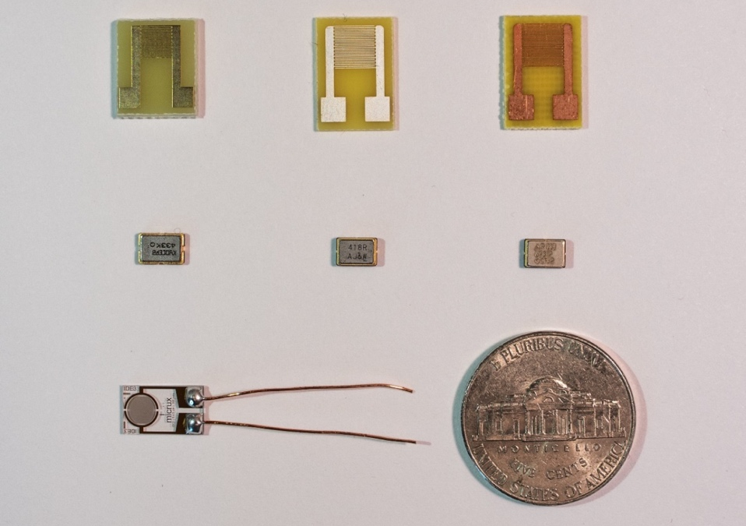
Au IDE
EPCOS 433.92
EPCOS 418R
Kyocera 433.92
Bare Cu PCB
Ag coated PCB
Au-Ni coated PCB
Figure 31 images of different electrodes used in the experiments. One coin of a quarter dollar is also included for the size comparison.

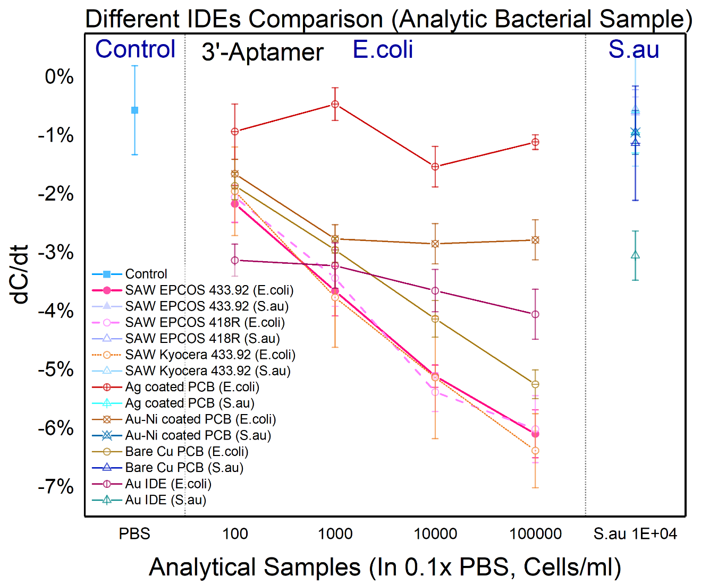
Figure 32 Dose response of different IDEs for analytic samples detection (Bacteria).

Their responses are very similar. For SAW Kyocera 433.92, the high and low concentrations can be easily separated, but the chips-to-chips variation is slightly larger. It is because the removal of the metal cover is more difficult for this kind of SAW IDEs, which may cause some damage to the inner IDEs structure during the preparation procedures.
For all three PCBs, since the dimension of the electrodes are much larger, which will weaken the DEP force, and thus the overall responses are smaller than the SAWs. For Ag or Au-Ni coated PCB IDEs, the pre-coating layer will modify the surface hardness and make it even more difficult to polish the surface and acquire an even, smooth surface, so the performance of those two pre-coated PCB IDEs did not match the bare copper PCB IDEs. This study between different IDEs confirmed that the two SAW IDEs from EPCOS are more suitable for detecting bacteria.

Surface optimization
For PCB IDEs, the surface is manually polished and gold plated. Different polishing methods can result in various surface morphology and effective electrical surface area. Since surface area and surface roughness directly influence the incubation efficiency and coverage density of problems, they needed to be invested detailly. Herein, different surface polishing methods, including hand-polishing, using 7000 grits waterproof sandpaper, machine polishing using 7000 grits polishing pad, and 0.3 µm aluminum slurry polishing using a felt polishing buffing wheel. All machinery polishings are implemented using a Dremel® rotary tool kit. Microscope images of these three polishing methods are shown in Fig. 33.
As can be seen, for hand-polished PCBs, their surfaces are much rougher than machine-polished ones. Alongside the micro-sized grains, there are some deep scratches distributed unevenly on the surface. The direction of those scratches matched the direction of polishing. Macroscopically speaking, the surface after hand-polishing is dull, lusterless. Even after gold polishing, there are still some matted grey tones shaded on the surface.
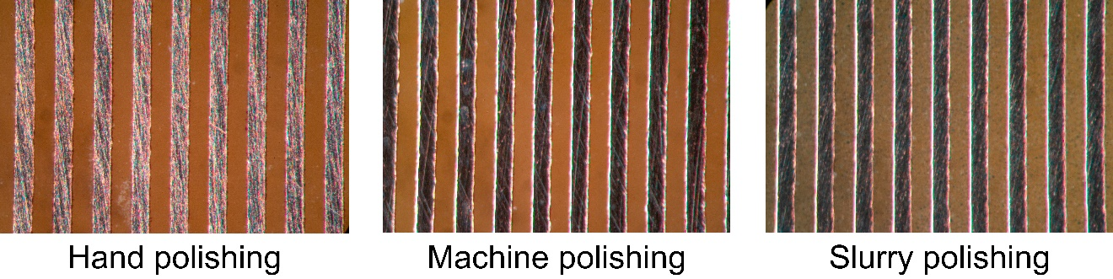
Figure 33 Microscope images of different polishing methods.

The machine-polished surface is generally more even than the hand-polished surface. There are still some deep scratches randomly distributed, and the sign of grains is almost invisible. In macroscopical observation, the surface after gold plating is fine, shiny, and has a mirror-like finish. While for 0.3 µm aluminum slurry polishing, the most significant difference is that the previously characteristic deep scratches are now tuned to be more shallow scorings that are more evenly separated onto the surfaces. In terms of the surface roughness, the slurry polishing obtains the finest surface.
Due to the roughness in microscopic scale, the geometrical electrode areas are not effective electroactive areas. Hence, ﻿electroactive areas and surface roughness of the PCB IDEs are calculated by the integration of the cathodic peak from gold electropolishing voltammograms (-0.3 V ~ 1.4 V CV scan with the rate of 100 mV/s in 0.5 M H₂SO₄, shown in Fig. 34) and convert to the effective surface area using a conversion factor of 482 μC cm⁻². The measured electroactive areas are within the range of 0.35 ~ 0.27 cm², 0.19 ~ 0.15 cm² and 0.17 ~ 0.15 cm² for hand-polished, machine-polished and aluminum slurry polished PCBs, respectively. The corresponding surface roughness factor (defined by effective electroactive areas/geometrical electrode areas) are 2.69~2.08, 1.46~1.15, and 1.31~1.15. As can be seen, the hand-polished surface has the highest surface roughness and the biggest standard deviation, which agrees with microscope observation.
The immobilization efficiency is the goal of surface optimization. Considering the difficulty of directly measuring the surface probe coverage density, we use an indirect approach by comparing the change of interfacial capacitance before and after probes immobilization to evaluate the quality of the immobilization since interfacial capacitance can be extremely sensitive to the interfacial binding. In this experiment, 6-MCH is utilized to simulate bio-probes. The capacitance changes are compared in Fig. 35.
Theoretically, after a perfect probe’s immobilization, there will be a large capacitance drop due to the enlarged EDL. The capacitance decreasing rates at 100 kHz are more than 90% for both hand polishing and machine polishing, indicating an excellent immobilization quality. While for slurry polishing, the capacitance rate drops only to less than 40%, implying the surface is not perfectly covered. It can be concluded that the
Figure 34 a typical curve of CV scan for the gold surface. The cathodic peak is highlighted by yellow. The charge is integrated to calculate the effective electroactive areas.

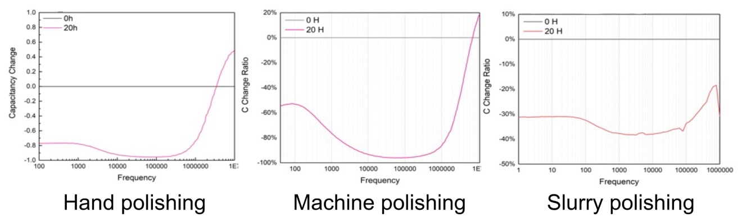
Figure 35 Interfacial capacitance changes for different polishing methods. The baseline (100%) are given as a grey line in all plots.

hand-polished surface owns the best immobilization efficiency. However, during the experiments, large chip-to-chip variations are observed for hand-polished PCB IDEs. As a consequence, the machine-polishing method is selected because it can reach a balance between immobilization quality and consistency.

Aptamer optimization
To achieve the goal of multi-target detection and obtain better storability, the aptamer is selected as the bio-probe instead of the antibody. Aptamers are small single-stranded oligonucleotides that fold into defined architectures and can specifically bind to target particles. After in-vitro selection using Systematic Evolution of Ligands by Exponential Enrichment (SELEX) [206], the aptamer can be a powerful bio-probes. Aptamer offers the advantages of easy to production, better stability, and long shelf-life compared with antibodies and usually does not require a restricted long-term storing environment [20]. Some latest highlights of developments of aptasensors for bacteria detection are elaborately reviewed by Majdinasab et. al. [207] The strong affinity and perfect specificity of the aptamer is attributed to the special spatial structure of the nucleotide [20,208–210]. As a capture probe, a dithiol phosphoramidite (DTPA) modified lipopolysaccharide (LPS) aptamer (5’-DTPA-TAGCCGGATCGCG-CTGGCCAGATGATATAAAGGGT-CAGCCCCCCA-3’) [210] is purchased from Integrated DNA Technologies, Inc. (IDT, Coralville, IA, USA). By decorating one thiol group at one terminal of the aptamer, the aptamer can be firmly self-assembled onto gold surface by strong Au-S covalent binding. Depending on the decoration position, there are two kinds of aptamer probes. Both of them share the same sequence but one of it has the thiol group on the 3’ end and the other one on the 5’ end. In this section, these two aptamers are compared in the analytical buffer for bacteria samples, as shown in Fig. 36.
Surprisingly, their responses are very similar, which may be due to the primary binding sites/segments of the aptamer locate at the middle of the ssDNA therefore no matter where the thiol group is, after self-folding, the two aptamers will have very similar binding characters. To simplify the experiment, the 5’-aptamer is adopted except for special notification.
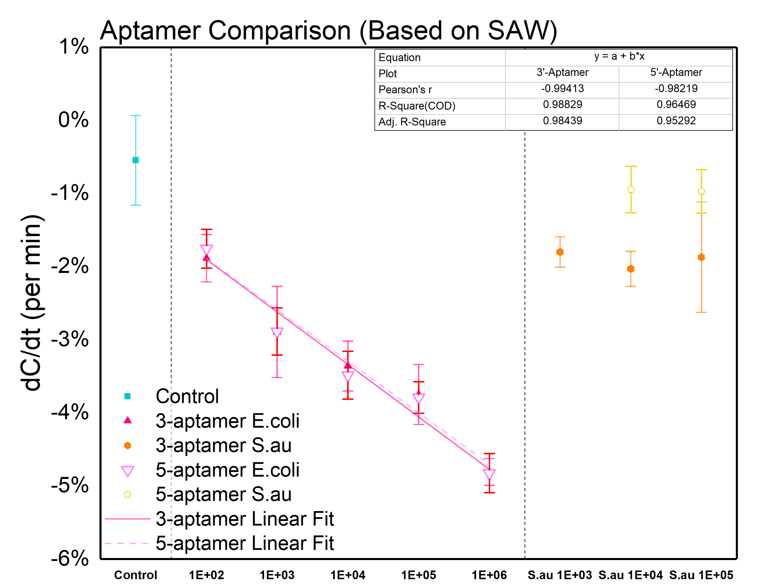
Figure 36 Dose response for two different aptamers (Bacteria, SAW based).

Voltage optimization
On account of the high sensitivity of DEP force toward the applied voltage. It is necessary to investigate how different applied voltages will influence the performance of capacitive sensing at the beginning. Hence, voltages ranging from 2 mV to 20 mV (all in RMS value) are applied to test 3.12×10², 3.42×10⁴ cells/ml E. coli, and 2.91×10⁴ cells/ml S. au in the analytical buffer. The analytical buffer itself is also tested as background control. The capacitance change ratio for different voltages is shown in Fig. 37. As expected, responses of 3.42×10⁴ cells/ml of E. coli are monotonically increased from -9.548×10⁻³ % ± 1.322×10⁻³ % to -0.158 % ± 1.322×10⁻² % with higher voltage. However, at 20 mV, a noteworthy saturation is observed. Considering the volume of the applied sample is only 10 μL, which means there are around 342 bacteria at the concentration of 3.42×10⁴ cells/ml, we make the hypothesis that at 20 mV, the DEP is powerful enough to aggregate almost all the bacteria to the surface. A similar positive correlation also applies for 3.12×10² cells/ml E. coli except that the responses are almost negligible at 2 mV and 5 mV, which revealed that the voltage should be no less than 10 mV for successful detecting E. coli at the concentration level of ~10² cells/ml. On the other hand, the responses of 2.91×10⁴ cells/ml S. au also start to become significant compared with background control when the voltage is higher than 5 mV, illustrating that the sensitivity and specificity cannot be achieved simultaneously within single phase measuring. At 2 mV, neither 3.42×10⁴ cells/ml E. coli nor 2.91×10⁴ cells/ml S. au shows a separable response from the background control, indicating the DEP force is too weak to manipulate any bacteria.
For tunable-DEP-based, combined-phase detection, the DEP force at phase I is expected to enrich as many bacteria as possible for best sensitivity. For phase II, the DEP force should be small enough to not restrain the non-specific bacteria from drifting away. Hence, 2 mV is determined as the optimized voltage for phase II detection. Considering the saturation at 20 mV will significantly compress the dynamic range, 15 mV is chosen as the optimized voltage for the phase I detection instead.

Figure 37 dC/dt responses of different voltages for analytical samples.

Frequency optimization
The mechanism of the impact of frequency on the strength of DEP force is more complicated than that of voltage. Basically, there are two possible aspects: the first is the dependence of permittivity on frequency, while the second is the precondition of the simplified circuit model. To determine the optimized frequency for bacteria enrichment, herein, frequencies ranging from 1 kHz to 300 kHz are evaluated to test 3.42×10⁴ cells/ml E. coli in the analytical buffer. The voltage is fixed at 10 mV (RMS) in consideration to avoid any possible signal saturation. The analytical buffer itself is also tested as background control. The capacitance change ratios for different frequencies are shown in Fig. 38.
The dC/dt response reached its peak at the frequency of 1 kHz, at the same time, the control group also showed a non-negligible response (-2.351 % ± 0.759 %), indicating the response was originated from the artifacts. Similar situations were also applied at the frequency of 4 kHz. As mentioned in the previous chapter, at low frequency, the impedance of the leakage resistor will in turn dominate the interfacial impedance, as a consequence, the capacitance extraction model will not be applicable. According to the response of the control group, the frequency should be no lower than 10 kHz to fulfill the precondition of circuit simplification. The dC/dt responses reached another peak at the frequency at 100 kHz, implying a positive DEP. A slight, monotonical decline of response was observed after 100 kHz. This is assumed to be caused by the permittivity change of bacteria and solution medium at the high-frequency end. Even though the permittivity of water-based solution will not dramatically change under 1 GHz, the Low-frequency dielectric dispersion of bacteria due to interfacial polarization will occur after 100 kHz [211], which will play an important role in the DEP enrichment.
The conclusion of peak DEP force at 100 kHz is well agreed with Syed et al. [212] To sum up, the frequency of 100 kHz was selected as the optimized stimulation frequency for DEP enrichment and 2-pahse based sensing. Due to the indistinctive response and corresponding weak DEP force at 25 kHz, it is possible to implement the frequency switch instead of the voltage switch, which will be further discussed in the following chapter.
Figure 38 dC/dt responses of capacitive optimization. The unconfident region is marked by the light orange color.

Samples preparation optimization
Raw milk can carry dangerous germs, such as Brucella, Campylobacter, Cryptosporidium, E. coli, Listeria, and Salmonella, which can pose serious health risks to humans. [213] Point-of-care, on-site diagnosis of Gram-negative bacteria has long been considered a proven and effective way to prevent pathogenic bacterial infections. In recent years, great effort has been attracted to extensively research and develop new diagnosis methods [214]. Nevertheless, direct sensing dairy milk sample can be challenging as there existed highly concentrated, larger-than-bacteria particles such as casein micelle and milkfat globule. Dilution is necessary to eliminate unexpected background responses and adjust the buffer conductivity for better DEP enrichment. For best performance, we test the whole milk samples with different dilution ratios ranging from 1:10 to 1:10000 using the analytical buffer as the diluent. The response of 0.1x PBS is also measured as a control group. The curves of ΔC/Cint vs. time for different dilutions were given in Fig. 39.
The phase I responses of 1:10 and 1:100 dilution are -0.0320 % ± 1.672×10⁻⁴ % and -0.0277 % ± 3.436×10⁻⁴ %, respectively, both of which are not negligible compared with control and are significantly greater than the response of 2.82×10² cells/mL E. coli in the analytical buffer. The phase I response starts to become neglectable at the dilution ratio of 1:1000. Therefore, 1:1000 is considered as the optimized dilution ratio. Meanwhile, the distinctive climbing phase II responses of 1:100 dilution make it possible to detect low concentrated E. coli using the combined-phase method even if its phase I response is entirely masked by the background. To validate the genericity of our method, the capacitive behavior under the dilution ratio of 1:100 is also extensively studied.
For the raw milk samples, in one of our previous works, we designed a sophisticated protocol (Fig. 40) to handle the milk samples, which included a 3-hours-long cell culture for amplifying the bacteria concentration, centrifugation steps to remove unwanted milk fat and casein and a following 10000-fold dilution for minimizing the noise background coming from the milk. This pretreatment protocol finally succeeds letting us in detecting pathogenic bacteria in field milk samples. But such pre-processing steps are difficult for

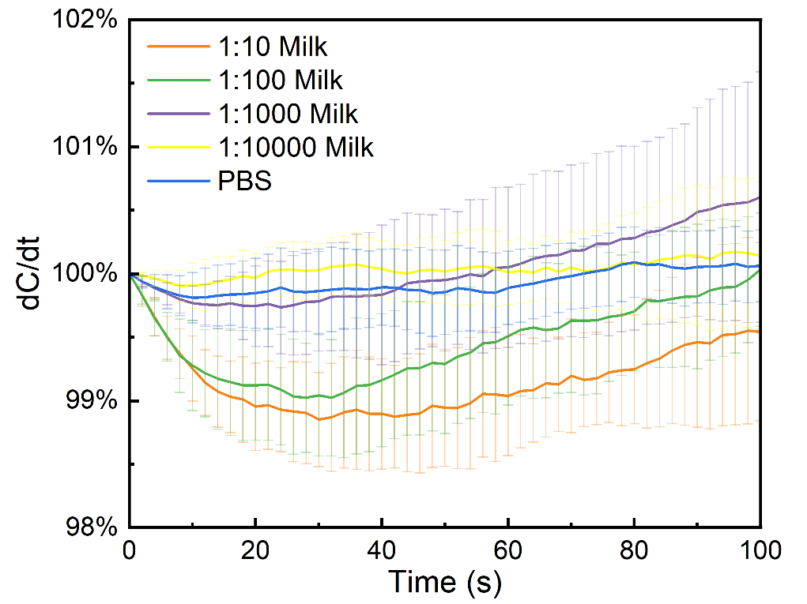
Figure 39 dC/dt responses of different dilution ratio. No bacteria is added during the optimization.

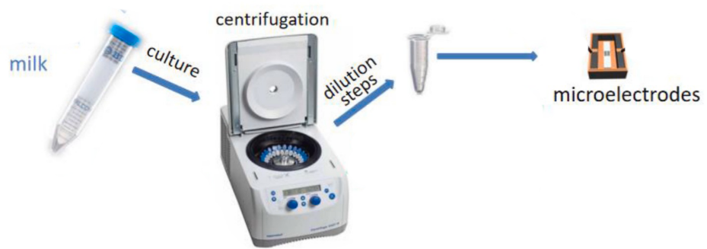
Figure 40 Specially designed protocols for the raw milk samples pretreatment.

implementing, they are time-consuming, and not friendly for POC detection. So, an improved protocol must be figured out.
In this place, raw milk with and without centrifugation was tested. The relative centrifugal force was set as 2000x g, and the time was set to 2 min. such settings will not inactivate the bacteria but can still isolate fat globules. After the centrifugation, it can be seen that components with lower density, which in this case is milk fat, have been separated out as supernatant.
The casein micelles have a higher average density, and they will sediment to the bottom, so the pipetting location is at the middle of the tube. Then in the next step, both the centrifuged and uncentrifuged samples were then 1:100 or 1:1000 diluted using PBS buffer and were tested based on the 2-phase method.
As shown in Fig. 41, the centrifugation did significantly minimize the phase I response both for 1:100 and 1:1000 dilutions. As a comparison, for uncentrifuged samples, after 1:100 dilution, they still have a remarkable phase I response. It is most likely caused by non-specific adsorption. Interestingly, for 1:1000 dilution, the phase I response was suppressed. So, it has the possibility to do the detection without centrifugation.
The E. coli samples were then spiked into raw milk samples to further study the behavior of specific binding. As can be seen, the centrifugation slightly lowers the E. coli response, and I also found that, E. coli can still be detected in 1:1000 diluted field milk without centrifugation. In this case, the background and the positive samples have similar responses in first 15 seconds, but they have very good separation afterward.
To sum up, for 2-phase detection, centrifugation is not a must, which can be a great advantage for the proposed 2-phase method.

Summary
With the aim to find the best suitable probes, electrodes, preparation protocol, and experiment parameters, several optimization experiments are implemented. Based on those tests, it can be concluded that the SAW IDEs have the best performance for bacteria
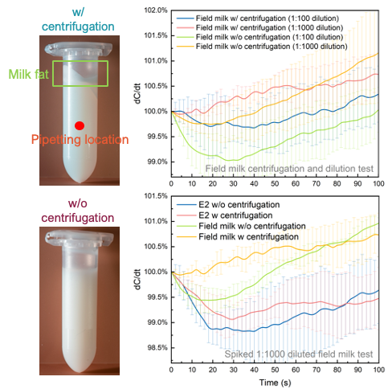
Figure 41 Photos (on the left) of raw milk samples with or without centrifugation. The sampling point after centrifugation was marked by a red dot. C vs. time curves (on the right) for raw milk samples with or without centrifugation.

detection. While for PCB IDEs, the machine-based polishing method can perfectly balance the chip-to-chip consistency and immobilization efficiency. Two different aptamers with the same sequence but different decoration positions are found to have almost identical performance. To maximize the bacteria aggregation in phase I and minimize the DEP force in phase II, we find the optimized voltages are 15 mV and 2 mV for the stepwise two phases, respectively. Similarly, the optimized frequency for DEP-based enrichment was determined to be 100 kHz. The comparatively weak DEP force at 25 kHz also let us implement 2-phase detection based on the frequency switch. Finally, to alleviate the influences of large particles in milk samples, different dilution ratios are tried. The dilution ratio of 1:1000 is considered as necessary for a finite, noise-free background response.

CHAPTER VIII APPLICATION OF COMBINED-PHASE METHOD FOR BACTERIA DETECTION
Rapid and reliable sensing technologies for the diagnosis of pathogenic bacteria are vitally important for assuring food safety and public health. As a great many efforts have been devoted for developing advanced biosensors, sensitivity and selectivity are usually two sides of the same coin. In this chapter, we implement the innovative combined-phase detection strategy based on tunable DEP for ultra-sensitive and high-reliable detection of Gram-negative bacteria. According to the optimized parameters, a capacitive aptasensor is fabricated and a sensitivity enough for quasi-single molecule detection is achieved both under analytical samples and spiked milk samples within just 100 s. The biosensor is fabricated based on low-cost commercial microelectrodes and is point-of-care application friendly. This work not only demonstrated a biosensor with great advantages in sensitivity, selectivity and assay time, but also proposed a brand-new sensing methodology that could benefit the further designing of board kinds of biosensors.

Introduction
Traditional methods like ﻿cell ﻿cultivation and ﻿nucleic acid-based methods have become gold standards for bacterial detection and identification because of their advantages of high reliability and accuracy. However, culture-based detection is biased toward culturable bacteria. While the majority of bacteria are fastidious and therefore invisible to culture-based analysis. Nucleic acid-based methods on the other hand can identify far more diverse bacteria, but the amplification process requires skilled experts and prolonged assay time, leading to poor portability and flexibility.
Recently developed biosensor-based methods own advantages in aspects of low limit of detection (LOD), rapidity, low-cost and are more suitable for point-of-care diagnosis [13,96]. Latest state-of-the-art works have made breakthroughs in directly detecting bacteria in real-world samples. Still, there is an intrinsic trade-off between sensitivity and selectivity. High sensitivity means the sensor is capable of responding to subtle changes in the system, therefore the sensor can be fragile, and disturbance-intolerable. This becomes further remarkable when measuring real-world samples and eventually presents in the way of LOD loss. Hereby, trends of LOD loss are quantified by the loss ratio, as is defined by LOD in real-world samples/LOD in analytical samples, which, in most cases is greater than 1. Ma et al. reported a colorimetric biosensor powered by ﻿CRISPR-Cas12a and obtained a LOD of 10 CFU/mL for Salmonella in food samples, however, it suffered from a long assay time (90 min) and noteworthy LOD loss [133]. ﻿Capobianco et al. reported a ﻿flowthrough immunoelectrochemical biosensor for the detection of E. coli O157: H7 and Salmonella in ground beef, achieving a LOD of 400 CFU/mL with minimal LOD loss, but it is short of sensitivity for food safety surveillance [134]. More recent works are summarized in Table 7, most of which encounters severe LOD loss (loss ratio >10). The long assay time is another disadvantage that will significantly minish the throughput.
In our previous work [215,216], we have demonstrated how to utilize ﻿dielectrophoresis (DEP)-based cell manipulation to significantly boost the sensitivity of a capacitive aptasensor. ﻿Interfacial capacitance is extremely sensitive to surface adsorption and is an ideal metric for biosensing [217]. Meanwhile, DEP force can create a localized high-density region of bacteria of interest. A LOD of 276 cells/mL was achieved within 30 seconds. However, 10 hours of culture and centrifugation are needed for a successful detection in field milk samples, and the LOD loss is still higher than 10.
In this work, we further improved the selectivity and robustness of the sensing platform by introducing the two-phases sensing strategy based on tunable DEP. Instead of applying DEP force at a constant strength, this work deployed two stepwise phases for DEP enrichment. In phase I, a stronger DEP force and corresponding higher localized density is induced, thus a higher sensitivity was achieved. Then in phase II, the DEP force and localized density are tuned lower, therefore non-specific particles could have a chance to release from the electrode surface due to diffusion, consequently, an improved selectivity was obtained. Quantitively analysis can be done in the first phase, while for low-density bacteria in a complex matrix, phases I and II can be combined for highly selective qualitatively analysis. Taking Escherichia coli (E. coli) as an example, the LOD and
Table 7 Some latest publications of bacteria detection in food samples
Method | Sensor design | Target | Background | LOD in background | Loss ratio | Assay time | Ref.
Colorimetry | ﻿﻿lab-on-a-tube/MNB | ﻿Salmonella | ﻿Chicken samples | 4×10³ CFU/mL | > 20 | 1 h | [218]
DPV | ﻿CRISPR/Cas12a and PER | E.coli | Milk | 1×10³ CFU/mL | > 50 | > 1 h | [219]
Colorimetry | ﻿CRISPR-Cas12a/AuNP | ﻿Salmonella | ﻿Food samples | > 10 CFU/mL | 10 | 90 min | [133]
﻿Electro-optical | ﻿pDEP electrodes/﻿rib waveguide | E.coli | ﻿Artificial urine | 1×10⁴ CFU/mL | 100 | < 1 min | [220]
Fluorescence | ﻿UCNPs/cDNA/AuNP | E.coli | ﻿Tap/pond water, milk | 1×10⁴ CFU/mL | 330 | 20 min | [221]
EIS | ﻿Con A- Functionalized paper | Multiple bacteria | Drinking water | 1.9×10³ CFU/mL | > 3 | 45 min | [222]
Colorimetry | ﻿AuNPs-based LFS | ﻿Salmonella, E.coli | Food samples | 1×10³ CFU/mL | 1~10 | 15 min | [223]
EIS/DPV | ﻿Au@MoS2–PANI nanocomposite | E.coli | ﻿Urine | 10 CFU/mL | 10 | 30 min | [224]
DPV | ﻿organic–inorganic hybrid nanoflowers | ﻿S. typhimurium | Milk | 100 CFU/mL | 10 | 60 min | [225]
Capacitive | Functionalized SAW IDEs | Gram-negative bacteria | Field milk | 287 cells/ml | ~ 1 | 100s | This work
In this table: NMB: ﻿magnetic nanobead; CRISPR/Cas12a: ﻿Clustered Regularly Interspaced Short Palindromic Repeats-Cas ﻿system 12a; AuNP: gold nanoparticle; pDEP: positive dielectrophoresis; UCNPs: ﻿upconversion nanoparticles; cDNA: ﻿complementary DNA; Con A: ﻿lectin Concanavalin A; LFS: ﻿lateral flow strip; PANI: ﻿polyaniline.

dynamic range were 282.1 cells/mL and 282.1~2.82×10⁵ cells/mL in analytical buffer. Compared with our previous work, the modified sensor achieved a LOD of 312.2 cells/mL in spiked dairy milk just after a simple, one-step dilution, therefore the LOD loss was only 1.02. ﻿Considering the sample volume is only 10 uL, our sensor has already realized quasi-single molecule detection. In terms of the manufacturing, the sensor was modified from a surface acoustic wave (SAW) device and the averaged cost was lower than ﻿$1. Despite the LOD of our sensor is not on the top,﻿ the assay time, accessibility and operability of our sensor maintains obvious advantages. Furthermore, this work not only presents a novel aptasensor for bacteria detection, but we also believe the two-phase strategy can open up new horizon for the development of other kinds of affinity-based biosensors.

Materials and methods
The E. coli bacteria DH5α strain (Thermo Fisher Scientific, Hampton, NH) is inoculated and cultured in liquid Miller's LB broth (LB) in a sterile 50 mL bacterial culture tube for 20 h at 37 °C in a 5% CO₂ : air balanced incubator. Similarly, Pseudomonas aeruginosa (P. aeruginosa, CIP 103467) is incubated in LB for 20 h at 37 °C. For control group, an aliquot of S. aureus frozen stock sample (API 6736151) kept at −80 °C is thawed down in a 37 °C water bath, streaked onto blood agar plates (BAP) in duplicate, and incubated for 20 h at 37 °C. After incubation, a single isolated colony is harvested from BAP, re-suspended into 20 mL Tryptic Soy Broth, and incubated for 20 h at 37 °C. Concentrations of E. coli, P. aeruginosa and S. aureus are ascertained using Petrifilm™ aerobic plates and Petrifilm™ reader system.
For analytical samples, the cultured bacteria are first 1:100 diluted in 0.1x PBS to get solution A (~10⁷ cells/mL). Then the medium (LB or TSB) is 1:100 diluted in 0.1x PBS to get solution B. Afterwards, solution A is diluted by solution B to get the final concentrations of ~10⁵, ~10⁴, ~10³ and ~10² cells/mL, respectively. For spiked dairy milk samples, Kroger® Vitamin D Whole Milk is purchased from the local market (Knoxville, TN, USA) and used as milk samples. The dilution procedures are similar to analytical samples except that the 0.1x PBS is replaced by 1:10, 1:100, 1:1000 or 1:10000 diluted milk (0.1x PBS diluted).
All electrical measurements are operated using a precision LCR meter (Keysight® E4980A). For voltage-switch based methods, the applied frequency is fixed at 100 kHz, which is the most suitable frequency for DEP-based bacteria manipulating according to our previous study. After adding 10 μL of sample solutions into SAW chip, a high-voltage AC signal with optimized amplitude is first applied for 15 s. Then, the amplitude is immediately switched to 2 mV (RMS). The low-voltage AC signal is kept stimulating for another 85 s to stabilize the electrode interface. For frequency-based methods, the frequency is fist set at 100 kHz for 20 s. It is the tuned lower to 25 kHz for 80seoncds. Te voltage is fixed at 10 mv (RMS). During the whole processes, the impedance is continuously measured and recorded. The EDL capacitance is extracted from the impedance data using the series R-C model. All tests are repeated at least three times using freshly prepared SAW chips each time to calculate mean and standard deviations.
The ΔC/C_{int} is calculated by normalizing all extracted capacitance values by dividing the initial value (i.e., C/C_{t=0}). The change rate of capacitance versus time (i.e. dC/dt [% per second]) is chosen as the metric for bacteria binding level. The change rate is calculated based on linear fitting. For the phase, I, data from 0 s to 16 s is adopted for change rate calculation, while for phase II, data from 40 s to 80 s is used. For data processing, MATLAB curve fitting and machine learning toolbox are used.

Frequency switch-based method
To validate the feasibility of the frequency-switch mechanism, bacteria samples including 3 gram-negative bacteria and 2 gram-positive bacteria diluted in the analytical buffer are tested using optimized frequencies. The concentrations of all bacteria samples are fixed at 10⁴ cells/mL. Since the impedances at 100 kHz/25 kHz are very different, curves of ΔC/C_{int} vs. time for phase I and II are demonstrated separately in Fig. 42. Each curve represents an independent test.
At phase I, both E. col, P. aeruginosa and S. marcescens showed large decreasing responses while the negative control group, S. aureus and Streptococcus uberis only showed small, divergent responses with large standard derivation. Fig. 43 more clearly
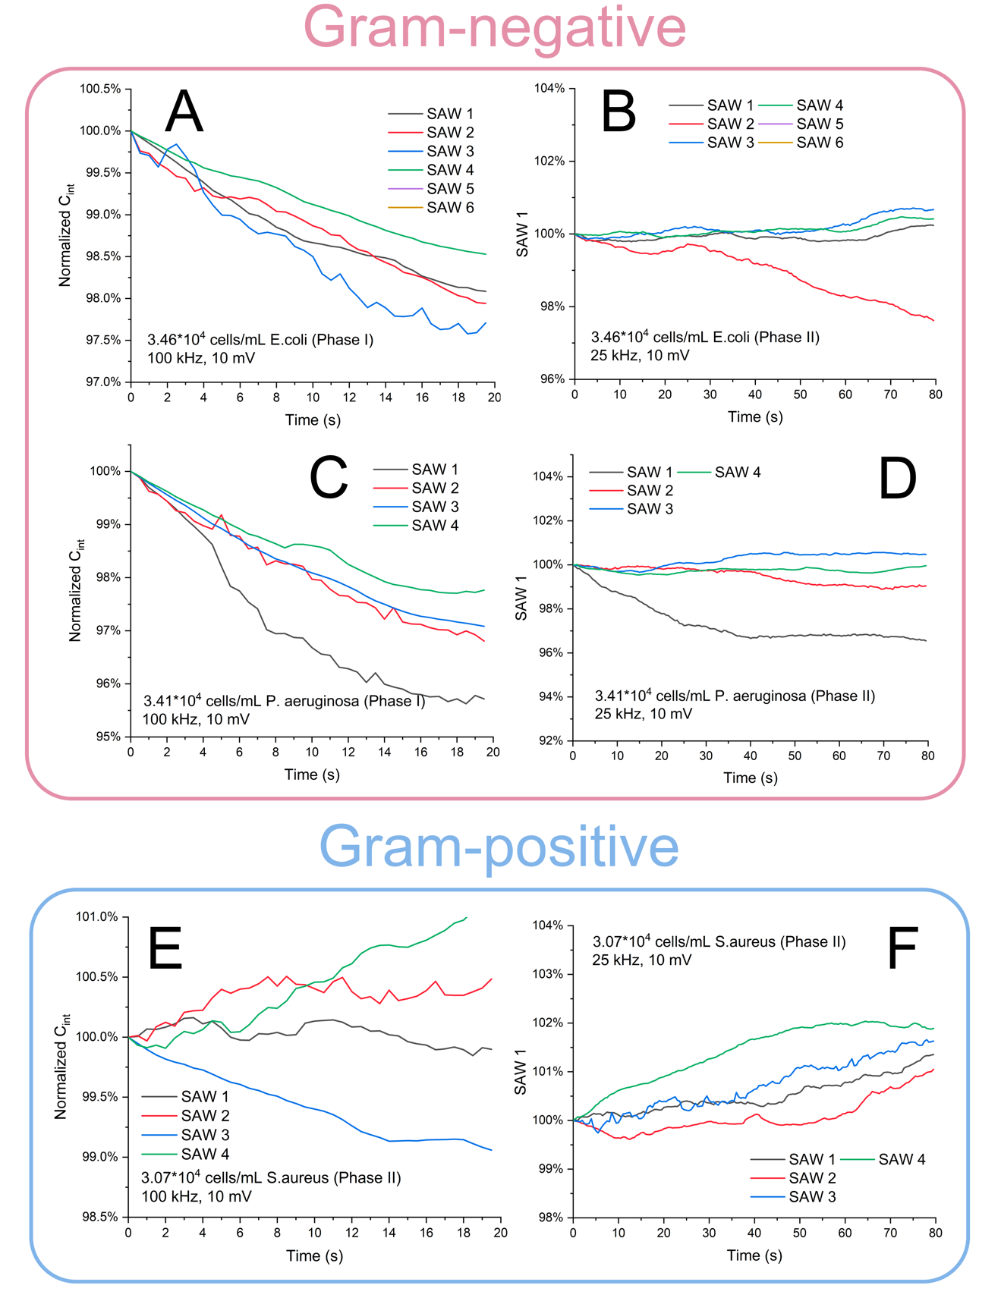
Figure 42 Capacitance response vs. time for frequency shift-based 2-phase method.
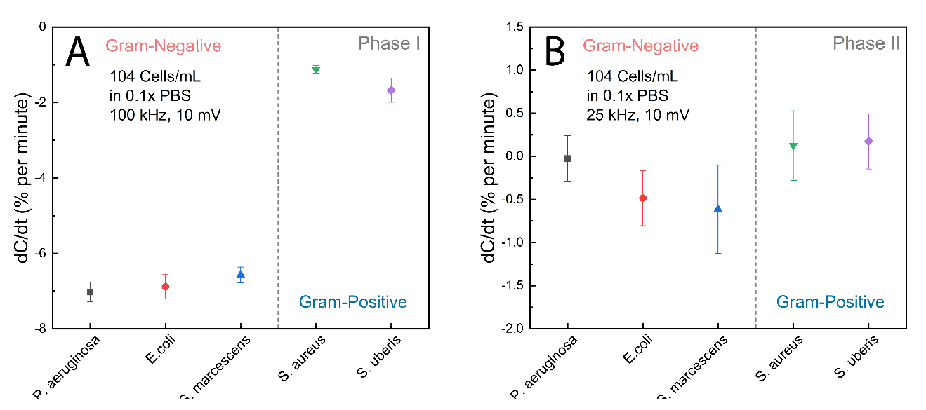
Figure 43 dC/dt responses at phase I and phase II for frequency shift-based 2-phase method.

illustrates the different behaviors. The responses of gram-negative bacteria are well below -6% while responses of gram-positive bacteria are all above -2 %, indicating a very good selectivity. But in phase II, they have very similar capacitive responses. Statistically, gram-negative bacteria have smaller responses, but considering the wide standard derivation, the positive controls can hardly be distinguished from negative controls. The poor differentiation is solid evidence that at the frequency of 25 kHz, the DEP force is insufficient to manipulate large particles and create a localized high concentration region, but at the same time, the DEP force near the electrode is still strong enough to prevent non-specific bacteria from detaching the surface. In conclusion, it is not feasible to implement the consecutive 2-phase method for bacteria detection that merely relies on the frequency switch.

Voltage switch-based method

Analytical samples test
To validate the feasibility of the voltage-switch mechanism, bacteria samples diluted in the analytical buffer are first tested using optimized voltages. The E. coli and S. aureus mixing samples are also tested for further studying the selectivity of our sensor under composite samples. The curves in Fig. 44 demonstrate ΔC/C_{int} vs. time for various models. The dC/dt at the first and second phases are separately plotted in Fig. 45 and 46. In phase I, both E. coli and S. aureus shows negative dC/dt responses. A linear, inverse correlation between dC/dt and concentration is observed for E. coli. The relation can be expressed by $y (\%/s)=-3.933×{10}^{-4}∙\log_{10}{x}+4.113×{10}^{-4}$, where $x$ is bacteria concentration in cells/mL with a Pearson correlation coefficient to be R² = 0.9692. The semi-logarithmic correction well agrees with Temkin isotherm model [226]. The liner fitting provides a powerful tool for quantitively analyzing bacteria samples at high concentrations. The LOD is calculated to be 810.3 cells/mL based on 3 standard deviations away from the response of control (analytical buffer: -1.995×10⁻⁴ % ± 2.073×10⁻⁴ %) and is close to our previous result using 5 mV [215].
Unlike phase I, a small positive correction is observed in phase II for S. aureus due to their detachments, while the responses of E. coli show no sign of any correlation with
Figure 44 curves of ΔC/Cint versus time for different samples.

Figure 45 dC/dt responses of phase I for analytical samples. The linear fitting curve is plotted in yellow. The threshold is given as the dashed line.

Figure 46 dC/dt responses of phase II for analytical samples.

the concentration as they are firmly captured by the aptamer. The different capacitive behavior between E. coli and S. aureus in phase II clearly demonstrates the dynamics of detachments of non-specific S. aureus under minimized DEP effect. The same situation also applies to mixed samples. In phase I, responses of mixed samples are almost identical to the mono E. coli samples of equal concentration, but in phase II, their responses are generally greater than the mono E. coli because of the detachments of loosely attached S. aureus.
The responses of S. aureus are distinguishable from the control when the concentration is higher than 2.93×10² cells/ml but are still well below the E. coli with the same concentration. However, at 2.93×10⁵ cells/ml, the response of S. aureus outperforms 2.82×10² cells/ml E. coli, which clearly exhibits the difficulty of separating the low concentrated E. coli from S. aureus with high concentration, as can be seen in Fig. 45.
The remarkedly different capacitive responses of E. coli and S. aureus in phase II give us a chance to utilize it for better filtering out the non-specific responses and improving the selectivity. From our previous works, the threshold for differentiating specific responses is based on 3 standard deviations from the response of background, which is only based on phase I. Herein, a decision tree model is used instead to combine dC/dt results from both phases. The model is trained to best separate specific responses from non-specific responses. The decision boundaries are compared in Fig. 47.
The sensitivity (defined by predicted specific/all specific) and specificity (defined by predicted non-specific/all non-specific) of the single-phase method is 92.86 % and 88.89 %, respectively. While for the combined method, the sensitivity and specificity are improved to be 100 % and 94.44 %, respectively. In Fig. 47, the responses of 2.82×10² cells/ml of E. coli are highlighted by pink crosses. The single-phase method failed to distinguish E. coli from non-specific responses when the concentration is low as 10² cells/ml (the sensitivity is only 50 %). However, for the combined method, all responses from 2.82×10² cells/ml of E. coli are successfully split. In conclusion, after the data fusion, the LOD is improved from 810.3 cells/mL to 282.1 cells/mL. The enhanced performance validates the superiority of the voltage-switch mechanism. Alongside the quantitative
Figure 47 Decision boundaries of single-phase and combined-phase methods. In all figures, E2, E3, E4, and E5 denote ~10², ~10³, ~10^{4,} and ~10⁵ cells/ml, respectively, and similarly hereinafter.

single-phase method, the combined-phase method can qualitatively diagnose ultra-low concentrated samples. Because the sample volume is 10 µL, at the LOD of 282.1 cells/mL, there are less than 3 bacteria in total been loaded into the sensor, which means our sensor has already realized quasi-single-cell detection.

Spiked pasteurized milk samples test
To further evaluate the selectivity of our sensor when measuring complex mediums, E. coli and S. aureus are spiked into 1:1000 diluted pasteurized milk background. Results of spiked samples are demonstrated in Fig. 48. The phase I responses are similar to analytical samples. A semi-logarithmic correction is observed from the concentration of ~10² to ~10⁴ cells/mL, which is $y (\%/s)=-3.933×{10}^{-4}∙\log_{10}{x}+4.113×{10}^{-4}$, with a Pearson correlation coefficient of R² = 0.9692. The LOD is 575.8 cells/mL. Starting at 2.93×10³ cells/mL, responses from S. aureus completely mask the response of ~10² cells/mL of E. coli, making it impossible to detect low concentrated E. coli. While responses of S. aureus in phase II are all well above responses of E. coli, again, implying a diverse capacitive behavior. The phase I responses of mixed samples are almost the same as the mono spiked samples, yet they have slightly higher responses compared with E. coli but are still smaller than those from S. aureus in phase II, indicating the mixed samples can also be recognized based on their phase II responses.
The decision boundaries calculated from single and combined-phase methods are plotted in Fig. 48 D. The combined-phase method is able to partially separate the 3.12×10² cells/mL E. coli from non-specific responses in spiked milk samples, obtaining a sensitivity of 75% and a LOD of 312.2 cells/mL. There is only insignificant LOD loss in pasteurized milk detection compared with analytical buffer (LOD loss = 1.11).
As an exploratory study, responses from 1:100 diluted pasteurized milk is also investigated. At such a dilution ratio, background responses at phase I can be noisy and unpredictable, therefore the primary goal is to recognize ~10² cells/mL of E. coli from the background instead of S. aureus. Responses of 2.82×10², 2.82×10³ cells/mL E. coli and background control are illustrated in Fig. 48 B and Fig. 48 C. As demonstrated, the combined-phase method still worked very well under 1:100 diluted milk, achieving a
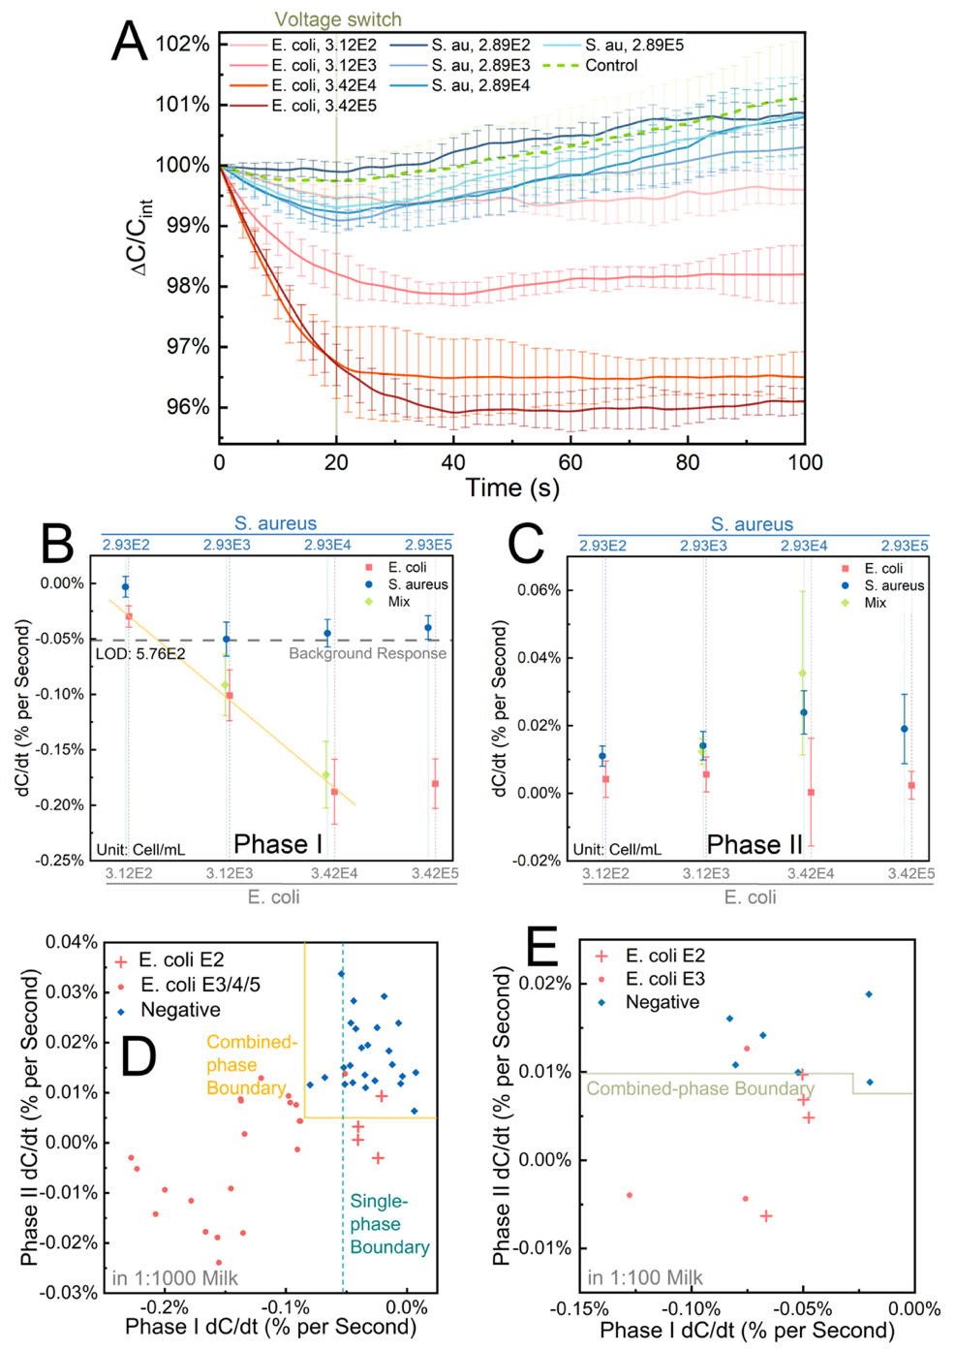
Figure 48 (A) Curves of ΔC/Cint versus time for different samples. (B) and (C): dC/dt responses of phase I and II for analytical samples. The linear fitting and LOD were given in (B). (D) Decision boundaries from single-phase and two-phase methods for 1:1000 diluted milk. The definitions of positive and negative data points were discussed in the supplementary information. In all figures, E2, E3, E4 and E5 denote ~10², ~10³, ~10⁴ and ~10⁵, respectively. (E) Decision boundaries for 1:100 diluted milk samples.

LOD of 2.82×10² cells/mL with a sensitivity and specificity of 75.00 % and 100.00 %. Even in 1:100 diluted pasteurized milk, the LOD loss is still close to 1, indicating good selectivity and robustness.

Board-spectra detection
Aptamer-based probes usually have advantages over antibodies not because of their low-cost and less rigid requirements for long-term storage, but also the capability of multi-target detection. Relying on the aptamer’s specificity toward LPS which is located on the outer membrane of Gram-negative bacteria, our sensor is also able to detect all kinds of Gram-negative bacteria. Here we also test another kind of Gram-negative bacteria, P. aeruginosa in spiked milk samples to verify the board-spectra detection ability. The responses of P. aeruginosa are slightly larger than E. coli at the concentration range of ~10² to ~10⁴ cells/mL but showed more significant saturation at ~10⁵ cells/mL, as seen in Fig. 49 A and B. Several factors contributed to the diversity of responses, such as the aptamer's inequal affinity toward different bacteria and bacteria size. Since the DEP force is particle size-dependable, in view of P. aeruginosa being larger than E. coli on average, we concluded that the magnitude of responses and the likelihood of saturation at high concertation is more particle size-related. Based on the combined-phase method, the LOD for P. aeruginosa is determined to be 3.21×10² cells/mL with sensitivity and selectivity of 80.00 % and 97.75%, respectively (shown in Fig. 49 C). The results indicate our sensor can effectively detect various Gram-negative bacteria in complex medium.

Raw field milk test
Finally, raw milk samples collected from a local farm are tested to evaluate the performance and robustness of our sensor when faced with real-world samples. The bacterial concentration in field milk for mastitis diagnosis is typically around 10⁵ cells/mL. However, it is still difficult to detect bacteria at such high concentrations due to disturbances coming from casein micelle, milkfat globule, or possible somatic cells. In our previous work, we designed a sophisticated pretreatment protocol including centrifugation, cell culture, and dilution steps to minimize the background noise, which was time and labor-consuming. In this work, the 1:1000 diluted raw milk with spiked bacteria is directly
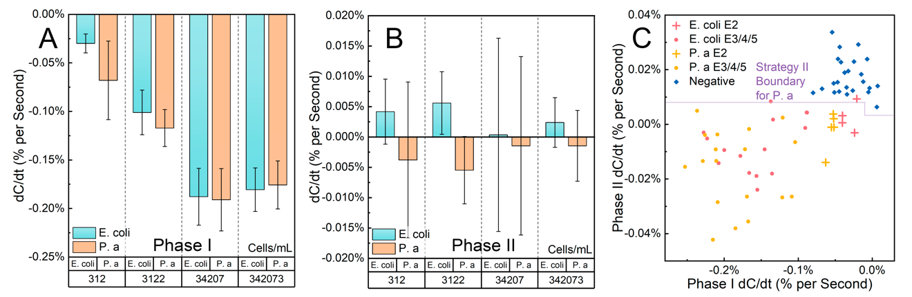
Figure 49 (A) and (B), Difference of dC/dt responses between E. coli and P. aeruginosa at phase I and II. (C) Decision boundary from two-phases methods for splitting the P. aeruginosa from negative samples. Datapoints of E. coli in (C) were only used for references, they were not counted for the calculation of the decision boundary. In all figures, P. a dented P. aeruginosa.

measured. ΔC/Cint vs. time for raw milk samples are demonstrated in Fig. 50 A. Unlike previous measurements, E. coli samples here also showed a remarkable increasing signal in phase II, as a consequence of strong background interference. The predicted decision boundary is shown in Fig. 50 B. For E. coli at 2.87×10² cells/mL, the sensitivity and selectivity dropped to 71.43% and 83.33%. Nevertheless, the practically accessible LOD is still at 2.87×10² cells/mL. A quasi-single cell detection is successfully achieved even in diluted field milk samples. A mentionable breakthrough here is that the LOD loss in the real-world sample is only 1.02.

Summary
In summary, this work proposed a brand-new sensing methodology named as switch-off mechanism and implemented it on a capacitive aptasensor for the detection of Gram-negative bacteria. By utilizing DEP enrichment, the assay could be completed within 100 s. Owing to the switch-off mechanism and the corresponding decision tree model for data fusion, the developed sensor showed good sensitivity and selectivity simultaneously to both analytical and real-world samples. For E. coli the sensor reached a LOD of 282.1 cells/mL in analytical buffer and 312.2 cells/mL in spiked dairy milk samples. The reported sensor was low-cost and disposable. The straightforward operation was amplification-free and was compatible with inexpensive portable instruments. Therefore, the proposed biosensor had an alluring prospect for large-scale on-site application.
In addition, as a proven approach for resolving the long-lasting contradiction between sensitivity and selectivity, the switch-off mechanism could be easily modified for broad varieties of affinity-based biosensors with different transducer designs. We believe our proposed methodology could contribute to future research on high-performance biosensors.

Figure 50 (A) Curves of ΔC/C_{int} vs. time for 1:1000 diluted field milk samples. (B) Decision boundaries from single phase and two-phases methods for 1:1000 diluted spiked field milk samples.

CHAPTER IX APPLICATION OF COMBINED-PHASE METHOD FOR LIPOPOLYSACCHARIDE DETECTION

Sensitive and specific detection of pathogenic bacteria is important for early and appropriate antibiotic treatment of infected humans and animals. Also, the detection of Gram-negative bacteria, such as Escherichia, has a significant implication for food safety as the organisms were a major cause of food-borne illnesses. The previous chapter demonstrated that dielectrophoretic (DEP) capacitive sensing could be used to accelerate the detection by simultaneous DEP attraction of target bioparticles to the sensor surface and direct monitoring of interfacial capacitance. At the same time, the 2-phase strategy can simultaneously improve sensitivity and selectivity. Instead of whole-bacteria-based detection, many immunology assays try to detect antigens or proteins located on the out membrane of bacteria, therefore the LOD can a further be improved. In this report, we implemented stepwise voltages for the detection of small particles, and lipopolysaccharide with high sensitivity and selectivity. The sensor achieved a detection limit of 10 pg/mL and a dynamic range of 100 pg ~ 100 ng/mL.

Materials and methods
Lipopolysaccharides (LPS) from Escherichia coli O55:B5, Peptidoglycan (PG) from Staphylococcus aureus and Bovine Serum Albumin (BSA) are purchased from Sigma-Aldrich (St. Louis, MO, USA). Their stock samples are prepared by dissolving powder samples into Milli-Q water for obtaining 100 ng/mL, 1 ug/mL and 1 mg/mL respectively. All stoked samples are then kept frozen for future use.
For analytical samples, the LPS are diluted to obtain the concentration of 10 pg, 100 pg, 1 ng and 10 ng/mL, respectively. For negative control samples, BSA is diluted using 0.1x PBS to obtain the concentration of 1 ng and 10 ng/mL. For serum samples, bovine serum samples collected from a local farm (Knoxville, TN, USA) are first 1:1000 diluted using 0.1x PBS for adjusting the ionic strength and to minimize the background noise. Them, the LPS are spiked into the diluted serum samples.
The electrodes used for LPS detection are the aforementioned PCB IDEs. PCB IDEs are first polished by fine lapping films. Then, a thin layer of gold (around 80 nm) is electrically plated onto the surface. Afterward, the PCB IDEs are rigorously washed using acetone, IPA and Milli-Q water in sequence and then dried by air. Finally, just before incubation, the PCB IDEs are further cleaned using UV ozone for 25 minutes and attached to a silica gel chamber, which is used to hold the samples. 2 µM aptamer solution is first pipetted into the chamber. The sensor is then incubated in a humidor for 24 h. Then, after being rinsed with Milli-Q water and dried with compressed air to remove unbounded probes, the sensor is further incubated for another 3 h with 1 mM 6-MCH. Finally, after washing with Milli-Q water and drying by compressed air, the sensor is ready for use.
All electrical measurements are operated using a precision LCR meter (Keysight® E4980A). For voltage-switch-based methods, the applied frequency is fixed at 75 kHz, which is the most suitable frequency for manipulating DEP-based bacteria, according to our previous study. After adding 10 μL of sample solutions into PCB IDEs chip, a high-voltage AC signal with an amplitude of 500 mV (RMS) is first applied for 20 s. Then, the amplitude is immediately switched to 20 mV (RMS). The low-voltage AC signal is stimulating for another 80 s to stabilize the electrode interface. During the whole process, the impedance is continuously measured and recorded. The EDL capacitance is extracted using the series R-C model from the impedance data. All tests are repeated at least three times using freshly prepared SAW chips each time to calculate mean and standard deviations.
The ΔC/C_{int} is calculated by normalizing all extracted capacitance values by dividing the initial value (i.e., C/C_{t=0}). The change rate of capacitance versus time (i.e. dC/dt [% per second]) is chosen as the metric for bacteria binding level. The change rate is calculated based on linear fitting. For phase I, data from 0 s to 16 s is adopted for change rate calculation, while for phase II, data from 40 s to 80 s is used. For data processing, MATLAB curve fitting and machine learning toolbox is used.

Analytical samples test
The first step is to validate the feasibility of the voltage-switch mechanism for smaller bio-particles. Curves in Fig. 51 demonstrates ΔC/C_{int} vs. time for various concentrations. The dC/dt at first and second phase are separately plotted in Fig. 52 A and B. At phase I, both LPS and BSA shows negative dC/dt responses. A linear, inverse correlation between dC/dt and concentration is observed for LPS. The relation can be expressed by $y (\%/s)=-1.738∙\log_{10}{x}-21.174$, where $x$ is LPS concentration in pg/mL with a Pearson correlation coefficient to be R² = 0.9176. The semi-logarithmic correction well agrees with the Temkin isotherm model [226]. Based on the linear fitting, the LOD is calculated to be 27.69 pg/mL based on 3 standard deviations away from the response of control (analytical buffer: -1.785 % ± 0.5327 %).
Similar to the bacteria detection, unlike phase I, responses of BSA in phase II showed very small, positive responses, while the responses of LPS show no sign of any correlation with the concentration as they are firmly captured by the aptamer. However, the difference between LPS and BSA is indistinctive, especially at the concentration of 10 ng/mL. Considering the size of BSA is much smaller than that of bacteria, an assumption is made hereby, that the smaller capacitive response at phase II is caused by the smaller size of the nonspecific particles. Responses coming from phase I and phase II are plotted in the same 2-D plane, as demonstrated in Fig 53. As can be seen, based on the 2-phase method, the sensitivity is improved from 80 % to 100 %, while the selectivity is kept at 93.75%. Due to the small difference in phase II, the selectivity improvement is ineffective compared with bacteria detection, still, the practically accessible LOD is greatly improved from 27.69 pg/mL to 10 pg/mL.

Serum samples test
To further evaluate the selectivity of our sensor when measuring complex mediums, LPS is spiked into 1:1000 diluted bovine serum background. Results of spiked samples are demonstrated in Fig. 54. The phase I responses are similar to analytical samples. A semi- logarithmic correction is observed from the concentration of 10 pg to 1 ng/mL, which is
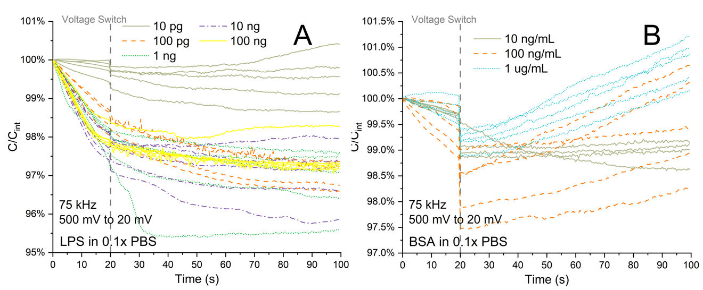
Figure 51 Curves of ΔC/C_{int} versus time for different LPS samples diluted in the analytical buffer. The moment of voltage is illustrated by a dash vertical line. (A) Represents response coming from LPS samples and (B) represents response coming from BSA samples.

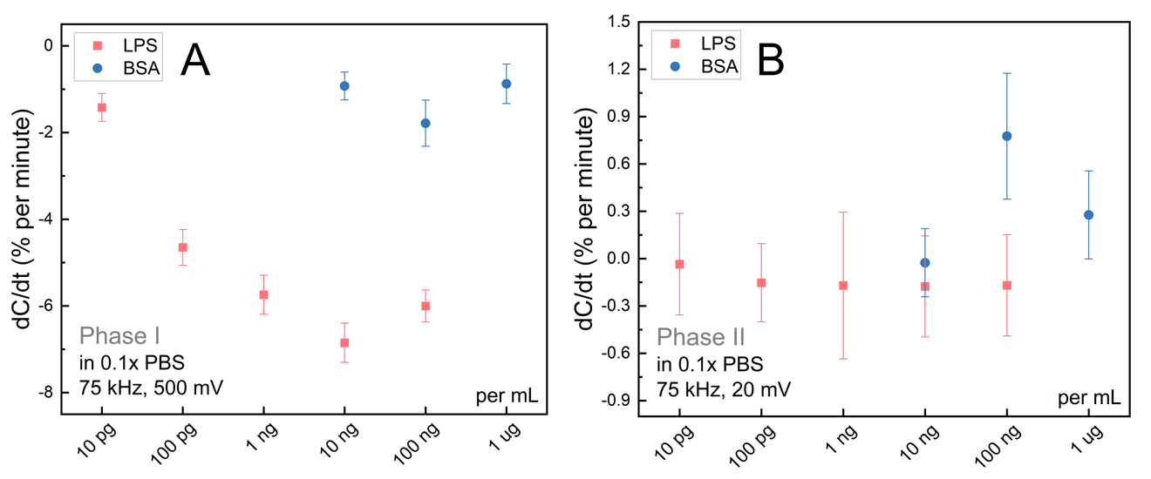
Figure 52 dC/dt responses of phase I and phase II for LPS samples diluted in analytical samples. The red color indicates the response of LPS and the blue color indicates the response of BSA.

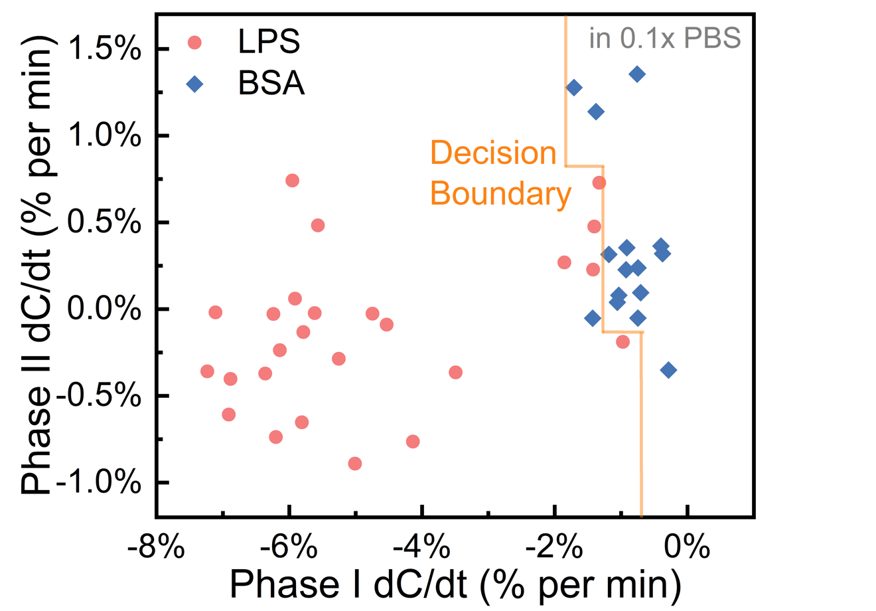
Figure 53 Decision boundaries from single-phase and two-phase methods for LPS samples in the analytical buffer.
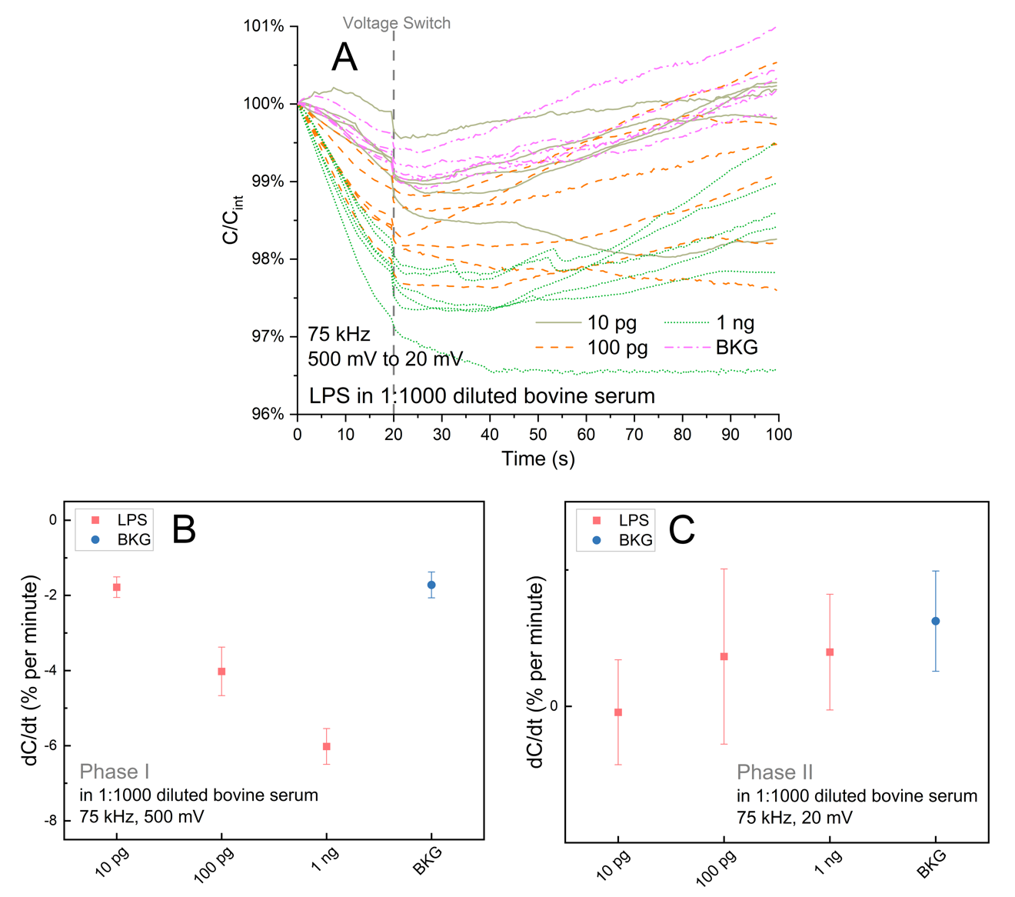
Figure 54 (A) Curves of ΔC/C_{int} versus time for different LPS samples spiked in 1:1000 diluted serum samples. (B) dC/dt responses of phase I and phase II for LPS spiked in1:1000 diluted serum samples. The red color indicates the response of LPS and the blue color indicates the response of serum background.

$y (\%/s)=-2.120∙\log_{10}{x}+25.138$, with a Pearson correlation coefficient of R² = 0.9989. The LOD is 77.015 pg/mL. As can be seen, responses from the serum background (notated as BKG) completely mask the response of 10 pg/mL LPS, making it impossible to detect low concentrated LPS. At phase II, the divergence is even hard to be recognized. Statistically, responses coming from spiked LPS samples are slightly smaller than responses of the background control, unfortunately, in the aspect of distribution of probability, they are actually mixed with each other together, making it very hard to find any threshold based on conventional tools or algorithms.
Again, responses of spiked samples are plotted in the same 2D plane as illustrated in Fig. 55. The decision boundaries calculated from single and combined-phase methods are shown by an orange line. The combined-phase method is able to partially separate the LPS from non-specific responses in bovine serum samples, obtaining a sensitivity of 82.35% and a LOD of 10 pg/mL. There is only insignificant LOD loss in pasteurized milk detection compared with analytical buffer (LOD loss = 1), indicating good selectivity and robustness.

Summary
Owing to the DEP enrichment, tunable DEP and the corresponding decision tree model for data fusion, the developed sensors were demonstrated to be fast, ultra-sensitive and selective. With the stepwise combined-phase method, the LOD was improved from 77.015 pg/mL to 10 pg/mL. The stepwise combined-phase method could be a powerful tool for the qualitative detection of a very low number of gram-negative bacteria. The simultaneously improved sensitivity and selectivity is solid evidence that the proposed 2-phase method not only can be applied for large particles but also work very well for smaller bio-particles. At the same time, the reported sensor could be low-cost and disposable. The operation of the sensor was straightforward, amplification-free, and compatible with inexpensive portable instruments. Therefore, the proposed sensor has the potential to be used for large-scale on-site applications. Further, the sensor could be easily modified for broad varieties of affinity-based biosensors.

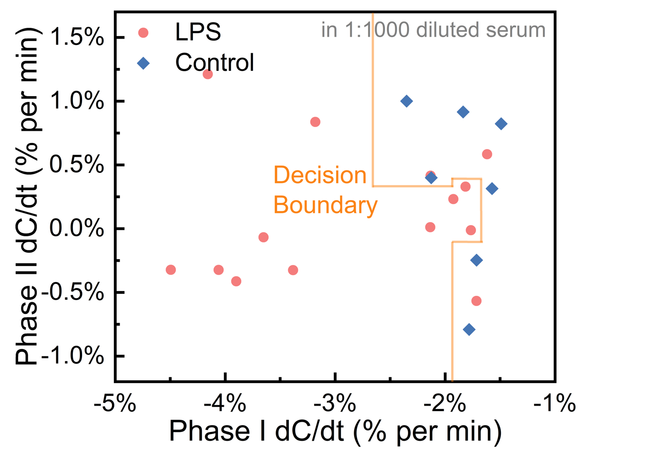
Figure 55 Decision boundaries from single phase and two-phase methods for LPS samples in 1:1000 diluted serum pool samples.

CHAPTER X CONCLUSION AND FUTURE PLAN

Conclusions
﻿This work demonstrates an innovative sensing strategy, which is called 2 consecutive phase sensing method that can be used to significantly improve the selectivity and sensitivity of affinity-based biosensors, simultaneously. Based on this sensing method, a low-cost, rapid, and highly sensitive POC biosensor is constructed to detect multiple molecules or particles of interest in various complicated mediums, which achieved great success in testing the real-world clinic samples. The achievements of this work include:
- This work presented a label-free and amplification-free biosensor for sensitive and rapid detection of miRNAs (miRNA-16b) in bovine serum samples. By fusing ACEK enrichment with direct capacitive interrogation, the sensor was well capable of detecting miRNA biomarkers in a complex matrix with significantly reduced assay time. For miRNAs in both PBS buffer and bovine serum samples, the LODs can reach as low as attomolar levels within 30 seconds. After developing a sample treatment protocol, our sensor was capable of directly testing clinic cow serum samples with the diagnostic sensitivity and specificity of 90.00% and 88.89%, respectively. The sensor exhibited rapid response time, reliability, improved specificity and sensitivity, showing high promise as a reliable and practical diagnostic tool for on-site screening of very early-stage embryonic mortality. Additionally, the PCB-based sensors are low-cost and simple to use, making them especially suited for large-scale, on-site, and real-time applications. We hope that the methodology of this work could advance the development of many other POC sensors.
- A simple, enzyme-free and low-cost broad-spectrum OPs recognition method was extensively studied. A competitive and displacement binding pattern was proposed. Based on the binding mechanism, a capacitive biosensor specific to multiple OPs with phosphonyl or phosphonyl-derived function group was developed. ACET enrichment was integrated into the sensing platform to aggregate the trace level OP molecules without additional preamplification. Therefore, the samples-to-results assay time could be shortened to 30 s. The proposed sensor achieved a LOD of ~57.21 fM, and a wide dynamic range of 100 fM ~ 100 pM to four OPs. Moreover, this sensor had excellent storability and exhibited acceptable performance in simulated real-world samples. Without any deployments of advanced nanomaterials or complicated nanofabrication, the proposed sensing platform provided an extremely low-cost and easy-to-operate solution for OPs detection, satisfying the requirements of the mass-scale, on-site application. Although the ACET enrichment preferred testing buffer with higher conductivity, by few simple steps of dilution, commonly used solvents such as tap water and natural water could be modified to meet the requirement easily. In summary, the proposed biosensor with the capacitive sensing assay offered an alternative approach for measuring wide verities of OPs in trace amounts and might contribute to the field of environmental monitoring or food safety inspection.

Future Scope
Currently, the proposed sensing strategy and corresponding sensors have demonstrated very promising performance when detecting whole bacteria or endotoxin in a complex matrix. In the next step, we will try to integrate the sensor with a portable, low-cost, hand-held multi-channel impedance analyzer. By doing so, the proposed sensor will be able to be operated in an on-site, POC setting in a high throughput manner. Secondly, the sensing system can further be integrated with a specially designed wicking material, in which way a piece of filtering paper or 3-D printed plastic plate can cover the sensing area and hold the sample liquid. After the integration with wicking material, the sensor can be turned into a lateral flow device, where the paper will functionalize to allow bacteria or small molecules to drift to the sensing area by capillary force, which makes the sensor to be capable of detecting whole blood directly.
Last but not least, as an exploratory step, the detection of small molecules need to be further studied. Taking the Per- and polyfluoroalkyl substances (PFAS) as an example. PFAS are widely used, long lasting chemicals, components of which break down very slowly over time. Because of their widespread use and their persistence in the environment, many PFAS are found in the blood of people and animals all over the world and are present at low levels in a variety of food products and in the environment. PFAS are found in water, air, fish, and soil at locations across the globe.
Here we designed an affinity-based protocols utilizing the fluorine-fluorine coupling. The immobilized probes contain fluoroalkyl group and can capture the PFAS molecule.
Some preliminary data for 2-phase detection of PFAS are demonstrated in Fig. 56. Two interfering samples, which is Octanoic acid and 1-Octanesulfonic acid are tested. They have similar molecule weight, but they don’t have fluoroalkyl group. The voltage is first kept at 500 mV and then tuned to 30 mV. At the same time, the frequency is kept at 10 kHz. As can be seen, there are some response on phase I, and based on it, the LOD was found to be 1 pM. However, in phase II, the response from specific and non-specific target are almost identical to each other. Making it nearly impossible to distinguish them (Fig. 57).
The disappeared recovering signal indicated the non-specific molecules are remained firmly attached to the surface. There are many non-specific binding forces, such as van der Waals forces, hydrogen bonding, or hydrophobic interactions. They are usually weak and unstable and can be ignored for large-sized particles. But for small molecules, such interactions will in turn become primary factor and hinder them from releasing from the surface.
Other challenges include the weakness of fluorine-fluorine coupling; therefore the capturing efficiency is week, which is also the reason why the phase I response is very small Also, owing to the fluoroalkyl group, the electrode surface become hydrophobic after probe immobilization, making the testing buffer hard to retain on the sensing area. (Fig. 58) And the overall stability and consistency of the sensing system need to be improved. Right now, the performance of the sensor are relied too much on how well the sensing surface was prepared.
The future improving approaches include systematically studying the binding mechanism behind the fluorine-fluorine coupling. It may offer some help for optimizing or
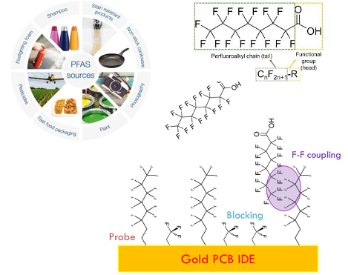
Figure 56 Experiment setup for small molecules (PFAS) detection based on 2-phase voltage switch method.
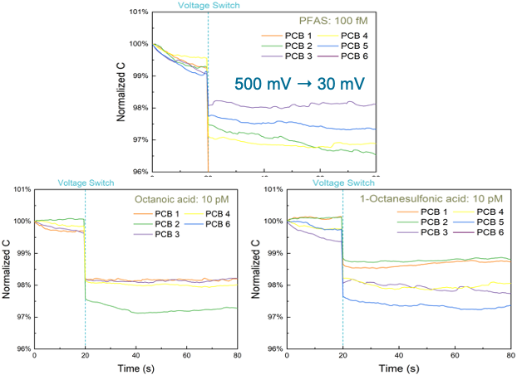
Figure 57 Preliminary C vs. time data for PFAS detection based on 2-phase method.

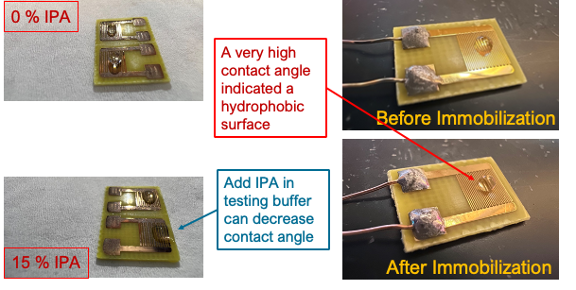
Figure 58 Contact angle before and after immobilization and for different mix ratio between PBS buffer and IPA

redesigning the recognition probes. On the other hand, the testing buffer should also be studied and optimized. I found that the hydrophobicity can be reduced by adding Isopropyl alcohol into the testing buffer. The mixing ratio should be optimized. Finally, more suitable surface blocking method should also be tested. Surface blocking can significantly minimize the non-specific binding.

BIBLIOGRAPHY
[1] M. Cremer, Über die Ursache der elektromotorischen Eigenschaften der Gewebe, zugleich ein Beitrag zur Lehre von den polyphasischen Elektrolytketten, Oldenbourg, 1906. https://books.google.com/books?id=J2j8tgAACAAJ.
[2] W.S. Hughes, THE POTENTIAL DIFFERENCE BETWEEN GLASS AND ELECTROLYTES IN CONTACT WITH THE GLASS, J Am Chem Soc. 44 (1922) 2860–2867. https://doi.org/10.1021/ja01433a021.
[3] W.R. Heineman, W.B. Jensen, Leland C. Clark Jr. (1918–2005), Biosensors and Bioelectronics. 21 (2006) 1403–1404. https://doi.org/https://doi.org/10.1016/j.bios.2005.12.005.
[4] N. Bhalla, P. Jolly, N. Formisano, P. Estrela, Introduction to biosensors, Essays in Biochemistry. 60 (2016) 1–8. https://doi.org/10.1042/EBC20150001.
[5] S. Amemiya, Potentiometric Ion-Selective Electrodes, Elsevier B.V., 2007. https://doi.org/10.1016/B978-0-444-51958-0.50020-3.
[6] A.E.G. Cass, Graham. Davis, G.D. Francis, H.A.O. Hill, W.J. Aston, I.John. Higgins, E. v Plotkin, L.D.L. Scott, A.P.F. Turner, Ferrocene-mediated enzyme electrode for amperometric determination of glucose, Analytical Chemistry. 56 (1984) 667–671. https://doi.org/10.1021/ac00268a018.
[7] Z. Shabaninejad, F. Yousefi, A. Movahedpour, Y. Ghasemi, S. Dokanehiifard, S. Rezaei, R. Aryan, A. Savardashtaki, H. Mirzaei, Electrochemical-based biosensors for microRNA detection: Nanotechnology comes into view, Analytical Biochemistry. 581 (2019). https://doi.org/10.1016/j.ab.2019.113349.
[8] H.C. Loh, M. Ahmad, M.N. Taib, Electrochemical sensor for the lead determination: Development and characterisation, 2005 Asian Conference on Sensors and the International Conference on New Techniques in Pharmaceutical and Biomedical Research - Proceedings. 2005 (2005) 118–126. https://doi.org/10.1109/ASENSE.2005.1564520.
[9] C. Chen, J. Wang, Optical biosensors: An exhaustive and comprehensive review, Analyst. 145 (2020) 1605–1628. https://doi.org/10.1039/c9an01998g.
[10] P. Damborský, J. Švitel, J. Katrlík, Optical biosensors, Essays in Biochemistry. 60 (2016) 91–100. https://doi.org/10.1042/EBC20150010.
[11] M.N. Velasco-Garcia, Optical biosensors for probing at the cellular level: A review of recent progress and future prospects, Seminars in Cell and Developmental Biology. 20 (2009) 27–33. https://doi.org/10.1016/j.semcdb.2009.01.013.
[12] Z. Moridi, V. Mottaghitalab, A.K. Haghi, A detailed review of recent progress in carbon nanotube/chitosan nanocomposites, Cellulose Chemistry and Technology. 45 (2011) 549–563.
[13] S. Sharifi, S.Z. Vahed, E. Ahmadian, S.M. Dizaj, A. Eftekhari, R. Khalilov, M. Ahmadi, E. Hamidi-Asl, M. Labib, Detection of pathogenic bacteria via nanomaterials-modified aptasensors, Biosensors and Bioelectronics. 150 (2020). https://doi.org/10.1016/j.bios.2019.111933.
[14] A.E. Nel, L. Mädler, D. Velegol, T. Xia, E.M. v Hoek, P. Somasundaran, F. Klaessig, V. Castranova, M. Thompson, Understanding biophysicochemical interactions at the nano-bio interface., Nat Mater. 8 (2009) 543–57. https://doi.org/10.1038/nmat2442.
[15] S. Sang, Y. Wang, Q. Feng, Y. Wei, J. Ji, W. Zhang, Progress of new label-free techniques for biosensors: A review, Critical Reviews in Biotechnology. 36 (2016) 465–481. https://doi.org/10.3109/07388551.2014.991270.
[16] N. Akkilic, S. Geschwindner, F. Höök, Single-molecule biosensors: Recent advances and applications, Biosensors and Bioelectronics. 151 (2020). https://doi.org/10.1016/j.bios.2019.111944.
[17] D.A. Blake, R.M. Jones, R.C. Blake, A.R. Pavlov, I.A. Darwish, H. Yu, Antibody-based sensors for heavy metal ions, Biosensors and Bioelectronics. 16 (2001) 799–809. https://doi.org/10.1016/S0956-5663(01)00223-8.
[18] G. Liang, Y. Man, A. Li, X. Jin, X. Liu, L. Pan, DNAzyme-based biosensor for detection of lead ion: A review, Microchemical Journal. 131 (2017) 145–153. https://doi.org/10.1016/j.microc.2016.12.010.
[19] T. Kajisa, T. Sakata, Molecularly Imprinted Artificial Biointerface for an Enzyme-Free Glucose Transistor, ACS Applied Materials and Interfaces. 10 (2018) 34983–34990. https://doi.org/10.1021/acsami.8b13317.
[20] S. Song, L. Wang, J. Li, C. Fan, J. Zhao, Aptamer-based biosensors, TrAC - Trends in Analytical Chemistry. 27 (2008) 108–117. https://doi.org/10.1016/j.trac.2007.12.004.
[21] S.C. Xie, B.G. Low, R.J. Nagel, K.K. Kramer, R. v Anthony, A.P. Zoli, J.F. Beckers, R.M. Roberts, Identification of the major pregnancy-specific antigens of cattle and sheep as inactive members of the aspartic proteinase family., Proc Natl Acad Sci U S A. 88 (1991) 10247–10251. https://doi.org/10.1073/pnas.88.22.10247.
[22] N. Tekaya, O. Saiapina, H. ben Ouada, F. Lagarde, P. Namour, H. ben Ouada, N. Jaffrezic-Renault, Bi-Enzymatic Conductometric Biosensor for Detection of Heavy Metal Ions and Pesticides in Water Samples Based on Enzymatic Inhibition in &lt;i&gt;Arthrospira platensis&lt;/i&gt;, Journal of Environmental Protection. 05 (2014) 441–453. https://doi.org/10.4236/jep.2014.55047.
[23] R. Penchovsky, Computational design of allosteric ribozymes as molecular biosensors, Biotechnology Advances. 32 (2014) 1015–1027. https://doi.org/https://doi.org/10.1016/j.biotechadv.2014.05.005.
[24] T.M. Herne, M.J. Tarlov, Characterization of DNA probes immobilized on gold surfaces, J Am Chem Soc. 119 (1997) 8916–8920. https://doi.org/10.1021/ja9719586.
[25] D. Saerens, L. Huang, K. Bonroy, S. Muyldermans, Antibody Fragments as Probe in Biosensor Development, Sensors . 8 (2008). https://doi.org/10.3390/s8084669.
[26] T. Alizadeh, L.A. Fard, Synthesis of Cu2+-mediated nano-sized salbutamol-imprinted polymer and its use for indirect recognition of ultra-trace levels of salbutamol, Analytica Chimica Acta. 769 (2013) 100–107. https://doi.org/10.1016/j.aca.2013.01.032.
[27] C. Chen, D.A. Ridzon, A.J. Broomer, Z. Zhou, D.H. Lee, J.T. Nguyen, M. Barbisin, N.L. Xu, V.R. Mahuvakar, M.R. Andersen, K.Q. Lao, K.J. Livak, K.J. Guegler, Real-time quantification of microRNAs by stem-loop RT-PCR, Nucleic Acids Research. 33 (2005) 1–9. https://doi.org/10.1093/nar/gni178.
[28] P. He, X. Lou, S.M. Woody, L. He, Amplification-by-Polymerization in Biosensing for Human Genomic DNA Detection, ACS Sensors. 4 (2019) 992–1000. https://doi.org/10.1021/acssensors.9b00133.
[29] M.N. Emaus, C. Zhu, J.L. Anderson, Selective hybridization and capture of KRAS DNA from plasma and blood using ion-tagged oligonucleotide probes coupled to magnetic ionic liquids, Analytica Chimica Acta. 1094 (2020) 1–10. https://doi.org/10.1016/j.aca.2019.10.057.
[30] A. Roda, E. Michelini, M. Zangheri, M. di Fusco, D. Calabria, P. Simoni, Smartphone-based biosensors: A critical review and perspectives, TrAC - Trends in Analytical Chemistry. 79 (2016) 317–325. https://doi.org/10.1016/j.trac.2015.10.019.
[31] J. Zhang, Y. Jiang, X. Xia, J. Wu, R. Almeida, S. Eda, H. Qi, An on-site, highly specific immunosensor for Escherichia coli detection in field milk samples from mastitis-affected dairy cattle, Biosensors and Bioelectronics. 165 (2020). https://doi.org/10.1016/j.bios.2020.112366.
[32] C. Cheng, R. Oueslati, J. Wu, J. Chen, S. Eda, Capacitive DNA sensor for rapid and sensitive detection of whole genome human herpesvirus-1 dsDNA in serum, Electrophoresis. 38 (2017) 1617–1623. https://doi.org/10.1002/elps.201700043.
[33] C. Cheng, J. Wu, J. Chen, A highly sensitive aptasensor for on-site detection of lipopolysaccharides in food, Electrophoresis. 40 (2019) 890–896. https://doi.org/10.1002/elps.201800289.
[34] R. Oueslati, C. Cheng, J. Wu, J. Chen, Highly sensitive and specific on-site detection of serum cocaine by a low cost aptasensor, Biosensors and Bioelectronics. 108 (2018) 103–108. https://doi.org/10.1016/j.bios.2018.02.055.
[35] J. Sabaté del Río, O.Y.F. Henry, P. Jolly, D.E. Ingber, An antifouling coating that enables affinity-based electrochemical biosensing in complex biological fluids, Nature Nanotechnology. 14 (2019) 1143–1149. https://doi.org/10.1038/s41565-019-0566-z.
[36] K. Sadani, P. Nag, S. Mukherji, LSPR based optical fiber sensor with chitosan capped gold nanoparticles on BSA for trace detection of Hg (II) in water, soil and food samples, Biosensors and Bioelectronics. 134 (2019) 90–96. https://doi.org/10.1016/j.bios.2019.03.046.
[37] Y. Jiang, J. Wu, Recent development in chitosan nanocomposites for surface-based biosensor applications, Electrophoresis. 40 (2019). https://doi.org/10.1002/elps.201900066.
[38] D. Harpaz, E. Eltzov, R.C.S. Seet, R.S. Marks, A.I.Y. Tok, Point-of-Care-Testing in Acute Stroke Management: An Unmet Need Ripe for Technological Harvest, Biosensors . 7 (2017). https://doi.org/10.3390/bios7030030.
[39] R.Q. Liang, W. Li, Y. Li, C. yan Tan, J.X. Li, Y.X. Jin, K.C. Ruan, An oligonucleotide microarray for microRNA expression analysis based on labeling RNA with quantum dot and nanogold probe., Nucleic Acids Res. 33 (2005). https://doi.org/10.1093/nar/gni019.
[40] J.S. Daniels, N. Pourmand, Label-Free Impedance Biosensors: Opportunities and Challenges, Electroanalysis. 19 (2007) 1239–1257. https://doi.org/https://doi.org/10.1002/elan.200603855.
[41] S. Sang, Y. Wang, Q. Feng, Y. Wei, J. Ji, W. Zhang, Progress of new label-free techniques for biosensors: A review, Critical Reviews in Biotechnology. 36 (2016) 465–481. https://doi.org/10.3109/07388551.2014.991270.
[42] N. Cheng, J.C. Li, D. Liu, Y. Lin, D. Du, Single-Atom Nanozyme Based on Nanoengineered Fe–N–C Catalyst with Superior Peroxidase-Like Activity for Ultrasensitive Bioassays, Small. 1901485 (2019) 1–7. https://doi.org/10.1002/smll.201901485.
[43] N. Fakhri, S. Abarghoei, M. Dadmehr, M. Hosseini, H. Sabahi, M.R. Ganjali, Paper based colorimetric detection of miRNA-21 using Ag/Pt nanoclusters, Spectrochimica Acta - Part A: Molecular and Biomolecular Spectroscopy. 227 (2020) 117529. https://doi.org/10.1016/j.saa.2019.117529.
[44] E. Rafatmah, B. Hemmateenejad, Colorimetric and visual determination of hydrogen peroxide and glucose by applying paper-based closed bipolar electrochemistry, Microchimica Acta. 186 (2019). https://doi.org/10.1007/s00604-019-3793-y.
[45] P. Damborský, J. Švitel, J. Katrlík, Optical biosensors, Essays in Biochemistry. 60 (2016) 91–100. https://doi.org/10.1042/EBC20150010.
[46] M. Trzaskowski, A. Napiórkowska, E. Augustynowicz-Kopeć, T. Ciach, Detection of tuberculosis in patients with the use of portable SPR device, Sensors and Actuators, B: Chemical. 260 (2018) 786–792. https://doi.org/10.1016/j.snb.2017.12.183.
[47] M. Mahmoudpour, J. Ezzati Nazhad Dolatabadi, M. Torbati, A. Homayouni-Rad, Nanomaterials based surface plasmon resonance signal enhancement for detection of environmental pollutions, Biosensors and Bioelectronics. 127 (2019) 72–84. https://doi.org/10.1016/j.bios.2018.12.023.
[48] Y. Alhamoud, D. Yang, S.S. Fiati Kenston, G. Liu, L. Liu, H. Zhou, F. Ahmed, J. Zhao, Advances in biosensors for the detection of ochratoxin A: Bio-receptors, nanomaterials, and their applications, Biosensors and Bioelectronics. 141 (2019). https://doi.org/10.1016/j.bios.2019.111418.
[49] G.P. Anderson, R.H. Glaven, W.R. Algar, K. Susumu, M.H. Stewart, I.L. Medintz, E.R. Goldman, Single domain antibody-quantum dot conjugates for ricin detection by both fluoroimmunoassay and surface plasmon resonance, Analytica Chimica Acta. 786 (2013) 132–138. https://doi.org/10.1016/j.aca.2013.05.010.
[50] L. Lan, Y. Yao, J. Ping, Y. Ying, Recent advances in nanomaterial-based biosensors for antibiotics detection, Biosensors and Bioelectronics. 91 (2017) 504–514. https://doi.org/10.1016/j.bios.2017.01.007.
[51] A. Sharma, R. Khan, G. Catanante, T.A. Sherazi, S. Bhand, A. Hayat, J.L. Marty, Designed strategies for fluorescence-based biosensors for the detection of mycotoxins, Toxins (Basel). 10 (2018). https://doi.org/10.3390/toxins10050197.
[52] W.D. Newman, C.L. Cortes, A. Afshar, K. Cadien, A. Meldrum, R. Fedosejevs, Z. Jacob, P H Y S I C S Observation of long-range dipole-dipole interactions in hyperbolic metamaterials, 2018. https://www.science.org.
[53] E.M. Kroh, R.K. Parkin, P.S. Mitchell, M. Tewari, Analysis of circulating microRNA biomarkers in plasma and serum using quantitative reverse transcription-PCR (qRT-PCR), Methods. 50 (2010) 298–301. https://doi.org/10.1016/j.ymeth.2010.01.032.
[54] C. Chen, D.A. Ridzon, A.J. Broomer, Z. Zhou, D.H. Lee, J.T. Nguyen, M. Barbisin, N.L. Xu, V.R. Mahuvakar, M.R. Andersen, K.Q. Lao, K.J. Livak, K.J. Guegler, Real-time quantification of microRNAs by stem-loop RT-PCR, Nucleic Acids Research. 33 (2005) 1–9. https://doi.org/10.1093/nar/gni178.
[55] J.S. Lee, H.A. Joung, M.G. Kim, C.B. Park, Graphene-based chemiluminescence resonance energy transfer for homogeneous immunoassay, ACS Nano. 6 (2012) 2978–2983. https://doi.org/10.1021/nn300684d.
[56] S. Zhao, Y. Huang, M. Shi, R. Liu, Y.M. Liu, Chemiluminescence resonance energy transfer-based detection for microchip electrophoresis, Analytical Chemistry. 82 (2010) 2036–2041. https://doi.org/10.1021/ac9027643.
[57] X. Liu, R. Freeman, E. Golub, I. Willner, Chemiluminescence and chemiluminescence resonance energy transfer (CRET) aptamer sensors using catalytic hemin/G-quadruplexes, ACS Nano. 5 (2011) 7648–7655. https://doi.org/10.1021/nn202799d.
[58] X. Huang, J. Ren, Nanomaterial-based chemiluminescence resonance energy transfer: A strategy to develop new analytical methods, TrAC - Trends in Analytical Chemistry. 40 (2012) 77–89. https://doi.org/10.1016/j.trac.2012.07.014.
[59] I.L. Medintz, J.H. Konnert, A.R. Clapp, I. Stanish, M.E. Twigg, H. Mattoussi, J.M. Mauro, J.R. Deschamps, A fluorescence resonance energy transfer-derived structure of a quantum dot-protein bioconjugate nanoassembly, Proc Natl Acad Sci U S A. 101 (2004) 9612–9617. https://doi.org/10.1073/pnas.0403343101.
[60] I.L. Medintz, H. Mattoussi, Quantum dot-based resonance energy transfer and its growing application in biology, Physical Chemistry Chemical Physics. 11 (2009) 17–45. https://doi.org/10.1039/b813919a.
[61] I.L. Medintz, A.R. Clapp, H. Mattoussi, E.R. Goldman, B. Fisher, J.M. Mauro, Self-assembled nanoscale biosensors based on quantum dot FRET donors, Nature Materials. 2 (2003) 630–638. https://doi.org/10.1038/nmat961.
[62] E.R. Goldman, I.L. Medintz, J.L. Whitley, A. Hayhurst, A.R. Clapp, H.T. Uyeda, J.R. Deschamps, M.E. Lassman, H. Mattoussi, A hybrid quantum dot - Antibody fragment fluorescence resonance energy transfer-based TNT sensor, J Am Chem Soc. 127 (2005) 6744–6751. https://doi.org/10.1021/ja043677l.
[63] Y. Zhao, L. Bouffier, G. Xu, G. Loget, N. Sojic, Electrochemiluminescence with semiconductor (nano)materials, Chemical Science. 2022 (2022) 2528–2550. https://doi.org/10.1039/D1SC06987J.
[64] Q. Dong, Y. Huang, D. Song, H. Wu, F. Cao, Y. Lei, Dual functional rhodium oxide nanocorals enabled sensor for both non-enzymatic glucose and solid-state pH sensing, Biosensors and Bioelectronics. 112 (2018) 136–142. https://doi.org/10.1016/j.bios.2018.04.021.
[65] R.D. Johnson, L.G. Bachas, Ionophore-based ion-selective potentiometric and optical sensors, Analytical and Bioanalytical Chemistry. 376 (2003) 328–341. https://doi.org/10.1007/s00216-003-1931-0.
[66] K. Srinivasan, G.A. Rechnitz, Selectivity Studies on Liquid Membrane, Ion-Selective Electrodes, Analytical Chemistry. 41 (1969) 1203–1208. https://doi.org/10.1021/ac60279a014.
[67] M. Rasmussen, S. Abdellaoui, S.D. Minteer, Enzymatic biofuel cells: 30 years of critical advancements, Biosensors and Bioelectronics. 76 (2016) 91–102. https://doi.org/10.1016/j.bios.2015.06.029.
[68] M.B. Gumpu, S. Sethuraman, U.M. Krishnan, J.B.B. Rayappan, A review on detection of heavy metal ions in water - An electrochemical approach, Sensors and Actuators, B: Chemical. 213 (2015) 515–533. https://doi.org/10.1016/j.snb.2015.02.122.
[69] I. Jeerapan, J.R. Sempionatto, A. Pavinatto, J.M. You, J. Wang, Stretchable biofuel cells as wearable textile-based self-powered sensors, Journal of Materials Chemistry A. 4 (2016) 18342–18353. https://doi.org/10.1039/C6TA08358G.
[70] P. Cinquin, C. Gondran, F. Giroud, S. Mazabrard, A. Pellissier, F. Boucher, J.P. Alcaraz, K. Gorgy, F. Lenouvel, S. Mathé, P. Porcu, S. Cosnier, A glucose BioFuel cell implanted in Rats, PLoS ONE. 5 (2010) 1–7. https://doi.org/10.1371/journal.pone.0010476.
[71] A.A. Babadi, S. Bagheri, S.B.A. Hamid, Progress on implantable biofuel cell: Nano-carbon functionalization for enzyme immobilization enhancement, Biosensors and Bioelectronics. 79 (2016) 850–860. https://doi.org/10.1016/j.bios.2016.01.016.
[72] M. Zhou, J. Wang, Biofuel Cells for Self-Powered Electrochemical Biosensing and Logic Biosensing: A Review, Electroanalysis. 24 (2012) 197–209. https://doi.org/10.1002/elan.201100631.
[73] R.D. Beach, R.W. Conlan, M.C. Godwin, F. Moussy, Towards a miniature implantable in vivo telemetry monitoring system dynamically configurable as a potentiostat or galvanostat for two- and three-electrode biosensors, IEEE Transactions on Instrumentation and Measurement. 54 (2005) 61–72. https://doi.org/10.1109/TIM.2004.839757.
[74] Y.-M. Uang, T.-C. Chou, Criteria for Designing a Polypyrrole Glucose Biosensor by Galvanostatic Electropolymerization, Electroanalysis. 14 (2002) 1564–1570. https://doi.org/https://doi.org/10.1002/1521-4109(200211)14:22<1564::AID-ELAN1564>3.0.CO;2-H.
[75] F. Ismail, S.B. Adeloju, A.N. Moline, Fabrication of a Single Layer and Bilayer Potentiometric Biosensors for Penicillin by Galvanostatic Entrapment of Penicillinase into Polypyrrole Films, Electroanalysis. 26 (2014) 2607–2618. https://doi.org/https://doi.org/10.1002/elan.201400452.
[76] I.L. de Mattos, L. Gorton, T. Ruzgas, Sensor and biosensor based on Prussian Blue modified gold and platinum screen printed electrodes, Biosensors and Bioelectronics. 18 (2003) 193–200. https://doi.org/https://doi.org/10.1016/S0956-5663(02)00185-9.
[77] B.K. Bansod, T. Kumar, R. Thakur, S. Rana, I. Singh, A review on various electrochemical techniques for heavy metal ions detection with different sensing platforms, Biosensors and Bioelectronics. 94 (2017) 443–455. https://doi.org/10.1016/j.bios.2017.03.031.
[78] L.P. Wong, Y. Wei, C.S. Toh, Self-powering amperometric sensor and biosensor, Journal of Electroanalytical Chemistry. 671 (2012) 80–84. https://doi.org/10.1016/j.jelechem.2012.02.017.
[79] A. Habekost, Simulation and Fitting of Cyclic Voltammetry and Chronoamperometry Curves of Electrochemical Reactions with Different Mechanisms — A Didactic Perspective, World Journal of Chemical Education. 7 (2019) 53–64. https://doi.org/10.12691/wjce-7-2-4.
[80] N. Elgrishi, K.J. Rountree, B.D. McCarthy, E.S. Rountree, T.T. Eisenhart, J.L. Dempsey, A Practical Beginner’s Guide to Cyclic Voltammetry, Journal of Chemical Education. 95 (2018) 197–206. https://doi.org/10.1021/acs.jchemed.7b00361.
[81] T.R.C. Zezza, M.D.S. Castilho, N.R. Stradiotto, Determination of phosphorus in biodiesel using 1:12 phosphomolybdic modified electrode by cyclic voltammetry, Fuel. 95 (2012) 15–18. https://doi.org/10.1016/j.fuel.2011.12.035.
[82] H. Safarpour, S. Dehghani, R. Nosrati, N. Zebardast, M. Alibolandi, A. Mokhtarzadeh, M. Ramezani, Optical and electrochemical-based nano-aptasensing approaches for the detection of circulating tumor cells (CTCs), Biosensors and Bioelectronics. 148 (2020) 111833. https://doi.org/10.1016/j.bios.2019.111833.
[83] J. Ping, Y. Wang, Y. Ying, J. Wu, Application of electrochemically reduced graphene oxide on screen-printed ion-selective electrode, Analytical Chemistry. 84 (2012) 3473–3479. https://doi.org/10.1021/ac203480z.
[84] D. Pankratov, Z. Blum, D.B. Suyatin, V.O. Popov, S. Shleev, Self-Charging Electrochemical Biocapacitor, ChemElectroChem. 1 (2014) 343–346. https://doi.org/10.1002/celc.201300142.
[85] P. Gillespie, S. Ladame, D. O’Hare, Molecular methods in electrochemical microRNA detection, Analyst. 144 (2019) 114–129. https://doi.org/10.1039/c8an01572d.
[86] A. Kaushik, S. Tiwari, R.D. Jayant, A. Vashist, R. Nikkhah-Moshaie, N. El-Hage, M. Nair, Electrochemical Biosensors for Early Stage Zika Diagnostics, Trends in Biotechnology. 35 (2017) 308–317. https://doi.org/10.1016/j.tibtech.2016.10.001.
[87] C. Tancharoen, W. Sukjee, C. Thepparit, T. Jaimipuk, P. Auewarakul, A. Thitithanyanont, C. Sangma, Electrochemical Biosensor Based on Surface Imprinting for Zika Virus Detection in Serum, ACS Sensors. 4 (2019) 69–75. https://doi.org/10.1021/acssensors.8b00885.
[88] F. Li, D. Chen, W. He, J. Peng, Y. Cao, J. Tu, X. Wang, Highly Accurate and Fast Electrochemical Detection of Scrub Typhus DNA via a Nanoflower NiFe-Based Biosensor, Biosensors . 11 (2021). https://doi.org/10.3390/bios11070207.
[89] J.H. Coelho, A.P.P. Eisele, C.F. Valezi, G.J. Mattos, J.G. Schirmann, R.F.H. Dekker, A.M. Barbosa-Dekker, E.R. Sartori, Exploring the exocellular fungal biopolymer botryosphaeran for laccase-biosensor architecture and application to determine dopamine and spironolactone, Talanta. 204 (2019) 475–483. https://doi.org/https://doi.org/10.1016/j.talanta.2019.06.033.
[90] M. Atapour, G. Amoabediny, M. Ahmadzadeh-Raji, Integrated optical and electrochemical detection of Cu2+ ions in water using a sandwich amino acid–gold nanoparticle-based nano-biosensor consisting of a transparent-conductive platform, RSC Advances. 9 (2019) 8882–8893. https://doi.org/10.1039/C8RA09659G.
[91] K. Asadpour-Zeynali, F. Mollarasouli, Novel electrochemical biosensor based on PVP capped CoFe2O4@CdSe core-shell nanoparticles modified electrode for ultra-trace level determination of rifampicin by square wave adsorptive stripping voltammetry, Biosensors and Bioelectronics. 92 (2017) 509–516. https://doi.org/https://doi.org/10.1016/j.bios.2016.10.071.
[92] Y. Zheng, X. Wang, S. He, Z. Gao, Y. Di, K. Lu, K. Li, J. Wang, Aptamer-DNA concatamer-quantum dots based electrochemical biosensing strategy for green and ultrasensitive detection of tumor cells via mercury-free anodic stripping voltammetry, Biosensors and Bioelectronics. 126 (2019) 261–268. https://doi.org/https://doi.org/10.1016/j.bios.2018.09.076.
[93] M. Dali, K. Zinoubi, A. Chrouda, S. Abderrahmane, S. Cherrad, N. Jaffrezic-Renault, A biosensor based on fungal soil biomass for electrochemical detection of lead (II) and cadmium (II) by differential pulse anodic stripping voltammetry, Journal of Electroanalytical Chemistry. 813 (2018) 9–19. https://doi.org/https://doi.org/10.1016/j.jelechem.2018.02.009.
[94] B. Rezaei, N. Irannejad, Chapter 2 - Electrochemical detection techniques in biosensor applications, in: A.A.B.T.-E.B. Ensafi (Ed.), Elsevier, 2019: pp. 11–43. https://doi.org/https://doi.org/10.1016/B978-0-12-816491-4.00002-4.
[95] M. Lekka, Electrochemical Deposition of Composite Coatings, in: K.B.T.-E. of I.C. Wandelt (Ed.), Elsevier, Oxford, 2018: pp. 54–67. https://doi.org/https://doi.org/10.1016/B978-0-12-409547-2.11716-0.
[96] A.L. Furst, M.B. Francis, Impedance-Based Detection of Bacteria, Chemical Reviews. 119 (2019) 700–726. https://doi.org/10.1021/acs.chemrev.8b00381.
[97] A. Susloparova, D. Koppenhöfer, J.K.Y. Law, X.T. Vu, S. Ingebrandt, Electrical cell-substrate impedance sensing with field-effect transistors is able to unravel cellular adhesion and detachment processes on a single cell level, Lab on a Chip. 15 (2015) 668–679. https://doi.org/10.1039/c4lc00593g.
[98] P. Schuller, M. Rothbauer, S.R.A. Kratz, G. Höll, P. Taus, M. Schinnerl, J. Genser, N. Bastus, O.H. Moriones, V. Puntes, B. Huppertz, M. Siwetz, H. Wanzenböck, P. Ertl, A lab-on-a-chip system with an embedded porous membrane-based impedance biosensor array for nanoparticle risk assessment on placental Bewo trophoblast cells, Sensors and Actuators B: Chemical. 312 (2020) 127946. https://doi.org/https://doi.org/10.1016/j.snb.2020.127946.
[99] I. Jasim, Z. Shen, Z. Mlaji, N.S. Yuksek, A. Abdullah, J. Liu, S.G. Dastider, M. El-Dweik, S. Zhang, M. Almasri, An impedance biosensor for simultaneous detection of low concentration of Salmonella serogroups in poultry and fresh produce samples, Biosensors and Bioelectronics. 126 (2019) 292–300. https://doi.org/https://doi.org/10.1016/j.bios.2018.10.065.
[100] G.N. Abdelrasoul, A. Anwar, S. MacKay, M. Tamura, M.A. Shah, D.P. Khasa, R.R. Montgomery, A.I. Ko, J. Chen, DNA aptamer-based non-faradaic impedance biosensor for detecting E. coli, Analytica Chimica Acta. 1107 (2020) 135–144. https://doi.org/https://doi.org/10.1016/j.aca.2020.02.004.
[101] M. Kaisti, Detection principles of biological and chemical FET sensors, Biosensors and Bioelectronics. 98 (2017) 437–448. https://doi.org/10.1016/j.bios.2017.07.010.
[102] J. Kwon, B.H. Lee, S.Y. Kim, J.Y. Park, H. Bae, Y.K. Choi, J.H. Ahn, Nanoscale FET-Based Transduction toward Sensitive Extended-Gate Biosensors, ACS Sensors. 4 (2019) 1724–1729. https://doi.org/10.1021/acssensors.9b00731.
[103] D.H. Shin, W. Kim, J. Jun, J.S. Lee, J.H. Kim, J. Jang, Highly selective FET-type glucose sensor based on shape-controlled palladium nanoflower-decorated graphene, Sensors and Actuators, B: Chemical. 264 (2018) 216–223. https://doi.org/10.1016/j.snb.2018.02.139.
[104] X. Zong, R. Zhu, ZnO nanorod-based FET biosensor for continuous glucose monitoring, Sensors and Actuators, B: Chemical. 255 (2018) 2448–2453. https://doi.org/10.1016/j.snb.2017.09.037.
[105] M. Pohanka, Overview of Piezoelectric Biosensors, Immunosensors and DNA Sensors and Their Applications, Materials . 11 (2018). https://doi.org/10.3390/ma11030448.
[106] M. Pohanka, Piezoelectric biosensor for the determination of Tumor Necrosis Factor Alpha, Talanta. 178 (2018) 970–973. https://doi.org/https://doi.org/10.1016/j.talanta.2017.10.031.
[107] G. Palazzo, D. de Tullio, M. Magliulo, A. Mallardi, F. Intranuovo, M.Y. Mulla, P. Favia, I. Vikholm-Lundin, L. Torsi, Detection beyond Debye’s length with an electrolyte-gated organic field-effect transistor, Advanced Materials. 27 (2015) 911–916. https://doi.org/10.1002/adma.201403541.
[108] M.T. Chorsi, E.J. Curry, H.T. Chorsi, R. Das, J. Baroody, P.K. Purohit, H. Ilies, T.D. Nguyen, Piezoelectric Biomaterials for Sensors and Actuators, Advanced Materials. 31 (2019) 1802084. https://doi.org/https://doi.org/10.1002/adma.201802084.
[109] F. Narita, Z. Wang, H. Kurita, Z. Li, Y. Shi, Y. Jia, C. Soutis, A Review of Piezoelectric and Magnetostrictive Biosensor Materials for Detection of COVID-19 and Other Viruses, Advanced Materials. 33 (2021) 2005448. https://doi.org/https://doi.org/10.1002/adma.202005448.
[110] A.T. Le, M. Ahmadipour, S.-Y. Pung, A review on ZnO-based piezoelectric nanogenerators: Synthesis, characterization techniques, performance enhancement and applications, Journal of Alloys and Compounds. 844 (2020) 156172. https://doi.org/https://doi.org/10.1016/j.jallcom.2020.156172.
[111] K.M. Hansen, T. Thundat, Microcantilever biosensors, Methods. 37 (2005) 57–64. https://doi.org/https://doi.org/10.1016/j.ymeth.2005.05.011.
[112] M.Z. Ansari, C. Cho, Design and Analysis of a High Sensitive Microcantilever Biosensor for Biomedical Applications, in: 2008 International Conference on BioMedical Engineering and Informatics, 2008: pp. 593–597. https://doi.org/10.1109/BMEI.2008.308.
[113] J. Pei, F. Tian, T. Thundat, Glucose Biosensor Based on the Microcantilever, Analytical Chemistry. 76 (2004) 292–297. https://doi.org/10.1021/ac035048k.
[114] K.R. Buchapudi, X. Huang, X. Yang, H.-F. Ji, T. Thundat, Microcantilever biosensors for chemicals and bioorganisms, Analyst. 136 (2011) 1539–1556. https://doi.org/10.1039/C0AN01007C.
[115] A.M. Moulin, S.J. O’Shea, M.E. Welland, Microcantilever-based biosensors, Ultramicroscopy. 82 (2000) 23–31. https://doi.org/https://doi.org/10.1016/S0304-3991(99)00145-X.
[116] P. Li, G.-H. Lee, S.Y. Kim, S.Y. Kwon, H.-R. Kim, S. Park, From Diagnosis to Treatment: Recent Advances in Patient-Friendly Biosensors and Implantable Devices, ACS Nano. 15 (2021) 1960–2004. https://doi.org/10.1021/acsnano.0c06688.
[117] J. Tu, R.M. Torrente-Rodríguez, M. Wang, W. Gao, The Era of Digital Health: A Review of Portable and Wearable Affinity Biosensors, Advanced Functional Materials. 30 (2020) 1906713. https://doi.org/https://doi.org/10.1002/adfm.201906713.
[118] S.A. Soper, K. Brown, A. Ellington, B. Frazier, G. Garcia-Manero, V. Gau, S.I. Gutman, D.F. Hayes, B. Korte, J.L. Landers, D. Larson, F. Ligler, A. Majumdar, M. Mascini, D. Nolte, Z. Rosenzweig, J. Wang, D. Wilson, Point-of-care biosensor systems for cancer diagnostics/prognostics, Biosensors and Bioelectronics. 21 (2006) 1932–1942. https://doi.org/https://doi.org/10.1016/j.bios.2006.01.006.
[119] C.I.L. Justino, T.A.P. Rocha-Santos, A.C. Duarte, T.A.P. Rocha-Santos, Advances in point-of-care technologies with biosensors based on carbon nanotubes, TrAC Trends in Analytical Chemistry. 45 (2013) 24–36. https://doi.org/https://doi.org/10.1016/j.trac.2012.12.012.
[120] L.-C. Chen, E. Wang, C.-S. Tai, Y.-C. Chiu, C.-W. Li, Y.-R. Lin, T.-H. Lee, C.-W. Huang, J.-C. Chen, W.L. Chen, Improving the reproducibility, accuracy, and stability of an electrochemical biosensor platform for point-of-care use, Biosensors and Bioelectronics. 155 (2020) 112111. https://doi.org/https://doi.org/10.1016/j.bios.2020.112111.
[121] S.G. Hwang, K. Ha, K. Guk, D.K. Lee, G. Eom, S. Song, T. Kang, H. Park, J. Jung, E.-K. Lim, Rapid and simple detection of Tamiflu-resistant influenza virus: Development of oseltamivir derivative-based lateral flow biosensor for point-of-care (POC) diagnostics, Scientific Reports. 8 (2018) 12999. https://doi.org/10.1038/s41598-018-31311-x.
[122] A.C. Sun, D.A. Hall, Point-of-Care Smartphone-based Electrochemical Biosensing, Electroanalysis. 31 (2019) 2–16. https://doi.org/10.1002/elan.201800474.
[123] E.-H. Yoo, S.-Y. Lee, Glucose Biosensors: An Overview of Use in Clinical Practice, Sensors . 10 (2010). https://doi.org/10.3390/s100504558.
[124] S. Sachdeva, R.W. Davis, A.K. Saha, Microfluidic Point-of-Care Testing: Commercial Landscape and Future Directions, Frontiers in Bioengineering and Biotechnology. 8 (2021) 1–14. https://doi.org/10.3389/fbioe.2020.602659.
[125] S. Viswanathan, T.N. Narayanan, K. Aran, K.D. Fink, J. Paredes, P.M. Ajayan, S. Filipek, P. Miszta, H.C. Tekin, F. Inci, U. Demirci, P. Li, K.I. Bolotin, D. Liepmann, V. Renugopalakrishanan, Graphene–protein field effect biosensors: glucose sensing, Materials Today. 18 (2015) 513–522. https://doi.org/https://doi.org/10.1016/j.mattod.2015.04.003.
[126] C.-K. Choi, S.M. Shaban, B.-S. Moon, D.-G. Pyun, D.-H. Kim, Smartphone-assisted point-of-care colorimetric biosensor for the detection of urea via pH-mediated AgNPs growth, Analytica Chimica Acta. 1170 (2021) 338630. https://doi.org/https://doi.org/10.1016/j.aca.2021.338630.
[127] X. Kou, L. Tong, Y. Shen, W. Zhu, L. Yin, S. Huang, F. Zhu, G. Chen, G. Ouyang, Smartphone-assisted robust enzymes@MOFs-based paper biosensor for point-of-care detection, Biosensors and Bioelectronics. 156 (2020) 112095. https://doi.org/https://doi.org/10.1016/j.bios.2020.112095.
[128] M. Ouyang, D. Tu, L. Tong, M. Sarwar, A. Bhimaraj, C. Li, G.L. Coté, D. di Carlo, A review of biosensor technologies for blood biomarkers toward monitoring cardiovascular diseases at the point-of-care, Biosensors and Bioelectronics. 171 (2021). https://doi.org/10.1016/j.bios.2020.112621.
[129] D. White, M. Keramane, A. Capretta, J.D. Brennan, A paper-based biosensor for visual detection of glucose-6-phosphate dehydrogenase from whole blood, Analyst. 145 (2020) 1817–1824. https://doi.org/10.1039/c9an02219h.
[130] J.R. Choi, Development of Point-of-Care Biosensors for COVID-19 , Frontiers in Chemistry . 8 (2020). https://www.frontiersin.org/articles/10.3389/fchem.2020.00517.
[131] K. Kim, H. Kim, E.-J. Jo, H. Jang, J. Park, G.Y. Jung, M.-G. Kim, Reactant/polymer hybrid films on p-n junction photodetectors for self-powered, non-invasive glucose biosensors, Biosensors and Bioelectronics. 175 (2021) 112855. https://doi.org/https://doi.org/10.1016/j.bios.2020.112855.
[132] B. Purohit, A. Kumar, K. Mahato, P. Chandra, Smartphone-assisted personalized diagnostic devices and wearable sensors, Current Opinion in Biomedical Engineering. 13 (2020) 42–50. https://doi.org/https://doi.org/10.1016/j.cobme.2019.08.015.
[133] L. Ma, L. Peng, L. Yin, G. Liu, S. Man, CRISPR-Cas12a-Powered Dual-Mode Biosensor for Ultrasensitive and Cross-validating Detection of Pathogenic Bacteria, ACS Sensors. 6 (2021) 2920–2927. https://doi.org/10.1021/acssensors.1c00686.
[134] J.A. Capobianco, C.M. Armstrong, J. Lee, A.G. Gehring, Detection of pathogenic bacteria in large volume food samples using an enzyme-linked immunoelectrochemical biosensor, Food Control. 119 (2021) 107456. https://doi.org/10.1016/j.foodcont.2020.107456.
[135] Y. Jiang, J. Wu, S. Eda, A Rapid and Ultra-sensitive Sensing Strategy based on Tunable Dielectrophoresis for Robust POC Detection, in: 2022 IEEE Healthcare Innovations and Point of Care Technologies (HI-POCT), 2022: pp. 103–106. https://doi.org/10.1109/HI-POCT54491.2022.9744059.
[136] C. Meinhart, D. Wang, K. Turner, Measurement of AC Electrokinetic Flows, Biomedical Microdevices. 5 (2003) 139–145. https://doi.org/10.1023/A:1024595329650.
[137] V. Studer, A. Pépin, Y. Chen, A. Ajdari, Fabrication of microfluidic devices for AC electrokinetic fluid pumping, Microelectronic Engineering. 61–62 (2002) 915–920. https://doi.org/https://doi.org/10.1016/S0167-9317(02)00518-X.
[138] P. García-Sánchez, Y. Ren, J.J. Arcenegui, H. Morgan, A. Ramos, Alternating Current Electrokinetic Properties of Gold-Coated Microspheres, Langmuir. 28 (2012) 13861–13870. https://doi.org/10.1021/la302402v.
[139] S. Li, Y. Jiang, S. Eda, J.J. Wu, Low-cost and desktop-fabricated biosensor for rapid and sensitive detection of circulating D-dimer biomarker, IEEE Sensors Journal. 19 (2019). https://doi.org/10.1109/JSEN.2018.2881916.
[140] R. Oueslati, Y. Jiang, J. Chen, J. Wu, Rapid and Sensitive Point of Care Detection of MRSA Genomic DNA by Nanoelectrokinetic Sensors, Chemosensors . 9 (2021). https://doi.org/10.3390/chemosensors9050097.
[141] J. Zhang, X. Fang, J. Wu, Z. Hu, Y. Jiang, H. Qi, L. Zheng, X. Xuan, An interdigitated microelectrode based aptasensor for real-time and ultratrace detection of four organophosphorus pesticides, Biosensors and Bioelectronics. 150 (2020). https://doi.org/10.1016/j.bios.2019.111879.
[142] T. Notomi, H. Okayama, H. Masubuchi, T. Yonekawa, K. Watanabe, N. Amino, T. Hase, Loop-mediated isothermal amplification of DNA, Nucleic Acids Research. 28 (2000) e63–e63. https://doi.org/10.1093/nar/28.12.e63.
[143] E. Paleček, M. Fojta, Magnetic beads as versatile tools for electrochemical DNA and protein biosensing, Talanta. 74 (2007) 276–290. https://doi.org/https://doi.org/10.1016/j.talanta.2007.08.020.
[144] S. Cosnier, Electropolymerization of amphiphilic monomers for designing amperometric biosensors, Electroanalysis. 9 (1997) 894–902. https://doi.org/https://doi.org/10.1002/elan.1140091206.
[145] L.H. Olesen, H. Bruus, A. Ajdari, ac electrokinetic micropumps: The effect of geometrical confinement, Faradaic current injection, and nonlinear surface capacitance, Physical Review E. 73 (2006) 56313. https://doi.org/10.1103/PhysRevE.73.056313.
[146] Y. Huang, R. Pethig, Electrode design for negative dielectrophoresis, Measurement Science and Technology. 2 (1991) 1142–1146. https://doi.org/10.1088/0957-0233/2/12/005.
[147] B.H. Lapizco-Encinas, M. Rito-Palomares, Dielectrophoresis for the manipulation of nanobioparticles, Electrophoresis. 28 (2007) 4521–4538. https://doi.org/10.1002/elps.200700303.
[148] B. Çetin, D. Li, Dielectrophoresis in microfluidics technology, Electrophoresis. 32 (2011) 2410–2427. https://doi.org/10.1002/elps.201100167.
[149] Q. Lang, Y. Wu, Y. Ren, Y. Tao, L. Lei, H. Jiang, AC Electrothermal Circulatory Pumping Chip for Cell Culture, ACS Applied Materials and Interfaces. 7 (2015) 26792–26801. https://doi.org/10.1021/acsami.5b08863.
[150] P.R.C. Gascoyne, J. Vykoukal, Particle separation by dielectrophoresis, Electrophoresis. 23 (2002) 1973–1983. https://doi.org/10.1002/1522-2683(200207)23:13<1973::AID-ELPS1973>3.0.CO;2-1.
[151] A. Salari, M. Navi, T. Lijnse, C. Dalton, AC Electrothermal Effect in Microfluidics: A Review, Micromachines . 10 (2019). https://doi.org/10.3390/mi10110762.
[152] S. Loire, P. Kauffmann, I. Mezić, C.D. Meinhart, A theoretical and experimental study of ac electrothermal flows, Journal of Physics D: Applied Physics. 45 (2012) 185301. https://doi.org/10.1088/0022-3727/45/18/185301.
[153] V. Calero, P. García-Sánchez, A. Ramos, H. Morgan, Electrokinetic biased deterministic lateral displacement: scaling analysis and simulations, Journal of Chromatography A. 1623 (2020) 461151. https://doi.org/https://doi.org/10.1016/j.chroma.2020.461151.
[154] Y. Lu, Q. Yang, J. Wu, Recent advances in biosensor-integrated enrichment methods for preconcentrating and detecting the low-abundant analytes in agriculture and food samples, TrAC Trends in Analytical Chemistry. 128 (2020) 115914. https://doi.org/https://doi.org/10.1016/j.trac.2020.115914.
[155] Q. Ren, Y. Wang, X. Lin, C.L. Chan, AC electrokinetic induced non-Newtonian electrothermal blood flow in 3D microfluidic biosensor with ring electrodes for point-of-care diagnostics, Journal of Applied Physics. 126 (2019) 84501. https://doi.org/10.1063/1.5099272.
[156] M. Song, X. Lin, Z. Peng, M. Zhang, J. Wu, Enhancing affinity-based electroanalytical biosensors by integrated AC electrokinetic enrichment—A mini review, ELECTROPHORESIS. 43 (2022) 201–211. https://doi.org/https://doi.org/10.1002/elps.202100168.
[157] C.-A. Lee, A. Teramoto, H. Watanabe, Monte Carlo Simulation of Nanowires Array Biosensor With AC Electroosmosis, IEEE Transactions on Electron Devices. 65 (2018) 1932–1938. https://doi.org/10.1109/TED.2018.2812783.
[158] M. Selmi, H. Belmabrouk, AC Electroosmosis Effect on Microfluidic Heterogeneous Immunoassay Efficiency, Micromachines . 11 (2020). https://doi.org/10.3390/mi11040342.
[159] W. Choi, Y.W. Min, K.Y. Lee, S. Jun, H.G. Lee, Dielectrophoresis-based microwire biosensor for rapid detection of Escherichia coli K-12 in ground beef, LWT. 132 (2020) 109230. https://doi.org/https://doi.org/10.1016/j.lwt.2020.109230.
[160] Z. Çağlayan, Y. Demircan Yalçın, H. Külah, A Prominent Cell Manipulation Technique in BioMEMS: Dielectrophoresis, Micromachines . 11 (2020). https://doi.org/10.3390/mi11110990.
[161] N. Abd Rahman, F. Ibrahim, B. Yafouz, Dielectrophoresis for Biomedical Sciences Applications: A Review, Sensors . 17 (2017). https://doi.org/10.3390/s17030449.
[162] L. Yang, A Review of Multifunctions of Dielectrophoresis in Biosensors and Biochips for Bacteria Detection, Analytical Letters. 45 (2012) 187–201. https://doi.org/10.1080/00032719.2011.633182.
[163] A. Henriksson, L. Kasper, M. Jäger, P. Neubauer, M. Birkholz, An Approach to Ring Resonator Biosensing Assisted by Dielectrophoresis: Design, Simulation and Fabrication, Micromachines . 11 (2020). https://doi.org/10.3390/mi11110954.
[164] L. Velmanickam, I.T. Lima, D. Nawarathna, High Throughput and Low-Cost Detection of Short Nucleic Acid Biomarkers in Serum using Dielectrophoretic Biosensor, in: 2018 IEEE Research and Applications of Photonics In Defense Conference (RAPID), 2018: pp. 1–3. https://doi.org/10.1109/RAPID.2018.8508984.
[165] H. Mirzajani, C. Cheng, J. Wu, C.S. Ivanoff, E. Najafi Aghdam, H. Badri Ghavifekr, Design and characterization of a passive, disposable wireless AC-electroosmotic lab-on-a-film for particle and fluid manipulation, Sensors and Actuators, B: Chemical. 235 (2016) 330–342. https://doi.org/10.1016/j.snb.2016.05.073.
[166] H.A. Pohl, J.S. Crane, Dielectrophoresis of Cells, Biophysical Journal. 11 (1971) 711–727. https://doi.org/https://doi.org/10.1016/S0006-3495(71)86249-5.
[167] R. Pethig, G.H. Markx, Applications of dielectrophoresis in biotechnology, Trends in Biotechnology. 15 (1997) 426–432. https://doi.org/https://doi.org/10.1016/S0167-7799(97)01096-2.
[168] R. Pethig, Review Article—Dielectrophoresis: Status of the theory, technology, and applications, Biomicrofluidics. 4 (2010) 022811. https://doi.org/10.1063/1.3456626.
[169] P.R.C. Gascoyne, J. Vykoukal, Particle separation by dielectrophoresis, Electrophoresis. 23 (2002) 1973–1983. https://doi.org/10.1002/1522-2683(200207)23:13<1973::AID-ELPS1973>3.0.CO;2-1.
[170] W.Y. Ng, S. Goh, Y.C. Lam, C. Yang, I. Rodríguez, DC-biased AC-electroosmotic and AC-electrothermal flow mixing in microchannels, Lab on a Chip. 9 (2009) 802–809. https://doi.org/10.1039/b813639d.
[171] J. Wu, Y. Ben, D. Battigelli, H.C. Chang, Long-range AC electroosmotic trapping and detection of bioparticles, Industrial and Engineering Chemistry Research. 44 (2005) 2815–2822. https://doi.org/10.1021/ie049417u.
[172] M.R. Bown, C.D. Meinhart, AC electroosmotic flow in a DNA concentrator, Microfluidics and Nanofluidics. 2 (2006) 513–523. https://doi.org/10.1007/s10404-006-0097-4.
[173] S.-H. Huang, S.-K. Wang, H.S. Khoo, F.-G. Tseng, AC electroosmotic generated in-plane microvortices for stationary or continuous fluid mixing, Sensors and Actuators B: Chemical. 125 (2007) 326–336. https://doi.org/https://doi.org/10.1016/j.snb.2007.01.046.
[174] N. Loucaides, A. Ramos, G.E. Georghiou, Novel systems for configurable AC electroosmotic pumping, Microfluidics and Nanofluidics. 3 (2007) 709–714. https://doi.org/10.1007/s10404-007-0168-1.
[175] M.Z. Rashed, S.J. Williams, Advances and applications of isomotive dielectrophoresis for cell analysis, Analytical and Bioanalytical Chemistry. 412 (2020) 3813–3833. https://doi.org/10.1007/s00216-020-02590-z.
[176] Q. Yuan, K. Yang, J. Wu, Optimization of planar interdigitated microelectrode array for biofluid transport by AC electrothermal effect, Microfluidics and Nanofluidics. 16 (2014) 167–178. https://doi.org/10.1007/s10404-013-1231-8.
[177] M.C. Biagi, R. Fabregas, G. Gramse, M. van der Hofstadt, A. Juárez, F. Kienberger, L. Fumagalli, G. Gomila, Nanoscale electric permittivity of single bacterial cells at gigahertz frequencies by scanning microwave microscopy, ACS Nano. 10 (2016) 280–288. https://doi.org/10.1021/acsnano.5b04279.
[178] L. Li, C. Li, Z. Zhang, E. Alexov, On the dielectric “constant” of proteins: Smooth dielectric function for macromolecular modeling and its implementation in DelPhi, Journal of Chemical Theory and Computation. 9 (2013) 2126–2136. https://doi.org/10.1021/ct400065j.
[179] J. Edrich, P.C. Hardee, Complex Permittivity and Penetration Depth of Muscle and Fat Tissues Between 40 and 90 GHz, IEEE Transactions on Microwave Theory and Techniques. 24 (1976) 273–275. https://doi.org/10.1109/TMTT.1976.1128840.
[180] C. Largeot, C. Portet, J. Chmiola, P.-L. Taberna, Y. Gogotsi, P. Simon, Relation between the Ion Size and Pore Size for an Electric Double-Layer Capacitor, J Am Chem Soc. 130 (2008) 2730–2731. https://doi.org/10.1021/ja7106178.
[181] M.J. Bleda-Martínez, J.A. Maciá-Agulló, D. Lozano-Castelló, E. Morallón, D. Cazorla-Amorós, A. Linares-Solano, Role of surface chemistry on electric double layer capacitance of carbon materials, Carbon N Y. 43 (2005) 2677–2684. https://doi.org/https://doi.org/10.1016/j.carbon.2005.05.027.
[182] W. Schmickler, Electronic Effects in the Electric Double Layer, Chemical Reviews. 96 (1996) 3177–3200. https://doi.org/10.1021/cr940408c.
[183] B. Giera, N. Henson, E.M. Kober, M.S. Shell, T.M. Squires, Electric double-layer structure in primitive model electrolytes: Comparing molecular dynamics with local-density approximations, Langmuir. 31 (2015) 3553–3562. https://doi.org/10.1021/la5048936.
[184] A. Allagui, T.J. Freeborn, A.S. Elwakil, B.J. Maundy, Reevaluation of Performance of Electric Double-layer Capacitors from Constant-current Charge/Discharge and Cyclic Voltammetry, Scientific Reports. 6 (2016) 38568. https://doi.org/10.1038/srep38568.
[185] M. Birla Singh, R. Kant, Theory of Anomalous Dynamics of Electric Double Layer at Heterogeneous and Rough Electrodes, The Journal of Physical Chemistry C. 118 (2014) 5122–5133. https://doi.org/10.1021/jp410999b.
[186] K.J. Aoki, Frequency-dependence of electric double layer capacitance without Faradaic reactions, Journal of Electroanalytical Chemistry. 779 (2016) 117–125. https://doi.org/https://doi.org/10.1016/j.jelechem.2016.04.026.
[187] L.I. Daikhin, A.A. Kornyshev, M. Urbakh, Double-layer capacitance on a rough metal surface, 1996.
[188] P. Chawla, R. Kaushik, V.J. Shiva Swaraj, N. Kumar, Organophosphorus pesticides residues in food and their colorimetric detection, Environmental Nanotechnology, Monitoring & Management. 10 (2018) 292–307. https://doi.org/https://doi.org/10.1016/j.enmm.2018.07.013.
[189] L.G. Sultatos, Mammalian toxicology of organophosphorus pesticides, Journal of Toxicology and Environmental Health. 43 (1994) 271–289. https://doi.org/10.1080/15287399409531921.
[190] C.N. Pope, ORGANOPHOSPHORUS PESTICIDES: DO THEY ALL HAVE THE SAME MECHANISM OF TOXICITY?, Journal of Toxicology and Environmental Health, Part B. 2 (1999) 161–181. https://doi.org/10.1080/109374099281205.
[191] S. Hassani, S. Momtaz, F. Vakhshiteh, A.S. Maghsoudi, M.R. Ganjali, P. Norouzi, M. Abdollahi, Biosensors and their applications in detection of organophosphorus pesticides in the environment, Archives of Toxicology. 91 (2017) 109–130. https://doi.org/10.1007/s00204-016-1875-8.
[192] M. Polhuijs, J.P. Langenberg, H.P. Benschop, New Method for Retrospective Detection of Exposure to Organophosphorus Anticholinesterases: Application to Alleged Sarin Victims of Japanese Terrorists, Toxicology and Applied Pharmacology. 146 (1997) 156–161. https://doi.org/https://doi.org/10.1006/taap.1997.8243.
[193] J. Wu, Interactions of electrical fields with fluids:laboratory-on-a-chip applications, IET Nanobiotechnology. 2 (2008) 14–27. https://doi.org/10.1049/iet-nbt:20070023.
[194] S. Sohn, D. Kim, Modification of Langmuir isotherm in solution systems - Definition and utilization of concentration dependent factor, Chemosphere. 58 (2005) 115–123. https://doi.org/10.1016/j.chemosphere.2004.08.091.
[195] Recommendations for standardizing bovine reproductive terms., Cornell Vet. 62 (1972) 216–237.
[196] B. Dagan, A review of embryonic, Reproduction. 54 (1978) 483–493.
[197] C.H. Hanzen, M. Pieterse, O. Szenci, M. Drost, Relative Accuracy of the Identification of Ovarian Structures in the Cow by Ultrasonography and Palpation Per Rectum, Veterinary Journal. 159 (2000) 161–170. https://doi.org/10.1053/tvjl.1999.0398.
[198] A.K. Balhara, M. Gupta, S. Singh, A.K. Mohanty, I. Singh, Early pregnancy diagnosis in bovines: Current status and future directions, The Scientific World Journal. 2013 (2013). https://doi.org/10.1155/2013/958540.
[199] P. Humblot, S. Camous, J. Martal, J. Charlery, N. Jeanguyot, M. Thibier, R.G. Sasser, Pregnancy-specific protein B, progesterone concentrations and embryonic mortality during early pregnancy in dairy cows, Journal of Reproduction and Fertility. 83 (1988) 215–223. https://doi.org/10.1530/jrf.0.0830215.
[200] Y. Jiang, J. Huang, J. Wu, S. Eda, A rapid, sensitive, and simple-to-use biosensor for on-site detection of attomolar level microRNA biomarkers from serum extracellular vesicles, Sensors and Actuators B: Chemical. (2022) 132314. https://doi.org/https://doi.org/10.1016/j.snb.2022.132314.
[201] N. Wan, Y. Jiang, J. Huang, R. Oueslati, S. Eda, J. Wu, X. Lin, Rapid and sensitive detection of mirna based on ac electrokinetic capacitive sensing for point-of-care applications, Sensors. 21 (2021). https://doi.org/10.3390/s21123985.
[202] K.G. Pohler, J.A. Green, L.A. Moley, S. Gunewardena, W.T. Hung, R.R. Payton, X. Hong, L.K. Christenson, T.W. Geary, M.F. Smith, Circulating microRNA as candidates for early embryonic viability in cattle, Molecular Reproduction and Development. 84 (2017) 731–743. https://doi.org/10.1002/mrd.22856.
[203] A.B. Steel, T.M. Herne, M.J. Tarlov, Electrochemical quantitation of DNA immobilized on gold, Analytical Chemistry. 70 (1998) 4670–4677. https://doi.org/10.1021/ac980037q.
[204] K. Subramanian, J.P. Urbanski, J.A. Levitan, M. Bazant, Experimental Study of Electrolyte Dependence of Ac Electroosmotic Pumps, (n.d.).
[205] M. Ritzefeld, N. Sewald, Real-Time Analysis of Specific Protein-DNA Interactions with Surface Plasmon Resonance, Journal of Amino Acids. 2012 (2012) 816032. https://doi.org/10.1155/2012/816032.
[206] R. Stoltenburg, C. Reinemann, B. Strehlitz, SELEX-A (r)evolutionary method to generate high-affinity nucleic acid ligands, Biomolecular Engineering. 24 (2007) 381–403. https://doi.org/10.1016/j.bioeng.2007.06.001.
[207] M. Majdinasab, A. Hayat, J.L. Marty, Aptamer-based assays and aptasensors for detection of pathogenic bacteria in food samples, TrAC - Trends in Analytical Chemistry. 107 (2018) 60–77. https://doi.org/10.1016/j.trac.2018.07.016.
[208] M. Majdinasab, A. Hayat, J.L. Marty, Aptamer-based assays and aptasensors for detection of pathogenic bacteria in food samples, TrAC - Trends in Analytical Chemistry. 107 (2018) 60–77. https://doi.org/10.1016/j.trac.2018.07.016.
[209] J. Kwon, Y. Lee, T. Lee, J.-H. Ahn, Aptamer-Based Field-Effect Transistor for Detection of Avian Influenza Virus in Chicken Serum, Analytical Chemistry. (2020). https://doi.org/10.1021/acs.analchem.0c00348.
[210] S.-E. Kim, W. Su, M. Cho, Y. Lee, W.-S. Choe, Harnessing aptamers for electrochemical detection of endotoxin, Analytical Biochemistry. 424 (2012) 12–20. https://doi.org/https://doi.org/10.1016/j.ab.2012.02.016.
[211] K. Asami, Low-frequency dielectric dispersion of bacterial cell suspensions, Colloids and Surfaces B: Biointerfaces. 119 (2014) 1–5. https://doi.org/10.1016/j.colsurfb.2014.04.014.
[212] L.U. Syed, J. Liu, A.K. Price, Y.F. Li, C.T. Culbertson, J. Li, Dielectrophoretic capture of E. coli cells at micropatterned nanoelectrode arrays, Electrophoresis. 32 (2011) 2358–2365. https://doi.org/10.1002/elps.201100020.
[213] P.C. Vasavada, Pathogenic Bacteria in Milk — A Review, Journal of Dairy Science. 71 (1988) 2809–2816. https://doi.org/10.3168/jds.S0022-0302(88)79876-8.
[214] L. Váradi, J.L. Luo, D.E. Hibbs, J.D. Perry, R.J. Anderson, S. Orenga, P.W. Groundwater, Methods for the detection and identification of pathogenic bacteria: Past, present, and future, Chemical Society Reviews. 46 (2017) 4818–4832. https://doi.org/10.1039/c6cs00693k.
[215] J. Zhang, R. Oueslati, C. Cheng, L. Zhao, J. Chen, R. Almeida, J. Wu, Rapid, highly sensitive detection of Gram-negative bacteria with lipopolysaccharide based disposable aptasensor, Biosensors and Bioelectronic. 112 (2018) 48–53. https://doi.org/10.1016/j.bios.2018.04.034.
[216] J. Zhang, Y. Jiang, X. Xia, J. Wu, R. Almeida, S. Eda, H. Qi, An on-site , highly specific immunosensor for Escherichia coli detection in field milk samples from mastitis-affected dairy cattle, Biosensors and Bioelectronics. 165 (2020) 112366. https://doi.org/10.1016/j.bios.2020.112366.
[217] G. Ertürk, R. Lood, Bacteriophages as biorecognition elements in capacitive biosensors: Phage and host bacteria detection, Sensors and Actuators, B: Chemical. 258 (2018) 535–543. https://doi.org/10.1016/j.snb.2017.11.117.
[218] W. Qi, L. Wang, N. Rong, X. Huo, Y. Li, M. Liao, J. Lin, A lab-on-a-tube biosensor for automatic detection of foodborne bacteria using rotated Halbach magnetic separation and Raspberry Pi imaging, Talanta. 239 (2022) 123095. https://doi.org/10.1016/j.talanta.2021.123095.
[219] S. Bu, X. Liu, Z. Wang, H. Wei, S. Yu, Z. Li, Z. Hao, W. Liu, J. Wan, Ultrasensitive detection of pathogenic bacteria by CRISPR/Cas12a coupling with a primer exchange reaction, Sensors and Actuators B: Chemical. 347 (2021) 130630. https://doi.org/10.1016/j.snb.2021.130630.
[220] D. Petrovszki, S. Valkai, E. Gora, M. Tanner, A. Bányai, P. Fürjes, A. Dér, An integrated electro-optical biosensor system for rapid, low-cost detection of bacteria, Microelectronic Engineering. 239–240 (2021). https://doi.org/10.1016/j.mee.2021.111523.
[221] B. Jin, S. Wang, M. Lin, Y. Jin, S. Zhang, X. Cui, Y. Gong, A. Li, F. Xu, T.J. Lu, Upconversion nanoparticles based FRET aptasensor for rapid and ultrasenstive bacteria detection, Biosensors and Bioelectronics. 90 (2017) 525–533. https://doi.org/10.1016/j.bios.2016.10.029.
[222] S. Rengaraj, Á. Cruz-Izquierdo, J.L. Scott, M. di Lorenzo, Impedimetric paper-based biosensor for the detection of bacterial contamination in water, Sensors and Actuators, B: Chemical. 265 (2018) 50–58. https://doi.org/10.1016/j.snb.2018.03.020.
[223] T. Bu, P. Jia, J. Liu, Y. Liu, X. Sun, M. Zhang, Y. Tian, D. Zhang, J. Wang, L. Wang, Diversely positive-charged gold nanoparticles based biosensor: A label-free and sensitive tool for foodborne pathogen detection, Food Chemistry: X. 3 (2019) 100052. https://doi.org/10.1016/j.fochx.2019.100052.
[224] P. Raj, M.H. Oh, K. Han, T.Y. Lee, Label-free electrochemical biosensor based on au@mos2–pani for escherichia coli detection, Chemosensors. 9 (2021) 1–12. https://doi.org/10.3390/chemosensors9030049.
[225] H. Wei, S. Bu, W. Zhang, L. Ma, X. Liu, Z. Wang, Z. Li, Z. Hao, X. He, J. Wan, An electrochemical biosensor for the detection of pathogenic bacteria based on dual signal amplification of Cu3(PO4)2-mediated click chemistry and DNAzymes, Analyst. 146 (2021) 4841–4847. https://doi.org/10.1039/d1an00982f.
[226] R.D. Johnson, F.H. Arnold, The Temkin isotherm describes heterogeneous protein adsorption, 1995.

VITA
Yu Jiang received the B.S. degree from the University of Electronic Science and Technology of China, majored in Advanced Renewable and Electrical Material. During his undergraduate study, he did research on novel 2-D semiconductor material based on density functional theory. After graduation, he went to USA to pursue his Ph.D. degree in Dr. Wu’s research group, in Department of Electrical Engineering and Computer Science, The University of Tennessee, Knoxville. His research interests include developing low-cost, point-of-care biosensor and bio-detection, lab-on-a-chip system, and micro-fluidic system based on ac electrokinetic (ACEK). During his PhD study, he developed a novel sensing platform that can simultaneity enhance the sensitivity and selectivity of a point-of-care biosensor.

