Morphological Classification of Microscopic Charcoal as an Indicator of Fuel Type: Developing a System and Applying it to Records from Two Lakes in
Southern Pacific Costa Rica

A Thesis Presented for the
Master of Science
Degree
The University of Tennessee, Knoxville

Jared A. Crain
May 2022
Copyright © 2022 by Jared A. Crain
All rights reserved.
ACKNOWLEDGEMENTS
I want to thank my advisor, Dr. Sally Horn, for her continued supervision, support, and guidance through this research. She has stayed committed to facilitating the development of this project, proposing new ideas after my initial project plans fell through due to Covid-19 and providing consistent, constructive feedback throughout the process. I also want to thank my committee members, Dr. Matthew Kerr, Dr. Yingkui Li, and Dr. Kelsey Ellis, for their support and feedback. Dr. Kerr’s research experience in the study area was especially valuable to me.
I owe special thanks also to Dr. Zachary Taylor for providing assistance on core chronologies, to Dr. Robert Dull for helping me refine my understanding of charcoal morphological structure, and to fellow graduate student Luke Blentlinger for assisting in the creation of age-depth models using ‘clam’ software in R.
The Laguna Zoncho and Laguna Santa Elena sediment cores used in this charcoal morphology research were collected by Sally Horn, Lisa Kennedy, Brandon League, Martin Arford, Kevin Anchukaitis, Zachary Taylor, and Greg Metcalf. The collection and prior analyses of the Zoncho and Santa Elena cores were supported by The A.W. Mellon Foundation, the National Science Foundation (grants #0538420, #0825406, #1660185), the Geological Society of America, and the University of Tennessee. I am grateful to the government of Costa Rica for providing permission to collect sediment cores, and to landowners for providing access to the lakes. Microscopic charcoal and pollen counts on the 1997 Zoncho core were made by Rachel (Clement) Headley, and those on the Santa Elena core were made by Kevin Anchukaitis, who was supported by a Star Fellowship through the Environmental Protection Agency. The pollen slides from the 2007 core on which I examined charcoal were prepared by Zachary Taylor.
ABSTRACT
Charcoal fragments in lake sediments are proxies for past fire activity. Charcoal presence indicates fire occurrence, while the morphology of charcoal particles can reveal the types of plants that burned, or fuel types, and hint at whether fires were natural or set by people. I developed a classification system for charred microscopic particles using a reference collection developed from laboratory charcoalification of modern plant samples and limited prior literature. The classification includes three primary morphologies: graminoid leafy, dicotyledon (dicot) leafy, and woody along with multiple subtypes. I applied this classification to pollen slides spanning the last two millennia prepared from sediment cores from two nearby lakes in southern Pacific Costa Rica, Laguna Zoncho and Laguna Santa Elena. Previous studies documented prehistoric agriculture, forest recovery, historic agriculture, and changes in climate at both lakes that show broadly similar trends but with differences in the scale and possibly timing of prehistoric agricultural decline and in historic patterns of biomass burning. I compared charcoal morphologies in multiple cores from Laguna Zoncho, and between Lagunas Zoncho and Santa Elena, to explore whether the new classification system could improve understanding of site differences. The Laguna Zoncho 1997 core showed a positive relationship between grass pollen and Graminoid charcoal percentages and between tree pollen and Compact charcoal percentages, and supported previous findings of agricultural decline and forest recovery in the century leading into the Spanish Conquest. The Santa Elena core demonstrated a more negative relationship between grass pollen and Graminoid charcoal and between tree pollen and Compact charcoal. Charcoal morphology showed little change around the Conquest, with trends suggesting morphology may be more sensitive to the expansion of agriculture than its cessation. Higher Graminoid charcoal percentages corresponded with high charcoal concentration and influx at both lakes, indicating that fires during intervals of high fire activity were characteristically fueled by grasses and sedges. Percentages for Graminoid, Compact, and Leafy charcoal morphology were similar across the Laguna Zoncho cores, suggesting that charcoal morphology may not be strongly affected by the position of a core within a lake, though more research is needed.
Table of Contents

Chapter One Introduction 1
Research questions 4
Chapter Two Environmental and Archaeological Setting 9
Site descriptions 9
Climate and vegetation 9
Archaeology 12
Chapter Three Literature Review 14
Multi-proxy records from lake sediments in southern Pacific Costa Rica 14
Laguna Zoncho findings 14
Laguna Santa Elena findings 17
Findings from other lakes in the region 18
Late Holocene climate events in southern Central America 19
Charcoal classification research 21
Chapter Four Methods 23
Sediment cores and pollen slides 23
Developing the classification system using reference charcoal samples 27
Microscopic charcoal classification and counting in Costa Rican cores 33
Age Modeling 35
Chapter Five Reference charcoal Morphology and the charcoal classification system 38
Chapter Six Results of Application of the Charcoal Classification System 56
Radiocarbon dates and age models 56
Microscopic charcoal morphology in the Zoncho 1997 Core 56
Microscopic charcoal morphology in the Santa Elena Core 68
Comparisons of charcoal morphology and other proxies in the Zoncho 1997 and Santa Elena cores 72
Microscopic charcoal morphology in the Zoncho 2007 Cores 80
Comparison of charcoal morphology in all cores 83
Chapter Seven Discussion 91
In laboratory controlled combustion, do samples from different types of plants produce charcoal fragments that appear morphologically distinct? 91
Do variations in the percentages of graminoid leaf, dicot leaf, and woody charcoal across periods of prehistoric agriculture and forest recovery over the last ca. 2000 years at Laguna Zoncho and Laguna Santa Elena indicate differences in fuel types? 92
Charcoal morphology in the Zoncho 1997 core 92
Charcoal morphology in the Santa Elena core 95
Morphological differences between the two notable charcoal peaks in Santa Elena core 98
Notable trends in microscopic charcoal morphology 99
Can the classification of microscopic charcoal morphology help explain contrasting charcoal records at these two lakes in southern Pacific Costa Rica? 101
Does a series of additional, shorter cores taken from different positions in Laguna Zoncho show consistent percentages of different charcoal morphologies across the lake basin? 104
Chapter Eight Conclusions 106
References 110
Vita 119

LIST OF TABLES

Table 4.1. Radiocarbon ages for the Zoncho 1997 sediment core and for Core 6 of the 2007 Zoncho sediment cores. 24
Table 4.2. Radiocarbon ages for the Laguna Santa Elena sediment core. 29
Table 4.3. Plant samples used in reference collection for charcoal morphology analysis. 32
Table 4.4. Radiocarbon ages for the Zoncho 2007 cores 1 and 2. 36
Table 4.5. Radiocarbon ages for the Zoncho 2007 cores 3 and 4. 37
Table 5.1. Microscopic charcoal morphology classification system. 54

LIST OF FIGURES

Figure 1.1. Selected data from the Zoncho 97, 2007 Zoncho cores, and Santa Elena core. 6
Figure 2.1. Locations of Lagunas Zoncho, Santa Elena, and nearby lakes in southern Pacific Costa Rica 10
Figure 4.1. Age-depth model for the 1997 sediment core from Laguna Zoncho 26
Figure 4.2. Age-depth model for sediment Core 6 collected in 2007 from Laguna Zoncho 28
Figure 4.3. Age-depth model for the sediment core from Laguna Santa Elena 30
Figure 5.1. Reference charcoal prepared from wood of the shrub Vaccinium, showing woody charcoal morphology 39
Figure 5.2. Reference charcoal samples of Quercus (Oak), showing woody charcoal morphology 40
Figure 5.3. Reference charcoal samples of Carex sp., a sedge (Cyperaceae), showing distinct graminoid leafy charcoal morphology 41
Figure 5.4. Charcoal reference samples of Rynchospora sp. (Whitetop sedge), showing graminoid leafy charcoal morphology 42
Figure 5.5. Charcoal reference samples made from grass blades of an unidentified Poaceae, showing graminoid leafy charcoal morphology 43
Figure 5.6. Charcoal reference samples made from blades of Eragrostis elliotti (Elliot’s Love grass), showing graminoid leafy charcoal morphology 44
Figure 5.7. Charcoal reference samples made from blades of Cortaderia sp. (Pompas grass), showing graminoid leafy charcoal morphology 45
Figure 5.8. Charcoal references samples made from blades of Panicum virgatum (Switch grass), showing graminoid leafy charcoal morphology 46
Figure 5.9. Charcoal reference samples made from leaf blades of Zea diploperennis, showing graminoid leafy charcoal morphology 47
Figure 5.10. Charcoal reference samples made from leaves of Pentcalia andicola (Asteraceae), showing dicot leafy charcoal morphology 48
Figure 5.11. Charcoal reference samples made from leaves of Gnaphalium rhodarum (Asteraceae), showing dicot leafy charcoal morphology 49
Figure 5.12. Charcoal reference samples made from leaves of Ilex aquifolia (English Holly), showing dicot leafy morphology 50
Figure 5.13. Charcoal reference samples made from leaves of Ilex aquifolia (English Holly), showing dicot leafy morphology 51
Figure 5.14. Charcoal reference samples made from leaves of Juglans nigra (Black Walnut), showing dicot leafy charcoal morphology 52
Figure 6.1. Age-depth model for Laguna Zoncho 2007 Core 1 using the CLAM age-modeling package in R and the IntCal13 dataset 57
Figure 6.2. Age-depth model for Laguna Zoncho 2007 Core 2 using the CLAM age-modeling package in R and the IntCal13 dataset 58
Figure 6.3. Age-depth model for Laguna Zoncho 2007 Core 3 using the CLAM age-modeling package in R and the IntCal13 dataset 59
Figure 6.4. Age-depth model for Laguna Zoncho 2007 Core 4 using the CLAM age-modeling package in R and the IntCal13 dataset 60
Figure 6.5. Microscopic charcoal fragments in a field of view from the Laguna Zoncho 1997 core 61
Figure 6.6. Charcoal fragments on Laguna Zoncho pollen slides classified as Graminoid Leafy charcoal. 62
Figure 6.7. Charcoal fragments on Laguna Zoncho pollen slides classified as Dicot Leafy (Brittle/Translucent) charcoal 63
Figure 6.8. Charcoal fragments on Laguna Zoncho pollen slides classified as Compact (woody) charcoal 64
Figure 6.9. Microscopic morphology percentages over time by zone for the Zoncho 1997 core 66
Figure 6.10. Microscopic morphology percentages over time for the Santa Elena core 70
Figure 6.11. Lasagna Cluster and Lasagna Noodle morphology percentages graphed together with total charcoal concentration, charcoal influx, grass pollen percentages, and Graminoid charcoal percentage in the Zoncho 1997 core 73
Figure 6.12. Lasagna Cluster and Lasagna Noodle morphology percentages graphed together with total charcoal concentration, charcoal influx, grass pollen percentages, and Graminoid charcoal percentage in the Santa Elena core 74
Figure 6.13. Primary charcoal morphology percentages trends compared to charcoal concentration, charcoal influx, and percentage trends for disturbance and tree pollen in the Zoncho 1997 core 75
Figure 6.14. Primary charcoal morphology percentages trends compared to charcoal concentration, charcoal influx, and percentage pollen trends for selected herbs and trees in the Santa Elena core. 76
Figure 6.15. Primary charcoal morphology trends overlapping charcoal concentration, charcoal influx, grass pollen, and tree pollen trends for the Zoncho 1997 core and Santa Elena core. 77
Figure 6.16. Primary charcoal morphology trends compared to the stable carbon isotope (d¹³C) curve for the Zoncho 1997 core. 78
Figure 6.17. Primary charcoal morphology trends compared to the stable carbon isotope (d¹³C) curve in the Santa Elena core 79
Figure 6.18. Lasagna Cluster charcoal morphology trends among the Zoncho 2007 cores and the Zoncho 1997 core 82
Figure 6.19. Lasagna Noodle charcoal morphology trends among the Zoncho 2007 cores and the Zoncho 1997 core 84
Figure 6.20. Total Graminoid charcoal morphology trends among the Zoncho 2007 cores and the Zoncho 1997 core 85
Figure 6.21. Total Leafy charcoal morphology trends among the Zoncho 2007 cores and the Zoncho 1997 core 86
Figure 6.22. Compact charcoal morphology percentage trends in all seven of the Laguna Zoncho and Laguna Santa Elena cores. 87
Figure 6.23. Graminoid charcoal morphology percentage trends in all seven of the Laguna Zoncho and Laguna Santa Elena cores 89
Figure 6.24. Leafy charcoal morphology percentage trends in all seven of the Laguna Zoncho and Laguna Santa Elena cores. 90

Chapter One
introduction

Sediment records from lakes and wetlands in southern Central America have allowed researchers to estimate timelines of agricultural activities throughout the region (Cooke 2005; Horn 2006; Piperno 2006). These sediment records contain archived proxies, notably pollen grains, charcoal particles, and stable carbon isotope signatures, that complement archaeological evidence by indicating changes in vegetation, agricultural presence, and fire activity over time (Lane et al. 2004; Taylor et al. 2013a, b; Johanson et al. 2019; Kerr et al. 2020).
Pollen grains from flowering plants and gymnosperms, and spores from ferns, are carried by wind or water to lakes and wetlands, where they accumulate and become buried in sediments. They can be preserved for tens of thousands of years or longer if the sediments remain saturated and somewhat acidic (Hupy and Yansa 2009). Pollen grains, including those from cultigens such as maize (Zea mays, subsp. mays), together with other proxies, can document shifts in vegetation over time in a landscape that are driven by changes in climate or human activities (Taylor et al. 2013a). Pollen assemblages in lake sediments are often interpreted to provide a regional signal of vegetation, based on high dispersability of these microscopic plant remains. However, some large pollen grains such as maize do not disperse far from their source (Horn 2006), and are thus regarded as a signal of local maize agriculture.
In pollen analysis, sediments from lakes and wetlands are processed using a series of chemical and physical steps to produce pollen-rich residues (Berglund 1986). These residues are then mounted on microscope slides and analyzed to detect change in assemblages over time that may indicate shifts in vegetation. “Pollen slides” also contain spores from ferns along with fungal spores and other “non pollen palynomorphs” that also reflect changes in vegetation and the environment (Van Geel 2001). These residues also contain microscopic charcoal fragments, which can be used along with pollen to explore relationships between fire activity and vegetation over time (Patterson et al. 1987).
Charcoal in lake sediments has been widely studied in conjunction with pollen to detect past fire activity and associations between fire and changes in climate and vegetation. Like pollen, microscopic charcoal particles may reflect a more regional signal of fire, as microscopic particles can be blown long distances (Whitlock and Larsen 2001). However, the microscopic charcoal particles on pollen slides may also derive from local fires, directly, or through breakage of macroscopic fragments during pollen processing (Horn and Underwood 2014; Lafon et al. 2017). Macroscopic charcoal particles, which are larger than fragments preserved on pollen slides, are studied using different methods. Most commonly, samples from sediment cores are washed through sieves of different mesh sizes, commonly 125 micrometers and 250 micrometers, and charcoal and other debris retained on the sieves are examined using a dissecting scope. These larger charcoal fragments may in some cases also travel many kilometers, though they are theorized to be more locally dispersed (Nevle et al. 2011; Peters and Higuera 2007). A complete understanding of charcoal dispersion from its source area remains to be achieved (Vachula 2020).
A variety of methods exists for quantifying charcoal in samples. On pollen slides, charcoal fragments may be individually counted, together with markers added to the samples in known quantities that make it possible to turn charcoal counts into charcoal concentrations (fragments/cm³). Another approach is to estimate the areal concentration of charcoal using point counting (Clark 1982), with data expressed as mm² charcoal/cm³ sediment. Fragment and area concentrations are also used in macroscopic charcoal studies. In both microscopic and macroscopic charcoal analyses, these measures of concentration are converted to measures of charcoal particle or area influx by multiplying the concentration values (particles/cm³) by the rate of sediment accumulation estimated from age models developed from radiocarbon dates or other means (cm/yr) to yield values for particle influx (particles/cm2/yr) or particle area influx (mm2/cm2/yr). Finally, in microscopic charcoal analysis, charcoal abundance is sometimes reported as the ratio of charcoal fragments or area to pollen grains.
While quantification of charcoal concentration and influx documents the occurrence, and sometimes locations, of past fire, quantification alone cannot reveal what plant taxa or types of vegetation burned in past fires (Mworia-Maitima 1997), nor provide an avenue for differentiating anthropogenic from naturally occurring fires (Anderson and Wahl 2016). This is where the morphological classification of charcoal, the subject of my thesis research, can be important. Charcoal fragments are burned, yet preserved, pieces of plant tissue; thus, their morphologies can allow identification of fuel type, such as woody fuels, grasses, or leaf litter. Changes over time in the percentage of charcoal particles in different morphological categories could indicate changes in the fire-impacted vegetation over time, especially when paired with analyses of changes in charcoal abundance (Crawford and Belcher 2014). Better understanding of fuel types burned in past fires, could, in turn, possibly allow inferences about whether fires resulted from natural ignition or were set by people.
In addition to pollen and charcoal, stable carbon isotope signatures in lake sediments serve as a proxy for detecting changes in vegetation, specifically changes between vegetation dominated by plants that use the C₃ photosynthetic pathway and vegetation dominated by plants that use the C₄ photosynthetic pathway (Lane et al. 2004). Stable carbon isotope analysis is particularly useful where pollen or archaeological evidence of agriculture already exists. In the neotropics, many plants associated with cultivation, for instance maize and other agricultural weeds, use the C₄ pathway. On the other hand, undisturbed lowland and mountainous tropical forests are composed almost exclusively of plants that use the C₃ pathway (Lane et al. 2004). Forest clearance and the establishment of agriculture in these areas increases the importance of C₄ plants and produces more positive values of stable carbon isotope ratios for organic matter in the lake sediment record (Lane et al. 2004). Shifts in stable carbon isotope ratios can also indicate past droughts. C₃ plants prevail in wet, cool conditions, but they tend to express slightly more positive signatures during droughts (Tieszen 1991).

Research questions
My thesis research on microscopic charcoal as a proxy of past fire has two goals. The first is to develop a more detailed system for classifying microscopic charcoal morphology that distinguishes graminoid leafy, non-graminoid leafy, and woody charcoal, and subtypes in these categories, in lake sediments. The second is to use this new system to determine possible changes in fuel types at Laguna Zoncho and Laguna Santa Elena in Costa Rica over the last ca. 2000 years using pollen slides previously processed from sediment cores recovered from Zoncho in 1997 and 2007 (Clement and Horn 2001; Taylor et al. 2013a) and from Santa Elena in 2000 (Anchukaitis and Horn 2005). The purpose of charting fuel types at these two sites using microscopic charcoal morphology is to provide insight on agricultural activity and decline as related to climate shifts, cultural change, and the Spanish Conquest (Figure 1.1).
By developing a microscopic charcoal classification system, and then applying this system to lake sediment cores from two sites that are 13 km apart but subtly different in their agricultural histories, I sought to answer the following questions:
- In laboratory controlled combustion, do samples from different types of plants produce charcoal fragments that appear morphologically distinct?
- Do variations in the percentages of graminoid leaf, dicot leaf, and woody charcoal across periods of prehistoric agriculture and forest recovery over the last ca. 2000 years at Laguna Zoncho and Laguna Santa Elena indicate differences in fuel types?
- Can the classification of microscopic charcoal morphology help explain contrasting charcoal records at these two lakes in southern Pacific Costa Rica?
- Does a series of additional, shorter cores taken from different positions in Laguna Zoncho show consistent percentages of different charcoal morphologies across the lake basin?

The apparent existence of differences in the scale and precise timing of agricultural decline and site abandonment at Lagunas Zoncho and Santa Elena, as described in the next chapter, has shown the need for additional research and new proxy analyses. Because charcoal morphology can reveal the types of plants that burned in past fires, new analyses that chart fuel types over time can improve understanding of agricultural decline and forest recovery at the two lakes. These new analyses may help explain other differences in the records, for example, high

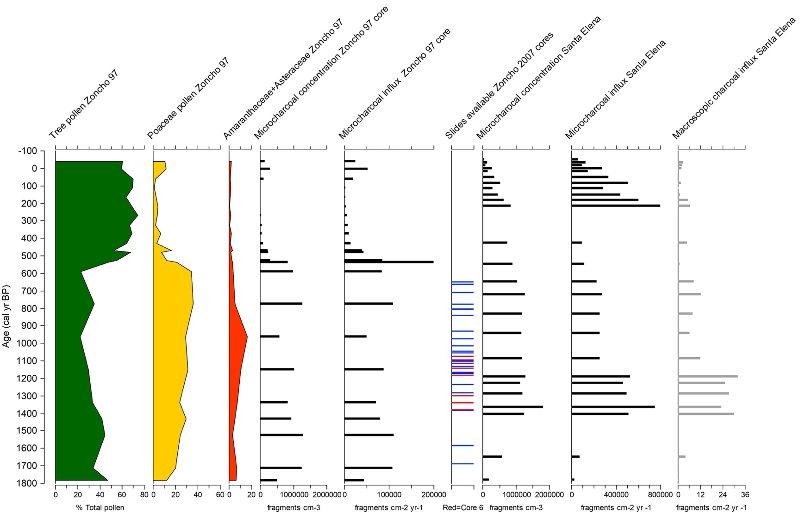
Figure 1.1. Selected pollen percentages for the Zoncho 97 sediment core together with microscopic charcoal data for the same core, the availability of pollen slides from the 2007 Zoncho core, and microscopic and macroscopic charcoal data from the Santa Elena core. Data from Clement and Horn (2001), Anchukaitis and Horn (2005), and Horn (pers. comm.), updated with age models from Taylor et al. (2020) and Kerr (2019).
microscopic charcoal influx values in the last century at Laguna Santa Elena that are not apparent at Laguna Zoncho.
My working hypothesis is that charcoal in sediments dating to agricultural periods comes primarily from fires set for agriculture, which could include fires in fields (burning maize plants and other crop residue, and agricultural weeds) as well as fires set in mature or secondary forests to clear land. On the other hand, charcoal in sediments from periods of agricultural decline and forest recovery should derive from fires burning established or regenerating forest.
The availability of pollen and stable isotope evidence of vegetation change and agricultural activity at Lagunas Zoncho and Santa Elena also provides an opportunity to improve understanding of the type of fuel represented by different charcoal morphologies. The availability of multiple sediment cores from Laguna Zoncho provides a means to examine whether the percentages of different morphological categories show consistency across the lake basin in samples of roughly similar ages.
In the next chapter of this thesis, I describe the study sites of Laguna Zoncho and Laguna Santa Elena within the Diquís Archaeological sub-region of Costa Rica. In Chapter 3 I review the multi-proxy research on cores from these lakes, and other research in the area, that has documented human occupation, agricultural activity, and changes in climate in southern Pacific Costa Rica over the past 2000 years. I also review literature on charcoal quantification and classification in the third chapter. In Chapter 4, I describe my methods for developing a more detailed microscopic charcoal classification system and how I applied it at Lagunas Zoncho and Santa Elena. In Chapter 5, I present my findings on the micromorphology of laboratory-produced charcoal particles, and the classification system I developed. In Chapter 6, I present the records of microscopic charcoal morphology that I developed for Lagunas Zoncho and Santa Elena and show how they compare to other proxy records. In Chapter 7, I discuss what I learned about the classification through its application at Lagunas Zoncho and Santa Elena, and how the charcoal classification adds to our understanding of past proxy analyses and differences between the lake records. I present a summary of key findings in Chapter 8.

Chapter TWO
Environmental and Archaeological SETTING

Site descriptions
Lagunas Zoncho (8.8121°N, 82.9607 °W, 1190 m above sea level) and Santa Elena (8.9290° N, 82.9257° W, 1055 m above sea level) are located 13 km apart in the Diquís Archaeological sub-region of Costa Rica, which is part of the Greater Chiriquí archaeological region of southern Pacific Costa Rica (Figure 2.1) (Snarskis 1981; Anchukaitis and Horn 2005; Kerr et al. 2020; Taylor et al. 2020). The Cordillera de Talamanca mountain range separates the Pacific coastal slopes of the Greater Chiriquí archaeological region from the Caribbean side, and many river valleys, coastal plains, and highlands further fragment the landscape (Geurds 2018).
Laguna Zoncho formed around 3200 years ago from large-scale slumping or faulting, while Laguna Santa Elena may have formed by a landslide (Horn and Haberyan 2016). Until recently, Laguna Zoncho contained the oldest botanical evidence of maize agriculture in the Diquís archaeological region (Horn 2006), but recently maize pollen predating the earliest grains at Laguna Zoncho was discovered in another lake, Laguna Los Mangos, located roughly 60 km northwest of Laguna Zoncho and Laguna Santa Elena (Johanson et al. 2019).

Climate and vegetation
Although Costa Rica is entirely in the tropics and has been latitudinally classified on the Köppen-Geiger Climate Classification system as an A (equatorial) and f (fully humid) climate (Kottek et al. 2006), the mountainous terrain and complex circulation patterns in the country result in a complex array of microclimates that vary abruptly over space and make the Köppen
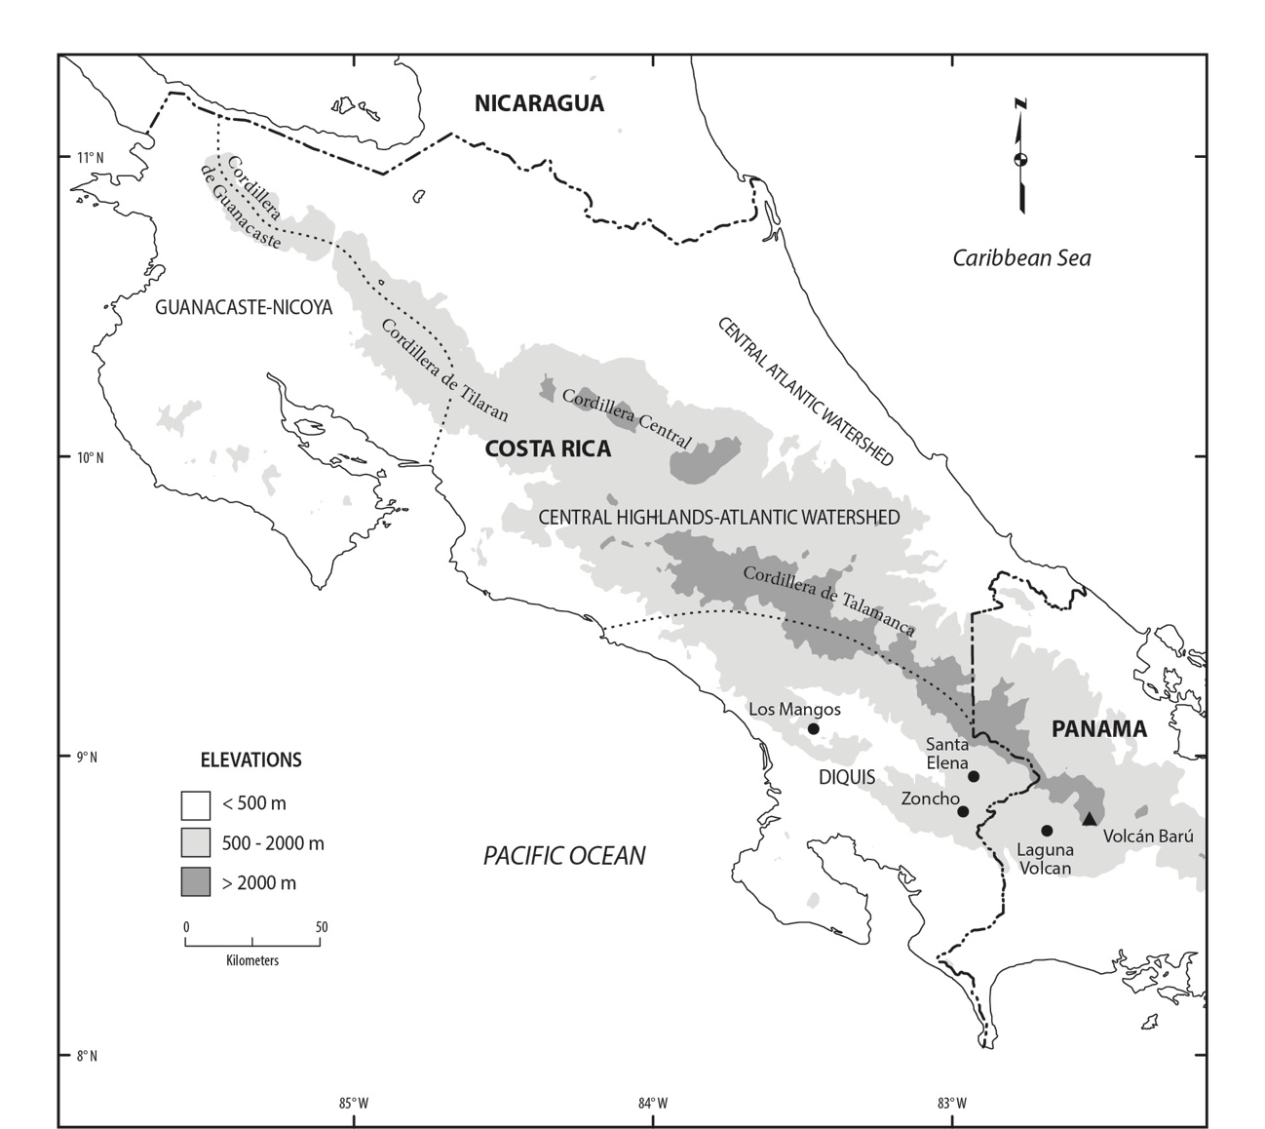
Figure 2.1. Locations of Lagunas Zoncho, Santa Elena, and nearby lakes in southern Pacific Costa Rica. The boundaries of archaeological regions follow Snarskis (1981). Map modified from Kerr et al. 2020.
system a poor measure of the region’s climate (Hall 1985). Seasonal migration of the Intertropical Convergence Zone results in distinct wet and dry seasons in the Diquís, with heavy precipitation in the northern hemisphere summer and lower precipitation in the winter (Anchukaitis and Horn 2005; Taylor et al. 2020). Localized atmospheric circulation patterns including land and sea breezes along the Pacific slope and mountain and valley breezes in the higher elevations further separate climate zones in southern Pacific Costa Rica (Hall 1985). The northwest and central regions of Costa Rica and higher elevation valleys often experience drought at the end of the dry season, while the dry season is shorter along the southern Pacific portion of the country (Hall 1985). Some plains of southern Pacific Costa Rica have no dry season due to sheltering against trade winds by the Talamanca mountains and other highlands, favoring a moist Pacific breeze year-round (Herrera 2016). Rainfall maps indicate annual precipitation of 3500–4500 mm at both Laguna Zoncho and Laguna Santa Elena (Instituto Meteorólogico Nacional n.d.).
Because of its small latitudinal range, temperature variations throughout Costa Rica are slight at similar elevations, and temperatures vary little throughout the year, with the warmest month rarely exceeding the average temperature of the coolest month by more than 5°C (Coen 1983). Mean annual temperatures at sea level are between 24°C and 27°C. Along lower mountain slopes, mean annual temperatures range between 12°C and 24°C, and in the higher elevations of the Cordillera de Talamanca mountain range, mean annual temperature is less than 12°C (Hall 1985).
Natural flora throughout Costa Rica is rich and varied like the climate. Tropical forest is the primary vegetation type throughout the country, though elevational variation causes zonal changes in vegetation, resulting in a series of distinct montane forests at middle elevations that are replaced by treeless páramos on the highest peaks (Hall 1985). Based on the Holdridge life zone classification (Tosi et al. 1969), the expected mature vegetation at Laguna Santa Elena is premontane wet forest (transitioning to rainforest) and at Laguna Zoncho, premontane rainforest. However, human activity has heavily disturbed modern forests.

Archaeology
Early evidence of prehistoric habitation of the Diquís archaeological sub-region comes from excavations in the Diquís Delta and Coto Colorado Valley (Anchukaitis and Horn 2005). Excavations from the early Sinancrá Phase date to 1500–300 B.C. (3450–2250 cal yr BP) based on stylistic ceramic comparisons. The Aguas Buenas Period, beginning anywhere between 500 B.C. (2450 cal yr BP) and A.D. 200 (1750 cal yr BP), has been connected to some level of cultivation and to village placement along smaller rivers, streams, and lakes at middle elevation sites like Laguna Zoncho and Laguna Santa Elena. While agriculture was present during this period, gathering was likely also an important cultural practice in the Diquís (Anchukaitis and Horn 2005; Kerr et al. 2020). The importance and intensity of maize cultivation for sustenance or ceremony during the Aguas Buenas Period is less certain, though maize pollen has been dated to 3200 cal yr BP by Clement and Horn (2001) at Laguna Zoncho and to 1780 cal yr BP at Laguna Santa Elena (Anchukaitis and Horn 2005). At Laguna Los Mangos, also in the Diquís region, Johanson et al. (2019) documented maize presence beginning at 3360 cal yr BP. The subsequent Chiriquí Period (1150–450 cal yr BP) saw a shift in material culture and settlement patterns. Ceramics became more elaborate, villages increased in quantity and complexity, and settlements spread to locations of varied topography and vegetation, including lowland sites and alluvial plains as well as mid-elevation sites (Anchukaitis and Horn 2005; Geurds 2018). Maize production is believed to have become more important in this more politically organized cultural period. The Spanish arrived at the end of the Chiriquí Period, altering indigenous structure, though early established settlements are thought to have persisted to some degree. Southern Pacific Costa Rica has remained lightly settled in modern times (Anchukaitis and Horn 2005; Kerr 2019). Throughout the archaeological record of the Diquís sub-region, debate persists over the precise timing and connections between cultural periods, events, and cultivation intensity (Kerr et al. 2020).

Chapter THREE
Literature Review

Multi-proxy records from lake sediments in southern Pacific Costa Rica
Southern Pacific Costa Rica has been an area of extensive multi-proxy research on evidence of landscape disturbance and archaeological activity preserved in lake sediments (Kerr et al. 2020). In addition to palynological and charcoal-based studies from Laguna Zoncho, Laguna Santa Elena, and several other lakes in the region, proxies including diatoms, chironomids, bulk stable carbon isotopes, n-alkanes, and phosphorous have been used to detect change over time on the landscape (Lane et al. 2004; Haberyan and Horn 2005; Filippelli et al. 2010; Taylor et al. 2013a, 2013b, 2015, 2020; Wu et al. 2017; Johanson et al. 2019, 2020; Kerr 2019; Kerr et al. 2020). Records spanning over 3000 years have revealed evidence of prehistoric agriculture, climate shifts, and forest recovery that together provide an ever more detailed environmental history of the region, but one in which questions still remain.

Laguna Zoncho findings
The existence of multiple records of paleoenvironmental change from Laguna Zoncho makes it a key site for examining the charcoal classification. While the goal is to classify charcoal morphology to further elucidate the agricultural and human history of the site, the many core samples available also provided an opportunity to test aspects of the classification. Here I describe previous research on sediment cores from this lake.
The first study of proxies in Laguna Zoncho sediment was carried out by Clement and Horn (2001), using a core recovered near the center of the lake by Horn and students in 1997. Based on the study of pollen and microscopic charcoal, they determined that humans occupied and disturbed the lake basin for more than 3000 years, with Zea pollen dating back to 3200 cal yr BP. Zones were delineated to separate intervals associated with presumed agricultural prehistory prior to Spanish arrival, forest recovery following the Conquest, and recent activity over the last century. For the first 2500 years, agricultural activity fluctuated but persisted, as revealed by pollen evidence of forest clearing and agriculture, and charcoal evidence interpreted as agricultural fires. Around the time of the Spanish Conquest, the site was mostly abandoned, fire declined, and forest began to recover. Over the past century, forest taxa have remained high and disturbance taxa have slightly increased, though nowhere near prehistoric levels (Clement and Horn 2001).
Lane et al. (2004) later measured stable carbon isotope ratios of organic carbon in bulk sediment (δ¹³C) in the same core from Laguna Zoncho and found that more positive carbon isotope values (characteristic of the C₄ pathway used by maize and agricultural weeds) tracked Poaceae, Amaranthaceae, and Asteraceae pollen values and charcoal abundance. Findings suggested the isotope ratios were both effective at detecting prehistoric forest clearance and agricultural practice and sensitive to the intensity (Lane et al. 2004). The Lane et al. study showed a shift to more negative δ¹³C prior to the Conquest, but the paper focused on the general similarity of the trends in evidence of forest clearance and stable carbon isotopes, not details of the isotope curve.
Using a set of five cores collected from Laguna Zoncho in 2007, Taylor et al. (2013b) also found that stable carbon isotope values were sensitive to forest disturbance associated with maize agriculture and field conditions favoring grasses and agricultural weeds. However, a comparison of stable carbon isotope values and maize pollen concentrations in the 2007 cores (Taylor et al. 2013a) showed that the two proxies did not correspond with each other. The authors interpreted this finding to indicate that maize pollen concentrations were not sensitive to the scale of agriculture (Taylor et al. 2013a). Furthermore, the stable carbon isotope shifts in the sediment records clearly indicated that agricultural and population decline occurred prior to the Spanish Conquest, contrary to Clement and Horn’s (2001) interpretation of pollen evidence in the 1997 Zoncho core that maize agriculture declined nearly 200 years later, at the time of the Conquest.
Haberyan and Horn (2005) analyzed diatom assemblages in Laguna Zoncho and found that diatoms appeared to respond strongly to reduced human impacts following the Spanish Conquest (Haberyan and Horn 2005). A study on phosphorous (P) fractions over the 3000-year record also highlighted the effects of human activity (Filippelli et al. 2010). P geochemistry remained fairly constant during the first 2500 years corresponding with varying yet ever-present forest clearance and agricultural disturbance (Clement and Horn 2001), but strongly shifted in the period of depopulation and forest regrowth following the Conquest. The finding that P fractions and nutrient status were driven by human effects on soil nutrient cycles except for during the short interval of site abandonment suggested soils were sensitive to even low-technology impacts (Filippelli et al. 2010).
More recent analyses of chironomid assemblages in the 1997 core (Wu et al. 2017), and of stable hydrogen isotopes in leaf waxes in Core 6 from 2007 (Taylor et al. 2020) showed that humans farmed at Laguna Zoncho across intervals of changing climate. The chironomid and stable hydrogen isotope studies showed evidence of drier conditions and lower lake levels around the time of a widespread series of droughts.

Laguna Santa Elena findings
Laguna Santa Elena, located 13 km from Laguna Zoncho, also shows extensive evidence of prehistoric agriculture. Anchukaitis and Horn (2005) produced a detailed pollen record that showed that disturbance taxa like Poaceae and Asteraceae, indicative of forest clearance for agriculture, became dominant by at least 1400 cal yr BP in the ~2000-year record, before which minor forest alteration occurred. Still, Zea pollen was dated back to 1780 cal yr BP in the record. Zea pollen presence in all but three levels of the core indicated persistent agriculture with possible brief hiatuses, and both macroscopic and microscopic charcoal influxes were high in the first section of the core when disturbance taxa were most dominant. The modern assemblage also indicates disturbance and successional taxa. Three tephra layers in the core are interpreted as eruptions of nearby Volcan Barú, though the data do not suggest that the eruptions had much of an effect on populations nor activity around Laguna Santa Elena (Anchukaitis and Horn 2005). The authors used the finding of continued maize presence in the Santa Elena pollen record, even after the Barú eruption around the late 14th or 15th century, to argue that these eruptions, only one of which was found in the Zoncho core, did not have a marked effect on people.
More recently, Kerr et al. (2020) examined stable carbon and nitrogen isotope ratios in the Laguna Santa Elena core, delineating five zones to mark shifts in human activity and climate events. They found that while the site likely experienced temporary population declines as noted by Anchukaitis and Horn (2005), the area was never fully abandoned. They hypothesized that when maize declined in the record around the time of Spanish arrival at 458 cal yr BP, the lake site may have continued to remain an agricultural outpost, though the finding of low maize pollen occurrence could also be the result of poor Zea pollen dispersal (Kerr et al. 2020). Prior evidence of forest regrowth beginning around 700 cal yr BP, nearly 250 years prior to Spanish arrival, indicated that a temporary decline in agricultural impact may have occurred before, and unassociated with, the Conquest (Anchukaitis and Horn 2005).

Findings from other lakes in the region
Additional records of pollen, charcoal, stable carbon isotopes, and other proxies have been developed from other lakes in southern Pacific Costa Rica, not far from Lagunas Zoncho and Santa Elena. A 4200-year record from Laguna Los Mangos, beginning over a thousand years earlier than other regional records, revealed geochemical and microfossil evidence of vegetation history both before and after the introduction of maize agriculture around 3360 cal yr BP (Johanson et al. 2019). The presence of microscopic charcoal and more positive stable carbon isotope ratios coincided with maize presence in the Laguna Los Mangos record. Charcoal was also present prior to maize pollen, perhaps indicating forest clearance in preparation for agriculture or the cultivation of different crops (Johanson et al. 2019). Charcoal records from the sites of Laguna Danta (~3 km from Los Mangos) and Laguna Carse (~12 km from Los Mangos) suggest that agriculture declined at the time of Spanish Contact and the Little Ice Age, while agriculture at Lagunas Zoncho and Santa Elena started to decline before these events (Johanson et al. 2020). The continuous presence of charcoal in the Lagunas Danta and Carse records is thought to be related to agriculture, though charcoal peaks may also reflect wildfires during intervals of dry climate (Johanson et al. 2020).

Late Holocene climate events in southern Central America
Two Late Holocene climate events recognized in Central America and the broader circum-Caribbean have complicated efforts to understand changes in agricultural activity and population levels associated with social changes over the last 2000 years and with the Spanish Conquest at ca. 1500 AD. A series of droughts each spanning several decades that is collectively known as the Terminal Classic Drought (TCD) affected Central America and the Caribbean between ca. 1200 and 850 cal yr BP (Lane et al. 2014). The TCD has been connected to a period of forest recovery after a decline in agricultural activity at Laguna Zoncho (Taylor et al. 2020) and Laguna Santa Elena (Kerr et al. 2020). Analysis of hydrogen isotopes in leaf waxes by Taylor et al. (2020) showed that arid conditions coincided with the TCD at Laguna Zoncho. The timing of maximum charcoal accumulation in the Santa Elena record (~1170 cal yr BP) was also linked to this time period, leading to the idea that severe regional drought contributed to widespread wildfire (Anchukaitis and Horn 2005). More recently, analyses of hydrogen isotopes by Kerr (2019) showed little evidence for extreme, continuous aridity during the TCD at Laguna Santa Elena, and in fact revealed wetter than average conditions punctuated with brief dry episodes. This interval is also associated with lower lake levels at Laguna Zoncho (Wu et al. 2017) and Laguna Los Mangos (Johanson et al. 2019).
A second climate event known as the Little Ice Age (LIA) affected some sites in Central America and the circum-Caribbean between ca. 550 and 100 cal yr BP. Wu et al. (2017) found changes in chironomid assemblages in Laguna Zoncho indicating cooling of 1.3 °C during the LIA relative to the past 3000 years. Power et al. (2013) associated LIA cooling with a general decline in plant biomass burning in Central America and noted a charcoal minimum across the Americas at about 450 cal yr BP at the height of the LIA. Evidence from Lagunas Zoncho and Santa Elena support the idea that large-scale shifts in vegetation type, biomass, and ignitability may have resulted from declines in population and burning at the height of the LIA (Clement and Horn 2001; Kerr et al. 2020), but this is very near the time of the Spanish Conquest, making it difficult to attribute cause. Clement and Horn (2001) interpreted a marked reduction in charcoal and changes in vegetation about 460 cal yr BP in the core collected from Laguna Zoncho in 1997 to indicate population decline and forest recovery associated with the Spanish Conquest. However, more recent records from additional cores collected in 2007 from Laguna Zoncho and in 2000 from Laguna Santa Elena place initial agricultural decline and forest regrowth at least two centuries before the Conquest (Anchukaitis and Horn 2005; Taylor et al. 2013b; Kerr et al. 2020), possibly associated with drought occurring after the TCD (Taylor et al. 2013b; Kerr et al. 2020).
Charcoal records from the broader region extending back as far as 21,000 years document the relationship between fire and climate variability related to changes in temperature and moisture budget (Power et al. 2010). However, for the last 2000 years that are the focus of my thesis research, researchers have argued that climate factors alone cannot explain biomass burning fluctuations, especially around the time of the Conquest when fire ignition and frequency suddenly decreased at many sites, followed by significant woody biomass accumulation (Nevle et al. 2011). One hypothesis posits that population decline, reduced biomass burning, and forest regeneration associated with the Conquest may have amplified cooling during the LIA by decreasing global carbon dioxide concentrations, further reducing biomass burning (Dull et al. 2010).

Charcoal classification research
Most studies of charcoal in lake sediments focus on quantifying charcoal fragment numbers or area to infer the timing and the frequency or extent of past fires, but few researchers have attempted to distinguish particles of different morphologies to understand plant types that burned. Enache and Cumming (2007) classified macroscopic charcoal fragments in sediments from the interior plateau of British Columbia, Canada, based on shape and appearance. Burney et al. (1994), Wooller et al. (2000), and Dull (2004) differentiated graminoid microscopic charcoal from other microscopic charcoal morphotypes in Puerto Rico, Kenya, and El Salvador, respectively.
Walsh et al. (2010) developed a method for charcoal classification in a high-resolution analysis of macroscopic charcoal and pollen in lake sediments from the Willamette Valley of Oregon. Their three-part identification system divided charcoal particles into woody, herbaceous, or lattice-type based on appearance. In that study, brittle and dark woody fragments were derived from trees and shrubs. Flat or elongated herbaceous charcoal with epidermal walls lined by stomatal complexes came from the leaves of grasses, sedges, and other monocots. Thin and flat with a latticework pattern, lattice charcoal was interpreted to derive from dicot leaves and other non-woody material (Walsh et al. 2010). In a recent, similar study conducted in the Basin of Mexico, Torres-Rodriguez et al. (2022) used shape and pattern to distinguish charcoal derived from woody, leafy, grassy, and herbaceous fuels. In the study, eighteen morphotypes associated with one of these four fuels, or with a mix of the fuel sources, were differentiated based on angularity, elongation, and irregularity (Torres-Rodriguez et al. 2022).
Umbanhowar and McGrath (1998) investigated morphological differences among charred woody, grassy, and leafy particles >125 and 250 µm taken from natural environments or experimentally produced. Enache and Cumming (2007) developed a more complex system of morphotypes based on the geometry, shape, structure, and sheen of macroscopic charcoal particles sieved from lake sediments from British Columbia. More recently, Vachula et al. (2021) examined prior studies that experimentally produced charcoal to assess how particle length:width ratios related to fuel type.
Studies classifying microscopic charcoal are much less common. Unlike the classifications applied to macroscopic charcoal, those used in microscopic charcoal analyses have typically not distinguished woody or leafy fragments of dicotyledenous plants. Rather, these studies have most commonly only separated graminoid leaf fragments from all other fragments of unspecified source (Burney et al. 1994; Wooller et al. 2000; Dull 2004). This thesis dives deeper into classifying microscopic charred fragments, distinguishing graminoid leaf fragments in addition to dicot leaf and woody fragments, and further subdividing these morphological classes.

Chapter FOUR
Methods

Sediment cores and pollen slides
This thesis uses pollen slides prepared from seven sediment cores previously collected in southern Pacific Costa Rica, six (1997 core and 2007 cores 1–4 and 6) from Laguna Zoncho and one from Laguna Santa Elena. At both lakes, the uppermost watery sediments were collected using a plastic tube fitted with a rubber piston, and extruded in the field at 1-cm intervals. Deeper sediments were collected in successive 1-m drives using a Colinvaux-Vohnout (C-V) locking piston corer (Colinvaux et al. 1999) from an anchored floating platform (Clement and Horn 2001; Anchukaitis and Horn 2005; Taylor et al. 2015). The C-V core sections were returned to the Laboratory of Paleoenvironmental Research at the University of Tennessee encased in aluminum coring tubes, and stored along with the mud-water interface samples at 4–6 °C. Core tubes were opened on a modified router and the sediments inside were sliced longitudinally with a wire. Subsamples were prepared for pollen analysis using standard procedure (HCl, HF, KOH, acetolysis, safranin stain; Berglund 1986) with the addition of Lycopodium spores as controls, and mounted on slides in silicone oil.
Pollen slides spanning the period from ca. 3200 cal yr BP to present were prepared from the single core recovered by Horn and students near the center of Laguna Zoncho in March 1997 (Clement and Horn 2001). The age model for that core is based on four radiocarbon dates and the position of the Barú tephra (Table 4.1, Figure 4.1). I examined charcoal morphology on 26 slides covering the period from 1525 cal yr BP to present. Taylor, Horn, and middle school teacher Greg Metcalf recovered six additional sediment cores from Laguna Zoncho in June 2007
Table 4.1. Radiocarbon ages for the Zoncho 1997 sediment core and for Core 6 of the 2007 Zoncho sediment cores,ª as reported by Taylor et al. (2020)
Lab  Number^{b} | Depth | Material  Dated | δ¹³C  (‰) |  | Uncalibrated  Age  (¹⁴C yr BP) | ±2σ Age Range  (cal yr BP) | Proba-bility
― Zoncho 1997 core —
Beta-954966^{c} | 101 | sediment |  |  | 500±60 | 348–338  571–458  651–579 | 1.1  70.3  23.5
Beta-122556 | 120 | wood |  | –30.0 | 540 ±50 | 568–506  648–583 | 53.6  41.3
Beta-122555 | 249 | plant  material |  | –28.1 | 2100 ±50 | 1963–1949  2163–1966  2179–2167  2302–2242 | 1.6  81.6  1.3  10.4
Beta-115186 | 284 | plant  material |  | –28.1 | 2940 ±50 | 3235–2951 | 95.0
AA-94893^{d} | 293 | plant  material |  | –29.0 | 3070 ±37 | 3199–3180  3367–3206 | 4  90.9
― Zoncho 2007 core 6 —
UGAMS-07206 | 86.5 | charcoal |  | –27.6 | 810 ±20 | 747–685  758-752 | 93.0  1.8
UGAMS-04555e | 162 | wood |  | –23.3 | 3880 ±45
UGAMS-04071 | 182 | wood |  | –23.3 | 1745 ±25 | 1584–1571  1713–1594 | 3.6  91.3
ª Dates were calibrated using the ‘clam’ age-modeling package in R (Blaauw 2019) and the IntCal13 dataset (Reimer et al. 2013).
^{b} Radiocarbon analyses were performed by Beta Analytic, Inc. (Beta #), the National Ocean Sciences Accelerator Mass Spectrometry Lab (OS #), and the Center for Applied Isotope Studies at the University of Georgia (UGAMS #).
^{c} This radiocarbon date was obtained by Behling (2000) just below the Barú tephra in a sediment core collected from Laguna Volcán on the lower slope of Volcán Barú. The date was applied to the sediment 0.5 cm below the Barú tephra in the Zoncho cores, at 101 cm in the 1997 Zoncho core and at 86.5 cm in Core 6 from 2007.

Table 4.1 continued

^{d} This date from a depth of 271 cm in Core 6 from 2007 core was matched to the 1997 core based on core stratigraphy, and used in the age models for both cores.
^{e} This date was excluded from the age model.
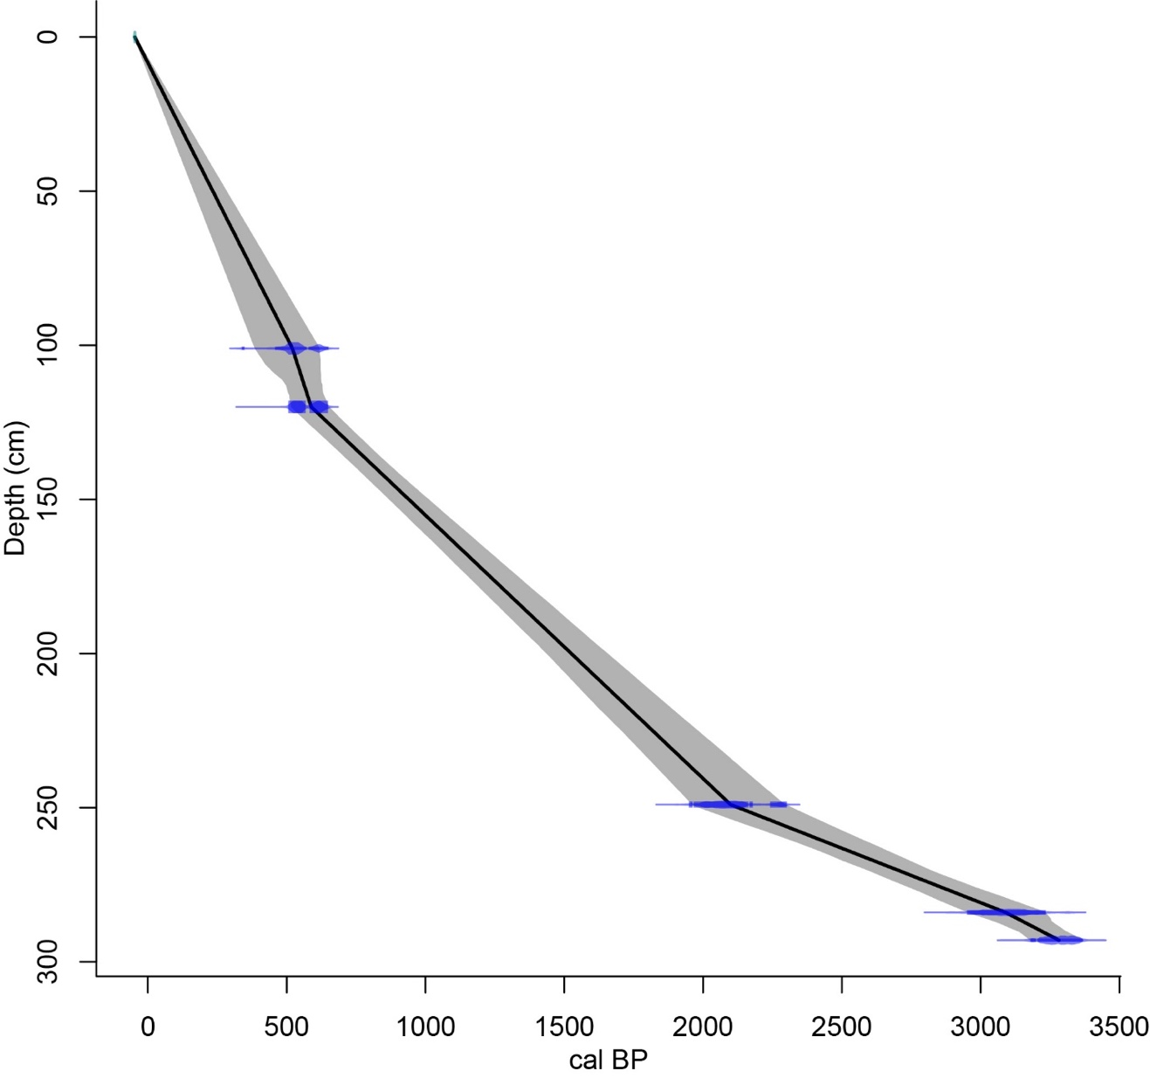

Figure 4.1. Age-depth model for the 1997 sediment core from Laguna Zoncho, from modeling by Taylor et al. (2020) using the ‘clam’ age-modeling package in R (Blaauw 2010) and the IntCal13 dataset (Reimer et al. 2013). The width of the shading indicates the uncertainty in the model.
(Taylor et al. 2015). Cores 1–5 were recovered in a radial pattern from equidistant spots between the shore and the center of the lake, and Core 6 was recovered near the center of the lake. Pollen slides were prepared by Taylor et al. (2013a) from samples of Cores 1–4 and 6 that corresponded to the later period of prehistoric agriculture and population decline. Taylor et al. (2013a) did not prepare pollen samples from Core 5, because it showed evidence of drying and oxidation, likely because it was taken too close to shore in a spot that was exposed during a previous low stand of the lake (Taylor et al. 2015). The samples I examined in Cores 1–4 are within the temporal range of ca. 1700 to 650 cal yr BP, based on age models I developed for this thesis research. The age model for Core 6 from 2007 was developed by Taylor et al. (2020) and is based on three radiocarbon dates and the position of the Barú tephra (Table 4.1, Figure 4.2). I examined charcoal morphology on 33 pollen slides from Core 6 within the age range of ca. 1400 to 1100 cal yr BP.
Pollen slides were prepared for 29 levels of the core from Laguna Santa Elena recovered by Horn, Anchukaitis, and other students in March 2000 (Anchukaitis and Horn 2005). The age model for this core was developed by Kerr (2019) and is based on seven radiocarbon dates (Table 4.2, Figure 4.3). I examined charcoal morphology on 27 pollen slides spanning the period from 1780 cal yr BP to present.

Developing the classification system using reference charcoal samples
I developed a microscopic charcoal classification system through synthesis of prior literature on macroscopic and microscopic charcoal morphology methods and by generating a reference collection of microscopic charcoal that I created through laboratory charcoalification
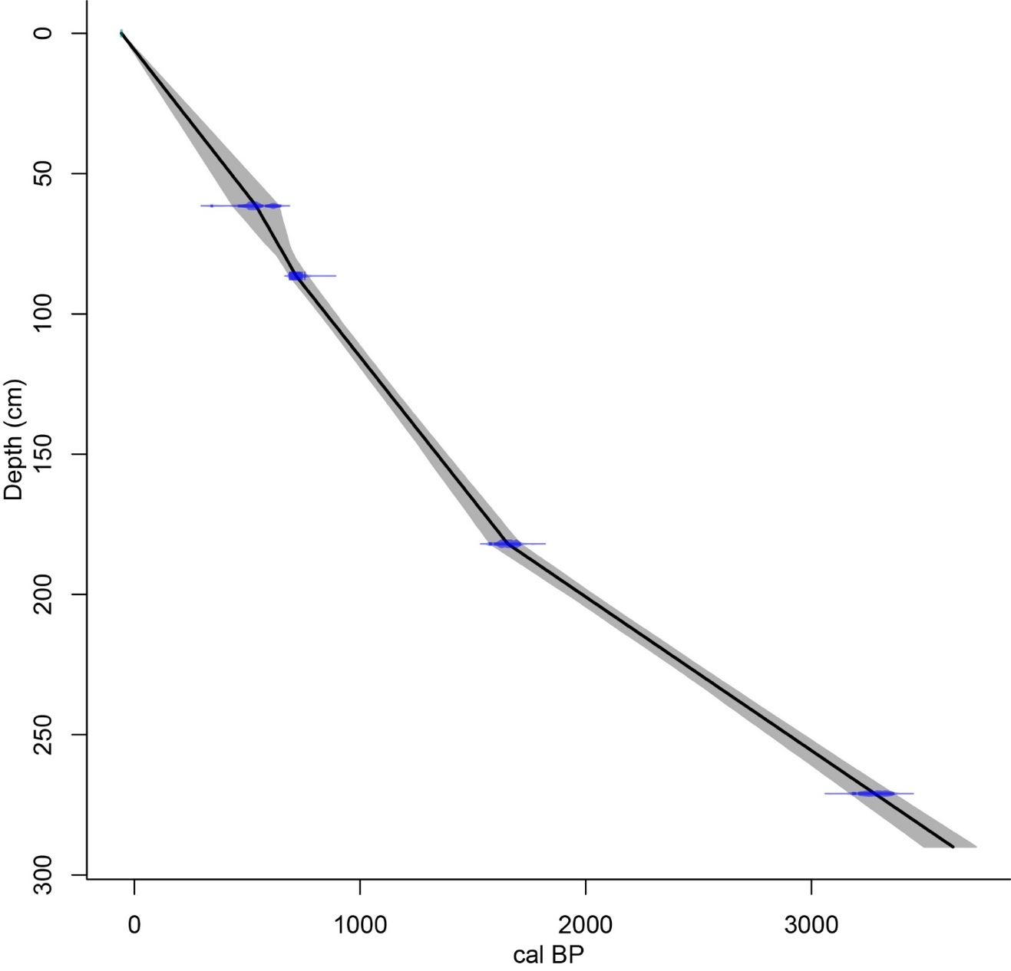
Figure 4.2. Age-depth model for sediment Core 6 collected in 2007 from Laguna Zoncho, from modeling by Taylor et al. (2020) using the ‘clam’ age-modeling package in R (Blaauw 2010) and the IntCal13 dataset (Reimer et al. 2013). The width of the shading indicates the uncertainty in the model.
Table 4.2. Radiocarbon ages for the Laguna Santa Elena sediment core,ª as reported by Kerr (2019)
Lab  Number^{b} | Depth | Material  Dated | δ¹³C  (‰) |  | Uncalibrated  Age  (¹⁴C yr BP) | ±2σ Age Range  (cal yr BP) | Probability
Beta-158436 | 156.5 | wood |  | –28.1 | 150 ±40 | 42–(–1)  154–59  234–167  284–236 | 16.6  32.3  28.7  17.2
OS-138420 | 261.5 | plant  material |  | –25.2 | 205 ±15 | 12–0  187–149  297–270 | 18.6  49.9  26.4
Beta-150706 | 312.0 | plant  material |  | –26.3 | 640 ±60 | 677–539 | 95.0
Beta-145347 | 434.5 | plant  material |  | –14.5 | 1240 ±40 | 1270–1070 | 95.0
Beta-145348 | 530.5 | charcoal |  | –25.5 | 1510 ±40 | 1424–1315  1443–1429  1521–1455 | 66.1  3.3  25.4
Beta-141242 | 580.5 | wood |  | –30.6 | 1880 ±30 | 1883–1730 | 95.0
Beta-141243 | 682.5 | wood |  | –27.9 | 1950 ±30 | 1950–1825  1970–1960  1983–1980 | 91.6  2.6  0.8
ª Dates calibrated using the ‘clam’ age-modeling package in R (Blaauw 2019) and the IntCal13 dataset (Reimer et al. 2013).
^{b} Radiocarbon analyses were performed by Beta Analytic, Inc. (Beta #) and the National
Ocean Sciences Accelerator Mass Spectrometry Lab (OS #).
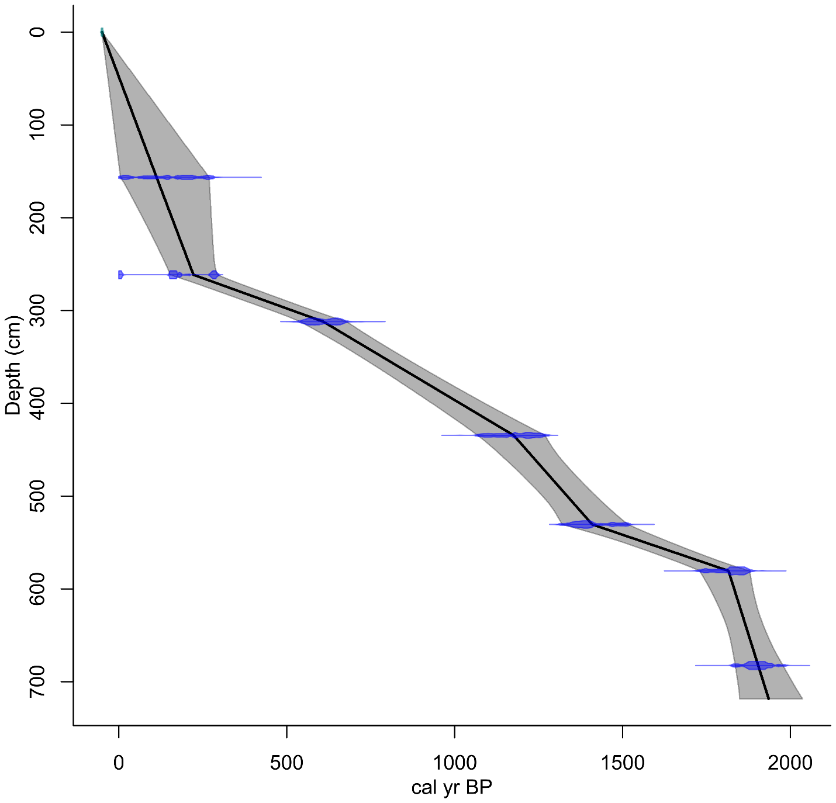

Figure 4.3. Age-depth model for the sediment core from Laguna Santa Elena, from modeling by Kerr (2019) using the ‘clam’ age-modeling package in R (Blaauw 2010) and the IntCal13 dataset (Reimer et al. 2013). The width of the shading indicates the uncertainty in the model.
of modern plant samples. To address my first research question, I made a reference collection of microscopic charcoal using methods developed by Orvis et al. (2005) (Table 4.3). I charcoalified dried plant specimens collected by Horn in Knoxville and the Florida Keys for previous studies in a laboratory muffle furnace at 550°C for 8–9 minutes (Orvis et al. 2005). Some of the samples had been identified to species, while others were only identified to genus or family. The charcoalified samples were finely ground using a mortar and pestle and mounted in silicone oil on microscope slides for examination (one plant species per slide). Additional plant samples that had been charcoalified as part of the Orvis et al. study by Chad Lane and stored in the Laboratory of Paleoenvironmental Research were also used. These samples had been created from plant samples collected by Horn in the highlands of Costa Rica and by Lane in Knoxville, and only needed to be ground prior to slide preparation. Finally, I used reference charcoal slides that had been previously prepared by Horn from the leaf of a sedge (Carex sp.) and wood from Vaccinium to increase my sample sizes of graminoid leafy charcoal and woody charcoal, respectively. Horn had used a pollen protocol to process the Vaccinium sample following charcoalification; I did not do this for any of the other reference samples. I examined all reference charcoal slides using a compound microscope at 400x magnification for distinct morphological characteristics within and among each type. I photographed and analyzed the images of each charred specimen to further develop my classification system.
I also examined classification systems in past microscopic charcoal studies to recognize different forms of charcoal on pollen slides, as described in the previous chapter (Burney et al. 1994; Wooller et al. 2000; Dull 2004). Specifically, I used photographs and morphological descriptions in these past studies to distinguish graminoid fragments from other charcoal
Table 4.3. Plant samples used in reference collection for charcoal morphology analysis.
Taxon | Common Name | Plant type
Vaccinium |  | Wood
Quercus | Oak | Wood
Carex sp. (Cyperaceae) | sedge | Graminoid leaf
Rynchospora sp. | Whitetop sedge | Graminoid leaf
Poaceae | grass | Graminoid leaf
Eragrostis ellioti | Elliot’s love grass | Graminoid leaf
Cortaderia sp. | Pompas grass | Graminoid leaf
Panicum virgatum | Switch grass | Graminoid leaf
Zea diploperennis | Teosinte | Graminoid leaf
Pentacalia andicola (Asteraceae) |  | Dicot leaf
Gnaphalium rhodarum (Asteraceae) |  | Dicot leaf
Ilex sp. | Holly | Dicot leaf
Magnolia sp. | Magnolia | Dicot leaf
Juglans nigra | Black walnut | Dicot leaf

morphologies. I also applied morphological characteristics of herbaceous, woody, and possibly leafy charcoal fragments described in classification systems for macroscopic charcoal to develop my system (Umbanhowar and McGrath 1998; Enache and Cumming 2007; Walsh et al. 2010; Torres-Rodriguez et al. 2022).

Microscopic charcoal classification and counting in Costa Rican cores
I applied my microscopic charcoal classification system to pollen slides prepared from core samples corresponding to the last ca. 2000 years at Lagunas Zoncho and Santa Elena. To reveal possible associations among charcoal morphology, human impacts, and climate events during the late Holocene, I examined and compared the charcoal morphology in the Zoncho 1997 and Santa Elena cores. To examine how charcoal morphology might vary among cores taken from different locations in a lake, I examined charcoal morphology in the Zoncho 2007 cores.
I used an Olympus compound microscope at 400x magnification to analyze all pollen slides containing microscopic charcoal. I used a transect method similar to prior microscopic charcoal studies to classify fragments (Patterson et al. 1987; Burney et al. 1994). For the majority of samples with abundant charcoal, I classified charcoal on 1–15 complete transects until at least 250 charcoal fragments were identified. Five samples from the Zoncho 1997 core had very low charcoal abundances. For these five samples I classified charcoal on fifteen total transects, but did not reach 250 fragments. The total charcoal classified ranged from 33 fragments to 1912 fragments, with a mean of 566 fragments and a median of 403 fragments.
I recorded counts for each morphological category for each transect of each pollen slide in a notebook, and later in an Excel spreadsheet, where I combined the data for all transects from each slide and calculated the percentages of different charcoal morphologies. For the samples from the 1997 Zoncho core and the Santa Elena core, I used values for total charcoal concentration for each sampling level from the original pollen and charcoal studies to calculate the concentrations of charcoal fragments of different morphologies. I also calculated the influx of charcoal fragments of different morphologies in these cores. For this calculation, I used total charcoal influx values calculated by multiplying the charcoal concentration by the sediment accumulation in cm/yr from the ‘clam’ age models of Taylor et al. (2020) and Kerr (2019). I used C2 software (Juggins 2007) to produce diagrams showing charcoal morphology by age and comparisons with pollen percentages and stable isotope values from previous studies to explore relationships between charcoal morphology and other indicators of environmental history.
For diagrams of charcoal morphology in the Zoncho 1997 core, I added the pollen zones recognized by Clement and Horn (2001), positioned at the same depths, but with ages updated using the Taylor et al. (2020) age model. The part of Zone 3 that I examined corresponds to the period 1525–528 cal yr BP. With the original age model in Clement and Horn (2001), the Zone 3/Zone 2 boundary occurred at 460 cal yr BP, approximately the time of the Spanish Conquest, but with the new age model this boundary falls some 70 years before the Conquest. Zone 2 extends from 528 cal yr BP to 60 cal yr BP (1422–1890 CE), and Zone 1 extends from 60 cal yr BP to –47 cal yr BP (1890–1997 CE).
For the diagrams of charcoal morphology at Santa Elena, I included the zones from Kerr et al. (2020). The basal zone, Zone 3, corresponds to the period 1780–1590 cal yr BP. Zone 2 is divided into three subzones. Zone 2c extends from 1590–1150 cal yr BP. Zone 2b extends from 1150–880 cal yr BP, corresponding to the approximate duration of the Terminal Classic Drought (TCD) from 1200–850 cal yr BP (Lane et al. 2014). Zone 2a extends from 880–450 cal yr BP. Zone 1 runs from 450 to –50 cal yr BP.

Age Modeling
Age-depth models for charcoal assemblages I examined on pollen slides were created using ‘clam’ software in R (Blaauw 2010) and the Intcal13 dataset of Reimer et al. (2013). For the Santa Elena core, the 1997 core from Laguna Zoncho, and Core 6 collected in 2007, I used the models previously developed by Kerr (2019) and Taylor et al. (2020). For Cores 1, 2, 3, and 4 at Laguna Zoncho, I also developed age-depth models using ‘clam’ software in R (Blaauw 2010) and the Intcal13 dataset (Reimer et al. 2013), based on dates reported in Taylor et al. (2015) and the position of the Barú tephra (Tables 4.4 and 4.5). The depths for some dates and for the Barú tephra were adjusted slightly based on reevaluation by Horn and Taylor (unpublished) of the match between A and B cores at each site. Following Taylor et al., a radiocarbon age of 500 ± 60 years was entered at a depth 0.5 cm below the bottom of the Barú tephra in each core. This date is based on the work of Behling (2000) at a lake on the slope of Volcán Barú in westernmost Panama.
Table 4.4. Radiocarbon ages for the Zoncho 2007 cores 1–2.
Lab  Number^{b} | Depth |  | Material  Dated | δ¹³C  (‰) |  | Uncalibrated  Age  (¹⁴C yr BP) | ±2σ Age Range  (cal yr BP) | Proba-bility
― Zoncho 2007 core 1—
Beta-954966^{c} |  | 94.5 | sediment |  |  | 500±60 | 348–338  571–458  651–579 | 1.1  70.3  23.5
UGAMS-04068 |  | 134 | leaf fragments |  | –25.3 | 920 ±25 | 918–785 | 94.9
Beta-233111 |  | 201 | plant  material |  | –26.8 | 1640 ±40 | 1618–1413  1681–1680 | 94.6  0.3
UGAMS-04069 |  | 219^{d} | wood fragments |  | –25.2 | 1670 ±25 | 1619–1529  1685–1677 | 92.8  2.1
― Zoncho 2007 core 2—
UGAMS-04450 |  | 150 | plant material |  | –26.0 | 1340 ±25 | 1203–1187  1249–1241  1304–1256 | 85.6  2.1  7.2
UGAMS-04551e |  | 156.5 | charcoal |  | –25.4 | 530 ±25
ª Dates calibrated using the ‘clam’ age-modeling package in R (Blaauw 2019) and the IntCal13 dataset (Reimer et al. 2013).
^{b} Radiocarbon analyses were performed by Beta Analytic, Inc. (Beta #) and the Center for Applied Isotope Studies at the University of Georgia (UGAMS #).
^{c} This radiocarbon date was obtained by Behling (2000) just below the Barú tephra in a sediment core collected from Laguna Volcán on the lower slope of Volcán Barú. The date was applied to the sediment 0.5 cm below the Barú tephra in the 2007 Zoncho cores, at 94.5 cm in Core 1 and at 108 cm in Core 2.
^{d} This depth differs from the depth in Taylor et al. (2015) because it is based on an updated depth model developed by Horn and Taylor.
^{e} This date was excluded from the age model.

Table 4.5. Radiocarbon ages for the Zoncho 2007 cores 3 and 4.
Lab  Number^{b} | Depth | Material  Dated |  | δ¹³C  (‰) | Uncalibrated  Age  (¹⁴C yr BP) | ±2σ Age Range  (cal yr BP) | Proba-bility
― Zoncho 2007 core 3—
Beta-954966^{c} | 94 | sediment |  |  | 500±60 | 348–338  571–458  651–579 | 1.1  70.3  23.5
UGAMS-07205 | 132.5 | bulk sediment | –28.1 |  | 690 ±20 | 583–568  677–648 | 14.8  79.9
UGAMS-04070 | 141 | wood fragments | –24.1 |  | 730 ±25 | 700–656 | 94.9
UGAMS-04552 | 167 | wood | –27.7 |  | 1620 ±25 | 1465–1415  1563-1476 | 33.0  61.9
― Zoncho 2007 core 4 —
UGAMS-04450^{d} | 145.5 | plant material | –25.6 |  | 430 ±35 | 348–338  571-458  651–579 | 1.1  70.3  23.5
UGAMS-04553e | 180 | charcoal | –23.2 |  | 1990 ±30 | 1996–1880 | 94.9
ª Dates calibrated using the ‘clam’ age-modeling package in R (Blaauw 2019) and the IntCal13 dataset (Reimer et al. 2013).
^{b} Radiocarbon analyses were performed by Beta Analytic, Inc. (Beta #) and the Center for Applied Isotope Studies at the University of Georgia (UGAMS #).
^{c} This radiocarbon date was obtained by Behling (2000) just below the Barú tephra in a sediment core collected from Laguna Volcán on the lower slope of Volcán Barú. The date was applied to the sediment 0.5 cm below the Barú tephra in the 2007 Zoncho cores, at 94 cm in Core 1 and at 124.5 cm in Core 4
^{d} This depth differs from the depth in Taylor et al. (2015) because it is based on an updated depth model developed by Horn and Taylor.
^{e} This date was excluded from the age model.

CHapter five

Reference charcoal Morphology and the charcoal classification system

By charcoalifying plant samples snipped from dried specimens of grasses, sedges, other herbs, and shrubs, and examining reference charcoal already made from similar specimens and from samples of oak wood, I was able to detect patterns in morphology to form my microscopic charcoal classification system.
Woody reference charcoal I examined came from the shrub Vaccinium, and from oak (Quercus) (Figures 5.1 and 5.2). Graminoid leafy, or grassy-type, monocot reference charcoal included Carex sp., a sedge of the family Cyperaceae, whitetop sedge (Rynchospora sp.), grass blades of an unidentified taxon in the family Poaceae, and leaves of Elliot’s Love grass (Eragrostis elliotti), Pompas grass (Cortaderia sp.), Switch grass (Panicum virgatum), and Teosinte (Zea diploperennis) (Figures 5.3-5.9). Dicot leafy reference charcoal was prepared from leaves of Pentacalia andicola and Gnaphalium rhodarum of the family Asteraceae, Holly (Ilex sp.), Magnolia (Magnolia sp.), and Black Walnut (Juglans nigra) (Figure 5.10-5.14).
Prior to examining reference charcoal, I had an idea from examining past literature on microscopic charcoal morphology that microscopic graminoid leafy charcoal fragments could be distinguished from other types of charcoal fragments by their consistent structural patterns, often elongated shapes, and often serrated, stomata-lined edges. Examination of reference charcoal allowed me to get a firsthand look at distinct morphologies of graminoid leafy charcoal and to get a better idea of the subtleties of dicot leafy charcoal morphology and woody charcoal morphology, and how they differed from one another. After studying a number of reference
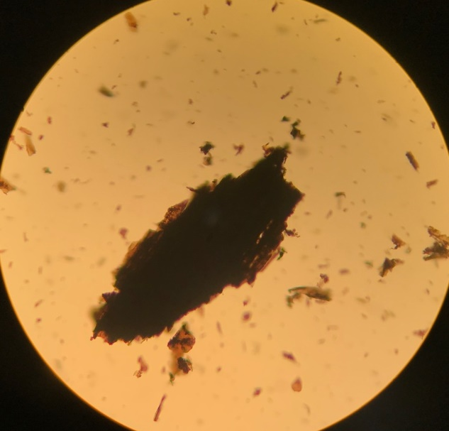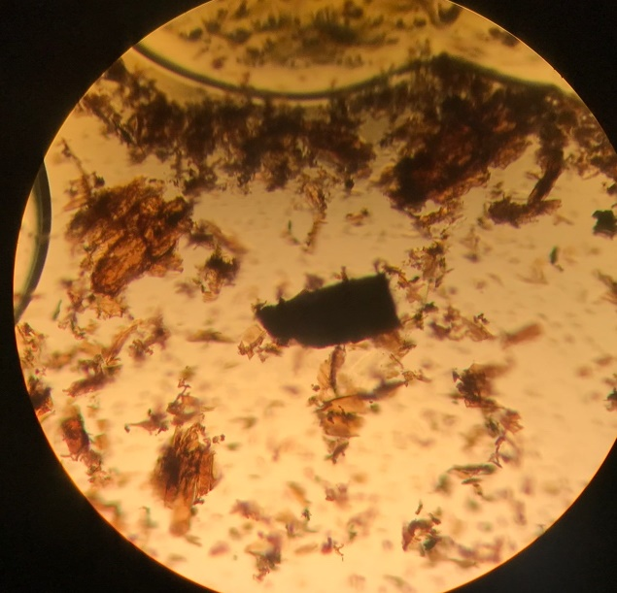

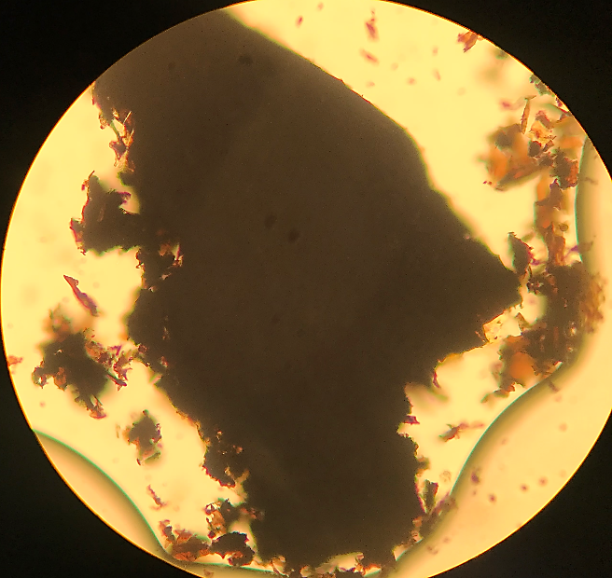

Figure 5.1. Charcoal reference samples prepared from wood of the shrub Vaccinium (Ericaceae), showing woody charcoal morphology. Charcoal fragments of Vaccinium are compact in structure and can be irregular (top left and bottom fragments) or more geometric in shape (top right fragment).
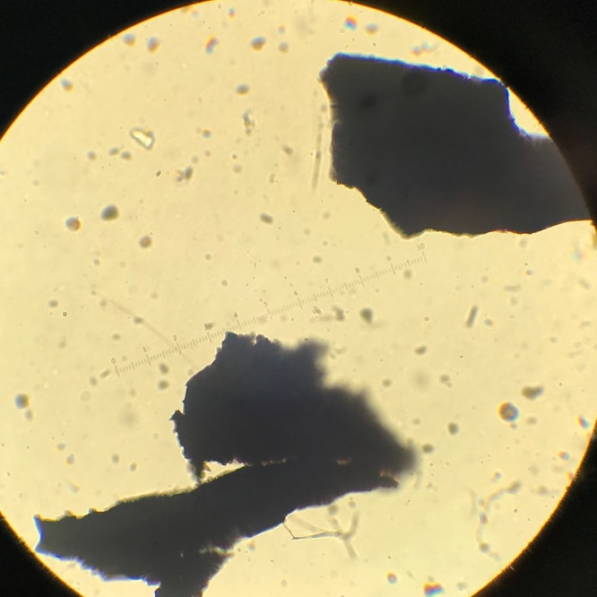 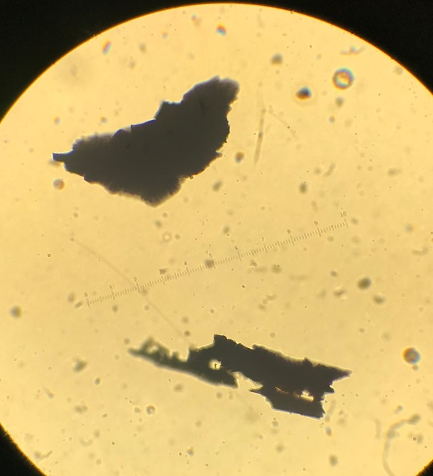

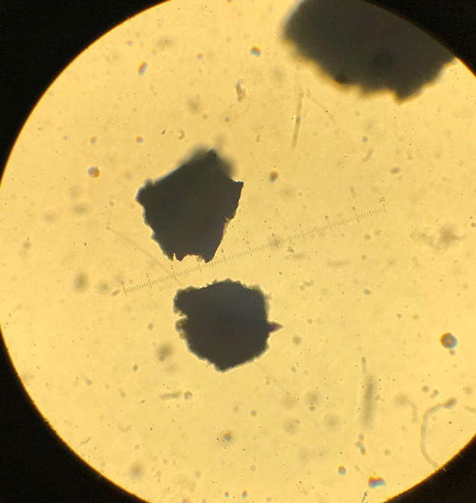

Figure 5.2. Charcoal reference samples of Quercus (Oak), showing woody charcoal morphology. Quercus charcoal fragments are mostly compact in structure and irregular in shape, though some fragments appear thin and crumbly (e.g. bottom fragment of top right image).
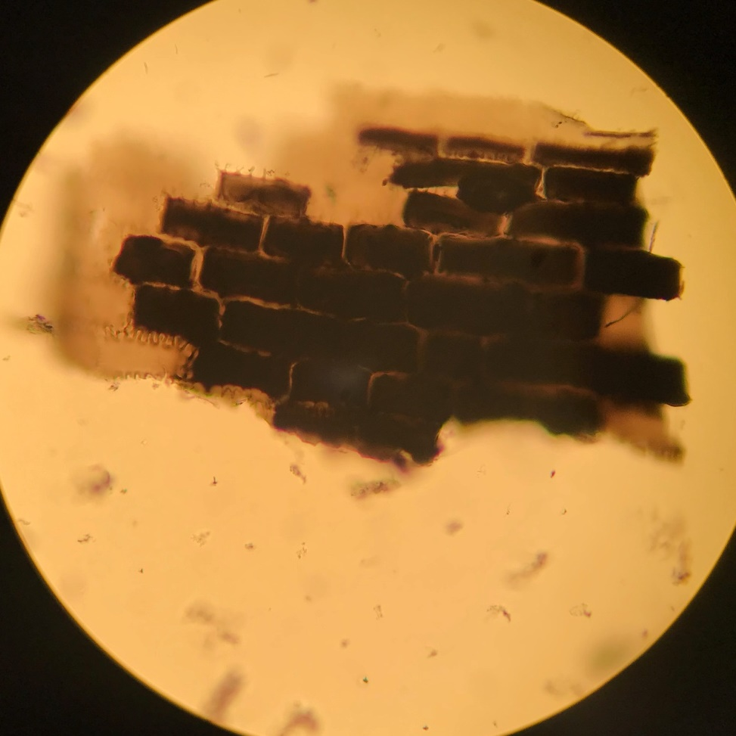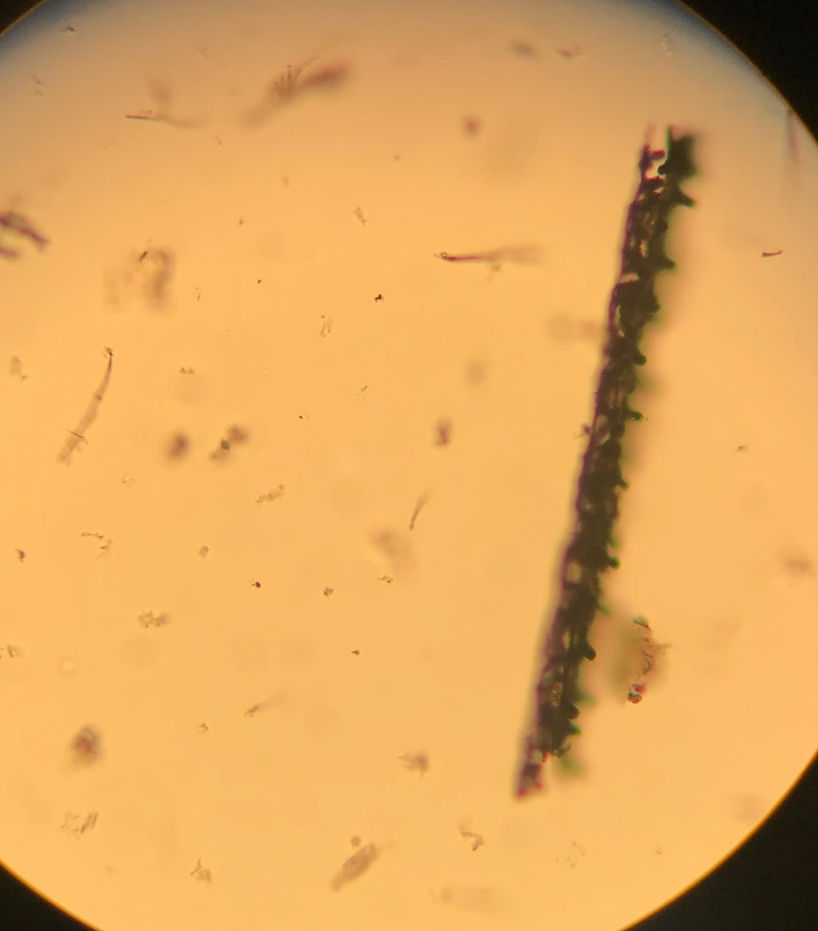

Figure 5.3. Charcoal reference samples of the sedge Carex (Cyperaceae), showing distinct graminoid leafy charcoal morphology. The image on the left shows a Carex fragment with a Lasagna Cluster morphology, and the image on the right shows an elongated Carex fragment with stomata-lined serrations on the edges.

.
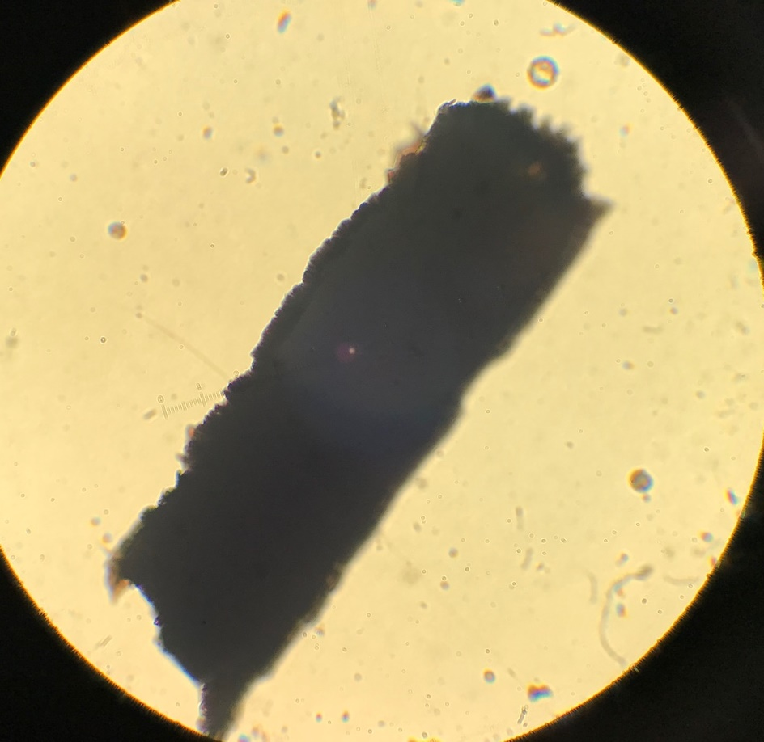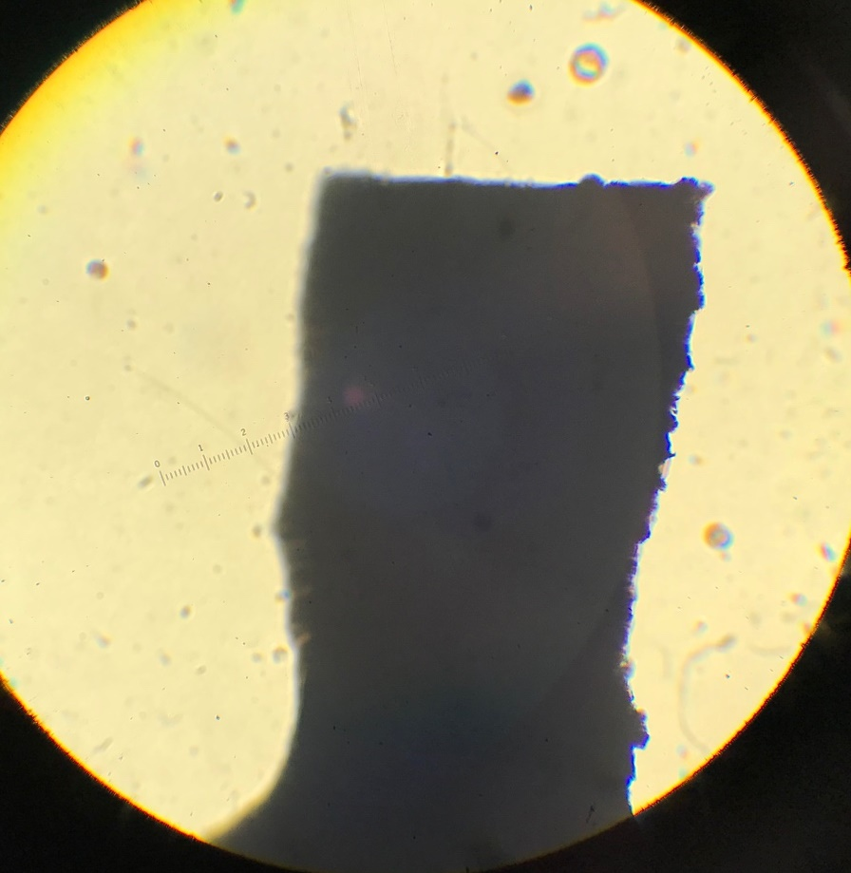

Figure 5.4. Charcoal reference samples of Rynchospora (Whitetop sedge), showing graminoid leafy charcoal morphology. Fragments of Rynchospora, though dense and relatively compact like fragments of Quercus, display saw-like serrations on one or more of their edges, and are consistently geometric in shape.
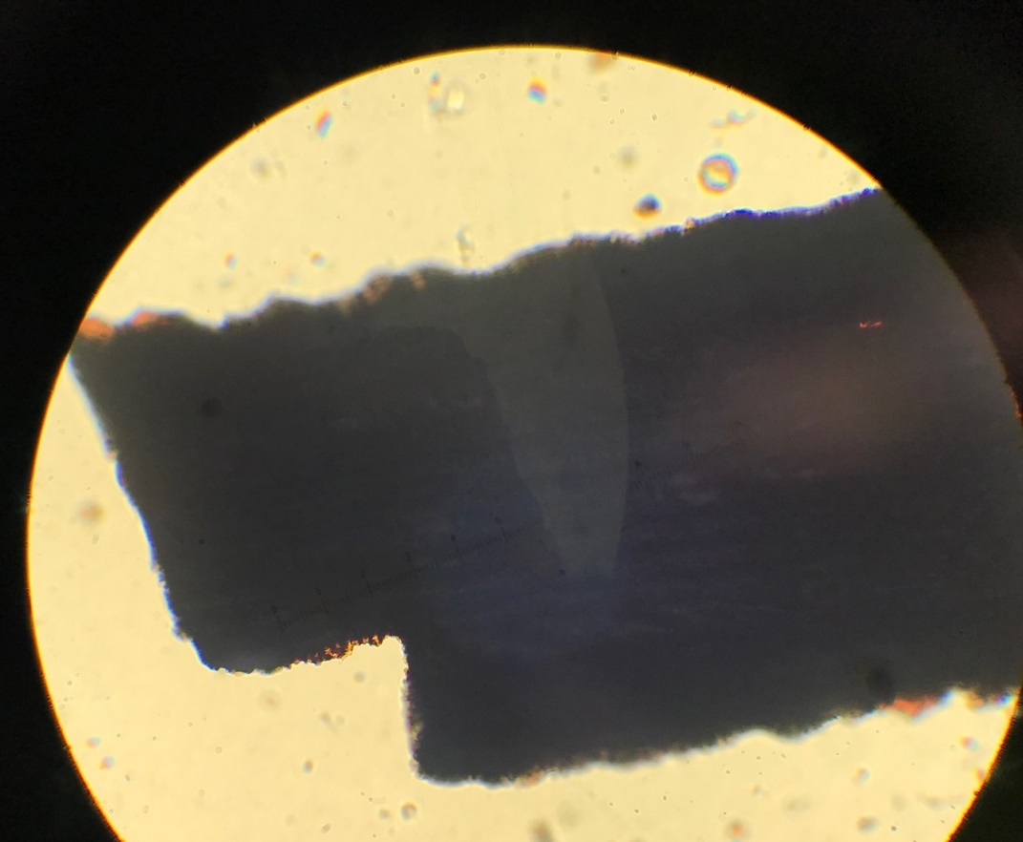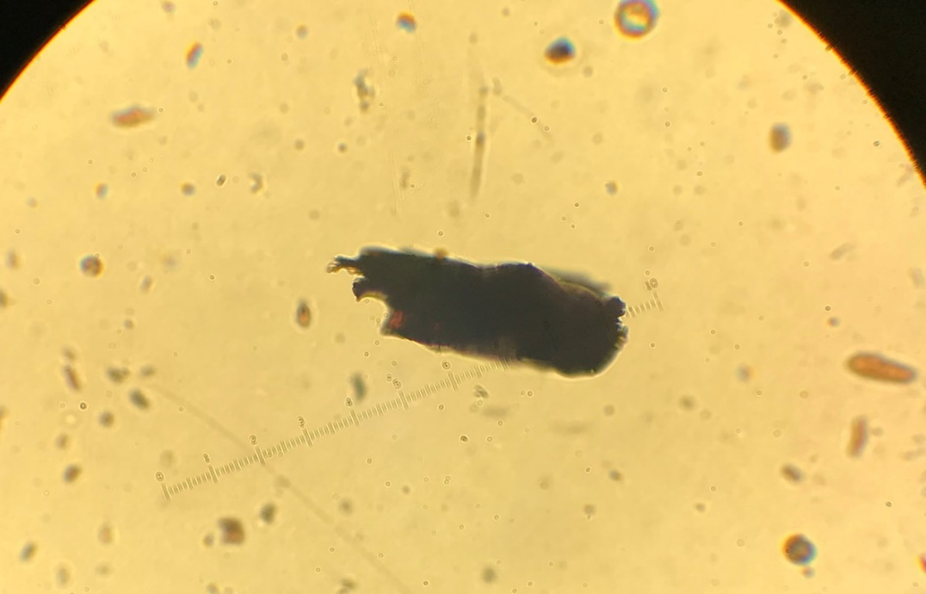

Figure 5.5. Charcoal reference samples made from grass blades of an unidentified Poaceae, showing graminoid leafy charcoal morphology. The image on the left shows a Poaceae fragment with a wavy Lasagna Noodle morphology, separated from its larger “cluster.” The image on the right shows subtle serrations on the bottom of the fragment.

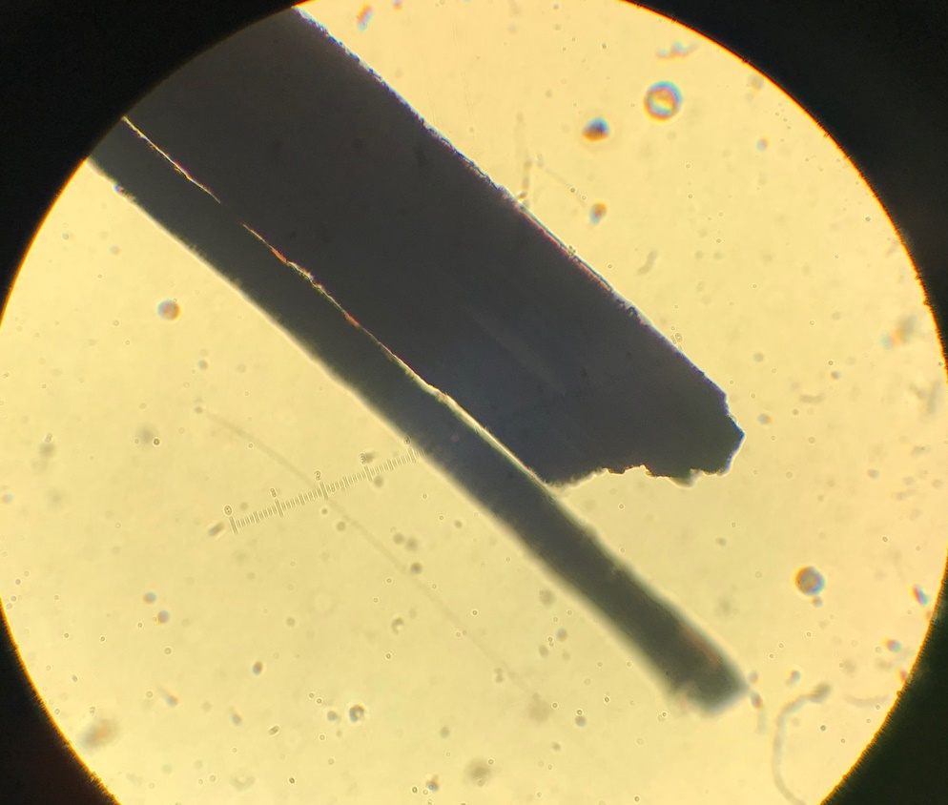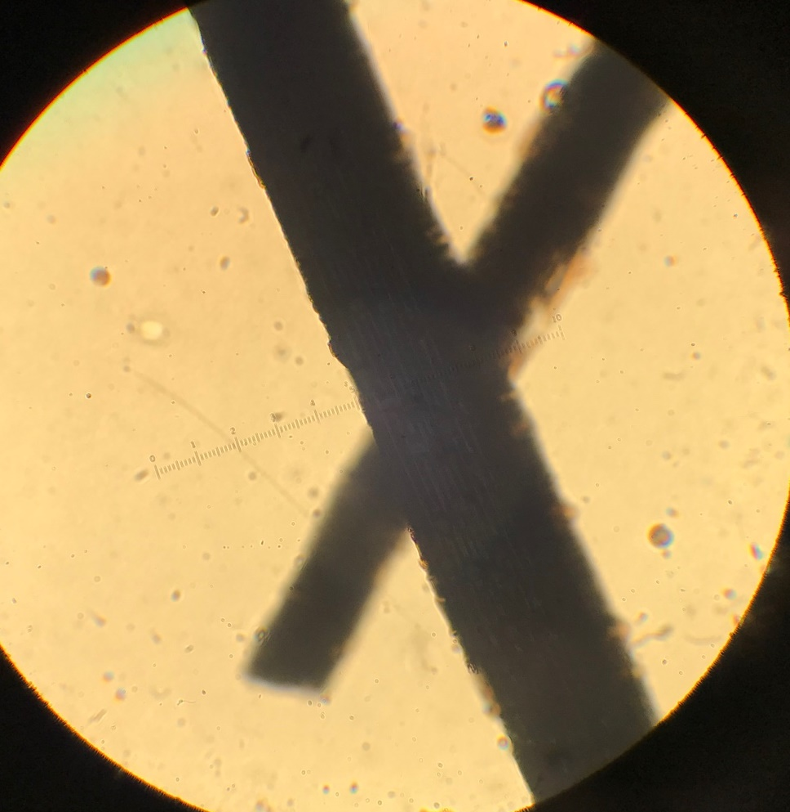

Figure 5.6. Charcoal reference samples made from blades of Erograstis elliotti (Elliot’s Love grass), showing graminoid leafy charcoal morphology. Charcoal fragments of these grass blades have high Length:Width ratios and demonstrate the Long/Thin morphology type.

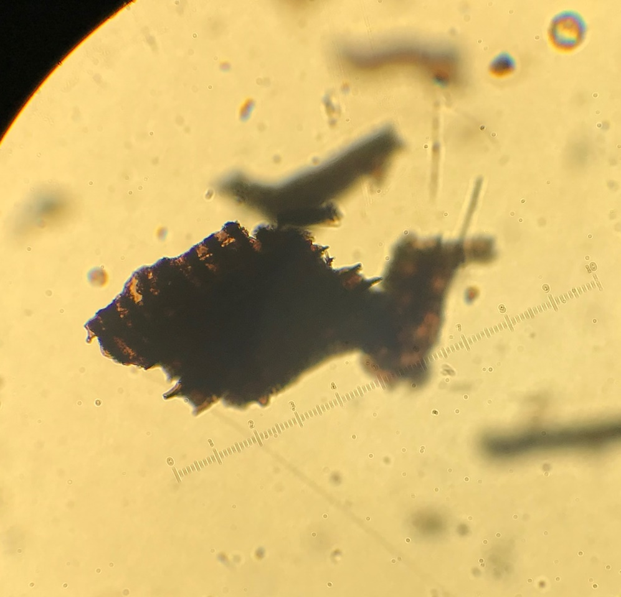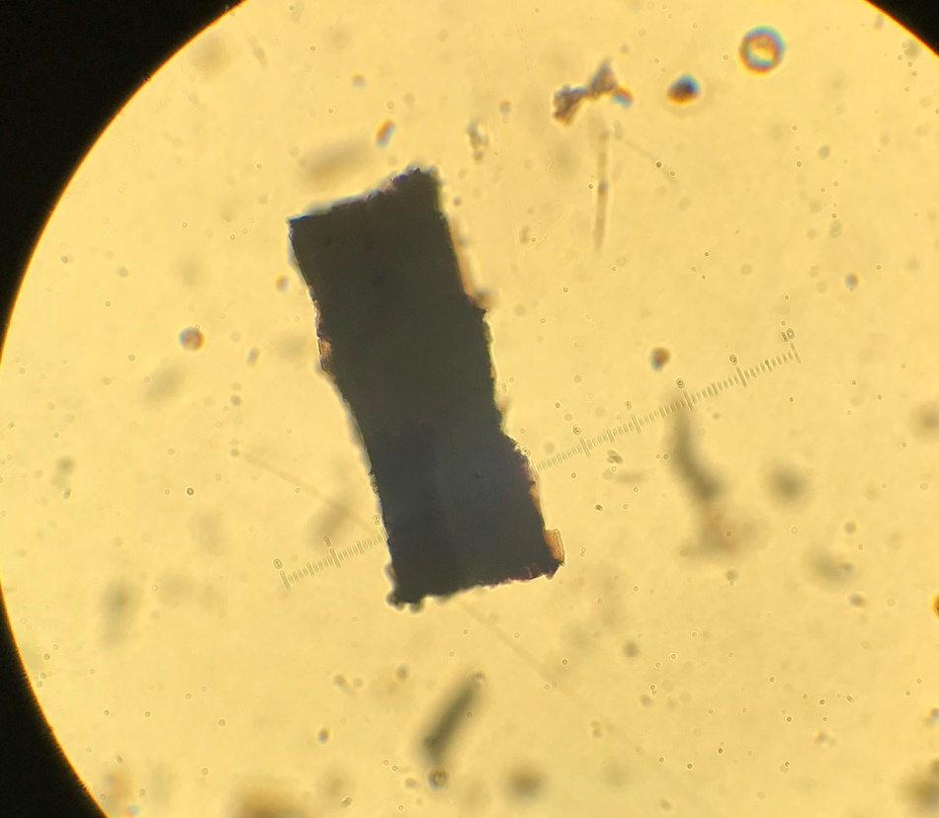

Figure 5.7. Charcoal reference samples made from blades of Cortaderia sp. (Pompas grass), showing graminoid leafy charcoal morphology. The image on the left shows a Cortaderia fragment with a Lasagna Cluster morphology. The image on the right shows a fragment geometric in shape with wavy serrations on all edges.

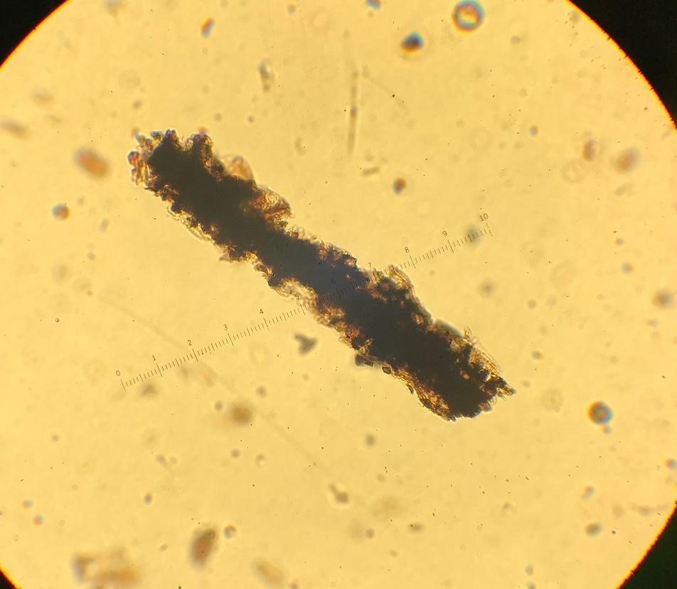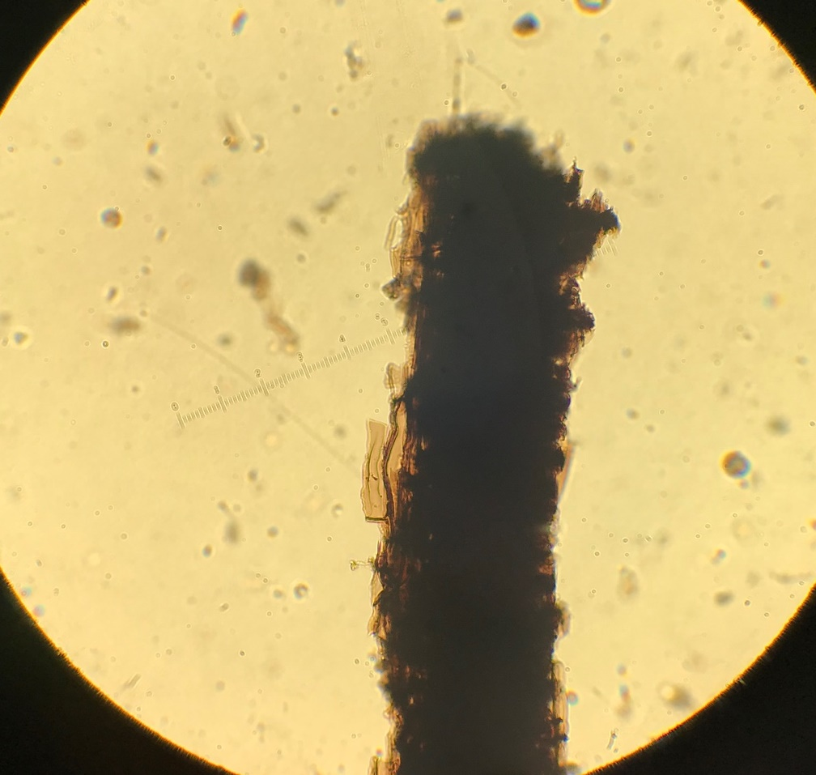

Figure 5.8. Charcoal references samples made from blades of Panicum virgatum (Switch grass), showing graminoid leafy charcoal morphology. These elongated fragments contain clear serrations along their edges.
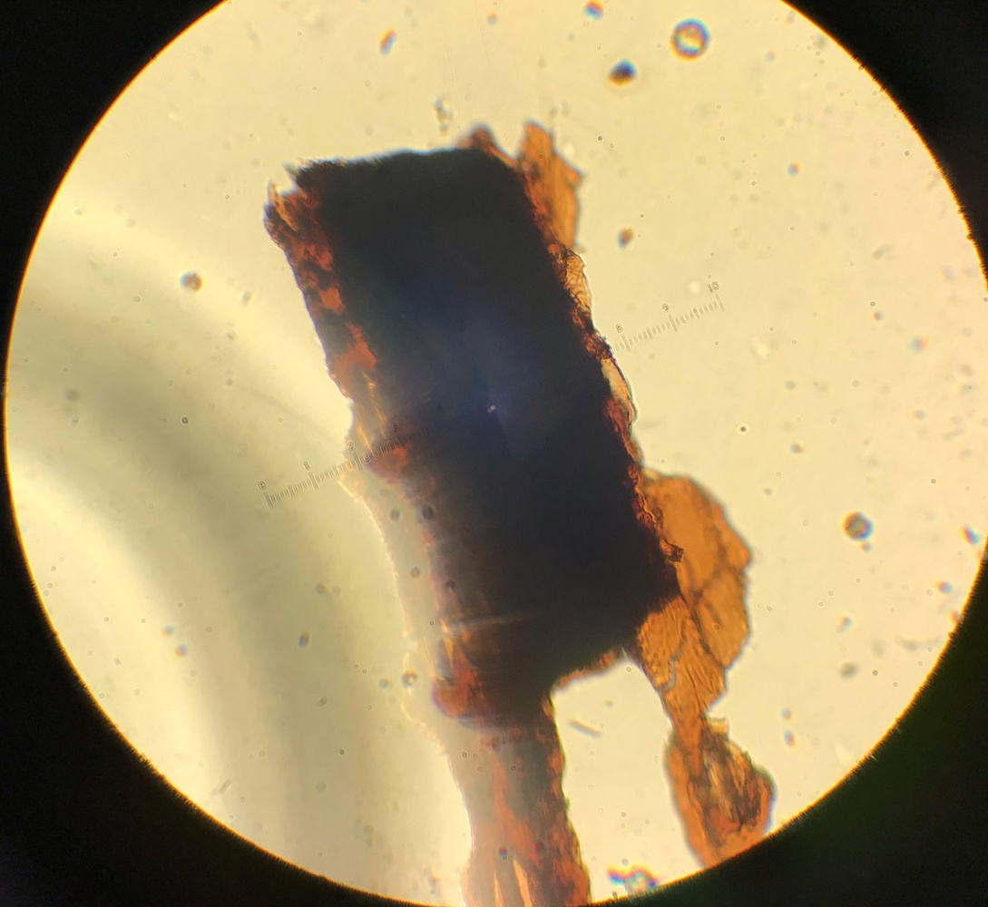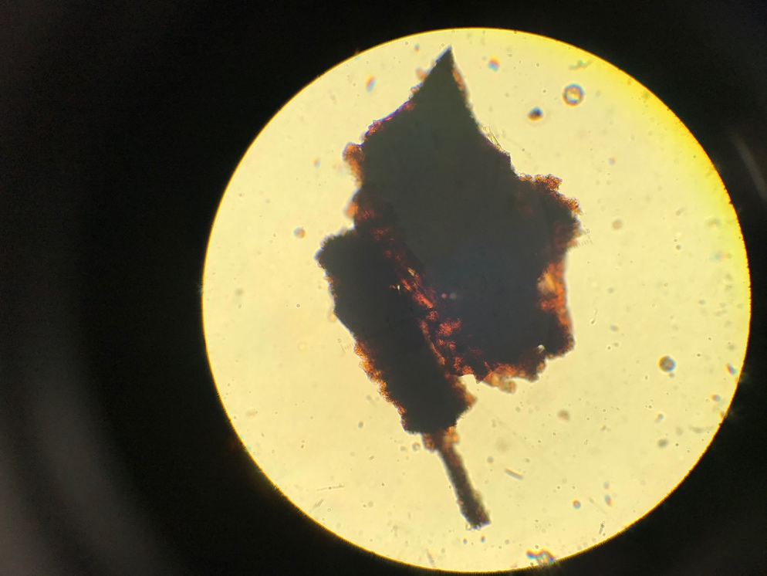

Figure 5.9. Charcoal reference samples made from a leaf of Zea diploperennis (Teosinte), showing graminoid leafy charcoal morphology. Charcoal fragments of Zea diploperennis contain subtle serrations on one or more edges, though these fragments differ from many other graminoid leafy samples due to their crumbly and translucent appearance, similar to the dicot leafy morphology shown in the next several figures.

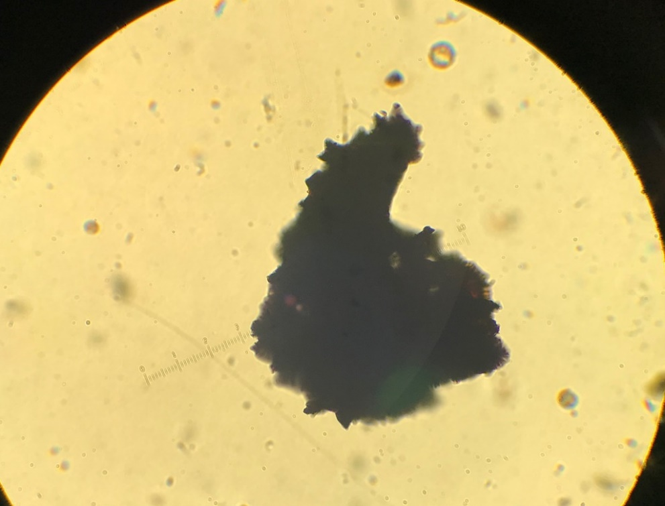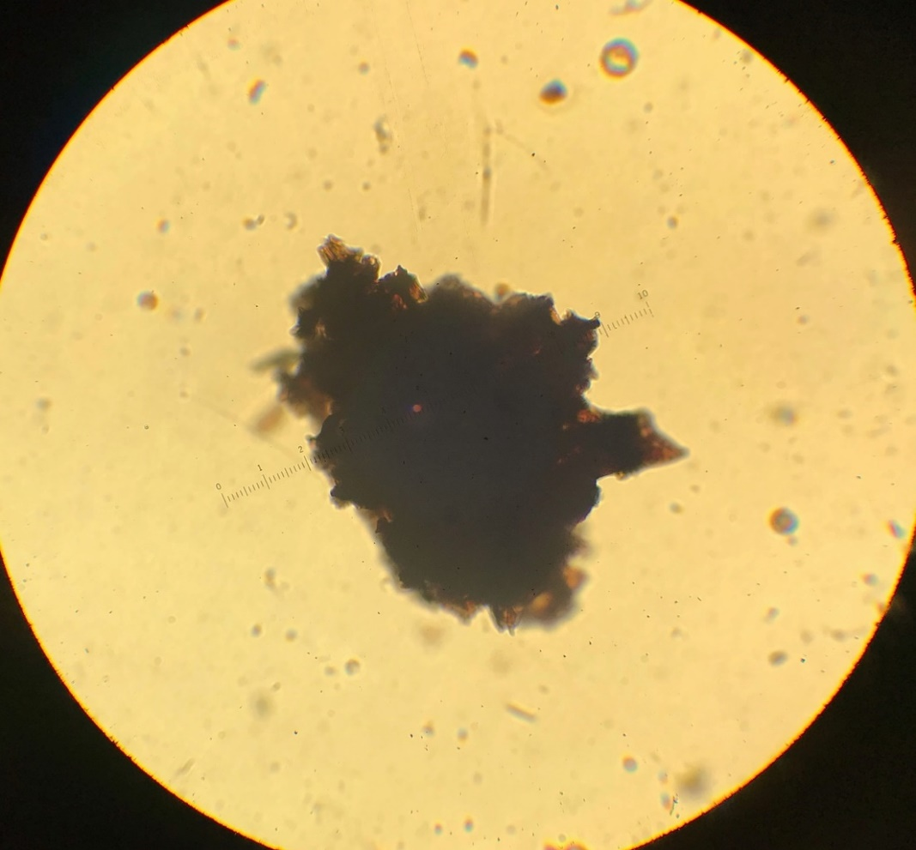

Figure 5.10. Charcoal reference samples made from leaves of Pentacalia andicola (Asteraceae), showing dicot leafy charcoal morphology. These charcoal fragments are very crumbly and brittle in appearance, with holes and translucent edges.
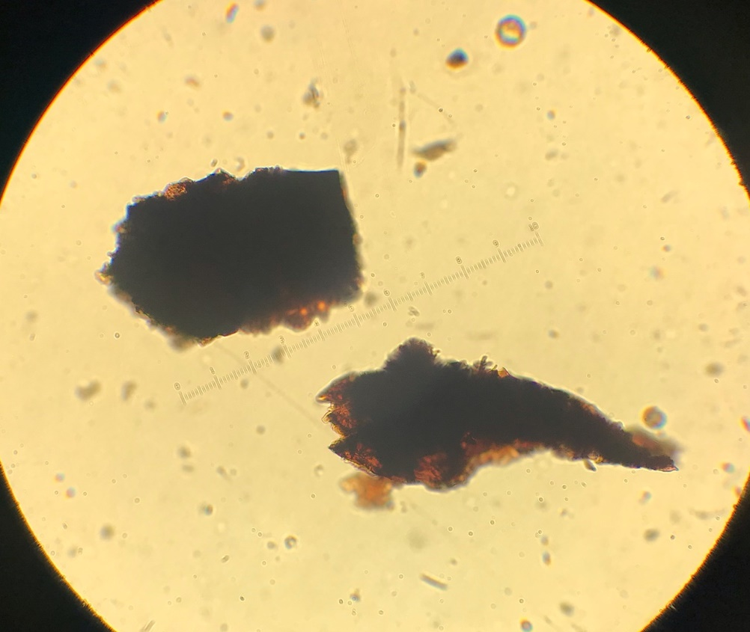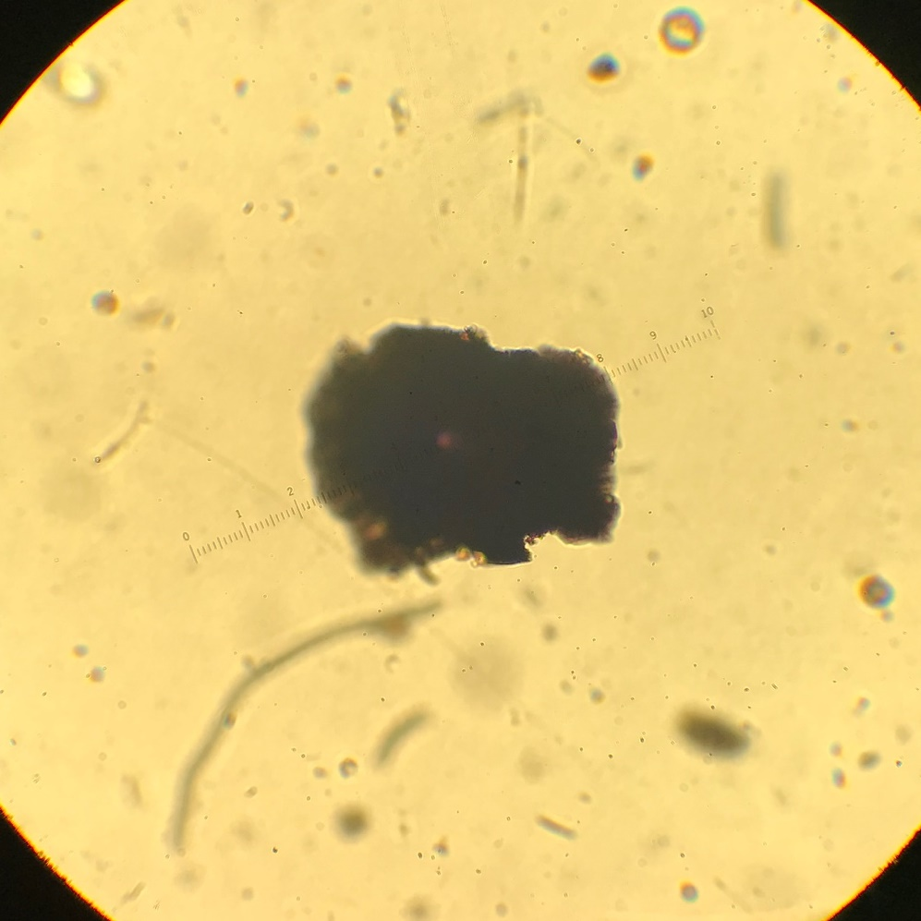
Figure 5.11. Charcoal reference samples made from leaves of Gnaphalium rhodarum (Asteraceae), showing dicot leafy charcoal morphology. These irregularly-shaped charcoal fragments contain translucent and crumbly edges.

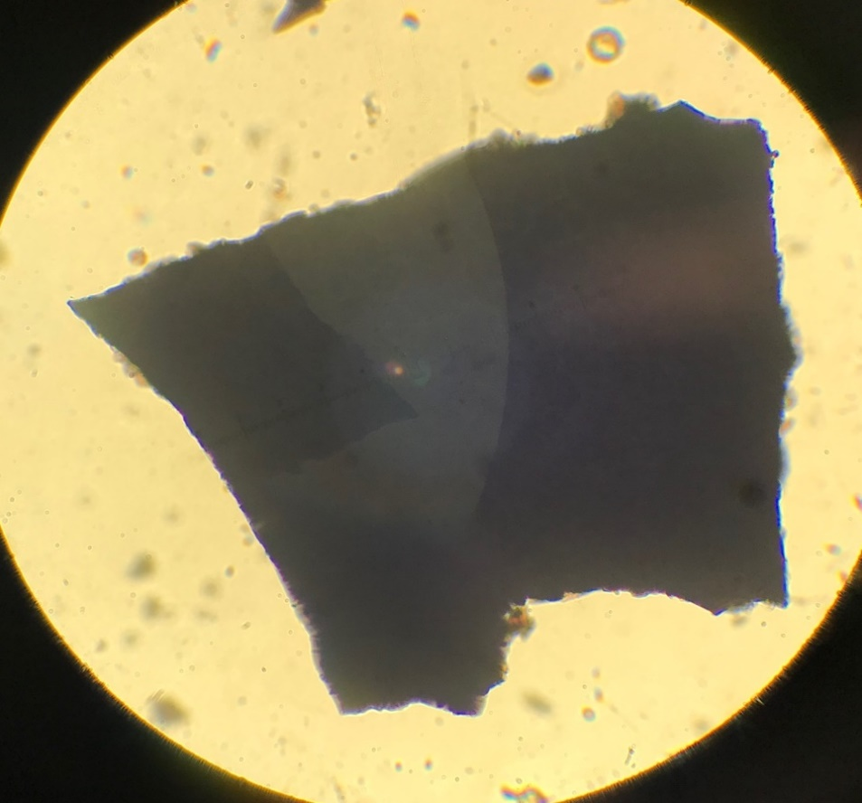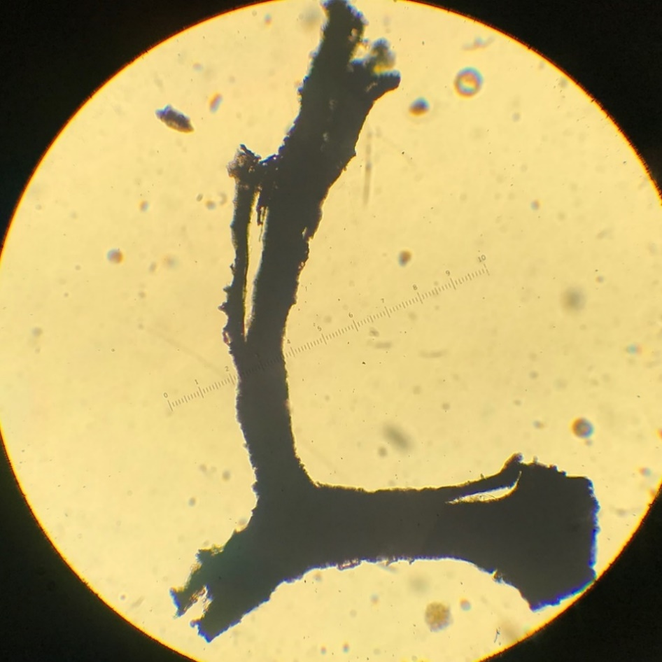
Figure 5.12. Charcoal reference samples made from leaves of Ilex (Holly), showing dicot leafy morphology. The image on the left shows a relatively geometric fragment with brittle and crumbly edges. The right image shows a very unique image similar to the graminoid leafy charcoal morphology with its elongation and serrations, but distinct in its more irregular shape and crumbly edges.
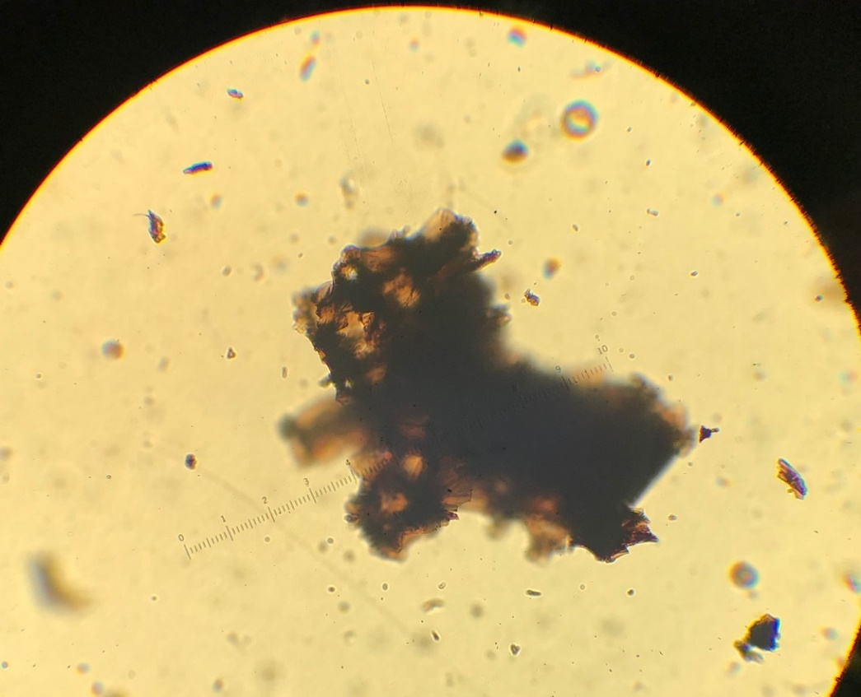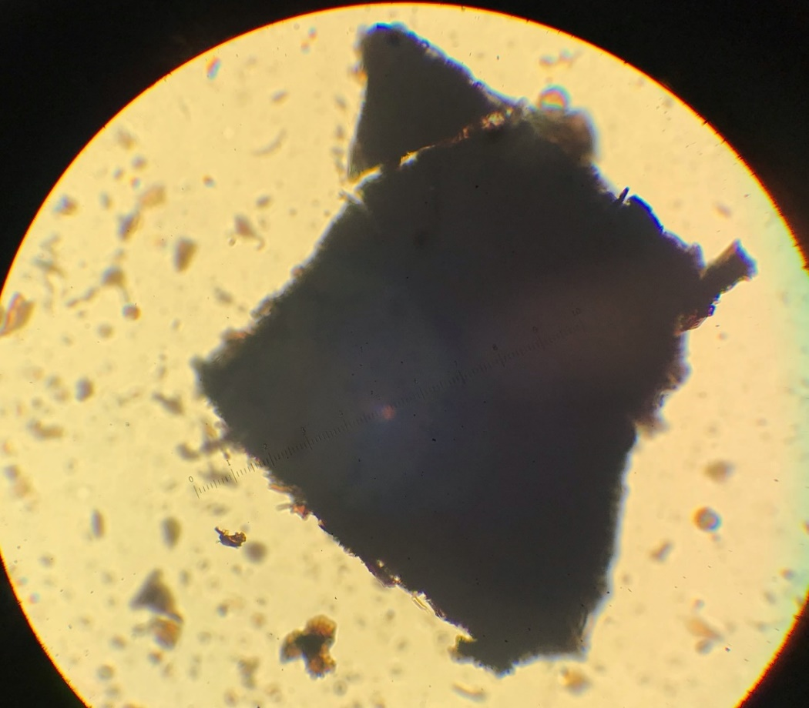
Figure 5.13. Charcoal reference samples made from leaves of Magnolia (Magnolia), showing dicot leafy charcoal morphology. The image on the left shows an irregular fragment with a very crumbly and translucent appearance, and the image on the right shows a relatively geometric fragment with brittle and crumbly edges.

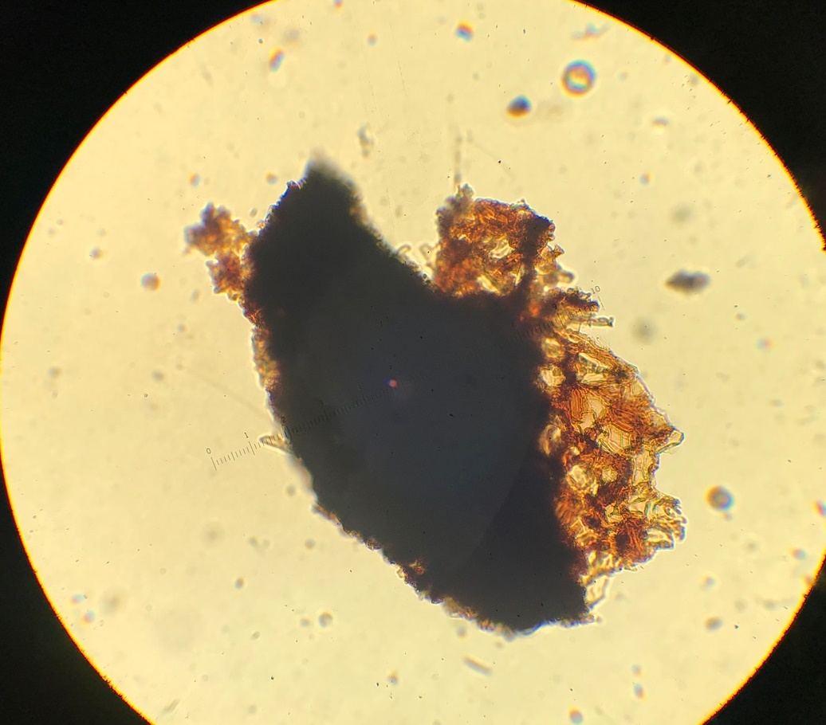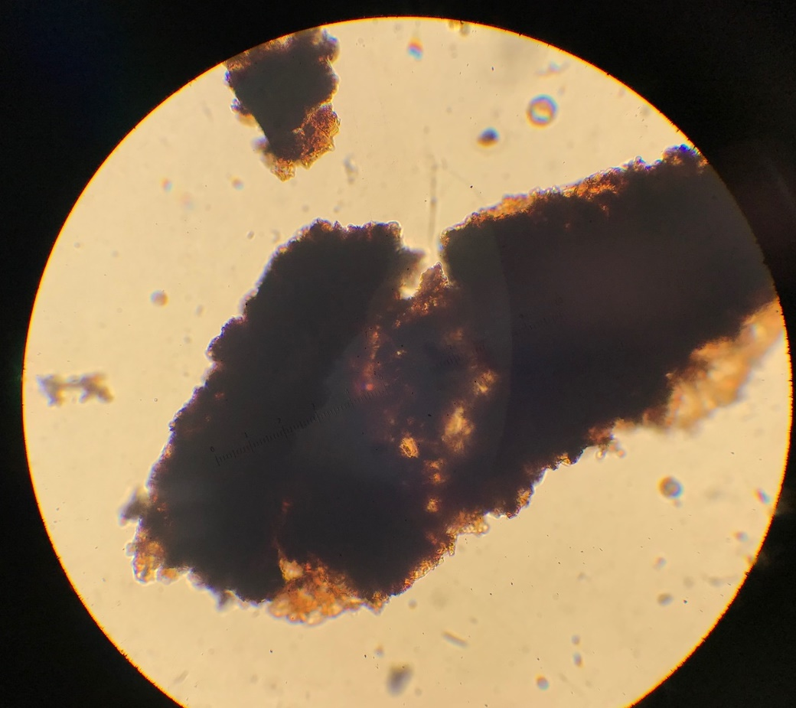
Figure 5.14. Charcoal reference samples made from leaves of Juglans nigra (Black Walnut), showing dicot leafy charcoal morphology. These irregularly-shaped charcoal fragments are very crumbly in structure and translucent in appearance.
samples derived from these three general plant and tissue types (graminoid leafy, dicot leafy, and woody), I noted similarities between types and features unique to each individual type, and I created a system that categorized the distinctions.
Reference collection analysis led me to identify and name seven morphological subcategories within the primary three microscopic charcoal types – graminoid leafy, dicot leafy, and woody (Table 5.1). Graminoid leafy morphologies include grass-cuticle complexes labeled “Lasagna Noodle Clusters” and “Lasagna Noodle Fragments” following terminology used by Robert Dull (pers. comm.). Lasagna Noodle Clusters are conglomerations of rectangular long-cells held together in original structure by intact grassy cuticle, while Lasagna Noodle Fragments are individual rectangular long-cells separated from their clusters (Wooller 2002). The reference to “Lasagna” is based on the wavy structural pattern along the edges of the individual “noodle” fragments that fit against one another when in “clusters”. The other two graminoid leafy morphologies I identified are fragments with stomata-lined epidermises (labeled “Serrated”) and considerably elongated fragments with at least a 10:1 length:width ratio (labeled “Long/Thin”).
The dicot leafy type morphology has not previously been recognized in the scientific literature on microscopic charcoal morphology. This type has a crumbly, brittle, and layered appearance. I refer to the dicot leafy morphology as “Brittle/Translucent” based on this appearance. I have not recognized any subtypes of this morphology, though later study might reveal them. Woody type charcoal, which is compact and dense, shows much less pattern and regularity than leafy charcoal. I subdivided woody charcoal into “Compact Geometric” and “Compact Irregular” subclasses. Geometric fragments are those with lined edges and angular
Table 5.1. Microscopic charcoal morphology classification system.
Morphology Type | Subtypes | Subtype Description
Graminoid Leafy | Lasagna Noodle Cluster | Grassy cuticle complex
Graminoid Leafy | Lasagna Noodle | Single grassy cuticle
Graminoid Leafy | Serrated | Fragments with stomata-lined epidermises
Graminoid Leafy | Long/Thin | Elongated fragments (high L:W ratios)
Woody (Compact) | Compact Geometric | Fragments with lined edges and angles
Woody (Compact) | Compact Irregular | Fragments with no defined pattern
Dicot Leafy (Brittle/Translucent) |  | Crumbly, layered, and brittle fragments

patterns, while irregular fragments show no particular pattern. Photos of charcoal showing these morphologies on pollen slides from Laguna Zoncho are included in Chapter 6.

Chapter SIX
Results of Application of the Charcoal Classification System

Radiocarbon dates and age models
The age-depth model for Laguna Zoncho 2007 Core 1, based on three radiocarbon dates and the position of the Barú tephra, shows a relatively high sedimentation rate of 0.24 cm/yr from the bottom of the profile to 1509 cal yr BP, above which point sedimentation slows to between 0.10 cm/yr and 0.16 cm/yr between 1509 cal yr BP and the top of the record at 2007 CE (Figure 6.1). The age depth model for Core 2 was based on the Barú tephra and one radiocarbon date, with a second date omitted from the model because it was deeper but younger than the age assigned to the tephra (Figure 6.2). The model shows a slow sedimentation rate of 0.06 cm/yr until 530 cal yr BP, at which time it increases three-fold to 0.18 cm/yr until the top of the profile. The age model for Core 3 was developed from three radiocarbon dates and the Barú tephra. The model shows a sedimentation rate of 0.03 cm/yr from the bottom of the profile until 675 cal yr BP, at which point the sedimentation rate increases 9-fold to 0.28 cm/yr and then 0.34 cm/yr until 530 cal yr BP, after which the rate of sedimentation declines to 0.16 cm/yr (Figure 6.3). Core 4 was based on two radiocarbon dates and the tephra, but one date was too young and was rejected. The model shows a sedimentation rate of 0.04 cm before 530 cal yr BP, increasing to 0.20 cm/yr afterward (Figure 6.4).

Microscopic charcoal morphology in the Zoncho 1997 Core
The pollen slides I examined from the Zoncho 1997 core contained a diversity of charcoal morphologies (Figures 6.5–6.8). The portion of Zone 3 of the Laguna Zoncho 1997
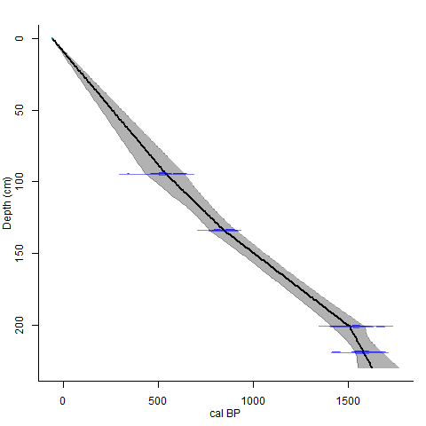
Figure 6.1. Age-depth model for Laguna Zoncho 2007 Core 1 using the ‘clam’ age-modeling package in R (Blaauw 2010) and the IntCal13 dataset (Reimer et al. 2013). The width of the shading indicates the uncertainty in the model.
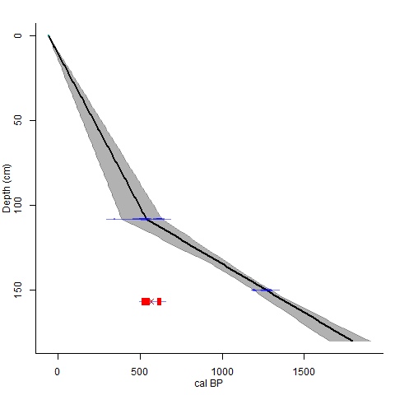 Figure 6.2. Age-depth model for Laguna Zoncho 2007 Core 2 using the ‘clam’ age-modeling package in R (Blaauw 2010) and the IntCal13 dataset (Reimer et al. 2013). The width of the shading indicates the uncertainty in the model. The radiocarbon date shown in red was omitted from the model.
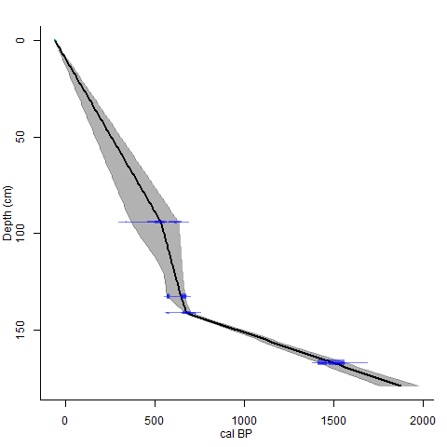
Figure 6.3. Age-depth model for Laguna Zoncho 2007 Core 3 using the ‘clam’ age-modeling package in R (Blaauw 2010) and the IntCal13 dataset (Reimer et al. 2013). The width of the shading indicates the uncertainty in the model.
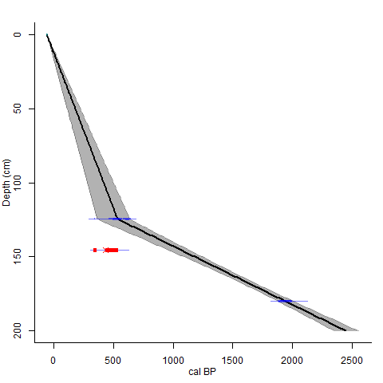
Figure 6.4. Age-depth model for Laguna Zoncho 2007 Core 4 using the ‘clam’ age-modeling package in R (Blaauw 2010) and the IntCal13 dataset (Reimer et al. 2013). The width of the shading indicates the uncertainty in the model. The radiocarbon date shown in red was omitted from the model.
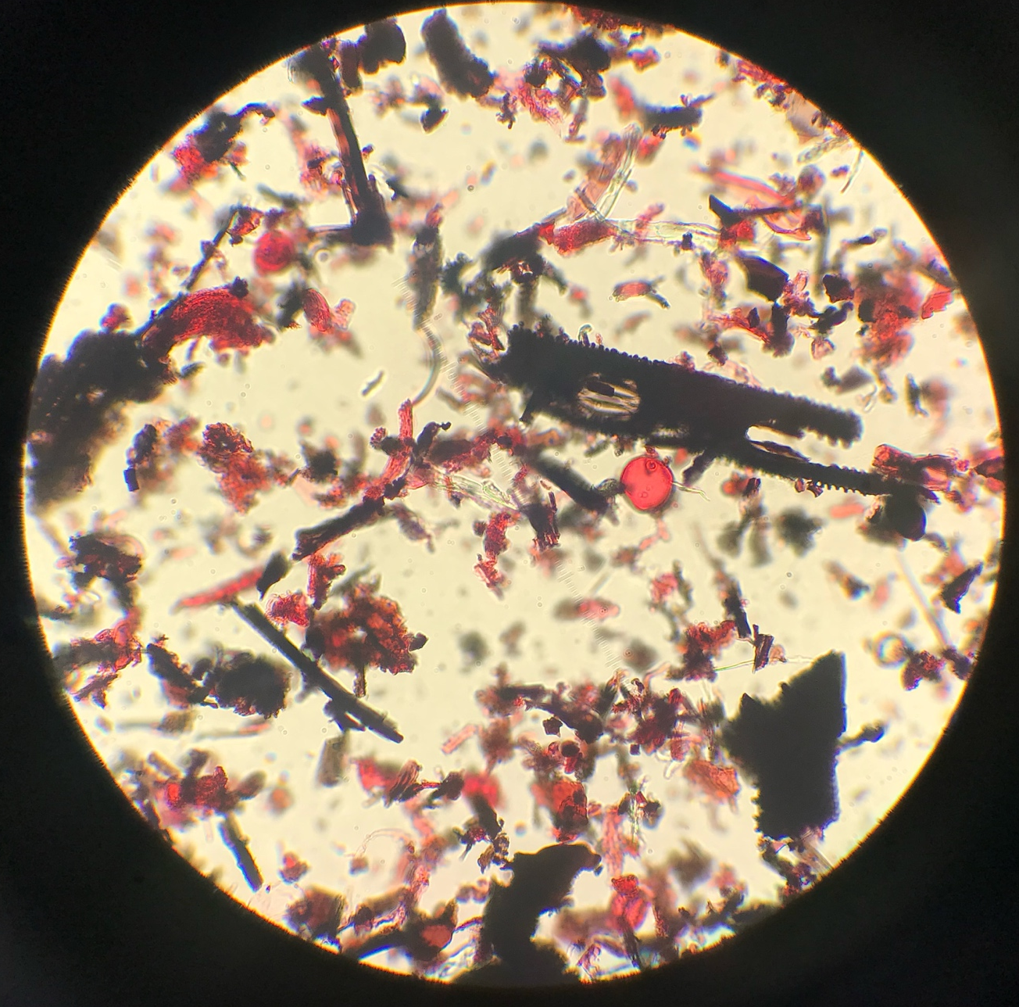

Figure 6.5. Microscopic charcoal fragments in a field of view from the Laguna Zoncho 1997 core. Lasagna Cluster, Serrated, Long/Thin, Compact Geometric, Compact Irregular, and Brittle/Translucent charcoal morphologies are present.
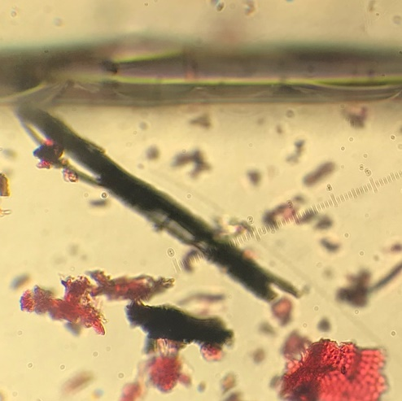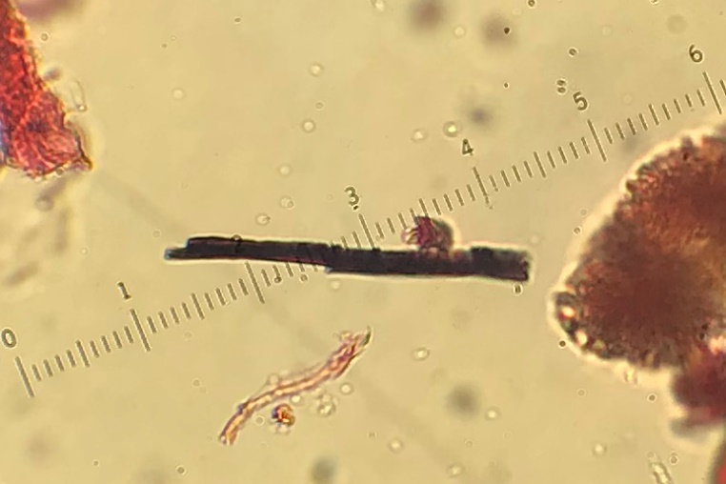

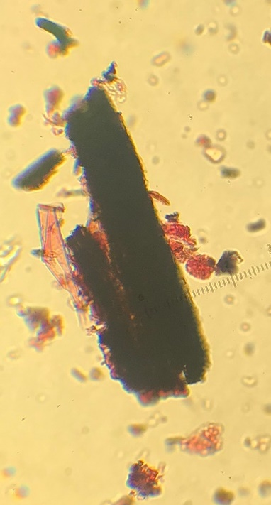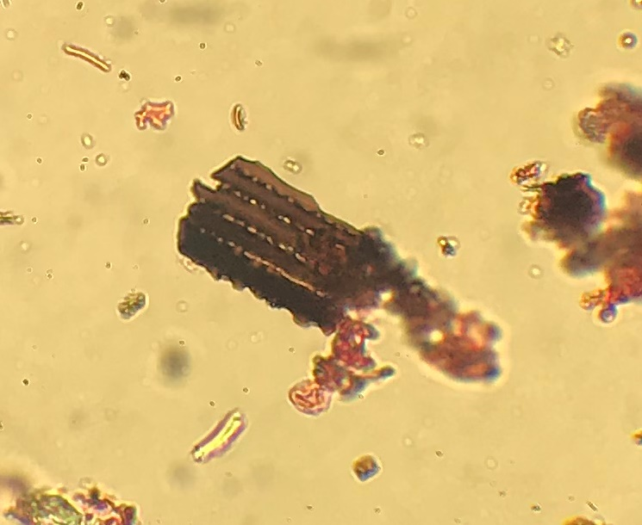

Figure 6.6. Charcoal fragments on Laguna Zoncho pollen slides classified as Graminoid Leafy charcoal. The top two images show charcoal fragments classified as Long/Thin. The bottom-left image shows two Serrated fragments. The bottom-right images shows a charcoal fragment classified as a Lasagna Cluster.
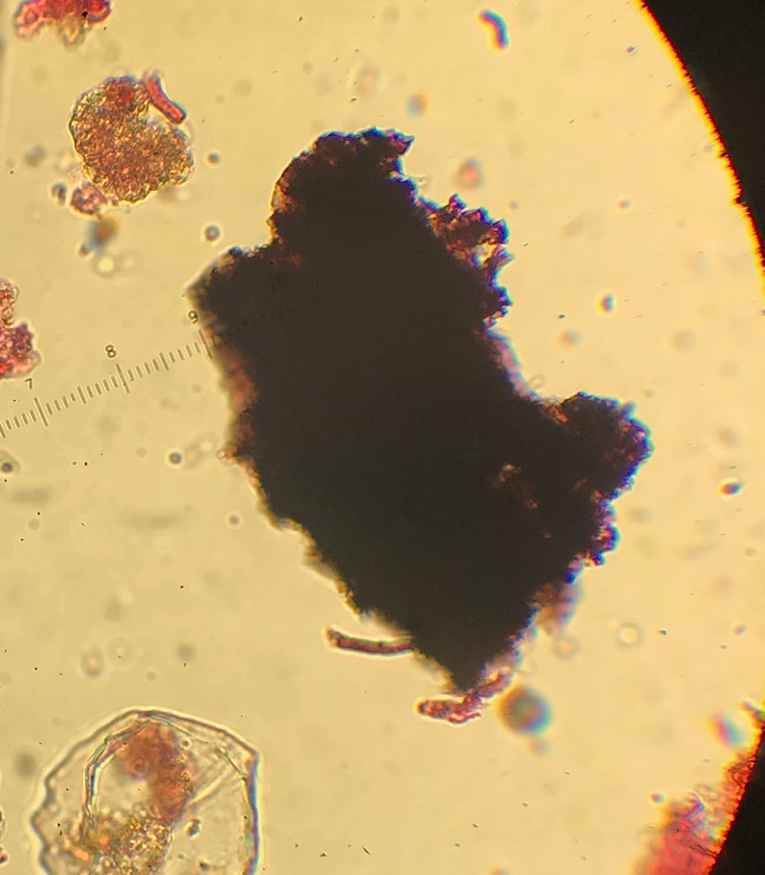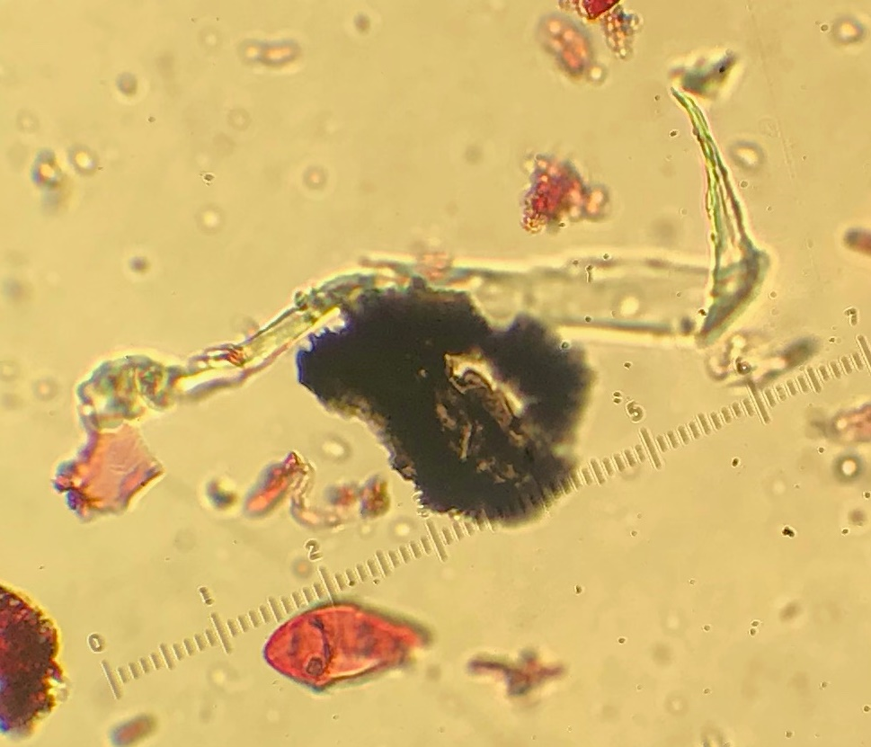

Figure 6.7. Charcoal fragments on Laguna Zoncho pollen slides classified as Dicot Leafy (Brittle/Translucent) charcoal. Both images show charcoal fragments with crumbly, brittle edges and a translucent appearance.
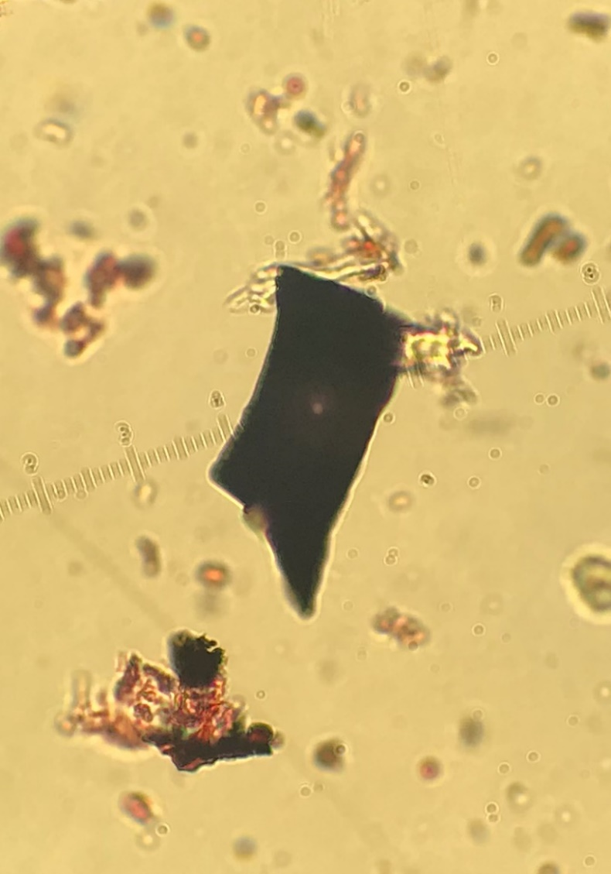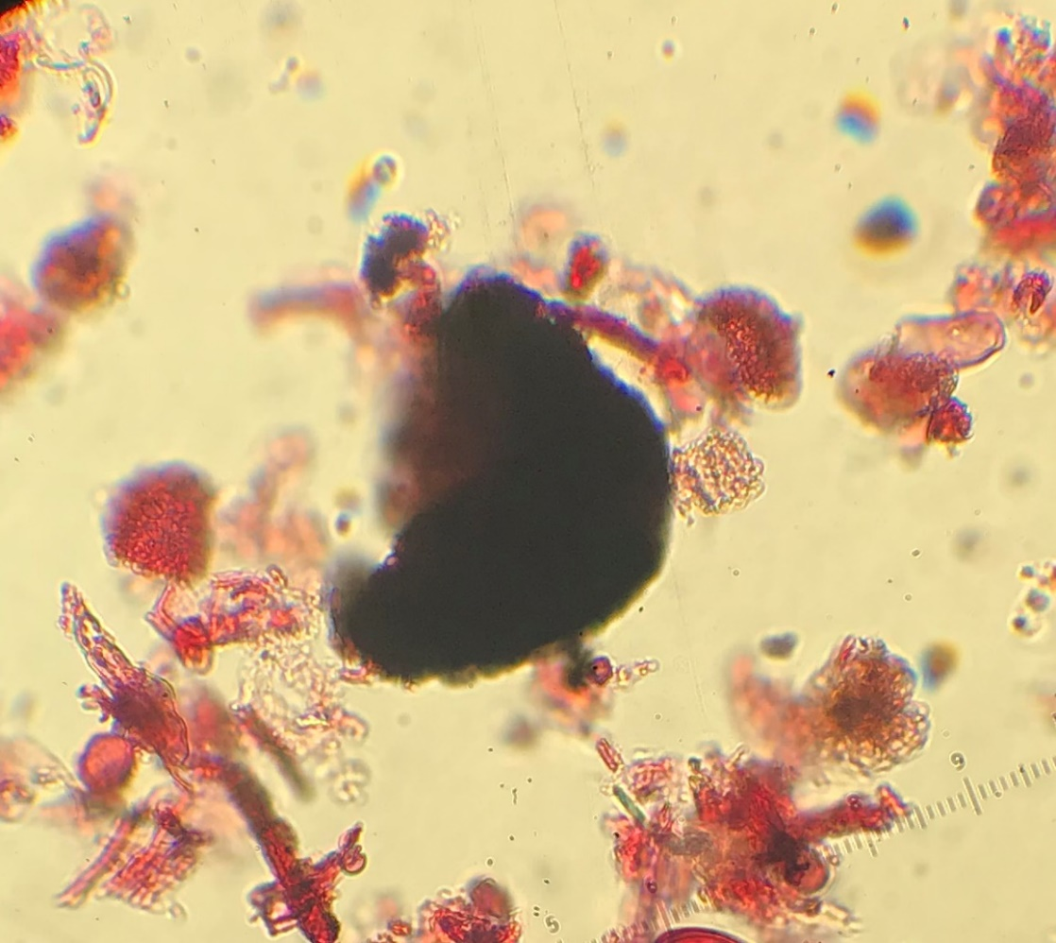

Figure 6.8. Charcoal fragments on Laguna Zoncho pollen slides classified as woody (Compact) charcoal. The image on the left is geometric in shape with smooth edges, classified as Compact Geometric. The image on the right is irregular in shape with relatively smooth edges, classified as Compact Irregular.
core that I studied, corresponding to the age range of 1525–528 cal yr BP, contains relatively high charcoal concentrations and influx values (Figure 6.9). A major peak in influx occurs at 538 cal yr BP, near the transition from Zone 3 to Zone 2 at 528 cal yr BP. The record begins with Compact charcoal making up about 40% of the total charcoal, increasing to 55% by 1340 cal yr BP, then declining after 1340 cal yr BP and reaching a low point at 776 cal yr BP (20%). The zone also has a moderately high percentage of Leafy charcoal (20–25%) from 1525–1432 cal yr BP, which decreases to 12% at 1340 cal yr BP, but then steadily rises again to 25% at 776 cal yr BP, opposite of Compact charcoal. Graminoid charcoal starts out low (32–36%) compared to Compact charcoal between 1525 and 1340 cal yr BP, but then steadily increases like Leafy charcoal, amounting to over 50% of charcoal by 776 cal yr BP. Graminoid charcoal remains the dominant morphological type through 528 cal yr BP, making up almost 60% of charcoal at 531 cal yr BP, at which time Compact charcoal makes up 25% of charcoal. Leafy charcoal percentage declines after 776 cal yr BP, making up ~15% of charcoal by 528 cal yr BP. Peaks occur for Lasagna Cluster (12%), Lasagna Noodle (10%), and Brittle/Translucent (25%) subtypes around 776 cal yr BP, when charcoal concentration is at its highest, while Compact Geometric and Compact Irregular morphologies are at their low points in the record, amounting to 7% and 15% of total charcoal. An abrupt spike in Lasagna Cluster morphology percentage to nearly 20% of total charcoal occurs at 531 cal cal yr BP, shortly following the record peak in total charcoal influx.
Total charcoal concentration and influx are drastically lower through Zone 2 from 528–60 cal yr BP. The percentage of Compact charcoal dramatically increases from its level at the end of Zone 3 to the start of Zone 2, jumping to over 40% at 484 cal yr BP, dropping below 35%
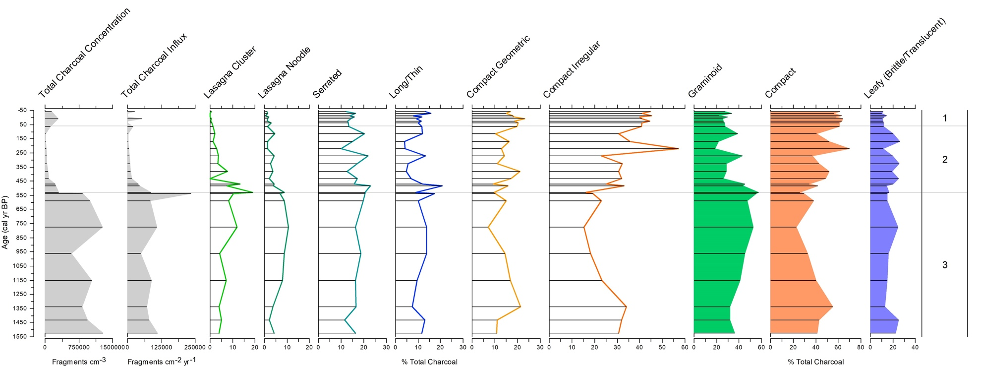

Figure 6.9. Microscopic morphology percentages over time by zone for the Zoncho 1997 core. Horizontal lines on all the graphs show samples examined. The gray silhouette graphs show total charcoal concentration and influx. These data are from Clement and Horn (2001), with influx recalculated using sedimentation rates from the age model in Taylor et al. (2020). The colored line graphs with horizontal bars show the seven subtypes of the classification system. The colored silhouette graphs show the three primary types. Charcoal
at 470 cal yr BP, then increasing again to 50% at 431 cal yr BP, after which it then steadily declines to just over 35% at 273 cal yr BP. Compact charcoal then dramatically spikes to its record peak at 223 cal yr BP, when it makes up 70% of all charcoal. After this peak, Compact charcoal steadily declines again, though still making up 60% of charcoal at 65 cal yr BP. Graminoid charcoal percentage immediately declines after peaking at the end of Zone 3 to ~45% until 470 cal yr BP, after which it drops to 25–30% of charcoal from 431 cal yr BP to 327 cal yr BP. Graminoid morphology spikes to over 40% of charcoal at 273 cal yr BP, slightly higher in percentage than Compact charcoal at this time, then dramatically drops below 20% at 223 cal yr BP. Graminoid charcoal percentages steadily increase afterward, making up almost 40% at 116 cal yr BP, then decreases to below 30% at the end of the zone. Leafy charcoal morphologies consistently make up 15–25% of total charcoal until 223 cal yr BP, where the type drops to 10%. It then increases to over 25% at 169 cal yr BP, before dropping again to 10% at 65 cal yr BP. With the exception of Lasagna Cluster charcoal making up almost 15% of charcoal at 470 cal yr BP, Lasagna morphotype percentages are low through Zone 2. Serrated and Long/Thin morphotypes make up significant percentages at the beginning of the zone, each over 20% at 484 cal yr BP. Both percentages are lower through the remainder of the zone, though increase to just over 20% and under 15% at 273 cal yr BP, then again to 20% and just over 10% at 116 cal yr BP. The two Compact subtypes compose a higher percentage each than in Zone 3, with Compact Geometric charcoal peaking to over 20% at 380 cal yr BP and then again to 20% at 65 cal yr BP, and Compact Irregular charcoal massively peaking to nearly 60% of all charcoal subtypes at 223 cal yr BP, corresponding to the time when Brittle/Translucent charcoal markedly declines to around 10%. Compact Irregular charcoal is the dominant subtype at the end of the zone, making up 40% of charcoal at 65 cal yr BP.
Total charcoal concentration and influx increase slightly in Zone 1 (60 cal yr BP to –47 cal yr BP), though values are still much lower than those in Zone 3. Percentages of Graminoid and Leafy morphologies remain relatively low in Zone 1, around 25% and 10%, respectively, while Compact charcoal is consistently high, between 55% and 65% of charcoal. Graminoid charcoal increases slightly to almost 35% at 1978 CE, when Compact charcoal drops to 55%. Lasagna Cluster and Lasagna Noodle morphologies are virtually absent in Zone 1. Serrated and Long/Thin morphologies together make up 20–30% of total Graminoid charcoal through the zone. Both Compact Geometric and Compact Irregular morphologies remain relatively high, around 15–20% and 40–45%, respectively, while Brittle/Translucent charcoal remains low.

Microscopic charcoal morphology in the Santa Elena Core
In the Santa Elena core, Zone 3 (1780–1590 cal yr BP) is low in total charcoal concentration and influx (Kerr et al. 2020). I analyzed two samples within this zone at 1779 cal yr BP and 1649 cal yr BP. Graminoid and Compact morphology percentages are similar at the start of the zone, both making up over 40% of charcoal, but at 1649 cal yr BP, the Graminoid morphology makes up over 60% of charcoal while the Compact morphology makes up around 20% of charcoal. Leafy charcoal remains around 15% in Zone 3. Though slight at the start of the zone, Lasagna Cluster and Lasagna Noodle morphologies together make up almost 20% of charcoal at 1649 cal yr BP. Serrated and Long/Thin morphologies make up around 20% of charcoal apiece at 1649 cal yr BP also. Compact Geometric charcoal drops from 12% to 6% and
Compact Irregular charcoal declines from 30% to 15% between 1779 cal yr BP and 1649 cal yr BP (Figure 6.10).
Total charcoal influx and concentration values increase markedly during Zone 2c (1590–1150 cal yr BP). Graminoid morphologies drop to 45% of total charcoal and Compact morphologies increase to 40% of total charcoal at 1404 cal yr BP. Compact charcoal remains ~40% through the rest of the zone, while Graminoid charcoal increases to nearly 50% at 1287 cal yr BP, then dips below 45% at 1189 cal yr BP. Leafy morphology consistently accounts for 15–20% of total charcoal through Zone 2c, except for a slight dip below 15% around 1287 cal yr BP when Graminoid percentages increase. The Graminoid subtypes slightly peak in percentages between 1404 cal yr BP and 1287 cal yr BP, except for Long/Thin charcoal, which remains about the same, just below 20%. Lasagna Cluster, Lasagna Noodle, and Serrated subtypes dip again slightly at 1189 cal yr BP. Percentages of Lasagna Cluster and Lasagna Noodle charcoal are very low (<3%) at 1365 cal yr BP and 1228 cal yr BP. Compact Geometric and Irregular morphologies each peak at1365 cal yr BP (15% and 30%), and then Irregular peaks again (30%) at 1228 cal yr BP while Geometric declines to 12%. Brittle/Translucent charcoal follows the same trend as Compact Irregular charcoal, though lower in total percentage (~13–18%).
At the start of Zone 2b (1150–880 cal yr BP), total charcoal concentration remains high while influx drops. I analyzed two samples within this zone at 1086 cal yr BP and 942 cal yr BP. Total Graminoid percentage spikes to its record peak of 65% at 1086 cal yr BP, and then drops to 50% at 942 cal yr BP. Total Compact drops to its record low percentage of 20% at 1086 cal yr BP, but rises to 35% at 942 cal yr BP. Total Leafy percentage remains low, even lower than in Zone 2c (<15%). Percentages of Lasagna Cluster (12%), Lasagna Noodle (8%), and Long/Thin
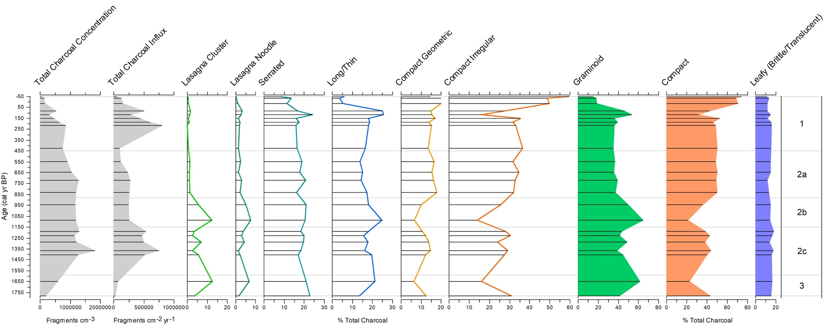

Figure 6.10. Microscopic morphology percentages over time for the Santa Elena core. Horizontal lines on all the graphs show samples examined. The gray silhouette graphs show total charcoal concentration and influx. These data are from Anchukaitis and Horn (2005), with influx recalculated using sedimentation rates from the age model in in Kerr (2019). The colored line graphs with horizontal bars show the seven subtypes of the classification system. The colored silhouette graphs show the three primary types.
(25%) peak in Zone 2b at 1086 cal yr BP, but all 3 morphotypes decline sharply at 942 cal yr BP. Serrated percentages remain high through Zone 2b, making up 20% of total charcoal. Both Compact Geometric and Irregular percentages hit low points in the record at 1086 cal yr BP (~6% and 15%), but increase again to 10% and 25% at 942 cal yr BP. Brittle/Translucent charcoal remains under 15%.
Total charcoal concentration and influx values in Zone 2a (880–450 cal yr BP) are similar to values from Zone 2b. Total Graminoid percentage drops to 37% at 831 cal yr BP, and remains between 35% and 40% in Zone 2a, while total Compact percentage spikes to 50% at 831 cal yr BP and stays around 50% through the rest of the zone. Total Leafy percentage stays between 10–15%. Lasagna Cluster and Lasagna Noodle percentages are extremely low through the zone section. Serrated percentage dips to ~15% of total charcoal at 831 cal yr BP, peaks slightly to 20% at 720 cal yr BP, then dips slightly and stays just under 20% until 548 cal yr BP. Long/Thin percentage is at 17% at 831 cal yr BP, declining to 14% by 548 cal yr BP. Compact Geometric percentage peaks to 18% of total charcoal at 831 cal yr BP and remains over 15% through 548 cal yr BP. Compact Irregular percentage remains between 30% and 35% through the zone section. Brittle/Translucent percentage dips very slightly at 831 cal yr BP then rises steadily through 548 cal yr BP.
Zone 1, ranging from 450 to –50 cal yr BP, begins with moderate total charcoal concentration and low influx, but influx values greatly increase by 216 cal yr BP. Total Graminoid percentages are at 35% around the start of Zone 1 at 425 cal yr BP, but increase steadily to 40% at 224 cal yr BP, and then to over 50% of total charcoal at 128 cal yr BP. Graminoid charcoal percentages then decline dramatically to under 20% of total charcoal between 83 cal yr BP and 1983 CE, and to under 15% by 2000 CE. Compact morphologies together make up 50% of total charcoal at 425 cal yr BP and remain near that percentage until 116 cal yr BP, when the type drops to 30%. After that, Compact percentage increases to 40% at 83 cal yr BP, to 70% at 16 cal yr BP, and then ultimately peaks at 75% by 2000 CE. Total Leafy charcoal percentage is close to 15% of total charcoal at the start of the zone, gradually declining to around 10% by 2000 CE. Lasagna Cluster and Lasagna Noodle morphotypes are rare in Zone 1. Serrated and Long/Thin morphotype percentages are around 15% at 425 cal yr BP, increasing to around 25% at 116 cal yr BP. The percentages of both morphotypes decline to 8% and 6% of total charcoal by 2000 CE. Compact Geometric charcoal remains between 15% and 20% of total charcoal through Zone 1. Compact Irregular charcoal makes up around 35% of total charcoal at 425 cal yr BP, drops to around 15% at 116 cal yr BP, then gradually increases to 60% of total charcoal by 2000 CE.

Comparisons of charcoal morphology and other proxies in the Zoncho 1997 and Santa Elena cores
My new records of changing charcoal morphology in the Zoncho 1997 and Santa Elena cores show some relationships with other proxy indicators studied in those cores (Figures 6.11–6.17). Lasagna Cluster and Lasagna Noodle charcoal percentages and Total Graminoid charcoal percentages show some correspondence with grass (Poaceae) pollen in the records (Figures 6.11–6.12). The primary charcoal morphologies (Graminoid, Compact, and Leafy) show relationships with additional pollen categories (Figures 6.13–6.15), and with stable carbon isotope (δ¹³C) values (Figures 6.16–6.17).
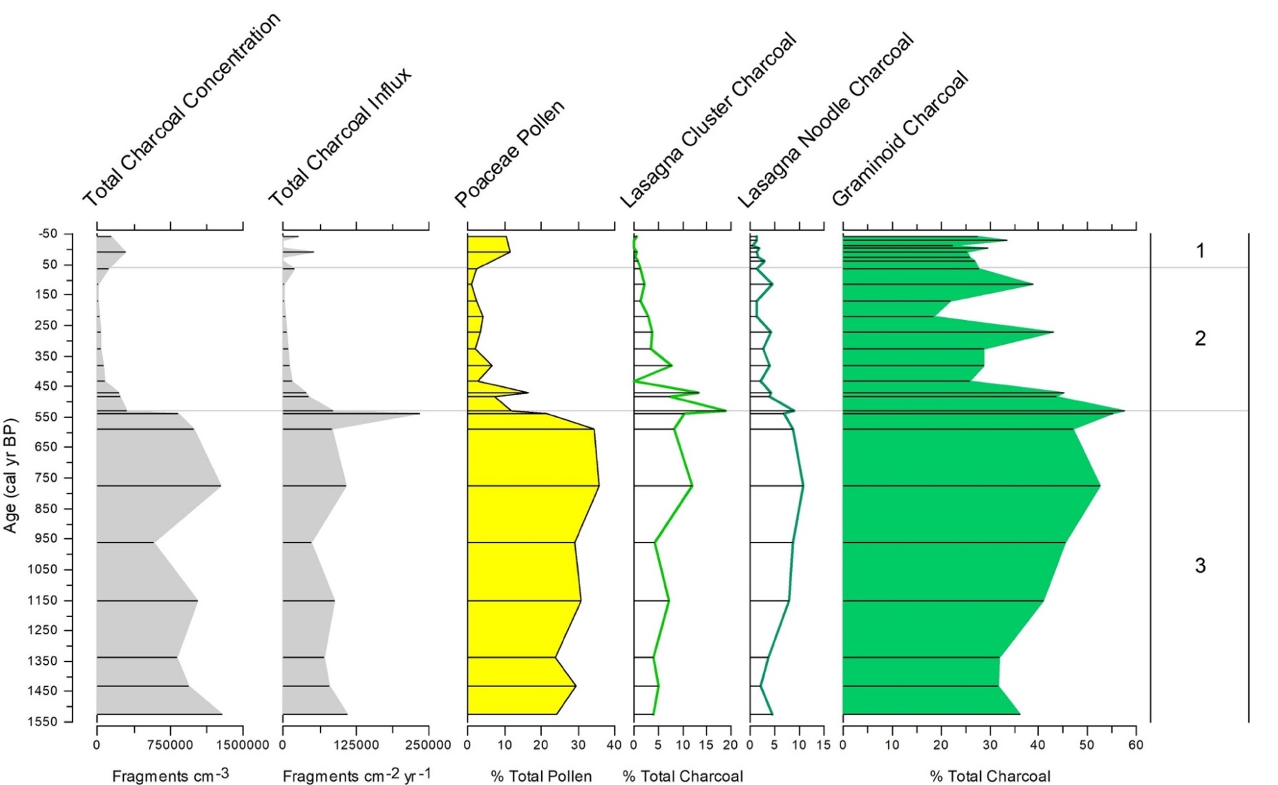
Figure 6.11. Lasagna Cluster and Lasagna Noodle morphology percentages graphed together with total charcoal concentration, charcoal influx, grass pollen percentages, and Graminoid charcoal percentages in the Zoncho 1997 core. Pollen and charcoal concentration and influx data are from Clement and Horn (2001), with influx recalculated using sedimentation rates from the age model in Taylor et al. (2020).
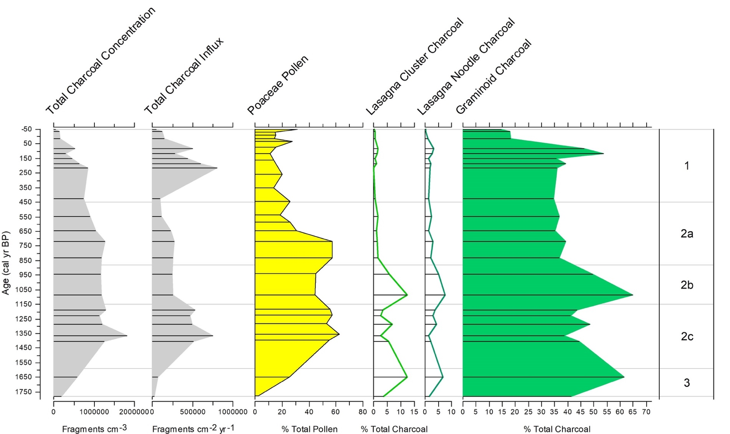

Figure 6.12. Lasagna Cluster and Lasagna Noodle morphology percentages graphed together with total charcoal concentration, charcoal influx, grass pollen percentages, and Graminoid charcoal percentages in the Santa Elena core. Pollen and charcoal concentration and influx data are from Anchukaitis and Horn (2005), with influx recalculated using sedimentation rates from the age model in Kerr (2019).
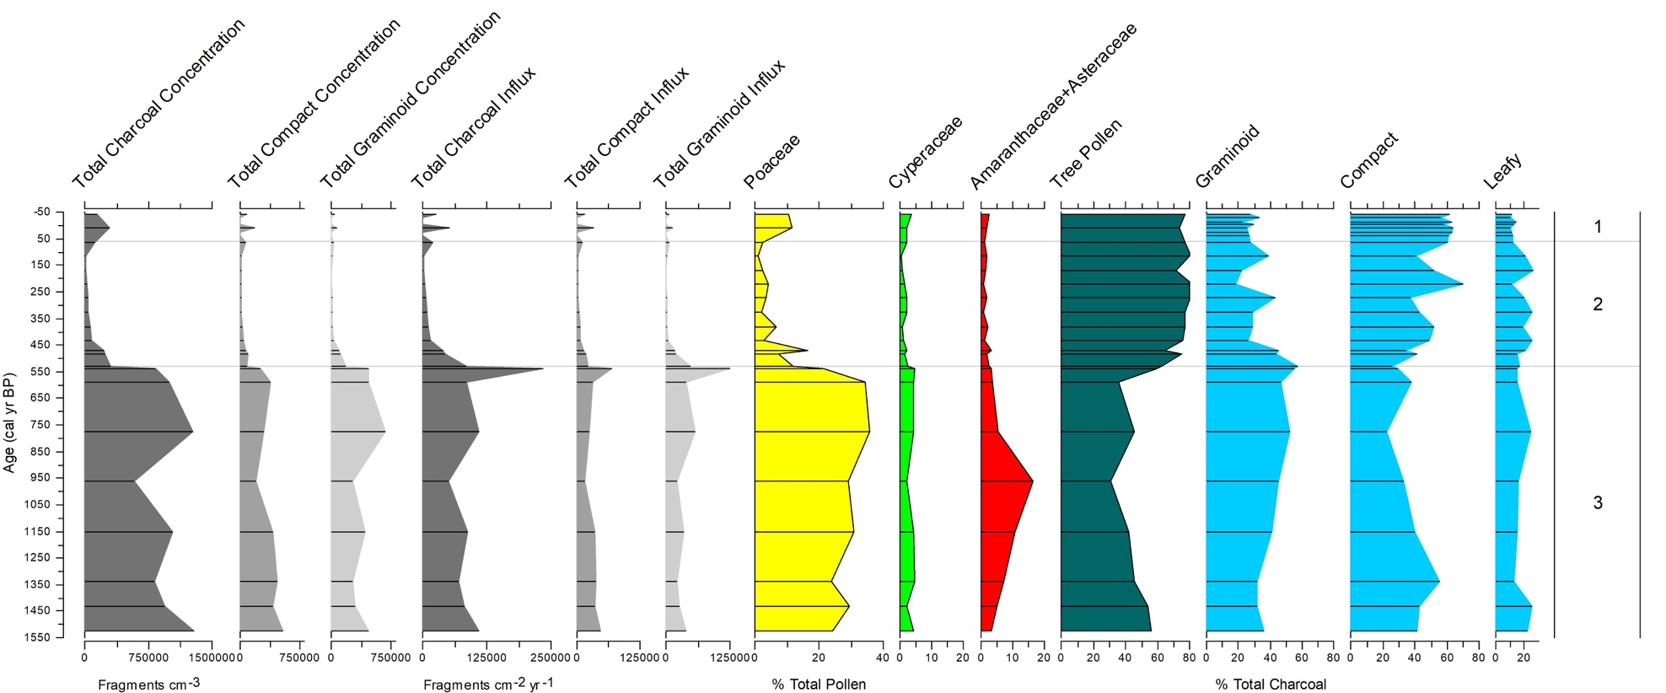

Figure 6.13. Primary charcoal morphology trends compared to charcoal concentration, charcoal influx, and percentage trends for disturbance and tree pollen in the Zoncho 1997 core. Pollen and charcoal concentration and influx data are from Clement and Horn (2001), with influx recalculated using sedimentation rates from the age model in Taylor et al. (2020). Concentration and influx data by morphology are calculated from the total charcoal values. The percent tree pollen category includes Podocarpus, Quercus, Alnus, Myrica, Weinmannia, Alchornea, Myrsine, Myrtaceae, Iriartea, other Palmae, Ulmus, Tiliaceae, Ficus, Cecropia, Trema, Celtis, and other diporate and triporate Urticales.
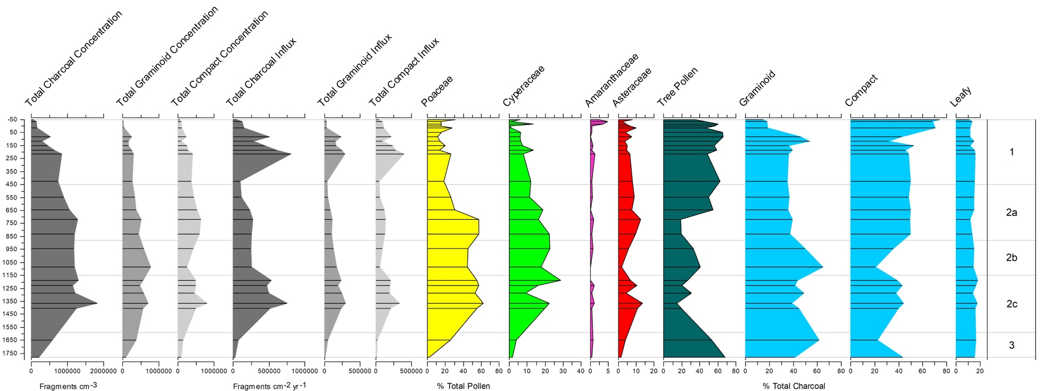

Figure 6.14. Primary charcoal morphology trends compared to charcoal concentration, charcoal influx, and percentage pollen trends for selected herbs and trees in the Santa Elena core. Pollen and total charcoal concentration and influx data are from Anchukaitis and Horn (2005), with influx recalculated using sedimentation rates from the age model in Kerr (2019). Concentration and influx data by morphology are calculated from the total charcoal values. The percent tree pollen category includes the taxa in the tree total at Laguna Zoncho (see caption for Fig. 6.13) with the addition of Melastomataceae/Combretaceae, Hedyosmum, and Piper.
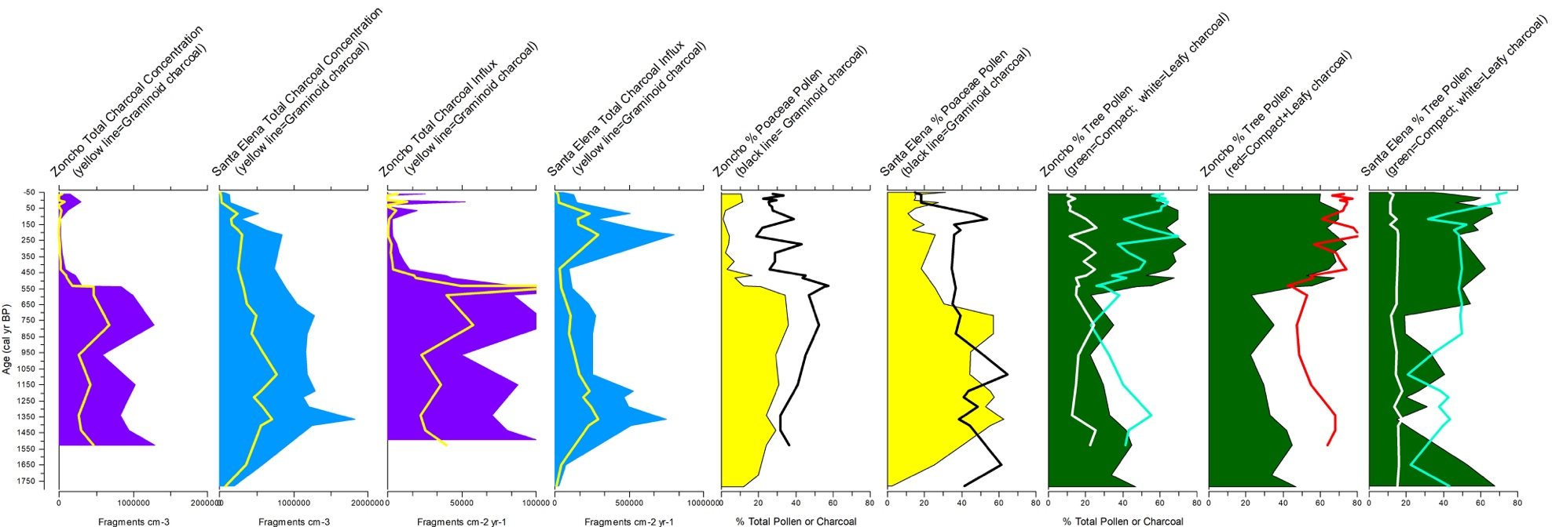

Figure 6.15. Primary charcoal morphology trends overlapping charcoal concentration, charcoal influx, grass pollen, and tree pollen trends for the Zoncho 1997 core and Santa Elena core. Zoncho pollen and charcoal concentration and influx data are from Clement and Horn (2001), with influx recalculated using sedimentation rates from the age model in Taylor et al. (2020). Santa Elena pollen and total charcoal concentration and influx data are from Anchukaitis and Horn (2005), with influx recalculated using sedimentation rates from the age model in Kerr (2019).
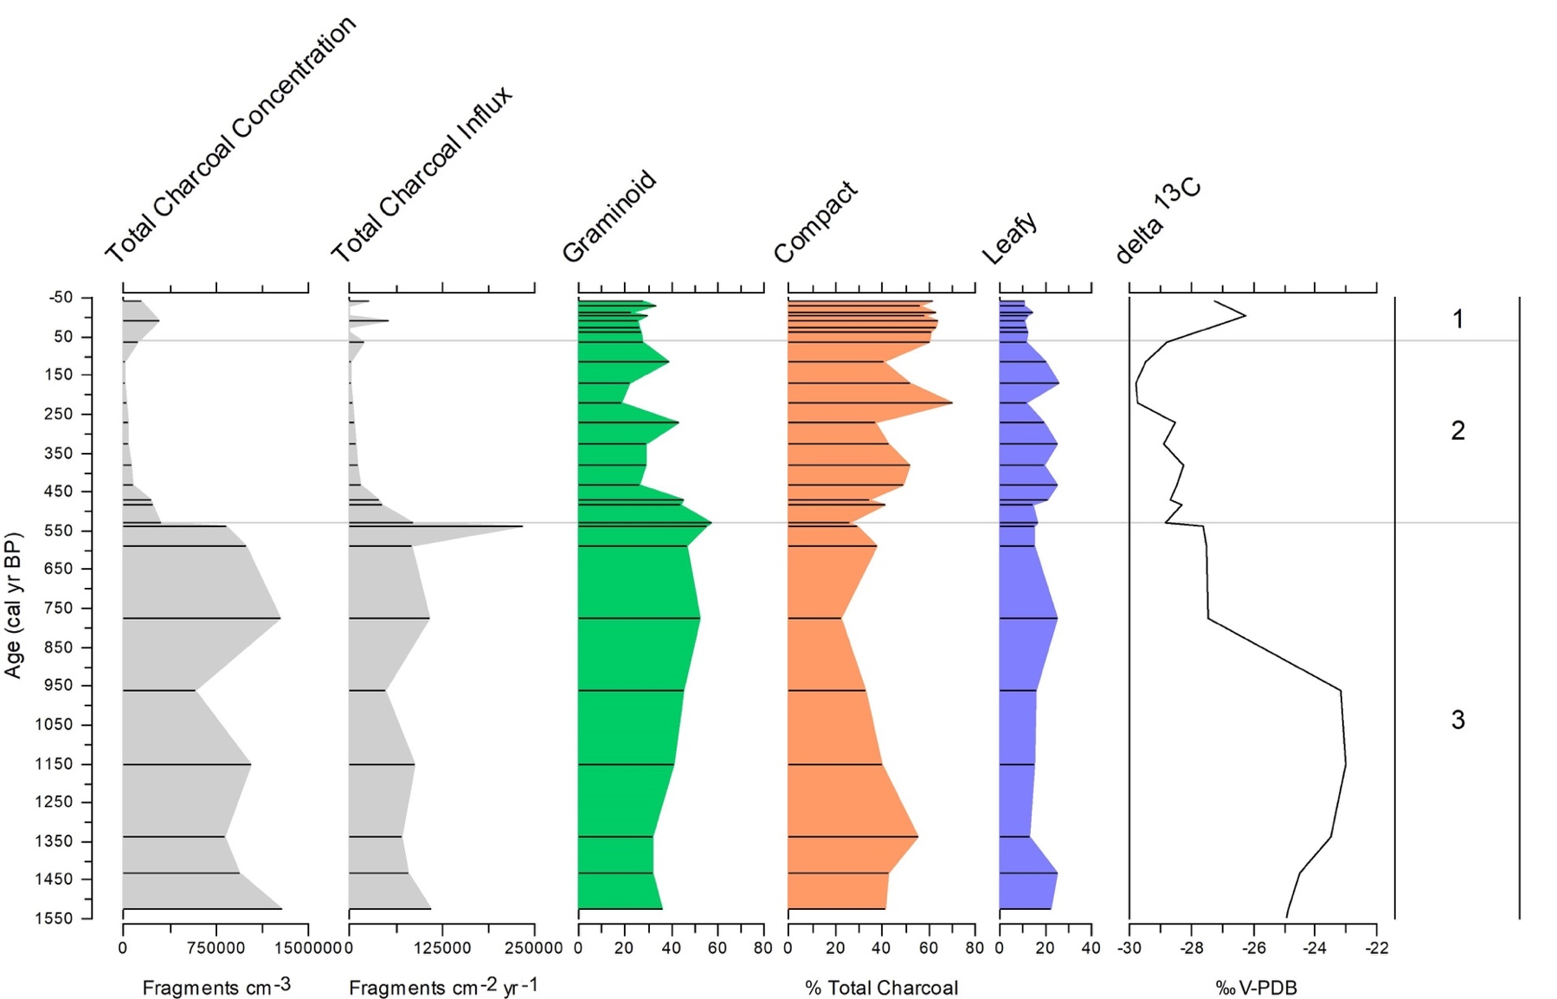

Figure 6.16. Charcoal concentration, influx, and primary charcoal morphology trends compared to the stable carbon isotope (δ¹³C) curve for the Zoncho 1997 core. Charcoal concentration data are from Clement and Horn (2001), with influx recalculated using sedimentation rates from the age model in Taylor et al. (2020). Bulk ¹³C data from Lane et al. (2004).
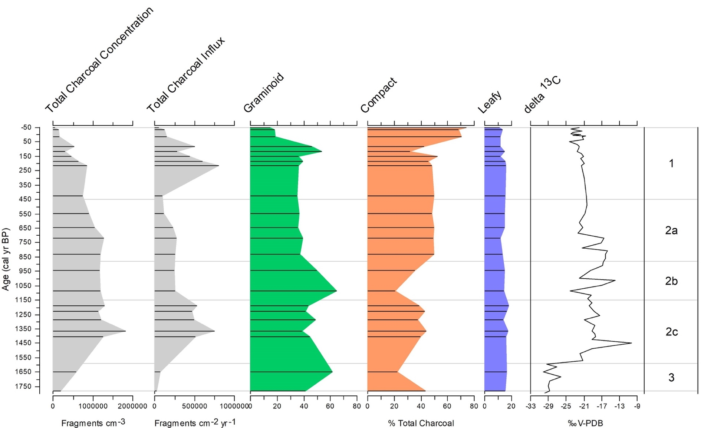

Figure 6.17. Charcoal concentration, influx, and primary charcoal morphology trends compared to the stable carbon isotope (δ¹³C) curve in the Santa Elena core. Charcoal concentration data are from Anchukaitis and Horn (2005), with influx recalculated using sedimentation rates from the age model in Kerr (2019). Bulk ¹³C data from Kerr et al. (2020).

Microscopic charcoal morphology in the Zoncho 2007 Cores
I classified charcoal on microscope slides from nine samples from Laguna Zoncho Core 1A corresponding to the interval 1173–778 cal yr BP. Graminoid charcoal percentage remains between 40% and 50% of total charcoal through this core except for around 1055 cal yr BP, when it dips to 30%. Compact charcoal percentages stay between 35% and 45% through the majority of the core, except for a spike to almost 50% at 1055 cal yr BP. Leafy charcoal is between 10% and 15%, except for a spike to over 20% at 1055 cal yr BP. Serrated charcoal is the dominant Graminoid subtype through Core 1A, while Compact Irregular is the dominant Compact subtype.
Using Core 2A and the parallel core 2B, I classified charcoal on slides from six samples ranging in age from 1238–976 cal yr BP. At 1238 cal yr BP, Graminoid charcoal makes up around 30% of total charcoal, increasing to 60% midway through the core and then decreasing to 50% at the top of the core. Compact charcoal follows a reverse trend, making up nearly 60% of total charcoal at the start, decreasing to 30% midway through the core, and remaining around 30% at the top of the core. Leafy charcoal remains under 15% until 976 cal yr BP, where it spikes up to over 25%. Again, Serrated charcoal makes up the majority of Graminoid charcoal and Compact Irregular charcoal makes up the most Compact charcoal in the core.
I classified charcoal on slides from six samples from Core 3B ranging in age from 1057 cal yr BP to 651 cal yr BP. Graminoid charcoal accounts for about 50% of total charcoal through this period, except near the middle, when it dips closer to 40%. Compact charcoal makes up 30–40% of charcoal through the core, increasing to 45% in the middle. Leafy charcoal starts at 20%, then decreases to 10–15% of total charcoal through the rest of the core. Serrated and Compact Irregular charcoal are the two dominant subtypes of charcoal.
In Core 4B, I classified charcoal on slides from five samples ranging from 1689–1182 cal yr BP in age. Graminoid charcoal increases from around 35% of total charcoal at the bottom of the core to nearly 60% at the top. Compact charcoal decreases from 50% of charcoal to around 25%. Leafy charcoal remains from 10 –20%. Serrated charcoal, Long/Thin charcoal, and Compact Irregular charcoal are the most well represented subtypes overall.
I classified charcoal on slides from seven samples from Core 6B ranging in age from 1380–1076 cal yr BP. Graminoid charcoal makes up between 40–45% of charcoal through the core. Compact charcoal makes up over 45% of total charcoal at the start, but remains between 30% and 40% through the rest of the core. Leafy charcoal makes up 12% of total charcoal at the start, gradually increasing to over 20% by the end of the core. Serrated and Compact Irregular morphotypes are the dominant charcoal subtypes.
Based on the age model for Core 6 developed by Taylor et al. (2020) and the models I developed for Cores 1–4 in this research, the sections of the Zoncho 2007 cores for which I classified microscopic charcoal morphology do not cover the same time periods. For that reason, I cannot compare trends in microscopic charcoal morphology across all cores. However, the samples are still helpful in testing the applicability of my morphological classification system. Where the samples do overlap in time, we might expect to find similarities in the percentages of the charcoal fragments of different morphologies, and possibly some correspondence in temporal trends. Figure 6.18 shows Lasagna Cluster percentage of total charcoal trends in all five Zoncho 2007 cores as compared to the Zoncho 1997 core. Cores 1 and 2 show similar trends, while there
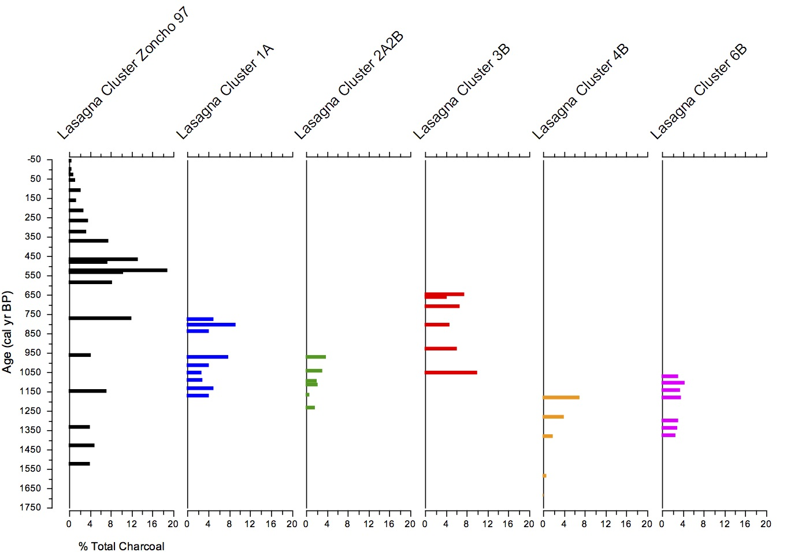
Figure 6.18. Lasagna Cluster charcoal morphology trends in the Zoncho cores. The letters in the core designations for the 2007 cores indicate whether the pollen samples came from the A core, the parallel B core, or both cores A and B from the site.
is less trend similarity among the other cores. Figure 6.19 shows trends in the percentage of charcoal with the Lasagna Noodle morphology in the Zoncho 2007 cores and the Zoncho 1997 core. Similar trends are seen where Core 1 and Core 2 overlap and more subtly where Core 4 and Core 6 overlap. Figure 6.20 shows total Graminoid percentage trends in the Zoncho 2007 cores and the Zoncho 1997 core. While percentage values are generally similar across the cores for Graminoid charcoal, trend similarities are not as obvious. Leafy charcoal percentage trends are compared across the Zoncho 2007 cores and the Zoncho 1997 core in Figure 6.21. Again, there is no obvious trend where cores overlap, though percentage values are similar overall.

Comparison of charcoal morphology in all cores
Comparisons among the Zoncho 1997 core, the Santa Elena core, and the Zoncho 2007 cores show differences among Compact, Graminoid, and Leafy charcoal percentage trends. While Compact charcoal percentage is lowest in the Zoncho 1997 core record around 775 cal yr BP at 20% of total charcoal, it is lowest in the Santa Elena core record (also around 20% of total charcoal) around 1075 cal yr BP. There is not much similarity among the Zoncho 2007 core trends for Compact morphology percentages, nor do these cores show significant associations with the Zoncho 1997 or Santa Elena core. While Compact charcoal appears to noticeably increase after 528 cal yr BP in the Zoncho 1997 core, there is little change in Compact charcoal percentage after that time in the Santa Elena Core until the last century. Both the Zoncho 1997 core and Santa Elena core show a large percentage of Compact charcoal in the last 100 years (Figure 6.22).
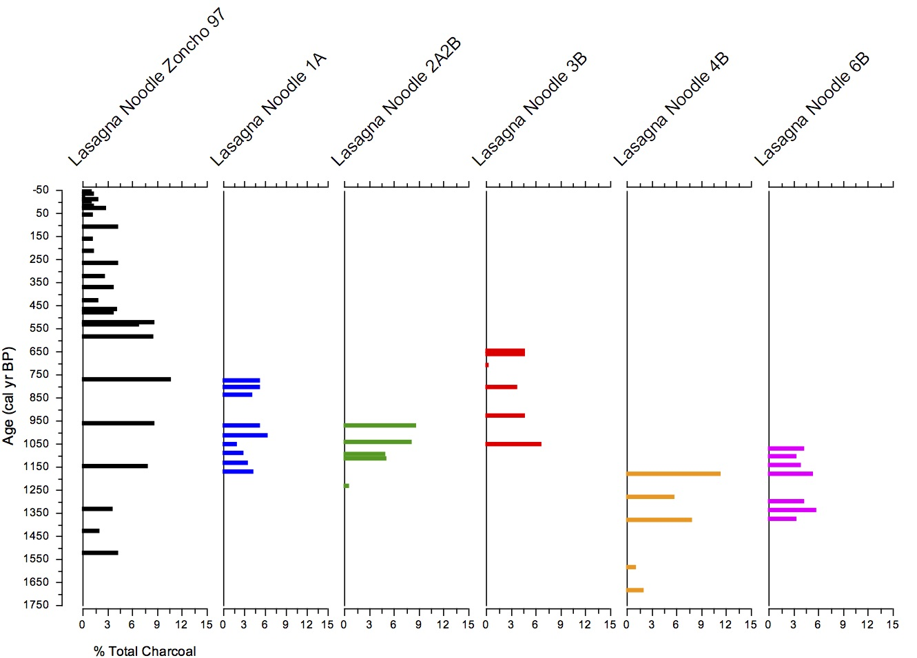

Figure 6.19. Lasagna Noodle charcoal morphology trends in the Zoncho cores. The letters in the core designations for the 2007 cores indicate whether the pollen samples came from the A core, the parallel B core, or both cores A and B from the site.
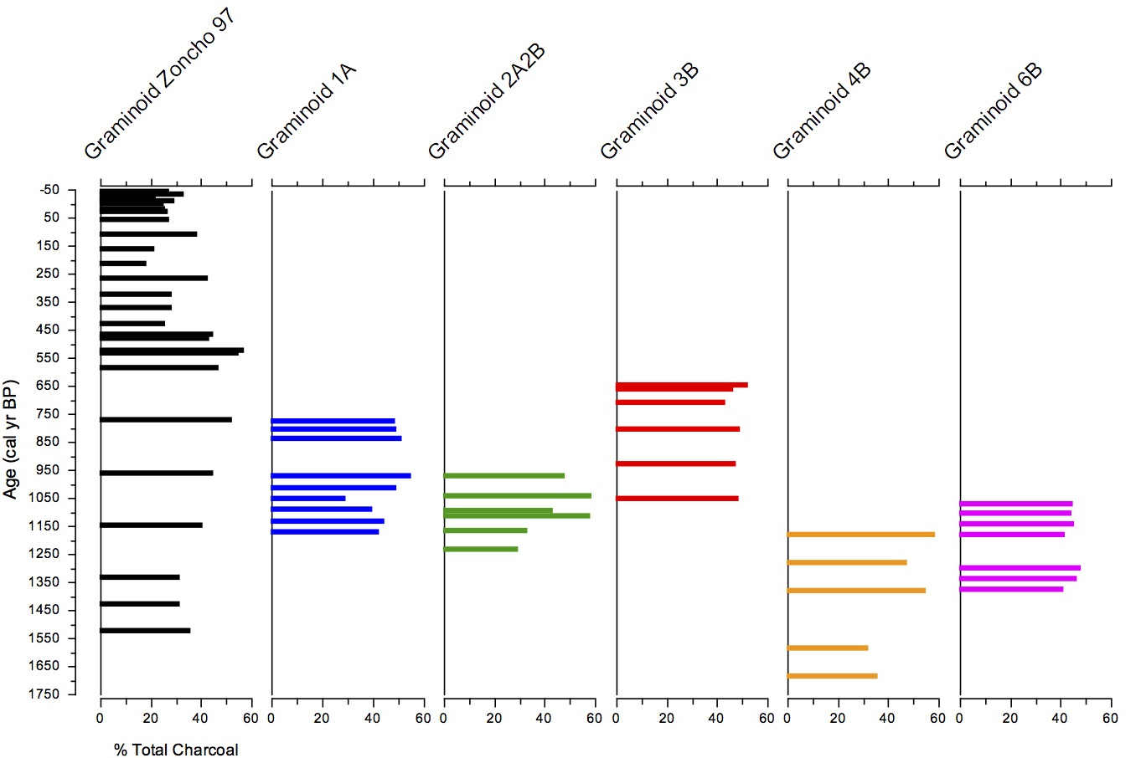

Figure 6.20. Total Graminoid charcoal morphology trends in the Zoncho cores. The letters in the core designations for the 2007 cores indicate whether the pollen samples came from the A core, the parallel B core, or both cores A and B from the site.
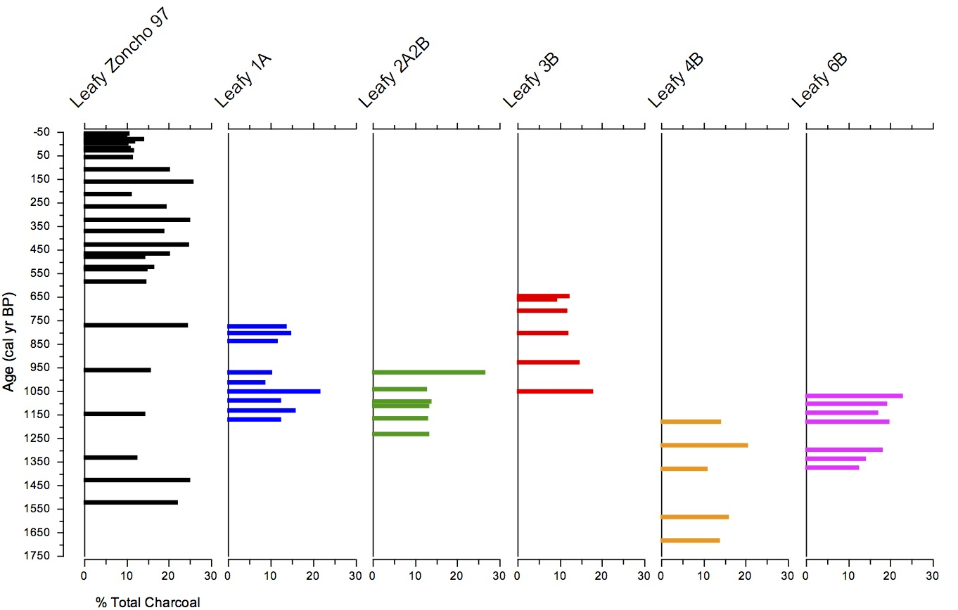

Figure 6.21. Total Leafy charcoal morphology trends in the Zoncho cores. The letters in the core designations for the 2007 cores indicate whether the pollen samples came from the A core, the parallel B core, or both cores A and B from the site.
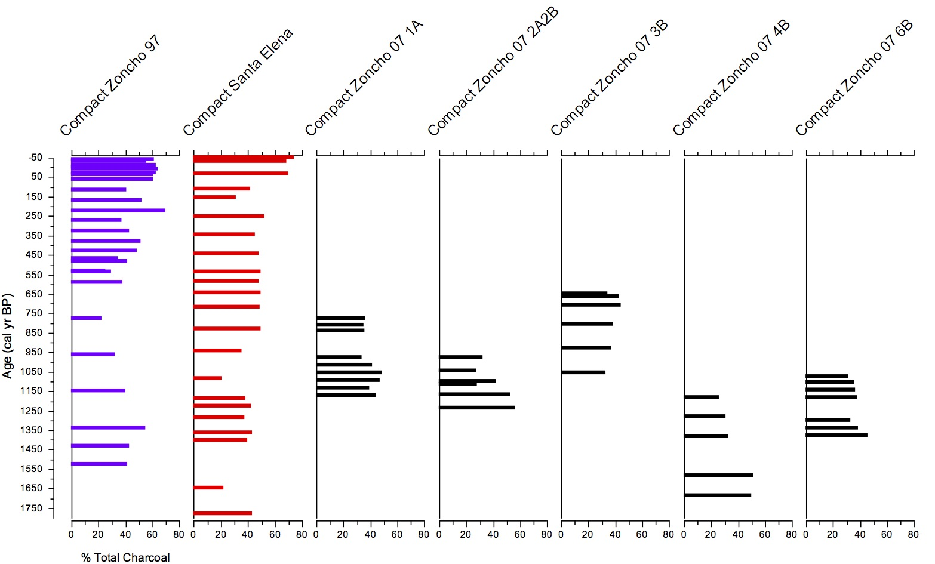

Figure 6.22. Compact charcoal morphology percentage trends in all seven of the Laguna Zoncho and Laguna Santa Elena cores. The letters in the core designations for the 2007 cores indicate whether the pollen samples came from the A core, the parallel B core, or both cores A and B from the site.
Trends in Graminoid charcoal percentages also show differences among all seven cores. Graminoid charcoal percentages are highest in the Zoncho 1997 record around 500 cal yr BP (50% of total charcoal), but in the Santa Elena core they are highest much earlier in the record, making up over 60% of charcoal around 1075 cal yr BP. Again, there are no marked associations in Graminoid charcoal percentage trends where the Zoncho 2007 cores overlap with the Zoncho 1997 and Santa Elena cores. Graminoid percentages show a subtle peak in both the Zoncho 1997 core and the Santa Elena core at 100 cal yr BP, and are similarly low in both cores in the last 100 years of the record (Figure 6.23).
Leafy charcoal percentage remain consistently lower than Graminoid and Compact percentages through the records of all seven cores, staying between 10% and 27% of total charcoal in all records. Leafy charcoal percentage shows a series of spikes and dips through the Zoncho 1997 and Zoncho 2007 cores, while it remains steady between 10 – 15% through the Santa Elena core (Figure 6.24).
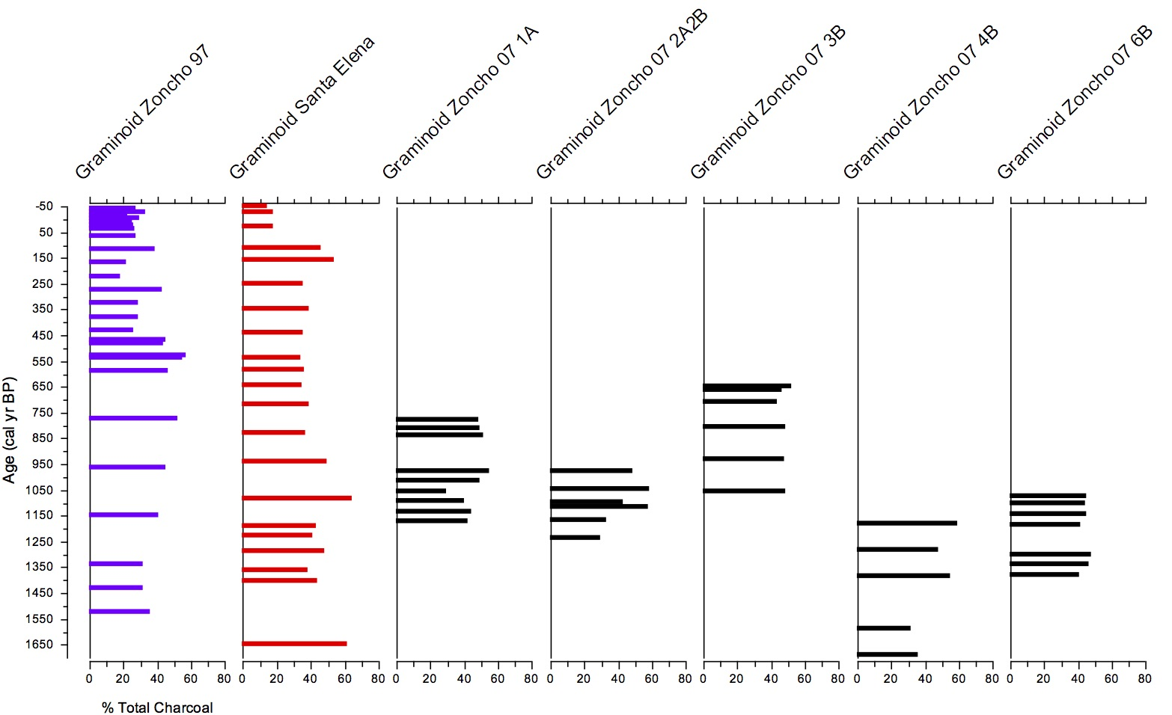
Figure 6.23. Graminoid charcoal morphology percentage trends in all seven of the Laguna Zoncho and Laguna Santa Elena cores. The letters in the core designations for the 2007 cores indicate whether the pollen samples came from the A core, the parallel B core, or both cores A and B from the site.
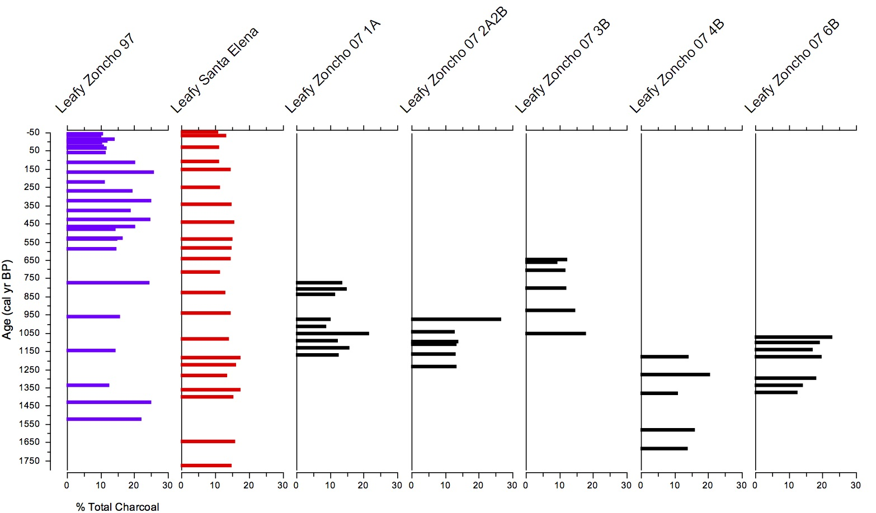

Figure 6.24. Leafy charcoal morphology percentage trends in all seven of the Laguna Zoncho and Laguna Santa Elena cores. The letters in the core designations for the 2007 cores indicate whether the pollen samples came from the A core, the parallel B core, or both cores A and B from the site.

Chapter seven
Discussion

In laboratory controlled combustion, do samples from different types of plants produce charcoal fragments that appear morphologically distinct?
A key goal of this study was to develop a more detailed system for classifying microscopic charcoal morphology and in this way potentially increase the value of what can be learned from sedimentary charcoal records. But developing a detailed classification of charcoal requires that distinctions can be made between charcoal derived from different plants, for example grasses versus trees, and plant tissues, for example wood from a shrub versus leaves from a shrub. Based on my review of the literature on microscopic and macroscopic charcoal morphology and on laboratory charcoalification of plant samples from the southeastern U.S. and Costa Rica, I was able to identify distinctions among charred monocot graminoid leaves, dicot leaves, and woody tissue. My examination of charred leaves from multiple sedge and grass taxa revealed graminoid morphologies not found in other charcoal morphotypes, including elongation, serration, and clear stomatal complexes. The compact, random, yet sometimes angular morphologies of charred wood from oaks (Quercus) and the shrub Vaccinium, considered alongside literature on woody charcoal morphology, led me to classify wood charcoal into Irregular or Geometric compact subclasses. The charcoalification of leaf samples from a variety of herbaceous and woody dicots led me to identify compact and random structures in the morphology of dicot leafy charcoal. These compact and random structures are more translucent than features of woody-type morphologies, and appear brittle, often with pores and crumbly edges. These distinctions allowed me to separate dicot leafy charcoal into a separate category from graminoid and woody charcoal, which has not been done in prior studies. My research revealed clear differences in the morphology of primary charcoal types, indicating that detailed classification of charcoal in lake sediments can provide information on the plants burned in past fires.

Do variations in the percentages of graminoid leaf, dicot leaf, and woody charcoal across periods of prehistoric agriculture and forest recovery over the last ca. 2000 years at Laguna Zoncho and Laguna Santa Elena indicate differences in fuel types?

Charcoal morphology in the Zoncho 1997 core

Zone 3 (1525–528 cal yr BP)
Charcoal morphology during the period of major prehistoric agriculture at Laguna Zoncho (Zone 3) shows overall trends of increasing Graminoid charcoal, generally decreasing Compact charcoal (until the top of the zone), and Leafy charcoal that is only about half as common, and swings up and down twice (Figure 6.9). The initial slight decrease in Graminoid charcoal until 1350 cal yr BP, when total charcoal concentration and influx decrease, suggests that when there was greater fire activity, greater proportions of grasses burned, and when fire activity decreased, lower proportions of grasses burned. The initial increase in Compact Charcoal when concentration and influx decreased suggests woody plants burned in greater proportions during less fire activity. This idea is further supported by the near identical dips and peaks among Lasagna Cluster and Lasagna Noodle morphologies, concentration, and influx (Figure 6.11); as fire activity increased through Zone 3, grasses became a more prominent fuel type. The massive spike in Lasagna Cluster morphology at the end of the zone when total charcoal influx peaks, suggests that the percentage of Lasagna Cluster fragments produced by the burning of graminoids may be an indicator from charcoal morphology of human disturbance and agricultural presence.
The increasing proportion of Graminoid charcoal and decreasing proportion of Compact charcoal when there is increased pollen of grasses and herbaceous disturbance taxa, and continuous maize presence, suggests increased burning of grasses as agriculture continued to intensify (Figure 6.13). The significant proportion of Compact charcoal at the start of the record when ignitions and grasses are high and maize is present likely indicates forest clearance and the burning of girdled or felled trees. Decreasing Compact charcoal as forest pollen taxa decline suggests less burning of forests as cultivated areas increased. In the upper part of Zone 3, changes in percentages of leafy charcoal parallel shifts in total tree pollen, but this is not the case through the zone. Because dicot leafy charcoal can be produced from the leaves of herbs, shrubs, or trees growing in forest or in disturbed areas, this charcoal type can enter the lake sediments following fires burning in varied contexts.
The increase in Graminoid charcoal from 1150 cal yr BP onward, indicating increased burning of grasses, occurs when δ¹³C values are more positive (Figure 6.16), supporting the sensitivity of stable carbon isotope values to forest disturbance (Lane et al. 2004). However, the continued greater dominance of Graminoid charcoal toward the end of Zone 1, when δ¹³C values become more negative, shows that charcoal morphology does not always change consistently with stable carbon isotope values.
Overall, charcoal morphology in Zone 3 supports the previous interpretation that large-scale agricultural burning preceded Spanish arrival in Costa Rica (Clement and Horn 2001) and indicates that grasses and sedges were a major fuel type during the centuries leading up to the Conquest, peaking before the Spanish arrived.

Zone 2 (528–60 cal yr BP)
Charcoal morphology during the period of forest recovery at Laguna Zoncho (Zone 2) shows a decrease in Graminoid charcoal, an increase in Compact charcoal, and continued moderate levels of Leafy charcoal (Figure 6.9). The more gradual decline in Graminoid charcoal when concentration and influx sharply decline at the start of this zone shortly preceding the Conquest shows that even though large-scale burning abruptly ceased, a significant amount of grassy fuel types continued to enter the sediment record. Several Graminoid and Compact sub-types (Serrated, Long/Thin, Compact Geometric, and Compact Irregular) increase simultaneously around the time of the Conquest, half a century after concentration and influx decline. But the immediate and continued decline in Lasagna morphologies when fire declined suggests Lasagna types may be a good indicator of human disturbance and cultivation. The record peak in Compact charcoal (primarily Compact Irregular charcoal) when concentration and influx are low supports the idea that when there were fewer fires, plants that did burn were primarily woody.
Less Graminoid charcoal when there are low pollen percentages of grass pollen (Figure 6.13), and similarly declining trends of Lasagna morphotypes and grass pollen (Figure 6.11), suggests graminoids were neither abundant nor often ignited during infrequent fires. The complete absence of Lasagna Cluster charcoal following the height of the Little Ice Age, shown by Wu et al. (2017) to have been cooler at Laguna Zoncho, suggests the possibility that widespread cooling may have affected what types of plant fuels were burned. More Compact charcoal when forest pollen taxa are abundant and δ¹³C values are more negative (Figure 6.16) indicates that the few infrequent fires recorded in the sediments burned woody plants that were increasingly present as forests recovered following the Conquest.

Zone 1 (60 cal yr BP to –47 cal yr BP)
Charcoal morphology over the last century at Laguna Zoncho (Zone 1) is predominately Compact, with low levels of Graminoid and Leafy charcoal and nearly absent Lasagna morphotypes (Figure 6.9). This is puzzling since total charcoal concentration, influx, grass pollen, and δ¹³C values increase slightly in the modern zone (Figures 6.13 and 6.16), but may indicate that fires during this period differed from the agricultural fires prior to the Conquest.

Charcoal morphology in the Santa Elena core

Zone 3 (1780–1590 cal yr BP)
Charcoal morphology in Zone 3 at Laguna Santa Elena shows similar percentages of Graminoid and Compact charcoal at the start, with a subsequent increase in Graminoid charcoal and decrease in Compact charcoal; Leafy dicot charcoal is consistently low, yet present, throughout the record (Figure 6.10), which suggests that as at Laguna Zoncho, dicot leaves of various plants burned in all fires, whether in forests or fields. The increase in Graminoid charcoal and decrease in Compact charcoal when charcoal concentration first increases and maize pollen is present suggests that as at Laguna Zoncho, a greater proportion of graminoids burned as fires increased. Increasing Graminoid charcoal along with low, yet increasing pollen percentages for grasses and herbaceous disturbance taxa and initially high, yet declining evidence of forest taxa (Figure 6.14) suggests that grasses were beginning to replace trees as the prominent fuel type, as agriculture expanded at Laguna Santa Elena. The peak in Lasagna Cluster and Lasagna Noodle (Figure 6.12) and Long/Thin morphotypes toward the top of the zone suggests increasing cultivation. As at Laguna Zoncho, Lasagna morphologies seem to be a good indicator of human disturbance. More negative δ¹³C values when Graminoid charcoal increases (Figure 6.17) may be explained by the fact that agricultural fields were still expanding, with grasses and sedges in fields or field edges burning enough to impact the charcoal morphology record, but not yet abundant enough to affect the stable carbon isotope record.

Zone 2c (1590–1150 cal yr BP)
Charcoal morphology in the next period at Laguna Santa Elena (Zone 2c) once again shows similar percentages of Graminoid and Compact charcoal (Figure 6.10). Even amounts of Graminoid and Compact charcoal when concentration and influx peak midway through the zone suggest that grasses and sedges as well as woody plants were important fuel sources. The positive spike in δ¹³C values when Graminoid charcoal no longer makes up the majority of charcoal (Figure 6.17) indicates that agricultural expansion was not always associated with increased burning of grasses.

Zone 2b (1150–880 cal yr BP)
Charcoal morphology during the Terminal Classic Drought at Laguna Santa Elena (Zone 2b) initially shows a large increase in Graminoid charcoal and decrease in Compact charcoal, followed by slightly decreased Graminoid charcoal and increased Compact charcoal (Figure 6.10). The presence of so much Graminoid charcoal and so little Compact charcoal as total charcoal concentration remains relatively high suggests the burning of fields more than forests. Increased Lasagna Cluster, Lasagna Noodle, Serrated, and Long/Thin morphotypes indicate that graminoids were major fuel sources, consistent with the high percentages of grass and sedge pollen. A spike in Graminoid charcoal occurs at the time of highest tree pollen in the record, at 1086 cal yr BP (Figure 6.14), perhaps indicating that some forest regrowth was occurring while grasses remained the main fuel type. Decreasing Graminoid and increasing Compact charcoal at the end of the zone may indicate a change in fuel type possibly associated with the effects of the TCD.

Zone 2a (880–450 cal yr BP)
Charcoal morphology in the period following the TCD and leading into the Conquest at Laguna Santa Elena (Zone 2a) shows less Graminoid charcoal and more Compact charcoal (Figure 6.10). Decreased Graminoid charcoal compared to Compact charcoal with low charcoal influx suggests that fewer grasses were being burned with decreasing fire. The greatly reduced Lasagna morphotype presence that occurs well before the decline in grass pollen (Figure 6.12) indicates that even though grasses stopped burning as much at the start of the zone, they remained a significant component of the vegetation assemblage for a while after. When tree pollen more than doubled in the middle of the zone, and grass, sedge, and Asteraceae pollen declined (Figure 6.14), charcoal morphology did not change, suggesting that fuel sources did not vary even as forests were recovering following a population decline prior to the Conquest (Kerr et al. 2020).

Zone 1 (450 to –50 cal yr BP)
Charcoal morphology in the post-Conquest period at Laguna Santa Elena (Zone 1) shows relatively similar percentages of Graminoid and Compact charcoal at first, with greatly increased Compact Charcoal and reduced Graminoid charcoal over the last century (Figure 6.10), as at Laguna Zoncho. The recent spike in Compact charcoal when the pollen record shows decreased tree pollen (Figure 6.14) suggests possible burning of forests associated with the arrival of non-indigenous people and modern agriculture (Kerr et al. 2020).

Morphological differences between the two notable charcoal peaks in Santa Elena core
Two distinct peaks in charcoal concentration and influx occur in the Laguna Santa Elena record: the first at 1365 cal yr BP, and the second at 216 cal yr BP (Figure 6.10). At the first peak, all charcoal morphology types are prominently represented in the record, with Compact and Graminoid morphologies making up relatively even percentages of total charcoal around 40% each, and Leafy morphology making up over 15%. This peak burning event therefore suggests that a large amount of graminoids and woody taxa were burning, possibly indicating a combination of forest clearance alongside intensifying cultivation and burning of agricultural fields. At the second, recent peak in charcoal influx, Graminoid morphologies make up around 35% of total charcoal and Compact morphologies make up 50%, with Leafy morphology still making up 15%. During this peak, Lasagna morphotypes are virtually absent, while the Compact Irregular morphotype is prominent. This second Santa Elena peak in charcoal, which is not apparent in the Zoncho 1997 record, may represent fires that burned forest vegetation more than open areas in a time when forests had regenerated around the lake. While Graminoid charcoal was also present, the near absence of Lasagna charcoal morphologies is consistent with the idea that indigenous cultivation in the area was much reduced at this time, and that non-indigenous settlers had yet to arrive in the area (Kerr et al. 2020). The fire activity that peaked at 216 cal yr BP could represent wildfires burning largely intact forests, possible ignited during droughts, from agricultural fires elsewhere that burned out of control, or from lightning.

Notable trends in microscopic charcoal morphology
Based on results from the Laguna Zoncho 1997 core and the Laguna Santa Elena core, patterns among microscopic charcoal morphology, total charcoal concentration and influx, and pollen are evident, though distinct between the two cores (Figure 6.15). In the Zoncho 1997 record, Graminoid charcoal percentage follows a similar trend with Poaceae pollen percentage. Combined Compact and Leafy charcoal percentage shows a close association with total tree pollen percentage. These patterns can be used to infer disturbance and recovery patterns in the area surrounding Laguna Zoncho related to fuel type. When grass pollen percentages were higher, indicating increased grass abundance, greater percentages of Graminoid charcoal entered the sediment record, suggesting that a greater percentage of grasses likely burned as fuel. The opposite likely occurred when grasses were less abundant. Though less obvious in the record than with Graminoid charcoal and grasses, generally when there were more trees and forest vegetation around Laguna Zoncho, greater percentages of Compact, and to a lesser extent Leafy charcoal entered the sediment record, indicating increased burning of woody plants, and of dicot leaves that could have come from trees, shrubs, or dicotyledonous herbs. When a lower percentage of tree pollen entered the sediment record, generally lower percentages of Compact (and somewhat less Leafy) charcoal entered the record, indicating that grasses and sedges made up a greater portion of ignited fuel at these times. Leafy charcoal percentages are similar across the record, however, suggesting that dicot leaves from trees, shrubs, or herbs burned at similar levels, despite changes in land use and vegetation.
The Laguna Santa Elena record also shows patterns between charcoal morphology and pollen, though these patterns are different from those evident in the Laguna Zoncho 1997 record (Figure 6.15). While the Zoncho 1997 record shows positive relationships between percentages of Graminoid charcoal percentage and grass pollen, and between percentages of Compact charcoal and tree pollen, the Santa Elena record shows more negative relationships. When grass pollen percentages were higher, indicating more abundant grasses, lower percentages of Graminoid charcoal entered the sediment record, suggesting that grasses made up a lower percentage of burned fields. When grass pollen percentages were lower, the record shows that higher percentages of Graminoid charcoal entered the sediment. Similarly, when tree pollen percentages were higher, suggesting greater forest cover, generally lower percentages of Compact charcoal entered the sediment record, while times of lower tree pollen generally showed higher percentages of Compact charcoal. Leafy charcoal showed little relationship to pollen in the Laguna Santa Elena record. The opposing trends between grass pollen and Graminoid charcoal and between tree pollen and Compact charcoal at Laguna Santa Elena suggest that even when more grasses were present at the site, fewer grasses were ignited as fuel, and that when more woody trees were present, fires were less often burning wood. One possibility is that the grasses and sedges that contributed to the high graminoid pollen counts at Laguna Santa Elena were mainly growing in marshy areas adjacent to the lake, or even within the lake in floating mats. This growing condition would make the plants less likely to burn. Another possibility is that prehistoric population levels and land use at Laguna Santa Elena and Laguna Zoncho differed, and that these differences somehow affected charcoal morphologies.
Though distinct in the way charcoal morphology is associated with pollen, the sediment records from both lakes show that peaks in total charcoal concentration and influx are associated with higher Graminoid charcoal morphologies (Figure 6.15). When charcoal levels are low, Compact charcoal is greater, or percentages of Graminoid and Compact charcoal are more even. These findings suggest that fires during intervals of high fire activity in both records are characteristically fueled by grasses and sedges, resulting in more Graminoid morphologies as a percentage of total charcoal.

Can the classification of microscopic charcoal morphology help explain contrasting charcoal records at these two lakes in southern Pacific Costa Rica?
Classifying microscopic charcoal in the Laguna Zoncho and Santa Elena cores contributes some new information to understanding the differences between the charcoal records at the two sites, but more remains to be learned. One motivation of my research was to see whether charcoal morphology might explain the high influx of charcoal at Laguna Santa Elena during the historic period, which did not occur at Laguna Zoncho. Based on charcoal morphology, much of the historic charcoal at Laguna Santa Elena came from the burning of woody fuels. Because macroscopic charcoal is absent in the Santa Elena core during this interval (Anchukaitis and Horn 2005), the microscopic charcoal may largely reflect fires associated with historic deforestation of the wider region.
Another motivation for my research on charcoal morphology classification was to see if charcoal morphology could shed light on the history of site abandonment and forest regrowth at Laguna Zoncho and Laguna Santa Elena at or prior to the Spanish Conquest. While total charcoal concentration and influx values from the Laguna Zoncho 1997 record significantly decrease in the century leading up to the Conquest, these values only slightly decrease at the same in the Laguna Santa Elena record, suggesting that fire activity dissipated much more rapidly and suddenly around Laguna Zoncho than around Laguna Santa Elena shortly prior to the Conquest. Clement and Horn (2001) saw tree pollen increase and grass pollen decrease in the Zoncho 1997 core at about 460 cal yr BP, suggesting population decline and forest recovery associated with the Conquest. On the other hand, Anchukaitis and Horn (2005) and Kerr et al. (2020) identified evidence of forest regrowth following an earlier decline in population around 700 cal yr BP, and also much earlier at 1085 cal yr BP (Kerr et al. 2020) at Laguna Santa Elena. In the cores collected in 2007, Taylor et al. (2013b, 2015) found stable carbon isotope shifts indicative of site abandonment around the same time at Laguna Zoncho, over 200 years before the Conquest. The first work on stable carbon isotopes at Laguna Zoncho, using the 1997 core, also showed evidence of reduced maize cultivation and forest regrowth preceding the Conquest (Lane et al. 2004), before the major decline in grass pollen and increase in tree pollen in the record. In the original age model for the Zoncho 1997 core, these shifts in pollen and a decline in charcoal at the Zone 3/2 boundary occurred at ca. 460 cal yr BP (Clement and Horn 2001), or about the time of the Conquest, but the current age model (Taylor et al. 2020) puts these shifts slightly earlier, before the Conquest at ca. 528 cal yr BP.
Two pollen slides I examined from Laguna Zoncho bracket the time of the postulated population decline around 700 cal yr BP. Between samples with modeled ages of 776 and 589 cal yr BP, there is a slight rise in Compact charcoal percentage and decrease in Graminoid charcoal percentage concomitant with a slight decrease in total charcoal concentration and influx (Figure 6.9). These shifts, thought slight, support other proxy evidence that cultivation became somewhat less intensive and forests had already begun to regrow prior to the Conquest. However, the peaks in charcoal influx and Graminoid charcoal morphology percentage (and low percentage of Compact charcoal) at 538 cal yr BP suggests renewed cultivation prior to a second decline.
In the Santa Elena record, there is also no obvious shift in charcoal morphology around 700 cal yr BP nor leading up to the Conquest to match other evidence of site abandonment. Percentages of Graminoid and Compact charcoal remain consistent across samples with modeled ages of 720 and 646 cal yr BP and until shortly after the Conquest, despite a slight decline in charcoal concentration and influx between 720 and 646 cal yr BP (Figure 6.10). The lack of strong evidence in the charcoal morphology of site abandonment near or at the time of the Spanish Conquest is somewhat surprising given the evidence in other proxies in the same cores, and may suggest that charcoal morphology is not as sensitive to reductions in agriculture and forest recovery, which may happen over decades, as it is to forest clearance and the expansion of agricultural fields, which may occur much more rapidly.

Does a series of additional, shorter cores taken from different positions in Laguna Zoncho show consistent percentages of different charcoal morphologies across the lake basin?
Where samples from the Laguna Zoncho 2007 cores overlap in age, they provide a means to explore whether the percentages of different charcoal morphologies are consistent across the lake basin, from core sites at various water depths and distances from shore. Where Core 1 and Core 2 overlap between 1100 and 950 cal yr BP, there is an increasing trend in Lasagna Cluster fragments and in Lasagna Noodle fragments in both cores. Where Core 4 and Core 6 overlap between 1350 and 1150 cal yr BP, another increasing trend in fragments of both morphotypes is apparent (Figure 6.18–6.19). Similarly, for the overlap in Core 1 and Core 2, total Graminoid charcoal generally increases between 1150 cal yr BP and 950 cal yr BP. The same pattern is seen during that time span in the Zoncho 1997 core (Figure 6.20). Among the Zoncho 2007 cores, there are more similarities in Graminoid charcoal trends, likely due to their stronger associations with fire, and perhaps partially due to their distinctive morphologies that reduce classification error. Other trends in morphological types do not match up as well across overlapping cores. For instance, Leafy charcoal percentages are consistently low with few trend patterns and associations within and among the cores (Figure 6.21). When compared to one another and to the Zoncho 1997 and Santa Elena cores, total percentage values among Graminoid, Compact, and Leafy morphologies are, however, generally similar (Figures 6.22–6.24), suggesting that charcoal of different morphologies is deposited fairly consistently across the lake basin. This finding is of potential importance for the application of microscopic charcoal morphology in paleoenvironmental studies, as it suggests that similar percentages of different charcoal morphologies might be found in cores taken from different parts of a lake. However, more analyses are needed to determine whether temporal trends in charcoal morphologies are consistent across multiple cores from a single basin.

Chapter Eight
Conclusions

The system of classification for microscopic charcoal morphology employed in this study builds on previous macroscopic and microscopic studies attempting to distinguish different plant types that burned in past fires. While past research has successfully distinguished grassy from woody charcoal fragments and recorded clear distinctions among particles, my classification additionally distinguishes dicot leafy fragments in the identification of fuel types.
When applied to sediment cores from two neotropical lakes near one another in the Diquís region of southern Pacific Costa Rica, my classification system for microscopic charcoal revealed relationships between charcoal morphological types and other proxies including total charcoal concentrations and influxes and pollen percentages. However, relationships differed between the two lakes. The Laguna Zoncho 1997 core shows a positive relationship between grass pollen and Graminoid charcoal percentages and between tree pollen and Compact charcoal percentages, while the Laguna Santa Elena core shows a more negative association between grass pollen and Graminoid charcoal percentages and between tree pollen and Compact charcoal percentages. Graminoid morphology percentages tend to show a positive relationship with total charcoal concentration and influx in both the Zoncho 1997 core and the Santa Elena core, suggesting that graminoid fuel types like grasses and sedges were more prominent during intervals of high fire activity. My morphology record additionally shows that the high modern influx of charcoal that occurred at Laguna Santa Elena, but not at Laguna Zoncho, during the historic period came primarily from woody fuel sources, possibly reflecting regional fires from modern deforestation.
While percentages of Graminoid and Compact charcoal showed clear trends in the Santa Elena and Zoncho cores and relationships to other proxies, Leafy dicot charcoal did not show consistent relationships with the other charcoal morphologies or other proxies. This charcoal morphology may be less informative because Leafy dicot charcoal is produced by trees, shrubs, and herbs. Thus, the type may be less likely to record shifting fuel sources. Nevertheless, the morphological distinction of Leafy dicot charcoal from other types may be valuable in studies of lake records from other areas of the world, and deserves attention in future studies. For example, in areas that lack woody vegetation, distinctions between Graminoid and Leafy dicot charcoal may reveal the importance of grasses and sedges versus other herbs as fuel sources.
Though the Laguna Zoncho 2007 cores cover time intervals too narrow to reveal significant trends in charcoal morphology, similar percentage values for the primary morphologies in these cores show that deposition of Graminoid, Compact, and Leafy charcoal is relatively constant across the lake basin. This finding suggests that percentages of different morphologies may be somewhat independent of depths and distance from shore, which means that cores recovered from a variety of positions within lakes may be suitable for charcoal morphological analysis. However, this finding needs more study, especially in terms of documenting trends in charcoal morphology in multiple cores from a lake basin.
Previous research has revealed evidence for site abandonment and forest regrowth, perhaps in two stages, between 750 cal yr BP and 450 cal yr BP, around the time of the Spanish Conquest. The Laguna Zoncho charcoal morphology record supports the idea that land use became less intensive shortly before the Conquest, and forest recovery occurred around the time of the Conquest, with a smaller shift in morphology a couple centuries earlier that could also indicate less intensive cultivation and moderate forest growth prior to the Conquest. The Laguna Santa Elena charcoal morphology record does not contribute new information on the scale and precise timing of site abandonment and forest recovery, but may indicate that charcoal morphology is more sensitive to forest clearance and agricultural expansion than the slower process of agricultural reduction and forest recovery.
A possible limitation to this study was the inability to perfectly mimic natural forces impacting charcoal deposition during laboratory charcoalification. The charcoal fragments examined in the lake sediment cores may have been broken, corroded, or otherwise affected by sediment transport processes before their deposition into the lake sediments. In contrast, the microscopic reference charcoal I examined was produced under controlled laboratory conditions with no transport. It is likely that charcoal appearance differs somewhat between the reference samples experimentally produced and the charcoal found in the natural environment, possibly leading to the misclassification of morphologies. Future experimental studies that include simulation of transport of charcoal could help reduce possible structural differences between charcoal preserved in lake sediments and reference charcoal. Running reference charcoal through pollen processing might be important for producing reference samples that more closely resemble charcoal in samples prepared from lake sediment cores.
My thesis is one of the few paleolimnological studies to investigate microscopic charcoal morphology, and may be the only study that has attempted to distinguish charcoal particles presumed to have derived from dicot leafy sources as well as graminoid and woody sources. The data from this research contribute to the growing body of paleolimnological work on Lagunas Zoncho and Santa Elena and more broadly on southern Pacific Costa Rica. It serves to refine the current understanding of agricultural and forest histories over the last ca. 2000 years surrounding the lakes, although questions remain on the timing of agricultural decline and forest recovery at the two sites, and on differences in charcoal influx in the last several centuries. Additional research on trends in charcoal morphologies and pollen, based on preparing and analyzing slides from more levels of the Zoncho 1997 core and the Santa Elena core, may be helpful in understanding why trends presented here for the two lakes seem to oppose one another. Additional research on morphology patterns during periods of postulated forest clearance and agricultural expansion versus periods of postulated agricultural decline and forest recovery could better reveal how charcoal morphology responds to each of these processes, and test the idea that the proxy may be more sensitive to rapid shifts in land use at the start of cultivation than to the cessation of cultivation.
Future studies could also use my system for classifying microscopic charcoal morphology in other lake sediment cores within or outside of southern Pacific Costa Rica to assess its usefulness in both similar and different environments. There are several other lakes within the Diquís region with charcoal, pollen, and other proxy records that would be complemented by studies of microscopic charcoal morphology. Classification of microscopic charcoal morphology could also be useful in combination with stable carbon isotope analyses to provide evidence of past vegetation from sites where pollen is not well preserved, as classifying fuel types can hint at plants and vegetation that existed and burned in the past.
                - References
Anchukaitis, K. J., and Horn, S. P. 2005. A 2000-year reconstruction of forest disturbance from southern Pacific Costa Rica. Palaeogeography, Palaeoclimatology, Palaeoecology. 221: 35–54.
Anderson, L. and Wahl, D. 2016. Two Holocene paleofire records from Peten, Guatemala: Implications for natural fire regime and prehispanic Maya land use. Global and Planetary Change. 138: 82–92.
Behling, H. 2000. 2860–year high resolution pollen and charcoal record from the Cordillera de Talamanca in Panama: A history of human and volcanic forest disturbance. Holocene. 10: 387–393.
Berglund, B. E. 1986. Handbook of Holocene Palaeoecology and Palaeohydrology. New York: John Wiley and Sons.
Blaauw, M. 2010. Methods and code for ‘classical’ age-modelling of radiocarbon sequences. Quaternary Geochronology. 5: 512–518.
Burney, D. A., Burney L. P., and MacPhee, R. D. E. 1994. Holocene charcoal stratigraphy from Laguna Tortuguero, Puerto Rico, and the timing of human arrival on the island. Journal of Archaeological Science. 21: 273–281.
Clark, R. L. 1982. Point count estimation of charcoal in pollen preparations and thin sections of sediments. Pollen et Spores. 24: 523–535.
Clement, R. M. and Horn, S. P. 2001. Pre-Columbian land-use history in Costa Rica: A 3000-year record of forest clearance, agriculture and fires from Laguna Zoncho. The Holocene. 11(4): 419–426.
Colinvaux, P. A., De Oliveira, P. E., and Moreno, J. E. 1999. Amazon Pollen Manual and Atlas. Amsterdam: Hardwood Academic Publishers.
Coen, E. 1983. Climate. In: Janzen, D. H. (ed). Costa Rican Natural History. Chicago: University of Chicago Press. 35–46.
Cooke, R. 2005. Prehistory of Native Americans on the Central American Land Bridge: Colonization, Dispersal, and Divergence. Journal of Archaeological Research. 13(2): 129–187.
Crawford, A. J. and Belcher, C. M. 2014. Charcoal morphometry for paeleoecological analysis: The effects of fuel type and transportation on morphological parameters. Applications in Plant Sciences. 2(8).
Dull, R. A. 2004. A Holocene record of neotropical savanna dynamics from El Salvador. Journal of Paleolimnology. 32: 219–231.
Dull, R. A., Nevle, R. J., Woods, W. I., Bird, D. K., Avnery, S., and Denevan, W. M. 2010. The Columbian encounter and the Little Ice Age: Abrupt land use change, fire, and greenhouse forcing. Annals of the Association of American Geographers. 100(4): 755–771.
Enache, M. D. and Cumming, B. F. 2007. Charcoal morphotypes in lake sediments from British Columbia (Canada): An assessment of their utility for the reconstruction of past fire and precipitation. Journal of Paleolimnology. 38: 347–363.
Filippelli, G. M., Souch, C., Horn, S. P., and Newkirk, D. 2010. The pre-Colombian footprint on terrestrial nutrient cycling in Costa Rica: Insights from phosphorous in a lake sediment record. Journal of Paleolimnology. 43: 843–856.
Geurds, A. 2018. Prehistory of southern Central America. In: Smith, C. (ed). Encyclopedia of Global Archaeology. Adelaide, Australia: Springer, 1–20.
Haberyan, K. A., and Horn, S. P. 2005. Diatom paleoecology of Laguna Zoncho, Costa Rica. Journal of Paleolimnology. 33: 361–369.
Hall, C. 1985. Costa Rica: A Geographical Interpretation in Historical Perspective. Dellplain Latin American Studies, no. 17. London: Westview.
Herrera, W. 2016. Climate of Costa Rica. In: Kappelle, M. (ed). Costa Rican Ecosystems. Chicago: University of Chicago Press, 19–29.
Horn, S. P. 2006. Pre-Columbian maize agriculture in Costa Rica: Pollen and other evidence from lake and swamp sediments. In: J Staller, J., Tykot, R., and Benz, B. (eds). Histories of Maize: Multidisciplinary Approaches to the Prehistory, Biogeography, Domestication, and Evolution of Maize. San Diego: Elsevier Press, 367–380.
Horn, S. P. and Hayberyan, K. A. 2016. Lakes of Costa Rica. In: Kappelle, M. (ed). Costa Rica Ecosystems. Chicago: University of Chicago Press, 656–682.
Horn, S. P. and Underwood, C. A. 2014. Methods for the study of soil charcoal as an indicator of fire and forest history in the Appalachian region, USA. In: Waldrop, T. A. (ed). Wildland Fire in the Appalachians: Discussions Among Managers and Scientists. General Technical Report SRS–199. Asheville: U.S. Department of Agriculture Forest Service, Southern Research Station, 104–199.
Hupy, C. M. and Yansa, C. H. 2009. Late Holocene vegetation history of the forest tension zone in central lower Michigan, USA. Physical Geography. 30(3): 205–235.
Instituto Meteorólogico Nacional. N.d. Precipitación Promedio Anual en Costa Rica, 1961–1980. Escala 1:1,600,000. https://www.imn.ac.cr/web/imn/atlas-climatologico.
Johanson, E. N., Horn, S. P., and Lane, C. S. 2019. Pre-Columbian agriculture, fire, and Spanish contact: A 4200-year record from Laguna Los Mangos, Costa Rica. The Holocene. 29(11): 1743–1757.
Johanson, E. N., Horn, S. P., Lane, C. S., Sanchez, M., and Cecil, J. 2020. Fire history across the Little Ice Age in southern Pacific Costa Rica. Journal of Paleolimnology. 64: 1–23.
Juggins, S. 2007. C2: Software for ecological and paleoecological data analysis and visualization (user guide version 1.5). Newcastle upon Tyne: Newcastle University, UK.
Kerr, M. T. 2019. Holocene Precipitation Variability, Prehistoric Agriculture, and Natural and Human-Set Fires in Costa Rica. University of Tennessee, Knoxville. Doctoral Dissertation.
Kerr, M. T., Horn, S. P., and Lane, C. S. 2020. Stable isotope analysis of vegetation history and land use change at Laguna Santa Elena in southern Pacific Costa Rica. Vegetation History and Archaeobotany. 29: 477–492.
Kottek, M., Grieser, J., Beck, C., Rudolf, B., and Rubel, F. 2006. World map of the Köppen-Geiger climate classification. Meteorologische Zeitschrift. 15(3): 259–263.
Lafon, C. W., Naito, A. T., Grissino-Mayer, H. D., Horn, S. P., and Waldrop, T. A. 2017. Fire History of the Appalachian Region: A Review and Synthesis. General Technical Report SRS–219. Asheville: US Department of Agriculture, Forest Service, Southern Research Station. 97.
Lane, C. S., Horn, S. P., and Mora, C. I. 2004. Stable carbon isotope ratios in lake and swamp sediments as a proxy for prehistoric forest clearance and crop cultivation in the Neotropics. Journal of Paleolimnology. 32: 375–381.
Lane, C. S., Horn, S. P., and Kerr, M. T. 2014. Beyond the Mayan lowlands: Impacts of the terminal classic drought in the Caribbearn Antilles. Quaternary Science Reviews. 86: 89–98.
Mworia-Maitima, J. 1997. Prehistoric fires and land-cover change in western Kenya: Evidences from charcoal, grass cuticles and grass phytoliths. The Holocene. 7(4): 409–417.
Nevle, R. J., Bird, D. K., Ruddiman, W. F., and Dull, R. A. 2011. Neotropical human-landscape interactions, fire, and atmospheric CO₂ during European conquest. The Holocene. 21(5): 853–864.
Orvis, K. H., Lane, C. S., and Horn, S. P. 2005. Laboratory production of vouchered reference charcoal from small wood samples and non-woody plant tissues. Palynology. 29: 1–11.
Patterson, W. A. (III), Edwards, K. J., and Maguire, D. J. 1987. Microscopic charcoal as a fossil indicator of fire. Quaternary Science Reviews. 6(1): 3–23.
Peters, M. E. and Higuera, P. E. 2007. Quantifying the source area of macroscopic charcoal with a particle dispersal model. Quaternary Research. 67: 304–310.
Piperno, D. R. 2006. Quaternary environmental history and agricultural impact on vegetation in Central America. Annals of the Missouri Botanical Garden. 93(2): 274–296.
Power, M. J., Bush, M. B., Behling, H., Horn, S. P., Mayle, F. E., and Urrego, D. H. 2010. Paleofire activity in tropical America during the last 21 ka: A regional synthesis based on sedimentary charcoal. 18(2).
Power, M. J., Mayle, F. E., Bartlein, P. J., Marlon, J. R., Anderson, R. S., Behling, H., Brown, K. J., Carcaillet, C., Colombaroli, D., Gavin, D. G., Hallett, D. J., Horn, S. P., Kennedy, L. M., Lane, C. S., Long, C. J., Moreno, P. I., Paitre, C., Robinson, G., Taylor, Z., and Walsh, M. K. 2013. Climatic control of the biomass-burning decline in the Americas after AD 1500. The Holocene. 23(1): 3–13.
Reimer, P. J., Bard, E., Bayliss, A., Beck, J. W., Bertrand, C. J. H., Blackwell, P. G., Ramsey, C. B., Buck, C. E., Cheng, H., Edwards, R. L., Friedrich, M., Grootes, P. M., Guilderson, T. P., Haflidason, H., Hajdas, I., Hatté, C., Heaton, T. J., Hoffmann, D. L., Hogg, A. G., Hughen, K. A., Kaiser, K. F., Kromer, B., Manning, S. W., Niu, M., Reimer, R. W., Richards, D. A., Scott, E. M., Southon, J. R., Staff, R. A., Turney, C. S. M., and van der Plicht, J. 2013. IntCal13 and Marine13 radiocarbon age calibration curves 0–50,000 years cal bp. Radiocarbon. 55(4): 1869–1887.
Snarskis, M. J. 1981. The archaeology of Costa Rica. In: Benson, E. P. (ed). Between Continents/Between Seas: Precolumbian Art of Costa Rica. New York: Harry N Abrams, 15–84.
Taylor, Z. P., Horn, S. P., and Finkelstein, D. B. 2013a. Maize pollen concentrations in neotropical lake sediments as an indicator of the scale of prehistoric agriculture. The Holocene. 23(1): 78–84.
Taylor, Z. P., Horn, S. P., and Finkelstein, D. B. 2013b. Pre-Hispanic agricultural decline prior to Spanish Conquest in southern Central America. Quaternary Science Reviews. 73: 196–200.
Taylor, Z. P., Lane, C. S., and Horn, S. P. 2020. A 3600-year record of drought in southern Pacific Costa Rica. Quaternary Research. 98: 36–48.
Taylor, Z. P., Horn, S. P., and Finkelstein, D. B. 2015. Assessing intra-basin spatial variability in geochemical and isotopic signatures in the sediments of a small neotropical lake. Journal of Paleolimnology. 54: 395–411.
Tieszen, L. L. 1991. Natural variations in the carbon isotope values of plants: Implications for archaeology, ecology, and paleoecology. Journal of Archaeological Science. 18: 227–248.
Torres-Rodriguez, E., Figueroa-Rangel, B. L., Lozano-Garcia, S., Ortega-Guerrero, B., Caballero-Miranda, M., and Herrejon-Serrano, A. 2022. Charcoal morphotypes and potential fuel types from a Mexican lake during MIS 5a and MIS 3. Journal of South American Earth Sciences. 115.
Umbanhowar, C. E. (Jr.), and McGrath, M. J. 1998. Experimental production and analysis of microscopic charcoal from wood, leaves and grasses. The Holocene. 8(3): 341–346.
Vachula, R. S. 2020. A meta-analytical approach to understanding the charcoal area problem. Palaeogeography, Palaeoclimatology, Palaeoecology. 562.
Vachula, R. S., Sae-Lim, J., and Li, R. 2021. A critical appraisal of charcoal morphometry as a paleofire fuel type proxy. Quaternary Science Reviews. 262.
Van Geel, B. 2001. Non-pollen palynomorphs. In: Smol, J. P., Birks, H. J. B., and Last, W. M. (eds). Tracking Environmental Change Using Lake Sediments. Volume 3: Terrestrial, Algal, and Siliceous Indicators. Dordrecht: Kluwer Academic Publishers.
Walsh, M. K., Pearl, C. A., Whitlock, C., Bartlein, P. J., Worona, M. A. 2010. An 11,000-year-long record of fire and vegetation history at Beaver Lake, Oregon, central Willamette Valley. Quaternary Science Reviews. 29: 1093–1106.
Wooller, M. J. 2002. Fossil grass cuticles from lacustrine sediments: A review of methods applicable to the analysis of tropical African lake cores. The Holocene. 12(1): 97–105.
Wooller, M. J., Street-Perrott, F. A., and Agnew, A. D. Q. 2000. Late Quaternary fires and grassland palaeoecology of Mount Kenya, East Africa: Evidence from charred grass cuticles in lake sediments. Palaeogeography, Palaeoclimatology, Palaeoecology. 164: 207–230.
Wu, J., Porinchu, D. F., and Horn, S. P. 2017. A chironomid-based reconstruction of late-Holocene climate and environmental change for southern Pacific Costa Rica. The Holocene. 27: 73–84.

Vita

Jared Andrew Crain was born in Gainesville, Florida, but grew up in Maryville, Tennessee, and graduated from Maryville High School. He then attended Berry College in Mt. Berry, Georgia, and received his Bachelors of Science degree in Environmental Science with a concentration in Biology and a minor in Writing, graduating magna cum laude. Jared entered the Master’s program in Geography at the University of Tennessee in 2020. He served as a teaching assistant for introductory physical geography classes and for upper division courses on natural hazards and human-environment interactions.

