Religious Metaphor and Structural Complexity

Tyler Kibbey, University of Tennessee-Knoxville
tkibbey@vols.utk.edu

I. Introduction
In religion, figurative language has always been a point of concern, from St Augustine to the Religious Philosophers of the 21st century. In questions about the meaning of specific religious texts and questions about the linguistic expression of divinity, figurative language has been problematic for the Christian theological community since its inception. This is no different in the field of metaphor studies and cognitive linguistics, where linguists and philosophers of religion alike have been attempting to come to a new understanding of religious language in light of Lakoff and Johnson’s Conceptual Theory of Metaphor (1980). The majority of contemporary work on religious metaphor places heavy emphasis on the lexical item and sentential context of language, while largely ignoring the phenomenological aspects of truth which hold for theists who attribute figurative truth to religious metaphor in their daily lives. In that religious metaphor also exemplifies qualities of direct language, unusual for the generally indirect nature of conceptual metaphors in general, I argue that contemporary methodologies fall short of accurately analyzing religious metaphor as a dynamic and complex linguistic structure. So, I propose that metaphor, especially religious metaphor, can be understood as true or patently literal in certain sentential contexts and that a new modeling system, multi-modal phenomonolinguistic modeling, can be implemented in order to create an empirical understanding of metaphor that is more comprehensive than previous models. Religious metaphor, as uniquely direct or complex in nature, serves both as an example of metaphorical complexity and as an overlooked problem for Conceptual Metaphor Theory to which this methodology provides a solution.
As a brief summary of the contemporary theory, the Conceptual Theory of Metaphor is not to be confused with the Classical Theory of Metaphor, which states that metaphor serves only as linguistic ornamentation. Rather, the Conceptual Theory of Metaphor should be understood as a cross-domain mapping of two concepts, a target domain and source domain, which aids in our ability to understand the world (Lakoff and Johnson 1980; Lakoff 1993). According to Lakoff and Johnson’s original theory (1980), the target domain is generally a more abstract conceptual domain such as Time and, the source domain, which provides its conceptual qualities for the cross-domain mapping, is generally a more concrete domain of experience such as Money. Thus, TIME IS MONEY. This metaphor then allows us to understand our daily and intangible experiences of time in terms of the concrete domain of currency: “I spent three hours on a paper,” “He invested a lot of time into the company,” “They wasted their time waiting for their friends,” and many other such linguistic expressions. As is evident from this simple example, conceptual metaphor is a common part of everyday life which organizes structures of the world we live in and allows us to explain and understand both concrete and abstract concepts through creative linguistic highlighting and backgrounding of conceptual similarities (Lakoff 1993; Jäkel 2002; Shokr 2006).
Additionally, the underlying cognitive systems of metaphor also have logical entailments that derive from the way Lakoff and Johnson represent them as syllogistic structures: for example, if TIME IS MONEY, then you can be compensated for your time in money, which is the idea behind an hourly wage (1980). However, conceptual metaphor has largely been understood as a mechanism which allows only figurative mappings that do not relate back to the world as it actually is in reality. After all, it is impossible for us to literally spend time like money. I can neither exchange 30 minutes for a cup of coffee nor withdraw a few hours from my local Time Bank. Yet, there are instances in which metaphor takes on patently true or what I call “complex” properties which lend itself toward a broader understanding of conceptual metaphor.
Now, to better describe this notion of complexity as a variable quality that affects the interpretation of a linguistic unit as metaphorical, let us first consider the first stanza of the poem “The Road Not Taken” by Robert Frost and how complexity can impact non-religious metaphor.
“Two roads diverged in a yellow wood,
And sorry I could not travel both
And be one traveler, long I stood
And looked down one as far as I could
To where it bent in the undergrowth” (p341)
First of all, as a narrative poem, it remains unclear simply from the text itself whether the narrator is Frost or another individual, fictitious or historical. Here, I will simply refer to this individual as the Journeyman since the metaphorical analysis of this poem is not contingent on the identity of the individual who is ultimately contingent on Frost regardless. Now, from our base reality that we share with Frost, this is clearly a poetic usage of the LIFE IS A JOURNEY metaphor with a detailed image-schematic (i.e. the visual ontological mappings that transfer from the source domain to the target domain) fictional context.
However, in the reality- that is to say context- of the poem, the statement “Two roads diverged in a yellow wood” is a patently literal statement, the poem itself could not work in its current structure otherwise. Whether or not the Journeyman extrapolates metaphorical meaning from this context- and the final stanza of the poem suggests he does- is not central to the text, because the metaphor is ultimately for the audience and the author, as the author is also a part of the audience. Now, some might hesitantly offer a purely literal reading of the poem and suggest that it has no metaphorical properties whatsoever. Yet, due to the genre of the text, poetry, we are already inclined to create the metaphorical mapping from the source domain JOURNEY and the lexical items from the text (e.g. roads, travel, far, etc.) onto the source domain of LIFE. Examples of conventional uses of this metaphor occur in expressions like “I’ve lost all sense of direction in life,” “I feel lost,” and “You must choose a path to follow in life.” Even without an appreciation for poetry, we are inclined to interpret the poem as metaphorical.
Yet, Frost’s poem is not entirely metaphorical- it would not work as a piece of poetry if it were. Rather, the poem itself creates a contextual reality describing a literal event of indecisiveness while walking through an English wood during the fall. In fact, if you were to read that first stanza as a diary entry, it would seem perfectly literal and completely dull in its non-metaphorical account of waking through a forest. So how do we resolve this paradoxical literal-figurative duality of language usage. In figure 1 below, I demonstrate a modeling system which allows linguists to understand the shared context between Frost and the Journeyman explicitly as a literal reading of the poem which allows for an enhanced and increasingly deliberate metaphorical usage of the metaphor LIFE IS A JOURNEY.
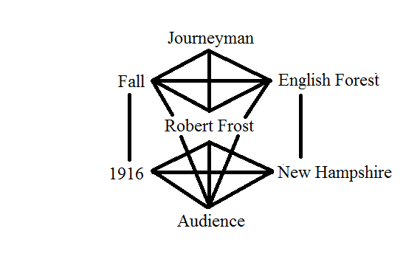
Fig. 1, Multi-Modal Phenomonolinguistic Model of “The Road Not Taken”
In figure 1, a modal understanding of the sentential and textual contexts as linguistic realities allows for an understanding of metaphor that is compatible with an interpretation of the poem as textually literal and linguistically metaphorical. Poetry is a particular genre which lends itself to these sorts of literal-figurative paradoxes in the Conceptual Theory of Metaphor and which is best understood contextually, both in the context of the author as a form of linguistic expression (Kövecses 2009) and in the textual reality of the poem itself.
Therefore, metaphor is a critically important aspect of communication, as ubiquitous in conversation and linguistic expression as it is difficult to analyze. The Conceptual Theory of Metaphor demonstrates that metaphor is a cornerstone of figurative language which allows us to both understand incredibly abstract concepts and re-conceptualize concrete objects in our experiential worlds (Lakoff and Johnson, 1980; Lakoff, 1993; Kövecses, 2009). However, as the above analysis of Frost’s poem shows, it falls short of fully accommodating metaphors that are patently true at the sentential or textual levels and tends to falsely equate these complex structures with conventional metaphors, which do not show the same level of complexity. For this reason, a new modeling system is needed for metaphor which more accurately models these structures which are especially prevalent in poetry, as demonstrated above, and religion.
II. Religious Metaphor, Complexity, and Multi-Modal Phenomenolinguistic Modeling
Now, religious metaphor, which is contextually true despite being figurative in form, causes several problems for the Conceptual Theory of Metaphor. I may say that “the King on High” exists, but it seems no different than if I were to speak of any king found in our experiential world. The key difference is that God as a lexical item is the linguistic representation is an inherently abstract conceptual domain. This domain contains within it an implicit and divine sense of truth for Christians who understand God as being like a person (i.e. personification) but not a person (Gomola 2015; Sztajer 2008). For instance, St. Augustine in his commentary on Genesis asserts that the language used in reference to God is figurative though this does not affect his belief in God’s existence or the “eternal truths” which he finds within the text of Genesis itself. Indeed, Augustine understands God as existing outside of the human ability to signify meaning through language, which leads to his thesis on the figurative-nature of referring to God (Ringer 2003):
“In all the sacred books, we should consider the eternal truths that are taught, the facts that are narrated, the future events that are predicted, and the precepts or counsels that are given. In the case of a narrative of events, the question arises as to whether everything must be taken according to the figurative sense only, or whether it must be expounded and defended also as a faithful record of what happened. No Christian will dare say that the narrative must not be taken in the figurative sense.” (Augustine, 1).
This occurs specifically within the introduction to his commentary on Genesis, where he spends a great deal of time attempting to reconcile crucial biblical verses in terms of figurative truth. One such aspect of God that Augustine contends with is God’s ability to speak, or that spoken words are attributed to him.
“And how did God say, ‘Let there be light?’ Was this in time or in the eternity of His Word? If this was spoken in time, it was certainly subject to change. How then could we conceive of God saying it except by means of a creature? For He Himself is unchangeable.” (Augustine, 2)
Here, St Augustine rejects the personification of God, in the literal sense, at the beginning of the universe, arguing that God is eternal and unchangeable and thus unable to take an active part in any sort of temporal domain. This is an important distinction from “immortal” or “everlasting” which refer to the property of not-dying and not-aging. In referring to God as eternal, Augustine is asserting that God existed before time and therefore exists outside of time. He then resolves the evident, causal problem by arguing that the Word of God (i.e. The Son of God), which was created as an entity within temporal existence, was the entity which uttered the words “Let there be light.” He says that, though Christ is co-eternal with God the Father, the Son of God must be the Word of God in the instance of God saying “Let there be light” because He was one of the first temporal entities to be created at the beginning of the world (Augustine, p3). Thus, Augustine is breaking down the metaphor of God’s eternal nature into a metaphysical argument that affects his conceptual metaphors: God is the only thing to exist before existence-itself and, being the source of everything that has been created in a physical and temporal world, cannot initially take part in the world. This allows God to be understood in figurative truths or complex metaphors about the qualities of personhood but distinguishes Him from concrete persons who exist finitely within time.
Augustine demonstrates in his commentary on Genesis that the conceptual domain of God, referred to as the Sacrum by Jeff Ringer (2003) and the Ultimate by Robert Neville and Wesley Wildman (2001), has unique properties at the level of linguistic expression. One such aspect in Christian thought is that it exists prototypically, causing God to become the prototypical perfection of any source domain used to understand Him. For instance, in The Dream of the Rood (trans. Liuzza), an 8th century Old English, Christian poem, the metaphor CHRIST IS KING appears throughout the text: “the King of Glory, Guardian of Heaven’s kingdom honored me” (l.90-91), “I raised up the mighty King, the Lord of Heaven” (1.44-45), and “the King’s fall: Christ on the cross” (l.56). In this poem, the conceptual domain GOD is structured in terms of the specific personification KING. In Anglo-Saxon England, the author of this poem would have had real life experiences with kings and monarchies. So, how can it be that this metaphor is experienced and interpreted as true if the author’s experience with God as king was different from his experience with men as kings. This peculiarity of patently true figurative language stems from an understanding that God is the abstract concept from which all concrete members of any given source domain derive, which we see in Augustine’s commentary above. In other words, the target domain God causes the source domain in question to become equally abstract, or at least more abstract than its default level of abstraction in relation to ourselves. Going back to the example metaphor CHRIST IS KING, this means that while Christ is understood as a king, He is also a perfect king and unlike any king we would have experiential knowledge of in our world.
In order to account for these peculiarities of religious metaphor, it is necessary to adopt an approach which places emphasis on the metaphors as valid experiences in addition to internal logic of their conceptual components. Therefore, I apply a modified form of thematic modeling which I borrowed from a phenomenological study of serpent handling in which the authors, W. Williamson and Howard Pollio, argue for an interpretation of sermons which places emphasis on the experiential validity of faith (1999). They argue that the individual parts of a text affect the meaning of the text itself, which then affects the meaning of its constitutive parts. In meta-phenomenological modeling, I assert that the sentential contexts form an internal text-dependent structure of metaphorical mappings which cannot be understood outside of their position within the text itself, and the context in which the text as a linguistic utterance was created. To account for this latter context, the spatio-temporal reality in which a text is created, I adopt Kövecses (2009) contextualist approach to poetic metaphor which, like Williamson and Pollio’s thematic modeling, requires the explicit determination of author and audience in addition to the time and place of the text’s creation.
In regards to the complexity of these religious metaphors, I first propose that some basic-meaning of God should be agreed upon. From the perspective of conceptual metaphor specifically, the greatest difficulty in analyzing metaphors about the Christian God is that he becomes the “unlimited realization of each perfection” or attribute he possesses (Peterson et al. 1998, p182). This quality of God ultimately derives from an underlying metaphor: GOD IS BEING-ITSELF. Furthermore, this metaphor, in the disciplines of Theology and Religious Philosophy, derives from the philosophical works of Paul Tillich during the mid-20th century; Peterson et al. summarize his argument as “when God is the subject of predication, all properties, relationships, and activities ascribed to him must be symbolic because God is transcendent, infinite, not limited by the structure of creaturely existence… He says that God is not a being at all but ‘the Ground of Being’” (Tillich qtd. in Peterson et al. 2009). For Tillich, this means that God cannot be discussed in literal terms because it would violate the ultimacy of God and assign to him properties and intentions which would not even begin to relate to such an unknowable entity. This idea of ultimacy goes beyond Christianity and is in fact a way of understanding the beliefs of many religions (Neville and Wildman, 2001). In claiming that it is an aspect of religious belief, ultimacy itself makes a claim about the ontologically ultimate subject of concern and importance in a religious belief system: for Christianity, God. For our purposes, I define God as an infinitely abstract and undefined target domain, borrowing from Augustine (trans. John Taylor, 1982), Tillich (qtd. in Peterson et al., 2009), Neville and Wildman’s (2001) ideas about divinity.
Additionally, a religious metaphor’s complexity is derived from the interaction of the dual contexts within which it exists: concrete reality and abstract reality. The former, concrete reality, consists of the time and place in which the metaphor was produced: for instance, the Westboro Baptist Church Sermon “The Wars of the Lord” was preached to the Church’s congregation on February 8, 2015, in Topeka, Kansas. The latter, abstract reality, consists of the temporal and spatial understanding of God within Christianity: eternity and infinity, respectively. From this, the metaphors ETERNITY IS A MOMENT IN TIME and INFINITY IS A GEOGRAPHICAL POINT allow the abstract context-reality of God to be understood in terms of the concrete context-reality of embodied existence. In Baptist Christianity, which is discussed in one of the case studies below, infinity is often replaced with the kingdom of God. To account for this, a modeling system representing the dual contexts of religious metaphor, figure 1 below, was created in order to show the complex contextuality in which these metaphors are created. Figure 2 serves as a notational model for discussing the modeling system itself and referring back to specific categories during discussion.
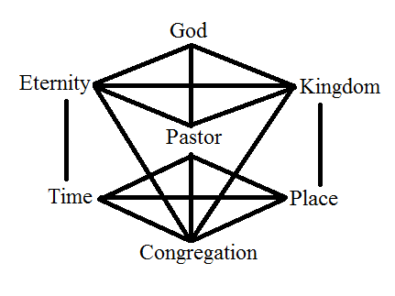
Figure 2, Multi-Modal Phenomenolinguistic Model of Baptist Metaphorical Expression
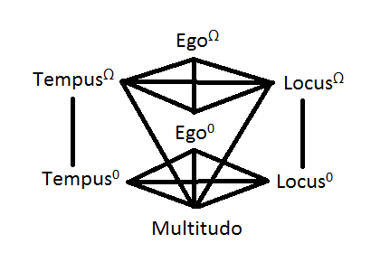
Figure 3. Multi-Modal Phenomenolinguistic Model of Religious Metaphor Notation
In figure 2, the metaphors ETERNITY IS A MOMENT IN TIME and INFINITY IS A KINGDOM compose three separate contexts: an abstract context, a concrete context, and a religious context which is both true and metaphorical. In figure 3, the model is constructed in a way so that it can be applied to other religions besides Christianity. Ego^{Ω} indicates the divine entity or target domain of religious discourse; Ego⁰ indicates the individual producing the religious metaphors and providing an interpretation of Ego^{Ω} to the Multitudo, the audience of which Ego⁰ is also a member; and Tempus^{Ω}/Locus^{Ω} and Tempus⁰/Locus⁰ indicate the abstract and concrete spatio-temporal contexts respectively, where Tempus refers to the temporal context and Locus refers to the spatial context. The overlap which creates a context between Ego^{Ω}, Tempus^{Ω}, Locus^{Ω}, and the Multitudo constitute the religious context, which Ego⁰ creates linguistically. It should be noted that these terms do not represent specifically the individual items which can be inserted into the model (e.g. Pastor, Jesus, Tennessee, 2015, etc.) but rather the roles in which specific individuals or ideas adopt during the construction of complex metaphor. In regards to notation, the higher order context shared between Ego^{Ω} and Ego⁰ will hereafter be referred to as Complex^{Ω} and the lower order context shared between Ego⁰ and the Multitudo will be referred to as Complex⁰, where each context is notated by the highest superscript which occurs within it.
Furthermore, the superscript “Ω” itself represents an endpoint in abstraction, which is generally a religious concept or metaphor. The Tempus^{Ω} and Locus^{Ω} par excellence are eternity and infinity respectively: an understanding of time beyond embodied temporal limits and an understanding of space beyond embodied spatial limits. So in the Christian traditions, Ego^{Ω} would be replaced with God, which is principally the personification of some incomprehensible divinity, or the ontologically ultimate (Neville and Wildman 2001). The target domain in all cases is understood as being beyond or outside of human faculties of comprehension and creates epistemological problems for religion, some of which Augustine considers as illustrated earlier. Therefore, any item which can be denoted with the superscript Ω is in itself metaphorical, yet trivially so as the target domain is not and cannot be defined in like terms. Here, “like terms” refers to items at an equal level of abstraction: since the highest point of abstraction, Ω, is the endpoint in itself, it therefore has no “like terms.” As an example from non-religious metaphor, TIME IS MONEY is a metaphorical understanding of “like terms” in that both domains are objectively experiential within our base reality. As an example of religious metaphor, the metaphor GOD IS KING is more accurately Ω IS KING, and the metaphor HEAVEN IS A KINGDOM is more accurately Ω IS A KINGDOM: the domains are not “like terms.” Moreover, the target domain is the same, Ω, in all cases because any concept beyond feasible comprehension is but one concept and indistinguishable from greater or equally abstract concepts.

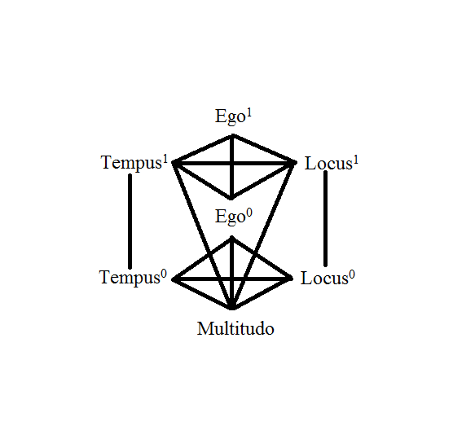
Fig. 4, Multi-Modal Phenomonolinguistic Model Non-Religious Metaphor Notation

Now asserting a notational framework, figure 4 allows us to consider a further property of religious metaphor, activation. This is a process where a religious metaphorical structure has an image-schema strongly activated in order to prevent it being supplanted by another, non-religious metaphorical structure. For example, I once had the opportunity to attend a Baptist church sermon in Tennessee during the June of 2016 where the pastor preached on the nature of marriage and provided two opposing metaphorical systems, one religious and one non-religious: the religious metaphor was FAITH IS A MARRIAGE, where Christ is the husband and the church is the wife, and the non-religious metaphor was A RELATIONSHIP IS A VEHICLE, where both parties are equals as traveling companions. The former metaphor was then combined with the Sovereignty metaphor system, a common system of metaphor in Baptist Protestantism which takes the metaphor GOD IS A SOVEREIGN RULER (KING) as primary, to evoke themes of submission and voluntary obedience: “the wife is to assume a subordinate role in the home,” “she promises submission to him,” “the wife is to submit to her husband as to the Lord,” and many more examples. This was all very standard for a Baptist sermon and generally uneventful until the pastor addressed an opposing mode of thought to this system, namely Feminism. Using language such as “women want to dominate their husbands” and “the Devil’s lie,” he spoke out against Feminism in a way that is not uncommon in the South; however, in order to address Feminism, he had to do so in its own terms- the RELATIONSHIP IS A VEHICLE metaphor system. For a small portion of the sermon, the pastor abandoned the religious metaphor in favor of the conventional metaphor and began speaking of marriages “breaking down” and being “off the tracks.” The reason that this metaphor is ideologically tied to Feminism in the pastor’s sermon is that the two travelers in the metaphor are, as mentioned above, equals, which contradicts the religious metaphor’s metaphysical proposition that God is greater than man. So, after this incongruence between the two systems was established, the religious metaphor quickly reasserted itself in the sermon, asserting both its primacy and the perceived truth of its ritual structure.
Now consider the following extract from a Westboro Baptist Sermon where the pastor is discussing a video in which a man is confronting “catholic idolatry and Mormon idolatry” among other ideologies which the Westboro Baptist Church considers sinful (2015).
“Now [saying “God bless you”] might be seen by some as just politeness, not wishing to rail against anyone or seem contentious, making sure people know he’s not out looking for a fight or presenting any kind of threat to them. I get that desire, and certainly that thinking has a place with us as we stand on these streets and wish to peacefully preach. The blessings of God ought not to be mis-used and thrown to the wind like some kind of cheap perfume to be lavishly laced upon any and all passers-by… The outrage I feel over the cavalier way so many of these so-called Christians use the phrase “God bless you” isn’t just directed at this one soul.” (WBC 2015).
The first system considers the context of the YouTuber, and from the metaphorical reality shared between Complex^{Ω} and Complex¹, the metaphor A BLESSING IS A SACRED RIGHT arises, of which the meta-phenomenological structure can be seen in figure 5 below.
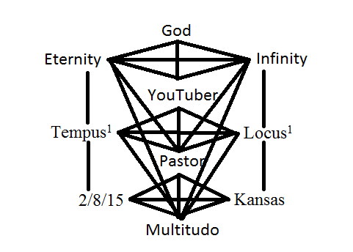
Fig. 5, YouTuber Model
Here, it is evident that figure 4 does not in itself illustrate the metaphor A BLESSING IS A SACRED RIGHT, as this metaphor does not involve a specific spatio-temporal aspect or any direct reference to Ego^{Ω} other than when God is mentioned in the ritual structure of the blessing; and the fact that the pastor does not bother to ground complex¹ in any specific time or place further weakens the structure prior to the activation of the alternative, figure 6 below. However, this system is still active at the beginning of the sermon: for example, “But he frequently ends his discourse with these souls with the equivalent to bidding them God speed. He will pronounce God’s blessing upon them as they depart” (WBC 2015). In other words, the YouTuber gives blessings considered sacred by the Westboro Baptist Church to people they would consider unworthy of God’s grace. Following this, the pastor activates an opposing framework which draws from the Second Epistle of John.
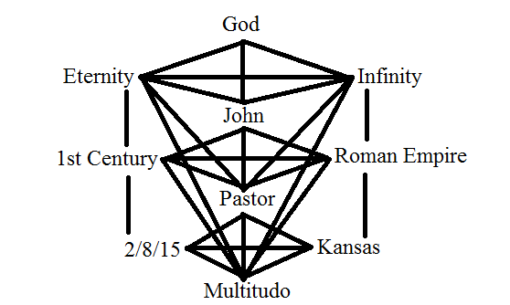
Fig. 6, Westboro Baptist Church and Blessings
The only difference between the two frameworks is in Complex¹, thus the difference in the interactionary and metaphorical properties of the two structures. This shift to an alternate framework is strongly activated with a quote from the Bible- “If there come any unto you, and bring not this doctrine, receive him not into your house, neither bid him God speed: For he that biddeth him God speed is partaker of his evil deeds” (2 John 1:10-11 qtd. in WBC 2015) which emphasizes the presumed spiritual authority of John the Apostle. From this new framework, the pastor is asserting the primary metaphors A BLESSING IS A SACRED RIGHT and the additional metaphor A BLESSING IS AN ENDORSEMENT. We can see the latter in the usage of words and phrases like misused, thrown to the wind like some kind of cheap perfume, and cavalier in the excerpt given above, which highlights how the Westboro Baptist Church understands that blessing a sinner is the endorsement of that sinner’s actions, making the blesser morally complicit in the misdeeds of the blessing’s recipient. Now, at the sentential level each structure works within its respective textual context and thus the metaphors should be understood as patently true up until they are rejected. However, as these models make clear, there is an underlying complexity in structure which must be taken into account in order to appropriately identify and discuss these metaphors at the sentential, textual, and embodied levels of their production.
Furthermore, as an additional note on the individual contexts of religious metaphor, activation is a result of the modal interactions which structure religious metaphor: Divine Reality, Experiential Reality, and Mundane Reality. For example, in the earlier section, A RELATIONSHIP IS A VEHICLE would exist within the Mundane Reality (i.e. the reality which does not include a Complex^{Ω}), and FAITH IS A MARRIAGE would exist in an Experiential Reality (i.e. a reality in which there is an overlap between a Complex^{Ω} and a cCmplex⁰, plus any number of intermittent complexes). As to the characteristics of these differing conceptual realities, they are different from simply Abstract and Concrete domains of experience. The Mundane Reality consists of everything that exists within our universe: matter, time, thoughts, ideas, and anything else that can be experienced in daily life. Thus, the metaphor TIME IS MONEY is a mundane metaphor, as its target and source domains occur entirely within the Mundane Reality. Now, the Divine Reality is harder to define since one of its basic characteristics is that it cannot be understood. For the moment, let’s say that the Divine Reality is an unknowable otherness that exists outside of our world, being called the Tao, God, and Nirvana among other things (Neville and Wildman 2001; Peterson et al 2013). As a basic condition of a reality which is understood as an unknowable otherness, within the Divine Reality we cannot have metaphors (that we would understand) which posits a domain of the Divine Reality in terms of another domain of the Divine Reality. Two conceptual domains of such unimaginable abstractness would have to be understood as a single, irreducible conceptual domain and considered indistinguishable from other domains of equal or greater abstractness. In order then to understand anything in the Divine Reality it is necessary to use a domain of experience from the Mundane Reality to create a composite reality which is both metaphorical and “divinely” true.
Additionally, this Experiential Reality is where religious metaphor occurs, though its primary subject matter exists beyond human understanding. As an example, let us for a moment consider the metaphor GOD IS GOOD. This is a fairly prevalent metaphor in many religious traditions including Christianity, where it is consistent with the idea of a benevolent God. So now, through this understanding of God, a Christian will experience God in an endless number of ways: at a sunset, after recovering from a debilitating illness, upon winning a contest, or even finding a dollar on the street. None of these situations are inherently divine to the outside observer, but they all connect back to the metaphor GOD IS GOOD. In simplistic terms, if an event X occurs which is perceived as having property Y, and God is understood in terms of Y, then X is an experiential understanding of God that is understood as a figurative truth. This is not to say that religious metaphor is the only subset of conceptual metaphor which makes metaphysical propositions about the nature of reality and activates to conceptually defend against opposing world views. Most conceptual metaphorical systems including those of scientists and physicists must routinely activate against opposing frameworks. These frameworks just happen to be more conducive to the metaphors of the Mundane Reality.
Another quality of religious metaphor to consider is its multi-modal phenomenolinguistic properties, mentioned in brief earlier, which gives its name to the system of modeling proposed in this paper. This central idea states that religious metaphor is a legitimate form of experience in which dismissing the validity of God or some other divinity would be a disservice both to the empirical study of metaphor and to the religious individuals who hold these experiences to be a significant part of their lives (Williamson and Pollio, 1999). In considering this attribute, I will quote another section of the Westboro Baptist sermon “The Wars of the Lord” (2015) in order to demonstrate the peculiar multi-modality of religious metaphor.
“I say again, we are at war, and our war, though fought on a different front, with different tactics, different strategies, and different weapons, is no less real than the war Moses began and Joshua led into Canaan. This isn’t our war, but it is the Lord’s, and we are His servants and soldiers in it.” (WBC 2015)
For an analysis of this excerpt, I propose the following model.
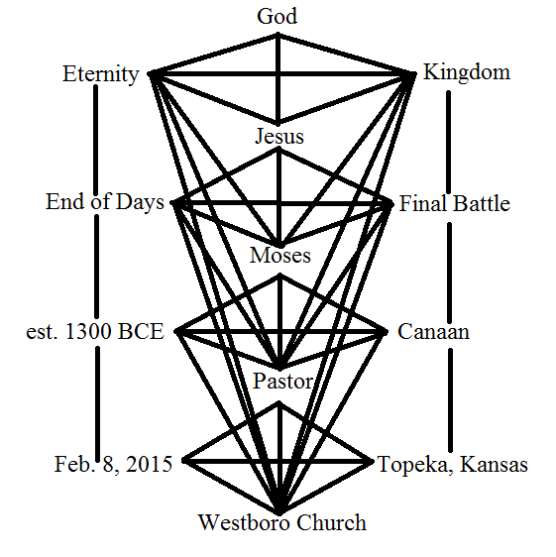
Fig. 7, The Wars of the Lord
So, in the first sentence of the excerpt, the word war is the lexical expression of the primary metaphor FAITH IS WAR. However, as it is considered throughout the text, this expression is sometimes true and sometimes metaphorically complex. For example, when discussing the wars of Moses and Joshua (i.e. Complex¹), the metaphor FAITH IS WAR is true in the sense that one religious group was waging war against members of another religious group and that religion was equivalent with what defined the nation of Israel in Exodus. Then, in Complex², or the Book of Revelations and the Christian understanding of the final battle between Jesus and the Antichrist, the metaphor FAITH IS WAR is true in the sense that Jesus and Christians, representing the forces of good, are believed to literally wage war against non-believers and the Antichrist, representing the forces of evil, at some undetermined time in the future. Furthermore, in Complex^{Ω}, the metaphor FAITH IS WAR is simply a component of the Sovereignty metaphor system which takes as its primary metaphor GOD IS KING. Since God is a King and takes as his subjects the adherents of His religion, a responsibility of kingship is waging war and defending against non-subjects who are then essentially all non-Christians. As Complex^{Ω} is solely constituted of divinely-true metaphors, any consideration of this ultimately abstract context must be considered patently true. It is this complexity which then allows the Westboro Baptist Church pastor to say that their RELIGION IS WAR metaphor system is no less real than those in other contexts, though they might have different entailments and interactionary properties. This was also discussed when considering the multiple realities of the meta-phenomenological model when I referred to the metaphor GOD IS GOOD, although figure 7 is a considerably more complex structure.

However, the inability to accurately identify the Divine Reality at the lexical level, as its linguistic existence being contingent upon metaphorical expression, shows an admitted weakness in multi-modal phenomenolinguistic modeling. If we are to understand Complex^{Ω} as the textual representation of the Divine Reality, we would then expect to find a lexical item that could be categorized as occurring within Complex^{Ω}. It seems reasonable to argue that titles, adjectives, and verbs relating to God or some aspect of divinity (e.g. heaven, a saint, the trinity, etc.) can be loosely placed in Complex^{Ω}, but these usually also occur within a narrative or superordinate complex in which God is an actor or heaven is a place which is mentioned and interacted with in explicit terms. Regardless, any word used to understand Ω is inherently metaphorical, its true meaning always just beyond our ability to fully grasp it. A solution to the problem of identifying the Ω target domain would be to distinguish the metaphoric structures of language from the metaphoric systems. If the former is understood as the linguistic expression of the system, then we can understand the system as the conceptual framework which underlies figurative language. Therefore, though it is impossible to non-figuratively include the target domain Ω in the structure of an utterance or text, it can be seen as fitting into the underlying system of metaphor. So, when I speak of Complex^{Ω} and its constituents in modeling religious metaphoric structures, I mean the most basic metaphoric representation of the Divine Reality in terms of agent, time, and place (God, eternity, and infinity respectively). This allows us to work with the Ω domain despite our inability to do anything other than interact with it through metaphor.
The final aspect of religious metaphor considered here is ritualization, which is in essence the conventionalization of metaphors which have only one definable domain. For example, it is common for Christian prayer to address the Lord, which refers to Jesus Christ. This is derivative of the Sovereignty metaphor where GOD IS KING and GOD IS A FATHER/JESUS IS A SON, which makes Jesus a prince or lord of heaven. Now, conventionalization occurs when the basic meaning of word shifts from its original, literal meaning to its metaphorical meaning, or when the metaphor itself becomes so widely used that it is no longer a novel metaphorical usage (Lakoff, 1993). Here, I distinguish a similar process in religious metaphor from the processes of conventional metaphor for a number of reasons. As religious metaphor takes on the function of religious ritual in its expression of abstract, sacred domains, it can indeed become conventional, in the sense that it is common place. However, while conventional metaphors in everyday speech can blend into the background of rhetoric or be detracted from by the novel usage of new metaphors, religious metaphor is central to the structure of religious ritual.
For example, in the case of prayer as a ritual which generally concludes a Baptist sermon, the invocation of God as father is a common aspect of a Baptist prayer’s metaphoric structure. This is abundantly evident in the concluding prayer of a Pleasant Valley Baptist Sermon.
“Father, as we turn now our hearts to our prayer list we ask that you would help us with that function of your spirit that we might be able to pray in such a way as to not only know with great assurance that you hear us, that you are moved by our weaknesses, our infirmities, and that as a father pities his children, you are moved to meet us in our limits. Father- and I thank you for your ward- I pray now that you would hear us for Jesus’ sake, and I ask that in His name. Amen.” (PVBC 1, 2015, my italics).
In the above prayer, the metaphor GOD IS A FATHER is not novel, as the metaphor appears frequently in the New Testament of the Bible: “yet for us there is one God, the Father” (1 Corinthians 8:6), “One God and Father of all” (Ephesians 4:6), “And call no man your father on earth, for you have one Father, who is in heaven” (Matthew 23:9), and dozens of other instances. However, it is neither dead nor conventional because the metaphorical usage of the word father still retains its figurative meaning while remaining primarily a feature of religious rhetoric and not everyday language. The fact that the metaphor retains its abstract meaning can be seen in the added complexity of the simile as a father pities his children; this additional context strengthens the metaphorical meaning of the ritualized GOD IS A FATHER metaphor as well as rhetorically demonstrating that this instance of the lexical item Father has a figurative function. Thus, this idea of ritualization is crucial for understanding the nature of these older Christian metaphors as neither conventional nor novel. This does not, however, exclude novel instances of religious metaphor from being ritualized, as they only need to be integrated into the metaphoric structure of religious, linguistic rituals in order to undergo ritualization.
III. Case Studies
To fully demonstrate this modeling system’s ability to accurately represent religious metaphoric structures, I discuss two case studies below, analyzed and modeled in respect to their central, metaphorical structures using multi-modal phenomenolinguistic modeling and taking into account the interactional complexity of individual metaphors. The first case study is an analysis of a Pleasant Valley Baptist Church sermon given August 8, 2015, to a Tennessee congregation. Priority will be given to the Sovereignty system of metaphor in Baptist rhetoric in order to thoroughly demonstrate the textual structures being modeled. The second case study is a full structural analysis of the Old English, Christian poem “The Dream of the Rood,” which was chosen to demonstrate the necessity of modeling complex, metaphorical structures as well as showcase the utility of this system in application to historical texts. In this case study, I will focus on the metaphor THE CROSS IS A TREE to demonstrate how on portion of the text acts upon the entirety of the text, which then affects the interpretation of the individual parts (Williamson and Pollio 1999). The sermon and the poem were each chosen for their reduced length, making a holistic analysis more manageable, and to demonstrate the applicability of the modeling system on both contemporary and historical texts.
III.i. Case Study: PVBC 2
The first case study is a meta-phenomenological analysis of a Baptist sermon (PVBC 2) given to a Pleasant Valley Baptist Church congregation in Tennessee during the August of 2015. As the Pleasant Valley Baptist Church belongs to the Baptist denomination of Christian Protestantism, I will be focusing on the Sovereignty metaphor in this analysis, as it is a prominent system of metaphor in this particular denomination. As the pastor frequently shifts complexes during the sermon, multiple models are employed for the analysis.

The first multi-modal phenomenolinguistic model, applicable to the opening portions of the sermon, is created through the pastor’s reference to the books of Exodus and Philippians, figure 8 below.
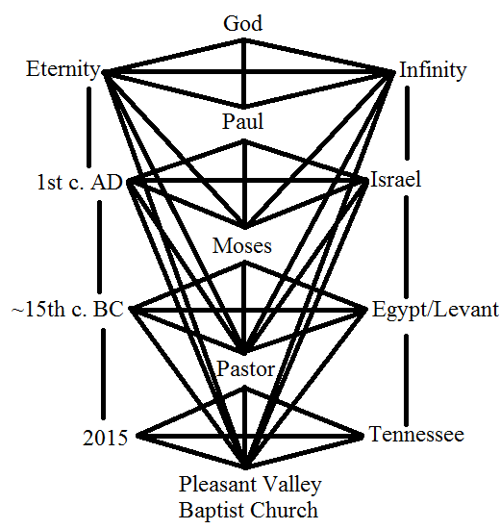
Figure 8, Multi-Modal Phenomenolinguistic Model of Exodus and Philippians in PVBC 2
The sermon starts by immediately shifting to Complex¹ when the pastor quotes Exodus 23:20-33 in its entirety and then paraphrases for the few lines which follow, continuing to define and outline Complex¹ as well as the sermon’s major theme, obedience. The Pastor then briefly shifts up to Complex² for four sentences in which he discusses Paul’s account of God’s work, before shifting from Complex² all the way down to Complex⁰ in (1) and (2).
- “He expects obedience.” (PVBC 2)
- “God has given clear commands here.” (PVBC 2)
Here we have our first examples of the metaphors FAITH IS OBEDIENCE and GOD IS A SOVEREIGN, respectively. However, though these metaphors are metaphorical in Complex⁰, they are non-metaphorical in Complex¹ because the literal interpretation of the Bible presented by the Baptists would force us to say that (3), which occurs in Complex¹, is a true statement.
- “So God is guiding His people [with pillars of fire and cloud] with the intention, that as they obey, that He is going to finish what He started.” (PVBC 2)
As seen in (3), the book of Exodus for the Baptist faith describes a direct interaction between God and the Israelites as well as God’s supernatural intervention in their journey to the land of Canaan. So here, obey has Complexity⁰ because God is an agent in the account of Exodus. The source domain of obedience is then more clearly defined in Complex², though indirectly.
- “[Paul] says ‘however, work out your own salvation with fear and trembling.’” (PVBC 2)
In (4), we see a shift into the context of the Book of Philippians where Paul is describing the nature of faith and obedience to God, fleshing out this part of the Sovereignty metaphor and the conceptual domain of obedience. Thus, we can say that obedience in (1) has complexity² because it is true in two superordinate complexes but commands in (2) only has complexity¹ because at this point in the sermon it is only true in one superordinate complex.
Following this, the sermon shifts into the basic model through which we can understand the majority of the sermon, figure 8. The sermon shifts between a combination of quotation and paraphrase and then the pastor’s interpretation of the metaphorical structures in Complex⁰.
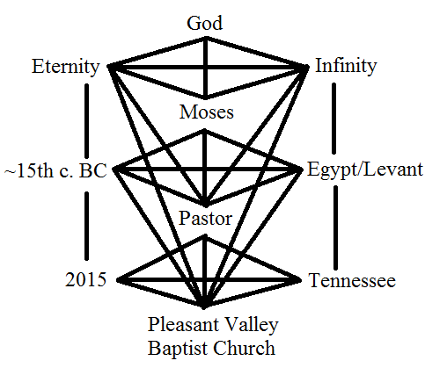
Figure 8, Multi-Modal Phenomenolinguistic Model of Exodus in PVBC 2

This structure is to be expected as the sermon explicitly addresses a section of the book of Exodus which the pastor deems pertinent for the congregation. Some foundational metaphoric structural items from Complex¹ are listed below in (5) -(7).
- “So that the second thing that you see, here, if you look at verse 24 [of Exodus chapter 23], is obedience to that first commandment requires the rejection of the gods of the Canaanites” (PVBC 2)
- “[Exodus 23:24] says the Canaanite worship sites, and this is important, Canaanite worship sites are to be destroyed, completely obliterated.” (PVBC 2)
- “the Exodus itself, that is God bringing His people, Israel, out of Egypt, out from under the bondage of Pharaoh.” (PVBC 2)
These lexical items and phrases all occur in Complex¹ and are thus true in their sentential contexts even though they constitute a part of the overarching metaphorical structure of the sermon. These concepts then form part of the central metaphorical mappings of the sermon through a downward shift into Complex⁰.
- “God expects an absolute, uncompromising loyalty to Himself in our obedience to that first commandment.” (PVBC 2)
- “We believe that God is in complete control, yes?” (PVBC 2)
- “Of our lives, God is sovereign, correct? God being sovereign, if we do anything bad, if we sin, God being in control of all things, who gets the blame?” (PVBC 2)
- “Mixing loyalty to the one true God and to false gods does not glorify God and so God wants everything wiped out that would detract from His glory.” (PVBC 2)
So we can see in (8) – (11) that the source domains outlined in Complex¹ then form metaphors in Complex⁰. For instance, FAITH IS OBEDIENCE can be seen in the items loyalty and obedience in (8) and (11). Loyalty here however is distinguished from obedience in that one obeys a law but complete obedience to the lawgiver is loyalty to that lawgiver, here represented by God. We also see the metaphor GOD IS A SOVEREIGN in (10) which is derived from the metaphor GOD IS POWER seen in (9) and (10) as complete control and in control of all things which combines with the understanding that rulers have power, to produce the former metaphor. This can also be seen in Complex¹ in (7) as His people which is an entailment of the sovereignty metaphor, where a Sovereign ruler of a kingdom (i.e. the Kingdom of God) rules over the subjects of his kingdom; and also in the contrast against Pharaoh who is an unlawful ruler of God’s people. The aspect of lawgiving inherent in sovereignty can also be seen in the expression commandment in (8), which is a religious law given by God to the Israelites but also treated as a divine law or moral code in Complex⁰, THE BIBLE IS THE LAW.
Then, in the following section of the sermon represented below by figure 9, the pastor shifts up into Complex¹ and then into Complex² as he begins to discuss the book of Genesis, specifically the Fall of Man, where Adam and Eve the fruit from the tree of the knowledge of good and evil and commit the first sin by disobeying God’s command not to eat the tree’s fruit. After he is finished recounting the story, the pastor immediately shifts down into Complex⁰. This brief interlude into the context of Genesis further defines the domains of obedience, sovereignty, and sin within the context of the sermon’s metaphoric structure. Furthermore, this is the final novel, multi-modal shift in the sermon as the pastor only occasionally shifts up into Complex¹ throughout the remainder of the sermon through reference to the book of Exodus.
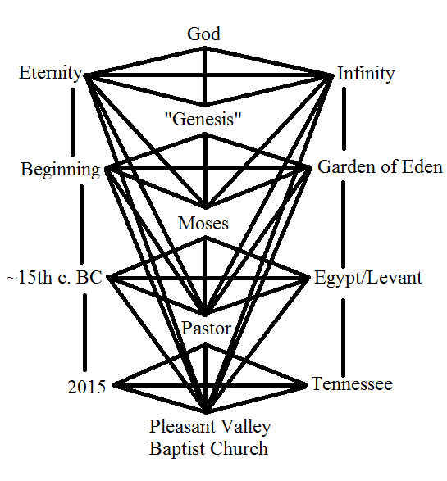
Figure 9, Meta-Phenomenological Model for Genesis in PVBC 2
Examples (12) -(15) below are representative of the metaphorical structures found in Complex² and are definitive in how they focus the source domain of their respective metaphors.
- “Now, again, you remember Satan, all the way back in the book of Genesis, in Eden. Satan had tempted Eve to believe that obedience was going to be bad for her” (PVBC 2)
- “It was forbidden fruit; she wasn’t to eat it.” (PVBC 2)
- “And then what was Satan’s next tactic?” (PVBC 2)
- “after she succumbs to the serpent” (PVBC 2)
- “They immediately start to adjust God’s word to fit their circumstances, rather than simply taking God’s word at face value and obeying.” (PVBC 2)
We then see these domains mapped onto their corresponding target domains in the following shift down into Complex⁰ where the pastor applies the lessons of Genesis to the experiential and metaphorical reality of the congregation, realities which have already been deeply affected at this point by Complex¹ in figure 8 and Complex² in figure 7.
- “God is simply reiterating, again, that His commands are not like the commands of some arbitrary tyrant” (PVBC 2)
- “[Not] ‘Obey me or else’ but rather ‘Obey me, and I will be for you; Obey me and I will bless you; Obey me and you will have good.’” (PVBC 2)
- “‘I will scare your enemies to death.’” (PVBC 2)
Here, the domain of obedience that we see in (12) and (16) are strongly mapped onto the domain of faith in (18), especially in how obedience to a sovereign is rewarded. This of course goes back to the metaphor FAITH IS OBEDIENCE discussed earlier, which relates back to the sovereignty metaphor we see in (17). Here, commands is referring back to the forbidden fruit in Complex² which God commanded Adam and Eve not to eat but is also building off the commandments of God in Complex¹. This idea of commanding is, once again, drawn from the metaphor GOD IS A SOVEREIGN in addition to an understanding that a ruler is also a lawgiver; but there is also the metaphor GOD IS GOODNESS-ITSELF, meaning God can do no wrong, which has the additional entailment that GOD IS A GOOD-SOVEREIGN and that GOD IS A GOOD-LAWGIVER. This leads the pastor to state that “His commands are not like the commands of some arbitrary tyrant” in (17). God’s merciful nature and power are thus emphasized in this Pleasant Valley Baptist Church sermon. It becomes apparent, after reaching these final examples, that an empirically valid account of religious metaphor must take into account the complex metaphoric structures which create figuratively true statements about the nature of the Pleasant Valley Baptist Church’s reality.
III.ii. Case Study: “The Dream of the Rood”
The second case study is an analysis of the metaphorical structures in the Old English poem “The Dream of the Rood,” which for this analysis is approached through a translation by Roy Liuzza. What makes this poem so interesting is its high complexity and level of structural recursion which consists of complexes that are explicitly embedded in the poem: the context of the poem (i.e. Complex¹), the context of the dream within the poem (i.e. Complex²), the context of the Cross’s monologue (i.e. Complex³), and the sacrum or divine context (i.e. Complex^{Ω}). In the following analysis, each complex will be analyzed in turn and then the full realization of the poem’s complex structures will be discussed in kind, see figure 10 below. Specific focus will be given to the CROSS IS TREE metonymy and how it is structured throughout the poem in order to narrow the focus to one specific aspect of the poem’s metaphoric structure.
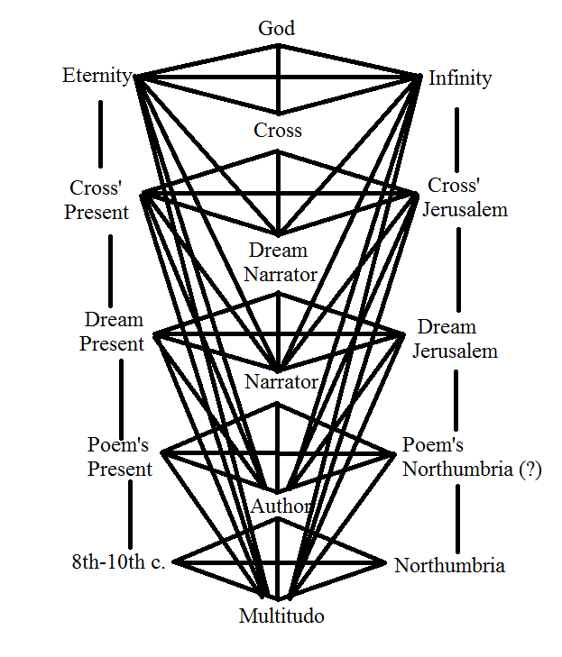
Figure 10, Multi-Modal Phenomenolinguistic Model of “The Dream of the Rood”
The poem initially begins in Complex¹ (lines 1-3), where the Narrator calls an undefined audience to listen to his account of a vision, but then immediately shifts to Complex² (lines 4-27). It is in this first line of the Narrator’s account of the dream, after a shift to Ego², the Dream Narrator, that the first instance of the CROSS IS TREE metaphor occurs. This definitively marks the metaphor as important structurally and thematically, especially as it appears in three of the five complexes: with the exception of Complex⁰ which is not written and Complex^{Ω} which is given as parallel but not directly occurring in the metaphor’s structure. other than through the basic metaphor structural understanding of Ω in terms of agentive and spatio-temporal domains of knowledge.
- “It seemed that I saw a most wondrous tree/ raised on high, circled round with light” (Liuzza, l.4-5)
- “All creation, eternally fair,/ beheld the Lord’s angel there; that was no shameful lynching tree” (Liuzza, l.9-10)
- “Wondrous was the victory-tree, and I was fouled by sins,/ wounded with guilt; I saw the tree of glory/ honored in garments” (Liuzza, l.13-15)
- “gems had/ covered worthily the Creator’s tree.” (Liuzza, 1.16-17)
- “I beheld in sorrow the Savior’s tree,/ until I heard it utter a sound;/ that best of woods began to speak words” (Liuzza, l.25-27)
On the methodological approach to these instances of complex metaphor, their interpretation and even their identification as metaphors is somewhat suspect under the Metaphor Identification Procedure (MIP), a proposed methodology which focuses on the contrast between sentential meaning and basic meaning (Pragglejaz Group, 2007). Though the group says that the failure to mark a word as metaphorical does not exclude it from having other figurative meaning, this is a weak argument in excuse of the procedure’s inadequacy in certain genre’s and forms of linguistic expression. For instance, in (20) when the Author describes the most wondrous tree, it is obvious that this is an instance of a metonymy which takes the material of the cross at an earlier point in time (i.e. when it’s a tree) as the cross itself; thus, the CROSS IS TREE metaphor. Yet in the genre-based context of the dream within the poem, it is entirely possible that the basic meaning and the sentential meaning are the same. It is in fact, probably the more likely reading of these usages of tree. Helena Tampierová for instance, drawing from an analysis of the tree as a symbol in many world religions and how this larger symbol is integrated into “The Dream of the Rood,” argues that these thematic instances of tree are directly related to “the Tree of Life or the axis mundi of the Germanico-Celtic mythologies, emphasized by the context of the dreaming poet” (2007). But more practically consider that someone might tell you “Last night, I dreamed my father was a lion.” You would be inclined to a more literal interpretation of the word lion because it takes place in a dream-context; and so in “The Dream of the Rood,” the literalness of the usage of tree is manifest in Complex², though its centrality to the metaphorical structure of CROSS IS TREE renders that sententially local literalness largely trivial.
The next shift occurs in line 28, where there is a deictic shift downward into the perspective and story of the personified cross. This section, Complex³, runs from lines 28 to 121 and thus constitutes the majority of the poem’s structure. However, while the CROSS IS TREE metaphor is fairly central to the two introductory sections of the poem, in Complex³ the metaphor occurs only seven times.
- “It was so long ago- I remember it still-/ that I was felled from the forest’s edge,/ ripped up from my roots” (Liuzza, l.28-30)
- “Then they began to fell us/ all to the earth- a terrible fate” (Liuzza, l.73)
- “Listen! The King of Glory, Guardian of heaven’s kingdom/ honored me over all the trees of the forest” (Liuzza, l.90-91)
- “tell them in word that it is the tree of glory/ on which almighty God suffered” (Liuzza, l.97-98)
- “who for the Lord’s name would taste/ bitter death, as he has done on that tree” (Liuzza, l.113-114)
Notice that in (25), the Cross is recounting what can be said as a real event in its life: when the Cross was a tree, it was literally felled from the edge of a literal forest and had literal roots. Then in (26), we see the lexical item fell once again; however, this time it is being used in reference to the Cross being taken down after the crucifixion of Christ. However, from the metaphorical perspective of the Cross as the agentive speaker in Complex³, there is a sense of continuity in its life per se, the length of time which spans its growth into a tree, its construction into a cross, and then its eventual rediscovery by “the Lord’s thanes” (Liuzza, l.75). From this sense of continuity, I argue that all instances of the CROSS IS TREE metaphor in Complex³ are figuratively true in respect to their integration into the poem’s metaphoric structure. The Cross’s invocation of the third person in referring to itself in (28) and (29) strengthens the idea that it is using the CROSS IS TREE metaphor to refer to itself in a previous time: perhaps in the sense of the personification of the Cross, the metonymy SELF IS PAST SELF would be more precise, in the same way that I might understand myself in terms of my childhood-self or High-School-self. As a final note on this section, lines 28 to 121 are a quotation of what the Cross said to the Dream Narrator, constituting a deictic shift which is derivative of the personification of the Cross. It is that derivation that poses problems for the identification of metaphor: in the sense that the entire section is spoken, speaking being an entailment of personification, how should it be treated or identified methodologically? It would be naïve to label every word as metaphorical because it appears within a length of text bookended by two specific quotation marks, and it would be unsatisfactory and imprecise to only label first person pronouns within this section as instances of personification. Conceptual Metaphor Theory and MIP do not suggest any readily available solutions. However, multi-modal phenomenolinguistic modeling incorporates this pseudo-extra-linguistic aspect of the poem’s personification of the Cross succinctly into the model itself and denotes the way in which it interacts with the more concrete linguistic aspects of the metaphoric structure.
The poem then shifts back to Complex², which in this instance goes only from line 122 to line 125, and gives only one additional instance of the CROSS IS TREE metaphor which serves as a bridging structure between the conceptual domain of trees expressed in Complex³ and Complex¹. After both the domains of TREE and CROSS are more clearly defined in Complex³, this instance can be interpreted as more metaphorical than previous instances in Complex², (20) – (24), due to its later occurrence in the overarching metaphoric structure of the poem.
- “Then I prayed to the tree with a happy heart” (Liuzza, l.122)
In (30), it is also important to notice that the Dream Narrator is praying to the tree: this is a result of the metaphorical structure interacting with aspects of Complex^{Ω}, which solidifies the Cross’s image as a religious symbol. Specifically, it overlaps with the metaphor CHRIST IS THE CROSS on a number of occasions, some listed below. This makes the CROSS IS TREE metaphor in some instances divinely true, because it entails that CHRIST IS A TREE.
- “And yet beneath that gold I began to see/ an old wretched struggle, when it first began/ to bleed on the right side” (Liuzza, l.18-20)
- “now it was drenched,/ stained with blood” (Liuzza, l.22-23)
The two examples above occur in Complex² and so should provisionally be approached as true in the context in which they occur, that is to say the Cross was literally bleeding from its right side. This is an explicit reference to the crucifixion of Christ and Christ being pierced by a lance on his right side, and is evidence of the CHRIST IS THE CROSS metonymy. However, this metaphor changes in Complex³ when Christ and the Cross are parallel but fully separate entities in the Cross’ monologue.
- “They drove dark nails through me; the scars are still visible,/ open wounds of hate; I dared not harm any of them./ They mocked us both together; I was all drenched with blood/ flowing from that man’s side” (Liuzza, l.46-49)
Thus the metaphor CHRIST IS THE CROSS takes on a literal and parallel expression in (33), occurring in Complex³. It even briefly attains complexity^{Ω} when the parallel structure leads the Cross to act as Christ or at least as a divine member of Complex^{Ω} in its relation to Christ (i.e. I dared not harm any of them). Complex^{Ω} in “The Dream of the Rood” occurs more commonly in the Sovereignty metaphor and the direct invocation of some aspect of God, yet here it connects to the CROSS IS TREE metaphor through metonymic association with Christ, affecting its meaning and interpretation in later instances.
Now, following the final example of the CROSS IS TREE metaphor in Complex², the poem makes a final shift back down into Complex¹ from lines 126 to 156, bookending the poem with Complex¹ in lines 1 through 3. In this section, there is also only one instance of the CROSS IS TREE metaphor which is the most metaphorical usage of all the examples found in the poem, as it connects back to a greater accumulation of structure and meaning presented earlier in the poem’s previous complexes.
- “It is now my life’s hope/ that I might seek the tree of victory” (Liuzza, l.126-127)
The usage of tree in (34) is clearly a metaphorical usage in this section of Complex¹ for a number of factors: in the previous complexes the relationship between the domains TREE and CROSS has been strengthened and reiterated in a number of ways. The structure then shifts to an experiential context that is not a dream-context makes a metaphorical interpretation more likely as the exegesis of this final section of the poem speaks more to coming to Christianity than literally searching for a tree. Though, since Complex¹ is still from the perspective of the poem’s narrator, caution is warranted in completely dismissing a reading that takes the final instance of tree as true. Thus, in (34), we have the fully realized metaphorical structure culminating in this last usage of tree. This last instance of the metaphor solidifies the poetically-constructed connections between the Cross, Christ, Christianity, and the importance of the tree as a multi-cultural symbol which carries cultural and spiritual significance in Complex⁰, the author’s reality.
IV. Conclusion
The case studies discussed at length above demonstrate not only the viability of multi-modal phenomenolinguistic modeling but also its utility for understanding religious metaphors. Previous studies have often neglected the truth of religious metaphor in their strict adherence to the methodological framework of Conceptual Metaphor Theory and lack of attention to the philosophical problems surrounding the conceptual domain of God and divinity. (Shokr 2006; Jäkel 2002) Within the larger contemporary field of metaphor studies however, it departs from the Conceptual Theory of Metaphor on the point of true figurative language which is inherent to religious metaphor and complex metaphorical mappings across sentential contexts. Lakoff might argue that these metaphors are only true in that they are embodied. Through a thesis of embodied realism, he would say that all metaphor is true via cognitive, sensori-motor interaction with the world, that metaphor is true because nothing is objective beyond what the body can conceive of as objective (Lakoff and Johnson, 1999). Yet I would respond that in their underlying metaphysical propositions about reality and truth itself, it would be inaccurate to label religious metaphors as simply embodied (Lakoff 1993; Lakoff and Johnson 1980). They define and demarcate what is objective for the faithful practitioner of religion and must of due course be consciously considered in a figuratively true sense, though religious metaphor is not literal in function nor embodied, as it is an understanding of what exists beyond what can be understood through the body (Williamson and Pollio 1999). Multi-modal phenomenolinguistic modeling then allows for an understanding of the patently true form of religious metaphor while preserving the metaphorical function of the structure being modeled.
Inasmuch as these metaphors are used in a deliberately true sense, it is necessary to discuss how complexity and multi-modal phenomenolinguistic modeling compare to Deliberate Metaphor Theory. The main points of this theory are that metaphor is not necessarily metaphorical but rather has metaphorical potential unless deliberately (Steen, 2008). It also states that lexical items which are metaphorical in form must be deliberate and that conventional metaphors are non-metaphorical. This directly contrasts with the mainstream view that metaphor is an unconscious and non-deliberate aspect of language (Lakoff and Johnson 1980; Gibbs 2015). Of course, ascertaining the deliberateness of an expression has the same shortcomings of the intuitive analysis of metaphor showcased in early versions of Conceptual Metaphor Theory which MIP originally sought to remedy through quantification of lexica items at the sentential level (Pragglejazz group, 2007). Additionally, the discussion of deliberate metaphor as the only kind of figurative language places too great an emphasis on the importance of the sentential context over the relational aspects of the text or utterance itself. Complexity and multi-modal phenomenolinguistic modeling are a way of understanding direct metaphor without entirely rejecting the paradigm of conventional metaphor. Ray Gibbs puts it quite nicely in responding to Steen on the grounds that Deliberate Metaphor Theory has yet to produce hard empirical evidence for the non-metaphorical quality of non-deliberate metaphors:
“Different contexts may work to highlight or strengthen the impression that a cross-domain mapping is relevant to understanding what a verbal metaphor implies in context. Steen is correct to suggest that there may be different linguistic and contextual cues that add emphasis to the underlying metaphorical mappings implied by linguistic metaphors. He is dead wrong, though, when he continues to state that only a select few metaphors give rise to cross-domain mappings (i.e., deliberate metaphors), while most others do not (i.e., non-deliberate cases).” (2015, 3)
In this paper, I am largely in agreement with Gibbs. I do not think that the presence of true or deliberate metaphors and their strongly formed mappings negates the ontological validity of conventional and non-deliberate metaphors. Religious metaphor, I argue is a counter-example to Deliberate Metaphor Theory: a religious metaphor with Ω as the target domain is deliberate, as the metaphor itself is necessary to create and define the abstract domain of divinity, but can also be conventional like the metaphor GOD IS A FATHER. Yet, I do agree with Steen on the peculiarity of these directly used metaphors. They do contain a certain strength in their structure which could be attributed to deliberate usage. However, as I have demonstrated with my analysis religious metaphor, this is derivative of complexities in the structure of a text and not the deliberateness of that structure, as the latter is by far a too intuitive approach to analyzing conceptual metaphor.
Therefore, I propose this modeling system as a methodological approach to understanding deliberateness, or what I call complexity. Going forward with this modeling system, it will be necessary to determine its accuracy across genres and beyond religious metaphor, but in respect to the latter, it must be tested across religious frameworks and belief systems. Further research will require the application of multi-modal phenomenolinguistic modeling to non-Western religions and non-religious texts to confirm the methodological validity of this modeling system. In addition, this system will need to be compared to more lexically grounded, quantitative methods such as MIP (Pragglejazz Group 2007) and its various versions and related procedures in order to ascertain the capacity for empirical replication across methodologies.
Religious metaphor, in its function as a point of access to divinity and spirituality, lends itself to complex analogies and rhetorical structure, founded in ritual and faith. Multi-modal phenomenolinguistic modeling, along with my theory of complexity, allows for a more accurate and precise analysis of metaphors in this domain of life, which is central to the lives of many people and cultures around the world. It takes into account ritualization, activation, and the phenomenology of religious experience, offering a solution to the problem of sententially and textually true metaphors while allowing an objective analysis of religious metaphor. This modeling system allows us to reconstruct the reality of faith through the metaphorical structures of a text and demonstrates the unique ontological arguments inherent in figuratively true language. We often forget that religion is just as influential in our world as politics, and thus overlook crucial opportunities to facilitate discourse on the metaphorically rich rhetoric of religious belief. Faith at its core can neither be removed from the world nor the languages which allow us to understand the world, and as the linguistic study of metaphor moves toward accounting for this, a more comprehensive understanding of metaphor will be created.

Works Cited
Augustine. “Augustine’s Commentary on the Biblical Book of Genesis.” St. Augustine, the Literal Meaning of Genesis vol. 1, Ancient Christian Writers vol. 41. Trans. John Hammond Taylor, S.J. New York: Paulist Press, 1982. 1-18. Web.

Frost, Robert. “The Road Not Taken.” The Treasury of American Poetry: A Collection of the Best Loved Poems by American Poets. Ed. Nancy Sullivan. New York: Barnes & Noble Inc, 1993. 341. Print.
Gibbs, R.W. “Does deliberate metaphor theory have a future?” Journal of Pragmatics (2015): 1- 4. Web.
Gomola, Aleksander. “Conceptual Disjunctions as a Challenge for the Church: A Cognitive Linguist’s Perspective.” Dilemmas of the Catholic Church in Poland ed. Buksińki Tadeusz. Washington: The council for Research in Values and Philosophy, 2015. 67-84. Web.
Jäkel, Olaf. “Hypotheses Revisited: The Cognitive Theory of Metaphor Applied to Religious Texts.” Metaphorik.de (2002): 20-42. Web.
KJV. The Holy Bible, King James Version. Cambridge Edition: 1769; King James Bible Online, 2016. Web.
Kövecses, Zoltán. “Metaphor and Poetic Creativity: A Cognitive Linguistic Account.” Acta Universitatis Sapientiae, Philologica 1.2 (2009): 181-196. Web.
Lakoff, George. “The Contemporary Theory of Metaphor.” Metaphor and Thought 2nd ed. Ed. A. Ortony. Cambridge: Cambridge UP, 1993. 202-251. Print.
Lakoff, George, and Mark Johnson. Metaphors We Live By. Chicago: University of Chicago Press, 1980. Print.
Lakoff, George, and Mark Johnson. Philosophy in the Flesh: The Embodied Mind and Its Challenge to Western Thought. New York: Basic Books, 1999. Print.

Neville, Robert Cummings, and Wesley J. Wildman. “Comparative Conclusions about Ultimate Realities.” Ultimate Realities: A Volume in the Comparative Religious Ideas Project ed. Robert Cummings Neville. New York: State University of New York Press, 2001. 151- 185. Print.
Peterson, M. et al. Reason & Religious Belief: An Introduction to the Philosophy of Religion, Fifth Edition. New York: Oxford University Press, 2013. Print.
Pragglejaz Group. “MIP: A Method for Identifying Metaphorically Used Words in Discourse.” Metaphor and Symbol 22.1 (2007): 1-39. Web.
PVBC. “PVBC 1” Pleasant Valley Baptist Church, Tennessee, 12 August 2015. Sermon.
PVBC. “PVBC 2.” Pleasant Valley Baptist Church, Tennessee, 2 August 2015. Sermon.
Ringer, Jeffrey. “Faith and Language: Walter Hilton, St. Augustine, and Poststructural Semiotics.” Christianity and Literature 53.1 (2003): 3-18. Web.
Shokr Mohamed Abdulmoneim, Banha. “The Metaphorical Concept "Life is a Journey" in the Qur’an: A cognitive- semantic Analysis” Metaphorik.de (2006): 94-132. Web.

Steen, Gerard. “When is metaphor deliberate?” Stockholm: Proceedings of Second Metaphor Festival, 2008. 1-22. Web.
Sztajer, Sławomir. “How is Religious Discourse Possible? The Constitutive Role of Metaphors in Religious Discourse.” Lingua ac Communitas (2008): 49-54. Web.
Tampierová, Helena. “The Dream of the Rood- A Blend of Christian and Pagan Values.” In Dream, Imagination and Reality in Literature eds. Vránková, K. & Koy, Ch.: 2007, 47- 51. Web.
“The Dream of the Rood.” Old English Poetry: An Anthology. Trans. R M. Liuzza. A Broadview Anthology of British Literature Edition. Peterborough, Ontario: Broadview Press, 2014. Web.

Westboro Baptist Church (WBC). “The Wars of the Lord.” WBC Archives: Topeka, Kansas, 8 Feb. 2015. 1-10. Web.
Williamson, W. Paul and Howard R. Pollio. “The Phenomenology of Religious Serpent Handling: A Rationale and Thematic Study of Extemporaneous Sermons.” Journal for the Scientific Study of Religion 38.2 (June 1999): 203-218. Web.

