Environmental Impact of Rock Climbers at Woodcock Cove, Tennessee

A Thesis Presented for the
Master of Science
Degree
The University of Tennessee, Knoxville

Gavin Woodard
August 2024
Acknowledgements
The contributions of my mentors and colleagues were instrumental to the success of this project. I greatly appreciate the support of Dr. Sylvia Trendafilova as my primary source of guidance throughout my research, as well as Dr. James Bemiller and Dr. Jeffrey Graham for their valuable feedback during the design of this project. I would also like to offer my gratitude and appreciation to Dr. Andrew Bailey for his collaboration, as he played an invaluable role in the accuracy of the data collected. And finally, I thank the employees of the Southeastern Climbers Coalition, Megan Evans, Kate Hanes, and Caleb Timmerman for allowing me to conduct research at Woodcock Cove.
Abstract
Rock climbing, among many outdoor recreational activities or sports, is seeing rapid growth in participation (Statista, 2022). The rise in participation has led to new environmental impacts which have yet to be fully researched, although evidence of these issues has been presented by numerous land managers of climbing areas and is one of their main focus (Access Fund, 2019). Understanding the relationship between the number of users of a climbing area and the level of impact the environment endures would be greatly beneficial to land managers. Although there has been minimal data collected on the number of users at climbing areas, research on this topic is under way. This study provides data on soil change that can be attributed to an exact number of people who have passed through a section of the approach trail in a climbing area in Tennessee. Data were collected over a period of six months from two active sample sites located along an approach trail to a popular rock climbing area in Tennessee as well as a control site. Soil erosion and soil compaction were measured at all three sites. The exact number of passersby were measured at one of the active sites. The data collected indicates that climbers have a significant impact on the soil on the approach trails to climbing areas. These findings indicate that land managers should be monitoring the number of users frequenting climbing areas as well as their impact in order to assess the need for further action to be taken. It is also a reminder that grassroots organizations such as the Southeastern Climber Coalition have the ability to use their relationships with climbing communities to conserve climbing areas in a sustainable manner.
Table of Contents
Chapter 1: Introduction 1
Problem Statement 2
Statement of Purpose 3
Topic Relevance 4
Chapter 2: Literature Review 8
Environmental Impact of Rock Climbing 8
Importance of Education 9
Economic Significance of Climbing Tourism 10
Instrumentation 11
Summary 11
Research Question 12
Chapter 3: Methodology 13
Research Site 13
Instrumentation 15
Data Collection 18
Chapter 4: Results 21
Foot Traffic 21
Soil Erosion 21
Soil Compaction 23
Chapter 5: Discussion, Implications, and Conclusions 25
Potential Solutions and Strategies 27
Limitations 28
Future Direction 30
Conclusions 32
References 34

Appendix 37
Appendix A 37
Appendix B 38
Appendix C 39
Appendix D 40
Vita 41

List of Figures
Figure 1: Monthly Foot Traffic at Woodcock Cove 16
Figure 2: Foot Traffic by Month 22
Figure 3: Foot Traffic by Week 22
Figure 4: Soil Erosion Results 24
Figure 5: Soil Compaction Results 24
Figure 6: Map of Woodcock Cove 37

Chapter 1: Introduction
Land managers are well aware that rock climbers have an impact on the environment (Access Fund, 2019). It is easy to surmise that an increase in climbers visiting climbing areas and crags has resulted in an increased impact on the environment. Land managers find themselves in an interesting position. While it is certainly a dream come true that there are more people than ever excited to participate in outdoor recreation (Outdoor Foundation, 2021; Statista 2022), it is a double-edged sword. Land managers struggle to maintain areas that are frequented by climbers who are generally unaware of the steps that they should take to protect the environment (Access Fund, 2019; Couper & Porter, 2016). Land managers generally work to address issues at crags such as erosion or vegetation loss as they arise. Obtaining data regarding the impact of climbers on different elements of crags could give land managers the ability to better anticipate environmental issues and address them before they become a serious problem.
Climbers impact the environment in a number of destructive ways. Two very visual ways include changes in soil and vegetation (Doytchev, 2021). Oftentimes, climbers attempt to limit their impact to specific areas at the base of cliffs in order to minimize their impact. With the rise in climbing participation, the size of these spaces has grown significantly (Access Fund, 2019). There is a finite amount of space at the base of most cliff line in the Southeastern United states due to the steep geography of the Appalachian Mountains. Oftentimes, small level spaces exist at the base of cliffs and bluffs but are limited by steep hillsides and the base of the cliff itself. This space is generally where people stand, sit, and place their personal items and gear that is not in use. Popular climbing areas can become crowded very quickly. This space, as well as the approach trail to crags, is typically the most impacted where climbers are present.
Rock climbing participation has more than doubled in the United States since 2011 reaching over 10 million participants, the majority of whom began climbing in 2016 or later (Outdoor Foundation, 2021; Statista, 2022). The influx of new climbers has created new challenges and added to concerns of land managers. Climbing was once a sport where it was shocking to run into another person. The opposite is true now. Luckily, we do know that climbers in the Southeastern United States will change their behavior once they are educated about their impact and how to minimize it (Sharp et al., 2018). This gives land managers a very powerful tool to use in their conservation efforts - education. Many climbers will not take the initiative to see an overcrowded area and take action unprompted (Couper & Porter, 2016); they will, however, react to a sign at the trailhead stating a maximum occupancy (Sharp et al., 2018). Climbing education can be tricky, as the sport was traditionally passed down via mentors who would teach people about climbing and everything that comes with it - finding climbing areas and taking care of them was a big part of this (Couper & Porter, 2016). Climbing classes offered at gyms typically cover safety and equipment use and not much more. There is a missing aspect of climbing education that land managers like the Southeast Climbers Coalition are trying to compensate for (SCC, 2023).

Problem Statement
It is undeniable that rock climbers cause significant changes to the environment in the areas that they utilize; especially at the base of the cliffs, hillsides, and rock faces on which they climb (Clark & Hessl, 2015; Doytchev, 2021; Lorite et al., 2017; Wood et al., 2006). Frequent human presence at the base of popular climbing routes perpetuates environmental issues which arise as a result of the significant increase in the number of rock climbing participants over the past decade (Outdoor Foundation, 2021; Statista, 2022). As the sport continues gaining popularity and growing in participation land managers struggle to maintain pace with negative impacts on the environment at the base of cliffs in climbing areas, or crags. Some of the most noticeable issues, such as erosion and vegetation loss, were often not nearly as present before climbers began climbing in an area (Access Fund, 2019; Doytchev, 2021). Climbing areas which used to see three to five users a week now see that many visitors in one morning, and the increased traffic has led to problems that were far less prevalent in the past. Despite the issues illustrated by the environmental data, there has been a very promising community response to environmental issues. Once climbers are aware of an issue and how they can help, they make changes to their behavior (Couper & Porter, 2016; Sharp et al., 2018).
A major hurdle that climbing organizations and land managers face today is measuring the progress of conservation efforts. Most professionals in the climbing industry are currently preoccupied with managing and educating the climbing community and trying to curb the environmental impact of a growing number of climbers. Not much data has been collected in an effort to measure the environmental impact of climbers in specific locations or ecosystems. As the climbing community continues to become more involved in the sustainable management and development of climbing areas it is becoming more difficult to allocate resources to climbing area restoration based on perceived need. Actual data regarding environmental damage would have the potential to make the allocation of resources much more efficient.
There are a large number of extant and potential future climbing areas in the Southeastern United States, especially in Tennessee (Access Fund & SCC, 2022). Each area faces a high demand for maintenance of the infrastructure (parking lots, trails, roads, permanent hardware used by climbers, etc.) that supports these public areas. The Southeastern Climbers Coalition (SCC) alone manages over 50 public crags in the Tennessee, Georgia, and Alabama region and nearly that many privately owned areas in the same region (SCC, 2023). While the SCC is one of the most successful climbing coalitions in the country, the organization is run almost entirely by volunteers, with only three part time employees. These individuals focus the majority of their effort on conservation and education of climbers who frequent crags that they manage.
The rock climbing community has seen explosive growth over the past decade (Statista, 2022). Existing infrastructure such as approach trails and parking lots were not designed for the traffic that climbing areas are currently experiencing, and the environmental impact that climbers have is greater than ever before. The current level of use of popular climbing areas is not sustainable, and land managers are struggling to understand and keep up with the user's impact (Access Fund, 2019). It is more important than ever for land managers, who have limited resources, to be able to prioritize their time efficiently by focusing on the most urgent projects.

Statement of Purpose
In a perfect world, land managers would have the ability to observe how users impact the environment and react by creating sustainable trail infrastructure to prevent significant environmental change. Currently, very little data are available correlating the amount of user traffic an area sustains and the impact that traffic leaves behind. Baseline data is necessary in order to understand the relationship between the number of climbers frequenting a space and the damage done to the environment. The purpose of this study is to provide valuable data that land managers are able to consider while planning conservation projects; as well as future researchers analyzing climbing areas, crags, and hiking trails. This study is intended to begin to provide baseline data regarding the number of climbers frequenting a space and their contribution to environmental change over time.
Establishing baseline data regarding the number of users in a space and the change in soil compaction and soil erosion over time will be useful data for the managers of rock climbing areas. Understanding the impact on different parts of the environment can aid in decision making when it comes to conservation project planning. Data for this study was collected in the Sequatchie Valley at Woodcock Cove near Dunlap, Tennessee. Many Southeastern crags feature descents and approaches similar to those at Woodcock Cove. Understanding the impact of a number of users over time at Woodcock Cove could offer insight to the level of impact to expect when analyzing other climbing areas. The Sequatchie Valley in particular hosts great potential for rock climbing, and much of the terrain at these potential crags is similar to Woodcock Cove. Data collected at Woodcock Cove could offer insight into the importance of erosion controlling trail infrastructure such as stone stairs or ladders at descents on approach trails.

Topic Relevance
Rock climbing is an activity which is heavily reliant on the natural environment. Not only does natural terrain produce the medium for rock climbing to take place, but the surrounding environment influences the quality of climber’s experiences in a variety of ways. There is no question that the spaces that climbers utilize to reach their destinations are all affected by the presence of humans in a variety of ways; from camping locations to roadways used to drive to climbing areas. The area which is frequently the most heavily impacted by climbers specifically is the area at the base of the cliffs that climbers climb on (Doytchev, 2021; Wood et al., 2006). This area is a cross section where the natural impact a climber has on the cliff face itself and the impact on the surrounding environment overlap. Erosion, habitat destruction and wildlife displacement, vegetation trampling, and substance introduction are just some of the impacts seen at the base of cliffs (Access Fund, 2019; Doytchev, 2021). In order for climbing to remain a sustainable sport, these issues must be managed.
The environmental impact due to rock climbing has recently been amplified by a large influx of new participants. Climbing has grown rapidly in the United States, from just under 5.3 million participants (defined as someone who participated in climbing at least once per year) in 2011 to 10.3 million in 2020 (Outdoor Foundation, 2021; Statista, 2022). While it is fantastic to see more people excited to participate, the stress on the environment is worrisome. Novice rock climbers typically have the most impact per person, simply due to a lack of educational exposure (Sharp et al., 2018). In previous decades when rock climbing was less popular, mentors would teach novice climbers environmental consideration and there was a higher margin for error regarding leave no trace principles as traffic in climbing areas was quite low. Due to the speed of the influx of new climbers, there are currently less experienced climbers than there are novices if we consider the time it takes to become experienced. Land managers and organizations that help manage climbers and climbing areas are overwhelmed and are working on strategies to educate new members of the climbing community (Access Fund, 2019; Sharp et al., 2018).
One benefit of the increased participation in rock climbing is the increased economic power within the rock climbing community. The Southeastern United States provides a fantastic opportunity to examine the potential of rock climbing economics. The Red River Gorge in Eastern Kentucky is perhaps the most popular climbing destination east of the Mississippi River. It is estimated that climbers spend roughly $8.7 million annually while visiting the Red River Gorge (Maples & Bradley, 2020). This is a big source of income for surrounding communities as climbers flood local restaurants and businesses in Powell County, Kentucky; a county with a 26.2% poverty rate compared to 16.5% in the state of Kentucky (U.S. Census Bureau, 2022). Tennessee has the potential to generate similar or greater revenue from rock climbing tourism, although private land issues prevent the majority of potential climbing areas from being publicly accessible (Access Fund & SCC, 2022).
As of 2016, rock climbing tourism had an impact of roughly $6.95 million in Hamilton County, where Chattanooga, Tennessee is located (Bailey et al., 2016). There are three large areas in Tennessee that have been identified as potential climbing tourism destinations (Access Fund & SCC, 2022). These areas are defined by counties and groups of counties. The area with the greatest amount of cliff line with potential public climbing, the Sequatchie Valley, has already been developed privately to a great extent. If this area alone were to become publicly accessible, Tennessee would have a climbing destination rivaling the Red River Gorge in size overnight (Access Fund & SCC, 2022). This is perhaps more significant than it seems. Currently, the Red River Gorge has many more publicly accessible rock climbs than the state of Tennessee, but Tennessee is able to rival the economic success of the Red River Gorge considering Chattanooga’s success in 2016 (Access Fund & SCC, 2022). Tennessee has a lot to gain from the sustainable development of future climbing areas, especially considering the economic status of many of the counties within and surrounding the Sequatchie Valley.
There are significant social and economic stakeholders which are directly impacted by the health of the environment containing climbing areas. Residents of areas that have great climbing tourism potential such as the Sequatchie Valley may not know the full value of their natural resources and they may have great potential for economic benefits (Access Fund & SCC, 2022). Future rock climbers are another major stakeholder. Ensuring climbing spaces are properly preserved is a priority in order to give future generations the opportunity to have high quality experiences. It is vital that we learn the extent of rock climber's impact on climbing areas for the survival of the sport as participation continues to grow exponentially. Creating a sustainable climbing community will also create and maintain significant economic growth in destinations where climbing tourism is popular. The climbing community is changing for the better, and climbers in the Southeastern United States have demonstrated that when they receive education about climbing sustainably, they will alter their behavior to minimize their impact (Sharp et al., 2018).
Woodcock Cove was selected as the location for this study. Woodcock Cove is one of the newest public climbing areas in Tennessee and is slowly becoming one of the most popular sport climbing destinations in Tennessee. Woodcock Cove sustains a high level of traffic from climbers relative to the number of established climbing routes. It is located near Dunlap, Tennessee and although it is open to the public the trail infrastructure was still under construction as recently as 2023 (SCC, 2023). Measuring the soil impact occurring at a high traffic location in Woodcock Cove will prove useful in prioritizing future trail infrastructure projects. Counting the number of climbers frequenting the area is also useful data for the SCC to have as land managers. If it is possible to estimate the impact of climbers based on an exact number of passersby, it will be even more beneficial in prioritizing trail infrastructure projects and would help inform the land management of more than 50 properties (SCCs, 2023).

Chapter 2: Literature Review

Environmental Impact of Rock Climbing
It is well known that rock climbing impacts the environment and has been to an increasing degree as of recent years (Access Fund, 2019; Clark & Hessl, 2015; Doytchev, 2021; Lorite et al., 2017; Reding et al., 2020; Wood et al., 2006). What is not known is the extent of the damage caused by specific numbers of people moving through an area. Erosion, vegetation destruction, soil acidity, habitat destruction, and more can all be attributed to rock climbers (Doytchev, 2021). What Doytchev and other researchers have not thoroughly explored is the relationship between the number of climbers in an area and the exact impact on the environment. The number of climbers visiting an area is typically referenced as “high traffic” or “low traffic” if it is observed at all. These broad terms do not provide much practical insight into the number of climbers visiting an area.
Vegetation loss appears to be the most frequently studied metric of climber impact. Clark and Hessl (2015) examined the reduction in vegetative life as a result of climber activity near the New River Gorge, a popular climbing destination in West Virginia. They found that lichen was consistently the most affected plant species on cliff faces, and that the steepness of a cliff is one of the strongest factors in determining biodiversity. West Virginia, a part of Central Appalachia, is not all that different from Tennessee, especially in rock composition. It is worth noting that Clark and Hessl focused on vegetation on cliff faces because they found a significant amount of research regarding the impact to vegetation at the base of cliffs in climbing areas which they could advance (Clark & Hessl, 2015). Soil compaction has not been studied specifically at climbing areas, but we do know that soil compaction leads to oxygen and nutrient depleted soil which prevents plant growth as well as contributing to both wind and water erosion via runoff (Batey, 2009). In fact, vegetation is an important factor when considering soil change. Plant life provides important anchors and cycles of nutrients that aid in soil security (Beillicci, 2021; Ng et al., 2023; Sommer, 2019).
Further research has examined sandstone, the type of stone at Woodcock Cove, and the effects of recreational climbing on lichen living on the rock face. Not surprisingly, lichen suffered where climbers were present (Adams & Zaniewski, 2012; Woods et al., 2006). Near the Mediterranean, vegetation loss was studied at the base of limestone cliffs. Vegetation cover and richness were both examined in climbing areas and outside of climbing areas. Within climbing areas, vegetation cover was half as plentiful and vegetation richness was less than half as strong (Lorite et al., 2017). Vegetation and soil erosion are connected in multiple ways. Soil compaction contributes to both vegetation loss and erosion. Vegetation presence helps prevent erosion, and erosion prevents the growth of vegetation (Beillicci, 2021; Ng et al., 2023; Sommer, 2019). In other words, with increasing climbing participation (Outdoor Foundation, 2022) it is clear that something needs to change (Sommer, 2019). Environmental issues resulting from climbing are widespread and appear via a range of symptoms at climbing crags. While studying vegetation is very informative, well-rounded research is necessary to understand the full extent of the impact that climbers have on the environment.

Importance of Education
Educating incoming climbers is more important than it ever has been (Access Fund 2019). There is currently an unprecedented interest in outdoor recreation (Outdoor Foundation, 2023). Rock climbing participation has more than doubled in the United States since 2011 reaching over 10 million participants, the majority of whom began climbing in 2016 or later (Statista, 2022). This has led to an unprecedented ratio of inexperienced climbers to experienced climbers. This is challenging because climbing had previously maintained a mentorship-based education structure for decades. True mentorship in climbing is becoming more and more rare as climbers turn to classes and clinics to learn what were once considered intimate details of the sport (Couper & Porter 2016; Sharp et al., 2018).
Fortunately, rock climbers are willing to change their behavior once they become educated. Once climbers are aware of environmental issues and the ways that they can help prevent them, they take action and change their current habits to reduce their impact (Sharp et al., 2018). One study from the Red River Gorge in Central Kentucky, somewhere close and arguably comparable to the area in which this study has taken place, details that climbers who are aware of their impact are willing to focus on changing their behavior (Sharp et al., 2018). Through introspection and conversation, Couper and Porter (2016) describe how education within the climbing community can change with the times to keep up with the demand of a growing community. Focusing not only on the risk management aspect of climbing, but on etiquette and responsible participation is incredibly beneficial.
Education is the key to positive change in the climbing community. A group of people who are willing to make actionable changes when they receive information can adapt and halt their environmental impact, but they need to be able to see the difference that they will be making (Sharp et al., 2018). When climbers understand how and why they should change, they follow through in an effort to make the spaces they utilize more enjoyable. The more educated the community becomes, the less damage is done to the environment. A major motivating factor for many climbers, especially at Woodcock Cove, is that climbers who identify as sport and trad climbers place a high value on the quality of the experience and venue of their rock climbing. Sport and trad climbers are specifically motivated by the quality of rock climbing routes themselves as well as the quality of the wilderness and natural landscape around them (Ansari, 2008).

Economic Significance of Climbing Tourism
The economic significance of climbing tourism, specifically in the Southeastern United States, is certainly not to be overlooked. The Red River Gorge in Kentucky continues to see more visitors each year than ever before, and the surrounding counties are able to make an estimated $8.7 million each year as a result of climbing tourism alone (Maples & Bradley, 2020). In 2016, Hamilton County, Tennessee, pulled in an estimated $7 million from climbing tourism alone, largely thanks to the city of Chattanooga, a hub for rock climbing in the Southeast U.S. (Bailey et al., 2016). As it stands, there are multiple ways that Tennessee could capitalize further on its rock climbing resources (Bailey & Hungenberg, 2017).
The state of Tennessee stands to gain a lot from climbing tourism. The Sequatchie Valley contains enough illegally and privately developed rock climbing that if the land were made public all at once, Tennessee would immediately have more public rock climbing than the Red River Gorge (Access Fund & SCC, 2022). Tennessee, as it stands, has far less publicly available rock climbing than the state of Kentucky. If Chattanooga alone is able to rival the revenue brought in by a much larger climbing destination, then increasing the available rock climbing in the state of Tennessee would potentially create significant economic growth through tourism (Bailey & Hungenberg, 2017).

Instrumentation
Obtaining accurate data regarding erosion is important considering the limitations imposed by a six-month timeline. Soil penetrometers such as the Dickey-John Soil Compaction Tester: 30 in Probe Large have proven to produce accurate depictions of soil compaction in Piedmont soil, which is present in the research sample area (Mousavi, 2018). The soil penetrometer model used for soil compaction data in Mousavi’s research regarding soil compaction is the same model that was used to obtain data for the research at Woodcock Cove.
Nail and washer fixtures, while simple, have stood the test of time and are known to be classic tools for measuring changes in soil level (Trendafilova & Waller, 2011). They offer the researcher freedom to be as specific as they choose regarding measurement units and are relatively easy to place and use (Brooks et al., 2013). These instruments were used to obtain soil erosion data at Woodcock Cove.

Summary
Rock climbing has seen significant growth in the past decade (Outdoor Foundation, 2021; Statista, 2022), and as a result an increase in environmental impact has made itself clear (Doytchev, 2021). Numerous factors which are interconnected have led to issues that did not arise until the foot traffic increased within climbing areas (Sommer, 2019). Due to the inexperienced nature of a majority of climbers today, an increased importance on aspects of education outside of purely safety focused learning is necessary and effective (Couper & Porter, 2016). Once climbers learn about the consequences of their actions and how to lessen their environmental impact, changes in behavior are made or attempted, making educational efforts worth a lot more than they may be in other sports (Sharp et al., 2018).
In order to combat increasing environmental issues, research detailing the damage done to climbing areas is necessary. The data produced in research regarding the climbing environment is used to inform educational programming as well as prioritizing infrastructure projects (Sommer, 2019). In addition to the environmental conservation of climbing areas, significant economic factors indicate that climbing protection should be prioritized to some degree. Tennessee has a lot to gain from climbing tourism. As a state which currently has less public climbing resources than Kentucky, Tennessee is able to rival the income resulting from climbing tourism in Kentucky (Bailey et al., 2016; Maples & Bradley, 2020). Tennessee has potential climbing resources tied up in private land that could increase the publicly available climbing to an unrivaled amount in the Southeastern U.S, but conservation would be key in the management of this asset (Access Fund & Southeastern Climbers Coalition, 2022). More research on climber impact is necessary to effectively manage climbing resources moving forward.

Research Question
What is the environmental impact on soil, if any, within sensitive areas where rock climbers approach the base of the cliff faces at Woodcock Cove, Tennessee?
We know that rock climbing participants alter the environment over the course of their recreation. While there is some existing research detailing the different ways that climbers impact the environment, not much data exists detailing the extent of the damage that climbers have caused their beloved crags. It has been said that climbers are loving their climbing areas to death. Data collection is necessary to understand the current extent of the impact of a climbing population on an outdoor area. These baseline data have the potential to provide important insight during the establishment of goals for successful future intervention. These data could also inform strategic educational planning and programming, which would curb and potentially lead to opportunities to reverse negative impacts on the environment surrounding climbing areas.

Chapter 3: Methodology
In order to better understand the difference that climbers have on the environment, soil erosion and compaction data were collected at a site on the approach trail that is sensitive to erosion; the point where climbers descend below the cliff line to reach a climbing area named The Dispensary. This data was compared to data collected from a control site found in a drainage on the Woodcock Cove property but off of the trail. The main difference between the sites is that the control sample did not have anyone but the researcher passing through it while collecting data; and the active site hosts an infrared sensor recording the number of people who pass through the site. In an effort to retrieve additional environmental impact data, a second active site was monitored near the parking lot. For the purpose of clarity, the active sites are referred to as the Dispensary site and Parking Lot site respectively.

Research Site
Woodcock Cove is a climbing area located about 3 miles southwest of Dunlap, Tennessee atop Fredonia Mountain. Woodcock Cove was purchased by the Southeastern Climbers Coalition (SCC) in 2021 and opened to the public for rock climbing in 2022. The SCC’s property boasts approximately 1 mile of cliff line with available climbing, featuring an 80’ freestanding sandstone tower within the Dispensary area (See Appendix A). Prior to the SCC’s purchase, Woodcock Cove was accessed and developed for climbing by a few individuals who built relationships with the neighbors and landowners to gain permission to climb on the property (SCC, 2023).
Woodcock Cove saw very little foot traffic prior to its purchase in 2021, and the existing infrastructure at the time of purchase reflected this. There is roughly one mile of cliff line with available climbing, with three main descents serving as access points from the top of the cliff to the bottom (see Appendix A). Significant time and effort were spent building and finishing the infrastructure to support public access. Part of this infrastructure includes measures to prevent environmental deterioration including stonework and metal ladders functioning as steps to prevent foot traffic from increasing erosion at the descent to the “Dispensary” location. This descent was the location of the Dispensary active sample site for this research, a site that is actively traveled through and frequented by climbers. The Dispensary site was also the location of the Pyro-Box and the site where foot traffic data was collected.
While it is possible that a hiker who is not a climber passed through the Dispensary site, this does not alter data collection or results and is rather unlikely. Although Woodcock Cove is located geographically near Dunlap, the drive from Dunlap to the parking lot takes 20 + minutes on mountain roads. Furthermore, the area is listed as a parking lot on Google maps (Google Maps, 2023). It is important to bear in mind that the property was purchased with the sole goal of climbing access and conservation, which influences some key features. The property is shaped like a “T,” with some sections of the SCC’s property being so narrow that there is only enough space for the extant approach trail. This is because the SCC’s goal was to maximize cliff line ownership while maintaining ownership of a continuous stretch of land between the cliff and the road. Woodcock Cove does not boast scenic overlooks, there are not extensive, exciting, or friendly hiking trails, or amenities such as restrooms or running water. In addition, the instrument recording passersby was placed directly at the point the trail descends to the base of the cliff. This terrain requires some technical capability, including the use of handlines and ladders that you walk on, and serves as a further deterrent to non-climbers. In the rare case a person does visit the area to hike and does reach the Dispensary site, they are still a person navigating the space with the potential to cause damage and should not be discounted from the data.
Established approach trails at Woodcock Cove take advantage of large water drainages which have created steep gullies where it is possible to scramble down aided by permanent infrastructure for descents. There are numerous drainage gullies on the Woodcock Cove property, but only 3 of them are used as approach trails. The Dispensary sample site was located at one of these descents. The control site was located within a comparable drainage gully which is not used as part of the approach trail. This control site is not trafficked by climbers; and is reached with great difficulty due to the thickness of the undergrowth, steepness of the hillside, and lack of established path to reach it. The space below this drainage gully is also isolated from the trail beneath the cliff. This drainage was not used as a part of an approach trail because it leads to a ledge near the base of the cliff. This ledge is a minimum of roughly 2.5 meters in height or taller and further isolates the control site from human contact. Another sample site was established on the approach trail near the parking lot, although an accurate count of passersby was not possible to obtain for this site.
As discussed earlier, Woodcock Cove is an ideal location for sample sites because of the great potential for recreational rock climbing in the Sequatchie Valley (Access Fund & SCC, 2022) and the similar geography it shares with many of the cliff faces located there. The Southeast Climbers Coalition has a working relationship with the University of Tennessee in Chattanooga, and data regarding the number of users visiting the site was being collected by Dr. Andrew Bailey prior to the beginning of this research project. The Southeastern Climbers Coalition granted permission to research soil erosion and the number of users on the property (See Appendix C). Dr. Bailey granted permission to use the Pyro-Box infrared sensor used to count passersby, which was already located on site. It is also beneficial that Dr. Bailey has collected data regarding the total number of users at Woodcock Cove over the course of a year. These data were made available to researchers for this study via the Eco-Link system and can be found in Figure 1 on the following page.

Instrumentation
For soil erosion measurements, 30 total nail and washer fixtures were installed to measure soil erosion over time, 10 at each sample site. 3.5 inch nails were used with small washers that could not come off over the head of the nail. Nails were placed exactly 2.5 inches in the ground so that 1 inch was the initial soil level measurement. This depth also provided the nails with sufficient stability so that they remained fixed in place as erosion took place. The washer was placed on each nail to provide a reliable point to measure from the top of the head of the nail. Each instrument was initially placed with a measurement of one inch between the head of the nail and top of the washer on the downhill side. Measurements were always taken between these two points. Rock climbers visiting Woodcock Cove were made aware of these instruments

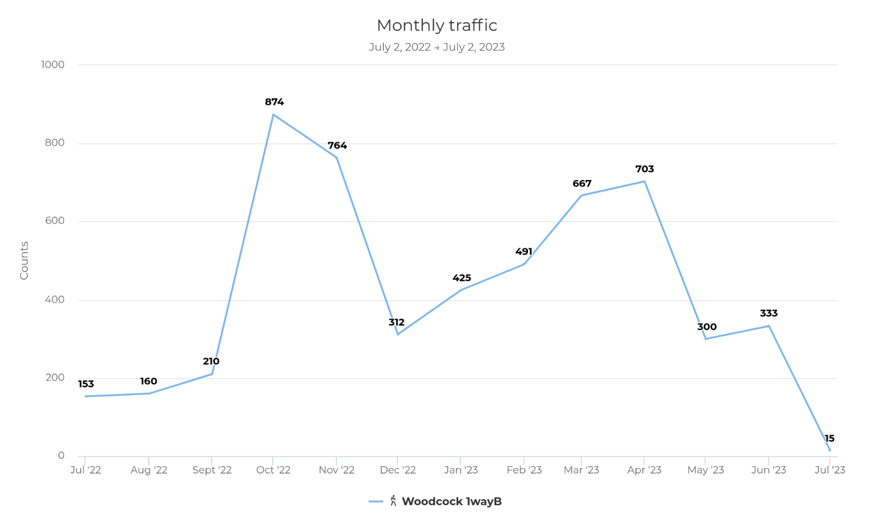 Figure 1: Monthly Foot Traffic at Woodcock Cove July 2022 to July 2023

via signage posted at the trailhead, as well as at the entrance to each active sample site and attached to a trail sign near the control site (See Appendix D).
Within the active sites, sections of the approach trail are highly sensitive to erosion. As the slope of the hill increases during the descent to the Dispensary, where 5 soil erosion samples were collected, and the area at the base of the descent which also serves as space to belay and relax at the base of the cliff while climbing where 5 more samples were collected. All 10 of these instruments were placed near the edge of the trail and belay area in an effort to avoid them being trampled. Although there is no trail within the control site, nails were placed in positions intended to mirror the Dispensary site. 5 instruments were placed where the slope of the hill increases near the top of the drainage gully and 5 more samples collected near the base of the cliff: away from any established trail or rock climbs. At the Parking Lot site all 10 instruments were placed on the edges of the approach trail as it descended a hillside showing signs of erosion, not in any gully or creek bed.
As soil on the trail is eroded out of the area, soil from the edges of the trail and surrounding area will fall into place to replace it. This replacement soil is generally washed away with ease. Over time, the amount of soil that is available for redistribution to mitigate soil level change due to erosion will be depleted, resulting in a change in average soil level. Thanks to this process, we are able to measure the amount of soil level change in an area without measuring the exact place where people step. As soil is eroded by natural and unnatural processes such as rain or hikers passing through respectively, soil levels change at the edge of the trail as soil from the edge of the trail naturally falls into place in an effort to replenish soil that erodes on the trail itself.
A soil cone penetrometer, the Dickey-John Soil Compaction Tester: 30 inch Probe Large, was used to measure 5 soil compaction samples within the sample sites containing the nail and washer fixtures. Precise locations were determined based on features on-site such as where water appears to run, the location of the trail, vegetation, rocks and rock features, where people step, and steepness of the hillside. In the active sites, compaction was measured where people walk on the trail. In the control site, compaction was measured based on where a theoretical trail would likely have run considering where water flows and steepness of the hillside. In order to measure soil compaction depth, the penetrometer was driven into the soil until it reached a point where it measured compaction to be 300 psi. This level of pressure prevents plant growth and contributes to the loss of topsoil (Trendafilova & Waller, 2011).
A Pyro-Box Mobile Multi was used to obtain an exact count of people moving through the Dispensary site. The instrument was placed on the approach trail directly prior to the descent to the Dispensary site. This is a one-way counter which records every instance of a passerby via an infrared sensor. The Pyro-Box does not record the direction they are traveling or any information about the passerby. No identifying information was collected about any individual for this research. The Institutional Review Board agreed that no identifying information was collected and informed us that their approval was not necessary (See Appendix B). Data is retrieved from the sensor using the Eco-Link mobile phone app and was accessed via the University of Tennessee at Chattanooga’s account with Eco-Counter. In order to ensure proper positioning to tally passersby on the approach trail, a researcher walked past the box a predetermined number of times in an hour before retrieving and confirming that the data collected for that hour were accurate to the number of passes that the researcher made.

Data Collection
Data collection occurred over the course of 171 days, about 10 days less than six full months. Measurements were collected after 82 days and again at 171 days. Data collection at 82 days also served the function of providing time to check on the instruments and ensure that signage warning visitors to try to avoid stepping on the instruments was still in place. Measurements were taken using a penetrometer for soil compaction and installed nails and washers to measure changes in soil erosion. Three sites were chosen for the soil compaction and soil erosion data collection. The Dispensary site, where the number of passersby was recorded and soil erosion and compaction data were recorded as well; the Parking Lot site, where soil erosion and compaction data were collected; and the control site, where soil erosion and compaction measurements were recorded as well.
Nails and washers were used to collect 10 samples focused around a descent through the drainage gully that is part of the approach trail to a popular climbing area, known as the Dispensary, as well as the climbing area itself which features an 80’ tall freestanding sandstone tower. The same measurements were taken for 10 samples within the control site and the site near the parking lot. Within the active site, sections of the approach trail are sensitive to erosion. As the slope of the hill increases during the descent, where 5 soil erosion samples were collected, and the area at the base of the descent which also serves as space to belay and relax at the base of the cliff while climbing where 5 more samples were collected. Although there is no trail within the control site, nails were placed equivalently. 5 instruments were placed where the slope of the hill increases in the drainage gully and 5 more samples collected near the base of the cliff not near any rock climbs and away from any established trail or rock climbs. The area below the cliff line was also guarded by a small bluff, 2 or 3 meters high in most places, which was located between the control site and the hiking trail. In the active site near the parking lot, all 10 instruments were placed on the edges of the approach trail on a hillside showing signs of erosion. Soil erosion was measured by taking the distance between the top of the head of the nail and the washer placed on the nail at the beginning of data collection. This measurement was initially 1 inch.
The penetrometer was used to collect 5 samples from roughly the same place within the same sample sites. It was important not to use the exact same spot to sample soil compaction twice because the penetrometer creates a small hole which could alter the measurement if taken in the exact same place. When the penetrometer was obstructed by a rock or root before reaching 300psi, its location was changed as little as possible to avoid the blockage. Compaction was recorded specifically at the edges of the approach trail. The intent of an approach trail is to minimize impact by limiting it to a specified and controlled area. The trail itself is intended to have abnormal levels of soil compaction. If the approach trail is being widened by hikers walking on the edges of it, creating a greater impact space, this creates more space for soil erosion to occur.
Data were collected regarding the number of climbers passing through the active sample area using an infrared sensor, the Pyro-Box Mobile Multi. This sensor simply tallies the number of passersby and stores that number. Data is retrieved from the sensor using the Eco-Link mobile app and must be collected on-site. Because it is a one-way sensor, the total number of passersby needs to be divided by two after collecting data. Passerby data were retrieved during the same site visits that soil data was collected during. In order to test that the Pyro-Box is accurately recording passersby, a researcher passed in front of the sensor 5 times in one hour during the 82nd day data collection and 6 times in one hour during final data collection. After retrieving data for the specified hours and ensuring no other entities triggered the sensor, the data collected reflected that there had only been 5 and 6 passersby, respectively.
Once these data were collected, data from the Pyro-Box underwent the adjustments discussed in the previous section. Eco-Link offers many options to display the data collected regarding passersby through the active site. Nothing further is needed in analyzing the number of passersby. Soil erosion data collected via the nail and washer instruments as well as the penetrometer was analyzed using a t-test executed via SPSS version 28 in order to assess the significance of change over time at the active site. Soil erosion over time and soil compaction change over time for the active sample site were compared to the same data from the control site. Unfortunately, only soil compaction data were obtainable from the Parking Lot site. For each round of data collection, between 4 and 6 of the nail and washer instruments were trampled by passersby and therefore no accurate soil erosion data were recorded. The average change in soil compaction at the edges of the trail was recorded and analyzed for the Parking Lot site.

Chapter 4: Results
Data for this study were collected over a period of 171 days, just under 6 months, from July 4th, 2023, through December 22nd, 2023. During this time, 967 people hiked through the Dispensary sample site and climbing area. Significant soil erosion and compaction took place at this sample site as well. A mean soil erosion of more than 7.6 millimeters occurred over the course of data collection at the Dispensary site. Soil compaction depth changed by more than 20 millimeters at both the Dispensary and Parking Lot sites as well. The results for the control site, however, showed little change. Soil erosion measurements were recorded to be less than ½ of a millimeter, and changes in soil compaction were less than 4.5 millimeters, an amount of change that can be attributed to variances while collecting data.

Foot Traffic
During the data collection period, the Pyro-Box counted 1,945 passersby total. 11 of these were a result of testing the accuracy of the Pyro-Box after placing its trailside mount on a tree. Due to this method of testing the accuracy of the counter, 1,934 is the accurate count of passersby which means that 967 people walked through the active sample site during data collection. On October 14th, 2023, the total number of passersby was the highest for any one day during the study. 64 people walked into and out of the Dispensary climbing area that Saturday.

Soil Erosion
Soil erosion data were successfully collected at two of the three sample sites on the Woodcock Cove property. Unfortunately, the sample site near the parking lot had too much interference with the nail and washer fixtures to accurately assess soil erosion. This section of the trail closer to the parking lot typically sees more traffic than the other active sample site due to the fact that the trail splits and the other active sample site is only frequented by those that are headed to the section of cliff line called the Dispensary.
At the control site, all 10 soil erosion measurements were successfully captured for each round of data collection. Over 6 months, the average soil level change measured at the control site was 0.0189 inches or about 0.48 millimeters. These nails were exposed to the same weather

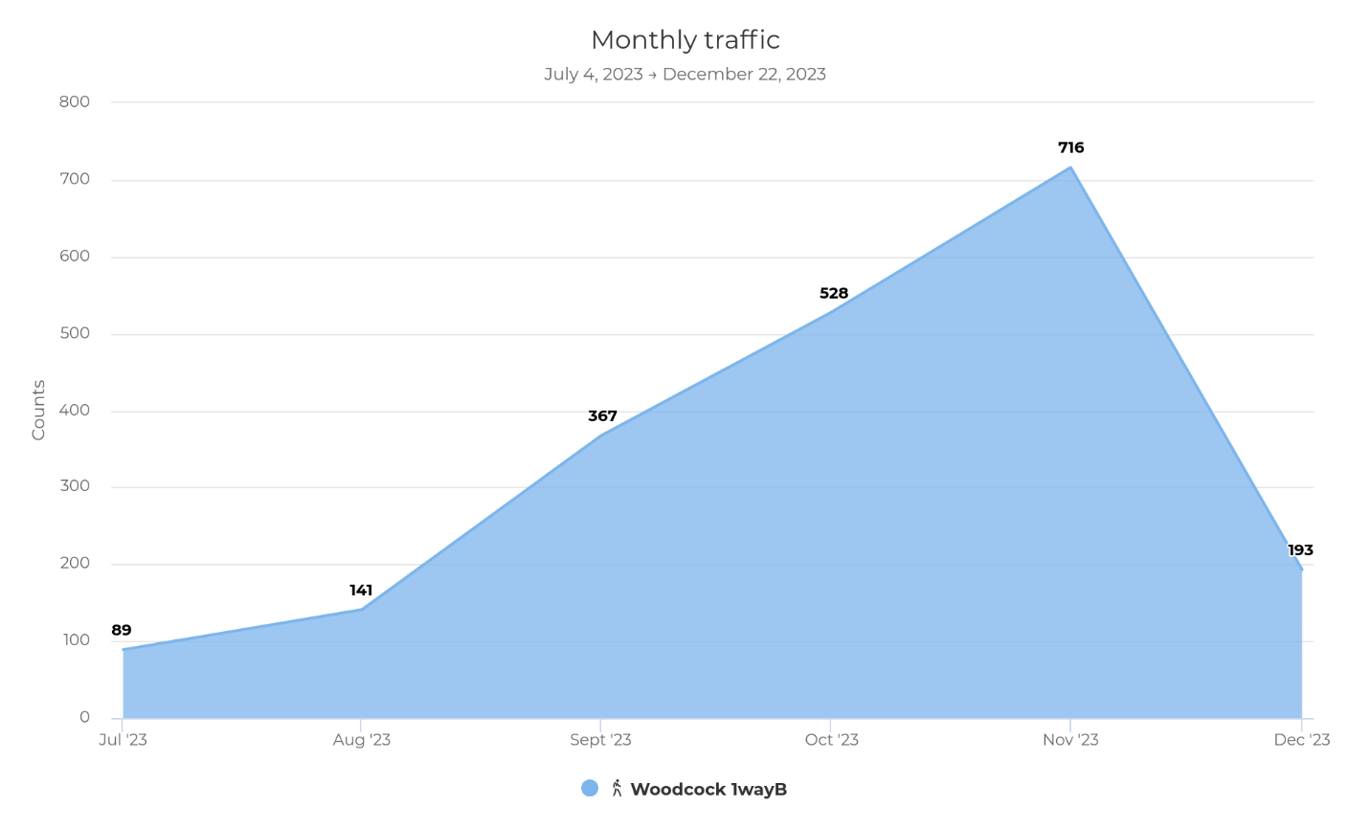Figure 2: Foot Traffic by Month

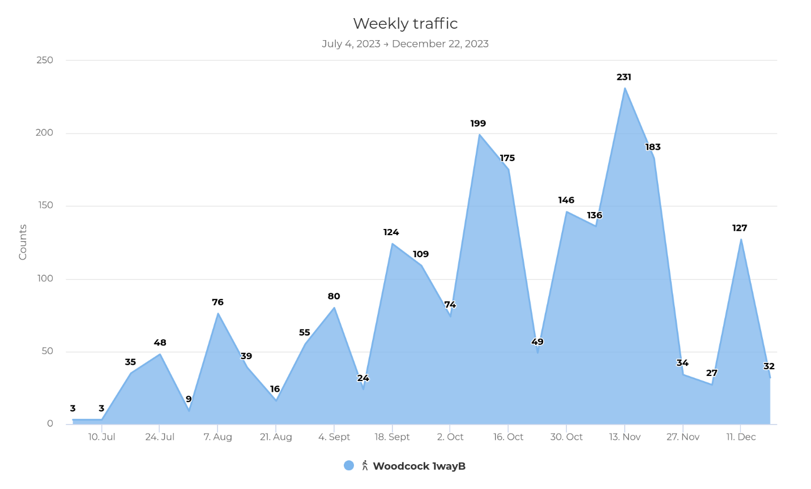Figure 3: Foot Traffic by Week
patterns as the other sample sites. The main observable difference in the instrument placement at the control site was the presence of vegetation and a layer of soil that could support it.
At the active site near the Dispensary, the average soil level change reached 0.3021 inches, or 7.6741 millimeters. There is a clear difference in soil erosion between the control and active sites. After running an independent t-test through SPSS, I found that p = 0.019, which is statistically significant considering a 95% confidence interval.

Soil Compaction
Compaction of 300 psi at the control site began at an average of 4.5125 inches. Plant life was observably more present on the surface of the soil at the control site as well. At the conclusion of data collection, soil compaction averaged 4.3375 inches. A change of 0.175 inches, roughly 4.5 millimeters, is insignificant. This change is minimal and is to be expected as a result of many factors such as precise location of the measurement, water content of the soil, and temperature to name a few.
At the Dispensary site, soil compaction initially reached a mean of 3.1375 inches. At the end of data collection, compaction depth had changed to an average of 2.225 inches indicating a change of 0.9125 inches, about 23 millimeters. An independent t-test run via SPSS resulted in p value of p = 0.113 for the average difference in compaction between the control and Dispensary site. At the Parking Lot site, the average change in soil compaction depth recorded was 0.8375 inches, roughly 21 millimeters. This change is similar to the change seen at the Dispensary site, and an independent t-test resulted in a p value of p = 0.085. While this may indicate a lack of statistical significance, the values themselves still provide useful insight into the impact that climbers have on the environment.

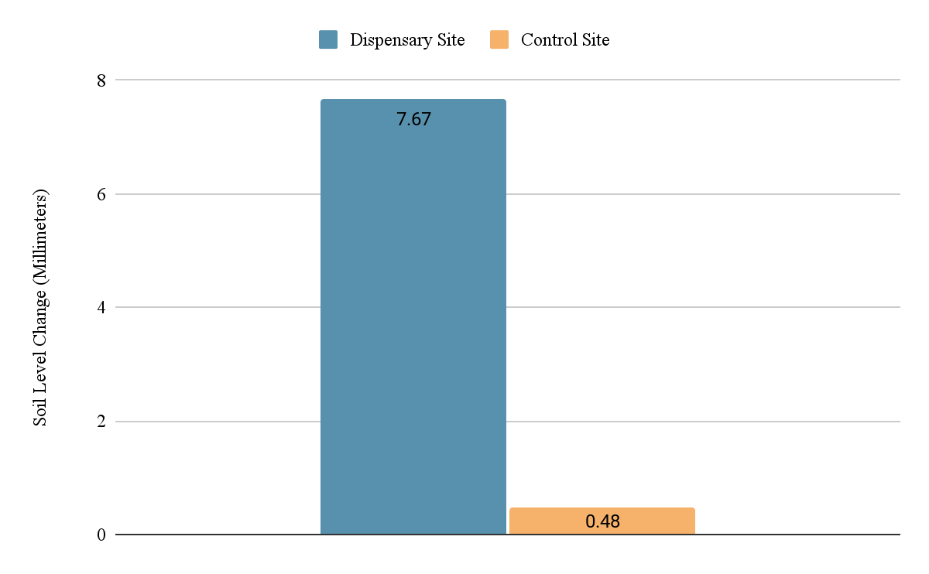

Figure 4: Soil Erosion Results

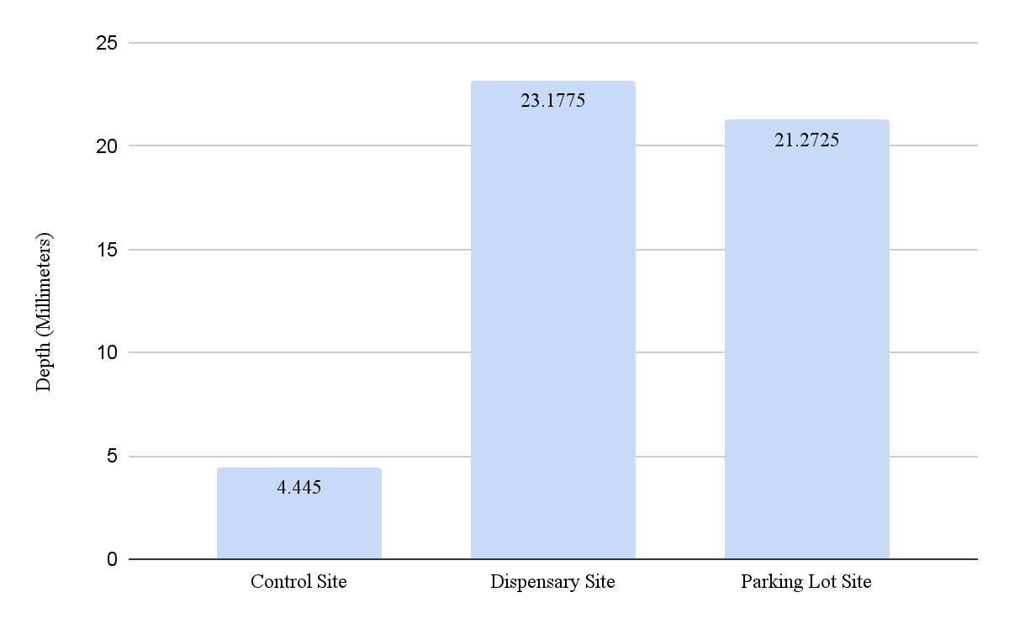

Figure 5: Soil Compaction Results

Chapter 5: Discussion, Implications, and Conclusions
Woodcock Cove hosts a fairly high volume of climbers during the climbing season. The Southeast Climbers Coalition prepared the property by building trail infrastructure such as stone stairs and trails designed for drainage before opening to the public and is constantly working to improve the trails. There is a significant amount of soil erosion occurring in the area where rock climbers’ belay, relax between climbs, and hike through. In the most vulnerable of these places, soil erosion and compaction are both occurring rapidly. This is largely due to the fact that climbers are expanding their impact by expanding the area that they use beneath the cliff, as well as eroding sensitive areas of the approach trail.
As discussed previously, measurements for this study were intentionally taken near sections of trail that are considered vulnerable. Measurements were also taken from the edges of the approach trail. This was in an effort to prevent the soil erosion instruments from being trampled and worked well at the Dispensary site. It is also a contributing factor to the extreme results of this study. Over the course of 6 months, climbers at Woodcock Cove slowly expanded their area of impact by walking on the edges of the trail and pushing the limits of where vegetation existed below the cliff line. At the Parking Lot site, the majority of the soil erosion instruments were trampled prior to each data collection session. Some features of the trail allowed for extra protection for the instruments at the Dispensary, such as exposed rocks.
It was evident that climbers had expanded their area of impact due to the loss of vegetation near the soil erosion instruments over the course of 6 months. This loss of vegetation was one of the early steps to the drastic change in soil compaction depth and soil level during the study (Ng & Fang, 2023). Once the vegetation had been trampled, the roots of the plants died and no longer held topsoil in place. Nutrient rich topsoil eroded rapidly as the vegetation dissipated, which left compacted soil underneath behind (Batey, 2009). One thing to consider when analyzing the soil compaction depth is that soil loss contributed to the change in compaction depth. If more than 7.5 millimeters of topsoil are gone, the depth where compaction reaches 300 psi is automatically 7.5 millimeters closer to the surface.
Much of the impact observed in the active sites is due to the 967 people who passed through the Dispensary site as well as those who passed through the Parking Lot site, although the number of passersby for the Parking Lot site is likely much higher. The approach trail splits before reaching the Dispensary descent (See Appendix A) and there are multiple other popular areas to climb on the property. Woodcock Cove is a roped climbing crag, developed for sport climbing and trad climbing. People hiking to Woodcock Cove almost always approach the climbing area in groups of 2 or more. Climbers who are sport and trad climbing use ropes for protection, which involves a partner who belays. While the approach trails at Woodcock Cove are designed for people to walk single file, these pairs or groups will often walk on the edges of the trail in order to walk side by side. This causes the trail to gradually grow wider, and contributed to the damage that was observed at Woodcock Cove.
Climbing pairs or groups typically take turns climbing. If there is a group, there can sometimes be a lot of people in the same area, especially if there are popular easy climbs. If these climbers are novices or newer to climbing outside there is a higher chance that they have not received any information about proper conservation tactics and potentially have a higher impact on the area around them (Couper & Porter, 2016; Sharp et al., 2018). This description fits the Dispensary climbing area at Woodcock Cove. On Saturday, October 14th, 2023, 64 people walked into and out of the Dispensary climbing area at Woodcock Cove. This was the highest traffic day recorded over the duration of this study. Climbers are not only limited by their need for a belayer. At some crags the difficulty of the climbing routes available is also a limitation. This can lead to even more downtime for climbers who have to wait their turn at the base of climbing routes.
It is important to halt the spread of climber impact. Soil erosion and compaction lead to issues such as altered water flow, the inability of vegetation to grow, and over time a loss of space for climbers to use (Brooks et al., 2013; Doytchev, 2021; Ng & Fang, 2023) which will subsequently result in lower quality rock climbing experiences. These unnatural changes are in addition to the moral obligation that climbers have to preserve the areas that they use for future climbers to enjoy (SCC, 2023). The alteration of the flow of water, especially in drainage gullies such as the Dispensary site, is often a compounding issue (Beilicci, 2021). As more soil erodes, the grade of the hill increases and water flows more rapidly, eroding soil more quickly.
While it is true that soil erosion occurs naturally, especially in drainage gullies (Beilicci, 2021), it is evident that heavy climber traffic has an effect on the rate of otherwise natural occurrences such as erosion. Soil compaction is not necessarily a natural occurrence in the places it was observed at Woodcock Cove. Unlike soil erosion, soil compaction is not necessarily impacted by wind or water in the same way (Batey, 2009). While soil can erode to reveal compacted soil in some cases, this is not common in areas that receive adequate rainfall (Batey, 2009). Woodcock Cove’s location allows it to receive plenty of rainfall, so soil compaction depth is clearly impacted by human presence. This is reflected in the difference in compaction depth over time displayed in Figure 5. Soil compaction data indicates that the control site had insignificant change in soil compaction depth over the course of 6 months while the edges of the trail both near the parking lot and near a popular climbing area had a decreased compaction depth of over 20 millimeters.
The loss of space in climbing areas is a unique issue related to soil erosion. There is a finite amount of horizontal space on the ground beneath climbing routes at Woodcock Cove. In some places, there is less than 2 meters of space between the base of the cliff and the point where the hillside becomes too steep for people to travel on. If Woodcock Cove is intended to provide quality rock climbing experiences to climbers for decades to come, the loss of soil on the hillside will slowly erode the space that climbers have available to use below climbing routes. It is especially important to preserve the natural qualities of climbing experiences at areas that provide sport and trad climbing opportunities considering the primary motivation for the majority of sport and traditional rock climbers includes quality rock climbing routes as well as natural wilderness settings (Ansari, 2008).

Potential Solutions and Strategies
Trail infrastructure solutions exist, as do behavioral approaches to combat the impact climbers have on the soil at Woodcock Cove. Stone stairs or additional ladder installations being constructed at the top of the descent gully at the Dispensary would help decrease soil erosion on the approach trail and would stop the trail from spreading wider by preventing hikers from walking on the edge of the trail. Stones being used to support the landing and area underneath climbing routes could also slow or stop soil erosion. An additional benefit to infrastructure involving stone or other surfaces to walk on is the creation of a clearly defined area for climbers on the approach trail as well as beneath the cliff. Better defined boundaries to the area that land managers intend for use to contain environmental impact could go a long way to curb the damage that climbers inflict. Furthermore, signage at the trailhead explaining why staying in designated recreation areas is important would help climbers learn about their impact and make a positive change to decrease the damage they cause to the environment.
There are examples of signage effectively preventing climbers from pushing boundaries at Woodcock Cove. As discussed, the Woodcock Cove property is bordered by private property. Part of the SCC’s strategy to the longevity of climbing areas is keeping the neighbors happy. In order to prevent disputes, the SCC posts property boundaries and no trespassing signs in places where people might be enticed to explore private property, such as the edge of the property below the cliff line, where developed climbing routes do exist on private property (see Appendix A).
Minimizing the area of impact resulting from human activity has been a successful strategy for land managers to curb and stop drastic environmental changes from occurring within climbing areas. The rapid growth in rock climbing participation has created a dilemma. Rock climbers at Woodcock Cove push the boundaries of intended impact areas such as approach trails as a result of lack of education and a need for space. Continuing to educate the climbing community and provide clear guidelines should be the primary tool of the Southeastern Climbers Coalition (SCC) when taking action to preserve Woodcock Cove. An underutilized facet of this tool is the communication of boundaries of the intended area of impact for rock climbers, whether through signage or infrastructure.

Limitations
The limitations of this study primarily arose from a lack of resources and the difficulty of retrieving some additional data. For instance, vegetation samples could have provided more insight into the spread of the impacted area surrounding the approach trail and sample sites but would have been incredibly time consuming to retrieve. These data would provide insight into the relationship between soil erosion, changes in compaction, and changes in vegetation as climbers continue to use an area over time. Recording vegetation degradation could also offer insight regarding the timeline of significant and difficult to reverse impacts such as the compaction of topsoil.
This research was limited in the amount of time available to collect data. 6 months was just enough time to collect data that reflects a relationship between climbers and the impact on the soil at Woodcock Cove. The season with the highest climbing participation is the fall at Woodcock Cove, as can be seen in Figure 1, and data collection for this study occurred during what some consider to be peak climbing season. A year-round study may reveal more in depth information regarding the effect that seasons may have on soil change. A study of longer duration coinciding with the full climbing season would also gain a more holistic understanding of the changes that occur as a result of climber activity.
The primary limitation of the nail and washer instruments was their lack of visibility. While it was possible to take detailed notes and photos to find them, hikers do not notice them and they can be stepped on or otherwise interfered with. One strategy to combat this would be posting additional signage closer to the sample sites as well as using additional nail and washer instruments in the future. These instruments are also naturally limited by their inability to be placed directly in high impact areas. If the nail and washer instruments had been placed in the center of the trail at the Dispensary they would almost certainly be trampled.
Finally, this study was limited to the use of one Pyro-Box. Data regarding the number of passersby at the Parking Lot site would have been useful to obtain. Passerby and environmental data from additional active sample sites along the approach trail would also be beneficial, as there can be significant variance as far as the terrain of different sections of trail depending on their purpose. Understanding the relationship between a number of passersby and the impact that is observed on a flat section of trail, for instance, would likely yield different results than recording data at sites on sections of trail with a steep gradient.

Future Direction
The purpose of this research was to provide insight into the relationship between an exact number of climbers using an area and the impact that those users have on the environment, specifically the effect on soil. These findings provide baseline data regarding changes in the soil as a result of climber activity that can be utilized in future studies or in the case of a longitudinal study at the same site. Further research is required to understand the relationship between numbers of climbers and vegetation loss, habitat displacement, and other environmental factors as well. While it is reasonable to assume that more people in a space means a greater impact, we do not have a good understanding of the full impact and it may even be the case that a large group of people who are educated regarding conservation practices has a smaller impact than a small group of novice climbers (Couper & Porter, 2016).
Future research should address the limitations of this study. More data regarding the number of climbers visiting crags is crucial for effective decision making for the allocation of conservation resources. Setting up sensors at more environmental research sites would further our understanding of the relationship between the number of climbers and impact on the environment. Theoretically, there is a critical point where the space climbers need for themselves and their gear surpasses the amount of usable space beneath climbing routes. Climbers are then indirectly encouraged to spread out further than they should due to a lack of space. The confined nature of the usable space at the base of climbing routes suggests that establishing a carrying capacity or maximum occupancy could significantly reduce the spread of the area impacted by climber activity. Further research is necessary to establish this limit based on environmental factors such as soil and vegetation.
Research conducted to assess the effectiveness of trail infrastructure would also be beneficial. While this study did take place in a descent gully with existing infrastructure, the space protected by that infrastructure was intentionally avoided during instrument placement to acquire data that reflects climbers’ impact on standard trails with no advanced infrastructure. It would benefit land managers greatly to know not only the impact climbers have on the environment, but how much real power they have to reduce or eliminate that impact through physical infrastructure. The practical application of the data collected regarding soil change during this study would be increased if land managers could weigh their effectiveness against the effort it takes to plan and create trail infrastructure such as stone stairs.
At Woodcock Cove specifically, the SCC should focus on creating easily recognizable boundaries to limit the spread of climbers along the approach trail and at the base of the cliff. The use of stonework would be one effective way to set clear boundaries with minimal impact. Using stone already present in the area to create a border around the area that it is acceptable for climbers to alter would create a clear, man-made boundary without introducing foreign objects such as ropes or manufactured signage. Furthermore, the use of trail infrastructure that creates a clearly defined walking surface in highly vulnerable areas such as stonework should be a priority when allocating resources. Not only would this infrastructure mitigate natural and human-driven soil erosion and compaction, it would offer a clear boundary between space intended for walking and the edge of the trail.
Perhaps the most important recommendation for the Southeastern Climbers Coalition (SCC) regarding the conservation of Woodcock Cove is to continue educational efforts. The SCC already allocates a large portion of their resources to education every chance they get. SCC members receive newsletters containing educational material monthly. The SCC Instagram and other social media are used as a means of spreading information and educational materials, as well as informing the rock climbing community of educational opportunities such as trail days and clinics. The SCC also hosts multiple social events throughout the year and capitalizes on these opportunities to include educational material as a part of their programming (SCC, 2023).
The SCC’s goal should continue to be to teach sport and trad climbers visiting Woodcock Cove that it is their responsibility to preserve the quality of the rock climbing experience; not only for future rock climbers, but for themselves as well. Soil degradation is occurring at a rate that will alter Woodcock Cove not only in the distant future, but in ways that current land users are likely to notice as well. Steepening sections of the approach trail, loss of wildlife, and compacted topsoil are all environmental impacts that can be noticed over relatively short periods of time. We know that climbers are willing to change their behavior, especially considering that the primary motivation for many sport and trad climbers is the quality of the environment they are in (Ansari, 2008; Sharp et al., 2018). Specific aspects of conservation efforts should be chosen based on the severity of their impact on the environment when educating climbers. In the case of Woodcock Cove, focusing on hiking and traveling on durable surfaces such as established trails should be a primary focus.

Conclusions
The rock climbers who frequent Woodcock Cove have a significant impact on the environment. Specifically, climbers have a clear impact on both soil erosion and compaction depth on the approach trail and beneath rock climbing routes. This impact degrades the land by contributing to erosion in already sensitive areas. By continuing to identify high-impact features or sections of approach trails and quantify climber impact, we are better informed and can more effectively allocate time and resources for conservation projects. Prioritizing projects that address the most severe environmental damage is the best way to combat severe damage resulting from the use of outdoor spaces by rock climbers.
Realizing that climbers could contribute to more than 7.5 millimeters of soil erosion specifically at the descents on approach trails during the Autumn climbing season informs us that additional infrastructure may be required. Land managers are well aware of the benefits of infrastructure, but with a small workforce and limited resources it is often difficult to decide where time, effort, and money should be allocated. After analyzing Woodcock Cove, we would recommend that more infrastructure focused on combating erosion be put in place at climbing descents. Not only does the impact on the soil contribute to issues such as habitat destruction and irrigation issues; it also contributes significantly to vegetation loss and destruction as described by Doytchev (2021) and Ng (2023).
The impact that climbers have on soil initiates a series of other changes to the landscape. Vegetation is trampled and destroyed, contributing to soil compaction and erosion, which in turn prevents vegetation from growing. Minimizing the amount of space that climbers walk, sit, or stand maintains more vegetation and minimizes damage by minimizing the area impacted. Setting clear boundaries for crowded areas would be beneficial as a long-term strategy. The primary issue observed at Woodcock was the regular disregard for the separation between established trail and the natural landscape directly adjacent. Communicating these boundaries and their purpose effectively is perhaps the most important factor in their success (Couper & Porter, 2016).
The rock climbing tourism industry provides unlikely economic opportunities to many places that are in desperate need of additional avenues of revenue, especially in the state of Tennessee where climbing tourism has already been found to attract millions in tourism revenue in the Chattanooga area (Bailey et al., 2016) and there is vast potential for further development in areas with below healthy economic status (Access Fund & SCC, 2022). Due to the motivation of climbers being rooted in the quality of the venue for climbing (Ansari, 2008), the economic efficacy of rock climbing areas as a resource for a growing tourism industry is entirely dependent on the preservation of the natural and wild quality of climbing areas. especially in the Sequatchie Valley, where the majority of climbing opportunities are sport and trad climbing (SCC, 2023).
As much as the changes in soil affect the environment, rock climbers are not going anywhere. In fact, according to the Outdoor Industry Association’s 2023 Participation Trends Report, rock climbing participation grew at a rate of 6.6% in 2022 (Outdoor Foundation, 2023). Climbing is a continually growing sport, and further effort is necessary to protect the environment that produces the activity so many have come to love. Education and empowerment of the climbing community are the tools that will have the greatest influence on the environmental impact of rock climbing. Changing behavior for the better is the only way to conserve climbing areas for future generations.

References
Access Fund. (2019, Summer). It’s time to move beyond blame for climbing areas in crisis. Vertical Times: News for Climbing Advocacy. Access Fund Summer 19, Volume 15. https://static1.squarespace.com/static/638927954320c12d8056bbbd/t/63f42cc9a67eec7ce5d6fa25/1676946638030/Vertical-Times-115-Summer2019.pdf
Access Fund & Southeastern Climbers Coalition (SCC). (2022, April 21). Tennessee climbing areas and climbing area potential by county economic status (distressed or at-risk). Access Fund and Southeastern Climbers Coalition. https://C:/Users/hhq315/Downloads/TN%20Climbing%20Areas%20by%20Economically%20Distressed%20Counties%202022.pdf
Adams, M. & Zaniewski, K. (2012). Effects of Recreational Rock Climbing and Environmental Variation on a Sandstone Cliff-Face Lichen Community. Canadian Journal of Botany, Vol. 90(4), 253-259. https://doi-org.myaccess.library.utoronto.ca/10.1139/b11-109
Ansari, A. (2008). Understanding the Motivations of Rock Climbers: A Social Worlds Study [Thesis, University of Nevada Las Vegas]. University of Nevada Las Vegas, University Libraries: Theses, Dissertations, Professional Papers, and Capstones. https://digitalscholarship.unlv.edu/cgi/viewcontent.cgi?article=1188&context=thesesdissertations&httpsredir=1&referer=
Bailey, A. & Hungenberg, E. (2017). Managing the Rock-Climbing Economy: A Case from Chattanooga. Annals of Leisure Research, Volume 23(2), 165-183. https://www.tandfonline.com/doi/full/10.1080/11745398.2018.1488146
Bailey, A. Hungenberg, E. McDowell, A. (2016, June). Chattanooga Climbing Impact Report. University of Tennessee Chattanooga Tourism Center. https://www.utc.edu/sites/default/files/2020-12/climbingimpact16.pdf
Batey, T. (2009). Soil Compaction and Soil Management - A Review. British Society of Soil Science, Soil Use and Management, Volume 25(4) 335-345. https://bsssjournals.onlinelibrary.wiley.com/doi/full/10.1111/j.1475-2743.2009.00236.x?saml_referrer
Beilicci, E. (2021). Estimation of Soil Losses in Small River Catchments. Research journal of Agricultural Science, Volume 53(2), 37-46. https://rjas.ro/download/paper_version.paper_file.9acb7d61d9c47a94.4245494c49434349204572696b612e706466.pdf
Brooks, K. Folliott, P. Magner, J. (2013). Chapter 8: Soil erosion processes and control. In C. Schreiber (Ed.), Hydrology and the management of watersheds, (4) 199-237. Wiley & Sons Inc. https://Users/gavinwoodard/Downloads/ch8.pdf
Clark, P. Hessl, A. (2015). The Effects of Rock Climbing on Cliff-Face Vegetation. Applied Vegetation Science, Volume 18, 705-715. https://doi.org/10.1111/avsc.12172
Couper, P. & Porter, S. (2016). “Environmental Awareness" and Rock Climbing: Changing Pedagogies to Enhance Pro-Environmental Graduate Attributes. Journal of Geography in Higher Education, Volume 40(2), 207-221. https://doi.org/10.1080/03098265.2016.1141187
Doytchev, B. (2021). The Impact of Mountaineering and Climbing on the Environment. Trakia Journal of Sciences Volume 19, 540-545. https://doi.org/10.15547/tjs.2021.s.01.083
Google Maps. (2023, February 23). Directions from Dunlap to Woodcock Cover Parking Lot. https://www.google.com/maps/dir/Dunlap,+Tennessee+37327/Woodcock+Cove+Parking+Lot,+8GPX%2BRP,+Dunlap,+TN+37327/@35.3690358,-85.4586663,13z/data=!3m1!4b1!4m14!4m13!1m5!1m1!1s0x8860eedc8a6d0511:0x77ddc92635a68a29!2m2!1d-85.3905209!2d35.3714575!1m5!1m1!1s0x8860e569796ffa23:0xa4858819141b75ae!2m2!1d-85.450661!2d35.337004!3e0
Lorite J, Serrano F, Lorenzo A, Cañadas EM, Ballesteros M, Peñas J. (2017). Rock Climbing Alters Plant Species Composition, Cover, and Richness in Mediterranean Limestone Cliffs. Plos One, Volume 12(8). https://doi.org/10.1371/journal.pone.0182414
Maples, J. & Bradley, M. (2020). Economic Impact of Rock Climbing in Kentucky’s Red River Gorge. Access Fund and Eastern Kentucky University. https://rrgcc.org/wp-content/uploads/2021/06/RRG-EIS-2020-final-report-62121.pdf
Mousavi, S. Gabr, M. Borden, R. (2018). Resilient Modulus Prediction of Soft Low-Plasticity Piedmont Residual Soil Using Dynamic Cone Penetrometer. Journal of Rock Mechanics and Geotechnical Engineering, Volume 10(2), 323-332. https://doi.org/10.1016/j.jrmge.2017.10.007
Ng, S.L. (2022). Is surfacing a good choice for trail management? Evidence from four high- use hiking trails in Hong Kong. Journal of Soil Water Conservation, Volume 77(6), 600–608 https://doi.org/10.2489/jswc.2022.00143
Ng, S.L. Fang, W. (2023). Trail Degradation Caused by Mountain Biking and Hiking: A Multi-Dimensional Analysis. Journal of Environmental Management, Volume 351. https://doi.org/10.1016/j.jenvman.2023.119801
Outdoor Foundation. (2021). 2021 Outdoor Participation Trends Report. Outdoor Foundation. https://outdoorindustry.org/wp-content/uploads/2015/03/2021-Outdoor-Participation-Trends-Report.pdf
Outdoor Foundation & Outdoor Industry Association. (2023). 2023 Outdoor Participation Trends Report: Executive Summary and Key Insights. Outdoor Foundation and Outdoor Industry Association. https://outdoorindustry.org/resource/2023-outdoor-participation-trends-report/
Reding, J. Davies, G. & Klips, R. (2020). Rock Climbing Disturbance Severity and Abiotic Gradients Interact to Determine Cryptogam Diversity and Community Structure. Applied Vegetation Science, Volume 25(3). https://doi.org/10.1111/avsc.12680
Southeastern Climbers Coalition (SCC). (2023, April 17). About. Seclimbers.org. https://www.seclimbers.org/about/
Sharp, R. Maples, J. Gerlaugh, K. (2018). Factors Influencing Knowledge and Self-Reported Applications of Leave No Trace Principles Amongst Rock Climbers in Kentucky’s Red River Gorge. Journal of Adventure Education & Outdoor Learning, Volume 20(1), 1-14. https://www.tandfonline.com/doi/pdf/10.1080/14729679.2018.1553723
Sommer, C. (2019, May). The Climb Towards Conservation: Identifying and Mitigating the Effects of Outdoor Rock Climbing on Surrounding Ecosystems in Colorado [Thesis, University of Colorado Boulder]. The University of Colorado, Boulder. https://scholar.colorado.edu/downloads/8623hz17v
Statista. (2022). Number of Participants in Climbing in the United States from 2006 to 2020. Statista Research Department. https://www.statista.com/statistics/191233/participants-in-climbing-in-the-us-since-2006
Trendafilova, S. & Waller, N. (2011). Assessing the Ecological Impact Due to Disc Golf. International Journal of Sport Management Recreation & Tourism, Volume 8, 35-64. https://doi.org/10.5199/ijsmart-1791-874X-8c
United States Census Bureau. (2024). U.S. Census Bureau quickfacts: Powell County, Kentucky. United States Census Bureau QuickFacts. https://www.census.gov/quickfacts/fact/table/powellcountykentucky/PST045222
Wood, K. Lawson, S. Marion, J. (2006). Assessing Recreation Impacts to Cliffs in Shenandoah National Park: Integrating Visitor Observation with Trail and Recreation Site Measurements. Journal of Park and Recreation Administration, Volume 24(4), 86-110. http://npshistory.com/publications/shen/romp/wood-etal-2006.pdf

Appendix

Appendix A
Woodcock Cove Map

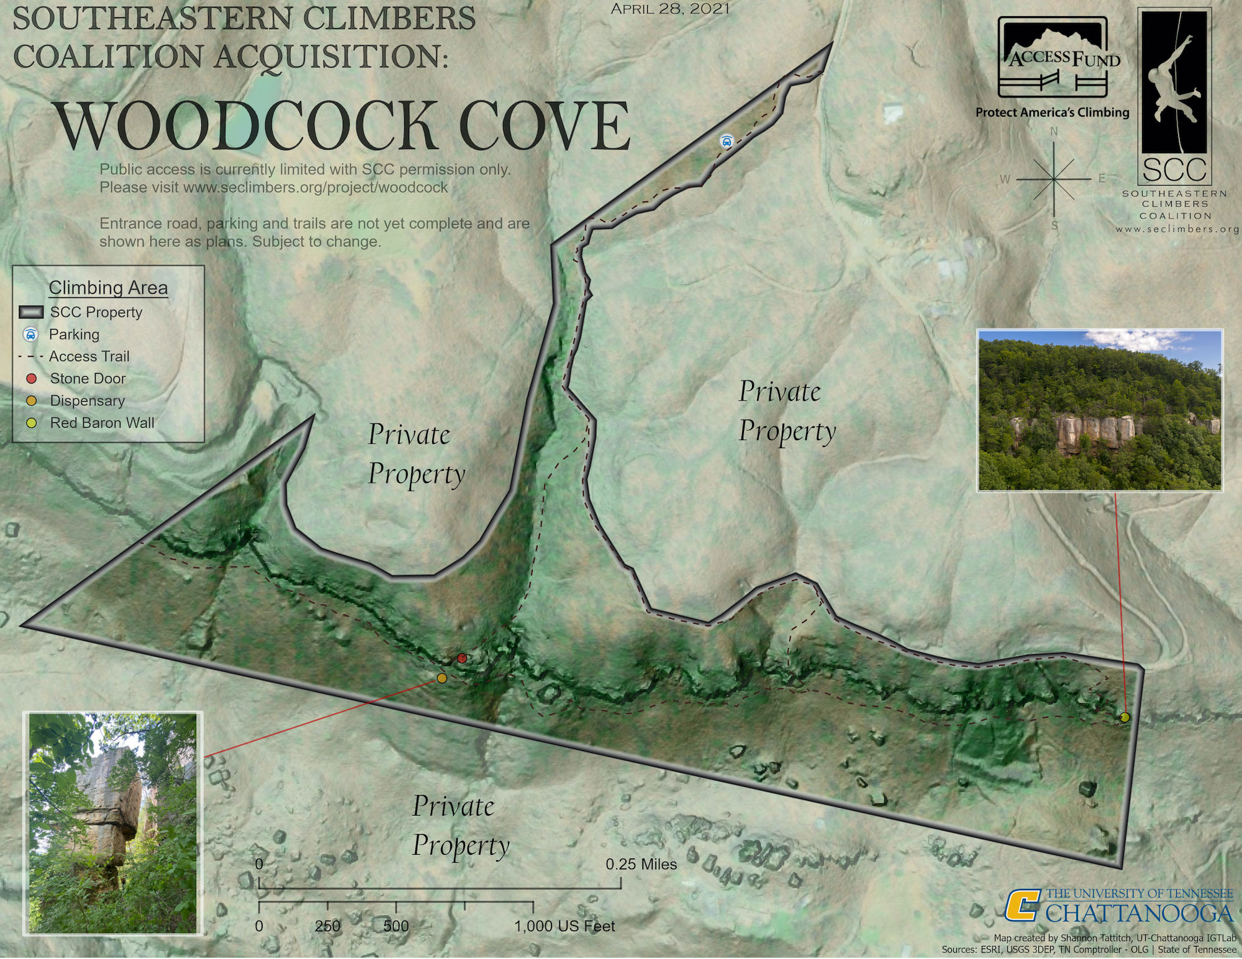
Figure 6: Map of Woodcock Cove
From https://www.seclimbers.org/2021/04/30/woodcock-cove-blog/

Appendix B
Institutional Review Board Exemption Letter

Exemption letter from the Institutional Review Board at the University of Tennessee in Chattanooga.

Appendix C
Permission for Access to and Use of Woodcock Cove
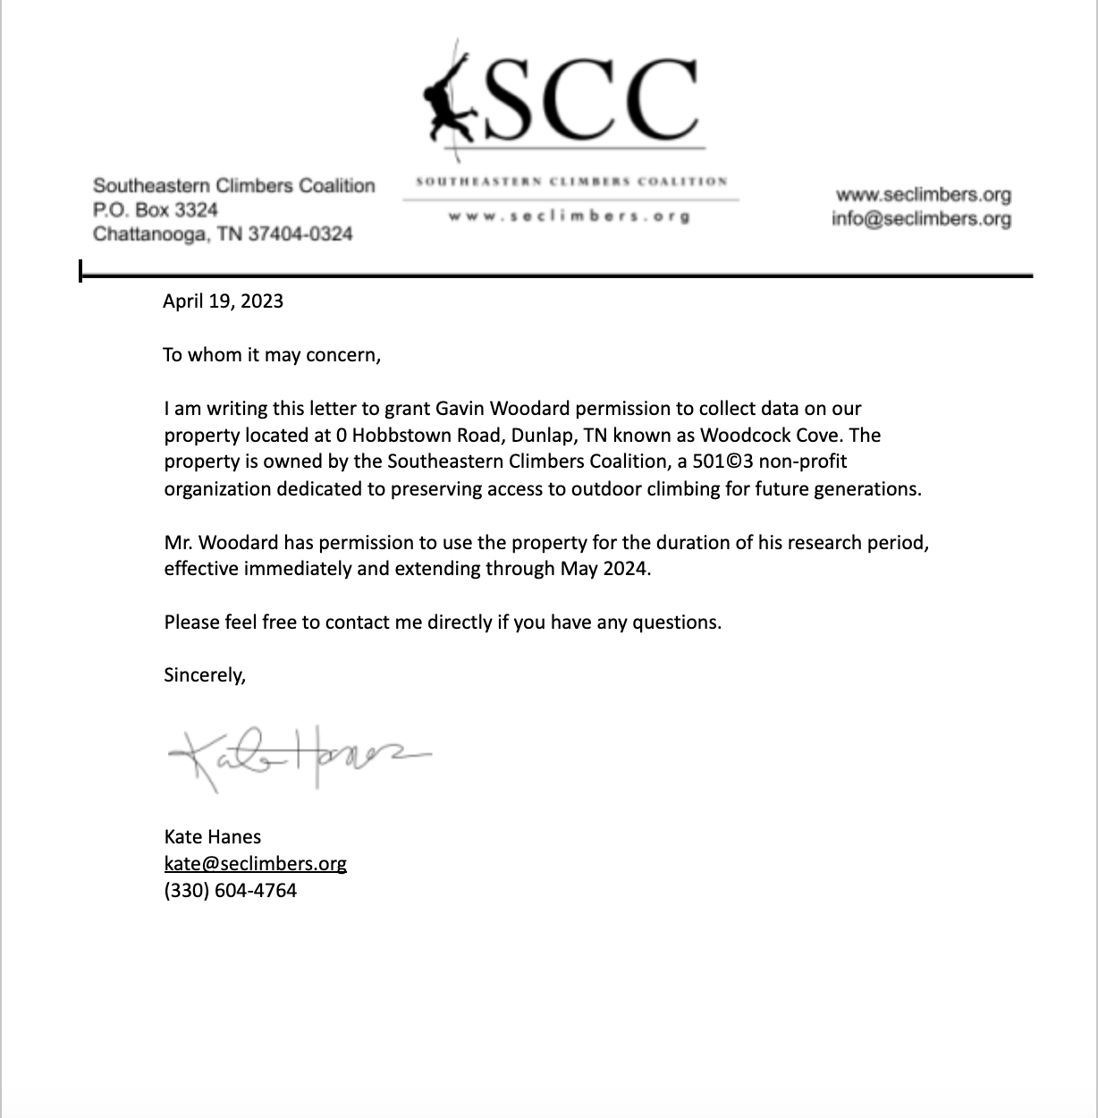
Written Permission to access the Woodcock Cove property from the Southeastern Climbers Coalition.

Appendix D
Image of Signage at Woodcock Cove
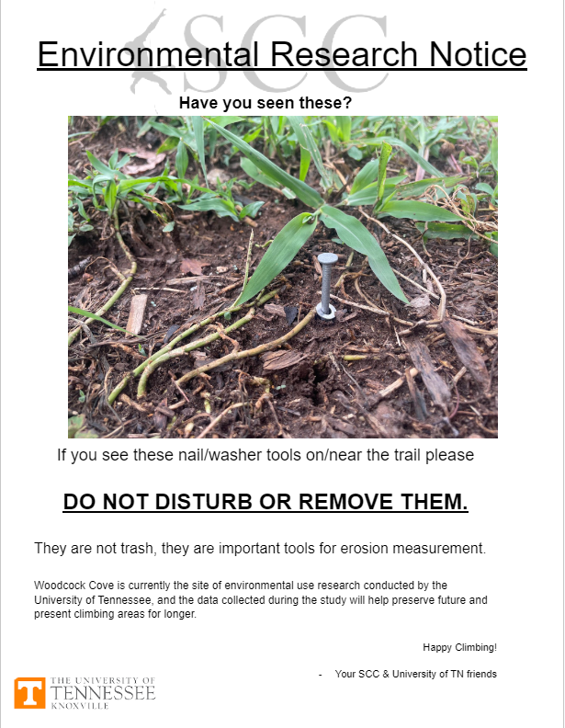
Signage posted to notify climbers at data collection sites at Woodcock Cove.

Vita
Originally born in Michigan, Gavin Woodard moved to Tennessee at a young age and received the majority of his primary education in the Memphis area. He received a Bachelor of Science degree in Sport, Outdoor Recreation, and Tourism Management from the University of Tennessee at Chattanooga in 2021 and chose to attend the University of Tennessee’s Knoxville campus to pursue a Master’s degree in Recreation and Sport Management. Gavin is an avid rock climber and outdoor enthusiast who enjoys spending his free time exploring the Cumberland Plateau, Southern Appalachians, and other remote locations across the United States. His research interests primarily concern the longevity and conservation of public outdoor rock-climbing areas. After graduation, Gavin will begin his position as an Airline Obstruction Lighting Technician and continue to pursue his passion for climbing. He is ecstatic and impressed at the support he has received from his family and colleagues during the pursuit of his education and as he brings this chapter in his academic career to a close.

