ME 460 Spring 2017
The Back-Up Linemen
Stephen Brennan, Benjamin Jacob, Blake McDavid, Logan Sissom

Problem Statement:
In order to enhance lineman’s ability to generate leverage, a training tool is used to provide feedback as to when a lineman has crossed a horizontal plane set at a predetermined elevation. The tool in use today consists of a fabric plane that is stretched and fastened to a rectangular frame made of steel pipe. The fabric plane is a rectangle approximately 10 feet wide and 20 feet long. The frame that supports it has a leg at each corner that sits on the ground. The size of the fabric plane and the placement of the legs limit the effective blocking drill area to the size of the fabric plane. During blocking drills, the opposing linemen position themselves under the fabric plane and go at each other. Whenever either lineman rises up too much (reducing his leverage) he comes in contact with the fabric letting him know any advantage he had over his opponent is gone. The desired design would be capable of providing an effective blocking drill area 40’x10’ or roughly twice the size of the existing tool. If supported by legs, the legs would be positioned so as to enhance the effective blocking drill area above the 40’x10’ size. The goal is to remove the legs to maximize the blocking area and allow the entire offensive line to be under the feedback plane at once. The football coaches requested the new lineman chute be designed so that it could be stationary and anchored to the ground in a specified area on the football practice field.

Background:

The Physics of Football: Lineman Leverage
If you’ve ever been around the game of football, there’s a good chance you’ve heard someone say “the lowest man wins” when talking about linemen. You may have also heard that defensive coaches preach “low tackles”. It turns out that both sayings are backed up by physics. In fact, they both work using the same mechanical relationship: torque.
A torque, sometimes called a moment, is the outcome of a force being delivered outside of an object’s center of mass. When a moment is applied to an object, it produces a rotation about the center of mass. For example, one person on a seesaw will simply drop their side of the seesaw to the ground, because their weight is the only outside force on the seesaw, and it rotates the object around the fixed center point. But if another person sits on the other end, their weight will work against the first person’s, and with some assistance from person one’s legs, together they can rotate the seesaw back and forth.
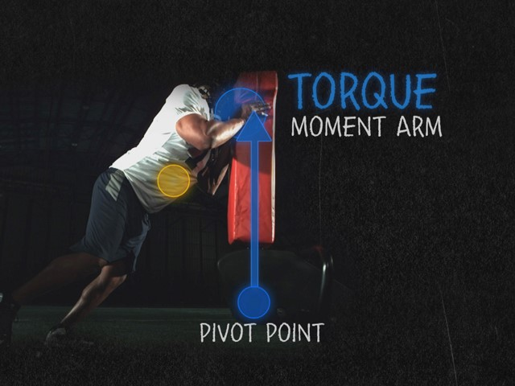
Figure 1: A Lineman pushing a football dummy
In Figure 1, an offensive lineman is shown pushing against the top of a football dummy. By pushing against the top of the dummy, he is giving himself the best leverage, i.e. producing the biggest moment. So why is it important for a lineman to stay low during the block? When a lineman gets low, his center of mass lowers with him. A man’s center of mass is usually located around the navel, and by keeping the upper half of his body lower, he decreases the maximum distance of his body from his center of mass. This means that when two linemen run into each other and push on each other’s chests, the lineman who is lower has created a mechanical advantage for himself. If he can produce the same force as his opponent, he will be producing a larger moment, and will win the matchup.
Similarly, if a defensive player is trying to tackle a running back, they are told to tackle the player low. When you deliver a force to the lower part of a player, you create a rotation around the running back’s center of mass. If the defense tackles higher, they decrease the magnitude of the resulting moment, and may have to tackle the player using only their force. This action may simply push the running back sideways, and his practiced balance may allow him to break free. In conclusion, a well-coached team uses any mechanical advantage they can, and a lineman’s low stance certainly creates one.
Present Designs in Use
Various leverage trainers, also called chutes, are on the market and are currently used by the football team. The primary mobility chute the football team uses is manufactured by Rogers Athletics and measures 20’ by 10’ at 230 pounds. The football team also has a number of 10’ by 10’ mobility chutes also made by Rogers that are 190 pounds and used less frequently. Features that both of these chutes include are 4 legs with casters for easy mobility, 40”-69” height adjustability via pins in legs, and mesh netting tops as non-scratch height barriers. The price of these chutes are $1200 for the 10’ by 10’ and $2065 for the 20’ by 10’.

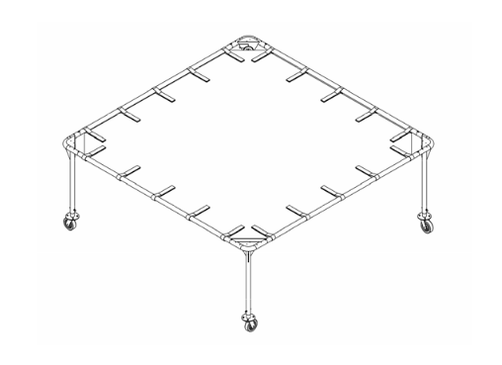
Figure 2: Rogers 10’ by 10’ Mobility Chute

As will be discussed a little later in the Approach section, another type of leverage trainer called a trap chute was also considered in our design process. This type of chute is typically longer and narrower in design when compared to mobility chutes. The football team also possesses a Rogers 24’ by 5’ trap chute that weighs 664 pounds that is used less frequently than the mobility chutes. This trap chute features two “T” shaped legs with casters on either short end of the structure and a two point 24” height adjustable plane with 90° optional angle adjustments. This model costs $2470.

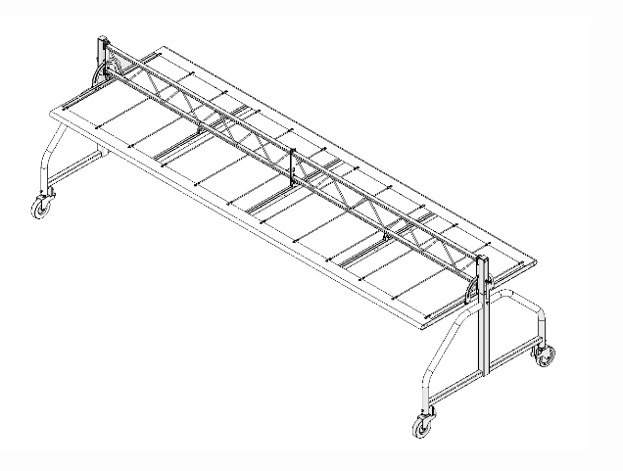

Figure 3: Rogers 24’ by 5’ Trap Chute

Approach and Methodology:
We began the Fall semester by creating a Gantt chart which would act as a guide throughout the semester to keep us on track with our project and to keep us accountable for any deadlines we needed to meet.

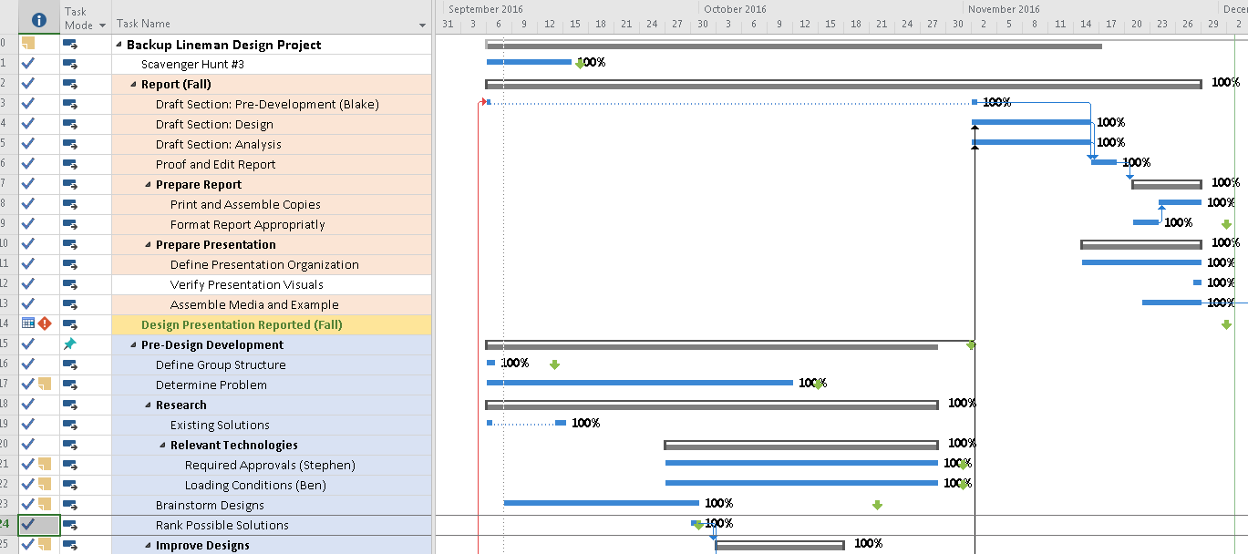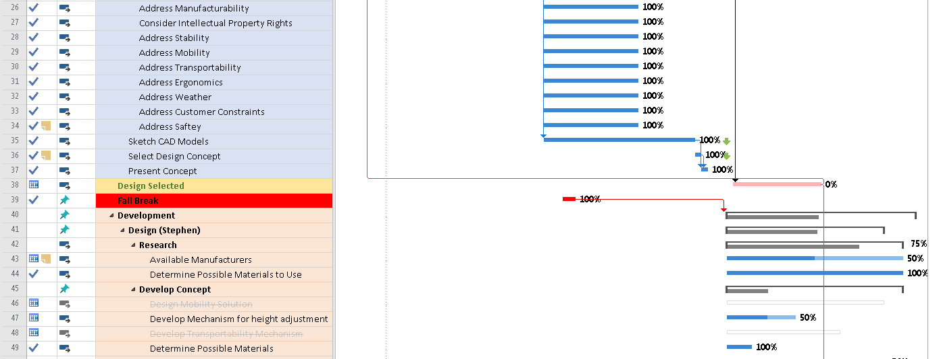
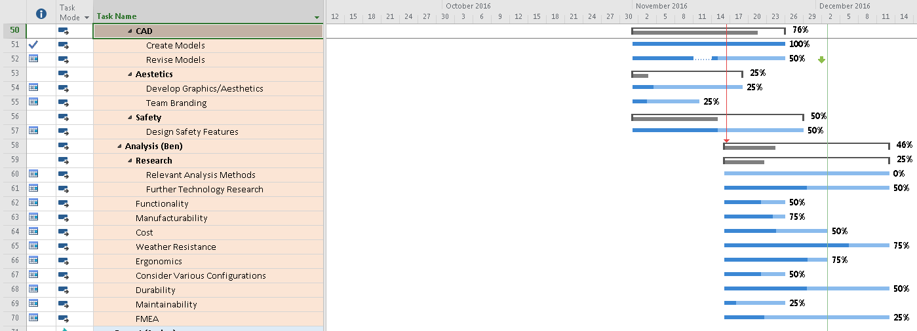
Figure 4: Fall Semester Gantt Chart
Our initial design approach focused on developing ideas to move the legs out of the way and to make the height adjustment more efficient. Some of the design sketches are shown in the Appendix A.

In designing and synthesizing concepts for this project we initially wanted to address concerns of the following: durability, overall cost, weather resistance, safety, ease of use by athletes, functionality and performance, weight, transportability, capacity to design, manufacturability, aesthetics, legal constraints, disposal, athlete capabilities, and ease of installation. Given these factors and the criteria of the problem statement we determined to design the tool in sections, that is separate concepts for the support structure, the feedback plane which athletes interface with, and the mechanism for adjusting the height.

Initially, for designs of the support structure there were two general concepts; the first being a truss that spans the major length of the feedback plane and is supported on either end by free-standing legs. The legs on either end could either be two separate legs or one legs with a T-shaped base. The second of the two designs is a cantilevered design; the structure consists of vertical posts positioned along the major length of the feedback plane. At the base of these posts there is a base that is either weighted or fixed, and at the top posts that extend out over the feedback plane.

Concepts for the feedback plane were quite varied; there were many types of designs that each focused on a different type of sensory feedback. For types of feedback that provides a sensory feedback by constructing a solid surface from either mesh, sheet metal, rubber, or some mass-loaded polymer sheeting. For visual and auditory means of feedback we considered an array of light beams or pressure switches which would trigger events of sirens and flashing lights to show that an athlete had exceeded the selected height restriction. Additionally, the concept of having a series of padded, cantilevered bars extending out over the area, such that when the athlete stands up the bars would rotate and show that the height had been exceeded in addition to the sensory feedback to the player.

In terms of the height adjustment mechanism there are multiple designs ranging from set of concentric tubes with an array of holes that would accept a pin to allow for the feedback to rest at some pre-selected interval of heights to a 3-bar mechanism that constrains the height depending upon the length of one of the mechanism links. For the array of holes, ideas of placing the extension in the vertical legs of the support structure were considered; alternatively, we considered make the adjustment at the connection point between the feedback plane and the overhead supporting structure. Some components that allow for a mechanism include a tensioned cable that when allowed to change lengths via a winch assembly, the height of the feedback plane would change, a power screw that when rotated allows for a changing length, and a rack and pinion which as a gear rotates (pinion) the rotational motion is translated into to linear movement of the rack.

In order to determine which designs were the best, we compared each component to a datum design using a Pugh Chart. We assigned a plus one to a design that was better than the datum, a minus one to a design that was worse than the datum, and a zero if the design was the same as the datum. The designs were compared to the datum for each of the criteria for success, and the scores for each design were summed. The Pugh charts can be seen in Figure 5.

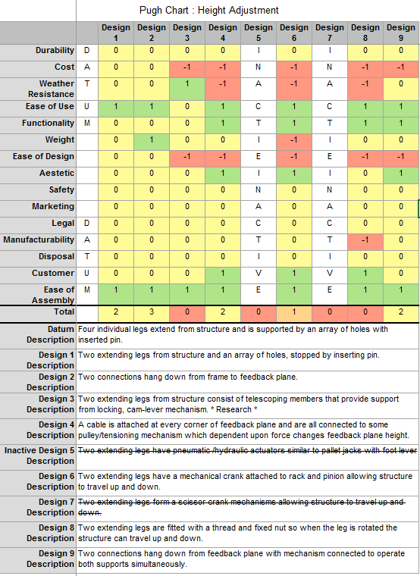

Figure 5a: Pugh Chart for Height Adjustment

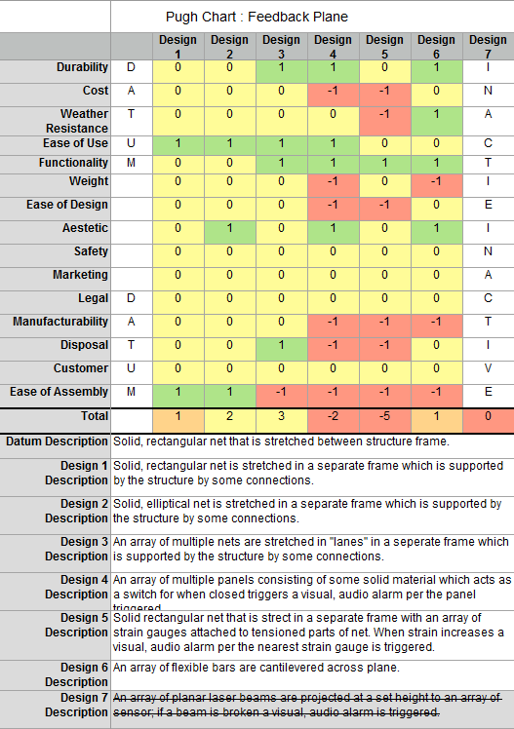

Figure 5b: Pugh Chart for Feedback Plane
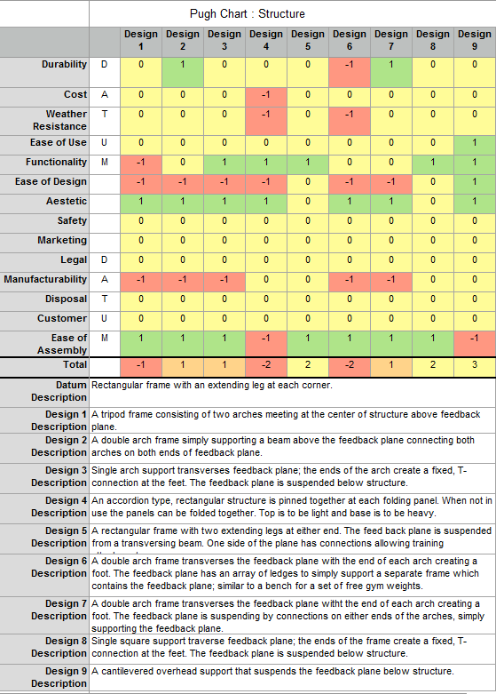

Figure 5c: Pugh Chart for Structure

Selected Concept Design:

After our Pugh Chart analysis was complete, it was decided that the best design option included a cantilevered overhead support that suspends the feedback plane from above. Figure 6 shows the CAD model of our selected concept.

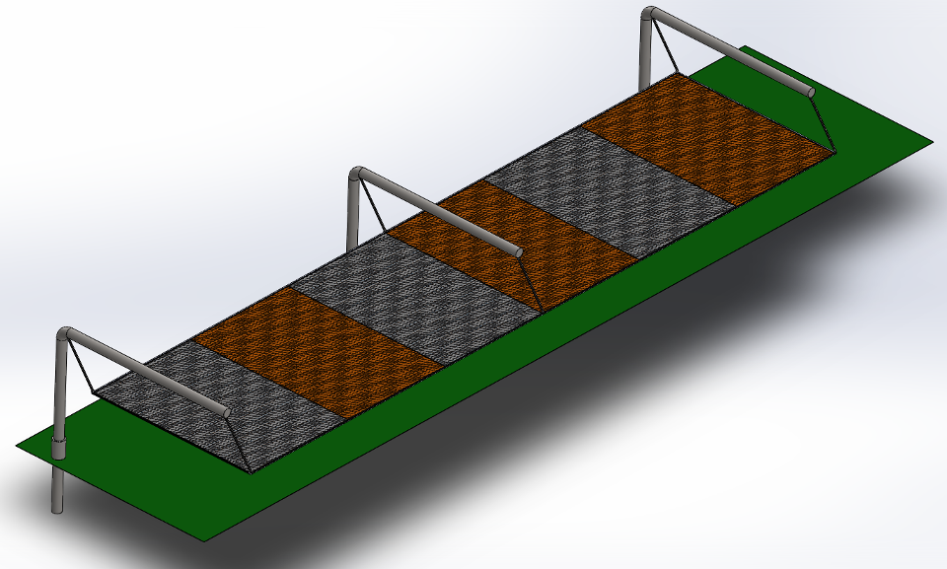

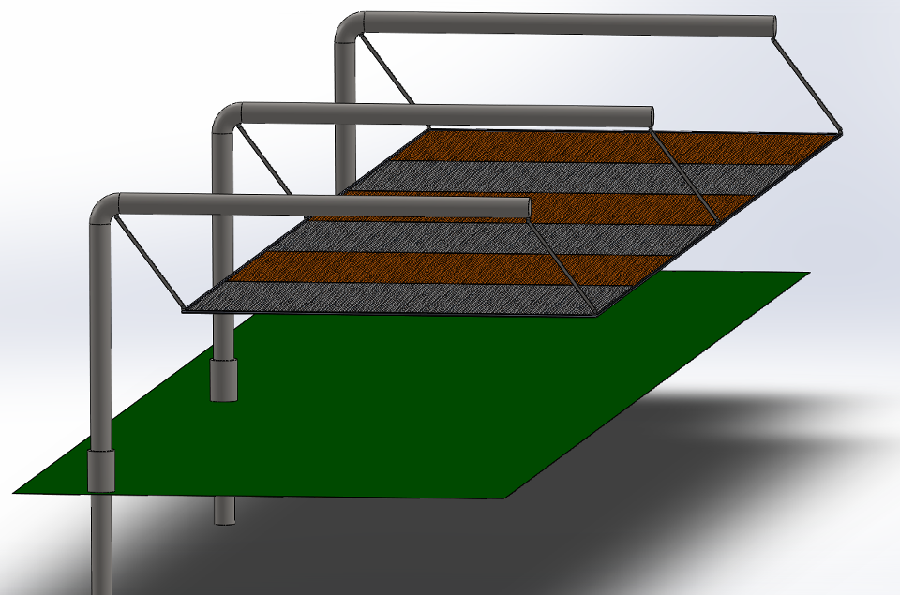

Figure 6: Selected Cantilever Design Concept

Initial Analysis:

Feedback Plane:
In determining the design of the feedback plane, the selected concept of the mesh lanes was analyzed on a basis that the mesh would span a length of 10’ between the feedback plane framing, and have a width of 80” such that separate lanes to drill under would exist under the feedback plane. Based on existing use of the Rogers Athletics mesh and extensive use in the Marine construction industry — within these too similar applications the mesh selected could demonstrate similar weather resistance — a vinyl-covered, thermoplastic polyester was selected for analysis. Additionally, from suppliers such as McMaster-Carr a net made of such material could be sourced with a thickness of 0.016” and 60% fill, i.e. 60% of the area covered by the mesh would have a fiber covering it. With this in mind, a mass of about 2.50 kg, a second-moment of area, I, of 1.137 x 10⁻¹¹ m⁴, and Young’s Modulus, E, of 2.49 GPa was determined.

Further, the stress and deflection of the net was then determined using equations of super-position. To first see how much the net deflected under its own weight the following equation modeled the net’s behavior assuming it is simply supported by the frame.

The resulting design would deflect at the center length a theoretical distance of 318.3 m which is impossible; it would simply fall off the frame. A further iteration was determined that the net would have to be placed into tension. Given that polyester is a polymer it is susceptible to the mechanism of creep — given a load over some time depending mainly on magnitude of load and operating temperature the polymer will rupture or fail. In the case of polyester with a maximum operating temperature of 125ºF the design could survive about 100,000 hours (about 11.5 years) as long as the strain in the fiber is below 2.4%. Given this the net could be loaded in tension by about 11 N or 2.5 lbs. The stress in the net would come from the load of the tension through the net and shear forces of the net keeping itself from deflecting. The resulting max force in the net would then occur at the edges of the net with 55.09 MPa since the cross-sectional area is so small (Note the estimate yield point is 57.1 MPa for polyester), the deflection then decreases to 0.141 m or 5.6” at the center.

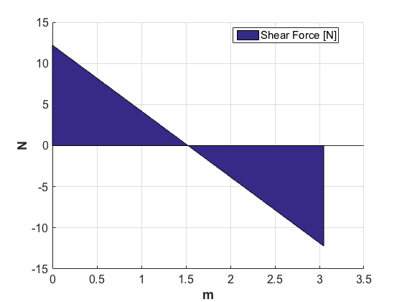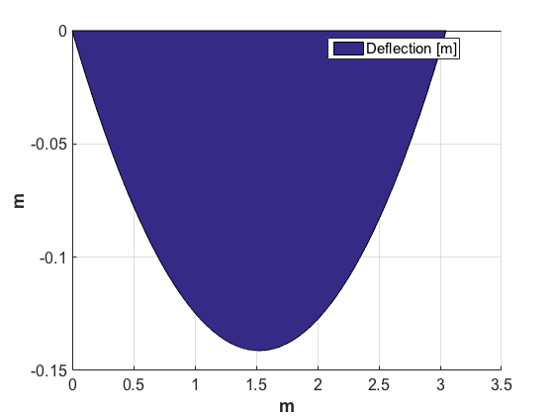
Figure 7a: Shear Stress in Net along length Figure 7b: Deflection of Net along length

This height can be further reduced by driving the tension up to 65 N or 15 lb in the net to a maximum of 4.1% strain; the design could then survive about 10,000 hours (about 1 year). The deflection however would reduce to 3” at the center.
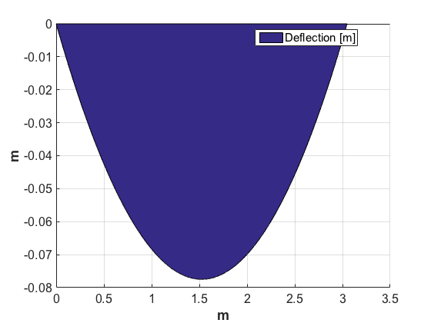
Figure 8: Deflection of Net along length

Due to the creep of the net this would change and drop over time the net would either have to be re-tensioned as the net elongates and drops, or add support that is not susceptible to the mechanism of creep and higher modulus of elasticity, i.e. steel cables. Under those terms the net could last as long as it is not deteriorated by weather or damaged by some other means not accounted for.

Analysis of Required Force to Push Feedback Plane:
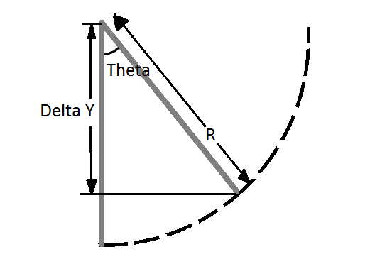
Figure 9: Arc with radius R and height Y from which theta is derived
If R is the length of the links connecting the feedback plane to the legs, ϴ is the angle of those links from their vertical position, and ΔY is the change in height of the feedback plane, then they are connected by the following relationships:

$$R-R*\cos\left(ϴ\right)=ΔY$$
$$ϴ=cos^{-1}\left(1-\frac{ΔY}{R}\right)$$

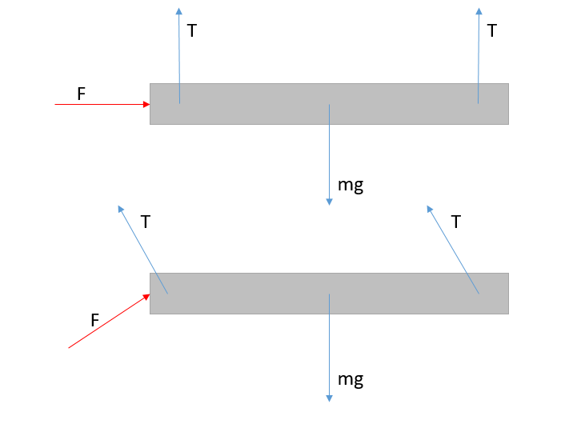
Figure 10: Free body diagram of feedback plane
A free body diagram of the feedback plane is shown in Figure 10 for two different positions: the connecting links in the vertical position, and the connecting links at an angle of ϴ from their vertical position. For the first position, the horizontal force F is equal to 0 pounds, because it doesn’t require a force to keep the feedback plane at its natural resting position. The following analysis is done for the second position, where all values except (mg) will be dependent on the angle ϴ.
$$\sum{Fx } \underset{→}{yields}F*cos\left(ϴ\right)= 2*T*sin\left(ϴ\right) \underset{→}{yields}F=2*T*tan⁡(ϴ)$$
$$\sum{Fy }\underset{→}{yields} F*\sin\left(ϴ\right)+2*T*\cos\left(ϴ\right)=2*T*\sin\left(ϴ\right)*\cos\left(ϴ\right)+2*T*\cos\left(ϴ\right)=mg$$
$$T\left(sinϴtanϴ+2cosϴ\right)=mg$$
$$T=\frac{mg}{2sinϴtanϴ+2cosϴ}, F=2*T*tanϴ=\frac{mg*tanϴ}{sinϴtanϴ+cosϴ}$$
$$F=\frac{mg*tanϴ}{sinϴtanϴ+cosϴ}=\frac{mg*tanϴ}{tanϴ(sinϴ+\frac{(cosϴ)^{2}}{sinϴ})}=\frac{mg}{\frac{(sinϴ)^{2}}{sinϴ}+\frac{(cosϴ)^{2}}{sinϴ}}=\frac{mg*sinϴ}{{\left(sinϴ\right)}^{2}+(cosϴ)^{2}}$$
$$F=mg*sinϴ$$

Table 1 shows various inputs, the outputted ϴ values, and the outputted F values.
R (ft) | ΔY (ft) | ϴ (degrees) | Mg (lbs) | F (lbs)
3 | 2 | 70.5 | 500 | 471
3 | 1 | 48.2 | 500 | 373
3 | 0.5 | 33.6 | 500 | 277
4 | 2 | 60 | 500 | 433
4 | 1 | 41.4 | 500 | 329
4 | 0.5 | 29.0 | 500 | 242
Table 1: Calculated forces at each angle theta
Analysis of Bending Stress on the Upper Leg Corner

Weight of Feedback Plane W = 500 lbs
Moment Arm Length (Maximum) X = 10 ft = 120 in.
Thickness of Legs T = 4 in.
Number of Legs N = 4
Max Moment on Each Leg Corner M = (W/N)*X = (500/4)*120
= 15000 in-lbs
Second Moment of Area of Each Leg’s Cross-Section Ix = (pi/4)*(T/2)⁴
= (pi/4)*(4/2)⁴
= 12.57 in.^4
Bending Stress σ = (M*(T/2)) / Ix)
= (15000*(4/2) / 12.57)
= 2386.7 psi
Yield Strength (T304 Stainless Steel) FY = 31200 psi
Factor of Safety FoS = (FY/ σ) = (31200/2386.7)
= 13.1
The Factor of Safety is a quantity that defines the factor that the current stress could be multiplied by to reach the Yield Strength of the structure material.

Spring Semester Gantt Chart:

Figure 11: Spring semester Gantt chart
In-Depth Analysis:
Safety is a vital component of any design, but is especially important when the failure of that design cold result directly in injuries. To prevent structural failure, many calculations were performed. In order to understand the importance of each calculation, a Failure Mode Effects Analysis (FMEA) was written. A summary of the FMEA is shown in Figure 12.
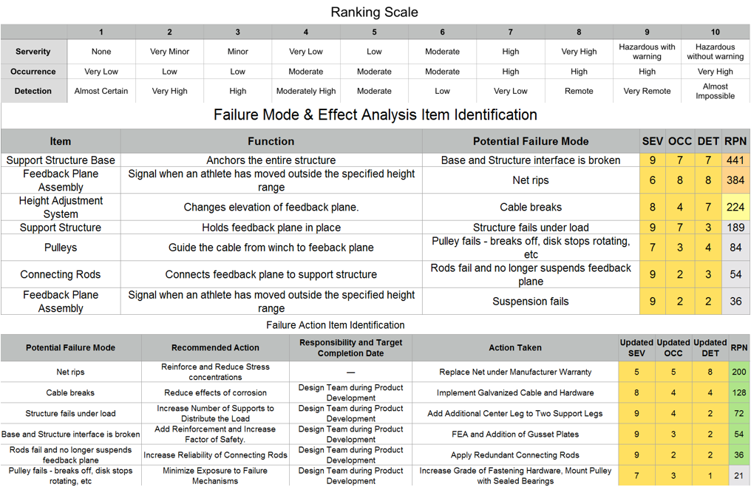
Figure 12: Summary of FMEA performed on design
Below is a summary of the analysis calculations done for the project.
Feedback Plane – Bending (Deflection and Stress), Shear in the part interactions
Links – Tensile Stress, Shear Stress, Deflection
Support Legs – Bending (Deflection and Stress), Shear, Buckling, Compression, Stress Concentrations
Redundancy Brackets – Shear, Shear Tear-Out
Cable – Tensile Strength
Pulleys – Loads from Cable System were compared to part allowance
Winch – Loads form Cable system were compared to part allowance
Concrete Base – Concrete Base was sized based from knowledge of soil mechanics and concrete pier strength
Anchor Bolts – Axial Stress and Pull-Out Strength
Brackets – Brackets were analyzed for strength in their respective loads
Fasteners – All fasteners were checked for strength in their respective load paths
Tolerance Stack-Up was checked for all parts, as well as the overall system reliability.

It is important to note that when calculating factors of safety, stress calculations were checked against the respective yield strength, and some parts were checked against the maximum loading values listed on their vendor websites. Below is a summary of the critical factors of safety for each designed part, along with the critical stress/load state, and supporting equations for calculation (See Appendix B for detailed MATLAB code). A factor of safety is considered critical if it is the lowest factor of safety for that respective part.
- Legs: 2.13 (Bending + Handling)
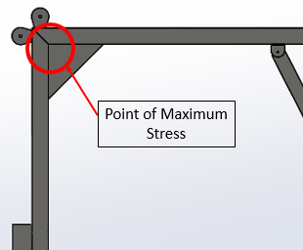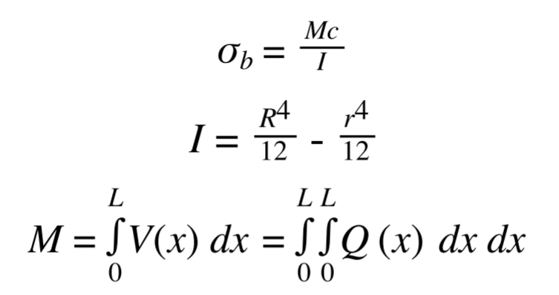
Figure 13: Point of maximum stress on Legs and supporting equations
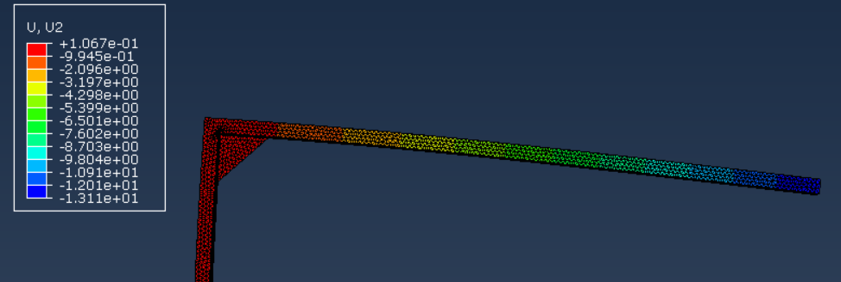
Figure 14: FEA displacement analysis of Leg
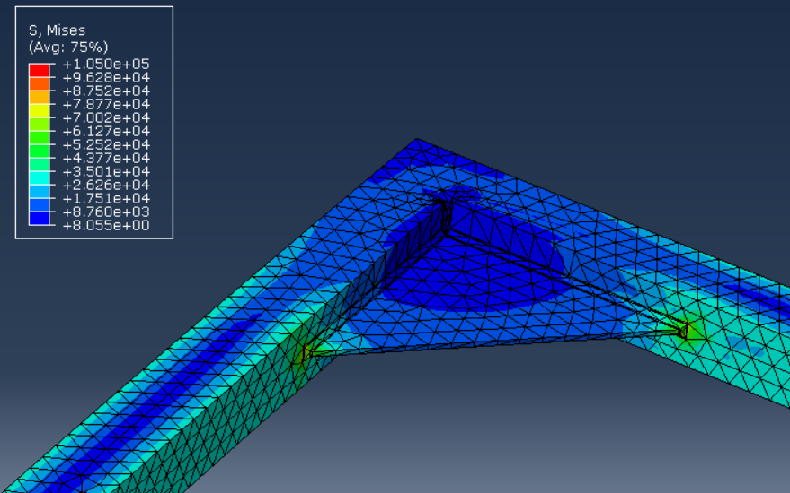
Figure 15: FEA Mises analysis of Upper Gusset Plate

- Links: 1.81 (Bending + Tension)
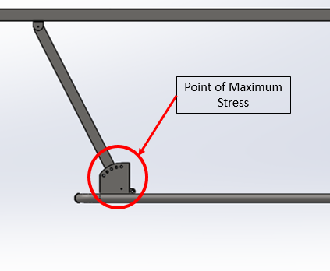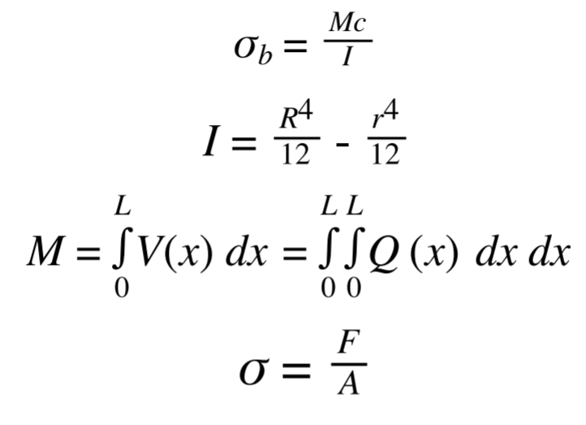
Figure 16: Point of maximum stress and supporting equations

- Feedback Plane: 4.54 (Stress on Perimeter Frame)
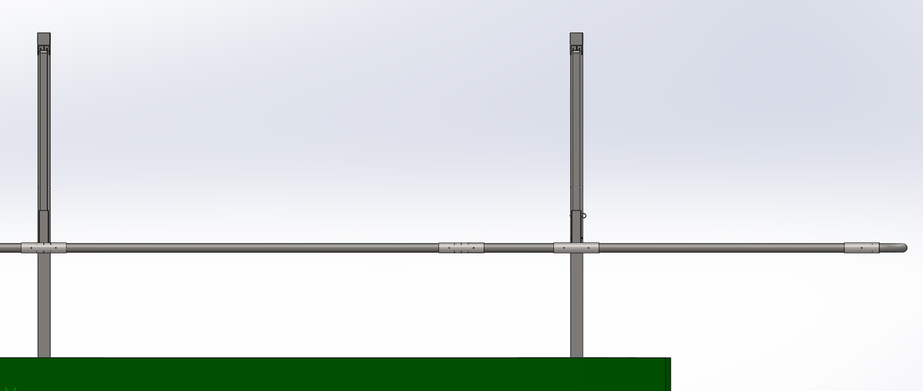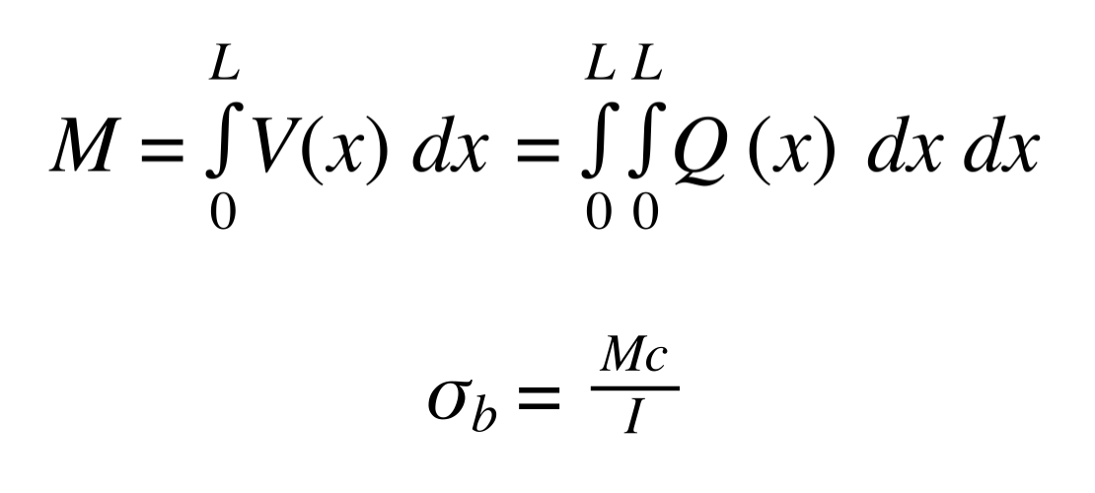
Figure 17: Stress on perimeter frame and supporting equations

- Anchor Bolts: 4.27 (Pull-Out)
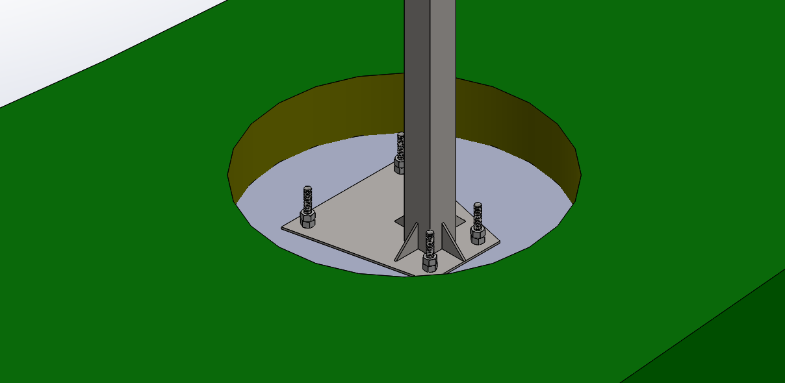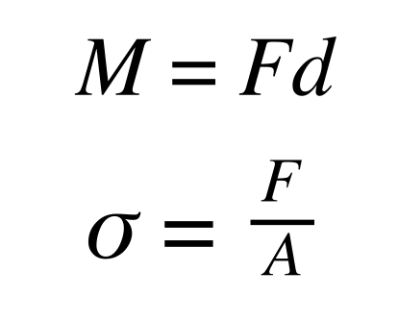
Figure 18: Anchor bolt pull out and supporting equations

- Lower Brackets: 2 (Shear Tear-Out)
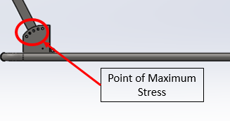
Figure 19: Lower bracket maximum stress and supporting equations
- Safety Pin: 3.5 (Shear)
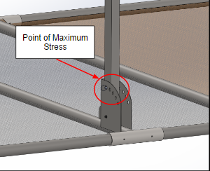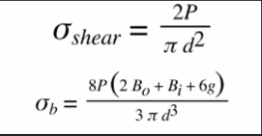
Figure 20: Safety Pin shear tear-out and supporting equations
- Upper Brackets: 13 (Shear Tear-Out + Handling)
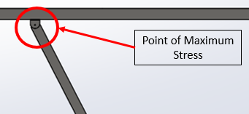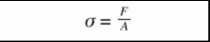
Figure 21: Upper Bracket point of maximum stress and supporting equation
- Cable System: Maximum Tension of 1250 lbs
- Upper Bracket Bolts: 1.14 (Bending, Shear, Handling)
- Concrete Pier Design
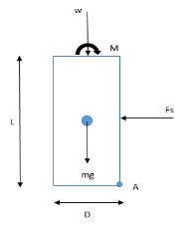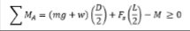
Figure 22: Concrete pier FBD and supporting equation

Future Actions & Conclusion
Although the design is complete, we do not yet have a working prototype. The biggest reason for this is because the customer was not sure if actually building the device was going to occur. Once we got approval from the football team, it was already too late to be able to complete the prototype by the end of the semester. We have been working very hard to order parts, refine drawings, and schedule time with Danny to get everything as close to done as possible.
Some tasks that still need to be completed going forward are:
- Cut and drill legs, feedback plane, and plates to spec
- Weld parts together
- Assemble the entire structure
- Map out area best for installation
- Transport parts to the field
- Install prototype on site via work instructions
We have learned a lot throughout this process and hopefully it will make us better engineers moving forward.

Figure 13 shows the Gantt chart moving forward into the summer months when we hope to complete the project.
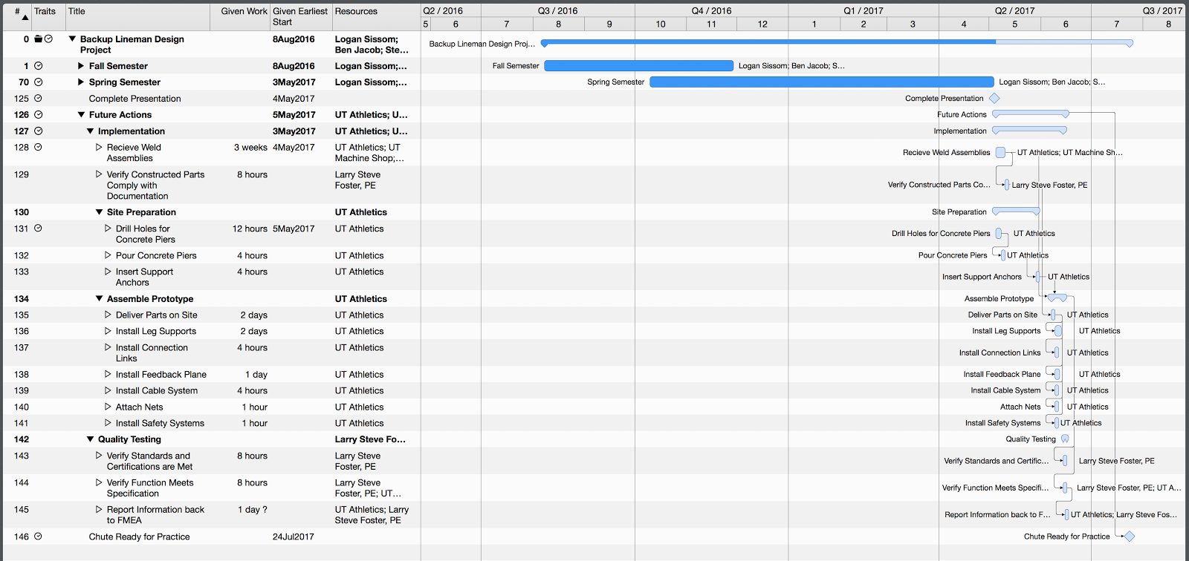
Figure 13: Future Actions Gantt Chart
Appendix A
Pre-Design Sketches:
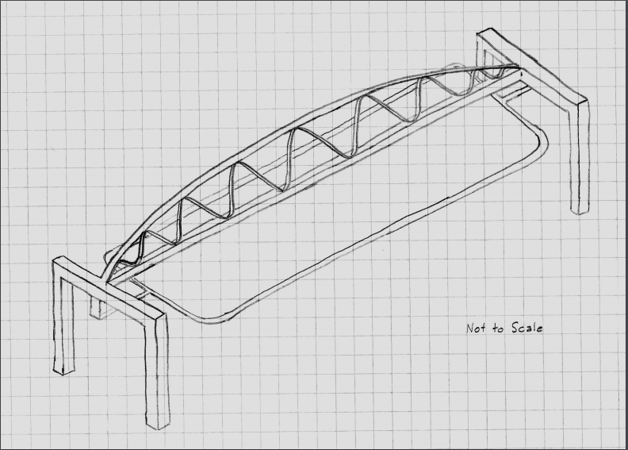
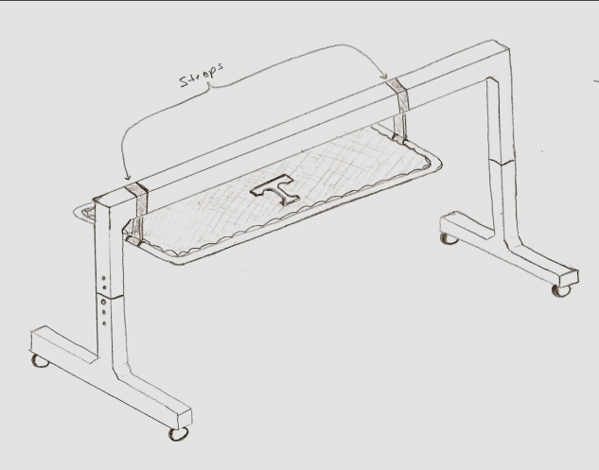
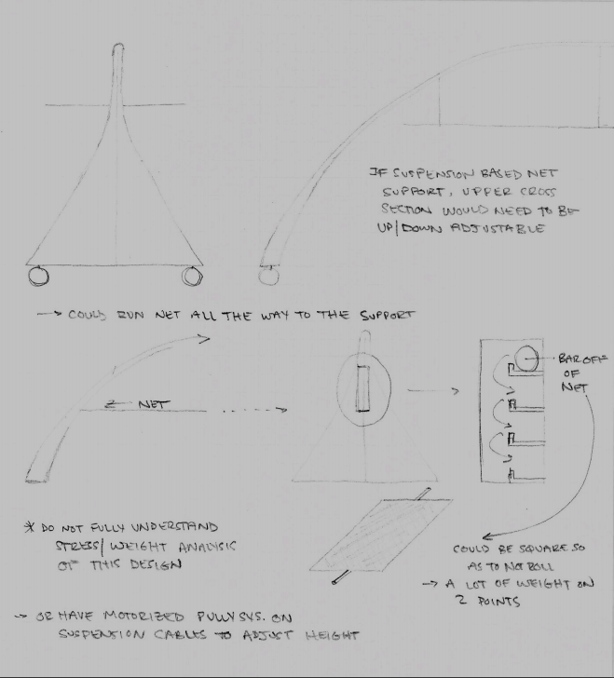
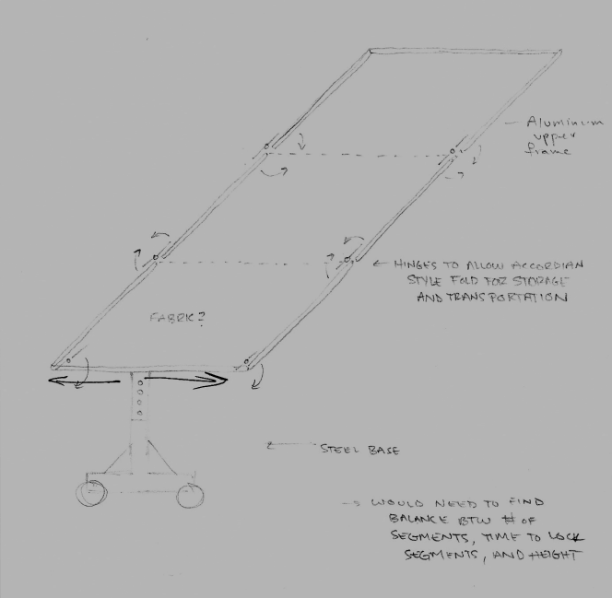
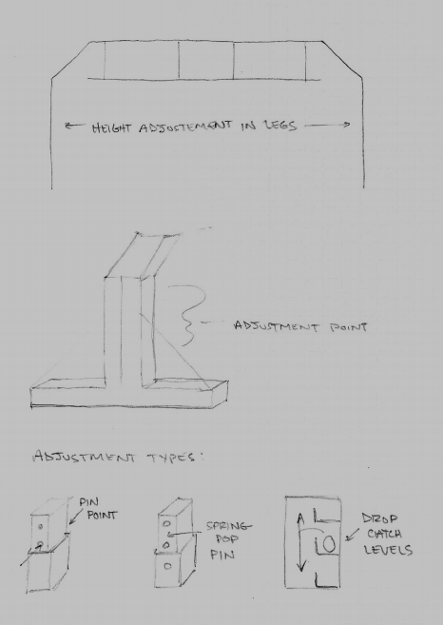
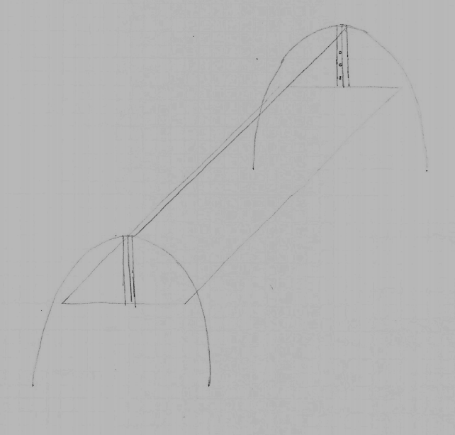
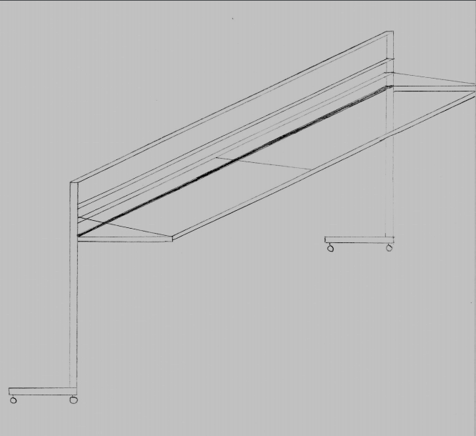
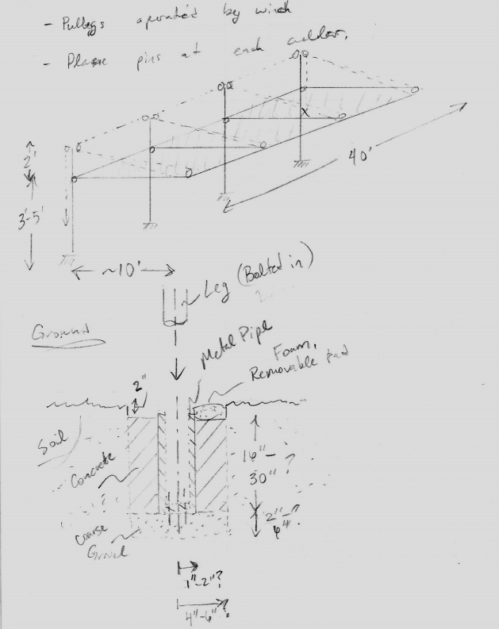

Appendix B
Analysis Calculations:
The stress calculations for the support leg are shown below, as well as the loading for the cable. The cable analysis calculates the load at different feedback plane heights, so that the maximum value could be accounted for. The cable was then purchased to be strong enough to handle the load.

Bending Stress at the Support Leg Bend
N = 3; % number of legs (unitless)
W = 900; % total weight in pounds
R = 13; % moment arm length in feet (maximum distance of application)
M = R*W; % magnitude of total weight moment in ft-lbs
h2 = (3.5/12); % outer height of support leg piping in feet
h1 = (3.25/12); % inner height of support leg piping in feet
b2 = (3.5/12); % outer radius of support leg piping in feet
b1 = (3.25/12); % inner radius of support leg pping in feet
I = (1/12)*((b2*h2.^3)-(b1*h1.^3)); % second moment of area of leg pipe in ft^4
Sig = (((M*h2)/(2*I))*(1/144))/N; % b-stress in psi (1 leg, total weight)
YS = 35000; % approximate yield strength of steel in psi
FoS = YS/Sig
% This bending moment is equal to the moment at the fixed conneciton of the
% support leg because these are the only acting moments on the leg
% structure
FoS =

1.3709

Axial Stress on the Support Cable(s)
WC = 670; % moving load (pounds) on one cable, only in y direction
FPL = 8.5; % feedback plane length with pulley in feet
LL = 5; % link length in feet
Del_Y = [0 0.5 1 1.5 2]; % change in height matrix in feet
Theta1 = acosd(1-(Del_Y./LL)); % angle between link and vertical
Del_X = sind(Theta1).*LL; % change in horizontal position of plane in feet
Theta2 = atand((FPL-Del_X)./(LL-Del_Y)); % angle between cable and vertical
Load = WC./(cosd(Theta2)) % maximum axial load in cable in lbs

% cable should be rated above the calculated load.
Load =

1.0e+03 *

1.3214 1.1552 1.1391 1.1573 1.2079

Below is the analysis for the buckling and compressive strength of the support leg.

Buckling and Compressive Strength
clear all
close all
clc

L = (8*12); % Length (Height of Vertical Support above ground) (in)
% Height measured from bottom of bent tube to top of ground

E = 30*(10^6); % Modulous of Elasticity (1026 Low Carbon Steel)

a = 3.5; % Outer Length Square (in)
b = a-(0.125*2); % Inner Length Square (in)

I = ((a^4)-(b^4))/12; % Center Moment of Inertia (Square Shape)
A = a^2-b^2; % Area of the vertical support bar
K = sqrt(I/A); % radius of gyration

% The vertical bar is in a fixed-free configuration, so a C value of (1/4)
% will be used to calculate the critical force.
C = 0.25; % end-condition constant C
Pcr = (C*(pi^2)*E*A)/((L/K)^2); % critical force for buckling in pounds
Weight = 900; % weight of feedback plane and total load in lbs
FoS = Pcr/Weight % factor of safety (buckling)
FoS =

28.6293

Compressive Strength
% 1020 Cold Rolled Steel (Low Carbon)
% Yield Strength - 51,000 psi (CD)
% - 43,000 psi (annealed)
% - 30,000 psi (HR)

% Formula Used: sigma = F/A

F = 1000; % Max force on a leg (lb)

ao = a.^2; % Outer Length Square (in^2)
bi = b.^2; % Inner Length Square (in^2)

A = (ao)-(bi);

sigma = F/A; % Applied stress to vertical tube cross section (psi)
YS = 35000; % steel yield strength (psi)
FoS2 = YS/sigma
FoS2 =

59.0625
Below is the analysis code for the feedback plane.

Revised Feedback Plane Analysis
Created by L. Sissom Date : 15 April 2017 Modified :
%{
PURPOSE:
The purpose of this script is to help compute the expected loads on
possible configurations of the senior design project.

REFERENCE:

LOCATION:
pathDir00 = '';
addpath(pathDir00);

FUNCTIONS:

%}

close all; clear all; clc; format compact; format long g;

Add Function Paths
Use below to locate directory:
%{
[fileName00, pathDir00] = uigetfile();
addpath(pathDir00);
completeName00 = fullfile(pathDir00,fileName00)
%}

Plotting Properties
psname = ('Helvetica'); % Plot Font Style
pawt = 'bold'; % Plot Label font weight
pftxt = 15; % Plot Text font size, [pts]
patxt = 18; % Plot Label font size, [pts]
pstxt = 16; % Plot Axis Ticks font size, [pts]

strU01 = ('in');
strU02 = ('Lb_f');
strU03 = ('Lb_f-in');
strU04 = ('º');
strU05 = ('psi');

Initializations
Load of Netting
T = 58.1358; % Tension per Net [lbf]
aT = 2.8108; % Angle from horizontal of net connection [º]
Tnetz = T*sind(aT);
Tnety = T*cosd(aT);
lT = 120; % Length of Net Section
% Positions Netting attaches to Feedback Plane [in]
cT = sort([(246-2) (246+2) (246-120+2) (246+120-2) (246-2*120+2) ...
(246+2*120-2) (246-120-2) (246+120+2)]);

% Load of Person
n = 3; % Worst Case Number of Persons on Plane
P = 320; % Weight of single Person [lbf]
aP = 00; % Angle from vertical person is leaning [º]

% Framing Properties
% Framing [0 93 126 246 366 399 492]
E = 30000000; % Modulus of Elasticity
YS = 36*10^3; % Yield Strength [psi]
den = 0.285; % Density of Carbon Steel [lbf/in^3]

Li = 492; % Length of Major Section [in]
xi = linspace(0,Li,1000);
Lj = 122.5; % Length of Minor Section [in]
xj = linspace(0,Lj,1000);

D = 2.5; % Diameter of Tubing [in]
t = ([(1/8) (3/16) (1/4)]); % Thickness of Framing Tube [in]
R = D/2; % Outer Radius of Framing [in]
r = R*ones(1,length(t)) - t; % Inner Radius of Framing [in]

A = pi.*((R*ones(1,length(r))).^2 - r.^2); % Area of Framing Cross-Section [in^2]
I = (pi.*((R*ones(1,length(r))).^4 - r.^4))./4; % Second moment of area of tubing [in^4]

% Load of Feedback Plane
fS = 1; % Identifier to Determine Weight of Feedback Plane
fD = ([3 1 1]); % Design for Feedback Plane Sections ([End, Center, Cross-Members])
% Wall Thickness Identifier: 1 = 1/8" ; 2 = 3/16" ; 3 = 1/4"
chw = 1000; % Estimated Load of Feedback Plane [lbf]; Current Design = 820 lbf
fW = A*den; % Weight per length of Frame [lbf/in]
if fS == 2
fL = chw; % Load of Feedback Plane from Estimated Weight [lbf]
elseif fS == 1
% Load of Feedback Plane from Framing Dimensioning [lbf]
fL = 4*(82.5*fW(fD(1))) + 4*(153*fW(fD(2))) + 7*(122.5*fW(fD(3)))...
+ 6*5.6 + 4*4.5 + 10*6.75;
end

Minor Length YZ Plane
Ljyz = ([0 10.238 112.262 122.5]);
spp1 = ([[1 1 0 0];[-51.012 51.012 0 0];...
[(1/6)*(Ljyz(3)-Ljyz(2))^3 0 Ljyz(3) 1];...
[0 0 Ljyz(2) 1]]);
spp2 = ([[(fL+n*P)/3];[n*P*61.25/3];...
[(fL/36)*(Ljyz(3)-Ljyz(1))^(3)+(fW(fD(3))/24)*(Ljyz(3))^4];...
[(fL/36)*(Ljyz(2)-Ljyz(1))^(3)+(fW(fD(3))/24)*(Ljyz(2))^4]]);
spp3 = spp1\spp2;
R1 = spp3(1); R2 = spp3(2); % Connection Reactions [lbf]
P1 = fL/6; P2 = P1 + (n*P/3); bcS = spp3(3); bcD = spp3(4);

% Shear
Vjyz = -(P1/1)*(xj > Ljyz(1)).*(xj - Ljyz(1)).^(0) + ...
(R1/1)*(xj > Ljyz(2)).*(xj - Ljyz(2)).^(0) + ...
(R2/1)*(xj > Ljyz(3)).*(xj - Ljyz(3)).^(0) - ...
(P2/1)*(xj > Ljyz(4)).*(xj - Ljyz(4)).^(0) - ...
fW(fD(3))*(xj > 0).*(xj - 0).^(1);

% Moment
Mjyz = -(P1/1)*(xj > Ljyz(1)).*(xj - Ljyz(1)).^(1) + ...
(R1/1)*(xj > Ljyz(2)).*(xj - Ljyz(2)).^(1) + ...
(R2/1)*(xj > Ljyz(3)).*(xj - Ljyz(3)).^(1) - ...
(P2/1)*(xj > Ljyz(4)).*(xj - Ljyz(4)).^(1) - ...
(fW(fD(3))/2)*(xj > 0).*(xj - 0).^(2);

% Slope
S = -(P1/2)*(xj > Ljyz(1)).*(xj - Ljyz(1)).^(2) + ...
(R1/2)*(xj > Ljyz(2)).*(xj - Ljyz(2)).^(2) + ...
(R2/2)*(xj > Ljyz(3)).*(xj - Ljyz(3)).^(2) - ...
(P2/2)*(xj > Ljyz(4)).*(xj - Ljyz(4)).^(2) - ...
(fW(fD(3))/6)*(xj > 0).*(xj - 0).^(3) + bcS;

Sjyz = (E*I(fD(3)))^(-1).*S;

% Deflection
D = -(P1/6)*(xj > Ljyz(1)).*(xj - Ljyz(1)).^(3) + ...
(R1/6)*(xj > Ljyz(2)).*(xj - Ljyz(2)).^(3) + ...
(R2/6)*(xj > Ljyz(3)).*(xj - Ljyz(3)).^(3) - ...
(P2/6)*(xj > Ljyz(4)).*(xj - Ljyz(4)).^(3) - ...
(fW(fD(3))/24)*(xj > 0).*(xj - 0).^(4) + bcS.*xj + bcD;

Djyz = (E*I(fD(3)))^(-1).*D;

% Beam Diagrams
% Shear Force Diagram Figure
strSV01 = ('Cross-Strut Shear Force Diagram YZ');
strSV02 = (['Shear Force [' strU02 ']']);
SVf = figure('Name',strSV01,'Resize','On','Visible','on');
hold on;
%axis([{x min} {x max} {y min} {y max}]);
grid on;
hSF = area(xj,Vjyz);
hlegSF = legend([hSF],{strSV02});
set(hlegSF,'FontSize',pftxt,'Location','best','orientation','vertical');
set(gca,'FontName',psname,'FontSize',pstxt);
strXlab = strU01;
strYlab = strU02;
xlabel(strXlab,'FontSize',patxt,'fontweight',pawt);
ylabel(strYlab,'FontSize',patxt,'fontweight',pawt);
%text({x position},{y position},str,'FontSize',pftxt,'FontName',psname);
hold off;

% Bending Moment Diagram Figure
strSM01 = ('Cross-Strut Bending Moment Diagram YZ');
strSM02 = (['Bending Moment [' strU03 ']']);
SMf = figure('Name',strSM01,'Resize','On','Visible','on');
hold on;
%axis([{x min} {x max} {y min} {y max}]);
grid on;
hSM = area(xj,Mjyz);
hlegSM = legend([hSM],{strSM02});
set(hlegSM,'FontSize',pftxt,'Location','best','orientation','vertical');
set(gca,'FontName',psname,'FontSize',pstxt);
strXlab = strU01;
strYlab = strU03;
xlabel(strXlab,'FontSize',patxt,'fontweight',pawt);
ylabel(strYlab,'FontSize',patxt,'fontweight',pawt);
%text({x position},{y position},str,'FontSize',pftxt,'FontName',psname);
hold off;

% Slope Diagram Figure
strSS01 = ('Cross-Strut Slope Diagram YZ');
strSS02 = (['Slope [' strU04 ']']);
SSf = figure('Name',strSS01,'Resize','On','Visible','on');
hold on;
%axis([{x min} {x max} {y min} {y max}]);
grid on;
hSS = area(xj,Sjyz);
hlegSS = legend([hSS],{strSS02});
set(hlegSS,'FontSize',pftxt,'Location','best','orientation','vertical');
set(gca,'FontName',psname,'FontSize',pstxt);
strXlab = strU01;
strYlab = strU04;
xlabel(strXlab,'FontSize',patxt,'fontweight',pawt);
ylabel(strYlab,'FontSize',patxt,'fontweight',pawt);
%text({x position},{y position},str,'FontSize',pftxt,'FontName',psname);
hold off;

% Deflection Diagram Figure
strD01 = ('Cross-Strut Deflection Diagram YZ');
strD02 = (['Deflection [' strU01 ']']);
Df = figure('Name',strD01,'Resize','On','Visible','on');
hold on;
hD = area(xj,Djyz);
grid on;
hlegD = legend([hD],{strU01});
set(hlegD,'FontSize',pftxt,'Location','best','orientation','vertical');
set(gca,'FontName',psname,'FontSize',pstxt);
strXlab = strU01; strYlab = strU01;
xlabel(strXlab,'FontSize',patxt,'fontweight',pawt);
ylabel(strYlab,'FontSize',patxt,'fontweight',pawt);
%text({x position},{y position},str,'FontSize',pftxt,'FontName',psname);
hold off;
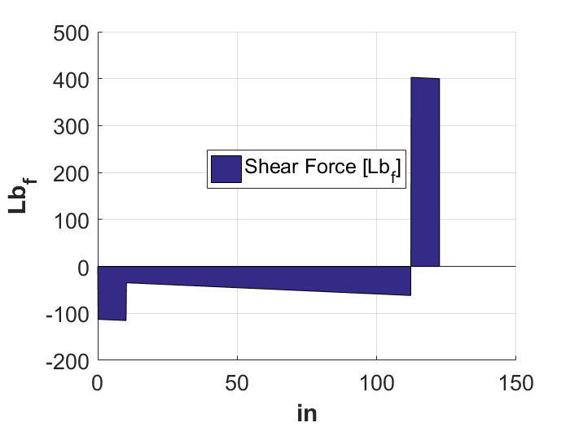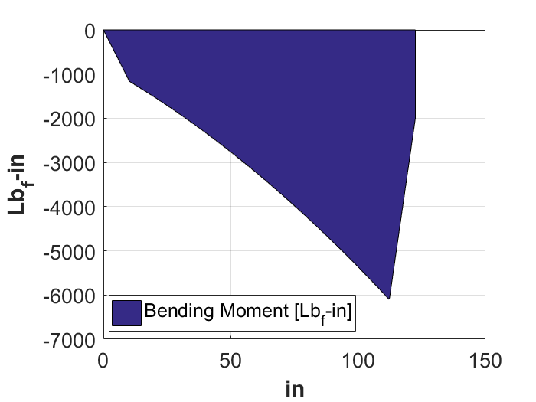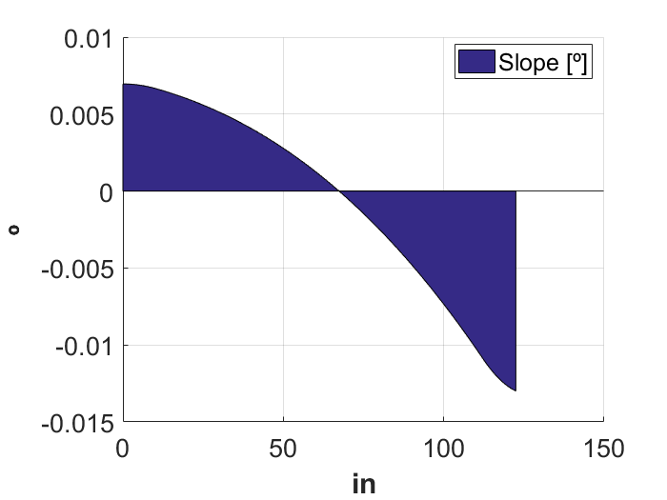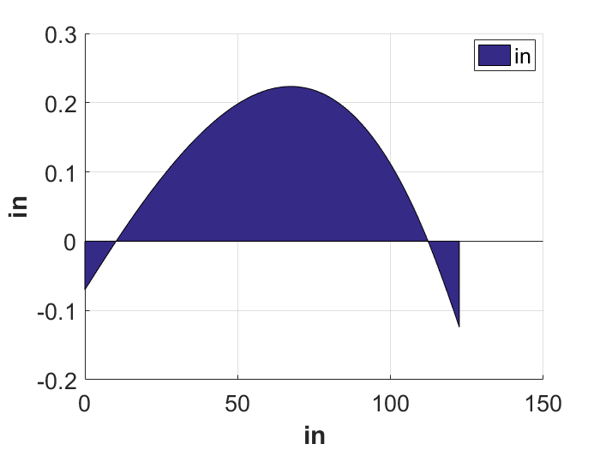

Major Length XZ Plane
Beam Diagrams
Lixz = ([93 246 399]);
spp1 = ([[1 1 1 0 0];[0 0 0 -Lixz(1) -1];...
[-((1/6)*(Lixz(2) - Lixz(1)).^(3)) 0 0 -Lixz(2) -1];...
[-((1/6)*(Lixz(3) - Lixz(1)).^(3)) -((1/6)*(Lixz(3) - Lixz(2)).^(3)) 0 -Lixz(3) -1];...
[-((1/2)*(Lixz(2) - Lixz(1))^(2)) 0 0 -1 0]]);
spp2 = ([[186*fW(fD(1))+306*fW(fD(2))+n*P];[-(fW(fD(1))/24)*(Lixz(1) - 0)^(4)];...
[-(fW(fD(1))/24)*(Lixz(2) - 0)^(4)+(fW(fD(1))/24)*(Lixz(2) - 93)^(4)-(fW(fD(2))/24)*(Lixz(2) - 93)^(4)];...
[-(fW(fD(1))/24)*(Lixz(3) - 0)^(4)+(fW(fD(1))/24)*(Lixz(3) - 93)^(4)-(fW(fD(2))/24)*(Lixz(3) - 93)^(4)-(n*P/6)*(Lixz(3) - Lixz(2))^(3)];...
[-(fW(fD(1))/6)*(Lixz(2) - 0)^(3)+(fW(fD(1))/6)*(Lixz(2) - 93)^(3)-(fW(fD(2))/6)*(Lixz(2) - 93)^(3)]]);
spp3 = spp1\spp2;
R1 = spp3(1); R2 = spp3(2); R3 = spp3(3); % Connection Reactions [lbf]
bcS = spp3(4); bcD = spp3(5);

% Shear
Vixz = -(fW(fD(1))/1)*(xi > 0).*(xi - 0).^(1) + (fW(fD(1))/1)*(xi > 93).*(xi - 93).^(1)...
-(fW(fD(2))/1)*(xi > 93).*(xi - 93).^(1) + (fW(fD(2))/1)*(xi > 399).*(xi - 399).^(1)...
-(fW(fD(1))/1)*(xi > 399).*(xi - 399).^(1)...
+(R1/1)*(xi > Lixz(1)).*(xi - Lixz(1)).^(0)...
+(R2/1)*(xi > Lixz(2)).*(xi - Lixz(2)).^(0)...
+(R3/1)*(xi > Lixz(3)).*(xi - Lixz(3)).^(0)...
-(n*P/1)*(xi > Lixz(2)).*(xi - Lixz(2)).^(0);

% Moment
Mixz = -(fW(fD(1))/2)*(xi > 0).*(xi - 0).^(2) + (fW(fD(1))/2)*(xi > 93).*(xi - 93).^(2)...
-(fW(fD(2))/2)*(xi > 93).*(xi - 93).^(2) + (fW(fD(2))/2)*(xi > 399).*(xi - 399).^(2)...
-(fW(fD(1))/2)*(xi > 399).*(xi - 399).^(2)...
+(R1/1)*(xi > Lixz(1)).*(xi - Lixz(1)).^(1)...
+(R2/1)*(xi > Lixz(2)).*(xi - Lixz(2)).^(1)...
+(R3/1)*(xi > Lixz(3)).*(xi - Lixz(3)).^(1)...
-(n*P/1)*(xi > (Li/2)).*(xi - (Li/2)).^(1);

% Slope
S = -(fW(fD(1))/6)*(xi > 0).*(xi - 0).^(3) + (fW(fD(1))/6)*(xi > 93).*(xi - 93).^(3)...
-(fW(fD(2))/6)*(xi > 93).*(xi - 93).^(3) + (fW(fD(2))/6)*(xi > 399).*(xi - 399).^(3)...
-(fW(fD(1))/6)*(xi > 399).*(xi - 399).^(3)...
+(R1/2)*(xi > Lixz(1)).*(xi - Lixz(1)).^(2)...
+(R2/2)*(xi > Lixz(2)).*(xi - Lixz(2)).^(2)...
+(R3/2)*(xi > Lixz(3)).*(xi - Lixz(3)).^(2)...
-(n*P/2)*(xi > Lixz(2)).*(xi - Lixz(2)).^(2) + bcS;

Iixz = I(fD(1))*(xi >= 0) - I(fD(1))*(xi >= 93) + ...
I(fD(2))*(xi >= 93) - I(fD(2))*(xi >= 399) + ...
I(fD(1))*(xi >= 399);
Aixz = A(fD(1))*(xi >= 0) - A(fD(1))*(xi >= 93) + ...
A(fD(2))*(xi >= 93) - A(fD(2))*(xi >= 399) + ...
A(fD(1))*(xi >= 399);
Sixz = S./(E*Iixz);

% Deflection
D = -(fW(fD(1))/24)*(xi > 0).*(xi - 0).^(4) + (fW(fD(1))/24)*(xi > 93).*(xi - 93).^(4)...
-(fW(fD(2))/24)*(xi > 93).*(xi - 93).^(4) + (fW(fD(2))/24)*(xi > 399).*(xi - 399).^(4)...
-(fW(fD(1))/24)*(xi > 399).*(xi - 399).^(4)...
+(R1/6)*(xi > Lixz(1)).*(xi - Lixz(1)).^(3)...
+(R2/6)*(xi > Lixz(2)).*(xi - Lixz(2)).^(3)...
+(R3/6)*(xi > Lixz(3)).*(xi - Lixz(3)).^(3)...
-(n*P/6)*(xi > Lixz(2)).*(xi - Lixz(2)).^(3) + bcS.*xi + bcD;

Dixz = D./(E*Iixz);

% Beam Diagrams
% Shear Force Diagram Figure
strSV01 = ('Main Length Shear Force Diagram XZ');
strSV02 = (['Shear Force [' strU02 ']']);
SVf = figure('Name',strSV01,'Resize','On','Visible','on');
hold on;
%axis([{x min} {x max} {y min} {y max}]);
grid on;
hSF = area(xi,Vixz);
hlegSF = legend([hSF],{strSV02});
set(hlegSF,'FontSize',pftxt,'Location','best','orientation','vertical');
set(gca,'FontName',psname,'FontSize',pstxt);
strXlab = strU01;
strYlab = strU02;
xlabel(strXlab,'FontSize',patxt,'fontweight',pawt);
ylabel(strYlab,'FontSize',patxt,'fontweight',pawt);
%text({x position},{y position},str,'FontSize',pftxt,'FontName',psname);
hold off;

% Bending Moment Diagram Figure
strSM01 = ('Main Length Bending Moment Diagram XZ');
strSM02 = (['Bending Moment [' strU03 ']']);
SMf = figure('Name',strSM01,'Resize','On','Visible','on');
hold on;
%axis([{x min} {x max} {y min} {y max}]);
grid on;
hSM = area(xi,Mixz);
hlegSM = legend([hSM],{strSM02});
set(hlegSM,'FontSize',pftxt,'Location','best','orientation','vertical');
set(gca,'FontName',psname,'FontSize',pstxt);
strXlab = strU01;
strYlab = strU03;
xlabel(strXlab,'FontSize',patxt,'fontweight',pawt);
ylabel(strYlab,'FontSize',patxt,'fontweight',pawt);
%text({x position},{y position},str,'FontSize',pftxt,'FontName',psname);
hold off;

% Slope Diagram Figure
strSS01 = ('Main Length Slope Diagram XZ');
strSS02 = (['Slope [' strU04 ']']);
SSf = figure('Name',strSS01,'Resize','On','Visible','on');
hold on;
%axis([{x min} {x max} {y min} {y max}]);
grid on;
hSS = area(xi,Sixz);
hlegSS = legend([hSS],{strSS02});
set(hlegSS,'FontSize',pftxt,'Location','best','orientation','vertical');
set(gca,'FontName',psname,'FontSize',pstxt);
strXlab = strU01;
strYlab = strU04;
xlabel(strXlab,'FontSize',patxt,'fontweight',pawt);
ylabel(strYlab,'FontSize',patxt,'fontweight',pawt);
%text({x position},{y position},str,'FontSize',pftxt,'FontName',psname);
hold off;

% Deflection Diagram Figure
strD01 = ('Main Length Deflection Diagram XZ');
strD02 = (['Deflection [' strU01 ']']);
Df = figure('Name',strD01,'Resize','On','Visible','on');
hold on;
hD = area(xi,Dixz);
grid on;
hlegD = legend([hD],{strU01});
set(hlegD,'FontSize',pftxt,'Location','best','orientation','vertical');
set(gca,'FontName',psname,'FontSize',pstxt);
strXlab = strU01; strYlab = strU01;
xlabel(strXlab,'FontSize',patxt,'fontweight',pawt);
ylabel(strYlab,'FontSize',patxt,'fontweight',pawt);
%text({x position},{y position},str,'FontSize',pftxt,'FontName',psname);
hold off;
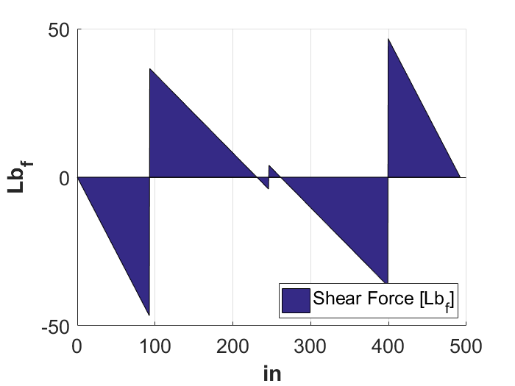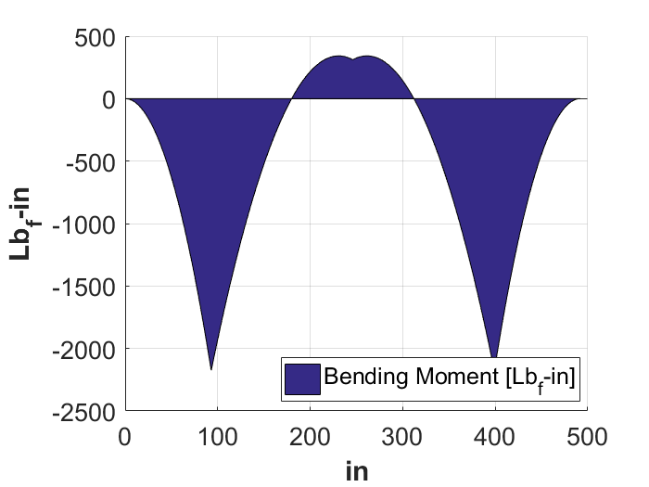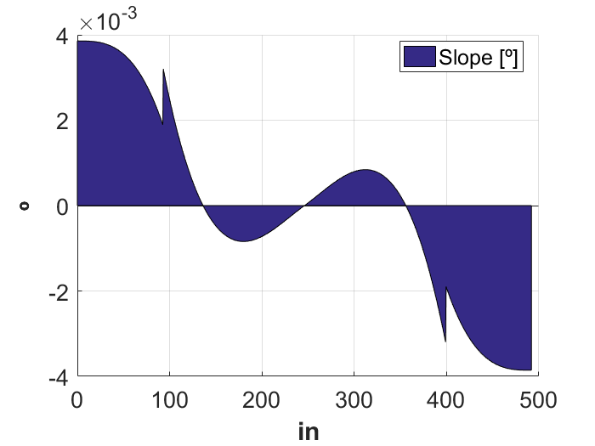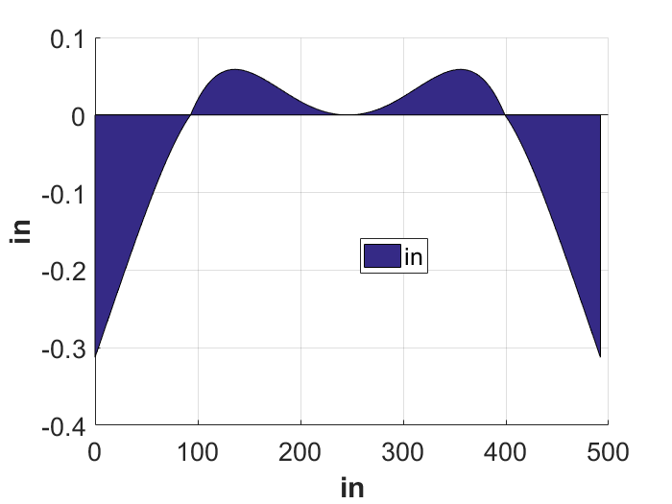

Major Length XY Plane
Beam Diagrams
Lixy = ([0 93 126 246 366 399 492]);
%{
spp1 = ([[1 1 1 1 1 1 1 0];...
[-((1/6)*(Lixy(2) - Lixy(1))^3) 0 0 0 0 0 0 -Lixy(2)];...
[-((1/6)*(Lixy(3) - Lixy(1))^3) -((1/6)*(Lixy(3) - Lixy(2))^3) 0 0 0 0 0 -Lixy(3)];...
[-((1/6)*(Lixy(4) - Lixy(1))^3) -((1/6)*(Lixy(4) - Lixy(2))^3) -((1/6)*(Lixy(4) - Lixy(3))^3) 0 0 0 0 -Lixy(4)];...
[-((1/6)*(Lixy(4) - Lixy(1))^3) 0 0 -Lixy(4)];...
[-((1/6)*(Lixy(7) - Lixy(1))^3) -((1/6)*(Lixy(7) - Lixy(4))^3) 0 -Lixy(7)];...
[-((1/2)*(Lixy(7) - Lixy(1))^2) -((1/2)*(Lixy(7) - Lixy(4))^2) 0 -Lixy(7)];...
[-((1/2)*(Lixy(4) - Lixy(1))^2) 0 0 -Lixy(4)]]);
spp2 = ([[4*Tnety];...
[-((0.5*Tnety/6)*(Lixy(2) - cT(1))^(3))];...
[-((0.5*Tnety/6)*(Lixy(3) - cT(1))^(3))-((0.5*Tnety/6)*(Lixy(4) - cT(2))^(3))];...
[];...
[-((0.5*Tnety/6)*(Lixy(4) - cT(1))^(3))-((0.5*Tnety/6)*(Lixy(4) - cT(2))^(3))-((0.5*Tnety/6)*(Lixy(4) - cT(3))^(3))-((0.5*Tnety/6)*(Lixy(4) - cT(4))^(3))];...
[-((0.5*Tnety/6)*(Lixy(7) - cT(1))^(3))-((0.5*Tnety/6)*(Lixy(7) - cT(2))^(3))-((0.5*Tnety/6)*(Lixy(7) - cT(3))^(3))-((0.5*Tnety/6)*(Lixy(7) - cT(4))^(3))-((0.5*Tnety/6)*(Lixy(7) - cT(5))^(3))-((0.5*Tnety/6)*(Lixy(7) - cT(6))^(3))-((0.5*Tnety/6)*(Lixy(7) - cT(7))^(3))-((0.5*Tnety/6)*(Lixy(7) - cT(8))^(3))];...
[-((0.5*Tnety/2)*(Lixy(7) - cT(1))^(2))-((0.5*Tnety/2)*(Lixy(7) - cT(2))^(2))-((0.5*Tnety/2)*(Lixy(7) - cT(3))^(2))-((0.5*Tnety/2)*(Lixy(7) - cT(4))^(2))-((0.5*Tnety/2)*(Lixy(7) - cT(5))^(2))-((0.5*Tnety/2)*(Lixy(7) - cT(6))^(2))-((0.5*Tnety/2)*(Lixy(7) - cT(7))^(2))-((0.5*Tnety/2)*(Lixy(7) - cT(8))^(2))];...
[-((0.5*Tnety/2)*(Lixy(4) - cT(1))^(2))-((0.5*Tnety/2)*(Lixy(4) - cT(2))^(2))-((0.5*Tnety/2)*(Lixy(4) - cT(3))^(2))-((0.5*Tnety/2)*(Lixy(4) - cT(4))^(2))]]);
spp3 = spp1\spp2;
%}
spp1 = ([[1 1 1 1 0];...
[(Lixy(4)-Lixy(1)) (Lixy(4)-Lixy(2)) (Lixy(4)-Lixy(3)) 0 0];...
[(1/6)*(Lixy(2) - Lixy(1))^3 0 0 0 -Lixy(2)];...
[(1/6)*(Lixy(3) - Lixy(1))^3 (1/6)*(Lixy(3) - Lixy(2))^3 0 0 -Lixy(3)];...
[(1/6)*(Lixy(4) - Lixy(1))^3 (1/6)*(Lixy(4) - Lixy(2))^3 (1/6)*(Lixy(4) - Lixy(3))^3 0 -Lixy(4)];...
[(1/2)*(Lixy(4) - Lixy(1))^2 (1/2)*(Lixy(4) - Lixy(2))^2 (1/2)*(Lixy(4) - Lixy(3))^2 0 -1]]);
spp2 = ([[2*Tnety];...
[0.5*Tnety*(Lixy(4)-cT(1))+0.5*Tnety*(Lixy(4)-cT(2))+0.5*Tnety*(Lixy(4)-cT(3))+0.5*Tnety*(Lixy(4)-cT(4))];...
[(Tnety/12)*(Lixy(2)-cT(1))^3];...
[(Tnety/12)*(Lixy(3)-cT(1))^3 + (Tnety/12)*(Lixy(3)-cT(2))^3];...
[(Tnety/12)*(Lixy(4)-cT(1))^3 + (Tnety/12)*(Lixy(4)-cT(2))^3 + (Tnety/12)*(Lixy(4)-cT(3))^3 + (Tnety/12)*(Lixy(4)-cT(4))^3];...
[(Tnety/4)*(Lixy(4)-cT(1))^2 + (Tnety/4)*(Lixy(4)-cT(2))^2 + (Tnety/4)*(Lixy(4)-cT(3))^2 + (Tnety/4)*(Lixy(4)-cT(4))^2]]);
spp3 = spp1\spp2;
% Connection Reactions [lbf]
R1 = spp3(1); R2 = spp3(2); R3 = spp3(3); R4 = spp3(4);
R5 = spp3(3); R6 = spp3(2); R7 = spp3(1); bcS = spp3(5);
bcD = 0;

% Shear
Vixy = (0.5*Tnety/1)*(xi > cT(1)).*(xi - cT(1)).^(0) ...
+(0.5*Tnety/1)*(xi > cT(2)).*(xi - cT(2)).^(0) ...
+(0.5*Tnety/1)*(xi > cT(3)).*(xi - cT(3)).^(0) ...
+(0.5*Tnety/1)*(xi > cT(4)).*(xi - cT(4)).^(0) ...
+(0.5*Tnety/1)*(xi > cT(5)).*(xi - cT(5)).^(0) ...
+(0.5*Tnety/1)*(xi > cT(6)).*(xi - cT(6)).^(0) ...
+(0.5*Tnety/1)*(xi > cT(7)).*(xi - cT(7)).^(0) ...
+(0.5*Tnety/1)*(xi > cT(8)).*(xi - cT(8)).^(0) ...
-(R1/1)*(xi > Lixy(1)).*(xi - Lixy(1)).^(0)...
-(R2/1)*(xi > Lixy(2)).*(xi - Lixy(2)).^(0)...
-(R3/1)*(xi > Lixy(3)).*(xi - Lixy(3)).^(0)...
-(R4/1)*(xi > Lixy(4)).*(xi - Lixy(4)).^(0)...
-(R5/1)*(xi > Lixy(5)).*(xi - Lixy(5)).^(0)...
-(R6/1)*(xi > Lixy(6)).*(xi - Lixy(6)).^(0)...
-(R7/1)*(xi > Lixy(7)).*(xi - Lixy(7)).^(0);
% Moment
Mixy = (0.5*Tnety/1)*(xi > cT(1)).*(xi - cT(1)).^(1) ...
+(0.5*Tnety/1)*(xi > cT(2)).*(xi - cT(2)).^(1) ...
+(0.5*Tnety/1)*(xi > cT(3)).*(xi - cT(3)).^(1) ...
+(0.5*Tnety/1)*(xi > cT(4)).*(xi - cT(4)).^(1) ...
+(0.5*Tnety/1)*(xi > cT(5)).*(xi - cT(5)).^(1) ...
+(0.5*Tnety/1)*(xi > cT(6)).*(xi - cT(6)).^(1) ...
+(0.5*Tnety/1)*(xi > cT(7)).*(xi - cT(7)).^(1) ...
+(0.5*Tnety/1)*(xi > cT(8)).*(xi - cT(8)).^(1) ...
-(R1/1)*(xi > Lixy(1)).*(xi - Lixy(1)).^(1)...
-(R2/1)*(xi > Lixy(2)).*(xi - Lixy(2)).^(1)...
-(R3/1)*(xi > Lixy(3)).*(xi - Lixy(3)).^(1)...
-(R4/1)*(xi > Lixy(4)).*(xi - Lixy(4)).^(1)...
-(R5/1)*(xi > Lixy(5)).*(xi - Lixy(5)).^(1)...
-(R6/1)*(xi > Lixy(6)).*(xi - Lixy(6)).^(1)...
-(R7/1)*(xi > Lixy(7)).*(xi - Lixy(7)).^(1);
% Slope
S = (0.5*Tnety/2)*(xi > cT(1)).*(xi - cT(1)).^(2) ...
+(0.5*Tnety/2)*(xi > cT(2)).*(xi - cT(2)).^(2) ...
+(0.5*Tnety/2)*(xi > cT(3)).*(xi - cT(3)).^(2) ...
+(0.5*Tnety/2)*(xi > cT(4)).*(xi - cT(4)).^(2) ...
+(0.5*Tnety/2)*(xi > cT(5)).*(xi - cT(5)).^(2) ...
+(0.5*Tnety/2)*(xi > cT(6)).*(xi - cT(6)).^(2) ...
+(0.5*Tnety/2)*(xi > cT(7)).*(xi - cT(7)).^(2) ...
+(0.5*Tnety/2)*(xi > cT(8)).*(xi - cT(8)).^(2) ...
-(R1/2)*(xi > Lixy(1)).*(xi - Lixy(1)).^(2)...
-(R2/2)*(xi > Lixy(2)).*(xi - Lixy(2)).^(2)...
-(R3/2)*(xi > Lixy(3)).*(xi - Lixy(3)).^(2)...
-(R4/2)*(xi > Lixy(4)).*(xi - Lixy(4)).^(2)...
-(R5/2)*(xi > Lixy(5)).*(xi - Lixy(5)).^(2)...
-(R6/2)*(xi > Lixy(6)).*(xi - Lixy(6)).^(2)...
-(R7/2)*(xi > Lixy(7)).*(xi - Lixy(7)).^(2) + bcS;

Iixy = I(fD(1))*(xi >= 0) - I(fD(1))*(xi >= 93) + ...
I(fD(2))*(xi >= 93) - I(fD(2))*(xi >= 399) + ...
I(fD(1))*(xi >= 399);
Aixy = A(fD(1))*(xi >= 0) - A(fD(1))*(xi >= 93) + ...
A(fD(2))*(xi >= 93) - A(fD(2))*(xi >= 399) + ...
A(fD(1))*(xi >= 399);
Sixy = S./(E*Iixy);

% Deflection
D = +(0.5*Tnety/6)*(xi > cT(1)).*(xi - cT(1)).^(3) ...
+(0.5*Tnety/6)*(xi > cT(2)).*(xi - cT(2)).^(3) ...
+(0.5*Tnety/6)*(xi > cT(3)).*(xi - cT(3)).^(3) ...
+(0.5*Tnety/6)*(xi > cT(4)).*(xi - cT(4)).^(3) ...
+(0.5*Tnety/6)*(xi > cT(5)).*(xi - cT(5)).^(3) ...
+(0.5*Tnety/6)*(xi > cT(6)).*(xi - cT(6)).^(3) ...
+(0.5*Tnety/6)*(xi > cT(7)).*(xi - cT(7)).^(3) ...
+(0.5*Tnety/6)*(xi > cT(8)).*(xi - cT(8)).^(3) ...
-(R1/6)*(xi > Lixy(1)).*(xi - Lixy(1)).^(3)...
-(R2/6)*(xi > Lixy(2)).*(xi - Lixy(2)).^(3)...
-(R3/6)*(xi > Lixy(3)).*(xi - Lixy(3)).^(3)...
-(R4/6)*(xi > Lixy(4)).*(xi - Lixy(4)).^(3)...
-(R5/6)*(xi > Lixy(5)).*(xi - Lixy(5)).^(3)...
-(R6/6)*(xi > Lixy(6)).*(xi - Lixy(6)).^(3)...
-(R7/6)*(xi > Lixy(7)).*(xi - Lixy(7)).^(3) + bcS.*xi + bcD;

Dixy = D./(E*Iixy);
%{
% Beam Diagrams
% Shear Force Diagram Figure
strSV01 = ('Main Length Shear Force Diagram XY');
strSV02 = (['Shear Force [' strU02 ']']);
SVf = figure('Name',strSV01,'Resize','On','Visible','on');
hold on;
%axis([{x min} {x max} {y min} {y max}]);
grid on;
hSF = area(xi,Vixy);
hlegSF = legend([hSF],{strSV02});
set(hlegSF,'FontSize',pftxt,'Location','best','orientation','vertical');
set(gca,'FontName',psname,'FontSize',pstxt);
strXlab = strU01;
strYlab = strU02;
xlabel(strXlab,'FontSize',patxt,'fontweight',pawt);
ylabel(strYlab,'FontSize',patxt,'fontweight',pawt);
%text({x position},{y position},str,'FontSize',pftxt,'FontName',psname);
hold off;

% Bending Moment Diagram Figure
strSM01 = ('Main Length Bending Moment Diagram XY');
strSM02 = (['Bending Moment [' strU03 ']']);
SMf = figure('Name',strSM01,'Resize','On','Visible','on');
hold on;
%axis([{x min} {x max} {y min} {y max}]);
grid on;
hSM = area(xi,Mixy);
hlegSM = legend([hSM],{strSM02});
set(hlegSM,'FontSize',pftxt,'Location','best','orientation','vertical');
set(gca,'FontName',psname,'FontSize',pstxt);
strXlab = strU01;
strYlab = strU03;
xlabel(strXlab,'FontSize',patxt,'fontweight',pawt);
ylabel(strYlab,'FontSize',patxt,'fontweight',pawt);
%text({x position},{y position},str,'FontSize',pftxt,'FontName',psname);
hold off;

% Slope Diagram Figure
strSS01 = ('Main Length Slope Diagram XY');
strSS02 = (['Slope [' strU04 ']']);
SSf = figure('Name',strSS01,'Resize','On','Visible','on');
hold on;
%axis([{x min} {x max} {y min} {y max}]);
grid on;
hSS = area(xi,Sixy);
hlegSS = legend([hSS],{strSS02});
set(hlegSS,'FontSize',pftxt,'Location','best','orientation','vertical');
set(gca,'FontName',psname,'FontSize',pstxt);
strXlab = strU01;
strYlab = strU04;
xlabel(strXlab,'FontSize',patxt,'fontweight',pawt);
ylabel(strYlab,'FontSize',patxt,'fontweight',pawt);
%text({x position},{y position},str,'FontSize',pftxt,'FontName',psname);
hold off;

% Deflection Diagram Figure
strD01 = ('Main Length Deflection Diagram XY');
strD02 = (['Deflection [' strU01 ']']);
Df = figure('Name',strD01,'Resize','On','Visible','on');
hold on;
hD = area(xi,Dixy);
grid on;
hlegD = legend([hD],{strU01});
set(hlegD,'FontSize',pftxt,'Location','best','orientation','vertical');
set(gca,'FontName',psname,'FontSize',pstxt);
strXlab = strU01; strYlab = strU01;
xlabel(strXlab,'FontSize',patxt,'fontweight',pawt);
ylabel(strYlab,'FontSize',patxt,'fontweight',pawt);
%text({x position},{y position},str,'FontSize',pftxt,'FontName',psname);
hold off;
%}

Minor Length XY Plane
Column Loading
k = sqrt(I(fD(3))/A(fD(3))); % Radius of Gyration [in]

Sr = Lj/k; % Actual Slenderness Ratio
Srj = pi*sqrt(2*E/YS); % Slenderness Ratio for Johnson Region

Mjxy = zeros(1,length(xj));
Vjxy = zeros(1,length(xj));

% Critcal Loading
if Sr <= Srj
Pcr = A(fD(3))*(YS - E^(-1)*((YS*Sr)/(2*pi))^2); % Johnson Region
else
Pcr = pi^2*E*A(fD(3))/Sr^2; % Euler Region
end

% Compression
sigC = max(abs([R1 R2 R3 R4 R5 R6 R7]))/A(fD(3));

% Factor of Safety
FScl = Pcr/max(abs([R1 R2 R3 R4 R5 R6 R7]));

Major Length Stresses
Top Surface
%{
Stresses coming from bending in XZ plane and transverse shear of bending in
XY plane
%}
for i = 1:length(xi)
if abs(Vixy(i)) == max(abs(Vixy))
ii = i;
else
end
if abs(Mixz(i)) == max(abs(Mixz))
jj = i;
else
end
end
% At length where max shear occurs
sgnx1 = Mixz(ii)*R/Iixz(ii);
txy1 = 2*Vixy(ii)/Aixz(ii);

ustr1 = ([[sgnx1 txy1 0];[txy1 0 0];[0 0 0]]);
sig_p1 = eig(ustr1); % Find the eigenvector to know stress in principle direction
p1a = max(sig_p1);
p3a = min(sig_p1);
p2a = sig_p1(2);

% At length where max bending occurs
sgnx2 = Mixz(jj)*R/Iixz(jj);
txy2 = 2*Vixy(jj)/Aixy(jj);

ustr2 = ([[sgnx2 txy2 0];[txy2 0 0];[0 0 0]]);
sig_p2 = eig(ustr2); % Find the eigenvector to know stress in principle direction
p1b = max(sig_p2);
p3b = min(sig_p2);
p2b = sig_p2(2);

% Side Surface
%{
Stresses coming from bending in XY plane and transverse shear of bending in
XZ plane
%}
for i = 1:length(xi)
if abs(Vixz(i)) == max(abs(Vixz))
ii = i;
else
end
if abs(Mixy(i)) == max(abs(Mixy))
jj = i;
else
end
end
% At length where max shear occurs
sgny3 = Mixy(ii)*R/Iixy(ii);
txz3 = 2*Vixz(ii)/Aixy(ii);

ustr3 = ([[0 0 txz3];[0 sgny3 0];[txz3 0 0]]);
sig_p3 = eig(ustr3); % Find the eigenvector to know stress in principle direction
p1c = max(sig_p3);
p3c = min(sig_p3);
p2c = sig_p3(2);

% At length where max bending occurs
sgny4 = Mixy(jj)*R/Iixy(jj);
txz4 = 2*Vixz(jj)/Aixy(jj);

ustr4 = ([[0 0 txz4];[0 sgny4 0];[txz4 0 0]]);
sig_p4 = eig(ustr4); % Find the eigenvector to know stress in principle direction
p1d = max(sig_p4);
p3d = min(sig_p4);
p2d = sig_p4(2);

% Neutral Axis
%{
Stresses coming from transverse shear of bending in XZ and XY planes
%}
for i = 1:length(xi)
if abs(Vixz(i)) == max(abs(Vixz))
ii = i;
else
end
if abs(Vixy(i)) == max(abs(Vixy))
jj = i;
else
end
end

% At length where max shear in XZ Plane occurs
txz5 = 2*Vixz(ii)/Aixz(ii);
txy5 = 2*Vixy(ii)/Aixz(ii);

ustr2 = ([[0 txy5 txz5];[txy5 0 0];[txz5 0 0]]);
sig_p2 = eig(ustr2); % Find the eigenvector to know stress in principle direction
p1b = max(sig_p2);
p3b = min(sig_p2);
p2b = sig_p2(2);

% At length where max shear in XY Plane occurs
txz6 = 2*Vixz(jj)/Aixz(jj);
txy6 = 2*Vixy(jj)/Aixy(jj);

ustr6 = ([[0 txy6 txz6];[txy6 0 0];[txz6 0 0]]);
sig_p6 = eig(ustr6); % Find the eigenvector to know stress in principle direction
p1f = max(sig_p6);
p3f = min(sig_p6);
p2f = sig_p6(2);

if p1a > p1b && p1a > p1c && p1a > p1d && p1a > p1b && p1a > p1f
sig_pi = sig_p1;
%disp('The maximum stress occurs on the top surface.');
elseif p1b > p1a && p1b > p1c && p1b > p1d && p1b > p1b && p1b > p1f
sig_pi = sig_p2;
%disp('The maximum stress occurs on the top surface.');
elseif p1c > p1a && p1c > p1b && p1c > p1d && p1c > p1b && p1c > p1f
sig_pi = sig_p3;
%disp('The maximum stress occurs on the side surface.');
elseif p1d > p1a && p1d > p1b && p1d > p1c && p1d > p1b && p1d > p1f
sig_pi = sig_p4;
%disp('The maximum stress occurs on the side surface.');
elseif p1b > p1a && p1b > p1b && p1b > p1c && p1b > p1d && p1b > p1f
sig_pi = sig_p2;
%disp('The maximum stress occurs along the neutral axis.');
elseif p1f > p1a && p1f > p1b && p1f > p1c && p1f > p1d && p1f > p1b
sig_pi = sig_p6;
%disp('The maximum stress occurs along the neutral axis.');
end

% Choose Greatest Principal Stress
p1i = max(sig_pi);
p3i = min(sig_pi);
p2i = sig_pi(2);

% Calculate Maximum Shear Stress
tm1i = (p1i-p3i)./2;

% Calculate Von Mises Stress
svmi = sqrt(p1i^2 + p2i^2 + p3i^2 - p1i*p2i - p2i*p3i - p1i*p3i);

% Determine Yielding
FSci = YS/svmi; % Static Yielding Factor of Safety
YSshi = 0.500*YS; % Shear Yielding
FScsi = YSshi/tm1i; % Shear Yielding Factor of Safety

Minor Length Stresses
Top Surface
%{
Stresses coming from bending in YZ plane and transverse shear of bending in
XY plane
%}
for i = 1:length(xj)
if abs(Vjxy(i)) == max(abs(Vjxy))
ii = i;
else
end
if abs(Mjyz(i)) == max(abs(Mjyz))
jj = i;
else
end
end
% At length where max shear occurs
sgnx1 = Mjyz(ii)*R/I(fD(3));
txy1 = 2*Vjxy(ii)/A(fD(3));

ustr1 = ([[0 txy1 0];[txy1 sgnx1+sigC 0];[0 0 0]]);
sig_p1 = eig(ustr1); % Find the eigenvector to know stress in principle direction
p1a = max(sig_p1);
p3a = min(sig_p1);
p2a = sig_p1(2);

% At length where max bending occurs
sgnx2 = Mjyz(jj)*R/I(fD(3));
txy2 = 2*Vjxy(jj)/I(fD(3));

ustr2 = ([[0 txy2 0];[txy2 sgnx2+sigC 0];[0 0 0]]);
sig_p2 = eig(ustr2); % Find the eigenvector to know stress in principle direction
p1b = max(sig_p2);
p3b = min(sig_p2);
p2b = sig_p2(2);

% Side Surface
%{
Stresses coming from bending in XY plane and transverse shear of bending in
YZ plane
%}
for i = 1:length(xj)
if abs(Vjyz(i)) == max(abs(Vjyz))
ii = i;
else
end
if abs(Mjxy(i)) == max(abs(Mjxy))
jj = i;
else
end
end
% At length where max shear occurs
sgny3 = Mjxy(ii)*R/I(fD(3));
tyz3 = 2*Vjyz(ii)/A(fD(3));

ustr3 = ([[0 0 tyz3];[0 sgny3+sigC 0];[tyz3 0 0]]);
sig_p3 = eig(ustr3); % Find the eigenvector to know stress in principle direction
p1c = max(sig_p3);
p3c = min(sig_p3);
p2c = sig_p3(2);

% At length where max bending occurs
sgny4 = Mjxy(jj)*R/I(fD(3));
tyz4 = 2*Vjyz(jj)/A(fD(3));

ustr4 = ([[0 0 tyz4];[0 sgny4+sigC 0];[tyz4 0 0]]);
sig_p4 = eig(ustr4); % Find the eigenvector to know stress in principle direction
p1d = max(sig_p4);
p3d = min(sig_p4);
p2d = sig_p4(2);

% Neutral Axis
%{
Stresses coming from transverse shear of bending in XZ and XY planes
%}
for i = 1:length(xj)
if abs(Vjyz(i)) == max(abs(Vjyz))
ii = i;
else
end
if abs(Vjxy(i)) == max(abs(Vjxy))
jj = i;
else
end
end

% At length where max shear in XZ Plane occurs
tyz5 = 2*Vjyz(ii)/A(fD(3));
txy5 = 2*Vjxy(ii)/A(fD(3));

ustr5 = ([[0 txy5 tyz5];[txy5 sigC 0];[tyz5 0 0]]);
sig_p5 = eig(ustr5); % Find the eigenvector to know stress in principle direction
p1e = max(sig_p5);
p3e = min(sig_p5);
p2e = sig_p5(2);

% At length where max shear in XY Plane occurs
tyz6 = 2*Vjyz(jj)/A(fD(3));
txy6 = 2*Vjxy(jj)/A(fD(3));

ustr6 = ([[0 txy6 tyz6];[txy6 sigC 0];[tyz6 0 0]]);
sig_p6 = eig(ustr6); % Find the eigenvector to know stress in principle direction
p1f = max(sig_p6);
p3f = min(sig_p6);
p2f = sig_p6(2);

%if p1a > p1b && p1a > p1c && p1a > p1d && p1a > p1b && p1a > p1f
if p1a >= max([p1b p1c p1d p1e p1f])
sig_pj = sig_p1;
%disp('The maximum stress occurs on the top surface.');
%elseif p1b > p1a && p1b > p1c && p1b > p1d && p1b > p1b && p1b > p1f
elseif p1b >= max([p1a p1c p1d p1e p1f])
sig_pj = sig_p2;
%disp('The maximum stress occurs on the top surface.');
%elseif p1c > p1a && p1c > p1b && p1c > p1d && p1c > p1b && p1c > p1f
elseif p1c >= max([p1a p1b p1d p1e p1f])
sig_pj = sig_p3;
%disp('The maximum stress occurs on the side surface.');
%elseif p1d > p1a && p1d > p1b && p1d > p1c && p1d > p1b && p1d > p1f
elseif p1d >= max([p1a p1c p1b p1e p1f])
sig_pj = sig_p4;
%disp('The maximum stress occurs on the side surface.');
%elseif p1e > p1a && p1e > p1b && p1e > p1c && p1e > p1d && p1e > p1f
elseif p1e >= max([p1a p1b p1c p1d p1f])
sig_pj = sig_p2;
%disp('The maximum stress occurs along the neutral axis.');
%elseif p1f > p1a && p1f > p1b && p1f > p1c && p1f > p1d && p1f > p1b
elseif p1f >= max([p1a p1b p1c p1d p1e])
sig_pj = sig_p6;
%disp('The maximum stress occurs along the neutral axis.');
end

% Choose Greatest Principal Stress
p1j = max(sig_pj);
p3j = min(sig_pj);
p2j = sig_pj(2);

% Calculate Maximum Shear Stress
tm1j = (p1j-p3j)./2;

% Calculate Von Mises Stress
svmj = sqrt(p1j^2 + p2j^2 + p3j^2 - p1j*p2j - p2j*p3j - p1j*p3j);

% Determine Yielding
FScj = YS/svmj; % Static Yielding Factor of Safety
YSshj = 0.500*YS; % Shear Yielding
FScsj = YSshj/tm1j; % Shear Yielding Factor of Safety

Reporting
def = max(abs(Dixz));
j = 1;
for i = 1:length(xi)
if abs(Dixz(i)) == max(abs(Dixz))
ii(j) = i;
j = j +1;
else
end
end
if xi(ii) > xi(1) && xi(ii) < xi(length(xi))
defp = xi(ii);
str01 = (['The maximum deflection is ' num2str(def,'%2.4f') ' [in], located ' ...
num2str(defp(1),'%3.1f') ' [in] from end.']);
elseif xi(ii) == xi(1)
str01 = (['The maximum deflection is ' num2str(def,'%2.4f') ' [in], located at end.']);
elseif xi(ii) == xi(length(xi))
str01 = (['The maximum deflection is ' num2str(def,'%2.4f') ' [in], located at end.']);
else
end
disp(str01);

rfsj = min([FScj FScsj]);
str02 = (['The minimum factor of safety in the cross-members is ' num2str(rfsj,'%2.2f') '.']);
disp(str02);

rfsi = min([FSci FScsi]);
str03 = (['The minimum factor of safety in the major length is ' num2str(rfsi,'%2.2f') '.']);
disp(str03);
The maximum deflection is 0.3125 [in], located at end.
The minimum factor of safety in the cross-members is 20.84.
The minimum factor of safety in the major length is 4.54.
Concrete Pier Design
d = 2.8; %ft
L = 4.4; %ft
w = 300; %lbs
M = 4000; %lb*ft
F = 50*L*d; %lbs (soil force)
p = 150; %lb/ft^3 (density of concrete)
W = pi*(d/2)^2*L*p; %lbs (weight of concrete)
SumMom = W*(d/2) + F*(L/2) + w*(d/2) - M;
if SumMom >= 0
D = d*12
H = L*12
else
Disp('The design will fail. Try different values');
end
D =
33.6000
H =
52.8000

The diameter of the pier should be 34 inches and the height of the pier should be 53 inches.

