Brand Positioning vs. Employee Behavior:

How Customer Service Affects Brand Perception

Kaitlin Waters
Faculty Advisor: Dr. Alex Zablah

Department of Marketing & Supply Chain Management
University of Tennessee
2016

Abstract

This study examines a retail company’s ability to portray their brand personality through frontline customer service workers. This was done by examining the effects of fault of service failure and employee alignment with brand on customers’ repurchase intentions from the retailer in question.
An experiment was conducted using an electronic survey that randomly assigned versions of customer/employee interactions to 176 survey respondents. Survey results indicate that a customer service employee whose personality is aligned with the high-end personality of the brand they’re representing does not elicit higher repurchase intentions. However, when the fault of failure was the firm’s and the customer service employee was aligned with the brand they are representing, mean repurchase intentions were higher.
While this study has limitations, the implications of its findings can be extended into human resource, marketing, and management areas.

Table of Contents
Introduction 3
Review of Literature 4
Brand Equity 4
The Service Encounter 5
Hypotheses 7
Study Overview 7
Method 8
Results 9
Manipulation Checks 9
Impact of Employee Alignment on Purchase Intentions 9
Interaction of Responsibility for Failure and Employee Alignment in Prediction 10 of Purchase Intentions
Discussion 11
Appendix 13
References 22

Introduction
Whether its payment processing issues, order tracking, or general complaints, consumers turn to customer service representatives to resolve their issues in the retail world. There are distinct differences between a brand’s personality, how it is portrayed via customer service workers, and how that personality is perceived by the end customer. The way a brand is displayed to the public plays a large role in how it is perceived and establishes what is known as brand equity. Brand equity is defined as “the commercial value that derives from consumer perception of the brand name of a particular product or service, rather than from the product or service itself.” This “brand equity” increases consumer loyalty and switching costs and can result in long-term benefits for firms with strong brands (Jones, Mothersbaugh, and Beatty 2000; McWilliams and Gerstner 2006).
In the retail world, brand equity can play a major role in a company’s customer base, how they retain customers, and how they attract new customers. It is possible to distinguish name brands as either being high-level or low-level. For the purposes of this study, I have defined “high-level” brands as “brands with high levels of awareness and strong, favorable and unique associations.” “Low-level” brands are thus defined as “brands with low levels of awareness, that lack unique associations and have a non-loyal customer base.”
While few studies have examined the how customer service representatives affect customers’ brand perceptions, available research suggests that the way an individual service representative portrays the brand through his or her dialect, tone, and words can affect customers’ perceptions of the brand. This study considers how a customer service employees’ portrayal of a high-level, luxurious brand affects customers’ future purchase intentions, an important indicator of a brand’s level of equity.

Review of Literature
This study is meant to examine the relationship between a retail brand’s personality and the role that company’s customer service employees play in portraying that personality to customers in the event of a service failure. To understand this relationship, previous research must be considered from two different domains: brand equity and the service encounter. Brand equity is a construct that is designed to reflect the real value that a brand name holds for the products and services that it accompanies (Keller, 2010). Brand equity can either help or hinder a company when trying to recover a customer who has experienced a service failure. However, whether a customer service employee’s behavior is either aligned or misaligned with their brand’s personality can elicit different responses from the customer. It is also important to distinguish the type of service failure the customer experiences. In this study I will be specifically examining services failures in the retail sector.
The other facet to examine is the interaction between company, via customer service representative, and customer. An important distinction to note is if the failure was at the fault of the firm or the fault of the customer. While some research examines the role of employees in both portraying a brand’s personality to customers and the role customer service employees play in recovering awry service encounters, this study attempts to find the relationship between whose fault the service failure was, how a retailer’s brand personality was portrayed [or not] to the customer, and how these two factors affect overall brand equity.

Brand Equity
The notion that brands add value to products has been called brand equity (Ravi, 2006). In the retail sector specifically, it is vital for retailers to continuously generate brand equity for the brands they own. This could be the name of a retailer itself, name brands the retailer carries, or the name of a particular service the retailer offers. There are variations of brand equity that occur when examining the retail sector: brand equity has been referred to as consumer-based brand equity from a consumer or marketing perspective, and has also be referred to as the equity consumers associate with a retail brand, known as consumer-based retailer equity (Ravi, 2006). In the context of this study, brand equity will be synonymous for all other variations (consumer-based brand equity, consumer-based retail equity).
In recent years, retailers have been facing a challenging marketing environment in the form of more demanding consumers, intensified competition and slow-growth markets (Ravi, 2006). In order to remain competitive, new benefits must be created and advertised so that a retailer is strategic in their brand equity generation. There are direct ways that retailers communicate new benefits of their products, for example through advertising or marketing campaigns. This research seeks to examine how brand equity is communicated through an indirect channel: retailer employees.
This study will examine how brand equity is portrayed through retail employees, but it will also be in the context of a service failure. A company's reputation in conjunction with its service offering determines customer's expectation (Sarkar, 2015). There has been previous research done on consumer responses to a firm in the event of a service failure. For high reputed brands, customers have high expectations, and view them as delivering superior services. Research findings have confirmed that customers positively relate to brand reputation and this affects their perception of service performance and benefits (Sarkar, 2015). In the face of a service failure, previous research suggests that a brand’s reputation, or the level of brand equity they have with a customer, may help mitigate customer’s negative reaction to the service failure. Results of previous studies suggest that high brand equity leads to more favorable satisfaction evaluations and behavioral intentions than low brand equity. The brand equity effect is identified as a prevailing advantage that spans the entire failure and recovery sequence (Brady, 2008).

The Service Encounter
The service encounter is known as the moment of interaction between the customer and the firm (Bitner, 1990). Effective management of the service encounter involves understanding the often complex behaviors of employees that can distinguish a highly satisfactory service encounter from a dissatisfactory one, and then training, motivating and rewarding employees to exhibit those behaviors (Bitner, 1990). Research has been done examining failed service encounters in the service industry, such as airlines, hotels, and restaurants. There is less research on service encounters in the retail setting, where this study will be focused. The moment of interaction between the customer and the firm in the retail setting occurs when customers interact with customer service employees. In the retail sector, if a customer is satisfied with the tangible product itself, customers often look to other cues, such as aspects of the interaction, in assessing service quality (Gremler, 2000).
However, there is variance in studying the service encounter because all people are unique and will react different ways to different situations. When a consumer infers from a good experience with an individual service provider that others in the firm will also provide good service, the consumer is more likely to be loyal to the firm even if the individual service provider quits the firm (Folkes, 2003). Retailers rely in their individual employees to portray the company accurately and favorably to the customers, but there is no way to guarantee consistency in all customer service employee interactions. Research has shown that even customer service employee’s differing cognitive habits may have an effect on customer perceptions of the firm. Studies have proven that the extent of service employees' display of positive emotions and the authenticity of their emotional labor display influences customers' emotional states and, subsequently, on customers' assessments of the service interaction and their relationship with the service provider (Hennig-Thurau, 2006). On the other hand, inferences from an individual’s negative attributes are more detrimental to a firm than inferences limited to the individual employee (Folkes, 2003). This would suggest that a negative service encounter has more effect on the firm as a whole than a positive service encounter, which would then affect the firm’s level of brand equity.
This study aims to combine the concept of brand equity and the concept of a service encounter to see how retailers are perceived after a failed service encounter. This study will measure brand equity by assessing customers’ intentions to purchase from the retail brand in the future. The findings in previous research revealed that excellent reputations provide firms with a “buffering effect”, insulating them from some of the negative consequences of failures (Hess, 2008). A firm’s reputation is only a portion of what is factored into brand equity, but these findings can be extended to say that a firm with higher brand equity would also have the “buffering effect” from negative service encounters. A firm with a lesser reputation, and thus less brand equity, would then have less of a “buffer” or none at all in the event of a negative service encounter. This “buffer” would affect how positively or negatively a retailer is perceived after a failed service encounter, which is what this study will examine.
From the customer’s perspective, a service encounter can go positively or negatively based on more than the nature of the service failure itself. If a customer stereotypes or subtypes the customer service employee they are interacting with, this will have an effect on how they perceive the brand and the firm as a whole. When the employee is considered primarily as an exemplar of the brand's workforce, his or her behavior is generalized more strongly to the brand. When, however, the employee is judged as a relatively unique individual (i.e., when the employee is subtyped), the behavior is not transferred to the brand to the full extent (Wentzel, 2009). This again, lends to the fact that human behavior cannot be standardized, so retailer perceptions will vary based on the actions of the customer. Previous research proposes that the impact of an employee's behavior depends on how the employee is categorized by the consumer (Wentzel, 2009), thus supporting that a customer service employees actions can have an effect on how a brand is perceived by the customer. This means that retailers can use their customer service employees to portray the brand and brand’s personality in a specific and intentional way.

Hypotheses
Building on the preceding literature, I thus expect that when a customer service employee’s behavior is aligned with a luxurious brand’s positioning (e.g., based on the choice of words used during an interaction), the customer will express higher future purchase intentions because the interaction with the service representative will signal to the customer that the brand lives up to its promise. Hence:

H1: Employee-brand alignment has a positive effect on customers’ intentions to purchase the brand in the future.

In addition, I expect that the importance of employee-brand aligned behavior is enhanced when a service failure occurs and is the firm’s responsibility. Under such circumstances, employee-aligned behavior will be particularly important because it will signal to the customer that the brand lives up to its promise in other ways, despite being responsible for the current service failure. Said differently, when a service failure is the firm’s fault and employee’s behavior is not brand-aligned, customers’ intentions to repurchase the brand should fall as the firm has broken two of its brand promises. Hence:

H2: The positive effect of employee-brand alignment on customers’ intentions to purchase the brand in the future will be stronger (as opposed to weaker) when the firm (as opposed to the customer) is responsible for the service failure.

Study Overview
In this experimental study, I examined the impact of two distinct factors, brand alignment and service failure cause, on customers purchase intentions. Brand alignment refers to whether an employee’s behavior is consistent with the “sophisticated” personality of a fictitious retailer brand. Service failure cause refers to whether the problem a customer is experiencing is due to a customer error or an error by the retailer. In this experiment, the service failure was the receipt of an incorrectly sized shirt. In a 2 x 2 experimental design, employee behavior (aligned vs. misaligned) and service failure cause (firm vs. customer) were manipulated. Thus, some participants in this study were exposed to a high level of brand alignment, meaning the employee matched the brand’s classy and sophisticated personality, and either a service failure caused by the customer (condition 1) or the firm (condition 2). Other participants were exposed to a low level of brand alignment where the employee’s behavior and personality did not match the high-end brand, and either a service failure caused by the customer (condition 3) or the firm (condition 4). One hundred seventy-six college-age students were randomly assigned to one of the four conditions via electronic survey.

Method
Participants recruited from the college campus of a large Southeastern University were invited via Facebook and email to participate in an electronic survey. Upon electing to take the survey, participants were instructed to read a description of an ambiguous high-end retailer called Luxe. Luxe was described in the cover story to be a high-end clothing retailer, with qualities such as “glamour, sophistication, exceptional fashion, and a smooth shopping experience” that were meant to be indicators of the brand’s personality. The name of the retailer itself, “Luxe,” is also meant to signify the brand’s high-end personality.
Participants were then randomly assigned to view a script of a telephone interaction between a customer service representative of Luxe and a customer. The instructions directed participants to place themselves in the role of the customer making the phone call. The script depicted a customer calling a customer service representative to exchange a shirt for a different size. In all scenarios, the customer service representative instructs the customer on how they can return the shirt in the wrong size once the correct size has been shipped to them.
The experimental scripts differed depending on the condition to which subjects were randomly assigned. As noted earlier, the four scripts differed as it relates to the level of employee-brand alignment (aligned vs. not aligned) and cause of the service failure (firm vs. customer). The scripts and description of the Luxe brand were adapted from a study developed by Nancy J. Sirianni, Mary Jo Bitner, Stephen W. Brown, and Naomi Vlandeland in 2013. The adaptations made from this 2013 study were (1) that the scripts were read by participants rather than listened to via simulated phone call and (2) that the constructs of “brand alignment” and “fault of failure” were manipulated in the experiment rather than employee behavior, brand personality and brand familiarity.
After reading a randomly assigned version of the customer/employee phone call interaction, participants answered a questionnaire that measured (1) the dependent variable of interest for the study, repurchase intentions, (2) manipulation check questions (to gauge whether the experimental scenarios were effective in manipulating alignment and service failure cause), (3) brand personality (for use as a control variable), and demographic questions for classification purposes. All constructs were measured using 7-point likert-type scales, with the anchors differing across questions (see Appendix for a complete description of the survey items).

Results
Manipulation Checks
The effectiveness of the manipulations was tested using a series of between-subject analysis of variance (ANOVA) tests. First, an ANOVA was performed using “Responsibility for Failure” as the dependent variables (one of the dependent variables measured whether the service failure was the customer’s fault while the other measured whether it was the firm’s fault). This analysis revealed that the manipulation was effective as subjects exposed to the “customer fault” scenario indicated that the service failure was the customers’ fault but not the firm’s fault (M_{Customer’s Fault =} 6.05 vs. M_{Firm’s Fault} = 1.58, p < .001). Similarly, an ANOVA with “Responsibility of Failure” as the dependent variable revealed that subjects exposed to the “firm fault” scenario indicated that the service failure was the firm’s fault and not the customer’s fault M_{Customer’s Fault} = 1.61 vs. M_{Firm’s Faul} = 6.08, p < .001).
In addition, an ANOVA was performed to assess the adequacy of the brand alignment manipulation. “Representative is sophisticated” was used as the dependent variable in this analysis. The analysis revealed that the manipulation was effective as well. Specifically, subjects exposed to the “brand aligned” scenario where employees’ personality was manipulated to match that of the firm’s sophisticated persona rated the employee as being more sophisticated (M_{Aligned} = 4.74) than those exposed to the unaligned scenario in which the employee’s personality was presented as rugged, in clear contrast to the brand’s persona (M_{Unaligned} = 3.47, p<.001).
Finally, three additional ANOVAs were performed to establish the independence of the manipulations. In the first ANOVA, “Representative is Sophisticated” was used as the dependent variable. This analysis revealed that subjects exposed to the “customer fault” and “firm fault” scenarios did not differ in their perception of the employee’s level of sophistication ( M_{Customer’s Fault} = 4.28 vs. M_{Firm’s Faul} = 3.94, p> .10).
Two additional ANOVAs were performed using “Responsibility for Failure” as the dependent variables (one of the dependent variables measured whether the service failure was the customer’s fault while the other measured whether it was the firm’s fault). This analysis revealed that subjects in the aligned and unaligned conditions did not differ in their evaluation of who was responsible for the service failure (p>.10). Specifically, those in the aligned and unaligned conditions had statistically equivalent perceptions regarding whether the service failure was the customer’s fault (M_{Aligned} = 3.86 vs. _{MUnaligned} = 3.84) or the firm’s fault (M_{Aligned} = 3.90 vs. M_{Unaligned} = 3.72). The lack of statistical significance in these results supports the design of the study as it demonstrates there is no confound in the manipulations. That is, the fault of failure manipulation does not have an effect on perception of representative sophistication and the alignment manipulation does not have an effect on subject’s perception of who was responsible for the service failure.
Impact of Employee Alignment on Purchase Intentions (Test of H1)
The effects of the customer service representatives’ alignment with the brand on respondents’ future purchase intentions was assessed via an ANOVA in which (1) future purchase intentions was specified as the dependent variable, (2) employee alignment was defined as the independent variable, and (3) respondents’ perceptions of the brand personality, which was not manipulated, was defined as a control variable. The results of this analysis did not reveal a significant effect of “employee alignment” on “future purchase intentions” (p > .10).
Stated differently, the results suggest that respondents were just as likely to purchase from Luxe in the future regardless of whether the employee they interacted with was unaligned with the brand (M_{employee unaligned} = 5.036) or aligned with the brand (M_{employee aligned} = 5.181). These findings do not support H1 which argued that brand-employee alignment would have a positive effect on customer repurchase intentions.

Interaction of Responsibility for Failure and Employee Alignment in Prediction of Purchase Intentions (Test of H2)
The effects of the study manipulations on subjects’ future purchase intentions was assessed via an ANOVA in which (1) purchase intentions was defined as the dependent variable, (2) each of the manipulations was defined as an independent variable, and (3) subjects’ perceptions of the brand’s personality ,which was not manipulated, was defined as a control variable. The results of this analysis revealed a significant interaction between “responsibility for failure” and “employee brand alignment” in prediction of subject’s future purchase intentions (p < .10).
Specifically, as is illustrated in Figure 1, respondents were significantly less likely to purchase the Luxe brand in the future if the problem they experienced was the firm’s fault and their customer service representative was unaligned with the brand (M = 4.57), when compared to all of the other three conditions (M_{Firmfault, employee aligned} = 5.11; MCustomerfault, employee aligned = 5.28; MCustomer fault, employee unaligned = 5.43). Purchase intention levels were the same across the three other conditions. These findings are thus consistent with H2 which argued that brand-employee misalignment would exacerbate the impact of firm mistakes on customer purchase intentions. Finally, it is worth noting that the control variable, firm brand personality, had a significant effect on subject’s purchase intentions (p<.01), such that those who perceived the brand to be more sophisticated were more likely to purchase the brand in the future.

Figure 1

Discussion
The study offers mixed support for the proposed hypotheses. While the study does not provide support for H1, it does provide support for H2. This implies that aligning customer service representative personality to the high-end personality of Luxe does not in itself have a positive effect on customers’ intentions to repurchase from Luxe (as proposed in H1). However, the study shows that service employee brand alignment matters when the firm is responsible for a service failure. Specifically, employee alignment with the Luxe brand does not have a significant effect on customer purchase intentions when a service failure is the customer’s fault, but it does affect future purchase intentions when the service failure is the firm’s fault (consistent with H2).
Mean future purchase intention levels are the same when a service failure is the customer’s fault (regardless of brand alignment status) and also when the service failure is the firm’s fault and the employee that is aligned with the brand. However, repurchase intentions are significantly lower when the service failure is the firm’s fault and the employee is unaligned with the brand they are representing.
The findings from this study demonstrate that alignment to firm’s personality matters most when a service failure is due to a mistake by the firm. The difference in future purchase intentions when the failure was the firm’s fault is accredited to the customer service employee’s personality and how they represent their brand. By aligning customer-facing employees with the brands they represent, firms are able to protect their relationship with customers in the case of service failures. Specifically, customers future purchase intentions are less likely to be affected by a firm’s service failures when the customer contact employees the deal with are aligned with the brand.
The controlled experimental design of this research allowed for me to test the causal impact of service failure and employee-brand alignment on customers’ future purchase intentions and, thus, sheds light on when customer-facing retail employees can be most influential in generating brand equity. Results show that for a high-end retailer, it is beneficial for their customer service employees to be aligned with the brand in the context of a service failure, especially a service failure that was the firm’s fault. Because a company's reputation in conjunction with its service offering determines customers’ expectations, a company risks losing brand equity when those high expectations aren’t met (Sarkar 1). By positively resolving a service failure, retail firms maintain and/or establish brand equity with the customer involved. This positive brand equity is spread through repeat purchases by the customer and word-of-mouth.
The results of this study have important implications for human resource management, as it demonstrates that it is beneficial to a firm to align their customer-facing employees to the personality of their brand. Service encounters between employee and customer can be the difference between retaining a profitable customer and losing them, only to expend marketing funds to generate a new one. Service failures are bound to happen in the retail sector, and by training customer service employees to speak and behave in accordance with the brand personality, this could have positive results on retaining customers. When a service failure is resolved, customers often look to other cues, such as aspects of the interaction, in assessing service quality (Gremler 89). These other cues, like employee-brand alignment, could be the difference between losing a customer to a poor service encounter or retaining a customer through a positive one. The challenge in aligning all customer representatives to one brand personality is steep due to natural differences in human nature. However, in the light of a service failure, doing so retains a profitable customer and adds to the company’s brand equity.
I recognize that there are limitations when generalizing the results of this study. The first limitation is that the interaction between customer service representative and customer was read via written script. This allowed respondents to imagine the personality, tone, and dialect of the interaction. Had the script been administered to respondents via audible recording, these variables could have been more realistically manipulated. A second limitation was the regional constraints of the respondents. The study was administered to a population largely in the Southeast region of the United States. Thus the unaligned, informal employee portrayed in the script could have been perceived by the audience as polite and friendly based on regional vernacular and culture. Further research with respondents in different geographic locations may show less favor of the unaligned, informal employee.

Appendix A: Description of Brand Personality
Luxe Inc is one of the nation’s leading and newest upscale retailers with many stores located across the United States. Luxe also serves customers through its online presence and catalogs. Since 2013, customers have come to Luxe for glamour, sophistication, exceptional fashion, and a smooth shopping experience. Known for their charm and refinement, Luxe’s goal is to provide outstanding service every day, one customer at a time.

Appendix B: Scripts
Condition 1
Customer: I just received a shirt from your company and realized that I ordered the wrong size. I ordered a medium, but should have asked for a large. It was my mistake completely.
Rep: I’m sorry that happened. Did you place your order online of through our catalog?
Customer: Online
Rep: Thank you. Do you have your order number?
Customer: Sure. It’s E-102985
Rep: I’ve located your order in the system. Are you Miss Alice Hall?
Customer: Yes
Rep: I have all the information about your recent order, Miss Hall. Please hold for a moment while I review our current stock to locate a size large.
Customer: Ok!
Rep: [puts customer on hold for 3 seconds] Yes, we have a large in stock and we’ll be pleased to send it to you immediately at no extra charge.
Customer: That’s great. Now how do I return the size medium I originally ordered?
Rep: We will include a prepaid return label with the new shirt so you may simply place the unwanted shirt into the shipping box, attach the label, and send it back to us in the mail. Or, if you’d prefer, you can always return the unwanted shirt to one of our stores. It is our goal to make the return process simple for our customers.
Customer: Well, that was easy! Thank you.
Rep: It was my pleasure. You should receive your shirt within 2-3 business days. Do you need assistance with anything else today?
Customer: That will be it.
Rep: Wonderful, thank you for calling! Goodbye.

Condition 2
Customer: I just received a shirt from your company and it was wrong size. I ordered a medium, but a large was delivered to me.
Rep: I’m sorry that happened. Did you place your order online of through our catalog?
Customer: Online
Rep: Thank you. Do you have your order number?
Customer: Sure. It’s E-102985
Rep: I’ve located your order in the system. Are you Miss Alice Hall?
Customer: Yes
Rep: I have all the information about your recent order, Miss Hall. It appears you did order a medium, so the mistake was entirely ours. Please hold for a moment while I review our current stock to locate a size large.
Customer: Ok!
Rep: [puts customer on hold for 3 seconds] Yes, we have a large in stock and we’ll be pleased to send it to you immediately at no extra charge.
Customer: That’s great. Now how do I return the size medium you sent to me?
Rep: We will include a prepaid return label with the new shirt so you may simply place the unwanted shirt into the shipping box, attach the label, and send it back to us in the mail. Or, if you’d prefer, you can always return the unwanted shirt to one of our stores. It is our goal to make the return process simple for our customers.
Customer: Well, that was easy! Thank you.
Rep: It was my pleasure. You should receive your shirt within 2-3 business days. Do you need assistance with anything else today?
Customer: That will be it.
Rep: Wonderful, thank you for calling! We’re very sorry about the inconvenience. Goodbye.

Condition 3
Customer: I just received a shirt from your company and realized that I ordered the wrong size. I ordered a medium, but should have asked for a large. It was my mistake completely.
Rep: Well bless your heart. I’m sorry that happened. Tell me now, did you place your order online or through our catalog?
Customer: Online
Rep: Thanks. Do you have your order number handy?
Customer: Sure. It’s E-102985
Rep: I’ve found you in our system here. Are you Alice Hall?
Customer: Yes
Rep: I have everything I need to know about your recent order right here, Alice. Please hang on for a sec while I check if we have a large in stock.
Customer: Ok!
Rep: [puts customer on hold for 3 seconds] Yes, we do have a large in stock and we’ll be happy to send one out to you right quick at no extra charge.
Customer: That’s great. Now how do I return the size medium I originally ordered?
Rep: We will include a prepaid return label with the new shirt so you may simply place the new shirt so you can place that unwanted shirt into the shipping box, attach the label, and send it back to us in the mail. Or if you’d rather, you can always return the unwanted shirt to one of our stores. We hope to make the return process easy as pie for you customers.
Customer: Well, that was easy! Thank you.
Rep: You betcha. You should receive your shirt within 2-3 business days. What else can I do for you today?
Customer: That will be it.
Rep: Okey-dokey! Thanks for calling. Bye now.

Condition 4
Customer: I just received a shirt from your company and it was wrong size. I ordered a medium, but a large was delivered to me.
Rep: Well bless your heart. I’m sorry we had a little mix up there. Tell me now, did you place your order online or through our catalog?
Customer: Online
Rep: Thanks. Do you have your order number handy?
Customer: Sure. It’s E-102985
Rep: I’ve found you in our system here. Are you Alice Hall?
Customer: Yes
Rep: I have everything I need to know about your recent order right here, Alice. Looks like you did order a medium, sorry about that dear! Please hand on for a sec while I check if we have a large in stock.
Customer: Ok! Rep: [puts customer on hold for 3 seconds] Yes, we do have a large in stock and we’ll be happy to send one out to you right quick at no extra charge.
Customer: That’s great. Now how do I return the size medium you sent to me?
Rep: We will include a prepaid return label with the new shirt so you may simply place the new shirt so you can place that unwanted shirt into the shipping box, attach the label, and send it back to us in the mail. Or if you’d rather, you can always return the unwanted shirt to one of our stores. We hope to make the return process easy as pie for you customers.
Customer: Well, that was easy! Thank you.
Rep: You betcha. You should receive your shirt within 2-3 business days. What else can I do for you today?
Customer: That will be it.
Rep: Okey-dokey! Thanks for calling! We’re very sorry about the trouble. Bye now.

Appendix C: Questionnaire
Future Purchase Intent Question
Q11 If you were in the market for clothing, how likely would you be to shop the Luxe brand?
- Not at all Likely =1 (1)
- 2 (2)
- 3 (3)
- 4 (4)
- 5 (5)
- 6 (6)
- Extremely Likely = 7 (7)

Manipulation Check Question
Q13 Please indicate your level of agreement with the following statements about the scenario you read as a part of this study.
 | Strongly dissagree =1 (1) | 2 (2) | 3 (3) | 4 (4) | 5 (5) | 6 (6) | Strongly agree = 7 (7)
The problem the customer experienced was the customer's fault. (1)
The problem the customer experienced was Luxe's fault. (2)

Brand Sophistication Questions
Q14 Based on the scenario you read as part of this study, how well do you think each of the following words describe the Luxe brand?
 | Not at all descriptive =1 (1) | 2 (2) | 3 (3) | 4 (4) | 5 (5) | 6 (6) | Extremely descriptive = 7 (7)
Upper class (1)
Glamorous (2)
Sophisticated (3)

Q15 Based on the scenario you read as part of this study, how well do you think each of the following words describe the Luxe customer service rep?
 | Not at all descriptive =1 (1) | 2 (2) | 3 (3) | 4 (4) | 5 (5) | 6 (6) | Extremely descriptive = 7 (7)
Upper class (1)
Glamorous (2)
Sophisticated (3)

Appendix D: SPSS Analysis
Univariate Analysis of Variance - Results of Test of H1
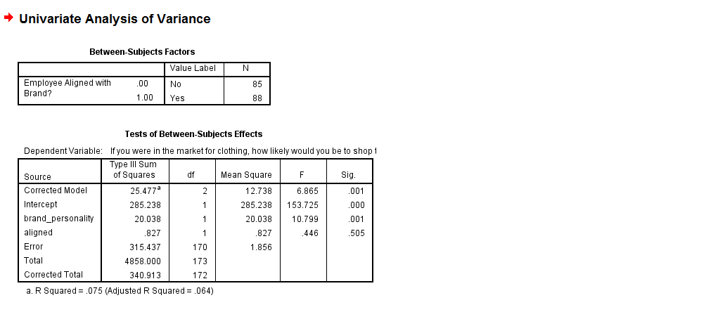
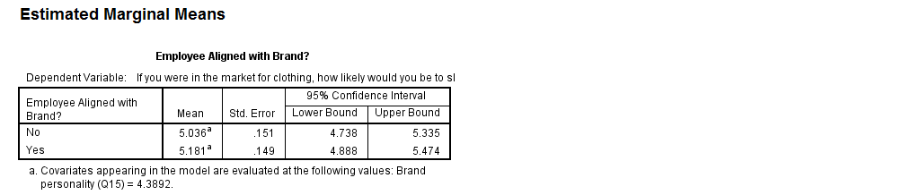

Univariate Analysis of Variance – Results of Test of H2
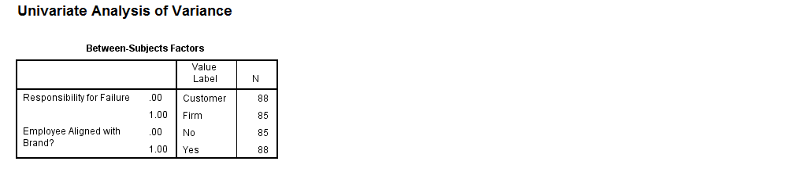
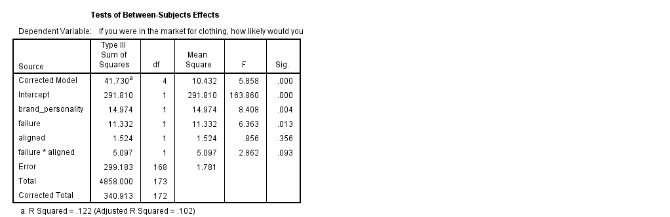
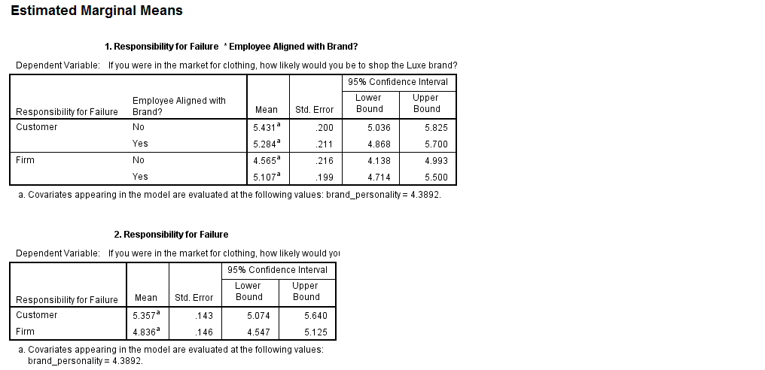
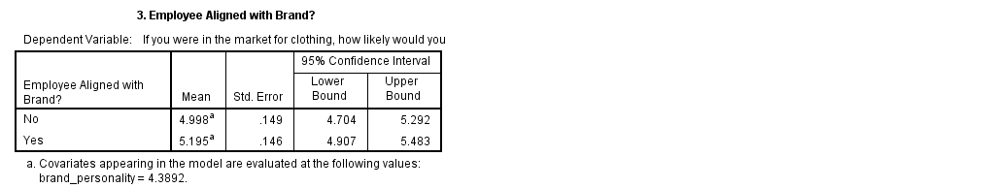

References
Bitner, M. J., Booms, B. H., & Tetreault, M. S. (1990). The service encounter: Diagnosing Favorable and Unfavorable Incidents. Journal Of Marketing, 54(1), 71-84.
Brady, M. K., Cronin, J. J., Fox, G. L., & Roehm, M. L. (2008). Strategies to offset performance failures: The role of brand equity. Journal Of Retailing, 84(2), 151-164.
Folkes, V. S., & Patrick, V. M. (2003). The Positivity Effect in Perceptions of Services: Seen One, Seen Them All?. Journal Of Consumer Research, 30(1), 125-137.
Gremler, Dwayne D. and Kevin P. Gwinner (2000), “Customer-Employee Rapport in Service Relationships,” Journal of Service Research, 3 (August), 82–104.
Grewal, D., Levy, M., & Lehmann, D. R. (2004, Winter2004). Retail Branding and Customer Loyalty: an overview. Journal of Retailing. p. 249. doi:10.1016/j.jretai.2004.10.001.
Hennig-Thurau, T., Groth, M., Paul, M., & Gremler, D. D. (2006). Are All Smiles Created Equal? How Emotional Contagion and Emotional Labor Affect Service Relationships. Journal Of Marketing, 70(3), 58-73.
Hess, R. L., Jr. (2008). The impact of firm reputation and failure severity on customers' responses to service failures. Journal of Services Marketing, 22(5), 385–398.
Keller, Kevin Lane, (2010), “Measuring Brand Equity,” INC. Magazine, “Brand Equity,” Chapter 26, page 22.
Ravi Pappu Pascale Quester, (2006),"Does customer satisfaction lead to improved brand equity? An empirical examination of two categories of retail brands", Journal of Product & Brand Management, Vol. 15 Iss 1 pp. 4 – 14
Sirianni, Nancy J., Mary Jo Bitner, Stephen W. Brown, and Naomi Mandel (2013) Branded Service Encounters: Strategically Aligning Employee Behavior with the Brand Positioning. Journal of Marketing: November 2013, Vol. 77, No. 6, pp. 108-123.
Sarkar Sengupta, A., Balaji, M., & Krishnan, B. C. (2015). How customers cope with service failure? A study of brand reputation and customer satisfaction. Journal Of Business Research, 68(3), 665-674. doi:10.1016/j.jbusres.2014.08.005.
Wallace, D., Giese, J. I., & Johnson, J. (2004). Customer retailer loyalty in the context of multiple channel strategies. Journal of Retailing, 80.
Wentzel, D. (2009). The effect of employee behavior on brand personality impressions and brand attitudes. Journal Of The Academy Of Marketing Science, 37(3), 359-374. doi:10.1007/s11747-009-0140-6.

